No. 98 3727

THE SOUTH AUSTRALIAN

GOVERNMENT GAZETTE
www.governmentgazette.sa.gov.au

PUBLISHED BY AUTHORITY

ALL PUBLIC ACTS appearing in this GAZETTE are to be considered official, and obeyed as such

ADELAIDE, THURSDAY, 20 OCTOBER 2005

CONTENTS

Page
Appointments, Resignations, Etc. 3728
Controlled Substances Act 1984—Notice 3729
Corporations and District Councils—Notices 3798
Crown Lands Act 1929—Notices 3729
Equal Opportunity Tribunal—Notice 3729
Fisheries Act 1982—Notices 3730
Fisheries (Scheme of Management—Rock Lobster
Fisheries) Regulations 1991—Notice 3730
Geographical Names Act 1991—Notice 3730
Land and Business (Sale and Conveyancing) Act 1994—
Notice 3730
Liquor Licensing Act 1997—Notices 3731
Local Government Act 1999—Notice 3734
Mining Act 1971—Notices 3734
National Electricity Law—Notice 3735
National Parks Regulations 2001—Notice 3735
Natural Resources Management Act 2004—Notices 3736
Petroleum Act 2000—Notices 3737
Proclamations 3744
Public Trustee Office—Administration of Estates 3800
Roads (Opening and Closing) Act 1991—Notice 3737
SafeWork SA—Notice 3737
Page
REGULATIONS
Fisheries Act 1982—
(No. 218 of 2005) 3749
(No. 219 of 2005) 3751
(No. 220 of 2005) 3753
(No. 221 of 2005) 3757
Citrus Industry Act 2005 (No. 222 of 2005) 3766
Primary Industry Funding Schemes Act 1998
(No. 223 of 2005) 3775
Primary Produce (Food Safety Schemes) Act 2004
(No. 224 of 2005) 3779
Harbors and Navigation Act 1993 (No. 225 of 2005) 3781
Retail and Commercial Leases Act 1995
(No. 226 of 2005) 3789
Natural Resources Management Act 2004—
(No. 227 of 2005) 3791
(No. 228 of 2005) 3793
(No. 229 of 2005) 3795
Sale of Property 3800
Training and Skills Development Act 2003—Notice 3741
Transport, Department of—Notices to Mariners 3737
Waterworks Act 1932—Notice 3742

GOVERNMENT GAZETTE NOTICES
ALL poundkeepers’ and private advertisements forwarded for publication in the South Australian Government Gazette must be PAID FOR PRIOR TO INSERTION; and all notices, from whatever source, should be legibly written on one side of the paper only and sent to Government Publishing SA so as to be received no later
than 4 p.m. on the Tuesday preceding the day of publication. Phone 8207 1045 or Fax 8207 1040. E-mail: governmentgazette@saugov.sa.gov.au. Send as attachments in Word format and please confirm your transmission with a faxed copy of your document, including the date the notice is to be published and to whom the notice will be charged. The Government Gazette is available online at: www.governmentgazette.sa.gov.au

Department of the Premier and Cabinet
Adelaide, 20 October 2005
HER Excellency the Governor in Executive Council has been pleased to appoint the undermentioned to the South Australian Housing Trust Board of Management, pursuant to the provisions of the South Australian Housing Trust Act 1995:
Member: (from 20 October 2005 until 19 October 2007)
Julia Dance
By command,
C. Zollo, for Premier
MFC CS/05/0031

Department of the Premier and Cabinet
Adelaide, 20 October 2005
HER Excellency the Governor in Executive Council has been pleased to appoint the undermentioned to the Natural Resources Management Board—Adelaide and Mount Lofty Ranges, pursuant to the provisions of the Natural Resources Management Act 2004:
Member: (from 20 October 2005 until 13 April 2007)
Anthony Cheshire
By command,
C. Zollo, for Premier
EC 05/0073CS

Department of the Premier and Cabinet
Adelaide, 20 October 2005
HER Excellency the Governor in Executive Council has been pleased to appoint the undermentioned to the Board of the Environment Protection Authority, pursuant to the provisions of the Environment Protection Act 1993:
Member: (from 21 October 2005 until 20 October 2008)
Stephen Hains
Member: (from 20 October 2005 until 19 October 2008)
Michael Nagel
Deputy Presiding Member: (from 21 October 2005 until 20 October 2008)
Stephen Hains
By command,
C. Zollo, for Premier
EC 05/0072CS

Department of the Premier and Cabinet
Adelaide, 20 October 2005
HER Excellency the Governor in Executive Council has been pleased to appoint the undermentioned to the Public Housing Appeal Panel, pursuant to the provisions of the Constitution Act 1934:
Member: (from 1 February 2006 until 31 January 2008)
Margaret Amelia Castles
Ursula Mary Dahl
Frances Meredith
Chris Finn
Kathleen Patricia McEvoy
Member: (from 20 October 2005 until 19 October 2006)
Peter David Anderson
Gaybrielle Cotton Kenny
Nicola Dawn Ferencz
Kate Warren
Georgina Mary Hone
Kathryn Jane Millar
Chair: (from 1 February 2006 until 31 January 2008)
Kathleen Patricia McEvoy
By command,
C. Zollo, for Premier
MFC CS/05/0030

Department of the Premier and Cabinet
Adelaide, 20 October 2005
HER Excellency the Governor in Executive Council has been pleased to appoint the undermentioned to the South Australian Multicultural and Ethnic Affairs Commission, pursuant to the provisions of the South Australian Multicultural and Ethnic Affairs Commission Act 1980:
Member: (from 1 January 2006 until 31 December 2007)
Hieu Van Le
Chair: (from 1 January 2006 until 31 December 2007)
Hieu Van Le
By command,
C. Zollo, for Premier
AGO 0433/02CS

Department of the Premier and Cabinet
Adelaide, 20 October 2005
HER Excellency the Governor in Executive Council has been pleased to appoint the undermentioned to the Legal Practitioners Disciplinary Tribunal, pursuant to the provisions of the Legal Practitioners Act 1981:
Member: (from 7 November 2005 until 6 November 2008)
Maurine Pyke
Member: (from 28 November 2005 until 27 November 2008)
Jillian Freda Cooper
Joanne Elizabeth Tracey
Member: (from 9 December 2005 until 8 December 2008)
Lindsay Smith
By command,
C. Zollo, for Premier
AGO 0069/03CS

Department of the Premier and Cabinet
Adelaide, 20 October 2005
HER Excellency the Governor in Executive Council has been pleased to appoint Bruno Krumins, Member of the Order of Australia, as Governor’s Deputy of South Australia for the period from 10 a.m. on Thursday, 27 October 2005 until 5 p.m. on Friday, 28 October 2005.
By command,
C. Zollo, for Premier

Department of the Premier and Cabinet
Adelaide, 20 October 2005
HER Excellency the Governor in Executive Council has revoked the appointments as officers of the Crown for the purpose of providing the range of custodial services for Prisoner Movement and In-Court Management Services, the former staff of GSL Custodial Services Pty Ltd as listed, pursuant to section 68 of the Constitution Act 1934 and section 36 of the Acts Interpretation Act 1915:
Johannes Veen
Andrew Reginald Cotton
Chris Economou
Sharon Louise Fuller
Lynette Kaye Langley
Stuart Stanley Bruggemann
Gary Raymond Manorl
David John Thomas
Sarah Wilsdon
Margaret Alison Walsh
Jennifer Rae Barton
Richard James Coonan
John Andrew Vlachoulis
By command,
C. Zollo, for Premier
CSC 0009/05

Department of the Premier and Cabinet
Adelaide, 20 October 2005
HER Excellency the Governor in Executive Council has been pleased to appoint as officers of the Crown for the purpose of providing the range of custodial services for Prisoner Movement and In-Court Management Services, in accordance with the South Australian Prisoner Movement In-Court Management contract, without pay or other industrial entitlement, staff of GSL Custodial Services Pty Ltd as listed, pursuant to section 68 of the Constitution Act 1934:
Adrian Tjalko Bartsch
Robyn Marshall Basso
Daniel Jarod Bryant
Graham Robert Cooper
Alexander Mark Durwood
Dean Robert James Edwards
Daniel Joseph Masefield
Michael Robin Mulder
Lisbeth Dawn Newell
Bradley Philip Smith
Jeremy Gordon Vos
Timothy Thomas Woods
By command,
C. Zollo, for Premier
CSC 0009/05

Department of the Premier and Cabinet
Adelaide, 20 October 2005
HER Excellency the Governor in Executive Council has been pleased to appoint the Honourable Jay Wilson Weatherill, MP, Minister for Families and Communities, Minister for Housing, Minister for Ageing and Minister for Disability to be also Acting Minister for Health and Acting Minister Assisting the Premier in Social Inclusion for the period 20 October 2005 until 23 October 2005 inclusive, during the absence of the Honourable Lea Stevens, MP.
By command,
C. Zollo, for Premier
DPC 05/025CS

CONTROLLED SUBSTANCES ACT 1984
Revocation
TAKE notice that on 11 October 2005, the Minister for Health issued an order pursuant to section 57 (2) of the Controlled Substances Act 1984 in respect of:
Dr Jonathon Sydney Close
6 Shannon Street
Fulham Gardens, S.A. 5024
revoking previous action taken by the Minister for Health on
2 July 1982 that withdrew his authority of Regulation 8 of the then Narcotic and Psychotropic Drugs Act to handle drugs of the following class:
• A drug of dependence as declared by Regulation 7A of the Controlled Substances (Poisons) Regulations 1996, pursuant to section 12 (3) of the Controlled Substances Act 1984, namely any poison listed in Schedule 8 of the Standard for the Uniform Scheduling of Drugs and Poisons as published and amended by the National Drugs and Poisons Schedule Committee under the Commonwealth’s Therapeutic Goods Act 1989.
This Order restores Dr Close’s ability to handle drugs of dependence as a medical practitioner and took effect from 18 October 2005 when served on him.
K. Evans, Delegate for the Minister for Health

CROWN LANDS ACT 1929: SECTION 5
TAKE NOTICE that pursuant to the Crown Lands Act 1929, I, JOHN HILL, Minister for Environment and Conservation, Minister of the Crown to whom the administration of the Crown Lands Act 1929 is committed DO HEREBY dedicate the Crown Land defined in The Schedule as a Cemetery Reserve and declare that such land shall be under the care, control and management of the Naracoorte Lucindale Council.
The Schedule
Section 486, Hundred of Jessie, County of Robe, exclusive of all necessary roads, being the whole of the land comprised in Crown Record Volume 5677, Folio 772.
Dated 20 October 2005.
J. Hill, Minister for Environment and Conservation
DL 2736/1985

CROWN LANDS ACT 1929: SECTION 5
TAKE NOTICE that pursuant to the Crown Lands Act 1929, I, JOHN HILL, Minister for Environment and Conservation, Minister of the Crown to whom the administration of the Crown Lands Act 1929 is committed DO HEREBY:
1. Resume the land defined in The First Schedule.
2. Dedicate the Crown Land defined in The Second Schedule as a Recreation Reserve and declare that such land shall be under the care, control and management of the Kangaroo Island Council.
The First Schedule
Recreation Reserve, Allotment 500 of Deposited Plan 58455, Town of Penneshaw, Hundred of Dudley, County of Carnarvon, the notice of which was published in the Government Gazette of 21 August 2003 at page 3259, The First Schedule, being the whole of the land comprised in Crown Record Volume 5895 Folio 301.
The Second Schedule
Allotment 50 of Deposited Plan 67485, Town of Penneshaw, Hundred of Dudley, County of Carnarvon, exclusive of all necessary roads, subject nevertheless to:
1. An easement for the transmission of electricity by underground cable over that portion of Allotment 50 marked A on Deposited Plan 67485 and appurtenant to Allotment 1 of Deposited Plan 67485.
2. An easement for telecommunications purposes by underground cable over that portion of Allotment 50 marked A on Deposited Plan 67485 and appurtenant to Allotment 1 of Deposited Plan 67485.
3. A free and unrestricted right of way over that portion of Allotment 50 marked B on Deposited Plan 67485 and appurtenant to Allotment 1 of Deposited Plan 67485.
Dated 20 October 2005.
J. Hill, Minister for Environment and Conservation
DEH 17/1628

EQUAL OPPORTUNITY TRIBUNAL
No. 285 of 2005
Notice of Exemption
Before Deputy Presiding Officer Robertson
Members Simmons and Shetliffe
I HEREBY certify that on 6 October 2005, the Equal Opportunity Tribunal of South Australia, on the application of Go Staff 40 Plus made the following orders for exemption:
1. Under the provisions of section 92 of the Equal Opportunity Act 1984, an exemption is granted to Go Staff 40 Plus to advertise specifically for the over 40 age group for a period of 3 years commencing on 6 October 2005.
2. It is a condition of the granting of the exemption that every advertisement must include a statement that payment for any employment will be in barter dollars.
3. Notice of granting of the exemption is to be published in the first available Government Gazette.
Dated 10 October 2005.
D. Hoban, for M. Moore, Registrar, Equal Opportunity Tribunal

FISHERIES ACT 1982: SECTION 43
TAKE notice that it is hereby declared that it shall be unlawful for any person to engage in the class of fishing activity specified in Schedule 1 during the period specified in Schedule 2.
Schedule 1
The act of taking or an act preparatory to or involved in the taking of snapper (Pagrus auratus) in all waters of the State.
Schedule 2
From 1200 hours on 1 November 2005 until 1200 hours on 30 November 2005.
Dated 17 October 2005.
W. Zacharin, Director of Fisheries

FISHERIES ACT 1982: SECTION 59
TAKE notice that pursuant to section 59 of the Fisheries Act 1982, Gary Payne, of Tanktech Pty Ltd, 5 Parkes Avenue, Woodcroft, S.A. 5162 (the ‘exemption holder’), is exempt from the Fisheries Act 1982, but only insofar as he may engage in the collection and possession of Caulerpa taxifolia from the waters listed in Schedule 1 (the ‘exempted activity’), subject to the conditions set out in Schedule 2, from 19 October 2005 until 26 October 2005, unless varied or revoked earlier.
Schedule 1
The waters of Port River and the waters surrounding Torrens Island.
Schedule 2
1. The specimens collected by the exemption holder may be used for research purposes only.
2. If using a boat during the exempted activity the exemption holder must comply with the Harbors and Navigation (Control of Caulerpa Taxifolia) Regulations 2002.
3. The testing of Caulerpa taxifolia by the exemption holder must be conducted in a land locked area to reduce the risk of further spread of the noxious weed.
4. The exemption holder must not return any water used in the experiment into any natural or man-made waters.
5. The exemption holder must place the Caulerpa taxifolia in a plastic bag and dispose of the waste into a landfill.
6. While engaged in the exempted activity, the exemption holder must be in possession of a copy of this notice. Such notice must be produced to a PIRSA Fisheries Compliance Officer if requested.
7. The exemption holder must not contravene or fail to comply with the Fisheries Act 1982, or any regulations made under the Act, except where specifically exempted by this notice.
Dated 17 October 2005.
W. Zacharin, Director of Fisheries

FISHERIES (SCHEME OF MANAGEMENT—ROCK LOBSTER FISHERIES) REGULATIONS 1991
Nominated Certification Stations
TAKE notice that in relation to the nominated certification stations listed in Column 1 below, the corresponding times specified in Columns 2 and 3 are, for the purposes of sub-regulations 14 F (2) and 14 G (2) of the Fisheries (Scheme of Management—Rock Lobster Fisheries) Regulations 1991, the times during which the requirements in 14 F (1) and 14 G (1) do not apply.
This notice applies from 20 October 2005 until 31 March 2006, unless varied or revoked earlier.
Column 1 | Column 2 | Column 3
Certification Station | Start Time | Finish Time
Beachport | 10.30 a.m. | 2.00 p.m.
Blackfellows Caves | 8.30 a.m. | 11.30 a.m.
Cape Jaffa | 11.00 a.m. | 3.00 p.m.
Carpenter Rocks | 8.30 a.m. | 11.30 a.m.
Port MacDonnell | 9.00 a.m. | 1.00 p.m.
Robe | 11.30 a.m. | 3.30 p.m.
Southend | 10.00 a.m. | 1.00 p.m.
Dated 18 October 2005.
W. Zacharin, Director of Fisheries

GEOGRAPHICAL NAMES ACT 1991
Notice to Rescind the Name of a Place
NOTICE is hereby given pursuant to section 11B (4) of the Geographical Names Act 1991 that I, PETER MACLAREN KENTISH, Surveyor-General and Delegate appointed by Michael Wright, Minister for Administrative Services, Minister of the Crown to whom the administration of the Geographical Names Act 1991 is committed DO HEREBY rescind the locality of WILLSDEN, area marked (A) on the plan below and include said area into the locality of PORT AUGUSTA.
The Plan
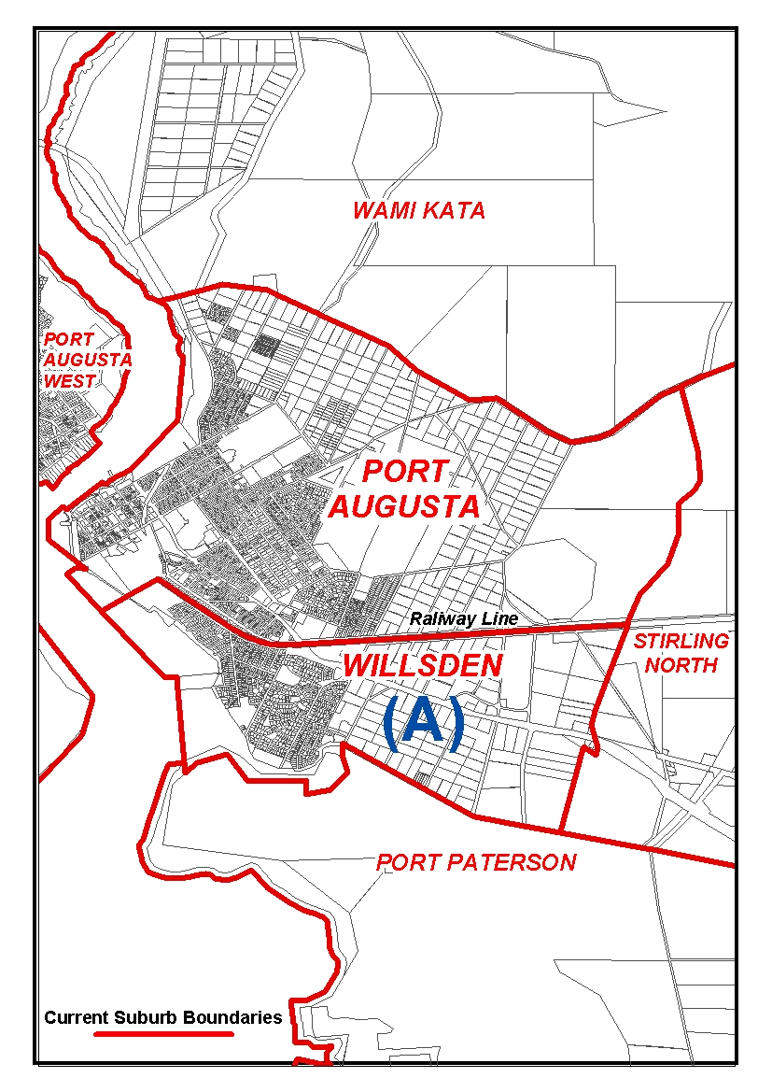
Dated 14 October 2005.
P. M. Kentish, Surveyor-General, Department for Administrative and Information Services
DAIS 22-413/04/0035

LAND AND BUSINESS (SALE AND CONVEYANCING)
ACT 1994
Exemption
TAKE notice that, pursuant to section 23 (3) of the Land and Business (Sale and Conveyancing) Act 1994, I, Karlene Maywald, Minister for Consumer Affairs, do hereby exempt the person named in Schedule 1 from the application of section 23 (2) of the Act in relation to the purchase of the land specified in Schedule 2.
Schedule 1
Melissa McMillan, an employee of Playford Real Estate Pty Ltd.
Schedule 2
The whole of the land described in certificate of title register book volume 5941, folio 947, situated at Lot 42, Hannah Road, Munno Para West, S.A. 5115.
Dated 20 October 2005.
Signed for and on behalf of the Minister for Consumer Affairs by the Commissioner for Consumer Affairs:
M. Bodycoat, Commissioner

LIQUOR LICENSING ACT 1997
Notice of Application
NOTICE is hereby given, pursuant to section 52 (2) (b) of the Liquor Licensing Act 1997, that Royston George Deer and Daryl John Fry have applied to the Licensing Authority for the transfer of a Restaurant Licence in respect of premises situated at Main Road, Springton, S.A. 5235, known as Cafe C and to be known as Blacksmiths Restaurant.
The application has been set down for hearing on 17 November 2005 at 10 a.m.
Any person may object to the application by lodging a notice of objection in the prescribed form with the Licensing Authority, and serving a copy of the notice on the applicants at the applicants’ address given above, at least seven days before the hearing date (viz: 9 November 2005).
The applicants’ address for service is c/o Royston Deer and Daryl Fry, P.O. Box 34, Mount Pleasant, S.A. 5235.
Plans in respect of the premises the subject of the application are open to public inspection without fee at the Office of the Liquor and Gambling Commissioner, 9th Floor, East Wing, 50 Grenfell Street, Adelaide, S.A. 5000. Phone 8226 8410, Fax:
8226 8512. Email: olgc@agd.sa.gov.au.
Dated 11 October 2005.
Applicants

LIQUOR LICENSING ACT 1997
Notice of Application
NOTICE is hereby given, pursuant to section 52 (2) (b) of the Liquor Licensing Act 1997, that World Wine Export Enterprises Pty Ltd has applied to the Licensing Authority for a Wholesale Liquor Merchant’s Licence in respect of premises situated at Stonyfell Function Centre, Stonyfell Road, Stonyfell, S.A. 5066 to be known as World Wine Export Enterprises.
The application has been set down for hearing on 18 November 2005 at 9 a.m.
Any person may object to the application by lodging a notice of objection in the prescribed form with the Licensing Authority, and serving a copy of the notice on the applicant at the applicant’s address given above, at least seven days before the hearing date (viz: 10 November 2005).
The applicant’s address for service is c/o David Watts, 1 Cator Street, Glenside, S.A. 5065.
Plans in respect of the premises the subject of the application are open to public inspection without fee at the Office of the Liquor and Gambling Commissioner, 9th Floor, East Wing, 50 Grenfell Street, Adelaide, S.A. 5000. Phone 8226 8410, Fax:
8226 8512. Email: olgc@agd.sa.gov.au.
Dated 12 October 2005.
Applicant

LIQUOR LICENSING ACT 1997
Notice of Application
NOTICE is hereby given, pursuant to section 52 (2) (b) of the Liquor Licensing Act 1997, that Richard Jefferson Carter has applied to the Licensing Authority for a Producer’s Licence in respect of premises situated at 43 Vine Street, Magill, S.A. 5072 and to be known as Craiglockhart Winery.
The application has been set down for hearing on 18 November 2005 at 9 a.m.
Any person may object to the application by lodging a notice of objection in the prescribed form with the Licensing Authority, and serving a copy of the notice on the applicant at the applicant’s address given above, at least seven days before the hearing date (viz: 10 November 2005).
The applicant’s address for service is c/o Richard Carter, P.O. Box 626, Magill, S.A. 5072.
Plans in respect of the premises the subject of the application are open to public inspection without fee at the Office of the Liquor and Gambling Commissioner, 9th Floor, East Wing, 50 Grenfell Street, Adelaide, S.A. 5000. Phone 8226 8410, Fax:
8226 8512. Email: olgc@agd.sa.gov.au.
Dated 14 October 2005.
Applicant

LIQUOR LICENSING ACT 1997
Notice of Application
NOTICE is hereby given, pursuant to section 52 (2) (b) of the Liquor Licensing Act 1997, that Horseshoe Investments (SA) Pty Ltd has applied to the Licensing Authority for the transfer of a Restaurant Licence in respect of premises situated at 1 Horseshoe Bay, Port Elliot, S.A. 5212 and known as Flying Fish Cafe.
The application has been set down for hearing on 21 November 2005 at 9.30 a.m.
Any person may object to the application by lodging a notice of objection in the prescribed form with the Licensing Authority, and serving a copy of the notice on the applicant at the applicant’s address given above, at least seven days before the hearing date (viz: 11 November 2005).
The applicant’s address for service is c/o David Watts and Associates, 1 Cator Street, Glenside, S.A. 5065.
Plans in respect of the premises the subject of the application are open to public inspection without fee at the Office of the Liquor and Gambling Commissioner, 9th Floor, East Wing, 50 Grenfell Street, Adelaide, S.A. 5000. Phone 8226 8410, Fax:
8226 8512. Email: olgc@agd.sa.gov.au.
Dated 12 October 2005.
Applicant

LIQUOR LICENSING ACT 1997
Notice of Application
NOTICE is hereby given, pursuant to section 52 (2) (b) of the Liquor Licensing Act 1997, that Duck Soo Kim and Mi Hwa Jung have applied to the Licensing Authority for the transfer of a Restaurant Licence in respect of premises situated at 31 Moonta Street, Adelaide, S.A. 5000, known as Talbot Village Seafood Restaurant and to be known as Han Kuk Kwan Korean Restaurant.
The application has been set down for hearing on 21 November 2005 at 10 a.m.
Any person may object to the application by lodging a notice of objection in the prescribed form with the Licensing Authority, and serving a copy of the notice on the applicants at the applicants’ address given above, at least seven days before the hearing date (viz: 11 November 2005).
The applicants’ address for service is c/o Jennifer Jeon, P.O. Box 3137, Rundle Mall, Adelaide, S.A. 5001.
Plans in respect of the premises the subject of the application are open to public inspection without fee at the Office of the Liquor and Gambling Commissioner, 9th Floor, East Wing, 50 Grenfell Street, Adelaide, S.A. 5000. Phone 8226 8410, Fax:
8226 8512. Email: olgc@agd.sa.gov.au.
Dated 12 October 2005.
Applicants

LIQUOR LICENSING ACT 1997
Notice of Application
NOTICE is hereby given, pursuant to section 52 (2) (b) of the Liquor Licensing Act 1997, that Mount Dare Hotel Pty Ltd as trustee for the Mount Dare Hotel Trust has applied to the Licensing Authority for the transfer of a Special Circumstances Licence in respect of premises situated at Mount Dare Homestead, Far North, S.A. 5710 and known as Mount Dare Homestead to be known as Mount Dare Hotel.
The application has been set down for hearing on 22 November 2005 at 10 a.m.
Any person may object to the application by lodging a notice of objection in the prescribed form with the Licensing Authority, and serving a copy of the notice on the applicant at the applicant’s address given above, at least seven days before the hearing date (viz: 14 November 2005).
The applicant’s address for service is c/o Ian Edgley, Level 8, 185 Victoria Square, Adelaide, S.A. 5000.
Plans in respect of the premises the subject of the application are open to public inspection without fee at the Office of the Liquor and Gambling Commissioner, 9th Floor, East Wing, 50 Grenfell Street, Adelaide, S.A. 5000. Phone 8226 8410, Fax:
8226 8512. Email: olgc@agd.sa.gov.au.
Dated 13 October 2005.
Applicant

LIQUOR LICENSING ACT 1997
Notice of Application
NOTICE is hereby given, pursuant to section 52 (2) (b) of the Liquor Licensing Act 1997, that Shirley Anne Andrew has applied to the Licensing Authority for the transfer of a Restaurant Licence in respect of premises situated at 38 Sheoak Road, Belair, S.A. 5052 and known as Sheoak Cafe.
The application has been set down for hearing on 22 November 2005 at 11 a.m.
Any person may object to the application by lodging a notice of objection in the prescribed form with the Licensing Authority, and serving a copy of the notice on the applicant at the applicant’s address given above, at least seven days before the hearing date (viz: 14 November 2005).
The applicant’s address for service is c/o Shirley Andrew, 38 Sheoak Road, Belair, S.A. 5052.
Plans in respect of the premises the subject of the application are open to public inspection without fee at the Office of the Liquor and Gambling Commissioner, 9th Floor, East Wing, 50 Grenfell Street, Adelaide, S.A. 5000. Phone 8226 8410, Fax:
8226 8512. Email: olgc@agd.sa.gov.au.
Dated 17 October 2005.
Applicant

LIQUOR LICENSING ACT 1997
Notice of Application
NOTICE is hereby given, pursuant to section 52 (2) (b) of the Liquor Licensing Act 1997, that Watt & Sons Pty Ltd has applied to the Licensing Authority for the transfer of a Residential Licence in respect of premises situated at 153-157 Esplanade, Port Noarlunga South, S.A. 5167, known as Port Noarlunga Coastview Motor Inn and to be known as Coastview Motor Inn.
The application has been set down for hearing on 24 November 2005 at 9.30 a.m.
Any person may object to the application by lodging a notice of objection in the prescribed form with the Licensing Authority, and serving a copy of the notice on the applicant at the applicant’s address given above, at least seven days before the hearing date (viz: 16 November 2005).
The applicant’s address for service is c/o Jeff Stevens & Associates, Level 1, 86 Pirie Street, Adelaide, S.A. 5000 (Attention: Kim Hudson).
Plans in respect of the premises the subject of the application are open to public inspection without fee at the Office of the Liquor and Gambling Commissioner, 9th Floor, East Wing, 50 Grenfell Street, Adelaide, S.A. 5000. Phone 8226 8410, Fax:
8226 8512. Email: olgc@agd.sa.gov.au.
Dated 13 October 2005.
Applicant

LIQUOR LICENSING ACT 1997
Notice of Application
NOTICE is hereby given, pursuant to section 52 (2) (b) of the Liquor Licensing Act 1997, that Alex Zemith has applied to the Licensing Authority for a Restaurant Licence with section 34 (1) (c) and Entertainment Consent in respect of premises situated at 6/384 Prospect Road, Kilburn, S.A. 5084 and to be known as Alfurat Restaurant.
The application has been set down for hearing on 18 November 2005 at 9 a.m.
Conditions
The following licence conditions are sought:
• Approval under section 34 (1) (c) to sell liquor for consumption on the licensed premises by persons:
(a) seated at a table; or
(b) attending a function at which food is provided.
• Entertainment Consent: Monday to Sunday: 11.30 a.m. to 2 a.m. the following day.
Any person may object to the application by lodging a notice of objection in the prescribed form with the Licensing Authority, and serving a copy of the notice on the applicant at the applicant’s address given above, at least seven days before the hearing date (viz: 10 November 2005).
The applicant’s address for service is c/o David Watts and Associates, 1 Cator Street, Glenside, S.A. 5065.
Plans in respect of the premises the subject of the application are open to public inspection without fee at the Office of the Liquor and Gambling Commissioner, 9th Floor, East Wing, 50 Grenfell Street, Adelaide, S.A. 5000. Phone 8226 8410, Fax:
8226 8512. Email: olgc@agd.sa.gov.au.
Dated 12 October 2005.
Applicant

LIQUOR LICENSING ACT 1997
Notice of Application
NOTICE is hereby given, pursuant to section 52 (2) (b) of the Liquor Licensing Act 1997, that Alconbury Pty Ltd has applied to the Licensing Authority for the variation to a Extended Trading Authorisation and Entertainment Consent in respect of premises situated at 173 Woodford Road, Elizabeth North, S.A. 5113 and known as Red Lion Hotel.
The application has been set down for hearing on 18 November 2005 at 9 a.m.
Conditions
The following licence conditions are sought:
• Variation to Extended Trading Authorisation:
Monday to Saturday: Midnight to 3 a.m. the following day;
Sunday: 8 a.m. to 11 a.m. and 8 p.m. to 3 a.m. the following day;
Good Friday: Midnight to 2 a.m.;
Sunday Christmas Eve: 8 p.m. to 2 a.m. the following day.
• Variation to Entertainment Consent to include Areas 1, 2, 3, 4 and 6 during the following hours:
Monday to Sunday: 11 a.m. to 3 a.m. the following day;
Good Friday: Midnight to 2 a.m.;
Christmas Day: Midnight to 2 a.m.;
Sunday Christmas Eve: 8 p.m. to 2 a.m. the following day.
Any person may object to the application by lodging a notice of objection in the prescribed form with the Licensing Authority, and serving a copy of the notice on the applicant at the applicant’s address given above, at least seven days before the hearing date (viz: 10 November 2005).
The applicant’s address for service is c/o Jarrod Ryan, Santos House, Level 17, 91 King William Street, Adelaide, S.A. 5000.
Plans in respect of the premises the subject of the application are open to public inspection without fee at the Office of the Liquor and Gambling Commissioner, 9th Floor, East Wing, 50 Grenfell Street, Adelaide, S.A. 5000. Phone 8226 8410, Fax:
8226 8512. Email: olgc@agd.sa.gov.au.
Dated 13 October 2005.
Applicant

LIQUOR LICENSING ACT 1997
Notice of Application
NOTICE is hereby given, pursuant to section 52 (2) (b) of the Liquor Licensing Act 1997, that Rocket Bar Pty Ltd as trustee for the Rocket Bar Unit Trust has applied to the Licensing Authority for an Entertainment Venue Licence with Extended Trading Authorisation, Entertainment Consent and section 35 (1) (c) Authorisation in respect of premises situated at 9 North Terrace, Adelaide, S.A. 5000 and to be known as Rocket Bar.
The application has been set down for hearing on 18 November 2005 at 9 a.m.
Conditions
The following licence conditions are sought:
• Approval under section 35 (1) (c) to sell liquor for consumption on the licensed premises by persons:
(a) seated at a table; or
(b) attending a function at which food is provided.
• Extended Trading Authorisation to apply to the whole of the licensed premises at the following times:
Monday to Saturday: Midnight to 5 a.m. the following day;
Sunday: 8 a.m. to 11 a.m. and 8 p.m. to 5 a.m. the following day;
Christmas Day: Midnight to 2 a.m.;
Good Friday: Midnight to 2 a.m.
• Entertainment Consent is sought for the whole of the licensed premises including the above hours sought for Extended Trading Authorisation.
Any person may object to the application by lodging a notice of objection in the prescribed form with the Licensing Authority, and serving a copy of the notice on the applicant at the applicant’s address given above, at least seven days before the hearing date (viz: 10 November 2005).
The applicant’s address for service is c/o Ben Allen, 173 Wakefield Street, Adelaide, S.A. 5000.
Plans in respect of the premises the subject of the application are open to public inspection without fee at the Office of the Liquor and Gambling Commissioner, 9th Floor, East Wing, 50 Grenfell Street, Adelaide, S.A. 5000. Phone 8226 8410, Fax:
8226 8512. Email: olgc@agd.sa.gov.au.
Dated 11 October 2005.
Applicant

LIQUOR LICENSING ACT 1997
Notice of Application
NOTICE is hereby given, pursuant to section 52 (2) (b) of the Liquor Licensing Act 1997, that K. L. City Pty Ltd has applied to the Licensing Authority for the transfer of a Special Circum-stances Licence, variation to Licence Conditions, variation to Entertainment Consent and Redefinition in respect of premises situated at 121-139 Grote Street, Adelaide, S.A. 5000 and known as South Australian Wine Centre.
The application has been set down for hearing on 18 November 2005 at 9 a.m.
Conditions
The following licence conditions are sought:
• Deleting the following condition from the licence:
The licensee will not advocate the sale of liquor for consumption off the licensed premises in the South Australian media, whether by electronic or print, or by the use of boardings or advertising pamphlets.
• Variation to the current Entertainment Consent:
Entertainment shall cease at 3 a.m. the following day (in lieu of the current Entertainment Consent ceasing at midnight).
• Redefinition of the licensed premises:
Redefinition of the licensed premises to exclude Areas 1, 3, 4, 5, 6, 8 and 9 as per plans lodged with this office.
Any person may object to the application by lodging a notice of objection in the prescribed form with the Licensing Authority, and serving a copy of the notice on the applicant at the applicant’s address given above, at least seven days before the hearing date (viz: 10 November 2005).
The applicant’s address for service is c/o Patel & Co. Solicitors, 61-63 Grote Street, Adelaide, S.A. 5000.
Plans in respect of the premises the subject of the application are open to public inspection without fee at the Office of the Liquor and Gambling Commissioner, 9th Floor, East Wing, 50 Grenfell Street, Adelaide, S.A. 5000. Phone 8226 8410, Fax:
8226 8512. Email: olgc@agd.sa.gov.au.
Dated 11 October 2005.
Applicant

LIQUOR LICENSING ACT 1997
Notice of Application
NOTICE is hereby given, pursuant to section 52 (2) (b) of the Liquor Licensing Act 1997, that McLaren Vale Studio Winery Pty Ltd has applied to the Licensing Authority for a Special Circumstances Licence with Extended Trading Authorisation and Entertainment Consent in respect of premises situated at Lot 3, corner of Foggo Road and Kangarilla Road, McLaren Vale, S.A. 5171 and to be known as Redheads Food and Wine.
The application has been set down for hearing on 18 November 2005 at 9 a.m.
Conditions
The following licence conditions are sought:
• Liquor may be sold for consumption on or off the licensed premises on any day between 9 a.m. and 3 a.m. the following day and on Sundays between 8 a.m. and midnight, except for the following days:
Christmas Eve: 9 a.m. to 2 a.m. the following day;
Sunday Christmas Eve: 9 a.m. to 2 a.m. the following day;
Maunday Thursday: 9 a.m. to 2 a.m. the following day;
New Year’s Eve: 9 a.m. to 5 a.m. the following day;
Days preceding other Public Holidays: 9 a.m. to 3 a.m. the following day;
Sundays preceding Public Holidays: 9 a.m. to 3 a.m. the following day;
On each day of the ‘Sea and Vines Festival’: 9 a.m. to midnight.
• Liquor may be sold or supplied for consumption on the licensed premises with or without a meal provided by the licensee.
• Liquor distributed by the licensee may be sold or supplied through Direct Sales transactions.
• Liquor distributed by the licensee may be by way or sample.
• Liquor sold or supplied by the licensee may include Grape Products produced by participating wineries and may include Grape Products originating from countries other than Australia.
• Entertainment Consent is sought at the following times:
Monday to Thursday: 9 a.m. to midnight;
Friday and Saturday: 9 a.m. to 2 a.m. the following day;
Sunday and Public Holidays: 9 a.m. to midnight;
On each day of the ‘Sea and Vines Festival’: 9 a.m. to midnight.
Any person may object to the application by lodging a notice of objection in the prescribed form with the Licensing Authority, and serving a copy of the notice on the applicant at the applicant’s address given above, at least seven days before the hearing date (viz: 10 November 2005).
The applicant’s address for service is c/o John Roger, 169 Main Road, McLaren Vale, S.A. 5171.
Plans in respect of the premises the subject of the application are open to public inspection without fee at the Office of the Liquor and Gambling Commissioner, 9th Floor, East Wing, 50 Grenfell Street, Adelaide, S.A. 5000. Phone 8226 8410, Fax:
8226 8512. Email: olgc@agd.sa.gov.au.
Dated 12 October 2005.
Applicant

LIQUOR LICENSING ACT 1997 AND GAMING MACHINES ACT 1992
Notice of Application
NOTICE is hereby given, pursuant to section 52 of the Liquor Licensing Act 1997 and section 29 of the Gaming Machines Act 1992, that Palazzo Bar Pty Ltd as trustee for The Café Palazzo Pirie Street Unit Trust has applied to the Licensing Authority for the transfer of a Hotel and Gaming Machine Licence in respect of premises situated at 110 Pirie Street, Adelaide, S.A. 5000 and known as The Office on Pirie.
The application has been set down for hearing on 22 November 2005 at 9.30 a.m.
Any person may object to the application by lodging a notice of objection in the prescribed form with the Licensing Authority, and serving a copy of the notice on the applicant at the applicant’s address given above, at least seven days before the hearing date (viz: 14 November 2005).
The applicant’s address for service is c/o Richards Commercial Lawyers, G.P.O. Box 2835, Adelaide, S.A. 5001.
Plans in respect of the premises the subject of the application are open to public inspection without fee at the Office of the Liquor and Gaming Commissioner, 9th Floor, East Wing, 50 Grenfell Street, Adelaide, S.A. 5000. Phone 8226 8410, Fax: 8226 8512. Email: olgc@agd.sa.gov.au.
Dated 17 October 2005.
Applicant

LOCAL GOVERNMENT ACT 1999
Regulations by the Local Government Superannuation Board
THE Local Government Superannuation Board makes the following regulations pursuant to Part 2 of Schedule 1 of the Local Government Act 1999.
The Rules constituting the Local Government Superannuation Scheme known as Local Super are amended with effect from
1 November 2005 as follows:
1. A new Rule 50A is inserted immediately before Rule 51 as follows:
‘50A Contributions from Non-council Employers:
(a) The Board may accept contributions in respect of a Member paid by an employer of a Member that is not a Council if the acceptance of those contributions would not cause the Scheme to be treated as a public offer superannuation fund for the purposes of the Commonwealth Act.
(b) Contributions accepted by the Board in accordance with Rule 50A (a) must be paid to the credit of the Member’s Credit.’
2. Rule 51 (b) is amended by inserting a new Rule 51 (b) (ii) (BB) immediately before Rule 51 (b) (ii) (B) as follows:
‘(BB) any contributions paid by an employer that is not a Council in respect of a Member pursuant to Rule 50A;’.
Dated 17 October 2005.
C. Gibson, Executive Officer

MINING ACT 1971
NOTICE is hereby given in accordance with section 28 (5) of the Mining Act 1971, that the Minister for Mineral Resources Development proposes to grant an Exploration Licence over the undermentioned area:
Applicant: Red Metal Ltd
Location: Lake Blanche area⎯Approximately 180 km east of Marree.
Term: 1 year
Area in km²: 994
Ref.: 2005/00027
Plan and co-ordinates can be found on the PIRSA Sarig website: http://www.minerals.pir.sa.gov.au/sarig or by phoning Mineral Tenements on (08) 8463 3103.
H. Tyrteos, Mining Registrar

MINING ACT 1971
NOTICE is hereby given in accordance with section 28 (5) of the Mining Act 1971, that the Minister for Mineral Resources Development proposes to grant an Exploration Licence over the undermentioned area:
Applicant: Monax Mining Ltd
Location: Pine Lodge area⎯Approximately 120 km east-north-east of Streaky Bay.
Term: 1 year
Area in km²: 549
Ref.: 2005/00059
Plan and co-ordinates can be found on the PIRSA Sarig website: http://www.minerals.pir.sa.gov.au/sarig or by phoning Mineral Tenements on (08) 8463 3103.
H. Tyrteos, Mining Registrar

MINING ACT 1971
NOTICE is hereby given in accordance with section 28 (5) of the Mining Act 1971, that the Minister for Mineral Resources Development proposes to grant an Exploration Licence over the undermentioned area:
Applicant: Flinders Diamonds Limited
Location: Echunga area⎯Approximately 40 km south-east of Adelaide.
Term: 1 year
Area in km²: 253
Ref.: 2005/00236
Plan and co-ordinates can be found on the PIRSA Sarig website: http://www.minerals.pir.sa.gov.au/sarig or by phoning Mineral Tenements on (08) 8463 3103.
H. Tyrteos, Mining Registrar

MINING ACT 1971
NOTICE is hereby given in accordance with section 28 (5) of the Mining Act 1971, that the Minister for Mineral Resources Development proposes to grant an Exploration Licence over the undermentioned area:
Applicant: Pepinnini Minerals Limited
Location: Outalpa Hill area⎯Approximately 60 km north-west of Olary.
Term: 1 year
Area in km²: 201
Ref.: 2005/00251
Plan and co-ordinates can be found on the PIRSA Sarig website: http://www.minerals.pir.sa.gov.au/sarig or by phoning Mineral Tenements on (08) 8463 3103.
H. Tyrteos, Mining Registrar

MINING ACT 1971
NOTICE is hereby given in accordance with section 28 (5) of the Mining Act 1971, that the Minister for Mineral Resources Development proposes to grant an Exploration Licence over the undermentioned area:
Applicant: Southern Cross Resources Australia Pty Ltd
Location: Kielpa area⎯Approximately 60 km west of Cowell.
Term: 1 year
Area in km²: 89
Ref.: 2005/00260
Plan and co-ordinates can be found on the PIRSA Sarig website: http://www.minerals.pir.sa.gov.au/sarig or by phoning Mineral Tenements on (08) 8463 3103.
H. Tyrteos, Mining Registrar

MINING ACT 1971
NOTICE is hereby given in accordance with section 28 (5) of the Mining Act 1971, that the Minister for Mineral Resources Development proposes to grant an Exploration Licence over the undermentioned area:
Applicant: Uranium Exploration Australia Limited
Location: Glenside area⎯Approximately 40 km south of Andamooka.
Term: 1 year
Area in km²: 354
Ref.: 2005/00300
Plan and co-ordinates can be found on the PIRSA Sarig website: http://www.minerals.pir.sa.gov.au/sarig or by phoning Mineral Tenements on (08) 8463 3103.
H. Tyrteos, Mining Registrar

MINING ACT 1971
NOTICE is hereby given in accordance with section 28 (5) of the Mining Act 1971, that the Minister for Mineral Resources Development proposes to grant an Exploration Licence over the undermentioned area:
Applicant: Monax Mining Ltd
Location: Pernatty area⎯Approximately 70 km south-east of Woomera.
Term: 1 year
Area in km²: 887
Ref.: 2005/00336
Plan and co-ordinates can be found on the PIRSA Sarig website: http://www.minerals.pir.sa.gov.au/sarig or by phoning Mineral Tenements on (08) 8463 3103.
H. Tyrteos, Mining Registrar

MINING ACT 1971
NOTICE is hereby given in accordance with section 28 (5) of the Mining Act 1971, that the Minister for Mineral Resources Development proposes to grant an Exploration Licence over the undermentioned area:
Applicant: Deep Well Pty Ltd
Location: Ferguson area⎯Approximately 40 km west of Kingoonya.
Term: 1 year
Area in km²: 115
Ref.: 2005/00553
Plan and co-ordinates can be found on the PIRSA Sarig website: http://www.minerals.pir.sa.gov.au/sarig or by phoning Mineral Tenements on (08) 8463 3103.
H. Tyrteos, Mining Registrar

MINING ACT 1971
NOTICE is hereby given in accordance with section 28 (5) of the Mining Act 1971, that the Minister for Mineral Resources Development proposes to grant an Exploration Licence over the undermentioned area:
Applicant: Onesteel Manufacturing Pty Ltd
Location: Middleback Ranges area⎯Approximately 35 km west of Whyalla.
Term: 1 year
Area in km²: 501
Ref.: 2005/00708
Plan and co-ordinates can be found on the PIRSA Sarig website: http://www.minerals.pir.sa.gov.au/sarig or by phoning Mineral Tenements on (08) 8463 3103.
H. Tyrteos, Mining Registrar

NATIONAL ELECTRICITY LAW
Notice under Section 95
Request for Making of a Rule
Treatment of Contingent Projects under Current TransGrid Revenue Determination
THE Australian Energy Market Commission (Commission) gives notice under section 95 of the National Electricity Law (NEL) that TransGrid has requested the making of a participant derogation (the TransGrid proposal). The proposal relates to treatment of contingent projects under TransGrid’s current revenue deter-mination.
A draft of the proposed Rule and a copy of the TransGrid proposal are published on the Commission’s website and are available for inspection at the offices of the Commission. The Commission invites written submissions from any person or body in relation to the proposed Rule. Submissions must be received no later than Friday, 18 November 2005.
Postal Address:
P.O. Box H166
Australia Square, N.S.W. 1215
Facsimile: (02) 8296 7899
Email: submissions@aemc.gov.au.
Offices:
Level 16, 1 Margaret Street,
Sydney, N.S.W. 2000
Website: www.aemc.gov.au.
J. Tamblyn, Chairman, Australian Energy Market Commission

NATIONAL PARKS REGULATIONS 2001
Closure of Gawler Ranges National Park
PURSUANT to Regulation 8 (3) (d) of the National Parks Regulations 2001, I, Edward Gregory Leaman, the Director of National Parks and Wildlife, close to the public the Gawler Ranges National Park from 8 a.m. on Sunday, 23 October 2005 until 5 p.m. on Monday, 24 October 2005.
The purpose of the closure is to ensure the safety of the public during a feral pest control program within the park during the period indicated.
Dated 18 October 2005.
E. G. Leaman, Director of National Parks and Wildlife

NATURAL RESOURCES MANAGEMENT ACT 2004
Notice of Authorisation to Take Water
PURSUANT to section 128 of the Natural Resources Management Act 2004 (the Act), I, John David Hill, Minister for Environment and Conservation, hereby authorise the taking of surface water from the Clare Valley Surface Water Prescribed Area (within the Clare Valley Prescribed Water Resources Area) for the purposes of:
(1) the use of up to 1 500 kilolitres per annum of prescribed surface water in a concrete mixing facility operated by Mid North Manufacturing Pty Ltd on the land described as Allotment 9 in Deposited Plan 47387, Hundred of Clare (certificate of title volume 5433, folio 161) owned by William McGregor,
subject to the conditions specified in Schedule A.
Schedule A
1. All surface water taken pursuant to this authorisation must only be used for the purposes described above, unless otherwise authorised.
2. All surface water taken pursuant to this authorisation can only be collected from one existing 1 800 m² and one proposed 1 800 m² shed located on Allotment 9 in Deposited Plan 47387, Hundred of Clare (certificate of title volume 5433, folio 161).
3. All water taken pursuant to this authorisation must only be directed to the existing 170 kilolitre holding tank located on Allotment 9 in Deposited Plan 47387, Hundred of Clare (certificate of title volume 5433, folio 161), unless other water storage facilities are constructed pursuant to condition 4.
4. Additional closed water storage facilities (holding tanks) of no more than 230 kilolitre capacity can be constructed to store surface water captured from the two 1 800 m² sheds on Allotment 9 in Deposited Plan 47387, Hundred of Clare (certificate of title volume 5433, folio 161).
5. All water that is collected from the roof surface of the two sheds subject to this authorisation that overflows from the holding tank(s), must be released into the environment through the existing surface water drainage arrangements and must not be recaptured or redirected, unless otherwise authorised.
6. The owner of Allotment 9 in Deposited Plan 47387, Hundred of Clare (certificate of title volume 5433, folio 161) must, on or before 31 July each year, provide a report stating the estimated volume of water taken and used from each holding tank authorised under this Notice in the preceding financial year.
This authorisation will commence on the date below and will remain in effect for a period of two years unless earlier varied or revoked.
Dated 15 October 2005.
J. Hill, Minister for Environment and Conservation

NATURAL RESOURCES MANAGEMENT ACT 2004
Notice of Variation to the Notice of Prohibition on Taking Surface Water, Water from Watercourses and Wells in the Western Mount Lofty Ranges Area
PURSUANT to section 132 (9) of the Natural Resources Management Act 2004 (‘the Act’), I, John David Hill, Minister for Environment and Conservation in the State of South Australia and the Minister to whom administration of the Act is committed, hereby vary the Notice of Prohibition on Taking Surface Water, Water from Watercourses and Wells in the Western Mount Lofty Ranges Area published in the Government Gazette on 14 October 2004 (page 3869), pursuant to section 16 (1) of the Water Resources Act 1997 as follows:
(1) In the text following the two bullet points in sub-paragraph (c) of Paragraph 2 of Schedule 4 of the Notice the following phrase is inserted between the words ‘in Area 1’ and the comma immediately following those words:
‘except from watercourses described as the Swamps of the Fleurieu Peninsula that are listed as a Critically Endangered Ecological Community under the Environment Protection and Biodiversity Conservation Act 1999 (Cth)’.
(2) Paragraph 5 of Schedule 4 of the Notice of Prohibition is amended by:
• the deletion of sub-paragraph (a) and its replacement with the following new sub-paragraph (a):
‘(a) to the taking of water, whether water from a watercourse or well, or surface water, for domestic purposes or for watering stock (other than stock subject to intensive farming), provided that:
—where the water is taken from the watercourses described as the Swamps of the Fleurieu Peninsula that are listed as a Critically Endangered Ecological Community under the Environment Protection and Biodiversity Act 1999 (Cth) the taking of that water commenced before 20 October 2005; and
—where the water is collected in a dam, the dam does not have a capacity of 5ML or greater;’ and
• the replacement of the full stop at the end of sub-paragraph (c) with a semicolon followed by the word ‘or’ and the addition of the following new sub-paragraph (d):
‘(d) to the taking of water from a watercourse, lake or well or surface water by a person who is a native title holder in relation to the land or waters on or in which that watercourse, lake or well, or surface water is situated, and the taking is for the purpose of satisfying that person’s personal, domestic, cultural, spiritual or non-commercial communal needs where they are doing so in the exercise or enjoyment of their native title rights and interests, provided that the taking does not involve stopping, impeding or diverting the flow of water for the purpose of collecting the water or diverting the flow of water from a watercourse.’
Dated 17 October 2005.
J. Hill, Minister for Environment and Conservation

NATURAL RESOURCES MANAGEMENT ACT 2004
Notice of Authorisation to Take Water for Stock and Domestic Purposes and for Native Title Purposes from Certain Prescribed Water Resources
PURSUANT to section 128 of the Natural Resources Management Act 2004 (‘the Act’), I, John David Hill, Minister for Environment and Conservation in the State of South Australia and Minister to whom the administration of the Natural Resources Management Act 2004 is committed, hereby authorise:
• the taking of water for domestic purposes or watering stock (other than stock subject to intensive farming) subject to the conditions specified in Schedule A, from the prescribed surface water, watercourses and wells in the Western Mount Lofty Ranges, which were prescribed on 20 October 2005; and
• the taking of water from the prescribed surface water, watercourses and wells in the Western Mount Lofty Ranges, which were prescribed on 20 October 2005, by a person who is a native title holder in relation to the land or waters on or in which that watercourse, lake or well, or surface water is situated and the taking is for the purpose of satisfying that person’s personal, domestic, cultural, spiritual or non-commercial communal needs where they are doing so in the exercise or enjoyment of their native title rights and interests, provided that the taking does not involve stopping, impeding or diverting the flow of water for the purpose of collecting the water or diverting the flow of water from a watercourse.
Schedule A
For the purposes of this notice:
1. Water may only be taken in accordance with this notice from:
(a) Dams (whether supplied by surface water, watercourses or wells) for the purposes of watering stock (other than stock subject to intensive farming) and/or domestic purposes where the dam has a volume of less than 5ML.
(b) Surface water (except surface water collected in dams in which case paragraph (a) above applies) for the purposes of watering stock (other than stock subject to intensive farming) and/or domestic purposes.
(c) Watercourses (except from watercourses collected in dams in which case paragraph (a) above applies) for the purposes of watering stock (other than stock subject to intensive farming) and/or domestic purposes except from those watercourses described as the Swamps of the Fleurieu Peninsula that are listed as a Critically Endangered Ecological Community under the Environment Protection and Biodiversity Conservation Act 1999 (Cth).
(d) Watercourses described as the Swamps of the Fleurieu Peninsula that are listed as a Critically Endangered Ecological Community under the Environment Protection and Biodiversity Conservation Act 1999 (Cth) (except from watercourses collected in dams in which case paragraph (a) above applies) for the purposes of watering stock (other than stock subject to intensive farming) and/or domestic purposes provided that the taking of water commenced before 20 October 2005.
(e) Wells (except water from wells collected in dams in which case paragraph (a) above applies) for the purposes of watering stock (other than stock subject to intensive farming) and/or domestic purposes.
2. Words used in this notice that are defined in this Act shall have the meanings set out in the Act.
Dated 17 October 2005.
J. Hill, Minister for Environment and Conservation

PETROLEUM ACT 2000
Suspension of Petroleum Exploration Licence—PEL 73
PURSUANT to section 92 of the Petroleum Act 2000, notice is hereby given that the abovementioned Petroleum Exploration Licence has been suspended under the provisions of the Petroleum Act 2000, from and including 15 October 2005 to 14 April 2006, pursuant to delegated powers dated 28 March 2002, Gazetted on 11 April 2002, page 1573.
The expiry date of Petroleum Exploration Licence PEL 73 is now determined to be 26 June 2007.
Dated 12 October 2005.
B. A. Goldstein, Director Petroleum
Minerals and Energy Resources
Primary Industries and Resources SA
Delegate of the Minister for Mineral Resources Development

PETROLEUM ACT 2000
(Sections 25 (5) (b) and 92 (1))
Suspension of Petroleum Exploration Licence—PEL 94
NOTICE is hereby given that the abovementioned Petroleum Exploration Licence has been suspended under the provisions of section 90 of the Petroleum Act 2000, from and including
4 October 2005 to 3 April 2006, pursuant to delegated powers dated 28 March 2002, Gazetted 11 April 2002, page 1573.
The expiry date of Petroleum Exploration Licence PEL 94 is now determined to be 4 May 2007.
The suspension is not considered to have any effect on the competitive tender process for PEL 94.
Dated 14 October 2005.
B. A. Goldstein, Director Petroleum
Minerals and Energy Resources
Primary Industries and Resources SA
Delegate of the Minister for Mineral Resources Development

ROADS (OPENING AND CLOSING) ACT 1991:
SECTION 24
NOTICE OF CONFIRMATION OF ROAD
PROCESS ORDER
Road Closure—Crocker Street, Port Augusta West
BY Road Process Order made on 3 March 2005, The Corporation of the City of Port Augusta ordered that:
1. The whole of the public road (Crocker Street) between Eyre Highway and Mellor Street more particularly delineated and lettered ‘A’ in Preliminary Plan No. 04/0090 be closed.
2. Issue a Certificate of Title to The Corporation of the City of Port Augusta for the whole of the land subject to closure which land is being retained by Council for Public Purposes.
3. The following easements are granted over portion of the land subject to that closure:
Grant to the South Australian Water Corporation an easement for sewerage purposes.
Grant an easement appurtenant to Certificate of Title Volume 5938, Folio 821 for electricity supply purposes.
On 28 July 2005 that order was confirmed by the Minister for Administrative Services conditionally upon the deposit by the Registrar-General of Deposited Plan 67521 being the authority for the new boundaries.
Pursuant to section 24 (5) of the Roads (Opening and Closing) Act 1991, NOTICE of the order referred to above and its confirmation is hereby given.
Dated 20 October 2005.
P. M. Kentish, Surveyor-General

SAFEWORK SA
Renaming of Workplace Services to SafeWork SA
NOTICE is hereby given that Workplace Services, a business unit of the Department for Administrative and Information Services, will be known as SafeWork SA, as of 24 October 2005.
M. J. Wright, Minister for Industrial Relations

NOTICE TO MARINERS
No. 33 of 2005
South Australia—Gulf St Vincent—Oyster Bay—Stansbury South Spit, Northern Unlit Port Hand Beacon—Reported Missing
MARINERS are advised that the Stansbury South Spit, Northern Unlit Port Hand Beacon, in position latitude 34°52.394′S, longitude 137°51.105′E has been reported missing.
Mariners are further advised to navigate with extreme caution when navigating in the vicinity of the area.
Charts affected: Aus. 345, 444, 780 and 781.
Adelaide, 17 October 2005.
P. Conlon, Minister for Transport
TSA 2005/00419

NOTICE TO MARINERS
No. 34 of 2005
South Australia—Gulf St Vincent—O’Sullivan Beach Boat Haven—Maintenance Dredging Operations—South Western Corner—Inner Basin
MARINERS are advised that maintenance-dredging operations, utilising the cutter suction dredge Iron Heart are scheduled to commence on Monday, 24 October 2005, for a period of approximately two weeks:
• Dredging operations will be continuous around the clock 24 hours.
• Dredge maintaining listening watch Channel 14.
• Dredge spoil will be pumped through a trailing pipeline, anchored to the seabed where it crosses the entrance channel. Floating pipeline will be marked by buoys where required.
• Dredge will display the appropriate International Collision Regulation lights and shapes.
Mariners are further advised that whilst the Entrance to the Boat Haven will remain open for the currency of the project, they should navigate with extreme caution when navigating in the vicinity of the dredge and its trailing pipeline.
Charts affected: Aus. 780 and 125.
Australia Pilot. Vol. 1 1992 edition. Page 125.
Adelaide, 19 October 2005.
P. Conlon, Minister for Transport
2005/00419

GOVERNMENT GAZETTE ADVERTISEMENT RATES

To apply from 1 July 2005

$  Agents, Ceasing to Act as 36.50  Associations:  Incorporation 18.60  Intention of Incorporation 46.00  Transfer of Properties 46.00  Attorney, Appointment of 36.50  Bailiff’s Sale 46.00  Cemetery Curator Appointed 27.25  Companies:  Alteration to Constitution 36.50  Capital, Increase or Decrease of 46.00  Ceasing to Carry on Business 27.25  Declaration of Dividend 27.25  Incorporation 36.50  Lost Share Certificates:  First Name 27.25  Each Subsequent Name 9.35  Meeting Final 30.50  Meeting Final Regarding Liquidator’s Report on  Conduct of Winding Up (equivalent to ‘Final  Meeting’)  First Name 36.50  Each Subsequent Name 9.35  Notices:  Call 46.00  Change of Name 18.60  Creditors 36.50  Creditors Compromise of Arrangement 36.50  Creditors (extraordinary resolution that ‘the Com-pany be wound up voluntarily and that a liquidator be appointed’) 46.00  Release of Liquidator⎯Application⎯Large Ad. 72.50  ⎯Release Granted 46.00  Receiver and Manager Appointed 42.50  Receiver and Manager Ceasing to Act 36.50  Restored Name 34.50  Petition to Supreme Court for Winding Up 64.00  Summons in Action 54.50  Order of Supreme Court for Winding Up Action 36.50  Register of Interests⎯Section 84 (1) Exempt 82.50  Removal of Office 18.60  Proof of Debts 36.50  Sales of Shares and Forfeiture 36.50  Estates:  Assigned 27.25  Deceased Persons⎯Notice to Creditors, etc. 46.00  Each Subsequent Name 9.35  Deceased Persons⎯Closed Estates 27.25  Each Subsequent Estate 1.20  Probate, Selling of 36.50  Public Trustee, each Estate 9.35 |  | $  Firms:  Ceasing to Carry on Business (each insertion) 24.30  Discontinuance Place of Business 24.30  Land⎯Real Property Act:  Intention to Sell, Notice of 46.00  Lost Certificate of Title Notices 46.00  Cancellation, Notice of (Strata Plan) 46.00  Mortgages:  Caveat Lodgment 18.60  Discharge of 19.50  Foreclosures 18.60  Transfer of 18.60  Sublet 9.35  Leases⎯Application for Transfer (2 insertions) each 9.35  Lost Treasury Receipts (3 insertions) each 27.25  Licensing 54.50  Municipal or District Councils:  Annual Financial Statement⎯Forms 1 and 2 513.00  Electricity Supply⎯Forms 19 and 20 364.00  Default in Payment of Rates:  First Name 72.50  Each Subsequent Name 9.35  Noxious Trade 27.25  Partnership, Dissolution of 27.25  Petitions (small) 18.60  Registered Building Societies (from Registrar-  General) 18.60  Register of Unclaimed Moneys⎯First Name 27.25  Each Subsequent Name 9.35  Registers of Members⎯Three pages and over:  Rate per page (in 8pt) 233.00  Rate per page (in 6pt) 308.00  Sale of Land by Public Auction 46.50  Advertisements 2.60  ¼ page advertisement 109.00  ½ page advertisement 218.00  Full page advertisement 427.00  Advertisements, other than those listed are charged at $2.60 per column line, tabular one-third extra.  Notices by Colleges, Universities, Corporations and District Councils to be charged at $2.60 per line.  Where the notice inserted varies significantly in length from that which is usually published a charge of $2.60 per column line will be applied in lieu of advertisement rates listed.  South Australian Government publications are sold on the condition that they will not be reproduced without prior permission from the Government Printer.
All the above prices include GST

GOVERNMENT GAZETTE NOTICES
ALL private advertisements forwarded for publication in the South Australian Government Gazette must be PAID FOR PRIOR TO INSERTION; and all notices, from whatever source, should be legibly written on one side of the paper only and sent to Government Publishing SA so as to be received no later than 4 p.m. Tuesday preceding the day of publication. Phone 8207 1045 or Fax 8207 1040. E-mail: governmentgazette@saugov.sa.gov.au. Send as attachments in Word format. Please include date the notice is to be published and to whom the notice will be charged. The Government Gazette is available online at: www.governmentgazette.sa.gov.au.

MISCELLANEOUS LEGISLATION AND GOVERNMENT PUBLICATIONS PRICES AS FROM 1 JULY 2005

Acts, Bills, Rules, Parliamentary Papers and Regulations
Pages | Main | Amends | Pages | Main | Amends

1-16 | 2.20 | 1.00 | 497-512 | 31.00 | 30.00
17-32 | 3.00 | 1.85 | 513-528 | 32.00 | 30.75
33-48 | 3.90 | 2.80 | 529-544 | 33.00 | 32.00
49-64 | 4.90 | 3.75 | 545-560 | 34.00 | 33.00
65-80 | 5.75 | 4.75 | 561-576 | 34.75 | 34.00
81-96 | 6.70 | 5.55 | 577-592 | 35.75 | 34.50
97-112 | 7.60 | 6.50 | 593-608 | 36.75 | 35.50
113-128 | 8.55 | 7.45 | 609-624 | 37.50 | 36.50
129-144 | 9.60 | 8.50 | 625-640 | 38.50 | 37.00
145-160 | 10.50 | 9.35 | 641-656 | 39.50 | 38.50
161-176 | 11.50 | 10.30 | 657-672 | 40.00 | 39.00
177-192 | 12.40 | 11.30 | 673-688 | 41.75 | 40.00
193-208 | 13.40 | 12.30 | 689-704 | 42.50 | 41.00
209-224 | 14.20 | 13.10 | 705-720 | 43.00 | 42.00
225-240 | 15.10 | 14.00 | 721-736 | 44.75 | 43.00
241-257 | 16.20 | 14.70 | 737-752 | 45.25 | 44.00
258-272 | 17.10 | 15.70 | 753-768 | 46.25 | 44.50
273-288 | 18.00 | 16.90 | 769-784 | 46.75 | 46.00
289-304 | 18.80 | 17.70 | 785-800 | 47.75 | 47.00
305-320 | 19.90 | 18.70 | 801-816 | 48.50 | 47.50
321-336 | 20.70 | 19.60 | 817-832 | 49.75 | 48.50
337-352 | 21.80 | 20.60 | 833-848 | 50.75 | 49.50
353-368 | 22.60 | 21.60 | 849-864 | 51.50 | 50.00
369-384 | 23.60 | 22.50 | 865-880 | 52.50 | 51.50
385-400 | 24.50 | 23.40 | 881-896 | 53.00 | 52.00
401-416 | 25.50 | 24.20 | 897-912 | 54.50 | 53.00
417-432 | 26.50 | 25.25 | 913-928 | 55.00 | 54.50
433-448 | 27.50 | 26.25 | 929-944 | 56.00 | 55.00
449-464 | 28.25 | 27.00 | 945-960 | 57.00 | 55.50
465-480 | 28.75 | 28.00 | 961-976 | 58.25 | 56.50
481-496 | 30.00 | 28.75 | 977-992 | 59.25 | 57.00

Legislation—Acts, Regulations, etc: $
Subscriptions:
Acts 192.00
All Bills as Laid 460.00
Rules and Regulations 460.00
Parliamentary Papers 460.00
Bound Acts 213.00
Index 106.00
Government Gazette
Copy 5.00
Subscription 254.00
Hansard
Copy 14.00
Subscription—per session (issued weekly) 399.00
Cloth bound—per volume 172.00
Subscription—per session (issued daily) 399.00
Legislation on Disk
Whole Database 2 951.00
Annual Subscription for fortnightly updates 907.00
Individual Act(s) including updates POA
Compendium
Subscriptions:
Subscriptions 1 749.00
Updates 617.00
(All the above prices include GST)

All Legislation, Government Gazette, Hansard and Legislation on disk are available from:
Counter Sales Service SA, Government Legislation⁺ Outlet
and Mail Orders: Lands Titles Office, 101 Grenfell Street, Adelaide, S.A. 5000
Phone: 13 23 24 (local call cost), Fax: (08) 8204 1909
Postal: G.P.O. Box 1707, Adelaide, S.A. 5001

Online Shop: www.shop.service.sa.gov.au

Subscriptions and Government Publishing SA
Standing Orders: Box 9, Plaza Level, Riverside Centre, North Terrace, Adelaide, S.A. 5000
Phone: (08) 8207 0908, (08) 8207 0910, Fax: (08) 8207 1040

TRAINING AND SKILLS DEVELOPMENT ACT 2003

Part 4 – Apprenticeships/Traineeships

Pursuant to the provision of the Training and Skills Development Act 2003, the Training and Skills Commission (TaSC) gives notice that determines the following:
Trades, Declared Vocations or Other Occupations

The following schedule is additional to the gazettals of:

- 5 February 2004 | - 19 February 2004 | - 11 March 2004 | - 1 April 2004
- 1 July 2004 | - 15 July 2004 | - 22 July 2004 | - 30 September 2004
- 16 December 2004 | - 27 January 2005 | - 3 February 2005 | - 10 February 2005
- 10 March 2005 | - 24 March 2005 | - 5 May 2005 | - 12 May 2005
- 2 June 2005 | - 16 June 2005 | - 7 July 2005 | - 4 August 2005
- 18 August 2005 | - 1 September 2005 | - 15 September 2005 | - 22 September 2005
- 6 October 2005

which set out the Trades, Declared Vocations or Other Occupations and the terms and conditions applicable to the Trades, Declared Vocations or Other Occupations.

Trades, Declared Vocations or Other Occupations, required Qualifications and Contract of Training Conditions for the
Furnishing Training Package (LMF02)

*Trade/  #Declared Vocation/  Other Occupation | National Code | Qualification | Nominal Term  of Contract of Training | Probationary Period
#Furniture Worker | LMF20202 | Certificate II in Furniture Finishing | 12 months | 1 month
#Glass and Glazing Worker | LMF20402 | Certificate II in Glass and Glazing | 12 months | 1 month
#Mattress Making Worker | LMF20502 | Certificate II in Mattress and Base Making | 12 months | 1 month
#Picture Framer Worker | LMF20602 | Certificate II in Picture Framing | 12 months | 1 month
*Picture Framer | LMF30802 | Certificate III in Picture Framing | 48 months | 3 months

WATERWORKS ACT 1932
Clare Valley Water Supply Scheme Roster
PURSUANT to agreements under section 37 of the Waterworks Act 1932, the Corporation has entered into agreements with certain customers for the supply of water in the Clare Valley Water Supply Scheme Area (being the Hundred of Upper Wakefield, Hundred of Clare or Hundred of Stanley) under a Roster.
Those agreements require the Corporation to publish such a Roster for each Peak Period.
The Roster for the Peak Period commencing at midnight on 30 November 2005 is set out in the Schedule.
Schedule
Roster—Peak Period Commencing 30 November 2005
Number of hours in a complete supply cycle: 96
Number of complete supply cycles during the Peak Period: 30
Commencement date and time of the first supply cycle: 1 December 12.01 a.m.
Details of the times (on a 24 hour clock) between which each customer is rostered to take water during each supply cycle (Rostered Times) are as follows:
Allocation per supply cycle (Kl): As notified to each customer
Supply Rate (L/s): As notified to each customer

Name | Total hours  of supply per  cycle | Start Time | Finish Time
B. J. Barry  Jud Hill Nominees | 77 | Day: 1  Time: 9.01 | Day: 4  Time: 14.00
N. and A. Baum  N. D. and A. L. P. Baum Family Trust | 39 | Day: 1  Time: 0.01 | Day: 2  Time: 15.00
I. Bidstrup  Martindale Holdings Pty Ltd | 39 | Day: 1  Time: 0.01 | Day: 2  Time: 15.00
E. W. K. and R. A. Castine | 14 | Day: 3  Time: 8.01 | Day: 3  Time: 22.00
D. Cook | 93 | Day: 1  Time: 3.01 | Day: 4  Time: 24.00
P. and M. Jenner  Cherax Hill Pty Ltd | 23 | Day: 2  Time: 22.01 | Day: 3  Time: 21.00
A. C. Jones | 37 | Day: 3  Time: 2.01 | Day: 4  Time: 15.00
G. P. and B. A. Jones | 7 | Day: 3  Time: 8.01 | Day: 3  Time: 15.00
G. D. Kelly  Springfarm Wines Pty Ltd | 18 | Day: 4  Time: 6.01 | Day: 4  Time: 24.00
A. D. and C. A. Koerner | 93 | Day: 1  Time: 0.01 | Day: 4  Time: 21.00
D. Lehmann (Nash P.)  Peter Lehmann Wines | 23 | Day: 4  Time: 1.01 | Day: 4  Time: 24.00
K. and F. J. Lymberopoulos | 46 | Day: 2  Time: 2.01 | Day: 3  Time: 24.00
K. and F.J. Lymberopoulos | 18 | Day: 1  Time: 1.01 | Day: 1  Time: 19.00
J. Maguire  Martindale Hall | 23 | Day: 2  Time: 23.01 | Day: 3  Time: 22.00
P. McClure  Sevenhill Cellars | 46 | Day: 2  Time: 2.01 | Day: 3  Time: 24.00
P. McClure  Sevenhill Cellars | 46 | Day: 2  Time: 4.01 | Day: 4  Time: 2.00
R. Meyman  Watervale Estates | 46 | Day: 1  Time: 0.01 | Day: 2  Time: 22.00
G. E. Mitchell  Chelston Farm Pty Ltd | 30 | Day: 1  Time: 0.01 | Day: 2  Time: 6.00
G. E. Mitchell  Chelston Farm Pty Ltd | 6 | Day: 4  Time: 18.01 | Day: 4  Time: 24.00
J. W. Mitchell  Chelwood Farming Pty Ltd | 12 | Day: 2  Time: 15.01 | Day: 3  Time: 3.00
A. Nitchingham | 16 | Day: 4  Time: 8.01 | Day: 4  Time: 24.00
R. T. Oliver  O’Connor Harvesting | 26 | Day: 1  Time: 0.01 | Day: 2  Time: 2.00
K. Olssen  Bass Hill Vineyards | 18 | Day: 4  Time: 0.01 | Day: 4  Time: 18.00
M. W. and J. J. Parish | 56 | Day: 2  Time: 16.01 | Day: 4  Time: 24.00
V. Patrick  Beringer Blass Wine Estate | 32 | Day: 1  Time: 0.01 | Day: 2  Time: 8.00
B. and C. Pontifex | 28 | Day: 2  Time: 8.01 | Day: 3  Time: 12.00
B. Richardson  Kirribilly Vineyard Management | 86 | Day: 1  Time: 0.01 | Day: 4  Time: 14.00
T. D. and A. J. Ruddenklau | 14 | Day: 4  Time: 10.01 | Day: 4  Time: 24.00
D. Sandow  Blenheim Proprietors | 23 | Day: 2  Time: 9.01 | Day: 3  Time: 8.00
M. A. and L. M. Sandow | 22 | Day: 2  Time: 9.01 | Day: 3  Time: 7.00
M. A. and L. M. Sandow | 15 | Day: 3  Time: 7.01 | Day: 3  Time: 22.00
T. D. Sandow  Trelawney Proprietors | 29 | Day: 3  Time: 19.01 | Day: 4  Time: 24.00
R. D. Schaefer | 23 | Day: 4  Time: 1.01 | Day: 4  Time: 24.00
A. Schwarz  Little Brampton Vineyards R42 Phaewyn Trust R47 | 37 | Day: 3  Time: 11.01 | Day: 4  Time: 24.00
A. Schwarz  Little Brampton Vineyards R42 Phaewyn Trust R47 | 28 | Day: 1  Time: 0.01 | Day: 2  Time: 4.00
P. and E. Seneca | 5 | Day: 4  Time: 19.01 | Day: 4  Time: 24.00
Sullivan and Shannon | 23 | Day: 1  Time: 0.01 | Day: 1  Time: 23.00
G. D. Taylor  T. J. Stephens Nominees and G. D. Taylor | 13 | Day: 3  Time: 12.01 | Day: 4  Time: 1.00
K. Waller  Wellman, Waller & Wellman | 23 | Day: 2  Time: 4.01 | Day: 3  Time: 3.00
P. Warrick | 11 | Day: 3  Time: 13.01 | Day: 3  Time: 24.00
P. H. and S. W. Wood | 28 | Day: 3  Time: 5.01 | Day: 4  Time: 9.00

NOTE: This roster does not of itself entitle a customer to take water. Such an entitlement only arises in accordance with an agreement under section 37 of the Waterworks Act 1932.
Dated 11 October 2005.
Signed for and on behalf of the South Australian Water Corporation by a person duly authorised so to do:
A. Howe, Chief Executive
In the presence of:
G. Henstock, Corporation Secretary

South Australia
Citrus Industry Act (Commencement) Proclamation 2005
1—Short title
This proclamation may be cited as the Citrus Industry Act (Commencement) Proclamation 2005.
2—Commencement of Act
The Citrus Industry Act 2005 (No 42 of 2005) will come into operation on 27 October 2005.
Note—
Schedule 1 Part 3 of the Act came into operation on the date of assent (21 July 2005)—see section 2(2) of the Act.
Made by the Governor
with the advice and consent of the Executive Council
on 20 October 2005
MAFF05/0030CSPT2

South Australia
Administrative Arrangements (Administration of Citrus Industry Act) Proclamation 2005
under section 5 of the Administrative Arrangements Act 1994
1—Short title
This proclamation may be cited as the Administrative Arrangements (Administration of Citrus Industry Act) Proclamation 2005.
2—Commencement
This proclamation comes into operation on the day on which it is made.
3—Administration of Act committed to Minister for Agriculture, Food and Fisheries
The administration of the Citrus Industry Act 2005 is committed to the Minister for Agriculture, Food and Fisheries.
Made by the Governor
with the advice and consent of the Executive Council
on 20 October 2005
MAFF05/0030CS

South Australia
Crown Lands (Land Freed from Trust) Proclamation 2005
under section 5AA(1)(d) of the Crown Lands Act 1929

Preamble
1 The following land is held in trust for Church purposes:
Section 40A, Hundred of Menzies, County of Carnarvon, being the whole of the land contained in Certificate of Title Register Book Volume 5285 Folio 700.
2 The registered proprietor of the land has requested the revocation of the trust.

1—Short title
This proclamation may be cited as the Crown Lands (Land Freed from Trust) Proclamation 2005.
2—Commencement
This proclamation comes into operation on the day on which it is made.
3—Land freed from trust
The land defined in the preamble to this proclamation is freed from the trust referred to in the preamble.
Made by the Governor
with the advice and consent of the Executive Council
on 20 October 2005
EC05/0074CS

South Australia
Crown Lands (Land Freed from Trust) Proclamation 2005
under section 5AA(1)(d) of the Crown Lands Act 1929

Preamble
1 The following land is held in trust as a Water Reserve:
Allotment 514 of Filed Plan No. 173605, Hundred of Moorooroo, County of Light, being the whole of the land contained in Certificate of Title Register Book Volume 5827 Folio 539.
2 The registered proprietor of the land has requested the revocation of the trust.

1—Short title
This proclamation may be cited as the Crown Lands (Land Freed from Trust) Proclamation 2005.
2—Commencement
This proclamation comes into operation on the day on which it is made.
3—Land freed from trust
The land defined in the preamble to this proclamation is freed from the trust referred to in the preamble.
4—Cancellation of grant of land
The grant of the land defined in the preamble to this proclamation is cancelled.
Made by the Governor
with the advice and consent of the Executive Council
on 20 October 2005
EC05/0075CS

South Australia
National Parks and Wildlife (Porter Scrub Conservation Park) Proclamation 2005
under section 30(1) of the National Parks and Wildlife Act 1972
1—Short title
This proclamation may be cited as the National Parks and Wildlife (Porter Scrub Conservation Park) Proclamation 2005.
2—Commencement
This proclamation comes into operation on the day on which it is made.
3—Constitution of Porter Scrub Conservation Park
The following Crown land is constituted as a conservation park and assigned the name Porter Scrub Conservation Park:
Allotment 12 of DP 61682, Hundred of Talunga, County of Adelaide;
Section 257, Hundred of Talunga, County of Adelaide;
Allotment U1 of Road Plan 710, Hundred of Talunga, County of Adelaide.
Made by the Governor
being of the opinion that the Crown land described in clause 3 should be protected and preserved for the purpose of conserving any wildlife and the natural features of the land and with the advice and consent of the Executive Council
on 20 October 2005
EC05/0068CS

South Australia
Fisheries (Vessel Monitoring Scheme) Variation Regulations 2005
under the Fisheries Act 1982

Contents
Part 1—Preliminary
1 Short title
2 Commencement
3 Variation provisions
Part 2—Variation of Fisheries (Vessel Monitoring Scheme) Regulations 2003
4 Variation of regulation 4—Requirement to install VMS unit

Part 1—Preliminary
1—Short title
These regulations may be cited as the Fisheries (Vessel Monitoring Scheme) Variation Regulations 2005.
2—Commencement
These regulations come into operation on the day on which they are made.
3—Variation provisions
In these regulations, a provision under a heading referring to the variation of specified regulations varies the regulations so specified.
Part 2—Variation of Fisheries (Vessel Monitoring Scheme) Regulations 2003
4—Variation of regulation 4—Requirement to install VMS unit
Regulation 4—after subregulation (2) insert:
(3) This regulation does not apply in relation to a registered boat that is only used for 1 or both of the following purposes:
(a) the transportation of persons, fish or devices to or from another registered boat;
(b) the setting of pilchard nets.
Note—
As required by section 10AA(2) of the Subordinate Legislation Act 1978, the Minister has certified that, in the Minister's opinion, it is necessary or appropriate that these regulations come into operation as set out in these regulations.
Made by the Governor
with the advice and consent of the Executive Council
on 20 October 2005
No 218 of 2005
MAFF05/0029CS

South Australia
Fisheries (Fish Processors) Variation Regulations 2005
under the Fisheries Act 1982

Contents
Part 1—Preliminary
1 Short title
2 Commencement
3 Variation provisions
Part 2—Variation of Fisheries (Fish Processors) Regulations 1991
4 Variation of regulation 14—Delivery, storage and sale of rock lobster
5 Variation of regulation 16—Delivery of giant crab to registered fish processor

Part 1—Preliminary
1—Short title
These regulations may be cited as the Fisheries (Fish Processors) Variation Regulations 2005.
2—Commencement
These regulations come into operation on the day on which they are made.
3—Variation provisions
In these regulations, a provision under a heading referring to the variation of specified regulations varies the regulations so specified.
Part 2—Variation of Fisheries (Fish Processors) Regulations 1991
4—Variation of regulation 14—Delivery, storage and sale of rock lobster
(1) Regulation 14(1), definitions of NZRL-TF book and NZRL-TF form—delete the definitions and substitute:
NZRL-CDR form means the form produced by the Department entitled Northern Zone Rock Lobster Catch and Disposal Record;
RLSTF book means the document issued by the Department containing RLSTF forms;
RLSTF form means the form produced by the Department entitled Rock Lobster Sales and Transfer Form;
(2) Regulation 14(1), definition of SZRL3 form—delete the definition
(3) Regulation 14(5)(c)—delete "NZRL-TF" and substitute:
RLSTF
(4) Regulation 14(5)(g)—delete "NZRL-TF" and substitute:
RLSTF
(5) Regulation 14(5)(h)—delete paragraph (h)
(6) Regulation 14(7)(c)—delete "SZRL3" and substitute:
RLSTF
(7) Regulation 14(9)—delete subregulation (9) and substitute:
(9) A registered fish processor must keep the following documents for a period of 7 years:
(a) the blue copies of all NZRL-CDR forms completed by the registered fish processor;
(b) RLSTF books containing the yellow copies of all RLSTF forms completed by the registered fish processor.
5—Variation of regulation 16—Delivery of giant crab to registered fish processor
(1) Regulation 16(1), definition of form GCCDR—delete the definition and substitute:
GC-CDR form means the form produced by the Department entitled Giant Crab Catch and Disposal Record properly completed by the person who took the giant crab;
(2) Regulation 16(2)—delete "form GCCDR" wherever occurring and substitute in each case:
GC-CDR form
Note—
As required by section 10AA(2) of the Subordinate Legislation Act 1978, the Minister has certified that, in the Minister's opinion, it is necessary or appropriate that these regulations come into operation as set out in these regulations.
Made by the Governor
with the advice and consent of the Executive Council
on 20 October 2005
No 219 of 2005
MAFF05/029CS

South Australia
Fisheries (General) Variation Regulations 2005
under the Fisheries Act 1982

Contents
Part 1—Preliminary
1 Short title
2 Commencement
3 Variation provisions
Part 2—Variation of Fisheries (General) Regulations 2000
4 Variation of regulation 4—Interpretation
5 Variation of regulation 21—Keeping of rock lobster
6 Insertion of regulation 24A
24A Commercial bait nets not to be left unattended
7 Variation of Schedule 1—Classes of fishing activities prescribed for purposes of section 41 of Act
8 Variation of Schedule 6—Undersize fish
9 Variation of Schedule 9—Expiation of offences

Part 1—Preliminary
1—Short title
These regulations may be cited as the Fisheries (General) Variation Regulations 2005.
2—Commencement
These regulations come into operation on the day on which they are made.
3—Variation provisions
In these regulations, a provision under a heading referring to the variation of specified regulations varies the regulations so specified.
Part 2—Variation of Fisheries (General) Regulations 2000
4—Variation of regulation 4—Interpretation
(1) Regulation 4(1)—after the definition of Act insert:
bait net means a fish net that—
(a) is not more than 150 metres in length; and
(b) has a mesh size of not less than 30 millimetres and not more than 150 millimetres;
(2) Regulation 4(1)—after the definition of mussel dredge insert:
non-commercial purpose means a purpose other than trade or business;
Northern Zone has the same meaning as in the Fisheries (Scheme of Management—Rock Lobster Fisheries) Regulations 1991;
(3) Regulation 4(1)—after the definition of southern bluefin tuna insert:
Southern Zone has the same meaning as in the Fisheries (Scheme of Management—Rock Lobster Fisheries) Regulations 1991;
(4) Regulation 4(6)—delete subregulation (6) and substitute:
(6) For the purposes of these regulations—
(a) a device registered for use for non-commercial purposes is attended only if it is all times actually being attended by the person in whose name it is registered under regulation 8 and that person is at all times—
(i) while the device is in the waters of Lake George—no more than 50 metres from the high water mark of the Lake;
(ii) while the device is in any other waters of the State—no more than 50 metres from any part of the device;
(b) a device registered for use pursuant to a fishery licence is attended only if it is at all times actually being attended by the person who holds the licence, or a person acting as an agent of the holder of the licence, and that person is at all times—
(i) while the device is in the waters of Lake George—no more than 50 metres from the high water mark of the Lake;
(ii) while the device is in any other waters of the State—no more than 50 metres from any part of the device.
5—Variation of regulation 21—Keeping of rock lobster
Regulation 21(2)—delete "waters of the Northern Zone Rock Lobster Fishery" and substitute:
Northern Zone
6—Insertion of regulation 24A
After regulation 24 insert:
24A—Commercial bait nets not to be left unattended
(1) Subject to subregulation (2), a bait net that is registered for use pursuant to a fishery licence must not be left unattended after it has been set in waters from a registered boat.
(2) A bait net that has a mesh size of not less than 50 millimetres may be left unattended for a continuous period not exceeding 12 hours.
(3) If subregulation (1) is contravened, the registered owner and registered master of the registered boat are each guilty of an offence.
Maximum penalty: $2 500.
7—Variation of Schedule 1—Classes of fishing activities prescribed for purposes of section 41 of Act
(1) Schedule 1, clause 37(d)—delete paragraph (d) and substitute:
(d) the taking of fish by a licensed person by using a bait net for the purpose of bait to be used for the taking of rock lobster in the waters of the fishery in respect of which he or she holds a licence.
(2) Schedule 1, clause 67, table—delete "The waters of the Northern Zone Rock Lobster Fishery or Southern Zone Rock Lobster Fishery" and substitute:
The Northern Zone or the Southern Zone
(3) Schedule 1, clause 69(2)—delete "below" second occurring
(4) Schedule 1, clause 86—delete "waters of the Northern Zone Rock Lobster Fishery" and substitute:
Northern Zone
(5) Schedule 1, clause 87—delete "waters of the Southern Zone Rock Lobster Fishery" and substitute:
Southern Zone
(6) Schedule 1, clause 88—delete "waters of the Southern Zone Rock Lobster Fishery" and substitute:
Southern Zone
(7) Schedule 1, clause 88—before "Fishery" second occurring insert:
Southern Zone Rock Lobster
(8) Schedule 1, clause 89—delete "waters of the Southern Zone Rock Lobster Fishery" and substitute:
Southern Zone
(9) Schedule 1, clause 90(4)—delete subclause (4)
(10) Schedule 1—after clause 90 insert:
91 The taking of fish in the waters of the State for the purpose of bait by a licensed person by using a fish net other than a bait net.
(11) Schedule 1, clause 94—delete the clause and substitute:
94 The taking of fish in the Northern Zone pursuant to a licence in respect of the Northern Zone Rock Lobster Fishery during the period commencing at 1800 hours on 31 May in any year and ending at 1200 hours on the following 1 November by a registered master who—
(a) is not the holder of the licence; or
(b) if the licence is held by a company—is not a director of the company.
8—Variation of Schedule 6—Undersize fish
Schedule 6, clause 7(1)(a)—delete "waters of the Northern Zone Rock Lobster Fishery" and substitute:
Northern Zone
9—Variation of Schedule 9—Expiation of offences
(1) Schedule 9, table relating to section 41 of the Act—after the item relating to Schedule 1, clause 90(1)(b) insert:

91 | Taking fish for bait using fish net other than bait net (commercial) | $300
(2) Schedule 9, table relating to the Fisheries (General) Regulations 2000—after the item relating to regulation 24(2) insert:

24A(3) | Leaving bait net unattended after setting net in waters (commercial) | $300
Note—
As required by section 10AA(2) of the Subordinate Legislation Act 1978, the Minister has certified that, in the Minister's opinion, it is necessary or appropriate that these regulations come into operation as set out in these regulations.
Made by the Governor
with the advice and consent of the Executive Council
on 20 October 2005
No 220 of 2005
MAFF05/0029CS

South Australia
Fisheries (Scheme of Management—Rock Lobster Fisheries) Variation Regulations 2005
under the Fisheries Act 1982

Contents
Part 1—Preliminary
1 Short title
2 Commencement
3 Variation provisions
Part 2—Variation of Fisheries (Scheme of Management—Rock Lobster Fisheries) Regulations 1991
4 Variation of regulation 4—Interpretation
5 Variation of regulation 8—Renewal of licences
6 Variation of regulation 10—Registration of boats
7 Variation of regulation 11—Use of second registered boat
8 Insertion of regulation 11A
11A Obligation of registered master to notify Director of use of bait nets
9 Variation of regulation 14—Rock lobster pot entitlement
10 Variation of regulation 14AA—Individual rock lobster catch quota system—Northern Zone
11 Variation of regulation 14A—Individual rock lobster catch quota system—Southern Zone
12 Variation of regulation 14B—Individual giant crab catch quota system
13 Variation of regulation 14D—Disposal of rock lobster and giant crab
14 Variation of regulation 14E—Catch and disposal records—Northern Zone
15 Insertion of regulations 14F and 14G
14F Catch and disposal records (rock lobster)—Southern Zone
14G Catch and disposal records (giant crab)—Southern Zone

Part 1—Preliminary
1—Short title
These regulations may be cited as the Fisheries (Scheme of Management—Rock Lobster Fisheries) Variation Regulations 2005.
2—Commencement
These regulations come into operation on the day on which they are made.
3—Variation provisions
In these regulations, a provision under a heading referring to the variation of specified regulations varies the regulations so specified.
Part 2—Variation of Fisheries (Scheme of Management—Rock Lobster Fisheries) Regulations 1991
4—Variation of regulation 4—Interpretation
(1) Regulation 4(1), definition of CDR book—delete the definition and substitute:
bait net has the same meaning as in the Fisheries (General) Regulations 2000;
(2) Regulation 4(1)—after the definition of current company extract insert:
Department means the administrative unit of the Public Service responsible, through the Minister, for the administration of the Act;
GC-CDR book means the document issued by the Department containing GC-CDR forms;
GC-CDR form means the form produced by the Department entitled Giant Crab Catch and Disposal Record;
(3) Regulation 4(1)—after the definition of licence period insert:
mesh net has the same meaning as in the Fisheries (General) Regulations 2000;
(4) Regulation 4(1), definition of NZRL-CDR form—delete the definition and substitute:
NZRL-CDR book means the document issued by the Department containing NZRL-CDR forms;
NZRL-CDR form means the form produced by the Department entitled Northern Zone Rock Lobster Catch and Disposal Record;
(5) Regulation 4(1)—after the definition of SARDI insert:
South Australian licence means a licence in respect of the Southern Zone Rock Lobster Fishery;
(6) Regulation 4(1)—after the definition of Southern Zone insert:
SZRL1-CDR book means the document issued by the Department containing SZRL1-CDR forms;
SZRL1-CDR form means the form produced by the Department entitled Southern Zone Rock Lobster Catch and Disposal Record;
5—Variation of regulation 8—Renewal of licences
Regulation 8(4a)—delete subregulation (4a)
6—Variation of regulation 10—Registration of boats
Regulation 10(2)—delete subregulation (2) and substitute:
(2) Before granting registration of the boat the Director must be satisfied that—
(a) the applicant is the holder of a licence in respect of the fishery; and
(b) the boat in respect of which the application is made is not already registered by endorsement of any licence in respect of a rock lobster fishery; and
(c) no more than 1 other boat is registered by endorsement of the applicant's licence in respect of the fishery.
7—Variation of regulation 11—Use of second registered boat
Regulation 11(1)—delete "the Northern Zone Rock Lobster Fishery" and substitute:
a rock lobster fishery
8—Insertion of regulation 11A
After regulation 11 insert:
11A—Obligation of registered master to notify Director of use of bait nets
Before a bait net registered for use pursuant to a licence in respect of a rock lobster fishery is set in waters from a registered boat used pursuant to the licence, the registered master of the registered boat must ensure that the Director is notified by telephone of—
(a) his or her name; and
(b) the number of the licence pursuant to which the bait net is to be used; and
(c) the location at which the bait net is to be set; and
(d) the time at which the bait net is to be set; and
(e) the period of time for which the bait net is to be left in waters; and
(f) the species of fish that are to be targeted using the bait net.
Penalty: Division 11 fine.
Expiation fee: Division 11 fee.
9—Variation of regulation 14—Rock lobster pot entitlement
(1) Regulation 14(1)(a)(i)—delete "70" and substitute:
100
(2) Regulation 14(1)(a)(i)—delete "25" and substitute:
20
(3) Regulation 14(1)(g)—delete "25" first and second occurring and substitute in each case:
20
(4) Regulation 14(1)(g)—delete "except to a number not less than 25"
(5) Regulation 14(1a)—delete "25" and substitute:
20
(6) Regulation 14—after subregulation (1a) insert:
(1b) The holder of a licence in respect of the Southern Zone Rock Lobster Fishery must not, for the purpose of trade or business, engage in a fishing activity of a class that constitutes the Fishery while the rock lobster pot entitlement endorsed on the licence is less than 40.
Penalty: Division 6 fine.
Expiation fee: Division 6 fee.
10—Variation of regulation 14AA—Individual rock lobster catch quota system—Northern Zone
Regulation 14AA(3)—delete "400" and substitute:
320
11—Variation of regulation 14A—Individual rock lobster catch quota system—Southern Zone
(1) Regulation 14A(1)—after the definition of the fishery insert:
prescribed period means the period of 12 months commencing on 1 October in any year;
(2) Regulation 14A(1), definition of rock lobster quota—delete "licence period" wherever occurring and substitute in each case:
prescribed period
(3) Regulation 14A(1), definition of rock lobster quota, paragraph (b)—delete "licence year" and substitute:
prescribed period
(4) Regulation 14A(1), definition of unit value—delete "licence period" and substitute:
prescribed period
(5) Regulation 14A(2)—delete subregulation (2) and substitute:
(2) The Director may vary conditions on licences in respect of the fishery fixing rock lobster quotas as follows:
(a) the Director must, on or before the commencement of each prescribed period, determine the number of kilograms of rock lobster that is to be the value of a rock lobster unit for the fishery and the prescribed period;
(b) the conditions of any 2 licences in respect of the fishery may, on application made to the Director by the holders of those licences in a manner and form approved by the Director, be varied so as to increase the unit entitlement of one of the licences and decrease the unit entitlement of the other licence by a corresponding number of units;
(c) the Director may, if the total rock lobster catch taken pursuant to a licence during a prescribed period exceeded the rock lobster quota of the licence for that prescribed period, vary the conditions of the licence so as to decrease the quota—
(i) where the catch exceeded the quota by not more than 20 kilograms of rock lobster—by 1 kilogram for each kilogram in excess of the quota; or
(ii) where the catch exceeded the quota by more than 20 kilograms but not more than 50 kilograms of rock lobster—by 2 kilograms for each kilogram in excess of the quota;
(d) any variation of—
(i) a unit entitlement made pursuant to paragraph (b); or
(ii) a rock lobster quota made pursuant to paragraph (c),
must be expressed to apply only for the prescribed period during which the variation is made;
(e) unit entitlements and rock lobster quotas must not be varied except as provided by this regulation.
(6) Regulation 14A(3)—delete "licence periods" and substitute:
prescribed periods
(7) Regulation 14A(3)—delete "licence period" and substitute:
prescribed period
12—Variation of regulation 14B—Individual giant crab catch quota system
(1) Regulation 14B(1)—after the definition of Miscellaneous Fishery insert:
prescribed period—
(a) in relation to the Northern Zone Rock Lobster Fishery—means the period of 12 months commencing on 1 November in any year;
(b) in relation to the Southern Zone Rock Lobster Fishery—means the period of 12 months commencing on 1 October in any year;
(2) Regulation 14B(2)—delete subregulation (2)
(3) Regulation 14B(3)(a) to (e)—delete paragraphs (a) to (e) inclusive and substitute:
(a) the Director must, on or before the commencement of each prescribed period, determine the number of kilograms of giant crab that is to be the value of a giant crab unit for a rock lobster fishery and the prescribed period;
(4) Regulation 14B(3)(i)—delete "licence period" wherever occurring and substitute in each case:
prescribed period
(5) Regulation 14B(3)(j)—delete "licence period" and substitute:
prescribed period
(6) Regulation 14B(4)—delete "licence periods" and substitute:
prescribed periods
(7) Regulation 14B(4)—delete "licence period" and substitute:
prescribed period
(8) Regulation 14B(6)—delete subregulation (6)
13—Variation of regulation 14D—Disposal of rock lobster and giant crab
Regulation 14D(1)—delete subregulation (1) and substitute:
(1) Subject to subregulation (2), the holder of a licence in respect of a rock lobster fishery must ensure that all rock lobster and giant crab taken pursuant to the licence are consigned or delivered to a registered fish processor.
Penalty: Division 6 fine.
Expiation fee: Division 9 fee.
14—Variation of regulation 14E—Catch and disposal records—Northern Zone
(1) Regulation 14E(2)(f)—delete "CDR book" first occurring and substitute:
NZRL-CDR book
(2) Regulation 14E(2)(f)—delete "the CDR book is completed" and substitute:
all the NZRL-CDR forms in the NZRL-CDR book are completed
15—Insertion of regulations 14F and 14G
After regulation 14E insert:
14F—Catch and disposal records (rock lobster)—Southern Zone
(1) Subject to subregulation (2), if rock lobster is taken pursuant to a South Australian licence, the holder of the licence or the registered master of the registered boat from which the rock lobster was taken must ensure that—
(a) at least 1 hour before the rock lobster is removed from the registered boat from which it was taken, the Director is notified by telephone of—
(i) the name of the person making the telephone call; and
(ii) the number of the licence pursuant to which the rock lobster was taken; and
(iii) the certification station at which the rock lobster is to be weighed; and
(iv) the estimated time of arrival of the rock lobster at that certification station; and
(v) whether any rock lobster is to be stored on board a registered boat used pursuant to the licence after the boat is landed; and
(b) the Director is notified of any change in the estimated time of arrival of the rock lobster at the certification station if it appears likely to the holder of the licence or the registered master that the rock lobster will arrive at the certification station earlier than the estimated time previously notified to the Director or more than 30 minutes after that time.
(2) Subregulation (1) does not apply if the rock lobster is to be weighed at a certification station nominated by the Director by notice in the Gazette between the hours specified in the notice.
(3) The holder of a South Australian licence or the registered master of a registered boat used pursuant to a South Australian licence must comply with the following provisions:
(a) if rock lobster taken pursuant to a Victorian licence is on board a registered boat used pursuant to the South Australian licence when the boat enters the Southern Zone, he or she must immediately complete Part C of a SZRL1-CDR form in respect of the rock lobster;
(b) before rock lobster taken pursuant to the South Australian licence is removed from the registered boat from which it was taken, he or she must complete Part A of a SZRL1-CDR form in respect of the rock lobster;
(c) immediately after a registered boat used pursuant to the South Australian licence is landed, he or she must remove from the boat any rock lobster that is not to be stored on the boat;
(d) he or she must ensure that rock lobster removed from a registered boat is delivered to the nearest certification station within 10 minutes of being removed from the boat;
(e) immediately after rock lobster taken pursuant to the South Australian licence is delivered to the certification station, he or she must weigh the rock lobster and complete Part B of the SZRL1-CDR form in respect of the rock lobster;
(f) immediately after rock lobster taken pursuant to a Victorian licence is delivered to the certification station, he or she must weigh the rock lobster and complete Part D of the SZRL1-CDR form in respect of the rock lobster;
(g) before the rock lobster is removed from the certification station, he or she must deposit the white copy of the SZRL1-CDR form completed in respect of the rock lobster in the locked container provided for that purpose;
(h) subject to paragraph (j), he or she must ensure that the SZRL1-CDR book is kept on board the registered boat from which the rock lobster was taken until all the SZRL1-CDR forms in the book are completed;
(i) he or she must delivered a completed SZRL1-CDR book to the Director within 14 days of its completion;
(j) if, at the end of a fishing season, a SZRL1-CDR book kept on board a registered boat has not been completed, he or she must return the book to the Director within 14 days after the end of the fishing season.
(4) If subregulation (1) or (3) is not complied with, the holder of the licence is guilty of an offence.
Penalty: Division 6 fine.
Expiation fee: Division 9 fee.
(5) In this regulation—
fishing season means a period commencing on 1 October in any year and ending on 30 April in the following year.
14G—Catch and disposal records (giant crab)—Southern Zone
(1) Subject to subregulation (2), if giant crab is taken pursuant to a licence in respect of the Southern Zone Rock Lobster Fishery endorsed with a condition fixing a giant crab quota on the licence, the holder of the licence or the registered master of the registered boat from which the giant crab is taken must ensure that—
(a) at least 1 hour before the giant crab is removed from the registered boat from which it was taken, the Director is notified by telephone of—
(i) the name of the person making the telephone call; and
(ii) the number of the licence pursuant to which the giant crab was taken; and
(iii) the certification station at which the giant crab is to be weighed; and
(iv) the estimated time of arrival of the giant crab at that certification station; and
(v) whether any giant crab is to be stored on a registered boat used pursuant to the licence after the boat is landed; and
(b) the Director is notified of any change in the estimated time of arrival of the giant crab at the certification station if it appears likely to the holder of the licence or the registered master that the giant crab will arrive at the certification station earlier than the estimated time previously notified to the Director or more than 30 minutes after that time.
(2) Subregulation (1) does not apply if the giant crab is to be weighed at a certification station nominated by the Director by notice in the Gazette between the hours specified in the notice.
(3) The holder of a licence in respect of the Southern Zone Rock Lobster Fishery endorsed with a condition fixing a giant crab quota on the licence or the registered master of a registered boat used to take giant crab pursuant to such a licence must comply with the following provisions:
(a) before giant crab taken pursuant to the licence is removed from the registered boat from which it was taken, he or she must complete Part A of a GC-CDR form in respect of the giant crab;
(b) immediately after a registered boat used pursuant to the licence is landed, he or she must remove from the boat any giant crab that is not to be stored on the boat;
(c) he or she must ensure that the GC-CDR book is kept on board the registered boat from which the giant crab was taken until all the GC-CDR forms in the book are completed;
(d) he or she must deliver a completed GC-CDR book to the Director within 14 days of its completion.
(4) If subregulation (1) or (3) is not complied with, the holder of the licence is guilty of an offence.
Penalty: Division 6 fine.
Expiation fee: Division 9 fee.
Note—
As required by section 10AA(2) of the Subordinate Legislation Act 1978, the Minister has certified that, in the Minister's opinion, it is necessary or appropriate that these regulations come into operation as set out in these regulations.
Made by the Governor
with the advice and consent of the Executive Council
on 20 October 2005
No 221 of 2005
MAFF05/0029CS

South Australia
Citrus Industry Regulations 2005
under the Citrus Industry Act 2005

Contents
Part 1—Preliminary
1 Short title
2 Commencement
3 Interpretation
Part 2—Board membership
4 Selection of members of Board
5 Establishment and membership of selection committee
6 Term and conditions of membership of selection committee
7 Allowances and expenses
8 Procedures of selection committee
9 Conflict of interest over appointments
10 Validity of acts of selection committee
Part 3—Contributions to Citrus Industry Fund
11 Fixing and notification of contributions
12 Contributions payable by or on behalf of citrus growers
13 Contributions payable by citrus packers
14 Contributions payable by citrus processors
15 Contributions payable by citrus wholesalers
16 Contribution may be payable in more than 1 capacity
17 Contributions by new entrants to citrus industry
18 Refunds
19 Exclusion from benefits of persons in default in relation to contributions
Schedule 1—Revocation and transitional provisions
1 Revocation of Citrus Industry Regulations 1992
2 Transitional provision—contributions
3 Transitional provision—membership of Board

Part 1—Preliminary
1—Short title
These regulations may be cited as the Citrus Industry Regulations 2005.
2—Commencement
These regulations will come into operation on the day on which section 4 of the Citrus Industry Act 2005 comes into operation.
3—Interpretation
In these regulations—
Act means the Citrus Industry Act 2005;
financial year means a period of 12 months commencing on 1 April;
selection committee means the Citrus Industry Development Board Selection Committee established under these regulations.
Part 2—Board membership
4—Selection of members of Board
(1) For the purposes of section 7 of the Act, 6 persons must be appointed to the Board on the nomination of the selection committee—
(a) 3 being eligible citrus growers who have, in the opinion of the committee, extensive knowledge of and experience in the production of citrus fruit; and
(b) 3 being persons (other than citrus growers) who have, in the opinion of the committee, extensive knowledge of and experience in the marketing of citrus fruit or citrus fruit products or any other foodstuffs.
(2) In this regulation—
eligible citrus grower means a citrus grower, or a director, manager or employee of a citrus grower—
(a) who—
(i) has given the Board written notice under Part 4 of the Act; or
(ii) was registered under the Citrus Industry Act 1991 immediately before the commencement of these regulations; and
(b) who is not in default in relation to contributions to the Fund (see regulation 19).
5—Establishment and membership of selection committee
(1) The Citrus Industry Development Board Selection Committee is established.
(2) The committee consists of 5 members appointed by the Minister.
(3) The Minister must appoint the members of the selection committee from a panel of 10 persons nominated in accordance with this section.
(4) The Minister must invite organisations or other bodies that are, in the opinion of the Minister, representative of citrus industry participants and substantially involved in the citrus industry—
(a) to each nominate a specified number of persons to the panel from which the Minister must appoint members of the selection committee; and
(b) to provide reasons in writing in support of each nomination.
(5) The Minister must appoint a member of the selection committee to preside at meetings of the committee.
6—Term and conditions of membership of selection committee
(1) A member of the selection committee will be appointed for a term of 3 years and, at the expiration of a term of appointment, is eligible for reappointment.
(2) The Minister may remove a member of the selection committee from office—
(a) for misconduct; or
(b) for failure or incapacity to carry out official duties satisfactorily.
(3) The office of a member of the selection committee becomes vacant if the member—
(a) dies; or
(b) completes a term of office and is not reappointed; or
(c) resigns by written notice addressed to the Minister; or
(d) is removed from office under subregulation (2).
(4) Subject to subregulation (5), on the office of a member becoming vacant, a person must be appointed in accordance with these regulations to the vacant office.
(5) On the office of a member becoming vacant prior to the completion of the full term for which that member was appointed, a suitable person may be appointed for the remainder of that term by the Minister.
7—Allowances and expenses
(1) A member of the selection committee is entitled to allowances and expenses determined by the Minister.
(2) The allowances and expenses must be paid out of the Citrus Industry Fund.
8—Procedures of selection committee
(1) Subject to regulation 9—
(a) all members of the committee must be present when the committee is making a nomination to the Board;
(b) 4 members of the committee constitute a quorum for the purpose of the transaction of other business by the committee.
(2) If the member appointed to preside at meetings of the committee is absent from a meeting of the committee, a member chosen by the members present at the meeting will preside.
(3) A decision carried by a majority of the votes cast by the members present at a meeting of the committee is a decision of the committee.
(4) Each member present at a meeting of the committee (subject to regulation 9) has 1 vote on a question arising for decision and, if the votes are equal, the member presiding at the meeting may exercise a casting vote.
(5) A conference by telephone or other electronic means between the members of the committee will, for the purposes of this regulation, be taken to be a meeting of the committee at which the participating members are present if—
(a) notice of the conference is given to all members in the manner determined by the committee for the purpose; and
(b) each participating member is capable of communicating with every other participating member during the conference.
(6) A proposed resolution of the committee becomes a valid decision of the committee despite the fact that it is not voted on at a meeting of the committee if—
(a) notice of the proposed resolution is given to all members of the committee in accordance with procedures determined by the committee; and
(b) a majority of the members express concurrence in the proposed resolution by letter, facsimile transmission, e-mail or other written communication setting out the terms of the resolution.
(7) The committee must have accurate minutes kept of its meetings.
(8) Subject to these regulations, the Board may determine its own procedures.
9—Conflict of interest over appointments
(1) A member of the selection committee who is closely associated with a person who is under consideration by the committee for nomination to the Board must disclose the existence of that association to the committee.
Maximum penalty: $5 000.
(2) A disclosure under subregulation (1) must be recorded in the minutes of the committee.
(3) A member of the selection committee who is closely associated with a person under consideration by the committee for nomination to the Board—
(a) must not, except on the request of the committee, take part in a discussion by the committee relating to that person; and
(b) must not vote in relation to the nomination of that person to the Board; and
(c) must, unless the committee permits otherwise, be absent from the meeting room when any such discussion or voting is taking place.
Maximum penalty: $5 000.
(4) It is a defence to a charge of an offence against this section for the defendant to prove that, at the time of the alleged offence, the defendant was unaware of his or her association with the person concerned.
(5) The fact that a member has failed to comply with this section in relation to a person does not invalidate a resolution or decision made in relation to that person.
(6) A member of the committee is closely associated with another person if that other person is—
(a) a director or member of the governing body of a body corporate of which the member is a director or member of the governing body; or
(b) a beneficiary under a trust or an object of a discretionary trust of which the member is a trustee; or
(c) a party to a partnership or share-farming agreement to which the member is also a party; or
(d) an employer or employee of the member; or
(e) the spouse, parent or child of the member.
(7) In this regulation—
spouse includes putative spouse (whether or not a declaration of the relationship has been made under the Family Relationships Act 1975).
10—Validity of acts of selection committee
An act or proceeding of the selection committee is not invalid by reason only of a vacancy in its membership (but not more than 1) or a defect in the appointment of a member.
Part 3—Contributions to Citrus Industry Fund
11—Fixing and notification of contributions
(1) Contributions payable to the Citrus Industry Fund by citrus industry participants are to be comprised of a flat component and a variable component.
(2) The Board is to determine—
(a) the amount of the flat component for each financial year for citrus growers, citrus packers, citrus processors and citrus wholesalers (which may, in a particular case, be zero); and
(b) a rate per tonne of citrus fruit produced (the citrus grower rate) for the purposes of determining the variable component for citrus growers; and
(c) separate scales for the purposes of determining the variable component for citrus packers, citrus processors and citrus wholesalers.
(3) The Board must give each citrus industry participant who has given the Board written notice under section 15 of the Act or who was registered under the Citrus Industry Act 1991 immediately before the commencement of these regulations—
(a) written notice of the flat component for a financial year that is to apply to the participant at least 1 month before the commencement of the financial year; and
(b) prior written notice of the rate or scale that is to apply to the participant and at least 1 month's advance written notice of a change in that rate or scale.
12—Contributions payable by or on behalf of citrus growers
(1) Contributions to the Citrus Industry Fund are payable by or on behalf of citrus growers as follows:
(a) Flat component to be paid annually by grower
on or before 30 April in each year, a citrus grower must pay the flat component applicable to citrus growers for the current financial year;
(b) Variable component to be paid monthly by packer or processor on behalf of grower
within 28 days after the commencement of each month—
(i) a citrus packer must pay, on behalf of each citrus grower from whom citrus fruit has been directly obtained, the variable component for that month, being an amount calculated by multiplying the citrus grower rate by the number of tonnes of citrus fruit produced by the grower and packed by the citrus packer during the preceding month;
(ii) a citrus processor must pay, on behalf of each citrus grower from whom citrus fruit has been directly obtained, the variable component for that month, being an amount calculated by multiplying the citrus grower rate by the number of tonnes of citrus fruit produced by the grower and processed by the citrus processor during the preceding month;
(c) Variable component to be paid monthly by grower for fruit not delivered to packer or processor
within 28 days after the commencement of each month, a citrus grower must pay the variable component for that month (if any), being an amount calculated by multiplying the citrus grower rate by the number of tonnes of citrus fruit produced by the grower and sold by the grower, by retail or wholesale, to a person who is not a citrus packer or citrus processor, during the preceding month.
(2) For the purposes of subregulation (1), if a person, as a citrus packer or citrus processor, packs or processes citrus fruit grown by the person as a citrus grower, the person will be taken to have directly obtained the fruit from a citrus grower and, consequently, must pay a contribution in the capacity of packer or processor on behalf of himself or herself in the capacity of grower.
13—Contributions payable by citrus packers
(1) Contributions to the Citrus Industry Fund are payable by citrus packers on or before 30 April in each year as follows:
(a) the citrus packer must pay the flat component applicable to citrus packers for the current financial year; and
(b) the citrus packer must pay the variable component, being an amount calculated by applying the scale that is to apply to citrus packers to the number of tonnes of citrus fruit packed by the packer, or sold (without being packed by the packer) by retail or wholesale to a person who is not a citrus packer or citrus processor, during the preceding financial year.
(2) A citrus packer must also pay contributions on behalf of citrus growers—see regulation 12(1)(b).
14—Contributions payable by citrus processors
(1) Contributions to the Citrus Industry Fund are payable by citrus processors on or before 30 April in each year as follows:
(a) the citrus processor must pay the flat component applicable to citrus processors for the current financial year; and
(b) the citrus processor must pay the variable component, being an amount calculated by applying the scale that is to apply to citrus processors to the number of tonnes of citrus fruit processed by the processor, or sold (without being processed by the processor) by retail or wholesale to a person who is not a citrus packer or citrus processor, during the preceding financial year.
(2) A citrus processor must also pay contributions on behalf of citrus growers—see regulation 12(1)(b).
15—Contributions payable by citrus wholesalers
Contributions to the Citrus Industry Fund are payable by citrus wholesalers on or before 30 April in each year as follows:
(a) the citrus wholesaler must pay the flat component applicable to citrus wholesalers for the current financial year; and
(b) the citrus wholesaler must pay the variable component, being an amount calculated by applying the scale that is to apply to citrus wholesalers to the number of tonnes of citrus fruit sold by wholesale by the citrus wholesaler during the preceding financial year.
16—Contribution may be payable in more than 1 capacity
A person may be liable to pay a contribution as a citrus industry participant in more than 1 capacity.
17—Contributions by new entrants to citrus industry
(1) A person who commences a business that results in the person becoming a citrus industry participant in a particular capacity must, within 28 days after commencing the business, pay contributions to the Citrus Industry Fund as follows:
(a) in the case of a citrus grower, an amount calculated by multiplying—
(i) the flat component for citrus growers for the financial year in which the person became a citrus grower; and
(ii) the proportion that the number of whole months between the month during which the person became a citrus grower and the next 31 March bears to 12 months; and
(b) in the case of a citrus packer, citrus processor or citrus wholesaler—
(i) an amount calculated by multiplying—
(A) the flat component for citrus packers, citrus processors or citrus wholesalers (as the case requires) for the financial year in which the person became a citrus packer, citrus processor or citrus wholesaler; and
(B) the proportion that the number of whole months between the month during which the person became a citrus packer, citrus processor or citrus wholesaler and the next 31 March bears to 12 months; and
(ii) an amount calculated by multiplying—
(A) the variable component that would have been payable had the person been a citrus packer, citrus processor or citrus wholesaler at the last date for payment of the component by citrus packers, citrus processors or citrus wholesalers (as the case requires); and
(B) the proportion that the number of whole months between the month during which the person became a citrus packer, citrus processor or citrus wholesaler and the next 31 March bears to 12 months.
(2) The variable component that would have been payable is to be calculated according to the Board's reasonable assumptions as to what would have been the participant's level of activity had the participant carried on business during the whole of the period relevant to the calculation of the component.
18—Refunds
(1) Refunds of the variable component of contributions to the Citrus Industry Fund paid by a person under this regulation in a particular financial year may be claimed by the person by written notice to the Board given in April of the following financial year.
(2) A person claiming a refund must supply the Board with—
(a) evidence acceptable to the Board of the contributions made by the claimant in respect of which the claim for refund is made; and
(b) verification of that evidence in the form of a statutory declaration.
19—Exclusion from benefits of persons in default in relation to contributions
For the purposes of section 16(2) of the Act and these regulations, a person is in default in relation to contributions to the Fund if, within the immediately preceding 2 financial years—
(a) all or some of the contributions payable to the Fund by the person have not been paid; or
(b) the person has been refunded contributions from the Fund; or
(c) all or some of the contributions payable to the Board under the repealed Citrus Industry Act 1991 by the person have not been paid.
Schedule 1—Revocation and transitional provisions
1—Revocation of Citrus Industry Regulations 1992
The Citrus Industry Regulations 1992 are revoked.
2—Transitional provision—contributions
(1) Regulation 11 does not apply to contributions payable on or before 30 April 2006.
(2) For the purposes of determining the contributions payable on or before 30 April 2006—
(a) the flat component is, in each case, 0;
(b) the citrus grower rate is—
(i) for oranges—$3.20 per tonne;
(ii) for other citrus fruit—$2.20 per tonne;
(c) the variable component for a citrus packer is to be determined according to the following scale:
(i) for 500 tonne or less—$500;
(ii) for more than 500 tonne but not more than1 000 tonne—$1 000;
(iii) for more than 1 000 tonne but not more than 5 000 tonne—$1 500;
(iv) for more than 5 000 tonne but not more than 15 000 tonne—$2 000;
(v) for more than 15 000 tonne—$2 500;
(d) the variable component for a citrus processor is to be determined according to the following scale:
(i) for 5 000 tonne or less—$1 000;
(ii) for more than 5 000 tonne—$2 000;
(e) the variable component for a citrus wholesaler is to be taken to be $2 000 regardless of the number of tonnes of citrus fruit sold by the wholesaler;
(f) the preceding financial year is to be taken to be the period commencing on the day after the end of the period in respect of which contributions have been paid by the citrus packer, citrus processor or citrus wholesaler under the repealed Act and ending on 31 March 2006.
3—Transitional provision—membership of Board
A vacancy in the membership of the Board existing at the commencement of this clause may be filled by the appointment of the person nominated for appointment by the selection committee under Schedule 1 of the Act but who could not be appointed because, although the person would have been eligible for appointment had the appointment been made in accordance with these regulations, the person was not eligible for appointment in accordance with that Schedule.
Note—
As required by section 10AA(2) of the Subordinate Legislation Act 1978, the Minister has certified that, in the Minister's opinion, it is necessary or appropriate that these regulations come into operation as set out in these regulations.
Made by the Governor
with the advice and consent of the Executive Council
on 20 October 2005
No 222 of 2005
MAFF05/0030CS

South Australia
Primary Industry Funding Schemes (Citrus Growers
Fund) Regulations 2005
under the Primary Industry Funding Schemes Act 1998

Contents
1 Short title
2 Commencement
3 Interpretation
4 Citrus Growers Fund
5 Contributions to Fund
6 Application of Fund
7 Exclusion from benefits of person in default in relation to contributions
8 False or misleading statements

1—Short title
These regulations may be cited as the Primary Industry Funding Schemes (Citrus Growers Fund) Regulations 2005.
2—Commencement
These regulations come into operation on the day on which they are made.
3—Interpretation
In these regulations—
Act means the Primary Industry Funding Schemes Act 1998;
Board means the South Australian Citrus Industry Development Board established under the Citrus Industry Act 2005;
citrus fruit means citrons, lemons, limes, grapefruit, mandarins, oranges, sevilles, tangerines or a hybrid of any of those fruits;
citrus fruit product means a product derived wholly or in part from citrus fruit;
citrus grower means a person who carries on the business of producing citrus fruit for sale;
citrus packer means a person who carries on the business of packing citrus fruit for sale by wholesale;
citrus processor means a person who carries on the business of processing citrus fruit into a citrus fruit product for sale by wholesale;
financial year means a period of 12 months commencing on 1 April;
Fund—see regulation 4.
4—Citrus Growers Fund
(1) The Citrus Growers Fund (the Fund) is established.
(2) The Fund will be administered by the Minister.
(3) The Fund consists of—
(a) contributions paid or collected in accordance with these regulations; and
(b) income of the Fund from investment; and
(c) any other sums received by the Minister for payment into the Fund.
5—Contributions to Fund
(1) Contributions to the Fund are payable by or on behalf of citrus growers as follows:
(a) the amount payable is $1.15 for each tonne of citrus fruit produced and sold by a citrus grower;
(b) contributions are payable monthly to the Board as collection agent for the Minister;
(c) contributions for a particular month fall due 28 days after the end of the month;
(d) if citrus fruit is sold by the citrus grower to a person who is not a citrus packer or citrus processor—
(i) the contributions for a particular month are payable in respect of the tonnage of citrus fruit sold during the month; and
(ii) the contributions are payable directly by the grower;
(e) if citrus fruit is sold by the citrus grower to a citrus packer or citrus processor—
(i) the contributions for a particular month are payable in respect of the tonnage of citrus fruit packed or processed during the month; and
(ii) the contributions are payable by the citrus packer or citrus processor on behalf of the citrus grower out of the amount payable to the citrus grower for the citrus fruit.
(2) Each monthly payment of contributions must be accompanied by a statement setting out the name and address of each citrus grower by or on behalf of whom the contributions are paid and, for each grower, the tonnage of citrus fruit in respect of which the contributions are paid.
(3) The Board must forward the statements and contributions to the Minister at intervals and in a manner determined by the Minister.
(4) The Minister may make the statements available to Citrus Growers of South Australia Incorporated.
(5) Refunds of contributions paid by or on behalf of a citrus grower in respect of citrus fruit sold during a financial year may be claimed by the citrus grower by notice in writing to the Minister given within April of the following financial year.
(6) A person claiming a refund under subregulation (5) must supply the Minister with—
(a) evidence acceptable to the Minister of the contributions made by the claimant in respect of which the claim for refund is made; and
(b) if the Minister so requires, verification of that evidence in the form of a statutory declaration.
(7) If the person satisfies the Minister that the person is entitled to a refund, the Minister must refund to the person the amount of the contributions paid by the person in respect of citrus fruit sold during the relevant financial year.
6—Application of Fund
The Fund may be applied by the Minister for any of the following purposes:
(a) payments to Citrus Growers of South Australia Incorporated for 1 or more of the following purposes:
(i) the reasonable operating and management expenses of the body;
(ii) fees for affiliation of the body with regional, State or national citrus or horticulture industry bodies;
(iii) promoting the South Australian citrus industry, including through industry field days, conferences and other events;
(iv) undertaking or facilitating research and development, or the collection and dissemination to citrus growers of information, relevant to the citrus industry;
(v) representation of citrus growers, or participation of the body, in regional, State or national citrus or horticulture industry forums;
(vi) programs designed to encourage communication and cooperation between citrus growers, citrus packers, citrus processors and persons marketing citrus fruit or citrus fruit products;
(vii) other purposes of the body;
(b) payments for other purposes for the benefit of citrus growers;
(c) payment of the expenses of administering the Fund;
(d) repayment of contributions to the Fund under regulation 5.
7—Exclusion from benefits of person in default in relation to contributions
(1) A person who is in default in relation to contributions to the Fund is not entitled to receive direct benefits or services funded by payments from the Fund.
(2) A person is in default in relation to contributions to the Fund if, within the immediately preceding 2 financial years—
(a) all or some of the contributions payable to the Fund by the person have not been paid; or
(b) the person has been refunded contributions from the Fund.
8—False or misleading statements
A person must not make a statement that is false or misleading in a material particular (whether by reason of the inclusion or omission of any particular) in any information provided, or record kept, for the purposes of these regulations.
Maximum penalty: $5 000.
Note—
As required by section 10AA(2) of the Subordinate Legislation Act 1978, the Minister has certified that, in the Minister's opinion, it is necessary or appropriate that these regulations come into operation as set out in these regulations.
Made by the Governor
with the advice and consent of the Executive Council
on 20 October 2005
No 223 of 2005
MAFF05/0030CS

South Australia
Primary Produce (Food Safety Schemes) (Citrus
Industry Advisory Committee) Regulations 2005
under the Primary Produce (Food Safety Schemes) Act 2004

Contents
1 Short title
2 Commencement
3 Interpretation
4 Advisory committee
Schedule 1—Transitional provision

1—Short title
These regulations may be cited as the Primary Produce (Food Safety Schemes) (Citrus Industry Advisory Committee) Regulations 2005.
2—Commencement
These regulations come into operation on the day on which they are made.
3—Interpretation
In these regulations—
Board means the South Australian Citrus Industry Development Board established under the Citrus Industry Act 2005;
citrus fruit means citrons, lemons, limes, grapefruit, mandarins, oranges, sevilles, tangerines or a hybrid of any of those fruits;
citrus packer means a person who carries on the business of packing citrus fruit for sale.
4—Advisory committee
(1) The Citrus Industry Advisory Committee is established for activities carried on by citrus packers.
(2) The advisory committee is comprised of the members, from time to time, of the Board.
(3) The procedures of the advisory committee are the same as the procedures of the Board.
(4) Subject to these regulations, the advisory committee may determine its own procedures.
(5) A member of the advisory committee will not be taken to have a direct or indirect interest in a matter for the purposes of the Public Sector Management Act 1995 by reason only of the fact that the member has an interest in the matter that is shared in common with the citrus industry or a substantial section of the citrus industry.
(6) An act or proceeding of the advisory committee is not invalid by reason only of a vacancy in its membership or a defect in the appointment of a member.
Schedule 1—Transitional provision
For the purposes of membership of the advisory committee, the appointments of the members of the first Board under the Citrus Industry Act 2005 will be regarded as having taken effect at the time of appointment (despite the fact that under the Citrus Industry Act 2005 the appointments take effect on the commencement of section 7 of that Act).
Note—
As required by section 10AA(2) of the Subordinate Legislation Act 1978, the Minister has certified that, in the Minister's opinion, it is necessary or appropriate that these regulations come into operation as set out in these regulations.
Made by the Governor
with the advice and consent of the Executive Council
on 20 October 2005
No 224 of 2005
MAFF05/0030CS

South Australia
Harbors and Navigation Variation Regulations 2005
under the Harbors and Navigation Act 1993

Contents
Part 1—Preliminary
1 Short title
2 Commencement
3 Variation provisions
Part 2—Variation of Harbors and Navigation Regulations 1994
4 Variation of Schedule 5—Restricted areas—delineation
5 Variation of Schedule 10—Speed restrictions in certain waters

Part 1—Preliminary
1—Short title
These regulations may be cited as the Harbors and Navigation Variation Regulations 2005.
2—Commencement
These regulations come into operation on the day on which they are made.
3—Variation provisions
In these regulations, a provision under a heading referring to the variation of specified regulations varies the regulations so specified.
Part 2—Variation of Harbors and Navigation Regulations 1994
4—Variation of Schedule 5—Restricted areas—delineation
(1) Schedule 5, entry relating to Point Turton—delete the entry and substitute:
Point Turton
Area 1: the portion of the sea at Hardwicke Bay in Spencer Gulf near Point Turton bounded as follows:
• on the west by a straight line being the prolongation northerly of the west boundary of Section 383, Hundred of Para Wurlie commencing at a point at which that line intersects high water mark (marked by a marker post) and extending 150 metres seaward;
• on the east by a straight line parallel to and 200 metres to the east of the west boundary of Area 1 described above commencing at a point at which that line intersects high water mark (marked by a marker post) and extending 150 metres seaward;
• on the north by a straight line joining the northernmost extremities of the east and west boundaries;
• on the south by high water mark.
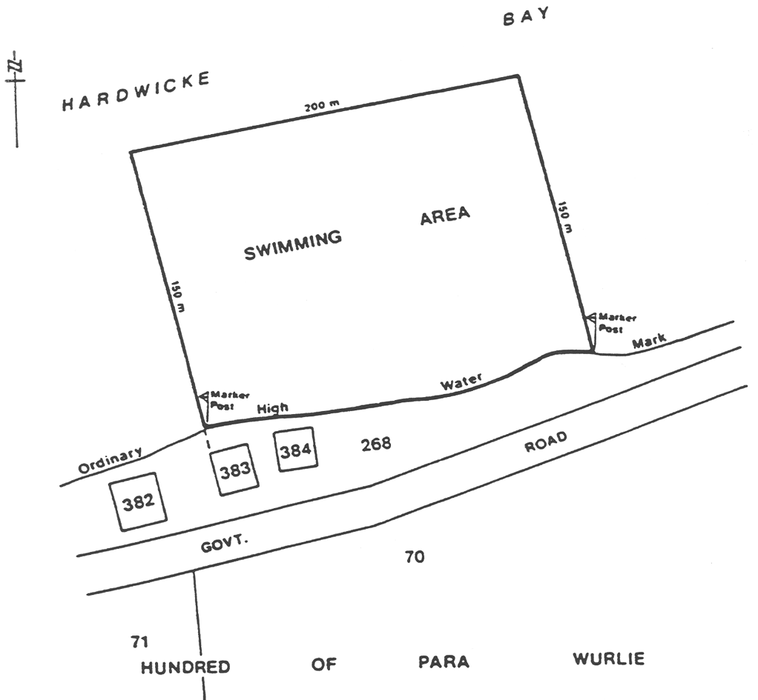
Area 2: the portion of the waters of Hardwicke Bay in Spencer Gulf near Point Turton described as "Area 2" on the plan below:
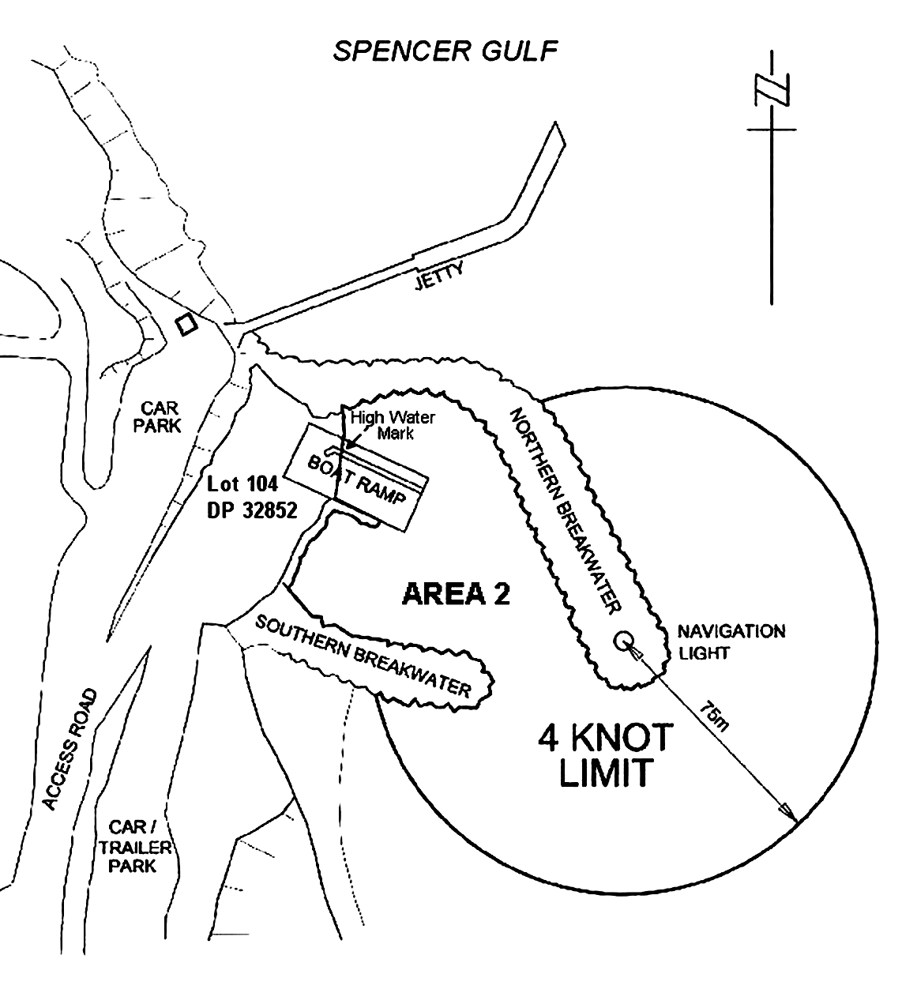
(2) Schedule 5, entry relating to Port Vincent, plan showing restricted areas 1 and 2—delete the plan and substitute:
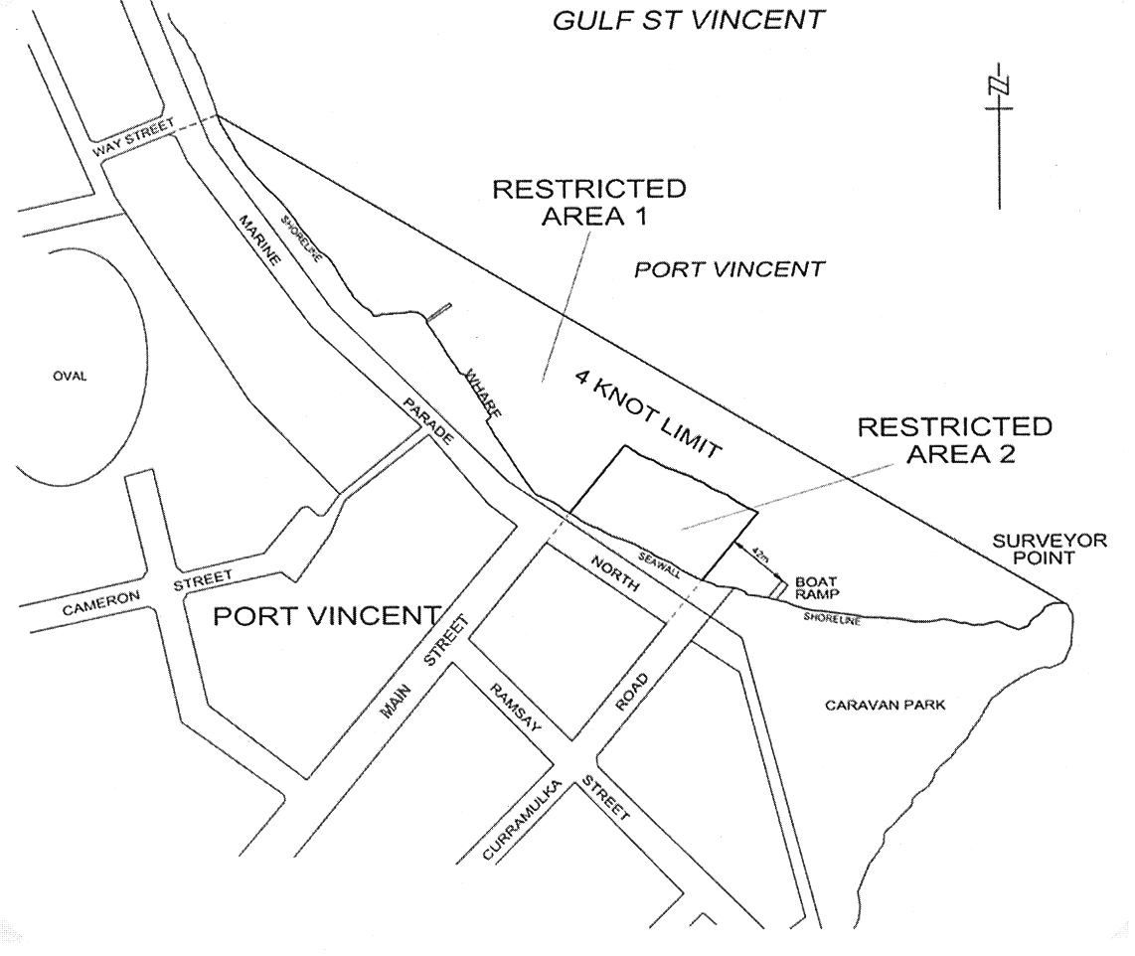
(3) Schedule 5, entry relating to Thistle Island—delete the entry and substitute:
Thistle Island
Area 1: the portion of the waters of Spencer Gulf bounded by a circle of radius 1 nautical mile centred on a point at latitude 34°55.9' south, longitude 136°14.05' east.
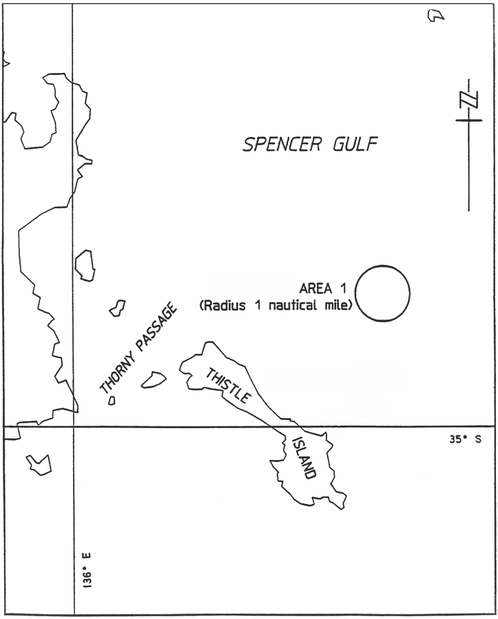
Area 2: the portion of the waters of Spencer Gulf bounded as follows: commencing at high water mark near Horny Point at a point at latitude 35°00'13 south, longitude 136°11'23.712 east, then east in a straight line to a point at latitude 35°00'13 south, longitude 136°12'50.256 east being the intersection of that line with the western circumference of a circle of radius 2 nautical miles centred on a point at latitude 35°00.878' south, longitude 136°15.146' east, then clockwise from that intersection around the circumference to a point on the western circumference of the circle at latitude 35°01'34.212 south, longitude 136°12'51.444 east, then north west in a straight line to high water mark at latitude 35°01'02.496 south, longitude 136°11'36.204 east, then north along high water mark to the point of commencement.
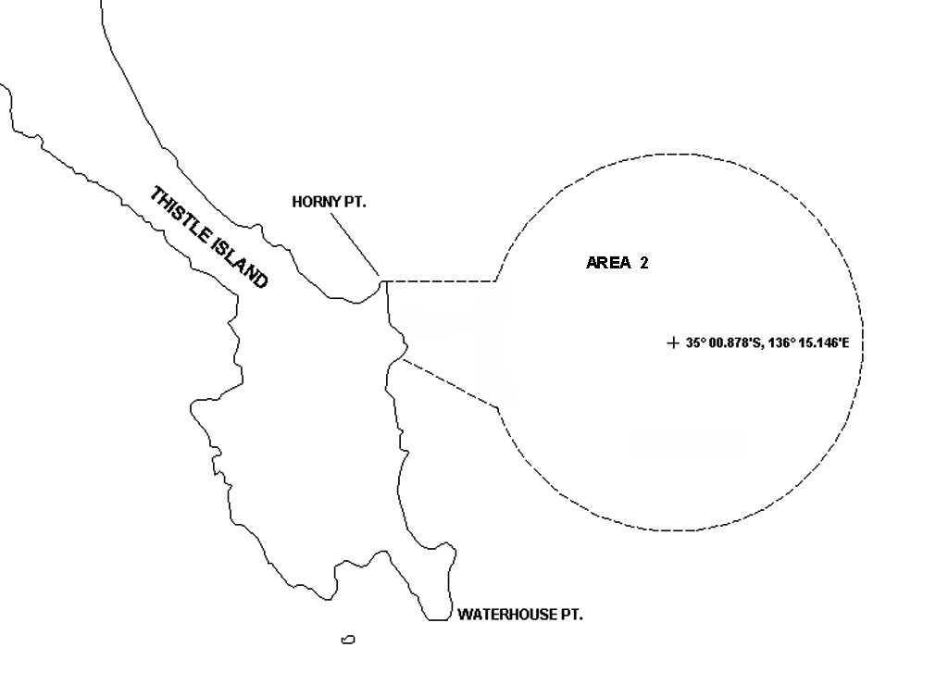
(4) Schedule 5, entry relating to Yatco Lagoon—delete the entry and substitute:
Yatco Lagoon
The whole of Yatco Lagoon being the body of water to the south of a straight line commencing at the point at which the prolongation easterly of the northern boundary of Gogel Road meets the waters edge and extending south easterly to the northernmost point of the headland immediately to the south of Moorook Island.
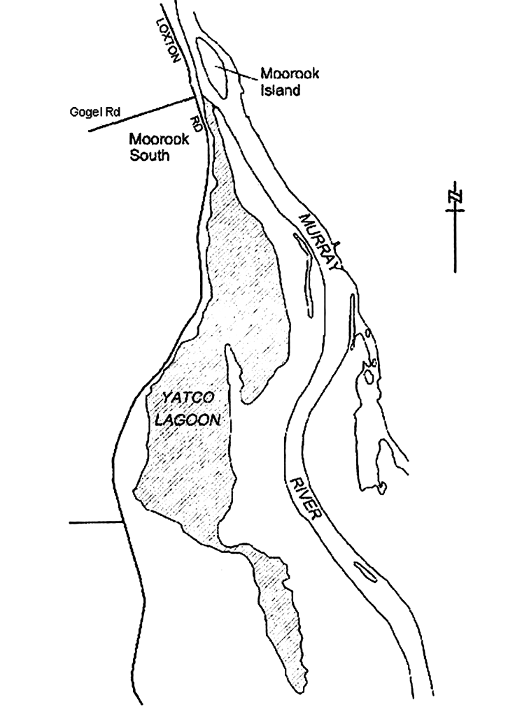
5—Variation of Schedule 10—Speed restrictions in certain waters
(1) Schedule 10, clause 2, paragraph (aa)—delete "Lacipede" wherever occurring and substitute in each case:
Lacepede
(2) Schedule 10, clause 2, paragraph (da)—delete paragraph (da) and substitute:
(da) Wallaroo Bay
Area 1: the portion of the waters of Wallaroo Bay extending to 200 metres seaward from high water mark, bounded at one end by a straight line being the prolongation seaward of the southern boundary of Phillips Street, Wallaroo and at the other by the southern breakwater near Copper Cove Marina;
Area 2: the portion of the waters of Wallaroo Bay extending to 200 metres seaward from high water mark, bounded at one end by the northern breakwater near Copper Cove Marina and at the other by a straight line extending westerly from the northern end of Otago Road, North Beach;
Area 3: the portion of the waters of Wallaroo Bay extending to 200 metres seaward from high water mark, bounded at one end by a straight line being the prolongation seaward of the southern boundary of Oceanview Drive, North Beach and at the other by a straight line being the prolongation seaward of the northern boundary of North Beach Road, North Beach.
Note—
As required by section 10AA(2) of the Subordinate Legislation Act 1978, the Minister has certified that, in the Minister's opinion, it is necessary or appropriate that these regulations come into operation as set out in these regulations.
Made by the Governor
with the advice and consent of the Executive Council
on 20 October 2005
No 225 of 2005
MTR05/035CS

South Australia
Retail and Commercial Leases Variation
Regulations 2005
under the Retail and Commercial Leases Act 1995

Contents
Part 1—Preliminary
1 Short title
2 Commencement
3 Variation provisions
Part 2—Variation of Retail and Commercial Leases Regulations 1995
4 Variation of regulation 4—Exclusions from application of Act

Part 1—Preliminary
1—Short title
These regulations may be cited as the Retail and Commercial Leases Variation Regulations 2005.
2—Commencement
These regulations come into operation on the day on which they are made.
3—Variation provisions
In these regulations, a provision under a heading referring to the variation of specified regulations varies the regulations so specified.
Part 2—Variation of Retail and Commercial Leases Regulations 1995
4—Variation of regulation 4—Exclusions from application of Act
Regulation 4—after subregulation (4) insert:
(5) Pursuant to section 4(3) of the Act, any retail shop lease—
(a) to which Adelaide Airport Limited (ACN 075 176 653) is a party as lessor; and
(b) that is a lease of premises that comprise the whole or any part of the terminal area of Adelaide Airport,
is excluded from the application of sections 41 and 61 of the Act.
(6) In this regulation—
terminal area has the same meaning as in the Airports (Control of On-Airport Activities) Regulations 1997 of the Commonwealth.
Note—
As required by section 10AA(2) of the Subordinate Legislation Act 1978, the Minister has certified that, in the Minister's opinion, it is necessary or appropriate that these regulations come into operation as set out in these regulations.
Made by the Governor
with the advice and consent of the Executive Council
on 20 October 2005
No 226 of 2005
OCBA00009/05

South Australia
Natural Resources Management (Western Mount Lofty Ranges—Prescribed Watercourses) Regulations 2005
under the Natural Resources Management Act 2004

Contents
1 Short title
2 Commencement
3 Interpretation
4 Declaration of prescribed watercourses
5 Establishment and prescribed periods
6 Operation of section 124(4)

1—Short title
These regulations may be cited as the Natural Resources Management (Western Mount Lofty Ranges—Prescribed Watercourses) Regulations 2005.
2—Commencement
These regulations come into operation on the day on which they are made.
3—Interpretation
In these regulations—
Act means the Natural Resources Management Act 2004;
Western Mount Lofty Ranges Prescribed Watercourses means all watercourses within—
(a) the area bounded by the bold red line in GRO Plan No 241/2004; and
(b) the area bounded by the bold red line in GRO Plan No 243/2004.
4—Declaration of prescribed watercourses
The Western Mount Lofty Ranges Prescribed Watercourses are declared to be prescribed watercourses.
5—Establishment and prescribed periods
(1) The establishment period in relation to the prescribed watercourses declared by regulation 4 commenced on 1 July 2001 and ended at the commencement of the prescribed period (14 October 2004).
(2) The prescribed period in relation to the prescribed watercourses declared by regulation 4 commenced on 14 October 2004 and will end on 31 December 2008.
6—Operation of section 124(4)
Pursuant to section 124(5) of the Act, the operation of section 124(4) of the Act is excluded in relation to the prescribed watercourses declared under regulation 4.
Note—
As required by section 10AA(2) of the Subordinate Legislation Act 1978, the Minister has certified that, in the Minister's opinion, it is necessary or appropriate that these regulations come into operation as set out in these regulations.
Made by the Governor
on the recommendation of the Minister for Environment and Conservation and with the advice and consent of the Executive Council
on 20 October 2005
No 227 of 2005
EC05/0067CS

South Australia
Natural Resources Management (Western Mount Lofty Ranges—Prescribed Wells Area) Regulations 2005
under the Natural Resources Management Act 2004

Contents
1 Short title
2 Commencement
3 Interpretation
4 Declaration of prescribed wells
5 Establishment and prescribed periods
6 Operation of section 124(4)

1—Short title
These regulations may be cited as the Natural Resources Management (Western Mount Lofty Ranges—Prescribed Wells Area) Regulations 2005.
2—Commencement
These regulations come into operation on the day on which they are made.
3—Interpretation
In these regulations—
Act means the Natural Resources Management Act 2004;
Western Mount Lofty Ranges Prescribed Wells Area means the area bounded by the bold red line in GRO Plan No 242/2004.
4—Declaration of prescribed wells
Wells situated in the Western Mount Lofty Ranges Prescribed Wells Area and wells drilled in the area after the commencement of these regulations are declared to be prescribed wells.
5—Establishment and prescribed periods
(1) The establishment period in relation to the prescribed wells declared by regulation 4 commenced on 1 July 2001 and ended at the commencement of the prescribed period (14 October 2004).
(2) The prescribed period in relation to the prescribed wells declared by regulation 4 commenced on 14 October 2004 and will end on 31 December 2008.
6—Operation of section 124(4)
Pursuant to section 124(5) of the Act, the operation of section 124(4) of the Act is excluded in relation to the prescribed wells declared under regulation 4.
Note—
As required by section 10AA(2) of the Subordinate Legislation Act 1978, the Minister has certified that, in the Minister's opinion, it is necessary or appropriate that these regulations come into operation as set out in these regulations.
Made by the Governor
on the recommendation of the Minister for Environment and Conservation and with the advice and consent of the Executive Council
on 20 October 2005
No 228 of 2005
EC05/0067CS

South Australia
Natural Resources Management (Western Mount Lofty Ranges—Surface Water Prescribed Area)
Regulations 2005
under the Natural Resources Management Act 2004

Contents
1 Short title
2 Commencement
3 Interpretation
4 Declaration of surface water prescribed area
5 Establishment and prescribed periods
6 Operation of section 124(4)

1—Short title
These regulations may be cited as the Natural Resources Management (Western Mount Lofty Ranges—Surface Water Prescribed Area) Regulations 2005.
2—Commencement
These regulations come into operation on the day on which they are made.
3—Interpretation
In these regulations—
Act means the Natural Resources Management Act 2004;
Western Mount Lofty Ranges Surface Water Area means the area bounded by the bold red line in GRO Plan No 241/2004.
4—Declaration of surface water prescribed area
The Western Mount Lofty Ranges Surface Water Area is declared to be a surface water prescribed area.
5—Establishment and prescribed periods
(1) The establishment period in relation to the surface water prescribed area declared by regulation 4 commenced on 1 July 2001 and ended at the commencement of the prescribed period (14 October 2004).
(2) The prescribed period in relation to the surface water prescribed area declared by regulation 4 commenced on 14 October 2004 and will end on 31 December 2008.
6—Operation of section 124(4)
Pursuant to section 124(5) of the Act, the operation of section 124(4) of the Act is excluded in relation to the surface water prescribed area declared under regulation 4.
Note—
As required by section 10AA(2) of the Subordinate Legislation Act 1978, the Minister has certified that, in the Minister's opinion, it is necessary or appropriate that these regulations come into operation as set out in these regulations.
Made by the Governor
on the recommendation of the Minister for Environment and Conservation and with the advice and consent of the Executive Council
on 20 October 2005
No 229 of 2005
EC05/0067CS

FAXING COPY?
IF you fax copy to Government Publishing SA for inclusion in the Government Gazette, there is no need to send a Confirmation Copy to us as well.
This creates confusion and may well result in your notice being printed twice.
Please use the following fax number:
Fax transmission: (08) 8207 1040
Phone Inquiries: (08) 8207 1045
Please include a contact person, phone number and order number so that we can phone back with any queries we may have regarding the fax copy.
NOTE: Closing time for lodging new copy (fax, hard copy or email) is 4 p.m. on Tuesday preceding the day of publication.

Government Gazette notices can be E-mailed.
The address is:
governmentgazette@saugov.sa.gov.au
Documents should be sent as attachments in Word format.
When sending a document via E-mail, please confirm your transmission with a faxed copy of your document, including the date the notice is to be published.
Fax transmission: (08) 8207 1040
Enquiries: (08) 8207 1045
NOTE: Closing time for lodging new copy (fax, hard copy or email) is 4 p.m. on Tuesday preceding the day of publication.

ADELAIDE CITY COUNCIL
One-Way/Two-Way Traffic Proposal—Morney Street, Adelaide
NOTICE is hereby given, that pursuant to section 32 of the Road Traffic Act 1961, the Adelaide City Council is proposing to introduce one-way/two-way traffic conditions in Morney Street, as per the diagram below.
Purpose: Morney Street will be upgraded as part of the 2005-2006 Capital Works Program which will include the widening of the footpaths.
To enable widened footpaths and possible planting of street trees, it will be necessary to introduce one-way traffic along most of Morney Street. Two-way traffic is proposed to remain in the northern section of Morney Street to facilitate access to the Peter Stevens Motorcycle service area.
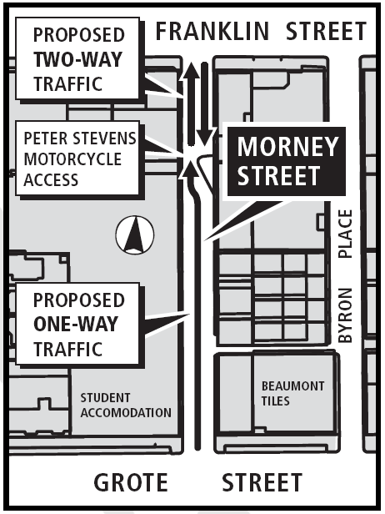
If you wish to comment on the proposal or require any additional information, please contact John Hanchett, telephone 8203 7433, or email: j.hanchett@adelaidecitycouncil.com by no later than Friday, 4 November 2005.
M. Hemmerling, Chief Executive Officer

CITY OF NORWOOD, PAYNEHAM & ST PETERS
Close of Roll for Supplementary Election
NOTICE is hereby given that due to Robert Bria being elected as Mayor of the Council, a supplementary election will be necessary to fill the vacancy of Councillor for Torrens Ward.
The voters roll to conduct this supplementary election will close at 5.00 p.m. on Friday, 28 October 2005.
Nominations to fill the vacancy will open on Thursday, 24 November 2005 and will be received up until 12 noon on Thursday, 15 December 2005.
The election will be conducted entirely by post with the return of ballot material to reach the Returning Officer no later than 12 noon on Monday, 30 January 2006.
Kay Mousley, Returning Officer

CITY OF ONKAPARINGA
Roads (Opening and Closing) Act 1991
NOTICE is hereby given pursuant to section 10 of the Roads (Opening and Closing) Act 1991, that the City of Onkaparinga proposes to make a Road Process Order to close and transfer those portions of Public Road marked ‘A’, ‘B’ and ‘C’ on the Preliminary Plan No. 05/0059:
Transfer ‘A’ to E. M. E. Nominees Pty Ltd, 8 Fourth Avenue, Cheltenham, S.A. 5014 and to merge that portion with certificate of title volume 5767, folio 966.
Transfer ‘B’ to R. J. Strauss, 14 Virgo Avenue, Warradale, S.A. 5046 and V. T. Strauss, 20 The Esplanade, Hallett Cove, S.A. 5158 and to merge that portion with certificate of title volume 5690, folio 584.
Transfer ‘C’ to R. J. Strauss, 14 Virgo Avenue, Warradale, S.A. 5046 and V. T. Strauss, 20 The Esplanade, Hallett Cove, S.A. 5158 and to merge that portion with certificate of title volume 5767, folio 965.
A statement of persons affected by the proposed road process together with a copy of the Preliminary Plan is available for inspection at the Offices of the City of Onkaparinga, Ramsay Place, Noarlunga Centre, during normal office hours. Copies may also be inspected at the Adelaide Office of the Surveyor-General, 101 Grenfell Street, Adelaide, during normal office hours.
Any person is entitled to object to the proposed road process, or any person affected by the proposed closure is entitled to apply for an easement to be granted in that person’s favour over the land subject to the proposed closure. Such objection or application for an easement must set out the full name and address of the person making the objection of application and must be fully supported by reasons. Any application for an easement must give full particulars of the nature and location of the easement land, where made by a person as the owner of adjoining land or nearby land, specify the land to which the easement is to be annexed.
The objection or application for an easement must be made in writing to the City of Onkaparinga, P.O. Box 1, Noarlunga Centre, S.A. 5168, within 28 days of this notice, and a copy shall be forwarded to the Adelaide office of the Surveyor-General, G.P.O. Box 1354, Adelaide, S.A. 5001. Where a submission is made, the City of Onkaparinga will give notification of a meeting at which the matter will be considered, so that the person making the submission or a representative may attend, if so desired.
Dated 20 October 2005.
J. Tate, City Manager

CITY OF ONKAPARINGA
Roads (Opening and Closing) Act 1991
Road Opening and Closing—Main South Road, O’Halloran Hill
NOTICE is hereby given, pursuant to section 10 of the Roads (Opening and Closing) Act 1991, that the City of Onkaparinga proposes to make a Road Process Order to:
(i) open as road portion of allotment 1 in Filed Plan 4986, more particularly delineated and numbered ‘1’ on Preliminary Plan No. 05/0058 and
(ii) to close and transfer to M. G. Wilson and C. G. Nixon portion of the public road adjoining allotment 1 in Filed Plan 4986 in exchange for land taken for new road ‘1’ (above), more particularly delineated and lettered ‘A’ in Preliminary Plan No. 05/0058.
A copy of the plan and a statement of persons affected are available for public inspection at the offices of the Council at Ramsay Place, Noarlunga Centre and the Adelaide office of the Surveyor-General during normal office hours.
Any application for easement or objection must set out the full name, address and details of the submission and must be fully supported by reasons.
The application for easement or objection must be made in writing to the Council, P.O. Box 1, Noarlunga Centre, S.A. 5168 within 28 days of this notice and a copy must be forwarded to the Surveyor-General, G.P.O. Box 1354, Adelaide, S.A. 5001. Where a submission is made, the Council will give notification of a meeting at which the matter will be considered.
Dated 20 October 2005.
J. Tate, City Manager

CITY OF ONKAPARINGA
Roads (Opening and Closing) Act 1991
NOTICE is hereby given pursuant to section 10 of the Roads (Opening and Closing) Act 1991, that the City of Onkaparinga proposes to make a Road Process Order to close and transfer the whole of Public Road marked ‘A’ on Preliminary Plan No. 05/0057:
Transfer ‘A’ to A. J. Richardson and T. M. Sayers, 605 Cherry Gardens Road, Cherry Gardens, S.A. 5157, and to merge that portion with certificate of title volume 5880, folio 495.
A statement of persons affected by the proposed road process together with a copy of the Preliminary Plan is available for inspection at the Offices of the City of Onkaparinga, Ramsay Place, Noarlunga Centre, during normal office hours. Copies may also be inspected at the Adelaide office of the Surveyor-General, 101 Grenfell Street, Adelaide, during normal office hours.
Any person is entitled to object to the proposed road process, or any person affected by the proposed closure is entitled to apply for an easement to be granted in that person’s favour over the land subject to the proposed closure. Such objection or application for an easement must set out the full name and address of the person making the objection of application and must be fully supported by reasons. Any application for an easement must give full particulars of the nature and location of the easement land, where made by a person as the owner of adjoining land or nearby land, specify the land to which the easement is to be annexed.
The objection or application for an easement must be made in writing to the City of Onkaparinga, P.O. Box 1, Noarlunga Centre, S.A. 5168, within 28 days of this notice, and a copy shall be forwarded to the Adelaide office of the Surveyor-General, G.P.O. Box 1354, Adelaide, S.A. 5001. Where a submission is made, the City of Onkaparinga will give notification of a meeting at which the matter will be considered, so that the person making the submission or a representative may attend, if so desired.
Dated 20 October 2005.
J. Tate, City Manager

CITY OF PORT ADELAIDE ENFIELD
Conversion of Private Roads to Public Roads
NOTICE is hereby given pursuant to section 210 (2) (b) of the Local Government Act 1999, that the City of Port Adelaide Enfield intends to declare the following private roads:
Unnamed road, Rosewater
The unnamed private road in Deposited Plan 921 being abutted on the western side by allotments 31 to 42 and on the eastern side by allotments 9 to 22 and contained within certificate of title volume 522, folio 109.
Unnamed road, Rosewater
The unnamed private road in Deposited Plan 921 situated between Evans and Jenkins Streets, Rosewater being abutted on the northern side by allotments 23 to 28 in Deposited Plan 921 and allotment 58 in Filed Plan 126438 and on the southern side by allotments 22 and 31 in Deposited Plan 921 and contained within certificate of title volume 522, folio 109, to be public roads.
A copy of the plan indicating the location of the private roads is on display in the Civic Centre, 163 St Vincent Street, Port Adelaide and at the Regional Offices situated in the Enfield, Greenacres and Parks Libraries and on Council’s Community website: www.portenf.sa.gov.au.
Residents may obtain further information and request that a copy of the plan be posted to them by contacting Gary Baron on Telephone: (08) 8405 6852, Fax: (08) 8405 6666 or Email: gbaron@portenf.sa.gov.au.
Dated 20 October 2005.
H. J. Wierda, City Manager

TOWN OF WALKERVILLE
Change of Meeting Date
NOTICE is hereby given that the meeting of Council scheduled for Monday, 7 November 2005 will be deferred and held on Monday, 14 November 2005, commencing at 7 p.m.
R. H. Wallace, Chief Executive

DISTRICT COUNCIL OF KAROONDA EAST MURRAY
Appointments
NOTICE is hereby given that at a meeting of the Council held on 11 October 2005, John Thomas Claydon and Peter Smithson were appointed as Authorised Officers, pursuant to section 27 of the Dog and Cat Management Act 1995.
P. Smithson, Chief Executive Officer

DISTRICT COUNCIL OF ORROROO CARRIETON
Amended Notice of Adoption of Valuation
and Declaration of Rates
NOTICE is hereby given that the District Council of Orroroo Carrieton at its meeting held on 19 July 2005, resolved for the financial year commencing on 1 July 2005, the following:
Adoption of Valuation
1. That in accordance with the provisions of section 167 (2) (a) of the Local Government Act 1999, the Council adopt, for rating purposes for the year ending 30 June 2006, the most recent capital valuations determined by the Valuer-General and applicable to land within the area of the Council totalling $134 097 500.
Declaration of Rates
2. Pursuant to sections 152 (1) (c) and 153 (1) (a) of the Local Government Act 1999, the Council declares a general rate within the area of the Council for the financial year ending 30 June 2006 based on two components, as follows:
(i) a rate based on the value of land of 0.261 cents in the dollar; and
(ii) a fixed charge of $150.
Refuse Collection
3. Pursuant to section 155 of the Local Government Act 1999, the Council fixed an annual service charge of $130 for the year ending 30 June 2006 on all land within the area of the Council to which the refuse collection service is provided.
Payment of Rate
4. Pursuant to section 181 (2) (a) of the Local Government Act 1999, the payment of all rates and charges which have been declared or imposed by the Council for the financial year ending 30 June 2006 shall be payable in four equal instalments with instalments falling due on 2 September 2005, 9 December 2005, 10 March 2006 and 30 June 2006.
A. J. Renshaw, Chief Executive Officer

WAKEFIELD REGIONAL COUNCIL
Development Act 1993
Port Wakefield Town Plan Amendment Report Prepared by the Council—For Public Consultation
NOTICE is hereby given that the Wakefield Regional Council has prepared a draft Plan Amendment Report to amend its current Development Plan to address planning and development issues at Port Wakefield.
Matters addressed in the draft Plan Amendment Report include:
• The re-zoning of the current Historic Centre Zone to Residential.
• The creation of a Tourist Accommodation Zone over the caravan park, wharf area and adjacent shack sites.
• The creation of a new area for the development of a Town Centre.
• Re-zoning of the current Light Industry Zone to Commercial.
• Re-zoning of land generally to the east of township to accommodate future residential growth including an area for Country Living.
• The establishment of a structure plan to facilitate the orderly realignment of the Balaklava to Port Wakefield Road and the establishment of a possible outer by-pass route for National Highway 1.
The draft Plan Amendment Report and statement will be available for public inspection and purchase during normal office hours at the Council Office, Scotland Place, Balaklava or is available on Council’s website at www.wakefieldrc.sa.gov.au from Thursday, 20 October 2005 to Tuesday, 20 December 2005.
Written submissions regarding the draft amendment should be lodged no later than 5 p.m. on Tuesday, 20 December 2005. All submissions should be addressed to the Chief Executive Officer, Wakefield Regional Council, P.O. Box 167, Balaklava, S.A. 5461, and should clearly indicate whether you wish to be heard in support of your submission.
Copies of all submissions will be available for inspection by interested persons at the Council Offices from Wednesday,
21 December 2005 until the public hearing.
A hearing will be held at 5 p.m. on Wednesday, 18 January 2006 in the Council Chambers, Scotland Place, Balaklava.
The hearing will not be held if no submissions are received or if no submission has a request to be heard.
Dated 19 October 2005.
P. Barry, Chief Executive Officer

IN the matter of the estates of the undermentioned deceased persons:
Beckett, Bruce Patrick, late of The Terrace, Port Pirie, retired rigger, who died on 3 August 2005.
Brown, Maxwell George, late of 80 Moseley Street, Glenelg South, retired electrical fitter, who died on 4 August 2005.
Carr, Valerie Mary, late of 110 Strathfield Terrace, Largs North, widow, who died on 17 August 2005.
Francis, Fay Joy, late of 2 Jelley Street, Woodville, of no occupation, who died on 24 February 2005.
Gale, Kenneth Vivian, late of 1-7 Leicester Street, Clearview, retired school teacher, who died on 16 August 2005.
Hoskin, James Phillip, late of 34 Grange Road, West Hindmarsh, retired mechanical inspector, who died on 9 August 2005.
Mahoney, David, late of 18 Fourth Avenue, Klemzig, retired public servant, who died on 30 August 2005.
Menzies, Dorothy, late of 8 Poltawa Terrace, Broadview, widow, who died on 15 September 2005.
Prew, Dorothy May, late of 26 River Road, Port Noarlunga, of no occupation, who died on 20 June 2005.
Prior, Cora Gwendoline, late of 26 River Road, Port Noarlunga, of no occupation, who died on 12 November 2004.
Sala, Carlo, late of 1 Masut Place, Coober Pedy, retired opal miner, who died on 25 May 2005.
Saunders, William Harold, late of 50 Gulfview Road, Christies Beach, retired transport officer, who died on 27 August 2005.
Taylor, Edna Millicent, late of 71 Stokes Terrace, Port Augusta West, of no occupation, who died on 31 August 2005.
Webster, Winifred May, late of Everard Street, Largs Bay, of no occupation, who died on 23 August 2005.
Zarins, Haralds, late of 46 Padbury Road, Gilles Plains, retired fireman, who died on 17 August 2005.
Notice is hereby given pursuant to the Trustee Act 1936, as amended, the Inheritance (Family Provision) Act 1972, and the Family Relationships Act 1975, that all creditors, beneficiaries, and other persons having claims against the said estates are required to send, in writing, to the Public Trustee, 25 Franklin Street, Adelaide, S.A. 5000, full particulars and proof of such claims, on or before 18 November 2005, otherwise they will be excluded from the distribution of the said estate; and notice is also hereby given that all persons who are indebted to the said estates are required to pay the amount of their debts to the Public Trustee or proceedings will be taken for the recovery thereof; and all persons having any property belonging to the said estates are forthwith to deliver the same to the Public Trustee.
Dated 20 October 2005.
C. J. O’Loughlin, Public Trustee

SALE OF PROPERTY
Auction Date: Wednesday, 26 October 2005 at 10 a.m.
Location: Government Auctions SA
47 Transport Avenue, Netley
NOTICE is hereby given that on the above date at the time and place stated, by virtue of Orders for Sale issued by the Fines Payment Unit of South Australia, Penalty No. EXREG 05/18311-1 and others, are directed to the Sheriff of South Australia in an action wherein Jims Fruit & Veg Pty Ltd is the Defendant, I, Mark Stokes, Sheriff of the State of South Australia, will by my auctioneers, Government Auctions SA make sale of the following:
Mitsubishi L300 Express
Registration Number: UAS 702

SALE OF PROPERTY
Auction Date: Wednesday, 26 October 2005 at 10 a.m.
Location: Government Auctions SA
47 Transport Avenue, Netley
NOTICE is hereby given that on the above date at the time and place stated, by virtue of Orders for Sale issued by the Fines Payment Unit of South Australia, Penalty No. EXREG 04/49475-1 and others, are directed to the Sheriff of South Australia in an action wherein Silvio Fontanarosa is the Defendant, I, Mark Stokes, Sheriff of the State of South Australia, will by my auctioneers, Government Auctions SA make sale of the following:
Ford Falcon XF
Registration Number: UER 157

ATTENTION

CUSTOMERS requiring a proof of their notice for inclusion in the Government Gazette, please note that the onus is on you to inform Government Publishing SA of any subsequent corrections by 10 a.m. on Thursday, which is our publication deadline.

For any corrections to your notice please phone 8207 1045 or Fax 8207 1040 before 10 a.m. on Thursday.

If we do not receive any communication by 10 a.m. on Thursday (day of publication) we will presume the notice is correct and will print it as it is.

Remember—the onus is on you to inform us of any corrections necessary to your notice.

NOTE: Closing time for lodging new copy (electronically, fax or hard copy) is 4 p.m. on Tuesday preceding the day of publication. Phone 8207 1045—Fax 8207 1040.
Email: governmentgazette@saugov.sa.gov.au

Printed and published by authority every Thursday by K. O’CALLAGHAN, Government Printer, South Australia
Price: $5.00, plus postage; to subscribers, $254.00 per annum.
(The above prices are inclusive of GST)

