SUPPLEMENTARY GAZETTE



THE SOUTH AUSTRALIAN

GOVERNMENT GAZETTE

PUBLISHED BY AUTHORITY

ALL PUBLIC ACTS appearing in this GAZETTE are to be considered official, and obeyed as such

ADELAIDE, FRIDAY, 9 APRIL 1999

SOUTH AUSTRALIAN MOTOR SPORT ACT 1984: SECTION 20 (2)⎯DECLARATION OF AREA
Notice by the Premier
PURSUANT to section 20 (2) of the South Australian Motor Sport Act 1984, I, the Minister to whom the administration of the Act has been committed, in respect of the motor sport event promoted by the South Australian Motor Sport Board under the name 1999 Sensational Adelaide 500, acting on the recommendation of the Board, declare:
(a) that the area previously declared to be the declared area is varied, such that the area delineated on the plan in the schedule will be the declared area under section 20 (1) of the Act for the purposes of the event.
John Olsen, Premier

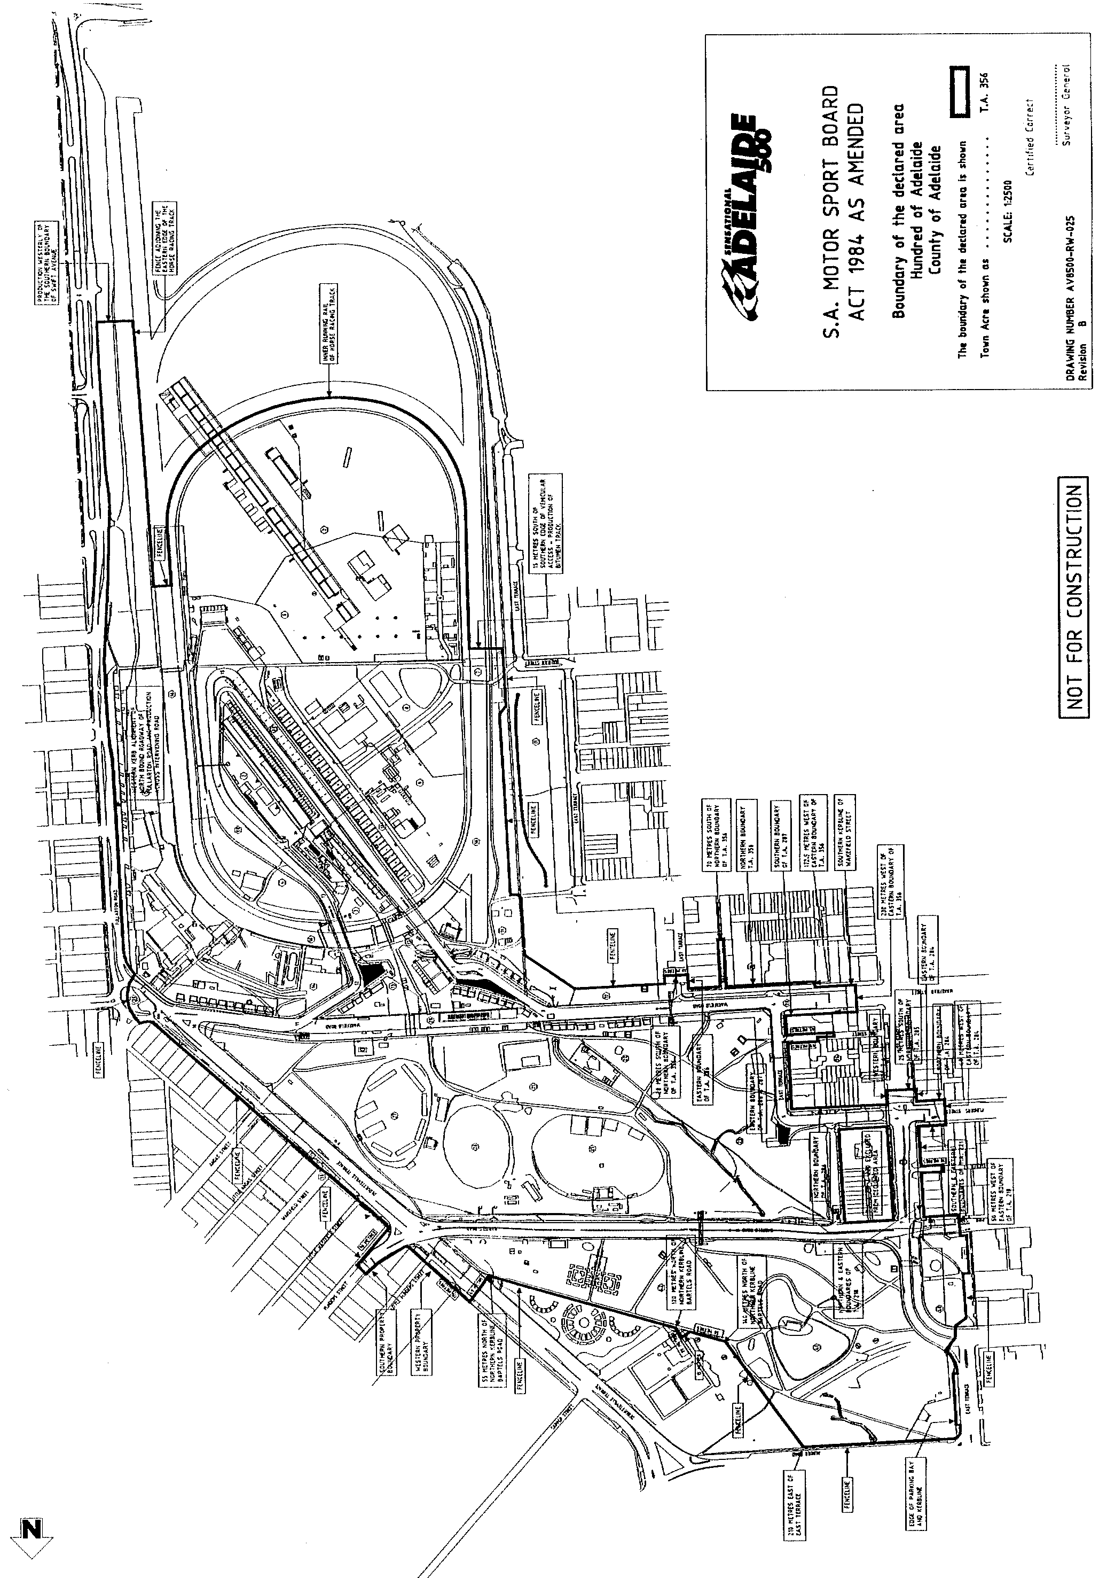
M. E. JONES, Acting Government Printer, South Australia

