SUPPLEMENTARY GAZETTE



THE SOUTH AUSTRALIAN

GOVERNMENT GAZETTE

PUBLISHED BY AUTHORITY

ALL PUBLIC ACTS appearing in this GAZETTE are to be considered official, and obeyed as such

ADELAIDE, THURSDAY, 5 AUGUST 1999

FISHERIES ACT 1982: SECTION 59
TAKE note that the notice made under section 59 of the Fsheries Act 1982, and published in the South Australian Government Gazette on page 152, dated 5 July 1999, being the fourth notice on that page, referring to the Scheme of Management (River Fishery) Regulations 1991, is hereby revoked.
Dated 31 July 1999.
D. Mackie, Manager, Legislation and Policy

FISHERIES ACT 1982: SECTION 59
TAKE notice that pursuant to section 59 of the Fisheries Act 1982, those holders of a licence issued pursuant to the Scheme of Management (River Fishery) Regulations 1991 (hereinafter referred to as the ‘fishers’) are exempted from the provisions of section 41 of the Fisheries Act 1982, in that the fishers shall not be guilty of an offence when using a hauling net for the purpose of trade or business (hereinafter referred to as the ‘permitted activity’), in the waters specified in Schedule 1 for the taking of the species specified in Schedule 2 subject to the conditions specified in Schedule 3, from 1 July 1999 until 30 June 2000.
Schedule 1
1. The Reach Box, defined for the purpose of this notice as the waters of the River Murray (excluding the main stream of the River) bounded by the co-ordinates referred to on the front of the licence holder’s licence.
2. Common Backwaters, defined for the purpose of this notice as all waters of the River Murray excluding:
• the waters of the main stream; and
• the waters included in the reach areas specified in Part 1 of Schedule 4.
• the waters described in Part 2 of Schedule 4.
3. The main stream of the River Murray for the purposes of this notice is defined as the waters shown as the main stream on the topographical maps described in Part 3 of Schedule 4.
Schedule 2
1. All non-native species and Bony Bream (Nematalosa erebi).
Schedule 3
1. The fishers may use no more than one hauling net at any one time.
2. Any hauling net used pursuant to this notice must have a total headline length not exceeding 240 m, a drop of no more than 2.7 m, and a mesh size no greater than 100 mm.
3. At least 24 hours prior to conducting any fishing activity in the common backwaters (as defined in Schedule 1), the fisher must notify PIRSA Fisheries and Aquaculture on 1800 065 522 and provide the following information:
(a) the name of the person making the call and the licence number to which the call relates; and
(b) the date and location of conducting the permitted activity.
4. The permit holder shall not contravene or fail to comply with the Fisheries Act 1982, or any regulations made under that Act, except where specifically exempted by this notice.

Schedule 4
Part 1.

Reach No. | Coordinate No.  (in succession) | Coordinates for Reach Box  Specifying Adjacent  Backwaters
R51 | 1 | 497500E, 623555N
 | 2 | 500150E, 623835N
 | 3 | 500150E, 623560N
 | 4 | 498900E, 623345N
R52 | 1 | 496100E, 623995N
 | 2 | 498300E, 624755N
 | 3 | 500150E, 624520N
 | 4 | 500150E, 623835N
 | 5 | 497500E, 623555N
R60 | 1 | 496100E, 623995N
 | 2 | 499000E, 624980N
 | 3 | 492500E, 624995N
 | 4 | 492350E, 624130N
 | 5 | 492500E, 624050N
R41 | 1 | 490400E, 623500N
 | 2 | 489200E, 624600N
 | 3 | 487200E, 624110N
 | 4 | 487600E, 623440N
R61 | 1 | 487650E, 623345N
 | 2 | 487100E, 624105N
 | 3 | 480005E, 623680N
R44 | 1 | 487400E, 623355N
 | 2 | 480005E, 623680N
 | 3 | 478350E, 623450N
 | 4 | 483800E, 623180N
 | 5 | 484450E, 623175N
 | 6 | 484450E, 623160N
R49 | 1 | 481000E, 622775N
 | 2 | 473600E, 623305N
 | 3 | 472100E, 623050N
 | 4 | 475400E, 622405N
R57 | 1 | 486050E, 621485N
 | 2 | 477500E, 621480N
 | 3 | 474150E, 621175N
 | 4 | 480350E, 620275N
R04 | 1 | 473800E, 621230N
 | 2 | 471850E, 621230N
 | 3 | 471900E, 620695N
 | 4 | 477550E, 620695N
R43 | 1 | 470650N, 620640N
 | 2 | 462000E, 620245N
 | 3 | 458900E, 629975N
 | 4 | 471600E, 620000N
R46 | 1 | 461100E, 619950N
 | 2 | 456250E, 620010N
 | 3 | 456350E, 619745N
 | 4 | 460800E, 619780N
 | 5 | 460800E, 619770N
 | 6 | 462100E, 619785N
R21 | 1 | 462100E, 619785N
 | 2 | 456350E, 619745N
 | 3 | 458100E, 619500N
 | 4 | 462100E, 619600N
R18 | 1 | 454500E, 619505N
 | 2 | 449800E, 619170N
 | 3 | 453000E, 619030N
 | 4 | 454600E, 619030N
R27 | 1 | 445150E, 620530N
 | 2 | 441000E, 620410N
 | 3 | 441000E, 619690N
 | 4 | 446000E, 619875N
R59 | 1 | 440700E, 621910N
 | 2 | 438100E, 621805N
 | 3 | 438700E, 621415N
 | 4 | 440750E, 621685N
R54 | 1 | 437450E, 621980N
 | 2 | 432800E, 621840N
 | 3 | 432500E, 621800N
 | 4 | 435200E, 621575N
 | 5 | 438400E, 621910N
R40 | 1 | 433150E, 621885N
 | 2 | 427450E, 621920N
 | 3 | 426400E, 621750N
 | 4 | 431800E, 621710N
R06 | 1 | 418050E, 621800N
 | 2 | 410900E, 622015N
 | 3 | 410400E, 621960N
 | 4 | 411800E, 621720N
 | 5 | 419150E, 621540N
R37 | 1 | 400700E, 622780N
 | 2 | 398950E, 622960N
 | 3 | 394700E, 622670N
 | 4 | 396400E, 622450N
R47 | 1 | 395650E, 623100N
 | 2 | 392550E, 623480N
 | 3 | 387000E, 622950N
 | 4 | 393600E, 623155N
 | 5 | 393600E, 623080N
R32 | 1 | 377500E, 621945N
 | 2 | 375400E, 621940N
 | 3 | 373900E, 621480N
 | 4 | 375650E, 621390N
R56 | 1 | 375750E, 621385N
 | 2 | 373800E, 621485N
 | 3 | 372750E, 620690N
 | 4 | 374500E, 620750N
R42 | 1 | 375650E, 620605N
 | 2 | 373711E, 620550N
 | 3 | 373450E, 620330N
 | 4 | 375200E, 620250N
R33 | 1 | 372750E, 619120N
 | 2 | 371550E, 619120N
 | 3 | 370700E, 618460N
 | 4 | 372200E, 618415N
R16 | 1 | 371800E, 618430N
 | 2 | 369200E, 618515N
 | 3 | 368350E, 617865N
 | 4 | 370500E, 617900N
R03 | 1 | 378400E, 616695N
 | 2 | 375350E, 616850N
 | 3 | 373750E, 616605N
 | 4 | 377200E, 616450N
R24 | 1 | 376650E, 616140N
 | 2 | 372100E, 616225N
 | 3 | 367700E, 615750N
 | 4 | 368350E, 615670N
R39 | 1 | 371450E, 614610N
 | 2 | 368500E, 615110N
 | 3 | 365850E, 614930N
 | 4 | 370050E, 614130N
R26 | 1 | 366200E, 614040N
 | 2 | 362100E, 614040N
 | 3 | 361750E, 613910N
 | 4 | 366400E, 613915N
R10 | 1 | 357700E, 609930N
 | 2 | 353600E, 610310N
 | 3 | 352550E, 610120N
 | 4 | 356650E, 609770M

* All co-ordinates are given in AMG 1984.

Part 2.

Lake Merreti (closed from August to January)
Lake Littra and outflow channel
Clover Lake
Coombool Swamp
Lake Limbra and outflow channel
Lake Woolpolool
Ral Ral Creek below Chaffey Pump and entrance waters to Lake Merreti
Katarapko Creek
Bulyong Creek
Pilby Creek
Lake Bonney
Cobdogla Swamp (closed from August to April)
Loveday Swamp/Mussel lagoons (closed from August to April)
Hancock Creek
Selected areas (refer attachment 1) of the Mundic/Pike system, including a small part of the Mundic Creek during flood periods when birds breed.

Part 3.

1:50 000 topographic map CHOWILLA 7030-2 & PT 7130-3, PARINGA 7029-1, RENMARK 7029-4, LOXTON 7029-3, MOOROOK 6929-2, OVERLAND CORNER 6929-1, POOGINOOK 6929-4, CADELL 6829-1, MORGAN 6829-4, BLANCHETOWN 6829-3, SWAN REACH 6828-4, CAURNAMONT 6828-3, MANNUM 6728-2, MOBILONG 6727-1, WELLINGTON 6727-2.

Attachment 1

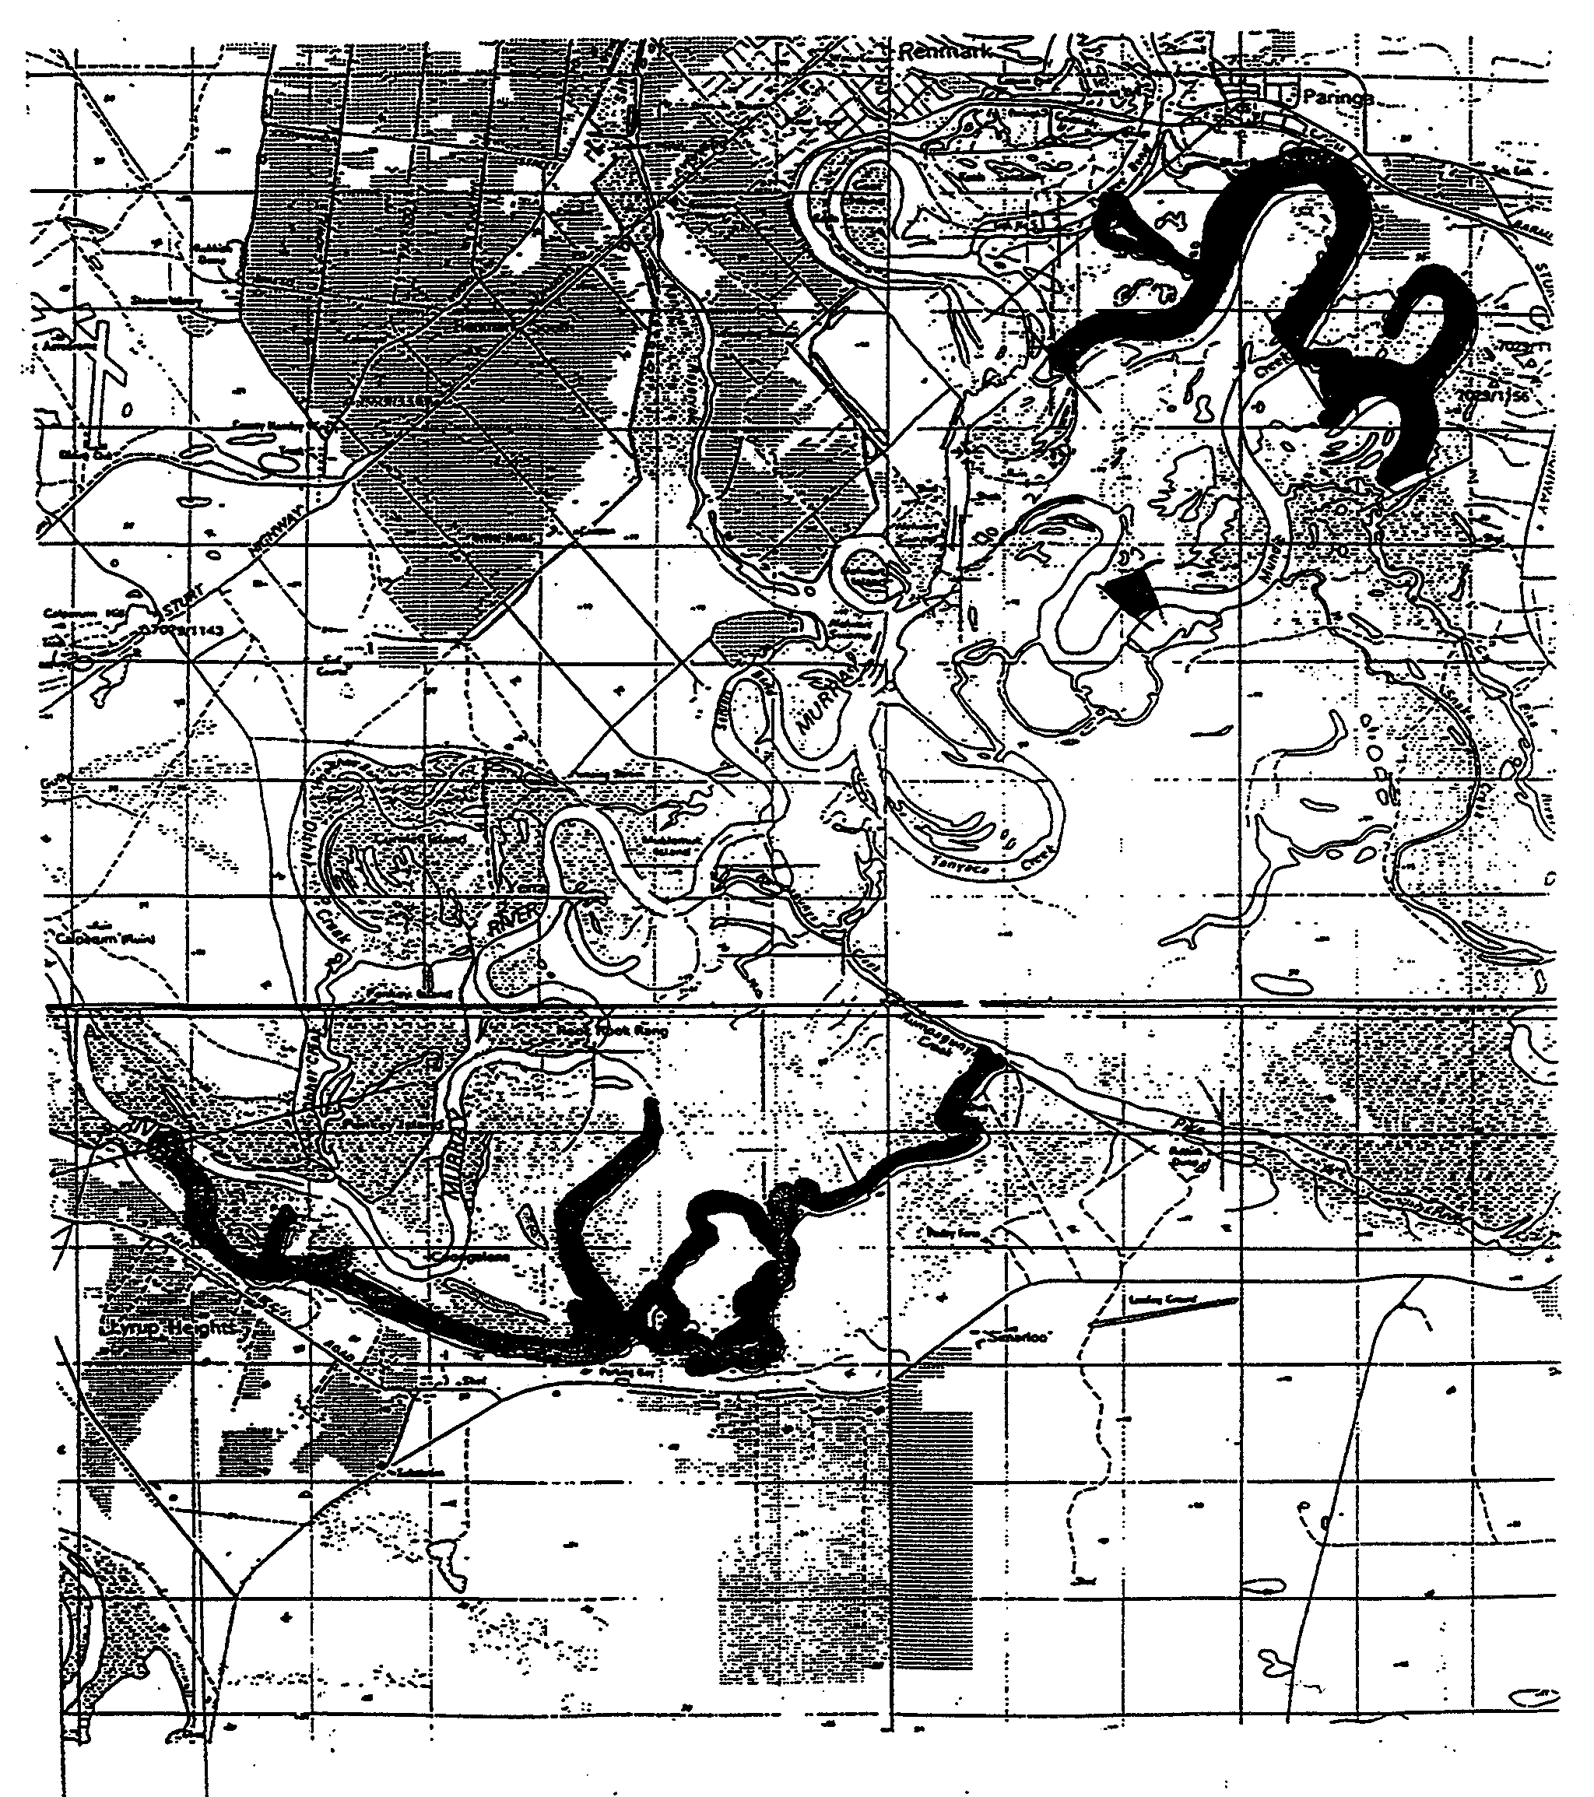

Dated 31 June 1999.
D. Mackie, Manager, Legislation and Policy

M. E. JONES, Acting Government Printer, South Australia

