SUPPLEMENTARY GAZETTE



THE SOUTH AUSTRALIAN

GOVERNMENT GAZETTE

PUBLISHED BY AUTHORITY

ALL PUBLIC ACTS appearing in this GAZETTE are to be considered official, and obeyed as such

ADELAIDE, MONDAY, 9 AUGUST 1999

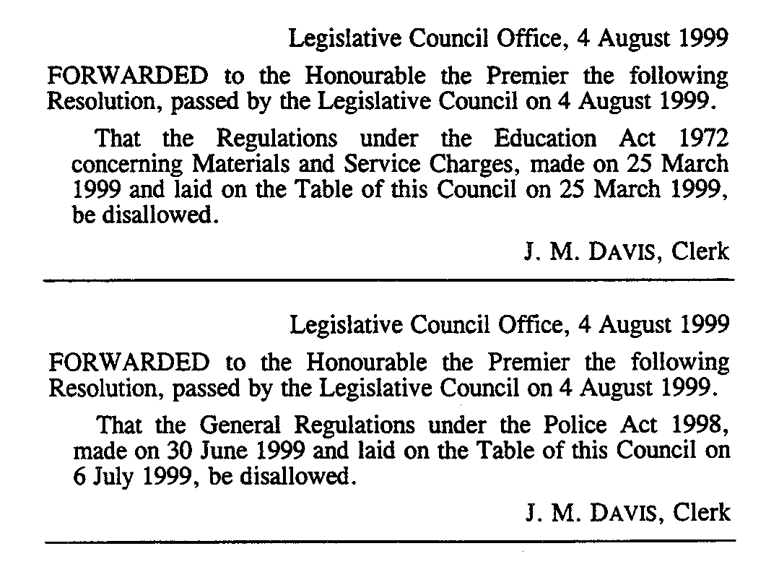

M. G. O’CALLAGHAN, Government Printer, South Australia

