No. 14 585

THE SOUTH AUSTRALIAN

GOVERNMENT GAZETTE

PUBLISHED BY AUTHORITY

ALL PUBLIC ACTS appearing in this GAZETTE are to be considered official, and obeyed as such

ADELAIDE, THURSDAY, 28 JANUARY 1999

CONTENTS

Page
Appointments, Resignations, Etc. 586
Commercial Motor Vehicles (Hours of Driving)
Act 1973⎯Notice 586
Corporations and District Councils—Notices 645
Crown Lands Act 1929—Notices 586
Dental Board of South Australia—Register 588
Gaming Machines Act 1992—Notices 609
Geographical Names Act 1991⎯Notices 609
Land and Business (Sale and Conveyancing)
Act 1994—Notice 611
Liquor Licensing Act 1997—Notices 611
Local Government Act 1934—Notice 616
Mining Act 1971—Notices 613
Page
Motor Vehicles Act 1959—Notice 613
National Parks and Wildlife Act 1972—Notices 617
Private Advertisements 647
Proclamations 587
Public Trustee Office—Administration of Estates 646
Racing Act 1976—Rules 619
REGULATION
Legal Practitioners Act 1981 (No. 7 of 1999) 635
Roads (Opening and Closing) Act 1991⎯Notices 618
Rules of Court 619
Sale of Property 648
Unclaimed Moneys Act 1891⎯Notices 649
Water Mains and Sewers—Mains Laid, Replaced, Etc 633

GOVERNMENT GAZETTE NOTICES
ALL poundkeepers' and private advertisements forwarded for publication in the South Australian Government Gazette must be PAID FOR PRIOR TO INSERTION; and all notices, from whatever source, should be legibly written on one side of the paper only and sent to Riverside 2000 so as to be received no later than 4 p.m. Tuesday preceding the day of publication. Phone 8207 1045 or Fax 8207 1040.

Department of the Premier and Cabinet
Adelaide, 28 January 1999
HIS Excellency the Governor in Executive Council has been pleased to appoint the undermentioned to the Public and Environmental Health Council, pursuant to the provisions of the Public and Environmental Health Act 1987:
Member: (from 28 January 1999 until 27 January 2002)
Prof Brendon John Kearney, MBBS, MRACP, FRACP, FRACMA, FCHSE, FFPHM, FACPE
Dr Nancy Judith Cromar, BSc (Hons), PhD
Deputy Member: (from 28 January 1999 until 27 January 2002)
Jane Shirley Heyworth, BAppSc(EnvHlth), GradDip-HlthSciences, MPH
By command,
Iain Evans, for Premier
MHS 030/004/044CS

Department of the Premier and Cabinet
Adelaide, 28 January 1999
HIS Excellency the Governor in Executive Council has been pleased to appoint the undermentioned to the South Australian Council on Reproductive Technology, pursuant to the provisions of the Reproductive Technology Act 1988:
Member: (from 28 January 1999 until 23 December 2000)
Prof Robert John Norman, MB ChB, MRCOG, MRC Path, CREI, FRCOG, FRCPA, FRACOG
Deputy Member: (from 28 January 1999 until 23 December 2000)
Dr Oswald Marino Petrucco, MB BS, MRCOG, FRACOG, FRCOG
By command,
Iain Evans, for Premier
MHS 030/075/009CS

Department of the Premier and Cabinet
Adelaide, 28 January 1999
HIS Excellency the Governor in Executive Council has been pleased to appoint the undermentioned to the South Australian Community Housing Authority (SACHA), pursuant to the provisions of the South Australian Co-operative and Community Housing Act 1991:
Member: (from 5 February 1999 until 1 September 2000)
Barry Burgan
Member: (from 5 February 1999 until 4 February 2000)
Gordon Cleve Folland
Presiding Member: (from 5 February 1999 until 1 September 2000)
Barry Burgan
By command,
Iain Evans, for Premier
MHS 21/98CS

Department of the Premier and Cabinet
Adelaide, 28 January 1999
HIS Excellency the Governor in Executive Council has been pleased to appoint the undermentioned to the Art Gallery Board, pursuant to the provisions of the Art Gallery Act 1939:
Member: (from 28 January 1999 until 19 January 2001)
Geoffrey David Pitt
Candy Bennett
By command,
Iain Evans, for Premier
ACD 001/94CS

Department of the Premier and Cabinet
Adelaide, 28 January 1999
HIS Excellency the Governor in Executive Council has been pleased to appoint Lynden Wayne Slape as a Deputy Registrar-General of Deeds, pursuant to section 6 (1) of the Registration of Deeds Act 1935.
By command,
Iain Evans, for Premier
ATTG 17/97CS

COMMERCIAL MOTOR VEHICLES (HOURS OF DRIVING) ACT 1973
Notice of Authorisation
PURSUANT to section 3 (1) of the Act, I, Diana Vivienne Laidlaw, the Minister in whom the administration of the Act is vested, by this notice authorise for issue in the jurisdiction of South Australia, the new National Driver Log Book (including the Interim Instructions for Completing Driver’s Log Book) for drivers of commercial motor vehicles.
This notice may be revoked at any time by further notice in writing.
Dated 22 December 1998.
Diana Laidlaw, Minister for Transport and Urban Planning

CROWN LANDS ACT 1929: SECTION 5
TAKE NOTICE that pursuant to the Crown Lands Act 1929, I PETER MACLAREN KENTISH, Surveyor-General and Delegate appointed by DOROTHY KOTZ, Minister for Environment and Heritage, Minister of the Crown to whom the administration of the Crown Lands Act 1929 is committed DO HEREBY:
1. Resume the land defined in The First Schedule.
2. Dedicate the Crown Land defined in The Second Schedule as a Recreation Reserve and declare that such land shall be under the care, control and management of the District Council of Renmark Paringa.
The First Schedule
Recreation Reserve, allotment 4 of Deposited Plan No. 27975, Hundred of Murtho, County of Alfred, the notice of which was published in the Government Gazette of 27 June 1991 at page 2041.
The Second Schedule
Allotment 105 of DP 37385, Hundred of Murtho, County of Alfred, exclusive of all necessary roads, subject nevertheless to:
1. an existing easement for water supply purposes more particularly described in Land Grant Volume 4368 Folio 910 over the land marked B on DP 27975, and appurtenant to sections 66 and 67, Hundred of Murtho, being the whole of the lands contained in Certificates of Title 5136/331 and 5136/332 respectively.
2. an existing easement for water supply purposes more particularly described in Land Grant Volume 4368 Folio 909 over the land marked A on DP 27975, and appurtenant to allotments 101, 102 and 103 (DP 37385), being the whole of the lands contained in Certificates of Title 5152/791, 5152/792 and 5152/793 respectively.
3. an existing easement for water supply purposes more particularly described in Land Grant Volume 4368 Folio 905 over the land marked C on DP 27975, and appurtenant to allotment 6 (DP 27975), being the whole of the land contained in Certificate of Title 5091/599.
4. an existing easement for water supply purposes more particularly described in Land Grant Volume 4368 Folio 908 over the land marked D on DP 27975, and appurtenant to allotment 1 (DP 27975), being the whole of the land contained in Certificate of Title 5142/694.
5. an existing easement for water supply purposes more particularly described in Land Grant Volume 4368 Folio 906 over the land marked D on DP 27975, and appurtenant to section 7, Hundred of Murtho, being the whole of the land contained in Crown Lease 1618/50.
6. an existing easement for water supply purposes more particularly described in Land Grant Volume 4368 Folio 907 over the land marked D on DP 27975, and appurtenant to allotment 7 (DP 27975), being the whole of the land contained in Certificate of Title 5455/155.
Dated 22 January 1999.
P. M. Kentish, Surveyor-General
DL 3141/1986

CROWN LANDS ACT 1929: SECTION 5
TAKE NOTICE that pursuant to the Crown Lands Act 1929, I PETER MACLAREN KENTISH, Surveyor-General and Delegate appointed by DOROTHY KOTZ, Minister for Environment and Heritage, Minister of the Crown to whom the administration of the Crown Lands Act 1929 is committed DO HEREBY:
1. Resume the land defined in The First Schedule.
2. Dedicate the Crown Land defined in The Second Schedule as a Walking and Bridle Path Reserve and declare that such land shall be under the care, control and management of the City of Onkaparinga.
The First Schedule
Walking and Bridle Path Reserve, section 1580, Hundred of Noarlunga, County of Adelaide, the proclamation of which was published in the Government Gazette of 5 November 1981 at page 1427, being the whole of the land comprised in Crown Record Volume 5529 Folio 230.
The Second Schedule
Allotment 101 of DP 51250, Hundred of Noarlunga, County of Adelaide, exclusive of all necessary roads, subject nevertheless to:
1. existing easements to the Minister for Infrastructure over those portions of allotment 101 marked A, B and C on DP 51250, more particularly described in Government Gazette of 5 November 1981 at page 1427.
2. an existing easement to the Minister for Infrastructure for sewerage purposes more particularly described and set forth in Land Grant Volume 4390 Folio 240 over that portion of allotment 101 marked D on DP 51250.
3. an existing easement to the City of Onkaparinga for drainage purposes more particularly described and set forth in Land Grant Volume 4390 Folio 241 over that portion of allotment 101 marked E on DP 51250.
Dated 22 January 1999.
P. M. Kentish, Surveyor-General
DENR 17/0601

LEGAL PRACTITIONERS (QUALIFICATIONS) AMEND-MENT ACT 1998 (Act No. 12 of 1998): DAY OF COMMENCEMENT
Proclamation By The Governor
(l.s.) E. J. Neal
WITH the advice and consent of the Executive Council, I fix 1 February 1999 as the day on which the Legal Practitioners (Qualifications) Amendment Act 1998 will come into operation.
Given under my hand and the Public Seal of South Australia, at Adelaide, 28 January 1999.
By command,
AG 73/94 TC1 CS Iain Evans, for Premier

LEGAL PRACTITIONERS (MISCELLANEOUS) AMEND-MENT ACT 1998 (Act No. 50 of 1998): DAY OF COMMENCEMENT
Proclamation By The Governor
(l.s.) E. J. Neal
WITH the advice and consent of the Executive Council, I fix 1 February 1999 as the day on which the Legal Practitioners (Miscellaneous) Amendment Act 1998 will come into operation.
Given under my hand and the Public Seal of South Australia, at Adelaide, 28 January 1999.
By command,
AG 73/94 TC1 CS Iain Evans, for Premier

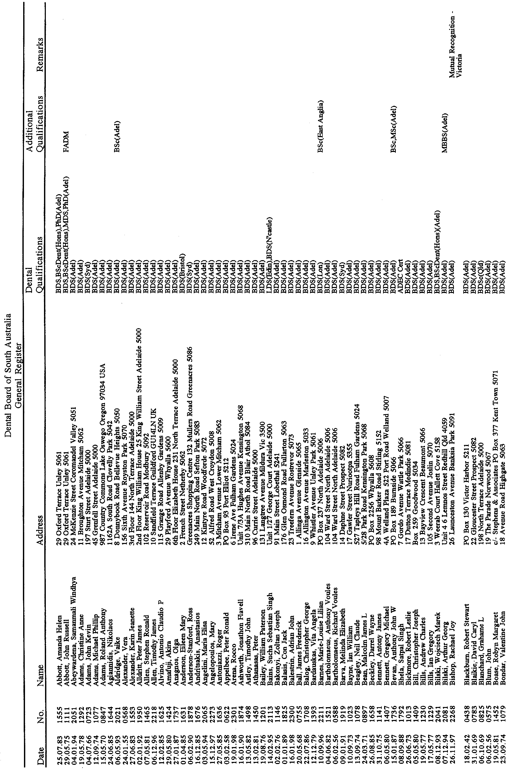
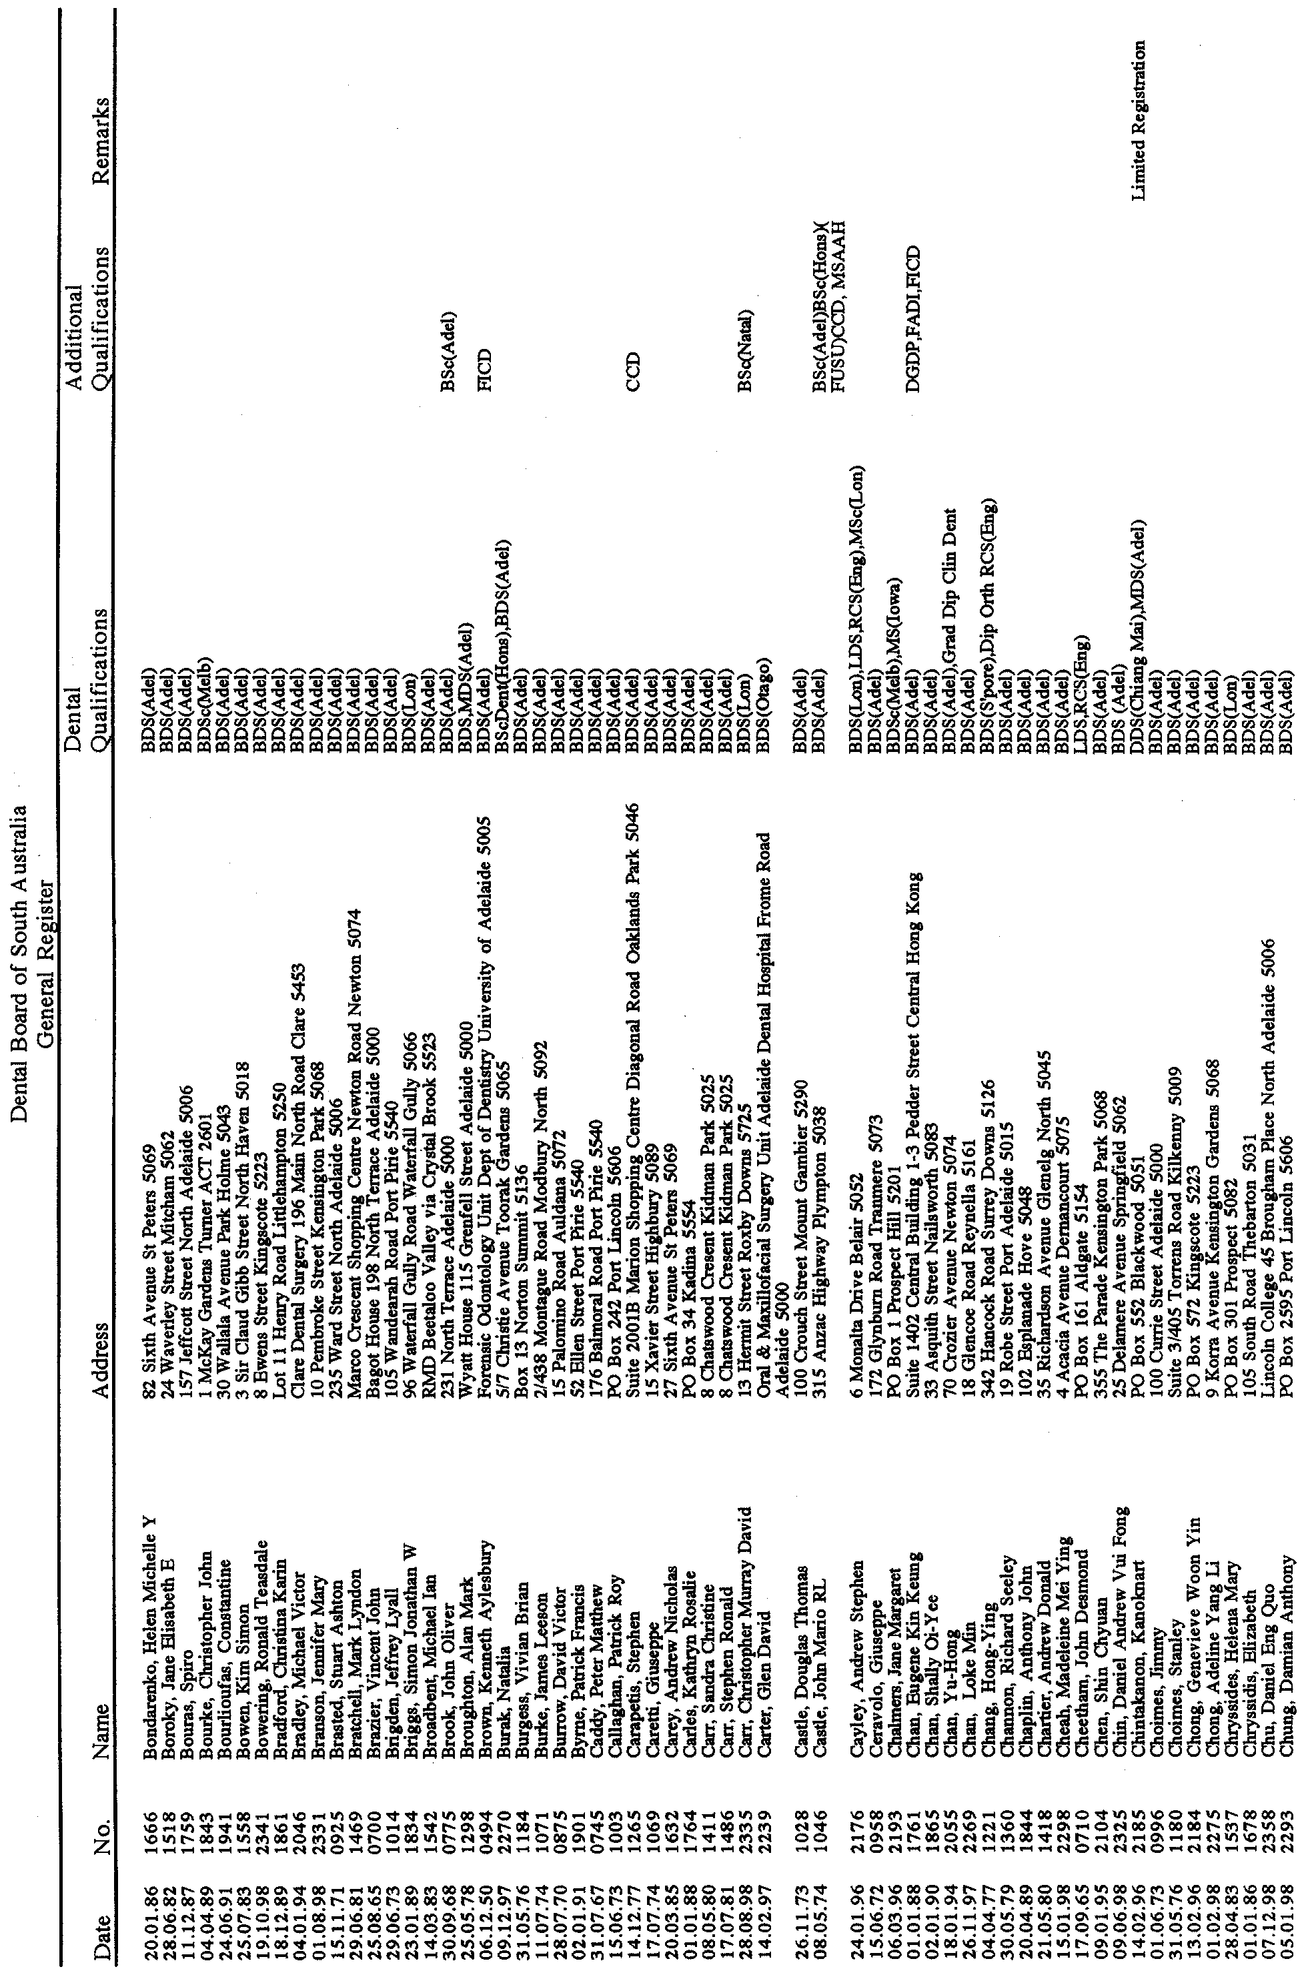
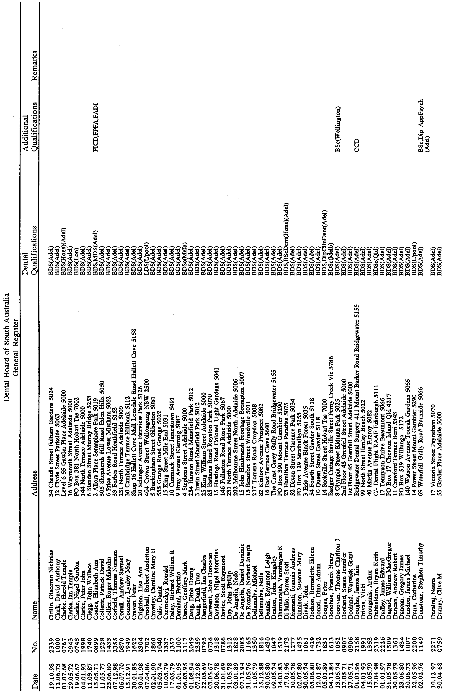
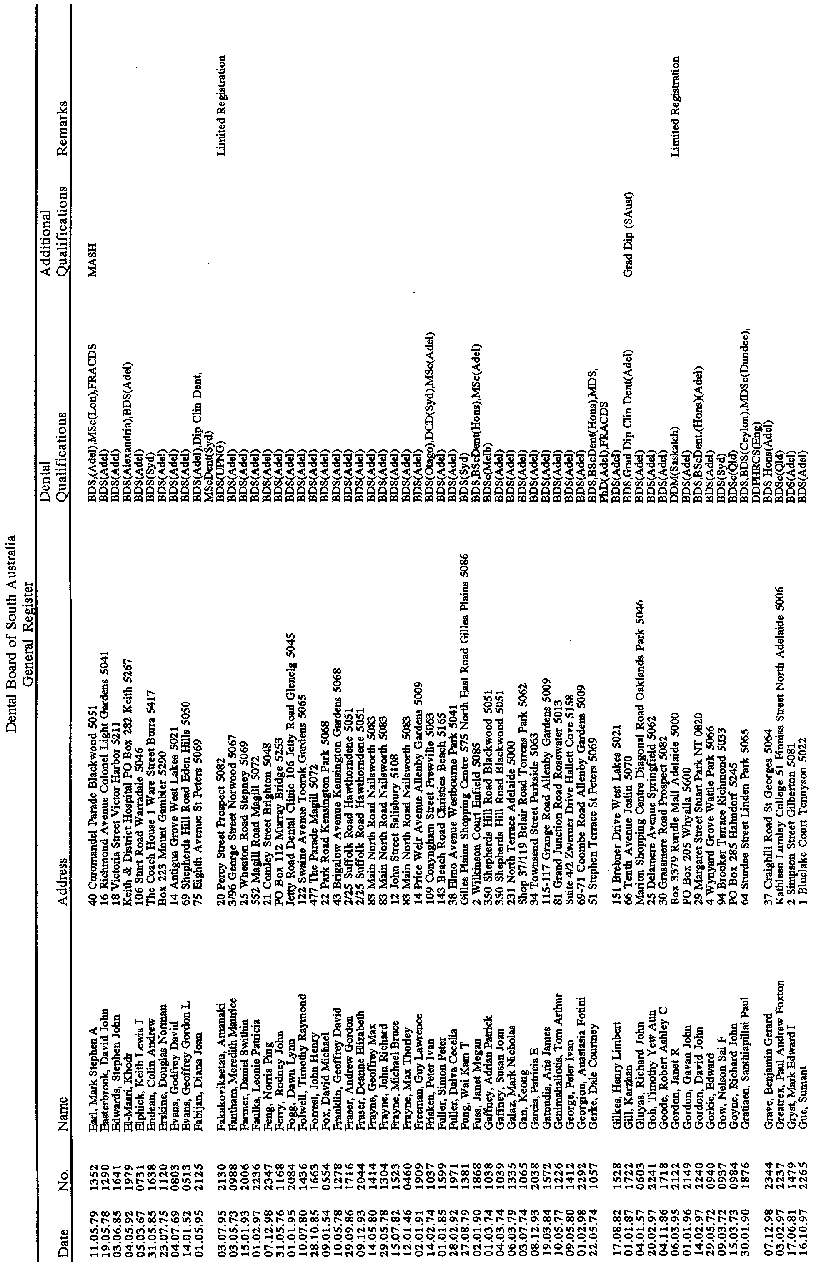
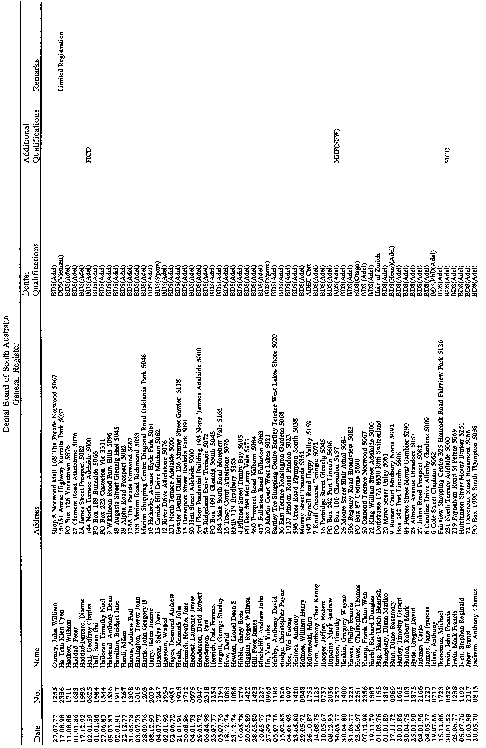
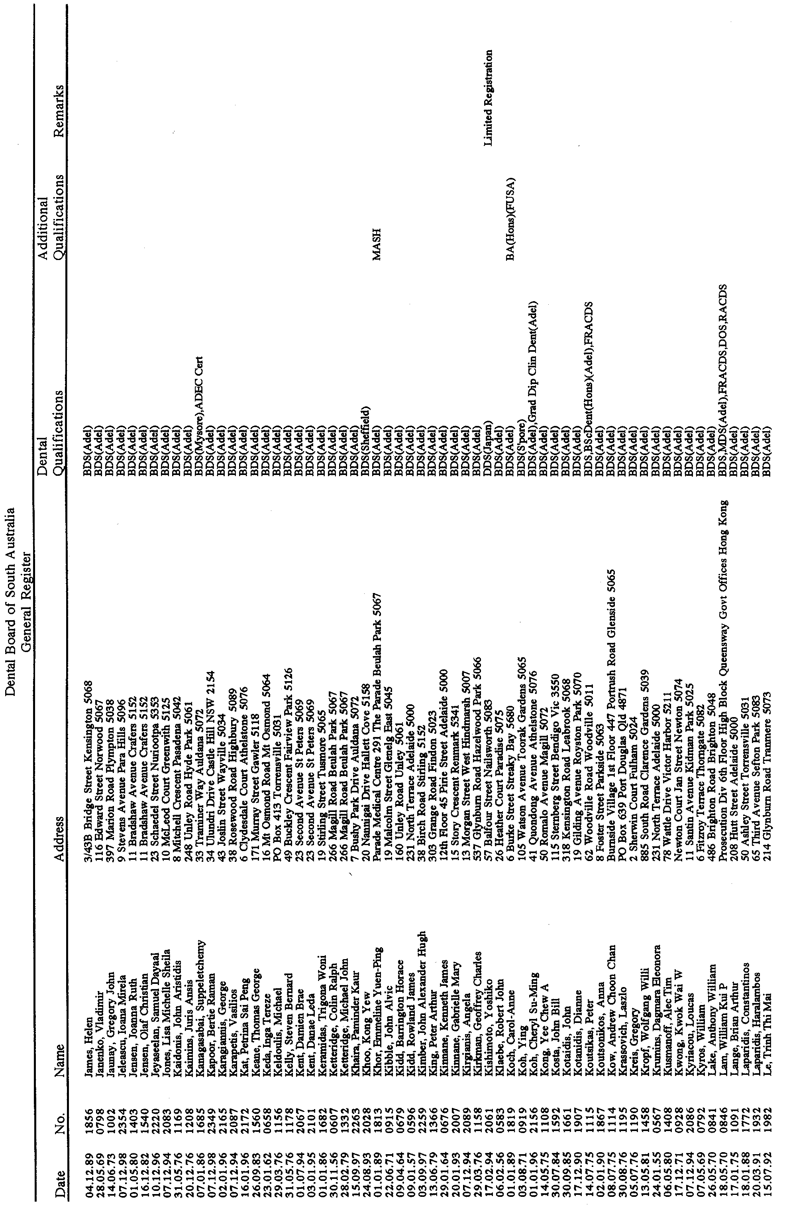
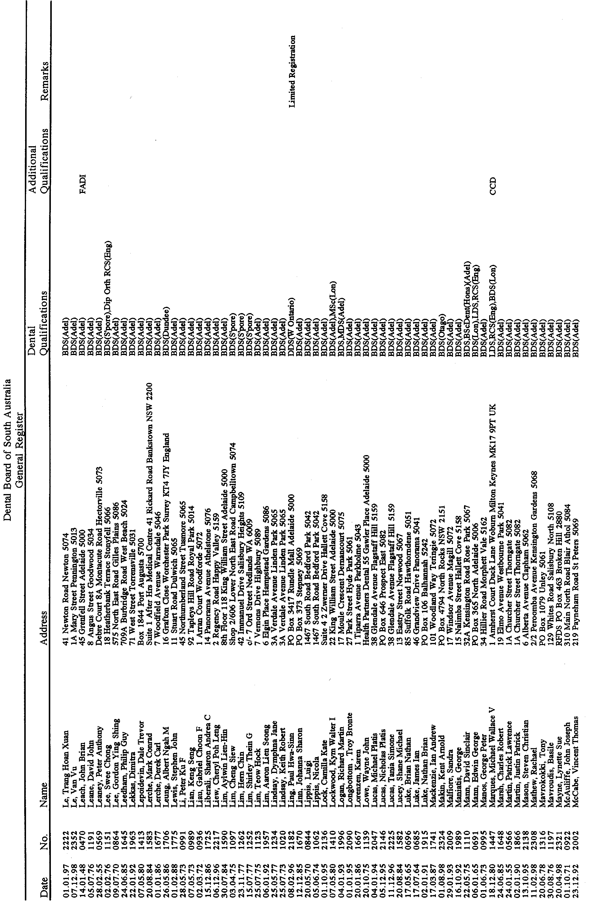
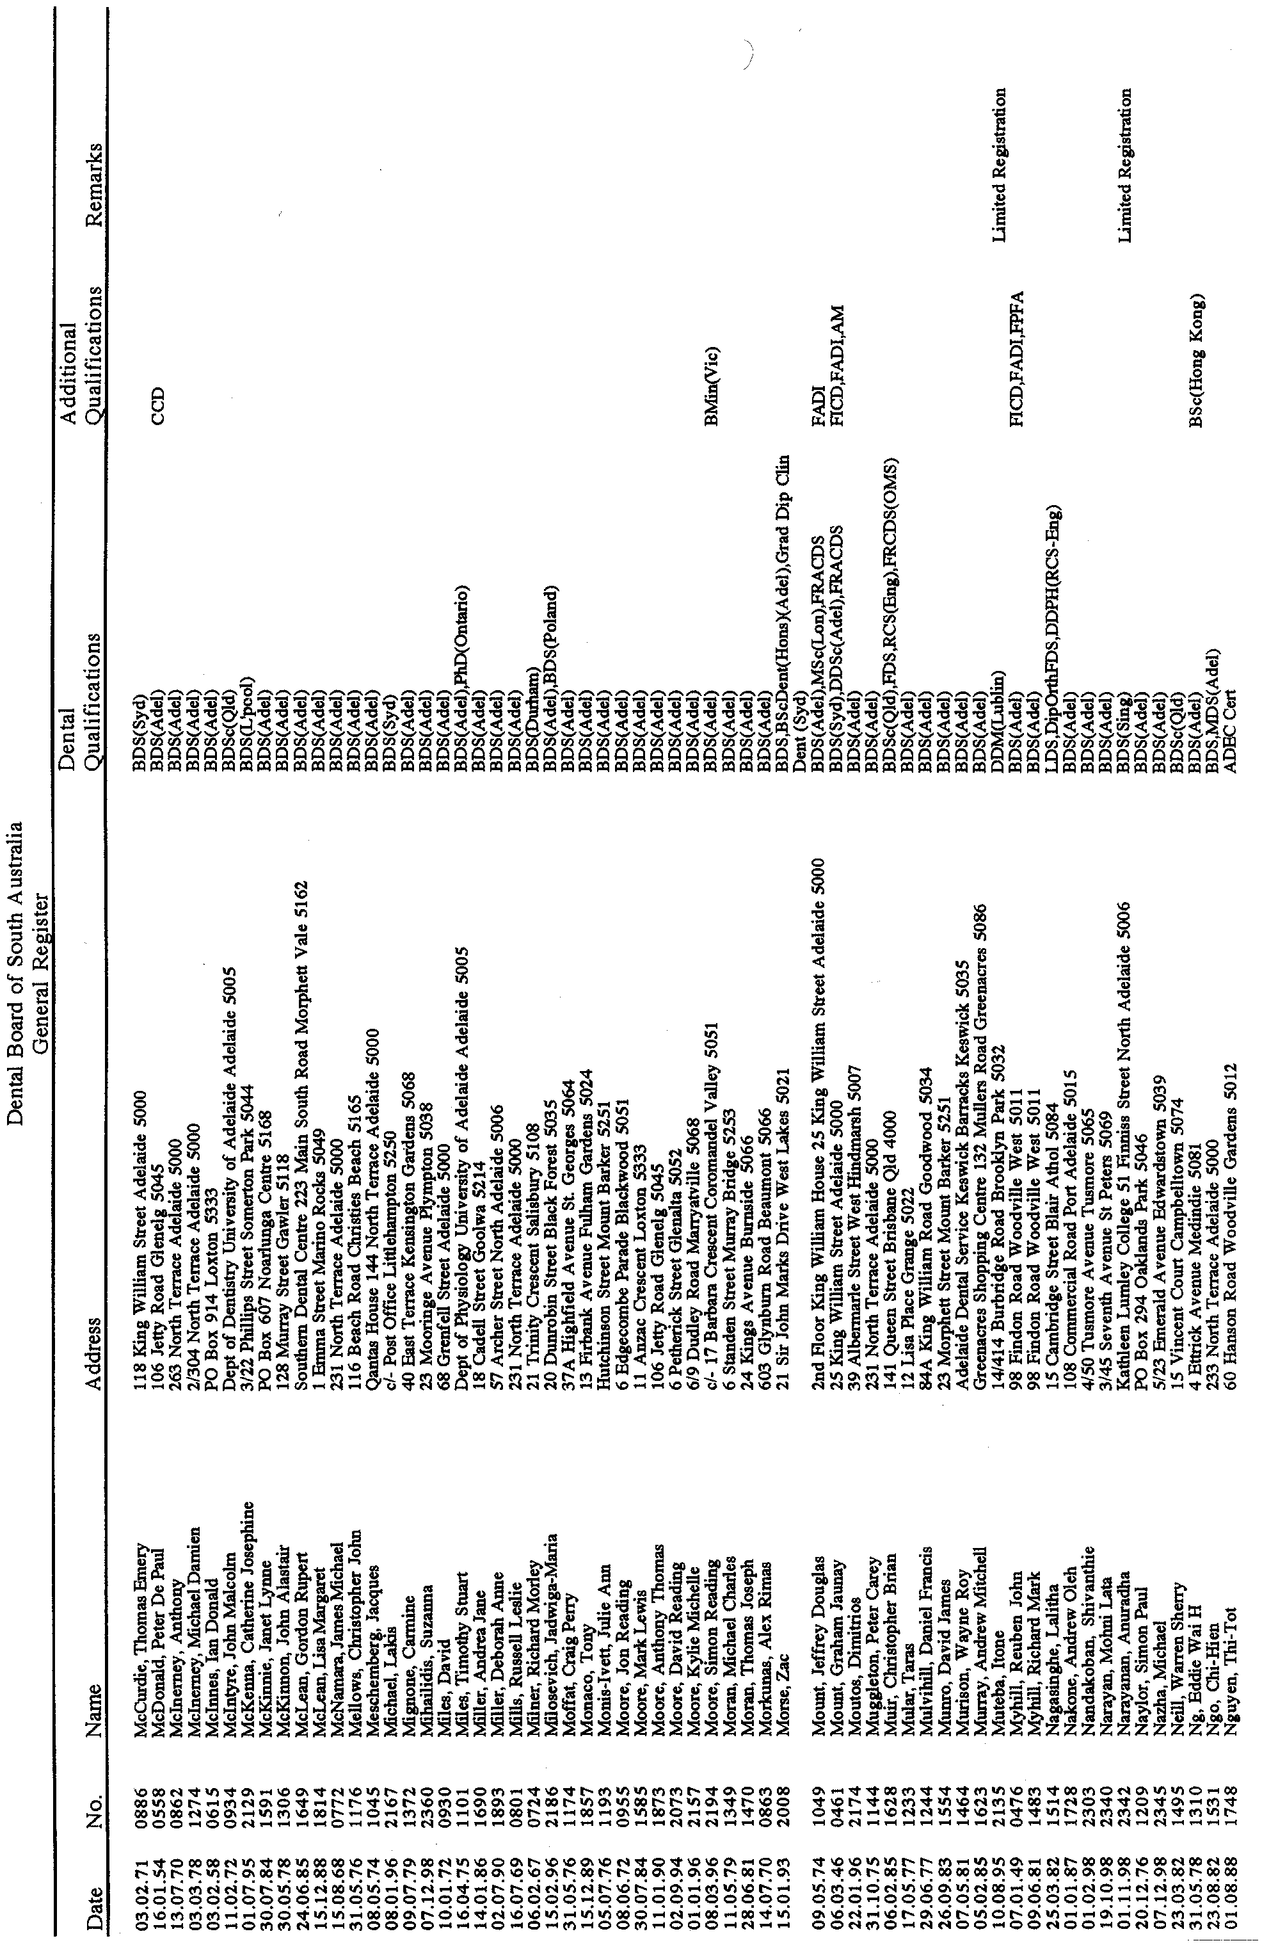
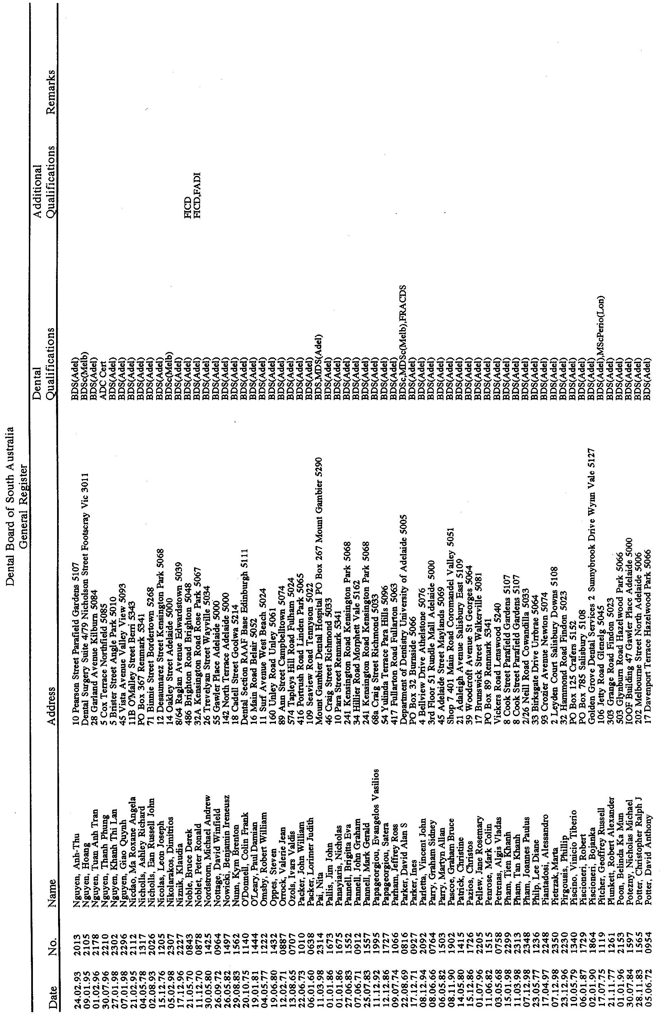
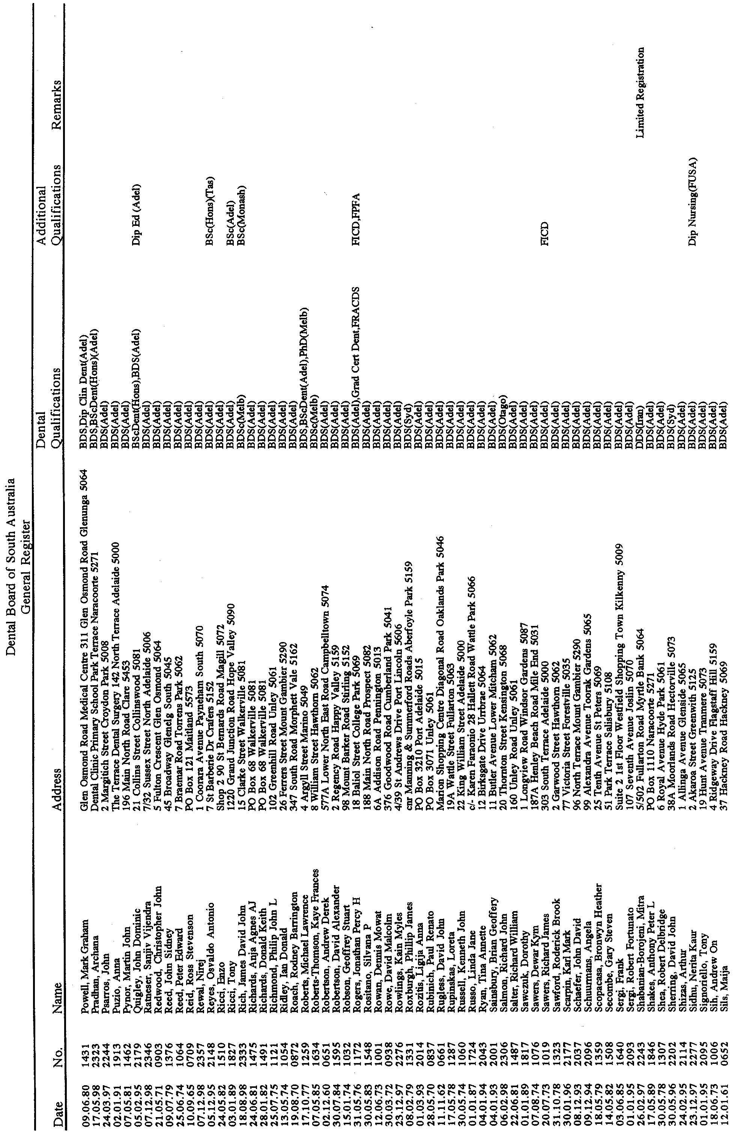
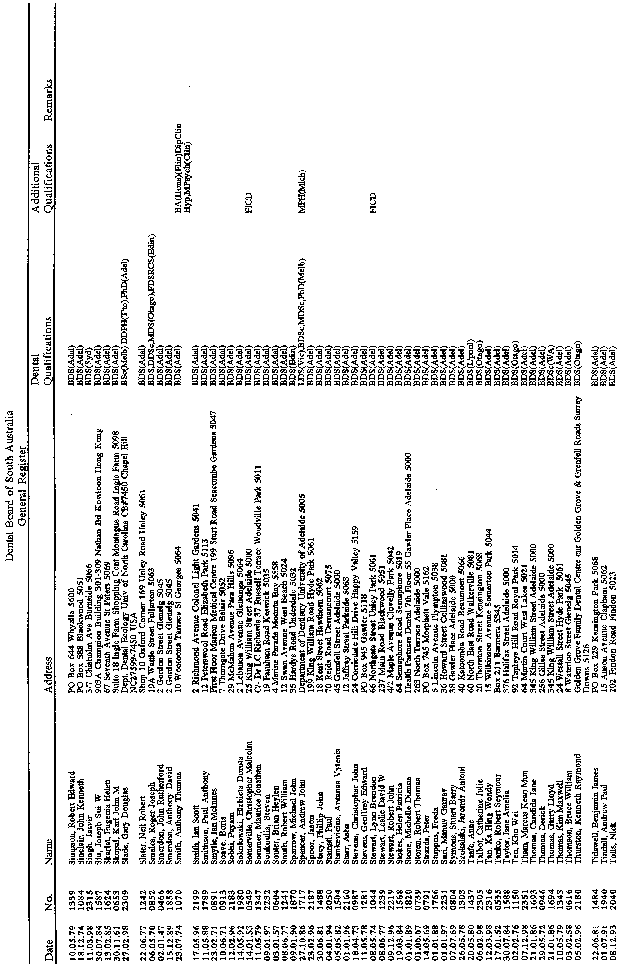
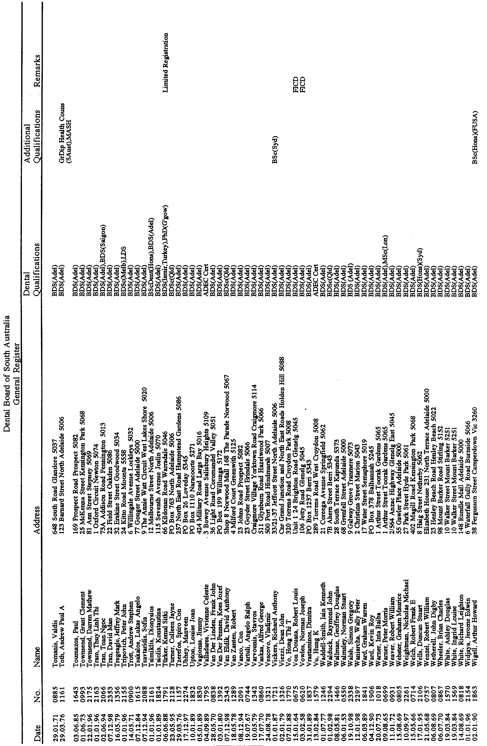
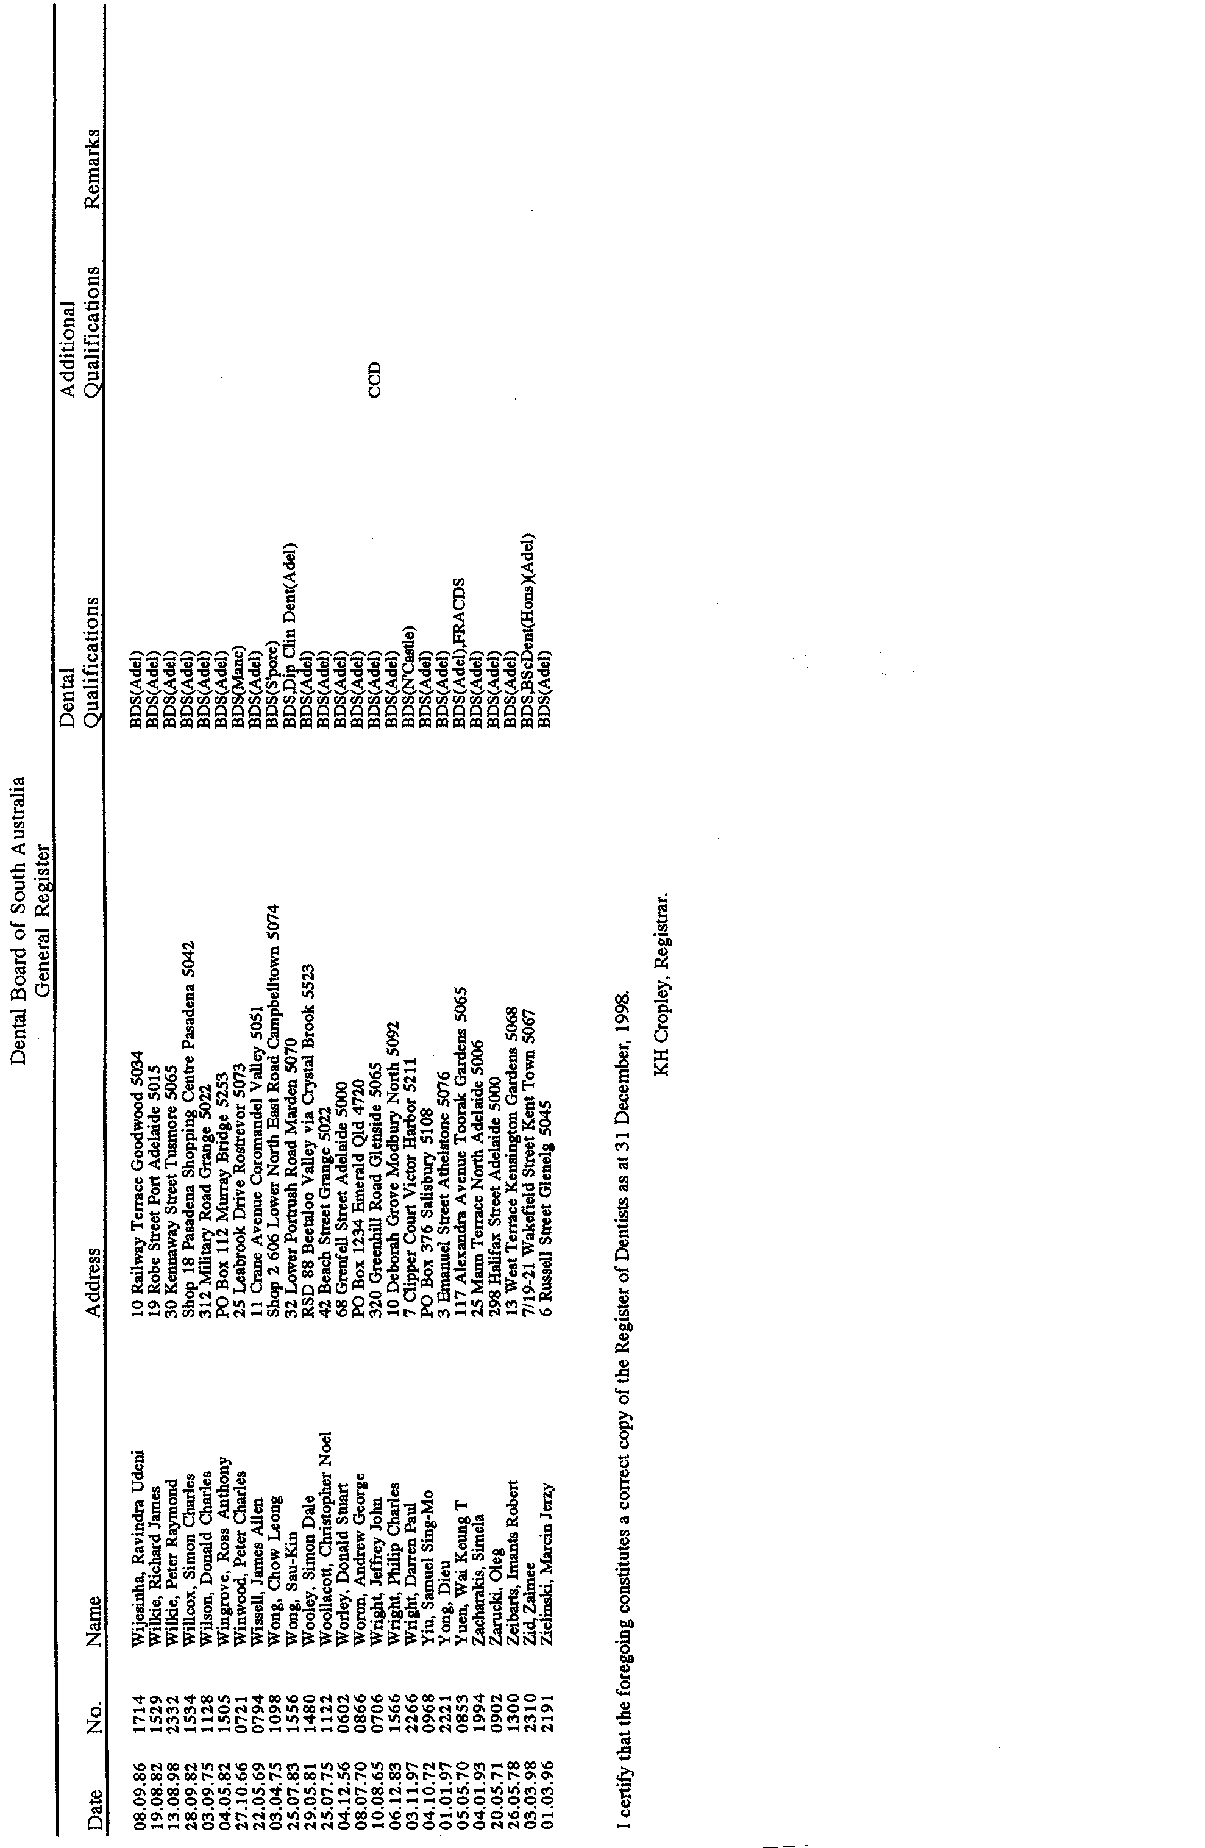
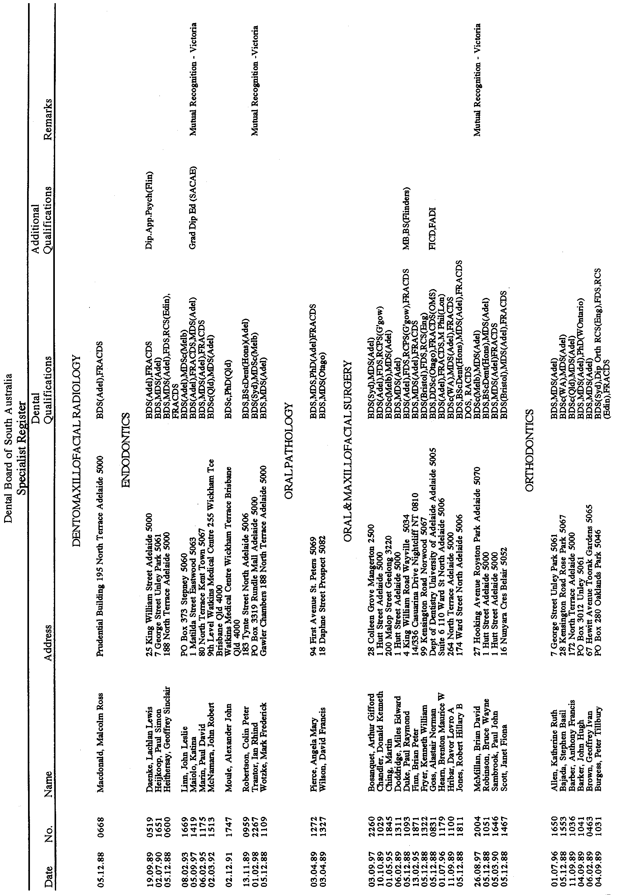
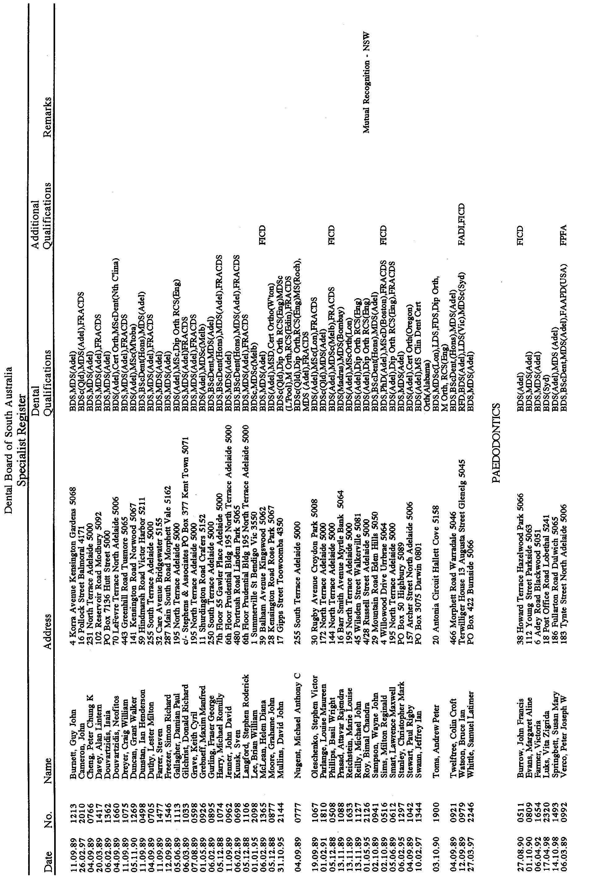
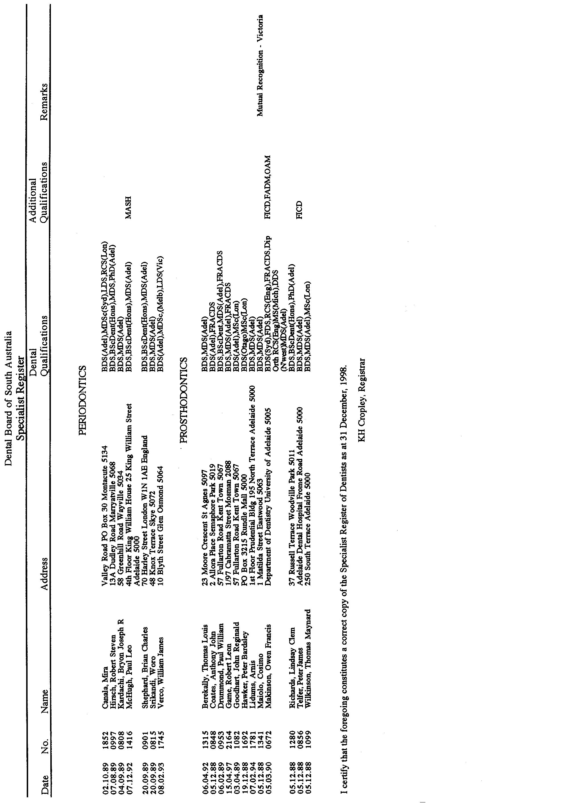
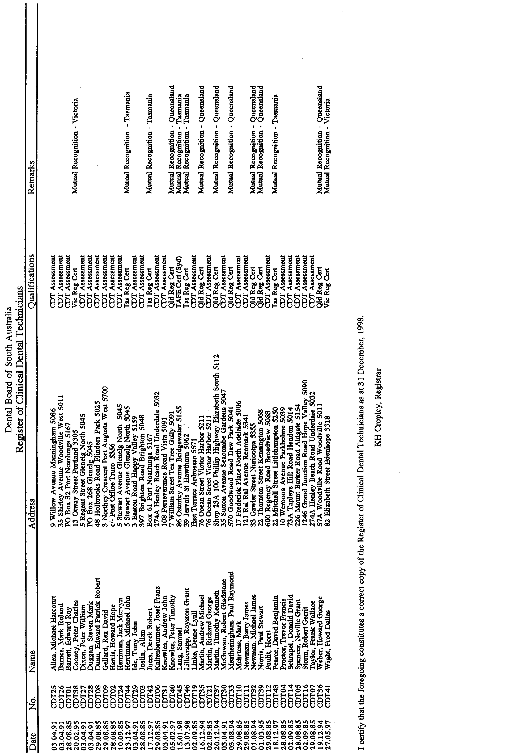
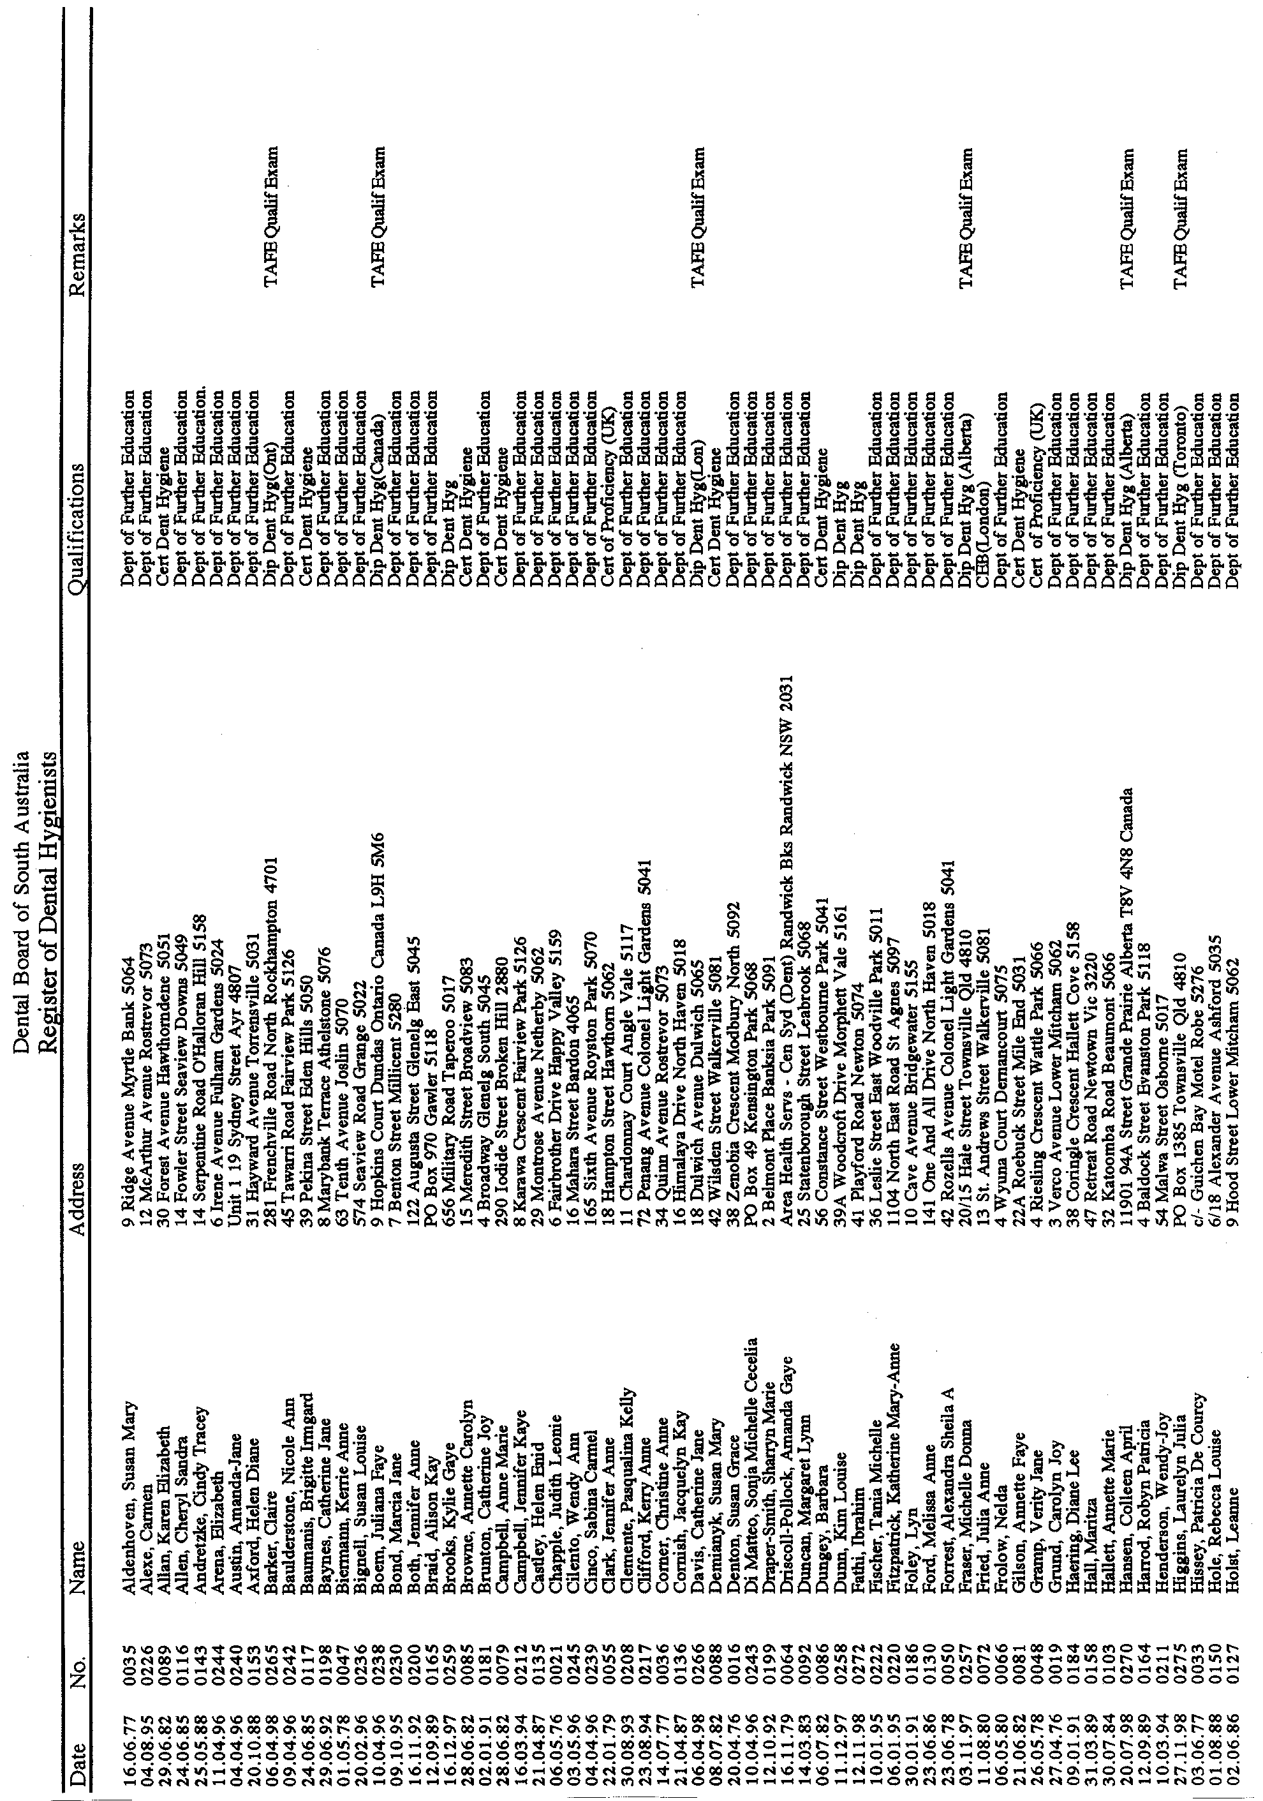
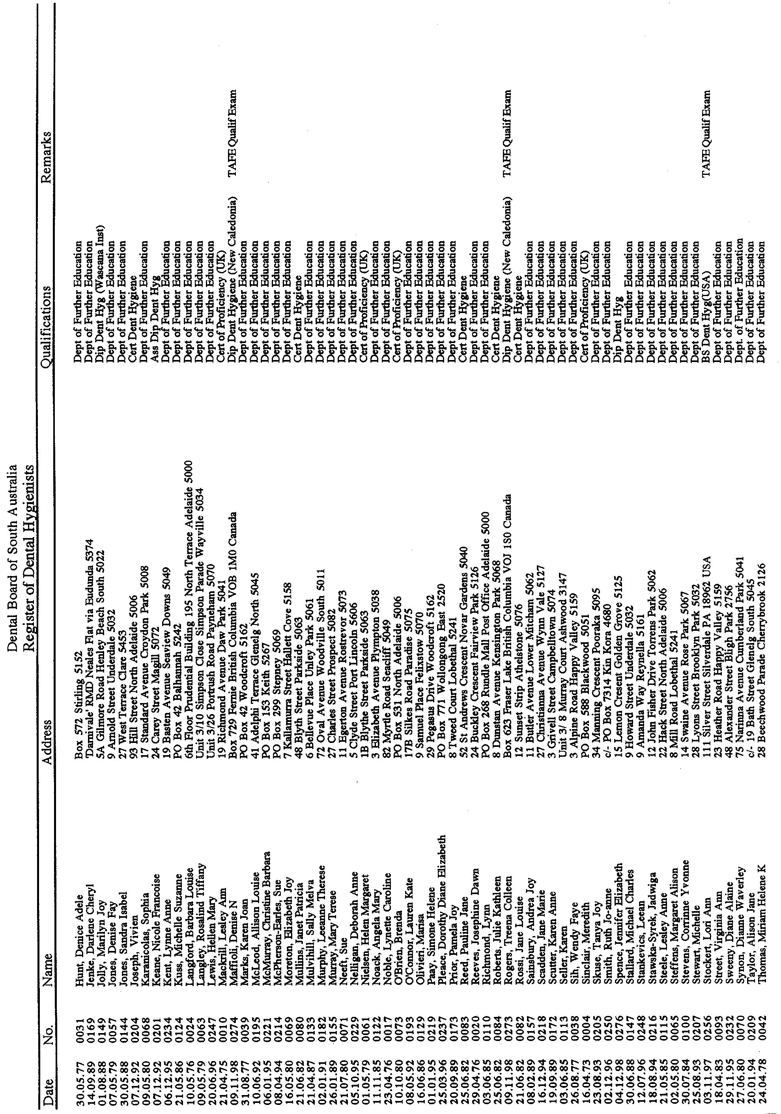
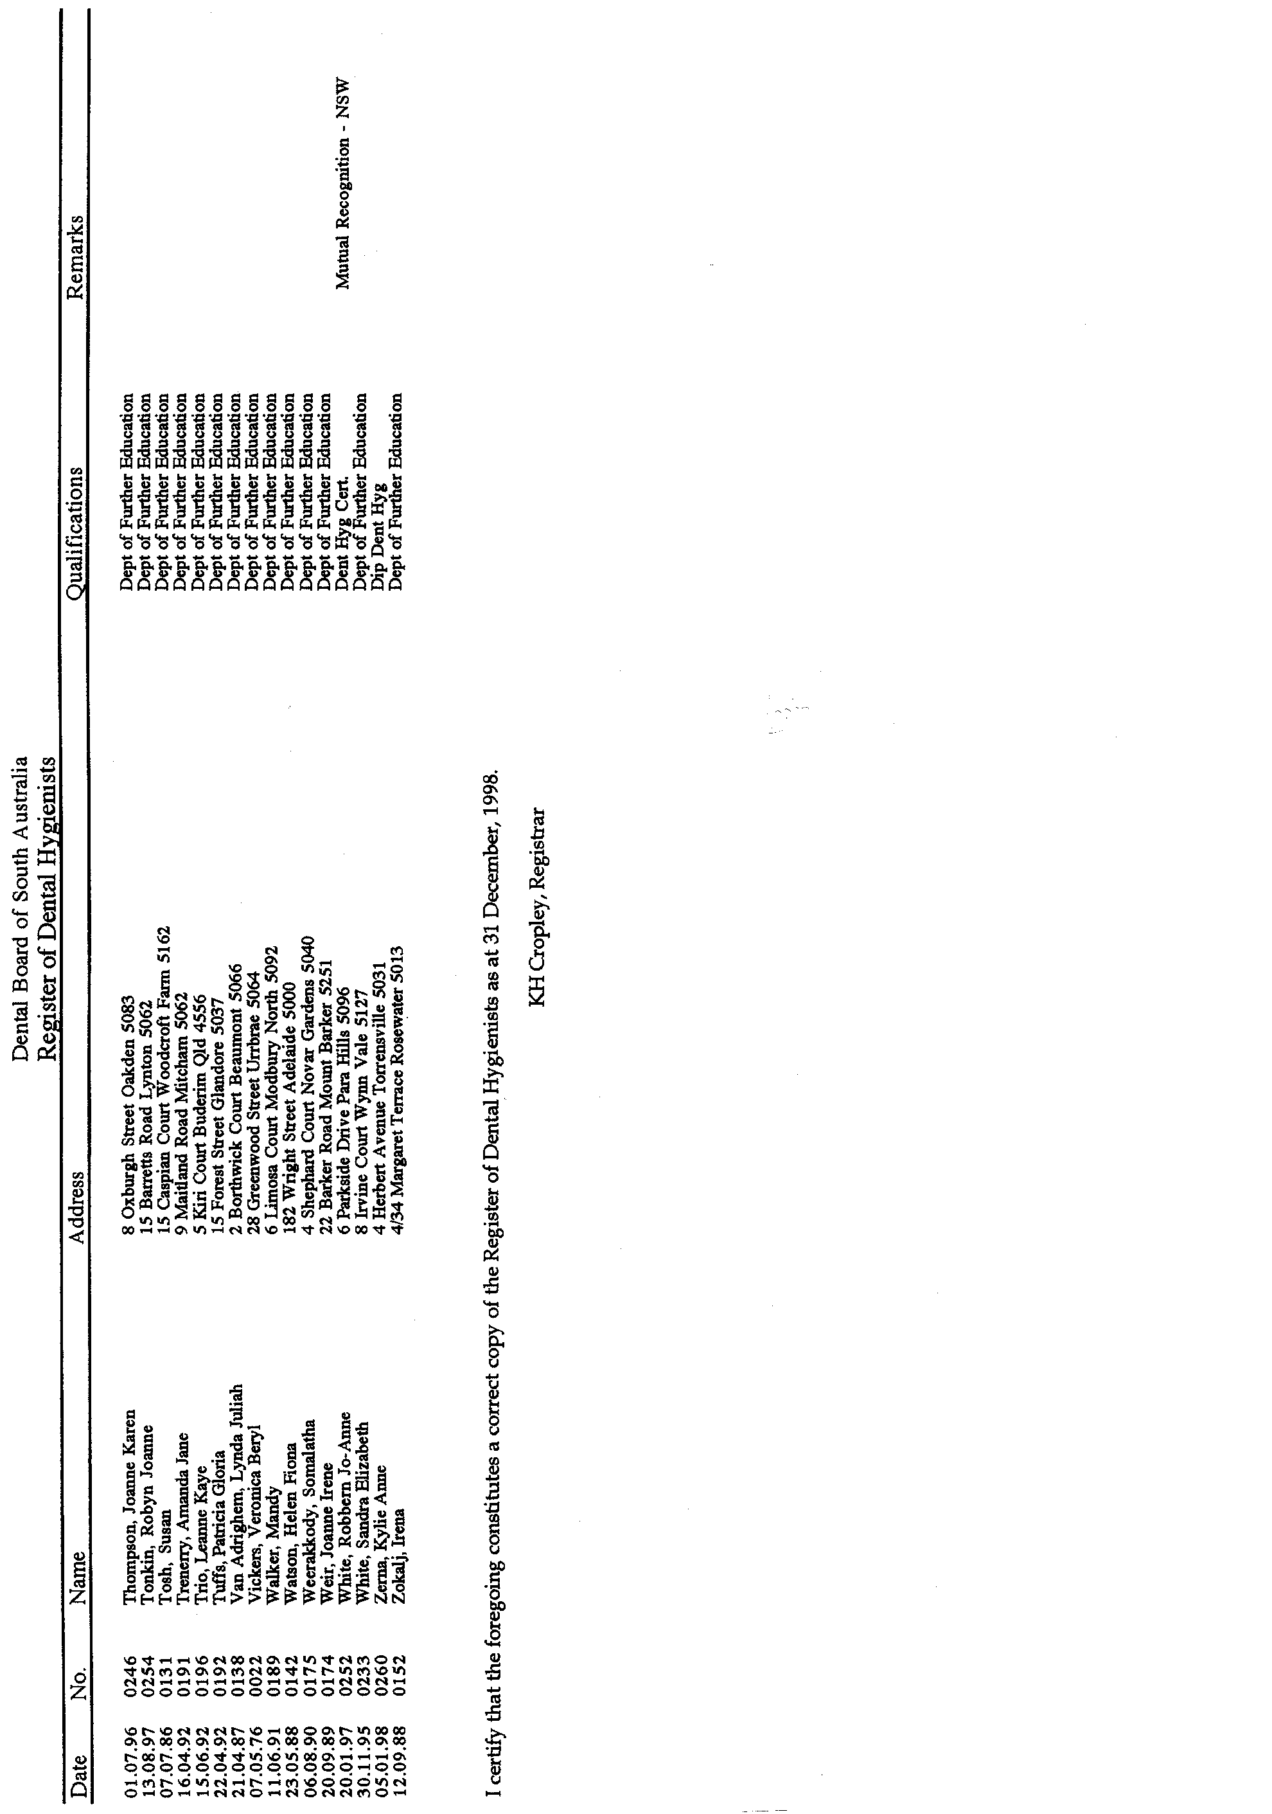
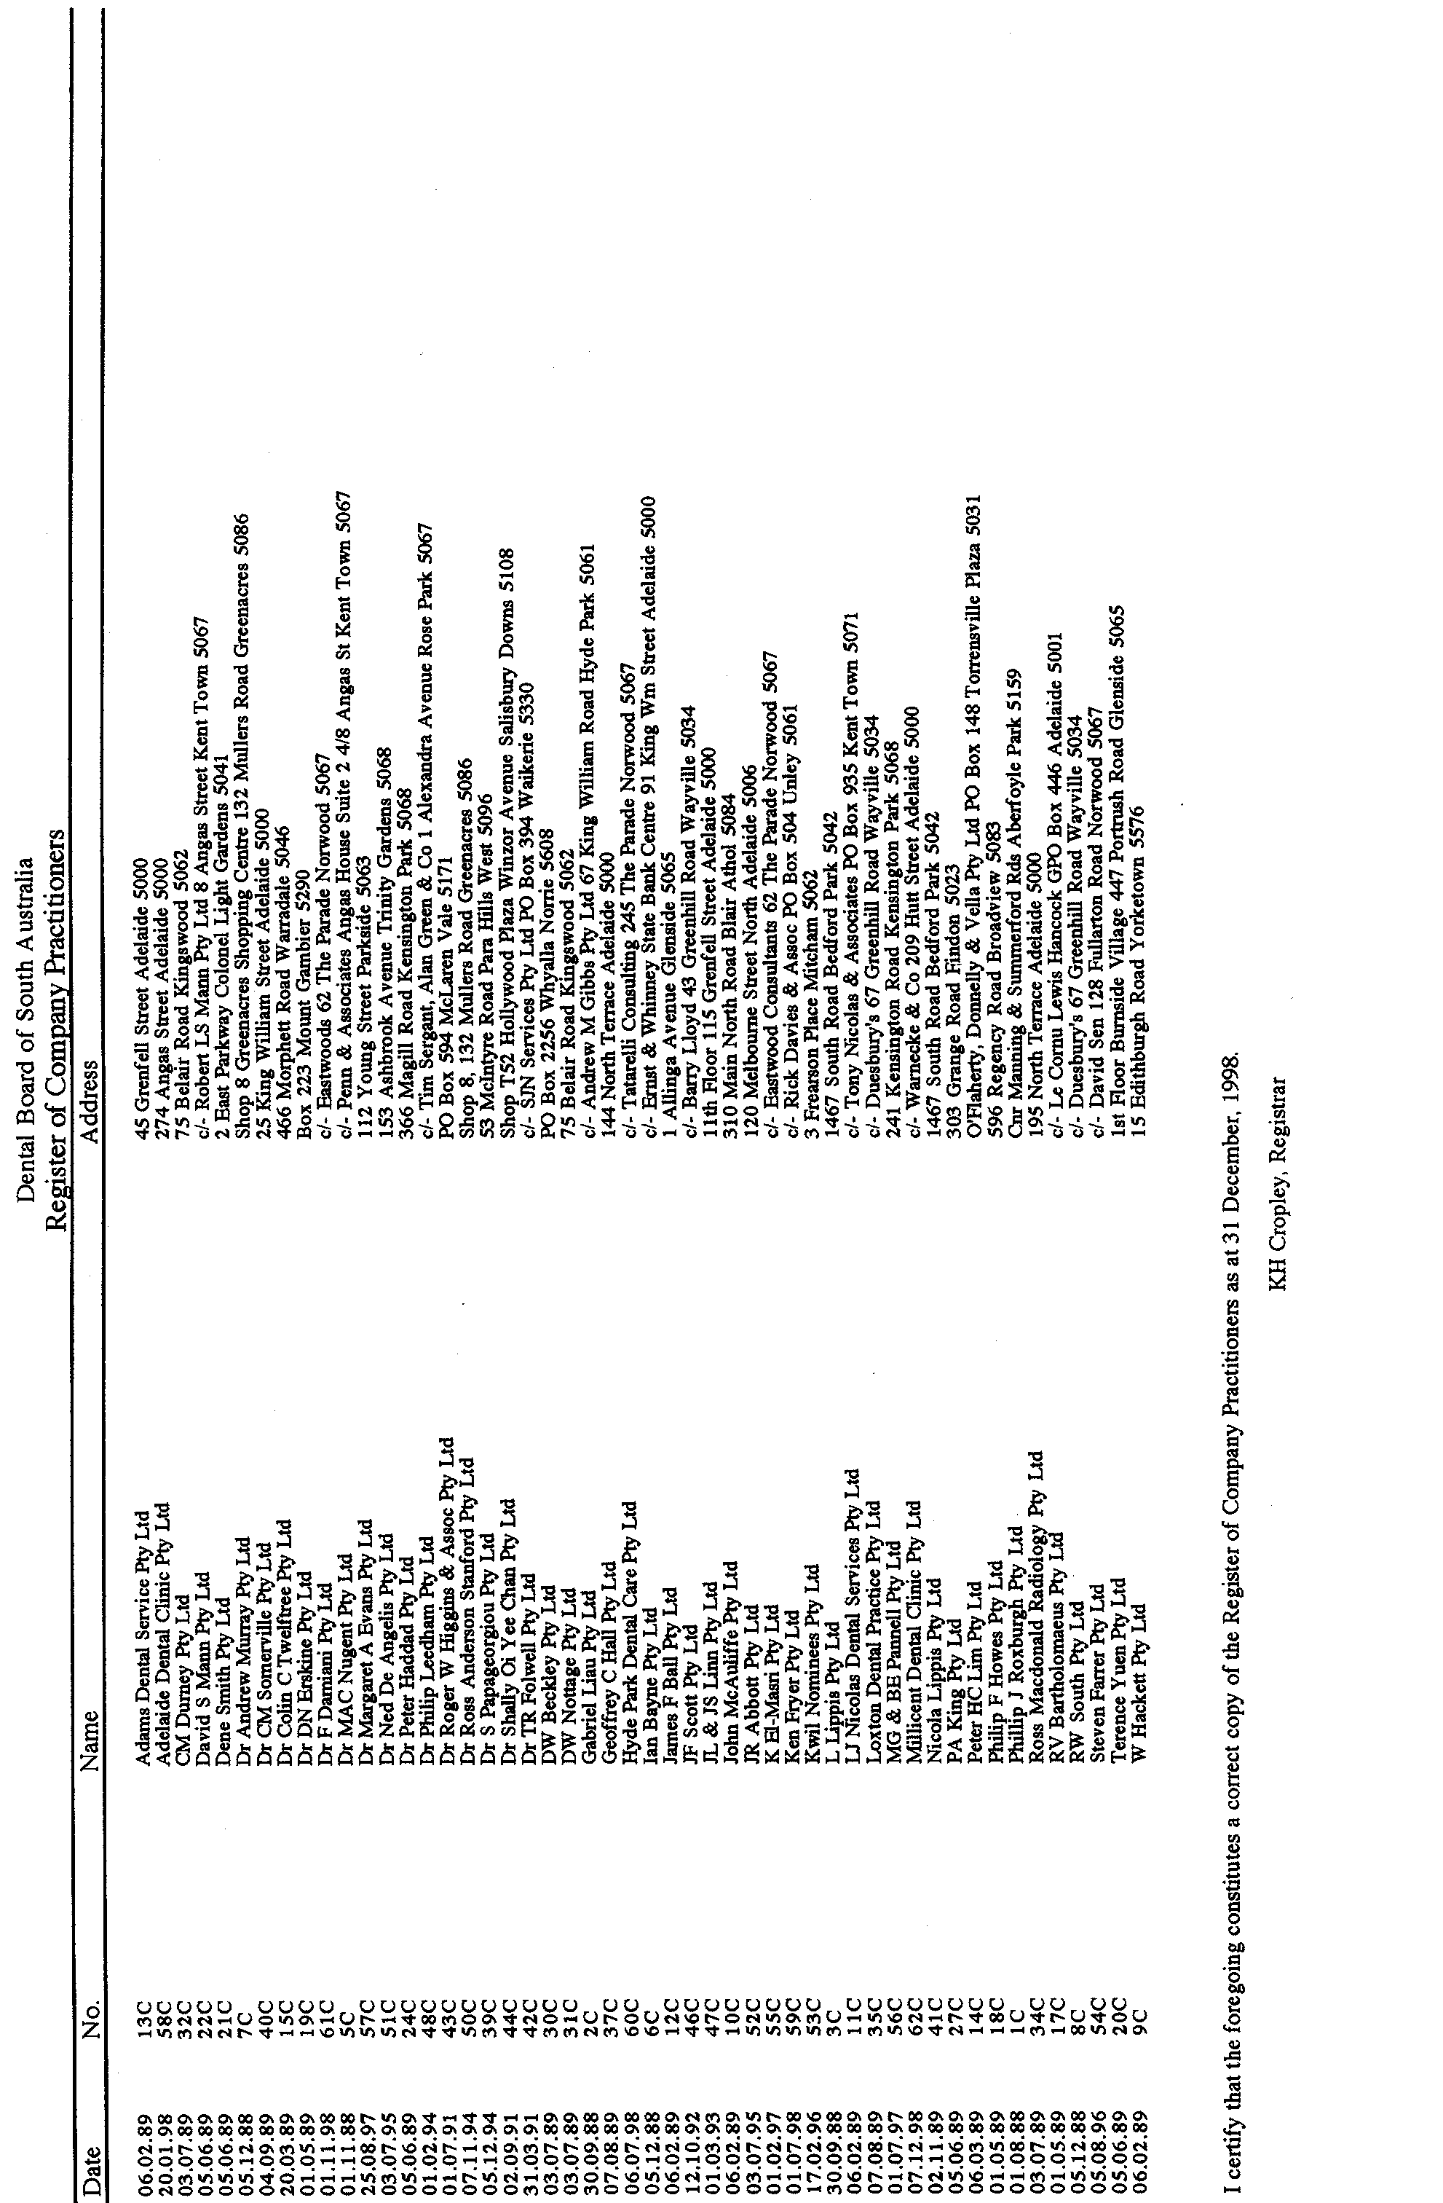
GAMING MACHINES ACT 1992
Notice of Application for Transfer of Liquor Licence and Gaming Machine Licence
NOTICE is hereby given, pursuant to section 52 of the Liquor Licensing Act 1997 and section 29 of the Gaming Machines Act 1992, that ACN 085 955 184 has applied to the Liquor Licensing Commissioner for the transfer of a Special Circumstances Licence and a Gaming Machine Licence in respect of premises situated at 41 Murray Street, Angaston, S.A. 5353 and known as Barossa Valley Hotel.
The applications have been set down for hearing on 26 February 1999.
Any person may object to the application by lodging a notice of objection in the prescribed form with the Liquor Licensing Commissioner, and serving a copy of the notice on the applicant at the applicant’s address given above, at least seven days before the hearing date.
Plans in respect of the premises the subject of the application are open to public inspection without fee at the Office of the Liquor Licensing Commissioner, 9th Floor, East Wing, G.R.E. Building, 50 Grenfell Street, Adelaide 5000.
Dated 21 January 1999.
Applicant

GAMING MACHINES ACT 1992
Notice of Application for Transfer of Liquor Licence and Gaming Machine Licence
NOTICE is hereby given, pursuant to section 52 of the Liquor Licensing Act 1997 and section 29 of the Gaming Machines Act 1992, that Barossa Brauhaus Pty Ltd (ACN 068 522 181), c/o Bonnins Commercial Lawyers, Level 14, 100 King William Street, Adelaide, S.A. 5000 has applied to the Liquor Licensing Commissioner for the transfer of a Hotel Licence and a Gaming Machine Licence in respect of premises situated at Port MacDonnell, S.A. 5291 and known as Victoria Hotel.
The applications have been set down for hearing on 26 February 1999 at 9 a.m.
Any person may object to the application by lodging a notice of objection in the prescribed form with the Liquor Licensing Commissioner, and serving a copy of the notice on the applicant at the applicant’s address given above, at least seven days before the hearing date.
Plans in respect of the premises the subject of the application are open to public inspection without fee at the Office of the Liquor Licensing Commissioner, 9th Floor, East Wing, G.R.E. Building, 50 Grenfell Street, Adelaide 5000.
Dated 21 January 1999.
Applicant

GAMING MACHINES ACT 1992
Notice of Application for Transfer of Liquor Licence and Gaming Machine Licence
NOTICE is hereby given, pursuant to section 52 of the Liquor Licensing Act 1997 and section 29 of the Gaming Machines Act 1992, that Gow Holdings Pty Ltd (ACN 008 087 858), c/o Bonnins Commercial Lawyers, Level 14, 100 King William Street, Adelaide, S.A. 5000 has applied to the Liquor Licensing Commissioner for the transfer of a Special Circumstances Licence and a Gaming Machine Licence in respect of premises situated at 208 Main Road, McLaren Vale, S.A. 5171 and known as Hotel McLaren.
The applications have been set down for hearing on 26 February 1999, at 9 a.m.
Any person may object to the application by lodging a notice of objection in the prescribed form with the Liquor Licensing Commissioner, and serving a copy of the notice on the applicant at the applicant’s address given above, at least seven days before the hearing date.
Plans in respect of the premises the subject of the application are open to public inspection without fee at the Office of the Liquor Licensing Commissioner, 9th Floor, East Wing, G.R.E. Building, 50 Grenfell Street, Adelaide 5000.
Dated 21 January 1999.
Applicant

GEOGRAPHICAL NAMES ACT 1991
Notice to Assign Boundaries to Places
NOTICE is hereby given pursuant to the Geographical Names Act 1991, I, PETER MACLAREN KENTISH, Surveyor-General and Delegate appointed by the Hon. Robert Lawson, QC, MLC, Minister for Administrative Services, Minister of the Crown to whom the administration of the Geographical Names Act 1991, is committed DO HEREBY exclude from the suburb of O’HALLORAN HILL and include into the suburb of FLAGSTAFF HILL the area marked (A) as shown on the plan below.
The Plan
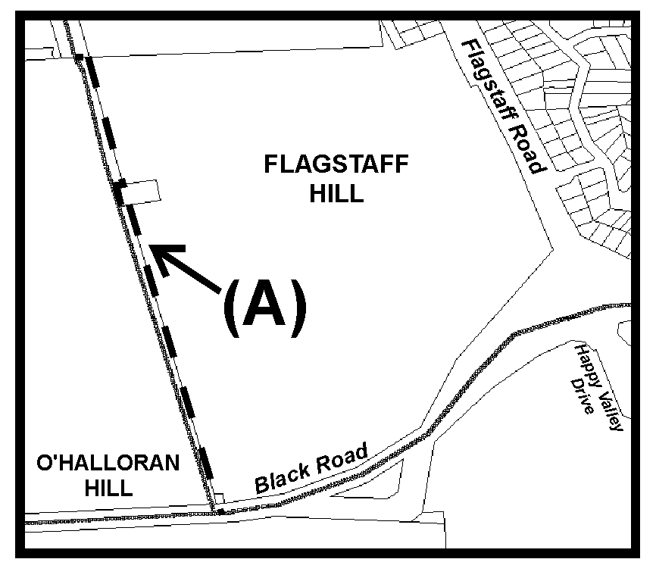
Dated 20 January 1999.
P. M. Kentish, Surveyor-General, Department for Administrative and Information Services
DEHAA 04/0142

GEOGRAPHICAL NAMES ACT 1991
Notice to Assign Boundaries to Places
NOTICE is hereby given pursuant to the Geographical Names Act 1991, I, PETER MACLAREN KENTISH, Surveyor-General and Delegate appointed by the Hon. Robert Lawson, QC, MLC, Minister for Administrative Services, Minister of the Crown to whom the administration of the Geographical Names Act 1991, is committed DO HEREBY:
(a) exclude from the suburb of FULHAM GARDENS and include into the suburb of FULHAM that area marked (A);
(b) exclude from the suburb of FULHAM and include into the suburb of FULHAM GARDENS that area marked (B), as shown on the plan below.
The Plan
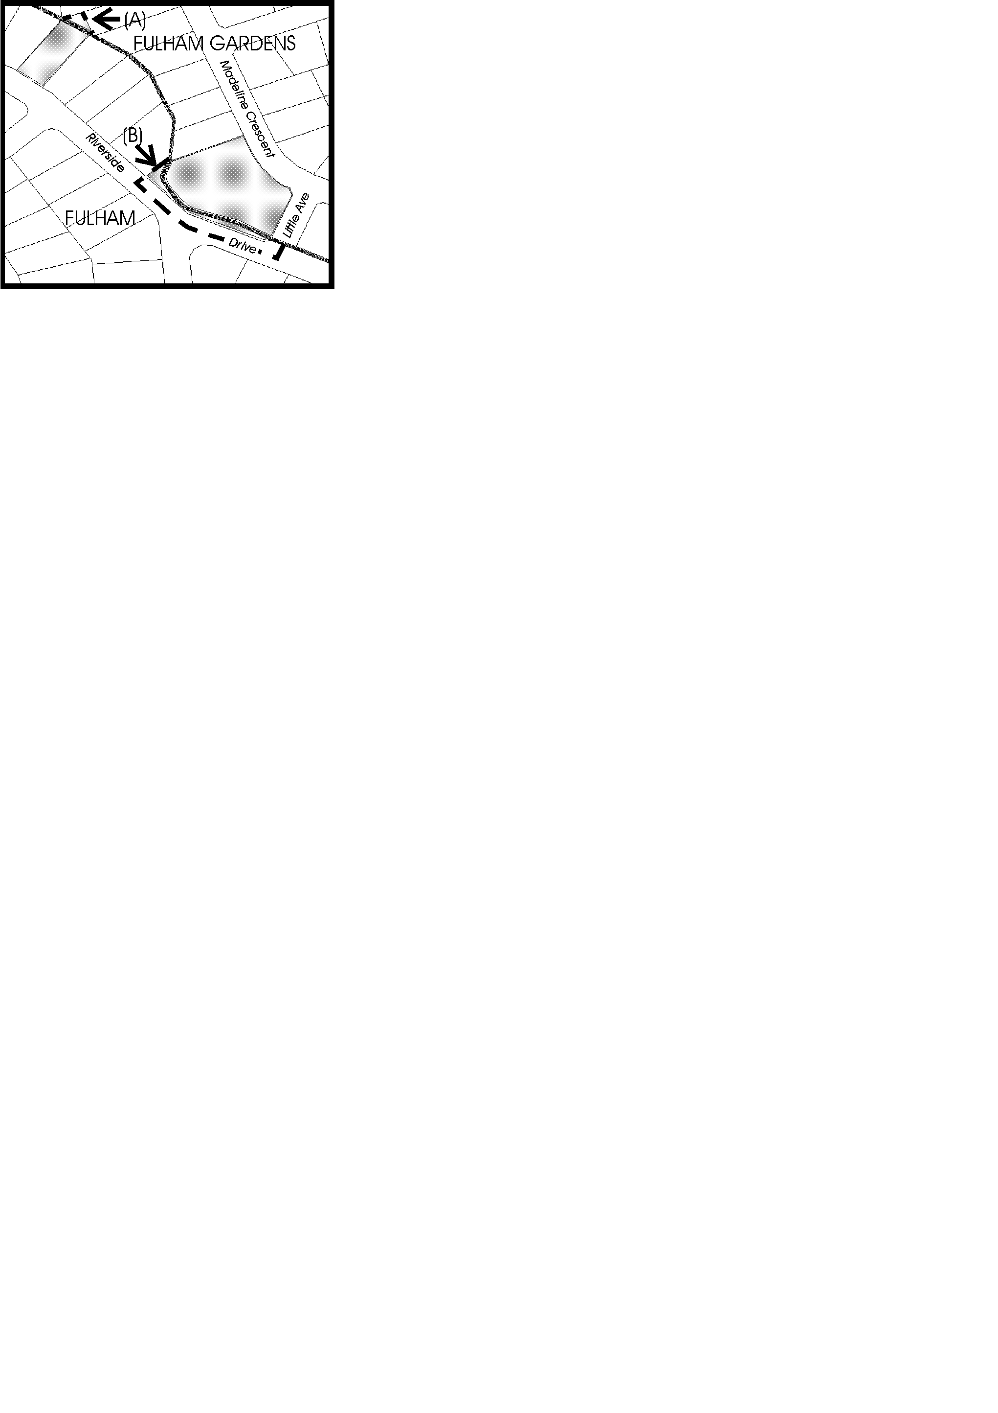
Dated 20 January 1999.
P. M. Kentish, Surveyor-General, Department for Administrative and Information Services
DEHAA 04/0125

GEOGRAPHICAL NAMES ACT 1991
Notice to Assign Boundaries to Places
NOTICE is hereby given pursuant to the Geographical Names Act 1991, I, PETER MACLAREN KENTISH, Surveyor-General and Delegate appointed by the Hon. Robert Lawson, QC, MLC, Minister for Administrative Services, Minister of the Crown to whom the administration of the Geographical Names Act 1991 is committed DO HEREBY exclude from the suburb of FITZROY and include into the suburb of PROSPECT the shaded area marked (A) as shown on the plan below.
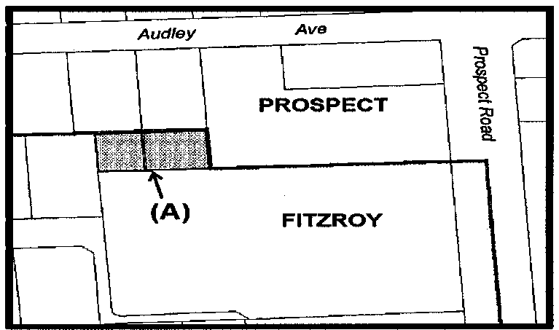
The Plan
Dated 20 January 1999.
P. M. Kentish, Surveyor-General, Department for Administrative and Information Services
DEHAA 04/0134

GEOGRAPHICAL NAMES ACT 1991
Notice to Assign Boundaries and Names to Places
TAKE NOTICE that pursuant to the above Act, I, PETER MACLAREN KENTISH, Surveyor-General and Delegate appointed by the Hon. Robert Lawson, QC, MLC, Minister for Administrative Services, Minister of the Crown to whom the administration of the Geographical Names Act 1991, is committed DO HEREBY assign the following names, BOATSWAIN POINT, MOUNT BENSON, REEDY CREEK, ROBE, NORA CREINA, BRAY, GREENWAYS and CLAY WELLS to those areas within the District Council of Robe and shown numbered 1 to 8 respectively on Rack Plan 823.
Dated 20 January 1999.
P. M. Kentish, Surveyor-General, Department for Administrative and Information Services
DEHAA 04/0100

GEOGRAPHICAL NAMES ACT 1991
Notice to Assign Boundaries and Names to Places
NOTICE is hereby given pursuant to the provisions of the above Act that I, PETER MACLAREN KENTISH, Surveyor-General and Delegate appointed by the Minister for Administrative Services, Minister of the Crown to whom the administration of the Geographical Names Act 1991, is committed DO HEREBY assign the names TICKERA, WALLAROO PLAIN, NORTH BEACH, WALLAROO, KADINA, WILLAMULKA, NEW TOWN, WALLAROO MINES, JERICHO, MATTA FLAT, JERUSALEM, WARBURTO, BOORS PLAIN, THRINGTON, PASKEVILLE, CUNLIFFE, MOONTA BAY, NORTH MOONTA, CROSS ROADS, PARAMATTA, MOONTA, YELTA, MOONTA MINES, EAST MOONTA, PORT HUGHES, KOOROONA, HAMLEY and NORTH YELTA to those areas within the District Council of the Copper Coast and shown numbered 1 to 28 respectively on Rack Plan 813.
Dated 14 January 1999.
P. M. Kentish, Surveyor-General, Department for Administrative and Information Services
DEHAA 04/0046

GEOGRAPHICAL NAMES ACT 1991
Notice to Assign Boundaries and Names to Places
NOTICE is hereby given pursuant to the provisions of the above Act that I, PETER MACLAREN KENTISH, Surveyor-General and Delegate appointed by the Minister for Administrative Services, Minister of the Crown to whom the administration of the Geographical Names Act 1991, is committed DO HEREBY assign the names CHARRA, CEDUNA, MUDAMUCKLA, NUNJIKOMPITA, WHITE WELL CORNER, WATRABA, UWORRA, KOONIBBA, KALANBI, NADIA, DENIAL BAY, THEVENARD, WANDANA, MERGHINY, LAURA BAY, SMOKY BAY, MALTEE, PUNTABIE, CHINBINGINA, PUREBA, CARAWA and PIMBAACLA to those areas in the District Council of Ceduna and shown numbered 1 to 22 respectively on Rack Plan 822.
Dated 20 January 1999.
P. M. Kentish, Surveyor-General, Department for Administrative and Information Services
DEHAA 04/0080

GEOGRAPHICAL NAMES ACT 1991
Notice to Assign Boundaries and Names to Places
NOTICE is hereby given pursuant to the provisions of the above Act that I, PETER MACLAREN KENTISH, Surveyor-General and Delegate appointed by the Minister for Administrative Services, Minister of the Crown to whom the administration of the Geographical Names Act 1991, is committed DO HEREBY:
1. Add the areas numbered 8, 14 and 16 on Rack Plan 792 to McLaren Vale, Aldinga and McLaren Flat respectively.
2. Assign the names THE RANGE, TATACHILLA, WHITES VALLEY, WILLUNGA, WILLUNGA SOUTH and SELLICKS HILL to those areas within the City of Onkaparinga and shown numbered 9 to 13 and 15 respectively on Rack Plan 792.
Dated 20 January 1999.
P. M. Kentish, Surveyor-General, Department for Administrative and Information Services
DENR 9100/1994

LAND AND BUSINESS (SALE AND CONVEYANCING) ACT 1994
Section 23
TAKE notice that, pursuant to section 23 (3) of the Land and Business (Sale and Conveyancing) Act 1994, I, Kenneth Trevor Griffin, Minister for Consumer Affairs, do hereby exempt the person named in Schedule 1 from the application of section 23 (2) of the Act in relation to the purchase of the land specified in Schedule 2.
Schedule 1
Yolande Campbell Bedford, an officer/employee of Delfin Realty Pty Ltd.
Schedule 2
The whole of land described in certificate of title register book volume 5601, folio 69, situated at allotment 173, Elder Circuit, Mawson Lakes, S.A. 5095.
Signed for and on behalf of the Minister for Consumer Affairs by the Commissioner for Consumer Affairs.
Dated 20 January 1999.
H. J. Gilmore, Commissioner

LIQUOR LICENSING ACT 1997
Notice of Application
NOTICE is hereby given, pursuant to section 52 (2) (b) of the Liquor Licensing Act 1997, that Café Numero Uno Pty Ltd (ACN 085 537 819) of Vlassis & Company, 217 Gouger Street, Adelaide, S.A. 5000 has applied to the Licensing Authority for the granting of a Restaurant Licence with Extended Trading Authorisation in respect of premises situated at Shops 10 and 11 Ingle Farm Shopping Centre, Montague Road, Ingle Farm, S.A. 5098 and to be known as Café Numero Uno.
The application has been set down for hearing on 26 February 1999.
Conditions
The following conditions are sought:
1. That the licensee be permitted to sell liquor on the licensed premises for consumption on the licensed premises without the provision of a meal.
2. With Extended Trading Authority in particular:
2.1 Monday, midnight to 1 a.m.
Tuesday, midnight to 1 a.m.
Wednesday, midnight to 1 a.m.
Thursday, midnight to 1 a.m.
Friday, midnight to 1 a.m.
Saturday, midnight to 1 a.m.
Sunday, 8 a.m. to 11 a.m. and 8 p.m. to midnight.
2.2 Christmas Day, 9 a.m. to midnight
2.3 Good Friday, 9 a.m. to midnight
Any person may object to the application by lodging a notice of objection in the prescribed form with the Licensing Authority, and serving a copy of the notice on the applicant at the applicant’s address given above, at least seven days before the hearing date.
Plans in respect of the premises the subject of the application are open to public inspection without fee at the Office of the Liquor Licensing Commissioner, 2nd Floor, East Wing, G.R.E. Building, 50 Grenfell Street, Adelaide 5000.
Dated 18 January 1999.
Applicant

LIQUOR LICENSING ACT 1997
Notice of Application
NOTICE is hereby given, pursuant to section 52 (2) (b) of the Liquor Licensing Act 1997, that Ip Man Ho and Ip Denise Yuk Lan as Trustees for the Ip Family Trust (trading as IPS Café) have applied to the Licensing Authority for a Restaurant Licence in respect of premises to be situated at 65A Grote Street, Adelaide, S.A. 5000 and to be known as IPS Café.
The application has been set down for hearing on 26 February 1999 at 9 a.m.
Any person may object to the application by lodging a notice of objection in the prescribed form with the Licensing Authority, and serving a copy of the notice on the applicants at the applicants’ address given above, at least seven days before the hearing date.
Plans in respect of the premises the subject of the application are open to public inspection without fee at the Office of the Liquor Licensing Commissioner, 2nd Floor, East Wing, G.R.E. Building, 50 Grenfell Street, Adelaide 5000.
Dated 18 January 1999.
Applicants

LIQUOR LICENSING ACT 1997
Notice of Application
NOTICE is hereby given, pursuant to section 52 (2) (b) of the Liquor Licensing Act 1997, that Franklin Central Apartments Pty Ltd (ACN 079 584 320), c/o Bonnins, Level 14, 100 King William Street, Adelaide, S.A. 5000 has applied to the Licensing Authority for a Residential Licence with an Entertainment Consent and Extended Trading Authorisation in respect of premises situated at 36-40 Franklin Street, Adelaide, S.A. 5000 and known as Doms at Franklin Street.
The application has been set down for hearing 26 February 1999 at 9 a.m.
Conditions
The following conditions are sought:
1. That liquor may be sold for consumption on the licensed premises at any time:
1.1 to a lodger for consumption on or off the licensed premises;
1.2 to a diner in a designated area for consumption with or ancillary to a meal provided by the licensee in that area;
1.3 to a person attending at a reception for consumption in a designated reception area.
2. That liquor may be sold for consumption on the licensed premises on any day except Good Friday and Christmas Day between 6 a.m. and 2 a.m. the following day to persons:
2.1 seated at a table; or
2.2 attending at a function at which food is provided.
3. That entertainment may be provided in the restaurant area of the premises which entertainment is ancillary to the primary use of that area as a restaurant.
Any person may object to the application by lodging a notice of objection in the prescribed form with the Licensing Authority, and serving a copy of the notice on the applicant at the applicant’s address given above, at least seven days before the hearing date.
Plans in respect of the premises the subject of the application are open to public inspection without fee at the Office of the Liquor Licensing Commissioner, 2nd Floor, East Wing, G.R.E. Building, 50 Grenfell Street, Adelaide 5000.
Dated 15 January 1999.
Applicant

LIQUOR LICENSING ACT 1997
Notice of Application
NOTICE is hereby given, pursuant to section 52 (2) (b) of the Liquor Licensing Act 1997, that Roxby Downs Club Inc., c/o Kelly & Co., 91 King William Street, Adelaide, S.A. 5000 has applied to the Licensing Authority to extend the scope of its existing Extended Trading Authorisation under the Club Licence in respect of premises situated at 21 Burgoyne Street, Roxby Downs.
The application has been set down for hearing on 26 February 1999 at 9 a.m.
Conditions
The following licence conditions are sought.
The existing authorisation covers on premises consumption at any time on any day in areas 1 to 5 inclusive of the licensed premises (comprising the whole of the Clubroom building and the original beer garden area). The authorisation now sought is for on premises consumption in areas 6 and 7 of the licensed premises (being the recently added verandah and beer garden extension area) from midnight to 5 a.m. the following day on each night of the week Monday to Saturday, inclusive. From 8 a.m. to 11 a.m. and from 8 p.m. to midnight on Sundays, and from midnight to 2 a.m. on Christmas Day (with no entertainment provided in those areas).
Any person may object to the application by lodging a notice of objection in the prescribed form with the Licensing Authority, and serving a copy of the notice on the applicant at the applicant’s address given above, at least seven days before the hearing date.
Plans in respect of the premises the subject of the application are open to public inspection without fee at the Office of the Liquor Licensing Commissioner, 2nd Floor, East Wing, G.R.E. Building, 50 Grenfell Street, Adelaide 5000.
Dated 6 January 1999.
Applicant

LIQUOR LICENSING ACT 1997
Notice of Application
NOTICE is hereby given, pursuant to section 52 (2) (b) of the Liquor Licensing Act 1997, that Wine Directions Australia Pty Ltd (ACN 066 979 379), c/o Wallmans, 173 Wakefield Street, Adelaide, S.A. 5000 has applied to the Licensing Authority for the grant of a Retail Liquor Merchant’s Licence in respect of premises situated at 10A James Street, Thebarton, S.A. 5031 and to be known as Premium Wines Direct.
The application has been set down for hearing on 26 February 1999.
Conditions
The following conditions are sought:
1. Sales will be by mail order, fax, internet or other electronic means only.
2. There will be no sale of liquor to persons attending at the licensed premises.
Any person may object to the application by lodging a notice of objection in the prescribed form with the Licensing Authority, and serving a copy of the notice on the applicant at the applicant’s address given above, at least seven days before the hearing date.
Plans in respect of the premises the subject of the application are open to public inspection without fee at the Office of the Liquor Licensing Commissioner, 2nd Floor, East Wing, G.R.E. Building, 50 Grenfell Street, Adelaide 5000.
Dated 21 January 1999.
Applicant

LIQUOR LICENSING ACT 1997
Notice of Application
NOTICE is hereby given, pursuant to section 52 (2) (b) of the Liquor Licensing Act 1997, that Ashley Brian Irving Dixon has applied to the Licensing Authority for the transfer of a Restaurant Licence in respect of premises situated at 89 Prospect Road, Prospect, S.A. 5082 and known as Court 89.
The application has been set down for hearing on 1 March 1999.
Any person may object to the application by lodging a notice of objection in the prescribed form with the Licensing Authority, and serving a copy of the notice on the applicant at the applicant’s address given above, at least seven days before the hearing date.
Plans in respect of the premises the subject of the application are open to public inspection without fee at the Office of the Liquor Licensing Commissioner, 2nd Floor, East Wing, G.R.E. Building, 50 Grenfell Street, Adelaide 5000.
Dated 13 January 1999.
Applicant

LIQUOR LICENSING ACT 1997
Notice of Application
NOTICE is hereby given, pursuant to section 52 (2) (b) of the Liquor Licensing Act 1997, that Sabcarol Pty Ltd, South Lakes Motel, Barrage Road, Goolwa has applied to the Licensing Authority for the transfer of a Residential Licence in respect of premises situated at South Lakes Motel, Barrage Road, Goolwa and known as South Lakes Motel.
The application has been set down for hearing on 1 March 1999.
Any person may object to the application by lodging a notice of objection in the prescribed form with the Licensing Authority, and serving a copy of the notice on the applicant at the applicant’s address given above, at least seven days before the hearing date.
Plans in respect of the premises the subject of the application are open to public inspection without fee at the Office of the Liquor Licensing Commissioner, 2nd Floor, East Wing, G.R.E. Building, 50 Grenfell Street, Adelaide 5000.
Dated 18 January 1999.
Applicant

LIQUOR LICENSING ACT 1997
Notice of Application
NOTICE is hereby given, pursuant to section 52 (2) (b) of the Liquor Licensing Act 1997, that Gregory John Mooney, 17 Tapleys Hill Road, Hendon has applied to the Licensing Authority for the transfer of a Special Circumstances Licence in respect of premises situated at 17 Tapleys Hill Road, Hendon and known as Ultimate Billiards and Pool Centre Hendon.
The application has been set down for hearing on 1 March 1999.
Any person may object to the application by lodging a notice of objection in the prescribed form with the Licensing Authority, and serving a copy of the notice on the applicant at the applicant’s address given above, at least seven days before the hearing date.
Plans in respect of the premises the subject of the application are open to public inspection without fee at the Office of the Liquor Licensing Commissioner, 2nd Floor, East Wing, G.R.E. Building, 50 Grenfell Street, Adelaide 5000.
Dated 14 October 1998.
Applicant

LIQUOR LICENSING ACT 1997
Notice of Application
NOTICE is hereby given, pursuant to section 52 (2) (b) of the Liquor Licensing Act 1997, that Thanh Quang Le, 7 Walnut Avenue, Parafield Gardens, S.A. 5107 has applied to the Licensing Authority for the transfer of a Restaurant Licence in respect of premises situated at Port Wakefield Road, Virginia, S.A. 5120 and known as Mediterranean Restaurant.
The application has been set down for hearing on 1 March 1999.
Any person may object to the application by lodging a notice of objection in the prescribed form with the Licensing Authority, and serving a copy of the notice on the applicant at the applicant’s address given above, at least seven days before the hearing date.
Plans in respect of the premises the subject of the application are open to public inspection without fee at the Office of the Liquor Licensing Commissioner, 2nd Floor, East Wing, G.R.E. Building, 50 Grenfell Street, Adelaide 5000.
Dated 1 December 1998.
Applicant

MINING ACT 1971
NOTICE is hereby given in accordance with section 53 (2) of the Mining Act 1971, that an application for a Miscellaneous Purposes Licence has been received. Details of the proposal may be inspected at the Department of Primary Industries and Resources, Mineral Resources Group, Level 5, 101 Grenfell Street, Adelaide, S.A. 5000:
Applicant: Vernon Ronald Hage
Location: In section 173 Hundred of Louth, approximately 20 km north of Port Lincoln.
Purpose: To enable a crushing, screening and blending plant to be operated at the quarry site.
Ref. D.M.E. No.: T2134
A copy of the proposal has been provided to the District Council of Lower Eyre Peninsula.
Written submissions in relation to the granting of the Miscellaneous Purposes Licence are invited to be received at the Department of Primary Industries and Resources, Mineral Resources Group, Level 5, 101 Grenfell Street, Adelaide, S.A. 5000 or G.P.O. Box 1671, Adelaide, S.A. 5001 no later than 12 February 1999.
Dated 28 January 1999.
L. Johnston, Mining Registrar

MINING ACT 1971
NOTICE is hereby given in accordance with section 28 (5) of the Mining Act 1971, that the Minister for Primary Industries, Natural Resources and Regional Development proposes to grant an Exploration Licence over the undermentioned area:
Applicant: Delta Gold NL
Location: Mt Davies area⎯Approximately 460 km west-north-west of Marla, bounded as follows: Commencing at a point being the intersection of latitude 26°03′S and longitude 129°10′E, thence east to longitude 129°12′E, south to latitude 26°05′S, west to longitude 129°11′E, south to latitude 26°06′S, west to longitude 129°09′E, south to latitude 26°07′S, east to longitude 129°11′E, south to latitude 26°08′S, east to longitude 129°13′E, south to latitude 26°10′S, east to longitude 129°15′E, south to latitude 26°11′S, east to longitude 129°21′E, south to latitude 26°13′S, west to longitude 129°19′E, south to latitude 26°14′S, west to longitude 129°18′E, south to latitude 26°15′S, west to longitude 129°09′E, north to latitude 26°13′S, west to longitude 129°06′E, south to latitude 26°17′S, west to longitude 129°05′E, south to latitude 26°18′S, west to the border of the State of South Australia, thence northerly along the border of the said State to latitude 26°12′S, east to longitude 129°09′E, north to latitude 26°10′S, west to the border of the State of South Australia, thence northerly along the border of the said State to latitude 26°05′S, east to longitude 129°03′E, south to latitude 26°07′S, east to longitude 129°06′E, north to latitude 26°06′S, east to longitude 129°08′E, north to latitude 26°04′S, east to longitude 129°09′E, north to latitude 26°02′S, west to longitude 129°06′E, north to the border of the State of South Australia, thence easterly along the border of the said State to longitude 129°12′E, south to latitude 26°01′S, west to longitude 129°10′E, and south to the point of commencement, all the within latitudes and longitudes being geodetic and expressed in terms of the Australian Geodetic Datum as defined on p. 4984 of Commonwealth Gazette number 84 dated 6 October 1966.
Term: 2 years
Area in km²: 473
Ref. D.M.E. No.: 277/1982
Dated 28 January 1999.
L. Johnston, Mining Registrar

MOTOR VEHICLES ACT 1959
Recognised Motor Vehicle Club
NOTICE is hereby given that the undermentioned club is recognised as an historic motor vehicle club, in accordance with Schedule 1, Clause 3 (3) (a) of the Motor Vehicles Regulations, for the purposes of section 25 of the Motor Vehicles Act 1959:
Morgan Owners Club of Australia Incorporated.
Dated 18 January 1999.
R. J. Frisby, Registrar of Motor Vehicles

GOVERNMENT GAZETTE ADVERTISEMENT RATES

To apply from 1 September 1998

$
Agents, Ceasing to Act as 27.70
Associations:
Incorporation 14.10
Intention of Incorporation 34.75
Transfer of Properties 34.75
Attorney, Appointment of 27.70
Bailiff’s Sale 34.75
Cemetery Curator Appointed 20.70
Companies:
Alteration to Constitution 27.70
Capital, Increase or Decrease of 34.75
Ceasing to Carry on Business 20.70
Declaration of Dividend 20.70
Incorporation 27.70
Lost Share Certificates:
First Name 20.70
Each Subsequent Name 7.10
Meeting Final 23.20
Meeting Final Regarding Liquidator’s Report on
Conduct of Winding Up (equivalent to ‘Final
Meeting’)
First Name 27.70
Each Subsequent Name 7.10
Notices:
Call 34.75
Change of Name 14.10
Creditors 27.70
Creditors Compromise of Arrangement 27.70
Creditors (extraordinary resolution that ‘the Com-pany be wound up voluntarily and that a liquidator be appointed’) 34.75
Release of Liquidator⎯Application⎯Large Ad. 55.40
⎯Release Granted 34.75
Receiver and Manager Appointed 32.30
Receiver and Manager Ceasing to Act 27.70
Restored Name 26.30
Petition to Supreme Court for Winding Up 48.35
Summons in Action 41.30
Order of Supreme Court for Winding Up Action 27.70
Register of Interests⎯Section 84 (1) Exempt 62.45
Removal of Office 14.10
Proof of Debts 27.70
Sales of Shares and Forfeiture 27.70
Estates:
Assigned 20.70
Deceased Persons⎯Notice to Creditors, etc. 34.75
Each Subsequent Name 7.10
Deceased Persons⎯Closed Estates 20.70
Each Subsequent Estate 0.90
Probate, Selling of 27.70
Public Trustee, each Estate 7.10
$
Firms:
Ceasing to Carry on Business (each insertion) 20.70
Discontinuance Place of Business 20.70
Land⎯Real Property Act:
Intention to Sell, Notice of 34.75
Lost Certificate of Title Notices 34.75
Cancellation, Notice of (Strata Plan) 34.75
Mortgages:
Caveat Lodgment 14.10
Discharge of 14.95
Foreclosures 14.10
Transfer of 14.10
Sublet 7.10
Leases⎯Application for Transfer (2 insertions) each 7.10
Lost Treasury Receipts (3 insertions) each 20.70
Licensing 41.30
Municipal or District Councils:
Annual Financial Statement⎯Forms 1 and 2 390.00
Electricity Supply⎯Forms 19 and 20 276.00
Default in Payment of Rates:
First Name 55.40
Each Subsequent Name 7.10
Noxious Trade 20.70
Partnership, Dissolution of 20.70
Petitions (small) 14.10
Registered Building Societies (from Registrar-
General) 14.10
Register of Unclaimed Moneys⎯First Name 20.70
Each Subsequent Name 7.10
Registers of Members⎯Three pages and over:
Rate per page (in 8pt) 176.00
Rate per page (in 6pt) 233.00
Sale of Land by Public Auction 35.25
Advertisements 1.95
Advertisements, other than those listed are charged at $1.95 per column line, tabular one-third extra.
Notices by Colleges, Universities, Corporations and District Councils to be charged at $1.95 per line.
Where the notice inserted varies significantly in length from that which is usually published a charge of $1.95 per column line will be applied in lieu of advertisement rates listed.
South Australian Government publications are sold on the condition that they will not be reproduced without prior permission from the Government Printer.

GOVERNMENT GAZETTE NOTICES
ALL private advertisements forwarded for publication in the South Australian Government Gazette must be PAID FOR PRIOR TO INSERTION; and all notices, from whatever source, should be legibly written on one side of the paper only and sent to Riverside 2000 so as to be received no later than 4 p.m. Tuesday preceding the day of publication. Phone 8207 1045 or Fax 8207 1040.

MISCELLANEOUS LEGISLATION AND GOVERNMENT PUBLICATIONS PRICES AS FROM 1 SEPTEMBER 1998

Acts, Bills, Rules, Parliamentary Papers and Regulations
Pages | Main | Amends | Pages | Main | Amends

1-16 | 1.55 | 0.75 | 497-512 | 22.70 | 21.85
17-32 | 2.25 | 1.40 | 513-528 | 23.30 | 22.45
33-48 | 2.85 | 2.05 | 529-544 | 24.05 | 23.20
49-64 | 3.60 | 2.70 | 545-560 | 24.65 | 23.85
65-80 | 4.25 | 3.45 | 561-576 | 25.40 | 24.55
81-96 | 4.90 | 4.10 | 577-592 | 26.00 | 25.20
97-112 | 5.60 | 4.75 | 593-608 | 26.70 | 25.80
113-128 | 6.25 | 5.45 | 609-624 | 27.50 | 26.70
129-144 | 7.00 | 6.15 | 625-640 | 28.00 | 27.25
145-160 | 7.70 | 6.80 | 641-656 | 28.85 | 27.80
161-176 | 8.35 | 7.50 | 657-672 | 29.35 | 28.55
177-192 | 9.00 | 8.20 | 673-688 | 30.20 | 29.35
193-208 | 9.70 | 8.85 | 689-704 | 30.95 | 29.90
209-224 | 10.35 | 9.50 | 705-720 | 31.45 | 30.70
225-240 | 10.95 | 10.20 | 721-736 | 32.30 | 31.25
241-257 | 11.75 | 10.85 | 737-752 | 33.00 | 32.00
258-272 | 12.50 | 11.50 | 753-768 | 33.55 | 32.50
273-288 | 13.10 | 12.30 | 769-784 | 34.05 | 33.35
289-304 | 13.75 | 12.90 | 785-800 | 34.90 | 34.05
305-320 | 14.45 | 13.55 | 801-816 | 35.45 | 34.60
321-336 | 15.15 | 14.25 | 817-832 | 36.25 | 35.45
337-352 | 15.80 | 15.05 | 833-848 | 37.00 | 35.95
353-368 | 16.50 | 15.65 | 849-864 | 37.50 | 36.80
369-384 | 17.15 | 16.40 | 865-880 | 38.35 | 37.50
385-400 | 17.85 | 17.05 | 881-896 | 38.85 | 38.05
401-416 | 18.50 | 17.65 | 897-912 | 39.70 | 38.85
417-432 | 19.25 | 18.40 | 913-928 | 40.25 | 39.70
433-448 | 19.85 | 19.00 | 929-944 | 40.95 | 40.25
449-464 | 20.60 | 19.65 | 945-960 | 41.80 | 40.75
465-480 | 21.20 | 20.40 | 961-976 | 42.30 | 41.50
481-496 | 21.85 | 21.00 | 977-992 | 43.15 | 42.00

Legislation—Acts, Regulations, etc: $
Subscriptions:
Acts 140.00
All Bills as Laid 335.00
Rules and Regulations 335.00
Parliamentary Papers 335.00
Bound Acts 155.00
Index 75.00
Government Gazette
Copy 3.75
Subscription 185.00
$
Hansard
Copy 10.00
Subscription—per session (issued weekly) 290.00
Cloth bound—per volume 125.00
Subscription—per session (issued daily) 290.00
Legislation on Disk
Whole Database 2 145.00
Annual Subscription for fortnightly updates 660.00
Individual Act(s) including updates POA
Postage Extra on Individual Copies

All Legislation, Government Gazette, Hansard and Legislation on disk are available from:
Counter Sales: Information SA (State Government Bookshop)
Australis Centre, Ground Floor, 77 Grenfell Street, Adelaide, S.A. 5000.
Phone: (08) 8204 1900. Fax: (08) 8204 1909
S.A. Country Customer Free Call: 1800 182 234
TTY (Hearing Impaired): (08) 8204 1923
Mail Orders: Information SA Subscription and Mail Order Service:
Phone: (08) 8204 9449. Fax: (08) 8204 1898
P.O. Box 1, Rundle Mall, Adelaide, S.A. 5000.

LOCAL GOVERNMENT ACT 1934
Regulations under the Local Government Superannuation Board
THE Local Government Superannuation Board makes the following regulations pursuant to section 73 (2) of the Local Government Act 1934.
The Rules constituting the Local Government Superannuation Scheme are amended with effect from the date of gazettal as follows:
1. Rule 62 is amended by deleting Rule 62 (b) and substituting the following:
“(b) Members who are not eligible to contribute to the Fund under paragraph (a) may only contribute to the Fund:
(i) if they are Special Accumulation Members—pursuant to Rule 65A; or
(ii) otherwise—pursuant to Rule 65B.”;
2. Sub-paragraph 63 (b) (ii) (A) is amended by:
2.1 deleting the words “Special Accumulation” without replacement; and
2.2 inserting immediately after the words “Rule 65A” the following:
“or Rule 65B”.
3. A new Rule 65B is inserted immediately after Rule 65A as follows:
“65B Lump sum contributions by Non-Contributory Members
(a) If permitted by the Commonwealth Act a Non-Contributory Member may contribute to the Fund such amounts at such times as are approved by the Board.
(b) Any contributions made pursuant to this Rule 65B must be credited to the Member Account of the Member’s Credit.
(c) A Non-Contributory Member who makes contributions pursuant to this Rule 65B will not be taken to be a Contributory Member.”
Dated 22 January 1999.

NATIONAL PARKS REGULATIONS 1990
Closure of the Flinders Ranges National Park
PURSUANT to Regulation 7 (3) (c) of the National Parks Regulations 1990, I, Allan Norman Holmes, the Director of National Parks and Wildlife, close to the public the whole of the Flinders Ranges National Park (excluding Wilpena Pound) from sunset on Friday, 19 February 1999 until sunset on Friday, 26 February 1999 for ground operations, and from sunset on Sunday, 28 February 1999 until sunset on Tuesday, 2 March 1999 for aerial operations.
The internal roads within the park will be closed to the public, however, the following roads within the park will be exempted from the closure:
The main road connecting Copley, Nepabunna and Balcanoona.
The main road connecting Blinman, Wirrealpa, Balcanoona and Arkaroola.
The main road connecting Yunta and Arkaroola.
The purpose of the closure is to ensure the safety of the public during a feral animal culling program within the reserve during the period.
Flinders Ranges National Park, Oraparinna to Wilkawillina only, will be closed from sunset on 5 March 1999 until sunset on 8 March 1999 for aerial operations.
Use of Firearms within the Reserve
Pursuant to regulations 7 (4), 18 (1) and 37 of the National Parks Regulations 1990, I, Allan Norman Holmes, the Director of National Parks and Wildlife grant permission to members of the Hunting and Conservation Branch of the Sporting Shooters Association of Australia, in possession of both a current Hunting Permit and a firearm to enter and remain in the Flinders Ranges National Park (excluding Wilpena Pound) from sunset on 19 February 1999 until sunset on 26 February 1999 for ground operations, and from sunset on 28 February 1999 until sunset on 2 March 1999 for aerial operations, for the purpose of taking feral animals.
This permission is conditional upon the observance by each of those persons of the requirements of the National Parks and Wildlife Act 1972, the National Parks Regulations 1990, and the National Parks and Wildlife (Hunting) Regulations 1996, including those requiring compliance with the directions, requests, requirements and orders of wardens.
Dated 13 January 1999.
A. N. Holmes, Director, National Parks and Wildlife SA

NATIONAL PARKS AND WILDLIFE ACT 1972
Department for Environment, Heritage and Aboriginal Affairs
Notice
I HEREBY advise it is proposed to excise a small portion, area 382 m² of the Kellidie Bay Conservation Park for the creation of a public road.
The area to be excised currently forms portion of section 274, Hundred of Lake Wangary and is partially encompassed by sections 496 and 497, Hundred of Lake Wangary.
In accordance with section 41A of the National Parks and Wildlife Act 1972, I advise a plan of the proposed alteration can be inspected at the following locations.
Department for Environment, Heritage and Aboriginal Affairs
9 Mackay Street
Port Augusta SA 5700
All interested parties in respect to this alteration are invited to make written submissions. Submissions should be forwarded to the following address:
Senior Property Officer
Department for Environment, Heritage and Aboriginal Affairs
75 Liverpool Street
Port Lincoln, S.A. 5606 and,
Department for Environment, Heritage and Aboriginal Affairs
9 Mackay Street
Port Augusta, S.A. 5700
All interested parties in respect to this alteration are invited to make written submissions. Submissions should be forwarded to the following address:
Senior Property Officer
Department for Environment, Heritage and Aboriginal Affairs
P.O. Box 78
Port Augusta, S.A. 5700
Dated 26 January 1999.
Dorothy Kotz, Minister for Environment and Heritage
DEHAA 13/0561

NATIONAL PARKS REGULATIONS 1990
Closure of the Telowie Gorge Conservation Park, Napperby Block (Sections 321, 322, 323, 325, 326, 327, 329 and 347, Hundred of Napperby)
PURSUANT to Regulation 7 (3) (c) of the National Parks Regulations 1990, I, Allan Norman Holmes, the Director of National Parks and Wildlife, close to the public the whole of the Telowie Gorge Conservation Park, Napperby Block from sunset on 28 January 1999 until sunrise on 2 February 1999 for ground operations.
The internal roads within the park will be closed to the public, however, the following roads within the park will be exempted from the closure:
The main road connecting Copley, Nepabunna and Balcanoona.
The main road connecting Blinman, Wirrealpa, Balcanoona and Arkaroola.
The main road connecting Yunta and Arkaroola.
The purpose of the closure is to ensure the safety of the public during a feral animal culling program within the reserve during the period.
Use of Firearms within the Reserve
Pursuant to Regulations 7 (4), 18 (1) and 37 of the National Parks Regulations 1990, I, Allan Norman Holmes, the Director of National Parks and Wildlife grant permission to members of the Hunting and Conservation Branch of the Sporting Shooters Association of Australia, in possession of both a current Hunting Permit and a firearm to enter and remain in the Telowie Gorge Conservation Park, Napperby Block from sunset on 28 January 1999 until sunrise on 2 February 1999 for ground operations, for the purpose of taking feral animals.
This permission is conditional upon the observance by each of those persons of the requirements of the National Parks and Wildlife Act 1972, the National Parks Regulations 1990, and the National Parks and Wildlife (Hunting) Regulations 1996, including those requiring compliance with the directions, requests, requirements and orders of wardens.
Dated 13 January 1999.
A. N. Holmes, Director, National Parks and Wildlife SA

ROADS (OPENING AND CLOSING) ACT 1991:
SECTION 24
NOTICE OF CONFIRMATION OF ROAD
PROCESS ORDER
Public Road adjacent Cleland Gully Road, Hundred of Nangkita
Deposited Plan 50840
BY Road Process Order made on 3 August 1998, the Alexandrina Council ordered that:
1. The greater portion of the public road dividing allotment 13 in Deposited Plan 19687 and piece 16 in Deposited Plan 29389 from allotment 1 in Filed Plan 126069, allotment 13 in Deposited Plan 19687 and piece 17 in Deposited Plan 29389, more particularly delineated and lettered ‘A’ and ‘B’ on the Preliminary Plan No. PP32/0310 be closed.
2. Portion of the said piece 17 in Deposited Plan 29389 and allotment 13 in Deposited Plan 19687 forming a widening of Cleland Gully Road more particularly delineated and numbered ‘1’ and ‘2’ on the Preliminary Plan No. PP32/0310 be opened as road.
3. The whole of the land subject to closure be transferred to HORST GERARD FEHRMANN and HELGA FEHRMANN in accordance with agreement for exchange dated 3 August 1998 entered into between the Alexandrina Council and H. G. and H. Fehrmann.
On 21 January 1999 that order was confirmed by the Minister for Administrative Services.
Pursuant to section 24(5) of the Roads (Opening and Closing) Act 1991, NOTICE of the order referred to above and its confirmation is hereby given.
Dated 28 January 1999.
P. M. Kentish, Surveyor-General

ROADS (OPENING AND CLOSING) ACT 1991
Road Closure—Public Road, Middle Beach
NOTICE is hereby given, pursuant to section 10 of the Roads (Opening and Closing) Act 1991, that THE DISTRICT COUNCIL OF MALLALA proposes to make a Road Process Order to close and transfer to L. G. and D. C. BRADBROOK, S. K. WILCZEK and J. A. SMITH portion of the public road adjoining the caravan park at Middle Beach (allotment 1 in Deposited Plan 32319), shown more particularly delineated and lettered ‘A’ on the Preliminary Plan PP32/0395.
A copy of the plan and a statement of persons affected are available for public inspection at the offices of the Council at 2A Wasleys Road, Mallala, S.A. 5502 and the Adelaide office of the Surveyor-General during normal office hours.
Any application for easement or objection must set out the full name, address and details of the submission and must be fully supported by reasons.
The application for easement or objection must be made in writing to the Council at P.O. Box 18, Mallala, S.A. 5502 WITHIN 28 DAYS OF THIS NOTICE and a copy must be forwarded to the Surveyor-General at G.P.O. Box 1354, Adelaide, S.A. 5001. Where a submission is made, the Council will give notification of a meeting at which the matter will be considered.
Dated 28 January 1999.
P. M. Kentish, Surveyor-General

ROADS (OPENING AND CLOSING) ACT 1991
Road Closure—Portion of Nerida Drive, North Haven
NOTICE is hereby given, pursuant to section 10 of the Roads (Opening and Closing) Act 1991, that the City of Port Adelaide Enfield proposes to make a Road Process Order to close and transfer to R. Bruno portion of the public road (Nerida Drive–The Lady Gowrie Drive intersection) adjoining the north-eastern corner of allotment 11 in Deposited Plan 35563, more particularly delineated and lettered ‘A’ in Preliminary Plan No. PP32/0396, subject to SA Water Corporation and ETSA easements.
A copy of the plan and a statement of persons affected are available for public inspection at the office of the Council at 163 St Vincent Street, Port Adelaide, S.A. 5015 and the Adelaide office of the Surveyor-General during normal office hours.
Any application for easement or objection must set out the full name, address and details of the submission and must be fully supported by reasons.
The application for easement or objection must be made in writing to the Council at P.O. Box 110, Port Adelaide, S.A. 5015 WITHIN 28 DAYS OF THIS NOTICE and a copy must be forwarded to the Surveyor-General at G.P.O. Box 1354, Adelaide, S.A. 5001. Where a submission is made, the Council will give notification of a meeting at which the matter will be considered.
Dated 28 January 1999. P. M. Kentish, Surveyor-General

ROADS (OPENING AND CLOSING) ACT 1991
Road Closure—Road adjacent Taylorville Road
Waikerie North
NOTICE is hereby given, pursuant to section 10 of the Roads (Opening and Closing) Act 1991, that the DISTRICT COUNCIL OF LOXTON WAIKERIE proposes to make a Road Process Order to close and transfer to T. J. and A. M. MACKERETH the portion of public road adjoining section 172 Hundred of Markaranka more particularly delineated and marked ‘A’ on the Preliminary Plan PP32/0397.
A copy of the plan and a statement of persons affected are available for public inspection at the offices of the Council at Strangman Road Waikerie and the Adelaide office of the Surveyor-General during normal office hours.
Any application for easement or objection must set out the full name, address and details of the submission and must be fully supported by reasons.
The application for easement or objection must be made in writing to the Council at P.O. Box 409 LOXTON, S.A. 5333 WITHIN 28 DAYS OF THIS NOTICE and a copy must be forwarded to the Surveyor-General at G.P.O. Box 1354 Adelaide, S.A. 5001. Where a submission is made, the Council will give notification of a meeting at which the matter will be considered.
Dated 28 January 1999. P. M. Kentish, Surveyor-General

ROADS (OPENING AND CLOSING) ACT 1991:
SECTION 24
NOTICE OF CONFIRMATION OF ROAD
PROCESS ORDER
Public Road (Delaneys Road), Hundred of Riddoch
Deposited Plan 50916
BY Road Process Order made on 2 September 1998, the Wattle Range Council ordered that:
1. Portion of Section 84 adjoining the western boundary of the said section and more particularly delineated and numbered ‘1’ on the Preliminary Plan No. PP32/0323 be opened as road.
2. The whole of the public road dividing Section 84 from allotment 91 in Filed Plan 203960 and Section 90, more particularly delineated and lettered ‘A’ on the Preliminary Plan No. PP32/0323 be closed.
3. The whole of the land subject to closure be transferred to WILLIAM RAYMORE THOROUGHGOOD in accordance with agreement for transfer exchange dated 23 June 1998 entered into between the Wattle Range Council and W. R. Thoroughgood.
On 20 September 1998 that order was confirmed by the Minister for Administrative Services, conditionally on approval and deposit of the survey plan by the Registrar-General. The condition has now been fulfilled.
Pursuant to section 24(5) of the Roads (Opening and Closing) Act 1991, NOTICE of the order referred to above and its confirmation is hereby given.
Dated 28 January 1999. P. M. Kentish, Surveyor-General

RACING ACT 1976
Amendment to Rules
AT a meeting of the SA Harness Racing Authority on 16 December 1998 it made the following amendments to the Rules of Harness Racing.
PART 11
LICENSING
Insert the new Local Rule 6K
LR6K The Controlling Body may grant a trainer’s licence to a person to train only in partnership and each partner shall be subject to any disability, fine, suspension, disqualification or other penalty that may be imposed under the Rules on any partner.
This Rule shall come into operation on the day on which it is made.
The Common Seal of the SA Harness Racing Authority was hereunto affixed in the presence of:
(l.s.) I. McEwen, Chairman
B. Grant, Deputy Chairman
I. Evans, Minister
Dated 16 December 1998.

RULES OF COURT
Amending the District Court Rules 1992
Amendment No. 21 to the District Court Rules
BY virtue and in pursuance of section 51 of the District Court Act 1991, and all other powers us thereunto enabling, We, Terence Anthony Worthington, Chief Judge, and Robert Martin Lunn and Peter Anthony John Herriman, Judges of the District Court of South Australia, do hereby make the following Rules of Court:
1. These Rules may be cited as the ‘District Court Rules 1992 Amendment No. 21’.
2. The District Court Rules 1992, as amended by these Rules, may be cited as the ‘District Court Rules 1992’.
3. Rule II-1 is amended by deleting the words ‘third and fourth’ and inserting in lieu thereof ‘third, fourth and fifth’.
4. Rule II-79 (c) is amended by deleting the words ‘14 and 21’ and inserting in lieu thereof ‘14, 21 and 47’.
5. Rule IV-15.03 is amended by deleting all the words appearing after the word ‘made’.
6. The Schedule to Part IV is amended by deleting Form No. 2.
Dated 23 December 1998.
T. A. WORTHINGTON, Chief Judge
R. M. LUNN, Judge
P. A. J. HERRIMAN, Judge

RULES OF COURT
Amending the District Court Rules 1992
Amendment No. 22 to the District Court Rules
BY virtue and in pursuance of section 51 of the District Court Act 1991, and all other powers us thereunto enabling, We, Terence Anthony Worthington, Chief Judge, and Barrie Kitchen and Anthony Vincent Russell, Judges of the District Court of South Australia, do hereby make the following Rules of Court:
1. These Rules may be cited as the ‘District Court Rules 1992 Amendment No. 22’.
2. The District Court Rules 1992 as amended by these Rules may be cited as the ‘District Court Rules 1992’.
3. Part IV of the Rules is amended by adding a new Rule IV-19 after Rule IV-18:
‘IV-19 Victim Impact Statements
IV-19.01 A person wishing to furnish the Court with a victim impact statement pursuant to s7A of the Criminal Law (Sentencing) Act 1988 (the Act) shall provide such statement in writing to the Director of Public Prosecutions (the DPP).
IV-19.02 A copy of the statement shall be provided to the presiding judge upon the accused pleading guilty to, or being found guilty of, the offence or offences to which the statement relates.
IV-19.03 The presiding judge shall appoint the time at which the statement will be read to the Court and may refuse to postpone the reading of the statement if the resulting delay would be unreasonable in the circumstances.
IV-19.04 If the person providing the statement is not in the Court when the presiding judge gives directions pursuant to Rule 19.03, the DPP shall advise the person of the time fixed by the Court for the reading of the statement.
IV-19.05 Subject to Rule 19.06, the person making the statement may amend it at any time prior to the time at which it is read to the Court.
IV-19.06 The presiding judge may direct that irrelevant material in the statement not be read out to the Court.
IV 19.07 A person who has furnished a statement in accordance with s7A (1) of the Act may at any time withdraw the statement as a victim impact statement provided pursuant to that section in which event the statement will not be read out to the Court.
IV-19.08 A statement which is withdrawn pursuant to Rule 19.08 may be furnished to the Court by the prosecutor pursuant to s7 of the Act.’
Dated 24 December 1998.
T. A. WORTHINGTON, Chief Judge
B. KITCHEN, Judge
A. V. RUSSELL, Judge

RULES OF COURT
Amending the Supreme Court Criminal Rules 1992
Amendment No. 8 to the Supreme Court Criminal Rules

BY virtue and in pursuance of Section 72 of the Supreme Court Act 1935, and all other powers us thereunto enabling, We, Judges of the Supreme Court of South Australia, do hereby make the following Rules to take effect as amendments to the Supreme Court Criminal Rules 1992, as amended:
1. These Rules may be cited as the “Supreme Court Criminal Rules 1992 Amendment No. 8”.
2. The Supreme Court Criminal Rules 1992 as amended by these Rules may be cited as the “Supreme Court Criminal Rules 1992”.
3. That a new Rule 19 be added after Rule 18.
“19 Victim Impact Statements
19.01 A person wishing to furnish the Court with a victim impact statement pursuant to s7A of the Criminal Law (Sentencing) Act 1988 (the Act) shall provide such statement in writing to the Director of Public Prosecutions (the DPP).
19.02 A copy of the statement shall be provided to the presiding judge upon the accused pleading guilty to, or being found guilty of, the offence or offences to which the statement relates.
19.03 The presiding judge shall appoint the time at which the statement will be read to the Court and may refuse to postpone the reading of the statement if the resulting delay would be unreasonable in the circumstances.
19.04 If the person providing the statement is not in the Court when the presiding judge gives directions pursuant to Rule 19.03, the DPP shall advise the person of the time fixed by the Court for the reading of the statement.
19.05 Subject to Rule 19.06, the person making the statement may amend it at any time prior to the time at which it is read to the Court.
19.06 The presiding judge may direct that irrelevant material in the statement not be read out to the Court.
19.07 A person who has furnished a statement in accordance with s7A(1) of the Act may at any time withdraw the statement as a victim impact statement provided pursuant to that section in which event the statement will not be read out to the Court.
19.08 A statement which is withdrawn pursuant to Rule 19.08 may be furnished to the court by the prosecutor pursuant to s7 of the Act.
GIVEN under our hands and the Seal of the Supreme Court of South Australia this 22nd day of December 1998.
(l.s.) J. DOYLE, CJ
B. R. COX, J
ROBIN MILLHOUSE, J
G. C. PRIOR, J
L. T. OLSSON, J
J. W. PERRY, J
K. P. DUGGAN, J
E. P. MULLIGHAN, J
M. J. NYLAND, J
B. T. LANDER, J
H. C. WILLIAMS, J
D. J. BLEBY, J
D. F. WICKS, J

SOUTH AUSTRALIA
RULES OF COURT REGULATING THE ADMISSION OF PRACTITIONERS 1999

INDEX

PRELIMINARY
APPLICATIONS FOR ADMISSION
APPLICATIONS FOR RE-ADMISSION
OBJECTIONS TO ADMISSION
APPEALS FROM DECISIONS OR DETERMINATIONS
OF THE BOARD
ROLL OF PRACTITIONERS
ASSIGNMENT OF FUNCTIONS AND POWERS
REGISTRATION UNDER THE MUTUAL RECOGNITION
ACT 1992 (CTH)
REGISTRATION UNDER THE TRANS-TASMAN MUTUAL
RECOGNITION ACT 1997 (CTH)

SCHEDULES
FORM 1
Notice of Application for Admission
FORM 2
(For use only by applicants who are entitled to rely solely on articles)
FORM 3
Statutory Declaration in Support of Application for Admission
FORM 4
Certificate of Practitioner to whom applicant for Admission was Articled
BY virtue and in pursuance of section 72 of the Supreme Court Act 1935, as amended, and of all other enabling powers, We, Judges of the Supreme Court of South Australia, hereby make the following Rules regulating the admission of Barristers, Attorneys, Solicitors and Proctors of the Supreme Court:
Preliminary
1. These Rules may be cited as the ‘Supreme Court Admission Rules 1999’.
2. These Rules shall come into operation on the 1st day of February 1999.
3. (1) The Rules regulating the admission of Barristers, Attorneys, Solicitors and Proctors dated the 28th day of October 1993, as amended, from time to time are hereby repealed.
(2) The repeal shall not affect the previous operation of any Rule so repealed or anything duly done thereunder.
4. In these Rules, unless the contrary intention appears:
‘Admission’ means admission as a practitioner;
‘Admitted to practise’ means holding an entitlement to practise law according to the laws of any State or Territory of the Commonwealth of Australia or according to the laws of any other country, in which such an entitlement is held;
‘Board of Examiners’ or ‘Board’ means the Board of Examiners established pursuant to section 141 of the Act;
‘Court’ means the Full Court of the Supreme Court;
‘Faculty’ means the Faculty of Law of the University of Adelaide or such other body as may, at any time, discharge within that University the function of the Faculty of Law;
‘Graduate Certificate in Legal Practice’ means the certificate so described awarded by the University of South Australia;
‘Graduate Diploma of Legal Practice’ means the certificate so described awarded by the Law Society;
‘Law Society’ means the Law Society of South Australia;
‘Local applicant’ means a person applying for admission on the basis of academic and practical qualifications obtained in Australia;
‘LPEAC’ means the Legal Practitioners Education and Admission Council established pursuant to section 14B of the Act;
‘Practising Certificate’ means a practising certificate issued pursuant to Division 2 of Part 3 of the Act;
‘Registrar’ means the Registrar of the supreme Court;
‘School’ means the School of Law of the Flinders University of South Australia or such other body as may, at any time, discharge within that University the function of the School of Law;
‘Supreme Court’ means the Supreme Court of South Australia;
‘the Act’ means the Legal Practitioners Act 1981 as amended;
‘the repealed Rules’ means the rules repealed by Rule 3 (1);
‘the State’ means the State of South Australia.
Any word or expression in these Rules which is a word or expression which appears in the Act shall bear the same meaning as in the Act.
5. The business of the Court is to be conducted by Admitted Practitioners.
Applications for Admission
6. An applicant for admission must:
(a) Satisfy the Court in the manner set out in these Rules that he or she comes within the requirements of section 15 of the Act.
(b) Not less than 21 days before the application for admission is listed for hearing file, lodge, produce or serve such of the following as are applicable:
(i) file in the Supreme Court and serve on the Board and on the Law Society a notice of application for admission in Form 1 in the Schedule to these Rules;
(ii) lodge with the Board a statutory declaration (Forms 2 or 3) and any other statutory declaration upon which the applicant relies as to the applicant’s eligibility for admission;
(iii) produce to the Board the original certificate that the applicant has fulfilled the academic requirements and any other certificate on which the applicant relies, and shall lodge with the Board a copy of every such certificate which is not otherwise exhibited to a statutory declaration lodged by the applicant;
(iv) lodge with the Board a true copy of the Graduate Certificate in Legal Practice or Graduate Diploma of Legal Practice or a certificate of satisfactory completion of that course or of such other practical training course as may have been approved under the repealed Rules or by the Board for the purposes of admission; and
(v) lodge with the Board a certificate (Form 4) from the applicant’s principal setting out the details of the period of articles, the nature of the applicant’s service and the absences on leave and a statement as to the applicant’s fitness and propriety to be admitted;
(vi) lodge with the Board such further evidence relating to the application as the Board may require.
7. (1) Subject to Rules 15 and 16, the Court shall hear and determine all applications for admission, and other applications under these Rules, and all appeals whether under these Rules or under the LPEAC Rules 1999, and shall make such orders therein as it thinks fit, including orders with respect to the costs of and incidental to any application, objection or appeal.
(2) The Court may, if it thinks fit, act upon a report of the Board without any further evidence.
Applications for Re-Admission
8. (1) An applicant for admission who was previously a practitioner of the Court, but whose name has been struck off or removed from the Roll of Practitioners, shall comply with such directions as may be given in the particular case by the Chairperson or Deputy-Chairperson of the Board as to the preliminaries to and the manner in which the application is to be made, including the lodgment and service of statutory declarations, the giving of notices, advertising and attending before the Board, and as to any other matter which to the Chairperson or Deputy-Chairperson of the Board may seem appropriate.
(2) This Rule does not apply to a person who applies for re-admission pursuant to Rule 13 (3).
Objections to Admission
9. Any person may object to the admission of any applicant for admission as a practitioner of the Supreme Court on the ground:
(a) that the applicant is not a fit and proper person to be admitted; or
(b) that under these Rules or the repealed Rules or both the applicant is not eligible to be admitted.
10. (1) An objection shall be made by:
(a) lodging with the Board a notice of objection; and
(b) lodging with the Board a statutory declaration setting out the facts, information, or belief on which the objector relies.
(2) Forthwith upon such lodgment, copies of the notice and statutory declaration shall be served on the applicant and on the Law Society.
(3) Within 14 days after service of the objector’s notice of objection, the applicant for admission and the Law Society may lodge with the Board statutory declarations responding to any matter raised in the notice of objection or the statutory declaration served with it.
Appeals from Decisions or Determinations of the Board
11. (a) If any person is dissatisfied with any decision or determination of the Board, he or she may appeal to the Court.
(b) The appeal shall be heard by the Court at such time as it appoints.
12. (1) The appeal shall be by notice of motion in a summary way.
(2) The notice of appeal shall be given and served within 14 days from the date of the decision or determination appealed against and shall state the grounds of the appeal.
(3) The appellant shall serve the notice upon the Board, the Law Society and upon any person affected by the appeal.
(4) The Law Society and any person served with the Notice of Appeal and by leave of the Court, any other person, may be heard on the appeal.
Roll of Practitioners
13. (1) Where an order is made by the Court that a person be admitted as a barrister and solicitor of the Supreme Court, or where the Board of Examiners has granted registration to an interstate practitioner pursuant to the provisions of the Mutual Recognition Act 1992 (Cth) as amended, or the Trans-Tasman Mutual Recognition Act 1997 (Cth), the person the subject of the order or grant of registration (referred to in this Rule as ‘the admitted person’) upon signing the Roll of Practitioners will be enrolled as a barrister and solicitor of the Supreme Court.
(2) If the admitted person fails to sign the Roll of Practitioners within 12 months of the order for admission or the grant of registration as the case may be, the order that the admitted person be admitted or the grant of registration to the admitted person, as the case may be, shall lapse.
(3) A person in respect of whom an order for admission or grant of registration has lapsed pursuant to Rule 63 (2) of the repealed rules or subrule (2) of this Rule may re-apply to be re-admitted in accordance with the provisions of this Rule.
(4) Subject to subrule (5), on an application for re-admission pursuant to subrule (3), the applicant may rely upon the evidence (whether by way of affidavit, declaration or otherwise) and documentation relied upon when the applicant originally applied to be admitted as a practitioner of the Supreme Court and whether the evidence and documentation was given or filed in the Court or, in the case of applications made after 1 February 1999, was lodged with the Board.
(5) An applicant for re-admission pursuant to subrule (3) shall, not less than one calendar month before the sitting of the Court at which he or she intends to re-apply for re-admission:
(a) file in the Registry notice of his or her application in Form 1 appropriately modified;
(b) file an affidavit:
(i) referring to the evidence and documentation, if any, given or filed in the Court, and in the cases where the original application was made to the Board on or after 1 February 1999, exhibiting a copy of that evidence and documentation;
(ii) setting out such further facts or matters, and exhibiting such further documents, as the applicant relies upon in seeking re-admission;
(c) serve a copy of such notice and affidavit on the Law Society and the Board.
(6) Upon the filing of the notice of application and the affidavit referred to in subrule (5), the Registrar shall, with the consent of the Chief Justice, set down the application for re-admission for hearing and determination by the Court at the appropriate sittings of the Court.
(7) The Registrar shall notify the applicant and the Law Society of the date of the commencement of the sittings of the Court during which the applicant’s application for re-admission will be heard.
(8) The address for service of the applicant for re-admission shall be the address for service stated on the original application for admission by the applicant unless the applicant provides a different address for service on the notice of application filed pursuant to subrule (5).
(9) This Rule shall apply to persons admitted to practise by order of the Court or by grant of registration from the Board of Examiners both before and after the date of the coming into force of this Rule.
(10) This Rule is in aid of and shall not derogate from any previous practice, custom or usage applicable to the signing of the Roll of Practitioners by admitted practitioners and in respect of the swearing or affirming of the oaths or affirmations of allegiance admission by them.
(11) (a) This Rule does not require the Board to inquire into an application for re-admission made pursuant to this Rule, unless requested to do so by the Court.
(b) If so requested, the Board shall report to the Court as to such matters as shall be specified for that purpose by the Court, and also as to such matters as may be specified by LPEAC.
Assignment of Functions and Powers
14. Pursuant to section 52A of the Act, the functions and powers of the Supreme Court:
(a) under Division 2 of Part 3 of the Act (other than those conferred by section 17A (6) and (7) of the Act) and Divisions 4 and 5 of Part 3 of the Act are assigned to the Law Society;
(b) under Division 1 of Part 3 of the Act, insofar as the same might otherwise be exercised with respect to any application for registration under the Mutual Recognition Act 1992 (Cth) or the Trans-Tasman Mutual Recognition Act 1997 (Cth), are assigned to the Board.
Registration Under the Mutual Recognition Act 1992 (Cth)
15. (1) In this Rule, unless the contrary intention appears, ‘the Act’ means the Mutual Recognition Act 1992 (Cth) as adopted by the Mutual Recognition (South Australia) Act 1993.
(2) This Rule ceases to operate upon the expiry of or the expiry of any renewal of the Mutual Recognition (South Australia) Act 1993, whichever is the later.
(3) The ‘local registration authority’ for the purposes of the Act is the Board, and the exercise of any discretion, and the discharge of any obligation given or imposed by the Act to or on the local registration authority may be exercised by the Board.
(4) A notice pursuant to section 19 of the Act and all other forms and procedures of and incidental to applications for registration or otherwise under the Act shall be in accordance with such rules as may be promulgated by LPEAC, applicable to the Board, for that purpose.
Registration Under the Trans-Tasman Mutual Recognition Act 1997 (Cth)
16. (1) In this Rule, unless the contrary intention appears, ‘the Act’ means the Trans-Tasman Mutual Recognition Act 1997 (Cth).
(2) The local registration authority for the purposes of the Act is the Board, and the exercise of any discretion, and the discharge of any obligation given or imposed by the Act to or on the local registration authority may be exercised by the Board.
(3) A notice pursuant to section 18 of the Act and all other forms and procedures of and incidental to applications for registration or otherwise under the Act shall be in accordance with such rules as may be promulgated by LPEAC, applicable to the Board, for that purpose.
SCHEDULE TO SUPREME COURT ADMISSION RULES 1999
FORM 1
NOTICE OF APPLICATION FOR ADMISSION
SOUTH AUSTRALIA
IN THE SUPREME COURT
No. of
IN THE MATTER of A.B., an applicant for admission as a practitioner.
I, (here state name, place of residence and designation in full) hereby give notice that I intend to apply at the sittings of the Full Court to be held on the day
of for admission as a practitioner of the Supreme Court of South Australia.
Dated the day of
..................................................................
(Signature of applicant)
File by [name and address for service]:

File Principal [name or N/A]:
Telephone number:
Facsimile number:
SCHEDULE TO SUPREME COURT ADMISSION RULES 1999
FORM 2
(for use only by applicants who are entitled to rely
solely on articles)
STATUTORY DECLARATION BY CLERK IN SUPPORT OF APPLICATION FOR ADMISSION
IN THE MATTER of A.B., an applicant for admission as a practitioner.
A.B., (state name, place of residence and designation in full) to solemnly and sincerely declare that:
1. My date of birth was the day of .
2. I was articled to C.D., a practitioner of the Supreme Court of South Australia, pursuant to articles of clerkship dated the day of .
3. In pursuance of the articles I served the said C.D. as [his or her] clerk at [his or her] office situated at in the State of South Australia
under [his or her] personal supervision (and that of [his or her] partner E.F. who at all material times had been in practice in the said State for a continuous period of five years) in [his or her] practice of a practitioner of this Honourable Court practising in the said State continuously from the date of the execution of the articles to the
day of inclusive, except as appears hereunder (full details are to
be given of the applicant’s service under articles).
4. During my period of service I was absent from the office and employment of the said C.D. on duty as a member of the naval, military or air force of the Commonwealth of Australia as shown hereunder (give appropriate details to show whether any absence was permitted by the Rules).
5. (1) In addition to periods of absence to attend lectures and examinations, and on annual leave for study or recreation, I was absent from the office and employment of C.D. during my period of service with the consent of C.D. or that of [his or her] partner on the following occasions [give length and occasion of each absence.]
OR
(2) Except for periods of absence to attend lectures and examinations, and on annual leave for study or recreation, I was not at any time during my period of service absent from the office and employment of C.D. or that of [his or her] partner.
6. I have not at any time during my period of service been absent from the office and employment of C.D. without [his or her] consent or that of [his or her] partner.
7. I did not during my period of service, nor have I since my articles expired, pursued any occupation or business other than my employment pursuant to my articles or the proper business of a practitioner. [If the applicant has pursued any other occupation or business, particulars are to be given.]
8. During my period of service I have served C.D. faithfully and diligently pursuant to my articles.
9. (1) I have completed the academic requirements for admission in that I have: [set out the means by which the applicant has completed these requirements.]
(2) A true copy of the original certificate dated the day of ,
that I have passed the examinations prescribed for completion of the academic requirements for admission (the original whereof I am required by the provisions of Rule 13 (b) to produce to the Registrar), is now exhibited hereto and marked ‘A’. I am the person therein named.
(3) Now exhibited hereto and marked ‘B’ is a true copy of a certificate that I have attended and shown a satisfactory interest in a course of lectures as approved by the Board of Examiners in the subject of Professional Conduct (or, where appropriate, in a subject or subjects that the Board of Examiners considers to be the equivalent of the subject of Professional Conduct). I am the (name as it appears in the certificate) named in the said certificate.
10. On the day of I filed and posted in the
Registry notice of my intention to apply for admission.
11. I served a copy of such notice on the Board and on the Law Society of Australia on the day of .
12. I caused to be published in the newspaper published in
Adelaide on the day of notice of my intention to apply for
admission. The sheet now produced and shown to me and marked contains the notice as it appeared in the said newspaper.
13. I have in all other respects complied with the LPEAC Rules 1999 and with the Supreme Court Admission Rules 199 [or where applicable, the Supreme Court Admission Rules 1993].
14. I have not been convicted or found guilty by a Court of any offences, nor, as far as I am aware, are there any charges or proceedings outstanding against me in relation to any offence or offences alleged to have been committed by me [add , if necessary, ‘save and except that [or those)]referred to in a certain direction (or intimation) of the Board of Examiners dated the day of exhibited hereto in a sealed envelope and marked ‘ ‘ and [if the case so requires] that [or those] disclosed in the statement annexed to my Notice of Intention to Enter into Articles filed herein and dated the day of ].
NOTE: If the position is otherwise, full details must be given in relation to each offence or alleged offence in a separate statement, which is to be exhibited to the statutory declaration in a sealed envelope, of the date and nature of the charge, the Court in which it was or will be heard, the sentence (if any) imposed, and the circumstances in which the offence was or is alleged to have been committed.
15. I have not otherwise done or suffered anything likely to affect adversely my good fame and character, nor am I aware of any circumstances which might affect my fitness to be admitted as a practitioner. [If otherwise, set out any facts or circumstances which the applicant is required to bring to the notice of the Board of Examiners.]
16. I am resident in Australia.
Declared at
this day of
Before me
.............................................................
(Signature of applicant)
SCHEDULE TO SUPREME COURT ADMISSION RULES 1999
FORM 3
STATUTORY DECLARATION IN SUPPORT OF APPLICATION
FOR ADMISSION
IN THE MATTER of A.B., an applicant for admission as a practitioner.
I, A.B. (state name, place of residence and designation in full) do solemnly and sincerely declare that:
1. I am of the age of years, and was born at in the State
of on the day of 19 .
2. I have complied with the academic and practical requirements for admission in that I have: [set out the means by which the applicant has qualified for each of these requirements or, where appropriate, refer to the relevant parts of any additional declaration the applicant is required by these rules to lodge.]
3. True copies of the original certificates dated the day of
and the day of respectively, that I have obtained or become qualified to obtain the degree, diploma or other form of certification referred to in paragraph 2 hereof (the originals whereof I am required by the provisions of Rule 13 (b) to produce to the Board) are now exhibited hereto and marked ‘A’ and ‘B’ respectively. I am the person therein named.
[This paragraph may be modified to the extent necessary if reference in paragraph 2 is made to another declaration.]
4. On the day of , I filed and posted in the Registry
notice of my intention to apply for admission.
5. I served a copy of such notice on the Board and on the Law Society of South Australia on the day of .
6. I caused to be published in the newspaper published in
Adelaide on the day of notice of my intention to apply for
admission. The sheet now produced and shown to me and marked contains the
notice as it appeared in the said newspaper.
7. I have in all other respects complied with the LPEAC Rules 1999 and with the Supreme Court Admission Rules 1999 where applicable.
8. I have not been convicted or found guilty by a Court of any offences, nor, as far as I am aware, are there any charges or proceedings outstanding against me in relation to any offence or offences alleged to have been committed by me [add , if necessary, ‘save and except that (or those) referred to in a certain direction (or intimation) of the Board of Examiners’ dated the day of exhibited hereto in a sealed envelope and marked “ ”.’].
NOTE: If the position is otherwise, full details must be given in relation to each offence or alleged offence in a separate statement, which is to be exhibited to the statutory declaration in a sealed envelope, of the date and nature of the charge, the Court in which it was or will be heard, the sentence (if any) imposed, and the circumstances in which the offence was or is alleged to have been committed.
9. I have not otherwise done or suffered anything likely to affect adversely my good fame and character, nor am I aware of any circumstances which might affect my fitness to be admitted as a practitioner. [If otherwise, set out any facts or circumstances which the applicant is required to bring to the notice of the Board of Examiners. Where the applicant is admitted to practice elsewhere, the following should be included in paragraph 9:
‘I was admitted to practise in [state where] on [date of first admission] and I remain enrolled as a practitioner of that jurisdiction. I have not at any time been struck off the Roll of Practitioners or otherwise been suspended from practise and I am not presently subject to any disciplinary inquiry or proceeding.’]
10. I am resident in Australia.
Declared at
this day of
Before me
........................................................
(Signature of applicant)
SCHEDULE TO SUPREME COURT ADMISSION RULES 1999
FORM 4
CERTIFICATE OF PRACTITIONER TO WHOM APPLICANT FOR
ADMISSION WAS ARTICLED
IN THE MATTER of A.B., an applicant for admission as a practitioner.
To the Board of Examiners
I, C.D. of , a practitioner of the Supreme Court of South Australia, certify that:
1. In pursuance of articles of clerkship bearing date the day of ,
A.B. served me as my clerk at my office at in the State of
South Australia under my personal supervision (and that of my partner E.F. who at all material times had been in practice in the said State for a continuous period of five years) in the practice of a practitioner of the Supreme Court of South Australia continuously from the date of the execution of the said articles to the day
of inclusive, except for the periods referred to below.
2. At the time of the execution of the said articles I was a duly admitted practitioner of the Supreme Court of South Australia in practice as a principal and had been in practice in this State for a continuous period of five years.
3. During the whole period of service of articles I have been and am now practising as a practitioner in this State as a principal, and during the period of service I did not at any time have more than three articled clerks including A.B.
4. A.B. was absent from my employment during the period of service on duty as a member of the naval, military or air force of the Commonwealth of Australia for the period [give date].
5. In addition to periods of absence to attend lectures and examinations and for annual leave for study or recreation, A.B. has been absent from my employment with my consent or that of my partner on the following occasions during [his/her] period of service [specify details of absence]:
OR
5. Except for periods of absence to attend lectures and examinations and for annual leave for study or recreation A.B. has not been absent from my employment during the above period of service.
6. A.B. has never been absent from my employment during [his/her] period of service without my consent or that of my partner.
6A. With my consent A.B. was employed as a bona fide pupil in the office of X.Y. my agent in Adelaide for the following period [state period]. X.Y. has informed me that A.B. served [him or her] faithfully and diligently as a clerk for the period during which [he or she] was so employed and [here give particulars in relation to service with Adelaide agent].
NOTE: This paragraph is to be included only when applicable.
7. To the best of my knowledge, information and belief A.B. did not during [his or her] articles pursue any occupation or business other than [his or her] employment as an articled Clerk.
8. A.B. served me faithfully and diligently as my articled Clerk pursuant to the articles.
9. A.B.’s conduct, character and habits during [his or her] period of service were satisfactory and [he pr she] is in my opinion a fit and proper person to be admitted as a practitioner of the Supreme Court of South Australia.
10. There are no other facts or circumstances relating to the qualification, service, conduct, character and habits of A.B. which are known to me and should be communicated to the Board of Examiners [add, if necessary, ‘save and except those disclosed in the statutory declaration of A.B. declared herein on the day
of , or as the case may require].
Dated the day of
.............................................................
(Signature of Practitioner)

GIVEN under our hands and the Seal of the Supreme Court of South Australia this 22nd day of December 1998.
J. DOYLE, CJ
B. R. COX, J
ROBIN MILLHOUSE, J
G. C. PRIOR, J
L. T. OLSSON, J
J. W. PERRY, J
K. P. DUGGAN, J
E. P. MULLIGAN, J
M. J. NYLAND, J
B. T. LANDER, J
H. C. WILLIAMS, J
D. J. BLEBY, J
D. F. WICKS, J

WATER MAINS AND SEWERS

Office of the South Australian Water Corporation
Adelaide, 28 January 1999.

WATER MAINS LAID

Notice is hereby given that the following main pipes or parts of main pipes have been laid down by the South Australian Water Corporation in or near the undermentioned water districts and are now available for a constant supply of water to adjacent land.

ADELAIDE WATER DISTRICT

CITY OF BURNSIDE
Pridmore Road, Glen Osmond. p33

CITY OF CAMPBELLTOWN
First Street, Magill. p34 and 38

CITY OF MARION
Railway Terrace, Ascot Park. p32

CITY OF MITCHAM
Across and in O’Neill Street, Panorama. p2

CITY OF PLAYFORD
Across and in Uley Road, Craigmore. p4 and 5
Beatrix Drive, Craigmore. p4-7
Ida Court, Craigmore. p4, 5 and 7
Easement in reserve (lot 50), Ida Court, Craigmore. p4 and 7
Konanda Road, Elizabeth North. p30
Donnington Road, Elizabeth North. p31

CITY OF SALISBURY
Levels Road, Mawson Lakes. p37

CITY OF TEA TREE GULLY
Gairdner Parade, Greenwith. p18
Panama Grove, Greenwith. p18
Kunzea Way, Golden Grove. p20
Myall Court, Golden Grove. p20
Laurina Court, Golden Grove. p20
Pannosa Way, Golden Grove. p20

MYPONGA WATER DISTRICT

DISTRICT OF YANKALLILA
La Ronde, Carrickalinga. p24

NURIOOTPA WATER DISTRICT

DISTRICT OF THE BAROSSA COUNCIL
Murray Street (Barossa Valley Highway), Nuriootpa. p8
Chardonnay Drive, Nuriootpa. p8 and 9
Merlot Court, Nuriootpa. p8 and 11
Traminer Way, Nuriootpa. p8 and 10

POINT TURTON WATER DISTRICT

DISTRICT OF YORK PENINSULA
Esplanade, Point Turton. p35

VICTOR HARBOR WATER DISTRICT

DISTRICT OF VICTOR HARBOR

Sells Street, Hayborough. p3
Humberstone Avenue, Hayborough. p3

WATER MAINS ABANDONED

Notice is hereby given that the undermentioned water mains have been abandoned by the South Australian Water Corporation.

ADELAIDE WATER DISTRICT

CITY OF BURNSIDE
Pridmore Road, Glen Osmond. p33

CITY OF CAMPBELLTOWN
First Street, Magill. p34 and 38

CITY OF MARION
Railway Terrace, Ascot Park. p32

CITY OF MITCHAM
O’Neill Street, Panorama. p2

CITY OF PLAYFORD
Konanda Road (formerly Tidworth Road), Elizabeth North. p30
Donnington Road, Elizabeth North. p31

CITY OF SALISBURY
Levels Road, Mawson Lakes. p37

POINT TURTON WATER DISTRICT

DISTRICT OF YORK PENINSULA
Esplanade, Point Turton. p35

SEWERS LAID

Notice is hereby given that the following sewers have been laid down by the South Australian Water Corporation in the undermentioned drainage areas and are now available for house connections.

ADELAIDE DRAINAGE AREA

CITY OF CHARLES STURT
Croydon Avenue, West Croydon. FB 1076 p42

CORPORATE TOWN OF GAWLER
Elaine Street, Evanston. FB 1076 p36

CITY OF HOLDFAST BAY
Easements in lot 87, Esplanade and lots 83 and 101, Marine Parade, Seacliff. FB 1077 p58

CITY OF MITCHAM
Easement in lot 4, Carrick Hill Drive and lots 3 and 2, Coreega Avenue, Springfield. FB 1078 p47

CITY OF ONKAPARINGA
Easements in lot 8, Skyline Drive, Flagstaff Hill. FB 1079 p1

CITY OF PORT ADELAIDE ENFIELD
Leicester Avenue, Kilburn. FB 1076 p43
Kensington Crescent, Enfield. FB 1076 p39-41
Easement in lot 11, Kensington Crescent, Enfield. FB 1076 p39-41

CITY OF SALISBURY
Easements in lot 60, Cadiz Court, Para Hills. FB 1076 p37

CITY OF TEA TREE GULLY
Kunzea Way, Golden Grove. FB 1078 p44 and 45
Easement in lot 17 and reserve (lot 270), Pannosa Way and lot 276, Laurina Court, Golden Grove. FB 1078 p44 and 45
Laurina Court, Golden Grove. FB 1078 p44 and 45

CITY OF UNLEY
Easement in lot 701, Miller Place, Unley. FB 1079 p2

PORT LINCOLN COUNTRY DRAINAGE AREA

CITY OF PORT LINCOLN
Across and in Lincoln Highway, Port Lincoln. FB 1030 p40, 39, 41 and 45
Kurla Street, Port Lincoln. FB 1030 p39 and 41
Unga Street, Port Lincoln. FB 1030 p39 and 41
Milton Avenue, Port Lincoln. FB 1030 p39, 41 and 42
Easement in lot 101, Milton Avenue, Port Lincoln. FB 1030 p39 and 41
Easements in lot 6, Milton Avenue and lot 2, Miltalie Avenue, Port Lincoln. FB 1030 p39 and 42
Easements in lot 2208, Milton Avenue, lots 2236-2233, Yardea Street and lots 2232-2216, Miltalie Avenue, Port Lincoln. FB 1030 p39, 43 and 44
Miltalie Avenue, Port Lincoln. FB 1030 p39 and 44
Yardea Street, Port Lincoln. FB 1030 p39 and 45
Easements in lots 2282-2266, Yardea Street, Port Lincoln. FB 1030 p39 and 45
Easement in lot 1, Milton Avenue, Port Lincoln. FB 1030 p39 and 42

VICTOR HARBOR COUNTRY DRAINAGE AREA

DISTRICT OF VICTOR HARBOR
Sells Street, Hayborough. FB 1078 p46
Humberstone Avenue, Hayborough. FB 1078 p46

SEWERS ABANDONED

Notice is hereby given that the undermentioned sewers have been abandoned by the South Australian Water Corporation.

ADELAIDE DRAINAGE AREA

CITY OF PORT ADELAIDE ENFIELD
Easements in lot 11, Kensington Crescent, Enfield. FB 1076 p39

CITY OF TEA TREE GULLY
Martindale Avenue, Golden Grove. FB 1078 p38

SEWERS LAID

Notice is hereby given that the undermentioned sewer has been laid down by the South Australian Water Corporation and is not available for house connections.

PORT LINCOLN COUNTRY DRAINAGE AREA

CITY OF PORT LINCOLN
Across and in Lincoln Highway, Port Lincoln - 100 mm PVC and 125 mm MDPE pumping main. FB 1030 p47-52

CORRECTIONS

Correction to notice in “Government Gazette” of 14 January 1999.

“ADELAIDE DRAINAGE AREA”

“CITY OF WEST TORRENS”
“Ayliffe Place, Novar Gardens. p12”

For “p12” read “FB 1078 p12”

E. J. Phipps, Chief Executive, South Australian Water Corporation

REGULATIONS UNDER THE LEGAL PRACTITIONERS ACT 1981
─────
No. 7 of 1999
─────
At the Executive Council Office at Adelaide 28 January 1999

PURSUANT to the Legal Practitioners Act 1981 and with the advice and consent of the Executive Council, I make the following regulations.
E. J. NEAL Governor

PURSUANT to section 10AA(2) of the Subordinate Legislation Act 1978, I certify that, in my opinion, it is necessary or appropriate that the following regulations come into operation as set out below.

K. T. GRIFFIN Attorney-General
────────────────────
SUMMARY OF PROVISIONS

1. Citation
2. Commencement
3. Variation of reg. 4—Interpretation
4. Variation of reg. 7—Notification of changes in practitioner's circumstances
5. Variation of reg. 8—Annual return of company practitioner
6. Variation of reg. 9—Supreme Court may obtain certain information
7. Variation of reg. 11—Receipting of trust money by practitioner
8. Variation of reg. 13—Practitioner must keep cash books
9. Variation of reg. 15—Preparation of reconciliation statements
10. Substitution of regs. 22 and 23
22. Approval of auditor by Supreme Court
23. Appointment of auditor
11. Variation of reg. 24—Auditing accounts and records
12. Variation of reg. 26—Auditor's report
13. Variation of reg. 28—Reports of irregularities
14. Variation of reg. 29—Access to auditors' reports, etc.
15. Variation of reg. 30—Audit when practitioner ceases to practise
16. Variation of reg. 31—Declaration as to non-receipt of trust money
17. Substitution of reg. 38
38. Obligation to provide information to Supreme Court
18. Variation of reg. 41—Service of documents
19. Variation of Sched. 1—Forms
────────────────────

Citation
1. The Legal Practitioners Regulations 1994 (see Gazette 1 September 1994 p. 636), as varied, are referred to in these regulations as "the principal regulations".

Commencement
2. These regulations will come into operation on the day on which the Legal Practitioners (Qualifications) Amendment Act 1998 comes into operation.

Variation of reg. 4—Interpretation
3. Regulation 4 of the principal regulations is varied by striking out the definition of "Registrar" and substituting the following definitions:

"constitution" means—

(a) the constitution of a company registered under the Corporations Law after 1 July 1998; and

(b) the Memorandum and Articles, taken together, of a company registered before 1 July 1998;

"registered company auditor" has the same meaning as in the Corporations Law;.

Variation of reg. 7—Notification of changes in practitioner's circumstances
4. (1) Regulation 7 of the principal regulations is varied—

(a) by striking out from subregulation (1) "Registrar" and substituting "Supreme Court";

(b) by striking out from subregulation (2) "Registrar" and substituting "Supreme Court";

(c) by inserting after subregulation (2) the following subregulation:

(3) If the function of receiving notices under subregulation (1) or (2) is assigned to the Law Society under section 52A of the Act, the subregulation is to be taken to require that the notices be given only to the Law Society.

(2) The following note is inserted at the foot of regulation 7 of the principal regulations (as amended by this regulation):

Note: The functions of the Supreme Court under subregulations (1) and (2) are assigned by the Court, by rules of court, to the Law Society (see section 52A of the Act and the Supreme Court Admission Rules 1999).

Variation of reg. 8—Annual return of company practitioner
5. (1) Regulation 8 of the principal regulations is varied—

(a) by striking out from subregulation (1) "Registrar" and substituting "Court";

(b) by striking out from subregulation (2) "Registrar", first occurring, and substituting "Supreme Court";

(c) by striking out from subregulation (2) "Registrar", second and third occurring, and substituting, in each case, "Court".

(2) The following note is inserted at the foot of regulation 8 of the principal regulations (as amended by this regulation):

Note: The functions and powers of the Supreme Court under subregulations (1) and (2) are assigned by the Court, by rules of court, to the Law Society (see section 52A of the Act and the Supreme Court Admission Rules 1999).

Variation of reg. 9—Supreme Court may obtain certain information
6. (1) Regulation 9 of the principal regulations is varied—

(a) by striking out from subregulation (1) "Registrar", first occurring, and substituting "Supreme Court";

(b) by striking out from subregulation (1) "Registrar", second and third occurring, and substituting, in each case, "Court";

(c) by striking out from subregulation (2) "Registrar" and substituting "Supreme Court";

(d) by striking out from subregulation (3) "Registrar", twice occurring, and substituting, respectively, "Supreme Court" and "Court".

(2) The following note is inserted at the foot of regulation 9 of the principal regulations (as amended by this regulation):

Note: The functions and powers of the Supreme Court under subregulations (1) and (3) are assigned by the Court, by rules of court, to the Law Society (see section 52A of the Act and the Supreme Court Admission Rules 1999).

Variation of reg. 11—Receipting of trust money by practitioner
7. (1) Regulation 11 of the principal regulations is varied by striking out from subregulation (4) "Registrar", twice occurring, and substituting, respectively, "Supreme Court" and "Court".

(2) The following note is inserted at the foot of regulation 11 of the principal regulations (as amended by this regulation):

Note: The power of the Supreme Court under subregulation (4) is assigned by the Court, by rules of court, to the Law Society (see section 52A of the Act and the Supreme Court Admission Rules 1999).

Variation of reg. 13—Practitioner must keep cash books
8. (1) Regulation 13 of the principal regulations is varied by striking out from subregulation (2) "Registrar", twice occurring, and substituting, respectively, "Supreme Court" and "Court".

(2) The following note is inserted at the foot of regulation 13 of the principal regulations (as amended by this regulation):

Note: The power of the Supreme Court under subregulation (2) is assigned by the Court, by rules of court, to the Law Society (see section 52A of the Act and the Supreme Court Admission Rules 1999).

Variation of reg. 15—Preparation of reconciliation statements
9. (1) Regulation 15 of the principal regulations is varied by striking out from subregulation (3) "Registrar", twice occurring, and substituting, respectively, "Supreme Court" and "Court".

(2) The following note is inserted at the foot of regulation 15 of the principal regulations (as amended by this regulation):

Note: The power of the Supreme Court under subregulation (3) is assigned by the Court, by rules of court, to the Law Society (see section 52A of the Act and the Supreme Court Admission Rules 1999).

Substitution of regs. 22 and 23
10. Regulations 22 and 23 of the principal regulations are revoked and the following regulations are substituted:

Approval of auditor by Supreme Court
22. (1) The Supreme Court may, on application, approve the applicant as an auditor for the purposes of the Act if the applicant—

(a) is a public accountant engaged as a principal in practice in South Australia; and

(b) has, within the period of two years immediately preceding the application, satisfactorily completed the Basic Solicitors' Trust Accounts Audit Course conducted by the Law Society; and

(c) —

(i) is a registered company auditor; or

(ii) is a member of The Institute of Chartered Accountants in Australia or the Australian Society of Certified Practising Accountants (or both) who—

(A) has been continuously engaged for at least three years in practice as a public accountant in the State (either as a principal or as an employee of a public accountant); and

(B) has, at least twice within the period of three years immediately preceding the application, worked as an assistant in auditing a practitioner's trust account under the direct supervision of an approved auditor (whether the auditor was approved under this regulation or under the revoked regulation); and

(C) is of good character.

(2) The Supreme Court may approve as auditors for the purposes of the Act persons who were immediately before the commencement of this regulation approved auditors under the revoked regulation.

(3) The Supreme Court may, if it thinks fit in relation to an applicant, dispense with the requirement that the applicant comply with subregulation (1)(c)(ii)(A) or (B) (or both).

(4) The Supreme Court may withdraw the approval of an auditor if—

(a) the auditor does not satisfy a requirement set out in subregulation (1); or

(b) the auditor does not comply with a requirement of the Court to attend a refresher course conducted by the Law Society for auditors of solicitors' trust accounts; or

(c) there is any other sufficient reason to withdraw the approval.

(5) In this regulation—

"revoked regulation" means the regulation revoked by this regulation.

Note: The functions and powers of the Supreme Court under subregulations (1),(2), (3) and (4) are assigned by the Court, by rules of court, to the Law Society (see section 52A of the Act and the Supreme Court Admission Rules 1999).

Appointment of auditor
23. (1) A practitioner who commences or recommences to practise the profession of the law must, within two months, appoint an approved auditor for the purposes of Division 5 of Part 3 of the Act.

(2) The appointment by a practitioner of a firm of public accountants of which at least one member is an approved auditor will, for the purposes of subregulation (1), be taken to be a valid appointment under that subregulation of each person who is, from time to time, a member of the firm and is an approved auditor.

(3) An approved auditor or firm may only be appointed by a practitioner under this regulation if the auditor or firm agrees to the appointment by notice in writing addressed to the practitioner.

(4) A person must not hold himself or herself out, or act, as a practitioner's approved auditor unless—

(a) the person is an approved auditor; and

(b) the person or his or her firm has agreed to the appointment in accordance with subregulation (3).

(5) An approved auditor who has been appointed under this regulation may not resign or be removed from office by a practitioner without the prior approval of the Supreme Court.

(6) Subject to subregulation (2), if an approved auditor appointed under this regulation—

(a) dies; or

(b) with the approval of the Supreme Court, resigns or is removed from office; or

(c) becomes incapable of auditing the accounts of the practitioner (whether because the Court has withdrawn approval or for another reason),

the practitioner must, within two months, appoint another approved auditor.

(7) The Supreme Court may excuse a practitioner from the obligation to appoint an approved auditor if the Court is satisfied that the practitioner does not receive or hold trust money.

Note: The functions and powers of the Supreme Court under subregulations (5), (6) and (7) are assigned by the Court, by rules of court, to the Law Society (see section 52A of the Act and the Supreme Court Admission Rules 1999).

Variation of reg. 24—Auditing accounts and records
11. (1) Regulation 24 of the principal regulations is varied—

(a) by striking out from subregulation (2) "Registrar", first occurring, and substituting "Supreme Court";

(b) by striking out from subregulation (2) "Registrar" second and third occurring, and substituting, in each case, "Court".

(2) The following note is inserted at the foot of regulation 24 of the principal regulations (as amended by this regulation):

Note: The power of the Supreme Court under subregulation (2) is assigned by the Court, by rules of court, to the Law Society (see section 52A of the Act and the Supreme Court Admission Rules 1999).

Variation of reg. 26—Auditor's report
12. Regulation 26 of the principal regulations is varied by striking out from subregulation (1) "Registrar" and substituting "Supreme Court".

Variation of reg. 28—Reports of irregularities
13. (1) Regulation 28 of the principal regulations is varied—

(a) by striking out from subregulation (1) "Registrar", twice occurring, and substituting, respectively, "Supreme Court" and "Court";

(b) by striking out from subregulation (2) "Registrar" and substituting "Supreme Court";

(c) by striking out from subregulation (3) "Registrar" and substituting "Supreme Court";

(d) by inserting after subregulation (3) the following subregulation:

(4) Subregulations (1) and (3) do not apply if the function of receiving an auditor's report is assigned to the Law Society under section 52A of the Act.

(2) The following note is inserted at the foot of regulation 28 of the principal regulations (as amended by this regulation):

Note: The functions of the Supreme Court under this regulation are assigned by the Court, by rules of court, to the Law Society (see section 52A of the Act and the Supreme Court Admission Rules 1999).

Variation of reg. 29—Access to auditors' reports, etc.
14. (1) Regulation 29 of the principal regulations is varied—

(a) by striking out from subregulation (1) "Registrar" and substituting "Supreme Court";

(b) by striking out from subregulation (2) "Registrar" and substituting "Supreme Court".

(2) The following note is inserted at the foot of regulation 29 of the principal regulations (as amended by this regulation):

Note: The power of the Supreme Court under subregulation (1) is assigned by the Court, by rules of court, to the Law Society (see section 52A of the Act and the Supreme Court Admission Rules 1999).

Variation of reg. 30—Audit when practitioner ceases to practise
15. (1) Regulation 30 of the principal regulations is varied—

(a) by striking out from subregulation (1)(b) "Registrar", twice occurring, and substituting, respectively, "Supreme Court" and "Court";

(b) by striking out from subregulation (2) "Registrar", first occurring, and substituting "Supreme Court";

(c) by striking out from subregulation (2)(b) "Registrar" and substituting "Court";

(d) by striking out from subregulation (5) "Registrar" and substituting "Supreme Court";

(e) by striking out from subregulation (6) "Registrar" and substituting "Supreme Court".

(2) The following note is inserted at the foot of regulation 30 of the principal regulations (as amended by this regulation):

Note: The functions and powers of the Supreme Court under subregulations (1), (2), (5) and (6) are assigned by the Court, by rules of court, to the Law Society (see section 52A of the Act and the Supreme Court Admission Rules 1999).

Variation of reg. 31—Declaration as to non-receipt of trust money
16. (1) Regulation 31 of the principal regulations is varied—

(a) by striking out "Registrar", wherever occurring, and substituting, in each case, "Supreme Court";

(b) by inserting after subregulation (3) the following subregulation:

(3a) Subregulation (3) does not apply if the function of receiving a statutory declaration under this regulation is assigned to the Law Society under section 52A of the Act.

(2) The following note is inserted at the foot of regulation 31 of the principal regulations (as amended by this regulation):

Note: The functions of the Supreme Court under this regulation are assigned by the Court, by rules of court, to the Law Society (see section 52A of the Act and the Supreme Court Admission Rules 1999).

Substitution of reg. 38
17. Regulation 38 of the principal regulations is revoked and the following regulation is substituted:

Obligation to provide information to Supreme Court
38. (1) A practitioner or other person must, if so required by the Supreme Court, furnish to the Court any evidence, record or information reasonably required by the Court for the purpose of determining an application or exercising a discretion under the Act or these regulations.

(2) If the Supreme Court has, by rules of court, assigned a function or power conferred or vested on it under Part 3 of the Act to a person or body other than a judge of the Court, a person affected by a decision of the assignee, or the failure of the assignee to make a decision, may appeal to the Supreme Court.
(3) An appeal under this regulation is by way of a fresh hearing.

Note: The power of the Supreme Court under subregulation (1) is assigned by the Court, by rules of court, to the Law Society (see section 52A of the Act and the Supreme Court Admission Rules 1999).

Variation of reg. 41—Service of documents
18. Regulation 41 of the principal regulations is varied by striking out "by the Registrar".

Variation of Sched. 1—Forms
19. Schedule 1 of the principal regulations is varied—

(a) by striking out from Form 1 "To The Registrar of the Supreme Court of South Australia";

(b) by striking out from Form 2 "To The Registrar of the Supreme Court of South Australia:";

(c) by striking out clause 2 of Form 2 and substituting the following clause:

2. Date Applicant registered as company:....../....../......;

(d) by striking out the passage following the heading "DIRECTIONS FOR COMPLETING APPLICATION" at the foot of Form 2 and substituting the following passage:

This application must be accompanied by—
⋅ a true copy of each of the certificate of registration of the Applicant and the constitution of the Applicant, each verified by statutory declaration made by a director of the Applicant to be a true copy; and
⋅ evidence that the Supreme Court has approved the constitution of the Applicant.

Note: The function of the Supreme Court to approve the constitution of the Applicant is assigned by the Court, by rules of court, to the Law Society (see section 52A of the Act and the Supreme Court Admission Rules 1999).

(e) by striking out from Form 3 "To The Registrar of the Supreme Court of South Australia";

(f) by striking out from clause 1 of Form 4 "the Registrar of";

(g) by striking out from clause 2 of Form 5 "the Registrar of";

(h) by striking out clause 2 of Form 6 and substituting the following clause:

2. Constitution of Company Practitioner

(a) Have there been any amendments to the constitution of the company practitioner during the period to which this return relates? If so, give particulars:

(b) During the period to which this return relates, has the constitution of the company practitioner at all times contained stipulations complying with the requirements of section 16(2)(a) of the Act? If not, give particulars of any non-compliance:

(c) During the period to which this return relates, have stipulations contained in the constitution of the company practitioner in accordance with the requirements of section 16(2)(a) of the Act been complied with at all times by the company practitioner? If not, give particulars of any non-compliance:

;

(i) by striking out from clause 2 of the DIRECTIONS FOR COMPLETING RETURN at the foot of Form 6 "the Registrar of";

(j) by inserting after clause 3 of the DIRECTIONS FOR COMPLETING RETURN at the foot of Form 6 the following note:

Note: The function of the Supreme Court to receive the return of the company practitioner is assigned by the Court, by rules of court, to the Law Society (see section 52A of the Act and the Supreme Court Admission Rules 1999).

AG 73/94 CS E. D. WILSON Clerk of the Council

FAXING COPY?

IF you fax copy to State Print (Riverside 2000), for inclusion in the Government Gazette, there is no need to send a Confirmation Copy to us as well.

This creates confusion and may well result in your notice being printed twice.

Please use the following fax number:

Fax transmission: (08) 8207 1040
Phone Inquiries: (08) 8207 1045

Please include a contact person, phone number and order number so that we can phone back with any queries we may have regarding the fax copy.

NOTE: Closing time for lodging new copy (either fax or hard copy) is 4 p.m. on Tuesday preceding the day of publication.

Government Gazette notices can now be E-mailed.

The address is:

govgaz@riv.ssa.sa.gov.au

Documents should be sent as attachments in Word 6 format.

When sending a document via E-mail, please confirm your transmission with a faxed copy of your document, including the date the notice is to be published.

Fax transmission: (08) 8207 1040
Enquiries: (08) 8207 1045

CITY OF ONKAPARINGA
Supplementary Election—Hunt Ward
NOTICE is hereby given that pursuant to the provisions of section 48 of the Local Government Act 1934, as amended, that as a result of the resignation of Councillor Edward Blackwell on Tuesday, 12 January 1999, a vacancy has occurred in the position of Councillor for Hunt Ward.
Nominations are hereby invited and will be received at the Office of the City of Onkaparinga located at Ramsay Place, Noarlunga Centre from Thursday, 28 January 1999 until noon on Thursday, 18 February 1999 from any person eligible to be a candidate for election to the vacancy of Councillor to represent the Hunt Ward of the City of Onkaparinga.
Candidate profiles if submitted will be required by the Returning Officer by close of nominations.
Nomination forms and information kits are available from Offices of the City of Onkaparinga located at Aberfoyle Park, Noarlunga or Willunga.
If more than the required number of nominations are received an election will be conducted entirely by postal ballot with the return of the ballot papers to reach the Returning Officer no later than 6 p.m. on Monday, 22 March 1999. The scrutiny and count of ballot papers will commence from 7 p.m. at the Office of the City of Onkaparinga, Ramsay Place, Noarlunga Centre.
S. H. Tully, Returning Officer

CITY OF SALISBURY
Roads (Opening and Closing) Act 1991
NOTICE is hereby given that pursuant to section 10 of the Roads (Opening and Closing) Act 1991, the City of Salisbury gives notice of its proposal to implement a road process to close the whole portion of the public road (walkway) between Hawke Crescent and Titmus Avenue, Salisbury East, more particularly delineated in Preliminary Plan No. PP32/0393 (‘the plan’).
The road to be closed marked ‘A’ on the plan is to be merged with the adjoining land (allotment 93 in Deposited Plan 7853, CT 5351/924) held by Alistar Robert Brown and Debra Ann Brown; and the portion of the public road marked ‘C’ on the plan is to be merged with the adjoining land (Allotment 78 in Deposited Plan 7853, CT 5233/95) held by Paul Arthur Little and Veronica Maralyn Little.
A statement of persons affected by the road process together with a copy of the above drawing is available for public inspection at the Council Offices, 12 James Street, Salisbury, S.A. 5108 between the hours of 9 a.m. and 5 p.m. weekdays only. Copies may also be inspected at the Adelaide office of the Surveyor-General during normal office hours.
Any person who may wish to object to the proposed road process or any person affected by the proposed road closure who may wish to apply for an easement to be granted in that person’s favour over the land subject to the proposed closure, must lodge with the said council a notice of objection or an application for an easement within 28 days of the date of this notice and forward a copy of same to the Surveyor-General at Adelaide.
All objections lodged shall be in writing giving the objectors full name and address, reasons for the objection and whether the objector wishes to appear in person or be represented at the subsequent meeting when the objections will be determined by council.
An application for an easement shall be in writing giving the full name and address of the person applying for the grant, full details of the nature and location of the requested easement, whether it will be in favour of the owner of adjoining or nearby land, and if so specify the land in which the easement will be annexed and reasons for the application for the grant of easement.
Dated 27 January 1999.
S. Haines, City Manager

ADELAIDE HILLS COUNCIL
Development Act 1993
Public Purpose Zone—Plan Amendment Report by the Council affecting the Development Plan of the former District
Council of Stirling
Draft for Public Consultation
NOTICE is hereby given that the Adelaide Hills Council has prepared a draft Plan Amendment Report to amend the existing Development Plan as it affects the former District Council of Stirling.
The Plan Amendment Report will amend the Stirling District Council Development Plan by:
Replacing the existing Special Uses Zone with the designation Public Purpose and includes new areas within the zone not previously zoned Special Uses. The zone recognises those areas of land, existing uses or localities that have a public focus or a regional or district nature such as conservation parks, secondary schools, public works depots, cemeteries and district parks.
Within the Public Purpose Zone there are six policy areas which also reflect the nature of the land use, these policy areas are:
(a) Education.
(b) Open Space.
(c) Recreation.
(d) Public Lands.
(e) Conservation.
(f) Recreation and Sports.
The Education, Recreation and Open Space policy areas are located within the township environs of Stirling, while the Conservation, Recreation and Sports and Public Lands policy areas are located outside of the township. The policy areas outside of the township have the additional controls of the Mount Lofty Ranges Watershed Area and Primary Production Area.
The Plan Amendment Report provides for the following:
• clear objectives which detail the intent of the zone and policy areas;
• principles of development control which provide guidance in relation to the form of development proposed, appearance of land and buildings, public utilities, conservation, heritage, building setbacks, access and movement and outdoor advertising;
• a table listing the types of development which are non-complying; and
• a provision detailing the public notification require-ments within the zone.
The draft Plan Amendment Report will be available for public inspection between 1 February 1999 and 30 March 1999, during normal office hours at the following locations:
• Stirling Service Centre and library, 63 Mount Barker Road, Stirling;
• Woodside Service Centre, 28 Main Street, Woodside;
• Gumeracha Service Centre, 1 Albert Street, Gumeracha;
• Norton Summit Service Centre, 1 The Crescent, Norton Summit.
Written submissions must reach council no later than the close of business on Tuesday, 30 March 1999.
Written submissions should be forwarded to:
Stephen Smith
Principal Planner (Policy)
Adelaide Hills Council
P.O. Box 44
Woodside, S.A. 5244
Written submissions should clearly indicate whether you will wish to speak at the public hearing based on yours or other submissions.
Copies of all submissions received will be available for inspection by interested persons at the Stirling and Woodside Service Centres from 2 April 1999 until the date of the public hearing.
A public hearing will be held at 7.30 p.m. on 14 April 1999 at the Stirling Service Centre, 63 Mount Barker Road, Stirling, at which time interested persons may appear to be heard in relation to the draft Plan Amendment Report and the submissions. The public hearing may not be held if no submission makes a request to be heard.
R. D. Blight, Chief Executive Officer

DISTRICT COUNCIL OF LACEPEDE
Temporary Street Closure—Kingston SE Triathlon
NOTICE is given that pursuant to section 359 of the Local Government Act 1934, as amended, the District Council of Lacepede hereby resolves to close the following road for the purpose of the Kingston SE Triathlon:
• Marine Parade from Arthur Street to Pinks Beach Road.
All vehicles other than emergency and official vehicles shall be excluded from the designated area between the hours of 8 a.m. and 11 a.m. on Sunday, 7 February 1999.
S. Rufus, Acting District Clerk

DISTRICT COUNCIL OF LOXTON WAIKERIE
Roads (Opening and Closing) Act 1991
NOTICE is hereby given that pursuant to section 10 of the Roads (Opening and Closing) Act 1991, the District Council of Loxton Waikerie hereby gives notice of its intention to implement a road process to close portion of the public road east of allotment 9 in Deposited Plan No. 39900 in the Hundred of Moorook, more particularly delineated and lettered ‘A’ on Preliminary Plan No. PP32/0244.
The closed road is to be transferred to S. and C. Moularadellis.
A statement of persons affected by the process together with a copy of the Preliminary Plan is available for public inspection at the offices of the District Council of Loxton Waikerie at Loxton and at the Adelaide office of the Surveyor-General during normal office hours.
Any person who may wish to object to the proposed road process, or any person who may wish to apply for an easement to be granted in that person’s favour over the land subject to the proposed closure must lodge with the said council a notice of objection or an application for easement within 28 days of the date of publication of this notice.
All objections shall be in writing, stating the objector’s full name and address and the reasons for the objection and whether the objector wishes to appear in person or be represented at a meeting convened by the council for the determination of objections.
An application for easement shall be in writing stating the applicant’s full name and address, the reasons for the application for the grant of easement, full details of the nature and location of the easement applied for and whether the easement will be in favour of adjoining or nearby land, and if so, specifying the land to which the easement will be annexed.
Where a submission is made the council will give notification of a meeting at which the matter will be considered so that the person making the submission or their representative may attend if desired.
A copy of any notice or application shall, at the same time it is lodged with the council be forwarded to the Adelaide office of the Surveyor-General.
Dated 22 December 1998.
T. L. Burgemeister, Chief Executive Officer

DISTRICT COUNCIL OF RENMARK PARINGA
Revocation of Appointment of Authorised Officers
NOTICE is hereby given that all delegations, authorisations and appointments made by the District Council of Renmark Paringa to Bob Twyford and Peter Burr, are hereby revoked.
I. L. Burfitt, District Manager

WATTLE RANGE COUNCIL
Supplementary Election
NOTICE is hereby given that nominations are invited and will be received by the undersigned at the Council Office, George Street, Millicent from Thursday, 4 February 1999 until noon on Thursday, 25 February 1999, from any persons eligible to be a candidate for election to the vacancy in the office of councillor for Corcoran Ward at the Supplementary Election to be held on Saturday, 20 March 1999.
Forms of nomination are available from all council offices during normal office hours.
F. N. Brennan, Returning Officer

DISTRICT COUNCIL OF YORKE PENINSULA
Supplementary Election
NOTICE is hereby given that a casual vacancy has occurred in the office of Councillor for Kalkabury Ward caused by the resignation of Councillor K. J. Lennon.
Nominations are hereby invited and will be received by me at the District Council of Yorke Peninsula’s offices at 8 Elizabeth Street, Maitland, 18 Main Street, Minlaton; 15 Edithburgh Road, Yorketown or Player Street, Warooka, from 28 January 1999, until noon on Thursday, 18 February 1999, from any persons eligible to be a candidate for election to the vacancy of Councillor (one required) for Kalkabury Ward for the remainder of the term up to the next general election (on the first Saturday in May 2000).
Nomination forms are available from any of the council’s offices during business hours.
M. J. Catford, Returning Officer

IN the matter of the estates of the undermentioned deceased persons:
Beard, Collin John, late of 35 Albert Road, Mount Barker, retired schoolteacher, who died on 22 September 1998.
Carroll, John Henry, late of 30 Lake Avenue, Barmera, fruit grower, who died on 23 November 1998.
Duns, Lawrence, late of 15 Angas Street, Kent Town, of no occupation, who died on 19 December 1998.
Elmslie, Christina Cameron, late of 5 Justinian Street, Elizabeth Downs, retired schoolteacher, who died on 16 July 1998.
Foster, Thora Elizabeth, late of 80 Playford Avenue, Whyalla, home duties, who died on 5 October 1998.
Hampel, Elise Ida, late of 5 Luther Road, Loxton, of no occupation, who died on 22 December 1998.
Heinjus, Reta May, late of 3 Melville Street, Yorketown, home duties, who died on 5 December 1998.
Heritage, Paula Joy, late of Everard Street, Largs Bay, of no occupation, who died on 11 November 1998.
Hill, Laurence Raymond, late of 31 Shepherd Street, Hove, retired clerk, who died on 10 November 1998.
Kelly, John, late of 108 South Road, West Hindmarsh, retired cook, who died on 19 November 1998.
Lane, Verdun Hector, late of 12 Seebohm Street, Tantanoola, retired caretaker, who died on 15 October 1998.
Lister, Olive, late of Blamey Road, Elizabeth East, of no occupation, who died on 12 December 1998.
Matthies, Elizabeth Catherine, late of 34 Grange Road, West Hindmarsh, widow, who died on 28 November 1998.
Morgan, Alice Marguerite, late of 42 Carlisle Road, Westbourne Park, of no occupation, who died on 7 December 1998.
Ramsay, Thomas, late of Tozer Road, Waterloo Corner, nurseryman, who died on 15 November 1998.
Ridley, Raymond Arthur, late of 154 Philip Highway, Elizabeth South, retired radio technician, who died on 8 December 1998.
Rowe, Thomas John, late of 247 Military Road, Semaphore, retired labourer, who died on 12 December 1997.
Shore, Lyn, late of 55 Mary Street, Largs Bay, accounts payable clerk, who died on 3 December 1998.
Smith, Eva, late of 33 Nile Street, Glenelg, of no occupation, who died on 10 December 1998.
Smith, Ina Janet, late of 51 Eighth Avenue, St Peters, of no occupation, who died on 7 January 1999.
Thompson, Allan John, late of 35 Hart Avenue, Unley, retired tramway employee, who died on 1 December 1998.
Thomson, Annie Kathleen, late of 53 Swanport Road, Murray Bridge, of no occupation, who died on 1 December 1998.
Toolan, Robert Daniel, late of 47 Livingstone Street, Glengowrie, retired master plumber, who died on 26 December 1998.
Turner, Nellie, late of 21 Dixon Street, Royal Park, home duties, who died on 16 July 1998.
Ward, Arthur Henry, late of 168 Railway Terrace, Tailem Bend, retired railway employee, who died on 27 August 1998.
Notice is hereby given pursuant to the Trustee Act 1936, as amended, the Inheritance (Family Provision) Act 1972, and the Family Relationships Act 1975, that all creditors, beneficiaries, and other persons having claims against the said estates are required to send, in writing, to the Public Trustee, 25 Franklin Street, Adelaide, S.A. 5000, full particulars and proof of such claims, on or before 26 February 1999, otherwise they will be excluded from the distribution of the said estate; and notice is also hereby given that all persons who are indebted to the said estates are required to pay the amount of their debts to the Public Trustee or proceedings will be taken for the recovery thereof; and all persons having any property belonging to the said estates are forthwith to deliver the same to the Public Trustee.
Dated 28 January 1999.
J. H. Worrall, Public Trustee

IN the matter of the estates of the undermentioned deceased persons:
Anderson, Joan Winifred, late of Western Community Nursing Home, 1 Margaret Street, Henley Beach, married woman, who died on 17 September 1998.
Bald, Robert James, late of Roseneath Nursing Home, 42 Carlisle Street, Westbourne Park, retired butchers assistant, who died on 12 December 1998.
Besley, Evelyn Elizabeth, late of Unit 81, 3 Conyngham Street, Glenside, home duties, who died on 14 September 1998.
Brainwhite, Ruth Meta, late of 17 Fort Avenue, Kensington Gardens, widow, who died on 13 December 1998.
Brokenshire, Elsie Mabel, late of Unit 13, Kalyra Hostel, Kalyra Road, Belair, widow, who died on 4 November 1998.
Byles, Lilian May, late of 11 Figsbury Street, Elizabeth North, widow, who died on 13 December 1998.
Davis Frederick, late of All Hallows Nursing Home, 20 Norseman Avenue, Westbourne Park, retired theatre manager, who died on 21 August 1998.
Gibbons, Judith Annette, late of 26 Reid Avenue, Felixstow, married woman, who died on 22 August 1998.
Hancock, Sylvia Jane, late of Aldis Nursing Home, Woodcroft Drive, Morphett Vale, widow, who died on 19 November 1998.
Ibbott, Mary, late of 54 Fisher Street, Balaklava, widow, who died on 16 August 1998.
Kellaway, Allan William, late of 19 Chicklade Street, Elizabeth Vale, retired technical officer, who died on 19 December 1998.
March, Roy Alfred James, late of Star of the Sea Home for the Aged, 15 Elizabeth Street, Wallaroo, retired seaman, who died on 15 November 1998.
McNeil Cyril Joseph, late of 4A Duke Street, Alberton, retired business proprietor, who died on 31 July 1998.
Michell, Geoffrey, late of Lima Nursing Home, 22 Le Hunte Avenue, Prospect, retired foreman despatch, who died on 16 December 1998.
Miels, Mary Gwendoline, late of 185 Kesters Road, Para Hills, widow, who died on 30 November 1998.
Mitchell, Ronald Laurence, late of 9 Thule Drive, Murray Bridge, retired truck driver, who died on 19 November 1998.
Montgomery, Coralie, Mildred, late of Clayton Nursing Home, 165 Beulah Road, Norwood, retired comptometrist, who died on 13 October 1998.
Norrish, Colin Maxwell, late of Resthaven, 53 Swanport Road, Murray Bridge, retired accountant, who died on 1 January 1999.
Polden, David James, late of 11 Myponga Terrace, Kilkenny, retired shipping clerk, who died on 26 October 1998.
Poulton, Lindsay Roy, late of 8 Davis Street, Bordertown, editor, who died on 25 July 1996.
Rowe, Elizabeth, late of Unit 4, 43 Smith Dorrien Street, Netherby, widow, who died on 17 December 1998.
Russ, George Randolph, late of Murray Mudge Settlement for the Aged, 7 Raymond Grove, Glenelg, retired moulder and taxi truck carrier, who died on 20 September 1998.
Russ, Vera Christine, late of Hahndorf Nursing Home, 1A Mount Barker Road, Hahndorf, widow, who died on 12 January 1999.
Smith, Jean, late of 6 Elm Street, Brighton, widow, who died on 18 August 1998.
Tunbridge, Albertina Kendil, late of 74 Margaret Terrace, Rosewater, home duties, who died on 27 August 1998.
Venning, Joy Scott, late of Julia Farr Centre, 103 Fisher Street, Fullarton, widow, who died on 21 November 1998.
Wagener, Sylvia Cecelia, late of Alwyndor Nursing Home, 52 Dunrobin Road, Hove, widow, who died on 31 October 1998.
Watson, Dulcie Beryl, late of Unit 1, 10 Bernhardt Court, Mount Barker, widow, who died on 9 December 1998.
Notice is hereby given pursuant to the Trustee Act 1936, as amended, the Inheritance (Family Provision) Act 1972-1975 and the Family Relationships Act 1975, that all creditors, beneficiaries, and other persons having claims against any of the abovenamed estates are directed to send full particulars of such claims to the undersigned on or before 25 February 1999, otherwise they will be excluded from the distribution of the said estate.
Dated 28 January 1999.
IOOF Australia Trustees Limited (ACN 007 870 644) and Bagot’s Executor and Trustee Company Limited (ACN 007 869 829), both of 212 Pirie Street, Adelaide, S.A. 5000

COMPLETE STRATEGIC BUSINESS TECHNOLOGY
PTY LTD
(ACN 076 799 178)
WANG GLOBAL PTY LTD has brought a summons in Action No. 44 of 1998 in the Supreme Court of South Australia seeking the winding up of Complete Strategic Business Technology Pty Ltd (ACN 076 799 178). The summons is listed for hearing on 23 February 1999 at not before 2.30 p.m. Any creditor or contributory of Complete Strategic Business Technology Pty Ltd wishing to be heard on the summons must file and serve a notice in accordance with Rule 20 of the Corporations (South Australia) Rules 1993 at least three business days before the day on which the summons is listed for hearing and must attend at the Supreme Courthouse, Victoria Square, Adelaide at the time set for the hearing of the summons. A copy of the summons and the affidavit in support can be obtained on payment of the proper costs from Marshalls, Level 2, 81 Flinders Street, Adelaide, S.A. 5000.

LOCAL GOVERNMENT RECYCLING AND WASTE MANAGEMENT BOARD INCORPORATED (IN LIQUIDATION)
Reg. No. A0022682R
Notice of Voluntary Liquidation
NOTICE is hereby given that in accordance with Clause 20 of its Constitution the abovenamed association entered into voluntary liquidation on 6 December 1998.
Dated 29 December 1998.
J. M. Allnut, Liquidator

OSSIE’S BACKPACKERS PTY LIMITED
(ACN 059 134 100)
THE DEPUTY COMMISSIONER OF TAXATION of the Adelaide Branch of the Australian Taxation Office, 191 Pulteney Street, Adelaide, S.A. 5000, has brought a summons in Action No. 27 of 1999, in the Supreme Court of South Australia seeking the winding up of Ossie’s Backpackers Pty Limited. The summons is listed for hearing on Tuesday, 23 February 1999 at not before 2.15 p.m. Any creditor or contributory of Ossie’s Backpackers Pty Limited wishing to be heard on the summons must file and serve a notice in accordance with Rule 20 of the Corporations (South Australia) Rules 1993, at least three business days before the day on which the summons is listed for hearing and must attend at the Supreme Courthouse, Victoria Square, Adelaide at the time set for the hearing of the summons. A copy of the summons and affidavit in support can be obtained on payment of the proper cost from The Deputy Commissioner of Taxation, 191 Pulteney Street, Adelaide, S.A. 5000.

VARIED SYSTEMS PTY LTD
(ACN 008 109 984)
ON 22 January 1999 the Supreme Court of South Australia in Action No. 61 of 1999 appointed John Maxwell Morgan, c/o BDO Nelson Parkhill, 248 Flinders Street, Adelaide, S.A. 5000 to be the provisional liquidator of that company.
H. Christie, Level 5, Arthur Andersen House, 12 Pirie Street, Adelaide, S.A. 5000, solicitor for Varied Systems Pty Ltd

VARIED SYSTEMS PTY LTD
(ACN 008 109 984)
VARIED SYSTEMS PTY LTD (ACN 008 109 984) has brought a summons in Action No. 61 of 1999 in the Supreme Court of South Australia seeking the winding up of itself. The summons is listed for hearing on 23 February 1999 at not before 2.15 p.m. Any creditor or contributory of Varied Systems Pty Ltd wishing to be heard on the summons must file and serve a notice in accordance with Rule 20 of the Corporations (South Australia) Rules 1993 at least three business days before the day on which the summons is listed for hearing and must attend at the Supreme Courthouse, Victoria Square, Adelaide at the time set for the hearing of the summons. A copy of the summons and the affidavit in support can be obtained on payment of the proper cost from H. Christie, Level 5, Arthur Andersen House, 12 Pirie Street, Adelaide, solicitor for the plaintiff.

PARTNERSHIP ACT 1891
Notice of Dissolution of Partnership
Strategic Know-How
I, JANINE DONNELLY hereby give notice that the partnership between Advanced Management Technologies Pty Ltd (ACN 080 826 900) and The Learning Revolution Pty Ltd (ACN 055 041 926) trading as Strategic Know-How and Strategic Outcomes International Project Office was dissolved from 24 August 1998, and I further give notice that neither The Learning Revolution Pty Ltd nor its directors are authorised to act for and on behalf of Strategic Know-How or Strategic Outcomes International Project Officers and Advanced Management Technologies Pty Ltd will not accept any responsibility for any debts incurred by them from 24 August 1998.

SALE OF PROPERTY
Curren Road, Winkie
To be auctioned on Friday, 19 February 1999 at 11 a.m.
NOTICE is hereby given that on the above date at the time and place stated, by virtue of the Warrant of Sale issued out of the Magistrates Court of South Australia, Adelaide Registry, Action No. 9918 of 1998, directed to the Sheriff of South Australia in an action wherein Police Credit Union Ltd is plaintiff and Barry John Galliford is defendant, I, John Andrew Carr, Sheriff of the State of South Australia, will by my auctioneers, L. J. Hooker, make sale of the estate, right, title or interest whatsoever it may be of the defendant Barry John Galliford as the registered proprietor of an estate in fee simple in the following:
That piece of land situated in the area named Winkie, being section 780, Curren Road, being the property comprised in Crown Lease register book volume 1420, folio 46.
Further particulars from the auctioneers, L. J. Hooker, CentrePoint Mall, Denny Street, Berri, S.A. 5343.

SALE OF PROPERTY
Lot 7—15 Kessell Road, Goolwa
To be auctioned on Wednesday, 17 February 1999 at 11 a.m.
NOTICE is hereby given that on the above date, at the time and place stated, by virtue of the Warrant of Sale issued out of the Magistrates Court of South Australia, Adelaide Registry, Action No. 15398 of 1998, directed to the Sheriff of South Australia in an action wherein Commonwealth of Australia is plaintiff and Patricia Ann Hartmann is defendant, I, John Andrew Carr, Sheriff of the State of South Australia, will by my auctioneers, Griffin Real Estate, make sale of the estate, right, title or interest whatsoever it may be of the defendant Patricia Ann Hartmann as the registered proprietor of an estate in fee simple in the following:
That piece of land situated in the area named Goolwa, being Lot 7, Deposited Plan 22454, being the property comprised in certificate of title register book volume 5114, folio 704.
Further particulars from the auctioneers, Griffin Real Estate, 179 King William Road, Hyde Park, S.A. 5061.

UNCLAIMED MONEYS ACT 1891
Register of Unclaimed Moneys Held by Members Australia Credit Union as at 1 January 1999

Name of Owner on Books  and Last Known Address | Total Amount  Due to  Owner  $ |  | Description of  Unclaimed Money |  | Date of  Last claim
Jennifer M. Kimpton, Glenalta, S.A. | 11.14 |  | Balance of Account with Members Australia Credit Union (including $5 shares) | 1.12.89
Katherine J. Kimpton, Glenalta, S.A. | 79.16 |  | Balance of Account with Members Australia Credit Union (including $5 shares) | 29.3.90
Peter W. Knott, Flinders Park, S.A. | 10.00 |  | Balance of Account with Members Australia Credit Union (including $5 shares) | 25.3.92
Leslie R. Krake, Glenside, S.A. | 252.05 |  | Balance of Account with Members Australia Credit Union (including $5 shares) | 28.11.85
Michael J. Ladd, Blackwood, S.A. | 10.00 |  | Balance of Account with Members Australia Credit Union (including $5 shares) | 9.8.85
Christa R. Mano, Colonel Light Gardens, S.A. | 10.00 |  | Balance of Account with Members Australia Credit Union (including $5 shares) | 27.11.84
Anna P. McLaughlin, Myrtle Bank, S.A. | 213.70 |  | Balance of Account with Members Australia Credit Union (including $5 shares) | 25.10.91
Yvonne E. Paynter, Lyndoch, S.A. | 15.53 |  | Balance of Account with Members Australia Credit Union (including $5 shares) | 21.8.87
David S. Pickering, Flagstaff Hill, S.A. | 10.00 |  | Balance of Account with Members Australia Credit Union (including $5 shares) | 26.5.89
Dr Wayne S. and J. M. Pitchford, Echunga, S.A. | 55.58 |  | Balance of Account with Members Australia Credit Union (including $5 shares) | 11.9.92
Jennifer V. Rhodes, Hallett Estate, S.A. | 10.00 |  | Balance of Account with Members Australia Credit Union (including $5 shares) | 9.8.91
David K. Roget, Clapham, S.A. | 10.00 |  | Balance of Account with Members Australia Credit Union (including $5 shares) | 4.9.87
Marina Ross, Warradale, S.A. | 10.00 |  | Balance of Account with Members Australia Credit Union (including $5 shares) | 2.6.88
Terry A. Sands, O’Sullivan Beach, S.A. | 10.00 |  | Balance of Account with Members Australia Credit Union (including $5 shares) | 26.4.85
Susanne C. Seelig, Kensington Gardens, S.A. | 10.00 |  | Balance of Account with Members Australia Credit Union (including $5 shares) | 1.12.86
Dr Richard M. Smith, Belair, S.A. | 220.36 |  | Balance of Account with Members Australia Credit Union (including $5 shares) | 8.10.87
Arthur Soeffky, Belair, S.A. | 29.53 |  | Balance of Account with Members Australia Credit Union (including $5 shares) | 12.4.89
Anne E. Stevens, Flagstaff Hill, S.A. | 10.00 |  | Balance of Account with Members Australia Credit Union (including $5 shares) | 15.9.92
Paul A. Stone, Cockatoo Valley, S.A. | 10.00 |  | Balance of Account with Members Australia Credit Union (including $5 shares) | 14.11.90
Susan J. Tassie, Eden Hills, S.A. | 10.00 |  | Balance of Account with Members Australia Credit Union (including $5 shares) | 5.5.87
Julien F. Taylor, Ashton, S.A. | 10.00 |  | Balance of Account with Members Australia Credit Union (including $5 shares) | 24.4.90
Maryann Taylor, Hawthorn, S.A. | 10.00 |  | Balance of Account with Members Australia Credit Union (including $5 shares) | 12.12.84
Alison E. Tuckfield, Stirling, S.A. | 21.56 |  | Balance of Account with Members Australia Credit Union (including $5 shares) | 12.9.89
Filomena Amato, Glanville, S.A. | 10.00 |  | Balance of Account with Members Australia Credit Union (including $5 shares) | 17.3.88
Penelope Axarlis, Black Forest, S.A. | 10.00 |  | Balance of Account with Members Australia Credit Union (including $5 shares) | 20.5.91
Glynn D. Bowen, Beaumont, S.A. | 21.22 |  | Balance of Account with Members Australia Credit Union (including $5 shares) | 4.10.91
Martin L. Brennan, Salisbury North, S.A. | 10.00 |  | Balance of Account with Members Australia Credit Union (including $5 shares) | 4.10.91
Janice G. Buczko, Ingle Farm, S.A. | 10.00 |  | Balance of Account with Members Australia Credit Union (including $5 shares) | 19.11.91
Andrew R. Correll, Urrbrae, S.A. | 31.03 |  | Balance of Account with Members Australia Credit Union (including $5 shares) | 14.3.89
Margaret J. Correll, Urrbrae, S.A. | 10.00 |  | Balance of Account with Members Australia Credit Union (including $5 shares) | 9.10.89
Dr Kenneth R. Davey, Wattle Park, S.A. | 15.26 |  | Balance of Account with Members Australia Credit Union (including $5 shares) | 31.12.87
Jeannie M. Ferris, Unley, S.A. | 31.99 |  | Balance of Account with Members Australia Credit Union (including $5 shares) | 23.12.88
Anna Frazis, Seacombe Gardens, S.A. | 10.00 |  | Balance of Account with Members Australia Credit Union (including $5 shares) | 22.10.91
Anne C. Frodsham, Glen Osmond, S.A. | 280.12 |  | Balance of Account with Members Australia Credit Union (including $5 shares) | 28.6.91
Stafford R. Goodsell, Black Forest, S.A. | 10.00 |  | Balance of Account with Members Australia Credit Union (including $5 shares) | 14.4.89
Carolyn A. Gould, Happy Valley, S.A. | 23.72 |  | Balance of Account with Members Australia Credit Union (including $5 shares) | 6.12.90
Dr Ernest G. Hallsworth, Mitcham, S.A. | 10.12 |  | Balance of Account with Members Australia Credit Union (including $5 shares) | 13.3.92
Dr Wayne J. Harvey, Norwood, S.A. | 10.00 |  | Balance of Account with Members Australia Credit Union (including $5 shares) | 31.12.91
Susan J. Hughes, Teringie, S.A. | 16.03 |  | Balance of Account with Members Australia Credit Union (including $5 shares) | 30.9.92
Kylie S. Imwood, McLaren Vale, S.A. | 15.08 |  | Balance of Account with Members Australia Credit Union (including $5 shares) | 2.10.92
Dr Bruno Kasum, Pennington, S.A. | 10.00 |  | Balance of Account with Members Australia Credit Union (including $5 shares) | 27.11.87
Christopher M. Kimpton, Glenunga, S.A. | 10.00 |  | Balance of Account with Members Australia Credit Union (including $5 shares) | 18.9.84

UNCLAIMED MONEYS ACT 1891
Register of Unclaimed Moneys over $10 Held by Argo Investments Limited

Name of Owner  on Books |  | Total Amount  Due to  Owner  $ |  | Description of  Unclaimed Moneys |  |  |  | Date of  Last Claim
John Fletcher Aitchison | 32.89  35.42  29.99  27.46 |  |  |  | Dividend on shares  Dividend on shares  Dividend on shares  Dividend on shares | May 1991  Nov. 1991  May 1992  Nov. 1992
Katherine E. Anderson | 27.95 |  |  |  | Dividend on shares | May 1991
Garry John Anderson | 15.19 |  |  |  | Dividend on shares | May 1992
Patricia Mary Blesing 14 | 14.95  16.10  14.00  12.85 |  |  |  | Dividend on shares  Dividend on shares  Dividend on shares  Dividend on shares | May 1991  Nov. 1991  May 1992  Nov. 1992
John Campbell 297 | 297.00 |  |  |  | Dividend on shares | Nov. 1992
Coastal Nominees Limited (A/c N. I.) | 22.95  24.71  22.26  20.54 |  |  |  | Dividend on shares  Dividend on shares  Dividend on shares  Dividend on shares | May 1991  Nov. 1991  May 1992  Nov. 1992
Fiona Constable | 13.00  14.00 |  |  |  | Dividend on shares  Dividend on shares | May 1991  Nov. 1991
John Charles N. Corbin (deceased) | 13.30  11.98  11.06 |  |  |  | Dividend on shares  Dividend on shares  Dividend on shares | Nov. 1991  May 1992  Nov. 1992
Daniel John Dineen 18 | 18.13 |  |  |  | Dividend on shares | Nov. 1992
Bruce Gardener Dolling and Heather Dawn Dolling | 66.00 |  |  |  | Dividend on shares | Nov. 1992
Arthur William Etherington | 24.12  25.97  22.17  20.31 |  |  |  | Dividend on shares  Dividend on shares  Dividend on shares  Dividend on shares | May 1991  Nov. 1991  May 1992  Nov. 1992
Gorton Nominees Ltd | 13.30  11.98  11.06 |  |  |  | Dividend on shares  Dividend on shares  Dividend on shares | Nov. 1991  May 1992  Nov. 1992
Philip Guilfoyle | 30.00 |  |  |  | Dividend on shares | Nov. 1992
Julie Louise Hannaford | 13.51 |  |  |  | Dividend on shares | Nov. 1991
John Andrew Hargrave | 67.21  60.96  56.24 |  |  |  | Dividend on shares  Dividend on shares  Dividend on shares | May 1991  May 1992  Nov. 1992
Stephanie Dione Hodge | 35.43  38.15  32.03  29.80 |  |  |  | Dividend on shares  Dividend on shares  Dividend on shares  Dividend on shares | May 1991  Nov. 1991  May 1992  Nov. 1992
G. M. Hopkin and M. Beamish | 16.12  17.36  14.67  13.93 |  |  |  | Dividend on shares  Dividend on shares  Dividend on shares  Dividend on shares | May 1991  Nov. 1991  May 1992  Nov. 1992
Geoffrey William Hughes | 36.47  39.27  33.07  30.76 |  |  |  | Dividend on shares  Dividend on shares  Dividend on shares  Dividend on shares | May 1991  Nov. 1991  May 1992  Nov. 1992
Suzanne Shalom Huston | 10.15 |  |  |  | Dividend on shares | Nov. 1991
Kenneth Johnson and Marion Anne Meyer | 75.08 |  |  |  | Dividend on shares | May 1992
James Frederick Kelly | 10.08 |  |  |  | Dividend on shares | Nov. 1991
Alexandra Mary Kidman | 74.20  68.90  63.60 |  |  |  | Dividend on shares  Dividend on shares  Dividend on shares | Nov. 1991  May 1992  Nov. 1992
Peter John Lamb and Debra Anne Lamb 19. | 19.50 |  |  |  | Dividend on shares | May 1992
Joanne Luxmoore Leonard 96 | 96.53  89.10 |  |  |  | Dividend on shares  Dividend on shares | May 1992  Nov. 1992
Iain Murray Lillecrapp | 96.92 |  |  |  | Dividend on shares | May 1991
Anne Mary Lloyd | 35.69 |  |  |  | Dividend on shares | May 1991
Thomas Richard Harman Luce Esq | 13.98  15.05  13.03  11.95 |  |  |  | Dividend on shares  Dividend on shares  Dividend on shares  Dividend on shares | May 1991  Nov. 1991  May 1992  Nov. 1992
Raymond Victor Mack | 44.10 |  |  |  | Dividend on shares | Nov. 1991
Ian Phillip Muston | 296.27  267.82 |  |  |  | Dividend on shares  Dividend on shares | May 1991  May 1992
Brian Leonard Pagett | 12.05  11.12 |  |  |  | Dividend on shares  Dividend on shares | May 1992  Nov. 1992
Mary Elaine Parker and Annie Hayton | 109.98 |  |  |  | Dividend on shares | May 1991
Prudence Noel Pennefather | 77.16  83.09  69.91  64.47 |  |  |  | Dividend on shares  Dividend on shares  Dividend on shares  Dividend on shares | May 1991  Nov. 1991  May 1992  Nov. 1992
Elizabeth Rimmington | 30.03  32.34  27.13  25.32 |  |  |  | Dividend on shares  Dividend on shares  Dividend on shares  Dividend on shares | May 1991  Nov. 1991  May 1992  Nov. 1992
Anna Hellain Russell | 14.17  15.26  13.22  12.13 |  |  |  | Dividend on shares  Dividend on shares  Dividend on shares  Dividend on shares | May 1991  Nov. 1991  May 1992  Nov. 1992
Maria Eleanore Swan | 427.35  396.83  366.30 |  |  |  | Dividend on shares  Dividend on shares  Dividend on shares | Nov. 1991  May 1992  Nov. 1992
Howard Thomas Taylor | 71.50  77.00  64.75 |  |  |  | Dividend on shares  Dividend on shares  Dividend on shares | May 1991  Nov. 1991  May 1992
Kathleen Ruth Tolland | 16.51  17.78  16.01  14.78 |  |  |  | Dividend on shares  Dividend on shares  Dividend on shares  Dividend on shares | May 1991  Nov. 1991  May 1992  Nov. 1992
Mary Gwyneth Viveash 41. | 41.15  44.31  37.30  34.58 |  |  |  | Dividend on shares  Dividend on shares  Dividend on shares  Dividend on shares | May 1991  Nov. 1991  May 1992  Nov. 1992
Charles Brian Wakefield Esq | 21.13  22.75  19.18  18.05 |  |  |  | Dividend on shares  Dividend on shares  Dividend on shares  Dividend on shares | May 1991  Nov. 1991  May 1992  Nov. 1992
Rosemary Jean Warr | 42.90  46.20  39.05  36.20 |  |  |  | Dividend on shares  Dividend on shares  Dividend on shares  Dividend on shares | May 1991  Nov. 1991  May 1992  Nov. 1992
Edward Gordon Wilckens (deceased) | 42.00 |  |  |  | Dividend on shares | Nov. 1991
Eleanor Patricia Williams | 26.95  25.03  22.63  21.15 |  |  |  | Dividend on shares  Dividend on shares  Dividend on shares  Dividend on shares | Nov. 1991  May 1991  May 1992  Nov. 1992

UNCLAIMED MONEYS ACT 1891
Register of Unclaimed Moneys over $10 Held by Bounty Investments Limited

Name of Owner  on Books |  | Total Amount  Due to  Owner  $ |  | Description of  Unclaimed Moneys |  |  |  | Date of  Last Claim
Greta Carmel Bradley | 27.24  31.78  24.84  24.84 |  |  |  | Dividend on shares  Dividend on shares  Dividend on shares  Dividend on shares | April 1991  Oct. 1991  April 1992  Oct. 1992
John Ronald Doulton | 228.54  266.63  206.84  206.84 |  |  |  | Dividend on shares  Dividend on shares  Dividend on shares  Dividend on shares | April 1991  Oct. 1991  April 1992  Oct. 1992
David Charles Harkin | 115.44  134.68  104.34 |  |  |  | Dividend on shares  Dividend on shares  Dividend on shares | April 1991  Oct. 1991  Oct. 1992
Jillian Leonie Morutto | 107.10  124.95  96.95  96.95 |  |  |  | Dividend on shares  Dividend on shares  Dividend on shares  Dividend on shares | April 1991  Oct. 1991  April 1992  Oct. 1992
Janet Ruth Norton | 47.70  55.65  43.35  43.35 |  |  |  | Dividend on shares  Dividend on shares  Dividend on shares  Dividend on shares | April 1991  Oct. 1991  April 1992  Oct. 1992
Idris Cyril Purdie | 36.84 |  |  |  | Dividend on shares | Oct. 1992
John Robert Prince Trustram | 180.72 |  |  |  | Dividend on shares | April 1991
Robert Travers I. Worth | 46.34 |  |  |  | Dividend on shares | April 1991
Ruth Mignon Yeatman | 111.79  95.82  95.82 |  |  |  | Dividend on shares  Dividend on shares  Dividend on shares | Oct. 1991  April 1992  Oct. 1992

UNCLAIMED MONEYS ACT 1891
Register of Unclaimed Moneys held by Elders Limited

Cheque No. |  |  | Name of Owner on Books and  and Last Known Address |  | TotalAmount  due to Owner  $ |  | Date when  First Due |  | Reason
501244 |  |  |  | AIU Ins., Milsons Point, N.S.W. | 59.50 |  |  | 8.1.90
574657 |  |  |  | Alice Bearing & Parts A/S N.T. 5750 | 84.81 |  |  | 14.9.90
554149 |  |  |  | D. W. Boxall, Box 9033, Alice Springs | 70.98 |  |  | 5.7.90
Cash |  |  |  | K. M. Brooker, Lameroo | 10.00 |  |  | 31.5.90
575686 |  |  |  | J. Caldwell, c/o Tickalara Station, N.S.W. 2880 | 47.31 |  |  | 19.9.90
574469 |  |  |  | C. Carmody, 12/61-63 Avoca Street, Randwick 2031 | 12.00 |  |  | 20.9.90
724542 |  |  |  | A. Cleary, c/o M. Goodings, Katherine, N.T. | 500.00 |  |  | 18.7.90
911 |  |  |  | Commercial Union Workers Compensation, North Sydney | 80.10 |  |  | 17.10.90
512204 |  |  |  | D B Farmers, Murray Bridge | 1 154.48 |  |  | 9.2.90
531386 |  |  |  | District Council, Mallala | 25.00 |  |  | 11.4.90
4295 |  |  |  | Duessl Freight Express | 85.00 |  |  | 20.12.90
579465 |  |  |  | W. H. Fahey, 567 Argyle Street, Moss Vale, N.S.W. | 15.38 |  |  | 4.10.90
578505 |  |  |  | B. Hilleman, c/o P.O. Karoonda, S.A. 5307 | 56.40 |  |  | 27.9.90
541386 |  |  |  | D. G. and E. H. Kirkby, Royston Park, S.A. | 23.30 |  |  | 17.5.90
575689 |  |  |  | S. P. and K. L. Leahy, Musheroo Station, Wilcannia, N.S.W. | 130.31 |  |  | 19.9.90
520772 |  |  |  | Lions Club, Mount Gambier | 49.07 |  |  | 8.3.90
533152 |  |  |  | T MacDonnell, Mount Gambier | 75.26 |  |  | 18.4.90
403627 |  |  |  | P. Marshall | 18.07 |  |  | 27.2.90
520672 |  |  |  | Miscellaneous Trading, Mildura | 45.00 |  |  | 8.3.90
511922 |  |  |  | T. Moyle, Strathalbyn | 22.50 |  |  | 12.2.90
573388 |  |  |  | M. Neumann, 1/53 Cliff Street, Glenelg, S.A. 5045 | 251.08 |  |  | 10.9.90
575171 |  |  |  | Oasis Car Centre, 20 Moore Crescent, St Agnes | 11.05 |  |  | 17.9.90
558536 |  |  |  | On the Spot, Locksmiths Wingfield | 76.06 |  |  | 25.7.90
511568 |  |  |  | P. G. Paech, Mannum | 366.93 |  |  | 9.2.90
579929 |  |  |  | W. H. Roberts, Box 561, Port Lincoln, S.A. 5606 | 96.97 |  |  | 1.10.90
530192 |  |  |  | Rocking Horse Rodeo CMT M/B | 25.00 |  |  | 6.4.90
722506 |  |  |  | N. Stanton, Loxton | 10.00 |  |  | 10.4.90
565854 |  |  |  | Sunbeam Corporation, 22 Kinkaid Avenue, Plympton North | 28.20 |  |  | 22.8.90
539326 |  |  |  | A. T. Wallent Plumbing, Clare | 36.00 |  |  | 9.5.90
531494 |  |  |  | E. Wickham, Newstead, Tasmania | 58.00 |  |  | 11.4.90
568721 |  |  |  | Yalata Community Inc. PMB 31, Ceduna 5690 | 22.71 |  |  | 29.8.90
9979 |  |  |  | Allflex Tags, c/o Elders, Mount Gambier | 36.60 |  |  | 27.3.91
26507 |  |  |  | A. Kerridge, Box 309, Wentworth 2648 | 19.72 |  |  | 27.5.91
37571 |  |  |  | M. McLean, c/o P.O. Tibooburra | 88.33 |  |  | 11.9.91
18148 |  |  |  | W. Stewart | 33.18 |  |  | 11.3.91
 |  |  |  | Alexander Toth, P.O. Box 2131, Alice Springs | 526.27 |  |  | 10.10.91 |  | Ctle PCD
4954 |  |  |  | Alexander Toth, P.O. Box 2131, Alice Springs | 208.21 |  |  | 30.9.91 |  | Ctle PCD
 |  |  |  | Total | 4 458.78

UNCLAIMED MONEYS ACT 1891
Register of Unclaimed Moneys held by Spencer Gulf Telecasters Limited (ACN 007 658 782), as at 1 January 1999

Payee |  | Description | Date |  | Amount  $
Malcolm Forgan Gray, 32 Mary Street, Unley, S.A. 5061 |  | Dividend on 213 ordinary shares | 21.4.92 | 10.65
William Alfred Legg, 230 Nicholson Street, Bairnsdale, Vic. 3875 |  | Dividend on 300 ordinary shares | 21.4.89  21.11.89  20.4.90  20.11.90  19.4.91  19.11.91  21.4.92 | 15.00  15.00  15.00  15.00  11.25  15.00  15.00

UNCLAIMED MONEYS ACT 1891
Register of Unclaimed Moneys over $10 Held by Wakefield Investments (Australia) Limited

Name of Owner  on Books |  | Total Amount  Due to  Owner  $ |  | Description of  Unclaimed Moneys |  |  |  | Date of  Last Claim
Andrew Richard Melville | 40.88 |  |  |  | Dividend on shares | Sept. 1991

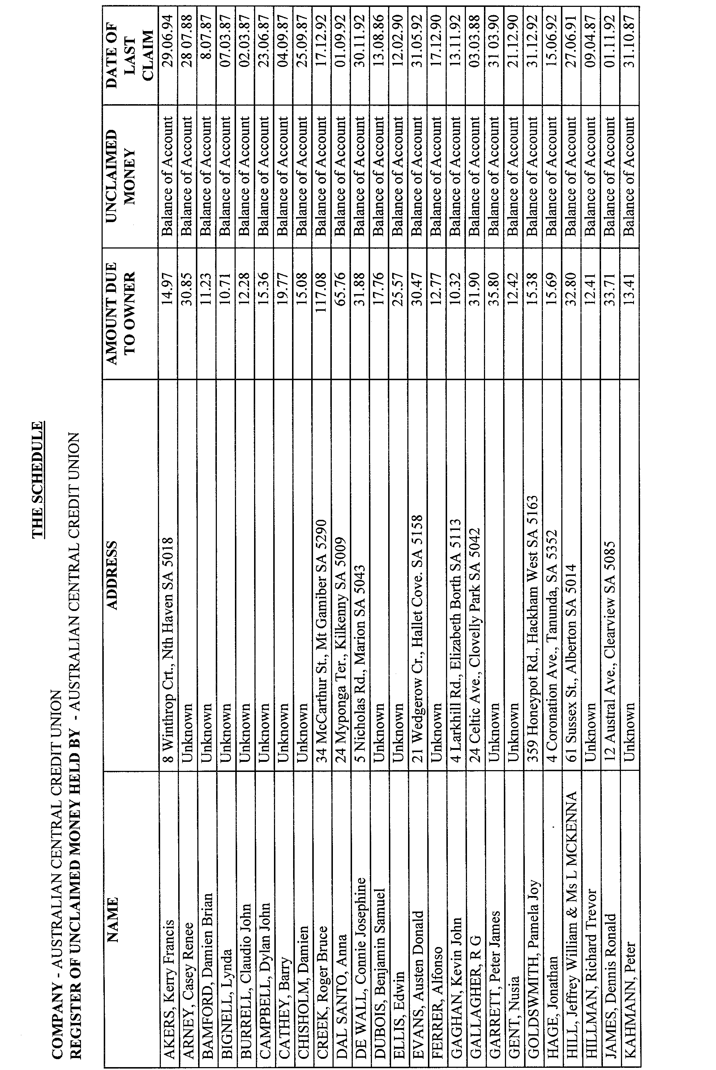
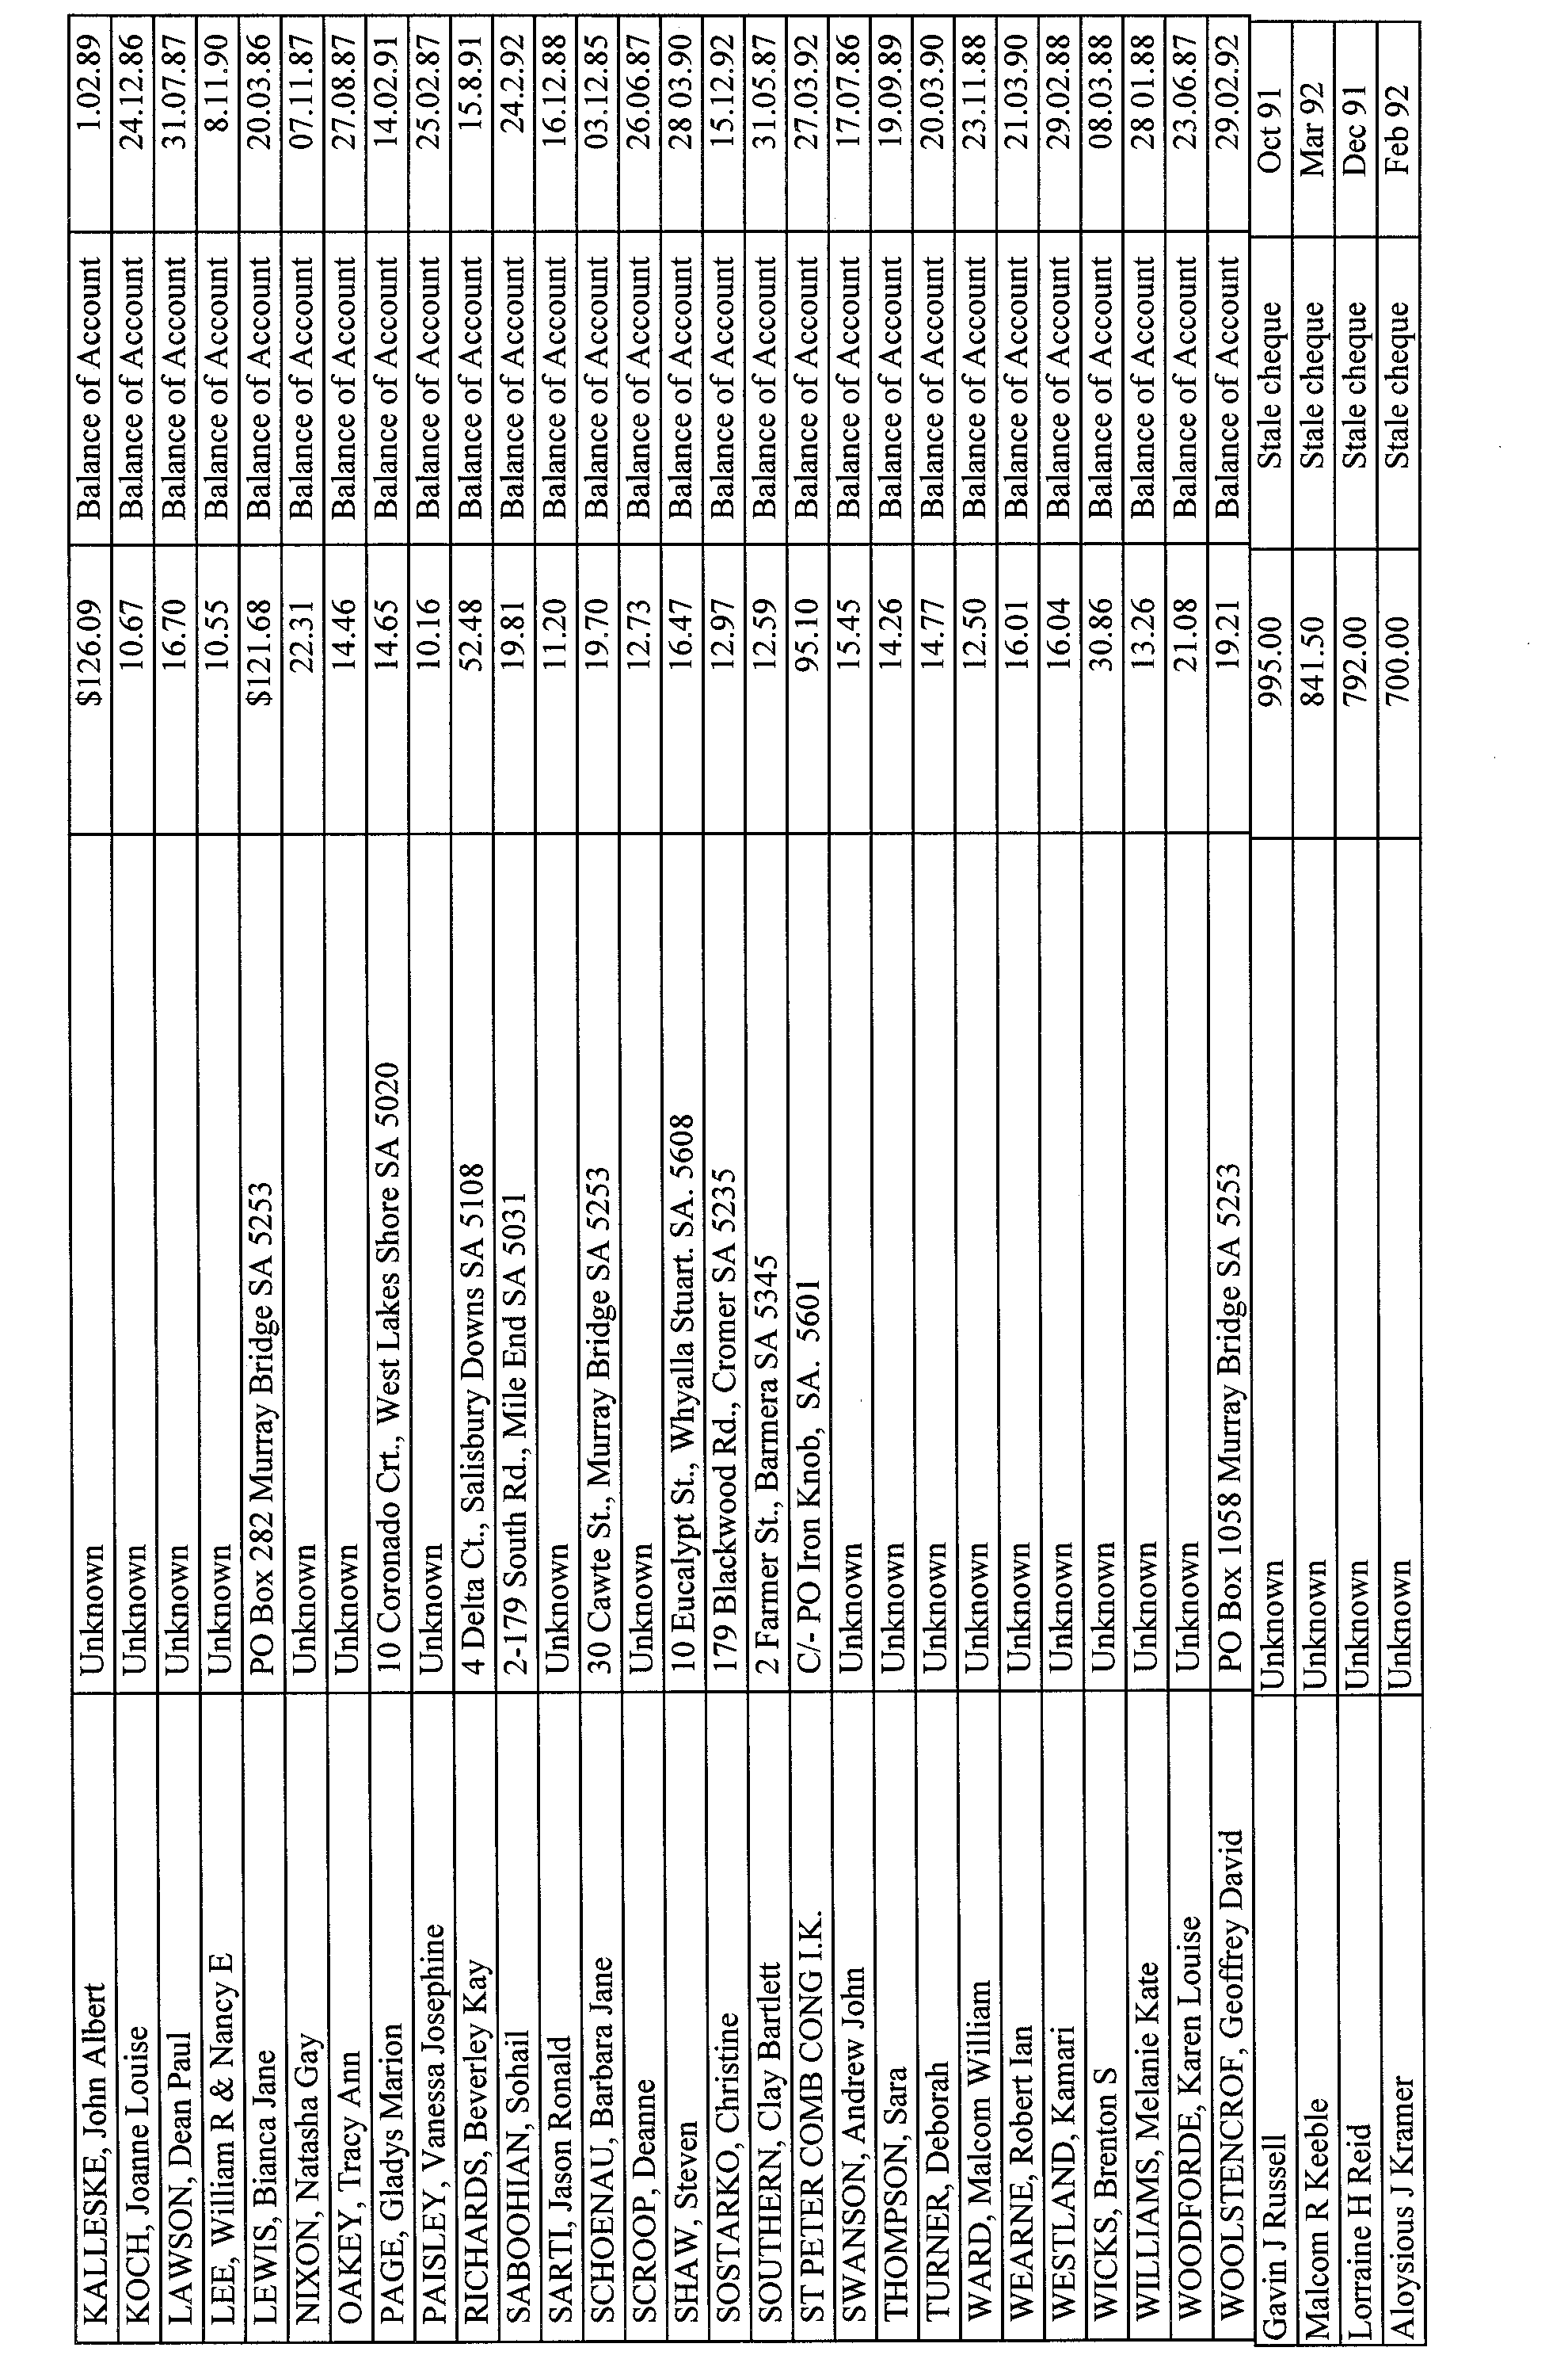
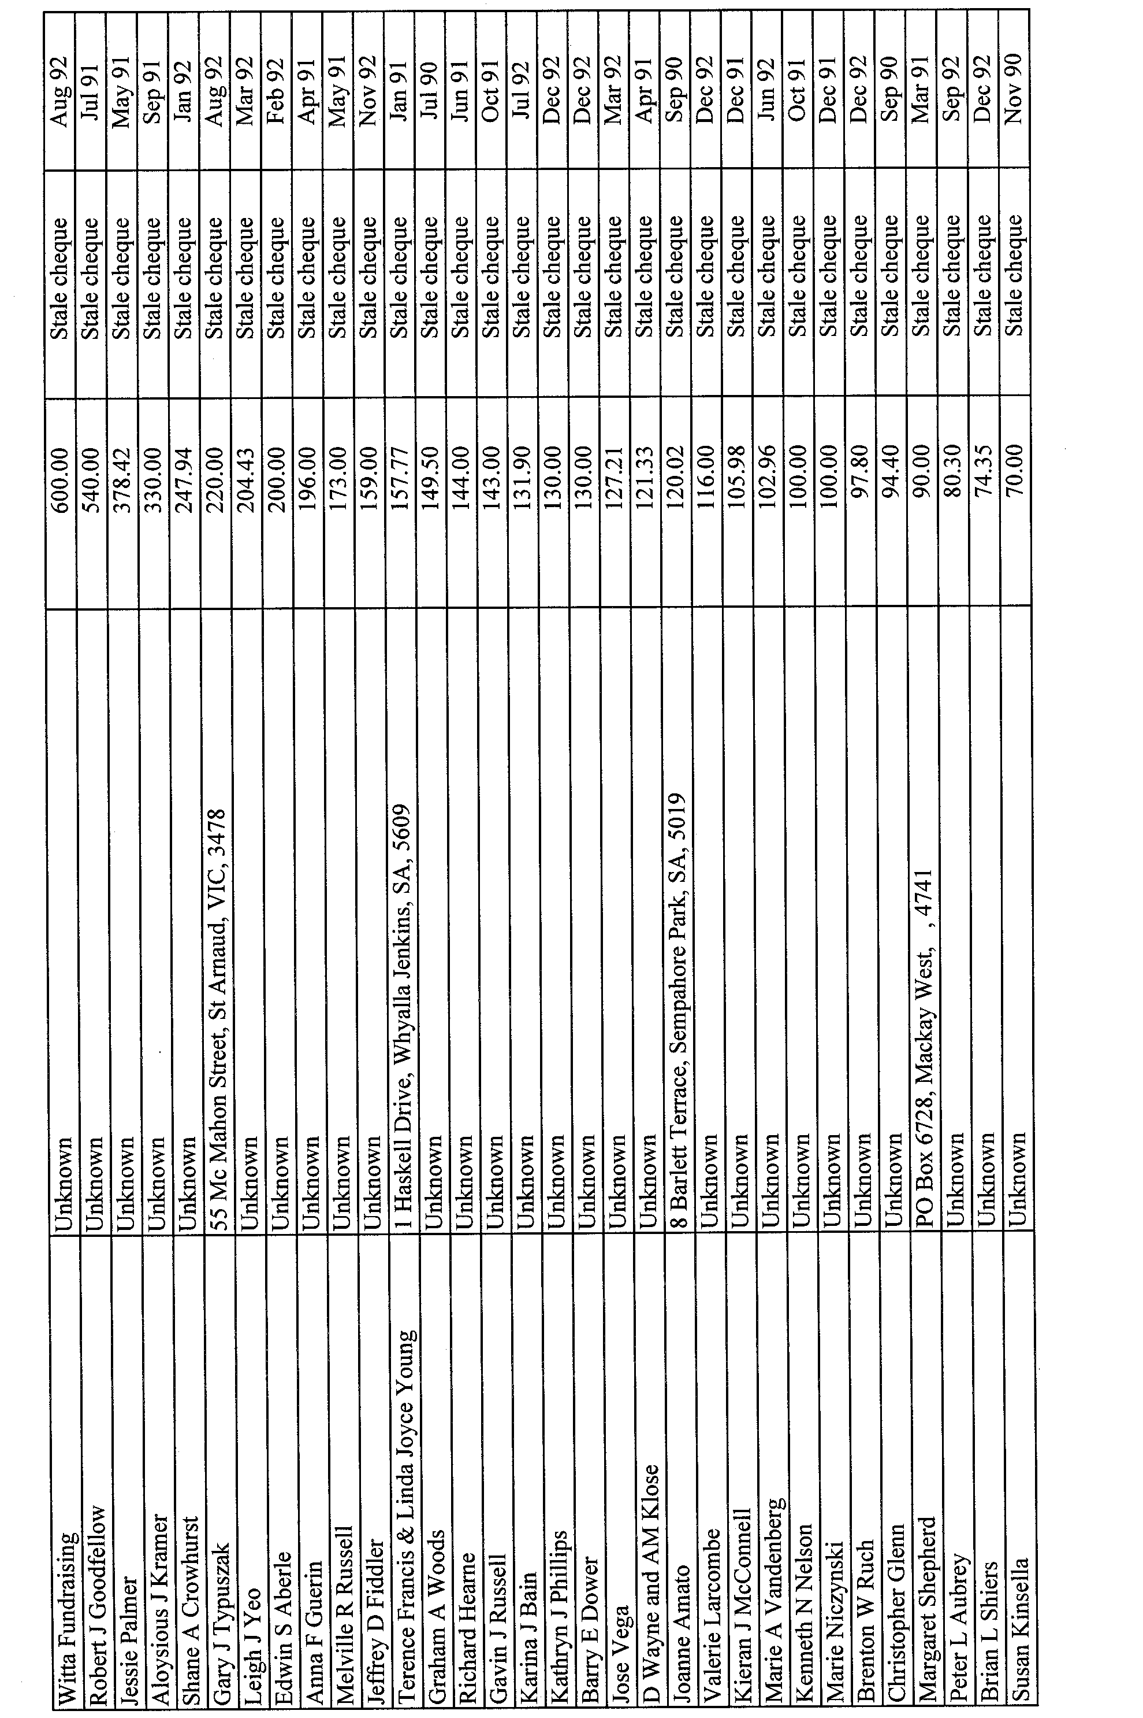
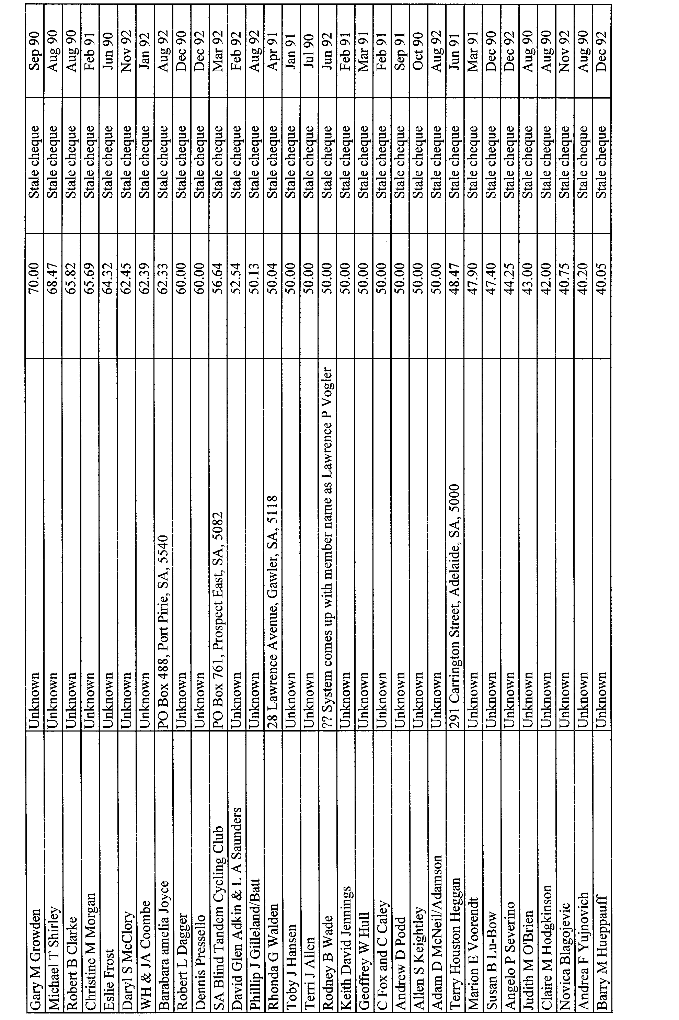
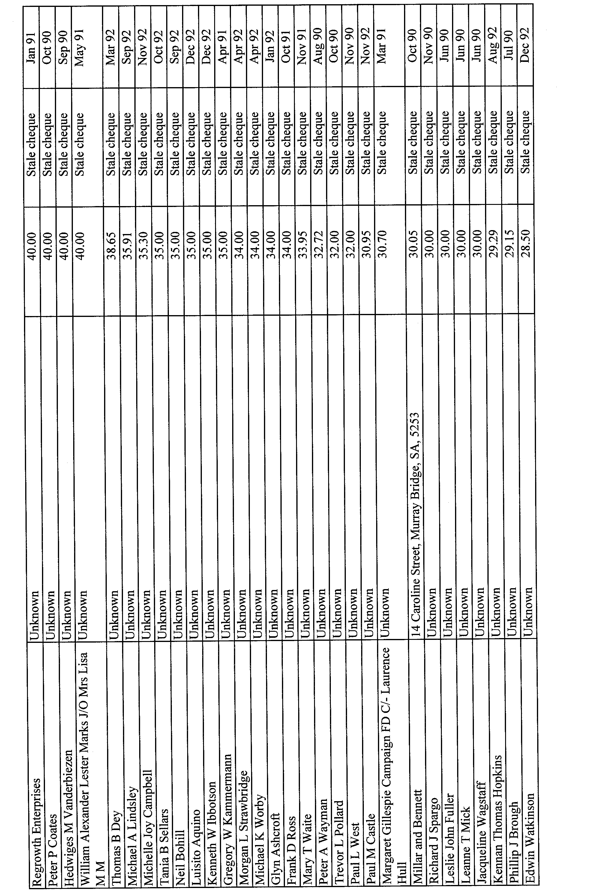
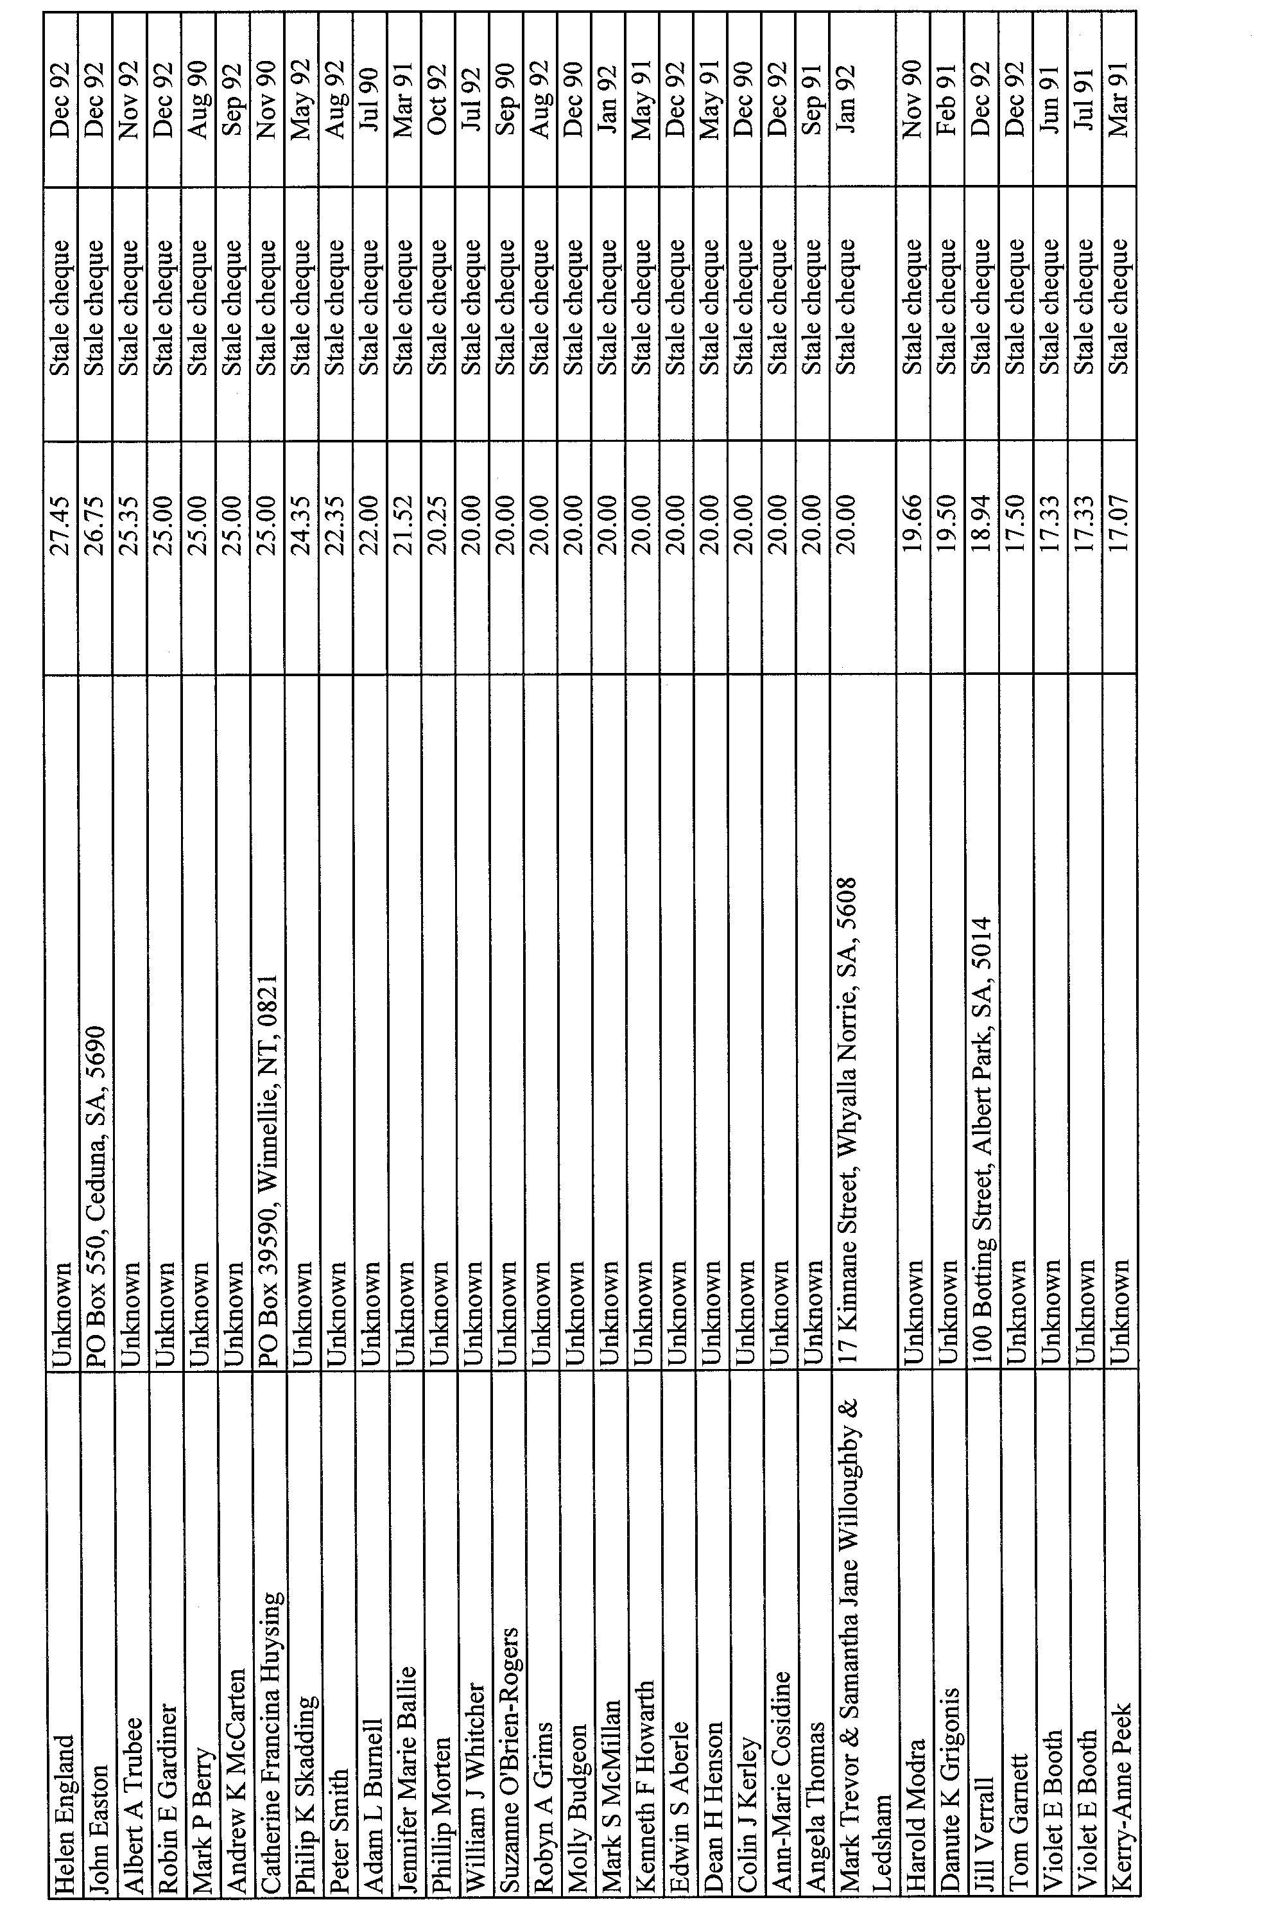
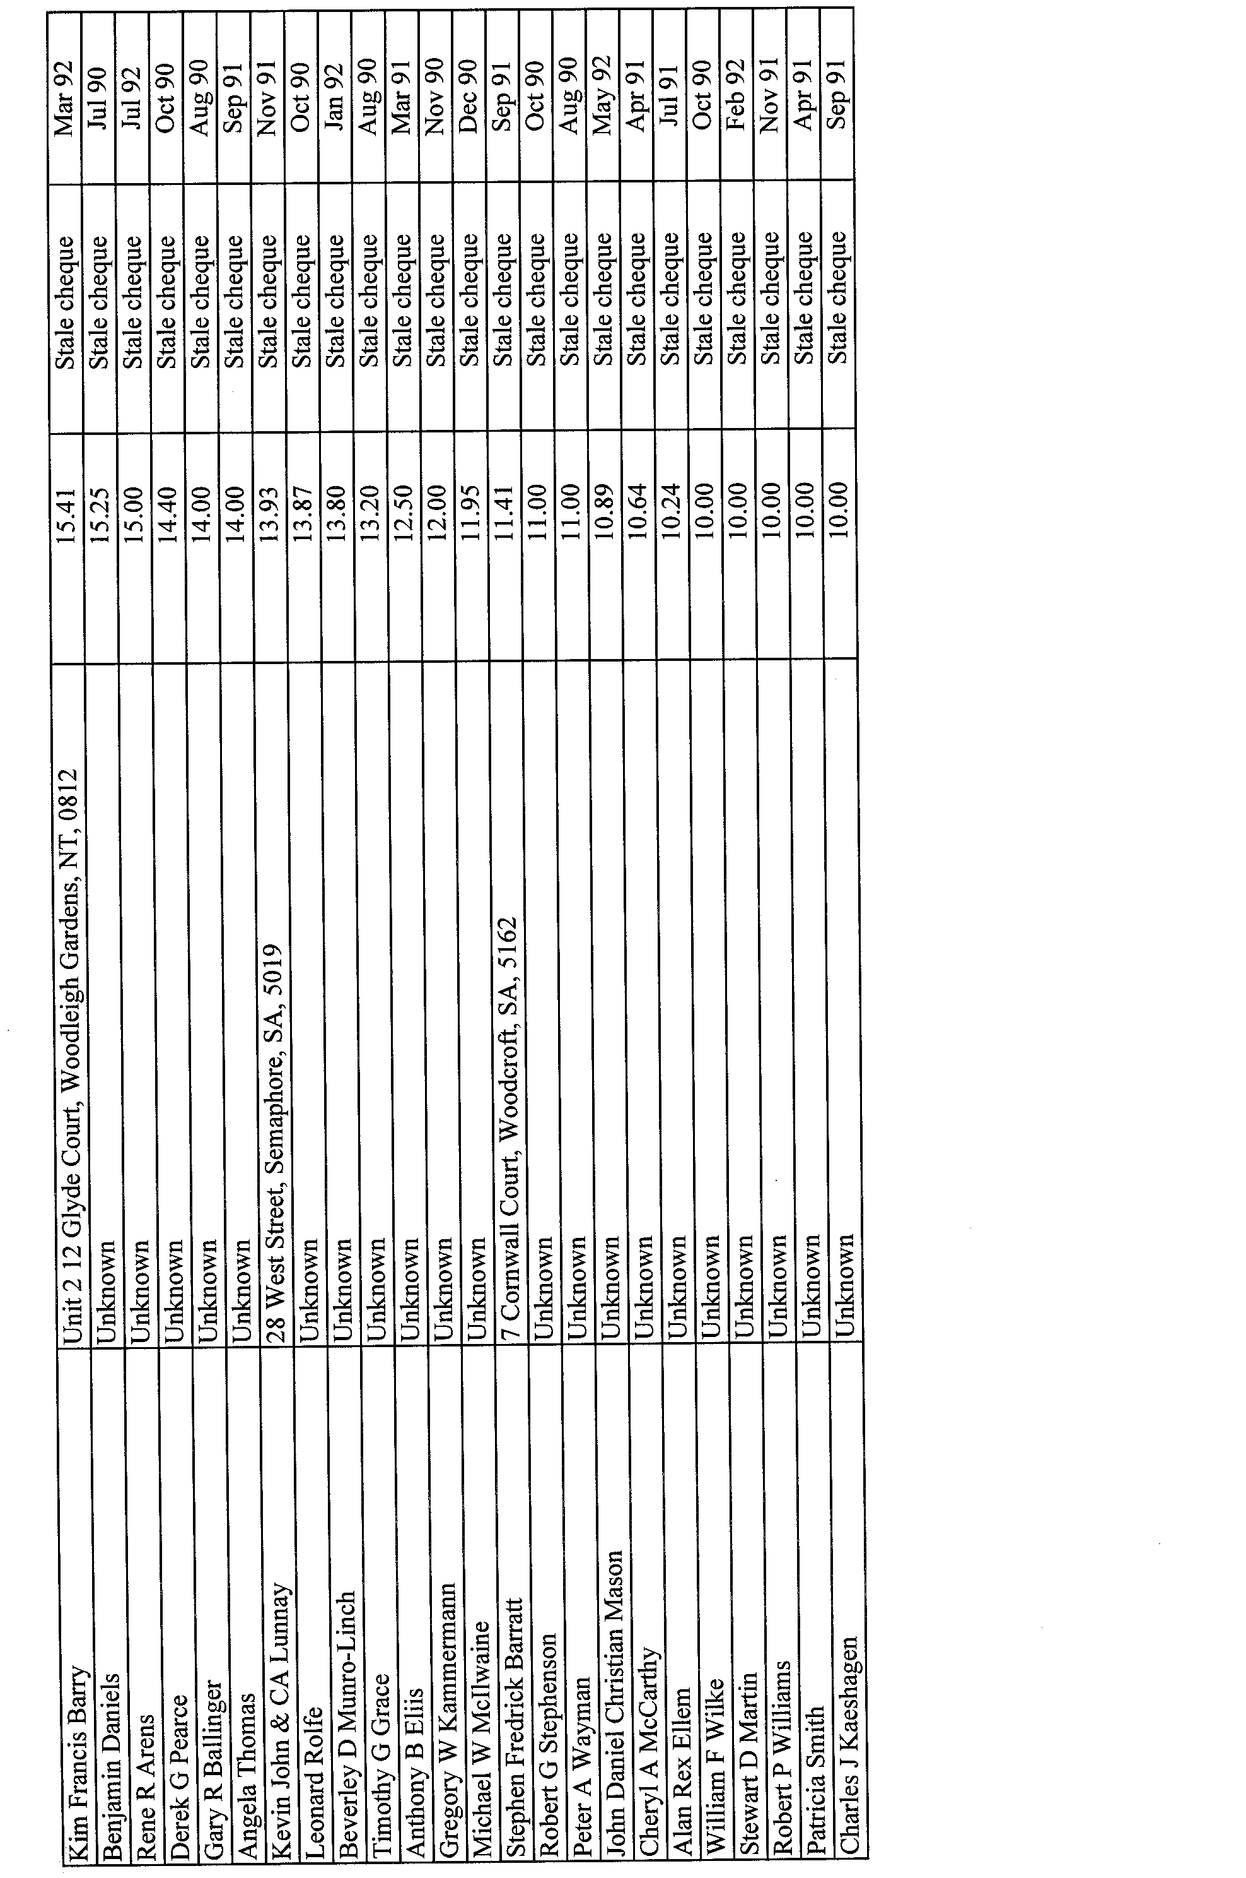
ATTENTION

CUSTOMERS requiring a proof of their notice for inclusion in the Government Gazette, please note that the onus is on you to inform State Print (Riverside 2000) of any subsequent corrections by 10 a.m. on Thursday, which is our publication deadline.

For any corrections to your notice please phone 8207 1045 or Fax 8207 1040 before 10 a.m. on Thursday.

If we do not receive any communication by 10 a.m. on Thursday (day of publication) we will presume the notice is correct and will print it as it is.

Remember—the onus is on you to inform us of any corrections necessary to your notice.

NOTE: Closing time for lodging new copy (either fax or hard copy) is 4 p.m. on Tuesday preceding the day of publication. Ph. 8207 1045—Fax 8207 1040.

Printed and published by authority every Thursday by M. E. JONES, Acting Government Printer, South Australia
Price: $3.75, plus postage; to subscribers, $185 per annum.

