No. 87 1

THE SOUTH AUSTRALIAN

GOVERNMENT GAZETTE

PUBLISHED BY AUTHORITY

ALL PUBLIC ACTS appearing in this GAZETTE are to be considered official, and obeyed as such

ADELAIDE, THURSDAY, 1 JULY 1999

CONTENTS

Page
Acts Assented To 2
Appointments, Resignations, Etc. 2
Associations Incorporation Act 1985⎯Notice 3
Corporations and District Councils—Notices 98
Crown Lands Act 1929—Notice 3
Dairy Industry Act 1992—Notice 3
Development Act 1993—Notices 4
Geographical Names Act 1991⎯Notice 5
Land Acquisition Act 1969-1972⎯Notices 5
Land and Business (Sale and Conveyancing) Act 1994—
Notice 7
Liquor Licensing Act 1997—Notices 10
Local Government Act 1934—Notice 11
Mining Act 1971—Notices 13
National Electricity (South Australia) Act 1996⎯Notice 13
Private Advertisements 102
Proclamations 2
Public Trustee Office—Administration of Estates 102
REGULATIONS
Fisheries Act 1982⎯
(No. 134 of 1999) 39
(No. 135 of 1999) 40
(No. 136 of 1999) 41
(No. 137 of 1999) 43
Page
Fisheries Act 1982⎯continued
(No. 138 of 1999) 45
(No. 139 of 1999) 47
(No. 140 of 1999) 49
(No. 141 of 1999) 51
(No. 142 of 1999) 53
Regulations Variation and Revocation (Financial Sector
Reform) Regulations 1999⎯(No. 143 of 1999) 55
South Australian Health Commission Act 1976⎯
(No. 144 of 1999) 64
(No. 145 of 1999) 65
Apiaries Act 1931⎯(No. 146 of 1999) 66
Travel Agents Act 1986⎯(No. 147 of 1999) 69
Opal Mining Act 1995⎯(No. 148 of 1999) 96
Renmark Irrigation Trust, The⎯Notice 14
Roads (Opening and Closing) Act 1991—Notices 14
Road Traffic Act 1961⎯Notice 15
Sewerage Act 1929—Notices 18
Unclaimed Moneys Act 1891⎯Notices 105
Vocational Education, Employment and Training Act 1994⎯
Contracts of Training 22
Water Mains and Sewers—Mains Laid, Replaced, Etc. 16
Waterworks Act 1932—Notices 19
Wine Grapes Industry Act 1991⎯Notice 21

GOVERNMENT GAZETTE NOTICES
ALL poundkeepers' and private advertisements forwarded for publication in the South Australian Government Gazette must be PAID FOR PRIOR TO INSERTION; and all notices, from whatever source, should be legibly written on one side of the paper only and sent to Riverside 2000 so as to be received no later than 4 p.m. Tuesday preceding the day of publication. Phone 8207 1045 or Fax 8207 1040. E-mail: govgaz@riv.ssa.sa.gov.au. Send as attachments in Word format and please confirm your transmission with a faxed copy of your document, including the date the notice is to be published and to whom the notice will be charged.

Department of the Premier and Cabinet
Adelaide, 1 July 1999
HIS Excellency the Governor directs it to be notified for general information that he has in the name and on behalf of Her Majesty The Queen, this day assented to the undermentioned Acts passed by the Legislative Council and House of Assembly in Parliament assembled, viz.:
No. 36 of 1999—An Act to make provision for the restructuring and disposal of all or part of the assets of electricity corporations; to amend the Development Act 1993, the Electricity Corporations Act 1994, the Environment Protection Act 1993, the Mining Act 1971 and the Superannuation Act 1988; and for other purposes.
By command,
Malcolm Buckby, for Premier

ADMINISTRATIVE ARRANGEMENTS ACT 1994 SECTION 5: ADMINISTRATION OF FINANCIAL SECTOR REFORM (SOUTH AUSTRALIA) ACT 1999 COMMITTED TO THE ATTORNEY-GENERAL
Proclamation By The Governor
(l.s.) E. J. Neal
PURSUANT to section 5 of the Administrative Arrangements Act 1994 and with the advice and consent of the Executive Council, I commit the administration of the Financial Sector Reform (South Australia) Act 1999 to the Attorney-General.
Given under my hand and the Public Seal of South Australia, at Adelaide, 1 July 1999.
By command,
Malcolm Buckby, for Premier
AG 43/97 CS

BARLEY MARKETING (MISCELLANEOUS) AMENDMENT ACT 1999 (Act No. 31 of 1999): DAY OF COMMENCE-MENT
Proclamation By The Governor
(l.s.) E. J. Neal
WITH the advice and consent of the Executive Council, I fix 1 July 1999 as the day on which the Barley Marketing (Miscellaneous) Amendment Act 1999 will come into operation.
Given under my hand and the Public Seal of South Australia, at Adelaide, 1 July 1999.
By command,
Malcolm Buckby, for Premier
MPNR 53/98 CS

MINING ACT 1971 SECTION 8(2): LEIGH CREEK COAL-FIELD—VARIATION OF PROCLAMATION RESERVING LAND FROM OPERATION OF CERTAIN PROVISIONS OF ACT
Proclamation By The Governor
(l.s.) E. J. Neal
Preamble
1. By proclamation made pursuant to the Mining Act 1971 on 25 October 1984 (see Gazette 25 October 1984 p. 1312), certain land was reserved from the operation of section 17 and Parts 4, 5, 6, 6A, 7 and 8 of the Act.
2. It is now intended that the land no longer be reserved from the operation of section 17 of the Act.
Proclamation
PURSUANT to section 8(2) of the Mining Act 1971 and with the advice and consent of the Executive Council, I vary the proclamation referred to in the preamble by striking out from clause 2 of the proclamation "section 17 and".
Given under my hand and the Public Seal of South Australia, at Adelaide, 1 July 1999.
By command,
Malcolm Buckby, for Premier
MPNR 28/99 CS

Department of the Premier and Cabinet
Adelaide, 1 July 1999
HIS Excellency the Governor in Executive Council has been pleased to appoint the undermentioned to the National Wine Centre Board, pursuant to the provisions of the National Wine Centre Act 1997:
Member: (from 1 July 1999 until 20 May 2000)
Dianne Davidson
By command,
Malcolm Buckby, for Premier
DPC 12/98CS

Department of the Premier and Cabinet
Adelaide, 1 July 1999
HIS Excellency the Governor in Executive Council has been pleased to appoint the undermentioned to the Superannuation Funds Management Corporation of South Australia Board (Funds SA), pursuant to the provisions of the Superannuation Funds Management Corporation of South Australia Act 1995:
Director: (from 1 July 1999 until 30 June 2002)
Jan McMahon
By command,
Malcolm Buckby, for Premier
DT&F 044/99CS

Department of the Premier and Cabinet
Adelaide, 1 July 1999
HIS Excellency the Governor in Executive Council has been pleased to appoint the undermentioned to the Motor Accident Commission, pursuant to the provisions of the Motor Accident Commission Act 1992:
Director: (from 1 July 1999 until 30 June 2001)
Roger Neil Sexton
David Henry Archbold
Christopher Lee Harris
John Thomas Hill
Richard Joseph McKay
Jeanette Matysek
Kym Albert Weir
Chair: (from 1 July 1999 until 30 June 2001)
Roger Neil Sexton
By command,
Malcolm Buckby, for Premier
DT&F 046/99CS

Department of the Premier and Cabinet
Adelaide, 1 July 1999
HIS Excellency the Governor in Executive Council has been pleased to appoint the undermentioned to the ETSA Corporation Board, pursuant to the provisions of the Electricity Corporations Act 1994:
Director: (from 1 July 1999 until 30 June 2000)
Michael John Janes
Cheryl Bart
Martin Cameron
Chair: (from 1 July 1999 until 30 June 2000)
Michael John Janes
By command,
Malcolm Buckby, for Premier
DT&F 049/99CS

Department of the Premier and Cabinet
Adelaide, 1 July 1999
HIS Excellency the Governor in Executive Council has been pleased to appoint the undermentioned to the Correctional Services Advisory Council, pursuant to the provisions of the Correctional Services Act 1982:
Member: (from 1 July 1999 until 30 June 2002)
Dr Susan Joan Gaffney
By command,
Malcolm Buckby, for Premier
MCS 9/98CS

Department of the Premier and Cabinet
Adelaide, 1 July 1999
HIS Excellency the Governor in Executive Council has been pleased to appoint the undermentioned to the South Australian Health Commission, pursuant to the provisions of the South Australian Health Commission Act 1976:
Part-Time Member: (from 25 July 1999 until 24 July 2002)
Arthur van Deth
Roxanne Ramsey
James Davidson
By command,
Malcolm Buckby, for Premier
DHS 12/99CS

Department of the Premier and Cabinet
Adelaide, 1 July 1999
HIS Excellency the Governor in Executive Council has been pleased to appoint the undermentioned to the Workers Rehabilitation and Compensation Advisory Committee, pursuant to the provisions of the Workers Rehabilitation and Compensation Act 1986:
Presiding Member: (from 1 July 1999 until 30 June 2001)
Keith Edwin Brown
By command,
Malcolm Buckby, for Premier
MGE 060/99CS

Department of the Premier and Cabinet
Adelaide, 1 July 1999
HIS Excellency the Governor in Executive Council has been pleased to appoint Bryan Wayne Atterton as an Inspector of Mines, pursuant to section 6 of the Mines and Works Inspection Act 1920.
By command,
Malcolm Buckby, for Premier
MPNR 013/99CS

Department of the Premier and Cabinet
Adelaide, 1 July 1999
HIS Excellency the Governor in Executive Council has been pleased to appoint John Andrew Darley as a Commissioner of Charitable Funds for the period 1 July 1999 to 30 June 2002, pursuant to section 6 (5) of the Public Charities Funds Act 1935-74.
By command,
Malcolm Buckby, for Premier
MHS 11/98CS

ASSOCIATIONS INCORPORATION ACT 1985
Order Pursuant to Subsection 42 (2)
WHEREAS the Corporate Affairs Commission (‘the Commission”) pursuant to subsection 42 (1) of the Associations Incorporation Act 1985 (‘the Act’) is of the opinion that the undertaking of S.A. Fishing and Seafood Industry Skills Centre Incorporated (‘the association’) being an incorporated association under the Act would more appropriately be carried on by a body corporate incorporated under the Corporations Law of South Australia and whereas the Commission was on 22 June 1999 requested by the association to transfer its undertaking to Australian Fisheries Academy Ltd (ACN 086 232 760) the Commission pursuant to subsection 42 (2) of the Act doth hereby order that on 1 July 1999 the undertaking of S.A. Fishing and Seafood Industry Skills Centre Incorporated be transferred to Australian Fisheries Academy Ltd (ACN 086 232 760).
Given at Adelaide, 22 June 1999.
A. J. Griffiths, A delegate of the Corporate Affairs Commission

CROWN LANDS ACT 1929: SECTION 5
TAKE NOTICE that pursuant to the Crown Lands Act 1929, I PETER MACLAREN KENTISH, Surveyor-General and Delegate appointed by DOROTHY KOTZ, Minister for Environment and Heritage, Minister of the Crown to whom the administration of the Crown Lands Act 1929 is committed DO HEREBY:
1. Dedicate the Crown Land defined in The First Schedule as a Public Road.
2. Dedicate the Crown Land defined in The Second Schedule as a Drainage Reserve and declare that such land shall be under the care, control and management of the Mid Murray Council.
The First Schedule
Allotment 30 of DP 50912, Hundred of Nildottie, County of Albert, being within the Mid Murray district.
The Second Schedule
Allotment 32 of DP 50912, Hundred of Nildottie, County of Albert, exclusive of all necessary roads.
Dated 28 June 1999.
P. M. Kentish, Surveyor-General
DENR 11/0279

DAIRY INDUSTRY ACT 1992
Notice of Licence Fees
THE Dairy Authority of South Australia in pursuance of the powers conferred by the Dairy Industry Act 1992, hereby requires every holder of a licence under the Act to pay to the Authority contributions towards the cost of administration of the Act.
All such contributions will be calculated from 1 July 1999, or the day on which the licence is granted, whichever is the later, unless otherwise determined by the Authority.
Each licence holder must pay to the Authority licence fees calculated in the following manner:
(1) Every holder of a dairy farmer’s licence who either:
(a) delivers milk to the holder of a processor’s licence; or
(b) sells or delivers milk to a person other than a processor,
must pay 0.025 cents per litre of milk produced on the premises specified in his/her licence during the relevant antecedent period.
(2) Every holder of a processor’s licence must pay:
(a) a licence fee of $50 per annum; or
(b) 0.025 cents per litre of milk received from licensed dairy farmers at premises specified in his/her licence during the relevant antecedent period,
whichever is the greater.
(3) Every holder of a vendor’s licence must pay a licence fee of $20 per annum.
Licence fees must be paid as follows:
(1) In the case of (1) (a) and (2) (b) above, within 14 days of the commencement of each calendar month.
(2) In the case of (1) (b) above, quarterly—this is to say within 14 days of 1 January, 1 April, 1 July and 1 October in each year.
(3) In the case of (2) (a) and (3) above, fees are payable in advance and must be lodged with an application for renewal of a licence.
In this notice ‘relevant antecedent period’ means (with regard to a dairy farmer delivering milk to a processor or a processor who pays a licence fee based on litres of milk received) the last calendar month but one before the commencement of the current calendar month.
Take note that:
(1) The above terms and conditions apply until further notice.
(2) The Regulations under the Dairy Industry Act 1992, authorise a processor to collect and remit to the Authority licence fees payable by dairy farmers.
This notice replaces the notice previously published in the Government Gazette on 3 September 1998, at page 777.
Dated 24 June 1999.
S. J. Rice, Chief Executive Officer, Dairy Authority of South Australia

DEVELOPMENT ACT 1993: SECTION 48
Decision by the Development Assessment Commission as
Delegate of the Governor
Preamble
1. An amended proposal to upgrade the facilities at Memorial Drive, North Adelaide comprising a new tennis club and fitness centre (to replace the existing club building), an undercroft car park, the redevelopment of the northern and southern grandstands of the centre court stadium and the removal and replacement of tennis courts has been under consideration under Division 2 of Part 4 of the Development Act 1993.
2. The development has been the subject of a Development Report and an Assessment Report under sections 46 and 46D of the Development Act 1993. The Development Report and the Assessment Report has been amended under section 47 of the Development Act 1993.
3. Application has now been made to the Development Assessment Commission as the Delegated Authority under section 48 of the Development Act 1993, for the approval of the development.
4. The Development Assessment Commission is satisfied that an appropriate Development Report, and an Assessment Report, have been prepared in relation to the development in accordance with the requirements of Division 2 of Part 4 of the Development Act 1993.
5. The Development Assessment Commission has, in considering the application, had regard to all relevant matters under section 48 (5) of the Development Act 1993.
Decision
PURSUANT to section 48 of the Development Act 1993, the Development Assessment Commission grants development approval for the amended proposal to Redevelop the Memorial Drive Tennis Centre as described in the following applications:
• Application dated 19 February 1998, amended by letter dated 1 September 1998 and the following plans dated September 1998:
⇒ AA0006/S/30A. September 1998—Undercroft Plan
⇒ AA0006/S/32B. September 1998—First Floor Plan
⇒ AA0006/S/31C. September 1998—Ground Floor Plan
⇒ AA0006/S/33C. September 1998—Elevations
• Application to vary the proposal dated 8 March 1999 (Ref. No.: AP0612B), including the following plans:
⇒ Memorial Drive Sports Centre. Scheme 12. AA0006/S/37. February 1999 Hassell
⇒ Memorial Drive Sports Centre. Scheme 12. AA0006/S/33E. December 1998 Hassell
• Application to vary the approval dated 8 March 1999 (Ref. No.: AP0612C) including the following plans:
⇒ Memorial Drive Sports Centre. Scheme 12. AA0006/S/40. February 1999 Hassell
⇒ Memorial Drive Sports Centre. Scheme 12. AA0006/S/41. February 1999 Hassell
⇒ Memorial Drive Sports Centre. Ground Floor Plan South AA0006/S/38
⇒ Memorial Drive Sports Centre. First Floor Plan South AA0006/S/39
• Application dated 18 May 1999 including the following plans:
⇒ Memorial Drive Tennis Stadium Upgrade-Stage 2 Plan—South Stand. AA0028B-DD-04
⇒ Memorial Drive Tennis Stadium Upgrade-Stage 2 Plan—North Stand. AA0028B-DD-05
Subject to conditions and notes attached entitled ‘Conditions (1-13) for Development Approval—Amendment to the Redevelopment of the Memorial Drive Tennis Centre proposal’.
Development Assessment Commission

Conditions [1-13] for Development Approval Amendment to the Redevelopment of the Memorial Drive Tennis Centre Proposal
1. An Environmental Management Plan must be prepared, to the satisfaction of the Environment Protection Agency prior to commencement of demolition or construction, which addresses:
• traffic management;
• dust and mud control;
• noise control;
• stormwater management;
• vegetation management;
• truck washdown management; and
• site clean up.
2. The proposed tennis courts lights must be directed and shielded, if necessary, to prevent glare and light overspill outside the courts impacting on road users on War Memorial Drive.
3. Retail floor space must be limited to a maximum floor area of 100 m² and must only be used for equipment servicing and the sale of goods/clothing/equipment associated with the tennis and sporting/fitness facilities in the Centre.
4. The use of the proposed hair dressing, facial and manicure facilities must, at any time, be limited to a maximum floor area of 80 m².
5. The office component of this development must be utilised for the administration of tennis and the Centre facilities only and not for other forms of offices.
6. The car parking areas must be designed in accordance with Australian Standards 2890.1 1993.
7. The proponent shall use its best endeavours to soften the visual impact of the eastern elevation of the tennis centre adjacent to the Tennis SA lease boundary by modelling of panels, landscaping, graphic displays or other such method. The proponent shall consult with the Adelaide City Council and Planning SA in relation to such methods.
8. If the South Australian Cricket Association wishes and so permits, the applicant (or any person hereafter having the benefit of this approval) must plant semi-mature trees adjacent to the southern bowling green, along the eastern elevation of the tennis centre.
9. The proposed development must comply with the S.A. Environment Protection Authority’s ‘Stormwater Pollution Prevention Code of Practice for Local, State and Federal Government’.
10. No excavation or other works whatsoever shall be undertaken within 5 m of the trunk of the Moreton Bay Fig tree located adjacent to the southern boundary of the site. The proponent shall obtain the advice of a qualified arborculturalist in relation to the preservation and well being of the tree prior to commencement of any works within the vicinity of the tree. No roots of the tree shall be severed or damaged unless personally supervised by the said arborculturalist. Pruning to balance the canopy of the tree may be undertaken to minimise stress associated with root pruning.
11. Provision must be made for at least 25 bicycle parks on the site.
12. All buildings and structures must be certified as complying with the Building Rules prior to any building work commencing.
13. The colour of the shade sail over the swimming pool and the small sail canopy must be of a light shade to blend in with the main building.
Notes
1. Consultation should occur between Adelaide City Council and emergency service organisations (ambulance, fire, police) regarding provision of access along War Memorial Drive during peak spectator periods at Memorial Drive Tennis Centre.
2. Consultation should occur between the proponents and Planning SA and Adelaide City Council on any proposals for advertising and direction signs. Advertising and direction signs for the proposed development are not included in this development authorisation.
3. In preparing the Environmental Management Plan the relevant Environment Protection Policies under the Environment Protection Act 1993, should assist in the process.
4. The construction, alteration or removal of any crossing place in relation to the development, which is to be at the applicant’s expense, will require a separate application to the Infrastructure Services Division of the Adelaide City Council. Such works should be undertaken before the building hereby approved are occupied.
G. Holland-Brooker, Secretary

DEVELOPMENT ACT 1993: SECTION 46 (4)
Preamble
1. On 15 April 1999 I, the Minister for Transport and Urban Planning, by notice in the Gazette (see Gazette 15 April 1999 pp. 1924 to 1927), declared that section 46 of the Development Act 1993 applies to any development of a kind specified in Schedule 1 of the declaration.
2. It is now appropriate to vary the declaration.
Notice
PURSUANT to section 46 (4) of the Development Act 1993, I vary the declaration referred to in clause 1 of the preamble by striking out Item 1 of Schedule 1 and substituting the following item:
Area 1
1. Development of a private haul road from a magnesite mine site to the Leigh Creek rail terminal together with any associated facility at the Leigh Creek rail terminal to remove impurities from the magnesite ore by the application of beneficiation processes such as crushing, grinding, flotation and physical separation of solid impurities (including developments for the disposal of the solid wastes arising from this processing) and any associated ore storage, loading facilities or new rail siding, within the area specified as Area 1 in Schedule 2.
Diana Laidlaw, Minister for Transport and Urban Planning

GEOGRAPHICAL NAMES ACT 1991
Notice of Intention to Assign Names and Boundaries to Places
NOTICE is hereby given pursuant to the provisions of the above Act that the Surveyor-General proposes to exclude from the suburb of Seaford and include in the suburb of Old Noarlunga that area marked A on the plan below.
The Plan
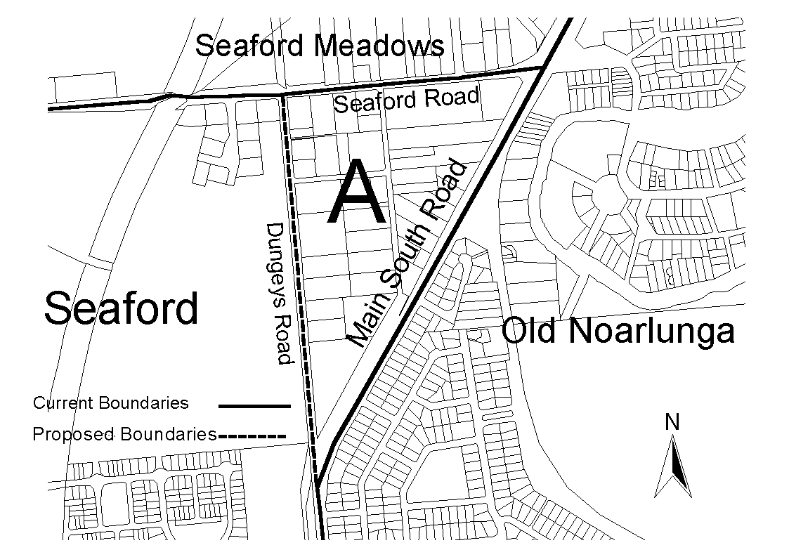
Submissions in writing regarding this proposal may be lodged with the Secretary, Geographical Names Advisory Committee, Building 2, 300 Richmond Road, Netley (P.O. Box 550, Marleston, S.A. 5033) within one month of the publication of this notice.
Dated 18 June 1999.
P. M. Kentish, Surveyor-General, Department for Administrative and Information Services
DEHAA 04/0072

LAND ACQUISITION ACT 1969
(Section 16)
Notice of Acquisition
THE Commissioner of Highways (the ‘Authority’), 33 Warwick Street, Walkerville, S.A. 5081, acquires the following interests in the following land:
The Fee Simple of the land in the Hundred of Jellicoe, and delineated as piece 63 in the plan lodged in the Lands Titles Office and numbered Deposited Plan 48458 and being portion of the land contained in certificate of title register book volume 3319, folio 56.
This notice is given under section 16 of the Land Acquisition Act 1969.
Compensation
A person who has or had an interest in the land that is divested or diminished by the acquisition or the enjoyment of which is adversely affected by the acquisition who does not receive an offer of compensation from the Authority may apply to the Authority for compensation.
Inquiries
Inquiries should be directed to:
Brian O’Callaghan
P.O. Box 1
Walkerville, S.A. 5081
Telephone (08) 8343 2423.
Dated 28 June 1999.
The common seal of the Commissioner of Highways was hereto affixed by direction of the Commissioner of Highways in the presence of:
R. G. Bevan, Manager, Land Acquisition and Disposal Transport SA

LAND ACQUISITION ACT 1969
(Section 16)
Notice of Acquisition
THE Commissioner of Highways (the ‘Authority’), 33 Warwick Street, Walkerville, S.A. 5081, acquires the following interests in the following land:
Firstly, the Fee Simple of the land situated in the Hundred of Belvidere, and delineated as piece 61 in the plan lodged in the Lands Titles Office and numbered Deposited Plan 48457 and being portion of the land contained in certificate of title register book volume 2615, folio 147.
Secondly, the Fee Simple of the land situated in the Hundred of Jellicoe, and delineated as piece 55 in the plan lodged in the Lands Titles Office and numbered Deposited Plan 48457 and being portion of the land contained in certificate of title register book volume 2615, folio 131.
Thirdly, the Fee Simple of the land situated in the Hundred of Jellicoe and delineated as piece 59 in the plan lodged in the Lands Titles Office and numbered Deposited Plan 48457, and being portion of the land contained in certificate of title register book volume 5424, folio 246.
This notice is given under section 16 of the Land Acquisition Act 1969.
Compensation
A person who has or had an interest in the land that is divested or diminished by the acquisition or the enjoyment of which is adversely affected by the acquisition who does not receive an offer of compensation from the Authority may apply to the Authority for compensation.
Inquiries
Inquiries should be directed to:
Brian O’Callaghan
P.O. Box 1
Walkerville, S.A. 5081
Telephone (08) 8343 2423.
Dated 28 June 1999.
The common seal of the Commissioner of Highways was hereto affixed by direction of the Commissioner of Highways in the presence of:
R. G. Bevan, Manager, Land Acquisition and Disposal Transport SA

LAND ACQUISITION ACT 1969
(Section 16)
Notice of Acquisition
THE Commissioner of Highways (the ‘Authority’), 33 Warwick Street, Walkerville, S.A. 5081, acquires the following interests in the following land:
Firstly, the Fee Simple of the land situated in the Hundred of Belvidere, and delineated as piece 153 in the plan lodged in the Lands Titles Office and numbered Deposited Plan 48606 and being portion of the land contained in certificate of title register book volume 4289, folio 963.
Secondly, the Fee Simple of the land situated in the Hundred of Belvidere, and delineated as piece 154 in the plan lodged in the Lands Titles Office and numbered Deposited Plan 48606 and being portion of the land contained in certificate of title register book volume 4065, folio 891.
This notice is given under section 16 of the Land Acquisition Act 1969.
Compensation
A person who has or had an interest in the land that is divested or diminished by the acquisition or the enjoyment of which is adversely affected by the acquisition who does not receive an offer of compensation from the Authority may apply to the Authority for compensation.
Inquiries
Inquiries should be directed to:
Brian O’Callaghan
P.O. Box 1
Walkerville, S.A. 5081
Telephone (08) 8343 2423.
Dated 28 June 1999.
The common seal of the Commissioner of Highways was hereto affixed by direction of the Commissioner of Highways in the presence of:
R. G. Bevan, Manager, Land Acquisition and Disposal Transport SA

LAND ACQUISITION ACT 1969
(Section 16)
Notice of Acquisition
THE Commissioner of Highways (the ‘Authority’), 33 Warwick Street, Walkerville, S.A. 5081, acquires the following interests in the following land:
The Fee Simple of the land situated in the Hundred of Moorooroo, delineated as piece 164 in the plan lodged in the Lands Titles Office and numbered Deposited Plan 48608 and being portion of the land contained in certificate of title register book volume 2729, folio 44.
This notice is given under section 16 of the Land Acquisition Act 1969.
Compensation
A person who has or had an interest in the land that is divested or diminished by the acquisition or the enjoyment of which is adversely affected by the acquisition who does not receive an offer of compensation from the Authority may apply to the Authority for compensation.
Inquiries
Inquiries should be directed to:
Brian O’Callaghan
P.O. Box 1
Walkerville, S.A. 5081
Telephone (08) 8343 2423.
Dated 28 June 1999.
The common seal of the Commissioner of Highways was hereto affixed by direction of the Commissioner of Highways in the presence of:
R. G. Bevan, Manager, Land Acquisition and Disposal Transport SA

LAND ACQUISITION ACT 1969
(Section 16)
Notice of Acquisition
THE Commissioner of Highways (the ‘Authority’), 33 Warwick Street, Walkerville, S.A. 5081, acquires the following interests in the following land:
Firstly, the Fee Simple of the land situated in the Hundred of Belvidere, delineated as piece 161 in the plan lodged in the Lands Titles Office and numbered Deposited Plan 48607 and being portion of the land contained in former certificate of title register book volume 5292, folio 796.
Secondly, the Fee Simple of the land situated in the Hundred of Belvidere, and delineated as piece 162 in the plan lodged in the Lands Titles Office and numbered Deposited Plan 48607 and being portion of the land contained in certificate of title register book volume 5292, folio 796.
This notice is given under section 16 of the Land Acquisition Act 1969.
Compensation
A person who has or had an interest in the land that is divested or diminished by the acquisition or the enjoyment of which is adversely affected by the acquisition who does not receive an offer of compensation from the Authority may apply to the Authority for compensation.
Inquiries
Inquiries should be directed to:
Brian O’Callaghan
P.O. Box 1
Walkerville, S.A. 5081
Telephone (08) 8343 2423.
Dated 28 June 1999.
The common seal of the Commissioner of Highways was hereto affixed by direction of the Commissioner of Highways in the presence of:
R. G. Bevan, Manager, Land Acquisition and Disposal Transport SA

LAND AND BUSINESS (SALE AND CONVEYANCING) ACT 1994
Section 23
TAKE notice that, pursuant to section 23 (3) of the Land and Business (Sale and Conveyancing) Act 1994, I, Kenneth Trevor Griffin, Minister for Consumer Affairs, do hereby exempt the person named in Schedule 1 from the application of section 23 (2) of the Act in relation to the purchase of the land specified in Schedule 2.
Schedule 1
Graham Edward Margrie, an officer/employee of Tea Tree Gully Estates Pty Ltd.
Schedule 2
The whole of land described in certificate of title register book volume 5522, folio 670 situated at allotment 37, Currawong Crescent, Modbury Heights, S.A. 5092.
Dated 1 July 1999.
Signed for and on behalf of the Minister for Consumer Affairs by the Acting Commissioner for Consumer Affairs.
W. J. Spehr, Acting Commissioner

GOVERNMENT GAZETTE ADVERTISEMENT RATES

To apply from 1 July 1999

$  Agents, Ceasing to Act as 28.50  Associations:  Incorporation 14.50  Intention of Incorporation 35.75  Transfer of Properties 35.75  Attorney, Appointment of 28.50  Bailiff’s Sale 35.75  Cemetery Curator Appointed 21.20  Companies:  Alteration to Constitution 28.50  Capital, Increase or Decrease of 35.75  Ceasing to Carry on Business 21.20  Declaration of Dividend 21.20  Incorporation 28.50  Lost Share Certificates:  First Name 21.20  Each Subsequent Name 7.30  Meeting Final 23.80  Meeting Final Regarding Liquidator’s Report on  Conduct of Winding Up (equivalent to ‘Final  Meeting’)  First Name 28.50  Each Subsequent Name 7.30  Notices:  Call 35.75  Change of Name 14.50  Creditors 28.50  Creditors Compromise of Arrangement 28.50  Creditors (extraordinary resolution that ‘the Com-pany be wound up voluntarily and that a liquidator be appointed’) 35.75  Release of Liquidator⎯Application⎯Large Ad. 57.00  ⎯Release Granted 35.75  Receiver and Manager Appointed 33.25  Receiver and Manager Ceasing to Act 28.50  Restored Name 27.00  Petition to Supreme Court for Winding Up 49.50  Summons in Action 42.25  Order of Supreme Court for Winding Up Action 28.50  Register of Interests⎯Section 84 (1) Exempt 64.00  Removal of Office 14.50  Proof of Debts 28.50  Sales of Shares and Forfeiture 28.50  Estates:  Assigned 21.20  Deceased Persons⎯Notice to Creditors, etc. 35.75  Each Subsequent Name 7.30  Deceased Persons⎯Closed Estates 21.20  Each Subsequent Estate 0.90  Probate, Selling of 28.50  Public Trustee, each Estate 7.30 |  | $  Firms:  Ceasing to Carry on Business (each insertion) 21.20  Discontinuance Place of Business 21.20  Land⎯Real Property Act:  Intention to Sell, Notice of 35.75  Lost Certificate of Title Notices 35.75  Cancellation, Notice of (Strata Plan) 35.75  Mortgages:  Caveat Lodgment 14.50  Discharge of 15.30  Foreclosures 14.50  Transfer of 14.50  Sublet 7.30  Leases⎯Application for Transfer (2 insertions) each 7.30  Lost Treasury Receipts (3 insertions) each 21.20  Licensing 42.25  Municipal or District Councils:  Annual Financial Statement⎯Forms 1 and 2 400.00  Electricity Supply⎯Forms 19 and 20 283.00  Default in Payment of Rates:  First Name 57.00  Each Subsequent Name 7.30  Noxious Trade 21.20  Partnership, Dissolution of 21.20  Petitions (small) 14.50  Registered Building Societies (from Registrar-  General) 14.50  Register of Unclaimed Moneys⎯First Name 21.20  Each Subsequent Name 7.30  Registers of Members⎯Three pages and over:  Rate per page (in 8pt) 181.00  Rate per page (in 6pt) 239.00  Sale of Land by Public Auction 36.25  Advertisements 2.00  Advertisements, other than those listed are charged at $2.00 per column line, tabular one-third extra.  Notices by Colleges, Universities, Corporations and District Councils to be charged at $2.00 per line.  Where the notice inserted varies significantly in length from that which is usually published a charge of $2.00 per column line will be applied in lieu of advertisement rates listed.  South Australian Government publications are sold on the condition that they will not be reproduced without prior permission from the Government Printer.

GOVERNMENT GAZETTE NOTICES
ALL private advertisements forwarded for publication in the South Australian Government Gazette must be PAID FOR PRIOR TO INSERTION; and all notices, from whatever source, should be legibly written on one side of the paper only and sent to Riverside 2000 so as to be received no later than 4 p.m. Tuesday preceding the day of publication. Phone 8207 1045 or Fax 8207 1040. E-mail: govgaz@riv.ssa.sa.gov.au. Send as attachments in Word format and please confirm your transmission with a faxed copy of your document, including the date the notice is to be published and to whom the notice will be charged.

MISCELLANEOUS LEGISLATION AND GOVERNMENT PUBLICATIONS PRICES AS FROM 1 JULY 1999

Acts, Bills, Rules, Parliamentary Papers and Regulations
Pages | Main | Amends | Pages | Main | Amends

1-16 | 1.60 | 0.75 | 497-512 | 23.30 | 22.40
17-32 | 2.30 | 1.45 | 513-528 | 23.90 | 23.00
33-48 | 2.90 | 2.10 | 529-544 | 24.70 | 23.80
49-64 | 3.70 | 2.75 | 545-560 | 25.30 | 24.50
65-80 | 4.35 | 3.55 | 561-576 | 26.00 | 25.20
81-96 | 5.00 | 4.20 | 577-592 | 26.75 | 25.75
97-112 | 5.75 | 4.85 | 593-608 | 27.50 | 26.50
113-128 | 6.40 | 5.60 | 609-624 | 28.25 | 27.50
129-144 | 7.20 | 6.30 | 625-640 | 28.75 | 28.00
145-160 | 7.90 | 6.95 | 641-656 | 29.50 | 28.50
161-176 | 8.60 | 7.70 | 657-672 | 30.00 | 29.25
177-192 | 9.25 | 8.40 | 673-688 | 31.00 | 30.00
193-208 | 9.95 | 9.10 | 689-704 | 31.75 | 30.75
209-224 | 10.60 | 9.75 | 705-720 | 32.25 | 31.50
225-240 | 11.25 | 10.50 | 721-736 | 33.25 | 32.00
241-257 | 12.05 | 11.10 | 737-752 | 33.75 | 32.75
258-272 | 12.80 | 11.80 | 753-768 | 34.50 | 33.25
273-288 | 13.45 | 12.60 | 769-784 | 35.00 | 34.25
289-304 | 14.10 | 13.20 | 785-800 | 35.75 | 35.00
305-320 | 14.80 | 13.90 | 801-816 | 36.25 | 35.50
321-336 | 15.55 | 14.60 | 817-832 | 37.25 | 36.25
337-352 | 16.20 | 15.40 | 833-848 | 38.00 | 37.00
353-368 | 16.90 | 16.05 | 849-864 | 38.50 | 37.75
369-384 | 17.60 | 16.80 | 865-880 | 39.25 | 38.50
385-400 | 18.30 | 17.50 | 881-896 | 39.75 | 39.00
401-416 | 19.00 | 18.10 | 897-912 | 40.75 | 39.75
417-432 | 19.75 | 18.90 | 913-928 | 41.25 | 40.75
433-448 | 20.40 | 19.50 | 929-944 | 42.00 | 41.25
449-464 | 21.15 | 20.20 | 945-960 | 43.00 | 41.75
465-480 | 21.75 | 20.90 | 961-976 | 43.50 | 42.50
481-496 | 22.40 | 21.50 | 977-992 | 44.25 | 43.00

Legislation—Acts, Regulations, etc: $
Subscriptions:
Acts 144.00
All Bills as Laid 344.00
Rules and Regulations 344.00
Parliamentary Papers 344.00
Bound Acts 159.00
Index 77.00
Government Gazette
Copy 3.85
Subscription 190.00

Hansard
Copy 10.30
Subscription—per session (issued weekly) 298.00
Cloth bound—per volume 128.00
Subscription—per session (issued daily) 298.00
Legislation on Disk
Whole Database 2 201.00
Annual Subscription for fortnightly updates 677.00
Individual Act(s) including updates POA
Postage Extra on Individual Copies

All Legislation, Government Gazette, Hansard and Legislation on disk are available from:
Counter Sales: Information SA (State Government Bookshop)
Australis Centre, Ground Floor, 77 Grenfell Street, Adelaide, S.A. 5000.
Phone: (08) 8204 1900. Fax: (08) 8204 1909
S.A. Country Customer Free Call: 1800 182 234
TTY (Hearing Impaired): (08) 8204 1923
Mail Orders: Subscriptions and Standing Orders:
Phone: (08) 8204 9447, (08) 8204 9448. Fax: (08) 8204 1898
P.O. Box 1, Rundle Mall, Adelaide, S.A. 5000.

LIQUOR LICENSING ACT 1997
Notice of Application
NOTICE is hereby given, pursuant to section 52 (2) (b) of the Liquor Licensing Act 1997, that Penneshaw Youth Hostel Pty Ltd has applied to the Licensing Authority for a Restaurant Licence in respect of premises to be situated at 43 North Terrace, Penneshaw, Kangaroo Island, S.A. 5222 and to be known as Dolphin Rock Café.
The application has been set down for hearing on 30 July 1999.
Any person may object to the application by lodging a notice of objection in the prescribed form with the Licensing Authority, and serving a copy of the notice on the applicant at the applicant’s address given above, at least seven days before the hearing date.
Plans in respect of the premises the subject of the application are open to public inspection without fee at the Office of the Liquor and Gaming Commissioner, 9th Floor, East Wing, 50 Grenfell Street, Adelaide, S.A. 5000.
Dated 28 June 1999.
Applicant

LIQUOR LICENSING ACT 1997
Notice of Application
NOTICE is hereby given, pursuant to section 52 (2) (b) of the Liquor Licensing Act 1997, that Spalding Community Hotel Inc. has applied to the Licensing Authority for an Extended Trading Authorisation in respect of premises situated at Main Street, Spalding, S.A. 5454 and known as Spalding Hotel.
The application has been set down for hearing on 30 July 1999.
Conditions
The following licence conditions are sought:
Hours of Operation:
Monday to Saturday, midnight to 2 a.m. the following morning; Sunday, 8 a.m. to 11 a.m. and 8 p.m. to midnight on the licensed premises.
Sunday, 8 a.m. to 11 a.m. and 8 p.m. to 9 p.m. off the licensed premises.
Any person may object to the application by lodging a notice of objection in the prescribed form with the Licensing Authority, and serving a copy of the notice on the applicant at the applicant’s address given above, at least seven days before the hearing date.
Plans in respect of the premises the subject of the application are open to public inspection without fee at the Office of the Liquor and Gaming Commissioner, 9th Floor, East Wing, 50 Grenfell Street, Adelaide, S.A. 5000.
Dated 24 June 1999.
Applicant

LIQUOR LICENSING ACT 1997
Notice of Application
NOTICE is hereby given, pursuant to section 52 (2) (b) of the Liquor Licensing Act 1997, that David Selwyn Barnett and Penelope Seymour Barnett, P.O. Box 22, Moculta, S.A. 5353 have applied to the Licensing Authority for a Producer’s Licence in respect of premises to be situated at 1 Truro Road, Moculta and to be known as Hartz Barn Wines.
The application has been set down for hearing on 30 July 1999.
Any person may object to the application by lodging a notice of objection in the prescribed form with the Licensing Authority, and serving a copy of the notice on the applicants at the applicants’ address given above, at least seven days before the hearing date.
Plans in respect of the premises the subject of the application are open to public inspection without fee at the Office of the Liquor and Gaming Commissioner, 9th Floor, East Wing, 50 Grenfell Street, Adelaide, S.A. 5000.
Dated 25 May 1999.
Applicants

LIQUOR LICENSING ACT 1997
Notice of Application
NOTICE is hereby given, pursuant to section 52 (2) (b) of the Liquor Licensing Act 1997, that Margaret Burpee and Reginald Burpee have applied to the Licensing Authority for the transfer of a Licence in respect of premises situated at 181 Goodwood Road, Millswood, S.A. 5034 currently known as Orphanage Teachers Centre and to be known as Classique Dining.
The application has been set down for hearing on 2 August 1999.
Any person may object to the application by lodging a notice of objection in the prescribed form with the Licensing Authority, and serving a copy of the notice on the applicants at the applicants’ address given above, at least seven days before the hearing date.
Plans in respect of the premises the subject of the application are open to public inspection without fee at the Office of the Liquor and Gaming Commissioner, 9th Floor, East Wing, 50 Grenfell Street, Adelaide, S.A. 5000.
Dated 24 June 1999.
Applicants

LIQUOR LICENSING ACT 1997
Notice of Application
NOTICE is hereby given, pursuant to section 52 (2) (b) of the Liquor Licensing Act 1997, that Junelle Pty Ltd, Luc Enterprises Pty Ltd and Young Yin have applied to the Licensing Authority for the transfer of a Restaurant Licence in respect of premises situated at 1 Saltfleet Street, Port Noarlunga, S.A. 5167 and known as the White Dove Restaurant.
The application has been set down for hearing on 2 August 1999.
Any person may object to the application by lodging a notice of objection in the prescribed form with the Licensing Authority, and serving a copy of the notice on the applicants at the applicants’ address given above, at least seven days before the hearing date.
Plans in respect of the premises the subject of the application are open to public inspection without fee at the Office of the Liquor and Gaming Commissioner, 9th Floor, East Wing, 50 Grenfell Street, Adelaide, S.A. 5000.
Dated 24 June 1999.
Applicants

LIQUOR LICENSING ACT 1997
Notice of Application
NOTICE is hereby given, pursuant to section 52 (2) (b) of the Liquor Licensing Act 1997, that Elliott Richard Errington and Maureen Errington have applied to the Licensing Authority for the transfer of a Restaurant Licence in respect of premises situated at Shop 29, Golden Grove Village Shopping Centre, Golden Grove and known as Café Grove.
The application has been set down for hearing on 2 August 1999.
Any person may object to the application by lodging a notice of objection in the prescribed form with the Licensing Authority, and serving a copy of the notice on the applicants at the applicants’ address given above, at least seven days before the hearing date.
Plans in respect of the premises the subject of the application are open to public inspection without fee at the Office of the Liquor and Gaming Commissioner, 9th Floor, East Wing, 50 Grenfell Street, Adelaide, S.A. 5000.
Dated 24 June 1999.
Applicants

LIQUOR LICENSING ACT 1997
Notice of Application
NOTICE is hereby given, pursuant to section 52 (2) (b) of the Liquor Licensing Act 1997, that Jacqueline Anne Moore and Gary John Moore, 57 Vansenden Avenue, Alice Spring, Northern Territory have applied to the Licensing Authority for the transfer of a Retail Liquor Merchant’s Licence in respect of premises situate at Coffin Bay and known as Coffin Bay Liquor Store.
The application has been set down for hearing on 2 August 1999.
Any person may object to the application by lodging a notice of objection in the prescribed form with the Licensing Authority, and serving a copy of the notice on the applicants at the applicants’ address given above, at least seven days before the hearing date.
Plans in respect of the premises the subject of the application are open to public inspection without fee at the Office of the Liquor and Gaming Commissioner, 9th Floor, East Wing, 50 Grenfell Street, Adelaide, S.A. 5000.
Dated 21 June 1999.
Applicants

LOCAL GOVERNMENT ACT 1934
Regulations under the Local Government Superannuation Board
THE Local Government Superannuation Board makes the following regulations pursuant to section 73 (2) of the Local Government Act 1934, as amended.
A. The Rules constituting the Local Government Superannuation Scheme are amended with immediate effect as follows:
1. Rule 22 (f) (ii) is deleted and a new rule is substituted as follows:
“(ii) An Old Benefit Member or Council may at any time while the Old Benefit Member remains in active employment with the Council change the rate or the basis upon which contributions are made pursuant to Rule 22 (f) (i) (including ceasing contributions) by notifying the Board in writing in a manner and form determined by the Board. The change to the rate or basis of contributions will take effect as soon as the Board is able to implement the change.”
2. A new Rule 35A is inserted immediately after Rule 35 as follows:
“35A. Option to convert deferred benefits:
(a) A Member who has elected before 1 July 1999 to receive a deferred benefit under either Rule 59 (b) (ii) or Rule 60 (b) may elect on or before 30 September 1999 to convert the deferred benefit to a benefit which is immediately payable. The converted benefit will continue to be subject to any preservation requirements under the Commonwealth Act.
(b) An election made to convert a deferred benefit must be made in writing before 30 September 1999 in a manner and form approved by the Board.
(c) The converted benefit is equal to an amount to be determined by the Actuary to represent the present value of the Member’s deferred benefit remaining in the Fund. In determining the amount of the converted benefit the Actuary must have regard to:
(i) the present value of the benefit on 1 July 1999;
(ii) any amounts which the Member has withdrawn or transferred out of the Fund;
(iii) costs, expenses and taxes apportionable to the Member’s benefit.”
3. A new Rule 60A is inserted immediately after Rule 60 as follows:
“60A. Minimum Guaranteed Benefits:
(a) If upon an MGB Member ceasing Service:
(i) a benefit becomes payable which is less than the benefit the MGB Member would have been entitled to had he or she been eligible and elected to receive an amount determined under Rule 60 (a);
(ii) then the Board must pay the MGB Member the amount determined under Rule 60 (a) in lieu of the benefit to which the MGB Member is otherwise entitled under these Rules.
(b) For the purpose of this Rule 60A an ‘MGB Member’ is a Member whose name appears in Schedule V to these Rules.”
4. A new Schedule V is inserted immediately after Schedule IV as follows:
“SCHEDULE V
For the purpose of Rule 60A the following Members are classified as MGB Members:
Davis, B. L. 509694
Clisby, T. 604673
Block, G. K. 605298
Timmermans, P. H. 605395
Andrews, J. T. 502436
Martinson, N. T. 503617
Smith, R. K. 504712
McMahon, J. 605359
Moore, R. K. 605362
Bateson, J. D. 605295
Deller, W. 605322.”
B. The Rules constituting the Local Government Superannuation Scheme are amended with effect from 30 June 1999 as follows:
1. Rule 2 is amended by inserting a definition of “Accrued Retirement Benefit” immediately after the definition of “Accrued Benefit Entitlement” as follows:
“‘Accrued Retirement Benefit’ means in respect of a Member who has ceased Service an amount calculated in accordance with Rule 53 (a) as if the Member had retired on the date of termination of Service counting only Years of Membership to the date of actual termination of Service.”
2. Rule 22 (g) is amended by deleting Rule 22 (g) (ii) and substituting the following:
“(ii) an Old Benefit Member who ceases Service prior to age 55 may elect, as an alternative to any benefit otherwise payable from the Fund, to receive either:
(A) the sum of:
(1) an amount calculated in accordance with the provisions of Rule 22 (a) (excluding the balance of the Member’s Credit) as if the Member had retired at age 65 on the date of termination of Service, counting only periods of membership, Service and Salary to the date of actual termination, provided that where the Commonwealth Act requires this amount to be preserved, then it will be preserved in the Fund as a deferred benefit and from the date the Member ceased Service it shall be varied on the Annual Review Date each year and on the date it is payable on such basis as the Board determines; and
(2) the balance of the Member’s Credit; or
(B) an amount equal to the sum of:
(1) an amount which the Actuary determines as at the date of termination of Service to represent the present value of the benefit calculated under subparagraph (A) (1) above; and
(2) the balance of the Member’s Credit.”
3. Rule 59 (b) is amended by:
3.1 deleting Rule 59 (b) (i) (A) and substituting the following:
“(A) twice the total of the Member’s Basic Contributions; and”
3.2 deleting Rule 59 (b) (ii) (D) and substituting the following:
“(D) the Member’s Accrued Retirement Benefit less the sum of the amounts determined under sub-paragraphs (A), (B) and (C) above, provided that where the Commonwealth Act requires any part of this amount to be preserved, then it will be preserved in the Fund as a deferred benefit and from the date the Member ceased Service it shall be varied on 30 June in each year and on the date upon which it is payable:
• in respect of the period up to the Member’s 55th birthday—by the CPI Factor plus 2% or if the CPI Factor is negative, by that rate or such greater rate of interest (including a nil rate or a negative rate) as the Board may in its absolute discretion determine; and
• in respect of the period after the Member’s 55th birthday—with interest at the Declared Rate,
and if a variation is to be made in respect of a period which is less than one year, the variation shall be adjusted to reflect the proportion which that period bears to one year; and”
3.3 deleting Rule 59 (b) (iii) and substituting the following:
“(iii) the sum of:
(A) the Member’s Accrued Retirement Benefit discounted for the period from the Member’s 55th birthday to the date of termination of Service by an amount determined by the Actuary so that the resulting amount represents the present value of the benefit; and
(B) the balance of the Member’s Credit.”
4. Rule 60 is amended by:
4.1 deleting Rule 60 (a) and substituting the following:
“(a) the sum of:
(i) twice the Member’s Basic Contributions;
(ii) the amount of any Additional Contributions made by or on behalf of the Member accumulated with compound interest at the rate of 5% per annum from 1 July 1984 to 1 January 1990 and thereafter, at the Declared Rate;
(iii) any Transfer Multiple Amount accumulated with interest at the Declared Rate; and
(iv) the balance of the Member’s Credit; or”
4.2 deleting Rule 60 (b) (iv) and substituting the following:
“(iv) the Member’s Accrued Retirement Benefit less the sum of the amounts determined under sub-paragraphs (i), (ii) and (iii) above, provided that where the Commonwealth Act requires any part of this amount to be preserved, then it
will be preserved in the Fund as a deferred benefit and from the date the Member ceased Service it shall be varied on 30 June in each year and on the date upon which it is payable:
• in respect of the period up to the Member’s 55th birthday—by the CPI Factor plus 2% or if the CPI Factor is negative, by that rate or such greater rate of interest (including a nil rate of a negative rate) as the Board may in its absolute discretion determine; and
• in respect of the period after the Member’s 55th birthday—with interest at the Declared Rate,
and if a variation is to be made in respect of a period which is less than one year, the variation shall be adjusted to reflect the proportion which that period bears to one year; and”
4.3 deleting Rule 60 (c) and substituting the following:
“(c) the sum of:
(i) the Member’s Accrued Retirement Benefit discounted for the period from the Member’s 55th birthday to the date of termination of Service by an amount determined by the Actuary so that the resulting amount represents the present value of the benefit; and
(ii) the balance of the Member’s Credit.”
5. Rule 70 (b) is amended by inserting a new paragraph (iii) immediately after paragraph (ii) as follows:
“(iii) If a Member has elected to take a deferred benefit under this Rule 70, only that part of the benefit which is required by the Commonwealth Act to be preserved must remain in the Fund as a deferred benefit until it is payable in accordance with Rule 35 (b).”
6. Rule 71(b) is amended by:
6.1 deleting from Rule 71 (b) (iii) the words “Member who is not a Hospital and Health Member” and substituting the following:
“Northern Territory Member”.
6.2 deleting Rule 71 (b) (iv) and substituting the following:
“(iv) in the case of a Member other than a Northern Territory Member—that part of the Member’s Credit accounted for as the Employer Account (if any);”
7. A new Rule 71 (f) is inserted immediately after Rule 71 (e) as follows:
“(f) If a Member has elected to take a deferred benefit under this Rule 71, only that part of the benefit which is required by the Commonwealth Act to be preserved must remain in the Fund as a deferred benefit until it is payable in accordance with Rule 35 (b).”
C. The Rules constituting the Local Government Super-annuation Scheme are amended as follows:
1. Rule 9 is deleted and the following is substituted:
“9. Limitation of liabilities and indemnities:
(a) to the extent permitted by law, no liability shall attach to the Board, a Board Member, a Deputy Board Member or an employee of the Board for any action in that capacity.
(b) to the extent permitted by law, the Board, Board Members, Deputy Board Members and employees of the Board are indemnified from the assets of the Fund in respect of:
(i) liabilities, losses and costs incurred in acting in that capacity;
(ii) the costs of defending or otherwise conducting any proceedings which relate to that capacity.
(c) This indemnity does not cover:
(i) any liability owed to the Board;
(ii) costs of defending proceedings taken by, or conducting proceedings against, the Board.
(d) The Board may effect a policy for trustee indemnity insurance to cover the Board, Board Members, Deputy Board Members, employees of the Board and Councils for any acts or omissions relating to the Scheme. The policy may extend to funds replacement to protect the assets of the Fund against any claim. All premiums and outgoings in respect of any such policy may be paid from the assets of the Fund.
(e) In this Rule 9:
(i) a reference to the Superannuation Board, Superannuation Board Member, Deputy Board Member or employee of the Board includes a former Superannuation Board, former Board Member, former Deputy Board Member or former employee of the Board;
(ii) a reference to “action” or “acting” includes and omission to act.”
Barbara Ryland, Executive Officer
Dated 25 June 1999.

MINING ACT 1971
NOTICE is hereby given in accordance with section 28 (5) of the Mining Act 1971, that the Minister for Primary Industries, Natural Resources and Regional Development proposes to grant an Exploration Licence over the undermentioned area:
Applicant: Minotaur Gold NL
Location: Wilkawillina area⎯Approximately 60 km east of Parachilna, bounded as follows: Commencing at a point being the intersection of latitude 31°00′S and longitude 139°00′E, thence east to longitude 139°05′E, south to latitude 31°25′S, west to longitude 138°50′E, north to latitude 31°10′S, east to longitude 139°00′E and north to the point of commencement, but excluding Flinders Ranges National Park, all the within latitudes and longitudes being geodetic and expressed in terms of the Australian Geodetic Datum as defined on p. 4984 of Commonwealth Gazette number 84 dated 6 October 1966.
Term: 1 year
Area in km²: 738
Ref. D.M.E. No.: 027/1999
Dated 1 July 1999.
L. Johnston, Mining Registrar

MINING ACT 1971
NOTICE is hereby given in accordance with section 28 (5) of the Mining Act 1971, that the Minister for Primary Industries, Natural Resources and Regional Development proposes to grant an Exploration Licence over the undermentioned area:
Applicant: Mount Isa Mines Limited (60%) and Western Metals Resources Limited (40%)
Location: Bulloo Creek area⎯Approximately 25 km north-east of Olary, bounded as follows: Commencing at a point being the intersection of latitude 32°06′S and longitude 140°25′E, thence east to longitude 140°40′E, south to latitude 32°10′S, west to longitude 140°25′E and north to the point of commencement, all the within latitudes and longitudes being geodetic and expressed in terms of the Australian Geodetic Datum as defined on p. 4984 of Commonwealth Gazette number 84 dated 6 October 1966.
Term: 2 years
Area in km²: 174
Ref. D.M.E. No.: 047/1999
Dated 1 July 1999.
L. Johnston, Mining Registrar

MINING ACT 1971
NOTICE is hereby given in accordance with section 35A (1) of the Mining Act 1971, that an application for a mining lease over the undermentioned mineral claim has been received. Details of the proposal may be inspected at the Department of Primary Industries and Resources, Mineral Resources Group, Level 5, 101 Grenfell Street, Adelaide, S.A. 5000:
Applicant: Australian Coloured Oxides Pty Ltd
Claim No.: 3108
Location: In Block 839, Out of Hundreds (Torrens), Pernatty Station, 140 kms north of Port Augusta.
Purpose: To excavate manganese, iron oxides and barite by open cut.
Ref. D.M.E. No.: T2146
Written submissions in relation to the granting of the mining lease are invited to be received at the Department of Primary Industries and Resources, Mineral Resources Group, Level 5, 101 Grenfell Street, Adelaide, S.A. 5000 or G.P.O. Box 1671, Adelaide, S.A. 5001 no later than 30 July 1999.
L. Johnston, Mining Registrar

NATIONAL ELECTRICITY (SOUTH AUSTRALIA)
ACT 1996
Notice Under Section 6 (2) of the National Electricity Law
NOTICE is hereby given pursuant to section 6 (2) of the National Electricity Law which forms the Schedule to the National Electricity (South Australia) Act 1996, that the National Electricity Code is amended as set out in Attachment 1 to this notice.
These amendments to the National Electricity Code commence at the beginning of 1 July 1999.
Dated 30 June 1999.
National Electricity Code Administrator

National Electricity Code Administrator Limited
(ACN 073 942 775)
Both these amendments and a copy of the ACCC’s letter of 30 June 1999, providing interim authorisation for these amendments can be viewed on the Internet website of National Electricity Code Administrator Limited (ACN 073 942 775) (‘NECA’) at www.neca.com.au under ‘The Code’ section of that website.
The National Electricity Code can be viewed on the NECA Internet website at www.neca.com.au and at the offices of NECA and National Electricity Market Management Company Limited (ACN 072 010 327). A list of addresses where the Code can be viewed is available on the NECA website.
Attachment 1—Amendments to Clause 9.16 and Clause 9.18 of the Code
1. Clause 9.16.1
1.1 Insert the words “responsible for the regulation of transmission service pricing from 1 July 1999 until 1 February 2000” after the phrase “the Jurisdictional Regulator for New South Wales”.
1.2 Replace the word “IPART” with the words “the ACCC”.
1.3 Add the words “, provided that for the purposes of clause 6.20 of the Code the Jurisdictional Regulator for New South Wales is IPART or any other person or body appointed for this purpose from time to time by New South Wales in writing signed by the Minister” after the words “the Minister” at the end of the clause.
2. Clause 9.16.2
2.1 Delete clause 9.16.2 (a) and replace with the following:
“(a) Notwithstanding clause 6.2.1 (a) of the Code:
(1) the transmission regulation commencement date in New South Wales is 1 February 2000; and
(2) except as specified in clause 9.16.2 (b) below, the arrangements specified in Part B of Chapter 6 of the Code governing the economic regulation of transmission revenue in the market are to commence with effect from 1 February 2000.”
2.2 Renumber clause 9.12.2 (b) as clause 9.16.2 (c) and insert the following clause 9.16.2 (b):
“(b) During the period from 1 July 1999 until 31 January 2000:
(1) for the purposes of clause 6.2.1 (e) of the Code, in relation to connection points on transmission networks located in New South Wales:
(i) where the connection points were in existence and generally in service on 30 June 1999 (“existing connection points”), the transmission network service prices which applied as at 30 June 1999, in respect of transmission services to such existing connection points will continue to apply; and
(ii) where the connection points were not in existence and generally in service on 30 June 1999 (“new connection points”), the transmission network service prices which will apply to transmission services to such new connection points will be those prices that would have applied as at 30 June 1999, if the new connection points were in existence and generally in service on 30 June 1999; and
(2) clauses 6.2.5 and 6.2.6 of the Code will commence with effect from 1 July 1999 provided that during the period from 1 July 1999 until 31 January 2000 references in clause 6.2.5 to a “revenue cap” will be deemed to refer to the revenue cap which applied as at 30 June 1999, in respect of the provision of transmission services to a connection point on a network located in New South Wales.”
2.3 Amend clause 9.16.2 (c) (formerly 9.16.2 (b)) by:
(i) deleting the word “clause” and replacing it with the word “clauses”;
(ii) inserting the words “and (b)” after the reference to clause 9.16.2 (a); and
(iii) deleting the words “1 July 1999” and replacing them with the words “1 February 2000 or such earlier date specified by notice in writing from the Minister to the ACCC”.
3. Clause 9.18
3.1 Delete the words “1 July 1999” after the phrase “have effect on and from” in paragraph (b) and replace them with the words “1 February 2000 or such earlier date specified by notice in writing from the Minister to the ACCC”.

THE RENMARK IRRIGATION TRUST
Annual Elections 1999
NOTICE is hereby given that at the close of nominations at noon on Monday, 21 June 1999, the following valid nominations were duly received by me:
For the Office of Members:
Andrew Patrick Arruzzolo
Philip John Binder
John Francis Craker
Peter Christopher Weir
As no more nominations were received than there are vacancies to be filled, I, therefore declare the abovenamed ratepayers elected as Members of the Trust for terms of two years commencing on the first Saturday in July 1999.
For the Office of Auditor:
Gregory James Thornley, A.C.A.
I therefore declare Gregory James Thornley duly elected as an Auditor of the Trust for a term of two years commencing on the first Monday in September 1999.
W. D. Morris, Returning Officer

ROADS (OPENING AND CLOSING) ACT 1991:
SECTION 24
NOTICE OF CONFIRMATION OF ROAD
PROCESS ORDER
Ferguson/Glenrowan Avenues, Myrtle Bank
Deposited Plan 52215
BY Road Process Order made on 31 March 1999, The Corporation of the City of Unley ordered that:
1. Portion of allotment 202 in Deposited Plan 16598 (forming a widening of Glenrowan Avenue), more particularly delineated and numbered ‘1’ in Preliminary Plan No. PP32/0387 be opened as road.
2. Portion of the public road (Ferguson Avenue) adjoining allotment 202 in Deposited Plan 16598, more particularly delineated and lettered ‘A’ in Preliminary Plan No. PP32/0387 be closed.
3. The whole of the land subject to closure be transferred to THE WAR VETERANS HOME MYRTLE BANK INC. in accordance with agreement for exchange dated 30 March 1999 entered into between The Corporation of the City of Unley and The War Veterans Home Myrtle Bank Inc.
On 27 April 1999, that order was confirmed by the Minister for Administrative Services conditionally on approval and deposit of the survey plan by the Registrar-General. The condition has now been fulfilled.
Pursuant to section 24(5) of the Roads (Opening and Closing) Act 1991, NOTICE of the order referred to above and its confirmation is hereby given.
Dated 1 July 1999.
P. M. Kentish, Surveyor-General

ROADS (OPENING AND CLOSING) ACT 1991
Road opening and closure—adjacent Mt Compass—Goolwa Road
Hundred of Goolwa
NOTICE is hereby given, pursuant to section 10 of the Roads (Opening and Closing) Act 1991, that the ALEXANDRINA COUNCIL proposes to make a Road Process Order to:
(i) open as road portion of section 2135, Hundred of Goolwa, shown more particularly delineated and numbered ‘1’ on the Preliminary Plan No. PP32/0464.
(ii) close and transfer to POLVERA PTY LTD in exchange for the above road opening, portion of the public road adjoining the said section 2135, Hundred of Goolwa shown more particularly delineated and lettered ‘A’ on the Preliminary Plan No. PP32/0464.
A copy of the plan and a statement of persons affected are available for public inspection at the office of the Council at Dawson Street, Goolwa and the Adelaide office of the Surveyor-General during normal office hours.
Any objection or application for easement must set out the full name, address and details of the submission and must be fully supported by reasons.
The objection or application must be made in writing to the Council at P.O. Box 21, Goolwa, S.A. 5214, WITHIN 28 DAYS OF THIS NOTICE and a copy must be forwarded to the Surveyor-General at G.P.O. Box 1354, Adelaide, S.A. 5001. Where a submission is made, the Council will give notification of a meeting at which the matter will be considered.
Dated 1 July 1999.
P. M. Kentish, Surveyor-General

ROADS (OPENING AND CLOSING) ACT 1991
Road Closure—Public Road adjacent Abbaston Road,
Hundred of Barossa
NOTICE is hereby given, pursuant to section 10 of the Roads (Opening and Closing) Act 1991, that THE BAROSSA COUNCIL proposes to make a Road Process Order to close and transfer to BAROSSA RANGES VINEYARDS PTY LTD and Z. ZACHOPOULOUS the public road situated north-west of Abbaston Road, as more particularly delineated and lettered ‘A’ on Preliminary Plan No. PP32/0462.
A copy of the plan and a statement of persons affected are available for public inspection at the offices of the Council at Washington Street, Angaston and the Adelaide office of the Surveyor-General during normal office hours.
Any application for easement or objection must set out the full name, address and details of the submission and must be fully supported by reasons.
The application for easement or objection must be made in writing to the Council at P.O. Box 295, Angaston, S.A. 5353, WITHIN 28 DAYS OF THIS NOTICE and a copy must be forwarded to the Surveyor-General at G.P.O. Box 1354, Adelaide, S.A. 5001. Where a submission is made, the Council will give notification of a meeting at which the matter will be considered.
Dated 1 July 1999.
P. M. Kentish, Surveyor-General

ROAD TRAFFIC ACT 1961
Operation of Medium Combination Vehicles
PURSUANT to the provisions of section 163aa of the Road Traffic Act 1961, as amended, and in accordance with the instrument of delegation from the Minister for Transport and Urban Planning, I, T. N. Argent, Executive Director, Transport SA, exempt medium combination vehicles commonly referred to as B-Doubles, Stinger Car Carriers and Rigid Truck and Dog Trailer Combinations from sections 140 (Length of Vehicles), 142 (Height of Vehicles), 146 (1) (Mass Limits of Vehicles) and 147 (1) (Mass of Towed Vehicle must not exceed Mass of Towing Vehicle) of the aforesaid Act subject to the following conditions:
1. Special Conditions
1.1 This notice and the document titled ‘Operation of Medium Combination Vehicles in South Australia’, Edition 1, or a copy of each shall be carried by the driver of the vehicle at all times when operating under this exemption and be produced when requested by an Inspector appointed under the Road Traffic Act 1961, or a Police Officer.
1.2 The vehicle is not under ‘Notice of Suspension to Operate as a Medium Combination Vehicle’ issued by the Minister for Transport.
2. Definitions
For the purpose of this notice the following definitions shall apply:
2.1 A ‘B-Double’ means an articulated motor vehicle, where the semi-trailer portion of the vehicle is attached to another semi-trailer by means, other than a pole, drawbar or similar device, whereby the second semi-trailer is pivoted to and superimposed on the first semi-trailer.
2.2 A ‘Stinger Car Carrier’ means a rigid motor vehicle towing a trailer which has a single axle or a tandem axle group located at the rear and where the front of the trailer is connected to the rear of the motor vehicle by a coupling. The overall length of the vehicle combination, including any load shall not exceed 23 m.
2.3 A ‘Rigid Truck and Dog Trailer’ means a rigid motor vehicle towing a trailer (which includes a trailer consisting of a semi-trailer and a converter dolly) where the trailer has:
(1) a single axle or tandem axle group at the front that is steered by connection to the towing vehicle by means of a drawbar; and
(2) has either a single axle, or tandem axle group or triaxle group at the rear.
3. General Conditions
3.1 The vehicles defined herein are operated in accordance with the conditions and on the routes specified in the document titled ‘Operation of Medium Combination Vehicles in South Australia’, Edition 1, issued by the South Australian Department of Transport.
3.2 The vehicles shall comply with the Road Transport Reform (Heavy Vehicle Standards) Regulations 1995, No. 55.
3.3 The gross mass of the vehicle and/or combination does not exceed the gross vehicle and/or gross combination mass limits specified on the vehicle registration certificate and label.
3.4 All South Australian registered vehicle units (prime movers and semi-trailers), shall be inspected and display a current inspection label as detailed in the document titled ‘Operation of Medium Combination Vehicles in South Australia’, Edition 1, or display a Roadworthiness Accreditation label in accordance with either a National or South Australian Alternative Compliance Scheme.
3.5 Vehicles registered in New South Wales, Victoria, Queensland and Western Australia are not required to display South Australian labels or undergo inspections which are additional to those required in their home states.
3.6 Vehicles registered in the Northern Territory are required to display either South Australian inspection labels or Northern Territory inspection and rating labels in accordance with the Mutual Recognition Agreement between South Australia and Northern Territory.
3.7 Any load carried on the vehicle shall be secured in accordance with the guidelines detailed in the ‘Load Restraint Guide’ published by the Federal Office of Road Safety and the National Road Transport Commission.
4. Registration Categories
4.1 Vehicles operating under this notice shall be registered in accordance with the Charge Codes shown in Table 1.
Table 1

Vehicle Configuration Charge Code

B-Double 2 axle prime mover hauling
Combination 2 semi-trailers MP2
(5 axle combination)

B-Double 3 axle prime mover hauling MP3
Combination 2 semi-trailers 1LP3
(7, 8 or 9 axle combination) 2LP3

Stinger Car 3 axle rigid truck hauling
Carriers 1 trailer SR3
(5 axle combination) MR3

Truck Trailer 3 axle truck hauling 1 trailer
Combination (6 or 8 axle combination) MR3

Note: A charge code is displayed on the truck and prime mover registration certificate and registration label.
5. Transport of Baled Wool
5.1 Bailed wool may be carried subject to the following conditions:
5.1.1 The baled wool shall not be loaded more than four layers high.
5.1.2 The maximum overall vehicle height including the baled wool shall not exceed 4.6 m.
5.1.3 The overall width of all axles or axle groups of the vehicle carrying the load, excluding the front axle or axle group, when measured between two vertical parallel planes located at the outer extremities of the tyres, shall be not less than 2.1 m.
5.1.4 Hauliers operating under provisions of this notice should be aware that some bridges, signs, overhead wires, trees and signals may not provide sufficient clearance for the passage of a 4.6 m high vehicle.
6. Additional Routes
6.1 The following routes shown in the document ‘Operation of Medium Combination Vehicles in South Australia’, Edition 1 as 23 m routes are also approved for 25 m long B-Double and Truck and Trailer combinations:
6.1.1 Heaslip Road and Angle Vale Road.
6.1.2 Paskeville to Wallaroo Road.
Travel in Wallaroo is as follows: from Port Broughton, Irwine Street, or from Kadina, Victoria Street, Richardson Street, Hughes Street, Wildman Street, to the grain marshalling yard, Cornish Terrace, Hall Street, Lydia Terrace into silo. Return via Abraham Rydberg Drive, Lydia Terrace, Hughes Street, Richardson Street, Victoria Street, towards Kadina or Victoria Street, East Terrace North, onto the Alford Road towards Port Broughton.
Note: Left turn not permitted from Hughes Street into Irwine Street.
6.1.3 Wallaroo (East Terrace North) to Port Broughton, Merriton and to Port Pirie to Route 1.
6.1.4 Wilmington to Quorn Road.
6.2 The following routes are approved for 25 m long B-Double and Truck and Trailer combinations:
6.2.1 Meatworks Road, from Bordertown/Mundulla Road to Cannawigara Road.
6.2.2 Cannawigara Road, from Meatworks Road to Ramsey Terrace.
6.2.3 Ramsey Terrace, from Cannawigara Road to the Dukes Highway.
6.2.4 Cleggett Street.
6.2.5 Merrett Street.
6.2.6 McLellan Road.
6.2.7 Dukes Highway Western Access Road (to and from the service stations).
(The above routes are in the Tatiara District Council area).
6.2.8 Aroona Road South, Kilkenny. Entry shall be from the southern carriageway of Port Road when travelling in a westerly direction via the roadway in the centre median across the northern carriageway into Aroona Road South. Exit shall be left onto Port Road.
6.2.9 Berri to Loxton Road from the Sturt Highway, Crawford Terrace, Berri Bridge, Berri/Loxton Road.
6.2.10 Crafers Interchange from Mount Barker Road when travelling in a south-easterly direction, Epiphany Place, right onto Summit Road over Crafers Bridge, right onto the access ramp onto Mount Barker towards Adelaide.
6.2.11 Morgan to Burra Road from the Morgan Renmark Road, Morgan Terrace then to Burra right onto the Barrier Highway.
6.2.12 Southern Expressway (M2) between South Road, Bedford Park and South Road, Reynella in accordance with direction signs.
6.2.13 The new Blanchetown Bridge Route 20 (when open for use by the general public).
6.2.14 The Adelaide Plains Saleyard Complex (near Dublin) via Carslake Road (effective from midnight, 11 July 1999).
6.2.15 Davids (SA) Ltd, Kidman Park via Grange Road from South Road, Findon Road to the warehouse. Note: Left turn not permitted from Grange Road into South Road.
6.2.16 Francis Street, Port Adelaide.
6.2.17 Smith Street, Naracoorte, Hynam Road, Hynam to the S.A./Vic. border (Apsley).
6.2.18 Cormack Road, Wingfield (just east of Moss Road) to Eastern Parade, Gillman via Cormack Road, North Arm Road, Kapara Road, Bedford Street North, Eastern Parade.
This notice can stand alone or can be read in conjunction with an individual permit which makes reference to the document titled ‘Operation of Medium Combination Vehicles in South Australia’, Edition 1.
The notice titled ‘Operation of Medium Combination Vehicles’ appearing in the Government Gazette dated 12 November 1998, is hereby revoked.
T. N. Argent, Executive Director, Transport SA

WATER MAINS AND SEWERS

Office of the South Australian Water Corporation
Adelaide, 1 July 1999.

WATER MAINS LAID

Notice is hereby given that the following main pipes or parts of main pipes have been laid down by the South Australian Water Corporation in or near the undermentioned water districts and are now available for a constant supply of water to adjacent land.

ADELAIDE WATER DISTRICT

CITY OF ADELAIDE
Rundle Mall, Adelaide. p15-22
Twin Street, Adelaide. p16
Charles Street, Adelaide. p17
Arcade Lane, Adelaide. p17 and 23
Francis Street, Adelaide. p19
Gawler Place, Adelaide. p19
Stephens Place, Adelaide. p20
James Place, Adelaide. p21

CITY OF BURNSIDE
Waterfall Gully Road, Waterfall Gully. p3-5

CITY OF CHARLES STURT
Rose Street, Hindmarsh. p2
Scammel Lane, Hindmarsh. p2
May Street, Fulham Gardens. p24
Fifth Street, Brompton. p25

CITY OF PORT ADELAIDE ENFIELD
Kensington Crescent, Enfield. p7-9

CITY OF WEST TORRENS
Port Road, Thebarton. p26

BAROSSA COUNTRY LANDS WATER DISTRICT

DISTRICT OF KAPUNDA AND LIGHT
John Eden Road, She-Oak Log. p1
Easement in lot 92, John Eden Road and lot 881, Gawler Road, She-Oak Log. p1
Waterworks reserve (lot 155), off John Eden Road, She-Oak Log. p1

BUNDALEER COUNTRY LANDS WATER DISTRICT

DISTRICT OF NORTHERN AREAS COUNCIL
Government road east of lots 12 and 3, hundred of Yackamoorundie. p6
Easement in lot 110 (railway land), hundred of Yackamoorundie. p6

MOONTA MINES WATER DISTRICT

DISTRICT OF THE COPPER COAST
Harvey Street, Moonta Mines. p12
Smith Street, Moonta Mines. p13
Elder Street, Moonta Mines. p13
Bower Street, Moonta Mines. p14
Lloyd Street, Moonta Mines. p14

WATER MAINS ABANDONED

Notice is hereby given that the undermentioned water mains have been abandoned by the South Australian Water Corporation.

ADELAIDE WATER DISTRICT

CITY OF ADELAIDE
Rundle Mall, Adelaide. p15-22
Twin Street, Adelaide. p16
Charles Street, Adelaide. p17
Arcade Lane, Adelaide. p17 and 23
Francis Street, Adelaide. p19
Gawler Place, Adelaide. p19
Stephens Place, Adelaide. p20
James Place, Adelaide. p21

CITY OF BURNSIDE
Waterfall Gully Road, Waterfall Gully. p3-5
Greenhill Road, Burnside. p11

CITY OF CHARLES STURT
Rose Street, Hindmarsh. p2
May Street, Fulham Gardens. p24
Fifth Street, Brompton. p25

CITY OF PORT ADELAIDE ENFIELD
Kensington Crescent, Enfield. p7-9
Easement in lot 12, Kensington Crescent, Enfield. p8

CITY OF WEST TORRENS
Port Road, Thebarton. p26

BAROSSA COUNTRY LANDS WATER DISTRICT

DISTRICT OF KAPUNDA AND LIGHT
John Eden Road, She-Oak Log. p1
Easement in lot 92, John Eden Road and lot 881, Gawler Road, She-Oak Log. p1
Waterworks reserve (lot 155, formerly section 725, hundred of Nuriootpa), She-Oak Log. p1

MOONTA MINES WATER DISTRICT

DISTRICT OF THE COPPER COAST
Harvey Street, Moonta Mines. p12
Smith Street, Moonta Mines. p13
Elder Street, Moonta Mines. p13
Bower Street, Moonta Mines. p14
Lloyd Street, Moonta Mines. p14

AMENDMENT

Amendment to notice in “Government Gazette” of 21 March 1985.

“WATER MAINS LAID”

“Notice is hereby given that the undermentioned water main has been laid down by the South Australian Water Corporation and is not available for a constant supply of water to adjacent land.”

“WATER MAINS REPLACED”

“KAROONDA WATER DISTRICT”

“District of Karoonda-East Murray”

“Murray Bridge Road, Karoonda – 1.9 m of 150 mm AC main and 4.7 m of 80 mm MSCL main from a point 17.7 m west of 150 mm main in West Terrace running westerly to 150 mm main, connecting mains; replacing 6.6 m of 150 mm main.”

This main is now available for a constant supply of water to adjacent land. p10

DELETION

Deletion to notice in “Government Gazette” of 22 September 1977 later corrected by addendum to notice in “Government Gazette” of 21 March 1985.

“KAROONDA WATER DISTRICT”

“District of Karoonda”

“Murray Bridge Road, Karoonda – 777.0 m of 150 mm AC main continuation of 150 mm main from boundary of Coonalpyn Downs Country Lands water district running generally north-easterly to West Terrace. This main is not available for constant rateable supply for the first 752.8 m”

Delete “This main is not available for constant rateable supply for the first 752.8 m.” p10

SEWERS LAID

Notice is hereby given that the following sewers have been laid down by the South Australian Water Corporation in the undermentioned drainage areas and are now available for house connections.

LOBETHAL COUNTRY DRAINAGE AREA

DISTRICT OF ADELAIDE HILLS COUNCIL
Easement in lot 278, Merino Court, Lobethal. FB 1062 p19

MURRAY BRIDGE COUNTRY DRAINAGE AREA

RURAL CITY OF MURRAY BRIDGE
Maurice Road, Murray Bridge. FB 1062 p17

STIRLING COUNTRY DRAINAGE AREA

DISTRICT OF ADELAIDE HILLS COUNCIL
Bradshaw Avenue, Crafers. FB 1062 p21
Osterley Avenue, Bridgewater. FB 1062 p20

SEWERS ABANDONED

Notice is hereby given that the undermentioned sewers have been abandoned by the South Australian Water Corporation.

ADELAIDE DRAINAGE AREA

CITY OF TEA TREE GULLY
Packham Place, Highbury. FB 1058 p53
Domain Commons, Highbury. FB 1058 p53

H. Lacy, Acting Chief Executive, South Australian Water Corporation

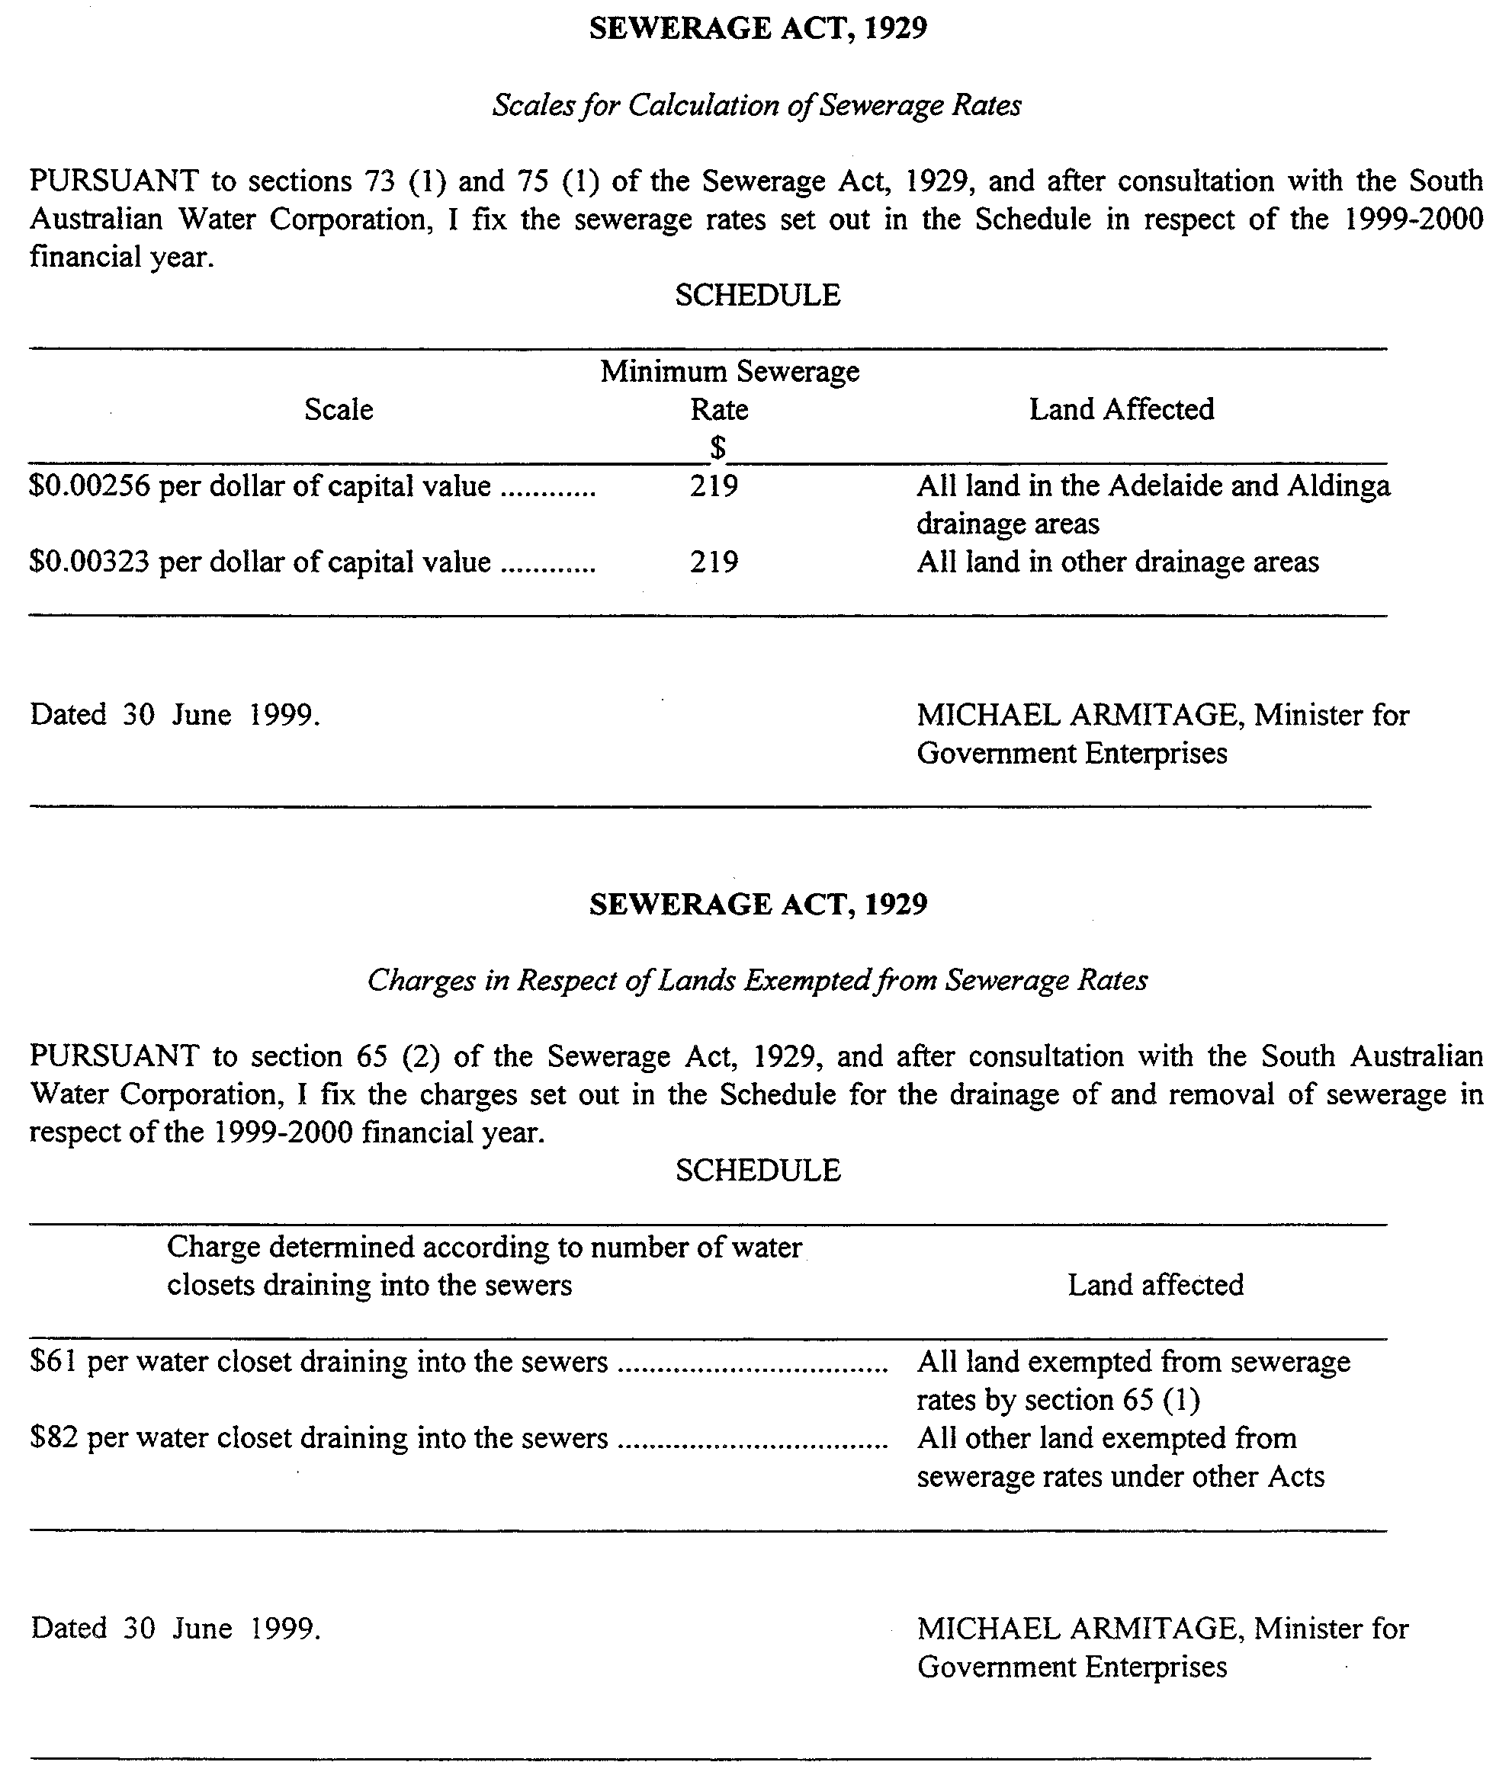
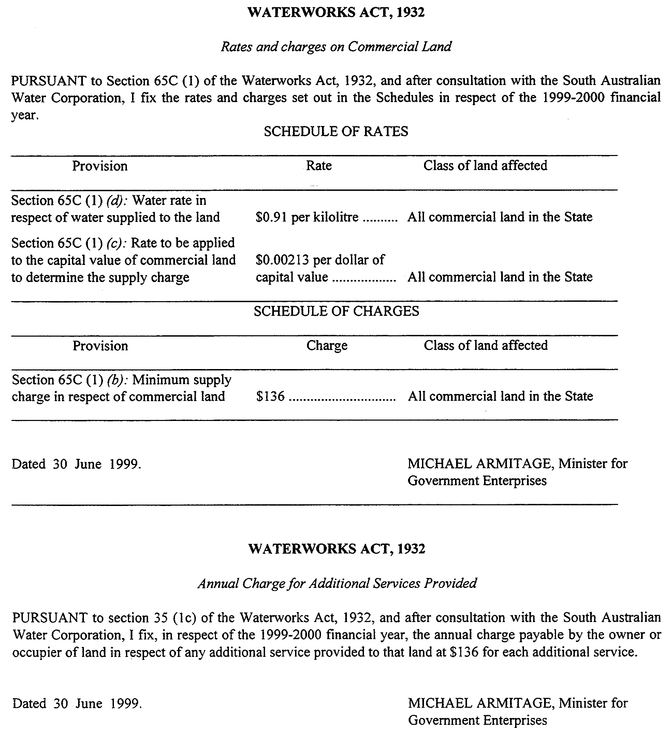
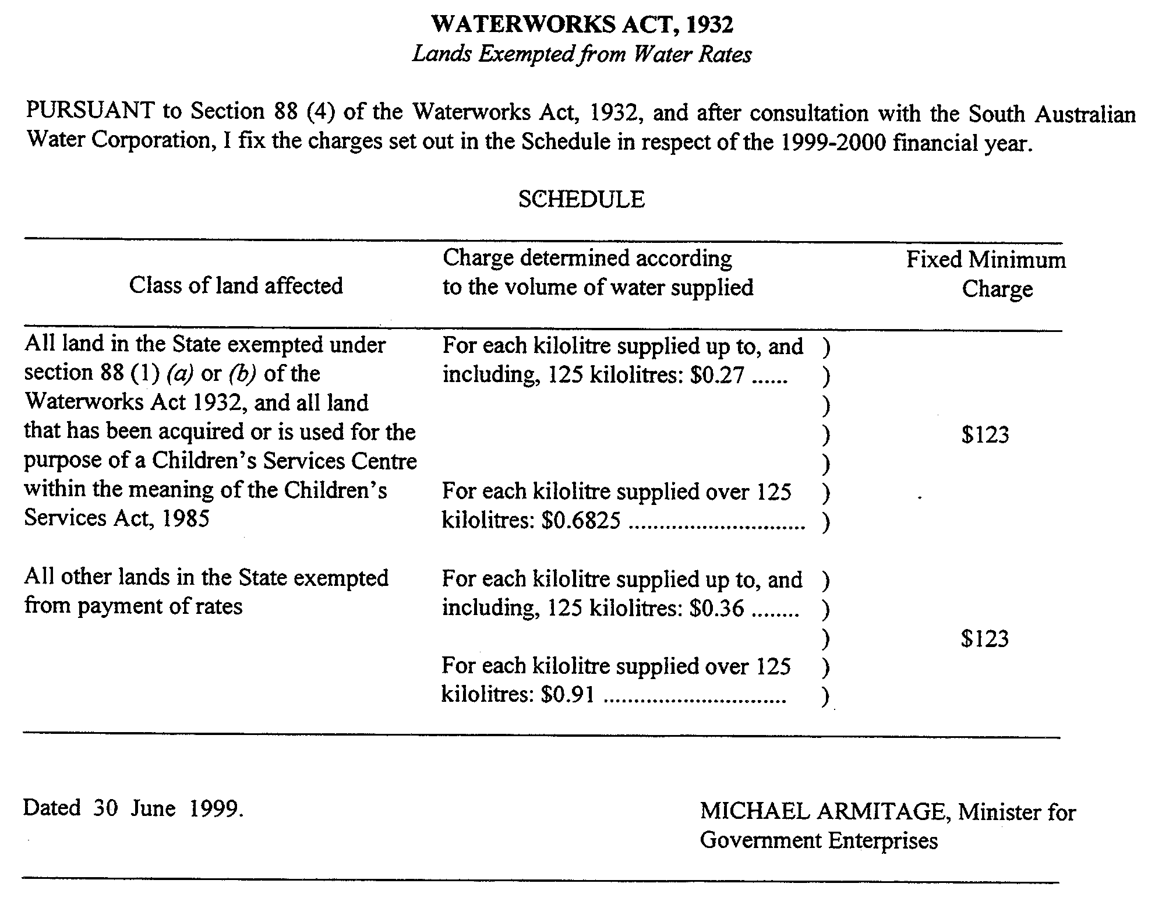
WINE GRAPES INDUSTRY ACT 1991
Order by Minister
PURSUANT to the Wine Grapes Industry Act 1991, I, Robert Gerard Kerin, Minister for Primary Industries, Natural Resources and Regional Development make the following order applying to wine grapes grown in the Langhorne Creek region (as detailed in the schedule) and sold to a processor:

SECTION 5: RECOMMENDED PRICES FOR WINE GRAPES GROWN IN THE REGION AND SOLD TO A PROCESSOR
TABLE 1: LANGHORNE CREEK REGION

WHITE VARIETIES | 1998  Total  Tonnes  Used | 1998  Total  Tonnes  Purchased | 1998  Weighted  Average  Baumé | 1998  Lowest  Price | 1998  Highest  Price | 1998  Weighted  Average  Price | 1999  Weighted  Average Indicative  Range | 1999  Baumé  Standard
Chardonnay  Riesling  Verdelho | 2,035  208  179 | 1,649  176  63 | 12.3  11.5  13.0 | 1,075  525  900 | 1,550  642  1,250 | 1,407  604  1,090 | 1,150-1,315  550-650  945-1,050 | 13.0  12.0  12.5

RED VARIETIES | 1998  Total  Tonnes  Used | 1998  Total  Tonnes  Purchased | 1998  Weighted  Average  Baumé | 1998  Lowest  Price | 1998  Highest  Price | 1998  Weighted  Average  Price | 1999  Weighted  Average Indicative  Range | 1999  Baumé  Standard
Cabernet Franc  Cabernet Sauvignon  Merlot  Shiraz | 169  7,485  401  5,272 | 74  5,004  302  2,933 | 14.0  13.6  13.4  13.7 | 1,025  1,082  1,000  973 | 1,300  2,750  2,000  2,490 | 1,103  1,697  1,599  1,706 | 1,000-1,100  1,600-1,725  1,500-1,600  1,600-1,725 | 13.5  13.5  13.5  13.5
Source (Columns 2-7): Phylloxera & Grape Industry Board of SA.
Notes for Table 1:
• 1998 tonnages, Baumés and prices delivered to winery (low, high and weighted average) are those reported by wineries and published in the SA Winegrape Utilisation and Pricing Survey.
• Indicative prices and Baumé standards are those agreed by the Indicative Price meeting for the 1999 vintage.
• Baumé standards are for grapes destined for table wine production.
• Grapes for sparkling, late picked and fortified wines may have separate standards.
The Schedule
The Hundreds of:
Bremer
Brinkley
Freeling
Strathalbyn.
SECTION 6: TERMS AND CONDITIONS OF PAYMENT FOR 1999 HARVEST
(1) The following terms and conditions are fixed in respect of wine grapes harvested in 1994 or any subsequent year and are implied in every contract for the sale of such grapes to a processor:
(a) If the grapes are delivered to the processor prior to 1 April in a year, the processor must pay to the producer 33¹/₃ per cent of the total amount payable for the grapes by the end of the month following the month during which the grapes are delivered, 50 per cent of the remaining balance by 30 June in that year and the balance by 30 September in that year.
(b) If the grapes are delivered to the processor on or after 1 April but prior to 1 May in a year, the processor must pay to the producer 33¹/₃ of the total amount payable for the grapes by 31 May in that year, 50 per cent of the remaining balance by 30 June in that year and the balance by 30 September in that year.
(c) If the grapes are delivered to the processor on or after 1 May in a year, the processor must pay to the producer 66²/₃ per cent of the total amount payable for the grapes by 30 June in that year and the balance by 30 September in that year.
(d) If a processor defaults in making a payment within the time fixed above, the processor must pay to the producer an amount equal to interest on any amount remaining in default calculated at the Commonwealth Bank standard overdraft interest rate (as at the beginning of the month during which the default occurred) plus 1 per cent per annum until the following 31 December and thereafter at the Commonwealth Bank standard overdraft interest rate (as at 1 September in the year during which the default occurred) plus 5 per cent per annum.
Application
(2) The terms and conditions fixed by this order apply in relation to contracts whether made before or after the publication of this order in the Gazette.
Dated 26 June 1999.
Rob Kerin, Deputy Premier, Minister for Primary Industries, Natural Resources and Regional Development

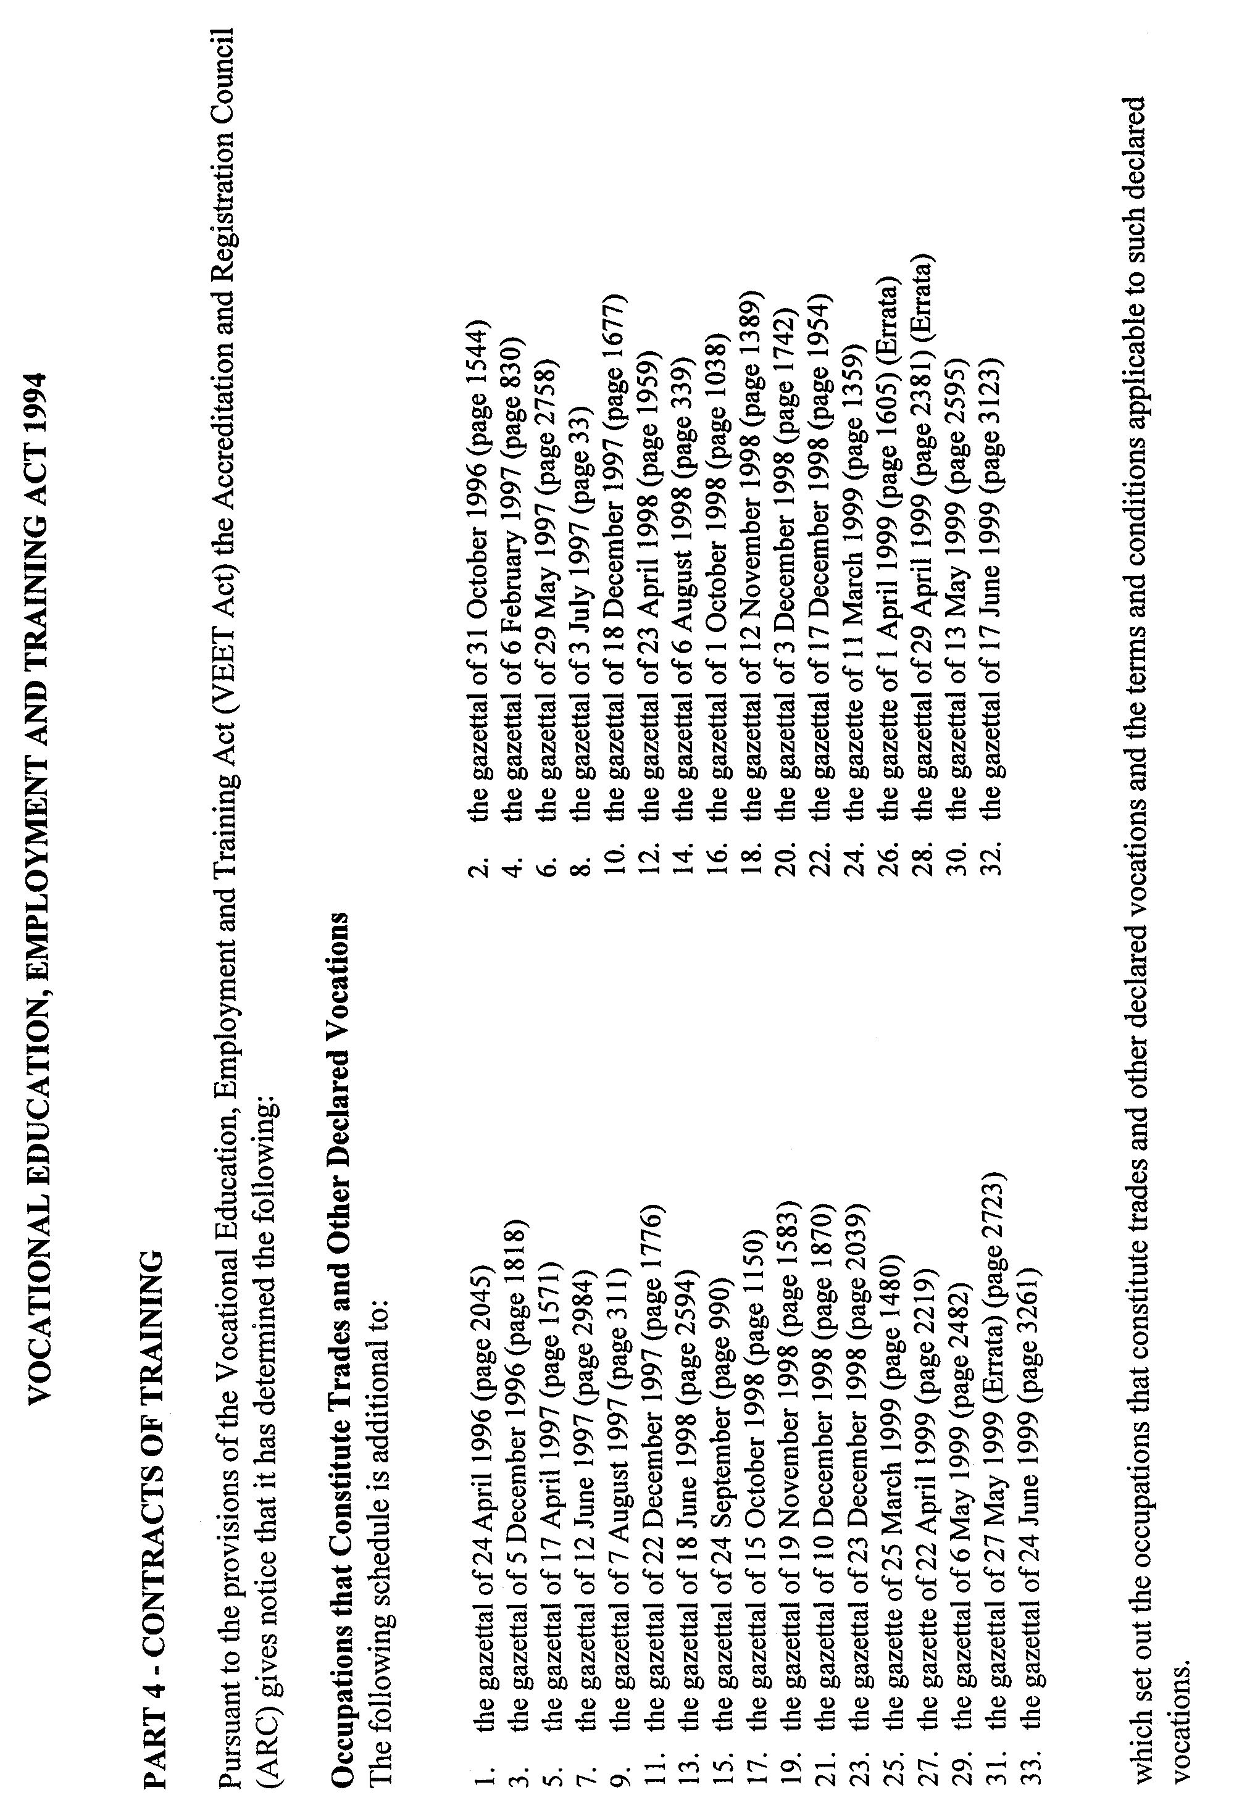
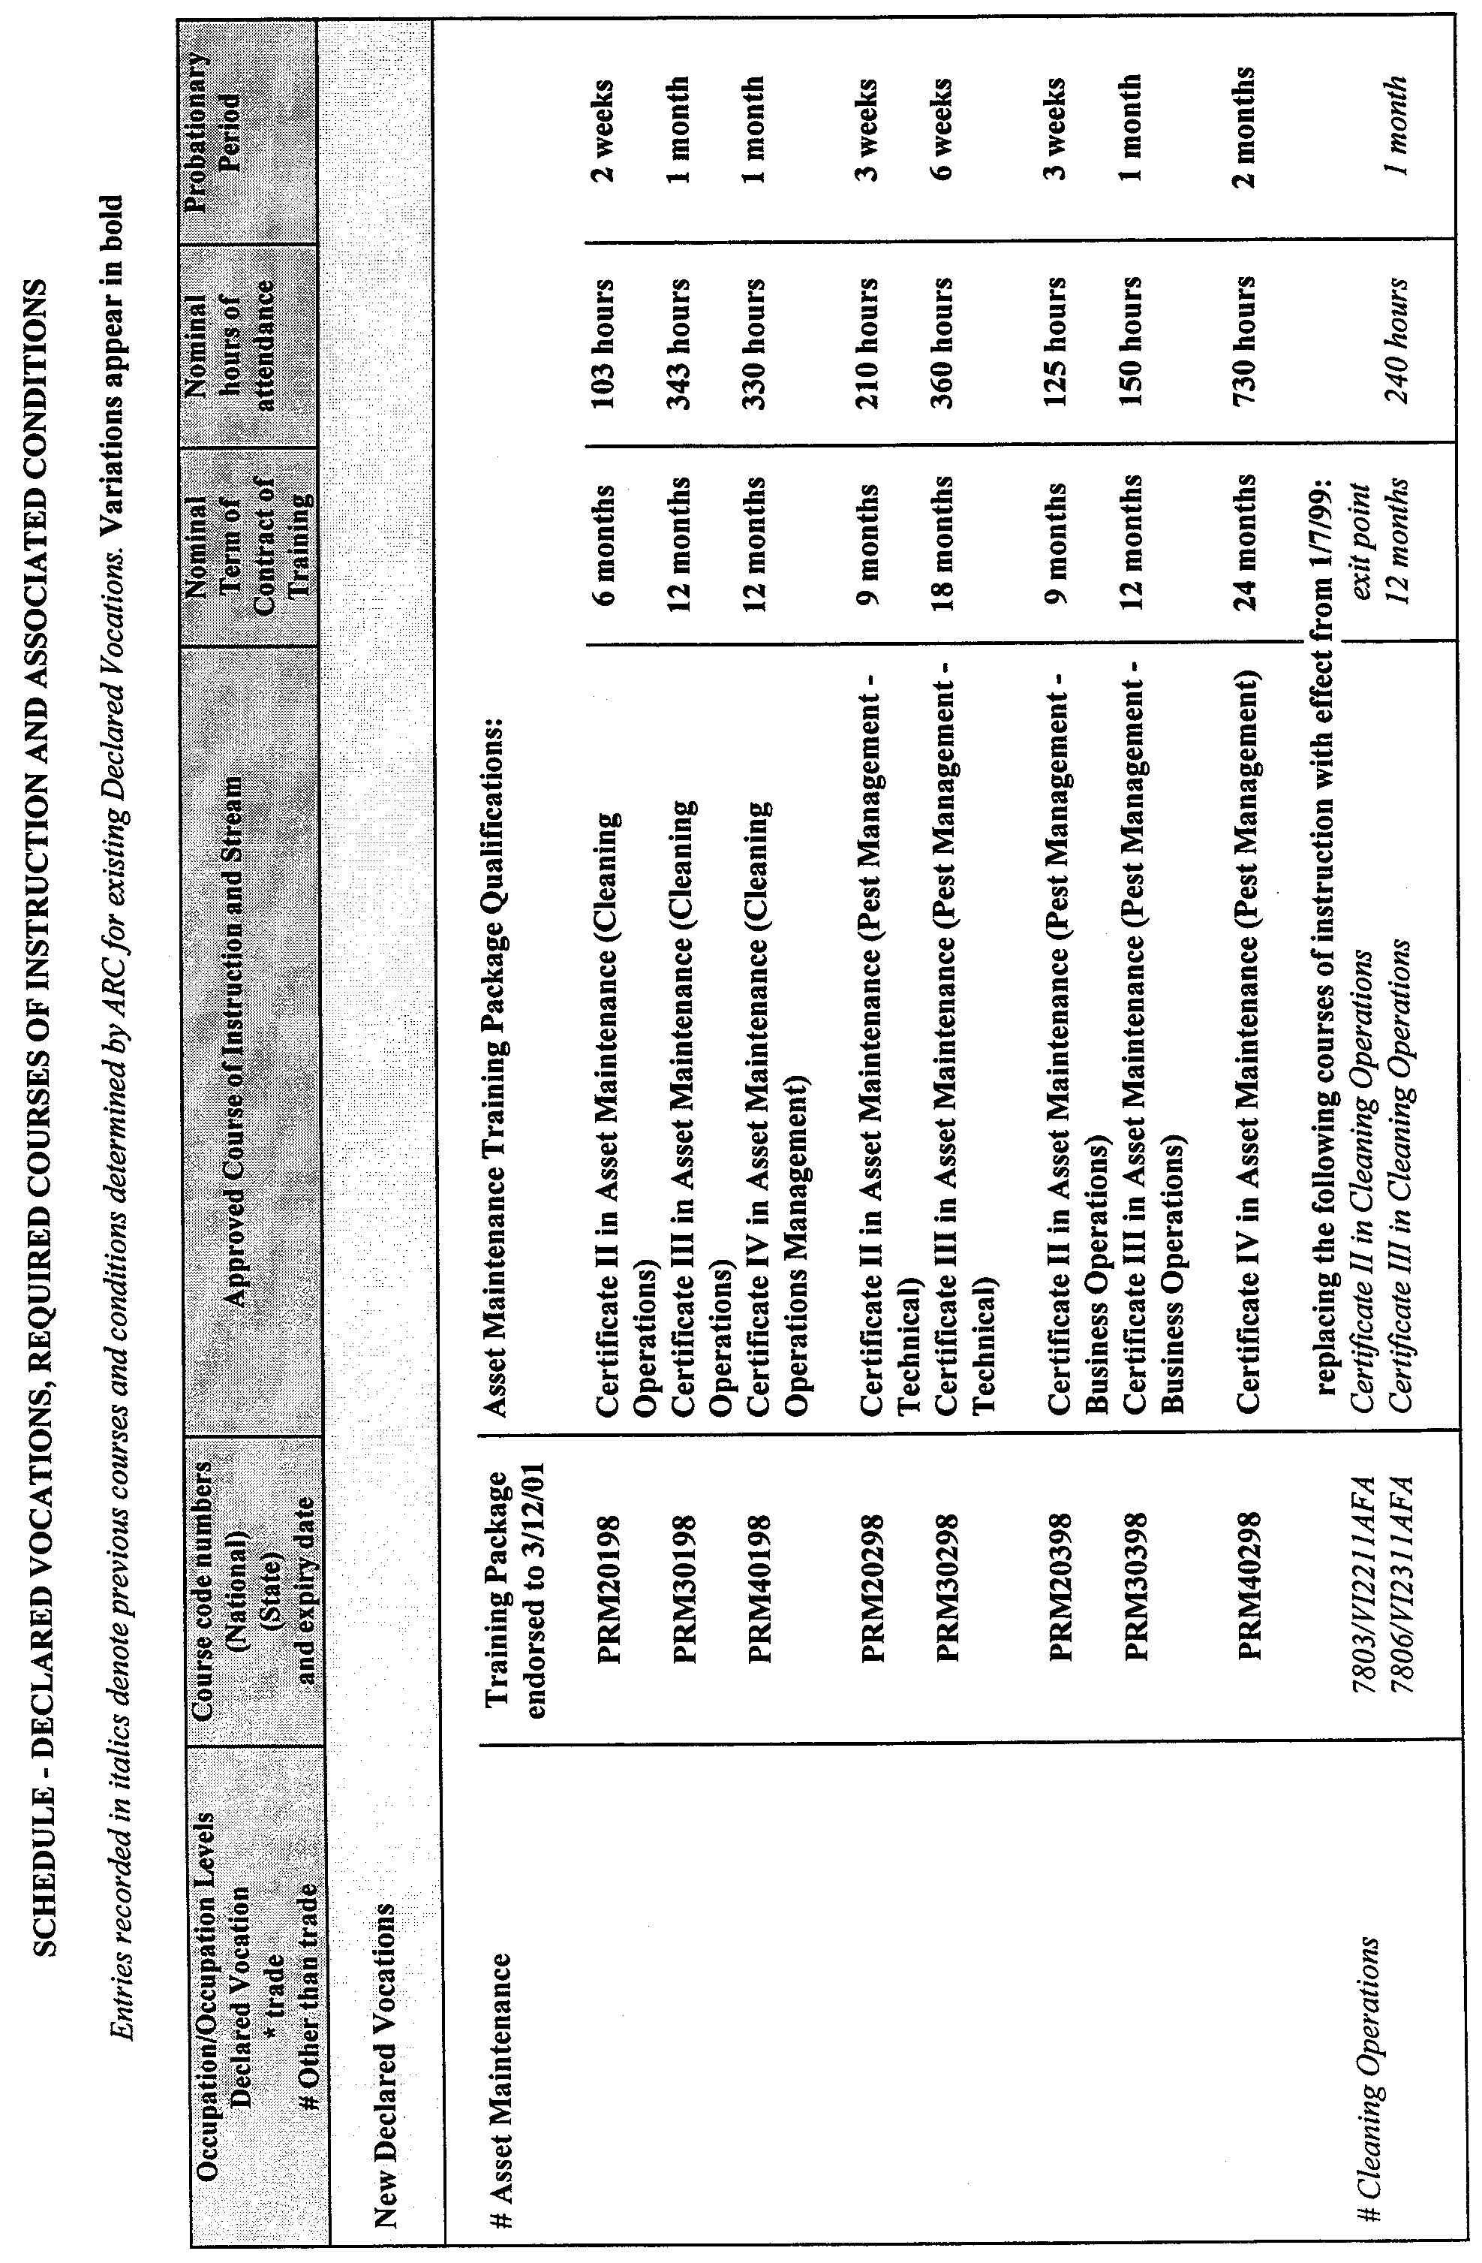
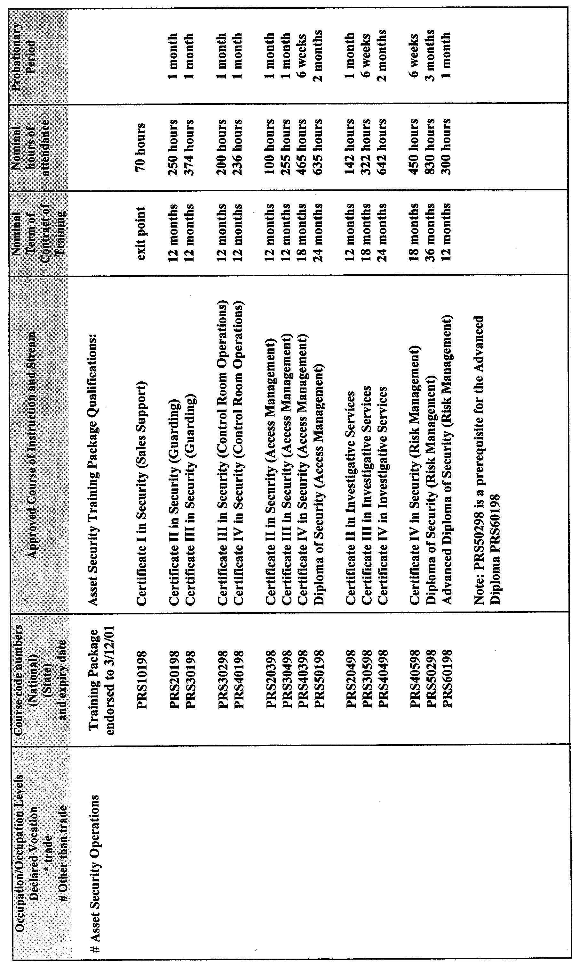
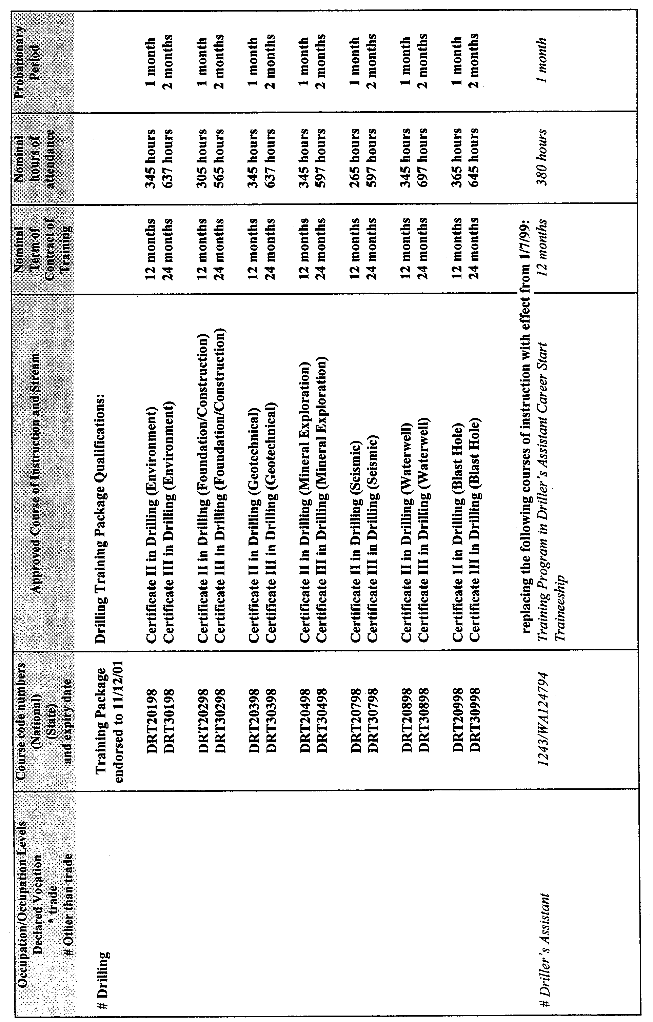
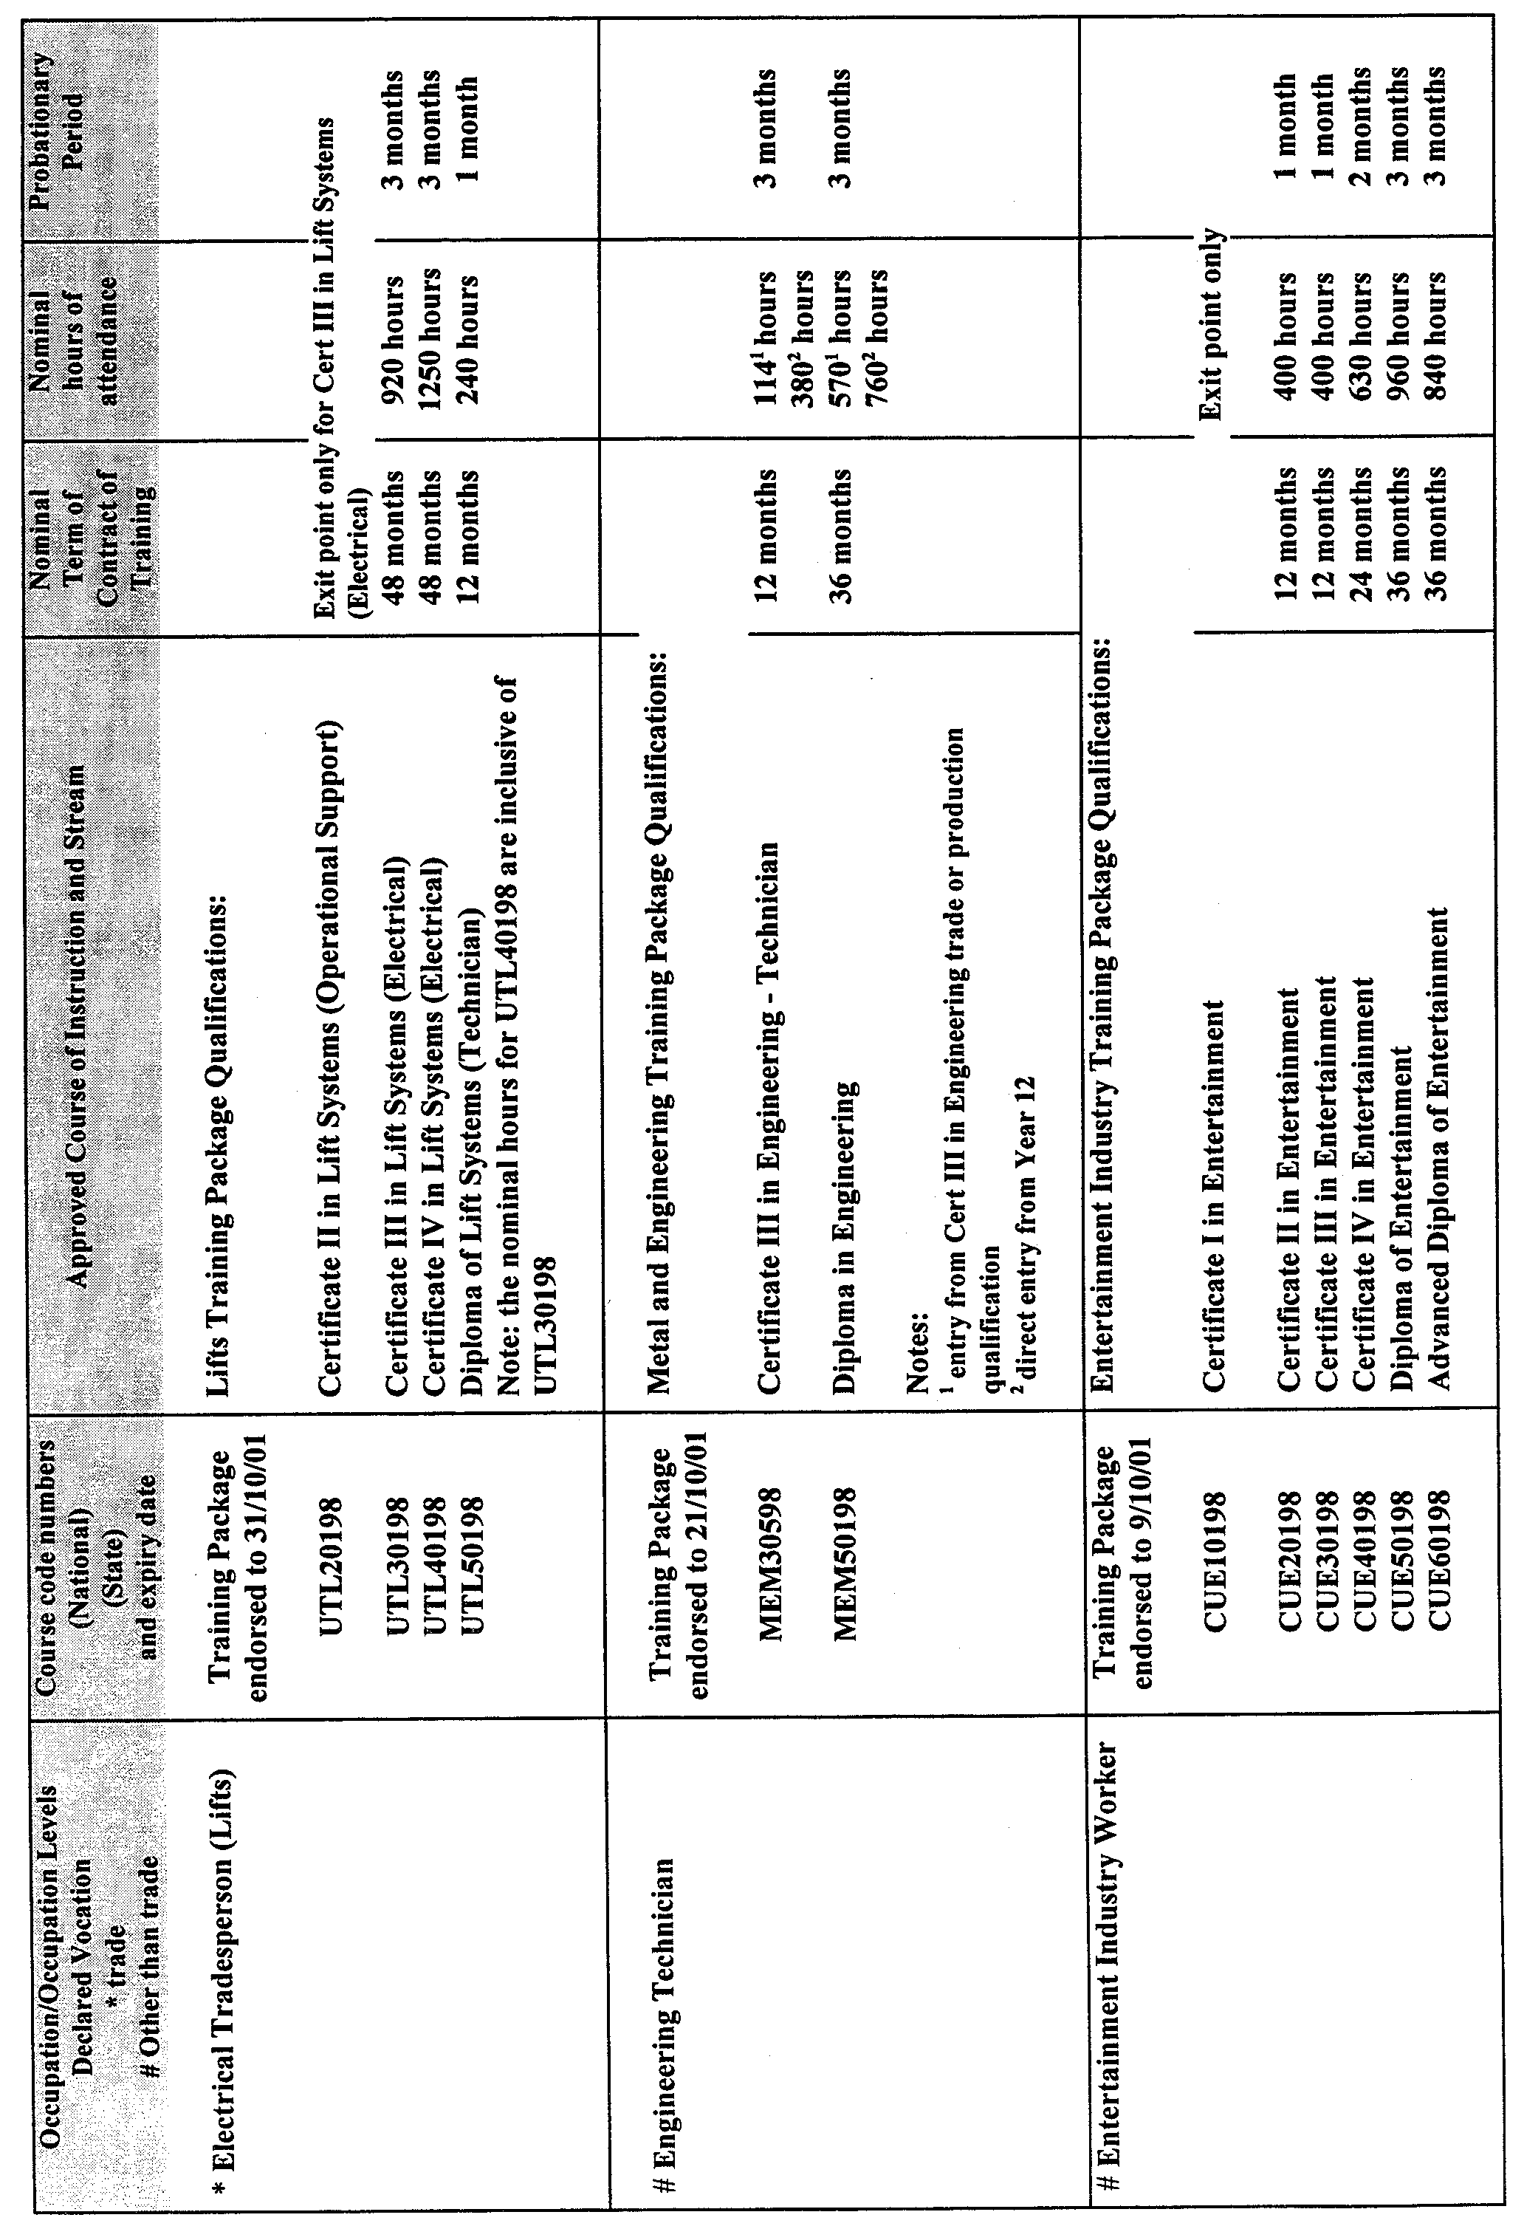
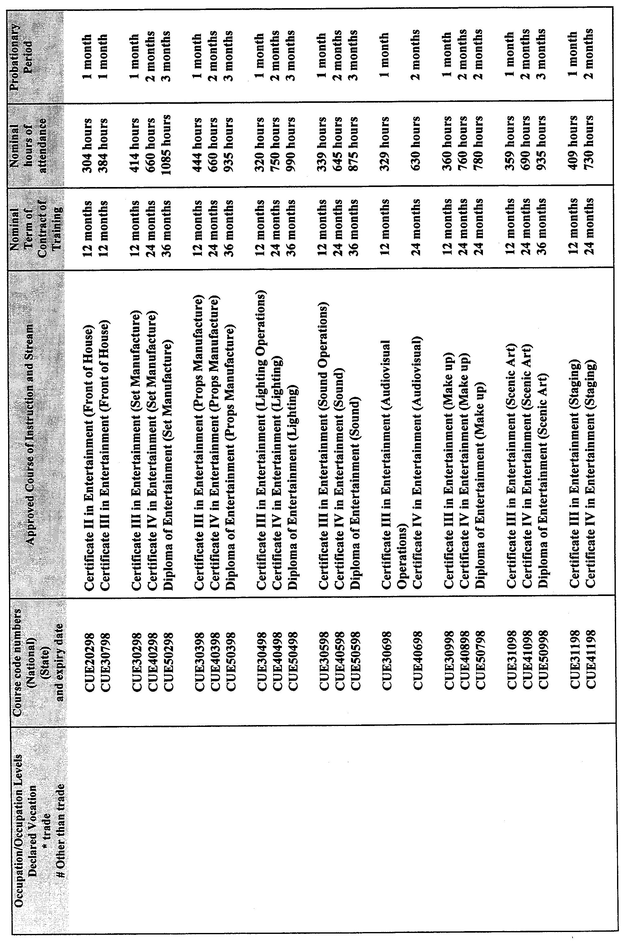
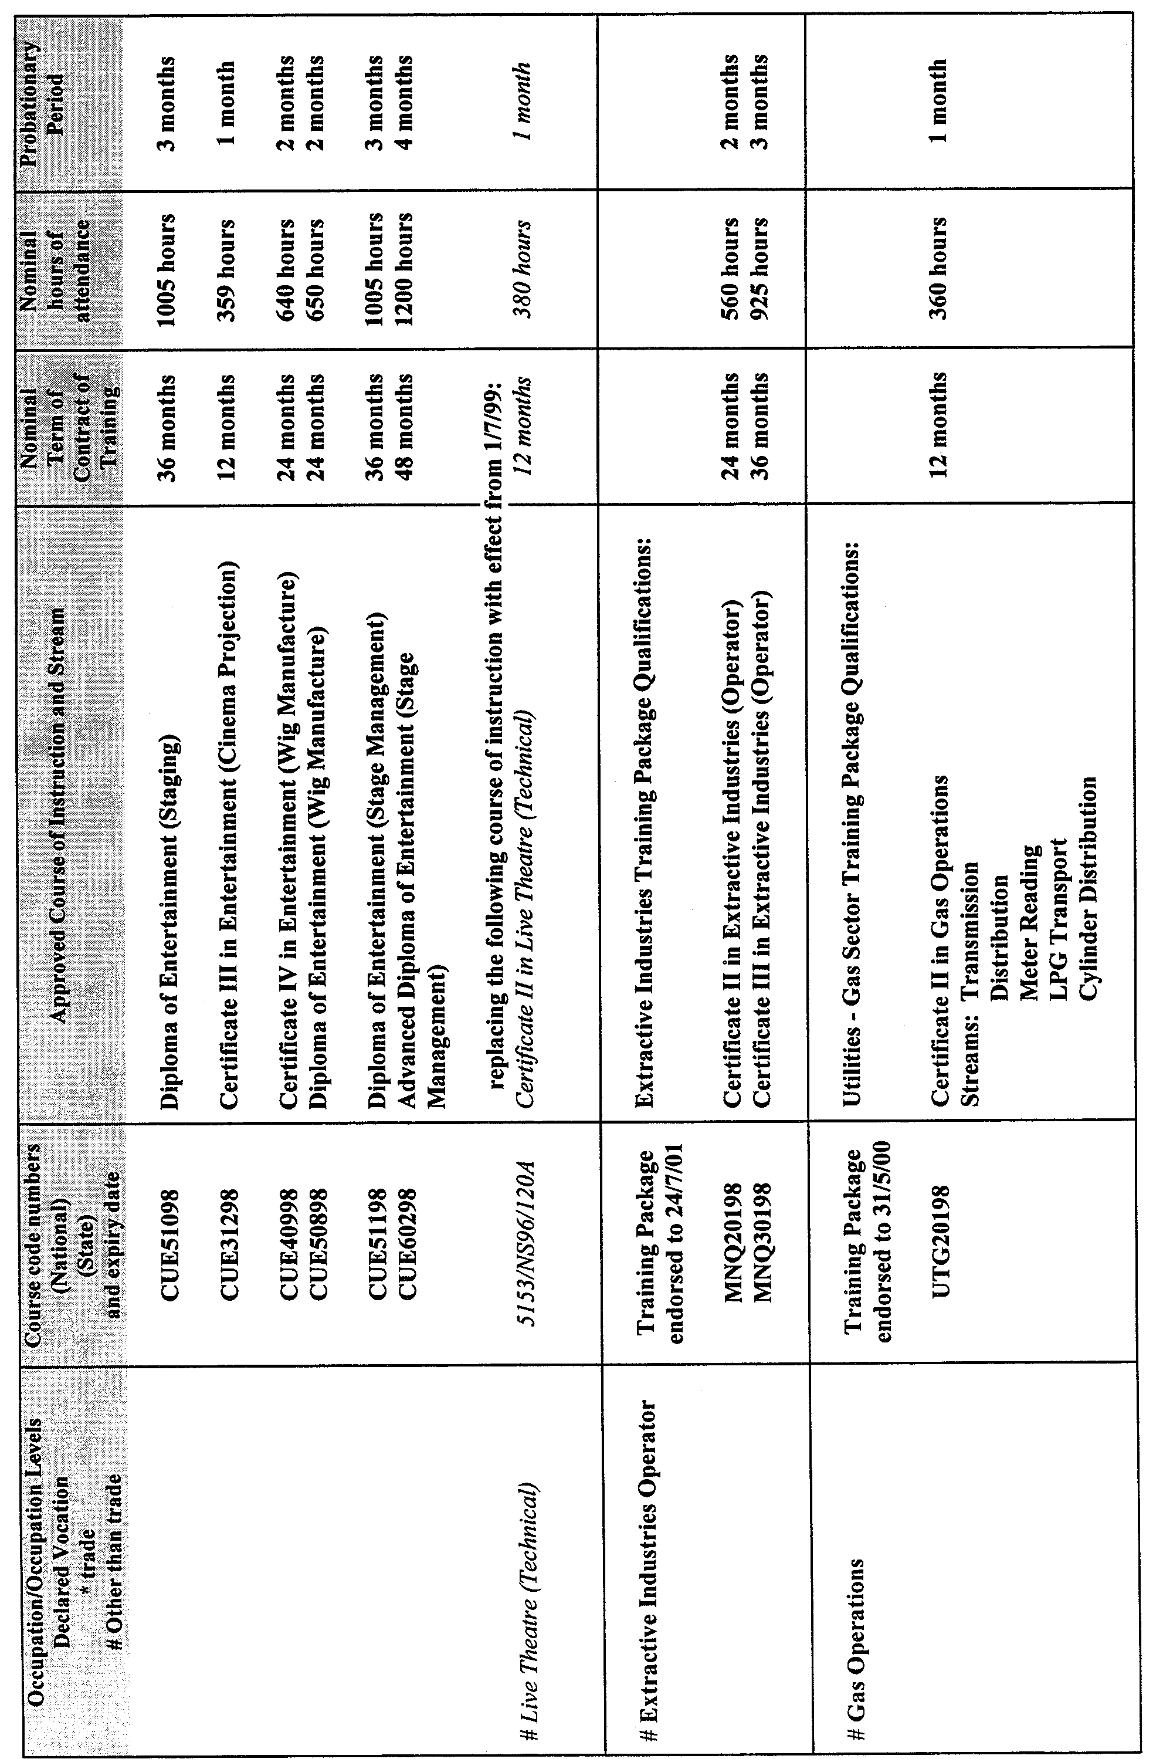
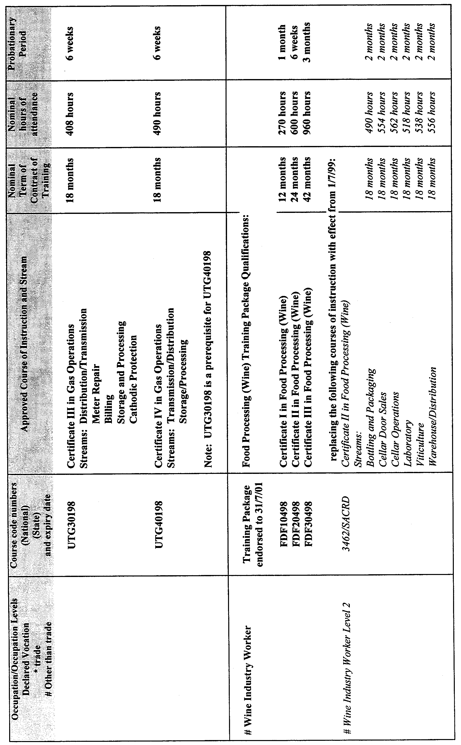
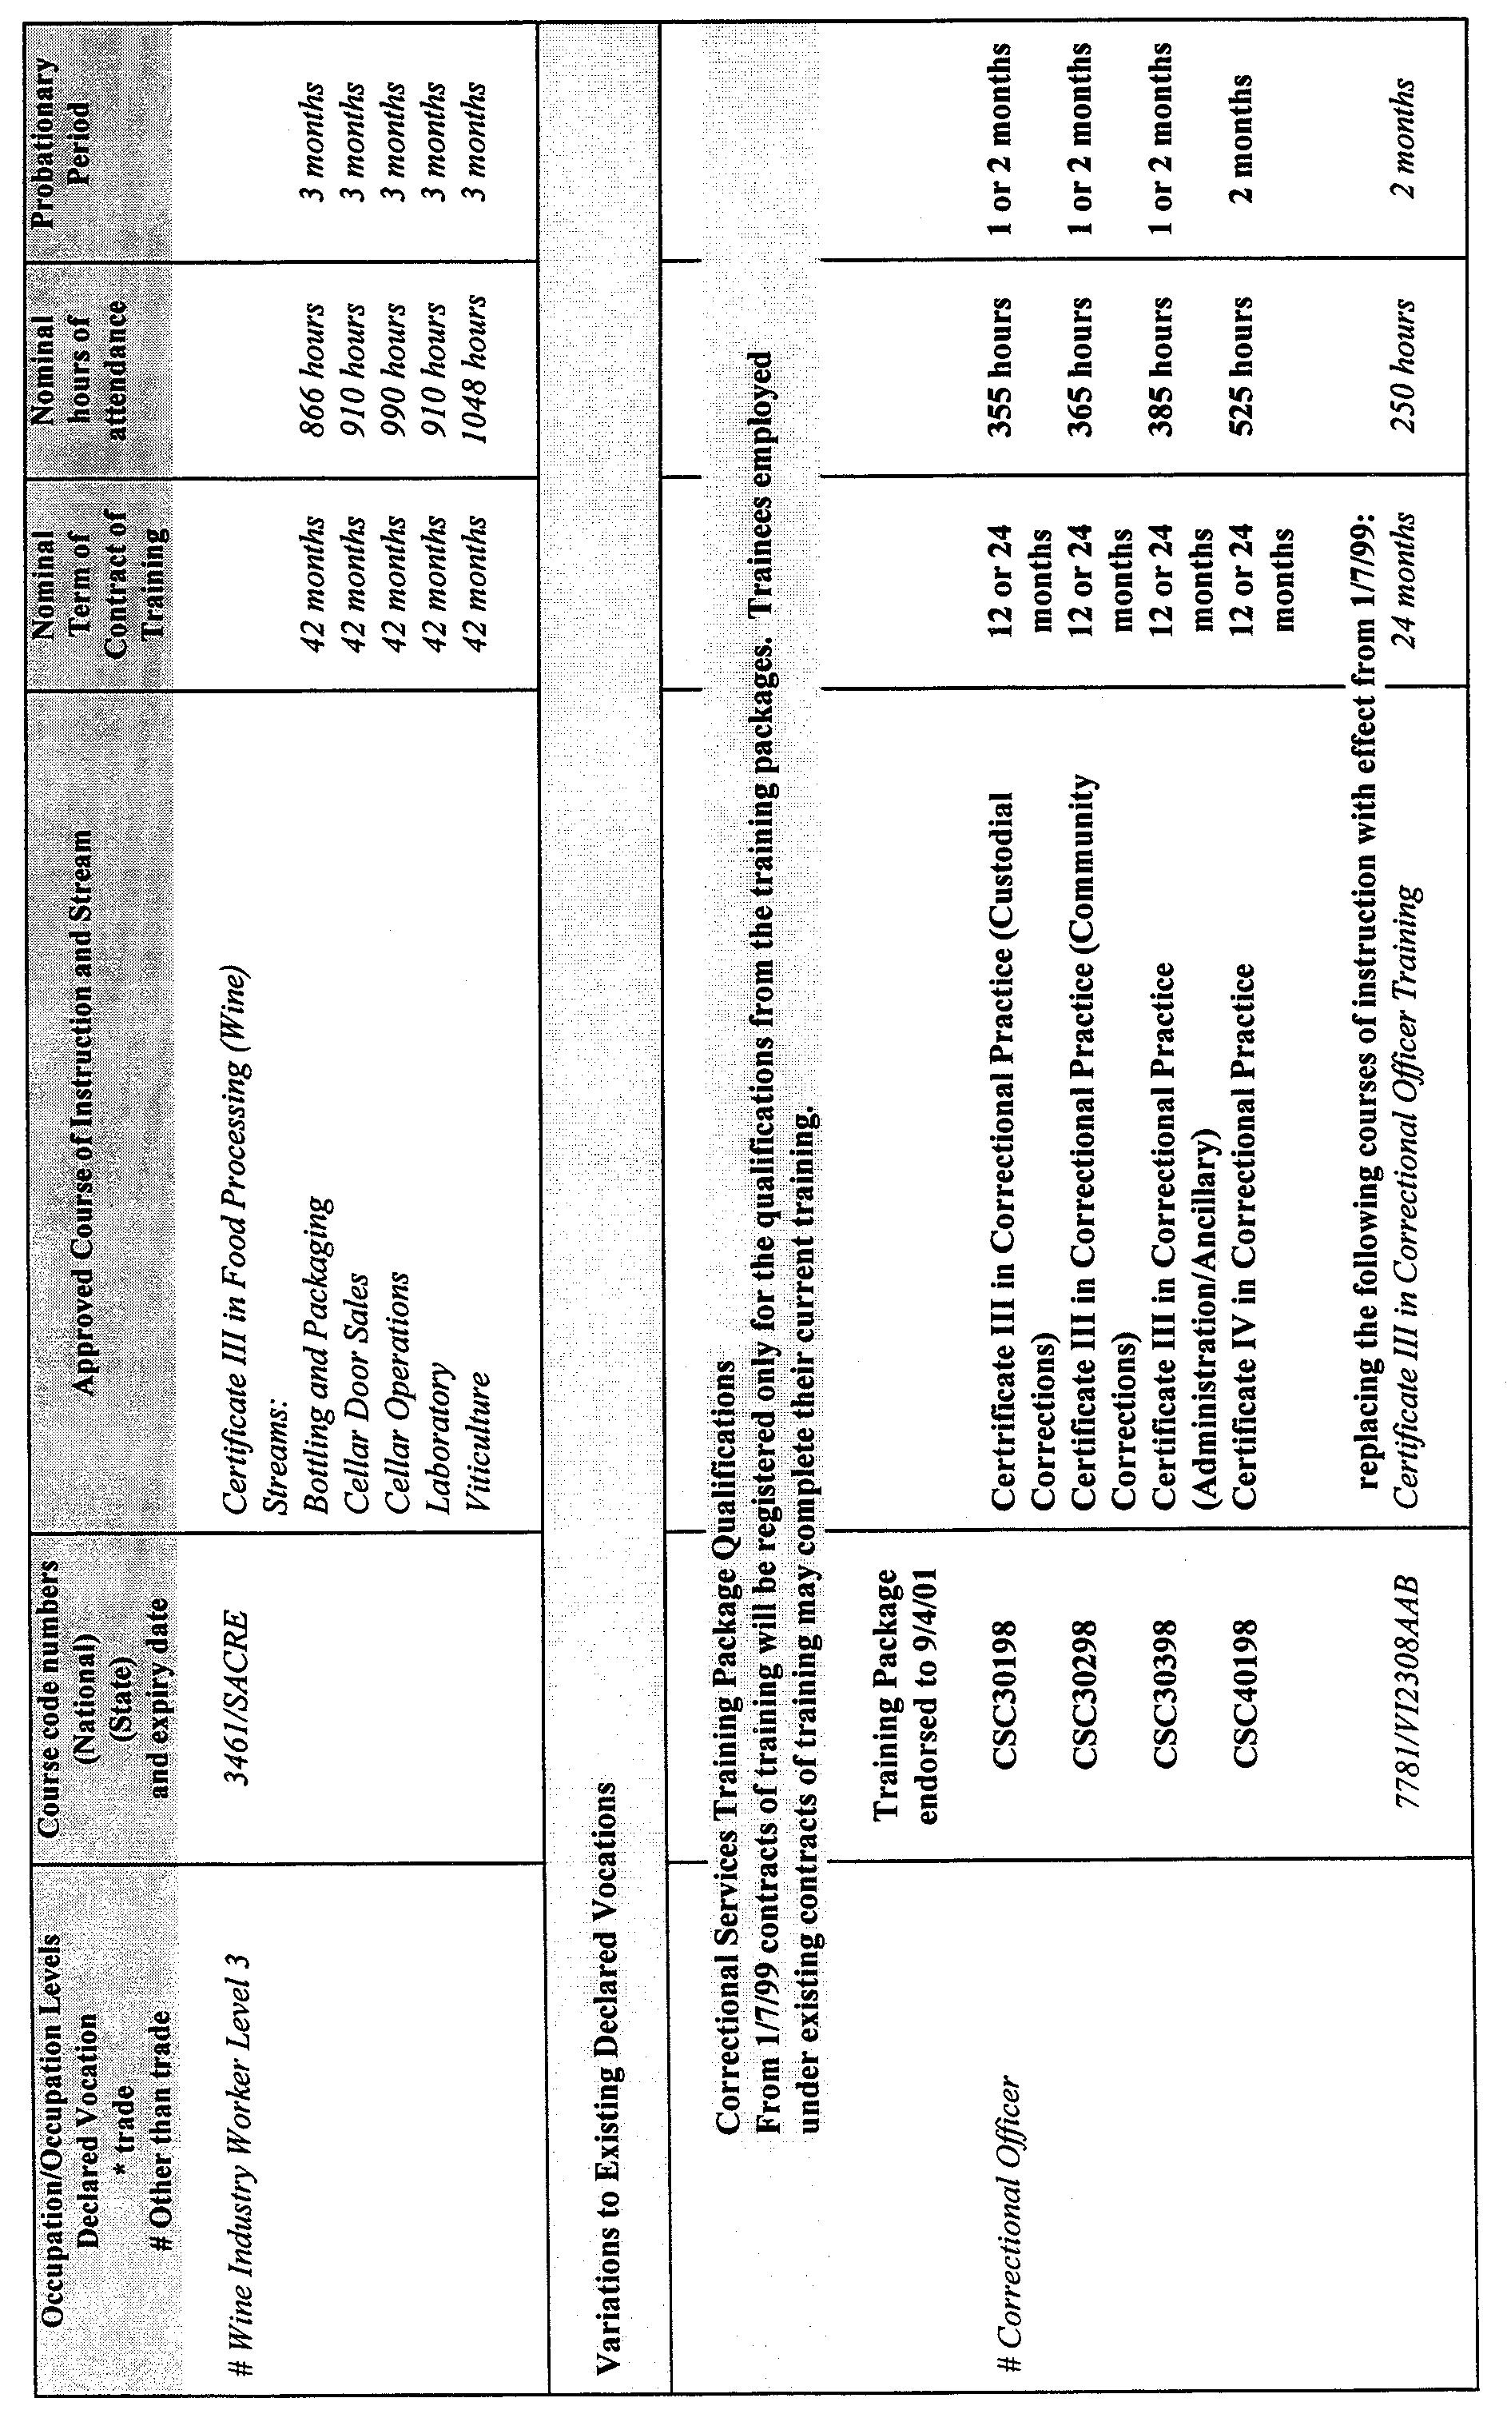
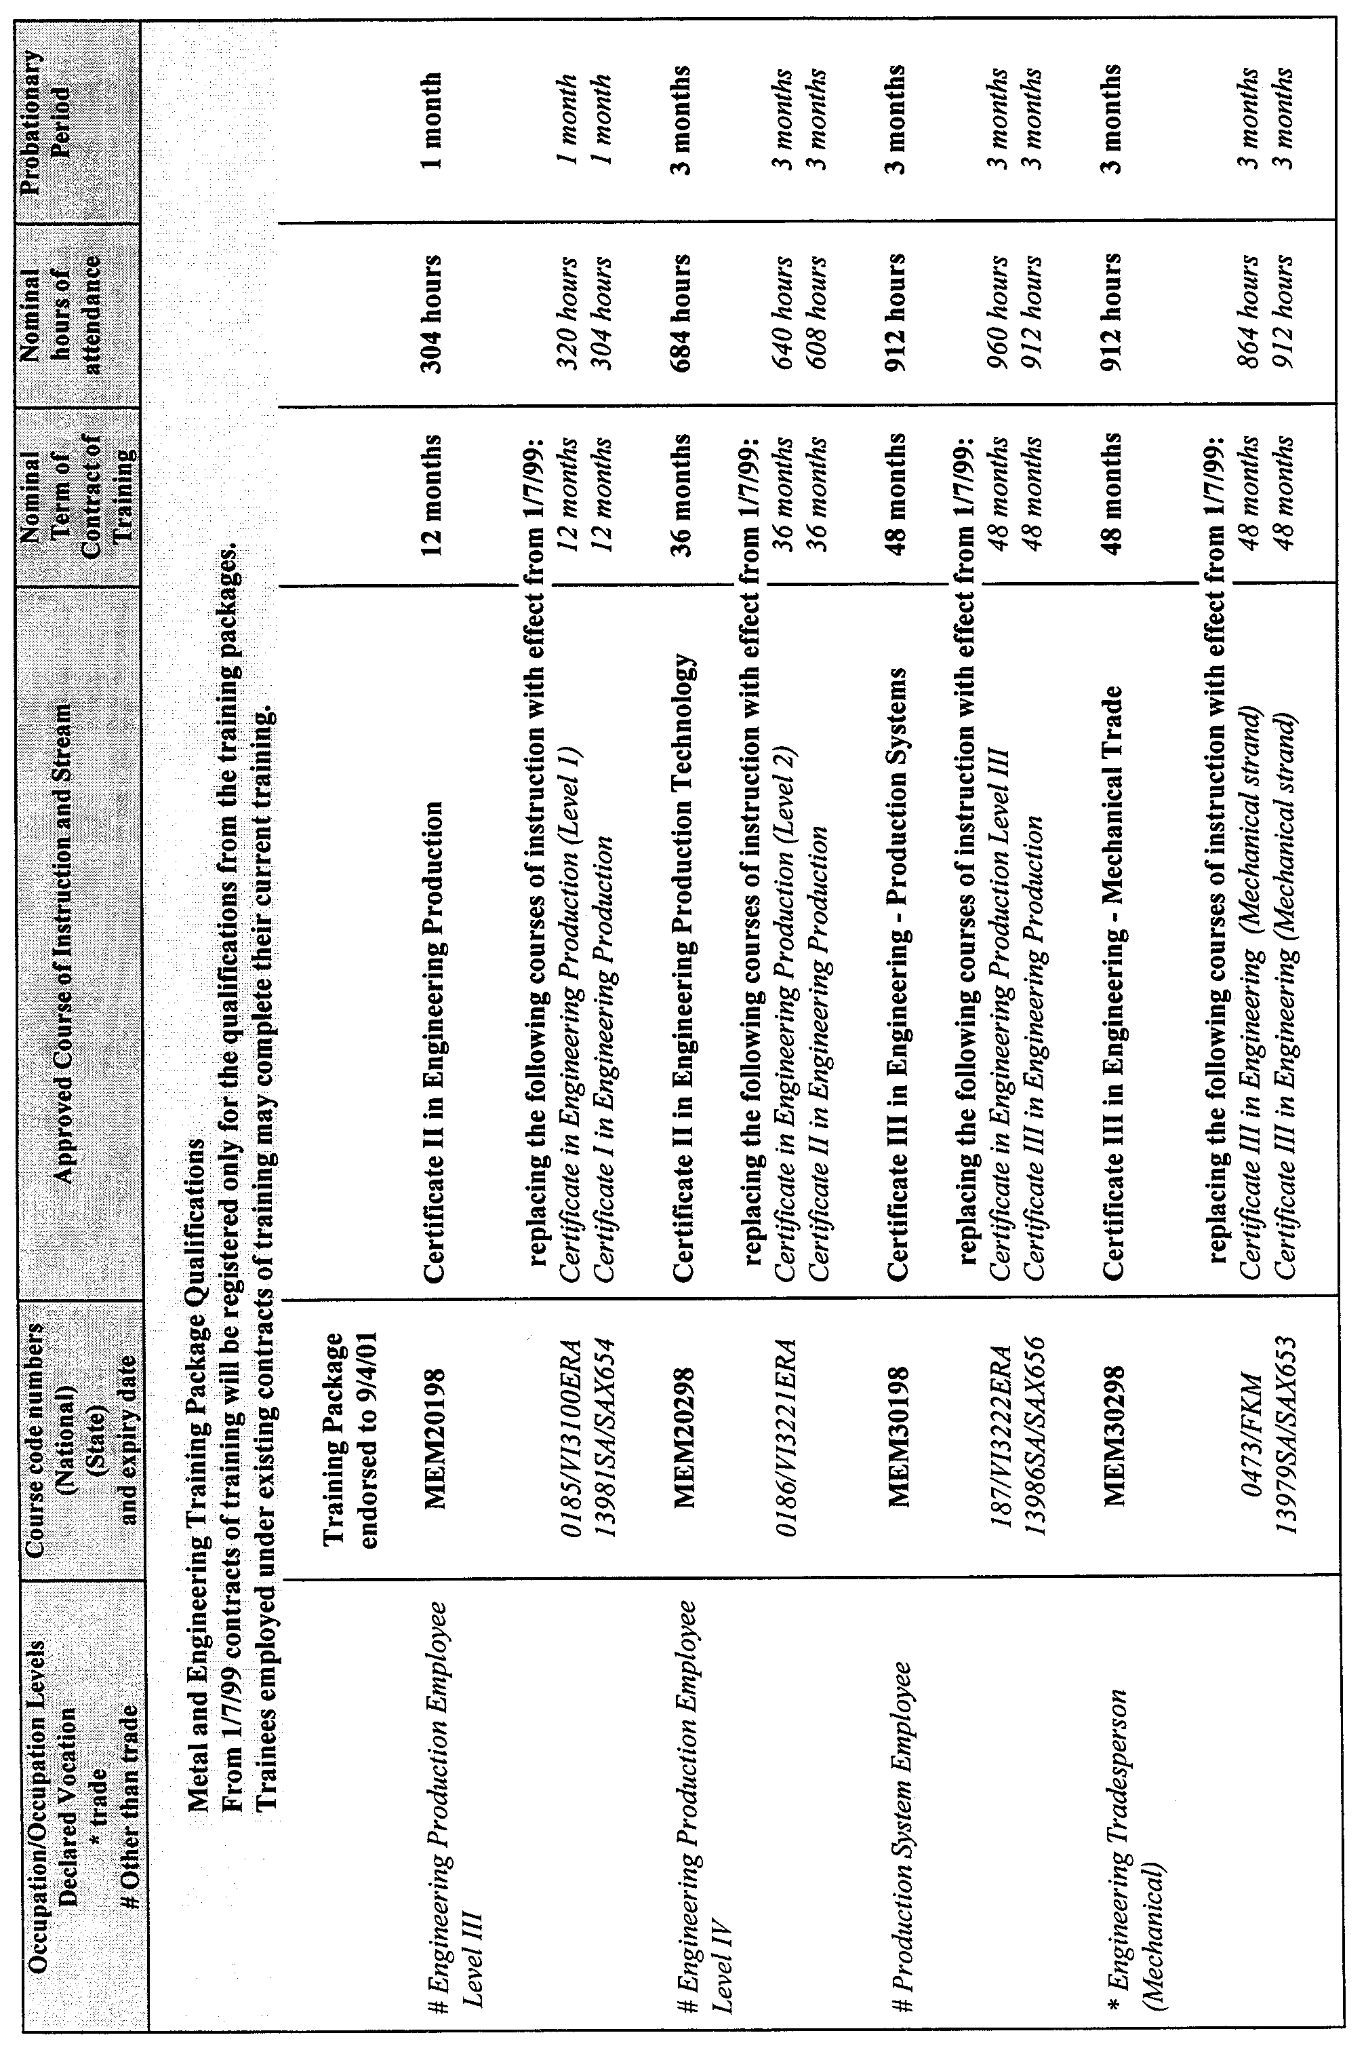
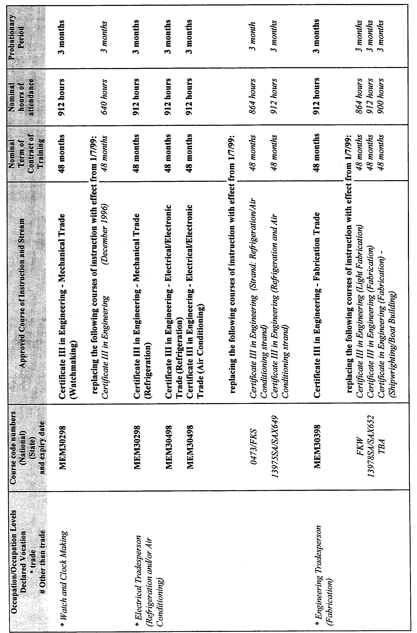
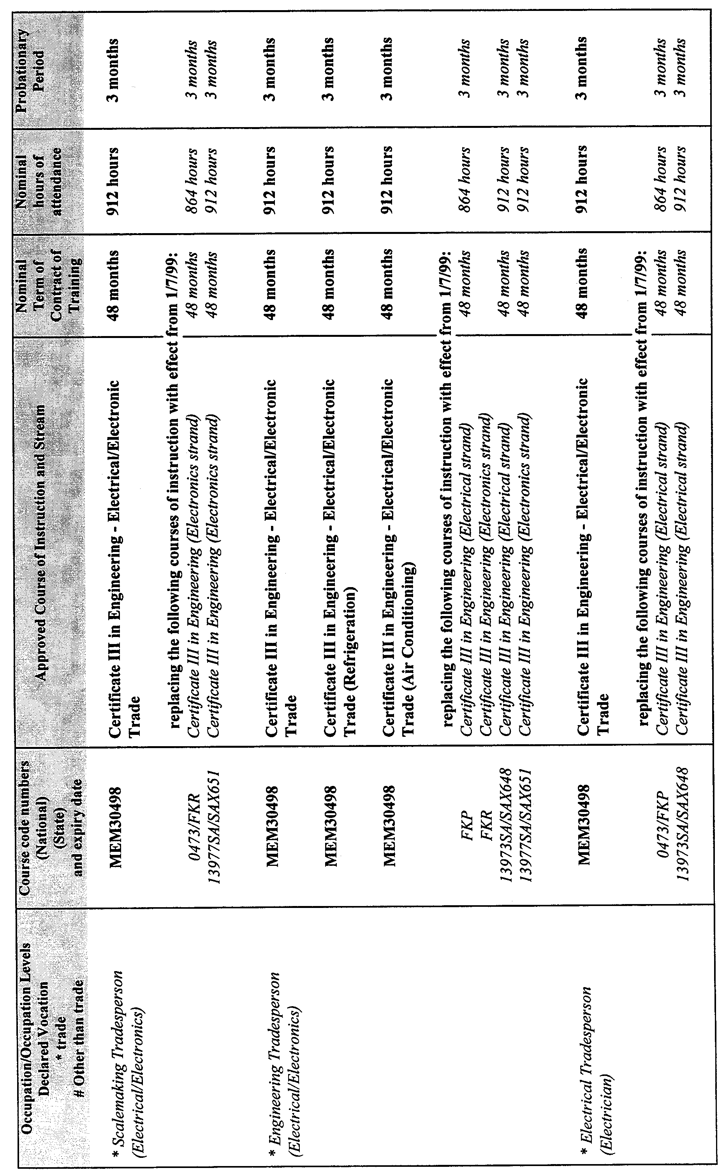
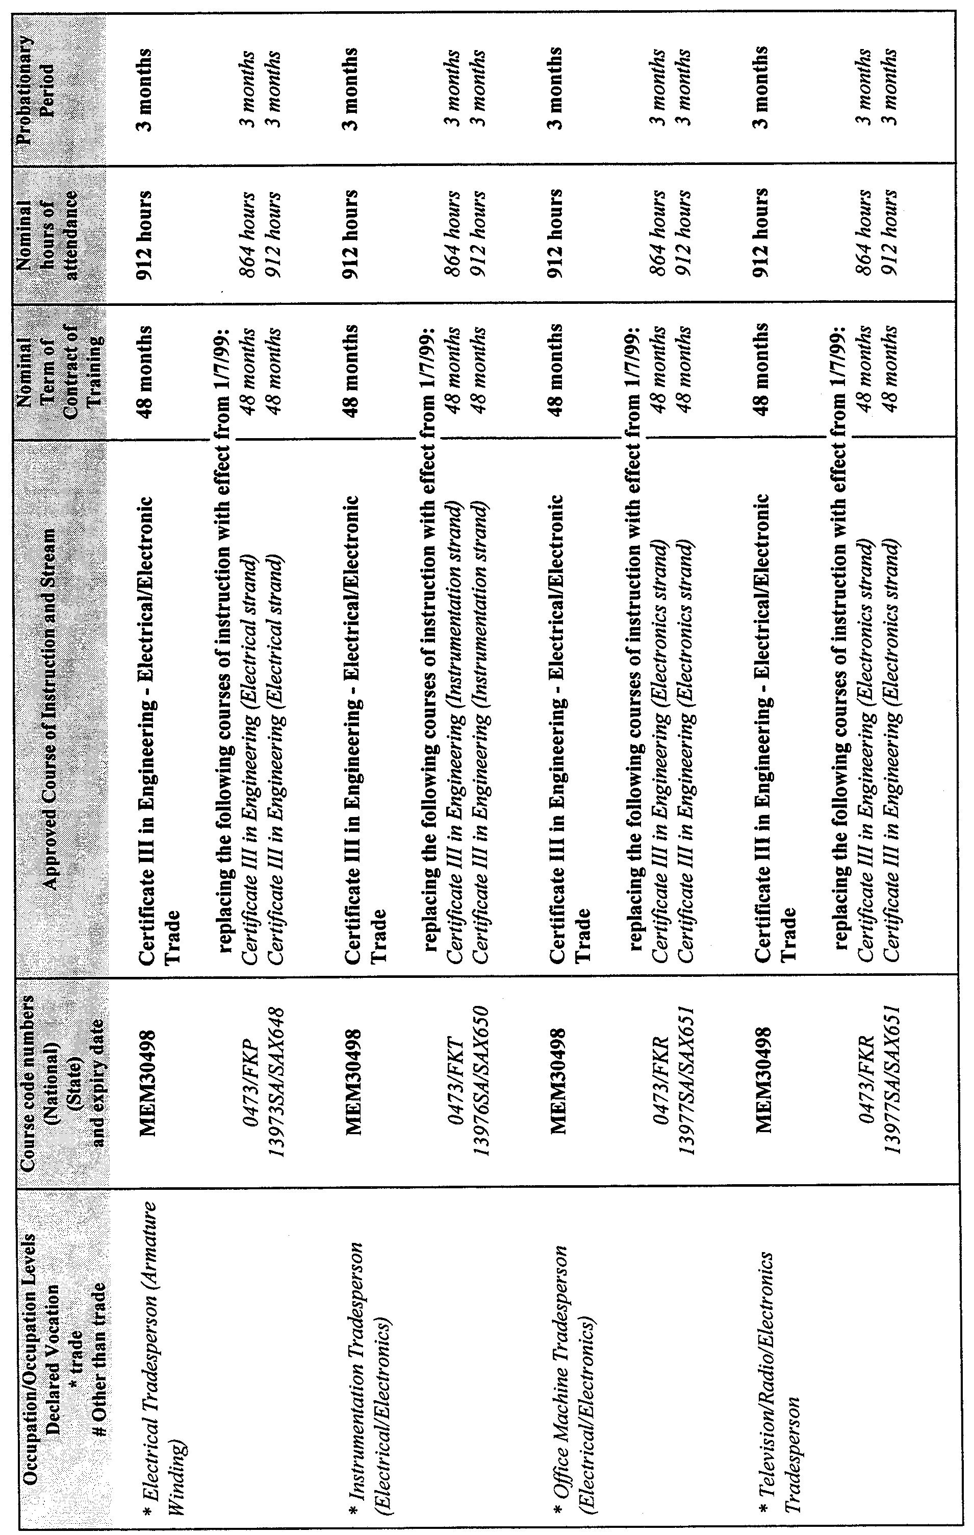
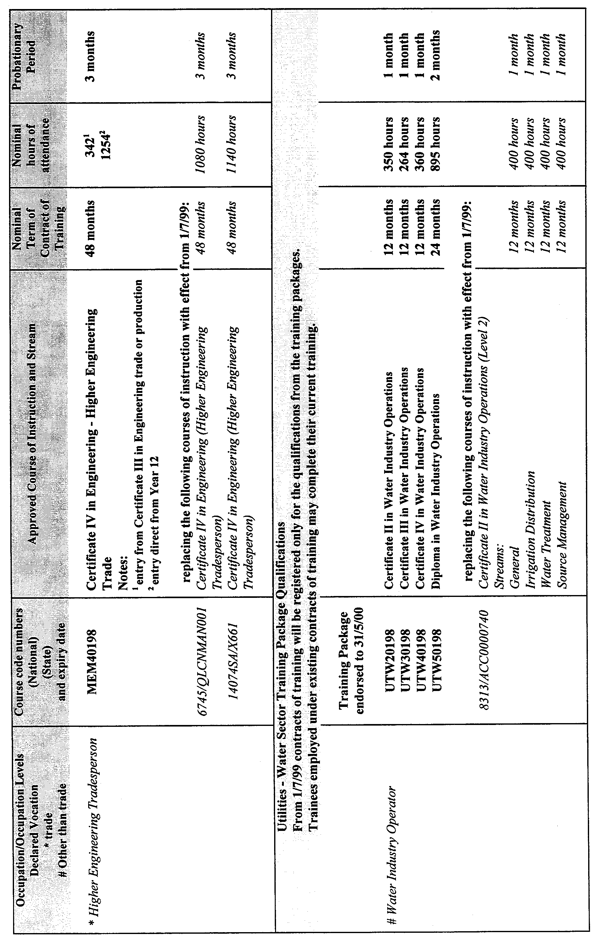
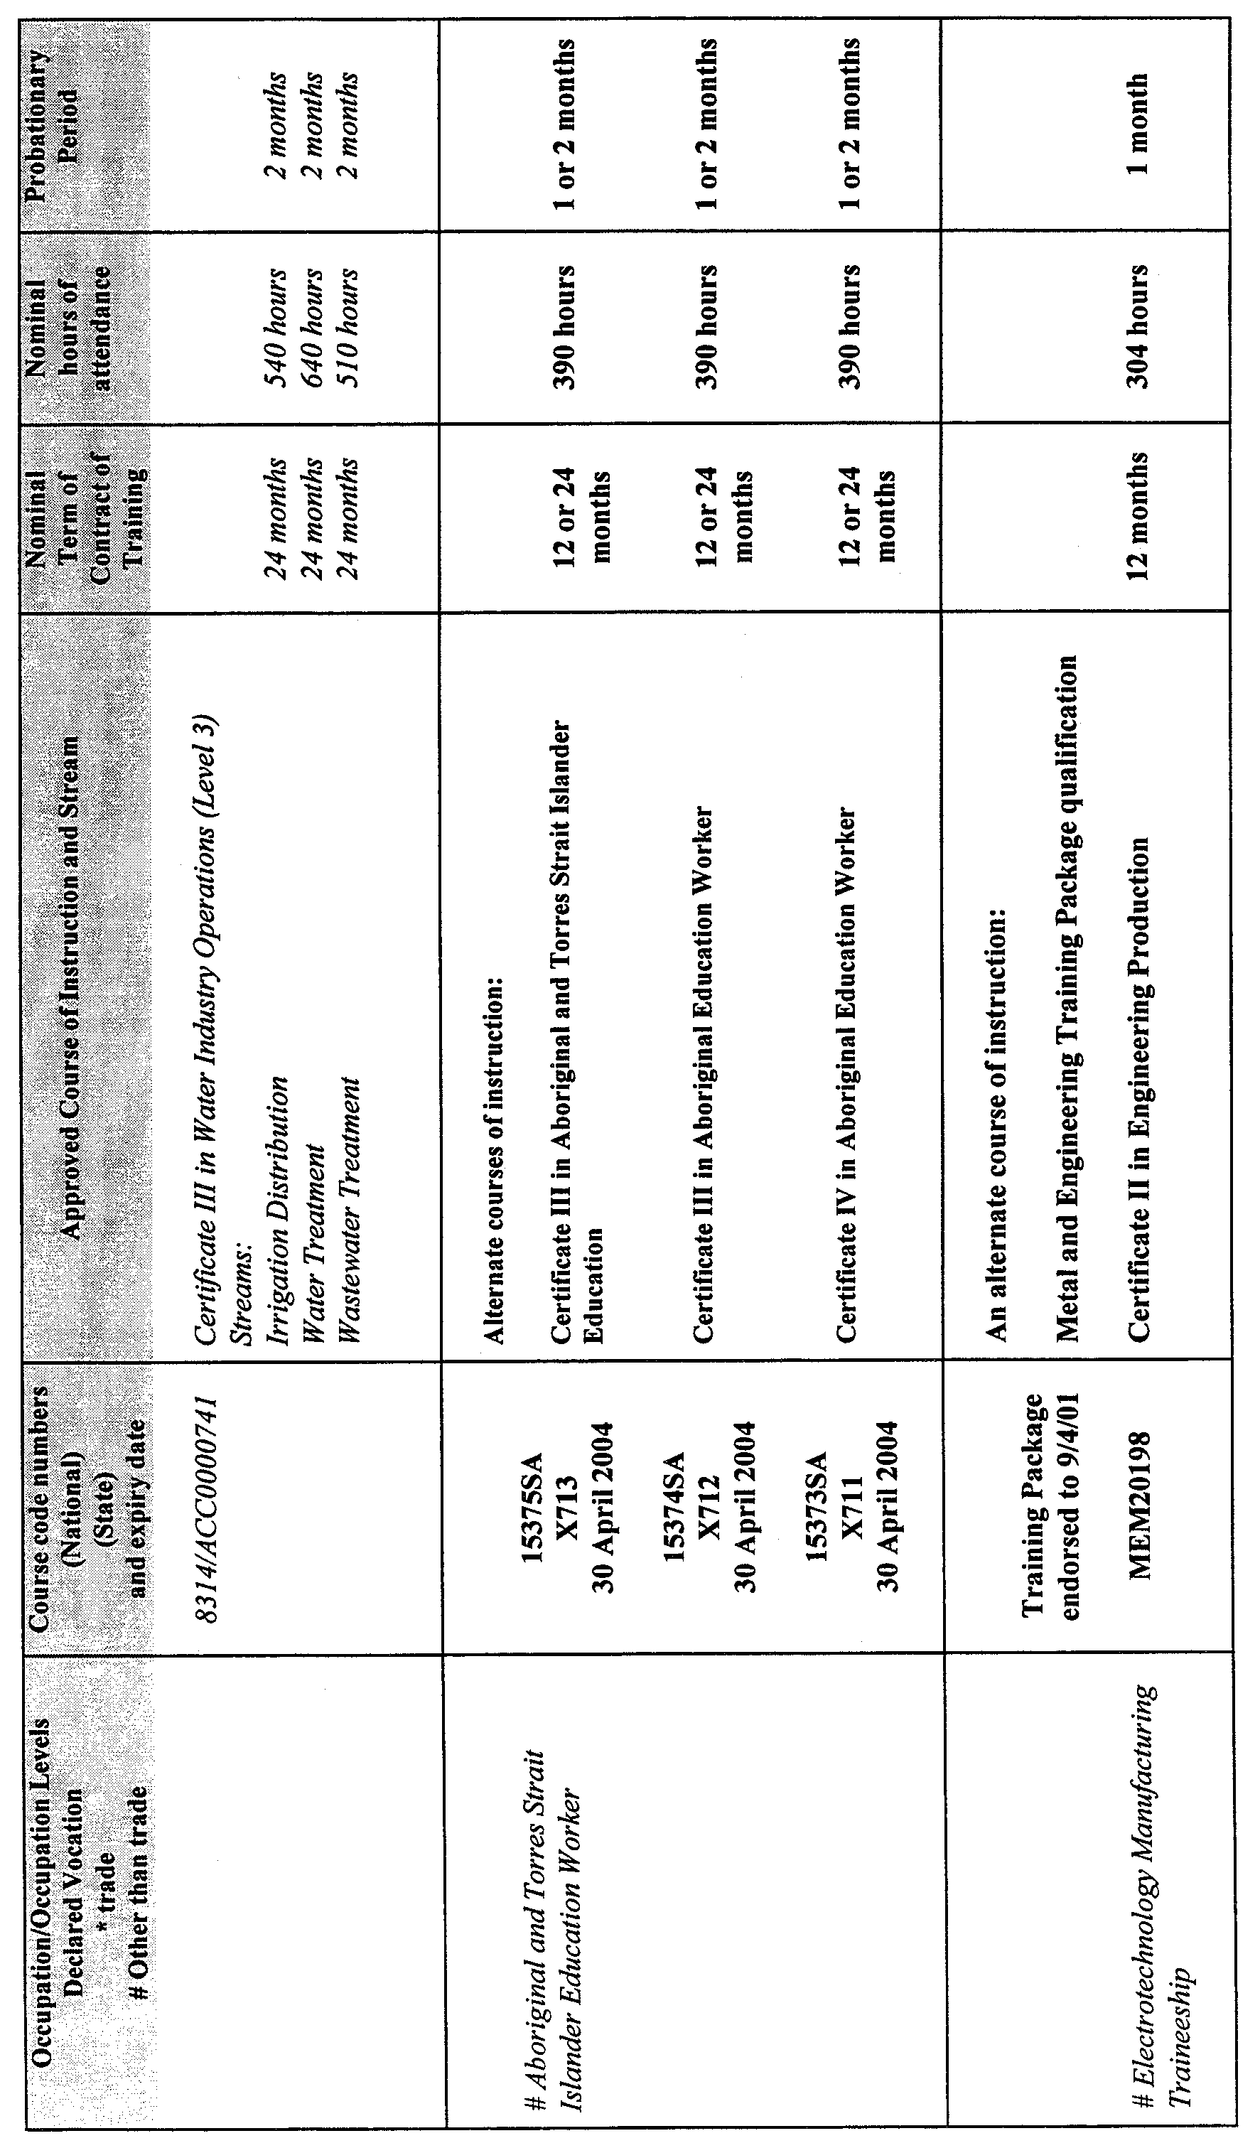
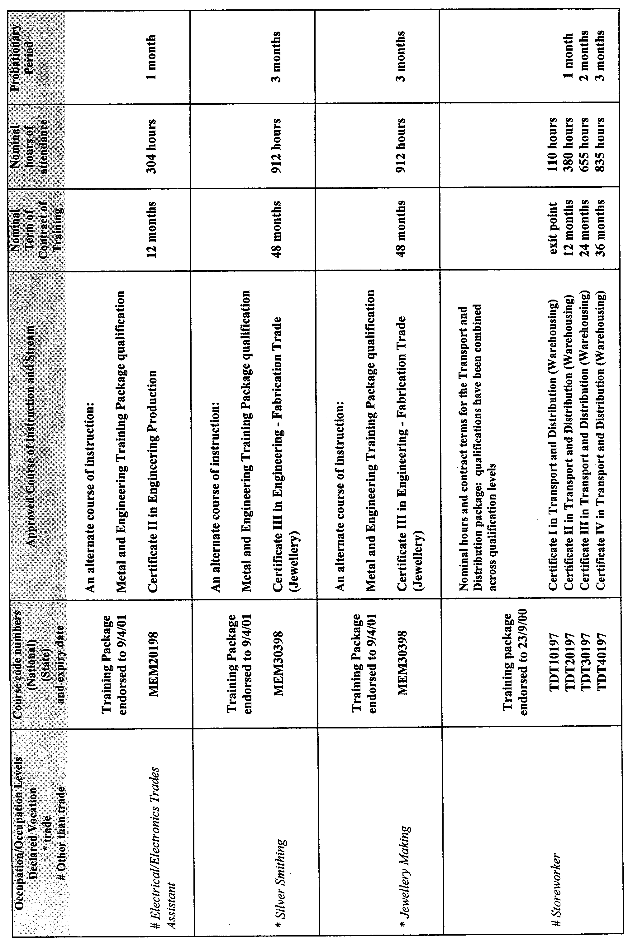
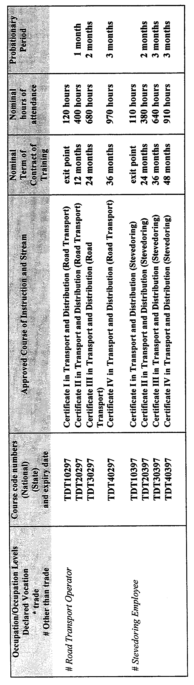
REGULATIONS UNDER THE FISHERIES ACT 1982
────
No. 134 of 1999
────
At the Executive Council Office at Adelaide 1 July 1999

PURSUANT to the Fisheries Act 1982 and with the advice and consent of the Executive Council, I make the following regulations.
E. J. NEAL Governor

PURSUANT to section 10AA(2) of the Subordinate Legislation Act 1978, I certify that, in my opinion, it is necessary or appropriate that the following regulations come into operation as set out below.

ROB KERIN Minister for Primary Industries, Natural Resources and Regional Development
───────────────────
SUMMARY OF PROVISIONS

1. Citation
2. Commencement
3. Variation of Sched. 5—Fees
───────────────────

Citation
1. The Fisheries (General) Regulations 1984 (see Gazette 28 June 1984 p. 1947), as varied, are referred to in these regulations as "the principal regulations".

Commencement
2. These regulations will come into operation on 1 July 1999.

Variation of Sched. 5—Fees
3. Schedule 5 of the principal regulations is varied—

(a) by striking out from clause 2(a)(ii) "1 438" and substituting "1 386";

(b) by striking out from clause 2(b) "1 438" and substituting "1 386";

(c) by striking out from clause 2(c) "2 107" and substituting "2 155";

(d) by striking out paragraph (d) of clause 2;

(e) by striking out from clause 2(e) "57" and substituting "32.70".

MPNR 24/99 CS R. DENNIS Clerk of the Council

REGULATIONS UNDER THE FISHERIES ACT 1982
────
No. 135 of 1999
────
At the Executive Council Office at Adelaide 1 July 1999

PURSUANT to the Fisheries Act 1982 and with the advice and consent of the Executive Council, I make the following regulations.
E. J. NEAL Governor

PURSUANT to section 10AA(2) of the Subordinate Legislation Act 1978, I certify that, in my opinion, it is necessary or appropriate that the following regulations come into operation as set out below.

ROB KERIN Minister for Primary Industries, Natural Resources and Regional Development
───────────────────
SUMMARY OF PROVISIONS

1. Citation
2. Commencement
3. Variation of reg. 8—Renewal of licences
4. Variation of reg. 9—Transfer of licence
5. Transitional provision
───────────────────

Citation
1. The Scheme of Management (Lakes and Coorong Fishery) Regulations 1991 (see Gazette 27 June 1991 p. 2178), as varied, are referred to in these regulations as "the principal regulations".

Commencement
2. These regulations come into operation on the day on which they are made.

Variation of reg. 8—Renewal of licences
3. Regulation 8 of the principal regulations is varied—

(a) by striking out from subregulation (5)(a)(i) "$3 070" and substituting "$3 656";

(b) by striking out from subregulation (5)(a)(ii) "that fee" and substituting "a fee of "$3 746".

Variation of reg. 9—Transfer of licence
4. Regulation 9 of the principal regulations is varied by striking out from subregulation (4)(c) "$200" and substituting "$300".

Transitional provision
5. (1) A licence renewal fee prescribed by regulation 8 of the principal regulations as varied by these regulations applies in relation to a licence period commencing after the commencement of these regulations.

(2) Despite regulation 3, a licence renewal fee prescribed by regulation 8 of the principal regulations as in force immediately before the commencement of these regulations continues to apply in relation to a licence period that commenced before the commencement of these regulations.

(3) In this regulation—

"licence period" means the period of 12 months commencing on 1 July in any year.

MPNR 24/99 CS R. DENNIS Clerk of the Council

REGULATIONS UNDER THE FISHERIES ACT 1982
────
No. 136 of 1999
────
At the Executive Council Office at Adelaide 1 July 1999

PURSUANT to the Fisheries Act 1982 and with the advice and consent of the Executive Council, I make the following regulations.
E. J. NEAL Governor

PURSUANT to section 10AA(2) of the Subordinate Legislation Act 1978, I certify that, in my opinion, it is necessary or appropriate that the following regulations come into operation as set out below.

ROB KERIN Minister for Primary Industries, Natural Resources and Regional Development
───────────────────
SUMMARY OF PROVISIONS

1. Citation
2. Commencement
3. Variation of reg. 8—Renewal of licences
4. Variation of Sched. 2—Fees
5. Transitional provision
───────────────────

Citation
1. The Scheme of Management (Prawn Fisheries) Regulations 1991 (see Gazette 27 June 1991 p. 2133), as varied, are referred to in these regulations as "the principal regulations".

Commencement
2. These regulations come into operation on the day on which they are made.

Variation of reg. 8—Renewal of licences
3. Regulation 8 of the principal regulations is varied by by striking out paragraph (a) of subregulation (5) and substituting the following paragraph:

(a) —

(i) the renewal fee specified in Schedule 2 less $90; or

(ii) the first instalment of the renewal fee specified in Schedule 2, in accordance with subregulation (6);.

Variation of Sched. 2—Fees
4. Schedule 2 of the principal regulations is varied—

(a) by striking out from clause 1(a)(i) "19 988" and substituting "17 422";

(b) by striking out from clause 1(a)(ii) "18 775" and substituting "16 739";

(c) by striking out from clause 1(a)(iii) "18 800" and substituting "17 058";

(d) by striking out from clause 1(b) "200" and substituting "300".

Transitional provision
5. (1) A licence renewal fee prescribed by Schedule 2 of the principal regulations as varied by these regulations applies in relation to a licence period commencing after the commencement of these regulations.

(2) Despite regulation , a licence renewal fee prescribed by Schedule 2 of the principal regulations as in force immediately before the commencement of these regulations continues to apply in relation to a licence period that commenced before the commencement of these regulations.

(3) In this regulation—

"licence period" has the same meaning as in the principal regulations.

MPNR 24/99 CS R. DENNIS Clerk of the Council

REGULATIONS UNDER THE FISHERIES ACT 1982
────
No. 137 of 1999
────
At the Executive Council Office at Adelaide 1 July 1999

PURSUANT to the Fisheries Act 1982 and with the advice and consent of the Executive Council, I make the following regulations.
E. J. NEAL Governor

PURSUANT to section 10AA(2) of the Subordinate Legislation Act 1978, I certify that, in my opinion, it is necessary or appropriate that the following regulations come into operation as set out below.

ROB KERIN Minister for Primary Industries, Natural Resources and Regional Development
───────────────────
SUMMARY OF PROVISIONS

1. Citation
2. Commencement
3. Variation of reg. 9—Renewal of licences
4. Variation of reg. 10A—Transfer of licence
5. Transitional provision
───────────────────

Citation
1. The Scheme of Management (River Fishery) Regulations 1991 (see Gazette 27 June 1991 p. 2197), as varied, are referred to in these regulations as "the principal regulations".

Commencement
2. These regulations come into operation on the day on which they are made.

Variation of reg. 9—Renewal of licences
3. Regulation 9 of the principal regulations is varied by striking out paragraph (a) of subregulation (5) and substituting the following paragraph:

(a) —

(i) a fee of $3 656; or

(ii) the first instalment of a fee of $3 746, in accordance with subregulation (6);.

Variation of reg. 10A—Transfer of licence
4. Regulation 10A of the principal regulations is varied by striking out from subregulation (4)(c) "$200" and substituting "$300".

Transitional provision
5. (1) A licence renewal fee prescribed by regulation 9 of the principal regulations as varied by these regulations applies in relation to a licence period commencing after the commencement of these regulations.

(2) Despite regulation 3, a licence renewal fee prescribed by regulation 9 of the principal regulations as in force immediately before the commencement of these regulations continues to apply in relation to a licence period that commenced before the commencement of these regulations.

(3) In this regulation—

"licence period" has the same meaning as in the principal regulations.

MPNR 24/99 CS R. DENNIS Clerk of the Council

REGULATIONS UNDER THE FISHERIES ACT 1982
────
No. 138 of 1999
────
At the Executive Council Office at Adelaide 1 July 1999

PURSUANT to the Fisheries Act 1982 and with the advice and consent of the Executive Council, I make the following regulations.
E. J. NEAL Governor

PURSUANT to section 10AA(2) of the Subordinate Legislation Act 1978, I certify that, in my opinion, it is necessary or appropriate that the following regulations come into operation as set out below.

ROB KERIN Minister for Primary Industries, Natural Resources and Regional Development
───────────────────
SUMMARY OF PROVISIONS

1. Citation
2. Commencement
3. Variation of reg. 7
4. Variation of reg. 18
5. Transitional provision
───────────────────

Citation
1. The Scheme of Management (Miscellaneous Fishery) Regulations 1984 (see Gazette 14 June 1984 p. 1686), as varied, are referred to in these regulations as "the principal regulations".

Commencement
2. These regulations come into operation on the day on which they are made.

Variation of reg. 7
3. Regulation 7 of the principal regulations is varied—

(a) by striking out paragraphs (a) and (b) of subregulation (4) and substituting the following paragraphs:

(a) the licence fee specified in subregulation (5) less $90; or

(b) the first instalment of the licence fee specified in subregulation (5), in accordance with subregulation (6).;

(b) by striking out from subregulation (5)(a) "$2 166" and substituting "$2 279".

Variation of reg. 18
4. Regulation 18 of the principal regulations is varied by striking out paragraph (a) of subregulation (5) and substituting the following paragraph:

(a) —

(i) a fee of $2 189; or

(ii) the first instalment of a fee of $2 279, in accordance with subregulation (6);.

Transitional provision
5. (1) The licence and renewal fees prescribed by the principal regulations as varied by these regulations apply in relation to a licence period commencing after the commencement of these regulations.

(2) Despite regulations 3 and 4, the licence and renewal fees prescribed by the principal regulations as in force immediately before the commencement of these regulations continue to apply in relation to a licence period that commenced before the commencement of these regulations.

(3) In this regulation—

"licence period" has the same meaning as in the principal regulations.

MPNR 24/99 CS R. DENNIS Clerk of the Council

REGULATIONS UNDER THE FISHERIES ACT 1982
────
No. 139 of 1999
────
At the Executive Council Office at Adelaide 1 July 1999

PURSUANT to the Fisheries Act 1982 and with the advice and consent of the Executive Council, I make the following regulations.
E. J. NEAL Governor

PURSUANT to section 10AA(2) of the Subordinate Legislation Act 1978, I certify that, in my opinion, it is necessary or appropriate that the following regulations come into operation as set out below.

ROB KERIN Minister for Primary Industries, Natural Resources and Regional Development
───────────────────
SUMMARY OF PROVISIONS

1. Citation
2. Commencement
3. Variation of Sched. 2—Fees
4. Transitional provision
───────────────────

Citation
1. The Scheme of Management (Rock Lobster Fisheries) Regulations 1991 (see Gazette 27 June 1991 p. 2143), as varied, are referred to in these regulations as "the principal regulations".

Commencement
2. These regulations come into operation on the day on which they are made.

Variation of reg. 8—Renewal of licences
3. Regulation 8 of the principal regulations is varied by striking out paragraph (a) of subregulation (5) and substituting the following paragraph:

(a) —

(i) the renewal fee specified in Schedule 2 less $90; or

(ii) the first instalment of the renewal fee specified in Schedule 2, in accordance with subregulation (6);.

Variation of reg. 14—Rock lobster pot entitlement
4. Regulation 14 of the principal regulations is varied by inserting in subregulation (1)(d) "and payment of the fee specified in Schedule 2" after "Director".

Variation of Sched. 2—Fees
5. Schedule 2 of the principal regulations is varied by striking out paragraphs (a) and (b) of clause 1 and substituting the following paragraphs:

(a) on application for the renewal of a licence—

(i) in respect of the Northern Zone Rock Lobster Fishery—

(A) in the case of a licence that will on its renewal be subject to
a condition limiting the holder of the licence to the taking of
rock lobster 5 397

(B) in any other case 5 828

An additional fee of an amount obtained by multiplying $88 by the number equal to the rock lobster pot entitlement fixed by condition of a licence under regulation 14 is payable.

(ii) in respect of the Southern Zone Rock Lobster Fishery—

(A) in the case of a licence that will on its renewal be subject to
a condition limiting the holder of the licence to the taking of
rock lobster 4 724

(B) in any other case 5 155

An additional fee of an amount obtained by multiplying $96 by the number equal to the rock lobster pot entitlement fixed by condition of a licence under regulation 14 is payable.

(b) on application for transfer of a licence in respect of either rock
lobster fishery 300

(c) on application under reg. 14(1)(d) by the holder of a licence in respect of a rock lobster fishery to vary a condition of the licence so as to decrease the rock lobster pot entitlement under the licence and increase the rock lobster pot entitlement under one or more other licences in respect of that fishery—$80 plus a fee of an amount obtained by multiplying $20 by the number of licences the rock lobster pot entitlement of which is to be increased.

Transitional provision
6. (1) A licence renewal fee prescribed by Schedule 2 of the principal regulations as varied by these regulations applies in relation to a licence period commencing after the commencement of these regulations.

(2) Despite regulation 4, a licence renewal fee prescribed by Schedule 2 of the principal regulations as in force immediately before the commencement of these regulations continues to apply in relation to a licence period that commenced before the commencement of these regulations.

(3) In this regulation—

"licence period" has the same meaning as in the principal regulations.

MPNR 24/99 CS R. DENNIS Clerk of the Council

REGULATIONS UNDER THE FISHERIES ACT 1982
────
No. 140 of 1999
────
At the Executive Council Office at Adelaide 1 July 1999

PURSUANT to the Fisheries Act 1982 and with the advice and consent of the Executive Council, I make the following regulations.
E. J. NEAL Governor

PURSUANT to section 10AA(2) of the Subordinate Legislation Act 1978, I certify that, in my opinion, it is necessary or appropriate that the following regulations come into operation as set out below.

ROB KERIN Minister for Primary Industries, Natural Resources and Regional Development
───────────────────
SUMMARY OF PROVISIONS

1. Citation
2. Commencement
3. Variation of reg. 8—Renewal of licences
4. Variation of Sched. 1—Fees
5. Transitional provision
───────────────────

Citation
1. The Scheme of Management (Abalone Fisheries) Regulations 1991 (see Gazette 27 June 1991 p. 2123), as varied, are referred to in these regulations as "the principal regulations".

Commencement
2. These regulations come into operation on the day on which they are made.

Variation of reg. 8—Renewal of licences
3. Regulation 8 of the principal regulations is varied by striking out paragraph (a) of subregulation (5) and substituting the following paragraph:

(a) —

(i) the renewal fee specified in Schedule 1 less $90; or

(ii) the first instalment of the renewal fee specified in Schedule 1, in accordance with subregulation (6);.

Variation of Sched. 1—Fees
4. Schedule 1 of the principal regulations is varied—

(a) by striking out from clause 1(a)(i) "48 800" and substituting "40 789";

(b) by striking out from clause 1(a)(ii) "71 036" and substituting "72 839";

(c) by striking out from clause 1(a)(iii) "56 854" and substituting "67 696".

(d) by striking out from clause 1(b) "200" and substituting "300";

(e) by inserting after paragraph (b) of clause 1 the following paragraph:

(c) on application under regulation 13(2)(c) by the holder of a licence in respect of the fishery to vary a condition of the licence so as to decrease the unit entitlement of the licence in respect of a species of abalone and increase the unit entitlement of one or more other licences—$80 plus a fee of an amount obtained by multiplying $20 by the number of licences the unit entitlement of which is to be increased.

Transitional provision
5. (1) A licence renewal fee prescribed by Schedule 1 of the principal regulations as varied by these regulations applies in relation to a licence period commencing after the commencement of these regulations.

(2) Despite regulation 4, a licence renewal fee prescribed by Schedule 1 of the principal regulations as in force immediately before the commencement of these regulations continues to apply in relation to a licence period that commenced before the commencement of these regulations.

(3) In this regulation—

"licence period" has the same meaning as in the principal regulations.

MPNR 24/99 CS R. DENNIS Clerk of the Council

REGULATIONS UNDER THE FISHERIES ACT 1982
────
No. 141 of 1999
────
At the Executive Council Office at Adelaide 1 July 1999

PURSUANT to the Fisheries Act 1982 and with the advice and consent of the Executive Council, I make the following regulations.
E. J. NEAL Governor

PURSUANT to section 10AA(2) of the Subordinate Legislation Act 1978, I certify that, in my opinion, it is necessary or appropriate that the following regulations come into operation as set out below.

ROB KERIN Minister for Primary Industries, Natural Resources and Regional Development
───────────────────
SUMMARY OF PROVISIONS

1. Citation
2. Commencement
3. Variation of reg. 4—Interpretation
4. Variation of reg. 8—Renewal of licences
5. Variation of reg. 14A—Blue crab net entitlement
6. Variation of reg. 14B—Individual blue crab quota system
7. Variation of Sched. 2—Fees
8. Transitional provision
───────────────────

Citation
1. The Scheme of Management (Marine Scalefish Fisheries) Regulations 1991 (see Gazette 27 June 1991 p. 2187), as varied, are referred to in these regulations as "the principal regulations".

Commencement
2. These regulations come into operation on the day on which they are made.

Variation of reg. 4—Interpretation
3. Regulation 4 of the principal regulations is varied by inserting after the definition of "director" in subregulation (1) the following definition:

"licence period" means the period of 12 months commencing on 1 July in any year;.

Variation of reg. 8—Renewal of licences
4. Regulation 8 of the principal regulations is varied by striking out paragraph (a) of subregulation (5) and substituting the following paragraph:

(a) —

(i) the renewal fee specified in Schedule 2 less $90; or

(ii) the first instalment of the renewal fee specified in Schedule 2, in accordance with subregulation (6);.

Variation of reg. 14A—Blue crab net entitlement
5. Regulation 14A of the principal regulations is varied by striking out from subregulation (1)(d) "the blue crab pot entitlement fixed" and substituting "the blue crab net entitlement fixed".

Variation of reg. 14B—Individual blue crab quota system
6. Regulation 14B of the principal regulations is varied—

(a) by striking out from paragraph (b) of the definition of "blue crab quota" in subregulation (2) "licence year" and substituting "licence period".

Variation of Sched. 2—Fees
7. Schedule 2 of the principal regulations is varied—

(a) by striking out from clause 1(a) "2 535" and substituting "2 518";

(b) by striking out from clause1(b) "200" and substituting "300";

(c) by inserting after paragraph (b) of clause 1 the following paragraph:

(c) on application under regulation 14A(1)(c) or (d) by the holder of a licence in respect of the fishery to vary a condition of the licence so as to decrease the blue crab net entitlement under the licence and increase the blue crab net entitlement under one or more licences in respect of the Fishery or the blue crab pot entitlement under one or more licences in respect of the Blue Crab Fishery—$80 plus a fee of an amount obtained by multiplying $20 by the number of licences the blue crab net entitlement or blue crab pot entitlement of which is to be increased.

Transitional provision
8. (1) A licence renewal fee prescribed by Schedule 2 of the principal regulations as varied by these regulations applies in relation to a licence period commencing after the commencement of these regulations.

(2) Despite regulation 7, a licence renewal fee prescribed by Schedule 2 of the principal regulations as in force immediately before the commencement of these regulations continues to apply in relation to a licence period that commenced before the commencement of these regulations.

(3) In this regulation—

"licence period" has the same meaning as in the principal regulations.

MPNR 24/99 CS R. DENNIS Clerk of the Council

REGULATIONS UNDER THE FISHERIES ACT 1982
────
No. 142 of 1999
────
At the Executive Council Office at Adelaide 1 July 1999

PURSUANT to the Fisheries Act 1982 and with the advice and consent of the Executive Council, I make the following regulations.
E. J. NEAL Governor

PURSUANT to section 10AA(2) of the Subordinate Legislation Act 1978, I certify that, in my opinion, it is necessary or appropriate that the following regulations come into operation as set out below.

ROB KERIN Minister for Primary Industries, Natural Resources and Regional Development
───────────────────
SUMMARY OF PROVISIONS

1. Citation
2. Commencement
3. Variation of reg. 8—Renewal of licences
4. Variation of Sched. 2—Fees
5. Transitional provision
───────────────────

Citation
1. The Scheme of Management (Blue Crab Fishery) Regulations 1998 (see Gazette 11 June 1998 p. 2519) are referred to in these regulations as "the principal regulations".

Commencement
2. These regulations come into operation on the day on which they are made.

Variation of reg. 8—Renewal of licences
3. Regulation 8 of the principal regulations is varied by striking out paragraph (a) of subregulation (5) and substituting the following paragraph:

(a) —

(i) the renewal fee specified in Schedule 2 less $90; or

(ii) the first instalment of the renewal fee specified in Schedule 2, in accordance with subregulation (6);.

Variation of Sched. 2—Fees
4. Schedule 2 of the principal regulations is varied—

(a) by striking out from clause 1(a) "4 151" and "18" substituting, respectively, "2 557.00" and "16.90";

(b) by striking out paragraph (b) of clause 1 and substituting the following paragraphs:

(b) on application for the transfer of a licence in respect of the fishery 300.00

(c) on application under regulation 14(1)(c) or (d) by the holder of a licence in respect of the fishery to vary a condition of the licence so as to decrease the blue crab pot entitlement under the licence and increase the blue crab pot entitlement under one or more licences in respect of the fishery or the blue crab net entitlement under one or more licence in respect of the Marine Scalefish Fishery—$80.00 plus a fee of an amount obtained by multiplying $20.00 by the number of licences the blue crab pot entitlement or blue crab net entitlement of which is to be increased.

Transitional provision
5. (1) A licence renewal fee prescribed by Schedule 2 of the principal regulations as varied by these regulations applies in relation to a licence period commencing after the commencement of these regulations.

(2) Despite regulation 4, a licence renewal fee prescribed by Schedule 2 of the principal regulations as in force immediately before the commencement of these regulations continues to apply in relation to a licence period that commenced before the commencement of these regulations.

(3) In this regulation—

"licence period" has the same meaning as in the principal regulations.

MPNR 24/99 CS R. DENNIS Clerk of the Council

REGULATIONS UNDER ACTS SPECIFIED IN SCHEDULES
────
No. 143 of 1999
────
At the Executive Council Office at Adelaide 1 July 1999

PURSUANT to the Acts specified in the Schedules and with the advice and consent of the Executive Council, I make the following regulations.
E. J. NEAL Governor

PURSUANT to section 10AA(2) of the Subordinate Legislation Act 1978, I certify that, in my opinion, it is necessary or appropriate that the following regulations come into operation as set out below.

ROB KERIN Primary Industries, Natural Resources and Regional Development
ROB LUCAS Treasurer
K. T. GRIFFIN Attorney-General
K. T. GRIFFIN Consumer Affairs
K. T. GRIFFIN Justice
DEAN BROWN Human Services
DIANA LAIDLAW Transport and Urban Planning
MALCOLM BUCKBY Education, Children's Services & Training
MICHAEL ARMITAGE Government Enterprises
IAIN EVANS Industry and Trade

───────────────────
SUMMARY OF PROVISIONS

1. Citation
2. Commencement
3. Variation of regulations
4. Revocation of regulations

SCHEDULE 1
Varied Regulations

SCHEDULE 2

Revoked Regulations
───────────────────

Citation
1. These regulations may be cited as the Regulations Variation and Revocation (Financial Sector Reform) Regulations 1999.

Commencement
2. These regulations will come into operation on the date that is the transfer date for the purposes of the Financial Sector Reform (Amendments and Transitional Provisions) Act (No. 1) 1999 of the Commonwealth.

Variation of regulations
3. The regulations specified in Schedule 1 are varied as indicated in that schedule.

Revocation of regulations
4. The regulations specified in Schedule 2 are revoked.

SCHEDULE 1
Varied Regulations
 | Act | Regulations | Provision | Variation
1. | Associations Incorporation Act 1985 | Associations Incorporation Regulations 1993 (see Gazette 20 May 1993 p. 1709), as varied | Sched. 1  Form 9A | Strike out "at bank" and substitute "with an ADI".
 |  |  | Sched. 1  Form 9B | Strike out "at bank" and substitute "with an ADI".
2. | Community Titles Act 1996 | Community Titles Regulations 1996 (see Gazette 31 October 1996 p. 1559), as varied | reg. 24(1)(c) | Strike out "bank" and substitute "ADI".
 |  |  | reg. 31(b)(iii) | Strike out "bank draft" and substitute "bank cheque".
 |  |  |  | After "cheque" second occurring insert "or bank cheque".
3. | Conveyancers Act 1994 | Conveyancers Regulations 1995 (see Gazette 25 May 1995 p. 2479), as varied | reg. 8 | Strike out "a bank, building society or credit union" and substitute "an ADI".
 |  |  | reg. 9(b)(iii) | Strike out "bank draft" and substitute "bank cheque".
 |  |  |  | After "cheque" second occurring insert "or bank cheque".
4. | Corporations (South Australia) Act 1990 | Corporations (South Australia) Regulations 1990 (see Gazette 20 December 1990 p. 1917), as varied | reg. 4(b), (d), (e) and (f) | Strike out these paragraphs.
 |  |  | reg. 5 | Strike out this regulation.
5. | Country Fires Act 1989 | Country Fires Regulations 1989 (see Gazette 31 August 1989 p. 713), as varied | reg. 19(1) | Strike out "a bank, building society or credit union" and substitute "an ADI".
6. | Development Act 1993 | Development Regulations 1993 (see Gazette 27 October 1993 p. 1954), as varied | Sched. 1  after definition of "amusement machine centre" | Insert the following definition:  "bank" means premises of an ADI; or

 | Act | Regulations | Provision | Variation
7. | Education Act 1972 | Education Regulations 1997 (see Gazette 28 August 1997 p. 484), as varied | reg. 99(2) | Strike out "bank" and substitute "ADI".
 |  |  | reg. 99(3) | Strike out "banked" and substitute "deposited".
 |  |  | reg. 99(7) | Strike out "banked" twice occurring and substitute in each case "deposited".
 |  |  | reg. 102(1) | Strike out "a bank" and substitute "an ADI".
8. | Expiation of Offences Act 1996 | Expiation of Offences Regulations 1996 (see Gazette 23 December 1996 p. 2237) | Sched.  Form 6 | Strike out "Approved Bank Manager" and substitute "Proclaimed Manager".
 |  |  | Sched.  Form 12 | Strike out "Approved Bank Manager" and substitute "Proclaimed Manager".
9. | Fair Trading Act 1987 | Fair Trading (Pre-paid Funerals Code of Practice) Regulations 1996 (see Gazette 23 May 1996 p. 2571). | Sched.  clause 2  definition of "approved investment manager" | Strike out from paragraph (b) "under the Friendly Societies Act 1919 or under similar legislation in force in another State or a Territory".
10. | Fisheries Act 1982 | (a) Fisheries (Exotic Fish, Fish Farming and Fish Diseases) Regulations 1984 (see Gazette 28 June 1984 p. 1910), as varied | reg. 14(2)(a) | Strike out "banks" and substitute "ADIs".
 |  |  | reg. 14(2)(b) | Strike out "bank" wherever it occurs and substitute in each case "ADI".
 |  | (b) Scheme of Management (Miscellaneous Fishery) Regulations 1984 (see Gazette 14 June 1984 p. 1686), as varied | reg. 15(3)(b) | Strike out "a bank" and substitute "an ADI".
 |  |  | reg. 15(10) | Strike out "bank".

 | Act | Regulations | Provision | Variation
11. | Land Agents Act 1994 | Land Agents Regulations 1995 (see Gazette 25 May 1995 p. 2464), as varied | reg. 10 | Strike out "a bank, building society or credit union" and substitute "an ADI".
 |  |  | reg. 11(b)(iii) | Strike out "bank draft" and substitute "bank cheque".
 |  |  |  | After "cheque" second occurring insert "or bank cheque".
12. | Land and Business (Sale and Conveyancing) Act 1994 | Land and Business (Sale and Conveyancing) Regulations 1995 (see Gazette 27 April 1995 p. 1577), as varied | Sched. 1  Form 2 | Strike out from the table under the heading "TRADING STATEMENT FOR LAST 3 FINANCIAL YEARS" "Bank charges" and substitute "ADI charges".
13. | Legal Practitioners Act 1981 | Legal Practitioners Regulations 1994 (see Gazette 1 September 1994 p. 636), as varied | reg. 4  definition of "trust bank account" | Strike out "bank" and substitute "ADI".  Strike out "a banking" and substitute "an ADI".
 |  |  | reg. 7(1)(h) | Strike out "bank" and substitute "ADI".
 |  |  | reg. 11(1) | Strike out "trust bank account" and substitute "trust ADI account".
 |  |  | reg. 11(1)(b)(iii) | Strike out "bank draft" and substitute "bank cheque".
 |  |  |  | After "cheque" second occurring insert "or bank cheque".
 |  |  | reg. 12(3)(ii) | Strike out "bank" and substitute "ADI".
 |  |  | reg. 15(1) | Strike out "bank" twice occurring and substitute in each case "ADI".
 |  |  | reg. 16(1) | Strike out "bank" and substitute "ADI".  Strike out "a banking" and substitute "an ADI".
 |  |  | reg. 18(b) | Strike out "bank" and substitute "ADI".
 |  |  | reg. 24(3) | Strike out "bank" wherever it occurs and substitute in each case "ADI".
 |  |  | reg. 25(1)(f)(i) | Strike out "banking" twice occurring and substitute in each case "ADI".
 |  |  | reg. 25(1)(f)(ii) | Strike out "bank" and substitute "ADI".
 |  |  | reg. 26(1) | Strike out "bank" wherever it occurs and substitute in each case "ADI".
14. | Local Government Act 1934 | Local Government Accounting Regulations 1993 (see Gazette 29 April 1993 p. 1526), as varied | Sched. | Strike out "Bank Overdraft" and substitute "ADI Overdrafts".
15. | Lottery and Gaming Act 1936 | Lottery and Gaming Regulations 1993 (see Gazette 27 October 1993 p. 1901), as varied | reg. 20(q) | Strike out "bank" and substitute "ADI".
 |  |  | reg. 20(v)(i) | Strike out "a bank" and substitute "an ADI".  Strike out "bank accounts" and substitute "ADI accounts".
 |  |  | reg. 21(y)(vi) | Strike out "a bank" and substitute "an ADI".
 |  |  | reg. 22(i)(i) | Strike out "a bank" and substitute "an ADI".  Strike out "bank accounts" and substitute "ADI accounts".
 |  |  | reg. 27(2) | Strike out "a bank" and substitute "an ADI".  Strike out "that bank" and substitute "that ADI".
 |  |  | reg. 30(2) | Strike out "a bank" and substitute "an ADI".
 |  |  | reg. 30(2)(a) | Strike out "bank" and substitute "ADI".
 |  |  | reg. 30(3) | Strike out "bank" and substitute "ADI".
 |  |  | reg. 34 | Strike out "a bank" and substitute "an ADI".
16. | Mining Act 1971 | Mining Regulations 1998 (see Gazette 21 August 1998 p. 476) | Sched. 1  Forms 1, 3, 14, 20 and 24 | Strike out "Proclaimed Bank Manager" wherever it occurs and substitute in each case "Proclaimed Manager".
17. | Pay-roll Tax Act 1971 | Pay-roll Tax Regulations 1990 (see Gazette 20 December 1990 p. 1894), as varied | reg. 8 | Strike out "bank draft" and substitute "bank cheque".
18. | Second-hand Dealers and Pawnbrokers Act 1996 | Second-hand Dealers and Pawnbrokers Regulations 1998 (see Gazette 19 February 1998 p. 964) | reg. 4(5) | Strike out "a bank or" and substitute "an ADI or a".
19. | Second-hand Vehicle Dealers Act 1995 | Second-hand Vehicle Dealers Regulations 1995 (see Gazette 2 November 1995 p. 1258), as varied | Sched. 6 | Strike out "proclaimed bank manager" twice occurring and substitute in each case "proclaimed manager".
20. | Security and Investigation Agents Act 1995 | Security and Investigation Agents Regulations 1996 (see Gazette 28 March 1996 p. 1857), as varied | reg. 13(1) | Strike out "a bank, building society or credit union" and substitute "an ADI".
 |  |  | reg. 13(3) | Strike out "bank, building society or credit union" and substitute "ADI".
 |  |  | reg. 15(2)(b)(iii) | Strike out "bank draft" and substitute "bank cheque".
 |  |  |  | After "cheque" second occurring insert "or bank cheque".
 |  |  | reg. 27(2) | Strike out "a bank" and substitute "an ADI".
 |  |  | reg. 28 | Strike out "A bank, building society or credit union" and substitute "An ADI".
 |  |  | reg. 30 | Strike out "a bank, building society or credit union" twice occurring and substitute in each case "an ADI".
21. | South Australian Co-operative and Community Housing Act 1991 | (a) South Australian Co-operative and Community Housing (General) Regulations 1992 (see Gazette 9 January 1992 p. 33), as varied | Sched. 3  Part 2, clause 1 | Strike out "Cash at Bank" and substitute "Cash with an ADI".
 |  | (b) South Australian Co-operative and Community Housing (Housing Associations) Regulations 1996 (see Gazette 15 February 1996 p. 1157) | Sched. 2  Part 2, clauses 2 and 3 | Strike out "Cash at Bank" twice occurring and substitute in each case "Cash with an ADI".

 | Act | Regulations | Provision | Variation
22. | Strata Titles Act 1988 | Strata Titles Regulations 1988 (see Gazette 21 July 1988 p. 460), as varied | reg. 16(b)(iii) | Strike out "bank draft" and substitute "bank cheque".
 |  |  |  | After "cheque" second occurring insert "or bank cheque".
23. | Supreme Court Act 1935 | Supreme Court (Fees) Regulations 1987 (see Gazette 3 December 1987 p. 1768), as varied | Sched.  Note to Part 4 | Strike out "in a bank" and substitute "with an ADI".
24. | Technical and Further Education Act 1975 | Technical and Further Education Regulations 1998 (see Gazette 10 September 1998 p. 854) | reg. 4  definition of "council fund account" | Strike out "a bank, building society, credit union" and substitute "an ADI".
 |  |  | reg. 56(k) | Strike out "a bank, building society, credit union" and substitute "an ADI".
25. | Trustee Act 1936 | Trustee Regulations 1996 (see Gazette 29 August 1996 p. 844), as varied | reg. 6(1)(k)(iv)(F) | Strike out "a bank" and substitute "an ADI".
 |  |  | reg. 6(1)(k)(vi) | Strike out "bank" twice occurring and substitute in each case "ADI".
26. | Trustee Companies Act 1988 | Trustee Companies Regulations 1989 (see Gazette 20 April 1989 p.1112) | Sched.  Clause 2 | Strike out "banks" and substitute "ADIs".
 |  |  | Sched.  Clause 6 | Strike out "Cash at bank and on hand" and substitute "Cash with an ADI and cash on hand".  Strike out "bank accepted or endorsed" twice occurring and substitute in each case "ADI accepted or endorsed".  Strike out "Bank overdrafts and bank loans" twice occurring and substitute in each case "ADI overdrafts and loans".
27. | Workers Rehabilitation and Compensation Act 1986 | Workers Rehabilitation and Compensation (Claims and Registration) Regulations 1987 (see Gazette 6 August 1987 p. 379), as varied | Fourth Sched.  clause 12(5)  definition of "financial institution" | Strike out paragraph (a) and substitute:  (a) an ADI; or

SCHEDULE 2
Revoked Regulations
Act | Regulations
Friendly Societies (South Australia) Act 1997 | Friendly Societies (South Australia) (Savings and Transitional) Regulations 1997, as varied

AG 43/97 CS R. DENNIS Clerk of the Council
REGULATIONS UNDER THE SOUTH AUSTRALIAN HEALTH COMMISSION ACT 1976
────
No. 144 of 1999
────
At the Executive Council Office at Adelaide 1 July 1999

PURSUANT to the South Australian Health Commission Act 1976, on the recommendation of the South Australian Health Commission and with the advice and consent of the Executive Council, I make the following regulations.
E. J. NEAL Governor

PURSUANT to section 10AA(2) of the Subordinate Legislation Act 1978, I certify that, in my opinion, it is necessary or appropriate that the following regulations come into operation as set out below.

DEAN BROWN Minister for Human Services
───────────────────
SUMMARY OF PROVISIONS

1. Citation
2. Commencement
3. Variation of Sched.
───────────────────

Citation
1. The Recognized Hospital and Incorporated Health Centre (Medicare Patients) Fees Regulations 1987 (see Gazette 30 July 1987 p. 334), as varied, are referred to in these regulations as "the principal regulations".

Commencement
2. These regulations will come into operation on 1 July 1999.

Variation of Sched.
3. The schedule of the principal regulations is varied—

(a) by striking out "$213" from paragraph (b) under the heading "Fees for Services Provided to Medicare Patients at Recognized Hospitals" and substituting "$216";

(b) by striking out "$154" from paragraph (d)(i) under the heading "Fees for Services Provided to Medicare Patients at Recognized Hospitals" and substituting "$156";

(c) by striking out "$176" from paragraph (d)(ii) under the heading "Fees for Services Provided to Medicare Patients at Recognized Hospitals" and substituting "$178";

(d) by striking out "$194" from paragraph (d)(iii) under the heading "Fees for Services Provided to Medicare Patients at Recognized Hospitals" and substituting "$196";

(e) by striking out "$213" from paragraph (d)(iv) under the heading "Fees for Services Provided to Medicare Patients at Recognized Hospitals" and substituting "$216".

DHS 10/99 CS R. DENNIS Clerk of the Council

REGULATIONS UNDER THE SOUTH AUSTRALIAN HEALTH COMMISSION ACT 1976
────
No. 145 of 1999
────
At the Executive Council Office at Adelaide 1 July 1999

PURSUANT to the South Australian Health Commission Act 1976, on the recommendation of the South Australian Health Commission and with the advice and consent of the Executive Council, I make the following regulations.
E. J. NEAL Governor

PURSUANT to section 10AA(2) of the Subordinate Legislation Act 1978, I certify that, in my opinion, it is necessary or appropriate that the following regulations come into operation as set out below.

DEAN BROWN Minister for Human Services
───────────────────
SUMMARY OF PROVISIONS

1. Citation
2. Commencement
3. Variation of Sched. 3
───────────────────

Citation
1. The South Australian Health Commission (Recognised Hospital and Incorporated Health Centre—Compensable and Non-Medicare Patients Fees) Regulations 1995 (see Gazette 13 April 1995 p. 1442), as varied, are referred to in these regulations as "the principal regulations".

Commencement
2. These regulations will come into operation on 1 July 1999 immediately after the regulations made under the South Australian Health Commission Act 1976 on 27 May 1999 (see Gazette 27 May 1999 p. 2868) come into operation.

Variation of Sched. 3
3. Schedule 3 of the principal regulations is varied by striking out from clause 2 "$ 260.00 per day" and substituting "$ 279.00 per day".

DHS 10/99 CS R. DENNIS Clerk of the Council

REGULATIONS UNDER THE APIARIES ACT 1931
────
No. 146 of 1999
────
At the Executive Council Office at Adelaide 1 July 1999

PURSUANT to the Apiaries Act 1931 and with the advice and consent of the Executive Council, I make the following regulations.
E. J. NEAL Governor

PURSUANT to section 10AA(2) of the Subordinate Legislation Act 1978, I certify that, in my opinion, it is necessary or appropriate that the following regulations come into operation as set out below.

ROB KERIN Minister for Primary Industries, Natural Resources and Regional Development
───────────────────
SUMMARY OF PROVISIONS

1. Citation
2. Commencement
3. Variation of reg. 7—Registration as beekeeper
4. Substitution of Sched. 1
SCHEDULE 1
Application for Registration
───────────────────

Citation
1. The Apiaries Regulations 1988 (see Gazette 22 September 1988 p. 1138), as varied, are referred to in these regulations as "the principal regulations".

Commencement
2. These regulations come into operation on the day on which they are made.

Variation of reg. 7—Registration as beekeeper
3. Regulation 7 of the principal regulations is varied by striking out subregulation (3) and substituting the following subregulations:

(3) The prescribed fee for registration or renewal of registration as a beekeeper is comprised of three annual instalments of the following amount:

(a) $15; plus

(b) 40 cents for each frame-hive in use at the time of payment.

(3a) Each instalment is payable annually in advance.

Substitution of Sched. 1
4. Schedule 1 of the principal regulations is revoked and the following schedule is substituted:

SCHEDULE 1
Application for Registration

This application must be completed and returned with the relevant fee to the Apiary Registration Section, Primary Industries & Resources (SA) GPO Box 1671, ADELAIDE, 5001 by . . . . . /. . . . . /. . . . . .

A maximum penalty of $5 000 is applicable for failure to register under the Apiaries Act 1931.

PERSONAL DETAILS OF APPLICANT
Name (first and surname)
Trading name (if applicable)
Postal address | Postcode
Telephone number (including mobile number)
Facsimile number

HIVE DETAILS
Name of person working bees
Number of frame-hives
Number of nucleus hives
Registered brand*

* NOTE: New applicants are required to complete a "Registration of a Brand" form before a brand is issued by Primary Industries and Resources SA.

Honey packers have provided a commitment to support the Mandatory Disease Control program by testing all their suppliers' honey for American Foul Brood annually. To help us monitor the progress of disease control within the industry, please indicate to whom you supplied honey within the last 12 months.

HONEY PACKER(S) SUPPLIED (You may tick more than one box.) | √
Capilano Honey Limited
Leabrook Farms
Green's Foods Limited
Sanitarium Health Food Company
Beerenberg Strawberry Farm
Gilbert's Honey
Other (please specify)

FEE PAYABLE (first annual instalment) | $
$15 | 15.00
40 cents for each frame-hive in use | +
TOTAL PAYABLE

The information in this application is true to the best of my knowledge and belief.
SIGNATURE OF APPLICANT

MPNR 845/99 CS R. DENNIS Clerk of the Council

REGULATIONS UNDER THE TRAVEL AGENTS ACT 1986
────
No. 147 of 1999
────
At the Executive Council Office at Adelaide 1 July 1999

PURSUANT to the Travel Agents Act 1986 and with the advice and consent of the Executive Council, I make the following regulations.
E. J. NEAL Governor

PURSUANT to section 10AA(2) of the Subordinate Legislation Act 1978, I certify that, in my opinion, it is necessary or appropriate that the following regulations come into operation as set out below.

K. T. GRIFFIN Minister for Consumer Affairs
───────────────────
SUMMARY OF PROVISIONS

1. Citation
2. Commencement
3. Variation of reg. 11—Trust deed (s. 19)
4. Substitution of Sched. 2
SCHEDULE 2
Trust Deed
───────────────────

Citation
1. The Travel Agents Regulations 1996 (see Gazette 27 June 1996 p. 3140), as varied, are referred to in these regulations as "the principal regulations".

Commencement
2. These regulations come into operation on the day on which they are made.

Variation of reg. 11—Trust deed (s. 19)
3. Regulation 11 of the principal regulations is varied by striking out "9 May 1996" and substituting "23 February 1999".

Substitution of Sched. 2
4. Schedule 2 of the principal regulations is revoked and the following schedule is substituted:

SCHEDULE 2
Trust Deed

DEED OF TRUST

THIS DEED is made the TWELFTH day of DECEMBER 1986

by:

DEIRDRE MARY GRUSOVIN of 1 Oxford Street, Darlinghurst in the State of New South Wales (being the Minister for Consumer Affairs in that State) for the Crown in the right of that State,

PETER CORNELIS SPYKER of 500 Bourke Street, Melbourne in the State of Victoria (being the Minister for Consumer Affairs in that State) for the Crown in the right of that State,

CHRISTOPHER JOHN SUMNER of 25 Grenfell Street, Adelaide in the State of South Australia (being the Minister for Public and Consumer Affairs in that State) for the Crown in the right of that State,

KEITH JAMES WILSON of 600 Murray Street, West Perth in the State of Western Australia (being the Minister for Consumer Affairs in that State) for the Crown in the right of that State,

hereinafter referred to as "the settlors".

WHEREAS

A. The Governments of the States of New South Wales, Victoria, South Australia and Western Australia have entered into a Participation Agreement dated the 19th day of September 1986 (hereinafter referred to as "the Participation Agreement") relating to the licensing of persons carrying on or intending to carry on business as travel agents and the regulation of their operations;

B. Reference is made in the Participation Agreement to a compensation fund;

C. The settlors are the Ministers of the Crown who will be respectively responsible for the Act in each State;

D. The settlors by this Deed appoint the persons named in this Deed to act as Trustees of the trust to be created upon the terms set out in this Deed in respect of a fund to be known as the Travel Compensation Fund and to be responsible for administration of the Scheme provided for in this Deed with a view to the Fund becoming the fund referred to in the Participation Agreement:

NOW THIS DEED WITNESSES as follows -

I. The settlors hereby declare that the Trust shall be established on the terms and conditions which are set out in the Schedule hereto and that this Deed includes that Schedule (as it may be amended from time to time).

II. The settlors appoint the following persons to act as Trustees:

(i) as the nominee of the New South Wales Minister under clause 4.1, John William Andrew Holloway of 39 Carcoola Avenue, Chipping Norton in the State of New South Wales;

(ii) as the nominee of the Victorian Minister under clause 4.1, John David Hall of 70 Scott Street, Beaumaris in the State of Victoria;

(iii) as the nominee of the South Australian Minister under clause 4.1, Philip Herschel Nicholls of 5 Robert Street, Unley in the State of South Australia;

(iv) as the nominee of the Western Australian Minister under clause 4.1, Paul Richard Glanville of Unit 5, 286 Mill Point Road, South Perth in the State of Western Australia;

(v) as the nominees of the Ministers under clause 4.1, Osmond Francis William Pitts of 18 Greenfield Avenue, Middle Cove in the State of New South Wales;

Allen Charles Corbett of 2 Singleton Road, North Balwyn in the State of Victoria;

Michael Anthony Gilmour Thompson of 103 Monmouth Street, North Perth in the State of Western Australia;

Francis William O'Gorman of 77 Rugby Street, Malvern in the State of South Australia; and

(vi) as the nominee of the Ministers under clause 4.3, Neil Francis Francey of Unit 6, 59 Kirribilli Avenue, Kirribilli in the State of New South Wales.

III. This Deed shall come into force and effect when it is executed by each of the settlors and when the persons appointed to act as Trustees under clause II. have consented so to act.

IV. As soon as this Deed comes into force and effect the settlors shall lodge with the Trustees the sum of one hundred dollars to be held by them on the trusts set out in this Deed.

IN WITNESS WHEREOF the settlors have executed this Deed on the date stated above.

SIGNED, SEALED AND DELIVERED )
by the said DEIRDRE MARY ) DEIRDRE M GRUSOVIN
GRUSOVIN )

in the presence of: M ROELANDTS

SIGNED, SEALED AND DELIVERED )
by the said PETER CORNELIS ) PETER SPYKER
SPYKER )

in the presence of: P VAN DYK

SIGNED, SEALED AND DELIVERED )
by the said CHRISTOPHER ) C J SUMNER
JOHN SUMNER )

in the presence of: ALAN MARTIN

SIGNED, SEALED AND DELIVERED )
By the said KEITH JAMES ) KEITH WILSON
WILSON )

in the presence of: E RUSSELL

 | SCHEDULE
1 | INTERPRETATION
2 | TITLE AND OBJECTS OF THE TRUST
3 | PURPOSES OF TRUST
4 | TRUSTEES
4A | GENERAL POWERS AND DUTIES OF BOARD
5 | THE FUND
6 | CONTRIBUTIONS, FEES, LEVIES AND PENALTIES
7 | INVESTMENT OF MONEY
8 | APPLICATION FOR ELIGIBILITY AS PARTICIPANT
9 | ELIGIBILITY CRITERIA AS PARTICIPANT
10 | ACCEPTANCE AS PARTICIPANT
11 | DECLARED PARTICIPANT
12 | INFORMATION BY PARTICIPANT
12A | REMAINING ELIGIBLE AS PARTICIPANT
12B | CEASING TO BE PARTICIPANT
12C | REINSTATEMENT AS PARTICIPANT
13 | HEARINGS AND APPEALS
14 | REGISTER OF PARTICIPANTS
15 | PAYMENT OF COMPENSATION
16 | CLAIMS FOR COMPENSATION
17 | AMOUNT OF COMPENSATION
18 | EMERGENCY COMPENSATION
19 | APPEALS
20 | MANAGEMENT COMMITTEE
21 | COMMITTEES
21A | CONDUCT OF MEETINGS

22 | APPEAL COMMITTEE
23 | SECRECY
24 | ACCOUNTS AND AUDIT
25 | ANNUAL REPORT
26 | NOTICES
27 | TERMINATION OF TRUST
28 | TRUST FUNDS NOT PAYABLE TO PARTICIPANTS
29 | SUBSTITUTION OF DEED
30 | AMENDMENT OF TRUST DEED
31 | GOVERNING LAW AND JURISDICTION
32 | CONSEQUENTIAL PROVISIONS RESULTING FROM AMENDMENTS

1 INTERPRETATION

1.1 In this Deed and in any document or statement issued under it, unless a different meaning is indicated –

"Act" means –

(a) the Agents Act 1968 in force in the Australian Capital Territory; and

(b) the Travel Agents Act in force in any other State;

"AFTA" means the Australian Federation of Travel Agents Limited;

"agency" means the government body administering the Act;

"Appeal Committee" means the committee established under clause 22;

"bank" means a bank –

(a) as defined in the Banking Act 1959 of the Commonwealth of Australia; or

(b) that carries on banking business on behalf of a State under the authority of the laws of that State;

"Board" means the Board of Trustees referred to in clause 4;

"Chief Executive Officer" means the person employed as such under clause 4A.1(c);

"claim" means a claim for compensation made under clause 16;

"client account" means an account that only holds money received in advance in respect of travel arrangements or travel-related arrangements;

"contribution" means any contribution determined by the Board under clause 6;

"fee" means a fee determined by the Board under clause 6;

"Fund" means the Travel Compensation Fund referred to in clause 5;

"levy" means a levy determined by the Board under clause 6;

"licensing authority" means the person or body in a State responsible for licensing travel agents under the Act;

"management" includes direction, conduct and control;

"Management Committee" means the committee established under clause 20;

"member" means –

(a) a member of a committee; or

(b) a member of a Management Committee;

"Minister" means the Minister of the Crown in a State responsible for the Act;

"Ministerial Council" means the Ministerial Council established under the Participation Agreement;

"notice" includes a notification;

"operator" means a person who operates –

(a) any transport system or transport facility; or

(b) any hotel, lodging house or other place of accommodation; or

(c) any restaurant or other eating or drinking place; or

(d) any place of entertainment, leisure or study; or

(e) any other facility or place in respect of which any travel arrangement or travel-related arrangement is made;

"participant" means a person who is –

(a) accepted as a participant of the Fund under clause 10; or

(b) declared to be a participant of the Fund under clause 11;

"Participation Agreement" means the Agreement made on 19 September 1986 between certain States to establish the scheme;

"person" includes a body corporate, firm, partnership or other body;

"scheme" means the co-operative scheme referred to in the Participation Agreement;

"Standing Committee" means the Standing Committee of Officials of Consumer Affairs;

"State" means a State or Territory that participates in the scheme;

"travel agent" means a person who carries on business as a travel agent in a State within the meaning of the Act of that State;

"travel arrangement" means any arrangement entered into in a State with a travel agent for the provision of services which in that State constitutes the carrying on of business as a travel agent in that State;

"travel-related arrangement" means -

(a) any arrangement relating to –

(i) hotel and airport transfers; or

(ii) accommodation and meals; or

(iii) car hire; or

(iv) theatre and entertainment tickets; or

(v) travellers cheques drawn against someone other than the person providing them; and

(b) any other arrangement that in the opinion of the Board is normally incidental to travel arrangements;

"Trust" means the Trust established under clause 2;

"Trustee" means a person appointed as a Trustee under clause 4;

"year" means the period from 1 January to the next succeeding 31 December.

1.2 A person who enters into a contract to provide services of which some are travel arrangements or travel-related arrangements and others are provided by the person as an operator is not an operator for the purpose of this Deed in respect of any of the services referred to in that contract.

1.3 Any parts of speech or grammatical forms of a word or expression defined in this Deed have corresponding meanings.

1.4 Words in the singular include the plural and words in the plural include the singular.

1.5 A reference to –

(a) Parts and clauses is a reference to Parts and clauses, including subclauses and paragraphs, of this Schedule; and

(b) the Schedule is a reference to the Schedule to this Deed.

1.6 A reference to a statute is a reference to –

(a) the statute as amended, consolidated or replaced by any other statute; and

(b) any orders, ordinances, regulations, rules and by-laws made under the statute.

1.7 A heading does not affect the interpretation of this Deed.

2 TITLE AND OBJECTS OF THE TRUST

2.1 The trust established by this Deed shall be known as the Travel Compensation Fund.

2.2 The object of the Trust is to provide a trust fund for the benefit of –

(a) the Crown in the right of a State; and

(b) any person who entrusts money or other valuable consideration to a travel agent in respect of any travel arrangement or travel-related arrangement if –

(i) the travel agent fails to account for that money or consideration; or

(ii) the travel agent passes all or part of that money or consideration to another travel agent who fails to account for that money or consideration in the capacity as a travel agent.

3 PURPOSES OF TRUST

3.1 The purposes of the Trust are –

(a) to provide compensation to certain people who deal with travel agents; and

(b) to provide for the operation of the Fund; and

(c) to ensure that only persons who have sufficient financial resources to enable them to carry on business as a travel agent are participants of the Fund.

4 TRUSTEES

4.1 The Trust is to be operated by a Board of Trustees consisting of 11 Trustees appointed by the Ministerial Council of whom –

(a) one is the chairperson; and

(b) 2 are persons who have knowledge of the interests of travel consumers; and

(c) 2 are persons who have knowledge and experience of the travel industry; and

(d) 2 are other persons who have knowledge and experience of the travel industry; and

(e) 4 are persons representing the Ministerial Council.

4.2 The Trustees are to be appointed by the Ministerial Council in the following manner:

(a) the appointment of chairperson is to be made from applications submitted as a result of public advertisement of the position;

(b) the appointments of the 2 persons referred to in clause 4.1(b) are to be made from –

(i) applications submitted as a result of public advertisement of the positions; and

(ii) nominations made by the Australian Consumers Association and the Consumers Federation of Australia;

(c) the appointments of the 2 persons referred to in clause 4.1(c) are to be made from at least 4 nominations made by AFTA from its members;

(d) the appointment of the persons referred to in clause 4.1(d) is to be made from –

(i) applications submitted as a result of public advertisement of the position; and

(ii) nominations made by travel agents not affiliated with AFTA submitted as the result of public advertisement of the position; and

(iii) nominations made by the Inbound Tourism Organisation of Australia Limited from its inbound tour operator members;

(e) the appointments of the 4 persons referred to in clause 4.1(e) are to be made –

(i) in respect of the first person, of a representative of the agency of New South Wales; and

(ii) in respect of the second person, of a representative of the agency of Victoria; and

(iii) in respect of the third person, of a representative of the agency of Queensland or Western Australia on a rotating basis; and

(iv) in respect of the fourth person, a representative of the agency of South Australia, Tasmania or the Australian Capital Territory on a rotating basis.

4.3 Nominations for the appointments of Trustees are to be –

(a) made by the closing date as fixed by the Ministerial Council; and

(b) lodged with the Standing Committee.

4.4 The Standing Committee is to –

(a) consider all nominations; and

(b) submit to the Ministerial Council a list of suitable persons from those nominations within 4 weeks after the closing date.

4.5 The Ministerial Council may reject any nomination and call for further nominations.

4.6 The Ministerial Council is to ensure that as far as practicable membership of the Board represents all the States.

4.7 The term of office of a Trustee is –

(a) a period not exceeding 3 years from the date of the appointment as specified in the instrument of appointment for a Trustee appointed under clause 4.2(a), (b), (c) or (d); and

(b) a period not exceeding 2 years from the date of the appointment as specified in the instrument of appointment for a Trustee appointed under clause 4.2(e).

4.8 A Trustee is eligible for re-appointment.

4.9 A Trustee –

(a) may resign by notice in writing to the Board; and

(b) is taken to have resigned if absent without leave from 3 consecutive meetings of the Board.

4.10 The Ministerial Council may remove a Trustee from office if the Trustee –

(a) becomes bankrupt or makes any arrangement or composition with the Trustee's creditors generally; or

(b) becomes of unsound mind or the Trustee's estate is liable to be dealt with in any way under the law relating to mental health that applies in the State where the Trustee resides; or

(c) is subject to any penalty in the Act or any Act relating to trustees; or

(d) being a participant, is found by the Board not to be eligible to remain a participant; or

(e) is an officer of a body corporate participant that is found by the Board not to be eligible to remain a participant; or

(f) is convicted, or proven guilty, of a criminal offence punishable on conviction by imprisonment for 2 years or more; or

(g) is for any other reason not fit to continue to be a Trustee.

4.11 The Ministerial Council may appoint a person to replace a Trustee if the Trustee resigns or is removed before the Trustee's term of office expires –

(a) from any nominations previously made in respect of that office; or

(b) in any other manner it considers appropriate.

4.12 The Ministerial Council may extend the term of office of a Trustee for a period not exceeding one year.

4.13 A Trustee appointed under clause 4.2(e) (iii) and (iv) representing an agency in a State must consult at regular intervals with a representative of the other agency or agencies referred to in the relevant subparagraph of that clause.

4A GENERAL POWERS AND DUTIES OF BOARD

4A.1 The Board has the following duties:

(a) to pay out of the Fund any claim admitted under clause 16.7;

(b) to pay out of the Fund any costs, charges and expenses incurred in –

(i) managing the Trust; or

(ii) exercising any of its powers; or

(iii) carrying out the purposes of the Trust; or

(iv) terminating the Trust; or

(v) paying the legal costs of the Board or a Trustee reasonably incurred in carrying out duties and exercising powers under this Deed;

(c) to employ a person as a Chief Executive Officer to manage the administration of the Fund;

(d) to give receipts and discharges for money received by or on behalf of the Board or otherwise relating to any matter provided for in this Deed;

(e) to pay a Trustee the expenses, fees and allowances to which the Trustee is entitled;

(f) to pay the expenses or costs, not otherwise provided for in this Deed that the Board determines to be reasonable;

(g) to advise the Ministerial Council on any matter arising from its powers and duties that may affect any policy matter relating to the scheme;

(h) to publish information concerning the operations of the Trust.

4A.2 The Board has the following powers:

(a) to draw, make, accept, endorse, discount, execute and issue promissory notes, bills of exchange and other negotiable or transferable instruments;

(b) for the purpose of conducting the affairs of the Trust, to raise money and secure over the whole or any part of the Fund the payment of money to any person, firm, association, body or bank in any manner or on any terms the Board thinks fit;

(c) to insure or re-insure the Board and all past and present Trustees against any claims made upon or against them under this Deed and to settle the terms of the insurance and to pay from the Fund the premiums and charges for that insurance;

(d) to give a guarantee or indemnity for the payment of money or the performance of a contract, obligation or undertaking by a person, firm or association, and to give any security over the assets of the Fund for the guarantee or indemnity;

(e) to deal with any real or personal property or any interest in it;

(f) to execute and release mortgages;

(g) to open and operate upon any account with any bank or other financial institution;

(h) to take any action the Board considers necessary –

(i) to adequately protect the Fund; or

(ii) to recover a debt owing to it; or

(iii) to release or compound that debt, or to give time for the payment of that debt;

(i) to appear in any appeal brought against a decision made by the Board;

(j) to institute or defend legal proceedings in the name of the Trust;

(k) to make arrangements and enter into contracts to underwrite any part of the liabilities of the Trust;

(l) to deposit securities included in the Fund with a bank;

(m) to appoint actuaries, accountants, solicitors, barristers and other professional advisers to represent, advise and act on behalf of the Board;

(n) to employ any persons to assist in the administration of the Fund or anything required or permitted to be done by the Board;

(o) to do anything incidental to the performance of its functions.

4A.3 The Board, in exercising any power or performing any duty, must take into account any relevant decision of the Ministerial Council.

4A.4 The Board may delegate –

(a) powers and duties relating to the administration of the Fund to the Management Committee; and

(b) any other powers and duties to the Chief Executive Officer, other than the powers and duties delegated to the Management Committee and the powers and duties under clauses 4A.1(c), 4A.2(b), 4A.2(d), 4A.4, 9, 15.3, 20, 21, 25, 27, 29 and 30.1.

4A.5 A Trustee is not liable to a participant or any other person bound by this Deed for –

(a) any losses incurred in performing any duty or exercising any power as a Trustee other than those arising from the Trustee's own wilful neglect or default; or

(b) the acts or defaults of any other Trustee; or

(c) an act done in good faith and in conformity with the decisions of the Board.

4A.6 The Board is not liable for the neglect or default of any actuary, accountant, auditor, legal practitioner, banker or other agent employed or appointed in good faith by the Board.

4A.7 A Trustee –

(a) is to be indemnified against any liability incurred in execution of the duties of the Trustee, other than if it arises from the Trustee's wilful neglect or default; and

(b) has a lien on the Fund for that indemnity.

5 THE FUND

5.1 There shall be established a fund called the Travel Compensation Fund which shall be held and applied by the Trustees for the purposes of this Trust.

5.2 The Fund consists of the following:

(a) any money or property transferred to, acquired, received or held by the Board for the purposes of the Trust;

(b) any contributions, fees, levies and penalties;

(c) any investments in the name of the Trust;

(d) any income earned on money invested by the Board;

(e) any money paid by an insurer under a contract of insurance or indemnity entered into by the Board;

(f) any money recovered by the Board under this Deed or by some other action lawfully taken by it;

(g) any other money lawfully paid into the Fund.

5.3 The Board may cause the books of account of the Fund to show separately money and property received and held for the purposes of meeting claims and administrative expenses of the Fund.

5.4 The Board is not prevented from transferring funds or property between separate accounts if it considers it to be appropriate.

6 CONTRIBUTIONS, FEES, LEVIES AND PENALTIES

6.1 The Board is to determine the amount, method of calculation and manner of collection of all contributions, fees, levies and penalties payable to the Fund by participants and any other persons applying to be participants of the Fund.

6.2 The Board may fix any or all of the following:

(a) an initial contribution payable upon application;

(b) an additional contribution or special levy if it is of the opinion that the Fund is insufficient to meet the existing or potential liabilities of the Trust;

(c) an application fee;

(d) an administration fee;

(e) an annual renewal fee;

(f) an additional fee or late filing fee or penalty fee for any participant who fails to meet obligations under this Deed;

(g) an additional fee, contribution or special levy for each location at which a participant carries on business as a travel agent in addition to the participant's first location.

6.3 The Board may waive or refund in part or whole any contribution, fee, levy or penalty if it considers the circumstances justify it.

7 INVESTMENT OF MONEY

7.1 The Board is to pay any money received by it into any account kept by it.

7.2 The Board is to invest any of the Fund that is not required for the immediate purposes of the Trust in any one or more of the following:

(a) bank-accepted bills and interest-bearing deposits with banks;

(b) bonds or securities issued or guaranteed by a State Government or the Commonwealth Government;

(c) units in cash trusts or other negotiable investment forms that –

(i) are guaranteed by, or have full recourse to, a bank; or

(ii) consist solely of investments guaranteed by a bank or investments specified in clause 7.2(a) and (b);

(d) any other investments which trustees may lawfully make in the State where the investment is made.

7.3 The Board may realise investments at any time.

7.4 Any document relating to the operation of any account or investment is to be signed in the manner the Board directs.

7.5 The Board may authorise any person to make deposits to any account kept by it.

8 APPLICATION FOR ELIGIBILITY AS PARTICIPANT

8.1 A person who intends to operate as a travel agent may apply in writing to the Board for a determination that the person is eligible to be a participant of the Fund.

8.2 An application is to be –

(a) in a form specified by the Board; and

(b) accompanied by the relevant contribution and application and administration fees.

8.3 The Board may require a person to supply any further information it reasonably requires to enable it to determine whether the person is eligible to be a participant.

8.4 If a person fails to comply with a requirement by the Board to supply further information within 3 months after the requirement is made, the application lapses.

8.5 If a person, in making an application or providing information, makes a statement that is false or misleading, the Board may require the person to show just cause why it should not determine that the person is not eligible to be a participant.

9 ELIGIBILITY CRITERIA AS PARTICIPANT

9.1 A person is eligible to be a participant if the Board considers that the person has, and is likely to continue to have, sufficient financial resources to enable the person to carry on business as a travel agent and enter into travel arrangements and travel-related arrangements.

9.2 In determining whether a person is eligible to be a participant, the Board may take into account whether the person, an employee of that person or, if the person is a body corporate, an officer of that body corporate –

(a) has experience in the management of the financial affairs of a business; and

(b) has been involved in the management of a failed travel agency; and

(c) has been involved in the management of a travel agency in respect of which a claim has been made under this Deed; and

(d) is or has been a travel agent in respect of whom a claim has been made under this Deed; and
(e) has previously failed to meet a criterion in guidelines issued under clause 9.4; and

(f) has been involved in the management of another business; and

(g) has previously applied to be a participant.

9.3 In determining a matter under clause 9.1 or 9.2, the Board may take into account the financial resources of any legal entity with which a person or an employee of the person is or has been associated.

9.4 The Board is to develop and publish from time to time guidelines as to the criteria it may use to determine whether a person is eligible to be a participant.

9.5 In developing the guidelines, the Board is to have regard to the risk of potential claims involved in particular types of operations carried out in the business of a travel agent.

9.6 If the Board is not satisfied that a person is eligible to be a participant, it may require the person to comply with any one or more of the following conditions in order to be satisfied that the person is eligible as a participant:

(a) that the person maintain and operate the business as a travel agent in a manner specified by the Board;

(b) that the person –

(i) maintain a trust account or client account in respect of any money received in the course of that business; or

(ii) increase the capital of that business; or

(iii) reduce the debt of that business; or

(iv) provide in favour of the Board any security it requires in any form it determines; or

(v) pay any costs incurred in connection with providing or releasing that security;

(c) that the business be guaranteed or insured in a manner, or by a person or class of person, specified by the Board;

(d) that the person maintain and operate books of account and other accounting records of the business in a manner specified by the Board;

(e) that a report be obtained at the expense of the person from a duly qualified auditor or accountant nominated by the Board –

(i) stating that the accounting records of the business give a true and fair view of the financial position of the business; or

(ii) providing any other information the Board requires to determine whether the person has sufficient financial resources to carry on the business;

(f) that the person provide full disclosure of the identity of any other person involved in the business.

9.7 The Board may –

(a) determine a reasonable date or period of time for compliance with any condition referred to in clause 9.6; and

(b) authorise payment of the cost of obtaining any report under clause 9.6(e) from the Fund if it considers it appropriate to do so.

10 ACCEPTANCE AS PARTICIPANT

10.1 If the Board determines that an applicant is eligible to be a participant, the Board, on payment of the initial contribution and relevant fees, must –

(a) accept that applicant as a participant; and

(b) notify the relevant licensing authority that the person is a participant.

10.2 If the Board determines that an applicant is not eligible to be a participant, it must –

(a) refuse the application; and

(b) give notice to the relevant licensing authority and the applicant of –

(i) the refusal; and

(ii) the matters taken into account in making the determination.

11 DECLARED PARTICIPANT

11.1 The Board is to declare that a person is a participant without determining the person's eligibility if the person –

(a) is exempt from the requirement to hold a licence under section 3(2) of the Act in New South Wales or the equivalent provision in an Act of another State; and

(b) gives written notice to the Board of the wish to be a participant; and

(c) pays any relevant contribution.

11.2 The Board must declare that a person is no longer a participant under this clause if the person –

(a) ceases to be exempt from the requirement to hold a licence under the Act; or

(b) fails to pay a contribution when it is due; or

(c) gives notice to the Board that the person wishes to cease to be a participant.

11.3 A person who is a participant under this clause is not required to comply with any other provision of this Deed.

12 INFORMATION BY PARTICIPANT

12.1 A participant must provide the Board, on or before a date fixed by the Board, with any information the Board reasonably requires about the participant's financial resources.

12.2 The Board may vary the date on which a participant is required to provide the information.

12.3 If a participant, in providing information, makes a statement that is false or misleading, the Board may require the participant to show cause why it should not determine that the participant is no longer eligible to be a participant.

12.4 A participant must notify the Board of any of the following relevant changes within 14 days after they occur:

(a) any changes in the structure of the ownership or management of the participant's business;

(b) any changes in the statutory officers of the participant's business;

(c) any changes in the place of business of the participant’s business.

12.5 A participant must notify the Board of any of the following events within 14 days after they occur–

(a) the participant becomes bankrupt or makes any arrangement or composition with creditors;

(b) the winding up, receivership or administration of, or deed of administration in respect of, the participant's business.

12A REMAINING ELIGIBLE AS PARTICIPANT

12A.1 The Board may at any time determine whether a person remains eligible to be a participant.

12A.2 In order to determine whether a person remains eligible to be a participant, the Board may require the person to –

(a) comply with any one or more of the conditions specified in clause 9.6; and

(b) provide any information it reasonably considers necessary for that purpose; and

(c) allow an employee or agent of the Board to examine, make or print copies of, or take extracts from, any books, documents or records relating to the person's business; and

(d) give any assistance reasonably necessary for that purpose.

12A.3 The Board is to certify to the relevant licensing authority that a person remains eligible to be a participant if –

(a) the Board so determines; and

(b) the person pays any relevant contribution, fee, levy and penalty.

12A.4 If the Board determines that a person is no longer eligible to remain a participant, it is to give notice as soon as practicable to the relevant licensing authority and to the person –

(a) of the determination; and

(b) of the matters taken into account in making it.

12B CEASING TO BE PARTICIPANT

12B.1 A participant must pay the annual renewal fee on or before the date fixed by the Board.

12B.2 If a participant fails to pay any contribution, fee, levy or penalty within 2 months of the due date or any further period the Board may allow, the Board may determine that the participant ceases to be a participant.

12B.3 If a participant fails to provide information required under clause 12 within 3 months or any other period the Board allows, the Board may determine that the participant ceases to be a participant.

12B.4 If the Board determines under clause 12A that a person is no longer eligible to remain a participant, the person ceases to be a participant as at the date of that determination.

12B.5 The Board may determine that a participant ceases to be a participant if –

(a) the participant has not shown cause when required to do so under clause 12.3; or

(b) it appears to the Board that the participant –

(i) has abandoned any premises from which the business of that participant is conducted; or

(ii) has ceased to carry on that business; or

(c) any claims have been or, in the opinion of the Board, are likely to be made in respect of the business conducted by the participant.

12B.6 The Board may take into safe custody any books, records, property, client files, ticket stocks and other material a participant referred to in clause 12B.5(b) and (c) uses or has used in the business as a travel agent.

12B.7 A participant ceases to be a participant when the participant's licence under the Act is surrendered, revoked or cancelled.

12C REINSTATEMENT AS PARTICIPANT

12C.1 The Board, on the written application of a person who ceased to be a participant, may reinstate that person as a participant.

12C.2 Before reinstating a person as a participant, the Board may require the person –

(a) to pay part or all of the relevant application and administration fees and any relevant fee, levy, contribution or penalty; and

(b) to provide the Board with any information that it reasonably requires about the person's financial resources.

12C.3 The Board is to notify the relevant licensing authority and the person of the reinstatement of the person as a participant.

12C.4 The Board is not to reinstate a person as a participant if the person has ceased to be a participant for a period exceeding 2 months.

13 HEARINGS AND APPEALS

13.1 Before the Trustees –

(a) determine that an applicant is not eligible to be a contributor to the Fund under clause 9.8;

(b) determine under clause 11.5 that a participant is no longer eligible to be a contributor to the Fund; or

(c) pursuant to clause 12.2, make their determination that an applicant or participant is eligible to be a contributor to the Fund conditional on any conduct –

they shall allow the applicant or participant a reasonable opportunity to be heard.

13.2 Notwithstanding any other provision of this Deed, where the Trustees make any determination or take any action referred to in paragraphs (a) to (c) of clause 13.1, and where an Act creates in or confers on the person a right so to do, a person who was the applicant or participant may –

(a) if the person was an applicant or participant in New South Wales, appeal to the Administrative Decisions Tribunal of that State;

(b) if the person was an applicant or participant in Victoria, apply for a review of the decision to the Victorian Civil and Administrative Tribunal;

(c) if the person was an applicant or participant in South Australia, appeal to the Administrative and Disciplinary Division of the District Court of that State;

(d) if the person was an applicant or participant in Western Australia, appeal to the District Court of that State.

(e) if the person was an applicant or participant in Tasmania, appeal to a magistrate of that State.

(f) if the person was an applicant or participant in Queensland, appeal to the District court in that State.

(g) if the person was an applicant or participant in the Australian Capital Territory, appeal to the Australian Capital Territory Administrative Appeals Tribunal.

13.3 The Trustees shall give effect forthwith to a decision of a court or tribunal referred to in clause 13.2, notwithstanding that an appeal or application to another court or tribunal named in that clause remains to be determined.

14 REGISTER OF PARTICIPANTS

14.1 The Board is to keep a register of participants that includes –

(a) the names and addresses of each participant; and

(b) any variation or change in the name or business name of a participant that is approved and notified by the relevant licensing authority; and

(c) any other details the Board considers necessary.

14.2 A participant must notify the Board within 14 days of any variation or change –

(a) in the name or business name of that participant; or

(b) in the address of the place at which business as a travel agent is carried out.

14.3 Any person may inspect the register on payment of a fee determined by the Board.

15 PAYMENT OF COMPENSATION

15.1 The Board must pay compensation out of the Fund to a person who –

(a) enters into travel arrangements or travel-related arrangements directly or indirectly with a participant; and

(b) has suffered or may suffer pecuniary loss arising directly from a failure to account by the participant for money or other valuable consideration paid by the person; and

(c) is not protected against the loss by a policy of insurance.

15.2 The Board may pay compensation to –

(a) a person referred to in clause 15.1 in relation to any consequential pecuniary loss suffered from a failure to account as referred to in that clause; or

(b) a person who has suffered pecuniary loss and consequential pecuniary loss arising directly from a failure to account for money or valuable consideration in relation to any travel arrangement or travel-related arrangement by a person who is not a participant.

15.3 The Board may develop and publish guidelines that apply to the payment of compensation arising under clause 15.2.

15.4 The Board must not pay compensation to a person in respect of loss referred to in this clause that arises before the commencement of the Act in the appropriate State.

15.5 Compensation payable under this clause is payable –

(a) to a person who is a resident of Australia in respect of any travel arrangements or travel-related arrangements; or

(b) to a person who is not a resident of Australia in respect of travel arrangements or travel-related arrangements within Australia.

15.6 A travel agent or an operator who carries on or carried on a business comprising or including the provision of travel arrangements or travel-related arrangements may be paid compensation under this clause only if the travel agent or operator is exercising the right of a person to claim or receive compensation out of the Fund that has been assigned to the travel agent or operator.

15.7 The Board may pay compensation under this clause to a person in consideration of, or subject to, the assignment to the Board of the person's right and entitlement against another person.

15.8 The Board may pay compensation in instalments in any manner it determines.

16 CLAIMS FOR COMPENSATION

16.1 A person is not entitled to compensation from the Fund unless the person makes a claim under this clause within 12 months after the failure to account for money or other valuable consideration to which the claim relates.

16.2 The Board may accept a claim made later than 12 months if it considers it appropriate to do so.

16.3 A claim for compensation is to be made in a form specified by the Board.

16.4 The Board, if it is reasonably necessary to do so, may require that a person provide –

(a) additional information relating to the claim; and

(b) copies of any document in the possession or under the control of the person that relate to the claim.

16.5 The Board may require that –

(a) information be provided by statutory declaration or in any other manner; and

(b) copies of documents be verified in a particular manner.

16.6 The Board is not liable to make any payment for compensation to a person who has not complied with a requirement under clause 16.4 or 16.5.

16.7 The Board may decide –

(a) to admit a claim in whole or in part; or

(b) to reject a claim.

16.8 Within 14 days of making a decision under clause 16.7, the Board is to notify in writing its decision to the person who made the claim of –

(a) its decision; and

(b) the right of appeal under clause 19.

17 AMOUNT OF COMPENSATION

17.1 The Board must –

(a) determine the amount of compensation payable to a person under clause 15.1; and

(b) determine the amount of compensation payable to a person under clause 15.2.

17.2 The amount of compensation is not to exceed the actual pecuniary or consequential pecuniary loss suffered.

18 EMERGENCY COMPENSATION

18.1 If a participant fails to meet, or, in the opinion of the Board, is unlikely to meet, an obligation to a person, the Board may pay out of the Fund the amount it determines is necessary to meet in whole or in part the emergency requirements of the person arising from the failure.

18.2 The Board must attempt to ensure that it does not make a payment prohibited by clause 15.

18.3 The Board is not liable for anything done in good faith under this clause.

19 APPEALS

19.1 A person may appeal against a decision of the Board under clause 16.7 that relates to any compensation referred to in clause 15.1 –

(a) if the person resides in Queensland or the matter to which the appeal relates is alleged to have taken place in Queensland, to a judge of the District Court at Brisbane in that State; or

(b) if the person resides in South Australia or the matter to which the appeal relates is alleged to have taken place in South Australia, to a judge of the District Court at Adelaide in that State; or

(c) if the person resides in Western Australia or the matter to which the appeal relates is alleged to have taken place in Western Australia, to a judge of the District Court at Perth in that State; or

(d) if the person resides in any other State or the matter to which the appeal relates is alleged to have taken place in any other State, to the Appeal Committee in either State.

19.2 An appeal is to be instituted within 1 month after receiving notice of the decision of the Board.

19.3 An appeal by a person referred to in clause 19.1(a), (b) or (c) is to be heard under the relevant Act as if it were an appeal relating to a refusal of participation in the compensation scheme under that Act.

19.4 An appeal by a person referred to in clause 19.1(d) is to be heard by the relevant Appeal Committee as a new hearing.

19.5 In the hearing and the determining of an appeal –

(a) an Appeal Committee has the powers of the Board specified in clause 16; and

(b) an Appeal Committee may determine its own rules and procedures; and

(c) the decision of an Appeal Committee may be by majority; and

(d) all questions of law are to be determined by the chairperson of an Appeal Committee.

20 MANAGEMENT COMMITTEE

20.1 The Board may establish a Management Committee to assist it in the administration of the Fund consisting of –

(a) the chairperson of the Board who is to be the chairperson of the Management Committee; and

(b) the Chief Executive Officer; and

(c) at least 2 Trustees.

20.2 The Board may delegate to the Management Committee any of its powers and duties under this Deed other than those under clauses 4A.1(c), 4A.2(b), 4A.2(d), 4A.4, 20, 21.1, 21.4, 25, 27, 29 and 30.1.

20.3 A member of the Management Committee is not liable for any action in respect of performing any duty or exercising any power in good faith as such a member.

21 COMMITTEES

21.1 The Board may establish committees to assist it in its powers and duties consisting of at least 3 Trustees each.

21.2 The Board may vary the membership of a committee from time to time.

21.3 The Board may nominate one or more Trustee to act in the absence of a Trustee appointed to a committee.

21.4 The Board, by instrument in writing, may delegate to a committee any of its powers and duties under this Deed other than those under clauses 4A.1(c), 4A.2(b), 4A.2(d), 4A.4, 20, 21.1, 21.4, 25, 27, 29 and 30.1.

21.5 A committee must exercise any delegated powers in accordance with any directions and subject to any conditions the Board specifies and a power so exercised is taken to be exercised by the Board.

21.6 A committee is to appoint one of its members who is a Trustee as chairperson of that committee.

21.7 A member of a committee is not liable for any action in respect of performing any duty or exercising any power in good faith as such a member.

21A CONDUCT OF MEETINGS

21A.1 The Board is to meet at least twice a year.

21A.2 A committee or a Management Committee is to meet as often as it considers necessary.

21A.3 The Board, a committee or Management Committee, may –

(a) determine the procedure for the calling of meetings and conduct of business at those meetings; and

(b) adjourn any meeting as it considers appropriate.

21A.4 Any 3 Trustees, by notice to the other Trustees, may call a meeting of the Board.

21A.5 The Board, a committee or a Management Committee may conduct a meeting –

(a) in person; or

(b) by audio or video conference facility; or

(c) by facsimile transmission; or

(d) by electronic mail; or

(e) by any other electronic medium approved by the Board.

21A.6 A Trustee or member who is not attending a meeting in person is taken to be present at the meeting if the Trustee or member –

(a) is able to hear the entire meeting and is able to be heard by all the others attending the meeting; or

(b) participates by facsimile transmission, electronic mail or any other electronic medium approved under clause 21A.5 (e).

21A.7 A meeting conducted otherwise than in person is taken to be held at a place agreed to by the Trustees or members present at the meeting if at least one of the Trustees or members was present during the whole of the meeting at that place.

21A.8 The quorum at a meeting –

(a) of the Board, is 6 Trustees; and

(b) of the Management Committee, is 2 Trustees; and

(c) of a committee, is one-half of the total number of members or, if that is not a whole number, the next highest number.

21A.9 If the chairperson is absent from a meeting –

(a) the Board may elect a Trustee who is present to chair the meeting; or

(b) the members present at that meeting may elect one of their number who is a Trustee to chair that meeting.

21A.10 Any question arising at a meeting is to be decided by a simple majority of votes of the Trustees or members present and voting.

21A.11 In the case of an equality of votes, the person chairing a meeting has a deliberative and a casting vote.

21A.12 A written resolution –

(a) may consist of several identical copies of the same document each signed by one or more of the Trustees or members; and

(b) if signed by the majority of the Trustees or members, is valid as if it had been passed at a meeting duly convened and held.

21A.13 The Board, a committee and a Management Committee is to keep full and accurate minutes of proceedings at meetings.

21A.14 A Trustee is entitled to expenses, fees and allowances for attending meetings and transacting the business of the Board, a committee or a Management Committee as fixed by the Ministerial Council.

22 APPEAL COMMITTEE

22.1 An Appeal Committee is appointed by a Minister to hear and determine an appeal made under clause 19.1(d).

22.2 An Appeal Committee consists of 3 members one of whom is a legal practitioner of at least 7 years' standing who is the chairperson of the Appeal Committee.

22.3 A Trustee is not eligible to be a member of an Appeal Committee.

22.4 A member of an Appeal Committee is entitled to any expenses, fees and allowances the Board determines.

23 SECRECY

23.1 A person who is or has been a Trustee must not, either directly or indirectly, make a record of or communicate any information about another person acquired as a result of being a Trustee unless the information is recorded or communicated –

(a) in performing a duty or exercising a power under this Deed; or

(b) for the purposes of the Act or this Deed to a person employed in the administration of the Act; or

(c) in giving evidence or producing a document to a person or body that is entitled to hear or determine an application or an appeal relating to a licence under the Act; or

(d) in giving evidence or producing a document to a court or tribunal that is hearing any criminal or civil proceedings; or

(e) at the request of, and provided to, an agency of the Commonwealth of Australia or a State of the Commonwealth under a law of the Commonwealth or of that State; or

(f) with the written authority of that other person.

23.2 A contract with a person by which the person is employed in, or concerned with, the administration of the Trust, must provide that the person –

(a) is bound by provisions of this clause as if the person were a Trustee; and

(b) if entering into a subcontract with another person, is to provide in that subcontract that the other person is bound by the provisions of this clause.

24 ACCOUNTS AND AUDIT

24.1 The Board must cause –

(a) proper books of account to be kept in relation to all of the dealings and operations of the Trust; and

(b) the accounts of the Trust to be audited and a balance sheet, statement of income and expenditure, funds statement, supporting information and an auditor's certificate to be presented to the Board within 90 days after the end of each year.

24.2 The Board may appoint and determine the remuneration of the auditors of the Trust.

25 ANNUAL REPORT

25.1 The Board must forward a report of the financial and operational activities of the Trust for each year to –

(a) each Minister within 4 months after the end of that year; and

(b) each participant within 6 months after the end of that year.

26 NOTICES

26.1 The Board is to publish in the Government Gazette of each State a postal or facsimile address to which notices can be delivered or sent.

26.2 A notice to the Board is duly given if it is –

(a) delivered or sent by prepaid post to an address published under clause 26.1; or

(b) sent by facsimile address to an address published under clause 26.1.

26.3 A notice sent by post is taken to have been delivered on the third day following the day on which it was posted.

26.4 In proving delivery of a notice sent by post it is sufficient to prove that the letter containing the notice was properly addressed and posted.

26.5 A notice sent to a facsimile address is taken to have been delivered on the next business day after it was sent.

27 TERMINATION OF TRUST

27.1 The Trust may be terminated by –

(a) the unanimous resolution of the Board; or

(b) the unanimous decision of the Ministerial Council; or

(c) an order of the Supreme Court of New South Wales.

27.2 Upon termination of the Trust, any money standing to the credit of the Fund is to be applied as follows:

(a) firstly, in the payment of all the liabilities of the Trust, including any liability arising from a failure to account after the termination of the Trust for money or other valuable consideration entrusted to another person before the termination of the Trust;

(b) secondly, in the payment of any balance to the States in proportions equivalent to the total number of participants in each State at the date of termination.

28 TRUST FUNDS NOT PAYABLE TO PARTICIPANTS

28.1 The Board must not distribute among, or pay to all or any of, the participants any part of the Fund otherwise than as provided under this Deed.

29 SUBSTITUTION OF DEED

29.1 This Deed may be substituted by another trust deed by –

(a) the Ministerial Council at its own discretion; or

(b) the Board by resolution passed by at least 75% of the Trustees and with the approval of the Ministerial Council.

29.2 If this Deed is substituted by another trust deed, any reference to this Deed or a provision of this Deed in any document, contract or agreement is to be read as a reference to the substituted trust deed or the equivalent provision of the substituted trust deed.

30 AMENDMENT OF TRUST DEED

30.1 Subject to this Part, this Deed may be amended by a resolution (in this Part called "an amendment resolution") passed by not less than seventy five per centum of the Trustees.

30.2 Part 13 (except by adding or deleting paragraphs in clause 13.2), clauses 30.1 and 31.3 and this clause may not be amended.

30.3 Immediately upon the passing of an amendment resolution the Trustees shall notify each Minister of it.

30.4 Where, within four weeks of an amendment resolution being passed, the Ministerial Council resolves that the amendment is rejected by the Ministerial Council, the amendment resolution lapses and is of no effect for any purpose.

30.5 An amendment resolution shall specify a date which shall be no earlier than six weeks after the date on which it is passed as the date on which the amendment is to take effect and this Deed shall be amended in accordance with that resolution as from and including that date.

30.6 An amendment to this Deed may be made and expressed so as to save from being void or of no effect a matter or thing done prior to the amendment.

31 GOVERNING LAW AND JURISDICTION

31.1 The Trust Fund shall be maintained in New South Wales.

31.2 The Trust shall be administered in New South Wales.

31.3 This Deed shall be governed by and construed in accordance with the laws of New South Wales.

31.4 A legal action or proceeding relating to this Deed or arising out of an action taken or omitted to be taken by the Trustees under this Deed may be brought in any State and the Trustees shall not raise any objection in regard to such an action or proceeding on the ground of venue or forum non conveniens or a similar ground.

32 CONSEQUENTIAL PROVISIONS RESULTING FROM AMENDMENTS

32.1 A reference in clause 13.1(a) to a contributor under clause 9.8 is to be read as a reference to a participant under clause 10.2.

32.2 A reference in clause 13.1(b) to clause 11.5 is to be read as a reference to clause 12A.4.

32.3 A reference in clause 13.1(c) to clause 12.2 is to be read as a reference to clause 12A.2.

32.4 The Ministerial Council may terminate or extend the term of office of a person who is a Trustee immediately before the substitution of clause 4 takes effect to ensure that the membership of the Board reflects the matters referred to in clause 4.2.

32.5 A person who is a Trustee immediately before the substitution of clause 4 takes effect continues as a Trustee until –

(a) the Ministerial Council terminates the Trustee's term of office under clause 32.4; or

the Trustee's term of office expires.

*****

AG 41/98 CS R. DENNIS Clerk of the Council

REGULATIONS UNDER THE OPAL MINING ACT 1995
────
No. 148 of 1999
────
At the Executive Council Office at Adelaide 1 July 1999

PURSUANT to the Opal Mining Act 1995 and with the advice and consent of the Executive Council, I make the following regulations.
E. J. NEAL Governor

PURSUANT to section 10AA(2) of the Subordinate Legislation Act 1978, I certify that, in my opinion, it is necessary or appropriate that the following regulations come into operation as set out below.

ROB KERIN Minister for Primary Industries, Natural Resources and Regional Development
───────────────────
SUMMARY OF PROVISIONS

1. Citation
2. Commencement
3. Variation of reg. 28—Offices of Mining Registrar
───────────────────

Citation
1. The Opal Mining Regulations 1997 (see Gazette 3 April 1997 p. 1410), as varied, are referred to in these regulations as "the principal regulations".

Commencement
2. These regulations will come into operation on the day on which they are made.

Variation of reg. 28—Offices of Mining Registrar
3. Regulation 28 of the principal regulations is varied by inserting in paragraph (a) ", Marla" after "Coober Pedy".

PIRSA 449/99 CS R. DENNIS Clerk of the Council

FAXING COPY?

IF you fax copy to Riverside 2000, for inclusion in the Government Gazette, there is no need to send a Confirmation Copy to us as well.

This creates confusion and may well result in your notice being printed twice.

Please use the following fax number:

Fax transmission: (08) 8207 1040
Phone Inquiries: (08) 8207 1045

Please include a contact person, phone number and order number so that we can phone back with any queries we may have regarding the fax copy.

NOTE: Closing time for lodging new copy (either fax or hard copy) is 4 p.m. on Tuesday preceding the day of publication.

Government Gazette notices can be E-mailed.

The address is:

govgaz@riv.ssa.sa.gov.au

Documents should be sent as attachments in Word format.

When sending a document via E-mail, please confirm your transmission with a faxed copy of your document, including the date the notice is to be published.

Fax transmission: (08) 8207 1040
Enquiries: (08) 8207 1045

CITY OF CAMPBELLTOWN
Supplementary Election—Alderman
NOTICE is hereby given pursuant to section 96 of the Local Government Act 1934, as amended, that an extraordinary vacancy exists for the office of Alderman for the Campbelltown City Council.
Nominations of candidates for election to the above vacancy are invited and will be received by the Returning Officer as from 7 July 1999. Nominations close at noon on Thursday, 29 July 1999.
Nomination forms may be obtained from the Municipal Offices, 172 Montacute Road, Rostrevor.
R. Smith, Returning Officer

CITY OF HOLDFAST BAY
Temporary Road Closure
NOTICE is hereby given that council, pursuant to section 359 of the Local Government Act 1934, as amended, authorises the exclusion of all vehicles generally, except emergency vehicles and vehicles for which express permission has been granted by the Chief Executive Officer, from the area comprising Moseley Square, Glenelg from 0001 hours on 1 July 1999 to 0800 hours on 31 January 2000.
D. Aylen, Chief Executive Officer

CITY OF MARION
Adoption of Valuation
NOTICE is hereby given that, pursuant to section 171 of the Local Government Act 1934, as amended, the council of the Corporation of the City of Marion did on 22 June 1999, make a valuation of all property within the municipality for the year ending 30 June 2000, by adopting the capital valuations as supplied by the Valuation Services Division of the Department of Administrative and Information Services, being the most recent valuation available to the council.
At the time of adoption, the valuation totalled:
$
Rateable 4 298 720 770
Non-rateable 227 962 730

Total $4 526 683 500

The valuation is deposited at the Principal Council Office, 245 Sturt Road, Sturt, and may be inspected by any person interested between the hours of 8.30 a.m. and 5 p.m. from Monday to Friday. Appeals against the valuation should be directed to the Office of the Valuer-General as described on the rate account, within the time allowed by statute.
Declaration of Rates
Notice is hereby given that, pursuant to section 174 (1) of the Local Government Act 1934, the council of the Corporation of the City of Marion did on 22 June 1999, declare a general rate of 0.5353 cents in the dollar on the capital value of all rateable land within the area for the year ending 30 June 2000.
Pursuant to section 190 (1) of the Local Government Act 1934, the council resolved that the minimum amount payable by way of rates in respect of rateable land within the area for the year ending 30 June 2000 shall be $487.
As required by the Catchment Water Management Act 1995, and pursuant to section 175 (1) of the Local Government Act 1934, the council declared a separate rate of 0.01112 cents in the dollar on all rateable land within the Patawalonga Catchment Area within the area for the year ending 30 June 2000.
As required by the Catchment Water Management Act 1995, and pursuant to section 175 (1) of the Local Government Act 1934, the council declared a separate rate of 0.02439 cents in the dollar on all rateable land within the Onkaparinga Catchment Area within the area for the year ending 30 June 2000.
Pursuant to section 184 (1) (c) of the Local Government Act 1934, the council resolved that rates will be payable in one instalment, and that the due date for that instalment will be 8 September 1999.
I. Wilson, Chief Executive Officer

CITY OF MOUNT GAMBIER
Roads (Opening and Closing) Act 1991
Clark Place, Mount Gambier
NOTICE is hereby given that, pursuant to section 10 of the Roads (Opening and Closing) Act 1991, the City of Mount Gambier intends to implement a road process order to close as road portion of public road (Clark Place), Hundred of Blanche and merge with allotment 202 in Filed Plan 194004 held in certificate of title, volume 2455, folio 99, in the name of Roma Genevieve King, more particularly lettered ‘A’ on Preliminary Plan No. PP32/0453.
A statement of persons affected by the road process order, together with a copy of the above drawing is available for inspection at the Council Offices, Watson Terrace, Mount Gambier, between the hours of 9 a.m. and 5 p.m. weekdays only. Copies may also be inspected at the Adelaide office of the Surveyor-General during normal office hours.
Any person who may wish to object to the proposed road process order or any person affected by the proposed road closing who may wish to apply for an easement to be granted in that person’s favour over the land subject to the proposed road closing must lodge with the said council a notice of objection or an application for an easement within 28 days of the date of this notice.
Any objections lodged shall be in writing giving the objector’s full name and address, reasons for the objection and whether the objector wishes to appear in person or be represented at a subsequent meeting when the objection will be determined by council. A copy of such objection shall be forwarded to the Surveyor-General, G.P.O. Box 1354, Adelaide, S.A. 5001.
An application for grant of easement shall be in writing giving full name and address of the person applying for the grant, full details of the nature of the location of the requested easement, whether it will be in favour of the owner of the adjoining or nearby land, and if so, specify the land to which the easement will be annexed and reasons for the application for grant of easement.
Dated 1 July 1999.
G. Muller, Chief Executive Officer

CITY OF TEA TREE GULLY
Adoption of Valuation
NOTICE is hereby given that on 22 June 1999, the council of the City of Tea Tree Gully, made a valuation of all properties within the municipality for the year ending 30 June 2000, by adopting the capital valuations as supplied by the Office of the Valuer-General of the Administrative and Information Service of the South Australian Government as at 22 June 1999, that such valuations to become and be the valuation of the council for the 1999-2000 financial year.
At the time of the adoption, the valuation totalled:
$
Rateable 4 820 983 000
Non-rateable 306 593 600

Total $5 127 576 600

The valuation is deposited at the Principal Council Office, 571 Montague Road, Modbury and may be inspected by any person between the hours of 9 a.m. and 5 p.m. Monday to Friday.
Declaration of Separate Rates 1999-2000
Notice is hereby given that at a meeting of the council of the City of Tea Tree Gully held on 22 June 1999, pursuant to section 175 (1) of the Local Government Act 1934, and as required by the Catchment Water Management Act 1995, the council declared a separate rate of 0.01352 cents in the dollar on all rateable land within the Torrens Catchment area and a separate rate of 0.01247 cents in the dollar on all rateable land within the Northern Adelaide and Barossa Catchment area within the City of Tea Tree Gully for the 1999-2000 financial year.

Declaration of Service Charge—Septic Tank Effluent
Disposal 1999-2000
Notice is hereby given that at a meeting of the council of the City of Tea Tree Gully held on 22 June 1999, pursuant to section 177 (2) of the Local Government Act 1934, declared the following service charges to be payable by owners or occupiers as set out hereunder, in respect to the financial year ending 30 June 2000:
$
Occupied properties 263.00
Vacant properties 171.00
Declaration of Rate 1999-2000
Notice is hereby given that, pursuant to section 174 (1) of the Local Government Act 1934, the council of the City of Tea Tree Gully did on 22 June 1999, declare a general rate of 0.5524 cents in the dollar on the capital value of all rateable land within the area for the 1999-2000 financial year.
Pursuant to section 190 (1) of the Local Government Act 1934, the council resolved that the minimum amount payable by way of rates in respect of rateable land within the area for the 1999-2000 financial year shall be $530.
G. Perkin, Chief Executive Officer

ALEXANDRINA COUNCIL
Adoption of Valuation
NOTICE is hereby given that pursuant to the provisions of section 171 of the Local Government Act 1934, as amended, the Alexandrina Council (‘the Council’) at a meeting held on 21 June 1999, adopted the valuations of capital value made by the Valuer-General for rating purposes for the year ending 30 June 2000, being the most recent valuations available. The valuations for the area aggregate $1 721 032 400.
Financial Estimates
The estimates of income and expenditure for the year ending 30 June 2000 adopted by the council comprised:
(a) total estimated expenditure of $13 654 500;
(b) total estimated income from sources other than rate of $6 389 300; and
(c) total amount required to be raised from general rates of $7 487 000.
Attribution of Land Uses
1. The numbers indicated against the various categories of land use prescribed by the Local Government (Land Use) Regulations 1989 (the ‘Regulations’) shall be used to designate land uses in the assessment book.
2. The use indicated by those numbers in respect of each separate assessment of land described in the assessment book on this date (as laid before the council) shall be attributed to each such assessment respectively.
3. Reference in this resolution to land being of a certain category use means the use indicated by the category number in the regulations.
Payment of Rates
1. All rates are payable in a single instalment (unless otherwise agreed with the principal ratepayers) by 30 September 1999, provided that in cases where the initial account requiring payment of rates is not sent at least 60 days prior to this date, or an amended account is required to be sent, authority to fix the date by which rates must be paid in respect for those assessments is hereby delegated to the Chief Executive Officer, but in any event the date fixed by the Chief Executive Officer shall not be less than 60 days from the date the account is sent.
2. The Chief Executive Officer is authorised to enter into agreements with the principal ratepayers relating to the payment of rates in any case where he considers it necessary or desirable to do so.
Declaration of Rates for Year Ended 30 June 2000
Council declares the following rates based on the capital value by reference to locality and land use (at its meeting on 21 June 1999) as follows:
1. Urban
1.1 For rateable land in the following zones delineated in that part of the Development Plan entitled Strathalbyn (DC) as:
• Country Township (Langhorne Creek)—Map STR/11
• Industry (Langhorne Creek)—Map STR/11
• Local Centre (Milang)—Map STR/13
• Residential (Milang)—Map STR/13
• Industrial (Milang)—Map STR/13
• Country Township (Clayton)—Map STR/15
• That portion of section 447, Hundred of Alexandrina zoned Waterfront—Map STR/15
• Residential (Strathalbyn)—Map STR/9
• District Centres—Areas 1, 2 and 3 (Strathalbyn)—Map STR/9
• Industry 1, 2 and 3 (Strathalbyn)—Map STR/9
A differential rate of 0.4816 cents in the dollar of capital value of rateable land with land use categories 1, 2, 3, 4, 5, 6, 8 and 9 as described in the Local Government (Land Use) Regulations.
1.2 For rateable land in the following zones delineated in that part of the Development Plan entitled Port Elliot and Goolwa (DC) shown on maps PTEG/5 to 26 zoned as:
• Residential
• Light Industry
• Home Industry
• Tourist Commercial
• Tourist Accommodation
• Historic Conservation Centre
• Centre
• Centre Conservation
• Commercial
• Industry
• Goolwa Centre
• Historic Waterfront
• Goolwa Recreation
• Goolwa Residential
• Urban Waterfront
• Town Centre
• Historic Conservation Residential
• Historic Conservation—Tourism Accommodation
• Historic Conservation Coastal
A differential rate of 0.4873 cents in the dollar of capital value of rateable land with land use categories 1, 2, 3, 4, 5, 6, 8 and 9 as described in the Local Government (Land Use) Regulations.
2. Urban Fringe
2.1 For rateable land in the zones delineated in the Development Plan entitled Strathalbyn (DC) as follows:
• Rural Living (Area 1)—Map STR/7
• Rural Living (Area 2)—Map STR/7
• Rural Living (Area 3)—Map STR/7
• Future Urban—Map STR/7
A differential rate of 0.4314 cents in the dollar of capital value of rateable land with land use categories 1, 2, 3, 4, 5, 6, 8 and 9 as described in the Local Government (Land Use) Regulations.
2.2 For rateable land in the zones delineated the Development Plan entitled Port Elliot and Goolwa (DC) shown on maps PTEG/16-26 as:
• Rural Living
• Rural Fringe
• Country Living
• Rural (Deferred Urban)
(a) A differential rate of 0.4548 cents in the dollar of capital value of rateable land with land use categories numbered 1, 2, 3, 4, 5, 6, 8 and 9 as described in the Local Government (Land Use) Regulations and that lies predominantly within a proclaimed township boundary.
(b) A differential rate of 0.3746 cents in the dollar of capital value of rateable land with land use categories numbered 1, 2, 3, 4, 5, 6, 8 and 9 as described in the Local Government (Land Use) Regulations and that lies predominantly outside a proclaimed township boundary.
2.3 For rateable land in all zones delineated in the Development Plan entitled Port Elliot and Goolwa (DC) and shown on Map PTEG/24 and 25 with land use categories 1, 2, 3, 4, 5, 6, 8 and 9 as described in the Local Government (Land Use) Regulations.
A differential rate of 0.3746 cents in the dollar of capital value of rateable land.
3. Rural
3.1 For rateable land delineated in the Development Plan entitled Willunga (Part DC) Map W1(om)/1:
(a) A differential rate of 0.4244 cents in the dollar of capital value of rateable land with land use categories numbered 1, 2, 3, 4, 5, 6, 8 and 9 as described in the Local Government (Land Use) Regulations.
(b) A differential rate of 0.3640 cents in the dollar of capital value of rateable land with land use category 7 as described in the Local Government (Land Use) Regulations.
3.2 For all other land delineated in the Development Plans entitled ‘Port Elliot and Goolwa (DC)’ and ‘Strathalbyn (DC)’ which is not described in categories 1 (Urban) and 2 (Urban Fringe) a differential rate of 0.3450 cents in the dollar of capital value.
4. Minimum Rate
A minimum amount by way of general rates of $346 is fixed in respect of rateable land in accordance with section 190 of the Local Government Act 1934.
Common Effluent Drainage Schemes
Council imposed a service charge on 21 June 1999, in respect of land serviced by Common Effluent Drainage Schemes within the Alexandrina Council on the following bases for the year ending 30 June 2000:
1. In the township of Strathalbyn:
(a) $128 per unit on occupied land; and
(b) $96 per unit for vacant land.
2. In the township of Goolwa:
(a) $187 per unit on occupied land; and
(b) $140 per unit for vacant land.
3. In the township of Port Elliot:
(a) $175 per unit on occupied land; and
(b) $131 per unit for vacant land.
4. In the township of Waterport (Port Elliot):
(a) $211 per unit on occupied land; and
(b) $158 per unit for vacant land.
5. In the township of Milang:
(a) $230 per unit on occupied land; and
(b) $170 per unit for vacant land.
(‘unit’ being as set out in the document entitled ‘Guidelines for establishing property units related to service charges for Septic Tank Effluent Disposal Schemes’ issued by the Local Government Association of SA and dated 20 February 1996).
Water Schemes
Pursuant to the powers vested under the Local Government Act 1934, council declares the following rates for water schemes for the year ending 30 June 2000:
1. Clayton Water Scheme
(a) A charge of $162 for properties connected to the scheme with an additional charge of 83 cents per kilolitre for consumption in excess of 300 kilolitres per year.
(b) A charge of $116 for properties to which the water service is available—but not connected.
2. Langhorne Creek Water Scheme
(a) A charge of $72 for properties connected to the scheme within the township of Langhorne Creek, with an additional charge of 52 cents per kilolitre for consumption in excess of 138 kilolitres.
(b) A charge of $162 for properties connected to the scheme outside the township of Langhorne Creek with an additional charge of 52 cents per kilolitre for consumption in excess of 138 kilolitres.
3. Finniss Water Scheme
A charge of $147.60 for properties connected to the scheme with an additional charge of $1.104 cents per kilolitre for consumption in excess of 122 kilolitres.
J. L. Coombe, Chief Executive Officer

DISTRICT COUNCIL OF BARUNGA WEST
Adoption of Valuation
NOTICE is hereby given that the District Council of Barunga West, pursuant to section 171 of the Local Government Act 1934, as amended, at a meeting held on 15 June 1999, adopted for the year ending 30 June 2000 the Valuer-General’s valuation of capital values in relation to property within the council district totalling $262 857 500.
Declaration of Rates
Notice is hereby given that pursuant to section 174 of the Local Government Act 1934, council declares the differential general rates for the year ending 30 June 2000 on the capital values of all rateable property by reference to the locality and land use.
1. Within the townships of Bute, Alford, Kulpara, Fisherman’s Bay, Tickera, Mundoora and Port Broughton:
(a) 1.5 cents in the dollar on rateable land for category 8 use;
(b) 0.46 cents in the dollar on rateable land for category 1 use.
2. Within the township of Port Broughton:
(a) 0.50 cents in the dollar on rateable land for categories 2, 3, 4, 5 and 6.
3. Within the Bute Ward:
(a) 0.36 cents in the dollar on rateable land of category 7 use.
4. Within the Broughton Ward:
(a) 0.41 cents in the dollar on rateable land of category 7 use.
Service Charge
Pursuant to section 177 of the Local Government Act 1934, council hereby declares that a service charge levied upon buildings and vacant properties being serviced by the common effluent scheme:
Buildings $95
Vacant $55
Separate Charge
Pursuant to section 175 of the Local Government Act 1934, council hereby declares that a separate rate of $12 per assessment be levied on properties within the Port Broughton and Fisherman’s Bay are for the purposes of mosquito control.
Fixed Charge
Pursuant to section 169 (3) of the Local Government Act 1934, council hereby declares that a service charge of $135 being levied upon each individual assessment.
Payments
All rates are payable by four instalments due on:
1 September 1999
1 December 1999
1 March 2000
1 June 2000
pursuant to section 184 (1) (a) of the Local Government Act 1934, and rates paid in full as at the first instalment will attract a 2.5% discount.
N. Hand, District Manager

DISTRICT COUNCIL OF GRANT
Development Act 1993—General Plan Amendment Report—
Draft for Public Consultation
NOTICE is hereby given that the District Council of Grant has prepared a draft Plan Amendment Report to amend the Development Plan as it affects the whole of the council area.
The Plan Amendment Report will amend the Development Plan by consolidating the Development Plans of the two former District Councils into one document for the amalgamated council and address a number of issues raised during the section 30 Development Plan Review process.
Apart from rationalising zones, objectives and principles of development control, the Plan incorporates amended policy in relation to rural land division and land use controls, water protection policy, coastal zone and township provisions, industry zone and policy, rural living areas and country townships.
The draft Plan Amendment Report and Statement of Investigations will be available for public inspection and purchase during normal office hours at the Council Office, 324 Commercial Street West, Mount Gambier, from 1 July 1999 to 3 September 1999. A copy of the Plan Amendment Report can be purchased from the council at a cost of $15 each.
Written submissions regarding the draft amendment will be accepted by the District Council of Grant until 5 p.m. on 3 September 1999. The written submission should also clearly indicate whether you wish to speak at the public hearing on your submission. All submissions should be addressed to the District Manager, District Council of Grant, P.O. Box 724, Mount Gambier, S.A. 5290.
Copies of all submissions received will be available for inspection by interested persons at the District Council of Grant Offices, 324 Commercial Street West, Mount Gambier, from 3 September 1999 until the date of the public hearing.
A public hearing will be held in the Council Chamber of the District Council of Grant on 27 September 1999. The public hearing may not be held if no submission indicates an interest in speaking at the public hearing.
R. J. Peate, District Manager

DISTRICT COUNCIL OF LACEPEDE
Change of Meeting Date
NOTICE is hereby given that the next ordinary meeting of the council will be held on Friday, 16 July 1999, commencing at 9.30 a.m., in lieu of the meeting which was scheduled to be held on 23 July 1999.
S. J. Rufus, Chief Executive Officer

DISTRICT COUNCIL OF RENMARK PARINGA
Adoption of Valuation and Declaration of Rates
NOTICE is hereby given, that the District Council of Renmark Paringa, at its meeting held on 22 June 1999, resolved the following:
1. In accordance with section 171 of the Local Government Act 1934, as amended, council hereby adopts the Valuer-General’s valuations for rating purposes for the year ending 30 June 2000, of the site values applicable to the Renmark Planning Zones ($114 778 500), and capital values applicable to the Paringa Planning Zones ($130 573 740), within the area of the council, and specified that the date of adoption of the valuations is 22 June 1999.
2. In accordance with section 159 of the Local Government Act 1934, council hereby adopts the document Proposed Budget—June 1999 as the approved budget for the year 1999-2000.
3. Pursuant to sections 174 and 176 of the Local Government Act 1934, council hereby declares differential general rates on rateable land within its area, which rates vary according to the locality of the land as defined by the zones established pursuant to the Development Act 1993, Development Plan, Renmark Supplementary Development Plan and Paringa Supplementary Development Plan, as follows:
Renmark (Site Values) Cents in $
Zone 1 Residential 2.22
2 District Business 2.22
3 General Industry 2.22
4 Horticulture (Deferred Urban) 1.28
5 Horticulture 1.28
6 Dryland Calperum 1.28
7 Flood 1.28
8 Tourist Accommodation 2.22
9 Community 2.22
10 Country Living 1.28
11 Town Centre 2.22
12 Local Centre 2.22
13 Residential Waterfront 2.22
14 Residential River Murray 2.22
17 Flood Adjoining 1.28
18 Waterfront 2.22
Paringa (Capital Values) Cents in $
Zone 30 Business 0.36
31 Commercial 0.36
32 Country Living 0.36
33 Dryland 0.30
34 Flood Plain 0.30
35 Fringe 0.30
36 Industrial 0.36
37 Lyrup Residential 0.36
38 Paringa Residential 0.36
4. Pursuant to section 190 of the Local Government Act 1934, council hereby fixes a minimum amount payable by way of rates in respect of all rateable land within its area (excluding Paringa Planning Zones; Dryland; Flood Plain and Fringe) of $220 in respect of the year ending 30 June 2000.
5. Pursuant to section 177 of the Local Government Act 1934, council hereby imposes an annual service charge for the Renmark Common Effluent Drainage System of $150 per unit in respect of land serviced by the Renmark scheme, which charge shall be calculated in accordance with the determination published by the STEDS Advisory Committee in September 1992 and further fixes an annual service charge of $150 in respect of each vacant allotment to which the Renmark scheme is available for the year ending 30 June 2000.
6. Pursuant to section 177 of the Local Government Act 1934, council hereby imposes an annual service charge for the Paringa Common Effluent Drainage System of $53 per unit in respect of land serviced by the Paringa scheme, which charge shall be calculated in accordance with the determination published by the STEDS Advisory Committee in September 1992 and further fixes an annual service charge of $53 in respect of each vacant allotment to which the Paringa scheme is available for the year ending 30 June 2000.
I. L. Burfitt, District Manager

DISTRICT COUNCIL OF TUMBY BAY
Adoption of Assessment
NOTICE is hereby given that at a meeting of council held on 18 June 1999, the District Council of Tumby Bay, in accordance with section 171 (2) of the Local Government Act 1934, as amended, adopts for the year ending 30 June 2000 the government assessment of site value in relation to the area of the council and hereby specifies 18 June 1999 as the day as from which such assessment shall become and be the assessment of the council. The total site value of the assessment being $142 827 640.
The said assessment is deposited in the offices of the District Council of Tumby Bay, Mortlock Street, Tumby Bay and may be inspected by any person interested therein between the hours of 9 a.m. and 5 p.m. daily, Monday to Friday.
Declaration of Rates 1999-2000
General Rate
The council for the District Council of Tumby Bay exercising powers under section 174 (1) (a) of the Local Government Act 1934, hereby declare a General Rate of 1.56133 cents in the dollar.
Differential General Rate
The council for the District Council of Tumby Bay exercising powers under section 174 (1) (b) of the Local Government Act 1934, hereby declare a Differential General Rate pursuant to sub-sections (1) (b) and (6) (c) of section 176 and the said Differential Rate shall be 0.51808 cents in the dollar and shall apply to all rural land being the land outside the defined townships of Tumby Bay, Port Neill, Lipson and Ungarra.
Fixed Charge
The council for the District Council of Tumby Bay exercising powers under section 169 (2) (b) of the Local Government Act 1934 hereby declare a Fixed Charge of $188.
Separate Rate
The council for the District Council of Tumby Bay exercising powers under section 175 (1) of the Local Government Act 1934, hereby declares a Separate Rate on the following areas and for the purpose outlined:
(a) Contribution to Port Neill Soldiers Memorial Hall Incorporated:
Port Neill Township—0.05826 cents in the dollar
Remainder of Hundred of Dixson—0.01568 cents in the dollar
(b) Contribution to Tumby Bay Oval Committee for oval maintenance:
Tumby Bay Township—0.02772 cents in the dollar
Hundred of Hutchison and Louth—0.00417 cents in the dollar
Service Charge
Pursuant to the provision of section 177 of the Local Government Act 1934 there be declared a Service Charge for the Tumby Bay Common Effluent Scheme of $215 per unit (as defined by Local Government Bulletin No. 114) for the year ending 30 June 2000.
Discount for Early Payment of Rates
Electors are granted 2% discount if paid by 31 August 1999 for prompt payment of council rates.
Last Day for Payment of Rates
The last day for the payment of rates for the 1999-2000 financial year shall be Tuesday, 30 November 1999.
E. A. Roberts, District Clerk

IN the matter of the estates of the undermentioned deceased persons:
Beardwell, Hilda Violet, late of 51 Eve Road, Bellevue Heights, of no occupation, who died on 17 May 1999.
Cox, Nada May Doreen, late of 388 Fullarton Road, Fullarton, retired clerk, who died on 4 May 1999.
Dawes, Sydney Charles, late of 288 Seaview Road, Henley Beach, retired metal machinist, who died on 28 May 1999.
Dayman, Ralph, late of Jenkins Terrace, Naracoorte, retired milk vendor, who died on 6 March 1999.
Foot, Ronald George, late of Grainger Road, Somerton Park, retired motor mechanic, who died on 23 May 1999.
Hanson, Elsie Rose, late of 32 Carnarvon Terrace, Largs North, home duties, who died on 26 May 1999.
Hendry, Sylvia Phoebe Sarah, late of 299 Seaview Road, Henley Beach, of no occupation, who died on 25 May 1999.
Iversen, Ernest Edward, late of 51 Avenue Road, Highgate, retired draftsman, who died on 13 April 1999.
Klose, Geoffrey Charles, late of 104 Sixth Avenue, St Peters, labourer, who died on 19 March 1999.
Krstic, Mario, late of 37 Welland Avenue, Welland, die setter, who died on 24 April 1999.
McGrath, Kenneth Roy, late of Fosters Road, Oakden, of no occupation, who died on 24 March 1999.
Middleton, David John, late of 82 Williams Road, Millicent, retired handyman, who died on 5 April 1999.
Mitchell, Gregory Paul, late of 43 Edinburgh Road, Modbury, retired track worker, who died on 14 December 1998.
Moysey, Beth Vivienne, late of 9 Little Street, Peterborough, of no occupation, who died on 18 April 1999.
Offord, Frank, late of 1 Henderson Street, Henley Beach, retired draftsman, who died on 1 June 1999.
Scott, Doris Mary Patricia, late of 12 Van Dieman Street, Flinders Park, home duties, who died on 30 April 1999.
Smith, Gwendoline Madge, late of 9 Brenchley Grove, Kingswood, widow, who died on 3 March 1999.
Timlin, Edward Patrick, late of 1 Cameron Avenue, Gilles Plains, retired business proprietor, who died on 15 May 1999.
Wegener, Jean May Munro, late of 14 DeLaine Avenue, Edwardstown, of no occupation, who died on 25 May 1999.
Woodrow, Isabel Jean, late of 22 Ackland Avenue, Clarence Gardens, widow, who died on 21 May 1999.
Notice is hereby given pursuant to the Trustee Act 1936, as amended, the Inheritance (Family Provision) Act 1972, and the Family Relationships Act 1975, that all creditors, beneficiaries, and other persons having claims against the said estates are required to send, in writing, to the Public Trustee, 25 Franklin Street, Adelaide, S.A. 5000, full particulars and proof of such claims, on or before 30 July 1999, otherwise they will be excluded from the distribution of the said estate; and notice is also hereby given that all persons who are indebted to the said estates are required to pay the amount of their debts to the Public Trustee or proceedings will be taken for the recovery thereof; and all persons having any property belonging to the said estates are forthwith to deliver the same to the Public Trustee.
Dated 1 July 1999.
J. H. Worrall, Public Trustee

IN the matter of the estates of the undermentioned deceased persons:
Bartlet, Norman Maxwell, late of Cleve District Hospital, North Terrace, Cleve, retired farmer, who died on 4 October 1998.
Bates, Arthur Glen, late of Howard Drive, Penneshaw, Kangaroo Island, retired tour manager, who died on 26 April 1999.
Daniel, Grace Aileen, late of The Kensington Residential Care Facility, 276 Portrush Road, Beulah Park, widow, who died on 26 January 1999.
Furler, Maxwell Horace, late of Perry Park Nursing Home, 26 River Road, Port Noarlunga, retired printer, who died on 28 May 1999.
Klose, Linda Hulda, late of Tanunda Lutheran Nursing Home, 27 Bridge Street, Tanunda, widow, who died on 5 June 1999.
Mumford, Edward James, late of Melaleuca Court Nursing Home, First Street, Minlaton, retired farmer, who died on 30 May 1999.
Telfer, Rita Joyce, late of Carinya Clare and District Home for the Aged, 17 Victoria Road, Clare, spinster, who died on 25 April 1999.
Notice is hereby given pursuant to the Trustee Act 1936, as amended, the Inheritance (Family Provision) Act 1972-1975, and the Family Relationships Act 1975, that all creditors, beneficiaries, and other persons having claims against the abovenamed estates are directed to send full particulars of such claims to the undersigned, on or before 22 July 1999, otherwise they will be excluded from the distribution of the said estate.
Dated 24 June May 1999.
IOOF Australia Trustees Limited (ACN 007 870 644) and Bagot’s Executor and Trustee Company Limited (ACN 007 869 829), 212 Pirie Street, Adelaide, S.A. 5000

A.C.N. 080 266 020 PTY LTD
(ACN 080 266 020)
ON 22 June 1999 the Supreme Court of South Australia in Action No. 511 of 1999 made an order for the winding up of A.C.N. 080 266 020 Pty Ltd and appointed John Maxwell Morgan, official liquidator, of BDO Nelson Parkhill, 248 Flinders Street, Adelaide, S.A. 5000 to be the liquidator of that company.
Von Doussas, 389 King William Street, Adelaide, S.A. 5000, solicitors for the plaintiff

BARTHOLOMEW HOLDINGS PTY LIMITED
(ACN 078 361 083)
THE DEPUTY COMMISSIONER OF TAXATION of the Adelaide Branch of the Australian Taxation Office located at 191 Pulteney Street, Adelaide, S.A. 5000, has brought a summons in Action No. 700 of 1999, in the Supreme Court of South Australia seeking the winding up of Bartholomew Holdings Pty Limited. The summons is listed for hearing on Tuesday, 20 July 1999 at not before 2.15 p.m. any creditor or contributory of Bartholomew Holdings Pty Limited wishing to be heard on the summons must file and serve a notice in accordance with Rule 20 of the Corporations (South Australia) Rules 1993, at least three business days before the day on which the summons is listed for hearing and must attend at the Supreme Courthouse, Victoria Square, Adelaide at the time set for the hearing of the summons. A copy of the summons and the affidavit in support can be obtained on payment of the proper costs from the Deputy Commissioner of Taxation, 191 Pulteney Street, Adelaide, S.A. 5000.

B. & S. FREIGHTLINES AUSTRALIA PTY LTD
(ACN 074 235 117)
AGRIPETA PTY LTD (ACN 060 322 250) has brought a summons in Action No. 657 of 1999, in the Supreme Court of South Australia seeking the winding up of B. & S. Freightlines Australia Pty Ltd. The summons is listed for hearing on Tuesday, 6 July 1999 at not before 2.15 p.m. Any creditor or contributory of B. & S. Freightlines Australia Pty Ltd wishing to be heard on the summons must file and serve a notice in accordance with Rule 20 of the Corporations (South Australia) Rules 1993, at least three business days before the day on which the summons is listed for hearing and must attend at the Supreme Courthouse, Victoria Square, Adelaide at the time set for the hearing of the summons. A copy of the summons and the affidavit in support can be obtained on payment of the proper costs from Martirovs & Co., 3rd Floor, 44 Pirie Street, Adelaide, S.A 5000.

CIVELEC PTY LTD
(ACN 068 717 108)
ON 22 June 1999, the Supreme Court of South Australia in Action No. 592 of 1999, made an order for the winding up Civelec Pty Ltd and appointed Mark Christopher Hall of Prentice Parbery Barilla, 26 Flinders Street, Adelaide, S.A. 5000 to be the liquidator of that company.
White Berman, 123 Carrington Street, Adelaide, S.A. 5000, solicitors for the plaintiff.

FREIGHTLINES NORTHERN TERRITORY PTY LTD TRADING AS ARAFURA FREIGHT LINES NORTHERN TERRITORY
(ACN 056 404 874)
ASCOT HAULAGE (N.T.) PTY LTD has brought a summons in Action No. 710 of 1999 in the Supreme Court of South Australia seeking the winding up of Freightlines Northern Territory Pty Ltd trading as Arafura Freight Lines Northern Territory. The summons is listed for hearing on 20 July 1999 at not before 2.30 p.m. Any creditor or contributory of Freightlines Northern Territory Pty Ltd trading as Arafura Freight lines Northern Territory wishing to be heard on the summons must file and serve a notice in accordance with Rule 20 of the Corporations (South Australia) Rules 1993 at least three business days before the day on which the summons is listed for hearing and must attend at the Supreme Courthouse, Victoria Square, Adelaide at the time set for the hearing of the summons. A copy of the summons and the affidavit in support can be obtained on payment of the proper costs from Marshalls, Level 2, 81 Flinders Street, Adelaide, S.A 5000.

SOUTH AUSTRALIA—In the Supreme Court No. 616 of 1991. In the matter of Hocking Advertising (S.A.) Pty Limited (ACN 008 155 913) and in the matter of the Corporations Law.
Notice of Release of Liquidator and Dissolution of the Company
Take notice that by order of the Supreme Court of South Australia dated 17 June 1999, I, John Sheahan, Level 8, 26 Flinders Street, Adelaide, S.A. 5000, the liquidator of the abovenamed company, was granted my release as liquidator and the company was dissolved as at the date of this order.
Dated 24 June 1999.
J. Sheahan, Liquidator

HEALTH & PROPERTY NETWORK PTY LIMITED
(CONTROLLER APPOINTED)
(ACN 077 366 119)
NOTICE is hereby given that on 21 June 1999, the National Mutual Life Assurance Association of Australasia Limited, 4th Floor, 80 King William Street, Adelaide, S.A. 5000 took possession of property of the company, being real estate at 90 Carlton Parade, Port Augusta and 2 Main Street, Port Augusta pursuant to the powers contained in a registered Mortgage No. 8334335.
Dated 24 June 1999.
P. Nomikos, The National Mutual Life Association of Australasia Limited

LA VILLA TRADING CO. PTY LTD
(ACN 054 871 171)
WORKERS REHABILITATION AND COMPENSATION CORPORATION has brought a summons in Action No. 725 of 1999 in the Supreme Court of South Australia seeking the winding up of La Villa Trading Co. Pty Ltd. The summons is listed for hearing on Tuesday 20 July 1999 at not before 2.15 p.m. Any creditor or contributory of La Villa Trading Co. Pty Ltd wishing to be heard on the summons must file and serve a Notice in accordance with Rule 20 of the Corporations (South Australia) Rules 1993 at least 3 business days before the day on which the summons is listed for hearing and must attend at the Supreme Courthouse, Victoria Square, Adelaide at the time set for hearing of the summons. A copy of the summons and the affidavit in support can be obtained on payment of the proper costs for Barratt Lindquist, 162 Halifax Street, Adelaide, S.A. 5000.

69 LIGHT SQUARE PTY LIMITED
(ACN 059 159 134)
THE DEPUTY COMMISSIONER OF TAXATION of the Adelaide Branch of the Australian Taxation Office located at 191 Pulteney Street, Adelaide, S.A. 5000, has brought a summons in Action No. 631 of 1999, in the Supreme Court of South Australia seeking the winding up of 69 Light Square Pty Limited. The summons is listed for hearing on Tuesday, 6 July 1999 at not before 2.15 p.m. Any creditor or contributory of 69 Light Square Pty Limited wishing to be heard on the summons must file and serve a notice in accordance with Rule 20 of the Corporations (South Australia) Rules 1993, at least three business days before the day on which the summons is listed for hearing and must attend at the Supreme Courthouse, Victoria Square, Adelaide at the time set for the hearing of the summons. A copy of the summons and affidavit in support can be obtained on payment of the proper cost from the Deputy Commissioner of Taxation, 191 Pulteney Street, Adelaide, S.A. 5000.

NATALE INVESTMENTS PTY LIMITED
(ACN 073 751 550)
THE DEPUTY COMMISSIONER OF TAXATION of the Adelaide Branch of the Australian Taxation Office located at 191 Pulteney Street, Adelaide, S.A. 5000, has brought a summons in Action No. 701 of 1999, in the Supreme Court of South Australia seeking the winding up of Natale Investments Pty Limited. The summons is listed for hearing on Tuesday, 20 July 1999 at not before 2.15 p.m. any creditor or contributory of Natale Investments Pty Limited wishing to be heard on the summons must file and serve a notice in accordance with Rule 20 of the Corporations (South Australia) Rules 1993, at least three business days before the day on which the summons is listed for hearing and must attend at the Supreme Courthouse, Victoria Square, Adelaide at the time set for the hearing of the summons. A copy of the summons and the affidavit in support can be obtained on payment of the proper costs from the Deputy Commissioner of Taxation, 191 Pulteney Street, Adelaide, S.A. 5000.

NORMAN SHEUN ARCHITECTS PTY LIMITED
(ACN 069 143 442)
ON 22 June 1999, the Supreme Court of South Australia in Action No. 492 of 1999, made an order for the winding up of Norman Sheun Architects Pty Limited and appointed Bruce James Carter, 81 Flinders Street, Adelaide, S.A. 5000 to be the liquidator of that company.
Deputy Commissioner of Taxation, 191 Pulteney Street, Adelaide, S.A. 5000.

RATTLE N’HUM (NT) PTY LIMITED
(ACN 080 316 552)
ON 22 June 1999, the Supreme Court of South Australia in Action No. 582 of 1999, made an order for the winding up of Rattle N’Hum (NT) Pty Limited and appointed Peter James Lanthois, 115 Grenfell Street, Adelaide, S.A. 5000 to be the liquidator of that company.
Deputy Commissioner of Taxation, 191 Pulteney Street, Adelaide, S.A. 5000.

SOUTH AUSTRALIA—In the Supreme Court No. 960 of 1995. In the matter of Skybut Pty Ltd (in liquidation) and in the matter of the Corporations Law.
Notice of Release of Liquidator
Take notice that by order of the Supreme Court of South Australia dated 3 June 1999, I, Russell H. Heywood-Smith, 248 Flinders Street, Adelaide, S.A. 5000, the liquidator of the abovenamed company, was granted my release as liquidator.
Dated 24 June 1999.
R. H. Heywood-Smith, Liquidator

WADEMAX PTY LTD
(ACN 080 864 286)
STRATA CORPORATION No. 13975 INC. (Administrator Appointed) has brought a summons in Action No. 711 of 1999, in the Supreme Court of South Australia seeking the winding up of Wademax Pty Ltd. The summons is listed for hearing on Tuesday, 20 July 1999 at not before 2.15 p.m. Any creditor or contributory of Wademax Pty Ltd wishing to be heard on the summons must file and serve a notice in accordance with Rule 20 of the Corporations (South Australia) Rules 1993, at least three business days before the day on which the summons is listed for hearing and must attend at the Supreme Courthouse, Victoria Square, Adelaide at the time set for the hearing of the summons. A copy of the summons and the affidavit in support can be obtained on payment of the proper costs from Ward & Partners, Solicitors, 26 Flinders Street, Adelaide, S.A 5000.

UNCLAIMED MONEYS ACT 1891
Register of Unclaimed Moneys held by Adelaide Brighton Ltd (ACN 007 596 018)
April and October 1991
Dividend 30
Name |  |  |  | Address | Cheque No. |  |  |  | Amount  $
Ambler, Kenneth G. |  |  | 72 Press Road, Brooklyn Park, S.A. 5032 |  |  |  | 22848 | 89.46
Ash, Judith Anne |  |  | 5 Caloroga Street, Wattle Park, S.A. 5066 |  |  |  | 22934  24193 | 4.68  8.58
Ballantyne, Deborah Jane |  |  |  |  |  |  | 23016  24273 | 33.00  60.50
Beard, Digby John |  |  | C/o 59 Minora Road, Dalkeith, W.A. 6009 |  |  |  | 23105  24358 | 9.18  16.83
Blanchard, Joan Elizabeth |  |  |  |  |  |  | 23228 | 17.34
BMIOOF (Fast) Nominees |  |  | G.P.O. Box 2322, Adelaide, S.A. 5001 |  |  |  | 23236 | 27.15
Bowden, Gavin David |  |  | 48 Walkerville Terrrace, Gilberton, S.A. 5081 |  |  |  | 24534 | 56.60
Broadbent, John Robert Hayley |  |  |  |  |  |  | 23358 | 22.20
Christy, John |  |  | 7 Butler Crescent, Tea Tree Gully, S.A. 5091 |  |  |  | 23692  24925 | 39.60  72.60
Close, William A. and Close, James G. |  |  | P.O. Box 738, Unley, S.A. 5061 |  |  |  | 23731  24967 | 4.68  8.58
Copping, Stephen W. |  |  | Box 185, Naracoorte, S.A. 5271 |  |  |  | 23820  25056 | 3.60  6.60
De Caen, Rebecca Jane |  |  | G.P.O. Box 2499, Adelaide, S.A. 5001 |  |  |  | 27028 | 37.44
Elliott, Susan Elizabeth |  |  |  |  |  |  | 25537  27309 | 8.75  4.77
Gill, Anthony Robert |  |  | 9 Clarence Street, Hilton, S.A. 5033 |  |  |  | 25882  27669 | 7.92  4.32
Gill, Judith Margaret |  |  | 7/27 Tudor Street, Dulwich, S.A. 5065 |  |  |  | 25883  27670 | 7.92  4.32
Grimwade, Robin M. |  |  | Apartment 13, 153-161 Coogee Bay Road, Coogee, N.S.W. 2034 |  |  |  | 27842 | 11.43
Grundy, Edward L. |  |  | 669 Toorak Road, Toorak, Vic. 3142 |  |  |  | 27858 | 30.00
Hanson, William S. |  |  | 15A Charles Street, Norwood, S.A. 5067 |  |  |  | 27974 | 46.02
Harbison, Lucille H. |  |  | 95 Highett Street, Richmond, Vic. 3121 |  |  |  | 26175  27978 | 339.74  185.31
Harper, Simon James |  |  | ‘Hillyfields’, Kangarilla, S.A. 5157 |  |  |  | 26195  26196  27996  27997 | 8.09  17.05  4.41  9.30
Jenkins, Evan John |  |  | 559 Glynburn Road, Hazelwood Park, S.A. 5066 |  |  |  | 26639  28462 | 9.57  5.22
Jones, Ronald |  |  | 5 Farnham Way, Morley, W.A. 6062 |  |  |  | 26698  28521 | 46.59  25.41
Kaluru Pty Ltd |  |  |  |  |  |  | 28562 | 69.96
McCabe, Ian Fraser |  |  | C/o 723 Squadron, HMAS Albatross, Nowra, N.S.W. 2540 |  |  |  | 29171 | 30.00
McCann, William R. R. |  |  |  |  |  |  | 29180 | 291.15
Parsons, Rosemary N. |  |  | ‘Kaninka’, P.O. Box 1, Keith, S.A. 5267 |  |  |  | 20934 | 72.66
Paterson, Janet McGregor |  |  |  |  |  |  | 20949 | 268.29
Payne, Dora Ellfreda |  |  |  |  |  |  | 20961 | 313.89
Pike, Lynette Gwenda |  |  | 15 Corinda Avenue, Kensington Park, S.A. 5068 |  |  |  | 21061 | 70.29
Playford, Gordon E. |  |  | P.O. Box 164, Aldinga Beach, S.A. 5173 |  |  |  | 21097  29962 | 72.60  39.60
Seagrim, Robert Harry and Colyer, Ian Geoffrey |  |  |  |  |  |  | 30452 | 113.25
Sellers, Mavis Jean |  |  | 8 Edward Street, Cumberland Park, S.A. 5041 |  |  |  | 21593  30470 | 35.09  19.14
Spicer-Good, Patricia Helen |  |  |  |  |  |  | 30699 | 36.00
Spooner, Elma Lucy |  |  |  |  |  |  | 21828 | 219.62
Stefanopoulos, Vasilios |  |  | 4 Finlayson Street, Grange, S.A. 5022 |  |  |  | 21876  30753 | 12.54  6.84
Swaine, David John |  |  | 13 Fife Street, Vale Park, S.A. 5081 |  |  |  | 21942  30824 | 7.26  3.96
Taylor, Amanda Mary |  |  | C/o 329 Portrush Road, Toorak Gardens, S.A. 5065 |  |  |  | 22007  30884 | 7.92  4.32
Waterman, Clyde |  |  | 8/6 Barr Smith Avenue, Myrtle Bank, S.A. 5064 |  |  |  | 22368 | 11.22
Williams, Eleanor P. |  |  | 4 Charron Road, Croydon Park, S.A. 5008 |  |  |  | 22535  31421 | 11.00  6.00
Withers, Jonathon Alexander |  |  |  |  |  |  | 22623  31513 | 129.03  70.38
Withers, Simon Timothy John |  |  |  |  |  |  | 22624  31514 | 129.03  70.38
Withers, Timothy John |  |  |  |  |  |  | 22622 | 194.92
Younger, Andrea B. |  |  | 40 Glenunga Avenue, Glenunga, S.A. 5064 |  |  |  | 22709  31604 | 18.87  10.29
 |  |  |  |  |  |  | Total | $3 640.26

UNCLAIMED MONEYS ACT 1891
Register of Unclaimed Moneys held by Adelaide Brighton Ltd (ACN 007 596 018)
April and October 1992
Dividend 30
Name |  |  |  | Address | Cheque No. |  |  |  | Amount  $
Armstrong, Dennis J. |  |  | 16 Kennerley Street, Curtin, ACT 2605 |  |  |  | 31823 | 12.58
Ambler, Kenneth G. |  |  | 72 Press Road, Brooklyn Park, S.A. 5032 |  |  |  | 38078 | 89.46
Ash, Judith Anne |  |  | 5 Caloroga Street, Wattle Park, S.A. 5066 |  |  |  | 31839  38164 | 3.12  4.68
Auricht, Helen Ruth |  |  | 32 Church Terrace, Walkerville, S.A. 5081 |  |  |  | 38176 | 83.58
Ballantyne, Jonathon |  |  | Gawler Downs, No. 8 Road, Ashburton, New Zealand |  |  |  | 38241 | 33.00
Beard, Digby John |  |  | C/o 59 Minora Road, Dalkeith, W.A. 6009 |  |  |  | 32026  38326 | 6.12  9.18
Bowden, Gavin David |  |  | 48 Walkerville Terrace, Gilberton, S.A. 5081 |  |  |  | 32211 | 20.58
Bridges, Margaret H. |  |  | 2 Bowman Avenue, Belair, S.A. 5052 |  |  |  | 32271 | 39.16
Broadbent, John Robert Hayley |  |  |  |  |  |  | 32283 | 14.80
Bromley Investments Pty Limited |  |  | 51 Hackney Road, Hackney, S.A. 5069 |  |  |  | 38590 | 1 235.12
Brookes, Kenneth C. (Deceased) |  |  | 10 McIllwrick Street, Windsor, Vic. 3181 |  |  |  | 38600 | 90.00
Candy, Frank Patrick |  |  | 10 Hollington Park Road, St Leonard, Sussex U.K. |  |  |  | 32504  38788 | 12.76  19.14
Chapman, William J. |  |  | 26 Trevelyn Street, Wayville, S.A. 5034 |  |  |  | 38871 | 25.02
Chia, Chi Ngai |  |  | 17 Winswood Close, Vermont South, Vic. 3133 |  |  |  | 32616 | 12.78
Christy, John |  |  | 7 Butler Crescent, Tea Tree Gully, S.A. 5091 |  |  |  | 38907 | 39.60
Cowan, Cecily Anne |  |  | ‘Poltalloch’, Tailem Bend, S.A. 5260 |  |  |  | 39068 | 79.98
De Caen Rebecca Jane |  |  | G.P.O. Box 2499, Adelaide, S.A. 5001 |  |  |  | 32979 | 24.96
Dillon, Stephanie M. (Deceased) |  |  | C/o Kelly & Co., G.P.O. Box 286, Adelaide, S.A. 5001 |  |  |  | 39315 | 90.00
Doyle, Donald |  |  | 33A Benara Road, Noranda, W.A. 6062 |  |  |  | 43954 | 11.61
Ellison, Jeffery Roy |  |  | P.O. Box 371, Unley, S.A. 5061 |  |  |  | 33285 | 22.80
Firth, Ronald David |  |  | P.O. Box 2255, Mount Isa, Qld 4825 |  |  |  | 43962 | 23.88
Ford, James Henry and Ford, Irene Eltham |  |  | 4A Revere Drive, North Haven, S.A. 5018 |  |  |  | 39734 | 79.20
Goold, Valmai, D. M. |  |  | 34 Claughton Road, Largs Bay, S.A. 5016 |  |  |  | 39991 | 182.85
Grant, Allan Kerr |  |  | 7 Duncraig Lane, Stirling, S.A. 5152 |  |  |  | 40027 | 47.52
Gray, Robert Ernest |  |  | Post Office, Littlehampton, S.A. 5250 |  |  |  | 40047 | 30.00
Grimwade, Robin M. |  |  | Apartment 13, 153-161 Coogee Bay Road, Coogee, N.S.W. 2034 |  |  |  | 33844  40092 | 7.62  11.43
Hamilton, Helen M. |  |  | 4 George Street, South Brighton, S.A. 5048 |  |  |  | 40187 | 45.48
Hanson, William S. |  |  | 15A Charles Street, Norwood, S.A. 5067 |  |  |  | 33985 | 30.68
Harbison, Lucille H. |  |  | 95 Highett Street, Richmond, Vic. 3121 |  |  |  | 33989  40225 | 123.54  185.31
Haskett, Judith A. and Haskett Peter |  |  | 6 Harrow Road, College Park, S.A. 5069 |  |  |  | 34062 | 400.00
Hubbard, Christine M. |  |  | 48 Walkerville Terrace, Gilberton, S.A. 5081 |  |  |  | 34326 | 166.28
Jones, Ronald |  |  | 5 Farnham Way, Morley, W.A. 6062 |  |  |  | 34544  40764 | 16.94  25.41
Keeves, John Storrie |  |  | 62 Marion Street, Unley, S.A. 5061 |  |  |  | 40826 | 63.51
Kirn, Tania Joan |  |  | 5 Vincent Court, Campbelltown, S.A. 5074 |  |  |  | 34687  40903 | 44.92  67.38
Knowles, Steven |  |  | 10 Deanswood Road, Forrest Hill, Vic. 3131 |  |  |  | 40924 | 36.00
Lanyon, Judith Ann |  |  | 2/1A Arthur Street, Fullarton, S.A. 5063 |  |  |  | 41008 | 172.80
Leslie, Elizabeth H. |  |  | 54 Ledborough Lane, Beaconsfield, Buckingham, HP9 2DF U.K. |  |  |  | 41089 | 741.30
MacGregor, G. G. and MacGregor,  E. M. |  |  | 37 Crompton Drive, Wattle Park, S.A. 5066 |  |  |  | 41236 | 102.96
Mander, Peter John |  |  | 2 Reservoir Road, Paradise, S.A. 5075 |  |  |  | 35092 | 34.00
McFarlane, Richard J. |  |  | Wellington Lodge, Tailem Bend, S.A. 5260 |  |  |  | 35278 | 10.66
Moore, John William |  |  | 30 Jenkinson Street, Gosnells, W.A. 6110 |  |  |  | 44005 | 11.61
N & T Nominees Pty Limited |  |  | G.P.O. Box 2322, Adelaide, S.A. 5001 |  |  |  | 35633  41816 | 18.10  27.15
Newton, Christopher and Hoey, Robert John |  |  | 223 Grenfell Street, Adelaide, S.A. 5000 |  |  |  | 41867 | 255.00
O’Brien, Anne Patricia |  |  |  |  |  |  | 35755 | 136.52
Pank, Mary Flora |  |  | 40 Waterfall Gully Road, Burnside, S.A. 5066 |  |  |  | 35849 | 24.04
Parsons, Rosemary N. |  |  | ‘Kaninka’, P.O. Box 1, Keith, S.A. 5267 |  |  |  | 35875  42059 | 26.42  39.63
Paterson, Robyn Anne |  |  | 23 Regent Street, Risdon Park, S.A. 5540 |  |  |  | 42076 | 136.11
Playford, Gordon E. |  |  | P.O. Box 164, Aldinga Beach, S.A. 5173 |  |  |  | 36048  42224 | 26.40  39.60
Richardson, Bruce D. |  |  | 246 Main Road, Oakbank, S.A. 5243 |  |  |  | 42431 | 114.24
Roberts, Harry W. |  |  | 21 Carlotta Street, Greenwich, N.S.W. 2065 |  |  |  | 42481 | 45.48
Scott, Bruce Ian H.. |  |  | 749A Sandy Bay Road, Sandy Bay, Tas. 7005 |  |  |  | 36547 | 30.00
Sellers, Mavis Jean |  |  | 8 Edward Street, Cumberland Park, S.A. 5041 |  |  |  | 36574  42734 | 12.76  19.14
Stannard, Barbara Ann |  |  |  |  |  |  | 36854 | 38.10
Stefanopoulos, Vasilios |  |  | 4 Finlayson Street, Grange, S.A. 5022 |  |  |  | 36870  43042 | 4.56  6.84

Name |  |  |  | Address | Cheque No. |  |  |  | Amount  $
Verteramo, Anthony |  |  | 72 Goddard Street, Lathlain, W.A. 6100 |  |  |  | 37923  44055 | 7.02  10.53
Waye, Mearl Dew (Deceased) |  |  | C/o Austrust Limited, G.P.O. Box 546, Adelaide, S.A. 5001 |  |  |  | 37429  43573 | 127.88  191.82
Wightman, Jennifer R. |  |  | 20 Kent Road, Marangaroo, W.A. 6064 |  |  |  | 37543  43688 | 7.16  10.74
Willoughby, Louise |  |  |  |  |  |  | 37590 | 28.80
Wincombe, Carson Trustee Co. Ltd |  |  |  |  |  |  | 37643  37644 | 43.20  325.60
Withers, Jonathan Alexander |  |  |  |  |  |  | 37670 | 46.92
Withers, Simon Timothy John |  |  |  |  |  |  | 37671 | 46.92
 |  |  |  |  |  |  | Total | $6 488.39

ATTENTION

CUSTOMERS requiring a proof of their notice for inclusion in the Government Gazette, please note that the onus is on you to inform Riverside 2000 of any subsequent corrections by 10 a.m. on Thursday, which is our publication deadline.

For any corrections to your notice please phone 8207 1045 or Fax 8207 1040 before 10 a.m. on Thursday.

If we do not receive any communication by 10 a.m. on Thursday (day of publication) we will presume the notice is correct and will print it as it is.

Remember—the onus is on you to inform us of any corrections necessary to your notice.

NOTE: Closing time for lodging new copy (either fax or hard copy) is 4 p.m. on Tuesday preceding the day of publication. Ph. 8207 1045—Fax 8207 1040.

Printed and published by authority every Thursday by M. E. JONES, Acting Government Printer, South Australia
Price: $3.85, plus postage; to subscribers, $190 per annum.

