SUPPLEMENTARY GAZETTE



THE SOUTH AUSTRALIAN

GOVERNMENT GAZETTE

PUBLISHED BY AUTHORITY

ALL PUBLIC ACTS appearing in this GAZETTE are to be considered official, and obeyed as such

ADELAIDE, MONDAY, 5 JULY 1999

FISHERIES ACT 1982: SECTION 59
TAKE notice that pursuant to section 59 of the Fisheries Act 1982, Jeffrey W. Schmucker (M397), P.O. Box 42, Streaky Bay, S.A. 5680 (hereinafter referred to as the ‘fisher’) is exempt from the provisions of Schedule 1, clause 63 of the Fisheries (General) Regulations 1984, subject to the conditions specified in Schedule 1, in that the fisher shall not be guilty of an offence when taking up to 150 razor fish (Pinna bicolour) in any one day, from South Australian coastal marine waters from the date of gazettal of this notice until 30 June 2000.
Schedule 1
1. All razor fish (Pinna bicolor) taken shall be used for bait only.
2. The total number of razor fish (Pinna bicolor) taken in any one day, shall be no greater than 150.
3. The fisher must include all razor fish (Pinna bicolor) taken under this permit on his monthly catch and effort summary provided to the South Australian Research and Development Institute (SARDI).
4. The fisher shall not contravene or fail to comply with the Fisheries Act 1982, or any regulations made under the Act, except where specifically exempted by this notice.
5. Whilst engaged in the collection activity the fisher must have in or about his possession the copy of this notice with which the Director of Fisheries has provided and produce that notice to a PIRSA Fisheries and Aquaculture Compliance Officer forthwith, if and when an officer requests the fisher to produce it.
Dated 30 June 1999.
D. Mackie, Manager, Legislation and Policy

FISHERIES ACT 1982: SECTION 59
TAKE notice that pursuant to section 59 of the Fisheries Act 1982, Andrew John Macleod (M446), P.O. Box 18, Streaky Bay, S.A. 5680 (hereinafter referred to as the ‘fisher’) is exempt from the provisions of Schedule 1, clause 63 of the Fisheries (General) Regulations 1984, subject to the conditions specified in Schedule 1, in that the fisher shall not be guilty of an offence when taking up to 150 razor fish (Pinna bicolour) in any one day, from South Australian coastal marine waters from the date of gazettal of this notice until 30 June 2000.
Schedule 1
1. All razor fish (Pinna bicolor) taken shall be used for bait only.
2. The total number of razor fish (Pinna bicolor) taken in any one day, shall be no greater than 150.
3. The fisher must include all razor fish (Pinna bicolor) taken under this permit on his monthly catch and effort summary provided to the South Australian Research and Development Institute (SARDI).
4. The fisher shall not contravene or fail to comply with the Fisheries Act 1982, or any regulations made under the Act, except where specifically exempted by this notice.
5. Whilst engaged in the collection activity the fisher must have in or about his possession the copy of this notice with which the Director of Fisheries has provided and produce that notice to a PIRSA Fisheries and Aquaculture Compliance Officer forthwith, if and when an officer requests the fisher to produce it.
Dated 30 June 1999.
D. Mackie, Manager, Legislation and Policy

FISHERIES ACT 1982: SECTION 59
TAKE notice that pursuant to section 59 of the Fisheries Act 1982, Tim Hoile of Star of the Sea School or persons acting as his agents (hereinafter referred to as the ‘permit holders’), 333 Military Road, Henley Beach, S.A. 5022 is exempt from section 41 of the Fisheries Act 1982, in that the permit holders shall not be guilty of an offence when engaging in the activity specified in Schedule 1, in the waters specified in Schedule 2, subject to the conditions specified in Schedule 3, from the date of gazettal of this notice until 30 June 2000.
Schedule 1
The removal of benthic organisms from the waters specified in Schedule 2 for display purposes at the Marine Discovery Centre.
Schedule 2
Intertidal ‘rocky’ reef areas adjacent to the coast and offshore islands of South Australia.
Schedule 3
1. The specimens collected by the permit holders are for display purposes only and may not be sold.
2. The permit holders shall not contravene or fail to comply with the Fisheries Act 1982, or any regulations made under that Act, except where specifically exempted by this notice.
3. Whilst engaged in the permitted activity, the permit holders must have in their possession a copy of this notice and produce a copy of the notice if required by a Fisheries Compliance Officer.
4. Before collecting any specimens pursuant to this notice, the permit holders must advise a Fisheries Compliance Officer of PIRSA Fisheries on 1800 065 522 with details of the proposed locations and the dates on which the collections are to be made.
5. The permit holders shall use non-mechanical means only to engage in the permitted activity.
6. The permitted activity shall be undertaken in a manner to ensure minimal disturbance of the reef.
Dated 30 June 1999.
D. Mackie, Manager, Legislation and Policy

FISHERIES ACT 1982: SECTION 59
TAKE notice that any person being the holder of a commercial fishery licence in the State of South Australia (hereinafter referred to as the ‘fishers’), are exempt from the provisions of paragraph 9, of Schedule 1 of the Fisheries (General) Regulations 1984, in that they shall not be guilty of an offence when using longlines whilst not attending those longlines, subject to the conditions set out in Schedule 1, in the waters specified in Schedule 2 from the date of this notice until 30 June 2000.
Schedule 1
1. PIRSA Fisheries and Aquaculture retains the right for a departmental officer to accompany the fisher at any time during any fishery operation conducted pursuant to this notice.
2. The fisher shall not contravene or fail to comply with the Fisheries Act 1982, or any regulations made under that Act, except where specifically exempted by this notice.
Schedule 2
The waters of Spencer Gulf north of the parallel of latitude 34°00′S and the waters of Gulf St Vincent north of the parallel of latitude 34°00′S.
Dated 30 June 1999.
D. Mackie, Manager, Legislation and Policy

FISHERIES ACT 1982: SECTION 59
TAKE notice that pursuant to section 59 of the Fisheries Act 1982, those holders of a licence issued pursuant to the Scheme of Management (River Fishery) Regulations 1991 (hereinafter referred to as the ‘fishers’) are exempted from the provisions of section 5 of the Scheme of Management (River Fishery) Regulations 1991, in that the fishers shall not be guilty of an offence when taking the species listed in Schedule 1 for the purpose of trade or business, subject to the conditions specified in Schedule 2, from 1 July 1999 until 30 June 2000.
Schedule 1
Freshwater Shrimp Macrobrachium australiensis
Freshwater Mussels Family Hyriidae
Schedule 2
The fisher shall not contravene or fail to comply with the Fisheries Act 1982, or any other regulations made under that Act except where specifically exempted by this notice.
Dated 29 June 1999.
D. Mackie, Manager, Legislation and Policy

FISHERIES ACT 1982: SECTION 59
TAKE notice that pursuant to section 59 of the Fisheries Act 1982, those holders of a licence issued pursuant to the Scheme of Management (River Fishery) Regulations 1991 (hereinafter referred to as the ‘fishers’) are exempted from the provisions of section 41 of the Fisheries Act 1982, in that the fishers shall not be guilty of an offence when using a hauling net for the purpose of trade or business (hereinafter referred to as the ‘permitted activity’), in the waters specified in Schedule 1 for the taking of the species specified in Schedule 2 subject to the conditions specified in Schedule 3, from 1 July 1999 until 30 June 2000.
Schedule 1
1. The Reach Box, defined for the purpose of this notice as the waters of the River Murray (excluding the main stream of the River) bounded by the co-ordinates referred to on the front of the licence holder’s licence.
2. Common Backwaters, defined for the purpose of this notice as all waters of the River Murray excluding:
• the waters of the main stream; and
• the waters included in the reach areas specified in Part 1 of Schedule 4.
• the waters described in Part 2 of Schedule 4.
3. The main stream of the River Murray for the purposes of this notice is defined as the waters shown as the main stream on the topographical maps described in Part 3 of Schedule 4.
Schedule 2
1. All non-native species and Bony Bream (Nematalosa erebi).
Schedule 3
1. The fishers may use no more than one hauling net at any one time.
2. Any hauling net used pursuant to this notice must have a total headline length not exceeding 270 m, a drop of no more than 2.7 m, and a mesh size no greater than 100 mm.
3. At least 24 hours prior to conducting any fishing activity in the common backwaters (as defined in Schedule 1), the fisher must notify PIRSA Fisheries and Aquaculture on 1800 065 522 and provide the following information:
(a) the name of the person making the call and the licence number to which the call relates; and
(b) the date and location of conducting the permitted activity.
4. The permit holder shall not contravene or fail to comply with the Fisheries Act 1982, or any regulations made under that Act, except where specifically exempted by this notice.

Schedule 4
Part 1.

Reach No. | Coordinate No.  (in succession) | Coordinates for Reach Box  Specifying Adjacent  Backwaters
R51 | 1 | 497500E, 623555N
 | 2 | 500150E, 623835N
 | 3 | 500150E, 623560N
 | 4 | 498900E, 623345N
R52 | 1 | 496100E, 623995N
 | 2 | 498300E, 624755N
 | 3 | 500150E, 624520N
 | 4 | 500150E, 623835N
 | 5 | 497500E, 623555N
R60 | 1 | 496100E, 623995N
 | 2 | 499000E, 624980N
 | 3 | 492500E, 624995N
 | 4 | 492350E, 624130N
 | 5 | 492500E, 624050N
R41 | 1 | 490400E, 623500N
 | 2 | 489200E, 624600N
 | 3 | 487200E, 624110N
 | 4 | 487600E, 623440N
R61 | 1 | 487650E, 623345N
 | 2 | 487100E, 624105N
 | 3 | 480005E, 623680N
R44 | 1 | 487400E, 623355N
 | 2 | 480005E, 623680N
 | 3 | 478350E, 623450N
 | 4 | 483800E, 623180N
 | 5 | 484450E, 623175N
 | 6 | 484450E, 623160N
R49 | 1 | 481000E, 622775N
 | 2 | 473600E, 623305N
 | 3 | 472100E, 623050N
 | 4 | 475400E, 622405N
R57 | 1 | 486050E, 621485N
 | 2 | 477500E, 621480N
 | 3 | 474150E, 621175N
 | 4 | 480350E, 620275N
R04 | 1 | 473800E, 621230N
 | 2 | 471850E, 621230N
 | 3 | 471900E, 620695N
 | 4 | 477550E, 620695N
R43 | 1 | 470650N, 620640N
 | 2 | 462000E, 620245N
 | 3 | 458900E, 629975N
 | 4 | 471600E, 620000N
R46 | 1 | 461100E, 619950N
 | 2 | 456250E, 620010N
 | 3 | 456350E, 619745N
 | 4 | 460800E, 619780N
 | 5 | 460800E, 619770N
 | 6 | 462100E, 619785N
R21 | 1 | 462100E, 619785N
 | 2 | 456350E, 619745N
 | 3 | 458100E, 619500N
 | 4 | 462100E, 619600N
R18 | 1 | 454500E, 619505N
 | 2 | 449800E, 619170N
 | 3 | 453000E, 619030N
 | 4 | 454600E, 619030N
R27 | 1 | 445150E, 620530N
 | 2 | 441000E, 620410N
 | 3 | 441000E, 619690N
 | 4 | 446000E, 619875N
R59 | 1 | 440700E, 621910N
 | 2 | 438100E, 621805N
 | 3 | 438700E, 621415N
 | 4 | 440750E, 621685N
R54 | 1 | 437450E, 621980N
 | 2 | 432800E, 621840N
 | 3 | 432500E, 621800N
 | 4 | 435200E, 621575N
 | 5 | 438400E, 621910N
R40 | 1 | 433150E, 621885N
 | 2 | 427450E, 621920N
 | 3 | 426400E, 621750N
 | 4 | 431800E, 621710N
R06 | 1 | 418050E, 621800N
 | 2 | 410900E, 622015N
 | 3 | 410400E, 621960N
 | 4 | 411800E, 621720N
 | 5 | 419150E, 621540N
R37 | 1 | 400700E, 622780N
 | 2 | 398950E, 622960N
 | 3 | 394700E, 622670N
 | 4 | 396400E, 622450N
R47 | 1 | 395650E, 623100N
 | 2 | 392550E, 623480N
 | 3 | 387000E, 622950N
 | 4 | 393600E, 623155N
 | 5 | 393600E, 623080N
R32 | 1 | 377500E, 621945N
 | 2 | 375400E, 621940N
 | 3 | 373900E, 621480N
 | 4 | 375650E, 621390N
R56 | 1 | 375750E, 621385N
 | 2 | 373800E, 621485N
 | 3 | 372750E, 620690N
 | 4 | 374500E, 620750N
R42 | 1 | 375650E, 620605N
 | 2 | 373711E, 620550N
 | 3 | 373450E, 620330N
 | 4 | 375200E, 620250N
R33 | 1 | 372750E, 619120N
 | 2 | 371550E, 619120N
 | 3 | 370700E, 618460N
 | 4 | 372200E, 618415N
R16 | 1 | 371800E, 618430N
 | 2 | 369200E, 618515N
 | 3 | 368350E, 617865N
 | 4 | 370500E, 617900N
R03 | 1 | 378400E, 616695N
 | 2 | 375350E, 616850N
 | 3 | 373750E, 616605N
 | 4 | 377200E, 616450N
R24 | 1 | 376650E, 616140N
 | 2 | 372100E, 616225N
 | 3 | 367700E, 615750N
 | 4 | 368350E, 615670N
R39 | 1 | 371450E, 614610N
 | 2 | 368500E, 615110N
 | 3 | 365850E, 614930N
 | 4 | 370050E, 614130N
R26 | 1 | 366200E, 614040N
 | 2 | 362100E, 614040N
 | 3 | 361750E, 613910N
 | 4 | 366400E, 613915N
R10 | 1 | 357700E, 609930N
 | 2 | 353600E, 610310N
 | 3 | 352550E, 610120N
 | 4 | 356650E, 609770M

* All co-ordinates are given in AMG 1984.

Part 2.

Lake Merreti (closed from August to January)
Lake Littra and outflow channel
Clover Lake
Coombool Swamp
Lake Limbra and outflow channel
Lake Woolpolool
Ral Ral Creek below Chaffey Pump and entrance waters to Lake Merreti
Katarapko Creek
Bulyong Creek
Pilby Creek
Lake Bonney
Cobdogla Swamp (closed from August to April)
Loveday Swamp/Mussel lagoons (closed from August to April)
Hancock Creek
Selected areas (refer attachment 1) of the Mundic/Pike system, including a small part of the Mundic Creek during flood periods when birds breed.

Part 3.

1:50 000 topographic map CHOWILLA 7030-2 & PT 7130-3, PARINGA 7029-1, RENMARK 7029-4, LOXTON 7029-3, MOOROOK 6929-2, OVERLAND CORNER 6929-1, POOGINOOK 6929-4, CADELL 6829-1, MORGAN 6829-4, BLANCHETOWN 6829-3, SWAN REACH 6828-4, CAURNAMONT 6828-3, MANNUM 6728-2, MOBILONG 6727-1, WELLINGTON 6727-2.

Attachment 1

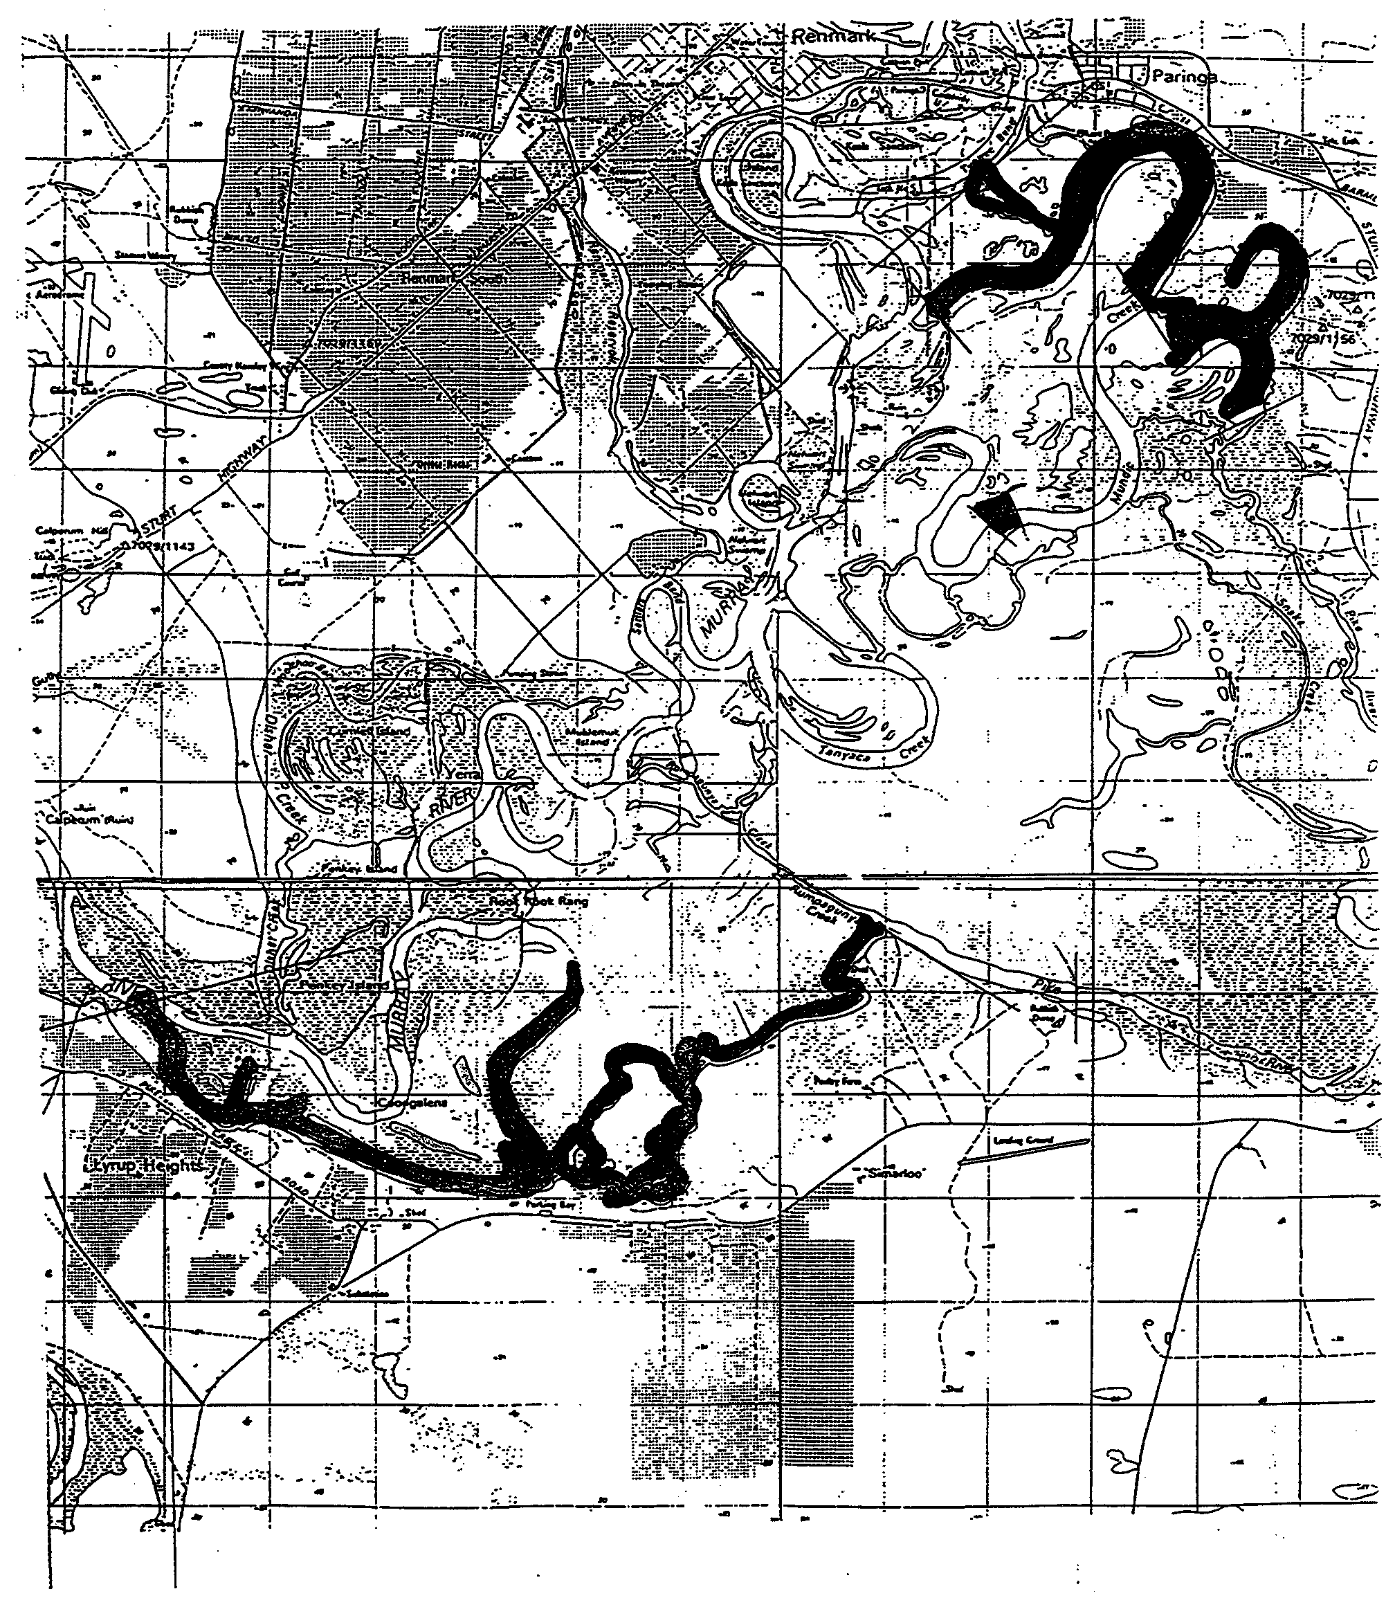

Dated 30 June 1999.
D. Mackie, Manager, Legislation and Policy

FISHERIES ACT 1982: SECTION 59
Permit No. 9800297
TAKE notice that pursuant to section 59 of the Fisheries Act 1982, Andrew Lord (hereinafter referred to as the ‘permit holder’), 1 Michelle Street, Wallaroo, S.A. 5556, is exempt from sections 34 and 41 of the Fisheries Act 1982, but only insofar as he may engage in the taking of those fish specified in Schedule 1, subject to the conditions in Schedule 2 (hereinafter referred to as the ‘permitted activity’) for the purposes of providing broodstock pursuant to S59 Permit No. FT00609.
Schedule 1
Common Starfish (Patriella exigua)
Schedule 2
1. The permit holder may only engage in the permitted activity from the date of gazettal of this notice to 29 August 1999.
2. The permit holder may engage in the permitted activity only in those waters of the tidal pond situated on Crown Lease Volume 1598 (Parcel No. 2903, Hundred of Wallaroo).
3. The permit holder must provide a report within 14 days of the expiry of this permit showing the number of starfish collected. This report should be marked ‘Attention Roger Hill’ and sent to PIRSA Fisheries, G.P.O. Box 1625, Adelaide, S.A. 5001.
4. While engaged in the permitted activity the permit holder shall carry or have about or near his person a copy of this notice. Such notice must be produced to a Fisheries Compliance Officer upon request.
5. PIRSA Fisheries retains the right for a departmental officer to accompany the permit holder at any time whilst conducting the permitted activity.
6. The permit holder shall not contravene or fail to comply with the Fisheries Act 1982, or any regulations made under that Act, except where specifically exempted by this notice.
Dated 30 June 1999.
D. Mackie, Manager, Legislation and Policy

FISHERIES ACT 1982: SECTION 59
Permit No. FT00609
TAKE notice that pursuant to section 59 of the Fisheries Act 1982, I hereby authorise AusAqua Pty Ltd (or their agent), (hereinafter referred to as the ‘fish farmer’), 1 Michelle Street, Wallaroo, S.A. 5556, to engage in the activities and to do the acts specified in Schedule 1 subject to the conditions specified in Schedule 2 from the date of this permit until this permit is revoked by the Director of Fisheries.
Schedule 1
The importation and release of starfish (Patiriella exigua), into ponds and tanks at section 1694, on the site of the Yorke Regional Development Boards’ aquaculture incubator, in the Hundred of Wallaroo.
Schedule 2
1. The fish farmer must maintain adequate security arrangements to prevent escapement of fish (ova, fry, or adult) into any South Australian waters.
2. Fish obtained for the purpose of providing broodstock is pursuant to the specifications within the S59 Permit No. 9800297 regarding the taking of fish.
3. Fish must not be collected from rivers, streams, lakes or other inland waters of this State unless prior approval for this collection is granted by the Director of Fisheries.
4. The fish farmer shall not import any live fish (ova, fry, or adult) into South Australia unless the shipment has certification from an appropriate authority in the State from which they are obtained that they are free from all relevant notifiable diseases listed in Schedule 4 of the Fisheries (Exotic Fish, Fish Farming and Fish Diseases) Regulations 1984.
5. The fish farmer shall not contravene or fail to comply with the Fisheries Act 1982, or any regulations made under the Act, except where specifically permitted by this notice.
6. The fish farmer must retain the copy of this permit which has been supplied by the Director of Fisheries, and if requested by a PIRSA Fisheries and Aquaculture Compliance Officer, produce that permit for inspection.
Dated 30 June 1999.
D. Mackie, Manager, Legislation and Policy

M. E. JONES, Acting Government Printer, South Australia

