No. 91 157

THE SOUTH AUSTRALIAN

GOVERNMENT GAZETTE

PUBLISHED BY AUTHORITY

ALL PUBLIC ACTS appearing in this GAZETTE are to be considered official, and obeyed as such

ADELAIDE, THURSDAY, 8 JULY 1999

CONTENTS

Page
Adelaide Festival Corporation Act 1998⎯Notices 158
Aerodrome Fees Act 1998⎯Notice 159
Appointments, Resignations, Etc. 158
Associations Incorporation Act 1985⎯Notice 159
Corporations and District Councils—Notices 213
Crown Lands Act 1929—Notice 159
Electoral Act 1985⎯Notice 159
ETSA Power⎯Standard Terms and Conditions of Supply 159
Geographical Names Act 1991⎯Notice 160
Irrigation Act 1994⎯Notice 160
Land and Business (Sale and Conveyancing) Act 1994—
Notices 161
Liquor Licensing Act 1997—Notices 161
Livestock Act 1997⎯Notices 168

Page
Mining Act 1971—Notice 174
Motor Vehicles Act 1959⎯Notice 174
National Parks and Wildlife Act 1972⎯Notices 172
Passenger Transport Act 1994⎯Notice 174
Petroleum Act 1940⎯Notice 174
Police Act 1998⎯Notices 174
Private Advertisements 221
Proclamations 158
Public Trustee Office—Administration of Estates 221
Roads (Opening and Closing) Act 1991—Notices 178
Road Traffic Act 1961⎯Notice 179
Rules of Court 208
Soil Conservation and Land Care Act 1989—Notices 179
Wildnerness Protection Act 1992—Notice 172

GOVERNMENT GAZETTE NOTICES
ALL poundkeepers' and private advertisements forwarded for publication in the South Australian Government Gazette must be PAID FOR PRIOR TO INSERTION; and all notices, from whatever source, should be legibly written on one side of the paper only and sent to Riverside 2000 so as to be received no later than 4 p.m. Tuesday preceding the day of publication. Phone 8207 1045 or Fax 8207 1040. E-mail: govgaz@riv.ssa.sa.gov.au. Send as attachments in Word format and please confirm your transmission with a faxed copy of your document, including the date the notice is to be published and to whom the notice will be charged.

SHOP TRADING HOURS ACT 1977 SECTION 13: ALTERATION OF SHOP TRADING HOURS⎯MOUNT BARKER SHOPPING DISTRICT
Proclamation By The Governor’s Deputy
(l.s.) Basil S. Hetzel
PURSUANT to section 13 of the Shop Trading Hours Act 1977, and with the advice and consent of the Executive Council, I authorise the opening of all shops, excluding those shops the business of which is solely or predominantly the sale of boats or motor vehicles, in the Mount Barker Shopping District on each Monday, Tuesday, Wednesday and Friday from 6 p.m. until 7 p.m.
This proclamation has effect from Monday, 12 July 1999, until Wednesday, 11 August 1999 (both days inclusive).
Given under my hand and the Public Seal of South Australia, at Adelaide, 8 July 1999.
By command,
Iain Evans, for Premier
MGE 68/99 CS

Department of the Premier and Cabinet
Adelaide, 8 July 1999
HIS Excellency the Governor’s Deputy in Executive Council has been pleased to appoint the Honourable John Wayne Olsen, FNIA, MP, Premier, Minister for State Development and Minister for Multicultural Affairs to be also Acting Treasurer for the period 11 July 1999 to 20 July 1999 inclusive, during the absence of the Honourable Robert Ivan Lucas, BSc, BEc, MBA, MLC.
By command,
Iain Evans, for Premier
DT&F 054/99CS

ADELAIDE FESTIVAL CORPORATION ACT 1998
Declaration pursuant to Section 22 (1)
I, DIANA LAIDLAW, Minister for the Arts, declare, pursuant to s.22 (1) of the Adelaide Festival Corporation Act 1998, that the Adelaide Festival Corporation may conduct its operations or any part of its operations under either or both of the following names:
Adelaide Festival
Adelaide Festival of Arts
Dated 28 June 1999.
Diana Laidlaw, Minister for the Arts

ADELAIDE FESTIVAL CORPORATION ACT 1998
Declaration pursuant to Section 23 (2)
I, DIANA LAIDLAW, Minister for the Arts, declare, pursuant to s.23 (2) of the Adelaide Festival Corporation Act 1998, that the names that appear in the schedule, being names or titles of events or activities conducted, promoted or undertaken by the Adelaide Festival Corporation are official titles.
Schedule
Adelaide Festival of Ideas
Adelaide Writers’ Week
Artists’ Week
Dated 28 June 1999.
Diana Laidlaw, Minister for the Arts

ADELAIDE FESTIVAL CORPORATION ACT 1999
Schedule⎯Clause 2⎯Transfer of Assets and Liabilities
I, DIANA LAIDLAW, Minister for the Arts, vest, pursuant to clause 2 (1) of the schedule to the Adelaide Festival Corporation Act 1998, the assets and liabilities constituted by the contracts referred to in the schedule, (being asset or liabilities held by me and associated with the Adelaide Festival of Arts) in the Adelaide Festival Corporation.
Adelaide Festival Employee Contractors at 31 March 1999
Contractural Party Signing Authority
D.W. Hepper Nominees Pty Ltd General Manager (DA)
(David Hepper)
Blue Bottle General Manager (DA)
Geoff Cobham
Tango Mike General Manager (DA)
(Tori Moreton)
Key Messages General Manager (DA)
(Penny Bailey)
Schrader Baker General Manager (DA)
(Kim Baker)
Wendy Bennett General Manager (DA)
Peter Sellars Adelaide Festival Board
Contracts (other than employees and Contractors) at 31 March 1999
Adelaide City Council Adelaide Festival Board
Adelaide Festival Centre Trust Adelaide Festival
Administrative and Information
Services Adelaide Festival Board
American Express Ltd Adelaide Festival Board
Ansett Australia Ltd and Show
Group Pty Ltd Adelaide Festival
Arts SA Adelaide Festival Board
Australia Council Adelaide Festival Board
Bank SA Adelaide Festival Board
Camtech (SA) Pty Ltd Adelaide Festival Board
Confederation of International
Art Festivals Adelaide Festival
Fleet SA Adelaide Festival Board
Friends of Adelaide Festival Inc Adelaide Festival Board
Fuji Xerox Australia Pty Ltd Adelaide Festival
Malaysian Airlines Adelaide Festival Board
Morgan & Banks Ltd Adelaide Festival Board
NWS 9 Southern Television Services Adelaide Festival
Plantscape Interiors Pty Ltd Adelaide Festival Board
Prestige Property Services Pty Ltd Adelaide Festival Board
SAICORP Adelaide Festival Board
Telstra Adelaide Festival Board
Thomas Cook Adelaide Festival Board
Dated 28 June 1999.
Diana Laidlaw, Minister for the Arts

ADELAIDE FESTIVAL CORPORATION ACT 1998
Declaration pursuant to Section 23 (1)
I, DIANA LAIDLAW, Minister for the Arts, declare, pursuant to s.23 (1) of the Adelaide Festival Corporation Act 1998, the logo appearing in the schedule to be a logo in respect of the Adelaide Festival Corporation.
Dated 28 June 1999.
Diana Laidlaw, Minister for the Arts

AERODROME FEES ACT 1998
Adelaide Airport
Notice of Schedule of Charges—Effective 1 July 1999
Aircraft | Landing charge per  1 000 kg MTOW  (pro-rata)  $ | Terminal Charge per  1 000 kg MTOW  (pro-rata)  $ | APS Security charge per  1 000 kg MTOW  (pro-rata) ⁽¹⁾  $

Passenger Air Transport Aircraft utilising terminals operated by AAL | 4.59 | ^{(2 & 3)} | 1.05 | 1.16
Passenger Air Transport Aircraft not utilising terminals operated by AAL | 4.59 | ^{(2 & 3)} |  | 1.16
Freight aircraft | 4.59 |  |  | 1.16
Fixed wing aircraft not operating Air Transport services | 4.59 | ^{(2 & 3)} |  | 1.16
Rotary wing aircraft and unpowered aircraft | 2.30 | ^{(3 & 4)} |  | Not applicable

⁽¹⁾ APS Security charge: applies to all fixed wing aircraft weighing more than 20 000 kg MTOW.
⁽²⁾ Minimum charge: a minimum landing charge of $27.50 applies.
⁽³⁾ Parking charges: apply to all aircraft parked longer than two hours in designated general aviation parking areas and will incur a charge of $11 per day or any part of a day. Fixed based operators may apply for a contract rate for parking.
⁽⁴⁾ Minimum charge: a minimum landing charge of $13.75 applies.

ASSOCIATIONS INCORPORATION ACT 1985
Deregistration of Associations
NOTICE is hereby given that the Corporate Affairs Commission will deregister the associations named below in accordance with the application received from the associations pursuant to section 43A of the Associations Incorporation Act 1985. Deregistration will take effect on the date of publication of this notice.
Ladies Probus Club of Maitland & District Inc.
Light Educational Ministries Inc.
Northern Flinders Community Services Centre Inc.
Nor-West Bend Lodge No. 76 SAC Inc.
Nuriootpa Commerce Association Inc.
Playford City Festival Inc.
Southern Development Board Adelaide Inc.
A. J. Griffiths, A delegate, Corporate Affairs Commission.

CROWN LANDS ACT 1929: SECTION 5
TAKE NOTICE that pursuant to the Crown Lands Act 1929, I PETER MACLAREN KENTISH, Surveyor-General and Delegate appointed by DOROTHY KOTZ, Minister for Environment and Heritage, Minister of the Crown to whom the administration of the Crown Lands Act 1929 is committed DO HEREBY:
1. Vary the notice as described in The First Schedule by declaring that Reserve for Car Park Purposes as defined in The First Schedule shall cease to be under the care, control and management of the Minister for Human Services and by further declaring that the said Reserve for Car Park Purposes shall be under the care, control and management of the Royal Adelaide Hospital and the Institute of Medical and Veterinary Science.
2. Vary the notice as described in The Second Schedule by declaring that Reserve for the Purposes of the Institute of Medical and Veterinary Science as defined in The Second Schedule shall cease to be under the care, control and management of the Minister for Human Services and by further declaring that the said Reserve for the Purposes of the Institute of Medical and Veterinary Science shall be under the care, control and management of the Institute of Medical and Veterinary Science.
3. Vary the notice as described in The Third Schedule by declaring that Reserve for Hospital Purposes as defined in The Third Schedule shall cease to be under the care, control and management of the Board of Management of the Royal Adelaide Hospital and by further declaring that the said Reserve for Hospital Purposes shall be under the care, control and management of the Royal Adelaide Hospital.
The First Schedule
Reserve for Car Park Purposes, allotment 13 of DP 51367, Hundred of Adelaide, County of Adelaide, the notice of which was published in the Government Gazette of 10 June 1999 at pages 3048 and 3049, The First Schedule.
The Second Schedule
Reserve for the Purposes of the Institute of Medical and Veterinary Science, allotment 12 of DP 51367, Hundred of Adelaide, County of Adelaide, the notice of which was published in the Government Gazette of 10 June 1999 at pages 3048 and 3049, The Second Schedule.
The Third Schedule
Reserve for Hospital Purposes, allotment 14 of DP 51367, Hundred of Adelaide, County of Adelaide, the notice of which was published in the Government Gazette of 10 June 1999 at pages 3048 and 3049, The Fourth Schedule.
Dated 5 July 1999.
P. M. Kentish, Surveyor-General
DL 1442/1989 TC 2

ELECTORAL ACT 1985
Part 6⎯Registration of Political Parties
NOTICE is hereby given that from the close of business on 8 July 1999, and in accordance with section 45, the following political party will be deregistered:
Australian Reform Party.
S. H. Tully, Electoral Commissioner
SEO 24/97

ETSA POWER
Standard Terms and Conditions of Supply
NOTICE is hereby given that the Standard Terms and Conditions governing the supply of electricity by ETSA Power Pty Ltd (ACN 082 928 701) have been amended as set out below and are published in accordance with section 36 (2) of the South Australian Electricity Act 1996.
These amendments to the standard Terms and Conditions will come into force on 1 July 1999 and when in force will be contractually binding on ETSA Power Pty Ltd and the class of customers to whom these terms and conditions are expressed to apply.
Schedule
1. Amend clause 2 by amending the definition of ‘Transition Tariff’ so as to read as follows:
‘Transition Tariff’ means in the case of every Continuing Contestable Customer (other than a Nominated Customer) whichever is the applicable of:
(a) the published tariff which is on the same terms and conditions as the tariff that applied to you immediately before you became a contestable customer;
(b) any derivation of the tariff referred to in (a) applied to you as a result of a special load characteristic or other determinant adopted by us for that purpose payable by you immediately before you became a contestable customer; or
(c) the rate payable by you under a Pre-Market Agreement immediately before becoming a contestable customer;
(‘Pre-Transition Tariff’) subject to the following conditions:
(d) the Transition Tariff equals your Pre-Transition Tariff plus 1.8 per cent;
(e) the Transition Tariff commences from 1 July 1999 and ceases at midnight 30 June 2000;
(f) the Transition Tariff ceases to apply to you once you enter into another agreement with us (other than a Pre-Market Agreement) or an agreement with another licensed retailer for the sale of electricity no matter what the terms or period of that agreement;
(g) if, at the date you became a contestable customer, you represented an aggregated point of connection, the Transition Tariff ceases if that point of connection ceases to be aggregated in the same way or to the same extent;
(h) a change to your Pre-Transition Tariff which comes into operation on or after the date you became a contestable customer will not change the Transition Tariff applicable to you;
(i) if a Pre-Transition Tariff falls within (b) or (c) above, that any conditions or circumstances attaching to that rate, in lieu of the rate that would otherwise be payable under (a), are maintained failing which the Transition Tariff shall thereafter be calculated as if the Pre-Transition Tariff was calculated as if (a) above was applicable to you;
(j) we will implement the policy of the State of South Australia with respect to the provision of a further Transition Tariff for the period 1 July 2000 until 30 June 2001 but no promise or assurance is provided that there will be any Transition Tariff beyond the expiration of that further period.
In the case of a Nominated Customer ‘Transition Tariff’ means a rate nominated from time to time (but not later than 1 September 1999) in writing by us to you including any conditions or circumstances in which the same shall not be applicable and any rate which applies in the event that those conditions or circumstances do not apply.’
2. Amend clause 2 by adding:
‘Nominated Customer’ means any Continuing Contestable Customer which we have nominated from time to time (but not later than 1 September 1999) for the purposes of these conditions on the basis that the circumstances of the particular Continuing Contestable Customer require, in our reasonably held view, the application of an alternative form of tariff’.

GEOGRAPHICAL NAMES ACT 1991
For Public Consultation
Notice of Intent to Alter the Name of a Feature
NOTICE is hereby given that the Surveyor-General proposes to rename Salt Creek as Gurra Gurra Creek.
The subject creek is located on the Loxton 1:50 000 mapsheet (7029-3) with the mouth being at grid reference 463000 East 6202000 North and the source at 467200 East 6209500 North, and shown marked (A) on the plan below.

The Plan

Submissions in writing regarding this proposal may be lodged with the Secretary, Geographical Names Advisory Committee, c/o Department for Environment, Heritage and Aboriginal Affairs, 300 Richmond Road, Netley, S.A. 5037 (P.O. Box 550, Marleston, S.A. 5033) within one month of the publication of this notice.
Dated 22 June 1966.
P. M. Kentish, Surveyor-General, Department for Administrative and Information Services.
DEHAA 04/0225

IRRIGATION ACT 1994
Grant of Application for Establishment of a
Private Irrigation District
Notice by the Minister for Government Enterprises
PURSUANT to section 10 (2) (b) of the Irrigation Act 1994, I have determined that the application from Century Orchards Pty Ltd for the establishment of a private irrigation district be approved.
Dated 30 June 1999.
Michael Armitage, Minister for Government Enterprises

LAND AND BUSINESS (SALE AND CONVEYANCING) ACT 1994
Section 23
TAKE notice that, pursuant to section 23 (3) of the Land and Business (Sale and Conveyancing) Act 1994, I, Kenneth Trevor Griffin, Minister for Consumer Affairs, do hereby exempt the person named in Schedule 1 from the application of section 23 (2) of the Act in relation to the purchase of the land specified in Schedule 2.
Schedule 1
Graham Edward Margrie, an officer/employee of Tea Tree Gully Estates Pty Ltd.
Schedule 2
The whole of the land described in certificate of title register book volume 5103, folio 496, situated at 4/41 Corroboree Road, Modbury North, S.A. 5092.
Dated 8 July 1999.
Signed for and on behalf of the Minister for Consumer Affairs by the Acting Commissioner for Consumer Affairs:
W. J. Spehr, Acting Commissioner

LAND AND BUSINESS (SALE AND CONVEYANCING) ACT 1994
Section 23
TAKE notice that, pursuant to section 23 (3) of the Land and Business (Sale and Conveyancing) Act 1994, I, Kenneth Trevor Griffin, Minister for Consumer Affairs, do hereby exempt the person named in Schedule 1 from the application of section 23 (2) of the Act in relation to the purchase of the land specified in Schedule 2.
Schedule 1
Pauline Margaret Perry, an officer/employee of Johnson Craigie Real Estate Pty Ltd.
Schedule 2
The whole of the land described in certificate of title register book volume 3967, folio 190, situated at 30 Stanley Avenue, Port Pirie, S.A. 5540.
Dated 8 July 1999.
Signed for and on behalf of the Minister for Consumer Affairs by the Acting Commissioner for Consumer Affairs:
W. J. Spehr, Acting Commissioner

LAND AND BUSINESS (SALE AND CONVEYANCING) ACT 1994
Section 23
TAKE notice that, pursuant to section 23 (3) of the Land and Business (Sale and Conveyancing) Act 1994, I, Kenneth Trevor Griffin, Minister for Consumer Affairs, do hereby exempt the person named in Schedule 1 from the application of section 23 (2) of the Act in relation to the purchase of the land specified in Schedule 2.
Schedule 1
Geoffrey David Muir, an officer/employee of John DeMichele Real Estate Pty Ltd.
Schedule 2
The whole of the land described in certificate of title register book volume 5267, folio 942, situated at 48 Bridge Street, Murray Bridge, S.A. 5253.
Dated 8 July 1999.
Signed for and on behalf of the Minister for Consumer Affairs by the Acting Commissioner for Consumer Affairs:
W. J. Spehr, Acting Commissioner

LAND AND BUSINESS (SALE AND CONVEYANCING) ACT 1994
Section 23
TAKE notice that, pursuant to section 23 (3) of the Land and Business (Sale and Conveyancing) Act 1994, I, Kenneth Trevor Griffin, Minister for Consumer Affairs, do hereby exempt the person named in Schedule 1 from the application of section 23 (2) of the Act in relation to the purchase of the land specified in Schedule 2.
Schedule 1
Meagan Leanne Blanden, an officer/employee of Greg Neil Smith.
Schedule 2
The whole of the land described in certificate of title register book volume 5333, folio 106, situated at 79 Haylock Road, Moonta, S.A. 5558.
Dated 8 July 1999.
Signed for and on behalf of the Minister for Consumer Affairs by the Acting Commissioner for Consumer Affairs:
W. J. Spehr, Acting Commissioner

LIQUOR LICENSING ACT 1997
Notice of Application for Transfer of Liquor Licence and Gaming Machine Licence
NOTICE is hereby given, pursuant to section 52 of the Liquor Licensing Act 1997, and section 29 of the Gaming Machines Act 1992, that Bonsung Pty Ltd (ACN 066 418 406), c/o Bonnins Commercial Lawyers, Level 14, 100 King William Street, Adelaide, S.A. 5000, has applied to the Liquor and Gaming Commissioner for the transfer of a Hotel Licence and a Gaming Machine Licence in respect of premises situated at 85 Leicester Street, Parkside, S.A. 5063 and known as Earl of Leicester Hotel.
The applications has been set down for hearing on 6 August 1999.
Any person may object to the applications by lodging a notice of objection in the prescribed form with the Licensing Authority, and serving a copy of the notice on the applicant at the applicant’s address given above, at least seven days before the hearing date.
Plans in respect of the premises the subject of the applications are open to public inspection without fee at the Office of the Liquor and Gaming Commissioner, 9th Floor, East Wing, 50 Grenfell Street, Adelaide, S.A. 5000.
Dated 1 July 1999.
Applicant

LIQUOR LICENSING ACT 1997
Notice of Application for Transfer of Liquor Licence and Gaming Machine Licence
NOTICE is hereby given, pursuant to section 52 of the Liquor Licensing Act 1997, and section 29 of the Gaming Machines Act 1992, that A. & M. McNicol Pty Ltd (ACN 088 189 280) and M.C. & L.K. Kies Pty Ltd (ACN 088 201 487), have applied to the Liquor and Gaming Commissioner for the transfer of a Hotel Licence and a Gaming Machine Licence in respect of premises situated at 32 Mawson Road, Meadows, S.A. 5201, and known as Meadows Hotel.
The applications has been set down for hearing on Friday, 6 August 1999 at 9 a.m.
Any person may object to the applications by lodging a notice of objection in the prescribed form with the Licensing Authority, and serving a copy of the notice on the applicants at the applicants’ address given above, at least seven days before the hearing date.
Plans in respect of the premises the subject of the applications are open to public inspection without fee at the Office of the Liquor and Gaming Commissioner, 9th Floor, East Wing, 50 Grenfell Street, Adelaide, S.A. 5000.
Dated 1 July 1999.
Applicants

LIQUOR LICENSING ACT 1997
Notice of Application for Transfer of Liquor Licence and Gaming Machine Licence
NOTICE is hereby given, pursuant to section 52 of the Liquor Licensing Act 1997, and section 29 of the Gaming Machines Act 1992, that Cleco Nominees No. 263 Pty Ltd (ACN 087 766 498), 208 Carrington Street, Adelaide, S.A. 5000, has applied to the Liquor and Gaming Commissioner for the transfer of a Hotel Licence and a Gaming Machine Licence in respect of premises situated at American River, Kangaroo Island, S.A. 5221, and known as Linnett’s Island Club.
The applications has been set down for hearing on 6 August 1999.
Any person may object to the applications by lodging a notice of objection in the prescribed form with the Licensing Authority, and serving a copy of the notice on the applicant at the applicant’s address given above, at least seven days before the hearing date.
Plans in respect of the premises the subject of the applications are open to public inspection without fee at the Office of the Liquor and Gaming Commissioner, 9th Floor, East Wing, 50 Grenfell Street, Adelaide, S.A. 5000.
Dated 1 July 1999.
Applicant

LIQUOR LICENSING ACT 1997
Notice of Application
NOTICE is hereby given, pursuant to section 52 (2) (b) of the Liquor Licensing Act 1997, that Australian Boutique Premium Wines Pty Ltd has applied to the Licensing Authority for the removal of a Retail Liquor Merchant’s Licence in respect of premises to be situated at 28 Richmond Road, Keswick, S.A. 5035 and to be known as Australian Boutique Premium Wines Pty Ltd.
The application has been set down for hearing on Friday, 6 August 1999 at 9 a.m.
Conditions
The following licence conditions are sought:
As current licence conditions, however wish to delete Condition 1 on the licence ‘The licence authorises the sale of wine only’.
Any person may object to the application by lodging a notice of objection in the prescribed form with the Licensing Authority, and serving a copy of the notice on the applicant at the applicant’s address given above, at least seven days before the hearing date.
Plans in respect of the premises the subject of the application are open to public inspection without fee at the Office of the Liquor and Gaming Commissioner, 9th Floor, East Wing, 50 Grenfell Street, Adelaide, S.A. 5000.
Dated 1 July 1999.
Applicant

LIQUOR LICENSING ACT 1997
Notice of Application
NOTICE is hereby given, pursuant to section 52 (2) (b) of the Liquor Licensing Act 1997, that Peter Joseph Kennelly and Josephine Mary Kennelly have applied to the Licensing Authority for a Producer’s Licence in respect of premises situated at section 69, Hundred of Light, Higgs Road, Freeling, S.A. 5372, and to be known as Old Kapunda Distillery.
The application has been set down for hearing on Friday, 6 August 1999.
Any person may object to the application by lodging a notice of objection in the prescribed form with the Licensing Authority, and serving a copy of the notice on the applicants at the applicants’ address given above, at least seven days before the hearing date.
Plans in respect of the premises the subject of the application are open to public inspection without fee at the Office of the Liquor and Gaming Commissioner, 9th Floor, East Wing, 50 Grenfell Street, Adelaide, S.A. 5000.
Dated 2 July 1999.
Applicants

LIQUOR LICENSING ACT 1997
Notice of Application
NOTICE is hereby given, pursuant to section 52 (2) (b) of the Liquor Licensing Act 1997, that Brian Richard West and Susan Elaine Putnam Bastian have applied to the Licensing Authority for a Producer’s Licence in respect of premises situated at 26 Thomas Street, Unley, S.A. 5061, and to be known as Bastian West Wines.
The application has been set down for hearing on Friday, 6 August 1999.
Any person may object to the application by lodging a notice of objection in the prescribed form with the Licensing Authority, and serving a copy of the notice on the applicants at the applicants’ address given above, at least seven days before the hearing date.
Plans in respect of the premises the subject of the application are open to public inspection without fee at the Office of the Liquor and Gaming Commissioner, 9th Floor, East Wing, 50 Grenfell Street, Adelaide, S.A. 5000.
Dated 1 July 1999.
Applicants

LIQUOR LICENSING ACT 1997
Notice of Application
NOTICE is hereby given, pursuant to section 52 (2) (b) of the Liquor Licensing Act 1997, that Nildottie Progress and Soldier’s Memorial Hall Association Inc. has applied to the Licensing Authority for a Limited Club Licence in respect of premises to be situated at Allotment 11, Main Road, Nildottie, S.A. 5238, and to be known as Nildottie Soldier’s Memorial Hall.
The application has been set down for hearing on Friday, 6 August 1999 at 9 a.m.
Conditions
The following licence conditions are sought:
Entertainment Consent: Extended Trading Authorisation—Monday to Saturday, midnight to 1 a.m. the following day and Sunday, 8 a.m. to 11 a.m. and 8 p.m. to 1 a.m. the following day.
Any person may object to the application by lodging a notice of objection in the prescribed form with the Licensing Authority, and serving a copy of the notice on the applicant at the applicant’s address given above, at least seven days before the hearing date.
Plans in respect of the premises the subject of the application are open to public inspection without fee at the Office of the Liquor and Gaming Commissioner, 9th Floor, East Wing, 50 Grenfell Street, Adelaide, S.A. 5000.
Dated 23 June 1999.
Applicant

LIQUOR LICENSING ACT 1997
Notice of Application
NOTICE is hereby given, pursuant to section 52 (2) (b) of the Liquor Licensing Act 1997, that Pied A Terre Pty Ltd has applied to the Licensing Authority for a Restaurant Licence in respect of premises situated at Osborn Road, McLaren Vale, S.A. 5171, and to be known as D’Arry’s Verandah Restaurant.
The application has been set down for hearing on Friday, 6 August 1999.
Condition
The following licence condition is sought:
Entertainment consent is sought for the area outlined in blue on the Deposited Plan.
Any person may object to the application by lodging a notice of objection in the prescribed form with the Licensing Authority, and serving a copy of the notice on the applicant at the applicant’s address given above, at least seven days before the hearing date.
Plans in respect of the premises the subject of the application are open to public inspection without fee at the Office of the Liquor and Gaming Commissioner, 9th Floor, East Wing, 50 Grenfell Street, Adelaide, S.A. 5000.
Dated 1 July 1999.
Applicant

LIQUOR LICENSING ACT 1997
Notice of Application
NOTICE is hereby given, pursuant to section 52 (2) (b) of the Liquor Licensing Act 1997, that Ashley William Eccles has applied to the Licensing Authority for a Restaurant Licence in respect of premises situated at Shop 4, 47 Jetty Road, Glenelg, S.A. 5045, and known as Zest Cafe Gallery.
The application has been set down for hearing on Friday, 6 August 1999.
Any person may object to the application by lodging a notice of objection in the prescribed form with the Licensing Authority, and serving a copy of the notice on the applicant at the applicant’s address given above, at least seven days before the hearing date.
Plans in respect of the premises the subject of the application are open to public inspection without fee at the Office of the Liquor and Gaming Commissioner, 9th Floor, East Wing, 50 Grenfell Street, Adelaide, S.A. 5000.
Dated 1 July 1999.
Applicant

LIQUOR LICENSING ACT 1997
Notice of Application
NOTICE is hereby given, pursuant to section 52 (2) (b) of the Liquor Licensing Act 1997, that Veronica Kay Muir and Mark John Muir, Penola Road, Naracoorte, S.A. 5271, have applied to the Licensing Authority for a Restaurant Licence in respect of premises situated at 85-87 Gordon Street, Naracoorte, and known as Settlers Tea Rooms.
The application has been set down for hearing on Friday, 6 August 1999 at 9 a.m.
Condition
The following licence condition is sought:
Entertainment consent.
Any person may object to the application by lodging a notice of objection in the prescribed form with the Licensing Authority, and serving a copy of the notice on the applicants at the applicants’ address given above, at least seven days before the hearing date.
Plans in respect of the premises the subject of the application are open to public inspection without fee at the Office of the Liquor and Gaming Commissioner, 9th Floor, East Wing, 50 Grenfell Street, Adelaide, S.A. 5000.
Dated 30 June 1999.
Applicants

LIQUOR LICENSING ACT 1997
Notice of Application
NOTICE is hereby given, pursuant to section 52 (2) (b) of the Liquor Licensing Act 1997, that Queens Investments Pty Ltd, c/o Waters & Lagzdins, 46 Kensington Road, Rose Park, S.A. 5067, has applied to the Licensing Authority for the transfer of a Restaurant Licence, an Extended Trading Authorisation, an authorisation to serve liquor without a meal seated at a table and variation of conditions of licence in respect of premises situated at 62 Pulteney Street, Adelaide, S.A. 5000, and known as Café Luna Piena but to be known as The Deli On Pulteney.
The application has been set down for hearing on Friday, 6 August 1999 at 9 a.m.
Conditions
The following licence conditions are sought:
1. Extended Trading Authorisation: Hours of operation—Sunday, 8 a.m. to 11 a.m. and 8 p.m. to midnight.
2. Authorisation under section 34 (1) (c) of the Act to serve liquor without a meal seated at a table.
3. To delete Condition 4 ‘The adjacent area is only to operate between the hours of 10 a.m. to midnight, Monday to Saturday’.
Any person may object to the application by lodging a notice of objection in the prescribed form with the Licensing Authority, and serving a copy of the notice on the applicant at the applicant’s address given above, at least seven days before the hearing date.
Plans in respect of the premises the subject of the application are open to public inspection without fee at the Office of the Liquor and Gaming Commissioner, 9th Floor, East Wing, 50 Grenfell Street, Adelaide, S.A. 5000.
Dated 29 June 1999.
Applicant

LIQUOR LICENSING ACT 1997
Notice of Application
NOTICE is hereby given, pursuant to section 52 (2) (b) of the Liquor Licensing Act 1997, that Anna Lorrenzetti, Vittorio Barone, Tomasso Barone and Vincenzo De Vellis have applied to the Licensing Authority for the grant of a Special Circumstances Licence in respect of premises situated at 21 Cardigan Avenue, Felixstow, S.A. 5070, and to be known as Plymouths of Adelaide.
The application has been set down for hearing on Friday, 6 August 1999.
Conditions
The following licence conditions are sought:
1. The licensee authorises the sale, supply and consumption of all types of liquor to and by passengers on any day and at any time except Sunday, 5 a.m. to 8 a.m.; Good Friday, midnight to 5 a.m. the day after Good Friday and midnight to
5 a.m. the day after Christmas Day in the vehicle and areas adjacent thereto provided such sales and consumption is always under the supervision and control of the driver of the subject vehicle subject to the conditions set out below.
2. Any other condition to be imposed by the office of the Liquor and Gaming Commissioner.
Any person may object to the application by lodging a notice of objection in the prescribed form with the Licensing Authority, and serving a copy of the notice on the applicants at the applicants’ address given above, at least seven days before the hearing date.
Plans in respect of the premises the subject of the application are open to public inspection without fee at the Office of the Liquor and Gaming Commissioner, 9th Floor, East Wing, 50 Grenfell Street, Adelaide, S.A. 5000.
Dated 1 July 1999.
Applicants

LIQUOR LICENSING ACT 1997
Notice of Application
NOTICE is hereby given, pursuant to section 52 (2) (b) of the Liquor Licensing Act 1997, that Margal Inn Investments Pty Ltd (ACN 007 750 879) has applied to the Licensing Authority for an Extended Trading Authorisation in respect of premises situated at High Street, Mitcham and known as Edinburgh Hotel.
The application has been set down for hearing on Friday, 6 August 1999 at 9 a.m.
Conditions
The following licence conditions are sought:
1. That the licensee be permitted to sell liquor for consumption on the licensed premises from 8 p.m. to 10 p.m. each Sunday.
2. That the extended trading authorisation shall apply to the areas referred to as Areas 1 to 9 inclusive on the deposited plan.
Any person may object to the application by lodging a notice of objection in the prescribed form with the Licensing Authority, and serving a copy of the notice on the applicant at the applicant’s address given above, at least seven days before the hearing date.
Plans in respect of the premises the subject of the application are open to public inspection without fee at the Office of the Liquor and Gaming Commissioner, 9th Floor, East Wing, 50 Grenfell Street, Adelaide, S.A. 5000.
Dated 28 June 1999.
Applicant

LIQUOR LICENSING ACT 1997
Notice of Application
NOTICE is hereby given, pursuant to section 52 (2) (b) of the Liquor Licensing Act 1997, that Dine Out Victoria Square Pty Ltd (ACN 075 129 930), 66 Wright Street, Adelaide, S.A. 5000, has applied to the Licensing Authority for a variation of conditions of a Special Circumstances Licence in respect of premises situated at 195 Victoria Square, Adelaide, S.A. 5000, and known as Round The Square Restaurant.
The application has been set down for hearing on Friday, 6 August 1999.
Conditions
The following licence conditions are sought:
Varying the conditions of the Special Circumstances Licence so as also to include:
1. Authorised hours of trading and entertainment consent on Fridays, Saturdays and Sundays of each week to 5 a.m. in lieu of the existing 2 a.m.
2. Extended trading authorisation and entertainment consent on the days referred to in 1 above to 5 a.m. in lieu of 2 a.m.
3. Increasing the capacities on the days referred to in 1 above from 8 p.m. each day in relation to Area 1 and Area 2 of the approved plan.
Any person may object to the application by lodging a notice of objection in the prescribed form with the Licensing Authority, and serving a copy of the notice on the applicant at the applicant’s address given above, at least seven days before the hearing date.
Plans in respect of the premises the subject of the application are open to public inspection without fee at the Office of the Liquor and Gaming Commissioner, 9th Floor, East Wing, 50 Grenfell Street, Adelaide, S.A. 5000.
Dated 29 June 1999.
Applicant

LIQUOR LICENSING ACT 1997
Notice of Application
NOTICE is hereby given, pursuant to section 52 (2) (b) of the Liquor Licensing Act 1997, that Perks Hotels Pty Ltd has applied to the Licensing Authority for consent to use the premises for entertainment in respect of premises situated at Main Road, Balhannah, S.A. 5242, and known as Balhannah Hotel.
The application has been set down for hearing on Friday, 6 August 1999.
Conditions
The following licence conditions are sought:
• Entertainment consent is sought for Areas 1 and 3 as depicted on the deposited plan.
• Entertainment consent is sought between the following hours: Monday to Saturday, 8 p.m. to 2 a.m. the following morning; Sunday, 8 p.m. to midnight.
Any person may object to the application by lodging a notice of objection in the prescribed form with the Licensing Authority, and serving a copy of the notice on the applicant at the applicant’s address given above, at least seven days before the hearing date.
Plans in respect of the premises the subject of the application are open to public inspection without fee at the Office of the Liquor and Gaming Commissioner, 9th Floor, East Wing, 50 Grenfell Street, Adelaide, S.A. 5000.
Dated 29 June 1999.
Applicant

LIQUOR LICENSING ACT 1997
Notice of Application
NOTICE is hereby given, pursuant to section 52 (2) (b) of the Liquor Licensing Act 1997, that Nikitas Manousakis and Anthony Manousakis have applied to the Licensing Authority for the transfer of a Restaurant Licence in respect of premises situated at 34/36 Whitmore Square, Adelaide, S.A. 5000, and known as Iliad Greek Taverna.
The application has been set down for hearing on Monday, 9 August 1999.
Any person may object to the application by lodging a notice of objection in the prescribed form with the Licensing Authority, and serving a copy of the notice on the applicants at the applicants’ address given above, at least seven days before the hearing date.
Plans in respect of the premises the subject of the application are open to public inspection without fee at the Office of the Liquor and Gaming Commissioner, 9th Floor, East Wing, 50 Grenfell Street, Adelaide, S.A. 5000.
Dated 21 June 1999.
Applicants

LIQUOR LICENSING ACT 1997
Notice of Application
NOTICE is hereby given, pursuant to section 52 (2) (b) of the Liquor Licensing Act 1997, that Nadreg Holdings Pty Ltd (ACN 086 474 679), 172 Fullarton Road, Dulwich, S.A. 5065, has applied to the Licensing Authority for the transfer of a Hotel Licence in respect of premises situated at 92 Franklin Street, Adelaide, S.A. 5000, and known as the Hotel Franklin.
The application has been set down for hearing on Monday, 9 August 1999 at 9.30 a.m.
Any person may object to the application by lodging a notice of objection in the prescribed form with the Licensing Authority, and serving a copy of the notice on the applicant at the applicant’s address given above, at least seven days before the hearing date.
Plans in respect of the premises the subject of the application are open to public inspection without fee at the Office of the Liquor and Gaming Commissioner, 9th Floor, East Wing, 50 Grenfell Street, Adelaide, S.A. 5000.
Dated 28 June 1999.
Applicant

LIQUOR LICENSING ACT 1997
Notice of Application
NOTICE is hereby given, pursuant to section 52 (2) (b) of the Liquor Licensing Act 1997, that Marian May Hunt, Jason Goodwin and Lynne Goodwin, c/o Bonnins, Level 14, 100 King William Street, Adelaide, S.A. 5000, have applied to the Licensing Authority for the transfer of a Hotel Licence in respect of the premises situated at Miller Street, Springton, S.A. 5235, and known as Springton Hotel.
The application has been set down for hearing on Monday, 9 August 1999 at 10 a.m.
Any person may object to the application by lodging a notice of objection in the prescribed form with the Licensing Authority, and serving a copy of the notice on the applicants at the applicants’ address given above, at least seven days before the hearing date.
Plans in respect of the premises the subject of the application are open to public inspection without fee at the Office of the Liquor and Gaming Commissioner, 9th Floor, East Wing, 50 Grenfell Street, Adelaide, S.A. 5000.
Dated 2 July 1999.
Applicants

LIQUOR LICENSING ACT 1997
Notice of Application
NOTICE is hereby given, pursuant to section 52 (2) (b) of the Liquor Licensing Act 1997, that Sunjoy Australia Pty Ltd, 93-95 McDouall Stuart Avenue, Whyalla, S.A. 5600, has applied to the Licensing Authority for the transfer of a Restaurant Licence in respect of premises situated at Shop 1, 167 Jenkins Avenue, Whyalla Norrie, S.A. 5608 and known as Lam Inn.
The application has been set down for hearing on Tuesday, 10 August 1999 at 9 a.m.
Any person may object to the application by lodging a notice of objection in the prescribed form with the Licensing Authority, and serving a copy of the notice on the applicant at the applicant’s address given above, at least seven days before the hearing date.
Plans in respect of the premises the subject of the application are open to public inspection without fee at the Office of the Liquor and Gaming Commissioner, 9th Floor, East Wing, 50 Grenfell Street, Adelaide, S.A. 5000.
Dated 29 June 1999.
Applicant

GOVERNMENT GAZETTE ADVERTISEMENT RATES

To apply from 1 July 1999

$  Agents, Ceasing to Act as 28.50  Associations:  Incorporation 14.50  Intention of Incorporation 35.75  Transfer of Properties 35.75  Attorney, Appointment of 28.50  Bailiff’s Sale 35.75  Cemetery Curator Appointed 21.20  Companies:  Alteration to Constitution 28.50  Capital, Increase or Decrease of 35.75  Ceasing to Carry on Business 21.20  Declaration of Dividend 21.20  Incorporation 28.50  Lost Share Certificates:  First Name 21.20  Each Subsequent Name 7.30  Meeting Final 23.80  Meeting Final Regarding Liquidator’s Report on  Conduct of Winding Up (equivalent to ‘Final  Meeting’)  First Name 28.50  Each Subsequent Name 7.30  Notices:  Call 35.75  Change of Name 14.50  Creditors 28.50  Creditors Compromise of Arrangement 28.50  Creditors (extraordinary resolution that ‘the Com-pany be wound up voluntarily and that a liquidator be appointed’) 35.75  Release of Liquidator⎯Application⎯Large Ad. 57.00  ⎯Release Granted 35.75  Receiver and Manager Appointed 33.25  Receiver and Manager Ceasing to Act 28.50  Restored Name 27.00  Petition to Supreme Court for Winding Up 49.50  Summons in Action 42.25  Order of Supreme Court for Winding Up Action 28.50  Register of Interests⎯Section 84 (1) Exempt 64.00  Removal of Office 14.50  Proof of Debts 28.50  Sales of Shares and Forfeiture 28.50  Estates:  Assigned 21.20  Deceased Persons⎯Notice to Creditors, etc. 35.75  Each Subsequent Name 7.30  Deceased Persons⎯Closed Estates 21.20  Each Subsequent Estate 0.90  Probate, Selling of 28.50  Public Trustee, each Estate 7.30 |  | $  Firms:  Ceasing to Carry on Business (each insertion) 21.20  Discontinuance Place of Business 21.20  Land⎯Real Property Act:  Intention to Sell, Notice of 35.75  Lost Certificate of Title Notices 35.75  Cancellation, Notice of (Strata Plan) 35.75  Mortgages:  Caveat Lodgment 14.50  Discharge of 15.30  Foreclosures 14.50  Transfer of 14.50  Sublet 7.30  Leases⎯Application for Transfer (2 insertions) each 7.30  Lost Treasury Receipts (3 insertions) each 21.20  Licensing 42.25  Municipal or District Councils:  Annual Financial Statement⎯Forms 1 and 2 400.00  Electricity Supply⎯Forms 19 and 20 283.00  Default in Payment of Rates:  First Name 57.00  Each Subsequent Name 7.30  Noxious Trade 21.20  Partnership, Dissolution of 21.20  Petitions (small) 14.50  Registered Building Societies (from Registrar-  General) 14.50  Register of Unclaimed Moneys⎯First Name 21.20  Each Subsequent Name 7.30  Registers of Members⎯Three pages and over:  Rate per page (in 8pt) 181.00  Rate per page (in 6pt) 239.00  Sale of Land by Public Auction 36.25  Advertisements 2.00  Advertisements, other than those listed are charged at $2.00 per column line, tabular one-third extra.  Notices by Colleges, Universities, Corporations and District Councils to be charged at $2.00 per line.  Where the notice inserted varies significantly in length from that which is usually published a charge of $2.00 per column line will be applied in lieu of advertisement rates listed.  South Australian Government publications are sold on the condition that they will not be reproduced without prior permission from the Government Printer.

GOVERNMENT GAZETTE NOTICES
ALL private advertisements forwarded for publication in the South Australian Government Gazette must be PAID FOR PRIOR TO INSERTION; and all notices, from whatever source, should be legibly written on one side of the paper only and sent to Riverside 2000 so as to be received no later than 4 p.m. Tuesday preceding the day of publication. Phone 8207 1045 or Fax 8207 1040. E-mail: govgaz@riv.ssa.sa.gov.au. Send as attachments in Word format and please confirm your transmission with a faxed copy of your document, including the date the notice is to be published and to whom the notice will be charged.

MISCELLANEOUS LEGISLATION AND GOVERNMENT PUBLICATIONS PRICES AS FROM 1 JULY 1999

Acts, Bills, Rules, Parliamentary Papers and Regulations
Pages | Main | Amends | Pages | Main | Amends

1-16 | 1.60 | 0.75 | 497-512 | 23.30 | 22.40
17-32 | 2.30 | 1.45 | 513-528 | 23.90 | 23.00
33-48 | 2.90 | 2.10 | 529-544 | 24.70 | 23.80
49-64 | 3.70 | 2.75 | 545-560 | 25.30 | 24.50
65-80 | 4.35 | 3.55 | 561-576 | 26.00 | 25.20
81-96 | 5.00 | 4.20 | 577-592 | 26.75 | 25.75
97-112 | 5.75 | 4.85 | 593-608 | 27.50 | 26.50
113-128 | 6.40 | 5.60 | 609-624 | 28.25 | 27.50
129-144 | 7.20 | 6.30 | 625-640 | 28.75 | 28.00
145-160 | 7.90 | 6.95 | 641-656 | 29.50 | 28.50
161-176 | 8.60 | 7.70 | 657-672 | 30.00 | 29.25
177-192 | 9.25 | 8.40 | 673-688 | 31.00 | 30.00
193-208 | 9.95 | 9.10 | 689-704 | 31.75 | 30.75
209-224 | 10.60 | 9.75 | 705-720 | 32.25 | 31.50
225-240 | 11.25 | 10.50 | 721-736 | 33.25 | 32.00
241-257 | 12.05 | 11.10 | 737-752 | 33.75 | 32.75
258-272 | 12.80 | 11.80 | 753-768 | 34.50 | 33.25
273-288 | 13.45 | 12.60 | 769-784 | 35.00 | 34.25
289-304 | 14.10 | 13.20 | 785-800 | 35.75 | 35.00
305-320 | 14.80 | 13.90 | 801-816 | 36.25 | 35.50
321-336 | 15.55 | 14.60 | 817-832 | 37.25 | 36.25
337-352 | 16.20 | 15.40 | 833-848 | 38.00 | 37.00
353-368 | 16.90 | 16.05 | 849-864 | 38.50 | 37.75
369-384 | 17.60 | 16.80 | 865-880 | 39.25 | 38.50
385-400 | 18.30 | 17.50 | 881-896 | 39.75 | 39.00
401-416 | 19.00 | 18.10 | 897-912 | 40.75 | 39.75
417-432 | 19.75 | 18.90 | 913-928 | 41.25 | 40.75
433-448 | 20.40 | 19.50 | 929-944 | 42.00 | 41.25
449-464 | 21.15 | 20.20 | 945-960 | 43.00 | 41.75
465-480 | 21.75 | 20.90 | 961-976 | 43.50 | 42.50
481-496 | 22.40 | 21.50 | 977-992 | 44.25 | 43.00

Legislation—Acts, Regulations, etc: $
Subscriptions:
Acts 144.00
All Bills as Laid 344.00
Rules and Regulations 344.00
Parliamentary Papers 344.00
Bound Acts 159.00
Index 77.00
Government Gazette
Copy 3.85
Subscription 190.00

Hansard
Copy 10.30
Subscription—per session (issued weekly) 298.00
Cloth bound—per volume 128.00
Subscription—per session (issued daily) 298.00
Legislation on Disk
Whole Database 2 201.00
Annual Subscription for fortnightly updates 677.00
Individual Act(s) including updates POA
Postage Extra on Individual Copies

All Legislation, Government Gazette, Hansard and Legislation on disk are available from:
Counter Sales: Information SA (State Government Bookshop)
Australis Centre, Ground Floor, 77 Grenfell Street, Adelaide, S.A. 5000.
Phone: (08) 8204 1900. Fax: (08) 8204 1909
S.A. Country Customer Free Call: 1800 182 234
TTY (Hearing Impaired): (08) 8204 1923
Mail Orders: Subscriptions and Standing Orders:
Phone: (08) 8204 9447, (08) 8204 9448. Fax: (08) 8204 1898
P.O. Box 1, Rundle Mall, Adelaide, S.A. 5000.

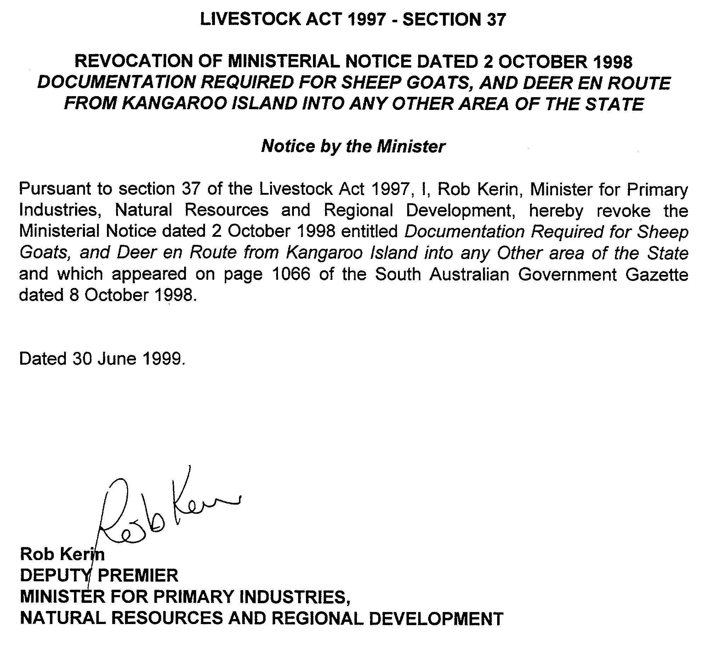
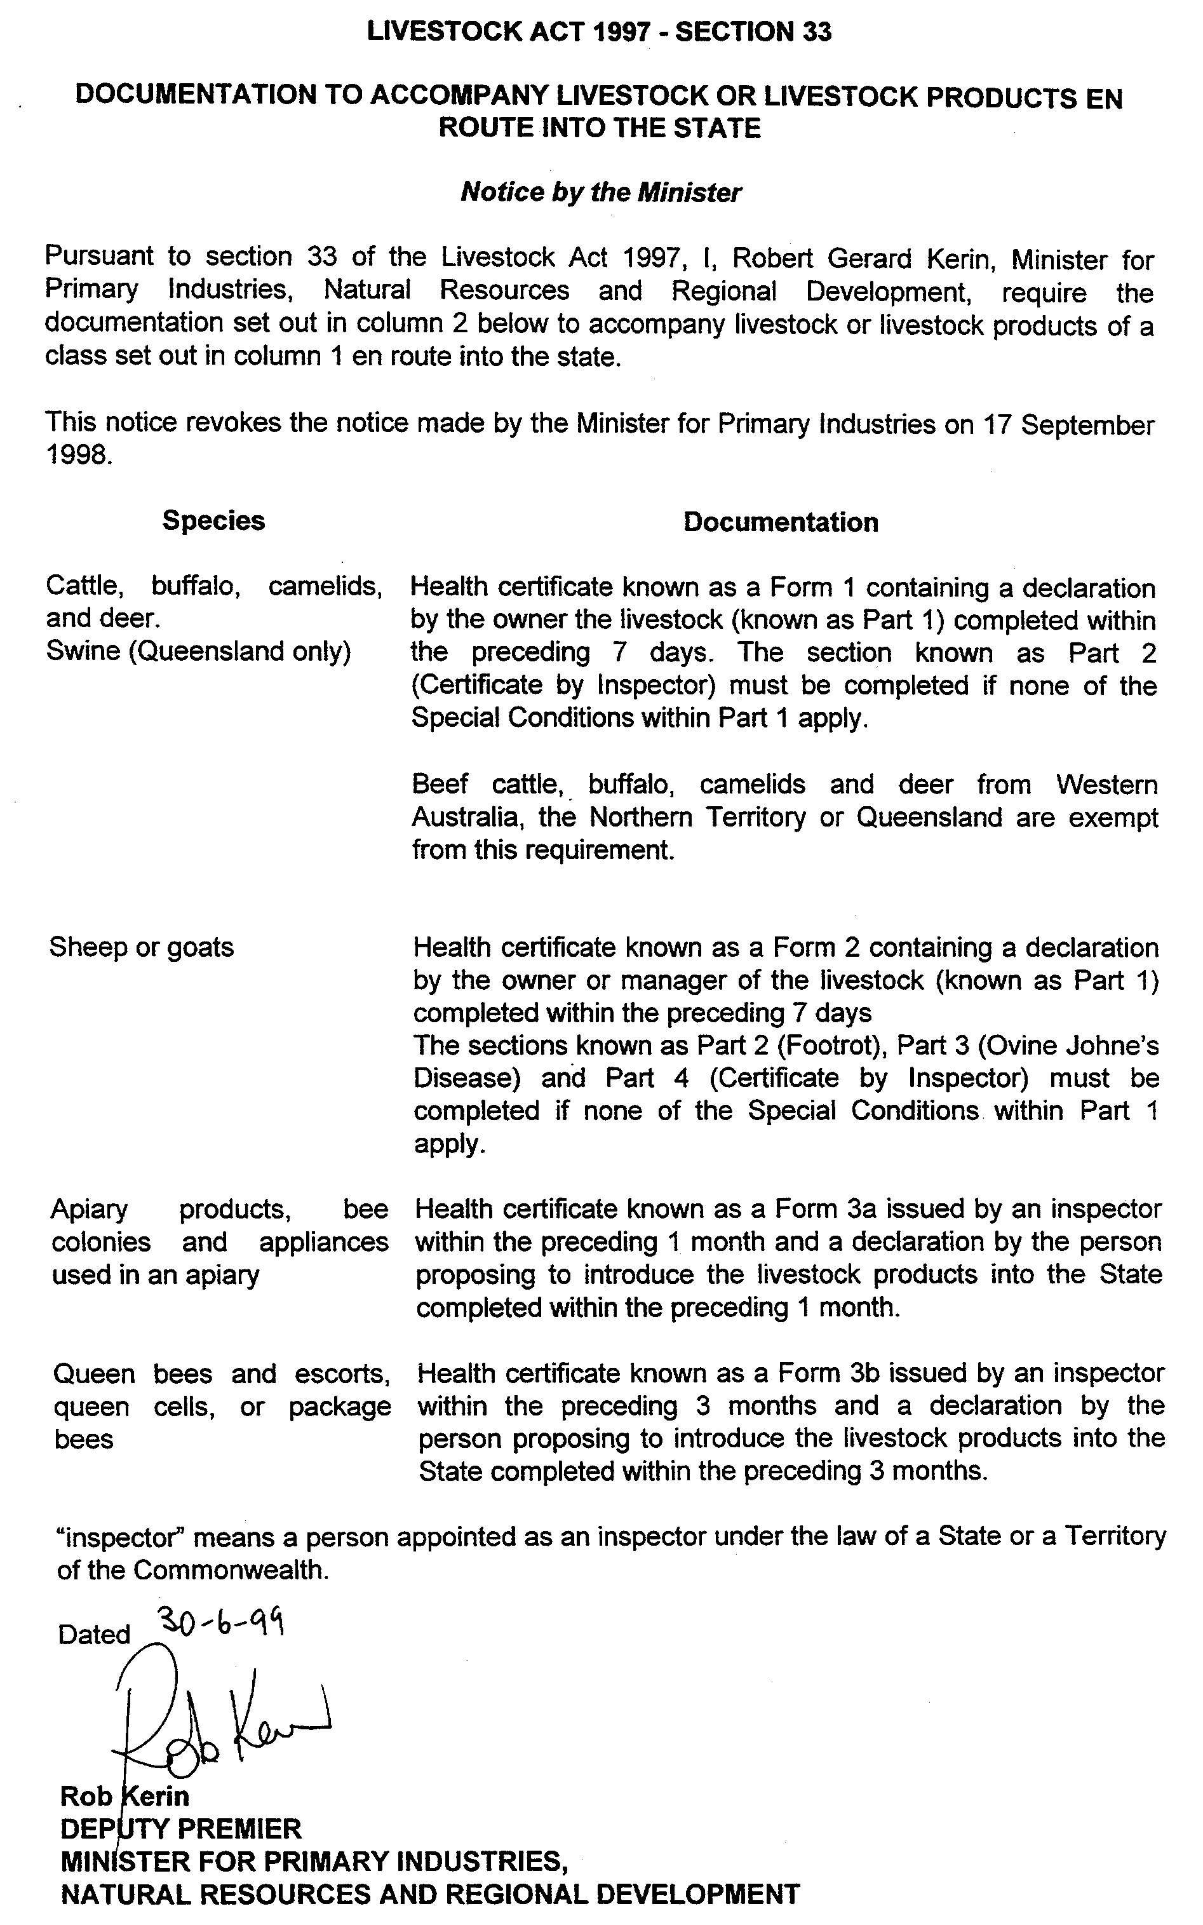
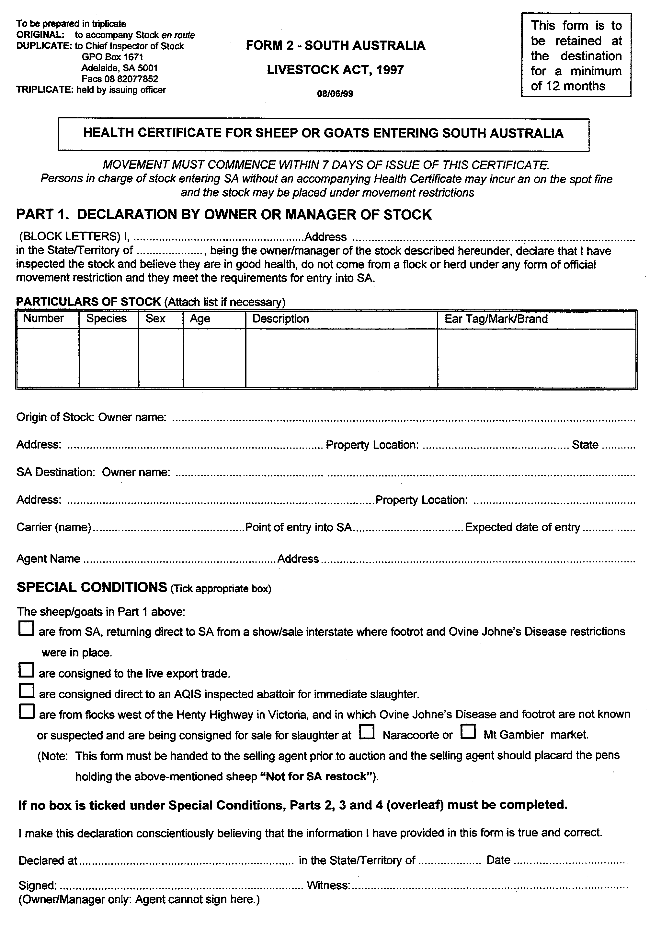
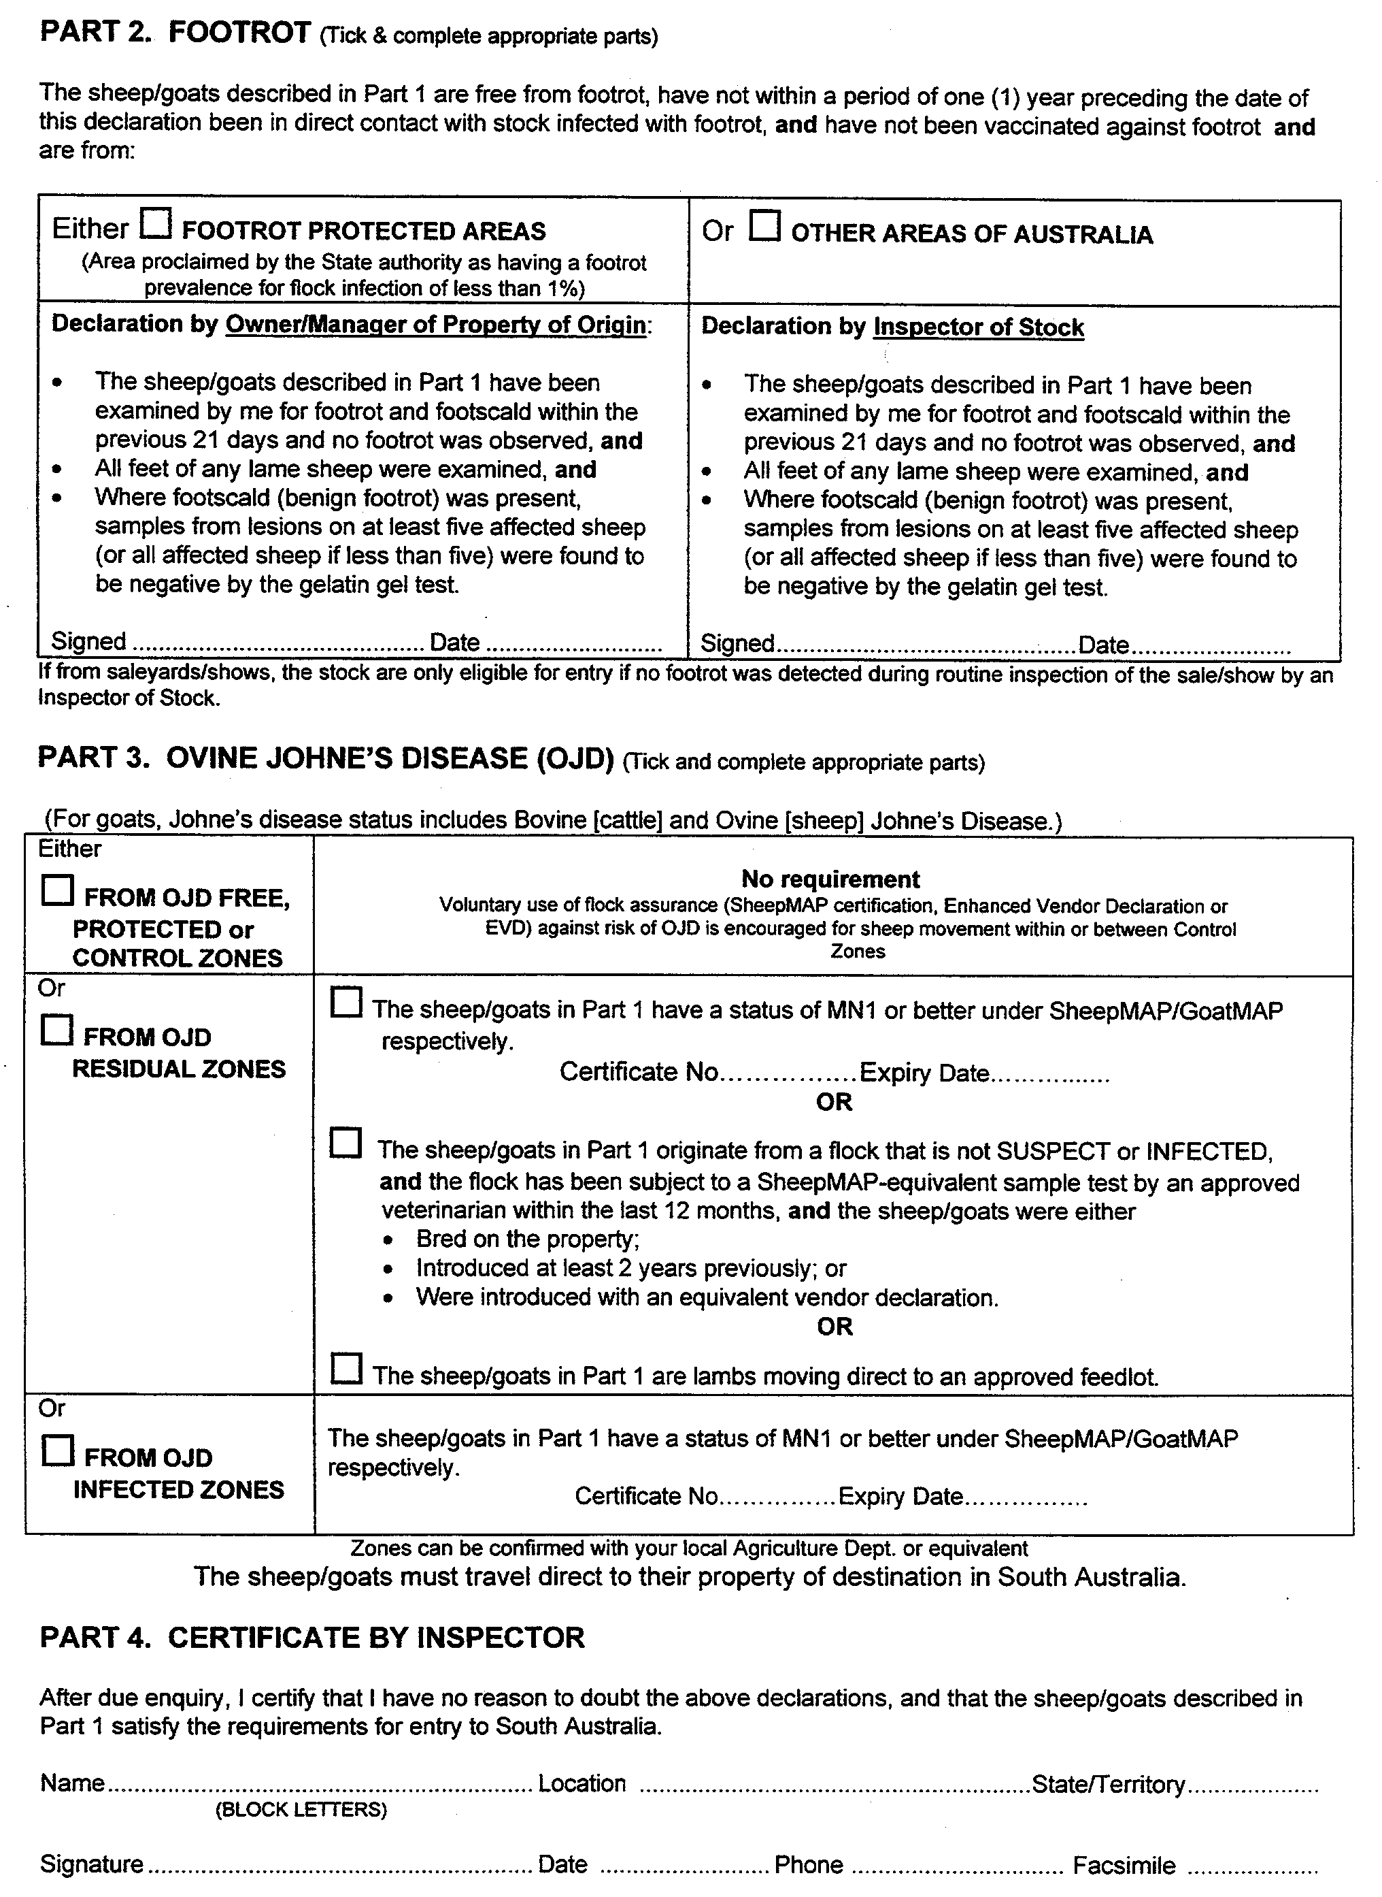

NATIONAL PARKS AND WILDLIFE ACT 1972
Parks of Coffin Bay area Draft Management Plan
Incorporating Coffin Bay National Park, Kellidie Bay Conservation Park, Mount Dutton Bay Conservation Park, Whidbey Isles Conservation Park and Avoid Bay Islands Conservation Park.
I, Dorothy Kotz, Minister for Environment and Heritage, hereby give notice under the provisions of section 38 of the National Parks and Wildlife Act 1972, that a Draft Management Plan has been proposed for the Parks of Coffin Bay area.
Copies of the draft plan may be inspected at or obtained at no cost ($1.50 postage within South Australia) from The Environment Shop, Ground Floor, Australis Building, 77 Grenfell Street, Adelaide, S.A. 5000 (G.P.O. Box 1047, Adelaide, S.A. 5001), telephone (08) 8204 1910 or, the Department for Environment, Heritage and Aboriginal Affairs, 75 Liverpool Street, Port Lincoln, S.A. 5606 (P.O. Box 22, Port Lincoln, S.A. 5606), telephone (08) 8688 3111.
Any person may make representations in connection with the Draft Management Plan during the period up to and including Friday, 15 October 1999.
Written comments should be forwarded to the Manager, Parks and Wildlife, West. Department for Environment, Heritage and Aboriginal Affairs, P.O. Box 22, Port Lincoln, S.A. 5606, telephone (08) 8688 3111.
D. C. Kotz, Minister for Environment and Heritage

NATIONAL PARKS AND WILDLIFE ACT 1972
Lincoln National Park Draft Management Plan
I, Dorothy Kotz, Minister for Environment and Heritage, hereby give notice under the provisions of section 38 of the National Parks and Wildlife Act 1972, that a Draft Management Plan has been proposed for the Lincoln National Park.
Copies of the draft plan may be inspected at or obtained at no cost ($1.50 postage within South Australia) from The Environment Shop, Ground Floor, Australis Building, 77 Grenfell Street, Adelaide, S.A. 5000 (G.P.O. Box 1047, Adelaide, S.A. 5001), telephone (08) 8204 1910 or, the Department for Environment, Heritage and Aboriginal Affairs, 75 Liverpool Street, Port Lincoln, S.A. 5606 (P.O. Box 22, Port Lincoln, S.A. 5606), telephone (08) 8688 3111.
Any person may make representations in connection with the draft management plan during the period up to and including Friday, 15 October 1999.
Written comments should be forwarded to the Manager, Parks and Wildlife, West. Department for Environment, Heritage and Aboriginal Affairs, P.O. Box 22, Port Lincoln, S.A. 5606, telephone (08) 8688 3111.
D. C. Kotz, Minister for Environment and Heritage

WILDERNESS PROTECTION ACT 1992
Proposal to Proclaim Wilderness Protection Areas on Southern Eyre Peninsula
I, Dorothy Kotz, Minister for Environment and Heritage, hereby give notice under the provisions of section 22 of the Wilderness Protection Act 1992, that I propose to recommend the constitution of the land identified in Schedules 1 and 2 as Wilderness Protection Areas because they meet the wilderness criteria to a sufficient extent to justify their protection as wilderness under the Act.
Schedule 1
The whole of the land now constituted as Avoid Bay Conservation Park, and that part of Coffin Bay National Park described in Figure 1, the boundary of which includes the whole of Lake Damascus, and due south from the southernmost point of Lake Damascus to mean low water mark on the coast at a point approximately 135°18′8″E longitude and 34°36′S latitude. Thence generally westward and northward along the coastline at mean low water mark to Reef Point Lookout, being a point approximately 135°7′51″E longitude and 34°31′49″S latitude, thence generally eastward and southward, parallel to and 100 m south of the four wheel drive track which runs adjacent to Seven Mile Beach to a point near the northern most point of Lake Damascus, being approximately 135°19′E longitude and 34°34′49″S latitude.
Schedule 2
That part of Lincoln National Park described in Figure 2, comprising sections 6, 12, 13, 22, 23, and parts of section 36, Hundred of Flinders, section 837 (Little Island), section 874 (Lewis Island), section 875 (Smith Island), section 876 (Hopkins Island), and section 2 DP19500 (part Williams Island, but excluding that part under the control of the Commonwealth Government) North Out of Hundreds.
Reports of the Wilderness Advisory Committee on the land described in Schedules 1 and 2 are included as Parts 2 of the Draft Plans of Management for Coffin Bay National Park and Lincoln National Park respectively.
These documents may be viewed at, or copies obtained at no cost ($1.50 postage within South Australia), from The Environment Shop, Ground Floor, Australis Building, 77 Grenfell Street, Adelaide, S.A. 5000 (G.P.O. Box 1047, Adelaide, S.A. 5001), telephone (08) 8204 1910 or the Department for Environment, Heritage and Aboriginal Affairs, 75 Liverpool Street, Port Lincoln, S.A. 5606 (P.O. Box 22, Port Lincoln, S.A. 5606), telephone (08) 8688 3111.
Any person may make submissions in relation to the proposals during the period up to and including Friday, 15 October 1999.
Written comments should be forwarded to:
Parks and Wildlife Manager West, Department for Environment, Heritage and Aboriginal Affairs, P.O. Box 22, Port Lincoln, S.A. 5606 (Telephone (08) 8688 3111).

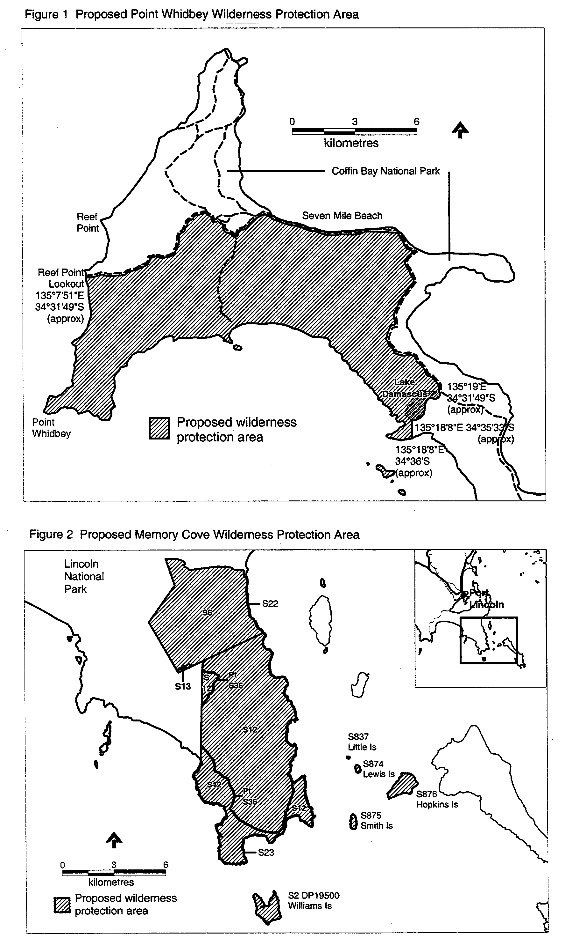
D. C. Kotz, Minister for Environment and Heritage

GRANT OF PETROLEUM PRODUCTION LICENCE
Department of Primary Industries and Resources, Parkside, 26 June 1999
NOTICE is hereby given that pursuant to delegated powers dated 20 November 1997, Gazetted 4 December 1997, page 1526, the undermentioned petroleum production licence has been granted under the provisions of the Petroleum Act 1940.
D. R. Mutton, Chief Executive Officer, Delegate of the Minister for Primary Industries, Natural Resources and Regional Development
No. of  Licence | Licensees | Locality | Date of  Expiry | Area in  km² | Reference

168 | Boral Energy Resources Ltd  Sagasco South East Inc.  Omega Oil NL |  | Redman field in the Otway Basin of South Australia | 25 June 2020 | 8.81 | SR.28.1.340

Description of Area
All that part of the State of South Australia bounded as follows: commencing at a point being the intersection of latitude 37°25′20″S and longitude 140°44′25″E, thence east to longitude 140°45′10″E, north to latitude 37°25′15″S, east to longitude 140°45′50″E, south to latitude 37°25′20″S, east to longitude 140°46′20″E, south to latitude 37°25′25″S, east to longitude 140°46′25″E, south to latitude 37°25′30″S, east to longitude 140°47′45″E, south to latitude 37°25′40″S, east to longitude 140°48′05″E, south to latitude 37°26′25″S, west to longitude 140°47′25″E, south to latitude 37°26′30″S, west to longitude 140°46′55″, south to latitude 37°26′35″S, west to longitude 140°46′35″E, north to latitude 37°26′30″S, west to longitude 140°46′10″E, north to latitude 37°26′25″S, west to longitude 140°46′05″E, north to latitude 37°26′20″S, west to longitude 140°45′55″E, north to latitude 37°26′15″S, west to longitude 140°45′50″E, north to latitude 37°26′10″S, west to longitude 140°45′40″E, north to latitude 37°26′05″S, west to longitude 140°45′20″E, north to latitude 37°26′00″S, west to longitude 140°44′45″E, north to latitude 37°25′55″S, west to longitude 140°44′25″, and north to the point of commencement, all the within latitudes and longitudes being geodetic and expressed in terms of the Australian Geodetic Datum as defined on p. 4984 of Commonwealth Gazette number 84 dated 6 October 1966.

MINING ACT 1971
NOTICE is hereby given in accordance with section 28 (5) of the Mining Act 1971, that the Minister for Primary Industries, Natural Resources and Regional Development proposes to grant an Exploration Licence over the undermentioned area:
Applicant: Murray Basin Minerals NL
Location: Warooka area⎯Approximately 22 km south-west of Minlaton, bounded as follows: Commencing at a point being the intersection of latitude 34°48′S and longitude 137°30′E, thence south to latitude 34°54′S, east to longitude 137°33′E, south to a line parallel to and 800 m inland from highwater mark, Investigator Strait, thence generally westerly along the said parallel line to longitude 137°24′E, north to a line parallel to and 800 m inland from highwater mark Spencer Gulf (eastern side), thence generally northerly along the said parallel line to latitude 34°48′S and east to the point of commencement, all the within latitudes and longitudes being geodetic and expressed in terms of the Australian Geodetic Datum as defined on p. 4984 of Commonwealth Gazette number 84 dated 6 October 1966.
Term: 1 year
Area in km²: 309
Ref. D.M.E. No.: 023/1999
Dated 8 July 1999.
L. Johnston, Mining Registrar

MOTOR VEHICLES ACT 1959
Recognised Historic Motor Vehicle Club
NOTICE is hereby given that the undermentioned club is recognised as an historic motor vehicle club in accordance with schedule 1, clause 3 (3) (a) of the Motor Vehicles Regulations, for the purposes of section 25 of the Motor Vehicles Act 1959:
Norton Motorcycle Club of South Australia Incorporated.
Dated 5 July 1999.
R. J. Frisby, Registrar of Motor Vehicles

PASSENGER TRANSPORT ACT 1994
Appointments
PURSUANT to section 57 of the Passenger Transport Act 1994, the following persons have been authorised by the Passenger Transport Board to act as prescribed officers:
Ilario Scuteri
David John Hardy
Ronald Hoorenman
Gregory Hudson
Andrew Farrent
H. Webster, Executive Director, Passenger Transport Board

POLICE ACT 1998
Directions to the Commissioner Of Police
PURSUANT to section 6 of the Police Act 1998, I, KENNETH TREVOR GRIFFIN, Minister for Justice, with the concurrence of ROBERT LAWRENCE BROKENSHIRE, Minister for Police, Correctional Services and Emergency Services, being the delegate of the Minister for Justice pursuant to section 9A of the Administrative Arrangements Act 1994, HEREBY GIVE the following directions to the Commissioner of Police relating to the control and management of South Australia Police:
1. In these Directions, unless the context otherwise requires:
‘Agreement of 1982’ means the Agreement regulating the relationship between ASIO and South Australia Police approved by the Governor in Executive Council on the 2nd of September, 1982;
‘Auditor’ means the Auditor or a Deputy Auditor appointed pursuant to the provisions of Clause 11;
‘Division’ means the Operations Intelligence Division as constituted pursuant to the Notice published in the Police Gazette on the 22nd of December 1993, and the provisions of Clause 2.
‘Information’ means information of any kind and from any source whatsoever;
‘Intelligence’ means information which is certified in writing by the Officer in Charge as relating to any person to whom or property to which the provisions of Clause 4 apply;
‘Library’ means the library established and maintained by the Division pursuant to the provisions of Clause 6;
‘Minister’ means the Minister for Police, Correctional Services & Emergency Services.
‘Officer in Charge’ means the Officer in Charge, Operations Intelligence Division of South Australia Police and if that officer is absent or otherwise unavailable to perform the duties of his or her office, includes the Sergeant in Charge of the Division;
‘Person’ includes a body, group, community or association of persons whether corporate or unincorporated;
‘Records’ means the records established and maintained by the Division and includes records which are contained in or reproduced from an electronic data storage system pursuant to the provisions of Clause 7 and any copies or duplicates thereof in whatever form;
2. The Division shall include at least one Commissioned Officer.
3. (1) Subject to these Directions, the Division shall discharge its functions by:
(i) gathering and receiving information and disseminating it pursuant to the provisions of subclause (3) of Clause 5;
(ii) assessing information and where appropriate, certifying it as intelligence relating to any person to whom or property to which the provisions of Clause 4 apply;
(iii) recording intelligence for retrieval as required; and
(iv) disseminating such intelligence as is recorded only to:
(a) members of South Australia Police involved in or concerned with the prevention and containment of situations where acts referred to in Clause 4 may occur;
(b) members of the Police Forces of other Australian States carrying out similar functions to the Division;
(c) the Australian Federal Police;
(d) The Australian Security and Intelligence Organisation in accordance with the Agreement of 1982;
(e) any Minister of the Crown;
(f) any person to whom the provisions of Clause 4(2) apply;
(g) the Minister, the Commissioner of Police, the Deputy Commissioner of Police and the Assistant Commissioner (Operations Support Command) for the purposes of subclause (2);
(h) such person whom the Commissioner of Police, has determined in writing to have a proper and legitimate interest in intelligence for the purposes of ensuring the protection or safety of persons or property and in the event of any such determination, the Commissioner must as soon as practicable advise the Auditor in writing.
(2) (i) Subject to paragraph (ii), intelligence shall only be disseminated by the Division upon the prior written approval of the Minister, the Commissioner of Police, the Deputy Commissioner of Police, the Assistant Commissioner (Operations Support Command) or the Officer in Charge.
(ii) In circumstances of urgency where the prior written approval of the Minister, the Commissioner of Police, the Deputy Commissioner of Police, the Assistant Commissioner (Operations Support Command) or the Officer in Charge cannot reasonably be obtained, intelligence may be disseminated with the prior written approval of the next most senior member of South Australia Police then available in the Division, provided
that a written report of the dissemination and of the intelligence disseminated shall be furnished by the Officer in Charge to the Commissioner of Police as soon as possible thereafter.
4. The Division shall record and disseminate intelligence only with respect to:
(1) Any person:
(i) who is reasonably believed to have committed or to have supported and assisted or to have incited the commission of; or
(ii) about whom there is a reasonable suspicion that such person’s activities may involve the commission of, the supporting and assisting or the incitement to commit;
(a) acts or threats of force or violence directed towards the overthrow, destruction or weakening of the constitutional Governments of the States, the Commonwealth or a Territory;
(b) acts or threats of violence of national concern, calculated to evoke extreme fear for the purpose of achieving a political objective in Australia or in a foreign country;
(c) acts or threats of violence against the safety or security of any dignitary; or
(d) violent behaviour within or between community groups.
(2) Any person who or property that is or may be at risk from the activities or behaviour of a person of the type referred to in subclause (1).
(3) Any person who may be able to provide information about a person or property of the type referred to in subclauses (1) and (2).
(4) For the purpose of this clause, ‘dignitary’ means:
(i) (a ) the Governor-General of the Commonwealth, the Governor of a State or the Administrator of a Territory;
(b) a Member of the Legislature, Executive Government or the Judiciary of the Commonwealth or of any State or Territory;
(c) any person who, for the time being, occupies the office or discharges the functions of an Officer or person referred to in this paragraph.
(ii) (a) the Head of State of a foreign country;
(b) any accredited representative of the head of State of a foreign country; or
(c) any person of a foreign country who occupies an office that is or discharges functions that are similar to that or those occupied or discharged by an Officer or person referred to in subclause (i); or
(iii) any person whom the Minister, the Commissioner of Police, the Deputy Commissioner of Police, or the Assistant Commissioner (Operation Support Command) determines for a dignitary. In the case of a determination made under this subparagraph, the Auditor and the Minister are to be advised forthwith of the determination.
5. (1) Where, before the expiration of the relevant period, information has not been assessed or certified by the Officer in Charge as relating to any person to whom or property to which the provisions to Clause 4 apply, such information:
(i) shall at all times be stored and secured at a place and in a manner satisfactory to the Auditor; and
(ii) shall not except as provided by subclause (3), be disseminated.
(2) Where the relevant period has expired, information shall be culled and destroyed.
(3) Where information is reasonably believed by the Officer in Charge to be relevant to a crime or breach of the peace that has been, or may be committed, or is information to be provided under the Agreement of 1982, that information may be disseminated by the Officer in Charge to:
(i) members of South Australia Police involved in or concerned with the prevention or detection of such crime or breach of peace;
(ii) in the case of the Agreement of 1982, those persons authorised under that Agreement; or
(iii) such person whom the Commissioner of Police, has determined in writing to have a proper and legitimate interest in such information for the purposes of ensuring the protection or safety of persons or property (and in the event of any such determination, the Commissioner must advise the Auditor).
(iv) any person who or whose property is or may be at risk from a crime or breach of the peace that has been or may be committed.
(4) For the purposes of this Clause, ‘the relevant period’ means:
(i) twelve months from the date information is gathered or received; or
(ii) such further period as the Auditor by direction may from time to allow:
(a) upon a request in writing to that effect from the Officer in Charge; and
(b) upon being satisfied that the further period is necessary for the proper and effective discharge of the functions of the Division.
6. (1) The Division may establish and maintain a library for its own internal use and purposes.
(2) The library shall at all times:
(i) be stored and secured at a place and in a manner satisfactory to the Auditor; and
(ii) consist only of the following:
(a) information in the form of books, electronic data, magazines, newspapers, periodicals, video or film imagery, reports and written matter commonly available to, or for reference by, the public; and
(b) information contained in or reproduced from an electronic data storage system, video or film imagery, or other information the Officer in Charge, with the written approval of the Auditor, considers necessary for the proper and effective discharge of the functions of the Division.
(3) Information, referred to in subclause (2) (ii) (b), shall be subject to the provisions of Clause 5.
7. (1) The Division shall establish and maintain records to the satisfaction of the Auditor, to ensure the fair, complete and accurate recording of the discharge of its functions.
(2) Without derogating from the generality of subclause (1) the records shall provide fair, complete and accurate particulars of:
(i) the intelligence held by the Division;
(ii) the certificate of the Officer in Charge and the ground or grounds upon which he certified information as intelligence;
(a) any determination made by the Minister pursuant to subclause 3 (1) (iv) or subclause 5 (3) (iii).
(iii) when, to whom, by whom, in what manner and for what purpose information was disseminated pursuant to the provisions of subclause (3) of Clause 5;
(iv) when, to whom, by whom, in what manner and for what purpose intelligence was disseminated;
(v) any determination of the Officer in Charge pursuant to Clause 4; and
(vi) any direction made or approval given by the Auditor pursuant to these Directions and what action was taken in response thereto but not so as to require a record to be maintained of any intelligence or record directed by the Auditor to be culled and destroyed.
8. Except as provided for by these Directions, no person shall have or be given access to information or intelligence held by, or the records or library of the Division.
9. To ensure the Division is complying with these Directions, the information and intelligence held by and the records and library of the Division:
(1) may at any time be subject to inspection by the Commissioner of Police, the Deputy Commissioner of Police or the Assistant Commissioner (Operations Support Command); and
(2) shall:
(i) at least once every financial year, be subject to a comprehensive inspection by the Auditor; and
(ii) whenever and to whatever extent necessary, at the direction and under the supervision of the Auditor, be culled and destroyed.
10. (1) The Auditor shall, on or before the 30th of September in each year, prepare and present a report to the Governor on the compliance of the Division with these Directions and the performance of his functions and duties for the period of twelve months ended on the 30th of June in that year.
(2) The Commissioner of Police shall, at least once every six months prepare and present a report to the Minister on the functions of the Division for the period of six months immediately preceding. The report shall include such information as the Minister may require as well as including the nature of information/intelligence passed on to other persons or agencies.
11. (1) For the purposes of these Directions the Governor by instrument in writing:
(i) shall appoint an Auditor who shall serve in that capacity for a period not exceeding three years from the date of his or her appointment;
(ii) may appoint a Deputy Auditor to act as Auditor pursuant to these Directions during any sickness, absence or other incapacity of the Auditor.
(2) Neither the Auditor not a Deputy Auditor shall be an officer of the Public Service or a member of South Australia Police.
12. Information or intelligence obtained by the Auditor in the course of his or her duties pursuant to these Directions shall not be disclosed except where necessary for the purposes of any inspection, direction or report made or approval given by the Auditor pursuant to these Directions.
Dated 1 July 1999.
K. T. Griffin, Minister for Justice

POLICE ACT 1998
Directions to the Commissioner of Police
PURSUANT to section 6 of the Police Act 1998, I, KENNETH TREVOR GRIFFIN, Minister for Justice, with the concurrence of ROBERT LAWRENCE BROKENSHIRE, Minister for Police, Correctional Services and Emergency Services, being the delegate of the Minister for Justice pursuant to section 9A of the Administrative Arrangements Act 1994, HEREBY GIVE the following directions to the Commissioner of Police relating to the control and management of South Australia Police:
1. In these directions, unless the context otherwise requires:
‘the External Auditor’: means a person (not being a member of South Australia Police or a member of the Public Service) appointed by the Governor to inspect the records of the Branch and report to the Minister his or her findings and recommendations in respect of the operations of the Branch:
‘the Audit Unit’ means the Audit Unit established pursuant to clause 2:
‘the Branch’ means the Anti-Corruption Branch established pursuant to these directions:
‘the Branch records’ means records established pursuant to clause 15:
‘the Commissioner’ means the Commissioner of Police as defined by the Police Act, 1998, and includes the Deputy Commissioner or an Assistant Commissioner of Police performing the duties and functions of the Commissioner in the absence or during any vacancy in the office of the Commissioner.
‘conduct’ includes omission:
‘corruption’ means:
(a) conduct of a public official involving a breach or neglect of duty or abuse of office engaged in as a result of a bribe or threat or to gain any financial or other advantage or for any dishonest or improper purpose;
(b) conduct of a public official or any other person involving the soliciting, offering, taking or giving of a bribe or any financial or other advantage, or the making of any threat, to induce a breach or neglect of duty or abuse of office on the part of a public official;
(c) conduct of a public official or any other person involving a conspiracy or attempt to engage in conduct of a kind referred to in paragraph (a) or (b),
where that conduct constitutes or involves, or might constitute or involve, a criminal offence:
‘the Investigation Unit’ means the Investigation Unit established pursuant to clause 3:
‘member of South Australia Police’ means a member of South Australia Police, or a police cadet, as defined by the Police Act 1998:
‘the Minister’ means the Minister to whom the Police Act 1998, is for the time being committed:
‘the Officer-in-Charge’ means the Officer-in-Charge, Anti-Corruption Branch and includes a Commissioned Officer performing the duties and functions of the Officer-in-Charge in the absence or during any vacancy in the office of the Officer-in-Charge:
‘police corruption’ means corruption where the public official concerned is a member of South Australia Police:
‘police misconduct’ means conduct of a kind referred to in paragraph (a), (b) or (c) of the definition of ‘corruption’ where that conduct constitutes, or might constitute, grounds for disciplinary action under the Police Act 1998, but not a criminal offence:
‘public official’ means:
(a) the Governor;
(b) a Minister of the Crown;
(c) a Member of the House of Assembly or the Legislative Council;
(d) a member of the judiciary;
(e) a person appointed to an office by the Governor;
(f) a person who constitutes or is a member of an incorporated or unincorporated body that is an agency of the Crown;
(g) a member of South Australia Police, the Public Service or the teaching service;
(h) any other person employed by the Crown or an agency of the Crown;
(i) a member, officer or employee of a council or other local government body.
‘Task Force’ means a task force established pursuant to clause 3.
2. (1) The Commissioner of Police shall cause a branch of South Australia Police to be established to be called the ‘Anti-Corruption Branch’.
(2) The Commissioner shall ensure that the requirements of these directions are given effect to in relation to the Branch.
3. The Branch shall comprise:
(a) the Investigation Unit;
(b) the Audit Unit;
(c) any Task Force established by the Commissioner for the purposes of the Branch.
4. (1) The Officer-in-Charge of the Branch shall hold the rank of Commander and shall while on duty devote all of his or her attention to the operations of the Branch or matters incidental to those operations.
(2) The Officer-in-Charge shall be entitled to report directly to the Commissioner on any matter relating to the Branch or the performance of its functions.
5. The Investigation Unit and the Audit Unit shall each include at lease one Commissioned Officer.
6. (1) A member of South Australia Police shall not continue to serve in the Branch after serving in it for a continuous period of three years, or periods amounting in aggregate to three years, and a period of two years shall be allowed to elapse before the member may resume service in the Branch after completing the first such period of service or any subsequent such period of service.
(2) Subclause (1) does not apply in relation to service as the Officer-in-Charge.
7. The Branch shall perform the following functions:
(a) in the case of the Investigation Unit:
(i) undertaking investigations into corruption or police misconduct, or allegations of such corruption or misconduct, at the direction of the Officer-in-Charge with the approval of, or acting under instruction from, the Commissioner;
(ii) undertaking further investigation or reinvestigation into matters referred to it by the Audit Unit with the approval of the Officer-in-Charge;
(b) in the case of the Audit Unit:
(i) monitoring the performance of South Australia Police to ensure an acceptable level of compliance with General Orders, Regulations, established procedures and Departmental policies;
(ii) reviewing the operation of General Orders, Regulations, established procedures and Departmental policies and recommending changes where such Orders, Regulations, procedures or policies lead to police corruption or misconduct or create a climate where police corruption or misconduct may occur;
(iii) conducting periodic and random audits of specific investigations with a view to identifying any procedural or other inadequacies;
(iv) conducting audits of specific investigations at the direction of the Commissioner;
(v) recommending changes to investigative procedures;
(vi) with the approval of the Officer-in-Charge, referring matters to the Investigation Unit for further investigation or reinvestigation;
(vii) assisting other persons or bodies with responsibility in respect of the conduct of public officials in developing practices and procedures designed to prevent or detect corruption;
(c) in the case of a Task Force⎯undertaking specific investigations into corruption or police misconduct, or allegations of such corruption or misconduct, at the direction of the Officer-in-Charge acting under instruction from the Commissioner.
8. Subject to these directions and General Orders, the Branch shall, in the exercise of its functions as far as practicable work in cooperation with other law enforcement agencies and relevant government agencies including the National Crime Authority, the Australian Bureau of Criminal Intelligence, the Auditor-General, the Police Complaints Authority, the Ombudsman and the Commissioner for Public Employment.
9. Neither the Branch nor any member of South Australia Police serving in the Branch may undertake the investigation of a complaint made under the provisions of the Police (Complaints and Disciplinary Proceedings) Act 1985, except where required or authorised to do so in accordance with the provisions of that Act.
10. The Commissioner shall cause General Orders to be amended so that a duty is imposed on each member of South Australia Police to report:
(a) to the Officer-in-Charge or his or her delegate;
or
(b) to the Police Complaints Authority,
any matter that the member suspects on reasonable grounds concerning police corruption or misconduct.
11. The Commissioner shall not establish a Task Force pursuant to clause 3 unless he or she is satisfied that:
(a) the Investigation Unit does not at that time have the capacity to allocate sufficient priority to the proposed investigation;
(b) specialist skills necessary to the conduct of the proposed investigation are not available within the Investigation Unit;
or
(c) there are other special reasons why the proposed investigation should be conducted by a Task Force established for the purpose.
12. A Task Force may comprise:
(a) members of South Australia Police;
(b) members of a Police Force of any other State of Australia or the Australian Federal Police seconded for the purpose;
(c) persons employed pursuant to the Public Sector Management Act 1995, and seconded for the purpose;
(d) other persons with relevant expertise engaged by the Commissioner for the purpose.
13. The Commissioner shall allocate sufficient personnel to enable the Branch to perform its functions effectively.
14. (1) The Commissioner shall at least once every six months present a report to the Minister on the operations of the Branch for the period of six months immediately preceding.
(2) The report shall include such information as the Minister may require.
15. The Officer-in-Charge shall cause records to be maintained detailing:
(a) any information or allegations however obtained or received concerning corruption or police misconduct;
(b) investigations undertaken pursuant to clause 7 (a) and (c) and any findings arising from such investigations;
(c) audits undertaken pursuant to clause 7 (b) and any findings or recommendations arising from such audits.
16. The Commissioner shall ensure that:
(a) the External Auditor is given such access, assistance and facilities as the Auditor may reasonably require for the purpose of:
(i) inspecting the Branch records at any time;
or
(ii) conducting any inquiry required by the Minister as to whether there is any substance to, or need for further investigation of, claims or allegations that information on corruption or police misconduct received or obtained by the Branch have not been dealt with properly;
and
(b) members of South Australia Police comply with any direction given by the External Auditor for the purpose of obtaining any information relating to the operations of the Branch not contained in the Branch records.
Dated 1 July 1999.
K. T. Griffin, Minister for Justice

ROADS (OPENING AND CLOSING) ACT 1991:
SECTION 24
NOTICE OF CONFIRMATION OF ROAD
PROCESS ORDER
Von Bertouch Road, Winkie, Berri Irrigation Area
Deposited Plan 50305
BY Road Process Order made on 24 August 1998, The Berri Barmera Council ordered that:
1. The whole of the public road (Von Bertouch Road) situated between Winkie Road and Lower Winkie Road, more particularly delineated and lettered ‘A’ in Preliminary Plan No. PP32/0008 be closed.
2. Vest in the Crown portion of the land subject to closure lettered ‘A’ and add that land to Section 1314 held by MICHAEL SZEWCZUK and ANN MARIE SZEWCZUK under Crown Lease Volume 1570, Folio 19, in accordance with the agreement for transfer dated 13 February 1998, entered into between The Berri Barmera Council and M. Szewczuk and A. M. Szewczuk.
3. Portion of the land subject to closure lettered ‘A’ be transferred to TERENCE GUY WARD and SUZANNE ROSE WARD in accordance with agreement for transfer dated 12 February 1998, entered into between The Berri Barmera Council and T. G. Ward and S. R. Ward.
4. The following easements be granted over the land subject to that closure:
Grant to the ETSA Corporation (now ETSA Utilities) an easement for overhead electricity supply purposes over portion of the land.
Grant an easement for drainage purposes over portion of the land appurtenant to Certificate of Title Volume 4210, Folio 542.
On 24 June 1999, that order was confirmed by the Minister for Administrative Services, conditionally on approval and deposit of the survey plan by the Registrar-General. The condition has now been fulfilled.
Pursuant to section 24(5) of the Roads (Opening and Closing) Act 1991, NOTICE of the order referred to above and its confirmation is hereby given.
Dated 8 July 1999.
P. M. Kentish, Surveyor-General

ROADS (OPENING AND CLOSING) ACT 1991:
SECTION 24
NOTICE OF CONFIRMATION OF ROAD
PROCESS ORDER
Puddletown Road, Winkie
Deposited Plan 52168
BY Road Process Order made on 22 March 1999, The Berri Barmera Council ordered that:
1. Portion of the public road (Puddletown Road) adjoining allotment 2 in Deposited Plan 36581, more particularly delineated and lettered ‘A’ in Preliminary Plan No. PP32/0328 be closed.
2. The whole of the land subject to closure be transferred to DAVID JOHN CHRISTIAN and KAREN ANN CHRISTIAN in accordance with agreement for transfer dated 22 March 1999, entered into between The Berri Barmera Council and D. J. Christian and K. A. Christian.
On 19 April 1999, that order was confirmed by the Minister for Administrative Services, conditionally on approval and deposit of the survey plan by the Registrar-General. The condition has now been fulfilled.
Pursuant to section 24(5) of the Roads (Opening and Closing) Act 1991, NOTICE of the order referred to above and its confirmation is hereby given.
Dated 8 July 1999.
P. M. Kentish, Surveyor-General

ROADS (OPENING AND CLOSING) ACT 1991:
SECTION 24
NOTICE OF CONFIRMATION OF ROAD
PROCESS ORDER
Public Road, Hundred of Woolumbool
Deposited Plan 52462
BY Road Process Order made on 30 April 1999, the District Council of Naracoorte and Lucindale ordered that:
Portion of section 122, more particularly delineated and numbered ‘1’ in the Preliminary Plan No. PP32/0379 be opened as road.
On 10 June 1999, that order was confirmed by the Minister for Administrative Services, conditionally on approval and deposit of the survey plan by the Registrar-General. The condition has now been fulfilled.
Pursuant to section 24(5) of the Roads (Opening and Closing) Act 1991, NOTICE of the order referred to above and its confirmation is hereby given.
Dated 8 July 1999.
P. M. Kentish, Surveyor-General

SOIL CONSERVATION AND LAND CARE ACT 1989
Appointments
I, ROBERT GERARD KERIN, Deputy Premier, Minister for Primary Industries, Natural Resources and Regional Develop-ment in the State of South Australia to whom the administration of the Soil Conservation and Land Care Act 1989 has been committed, do hereby appoint the following persons as members of the Murray Plains Soil Conservation Board, pursuant to section 24 of the Act until 30 June 2002:
Joseph Lindsay Keynes
James Carl Bormann
Brenton John Lewis
John R. Schirmer
Neil Richard Burbidge
Christine Ann Jones
Local Government Representative:
Peter Dabinett
Dated 2 July 1999.
Rob Kerin, Deputy Premier, Minister for Primary Industries, Natural Resources and Regional Development.

SOIL CONSERVATION AND LAND CARE ACT 1989
Appointments
I, ROBERT GERARD KERIN, Deputy Premier, Minister for Primary Industries, Natural Resources and Regional Develop-ment in the State of South Australia to whom the administration of the Soil Conservation and Land Care Act 1989 has been committed, do hereby appoint the following persons as members of the Murray Mallee Soil Conservation Board, pursuant to section 24 of the Act until 30 June 2002:
John Anthony Berger
Neville Andrew Wurst
Jennifer Jane Roberts
Russell Ross Smith
Kevin John Burdett
Local Government Representative:
Darryl McNeilly
Dated 3 July 1999.
Rob Kerin, Deputy Premier, Minister for Primary Industries, Natural Resources and Regional Development.

SOIL CONSERVATION AND LAND CARE ACT 1989
Appointment
I, ROBERT GERARD KERIN, Deputy Premier, Minister for Primary Industries, Natural Resources and Regional Develop-ment in the State of South Australia to whom the administration of the Soil Conservation and Land Care Act 1989 has been committed, do hereby appoint the following person as a member of the Central Hills Soil Conservation Board, pursuant to section 24 of the Act until 31 July 2000:
Margaret Ann Wilksch
Dated 5 July 1999.
Rob Kerin, Deputy Premier, Minister for Primary Industries, Natural Resources and Regional Development.

SOIL CONSERVATION AND LAND CARE ACT 1989
Appointments
I, ROBERT GERARD KERIN, Deputy Premier, Minister for Primary Industries, Natural Resources and Regional Develop-ment in the State of South Australia to whom the administration of the Soil Conservation and Land Care Act 1989 has been committed, do hereby appoint the following persons as members of the Coorong and Districts Soil Conservation Board, pursuant to section 24 of the Act until 31 July 2002:
Stephen Rostron Murray
Margaret Joan Brookman
Henry Stuart Fife Angas
Alan Malcolm Piggott
Gordon Warren Stopp
Kenneth Norman Strother
Local Government Representative:
Keith Scobie
Dated 3 July 1999.
Rob Kerin, Deputy Premier, Minister for Primary Industries, Natural Resources and Regional Development.

ROAD TRAFFIC ACT 1961
Higher Mass Limits for Vehicles Fitted with Road Friendly
Suspensions
PURSUANT to the provisions of Section 163AA of the Road Traffic Act 1961, as amended, I, T. N. Argent, Executive Director, Transport SA, as an authorised delegate of the Minister for Transport and Urban Planning, hereby exempt vehicles fitted with ‘Road Friendly Suspensions’ as defined in Clause 3.1.1, for vehicle configurations as described in Table 1 of this Notice, from Section 146 (1) (Mass limits of vehicles), of the aforesaid Act for travel on only those routes specified by this notice, subject to the following conditions:
1 Special Conditions
1.1 This notice and the maps titled ‘Route Network for General Access Vehicles fitted with Road Friendly Suspension’ or a copy shall be carried by the driver of the vehicle at all times when operating under this exemption and be produced when requested by an Inspector appointed under the Road Traffic Act and/or Motor Vehicles Act or a Police Officer.
1.2 Drivers of road trains when operating under this exemption must also carry a copy of:
1.2.1 The current South Australian Government Gazette notice titled ‘Operation of Road Train Vehicles in South Australia’; and
1.2.2 The information booklet titled ‘Operation of Road Train Vehicles in South Australia’ Edition No.1.
1.3 Drivers of Stinger Car Carriers which are more than 20.117 metres long or B Doubles must also carry:
1.3.1 The current South Australian Government Gazette notice titled ‘Operation of Medium Combination Vehicles’; and
1.3.2 The information booklet titled ‘Operation of Medium Combination Vehicles in South Australia’ Edition No.1.
1.4 The axle mass limits and other conditions specified in this notice take precedence over any mass limits and conditions specified for B-Doubles, Stinger Car Carriers and Road Trains operating under existing South Australian Government Gazette Notices.
2 Approved Vehicles
2.1 Only the axle groups specified for vehicles and/or combinations nominated in Table 1 with the corresponding registration codes and which are fitted with road friendly suspensions are approved to operate, at higher mass limits, under this Notice.
Table 1
Vehicle Configuration |  | Registration  Code
a  b  c  d  e  f | Rigid Trucks fitted with a tandem drive axle group.  Rigid Trucks fitted with a tandem drive axle group towing a Stinger Car Carrier trailer that is fitted with a tandem axle group.  Articulated vehicles where the prime mover is fitted with a tandem drive axle group and the semi trailer is fitted with either a tandem or triaxle group.  Buses fitted with a single drive axle or a six tyred tandem axle group (which includes the drive axle) at the rear.  B-Doubles where the prime mover is fitted with a tandem drive axle group and the trailers are fitted with either tandem or triaxle groups.  Double and Triple Road Trains where the prime mover is fitted with a tandem drive axle group, the semi trailers are fitted with either tandem or triaxle group and the converter dolly is fitted with a tandem axle group. | 2R3  2R4  SR3  SR4  T2  SP3  T2  T3  2B2  2B3  MP3  T2  T3  1LP3  2LP3  T2  T3

3 Definitions
3.1 For the purpose of this notice the following definitions shall apply:
3.1.1 ‘Road Friendly Suspension’ means a suspension system that uses air bags in combination with effective hydraulic dampers, with the air bags being the principal suspension medium.
3.1.2 ‘Mass Management Accreditation Scheme’ means a scheme specified in this notice.
3.1.3 A ‘Stinger Car Carrier’ means a rigid motor vehicle fitted with a tandem drive axle group towing a trailer which has a tandem axle group located at the rear and where the front of the trailer is connected to the rear of the motor vehicle by a coupling. The overall length of the vehicle com-bination, including any load shall not exceed 23 m.
3.1.4 A ‘General Access Vehicle’ means a vehicle included under vehicle configuration a or c or d, specified in Table 1 or a Rigid Truck towing a Stinger Car Carrier trailer less than 20.117 m long. For General Access Vehicles, this notice shall stand alone.
3.1.5 A ‘Restricted Access Vehicle’ means a vehicle included under vehicle configuration e or f, specified in Table 1 or a Rigid Truck towing a Stinger Car Carrier trailer longer than 20.117 m. For these Restricted Access Vehicles, this notice shall be read in conjunction with the relevant South Australian Government Gazette notice exemption.
4 Axle Mass Limits
4.1 The total mass on the axle or axle group shall not exceed the limits listed in Table 2 for the specified axle or axle group.
4.2 The mass limits specified in Table 2 shall only apply to axles or axle groups fitted with a road friendly suspension (except for the steer axle on the Road Train prime mover).
Table 2
Axle or Axle Group  Configuration | Mass Limit  (tonnes)
Single drive axle on buses fitted with 4 tyres  Tandem axle groups fitted with 6 tyres  Tandem axle groups fitted with 8 tyres  Triaxle group fitted with 12 tyres  Single steer axle fitted with wide single tyres* on road train prime mover registered 1LP3 and/or 2LP3  * tyres with section width greater than 375mm | 10.0  14.0  17.0  22.5  6.7

5 Mass Accreditation
5.1 Vehicles or vehicle configurations fitted with triaxle groups where the triaxle group is loaded in accordance with Table 2 are required to be accredited under one of the following Mass Management Accreditation Schemes and display a label that identifies scheme membership:
5.1.1 Transport SA Heavy Vehicle Mass Management Accreditation Scheme;
5.1.2 Mass Management Module of the National Heavy Vehicle Accreditation Scheme (Victorian);
5.1.3 National Heavy Vehicle Accreditation Scheme for Mass Management, known as the Mass Manage-ment Accreditation (Pilot) Program (Victorian).
5.2 Vehicles accredited under the schemes specified in 5.1.2 and 5.1.3 may operate in South Australia under the terms and conditions and on the routes detailed in this Notice, provided the driver:
5.2.1 has determined that a higher mass limit route is available by reference to the maps contained in this Notice; and
5.2.2 records the route details on a Route Compliance Certificate and has signed the Certificate; and
5.2.3 carries the Route Compliance Certificate in the vehicle when operating at higher mass limits; and
5.2.4 produces the Certificate if requested by a Transport SA Inspector or Police Officer; and
5.2.5 retains the original copy of the Certificate for a period of not less than 12 months from the date it is signed for auditing purposes.

6 Routes
6.1 Vehicle configurations a, c and d, specified in Table 1 and Rigid Trucks towing Stinger Car Carrier trailers less than 20.117 metres long shall operate only on the approved routes specified in the maps titled ‘Route Network for General Access Vehicles fitted with Road Friendly Suspension’, as amended.
6.2 B-Doubles and Stinger Car Carriers operating in accordance with the South Australian Government Gazette notice titled ‘Operation of Medium Combination Vehicles’, may operate at increased mass limits only where routes specified in the maps contained in the information booklet titled ‘Operation of Medium Combination Vehicles in South Australia’ Edition No.1 are also routes specified in Clause 6.1 of this Notice.
6.3 Double and Triple Road Trains operating in accordance with the South Australian Government Gazette Notice titled ‘Operation of Road Trains in South Australia’, may operate at increased mass limits only where routes specified in the maps contained in the information booklet titled ‘Operation of Road Trains in South Australia’ Edition No.1 are also routes specified in Clause 6.1 of this Notice.
7 Vehicle Specifications
7.1 General requirements:
7.1.1 The vehicle and/or combination shall not be driven or loaded in excess of the manufacturers rating for axle, suspension, tyre and coupling capacities or in excess of the manufacturers gross vehicle mass and gross combination mass ratings.
7.1.2 South Australian registered vehicles shall not exceed the Gross Vehicle Mass Limit and/or Gross Combination Mass Limit as shown on the certificate of registration for that vehicle
7.1.3 Vehicles registered in other States and Territories shall comply with the requirements of Clause 7.1.1 or the Gross Vehicle Mass and/or Gross Combination Mass as shown on the certificate of registration for that vehicle.
7.2 B-Double Coupling Requirements:
7.2.1 The ‘D’ rating for fifth wheel couplings and king pins shall be equal to or greater than 112 kN.
7.3 Road Train Coupling Requirements:
7.3.1 For Double Road Trains the minimum ‘D’ rating for the fifth wheel couplings and king pins shall be equal to or greater than 135 kN and the minimum ‘D’ rating for tow couplings and drawbar eyes shall be equal to or greater than 15 tonnes.
7.3.2 For Triple Road Trains the minimum ‘D’ rating for the fifth wheel couplings and king pins shall be equal to or greater than 173 kN and the minimum ‘D’ rating for tow couplings and drawbar eyes shall be equal to or greater than 21 tonnes.
The notice titled ‘Increased Mass Limits for Vehicles Fitted with Road Friendly Suspensions’ that appeared in the South Australian Government Gazette, dated 23 December 1998, is hereby revoked.

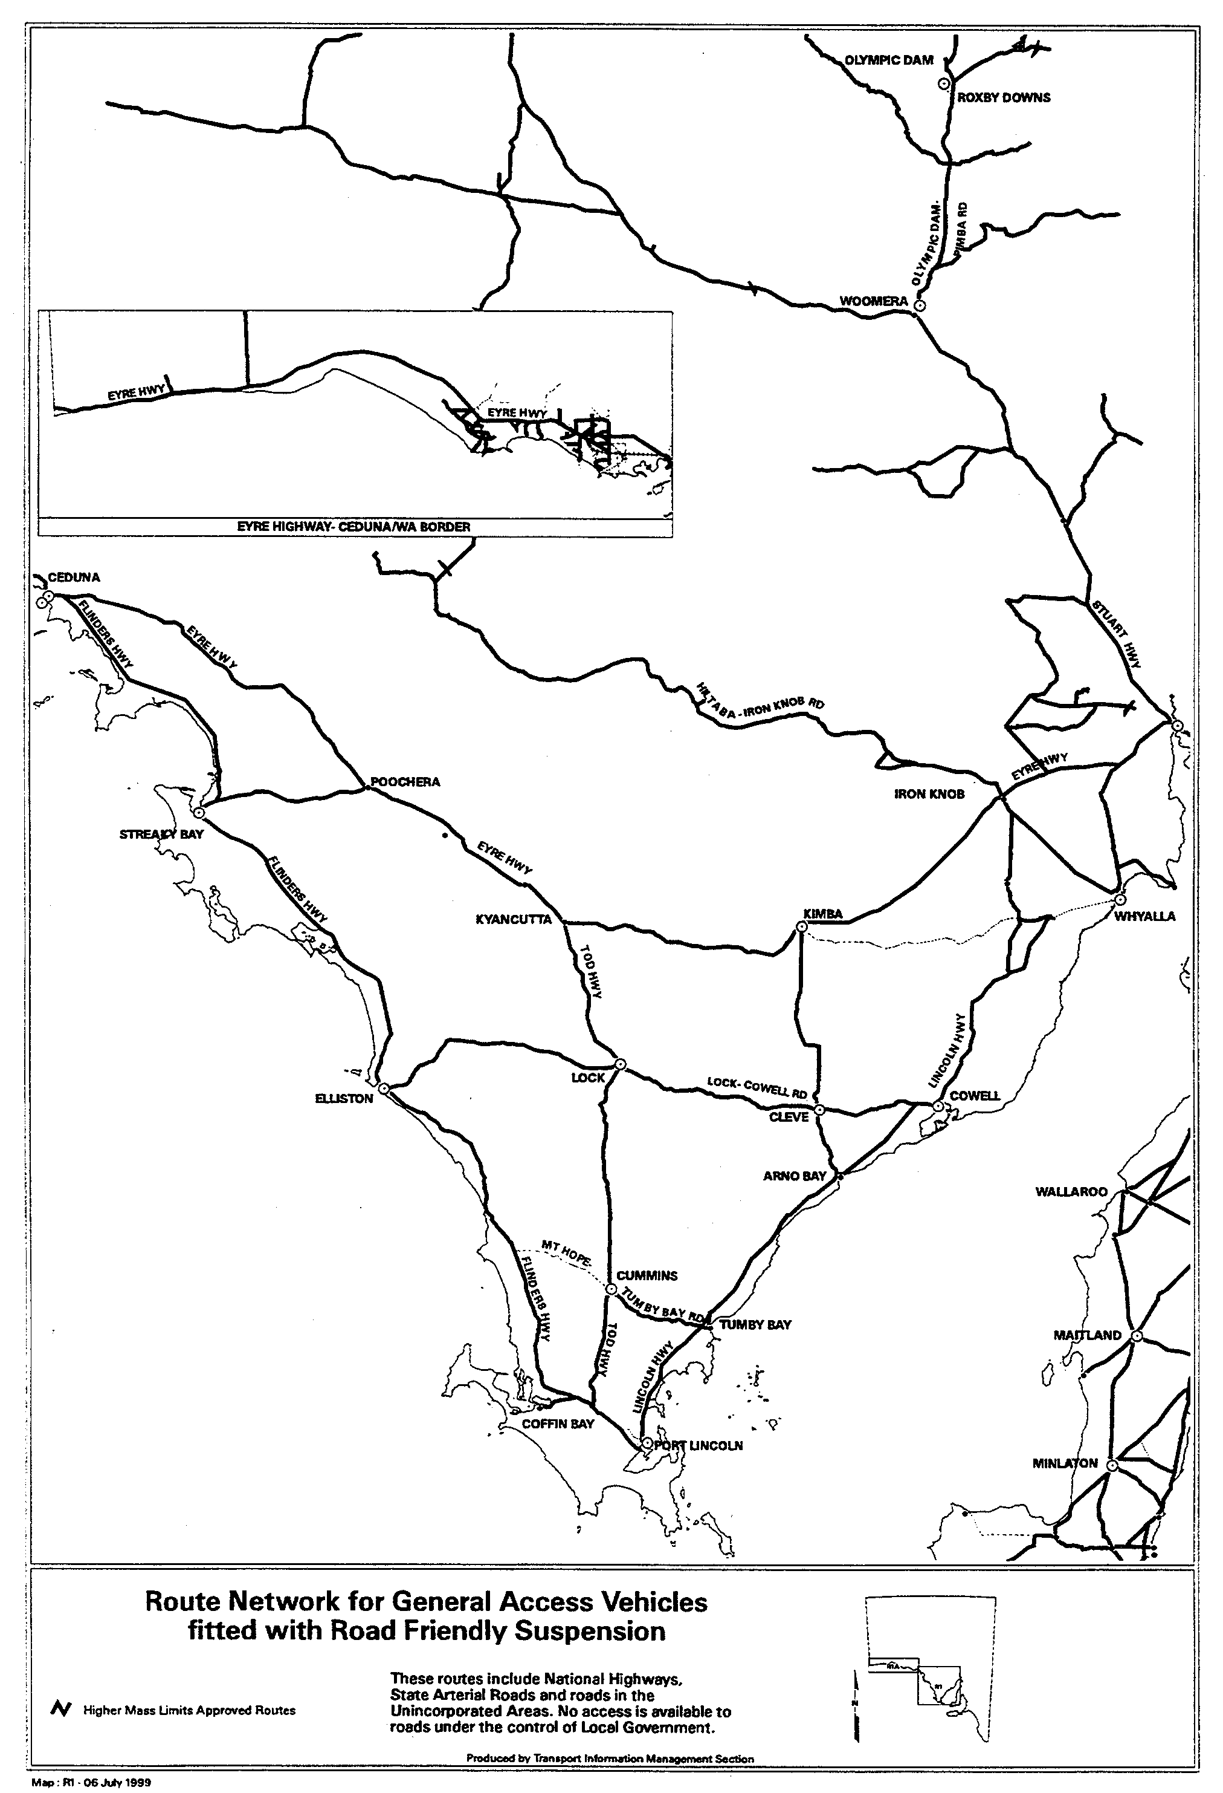
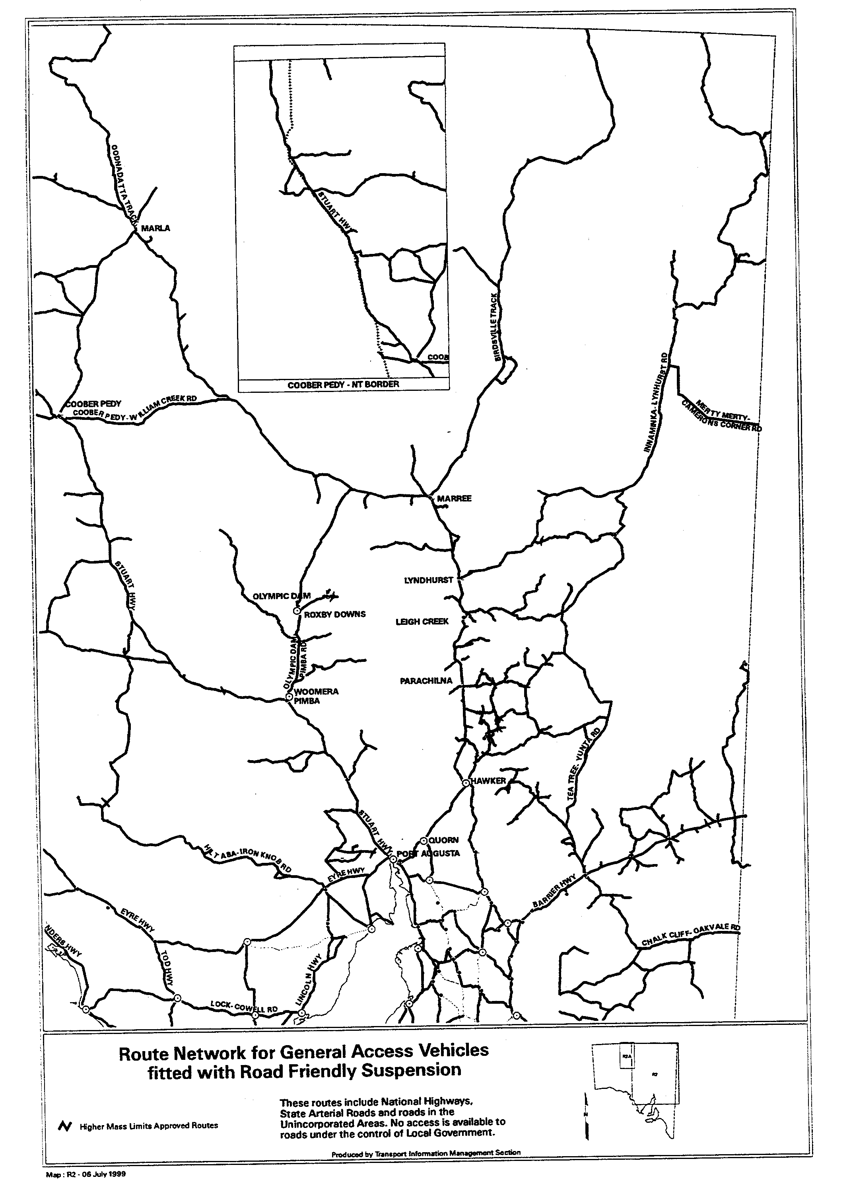
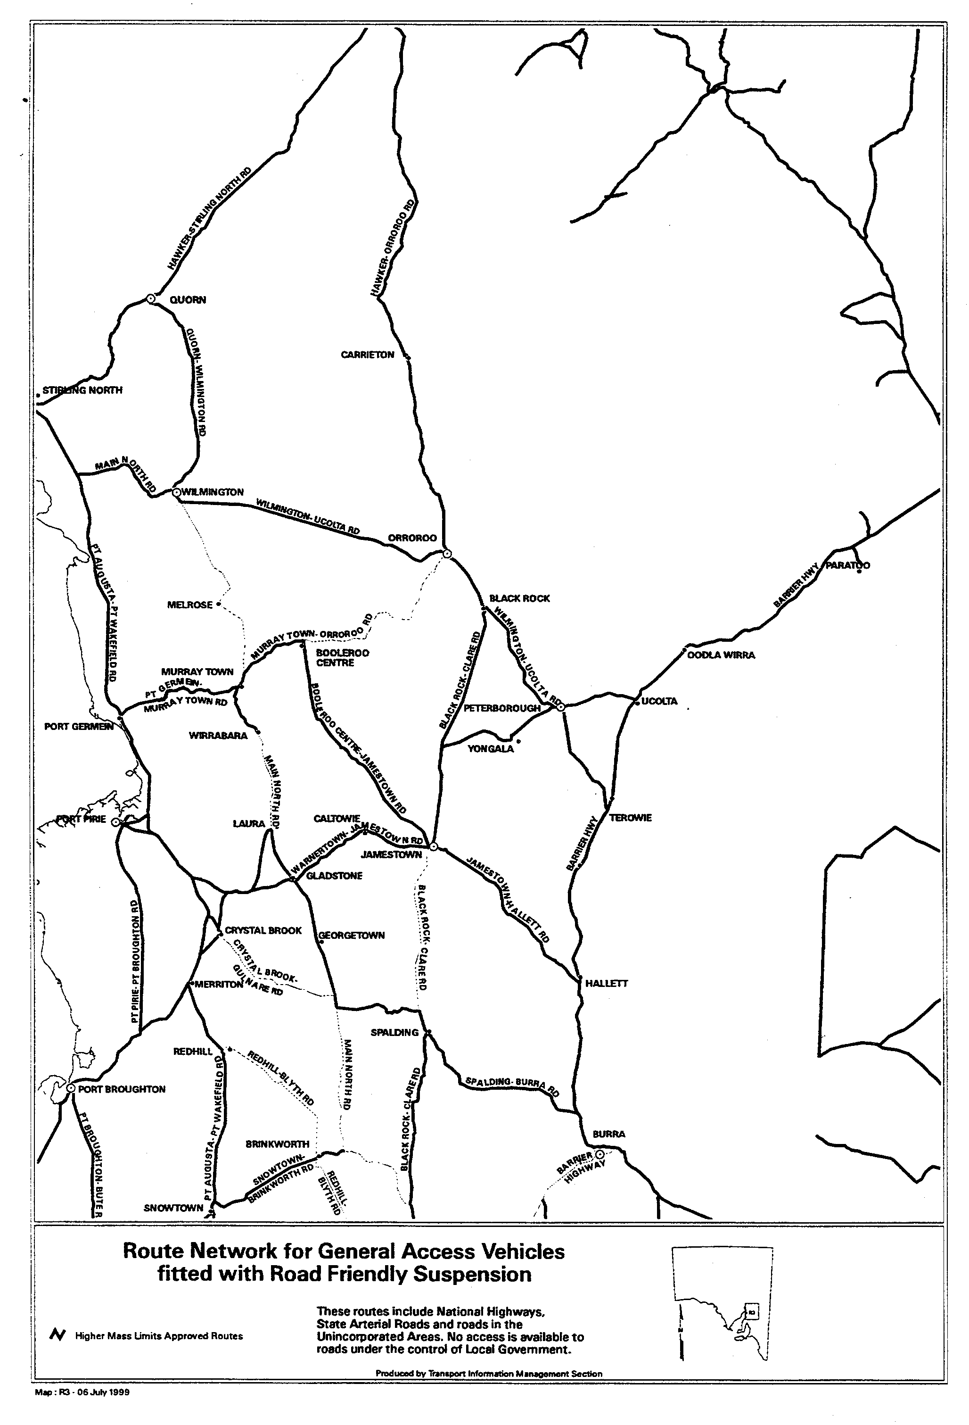
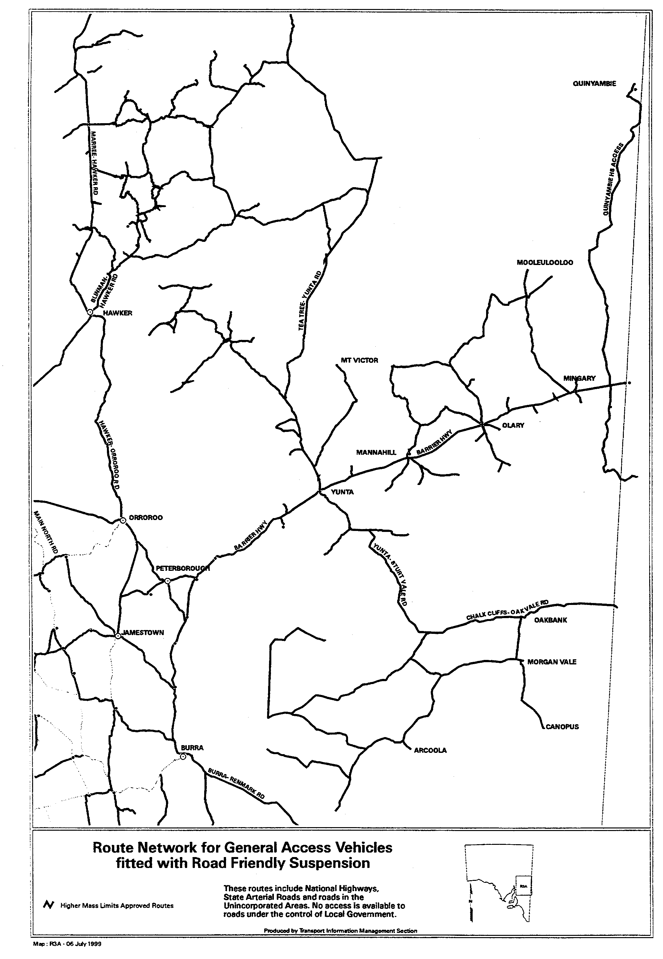
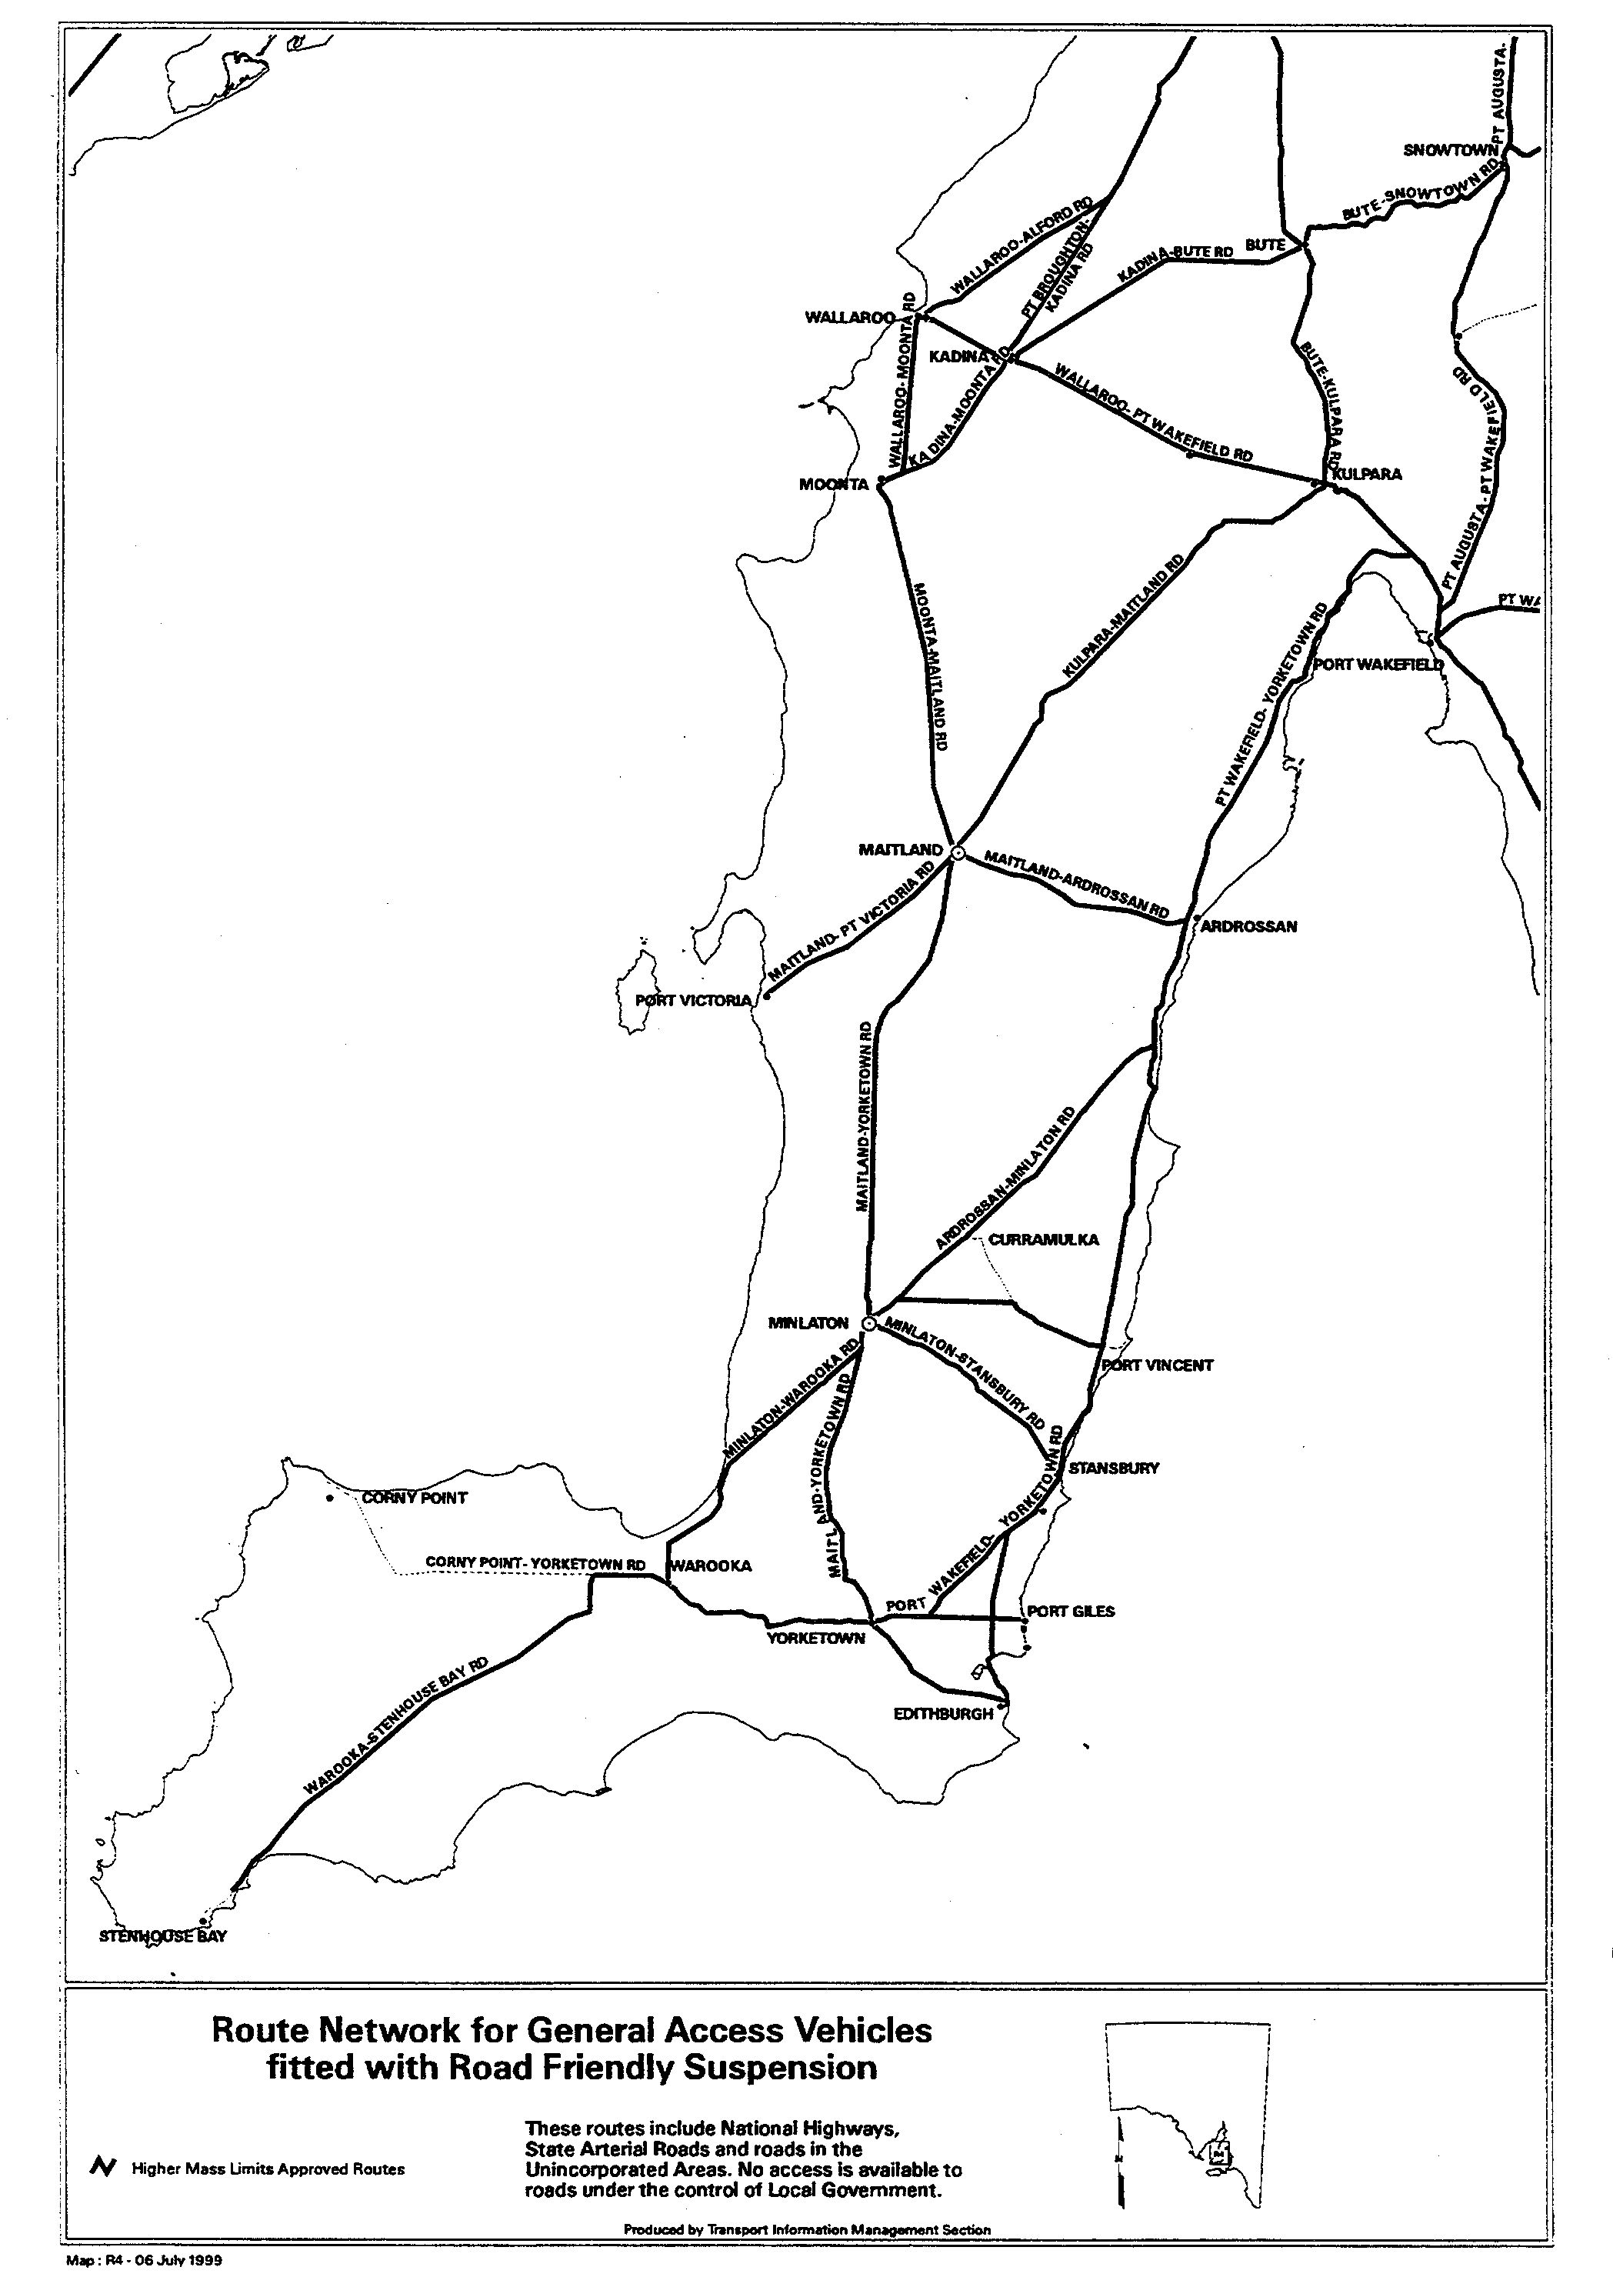
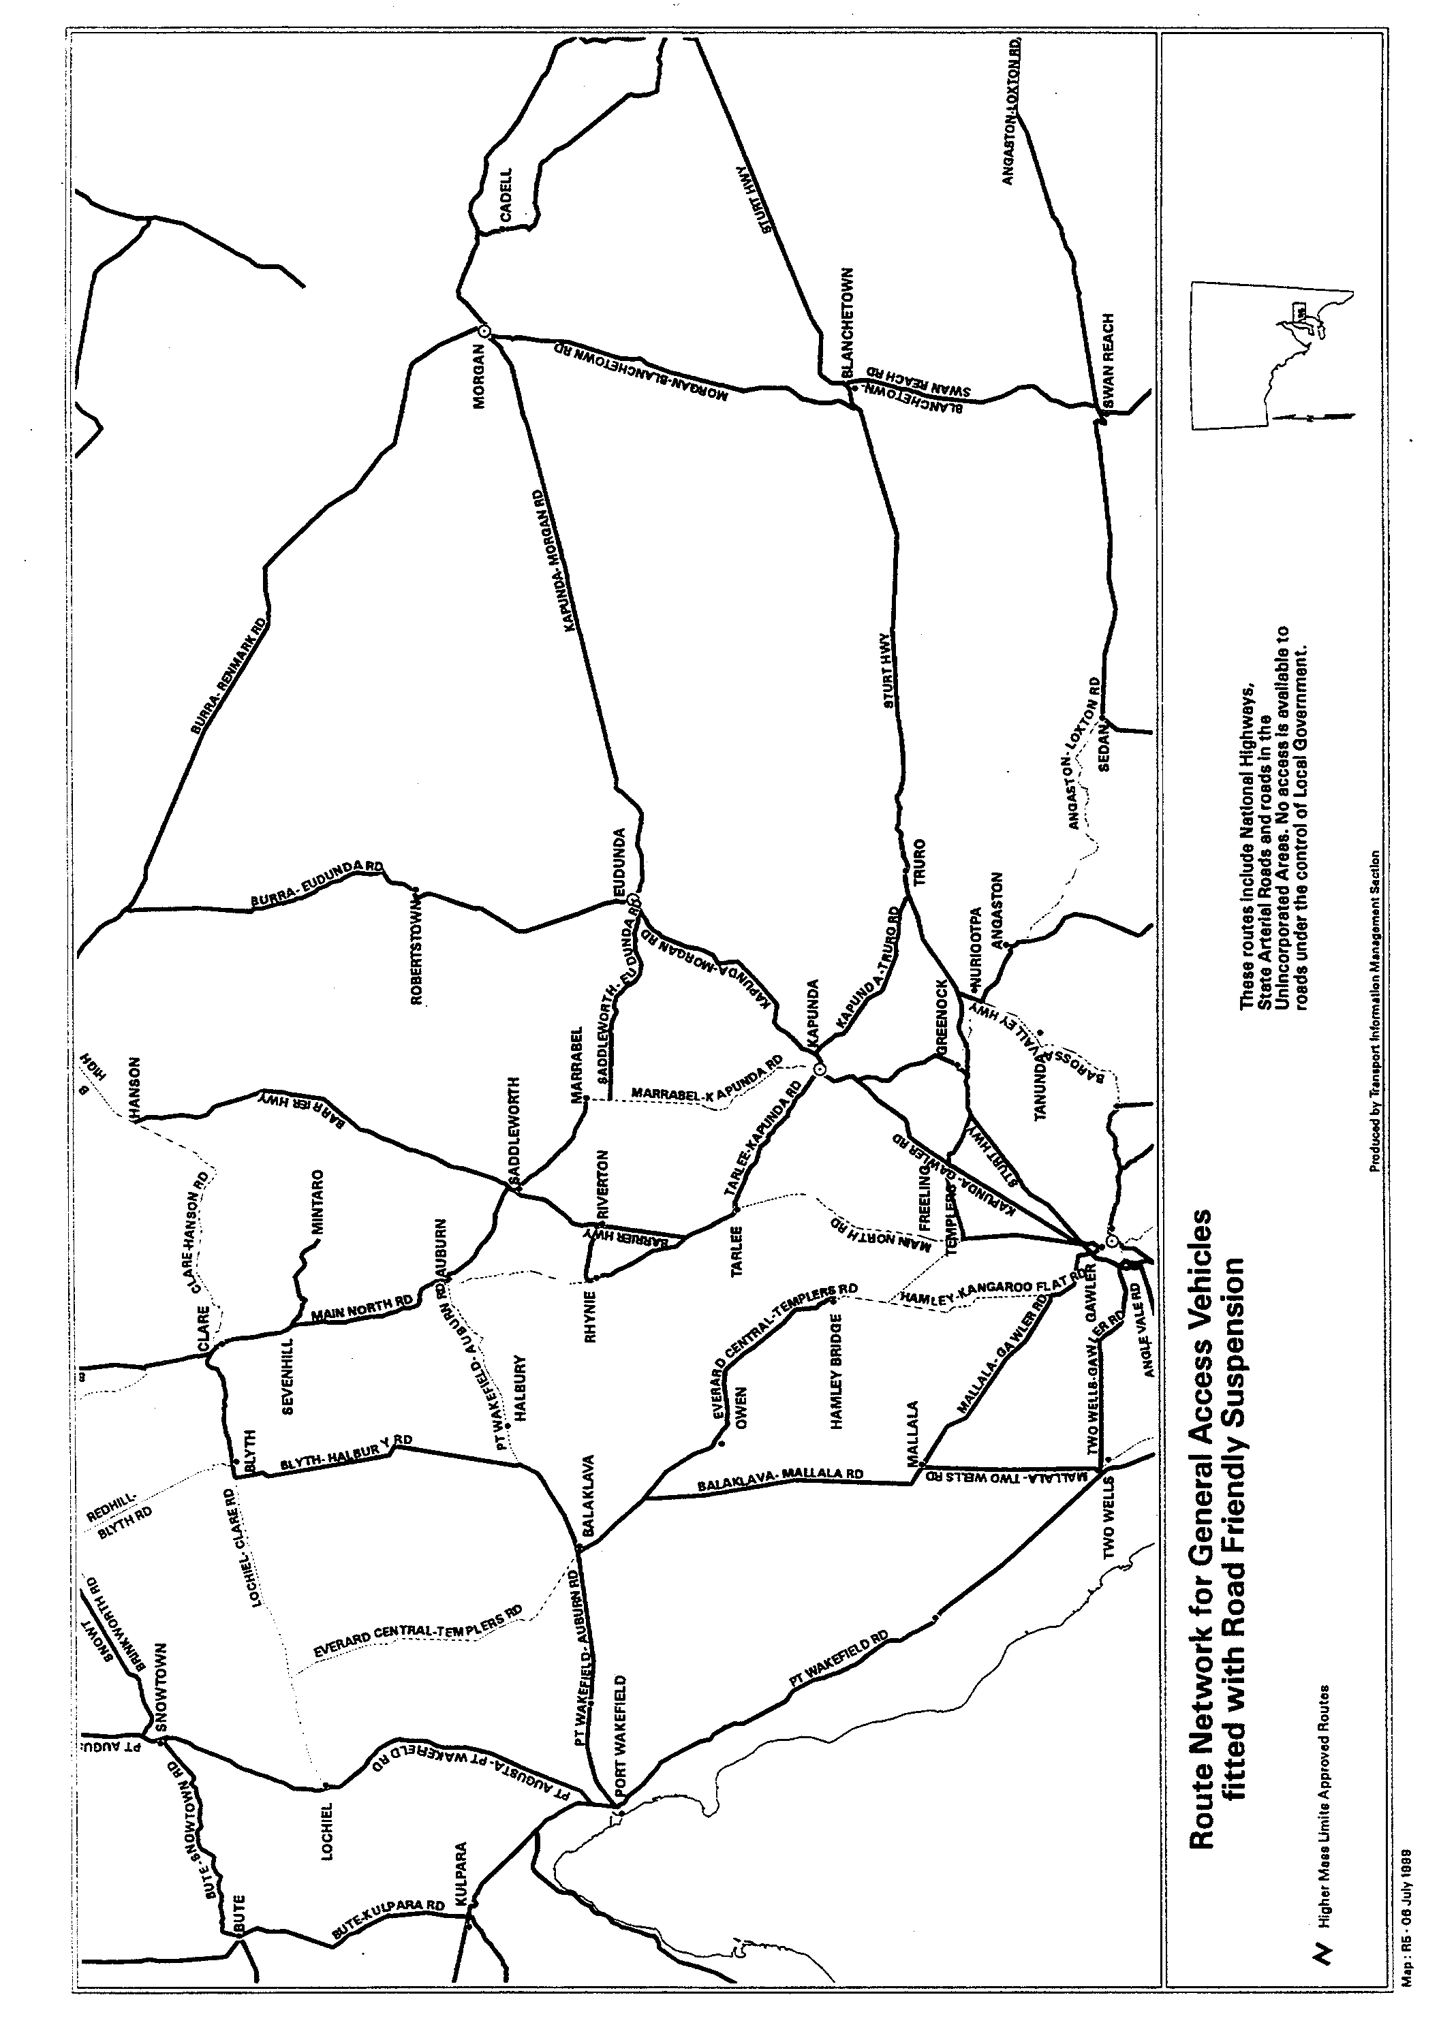
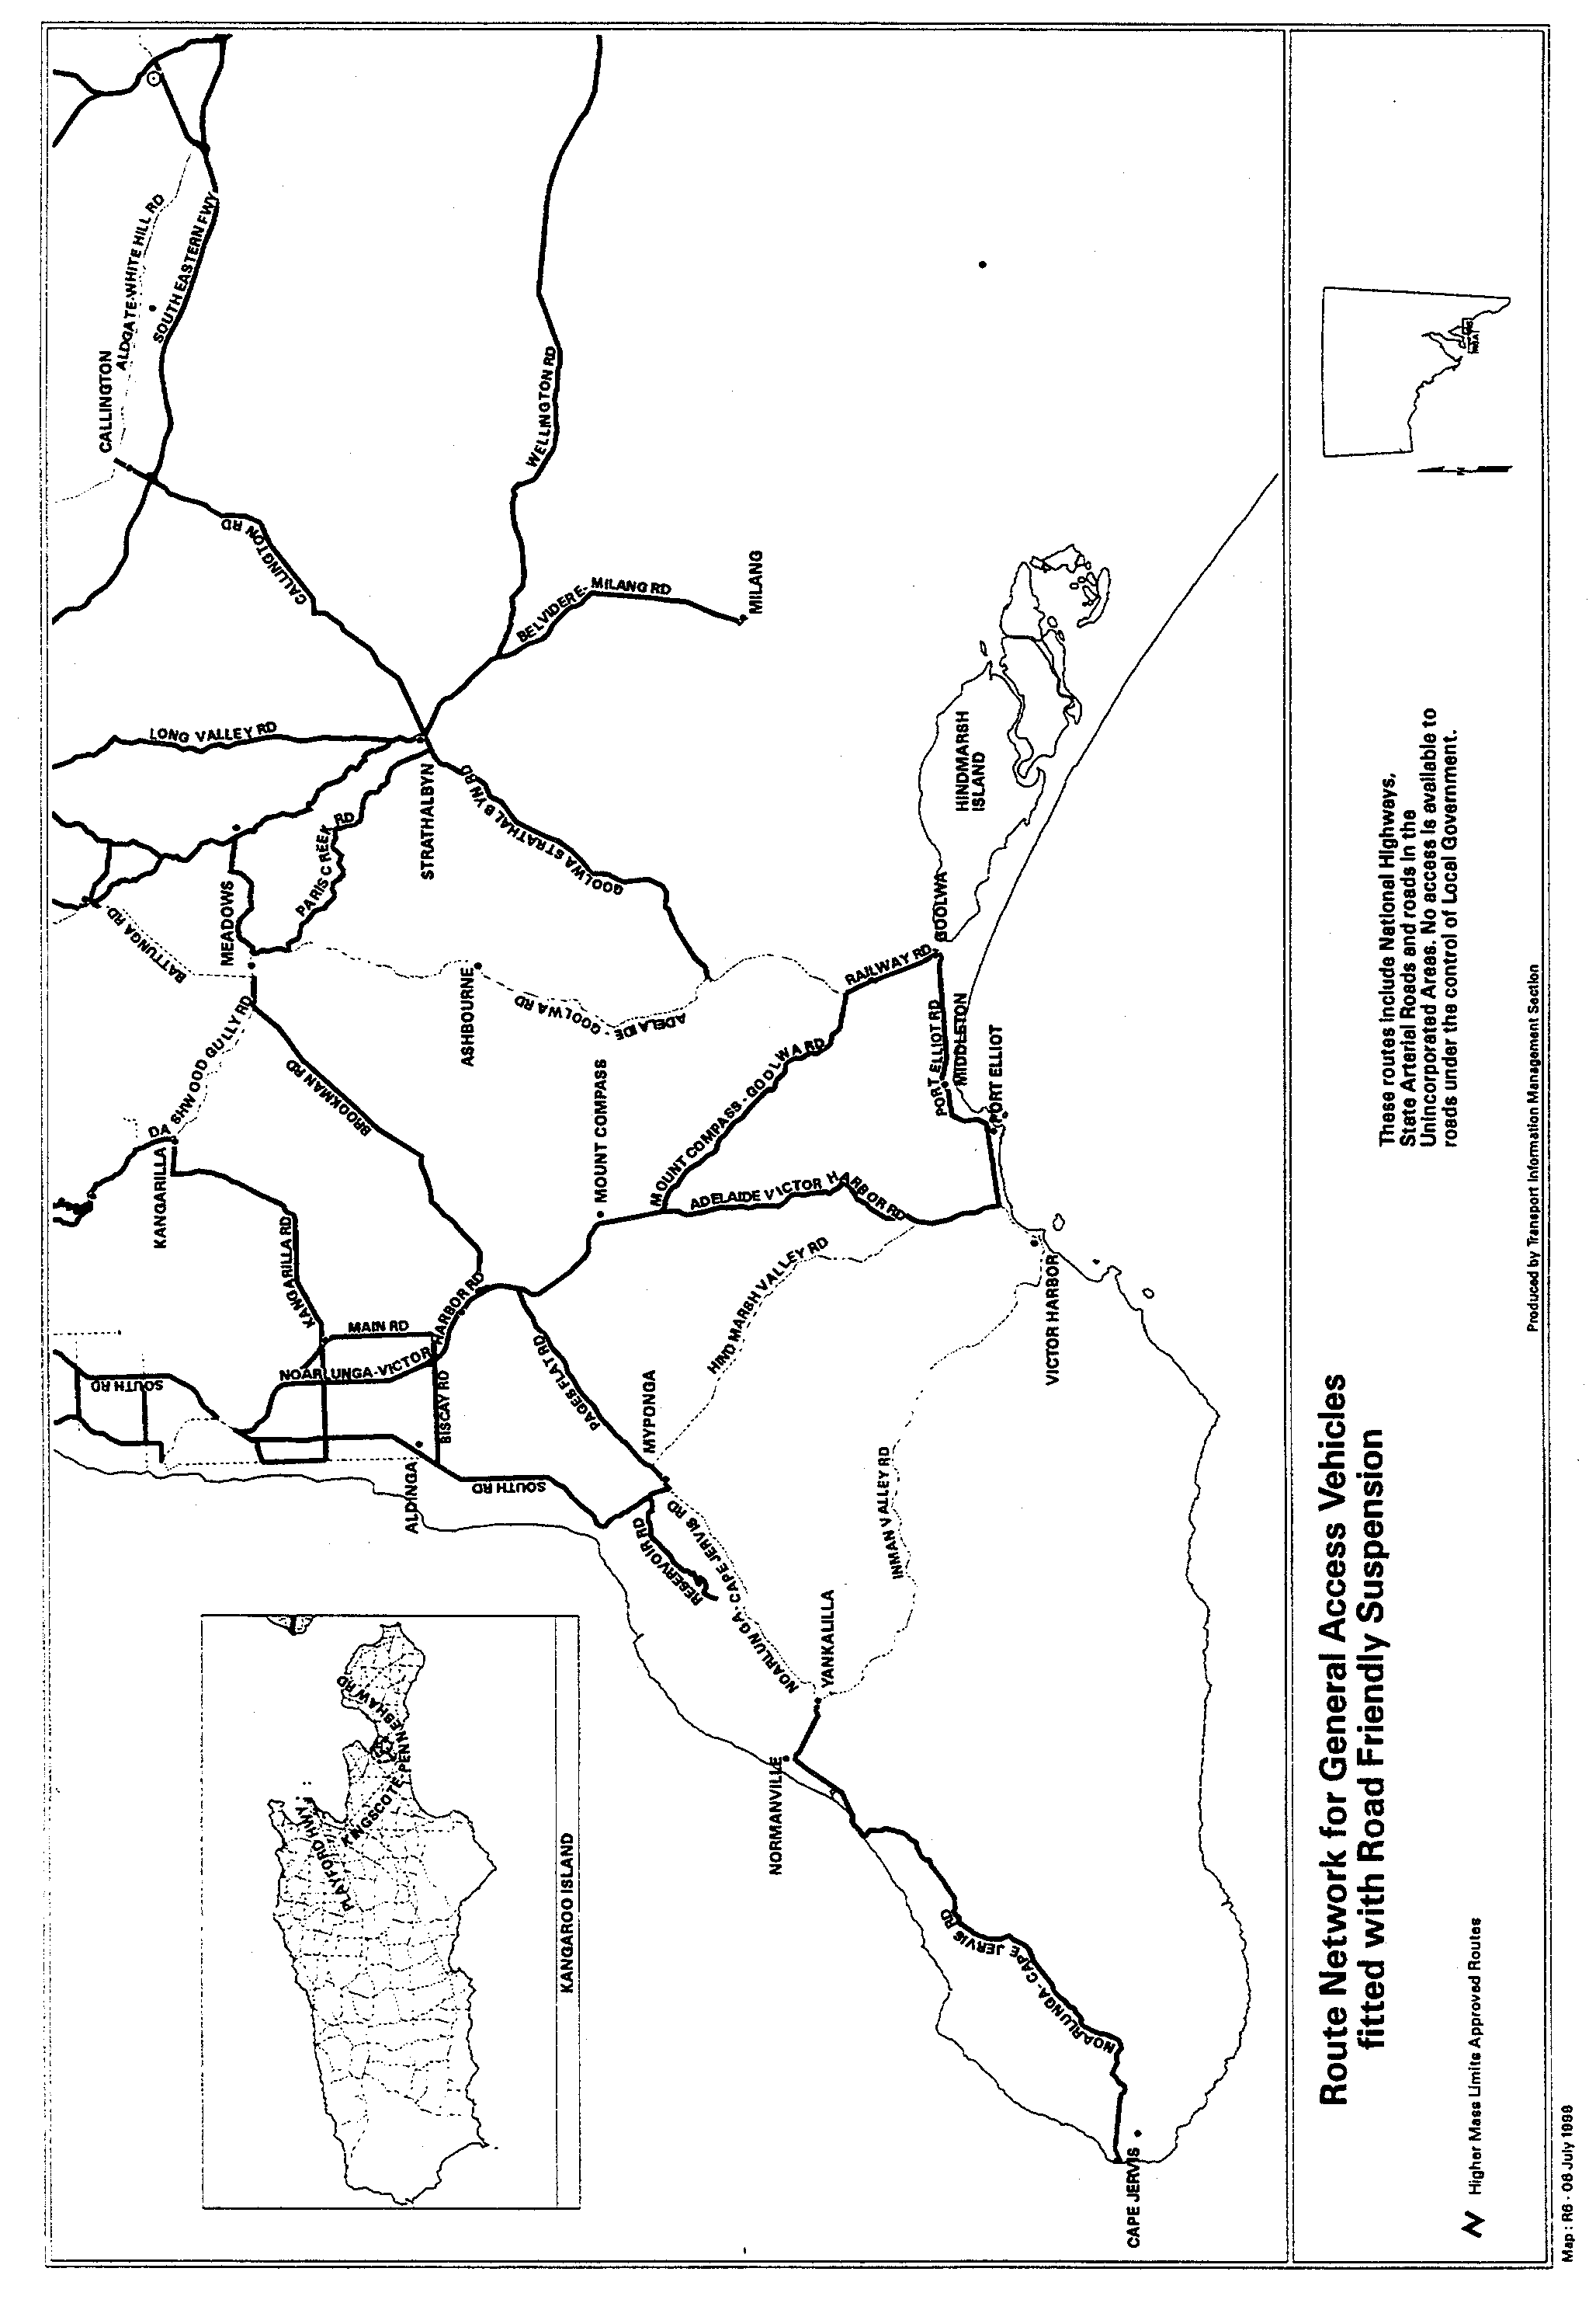
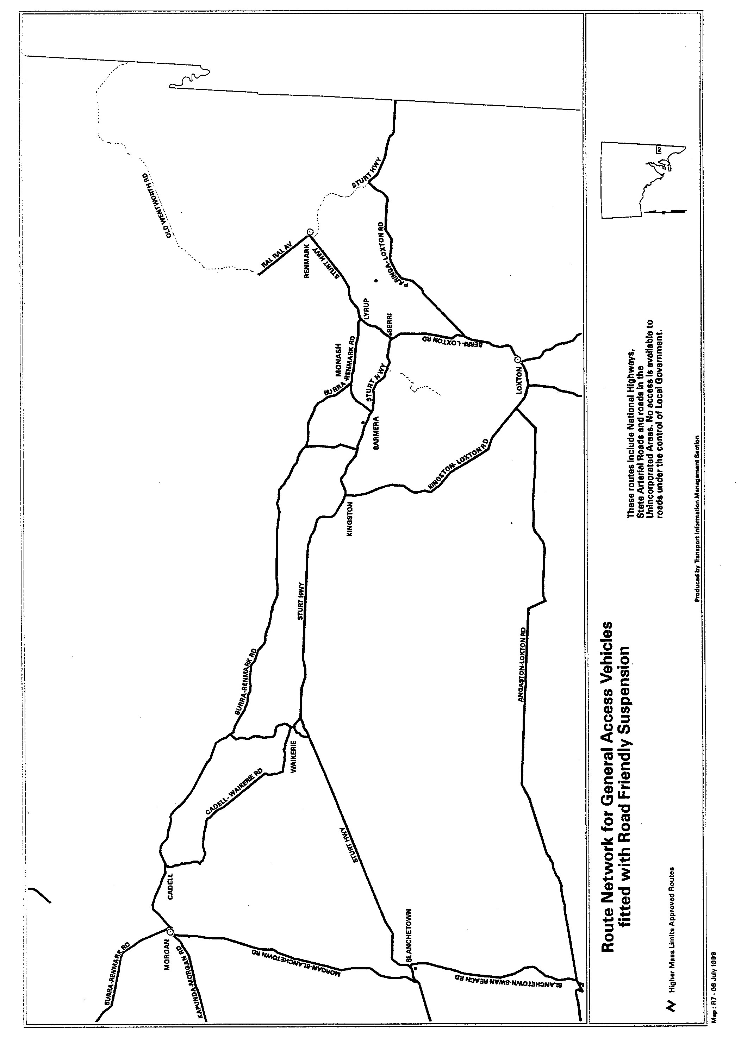
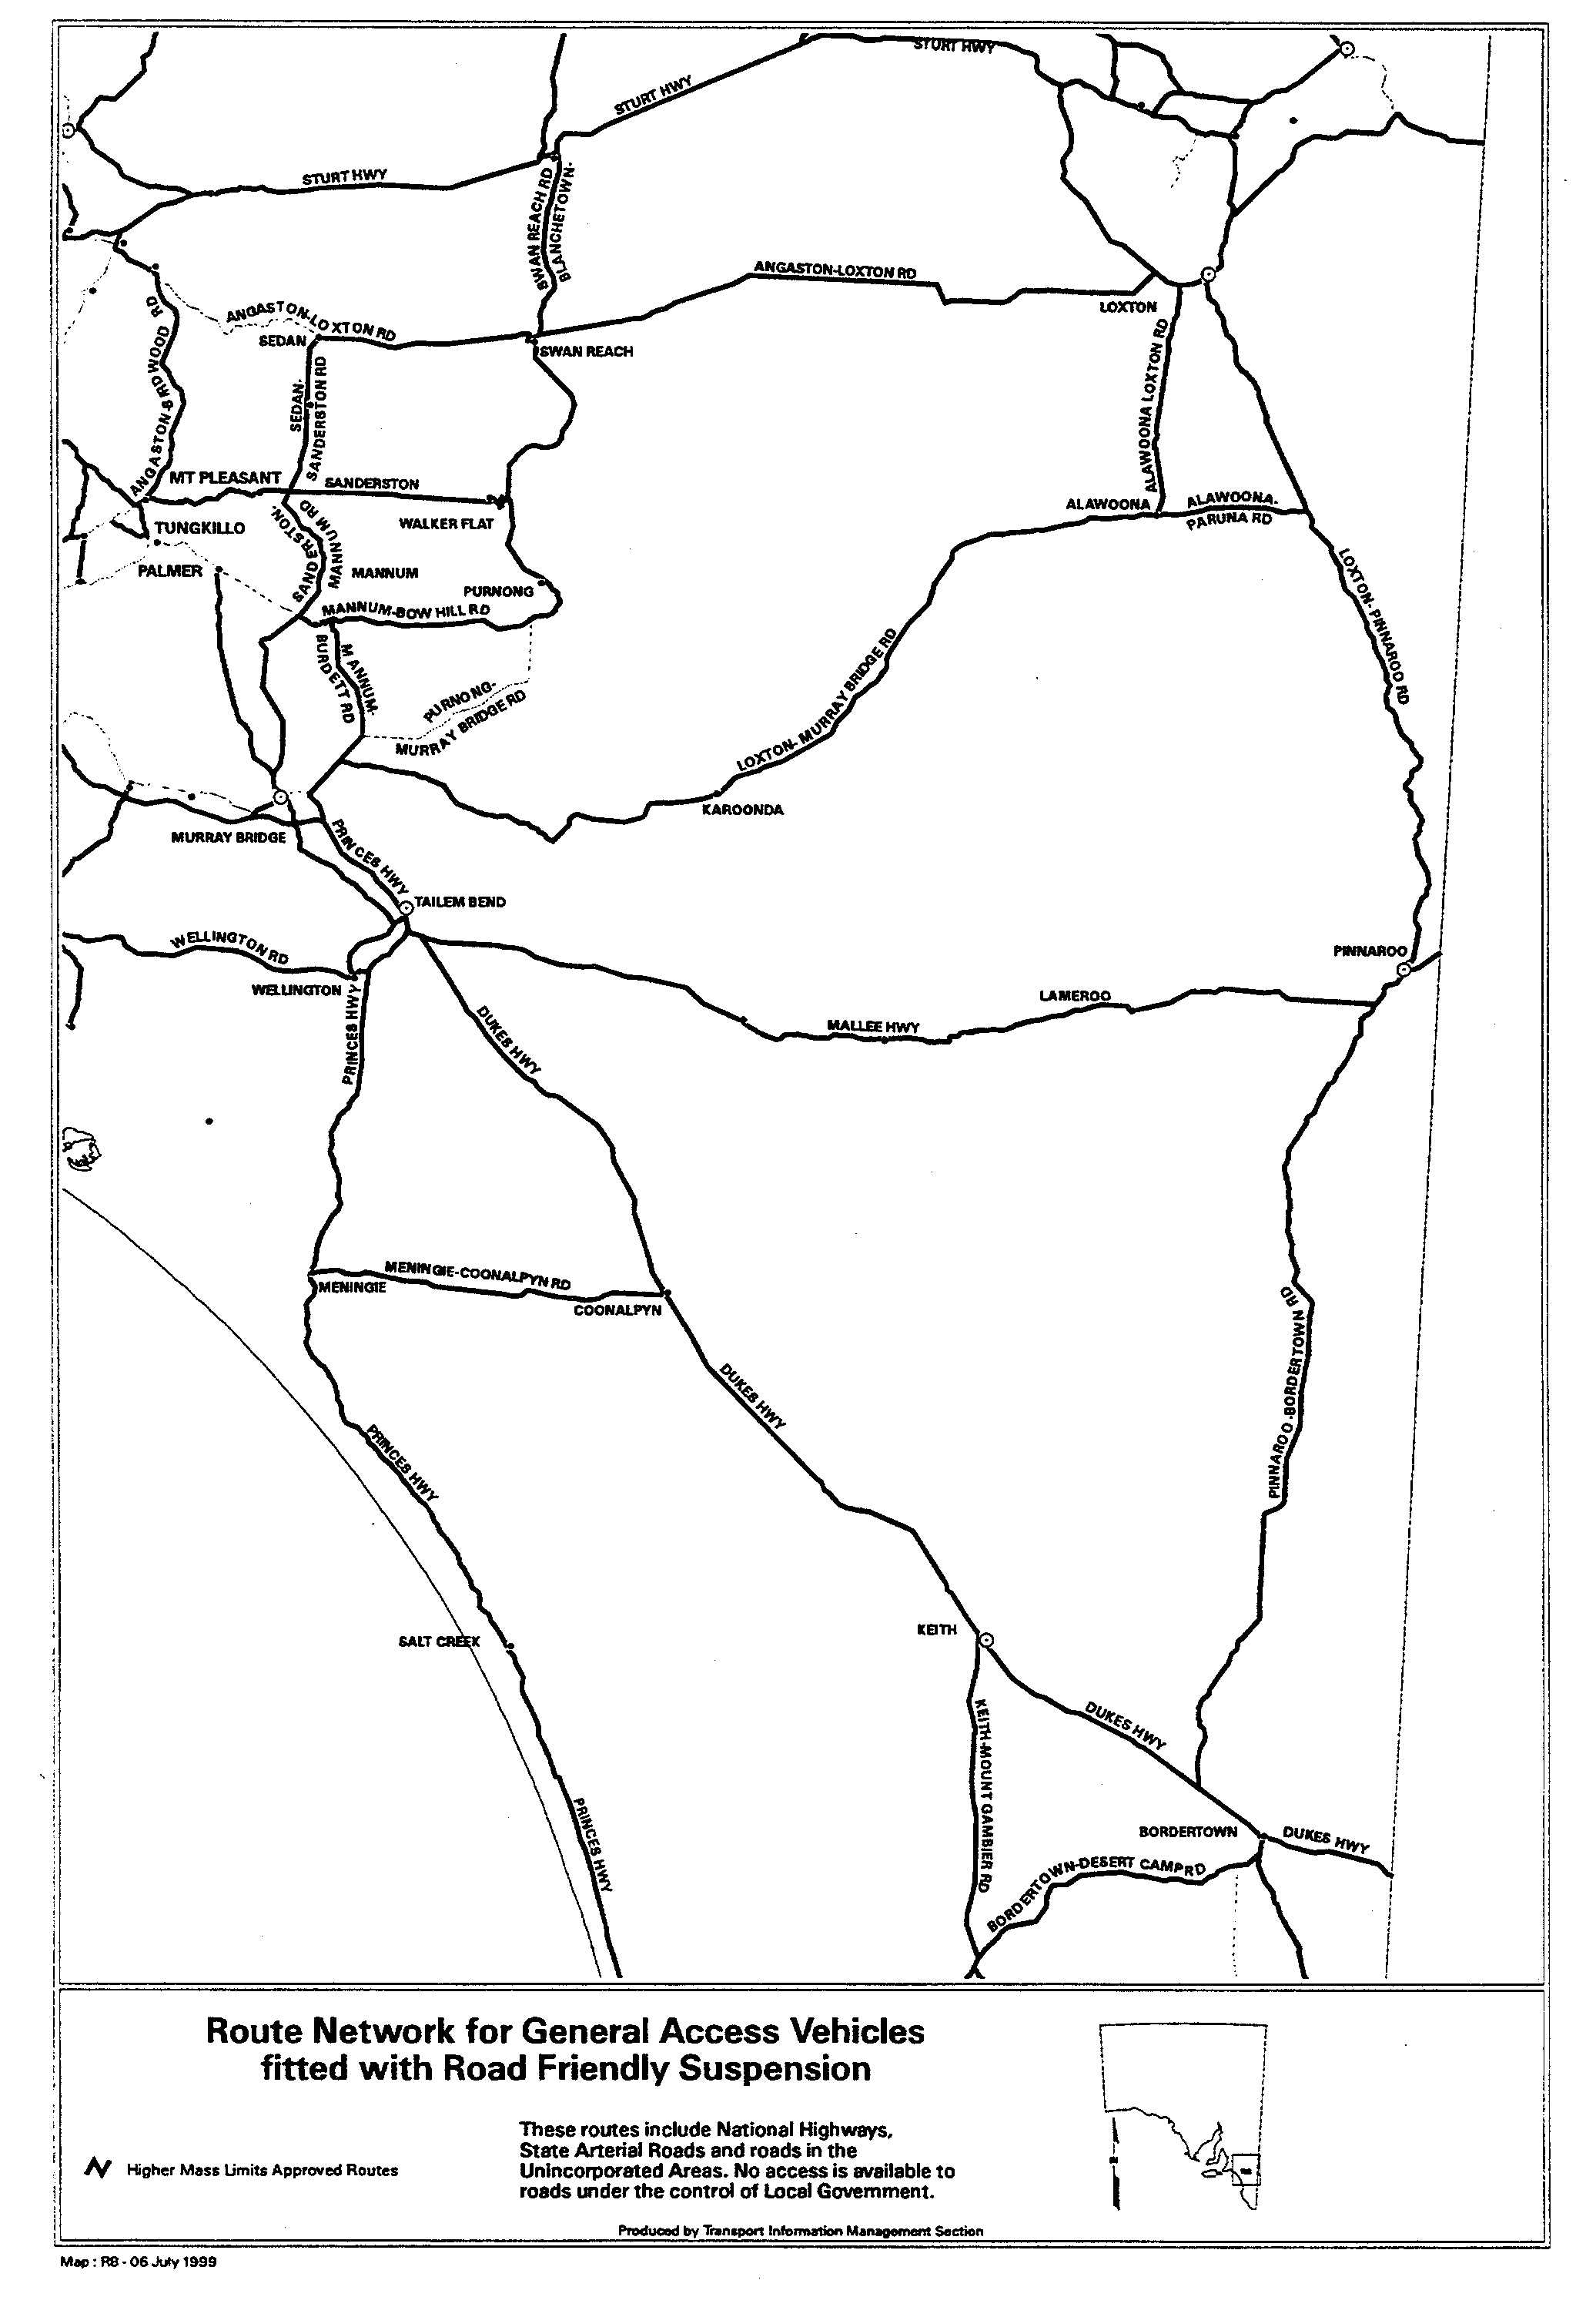
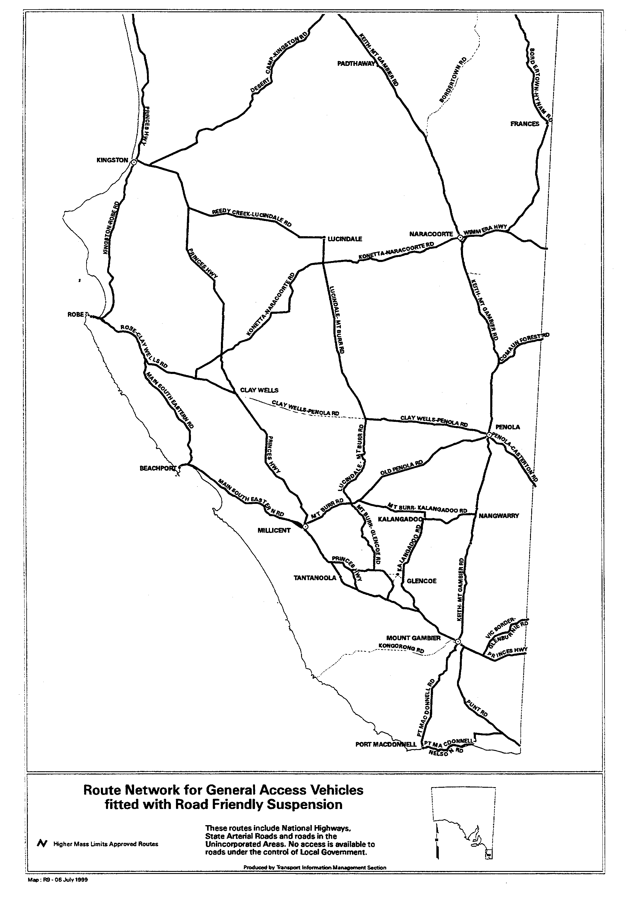
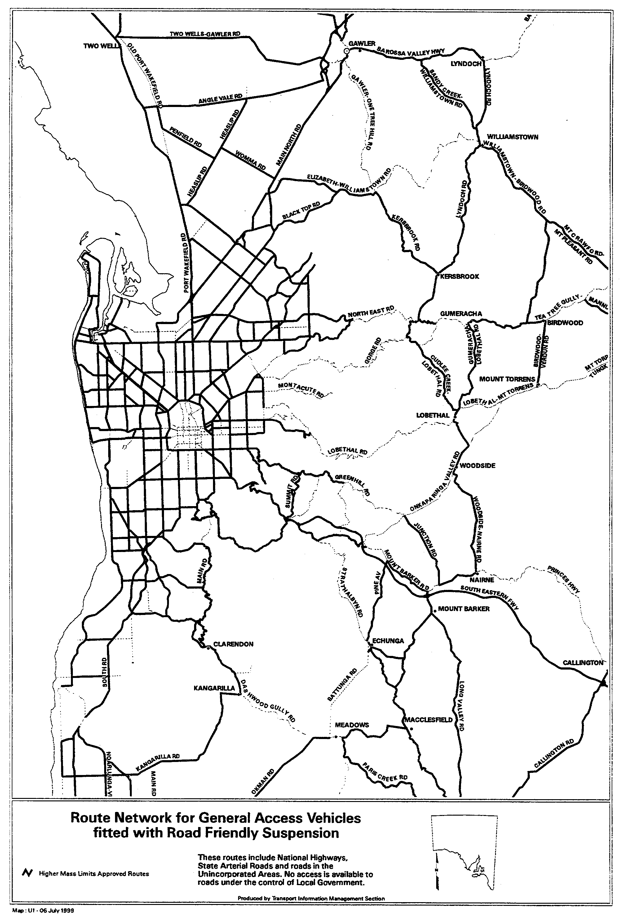
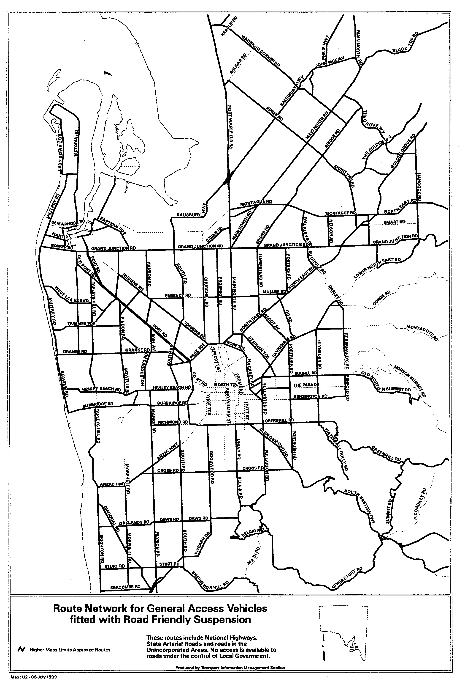
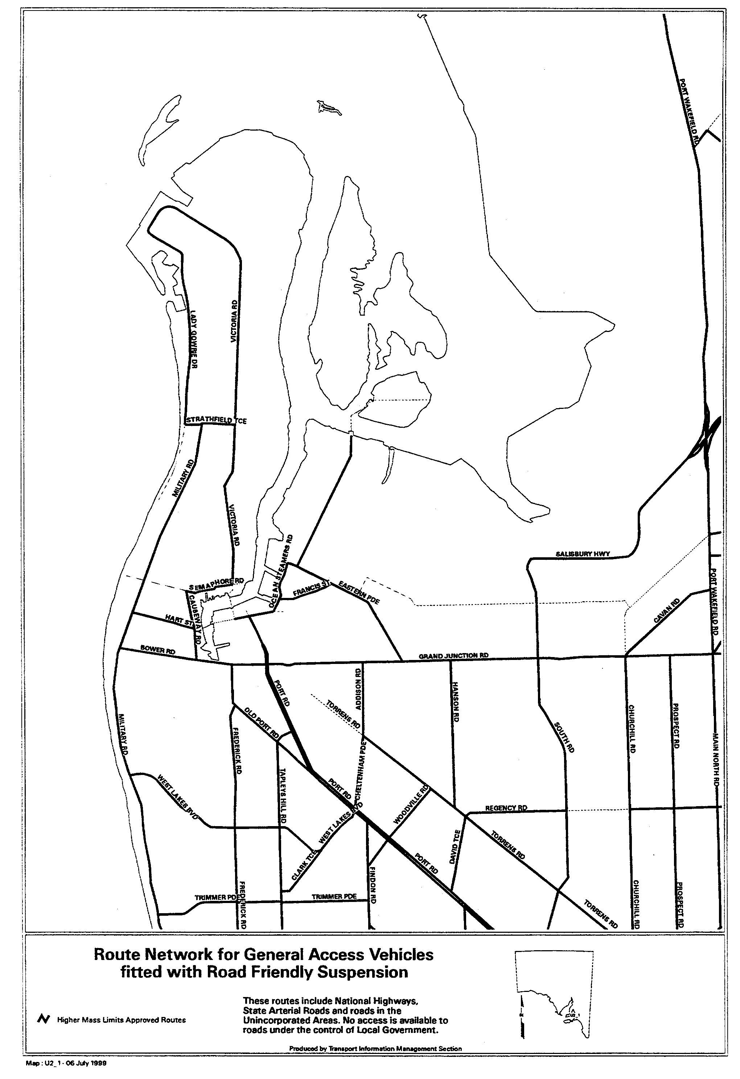
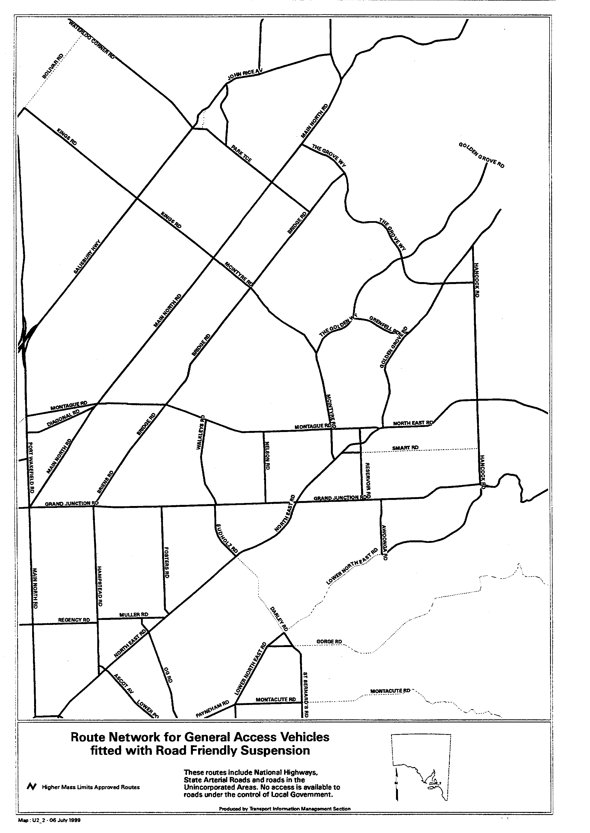
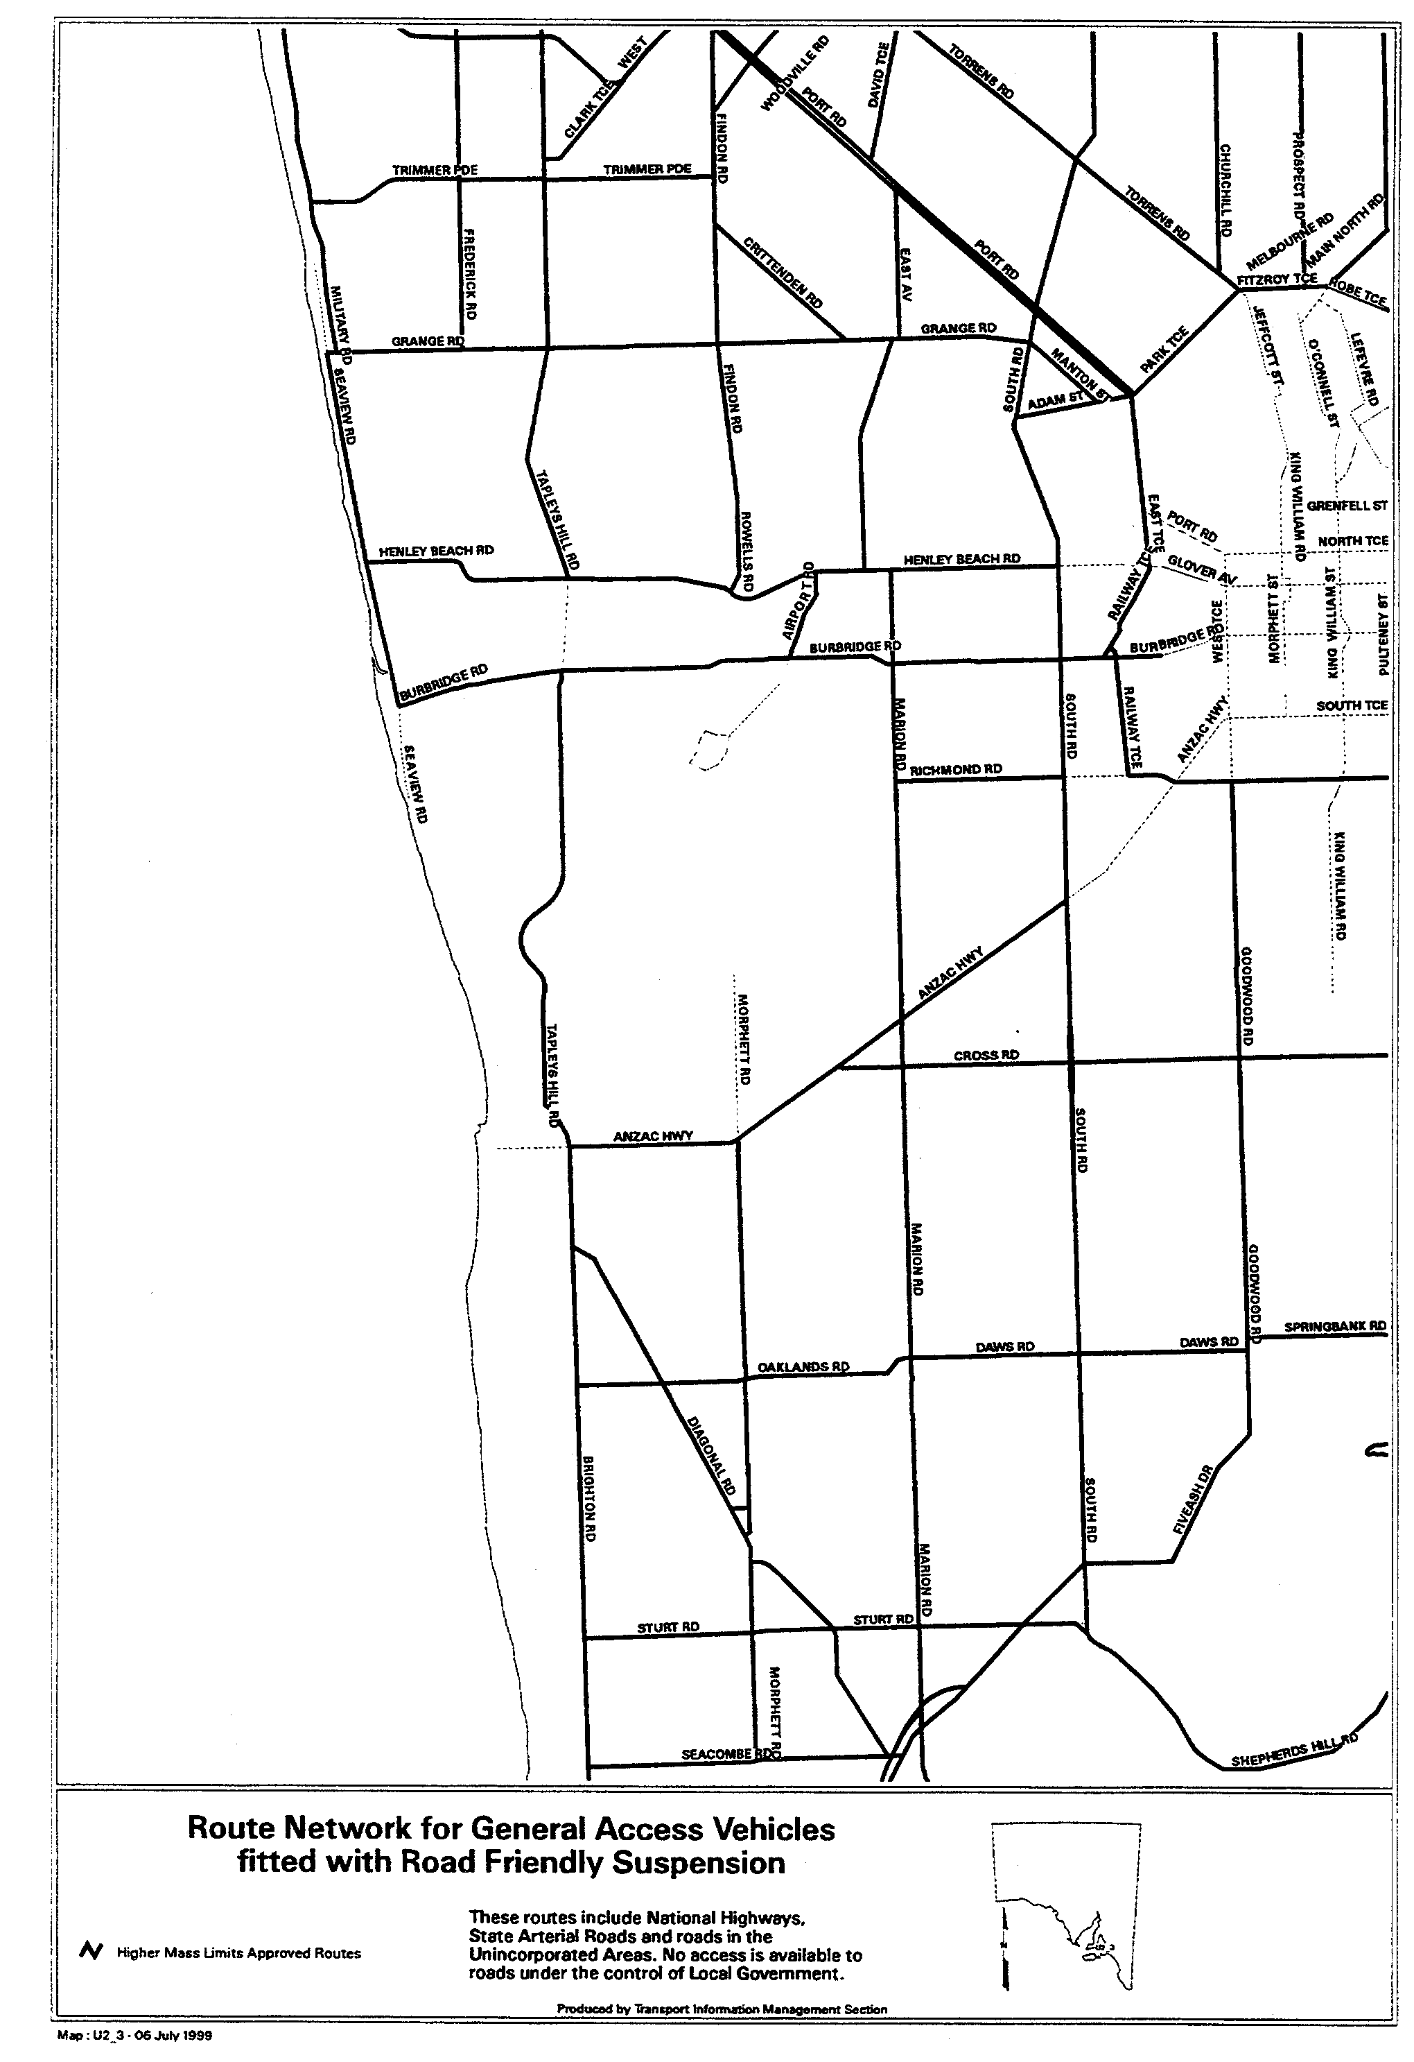
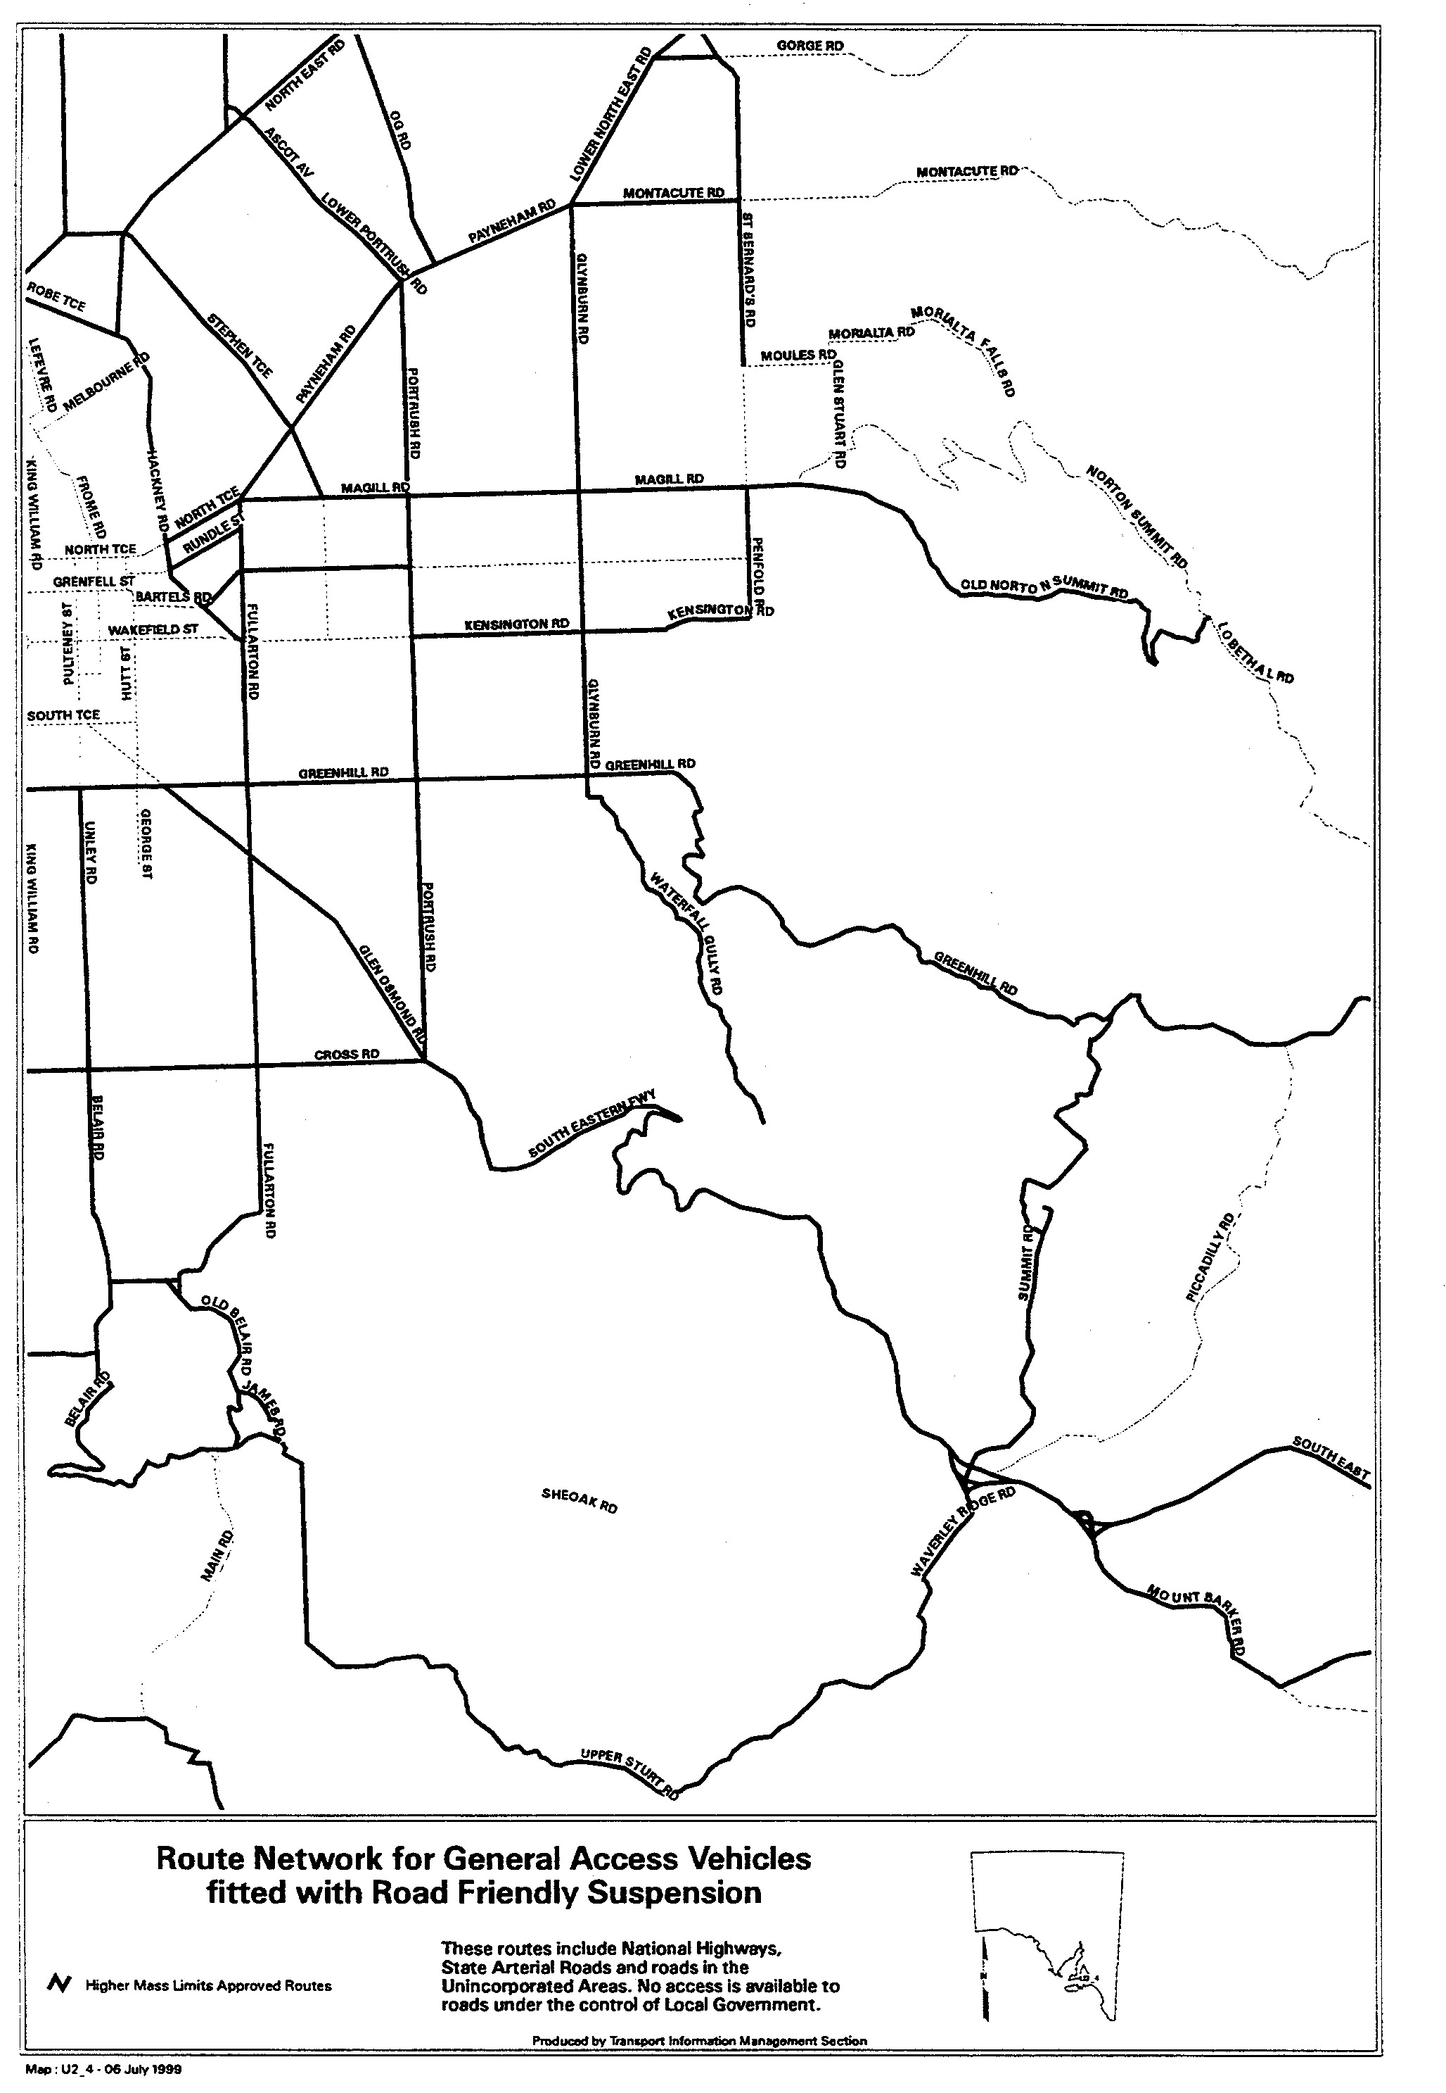
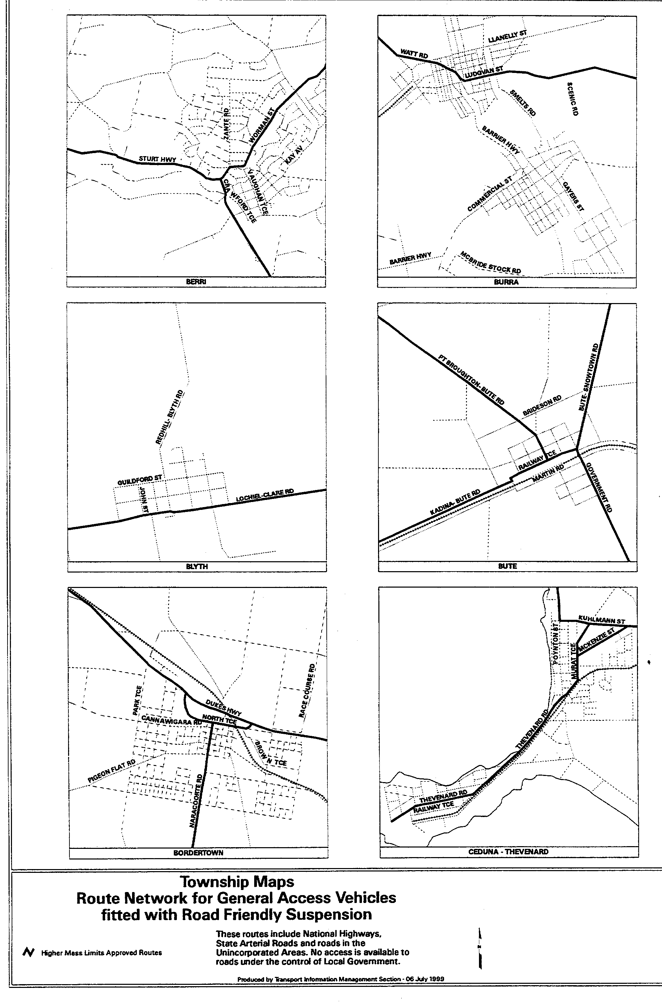
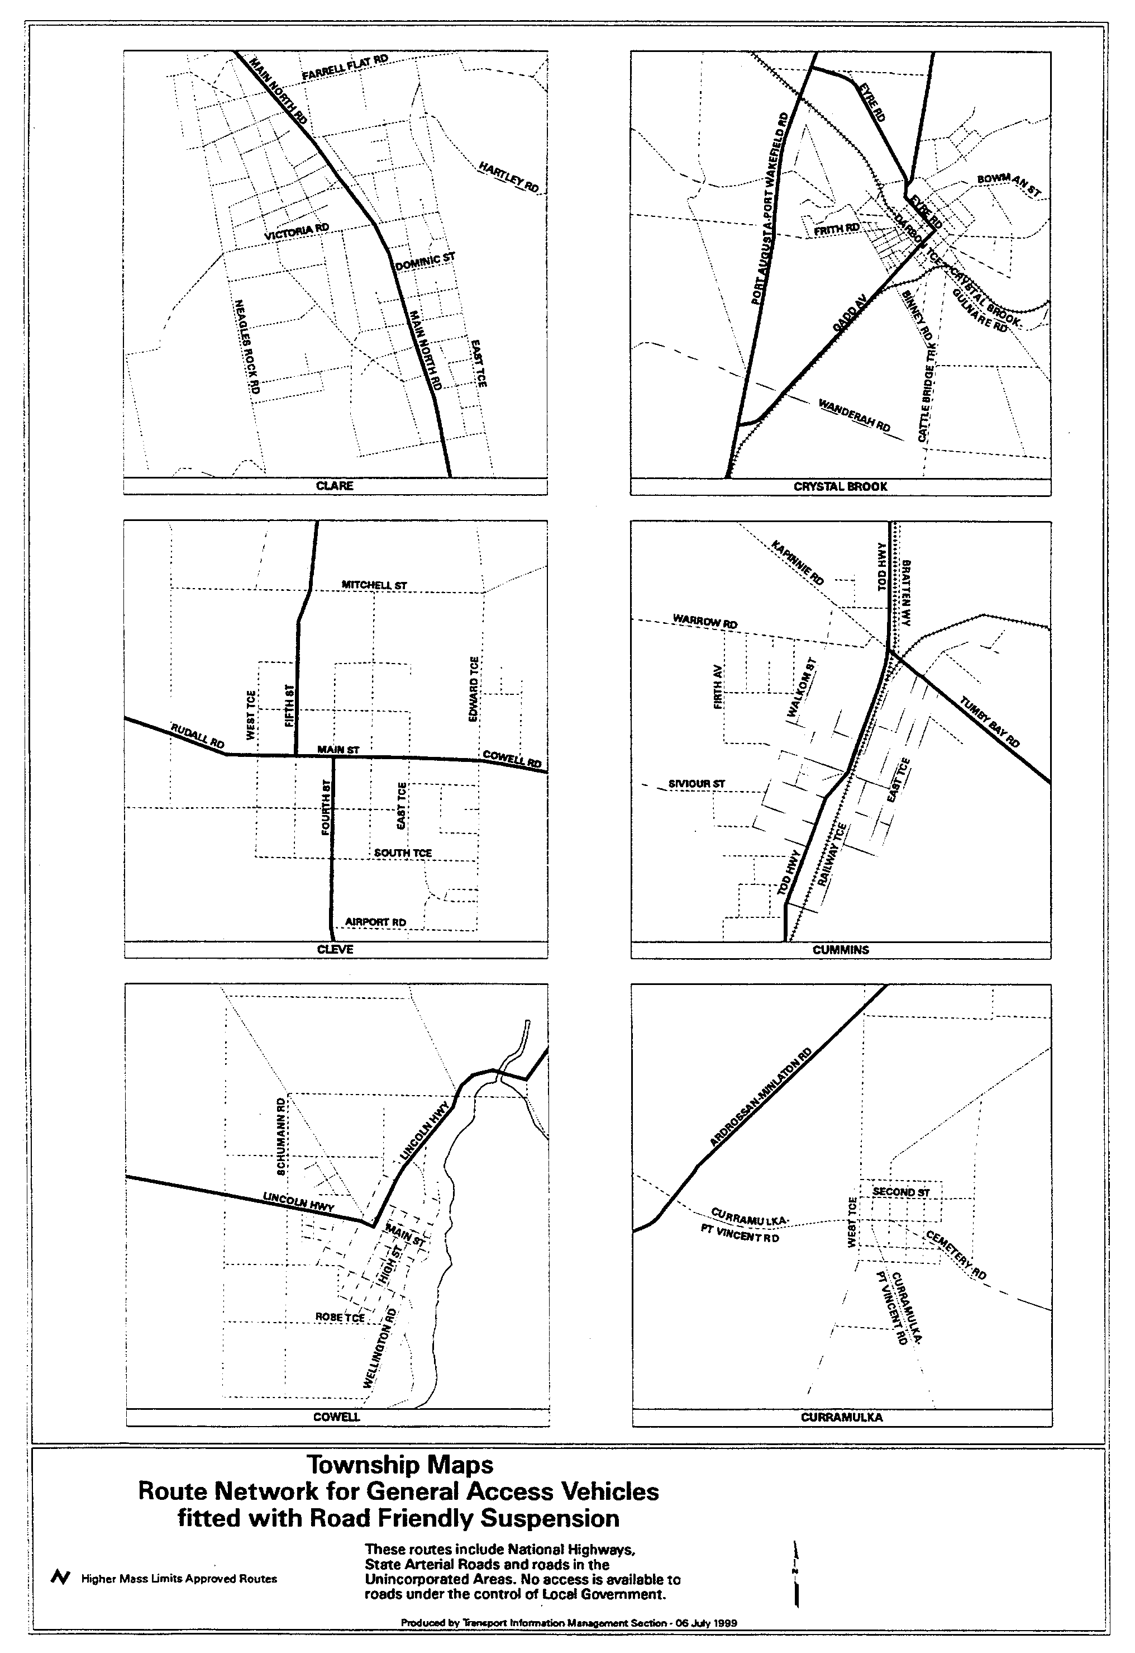
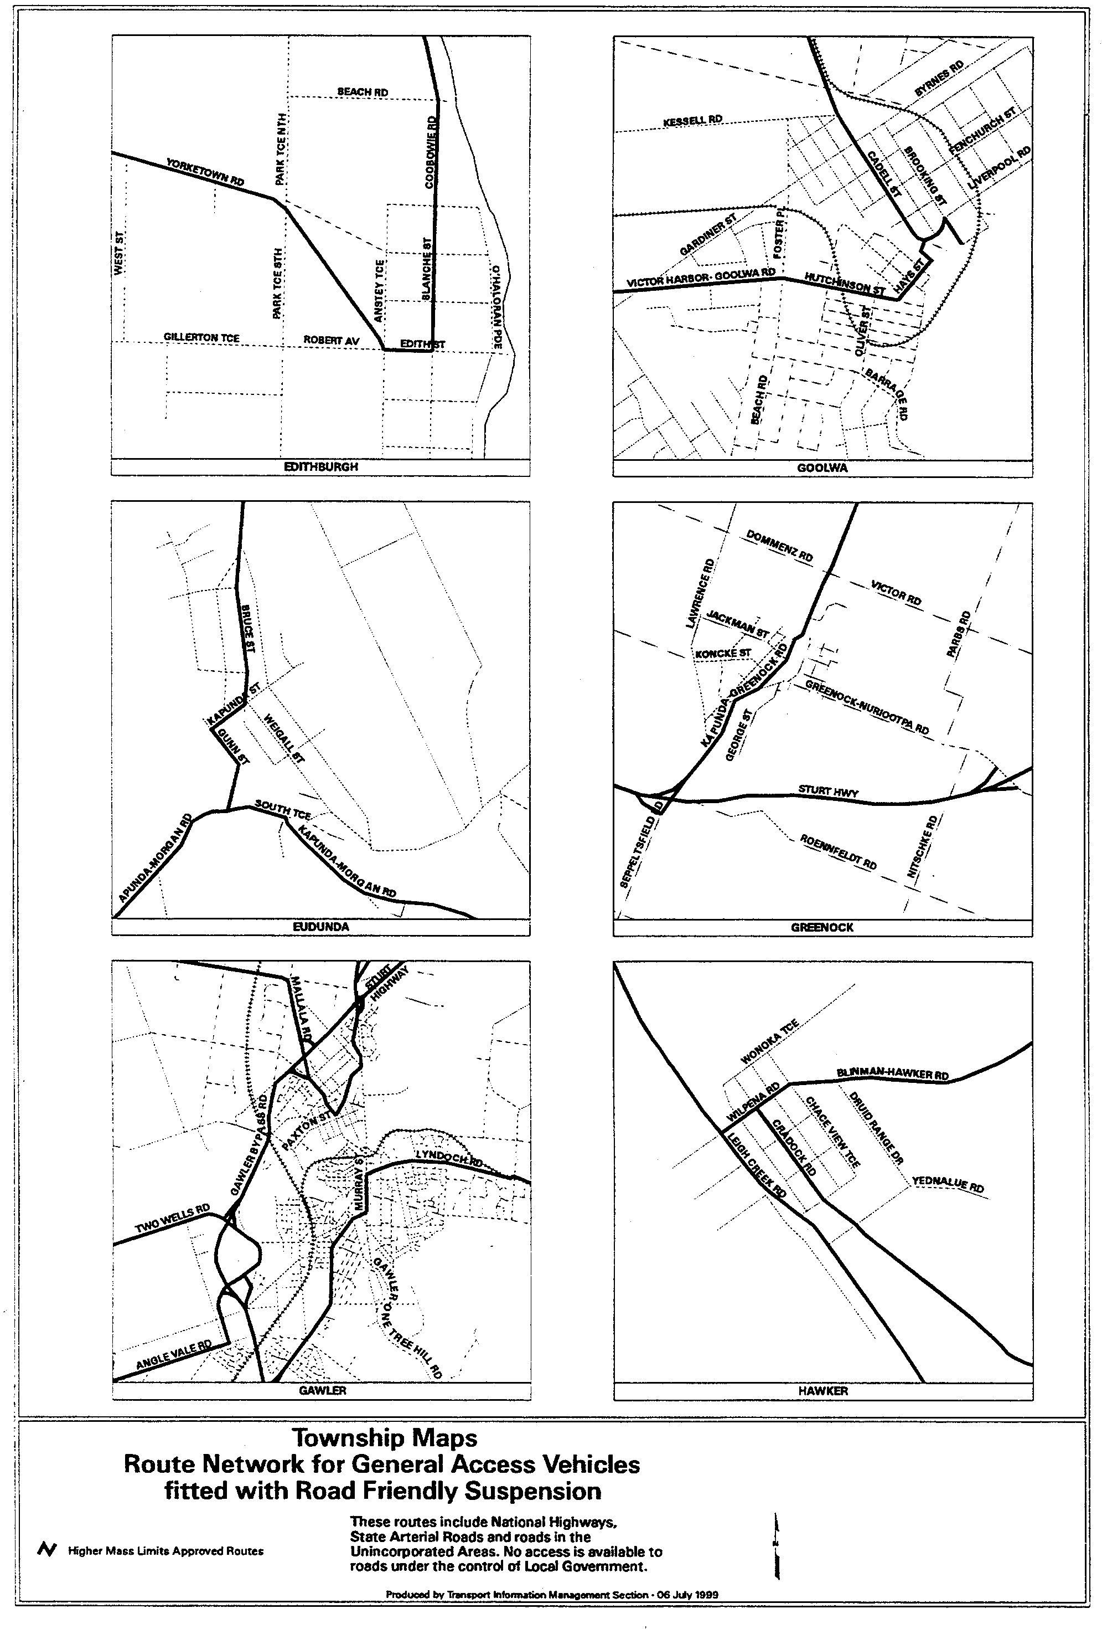
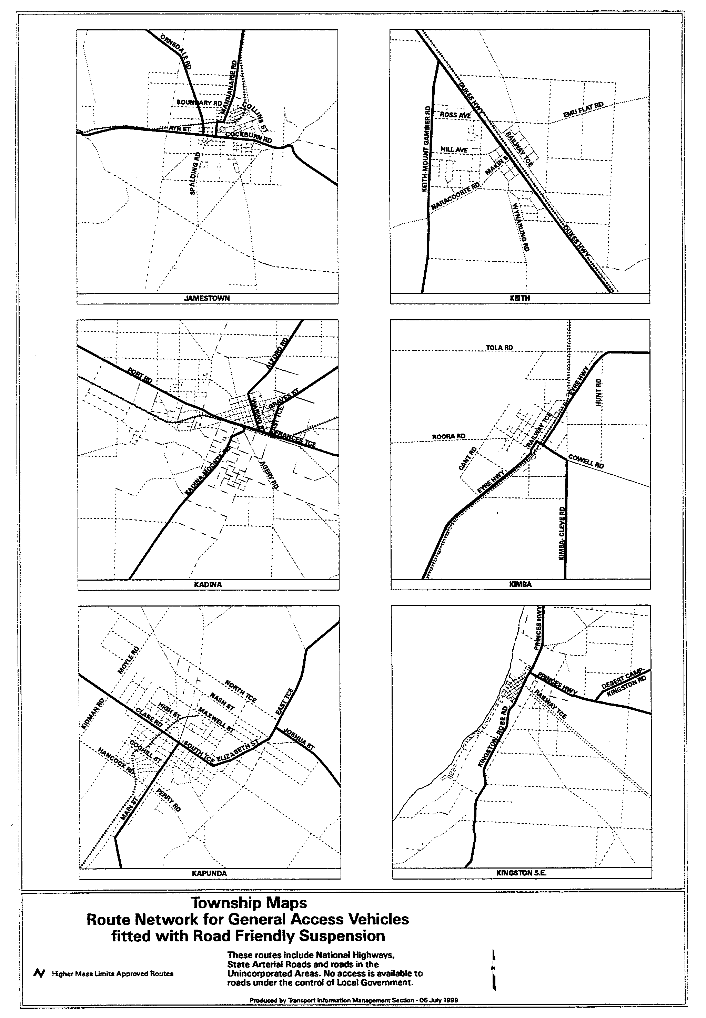
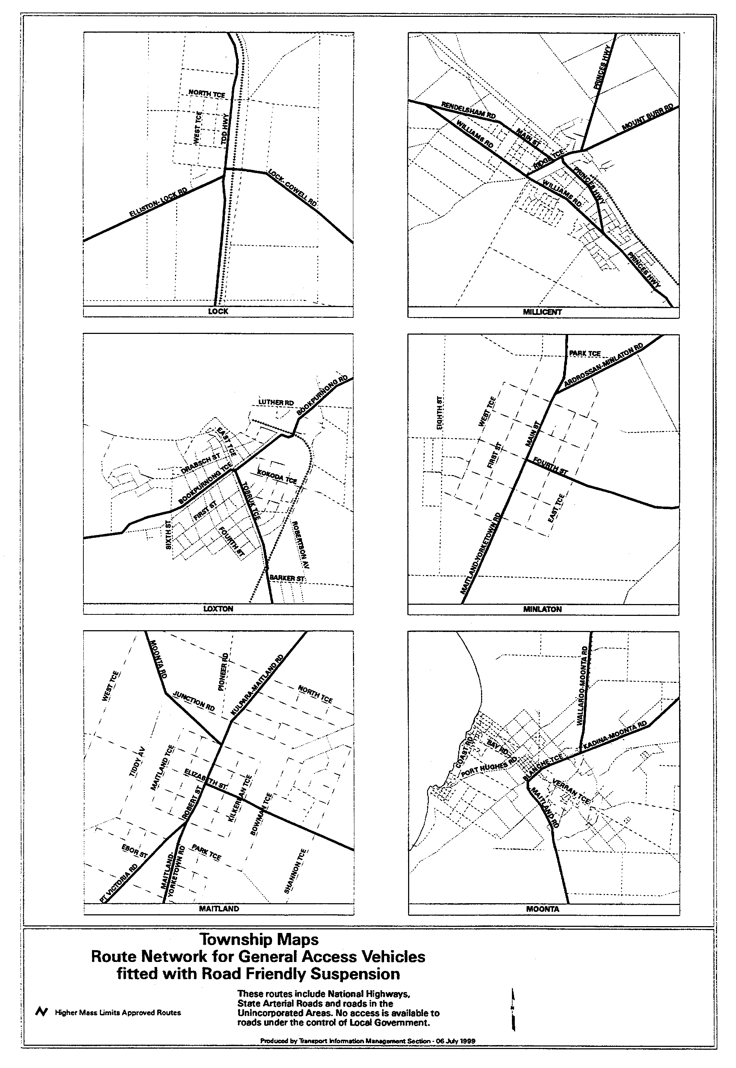
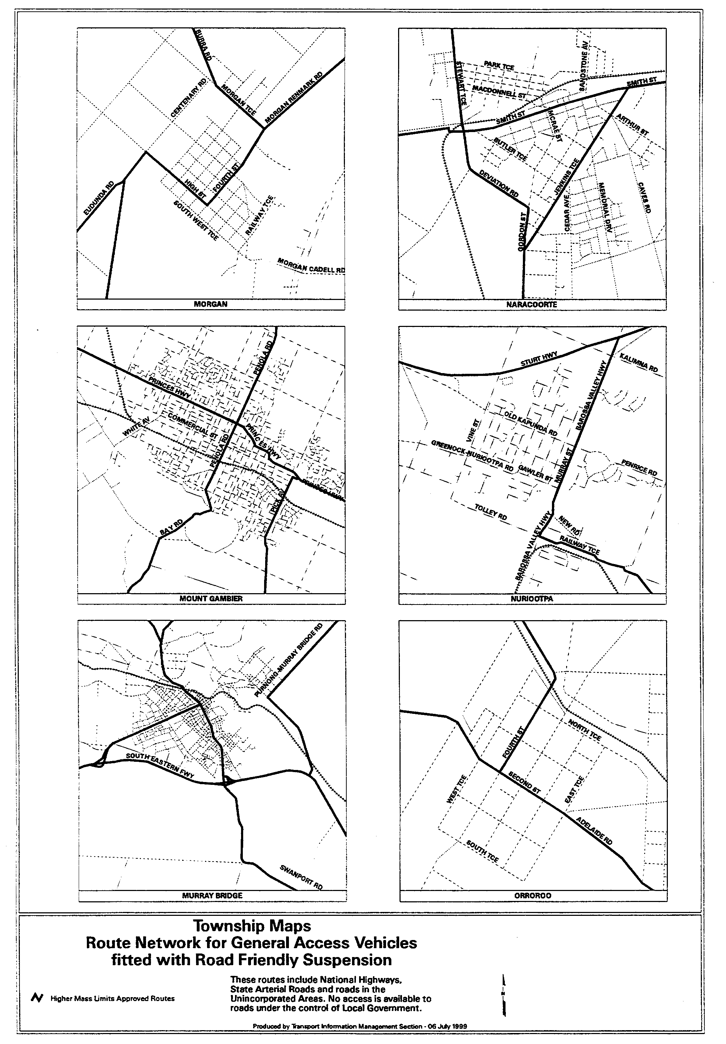
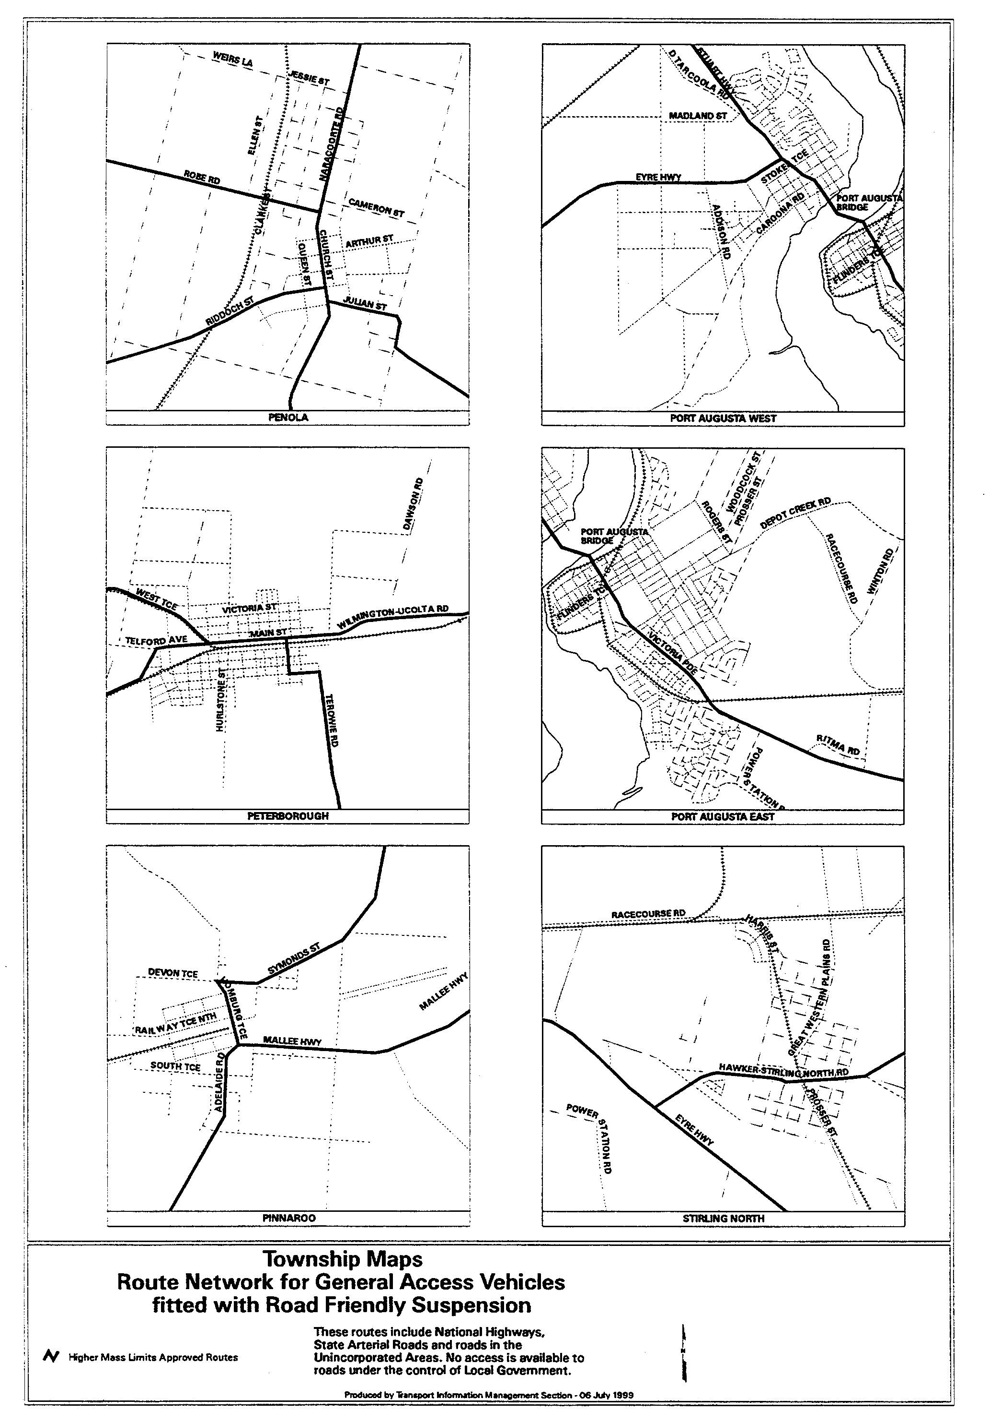
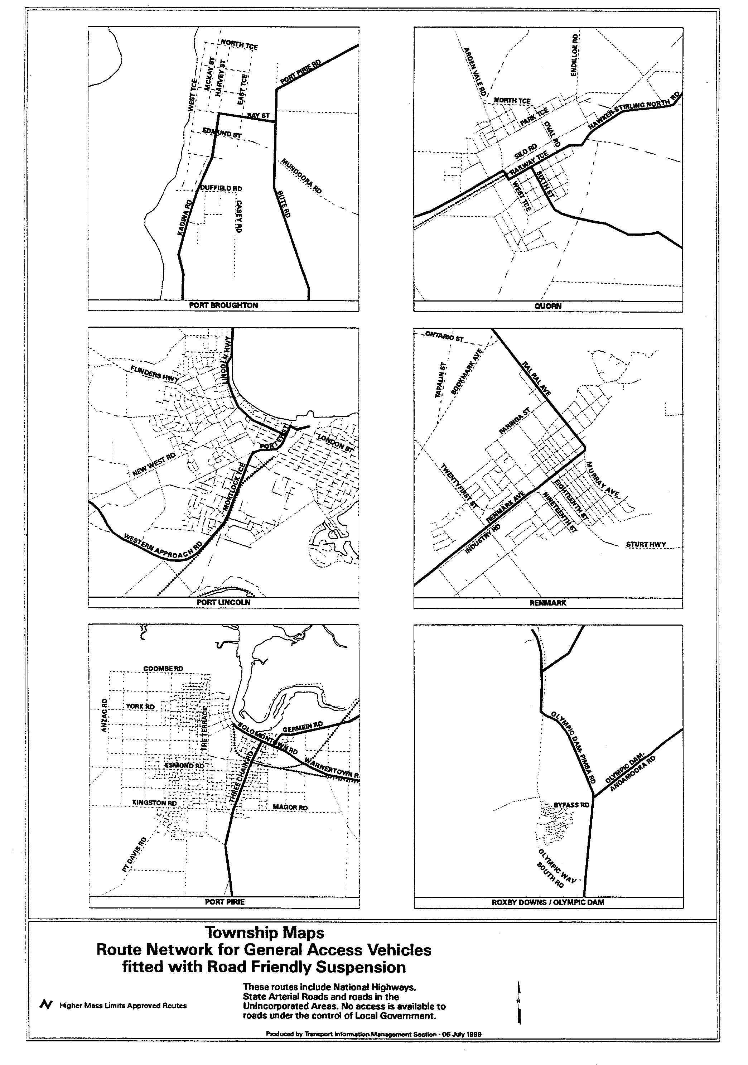

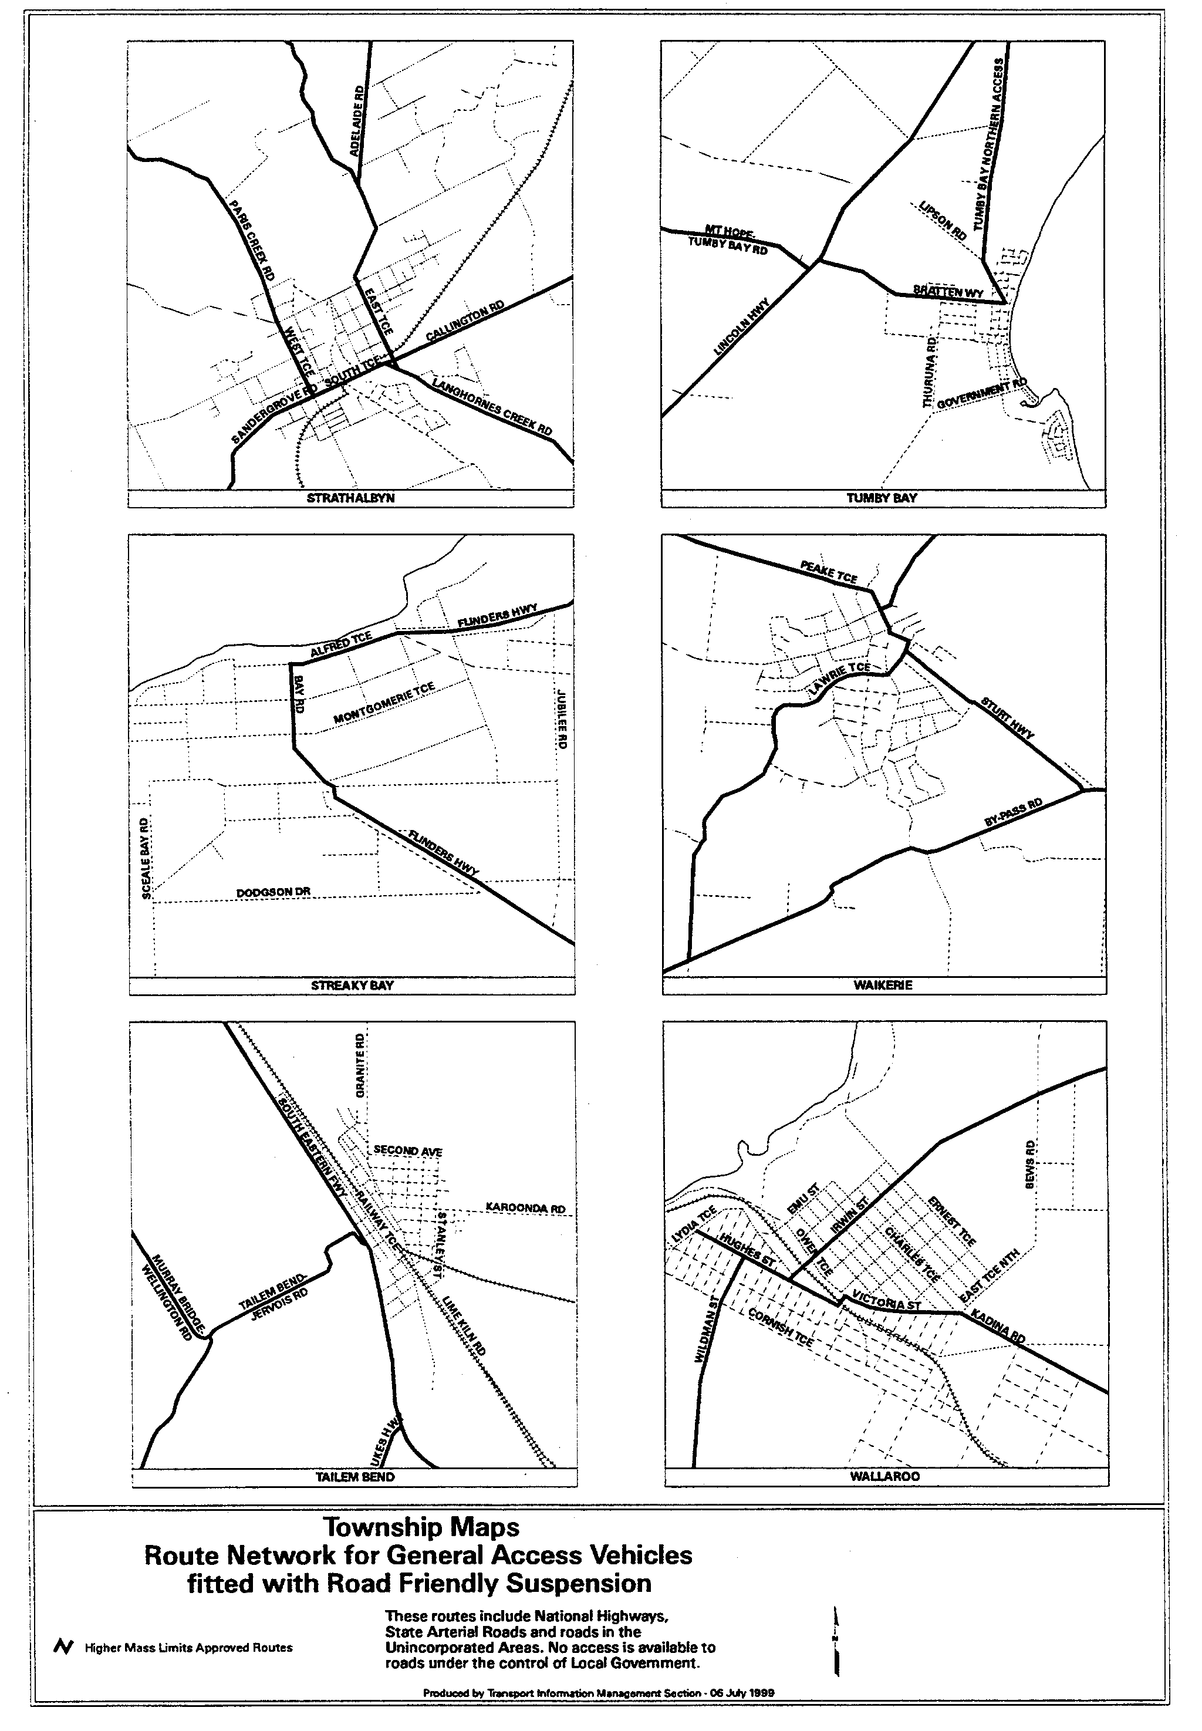
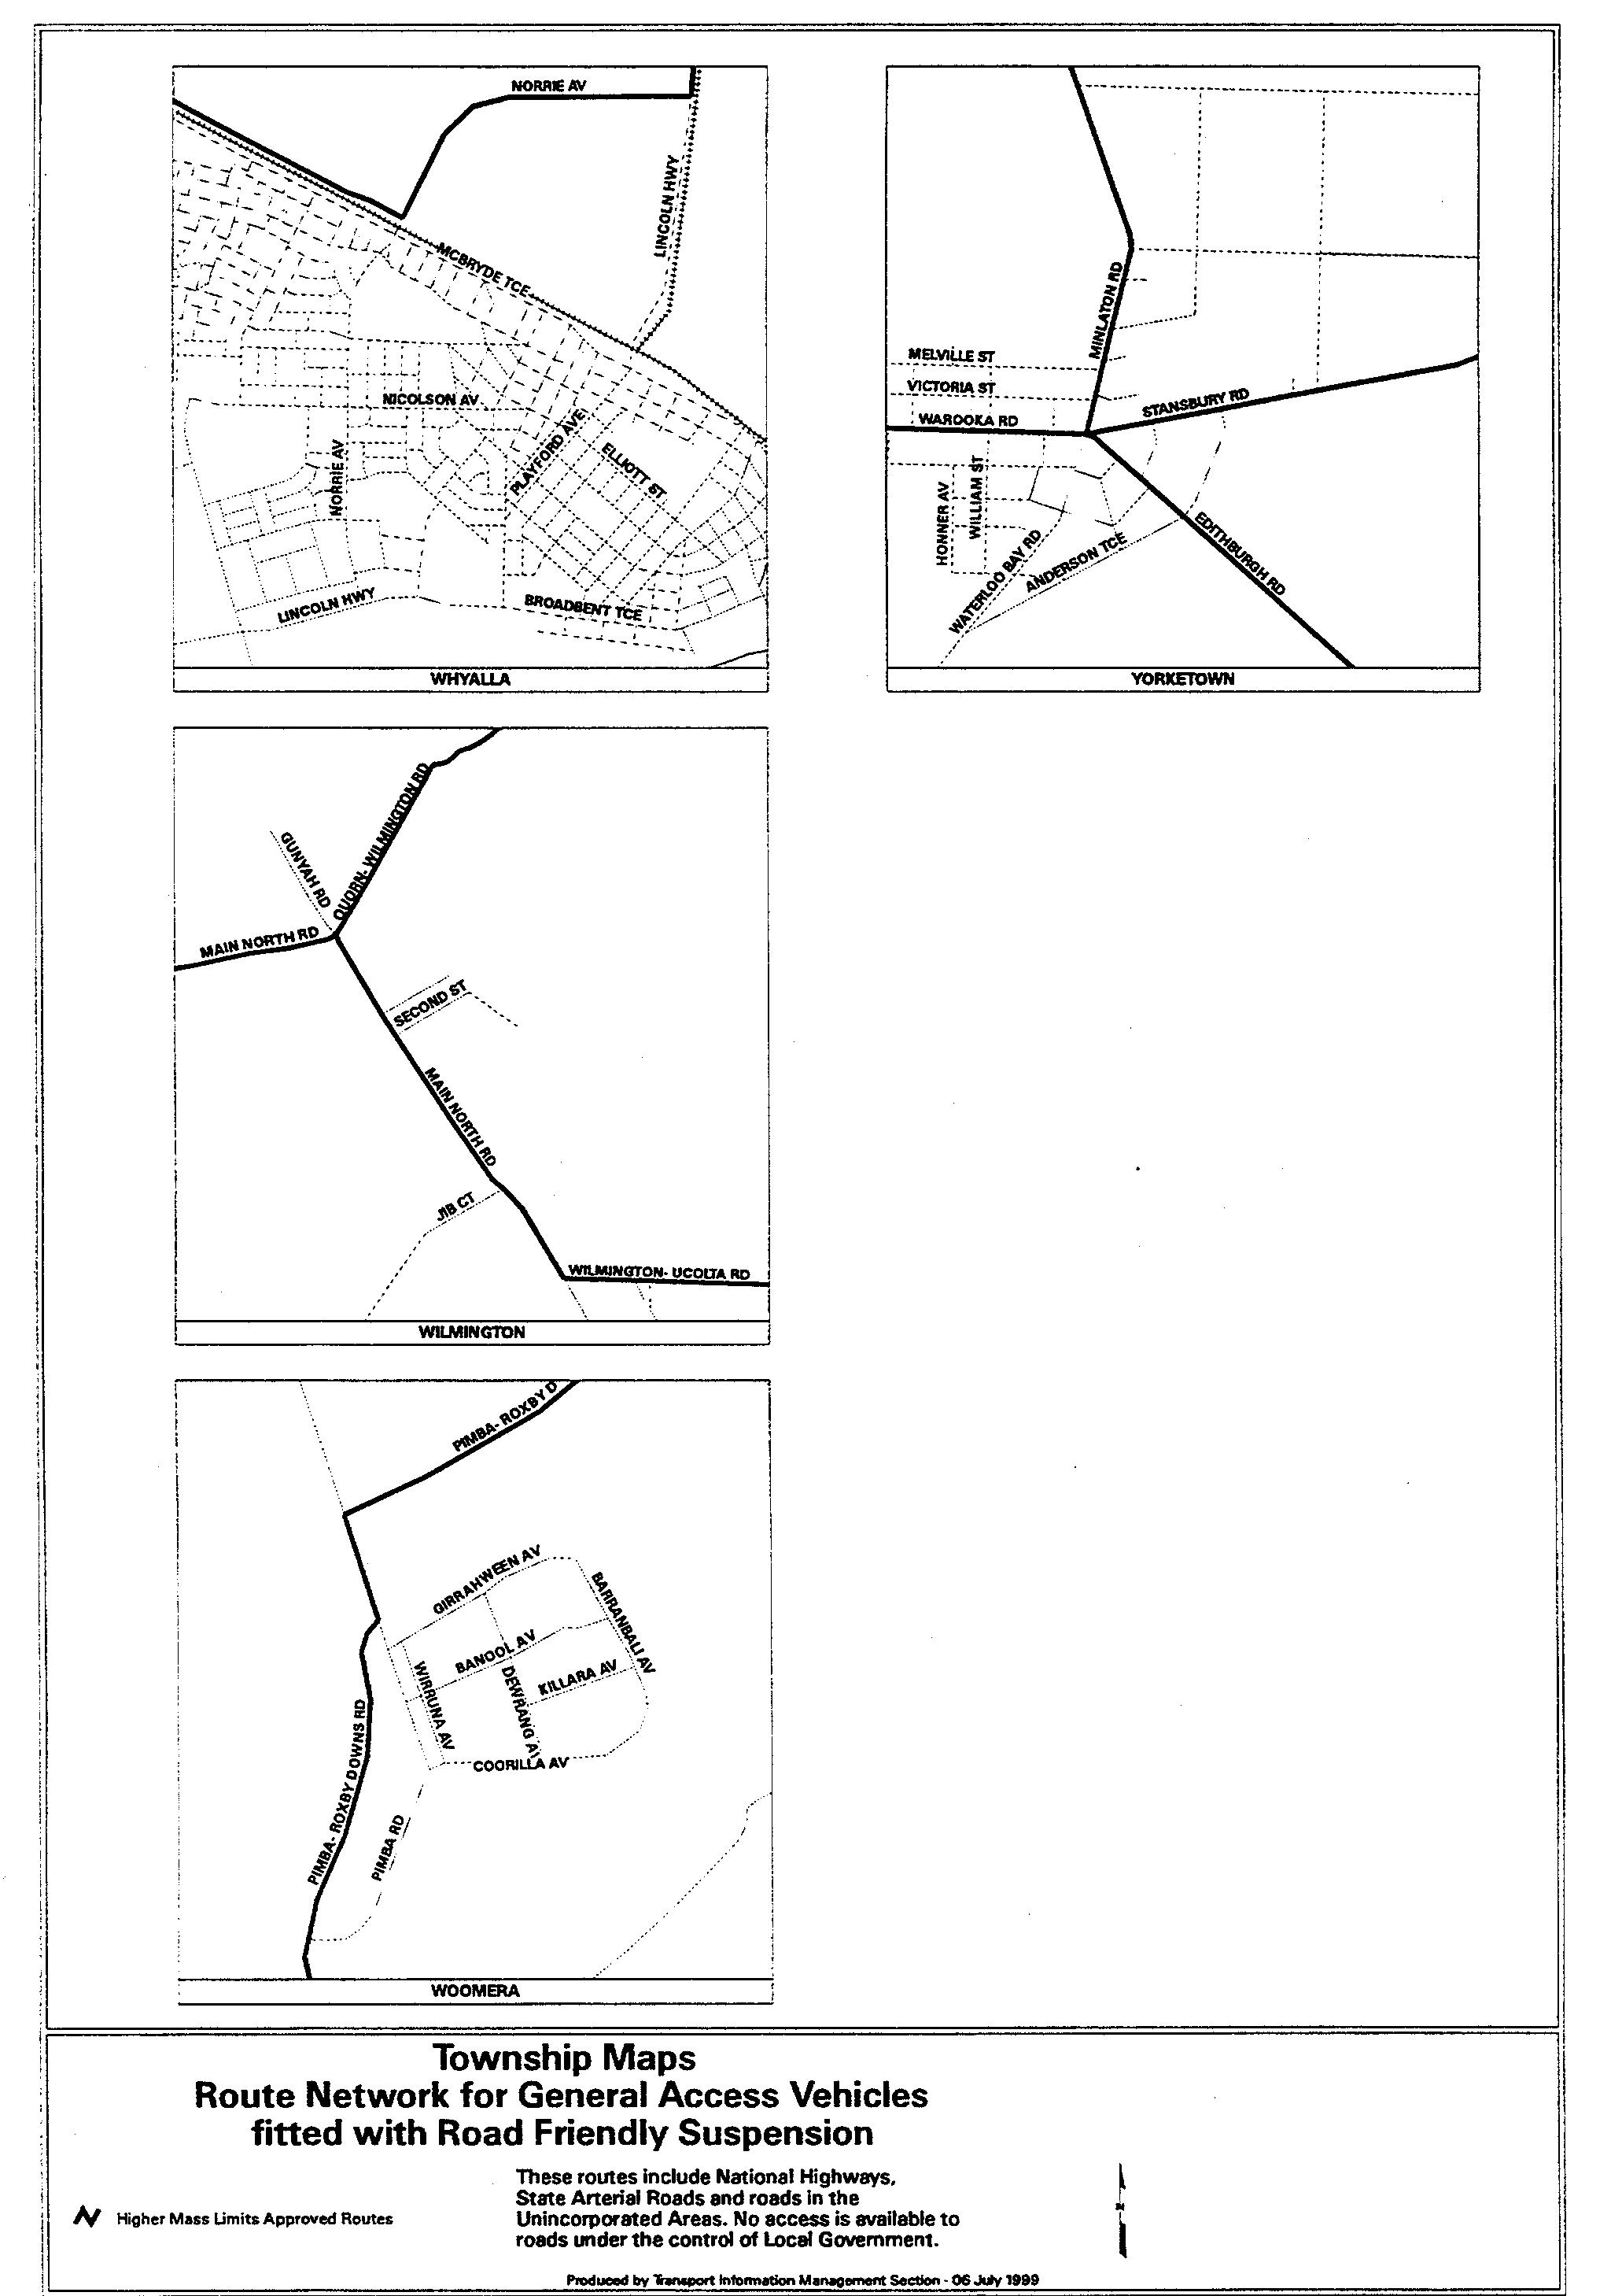
T. N. Argent, Delegate of the Minister for Transport and Urban Planning.

RULES OF COURT
Magistrates Court of South Australia
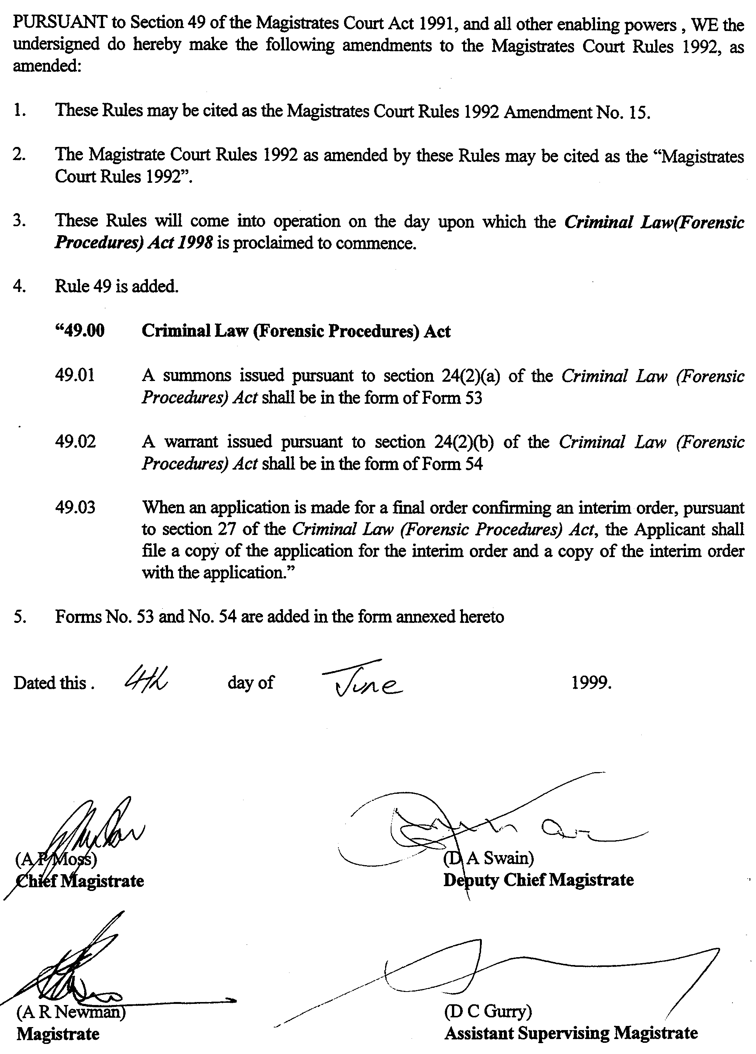
Amendment No. 15 to the Magistrates Court Rules

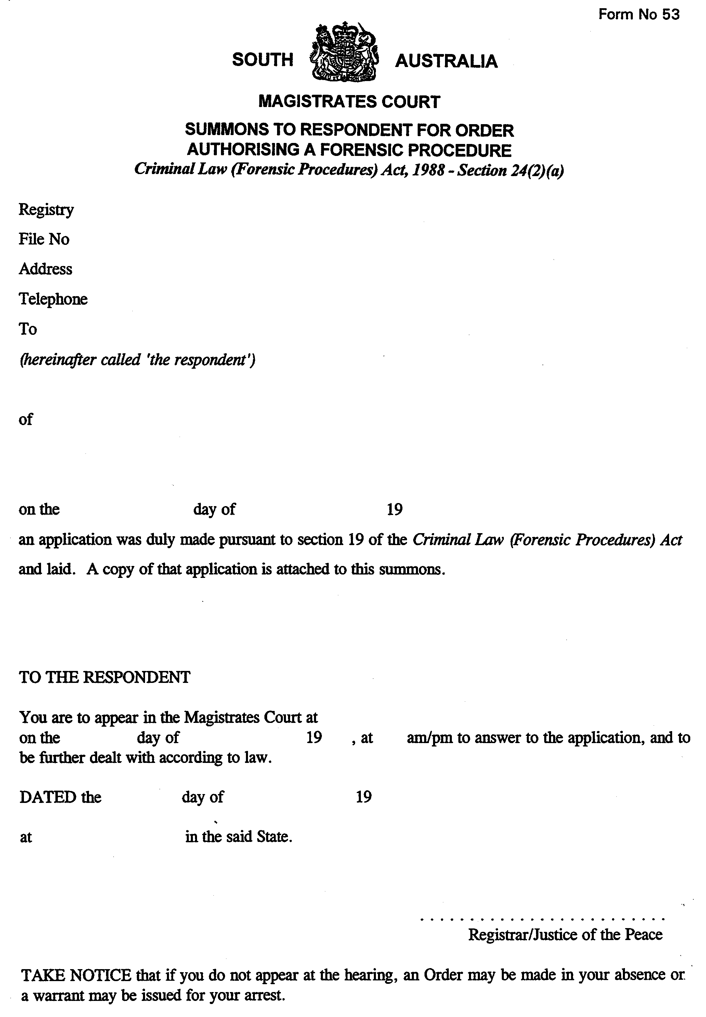
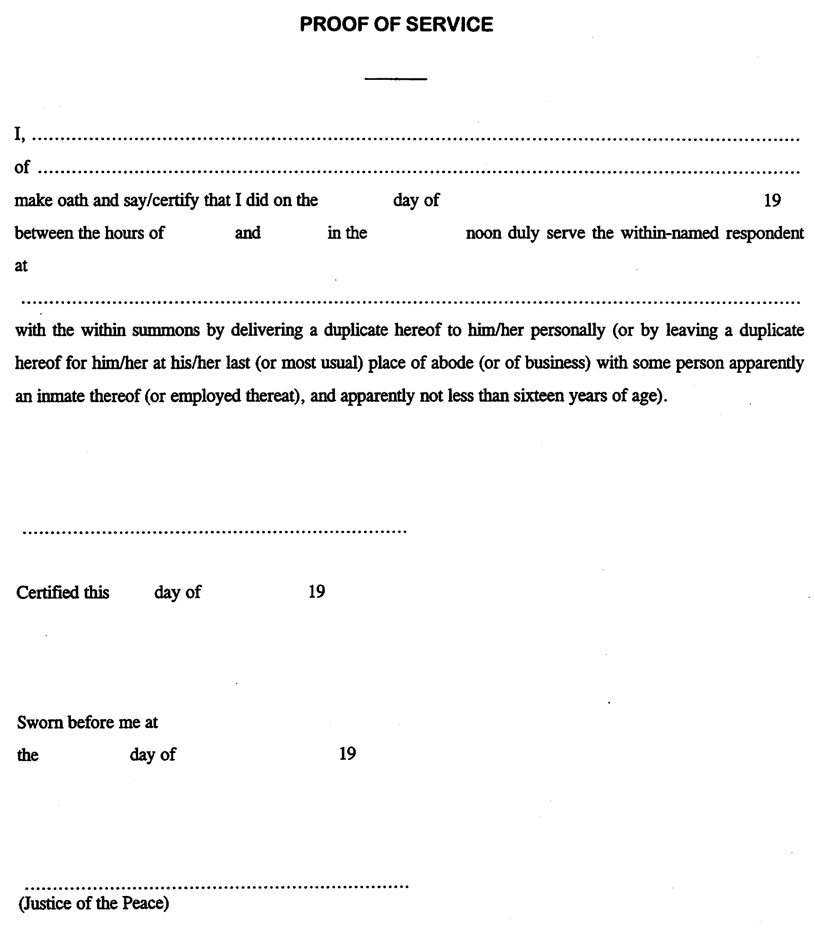
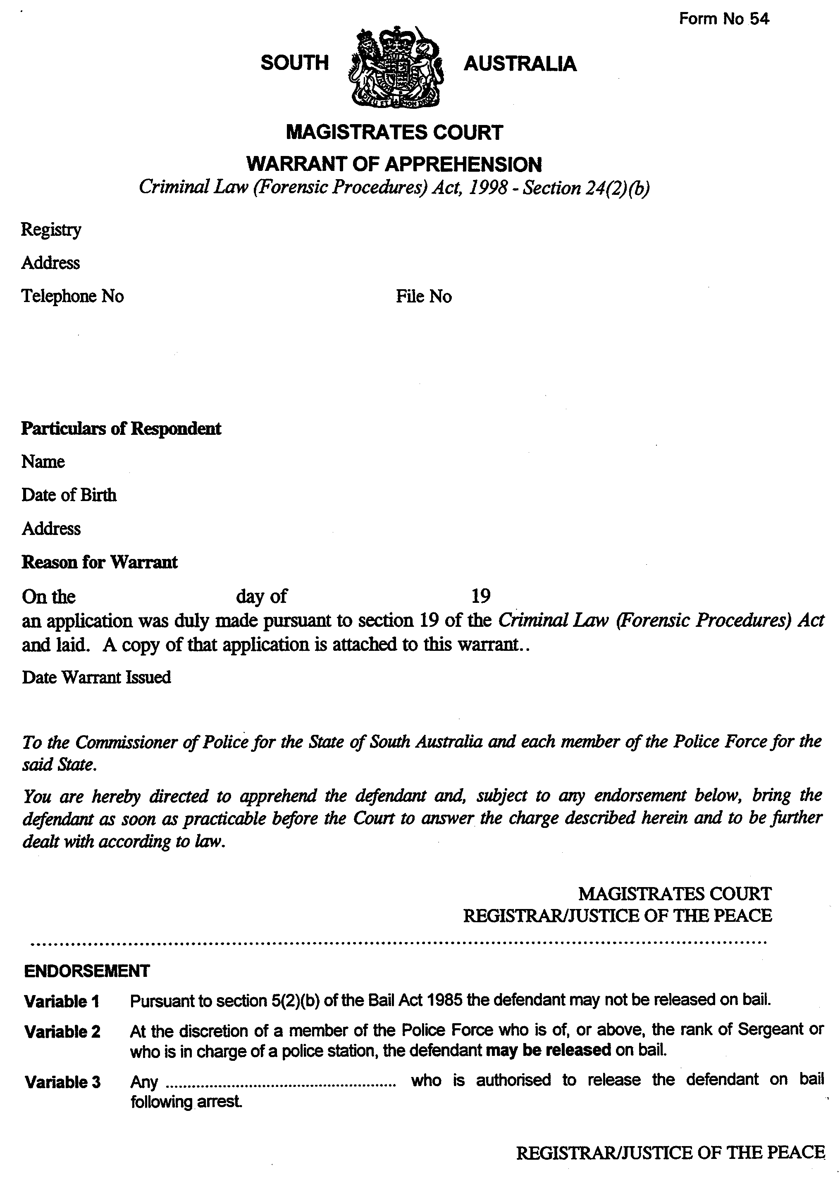

FAXING COPY?

IF you fax copy to Riverside 2000, for inclusion in the Government Gazette, there is no need to send a Confirmation Copy to us as well.

This creates confusion and may well result in your notice being printed twice.

Please use the following fax number:

Fax transmission: (08) 8207 1040
Phone Inquiries: (08) 8207 1045

Please include a contact person, phone number and order number so that we can phone back with any queries we may have regarding the fax copy.

NOTE: Closing time for lodging new copy (either fax or hard copy) is 4 p.m. on Tuesday preceding the day of publication.

Government Gazette notices can be E-mailed.

The address is:

govgaz@riv.ssa.sa.gov.au

Documents should be sent as attachments in Word format.

When sending a document via E-mail, please confirm your transmission with a faxed copy of your document, including the date the notice is to be published.

Fax transmission: (08) 8207 1040
Enquiries: (08) 8207 1045

CITY OF ADELAIDE
NOTICE is hereby given that the council of the corporation of the City of Adelaide at its meeting held on 5 July 1999, passed inter alia the following resolutions:
Pursuant to section 359 of the Local Government Act 1934, as amended, the roads described in the following schedule, between the hours specified in the schedule, be closed to all vehicles except for emergency vehicles or those given express permission to enter by the Chief Executive Officer.
Schedule
Location |  | From |  | To
North Terrace from King William Street to Pulteney Street |  | 11.59 p.m. on Monday, 27 December 1999 |  | 6.00 a.m. on Wednesday, 29 December 1999
Kintore Avenue from North Terrace to Victoria Drive |  | 11.59 p.m. on Monday, 27 December 1999 |  | 6.00 a.m. on Wednesday, 29 December 1999
Jude Munro, Chief Executive Officer

CITY OF ADELAIDE
Adoption of Valuation
NOTICE is hereby given that the council of the Corporation of the City of Adelaide at its meeting held on 21 June 1999, pursuant to section 171 of the Local Government Act 1934, as amended, has adopted for rating purposes valuations prepared on the basis of annual value, amounting to $323 416 770 made by Valuers employed by council, as applying to the land within the area of the Corporation of the City of Adelaide.
Declaration of Rates
Notice is hereby given that the council of the Corporation of the City of Adelaide at its meeting held on 21 June 1999, resolved that:
(1) in accordance with section 32, of the City of Adelaide Act 1998, the ‘Rating Policy’ for 1999-2000, be adopted, and that the Rating Policy Statements be made available free-of-charge;
(2) in accordance with section 174 of the Local Government Act 1934, declare a general rate of 12.3 cents in the dollar on property within the City of Adelaide for the financial year ending 30 June 2000;
(3) in accordance with the Policy on Discretionary Rebates (the Policy) and pursuant to section 193 (4) (a) of the Local Government Act 1934, a rebate of general rates be granted to such ratepayers as shall meet the eligibility criteria provided for in the Policy and in each case the amount of such rebate shall be determined in accordance with the Policy.
(4) council rates be allowed to be payable in two instalments due on 1 September 1999 and 1 March 2000, respectively.
Declaration of Separate Rate—Water Catchment Environment Levy
Notice is hereby given that the council of the Corporation of the City of Adelaide at its meeting held on 21 June 1999, declared a separate rate pursuant to section 175 of the Local Government Act 1934, and section 52 of the Catchment Water Management Act 1995:
(1) a separate rate of 0.17800 cents in the dollar be declared on rateable land within the council area falling within the Catchment Area of the Torrens Catchment Water Management Board, in accordance with the requirements of section 52 of the Catchment Water Management Act 1995;
(2) a separate rate of 0.16252 cents in the dollar be declared on rateable land within the council area falling within the Catchment Area of the Patawalonga Catchment Water Management Board, in accordance with the requirements of section 52 of the Catchment Water Management Act 1995.
Declaration of Separate Rate—Rundle Mall Environs Separate Rate
Notice is hereby given that the council of the Corporation of the City of Adelaide at its meeting held on 21 June 1999, declared a separate rate pursuant to section 175 of the Local Government Act 1934, to be known as the Rundle Mall Environs Separate Rate:
(1) a separate rate (to be known as the Rundle Mall Environs Separate Rate) of 2.64 cents in the dollar be declared for the period 1 July 1999 to 30 June 2000 on rateable land within the relevant part of the council area for the purposes of the relevant project;
(2) for the purposes of this resolution:
(i) ‘the relevant part of the council area’ is that area bounded by the:
(a) southern alignment of North Terrace between Pulteney Street and King William Street;
(b) eastern alignment of King William Street between North Terrace and Grenfell Street;
(c) northern alignment of Grenfell Street between King William Street and Pulteney Street; and
(d) western alignment of Pulteney Street between Grenfell Street and North Terrace;
(ii) ‘the relevant project’ means the undertaking of activities relevant to the promotion and development of the relevant part of the council area; and
(3) the Rundle Mall Environs Separate Rate be payable by two equal instalments due on or before the first day of September 1999 and the first day of March 2000;
(4) ratepayers liable to pay the rundle Mall Environs Separate Rate shall be entitled to the following remission of rates in the exercise of the powers conferred upon the council by section 185 (3) (b) of the Local Government Act 1934:
(i) if the ratepayer is a ratepayer in respect of rateable land that is Category 3 rateable land—100% of the Rundle Mall Environs Separate Rate applicable to that Category 3 rateable land shall be remitted;
(ii) if the ratepayer is a ratepayer in respect of rateable land that is Category 4 rateable land—35% of the Rundle Mall Environs Separate Rate applicable to that Category 4 rateable land shall be remitted; and
(5) for the purposes of this resolution:
(i) ‘Category 3 rateable land’ means rateable land not used for trading purposes as at the first day of July 1999;
(ii) ‘Category 4 rateable land’ means rateable land used for trading purposes as at the first day of July 1999, which does not have a frontage to the Rundle Mall as at the first day of July 1999;
(iii) ‘Rundle Mall’ means the area dark stippled on the plan set out in the schedule to the Rundle Street Mall Act 1975, as enacted, as at the first day of July 1999;
(iv) ‘Trading purposes’ means the use of rateable land for retailing or as a restaurant, café, cinema, bank, travel agency, car park, hairdressing salon, barber shop, tailors shop or room, hotel, pharmacy, dry cleaning agency or shop, repair agency or shop for goods customarily retailed to personal shoppers, medical benefits agency or office building society agency or office, health studio, or any other purpose which is such that the level of trade or business activity carried on in or earnings from the rateable land are likely to benefit directly or indirectly from the existence of the Rundle Mall, and shall include the use of any part of the rateable land or a separate piece of rateable land in the same building for office, dispatch, or other purposes connected with those trading purposes defined above, but shall not include the use of premises by doctors, lawyers, architects, dentists, optometrists, chiropodists, accountants, engineers, management of property consultants, aural consultants or suppliers, photographers, manufacturers’ representatives, wholesale agents, ballet schools or other persons whose level of trade of business activity or earnings is not likely to benefit directly or indirectly from the existence of the Rundle Mall;
(v) ‘Common area’ means an area of any building which is available for use by the occupiers of more than one piece of rateable land or by their customers or invitees as a means of access to their respective premises;
(vi) ‘Thoroughfare’ shall mean either a private street or a linear passageway (such as an arcade) which has one or more pieces of rateable land used for trading purposes on each side thereof and which is directly open to and connects two or more street;
(vii) Rateable land shall be taken to have a frontage to the Rundle Mall if it is directly open to or which has a doorway or lift opening directly on to:
(a) Rundle Mall;
(b) a privately owned common area (not being a thoroughfare) which is directly open to Rundle Mall or which has a doorway opening directly on to Rundle Mall; or
(c) a privately owned common area (not being a thoroughfare) which has access directly or indirectly to a privately owned common area within the meaning of paragraph (b) thereof;
(viii) Rateable land, a common area, lift or passageway shall be deemed to be directly open to Rundle Mall or a street if it is so open at least during ordinary business hours.
(6) (a) The increased amount arising, from the 1 cent increase in the rate, not be spent until the ACM Review is complete and that the Rundle Mall Advisory Committee adopt in the most appropriate manner in which these funds are spent.
(b) In the event that the Rundle Mall Advisory Committee does not agree by 1 October 1999, the expenditure of such funds, council will refund or credit in conjunction with the second rate instalment at 1 March 1999, this amount to the respective entities. Further, that in the event that a plan is not agreed, then the Strategic Initiative which is matching funding for the amount arising from the levy increase and exemption charges not be proceeded with.
Jude Munro, Chief Executive Officer

CITY OF CAMPBELLTOWN
NOTICE is hereby given that the Corporation of the City of Campbelltown at a meeting held on 5 July 1999, passed the following resolutions:
Adoption of Valuation
That the Corporation of the City of Campbelltown in respect of the financial year commencing on 1 July 1999 and concluding on 30 June 2000, pursuant to section 171 of the Local Government Act 1934, as amended, adopt the capital valuations made by the Valuer-General for rating purposes, totalling $2 665 826 000.
Declaration of General Rate for the Year 1999-2000
That pursuant to section 174 of the Local Government Act 1934, the council hereby declares a general rate of 0.443291 cents in the dollar of the assessed capital value of rateable property within the municipality for the financial year commencing on 1 July 1999 and ending on 30 June 2000, and the council in respect of the said financial year hereby fixes pursuant to section 190 of the said Act a minimum amount of $400 which shall be payable by way of rates on rateable land within the municipality.
Catchment Environment Levy
That pursuant to section 175 of the Local Government Act 1934, and section 52 of the Catchment Water Management Act 1996, council declares a separate rate of 0.01366 cents in the dollar of the capital value of rateable land within the Torrens Catchment Area within the boundaries of the City of Campbelltown, for the financial year commencing on 1 July 1999 and ending on 30 June 2000.
P. Vlatko, Chief Executive Officer

CITY OF CHARLES STURT
Declaration of Public Road
PURSUANT to section 3011 (1) (d) of the Local Government Act 1934, as amended, the City of Charles Sturt resolved at its meeting of 15 June 1999, that the land being walkway shown as allotment 20 in deposited plan 34275 is hereby declared to be a public road.
S. Law, Chief Executive

THE RURAL CITY OF MURRAY BRIDGE
Adoption of Valuations and Declaration of Rates
NOTICE is hereby given that at its meeting held on 28 June 1999, the council resolved that in exercise of the powers contained in Parts IX and X of the Local Government Act 1934, as amended, (the ‘Act’), and in respect of the financial year ending 30 June 2000:
Adoption of Valuation
(i) The most recent valuations of the Valuer-General available to the council of the capital value of land within the council’s area be adopted; totalling $809 352 580 comprising $733 118 230 for rateable land; and $76 234 350 for non-rateable land.
Attribution of Land Uses
(ii) (a) the numbers indicated against the various categories of land use prescribed by the Local Government (Land Use) Regulations 1989 (the ‘Regulations’) be used to designate land uses in the assessment book;
(b) the use indicated by those numbers in respect of each separate assessment of land described in the assessment book on this date (as laid before the council) be attributed to each such assessment respectively; and
(c) reference in this resolution to land being of a certain category use means the use indicated by that category number in the regulations.
Declaration of General Rates
(iii) In order to raise the amount required for general rate revenue:
(a) differential general rates be declared on all rateable land as follows:
(i) 0.685 cents in the dollar of the capital value of rateable land of categories 1 and 9 use (residential and ‘other’ categories);
(ii) 1.185 cents in the dollar of the capital value of rateable land of categories 2, 3 and 4 use (commercial categories);
(iii) 1.005 cents in the dollar of the capital value of rateable land of categories 5 and 6 use (industrial categories);
(iv) 0.540 cents in the dollar of the capital value of rateable land of category 7 use (primary production); and
(v) 0.900 cents in the dollar of the capital value of rateable land of category 8 use (vacant land);
(b) a minimum amount payable by way of the general rate of $400 in respect of each assessment in accordance with section 190 of the Act.
Declaration of Separate Rates
(iv) (a) in exercise of the powers contained in section 175 of the Act in order to provide carparking facilities for the benefit of properties within an area bounded by South Terrace, Swanport Road, Mannum Road, First Street, West Terrace, North Terrace, Railway Terrace, Bridge Street and East Terrace, a separate rate of 0.0567 cents in the dollar of the capital value of rateable land in that area is declared on that land;
(b) in exercise of the powers contained in section 185 (3) of the Act, a remission of rates be granted to ratepayers of property in that area where the property is used for other than categories 2, 3 or 4 use, such remission being of an amount of 0.0567 cents in the dollar of the capital value of the property;
(c) in exercise of the powers contained in section 175 of the Act in order to upgrade and improve the Town Centre Zone (as defined in the Development Plan under the Development Act 1993, applicable to the council’s area), a separate rate of 0.2102 cents in the dollar of the capital value of rateable land in the Town Centre Zone is declared on that land;
(d) in exercise of the powers contained in section 185 (3) of the Act, a remission of rates be granted to ratepayers of property in the Town Centre Zone where the property is used for other than categories 2, 3 or 4 use, such remission being of an amount of 0.2102 cents in the dollar of the capital value of the property.
Declaration of Service Rate
(v) Pursuant to section 177 of the Act, a service charge of $300 per assessment, and a service rate of 0.5320 cents in the dollar of the capital value of rateable land comprising allotments 1 to 30, 125, 126 in Deposited Plan 30450 and Units 1 to 73 in Strata Plan No. 11238, is declared on the land, being for the provision of septic tank effluent disposal and water supply services to the land.
Payment
(iv) (a) all rates be payable in a single instalment (unless otherwise agreed with the principal ratepayer) by 1 October 1999, provided that in cases where the initial account requiring payment of rates is not sent at least 60 days prior to this date, or an amended account is required to be sent, authority to fix the date by which rates must be paid in respect of those assessments affected is delegated to the Chief Executive Officer; and
(b) the Chief Executive Officer be authorised to enter into agreements with principal ratepayers relating to the payment of rates in any case where it is considered necessary or desirable to do so, which agreements may require the payment of an amount or amounts additional to rates, for the purpose of recovering costs associated with entering into them; and
(c) without limiting the generality of the foregoing, the Chief Executive Officer may enter into agreements with principal ratepayers to pay rates in four instalments being due and amounts being payable as follows:
First instalment, approximately ¼ total 1999-2000 rates, due 1 October 1999;
Second instalment, approximately ¼ total 1999-2000 rates, due 1 November 1999;
Third instalment, approximately ¼ total 1999-2000 rates, due 1 December 1999; and
Fourth instalment, approximately ¼ total 1999-2000 rates, due 7 January 2000.
Early Payment Incentive Scheme
(vii) In exercise of the powers contained in section 184 (11) of the Act, and being of the opinion that it is desirable to encourage ratepayers to pay their general rates and/or separate rates, and/or service charges early, the council offers to give a discount of 1% of the amount payable of general rates, and/or separate rates, and/or service rates, and/or service charges if paid in full by 13 August 1999.
R. J. Foster, Chief Executive Officer

CITY OF PLAYFORD
Adoption of Valuation and Declaration of Rates
NOTICE is hereby given that the City of Playford, in accordance with section 171 of the Local Government Act 1934, as amended, at a meeting of the council held on Tuesday, 22 June 1999, adopted for the year ending 30 June 2000, the Valuer-General’s capital valuation being $2 237 130 704 in relation to the whole area of the council and hereby specifies 1 July 1999 as the day from which such valuation shall become the valuation of council.
Pursuant to the provisions of the said Act the valuation may be inspected Monday to Friday from 8.30 a.m. to 5.30 p.m. (excluding public holidays) at the City of Playford Customer Service Centres located at 3 Windsor Square, Elizabeth and Gapper Building, Warooka Drive, Smithfield.
Attribution of Land Uses
(a) That the numbers indicated against the various categories of land use prescribed by the Local Government (Land Use) Regulations 1989 (the ‘Regulations’) be used to designate land uses in the assessment book;
(b) that the use indicated by those numbers in respect of each separate assessment of land described in the assessment book on this date (as laid before council) be attributed to each such assessment respectively; and
(c) that reference in this resolution to land being of a certain category use means the use indicated in that category number in the regulations.
Declaration of Rates
That pursuant to the provisions of section 169 of the Local Government Act 1934, the City of Playford declares the following general rate to apply to all rateable land within the council area:
1. A component comprising a fixed charge of $324 for the year ending 30 June 2000, as part of the general rate upon each separately valued piece of rateable land within the council area, except where two or more pieces of contiguous rateable land are owned by the same owner and occupied by the same occupier in which case the fixed charge will be imposed against the whole of that land.
2. A further component, pursuant to the provisions of section 174 and section 176 of the Local Government Act 1934, and the proclamation of the Governor as appearing in the Government Gazette of 13 February 1997 at page 898 and following, the City of Playford being of the opinion that in the circumstances of the amalgamation of the City of Elizabeth and the City of Munno Para differential rating is appropriate in order to allow rating relativities within the area to be gradually re-aligned, and declares differential rates will vary according to the use of the land, whether the land is located within a designated township or not, or whether the land was located immediately prior to 3 May 1997, within the constituted area of the City of Elizabeth or the constituted area of the City of Munno Para as follows:
A. All land within the area of the City of Playford except for land falling within B, C, D and E, and used in accordance with the following categories:
(a) 0.384250 cents in the dollar on rateable land of Category 1 use (Residential);
(b) 0.329410 cents in the dollar on rateable land of Category 7 use (Primary Production);
(c) 0.384250 cents in the dollar on rateable land of Category 8 use (Vacant Land);
(d) 0.384250 cents in the dollar on rateable land of Category 9 use (Other).
B. Land within that area of the City of Playford immediately prior to 3 May 1997, constituting the area of the City of Elizabeth, and used in accordance with the following categories:
(1) In that part comprising the Regional Centre Zone in the Development Plan under the Development Act 1993 (The Plan):
(a) 1.313000 cents in the dollar on rateable land of Category 1 use (Residential);
(b) 1.313000 cents in the dollar on rateable land of Category 2 use (Commercial—Shop);
(c) 1.313000 cents in the dollar on rateable land of Category 3 use (Commercial—Office);
(d) 1.313000 cents in the dollar on rateable land of Category 4 use (Commercial—Other);
(e) 1.313000 cents in the dollar on rateable land of Category 5 use (Industrial—Light);
(f) 1.313000 cents in the dollar on rateable land of Category 6 use (Industrial—Other);
(g) 1.313000 cents in the dollar on rateable land of Category 7 use (Primary Production);
(h) 1.313000 cents in the dollar on rateable land of Category 8 use (Vacant Land);
(i) 1.313000 cents in the dollar on rateable land of Category 9 use (Other).
(2) In all other parts of that area:
(a) 1.370100 cents in the dollar on rateable land of Category 2 use (Commercial—Shop);
(b) 1.370100 cents in the dollar on rateable land of Category 3 use (Commercial—Office);
(c) 1.370100 cents in the dollar on rateable land of Category 4 use (Commercial—Other);
(d) 1.370100 cents in the dollar on rateable land of Category 5 use (Industrial—Light);
(e) 1.370100 cents in the dollar on rateable land of Category 6 use (Industrial—Other).
C. Land within that area of the City of Playford immediately prior to 3 May 1997, constituting the area of the City of Munno Para, except for land falling within D and E, and used in accordance with the following categories:
(a) 0.620100 cents in the dollar on rateable land of Category 2 use (Commercial—Shop);
(b) 0.620100 cents in the dollar on rateable land of Category 3 use (Commercial—Office);
(c) 0.620100 cents in the dollar on rateable land of Category 4 use (Commercial—Other);
(d) 0.620100 cents in the dollar on rateable land of Category 5 use (Industrial—Light);
(e) 0.620100 cents in the dollar on rateable land of Category 6 use (Industrial—Other).
D. Land within that area of the City of Playford immediately prior to 3 May 1997, constituting the area of the City of Munno Para other than referred to in E below, and not contained within the following townships:
(a) Hillbank, the boundaries of which are defined by Gazette notices on 22 July 1976 and 24 March 1994;
(b) Blakeview, the boundaries of which are defined by Gazette notices on 24 April 1991 and 27 May 1993;
(c) Craigmore, the boundaries of which are defined by Gazette notices on 25 May 1978, 14 May 1987, 22 June 1989 and 27 May 1993;
(d) Andrews Farm, the boundaries of which are defined by Gazette notice on 24 March 1995;
(e) Smithfield, the boundaries of which are defined by Gazette notices on 22 July 1976 and 29 May 1980;
(f) Munno Para, the boundaries of which are defined by Gazette notice 22 July 1976;
(g) Elizabeth Downs, the boundaries of which are defined by Gazette notice on 22 July 1976;
(h) Smithfield Plains, the boundaries of which are defined by Gazette notice on 22 July 1976;
(i) Davoren Park, the boundaries of which are defined by Gazette notice on 25 May 1995,
and used in accordance with the following categories:
(a) 0.451100 cents in the dollar on rateable land of Category 2 use (Commercial—Shop);
(b) 0.451100 cents in the dollar on rateable land of Category 3 use (Commercial—Office);
(c) 0.451100 cents in the dollar on rateable land of Category 4 use (Commercial—Other);
(d) 0.451100 cents in the dollar on rateable land of Category 5 use (Industrial—Light);
(e) 0.451100 cents in the dollar on rateable land of Category 6 use (Industrial—Other).
E. Land within that area of the City of Playford immediately prior to 3 May 1997, constituting the area of the City of Munno Para and located within the following townships at a differential general rate of 0.341500 cents in the dollar:
(a) Angle Vale, the boundaries of which are defined by Gazette notice on 21 May 1992;
(b) One Tree Hill, the boundaries of which are defined by Gazette notice on 21 May 1992;
(c) Virginia, the boundaries of which are defined by Gazette notice on 21 May 1992.
Remission of Rates
Notice is hereby given that pursuant to section 185 (3) of the Local Government Act 1934, a principal ratepayer who makes due application (which shall be deemed to have been made by payment of the rate in full as reduced by the amount of the remission or, in the case of payment by instalment, payment of each instalment as reduced by the remission) shall be entitled to a partial remission of the rates payable in the following circumstances:
(a) the rateable land is the same rateable land contained in the rate notice issued by council for 1998-1999 financial year;
(b) the land use remains the same as adopted by council for the 1998-1999 financial year;
(c) the rates (excluding any separate rate) payable on the said rateable land exceed the amount paid for the 1998-1999 financial year by an amount of more than 10%;
(d) the partial remission shall comprise the amount by which the total rates (excluding any separate rate) payable for the financial year 1999-2000 exceed the total rates (excluding any separate rate) payable for the financial year 1998-1999 by the said amount of more than 10% referred to in (c);
(e) Council has not during the financial years 1997-1998 and 1998-1999 granted a provisional building rules consent, pursuant to the Development Act 1993, for the rateable land.
Separate Rate
Notice is hereby given that pursuant to the provisions of section 175 (1) of the Local Government Act 1934, and for the purposes prescribed in that subsection, a separate rate in the dollar on the valuation of all applicable rateable properties within the Northern Adelaide and Barossa Catchment Water Area be declared at 0.013541 cents in the dollar for the year ending 30 June 2000, so as to reimburse the State Government to pay the Northern Adelaide and Barossa Catchment Water Management Board Levy of $288 416.
Method of Payment of Rates
Notice is hereby given that pursuant to the provisions of section 184 of the Local Government Act 1934, the rates imposed in respect of the 1999-2000 financial year will fall due in four instalments payable on:
• 16 September 1999;
• 16 December 1999;
• 16 March 2000;
• 16 June 2000.
T. R. S. Jackson, Chief Executive Officer

CITY OF PLAYFORD
Declaration of Public Road
NOTICE is hereby given that the City of Playford has resolved, pursuant to section 303 (1) (d) of the Local Government Act 1934, as amended, that the walkway (Lot 524), between Underdown Road/Philip Highway, Elizabeth South as shown in Deposited Plan 6003, be declared a public road and known as an unnamed road.
T. R. S. Jackson, Chief Executive Officer

CITY OF SALISBURY
Adoption of Valuation
NOTICE is hereby given that the council of the City of Salisbury at a meeting held on Monday, 21 June 1999, by virtue of the powers contained in section 171 of the Local Government Act 1934, as amended, has adopted the Government valuation of capital values for the whole of the municipality for the year ending 30 June 2000. The valuation shall, from 21 June 1999, become and be the valuation of the council. The valuation is deposited in the Municipal Offices, James Street, Salisbury and may be inspected Monday to Friday between the hours of 10 a.m. and 4 p.m., pursuant to the provisions of section 180 of the said Act.
Declaration of Rate
Notice is hereby given that by virtue of the powers vested in it by the Local Government Act 1934, the council of the City of Salisbury at a meeting held on 21 June 1999, declared differential general rates on property within its area for the financial year ending on 30 June 2000, which rates shall vary by reference to the use to which rateable property is put as follows:
(a) In respect of rateable property which is used for ‘Commercial’, ‘Industrial’ Land uses and classified as such in the assessment records of the council at the date of this declaration, a differential general rate of 0.7307 cents in the dollar for the assessed capital value of such property.
(b) In respect of rateable property which is used for ‘Vacant Land’ Land use and classified as such in the assessment records of the council at the date of this declaration, a differential general rate of 0.7972 cents in the dollar for the assessed capital value of such property.
(c) In respect of all other rateable property in the area used for purposes other than as stated in paragraph (a) and (b) hereof, a differential general rate of 0.6643 cents in the dollar on the assessed capital value of such property.
For the purpose of this Declaration, Commercial, Industrial, and Vacant Land Uses shall mean and include land and premises used as follows:
Commercial—Shop: Comprising the use of land for a shop within the meaning of the Development Control Regulations.
Commercial—Office: Comprising the use of land for an office within the meaning of the Development Control Regulations.
Commercial—Other: Comprising any other commercial user of land not referred to in categories Commercial—Shop, or Commercial—Office.
Industry—Light: Comprising the use of land for a light industry within the meaning of the Development Control Regulations.
Industry—Other: Comprising any other industrial use of land not referred to in Industry—Light.
Vacant Land: Comprising the non-use of vacant land.
The council has also pursuant to section 190 of the Local Government Act 1934, fixed a minimum amount of $465 which shall be payable by way of rates on any one assessment within the municipality in respect of the year ending 30 June 2000.
Declaration of Salisbury Town Centre Separate Rate
Notice is hereby given in accordance with section 189 of the Local Government Act 1934, that the council, at a meeting held on 21 June 1999, declared pursuant to section 175 of the Act a separate rate of 0.1151 cents in the dollar on the capital value of rateable land within that part of its area comprising the Salisbury Town Centre District Centre Zone which is delineated on Maps Sa/11 and Sa/12 of the Development Plan under the Development Act 1993, applicable to the council’s area.
The purpose of this separate rate is to provide a fund to promote and enhance business viability, profitability and trade commerce and industry in that part of the council’s area, which is the subject of the separate rate.
Declaration of Globe Derby Separate Rate
Notice is hereby given in accordance with section 189 of the Local Government Act 1934, that the council, at a meeting held on 21 June 1999, declared pursuant to section 175 of the Act a separate rate of $50 per each allotment numbered 1-32 in Deposited Plan No. 9830 and allotments numbered 33, 34 and 36-64 in Deposited Plan No. 9831 of portion of section 3070, Hundred of Port Adelaide (laid out as Bolivar) is declared for the year ending 30 June 1999.
The purpose of this separate rate is to provide a fund to the Globe Derby Community Club for the purpose of maintaining the common land, being Lot 65 in Deposited Plan No. 9832.
Declaration of Northern Adelaide and Barossa Catchment Water Management Board Separate Rate
Notice is hereby given in accordance with section 189 of the Local Government Act 1934, that the council, at a meeting held on 21 June 1999, declared pursuant to section 175 of the Act, a separate rate of 0.0132 cents in the dollar on the capital value of all rateable land in the council’s area which is in the Northern Adelaide and Barossa Catchment area.
The purpose of this separate rate is to provide funds to the Northern Adelaide and Barossa Catchment Water Management Board as required under section 138 of the Water Resources Act 1997.
S. Hains, City Manager

CITY OF SALISBURY
Declaration of Public Road
NOTICE is hereby given that pursuant to section 303 (1) of the Local Government Act 1934, as amended, the City of Salisbury resolved at its meeting held on 28 June 1999, that the portion of land shown as allotment 30 in Deposited Plan 43912 and allotment 41 in Deposited Plan 51420 be all hereby declared as public road and be known as Burton Road, Salisbury.
S. Hains, City Manager

CITY OF TEA TREE GULLY
Declaration of Reserve
NOTICE is hereby given that the City of Tea Tree Gully at its meeting held on 8 June 1999, passed the following resolutions:
1. That council not proceed with the sale of allotment 6 of filed plan 10560 being land in certificate of title register book volume 5436, folio 38, a property situated on Historic Drive, Highbury.
2. That council declares the land, consisting of allotment 6 of filed plan 10560 being land in certificate of title register volume 5436, folio plan 38, will be used as reserve in accordance with section 453 of the Local Government Act.
G. Perkin, Chief Executive Officer

CITY OF TEA TREE GULLY
Temporary Road Closure
NOTICE is hereby given that at its meeting held on 8 June 1999, council resolved the following:
That pursuant to section 359 of the Local Government Act 1934, as amended, all vehicles with the exception of bicycles be excluded generally from that portion of Beaufort Avenue, Golden Grove, commencing from the projection of the south-eastern boundary of Lot 103 and continuing south to a point 9.6 m north of the projection of Beaufort for the period of 12 months until midday on 9 June 2000 with the right to renew for a further 12 months to enable a portion of road as delineated on the locality map (refer to Report C.C.TMSU.15/1999 Attachment No. 1) to be incorporated in the Housing for the Two of Us display village.
G. Perkin, Chief Executive Officer

CITY OF WEST TORRENS
Declaration of Public Roads
NOTICE is hereby given that pursuant to section 303 (1) (a) of the Local Government Act 1934, as amended, the council declares the portions of roads laid out and constructed in certificate of title volume 3058, folio 81, in Deposited Plan 1569, being situated between public roads Mortimer Street and Anzac Highway and named Grassmere Street, Warwick Avenue and Selby Street, to be public roads.
T. M. Starr, City Manager

CITY OF WEST TORRENS
Adoption of Valuations and Declaration of Rates
NOTICE is hereby given that at its meeting held on 16 June 1999, the council, in exercise of the powers contained in Parts IX and X of the Local Government Act 1934, as amended, the provisions of the Proclamation establishing the City of West Torrens, and the Water Resources Act 1997:
Adoption of Valuations
1. Adopted for rating purposes for the year ended 30 June 2000, the capital valuations of the Valuer-General of all property within the area, totalling $3 832 175 000.
Declaration of Rates
2. (i) Declared differential general rates on rateable land within the former City of West Torrens based on combined values as follows:
(a) 0.4279 cents in the dollar on rateable land of Category 1 use;
(b) 0.7787 cents in the dollar on rateable land of Categories 2, 3 and 4 use;
(c) 1.0900 cents in the dollar on rateable land of Category 5 use;
(d) 0.8500 cents in the dollar on rateable land of Category 6 use;
(e) 0.8581 cents in the dollar on rateable land of Category 7 use;
(f) 1.1000 cents in the dollar on rateable land of Category 8 use;
(g) 0.9400 cents in the dollar on rateable land of Category 9 use.
(ii) Declared differential general rates on rateable land within the former Town of Thebarton based on capital values as follows:
(a) 0.3864 cents in the dollar on rateable land of Category 1 use;
(b) 0.6225 cents in the dollar on rateable land of Category 2 use;
(c) 0.6949 cents in the dollar on rateable land of Category 3 use;
(d) 0.6723 cents in the dollar on rateable land of Category 4 use;
(e) 0.9408 cents in the dollar on rateable land of Category 5 use;
(f) 0.6964 cents in the dollar on rateable land of Category 6 use;
(g) 1.1014 cents in the dollar on rateable land of Category 8 use.
(h) 0.7298 cents in the dollar on rateable land of Category 9 use.
(iii) Declared a minimum amount payable by way of general rates on rateable land in its area of $365.
(iv) Declared separate rates on rateable land within the area as follows:
(a) 0.0156 cents in the dollar based on combined values on all rateable land in the former City of West Torrens in the area of the River Torrens Catchment Water Management Board;
(b) 0.0139 cents in the dollar based on capital values on all rateable land in the former Town of Thebarton in the area of the River Torrens Catchment Water Management Board;
(c) 0.0123 cents in the dollar based on combined values on all rateable land in the former City of West Torrens in the area of the Patawalonga Catchment Water Management Board; and
(d) 0.0111 cents in the dollar based on capital values on all rateable land in the former Town of Thebarton in the area of the Patawalonga Catchment Water Management Board.
T. M. Starr, City Manager

TOWN OF WALKERVILLE
Adoption of Valuation
NOTICE is hereby given that the Corporation of the Town of Walkerville at a meeting held on 21 June 1999 resolved pursuant to section 174 (2) (a) of the Local Government Act 1934, as amended, and all other powers thereunto enabling, to adopt the government valuation totalling $768 287 000 capital value made under the Valuation of Land Act 1971, and specified 30 June 1999 as the day from which such valuation shall become and be the valuation of the council for the year ending 30 June 2000. The valuation is deposited in the Municipal Offices, 66 Walkerville Terrace, Gilberton, and may be inspected by any persons interested therein between the hours of 9 a.m. and 5 p.m., Monday to Friday.
Declaration of Rates
Notice is hereby given that at a meeting held on 21 June 1999, the Corporation of the Town of Walkerville, having adopted its budget, resolved to declare the differential general rate on rateable land within its area for the financial year, 1999-2000, pursuant to the provisions of section 176 (1) (b) of the Local Government Act 1934 and further resolved to vary the differential rates according to the use of land provided by section 176 (1) (a) of the said Act, and in accordance with the following categories of land use prescribed as permissible differentiating factors specified in the Regulations under the said Act, such differential rates being declared as follows:
(a) In respect of such rateable property which is prescribed as ‘Residential’ a differential general rate of 0.3134 cents in the dollar on the assessed value of such rateable property.
(b) In respect of such rateable property which is prescribed as ‘Commercial Shop’, ‘Commercial Office’, ‘Commercial Other’, ‘Light Industry’, ‘Industry Other’, ‘Vacant Land’ and ‘Other’, a differential rate of 0.3474 cents in the dollar on the assessed value of such rateable property.
The council further resolved to fix a minimum amount payable by way of rates in respect of rateable property within its area, pursuant to the provisions of section 190 of the Local Government Act 1934, such minimum amount being $425 in respect of the year ending 30 June 2000.
R. H. Wallace, Chief Executive Officer

Declaration of Separate Rate—Torrens Catchment Area
Notice is hereby given that at a meeting held on 21 June 1999, the Corporation of the Town of Walkerville resolved that in exercise of powers contained in section 52 of the Catchment Water Management Act 1995, and section 175 of the Local Government Act 1934, and in order to reimburse the council the amounts contributed to the Catchment Water Management Board for the River Torrens Catchment in council’s area being $96 900, a separate rate of 0.0136 cents in the dollar, based on the capital value of rateable land in the catchment area, the capital value of such land being $768 287.
R. H. Wallace, Chief Executive Officer

DISTRICT COUNCIL OF CLEVE
Adoption of Valuations
NOTICE is hereby given that the District Council of Cleve in accordance with section 171 of the Local Government Act 1934, as amended, at a special meeting held on 29 June 1999, adopted for the year ending 30 June 2000, the site valuations made by the Valuer-General in relation to the area of the council, being the most recent valuation available and totalling $85 385 700.
Declaration of Rates and Charges
Notice is hereby given pursuant to section 189 of the Local Government Act 1934, that the District Council of Cleve at a special meeting held on 29 June 1999, declared the following rates and charges for the year ending 30 June 2000:
1. Pursuant to section 174 of the Local Government Act 1934, differential general rates based on the site value of land as hereunder:
Cents in the $
(a) Arno Bay Town 7.2698
(b) Arno Bay—Coastal Zone 3.1936
(c) Cleve Town 3.3942
(d) Cleve—Rural Living/Fringe Zone 2.7908
(e) Towns of Kielpa, Caralue, Rudall and
Darke Peak 50.0000
(f) Outside of towns—Rural 0.9619
(g) Special Industry Zone (SACBH
SILOS) 32.2400
2. Pursuant to section 190 of the Local Government Act 1934, a minimum amount that shall be payable by the way of rates on rateable properties of $230.
3. Pursuant to section 177 of the Local Government Act 1934, an annual service charge of $80 per unit payable on land benefited by the Cleve Common Effluent Drainage Scheme.
4. Pursuant to section 175 of the Local Government Act 1934, a separate rate of $57 per property, upon all property serviced by a common antenna TV system project.
5. Pursuant to section 175 of the Local Government Act 1934, separate rates based on the site value of relevant rateable properties abutting street sealing projects as follows:
Portion of Golf Drive, Cleve (Sections 208/9, 211)—0.00705 cents in the dollar;
Portion of Golf Drive, Cleve (Sections 206, 207, 444)—0.00689 cents in the dollar.
Payment of Rates
Notice is hereby given that the District Council of Cleve has resolved pursuant to section 184 of the Local Government Act 1934, that rates shall be payable by a single instalment due no later than 15 December 1999. A 1.5% discount will apply for payment of 1999-2000 general rates before 16 October 1999.
F. L. Gillings, Chief Executive Officer

COORONG DISTRICT COUNCIL
Supplementary Election
NOTICE is hereby given that owing to the passing of Councillor James Cattle a vacancy now exists for the office of Councillor for Peake Ward.
Nominations are hereby invited and will be received at the Council Office, 95 Railway Terrace, Tailem Bend from Thursday, 8 July 1999 until noon on Friday, 30 July 1999, from any persons eligible to be a candidate for election to the vacancy in the office of Councillor for Peake Ward.
Forms of nomination are available from the Council Offices, 95 Railway Terrace, Tailem Bend, during normal office hours.
T. J. Gordon, Returning Officer

REGIONAL COUNCIL OF GOYDER
Periodic Review of Elector Representation
NOTICE is hereby given that pursuant to the provisions of section 24 (3) of the Local Government Act 1934, as amended, the Regional Council of Goyder has completed a review to determine whether a change to ward boundaries and/or composition would result in the electors of the area being more fairly represented.
Council has prepared a report which details the review process, public consultation undertaken and the proposal it considers should be implemented. Copies of this report are available from the principal office at 1 Market Square, Burra, and the branch at Bruce Street, Eudunda.
Written submissions are invited from interested persons and should be directed to the Chief Executive Officer, Regional Council of Goyder, 1 Market Square, Burra, S.A. 5417 to be received before 4 p.m. on Tuesday, 3 August 1999.
Any persons making a written submission will also be invited to appear personally, or by representation before a meeting of council, or a Council Committee to be heard in support of their submission.
S. Kerrigan, Chief Executive Officer

DISTRICT COUNCIL OF KAPUNDA AND LIGHT
Appointment
NOTICE is hereby given that at the meeting of council held on 29 June 1999, council appointed Linda Hammond as Deputy Returning Officer in terms of section 86 (1) of the Local Government Act 1934, as amended.
G. W. Sheridan, Chief Executive Officer

WAKEFIELD REGIONAL COUNCIL
Adoption of Valuation
NOTICE is hereby given that the Wakefield Regional Council at a meeting held on 1 July 1999, adopted, in accordance with section 171 of the Local Government Act 1934, as amended, for the year ending 30 June 2000, the Valuer-General’s capital valuation in relation to property, within the council totalling $522 349 260.
Declaration of Rates
Notice is hereby given that in accordance with sections 174 and 176 (1) and (2) of the Local Government Act 1934, the Wakefield Regional Council at a meeting held on 1 July 1999, declared differential general rates on property within its area for the financial year ending 30 June 2000, by reference to the locality of the land, within or outside a township, as follows:
(a) townships of:
(i) Brinkworth, Lochiel and Snowtown 1.05 cents in the dollar;
(ii) townships of Balaklava, Blyth, Hamley Bridge, Owen and Port Wakefield⎯0.7044 cents in the dollar;
(b) remaining area:
(i) the area of the district located outside of the townships above but located within the boundaries of the former District Council of Blyth-Snowtown⎯0.379 cents in the dollar;
(ii) the area of the district located outside of the townships above but located within the boundaries of the former District Council of Wakefield Plains⎯0.3995 cents in the dollar;
with such differential rating in accordance with clause 16 of the amalgamation proclamation notice published in the South Australian Government Gazette on 27 February 1997, at page 1045.
Property in the former District Council of Blyth-Snowtown area shall, as a result of the change from site to capital valuation in 1997-1998, be granted a remission in accordance with section 185 (3) (b) of the Local Government Act 1934, on the general rate payable on individual assessments in the aforesaid area so that any increase will not be greater than 20 per cent of the previous year’s (1998-1999) general rate amount so payable.
Furthermore, in accordance with section 190 of the Local Government Act 1934, the minimum amount payable by way of general rates on all rateable properties within the district shall be $320.
Common Effluent Drainage⎯Service Charge
Notice is hereby given that in accordance with section 177 of the Local Government Act 1934, the Wakefield Regional Council at a meeting held on 1 July 1999, declared service charges for the financial year ending 30 June 2000, pertaining to the common effluent drainage schemes as follows:
Occupied Unoccupied
Unit Unit
Balaklava 75.00 48.00
Blyth 160.00 130.00
Hamley Bridge 98.00 81.00
Port Wakefield 56.10 ⎯
Snowtown 64.00 44.00
Payment
Notice is hereby given that pursuant to section 184 of the Local Government Act 1934, all rates shall be payable in a single instalment (unless otherwise agreed with the principal ratepayer in accordance with section 184 (6)) on or before 1 October 1999.
P. J. Barry, Chief Executive Officer

WATTLE RANGE COUNCIL
Roads (Opening and Closing) Act 1991

PURSUANT to section 10 of the Roads (Opening and Closing) Act 1991, The Wattle Range Council hereby gives notice of its intent to implement a road process order to:
(i) Close portion of public road, Hundred of Comaum and merge with adjoining section 236 held in certificate of title volume 1697, folio 37, in the name of Bundalong Pty Ltd, more particularly delineated and lettered ‘A’ on Preliminary Plan No. PP32/0463.
(ii) Close portion of public road, Hundred of Comaum and merge with adjoining section 251 held in certificate of title volume 1697, folio 37, in the name of Bundalong Pty Ltd, more particularly delineated and lettered ‘B’ on Preliminary Plan No. PP32/0463.
A statement of persons affected by the road process order, together with a copy of the above drawing is available for inspection at the Council Offices, George Street, Millicent, between the hours of 9.00 a.m. and 5.00 p.m. weekdays only. Copies may also be inspected at the Adelaide office of the Surveyor-General during normal office hours.
Any person who may wish to object to the proposed road process order or any person affected by the proposed road closing who may wish to apply for an easement to be granted in that persons favour over the land subject to the proposed road closing must lodge with the said council a notice of objection or an application for an easement within 28 days of the date of this notice.
Any objections lodged shall be in writing giving the objector’s full name and address, reasons for the objection and whether the objector wishes to appear in person or be represented at the subsequent meeting when the objection will be determined by council. A copy of such objection shall also be forwarded to the Surveyor-General, G.P.O. Box 1354, Adelaide, S.A. 5001.
An application for grant of easement shall be in writing giving full name and address of the person applying for the grant, full details of the nature of the location of the requested easement, whether it will be in favour of the owner of the adjoining or nearby land and if so specify the land to which the easement will be annexed and reasons for the application for grant of easement.
Dated 8 July 1999.
F. Brennan, Chief Executive Officer

WATTLE RANGE COUNCIL
Adoption of Valuation and Declaration of Rates
NOTICE is hereby given that at its meeting on 29 June 1999, the council in exercise of the powers contained in Parts ix and x of the Local Government Act 1934, as amended:
1. Adopted the valuations that are to apply in its area for rating purposes for the 1999-2000 financial year, being the capital valuations of the Valuer-General, totalling $1 322 905 220 comprising $1 197 909 200 in respect of rateable land and $124 996 020 in respect of non-rateable land before alteration.
2. Declared differential general rates on rateable land within its area for the year ended 30 June 2000, as follows:
(a) 0.5599 cents in the dollar on the capital value of rateable land within the following township areas:
(i) in respect of land within the Millicent township area not herebelow otherwise referred to;
(ii) Rural Townships: in respect of land within the Southend, Tantanoola and Rendelsham township areas;
(iii) in respect of land within the townships of Penola, Coonawarra, Kalangadoo and Nangwarry, the boundaries of which are defined by the former District Council of Penola Supplementary Development Plan authorised on 1 November 1990;
(iv) in respect of land within the Beachport township; and
(v) in respect of land within the Mount Burr township.
(b) 0.4838 cents in the dollar on the capital value of rateable land within the following areas:
(i) Rural Industry⎯Penola: in respect of land outside the townships of Penola, Coonawarra, Kalangadoo or Nangwarry in the former District Council of Penola area which land is designated by Regulation 4 of the Local Government (Land Use Regulations 1989) as ‘industry⎯other’;
(ii) Rural Living⎯Beachport: in respect of land in the former District Council of Beachport area within the Beachport Rural Living Policy Area as described in that part of the development plan under the former District Council of Beachport.
(c) General Industrial⎯Millicent: for properties within the General Industrial Zone as described in that part of the Development Plan under the Development Act 1993, applicable to the former District Council of Millicent area:
(i) 0.5599 cents in the dollar for properties located within the Millicent township area;
(ii) 0.4007 cents in the dollar for properties located outside the Millicent township area and having a land code use of 7 (Primary Production);
(iii) 0.5599 cents in the dollar for all other properties within the zone.
(d) 0.5599 cents in the dollar on the capital value of rateable land for properties within the Country Living Zone as described in that part of the Development Plan under the Development Act 1993, applicable to the former District Council of Millicent area:

(i) for properties having a land use code of 1 (Residential);
(ii) for all other properties within the zone.
(e) Rural Living⎯Millicent: for properties within the Rural Living (Millicent) Zone as described in that part of the Development Plan under the Development Act 1993, applicable to the former District Council of Millicent area;
(i) 0.5599 cents in the dollar for properties located within the Millicent township area;
(ii) 0.4007 cents in the dollar for properties located outside the Millicent township area and having a land code use 7 (Primary Production);
(iii) 0.4838 cents in the dollar for all other properties within the zone.
(f) 0.4007 cents in the dollar in respect of all other property not hereinbefore referred to in the council area.
3. Declared a minimum amount payable by way of general rates on rateable land in its area of $310.
4. Declared a separate rate (Garbage Collection Service) of $53:
(a) on rateable land within the Townships of Millicent, Rendelsham, Tantanoola, Hatherleigh and Southend except land of Category 8 use (Vacant Land); and
(b) on rateable land within the General Industrial Zone, Country Living Zone, Rural Living (Millicent) Zone, Rural Living (Glencoe) Zone and Country Township (Hatherleigh) Zone as described in the Development Plan applicable to the former District Council of Millicent area, except those properties having a land use Category 7 (Primary Production) and a land use Category 8 (Vacant Land).
5. Declared the following separate rates:
(a) Mount Burr Recreation Area Facilities⎯separate rate of $10 per annum on all properties within the Mount Burr township.
6. Declared service rates on all rateable land serviced by septic tank effluent disposal schemes within its area as follows:
Southend Township $
(a) Occupied unit 215
(b) Occupied unit⎯Yates Court only 145
(c) Vacant unit 160
(d) Vacant unit⎯Yates Court only 85
(e) Occupied unit who require pump 145
Penola Township
(a) Occupied unit 62
(b) Occupied unit in respect of land serviced by extension 1 of the Penola Common Effluent Drainage System 40
(c) Vacant unit 35
Kalangadoo Township
(a) Occupied unit 42
(b) Vacant unit 18
(Unit as defined by Local Government Bulletin 114)
7. Declared that all rates are payable in two equal or approximately equal instalments with the first instalment payable on or before 30 September 1999, and the second instalment on or before 3 March 2000.
F. N. Brennan, Chief Executive Officer

IN the matter of the estates of the undermentioned deceased persons:
Barratt, Sylvia Murial, late of 1 Friar Street, Enfield, home duties, who died on 4 May 1999.
Davis, Beverley Ann, late of 8 Lincoln Avenue, Warradale, schoolteacher, who died on 15 April 1999.
Dittmar, Mary Margaret, late of 439 Marion Road, South Plympton, of no occupation, who died on 27 May 1999.
Eastwood, Barbara, late of 3 Sprod Avenue, Toorak Gardens, of no occupation, who died on 31 May 1999.
Gardiner, Grace, late of 26 River Road, Port Noarlunga, widow, who died on 18 April 1999.
Goldsack, Mavis Annie, late of 16 Livingstone Street, Glengowrie, home duties, who died on 25 April 1999.
Hass, Caroline Ann, late of 8 Mine Street, Kadina, widow, who died on 11 May 1999.
Hemer, Keith Wilfred May, late of 52 Ledger Road, Woodville, retired factory manager, who died on 17 May 1999.
Kelly, Dina Emily, late of 34 Grange Road, West Hindmarsh, widow, who died on 24 April 1999.
Kittelty, Doris May, late of 53 Swanport Road, Murray Bridge, of no occupation, who died on 29 April 1999.
Mallinson, Edith, late of 16 Shackleton Avenue, Ingle Farm, retired shopkeeper, who died on 3 April 1999.
Meegan, Peter, late of 337 Military Road, Largs Bay, retired pharmacist, who died on 17 May 1999.
Mitchell, Jack Ronald, late of 11 John Lewis Drive, Port Broughton, retired share farmer, who died on 7 May 1999.
Moldenhauer, Lawrence Arthur Cyril, late of 324 Military Road, Semaphore Park, retired storeman, who died on 3 June 1999.
Neighbour, Edward Alick, late of 56 High Street, Grange, retired storeman, who died on 23 May 1999.
Noble, Adam Shane, late of 6 Meadfoot Close, Moana, plant operator, who died on 25 December 1998.
Paddick, Florence Blanche, late of 9 Brenchley Grove, Kingswood, of no occupation, who died on 11 May 1999.
Parkes, Mary Gertrude, late of 7 Victoria Street, Goodwood, widow, who died on 14 June 1999.
Pike, Edward Desmond, late of 11 Annesley Close, Salisbury Heights, retired shop proprietor, who died on 18 May 1999.
Proszko, Dominica, late of 29 Austral Terrace, Morphettville, widow, who died on 10 June 1999.
Randles, Arthur Wesley Hosea, late of 35 Roslind Street, Kensington Gardens, retired manufacturers agent, who died on 11 May 1999.
Schubert, Thelma Grace, late of 15 Ward Street, Whyalla, home duties, who died on 4 February 1999.
Smith, Audrey Hannah, late of 35 Hulbert Street, Hove, of no occupation, who died on 23 May 1999.
Thorsen, Mary Ethel, late of 19 Graham Avenue, Hackham, married woman, who died on 28 May 1999.
Weston, Margaret Elsie, late of Loveday, of no occupation, who died on 17 April 1999.
Notice is hereby given pursuant to the Trustee Act 1936, as amended, the Inheritance (Family Provision) Act 1972, and the Family Relationships Act 1975, that all creditors, beneficiaries, and other persons having claims against the said estates are required to send, in writing, to the Public Trustee, 25 Franklin Street, Adelaide, S.A. 5000, full particulars and proof of such claims, on or before 6 August 1999, otherwise they will be excluded from the distribution of the said estate; and notice is also hereby given that all persons who are indebted to the said estates are required to pay the amount of their debts to the Public Trustee or proceedings will be taken for the recovery thereof; and all persons having any property belonging to the said estates are forthwith to deliver the same to the Public Trustee.
Dated 8 July 1999
J. H. Worrall, Public Trustee

IN the matter of the estates of the undermentioned deceased persons:
Collins, Mavis Irene, late of Murray Mudge Nursing Home, 5 Maturin Road, Glenelg, widow, who died on 23 January 1999.
Fleer, Ethel May, late of 61 Cumberland Avenue, Cumberland Park, home duties, who died on 13 November 1998.
Hart, Colin Louis, late of Yacka, labourer, who died on 11 January 1999.
Jays, Ian Ernest, late of 18A Kauri Road, Hawthorndene, retired supervisor, who died on 22 September 1998.
Jones, Doris, late of 13 Rose Street, Lobethal, married woman, who died on 15 June 1999.
Kemp, William Robert, late of 9 Glebe Road, Balhannah, retired merchandise officer, who died on 17 June 1999.
Lachowicz, Jan, late of 100 Shakespeare Avenue, Magill, retired hospital theatre attendant, who died on 19 January 1999.
Preiss, Ellen Harriet Gladys, late of Miroma Nursing Home, 7 Lancelot Drive, Daw Park, spinster, who died on 21 February 1999.
Prosser, Edna Maude, late of Southern Cross Care⎯Lourdes Valley, 18 Cross Road, Myrtle Bank, spinster, who died on 3 June 1999.
Shaw, Keith Matthew, late of Unit 2, 28 Capper Street, Camden Park, chauffeur, who died on 9 June 1999.
Story, Mabel Doris, late of Cowell District Hospital, 17 South Terrace, Cowell, widow, who died on 11 May 1999.
Thomas, Margaretta, late of Resthaven, 30 Sussex Terrace, Westbourne Park, widow, who died on 9 May 1999.
Weidenhofer, Norma Elsie, late of Unit 30, The Braes Estate, 4 Braes Close, Reynella East, widow, who died on 8 June 1999.
Willis, Kathleen Lorraine, late of 22 May Street, Mannum, widow, who died on 5 April 1999.
Notice is hereby given pursuant to the Trustee Act 1936, as amended, the Inheritance (Family Provision) Act 1972-1975 and the Family Relationships Act 1975, that all creditors, beneficiaries, and other persons having claims against any of the abovenamed estates are directed to send full particulars of such claims to the undersigned on or before 29 July 1999, otherwise they will be excluded from the distribution of the said estates.
Dated 1 July 1999.
IOOF Australia Trustees Limited (ACN 007 870 644) and Bagot’s Executor and Trustee Company Limited (ACN 007 869 829), 212 Pirie Street, Adelaide, S.A. 5000.

COBWELD INDUSTRIES PTY LTD
(ACN 007 730 029)
BRESIMARK MINING COMPANY PTY LTD has brought a summons in Action No. 777 of 1999, in the Supreme Court of South Australia seeking the winding up of Cobweld Industries Pty Ltd. The summons is listed for hearing on Tuesday, 3 August 1999 at not before 2.15 p.m. Any creditor or contributory of Cobweld Industries Pty Ltd wishing to be heard on the summons must file and serve a notice in accordance with Rule 20 of the Corporations (South Australia) Rules 1993, at least three business days before the day on which the summons is listed for hearing and must attend at the Supreme Courthouse, Victoria Square, Adelaide at the time set for the hearing of the summons. A copy of the summons and the affidavit in support can be obtained on payment of the proper costs from Messrs Knox & Hargrave, Level 21, Grenfell Centre, 25 Grenfell Street, Adelaide, S.A. 5000, solicitors for the plaintiff.

DEDECE SIGN & DISPLAY PTY LTD
(ACN 070 192 111)
ON 6 July 1999, the Supreme Court of South Australia in Action No. 662 of 1999, made an order for the winding up of Dedece Sign & Display Pty Ltd and appointed Bruce James Carter, Level 5, 81 Flinders Street, Adelaide, S.A. 5000, to be the liquidator of that company.
Marshalls, Level 2, 81 Flinders Street, Adelaide, S.A. 5000.

J. F. SHARLEY PTY LTD (IN LIQUIDATION)
(ACN 007 656 420)
Members’ Voluntary Liquidation
NOTICE is hereby given that by a special resolution passed at a general meeting of members of the abovenamed company duly convened and held on 25 June 1999, it was resolved that the company be wound up voluntarily and that Barry Harold Hughes be appointed as liquidator.
Notice is also given that a final meeting of members of the abovenamed company will be held at 27 Vaughan Terrace, Berri, S.A. 5343, on Monday, 16 August 1999 at 9 a.m.
Dated 8 July 1999.
Tilley Murphy Hughes, 27 Vaughan Terrace, Berri, S.A. 5343, solicitors for the plaintiff.

LEISURETIME HOLIDAYS (AUSTRALIA) LTD
(ARBN 081 261 967)
ON 1 July 1999, the Supreme Court of South Australia in Action No. 758 of 1999, appointed Bruce Neil Mulvaney, Bruce Mulvaney & Co., 1st Floor, 22 Grenfell Street, Adelaide, S.A. 5000 to be the provisional liquidator of Leisuretime Holidays (Australia) Ltd. This advertisement is inserted by V. Malinaric, General Counsel, Solicitor for the Australian Securities & Investments Commission.

LEISURETIME HOLIDAYS (AUSTRALIA) LTD
(ARBN 081 261 967)
THE AUSTRALIAN SECURITIES & INVESTMENTS COMMISSION has brought a summons in Action No. 758 of 1999 in the Supreme Court of South Australia seeking the winding up of Leisuretime Holidays (Australia) Ltd. The summons is listed for hearing on Tuesday, 3 August 1999 at not before 2.15 p.m. Any creditor or contributory of Leisuretime Holidays (Australia) Ltd wishing to be heard on the summons must file and serve a notice in accordance with Rule 20 of the Corporations (South Australia) Rules 1993 at least three business days before the days on which the summons is listed for hearing and must attend at the Supreme Courthouse, Victoria Square, Adelaide at the time set for the hearing of the summons. A copy of the summons and the affidavit in support can be obtained on payment of the proper costs from the Australian Securities & Investments Commission, Level 8, 100 Pirie Street, Adelaide, S.A. 5000.

NARACOORTE BULK HAULAGE PTY LTD
(ACN 005 848 760)
TRUCK BROKERAGE (SA) PTY LTD trading as Jamieson Truck Sales has brought a summons in Action No. 739 of 1999 in the Supreme Court of South Australia seeking the winding up of Naracoorte Bulk Haulage Pty Ltd. The summons is listed for hearing on 3 August 1999 at not before 2.30 p.m. Any creditor or contributory of Naracoorte Bulk Haulage Pty Ltd wishing to be heard on the summons must file and serve a notice in accordance with Rule 20 of the Corporations (South Australia) Rules 1993 at least three business days before the day on which the summons is listed for hearing and must attend at the Supreme Courthouse, Victoria Square, Adelaide at the time set for the hearing of the summons. A copy of the summons and the affidavit in support can be obtained on payment of the proper costs from Marshalls, Level 2, 81 Flinders Street, Adelaide, S.A. 5000.

RHUE INDUSTRIAL SUPPLIES PTY LTD
(ACN 079 186 717)
ON 6 July 1999, the Supreme Court of South Australia in Action No. 663 of 1999, made an order for the winding up of Rhue Industrial Supplies Pty Ltd and appointed Alan Geoffrey Scott, Level 6, 81 Flinders Street, Adelaide, S.A. 5000, to be the liquidator of that company.
Marshalls, Level 2, 81 Flinders Street, Adelaide, S.A. 5000.

THE YANK HOTEL Pty Ltd
(ACN 008 267 203)
WORKERS REHABILITATION AND COMPENSATION CORPORATION has brought a summons in Action No. 781 of 1999 in the Supreme Court of South Australia seeking the winding up of The Yank Hotel Pty Ltd. The summons is listed for hearing on Tuesday, 3 August 1999 at not before 2.15 p.m. Any creditor or contributory of The Yank Hotel Pty Ltd wishing to be heard on the summons must file and serve a notice in accordance with Rule 20 of the Corporations (South Australia) Rules 1993 at least three business days before the day on which the summons is listed for hearing and must attend at the Supreme Courthouse, Victoria Square, Adelaide at the time set for the hearing of the summons. A copy of the summons and the affidavit in support can be obtained on payment of the proper costs from Barratt Lindquist, 162 Halifax Street, Adelaide, S.A. 5000.

ATTENTION

CUSTOMERS requiring a proof of their notice for inclusion in the Government Gazette, please note that the onus is on you to inform Riverside 2000 of any subsequent corrections by 10 a.m. on Thursday, which is our publication deadline.

For any corrections to your notice please phone 8207 1045 or Fax 8207 1040 before 10 a.m. on Thursday.

If we do not receive any communication by 10 a.m. on Thursday (day of publication) we will presume the notice is correct and will print it as it is.

Remember—the onus is on you to inform us of any corrections necessary to your notice.

NOTE: Closing time for lodging new copy (either fax or hard copy) is 4 p.m. on Tuesday preceding the day of publication. Ph. 8207 1045—Fax 8207 1040.

Printed and published by authority every Thursday by M. E. JONES, Acting Government Printer, South Australia
Price: $3.85, plus postage; to subscribers, $190 per annum.

