SUPPLEMENTARY GAZETTE



THE SOUTH AUSTRALIAN

GOVERNMENT GAZETTE

PUBLISHED BY AUTHORITY

ALL PUBLIC ACTS appearing in this GAZETTE are to be considered official, and obeyed as such

ADELAIDE, WEDNESDAY, 28 JULY 1999

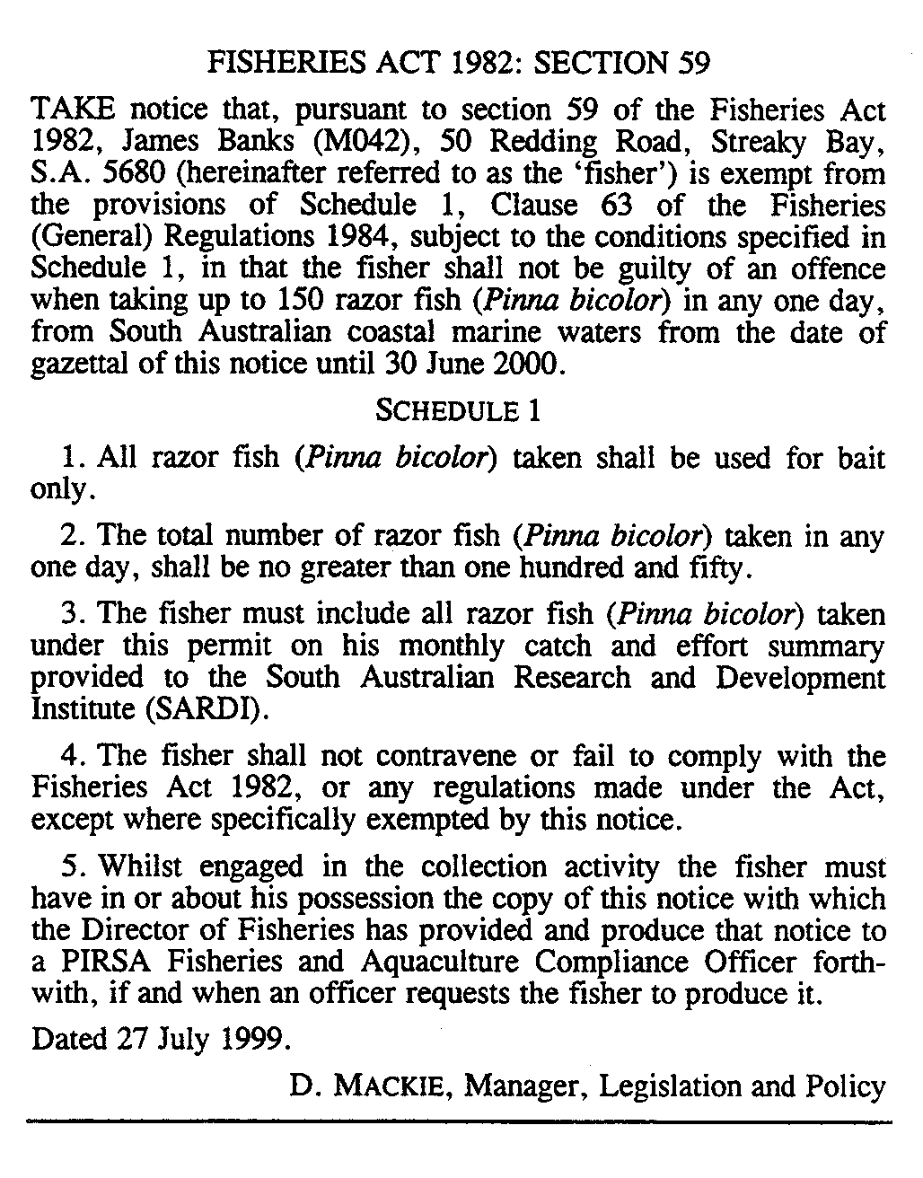

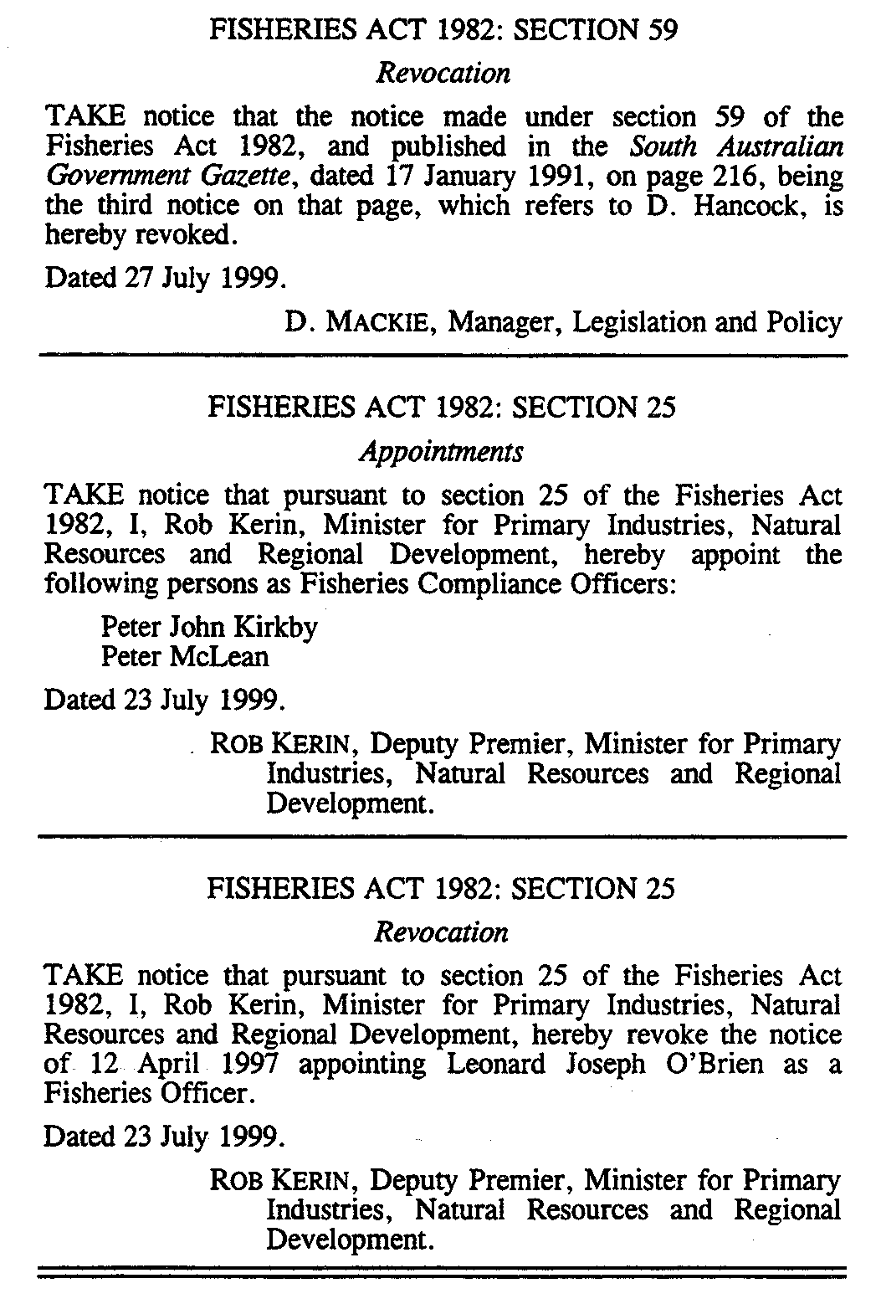

M. E. JONES, Acting Government Printer, South Australia

