SUPPLEMENTARY GAZETTE



THE SOUTH AUSTRALIAN

GOVERNMENT GAZETTE

PUBLISHED BY AUTHORITY

ALL PUBLIC ACTS appearing in this GAZETTE are to be considered official, and obeyed as such

ADELAIDE, TUESDAY, 8 JUNE 1999

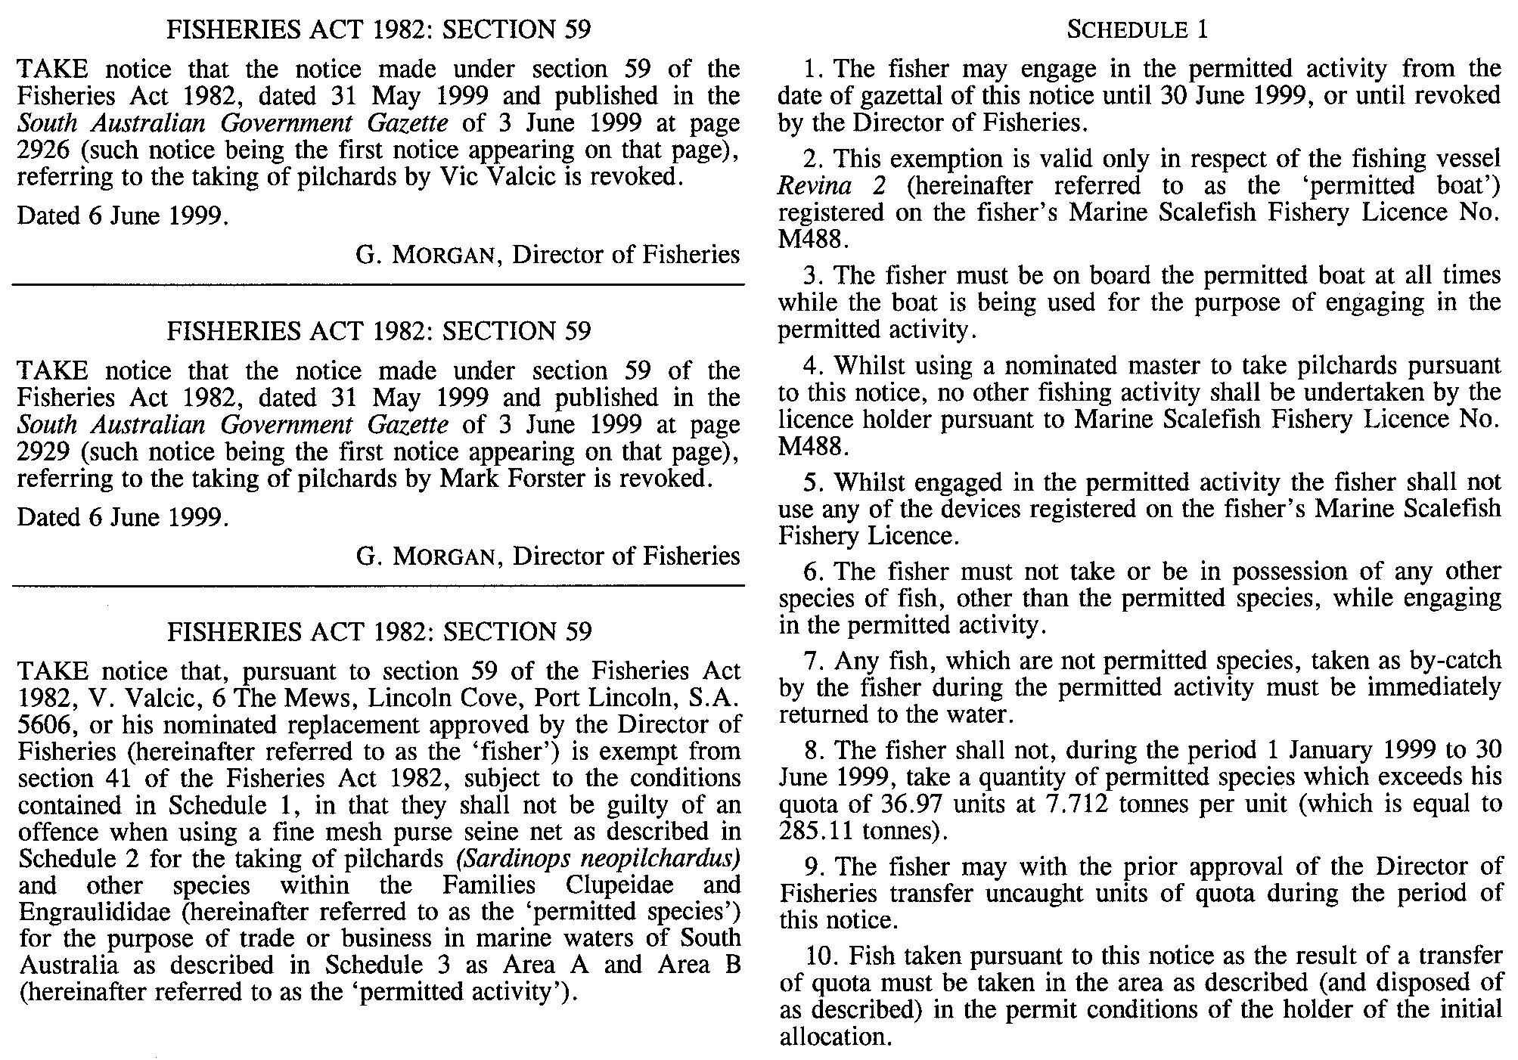

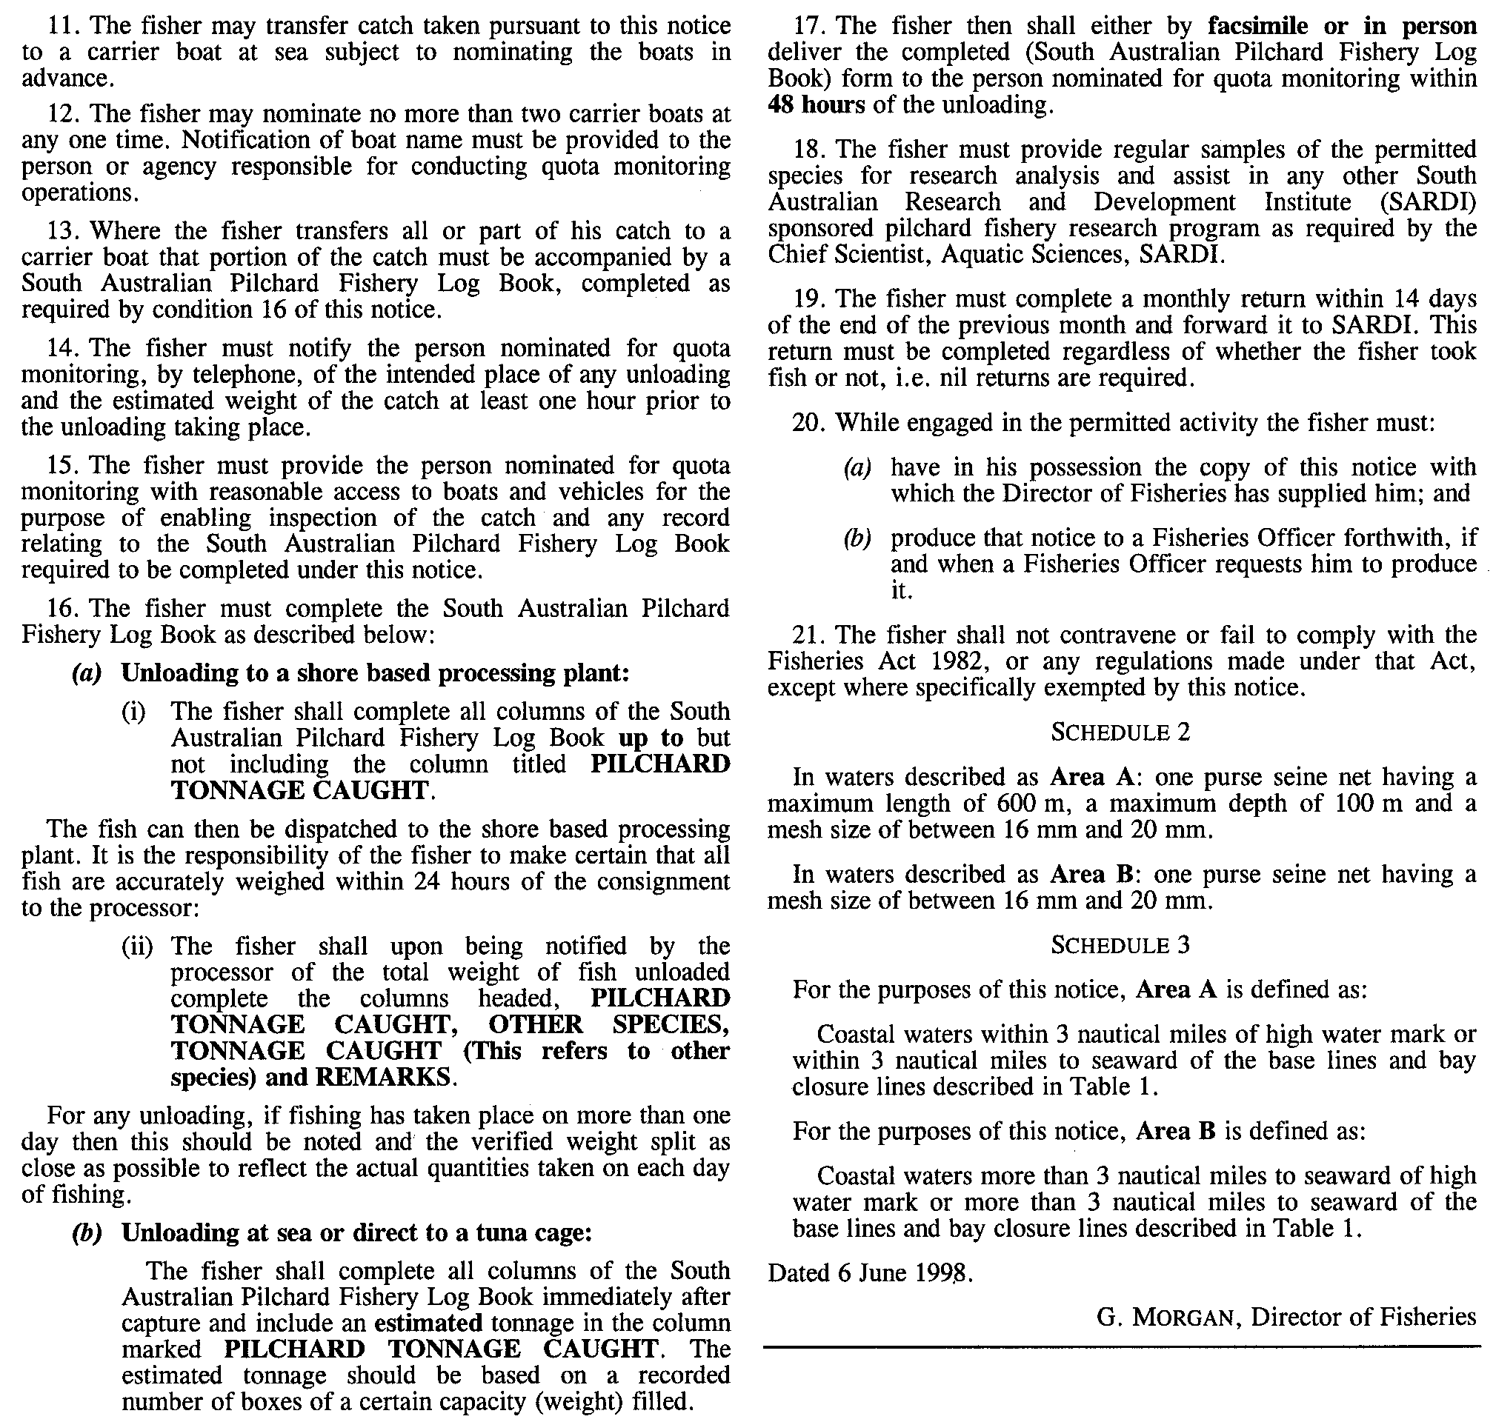

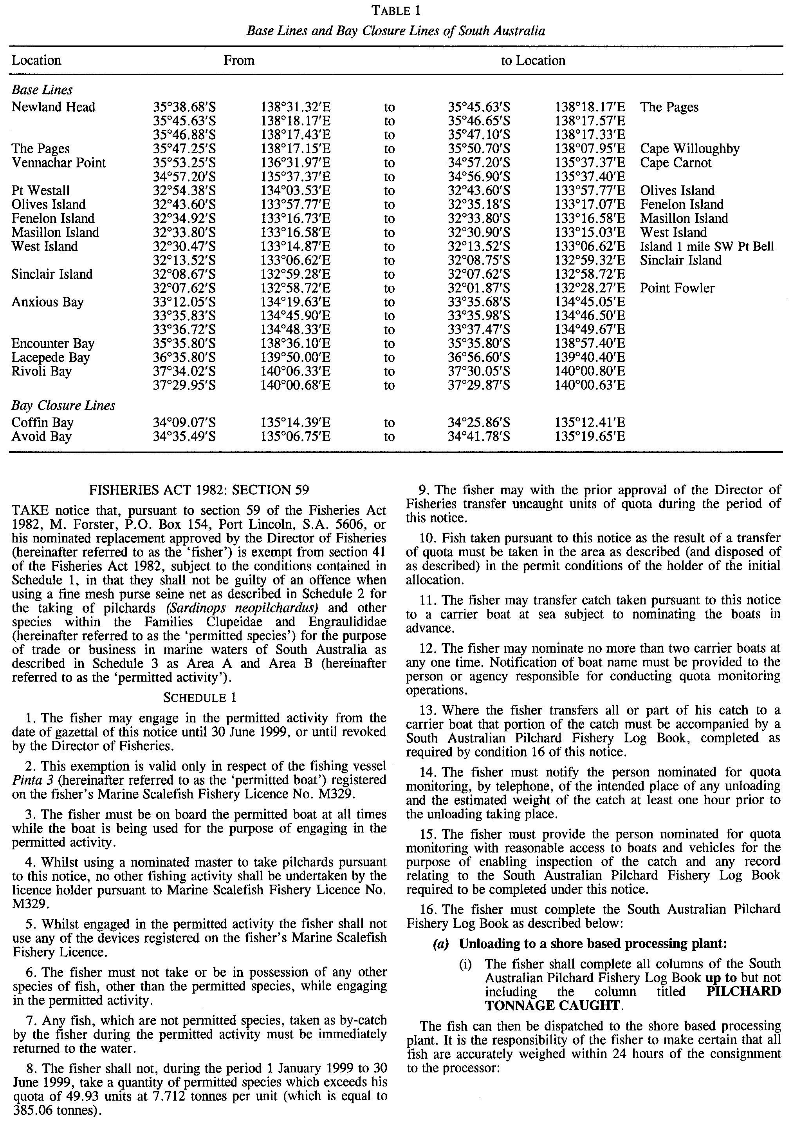

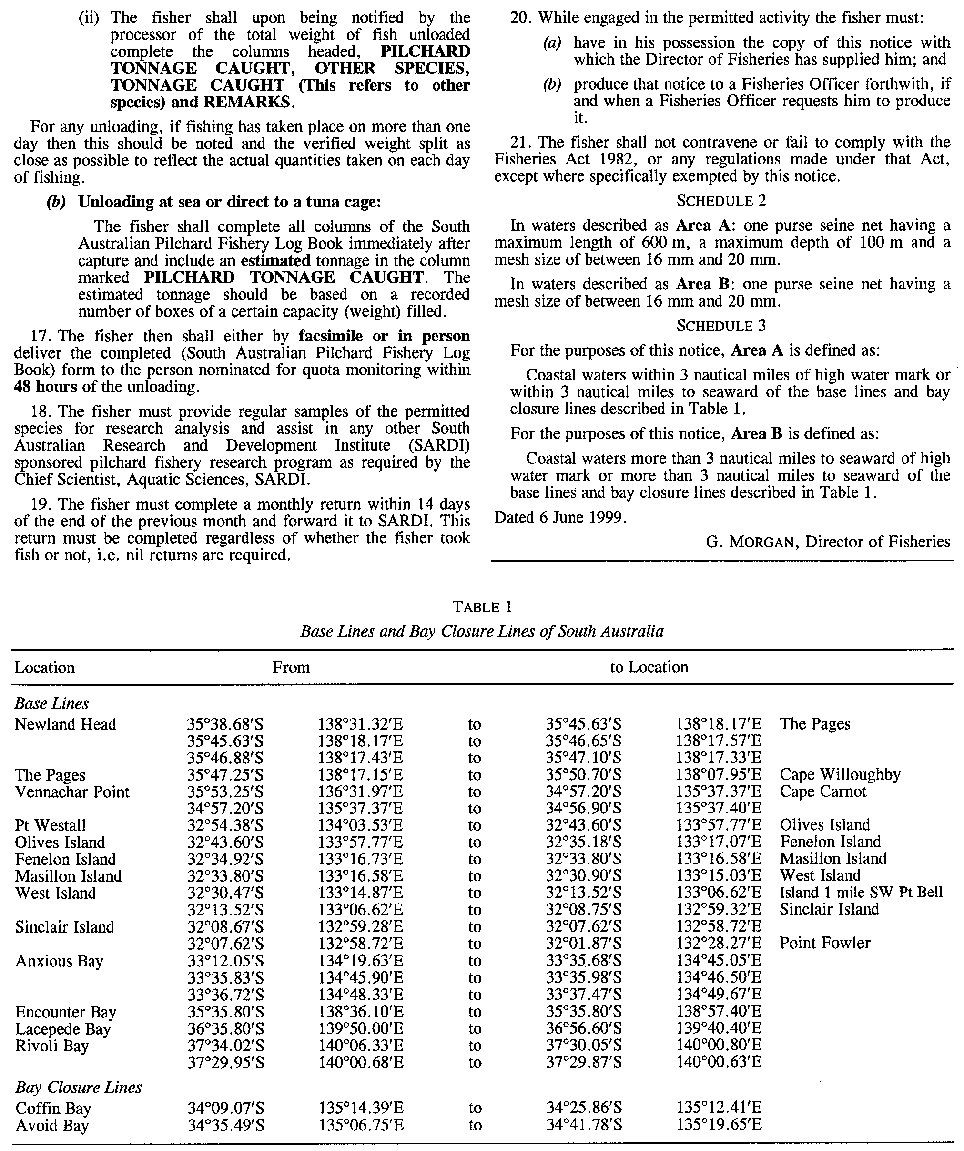

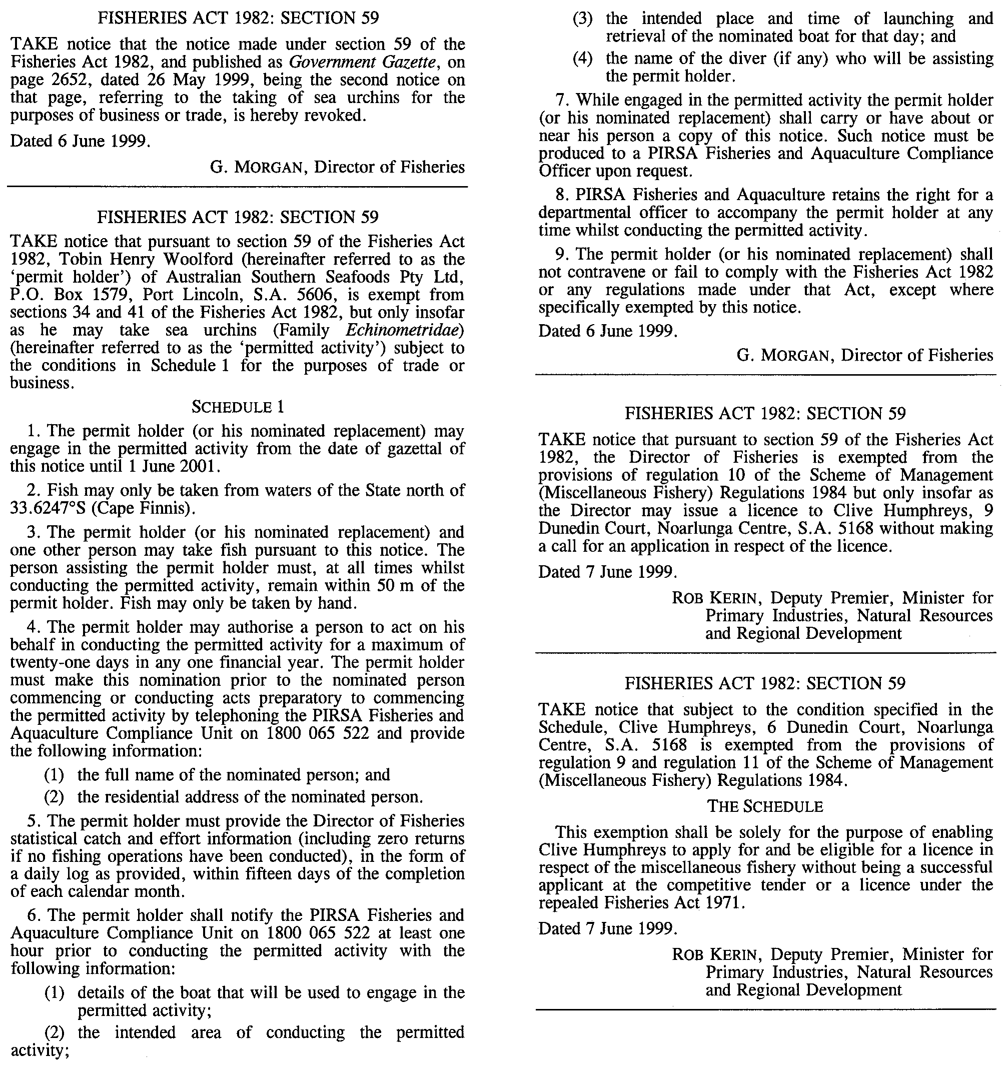

M. E. JONES, Acting Government Printer, South Australia

