No. 74 3047

THE SOUTH AUSTRALIAN

GOVERNMENT GAZETTE

PUBLISHED BY AUTHORITY

ALL PUBLIC ACTS appearing in this GAZETTE are to be considered official, and obeyed as such

ADELAIDE, THURSDAY, 10 JUNE 1999

CONTENTS

Page
Acts Assented To 3048
Appointments, Resignations, Etc. 3048
Associations Incorporation Act 1985⎯Notice 3084
Corporations and District Councils—Notices 3082
Crown Lands Act 1929—Notices 3048
Electoral Act 1985⎯Notice 3049

ENVIRONMENT, HERITAGE AND ABORIGINAL
AFFAIRS
Leases amended, Etc. 3062
Fisheries Act 1982—Notices 3049
Land and Business (Sale and Conveyancing) Act 1994—
Notices 3061
Liquor Licensing Act 1997—Notices 3063
Mining Act 1971—Notices 3065

Page
National Parks and Wildlife Act 1972⎯Notice 3065
Partnership Act 1891⎯Notice 3085
Passenger Transport Act 1994⎯Notice 3065
Petroleum Act 1940⎯Notice 3068
Private Advertisements 3084
Proclamations 3048
Public Trustee Office—Administration of Estates 3084
Real Property Act 1886—Notice 3068
Roads (Opening and Closing) Act 1991—Notices 3079
Road Traffic Act 1961⎯Notice 3069
Rules of Court 3078
South Australian Totalizator Agency Board⎯Ministerial
Direction 3079
Valuation of Land Act 1971⎯Notice 3080
Water Resources Act 1997⎯Notices 3080

GOVERNMENT GAZETTE NOTICES
ALL poundkeepers' and private advertisements forwarded for publication in the South Australian Government Gazette must be PAID FOR PRIOR TO INSERTION; and all notices, from whatever source, should be legibly written on one side of the paper only and sent to Riverside 2000 so as to be received no later than 4 p.m. Tuesday preceding the day of publication. Phone 8207 1045 or Fax 8207 1040. E-mail: govgaz@riv.ssa.sa.gov.au. Send as attachments in Word format and please confirm your transmission with a faxed copy of your document, including the date the notice is to be published and to whom the notice will be charged.

Department of the Premier and Cabinet
Adelaide, 10 June 1999
HIS Excellency the Governor directs it to be notified for general information that he has in the name and on behalf of Her Majesty The Queen, this day assented to the undermentioned Acts passed by the Legislative Council and House of Assembly in Parliament assembled, viz.:
No. 30 of 1999—An Act to amend the Explosives Act 1936.
No. 31 of 1999—An Act to amend the Barley Marketing Act 1993.
By command,
Rob Kerin, for Premier

SHOP TRADING HOURS ACT 1977 SECTION 13: ALTERATION OF SHOP TRADING HOURS—MOUNT BARKER SHOPPING DISTRICT
Proclamation By The Governor
(l.s.) E. J. Neal
PURSUANT to section 13 of the Shop Trading Hours Act 1977 and with the advice and consent of the Executive Council, I authorise the opening of all shops, excluding those shops the business of which is solely or predominantly the sale of boats or motor vehicles, in the Mount Barker Shopping District on each Monday (other than Monday, 14 June 1999), Tuesday, Wednesday and Friday from 6 p.m. until 7 p.m.
This proclamation has effect from Friday, 11 June 1999 until Friday, 9 July 1999 (both days inclusive).
Given under my hand and the Public Seal of South Australia at Adelaide, 10 June 1999.
By command,
Rob Kerin, for Premier
MGE 57/99 CS

Department of the Premier and Cabinet
Adelaide, 10 June 1999
HIS Excellency the Governor in Executive Council has been pleased to appoint Commander Brian Kenneth Gorringe as Deputy Official Secretary to His Excellency the Governor from 21 June 1999, pursuant to the provisions of the Constitution Act 1934.
By command,
Rob Kerin, for Premier
DPC 036/97CS

CROWN LANDS ACT 1929: SECTION 5
TAKE NOTICE that pursuant to the Crown Lands Act 1929, I PETER MACLAREN KENTISH, Surveyor-General and Delegate appointed by DOROTHY KOTZ, Minister for Environment and Heritage, Minister of the Crown to whom the administration of the Crown Lands Act 1929 is committed DO HEREBY dedicate the Crown Land defined in The Schedule as Public Roads.
The Schedule
1. Allotments 23 and 24 of DP 51601, Hundred of Jessie, County of Robe.
2. Allotment 25 of DP 51601, Hundred of Joanna, County of Robe.
The above-described land is within the District of Naracoorte and Lucindale.
Dated 7 June 1999.
P. M. Kentish, Surveyor-General
DENR 09/1012

CROWN LANDS ACT 1929: SECTION 5
TAKE NOTICE that pursuant to the Crown Lands Act 1929, I PETER MACLAREN KENTISH, Surveyor-General and Delegate appointed by DOROTHY KOTZ, Minister for Environment and Heritage, Minister of the Crown to whom the administration of the Crown Lands Act 1929 is committed DO HEREBY dedicate the Crown Land defined in The Schedule as Drainage and Wetlands Reserves (two) and declare that such land shall be under the care, control and management of the City of Port Adelaide Enfield.
The Schedule
1. Allotment 1 of DP 18683, Hundred of Port Adelaide, County of Adelaide, exclusive of all necessary roads, being the whole of the land comprised in Crown Record Volume 5656 Folio 567.
2. Allotment 202 of DP 45294, and allotment 1000 of DP 50514, Hundred of Port Adelaide, County of Adelaide, exclusive of all necessary roads, being the whole of the land comprised in Crown Records Volume 5364 Folio 350 and Volume 5656 Folio 568 respectively.
Dated 7 June 1999.
P. M. Kentish, Surveyor-General
DEHAA 17/0948

CROWN LANDS ACT 1929: SECTION 5
TAKE NOTICE that pursuant to the Crown Lands Act 1929, I PETER MACLAREN KENTISH, Surveyor-General and Delegate appointed by DOROTHY KOTZ, Minister for Environment and Heritage, Minister of the Crown to whom the administration of the Crown Lands Act 1929 is committed DO HEREBY:
1. Dedicate the Crown Land defined in The First Schedule as a Reserve for Car Park Purposes and declare that such land shall be under the care, control and management of the Minister for Human Services.
2. Dedicate the Crown Land defined in The Second Schedule as a Reserve for the Purposes of the Institute of Medical and Veterinary Science and declare that such land shall be under the care, control and management of the Minister for Human Services.
3. Dedicate the Crown Land defined in The Third Schedule as a Reserve for University Purposes and declare that such land shall be under the care, control and management of the University of Adelaide.
4. Dedicate the Crown Land defined in The Fourth Schedule as a Reserve for Hospital Purposes and declare that such land shall be under the care, control and management of the Board of Management of the Royal Adelaide Hospital.
The First Schedule
Allotment 13 of DP 51367, Hundred of Adelaide, County of Adelaide, exclusive of all necessary roads:
1. Subject nevertheless to an existing easement to ETSA Utilities Pty Ltd for the transmission of electricity by underground cable more particularly described in Land Grant Volume 4398 Folio 416 over that portion of allotment 13 marked C on DP 51367, and
2. Together with a free and unrestricted right of way shown marked A and B on DP 51367.
The Second Schedule
Allotment 12 of DP 51367, Hundred of Adelaide, County of Adelaide, exclusive of all necessary roads, together with a free and unrestricted right of way shown marked A on DP 51367.
The Third Schedule
Allotment 11 of DP 51367, Hundred of Adelaide, County of Adelaide, exclusive of all necessary roads, subject nevertheless to an existing easement to ETSA Utilities Pty Ltd for the transmission of electricity by underground cable more particularly described in Land Grant Volume 4398 Folio 416 over that portion of allotment 11 marked C on DP 51367.
The Fourth Schedule
Allotment 14 of DP 51367, Hundred of Adelaide, County of Adelaide, exclusive of all necessary roads, subject nevertheless to:
1. An existing easement to ETSA Utilities Pty Ltd for the transmission of electricity by underground cable more particularly described in Land Grant Volume 4398 Folio 416 over that portion of allotment 14 marked C on DP 51367.
2. A free and unrestricted right of way shown marked B on DP 51367 and appurtenant to allotment 13 (DP 51367), and
3. Together with a free and unrestricted right of way shown marked A on DP 51367.
Dated 7 June 1999.
P. M. Kentish, Surveyor-General
DL 1442/1989 TC 2

ELECTORAL ACT 1985
Part 6—Registration of Political Parties
NOTICE is hereby given that from the close of business on 11 June 1999 and in accordance with section 45, the following political party will be deregistered:
The Socialist Alliance
S. H. Tully, Electoral Commissioner
SEO 104/97

FISHERIES ACT 1982: SECTION 43
TAKE note that the notice number D0022/99 made under section 43 of the Fisheries Act 1982 dated 7 April 1999 and published in the Government Gazette, page 1650, dated 8 April 1999, being the sixth notice on that page, which refers to the West Coast prawn fishery is revoked as of 1800 hours on 7 June 1999.
Dated 7 June 1999.
W. Zacharin, Principal Manager, Shellfish
R0018/99

FISHERIES ACT 1982: SECTION 43
TAKE notice that it is hereby declared that it shall be unlawful for any person to engage in the class of fishing activity specified in Schedule 1 during the periods specified in Schedule 2.
Schedule 1
The act of taking or the act preparatory to or involved in the taking of western king prawn (Penaeus latisulcatus) in all waters of the West Coast north of latitude 33°12.00′S.
Schedule 2
1800 hours on 7 June 1999 to 0700 hours on 21 June 1999.
Dated 7 June 1999.
W. Zacharin, Principal Manager, Shellfish
D0025/99

FISHERIES ACT 1982: SECTION 43
TAKE notice that it is hereby declared that it shall be unlawful for any person to engage in the class of fishing activity specified in Schedule 1 during the periods specified in Schedule 2.
Schedule 1
The act of taking or the act preparatory to or involved in the taking of western king prawn (Penaeus latisulcatus) in all waters of the West Coast northerly of a line commencing from latitude 33°12.00′S, longitude 134°19.00′E, then to position latitude 33°18.50′S, longitude 134°39.00′E, then to position latitude 33°22.00′S, longitude 134°44.50′E, then to position latitude 33°33.50′S, longitude 134°51.40′E.
Schedule 2
1800 hours on 7 June 1999 to 0700 hours on 21 June 1999.
Dated 7 June 1999.
W. Zacharin, Principal Manager, Shellfish
D0026/99

FISHERIES ACT 1982: SECTION 43
TAKE notice that it is hereby declared that it shall be unlawful for any person to engage in the class of fishing activity specified in Schedule 1 during the periods specified in Schedule 2.
Schedule 1
The act of taking or the act preparatory to or involved in the taking of western king prawn (Penaeus latisulcatus) in all waters of the West Coast prawn fishery between 0700 hours and 1800 hours.
Schedule 2
8 June 1999 to 20 June 1999.
Dated 7 June 1999.
W. Zacharin, Principal Manager, Shellfish
D0027/99

FISHERIES ACT 1982: SECTION 43
TAKE notice that it is hereby declared that it shall be unlawful for any person to engage in the class of fishing activity specified in Schedule 1 during the periods specified in Schedule 2.
Schedule 1
The act of taking or the act preparatory to or involved in the taking of western king prawn (Penaeus latisulcatus) in all waters of the West Coast prawn fishery.
Schedule 2
0700 hours on 21 June 1999 until 2400 hours on 31 December 1999.
Dated 7 June 1999.
W. Zacharin, Principal Manager, Shellfish
D0028/99

FISHERIES ACT 1982
Finfish Farming Licence FF00019
(Previous Licence No. F1533)
Licence to Farm Fish under section 53 of the Fisheries
Act 1982
WHEREAS the Director of Fisheries has, pursuant to section 50 (2) of the Fisheries Act 1982 (‘the Act’), issued a permit to the undermentioned licensee to release the fish specified in Schedule 2 of this licence (‘the permitted species’) and, pursuant to section 48G (2) of the Act, the Director of Fisheries has also issued a permit to disturb the seabed for the purpose of installing structures necessary for the licensed activity at the undermentioned site, the Minister for Primary Industries, Natural Resources and Regional Development (‘the Minister’) hereby grants to:
Eyre Aquaculture Pty Ltd
5 French Street
Broadview, S.A. 5083,
a non-exclusive licence to occupy and use the waters specified in Item 1 of Schedule 1 of this licence (‘the site’) for the purpose of farming and taking the permitted species (‘the permitted use’) for the period commencing on 1 July 1998 and ending, subject to any earlier termination under this licence, on 30 June 1999 (‘the term’) subject to the following terms and conditions:
Conditions of This Licence
1. Licence
The parties acknowledge and agree that:
1.1 the rights, powers and privileges granted to or vested in the licensee under this licence are contractual only and shall not create or vest in the licensee any estate, interest or right of a proprietary nature in the site; and
1.2 that, subject to section 53A of the Fisheries Act 1982, this licence does not entitle the licensee to exclusive rights of entry to and occupation of the site and that the rights granted by this licence are exercisable by the licensee in common with any other occupiers of the site from time to time.
2. Marked-off Areas
For the purposes of section 53A of the Fisheries Act 1982, the marked-off areas within the site is that area or those areas marked-off or indicated in the manner set out in Item 2 of Schedule 1 of this licence.
3. Permitted Species
The licensee:
3.1 must not farm or introduce any species at the site other than the permitted species; and
3.2 must not take any wild fish from the site except for recreational purposes.
4. Permitted Use
The licensee must not use the site for any purpose other than the permitted use.
5. Permitted Methods
The licensee:
5.1 must not stock the permitted species at a rate greater than that specified in Schedule 2 of this licence;
5.2 must not use the anti-fouling chemical tributyltin (TBT) on any equipment used at the site;
5.3 must not use any chemical or drug for either therapeutic or prophylactic purpose except with the prior approval of the Minister;
5.4 must apply the permitted farming methods set out in Schedule 2 of this licence.
5.5 must conduct an environmental monitoring program as set out in Schedule 5 of this licence.
6. Seacages
The licensee:
6.1 must ensure that all seacages on the site have anti-predator protection satisfactory to the Minister at all times during the term; and
6.2 must immediately inform an officer of PIRSA (Fisheries) on 1800 065 522 or such other officer as the Minister from time to time notifies to the licensee in writing if any marine animal, other than the permitted species, is caught in any seacage or other farm structure used by the licensee on the site.
7. Location of Seacages
The licensee must not erect or use any seacages in any location on the site where stocked seacages have been used in the immediately preceding two year period.
8. Marking and Maintaining the Site
The licensee:
8.1 must ensure that the site is maintained in a good, tidy and safe condition to the satisfaction of the Minister;
8.2 must remove and lawfully dispose of any waste or debris on the site as soon as is reasonably practicable and in particular must comply with any guidelines issued from time to time by the Minister in relation to the removal from the site of any unhealthy or dead fish;
8.3 must maintain all buoys, crosses and markers on the site in good condition and in accordance with the colours specified in Schedule 1 of this licence; and
8.4 must mark the site boundary in accordance with the specifications in Schedule 1 of this licence.
9. Site Inspection and Supervision
The licensee:
9.1 must at all times permit the Minister, his employees, agents or contractors or any employees, agents or contractors of the Crown to enter the site for the purposes of inspecting the site, the sea floor and the flora and fauna on or in the vicinity of the site; and
9.2 must comply with all reasonable directions of any such person authorised by the Director of Fisheries to inspect the conduct of the licensee’s activities at the site.
10. Fees and Returns
The licensee:
10.1 must pay to the Minister the licence fee in accordance with Item l of Schedule 3 of this licence;
10.2 must on or before 31 January and 31 July during the term, submit to the Minister a return supplying all of the information described in Schedule 4 of this licence.
11. Compliance With Relevant Laws
11.1 the licensee must at all times comply with all laws, by-laws or regulations in force which relate to the site or the activities conducted in the site and with all notices, orders or requirements lawfully given or made by any authority or authorities in respect of the site;
11.2 in particular, without derogating from the general requirement under condition 11 of this licence:
11.2.1 the licensee must not do or permit to be done in upon or about the site anything which in the opinion of the Minister would cause or contribute to the degradation or pollution of any coastal land or the surrounding marine environment; and
11.2.2 in the event that the Minister is satisfied, on reasonable grounds, that the fish taken from the waters are not fit for human consumption or that consumption of fish taken from the waters could present a danger to the health of the consumer, the licensee must, in accordance with a written notice from the Minister, cease or suspend the conduct of the permitted use or else conduct the permitted use as directed within the notice.
12. Public Risk Indemnity
The licensee must at all times indemnify the Minister, his officers, employees, contractors and agents from and against all claims, demands, actions, judgments, proceedings, damages, losses, costs, charges and expenses in respect of any loss of life, personal injury and/or damage to property caused or suffered in any manner in or about the site.
13. Release
The licensee must use and keep the site at the risk in all things of the licensee and the licensee must release to the full extent permitted by law the Minister, his agents, contractors and servants in the absence of any wilful act, omission, default or neglect on their part from all claims and demands of every kind resulting from any accident, damage or injury to persons or property occurring at the site, including loss or damage to the licensee’s fixtures or personal property of the licensee.
14. Public Risk Insurance
The licensee shall at its own cost and expense during the term effect and keep in full force and effect in respect of the site and the permitted use a policy of public risk insurance in the joint names of the licensee and the Minister in which the limits of public risk shall not be less than the amount specified in Item 2 of Schedule 3 of this licence, or such further amount as the Minister may from time to time reasonably require, as the amount which may be paid out in respect of any one single claim and a policy of insurance or copy thereof or a certificate of insurance shall be produced by the licensee to the Minister on request in writing being made by the Minister for its production.
15. Guarantee or Indemnity Scheme
The licensee must either:
15.1 provide a guarantee from its bankers; or
15.2 contribute to an indemnity scheme established for the aquaculture and fisheries industry and approved by the Minister,
to and in favour of and for the benefit of the Minister by way of security for the due and punctual performance by the licensee of the terms and conditions of this licence and in particular the obligations of the licensee to rehabilitate the site immediately prior to the expiration or sooner determination of the term of this licence. Such guarantee or indemnity scheme must have effect from the date of commencement of the term.
16. No Assignment
The licensee acknowledges that this licence is personal and it must not assign or sublet or deal in any other way with any interest in this licence.
17. Default by Licensee and Termination
The Minister may terminate this licence immediately by notice in writing served on the licensee if:
17.1 the licensee commits or permits any breach or default of the obligations imposed on the licensee by this licence, and following the giving by the Minister of written notice of such breach or default, the licensee either fails to rectify such breach or default within one calendar month of the date of such notice (or earlier if the circumstances require) or fails to make diligent progress towards rectifying any such breach which is incapable of rectification within the time so limited; or
17.2 the licensee commits or permits any further breach or default of the obligations imposed on the licensee by this licence for which the Minister has previously given notice in writing of such breach or default pursuant to paragraph 1 of condition 15.1 notwith-standing rectification of the previous breach or default; or
17.3 the licence fee referred to in condition 10 is unpaid for a period of 14 days after notice has been given to the licensee that it is outstanding; or
17.4 if the licensee is a body corporate, any of the following occur:
17.4.1 the licensee is unable to pay its debts as and when they fall due or is otherwise insolvent;
17.4.2 an order is made for the winding up or liquidation of the licensee;
17.4.3 the licensee enters into a scheme of arrangement, compromise, moratorium or other form of composition with its creditors or any class of its creditors;
17.4.4 a receiver, a manager or a receiver and manager, a company administrator or other insolvency administrator is appointed to the licensee; or
17.4.5 a mortgagee, chargee or other encum-brancee is appointed over or takes possession of or appoints an agent to take possession of all or any of the licensee’s assets; or
17.5 if the licensee is an individual, the licensee:
17.5.1 becomes bankrupt or assigns its estate or enters into a deed of arrangement or other form of composition for the benefit of the licensee’s creditors; or
17.5.2 is convicted of an indictable offence.
Termination of this licence by the Minister shall be without prejudice to any rights, remedies or actions that the Minister may have against the licensee in respect of any antecedent breach by the licensee of the terms and conditions contained in this licence.
18. Interpretation
Subject to any inconsistency of subject or context, the following rules of construction shall be used in the interpretation of this licence:
18.1 any word importing the plural includes the singular and vice versa;
18.2 any wording importing a gender shall include all other genders;
18.3 a reference to a body corporate shall include a natural person and vice versa;
18.4 a reference to a recital, party, clause, Schedule or Annexure is a reference to a recital, party, clause, Schedule or Annexure of this licence;
18.5 the captions, headings, section numbers and clause numbers appearing in this licence are inserted only as a matter of convenience and in no way affect the construction of this licence;
18.6 a reference to a statute shall include all statutes amending, consolidating or replacing the statutes referred to;
18.7 where two or more persons are named as licensees, this licence shall bind the licensees jointly and each of them severally; and
18.8 time is of the essence in respect of any obligation relating to time in this licence.
19. Delegation
Any consent, notice, any consultation or any other thing which is pursuant to the terms of this licence either required to be given, done or performed or which may be given, done or performed by the Minister may for the purposes of this licence be properly given, done or performed by any duly authorised agent or employee of the Minister.
20. Severance
If any term or condition of this licence should be for any reason unlawful, void, invalid or unenforceable then the offending term or condition shall be severed from this licence without affecting the validity or enforceability of the remainder of this licence.
21. Modification
No variation of or addition to any provision of this licence shall be binding upon the Minister and the licensee unless such variation or addition is made in writing, signed by both the Minister and the licensee and expressed to be either supplemental to or in substitution for the whole or a part of this licence.
22. Waiver
22.1 A waiver of any provision of this licence by the Minister must both be in writing and be signed by the Minister or by persons duly authorised to execute such a document on the Minister’s part.
22.2 No waiver by the Minister of a breach of a term or condition contained in this licence shall operate as a waiver of any breach of the same or any other term or condition contained in this licence.
22.3 No forbearance, delay or indulgence by the Minister in enforcing the provisions of this licence shall prejudice or restrict the rights of the Minister.
23. Notices
23.1 Notices may be served by delivering the same personally, by mail or facsimile transmission and shall be:
23.1.1 in writing addressed to the Director of Fisheries, PIRSA, 16th Floor, 25 Grenfell Street, Adelaide, S.A. 5000 (in the case of the Minister) and to the address of the licensee set out above (in the case of the licensee);
23.1.2 signed by or on behalf of the sender or by a person duly authorised in that regard by the sender;
23.1.3 deemed to be duly served or made in the following circumstances:
(a) if delivered, upon delivery;
(b) if sending by mail, upon posting;
(c) if sent by facsimile transmission, upon the sender’s facsimile producing a transmission report that the facsimile was satisfactorily sent in its entirety to the addressee’s facsimile number,
but if delivery is not made before 5 p.m. on any day it shall be deemed to be received at 9 a.m. on the next day in that place.
23.2 The Minister and the licensee may each vary their address or facsimile number at any time by written notice.
Granted on behalf of the Minister by Director of Fisheries, delegate of the Minister, on 6 June 1999.
G. Morgan, Director of Fisheries
The Common Seal of Eyre Aquaculture Pty Ltd was hereunto affixed in the presence of:
(l.s.) P. B. Parry, Director
R. T. Bakewell, Witness
Schedule 1
Item 1—The Site
Area applicable to this licence:
Licensed Area Licensed
Hectares
Zone 53
679455E 6269470N 136°56′10″ -33°41′58″ 5
679558E 6269243N 136°56′14″ -33°42′05″
679397E 6269132N 136°56′08″ -33°42′09″
679304E 6269356N 136°56′04″ -33°42′01″
All structures, equipment, buoys and flotations (except for that required by the Department for Transport, Urban Planning and the Arts) must be black, dark grey, dark blue, dark brown, or dark green coloured materials.
The boundary of the site to be marked either with:
(a) (1) At the corners with posts extending 900 mm above mean high water springs. Such posts to be marked with a St Andrews cross, each cross arm measuring 900 mm from tip to tip, minimum width 75 mm.
(2) Posts to be not less than 125 mm in diameter.
(3) Posts and crosses to be painted yellow.
(4) The ends of each cross to be marked with a 200 mm strip of yellow retro-reflective tape.
(5) Between the corner posts at intervals not exceeding 50 m, buoys not less than 300 mm in diameter.
(6) All buoys, posts, crosses and markers must be maintained in good condition.
or
(b) (1) At each corner, yellow spar buoys with a St Andrews cross as a top mark placed at least 900 mm above the buoy, cross arms 900 mm long x 75 mm wide.
(2) At distances not exceeding 50 m between the corner spar buoys, yellow spherical buoys not less than 300 mm in diameter.
(3) The buoys and topmarks must all be coloured yellow and marked with a yellow retro-reflective as in (a) (4).
(4) All buoys, posts, crosses and markers must be maintained in good condition.
When the site is in navigable water and possible danger to navigation, lights must be yellow in colour and flashing once every 4 seconds and visible over an arc of 360 degrees for a distance of at least one mile.
All seacages on the site must be marked with a unique seacage number and the site’s unique ‘F number’; that is, the licence number. All St Andrew’s crosses must be marked with the site’s unique ‘F number’; that is the licence number.
Item 2—Marked-Off Areas
Marked-off areas must be marked with no less than 8 equally spaced white buoys, each of at least 12 inches in diameter, each positioned no more than 70 m from each relevant sea cage situated on the site.
Schedule 2
Permitted Species
The Director of Fisheries has, pursuant to section 50 (2) of the Act, issued a permit for the release of the fish specified in this Schedule.
Whiting, King George (Sillaginodes punctata)
Snapper (Pagrus auratus)
Australian Herring (Tommy Ruff) (Arripis georgianus)
Yellowtail King Fish (Seriola lalandi)
Permitted Farming Methods
The Director of Fisheries has, pursuant to section 48G (2) of the Act, issued a permit to disturb the seabed for the purpose of installing the structures specified in this Schedule.
Sea Cages 5
Stocking Rates
The maximum standing stock on the Site must not exceed 25 tonnes.
Schedule 3
Item 1—Fees
$
Base Licence Fee 558.00
Total Annual Licence Fee 558.00
Item 2—Public Risk Insurance
Five million dollars ($5 000 000).
Schedule 4
Returns
The licensee must submit the following information to the Minister, c/o Director of Fisheries, PIRSA, 16th Floor, 25 Grenfell Street, Adelaide, S.A. 5000 (G.P.O. Box 1625, Adelaide, S.A. 5001) on or before 31 January and 31 July during the term of this licence:
1. Name of licensee.
2. Address of licensee.
3. Species of fish farmed and held on the site.
4. Location of aquaculture operation.
5. Period covered by return.
6. Number of life stage of each species of fish held.
7. Number, weight and value of each species of fish held.
8. Details of any disease detected in any fish kept.
9. Source (whether interstate or intrastate) of any stock acquired and date of acquisition (if relevant, include name of authority that provided certification that stock was free from disease).
10. If any fish were brought into the State, the number of fish and the life stage of the fish.
11. If fish were brought into the State, the purpose for which they were brought in.
12. Method of disposal of water and packaging use for transporting the fish.
13. If any disease or symptom of disease occurred in the acquired fish.
14. Method of disposal of diseased or dead fish and the number disposed of.
15. Signature, date and telephone number.
16. Use of any chemicals for fish husbandry—type of chemical and quantity used, purpose and date of use.
Schedule 5
Approved Environmental Monitoring Program
An Environmental Monitoring Program for the site must comply with the general requirements for environmental monitoring specified by the Director of Fisheries.
The licensee must submit a draft Environmental Monitoring Program in writing to the Director of Fisheries within 60 days after the grant of the licence by the Minister.

FISHERIES ACT 1982
Marine Mollusc Farming Licence FM00073
(Previous Licence No. F735)
Licence to Farm Fish under section 53 of the Fisheries
Act 1982
WHEREAS the Director of Fisheries has, pursuant to section 50 (2) of the Fisheries Act 1982 (‘the Act’), issued a permit to the undermentioned licensee to release the fish specified in Item 1 of Schedule 2 of this licence (‘the permitted species’) and, pursuant to section 48G (2) of the Act, the Director of Fisheries has also issued a permit to disturb the seabed for the purpose of installing structures necessary for the licensed activity at the undermentioned site, the Minister for Primary Industries, Natural Resources and Regional Development (‘the Minister’) hereby grants to:
Michael Van Doorn
P.O. Box 1083
Port Lincoln, S.A. 5606,
a non-exclusive licence to occupy and use the waters specified in Item 1 of Schedule 1 of this licence (‘the site’) for the purpose of farming and taking the permitted species (‘the permitted use’) for the period commencing on 1 January 1999 and ending, subject to any earlier termination under this licence, on 30 June 1999 (‘the term’) subject to the following terms and conditions:
Conditions of This Licence
1. Licence
The parties acknowledge and agree that:
1.1 the rights, powers and privileges granted to or vested in the licensee under this licence are contractual only and shall not create or vest in the licensee any estate, interest or right of a proprietary nature in the site; and
1.2 that, subject to section 53A of the Fisheries Act 1982, this licence does not entitle the licensee to exclusive rights of entry to and occupation of the site and that the rights granted by this licence are exercisable by the licensee in common with any other occupiers of the site from time to time.
2. Marked-off Areas
For the purposes of section 53A of the Fisheries Act 1982, the marked-off areas within the site is that area or those areas marked-off or indicated in the manner set out in Item 2 of Schedule 1 of this licence.
3. Permitted Species
The licensee:
3.1 must not farm or introduce any species at the site other than the permitted species; and
3.2 must not take any wild fish from the site except for recreational purposes.
4. Permitted Use
The licensee must not use the site for any purpose other than the permitted use.
5. Permitted Methods
The licensee:
5.1 must not stock the permitted species at a rate greater than that specified in Schedule 2 of this licence;
5.2 must not use the anti-fouling chemical tributyltin (TBT) on any equipment used at the site;
5.3 must not use any chemical or drug for either therapeutic or prophylactic purpose except with the prior approval of the Minister;
5.4 must apply the permitted farming methods set out in Item 2 of Schedule 2 of this licence.
6. Marking and Maintaining the Site
The licensee:
6.1 must ensure that the site is maintained in a good, tidy and safe condition to the satisfaction of the Minister;
6.2 must remove and lawfully dispose of any waste or debris on the site as soon as is reasonably practicable and in particular must comply with any guidelines issued from time to time by the Minister in relation to the removal from the site of any unhealthy or dead fish;
6.3 must maintain all buoys, crosses, and markers on the site in good condition and in accordance with the colours specified in Schedule 1 of this licence; and
6.4 must mark the site boundary in accordance with the specifications in Schedule 1 of this licence.
7. Site Inspection and Supervision
The licensee:
7.1 must at all times permit the Minister, his employees, agents or contractors or any employees, agents or contractors of the Crown to enter the site for the purposes of inspecting the site, the sea floor and the flora and fauna on or in the vicinity of the site; and
7.2 must comply with all reasonable directions of any such person authorised by the Director of Fisheries to inspect the conduct of the licensee’s activities at the site.
8. Fees and Returns
The licensee:
8.1 must pay to the Minister the licence fee in accordance with Item l of Schedule 3 of this licence;
8.2 must on or before 31 January and 31 July during the term, submit to the Minister a return supplying all of the information described in Schedule 4 of this licence.
9. Compliance With Relevant Laws
9.1 the licensee must at all times comply with all laws, by-laws or regulations in force which relate to the site or the activities conducted in the site and with all notices, orders or requirements lawfully given or made by any authority or authorities in respect of the site;
9.2 in particular, without derogating from the general requirement under condition 9 of this licence:
9.2.1 the licensee must not do or permit to be done in upon or about the site anything which in the opinion of the Minister would cause or contribute to the degradation or pollution of any coastal land or the surrounding marine environment; and
9.2.2 in the event that the Minister is satisfied, on reasonable grounds, that the fish taken from the waters are not fit for human consumption or that consumption of fish taken from the waters could present a danger to the health of the consumer, the licensee must, in accordance with a written notice from the Minister, cease or suspend the conduct of the permitted use or else conduct the permitted use as directed within the notice.
10. Public Risk Liability
The licensee must at all times indemnify the Minister, his officers, employees, contractors and agents from and against all claims, demands, actions, judgments, proceedings, damages, losses, costs, charges and expenses in respect of any loss of life, personal injury and/or damage to property caused or suffered in any manner in or about the site.
11. Release
The licensee must use and keep the site at the risk in all things of the licensee and the licensee must release to the full extent permitted by law the Minister, his agents, contractors and servants in the absence of any wilful act, omission, default or neglect on their part from all claims and demands of every kind resulting from any accident damage or injury to persons or property occurring at the site, including loss or damage to the licensee’s fixtures or personal property of the licensee.
12. Public Risk Insurance
The licensee shall at its own cost and expense during the term effect and keep in full force and effect in respect of the site and the permitted use a policy of public risk insurance in the joint names of the licensee and the Minister in which the limits of public risk shall not be less than the amount specified in Item 2 of Schedule 3 of this licence, or such further amount as the Minister may from time to time reasonably require, as the amount which may be paid out in respect of any one single claim and a policy of insurance or copy thereof or a certificate of insurance shall be produced by the licensee to the Minister on request in writing being made by the Minister for its production.
13. Guarantee or Indemnity Scheme
The licensee must either:
13.1 provide a guarantee from its bankers; or
13.2 contribute to an indemnity scheme established for the aquaculture and fisheries industry and approved by the Minister,
to and in favour of and for the benefit of the Minister by way of security for the due and punctual performance by the licensee of the terms and conditions of this licence and in particular the obligations of the licensee to rehabilitate the site immediately prior to the expiration or sooner determination of the term of this licence. Such guarantee or indemnity scheme must have effect from the date of commencement of the term.
14. No Assignment
The licensee acknowledges that this licence is personal and it must not assign or sublet or deal in any other way with any interest in this licence.
15. Default by Licensee and Termination
The Minister may terminate this licence immediately by notice in writing served on the licensee if:
15.1 the licensee commits or permits any breach or default of the obligations imposed on the licensee by this licence, and following the giving by the Minister of written notice of such breach or default, the licensee either fails to rectify such breach or default within one calendar month of the date of such notice (or earlier if the circumstances require) or fails to make diligent progress towards rectifying any such breach which is incapable of rectification within the time so limited; or
15.2 the licensee commits or permits any further breach or default of the obligations imposed on the licensee by this licence for which the Minister has previously given notice in writing of such breach or default pursuant to paragraph 1 of condition 15.1 notwith-standing rectification of the previous breach or default; or
15.3 the licence fee referred to in condition 8 is unpaid for a period of 14 days after notice has been given to the licensee that it is outstanding; or
15.4 if the licensee is a body corporate, any of the following occur:
15.4.1 the licensee is unable to pay its debts as and when they fall due or is otherwise insolvent;
15.4.2 an order is made for the winding up or liquidation of the licensee;
15.4.3 the licensee enters into a scheme of arrangement, compromise, moratorium or other form of composition with its creditors or any class of its creditors;
15.4.4 a receiver, a manager or a receiver and manager, a company administrator or other insolvency administrator is appointed to the licensee; or
15.4.5 a mortgagee, chargee or other encum-brancee is appointed over or takes possession of or appoints an agent to take possession of all or any of the licensee’s assets; or
15.5 if the licensee is an individual, the licensee:
15.5.1 becomes bankrupt or assigns its estate or enters into a deed of arrangement or other form of composition for the benefit of the licensee’s creditors; or
15.5.2 is convicted of an indictable offence.
Termination of this licence by the Minister shall be without prejudice to any rights, remedies or actions that the Minister may have against the licensee in respect of any antecedent breach by the licensee of the terms and conditions contained in this licence.
16. Interpretation
Subject to any inconsistency of subject or context, the following rules of construction shall be used in the interpretation of this licence:
16.1 any word importing the plural includes the singular and vice versa;
16.2 any wording importing a gender shall include all other genders;
16.3 a reference to a body corporate shall include a natural person and vice versa;
16.4 a reference to a recital, party, clause, Schedule or Annexure is a reference to a recital, party, clause, Schedule or Annexure of this licence;
16.5 the captions, headings, section numbers and clause numbers appearing in this licence are inserted only as a matter of convenience and in no way affect the construction of this licence;
16.6 a reference to a statute shall include all statutes amending, consolidating or replacing the statutes referred to;
16.7 where two or more persons are named as licensees, this licence shall bind the licensees jointly and each of them severally; and
16.8 time is of the essence in respect of any obligation relating to time in this licence.
17. Delegation
Any consent, notice, any consultation or any other thing which is pursuant to the terms of this licence either required to be given, done or performed or which may be given, done or performed by the Minister may for the purposes of this licence be properly given, done or performed by any duly authorised agent or employee of the Minister.
18. Severance
If any term or condition of this licence should be for any reason unlawful, void, invalid or unenforceable then the offending term or condition shall be severed from this licence without affecting the validity or enforceability of the remainder of this licence.
19. Modification
No variation of or addition to any provision of this licence shall be binding upon the Minister and the licensee unless such variation or addition is made in writing, signed by both the Minister and the licensee and expressed to be either supplemental to or in substitution for the whole or a part of this licence.
20. Waiver
20.1 A waiver of any provision of this licence by the Minister must both be in writing and be signed by the Minister or by persons duly authorised to execute such a document on the Minister’s part.
20.2 No waiver by the Minister of a breach of a term or condition contained in this licence shall operate as a waiver of any breach of the same or any other term or condition contained in this licence.
20.3 No forbearance, delay or indulgence by the Minister in enforcing the provisions of this licence shall prejudice or restrict the rights of the Minister.
21. Notices
21.1 Notices may be served by delivering the same personally, by mail or facsimile transmission and shall be:
21.1.1 in writing addressed to the Director of Fisheries, PIRSA, 16th Floor, 25 Grenfell Street, Adelaide, S.A. 5000 (in the case of the Minister) and to the address of the licensee set out above (in the case of the licensee);
21.1.2 signed by or on behalf of the sender or by a person duly authorised in that regard by the sender;
21.1.3 deemed to be duly served or made in the following circumstances:
(a) if delivered, upon delivery;
(b) if sending by mail, upon posting;
(c) if sent by facsimile transmission, upon the sender’s facsimile producing a transmission report that the facsimile was satisfactorily sent in its entirety to the addressee’s facsimile number,
but if delivery is not made before 5 p.m. on any day it shall be deemed to be received at 9 a.m. on the next day in that place.
21.2 The Minister and the licensee may each vary their address or facsimile number at any time by written notice.
22. SASQAP
22.1 The licensee:
22.1.1 must submit to the Manager, South Australian Shellfish Quality Assurance Program (‘SASQAP’) for testing such sample as the Manager, SASQAP requires of the fish farmed at the site and specified in Item 1.1 of Schedule 2;
22.1.2 must comply with all reasonable require-ments of the Manager, SASQAP in relation to such testing; and
22.1.3 must obtain the written consent of the Manager, SASQAP, prior to making any of the fish farmed at the site and specified in Item 1.1 of Schedule 2, available for human consumption.
Granted on behalf of the Minister by Director of Fisheries, delegate of the Minister, on 1 June 1999.
G. Morgan, Director of Fisheries
The licensee hereby acknowledges and agrees to the terms and conditions of this licence.
Signed by the said M. Van Doorn
In the presence of: S. A. Fauser, Witness
Schedule 1
Item 1—The Site
Area applicable to this licence:
Licensed Area Licensed
Hectares
Zone 53
582750E 6171000N 135°54′08″ -34°35′57″ 10
583100E 6171050N 135°54′22″ -34°35′56″
583150E 6170650N 135°54′24″ -34°36′08″
582825E 6170600N 135°54′11″ -34°36′10″
All structures, equipment, buoys and flotations (except for that required by the Department for Transport, Urban Planning and the Arts) must be black, dark grey, dark blue, dark brown, or dark green coloured materials.
The boundary of the site to be marked either with:
(a) (1) At the corners with posts extending 900 mm above mean high water springs. Such posts to be marked with a St Andrews cross, each cross arm measuring 900 mm from tip to tip, minimum width 75 mm.
(2) Posts to be not less than 125 mm in diameter.
(3) Posts and crosses to be painted yellow.
(4) The ends of each cross to be marked with a 200 mm strip of yellow retro-reflective tape.
(5) Between the corner posts at intervals not exceeding 50 m, buoys not less than 300 mm in diameter.
(6) All buoys, posts, crosses and markers must be maintained in good condition.
or
(b) (1) At each corner, yellow spar buoys with a St Andrews cross as a top mark placed at least 900 mm above the buoy, cross arms 900 mm long x 75 mm wide.
(2) At distances not exceeding 50 m between the corner spar buoys, yellow spherical buoys not less than 300 mm in diameter.
(3) The buoys and topmarks must all be coloured yellow and marked with a yellow retro-reflective as in (a) (4).
(4) All buoys, posts, crosses and markers must be maintained in good condition.
When the site is in navigable water and possible danger to navigation, lights must be placed on the top of each St Andrews cross that is located at each corner of the site and these lights must be yellow in colour and flashing once every 4 seconds and visible over an arc of 360 degrees for a distance of at least one mile.
Item 2—Marked-Off Areas
[Co-ordinates of developed areas within the site to be provided by the licensee.]
White buoys of at least 12 inches in diameter must be placed around the whole of the perimeter of the developed areas within the site at a distance of no less than 50 m from one another.
Schedule 2
Item 1⎯Permitted Species
The Director of Fisheries has, pursuant to section 50 (2) of the Act, issued a permit for the release of the fish specified in this Schedule.
Oysters, Native (Ostrea angasi)
Oysters, Pacific (Crassostrea gigas)
Item 1.1—Fish subject to SASQAP testing
Oysters, Native (Ostrea angasi)
Oysters, Pacific (Crassostrea gigas)
Item 2⎯Permitted Farming Methods
The Director of Fisheries has, pursuant to section 48G (2) of the Act, issued a permit to disturb the seabed for the purpose of installing the structures specified in this Schedule.
Longlines
Each unit must not exceed 100 m in length and 2 m in width, and each unit must be at least 6 m from any other unit.
Item 3⎯Stocking Rates
Oysters
Size (mm) Number per Hectare
3 2 500 000
10 1 600 000
20 1 100 000
30 750 000
40 500 000
50 350 000
60 200 000
70 150 000
80 100 000
Schedule 3
Item 1—Fees
$
Environmental Monitoring Program 10 at $20 each 200.00
SASQAP (Non-Classified Area) 10 at $134 each 1343.00
Base Licence Fee 328.00
Fisheries Research and Development Corporation
Levy 92.60
Total Annual Licence Fee 1960.60
Item 2—Public Risk Insurance
Five million dollars ($5 000 000).
Schedule 4
Returns
The licensee must submit the following information to the Minister, c/o Director of Fisheries, PIRSA, 16th Floor, 25 Grenfell Street, Adelaide, S.A. 5000 on or before 31 January and 31 July during the term of this licence:
1. Name of licensee.
2. Address of licensee.
3. Species of fish farmed and held on the site.
4. Location of aquaculture operation.
5. Period covered by return.
6. Number of life stage of each species of fish held.
7. Number, weight and value of each species of fish held.
8. Details of any disease detected in any fish kept.
9. Source (whether interstate or intrastate) of any stock acquired and date of acquisition (if relevant, include name of authority that provided certification that stock was free from disease).
10. If any fish were brought into the state, the number of fish and the life stage of the fish.
11. If fish were brought into the state, the purpose for which they were brought in.
12. Method of disposal of water and packaging use for transporting the fish.
13. If any disease or symptom of disease occurred in the acquired fish.
14. Method of disposal of diseased or dead fish and the number disposed of.
15. Signature, date and telephone number.
16. Use of any chemicals for fish husbandry—type of chemical and quantity used, purpose and date of use.

FISHERIES ACT 1982
Marine Mollusc Farming Licence FM00211
Licence to Farm Fish under section 53 of the Fisheries
Act 1982
WHEREAS the Director of Fisheries has, pursuant to section 50 (2) of the Fisheries Act 1982 (‘the Act’), issued a permit to the undermentioned licensee to release the fish specified in Item 1 of Schedule 2 of this licence (‘the permitted species’) and, pursuant to section 48G (2) of the Act, the Director of Fisheries has also issued a permit to disturb the seabed for the purpose of installing structures necessary for the licensed activity at the undermentioned site, the Minister for Primary Industries, Natural Resources and Regional Development (‘the Minister’) hereby grants to:
Peter G. Vigar
c/o Post Office
Coobowie, S.A. 5583,
a non-exclusive licence to occupy and use the waters specified in Item 1 of Schedule 1 of this licence (‘the site’) for the purpose of farming and taking the permitted species (‘the permitted use’) for the period commencing on 13 May 1999 and ending, subject to any earlier termination under this licence, on 30 June 1999 (‘the term’) subject to the following terms and conditions:
Conditions of This Licence
1. Licence
The parties acknowledge and agree that:
1.1 the rights, powers and privileges granted to or vested in the licensee under this licence are contractual only and shall not create or vest in the licensee any estate, interest or right of a proprietary nature in the site; and
1.2 that, subject to section 53A of the Fisheries Act 1982, this licence does not entitle the licensee to exclusive rights of entry to and occupation of the site and that the rights granted by this licence are exercisable by the licensee in common with any other occupiers of the site from time to time.
2. Marked-off Areas
For the purposes of section 53A of the Fisheries Act 1982, the marked-off areas within the site is that area or those areas marked-off or indicated in the manner set out in Item 2 of Schedule 1 of this licence.
3. Permitted Species
The licensee:
3.1 must not farm or introduce any species at the site other than the permitted species; and
3.2 must not take any wild fish from the site except for recreational purposes.
4. Permitted Use
The licensee must not use the site for any purpose other than the permitted use.
5. Permitted Methods
The licensee:
5.1 must not stock the permitted species at a rate greater than that specified in Schedule 2 of this licence;
5.2 must not use the anti-fouling chemical tributyltin (TBT) on any equipment used at the site;
5.3 must not use any chemical or drug for either therapeutic or prophylactic purpose except with the prior approval of the Minister;
5.4 must apply the permitted farming methods set out in Item 2 of Schedule 2 of this licence.
5.5 must conduct an environmental monitoring program as set out in Schedule 5 of this licence.
6. Marking and Maintaining the Site
The licensee:
6.1 must ensure that the site is maintained in a good, tidy and safe condition to the satisfaction of the Minister;
6.2 must remove and lawfully dispose of any waste or debris on the site as soon as is reasonably practicable and in particular must comply with any guidelines issued from time to time by the Minister in relation to the removal from the site of any unhealthy or dead fish;
6.3 must maintain all buoys, crosses, and markers on the site in good condition and in accordance with the colours specified in Schedule 1 of this licence; and
6.4 must mark the site boundary in accordance with the specifications in Schedule 1 of this licence.
7. Site Inspection and Supervision
The licensee:
7.1 must at all times permit the Minister, his employees, agents or contractors or any employees, agents or contractors of the Crown to enter the site for the purposes of inspecting the site, the sea floor and the flora and fauna on or in the vicinity of the site; and
7.2 must comply with all reasonable directions of any such person authorised by the Director of Fisheries to inspect the conduct of the licensee’s activities at the site.
8. Fees and Returns
The licensee:
8.1 must pay to the Minister the licence fee in accordance with Item l of Schedule 3 of this licence;
8.2 must on or before 31 January and 31 July during the term, submit to the Minister a return supplying all of the information described in Schedule 4 of this licence.
9. Compliance With Relevant Laws
9.1 the licensee must at all times comply with all laws, by-laws or regulations in force which relate to the site or the activities conducted in the site and with all notices, orders or requirements lawfully given or made by any authority or authorities in respect of the site;
9.2 in particular, without derogating from the general requirement under condition 9 of this licence:
9.2.1 the licensee must not do or permit to be done in upon or about the site anything which in the opinion of the Minister would cause or contribute to the degradation or pollution of any coastal land or the surrounding marine environment; and
9.2.2 in the event that the Minister is satisfied, on reasonable grounds, that the fish taken from the waters are not fit for human consumption or that consumption of fish taken from the waters could present a danger to the health of the consumer, the licensee must, in accordance with a written notice from the Minister, cease or suspend the conduct of the permitted use or else conduct the permitted use as directed within the notice.
10. Public Risk Liability
The licensee must at all times indemnify the Minister, his officers, employees, contractors and agents from and against all claims, demands, actions, judgments, proceedings, damages, losses, costs, charges and expenses in respect of any loss of life, personal injury and/or damage to property caused or suffered in any manner in or about the site.
11. Release
The licensee must use and keep the site at the risk in all things of the licensee and the licensee must release to the full extent permitted by law the Minister, his agents, contractors and servants in the absence of any wilful act, omission, default or neglect on their part from all claims and demands of every kind resulting from any accident damage or injury to persons or property occurring at the site, including loss or damage to the licensee’s fixtures or personal property of the licensee.
12. Public Risk Insurance
The licensee shall at its own cost and expense during the term effect and keep in full force and effect in respect of the site and the permitted use a policy of public risk insurance in the joint names of the licensee and the Minister in which the limits of public risk shall not be less than the amount specified in Item 2 of Schedule 3 of this licence, or such further amount as the Minister may from time to time reasonably require, as the amount which may be paid out in respect of any one single claim and a policy of insurance or copy thereof or a certificate of insurance shall be produced by the licensee to the Minister on request in writing being made by the Minister for its production.
13. Guarantee or Indemnity Scheme
The licensee must either:
13.1 provide a guarantee from its bankers; or
13.2 contribute to an indemnity scheme established for the aquaculture and fisheries industry and approved by the Minister,
to and in favour of and for the benefit of the Minister by way of security for the due and punctual performance by the licensee of the terms and conditions of this licence and in particular the obligations of the licensee to rehabilitate the site immediately prior to the expiration or sooner determination of the term of this licence. Such guarantee or indemnity scheme must have effect from the date of commencement of the term.
14. No Assignment
The licensee acknowledges that this licence is personal and it must not assign or sublet or deal in any other way with any interest in this licence.
15. Default by Licensee and Termination
The Minister may terminate this licence immediately by notice in writing served on the licensee if:
15.1 the licensee commits or permits any breach or default of the obligations imposed on the licensee by this licence, and following the giving by the Minister of written notice of such breach or default, the licensee either fails to rectify such breach or default within one calendar month of the date of such notice (or earlier if the circumstances require) or fails to make diligent progress towards rectifying any such breach which is incapable of rectification within the time so limited; or
15.2 the licensee commits or permits any further breach or default of the obligations imposed on the licensee by this licence for which the Minister has previously given notice in writing of such breach or default pursuant to paragraph 1 of condition 15.1 notwith-standing rectification of the previous breach or default; or
15.3 the licence fee referred to in condition 8 is unpaid for a period of 14 days after notice has been given to the licensee that it is outstanding; or
15.4 if the licensee is a body corporate, any of the following occur:
15.4.1 the licensee is unable to pay its debts as and when they fall due or is otherwise insolvent;
15.4.2 an order is made for the winding up or liquidation of the licensee;
15.4.3 the licensee enters into a scheme of arrangement, compromise, moratorium or other form of composition with its creditors or any class of its creditors;
15.4.4 a receiver, a manager or a receiver and manager, a company administrator or other insolvency administrator is appointed to the licensee; or
15.4.5 a mortgagee, chargee or other encum-brancee is appointed over or takes possession of or appoints an agent to take possession of all or any of the licensee’s assets; or
15.5 if the licensee is an individual, the licensee:
15.5.1 becomes bankrupt or assigns its estate or enters into a deed of arrangement or other form of composition for the benefit of the licensee’s creditors; or
15.5.2 is convicted of an indictable offence.
Termination of this licence by the Minister shall be without prejudice to any rights, remedies or actions that the Minister may have against the licensee in respect of any antecedent breach by the licensee of the terms and conditions contained in this licence.
16. Interpretation
Subject to any inconsistency of subject or context, the following rules of construction shall be used in the interpretation of this licence:
16.1 any word importing the plural includes the singular and vice versa;
16.2 any wording importing a gender shall include all other genders;
16.3 a reference to a body corporate shall include a natural person and vice versa;
16.4 a reference to a recital, party, clause, Schedule or Annexure is a reference to a recital, party, clause, Schedule or Annexure of this licence;
16.5 the captions, headings, section numbers and clause numbers appearing in this licence are inserted only as a matter of convenience and in no way affect the construction of this licence;
16.6 a reference to a statute shall include all statutes amending, consolidating or replacing the statutes referred to;
16.7 where two or more persons are named as licensees, this licence shall bind the licensees jointly and each of them severally; and
16.8 time is of the essence in respect of any obligation relating to time in this licence.
17. Delegation
Any consent, notice, any consultation or any other thing which is pursuant to the terms of this licence either required to be given, done or performed or which may be given, done or performed by the Minister may for the purposes of this licence be properly given, done or performed by any duly authorised agent or employee of the Minister.
18. Severance
If any term or condition of this licence should be for any reason unlawful, void, invalid or unenforceable then the offending term or condition shall be severed from this licence without affecting the validity or enforceability of the remainder of this licence.
19. Modification
No variation of or addition to any provision of this licence shall be binding upon the Minister and the licensee unless such variation or addition is made in writing, signed by both the Minister and the licensee and expressed to be either supplemental to or in substitution for the whole or a part of this licence.
20. Waiver
20.1 A waiver of any provision of this licence by the Minister must both be in writing and be signed by the Minister or by persons duly authorised to execute such a document on the Minister’s part.
20.2 No waiver by the Minister of a breach of a term or condition contained in this licence shall operate as a waiver of any breach of the same or any other term or condition contained in this licence.
20.3 No forbearance, delay or indulgence by the Minister in enforcing the provisions of this licence shall prejudice or restrict the rights of the Minister.
21. Notices
21.1 Notices may be served by delivering the same personally, by mail or facsimile transmission and shall be:
21.1.1 in writing addressed to the Director of Fisheries, PIRSA, 16th Floor, 25 Grenfell Street, Adelaide, S.A. 5000 (in the case of the Minister) and to the address of the licensee set out above (in the case of the licensee);
21.1.2 signed by or on behalf of the sender or by a person duly authorised in that regard by the sender;
21.1.3 deemed to be duly served or made in the following circumstances:
(a) if delivered, upon delivery;
(b) if sending by mail, upon posting;
(c) if sent by facsimile transmission, upon the sender’s facsimile producing a transmission report that the facsimile was satisfactorily sent in its entirety to the addressee’s facsimile number,
but if delivery is not made before 5 p.m. on any day it shall be deemed to be received at 9 a.m. on the next day in that place.
21.2 The Minister and the licensee may each vary their address or facsimile number at any time by written notice.
22. SASQAP
22.1 The licensee:
22.1.1 must submit to the Manager, South Australian Shellfish Quality Assurance Program (‘SASQAP’) for testing such sample as the Manager, SASQAP requires of the fish farmed at the site and specified in Item 1.1 of Schedule 2;
22.1.2 must comply with all reasonable require-ments of the Manager, SASQAP in relation to such testing; and
22.1.3 must obtain the written consent of the Manager, SASQAP, prior to making any of the fish farmed at the site and specified in Item 1.1 of Schedule 2, available for human consumption.
Granted on behalf of the Minister by Director of Fisheries, delegate of the Minister, on 6 June 1999.
G. Morgan, Director of Fisheries
The licensee hereby acknowledges and agrees to the terms and conditions of this licence.
Signed by the said P. G. Vigar
In the presence of: G. Williams, Witness
Schedule 1
Item 1—The Site
Area applicable to this licence:
Licensed Area Licensed
Hectares
Zone 53
752019E 6119887N 137°45′45″ -35°01′55″ 10
752226E 6119949N 137°45′53″ -35°01′53″
752375E 6119517N 137°45′59″ -35°02′07″
752166E 6119450N 137°45′51″ -35°02′09″
All structures, equipment, buoys and flotations (except for that required by the Department for Transport, Urban Planning and the Arts) must be black, dark grey, dark blue, dark brown, or dark green coloured materials.
The boundary of the site to be marked either with:
(a) (1) At the corners with posts extending 900 mm above mean high water springs. Such posts to be marked with a St Andrews cross, each cross arm measuring 900 mm from tip to tip, minimum width 75 mm.
(2) Posts to be not less than 125 mm in diameter.
(3) Posts and crosses to be painted yellow.
(4) The ends of each cross to be marked with a 200 mm strip of yellow retro-reflective tape.
(5) Between the corner posts at intervals not exceeding 50 m, buoys not less than 300 mm in diameter.
(6) All buoys, posts, crosses and markers must be maintained in good condition.
or
(b) (1) At each corner, yellow spar buoys with a St Andrews cross as a top mark placed at least 900 mm above the buoy, cross arms 900 mm long x 75 mm wide.
(2) At distances not exceeding 50 m between the corner spar buoys, yellow spherical buoys not less than 300 mm in diameter.
(3) The buoys and topmarks must all be coloured yellow and marked with a yellow retro-reflective as in (a) (4).
(4) All buoys, posts, crosses and markers must be maintained in good condition.
When the site is in navigable water and possible danger to navigation, lights must be placed on the top of each St Andrews cross that is located at each corner of the site and these lights must be yellow in colour and flashing once every 4 seconds and visible over an arc of 360 degrees for a distance of at least one mile.
Item 2—Marked-Off Areas
[Co-ordinates of developed areas within the site to be provided by the licensee.]
White buoys of at least 12 inches in diameter must be placed around the whole of the perimeter of the developed areas within the site at a distance of no less than 50 m from one another.
Schedule 2
Item 1⎯Permitted Species
The Director of Fisheries has, pursuant to section 50 (2) of the Act, issued a permit for the release of the fish specified in this Schedule.
Mussels, Blue (Mytilus edulis)
Oysters, Pacific (Crassostrea gigas)
Scallops, Commercial (King) (Pecten fumatus)
Scallops, Queen (Equichlamys bifrons)
Item 1.1—Fish subject to SASQAP testing
Oysters, Pacific (Crassostrea gigas)
Mussels, Blue (Mytilus edulis)
Scallops, Commercial (King) (Pecten fumatus)
Scallops, Queen (Equichlamys bifrons)
Item 2⎯Permitted Farming Methods
The Director of Fisheries has, pursuant to section 48G (2) of the Act, issued a permit to disturb the seabed for the purpose of installing the structures specified in this Schedule.
Longlines
Each unit must not exceed 100 m in length and 2 m in width, and each unit must be at least 6 m from any other unit.
Item 3⎯Stocking Rates
Oysters
Size (mm) Number per Hectare
3 2 500 000
10 1 600 000
20 1 100 000
30 750 000
40 500 000
50 350 000
60 200 000
70 150 000
80 100 000
Mussels and Scallops
Size (mm) Number per Hectare
3 30 000 000
10 20 000 000
20 16 000 000
30 13 000 000
40 6 000 000
50 4 000 000
60 2 000 000
70 1 500 000
80 1 000 000
90 750 000
100 500 000
Schedule 3
Item 1—Fees
(1 May to 30 June 1999)
$
Environmental Monitoring Program 10 at $20 each 34.00
Base Licence Fee 55.76
SASQAP (Under Classification) 10 at $37 each 1 340.00
Fisheries Research and Development Corporation
Levy 15.74
Total Annual Licence Fee 1 445.50
Item 2—Public Risk Insurance
Five million dollars ($5 000 000).
Schedule 4
Returns
The licensee must submit the following information to the Minister, c/o Director of Fisheries, PIRSA, 16th Floor, 25 Grenfell Street, Adelaide, S.A. 5000 on or before 31 January and 31 July during the term of this licence:
1. Name of licensee.
2. Address of licensee.
3. Species of fish farmed and held on the site.
4. Location of aquaculture operation.
5. Period covered by return.
6. Number of life stage of each species of fish held.
7. Number, weight and value of each species of fish held.
8. Details of any disease detected in any fish kept.
9. Source (whether interstate or intrastate) of any stock acquired and date of acquisition (if relevant, include name of authority that provided certification that stock was free from disease).
10. If any fish were brought into the state, the number of fish and the life stage of the fish.
11. If fish were brought into the state, the purpose for which they were brought in.
12. Method of disposal of water and packaging use for transporting the fish.
13. If any disease or symptom of disease occurred in the acquired fish.
14. Method of disposal of diseased or dead fish and the number disposed of.
15. Signature, date and telephone number.
16. Use of any chemicals for fish husbandry—type of chemical and quantity used, purpose and date of use.
Schedule 5
Approved Environmental Monitoring Program
An Environmental Monitoring Program for the site must comply with the general requirements for environmental monitoring specified in the Decision Notification Form issued for the site under Regulation 42 of the Development Regulations 1993.
The licensee must submit a draft Environmental Monitoring Program in writing to the Director of Fisheries within 60 days after the grant of the licence by the Minister.

FISHERIES ACT 1982: SECTION 53
TAKE note that the licence to farm fish made under section 53 of the Fisheries Act 1982 and published in the South Australian Government Gazette, dated 27 May 1999, on page number 2690, being the first notice on that page, through to page number 2693 and referring to Peter G. Vigar is hereby revoked.
Dated 31 May 1999.
G. R. Morgan, Director of Fisheries

FISHERIES ACT, 1982: SECTION 59
TAKE notice that pursuant to section 59 of the Fisheries Act 1982, Abalone Seafarms Pty Ltd, 37 Park Avenue, Streaky Bay, S.A. 5680 or persons acting as their agents (hereinafter referred to as the ‘permit holder’) are exempt from the provisions of section 50 and 53 of the Fisheries Act 1982, insofar as they may engage in the activities and do the acts specified in Schedule 1 (hereafter referred to as the ‘permitted use’) during the times specified in Schedule 2 subject to the conditions specified in Schedule 3 from the waters specified in Schedule 4 (hereinafter referred to as the ‘site’).
Schedule 1
The deposit and subsequent removal and sale of Greenlip Abalone (Haliotis laevigata) hereinafter referred to as the ‘permitted species’ into temporary barrels or cages located in the area of water specified in Schedule 4 for the purpose of conducting research and development of their farming.
Schedule 2
This permit is valid from 0001 hours on 3 June 1999 to 2400 hours on 30 June 1999 subject to condition 3.1.
Schedule 3
3.1 The permit holder must at all times comply with all laws, by-laws or regulations in force which relate to the site or the activities conducted in the site and with all notices, orders or requirements lawfully given or made by any authority or authorities in respect of the site.
3.2 The permit holder must conduct a research and development program that meets the requirements of the Director of Fisheries. The preliminary program must be provided in writing by the permit holder to the Director of Fisheries within 30 days after the grant of the permit by the Minister for Primary Industries, Natural Resources and Regional Development (‘the Minister’).
3.3 The permit holder must not farm or introduce any species at the site other than the permitted species.
3.4 The permit holder must maintain adequate security arrangements to prevent escapement of fish (ova, fry or adult) into South Australian waters.
3.5 The permit holder must source all farm stock from registered South Australian growers or hatcheries.
3.6 The permit holder must not stock the site with more than 50 000 individuals of the permitted species at any time. The size of the abalone shell must not be less than 20 mm in length and must not be greater than 90 mm in length.
3.7 The permit holder must use original brood stock wholly from, or the progency of, wild stocks from South Australian waters.
3.8 The permit holder must maintain a document trail that identifies the source of all farmed stock. The information must be recorded in sufficient detail so as to identify the provider of each batch of stock, including the name and signature of the farm manager or the manager’s delegate.
3.9 A Stock Movement Register shall be kept to immediately record all movements of abalone stock to and from the farm.
3.10 The Stock Movement Register shall be kept regardless of the purpose of the movement of the stock.
3.11 The Stock Movement Register shall include the date on which the stock was placed on or removed from the site and the numbers of stock moved on each occasion.
3.12 The permit holder must maintain a Mortality Register and record the mortalities of all farm abalone. Mortalities must be physically counted at intervals of no more than three months, the first interval commencing from the date of the permit.
3.13 The permit holder must keep the Stock Movement and Mortality Registers for 12 months from the last entry date. A photocopy of the Registers for the period from the date of gazettal of this permit to 30 June 1999 must be forwarded to PIRSA Aquaculture Compliance on or before 30 June 1999.
3.14 The permit holder must complete a ‘Farmed Abalone Disposal Statement’ and forward this statement to PIRSA Aquaculture Compliance at least 48 hours prior to disposal of farmed stock.
3.15 The permit holder must use the bins, lids, labelling and seals during transporting of stock as defined by the National Docketing System.
3.16 The permit holder must ensure all farm registers are bound books with consecutively numbered pages, each entry must be recorded in ink in the order of events, each entry must be made immediately below the previous entry and each page must be filled before commencing the next page.
3.17 The permit holder must make available all farm Registers for inspection by PIRSA Fisheries Aquaculture Compliance Officers immediately upon request.
3.18 The permit holder must ensure that stock moved from the site is moved ‘in shell’. The permit holder must ensure that no processing occurs at sea and must further ensure that no dead farm fish or waste is deposited at sea.
3.19 The permit holder must ensure that farm stock is sold to a fish processor registered in the state of South Australia.
3.20 The permit holder must not use the site for any purpose other than the permitted use.
3.21 The permit holder must not use the anti-fouling chemical tributyltin (TBT) on any equipment used at the site.
3.22 The permit holder must not use any chemical or drug for either therapeutic or prophylactic purpose except with the prior approval of the Minister.
3.23 The permit holder must ensure that the site is maintained in a good, tidy and safe condition to the satisfaction of the Minister.
3.24 The permit holder must remove and lawfully dispose of any waste or debris on the site as soon as is reasonably practicable and in particular must comply with any instructions issued from time to time by the Minister or an officer acting on his behalf in relation to the removal from the site of any unhealthy or dead fish.
3.25 The permit holder must mark the site boundary in accordance with any requirements of the Harbours and Navigation Act 1993, or other applicable Acts.
3.26 The permit holder must at all times permit the Minister, his employees, agents or contractors or any employees, agents or contractors of the Crown to enter the Site for the purposes of inspecting the site, the sea floor and the flora and fauna on or in the vicinity of the Site.
3.27 The permit holder must comply with all reasonable directions of any such person authorised by the Minister to inspect the conduct of the permit holder’s activities at the site.
3.28 The permit holder must at all times comply with all laws, by-laws or regulations in force which relate to the site or the activities conducted in the site and with all notices, orders or requirements lawfully given or made by any authority or authorities in respect of the Site.
3.29 The permit holder must not do or permit to be done in upon or about the site anything which in the opinion of the Minister would cause or contribute to the degradation or pollution of any coastal land or the surrounding marine environment.
3.30 In the event that the Minister is satisfied, on reasonable grounds, that the fish taken from the waters are not fit for human consumption or that consumption of fish taken from the waters could present a danger to the health of the consumer, the permit holder must, in accordance with a written notice from the Minister, cease or suspend the conduct of the permitted use or else conduct the permitted use as directed within the notice.
3.31 The permit holder must at all times indemnify the Minister, his officers, employees, contractors and agents from and against all claims, demands, actions, judgments, proceedings, damages, losses, costs, charges and expenses in respect of any loss of life, personal injury and/or damage to property caused or suffered in any manner in or about the site.
3.32 The Minister may terminate this permit immediately by notice in writing served on the permit holder if the permit holder commits or permits any breach or default of the obligations imposed on the permit holder by this permit.
3.33 The permit holder must not contravene or fail to comply with the Fisheries Act 1982, or any regulations made under the Act, except where specifically permitted by this notice.
3.34 The permit holder must retain a copy of this permit which has been supplied by the Minister, and if requested by a Fisheries Officer, produce that permit for inspection.
Schedule 4
Licensed Area Licensed
Hectares
Zone 53
422415E 6397664N 2
422681E 6397666N
422681E 6397740N
422414E 6397740N
Dated 7 June 1999.
D. Mackie, Manager Legislation and Policy
FM00249

LAND AND BUSINESS (SALE AND CONVEYANCING) ACT 1994
Notice of Exemption
PURSUANT to the provisions of section 32 of the Land and Business (Sale and Conveyancing) Act 1994, I, Kenneth Trevor Griffin, MLC, Minister for Consumer Affairs in the State of South Australia, hereby grant to the person named in Schedule A of this Notice of Exemption, an exemption from certain requirements of the Land and Business (Sale and Conveyancing) Act 1994, which are specified in Schedule B of this Notice of Exemption.
Schedule A
South Australian Brewing Company Pty Ltd.
Schedule B
The person named in Schedule A of this Notice of Exemption is exempted from the requirement to provide Forms 1 and Forms 2 under the Land and Business (Sale and Conveyancing) Act 1994 only in respect of the sale of property pursuant to a partnership agreement between the South Australian Brewing Company Pty Ltd and a tenant in common of the subject land. The subject land must be a hotel to which the partnership agreement refers.
This exemption is subject to the following:
1. That a fully completed Form 1 is served on the purchaser where the purchaser is an ‘investor’ as defined by the partnership agreement and the identity of the investor has changed within the last twelve months.
2. The person named in Schedule A of this Notice of Exemption will be required to provide investors who entered into a partnership agreement with the South Australian Brewing Company Pty Ltd more than twelve months before the proposed sale with a modified Form 1 as provided to the South Australian Brewing Company Pty Ltd by the Commissioner for Consumer Affairs. This exemption will cease to have effect on 1 January 2000.
Dated 2 June 1999.
K. T. Griffin, Minister for Consumer Affairs

LAND AND BUSINESS (SALE AND CONVEYANCING) ACT 1994
Section 23
TAKE notice that, pursuant to section 23 (3) of the Land and Business (Sale and Conveyancing) Act 1994, I, Kenneth Trevor Griffin, Minister for Consumer Affairs, do hereby exempt the person named in Schedule 1 from the application of section 23 (2) of the Act in relation to the purchase of the land specified in Schedule 2.
Schedule 1
Susanne Chimene Bayford, an officer/employee of Lindco Pty Ltd.
Schedule 2
The whole of the land described in Certificate of Title Register Book Volume 5457, folio 946 and certificate of title register book volume 5452, folio 12 situated at lots 3 to 12 Apold Court, Pine Village, Cadell, S.A. 5321 and Unit 10, Apold Court, Pine Village, Cadell, S.A. 5321.
Dated 2 June 1999.
Signed for and on behalf of the Minister for Consumer Affairs by the Commissioner for Consumer Affairs:
H. J. Gilmore, Commissioner

Department for Environment Heritage and Aboriginal Affairs, Adelaide, 8 June 1999
NOTICE is hereby given that the lease mentioned and described at the foot hereof has been cancelled, and determined by the Minister for Environment and Heritage and is hereby declared forfeited.
J. Scanlon, Chief Executive, Department for Environment, Heritage and Aboriginal Affairs
Lease | Section | Irrigation area |  | Lessees | Cause of Forfeiture | Date of  Cancel-  lation

Irrigation perpetual No. 854 | 724 | Berri |  | James, Alfred Harrald  Barton, Adolphus  Hamlyn, James Eustace  Tucker, Leonard Cecil  Waye, Hendrick Stambury (as Trustees) |  | Cancelled pursuant to section 59 (1) of the Crown Lands Act 1929 | 14.4.99
The above notice is inserted and published by authority of the Honourable Dorothy Kotz, Minister for Environment and Heritage.

INFORMATION SA

Located on the Ground Floor, 77 Grenfell Street, Adelaide will be closed on Friday, 25 June 1999 for annual stock-take.

ONLY Government Gazette sales for 24 June 1999 will be available from the Environment Shop, Ground Floor, 77 Grenfell Street, Adelaide from 9 a.m. to 5 p.m. on Friday, 25 June. No other publications can be sold.

Manager, Information SA

LIQUOR LICENSING ACT 1997
Notice of Application
NOTICE is hereby given, pursuant to section 52 (2) (b) of the Liquor Licensing Act 1997, that Dianne Margaret Buckley, Georgina Margaret Carnegie, Douglas Robert Coats and Estelle Betty Coats, c/o Wallmans Solicitors, 173 Wakefield Street, Adelaide, S.A. 5000 have applied to the Licensing Authority for a Variation of Conditions of Licence in respect of premises situated at 6-8 Washington Street, Angaston, S.A. 5353 and known as Seasons of the Valley.
The application has been set down for hearing on Friday, 9 July 1999 at 9 a.m.
Conditions
The following licence conditions are sought:
1. An order deleting existing condition 4 on the licence which reads “The only liquor to be sold supplied or consumed between the hours of 6 p.m. and 8 p.m. on any day shall be wine.
2. Variation to conditions of licence to permit trading until 11 p.m.
3. Any other order which the Licensing Authority considers appropriate.
Any person may object to the application by lodging a notice of objection in the prescribed form with the Licensing Authority, and serving a copy of the notice on the applicants at the applicants’ address given above, at least seven days before the hearing date.
Plans in respect of the premises the subject of the application are open to public inspection without fee at the Office of the Liquor Licensing Commissioner, 2nd Floor, East Wing, G.R.E. Building, 50 Grenfell Street, Adelaide 5000.
Applicants

LIQUOR LICENSING ACT 1997
Notice of Application
NOTICE is hereby given, pursuant to section 52 (2) (b) of the Liquor Licensing Act 1997, that Clare Golf Club Inc. has applied to the Licensing Authority for a Club Licence in respect of premises situated at White Hutt Road, Clare, S.A. 5453 and to be known as Clare Golf Club Inc.
The application has been set down for hearing on 9 July 1999.
Conditions
The following licence conditions are sought:
• An extended trading authorisation to authorise the sale of liquor for consumption on the licensed premises between the following hours, Friday and Saturday, midnight to 1 a.m. the following morning and Sunday, 10 a.m. to 11 a.m. and 8 p.m. to 10 p.m.
• Entertainment consent is sought for the area outlined in blue on the deposited plan.
Any person may object to the application by lodging a notice of objection in the prescribed form with the Licensing Authority, and serving a copy of the notice on the applicant at the applicant’s address given above, at least seven days before the hearing date.
Plans in respect of the premises the subject of the application are open to public inspection without fee at the Office of the Liquor Licensing Commissioner, 2nd Floor, East Wing, G.R.E. Building, 50 Grenfell Street, Adelaide 5000.
Dated 4 June 1999.
Applicant

LIQUOR LICENSING ACT 1997
Notice of Application
NOTICE is hereby given, pursuant to section 52 (2) (b) of the Liquor Licensing Act 1997, that Gawler Central Football Club Inc. has applied to the Licensing Authority for a Variation to Extended Trading Authorisation in respect of premises situated at Nixon Terrace, Gawler Oval, Gawler, S.A. 5118 and known as Gawler Central Football Club.
The application has been set down for hearing on Friday, 9 July 1999 at 9 a.m.
Condition
The following licence condition is sought:
Extended Trading Authorisation, Friday and Saturday, midnight to 2 a.m. the following day.
Any person may object to the application by lodging a notice of objection in the prescribed form with the Licensing Authority, and serving a copy of the notice on the applicant at the applicant’s address given above, at least seven days before the hearing date.
Plans in respect of the premises the subject of the application are open to public inspection without fee at the Office of the Liquor Licensing Commissioner, 2nd Floor, East Wing, G.R.E. Building, 50 Grenfell Street, Adelaide 5000.
Dated 20 May 1999.
Applicant

LIQUOR LICENSING ACT 1997
Notice of Application
NOTICE is hereby given, pursuant to section 52 (2) (b) of the Liquor Licensing Act 1997, that Woolies Liquor Stores Pty Ltd (ACN 007 939 531) c/o Griffins Lawyers, Level 14, 26 Flinders Street, Adelaide, S.A. 5000 has applied to the Licensing Authority for the grant of a Retail Liquor Merchant’s Licence in respect of premises situated at corner Main South Road and Penneys Hill Road, Hackham and known as Mac’s Liquor—Hackham.
The application has been set down for hearing on 9 July 1999.
Any person may object to the application by lodging a notice of objection in the prescribed form with the Licensing Authority, and serving a copy of the notice on the applicant at the applicant’s address given above, at least seven days before the hearing date.
Plans in respect of the premises the subject of the application are open to public inspection without fee at the Office of the Liquor Licensing Commissioner, 2nd Floor, East Wing, G.R.E. Building, 50 Grenfell Street, Adelaide 5000.
Applicant

LIQUOR LICENSING ACT 1997
Notice of Application
NOTICE is hereby given, pursuant to section 52 (2) (b) of the Liquor Licensing Act 1997, that Noel Morris Heidenreich and Cheryl Anne Heidenreich have applied to the Licensing Authority for a Producers’ Licence in respect of premises situated at allotment 194 in Filed Plan 172455 of portion of section 57 being all the land comprised in certificate of title register book volume 1264, folio 15, situated at Light Pass Road, Vine Vale, near Tanunda.
The application has been set down for hearing on Friday, 9 July 1999 at 9 a.m.
Any person may object to the application by lodging a notice of objection in the prescribed form with the Licensing Authority, and serving a copy of the notice on the applicants at the applicants’ address given above, at least seven days before the hearing date.
Plans in respect of the premises the subject of the application are open to public inspection without fee at the Office of the Liquor Licensing Commissioner, 2nd Floor, East Wing, G.R.E. Building, 50 Grenfell Street, Adelaide 5000.
Dated 30 April 1999.
Applicants

LIQUOR LICENSING ACT 1997
Notice of Application for Transfer of Liquor Licence and Gaming Machine Licence
NOTICE is hereby given, pursuant to section 52 of the Liquor Licensing Act 1997 and section 29 of the Gaming Machines Act 1992 that EC Hotel Pty Ltd (ACN 087 328 425) c/o Bonnins Commercial Lawyers, Level 14, 100 King William Street, Adelaide, S.A. 5000 has applied to the Liquor and Gaming Commissioner for the transfer of a Hotel Licence and a Gaming Licence in respect of premises situated at 179 West Terrace, Adelaide, S.A. 5000 and known as Elephant and Castle Hotel.
The application has been set down for hearing on 9 July 1999.
Any person may object to the application by lodging a notice of objection in the prescribed form with the Licensing Authority, and serving a copy of the notice on the applicant at the applicant’s address given above, at least seven days before the hearing date.
Plans in respect of the premises the subject of the application are open to public inspection without fee at the Office of the Liquor Licensing Commissioner, 2nd Floor, East Wing, G.R.E. Building, 50 Grenfell Street, Adelaide 5000.
Dated 3 June 1999.
Applicant

LIQUOR LICENSING ACT 1997
Notice of Application
NOTICE is hereby given, pursuant to section 52 (2) (b) of the Liquor Licensing Act 1997, that Adrian Saturno Nominees Pty Ltd (ACN 007 891 447) and Leon Saturno Nominees Pty Ltd (ACN 007 891 439) both of 97 The Parade, Norwood, S.A. 5067 have applied to the Licensing Authority for a Retail Liquor Merchant’s Licence in respect of premises to be situated at Shop 7, 77 Collins Parade, Hackham, S.A. 5163 and to be known as Saturno’s Hackham Cellars.
The application has been set down for hearing on 9 July 1999 at 9 a.m.
Any person may object to the application by lodging a notice of objection in the prescribed form with the Licensing Authority, and serving a copy of the notice on the applicants at the applicants’ address given above, at least seven days before the hearing date.
Plans in respect of the premises the subject of the application are open to public inspection without fee at the Office of the Liquor Licensing Commissioner, 2nd Floor, East Wing, G.R.E. Building, 50 Grenfell Street, Adelaide 5000.
Applicants

LIQUOR LICENSING ACT 1997
Notice of Application
NOTICE is hereby given, pursuant to section 52 (2) (b) of the Liquor Licensing Act 1997, that South Australian Cruise Train Pty Limited, Lower Ground, 18-20 Grenfell Street, Adelaide, S.A. 5000 has applied to the Licensing Authority for a Transfer of a Special Circumstances Licence in respect of premises situated at 149 Flinders Street, Adelaide, S.A. 5000 and to be situated at Lower Ground, 18-20 Grenfell Street, Adelaide, S.A. 5000 and known as Bluebird Passenger Services.
The application has been set down for hearing on 12 July 1999.
Any person may object to the application by lodging a notice of objection in the prescribed form with the Licensing Authority, and serving a copy of the notice on the applicant at the applicant’s address given above, at least seven days before the hearing date.
Plans in respect of the premises the subject of the application are open to public inspection without fee at the Office of the Liquor Licensing Commissioner, 2nd Floor, East Wing, G.R.E. Building, 50 Grenfell Street, Adelaide 5000.
Dated 4 May 1999.
Applicant

LIQUOR LICENSING ACT 1997
Notice of Application
NOTICE is hereby given, pursuant to section 52 (2) (b) of the Liquor Licensing Act 1997, that Wendy Margaret Mainwaring, 9 College Street, Tanunda, S.A. 5352 and Pamela Gwen St. Claire, Jacob Road, Rowland Flat, S.A. 5352 have applied to the Licensing Authority for the transfer of a Special Circumstances Licence in respect of premises situated at Shops 1 and 2, corner Basedow and Murray Streets, Tanunda, S.A. 5352 and known as Café Lanzerac.
The application has been set down for hearing on Monday, 12 July 1999 at 9 a.m.
Any person may object to the application by lodging a notice of objection in the prescribed form with the Licensing Authority, and serving a copy of the notice on the applicants at the applicants’ addresses given above, at least seven days before the hearing date.
Plans in respect of the premises the subject of the application are open to public inspection without fee at the Office of the Liquor Licensing Commissioner, 2nd Floor, East Wing, G.R.E. Building, 50 Grenfell Street, Adelaide 5000.
Dated 2 June 1999.
Applicants

LIQUOR LICENSING ACT 1997
Notice of Application
NOTICE is hereby given, pursuant to section 52 (2) (b) of the Liquor Licensing Act 1997, that Comfy Warranty Pty Ltd (ACN 084 366 549), P.O. Box 99, Walkerville, S.A. 5081 has applied to the Licensing Authority for the transfer of a Restaurant Licence in respect of premises situated at 19 Leigh Street, Adelaide, S.A. 5000 and to be known as Caon’s Restaurant.
The application has been set down for hearing on 12 July 1999 at 9.30 a.m.
Any person may object to the application by lodging a notice of objection in the prescribed form with the Licensing Authority, and serving a copy of the notice on the applicant at the applicant’s address given above, at least seven days before the hearing date.
Plans in respect of the premises the subject of the application are open to public inspection without fee at the Office of the Liquor Licensing Commissioner, 2nd Floor, East Wing, G.R.E. Building, 50 Grenfell Street, Adelaide 5000.
Dated 3 July 1999.
Applicant

MINING ACT 1971
NOTICE is hereby given in accordance with section 28 (5) of the Mining Act 1971, that the Minister for Primary Industries, Natural Resources and Regional Development proposes to grant an Exploration Licence over the undermentioned area:
Applicant: Renison Limited
Location: Peake and Denison Ranges area—Approximately 130 km south-east of Oodnadatta, bounded as follows: Commencing at a point being the intersection of latitude 28°05′S and longitude 136°05′E, thence east to longitude 136°25′E, south to latitude 28°15′S, east to longitude 136°31′E, south to latitude 28°35°S, west to longitude 136°10′E, north to latitude 28°20′S, west to longitude 136°05′E and north to the point of commencement, all the within latitudes and longitudes being geodetic and expressed in terms of the Australian Geodetic Datum as defined on p. 4984 of Commonwealth Gazette number 84 dated 6 October 1966.
Term: 1 year
Area in km²: 1946
Ref DME: 022/1999
Dated 10 June 1999.
L. Johnston, Mining Registrar

MINING ACT 1971
NOTICE is hereby given in accordance with section 28 (5) of the Mining Act 1971, that the Minister for Primary Industries, Natural Resources and Regional Development proposes to grant an Exploration Licence over the undermentioned area:
Applicant: Rio Tinto Exploration Pty Limited
Location: Garford area—Approximately 130 km south-west of Coober Pedy, bounded as follows:
Area ‘A’—Commencing at a point being the intersection of latitude 29°34′S and longitude 133°01′E, thence east to longitude 133°09′E, south to latitude 29°41′S, west to longitude 133°01′E, and north to the point of commencement.
Area ‘B’—Commencing at a point being the intersection of latitude 29°36′S and longitude 133°36′E, thence west to longitude 133°33′E, south to latitude 29°44′S, west to longitude 133°20′E, north to the southern boundary of Tallaringa Conservation Park, thence generally easterly along the boundary of the said Conservation Park to longitude 133°36′E, thence south to the point of commencement.
All the within latitudes and longitudes are geodetic and expressed in terms of the Australian Geodetic Datum as defined on p. 4984 of Commonwealth Gazette number 84 dated 6 October 1966.
Term: 1 year
Area in km²: 742
Ref DME: 036/1999
Dated 10 June 1999.
L. Johnston, Mining Registrar

MINING ACT 1971
NOTICE is hereby given in accordance with section 28 (5) of the Mining Act 1971, that the Minister for Primary Industries, Natural Resources and Regional Development proposes to grant an Exploration Licence over the undermentioned area:
Applicant: Reedy Lagoon Corporation NL
Location: Nilpinna area—Approximately 100 km south-east of Oodnadatta, bounded as follows: Commencing at a point being the intersection of latitude 28°20′S and longitude 135°45′E, thence east to longitude 135°55′E, south to latitude 28°23′S, east to longitude 136°00′E, south to latitude 28°38°S, west to longitude 135°55′E, north to latitude 28°32′S, west to longitude 135°45′E and north to the point of commencement, all the within latitudes and longitudes being geodetic and expressed in terms of the Australian Geodetic Datum as defined on p. 4984 of Commonwealth Gazette number 84 dated 6 October 1966.
Term: 1 year
Area in km²: 588
Ref DME: 040/1999
Dated 10 June 1999.
L. Johnston, Mining Registrar

MINING ACT 1971
NOTICE is hereby given in accordance with section 28 (5) of the Mining Act 1971, that the Minister for Primary Industries, Natural Resources and Regional Development proposes to grant an Exploration Licence over the undermentioned area:
Applicant: BHP Minerals Pty Ltd
Location: Kalkaroo area—Approximately 80 km north-east of Olary, bounded as follows: Commencing at a point being the intersection of latitude 31°36′S and longitude 140°40′E, thence east to the eastern border of the State of South Australia, thence southerly along the border of the said State to latitude 31°51′S, west to longitude 140°50′E, north to latitude 31°38′S, west to longitude 140°40′E and north to the point of commencement, all the within latitudes and longitudes being geodetic and expressed in terms of the Australian Geodetic Datum as defined on p. 4984 of Commonwealth Gazette number 84 dated 6 October 1966.
Term: 1 year
Area in km²: 496
Ref DME: 042/1999
Dated 10 June 1999.
L. Johnston, Mining Registrar

NATIONAL PARKS AND WILDLIFE ACT 1972
Ngautngaut Conservation Park—Plan of Management
I, DOROTHY KOTZ, Minister for Environment and Heritage, hereby give notice under the provisions of section 38 of the National Parks and Wildlife Act 1972, that I have adopted a plan of management in respect of the Ngautngaut Conservation Park.
Copies of the plan may be inspected at or obtained from the offices of The Department for Environment, Heritage and Aboriginal Affairs at The Environment Shop, Ground Floor, Australis Building, 77 Grenfell Street, Adelaide, S.A. 5000, (G.P.O. Box 1047, Adelaide, S.A. 5001), telephone (08) 8204 1910 or Murraylands Region, Berri Office, 28 Vaughan Terrace, Berri, S.A. 5347 (P.O. Box 231, Berri, S.A. 5347) telephone (08) 8595 2111.
Copies of this publication can be purchased at a cost of $3 per copy (plus $2 postage within South Australia) from the addresses above.
D. KOTZ, Minister for Environment and Heritage

PASSENGER TRANSPORT ACT 1994
Appointments
PURSUANT to section 57 of the Passenger Transport Act 1994 the following persons have been authorised by the Passenger Transport Board to act as prescribed officers:
Michael Foreman
David Hedger
Brian Wardle
Christopher Dunn
H. Webster, Executive Director, Passenger Transport Board

GOVERNMENT GAZETTE ADVERTISEMENT RATES

To apply from 1 September 1998

$  Agents, Ceasing to Act as 27.70  Associations:  Incorporation 14.10  Intention of Incorporation 34.75  Transfer of Properties 34.75  Attorney, Appointment of 27.70  Bailiff’s Sale 34.75  Cemetery Curator Appointed 20.70  Companies:  Alteration to Constitution 27.70  Capital, Increase or Decrease of 34.75  Ceasing to Carry on Business 20.70  Declaration of Dividend 20.70  Incorporation 27.70  Lost Share Certificates:  First Name 20.70  Each Subsequent Name 7.10  Meeting Final 23.20  Meeting Final Regarding Liquidator’s Report on  Conduct of Winding Up (equivalent to ‘Final  Meeting’)  First Name 27.70  Each Subsequent Name 7.10  Notices:  Call 34.75  Change of Name 14.10  Creditors 27.70  Creditors Compromise of Arrangement 27.70  Creditors (extraordinary resolution that ‘the Com-pany be wound up voluntarily and that a liquidator be appointed’) 34.75  Release of Liquidator⎯Application⎯Large Ad. 55.40  ⎯Release Granted 34.75  Receiver and Manager Appointed 32.30  Receiver and Manager Ceasing to Act 27.70  Restored Name 26.30  Petition to Supreme Court for Winding Up 48.35  Summons in Action 41.30  Order of Supreme Court for Winding Up Action 27.70  Register of Interests⎯Section 84 (1) Exempt 62.45  Removal of Office 14.10  Proof of Debts 27.70  Sales of Shares and Forfeiture 27.70  Estates:  Assigned 20.70  Deceased Persons⎯Notice to Creditors, etc. 34.75  Each Subsequent Name 7.10  Deceased Persons⎯Closed Estates 20.70  Each Subsequent Estate 0.90  Probate, Selling of 27.70  Public Trustee, each Estate 7.10 |  | $  Firms:  Ceasing to Carry on Business (each insertion) 20.70  Discontinuance Place of Business 20.70  Land⎯Real Property Act:  Intention to Sell, Notice of 34.75  Lost Certificate of Title Notices 34.75  Cancellation, Notice of (Strata Plan) 34.75  Mortgages:  Caveat Lodgment 14.10  Discharge of 14.95  Foreclosures 14.10  Transfer of 14.10  Sublet 7.10  Leases⎯Application for Transfer (2 insertions) each 7.10  Lost Treasury Receipts (3 insertions) each 20.70  Licensing 41.30  Municipal or District Councils:  Annual Financial Statement⎯Forms 1 and 2 390.00  Electricity Supply⎯Forms 19 and 20 276.00  Default in Payment of Rates:  First Name 55.40  Each Subsequent Name 7.10  Noxious Trade 20.70  Partnership, Dissolution of 20.70  Petitions (small) 14.10  Registered Building Societies (from Registrar-  General) 14.10  Register of Unclaimed Moneys⎯First Name 20.70  Each Subsequent Name 7.10  Registers of Members⎯Three pages and over:  Rate per page (in 8pt) 176.00  Rate per page (in 6pt) 233.00  Sale of Land by Public Auction 35.25  Advertisements 1.95  Advertisements, other than those listed are charged at $1.95 per column line, tabular one-third extra.  Notices by Colleges, Universities, Corporations and District Councils to be charged at $1.95 per line.  Where the notice inserted varies significantly in length from that which is usually published a charge of $1.95 per column line will be applied in lieu of advertisement rates listed.  South Australian Government publications are sold on the condition that they will not be reproduced without prior permission from the Government Printer.

GOVERNMENT GAZETTE NOTICES
ALL private advertisements forwarded for publication in the South Australian Government Gazette must be PAID FOR PRIOR TO INSERTION; and all notices, from whatever source, should be legibly written on one side of the paper only and sent to Riverside 2000 so as to be received no later than 4 p.m. Tuesday preceding the day of publication. Phone 8207 1045 or Fax 8207 1040.

MISCELLANEOUS LEGISLATION AND GOVERNMENT PUBLICATIONS PRICES AS FROM 1 SEPTEMBER 1998

Acts, Bills, Rules, Parliamentary Papers and Regulations
Pages | Main | Amends | Pages | Main | Amends

1-16 | 1.55 | 0.75 | 497-512 | 22.70 | 21.85
17-32 | 2.25 | 1.40 | 513-528 | 23.30 | 22.45
33-48 | 2.85 | 2.05 | 529-544 | 24.05 | 23.20
49-64 | 3.60 | 2.70 | 545-560 | 24.65 | 23.85
65-80 | 4.25 | 3.45 | 561-576 | 25.40 | 24.55
81-96 | 4.90 | 4.10 | 577-592 | 26.00 | 25.20
97-112 | 5.60 | 4.75 | 593-608 | 26.70 | 25.80
113-128 | 6.25 | 5.45 | 609-624 | 27.50 | 26.70
129-144 | 7.00 | 6.15 | 625-640 | 28.00 | 27.25
145-160 | 7.70 | 6.80 | 641-656 | 28.85 | 27.80
161-176 | 8.35 | 7.50 | 657-672 | 29.35 | 28.55
177-192 | 9.00 | 8.20 | 673-688 | 30.20 | 29.35
193-208 | 9.70 | 8.85 | 689-704 | 30.95 | 29.90
209-224 | 10.35 | 9.50 | 705-720 | 31.45 | 30.70
225-240 | 10.95 | 10.20 | 721-736 | 32.30 | 31.25
241-257 | 11.75 | 10.85 | 737-752 | 33.00 | 32.00
258-272 | 12.50 | 11.50 | 753-768 | 33.55 | 32.50
273-288 | 13.10 | 12.30 | 769-784 | 34.05 | 33.35
289-304 | 13.75 | 12.90 | 785-800 | 34.90 | 34.05
305-320 | 14.45 | 13.55 | 801-816 | 35.45 | 34.60
321-336 | 15.15 | 14.25 | 817-832 | 36.25 | 35.45
337-352 | 15.80 | 15.05 | 833-848 | 37.00 | 35.95
353-368 | 16.50 | 15.65 | 849-864 | 37.50 | 36.80
369-384 | 17.15 | 16.40 | 865-880 | 38.35 | 37.50
385-400 | 17.85 | 17.05 | 881-896 | 38.85 | 38.05
401-416 | 18.50 | 17.65 | 897-912 | 39.70 | 38.85
417-432 | 19.25 | 18.40 | 913-928 | 40.25 | 39.70
433-448 | 19.85 | 19.00 | 929-944 | 40.95 | 40.25
449-464 | 20.60 | 19.65 | 945-960 | 41.80 | 40.75
465-480 | 21.20 | 20.40 | 961-976 | 42.30 | 41.50
481-496 | 21.85 | 21.00 | 977-992 | 43.15 | 42.00

Legislation—Acts, Regulations, etc: $
Subscriptions:
Acts 140.00
All Bills as Laid 335.00
Rules and Regulations 335.00
Parliamentary Papers 335.00
Bound Acts 155.00
Index 75.00
Government Gazette
Copy 3.75
Subscription 185.00
$
Hansard
Copy 10.00
Subscription—per session (issued weekly) 290.00
Cloth bound—per volume 125.00
Subscription—per session (issued daily) 290.00
Legislation on Disk
Whole Database 2 145.00
Annual Subscription for fortnightly updates 660.00
Individual Act(s) including updates POA
Postage Extra on Individual Copies

All Legislation, Government Gazette, Hansard and Legislation on disk are available from:
Counter Sales: Information SA (State Government Bookshop)
Australis Centre, Ground Floor, 77 Grenfell Street, Adelaide, S.A. 5000.
Phone: (08) 8204 1900. Fax: (08) 8204 1909
S.A. Country Customer Free Call: 1800 182 234
TTY (Hearing Impaired): (08) 8204 1923
Mail Orders: Information SA Subscription and Mail Order Service:
Phone: (08) 8204 9449. Fax: (08) 8204 1898
P.O. Box 1, Rundle Mall, Adelaide, S.A. 5000.

GRANT OF PETROLEUM PRODUCTION LICENCE
Department of Primary Industries and Resources, 31 May 1999
NOTICE is hereby given that pursuant to delegated powers dated 20 November 1997, Gazetted 4 December 1997, page 1526, the undermentioned Petroleum Production Licence has been granted under the provisions of the Petroleum Act 1940.
D. R. Mutton, Chief Executive, Delegate of the Minister for Primary Industries, Natural Resources and Regional Development
No. of  Licence | Licensees | Locality | Date of  Expiry | Area in  km² | Reference

135 | SANTOS Ltd  Delhi Petroleum Pty Ltd  Boral Energy Resources Ltd  Vamgas Pty Ltd  Gulf (Aust) Resources NL  Alliance Petroleum Australia Pty Ltd  Reef Oil Pty Ltd  Santos Petroleum Pty Ltd  Bridge Oil Developments Pty Ltd  Santos (BOL) Pty Ltd  Basin Oil NL |  | Goyder Gas Field in the Cooper Basin of South Australia | 31 December 2019 | 11.10 | SR.28.1.253

Description of the Area
All that part of the State of South Australia bounded as follows: commencing at a point being the intersection of latitude 28°22′05″S and longitude 140°25′00″E, thence east to longitude 140°26′30″E, south to latitude 28°22′10″S, east to longitude 140°26′40″E, south to latitude 28°22′30″S, east to longitude 140°27′00″E, south to latitude 28°22′45″S, east to longitude 140°27′10″E, south to latitude 28°23′15″S, west to longitude 140°27′00″E, south to latitude 28°23′45″S, west to longitude 140°26′50″E, south to latitude 28°23′55″S, west to longitude 140°26′40″E, south to latitude 28°24′00″S, west to longitude 140°25′10″E, north to latitude 28°23′50″S, west to longitude 140°25′00″E, and north to the point of commencement, all the within latitudes and longitudes being geodetic and expressed in terms of the Australian Geodetic Datum as defined on p. 4984 of Commonwealth Gazette number 84 dated 6 October 1966.

REAL PROPERTY ACT NOTICE
WHEREAS the persons named in the schedule appear to be entitled to the land set forth and described before their names, notice is hereby given that unless caveat be lodged with me at the Lands Titles Registration Office, 101 Grenfell Street, Adelaide, by some person having an estate or interest in the said land on or before the date specified, it is my intention to bring the said land under the provisions of the Real Property Act 1886, as amended, pursuant to the authority vested in me by the Real Property (Registration of Titles) Act 1945. Plans of the land may be inspected at this office, and in the office of the Corporation or District Council in which the land is situated.

The Schedule
Search No. | Description of Property |  | Name |  | Date up to and  inclusive of which caveat  may be lodged

2865 | Allotment 91 of portion of Section 1081, Hundred of Adelaide in the area named Norton Summit in Filed Plan No. 207177, subject to a full free right and liberty more particularly set forth in Indenture No. 43, Book 537 |  | Algimantas Robert Snarskis and  Mary Irvina Snarskis |  | 10 August 1999
2866 | Allotment 92 of portion of Section 1081, Hundred of Adelaide in the area named Norton Summit in Filed Plan No. 207177, together with a full free right and liberty more particularly set forth in Indenture No. 43, Book 537 |  | Peter Thomas Playford and  Andrea Elizabeth Playford |  | 10 August 1999

Dated 8 June 1999, at the Lands Titles Registration Office, Adelaide. A. J. Sharman, Registrar-General

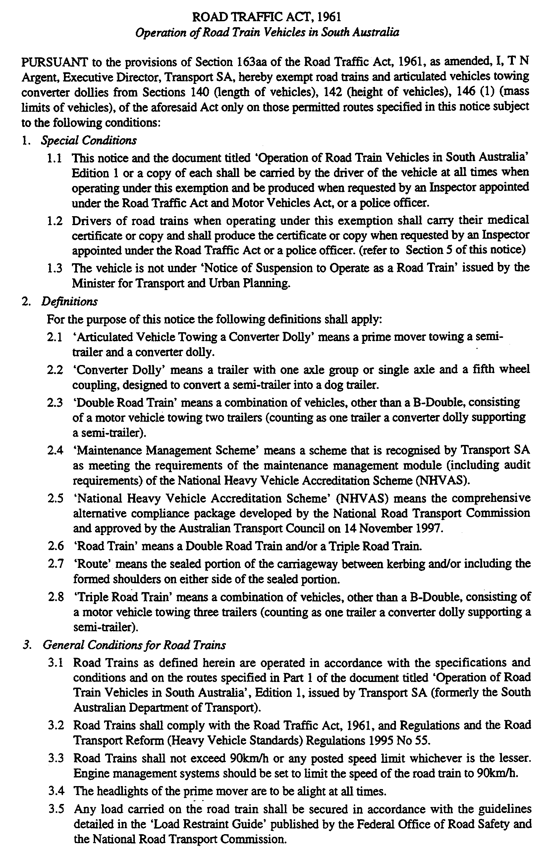

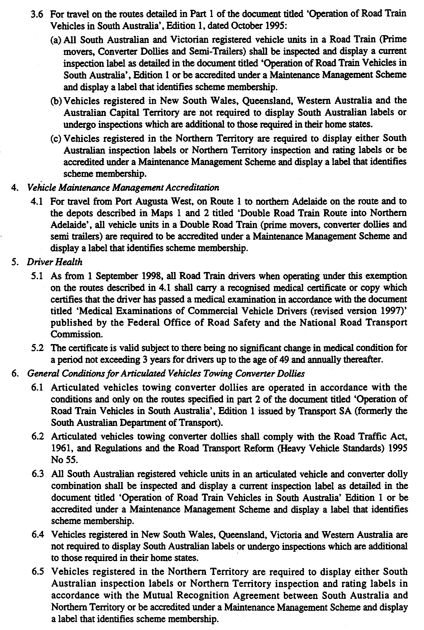
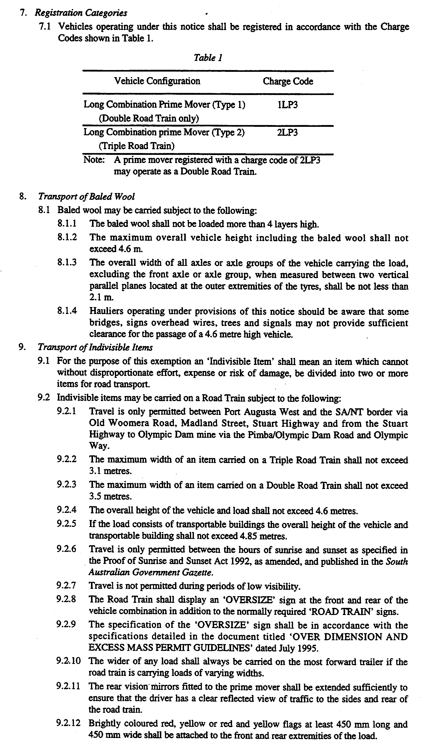
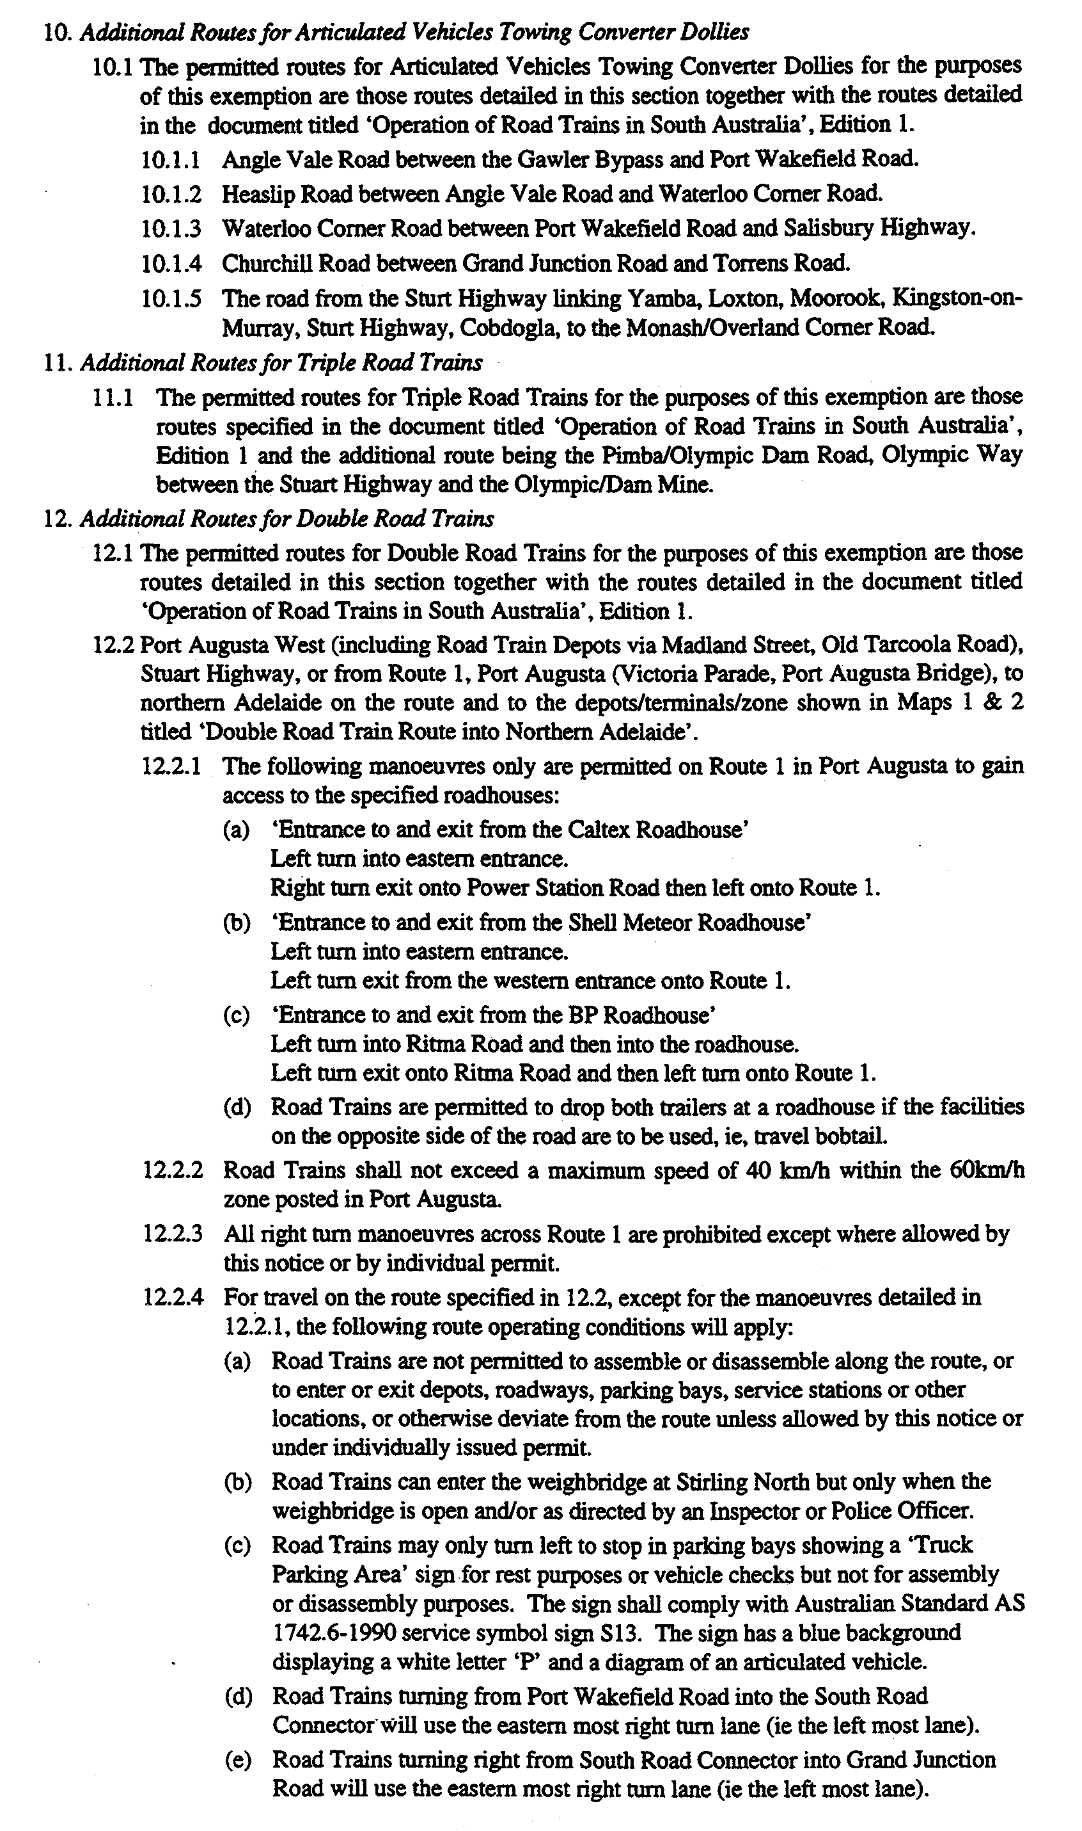
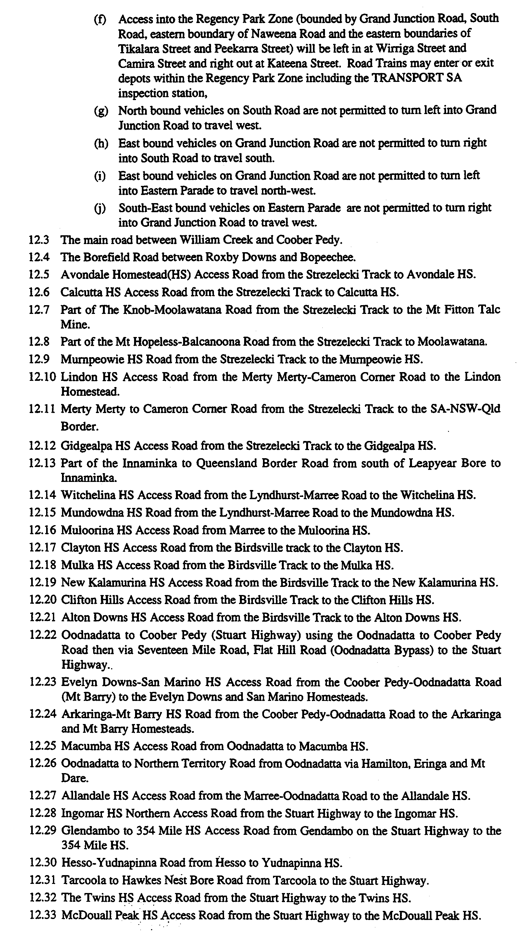
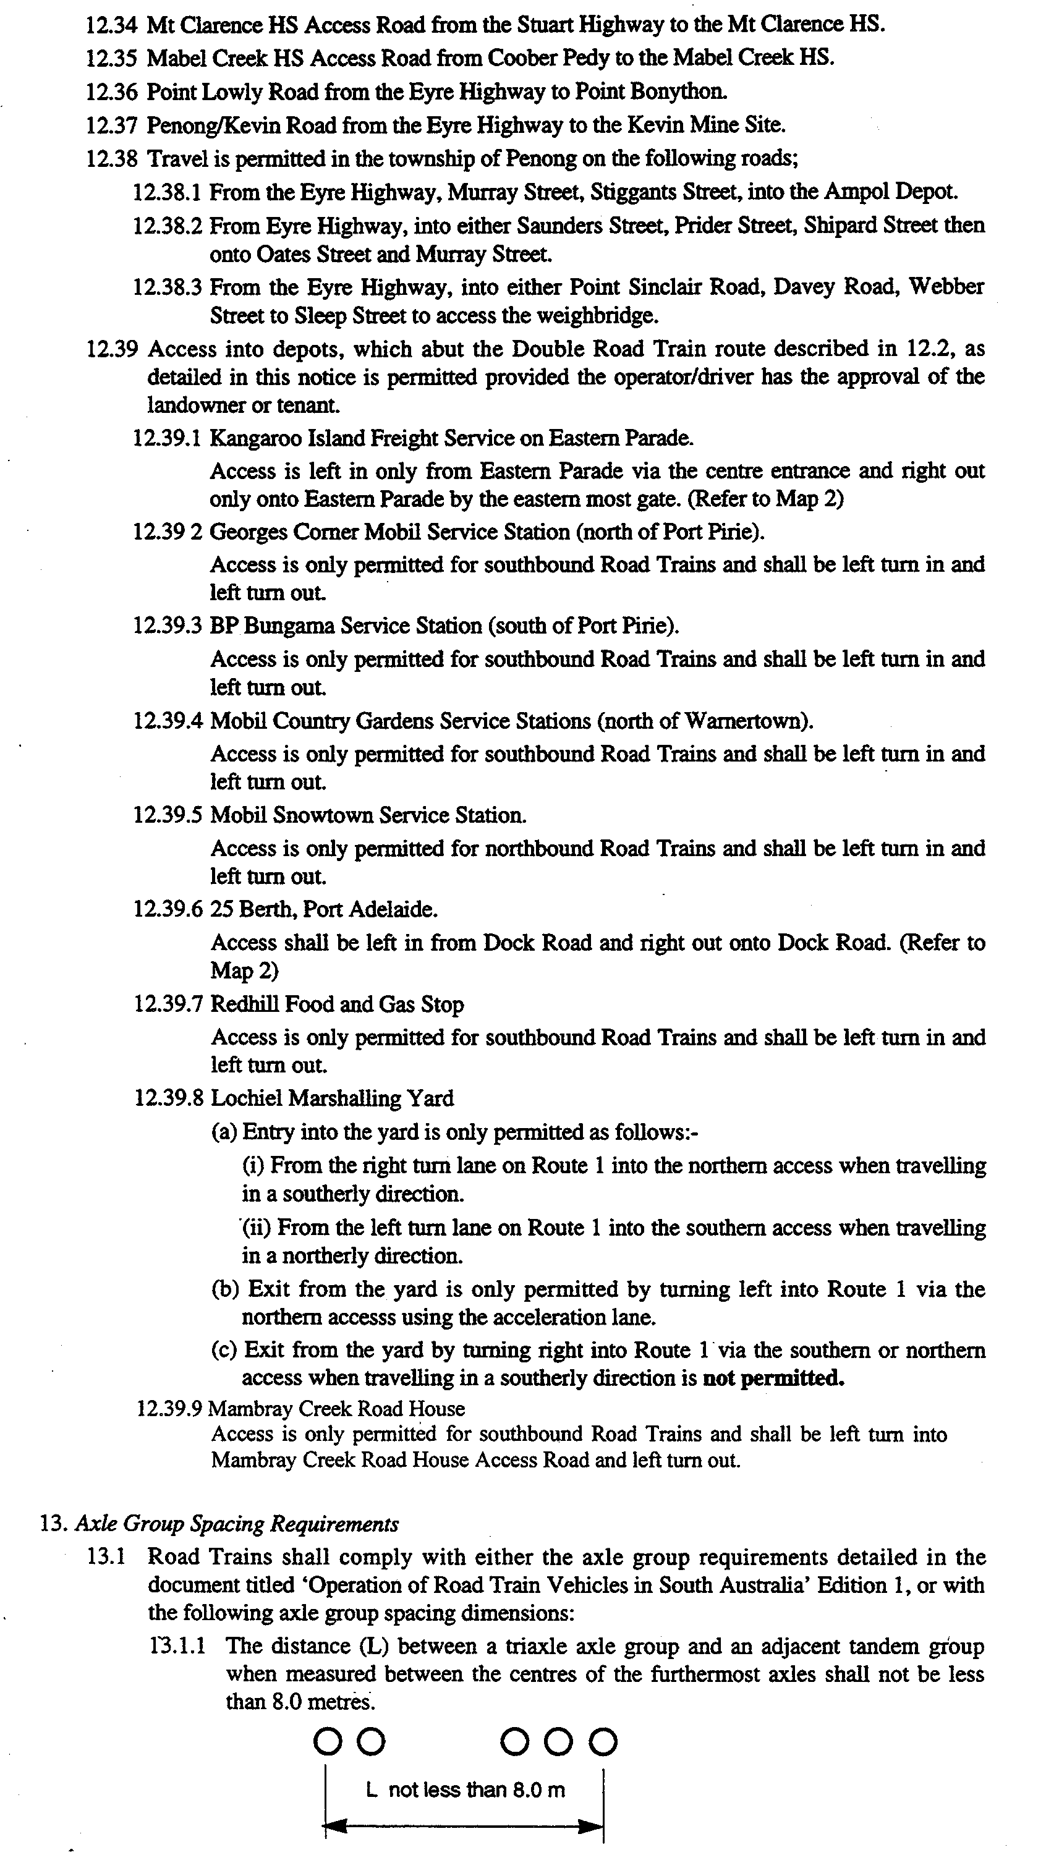
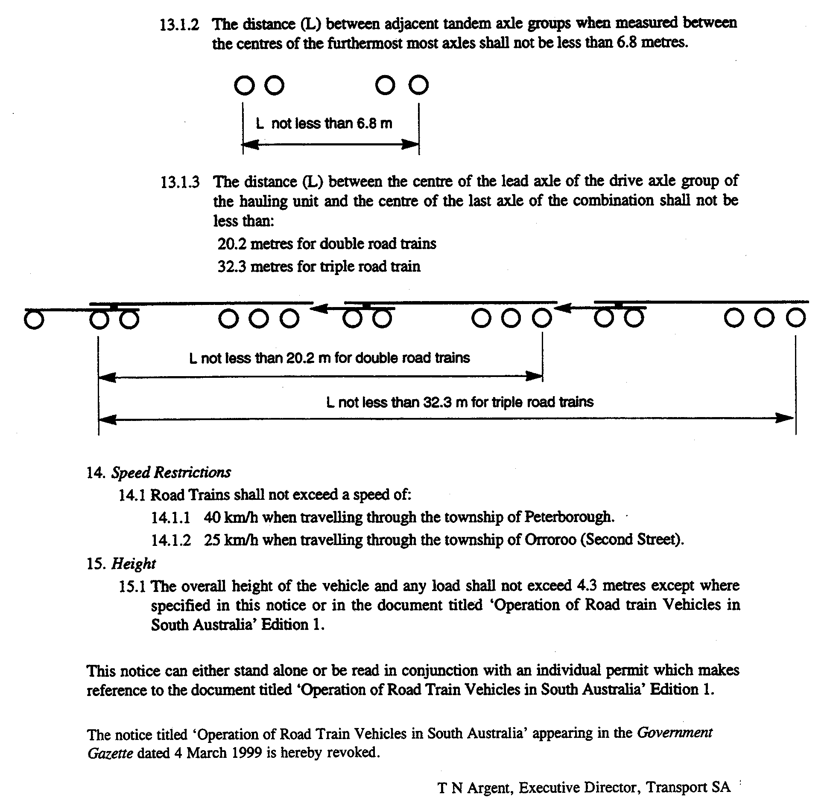
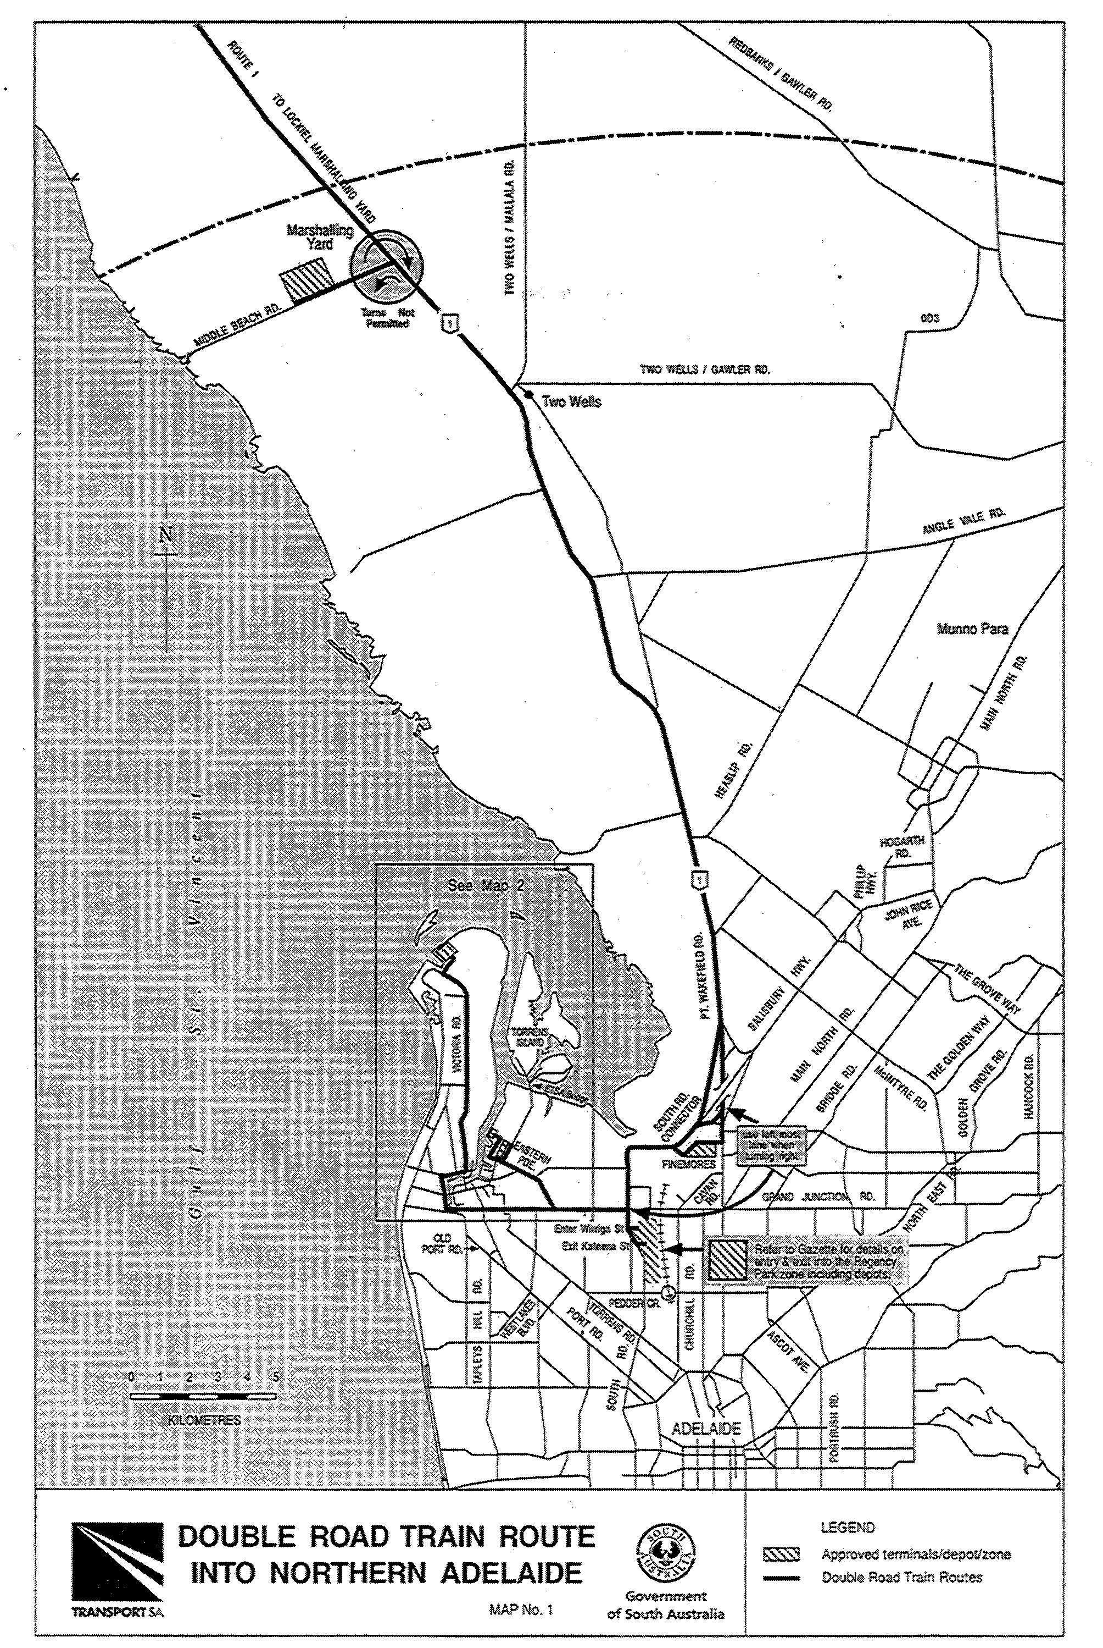
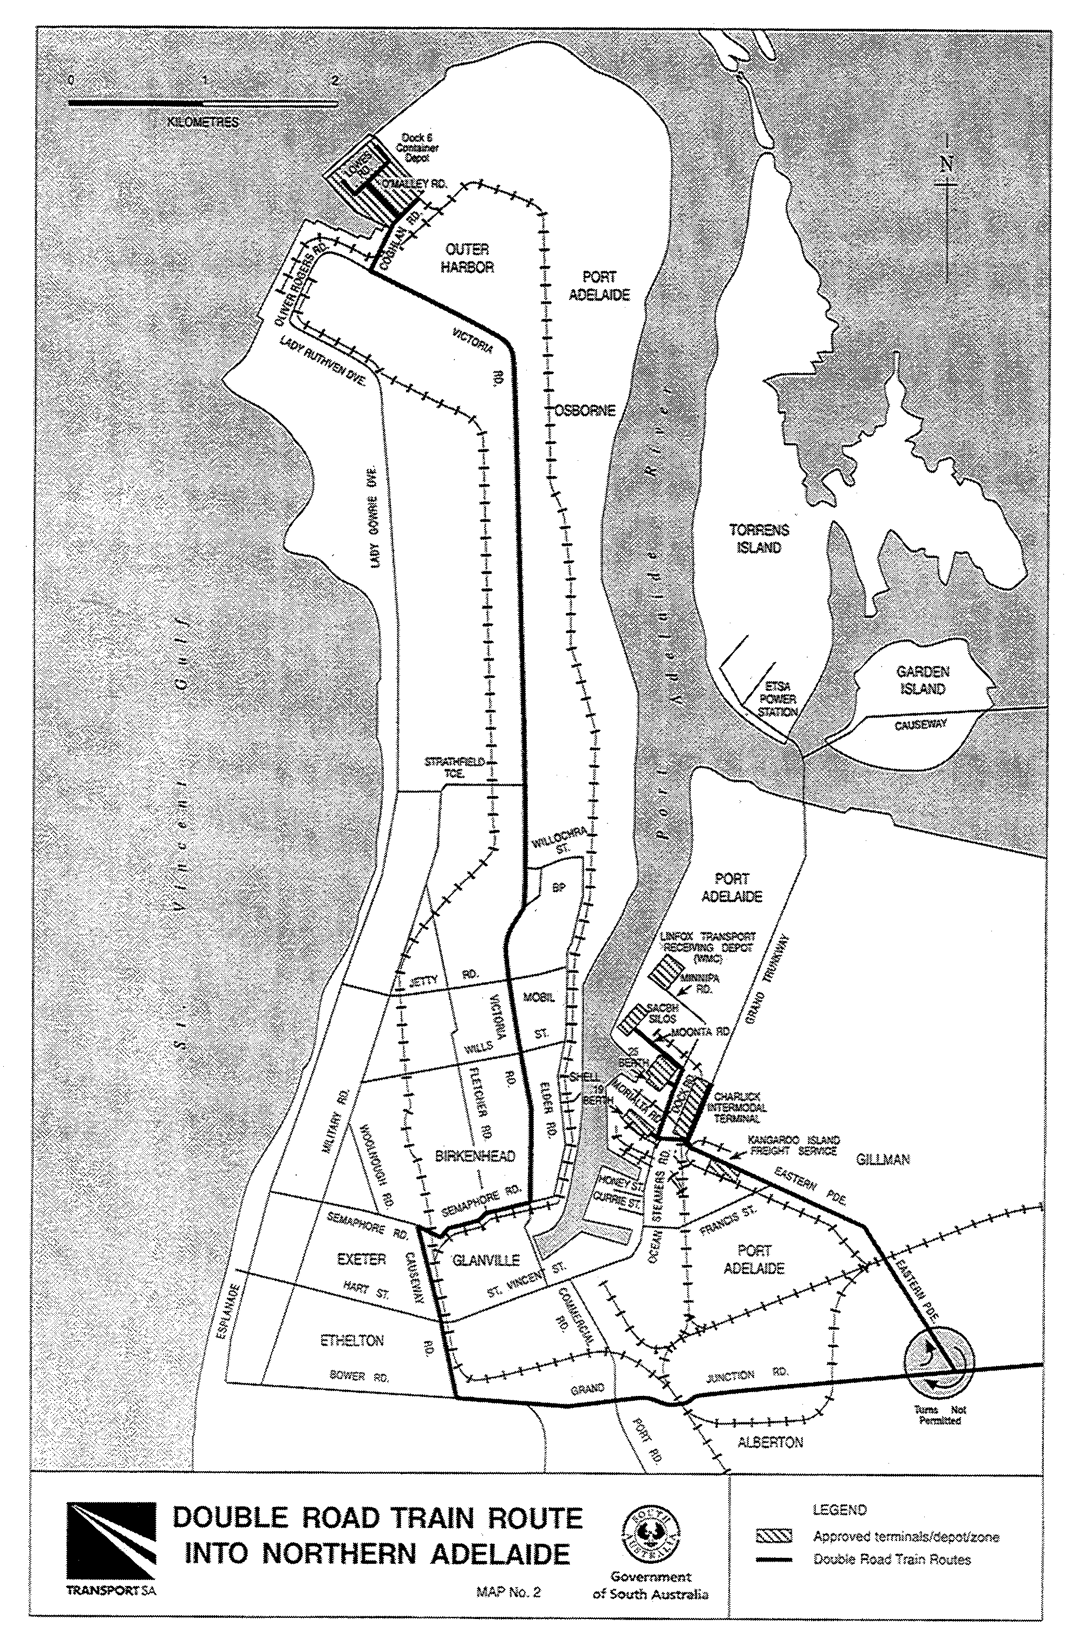

RULES OF COURT
Amending the Supreme Court Rules 1987
Amendment No 66 to the Supreme Court Rules
BY virtue and in pursuance of Section 72 of the Supreme Court Act 1935 and all other enabling powers, We, Judges of the Supreme Court of South Australia, make the following Rules to take effect as amendments to the Supreme Court Rules 1987, as amended:
1. These Rules may be cited as the ‘Supreme Court Rules 1987 Amendment No 66’.
2. The Supreme Court Rules 1987 as amended by these Rules may be cited as the ‘Supreme Court Rules 1987’.
3. Rule 115A.01 is revoked and the following Rule is substituted in its place:
‘115A.01 Scope of Rule 115A
This Rule applies:
(a) to an application for a direction under Section 59IE of the Evidence Act 1929 (which for the purposes of Rule 115A only is referred to as ‘the Act’); and
(b) to the provisions of Section 59IL of the Act.’
4. The following sub-rule is inserted immediately after sub-rule 115A.07:
‘115A.08 Enforcement of Orders made by a Recognised Court:
(1) Where a party to proceedings has obtained an order of a recognised Court (as defined in Section 59IA of the Act) pursuant to the provisions of Division 3 of Part 6C of the Act, and that party wishes to enforce the order, such party shall lodge with the Registrar a sealed copy of the order.
(2) The Registrar shall maintain a register of orders made by a recognised Court lodged pursuant to sub-paragraph (1).
(3) After the lodgement of the order of the recognised Court the party seeking to enforce the same may do so in accordance with the provisions of Section 59IL(2) of the Act.’
GIVEN under our hands and the Seal of the Supreme Court of South Australia this 1st day of June 1999.
(l.s.) J. DOYLE, CJ
ROBIN MILLHOUSE, J
G. C. PRIOR, J
L. T. OLSSON, J
J. W. PERRY, J
K. P. DUGGAN, J
E. P. MULLIGHAN, J
B. M. DEBELLE, J
B. T. LANDER, J
H. C. WILLIAMS, J
D. J. BLEBY, J
D. F. WICKS, J
BRIAN MARTIN, J

ROADS (OPENING AND CLOSING) ACT 1991
Road Closure⎯Mawson Road, Salisbury
NOTICE is hereby given, pursuant to section 10 of the Roads (Opening and Closing) Act 1991, that CITY OF SALISBURY proposes to close and transfer to FORESIGHT PTY LTD the portion of public road (Mawson Road) adjoining allotment 73 in GP83/1857, adjacent to Park Terrace, (leaving a strip remaining open for walkway purposes) shown delineated and lettered 'A' on Preliminary Plan No. PP/32/0455:
A copy of the plan and a statement of persons affected are available for public inspection at the offices of the Council at 8 James Street, Salisbury, S.A. 5108 and the Adelaide office of the Surveyor-General during normal office hours.
Any application for easement or objection must set out the full name, address and details of the submission and must be fully supported by reasons.
The application for easement or objection must be made in writing to the Council at P.O. Box 8, Salisbury, S.A. 5108 WITHIN 28 DAYS OF THE DATE OF THIS NOTICE and a copy must be forwarded to the Surveyor-General at G.P.O. Box 1354 Adelaide, S.A. 5001. Where a submission is made, the Council will give notification of a meeting at which the matter will be considered.
Dated 10 June 1999.
P. M. Kentish, Surveyor-General

ROADS (OPENING AND CLOSING) ACT 1991
Road Opening and Closing⎯Millicent North
NOTICE is hereby given, pursuant to section 10 of the Roads (Opening and Closing) Act 1991, that WATTLE RANGE COUNCIL proposes to make a Road Process Order to:
(i) Open as road portions of piece 3 in Deposited Plan 31488, allotments 3 and 6 in Filed Plan 2115, portions of allotments 4 and 5 in Filed Plan 2115, portions of allotment 2 in Filed Plan 13881 shown delineated and numbered ‘1’, ‘2’ and ‘3’ on Preliminary Plan No. PP/32/0456:
(ii) Close and transfer to the South Australian Co-op Bulk Handling Ltd portion of the public road (Belt Road) adjoining Section 190 Hundred of Mount Muirhead, portions of the public road (Aberle Road) adjoining allotment 2 in Filed Plan 13881 and allotment 10 in Deposited Plan 46855 all shown delineated and lettered ‘A’, ‘B’ and ‘C’ (respectively) on Preliminary Plan No. PP/32/0456:
A copy of the plan and a statement of persons affected are available for public inspection at the offices of the Council at Civic Centre, George Street, Millicent, S.A. 5280 and the Adelaide office of the Surveyor-General during normal office hours.
Any application for easement or objection must set out the full name, address and details of the submission and must be fully supported by reasons.
The application for easement or objection must be made in writing to the Council at P.O. Box 27, Millicent, S.A. 5280 WITHIN 28 DAYS OF THE DATE OF THIS NOTICE and a copy must be forwarded to the Surveyor-General at G.P.O. Box 1354, Adelaide, S.A. 5001. Where a submission is made, the Council will give notification of a meeting at which the matter will be considered.
Dated 10 June 1999.
P. M. Kentish Surveyor-General

ROADS (OPENING AND CLOSING) ACT, 1991:
SECTION 34
ORDER BY THE MINISTER TO CLOSE ROAD
Public Road, Andamooka
Deposited Plan 52421
BY an Order made on 5 May 1999 under Sections 6 and 34 of the Roads (Opening and Closing) Act 1991, the Minister for Administrative Services ordered that the portion of the public road adjoining allotment 797 in Deposited Plan 41977 be closed.
Vest in the Crown the whole of the land subject to closure.
Notice of the Order is hereby published in accordance with Section 34(7) of the said Act.
Dated 10 June 1999.
P. M. Kentish, Surveyor-General

ROADS (OPENING AND CLOSING) ACT 1991
Corrigendum
NOTICE OF CONFIRMATION OF ROAD
PROCESS ORDER
Martins/McNicoll Roads extension, Paralowie
Deposited Plan 50618
IN NOTICE appearing in Government Gazette dated 3 June 1999 on page 2989, pursuant to section 24(5) of the Roads (Opening and Closing) Act 1991 for the City of Salisbury should read as follows:
The heading Deposited Plan 50472 to read as follows:
Deposited Plan 50618
Dated 10 June 1999.
P. M. Kentish, Surveyor-General

SOUTH AUSTRALIAN TOTALIZATOR AGENCY BOARD
Scoping Review
I, MICHAEL HARRY ARMITAGE, Minister for Government Enterprises, in and for the State of South Australia, hereby authorise the gazettal of the attached Direction to the South Australian Totalizator Agency Board, pursuant to section 6 of the Public Corporations Act 1993.
Dated 7 June 1999.
M. H. Armitage, Minister for Government Enterprises

Ministerial Direction Pursuant to Section 52 of the
Racing Act 1976
I, Michael Armitage, Minister for Government Enterprises (the Minister), in my capacity as delegate of Minister for Recreation, Sport and Racing hereby direct the South Australian Totalizator Agency Board (SA TAB), until further written direction by me, in the conduct and affairs of the business to continue to have regard to the objectives of the Government in the review and possible sale of SA TAB to the private sector and to continue with the operation of the business of SA TAB and for that purpose I further direct you from the date of this Direction and until further notice:
1. To account for, administer and apply revenues, including interest revenue, attributable to the Capital Fund (‘the Fund’), established pursuant to section 69 (1a)(c) of the Racing Act 1976 (‘the Act’) as part of the Fund and in so doing, any distributions to be made from that Fund (including the distribution of attributable interest revenues) must only be made to meet the capital expenses of SA TAB;
2. to ensure that in respect of any distribution(s) made from the date of this Direction by SA TAB pursuant to section 69 of the Act, being distributions to the RIDA, SATRA, SAHRA and SAGRA funds (as defined in Part 1 section 5 of the Act) or, either all or any one of them or, to RIDA in its capacity as manager of those funds, that the distributions made by SA TAB are made net of any interest or other revenue that is, or has been, attributed to the Fund pursuant to section 69 (1a)(c) of the Act and in accordance with this Direction;
3. to consider that assets purchased with monies from the Fund do not form part of the Fund and therefore on any sale of such assets the proceeds from sale do not have to be paid into the Fund;
4. in determining what expenditure may be met from the Fund for the purposes of capital expenses, to have regard to Treasurer’s instructions issued pursuant to section 41 of the Public Finance and Audit Act 1987 together with any policies issued as part of those instructions;
5. provided that clear accounting records exist in relation to capital and income, invest monies held in the Fund as part of SA TAB’s general investment operations, without the necessity to maintain dedicated bank accounts and investments.
Dated 25 March 1999.
M. H. Armitage, Minister for Government Enterprises

VALUATION OF LAND ACT 1971
Notice of General Valuation
PURSUANT to the Valuation of Land Act 1971, notice is hereby given that within the following Local Government Areas I have made a general valuation of all land subject to the general valuation. The values are assigned as at 1 January 1999.
L.G.A. No. | Local Government Areas
6910 | Coober Pedy
8300 | Mount Remarkable
5800 | Mount Barker
4540 | Alexandrina 1
7710 | Alexandrina 2
1800 | Burnside
4310 | Clare & Gilbert Valleys 1
4320 | Clare & Gilbert Valleys 2
9680 | Clare & Gilbert Valleys 3
6801 | Northern UIA
9340 | Port Lincoln
9350 | Lower Eyre Peninsula
6803 | Riverland UIA
0200 | Adelaide
These values will come into force from 1 July 1999.
Dated 7 June 1999.
P. W. Fountain, Deputy Valuer-General
CL 110/93

WATER RESOURCES ACT 1997
South East Catchment Water Management Board Water Based Levy in the Comaum Caroline, Lacepede Kongorong, Naracoorte Ranges, Padthaway and Tatiara Prescribed Wells Areas
Notice by the Minister for Environment and Heritage Pursuant to Section 122
I, DOROTHY KOTZ, Minister for Environment and Heritage, hereby declare a levy for the right to take water from all prescribed wells within the Comaum Caroline, Lacepede Kongorong, Naracoorte Ranges, Padthaway and Tatiara Prescribed Wells Areas (the Area), which lie entirely within the catchment area of the South East Catchment Water Management Board.
The levy is payable by persons who are authorised by a water licence to take water from a prescribed well or wells within the Area, and the levy is charged at the following rate:
(a) where the water allocation on the licence is specified as an annual volume in kilolitres, 0.15 cents per kilolitre of the allocation;
(b) where the water allocation on the licence is specified in Irrigation Equivalents, $7.50 per hectare Irrigation Equivalent (IE) or part thereof of the allocation; and
(c) a minimum levy of $15 is payable.
This notice has effect in relation to the financial year commencing on 1 July 1999.
Dated 8 June 1999.
D. Kotz, Minister for Environment and Heritage

WATER RESOURCES ACT 1997
Northern Adelaide and Barossa Catchment Water Management Board Water Based Levy in the Northern Adelaide Plains Prescribed Wells Area
Notice by the Minister for Environment and Heritage pursuant to Section 122
I, DOROTHY KOTZ, Minister for Environment and Heritage, hereby declare levies for the right to take water and for the water taken from all prescribed wells within the Northern Adelaide Plains Prescribed Wells Area (‘the Area’), which lies entirely within the catchment area of the Northern Adelaide and Barossa Catchment Water Management Board. This levy does not apply where the water is taken for domestic purposes or for the watering of stock not subject to intensive farming.
The levies are payable by persons who are authorised by a water licence to take water from a prescribed well or wells within the Area, and the levies are charged at the following rates:
• for the right to take water, 0.5 cents per kilolitre of water allocation specified on the water licence; and
• for the water taken, 0.5 cents per kilolitre of allocated water taken.
This notice has effect in relation to the financial year commencing on 1 July 1999.
Dated 3 June 1999.
D. Kotz, Minister for Environment and Heritage

WATER RESOURCES ACT 1997
Northern Adelaide and Barossa Catchment Water Management Board Water Based Levy in the Barossa Prescribed Water Resources Area
Notice by the Minister for Environment and Heritage Pursuant to Section 122
I, DOROTHY KOTZ, Minister for Environment and Heritage, hereby declare a levy for the right to take water from all prescribed wells, watercourses and surface water within the Barossa Prescribed Water Resources Area (‘the Area’), which lies entirely within the catchment area of the Northern Adelaide and Barossa Catchment Water Management Board. The levy does not apply where the water is taken for domestic purposes or for the watering of stock not subject to intensive farming.
The levy is payable by persons who are authorised by a water licence to take water from a prescribed well or wells, or from a prescribed watercourse or from surface water in the Area and the levy is charged at the following rates:
• where the water allocated specified on the water licence is expressed as a volume of water, at the rate of 1 cent per kilolitre of allocation;
• where the water allocation specified on the water licence is expressed as an area of crop, at the following rates:
Crop Type Levy Rate
Lucerne/Full Pasture $50/Hectare of allocation
Vegetables $50/Hectare of allocation
Recreation/Lawn $50/Hectare of allocation
Vines $10/Hectare of allocation
Starter Pasture $10/Hectare of allocation
Fruit Trees $10/Hectare of allocation
Stone Fruit $10/Hectare of allocation
Pome Fruit $10/Hectare of allocation
This notice has effect in relation to the financial year commencing on 1 July 1999.
Dated 3 June 1999.
D. Kotz, Minister for Environment and Heritage

FAXING COPY?

IF you fax copy to Riverside 2000, for inclusion in the Government Gazette, there is no need to send a Confirmation Copy to us as well.

This creates confusion and may well result in your notice being printed twice.

Please use the following fax number:

Fax transmission: (08) 8207 1040
Phone Inquiries: (08) 8207 1045

Please include a contact person, phone number and order number so that we can phone back with any queries we may have regarding the fax copy.

NOTE: Closing time for lodging new copy (either fax or hard copy) is 4 p.m. on Tuesday preceding the day of publication.

Government Gazette notices can be E-mailed.

The address is:

govgaz@riv.ssa.sa.gov.au

Documents should be sent as attachments in Word format.

When sending a document via E-mail, please confirm your transmission with a faxed copy of your document, including the date the notice is to be published.

Fax transmission: (08) 8207 1040
Enquiries: (08) 8207 1045

CITY OF BURNSIDE
Adoption of Valuations and Declaration of Rates
NOTICE is hereby given that at its meeting held on 3 June 1999, the council, in exercise of the powers contained in Parts ix and x of the Local Government Act 1934, as amended:
1. Adopted its budget for the year ending 30 June 2000 which involved an amount required to be raised from rates of $15 011 000.
2. Adopted the valuations that are to apply in its area for rating purposes for the 1999-2000 financial year, being the capital valuations of the Valuer-General, totalling $4 394 353 000, comprising $4 205 653 000 for rateable land, and $188 700 000 for non-rateable land.
3. Declared a general rate on rateable land of 0.361 cents in the dollar of the capital value of that rateable land.
4. Declared a minimum amount payable by way of general rates on rateable land in its area of $400.
5. Declared pursuant to section 184 (11) of the Act, a discount of 3 per centum of rates payable, be given in respect of any payments of the general rate received in full by 30 September 1999.
R. W. S. Donne, Chief Executive Officer

Declaration of Separate Rates
NOTICE is hereby given that at its meeting held on 3 June 1999, the council, in exercise of the powers contained in the Catchment Water Management Act 1995, declared separate rates on rateable land within its area as follows:
0.01273 cents in the dollar of the capital value of rateable land in the area of the River Torrens Catchment Water Management Board; and
0.01066 cents in the dollar of the capital value of rateable land in the area of the Patawalonga Catchment Water Management Board.
R. W. S. Donne, Chief Executive Officer

CITY OF HOLDFAST BAY
Periodical Review of Elector Representation
NOTICE is hereby given that pursuant to the provisions of section 24 (3) of the Local Government Act 1934, as amended the City of Holdfast Bay is to carry out a review to determine whether a change of arrangements in respect to elector representation, including composition of council and its ward boundaries, will result in the electors of the city being more adequately and fairly represented.
Information regarding the nature of the periodical review is available from:
Head Office, 24 Jetty Road, Brighton
Branch Office, 1 Moseley Square, Glenelg
Brighton Library, 20 Jetty Road, Brighton
Glenelg Library, 2 Colley Terrace, Glenelg,
during opening hours or by contacting Ross Baker on 8229 9921.
Written submissions are invited from interested persons from Friday, 11 June 1999 and should be directed to:
Chief Executive Officer
City of Holdfast Bay
P.O. Box 19
Brighton, S.A. 5048,
to be received by 5 p.m. on 23 July 1999.
Any persons making a written submission will also be invited to appear before a meeting of council, or a council committee, to be heard in respect of their submission.
D. Aylen, Chief Executive Officer

THE RURAL CITY OF MURRAY BRIDGE
Development Act 1993
Rural City of Murray Bridge Development Plan
Monarto Zoological Park Plan Amendment Report—
Draft for Public Exhibition
NOTICE is hereby given that The Rural City of Murray Bridge has prepared a draft Plan Amendment Report to amend the Development Plan as it affects the whole of the Council area.
The Plan Amendment Report will amend the Development Plan by incorporating a Zone that acknowledges the area of the Monarto Zoological Park. Matters addressed include:
• implementation of principles relating to intensive animal keeping;
• the further establishment of tourism development;
• potential amenity impacts;
• establishment of rural industries;
The draft Plan Amendment Report and Statement of Investigation will be available for public inspection and purchase during normal office hours at The Rural City of Murray Bridge from 10 June 1999 to 10 August 1999. A copy of the Plan Amendment Report can be purchased from the Council offices for $5 each.
Written submissions regarding the draft amendment will be accepted by The Rural City of Murray Bridge until 4.45 p.m. on 10 August 1999. The written submission should also clearly indicate whether you will wish to speak at the public hearing on your submission. All submissions should be addressed to the Chief Executive Officer of The Rural City of Murray Bridge, P.O. Box 421, Murray Bridge, S.A. 5253.
Copies of all submissions received will be available for inspection by interested persons at The Rural City of Murray Bridge office, 2 Seventh Street, Murray Bridge, from 11 August 1999, until the date of the public hearing.
A public hearing will be held at 7 p.m. at the Council Chambers of The Rural City of Murray Bridge on 20 August 1999 at which interested persons may appear and be heard before Council in relation to the Plan Amendment Report and the submissions. The public hearing may not be held if no submission indicates an interest by its author to speak at the public hearing.
Dated 10 June 1999.
R. J. Foster, Chief Executive Officer

CITY OF WEST TORRENS
Roads (Opening and Closing) Act 1991
NOTICE is hereby given that the portion of public road known as Grassmere Street, Kurralta Park and marked ‘A’ on the Preliminary Plan No. PP32/0407 is to be closed. The closed road is to be merged with allotments 9 and 10 in Filed Plan 8361 and allotments 81 and 82 in Filed Plan 7380.
The closed road is to be transferred to Sandhurst Trustees Ltd.
The preliminary plan and associated statements prepared pursuant to section 9 of the Roads (Opening and Closing) Act 1991 are available for examination to the public at the office of the City of West Torrens, 165 Burbridge Road, Hilton, S.A. 5033 and at the Adelaide office of the Surveyor-General, 101 Grenfell Street, Adelaide, S.A. 5000 during normal office hours.
Any person who wishes to object to this proposal may lodge a written objection to the City of West Torrens, 165 Burbridge Road, Hilton, S.A. 5033 and a copy forwarded to the Surveyor-General, 101 Grenfell Street, Adelaide, S.A. 5000 within 28 days of the date of this notice. Any objectors must include their full name and address stating their reasons for objecting and stating whether or not they wish to make submissions to the City of West Torrens at a meeting convened to consider such objections.
Any land owner adjoining or other person substantially affected by the closure may apply for an easement over all or part of the proposed road closure. Such application shall be in writing to the City of West Torrens, 165 Burbridge Road, Hilton, S.A. 5033 and a copy must be forwarded to the office of the Surveyor-General, 101 Grenfell Street, Adelaide, S.A. 5000 within 28 days of the date of this notice. The applicants must include their full name and address giving particulars of the nature and location of the easement being applied for, specifying the land to which the easement is to be annexed and stating the reason for the application for easement.
T. Starr, City Manager

ADELAIDE HILLS COUNCIL
Local Heritage Places and Historic Conservation Policy Areas⎯Plan Amendment Report
Draft for Public Consultation
NOTICE is hereby given that the Adelaide Hills Council has prepared a draft Plan Amendment Report to amend the Development Plan as it affects the land situated in the Stirling (DC) Development Plan.
The Plan Amendment Report will amend the Development Plan by introducing heritage planning policies and principles of development control, which gives status to the recommendations of the District Council of Stirling: District Heritage Survey, 1997. The Development Plan is amended by the following policy changes:
• Revises the register of land, buildings and structures of local heritage value;
• inclusion of a register of state heritage places;
• establishing historic conservation policy areas;
• establish objectives and principles of development control applicable to the policy areas;
• revises the objectives and principles of development control relating to heritage generally; and
• introduce demolition and land division controls for local heritage places within policy areas.
The draft Plan Amendment Report and statement will be available for public inspection between 17 June 1999 and 20 August 1999, during normal office hours at the following locations:
• Stirling Service Centre and library, 63 Mount Barker Road, Stirling;
• Woodside Service Centre, 28 Main Street, Woodside;
• Gumeracha Service Centre, 1 Albert Street, Gumeracha;
• Norton Summit Service Centre, 1 The Crescent, Norton Summit.
A copy of the Plan Amendment Report can be purchased from council for $7.50 each.
Written submissions regarding the draft amendment will be accepted by the Adelaide Hills Council, until the close of business on 20 August 1999. The written submissions should also clearly indicate whether you would wish to speak at the public hearing on your submission.
Written submissions should be forwarded to:
Stephen Smith
Principal Planner (Policy)
Adelaide Hills Council
P.O. Box 44
Woodside, S.A. 5244
Copies of all submissions received will be available for inspection by interested persons at all of the Service Centres from 25 August 1999 until the date of the public hearing.
A public hearing will be held at 7 p.m. on 8 September 1999 at the Stirling Service Centre, 63 Mount Barker Road, Stirling, at which time interested persons may appear to be heard in relation to the draft Plan Amendment Report and the submissions. The public hearing may not be held if no submission makes a request to be heard.
R. Blight, Chief Executive Officer

ALEXANDRINA COUNCIL
Change of Meeting Time
NOTICE is hereby given that council has resolved to hold its meeting scheduled for the third Monday of every month commencing at 5 p.m. in lieu of 5.30 p.m.
J. L. Coombe, Chief Executive Officer

THE BAROSSA COUNCIL
Supplementary Elections
NOTICE is hereby given that nominations are invited from persons eligible to be candidates for election to fill two vacancies of Councillor.
Nomination forms may be obtained at the office of The Barossa Council located at Washington Street, Angaston between the hours of 9 a.m. and 5 p.m., Monday to Friday.
Nominations will be received at the above office commencing at 9 a.m. on Thursday, 17 June 1999 until noon on Thursday, 8 July 1999.
Please note that candidate profiles, if submitted, will be required by the Returning Officer no later than by the close of nominations at noon on Thursday, 8 July 1999.
The Returning Officer will conduct a briefing session for intending candidates at the office of The Barossa Council, Washington Street, Angaston on Tuesday, 6 July 1999 commencing at 6 p.m.
The elections will be conducted entirely by postal ballot with the return of ballot papers closing at 6 p.m. on Friday, 13 August 1999.
The counting of ballot papers will be conducted on Saturday, 14 August 1999, commencing at 9 a.m.
Nomination and declaration forms are available from the above address.
S. H. Tully, Returning Officer

THE BAROSSA COUNCIL
Resignation of Councillors
NOTICE is hereby given that pursuant to section 48 of the Local Government Act 1934, as amended, Robert O’Callaghan and Lindy Pitt have resigned from the elected position of Councillor, effective 31 May 1999, creating two casual vacancies within the council.
J. G. Jones, Chief Executive Officer

DISTRICT COUNCIL OF LE HUNTE
Periodical Review of Elector Representation
NOTICE is hereby given that pursuant to section 24 (3) of the Local Government Act 1934, as amended, the District Council of Le Hunte is to carry out a review to determine whether a change in arrangements with respect to elector representation, including the area and composition of the council, would result in electors of the area being more adequately and fairly represented.
Interested persons are invited to seek further information and/or make written submissions by Thursday, 29 July 1999 to the Chief Executive Officer, P.O. Box 6, Wudinna, S.A. 5652.
An opportunity will be given to any person making written submission to appear personally or by representative before the council to be heard in respect of their submission.
A. F. McQuire, Chief Executive Officer

DISTRICT COUNCIL OF MALLALA
Periodical Review of Elector Representation
PURSUANT to the provisions of section 24 (3) of the Local Government Act 1934, as amended, notice is hereby given that the District Council of Mallala is to carry out a review to determine whether a change of arrangements in respect to elector representation, including ward boundaries and the composition of council, will result in the electors of the council area being more adequately and fairly represented.
Information regarding the nature of the periodical review is available at the Council Office and the Library, or by contacting Debra Wilson on 8527 2006.
Interested persons are invited to make a written submission to the Chief Executive Officer, P.O. Box 18, Mallala, S.A. 5502, by close of business on 23 July 1999.
Any person who makes a written submission will be afforded an opportunity to appear before council, or a committee thereof, to be heard in respect to his/her submission.
C. Dunlop, Chief Executive Officer

DISTRICT COUNCIL OF ORROROO/CARRIETON
Appointments
NOTICE is hereby given that at a council meeting held on Tuesday, 11 May 1999, the following appointments were made:
(a) Pursuant to section 26 (1) (b) of the Dog and Cat Management Act 1995, council appointed Jonathan William Oliver as Registrar of Dogs, effective from 10 May 1999, vice Steven Paul Griffiths resigned.
(b) Pursuant to section 38 of the Country Fires Act 1989, council appointed Jonathan William Oliver as a Fire Permits Officer, effective from 10 May 1999, vice Steven Paul Griffiths resigned.
(c) Pursuant to section 82 (1) of the Local Government Act 1934, as amended, council appointed Jonathan William Oliver as an Authorised Officer, effective from 10 May 1999, vice Steven Paul Griffiths resigned.
(d) Pursuant to section 14 of the Impounding Act 1920, council appointed Jonathan William Oliver as an Authorised Officer, effective from 10 May 1999, vice Steven Paul Griffiths resigned.
(e) Pursuant to the Environment Protection Act 1993, (Burning Policy), council appointed Jonathan William Oliver as an Authorised Officer, effective from 10 May 1999, vice Steven Paul Griffiths resigned.
(f) Pursuant to section 17 of the Development Act 1993, council appointed Jonathan William Oliver as an Authorised Officer, effective from 10 May 1999, vice Steven Paul Griffiths resigned.
J. W. Oliver, Chief Executive Officer

IN the matter of the estates of the undermentioned deceased persons:
Coldwell, Hilda Violet, late of 98 Military Road, Semaphore South, widow who died on 23 April 1999.
Curnow, Albert Ernest, late of 5 Sheffield Crescent, Blair Athol, retired bus operator, who died on 23 April 1999.
Farnham, Ellen Olive, late of 1 Osborne Avenue, St Agnes, widow, who died on 19 April 1999.
Kenny, Lillian Merle, late of 24-34 Avenue Road, Glynde, widow, who died on 13 November 1998.
Kotsonopoulos, Stavros, late of 114 George Street, Thebarton, retired minister of religion, who died on 25 December 1998.
Levertington, Lavinia Nellie, late of Diagonal Road, Somerton Park, of no occupation, who died on 25 April 1999.
Levi, Rita Ivie, late of 324 Military Road, Semaphore Park, of no occupation, who died on 29 April 1999.
Marshall, Elinore Anne, late of 14 Innes Road, Windsor Gardens, home duties, who died on 7 May 1999.
Menzies, Joan Elizabeth, late of 29 Austral Terrace, Morphettville, widow, who died on 12 April 1999.
Morgan, Edavene Lilla, late of 18 Wilcher Street, Port Pirie West, widow, who died on 30 March 1999.
Purling, Harriet May, late of 34 Molesworth Street, North Adelaide, retired process worker, who died on 8 March 1999.
Russel, Arthur John, late of 55-59 Ferguson Avenue, Myrtle Bank, retired vehicle inspector, who died on 2 May 1999.
Sigurd, Arne, late of 107 Blight Street, Renown Park, of no occupation, who died on 1 August 1998.
Wescombe, Keith Edwin, late of 35 Hulbert Street, Hove, retired tool maker, who died on 16 September 1998.
Notice is hereby given pursuant to the Trustee Act 1936, as amended, the Inheritance (Family Provision) Act 1972, and the Family Relationships Act 1975, that all creditors, beneficiaries, and other persons having claims against the said estates are required to send, in writing, to the Public Trustee, 25 Franklin Street, Adelaide, S.A. 5000, full particulars and proof of such claims, on or before 9 July 1999, otherwise they will be excluded from the distribution of the said estate; and notice is also hereby given that all persons who are indebted to the said estates are required to pay the amount of their debts to the Public Trustee or proceedings will be taken for the recovery thereof; and all persons having any property belonging to the said estates are forthwith to deliver the same to the Public Trustee.
Dated 10 June 1999.
J. H. Worrall, Public Trustee

IN the matter of the undermentioned deceased person:
Edwards, Maureen Patricia, late of Unit 1, 466 Glenburn Road, Burnside, home duties, who died on 27 March 1999.
Notice is hereby given pursuant to the Trustee Act 1936, as amended the Inheritance (Family Provision) Act 1972-1975 and the Family Relationships Act 1975, that all creditors, beneficiaries and other persons having claims against the abovenamed estate are directed to send full particulars of such claims to the undersigned on or before 15 July 1999, otherwise they will be excluded from the distribution of the estate.
Perpetual Trustees S.A. Limited (ACN 008 273 916), 89 King William Street, G.P.O. Box 1098, Adelaide, S.A.5001

ASSOCIATIONS INCORPORATION ACT 1985
Notice of Winding Up
NOTICE is hereby given that under section 41 of the Associations Incorporation Act 1985 the undermentioned Association has been wound up, and upon publication of this notice the Association will be removed from the Register:
Local Government Recycling and Waste Management Board Inc. (in liquidation) (A0022682R)
Dated 8 June 1999.
J. M. Allnutt, Liquidator

GUARDIAN SECURITY AGENCIES PTY LIMITED
(ACN 081 372 090)
THE DEPUTY COMMISSIONER OF TAXATION (Adelaide Branch of the Australian Taxation Office), 191 Pulteney Street, Adelaide, S.A. 5000, has brought a Summons in Action No. 607 of 1999 in the Supreme Court of South Australia seeking the winding up of Guardian Security Agencies Pty Limited. The summons is listed for hearing on Tuesday, 22 June 1999 at not before 2.15 p.m. Any creditor or contributory of Guardian Security Agencies Pty Limited wishing to be heard on the summons must file and serve a notice in accordance with Rule 20 of the Corporations (South Australia) Rules 1993 at least three business days before the day on which the summons is listed for hearing and must attend at the Supreme Courthouse, Victoria Square, Adelaide at the time set for the hearing of the summons. A copy of the summons and affidavit in support can be obtained on payment of the proper cost from the Deputy Commissioner of Taxation, 191 Pulteney Street, Adelaide, S.A. 5000.

HARVEST HORIZONS PTY LTD
(ACN 066 948 614)
LEADENHALL AUSTRALIA LTD has brought a summons in Action No. 625 of 1999 in the Supreme Court of South Australia seeking the winding up of Harvest Horizons Pty Ltd. The summons is listed for hearing on 22 June 1999 at not before 2.30 p.m. Any creditor or contributory of Harvest Horizons Pty Ltd wishing to be heard on the summons must file and serve a notice in accordance with Rule 20 of the Corporations (South Australia) Rules 1993 at least three business days before the day on which the summons is listed for hearing and must attend at the Supreme Courthouse, Victoria Square, Adelaide at the time set for the hearing of the summons. A copy of the summons and the affidavit in support can be obtained on payment of the proper costs from Marshalls, Level 2, 81 Flinders Street, Adelaide, S.A. 5000.

PRACTEL HOLDINGS LIMITED
(ACN 060 562 094)
WALTER MESITI has brought a summons in Action No. 588 of 1999 in the Supreme Court of South Australia seeking the winding up of Practel Holdings Limited. The summons is listed for hearing on 22 June 1999 at not before 2.15 p.m. Any creditor or contributory of Practel Holdings Limited wishing to be heard on the summons must file and serve a notice in accordance with Rule 20 of the Corporations (South Australia) Rules 1993 at least three business days before the day on which the summons is listed for hearing and must attend at the Supreme Courthouse, Victoria Square, Adelaide at the time set for the hearing of the summons. A copy of the summons and the affidavit in support can be obtained on payment of the proper cost from B. J. Tremaine, Solicitor, 21 Franklin Street, Adelaide, S.A. 5000, solicitor for the plaintiff.

RATTLE N’HUM (NT) PTY LIMITED
(ACN 080 316 552)
THE DEPUTY COMMISSIONER OF TAXATION of the Adelaide Branch of the Australian Taxation Office located at 191 Pulteney Street, Adelaide, S.A. 5000 has brought a summons in Action No. 582 of 1999 in the Supreme Court of South Australia seeking the winding up of Rattle N’Hum (NT) Pty Limited. The summons is listed for hearing on Tuesday, 22 June 1999, at not before 2.15 p.m. Any creditor or contributory of Rattle N’Hum (NT) Pty Limited wishing to be heard on the summons must file and serve a notice in accordance with Rule 20 of the Corporations (South Australia) Rules 1992, at least three business days before the day on which the summons is listed for hearing and must attend at the Supreme Courthouse, Victoria Square, Adelaide at the time set for the hearing of the summons. A copy of the summons and that affidavit in support can be obtained on payment of the proper cost from the Deputy Commissioner of Taxation, 191 Pulteney Street, Adelaide, S.A. 5000.

SOUTH AUSTRALIA—In the Supreme Court. No. 75 of 1992. In the matter of Technique Pty Ltd (ACN 008 103 348) and in the matter of the Corporations Law.
Notice of Release of Liquidator and Dissolution of the Company
Take notice that by order of the Supreme Court of South Australia dated 1 June 1999, I, John Sheahan, Level 8, 26 Flinders Street, Adelaide, S.A. 5000, the liquidator of the abovenamed company, was granted my release as liquidator and the company was dissolved as at the date of this order.
Dated 7 June 1999.
J. Sheahan, Liquidator

SOUTH AUSTRALIA—In the Supreme Court. No. 1845 of 1991. In the matter of Vicksburg Pty Limited (in liquidation) (ACN 008 180 818) and in the matter of the Corporations Law.
Notice by a Liquidator of His Intention to Seek His Release and Dissolution of the Company
Take notice that I, John Sheahan, Level 8, 26 Flinders Street, Adelaide, S.A. 5000, the liquidator of the abovenamed company, intend to make application to the Supreme Court of South Australia for my release as the Liquidator and Dissolution of the abovenamed company.
And take further notice that if you have any objection to the granting of my release and dissolution of the company you must file at the Supreme Court and also forward to me within 21 days of the publication in the Gazette of the notice of my intention to apply for a release and dissolution of the company a notice of objection in the form laid down by the Corporations (South Australia) Rules 1993. A summary of my receipts and payments as liquidator is available from my office.
Dated 7 June 1999.
J. Sheahan, Liquidator
Note: Section 481 of the Corporations Law enacts that an order of the Court releasing a liquidator shall discharge him/her in the administration of the affairs of the company, or otherwise in relation to his or her conduct as liquidator, but any such order may be revoked on proof that it was obtained by fraud or by suppression or by concealment of any material fact.

ZHONG XING (AUSTRALIA) PTY LTD
(ACN 008 213 385)
MOULDENS (a partnership) has brought a summons in action No. 629 of 1999 in the Supreme Court of South Australia seeking the winding up of Zhong Xing (Australia) Pty Ltd. The summons is listed for hearing on Tuesday, 6 July 1999 at not before 2.15 p.m. Any creditor or contributory of Zhong Xing (Australia) Pty Ltd wishing to be heard on the summons must file and serve a notice in accordance with Rule 20 of the Corporations (South Australia) Rules 1993 at least three business days before the day on which the summons is listed for hearing and must attend at the Supreme Courthouse, Victoria Square, Adelaide at the time set for the hearing of the summons. A copy of the summons and the affidavit in support can be obtained on payment of the proper cost from Mouldens, 45 King William Street, Adelaide, S.A. 5000.

PARTNERSHIP ACT 1891
Dissolution of Partnership
NOTICE is hereby given that the Partnership between Michael John Coutts, Kim Lesley Coutts, Roman Tos and Kerry Lee Tos carrying on the business of transport engineering under the business name Tos Transport Engineering has been dissolved as from 31 May 1999 so far as concerns the said Michael John Coutts and Kim Lesley Coutts who retire from the said partnership. The said business shall continue to be carried on under the said business name Tos Transport Engineering by the said Roman Tos and Kerry Lee Tos who shall continue as partners.
Dated 31 May 1999.
M. J. Coutts
K. L. Coutts
R. Tos
K. L. Tos

ATTENTION

CUSTOMERS requiring a proof of their notice for inclusion in the Government Gazette, please note that the onus is on you to inform Riverside 2000 of any subsequent corrections by 10 a.m. on Thursday, which is our publication deadline.

For any corrections to your notice please phone 8207 1045 or Fax 8207 1040 before 10 a.m. on Thursday.

If we do not receive any communication by 10 a.m. on Thursday (day of publication) we will presume the notice is correct and will print it as it is.

Remember—the onus is on you to inform us of any corrections necessary to your notice.

NOTE: Closing time for lodging new copy (either fax or hard copy) is 4 p.m. on Tuesday preceding the day of publication. Ph. 8207 1045—Fax 8207 1040.

Printed and published by authority every Thursday by M. E. JONES, Acting Government Printer, South Australia
Price: $3.75, plus postage; to subscribers, $185 per annum.

