No. 38 1423

THE SOUTH AUSTRALIAN

GOVERNMENT GAZETTE

PUBLISHED BY AUTHORITY

ALL PUBLIC ACTS appearing in this GAZETTE are to be considered official, and obeyed as such

ADELAIDE, THURSDAY, 18 MARCH 1999

CONTENTS

Page
Acts Assented To 1424
Appointments, Resignations, Etc. 1424
Corporations and District Councils—Notices 1447
Crown Lands Act 1929—Notices 1425
Development Act 1993—Notices 1426

ENVIRONMENT, HERITAGE AND ABORIGINAL
AFAIRS
Lease amended, etc. 1436
Fisheries Act 1982—Notices 1428
Geographical Names Act 1991—Notice 1429
Harbors and Navigation Act 1993—Determinations 1429
Land Acquisition Act 1969—Notices 1430

Page
Land and Business (Sale and Conveyancing) Act 1994—
Notices 1433
Liquor Licensing Act 1997—Notices 1436
Mining Act 1971—Notice 1438
Mount Gambier—Circuit Court—Notice 1425
National Parks and Wildlife Act 1972—Notice 1438
Private Advertisements 1449
Proclamations 1424
Public Sector Management Act 1995—Notice 1441
Public Trustee Office—Administration of Estates 1448
Roads (Opening and Closing) Act 1991⎯Notices 1440
Rules of Court 1445
Transport, Department of—Notices to Mariners 1439
West Beach Recreation Reserve Act 1987—Appointments 1425

GOVERNMENT GAZETTE NOTICES
ALL poundkeepers' and private advertisements forwarded for publication in the South Australian Government Gazette must be PAID FOR PRIOR TO INSERTION; and all notices, from whatever source, should be legibly written on one side of the paper only and sent to Riverside 2000 so as to be received no later than 4 p.m. Tuesday preceding the day of publication. Phone 8207 1045 or Fax 8207 1040.

Department of the Premier and Cabinet
Adelaide, 18 March 1999
HIS Excellency the Governor directs it to be notified for general information that he has in the name and on behalf of Her Majesty The Queen, this day assented to the undermentioned Acts passed by the Legislative Council and House of Assembly in Parliament assembled, viz.:
No. 7 of 1999—An Act to amend the Livestock Act 1997.
No. 8 of 1999—An Act to amend the Parliamentary Superannuation Act 1974 and to make a consequential amendment to the Superannuation Funds Management Corporation of South Australia Act 1995.
No. 9 of 1999—An Act to amend the Racing Act 1976.
No. 10 of 1999—An Act to repeal the Shearers Accommodation Act 1975.
No. 11 of 1999—An Act to amend the Stamp Duties Act 1923.
No. 12 of 1999—An Act to amend the Country Fires Act 1989, the Local Government Act 1934 and the South Australian Metropolitan Fire Service Act 1936.
No. 13 of 1999—An Act to amend the Criminal Law Consolidation Act 1935 and the Criminal Law (Sentencing) Act 1988.
By command,
Iain Evans, for Premier

ADELAIDE FESTIVAL CORPORATION ACT 1998
(Act No. 73 of 1998): DAY OF COMMENCEMENT
Proclamation By The Governor
(l.s.) E. J. Neal
WITH the advice and consent of the Executive Council, I fix 1 April 1999 as the day on which the Adelaide Festival Corporation Act 1998, will come into operation.
Given under my hand and the Public Seal of South Australia, at Adelaide, 18 March 1999.
By command,
Iain Evans, for Premier
ASA 8/98 CS

SHOP TRADING HOURS ACT 1977 SECTION 13: ALTERATION OF SHOP TRADING HOURS⎯ANZAC DAY 1999
Proclamation By The Governor
(l.s.) E. J. Neal
PURSUANT to section 13 of the Shop Trading Hours Act 1977, and with the advice and consent of the Executive Council, I require all shops (excluding exempt shops) in all shopping districts to remain closed on Sunday, 25 April 1999, until noon.
Given under my hand and the Public Seal of South Australia, at Adelaide, 18 March 1999.
By command,
Iain Evans, for Premier
MGE 26/99

ADELAIDE FESTIVAL CORPORATION ACT 1998 CLAUSE 1 OF SCHEDULE: TRANSFER OF STAFF
Proclamation By The Governor
(l.s.) E. J. Neal
PURSUANT to clause 1 of the schedule of the Adelaide Festival Corporation Act 1998, and with the advice and consent of the Executive Council, I declare that a person referred to in the list of persons set out in the schedule of this proclamation (being persons who are, immediately before 1 April 1999, employed or engaged for purposes associated with the conduct of the Adelaide Festival of Arts) is to be employed in a position in the employment of the Adelaide Festival Corporation.
This proclamation will take effect on 1 April 1999.
Schedule
Robyn Archer
Bronte De Young
Jeanne Eves
Nicholas Heyward
Andrea Kleist
David Malacari
Sandy Meakin
Lesley Newton
Bev Prosser
Jaime Stephenson
Lyn Wagstaff
Rose Wight
Given under my hand and the Public Seal of South Australia, at Adelaide, 18 March 1999.
By command,
Iain Evans, for Premier
ASA 8/98 CS

Department of the Premier and Cabinet
Adelaide, 18 March 1999
HIS Excellency the Governor in Executive Council has been pleased to appoint the undermentioned to the South Australian Motor Sport Board, pursuant to the provisions of the South Australian Motor Sport Act 1984.
Member: (from 18 March 1999 until 31 December 2001)
Greg Swann
Member: (from 18 March 1999 until 1 March 2000)
Councillor Richard Hayward
By command,
Iain Evans, for Premier
MITT T0003/97CS

Department of the Premier and Cabinet
Adelaide, 18 March 1999
HIS Excellency the Governor in Executive Council has been pleased to appoint the undermentioned to the South Australian Classification Council, pursuant to the provisions of the Classification (Publications, Films and Computer Games) Act 1995.
Member: (from 18 March 1999 until 17 March 2002)
Ann Louise Deslandes
Katherine O’Neill
By command,
Iain Evans, for Premier
ATTG 73/95CS

Department of the Premier and Cabinet
Adelaide, 18 March 1999
HIS Excellency the Governor in Executive Council has been pleased to appoint the undermentioned to the Senior Secondary Assessment Board of South Australia, pursuant to the provisions of the Senior Secondary Assessment Board of South Australia Act 1983.
Deputy Member: (from 18 March 1999 until 30 April 2000)
Richard Gordon Hosking MA, BA (Honours), DipEd
By command,
Iain Evans, for Premier
MECT 2/99CS

Department of the Premier and Cabinet
Adelaide, 18 March 1999
HIS Excellency the Governor in Executive Council has been pleased to appoint Peter John Norman to the office of Acting Master of the District Court from Monday, 10 May 1999 to Friday, 28 May 1999 inclusive, pursuant to section 12 of the District Court Act 1991.
By command,
Iain Evans, for Premier
ATTG 53/93CS

WEST BEACH RECREATION RESERVE ACT 1987
Appointments
I, DIANA VIVENNE LAIDLAW, Minister for Transport and Urban Planning in the State of South Australia, being the Minister to whom the administration of the West Beach Recreation Reserve Act 1987, has been committed do hereby appoint the following persons as members of the West Beach Trust pursuant to section 7 of the Act.
Brian Nadilo from 18 March 1999 to 31 March 2001
Harold Anderson from 18 March 1999 to 31 March 2001
Candice Bowey from 18 March 1999 to 31 March 2000
Dated 17 March 1999.
Diana Laidlaw, Minister for Transport and Urban Planning

CROWN LANDS ACT 1929: SECTION 5
TAKE NOTICE that pursuant to the Crown Lands Act 1929, I PETER MACLAREN KENTISH, Surveyor-General and Delegate appointed by DOROTHY KOTZ, Minister for Environment and Heritage, Minister of the Crown to whom the administration of the Crown Lands Act 1929 is committed DO HEREBY resume the land defined in The Schedule.
The Schedule
Water Conservation Reserve (Fyfe Bore), section 47, Hundred of Livingstone, the proclamation of which was published in the Government Gazette of 31 July 1952 at page 254, being the whole of the land comprised in Crown Record Volume 5564 Folio 910.
Dated 12 March 1999.
P. M. Kentish, Surveyor-General
DENR 11/0233

CROWN LANDS ACT 1929: SECTION 5
TAKE NOTICE that pursuant to the Crown Lands Act 1929, I PETER MACLAREN KENTISH, Surveyor-General and Delegate appointed by DOROTHY KOTZ, Minister for Environment and Heritage, Minister of the Crown to whom the administration of the Crown Lands Act 1929 is committed DO HEREBY:
1. Resume the land defined in The First Schedule.
2. Dedicate the Crown Land defined in The Second Schedule as a Conservation and Plantation Reserve and declare that such land shall be under the care, control and management of the District Council of the Copper Coast.
The First Schedule
Portion of Conservation and Plantation Reserve, section 3039, Hundred of Wallaroo, County of Daly, the notice of which, together with other land was published in the Government Gazette of 5 February 1987 at page 264, being the whole of the land comprised in Crown Record Volume 5579 Folio 750.
The Second Schedule
Allotment 1 of DP 51662, Hundred of Wallaroo, County of Daly, exclusive of all necessary roads.
Dated 12 March 1999.
P. M. Kentish, Surveyor-General
DL 4009/1993

CROWN LANDS ACT 1929: SECTION 5
TAKE NOTICE that pursuant to the Crown Lands Act 1929, I PETER MACLAREN KENTISH, Surveyor-General and Delegate appointed by DOROTHY KOTZ, Minister for Environment and Heritage, Minister of the Crown to whom the administration of the Crown Lands Act 1929 is committed DO HEREBY dedicate the Crown Land defined in The Schedule as a Recreation Reserve and declare that such land shall be under the care, control and management of The Barossa Council.
The Schedule
Allotment 100 of DP 51340, Hundred of Moorooroo, County of Light, exclusive of all necessary roads.
Dated 12 March 1999.
P. M. Kentish, Surveyor-General
DENR 10/0038

DISTRICT COURT OF SOUTH AUSTRALIA
Mount Gambier Circuit
Sheriff’s Office, Adelaide, 16 March 1999
IN pursuance of a precept from the Supreme Court to me directed, I do hereby give notice that the said Court will sit as a Court of Oyer and Terminer and Gaol Delivery on Monday, 12 April 1999 at the Courthouse at Mount Gambier at 10 a.m. and all parties bound to prosecute and give evidence and all jurors summoned and all others having business at the said court are required to attend the sittings thereof. In accordance with Rules of the Supreme Court made by the Judges as amended, the order of business will be, unless a Judge otherwise orders, as follows:
Monday, 12 April 1999 at 10 a.m. the first day of the sittings the only business taken will be the arraignment of prisoners in gaol and the passing of sentences on prisoners in gaol committed for sentence; surrender of prisoners on bail committed for sentence; the surrender of persons in response to ex officio informations or of persons on bail and committed for trial who have signified their intention to plead guilty and the passing of sentences.
Juries will be summoned for and persons will be tried on this and subsequent days of the sittings.
Prisoners in H.M. Gaol and on Bail for Sentence and for Trial at the Sittings of the Mount Gambier Courthouse, commencing Monday, 12 April 1999.
Brown, Russell John |  | Murder | In gaol
Corbett, Gerard Luke |  | Murder | In gaol
Prisoners on bail must surrender at 10 a.m. of the day appointed for their respective trials. If they do not appear when called upon their recognizances and those of their bail will be estreated and a bench warrant will be issued forthwith.
By order of the Court,
J. A. Carr, Sheriff

DEVELOPMENT ACT 1993, SECTION 29 (2): AMENDMENT TO THE SALISBURY (CITY) DEVELOPMENT PLAN
Preamble
It is necessary to amend the Salisbury (City) Development Plan dated 30 April 1998.
Notice
PURSUANT to section 29 (2) of the Development Act 1993, I, Diana Laidlaw, being the Minister administering the Act, amend:
The Salisbury (City) Development Plan dated 30 April 1998, as follows:
Figures Nce/5 and 6 dated 30 April 1998 should be deleted and replaced with the contents of ‘Attachment A’.
Attachment A
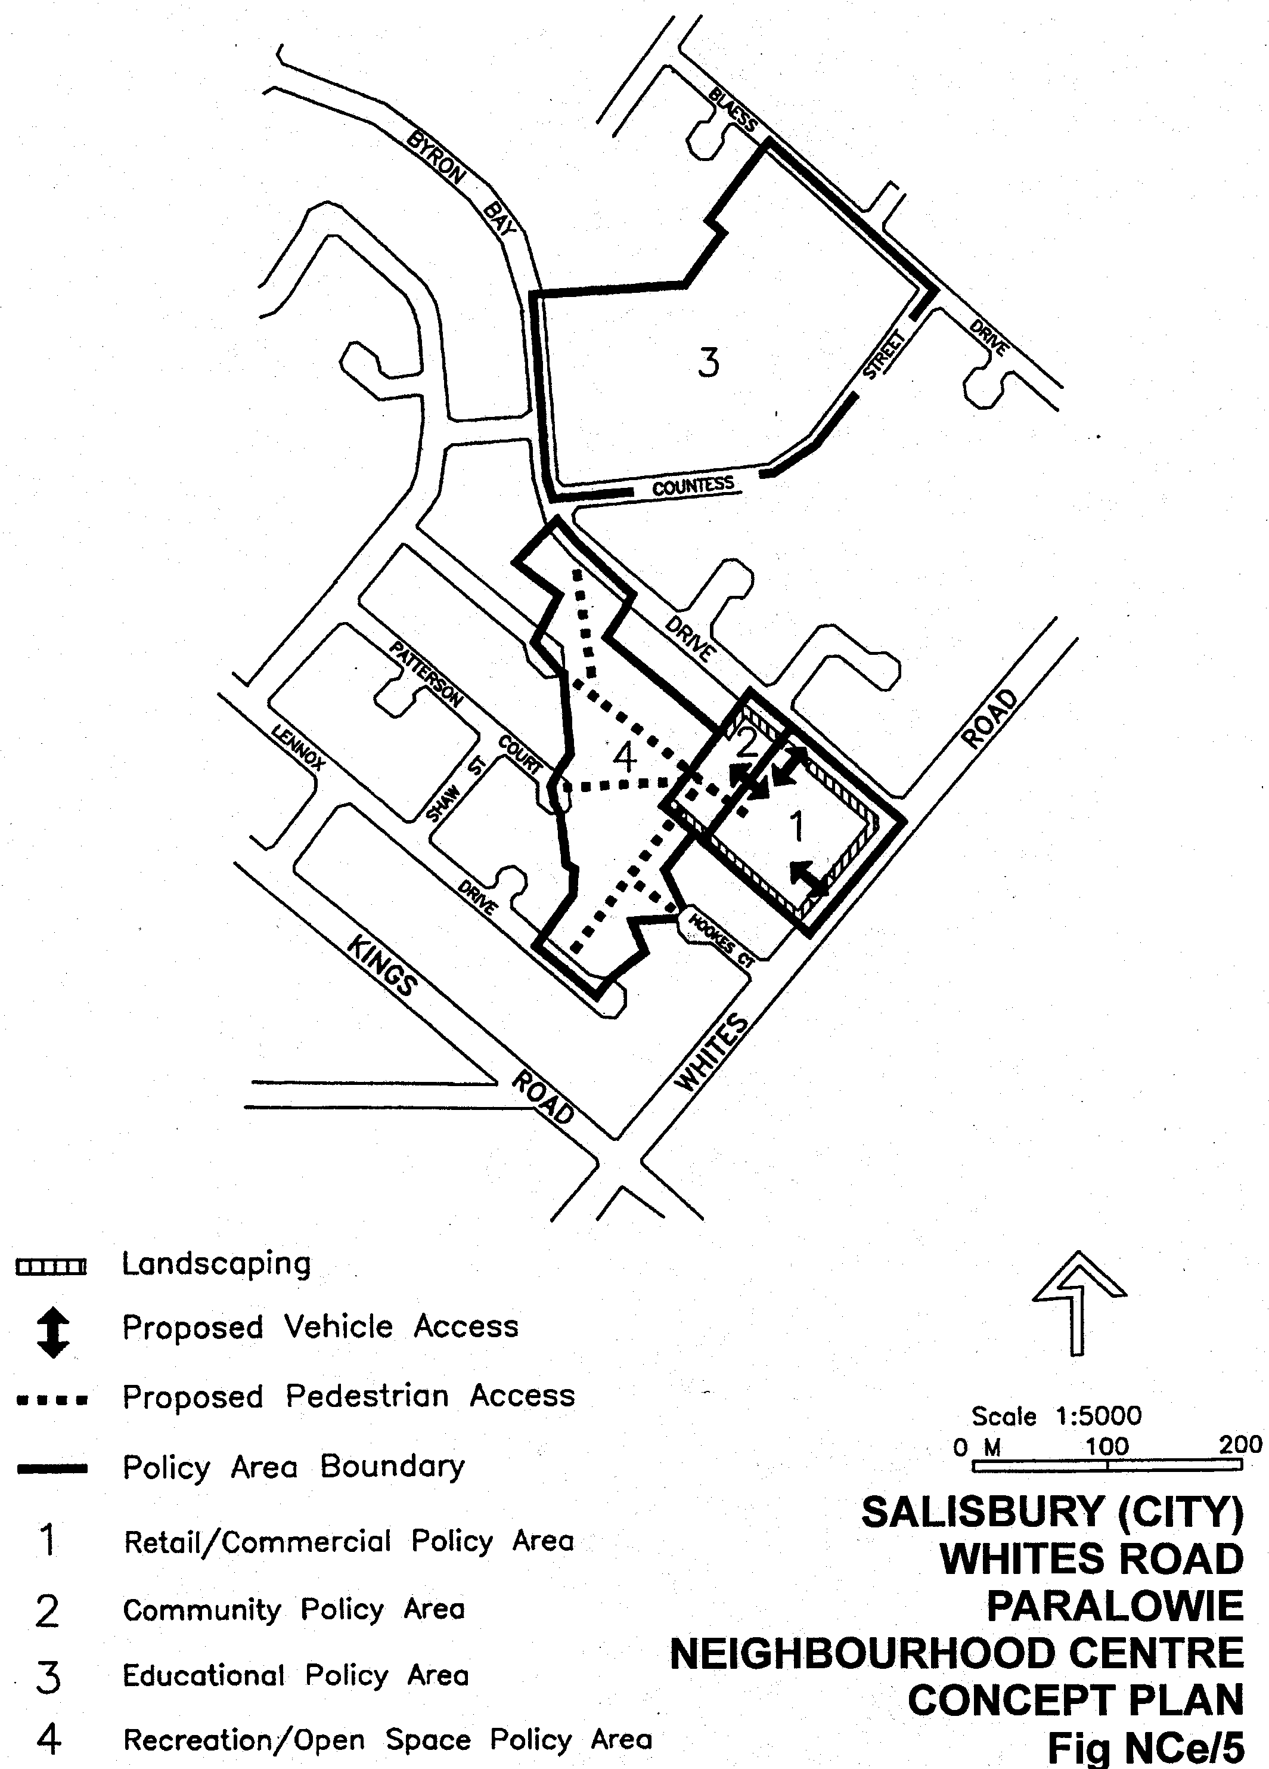

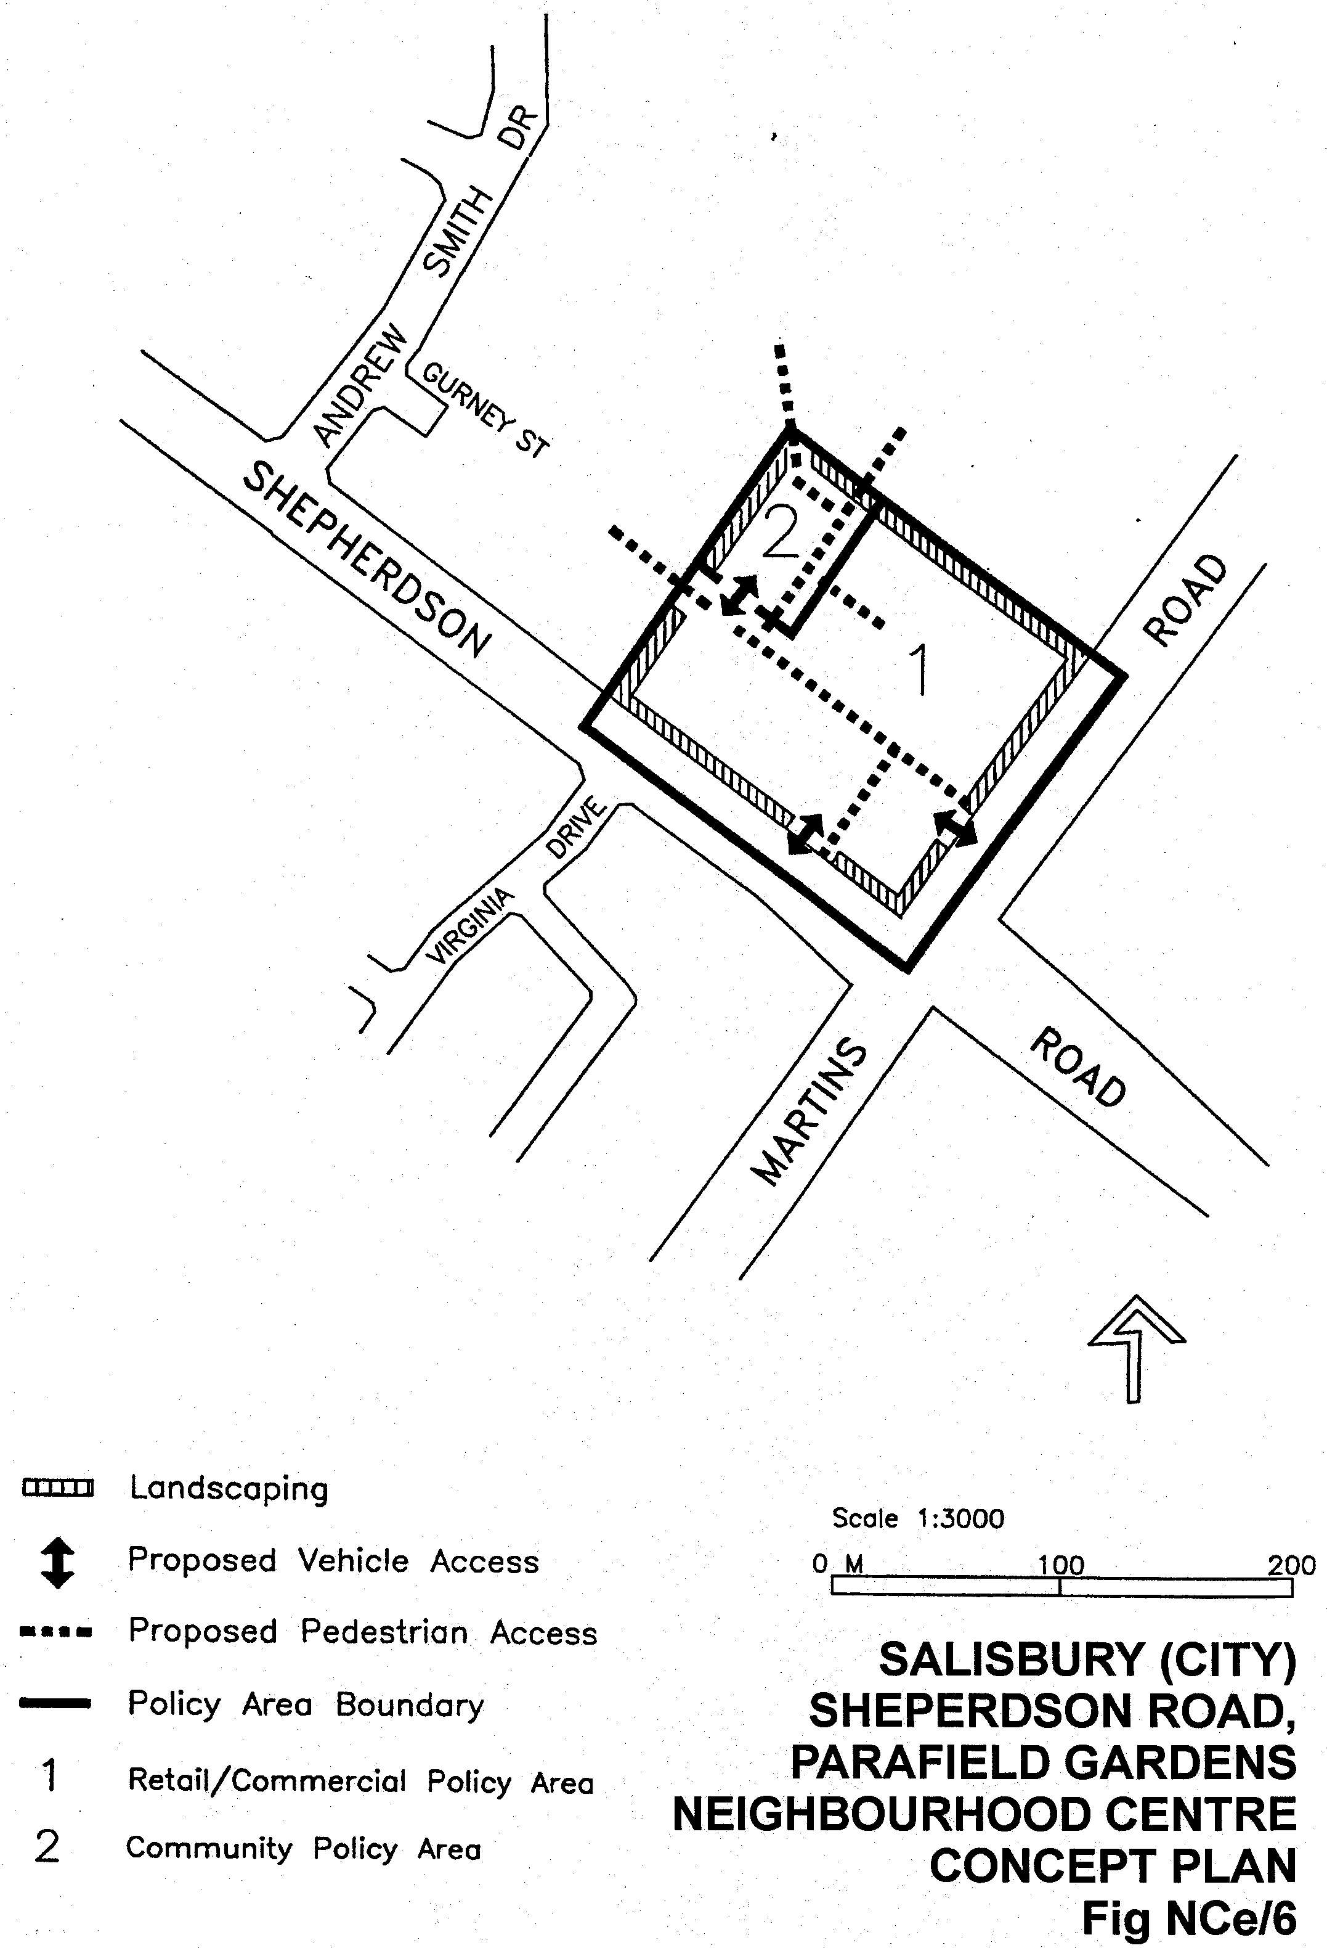
Dated 18 March 1999.
Diana Laidlaw, Minister for Transport and Urban Planning
PLN 97/0382

DEVELOPMENT ACT 1993, SECTION 27 (1): DISTRICT COUNCIL OF CEDUNA—RURAL LIVING, DENIAL BAY AND CEDUNA NORTH PLAN AMENDMENT
Preamble
The Minister for Transport and Urban Planning has approved the amendment entitled ‘District Council of Ceduna—Rural Living, Denial Bay and Ceduna North Plan Amendment’ (the Plan Amendment) and has referred it to the Governor.
Notice
PURSUANT to section 27 (1) of the Development Act 1993, I, the Governor with the advice and consent of the Executive Council, declare the Plan Amendment to be an authorised Plan Amendment and fix 18 March 1999 as the day on which it will come into operation.
Dated 18 March 1999.
E. J. Neal, Governor
MTUP 43/98CS

FISHERIES ACT 1982: SECTION 43
TAKE notice that it is hereby declared that it shall be unlawful for any person to engage in the class of fishing activity specified in Schedule 1 during the periods specified in Schedule 2.
Schedule 1
The act of taking or the act preparatory to or involved in the taking of western king prawn (Penaeus latisulcatus) in waters of Spencer Gulf bounded by a line commencing at position latitude 33°55.00′S, longitude 137°08.00′E, then to position latitude 33°57.00′S, longitude 137°09.00′E then to position latitude 34°00.00′S, longitude 137°03.80′E, then to position latitude 34°07.00′S, longitude 136°57.00′E then to position latitude 34°07.00′S longitude 136°55.00′E, then to position latitude 34°03.00′S, longitude 136°55.00′E, then to position latitude 33°55.00′S, longitude 137°08.00′E then back to the point of commencement.
Schedule 2
2030 hours on 16 March 1999 to 0700 hours on 23 March 1999.
Dated 16 March 1999.
W. Zacharin, Principal Manager, Shellfish
P0005/98

FISHERIES ACT 1982: SECTION 43
TAKE note that the notice number P0004/99 made under section 43 of the Fisheries Act 1982 dated 12 March 1999 which refers to the Spencer Gulf prawn fishery is revoked as of 2030 hours on 16 March 1999.
Dated 16 March 1999.
W. Zacharin, Principal Manager, Shellfish
R0007/99

FISHERIES ACT 1982: SECTION 59
TAKE notice that pursuant to section 59 of the Fisheries Act 1982, Doug Graske (hereinafter referred to as the ‘permit holder’) P.O. Box 1781, Port Lincoln, S.A. 5606, is exempt from section 41 of the Fisheries Act 1982, insofar as he may take blacklip abalone (Haliotis rubra) for the purpose of aquaculture broodstock in the waters specified in Schedule 1 subject to the conditions in Schedule 2 (hereinafter referred to as the ‘permitted activity’).
Schedule 1
South Australian coastal waters south and east of a line drawn due south through Point Brown (latitude 32°32.6′S, longitude 133°50.8′E) and west of the meridian of longitude 136°30′E.
Schedule 2
1. The permit holder may take a maximum of 50 male and 50 female blacklip abalone (Haliotis rubra). All abalone taken pursuant to this notice must be transferred to the South Australian Research and Development Institute (SARDI).
2. The permit holder may engage in the permitted activity from 22 February 1999 until 2 August 1999.
3. The permitted activity may only be conducted by Doug Graske.
4. The permit holder shall notify PIRSA Fisheries and Aquaculture on 1800 065 522 at least 24 hours prior to conducting the permitted activity with the following information:
(a) details of the boat that will be used to engage in the permitted activity;
(b) the intended place and time of launching and retrieval of the nominated boat for that day; and
(c) the intended area of conducting the permitted activity.
5. PIRSA Fisheries and Aquaculture retains the right for a departmental officer to accompany the fisher at any time during the permitted activity.
6. While engaged in the permitted activity the permit holder shall carry or have about or near his person a copy of this notice. Such notice must be produced to a PIRSA Fisheries and Aquaculture Compliance Officer upon request.
7. The permit holder shall not contravene or fail to comply with the Fisheries Act 1982, or any regulations made under that Act, except where specifically exempted by this notice.
Dated 22 February 1999.
D. Mackie, Manager, Legislation and Policy

FISHERIES ACT 1982: SECTION 59
TAKE notice that pursuant to section 59 of the Fisheries Act 1982, Rolf Czabayski, 5 Willowbridge Grove, Burnside, S.A. 5066 (hereinafter referred to as the ‘permit holder’) is exempt from Regulation 35C of the Fisheries (General) Regulations 1984, in that the permit holder shall not be guilty of an offence when using berley within the waters specified in Schedule 1 to attract white sharks (Carchardon carcharias) for the purpose of cage viewing only (hereinafter referred to as the ‘permitted activity’), subject to the conditions specified in Schedule 2, for the dates specified in Schedule 3.
Schedule 1
Coastal waters contained within the Neptune Islands Conservation Park, and the following portions of the Sir Joseph Banks Islands Conservation Park; Dangerous Reef, English and Sibsey Islands.
Note: A maximum of 15 days per calender month is permitted at Dangerous Reef which requires consultation with other approved operators through the Great White Shark Cage Viewing Association.
Schedule 2
1. The permit holder must be on board the boat when conducting the permitted activity.
2. All berley used while conducting the permitted activity must consist of fish based products only. All berley (other than fish oil) must be stored below a maximum temperature of 4°C.
3. The permit holder must notify the public by a Notice to Mariners through the Australian Maritime Safety Authority, by public notice in the Adelaide Advertiser at least 24 hours in advance of berleying operations, advising the local coastguard and the Fisheries Compliance Unit on 1800 065 522 at least two hours prior to conducting the permitted activities.
4. The permit holder shall allow an officer of the Department for Environment Heritage and Aboriginal Affairs (DEHAA) or nominee to be present on board the boat during the permitted activities if requested and subject to negotiation and availability of space.
5. The permit holder must comply with all instructions (including ceasing to berley if so instructed) given by an officer from DEHAA.
6. Whilst engaged in the permitted activity, a pennant (approved by DEHAA) must be flown from the boat so as to be clearly visible.
7. Whilst engaged in the permitted activity the permit holder must have in his/her possession a copy of this notice and produce a copy of the notice if required by a Fisheries Compliance Officer.
8. The permit holder shall not contravene or fail to comply with the Fisheries Act 1982, or any regulations made under the Act, except where specifically exempted by this notice.
9. The permit holder must maintain a log whilst engaged in the permitted activity which includes the date and location, number of passengers, number of sharks observed and any other relevant observations or comments. Records must be kept in a form determined by the operators association and endorsed by the Minister for Environment and Heritage. A copy of the log must be provided to DEHAA within 14 days of each calender month.
10. The permit holder must conform to a code of ethics developed by the operators association and endorsed by the Minister for Environment and Heritage.
11. The permit holder will operate in co-operation with and in agreement of any other approved operator at the same location.
12. The permit holder must have public liability insurance to an amount determined by the Minister for Environment and Heritage and ensure vessels are surveyed and staffed as per Department of Transport regulations.
Schedule 3
28 March 1999 to 2 April 1999
2 May 1999 to 7 May 1999
Dated 8 March 1999.
R. Allen, Manager Parks and Wildlife West

GEOGRAPHICAL NAMES ACT 1991
For Public Consultation
Notice of Intent to Assign Suburb Name
NOTICE is hereby given pursuant to the provisions of the above Act, that the Surveyor-General proposes to assign the suburb name of EDINBURGH that area marked (A) on the plan below:
The Plan
Submissions in writing regarding this proposal may be lodged with the Secretary, Geographical Names Advisory Committee, c/o Department for Environment, Heritage and Aboriginal Affairs, 300 Richmond Road, Netley, S.A. 5037 (P.O. Box 550, Marleston, S.A. 5033) within one month of the publication of this notice.
Dated 23 February 1999.
P. M. Kentish, Surveyor-General, Department for Administrative and Information Services
DEHAA 04/0141

HARBORS AND NAVIGATION ACT 1993
Determination of State Crewing Committee
THE following determination made on 22 October 1998 by the State Crewing Committee is published pursuant to part 6, section 45 of the Harbors and Navigation Act 1993.
Diana Laidlaw, Minister for Transport and Urban Planning.
TSA 98/08910

HARBORS AND NAVIGATION ACT 1993
Determination of State Crewing Committee in respect of the
S.Y. ‘C-Nymph’
THE following determination is made by the State Crewing Committee pursuant to part 6, section 45 of the Harbors and Navigation Act 1993, in respect of the C-Nymph whilst operating within Smooth and Partially Smooth water limits of South Australia as per Schedule 1 of the Harbors and Navigation Act 1993.
Minimum complement
One person⎯Master
Minimum Qualifications of Crew
Master⎯Certificate of Competency as Coxswain, and has successfully completed an approved Elements of Shipboard Safety and Restricted Radio Telephony Courses.
Capt. W. J. Stuart, Presiding Member, State Crewing Committee.

HARBORS AND NAVIGATION ACT 1993
Determination of State Crewing Committee
THE following determination made on 4 March 1999, by the State Crewing Committee is published pursuant to part 6, section 45 of the Harbors and Navigation Act 1993.
Diana Laidlaw, Minister for Transport and Urban Planning.
TSA 99/01683

HARBORS AND NAVIGATION ACT 1993
Determination of State Crewing Committee in respect of the
M.V. ‘Scuba’
THE following determination is made by the State Crewing Committee pursuant to part 6, section 45 of the Harbors and Navigation Act 1993, in respect of the Scuba whilst operating within the following limits.
Operational limits
1. Within 15 nautical miles of the coast of South Australia within the waters of Spencer Gulf, Gulf St Vincent, Investigator Strait and Backstairs Passage, east of a line drawn from Cape Catastrophe to Cape Borda and west of a line drawn from Cape Willoughby to the Murray Mouth.
2. Within Smooth water limits as per Schedule 1 of the Harbors and Navigation Act 1993.
Minimum complement
1. From 1-9 passengers:
One person—Master.
From 10-12 passengers:
Two persons⎯Master and GP (General Purpose Person)
2. Two persons⎯Master and GP (General Purpose Person)
Minimum Qualifications of Crew
Master⎯Certificate of Competency as Coxswain and has successfully completed an approved Elements of Shipboard Safety and Restricted Radio Telephony Courses.
GP⎯General purpose person, an able bodied person not less than 16 years of age with not less than 3 months sea experience and has successfully completed an approved Elements of Shipboard Safety Course.
Capt. W. J. Stuart, Presiding Member, State Crewing Committee.

HARBORS AND NAVIGATION ACT 1993
Determination of State Crewing Committee
THE following determination made on 4 March 1999, by the State Crewing Committee is published pursuant to part 6, section 45 of the Harbors and Navigation Act 1993.
Diana Laidlaw, Minister for Transport and Urban Planning.
TSA 99/01482

HARBORS AND NAVIGATION ACT 1993
Determination of State Crewing Committee in respect of the
M.V. ‘FPV Tarangau’
THE following determination is made by the State Crewing Committee pursuant to part 6, section 45 of the Harbors and Navigation Act 1993, in respect of the FPV Tarangau whilst operating within 15 nautical miles of the coast of South Australia.
Minimum complement
One person⎯Master
Minimum Qualifications of Crew
Master⎯Certificate of Competency as Coxswain and has successfully completed an approved Elements of Shipboard Safety and Restricted Radio Telephony Courses.
Capt. W. J. Stuart, Presiding Member, State Crewing Committee.

HARBORS AND NAVIGATION ACT 1993
Determination of State Crewing Committee
THE following determination made on 4 March 1999, by the State Crewing Committee is published pursuant to part 6, section 45 of the Harbors and Navigation Act 1993.
Diana Laidlaw, Minister for Transport and Urban Planning.
DMH 46/93

HARBORS AND NAVIGATION ACT 1993
Determination of State Crewing Committee in respect of the
M.V. ‘Freelance’
THE following determination is made by the State Crewing Committee pursuant to part 6, section 45 of the Harbors and Navigation Act 1993, in respect of the Freelance whilst operating within the following limits.
Operational limits
1. Within 15 nautical miles of the coast of South Australia within the waters of Spencer Gulf, St Vincent Gulf, Investigator Strait and Backstairs Passage, east of a line drawn from Cape Catastrophe to Cape Borda and west of a line drawn from Cape Willoughby to the Murray Mouth.
2. River Murray, Coorong and Lakes.
Minimum complement
One person⎯Master
Minimum Qualifications of Crew
1. Master⎯Certificate of Competency as Coxswain and has successfully completed an approved Elements of Shipboard Safety and Restricted Radio Telephony Courses.
2. Master—Certificate of Competency as Coxswain RMIW.
Capt. W. J. Stuart, Presiding Member, State Crewing Committee.

HARBORS AND NAVIGATION ACT 1993
Determination of State Crewing Committee
THE following determination made on 4 March 1999, by the State Crewing Committee is published pursuant to part 6, section 45 of the Harbors and Navigation Act 1993.
Diana Laidlaw, Minister for Transport and Urban Planning.
TSA 99/01683

HARBORS AND NAVIGATION ACT 1993
Determination of State Crewing Committee in respect of the
M.V. ‘Free Spirit’
THE following determination is made by the State Crewing Committee pursuant to part 6, section 45 of the Harbors and Navigation Act 1993, in respect of the Free Spirit whilst operating within the following limits.
Operational limits
1. Within 15 nautical miles of the coast of South Australia within the waters of Gulf St Vincent, Spencer Gulf and Investigator Strait, but not west of a line from Cape Borda and Cape Catastrophe north-east of a line from Cape St Albans to Porpoise Head.
2. Smooth and Partially Smooth water limits as per Schedule 1 of the Harbors and Navigation Act 1993.
3. Smooth water limits as per Schedule 1 of the Harbors and Navigation Act 1993.
Minimum complement
1. and 2. Two persons⎯Master and GP (General Purpose Person).
3. One persons⎯Master.
Minimum Qualifications of Crew
Master⎯Certificate of Competency as Coxswain and has successfully completed an approved Elements of Shipboard Safety and Restricted Radio Telephony Courses.
GP⎯General purpose person, an able bodied person not less than 16 years of age with not less than 3 months sea experience and has successfully completed an approved Elements of Shipboard Safety Course.
Capt. W. J. Stuart, Presiding Member, State Crewing Committee.

LAND ACQUISITION ACT 1969
(Section 16)
Notice of Acquisition
THE Commissioner of Highways (the ‘Authority’), 33 Warwick Street, Walkerville, S.A. 5081, acquires the following interests in the following land:
The lessee interest in Lease No. 7348057 over that piece of land situated at 120 Burbridge Road, Hilton, S.A. 5033, being portion of the land formerly contained in cancelled certificate of title register book volume 1122, folio 2, and being the whole of the land delineated as allotment 86 in Deposited Plan No. 48933.
This notice is given under section 16 of the Land Acquisition Act 1969.
Compensation
A person who has or had an interest in the land that is divested or diminished by the acquisition or the enjoyment of which is adversely affected by the acquisition who does not receive an offer of compensation from the Authority may apply to the Authority for compensation.
Inquiries
Inquiries should be directed to:
Eugene Lewandowski
P.O. Box 1
Walkerville, S.A. 5081
Telephone: (08) 8343 2458
Dated 15 March 1999.
The Common Seal of the Commissioner of Highways was hereto affixed by direction of the Commissioner of Highways in the presence of:
E. Lewandowski, Acting Manager, Land Acquisition and Disposal, Transport SA

LAND ACQUISITION ACT 1969
(Section 16)
Notice of Acquisition
THE Commissioner of Highways (the ‘Authority’), 33 Warwick Street, Walkerville, S.A. 5081, acquires the following interests in the following land:
Firstly, the lessee interest in Lease No. 8190855 in that piece of land situated at 103-105 Burbridge Road, Hilton, S.A. 5033, being portion of the land contained in certificate of title register book volume 5375, folio 412, and being the whole of the land delineated as allotment 80 on the plan lodged in the Lands Titles Office and Deposited Plan No. 48955.
Secondly, the lessee interest in Lease No. 8190855 in that piece of land situated at 103-105 Burbridge Road, Hilton, S.A. 5033, being portion of the land contained in certificate of title register book volume 5375, folio 411 and being the whole of the land delineated as allotment 81 on the plan lodged in the Lands Titles Office and Deposited Plan No. 48955.
This notice is given under section 16 of the Land Acquisition Act 1969.
Compensation
A person who has or had an interest in the land that is divested or diminished by the acquisition or the enjoyment of which is adversely affected by the acquisition who does not receive an offer of compensation from the Authority may apply to the Authority for compensation.
Inquiries
Inquiries should be directed to:
Eugene Lewandowski
P.O. Box 1
Walkerville, S.A. 5081
Telephone: (08) 8343 2458
Dated 15 March 1999.
The Common Seal of the Commissioner of Highways was hereto affixed by direction of the Commissioner of Highways in the presence of:
E. Lewandowski, Acting Manager, Land Acquisition and Disposal, Transport SA

LAND ACQUISITION ACT 1969
(Section 16)
Notice of Acquisition
THE Commissioner of Highways (the ‘Authority’), 33 Warwick Street, Walkerville, S.A. 5081, acquires the following interests in the following land:
The unregistered lessee interest in that piece of land situated at 86-88 Burbridge Road, Hilton, S.A. 5033, being portion of the land contained in certificate of title register book volume 1079, folio 44, and being the whole of the land delineated as allotments 128 and 129 on the plan lodged in the Lands Titles Office and Deposited Plan No. 48893.
This notice is given under section 16 of the Land Acquisition Act 1969.
Compensation
A person who has or had an interest in the land that is divested or diminished by the acquisition or the enjoyment of which is adversely affected by the acquisition who does not receive an offer of compensation from the Authority may apply to the Authority for compensation.
Inquiries
Inquiries should be directed to:
Eugene Lewandowski
P.O. Box 1
Walkerville, S.A. 5081
Telephone: (08) 8343 2458
Dated 15 March 1999.
The Common Seal of the Commissioner of Highways was hereto affixed by direction of the Commissioner of Highways in the presence of:
E. Lewandowski, Acting Manager, Land Acquisition and Disposal, Transport SA

LAND ACQUISITION ACT 1969
(Section 16)
Notice of Acquisition
THE Commissioner of Highways (the ‘Authority’), 33 Warwick Street, Walkerville, S.A. 5081, acquires the following interests in the following land:
The fee simple of that piece of land situated at 154 Burbridge Road, Hilton, S.A. 5033, being portion of the land formerly contained in cancelled certificate of title register book volume 5395, folio 102, and being the whole of the land delineated as allotment 68 on the plan lodged in the Lands Titles Office and Deposited Plan No. 48938.
This notice is given under section 16 of the Land Acquisition Act 1969.
Compensation
A person who has or had an interest in the land that is divested or diminished by the acquisition or the enjoyment of which is adversely affected by the acquisition who does not receive an offer of compensation from the Authority may apply to the Authority for compensation.
Inquiries
Inquiries should be directed to:
Eugene Lewandowski
P.O. Box 1
Walkerville, S.A. 5081
Telephone: (08) 8343 2458
Dated 15 March 1999.
The Common Seal of the Commissioner of Highways was hereto affixed by direction of the Commissioner of Highways in the presence of:
E. Lewandowski, Acting Manager, Land Acquisition and Disposal, Transport SA

LAND ACQUISITION ACT 1969
(Section 16)
Notice of Acquisition
THE Commissioner of Highways (the ‘Authority’), 33 Warwick Street, Walkerville, S.A. 5081, acquires the following interests in the following land:
The fee simple of that piece of land situated at 136-140 Burbridge Road, Hilton, S.A. 5033, being portion of the land contained in cancelled certificate of title register book volume 5117, folio 403, and being the whole of the land delineated as allotment 108 on the plan lodged in the Lands Titles Office and Deposited Plan No. 48932.
This notice is given under section 16 of the Land Acquisition Act 1969.
Compensation
A person who has or had an interest in the land that is divested or diminished by the acquisition or the enjoyment of which is adversely affected by the acquisition who does not receive an offer of compensation from the Authority may apply to the Authority for compensation.
Inquiries
Inquiries should be directed to:
Eugene Lewandowski
P.O. Box 1
Walkerville, S.A. 5081
Telephone: (08) 8343 2458
Dated 15 March 1999.
The Common Seal of the Commissioner of Highways was hereto affixed by direction of the Commissioner of Highways in the presence of:
E. Lewandowski, Acting Manager, Land Acquisition and Disposal, Transport SA

LAND ACQUISITION ACT 1969
(Section 16)
Notice of Acquisition
THE Commissioner of Highways (the ‘Authority’), 33 Warwick Street, Walkerville, S.A. 5081, acquires the following interests in the following land:
Firstly, the registered lessee interest in that piece of land situated at 108 Burbridge Road, Hilton, S.A. 5033, being portion of the land contained in certificate of title register book volume 5235, folio 333, and being the whole of the land delineated as allotment 96 on the plan lodged in the Lands Titles Office and Deposited Plan No. 48884.
Secondly, the registered lessee interest in that piece of land situated at 108 Burbridge Road, Hilton, S.A. 5033, being portion of the land contained in certificate of title register book volume 5235, folio 332, and being the whole of the land delineated as allotment 97 on the plan lodged in the Lands Titles Office and Deposited Plan No. 48884.
Thirdly, the registered lessee interest in that piece of land situated at 108 Burbridge Road, Hilton, S.A. 5033, being portion of the land contained in certificate of title register book volume 5235, folio 334, and being the whole of the land delineated as allotment 98 on the plan lodged in the Lands Titles Office and Deposited Plan No. 48884.
Fourthly, the registered lessee interest in that piece of land situated at 108 Burbridge Road, Hilton, S.A. 5033, being portion of the land contained in certificate of title register book volume 5235, folio 335, and being the whole of the land delineated as allotment 99 on the plan lodged in the Lands Titles Office and Deposited Plan No. 48884.
This notice is given under section 16 of the Land Acquisition Act 1969.
Compensation
A person who has or had an interest in the land that is divested or diminished by the acquisition or the enjoyment of which is adversely affected by the acquisition who does not receive an offer of compensation from the Authority may apply to the Authority for compensation.
Inquiries
Inquiries should be directed to:
Eugene Lewandowski
P.O. Box 1
Walkerville, S.A. 5081
Telephone: (08) 8343 2458
Dated 12 March 1999.
The Common Seal of the Commissioner of Highways was hereto affixed by direction of the Commissioner of Highways in the presence of:
E. Lewandowski, Acting Manager, Land Acquisition and Disposal, Transport SA

LAND ACQUISITION ACT 1969
(Section 16)
Notice of Acquisition
THE Commissioner of Highways (the ‘Authority’), 33 Warwick Street, Walkerville, S.A. 5081, acquires the following interests in the following land:
Firstly, the fee simple of that piece of land situated at 118 Burbridge Road, Hilton, S.A. 5033, being portion of the land contained in certificate of title register book volume 5230, folio 201, and being the whole of the land delineated as allotment 122 on the plan lodged in the Lands Titles Office and Deposited Plan No. 48892.
Secondly, the fee simple of that piece of land situated at 116 Burbridge Road, Hilton, S.A. 5033, being portion of the land contained in certificate of title register book volume 5107, folio 81, and being the whole of the land delineated as allotment 123 on the plan lodged in the Lands Titles Office and Deposited Plan No. 48892.
This notice is given under section 16 of the Land Acquisition Act 1969.
Compensation
A person who has or had an interest in the land that is divested or diminished by the acquisition or the enjoyment of which is adversely affected by the acquisition who does not receive an offer of compensation from the Authority may apply to the Authority for compensation.
Inquiries
Inquiries should be directed to:
Eugene Lewandowski
P.O. Box 1
Walkerville, S.A. 5081
Telephone: (08) 8343 2458
Dated 12 March 1999.
The Common Seal of the Commissioner of Highways was hereto affixed by direction of the Commissioner of Highways in the presence of:
E. Lewandowski, Acting Manager, Land Acquisition and Disposal, Transport SA

LAND AND BUSINESS (SALE AND CONVEYANCING) ACT 1994
Section 23
TAKE notice that, pursuant to section 23 (3) of the Land and Business (Sale and Conveyancing) Act 1994, I, Kenneth Trevor Griffin, Minister for Consumer Affairs, do hereby exempt the person named in Schedule 1 from the application of section 23 (2) of the Act in relation to the purchase of the land specified in Schedule 2.
Schedule 1
Richard Meyler Williams, an officer/employee of Toop Real Estate Group Pty Ltd.
Schedule 2
The whole of the land described in certificate of title register book volume 5021, folio 901, situated at Unit 2/8 Winston Street, Somerton Park, S.A. 5044.
Dated 11 March 1999.
Signed for and on behalf of the Minister for Consumer Affairs by the Commissioner for Consumer Affairs.
H. J. Gilmore, Commissioner

LAND AND BUSINESS (SALE AND CONVEYANCING) ACT 1994
Section 23
TAKE notice that, pursuant to section 23 (3) of the Land and Business (Sale and Conveyancing) Act 1994, I, Kenneth Trevor Griffin, Minister for Consumer Affairs, do hereby exempt the person named in Schedule 1 from the application of section 23 (2) of the Act in relation to the purchase of the land specified in Schedule 2.
Schedule 1
Claire Elizabeth Elliott, an officer/employee of Elders Ltd.
Schedule 2
The whole of the land described in certificate of title register book volume 770, folio 160, situated at 11 Willow Avenue, Lucindale, S.A. 5272.
Dated 11 March 1999.
Signed for and on behalf of the Minister for Consumer Affairs by the Commissioner for Consumer Affairs.
H. J. Gilmore, Commissioner

LAND AND BUSINESS (SALE AND CONVEYANCING) ACT 1994
Section 23
TAKE notice that, pursuant to section 23 (3) of the Land and Business (Sale and Conveyancing) Act 1994, I, Kenneth Trevor Griffin, Minister for Consumer Affairs, do hereby exempt the person named in Schedule 1 from the application of section 23 (2) of the Act in relation to the purchase of the land specified in Schedule 2.
Schedule 1
Lilian Irene Nicholson, an officer/employee of Geo Kennedy Pty Ltd.
Schedule 2
The whole of land described in certificate of title register book volume 5027, folio 117, situated at Unit 11/26-30 Richards Drive, Morphett Vale, S.A. 5162.
Dated 11 March 1999.
Signed for and on behalf of the Minister for Consumer Affairs by the Commissioner for Consumer Affairs.
H. J. Gilmore, Commissioner

GOVERNMENT GAZETTE ADVERTISEMENT RATES

To apply from 1 September 1998

$  Agents, Ceasing to Act as 27.70  Associations:  Incorporation 14.10  Intention of Incorporation 34.75  Transfer of Properties 34.75  Attorney, Appointment of 27.70  Bailiff’s Sale 34.75  Cemetery Curator Appointed 20.70  Companies:  Alteration to Constitution 27.70  Capital, Increase or Decrease of 34.75  Ceasing to Carry on Business 20.70  Declaration of Dividend 20.70  Incorporation 27.70  Lost Share Certificates:  First Name 20.70  Each Subsequent Name 7.10  Meeting Final 23.20  Meeting Final Regarding Liquidator’s Report on  Conduct of Winding Up (equivalent to ‘Final  Meeting’)  First Name 27.70  Each Subsequent Name 7.10  Notices:  Call 34.75  Change of Name 14.10  Creditors 27.70  Creditors Compromise of Arrangement 27.70  Creditors (extraordinary resolution that ‘the Com-pany be wound up voluntarily and that a liquidator be appointed’) 34.75  Release of Liquidator⎯Application⎯Large Ad. 55.40  ⎯Release Granted 34.75  Receiver and Manager Appointed 32.30  Receiver and Manager Ceasing to Act 27.70  Restored Name 26.30  Petition to Supreme Court for Winding Up 48.35  Summons in Action 41.30  Order of Supreme Court for Winding Up Action 27.70  Register of Interests⎯Section 84 (1) Exempt 62.45  Removal of Office 14.10  Proof of Debts 27.70  Sales of Shares and Forfeiture 27.70  Estates:  Assigned 20.70  Deceased Persons⎯Notice to Creditors, etc. 34.75  Each Subsequent Name 7.10  Deceased Persons⎯Closed Estates 20.70  Each Subsequent Estate 0.90  Probate, Selling of 27.70  Public Trustee, each Estate 7.10 |  | $  Firms:  Ceasing to Carry on Business (each insertion) 20.70  Discontinuance Place of Business 20.70  Land⎯Real Property Act:  Intention to Sell, Notice of 34.75  Lost Certificate of Title Notices 34.75  Cancellation, Notice of (Strata Plan) 34.75  Mortgages:  Caveat Lodgment 14.10  Discharge of 14.95  Foreclosures 14.10  Transfer of 14.10  Sublet 7.10  Leases⎯Application for Transfer (2 insertions) each 7.10  Lost Treasury Receipts (3 insertions) each 20.70  Licensing 41.30  Municipal or District Councils:  Annual Financial Statement⎯Forms 1 and 2 390.00  Electricity Supply⎯Forms 19 and 20 276.00  Default in Payment of Rates:  First Name 55.40  Each Subsequent Name 7.10  Noxious Trade 20.70  Partnership, Dissolution of 20.70  Petitions (small) 14.10  Registered Building Societies (from Registrar-  General) 14.10  Register of Unclaimed Moneys⎯First Name 20.70  Each Subsequent Name 7.10  Registers of Members⎯Three pages and over:  Rate per page (in 8pt) 176.00  Rate per page (in 6pt) 233.00  Sale of Land by Public Auction 35.25  Advertisements 1.95  Advertisements, other than those listed are charged at $1.95 per column line, tabular one-third extra.  Notices by Colleges, Universities, Corporations and District Councils to be charged at $1.95 per line.  Where the notice inserted varies significantly in length from that which is usually published a charge of $1.95 per column line will be applied in lieu of advertisement rates listed.  South Australian Government publications are sold on the condition that they will not be reproduced without prior permission from the Government Printer.

GOVERNMENT GAZETTE NOTICES
ALL private advertisements forwarded for publication in the South Australian Government Gazette must be PAID FOR PRIOR TO INSERTION; and all notices, from whatever source, should be legibly written on one side of the paper only and sent to Riverside 2000 so as to be received no later than 4 p.m. Tuesday preceding the day of publication. Phone 8207 1045 or Fax 8207 1040.

MISCELLANEOUS LEGISLATION AND GOVERNMENT PUBLICATIONS PRICES AS FROM 1 SEPTEMBER 1998

Acts, Bills, Rules, Parliamentary Papers and Regulations
Pages | Main | Amends | Pages | Main | Amends

1-16 | 1.55 | 0.75 | 497-512 | 22.70 | 21.85
17-32 | 2.25 | 1.40 | 513-528 | 23.30 | 22.45
33-48 | 2.85 | 2.05 | 529-544 | 24.05 | 23.20
49-64 | 3.60 | 2.70 | 545-560 | 24.65 | 23.85
65-80 | 4.25 | 3.45 | 561-576 | 25.40 | 24.55
81-96 | 4.90 | 4.10 | 577-592 | 26.00 | 25.20
97-112 | 5.60 | 4.75 | 593-608 | 26.70 | 25.80
113-128 | 6.25 | 5.45 | 609-624 | 27.50 | 26.70
129-144 | 7.00 | 6.15 | 625-640 | 28.00 | 27.25
145-160 | 7.70 | 6.80 | 641-656 | 28.85 | 27.80
161-176 | 8.35 | 7.50 | 657-672 | 29.35 | 28.55
177-192 | 9.00 | 8.20 | 673-688 | 30.20 | 29.35
193-208 | 9.70 | 8.85 | 689-704 | 30.95 | 29.90
209-224 | 10.35 | 9.50 | 705-720 | 31.45 | 30.70
225-240 | 10.95 | 10.20 | 721-736 | 32.30 | 31.25
241-257 | 11.75 | 10.85 | 737-752 | 33.00 | 32.00
258-272 | 12.50 | 11.50 | 753-768 | 33.55 | 32.50
273-288 | 13.10 | 12.30 | 769-784 | 34.05 | 33.35
289-304 | 13.75 | 12.90 | 785-800 | 34.90 | 34.05
305-320 | 14.45 | 13.55 | 801-816 | 35.45 | 34.60
321-336 | 15.15 | 14.25 | 817-832 | 36.25 | 35.45
337-352 | 15.80 | 15.05 | 833-848 | 37.00 | 35.95
353-368 | 16.50 | 15.65 | 849-864 | 37.50 | 36.80
369-384 | 17.15 | 16.40 | 865-880 | 38.35 | 37.50
385-400 | 17.85 | 17.05 | 881-896 | 38.85 | 38.05
401-416 | 18.50 | 17.65 | 897-912 | 39.70 | 38.85
417-432 | 19.25 | 18.40 | 913-928 | 40.25 | 39.70
433-448 | 19.85 | 19.00 | 929-944 | 40.95 | 40.25
449-464 | 20.60 | 19.65 | 945-960 | 41.80 | 40.75
465-480 | 21.20 | 20.40 | 961-976 | 42.30 | 41.50
481-496 | 21.85 | 21.00 | 977-992 | 43.15 | 42.00

Legislation—Acts, Regulations, etc: $
Subscriptions:
Acts 140.00
All Bills as Laid 335.00
Rules and Regulations 335.00
Parliamentary Papers 335.00
Bound Acts 155.00
Index 75.00
Government Gazette
Copy 3.75
Subscription 185.00
$
Hansard
Copy 10.00
Subscription—per session (issued weekly) 290.00
Cloth bound—per volume 125.00
Subscription—per session (issued daily) 290.00
Legislation on Disk
Whole Database 2 145.00
Annual Subscription for fortnightly updates 660.00
Individual Act(s) including updates POA
Postage Extra on Individual Copies

All Legislation, Government Gazette, Hansard and Legislation on disk are available from:
Counter Sales: Information SA (State Government Bookshop)
Australis Centre, Ground Floor, 77 Grenfell Street, Adelaide, S.A. 5000.
Phone: (08) 8204 1900. Fax: (08) 8204 1909
S.A. Country Customer Free Call: 1800 182 234
TTY (Hearing Impaired): (08) 8204 1923
Mail Orders: Information SA Subscription and Mail Order Service:
Phone: (08) 8204 9449. Fax: (08) 8204 1898
P.O. Box 1, Rundle Mall, Adelaide, S.A. 5000.

Department for Environment, Heritage and Aboriginal Affairs, Adelaide, 16 March 1999
NOTICE is hereby given that the lease undermentioned and described at the foot hereof has been cancelled, and determined by the Minister for Environment and Heritage and is hereby declared forfeited.
J. Scanlon, Chief Executive, Department for Environment, Heritage and Aboriginal Affairs
Lease | Allotment | Hundred |  | Lessee | Cause of Forfeiture | Date of  Cancel-  lation

Miscellaneous No. 20242 | 16  DP47645 | Gillen |  | Evans, Marcelle Marie |  | Cancelled pursuant to section 59 (1) of Crown Lands Act 1929 | 16.3.99

The above notice is inserted and published by authority of the Honourable Dorothy Kotz, Minister for Environment and Heritage.
J. Scanlon, Chief Executive, Department for Environment, Heritage and Aboriginal Affairs

LIQUOR LICENSING ACT 1997
Notice of Application
NOTICE is hereby given, pursuant to section 52 (2) (b) of the Liquor Licensing Act 1997, that Graham and Robyn Virgin, c/o Phillips Fox, 19-29 Young Street, Adelaide, S.A. 5000 have applied to the Licensing Authority for the Grant of a Hotel Licence in respect of premises to be situated at section 90, Stenhouse Bay Road, Marion Bay.
The application has been set down for hearing on 16 April 1999.
Conditions
The following licence conditions are sought:
1. That the licence authorise extended trade in liquor during the hours 8 a.m. to 11 a.m. and 8 p.m. to midnight on Sundays, pursuant to section 44 of the Liquor Licensing Act 1997.
2. That no liquor be served in the courtyard area after 10 p.m. on any day.
3. That consent to use the premises for the purpose of providing entertainment be granted pursuant to section 105 of the Liquor Licensing Act 1997.
Any person may object to the application by lodging a notice of objection in the prescribed form with the Licensing Authority, and serving a copy of the notice on the applicants at the applicants’ address given above, at least seven days before the hearing date.
Plans in respect of the premises the subject of the application are open to public inspection without fee at the Office of the Liquor Licensing Commissioner, 2nd Floor, East Wing, G.R.E. Building, 50 Grenfell Street, Adelaide 5000.
Dated 25 February 1999.
Applicants

LIQUOR LICENSING ACT 1997
Notice of Application
NOTICE is hereby given, pursuant to section 52 (2) (b) of the Liquor Licensing Act 1997, that Tumby Bay Football Club Inc. has applied to the Licensing Authority for the Removal of a Licence in respect of premises situated at 16 Lipson Road, Tumby Bay, S.A. 5605 and to be situated at Tumby Bay Oval, West Terrace, Tumby Bay, S.A. 5605 and known as Tumby Bay Football Club.
The application has been set down for hearing on 16 April 1999.
Any person may object to the application by lodging a notice of objection in the prescribed form with the Licensing Authority, and serving a copy of the notice on the applicant at the applicant’s address given above, at least seven days before the hearing date.
Plans in respect of the premises the subject of the application are open to public inspection without fee at the Office of the Liquor Licensing Commissioner, 2nd Floor, East Wing, G.R.E. Building, 50 Grenfell Street, Adelaide 5000.
Dated 3 March 1999.
Applicant

LIQUOR LICENSING ACT 1997
Notice of Application
NOTICE is hereby given, pursuant to section 52 (2) (b) of the Liquor Licensing Act 1997, that Crystal Brook Motorcycle Club Inc. has applied to the Licensing Authority for a Limited Club Licence in respect of premises to be situated at Section 825, Crystal Brook, S.A. 5523 and to be known as Crystal Brook Motorcycle Club Inc.
The application has been set down for hearing on 16 April 1999.
Condition
The following licence condition is sought:
Extended trading authorisation, hours of operation: Sunday 8 a.m. to 11 a.m. and 8 a.m. to midnight.
Any person may object to the application by lodging a notice of objection in the prescribed form with the Licensing Authority, and serving a copy of the notice on the applicant at the applicant’s address given above, at least seven days before the hearing date.
Plans in respect of the premises the subject of the application are open to public inspection without fee at the Office of the Liquor Licensing Commissioner, 2nd Floor, East Wing, G.R.E. Building, 50 Grenfell Street, Adelaide 5000.
Dated 8 April 1999.
Applicant

LIQUOR LICENSING ACT 1997
Notice of Application
NOTICE is hereby given, pursuant to section 52 (2) (b) of the Liquor Licensing Act 1997, that Adelaide Black Powder Muzzle Loading Club (S.S.A.A.) Inc. has applied to the Licensing Authority for a Limited Club Licence in respect of premises to be situated at Off Gorge Road, Playford Bridge, Castambul and to be known as Adelaide Black Powder Muzzle Loading Club (S.S.A.A.) Inc.
The application has been set down for hearing on 16 April 1999.
Any person may object to the application by lodging a notice of objection in the prescribed form with the Licensing Authority, and serving a copy of the notice on the applicant at the applicant’s address given above, at least seven days before the hearing date.
Plans in respect of the premises the subject of the application are open to public inspection without fee at the Office of the Liquor Licensing Commissioner, 2nd Floor, East Wing, G.R.E. Building, 50 Grenfell Street, Adelaide 5000.
Dated 8 March 1999.
Applicant

LIQUOR LICENSING ACT 1997
Notice of Application
NOTICE is hereby given, pursuant to section 52 (2) (b) of the Liquor Licensing Act 1997, that Kirribilly Wines Pty Ltd (ACN 081 787 500) c/o Wallmans Solicitors, 173 Wakefield Street, Adelaide, S.A. 5000 has applied to the Licensing Authority for the grant of a Producer’s Licence in respect of premises situated at 242 Main North Road, Clare, S.A. 5453 and to be known as Kirribilly Wines.
The application has been set down for hearing on 16 April 1999.
Any person may object to the application by lodging a notice of objection in the prescribed form with the Licensing Authority, and serving a copy of the notice on the applicant at the applicant’s address given above, at least seven days before the hearing date.
Plans in respect of the premises the subject of the application are open to public inspection without fee at the Office of the Liquor Licensing Commissioner, 2nd Floor, East Wing, G.R.E. Building, 50 Grenfell Street, Adelaide 5000.
Dated 10 March 1999.
Applicant

LIQUOR LICENSING ACT 1997
Notice of Application
NOTICE is hereby given, pursuant to section 52 (2) (b) of the Liquor Licensing Act 1997, that Peter Alexander Badenoch and Margaret Easter have applied to the Licensing Authority for a Restaurant Licence with Entertainment Consent in respect of premises situated at Migration Museum, 82 Kintore Avenue, Adelaide and known as Maggie’s Table.
The application has been set down for hearing on 16 April 1999.
Any person may object to the application by lodging a notice of objection in the prescribed form with the Licensing Authority, and serving a copy of the notice on the applicants at the applicants’ address given above, at least seven days before the hearing date.
Plans in respect of the premises the subject of the application are open to public inspection without fee at the Office of the Liquor Licensing Commissioner, 2nd Floor, East Wing, G.R.E. Building, 50 Grenfell Street, Adelaide 5000.
Dated 12 March 1999.
Applicants

LIQUOR LICENSING ACT 1997
Notice of Application
NOTICE is hereby given, pursuant to section 52 (2) (b) of the Liquor Licensing Act 1997, that Fenn on Hindley Pty Ltd has applied to the Licensing Authority for a Variation to an Extended Trading Authorisation in respect of premises situated at 208 Hindley Street, Adelaide, S.A. 5000 and known as Worldsend Hotel.
The application has been set down for hearing on 16 April 1999.
Condition
The folloiwng licence condition is sought:
Hours of operation: Sunday, 8 p.m. to midnight.
Any person may object to the application by lodging a notice of objection in the prescribed form with the Licensing Authority, and serving a copy of the notice on the applicant at the applicant’s address given above, at least seven days before the hearing date.
Plans in respect of the premises the subject of the application are open to public inspection without fee at the Office of the Liquor Licensing Commissioner, 2nd Floor, East Wing, G.R.E. Building, 50 Grenfell Street, Adelaide 5000.
Dated 9 March 1999.
Applicant

LIQUOR LICENSING ACT 1997
Notice of Application
NOTICE is hereby given, pursuant to section 52 (2) (b) of the Liquor Licensing Act 1997, that Kevin Len Dinnison and Cheryle Rae Dinnison have applied to the Licensing Authority for the Transfer of a Retail Liquor Merchant’s Licence in respect of premises situated at Lot 174, Laffer Street, Nangwarry, S.A. 5277 and known as Nangwarry Serv-Well.
The application has been set down for hearing on 19 April 1999.
Any person may object to the application by lodging a notice of objection in the prescribed form with the Licensing Authority, and serving a copy of the notice on the applicants at the applicants’ address given above, at least seven days before the hearing date.
Plans in respect of the premises the subject of the application are open to public inspection without fee at the Office of the Liquor Licensing Commissioner, 2nd Floor, East Wing, G.R.E. Building, 50 Grenfell Street, Adelaide 5000.
Applicants

LIQUOR LICENSING ACT 1997
Notice of Application
NOTICE is hereby given, pursuant to section 52 (2) (b) of the Liquor Licensing Act 1997, that Raymond Shane and Tracy Denness have applied to the Licensing Authority for the Transfer of a Retail Liquor Merchant’s Licence and Restaurant Licence in respect of premises situated at Dickenson Street, Iron Knob, S.A. 5601 and known as Iron Knob Motel Roadhouse.
The application has been set down for hearing on 19 April 1999.
Any person may object to the application by lodging a notice of objection in the prescribed form with the Licensing Authority, and serving a copy of the notice on the applicants at the applicants’ address given above, at least seven days before the hearing date.
Plans in respect of the premises the subject of the application are open to public inspection without fee at the Office of the Liquor Licensing Commissioner, 2nd Floor, East Wing, G.R.E. Building, 50 Grenfell Street, Adelaide 5000.
Dated 1 March 1999.
Applicants

LIQUOR LICENSING ACT 1997
Notice of Application
NOTICE is hereby given, pursuant to section 52 (2) (b) of the Liquor Licensing Act 1997, that Rainer Mueller c/o Bonnins, Level 14, 100 King William Street, Adelaide, S.A. 5000 has applied to the Licensing Authority for the Transfer of a Hotel Licence in respect of the premises situated at Eyre Highway, Nundroo, S.A. 5690 and known as Nundroo Hotel Motel Inn.
The application has been set down for hearing on 19 April 1999 at 10 a.m.
Any person may object to the application by lodging a notice of objection in the prescribed form with the Licensing Authority, and serving a copy of the notice on the applicant at the applicant’s address given above, at least seven days before the hearing date.
Plans in respect of the premises the subject of the application are open to public inspection without fee at the Office of the Liquor Licensing Commissioner, 2nd Floor, East Wing, G.R.E. Building, 50 Grenfell Street, Adelaide 5000.
Dated 9 March 1999.
Applicant

LIQUOR LICENSING ACT 1997
Notice of Application
NOTICE is hereby given, pursuant to section 52 (2) (b) of the Liquor Licensing Act 1997, that D. & W. Pastoral Company Pty Ltd (ACN 082 968 474) has applied to the Licensing Authority for the Transfer of a Hotel Licence in respect of premises situated at 15 Railway Parade, Mount Bryan and known as Mount Bryan Hotel.
The application has been set down for hearing on 19 April 1999.
Any person may object to the application by lodging a notice of objection in the prescribed form with the Licensing Authority, and serving a copy of the notice on the applicant at the applicant’s address given above, at least seven days before the hearing date.
Plans in respect of the premises the subject of the application are open to public inspection without fee at the Office of the Liquor Licensing Commissioner, 2nd Floor, East Wing, G.R.E. Building, 50 Grenfell Street, Adelaide 5000.
Applicant

LIQUOR LICENSING ACT 1997
Notice of Application
NOTICE is hereby given, pursuant to section 52 (2) (b) of the Liquor Licensing Act 1997, that David Paul Hartley and Wendy Ann Hartley, Ral Ral Avenue, Renmark, S.A. 5341 have applied to the Licensing Authority for the Transfer of the Residential Licence in respect of the premises situated at Randell Road, Mannum, S.A. 5238 and known as the Mannum Motel.
The application has been set down for hearing on 20 April 1999.
Any person may object to the application by lodging a notice of objection in the prescribed form with the Licensing Authority, and serving a copy of the notice on the applicants at the applicants’ address given above, at least seven days before the hearing date.
Plans in respect of the premises the subject of the application are open to public inspection without fee at the Office of the Liquor Licensing Commissioner, 2nd Floor, East Wing, G.R.E. Building, 50 Grenfell Street, Adelaide 5000.
Dated 11 March 1999.
Applicants

LIQUOR LICENSING ACT 1997
Notice of Application
NOTICE is hereby given, pursuant to section 52 (2) (b) of the Liquor Licensing Act 1997, that European Catering Service Pty Ltd has applied to the Licensing Authority for the Transfer of a Special Circumstances Licence in respect of premises situated at 292 Findon Road, Findon and known as European Convention Centre.
The application has been set down for hearing on 20 April 1999.
Any person may object to the application by lodging a notice of objection in the prescribed form with the Licensing Authority, and serving a copy of the notice on the applicant at the applicant’s address given above, at least seven days before the hearing date.
Plans in respect of the premises the subject of the application are open to public inspection without fee at the Office of the Liquor Licensing Commissioner, 2nd Floor, East Wing, G.R.E. Building, 50 Grenfell Street, Adelaide 5000.
Dated 12 March 1999.
Applicant

MINING ACT 1971
NOTICE is hereby given in accordance with section 35A (1) of the Mining Act 1971, that an application for a mining lease over the undermentioned mineral claim has been received. Details of the proposal may be inspected at the Department of Primary Industries and Resources, Mineral Resources Group, Level 5, 101 Grenfell Street, Adelaide, S.A. 5000:
Applicant: David William Marcus.
Claim Number: 2948.
Location: Section 252, Hundred of Monbulla, 12 kms west of Penola.
Purpose: For the recovery of filling and construction sand.
Ref. D.M.E. No.: T1975.
A copy of the proposal has been provided to the Wattle Range Council.
Written submissions in relation to the granting of the mining lease are invited to be received at the Department of Primary Industries and Resources, Mineral Resources Group, Level 5, 101 Grenfell Street, Adelaide, S.A. 5000 or G.P.O. Box 1671, Adelaide, S.A. 5001, no later than 30 April 1999.
L. Johnston, Mining Registrar

NATIONAL PARKS AND WILDLIFE ACT 1972
Mount Boothby Conservation Park—Plan of Management
I, DOROTHY KOTZ, Minister for Environment and Heritage, hereby given notice under the provisions of section 38 of the National Parks and Wildlife Act 1972, that I have adopted a plan of management in respect of the Mount Boothby Conservation Park.
Copies of the plan may be inspected at or obtained from the Department for Environment, Heritage and Aboriginal Affairs at the following offices: The Environment Shop, Ground Floor, Australis Building, 77 Grenfell Street, Adelaide, S.A. 5000, (G.P.O. Box 1047, Adelaide, S.A. 5001) telephone (08) 8204 1910 or South East Region Office, SGIC Building, 11 Helen Street, Mount Gambier, S.A. 5290, telephone (08) 8735 1111.
Copies of this publication can be purchased at a cost of $3 per copy (plus $2 postage within South Australia) from the addresses above.
D. C. Kotz, Minister for the Environment and Heritage

Small Coastal Parks of the South East—Amendment to the Plan of Management—Lake Rove Game Reserve
I, DOROTHY KOTZ, Minister for Environment and Heritage, hereby given notice under the provisions of section 38 of the National Parks and Wildlife Act 1972, that I have adopted an amendment to the plan of management in respect of the Lake Robe Game Reserve.
Copies of the plan may be inspected at or obtained from the Department for Environment, Heritage and Aboriginal Affairs at the following offices: The Environment Shop, Ground Floor, Australis Building, 77 Grenfell Street, Adelaide, S.A. 5000, (G.P.O. Box 1047, Adelaide, S.A. 5001), telephone (08) 8204 1910 or South East Region Office, SGIC Building, 11 Helen Street, Mount Gambier, S.A. 5290, telephone (08) 8735 111.
Copies of this publication can be purchased at a cost of $2.50 per copy (plus $2 postage within South Australia) from the addresses above.
D. C. Kotz, Minister for the Environment and Heritage

Ewen Ponds Conservation Park—Amendment to the Plan of Management
I, DOROTHY KOTZ, Minister for Environment and Heritage, hereby given notice under the provisions of section 38 of the National Parks and Wildlife Act 1972, that I have adopted an amendment to the plan of management in respect of the Ewen Ponds Conservation Park.
Copies of the plan may be inspected at or obtained from the Department for Environment, Heritage and Aboriginal Affairs at the following offices: The Environment Shop, Ground Floor, Australis Building, 77 Grenfell Street, Adelaide, S.A. 5000, (G.P.O. Box 1047, Adelaide, S.A. 5001), telephone (08) 8204 1910 or South East Region Office, SGIC Building, 11 Helen Street, Mount Gambier, S.A. 5290, telephone (08) 8735 111.
Copies of this publication can be purchased at a cost of $3.50 per copy (plus $2 postage within South Australia) from the addresses above.
D. C. Kotz, Minister for the Environment and Heritage

NOTICE TO MARINERS
No. 1 of 1999
South Australia—Gulf St Vincent—Outer Harbor—DSTO Radar Trials
MARINERS are advised that the Defence Science & Technology Organisation will be conducting radar trials in Gulf St Vincent between 1400 hrs on 11 January 1999 and 1200 hrs on 22 January 1999.
This will involve the deployment of two buoys approximately 100 metres apart on temporary moorings north of the entrance channel to Outer Harbor at approximate position Latitude 34°45′S, Longitude 138°24′E.
Buoy 1 is a 250 mm diameter spar buoy, 8 m above the mean waterline with a draft of 5 m.
Buoy 2 is a 2.3 m x 3 m raft buoy with a 6 m mast.
Both buoys will be fitted with two strobe lights, one on top and the other half way down.
Mariners are advised to proceed with caution in the area and to keep well clear of the buoys.
Navy Charts affected: Aus 345, 444, 780 & 781
Local Charts affected: Port Adelaide and Approaches, Gulf
St Vincent
Adelaide, 7 January 1999.
Diana Laidlaw, Minister for Transport and Urban Planning
TSA 99/00157
PCSA 95/0621

NOTICE TO MARINERS
No. 2 of 1999
South Australia—Gulf St Vincent—Port Adelaide River—Towing of Devices
MARINERS are advised that commencing Monday, 18 January 1999 and for approximately six weeks, Glenelg Marine & Scuba Diving Inc. will be towing a catamaran style pontoon with acoustic generators suspended underneath at a depth of 2 metres in the Port Adelaide River. The towing will be carried out between No. 13 Beacon north of the Royal South Australian Yacht Squadron around Pelican Point to No. 33 Beacon south of the Australian Submarine Corporation Site at Osborne.
Mariners are advised to take care in the vicinity during the towing operations.
Navy chart affected: Aus 137
Local chart affected: Port Adelaide and Approaches
Adelaide, 14 January 1999.
Diana Laidlaw, Minister for Transport and Urban Planning
TSA 98/06313
PCSA 99/0019

NOTICE TO MARINERS
No. 3 of 1999
South Australia—Thevenard—Channel Beacon Alterations
MARINERS are advised that the following alterations to channel beacons in the approaches to Thevenard have been observed:
The Entrance Beacon has a port hand top mark (all other characteristics remain the same).
Navy Chart affected: Aus 120
Publications affected: Australian Pilot Vol. 1, (Seventh
Edition 1992), pages 72 and 73
Admiralty List of Lights Volume K,
1998 Edition, No. 1822
Adelaide, 20 January 1999.
Diana Laidlaw, Minister for Transport and Urban Planning
TSA 97/15112
PCSA 99/0002

NOTICE TO MARINERS
No. 4 of 1999
South Australia—Spencer Gulf—Boston Island—Australian Search and Rescue—Supply Dropping Exercises
ON 13 and 14 February 1999 between 0900 hrs and 1630 hrs, Australian Search and Rescue will be conducting a training exercise in supply dropping from aircraft in Spencer Gulf east of Boston Island.
The training exercise involves dropping equipment from an aircraft. White and orange smoke markers will also be deployed. A surface vessel will be in attendance at all times to recover equipment, act as communications vessel and oversight general safety in the area.
Mariners are advised to keep well clear of the drop zone during these times.
Navy Charts affected: Aus 134, 345, 444 & 776
Adelaide, 3 February 1999.
Diana Laidlaw, Minister for Transport and Urban Planning
TSA 97/14415

NOTICE TO MARINERS
No. 5 of 1999
South Australia—Spencer Gulf—Thistle Island—Defence Trials—Defence Practice Areas R245 and R246
DEFENCE trials involving ships and submarines will be carried out in Defence Practice Areas R245 and R246 in Spencer Gulf from 0001 hrs on 12 February 1999 to 2359 hrs on 15 March 1999. Unauthorised persons or property within these areas during this period risk serious injury or damage.
The designated areas are as follows:
R245—an area bounded by a circle of radius 1 Nautical mile centred on a position at Latitude 34°55.9′S, Longitude 136°14.5′E. This is approximately 5.5 Nautical miles NNE of Horny Point, Thistle Island.
R246—an area bounded by a circle of radius 2 Nautical mile centred on a position at Latitude 34°59.7′S, Longitude 136°13.2′E. This is approximately 1.5 Nautical miles NNE of Horny Point, Thistle Island.
Mariners are advised that whilst trials are underway call sign Navy Range Control at Thistle Island may be contacted on VHF Marine Band 69.
All vessel and aircraft not involved in the testing are excluded from these areas for the duration of the trials. Trespassers found within the areas during this period will be prosecuted.
Charts affected: Aus 343, 345, 444 & 776.
Publication affected: Australian Pilot,Vol. 1 (Seventh
Edition, 1992) page 87.
Adelaide, 17 February 1999.
Diana Laidlaw, Minister for Transport and Urban Planning
TSA 98/35078

NOTICE TO MARINERS
No. 6 of 1999
South Australia—River Murray—Paringa Bridge—Maintenance Operations
FROM Tuesday, 9 March 1999 until Friday, 19 March 1999, maintenance operations will be carried out on the Paringa Bridge over the River Murray near Renmark.
An 18 m x 7.2 m barge, working during the day only, and exhibiting special marker lights and shapes, will be used in various locations across the River and will be securely moored clear of the navigable channel when not in use.
A scaffold and working platform will be erected on the barge.
Mariners are advised to proceed with caution while in the vicinity and to keep well clear of the barge at all times.
Adelaide, 4 March 1999.
Diana Laidlaw, Minister for Transport and Urban Planning
TSA 99/01488

NOTICE TO MARINERS
No. 7 of 1999
South Australia—Gulf St Vincent—Port Noarlunga—Temporary Scientific Instrument Deployed
MARINERS are advised that from 27 February 1999 until 27 February 2000, a weather instrument will be deployed by the Bureau of Meteorology in Gulf St Vincent adjacent to Port Noarlunga in approximate position Latitude 35°11′S, Longitude 138°18′E.
The instrument will be marked by a yellow surface buoy by day, and by a one second flashing white light at night.
Mariners are advised to proceed with caution while in the vicinity and to keep 200 metres clear of the buoy at all times.
Navy Charts affected: Aus 444, 780 and 781
Local Chart affected: Gulf St Vincent
Adelaide, 5 March 1999.
Diana Laidlaw, Minister for Transport and Urban Planning
TSA 99/01313

ROADS (OPENING AND CLOSING) ACT 1991
Road Closure—Burge Road, Williamstown
NOTICE is hereby given, pursuant to section 10 of the Roads (Opening and Closing) Act 1991, that THE BAROSSA COUNCIL proposes to make a Road Process Order to close and transfer to Chamberlain Investments Pty Ltd the whole of the public road (Burge Road) between Lorke Road and Williamstown Road, adjoining allotment 6 in Deposited Plan 407 shown delineated and lettered ‘A’ on the Preliminary Plan No. PP32/0421.
A copy of the plan and a statement of persons affected are available for public inspection at the offices of the Council at Washington Street, Angaston, S.A. 5353 and the Adelaide office of the Surveyor-General during normal office hours.
Any application for easement or objection must set out the full name, address and details of the submission and must be fully supported by reasons.
The application for easement or objection must be made in writing to the Council at P.O. Box 295, Angaston, S.A. 5353 WITHIN 28 DAYS OF THIS NOTICE and a copy must be forwarded to the Surveyor-General at G.P.O. Box 1354, Adelaide, S.A. 5001. Where a submission is made, the Council will give notification of a meeting at which the matter will be considered.
Dated 16 March 1999.
P. M. Kentish, Surveyor-General

ROADS (OPENING AND CLOSING) ACT 1991
Road Closure—Portion of Portland Street, Seacliff

NOTICE is hereby given, pursuant to section 10 of the Roads (Opening and Closing) Act 1991, that the City of Holdfast bay proposes to make a Road Process Order to close and retain portion of the public road (Portland Street) between Kauri Parade and railway land shown delineated and lettered ‘Z’ in Preliminary Plan No. PP32/0422.
A copy of the plan and a statement of persons affected are available for public inspection at the office of the Council at 24 Jetty Road, Brighton, S.A. 5048 and the Adelaide office of the Surveyor-General during normal office hours.
Any application for easement or objection must set out the full name, address and details of the submission and must be fully supported by reasons.
The application for easement or objection must be made in writing to the Council at P.O. Box 19, Brighton. S.A. 5048 WITHIN 28 DAYS OF THIS NOTICE and a copy must be forwarded to the Surveyor-General at G.P.O. Box 1354, Adelaide, S.A. 5001. Where a submission is made, the Council will give notification of a meeting at which the matter will be considered.
Dated 16 March 1999.
P. M. Kentish, Surveyor-General

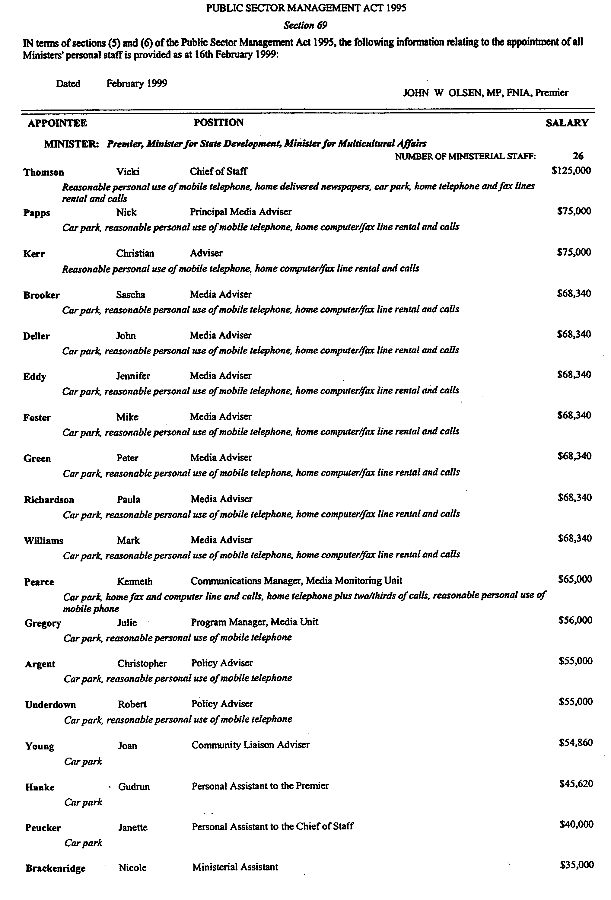
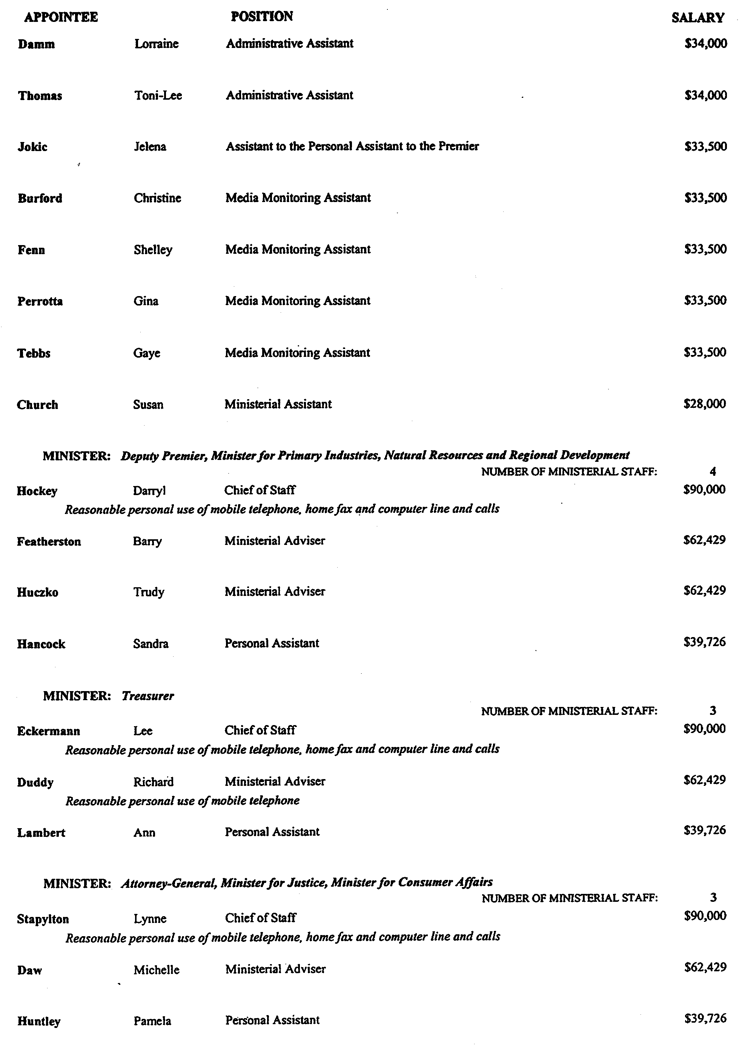
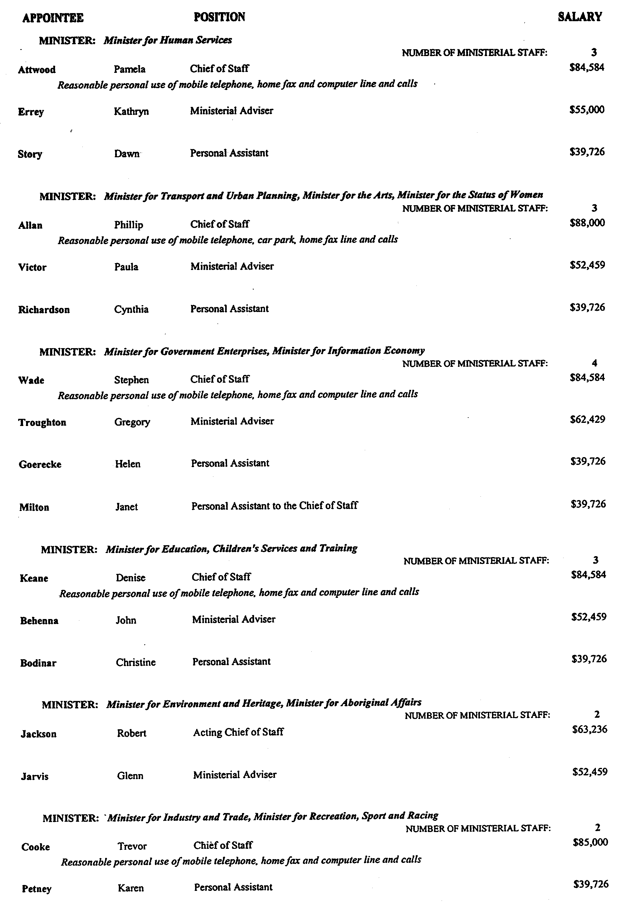
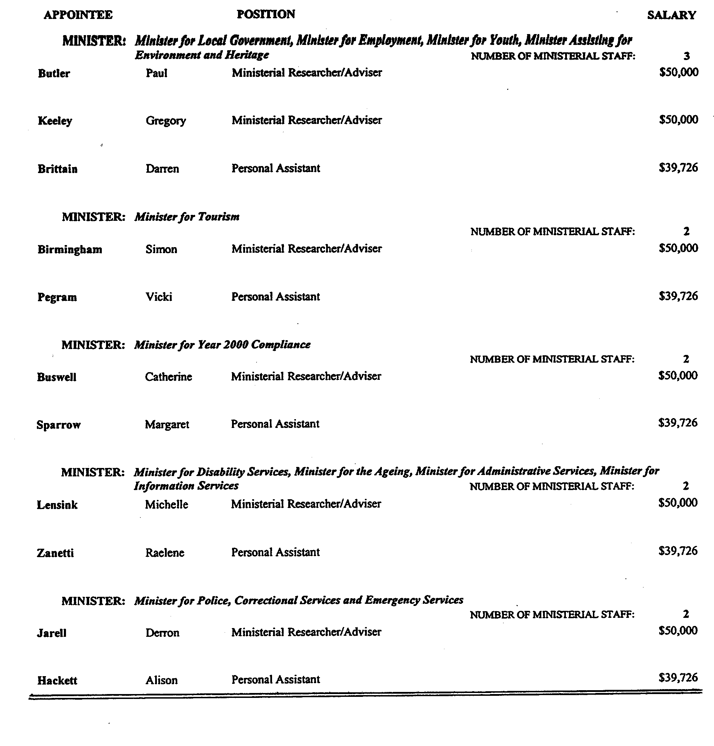

RULES OF COURT
Amending the Supreme Court Criminal Rules 1992
Amendment No. 9 to the Supreme Court Criminal Rules
BY virtue and in pursuance of Section 72 of the Supreme Court Act 1935, and all other powers us thereunto enabling, We, Judges of the Supreme Court of South Australia, do hereby make the following Rules to take effect as amendments to the Supreme Court Criminal Rules 1992, as amended:
1. These Rules may be cited as the “Supreme Court Criminal Rules 1992 Amendment No. 9”.
2. The Supreme Court Criminal Rules 1992, as amended, by these Rules may be cited as the “Supreme Court Criminal Rules 1992”.
3. That Rule 19.08 be amended by deleting therefrom the figures “19.08” and inserting in lieu thereof “19.07”.
GIVEN under our hands and the Seal of the Supreme Court of South Australia this 26th day of February 1999.
(l.s.) J. DOYLE, CJ
ROBIN MILLHOUSE, J
G. C. PRIOR, J
L. T. OLSSON, J
J. W. PERRY, J
K. P. DUGGAN, J
E. P. MULLIGHAN, J
B. M. DEBELLE, J
M. J. NYLAND, J
B. T. LANDER, J
H. C. WILLIAMS, J
D. J. BLEBY, J
D. F. WICKS, J
BRIAN MARTIN, J

FAXING COPY?

IF you fax copy to Riverside 2000, for inclusion in the Government Gazette, there is no need to send a Confirmation Copy to us as well.

This creates confusion and may well result in your notice being printed twice.

Please use the following fax number:

Fax transmission: (08) 8207 1040
Phone Inquiries: (08) 8207 1045

Please include a contact person, phone number and order number so that we can phone back with any queries we may have regarding the fax copy.

NOTE: Closing time for lodging new copy (either fax or hard copy) is 4 p.m. on Tuesday preceding the day of publication.

Government Gazette notices can now be E-mailed.

The address is:

govgaz@riv.ssa.sa.gov.au

Documents should be sent as attachments in Word format.

When sending a document via E-mail, please confirm your transmission with a faxed copy of your document, including the date the notice is to be published.

Fax transmission: (08) 8207 1040
Enquiries: (08) 8207 1045

CITY OF CHARLES STURT
Declaration of Public Roads
NOTICE is hereby given that pursuant to section 301 (1) (iii) of the Local Government Act 1934, as amended, the council at its meeting held on 8 February 1999, resolved:
1. Allotment 109 in Deposited Plan 51497 being portion of the land comprised in certificate of title register book volume 5089, folio 204, being transferred to the City of Charles Sturt from Yvonne Gai Litzheim and Julie Ann Litzheim be accepted by the council as public road, and is hereby declared to be public road and named Gilbert Street.
2. Allotments 3 and 4 in Deposited Plan 51035 being portion of the land comprised in certificate of title register book volume 405, folio 191 and volume 5462, folio 621, being transferred to the City of Charles Sturt from Boral Energy Asset Management Ltd be accepted by the council as public road, and is hereby declared to be public road and named Drayton Street.
S. Law, Chief Executive Officer

CITY OF SALISBURY
Declaration of Public Road
NOTICE is hereby given that pursuant to section 303 (1) of the Local Government Act 1934, as amended, the City of Salisbury resolved at its meeting held on 22 February 1999, that each portion of land shown as walkway between Maxwell Road to Montrose Avenue, Para Hills, adjacent to Lot 2 and Lot 3, and Lot 12 and Lot 13 in Deposited Plan No. 7391 be declared as public road.
S. Hains, City Manager

CITY OF SALISBURY
Notice of Proposal to Dispose of Reserve
NOTICE is hereby given that at a meeting held on 22 February 1999, the council of the City of Salisbury formed the opinion that portion of reserve land being portion of allotment 2 in deposited plan No. 27015 in certificate of title volume 5517, folio 322 and portion of allotment 125 in deposited plan 10456 in certificate of title volume 5552, folio 395, situated at Bridge Road and Spearman Avenue, Salisbury East, is no longer required as a reserve.
Council proposes pursuant to the provisions of section 459 (a) of the Local Government Act 1934, as amended, to dispose of this reserve for residential development to Montfair Nominees Pty Ltd subject to approval by the Minister for Local Government. Any interested person may make representation to council on the matter up to and including Friday, 16 April 1999. Any representations should be addressed to the City of Salisbury, Property Services Officer, 12 James Street, Salisbury, S.A. 5108.
S. Hains, City Manager

ADELAIDE HILLS COUNCIL
Temporary Road Closures
NOTICE is hereby given that pursuant to the section 59 of the Summary Offences Act 1953, I, Anita Aspinall, Mayor of the Adelaide Hills Council, approve the temporary closure of the following roads in Stirling on Wednesday, 24 March 1999, as these roads will be unusually crowded due to the ‘Come Out’ parade of school children:
• Oakbank Street, Stirling (from the gateway of No. 10 Oakbank Street to Johnston Street)—between 1.45 p.m. and 2.15 p.m.
• Johnston Street, Stirling (from Oakbank Street to Milan Terrace)—from 2 p.m. to 2.30 p.m.
• Oakbank Street, Stirling (from Milan Terrace for a distance of approximately 100 m to the vehicular gates into the Stirling Oval)—from 2.15 p.m. to 2.45 p.m.
Enquiries can be directed to Ruth Flaherty on (08) 8339 2255.
A. Aspinall, Mayor

REGIONAL COUNCIL OF GOYDER
Temporary Road Closure
NOTICE is hereby given that, in accordance with Section 359 of the Local Government Act 1934, as amended, the Regional Council of Goyder has resolved to exclude all vehicles from that part of Bruce Street, Eudunda, between Kapunda Street and the carpark of the Eudunda Community Club, from 10.30 a.m. to 11.30 a.m. on Thursday, 25 March 1999, for the purpose of the Come Out ’99 Festival.
S. H. Kerrigan, Chief Executive Officer

MID MURRAY COUNCIL
Temporary Road Closure—Morgan Township
NOTICE is hereby given that at a meeting of council held on 8 March 1999, it was resolved that pursuant to section 359 of the Local Government Act 1934, as amended, that section of Railway Terrace between High Street and Eighth Street, be closed to all vehicular traffic other than emergency service vehicles on Saturday, 3 April 1999 from 8 a.m. until 2 p.m. for the purpose of holding a Paddy’s Market.
G. R. Brus, Chief Executive Officer

Temporary Road Closure—Cadell Township
NOTICE is hereby given that at a meeting of council held on 8 March 1999, it was resolved that pursuant to section 359 of the Local Government Act 1934, as amended, the following roads will be closed to all vehicular traffic other than emergency service vehicles on Saturday, 27 March 1999 from 4 p.m. until midnight:
• Smith Street—between Lots 146 and 154;
• McGuire Terrace—between Lots 146 and 166,
for the purpose of holding a Street Party.
G. R. Brus, Chief Executive Officer

MID-MURRAY COUNCIL
Development Act 1993
Plan Amendment Report Prepared By The Council—General Policy Plan Amendment Report
THE Mid-Murray Council has prepared a Plan Amendment Report (PAR) to amend the Development Plan based on a Review of Plans in accordance with statutory requirements of section 30 of the Development Act 1993.
The PAR affects all land within the council area and consolidates and reviews development policy previously applicable to the local government areas of Mannum, Morgan, Ridley-Truro and part Mount Pleasant.
The PAR is available for public inspection during normal office hours at the Mid-Murray Council offices, 49 Adelaide Road, Mannum; Main Street, Cambrai and 10 Fourth Street, Morgan. The PAR will be on display from 18 March 1999 to 19 May 1999 and can be purchased for $5 each.
Written submissions regarding the PAR should be submitted no later than 19 May 1999. All submissions should be addressed to the Chief Executive Officer, Mid-Murray Council, P.O. Box 28, Mannum, S.A. 5238 and should clearly indicate whether there is an intention to be heard in support of a submission.
Public hearings will be held at the Council Office at Morgan on 15 June 1999 commencing at 7 p.m. and also the Council Office at Mannum on 17 June 1999 commencing at 7 p.m. At the meetings all interested persons are welcome to attend to comment on proposed amendment or be heard in relation to their submission.
Copies of all submissions received will be available for inspection by any interested person at the council offices from 19 May 1999 until the public hearings.
Dated 18 March 1999.
G. R. Brus, Chief Executive Officer

DISTRICT COUNCIL OF MOUNT BARKER
Periodical Review
NOTICE is hereby given that pursuant to the provisions of section 24 (3) of the Local Government Act 1934, as amended, the District Council of Mount Barker is to carry out a review to determine whether a change of arrangements in respect to elector representation, including ward boundaries and the composition of council, will result in the electors of the area being more adequately and fairly represented.
Information regarding the nature of the periodical review is available at the council office, or by contacting Naomi Wegner on 8406 7223.
Interested persons are invited to make a written submission to the Chief Executive Officer, P.O. Box 54, Mount Barker, S.A. 5251, by close of business on 30 April 1999.
Any person who makes a written submission will be afforded an opportunity to appear before council, or a committee thereof, to be heard in respect of his/her submission.
D. H. Gollan, Chief Executive Officer

DISTRICT COUNCIL OF NARACOORTE AND LUCINDALE
Temporary Road Closure
NOTICE is hereby given that the council, pursuant to section 359 of the Local Government Act 1934, as amended, prohibit vehicular traffic on that portion of Smith Street, west of Sandstone Avenue to McRae Street, on Sunday, 25 April 1999, between the hours of 6 a.m. and 8 a.m. for the purpose of a street march.
D. L. Beaton, Chief Executive Officer

SOUTHERN MALLEE DISTRICT COUNCIL
Temporary Road Closure
NOTICE is hereby given that pursuant to section 359 of the Local Government Act 1934, as amended, council has approved of the temporary closure of Railway Terrace North, Lameroo between the hours of 11.15 a.m. and noon on Friday, 26 March 1999, for the purposes of a street parade by students of the Geranium and Pinnaroo Primary Schools and the Lameroo Regional Community School.
P. Wood, Chief Executive Officer

DISTRICT COUNCIL OF TATIARA
Review of Ward Boundaries
NOTICE is hereby given that pursuant to section 24 of the Local Government Act 1934, as amended, the District Council of Tatiara is to carry out a review to determine whether a change of ward boundaries would result in electors of the area being more adequately and fairly represented.
Interested persons are invited to make written submissions which will be accepted by the council until 5 p.m. on Friday, 16 April 1999. All submissions should be addressed to John Stephens, Chief Executive Officer, District Council of Tatiara, P.O. Box 346, Bordertown, S.A. 5268.
An opportunity will be given to any person making written submissions to appear personally or by representative before the council to be heard upon their submissions.
A copy of the Chief Executive Officer’s Reports which were presented to council on Tuesday, 8 September 1998, Tuesday, 2 February 1999 and Tuesday, 9 March 1999 are available for public inspection, without charge and during normal office hours, 8.30 a.m. to 5.00 p.m., at the Tatiara District Council Offices, 43 Woolshed Street, Bordertown, S.A. 5268 from Thursday, 18 March 1999 to Friday, 16 April 1999.
To date, council has been unable to agree on a preference of wards or no wards. Council will have a further opportunity to consider its preference prior to submitting its final report to the State Electoral Commissioner. The final report will be completed following the current public consultation process.
J. G. Stephens, Chief Executive Officer

WATTLE RANGE COUNCIL
Supplementary Election—Counting of Votes
NOTICE is hereby given that in accordance with section 89 (1) of the Local Government Act 1934, as amended, the Wattle Range Council has appointed the Council Office, Civic Centre, George Street, Millicent as the place for the counting of votes for the Corcoran Ward Supplementary Election.
The counting of votes will commence immediately after the close of voting at 6 p.m. on Friday, 19 March 1999.
The Council Chamber will be open to the public from 7.30 p.m. on Friday, 19 March 1999, where the public will be advised of the progress of the counting of votes.
F. N. Brennan, Returning Officer

IN the matter of the estates of the undermentioned deceased persons:
Allan, Ivy Marjorie, late of 324 Military Road, Semaphore Park, widow, who died on 3 January 1999.
Barth, Maria, late of 39 Delhi Avenue, Hillcrest, home duties, who died on 8 February 1999.
Bleeze, Constance Ada Eldwyne, late of 1 Johnstone Street, Glengowrie, retired trained nurse, who died on 1 February 1999.
Carter, Hazel Rosemary, late of 4 St Annes Terrace, Glenelg North, home duties, who died on 26 December 1998.
Clarke, Nancy, late of 5 Davoren Court, Victor Harbor, home duties, who died on 25 December 1998.
Colthorpe, Edna Sarah, late of 89 Heysen Avenue, Holden Hill, widow, who died on 5 October 1998.
Crowley, Doris Irene, late of 8 Sanders Place, Adelaide, retired machinist, who died on 27 January 1999.
Dickson, Elda Mary, late of 71 Balmoral Avenue, Warradale, home duties, who died on 26 January 1999.
Driver, Muriel Ada, late of 4 Daly Street, Magill, home duties, who died on 19 January 1999.
Dyson, Letitia Emily, late of 740 Torrens Road, Rosewater, of no occupation, who died on 12 February 1999.
Furnell, Colin Slater, late of 1 Walter Street, Cummins, retired fitter and turner, who died on 25 January 1999.
Geddes, Ada Doreen, late of 15-19 Woodville Road, Woodville South, of no occupation, who died on 1 November 1998.
Graham, George Finlay, late of 42 Hill Street, Victor Harbor, retired grazier, who died on 17 December 1998.
Kohler, Allen John, late of 20 Ward Street, Pennington, retired storeman, who died on 9 February 1999.
Lillecrapp, Claude Linfield, late of 4 Ellis Street, Enfield, retired grazier, who died on 11 December 1998.
Matheson, John Christian Kromberg, late of 103 Carlton Crescent, Summer Hill, New South Wales, retired railway worker, who died on 16 October 1998.
Noblet, Dudley Walter, late of 160 Trimmer Parade, Seaton, retired police officer, who died on 4 February 1999.
Pullan, Rachel Elizabeth, late of 40 Everard Avenue, Keswick, sales representative, who died on 23 November 1998.
Smithers, Pamela Ellen, late of 40 Blacks Road, Gilles Plains, home duties, who died on 8 February 1999.
Symons, Enid Olive, late of 34 Norman Terrace, Everard Park, widow, who died on 11 January 1999.
Thyssen, Theodorlis, late of 17 Margaret Terrace, Rosewater, retired milk vendor, who died on 2 February 1999.
Tonkin, Jessie Caroline, late of 11 Royal Place, Adelaide, retired enrolled nurse, who died on 28 January 1999.
Notice is hereby given pursuant to the Trustee Act 1936, as amended, the Inheritance (Family Provision) Act 1972, and the Family Relationships Act 1975, that all creditors, beneficiaries, and other persons having claims against the said estates are required to send, in writing, to the Public Trustee, 25 Franklin Street, Adelaide, S.A. 5000, full particulars and proof of such claims, on or before 16 April 1999, otherwise they will be excluded from the distribution of the said estate; and notice is also hereby given that all persons who are indebted to the said estates are required to pay the amount of their debts to the Public Trustee or proceedings will be taken for the recovery thereof; and all persons having any property belonging to the said estates are forthwith to deliver the same to the Public Trustee.
Dated 18 March 1999.
J. H. Worrall, Public Trustee

IN the matter of the estates of the undermentioned deceased persons:
Molan, Alice May, late of The Pines Nursing Home, 342 Marion Road, North Plympton, spinster, who died on 13 April 1998.
Holmes, Patricia Langley, late of 4 Rymill Road, Somerton Park, retired senior lecturer, who died on 8 August 1998.
Loechel, Harold Edwin, late of Glenview Homes, Albert Street, Gumeracha, retired farmer, who died on 24 October 1998.
Dealtry, Lois Ethel, late of 17 Milne Street, Vale Park, widow, who died on 28 November 1998.
Notice is hereby given pursuant to the Trustee Act 1936, as amended, the Inheritance (Family Provision) Act 1975 and the Family Relationships Act 1975, that all creditors, beneficiaries, and other persons having claims against any of the above estates are directed to send full particulars and evidence of such claims to the undersigned on or before 19 April 1999, otherwise they will be excluded from the distribution of the said estate; and notice is also hereby given that all persons who are indebted to the said estates are required to pay the amount of their debts to the undersigned or proceedings will be taken for the recovery thereof; and all persons having any property belonging to the said estates are forthwith to deliver the same to the undersigned.
Dated 18 March 1999.
ANZ Executors & Trustee Company Limited (ACN 006 132 332), 530 Collins Street, Melbourne, Vic. 3000.

IN the matter of the estates of the undermentioned deceased persons:
Arnold, Hubert Samuel, late of Adelaide Road, Mallala, retired farmer, who died on 23 February 1999.
Cheek, Harold Dudley, late of 29 Elderslie Avenue, Fitzroy, retired pharmacist, who died on 5 February 1999.
Collins, Mavis Irene, late of Murray Bridge Nursing Home, 5 Maturin Road, Glenelg, widow, who died on 23 January 1999.
Ettridge, Frances Jean, late of Ceduna Senior Citizens’ Village, O’Loughlin Terrace, Ceduna, widow, who died on 1 February 1999.
Gammage, Gladys, late of Perry Park Nursing Home, 26 River Road, Port Noarlunga, widow, who died on 9 December 1998.
Harris, Gladys May, late of Unit 7, 23 Weymouth Street, Campbelltown, retired shop assistant, who died on 15 February 1999.
Jones, John Edward, late of 10 Brigalow Avenue, Kensington Gardens, retired butcher, who died on 22 February 1999.
Kuzmanovic, Tomislav, late of 5 Martins Road, Seaton, retired machine setter, who died on 13 February 1999.
McDonald, Stanley Victor, late of Unit 10, AM Ramsay Retirement Village, 77 Seaview Road, Port Augusta, retired gardener, who died on 14 November 1998.
McPhee, George Mervyn Charles, late of Hearles Road, Eden Valley, retired station hand, who died on 27 August 1998.
Morrison, Gladys Mary, late of All Hallows Nursing Home, 20 Norseman Avenue, Westbourne Park, widow, who died on 16 February 1999.
Owers, Douglas Leslie, late of Kadina Road, Wallaroo, retired waterside worker, who died on 13 January 1999.
Vines, Lillian, late of 23 Hamilton Street, Mannum, widow, who died on 13 February 1999.
West, Hilda Mabel, late of Andrina Private Nursing Home, 360 Bay Street, Brighton, Victoria, widow, who died on 6 March 1999.
Notice is hereby given pursuant to the Trustee Act 1936, as amended, the Inheritance (Family Provision) Act 1972-1975 and the Family Relationships Act 1975, that all creditors, beneficiaries, and other persons having claims against any of the abovenamed estates are directed to send full particulars of such claims to the undersigned on or before 8 April 1999, otherwise they will be excluded from the distribution of the said estate.
Dated 11 March 1999.
IOOF Australia Trustees Limited (ACN 007 870 644) and Bagot’s Executors & Trustee Company Limited (ACN 007 869 829), 212 Pirie Street, Adelaide, S.A. 5000.

SOUTH AUSTRALIA—In the Supreme Court No. 1701 of 1994. In the matter of Australian Health Education & Lifestyle Centres Pty Limited (in liquidation) (ACN 057 234 312) and in the matter of the Corporations Law.
Notice of Release of Liquidator and Dissolution of the Company
Take notice that by order of the Supreme Court of South Australia dated 9 March 1999, I, Barrie Malcolm Mansom, 1st Floor, 17 Bagot Street, North Adelaide, S.A. 5006, the liquidator of the abovenamed company, was granted my release as liquidator and the company was dissolved as at the date of this order.
Dated 12 March 1999.
B. M. Mansom, Liquidator

B. & M. PROPERTY ENTERPRISES PTY LTD
(ACN 008 104 069)
ON 9 March 1999, the Supreme Court of South Australia in Action No. 1166 of 1998, made an order for the winding up of B. & M. Property Enterprises Pty Ltd and appointed Frederick Charles Perkins, 185 Fullarton Road, Dulwich, to be the liquidator of the company.
Ward & Partners, 26 Flinders Street, Adelaide, S.A. 5000, solicitors for the plaintiff.

Consortium Management Services Pty Ltd
(ACN 075 684 605)
George Karounos as trustee of the RFC Trust has brought a summons in Action No. 251 of 1999 in the Supreme Court of South Australia seeking the winding up of Consortium Management Services Pty Ltd. The summons is listed for hearing on Tuesday, 6 April 1999 at not before 2.15 p.m. Any creditor or contributory of Consortium Management Services Pty Ltd wishing to be heard on the summons must file and serve a notice in accordance with Rule 20 of the Corporations (South Australia) Rules 1993 at least three business days before the day on which the summons is listed for hearing and must attend at the Supreme Courthouse, Victoria Square, Adelaide at the time set for the hearing of the summons. A copy of the summons and the affidavit in support can be obtained on payment of the proper cost from Messrs Donaldson Walsh, Kings Chambers, 320 King William Street, Adelaide, S.A. 5000.

CAMMS SYSTEMS PTY LIMITED
(ACN 051 742 646)
THE DEPUTY COMMISSIONER OF TAXATION of the Adelaide Branch of the Australian Taxation Office, 191 Pulteney Street, Adelaide, S.A. 5000 has brought a summons in Action No. 240 of 1999 in the Supreme Court of South Australia seeking the winding up of Camms Systems Pty Limited. The summons is listed for hearing on Tuesday, 6 April 1999 at not before 2.15 p.m. Any creditor or contributory of Camms Systems Pty Limited wishing to be heard on the summons must file and serve a notice in accordance with Rule 20 of the Corporations (South Australia) Rules 1993, at least three business days before the day on which the summons is listed for hearing and must attend at the Supreme Courthouse, Victoria Square, Adelaide at the time set for the hearing of the summons. A copy of the summons and affidavit in support can be obtained on payment of the proper cost from the Deputy Commissioner of Taxation, 191 Pulteney Street, Adelaide, S.A. 5000.

DIESEL LAB PTY LIMITED
(ACN 066 952 047)
THE DEPUTY COMMISSIONER OF TAXATION of the Adelaide branch of the Australian Taxation Office located at 191 Pulteney Street, Adelaide, S.A. 5000 has brought a summons in Action No. 155 of 1999 in the Supreme Court of South Australia seeking the winding up of Diesel Lab Pty Limited. The summons is listed for hearing on Tuesday, 23 March 1999 at not before 2.15 p.m. Any creditor or contributory of Diesel Lab Pty Limited wishing to be heard on the summons must file and serve a notice in accordance with Rule 20 of the Corporations (South Australia) Rules 1993 at least three business days before the day on which the summons is listed for hearing and must attend at the Supreme Courthouse, Victoria Square, Adelaide at the time set for the hearing of the summons. A copy of the summons and affidavit in support can be obtained on payment of the proper cost from the The Deputy Commissioner of Taxation, 191 Pulteney Street, Adelaide, S.A. 5000.

SOUTH AUSTRALIA—In the Supreme Court No. 1067 of 1989. In the matter of Dominant Starline Pty Limited (in liquidation) (ACN 008 124 883) and in the matter of the Corporations Law.
Notice of Release of Liquidator and Dissolution of the Company
Take notice that by order of the Supreme Court of South Australia dated 9 March 1999, I, Barrie Malcolm Mansom, 1st Floor, 17 Bagot Street, North Adelaide, S.A. 5006, the liquidator of the abovenamed company, was granted my release as liquidator and the company was dissolved as at the date of this order.
Dated 12 March 1999.
B. M. Mansom, Liquidator

EXCLUSIVE SHEEPSKIN FOOTWEAR PTY LTD
(ACN 083 091 196)
CROMPTON GROUP HOLDINGS PTY LTD (Receiver and Manager appointed) has brought a summons in Action No. 265 of 1999 in the Supreme Court of South Australia seeking the winding up of Exclusive Sheepskin Footwear Pty Ltd. The summons is listed for hearing on 6 April 1999 at not before 2.30 p.m. Any creditor or contributory of Exclusive Sheepskin Footwear Pty Ltd wishing to be heard on the summons must file and serve a notice in accordance with Rule 20 of the Corporations (South Australia) Rules 1993 at least three business days before the day on which the summons is listed for hearing and must attend at the Supreme Courthouse, Victoria Square, Adelaide at the time set for the hearing of the summons. A copy of the summons and the affidavit in support can be obtained on payment of the proper costs from Marshalls, Level 2, 81 Flinders Street, Adelaide, S.A. 5000.

FJS Holdings Pty Ltd
(ACN 076 476 474)
George Karounos as trustee of the RFC Trust has brought a summons in Action No. 252 of 1999 in the Supreme Court of South Australia seeking the winding up of FJS Holdings Pty Ltd. The summons is listed for hearing on Tuesday, 6 April 1999 at not before 2.15 p.m. Any creditor or contributory of FJS Holdings Pty Ltd wishing to be heard on the summons must file and serve a notice in accordance with Rule 20 of the Corporations (South Australia) Rules 1993 at least three business days before the day on which the summons is listed for hearing and must attend at the Supreme Courthouse, Victoria Square, Adelaide at the time set for the hearing of the summons. A copy of the summons and the affidavit in support can be obtained on payment of the proper cost from Messrs Donaldson Walsh, Kings Chambers, 320 King William Street, Adelaide, S.A. 5000.

SOUTH AUSTRALIA—In the Supreme Court No. 99 of 1991. In the matter of Grosvenor Concrete Contractors Pty Limited (in liquidation) (ACN 008 102 289) and in the matter of the Corporations Law.
Notice of Release of Liquidator and Dissolution of the Company
Take notice that by order of the Supreme Court of South Australia dated 9 March 1999, I, Barrie Malcolm Mansom, 1st Floor, 17 Bagot Street, North Adelaide, S.A. 5006, the liquidator of the abovenamed company, was granted my release as liquidator and the company was dissolved as at the date of this order.
Dated 12 March 1999.
B. M. Mansom, Liquidator

GENESIS CLOTHING COMPANY PTY LTD
(ACN 069 721 035)
TONY COLYER PTY LTD (ACN 007 778 672) has brought a summons in Action No. 215 of 1999 in the Supreme Court of South Australia seeking the winding up of Genesis Clothing Company Pty Ltd. The summons is listed for hearing on Tuesday, 6 April 1999 at not before 2.15 p.m. Any creditor or contributory of Genesis Clothing Company Pty Ltd wishing to be heard on the summons must file and serve a notice in accordance with Rule 20 of the Corporations (South Australia) Rules 1993 at least three business days before the day on which the summons is listed for hearing and must attend at the Supreme Courthouse, Victoria Square, Adelaide at the time set for the hearing of the summons. A copy of the summons and the affidavit in support can be obtained on payment of the proper cost from Martirovs & Co., 3rd Floor, 44 Pirie Street, Adelaide, S.A. 5000, solicitors for the plaintiff.

SOUTH AUSTRALIA—In the Supreme Court No. 42 of 1987. In the matter of Montiadis Nominees Pty Limited (in liquidation) (ACN 008 071 047) and in the matter of the Corporations Law.
Notice of Release of Liquidator and Dissolution of the Company
Take notice that by order of the Supreme Court of South Australia dated 9 March 1999, I, Barrie Malcolm Mansom, 1st Floor, 17 Bagot Street, North Adelaide, S.A. 5006, the liquidator of the abovenamed company, was granted my release as liquidator and the company was dissolved as at the date of this order.
Dated 12 March 1999.
B. M. Mansom, Liquidator

ATTENTION

CUSTOMERS requiring a proof of their notice for inclusion in the Government Gazette, please note that the onus is on you to inform Riverside 2000 of any subsequent corrections by 10 a.m. on Thursday, which is our publication deadline.

For any corrections to your notice please phone 8207 1045 or Fax 8207 1040 before 10 a.m. on Thursday.

If we do not receive any communication by 10 a.m. on Thursday (day of publication) we will presume the notice is correct and will print it as it is.

Remember—the onus is on you to inform us of any corrections necessary to your notice.

NOTE: Closing time for lodging new copy (either fax or hard copy) is 4 p.m. on Tuesday preceding the day of publication. Ph. 8207 1045—Fax 8207 1040.

Printed and published by authority every Thursday by M. E. JONES, Acting Government Printer, South Australia
Price: $3.75, plus postage; to subscribers, $185 per annum.

