No. 68 2655

THE SOUTH AUSTRALIAN

GOVERNMENT GAZETTE

PUBLISHED BY AUTHORITY

ALL PUBLIC ACTS appearing in this GAZETTE are to be considered official, and obeyed as such

ADELAIDE, THURSDAY, 27 MAY 1999

CONTENTS

Page
Appointments, Resignations, Etc. 2657
Commercial Motor Vehicles (Hours of Driving) Act
1973—Notice 2659
Corporations and District Councils—Notices 2728
Crown Lands Act 1929—Notices 2659
Development Act 1993—Notices 2659
Electricity Act 1996—Notice 2660
Environment Protection Act 1993—Notice 2661
Fisheries Act 1982—Notices 2664
Geographical Names Act 1991—Notices 2696
Harbors and Navigation Act 1993—Notices 2661
Housing Improvement Act 1940—Notices 2662
Land and Business (Sale and Conveyancing) Act 1994—
Notices 2696
Liquor Licensing Act 1997—Notices 2697
Page
Mining Act 1971—Notices 2699
National Parks and Wildlife Act 1972—Notice 2700
Optometrists Act 1920—Notice 2700
Private Advertisements 2731
Proclamations 2656
Proof of Sunrise and Sunset Act 1923—Almanac 2703
Public Trustee Office—Administration of Estates 2730
Radiation Protection and Control Act 1982—Notice 2706
Roads (Opening and Closing) Act 1991—Notices 2706
Rules of Court—Amendment 2706
South Australian Motor Sport Act 1984—Notice 2706
Survey Act 1992—Notice 2707
Vocational Education, Employment and Training Act
1994—Contracts of Training—Errata 2723
Workers Rehabilitation and Compensation Act 1986—
Notice 2715

GOVERNMENT GAZETTE NOTICES
ALL poundkeepers' and private advertisements forwarded for publication in the South Australian Government Gazette must be PAID FOR PRIOR TO INSERTION; and all notices, from whatever source, should be legibly written on one side of the paper only and sent to Riverside 2000 so as to be received no later than 4 p.m. Tuesday preceding the day of publication. Phone 8207 1045 or Fax 8207 1040. E-mail: govgaz@riv.ssa.sa.gov.au. Send as attachments in Word format and please confirm your transmission with a faxed copy of your document, including the date the notice is to be published and to whom the notice will be charged.

NATIONAL PARKS AND WILDLIFE ACT 1972 SECTION 58(4): EXCLUSION OF SPECIES FROM THE NEED FOR A PERMIT UNDER SECTION 58
Proclamation By The Governor
(l.s.) E. J. Neal, Governor
PURSUANT to section 58(4) of the National Parks and Wildlife Act 1972 and with the advice and consent of the Executive Council, I—
(a) revoke the proclamation made on 16 May 1991 under section 58(4) of the Act (See Gazette 16 May 1991 p. 1570); and
(b) exclude from the operation of subsections (1), (2) and (3) of section 58 of the Act the animals and the carcasses and eggs of the animals of the species listed in the Schedule.
This proclamation comes into operation on 1 July 1999.
SCHEDULE
Excluded Species
Species Code | Common Name | Zoological Name
 | Mammals
K1113 | Common Brushtail Possum | Trichosurus vulpecula
S1469 | Plains Mouse Plains Rat | Pseudomys australis
K1481 | Spinifex Hopping Mouse | Notomys alexis
 | Reptiles
S2525 | Adelaide Snake-eye Skink | Morethia adelaidensis
U2138 | Barking Gecko | Nephrurus milii
G2475 | Bougainville’s Skink | Lerista bougainvilli
C2105 | Bynoe’s Gecko | Heteronotia binoei
W2519 | Dwarf Skink | Menetia greyii
Y2580 | Eastern Blue-tongued Lizard | Tiliqua scincoides
K2557 | Eastern Water Skink | Eulamprus quoyii
U2446 | Four-toed Earless Skink | Hemiergis peronii
Z2451 | Garden Skink | Lampropholis guichenoti
C2017 | Long-necked Turtle | Chelodina longicollis
M2126 | Marbled Gecko | Christinus marmoratus
E2034 | Murray River Turtle | Emydura macquarii
G2379 | Sandplain Ctenotus | Ctenotus schomburgkii
Z2583 | Sleepy Lizard | Tiliqua rugosa
K2441 | Three toed Earless Skink | Hemiergis decresiensis
A2092 | Tree Dtella | Gehyra variegata
S2429 | Tree Skink | Egernia striolata
E2430 | White’s Skink | Egernia whitii
 | Birds
Q0032 | Bar-shouldered Dove | Geopelia humeralis
S0705 | Black-backed Magpie | Gymnorhina tibicen tibicen
Y0304 | Bourke’s Parrot | Neopsephotus bourkii
K0657 | Chestnut-breasted Mannikin | Lonchura castaneothorax
E00274 | Cockatiel | Nymphicus hollandicus
U0034 | Common Bronze-wing | Phaps chalcoptera
W0043 | Crested Pigeon | Ocyphaps lophotes
Z00031 | Diamond Dove | Geopelia cuneata
G0655 | Double Bar (Black rump) | Taeniopygia bichenovii annulosa
G0655 | Double Bar (White rump) | Taeniopygia bichenovii
Z0307 | Elegant Parrot | Neophema elegans
S0033 | Green winged Pigeon | Chalcophaps indica
Y00012 | King Quail | Coturnix chinesis
C0637 | Little Wattlebird | Anthochaera chrysoptera
A0272 | Long-billed Corella | Cacatua tenuirostris
M0666 | Long-tailed Finch (Hecks) | Poephila acuticauda
M0666 | Long-tailed Finch (Longtail) | Poephila acuticauda
W0415 | Murray Magpie | Grallina cyanoleuca
E0258 | Musk Lorikeet | Glossopsitta concinna
Z0631 | New Holland Honeyeater | Phylidonyris novaehollandiae
U0634 | Noisy Miner | Manorina melanocephala
E0654 | Painted Finch | Emblema pictum
Q04168 | Peaceful Dove | Geopelia striata
Z0279 | Princess Parrot | Polytelis alexandrae
U0254 | Rainbow Lorikeet | Trichoglossus haematodus
Z0295 | Red-rumped Parrot | Psephotus haematonotus
G0303 | Scarlet-chested Parrot | Neophema splendida
C0125 | Silver Gull | Larus novaehollandiae
G0663 | Star Finch | Neochmia ruficauda
S0009 | Stubble Quail | Coturnix pectoralis
Q04176 | Sulphur- crested Cockatoo | Cacatua galerita
E0054 | Tasmanian Native Hen | Gallinula mortierii
E0302 | Turquoise Parrot | Neophema pulchella
K0293 | Twenty-eight Parrot | Barnardius zonarius
A0272 | Western Corella | Cacatua pastinator
S0625 | White plumed honeyeater | Meliphreptus pencillata
S0705 | White-backed Magpie | Gymnorhina tibicen leuconota
Given under my hand and the Public Seal of South Australia at Adelaide 27 May 1999.
By command,
Iain Evans, for Premier
MEH 7/99 CS

ADMINISTRATIVE ARRANGEMENTS ACT 1994 SECTION 5: ADMINISTRATION OF EMERGENCY SERVICES FUNDING ACT 1998 COMMITTED TO MINISTER FOR JUSTICE
Proclamation By The Governor
(l.s.) E. J. Neal
PURSUANT to section 5 of the Administrative Arrangements Act 1994 and with the advice and consent of the Executive Council, I commit the administration of the Emergency Services Funding Act 1998 to the Minister for Justice.
Given under my hand and the Public Seal of South Australia, at Adelaide, 27 May 1999.
By command,
Iain Evans, for Premier
CSE 0008/99 B

LOCAL GOVERNMENT ACT 1934 SECTIONS 8, 11, 14 AND 20: ALTERATION OF BOUNDARIESAREA OF THE ADELAIDE HILLS COUNCIL (AND MARBLE HILL WARD)AREA OF THE CORPORATION OF THE CITY OF BURNSIDE (AND KENSINGTON GARDENS AND MAGILL WARD)
Proclamation By The Governor
(l.s.) E. J. Neal
PURSUANT to sections 8, 11, 14 and 20 of the Local Government Act 1934, on the recommendation of the Boundary Adjustment Facilitation Panel and with the advice and consent of the Executive Council, I—
1. Alter the boundaries of the area of the Adelaide Hills Council by severing from that area the land defined in the schedule (and the boundaries of the Marble Hill Ward in that area are altered accordingly).
2. Alter the boundaries of the area of the Corporation of the City of Burnside by incorporating in that area the land defined in the schedule (and the boundaries of the Kensington Gardens and Magill Ward in that area are altered accordingly).
3. Declare that this proclamation will take effect on 1 July 1999.
Schedule
Commencing at a point on a western boundary of the Adelaide Hills district (an eastern boundary of the City of Burnside), suburb of Magill, being its intersection with the production westerly of the centre of the road (Old Norton Summit Road) north of and adjoining the land contained in DP 11061, suburb of Auldana; thence easterly along the latter production and continuing generally south-easterly along the centre of Old Norton Summit Road to the centre of the road (Horsnells Gully Road) east of and adjoining allotment 1 (FP 142857), suburb of Skye; generally southerly and generally south-easterly along the centre of Horsnells Gully Road and the centre of the road south of and adjoining allotment 9 (FP 130671) and east of and adjoining allotment 8 (FP 130062) to its south-eastern boundary; south-westerly along the latter boundary of road and continuing generally south-westerly along the south-eastern and south-western boundaries of allotment 8 (FP 130062), south-eastern and north-eastern boundaries of allotment 8 (FP 130671) and the south-eastern boundaries of allotments 18 and 19 (DP 7308) and production south-westerly to the centre of the road (Coach Road) south-west of and adjoining the land contained in DP 7308; north-westerly along the centre of Coach Road to its intersection with the production easterly of the southern boundary of allotment 3 (FP 130942); westerly along the latter production and boundary and the southern boundaries of allotment 6 (FP 130060) and allotment 64 (DP 6828); south-westerly along the south-eastern boundaries of allotments 64, 62 and 111 (DP 6828) to the southern corner of allotment 111 (DP 6828); northerly along portion of the western boundary of allotment 111 (DP 6828) for 10.00 metres; south-westerly along a straight line to a point on the centre of McBeath Drive, being its intersection with the production southerly of the eastern boundary of the northern portion of section 906, Hundred of Adelaide; generally westerly along the centre of McBeath Drive to a western boundary of the Adelaide Hills district; thence northerly, easterly, northerly, westerly and northerly along the boundaries of the Adelaide Hills district to the point of commencement and crossing all intervening roads.
Given under my hand and the Public Seal of South Australia, at Adelaide, 27 May 1999.
By command,
Iain Evans, for Premier
LG 4/99 CS

ROAD TRAFFIC (MISCELLANEOUS) AMENDMENT ACT 1998 (Act No. 58 of 1998): COMMENCEMENT OF SECTION 5
Proclamation By The Governor
(l.s.) E. J. Neal
WITH the advice and consent of the Executive Council, I fix 27 May 1999 as the day on which section 5 of the Road Traffic (Miscellaneous) Amendment Act 1998 will come into operation.
Given under my hand and the Public Seal of South Australia, at Adelaide, 27 May 1999.
By command,
Iain Evans, for Premier
TSA 3203/99 CS

SHOP TRADING HOURS ACT 1977 SECTION 13: ALTERATION OF SHOP TRADING HOURS—PORT LINCOLN SHOPPING DISTRICT
Proclamation By The Governor
(l.s.) E. J. Neal
PURSUANT to section 13 of the Shop Trading Hours Act 1977 and with the advice and consent of the Executive Council, I authorise the opening of all shops in the Port Lincoln Shopping District from 10 a.m. until 4 p.m. on Sunday, 13 June 1999, subject to the conditions specified in the schedule.

Schedule
This proclamation only authorises the opening of a shop if:
(a) all relevant industrial awards, workplace agreements and enterprise agreements are observed by the shopkeeper and persons employed in the business of the shop during and in relation to the hours specified in this proclamation during which the shop is open; and
(b) subject to an industrial award, workplace agreement or enterprise agreement to the contrarya person who is employed in the business of the shop is entitled to refuse to work at the shop during the hours specified in this proclamation unless he or she has agreed with the shopkeeper to work during those hours.
Given under my hand and the Public Seal of South Australia, at Adelaide, 27 May 1999.
By command,
Iain Evans, for Premier
MGE 47/99 CS

Department of the Premier and Cabinet
Adelaide, 27 May 1999
HIS Excellency the Governor in Executive Council has been pleased to appoint the undermentioned to the South Australian Gas Review Board, pursuant to the provisions of the Gas Pipelines Access (South Australia) Act 1997:
Panel Member: (from 27 May 1999 until 26 May 2002)
Richard Jeffrie Pash, LLB (Hons), LLM (Adelaide)
By command,
Iain Evans, for Premier
MPNR 018/99CS

Department of the Premier and Cabinet
Adelaide, 27 May 1999
HIS Excellency the Governor in Executive Council has been pleased to appoint the undermentioned to the Citrus Board of South Australia, pursuant to the provisions of the Citrus Industry Act 1991:
Member: (from 6 June 1999 until 22 April 2001)
Dr Ruben John Van Velsen, Ph.D. (Cambridge)
Presiding Member: (from 6 June 1999 until 22 April 2001)
Dr Ruben John Van Velsen, Ph.D. (Cambridge)
By command,
Iain Evans, for Premier
MPNR 019/99CS

Department of the Premier and Cabinet
Adelaide, 27 May 1999
HIS Excellency the Governor in Executive Council has been pleased to appoint the undermentioned to the Police Superannuation Board, pursuant to the provisions of the Police Superannuation Act 1990:
Member: (from 27 May 1999 until 26 June 1999)
Chief Inspector Kingsley Jeffrey Oakley
By command,
Iain Evans, for Premier
DT&F 040/99CS

Department of the Premier and Cabinet
Adelaide, 27 May 1999
HIS Excellency the Governor in Executive Council has been pleased to appoint the undermentioned to the State Heritage Authority, pursuant to the provisions of the Heritage Act 1993:
Member: (from 27 May 1999 until 26 May 2002)
The Hon. Roderick Matheson
Mark Hamilton
The Most Reverent Ian Gordon Combe George
Virginia Margaret Mehrtens
Member: (from 27 May 1999 until 26 May 2001)
William Andrew Close
Elizabeth Ho
Iris Iwanicki
Cr. Anthony Presgrave
Presiding Member: (from 27 May 1999 until 26 May 2002)
The Hon. Roderick Matheson
Deputy Member: (from 27 May 1999 until 26 May 2002)
Harry Bechervaise
Maureen Annette Wright
Mary Patricia Marsland
Deputy Member: (from 27 May 1999 until 26 May 2001)
Dr Noris Ioannou
Bruce Robert Pettman
Cr. Anne Moran
David Nathan Hillan
By command,
Iain Evans, for Premier
MEH 77/98CS

Department of the Premier and Cabinet
Adelaide, 27 May 1999
HIS Excellency the Governor in Executive Council has been pleased to appoint the undermentioned to the Outback Areas Community Development Trust, pursuant to the provisions of the Outback Areas Community Development Trust Act 1978:
Member: (from 1 July 1999 until 31 December 1999)
William Raymond McIntosh
Nancy Joy Baluch
Maryanne Rose Michell
Maurice Kenworthy Francis
Gary Colin Fuller
Chairman: (from 1 July 1999 until 31 December 1999)
William Raymond McIntosh
Deputy Member: (from 1 July 1999 until 31 December 1999)
Shirley Ann Mills
By command,
Iain Evans, for Premier
MLG 0005/99CS

Department of the Premier and Cabinet
Adelaide, 27 May 1999
HIS Excellency the Governor in Executive Council has been pleased to appoint Penelope Mary Stratmann as Official Secretary to His Excellency the Governor, from 31 May 1999, pursuant to the provisions of the Constitution Act 1934.
By command,
Iain Evans, for Premier
DPC 036/97CS

Department of the Premier and Cabinet
Adelaide, 27 May 1999
HIS Excellency the Governor in Executive Council has removed Edward James Phipps, former Chief Executive, S.A. Water, from his office of Commissioner representing South Australia on the Murray-Darling Basin Commission, pursuant to Section 11 of the Murray-Darling Basin Act 1993.
By command,
Iain Evans, for Premier
MEH 24/99CS

Department of the Premier and Cabinet
Adelaide, 27 May 1999
HIS Excellency the Governor in Executive Council has removed Dennis Ray Mutton, Chief Executive, Department of Primary Industries and Resources, from his office of Deputy Commissioner representing South Australia on the Murray-Darling Basin Commission, pursuant to Section 11 of the Murray-Darling Basin Act 1993.
By command,
Iain Evans, for Premier
MEH 24/99CS

Department of the Premier and Cabinet
Adelaide, 27 May 1999
HIS Excellency the Governor in Executive Council has been pleased to appoint Dennis Ray Mutton, Chief Executive, Department of Primary Industries and Resources, as a Commissioner representing South Australia on the Murray-Darling Basin Commission, for a period of five years, from 27 May 1999, pursuant to Section 6 (1) of the Murray-Darling Basin Act 1993.
By command,
Iain Evans, for Premier
MEH 24/99CS

Department of the Premier and Cabinet
Adelaide, 27 May 1999
HIS Excellency the Governor in Executive Council has been pleased to appoint Howard Andrew Lacy, Executive General Manager Water Operations, S.A. Water Corporation, as a Deputy Commissioner representing South Australia on the Murray-Darling Basin Commission, for a period of five years, from 27 May 1999, pursuant to Section 6 (1) of the Murray-Darling Basin Act 1993.
By command,
Iain Evans, for Premier
MEH 24/99CS

Department of the Premier and Cabinet
Adelaide, 27 May 1999
HIS Excellency the Governor in Executive Council has been pleased to appoint Christine Patricia Charles as Chief Executive Officer of the South Australian Health Commission, for a period ending 15 April 2001, pursuant to section 68 of the Constitution Act 1934.
By command,
Iain Evans, for Premier
DHS 04/99CS

COMMERCIAL MOTOR VEHICLE (HOURS OF DRIVING) ACT 1973
Notice of Exemption
PURSUANT to Regulation 8 (1) of the Commercial Motor Vehicles (Hours of Driving) Act 1973, I, Diana Vivienne Laidlaw, the Minister in whom the administration of the Act is vested, by this notice exempt the following transport companies from the provisions of section 4 of the Act, whilst they are operating under an approved Fatigue Management Program:
T. L. Brown Transport Pty Ltd
A. J. Mills & Sons Pty Ltd
Bunker Freightlines (Australia) Pty Ltd
D. & P. Haulage Pty Ltd
Finemore Holdings Limited
Hardy’s Haulage (a division of Rossel Pty Ltd)
John L. Pierce Pty Ltd
K. & S. Freighters Pty Ltd
McCafferty’s Management Pty Ltd
N. J. & N. F. Bransgrove Pty Ltd
Roadmaster Haulage Pty Ltd
Specialised Fleet Services
Simon Transport Pty Ltd
Mayne Logistics (a division of Mayne Nickless Ltd)
Toll Transport Pty Ltd
This notice may be revoked at any time by further notice in writing.
Dated 9 May 1999.
Diana Laidlaw, Minister for Transport and Urban Planning

CROWN LANDS ACT 1929: SECTION 5
TAKE NOTICE that pursuant to the Crown Lands Act 1929, I PETER MACLAREN KENTISH, Surveyor-General and Delegate appointed by DOROTHY KOTZ, Minister for Environment and Heritage, Minister of the Crown to whom the administration of the Crown Lands Act 1929 is committed DO HEREBY:
1. Resume the land defined in The First Schedule.
2. Dedicate the Crown Land defined in The Second Schedule as a Recreation Reserve and declare that such land shall be under the care, control and management of The Coorong District Council.
The First Schedule
Reserve for Marine and Harbors Purposes, section 653, Hundred of Baker, County of Russell, the proclamation of which was published in the Government Gazette of 27 March 1969 at page 929, being the whole of the land comprised in Crown Record Volume 5637 Folio 190.
The Second Schedule
Section 653, Hundred of Baker, County of Russell, exclusive of all necessary roads, being the whole of the land comprised in Crown Record Volume 5637 Folio 190.
Dated 25 May 1999.
P. M. Kentish, Surveyor-General
DENR 12/0275

CROWN LANDS ACT 1929: SECTION 5
TAKE NOTICE that pursuant to the Crown Lands Act 1929, I PETER MACLAREN KENTISH, Surveyor-General and Delegate appointed by DOROTHY KOTZ, Minister for Environment and Heritage, Minister of the Crown to whom the administration of the Crown Lands Act 1929 is committed DO HEREBY resume the land defined in The Schedule.
The Schedule
Site for Police Buildings, allotment 120, Town of Gladstone (formerly Town of Booyoolie), Hundred of Booyoolie, the proclamation of which was published in the Government Gazette of 10 August 1876 at page 1528, being the whole of the land comprised in Crown Record Volume 5529 Folio 234.
Dated 25 May 1999.
P. M. Kentish, Surveyor-General
DENR 17/0135

DEVELOPMENT ACT 1993, SECTION 28 (1): DECLARATION OF INTERIM OPERATION OF ALEXANDRINA COUNCIL—STRATHALBYN (DC)—FLOOD PRONE AREAS PLAN AMENDMENT
Notice
PURSUANT to section 28 (1) of the Development Act 1993, I, the Governor, with the advice and consent of the Executive Council, being of the opinion that it is necessary in the interest of the orderly and proper development of the area affected by the ‘Alexandrina Council—Strathalbyn (DC)—Flood Prone Areas Plan Amendment’ that the Plan Amendment should come into operation without delay, declare that the Plan Amendment will come into operation on an interim basis on 27 May 1999.
Given under my hand at Adelaide, 27 May 1999.
E. J. Neal, Governor
MTUP-PL17/99CS

DEVELOPMENT ACT 1993
Alteration to the Building Code of Australia
Preamble
1. The Building Code of Australia as in force from time to time is adopted by the Development Regulations 1993 as part of the Building Rules under the Development Act 1993.
2. The Code has been altered.
3. The Development Act 1993 requires that notice of the alteration must be published before the alteration can take effect.
Notice
PURSUANT to sections 4 (7) and 108 (7) of the Development Act 1993, notice is given of an alteration to the 1996 Edition of the Building Codes of Australia, that alteration being Amendment No. 5, published by the Australian Building Codes Board, as modified by the variations and additions for South Australia contained in the appendix to that Code.
The alterations made by Amendment No. 5 to the Building Code of Australia will take effect for the purposes of the Development Act 1993 on 1 July 1999.
Dated 18 May 1999.
Diana Laidlaw, Minister for Transport and Urban Planning

ELECTRICITY ACT 1996
Notice of Prices for Network Services
NOTICE is hereby given that the Pricing Regulator has, pursuant to Section 35A (1) of the Electricity Act 1996 (SA) and in accordance with the following term of the notice in the Gazette on 17 December 1998:
‘The Pricing Regulator may vary this notice by publishing a subsequent notice in the Gazette if, at any stage of the process being undertaken by the South Australian Government for the review and rationalisation of the State’s electricity assets and the reform of the State’s electricity supply industry, the Pricing Regulator determines that it is desirable to extend the operation of this Notice for a further 12 months.’
determined that the maximum prices that ETSA Transmission Corporation and ETSA Utilities Pty Limited may charge for network services for the period 1 July 1999 to 30 June 2000 remain as appeared in the Gazette on 17 December 1998.
BACKGROUND
1. The Government of South Australia has determined that South Australia will participate in the national electricity market to be implemented pursuant to the National Electricity (South Australia) Act 1996 (SA) and corresponding legislation enacted in each jurisdiction participating in the national electricity market.
2. For the purpose of promoting efficiency in the national electricity market, the Pricing Regulator published notices in the Gazette on 2 April and 17 December 1998.
3. The previous notices referred to the process being undertaken by the Government of South Australia of reviewing and rationalising the State’s electricity assets, and provided for the Pricing Regulator to vary or revoke previous notices if, at any stage of that process, it became apparent to the Pricing Regulator that an alteration of the prices contained in the previous notices was desirable.
4. The Pricing Regulator has determined that an alteration of the prices contained in the 17 December 1998 Notice is not desirable and, accordingly, has determined to continue that Notice by publishing this Notice.
5. The Government of South Australia is continuing the process of review and rationalisation of the State’s electricity assets. This process includes proposals to implement a program of regulatory reform in relation to the State’s electricity supply industry.
6. The process described in paragraph 5 may necessitate further alterations of the prices for network services contained in this Notice.
VARIATION OR REVOCATION OF NOTICE
(a) The Pricing Regulator may vary this Notice by publishing a subsequent notice in the Gazette if, at any stage of the process being undertaken by the South Australian Government for the review and rationalisation of the State’s electricity assets and the reform of the State’s electricity supply industry, the Pricing Regulator determines that it is desirable to extend the operation of this Notice for a further 12 months.
(b) The Pricing Regulator may vary or revoke this Notice by publishing a subsequent notice in the Gazette if, at any stage of the process being undertaken by the South Australian Government for the review and rationalisation of the State’s electricity assets and the reform of the State’s electricity supply industry, the Pricing Regulator determines that it is desirable to alter the prices for network services set by this Notice.
Dated 26 May 1999.
Rob Kerin, Pricing Regulator

ENVIRONMENT PROTECTION ACT 1993 (SA)
Section 69
I, STEPHEN RICHARD SMITH, Co-ordinator, Beverage Container Administration and Delegate of the Environment Protection Authority hereby:
1. Vary, pursuant to section 69 of the Environment Protection Act, 1993 (SA) [referred to hereafter in this Notice as ‘the Act’], all approvals of classes of containers as Category A containers, consisting of those containers which immediately before this Notice came into operation were approved under the Act as Category A containers, to impose the following conditions upon the approval:
(i) Each container within the class of container hereby approved as a Category A container must have been sold in the State of South Australia; and
(ii) An arrangement, which the Environment Protection Authority or its delegate considers to be satisfactory for the financing of the refund payable under section 70 of the Act, must be in place in relation to the class of container hereby approved as a Category A container.
2. Vary, pursuant to section 69 of the Act, all approvals of category B containers, consisting of those containers which immediately before this Notice came into operation were approved under the Act as Category B containers, to impose the following conditions upon the approval:
(i) Each container within the class of container hereby approved as a Category B container must have been sold in the State of South Australia; and
(ii) An arrangement, which the Environment Protection Authority or its delegate considers to be satisfactory for the financing of the refund payable under section 71 of the Act, must be in place in relation to the class of container hereby approved as a Category B container.
This notice will have effect from 28 May 1999.
S. R. Smith, Co-ordinator, Beverage Container Administration and Delegate of the Environment Protection Authority.

HARBORS AND NAVIGATION ACT 1993
Determination of State Crewing Committee
THE following determination made on 29 April 1999 by the State Crewing Committee is published pursuant to part 6, section 45 of the Harbors and Navigation Act 1993.
Diana Laidlaw, Minister for Transport and Urban Planning.
TSA 99/02672

HARBORS AND NAVIGATION ACT 1993
Determination of State Crewing Committee in respect of the
M.T. ‘Wiabuna’
THE following determination is made by the State Crewing Committee pursuant to part 6, section 45 of the Harbors and Navigation Act 1993, in respect of the Wiabuna whilst operating within the following limits.
Operational Limits
1. Within 15 nautical miles of the coast of South Australia.
2. Within 30 nautical miles of the coast of South Australia.
3. Voyages of greater than 12 hours duration.
Minimum complement
1. Three persons⎯Master, Engineer and GP (General Purpose Person).
2. Four persons⎯Master, Engineer and 2 GP’s (General Purpose Person).
3. Six persons⎯Master, Mate, Chief Engineer, 2nd Engineer and 2 GP’s (General Purpose Person).
Minimum Qualification of Crew
Master⎯Certificate of Competency as Master Class 4.
Mate—Certificate of Competency as Mate Class 4.
Chief Engineer—Certificate of Competency as Marine Engine Driver Grade 1.
2nd Engineer—Certificate of Competency as Marine Engine Driver Grade 3.
GP⎯General purpose person, an able bodied person not less than 16 years of age with not less than 3 months sea experience and has successfully completed an approved Elements of Shipboard Safety Course.
Note: The Mate in Minimum Complement 3 above may hold the qualifications of Master Class 5 Certificate of Competency.
Capt. W. J. Stuart, Presiding Member, State Crewing Committee.

HARBORS AND NAVIGATION ACT 1993
Determination of State Crewing Committee
THE following determination made on 29 April 1999 by the State Crewing Committee is published pursuant to part 6, section 45 of the Harbors and Navigation Act 1993.
Diana Laidlaw, Minister for Transport and Urban Planning.
TSA 99/01967

HARBORS AND NAVIGATION ACT 1993
Determination of State Crewing Committee in respect of the
M.V. ‘Hot Spot’
THE following determination is made by the State Crewing Committee pursuant to part 6, section 45 of the Harbors and Navigation Act 1993, in respect of the Hot Spot whilst operating within the following limits.
Operational Limits
1. Within 15 nautical miles of the coast of South Australia.
2. Within the waters of Spencer Gulf, St Vincent Gulf, Investigator Strait and Backstairs Passage, east of a line drawn from Cape Catastrophe to Cape Borda and west of a line drawn from Cape Willoughby to the Murray Mouth.
Minimum complement
1. One person⎯Master.
2. Two persons⎯Master and Engineer.
Minimum Qualifications of Crew
1. Master⎯Certificate of Competency as Coxswain and has successfully completed Elements of Shipboard Safety and Restricted Radio Telephony courses.
2. Master—Certificate of Competency as Master Class 5.
Engineer—Certificate of Competency as Marine Engine Driver Grade 3.
Capt. W. J. Stuart, Presiding Member, State Crewing Committee.

HOUSING IMPROVEMENT ACT 1940
WHEREAS by notice published in the Government Gazette on the dates mentioned in the following table the South Australian Housing Trust did declare the houses described in the said table to be substandard for the purposes of Part VII of the Housing Improvement Act 1940, and whereas the South Australian Housing Trust is satisfied that each of the houses described hereunder has ceased to be substandard, notice is hereby given that, in exercise of the powers conferred by the said Part, the South Australian Housing Trust does hereby revoke the said declaration in respect of each house.
Address of House | Allotment, Section, etc. | Certificate of Title  Volume Folio | Date and page of Government Gazette in which notice declaring house to be substandard published

Room 1, Ground Floor, 19 Hurtle Square, Adelaide |  | Allotment 92 of portion of town acre 491, Hundred of Adelaide | 4314 | 716 |  | 12.8.71, page 563
Room 2 Ground Floor, 19 Hurtle Square, Adelaide |  | Allotment 92 of portion of town acre 491, Hundred of Adelaide | 4314 | 716 |  | 12.8.71, page 563
Room 4 Upper Floor, 19 Hurtle Square, Adelaide |  | Allotment 92 of portion of town acre 491, Hundred of Adelaide | 4314 | 716 |  | 12.8.71, page 563
Room 5, Upper Floor, 19 Hurtle Square, Adelaide |  | Allotment 92 of portion of town acre 491, Hundred of Adelaide | 4314 | 716 |  | 12.8.71, page 563
Room 6, Upper Floor, 19 Hurtle Square, Adelaide |  | Allotment 92 of portion of town acre 491, Hundred of Adelaide | 4314 | 716 |  | 12.8.71, page 563
Room 7, Upper Floor, 19 Hurtle Square, Adelaide |  | Allotment 92 of portion of town acre 491, Hundred of Adelaide | 4314 | 716 |  | 12.8.71, page 563
Room 8, Upper Floor, 19 Hurtle Square, Adelaide |  | Allotment 92 of portion of town acre 491, Hundred of Adelaide | 4314 | 716 |  | 12.8.71, page 563
54 Port Road, Alberton |  | Unit 2, Strata Plan 14129, Hundred of Yatala | 5461 | 119 |  | 14.7.88, page 378
69 Howard Street, Beulah Park |  | Allotment 35 of Block 5 of section 288, Hundred of Adelaide | 309 | 193 |  | 10.12.87, page 1809
7 Alexander Avenue, Cumberland Park |  | Allotment 12 in deposited plan 1935, Hundred of Adelaide | 5129 | 790 |  | 22.12.94, page 2316
33 Whittington Road, Enfield |  | Allotment 823 in deposited plan 2983, Hundred of Yatala | 5212 | 540 |  | 1.5.86, page 1111
10 Jeffs Street, Kapunda |  | Allotment 350 in filed plan 176422, Hundred of Kapunda | 5634 | 469 |  | 29.11.73, page 3139
18 Ellis Street, Magill |  | Allotment 30 in filed plan 140291, Hundred of Adelaide | 5370 | 803 |  | 23.8.73, page 1039
7 Penfold Road, Magill |  | Portion of allotment 15 of subdivision of section 285, Hundred of Adelaide | 2729 | 199 |  | 26.6.80, page 1891
47 Charlbury Road, Medindie Gardens |  | Allotment 3 in filed plan 100965, Hundred of Yatala | 5103 | 51 |  | 29.10.92, page 1438
7 Flaxley Road, Mount Barker |  | Allotment 22 in portion of section 4471, Hundred of Macclesfield | 5448 | 672 |  | 28.11.96, page 1755
Unit 2/4 Railway Terrace, Mount Barker |  | Allotment 92 in filed plan 160169, Hundred of Macclesfield | 5500 | 231 |  | 28.10.93, page 2118
5 Albert Street, Murray Bridge |  | Allotment 307 in filed plan 167122, Hundred of Mobilong | 5579 | 197 |  | 18.12.97, page 1656
91 Rosewater Terrace, Ottoway |  | Allotment 36 of section 1167, Hundred of Port Adelaide | 5285 | 148 |  | 3.9.70, page 1082
Rear of Shop at 75 Addison Road, Pennington |  | Allotment 28 of subdivision of portion of sections 421 and 422, Hundred of Yatala | 1704 | 51 |  | 7.7.94, page 21
5 Dundas Street, Rosewater |  | Portion of allotments 92 and 93 of section 422 | 946 | 98 |  | 17.6.76, page 3137
46 Russell Street, Rosewater |  | Allotment 96 in portion of section 422, Hundred of Yatala | 2288 | 152 |  | 23.12.76, page 2364
91 East Street, Torrensville |  | Allotment 121 in deposited plan 1059, Hundred of Adelaide | 5351 | 333 |  | 28.10.93, page 2119
28 Murray Road, Willaston |  | Allotment 91 in filed plan 206844, Hundred of Mudla Wirra | 5431 | 952 |  | 15.12.88, page 2038
3 Brooker Court, Woodville Park |  | Allotment 97 in filed plan 123791, Hundred of Yatala | 5362 | 461 |  | 28.9.95, page 831

Dated at Adelaide, 27 May 1999. G. Black, Chief General Manager, Housing Trust

HOUSING IMPROVEMENT ACT 1940
WHEREAS by notice published in the Government Gazette on the dates mentioned in the following table the South Australian Housing Trust did declare the houses described in the said table to be substandard for the purposes of Part VII of the Housing Improvement Act 1940, the South Australian Housing Trust in the exercise of the powers conferred by the said Part, does hereby fix as the maximum rental per week which shall be payable subject to section 55 of the Residential Tenancies Act 1995, in respect of each house described in the following table the amount shown in the said table opposite the description of such house and this notice shall come into force on the date of this publication in the Gazette.
Address of House | Allotment, Section, etc. | Certificate of Title  Volume Folio | Date and page of Government Gazette in which notice declaring house to be substandard published | Maximum rental per week payable in respect of each house  $

5 McLaren Street, Adelaide |  | Portion of Part Town Acre 517, Allotment 678, Hundred of Adelaide | 2860 | 81 |  | 11.2.88, page 359 | 145.00
14 Hillview Road, Bridgewater |  | Allotments 265 and 266 in filed plan 8131, Hundred of Noarlunga | 5443 | 599 |  | 27.8.98, page 640 | 110.00
Unit 1/11 Williams Avenue, Dulwich |  | Common Property Strata Plan 5389, Hundred of Adelaide  Unit 1 Strata Plan 5389, Hundred of Adelaide | 5028  5028 | 349  347 |  | 29.10.98, page 1289 | 140.00
48a Albert Street, Goodwood |  | Allotment 135 of part of section 221, Hundred of Adelaide | 2392 | 166 |  | 25.10.73, page 2688 | 125.00
103 Edward Street, Norwood |  | Allotment 3 of section 276, Hundred of Adelaide | 5213 | 746 |  | 9.7.70, page 165 | 145.00
Rear of 67 Rosewater Terrace, Ottoway |  | Portion of section 1168, Hundred of Port Adelaide | 2083 | 154 |  | 30.7.92, page 760 | 50.00
58 Emilie Street, Sefton Park |  | Allotment 33 in filed plan 18675 | 1697 | 108 |  | 28.10.93, page 2119 | 145.00
81 Main North Road, Willaston |  | Allotment 38 of section 9, Hundred of Mudla Wirra | 5503 | 501 |  | 8.5.69, page 1375 | 110.00
Flat 2/51 Radstock Street, Woodville Park |  | Allotment 40 of the sub-division of Lot 2 of section 397, Hundred of Yatala | 949 | 157 |  | 8.11.79, page 1187 | 40.00

Dated at Adelaide, 27 May 1999 G. Black, Chief General Manager, Housing Trust

FISHERIES ACT 1982
Marine Tuna Farming Licence FB00003
Licence to Farm Fish under section 53 of the Fisheries
Act 1982
WHEREAS the Director of Fisheries has, pursuant to section 50 (2) of the Fisheries Act 1982 (‘the Act’), issued a permit to the undermentioned licensee to release the fish specified in Schedule 2 of this licence (‘the permitted species’) and, pursuant to section 48G (2) of the Act, the Director of Fisheries has also issued a permit to disturb the seabed for the purpose of installing structures necessary for the licensed activity at the below mentioned site, the Minister for Primary Industries, Natural Resources and Regional Development (‘the Minister’) hereby grants to:
Rocky Island Bluefin Industries Pty Ltd
Southern Bluefin Farmers Pty Ltd
62 Lincoln Highway
Port Lincoln, S.A. 5606,
a non-exclusive licence to occupy and use the waters specified in Item 1 of Schedule 1 of this licence (‘the site’) for the purpose of farming and taking the permitted species (‘the permitted use’) for the period commencing on 1 July 1998 and ending, subject to any earlier termination under this licence, on 30 June 1999 (‘the term’) subject to the following terms and conditions:
Conditions of This Licence
1. Licence
The parties acknowledge and agree that:
1.1 the rights, powers and privileges granted to or vested in the licensee under this licence are contractual only and shall not create or vest in the licensee any estate, interest or right of a proprietary nature in the site; and
1.2 that, subject to section 53A of the Fisheries Act 1982, this licence does not entitle the licensee to exclusive rights of entry to and occupation of the site and that the rights granted by this licence are exercisable by the licensee in common with any other occupiers of the site from time to time.
2. Marked-off Areas
For the purposes of section 53A of the Fisheries Act 1982, the marked-off areas within the site is that area or those areas marked-off or indicated in the manner set out in Item 2 of Schedule 1 of this licence.
3. Permitted Species
The licensee:
3.1 must not farm or introduce any species at the site other than the permitted species; and
3.2 must not take any wild fish from the site except for recreational purposes.
4. Permitted Use
The licensee must not use the site for any purpose other than the permitted use.
5. Permitted Methods
The licensee:
5.1 must not stock the permitted species at a rate greater than that specified in Schedule 2 of this licence;
5.2 must not use the anti-fouling chemical tributyltin (TBT) on any equipment used at the site;
5.3 must not use any chemical or drug for either therapeutic or prophylactic purpose except with the prior approval of the Minister;
5.4 must apply the permitted farming methods set out in Schedule 2 of this licence.
6. Sea Cages
The licensee:
6.1 must ensure that all sea cages on the site have anti-predator protection satisfactory to the Minister at all times during the term; and
6.2 must immediately inform an officer of PIRSA (Fisheries) on 1800 065 522 or such other officer as the Minister from time to time notifies to the licensee in writing if any marine animal, other than the permitted species, is caught in any sea cage or other farm structure used by the licensee on the site.
7. Location of Sea Cages
The licensee must not erect or use any sea cages in any location on the site where stocked sea cages have been used in the immediately preceding two year period.
8. Marking and Maintaining the Site
The licensee:
8.1 must ensure that the site is maintained in a good, tidy and safe condition to the satisfaction of the Minister;
8.2 must remove and lawfully dispose of any waste or debris on the site as soon as is reasonably practicable and in particular must comply with any guidelines issued from time to time by the Minister in relation to the removal from the site of any unhealthy or dead fish;
8.3 must maintain all buoys, crosses, and markers on the site in good condition and in accordance with the colours specified in Schedule 1 of this licence; and
8.4 must mark the site boundary in accordance with the specifications in Schedule 1 of this licence.
9. Site Inspection and Supervision
The licensee:
9.1 must at all times permit the Minister, his employees, agents or contractors or any employees, agents or contractors of the Crown to enter the site for the purposes of inspecting the site, the sea floor and the flora and fauna on or in the vicinity of the site; and
9.2 must comply with all reasonable directions of any such person authorised by the Director of Fisheries to inspect the conduct of the licensee’s activities at the site.
10. Fees and Returns
The licensee:
10.1 must pay to the Minister the licence fee in accordance with Item l of Schedule 3 of this licence;
10.2 must on or before 31 January and 31 July during the term, submit to the Minister a return supplying all of the information described in Schedule 4 of this licence.
11. Compliance With Relevant Laws
11.1 the licensee must at all times comply with all laws, by-laws or regulations in force which relate to the site or the activities conducted in the site and with all notices, orders or requirements lawfully given or made by any authority or authorities in respect of the site;
11.2 in particular, without derogating from the general requirement under condition 11 of this licence:
11.2.1 the licensee must not do or permit to be done in upon or about the site anything which in the opinion of the Minister would cause or contribute to the degradation or pollution of any coastal land or the surrounding marine environment; and
11.2.2 in the event that the Minister is satisfied, on reasonable grounds, that the fish taken from the waters are not fit for human consumption or that consumption of fish taken from the waters could present a danger to the health of the consumer, the licensee must, in accordance with a written notice from the Minister, cease or suspend the conduct of the permitted use or else conduct the permitted use as directed within the notice.
12. Public Risk Indemnity
The licensee must at all times indemnify the Minister, his officers, employees, contractors and agents from and against all claims, demands, actions, judgments, proceedings, damages, losses, costs, charges and expenses in respect of any loss of life, personal injury and/or damage to property caused or suffered in any manner in or about the site.
13. Release
The licensee must use and keep the site at the risk in all things of the licensee and the licensee must release to the full extent permitted by law the Minister, his agents, contractors and servants in the absence of any wilful act, omission, default or neglect on their part from all claims and demands of every kind resulting from any accident damage or injury to persons or property occurring at the site, including loss or damage to the licensee’s fixtures or personal property of the licensee.
14. Public Risk Insurance
The licensee shall at its own cost and expense during the term effect and keep in full force and effect in respect of the site and the permitted use a policy of public risk insurance in the joint names of the licensee and the Minister in which the limits of public risk shall not be less than the amount specified in Item 2 of Schedule 3 of this licence, or such further amount as the Minister may from time to time reasonably require, as the amount which may be paid out in respect of any one single claim and a policy of insurance or copy thereof or a certificate of insurance shall be produced by the licensee to the Minister on request in writing being made by the Minister for its production.
15. Guarantee or Indemnity Scheme
The licensee must either:
15.1 provide a guarantee from its bankers; or
15.2 contribute to an indemnity scheme established for the aquaculture and fisheries industry and approved by the Minister,
to and in favour of and for the benefit of the Minister by way of security for the due and punctual performance by the licensee of the terms and conditions of this licence and in particular the obligations of the licensee to rehabilitate the site immediately prior to the expiration or sooner determination of the term of this licence. Such guarantee or indemnity scheme must have effect from the date of commencement of the term.
16. No Assignment
The licensee acknowledges that this licence is personal and it must not assign or sublet or deal in any other way with any interest in this licence.
17. Default by Licensee and Termination
The Minister may terminate this licence immediately by notice in writing served on the licensee if:
17.1 the licensee commits or permits any breach or default of the obligations imposed on the licensee by this licence, and following the giving by the Minister of written notice of such breach or default, the licensee either fails to rectify such breach or default within one calendar month of the date of such notice (or earlier if the circumstances require) or fails to make diligent progress towards rectifying any such breach which is incapable of rectification within the time so limited; or
17.2 the licensee commits or permits any further breach or default of the obligations imposed on the licensee by this licence for which the Minister has previously given notice in writing of such breach or default pursuant to paragraph 1 of condition 17.1 notwith-standing rectification of the previous breach or default; or
17.3 the licence fee referred to in condition 10 is unpaid for a period of 14 days after notice has been given to the licensee that it is outstanding; or
17.4 if the licensee is a body corporate, any of the following occur:
17.4.1 the licensee is unable to pay its debts as and when they fall due or is otherwise insolvent;
17.4.2 an order is made for the winding up or liquidation of the licensee;
17.4.3 the licensee enters into a scheme of arrangement, compromise, moratorium or other form of composition with its creditors or any class of its creditors;
17.4.4 a receiver, a manager or a receiver and manager, a company administrator or other insolvency administrator is appointed to the licensee; or
17.4.5 a mortgagee, chargee or other encum-brancee is appointed over or takes possession of or appoints an agent to take possession of all or any of the licensee’s assets; or
17.5 if the licensee is an individual, the licensee:
17.5.1 becomes bankrupt or assigns its estate or enters into a deed of arrangement or other form of composition for the benefit of the licensee’s creditors; or
17.5.2 is convicted of an indictable offence.
Termination of this licence by the Minister shall be without prejudice to any rights, remedies or actions that the Minister may have against the licensee in respect of any antecedent breach by the licensee of the terms and conditions contained in this licence.
18. Interpretation
Subject to any inconsistency of subject or context, the following rules of construction shall be used in the interpretation of this licence:
18.1 any word importing the plural includes the singular and vice versa;
18.2 any wording importing a gender shall include all other genders;
18.3 a reference to a body corporate shall include a natural person and vice versa;
18.4 a reference to a recital, party, clause, Schedule or Annexure is a reference to a recital, party, clause, Schedule or Annexure of this licence;
18.5 the captions, headings, section numbers and clause numbers appearing in this licence are inserted only as a matter of convenience and in no way affect the construction of this licence;
18.6 a reference to a statute shall include all statutes amending, consolidating or replacing the statutes referred to;
18.7 where two or more persons are named as licensees, this licence shall bind the licensees jointly and each of them severally; and
18.8 time is of the essence in respect of any obligation relating to time in this licence.
19. Delegation
Any consent, notice, any consultation or any other thing which is pursuant to the terms of this licence either required to be given, done or performed or which may be given, done or performed by the Minister may for the purposes of this licence be properly given, done or performed by any duly authorised agent or employee of the Minister.
20. Severance
If any term or condition of this licence should be for any reason unlawful, void, invalid or unenforceable then the offending term or condition shall be severed from this licence without affecting the validity or enforceability of the remainder of this licence.
21. Modification
No variation of or addition to any provision of this licence shall be binding upon the Minister and the licensee unless such variation or addition is made in writing, signed by both the Minister and the licensee and expressed to be either supplemental to or in substitution for the whole or a part of this licence.
22. Waiver
22.1 A waiver of any provision of this licence by the Minister must both be in writing and be signed by the Minister or by persons duly authorised to execute such a document on the Minister’s part.
22.2 No waiver by the Minister of a breach of a term or condition contained in this licence shall operate as a waiver of any breach of the same or any other term or condition contained in this licence.
22.3 No forbearance, delay or indulgence by the Minister in enforcing the provisions of this licence shall prejudice or restrict the rights of the Minister.
23. Notices
23.1 Notices may be served by delivering the same personally, by mail or facsimile transmission and shall be:
23.1.1 in writing addressed to the Director of Fisheries, PIRSA, 16th Floor, 25 Grenfell Street, Adelaide, S.A. 5000 (in the case of the Minister) and to the address of the licensee set out above (in the case of the licensee);
23.1.2 signed by or on behalf of the sender or by a person duly authorised in that regard by the sender;
23.1.3 deemed to be duly served or made in the following circumstances:
(a) if delivered, upon delivery;
(b) if sending by mail, upon posting;
(c) if sent by facsimile transmission, upon the sender’s facsimile producing a transmission report that the facsimile was satisfactorily sent in its entirety to the addressee’s facsimile number,
but if delivery is not made before 5 p.m. on any day it shall be deemed to be received at 9 a.m. on the next day in that place.
23.2 The Minister and the licensee may each vary their address or facsimile number at any time by written notice.
Granted on behalf of the Minister by Director of Fisheries, delegate of the Minister, on 10 May 1999.
G. Morgan, Director of Fisheries
The licensee hereby acknowledges and agrees to the terms and conditions of this licence.
The Common Seal of Rocky Island Fisheries Pty Ltd was hereunto affixed in the presence of:
(l.s.) S. Sarin, Director
M. Valcic, Secretary
The Common Seal of Southern Bluefin Farmers Pty Ltd was hereunto affixed in the presence of:
(l.s.) R. Sheehy, Director
L. Lukin, Secretary
Schedule 1
Item 1—The Site
Area applicable to this licence:
Licensed Area Licensed
Hectares
Zone 53
586597E 6154606N 135°56′45″ -34°44′48″ 20
586400E 6154264N 135°56′38″ -34°44′59″
585971E 6154499N 135°56′21″ -34°44′52″
586170E 6154841N 135°56′28″ -34°44′41″
All structures, equipment, buoys and flotations (except for that required by the Department for Transport, Urban Planning and the Arts) must be black, dark grey, dark blue, dark brown, or dark green coloured materials.
The boundary of the site to be marked either with:
(a) (1) At the corners with posts extending 900 mm above mean high water springs. Such posts to be marked with a St Andrews cross, each cross arm measuring 900 mm from tip to tip, minimum width 75 mm.
(2) Posts to be not less than 125 mm in diameter.
(3) Posts and crosses to be painted yellow.
(4) The ends of each cross to be marked with a 200 mm strip of yellow retro-reflective tape.
(5) Between the corner posts at intervals not exceeding 50 m, buoys not less than 300 mm in diameter.
(6) All buoys, posts, crosses and markers must be maintained in good condition.
or
(b) (1) At each corner, yellow spar buoys with a St Andrews cross as a top mark placed at least 900 mm above the buoy, cross arms 900 mm long x 75 mm wide.
(2) At distances not exceeding 50 m between the corner spar buoys, yellow spherical buoys not less than 300 mm in diameter.
(3) The buoys and topmarks must all be coloured yellow and marked with a yellow retro-reflective as in (a) (4).
(4) All buoys, posts, crosses and markers must be maintained in good condition.
When the site is in navigable water and possible danger to navigation, lights must be yellow in colour and flashing once every 4 seconds and visible over an arc of 360 degrees for a distance of at least one mile.
All sea cages on the site must be marked with a unique sea cage number and the site’s unique ‘FB number’; that is, the licence number. All St Andrew’s crosses must be marked with the site’s unique ‘FB number’; that is the licence number.
Item 2—Marked-Off Areas
Marked-off areas must be marked with no less the 8 equally spaced white buoys, each of at least 12 inches in diameter, each positioned no more than 70 m from each relevant sea cage situated on the site.
Schedule 2
Permitted Species
The Director of Fisheries has, pursuant to section 50 (2) of the Act, issued a permit for the release of the fish specified in this Schedule.
Southern Bluefin Tuna (Thunnus maccoyii)
Permitted Farming Methods
The Director of Fisheries has, pursuant to section 48G (2) of the Act, issued a permit to disturb the seabed for the purpose of installing the structures specified in this Schedule.
Sea Cages 10
Stocking Rates
The maximum weight of fish introduced into the site must not exceed 150 tonnes in total during the term of the licence.
The maximum stocking density of fish introduced into the site must not exceed 4 kg/m³.
Schedule 3
Item 1—Fees
Annual licence fees are:
$
TEMP Environmental Monitoring Fee 20 at $126.70
each 2 534.00
Base Licence Fee 20 at $321.34 each 6 426.80
Total Annual Licence Fee 8 960.80
Item 2—Public Risk Insurance
Five million dollars ($5 000 000).
Schedule 4
Returns
The licensee must submit the following information to the Minister, c/o Director of Fisheries, PIRSA, 16th Floor, 25 Grenfell Street, Adelaide, S.A. 5000 on or before 31 January and 31 July during the term of this licence:
1. Name of licensee.
2. Address of licensee.
3. Species of fish farmed and held on the site.
4. Location of aquaculture operation.
5. Period covered by return.
6. Number of life stage of each species of fish held.
7. Number, weight and value of each species of fish held.
8. Details of any disease detected in any fish kept.
9. Source (whether interstate or intrastate) of any stock acquired and date of acquisition (if relevant, include name of authority that provided certification that stock was free from disease).
10. If any fish were brought into the state, the number of fish and the life stage of the fish.
11. If fish were brought into the state, the purpose for which they were brought in.
12. Method of disposal of water and packaging use for transporting the fish.
13. If any disease or symptom of disease occurred in the acquired fish.
14. Method of disposal of diseased or dead fish and the number disposed of.
15. Signature, date and telephone number.
16. Use of any chemicals for fish husbandry—type of chemical and quantity used, purpose and date of use.

FISHERIES ACT 1982
Marine Tuna Farming Licence FB00005
Licence to Farm Fish under section 53 of the Fisheries
Act 1982
WHEREAS the Director of Fisheries has, pursuant to section 50 (2) of the Fisheries Act 1982 (‘the Act’), issued a permit to the undermentioned licensee to release the fish specified in Schedule 2 of this licence (‘the permitted species’) and, pursuant to section 48G (2) of the Act, the Director of Fisheries has also issued a permit to disturb the seabed for the purpose of installing structures necessary for the licensed activity at the below mentioned site, the Minister for Primary Industries, Natural Resources and Regional Development (‘the Minister’) hereby grants to:
Australian Longline Industries Pty Ltd
S. & Z. Lukin Nominees Pty Ltd
P.O. Box 2380
Port Lincoln, S.A. 5606,
a non-exclusive licence to occupy and use the waters specified in Item 1 of Schedule 1 of this licence (‘the site’) for the purpose of farming and taking the permitted species (‘the permitted use’) for the period commencing on 1 July 1998 and ending, subject to any earlier termination under this licence, on 30 June 1999 (‘the term’) subject to the following terms and conditions:
Conditions of This Licence
1. Licence
The parties acknowledge and agree that:
1.1 the rights, powers and privileges granted to or vested in the licensee under this licence are contractual only and shall not create or vest in the licensee any estate, interest or right of a proprietary nature in the site; and
1.2 that, subject to section 53A of the Fisheries Act 1982, this licence does not entitle the licensee to exclusive rights of entry to and occupation of the site and that the rights granted by this licence are exercisable by the licensee in common with any other occupiers of the site from time to time.
2. Marked-off Areas
For the purposes of section 53A of the Fisheries Act 1982, the marked-off areas within the site is that area or those areas marked-off or indicated in the manner set out in Item 2 of Schedule 1 of this licence.
3. Permitted Species
The licensee:
3.1 must not farm or introduce any species at the site other than the permitted species; and
3.2 must not take any wild fish from the site except for recreational purposes.
4. Permitted Use
The licensee must not use the site for any purpose other than the permitted use.
5. Permitted Methods
The licensee:
5.1 must not stock the permitted species at a rate greater than that specified in Schedule 2 of this licence;
5.2 must not use the anti-fouling chemical tributyltin (TBT) on any equipment used at the site;
5.3 must not use any chemical or drug for either therapeutic or prophylactic purpose except with the prior approval of the Minister;
5.4 must apply the permitted farming methods set out in Schedule 2 of this licence.
6. Sea Cages
The licensee:
6.1 must ensure that all sea cages on the site have anti-predator protection satisfactory to the Minister at all times during the term; and
6.2 must immediately inform an officer of PIRSA (Fisheries) on 1800 065 522 or such other officer as the Minister from time to time notifies to the licensee in writing if any marine animal, other than the permitted species, is caught in any sea cage or other farm structure used by the licensee on the site.
7. Location of Sea Cages
The licensee must not erect or use any sea cages in any location on the site where stocked sea cages have been used in the immediately preceding two year period.
8. Marking and Maintaining the Site
The licensee:
8.1 must ensure that the site is maintained in a good, tidy and safe condition to the satisfaction of the Minister;
8.2 must remove and lawfully dispose of any waste or debris on the site as soon as is reasonably practicable and in particular must comply with any guidelines issued from time to time by the Minister in relation to the removal from the site of any unhealthy or dead fish;
8.3 must maintain all buoys, crosses, and markers on the site in good condition and in accordance with the colours specified in Schedule 1 of this licence; and
8.4 must mark the site boundary in accordance with the specifications in Schedule 1 of this licence.
9. Site Inspection and Supervision
The licensee:
9.1 must at all times permit the Minister, his employees, agents or contractors or any employees, agents or contractors of the Crown to enter the site for the purposes of inspecting the site, the sea floor and the flora and fauna on or in the vicinity of the site; and
9.2 must comply with all reasonable directions of any such person authorised by the Director of Fisheries to inspect the conduct of the licensee’s activities at the site.
10. Fees and Returns
The licensee:
10.1 must pay to the Minister the licence fee in accordance with Item l of Schedule 3 of this licence;
10.2 must on or before 31 January and 31 July during the term, submit to the Minister a return supplying all of the information described in Schedule 4 of this licence.
11. Compliance With Relevant Laws
11.1 the licensee must at all times comply with all laws, by-laws or regulations in force which relate to the site or the activities conducted in the site and with all notices, orders or requirements lawfully given or made by any authority or authorities in respect of the site;
11.2 in particular, without derogating from the general requirement under condition 11 of this licence:
11.2.1 the licensee must not do or permit to be done in upon or about the site anything which in the opinion of the Minister would cause or contribute to the degradation or pollution of any coastal land or the surrounding marine environment; and
11.2.2 in the event that the Minister is satisfied, on reasonable grounds, that the fish taken from the waters are not fit for human consumption or that consumption of fish taken from the waters could present a danger to the health of the consumer, the licensee must, in accordance with a written notice from the Minister, cease or suspend the conduct of the permitted use or else conduct the permitted use as directed within the notice.
12. Public Risk Indemnity
The licensee must at all times indemnify the Minister, his officers, employees, contractors and agents from and against all claims, demands, actions, judgments, proceedings, damages, losses, costs, charges and expenses in respect of any loss of life, personal injury and/or damage to property caused or suffered in any manner in or about the site.
13. Release
The licensee must use and keep the site at the risk in all things of the licensee and the licensee must release to the full extent permitted by law the Minister, his agents, contractors and servants in the absence of any wilful act, omission, default or neglect on their part from all claims and demands of every kind resulting from any accident damage or injury to persons or property occurring at the site, including loss or damage to the licensee’s fixtures or personal property of the licensee.
14. Public Risk Insurance
The licensee shall at its own cost and expense during the term effect and keep in full force and effect in respect of the site and the permitted use a policy of public risk insurance in the joint names of the licensee and the Minister in which the limits of public risk shall not be less than the amount specified in Item 2 of Schedule 3 of this licence, or such further amount as the Minister may from time to time reasonably require, as the amount which may be paid out in respect of any one single claim and a policy of insurance or copy thereof or a certificate of insurance shall be produced by the licensee to the Minister on request in writing being made by the Minister for its production.
15. Guarantee or Indemnity Scheme
The licensee must either:
15.1 provide a guarantee from its bankers; or
15.2 contribute to an indemnity scheme established for the aquaculture and fisheries industry and approved by the Minister,
to and in favour of and for the benefit of the Minister by way of security for the due and punctual performance by the licensee of the terms and conditions of this licence and in particular the obligations of the licensee to rehabilitate the site immediately prior to the expiration or sooner determination of the term of this licence. Such guarantee or indemnity scheme must have effect from the date of commencement of the term.
16. No Assignment
The licensee acknowledges that this licence is personal and it must not assign or sublet or deal in any other way with any interest in this licence.
17. Default by Licensee and Termination
The Minister may terminate this licence immediately by notice in writing served on the licensee if:
17.1 the licensee commits or permits any breach or default of the obligations imposed on the licensee by this licence, and following the giving by the Minister of written notice of such breach or default, the licensee either fails to rectify such breach or default within one calendar month of the date of such notice (or earlier if the circumstances require) or fails to make diligent progress towards rectifying any such breach which is incapable of rectification within the time so limited; or
17.2 the licensee commits or permits any further breach or default of the obligations imposed on the licensee by this licence for which the Minister has previously given notice in writing of such breach or default pursuant to paragraph 1 of condition 17.1 notwith-standing rectification of the previous breach or default; or
17.3 the licence fee referred to in condition 10 is unpaid for a period of 14 days after notice has been given to the licensee that it is outstanding; or
17.4 if the licensee is a body corporate, any of the following occur:
17.4.1 the licensee is unable to pay its debts as and when they fall due or is otherwise insolvent;
17.4.2 an order is made for the winding up or liquidation of the licensee;
17.4.3 the licensee enters into a scheme of arrangement, compromise, moratorium or other form of composition with its creditors or any class of its creditors;
17.4.4 a receiver, a manager or a receiver and manager, a company administrator or other insolvency administrator is appointed to the licensee; or
17.4.5 a mortgagee, chargee or other encum-brancee is appointed over or takes possession of or appoints an agent to take possession of all or any of the licensee’s assets; or
17.5 if the licensee is an individual, the licensee:
17.5.1 becomes bankrupt or assigns its estate or enters into a deed of arrangement or other form of composition for the benefit of the licensee’s creditors; or
17.5.2 is convicted of an indictable offence.
Termination of this licence by the Minister shall be without prejudice to any rights, remedies or actions that the Minister may have against the licensee in respect of any antecedent breach by the licensee of the terms and conditions contained in this licence.
18. Interpretation
Subject to any inconsistency of subject or context, the following rules of construction shall be used in the interpretation of this licence:
18.1 any word importing the plural includes the singular and vice versa;
18.2 any wording importing a gender shall include all other genders;
18.3 a reference to a body corporate shall include a natural person and vice versa;
18.4 a reference to a recital, party, clause, Schedule or Annexure is a reference to a recital, party, clause, Schedule or Annexure of this licence;
18.5 the captions, headings, section numbers and clause numbers appearing in this licence are inserted only as a matter of convenience and in no way affect the construction of this licence;
18.6 a reference to a statute shall include all statutes amending, consolidating or replacing the statutes referred to;
18.7 where two or more persons are named as licensees, this licence shall bind the licensees jointly and each of them severally; and
18.8 time is of the essence in respect of any obligation relating to time in this licence.
19. Delegation
Any consent, notice, any consultation or any other thing which is pursuant to the terms of this licence either required to be given, done or performed or which may be given, done or performed by the Minister may for the purposes of this licence be properly given, done or performed by any duly authorised agent or employee of the Minister.
20. Severance
If any term or condition of this licence should be for any reason unlawful, void, invalid or unenforceable then the offending term or condition shall be severed from this licence without affecting the validity or enforceability of the remainder of this licence.
21. Modification
No variation of or addition to any provision of this licence shall be binding upon the Minister and the licensee unless such variation or addition is made in writing, signed by both the Minister and the licensee and expressed to be either supplemental to or in substitution for the whole or a part of this licence.
22. Waiver
22.1 A waiver of any provision of this licence by the Minister must both be in writing and be signed by the Minister or by persons duly authorised to execute such a document on the Minister’s part.
22.2 No waiver by the Minister of a breach of a term or condition contained in this licence shall operate as a waiver of any breach of the same or any other term or condition contained in this licence.
22.3 No forbearance, delay or indulgence by the Minister in enforcing the provisions of this licence shall prejudice or restrict the rights of the Minister.
23. Notices
23.1 Notices may be served by delivering the same personally, by mail or facsimile transmission and shall be:
23.1.1 in writing addressed to the Director of Fisheries, PIRSA, 16th Floor, 25 Grenfell Street, Adelaide, S.A. 5000 (in the case of the Minister) and to the address of the licensee set out above (in the case of the licensee);
23.1.2 signed by or on behalf of the sender or by a person duly authorised in that regard by the sender;
23.1.3 deemed to be duly served or made in the following circumstances:
(a) if delivered, upon delivery;
(b) if sending by mail, upon posting;
(c) if sent by facsimile transmission, upon the sender’s facsimile producing a transmission report that the facsimile was satisfactorily sent in its entirety to the addressee’s facsimile number,
but if delivery is not made before 5 p.m. on any day it shall be deemed to be received at 9 a.m. on the next day in that place.
23.2 The Minister and the licensee may each vary their address or facsimile number at any time by written notice.
Granted on behalf of the Minister by Director of Fisheries, delegate of the Minister, on 21 May 1999.
G. Morgan, Director of Fisheries
The licensee hereby acknowledges and agrees to the terms and conditions of this licence.
The Common Seal of S. & Z. Lukin Nominees Pty Ltd was hereunto affixed in the presence of:
(l.s.) L. Lukin, Director
Z. Lukin, Secretary
Schedule 1
Item 1—The Site
Area applicable to this licence:
Licensed Area Licensed
Hectares
Zone 53
587797E 6155738N 135°57′32″ -34°44′11″ 20
587445E 6155547N 135°57′18″ -34°44′17″
587697E 6155116N 135°57′28″ -34°44′31″
588045E 6155308N 135°57′42″ -34°44′25″
All structures, equipment, buoys and flotations (except for that required by the Department for Transport, Urban Planning and the Arts) must be black, dark grey, dark blue, dark brown, or dark green coloured materials.
The boundary of the site to be marked either with:
(a) (1) At the corners with posts extending 900 mm above mean high water springs. Such posts to be marked with a St Andrews cross, each cross arm measuring 900 mm from tip to tip, minimum width 75 mm.
(2) Posts to be not less than 125 mm in diameter.
(3) Posts and crosses to be painted yellow.
(4) The ends of each cross to be marked with a 200 mm strip of yellow retro-reflective tape.
(5) Between the corner posts at intervals not exceeding 50 m, buoys not less than 300 mm in diameter.
(6) All buoys, posts, crosses and markers must be maintained in good condition.
or
(b) (1) At each corner, yellow spar buoys with a St Andrews cross as a top mark placed at least 900 mm above the buoy, cross arms 900 mm long x 75 mm wide.
(2) At distances not exceeding 50 m between the corner spar buoys, yellow spherical buoys not less than 300 mm in diameter.
(3) The buoys and topmarks must all be coloured yellow and marked with a yellow retro-reflective as in (a) (4).
(4) All buoys, posts, crosses and markers must be maintained in good condition.
When the site is in navigable water and possible danger to navigation, lights must be yellow in colour and flashing once every 4 seconds and visible over an arc of 360 degrees for a distance of at least one mile.
All sea cages on the site must be marked with a unique sea cage number and the site’s unique ‘FB number’; that is, the licence number. All St Andrew’s crosses must be marked with the site’s unique ‘FB number’; that is the licence number.
Item 2—Marked-Off Areas
Marked-off areas must be marked with no less the 8 equally spaced white buoys, each of at least 12 inches in diameter, each positioned no more than 70 m from each relevant sea cage situated on the site.
Schedule 2
Permitted Species
The Director of Fisheries has, pursuant to section 50 (2) of the Act, issued a permit for the release of the fish specified in this Schedule.
Southern Bluefin Tuna (Thunnus maccoyii)
Permitted Farming Methods
The Director of Fisheries has, pursuant to section 48G (2) of the Act, issued a permit to disturb the seabed for the purpose of installing the structures specified in this Schedule.
Sea Cages 10
Stocking Rates
The maximum weight of fish introduced into the site must not exceed 142 tonnes in total during the term of the licence.
The maximum stocking density of fish introduced into the site must not exceed 4 kg/m³.
Schedule 3
Item 1—Fees
Annual licence fees are:
$
TEMP Environmental Monitoring Fee 20 at $126.70
each 2 534.00
Base Licence Fee 20 at $321.34 each 6 426.80
Total Annual Licence Fee 8 960.80
Item 2—Public Risk Insurance
Five million dollars ($5 000 000).
Schedule 4
Returns
The licensee must submit the following information to the Minister, c/o Director of Fisheries, PIRSA, 16th Floor, 25 Grenfell Street, Adelaide, S.A. 5000 on or before 31 January and 31 July during the term of this licence:
1. Name of licensee.
2. Address of licensee.
3. Species of fish farmed and held on the site.
4. Location of aquaculture operation.
5. Period covered by return.
6. Number of life stage of each species of fish held.
7. Number, weight and value of each species of fish held.
8. Details of any disease detected in any fish kept.
9. Source (whether interstate or intrastate) of any stock acquired and date of acquisition (if relevant, include name of authority that provided certification that stock was free from disease).
10. If any fish were brought into the state, the number of fish and the life stage of the fish.
11. If fish were brought into the state, the purpose for which they were brought in.
12. Method of disposal of water and packaging use for transporting the fish.
13. If any disease or symptom of disease occurred in the acquired fish.
14. Method of disposal of diseased or dead fish and the number disposed of.
15. Signature, date and telephone number.
16. Use of any chemicals for fish husbandry—type of chemical and quantity used, purpose and date of use.

FISHERIES ACT 1982
Marine Mollusc Farming Licence FM00020
(Previous Licence No. F511)
Licence to Farm Fish under section 53 of the Fisheries
Act 1982
WHEREAS the Director of Fisheries has, pursuant to section 50 (2) of the Fisheries Act 1982 (‘the Act’), issued a permit to the undermentioned licensee to release the fish specified in Item 1 of Schedule 2 of this licence (‘the permitted species’) and, pursuant to section 48G (2) of the Act, the Director of Fisheries has also issued a permit to disturb the seabed for the purpose of installing structures necessary for the licensed activity at the undermentioned site, the Minister for Primary Industries, Natural Resources and Regional Development (‘the Minister’) hereby grants to:
G. J. Olds
63 Esplanade Avenue
Coffin Bay, S.A. 5607,
a non-exclusive licence to occupy and use the waters specified in Item 1 of Schedule 1 of this licence (‘the site’) for the purpose of farming and taking the permitted species (‘the permitted use’) for the period commencing on 1 July 1998 and ending, subject to any earlier termination under this licence, on 30 June 1999 (‘the term’) subject to the following terms and conditions:
Conditions of This Licence
1. Licence
The parties acknowledge and agree that:
1.1 the rights, powers and privileges granted to or vested in the licensee under this licence are contractual only and shall not create or vest in the licensee any estate, interest or right of a proprietary nature in the site; and
1.2 that, subject to section 53A of the Fisheries Act 1982, this licence does not entitle the licensee to exclusive rights of entry to and occupation of the site and that the rights granted by this licence are exercisable by the licensee in common with any other occupiers of the site from time to time.
2. Marked-off Areas
For the purposes of section 53A of the Fisheries Act 1982, the marked-off areas within the site is that area or those areas marked-off or indicated in the manner set out in Item 2 of Schedule 1 of this licence.
3. Permitted Species
The licensee:
3.1 must not farm or introduce any species at the site other than the permitted species; and
3.2 must not take any wild fish from the site except for recreational purposes.
4. Permitted Use
The licensee must not use the site for any purpose other than the permitted use.
5. Permitted Methods
The licensee:
5.1 must not stock the permitted species at a rate greater than that specified in Schedule 2 of this licence;
5.2 must not use the anti-fouling chemical tributyltin (TBT) on any equipment used at the site;
5.3 must not use any chemical or drug for either therapeutic or prophylactic purpose except with the prior approval of the Minister;
5.4 must apply the permitted farming methods set out in Item 2 of Schedule 2 of this licence.
6. Marking and Maintaining the Site
The licensee:
6.1 must ensure that the site is maintained in a good, tidy and safe condition to the satisfaction of the Minister;
6.2 must remove and lawfully dispose of any waste or debris on the site as soon as is reasonably practicable and in particular must comply with any guidelines issued from time to time by the Minister in relation to the removal from the site of any unhealthy or dead fish;
6.3 must maintain all buoys, crosses, and markers on the site in good condition and in accordance with the colours specified in Schedule 1 of this licence; and
6.4 must mark the site boundary in accordance with the specifications in Schedule 1 of this licence.
7. Site Inspection and Supervision
The licensee:
7.1 must at all times permit the Minister, his employees, agents or contractors or any employees, agents or contractors of the Crown to enter the site for the purposes of inspecting the site, the sea floor and the flora and fauna on or in the vicinity of the site; and
7.2 must comply with all reasonable directions of any such person authorised by the Director of Fisheries to inspect the conduct of the licensee’s activities at the site.
8. Fees and Returns
The licensee:
8.1 must pay to the Minister the licence fee in accordance with Item l of Schedule 3 of this licence;
8.2 must on or before 31 January and 31 July during the term, submit to the Minister a return supplying all of the information described in Schedule 4 of this licence.
9. Compliance With Relevant Laws
9.1 the licensee must at all times comply with all laws, by-laws or regulations in force which relate to the site or the activities conducted in the site and with all notices, orders or requirements lawfully given or made by any authority or authorities in respect of the site;
9.2 in particular, without derogating from the general requirement under condition 9 of this licence:
9.2.1 the licensee must not do or permit to be done in upon or about the site anything which in the opinion of the Minister would cause or contribute to the degradation or pollution of any coastal land or the surrounding marine environment; and
9.2.2 in the event that the Minister is satisfied, on reasonable grounds, that the fish taken from the waters are not fit for human consumption or that consumption of fish taken from the waters could present a danger to the health of the consumer, the licensee must, in accordance with a written notice from the Minister, cease or suspend the conduct of the permitted use or else conduct the permitted use as directed within the notice.
10. Public Risk Liability
The licensee must at all times indemnify the Minister, his officers, employees, contractors and agents from and against all claims, demands, actions, judgments, proceedings, damages, losses, costs, charges and expenses in respect of any loss of life, personal injury and/or damage to property caused or suffered in any manner in or about the site.
11. Release
The licensee must use and keep the site at the risk in all things of the licensee and the licensee must release to the full extent permitted by law the Minister, his agents, contractors and servants in the absence of any wilful act, omission, default or neglect on their part from all claims and demands of every kind resulting from any accident damage or injury to persons or property occurring at the site, including loss or damage to the licensee’s fixtures or personal property of the licensee.
12. Public Risk Insurance
The licensee shall at its own cost and expense during the term effect and keep in full force and effect in respect of the site and the permitted use a policy of public risk insurance in the joint names of the licensee and the Minister in which the limits of public risk shall not be less than the amount specified in Item 2 of Schedule 3 of this licence, or such further amount as the Minister may from time to time reasonably require, as the amount which may be paid out in respect of any one single claim and a policy of insurance or copy thereof or a certificate of insurance shall be produced by the licensee to the Minister on request in writing being made by the Minister for its production.
13. Guarantee or Indemnity Scheme
The licensee must either:
13.1 provide a guarantee from its bankers; or
13.2 contribute to an indemnity scheme established for the aquaculture and fisheries industry and approved by the Minister,
to and in favour of and for the benefit of the Minister by way of security for the due and punctual performance by the licensee of the terms and conditions of this licence and in particular the obligations of the licensee to rehabilitate the site immediately prior to the expiration or sooner determination of the term of this licence. Such guarantee or indemnity scheme must have effect from the date of commencement of the term.
14. No Assignment
The licensee acknowledges that this licence is personal and it must not assign or sublet or deal in any other way with any interest in this licence.
15. Default by Licensee and Termination
The Minister may terminate this licence immediately by notice in writing served on the licensee if:
15.1 the licensee commits or permits any breach or default of the obligations imposed on the licensee by this licence, and following the giving by the Minister of written notice of such breach or default, the licensee either fails to rectify such breach or default within one calendar month of the date of such notice (or earlier if the circumstances require) or fails to make diligent progress towards rectifying any such breach which is incapable of rectification within the time so limited; or
15.2 the licensee commits or permits any further breach or default of the obligations imposed on the licensee by this licence for which the Minister has previously given notice in writing of such breach or default pursuant to paragraph 1 of condition 15.1 notwith-standing rectification of the previous breach or default; or
15.3 the licence fee referred to in condition 8 is unpaid for a period of 14 days after notice has been given to the licensee that it is outstanding; or
15.4 if the licensee is a body corporate, any of the following occur:
15.4.1 the licensee is unable to pay its debts as and when they fall due or is otherwise insolvent;
15.4.2 an order is made for the winding up or liquidation of the licensee;
15.4.3 the licensee enters into a scheme of arrangement, compromise, moratorium or other form of composition with its creditors or any class of its creditors;
15.4.4 a receiver, a manager or a receiver and manager, a company administrator or other insolvency administrator is appointed to the licensee; or
15.4.5 a mortgagee, chargee or other encum-brancee is appointed over or takes possession of or appoints an agent to take possession of all or any of the licensee’s assets; or
15.5 if the licensee is an individual, the licensee:
15.5.1 becomes bankrupt or assigns its estate or enters into a deed of arrangement or other form of composition for the benefit of the licensee’s creditors; or
15.5.2 is convicted of an indictable offence.
Termination of this licence by the Minister shall be without prejudice to any rights, remedies or actions that the Minister may have against the licensee in respect of any antecedent breach by the licensee of the terms and conditions contained in this licence.
16. Interpretation
Subject to any inconsistency of subject or context, the following rules of construction shall be used in the interpretation of this licence:
16.1 any word importing the plural includes the singular and vice versa;
16.2 any wording importing a gender shall include all other genders;
16.3 a reference to a body corporate shall include a natural person and vice versa;
16.4 a reference to a recital, party, clause, Schedule or Annexure is a reference to a recital, party, clause, Schedule or Annexure of this licence;
16.5 the captions, headings, section numbers and clause numbers appearing in this licence are inserted only as a matter of convenience and in no way affect the construction of this licence;
16.6 a reference to a statute shall include all statutes amending, consolidating or replacing the statutes referred to;
16.7 where two or more persons are named as licensees, this licence shall bind the licensees jointly and each of them severally; and
16.8 time is of the essence in respect of any obligation relating to time in this licence.
17. Delegation
Any consent, notice, any consultation or any other thing which is pursuant to the terms of this licence either required to be given, done or performed or which may be given, done or performed by the Minister may for the purposes of this licence be properly given, done or performed by any duly authorised agent or employee of the Minister.
18. Severance
If any term or condition of this licence should be for any reason unlawful, void, invalid or unenforceable then the offending term or condition shall be severed from this licence without affecting the validity or enforceability of the remainder of this licence.
19. Modification
No variation of or addition to any provision of this licence shall be binding upon the Minister and the licensee unless such variation or addition is made in writing, signed by both the Minister and the licensee and expressed to be either supplemental to or in substitution for the whole or a part of this licence.
20. Waiver
20.1 A waiver of any provision of this licence by the Minister must both be in writing and be signed by the Minister or by persons duly authorised to execute such a document on the Minister’s part.
20.2 No waiver by the Minister of a breach of a term or condition contained in this licence shall operate as a waiver of any breach of the same or any other term or condition contained in this licence.
20.3 No forbearance, delay or indulgence by the Minister in enforcing the provisions of this licence shall prejudice or restrict the rights of the Minister.
21. Notices
21.1 Notices may be served by delivering the same personally, by mail or facsimile transmission and shall be:
21.1.1 in writing addressed to the Director of Fisheries, PIRSA, 16th Floor, 25 Grenfell Street, Adelaide, S.A. 5000 (in the case of the Minister) and to the address of the licensee set out above (in the case of the licensee);
21.1.2 signed by or on behalf of the sender or by a person duly authorised in that regard by the sender;
21.1.3 deemed to be duly served or made in the following circumstances:
(a) if delivered, upon delivery;
(b) if sending by mail, upon posting;
(c) if sent by facsimile transmission, upon the sender’s facsimile producing a transmission report that the facsimile was satisfactorily sent in its entirety to the addressee’s facsimile number,
but if delivery is not made before 5 p.m. on any day it shall be deemed to be received at 9 a.m. on the next day in that place.
21.2 The Minister and the licensee may each vary their address or facsimile number at any time by written notice.
Granted on behalf of the Minister by Director of Fisheries, delegate of the Minister, on 12 May 1999.
G. Morgan, Director of Fisheries
The licensee hereby acknowledges and agrees to the terms and conditions of this licence.
Signed by the said G. J. Olds
In the presence of: M. Lorkin, Witness
Schedule 1
Item 1—The Site
Area applicable to this licence:
Licensed Area Licensed
Hectares
Zone 53
538374E 6171733N 135°25′06″ -34°35′43″ 2
538290E 6171764N 135°25′03″ -34°35′42″
538108E 6171527N 135°24′56″ -34°35′50″
538192E 6171497N 135°24′59″ -34°35′51″
All structures, equipment, buoys and flotations (except for that required by the Department for Transport, Urban Planning and the Arts) must be black, dark grey, dark blue, dark brown, or dark green coloured materials.
The boundary of the site to be marked either with:
(a) (1) At the corners with posts extending 900 mm above mean high water springs. Such posts to be marked with a St Andrews cross, each cross arm measuring 900 mm from tip to tip, minimum width 75 mm.
(2) Posts to be not less than 125 mm in diameter.
(3) Posts and crosses to be painted yellow.
(4) The ends of each cross to be marked with a 200 mm strip of yellow retro-reflective tape.
(5) Between the corner posts at intervals not exceeding 50 m, buoys not less than 300 mm in diameter.
(6) All buoys, posts, crosses and markers must be maintained in good condition.
or
(b) (1) At each corner, yellow spar buoys with a St Andrews cross as a top mark placed at least 900 mm above the buoy, cross arms 900 mm long x 75 mm wide.
(2) At distances not exceeding 50 m between the corner spar buoys, yellow spherical buoys not less than 300 mm in diameter.
(3) The buoys and topmarks must all be coloured yellow and marked with a yellow retro-reflective as in (a) (4).
(4) All buoys, posts, crosses and markers must be maintained in good condition.
When the site is in navigable water and possible danger to navigation, lights must be placed on the top of each St Andrews cross that is located at each corner of the site and these lights must be yellow in colour and flashing once every 4 seconds and visible over an arc of 360 degrees for a distance of at least one mile.
Item 2—Marked-Off Areas
[Co-ordinates of developed areas within the site to be provided by the licensee.]
White buoys of at least 12 inches in diameter must be placed around the whole of the perimeter of the developed areas within the site at a distance of no less than 50 m from one another.
Schedule 2
Item 1⎯Permitted Species
The Director of Fisheries has, pursuant to section 50 (2) of the Act, issued a permit for the release of the fish specified in this Schedule.
Pacific Oysters (Crassostrea gigas)
Item 2⎯Permitted Farming Methods
The Director of Fisheries has, pursuant to section 48G (2) of the Act, issued a permit to disturb the seabed for the purpose of installing the structures specified in this Schedule.
Longlines
Each unit must not exceed 100 m in length and 2 m in width, and each unit must be at least 6 m from any other unit.
Item 3⎯Stocking Rates
Oysters
Size (mm) Number per Hectare
3 2 500 000
10 1 600 000
20 1 100 000
30 750 000
40 500 000
50 350 000
60 200 000
70 150 000
80 100 000
Schedule 3
Item 1—Fees
$
Environmental Monitoring Program 2 at $20 each 40.00
SASQAP (Classified Area) 2 at $37 each 74.00
Base Licence Fee 328.00
Fisheries Research and Development Corporation
Levy 92.60
Total Annual Licence Fee 534.60
Item 2—Public Risk Insurance
Five million dollars ($5 000 000).
Schedule 4
Returns
The licensee must submit the following information to the Minister, c/o Director of Fisheries, PIRSA, 16th Floor, 25 Grenfell Street, Adelaide, S.A. 5000 on or before 31 January and 31 July during the term of this licence:
1. Name of licensee.
2. Address of licensee.
3. Species of fish farmed and held on the site.
4. Location of aquaculture operation.
5. Period covered by return.
6. Number of life stage of each species of fish held.
7. Number, weight and value of each species of fish held.
8. Details of any disease detected in any fish kept.
9. Source (whether interstate or intrastate) of any stock acquired and date of acquisition (if relevant, include name of authority that provided certification that stock was free from disease).
10. If any fish were brought into the state, the number of fish and the life stage of the fish.
11. If fish were brought into the state, the purpose for which they were brought in.
12. Method of disposal of water and packaging use for transporting the fish.
13. If any disease or symptom of disease occurred in the acquired fish.
14. Method of disposal of diseased or dead fish and the number disposed of.
15. Signature, date and telephone number.
16. Use of any chemicals for fish husbandry—type of chemical and quantity used, purpose and date of use.

FISHERIES ACT 1982
Marine Mollusc Farming Licence FM00053
(Previous Licence No. F590)
Licence to Farm Fish under section 53 of the Fisheries
Act 1982
WHEREAS the Director of Fisheries has, pursuant to section 50 (2) of the Fisheries Act 1982 (‘the Act’), issued a permit to the undermentioned licensee to release the fish specified in Item 1 of Schedule 2 of this licence (‘the permitted species’) and, pursuant to section 48G (2) of the Act, the Director of Fisheries has also issued a permit to disturb the seabed for the purpose of installing structures necessary for the licensed activity at the undermentioned site, the Minister for Primary Industries, Natural Resources and Regional Development (‘the Minister’) hereby grants to:
R. P. and L. C. Grove-Jones (Marine Farm Development Service)
78 Happy Valley Road,
Port Lincoln, S.A. 5606,
a non-exclusive licence to occupy and use the waters specified in Item 1 of Schedule 1 of this licence (‘the site’) for the purpose of farming and taking the permitted species (‘the permitted use’) for the period commencing on 1 January 1999 and ending, subject to any earlier termination under this licence, on 30 June 1999 (‘the term’) subject to the following terms and conditions:
Conditions of This Licence
1. Licence
The parties acknowledge and agree that:
1.1 the rights, powers and privileges granted to or vested in the licensee under this licence are contractual only and shall not create or vest in the licensee any estate, interest or right of a proprietary nature in the site; and
1.2 that, subject to section 53A of the Fisheries Act 1982, this licence does not entitle the licensee to exclusive rights of entry to and occupation of the site and that the rights granted by this licence are exercisable by the licensee in common with any other occupiers of the site from time to time.
2. Marked-off Areas
For the purposes of section 53A of the Fisheries Act 1982, the marked-off areas within the site is that area or those areas marked-off or indicated in the manner set out in Item 2 of Schedule 1 of this licence.
3. Permitted Species
The licensee:
3.1 must not farm or introduce any species at the site other than the permitted species; and
3.2 must not take any wild fish from the site except for recreational purposes.
4. Permitted Use
The licensee must not use the site for any purpose other than the permitted use.
5. Permitted Methods
The licensee:
5.1 must not stock the permitted species at a rate greater than that specified in Schedule 2 of this licence;
5.2 must not use the anti-fouling chemical tributyltin (TBT) on any equipment used at the site;
5.3 must not use any chemical or drug for either therapeutic or prophylactic purpose except with the prior approval of the Minister;
5.4 must apply the permitted farming methods set out in Item 2 of Schedule 2 of this licence.
6. Marking and Maintaining the Site
The licensee:
6.1 must ensure that the site is maintained in a good, tidy and safe condition to the satisfaction of the Minister;
6.2 must remove and lawfully dispose of any waste or debris on the site as soon as is reasonably practicable and in particular must comply with any guidelines issued from time to time by the Minister in relation to the removal from the site of any unhealthy or dead fish;
6.3 must maintain all buoys, crosses, and markers on the site in good condition and in accordance with the colours specified in Schedule 1 of this licence; and
6.4 must mark the site boundary in accordance with the specifications in Schedule 1 of this licence.
7. Site Inspection and Supervision
The licensee:
7.1 must at all times permit the Minister, his employees, agents or contractors or any employees, agents or contractors of the Crown to enter the site for the purposes of inspecting the site, the sea floor and the flora and fauna on or in the vicinity of the site; and
7.2 must comply with all reasonable directions of any such person authorised by the Director of Fisheries to inspect the conduct of the licensee’s activities at the site.
8. Fees and Returns
The licensee:
8.1 must pay to the Minister the licence fee in accordance with Item l of Schedule 3 of this licence;
8.2 must on or before 31 January and 31 July during the term, submit to the Minister a return supplying all of the information described in Schedule 4 of this licence.
9. Compliance With Relevant Laws
9.1 the licensee must at all times comply with all laws, by-laws or regulations in force which relate to the site or the activities conducted in the site and with all notices, orders or requirements lawfully given or made by any authority or authorities in respect of the site;
9.2 in particular, without derogating from the general requirement under condition 9 of this licence:
9.2.1 the licensee must not do or permit to be done in upon or about the site anything which in the opinion of the Minister would cause or contribute to the degradation or pollution of any coastal land or the surrounding marine environment; and
9.2.2 in the event that the Minister is satisfied, on reasonable grounds, that the fish taken from the waters are not fit for human consumption or that consumption of fish taken from the waters could present a danger to the health of the consumer, the licensee must, in accordance with a written notice from the Minister, cease or suspend the conduct of the permitted use or else conduct the permitted use as directed within the notice.
10. Public Risk Liability
The licensee must at all times indemnify the Minister, his officers, employees, contractors and agents from and against all claims, demands, actions, judgments, proceedings, damages, losses, costs, charges and expenses in respect of any loss of life, personal injury and/or damage to property caused or suffered in any manner in or about the site.
11. Release
The licensee must use and keep the site at the risk in all things of the licensee and the licensee must release to the full extent permitted by law the Minister, his agents, contractors and servants in the absence of any wilful act, omission, default or neglect on their part from all claims and demands of every kind resulting from any accident damage or injury to persons or property occurring at the site, including loss or damage to the licensee’s fixtures or personal property of the licensee.
12. Public Risk Insurance
The licensee shall at its own cost and expense during the term effect and keep in full force and effect in respect of the site and the permitted use a policy of public risk insurance in the joint names of the licensee and the Minister in which the limits of public risk shall not be less than the amount specified in Item 2 of Schedule 3 of this licence, or such further amount as the Minister may from time to time reasonably require, as the amount which may be paid out in respect of any one single claim and a policy of insurance or copy thereof or a certificate of insurance shall be produced by the licensee to the Minister on request in writing being made by the Minister for its production.
13. Guarantee or Indemnity Scheme
The licensee must either:
13.1 provide a guarantee from its bankers; or
13.2 contribute to an indemnity scheme established for the aquaculture and fisheries industry and approved by the Minister,
to and in favour of and for the benefit of the Minister by way of security for the due and punctual performance by the licensee of the terms and conditions of this licence and in particular the obligations of the licensee to rehabilitate the site immediately prior to the expiration or sooner determination of the term of this licence. Such guarantee or indemnity scheme must have effect from the date of commencement of the term.
14. No Assignment
The licensee acknowledges that this licence is personal and it must not assign or sublet or deal in any other way with any interest in this licence.
15. Default by Licensee and Termination
The Minister may terminate this licence immediately by notice in writing served on the licensee if:
15.1 the licensee commits or permits any breach or default of the obligations imposed on the licensee by this licence, and following the giving by the Minister of written notice of such breach or default, the licensee either fails to rectify such breach or default within one calendar month of the date of such notice (or earlier if the circumstances require) or fails to make diligent progress towards rectifying any such breach which is incapable of rectification within the time so limited; or
15.2 the licensee commits or permits any further breach or default of the obligations imposed on the licensee by this licence for which the Minister has previously given notice in writing of such breach or default pursuant to paragraph 1 of condition 15.1 notwith-standing rectification of the previous breach or default; or
15.3 the licence fee referred to in condition 8 is unpaid for a period of 14 days after notice has been given to the licensee that it is outstanding; or
15.4 if the licensee is a body corporate, any of the following occur:
15.4.1 the licensee is unable to pay its debts as and when they fall due or is otherwise insolvent;
15.4.2 an order is made for the winding up or liquidation of the licensee;
15.4.3 the licensee enters into a scheme of arrangement, compromise, moratorium or other form of composition with its creditors or any class of its creditors;
15.4.4 a receiver, a manager or a receiver and manager, a company administrator or other insolvency administrator is appointed to the licensee; or
15.4.5 a mortgagee, chargee or other encum-brancee is appointed over or takes possession of or appoints an agent to take possession of all or any of the licensee’s assets; or
15.5 if the licensee is an individual, the licensee:
15.5.1 becomes bankrupt or assigns its estate or enters into a deed of arrangement or other form of composition for the benefit of the licensee’s creditors; or
15.5.2 is convicted of an indictable offence.
Termination of this licence by the Minister shall be without prejudice to any rights, remedies or actions that the Minister may have against the licensee in respect of any antecedent breach by the licensee of the terms and conditions contained in this licence.
16. Interpretation
Subject to any inconsistency of subject or context, the following rules of construction shall be used in the interpretation of this licence:
16.1 any word importing the plural includes the singular and vice versa;
16.2 any wording importing a gender shall include all other genders;
16.3 a reference to a body corporate shall include a natural person and vice versa;
16.4 a reference to a recital, party, clause, Schedule or Annexure is a reference to a recital, party, clause, Schedule or Annexure of this licence;
16.5 the captions, headings, section numbers and clause numbers appearing in this licence are inserted only as a matter of convenience and in no way affect the construction of this licence;
16.6 a reference to a statute shall include all statutes amending, consolidating or replacing the statutes referred to;
16.7 where two or more persons are named as licensees, this licence shall bind the licensees jointly and each of them severally; and
16.8 time is of the essence in respect of any obligation relating to time in this licence.
17. Delegation
Any consent, notice, any consultation or any other thing which is pursuant to the terms of this licence either required to be given, done or performed or which may be given, done or performed by the Minister may for the purposes of this licence be properly given, done or performed by any duly authorised agent or employee of the Minister.
18. Severance
If any term or condition of this licence should be for any reason unlawful, void, invalid or unenforceable then the offending term or condition shall be severed from this licence without affecting the validity or enforceability of the remainder of this licence.
19. Modification
No variation of or addition to any provision of this licence shall be binding upon the Minister and the licensee unless such variation or addition is made in writing, signed by both the Minister and the licensee and expressed to be either supplemental to or in substitution for the whole or a part of this licence.
20. Waiver
20.1 A waiver of any provision of this licence by the Minister must both be in writing and be signed by the Minister or by persons duly authorised to execute such a document on the Minister’s part.
20.2 No waiver by the Minister of a breach of a term or condition contained in this licence shall operate as a waiver of any breach of the same or any other term or condition contained in this licence.
20.3 No forbearance, delay or indulgence by the Minister in enforcing the provisions of this licence shall prejudice or restrict the rights of the Minister.
21. Notices
21.1 Notices may be served by delivering the same personally, by mail or facsimile transmission and shall be:
21.1.1 in writing addressed to the Director of Fisheries, PIRSA, 16th Floor, 25 Grenfell Street, Adelaide, S.A. 5000 (in the case of the Minister) and to the address of the licensee set out above (in the case of the licensee);
21.1.2 signed by or on behalf of the sender or by a person duly authorised in that regard by the sender;
21.1.3 deemed to be duly served or made in the following circumstances:
(a) if delivered, upon delivery;
(b) if sending by mail, upon posting;
(c) if sent by facsimile transmission, upon the sender’s facsimile producing a transmission report that the facsimile was satisfactorily sent in its entirety to the addressee’s facsimile number,
but if delivery is not made before 5 p.m. on any day it shall be deemed to be received at 9 a.m. on the next day in that place.
21.2 The Minister and the licensee may each vary their address or facsimile number at any time by written notice.
Granted on behalf of the Minister by Director of Fisheries, delegate of the Minister, on 13 May 1999.
G. Morgan, Director of Fisheries
The licensee hereby acknowledges and agrees to the terms and conditions of this licence.
Signed by the said R. P. Grove-Jones
In the presence of: L. C. Grove-Jones, Witness
Schedule 1
Item 1—The Site
Area applicable to this licence:
Licensed Area Licensed
Hectares
Zone 53
544210E 6169711N 135°28′56″ -34°36′48″ 5
544171E 6169823N 135°28′54″ -34°36′44″
544570E 6169965N 135°29′10″ -34°36′39″
544611E 6169855N 135°29′11″ -34°36′43″
All structures, equipment, buoys and flotations (except for that required by the Department for Transport, Urban Planning and the Arts) must be black, dark grey, dark blue, dark brown, or dark green coloured materials.
The boundary of the site to be marked either with:
(a) (1) At the corners with posts extending 900 mm above mean high water springs. Such posts to be marked with a St Andrews cross, each cross arm measuring 900 mm from tip to tip, minimum width 75 mm.
(2) Posts to be not less than 125 mm in diameter.
(3) Posts and crosses to be painted yellow.
(4) The ends of each cross to be marked with a 200 mm strip of yellow retro-reflective tape.
(5) Between the corner posts at intervals not exceeding 50 m, buoys not less than 300 mm in diameter.
(6) All buoys, posts, crosses and markers must be maintained in good condition.
or
(b) (1) At each corner, yellow spar buoys with a St Andrews cross as a top mark placed at least 900 mm above the buoy, cross arms 900 mm long x 75 mm wide.
(2) At distances not exceeding 50 m between the corner spar buoys, yellow spherical buoys not less than 300 mm in diameter.
(3) The buoys and topmarks must all be coloured yellow and marked with a yellow retro-reflective as in (a) (4).
(4) All buoys, posts, crosses and markers must be maintained in good condition.
When the site is in navigable water and possible danger to navigation, lights must be placed on the top of each St Andrews cross that is located at each corner of the site and these lights must be yellow in colour and flashing once every 4 seconds and visible over an arc of 360 degrees for a distance of at least one mile.
Item 2—Marked-Off Areas
[Co-ordinates of developed areas within the site to be provided by the licensee.]
White buoys of at least 12 inches in diameter must be placed around the whole of the perimeter of the developed areas within the site at a distance of no less than 50 m from one another.
Schedule 2
Item 1⎯Permitted Species
The Director of Fisheries has, pursuant to section 50 (2) of the Act, issued a permit for the release of the fish specified in this Schedule.
Pacific Oysters (Crassostrea gigas)
Item 2⎯Permitted Farming Methods
The Director of Fisheries has, pursuant to section 48G (2) of the Act, issued a permit to disturb the seabed for the purpose of installing the structures specified in this Schedule.
Longlines
Each unit must not exceed 100 m in length and 2 m in width, and each unit must be at least 6 m from any other unit.
Item 3⎯Stocking Rates
Oysters
Size (mm) Number per Hectare
3 2 500 000
10 1 600 000
20 1 100 000
30 750 000
40 500 000
50 350 000
60 200 000
70 150 000
80 100 000
Schedule 3
Item 1—Fees
$
Environmental Monitoring Program 5 at $20 each 100.00
SASQAP (Classified Area) 5 at $37 each 185.00
Base Licence Fee 328.00
Fisheries Research and Development Corporation
Levy 92.60
Total Annual Licence Fee 705.60
Item 2—Public Risk Insurance
Five million dollars ($5 000 000).
Schedule 4
Returns
The licensee must submit the following information to the Minister, c/o Director of Fisheries, PIRSA, 16th Floor, 25 Grenfell Street, Adelaide, S.A. 5000 on or before 31 January and 31 July during the term of this licence:
1. Name of licensee.
2. Address of licensee.
3. Species of fish farmed and held on the site.
4. Location of aquaculture operation.
5. Period covered by return.
6. Number of life stage of each species of fish held.
7. Number, weight and value of each species of fish held.
8. Details of any disease detected in any fish kept.
9. Source (whether interstate or intrastate) of any stock acquired and date of acquisition (if relevant, include name of authority that provided certification that stock was free from disease).
10. If any fish were brought into the state, the number of fish and the life stage of the fish.
11. If fish were brought into the state, the purpose for which they were brought in.
12. Method of disposal of water and packaging use for transporting the fish.
13. If any disease or symptom of disease occurred in the acquired fish.
14. Method of disposal of diseased or dead fish and the number disposed of.
15. Signature, date and telephone number.
16. Use of any chemicals for fish husbandry—type of chemical and quantity used, purpose and date of use.

FISHERIES ACT 1982
Marine Mollusc Farming Licence FM00151
(Previous Licence No. F833)
Licence to Farm Fish under section 53 of the Fisheries
Act 1982
WHEREAS the Director of Fisheries has, pursuant to section 50 (2) of the Fisheries Act 1982 (‘the Act’), issued a permit to the undermentioned licensee to release the fish specified in Item 1 of Schedule 2 of this licence (‘the permitted species’) and, pursuant to section 48G (2) of the Act, the Director of Fisheries has also issued a permit to disturb the seabed for the purpose of installing structures necessary for the licensed activity at the undermentioned site, the Minister for Primary Industries, Natural Resources and Regional Development (‘the Minister’) hereby grants to:
R. P. and L. C. Grove-Jones (Marine Farm Development Services)
78 Happy Valley Road
Port Lincoln, S.A. 5606,
a non-exclusive licence to occupy and use the waters specified in Item 1 of Schedule 1 of this licence (‘the site’) for the purpose of farming and taking the permitted species (‘the permitted use’) for the period commencing on 1 January 1999 and ending, subject to any earlier termination under this licence, on 30 June 1999 (‘the term’) subject to the following terms and conditions:
Conditions of This Licence
1. Licence
The parties acknowledge and agree that:
1.1 the rights, powers and privileges granted to or vested in the licensee under this licence are contractual only and shall not create or vest in the licensee any estate, interest or right of a proprietary nature in the site; and
1.2 that, subject to section 53A of the Fisheries Act 1982, this licence does not entitle the licensee to exclusive rights of entry to and occupation of the site and that the rights granted by this licence are exercisable by the licensee in common with any other occupiers of the site from time to time.
2. Marked-off Areas
For the purposes of section 53A of the Fisheries Act 1982, the marked-off areas within the site is that area or those areas marked-off or indicated in the manner set out in Item 2 of Schedule 1 of this licence.
3. Permitted Species
The licensee:
3.1 must not farm or introduce any species at the site other than the permitted species; and
3.2 must not take any wild fish from the site except for recreational purposes.
4. Permitted Use
The licensee must not use the site for any purpose other than the permitted use.
5. Permitted Methods
The licensee:
5.1 must not stock the permitted species at a rate greater than that specified in Schedule 2 of this licence;
5.2 must not use the anti-fouling chemical tributyltin (TBT) on any equipment used at the site;
5.3 must not use any chemical or drug for either therapeutic or prophylactic purpose except with the prior approval of the Minister;
5.4 must apply the permitted farming methods set out in Item 2 of Schedule 2 of this licence.
6. Marking and Maintaining the Site
The licensee:
6.1 must ensure that the site is maintained in a good, tidy and safe condition to the satisfaction of the Minister;
6.2 must remove and lawfully dispose of any waste or debris on the site as soon as is reasonably practicable and in particular must comply with any guidelines issued from time to time by the Minister in relation to the removal from the site of any unhealthy or dead fish;
6.3 must maintain all buoys, crosses, and markers on the site in good condition and in accordance with the colours specified in Schedule 1 of this licence; and
6.4 must mark the site boundary in accordance with the specifications in Schedule 1 of this licence.
7. Site Inspection and Supervision
The licensee:
7.1 must at all times permit the Minister, his employees, agents or contractors or any employees, agents or contractors of the Crown to enter the site for the purposes of inspecting the site, the sea floor and the flora and fauna on or in the vicinity of the site; and
7.2 must comply with all reasonable directions of any such person authorised by the Director of Fisheries to inspect the conduct of the licensee’s activities at the site.
8. Fees and Returns
The licensee:
8.1 must pay to the Minister the licence fee in accordance with Item l of Schedule 3 of this licence;
8.2 must on or before 31 January and 31 July during the term, submit to the Minister a return supplying all of the information described in Schedule 4 of this licence.
9. Compliance With Relevant Laws
9.1 the licensee must at all times comply with all laws, by-laws or regulations in force which relate to the site or the activities conducted in the site and with all notices, orders or requirements lawfully given or made by any authority or authorities in respect of the site;
9.2 in particular, without derogating from the general requirement under condition 9 of this licence:
9.2.1 the licensee must not do or permit to be done in upon or about the site anything which in the opinion of the Minister would cause or contribute to the degradation or pollution of any coastal land or the surrounding marine environment; and
9.2.2 in the event that the Minister is satisfied, on reasonable grounds, that the fish taken from the waters are not fit for human consumption or that consumption of fish taken from the waters could present a danger to the health of the consumer, the licensee must, in accordance with a written notice from the Minister, cease or suspend the conduct of the permitted use or else conduct the permitted use as directed within the notice.
10. Public Risk Liability
The licensee must at all times indemnify the Minister, his officers, employees, contractors and agents from and against all claims, demands, actions, judgments, proceedings, damages, losses, costs, charges and expenses in respect of any loss of life, personal injury and/or damage to property caused or suffered in any manner in or about the site.
11. Release
The licensee must use and keep the site at the risk in all things of the licensee and the licensee must release to the full extent permitted by law the Minister, his agents, contractors and servants in the absence of any wilful act, omission, default or neglect on their part from all claims and demands of every kind resulting from any accident damage or injury to persons or property occurring at the site, including loss or damage to the licensee’s fixtures or personal property of the licensee.
12. Public Risk Insurance
The licensee shall at its own cost and expense during the term effect and keep in full force and effect in respect of the site and the permitted use a policy of public risk insurance in the joint names of the licensee and the Minister in which the limits of public risk shall not be less than the amount specified in Item 2 of Schedule 3 of this licence, or such further amount as the Minister may from time to time reasonably require, as the amount which may be paid out in respect of any one single claim and a policy of insurance or copy thereof or a certificate of insurance shall be produced by the licensee to the Minister on request in writing being made by the Minister for its production.
13. Guarantee or Indemnity Scheme
The licensee must either:
13.1 provide a guarantee from its bankers; or
13.2 contribute to an indemnity scheme established for the aquaculture and fisheries industry and approved by the Minister,
to and in favour of and for the benefit of the Minister by way of security for the due and punctual performance by the licensee of the terms and conditions of this licence and in particular the obligations of the licensee to rehabilitate the site immediately prior to the expiration or sooner determination of the term of this licence. Such guarantee or indemnity scheme must have effect from the date of commencement of the term.
14. No Assignment
The licensee acknowledges that this licence is personal and it must not assign or sublet or deal in any other way with any interest in this licence.
15. Default by Licensee and Termination
The Minister may terminate this licence immediately by notice in writing served on the licensee if:
15.1 the licensee commits or permits any breach or default of the obligations imposed on the licensee by this licence, and following the giving by the Minister of written notice of such breach or default, the licensee either fails to rectify such breach or default within one calendar month of the date of such notice (or earlier if the circumstances require) or fails to make diligent progress towards rectifying any such breach which is incapable of rectification within the time so limited; or
15.2 the licensee commits or permits any further breach or default of the obligations imposed on the licensee by this licence for which the Minister has previously given notice in writing of such breach or default pursuant to paragraph 1 of condition 15.1 notwith-standing rectification of the previous breach or default; or
15.3 the licence fee referred to in condition 8 is unpaid for a period of 14 days after notice has been given to the licensee that it is outstanding; or
15.4 if the licensee is a body corporate, any of the following occur:
15.4.1 the licensee is unable to pay its debts as and when they fall due or is otherwise insolvent;
15.4.2 an order is made for the winding up or liquidation of the licensee;
15.4.3 the licensee enters into a scheme of arrangement, compromise, moratorium or other form of composition with its creditors or any class of its creditors;
15.4.4 a receiver, a manager or a receiver and manager, a company administrator or other insolvency administrator is appointed to the licensee; or
15.4.5 a mortgagee, chargee or other encum-brancee is appointed over or takes possession of or appoints an agent to take possession of all or any of the licensee’s assets; or
15.5 if the licensee is an individual, the licensee:
15.5.1 becomes bankrupt or assigns its estate or enters into a deed of arrangement or other form of composition for the benefit of the licensee’s creditors; or
15.5.2 is convicted of an indictable offence.
Termination of this licence by the Minister shall be without prejudice to any rights, remedies or actions that the Minister may have against the licensee in respect of any antecedent breach by the licensee of the terms and conditions contained in this licence.
16. Interpretation
Subject to any inconsistency of subject or context, the following rules of construction shall be used in the interpretation of this licence:
16.1 any word importing the plural includes the singular and vice versa;
16.2 any wording importing a gender shall include all other genders;
16.3 a reference to a body corporate shall include a natural person and vice versa;
16.4 a reference to a recital, party, clause, Schedule or Annexure is a reference to a recital, party, clause, Schedule or Annexure of this licence;
16.5 the captions, headings, section numbers and clause numbers appearing in this licence are inserted only as a matter of convenience and in no way affect the construction of this licence;
16.6 a reference to a statute shall include all statutes amending, consolidating or replacing the statutes referred to;
16.7 where two or more persons are named as licensees, this licence shall bind the licensees jointly and each of them severally; and
16.8 time is of the essence in respect of any obligation relating to time in this licence.
17. Delegation
Any consent, notice, any consultation or any other thing which is pursuant to the terms of this licence either required to be given, done or performed or which may be given, done or performed by the Minister may for the purposes of this licence be properly given, done or performed by any duly authorised agent or employee of the Minister.
18. Severance
If any term or condition of this licence should be for any reason unlawful, void, invalid or unenforceable then the offending term or condition shall be severed from this licence without affecting the validity or enforceability of the remainder of this licence.
19. Modification
No variation of or addition to any provision of this licence shall be binding upon the Minister and the licensee unless such variation or addition is made in writing, signed by both the Minister and the licensee and expressed to be either supplemental to or in substitution for the whole or a part of this licence.
20. Waiver
20.1 A waiver of any provision of this licence by the Minister must both be in writing and be signed by the Minister or by persons duly authorised to execute such a document on the Minister’s part.
20.2 No waiver by the Minister of a breach of a term or condition contained in this licence shall operate as a waiver of any breach of the same or any other term or condition contained in this licence.
20.3 No forbearance, delay or indulgence by the Minister in enforcing the provisions of this licence shall prejudice or restrict the rights of the Minister.
21. Notices
21.1 Notices may be served by delivering the same personally, by mail or facsimile transmission and shall be:
21.1.1 in writing addressed to the Director of Fisheries, PIRSA, 16th Floor, 25 Grenfell Street, Adelaide, S.A. 5000 (in the case of the Minister) and to the address of the licensee set out above (in the case of the licensee);
21.1.2 signed by or on behalf of the sender or by a person duly authorised in that regard by the sender;
21.1.3 deemed to be duly served or made in the following circumstances:
(a) if delivered, upon delivery;
(b) if sending by mail, upon posting;
(c) if sent by facsimile transmission, upon the sender’s facsimile producing a transmission report that the facsimile was satisfactorily sent in its entirety to the addressee’s facsimile number,
but if delivery is not made before 5 p.m. on any day it shall be deemed to be received at 9 a.m. on the next day in that place.
21.2 The Minister and the licensee may each vary their address or facsimile number at any time by written notice.
Granted on behalf of the Minister by Director of Fisheries, delegate of the Minister, on 13 May 1999.
G. Morgan, Director of Fisheries
The licensee hereby acknowledges and agrees to the terms and conditions of this licence.
Signed by the said R. P. Grove-Jones
In the presence of: L. C. Grove-Jones, Witness
Schedule 1
Item 1—The Site
Area applicable to this licence:
Licensed Area Licensed
Hectares
Zone 53
530852E 6177332N 135°20′10″ -34°32′42″ 2
530952E 6177354N 135°20′14″ -34°32′41″
530952E 6177554N 135°20′14″ -34°32′35″
530852E 6177532N 135°20′10″ -34°32′36″
All structures, equipment, buoys and flotations (except for that required by the Department for Transport, Urban Planning and the Arts) must be black, dark grey, dark blue, dark brown, or dark green coloured materials.
The boundary of the site to be marked either with:
(a) (1) At the corners with posts extending 900 mm above mean high water springs. Such posts to be marked with a St Andrews cross, each cross arm measuring 900 mm from tip to tip, minimum width 75 mm.
(2) Posts to be not less than 125 mm in diameter.
(3) Posts and crosses to be painted yellow.
(4) The ends of each cross to be marked with a 200 mm strip of yellow retro-reflective tape.
(5) Between the corner posts at intervals not exceeding 50 m, buoys not less than 300 mm in diameter.
(6) All buoys, posts, crosses and markers must be maintained in good condition.
or
(b) (1) At each corner, yellow spar buoys with a St Andrews cross as a top mark placed at least 900 mm above the buoy, cross arms 900 mm long x 75 mm wide.
(2) At distances not exceeding 50 m between the corner spar buoys, yellow spherical buoys not less than 300 mm in diameter.
(3) The buoys and topmarks must all be coloured yellow and marked with a yellow retro-reflective as in (a) (4).
(4) All buoys, posts, crosses and markers must be maintained in good condition.
When the site is in navigable water and possible danger to navigation, lights must be placed on the top of each St Andrews cross that is located at each corner of the site and these lights must be yellow in colour and flashing once every 4 seconds and visible over an arc of 360 degrees for a distance of at least one mile.
Item 2—Marked-Off Areas
[Co-ordinates of developed areas within the site to be provided by the licensee.]
White buoys of at least 12 inches in diameter must be placed around the whole of the perimeter of the developed areas within the site at a distance of no less than 50 m from one another.
Schedule 2
Item 1⎯Permitted Species
The Director of Fisheries has, pursuant to section 50 (2) of the Act, issued a permit for the release of the fish specified in this Schedule.
Pacific Oysters (Crassostrea gigas)
Item 2⎯Permitted Farming Methods
The Director of Fisheries has, pursuant to section 48G (2) of the Act, issued a permit to disturb the seabed for the purpose of installing the structures specified in this Schedule.
Longlines
Each unit must not exceed 100 m in length and 2 m in width, and each unit must be at least 6 m from any other unit.
Item 3⎯Stocking Rates
Oysters
Size (mm) Number per Hectare
3 2 500 000
10 1 600 000
20 1 100 000
30 750 000
40 500 000
50 350 000
60 200 000
70 150 000
80 100 000
Schedule 3
Item 1—Fees
$
Environmental Monitoring Program 2 at $20 each 40.00
SASQAP (Classified Area) 2 at $37 each 74.00
Base Licence Fee 328.00
Fisheries Research and Development Corporation
Levy 92.60
Total Annual Licence Fee 534.60
Item 2—Public Risk Insurance
Five million dollars ($5 000 000).
Schedule 4
Returns
The licensee must submit the following information to the Minister, c/o Director of Fisheries, PIRSA, 16th Floor, 25 Grenfell Street, Adelaide, S.A. 5000 on or before 31 January and 31 July during the term of this licence:
1. Name of licensee.
2. Address of licensee.
3. Species of fish farmed and held on the site.
4. Location of aquaculture operation.
5. Period covered by return.
6. Number of life stage of each species of fish held.
7. Number, weight and value of each species of fish held.
8. Details of any disease detected in any fish kept.
9. Source (whether interstate or intrastate) of any stock acquired and date of acquisition (if relevant, include name of authority that provided certification that stock was free from disease).
10. If any fish were brought into the state, the number of fish and the life stage of the fish.
11. If fish were brought into the state, the purpose for which they were brought in.
12. Method of disposal of water and packaging use for transporting the fish.
13. If any disease or symptom of disease occurred in the acquired fish.
14. Method of disposal of diseased or dead fish and the number disposed of.
15. Signature, date and telephone number.
16. Use of any chemicals for fish husbandry—type of chemical and quantity used, purpose and date of use.

FISHERIES ACT 1982
Marine Mollusc Farming Licence FM00153
(Previous Licence No. F837)
Licence to Farm Fish under section 53 of the Fisheries
Act 1982
WHEREAS the Director of Fisheries has, pursuant to section 50 (2) of the Fisheries Act 1982 (‘the Act’), issued a permit to the undermentioned licensee to release the fish specified in Item 1 of Schedule 2 of this licence (‘the permitted species’) and, pursuant to section 48G (2) of the Act, the Director of Fisheries has also issued a permit to disturb the seabed for the purpose of installing structures necessary for the licensed activity at the undermentioned site, the Minister for Primary Industries, Natural Resources and Regional Development (‘the Minister’) hereby grants to:
R. P. and L. C. Grove-Jones (Marine Farm Development Service)
78 Happy Valley Road,
Port Lincoln, S.A. 5606,
a non-exclusive licence to occupy and use the waters specified in Item 1 of Schedule 1 of this licence (‘the site’) for the purpose of farming and taking the permitted species (‘the permitted use’) for the period commencing on 1 January 1999 and ending, subject to any earlier termination under this licence, on 30 June 1999 (‘the term’) subject to the following terms and conditions:
Conditions of This Licence
1. Licence
The parties acknowledge and agree that:
1.1 the rights, powers and privileges granted to or vested in the licensee under this licence are contractual only and shall not create or vest in the licensee any estate, interest or right of a proprietary nature in the site; and
1.2 that, subject to section 53A of the Fisheries Act 1982, this licence does not entitle the licensee to exclusive rights of entry to and occupation of the site and that the rights granted by this licence are exercisable by the licensee in common with any other occupiers of the site from time to time.
2. Marked-off Areas
For the purposes of section 53A of the Fisheries Act 1982, the marked-off areas within the site is that area or those areas marked-off or indicated in the manner set out in Item 2 of Schedule 1 of this licence.
3. Permitted Species
The licensee:
3.1 must not farm or introduce any species at the site other than the permitted species; and
3.2 must not take any wild fish from the site except for recreational purposes.
4. Permitted Use
The licensee must not use the site for any purpose other than the permitted use.
5. Permitted Methods
The licensee:
5.1 must not stock the permitted species at a rate greater than that specified in Schedule 2 of this licence;
5.2 must not use the anti-fouling chemical tributyltin (TBT) on any equipment used at the site;
5.3 must not use any chemical or drug for either therapeutic or prophylactic purpose except with the prior approval of the Minister;
5.4 must apply the permitted farming methods set out in Item 2 of Schedule 2 of this licence.
6. Marking and Maintaining the Site
The licensee:
6.1 must ensure that the site is maintained in a good, tidy and safe condition to the satisfaction of the Minister;
6.2 must remove and lawfully dispose of any waste or debris on the site as soon as is reasonably practicable and in particular must comply with any guidelines issued from time to time by the Minister in relation to the removal from the site of any unhealthy or dead fish;
6.3 must maintain all buoys, crosses, and markers on the site in good condition and in accordance with the colours specified in Schedule 1 of this licence; and
6.4 must mark the site boundary in accordance with the specifications in Schedule 1 of this licence.
7. Site Inspection and Supervision
The licensee:
7.1 must at all times permit the Minister, his employees, agents or contractors or any employees, agents or contractors of the Crown to enter the site for the purposes of inspecting the site, the sea floor and the flora and fauna on or in the vicinity of the site; and
7.2 must comply with all reasonable directions of any such person authorised by the Director of Fisheries to inspect the conduct of the licensee’s activities at the site.
8. Fees and Returns
The licensee:
8.1 must pay to the Minister the licence fee in accordance with Item l of Schedule 3 of this licence;
8.2 must on or before 31 January and 31 July during the term, submit to the Minister a return supplying all of the information described in Schedule 4 of this licence.
9. Compliance With Relevant Laws
9.1 the licensee must at all times comply with all laws, by-laws or regulations in force which relate to the site or the activities conducted in the site and with all notices, orders or requirements lawfully given or made by any authority or authorities in respect of the site;
9.2 in particular, without derogating from the general requirement under condition 9 of this licence:
9.2.1 the licensee must not do or permit to be done in upon or about the site anything which in the opinion of the Minister would cause or contribute to the degradation or pollution of any coastal land or the surrounding marine environment; and
9.2.2 in the event that the Minister is satisfied, on reasonable grounds, that the fish taken from the waters are not fit for human consumption or that consumption of fish taken from the waters could present a danger to the health of the consumer, the licensee must, in accordance with a written notice from the Minister, cease or suspend the conduct of the permitted use or else conduct the permitted use as directed within the notice.
10. Public Risk Liability
The licensee must at all times indemnify the Minister, his officers, employees, contractors and agents from and against all claims, demands, actions, judgments, proceedings, damages, losses, costs, charges and expenses in respect of any loss of life, personal injury and/or damage to property caused or suffered in any manner in or about the site.
11. Release
The licensee must use and keep the site at the risk in all things of the licensee and the licensee must release to the full extent permitted by law the Minister, his agents, contractors and servants in the absence of any wilful act, omission, default or neglect on their part from all claims and demands of every kind resulting from any accident damage or injury to persons or property occurring at the site, including loss or damage to the licensee’s fixtures or personal property of the licensee.
12. Public Risk Insurance
The licensee shall at its own cost and expense during the term effect and keep in full force and effect in respect of the site and the permitted use a policy of public risk insurance in the joint names of the licensee and the Minister in which the limits of public risk shall not be less than the amount specified in Item 2 of Schedule 3 of this licence, or such further amount as the Minister may from time to time reasonably require, as the amount which may be paid out in respect of any one single claim and a policy of insurance or copy thereof or a certificate of insurance shall be produced by the licensee to the Minister on request in writing being made by the Minister for its production.
13. Guarantee or Indemnity Scheme
The licensee must either:
13.1 provide a guarantee from its bankers; or
13.2 contribute to an indemnity scheme established for the aquaculture and fisheries industry and approved by the Minister,
to and in favour of and for the benefit of the Minister by way of security for the due and punctual performance by the licensee of the terms and conditions of this licence and in particular the obligations of the licensee to rehabilitate the site immediately prior to the expiration or sooner determination of the term of this licence. Such guarantee or indemnity scheme must have effect from the date of commencement of the term.
14. No Assignment
The licensee acknowledges that this licence is personal and it must not assign or sublet or deal in any other way with any interest in this licence.
15. Default by Licensee and Termination
The Minister may terminate this licence immediately by notice in writing served on the licensee if:
15.1 the licensee commits or permits any breach or default of the obligations imposed on the licensee by this licence, and following the giving by the Minister of written notice of such breach or default, the licensee either fails to rectify such breach or default within one calendar month of the date of such notice (or earlier if the circumstances require) or fails to make diligent progress towards rectifying any such breach which is incapable of rectification within the time so limited; or
15.2 the licensee commits or permits any further breach or default of the obligations imposed on the licensee by this licence for which the Minister has previously given notice in writing of such breach or default pursuant to paragraph 1 of condition 15.1 notwith-standing rectification of the previous breach or default; or
15.3 the licence fee referred to in condition 8 is unpaid for a period of 14 days after notice has been given to the licensee that it is outstanding; or
15.4 if the licensee is a body corporate, any of the following occur:
15.4.1 the licensee is unable to pay its debts as and when they fall due or is otherwise insolvent;
15.4.2 an order is made for the winding up or liquidation of the licensee;
15.4.3 the licensee enters into a scheme of arrangement, compromise, moratorium or other form of composition with its creditors or any class of its creditors;
15.4.4 a receiver, a manager or a receiver and manager, a company administrator or other insolvency administrator is appointed to the licensee; or
15.4.5 a mortgagee, chargee or other encum-brancee is appointed over or takes possession of or appoints an agent to take possession of all or any of the licensee’s assets; or
15.5 if the licensee is an individual, the licensee:
15.5.1 becomes bankrupt or assigns its estate or enters into a deed of arrangement or other form of composition for the benefit of the licensee’s creditors; or
15.5.2 is convicted of an indictable offence.
Termination of this licence by the Minister shall be without prejudice to any rights, remedies or actions that the Minister may have against the licensee in respect of any antecedent breach by the licensee of the terms and conditions contained in this licence.
16. Interpretation
Subject to any inconsistency of subject or context, the following rules of construction shall be used in the interpretation of this licence:
16.1 any word importing the plural includes the singular and vice versa;
16.2 any wording importing a gender shall include all other genders;
16.3 a reference to a body corporate shall include a natural person and vice versa;
16.4 a reference to a recital, party, clause, Schedule or Annexure is a reference to a recital, party, clause, Schedule or Annexure of this licence;
16.5 the captions, headings, section numbers and clause numbers appearing in this licence are inserted only as a matter of convenience and in no way affect the construction of this licence;
16.6 a reference to a statute shall include all statutes amending, consolidating or replacing the statutes referred to;
16.7 where two or more persons are named as licensees, this licence shall bind the licensees jointly and each of them severally; and
16.8 time is of the essence in respect of any obligation relating to time in this licence.
17. Delegation
Any consent, notice, any consultation or any other thing which is pursuant to the terms of this licence either required to be given, done or performed or which may be given, done or performed by the Minister may for the purposes of this licence be properly given, done or performed by any duly authorised agent or employee of the Minister.
18. Severance
If any term or condition of this licence should be for any reason unlawful, void, invalid or unenforceable then the offending term or condition shall be severed from this licence without affecting the validity or enforceability of the remainder of this licence.
19. Modification
No variation of or addition to any provision of this licence shall be binding upon the Minister and the licensee unless such variation or addition is made in writing, signed by both the Minister and the licensee and expressed to be either supplemental to or in substitution for the whole or a part of this licence.
20. Waiver
20.1 A waiver of any provision of this licence by the Minister must both be in writing and be signed by the Minister or by persons duly authorised to execute such a document on the Minister’s part.
20.2 No waiver by the Minister of a breach of a term or condition contained in this licence shall operate as a waiver of any breach of the same or any other term or condition contained in this licence.
20.3 No forbearance, delay or indulgence by the Minister in enforcing the provisions of this licence shall prejudice or restrict the rights of the Minister.
21. Notices
21.1 Notices may be served by delivering the same personally, by mail or facsimile transmission and shall be:
21.1.1 in writing addressed to the Director of Fisheries, PIRSA, 16th Floor, 25 Grenfell Street, Adelaide, S.A. 5000 (in the case of the Minister) and to the address of the licensee set out above (in the case of the licensee);
21.1.2 signed by or on behalf of the sender or by a person duly authorised in that regard by the sender;
21.1.3 deemed to be duly served or made in the following circumstances:
(a) if delivered, upon delivery;
(b) if sending by mail, upon posting;
(c) if sent by facsimile transmission, upon the sender’s facsimile producing a transmission report that the facsimile was satisfactorily sent in its entirety to the addressee’s facsimile number,
but if delivery is not made before 5 p.m. on any day it shall be deemed to be received at 9 a.m. on the next day in that place.
21.2 The Minister and the licensee may each vary their address or facsimile number at any time by written notice.
Granted on behalf of the Minister by Director of Fisheries, delegate of the Minister, on 13 May 1999.
G. Morgan, Director of Fisheries
The licensee hereby acknowledges and agrees to the terms and conditions of this licence.
Signed by the said R. P. Grove-Jones, Director
In the presence of: L. C. Grove-Jones, Witness
Schedule 1
Item 1—The Site
Area applicable to this licence:
Licensed Area Licensed
Hectares
Zone 53
532746E 6175747N 135°21′25″ -34°33′33″ 1
532817E 6175677N 135°21′27″ -34°33′36″
532887E 6175747N 135°21′30″ -34°33′33″
532817E 6175818N 135°21′27″ -34°33′31″
All structures, equipment, buoys and flotations (except for that required by the Department for Transport, Urban Planning and the Arts) must be black, dark grey, dark blue, dark brown, or dark green coloured materials.
The boundary of the site to be marked either with:
(a) (1) At the corners with posts extending 900 mm above mean high water springs. Such posts to be marked with a St Andrews cross, each cross arm measuring 900 mm from tip to tip, minimum width 75 mm.
(2) Posts to be not less than 125 mm in diameter.
(3) Posts and crosses to be painted yellow.
(4) The ends of each cross to be marked with a 200 mm strip of yellow retro-reflective tape.
(5) Between the corner posts at intervals not exceeding 50 m, buoys not less than 300 mm in diameter.
(6) All buoys, posts, crosses and markers must be maintained in good condition.
or
(b) (1) At each corner, yellow spar buoys with a St Andrews cross as a top mark placed at least 900 mm above the buoy, cross arms 900 mm long x 75 mm wide.
(2) At distances not exceeding 50 m between the corner spar buoys, yellow spherical buoys not less than 300 mm in diameter.
(3) The buoys and topmarks must all be coloured yellow and marked with a yellow retro-reflective as in (a) (4).
(4) All buoys, posts, crosses and markers must be maintained in good condition.
When the site is in navigable water and possible danger to navigation, lights must be placed on the top of each St Andrews cross that is located at each corner of the site and these lights must be yellow in colour and flashing once every 4 seconds and visible over an arc of 360 degrees for a distance of at least one mile.
Item 2—Marked-Off Areas
[Co-ordinates of developed areas within the site to be provided by the licensee.]
White buoys of at least 12 inches in diameter must be placed around the whole of the perimeter of the developed areas within the site at a distance of no less than 50 m from one another.
Schedule 2
Item 1⎯Permitted Species
The Director of Fisheries has, pursuant to section 50 (2) of the Act, issued a permit for the release of the fish specified in this Schedule.
Pacific Oysters (Crassostrea gigas)
Item 2⎯Permitted Farming Methods
The Director of Fisheries has, pursuant to section 48G (2) of the Act, issued a permit to disturb the seabed for the purpose of installing the structures specified in this Schedule.
Longlines
Each unit must not exceed 100 m in length and 2 m in width, and each unit must be at least 6 m from any other unit.
Item 3⎯Stocking Rates
Oysters
Size (mm) Number per Hectare
3 2 500 000
10 1 600 000
20 1 100 000
30 750 000
40 500 000
50 350 000
60 200 000
70 150 000
80 100 000
Schedule 3
Item 1—Fees
$
Environmental Monitoring Program 1at $20 each 20.00
SASQAP (Classified Area) 1 at $37 each 37.00
Base Licence Fee 328.00
Fisheries Research and Development Corporation
Levy 92.60
Total Annual Licence Fee 477.60
Item 2—Public Risk Insurance
Five million dollars ($5 000 000).
Schedule 4
Returns
The licensee must submit the following information to the Minister, c/o Director of Fisheries, PIRSA, 16th Floor, 25 Grenfell Street, Adelaide, S.A. 5000 on or before 31 January and 31 July during the term of this licence:
1. Name of licensee.
2. Address of licensee.
3. Species of fish farmed and held on the site.
4. Location of aquaculture operation.
5. Period covered by return.
6. Number of life stage of each species of fish held.
7. Number, weight and value of each species of fish held.
8. Details of any disease detected in any fish kept.
9. Source (whether interstate or intrastate) of any stock acquired and date of acquisition (if relevant, include name of authority that provided certification that stock was free from disease).
10. If any fish were brought into the state, the number of fish and the life stage of the fish.
11. If fish were brought into the state, the purpose for which they were brought in.
12. Method of disposal of water and packaging use for transporting the fish.
13. If any disease or symptom of disease occurred in the acquired fish.
14. Method of disposal of diseased or dead fish and the number disposed of.
15. Signature, date and telephone number.
16. Use of any chemicals for fish husbandry—type of chemical and quantity used, purpose and date of use.

FISHERIES ACT 1982
Marine Mollusc Farming Licence FM00201
(Previous Licence No. F1555)
Licence to Farm Fish under section 53 of the Fisheries
Act 1982
WHEREAS the Director of Fisheries has, pursuant to section 50 (2) of the Fisheries Act 1982 (‘the Act’), issued a permit to the undermentioned licensee to release the fish specified in Item 1 of Schedule 2 of this licence (‘the permitted species’) and, pursuant to section 48G (2) of the Act, the Director of Fisheries has also issued a permit to disturb the seabed for the purpose of installing structures necessary for the licensed activity at the undermentioned site, the Minister for Primary Industries, Natural Resources and Regional Development (‘the Minister’) hereby grants to:
Brenton Hage
26 Smith Street
Port Lincoln, S.A. 5606,
a non-exclusive licence to occupy and use the waters specified in Item 1 of Schedule 1 of this licence (‘the site’) for the purpose of farming and taking the permitted species (‘the permitted use’) for the period commencing on 1 January 1999 and ending, subject to any earlier termination under this licence, on 30 June 1999 (‘the term’) subject to the following terms and conditions:
Conditions of This Licence
1. Licence
The parties acknowledge and agree that:
1.1 the rights, powers and privileges granted to or vested in the licensee under this licence are contractual only and shall not create or vest in the licensee any estate, interest or right of a proprietary nature in the site; and
1.2 that, subject to section 53A of the Fisheries Act 1982, this licence does not entitle the licensee to exclusive rights of entry to and occupation of the site and that the rights granted by this licence are exercisable by the licensee in common with any other occupiers of the site from time to time.
2. Marked-off Areas
For the purposes of section 53A of the Fisheries Act 1982, the marked-off areas within the site is that area or those areas marked-off or indicated in the manner set out in Item 2 of Schedule 1 of this licence.
3. Permitted Species
The licensee:
3.1 must not farm or introduce any species at the site other than the permitted species; and
3.2 must not take any wild fish from the site except for recreational purposes.
4. Permitted Use
The licensee must not use the site for any purpose other than the permitted use.
5. Permitted Methods
The licensee:
5.1 must not stock the permitted species at a rate greater than that specified in Schedule 2 of this licence;
5.2 must not use the anti-fouling chemical tributyltin (TBT) on any equipment used at the site;
5.3 must not use any chemical or drug for either therapeutic or prophylactic purpose except with the prior approval of the Minister;
5.4 must apply the permitted farming methods set out in Item 2 of Schedule 2 of this licence.
5.5 must conduct an environmental monitoring program as set out in Schedule 5 of this licence.
6. Marking and Maintaining the Site
The licensee:
6.1 must ensure that the site is maintained in a good, tidy and safe condition to the satisfaction of the Minister;
6.2 must remove and lawfully dispose of any waste or debris on the site as soon as is reasonably practicable and in particular must comply with any guidelines issued from time to time by the Minister in relation to the removal from the site of any unhealthy or dead fish;
6.3 must maintain all buoys, crosses, and markers on the site in good condition and in accordance with the colours specified in Schedule 1 of this licence; and
6.4 must mark the site boundary in accordance with the specifications in Schedule 1 of this licence.
7. Site Inspection and Supervision
The licensee:
7.1 must at all times permit the Minister, his employees, agents or contractors or any employees, agents or contractors of the Crown to enter the site for the purposes of inspecting the site, the sea floor and the flora and fauna on or in the vicinity of the site; and
7.2 must comply with all reasonable directions of any such person authorised by the Director of Fisheries to inspect the conduct of the licensee’s activities at the site.
8. Fees and Returns
The licensee:
8.1 must pay to the Minister the licence fee in accordance with Item l of Schedule 3 of this licence;
8.2 must on or before 31 January and 31 July during the term, submit to the Minister a return supplying all of the information described in Schedule 4 of this licence.
9. Compliance With Relevant Laws
9.1 the licensee must at all times comply with all laws, by-laws or regulations in force which relate to the site or the activities conducted in the site and with all notices, orders or requirements lawfully given or made by any authority or authorities in respect of the site;
9.2 in particular, without derogating from the general requirement under condition 9 of this licence:
9.2.1 the licensee must not do or permit to be done in upon or about the site anything which in the opinion of the Minister would cause or contribute to the degradation or pollution of any coastal land or the surrounding marine environment; and
9.2.2 in the event that the Minister is satisfied, on reasonable grounds, that the fish taken from the waters are not fit for human consumption or that consumption of fish taken from the waters could present a danger to the health of the consumer, the licensee must, in accordance with a written notice from the Minister, cease or suspend the conduct of the permitted use or else conduct the permitted use as directed within the notice.
10. Public Risk Liability
The licensee must at all times indemnify the Minister, his officers, employees, contractors and agents from and against all claims, demands, actions, judgments, proceedings, damages, losses, costs, charges and expenses in respect of any loss of life, personal injury and/or damage to property caused or suffered in any manner in or about the site.
11. Release
The licensee must use and keep the site at the risk in all things of the licensee and the licensee must release to the full extent permitted by law the Minister, his agents, contractors and servants in the absence of any wilful act, omission, default or neglect on their part from all claims and demands of every kind resulting from any accident damage or injury to persons or property occurring at the site, including loss or damage to the licensee’s fixtures or personal property of the licensee.
12. Public Risk Insurance
The licensee shall at its own cost and expense during the term effect and keep in full force and effect in respect of the site and the permitted use a policy of public risk insurance in the joint names of the licensee and the Minister in which the limits of public risk shall not be less than the amount specified in Item 2 of Schedule 3 of this licence, or such further amount as the Minister may from time to time reasonably require, as the amount which may be paid out in respect of any one single claim and a policy of insurance or copy thereof or a certificate of insurance shall be produced by the licensee to the Minister on request in writing being made by the Minister for its production.
13. Guarantee or Indemnity Scheme
The licensee must either:
13.1 provide a guarantee from its bankers; or
13.2 contribute to an indemnity scheme established for the aquaculture and fisheries industry and approved by the Minister,
to and in favour of and for the benefit of the Minister by way of security for the due and punctual performance by the licensee of the terms and conditions of this licence and in particular the obligations of the licensee to rehabilitate the site immediately prior to the expiration or sooner determination of the term of this licence. Such guarantee or indemnity scheme must have effect from the date of commencement of the term.
14. No Assignment
The licensee acknowledges that this licence is personal and it must not assign or sublet or deal in any other way with any interest in this licence.
15. Default by Licensee and Termination
The Minister may terminate this licence immediately by notice in writing served on the licensee if:
15.1 the licensee commits or permits any breach or default of the obligations imposed on the licensee by this licence, and following the giving by the Minister of written notice of such breach or default, the licensee either fails to rectify such breach or default within one calendar month of the date of such notice (or earlier if the circumstances require) or fails to make diligent progress towards rectifying any such breach which is incapable of rectification within the time so limited; or
15.2 the licensee commits or permits any further breach or default of the obligations imposed on the licensee by this licence for which the Minister has previously given notice in writing of such breach or default pursuant to paragraph 1 of condition 15.1 notwith-standing rectification of the previous breach or default; or
15.3 the licence fee referred to in condition 8 is unpaid for a period of 14 days after notice has been given to the licensee that it is outstanding; or
15.4 if the licensee is a body corporate, any of the following occur:
15.4.1 the licensee is unable to pay its debts as and when they fall due or is otherwise insolvent;
15.4.2 an order is made for the winding up or liquidation of the licensee;
15.4.3 the licensee enters into a scheme of arrangement, compromise, moratorium or other form of composition with its creditors or any class of its creditors;
15.4.4 a receiver, a manager or a receiver and manager, a company administrator or other insolvency administrator is appointed to the licensee; or
15.4.5 a mortgagee, chargee or other encum-brancee is appointed over or takes possession of or appoints an agent to take possession of all or any of the licensee’s assets; or
15.5 if the licensee is an individual, the licensee:
15.5.1 becomes bankrupt or assigns its estate or enters into a deed of arrangement or other form of composition for the benefit of the licensee’s creditors; or
15.5.2 is convicted of an indictable offence.
Termination of this licence by the Minister shall be without prejudice to any rights, remedies or actions that the Minister may have against the licensee in respect of any antecedent breach by the licensee of the terms and conditions contained in this licence.
16. Interpretation
Subject to any inconsistency of subject or context, the following rules of construction shall be used in the interpretation of this licence:
16.1 any word importing the plural includes the singular and vice versa;
16.2 any wording importing a gender shall include all other genders;
16.3 a reference to a body corporate shall include a natural person and vice versa;
16.4 a reference to a recital, party, clause, Schedule or Annexure is a reference to a recital, party, clause, Schedule or Annexure of this licence;
16.5 the captions, headings, section numbers and clause numbers appearing in this licence are inserted only as a matter of convenience and in no way affect the construction of this licence;
16.6 a reference to a statute shall include all statutes amending, consolidating or replacing the statutes referred to;
16.7 where two or more persons are named as licensees, this licence shall bind the licensees jointly and each of them severally; and
16.8 time is of the essence in respect of any obligation relating to time in this licence.
17. Delegation
Any consent, notice, any consultation or any other thing which is pursuant to the terms of this licence either required to be given, done or performed or which may be given, done or performed by the Minister may for the purposes of this licence be properly given, done or performed by any duly authorised agent or employee of the Minister.
18. Severance
If any term or condition of this licence should be for any reason unlawful, void, invalid or unenforceable then the offending term or condition shall be severed from this licence without affecting the validity or enforceability of the remainder of this licence.
19. Modification
No variation of or addition to any provision of this licence shall be binding upon the Minister and the licensee unless such variation or addition is made in writing, signed by both the Minister and the licensee and expressed to be either supplemental to or in substitution for the whole or a part of this licence.
20. Waiver
20.1 A waiver of any provision of this licence by the Minister must both be in writing and be signed by the Minister or by persons duly authorised to execute such a document on the Minister’s part.
20.2 No waiver by the Minister of a breach of a term or condition contained in this licence shall operate as a waiver of any breach of the same or any other term or condition contained in this licence.
20.3 No forbearance, delay or indulgence by the Minister in enforcing the provisions of this licence shall prejudice or restrict the rights of the Minister.
21. Notices
21.1 Notices may be served by delivering the same personally, by mail or facsimile transmission and shall be:
21.1.1 in writing addressed to the Director of Fisheries, PIRSA, 16th Floor, 25 Grenfell Street, Adelaide, S.A. 5000 (in the case of the Minister) and to the address of the licensee set out above (in the case of the licensee);
21.1.2 signed by or on behalf of the sender or by a person duly authorised in that regard by the sender;
21.1.3 deemed to be duly served or made in the following circumstances:
(a) if delivered, upon delivery;
(b) if sending by mail, upon posting;
(c) if sent by facsimile transmission, upon the sender’s facsimile producing a transmission report that the facsimile was satisfactorily sent in its entirety to the addressee’s facsimile number,
but if delivery is not made before 5 p.m. on any day it shall be deemed to be received at 9 a.m. on the next day in that place.
21.2 The Minister and the licensee may each vary their address or facsimile number at any time by written notice.
22. SASQAP
22.1 The licensee:
22.1.1 must submit to the Manager, South Australian Shellfish Quality Assurance Program (‘SASQAP’) for testing such sample as the Manager, SASQAP requires of the fish farmed at the site and specified in Item 1.1 of Schedule 2;
22.1.2 must comply with all reasonable require-ments of the Manager, SASQAP in relation to such testing; and
22.1.3 must obtain the written consent of the Manager, SASQAP, prior to making any of the fish farmed at the site and specified in Item 1.1 of Schedule 2, available for human consumption.
Granted on behalf of the Minister by Director of Fisheries, delegate of the Minister, on 10 May 1999.
G. Morgan, Director of Fisheries
The licensee hereby acknowledges and agrees to the terms and conditions of this licence.
Signed by the said B. Hage
In the presence of: D. M. Enright, Witness
Schedule 1
Item 1—The Site
Area applicable to this licence:
Licensed Area Licensed
Hectares
Zone 53
580000E 6150000N 135°52′27″ -34°47′20″ 1
580000E 6149900N 135°52′28″ -34°47′23″
579900E 6149900N 135°52′24″ -34°47′23″
579900E 6150000N 135°52′24″ -34°47′20″
All structures, equipment, buoys and flotations (except for that required by the Department for Transport, Urban Planning and the Arts) must be black, dark grey, dark blue, dark brown, or dark green coloured materials.
The boundary of the site to be marked either with:
(a) (1) At the corners with posts extending 900 mm above mean high water springs. Such posts to be marked with a St Andrews cross, each cross arm measuring 900 mm from tip to tip, minimum width 75 mm.
(2) Posts to be not less than 125 mm in diameter.
(3) Posts and crosses to be painted yellow.
(4) The ends of each cross to be marked with a 200 mm strip of yellow retro-reflective tape.
(5) Between the corner posts at intervals not exceeding 50 m, buoys not less than 300 mm in diameter.
(6) All buoys, posts, crosses and markers must be maintained in good condition.
or
(b) (1) At each corner, yellow spar buoys with a St Andrews cross as a top mark placed at least 900 mm above the buoy, cross arms 900 mm long x 75 mm wide.
(2) At distances not exceeding 50 m between the corner spar buoys, yellow spherical buoys not less than 300 mm in diameter.
(3) The buoys and topmarks must all be coloured yellow and marked with a yellow retro-reflective as in (a) (4).
(4) All buoys, posts, crosses and markers must be maintained in good condition.
When the site is in navigable water and possible danger to navigation, lights must be placed on the top of each St Andrews cross that is located at each corner of the site and these lights must be yellow in colour and flashing once every 4 seconds and visible over an arc of 360 degrees for a distance of at least one mile.
Item 2—Marked-Off Areas
[Co-ordinates of developed areas within the site to be provided by the licensee.]
White buoys of at least 12 inches in diameter must be placed around the whole of the perimeter of the developed areas within the site at a distance of no less than 50 m from one another.
Schedule 2
Item 1⎯Permitted Species
The Director of Fisheries has, pursuant to section 50 (2) of the Act, issued a permit for the release of the fish specified in this Schedule.
Blue Mussels (Mytilus edulis)
Item 1.1—Fish subject to SASQAP testing
Blue Mussels (Mytilus edulis)
Item 2⎯Permitted Farming Methods
The Director of Fisheries has, pursuant to section 48G (2) of the Act, issued a permit to disturb the seabed for the purpose of installing the structures specified in this Schedule.
Longlines
Each unit must not exceed 100 m in length and 2 m in width, and each unit must be at least 6 m from any other unit.
Item 3⎯Stocking Rates
Mussels
Size (mm) Number per Hectare
3 30 000 000
10 20 000 000
20 16 000 000
30 13 000 000
40 6 000 000
50 4 000 000
60 2 000 000
70 1 500 000
80 1 000 000
90 750 000
100 500 000
Schedule 3
Item 1—Fees
Fee for period 1 January 1999 to 30 June 1999:
$
SASQAP (Under Classified) 657.14
Base Licence Fee 164.00
Total Annual Licence Fee 821.14
Item 2—Public Risk Insurance
Five million dollars ($5 000 000).
Schedule 4
Returns
The licensee must submit the following information to the Minister, c/o Director of Fisheries, PIRSA, 16th Floor, 25 Grenfell Street, Adelaide, S.A. 5000 on or before 31 January and 31 July during the term of this licence:
1. Name of licensee.
2. Address of licensee.
3. Species of fish farmed and held on the site.
4. Location of aquaculture operation.
5. Period covered by return.
6. Number of life stage of each species of fish held.
7. Number, weight and value of each species of fish held.
8. Details of any disease detected in any fish kept.
9. Source (whether interstate or intrastate) of any stock acquired and date of acquisition (if relevant, include name of authority that provided certification that stock was free from disease).
10. If any fish were brought into the state, the number of fish and the life stage of the fish.
11. If fish were brought into the state, the purpose for which they were brought in.
12. Method of disposal of water and packaging use for transporting the fish.
13. If any disease or symptom of disease occurred in the acquired fish.
14. Method of disposal of diseased or dead fish and the number disposed of.
15. Signature, date and telephone number.
16. Use of any chemicals for fish husbandry—type of chemical and quantity used, purpose and date of use.
Schedule 5
Approved Environmental Monitoring Program
An Environmental Monitoring Program for the site must comply with the relevant schedule of Guidelines for Licensing Discharges to the Marine Environment, November 1993, pursuant to the Environment Protection Act 1993.
The licensee must submit a draft Environmental Monitoring Program in writing to the Director of Fisheries within 60 days after the grant of the licence by the Minister.

FISHERIES ACT 1982
Marine Mollusc Farming Licence FM00202
(Previous Licence No. F1556)
Licence to Farm Fish under section 53 of the Fisheries
Act 1982
WHEREAS the Director of Fisheries has, pursuant to section 50 (2) of the Fisheries Act 1982 (‘the Act’), issued a permit to the undermentioned licensee to release the fish specified in Item 1 of Schedule 2 of this licence (‘the permitted species’) and, pursuant to section 48G (2) of the Act, the Director of Fisheries has also issued a permit to disturb the seabed for the purpose of installing structures necessary for the licensed activity at the undermentioned site, the Minister for Primary Industries, Natural Resources and Regional Development (‘the Minister’) hereby grants to:
Barry Hage
13 Gledstanes Terrace
Port Lincoln, S.A. 5606,
a non-exclusive licence to occupy and use the waters specified in Item 1 of Schedule 1 of this licence (‘the site’) for the purpose of farming and taking the permitted species (‘the permitted use’) for the period commencing on 1 January 1999 and ending, subject to any earlier termination under this licence, on 30 June 1999 (‘the term’) subject to the following terms and conditions:
Conditions of This Licence
1. Licence
The parties acknowledge and agree that:
1.1 the rights, powers and privileges granted to or vested in the licensee under this licence are contractual only and shall not create or vest in the licensee any estate, interest or right of a proprietary nature in the site; and
1.2 that, subject to section 53A of the Fisheries Act 1982, this licence does not entitle the licensee to exclusive rights of entry to and occupation of the site and that the rights granted by this licence are exercisable by the licensee in common with any other occupiers of the site from time to time.
2. Marked-off Areas
For the purposes of section 53A of the Fisheries Act 1982, the marked-off areas within the site is that area or those areas marked-off or indicated in the manner set out in Item 2 of Schedule 1 of this licence.
3. Permitted Species
The licensee:
3.1 must not farm or introduce any species at the site other than the permitted species; and
3.2 must not take any wild fish from the site except for recreational purposes.
4. Permitted Use
The licensee must not use the site for any purpose other than the permitted use.
5. Permitted Methods
The licensee:
5.1 must not stock the permitted species at a rate greater than that specified in Schedule 2 of this licence;
5.2 must not use the anti-fouling chemical tributyltin (TBT) on any equipment used at the site;
5.3 must not use any chemical or drug for either therapeutic or prophylactic purpose except with the prior approval of the Minister;
5.4 must apply the permitted farming methods set out in Item 2 of Schedule 2 of this licence.
5.5 must conduct an environmental monitoring program as set out in Schedule 5 of this licence.
6. Marking and Maintaining the Site
The licensee:
6.1 must ensure that the site is maintained in a good, tidy and safe condition to the satisfaction of the Minister;
6.2 must remove and lawfully dispose of any waste or debris on the site as soon as is reasonably practicable and in particular must comply with any guidelines issued from time to time by the Minister in relation to the removal from the site of any unhealthy or dead fish;
6.3 must maintain all buoys, crosses, and markers on the site in good condition and in accordance with the colours specified in Schedule 1 of this licence; and
6.4 must mark the site boundary in accordance with the specifications in Schedule 1 of this licence.
7. Site Inspection and Supervision
The licensee:
7.1 must at all times permit the Minister, his employees, agents or contractors or any employees, agents or contractors of the Crown to enter the site for the purposes of inspecting the site, the sea floor and the flora and fauna on or in the vicinity of the site; and
7.2 must comply with all reasonable directions of any such person authorised by the Director of Fisheries to inspect the conduct of the licensee’s activities at the site.
8. Fees and Returns
The licensee:
8.1 must pay to the Minister the licence fee in accordance with Item l of Schedule 3 of this licence;
8.2 must on or before 31 January and 31 July during the term, submit to the Minister a return supplying all of the information described in Schedule 4 of this licence.
9. Compliance With Relevant Laws
9.1 the licensee must at all times comply with all laws, by-laws or regulations in force which relate to the site or the activities conducted in the site and with all notices, orders or requirements lawfully given or made by any authority or authorities in respect of the site;
9.2 in particular, without derogating from the general requirement under condition 9 of this licence:
9.2.1 the licensee must not do or permit to be done in upon or about the site anything which in the opinion of the Minister would cause or contribute to the degradation or pollution of any coastal land or the surrounding marine environment; and
9.2.2 in the event that the Minister is satisfied, on reasonable grounds, that the fish taken from the waters are not fit for human consumption or that consumption of fish taken from the waters could present a danger to the health of the consumer, the licensee must, in accordance with a written notice from the Minister, cease or suspend the conduct of the permitted use or else conduct the permitted use as directed within the notice.
10. Public Risk Liability
The licensee must at all times indemnify the Minister, his officers, employees, contractors and agents from and against all claims, demands, actions, judgments, proceedings, damages, losses, costs, charges and expenses in respect of any loss of life, personal injury and/or damage to property caused or suffered in any manner in or about the site.
11. Release
The licensee must use and keep the site at the risk in all things of the licensee and the licensee must release to the full extent permitted by law the Minister, his agents, contractors and servants in the absence of any wilful act, omission, default or neglect on their part from all claims and demands of every kind resulting from any accident damage or injury to persons or property occurring at the site, including loss or damage to the licensee’s fixtures or personal property of the licensee.
12. Public Risk Insurance
The licensee shall at its own cost and expense during the term effect and keep in full force and effect in respect of the site and the permitted use a policy of public risk insurance in the joint names of the licensee and the Minister in which the limits of public risk shall not be less than the amount specified in Item 2 of Schedule 3 of this licence, or such further amount as the Minister may from time to time reasonably require, as the amount which may be paid out in respect of any one single claim and a policy of insurance or copy thereof or a certificate of insurance shall be produced by the licensee to the Minister on request in writing being made by the Minister for its production.
13. Guarantee or Indemnity Scheme
The licensee must either:
13.1 provide a guarantee from its bankers; or
13.2 contribute to an indemnity scheme established for the aquaculture and fisheries industry and approved by the Minister,
to and in favour of and for the benefit of the Minister by way of security for the due and punctual performance by the licensee of the terms and conditions of this licence and in particular the obligations of the licensee to rehabilitate the site immediately prior to the expiration or sooner determination of the term of this licence. Such guarantee or indemnity scheme must have effect from the date of commencement of the term.
14. No Assignment
The licensee acknowledges that this licence is personal and it must not assign or sublet or deal in any other way with any interest in this licence.
15. Default by Licensee and Termination
The Minister may terminate this licence immediately by notice in writing served on the licensee if:
15.1 the licensee commits or permits any breach or default of the obligations imposed on the licensee by this licence, and following the giving by the Minister of written notice of such breach or default, the licensee either fails to rectify such breach or default within one calendar month of the date of such notice (or earlier if the circumstances require) or fails to make diligent progress towards rectifying any such breach which is incapable of rectification within the time so limited; or
15.2 the licensee commits or permits any further breach or default of the obligations imposed on the licensee by this licence for which the Minister has previously given notice in writing of such breach or default pursuant to paragraph 1 of condition 15.1 notwith-standing rectification of the previous breach or default; or
15.3 the licence fee referred to in condition 8 is unpaid for a period of 14 days after notice has been given to the licensee that it is outstanding; or
15.4 if the licensee is a body corporate, any of the following occur:
15.4.1 the licensee is unable to pay its debts as and when they fall due or is otherwise insolvent;
15.4.2 an order is made for the winding up or liquidation of the licensee;
15.4.3 the licensee enters into a scheme of arrangement, compromise, moratorium or other form of composition with its creditors or any class of its creditors;
15.4.4 a receiver, a manager or a receiver and manager, a company administrator or other insolvency administrator is appointed to the licensee; or
15.4.5 a mortgagee, chargee or other encum-brancee is appointed over or takes possession of or appoints an agent to take possession of all or any of the licensee’s assets; or
15.5 if the licensee is an individual, the licensee:
15.5.1 becomes bankrupt or assigns its estate or enters into a deed of arrangement or other form of composition for the benefit of the licensee’s creditors; or
15.5.2 is convicted of an indictable offence.
Termination of this licence by the Minister shall be without prejudice to any rights, remedies or actions that the Minister may have against the licensee in respect of any antecedent breach by the licensee of the terms and conditions contained in this licence.
16. Interpretation
Subject to any inconsistency of subject or context, the following rules of construction shall be used in the interpretation of this licence:
16.1 any word importing the plural includes the singular and vice versa;
16.2 any wording importing a gender shall include all other genders;
16.3 a reference to a body corporate shall include a natural person and vice versa;
16.4 a reference to a recital, party, clause, Schedule or Annexure is a reference to a recital, party, clause, Schedule or Annexure of this licence;
16.5 the captions, headings, section numbers and clause numbers appearing in this licence are inserted only as a matter of convenience and in no way affect the construction of this licence;
16.6 a reference to a statute shall include all statutes amending, consolidating or replacing the statutes referred to;
16.7 where two or more persons are named as licensees, this licence shall bind the licensees jointly and each of them severally; and
16.8 time is of the essence in respect of any obligation relating to time in this licence.
17. Delegation
Any consent, notice, any consultation or any other thing which is pursuant to the terms of this licence either required to be given, done or performed or which may be given, done or performed by the Minister may for the purposes of this licence be properly given, done or performed by any duly authorised agent or employee of the Minister.
18. Severance
If any term or condition of this licence should be for any reason unlawful, void, invalid or unenforceable then the offending term or condition shall be severed from this licence without affecting the validity or enforceability of the remainder of this licence.
19. Modification
No variation of or addition to any provision of this licence shall be binding upon the Minister and the licensee unless such variation or addition is made in writing, signed by both the Minister and the licensee and expressed to be either supplemental to or in substitution for the whole or a part of this licence.
20. Waiver
20.1 A waiver of any provision of this licence by the Minister must both be in writing and be signed by the Minister or by persons duly authorised to execute such a document on the Minister’s part.
20.2 No waiver by the Minister of a breach of a term or condition contained in this licence shall operate as a waiver of any breach of the same or any other term or condition contained in this licence.
20.3 No forbearance, delay or indulgence by the Minister in enforcing the provisions of this licence shall prejudice or restrict the rights of the Minister.
21. Notices
21.1 Notices may be served by delivering the same personally, by mail or facsimile transmission and shall be:
21.1.1 in writing addressed to the Director of Fisheries, PIRSA, 16th Floor, 25 Grenfell Street, Adelaide, S.A. 5000 (in the case of the Minister) and to the address of the licensee set out above (in the case of the licensee);
21.1.2 signed by or on behalf of the sender or by a person duly authorised in that regard by the sender;
21.1.3 deemed to be duly served or made in the following circumstances:
(a) if delivered, upon delivery;
(b) if sending by mail, upon posting;
(c) if sent by facsimile transmission, upon the sender’s facsimile producing a transmission report that the facsimile was satisfactorily sent in its entirety to the addressee’s facsimile number,
but if delivery is not made before 5 p.m. on any day it shall be deemed to be received at 9 a.m. on the next day in that place.
21.2 The Minister and the licensee may each vary their address or facsimile number at any time by written notice.
22. SASQAP
22.1 The licensee:
22.1.1 must submit to the Manager, South Australian Shellfish Quality Assurance Program (‘SASQAP’) for testing such sample as the Manager, SASQAP requires of the fish farmed at the site and specified in Item 1.1 of Schedule 2;
22.1.2 must comply with all reasonable require-ments of the Manager, SASQAP in relation to such testing; and
22.1.3 must obtain the written consent of the Manager, SASQAP, prior to making any of the fish farmed at the site and specified in Item 1.1 of Schedule 2, available for human consumption.
Granted on behalf of the Minister by Director of Fisheries, delegate of the Minister, on 10 May 1999.
G. Morgan, Director of Fisheries
The licensee hereby acknowledges and agrees to the terms and conditions of this licence.
Signed by the said B. Hage
In the presence of: D. M. Enright, Witness
Schedule 1
Item 1—The Site
Area applicable to this licence:
Licensed Area Licensed
Hectares
Zone 53
581000E 6150000N 135°53′07″ -34°47′19″ 1
581000E 6149900N 135°53′07″ -34°47′23″
580900E 6149900N 135°53′03″ -34°47′23″
580900E 6150000N 135°53′03″ -34°47′19″
All structures, equipment, buoys and flotations (except for that required by the Department for Transport, Urban Planning and the Arts) must be black, dark grey, dark blue, dark brown, or dark green coloured materials.
The boundary of the site to be marked either with:
(a) (1) At the corners with posts extending 900 mm above mean high water springs. Such posts to be marked with a St Andrews cross, each cross arm measuring 900 mm from tip to tip, minimum width 75 mm.
(2) Posts to be not less than 125 mm in diameter.
(3) Posts and crosses to be painted yellow.
(4) The ends of each cross to be marked with a 200 mm strip of yellow retro-reflective tape.
(5) Between the corner posts at intervals not exceeding 50 m, buoys not less than 300 mm in diameter.
(6) All buoys, posts, crosses and markers must be maintained in good condition.
or
(b) (1) At each corner, yellow spar buoys with a St Andrews cross as a top mark placed at least 900 mm above the buoy, cross arms 900 mm long x 75 mm wide.
(2) At distances not exceeding 50 m between the corner spar buoys, yellow spherical buoys not less than 300 mm in diameter.
(3) The buoys and topmarks must all be coloured yellow and marked with a yellow retro-reflective as in (a) (4).
(4) All buoys, posts, crosses and markers must be maintained in good condition.
When the site is in navigable water and possible danger to navigation, lights must be placed on the top of each St Andrews cross that is located at each corner of the site and these lights must be yellow in colour and flashing once every 4 seconds and visible over an arc of 360 degrees for a distance of at least one mile.
Item 2—Marked-Off Areas
[Co-ordinates of developed areas within the site to be provided by the licensee.]
White buoys of at least 12 inches in diameter must be placed around the whole of the perimeter of the developed areas within the site at a distance of no less than 50 m from one another.
Schedule 2
Item 1⎯Permitted Species
The Director of Fisheries has, pursuant to section 50 (2) of the Act, issued a permit for the release of the fish specified in this Schedule.
Mussels, Blue (Mytilus edulis)
Item 1.1—Fish subject to SASQAP testing
Mussels, Blue (Mytilus edulis)
Item 2⎯Permitted Farming Methods
The Director of Fisheries has, pursuant to section 48G (2) of the Act, issued a permit to disturb the seabed for the purpose of installing the structures specified in this Schedule.
Longlines
Each unit must not exceed 100 m in length and 2 m in width, and each unit must be at least 6 m from any other unit.
Item 3⎯Stocking Rates
Mussels
Size (mm) Number per Hectare
3 30 000 000
10 20 000 000
20 16 000 000
30 13 000 000
40 6 000 000
50 4 000 000
60 2 000 000
70 1 500 000
80 1 000 000
90 750 000
100 500 000
Schedule 3
Item 1—Fees
Fees for period 1 January 1999
$
SASQAP (under classification) 657.14
Base Licence Fee 164.00
Total Annual Licence Fee 821.14
Item 2—Public Risk Insurance
Five million dollars ($5 000 000).
Schedule 4
Returns
The licensee must submit the following information to the Minister, c/o Director of Fisheries, PIRSA, 16th Floor, 25 Grenfell Street, Adelaide, S.A. 5000 on or before 31 January and 31 July during the term of this licence:
1. Name of licensee.
2. Address of licensee.
3. Species of fish farmed and held on the site.
4. Location of aquaculture operation.
5. Period covered by return.
6. Number of life stage of each species of fish held.
7. Number, weight and value of each species of fish held.
8. Details of any disease detected in any fish kept.
9. Source (whether interstate or intrastate) of any stock acquired and date of acquisition (if relevant, include name of authority that provided certification that stock was free from disease).
10. If any fish were brought into the state, the number of fish and the life stage of the fish.
11. If fish were brought into the state, the purpose for which they were brought in.
12. Method of disposal of water and packaging use for transporting the fish.
13. If any disease or symptom of disease occurred in the acquired fish.
14. Method of disposal of diseased or dead fish and the number disposed of.
15. Signature, date and telephone number.
16. Use of any chemicals for fish husbandry—type of chemical and quantity used, purpose and date of use.
Schedule 5
Approved Environmental Monitoring Program
An Environmental Monitoring Program for the site must comply with the relevant Schedule of Guidelines for Licensing Discharges to the Marine Environment, November 1993 pursuant to the Environment Protection Act 1993.
The licensee must submit a draft Environmental Monitoring Program in writing to the Director of Fisheries within 60 days after the grant of the licence by the Minister.

FISHERIES ACT 1982
Marine Mollusc Farming Licence FM00211
Licence to Farm Fish under section 53 of the Fisheries
Act 1982
WHEREAS the Director of Fisheries has, pursuant to section 50 (2) of the Fisheries Act 1982 (‘the Act’), issued a permit to the undermentioned licensee to release the fish specified in Item 1 of Schedule 2 of this licence (‘the permitted species’) and, pursuant to section 48G (2) of the Act, the Director of Fisheries has also issued a permit to disturb the seabed for the purpose of installing structures necessary for the licensed activity at the undermentioned site, the Minister for Primary Industries, Natural Resources and Regional Development (‘the Minister’) hereby grants to:
Peter G. Vigar
c/o Post Office
Coobowie, S.A. 5583,
a non-exclusive licence to occupy and use the waters specified in Item 1 of Schedule 1 of this licence (‘the site’) for the purpose of farming and taking the permitted species (‘the permitted use’) for the period commencing on 13 May 1999 and ending, subject to any earlier termination under this licence, on 30 June 1999 (‘the term’) subject to the following terms and conditions:
Conditions of This Licence
1. Licence
The parties acknowledge and agree that:
1.1 the rights, powers and privileges granted to or vested in the licensee under this licence are contractual only and shall not create or vest in the licensee any estate, interest or right of a proprietary nature in the site; and
1.2 that, subject to section 53A of the Fisheries Act 1982, this licence does not entitle the licensee to exclusive rights of entry to and occupation of the site and that the rights granted by this licence are exercisable by the licensee in common with any other occupiers of the site from time to time.
2. Marked-off Areas
For the purposes of section 53A of the Fisheries Act 1982, the marked-off areas within the site is that area or those areas marked-off or indicated in the manner set out in Item 2 of Schedule 1 of this licence.
3. Permitted Species
The licensee:
3.1 must not farm or introduce any species at the site other than the permitted species; and
3.2 must not take any wild fish from the site except for recreational purposes.
4. Permitted Use
The licensee must not use the site for any purpose other than the permitted use.
5. Permitted Methods
The licensee:
5.1 must not stock the permitted species at a rate greater than that specified in Schedule 2 of this licence;
5.2 must not use the anti-fouling chemical tributyltin (TBT) on any equipment used at the site;
5.3 must not use any chemical or drug for either therapeutic or prophylactic purpose except with the prior approval of the Minister;
5.4 must apply the permitted farming methods set out in Item 2 of Schedule 2 of this licence.
5.5 must conduct an environmental monitoring program as set out in Schedule 5 of this licence.
6. Marking and Maintaining the Site
The licensee:
6.1 must ensure that the site is maintained in a good, tidy and safe condition to the satisfaction of the Minister;
6.2 must remove and lawfully dispose of any waste or debris on the site as soon as is reasonably practicable and in particular must comply with any guidelines issued from time to time by the Minister in relation to the removal from the site of any unhealthy or dead fish;
6.3 must maintain all buoys, crosses, and markers on the site in good condition and in accordance with the colours specified in Schedule 1 of this licence; and
6.4 must mark the site boundary in accordance with the specifications in Schedule 1 of this licence.
7. Site Inspection and Supervision
The licensee:
7.1 must at all times permit the Minister, his employees, agents or contractors or any employees, agents or contractors of the Crown to enter the site for the purposes of inspecting the site, the sea floor and the flora and fauna on or in the vicinity of the site; and
7.2 must comply with all reasonable directions of any such person authorised by the Director of Fisheries to inspect the conduct of the licensee’s activities at the site.
8. Fees and Returns
The licensee:
8.1 must pay to the Minister the licence fee in accordance with Item l of Schedule 3 of this licence;
8.2 must on or before 31 January and 31 July during the term, submit to the Minister a return supplying all of the information described in Schedule 4 of this licence.
9. Compliance With Relevant Laws
9.1 the licensee must at all times comply with all laws, by-laws or regulations in force which relate to the site or the activities conducted in the site and with all notices, orders or requirements lawfully given or made by any authority or authorities in respect of the site;
9.2 in particular, without derogating from the general requirement under condition 9 of this licence:
9.2.1 the licensee must not do or permit to be done in upon or about the site anything which in the opinion of the Minister would cause or contribute to the degradation or pollution of any coastal land or the surrounding marine environment; and
9.2.2 in the event that the Minister is satisfied, on reasonable grounds, that the fish taken from the waters are not fit for human consumption or that consumption of fish taken from the waters could present a danger to the health of the consumer, the licensee must, in accordance with a written notice from the Minister, cease or suspend the conduct of the permitted use or else conduct the permitted use as directed within the notice.
10. Public Risk Liability
The licensee must at all times indemnify the Minister, his officers, employees, contractors and agents from and against all claims, demands, actions, judgments, proceedings, damages, losses, costs, charges and expenses in respect of any loss of life, personal injury and/or damage to property caused or suffered in any manner in or about the site.
11. Release
The licensee must use and keep the site at the risk in all things of the licensee and the licensee must release to the full extent permitted by law the Minister, his agents, contractors and servants in the absence of any wilful act, omission, default or neglect on their part from all claims and demands of every kind resulting from any accident damage or injury to persons or property occurring at the site, including loss or damage to the licensee’s fixtures or personal property of the licensee.
12. Public Risk Insurance
The licensee shall at its own cost and expense during the term effect and keep in full force and effect in respect of the site and the permitted use a policy of public risk insurance in the joint names of the licensee and the Minister in which the limits of public risk shall not be less than the amount specified in Item 2 of Schedule 3 of this licence, or such further amount as the Minister may from time to time reasonably require, as the amount which may be paid out in respect of any one single claim and a policy of insurance or copy thereof or a certificate of insurance shall be produced by the licensee to the Minister on request in writing being made by the Minister for its production.
13. Guarantee or Indemnity Scheme
The licensee must either:
13.1 provide a guarantee from its bankers; or
13.2 contribute to an indemnity scheme established for the aquaculture and fisheries industry and approved by the Minister,
to and in favour of and for the benefit of the Minister by way of security for the due and punctual performance by the licensee of the terms and conditions of this licence and in particular the obligations of the licensee to rehabilitate the site immediately prior to the expiration or sooner determination of the term of this licence. Such guarantee or indemnity scheme must have effect from the date of commencement of the term.
14. No Assignment
The licensee acknowledges that this licence is personal and it must not assign or sublet or deal in any other way with any interest in this licence.
15. Default by Licensee and Termination
The Minister may terminate this licence immediately by notice in writing served on the licensee if:
15.1 the licensee commits or permits any breach or default of the obligations imposed on the licensee by this licence, and following the giving by the Minister of written notice of such breach or default, the licensee either fails to rectify such breach or default within one calendar month of the date of such notice (or earlier if the circumstances require) or fails to make diligent progress towards rectifying any such breach which is incapable of rectification within the time so limited; or
15.2 the licensee commits or permits any further breach or default of the obligations imposed on the licensee by this licence for which the Minister has previously given notice in writing of such breach or default pursuant to paragraph 1 of condition 15.1 notwith-standing rectification of the previous breach or default; or
15.3 the licence fee referred to in condition 8 is unpaid for a period of 14 days after notice has been given to the licensee that it is outstanding; or
15.4 if the licensee is a body corporate, any of the following occur:
15.4.1 the licensee is unable to pay its debts as and when they fall due or is otherwise insolvent;
15.4.2 an order is made for the winding up or liquidation of the licensee;
15.4.3 the licensee enters into a scheme of arrangement, compromise, moratorium or other form of composition with its creditors or any class of its creditors;
15.4.4 a receiver, a manager or a receiver and manager, a company administrator or other insolvency administrator is appointed to the licensee; or
15.4.5 a mortgagee, chargee or other encum-brancee is appointed over or takes possession of or appoints an agent to take possession of all or any of the licensee’s assets; or
15.5 if the licensee is an individual, the licensee:
15.5.1 becomes bankrupt or assigns its estate or enters into a deed of arrangement or other form of composition for the benefit of the licensee’s creditors; or
15.5.2 is convicted of an indictable offence.
Termination of this licence by the Minister shall be without prejudice to any rights, remedies or actions that the Minister may have against the licensee in respect of any antecedent breach by the licensee of the terms and conditions contained in this licence.
16. Interpretation
Subject to any inconsistency of subject or context, the following rules of construction shall be used in the interpretation of this licence:
16.1 any word importing the plural includes the singular and vice versa;
16.2 any wording importing a gender shall include all other genders;
16.3 a reference to a body corporate shall include a natural person and vice versa;
16.4 a reference to a recital, party, clause, Schedule or Annexure is a reference to a recital, party, clause, Schedule or Annexure of this licence;
16.5 the captions, headings, section numbers and clause numbers appearing in this licence are inserted only as a matter of convenience and in no way affect the construction of this licence;
16.6 a reference to a statute shall include all statutes amending, consolidating or replacing the statutes referred to;
16.7 where two or more persons are named as licensees, this licence shall bind the licensees jointly and each of them severally; and
16.8 time is of the essence in respect of any obligation relating to time in this licence.
17. Delegation
Any consent, notice, any consultation or any other thing which is pursuant to the terms of this licence either required to be given, done or performed or which may be given, done or performed by the Minister may for the purposes of this licence be properly given, done or performed by any duly authorised agent or employee of the Minister.
18. Severance
If any term or condition of this licence should be for any reason unlawful, void, invalid or unenforceable then the offending term or condition shall be severed from this licence without affecting the validity or enforceability of the remainder of this licence.
19. Modification
No variation of or addition to any provision of this licence shall be binding upon the Minister and the licensee unless such variation or addition is made in writing, signed by both the Minister and the licensee and expressed to be either supplemental to or in substitution for the whole or a part of this licence.
20. Waiver
20.1 A waiver of any provision of this licence by the Minister must both be in writing and be signed by the Minister or by persons duly authorised to execute such a document on the Minister’s part.
20.2 No waiver by the Minister of a breach of a term or condition contained in this licence shall operate as a waiver of any breach of the same or any other term or condition contained in this licence.
20.3 No forbearance, delay or indulgence by the Minister in enforcing the provisions of this licence shall prejudice or restrict the rights of the Minister.
21. Notices
21.1 Notices may be served by delivering the same personally, by mail or facsimile transmission and shall be:
21.1.1 in writing addressed to the Director of Fisheries, PIRSA, 16th Floor, 25 Grenfell Street, Adelaide, S.A. 5000 (in the case of the Minister) and to the address of the licensee set out above (in the case of the licensee);
21.1.2 signed by or on behalf of the sender or by a person duly authorised in that regard by the sender;
21.1.3 deemed to be duly served or made in the following circumstances:
(a) if delivered, upon delivery;
(b) if sending by mail, upon posting;
(c) if sent by facsimile transmission, upon the sender’s facsimile producing a transmission report that the facsimile was satisfactorily sent in its entirety to the addressee’s facsimile number,
but if delivery is not made before 5 p.m. on any day it shall be deemed to be received at 9 a.m. on the next day in that place.
21.2 The Minister and the licensee may each vary their address or facsimile number at any time by written notice.
22. SASQAP
22.1 The licensee:
22.1.1 must submit to the Manager, South Australian Shellfish Quality Assurance Program (‘SASQAP’) for testing such sample as the Manager, SASQAP requires of the fish farmed at the site and specified in Item 1.1 of Schedule 2;
22.1.2 must comply with all reasonable require-ments of the Manager, SASQAP in relation to such testing; and
22.1.3 must obtain the written consent of the Manager, SASQAP, prior to making any of the fish farmed at the site and specified in Item 1.1 of Schedule 2, available for human consumption.
Granted on behalf of the Minister by Director of Fisheries, delegate of the Minister, on 21 May 1999.
G. Morgan, Director of Fisheries
The licensee hereby acknowledges and agrees to the terms and conditions of this licence.
Signed by the said P. G. Vigar
In the presence of: G. Williams, Witness
Schedule 1
Item 1—The Site
Area applicable to this licence:
Licensed Area Licensed
Hectares
Zone 53
752019E 6119887N 137°45′45″ -35°01′55″ 10
752226E 6119949N 137°45′53″ -35°01′53″
752375E 6119517N 137°45′59″ -35°02′07″
752166E 6119450N 137°45′51″ -35°02′09″
All structures, equipment, buoys and flotations (except for that required by the Department for Transport, Urban Planning and the Arts) must be black, dark grey, dark blue, dark brown, or dark green coloured materials.
The boundary of the site to be marked either with:
(a) (1) At the corners with posts extending 900 mm above mean high water springs. Such posts to be marked with a St Andrews cross, each cross arm measuring 900 mm from tip to tip, minimum width 75 mm.
(2) Posts to be not less than 125 mm in diameter.
(3) Posts and crosses to be painted yellow.
(4) The ends of each cross to be marked with a 200 mm strip of yellow retro-reflective tape.
(5) Between the corner posts at intervals not exceeding 50 m, buoys not less than 300 mm in diameter.
(6) All buoys, posts, crosses and markers must be maintained in good condition.
or
(b) (1) At each corner, yellow spar buoys with a St Andrews cross as a top mark placed at least 900 mm above the buoy, cross arms 900 mm long x 75 mm wide.
(2) At distances not exceeding 50 m between the corner spar buoys, yellow spherical buoys not less than 300 mm in diameter.
(3) The buoys and topmarks must all be coloured yellow and marked with a yellow retro-reflective as in (a) (4).
(4) All buoys, posts, crosses and markers must be maintained in good condition.
When the site is in navigable water and possible danger to navigation, lights must be placed on the top of each St Andrews cross that is located at each corner of the site and these lights must be yellow in colour and flashing once every 4 seconds and visible over an arc of 360 degrees for a distance of at least one mile.
Item 2—Marked-Off Areas
[Co-ordinates of developed areas within the site to be provided by the licensee.]
White buoys of at least 12 inches in diameter must be placed around the whole of the perimeter of the developed areas within the site at a distance of no less than 50 m from one another.
Schedule 2
Item 1⎯Permitted Species
The Director of Fisheries has, pursuant to section 50 (2) of the Act, issued a permit for the release of the fish specified in this Schedule.
Blue Mussels (Mytilus edulis)
Pacific Oysters (Crassostrea gigas)
Scallops, Commercial (King) (Pecten fumatus)
Scallops (Queen) (Equichlamys bifrons)
Item 1.1—Fish subject to SASQAP testing
Blue Mussels (Mytilus edulis)
Pacific Oysters (Crassostrea gigas)
Scallops, Commercial (King) (Pecten fumatus)
Scallops (Queen) (Equichlamys bifrons)
Item 2⎯Permitted Farming Methods
The Director of Fisheries has, pursuant to section 48G (2) of the Act, issued a permit to disturb the seabed for the purpose of installing the structures specified in this Schedule.
Longlines
Each unit must not exceed 100 m in length and 2 m in width, and each unit must be at least 6 m from any other unit.
Item 3⎯Stocking Rates
Oysters
Size (mm) Number per Hectare
3 2 500 000
10 1 600 000
20 1 100 000
30 750 000
40 500 000
50 350 000
60 200 000
70 150 000
80 100 000
Mussels and Scallops
Size (mm) Number per Hectare
3 30 000 000
10 20 000 000
20 16 100 000
30 13 000 000
40 6 000 000
50 4 000 000
60 2 000 000
70 1 500 000
80 1 000 000
90 750 000
100 500 000
Schedule 3
Item 1—Fees
1 May 1999 to 30 June 1999
$
Environmental Monitoring Program 34.00
Base Licence Fee 55.76
Fisheries Research and Development Corporation
Levy 15.74
Total Annual Licence Fee 105.50
Item 2—Public Risk Insurance
Five million dollars ($5 000 000).
Schedule 4
Returns
The licensee must submit the following information to the Minister, c/o Director of Fisheries, PIRSA, 16th Floor, 25 Grenfell Street, Adelaide, S.A. 5000 on or before 31 January and 31 July during the term of this licence:
1. Name of licensee.
2. Address of licensee.
3. Species of fish farmed and held on the site.
4. Location of aquaculture operation.
5. Period covered by return.
6. Number of life stage of each species of fish held.
7. Number, weight and value of each species of fish held.
8. Details of any disease detected in any fish kept.
9. Source (whether interstate or intrastate) of any stock acquired and date of acquisition (if relevant, include name of authority that provided certification that stock was free from disease).
10. If any fish were brought into the state, the number of fish and the life stage of the fish.
11. If fish were brought into the state, the purpose for which they were brought in.
12. Method of disposal of water and packaging use for transporting the fish.
13. If any disease or symptom of disease occurred in the acquired fish.
14. Method of disposal of diseased or dead fish and the number disposed of.
15. Signature, date and telephone number.
16. Use of any chemicals for fish husbandry—type of chemical and quantity used, purpose and date of use.
Schedule 5
Approved Environmental Monitoring Program
An Environmental Monitoring Program for the site must comply with the general requirements for environmental monitoring specified in the Decision Notification Form issued for the site under Regulation 42 of the Development Regulations 1993.
The licensee must submit a draft Environmental Monitoring Program in writing to the Director of Fisheries within 60 days after the grant of the licence by the Minister.

FISHERIES ACT 1982: SECTION 53
TAKE NOTE that the licence to farm fish made under section 53 of the Fisheries Act 1982, and published in the South Australian Government Gazette, dated 15 April 1999, on page number 1972, being the second notice on that page, through to page number 1975 and referring to Oyster Traders Pty Ltd is hereby revoked.
Dated 24 May 1999.
G. R. Morgan, Director of Fisheries

FISHERIES ACT 1982: SECTION 53
TAKE NOTE that the licence to farm fish made under section 53 of the Fisheries Act 1982, and published in the South Australian Government Gazette, dated 3 March 1999, on page number 1200, being the second notice on that page, through to page number 1203 and referring to Oyster Traders Pty Ltd is hereby revoked.
Dated 24 May 1999.
G. R. Morgan, Director of Fisheries

FISHERIES ACT 1982: SECTION 50
FT00030
TAKE NOTICE that pursuant to section 50 of the Fisheries Act 1982, I hereby authorise Robert Turner (or their agent) (hereafter referred to as the ‘fish farmer’), 253-259 McBryde Terrace, Whyalla Playford, S.A., to engage in the activities and to do the acts specified in Schedule 1 subject to the conditions specified in Schedule 2 from the date of gazettal of this permit until this permit is revoked by the Director of Fisheries.
Schedule 1
The importation and release of Golden Perch (Macquaria ambigua) into tanks at 253-259 McBryde Terrace and 10 Hursthouse Street in the Hundred of Whyalla.
Schedule 2
1. The fish farmer must maintain adequate security arrangements to prevent escapement of fish (ova, fry or adult) into any South Australian waters.
2. Fish obtained within South Australia for use on the fish farm shall only be obtained from registered fish farmers, licensed fishers or other persons approved by the Director of Fisheries.
3. Fish must not be collected from rivers, streams, lakes or other inland waters of this State unless prior approval for this collection is granted by the Director of Fisheries.
4. The fish farmer shall not import any live fish (ova, fry or adult) into South Australia unless the shipment has certification from an appropriate authority in the State from which they are obtained that they are free from all relevant notifiable diseases listed in Schedule 4 of the Fisheries (Exotic Fish, Fish Farming and Fish Diseases) Regulations 1984.
5. The fish farmer shall not contravene or fail to comply with the Fisheries Act 1982, or any regulations made under the Act, except where specifically permitted by this notice.
6. The fish farmer must retain the copy of this permit which has been supplied by the Director of Fisheries, and if requested by a PIRSA Fisheries and Aquaculture Compliance Officer, produce that permit for inspection.
Dated 14 May 1999.
D. Mackie, Manager Legislation and Policy

FISHERIES ACT 1982: SECTION 50
FT00068
TAKE NOTICE that pursuant to section 50 of the Fisheries Act 1982, I hereby authorise N. R. Telford (hereafter referred to as the ‘fish farmer’), Allendale East, via Mt Gambier, S.A. 5291, to engage in the activities and to do the acts specified in Schedule 1 subject to the conditions specified in Schedule 2 from the date of gazettal of this permit until this permit is revoked by the Director of Fisheries.
Schedule 1
The importation and release of Shortfinned Eel (Anguilla australis) into ponds located at section 845 in the Hundred of Macdonnell.
Schedule 2
1. The fish farmer must maintain adequate security arrangements to prevent escapement of fish (ova, fry or adult) into any South Australian waters.
2. Fish obtained within South Australia for use on the fish farm shall only be obtained from registered fish farmers, licensed fishers or other persons approved by the Director of Fisheries.
3. Fish must not be collected from rivers, streams, lakes or other inland waters of this State unless prior approval for this collection is granted by the Director of Fisheries.
4. The fish farmer shall not import any live fish (ova, fry or adult) into South Australia unless the shipment has certification from an appropriate authority in the State from which they are obtained that they are free from all relevant notifiable diseases listed in Schedule 4 of the Fisheries (Exotic Fish, Fish Farming and Fish Diseases) Regulations 1984.
5. The fish farmer shall not contravene or fail to comply with the Fisheries Act 1982, or any regulations made under the Act, except where specifically permitted by this notice.
6. The fish farmer must retain the copy of this permit which has been supplied by the Director of Fisheries, and if requested by a PIRSA Fisheries and Aquaculture Compliance Officer, produce that permit for inspection.
Dated 24 May 1999.
D. Mackie, Manager Legislation and Policy

FISHERIES ACT 1982: SECTION 50
FT00163
TAKE NOTICE that pursuant to section 50 of the Fisheries Act 1982, I hereby authorise C. R. and K. J. Graham Pty Ltd (or their agent) (hereafter referred to as the ‘fish farmer’), P.O. Box 119, Maitland, S.A. 5573, to engage in the activities and to do the acts specified in Schedule 1 subject to the conditions specified in Schedule 2 from the date of gazettal of this permit until this permit is revoked by the Director of Fisheries.
Schedule 1
The importation and release of Marron (Cherax tenuimanus), Yabbies (Cherax destructor) and Rainbow Trout (Onocorhynchus mykiss) into dams, ponds and tanks at section 80 in the Hundred of Duncan.
Schedule 2
1. The fish farmer must maintain adequate security arrangements to prevent escapement of fish (ova, fry or adult) into any South Australian waters.
2. Fish obtained within South Australia for use on the fish farm shall only be obtained from registered fish farmers, licensed fishers or other persons approved by the Director of Fisheries.
3. Fish must not be collected from rivers, streams, lakes or other inland waters of this State unless prior approval for this collection is granted by the Director of Fisheries.
4. The fish farmer shall not import any live fish (ova, fry or adult) into South Australia unless the shipment has certification from an appropriate authority in the State from which they are obtained that they are free from all relevant notifiable diseases listed in Schedule 4 of the Fisheries (Exotic Fish, Fish Farming and Fish Diseases) Regulations 1984.
5. The fish farmer shall not contravene or fail to comply with the Fisheries Act 1982, or any regulations made under the Act, except where specifically permitted by this notice.
6. The fish farmer must retain the copy of this permit which has been supplied by the Director of Fisheries, and if requested by a PIRSA Fisheries and Aquaculture Compliance Officer, produce that permit for inspection.
Dated 21 May 1999.
D. Mackie, Manager Legislation and Policy

FISHERIES ACT 1982: SECTION 50
FT00265
TAKE NOTICE that pursuant to section 50 of the Fisheries Act 1982, I hereby authorise K. M. and J. K., A. K. and S. L. Wiech (or their agent) (hereafter referred to as the ‘fish farmer’), Oakvale Station, via Burra, S.A. 5417, to engage in the activities and to do the acts specified in Schedule 1 subject to the conditions specified in Schedule 2 from the date of gazettal of this permit until this permit is revoked by the Director of Fisheries.
Schedule 1
The importation and release of Golden Perch (Macquaria ambigua) into lakes at Oakvale Station, via Burra in the Hundred of Herbert.
Schedule 2
1. The fish farmer must maintain adequate security arrangements to prevent escapement of fish (ova, fry or adult) into any South Australian waters.
2. Fish obtained within South Australia for use on the fish farm shall only be obtained from registered fish farmers, licensed fishers or other persons approved by the Director of Fisheries.
3. Fish must not be collected from rivers, streams, lakes or other inland waters of this State unless prior approval for this collection is granted by the Director of Fisheries.
4. The fish farmer shall not import any live fish (ova, fry or adult) into South Australia unless the shipment has certification from an appropriate authority in the State from which they are obtained that they are free from all relevant notifiable diseases listed in Schedule 4 of the Fisheries (Exotic Fish, Fish Farming and Fish Diseases) Regulations 1984.
5. The fish farmer shall not contravene or fail to comply with the Fisheries Act 1982, or any regulations made under the Act, except where specifically permitted by this notice.
6. The fish farmer must retain the copy of this permit which has been supplied by the Director of Fisheries, and if requested by a PIRSA Fisheries and Aquaculture Compliance Officer, produce that permit for inspection.
Dated 21 May 1999.
D. Mackie, Manager Legislation and Policy

FISHERIES ACT 1982: SECTION 50
FT00576
TAKE NOTICE that pursuant to section 50 of the Fisheries Act 1982, I hereby authorise Gregory Anton Semczuk (or their agent) (hereafter referred to as the ‘fish farmer’), corner Pages Flat Road and Victor Harbor Road, Port Willunga, S.A. 5173, to engage in the activities and to do the acts specified in Schedule 1 subject to the conditions specified in Schedule 2 from the date of gazettal of this permit until this permit is revoked by the Director of Fisheries.
Schedule 1
The importation and release of Rainbow Trout (Oncorhynchus mykiss) into ponds at part section 128 in the Hundred of Myponga.
Schedule 2
1. The fish farmer must maintain adequate security arrangements to prevent escapement of fish (ova, fry or adult) into any South Australian waters.
2. Fish obtained within South Australia for use on the fish farm shall only be obtained from registered fish farmers, licensed fishers or other persons approved by the Director of Fisheries.
3. Fish must not be collected from rivers, streams, lakes or other inland waters of this State unless prior approval for this collection is granted by the Director of Fisheries.
4. The fish farmer shall not import any live fish (ova, fry or adult) into South Australia unless the shipment has certification from an appropriate authority in the State from which they are obtained that they are free from all relevant notifiable diseases listed in Schedule 4 of the Fisheries (Exotic Fish, Fish Farming and Fish Diseases) Regulations 1984.
5. The fish farmer shall not contravene or fail to comply with the Fisheries Act 1982, or any regulations made under the Act, except where specifically permitted by this notice.
6. The fish farmer must retain the copy of this permit which has been supplied by the Director of Fisheries, and if requested by a PIRSA Fisheries and Aquaculture Compliance Officer, produce that permit for inspection.
Dated 14 May 1999.
D. Mackie, Manager Legislation and Policy

FISHERIES ACT 1982: SECTION 50
FT00601
TAKE NOTICE that pursuant to section 50 of the Fisheries Act 1982, I hereby authorise Guenter Bertram (or their agent) (hereafter referred to as the ‘fish farmer’), ‘Walnut Park’, Inman Valley Road, Inman Valley, S.A. 5211, to engage in the activities and to do the acts specified in Schedule 1 subject to the conditions specified in Schedule 2 from the date of gazettal of this permit until this permit is revoked by the Director of Fisheries.
Schedule 1
The importation and release of Yabby (Cherax destructor) into ponds at allotment 10 in Filed Plan 33332 and lot 51 in Deposited Plan 45187 in the Hundred of Encounter Bay.
Schedule 2
1. The fish farmer must maintain adequate security arrangements to prevent escapement of fish (ova, fry or adult) into any South Australian waters.
2. Fish obtained within South Australia for use on the fish farm shall only be obtained from registered fish farmers, licensed fishers or other persons approved by the Director of Fisheries.
3. Fish must not be collected from rivers, streams, lakes or other inland waters of this State unless prior approval for this collection is granted by the Director of Fisheries.
4. The fish farmer shall not import any live fish (ova, fry or adult) into South Australia unless the shipment has certification from an appropriate authority in the State from which they are obtained that they are free from all relevant notifiable diseases listed in Schedule 4 of the Fisheries (Exotic Fish, Fish Farming and Fish Diseases) Regulations 1984.
5. The fish farmer shall not contravene or fail to comply with the Fisheries Act 1982, or any regulations made under the Act, except where specifically permitted by this notice.
6. The fish farmer must retain the copy of this permit which has been supplied by the Director of Fisheries, and if requested by a PIRSA Fisheries and Aquaculture Compliance Officer, produce that permit for inspection.
Dated 14 May 1999.
D. Mackie, Manager Legislation and Policy

FISHERIES ACT 1982: SECTION 50
FT00603
TAKE NOTICE that pursuant to section 50 of the Fisheries Act 1982, I hereby authorise S. G. and W. J. Barrett (or their agent) (hereafter referred to as the ‘fish farmer’), section 189, Hundred of Parawurlie, to engage in the activities and to do the acts specified in Schedule 1 subject to the conditions specified in Schedule 2 from the date of gazettal of this permit until this permit is revoked by the Director of Fisheries.
Schedule 1
The importation and release of Murray Cod (Maccullochella spp), Silver Perch (Bidyanus bidyanus), Yabby (Cherax destructor), Marron (Cherax tenuimanus), Golden Perch (Macquaria ambigua) and Catfish (Tandanus tandanus) into tanks at section 189 in the Hundred of Parawurlie.
Schedule 2
1. The fish farmer must maintain adequate security arrangements to prevent escapement of fish (ova, fry or adult) into any South Australian waters.
2. Fish obtained within South Australia for use on the fish farm shall only be obtained from registered fish farmers, licensed fishers or other persons approved by the Director of Fisheries.
3. Fish must not be collected from rivers, streams, lakes or other inland waters of this State unless prior approval for this collection is granted by the Director of Fisheries.
4. The fish farmer shall not import any live fish (ova, fry or adult) into South Australia unless the shipment has certification from an appropriate authority in the State from which they are obtained that they are free from all relevant notifiable diseases listed in Schedule 4 of the Fisheries (Exotic Fish, Fish Farming and Fish Diseases) Regulations 1984.
5. The fish farmer shall not contravene or fail to comply with the Fisheries Act 1982, or any regulations made under the Act, except where specifically permitted by this notice.
6. The fish farmer must retain the copy of this permit which has been supplied by the Director of Fisheries, and if requested by a PIRSA Fisheries and Aquaculture Compliance Officer, produce that permit for inspection.
Dated 14 May 1999.
D. Mackie, Manager Legislation and Policy

FISHERIES ACT 1982: SECTION 50
FT00604
TAKE NOTICE that pursuant to section 50 of the Fisheries Act 1982, I hereby authorise G. N. and B. A. Mumford (or their agent) (hereafter referred to as the ‘fish farmer’), Minlacowie Road, Brentwood, S.A. 5575, to engage in the activities and to do the acts specified in Schedule 1 subject to the conditions specified in Schedule 2 from the date of gazettal of this permit until this permit is revoked by the Director of Fisheries.
Schedule 1
The importation and release of Murray Cod (Maccullochella peelii), Silver Perch (Bidyanus bidyanus), Yabby (Cherax destructor), Marron (Cherax tenuimanus), Golden Perch (Macquaria ambigua) and Catfish (Tandanus tandanus) into tanks at section 274 in the Hundred of Parawurlie.
Schedule 2
1. The fish farmer must maintain adequate security arrangements to prevent escapement of fish (ova, fry or adult) into any South Australian waters.
2. Fish obtained within South Australia for use on the fish farm shall only be obtained from registered fish farmers, licensed fishers or other persons approved by the Director of Fisheries.
3. Fish must not be collected from rivers, streams, lakes or other inland waters of this State unless prior approval for this collection is granted by the Director of Fisheries.
4. The fish farmer shall not import any live fish (ova, fry or adult) into South Australia unless the shipment has certification from an appropriate authority in the State from which they are obtained that they are free from all relevant notifiable diseases listed in Schedule 4 of the Fisheries (Exotic Fish, Fish Farming and Fish Diseases) Regulations 1984.
5. The fish farmer shall not contravene or fail to comply with the Fisheries Act 1982, or any regulations made under the Act, except where specifically permitted by this notice.
6. The fish farmer must retain the copy of this permit which has been supplied by the Director of Fisheries, and if requested by a PIRSA Fisheries and Aquaculture Compliance Officer, produce that permit for inspection.
Dated 14 May 1999.
D. Mackie, Manager Legislation and Policy

FISHERIES ACT 1982: SECTION 50
FT00607
TAKE NOTICE that pursuant to section 50 of the Fisheries Act 1982, I hereby authorise Kingston Community School (or their agent) (hereafter referred to as the ‘fish farmer’), Gall Park, East Terrace, Kingston, S.A. 5275, to engage in the activities and to do the acts specified in Schedule 1 subject to the conditions specified in Schedule 2 from the date of gazettal of this permit until this permit is revoked by the Director of Fisheries.
Schedule 1
The importation and release of Atlantic Salmon (Salmo salar) into tanks at part section 508 in the Hundred of Lacepede.
Schedule 2
1. The fish farmer must maintain adequate security arrangements to prevent escapement of fish (ova, fry or adult) into any South Australian waters.
2. Fish obtained within South Australia for use on the fish farm shall only be obtained from registered fish farmers, licensed fishers or other persons approved by the Director of Fisheries.
3. Fish must not be collected from rivers, streams, lakes or other inland waters of this State unless prior approval for this collection is granted by the Director of Fisheries.
4. The fish farmer shall not import any live fish (ova, fry or adult) into South Australia unless the shipment has certification from an appropriate authority in the State from which they are obtained that they are free from all relevant notifiable diseases listed in Schedule 4 of the Fisheries (Exotic Fish, Fish Farming and Fish Diseases) Regulations 1984.
5. The fish farmer shall not contravene or fail to comply with the Fisheries Act 1982, or any regulations made under the Act, except where specifically permitted by this notice.
6. The fish farmer must retain the copy of this permit which has been supplied by the Director of Fisheries, and if requested by a PIRSA Fisheries and Aquaculture Compliance Officer, produce that permit for inspection.
Dated 14 May 1999.
D. Mackie, Manager Legislation and Policy

GEOGRAPHICAL NAMES ACT 1991
Notice to Assign Boundaries and Names to Places
NOTICE is hereby given pursuant to the Geographical Names Act 1991, I, PETER MACLAREN KENTISH, Surveyor-General and Delegate appointed by Hon Robert Lawson, QC, MLC, Minister for Administrative Services, Minister of the Crown to whom the administration of the Geographical Names Act 1991 is committed DO HEREBY assign the following names, NALYAPPA, AGERY, SUNNYVALE, KAINTON, PORT ARTHUR, WEETULTA, ARTHURTON, CLINTON CENTRE, CLINTON, BALGOWAN, MAITLAND, WINULTA, PETERSVILLE, DOWLINGVILLE, PRICE, CHINAMAN WELLS, POINT PEARCE, SOUTH KILKERRAN, YORKE VALLEY, CUNNINGHAM, ARDROSSAN, TIDDY WIDDY BEACH, PORT VICTORIA, URANIA, SANDILANDS, JAMES WELL, ROGUES POINT, WAURALTEE, PINE POINT, BLACK POINT, PORT RICKABY, KOOLYWURTIE, CURRAMULKA, PORT JULIA, SHEAOAK FLAT, BLUFF BEACH, MINLATON, RAMSAY, PORT VINCENT, BRENTWOOD, HARDWICKE BAY, YORKETOWN, STANSBURY, WOOL BAY, COOBOWIE, CORNY POINT, THE PINES, COUCH BEACH, POINT SOUTTAR, POINT TURTON, WHITE HUT, WAROOKA, PORT MOOROWIE, HONITON, EDITHBURGH, INNESTON, MARION BAY and FOUL BAY to those areas within the District Council of Yorke Peninsula and shown numbered 1 to 58 respectively on Rack Plan 831.
Dated 24 May 1999.
P. M. Kentish, Surveyor-General, Department for Administrative and Information Services
DEHAA 04/0058

GEOGRAPHICAL NAMES ACT 1991
For Public Consultation
Notice of Intention to Assign Boundaries and Names to Places and Alter the Names and Boundaries of Places
NOTICE is hereby given pursuant to the provisions of the above Act that the Surveyor-General proposes to:
1. Exclude from the suburb of Bridgewater those areas numbered 4 and 8 on Rack Plan 756.
2. Exclude from the suburb of Heathfield and add to the suburb of Upper Sturt that area numbered 5 in Rack Plan 756.
3. Exclude from the suburb of Mylor that area numbered 7 on Rack Plan 756.
4. Exclude from the suburb of Longwood that area numbered 10 on Rack Plan 756.
5. Assign the name CLELAND to that area numbered 1 on Rack Plan 756.
6. Assign the name CAREY GULLY to that area numbered 2 on Rack Plan 756.
7. Assign the name MOUNT GEORGE to those areas numbered 3 and 4 on Rack Plan 756.
8. Add the areas numbered 6 and 7 to the suburb of Bridgewater.
9. Assign the name VERDUN to those areas numbered 8 and 9 on Rack Plan 756.
10. Assign the name BRADBURY to those areas numbered 10 and 12 on Rack Plan 756.
11. Add the area numbered 11 on Rack Plan 756 to the suburb of Mylor.
12. Assign the name SCOTT CREEK to that area numbered 13 on Rack Plan 756.
Copies of Rack Plan 756 can be viewed at the office of the Surveyor-General, 101 Grenfell Street, Adelaide or at the offices of the Adelaide Hills Council.
Submissions in writing regarding this proposal may be lodged with the Secretary, Geographical Names Advisory Committee, Building 2, 300 Richmond Road, Netley, (P.O. Box 550, Marleston, S.A. 5033) within one month of the publication of this notice.
Dated 13 May 1999.
P. M. Kentish, Surveyor-General, Department for Administrative and Information Services
DL1242/1992

LAND AND BUSINESS (SALE AND CONVEYANCING) ACT 1994
Section 23
TAKE notice that, pursuant to section 23 (3) of the Land and Business (Sale and Conveyancing) Act 1994, I, Kenneth Trevor Griffin, Minister for Consumer Affairs, do hereby exempt the person named in Schedule 1 from the application of section 23 (2) of the Act in relation to the purchase of the land specified in Schedule 2.
Schedule 1
Michael Wayne Simounds, an officer/employee of Wardland Holdings Pty Ltd.
Schedule 2
The whole of land described in certificate of title register book volume 5637, folio 939 situated at allotment 511 Kadina Road, Port Broughton, S.A. 5522.
Dated 25 May 1999.
Signed for and on behalf of the Minister for Consumer Affairs by the Commissioner for Consumer Affairs
H. J. Gilmore, Commissioner

LAND AND BUSINESS (SALE AND CONVEYANCING) ACT 1994
Section 23
TAKE notice that, pursuant to section 23 (3) of the Land and Business (Sale and Conveyancing) Act 1994, I, Kenneth Trevor Griffin, Minister for Consumer Affairs, do hereby exempt the person named in Schedule 1 from the application of section 23 (2) of the Act in relation to the purchase of the land specified in Schedule 2.
Schedule 1
Ezio Marcel, an officer/employee of Carol Clark & E. Marcel Estates Pty Ltd.
Schedule 2
The whole of land described in certificate of title register book volume 5333, folio 833 situated at Lot 14, Mawson Close, Tennyson, S.A. 5022.
Dated 25 May 1999.
Signed for and on behalf of the Minister for Consumer Affairs by the Commissioner for Consumer Affairs
H. J. Gilmore, Commissioner

LAND AND BUSINESS (SALE AND CONVEYANCING) ACT 1994
Section 23
TAKE notice that, pursuant to section 23 (3) of the Land and Business (Sale and Conveyancing) Act 1994, I, Kenneth Trevor Griffin, Minister for Consumer Affairs, do hereby exempt the person named in Schedule 1 from the application of section 23 (2) of the Act in relation to the purchase of the land specified in Schedule 2.
Schedule 1
Darren Wilson McGlone, an officer/employee of Kies Real Estate Pty Ltd.
Schedule 2
The whole of land described in certificate of title register book volume 5335, folio 45 situated at 19 Cameron Street, Gawler, S.A. 5118.
Dated 25 May 1999.
Signed for and on behalf of the Minister for Consumer Affairs by the Commissioner for Consumer Affairs
H. J. Gilmore, Commissioner

LIQUOR LICENSING ACT 1997
Notice of Application
NOTICE is hereby given, pursuant to section 52 (2) (b) of the Liquor Licensing Act 1997, that Blarney Holdings Pty Ltd c/o Ward & Partners, Level 12, 26 Flinders Street, Adelaide, S.A. 5000, the holder of a Special Circumstances Licence in respect of premises situated at Cinema Place and Vaughan Place, (off Rundle Street East), Adelaide, S.A. 5000 and known as Elephant & Wheelbarrow—Cinema Place has applied to the Licensing Authority for an order to convert the licence into an Hotel Licence.
The application has been set down for hearing on 25 June 1999 at 9 a.m.
Conditions
The following licence conditions are sought in the application:
That condition 3 of the current Special Circumstances Licence which reads:
‘The premises shall not open on a particular day unless the IMAX Cinema operates as follows:
(a) Monday—10 a.m. to midnight; Tuesday—10 a.m. to midnight; Wednesday—10 a.m. to midnight; Sunday—10 a.m. to midnight.
(b) Thursday—10 a.m. to 1 a.m. the following day; Friday—10 a.m. to 1 a.m. the following day; Saturday—10 a.m. to 1 a.m. the following day,’
be deleted, and
That the Hotel Licence not authorise the sale of liquor on the premises for consumption off the premises.
Any person may object to the application by lodging a notice of objection in the prescribed form with the Licensing Authority, and serving a copy of the notice on the applicant at the applicant’s address given above, at least seven days before the hearing date.
Plans in respect of the premises the subject of the application are open to public inspection without fee at the Office of the Liquor Licensing Commissioner, 2nd Floor, East Wing, G.R.E. Building, 50 Grenfell Street, Adelaide 5000.
Dated 20 June 1999.
Applicant

LIQUOR LICENSING ACT 1997
Notice of Application
NOTICE is hereby given, pursuant to section 52 (2) (b) of the Liquor Licensing Act 1997, that Rawnsley Park Tourism Pty Ltd, has applied to the Licensing Authority for Section 37 of the Liquor Licensing Act 1997 in respect of premises situated at Rawnsley Park Station, via Hawker, S.A. 5434 and known as Rawnsley Park Store.
The application has been set down for hearing on 26 June 1999.
Any person may object to the application by lodging a notice of objection in the prescribed form with the Licensing Authority, and serving a copy of the notice on the applicant at the applicant’s address given above, at least seven days before the hearing date.
Plans in respect of the premises the subject of the application are open to public inspection without fee at the Office of the Liquor Licensing Commissioner, 2nd Floor, East Wing, G.R.E. Building, 50 Grenfell Street, Adelaide 5000.
Dated 10 May 1999.
Applicant

LIQUOR LICENSING ACT 1997
Notice of Application
NOTICE is hereby given, pursuant to section 52 (2) (b) of the Liquor Licensing Act 1997, that Barossa Grapepress Pty Ltd has applied to the Licensing Authority for a Producer’s Licence in respect of premises situated at Tolley Road, Nuriootpa, S.A. 5355.
The application has been set down for hearing on 25 June 1999.
Any person may object to the application by lodging a notice of objection in the prescribed form with the Licensing Authority, and serving a copy of the notice on the applicant at the applicant’s address given above, at least seven days before the hearing date.
Plans in respect of the premises the subject of the application are open to public inspection without fee at the Office of the Liquor Licensing Commissioner, 2nd Floor, East Wing, G.R.E. Building, 50 Grenfell Street, Adelaide 5000.
Dated 18 May 1999.
Applicant

LIQUOR LICENSING ACT 1997
Notice of Application
NOTICE is hereby given, pursuant to section 52 (2) (b) of the Liquor Licensing Act 1997, that Paraschos Tsantes as Trustee for the Ikaros Family Trust has applied to the Licensing Authority for the transfer of a Restaurant Licence in respect of premises situated at (formerly Shop 2A) now Shop 4, 108-116 Jetty Road, Glenelg, S.A. 5045 and known as Snapper’s Fish Cafe.
The application has been set down for hearing on 25 June 1999.
Condition
The following licence condition is sought:
Entertainment consent is sought.
Any person may object to the application by lodging a notice of objection in the prescribed form with the Licensing Authority, and serving a copy of the notice on the applicant at the applicant’s address given above, at least seven days before the hearing date.
Plans in respect of the premises the subject of the application are open to public inspection without fee at the Office of the Liquor Licensing Commissioner, 2nd Floor, East Wing, G.R.E. Building, 50 Grenfell Street, Adelaide 5000.
Dated 24 May 1999.
Applicant

LIQUOR LICENSING ACT 1997
Notice of Application
NOTICE is hereby given, pursuant to section 52 (2) (b) of the Liquor Licensing Act 1997, that United Eagles Football Club Inc. has applied to the Licensing Authority for a Limited Club Licence in respect of premises to be situated at Memorial Oval, Callington Road, Callington, S.A. 5254 and to be known as United Eagles Football Club Inc.
The application has been set down for hearing on 25 June 1999.
Conditions
The following licence conditions are sought:
Extended Trading Authorisation—Hours of Operation, Friday and Saturday, midnight to 2 a.m. the following morning; Sunday, 8 a.m. to 11 a.m.
Entertainment consent is sought.
Any person may object to the application by lodging a notice of objection in the prescribed form with the Licensing Authority, and serving a copy of the notice on the applicant at the applicant’s address given above, at least seven days before the hearing date.
Plans in respect of the premises the subject of the application are open to public inspection without fee at the Office of the Liquor Licensing Commissioner, 2nd Floor, East Wing, G.R.E. Building, 50 Grenfell Street, Adelaide 5000.
Dated 24 May 1999.
Applicant

LIQUOR LICENSING ACT 1997
Notice of Application
NOTICE is hereby given, pursuant to section 52 of the Liquor Licensing Act 1997 and section 29 of the Gaming Machine Act 1992, that I. & N. A. Davies Pty Ltd c/o 14 Stamford Court Adelaide, S.A. 5000 has applied to the Liquor and Gaming Commissioner for the transfer of a Hotel Licence and Gaming Machine Licence in respect of premises situated at 120 Magill Road, Norwood and known as Osmonds Hotel Norwood.
The application has been set down for hearing on 25 June 1999.
Any person may object to the application by lodging a notice of objection in the prescribed form with the Licensing Authority, and serving a copy of the notice on the applicant at the applicant’s address given above, at least seven days before the hearing date.
Plans in respect of the premises the subject of the application are open to public inspection without fee at the Office of the Liquor Licensing Commissioner, 2nd Floor, East Wing, G.R.E. Building, 50 Grenfell Street, Adelaide 5000.
Applicant

LIQUOR LICENSING ACT 1997
Notice of Application
NOTICE is hereby given, pursuant to section 52 (2) (b) of the Liquor Licensing Act 1997, that Liquorland (Australia) Pty Ltd (ACN 007 512 414) corner of Gouger Street and West Terrace, Adelaide, S.A. 5000 has applied to the Licensing Authority for the grant of a Wholesale Liquor Merchant’s Licence in respect of premises situated at 1st Floor, corner Gouger Street and West Terrace, Adelaide, S.A. 5000.
The application has been set down for hearing on 25 June 1999.
Any person may object to the application by lodging a notice of objection in the prescribed form with the Licensing Authority, and serving a copy of the notice on the applicant at the applicant’s address given above, at least seven days before the hearing date.
Plans in respect of the premises the subject of the application are open to public inspection without fee at the Office of the Liquor Licensing Commissioner, 2nd Floor, East Wing, G.R.E. Building, 50 Grenfell Street, Adelaide 5000.
Dated 20 May 1999.
Applicant

LIQUOR LICENSING ACT 1997
Notice of Application
NOTICE is hereby given, pursuant to section 52 (2) (b) of the Liquor Licensing Act 1997, that Horst Berger and Renate Berger, c/o Bonnins, Level 14, 100 King William Street, Adelaide, S.A. 5000 have applied to the Licensing Authority for the transfer of a Restaurant Licence in respect of premises situated at 223 Flinders Street, Adelaide, S.A. 5000 and known as Klein Gallerie.
The application has been set down for hearing on 28 June 1999, at 9.30 a.m.
Any person may object to the application by lodging a notice of objection in the prescribed form with the Licensing Authority, and serving a copy of the notice on the applicants at the applicants’ address given above, at least seven days before the hearing date.
Plans in respect of the premises the subject of the application are open to public inspection without fee at the Office of the Liquor Licensing Commissioner, 2nd Floor, East Wing, G.R.E. Building, 50 Grenfell Street, Adelaide 5000.
Dated 19 May 1999.
Applicants

LIQUOR LICENSING ACT 1997
Notice of Application
NOTICE is hereby given, pursuant to section 52 (2) (b) of the Liquor Licensing Act 1997, that Peter Thanissorn and Suree Thanissorn c/o Bonnins, Level 14, 100 King William Street, Adelaide, S.A. 5000 have applied to the Licensing Authority for the transfer of a Restaurant Licence in respect of the premises situated at 330 Unley Road, Hyde Park, S.A. 5061 and known as Carlos McEvoys but to be known as Suree’s Thai Kitchen.
The application has been set down for hearing on 28 June 1999 at 10 a.m.
Any person may object to the application by lodging a notice of objection in the prescribed form with the Licensing Authority, and serving a copy of the notice on the applicants at the applicants’ address given above, at least seven days before the hearing date.
Plans in respect of the premises the subject of the application are open to public inspection without fee at the Office of the Liquor Licensing Commissioner, 2nd Floor, East Wing, G.R.E. Building, 50 Grenfell Street, Adelaide 5000.
Dated 19 May 1999.
Applicants

LIQUOR LICENSING ACT 1997
Notice of Application
NOTICE is hereby given, pursuant to section 52 (2) (b) of the Liquor Licensing Act 1997, that Nguyen Chi Tran, 15 Brook Street, Whyalla Stuart, S.A. 5608 has applied to the Licensing Authority for the transfer of a Restaurant Licence in respect of premises situated at 48 Florence Street, Port Pirie, S.A. 5540 and known as Toledo Three Plenties Palace.
The application has been set down for hearing on 28 June 1999 at 9 a.m.
Any person may object to the application by lodging a notice of objection in the prescribed form with the Licensing Authority, and serving a copy of the notice on the applicant at the applicant’s address given above, at least seven days before the hearing date.
Plans in respect of the premises the subject of the application are open to public inspection without fee at the Office of the Liquor Licensing Commissioner, 2nd Floor, East Wing, G.R.E. Building, 50 Grenfell Street, Adelaide 5000.
Dated 8 May 1999.
Applicant

LIQUOR LICENSING ACT 1997
Notice of Application
NOTICE is hereby given, pursuant to section 52 (2) (b) of the Liquor Licensing Act 1997, that Camika Pty Ltd (ACN 086 325 493) c/o Wallmans Solcitors, 173 Wakefield Street, Adelaide, S.A. 5000 has applied to the Licensing Authority for the transfer of a Hotel Licence in respect of premises situated at 205 Waymouth Street, Adelaide, S.A. 5000 and to be known as Cumberland Arms Hotel.
The application has been set down for hearing on 28 June 1999, at 11 a.m.
Any person may object to the application by lodging a notice of objection in the prescribed form with the Licensing Authority, and serving a copy of the notice on the applicant at the applicant’s address given above, at least seven days before the hearing date.
Plans in respect of the premises the subject of the application are open to public inspection without fee at the Office of the Liquor Licensing Commissioner, 2nd Floor, East Wing, G.R.E. Building, 50 Grenfell Street, Adelaide 5000.
Dated 20 May 1999.
Applicant

LIQUOR LICENSING ACT 1997
Notice of Application
NOTICE is hereby given, pursuant to section 52 (2) (b) of the Liquor Licensing Act 1997, that Benjamin Joseph Kerry and Deborah Ann Kerry both of 3/171 East Terrace, Adelaide, S.A. 5000 have applied to the Licensing Authority for the transfer of a Special Circumstances Licence in respect of the premises situated at Hollands Creek Road, Cudlee Creek, S.A. 5232 and known as the Cudlee Creek Golf Course.
The application has been set down for hearing on 28 June 1999 at 10.30 a.m.
Any person may object to the application by lodging a notice of objection in the prescribed form with the Licensing Authority, and serving a copy of the notice on the applicants at the applicants’ address given above, at least seven days before the hearing date.
Plans in respect of the premises the subject of the application are open to public inspection without fee at the Office of the Liquor Licensing Commissioner, 2nd Floor, East Wing, G.R.E. Building, 50 Grenfell Street, Adelaide 5000.
Dated 19 May 1999.
Applicants

MINING ACT 1971
NOTICE is hereby given in accordance with section 28 (5) of the Mining Act 1971, that the Minister for Primary Industries, Natural Resources and Regional Development proposes to grant an Exploration Licence over the undermentioned area:
Applicant: Geo Developments Pty Ltd
Location: Willochra area⎯Approximately 70 km north-east of Port Augusta, bounded as follows: Commencing at a point being the intersection of latitude 32°01′S and longitude 138°10′E, thence east to longitude 138°14′E, south to latitude 32°06′S, west to longitude 138°12′E, south to latitude 32°08′S, west to longitude 138°10′E, and north to the point of commencement, all the within latitudes and longitudes being geodetic and expressed in terms of the Australian Geodetic Datum as defined on p. 4984 of Commonwealth Gazette number 84 dated 6 October 1966.
Term: 1 year
Area in km²: 70
Ref. D.M.E. No.: 025/1999
Dated 25 May 1999.
L. Johnston, Mining Registrar

MINING ACT 1971
NOTICE is hereby given in accordance with section 28 (5) of the Mining Act 1971, that the Minister for Primary Industries, Natural Resources and Regional Development proposes to grant an Exploration Licence over the undermentioned area:
Applicant: Caldera Resources NL
Location: Bloods Creek area⎯Approximately 160 km north of Oodnadatta, bounded as follows: Commencing at a point being the intersection of latitude 26°12′S and longitude 134°56′E, thence east to longitude 135°00′E, south to latitude 26°20′S, west to longitude 134°52′E, south to latitude 26°24′S, west to longitude 134°51′E, south to latitude 26°25′S, west to longitude 134°50′E, south to latitude 26°26′S, west to longitude 134°41′E, north to latitude 26°17′S, east to longitude 134°52′E, north to latitude 26°15′S, east to longitude 134°56′E, and north to the point of commencement, all the within latitudes and longitudes being geodetic and expressed in terms of the Australian Geodetic Datum as defined on p. 4984 of Commonwealth Gazette number 84 dated 6 October 1966.
Term: 1 year
Area in km²: 453
Ref. D.M.E. No.: 041/1999
Dated 25 May 1999.
L. Johnston, Mining Registrar

MINING ACT 1971
NOTICE is hereby given in accordance with section 28 (5) of the Mining Act 1971, that the Minister for Primary Industries, Natural Resources and Regional Development proposes to grant an Exploration Licence over the undermentioned area:
Applicant: BHP Minerals Pty Ltd
Location: Eurinilla area⎯Approximately 100 km north of Olary, bounded as follows: Commencing at a point being the intersection of latitude 31°20′S and longitude 140°30′E, thence east to longitude 140°40′E, south to latitude 31°24′S, west to longitude 140°30′E and north to the point of commencement, all the within latitudes and longitudes being geodetic and expressed in terms of the Australian Geodetic Datum as defined on p. 4984 of Commonwealth Gazette number 84 dated 6 October 1966.
Term: 1 year
Area in km²: 117
Ref. D.M.E. No.: 024/1999
Dated 25 May 1999.
L. Johnston, Mining Registrar

NATIONAL PARKS AND WILDLIFE ACT 1972
Destruction of Birds in Commercially Operated Orchards and Vineyards
PURSUANT to Section 51A of the National Parks and Wildlife Act 1972, I, Dorothy Kotz, Minister for Environment, Heritage and Aboriginal Affairs, being the Minister of the Crown to whom the administration of the National Parks and Wildlife Act 1972, is for the time being committed, declare that the protected animals identified in clause 1 of this notice may be destroyed in the circumstances, and on the conditions, set out in this notice.
1. Protected animals which may be destroyed
Musk Lorikeet (Glossopsitta concinna),
Rainbow Lorikeet (Trichoglossus haematodus),
Crimson Rosella (Adelaide/Yellow) (Platycercus elegans).
2. Area of the State
The protected animals listed in clause 1 may only be destroyed in commercially operated orchards and vineyards located within the following council districts:
Mount Lofty Ranges/Barossa/Fleurieu Peninsula regions: Adelaide Hills, Alexandrina, Barossa, Gawler, Kapunda and Light, Marion, Mitcham, Mount Barker, Onkaparinga, Playford, Tea Tree Gully, Victor Harbor, Yankalilla.
Murraylands region: Berri, Barmera, Loxton Waikerie, Mid Murray, Murray Bridge, Renmark Paringa.
3. Authorised persons
The persons authorised to kill the protected animals listed in clause 1 are persons owning commercially operated orchards and vineyards within council districts identified in clause 2, and their employees and agents.
4. Methods of destruction
The protected animals listed in clause 1 may only be destroyed:
4.1 by means of a firearm, operated in accordance with all legislation pertaining to the use of firearms, animal welfare and noise, and all other relevant legislation; and
4.2 in accordance with the code of practice entitled ‘Humane destruction of Galahs and Little Corellas’.
5. Period of notice
This notice will remain in force for a period of 12 months from the date of publication.
6. Variation
This declaration may be varied or revoked by the publication of a subsequent notice.
Dated 25 May 1999.
D. C. Kotz, Minister for Environment and Heritage

OPTOMETRISTS ACT 1920
Registered Optometrists
As at 1 February 1999

AITCHISON STUART WILLIAM
AMES ROBERT LIONEL
APRO JANE DOROTHY
BAILEY NEVILLE
BARNETT DUNCAN LINDSAY
BARTON DANIEL
BEAL MARTIN RUPERT STEPHEN
BEHARRYLALL INDRANI
BELL PAUL CLAYTON
BENNETT REGINALD FREDERICK
BERRY CAROLINE
BERRY MARK BOYD
BIAN GANG (STEVEN)
BIGAULT OLIVIA JANE
BLUNTISH IAN STANFORD
BOLTON ANTHONY LAURENCE
BOTTRILL ANTOINETTE
BOTTRILL DAVID JAMES
BROADHEAD ANN FAITH
BROOK IAN OLLIVER
BROWN PAUL ANTHONY
BULL BENJAMIN ANTHONY
BURNSIDE MICHAEL EDWARD
BUTLER GRAEME ANDREW
CANT DONALD PERCIVAL
CAPPER ELIZABETH JANE
CARPENTER PAUL ANTHONY
CHENERY KENNETH DESMOND
CHEUNG CHING PUI
CHIN WILLIAM
CLEM PHILIP MARTIN
CONDON WILFRED PETER
COOREY DAVID MICHAEL
COTTER SUSAN
COTTON KELLY MARIE
CUNNINGHAM MICHAEL GERARD
de BOCK JELLE
DELANEY PETER JOHN
DICKENSON JENNIFER
DICKENSON WILLIAM ARTHUR
DINGLE CAROLYN EMMA
DIXON PETER JAMES
DONOVAN REBECCA
DUNSFORD NIGEL EMERY
EMSLEY JOHN GORDON
EVANS COLIN GLYN
FIELDHOUSE RONALD HORACE
FOTKU PAUL
FREWIN JOLYON WESTCOTT
GATERELL LORI LEANNE
GILLIES DIANA BERYL
GONSALVES JOSE ANTHONY
GRACE ASHLEY .ANTHONY
GRACE RUTH MARGARET
GREEN EDWARD CHARLES
GRIBBIN JUSTIN MATTHEW
GRIFFITHS ANDREW CHARLES
GROTH MELANIE KATE
GUNAWAN BEE BUAN
GUNAWAN HANDANI
HALL LYNDA ANN
HANCOCK MITCHELL JOHN
HEANEY LESLEY ANNE
HOLDING LEIGH JAMES
HOLDSWORTH SHARON CATHERINE
HOLLAND JASON JOHN
HOOK MARK JOHN
HORNE CHAU HAN
HOWE WILLIAM
HUME JOHN BRYCE
HUMPHREYS MICHELLE KAREN
HUNT PHILIP ANDREW
JENKINS GRAEME SKENE
JESSOP DONALD SCOTT
JOHNSTON KIRSTY LEE
JONES MICHAEL LANDON
KAKULAS ANTHONY BARTLEY
KAVANAGH ROSEMARIE
KAWECKI CHRISTOPHER
KEARY PETER MICHAEL
KEHDI ELIAS ELIE
KEIPERT LEWIS DOUGLAS
KELLER INGRID SUZETTE
KENEFICK JAMES DAVID
KENG WEN LI
KENNY BRYAN MICHAEL
KENNY SONIA JOANN
KINCHINGTON DAVID PATRICK
KIRKMAN MARGARET ANN
KRUSZEWSKI HENRY JOHN
LAI EE-LYNN
LAKE DONALD DEREK
LAM LEE CHOON
LANHAM JENNIFER ANNE
LAVERTY EMMA MARY
LEHMANN ANDREW MARK
LEHMANN JULIANNE MARGARET
LEWRY ALLAN JOHN
LI COLIN
LISKA ANTHONY
LONG KENNETH ROBERT
LYGO DAVID JAMES
MACBETH MICHAEL ROBERT
MALINGRE RENE MARCEL PIERRE
MANN STANLEY BRADSHAW
MANN VERONICA LOUISE
MARTIN FREDERICK WAYNE
MARTIN JANN ELIZABETH
McCREERY GRANT BRUCE
McGREGOR ROBERT BRUCE
McLARTY ANTHONY MATTHEW
McMAHON ERIN BLEAKLEY
MERRINGTON JOHN COSSAR
MERRINGTON PETER JOHN
MILDENHALL PAULA JANE
MILFORD PHILIP KENDALL
MILHINCH PETER HADFIELD
MILLER CARLIEN CLARICE
MILLER MALCOLM HAYWARD
MORRIS PHILIP ANDREW
MURPHY SIOBHAN GRAINNE
MURRAY ANDREA DORNE
MURRAY NEIL BRUCE
NGUYEN MARILYN HONG
NORTON ROBERT DENNIS
OAKEY GEOFFREY GORDON
O’BRIEN DAVID ANTHONY
O’CALLAGHAN GAVIN JOSEPH
O’CONNOR DAVID CHRISTOPHER
O’CONNOR MARK JOHN
OGDEN KAREN JANE
O’NEILL ANDREW PAUL
OSWALD PETER JAMES
PARSONS MARK PHILIP WILLIAM
PEAKE SELWYN HUGH
PESUDOVS KONRAD
PHILLIPS ANTHONY JOHN
PHUAH SELINA
POCKNEE ELISE
PRESTON SUZANNE
PRITCHARD ROBERT
RIVETT ASHLEY GORDON
ROONEY KEVIN FRANCIS
ROYLE LISE MARIE
SANUN BHUPINDER
SARA DONALD EDWARD
SCHONEVELD PAUL GREGORY ANTHONY
SCHULTZ GLEN PHILLIP
SCOTT HOY STEPHEN
SEILER ROBERT ARTHUR
SELBY NIGEL
SIBBIN BRIAN GERARD
SMITH LEANNE
SOLLEVELD TERESA ANN
SOO BOBBY TONG
SOTIROPOULOS ORIANA
SPRUMONT
(nee PYNE) KYLIE CARITA
STANBURY DION NEVILLE
STANLEY MURRAY DAVID
STOKES CLIVE ROBERT
TANZER MICHAEL JOHN
TARGETT ALLAN PETER
TAYLER BRIAN OSWALD
THOMAS ANDREW ROY SCOTT
THOMSON CHRISTOPHER WYVILLE
THOMSON PETER WYVILLE
THORNTON PENELOPE RAE
TRIMPER MERVYN STANLEY
UPTON GEORGE MOSTYN
VANSTONE JOHN ALLEN
VERNEY STEPHEN JOHN
WALLIS ANNETTE
WALLIS ERIC ROBERT
WALLIS KAY LOUISE
WALLIS REX BURTON
WATERMAN BRIAN KEITH
WATKINS RODNEY DENNIS
WATLING MARK EDWARD AUSTIN
WELCH DAVID JOHN
WELLS JANE MARGARET
WHEELER IAN ROBERT
WILDEN STEFANIE BARBARA
WILKINSON HARTLEY LANCE
WILLMORE MELVIN ROBERT
WILSON MANDY
WOJT JACINTA
WOJT MAREK JAN
WYATT SIMONE LYNETTE
WYNN IAN LESLIE
YEE BASIL
YEE MARIE

Optometrists Struck off the Register
As at 1 February 1999

BARCLAY PAUL
BOSLAND JOHN DEREK
BOSLAND KATHRYN JANE
BRADLEY LYNN
COOKE LOIS ANNE
DELAVERIS ANDRONIKI
DEVER REBECCA JANE
FARRAR PAULA MICHELLE
GIANG QUOC CUONG
HANIFAN KATHRYN
HO WENDY
IMISON ANTHONY KENNETH
JONES DAVID ROSSER
JONES KRISTINE LEIGH
KELLY PATRICK
KY KIM
LIDSTONE BARBARA ALICE
MAHASURIA ASHA
MARSON JOANNE LEA
MENTLIKOWSKI ANDREA JANE
OZKAN JRAN
RUSSELL MARTYN HUGH
SAVITZ HAROLD
SIMSON BRINAH
SLEEMAN JAMES JOHN
SMITH TRACEY MICHELLE
STEPHENSEN ANDREW
TAYLOR RORBERT PHILLIP
TCHAN TREVOR KENNETH
VANDERBURG KELLIE LEIGH-ANNE

Registered Optical Dispensers
As at 1 February 1999

ACHESON JANETTE ELLEN
ADAMS RONALD MAURICE
ALLEN DAVID JEFFREY
ANDERSON KEVIN FRANCIS
ARNST FREDERIC DONALD
ASHFORD IAN PATRICK
BAILEY BARBARA FRANCES
BALAZA STEPHEN
BASFORD IRIS WINIFRED
BLAIN MICHELLE
BOYS BETH IRENE
BOYS PHILIP JOHN
BREUKER LINDA JOAN
BRIGGS BRIAN CHARLES
BROCK KARREN JANE
BROUGHAM JOHN MATTHEW
BROWNE ROBERT GEOFFREY
BULLEN GILLIAN PATRICIA
BUSHELL KEITH NEVILLE
BUTCHER ROBERT RICHARD
BUTCHER SCOTT KENDALL
BUTCHER WENDY LILIAN
CALLEJA DARREN JOHN
CARR REGINA BARBARA
CATTERALL JULIE ELIZABETH
CHAMPION KEITH THOMAS
CHEESMAN GRAHAM ATHELSTAN
CLARKE SANDRA JAYNE
CLARKE WENDY EVELYN
CONROY VINCENT RALPH
COOPE PAUL
COOPER JULIE MICHELLE
COTTLE DENNIS LINDSAY
CROOK LANCE OWEN
CROSBY EVELYN JOAN
CROSSLEY CHARLES ERIC
CRUICKSHANK ANNE
CUMMINGS GRAHAM MALCOLM
DARTNALL SHIRLEY
DATSON DAVID LESLIE
DEACON RICHARD JOHN
DINOS ELIZABETH
DORMAN JOHN FRANCIS
DORMAN MARK JOHN
DORZ STEVEN PETER
DUGAIN VALERY PASCAL
DUNGEY LEIGH ANTHONY
ECKERMANN GREGORY JOHN
ECKERT PETER JOHN
ECKSTEIN SILVIA
ESHMAN BARRIE FREDERICK
ESHMAN JULIE LOUISE
EWER TREVOR MAX
FISK DENIS ANDREW
FLETCHER JULIE MARGARET
FREEMAN ROYCE ANNETTE
FROMM DAVID JOHN
FURY DIANNE LESLEY
GALLAGHER PETER EMMETT
GARDNER PATRICIA STEPHANIE
GASKIN SHARYN ELIZABETH
GAUCI VINCENT
GEORGONICAS STEPHEN
GEORGOPOULOS NICHOLAS
GEPP STEPHEN WAYNE
GODDEN DEBORAH ANNE
GOLDSWORTHY KAREN ANNE
GOODWIN MERILYN JEAN
GRACE JENNIFER ANNE
GRAHAM RAELENE GAYE
GRAY ANTHONY KEITH
GUEST JILLIAN ADA
GUY ANDREW JAMES
HALLINAN HELENA
HAMILTON LINDA
HANISCH DAVID PAUL
HARRIS TRAFFORD JOHN
HARRISON-BARKER VALERIE IRENE
HARTSHORNE DAVID RALPH
HAYMAN SHELLEY ANN
HEFFERNAN CRAIG PHILLIP
HENLEY BEVERLEY ANNE
HILDER EUNICE MARIE
HILHORST SHILO ARLENE
HOGAN MARTIN XAVIER
HOLMES MARTIN SCOTT
HONEY KERRY BENTLEY
HOSKING JILLIAN PATRICIA
HULL TRACEY MAREE
HUTTON MARGARET RUTH
HUTTON STEVEN ANDREW
INGLIS TREVOR
ISAACS WARREN
JACOBS DAVID GEORGE
JOHNSTON DENISE JUNE
JONES ANDREW LUCAS
JONES DENISE EILEEN
JOSHI SANGEETA
KEHOE JANE
KELLY GAIL
KEOGH KYM HAROLD
KUBLER SASCHA
LACZINA MICHELLE KIM
LANGFORD DONNA-MAREE
LAUSBERG WERNER HUBERT
LEE DONALD GEORGE
LE-GASSICK CAROLINE
LEWRY TONIA ANN
LIDDIARD SALLY ELIZABETH
LO OI KING
LONGBOTTOM WENDY JEAN
MACBETH TANIA DENISE
MACKENZIE BRIAN BERRY
MACOLINO MARIA
MANGELSDORF REBECCA ELIZABETH
MARTIN MURRAY CHARLES
MARTIN PENELOPE JANE
MATE MICHAEL JOHN
MATULICK KATHRYN LEANNE
McFALL JACQUELINE CLAIRE
McGIBBON VANESSA LEE
McINERNEY MICHAEL BRIAN
McINERNEY PAUL KEVIN
McNAMARA BERNADETTE LOUISE
McPHEE MICHELLE
MEDCALF JENNIFER MERLE
MILLER CHRISTOPHER JOHN
MONKSFIELD MICHELLE LEE
MUNYARD WENDY MARIE
MURCHISON MICHELLE
NOLAN LAWRENCE MICHAEL
O’NEILL ROBERT ANTHONY
OUZMAN MICHELE
PAECH JANINE MARY
PARKER KAREN JANE
PARRY JULIE FAY
PEARSON CRAIG ANDREW
PETHICK PRUDENCEN ROSALIND
PHILLIPS MBRETT DON
POPE ICHAEL JOHN
PRITCHARD TASLIM
PRZIBILLA HEATHER JEAN
PRZIBILLA TIMOTHY CLARENCE
PULLEN JOHN RUSSELL
PURLING JOANNE
RAKE MEREDITH PHYLLIS
RICHARDS MARK JASON
ROE ROSEMARIE
ROGERS JOHN ALLAN
SCHROEDER SHARON ANN
SENECA CAROLINA
SIMON MARK ALLEN
SIMS KERRIE ANNE
SMITH BRIAN NORMAN
SMITH RODNEY DONALD
SMITH SHEILA
SMITHSON LOUISE MAY
SPENCER TODD STUART
STANES CYNTHIA LOIS
STANSBOROUGH JASON GLENN
STANYER ELINOR MAY
STEVENS ROSEMARY ANN
STREET ROBYN LEE
TAINTEY ROBERT JAMES
TEN VOORDE LUCIA JOHANNA
THYER ANTHONY DAVID
TILKE GLENN LAWRENCE
TILKE LEANNE DOROTHY
TIMMINS PERRY JOHN
TIMMINS SUSAN ANN
TSOUTSOURAS SUSAN JANE
TUCKER PAUL LESLIE
VAN BALEN AUGUSTINAS
VAN SPRANG JAN CORNELIS
VIANT BRENDAN THOMAS
VIRGO LEIGHTON DAVID
WALTER CHERYL KAYE
WAUGH DEBRA VALERIE
WEBBER MARIE ANNE
WESTALL MARGARET CHRISTINA
WHIBLEY JOHN MARK
WHITE CHRISTINE ISABEL
WHITE JEFFREY DEAN
WHITTAKER KAREN MICHELLE
WHITTALL MICHAEL JOHN
WILLIAMSON CLARE LOUISE
WILLINGTON GRANT SCOTT
WOJT JACINTA CLARE

Optical Dispensers Struck off the Register
As at 1 February 1999

ASSANIOTIS AKI ARGIRIOS
BRERETON MARK EDWARD
CHAMBERS PETER NEIL
FARRUGIA KENT MICHAEL
GRIBBLE MARC HAMILTON
KIRBY KENNETH ROBERT
PENGILLY MARK JOHN
RICHARDSON JUDITH

PROOF OF SUNRISE AND SUNSET ACT 1923—ALMANAC FOR JULY, AUGUST AND SEPTEMBER 1999
PURSUANT to the requirements of the Proof of Sunrise and Sunset Act 1923, I, Trevor Noel Argent, Commissioner of Highways, at the direction of the Honourable the Minister for Transport, Urban Planning and the Arts, publish in the Schedule hereto an almanac setting out the times of sunrise and sunset on every day for the three calendar months of July, August and September 1999.
Dated at Adelaide, 18 May 1999.
T. N. Argent, Comissioner of Highways
97/03263

The Schedule
Times of sunrise and sunset during the months of July, August and September 1999.
Month | July |  | August |  |  | September
Date | Sunrise  a.m. | Sunset  p.m. |  | Sunrise  a.m. | Sunset  p.m. |  | Sunrise  a.m. | Sunset  p.m.

1  2  3  4  5  6  7  8  9  10  11  12  13  14  15  16  17  18  19  20  21  22  23  24  25  26  27  28  29  30  31 | 7.25  7.25  7.25  7.24  7.24  7.24  7.24  7.24  7.24  7.24  7.23  7.23  7.22  7.22  7.22  7.21  7.21  7.21  7.20  7.20  7.19  7.18  7.18  7.17  7.16  7.15  7.15  7.14  7.13  7.12  7.12 | 5.15  5.16  5.16  5.17  5.17  5.18  5.18  5.19  5.19  5.20  5.20  5.21  5.21  5.22  5.23  5.23  5.24  5.25  5.25  5.26  5.26  5.27  5.28  5.28  5.29  5.30  5.31  5.31  5.32  5.33  5.34 | 7.11  7.10  7.09  7.08  7.07  7.06  7.05  7.04  7.03  7.02  7.01  7.00  6.59  6.58  6.57  6.56  6.54  6.53  6.52  6.51  6.50  6.49  6.48  6.46  6.45  6.43  6.42  6.41  6.39  6.38  6.37 | 5.34  5.35  5.36  5.37  5.37  5.38  5.39  5.40  5.40  5.41  5.42  5.43  5.43  5.44  5.45  5.46  5.46  5.47  5.48  5.49  5.49  5.50  5.51  5.52  5.52  5.53  5.54  5.55  5.55  5.56  5.57 | 6.36  6.34  6.33  6.32  6.30  6.29  6.27  6.26  6.25  6.23  6.22  6.21  6.19  6.18  6.16  6.15  6.13  6.12  6.10  6.09  6.07  6.06  6.04  6.03  6.02  6.00  5.59  5.58  5.56  5.55 | 5.57  5.58  5.58  5.59  6.00  6.00  6.01  6.02  6.03  6.03  6.04  6.05  6.06  6.06  6.07  6.08  6.09  6.09  6.10  6.11  6.12  6.12  6.13  6.14  6.15  6.15  6.16  6.17  6.18  6.18

GOVERNMENT GAZETTE ADVERTISEMENT RATES

To apply from 1 September 1998

$  Agents, Ceasing to Act as 27.70  Associations:  Incorporation 14.10  Intention of Incorporation 34.75  Transfer of Properties 34.75  Attorney, Appointment of 27.70  Bailiff’s Sale 34.75  Cemetery Curator Appointed 20.70  Companies:  Alteration to Constitution 27.70  Capital, Increase or Decrease of 34.75  Ceasing to Carry on Business 20.70  Declaration of Dividend 20.70  Incorporation 27.70  Lost Share Certificates:  First Name 20.70  Each Subsequent Name 7.10  Meeting Final 23.20  Meeting Final Regarding Liquidator’s Report on  Conduct of Winding Up (equivalent to ‘Final  Meeting’)  First Name 27.70  Each Subsequent Name 7.10  Notices:  Call 34.75  Change of Name 14.10  Creditors 27.70  Creditors Compromise of Arrangement 27.70  Creditors (extraordinary resolution that ‘the Com-pany be wound up voluntarily and that a liquidator be appointed’) 34.75  Release of Liquidator⎯Application⎯Large Ad. 55.40  ⎯Release Granted 34.75  Receiver and Manager Appointed 32.30  Receiver and Manager Ceasing to Act 27.70  Restored Name 26.30  Petition to Supreme Court for Winding Up 48.35  Summons in Action 41.30  Order of Supreme Court for Winding Up Action 27.70  Register of Interests⎯Section 84 (1) Exempt 62.45  Removal of Office 14.10  Proof of Debts 27.70  Sales of Shares and Forfeiture 27.70  Estates:  Assigned 20.70  Deceased Persons⎯Notice to Creditors, etc. 34.75  Each Subsequent Name 7.10  Deceased Persons⎯Closed Estates 20.70  Each Subsequent Estate 0.90  Probate, Selling of 27.70  Public Trustee, each Estate 7.10 |  | $  Firms:  Ceasing to Carry on Business (each insertion) 20.70  Discontinuance Place of Business 20.70  Land⎯Real Property Act:  Intention to Sell, Notice of 34.75  Lost Certificate of Title Notices 34.75  Cancellation, Notice of (Strata Plan) 34.75  Mortgages:  Caveat Lodgment 14.10  Discharge of 14.95  Foreclosures 14.10  Transfer of 14.10  Sublet 7.10  Leases⎯Application for Transfer (2 insertions) each 7.10  Lost Treasury Receipts (3 insertions) each 20.70  Licensing 41.30  Municipal or District Councils:  Annual Financial Statement⎯Forms 1 and 2 390.00  Electricity Supply⎯Forms 19 and 20 276.00  Default in Payment of Rates:  First Name 55.40  Each Subsequent Name 7.10  Noxious Trade 20.70  Partnership, Dissolution of 20.70  Petitions (small) 14.10  Registered Building Societies (from Registrar-  General) 14.10  Register of Unclaimed Moneys⎯First Name 20.70  Each Subsequent Name 7.10  Registers of Members⎯Three pages and over:  Rate per page (in 8pt) 176.00  Rate per page (in 6pt) 233.00  Sale of Land by Public Auction 35.25  Advertisements 1.95  Advertisements, other than those listed are charged at $1.95 per column line, tabular one-third extra.  Notices by Colleges, Universities, Corporations and District Councils to be charged at $1.95 per line.  Where the notice inserted varies significantly in length from that which is usually published a charge of $1.95 per column line will be applied in lieu of advertisement rates listed.  South Australian Government publications are sold on the condition that they will not be reproduced without prior permission from the Government Printer.

GOVERNMENT GAZETTE NOTICES
ALL private advertisements forwarded for publication in the South Australian Government Gazette must be PAID FOR PRIOR TO INSERTION; and all notices, from whatever source, should be legibly written on one side of the paper only and sent to Riverside 2000 so as to be received no later than 4 p.m. Tuesday preceding the day of publication. Phone 8207 1045 or Fax 8207 1040.

MISCELLANEOUS LEGISLATION AND GOVERNMENT PUBLICATIONS PRICES AS FROM 1 SEPTEMBER 1998

Acts, Bills, Rules, Parliamentary Papers and Regulations
Pages | Main | Amends | Pages | Main | Amends

1-16 | 1.55 | 0.75 | 497-512 | 22.70 | 21.85
17-32 | 2.25 | 1.40 | 513-528 | 23.30 | 22.45
33-48 | 2.85 | 2.05 | 529-544 | 24.05 | 23.20
49-64 | 3.60 | 2.70 | 545-560 | 24.65 | 23.85
65-80 | 4.25 | 3.45 | 561-576 | 25.40 | 24.55
81-96 | 4.90 | 4.10 | 577-592 | 26.00 | 25.20
97-112 | 5.60 | 4.75 | 593-608 | 26.70 | 25.80
113-128 | 6.25 | 5.45 | 609-624 | 27.50 | 26.70
129-144 | 7.00 | 6.15 | 625-640 | 28.00 | 27.25
145-160 | 7.70 | 6.80 | 641-656 | 28.85 | 27.80
161-176 | 8.35 | 7.50 | 657-672 | 29.35 | 28.55
177-192 | 9.00 | 8.20 | 673-688 | 30.20 | 29.35
193-208 | 9.70 | 8.85 | 689-704 | 30.95 | 29.90
209-224 | 10.35 | 9.50 | 705-720 | 31.45 | 30.70
225-240 | 10.95 | 10.20 | 721-736 | 32.30 | 31.25
241-257 | 11.75 | 10.85 | 737-752 | 33.00 | 32.00
258-272 | 12.50 | 11.50 | 753-768 | 33.55 | 32.50
273-288 | 13.10 | 12.30 | 769-784 | 34.05 | 33.35
289-304 | 13.75 | 12.90 | 785-800 | 34.90 | 34.05
305-320 | 14.45 | 13.55 | 801-816 | 35.45 | 34.60
321-336 | 15.15 | 14.25 | 817-832 | 36.25 | 35.45
337-352 | 15.80 | 15.05 | 833-848 | 37.00 | 35.95
353-368 | 16.50 | 15.65 | 849-864 | 37.50 | 36.80
369-384 | 17.15 | 16.40 | 865-880 | 38.35 | 37.50
385-400 | 17.85 | 17.05 | 881-896 | 38.85 | 38.05
401-416 | 18.50 | 17.65 | 897-912 | 39.70 | 38.85
417-432 | 19.25 | 18.40 | 913-928 | 40.25 | 39.70
433-448 | 19.85 | 19.00 | 929-944 | 40.95 | 40.25
449-464 | 20.60 | 19.65 | 945-960 | 41.80 | 40.75
465-480 | 21.20 | 20.40 | 961-976 | 42.30 | 41.50
481-496 | 21.85 | 21.00 | 977-992 | 43.15 | 42.00

Legislation—Acts, Regulations, etc: $
Subscriptions:
Acts 140.00
All Bills as Laid 335.00
Rules and Regulations 335.00
Parliamentary Papers 335.00
Bound Acts 155.00
Index 75.00
Government Gazette
Copy 3.75
Subscription 185.00
$
Hansard
Copy 10.00
Subscription—per session (issued weekly) 290.00
Cloth bound—per volume 125.00
Subscription—per session (issued daily) 290.00
Legislation on Disk
Whole Database 2 145.00
Annual Subscription for fortnightly updates 660.00
Individual Act(s) including updates POA
Postage Extra on Individual Copies

All Legislation, Government Gazette, Hansard and Legislation on disk are available from:
Counter Sales: Information SA (State Government Bookshop)
Australis Centre, Ground Floor, 77 Grenfell Street, Adelaide, S.A. 5000.
Phone: (08) 8204 1900. Fax: (08) 8204 1909
S.A. Country Customer Free Call: 1800 182 234
TTY (Hearing Impaired): (08) 8204 1923
Mail Orders: Information SA Subscription and Mail Order Service:
Phone: (08) 8204 9449. Fax: (08) 8204 1898
P.O. Box 1, Rundle Mall, Adelaide, S.A. 5000.

RULES OF COURT
Amending the District Court Rules 1992
Amendment No. 23 to the District Court Rules
IN Government Gazette of 20 May 1999 on page 2639, third line down should read HEARING DATE not HEARIND DATE.

RADIATION PROTECTION AND CONTROL ACT 1982
Section 44
TAKE notice that Dr Michael Innes Kitchener, MBBS, FRACP, is exempt from the requirement of Regulation 55 of the Ionizing Radiation Regulations 1985, to the extent that he may authorise the treatment with radionuclides of patients suffering from the disorders listed in column 1 of the Schedule provided that:
1. the type and maximum activity of the radionuclides to be used in the treatment shall conform to those listed in Column 2 of the Schedule;
2. authorisation for treatment of malignant disorders shall only be given following consultation with a radiation oncologist;
3. the treatments shall only be carried out at premises registered under section 29 of the Radiation Protection and Control Act 1982; and
4. the treatment of malignant disorders use I-131 shall only be carried out at the following hospitals: Royal Adelaide Hospital, North Western Adelaide Health Service, Women’s and Children’s Hospital and Flinders Medical Centre.
The Schedule
Column 1 Column 2
Advanced malignant phaeochromocytoma,
neuroblastoma or other endocrine
tumours with active uptake I-131 5GBq
Thyroid malignancy I-131 5GBq
Thyrotoxicosis I-131 600MBq
Rheumatoid arthritis and related diseases Y-90 500MBq
Haemophiliac arthropathy Y-90 500MBq
Painful bone metastases Sr-89 150MBq
Painful bone metastases Sm-153 5GBq
Polycythaemia rubra vera P-32 200MBq
Thrombocytosis P-32 200MBq
The exemption from the requirement of Regulation 55 granted to Dr Michael Innes Kitchener on 2 March 1995, is hereby revoked.
Prof. B. Kearney, Executive Director, Statewide Division Department of Human Services

ROADS (OPENING AND CLOSING) ACT 1991:
SECTION 24
NOTICE OF CONFIRMATION OF ROAD
PROCESS ORDER
Patawalonga Frontage/North Esplanade, Glenelg North
Deposited Plan 52221
BY Road Process Order made on 9 March 1999, the City of Holdfast Bay ordered that:
1. Portions of the public roads (Patawalonga Frontage and North Esplanade) situated south of King Street and adjoining section 1023 Hundred of Adelaide, more particularly delineated and lettered ‘A’ on Preliminary Plan No. PP 32/0352 be closed.
2. Portion of the land subject to closure be transferred to the SOUTH AUSTRALIAN WATER CORPORATION in accordance with agreement for transfer dated 26 March 1999 entered into between the City of Holdfast Bay and South Australian Water Corporation.
3. Vest in the Crown the balance of the land subject to closure.
4. The following easement be granted over portion of the land subject to that closure.
Grant to the South Australian Water Corporation an easement for sewerage purposes.
On 29 April 1999 that order was confirmed by the Minister for Administrative Services, conditionally on approval and deposit of the survey plan by the Registrar-General. The condition has now been fulfilled.
Pursuant to section 24(5) of the Roads (Opening and Closing) Act 1991, NOTICE of the order referred to above and its confirmation is hereby given.
Dated 27 May 1999.
P. M. Kentish, Surveyor-General

ROADS (OPENING AND CLOSING) ACT 1991:
SECTION 24
NOTICE OF CONFIRMATION OF ROAD
PROCESS ORDER
Warner Road, Upper Hermitage
Deposited Plan 51974
BY Road Process Order made on 21 January 1998, The Adelaide Hills Council ordered that:
1. Portion of the allotment 26 in Filed Plan 100331 adjoining the north-eastern boundary of Warner Road, more particularly delineated and numbered ‘1’ in the Preliminary Plan No. PP 32/0332 be opened as road.
2. An irregular shaped portion of the public road (Warner Road) adjoining the western boundary of allotment 26 in Filed Plan 100331 more particularly lettered ‘A’ in Preliminary Plan No. PP 32/0332 be closed.
3. The whole of the land subject to closure be transferred to TERENCE ROBERT LEACH and ELAINE SMALE in accordance with agreement for exchange dated 19 May 1998 entered into between The Adelaide Hills Council and T. R. Leach and E. Smale.
On 31 March 1999 that order was confirmed by the Minister for Administrative Services conditionally on approval and deposit of the survey plan by the Registrar-General. The condition has now been fulfilled.
Pursuant to section 24(5) of the Roads (Opening and Closing) Act 1991, NOTICE of the order referred to above and its confirmation is hereby given.
Dated 27 May 1999.
P. M. Kentish, Surveyor-General

SOUTH AUSTRALIAN MOTOR SPORT ACT 1984: SECTION 28AA (2)
Consent for Declaration
PURSUANT to section 28AA (2) of the South Australian Motor Sport Act 1984, I, the Minister to whom the Act has been committed, hereby consent to the Board declaring under section 28AA (1) (c) of the Act, the following titles for the 2000 to 2003 (inclusive) Adelaide 500 V8 Supercar event:
Official Titles: ‘Clipsal 500, Adelaide’
‘Clipsal 500 in Adelaide’
Dated 24 May 1999.
John Olsen, Premier

SURVEY ACT 1992
Designated Survey Areas
PURSUANT to section 49 (1) (b) of the Survey Act 1992, I declare that from 1 September 1999 the following areas of the State numbered 74, 89, 90, 97, 98, 99, 100 and 101 outlined in black on the following plans, to be designated survey areas.
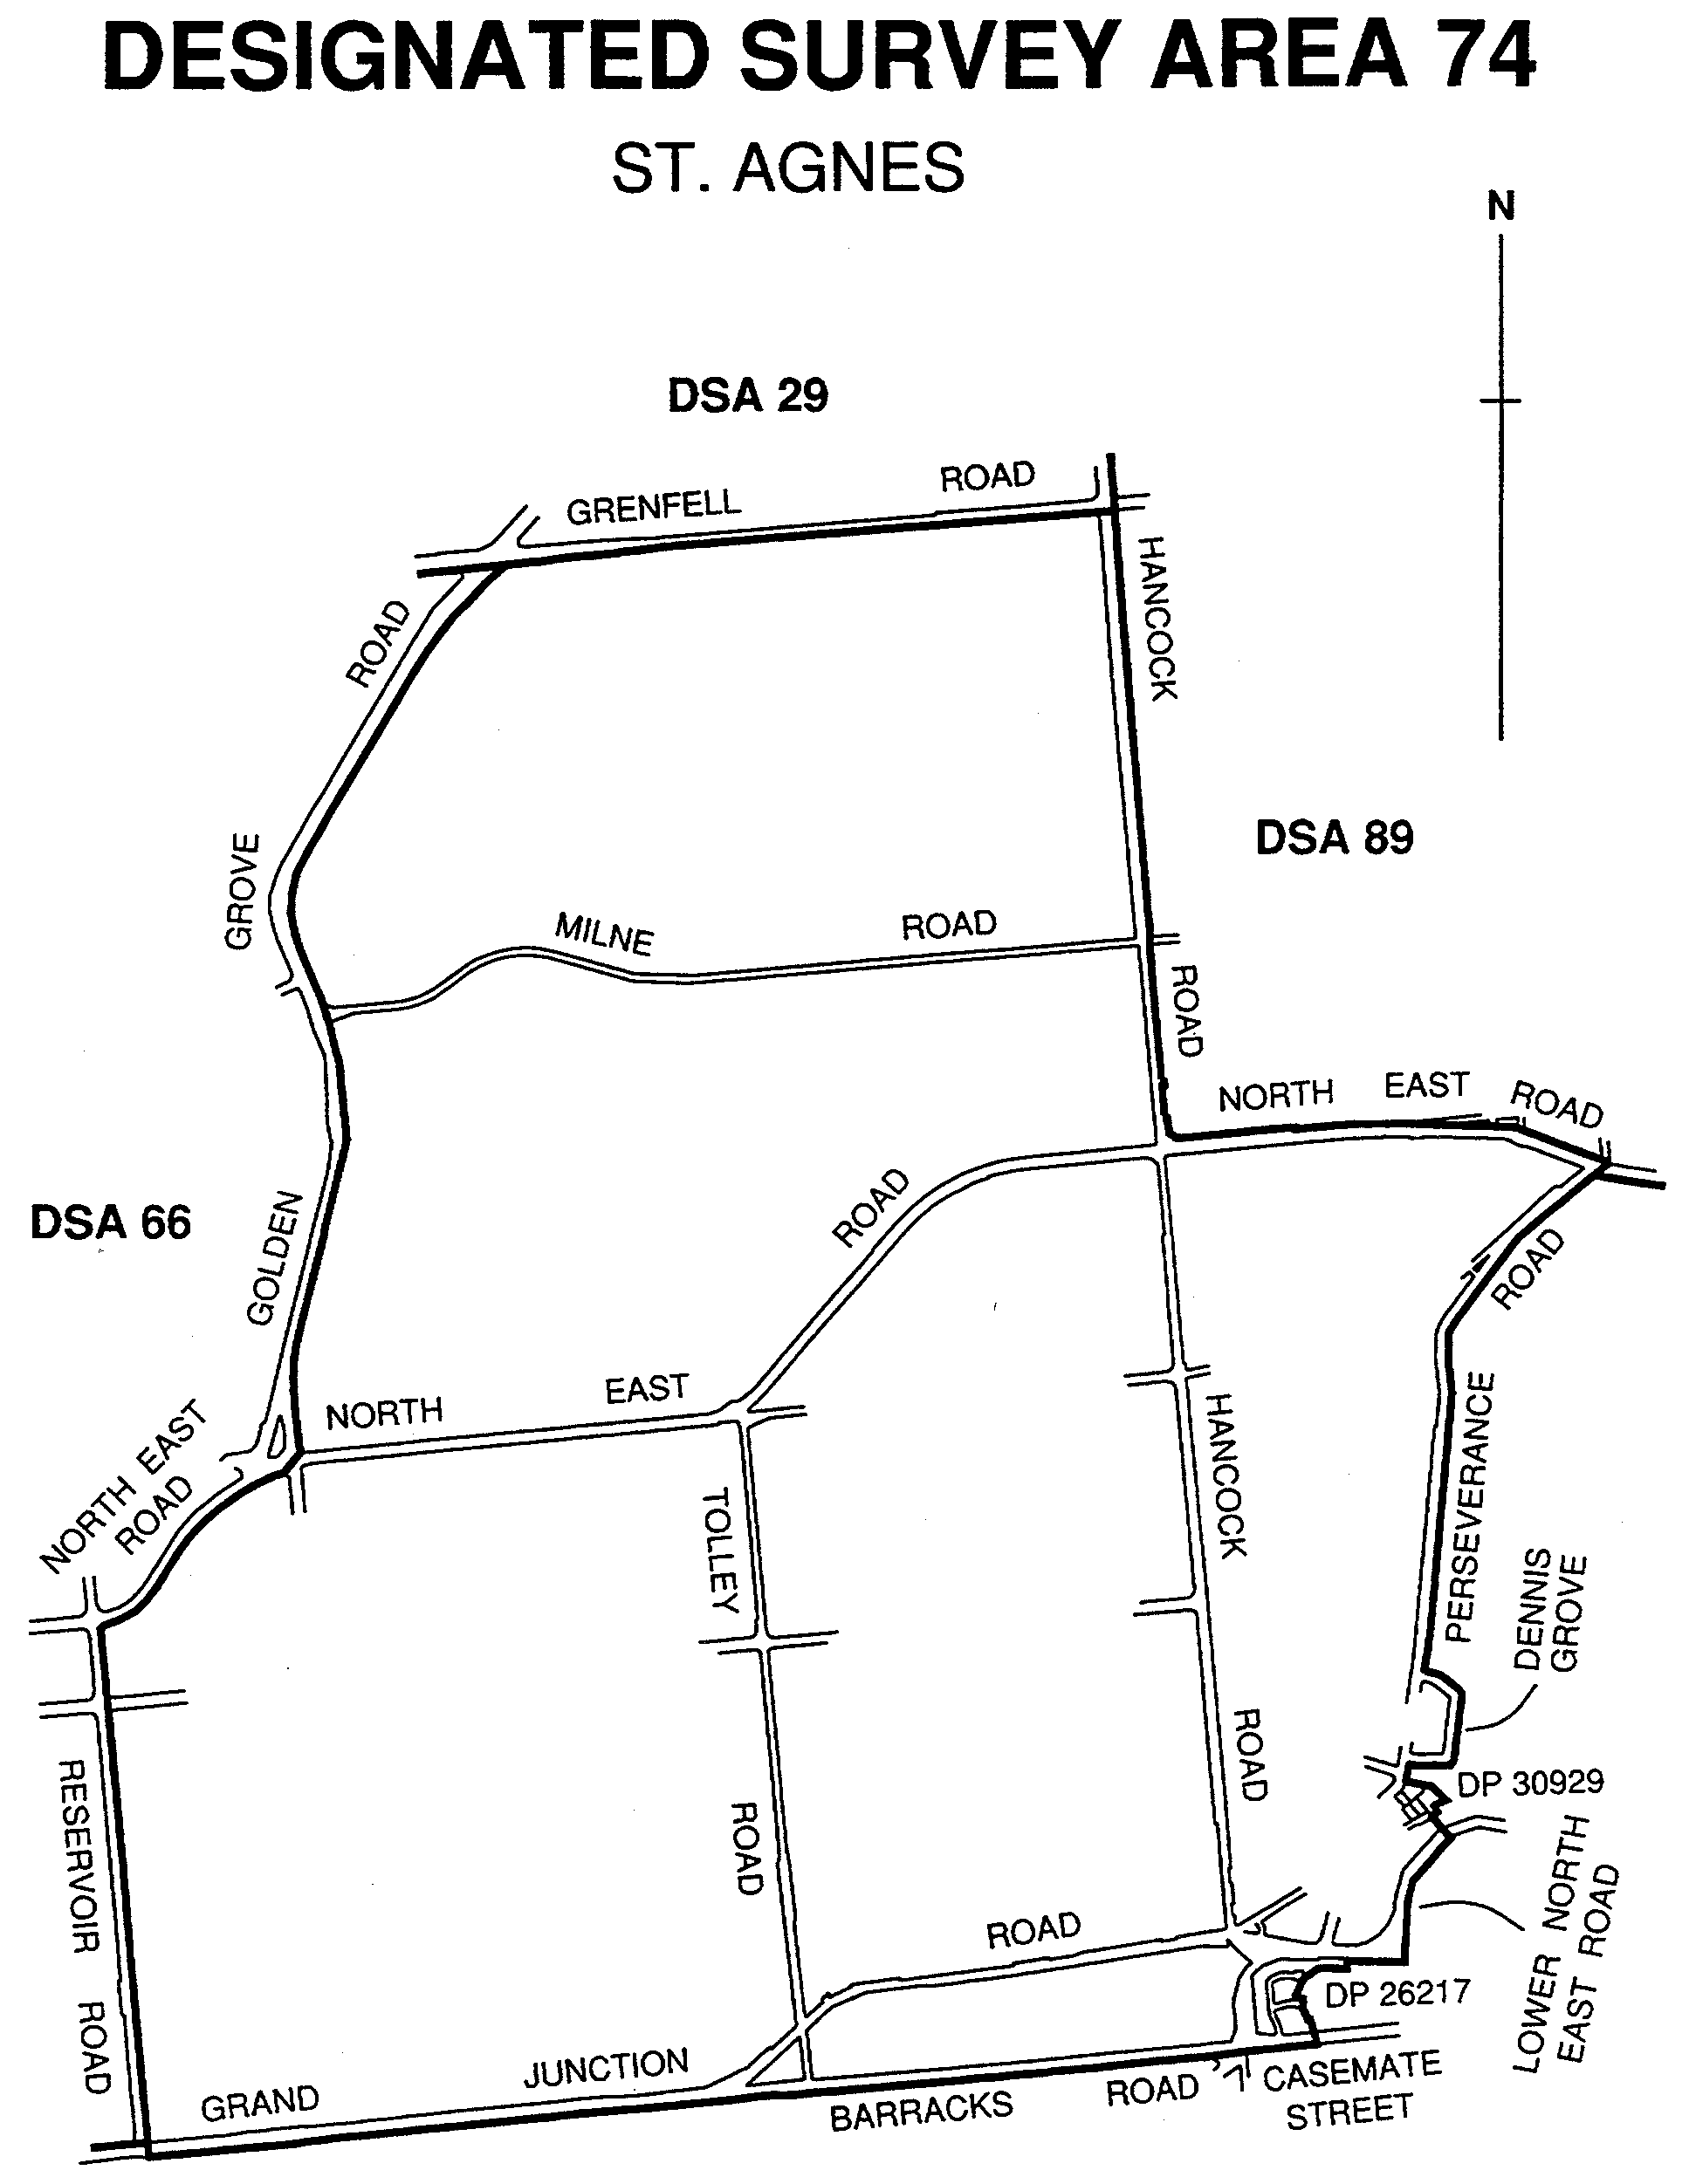

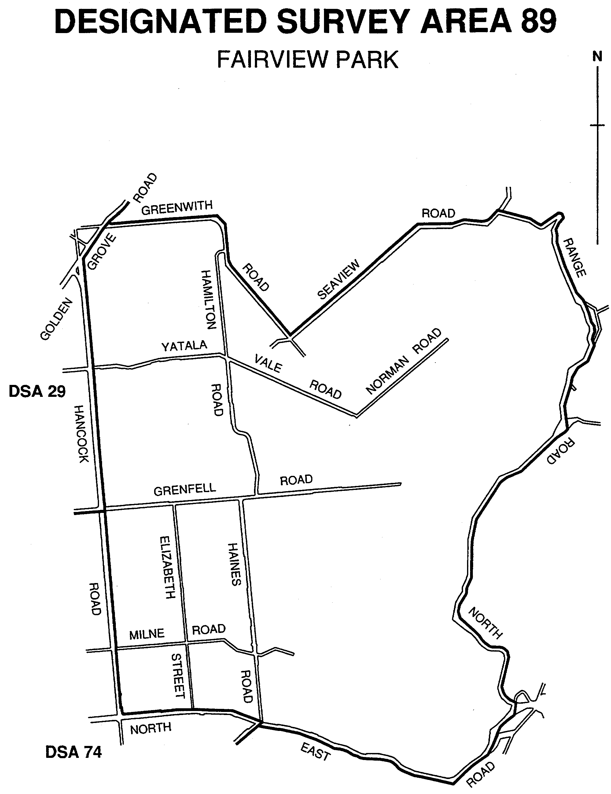
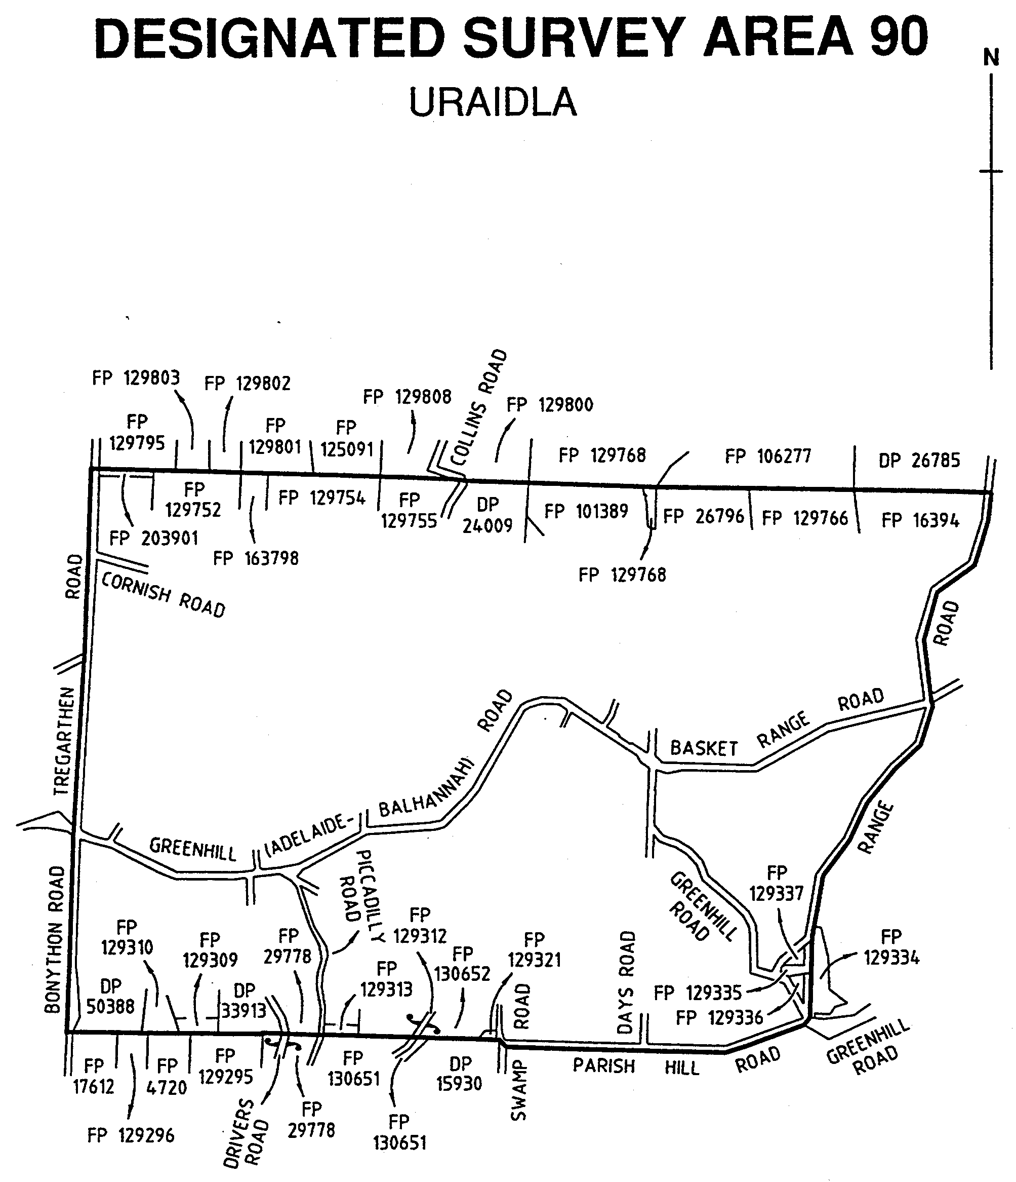
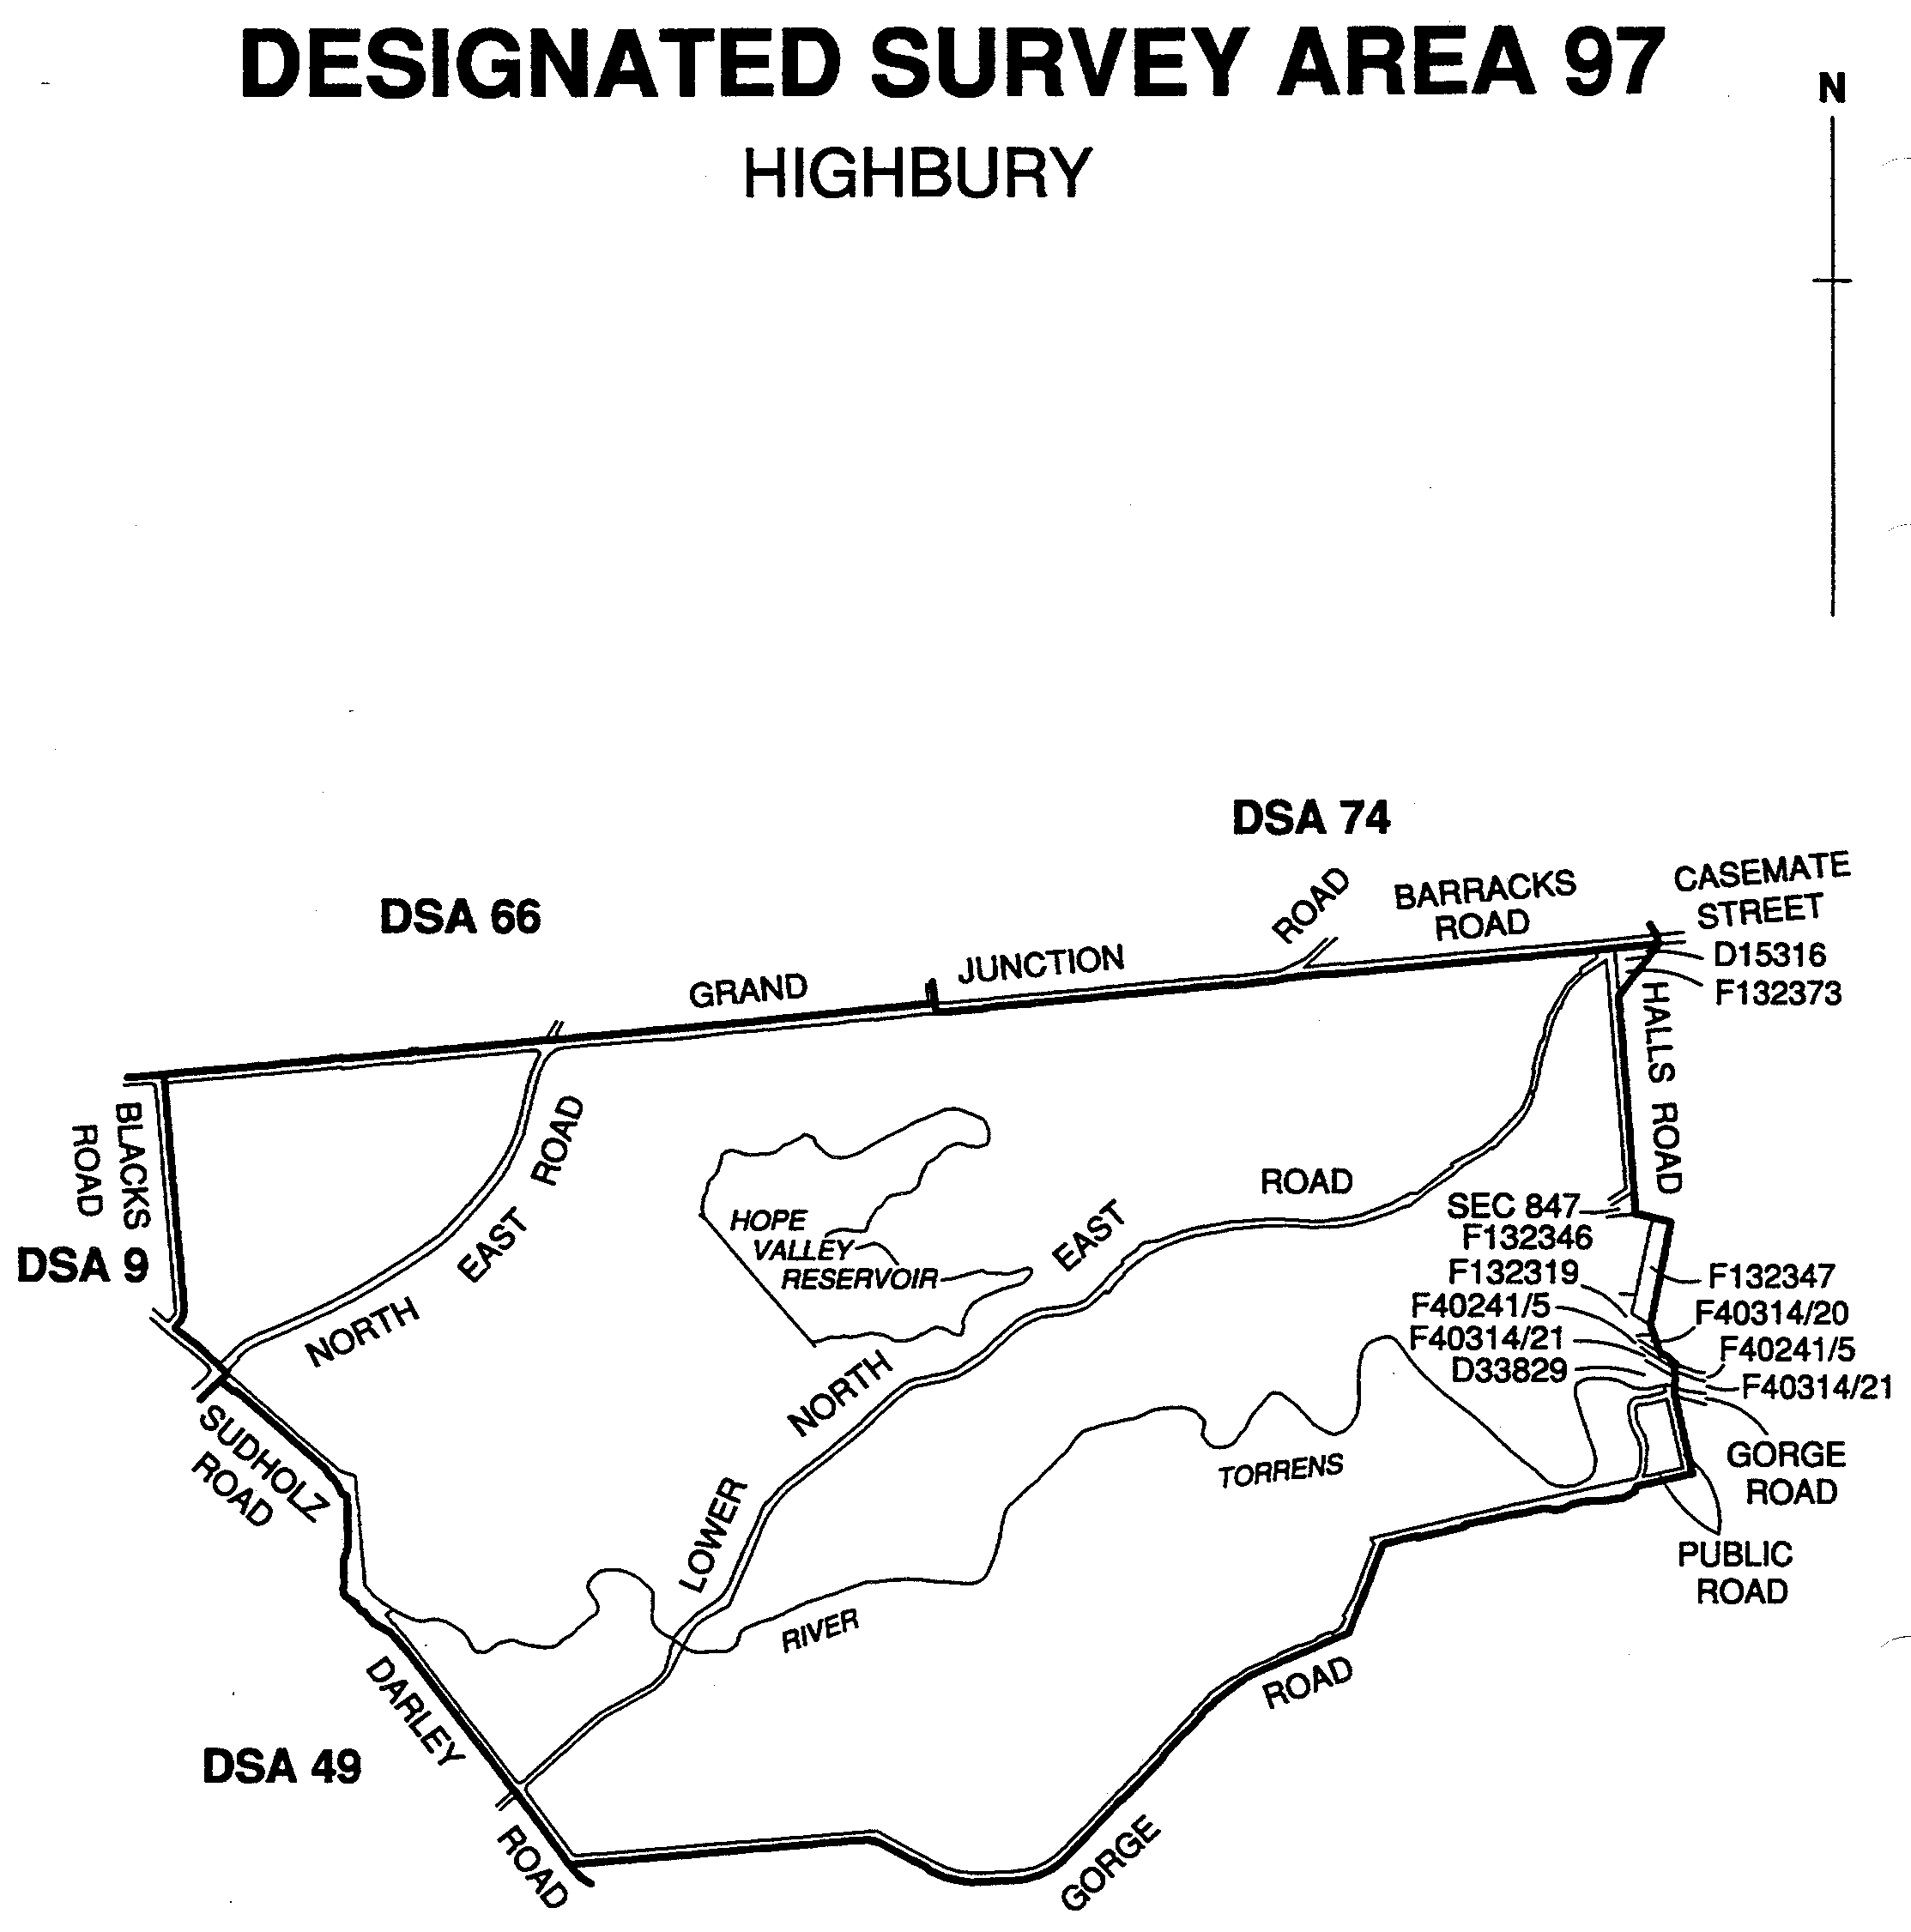

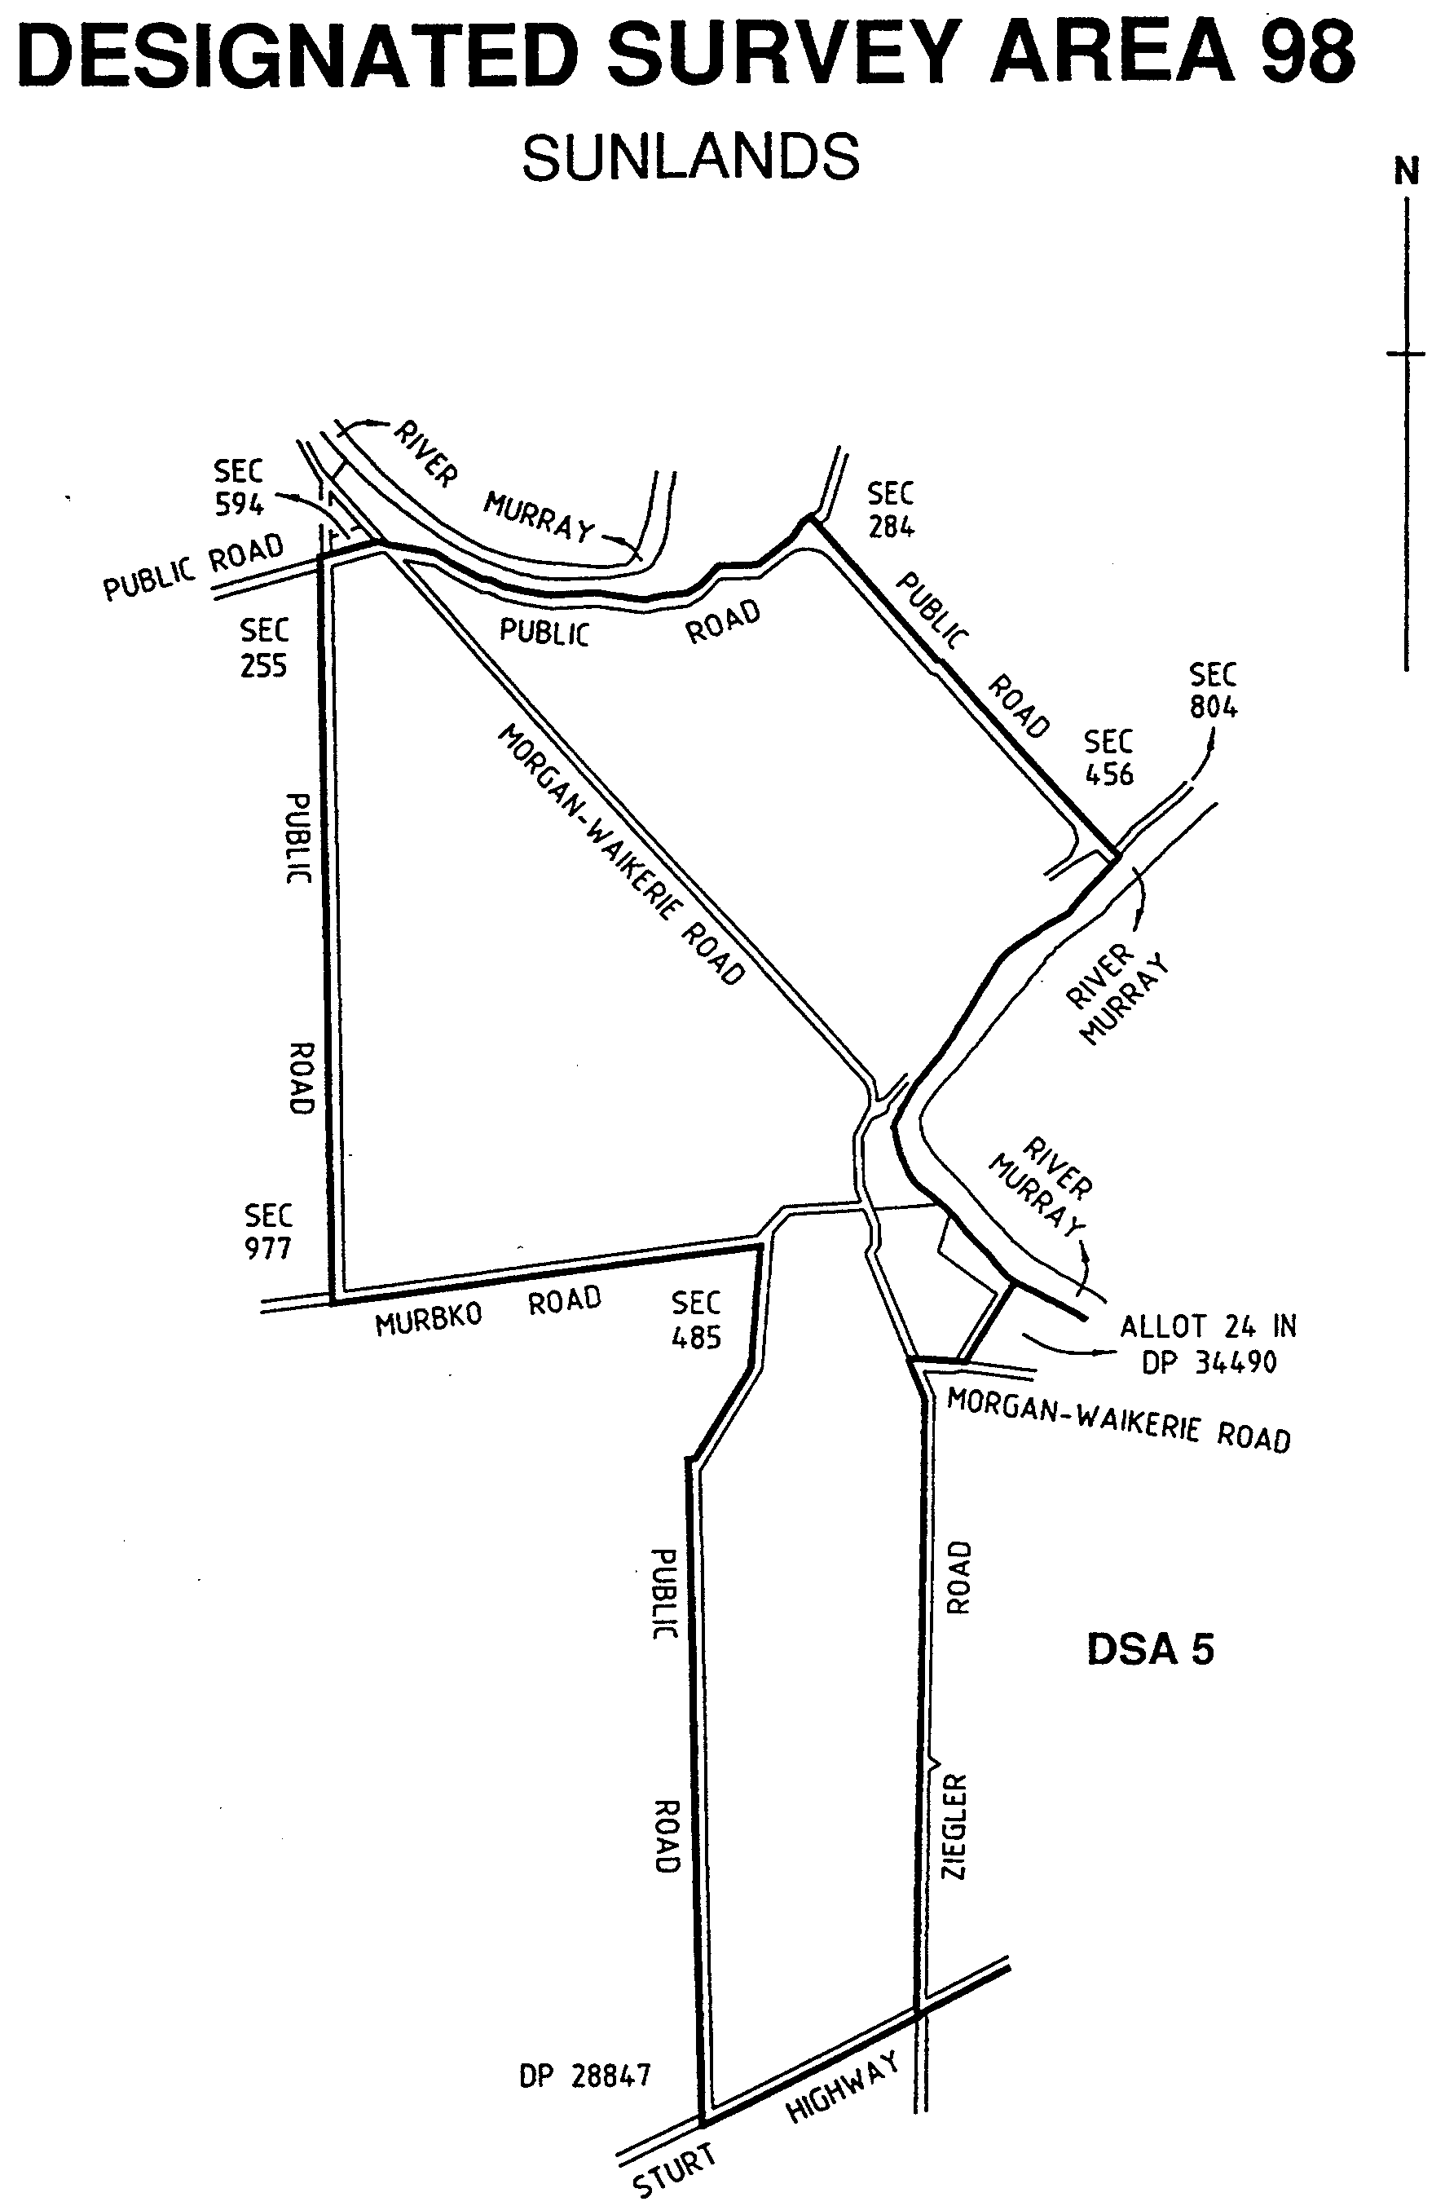

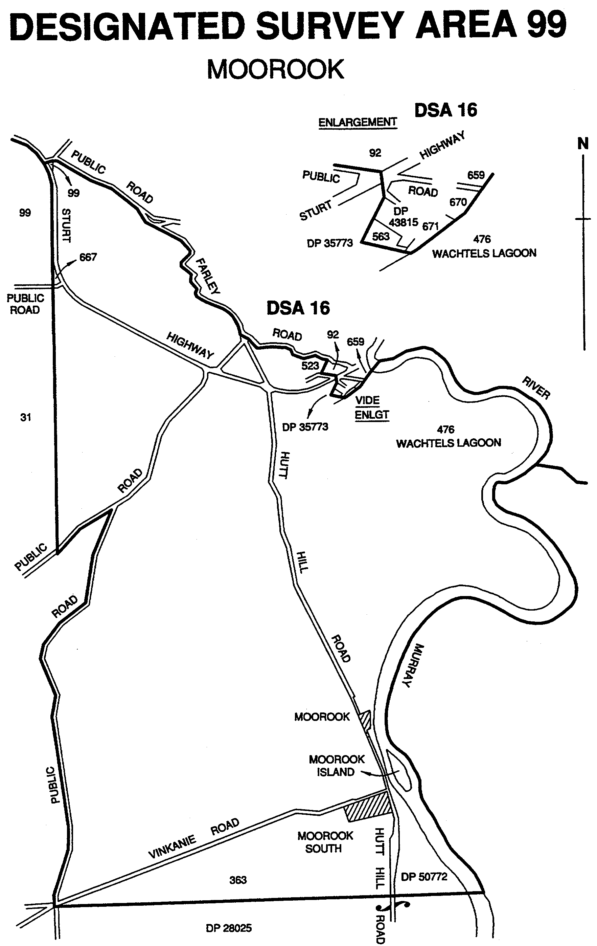
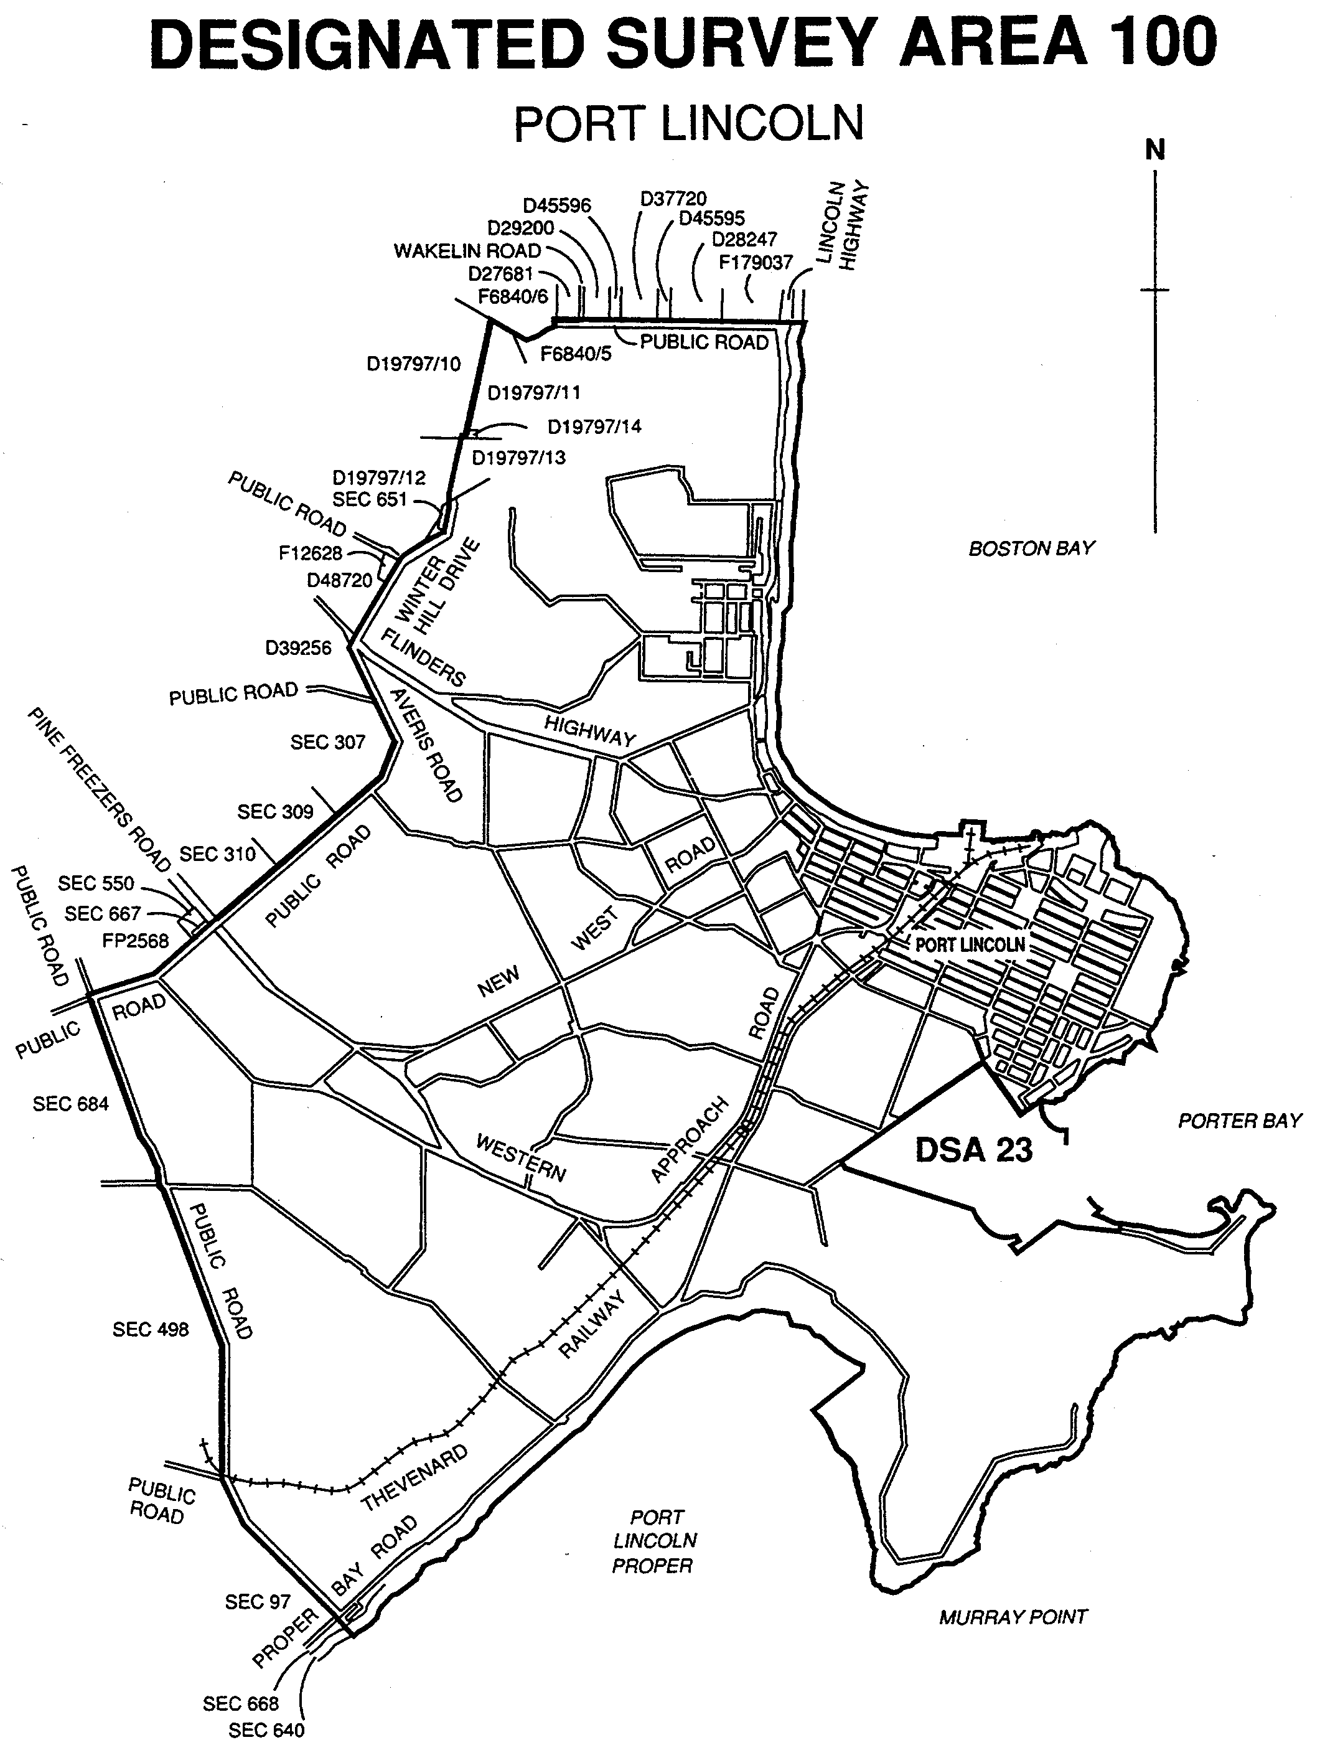

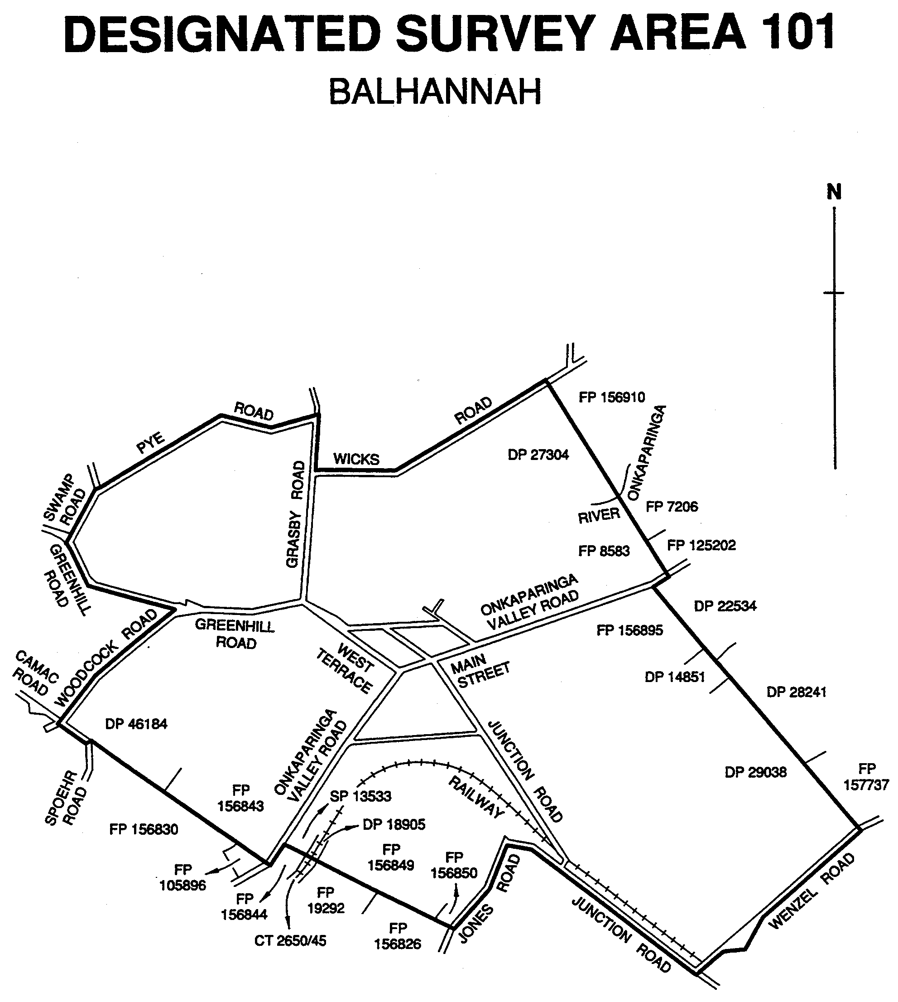

Dated 27 May 1999.
P. M. Kentish, Surveyor-General

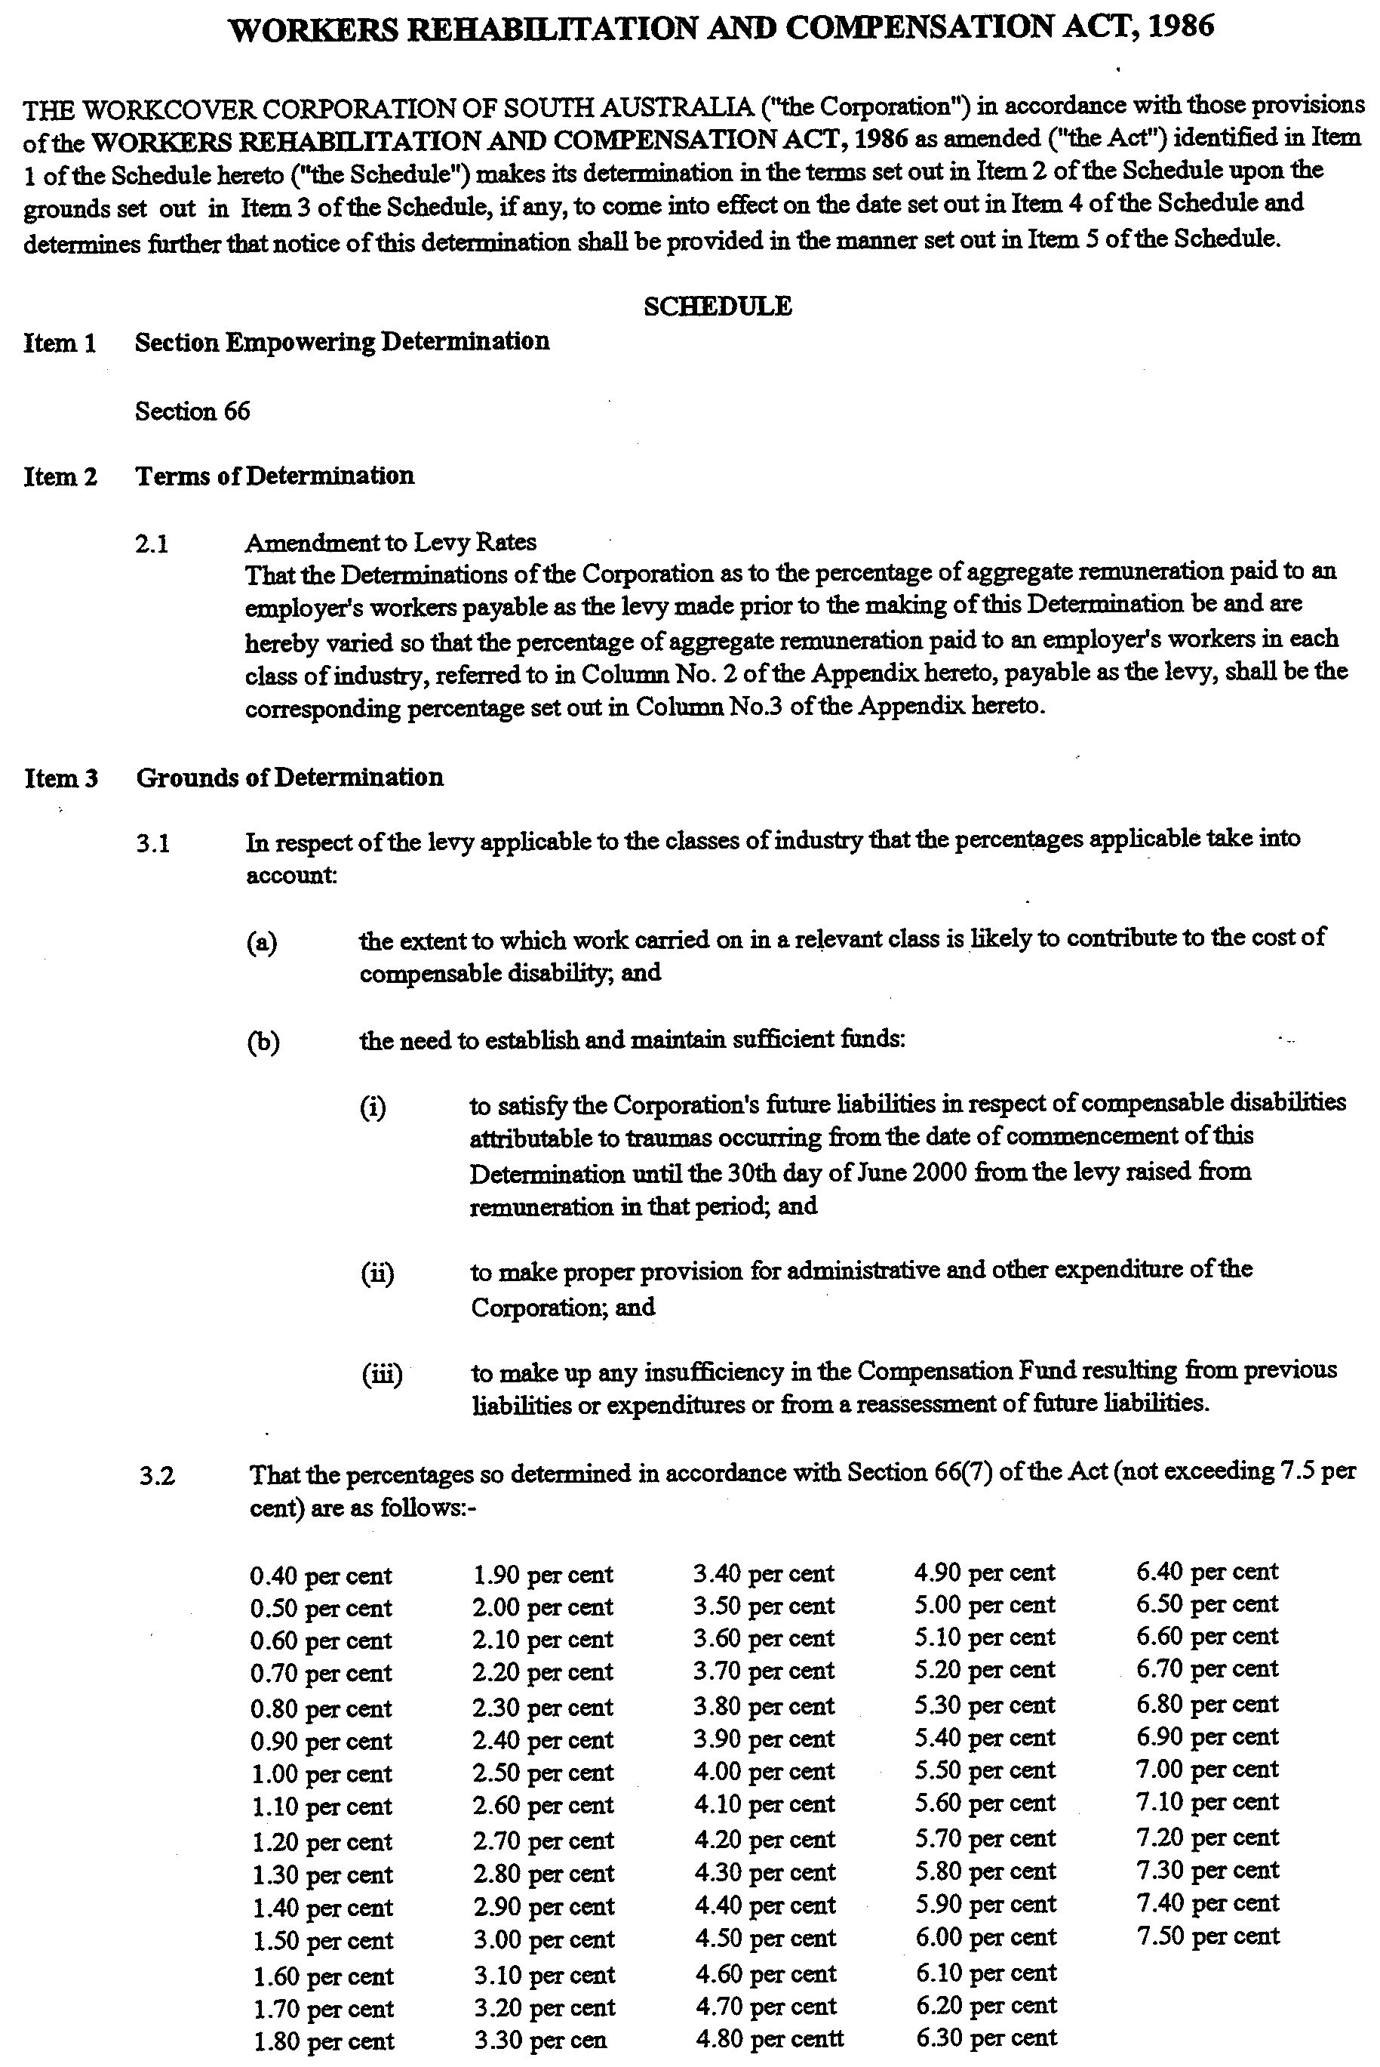



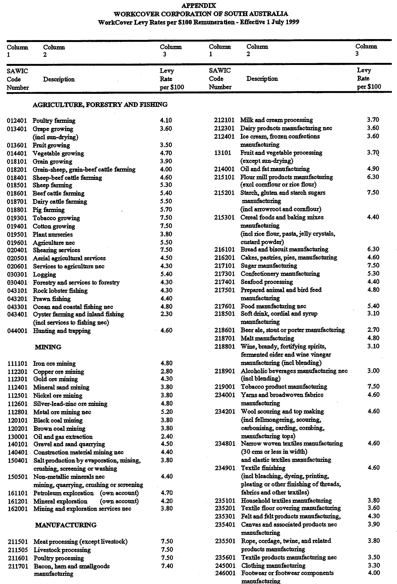
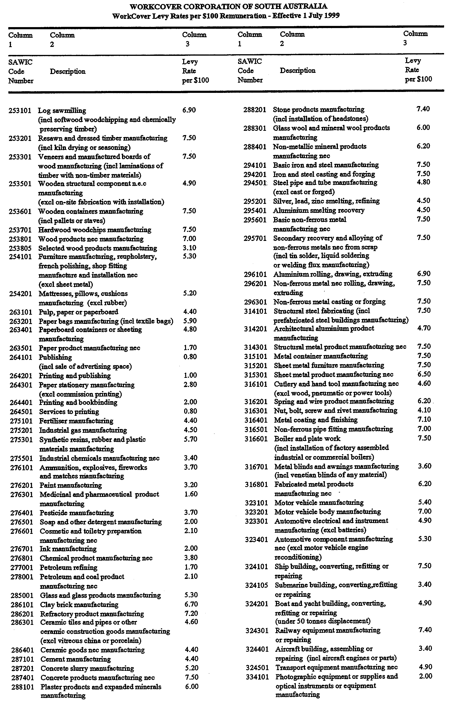
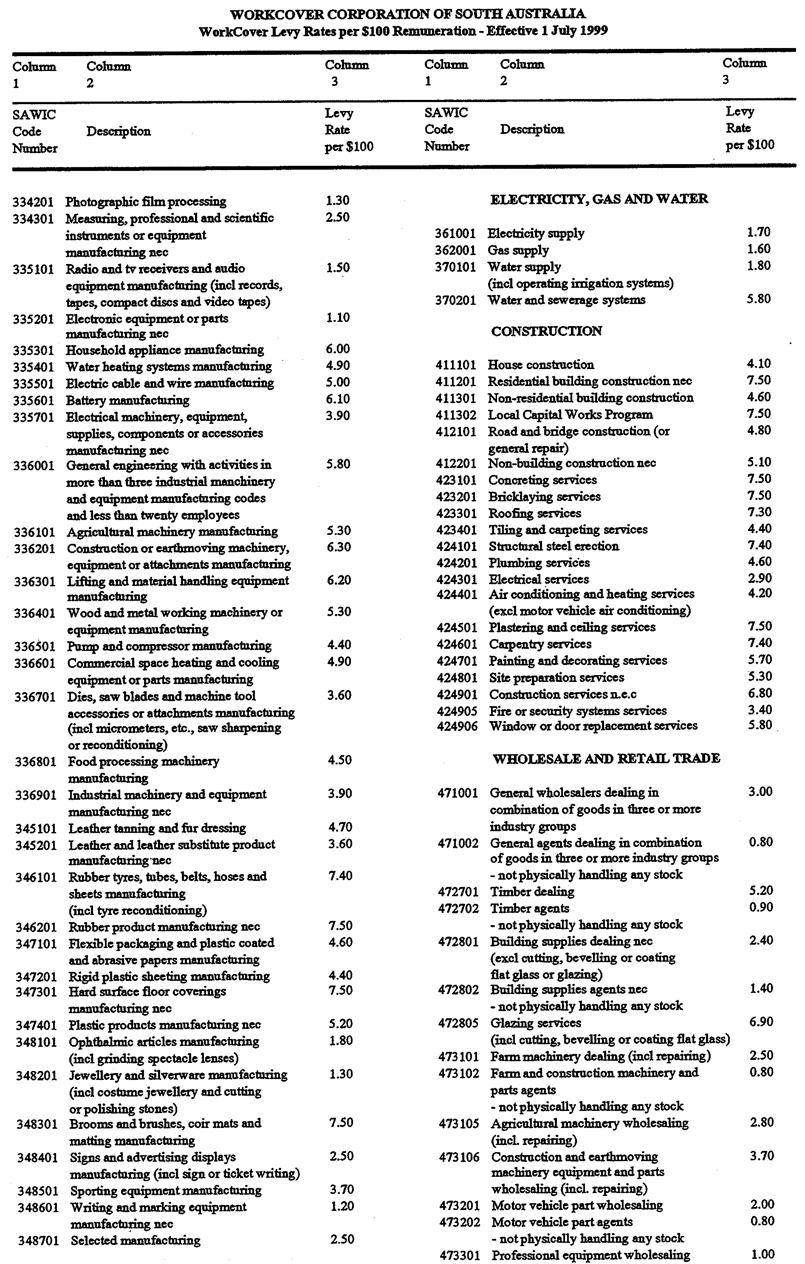
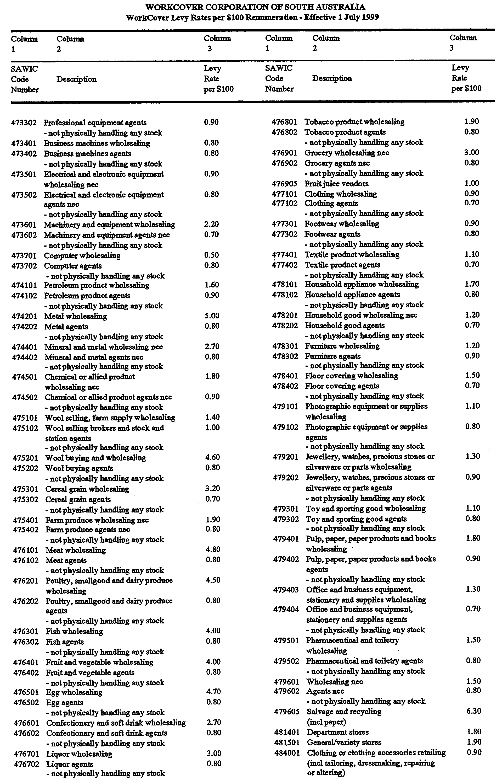
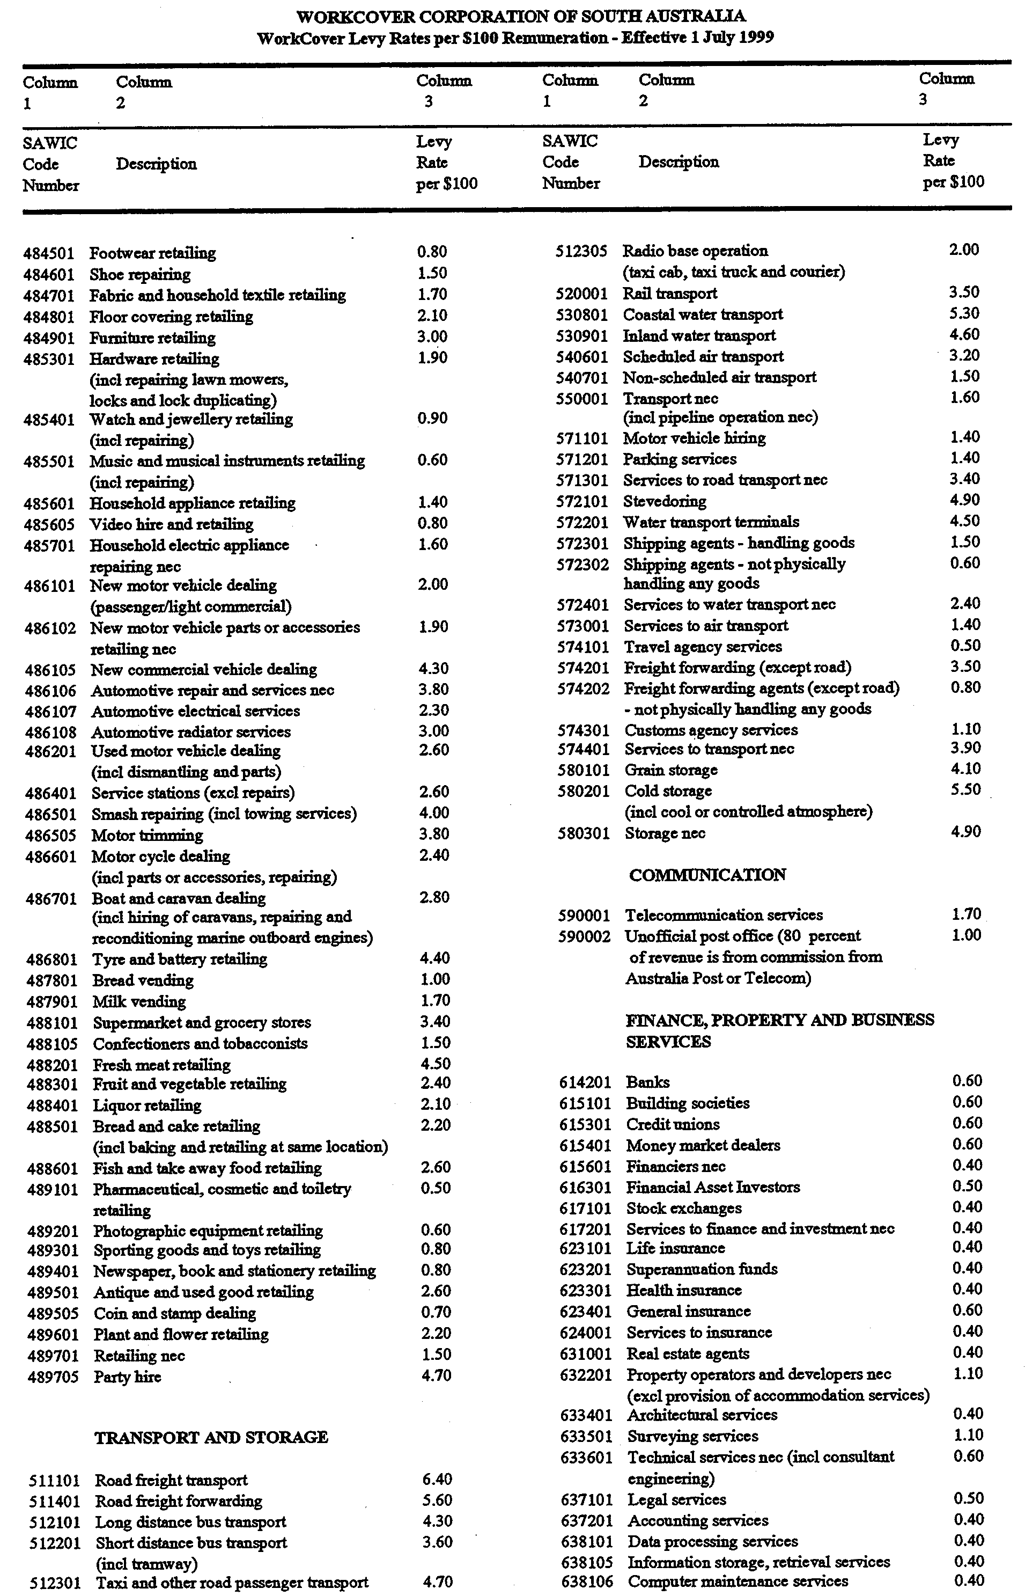
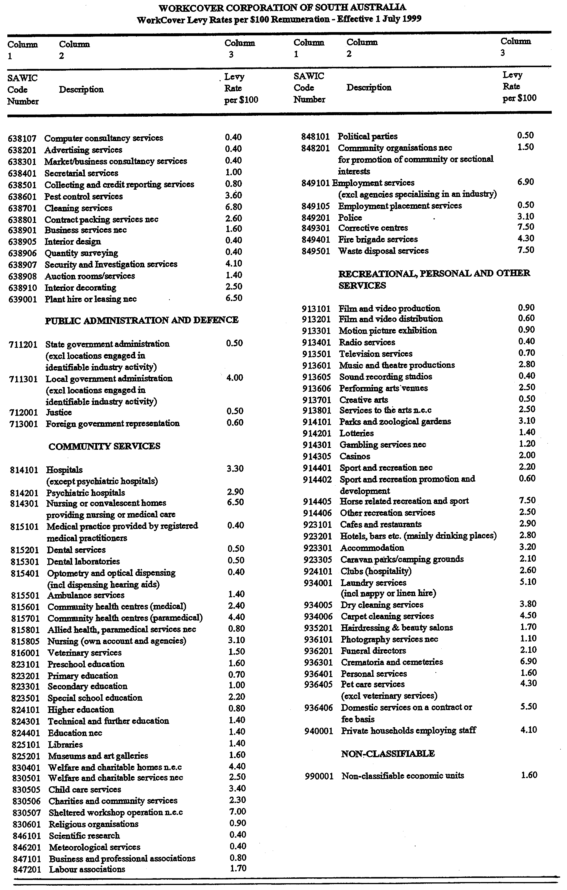
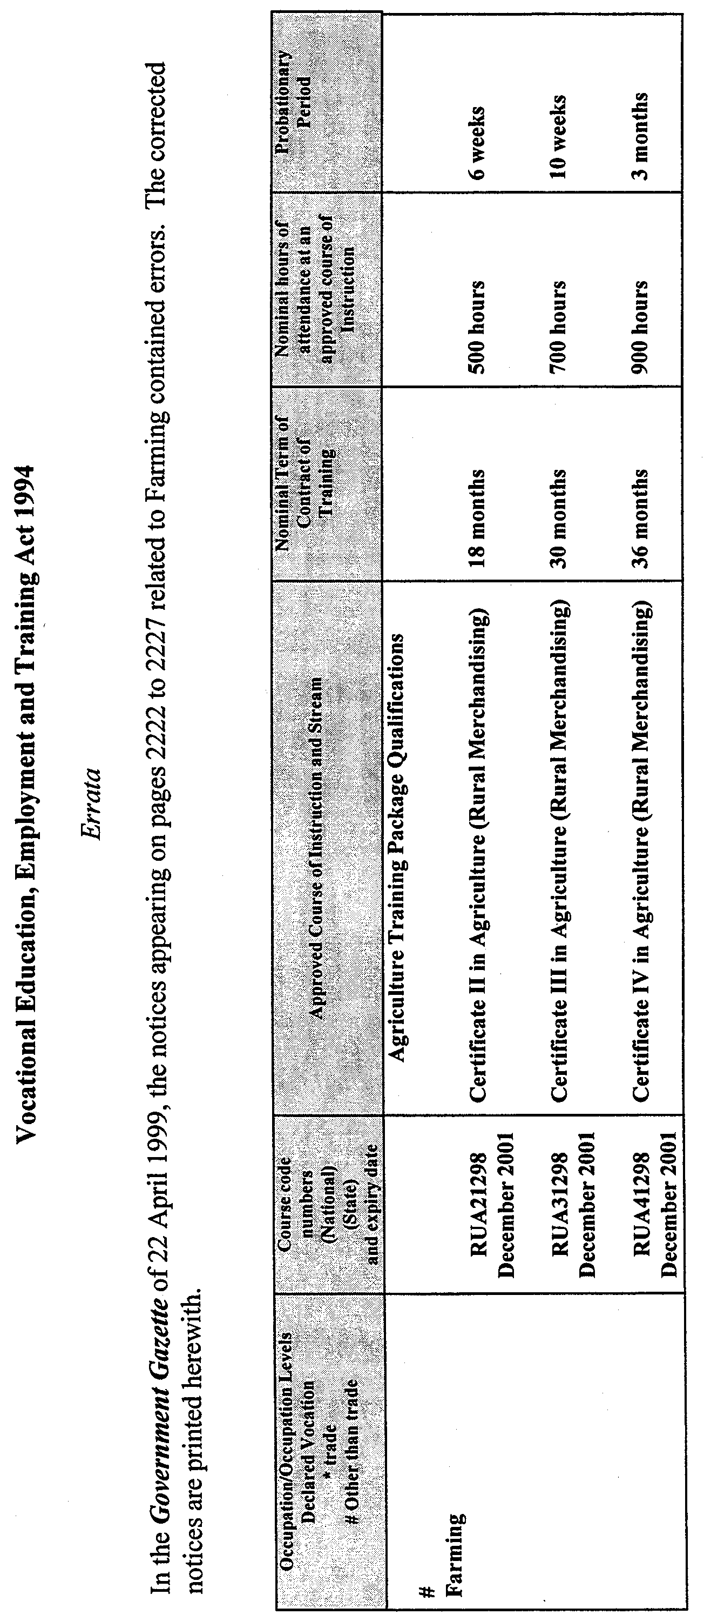
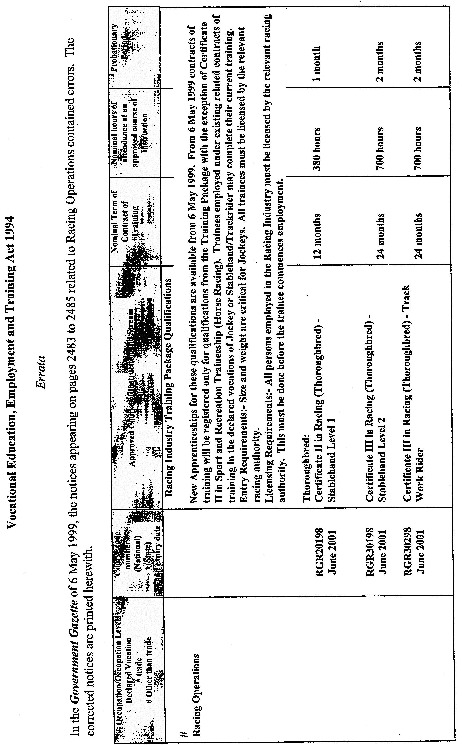
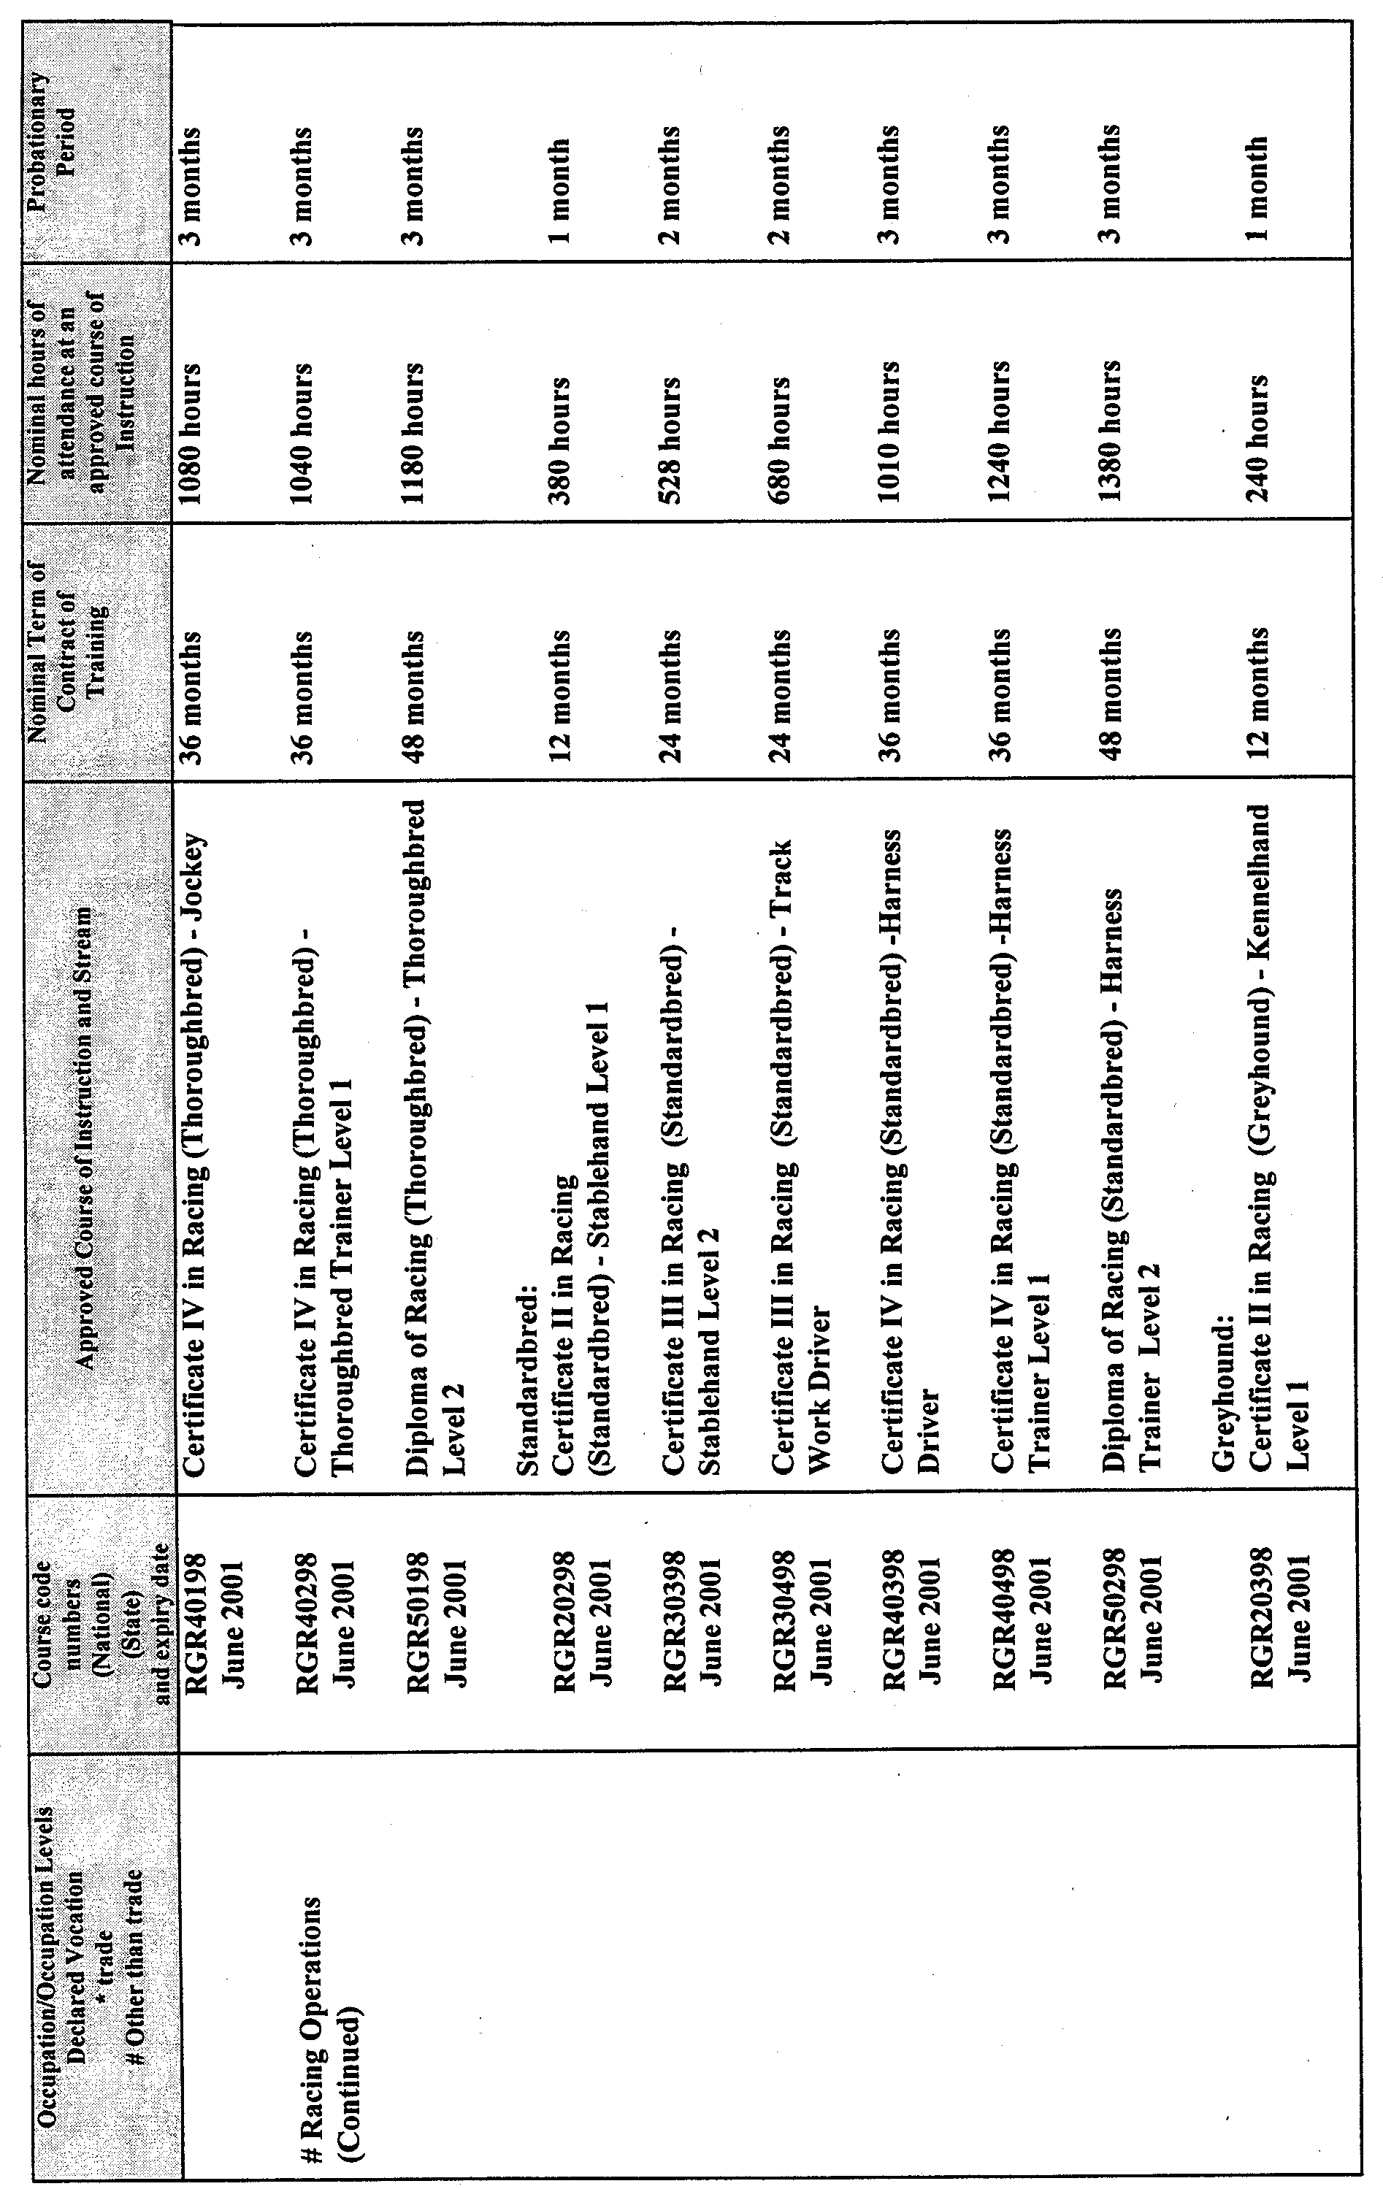
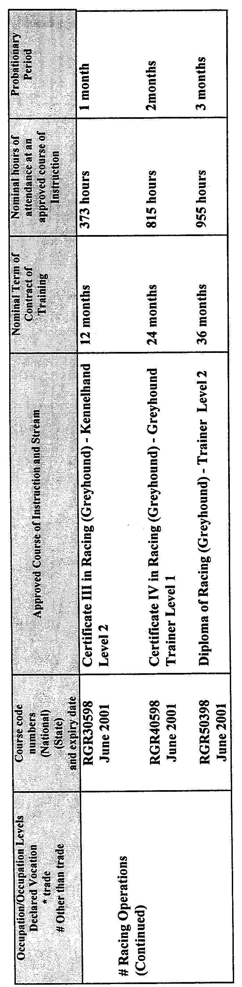

FAXING COPY?

IF you fax copy to Riverside 2000, for inclusion in the Government Gazette, there is no need to send a Confirmation Copy to us as well.

This creates confusion and may well result in your notice being printed twice.

Please use the following fax number:

Fax transmission: (08) 8207 1040
Phone Inquiries: (08) 8207 1045

Please include a contact person, phone number and order number so that we can phone back with any queries we may have regarding the fax copy.

NOTE: Closing time for lodging new copy (either fax or hard copy) is 4 p.m. on Tuesday preceding the day of publication.

Government Gazette notices can be E-mailed.

The address is:

govgaz@riv.ssa.sa.gov.au

Documents should be sent as attachments in Word format.

When sending a document via E-mail, please confirm your transmission with a faxed copy of your document, including the date the notice is to be published.

Fax transmission: (08) 8207 1040
Enquiries: (08) 8207 1045

CITY OF CHARLES STURT
Roads (Opening and Closing) Act 1991
NOTICE is hereby given that the City of Charles Sturt in accordance with section 10 of the Roads (Opening and Closing) Act 1991, proposes to make a road process order to close the following road in the Hundred of Adelaide, an irregularly-shaped strip of walkway between White Sands Drive and West Beach Road, West Beach situate dividing allotments 1 and 9 in deposited plan 34275 from allotments 31 and 32 in deposited plan 52019 and marked ‘E’ and ‘F’ on Preliminary Plan No. PP32/0451.
It is proposed that the portion of road to be closed marked ‘E’ and be transferred to E. & A. Di-Salvo Nominees Pty Ltd and merged with said allotment 9 in deposited plan 34275 and that portion marked ‘F’ be transferred to Avireen Pty Ltd and merged with said allotment 32 in deposited plan 52019 subject to an easement over the whole to City of Charles Sturt for drainage purposes.
A preliminary plan of the proposal, and a statement are available for public inspection at the Charles Sturt Council office, 72 Woodville Road, Woodville between the hours of 9 a.m. and 5 p.m., Monday to Friday or at the Adelaide office of the Surveyor-General during normal office hours.
Any person may object to the proposal and any adjoining land owner or other person substantially affected by the proposed road closure may apply for an easement relative to the closure. Such objection or application for an easement must be made in writing to the City of Charles Sturt within 28 days of the date of this notice. If a submission is made, the City of Charles Sturt is required to give notice of the time and place at which a meeting will be held to consider the matter, so that the person making the submission or a representative may attend to support the submission, if so desired.
Any submission must set out the full name and address of the person making the submission, and must be fully supported by reasons and any application for the grant of an easement must give full particulars of the nature and location of the easement and, where made by a person as the owner of adjoining or nearby land, specify the land to which the easement is to be annexed. A copy of the submission must be forwarded to the Surveyor-General at Adelaide.
Dated 27 May 1999.
S. Law, Chief Executive Officer

CITY OF HOLDFAST BAY
Development Act 1993
Structure Plan and Policy Plan Amendment Report—
Draft for Public Consultation
NOTICE is hereby given that the City of Holdfast Bay has prepared a Structure Plan and Policy Plan Amendment Report for the purpose of introducing more detailed Structure Plans to establish a clear urban structure for the long term development of the City of Holdfast Bay.
The Structure Plan and Policy Plan Amendment Report (PAR) will introduce a number of policy changes, most of which were identified in the section 30 Development Plan Reviews for the former Cities of Brighton and Glenelg.
The major policy changes that will result from the Structure Plan and Policy Plan Amendment include the introduction of six new Structure Plans and Associated Principles. It will involve the removal of Policy areas along Brighton Road in the former City of Brighton Development Plan. The PAR will result in several residential policy changes relating to corner sites, minimum frontage for semi-detached dwellings, measurement of coastal building heights from the natural surface, screen walls on arterial roads, development abutting laneways, clarification of the requirements for minimum site areas in the former Brighton development Plan area, setbacks, development fronting North Esplanade, King Street and Patawalonga Frontage (Glenelg North), access to the Esplanade and access on corner sites. Other important issues include: minor changes to the Light Industry zone including conditions relating to complying development; a
new comprehensive car parking requirements table including some revised standards; improved environmental requirements including retention of stormwater and reuse of grey water; expanded controls on outdoor advertising; restrictions to horsekeeping; and minor zone boundary amendments.
The Plan Amendment Report and Statement of Investigation will be available for public inspection during normal office hours at the City of Holdfast Bay Council Office, 24 Jetty Road, Brighton, the City of Holdfast Bay Glenelg Branch Office at Glenelg Town Hall, Moseley Square, Glenelg and the Glenelg and Brighton Public Libraries, located at Hope Street, Glenelg and Jetty Road, Brighton respectively, from 27 May 1999 until 30 July 1999. Copies of the Plan Amendment Report can be purchased from the Council Office at Brighton at a cost of $10 each.
Written submissions regarding the Plan Amendment Report will be accepted by the City of Holdfast Bay until 5 p.m. on Friday, 30 July 1999. All submissions should be addressed to the Chief Executive Officer, City of Holdfast Bay, P.O. Box 19, Brighton, S.A. 5048.
Copies of all submissions received will be available for inspection for all interested persons at the Council Office from 30 July 1999 until the date of the public hearing.
A public hearing will be held commencing at 7 p.m. on 17 August 1999 at the Council Chambers in Glenelg Town Hall, Moseley Square, Glenelg, at which time interested parties may appear and be heard in relation to the Plan Amendment Report and Submissions.
R. K. Baker, Acting Chief Executive Officer

CITY OF HOLDFAST BAY
Development Act 1993
Local Heritage Plan Amendment Report—
Draft for Public Consultation
NOTICE is hereby given that the City of Holdfast Bay has prepared a Local Heritage Plan Amendment Report for the purpose of identifying Local Heritage Places and areas of historic significance (Historic Conservation Zones).
The Plan Amendment Report seeks to ensure that the future development within a proposed Historic (Conservation) Zone, or that which affects a Local Heritage Place, proceeds in a manner which is sympathetic to the identified heritage values of the proposed Zone and/or Place.
The primary policy changes include the introduction of a new Schedule containing a list of Local Heritage Places, a total of 200 places, with accompanying Council-wide policies in relation to development which would affect those places, and the introduction of four Historic (Conservation) Zones with accompanying zone specific Objectives and Principles of Development Control, focussed in the Glenelg area.
The extent of the heritage significance of each place has been specified. In most cases the extent of significance includes the external form, materials and detailing of the proposed Local Heritage Place.
The Plan Amendment Report and Statement of Investigation will be available for public inspection during normal office hours at the City of Holdfast Bay Council Office, 24 Jetty Road, Brighton, the City of Holdfast Bay Glenelg Branch Office at Glenelg Town Hall, Moseley Square, Glenelg and the Glenelg and Brighton Public Libraries, located at Hope Street, Glenelg and Jetty Road, Brighton respectively, from Thursday, 27 May 1999 until Friday, 30 July 1999. Copies of the Plan Amendment Report can be purchased from the Council Office at Brighton at a cost of $10 each.
Written submissions regarding the Plan Amendment Report will be accepted by the City of Holdfast Bay until 30 July 1999. All submissions should be addressed to the Chief Executive Officer, City of Holdfast Bay, P.O. Box 19, Brighton, S.A. 5048.
Copies of all submissions received will be available for inspection for all interested persons at the Council Office from 30 July 1999, until the date of the public hearing.
A public hearing will be held commencing at 7 p.m. on Tuesday, 17 August 1999, at the Council Chambers in Glenelg Town Hall, Moseley Square, Glenelg, at which time interested parties may appear and be heard in relation to the Plan Amendment Report and Submissions.
R. K. Baker, Acting Chief Executive Officer

CITY OF ONKAPARINGA
Declaration of Public Road
NOTICE is hereby given that at a meeting held on 18 May 1999, the council of the City of Onkaparinga resolved pursuant to section 303 (1d) of the Local Government Act 1934, as amended, that the walkway identified on deposited plan 6722 and located between Butterworth Road and Blacker Road, Aldinga Beach abutting allotments 701, 711 and 702, 711 be declared a public road.
J. S. Tate, City Manager

CITY OF PLAYFORD
Bushfire Prevention Committee
NOTICE is hereby given that on 1 August 1998, the City of Playford District Bushfire Prevention Committee was formed as the requirement of section 32 (1) of the Country Fires Act 1989. The responsibilities of the District Committee as prescribed in section 33 of the The Country Fires Act 1989. The committee consists of the following positions:
1. Council’s Fire Prevention Officer.
2. Council’s Deputy Fire Prevention Officer.
3. A representative of each CFS Brigade operating in the council area (3).
4. Two councillors of the City of Playford.
5. An officer of the National Parks and Wildlife Department.
6. A representative of Forestry SA.
7. A person nominated by the committee from any other agency or organisation thought to be beneficial to the aims of the District Bushfire Prevention Committee.
T. R. S. Jackson, Chief Executive Officer

CITY OF PLAYFORD
Declaration of Public Road
NOTICE is hereby given that pursuant to section 303 (1) (d) of the Local Government Act 1934, as amended, council has resolved that walkway between Ballard Street and Halsey Road, Elizabeth West, more particularly described as walkway ‘C’ in deposited plan 6421 and allotment 21 walkway, in deposited plan 10575 be declared a public road.
Dated 27 May 1999.
T. R. S. Jackson, Chief Executive Officer

PORT PIRIE REGIONAL COUNCIL
Declaration of Public Road
NOTICE is hereby given that at its meeting held on 13 April 1999, council resolved that, pursuant to the powers contained in section 301 (c) of the Local Government Act 1934, as amended, that portion of land adjacent to allotments 44-54 and 59-61 in Deposited Plan 1976 and allotments 103 and 104 in Deposited Plan 43855 and referred to as private right of way be declared public road.
P. J. Arnold, Chief Executive Officer

CITY OF SALISBURY
Adoption of Valuation and Declaration of Rates
Erratum
NOTICE is hereby given that the notice appearing on page 2757 of the Government Gazette dated 25 June 1998 should read as follows:
Paragraph number 1, ‘Adoption of Valuations’ delete 1998 in the first line and insert 1999 in its place.
T. Starr, City Manager

ALEXANDRINA COUNCIL
Development Act 1993
Flood Prone Areas Plan Amendment Report
Draft for Public and Agency Consultation
NOTICE is hereby given that the Alexandrina Council has prepared a draft Plan Amendment Report to amend the Strathalbyn (DC) (Outer Metropolitan) Development Plan as it affects land inundated from the Bremer and Angas Rivers in the event of a 1-in-100-year average return interval (ARI) flood.
The draft Plan Amendment Report will amend the Development Plan by:
• introducing a Flood Zone over land inundated in a 1-in-100-year ARI event, fixed by measurement to the nearest cadastral boundary intersected by the flood;
• introducing policies in the Flood Zone:
• in which a number of uses including, but not limited to, additional allotments, intensive animal keeping, and industries are listed as non-complying;
• giving direction on issues affecting the safety of residential occupation of the land, minimising potential for inundation of dwellings and minimising interference with the flood flow and hazards elsewhere;
• in respect of matters including land fill, excavation and levees, fencing, outbuildings, building siting, finished floor levels and the like;
• removing the Country Township (Langhorne Creek) policy areas, and amending the existing Country Township Zone boundaries at Langhorne Creek and Milang to remove land inundated, or not readily protected from a 1-in-100-year ARI event.
This draft Plan Amendment Report is available for inspection during normal office hours at the Alexandrina Council, from 27 May 1999 to 29 July 1999. A copy of the draft Plan Amendment Report can be purchased from the Alexandrina Council for $5 each.
Persons interested in making written submissions regarding the draft Plan Amendment Report must do so by 5 p.m. on 29 July 1999. The written submissions should also clearly indicate whether you wish to speak at the public hearing on your submission. All submissions should be addressed to the Chief Executive Officer, Alexandrina Council, P.O. Box 21, Goolwa, S.A. 5214.
Copies of all submissions will be available for inspection by interested persons at the Strathalbyn Branch Office at 1 Colman Terrace, Strathalbyn, from 30 July 1999 till the end of the public hearing.
A public hearing will commence in the Langhorne Creek Memorial Hall at 7.30 p.m., on 18 August 1999 at which time interested persons may appear and be heard by Council in relation to the draft Plan Amendment Report and the submissions.
The public hearing may not be held if no submission indicates an interest at speaking at the public hearing.
J. Coombe, Chief Executive Officer

THE FLINDERS RANGES COUNCIL
Periodical Review of Elector Representation
NOTICE is hereby given that pursuant to the provisions of section 24 (3) of the Local Government Act 1934, as amended, The Flinders Ranges Council is to carry out a review to determine whether a change of arrangements in respect to elector representation, including ward boundaries and the composition of council, will result in the electors of the council area being more adequately and fairly represented.
Information regarding the nature of the periodical review is available at the council office, or by contacting D. A. Cearns on telephone 8648 6031.
Interested persons are invited to make a written submission to the Chief Executive Officer, P.O. Box 43, Quorn, S.A. 5433, by close of business on Friday, 9 July 1999.
Any person who makes a written submission will be afforded an opportunity to appear before council, or a committee thereof, to be heard in respect of his or her submission.
D. A. Cearns, Chief Executive Officer

REGIONAL COUNCIL OF GOYDER
Change to Monthly Meeting Dates
NOTICE is hereby given that the Regional Council of Goyder at their meeting held on 18 May 1999, resolved to alter their monthly meetings from the third Monday to the third Tuesday of each month, commencing from 1 July 1999. Meetings will commence at 9 a.m.
S. Kerrigan, Chief Executive Officer

DISTRICT COUNCIL OF MOUNT BARKER
Temporary Road Closure
NOTICE is hereby given that in accordance with section 359 of the Local Government Act 1934, as amended, that vehicles of all classes, except those belonging to stall-holders of the Nairne Country Markets, be excluded from Junction Street, Nairne between the hours of 9 a.m. and 3 p.m. on the following days:
29 May 1999 29 April 2000
31 July 1999 29 July 2000
30 October 1999 30 September 2000
29 January 2000 30 December 2000
D. H. Gollan, Chief Executive Officer

DISTRICT COUNCIL OF PETERBOROUGH
Appointments
NOTICE is hereby given that at a council meeting held on Tuesday, 18 May 1999 the following appointments were made:
(a) Pursuant to section 86 (3) of the Local Government Act 1934, as amended, council appointed Jonathan William Oliver as a Deputy Returning officer effective from 10 May 1999 vice Steven Paul Griffiths resigned.
(b) Pursuant to section 26 (1) (b) of the Dog and Cat Management Act 1995, council appointed Jonathan William Oliver as Registrar of Dogs effective from 10 May 1999 vice Steven Paul Griffiths resigned.
(c) Pursuant to section 38 of the Country Fires Act 1989, council appointed Jonathan William Oliver as a Fire Permits Officer effective from 10 May 1999 vice Steven Paul Griffiths resigned.
(d) Pursuant to section 82 (1) of the Local Government Act 1934, council appointed Jonathan William Oliver as an Authorised Officer, effective from 10 May 1999 vice Steven Paul Griffiths resigned.
(e) Pursuant to section 14 of the Impounding Act 1920, council appointed Jonathan William Oliver as an Authorised Officer, effective from 10 May 1999 vice Steven Paul Griffiths resigned.
(f) Pursuant to the Environment Protection Act 1993, (Burning Policy), council appointed Jonathan William Oliver as an Authorised Officer, effective from 10 May 1999 vice Steven Paul Griffiths resigned.
(g) Pursuant to section 17 of the Development Act 1993, council appointed Jonathan William Oliver as an Authorised Officer, effective from 10 May 1999 vice Steven Paul Griffiths resigned.
J. W. Oliver, Chief Executive Officer

DISTRICT COUNCIL OF VICTOR HARBOR
Declaration of Drainage Reserve
NOTICE is hereby given that the District Council of Victor Harbor passed the following resolution:
Resolved that the land contained in Form R.T.C. Application for deposit of plan of division transferring from Stiletto Investments Pty Ltd (ACN 009 600 695), c/o Wardell Nominees Pty Ltd, 22 Mitchell Street, Darwin N.T. 0800 and Rheuben’s (Holdings) Pty Ltd (ACN 000 242 044), c/o Hodes Lau & Co., Level 9, 350 Kent Street, Sydney, N.S.W. 2000 to The District Council of Victor Harbor, Bay Road, Victor Harbor, S.A. 5211 and dated 30 March 1999 and comprising portion of the land contained in certificate of title register book volume 5288, folio 927 and known as allotment 1 in deposited plan No. 52399 and is hereby declared to be a Drainage Reserve, pursuant to section 301 (1) (c) of the Local Government Act 1934, as amended.
The Common Seal of the District Council of Victor Harbor was affixed in accordance with its Constitution (or Articles of Association) in the presence of:
(L.S.) J. W. Crompton, Mayor
G. K. Maxwell, District Manager

IN the matter of the estates of the undermentioned deceased persons:
Amor, Pauline, late of 57 Australian Avenue, Clovelly Park, home duties, who died on 31 March 1999.
Barnes, Alexander, late of 28a Cuming Street, Mile End, retired fitter and turner, who died on 1 March 1999.
Bauer, Ida Elizabeth, late of 6 Ellis Street, Enfield, widow, who died on 21 April 1999.
Blair, Kathleen Dawn, late of Hempel Road, Daveyston, home duties, who died on 10 April 1999.
Chinnick, Richard Lionel, late of 28 Second Street, Brompton, retired schoolteacher, who died on 15 March 1999.
Downie, Irene Mary Ann, late of 3 Parham Crescent, Port Noarlunga, home duties, who died on 21 March 1999.
Evans, Kevin James, late of 128 Musgrave Terrace, Kadina, retired maintenance man, who died on 22 December 1998.
Fry, George William, late of 20 Wilkins Street, Solomontown, retired storeman, who died on 20 April 1999.
Geoghegan, Brian John, late of 7 Graham Crescent, Novar Gardens, of no occupation, who died on 26 March 1999.
Goodwin, Lily Louisa, late of 50 Gulfview Road, Christies Beach, retired storekeeper, who died on 18 December 1998.
Hyde, Florence May, late of 8 Lothian Avenue, Windsor Gardens, of no occupation, who died on 27 March 1999.
Keane, Hazel Joyse, late of 55 Ballantyne Street, Thebarton, retired accounts clerk, who died on 24 March 1999.
Kennedy, Kenneth, late of 6 Machin Street, Woodville South, retired stores manager, who died on 26 February 1999.
King, Robert Neil, late of 17 Armagh Avenue, Hectorville, retired gas fitter, who died on 18 January 1999.
Lehmann, Kevin Colin, late of 30 Lincoln Highway, Port Lincoln, retired building officer, who died on 28 February 1999.
McGuire, Anne Joan, late of 7 Lancelot Drive, Daw Park, widow, who died on 5 April 1999.
McKechnie, Gweneth Mary, late of Hutchinson Street, Mount Barker, home duties, who died on 6 April 1999.
Moricz, Kalman, late of Reilly Street, Coober Pedy, retired farm worker, who died on 30 September 1998.
O’Grady, John Doran, late of 16 Coppin Street, Glengowrie, retired public servant, who died on 22 March 1999.
Parfrey Edward Robert, late of 10 Golflinks Road, Stirling, retired building surveyor, who died on 30 March 1999.
Phillips, Emmie, late of 6 Ellis Street, Enfield, of no occupation, who died on 23 March 1999.
Roberts, Keith Reginald, late of Bangor near Wirrabara, retired motor driver, who died on 20 March 1999.
Ryan, Peter Thomas, late of 98 Oaklands Road, Glengowrie, retired public servant, who died on 11 February 1999.
Sarbalius, Sophia, late of 22 Le Hunte Avenue, Prospect, of no occupation, who died on 4 January 1999.
Sharp, Alice May, late of 160 Walkerville Terrace, Walkerville, retired dental nurse, who died on 27 April 1999.
Stewart, Thelma Dorothy, late of 84A Sherriffs Road, Morphett Vale, home duties, who died on 18 April 1999.
Walden, Philippa, late of 147 St Bernards Road, Rostrevor, of no occupation, who died on 21 March 1999.
Wharton, Phyllis Jean, late of 19 Riverside Drive, Redwood Park, home duties, who died on 9 April 1999.
Notice is hereby given pursuant to the Trustee Act 1936, as amended, the Inheritance (Family Provision) Act 1972, and the Family Relationships Act 1975, that all creditors, beneficiaries, and other persons having claims against the said estates are required to send, in writing, to the Public Trustee, 25 Franklin Street, Adelaide, S.A. 5000, full particulars and proof of such claims, on or before 25 June 1999, otherwise they will be excluded from the distribution of the said estate; and notice is also hereby given that all persons who are indebted to the said estates are required to pay the amount of their debts to the Public Trustee or proceedings will be taken for the recovery thereof; and all persons having any property belonging to the said estates are forthwith to deliver the same to the Public Trustee.
Dated 27 May 1999.
J. H. Worrall, Public Trustee

IN the matter of the estates of the undermentioned deceased persons:
Hale, Robert Keith, late of Cowell, retired boot repairer, who died on 12 March 1999.
Murphy, Eileen, late of Unit 5, 25 McFarlane Street, Glenelg North, retired machinist, who died on 25 March 1999.
Nethercott, Margaret Verna, late of 13 Forbes Avenue, Jamestown, widow, who died on 29 April 1999.
Szechinger, John Henry, late of 6 Wilson Street, Magill, retired gardener, who died on 5 March 1999.
Notice is hereby given pursuant to the Trustee Act 1936, as amended, the Inheritance (Family Provision) Act 1972-1975, and the Family Relationships Act 1975, that all creditors, beneficiaries, and other persons having claims against the said estates are directed to send full particulars of such claims to the undersigned, on or before 17 June 1999, otherwise they will be excluded from the distribution of the said estate.
Dated 20 May 1999.
IOOF Australia Trustees Limited (ACN 007 870 644) and Bagot’s Executor and Trustee Company Limited (ACN 007 869 829), 212 Pirie Street, Adelaide, S.A. 5000

ATRIUM PROPERTIES PTY LTD
(ACN 075 987 914)
ON 18 May 1999 the Supreme Court of South Australia in Action No. 352 of 1999 made an order for the winding up of Atrium Properties Pty Ltd and appointed Austin Robert Meerten Taylor, 99 Frome Street, Adelaide, S.A. 5000 to be the liquidator of that company.
Ward & Partners, 26 Flinders Street, Adelaide, S.A. 5000, solicitors for the plaintiff.

ATRIUM HOLDINGS (SA) PTY LTD
(ACN 075 987 898)
ON 18 May 1999 the Supreme Court of South Australia in Action No. 351 of 1999 made an order for the winding up of Atrium Holdings (SA) Pty Ltd and appointed Austin Robert Meerten Taylor, 99 Frome Street, Adelaide, S.A. 5000 to be the liquidator of that company.
Ward & Partners, 26 Flinders Street, Adelaide, S.A. 5000, solicitors for the plaintiff.

CAPRICORN PACKAGING AND FILLING PTY LTD
(ACN 009 651 325)
ON Tuesday, 18 May 1999, the Supreme Court of South Australia in Action No. 401 of 1999, made an order for the winding up of Capricorn Packaging and Filling Pty Ltd and appointed Alan Geoffrey Scott of Sims Lockwood & Partners, Level 6, 81 Flinders Street, Adelaide, S.A. 5000 to be the liquidator of that company.
Dated 21 May 1999.
Warmings, Barristers & Solicitors, 94-98 Sturt Street, Adelaide, S.A. 5000, solicitors for the plaintiff

GILDAGE PTY LTD
(ACN 053 917 829)
ON 18 May 1999 the Supreme Court of South Australia in Action No. 381 of 1999 made an order for the winding up of Gildage Pty Ltd and appointed Frederick Charles Perkins, 185 Fullarton Road, Dulwich to be the liquidator of that company.
Mellor Olsson, 80 King William Street, Adelaide, S.A. 5000, solicitors for Ridley Agriproducts Pty Ltd

SOUTH AUSTRALIA—In the Supreme Court. No. 1682 of 1997. In the matter of Reynella Brake & Clutch Pty Ltd (in liquidation) (ACN 076 654 129) and in the matter of the Corporations Law.
Notice by a Liquidator of His Intention to Seek His Release and Dissolution of the Company
Take notice that I, John Sheahan, Level 8, 26 Flinders Street, Adelaide, S.A. 5000 the liquidator of the abovenamed company intend to make application to the Supreme Court of South Australia for my release as the liquidator and dissolution of the abovenamed company.
And take further notice that if you have any objection to the granting of my release and dissolution of the company you must file at the Supreme Court and also forward to me within 21 days of the publication in the Gazette of the notice of my intention to apply for a release and dissolution of the company a notice of objection in the form laid down by the Corporations (South Australia) Rules 1993.
Dated 19 May 1999.
J. Sheahan, Liquidator
Note: Section 481 of the Corporations Law enacts that on order of the Court releasing a liquidator shall discharge him/her in the administration of the affairs of the company, or otherwise in relation to his or her conduct as liquidator, but any such order may be revoked on proof that it was obtained by fraud or by suppression or by concealment of any material fact.

SOUTH AUSTRALIA—In the Supreme Court. No. 1628 of 1997. In the matter of Sutton Haulage Pty Limited (in liquidation) (ACN 056 284 292) and in the matter of the Corporations Law.
Notice by a Liquidator of His Intention to Seek His Release
Take notice that I, David John Olifent, 91 King William Street, Adelaide, S.A. 5000 the liquidator of the abovenamed company intend to make application to the Supreme Court of South Australia for my release as the liquidator of the abovenamed company.

And take further notice that if you have any objection to the granting of my release you must file at the Supreme Court and also forward to me within 21 days of the publication in the Gazette of the notice of my intention to apply for a release a notice of objection in the form laid down by the Corporations (South Australia) Rules 1993.
Notice is hereby given that the liquidator’s account has been made up to 21 May 1999.
Dated 21 May 1999.
D. J. Olifent, Liquidator
Note: Section 481 (3) of the Corporations Law enacts that an order of the Court releasing a liquidator shall discharge him/her from all liability in respect of any act done or default made by him or her in the administration of the affairs of the company, or otherwise in relation to his or her conduct as liquidator, but any such order may be revoked on proof that it was obtained by fraud or by suppression or by concealment of any material fact.

T & C HOLDINGS PTY LIMITED
(ACN 074 281 691)
ON 18 May 1999 the Supreme Court of South Australia in Action No. 1227 of 1998 made an order for the winding up of T & C Holdings Pty Limited and appointed Maris Andris Rudaks, Level 10, 60 Waymouth Street, Adelaide, S.A. 5000 to be the liquidator of that company.
Australian Government Solicitor, Level 20, Grenfell Centre, 25 Grenfell Street, Adelaide, S.A. 5000, solicitors for the Plaintiff.

WIMS SERVICES PTY LIMITED
(ACN 076 658 136)
THE DEPUTY COMMISSIONER OF TAXATION (Adelaide Branch of the Australian Taxation Officer), 191 Pulteney Street, Adelaide, S.A. 5000, has brought a Summons in Action No. 542 of 1999 in the Supreme Court of South Australia seeking the winding up of Wims Services Pty Limited. The summons is listed for hearing on Tuesday, 8 June 1999 at not before 2.15 p.m. Any creditor or contributory of Wims Services Pty Limited wishing to be heard on the summons must file and serve a notice in accordance with Rule 20 of the Corporations (South Australia) Rules 1993, at least three business days before the day on which the summons is listed for hearing and must attend at the Supreme Courthouse, Victoria Square, Adelaide, at the time set for the hearing of the summons. A copy of the summons and affidavit in support can be obtained on payment of the proper cost from the Deputy Commissioner of Taxation, 191 Pulteney Street, Adelaide, S.A. 5000.

ATTENTION

CUSTOMERS requiring a proof of their notice for inclusion in the Government Gazette, please note that the onus is on you to inform Riverside 2000 of any subsequent corrections by 10 a.m. on Thursday, which is our publication deadline.

For any corrections to your notice please phone 8207 1045 or Fax 8207 1040 before 10 a.m. on Thursday.

If we do not receive any communication by 10 a.m. on Thursday (day of publication) we will presume the notice is correct and will print it as it is.

Remember—the onus is on you to inform us of any corrections necessary to your notice.

NOTE: Closing time for lodging new copy (either fax or hard copy) is 4 p.m. on Tuesday preceding the day of publication. Ph. 8207 1045—Fax 8207 1040.

Printed and published by authority every Thursday by M. E. JONES, Acting Government Printer, South Australia
Price: $3.75, plus postage; to subscribers, $185 per annum.

