No. 69 2735
EXTRAORDINARY GAZETTE

THE SOUTH AUSTRALIAN

GOVERNMENT GAZETTE

PUBLISHED BY AUTHORITY

ALL PUBLIC ACTS appearing in this GAZETTE are to be considered official, and obeyed as such

ADELAIDE, THURSDAY, 27 MAY 1999

CONTENTS

Page
REGULATIONS
Emergency Services Funding Act 1998⎯(No. 36 of 1999) 2736
Racing Act 1976⎯(No. 37 of 1999) 2738
Workers Rehabilitation and Compensation Act 1986⎯
(No. 38 of 1999) 2740
National Parks and Wildlife Act 1972⎯(No. 39 of 1999) 2764
National Parks and Wildlife Act 1972⎯(No. 40 of 1999) 2775
Financial Institutions Duty Act 1983⎯(No. 41 of 1999) 2776
Meat Hygiene Act 1994⎯(No. 42 of 1999) 2778
Mining Act 1971⎯(No. 43 of 1999) 2779
Mines and Works Inspection Act 1920⎯
(No. 44 of 1999) 2782
Opal Mining Act 1995⎯(No. 45 of 1999) 2783
Petroleum Act 1940⎯(No. 46 of 1999) 2785
Seeds Act 1979⎯(No. 47 of 1999) 2787
Tobacco Products Regulation Act 1997⎯
(No. 48 of 1999) 2789
Land Tax Act 1936⎯(No. 49 of 1999) 2790
Petroleum Products Regulation Act 1995⎯
(No. 50 of 1999) 2791
Motor Vehicles Act 1959⎯(No. 51 of 1999) 2792
Road Traffic Act 1961⎯(No. 52 of 1999) 2794
Fees Regulation Act 1927⎯(No. 53 of 1999) 2799
Cremation Act 1891⎯(No. 54 of 1999) 2800
Sexual Reassignment Act 1988⎯(No. 55 of 1999) 2801
Births, Deaths and Marriages Registration Act 1996⎯
(No. 56 of 1999) 2802
Building Work Contractors Act 1995⎯(No. 57 of 1999) 2804
Conveyancers Act 1994⎯(No. 58 of 1999) 2806
Land Agents Act 1994⎯(No. 59 of 1999) 2807
Plumber, Gas Fitters and Electricians Act 1995⎯
(No. 60 of 1999) 2808
Second-Hand Vehicle Dealers Act 1995⎯
(No. 61 of 1999) 2810
Security and Investigation Agents Act 1995⎯
(No. 62 of 1999) 2812
Trade Measurement Administration Act 1993⎯
(No. 63 of 1999) 2814
Travel Agents Act 1986⎯(No. 64 of 1999) 2820
Supreme Court Act 1935⎯(No. 65 of 1999) 2821
Supreme Court Act 1935⎯(No. 66 of 1999) 2825
Firearms Act 1977⎯(No. 67 of 1999) 2828
Associations Incorporation Act 1985⎯(No. 68 of 1999) 2830
Business Names Act 1996⎯(No. 69 of 1999) 2832
Co-operatives Act 1997⎯(No. 70 of 1999) 2834
Liquor Licensing Act 1997⎯(No. 71 of 1999) 2838
Page

Gaming Machines Act 1992⎯(No. 72 of 1999) 2840
Bills of Sale Act 1886⎯(No. 73 of 1999) 2842
Community Titles Act 1996⎯(No. 74 of 1999) 2843
Real Property Act 1886⎯(No. 75 of 1999) 2846
Real Property Act 1886⎯(No. 76 of 1999) 2847
Registration of Deeds Act 1935⎯(No. 77 of 1999) 2850
Strata Titles Act 1988⎯(No. 78 of 1999) 2851
Worker’s Liens Act 1893⎯(No. 79 of 1999) 2853
South Australian Health Commission Act 1976⎯
(No. 80 of 1999) 2854
Adoption Act 1988⎯(No. 81 of 1999) 2855
Controlled Substances Act 1984⎯(No. 82 of 1999) 2857
Controlled Substances Act 1984⎯(No. 83 of 1999) 2858
Controlled Substances Act 1984⎯(No. 84 of 1999) 2860
Housing Improvement Act 1940⎯(No. 85 of 1999) 2862
Public and Environmental Health Act 1987⎯
(No. 86 of 1999) 2863
Radiation Protection and Control Act 1982⎯
(No. 87 of 1999) 2865
South Australian Health Commission Act 1976⎯
(No. 88 of 1999) 2867
South Australian Health Commission Act 1976⎯
(No. 89 of 1999) 2868
Road Traffic Act 1961⎯(No. 90 of 1999) 2870
Passenger Transport Act 1994⎯(No. 91 of 1999) 2874
Development Act 1993⎯(No. 92 of 1999) 2878
Harbors and Navigation Act 1993⎯(No. 93 of 1999) 2881
Motor Vehicles Act 1959⎯(No. 94 of 1999) 2887
State Records Act 1997⎯(No. 95 of 1999) 2890
Explosives Act 1936⎯(No. 96 of 1999) 2893
Occupational Health, Safety and Welfare Act 1986⎯
(No. 97 of 1999) 2896
Dangerous Substances Act 1979⎯(No. 98 of 1999) 2898
Valuation of Land Act 1971⎯(No. 99 of 1999) 2900
Roads (Opening and Closing) Act 1991⎯
(No. 100 of 1999) 2902
Botanic Gardens and State Herbarium Act 1978⎯
(No. 101 of 1999) 2904
Crown Lands Act 1929⎯(No. 102 of 1999) 2906
Environment Protection Act 1993⎯(No. 103 of 1999) 2908
Environment Protection Act 1993⎯(No. 104 of 1999) 2909
Pastoral Land Management and Conservation Act 1989⎯
(No. 105 of 1999) 2910
Water Resources Act 1997⎯(No. 106 of 1999) 2912
Local Government Act 1934⎯(No. 107 of 1999) 2915

REGULATIONS UNDER THE EMERGENCY SERVICES FUNDING
ACT 1998
────
No. 36 of 1999
────
At the Executive Council Office at Adelaide 27 May 1999

PURSUANT to the Emergency Services Funding Act 1998 and with the advice and consent of the Executive Council, I make the following regulations.
E. J. NEAL Governor

PURSUANT to section 10AA(2) of the Subordinate Legislation Act 1978, I certify that, in my opinion, it is necessary or appropriate that the following regulations come into operation as set out below.

K. T. GRIFFIN Minister for Justice
───────────────────
SUMMARY OF PROVISIONS

1. Citation
2. Commencement
3. Interpretation
4. Interest on unpaid levy and unpaid interest
5. Interest on overpayments of levy
6. Interest on payment of additional amount
7. Remission of interest
8. Payment of interest on judgement debt
───────────────────

Citation
1. These regulations may be cited as the Emergency Services Funding Regulations 1999.

Commencement
2. These regulations come into operation on 30 June 1999.

Interpretation
3. (1) In these regulations—

"the Act" means the Emergency Services Funding Act 1998.

(2) A reference in these regulations to a levy, refund or amount in relation to which interest is payable includes a reference to part of the levy, refund or amount.

Interest on unpaid levy and unpaid interest
4. (1) Subject to subregulation (4), interest accrues on a daily basis on an unpaid levy from the date stated for payment of the levy in the notice under section 16 of the Act.

(2) Interest accrues on a daily basis on the amount of interest that has accrued under subregulation (1) at the end of each period of six months following the date stated for payment of the levy in the notice under section 16 of the Act.

(3) The rate of interest for the purposes of subregulations (1) and (2) is 12.8 per cent per annum.

(4) Interest is not payable on an unpaid levy if, at the time at which the levy is paid, the interest would, but for this subregulation, be less than $20.

Interest on overpayments of levy
5. (1) Where a refund of part of a levy is to be made under section 21 of the Act, interest accrues on a daily basis on the amount to be refunded from the date stated for payment of the levy in the notice under section 16 of the Act or from the date on which the levy was paid whichever is the later.

(2) The rate of interest for the purposes of subregulation (1) is 4.8 per cent per annum.

Interest on payment of additional amount
6. (1) Where an additional amount is payable under section 21 of the Act, interest accrues on a daily basis on the amount payable from the expiration of 30 days from the date on which notification of the alteration referred to in section 21 was given to the person who initiated the objection, review or appeal.

(2) The rate of interest for the purposes of subregulation (1) is 12.8 per cent per annum.

Remission of interest
7. (1) The Minister may remit interest otherwise payable by any amount.

(2) Interest remitted by the Minister under subregulation (1) will be taken never to have accrued under these regulations.

Payment of interest on judgement debt
8. Payment of interest that has accrued on a judgement debt for a levy or for an additional amount referred to in regulation 6 will be taken to have been paid on account of interest accrued under these regulations.

MES 8/99 CS SUZANNE M. CARMAN Clerk of the Council

REGULATIONS UNDER THE RACING ACT 1976
────
No. 37 of 1999
────
At the Executive Council Office at Adelaide 27 May 1999

PURSUANT to the Racing Act 1976 and with the advice and consent of the Executive Council, I make the following regulations.

E. J. NEAL Governor

PURSUANT to section 10AA(2) of the Subordinate Legislation Act 1978, I certify that, in my opinion, it is necessary or appropriate that the following regulations come into operation as set out below.

IAIN EVANS Minister for Recreation, Sport and Racing
───────────────────
SUMMARY OF PROVISIONS

1. Citation
2. Commencement
3. Revocation
4. Interpretation
5. Deduction of percentage from totalizator money
6. Prescribed foot race meeting
───────────────────

Citation
1. These regulations may be cited as the Racing Regulations 1999.

Commencement
2. These regulations come into operation on the day on which they are made.

Revocation
3. The Racing Regulations 1991 are revoked.

Interpretation
4. In these regulations—

"the Act" means the Racing Act 1976.

Deduction of percentage from totalizator money
5. (1) Where an agreement under section 82A of the Act between TAB and an interstate totalizator authority is in force, TAB must deduct from all bets accepted by it under the agreement on behalf of the interstate authority the amount referred to in subregulation (2).

(2) The amount to be deducted is the amount that would, under the law of the State or Territory in which the interstate totalizator authority is entitled to conduct totalizator betting, be deducted from those bets if they were made directly with that authority.

(3) Where TAB conducts off-course totalizator betting on a race-result (as distinct from accepting bets on behalf of an interstate authority referred to in subregulation (1)), TAB must deduct from the amount of the bets an amount fixed by it after consultation with RIDA.

(4) Where an authorised racing club conducts on-course totalizator betting on a race-result, the club must deduct from the amount of the bets an amount fixed by RIDA after consultation with TAB.
(5) The amount fixed for deduction under subregulation (3) or (4) must not be less than 12 per cent nor more than 25 per cent of the amount of the bets.

Prescribed foot race meeting
6. The Whyalla Gift Carnival conducted by the South Australian Athletic League Incorporated is a prescribed foot race meeting for the purposes of Part 4 of the Act.

MGE 33/98 CS SUZANNE M. CARMAN Clerk of the Council

REGULATIONS UNDER THE WORKERS REHABILITATION AND COMPENSATION ACT 1986
────
No. 38 of 1999
────
At the Executive Council Office at Adelaide 27 May 1999

PURSUANT to the Workers Rehabilitation and Compensation Act 1986 and with the advice and consent of the Executive Council, I make the following regulations.
E. J. NEAL Governor

PURSUANT to section 10AA(2) of the Subordinate Legislation Act 1978, I certify that, in my opinion, it is necessary or appropriate that the following regulations come into operation as set out below.

MICHAEL ARMITAGE Minister for Government Enterprises
───────────────────
SUMMARY OF PROVISIONS

1. Citation
2. Commencement
3. Variation of explanatory notes
4. Variation of schedule of items

SCHEDULE 1
Explanatory Notes to be Substituted in Principal Regulations

SCHEDULE 2
Entry to be Inserted in Schedule of Items of Principal Regulations
───────────────────
Citation
1. The Workers Rehabilitation and Compensation (Scales of Charges—Medical Practitioners) Regulations 1999 (see Gazette 14 January 1999 p. 58) are referred to in these regulations as "the principal regulations".

Commencement
2. These regulations will come into operation on the day on which they are made.

Variation of explanatory notes
3. The explanatory notes of the principal regulations are varied by striking out the heading "DIL MAGNETIC RESONANCE IMAGING" and the explanatory notes relating to that heading and substituting the heading and explanatory notes set out in Schedule 1 of these regulations.

Variation of schedule of items
4. The schedule of items set out in the principal regulations is varied—

(a) by inserting after the entry relating to CATEGORY FIVE: DIAGNOSTIC IMAGING SERVICES, GROUP 14: NUCLEAR MEDICINE IMAGING the entry set out in Schedule 2 of these regulations;

(b) by striking out from the entry relating to SERVICES DELIVERED BY RADIOLOGISTS in SCHEDULE B — TRADITIONAL SERVICES the following items:

WM101;
WM102;
WM103.
SCHEDULE 1
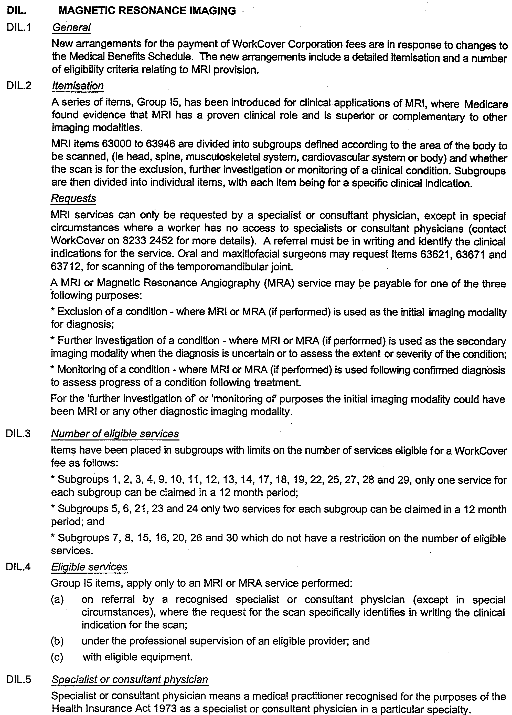
Explanatory Notes to be Substituted in Principal Regulations

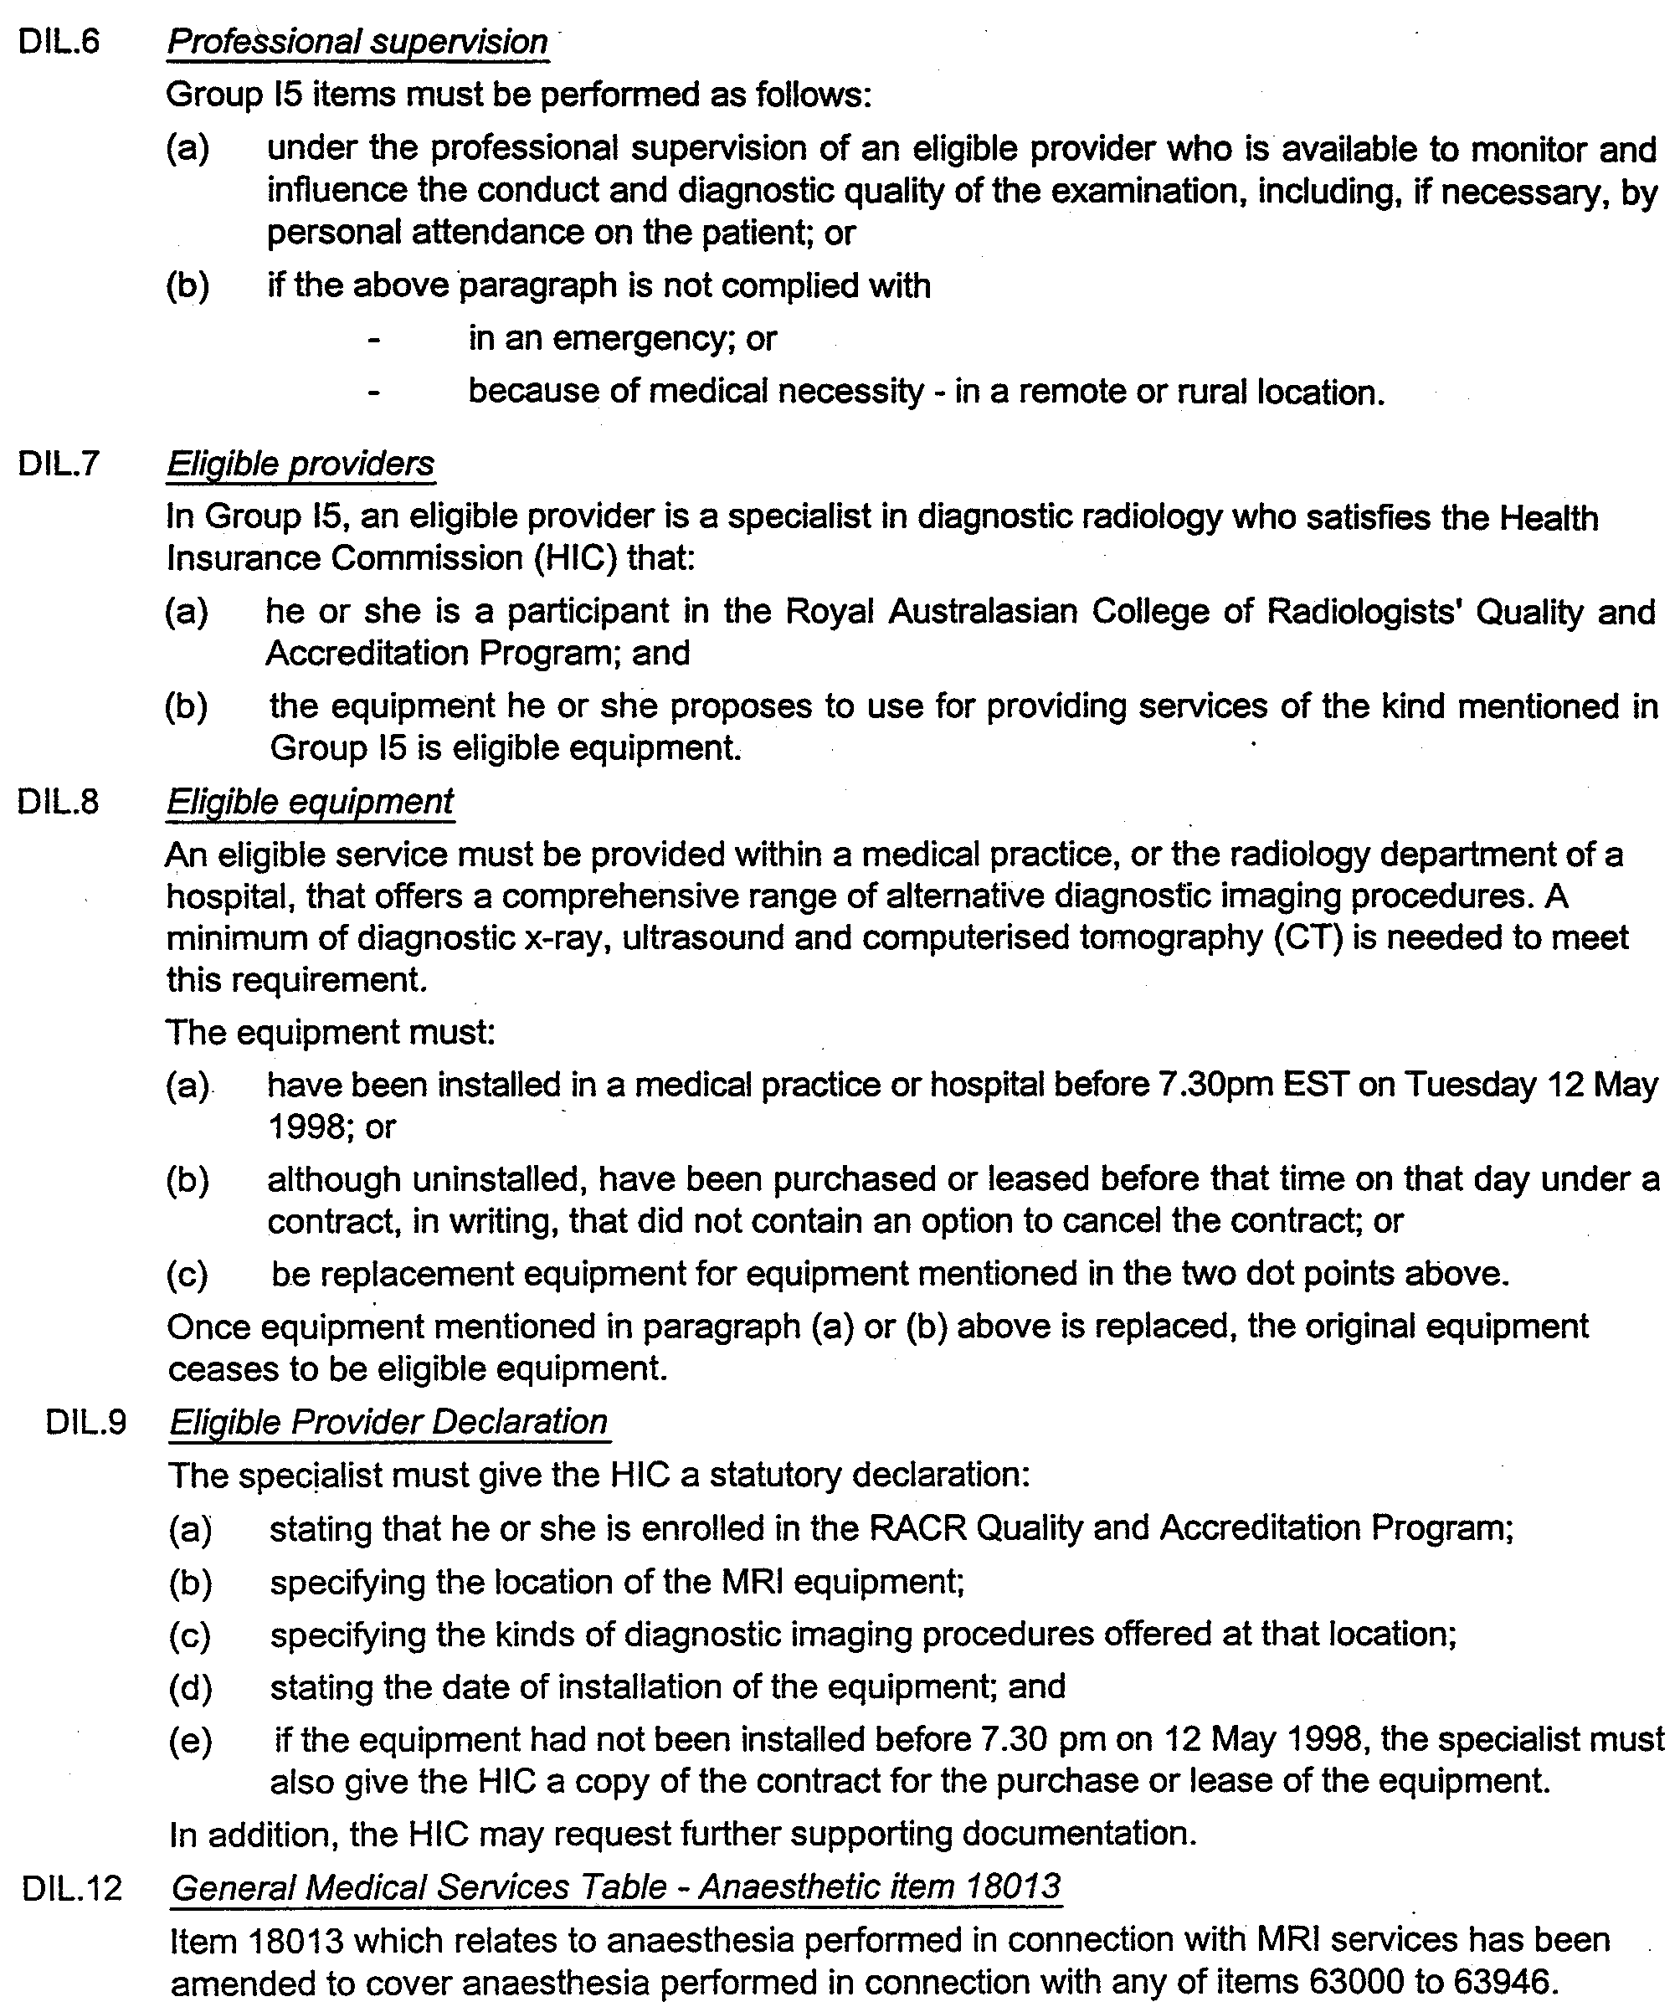
SCHEDULE 2
Entry to be Inserted in Schedule of Items of Principal Regulations

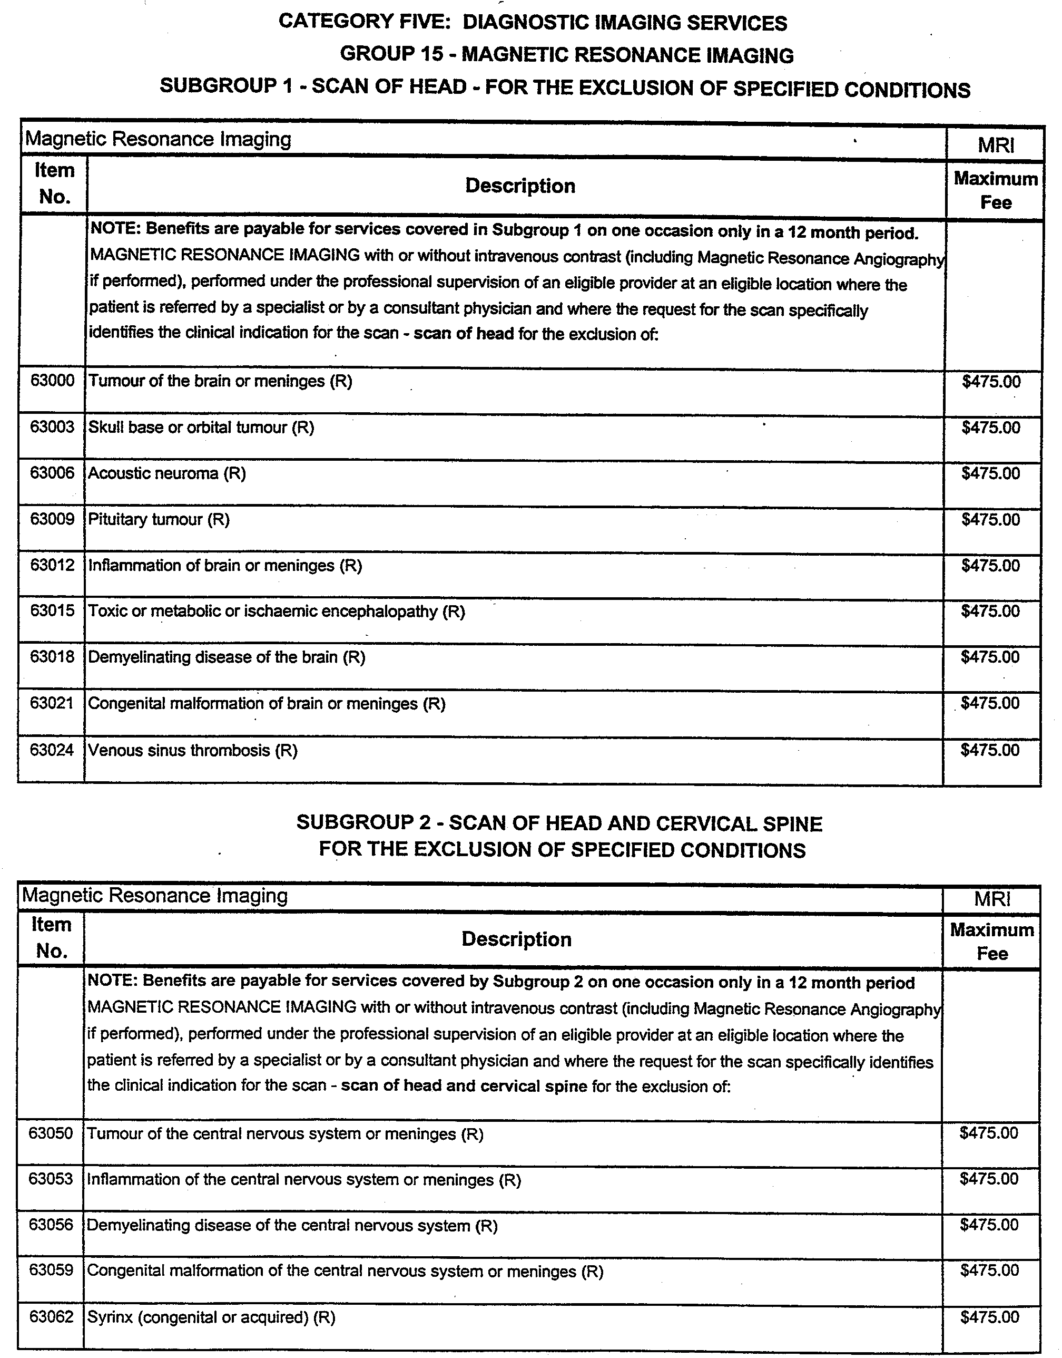

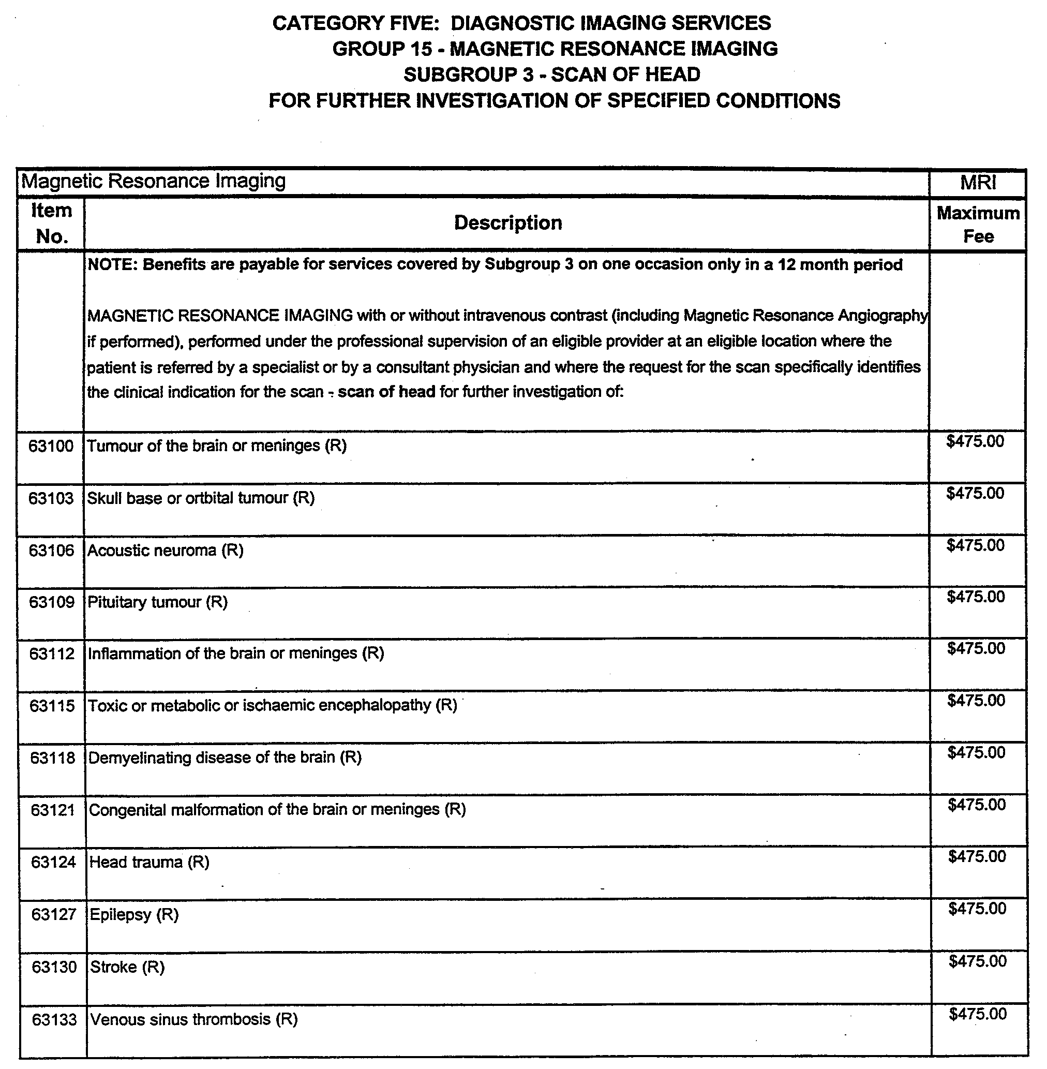

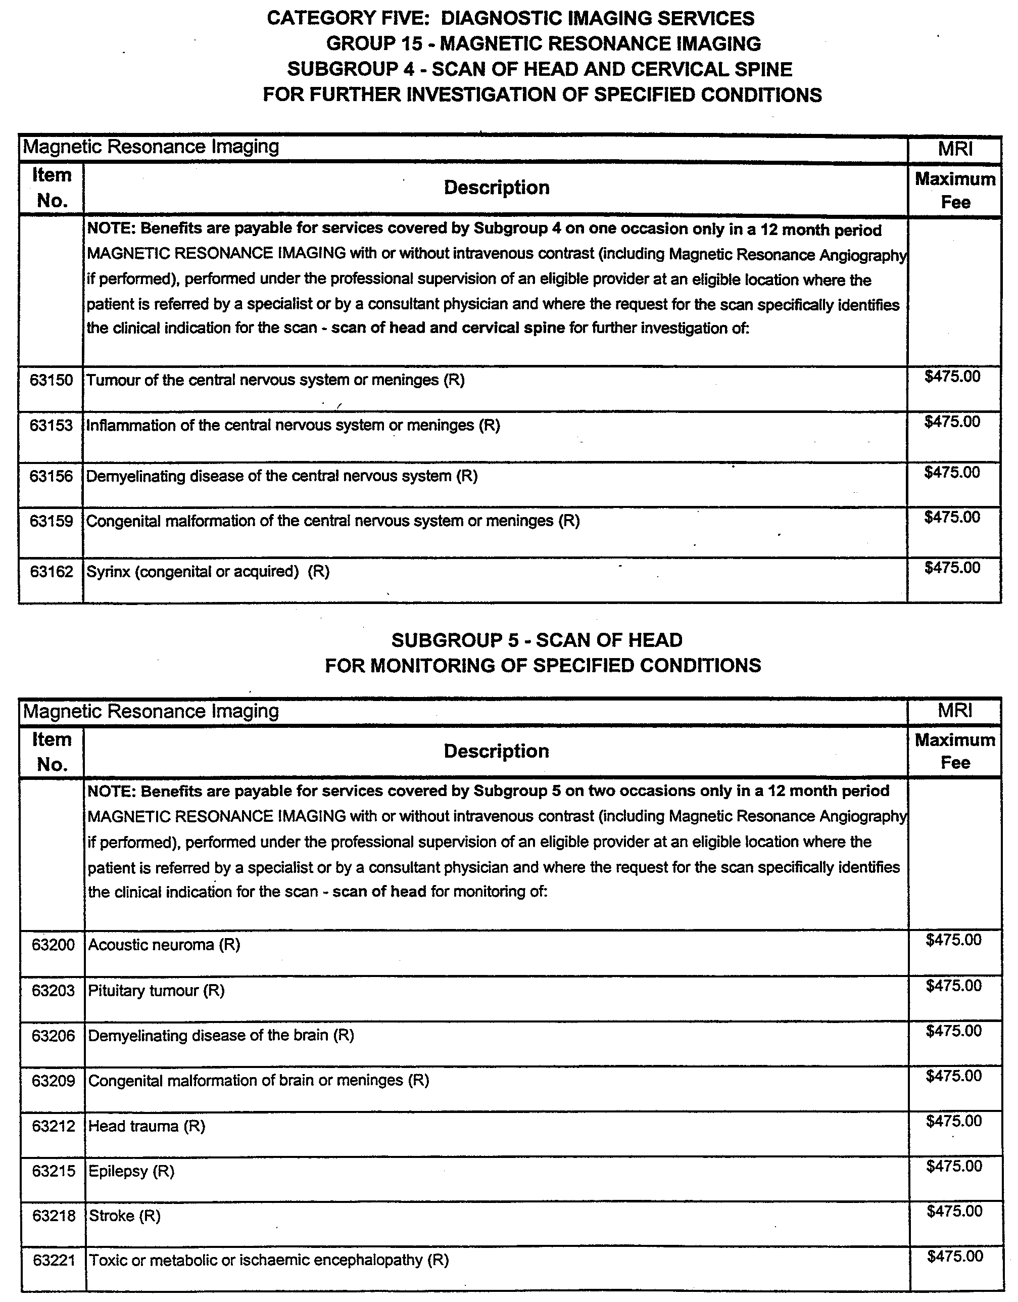

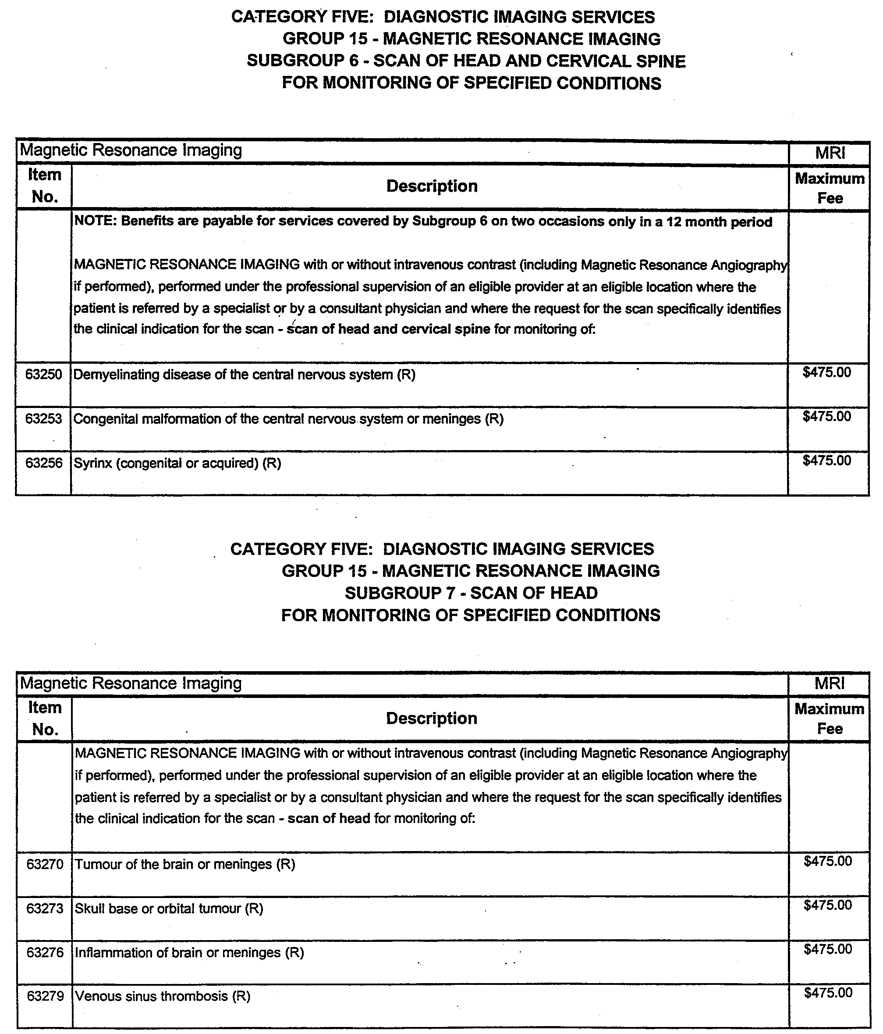

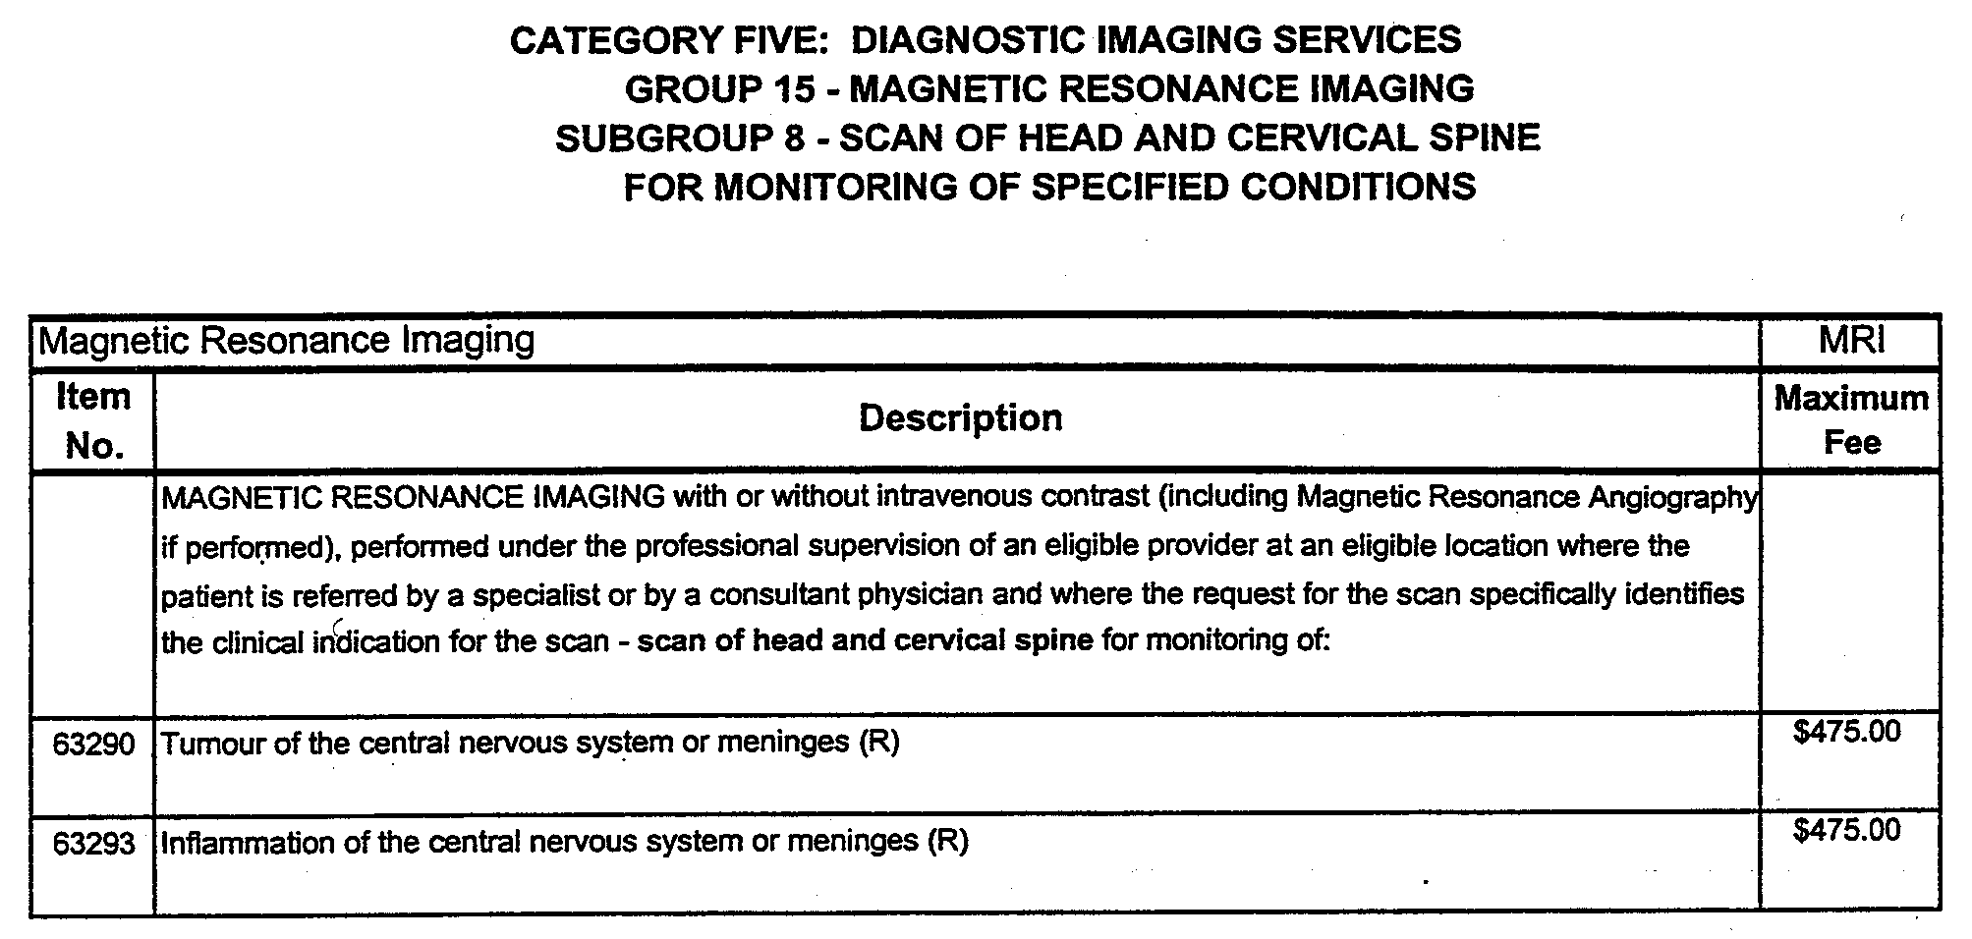

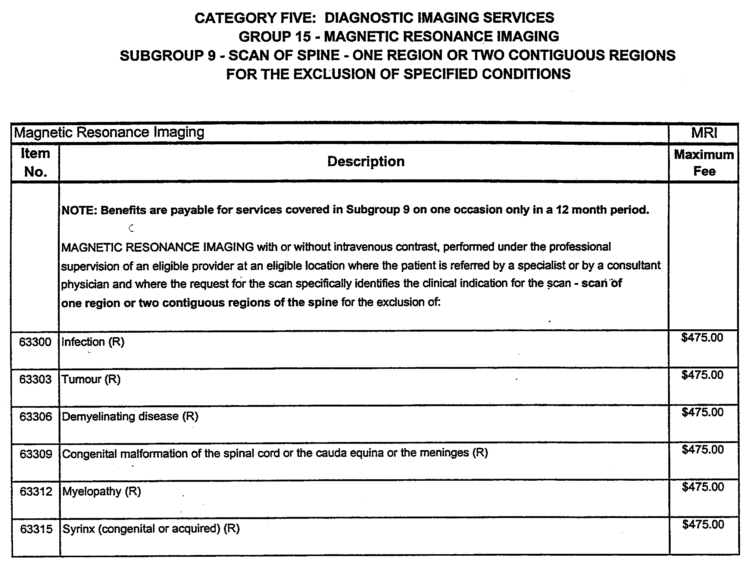

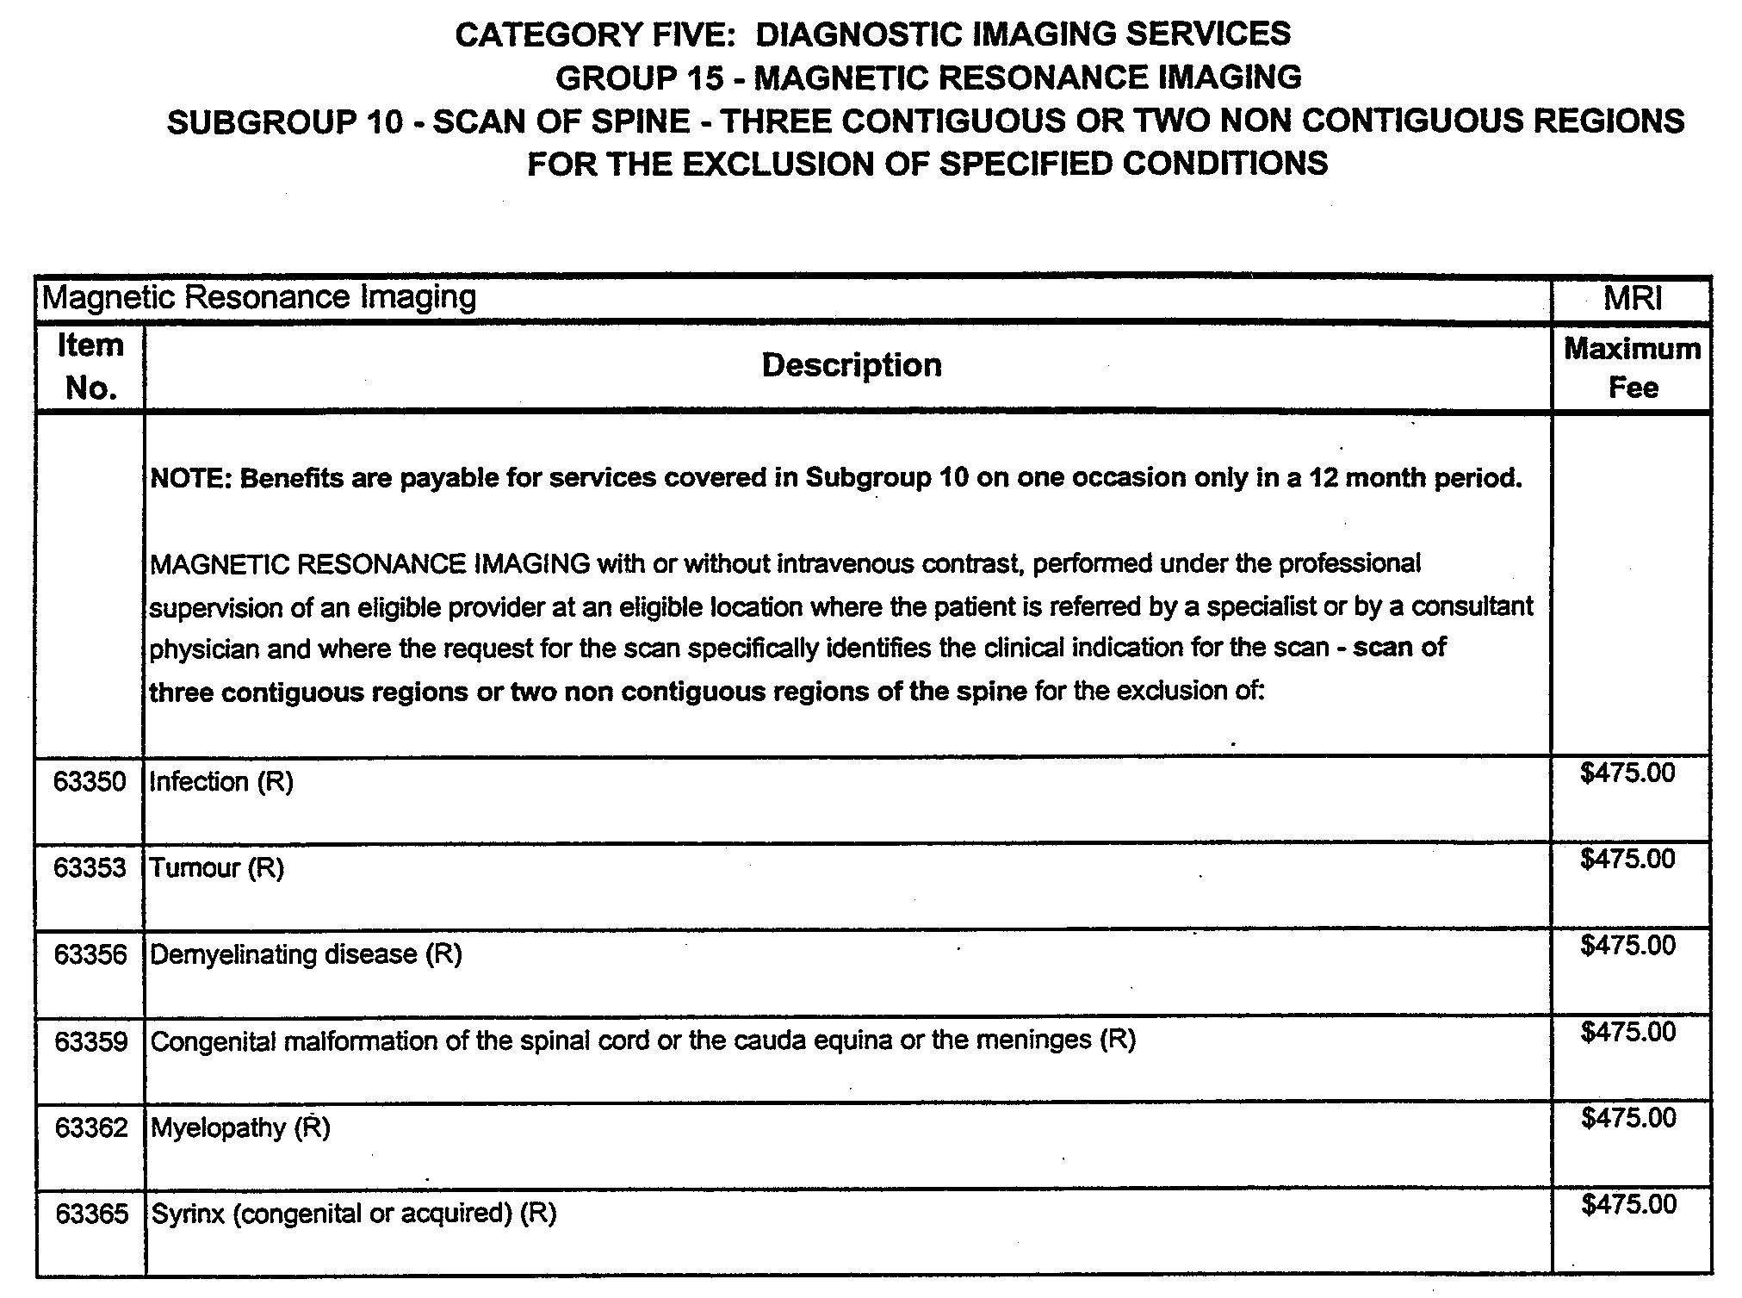

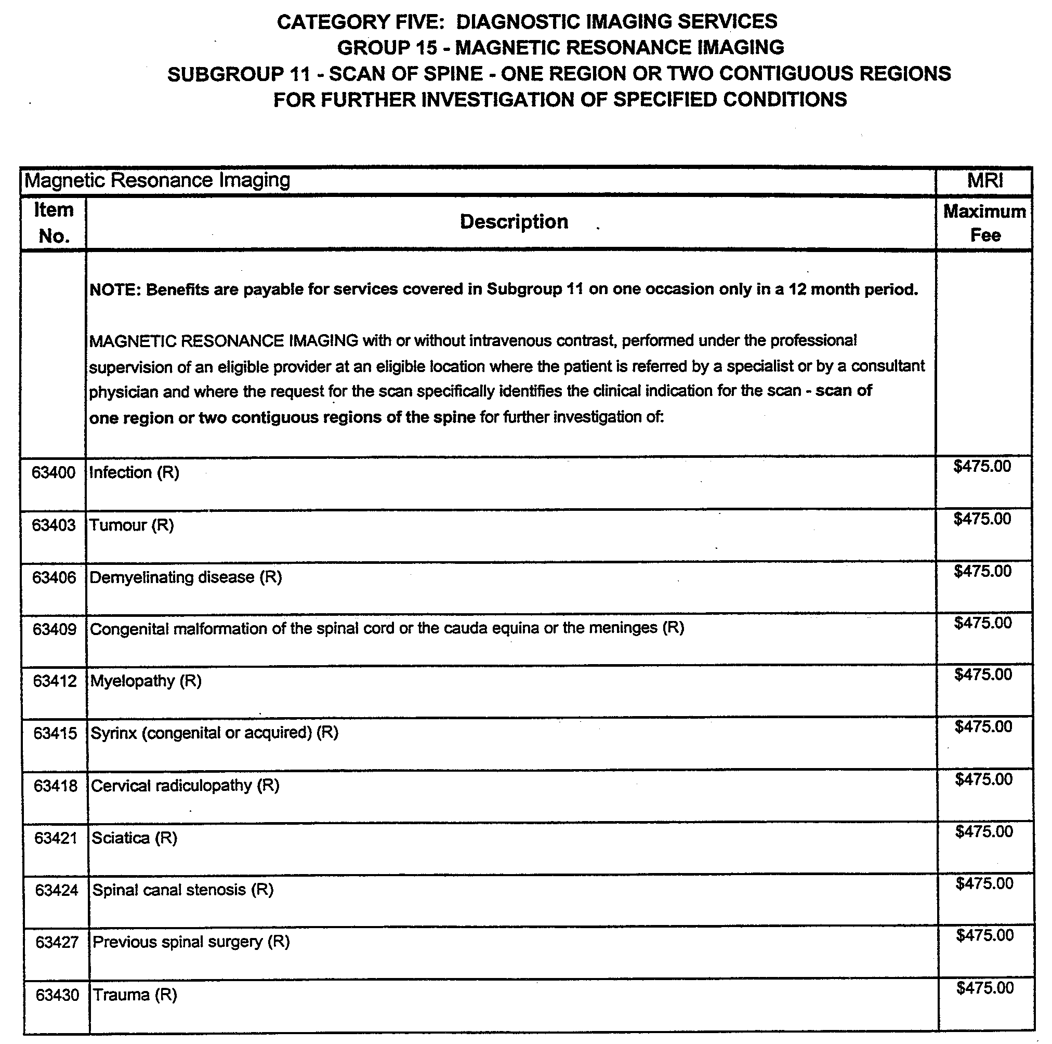

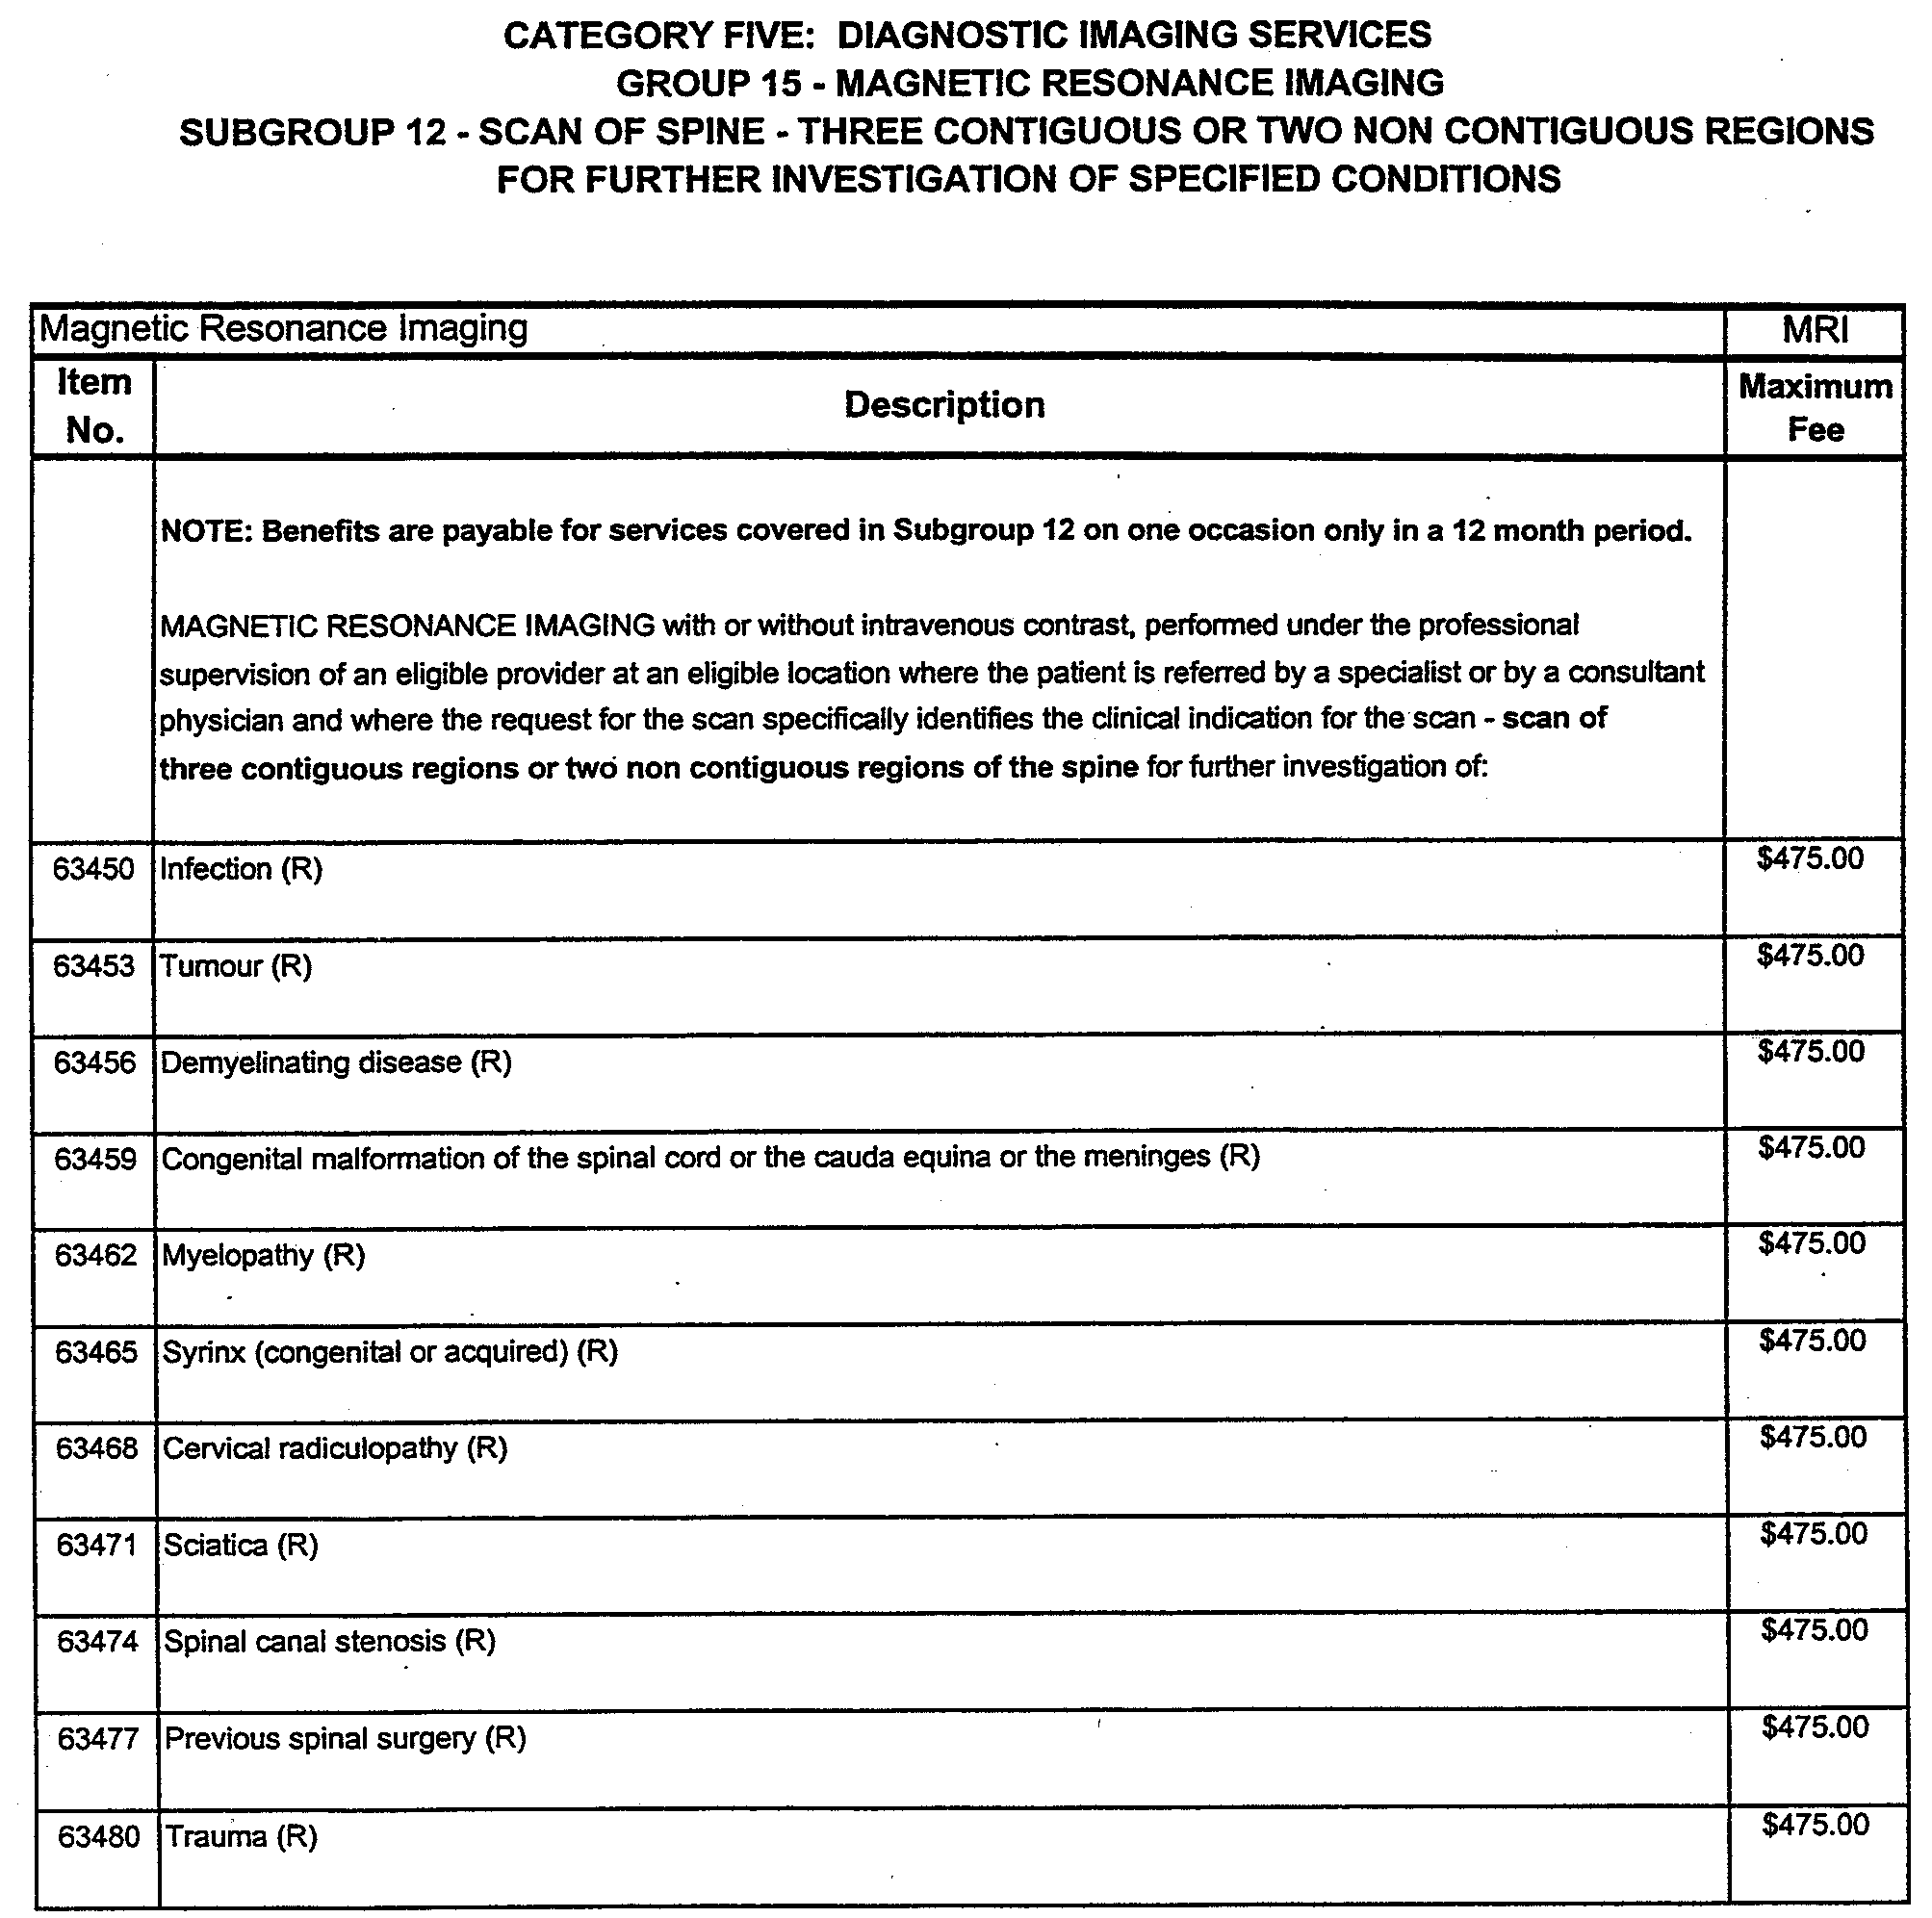

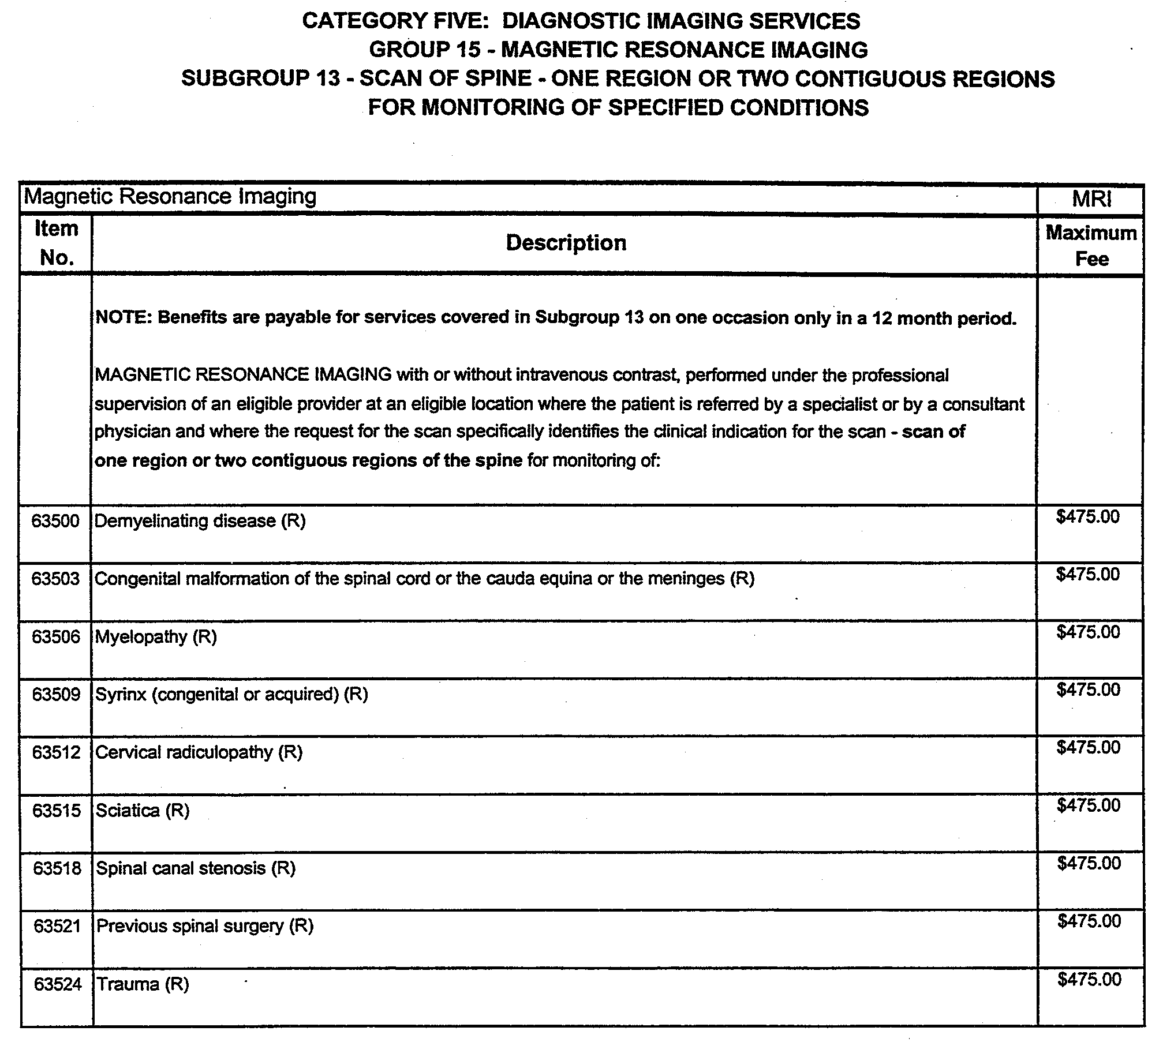

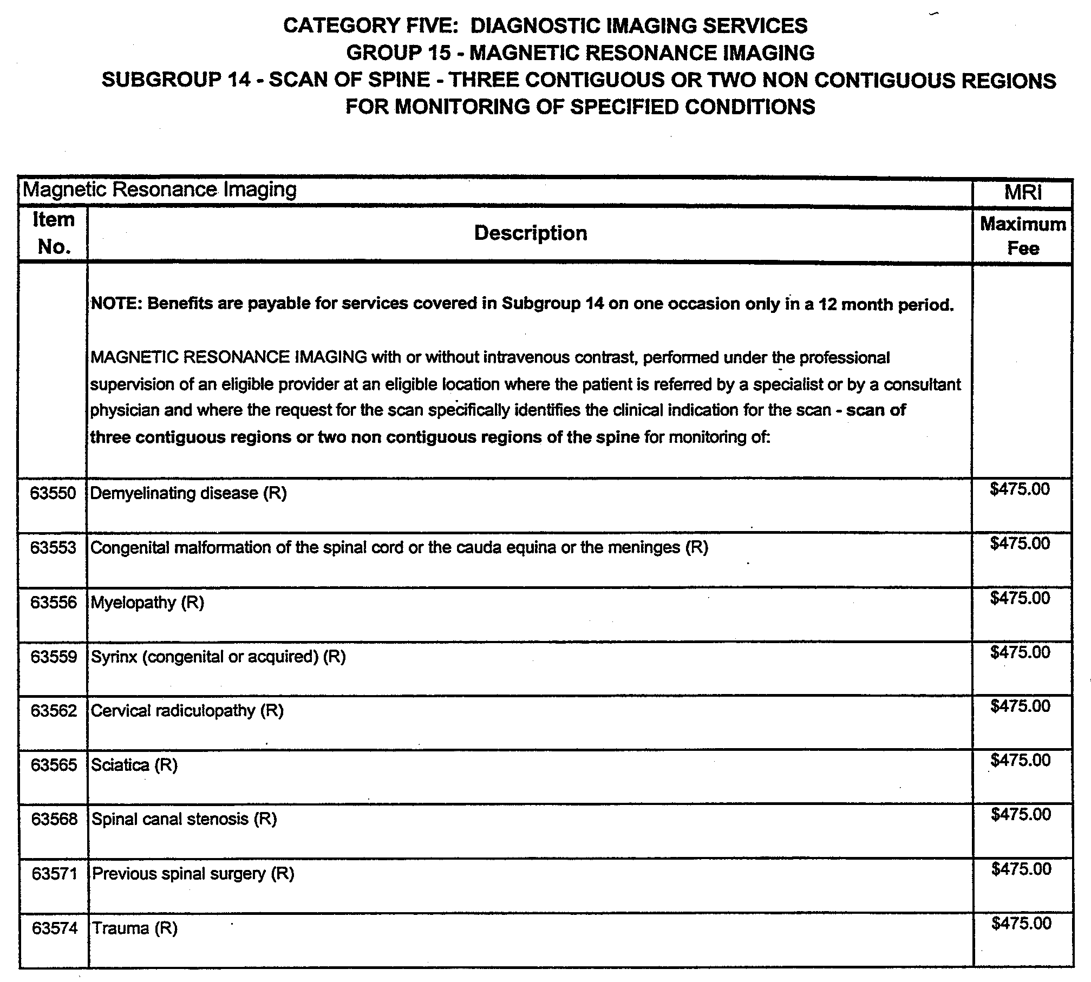

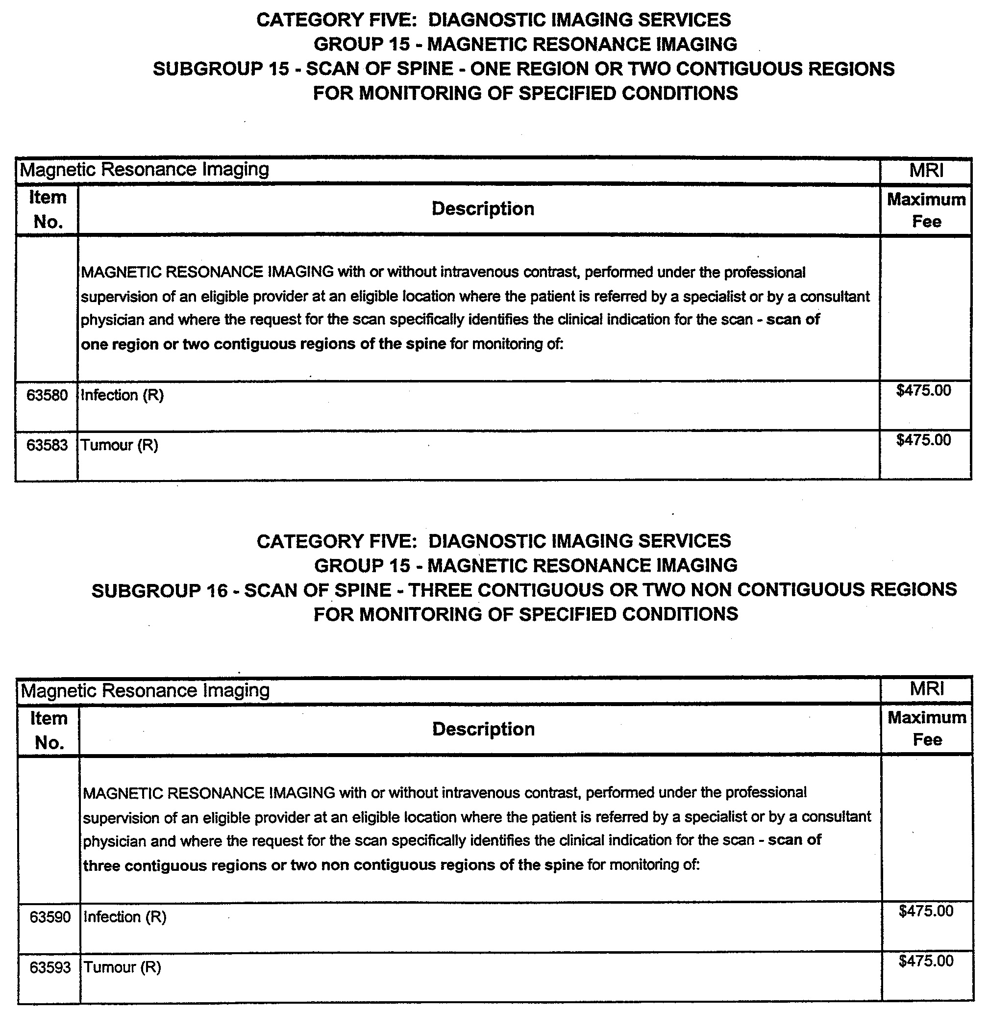

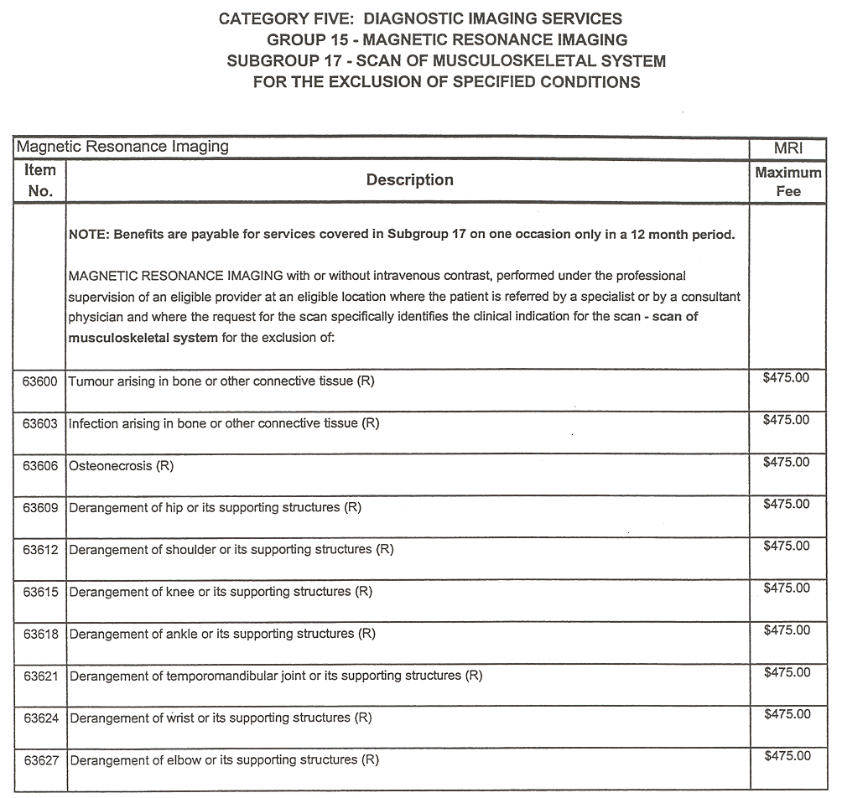

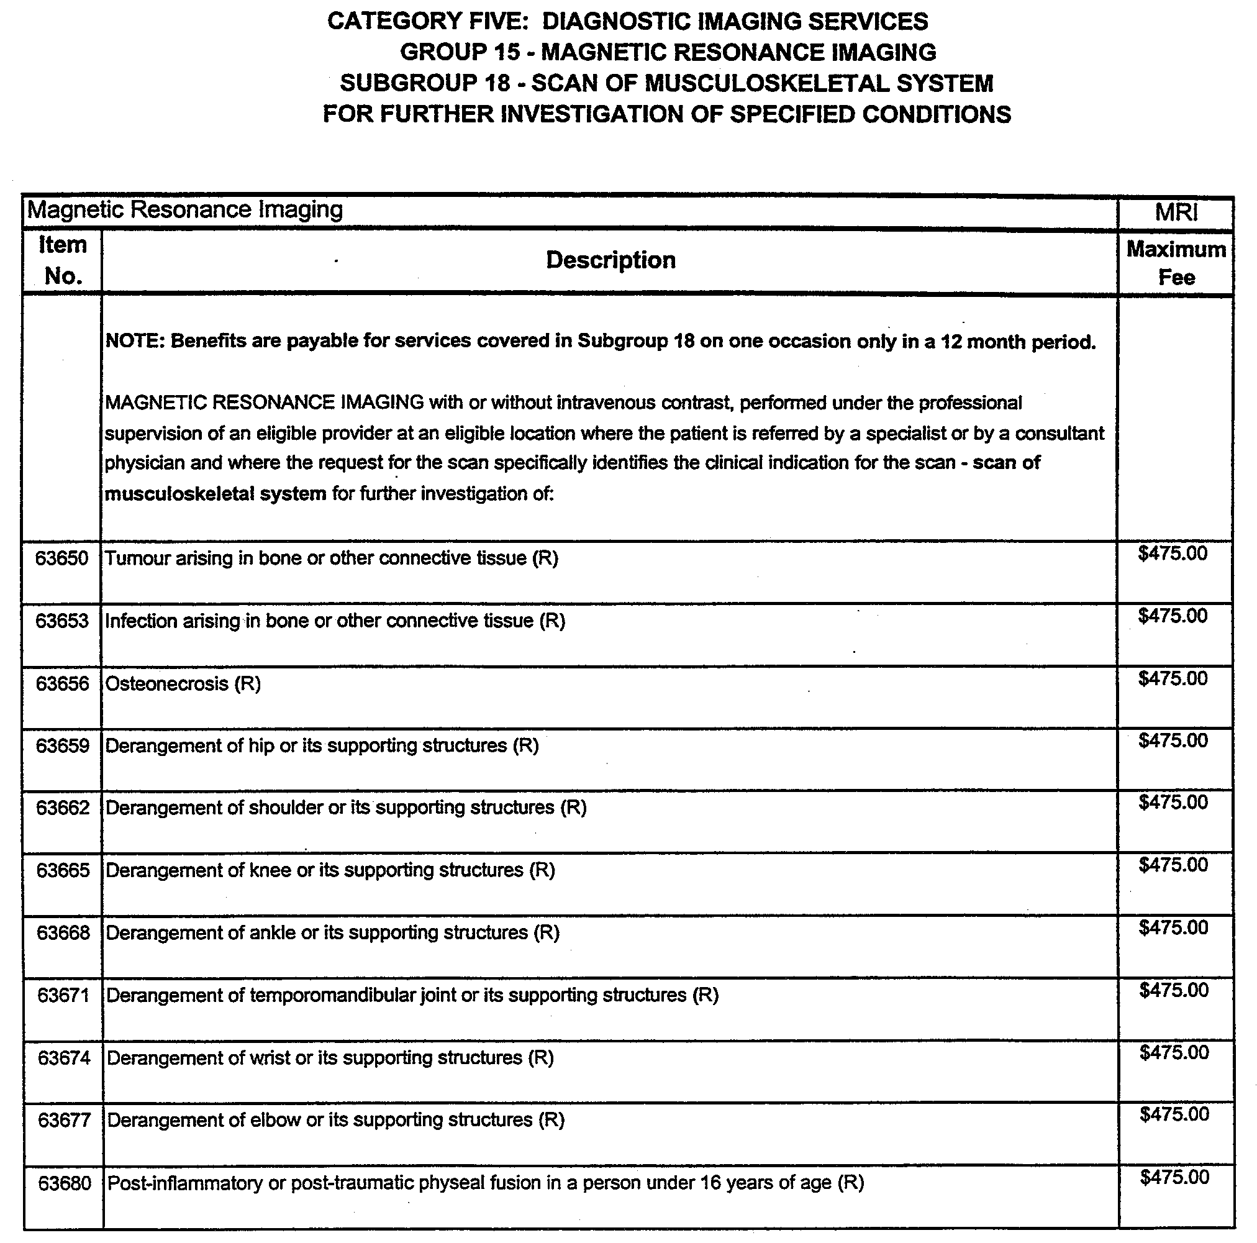

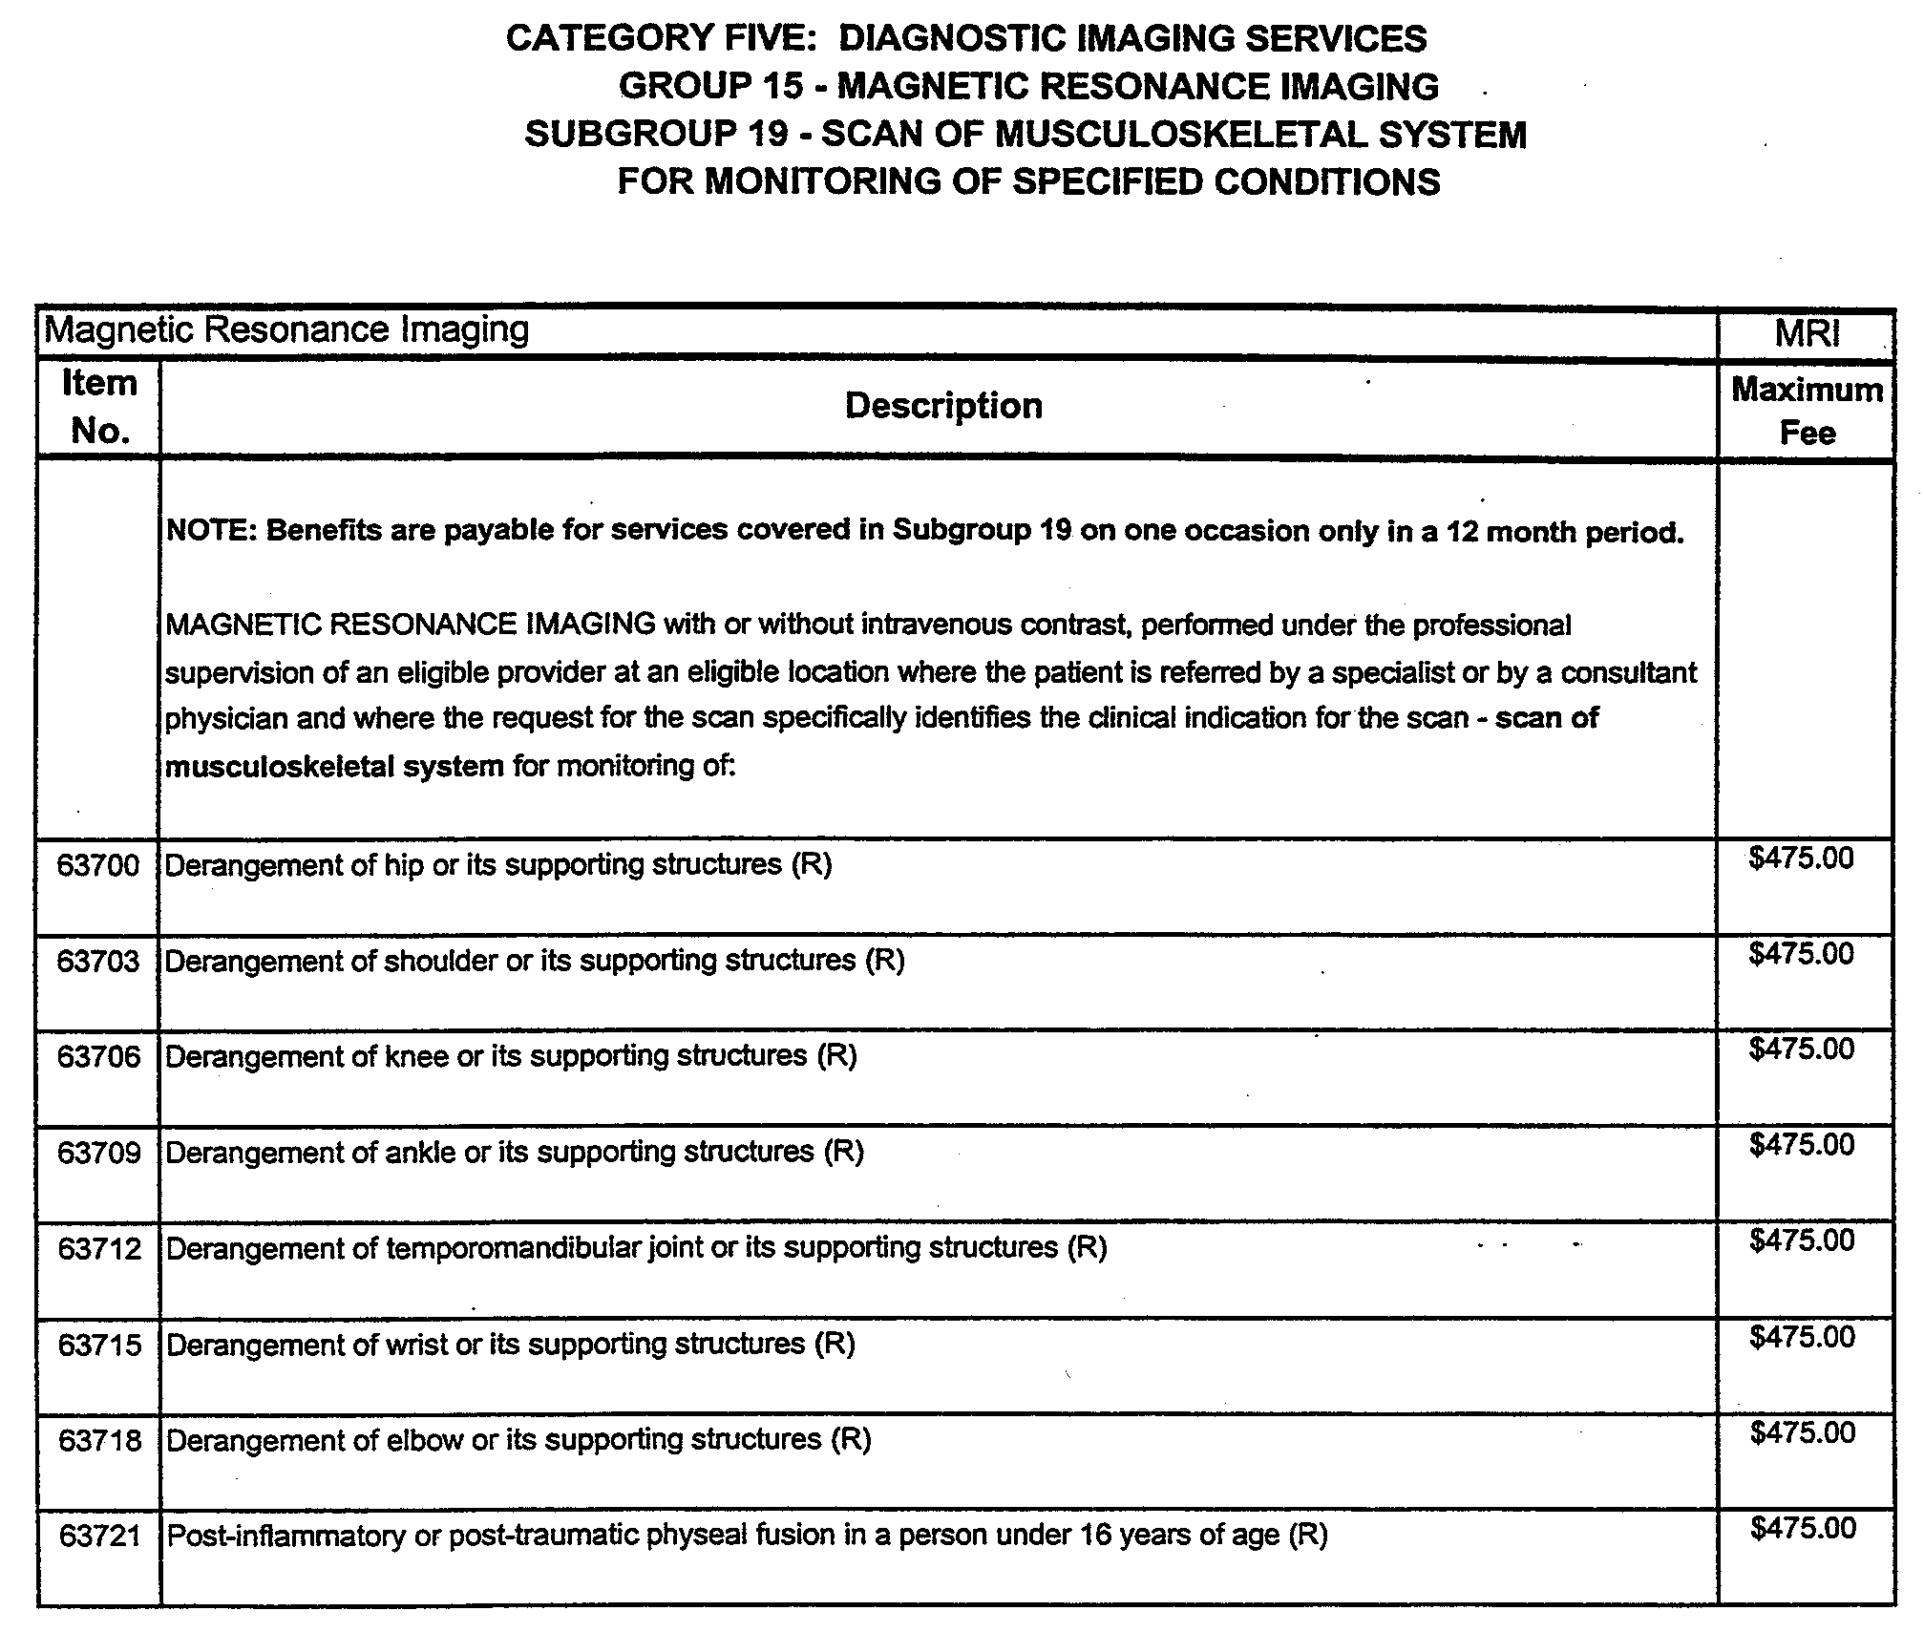

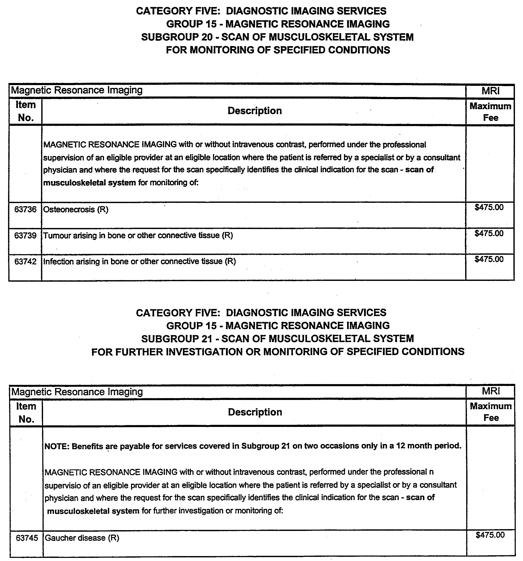

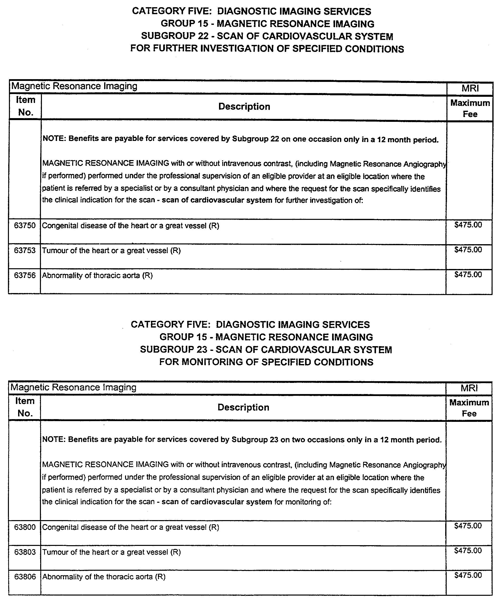

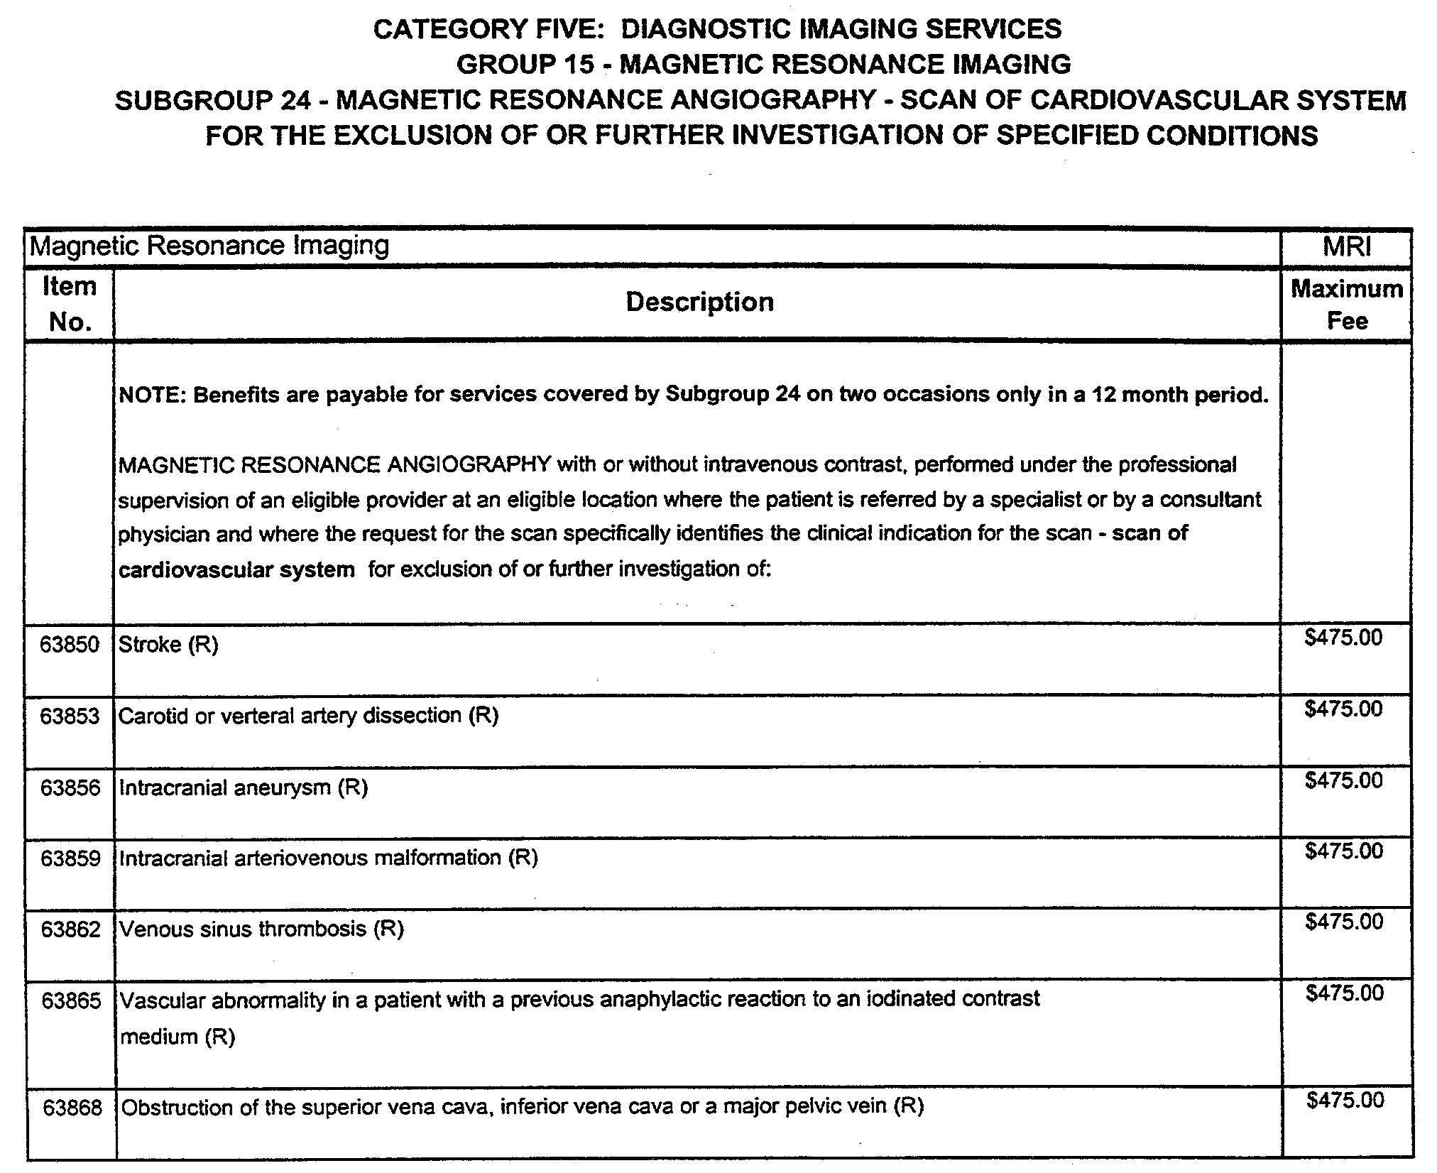

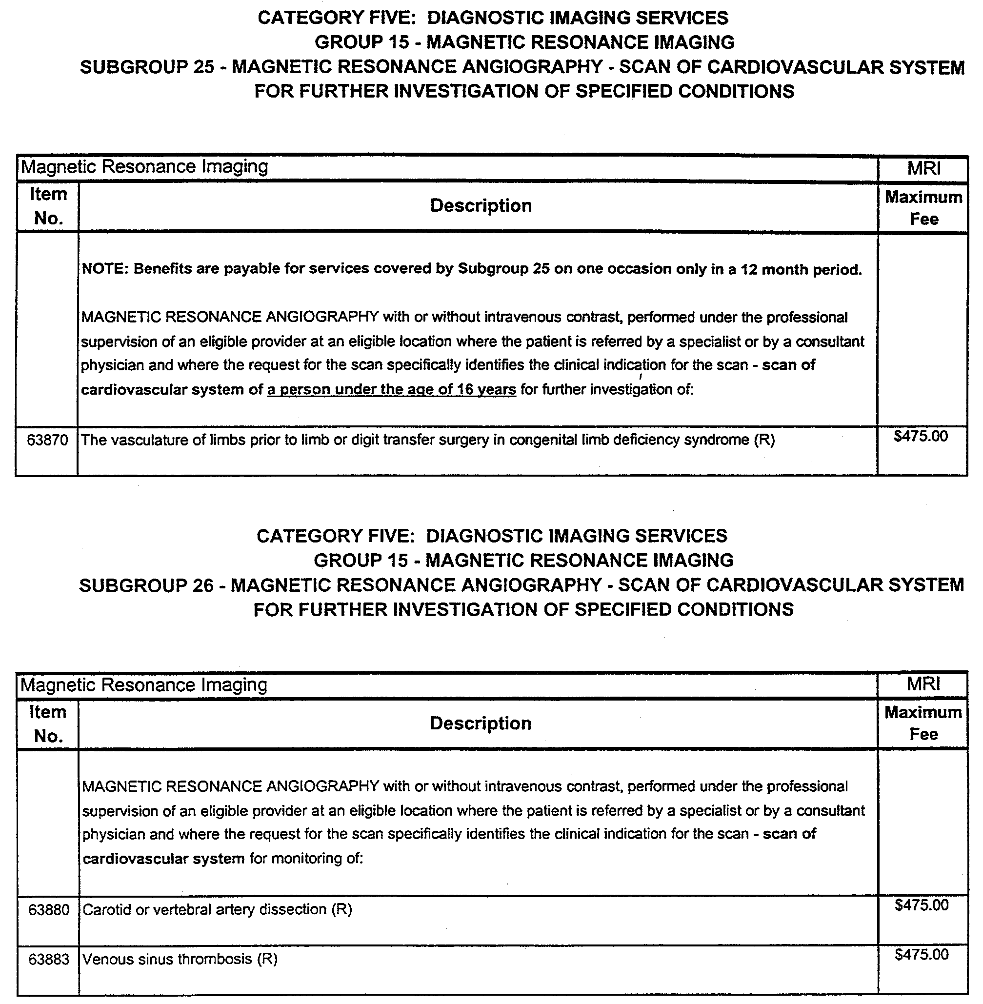

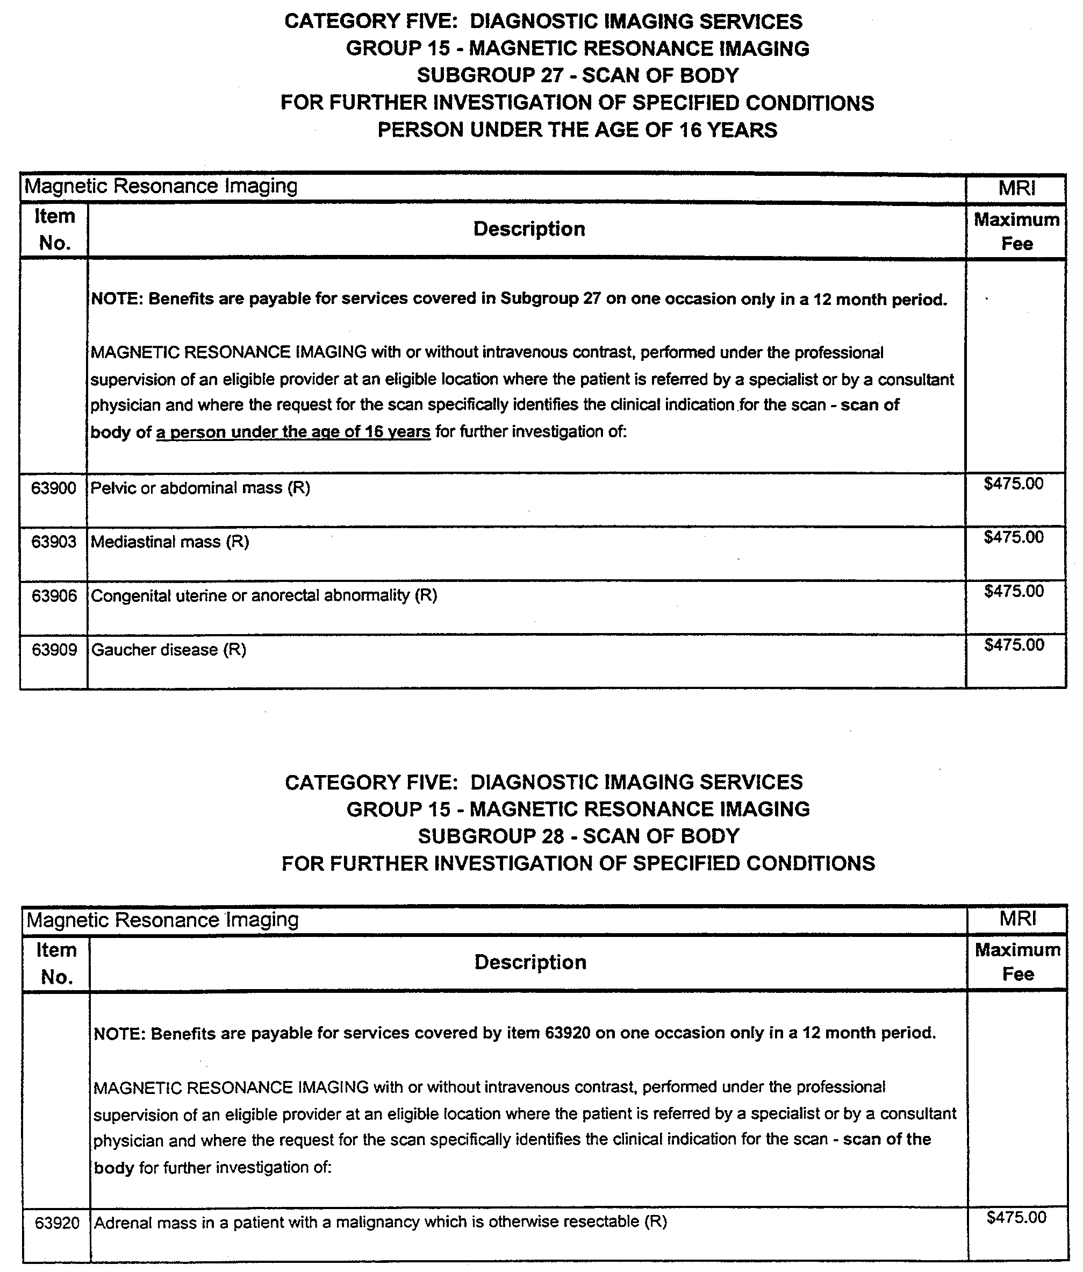

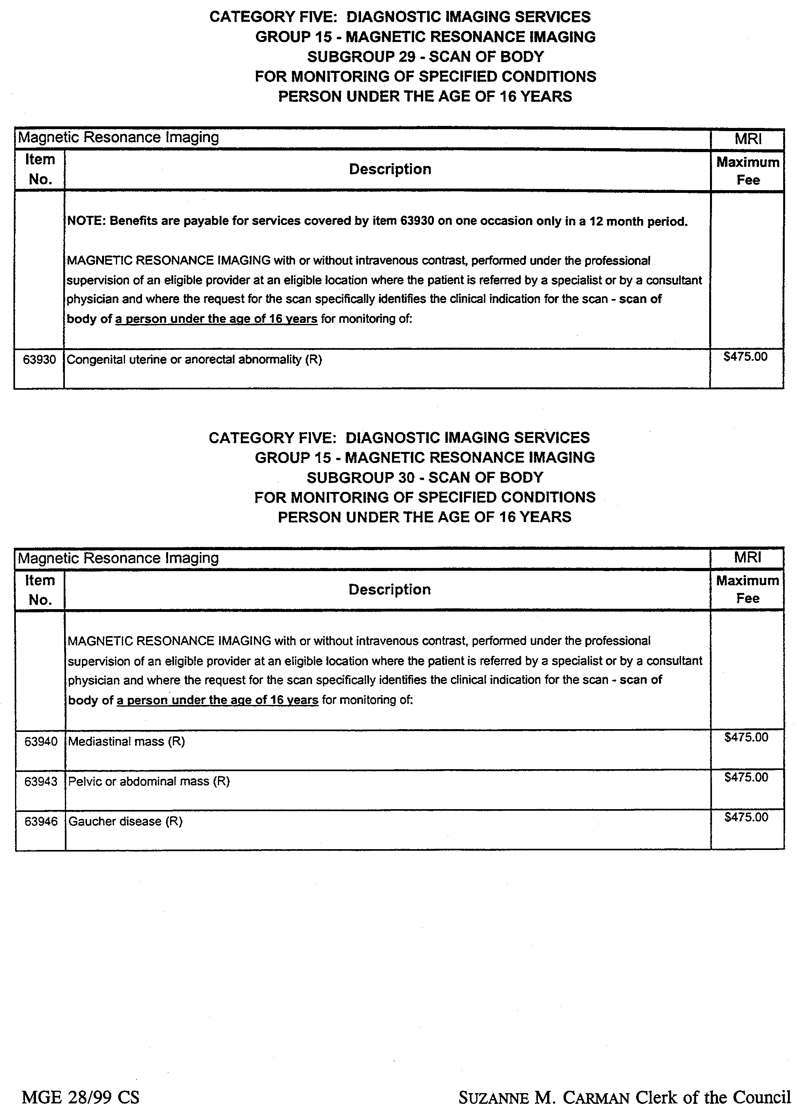

REGULATIONS UNDER THE NATIONAL PARKS AND WILDLIFE
ACT 1972
────
No. 39 of 1999
────
At the Executive Council Office at Adelaide 27 May 1999

PURSUANT to the National Parks and Wildlife Act 1972 and with the advice and consent of the Executive Council, I make the following regulations.
E. J. NEAL Governor

PURSUANT to section 10AA(2) of the Subordinate Legislation Act 1978, I certify that, in my opinion, it is necessary or appropriate that the following regulations come into operation as set out below.

D. C. KOTZ Minister for Environment and Heritage
───────────────────
SUMMARY OF PROVISIONS

1. Citation
2. Commencement
3. Variation of reg. 4—Interpretation
4. Variation of reg. 9—Records and returns in relation to section 58 and 60C permits
5. Variation of reg. 10—Class 2 permits
6. Variation of reg. 11—Premises from which animals are sold
7. Insertion of reg. 11A
11A. Advertisement to include permit number
8. Variation of reg. 12—Purchase etc., only from permit holder
9. Variation of reg. 15—Importing protected animals, carcasses and eggs
10. Variation of reg. 16—Exporting protected animals, carcasses and eggs
11. Substitution of Schedule 1—Fees

SCHEDULE 1
Fees

1. Variation of Schedule 3—Classes of Permits under sections 58 and 60C
2. Variation of Schedule 4
3. Variation of Schedule 5—Times for Provision of Returns in Relation to Sections 58 and 60C Permits
4. Substitution of Schedules 6 and 7

SCHEDULE 6

SCHEDULE 7
Species Excluded by Proclamation Under Section 58(4) of the Act
───────────────────

Citation
1. The Wildlife Regulations 1990 (see Gazette 1 November 1990 p. 1400), as varied, are referred to in these regulations as "the principal regulations".

Commencement
2. These regulations come into operation on 1 July 1999.

Variation of reg. 4—Interpretation
3. Regulation 4 of the principal regulations is varied—

(a) by striking out the definition of "pensioner" and substituting the following definitions:

"section 58 permit" means a permit granted under section 58 of the Act;

"section 59 permit" means a permit granted under section 59 of the Act;

"section 60C permit" means a permit granted under section 60C of the Act;

"specialist animal" means an animal of a specialist species;

"specialist species" means a species of protected animal that—

(a) is not excluded by proclamation under section 58(4) of the Act; and

(b) is not listed in Schedule 6.;

(b) by inserting after its present contents as varied by this regulation (now to be designated as subregulation (1)) the following subregulation:

(2) A reference in these regulations to a class 1, 2, 3, 4, 5, 7, 8, 10, 11 or 12 permit is a reference to a permit of the appropriate class referred to in Schedule 3.

Variation of reg. 9—Records and returns in relation to sections 58 and 60C permits
4. Regulation 9 of the principal regulations is varied—

(a) by striking out ", 6, 9" from subregulation (1);

(b) by striking out "section 58 or" from subregulation (2) and substituting "section 58 permit (other than a class 2 permit) or a";

(c) by inserting the following subregulation after subregulation (3):

(3a) The holder of a class 2 permit must submit the record book, or a copy of the record book, to the Director within 14 days after 30 September, 31 December, 31 March and 30 June in each year.;

(d) by inserting the following subregulation after subregulation (4):

(4a) Submission of a record book to the Director by the holder of a class 2 permit under subregulation (3a) will not be taken to be in breach of subregulation (4).;

(e) by striking out "class 1, 2, 3, 6, 9 or 12 permit" from paragraph (a) of subregulation (5) and substituting "class 1, 3 or 12 permit;

(f) by striking out "class 1, 2, or 3 permit" from subregulation (11) and substituting "class 1 or 3 permit";

(g) by striking out "class 6 or 9 permit" from subregulation (12) and substituting "class 2 permit".

Variation of reg. 10—Class 2 permits
5. Regulation 10 of the principal regulations is varied by striking out "class 6 or 9 permit" (twice occurring) from subregulation (3) and substituting, in each case, "class 2 permit".
Variation of reg. 11—Premises from which animals are sold
6. Regulation 11 of the principal regulations is varied by striking out "class 6 or 9 permit" from paragraph (a) of subregulation (1) and substituting "class 2 permit".

Insertion of reg. 11A
7. The following regulation is inserted after regulation 11 of the principal regulations:

Advertisement to include permit number
11A. Where section 58 of the Act requires that the sale of a protected animal be authorised by a permit granted under that section, a person who advertises the animal for sale must state in the advertisement the number of the permit that authorises the sale.

Variation of reg. 12—Purchase etc., only from permit holder
8. Regulation 12 of the principal regulations is varied—

(a) by striking out from subregulation (1) "who does not hold a permit authorising the sale or gift of the animal, carcass or eggs" and substituting "who is required by the Act to hold a permit authorising the sale or gift if that person does not hold the required permit".;

(b) by striking out subregulation (2).

Variation of reg. 15—Importing protected animals, carcasses and eggs
9. Regulation 15 of the principal regulations is varied by striking out paragraph (b) of subregulation (1) and substituting the following paragraphs:

(b) if the proposed importation does not proceed—inform the Director of that fact within 48 hours after he or she first became aware that it would not proceed; and

(c) if the importation does proceed but one or more of the particulars of the importation differ from those stated under paragraph (a)—inform the Director of the variation within 48 hours after the importation takes place.

Variation of reg. 16—Exporting protected animals, carcasses and eggs
10. Regulation 16 of the principal regulations is varied—

(a) by striking out subregulation (1) and substituting the following subregulation:

(1) A person who exports a protected animal or the carcass or egg of a protected animal pursuant to a section 59 permit must ensure that—

(a) the original permit; or

(b) in the case of a class 2 permit—a photocopy of the original permit; or

(c) in the circumstances prescribed by subregulation (1a)—a facsimile of the original permit transmitted to the person by the Minister,

is securely attached in a conspicuous position to the receptacle or package containing the protected animal, carcass or egg.;

(b) by striking out "class 6, 7, 8, 9 or 12 permit" from subregulation (1a) and substituting "class 1, 2, 3, 7, 8 or 12 permit".

Substitution of Schedule 1—Fees
11. Schedule 1 of the principal regulations is revoked and the following schedule is substituted:

SCHEDULE 1
Fees

1. Take permit (s. 53(1)(d)) |  | $32.00
2. The following fees are payable:
(a) on application for a permit
Keep and sell permit (s. 58) | Fee for a period of 1, 3 or 5 years (a period of less than 1 year but more than 6 months will be taken to be 1 year) ending on 30 June | Fee for a period of 6 months or less ending 30 June
Class 1 | $40.00 per year | $24.00
Class 2 (Schedule 6 animals only) | $700.00 per year | $385.00
Class 2 (Schedule 6 and specialist animals) | $1000.00 per year | $550.00
Class 3 | $70.00 per year | $39.00
Class 4 | $323.00 per year | $180.00
Class 5 | $646.00 per year | $359.00
Class 7 | $1292.00 per year | $719.00
Class 8 | $646.00 per year | $359.00
Class 10 | Nil | Nil
Class 11 | $20.00 per year | $11.00
Transfer
transfer class 1 to 3 | $30.00 | $15.00
transfer class 2 (Schedule 6 animals only) to Class 2 (Schedule 6 and specialist animals) | $300.00 | $165.00

Emu farming permit (s.60C)—
Class 12 | $276.00 | $149.50
for each additional property to which permit applies | $111.00 | $66.50
(b) on application for an additional record or return book under reg. 9(10) |  | $7.50
(c) on application for approval of premises under reg. 10 or 11 |  | $137.50

Variation of Schedule 3—Classes of Permits under sections 58 and 60C
12. Schedule 3 of the principal regulations is varied—

(a) by striking out the items headed "Class 1", "Class 2" and "Class 3" and substituting the following items:

Class 1: entitles the holder (being a person who does not carry on the business of dealing in protected animals) to keep two or more of the animals of the species listed in Schedule 6 or to sell or give one or more of the animals of the species listed in Schedule 6.

Class 2: entitles the holder in the course of carrying on the business of dealing in protected animals to keep and sell—

(a) animals of the species listed in Schedule 6; and

(b) specialist animals identified in the permit by reference to the species or other class to which they belong.

Class 3: entitles the holder (being a person who does not carry on the business of dealing in protected animals) to keep, sell or give specialist animals identified in the permit by reference to the species or other class to which they belong.;

(b) by striking out the items headed "Class 6" and "Class 9".

Variation of Schedule 4
13. Schedule 4 of the principal regulations is varied—

(a) by striking out "1" under the heading "Class of Permit" and substituting "1 and 3";

(b) by inserting before "Date of return" under the heading "Information Required" opposite "1 and 3" inserted by paragraph (a) the following:

Period of return
Name and address
Permit number;

(c) by striking out "2, 3, 6 and 9" under the heading "Class of Permit" and the items under the heading "Information Required" relating to "2, 3, 6 and 9" removed by this paragraph.

Variation of Schedule 5—Times for Provision of Returns in Relation to Sections 58 and 60C Permits
14. Schedule 5 of the principal regulations is varied by striking out that part of the schedule appearing after "set out below—" and substituting the following:

Class of Permit | Day
Class 1 | 30 June
Class 3 | 28 February, 30 June
Classes 4 and 5 | 30 September, 31 December, 31 March, 30 June
Classes 7 and 8 | the last day of each month
Class 11 | 30 June
Class 12 | 30 April, 31 October

Substitution of Schedules 6 and 7
15. Schedules 6 and 7 of the principal regulations are revoked and the following schedules are substituted:

SCHEDULE 6

This schedule is a list of species prescribed both for the purposes of section 58(1)(a) of the Act and for the definition of Class 1 permit in Schedule 3.

Species Code | Common Name | Zoological name
 | Mammals
M1262 | Agile Wallaby | Macropus agilis
U1274 | Antilopine Wallaroo | Macropus antilopinus
Y1260 | Black-striped Wallaby | Macropus dorsalis
K1181 | Brush-tailed Bettong | Bettongia penicillata
C1129 | Common Ringtail Possum | Pseudocheirus peregrinus
U1266 | Common Wallaroo | Macropus robustus
M1246 | Dama Wallaby | Macropus eugenii
S1265 | Eastern Grey Kangaroo | Macropus giganteus
A1072 | Fat-tailed Dunnart | Smithopsis crassicaudata
Z1263 | Kangaroo Island Kangaroo | Macropus fuliginosus fuliginosus
Z1175 | Long-nosed Potoroo | Potorous tridactylus
Y1480 | Mitchell’s Hopping Mouse | Notomys mitchelli
K1245 | Parma Wallaby | Macropus parma
W1275 | Red Kangaroo | Macropus rufus
G1235 | Red-bellied Pademelon | Thylogale billardierii
E1234 | Red-legged Pademelon | Thylogale stigmatica
Y1236 | Red-necked Pademelon | Thylogale thetis
K1261 | Red-necked Wallaby | Macropus rufogriseus
W1187 | Rufus Bettong | Aepyrymnus rufescens
C1137 | Squirrel Glider | Petaurus norfolcensis
E1138 | Sugar Glider | Petaurus breviceps
E1242 | Swamp Wallaby | Wallabia bicolor
M1182 | Tasmanian Bettong | Bettongia gaimardi
Z1467 | Western Chestnut Mouse | Pseudomys nanus
Z1263 | Western Grey Kangaroo | Macropus fuliginosus
 | Birds
G0283 | Adelaide Rosella | Platycerus elegans adelaidae
C0281 | Australian King Parrot | Alisterus scapularis
G0291 | Australian Ringneck | Barnardius zonarius barnardi
G0207 | Australian Shelduck | Tadorna tadornoides
G0135 | Banded Plover | Vanellus tricolor
Y0208 | Black Duck | Anas superciliosa
A0424 | Black Faced Cuckoo-shrike | Coracina novaehollandiae
W0203 | Black Swan | Cygnus atratus
S0017 | Black-breasted Button Quail | Turnix melanogaster
G0055 | Black-tailed Native Hen | Gallinula ventralis
Z0667 | Black-throated Finch (Diggles) | Poephila cincta atropgialis
Z0667 | Black-throated Finch (Parsons) | Poephila cincta cincta
M8010 | Blue-cheeked Rosella | Platycercus adscitus amathusia
M0306 | Blue-winged Parrot | Neophema chrysostoma
M0242 | Boobook Owl | Ninox novaeseelandiae
C0029 | Brown Cuckoo-dove | Macropygia amboinensis
G0011 | Brown Quail | Coturnix australis
W0035 | Brush Bronzewing | Phaps elegans
E0206 | Burdekin Duck | Tadorna radjah
M0198 | Cape Barren Goose | Cereopsis novaehollandiae
U0210 | Chestnut Teal | Anas castanea
Y0292 | Cloncurry Parrot | Barnardius barnardi macgillivrayi
Y0664 | Crimson Finch | Neochmia phaeton
E0282 | Crimson Rosella | Platycercus elegans
A0652 | Diamond Firetail | Stagonopleura guttata
Q0288 | Eastern Rosella | Platycercus eximius
K8029 | Eclectus Parrot | Eclectus roratus macgilivrayi
C0001 | Emu | Dromaius novaehollandiae
A0036 | Flock Pigeon | Phaps histrionica
E0670 | Gouldian Finch | Erythrura gouldiae
K0285 | Green Rosella | Platycercus caledonicus
W0211 | Grey Teal | Anas gracilis
G0215 | Hard head Duck | Aythya australis
C0301 | Hooded Parrot | Psephotus dissimilis
M0322 | Laughing Kookaburra | Dacelo novaeguineae
U0018 | Little Button Quail | Turnix velox
Q0260 | Little Lorikeet | Glossopsitta pusilla
Z0199 | Magpie Goose | Anseranas semipalmata
U0270 | Major Mitchell’s Cockatoo | Cacatua leadbeateri
S0669 | Masked Finch | Poephila personata
C0133 | Masked Lapwing | Vanellus miles
Q0296 | Mulga Parrot | Psephotus varius
Z0287 | Northern Rosella | Platycercus venustus
M0014 | Painted Button-quail | Turnix varia
M0286 | Pale-headed Rosella | Platycercus adscitus
Q0040 | Partridge Pigeon | Geophaps smithii
Z0659 | Pictorella Mannikin | Heteromunia pectoralis
C0205 | Plumed Whistling-Duck | Dendrocygna eytoni
C0661 | Plum-headed Finch | Neochmia modesta
M0294 | Port Lincoln Parrot | Barnardius zonarius myrtae
G0259 | Purple-crowned Lorikeet | Glossopsitta porphyrocephala
K0013 | Red-backed Button-quail | Turnix maculosa
E0662 | Red-browed Finch | Neochmia temporalis
E0290 | Red-capped Parrot | Purpureicephalus spurius
W0019 | Red-chested Button-quail | Turnix pyrrhothorax
W0255 | Red-collared Lorikeet | Trichoglossus rubritorquis
M8002 | Red-vented Blue Bonnet | Northiella haematogaster haematorrhous
A0280 | Red-winged Parrot | Aprosmictus erythropterus
M0278 | Regent Parrot | Polytelis anthopeplus
Q0308 | Rock Parrot | Neophema petrophila
A0256 | Scaly-breasted Lorikeet | Trichoglossus chlorolepidotus
U0042 | Spinifex Pigeon | Geophaps plumifera
C0133 | Spur-winged Plover | Vanellus miles novaehollandiae
G0039 | Squatter Pigeon | Geophaps scripta
S0529 | Surperb Blue Wren | Malurus cyaneus cyaneus
K0277 | Superb Parrot | Polytelis swainsonii
K0313 | Tawny Frogmouth` | Podargus strigoides
U0026 | Torres Strait Pigeon | Ducula bicolor
C0257 | Varied Lorikeet | Psitteuteles versicolor
A0204 | Wandering Whistling-Duck | Dendrocygna arcuata
S0289 | Western Rosella | Platycercus icterotis
S0669 | White eared Masked Finch | Poephila personata leucotis
A0028 | White-headed Pigeon | Columba leucomela
A0044 | Wonga Pigeon | Leucosarcia melanoleuca
U0202 | Wood Duck | Chenonetta jubata
Y0284 | Yellow Rosella | Platycercus elegans flaveolus
M0658 | Yellow-rumped Mannikin | Lonchura flaviprymna
S0297 | Yellow-vented Blue Bonnet | Northiella haematogaster haematogaster
 | Reptiles
S2161 | Adelaide Snake-lizard | Delma molleri
Y2028 | Australian Snapping Turtle | Elseya dentata
K2109 | Beaded Gecko | Diplodactylus damaeus
S2137 | Beaked Gecko | Rhynchoedura ornata
K2425 | Black Rock Skink | Egernia saxatilis
G2775 | Black soil bearded Dragon | Pogona brevis
Q2612 | Black-headed Python | Aspidites melanocephalus
M2283 | Black-tailed Monitor | Varanus tristis
U2578 | Blotched Blue-tongued Lizard | Tiliqua nigrolutea
S2129 | Broad tailed Gecko | Phyllurus platurus
U2438 | Broad-banded Sand Swimmer | Eremiascincus richardsonii
A2016 | Broad-shelled River Turtle | Chelodina expansa
U2630 | Brown Tree Snake | Boiga irregularis
U2170 | Burton’s Legless Lizard | Lialis burtonis
Q04212 | Western Australian Carpet Python | Morelia spilota imbricata
C2625 | Carpet Python | Morelia spilota
Q2196 | Central Netted Dragon | Ctenophorus nuchalis
S2577 | Centralian Blue-tongued Lizard | Tiliqua multifasciata
W2623 | Centralian Python | Morelia bredli
G2619 | Children’s Python | Antaresia childreni
E2174 | Common Scaly-foot | Pygopus lepidopodus
C2633 | Common Tree Snake | Dendrelaphis punctualata
A2180 | Crested Dragon | Ctenophorus cristatus
Y2408 | Cunningham’s Skink | Egernia cunninghamii
C2413 | Desert Skink | Egernia inornata
S04213 | Diamond Python | Morelia spilota spilota
K2177 | Eastern Bearded Dragon | Pogona barbata
U2374 | Eastern Desert Ctenotus | Ctenotus regius
W2375 | Eastern Striped Skink | Ctenotus robustus
A2252 | Eastern Water Dragon | Physignathus lesueurii
K2257 | Eyrean Earless Dragon | Tympanocryptis tetraporophora
M2054 | Fat-tailed Gecko | Diplodactylus conspicillatus
Z2135 | Giant Cave Gecko | Pseudothecadactylus lindneri
Z2427 | Gidgee Skink | Egernia stokesii
E2246 | Gilbert’s Dragon | Amphibolurus gilberti
W2287 | Heath Goanna | Varanus rosenbergi
G2175 | Hooded Scaly-foot | Pygopus nigriceps
A2412 | Hosmer’s Skink | Egernia hosmeri
Y2204 | Inland Bearded Dragon | Pogona vitticeps
M2194 | Jacky Dragon | Amphibolurus muricatus
Z2055 | Jewelled Gecko | Strophurus elderi
E2414 | King’s Skink | Egernia kingii
C2033 | Krefft’s River Turtle | Emydura krefftii
K2417 | Land Mullet | Egernia major
G2255 | Lined Earless Dragon | Tympanocryptis lineata
G2247 | Long-nosed Water Dragon | Amphibolurus longirostris
W2411 | Major Skink | Egernia frerei
K2185 | Mallee Dragon | Ctenphorus fordi
Z2267 | Marbled velvet Gecko | Oedura marmorata
M2418 | Masked Rock Skink | Egernia margaretae
U2666 | Masters’ Snake | Drysdalia masterii
G2273 | Merten’s Water Monitor | Varanus mertensi
K2187 | Military Dragon | Ctenphorus isolepis
S2437 | Narrow-banded Sand Swimmer | Eremiascincus fasciolatus
K2053 | North Spiny-tailed Gecko | Strophurus ciliaris
C2085 | Northern Dtella | Gehyra australis
Q2128 | Northern Leaf tailed Gecko | Saltuarius cornutus
Q2020 | Northern Snake-necked Turtle | Chelodina rugosa
G2019 | Oblong River Turtle | Chelodina oblonga
W2463 | Ocellated Skink | Niveoscincus ocellatus
S2621 | Olive Python | Liasis olivaceus
W2199 | Painted Dragon | Ctenphorus pictus
W2111 | Pale Knob Tailed Gecko | Nephrurus laevissimus
Y2184 | Peninsula Dragon | Ctenophorus fionni
Y2052 | Pink-blotched Gecko | Diplodactylus byrnei
Z2575 | Pink-tongued Skink | Cyclodomorphus gerrardii
Q2268 | Pygmy Mulga Monitor | Varanus gilleni
G2203 | Red-barred Dragon | Ctenophorus vadnappa
G2263 | Ridge-tailed Monitor | Varanus acanthurus
G2271 | Sand Goanna | Varanus gouldii
G2343 | Sandhill Ctenotus | Ctenotus brooksi
K2029 | Saw-shell Turtle | Elseya latisternum
M2638 | Slaty-grey Snake | Stegonotus cucullatus
A2112 | Smooth Knob-tailed Gecko | Nephrurus levis
C2245 | Southern Rainforest Dragon | Hypsilurus spinipes
W2059 | Southern Spiny-tailed Gecko | Strophurus intermedius
Y2124 | Southern Velvet Gecko | Oedura tryoni
C2561 | Southern Water Skink | Eulamprus tympanum
W2279 | Spencer’s Monitor | Varanus spenceri
U2110 | Spiny Knob-tail Gecko | Nephrurus asper
K2281 | Spotted tree Monitor | Varanus timorensis
C2113 | Starred Knob-tailed Gecko | Nephrurus stellatus
C2077 | Stone Gecko | Diplodactylus vittatus
Y2280 | Storr’s Monitor | Varanus storri
C2181 | Tawny Dragon | Ctenophorus decresii
A2076 | Tessellated Gecko | Diplodactylus tessellatus
Q2620 | Water Python | Liasis fuscus
W2579 | Western Blue-tongued Skink | Tiliqua occipitalis
A2200 | Western Netted Dragon | Ctenophorus reticulatus
U2058 | Western Stone Gecko | Diplodactylus granariensis
S2613 | Woma Python | Aspidites ramsayi
S2285 | Yellow-spotted Monitor | Varanus panoptes

SCHEDULE 7
Species Excluded by Proclamation Under Section 58(4) of the Act

[Note: This schedule records the species excluded by proclamation under section 58(4) of the Act and is included for information purposes only. The proclamation under section 58(4) may be revoked or varied from time to time in which event this schedule will no longer be accurate.]

Species Code | Common Name | Zoological Name
 | Mammals
K1113 | Common Brushtail Possum | Trichosurus vulpecula
S1469 | Plains Mouse Plains Rat | Pseudomys australis
K1481 | Spinifex Hopping Mouse | Notomys alexis
 | Reptiles
S2525 | Adelaide Snake-eye Skink | Morethia adelaidensis
U2138 | Barking Gecko | Nephrurus milii
G2475 | Bougainville’s Skink | Lerista bougainvilli
C2105 | Bynoe’s Gecko | Heteronotia binoei
W2519 | Dwarf Skink | Menetia greyii
Y2580 | Eastern Blue-tongued Lizard | Tiliqua scincoides
K2557 | Eastern Water Skink | Eulamprus quoyii
U2446 | Four-toed Earless Skink | Hemiergis peronii
Z2451 | Garden Skink | Lampropholis guichenoti
C2017 | Long-necked Turtle | Chelodina longicollis
M2126 | Marbled Gecko | Christinus marmoratus
E2034 | Murray River Turtle | Emydura macquarii
G2379 | Sandplain Ctenotus | Ctenotus schomburgkii
Z2583 | Sleepy Lizard | Tiliqua rugosa
K2441 | Three toed Earless Skink | Hemiergis decresiensis
A2092 | Tree Dtella | Gehyra variegata
S2429 | Tree Skink | Egernia striolata
E2430 | White’s Skink | Egernia whitii
 | Birds
Q0032 | Bar-shouldered Dove | Geopelia humeralis
S0705 | Black-backed Magpie | Gymnorhina tibicen tibicen
Y0304 | Bourke’s Parrot | Neopsephotus bourkii
K0657 | Chestnut-breasted Mannikin | Lonchura castaneothorax
E00274 | Cockatiel | Nymphicus hollandicus
U0034 | Common Bronze-wing | Phaps chalcoptera
W0043 | Crested Pigeon | Ocyphaps lophotes
Z00031 | Diamond Dove | Geopelia cuneata
G0655 | Double Bar (Black rump) | Taeniopygia bichenovii annulosa
G0655 | Double Bar (White rump) | Taeniopygia bichenovii
Z0307 | Elegant Parrot | Neophema elegans
S0033 | Green winged Pigeon | Chalcophaps indica
Y00012 | King Quail | Coturnix chinesis
C0637 | Little Wattlebird | Anthochaera chrysoptera
A0272 | Long-billed Corella | Cacatua tenuirostris
M0666 | Long-tailed Finch (Hecks) | Poephila acuticauda
M0666 | Long-tailed Finch (Longtail) | Poephila acuticauda
W0415 | Murray Magpie | Grallina cyanoleuca
E0258 | Musk Lorikeet | Glossopsitta concinna
Z0631 | New Holland Honeyeater | Phylidonyris novaehollandiae
U0634 | Noisy Miner | Manorina melanocephala
E0654 | Painted Finch | Emblema pictum
Q04168 | Peaceful Dove | Geopelia striata
Z0279 | Princess Parrot | Polytelis alexandrae
U0254 | Rainbow Lorikeet | Trichoglossus haematodus
Z0295 | Red-rumped Parrot | Psephotus haematonotus
G0303 | Scarlet-chested Parrot | Neophema splendida
C0125 | Silver Gull | Larus novaehollandiae
G0663 | Star Finch | Neochmia ruficauda
S0009 | Stubble Quail | Coturnix pectoralis
Q04176 | Sulphur- crested Cockatoo | Cacatua galerita
E0054 | Tasmanian Native Hen | Gallinula mortierii
E0302 | Turquoise Parrot | Neophema pulchella
K0293 | Twenty-eight Parrot | Barnardius zonarius
A0272 | Western Corella | Cacatua pastinator
S0625 | White plumed honeyeater | Meliphreptus pencillata
S0705 | White-backed Magpie | Gymnorhina tibicen leuconota

MEH 7/99 CS SUZANNE M. CARMAN Clerk of the Council

REGULATIONS UNDER THE NATIONAL PARKS AND WILDLIFE ACT 1972
────
No. 40 of 1999
────
At the Executive Council Office at Adelaide 27 May 1999

PURSUANT to the National Parks and Wildlife Act 1972 and with the advice and consent of the Executive Council, I make the following regulations.
E. J. NEAL Governor

PURSUANT to section 10AA(2) of the Subordinate Legislation Act 1978, I certify that, in my opinion, it is necessary or appropriate that the following regulations come into operation as set out below.

D. C. KOTZ Minister for Environment and Heritage
───────────────────
SUMMARY OF PROVISIONS

1. Citation
2. Commencement
3. Variation of schedule—Fees
───────────────────

Citation
1. The National Parks and Wildlife (Hunting) Regulations 1996 (see Gazette 29 August 1996 p. 984), as varied, are referred to in these regulations as "the principal regulations".

Commencement
2. These regulations come into operation on 1 July 1999.

Variation of schedule—Fees
3. The schedule of the principal regulations is varied by striking out "21.00" from paragraph (j) of clause 2 and substituting "50.00".

MEH 7/99 CS SUZANNE M. CARMAN Clerk of the Council

REGULATIONS UNDER THE FINANCIAL INSTITUTIONS DUTY ACT 1983
────
No. 41 of 1999
────
At the Executive Council Office at Adelaide 27 May 1999

PURSUANT to the Financial Institutions Duty Act 1983 and with the advice and consent of the Executive Council, I make the following regulations.
E. J. NEAL Governor

PURSUANT to section 10AA(2) of the Subordinate Legislation Act 1978, I certify that, in my opinion, it is necessary or appropriate that the following regulations come into operation as set out below.

ROB LUCAS Treasurer
───────────────────
SUMMARY OF PROVISIONS

1. Citation
2. Commencement
3. Variation of reg. 5—Non-dutiable receipts
───────────────────

Citation
1. The Financial Institutions Duty Regulations 1998 (see Gazette 13 August 1998 p. 412), as varied, are referred to in these regulations as "the principal regulations".

Commencement
2. These regulations come into operation on the day on which they are made.

Variation of reg. 5—Non-dutiable receipts
3. Regulation 5 of the principal regulations is varied—

(a) by inserting the following paragraph after paragraph (h) of subregulation (1):

(i) a receipt for money transferred from the Income Equalisation Deposit scheme or the Farm Management Bond scheme to the Farm Management Deposit scheme.;

(b) by inserting the following definitions after the definition of "direct credit" in subregulation (2):

"Farm Management Bond scheme"—see subregulation (4);

"Farm Management Deposit scheme"—see subregulation (5);;

(c) by inserting the following definition after the definition of "general authority" in subregulation (2):

"Income Equalisation Deposit scheme"—see subregulation (4);;

(d) by inserting the following subregulations after subregulation (3):

(4) The Farm Management Bond scheme and the Income Equalisation Deposit scheme are farm income equalisation schemes administered by the Commonwealth Department of Agriculture Fisheries and Forestry.

(5) The Farm Management Deposit scheme is a farm income equalisation scheme administered by financial institutions and was established to replace the Farm Management Bond scheme and the Income Equalisation Deposit scheme.

T&F 130/98 CS SUZANNE M. CARMAN Clerk of the Council

REGULATIONS UNDER THE MEAT HYGIENE ACT 1994
────
No. 42 of 1999
────
At the Executive Council Office at Adelaide 27 May 1999

PURSUANT to the Meat Hygiene Act 1994 and with the advice and consent of the Executive Council, I make the following regulations.
E. J. NEAL Governor

PURSUANT to section 10AA(2) of the Subordinate Legislation Act 1978, I certify that, in my opinion, it is necessary or appropriate that the following regulations come into operation as set out below.

ROB KERIN Minister for Primary Industries, Natural Resources and Regional Development
───────────────────
SUMMARY OF PROVISIONS

1. Citation
2. Commencement
3. Variation of Sched. 1—Fees
4. Transitional provision
───────────────────

Citation
1. The Meat Hygiene Regulations 1994 (see Gazette 1 December 1994 p. 1894), as varied, are referred to in these regulations as "the principal regulations".

Commencement
2. These regulations come into operation on the day on which they are made.

Variation of Sched. 1—Fees
3. Schedule 1 of the principal regulations is varied by striking out paragraph (a) of clause (6) and substituting the following paragraph:

(a) a fee unit has a monetary value of $70;.

Transitional provision
4. If an accreditation is granted, varied or transferred on or before 30 June 1999, the fees payable in respect of the grant, variation or transfer are to be determined in accordance with Schedule 1 of the principal regulations as in force immediately before the commencement of these regulations.

MPNR 10/99 CS SUZANNE M. CARMAN Clerk of the Council

REGULATIONS UNDER THE MINING ACT 1971
────
No. 43 of 1999
────
At the Executive Council Office at Adelaide 27 May 1999

PURSUANT to the Mining Act 1971 and with the advice and consent of the Executive Council, I make the following regulations.
E. J. NEAL Governor

PURSUANT to section 10AA(2) of the Subordinate Legislation Act 1978, I certify that, in my opinion, it is necessary or appropriate that the following regulations come into operation as set out below.

ROB KERIN Minister for Primary Industries, Natural Resources and Regional Development
───────────────────
SUMMARY OF PROVISIONS

1. Citation
2. Commencement
3. Substitution of Scheds. 2 and 3
SCHEDULE 2
Fees
SCHEDULE 3
Rents and other annual fees
───────────────────

Citation
1. The Mining Regulations 1998 (see Gazette 21 August 1998 p. 476) are referred to in these regulations as "the principal regulations".

Commencement
2. These regulations will come into operation on 1 July 1999.

Substitution of Scheds. 2 and 3
3. Schedules 2 and 3 of the principal regulations are revoked and the following Schedules are substituted:

SCHEDULE 2
Fees

1. Application for issue or renewal of miner's right $ 41.00

2. Declaration of loss $ 9.50

3. Application for registration of mineral claim $ 23.50

4. Application for registration or renewal of access claim $ 41.00

5. Mining Lease—
(a) Application fee (per lease) $ 61.50
(b) Preparation fee (per lease) $ 61.50
(c) Renewal fee (per lease) $ 61.50

6. Miscellaneous Purposes Licence—
(a) Application fee (per licence) $ 61.50
(b) Preparation fee (per licence) $ 61.50
(c) Renewal fee (per licence) $ 61.50

7. Retention Lease—
(a) Application fee (per lease) $ 61.50
(b) Preparation fee (per lease) $ 61.50
(c) Renewal fee (per lease) $ 61.50

8. Exploration Licence—
(a) Application fee (per licence) $177.00

PLUS, in respect of the cost of advertising the application under section 28(5) of the Act—

(i) if the proposed area of the licence is not more than 1 000 square kilometres $300.00

(ii) if the proposed area of the licence is more than 1 000 square kilometres but
not more than 2 000 square kilometres $400.00

(iii) if the proposed area of the licence is more than 2 000 square kilometres $500.00

(b) Renewal fee (per licence) $ 60.00

9. Application for variation of condition of a tenement, working conditions
or special approval to undertake a particular work program $100.00

10. Inspection of register $ 25.50
(a) Extract of lease or licence $ 6.50
(b) Extract of claim $ 4.00

11. Search of tenement database—
(a) Standard report $ 25.00
plus 25 cents per page
(b) Non-standard report $ 50.00
plus 25 cents per page

12. Application for Ministerial consent to dealing with the following—
(a) Exploration licence $257.00
(b) Mining Lease $ 51.50
(c) Retention lease $ 51.50
(d) Miscellaneous purposes licence $ 51.50

13. Registration of Ministerial consent (in respect of each tenement
affected by the instrument) $ 9.50

14. Application for issue of duplicate lease $ 62.50

15. Application for issue of duplicate licence $ 62.50

16. Late lodgment of transfer $ 23.50

17. Further fee for late lodgment of transfer, if lodged more than 90 days late $ 6.50

18. Lodgment of an agreement or determination with the Mining Registrar under Part 9B of Act $100.00

19. Lodgment of caveat $ 41.00

20. Withdrawal of caveat $ 41.00

21. Registration of any other document $ 9.50

22. Application for a safety net agreement under section 84A of Act $ 50.00

23. Exemption from removing posts $ 6.50

SCHEDULE 3
Rents and other annual fees

Rental (per annum)—
(a) Mining lease (per hectare) $ 23.90
(b) Retention lease (per hectare) $ 11.90
(c) Minimum rental in respect of any lease $ 61.50
(d) Miscellaneous purposes licence (per hectare) $ 11.90
Minimum rental $ 57.50
(e) Exploration licence (per square kilometre) $ 3.30
Minimum annual fee $241.00

MPNR 10/99 CS SUZANNE M. CARMAN Clerk of the Council

REGULATIONS UNDER THE MINES AND WORKS INSPECTION
ACT 1920
────
No. 44 of 1999
────
At the Executive Council Office at Adelaide 27 May 1999

PURSUANT to the Mines and Works Inspection Act 1920 and with the advice and consent of the Executive Council, I make the following regulations.
E. J. NEAL Governor

PURSUANT to section 10AA(2) of the Subordinate Legislation Act 1978, I certify that, in my opinion, it is necessary or appropriate that the following regulations come into operation as set out below.

ROB KERIN Minister for Primary Industries, Natural Resources and Regional Development
───────────────────
SUMMARY OF PROVISIONS

1. Citation
2. Commencement
3. Substitution of Sched. 3
SCHEDULE 3
Fees
───────────────────

Citation
1. The Mines and Works Inspection Regulations 1998 (see Gazette 21 August 1998 p. 579) are referred to in these regulations as "the principal regulations".

Commencement
2. These regulations will come into operation on 1 July 1999.

Substitution of Sched. 3
3. Schedule 3 of the principal regulations is revoked and the following Schedule is substituted:

SCHEDULE 3
Fees

1. | Application for a certificate under schedule 1 | $17.50
2. | Each subject for examination for a second-class quarry manager's certificate under schedule 1 | $10.00
3. | Examination in mining law, environment and occupational health and safety law under schedule 1 | $10.00
4. | Issue of a certificate under schedule 1 | $26.50
5. | Issue of a replacement certificate | $17.50.

MPNR 10/99 CS SUZANNE M. CARMAN Clerk of the Council

REGULATIONS UNDER THE OPAL MINING ACT 1995
────
No. 45 of 1999
────
At the Executive Council Office at Adelaide 27 May 1999

PURSUANT to the Opal Mining Act 1995 and with the advice and consent of the Executive Council, I make the following regulations.
E. J. NEAL Governor

PURSUANT to section 10AA(2) of the Subordinate Legislation Act 1978, I certify that, in my opinion, it is necessary or appropriate that the following regulations come into operation as set out below.

ROB KERIN Minister for Primary Industries, Natural Resources and Regional Development
───────────────────
SUMMARY OF PROVISIONS

1. Citation
2. Commencement
3. Substitution of Sched. 2
SCHEDULE 2
Fees
───────────────────

Citation
1. The Opal Mining Regulations 1997 (see Gazette 3 April 1997 p. 1410), as varied, are referred to in these regulations as "the principal regulations".

Commencement
2. These regulations will come into operation on 1 July 1999.

Substitution of Sched. 2
3. Schedule 2 of the principal regulations is revoked and the following Schedule is substituted:

SCHEDULE 2
Fees

The following fees are payable:

1. Application for a permit under section 7 of the Act $ 41.00

2. Application for renewal of a permit under section 9 of the Act $ 41.00

3. Application for a set of identification plates (other than the first set of plates) $ 5.00

4. Application for issue of a replacement identification plate $ 4.00

5. Application for issue of a duplicate permit $ 9.50

6. Application for registration of a tenement under section 19 of the Act:
small precious stones claim $ 17.50
large precious stones claim $ 35.00
extra large precious stones claim $ 49.50
opal development lease $ 54.50

7. Application for renewal of a tenement under section 22 of the Act:
small precious stones claim $ 63.50
large precious stones claim $127.00
extra large precious stones claim $173.00

8. Lodging a caveat under section 26 of the Act $ 41.00

9. Withdrawal of a caveat $ 41.00

10. Application for an authorisation under the Act $ 9.50

11. Lodging a bond under section 36 of the Act $ 9.50

12. Registration of an agreement under Part 6 of the Act $ 51.50

13. Lodging for registration of mining native title agreement under section 59 of
the Act or mining native title determination under section 64 of the Act $108.00

14. Inspection fee under section 76 of the Act $ 25.50

15. Extraction of claim $ 4.00

16. Application for an exemption under section 79 of the Act $ 54.50

17. Recovering a post stored at an office of the Mining Registrar $ 13.50

18. Exemption from removing posts $ 6.50

19. Registration of any other document $ 9.50

MPNR 10/99 CS SUZANNE M. CARMAN Clerk of the Council

REGULATIONS UNDER THE PETROLEUM ACT 1940
────
No. 46 of 1999
────
At the Executive Council Office at Adelaide 27 May 1999

PURSUANT to the Petroleum Act 1940 and with the advice and consent of the Executive Council, I make the following regulations.
E. J. NEAL Governor

PURSUANT to section 10AA(2) of the Subordinate Legislation Act 1978, I certify that, in my opinion, it is necessary or appropriate that the following regulations come into operation as set out below.

ROB KERIN Minister for Primary Industries, Natural Resources and Regional Development
───────────────────
SUMMARY OF PROVISIONS

1. Citation
2. Commencement
3. Variation of reg. 13—Register of licences
4. Substitution of Sched.
SCHEDULE
Fees and amounts (reg.254)
───────────────────

Citation
1. The Petroleum Regulations 1989 (see Gazette 5 October 1989 p. 1053), as varied, are referred to in these regulations as "the principal regulations".

Commencement
2. These regulations will come into operation on 1 July 1999.

Variation of reg. 13—Register of licences
3. Regulation 13 of the principal regulations is varied—

(a) by striking out from subregulation (2) "$112" and substituting "$115";

(b) by striking out from subregulation (4) "$1.12" and substituting "$1.15".

Substitution of Sched.
4. The Schedule of the principal regulations is revoked and the following Schedule is substituted:

SCHEDULE
Fees and amounts (reg.254)

Fees — various
1. On application for the grant of a petroleum exploration licence or
petroleum production licence (s. 7(2)) $2 298.00
2. On application for the renewal of a petroleum production licence
(s. 32(2)(c)) $1 149.00
3. Annual fee for a petroleum production licence (per square
kilometre of the area comprised in the licence) (s. 34) $150.00
4. On application for the Minister's approval to deal with a licence or
an interest in a licence, etc. (s. 42(6)) $1 149.00
5. Annual fee for a pipeline licence (per kilometre of the pipeline or
proposed pipeline) (s. 80o) $91.90

Scale of licence fees — petroleum exploration licence (s. 18c)
6. Annual fee for a petroleum exploration licence (per square kilometre
of the area comprised in the licence)—
(a) in respect of the initial term of the licence $0.28
(b) in respect of the first renewal of the licence $0.41
(c) in respect of the second renewal of the licence $0.55
(d) in respect of any subsequent renewal of the licence $0.69

Bond
7. Bond to be lodged before grant of a petroleum exploration licence
or petroleum production licence (s. 13(1)) $15 000.00

MPNR 10/99 CS SUZANNE M. CARMAN Clerk of the Council

REGULATIONS UNDER THE SEEDS ACT 1979
────
No. 47 of 1999
────
At the Executive Council Office at Adelaide 27 May 1999

PURSUANT to the Seeds Act 1979 and with the advice and consent of the Executive Council, I make the following regulations.
E. J. NEAL Governor

PURSUANT to section 10AA(2) of the Subordinate Legislation Act 1978, I certify that, in my opinion, it is necessary or appropriate that the following regulations come into operation as set out below.

ROB KERIN Minister for Primary Industries, Natural Resources and Regional Development
───────────────────
SUMMARY OF PROVISIONS

1. Citation
2. Commencement
3. Variation of Sched. 5—Fees for Seed Analysis Service (Regulation 12)
───────────────────

Citation
1. The Seeds Regulations 1986 (see Gazette 14 August 1986 p. 522), as varied, are referred to in these regulations as "the principal regulations".

Commencement
2. These regulations will come into operation on 1 July 1999.

Variation of Sched. 5—Fees for Seed Analysis Service (Regulation 12)
3. Schedule 5 of the principal regulations is varied by striking out the table of fees in clause 2 and substituting the following table:

 | Service | Fee
1. | Purity analysis of seeds of—  (a) Group 1 species  (b) Group 2 species  (c) Group 3 species  (d) Group 4 species | $29.50  $38.50  $47.25  $54.00
2. | Germination analysis of seeds of—  (a) Group 1 species  (b) Group 2 species  (c) Group 3 species  (d) Group 4 species | $31.00  $33.75  $37.00  $42.75
3. | Determination of moisture content—  (a) ISTA test (oven method)  (b) meter tests | $22.50  $11.00
4. | Weed seed count—  (a) including count of prohibited seeds  (b) including count of all species | $29.50  $37.00
5. | Tetrazolium test for whether seed is alive or dead—  (a) for cereals and grain legumes  (b) for grasses and other species | $60.00  $64.00
6. | Analysis of seed mixture—  (a) purity analysis of seeds included in mixture—  ⋅ if the mixture comprises 2 species  ⋅ if the mixture comprises 3 species  ⋅ if the mixture comprises at least 4 species  (b) germination analysis of seeds included in mixture—  ⋅ analysis of combined species in mixture  ⋅ in addition, for each species analysed | $40.75  $45.25  $52.00  $31.00  $31.00
7. | Number of seeds per unit mass—  (a) field crops/cereal species  (b) all other species | $15.40  $29.50
8. | Seed identification for each species identified | $6.50
9. | Seed identification by chemical means | $10.80
10. | Cultivar determination—  (a) by grow-on test  (b) by visual assessment | $85.50  $16.10
11. | Fluorescence test | $29.50
12. | Sprouting test (not to ISTA rules)—  (a) without purity analysis  (b) including purity analysis | $37.00  $59.00
13. | Purity analysis of seeds (not to ISTA rules) for quality assurance purposes—  (a) for samples provided by Freepost (Australia wide)  (b) for all other samples | $39.25  $29.50
14. | Issue of International Certificate—  (a) if analysis is not required  (b) if purity analysis is required of—  ⋅ Group 1 species  ⋅ Group 2 species  ⋅ Group 3 species  ⋅ Group 4 species  (c) if germination analysis is required of—  ⋅ Group 1 species  ⋅ Group 2 species  ⋅ Group 3 species  ⋅ Group 4 species | $13.20  $36.50  $42.75  $49.25  $56.00  $38.50  $41.00  $43.25  $56.00
15. | Emergence test | $29.50
16. | For issuing—  (a) an interim certificate of analysis  (b) a duplicate certificate of analysis | $2.65  $2.65
17. | A 15 per cent surcharge is payable for each test or analysis required to be carried out on dirty samples.

MPNR 10/99 CS SUZANNE M. CARMAN Clerk of the Council

REGULATIONS UNDER THE TOBACCO PRODUCTS REGULATION ACT 1997
────
No. 48 of 1999
────
At the Executive Council Office at Adelaide 27 May 1999

PURSUANT to the Tobacco Products Regulation Act 1997 and with the advice and consent of the Executive Council, I make the following regulations.
E. J. NEAL Governor

PURSUANT to section 10AA(2) of the Subordinate Legislation Act 1978, I certify that, in my opinion, it is necessary or appropriate that the following regulations come into operation as set out below.

ROB LUCAS Treasurer
───────────────────
SUMMARY OF PROVISIONS

1. Citation
2. Commencement
3. Variation of reg. 3—Licence fee
───────────────────

Citation
1. The Tobacco Products Regulations 1997 (see Gazette 5 June 1997 p. 2925), as varied, are referred to in these regulations as "the principal regulations".

Commencement
2. These regulations will come into operation on 1 July 1999.

Variation of reg. 3—Licence fee
3. Regulation 3 of the principal regulations is varied—

(a) by striking out "$2.10" and substituting "$2.15";

(b) by striking out "$10.50" and substituting "$10.80".

T&F 24/99 CS SUZANNE M. CARMAN Clerk of the Council

REGULATIONS UNDER THE LAND TAX ACT 1936
────
No. 49 of 1999
────
At the Executive Council Office at Adelaide 27 May 1999

PURSUANT to the Land Tax Act 1936 and with the advice and consent of the Executive Council, I make the following regulations.
E. J. NEAL Governor

PURSUANT to section 10AA(2) of the Subordinate Legislation Act 1978, I certify that, in my opinion, it is necessary or appropriate that the following regulations come into operation as set out below.

ROB LUCAS Treasurer
───────────────────
SUMMARY OF PROVISIONS

1. Citation
2. Commencement
3. Variation of reg. 11—Certificates in respect of liability to land tax
───────────────────

Citation
1. The Land Tax Regulations 1989 (see Gazette 22 December 1988 p. 2111), as varied, are referred to in these regulations as "the principal regulations".

Commencement
2. These regulations come into operation on 1 July 1999.

Variation of reg. 11—Certificates in respect of liability to land tax
3. Regulation 11 of the principal regulations is varied by striking out "$18.20" from subregulation (1) and substituting "$18.70".

T & F 23/99 CS SUZANNE M. CARMAN Clerk of the Council

REGULATIONS UNDER THE PETROLEUM PRODUCTS REGULATION ACT 1995
────
No. 50 of 1999
────
At the Executive Council Office at Adelaide 27 May 1999

PURSUANT to the Petroleum Products Regulation Act 1995 and with the advice and consent of the Executive Council, I make the following regulations.
E. J. NEAL Governor

PURSUANT to section 10AA(2) of the Subordinate Legislation Act 1978, I certify that, in my opinion, it is necessary or appropriate that the following regulations come into operation as set out below.

ROB LUCAS Treasurer
───────────────────
SUMMARY OF PROVISIONS

1. Citation
2. Commencement
3. Variation of Sched.—Fees
───────────────────

Citation
1. The Petroleum Products Regulations 1995 (see Gazette 1 June 1995 p. 2574), as varied, are referred to in these regulations as "the principal regulations".

Commencement
2. These regulations will come into operation on 1 July 1999.

Variation of Sched.—Fees
3. The Schedule of the principal regulations is varied—

(a) by striking out from item 1(1)(a) "139.00" and substituting "143.00";

(b) by striking out from item 1(1)(b) "139.00" and substituting "143.00";

(c) by striking out from item 2(1)(a) "103.00" and substituting "106.00";

(d) by striking out from item 2(1)(b) "296.00" and substituting "304.00";

(e) by striking out from item 2(1)(c) "478.00" and substituting "490.00";

(f) by striking out from item 2(2)(a) "55.00" and substituting "56.50";

(g) by striking out from item 2(2)(b) "103.00" and substituting "106.00";

(h) by striking out from item 2(2)(c) "259.00" and substituting "266.00";

(i) by striking out from item 2(2)(d) "876.00" and substituting "899.00";

(j) by striking out from item 2(2)(e) "2 947.00" and substituting "3 024.00";

(k) by striking out from item 2(2)(f) "4 847.00" and substituting "4 973.00".

T&F 22/99 CS SUZANNE M. CARMAN Clerk of the Council

REGULATIONS UNDER THE MOTOR VEHICLES ACT 1959
────
No. 51 of 1999
────
At the Executive Council Office at Adelaide 27 May 1999

PURSUANT to the Motor Vehicles Act 1959 and with the advice and consent of the Executive Council, I make the following regulations.
E. J. NEAL Governor

PURSUANT to section 10AA(2) of the Subordinate Legislation Act 1978, I certify that, in my opinion, it is necessary or appropriate that the following regulations come into operation as set out below.

DIANA LAIDLAW Minister for Transport and Urban Planning
───────────────────
SUMMARY OF PROVISIONS

1. Citation
2. Commencement
3. Substitution of Sched. 6
SCHEDULE 6
Expiation Fees (regs. 54 & 55)
───────────────────

Citation
1. The Motor Vehicles Regulations 1996 (see Gazette 30 May 1996 p. 2751), as varied, are referred to in these regulations as "the principal regulations".

Commencement
2. These regulations will come into operation on 1 July 1999.

Substitution of Sched. 6
3. Schedule 6 of the principal Act is revoked and the following Schedule is substituted:

SCHEDULE 6
Expiation Fees (regs. 54 & 55)

Alleged offence against Act
s. 16(9) $64
s. 16(11) $53
s. 47(1) $53
s. 47A(7) $62
s. 48(3) $64
s. 53(1) $62
s. 66(2) $62
s. 74(1) $188
s. 75A(5):
⋅ contravention of condition requiring licensed driver to accompany learner $121
⋅ contravention of condition requiring one "L" plate to be affixed to vehicle $114
⋅ in any other case $49
s. 75A(5aaa) $43
s. 75A(7):
⋅ contravention involving less than .08 grams of alcohol in 100 millilitres of blood $122
s. 81(4) $49
s. 81A(5):
⋅ contravention of condition requiring one "P" plate to be affixed to vehicle $108
⋅ in any other case $49

s. 81A(5a) $56
s. 97A(3) $62
s. 98AAA(1) $55
s. 98AAB(1) or (2) $55
s. 102(2)(a) $17
s. 136(1), (1a) or (2) $78
s. 143:
⋅ offence of causing or permitting the commission of an expiable offence against the Act
or these regulations $38

Alleged offence against reg. 54 arising from alleged contravention of, or failure to comply with—
reg. 22(1) or (4) $239
reg. 27(1) or (3) $49

PCO 1/99 PTB CS SUZANNE M. CARMAN Clerk of the Council

REGULATIONS UNDER THE ROAD TRAFFIC ACT 1961
────
No. 52 of 1999
────
At the Executive Council Office at Adelaide 27 May 1999

PURSUANT to the Road Traffic Act 1961 and with the advice and consent of the Executive Council, I make the following regulations.
E. J. NEAL Governor

PURSUANT to section 10AA(2) of the Subordinate Legislation Act 1978, I certify that, in my opinion, it is necessary or appropriate that the following regulations come into operation as set out below.

DIANA LAIDLAW Minister for Transport and Urban Planning
───────────────────
SUMMARY OF PROVISIONS

1. Citation
2. Commencement
3. Substitution of Fifth Sched.
FIFTH SCHEDULE
Expiation Fees
───────────────────

Citation
1. The Road Traffic Regulations 1996 (see Gazette 29 August 1996 p. 888), as varied, are referred to in these regulations as "the principal regulations".

Commencement
2. These regulations will come into operation on 1 July 1999.

Substitution of Fifth Sched.
3. The Fifth Schedule of the principal regulations is revoked and the following Schedule is substituted:

FIFTH SCHEDULE
Expiation Fees

Alleged offences against Act:
s. 47B(1):
⋅ contravention involving less than 0.08 grams of alcohol in 100 millilitres of blood $122
s. 91(3) $43
s. 146(2): exceeding mass limits of vehicle—
⋅ by not more than 500 kilograms over the permitted mass 161
⋅ by more than 500 kilograms but not more than 1 000 kilograms over the permitted mass $206
⋅ by more than 1 000 kilograms but not more than 1 500 kilograms over the permitted mass $265
⋅ by more than 1 500 kilograms but not more than 2 tonnes over the permitted mass $278
s. 150(2) $43

s. 167(1):
⋅ offence of causing or permitting the commission of an expiable offence against the Act
or these regulations $38

Alleged offence against s. 164A(1) arising from alleged contravention of, or failure to comply with—
s. 20(4): exceeding speed limit indicated by signs at works in progress etc.—
⋅ by less than 15 km/h $119
⋅ by 15 km/h or more but less than 30 km/h $189
⋅ by 30 km/h or more $306

s. 33(9) $117
s. 41(2) $117
s. 45A $102
s. 48: exceeding general speed limit—
⋅ by less than 15 km/h $119
⋅ by 15 km/h or more but less than 30 km/h $189
⋅ by 30 km/h or more $306
s. 49(1): exceeding speed limit in various circumstances—
⋅ by less than 15 km/h $119
⋅ by 15 km/h or more but less than 30 km/h $189
⋅ by 30 km/h or more $306
s. 50(1): exceeding speed limit fixed in speed zone—
⋅ by less than 15 km/h $119
⋅ by 15 km/h or more but less than 30 km/h $189
⋅ by 30 km/h or more $306
s. 52: exceeding speed limit on bridge—
⋅ by less than 15 km/h $119
⋅ by 15 km/h or more but less than 30 km/h $189
⋅ by 30 km/h or more $306
s. 53(1): exceeding speed limit—certain vehicles—
⋅ by less than 15 km/h $151
⋅ by 15 km/h or more but less than 30 km/h $236
⋅ by 30 km/h or more $306
s. 53B(1) $199
s. 54(1)(a) $108
s. 54(1)(b) $134
s. 54(3) $17
s. 55(1) $152
s. 55A $17
s. 56(a) $108
s. 56(b) $150
s. 57(1) $177
s. 58(1) $134
s. 58(2) $150
s. 58(4) $156
s. 58A $17
s. 59(1) $150
s. 60(1) $132
s. 60(3) $10
s. 61(1) $102
s. 61(3) $10
s. 61(4) $10
s. 61(5)(a): exceeding speed limit—
⋅ on pedal cycle $23
⋅ on motor cycle $173
s. 61(5)(b) $150
s. 63(1) $199
s. 63(1b) $199
s. 63(2) $150
s. 65 $177
s. 65A(1) $177
s. 66(1) $177
s. 67(1) $190
s. 67(3) $190
s. 68 $177
s. 68A $152
s. 69 $156
s. 69A(1) $134
s. 70(1) $144
s. 70B(3) $125
s. 71A $141
s. 72(1) $177
s. 73 $81
s. 74(1) $139
s. 74A $81
s. 75(1) $199
s. 75(1a) $10
s. 76(2) $165
s. 76(2a) $10
s. 78(1) $199
s. 78(2) $173
s. 78(2a) $165
s. 78(2b) $165
s. 78(2c) $165
s. 78(3) $165
s. 78(3a) $165
s. 79 $126
s. 79B(2)—see below
s. 80 $136
s. 81(1) $136
s. 83A(1) $43
s. 83A(2) $43
s. 85(2) $54
s. 87 $10
s. 88(1) $10
s. 88(3) $10
s. 88(5) $10
s. 89(1) $10
s. 89(2) $10
s. 90 $10
s. 90A $10
s. 92 $43
s. 93 $68
s. 94 $68
s. 94A(1) $68
s. 95 $43
s. 96(2) $56
s. 97(1) $43
s. 98 $17
s. 99 $17
s. 99A $17
s. 99B(1) $17
s. 99B(3) $56
s. 100(2) $68
s. 101 $79
s. 102(1) $68
s. 102(2) $67
s. 103 $67
s. 104(1) $17
s. 105: unlawful leading of animals—
⋅ by person riding animal $17
⋅ by person driving etc. in vehicle $43
s. 106(1) $101
s. 107 $101
s. 108(1) $95
s. 109 $43
s. 110 $43

s. 111:
⋅ contravention of, or failure to comply with s. 119 or 122 $101
s. 139:
⋅ contravention of, or failure to comply with s. 140, 141 or 142 $130
s. 144(1) $122
s. 157 $62
s. 161A(1) $43
s. 162 $49
s. 162A(2) $175
s. 162AB(1) $145
s. 162AB(2) $145
s. 162AB(3) $145
s. 162B $43
s. 162C(1) $43
s. 162C(2) $42
s. 162C(2a) $42
s. 163(3) $67

Alleged offences against regulations:
reg. 3.08(2) $43
reg. 4.01 $52
reg. 4.08(7):
⋅ failure to comply with subregulation (2) $52
⋅ failure to comply with subregulation (3) $17
⋅ failure to comply with subregulation (4) by riding on a small-wheeled vehicle $17
⋅ failure to comply with subregulation (4) in any other case $10
reg. 4.09(7) $113
reg. 4.10(7) $113
reg. 7.00A(2)(b) $43
reg. 9.02(2)(c) $53

Alleged offence against reg. 11.01 constituted of alleged contravention or failure to comply with—
reg. 3.03A:
⋅ in the case of a pedestrian $15
⋅ in the case of a driver $43
reg. 3.04(1) or (3) $10
reg. 3.05(2) $143
reg. 3.05(3) $101
reg. 3.06(2) $101
reg. 3.11 $43
reg. 4.06(1) $113
reg. 4.06(2) $165
reg. 4.06(3) $113
reg. 4.06(5) $10
reg. 4.06(6) $17
reg. 4.07(3) $112
reg. 4.07(4) or (4a) $17
reg. 5.05(1) $56
reg. 5.10(1) $17
reg. 5.13(2), (4) or (6) $43
reg. 5.14A(4) $56
reg. 5.14B(3) $56
reg. 7.01(1) $43
reg. 8.01(1) or (2) $58
reg. 8.02(1) $17
reg. 8.02A(1) $17
reg. 9.03(1) $56
reg. 10.02A(1) $86
reg. 10.04(2) $43

Photographic detection devices
1. The expiation fee for an alleged offence against s. 79B(2) of the Act constituted of being the registered owner of a vehicle that appears from evidence obtained through the operation of a photographic detection device to have been involved in the commission of an expiable offence is the same as the expiation fee payable for that expiable offence.

Lesser expiation fee if motor vehicle not involved
2. Despite the fees fixed in the table above, the expiation fee is $17 for an alleged offence (other than an offence constituted of failing to comply with the lawful directions of a person or an offence against s. 96(2), 99B(3) or 162C(1), (2) or (2a) of the Act) constituted of—
⋅ driving, riding, drawing, propelling, parking or leaving standing a vehicle other than a motor vehicle; or
⋅ driving, riding, drawing or propelling a small-wheeled vehicle (whether the offence was committed by the rider as a pedestrian or otherwise).

PCO 1/99 PTB CS SUZANNE M. CARMAN Clerk of the Council

REGULATIONS UNDER THE FEES REGULATION ACT 1927
────
No. 53 of 1999
────
At the Executive Council Office at Adelaide 27 May 1999

PURSUANT to the Fees Regulation Act 1927 and with the advice and consent of the Executive Council, I make the following regulations.
E. J. NEAL Governor
───────────────────
SUMMARY OF PROVISIONS

1. Citation
2. Commencement
3. Variation of reg. 1—Citation
4. Variation of reg. 2—Fee for appointment of proclaimed managers
5. Variation of reg. 3—Fee for appointment of certain justices
───────────────────

Citation
1. The Appointment of Proclaimed Bank Managers and Certain Justices Fees Regulations 1991 (see Gazette 19 December 1991 p. 1986), as varied, are referred to in these regulations as "the principal regulations".

Commencement
2. These regulations will come into operation in accordance with section 5 of the Fees Regulation Act 1927.

Variation of reg. 1—Citation
3. Regulation 1 of the principal regulations is varied by striking out "Bank".

Variation of reg. 2—Fee for appointment of proclaimed managers
4. Regulation 2 of the principal regulations is varied by striking out "bank" wherever it occurs.

Variation of reg. 3—Fee for appointment of certain justices
5. Regulation 3 of the principal regulations is varied by striking out "$28.00" and substituting "$29.00".

AG 8/99 CS SUZANNE M. CARMAN Clerk of the Council

REGULATIONS UNDER THE CREMATION ACT 1891
────
No. 54 of 1999
────
At the Executive Council Office at Adelaide 27 May 1999

PURSUANT to the Cremation Act 1891 and with the advice and consent of the Executive Council, I make the following regulations.
E. J. NEAL Governor

PURSUANT to section 10AA(2) of the Subordinate Legislation Act 1978, I certify that, in my opinion, it is necessary or appropriate that the following regulations come into operation as set out below.

ROB LUCAS Acting Attorney-General
───────────────────
SUMMARY OF PROVISIONS
1. Citation
2. Commencement
3. Variation of reg. 5—Cremation permit
───────────────────

Citation
1. The Cremation Regulations 1994 (see Gazette 25 August 1994 p. 564), as varied, are referred to in these regulations as "the principal regulations".

Commencement
2. These regulations will come into operation on 1 July 1999.

Variation of reg. 5—Cremation permit
3. Regulation 5 of the principal regulations is varied by striking out from subregulation (1)(c) "$28" and substituting "$29".

AG 8/99 CS SUZANNE M. CARMAN Clerk of the Council

REGULATIONS UNDER THE SEXUAL REASSIGNMENT ACT 1988
────
No. 55 of 1999
────
At the Executive Council Office at Adelaide 27 May 1999

PURSUANT to the Sexual Reassignment Act 1988 and with the advice and consent of the Executive Council, I make the following regulations.
E. J. NEAL Governor

PURSUANT to section 10AA(2) of the Subordinate Legislation Act 1978, I certify that, in my opinion, it is necessary or appropriate that the following regulations come into operation as set out below.

ROB LUCAS Acting Attorney-General
───────────────────
SUMMARY OF PROVISIONS

1. Citation
2. Commencement
3. Variation of reg. 4—Applications for recognition certificates
4. Variation of reg. 5—Registration of certificates
───────────────────

Citation
1. The Sexual Reassignment Regulations 1988 (see Gazette 10 November 1988 p. 1723) are referred to in these regulations as "the principal regulations".

Commencement
2. These regulations will come into operation on 1 July 1999.

Variation of reg. 4—Applications for recognition certificates
3. Regulation 4 of the principal regulations is varied by striking out from subregulation (3) "$48" and substituting "$49".

Variation of reg. 5—Registration of certificates
4. Regulation 5 of the principal regulations is varied by striking out "$29" and substituting "$30".

AG 8/99 CS SUZANNE M. CARMAN Clerk of the Council

REGULATIONS UNDER THE BIRTHS, DEATHS AND MARRIAGES REGISTRATION ACT 1996
────
No. 56 of 1999
────
At the Executive Council Office at Adelaide 27 May 1999

PURSUANT to the Births, Deaths and Marriages Registration Act 1996 and with the advice and consent of the Executive Council, I make the following regulations.
E. J. NEAL Governor

PURSUANT to section 10AA(2) of the Subordinate Legislation Act 1978, I certify that, in my opinion, it is necessary or appropriate that the following regulations come into operation as set out below.
ROB LUCAS Acting Minister for Consumer Affairs
───────────────────
SUMMARY OF PROVISIONS
1. Citation
2. Commencement
3. Substitution of schedule

SCHEDULE
Fees
───────────────────

Citation
1. The Births, Deaths and Marriages Registration Regulations 1996 (see Gazette 30 May 1996 p. 2675), as varied, are referred to in these regulations as "the principal regulations".

Commencement
2. These regulations will come into operation on 1 July 1999.

Substitution of schedule
3. The schedule of the principal regulations is revoked and the following schedule is substituted:

SCHEDULE
Fees

Section  of Act | Circumstances in which fee is payable | Fee  $
24 or 25 | Application to register a change of an adult's or a child's name | 97
27(2) | Application to register a change of name under the law of another State or by order of a court | 29
42 | Application for correction of an entry in the Register | 29
43 | Application for access to the Register or the provision of information extracted from the Register | To be fixed by negotiation between the Registrar and the person asking for the relevant service.
44 and 46 | Application for a search of entries made in the Register about a particular registrable event within a 10 year period or part of a 10 year period  (Note—this fee includes the issue of a certificate on completion of the search)  Additional fee for giving priority to an application | 29  21

AG 8/99 TC1 CS SUZANNE M. CARMAN Clerk of the Council

REGULATIONS UNDER THE BUILDING WORK CONTRACTORS ACT 1995
────
No. 57 of 1999
────
At the Executive Council Office at Adelaide 27 May 1999

PURSUANT to the Building Work Contractors Regulations 1996 and with the advice and consent of the Executive Council, I make the following regulations.
E. J. NEAL Governor

PURSUANT to section 10AA(2) of the Subordinate Legislation Act 1978, I certify that, in my opinion, it is necessary or appropriate that the following regulations come into operation as set out below.

ROB LUCAS Acting Minister for Consumer Affairs
───────────────────
SUMMARY OF PROVISIONS

1. Citation
2. Commencement
3. Substitution of Sched. 1
───────────────────

Citation
1. The Building Work Contractors Regulations 1996 (see Gazette 23 May 1996 p. 2547), as varied, are referred to in these regulations as "the principal regulations".

Commencement
2. These regulations will come into operation on 1 July 1999.

Substitution of Sched. 1
3. Schedule 1 of the principal regulations is revoked and the following Schedule is substituted:

SCHEDULE 1
Fees

1. Application fee for licence (s. 8(1)(b) of the Act) $113

2. Licence fee—payable before the granting of a licence under Part 2 of the Act—

(a) for a natural person for the following kinds of building work (as described in Schedule 2 Part C)—

(i) any building work $236

(ii) light commercial/industrial and residential building work $236

(iii) residential building work $236

(iv) other specified building work $118

(b) for a body corporate for the following kinds of building work (as described in Schedule 2 Part C)—

(i) any building work $528

(ii) light commercial/industrial and residential building work $528

(iii) residential building work $528

(iv) other specified building work $267

3. Periodic fee for licence (s. 11(2)(a) of the Act):

(a) for a natural person for the following kinds of building work (as described in Schedule 2 Part C)—

(i) any building work $236

(ii) light commercial/industrial and residential building work $236

(iii) residential building work $236

(iv) other specified building work $118

(b) for a body corporate for the following kinds of building work (as described in Schedule 2 Part C)—

(i) any building work $528

(ii) light commercial/industrial and residential building work $528

(iii) residential building work $528

(iv) other specified building work $267

4. Default penalty fee (s. 11(3) of the Act) $97

5. Application fee to vary or revoke a licence condition (s. 7(2)(b) of the Act) $87

6. Application fee for registration (s. 15(b) of the Act) $113

7. Registration fee—payable before registration under Part 3 of the Act $108

8. Periodic fee for registration (s. 18(2)(a) of the Act) $108

9. Application fee to vary or revoke a condition of registration (s. 13(2)(b) of the Act) $87

10. Application fee for approval as a building work supervisor in relation to a building work contractor's business (s. 19(3)(b) of the Act) $67

11. Application fee for exemption (s. 45(1) of the Act) $56

12. Fee for replacement of licence or certificate of registration $36

AG 8/99 CS SUZANNE M. CARMAN Clerk of the Council

REGULATIONS UNDER THE CONVEYANCERS ACT 1994
────
No. 58 of 1999
────
At the Executive Council Office at Adelaide 27 May 1999

PURSUANT to the Conveyancers Act 1994 and with the advice and consent of the Executive Council, I make the following regulations.
E. J. NEAL Governor

PURSUANT to section 10AA(2) of the Subordinate Legislation Act 1978, I certify that, in my opinion, it is necessary or appropriate that the following regulations come into operation as set out below.

ROB LUCAS Acting Minister for Consumer Affairs
───────────────────
SUMMARY OF PROVISIONS

1. Citation
2. Commencement
3. Substitution of Sched.
───────────────────

Citation
1. The Conveyancers Regulations 1995 (see Gazette 25 May 1995 p. 2479), as varied, are referred to in these regulations as "the principal regulations".

Commencement
2. These regulations will come into operation on 1 July 1999.

Substitution of Sched.
3. The Schedule of the principal regulations is revoked and the following Schedule is substituted:

SCHEDULE
Fees

1. Application fee for registration (s. 6(b) of the Act) $159

2. Registration fee—payable before registration under Part 2 of the Act—
(a) for a natural person $195
(b) for a body corporate $292

3. Annual fee (s. 8(2)(a) of the Act)—
(a) for a natural person $195
(b) for a body corporate $292

4. Default penalty fee (s. 8(3) of the Act) $103

5. Civil penalty for default (s. 24(4) of the Act) $323

AG 8/99 CS SUZANNE M. CARMAN Clerk of the Council

REGULATIONS UNDER THE LAND AGENTS ACT 1994
────
No. 59 of 1999
────
At the Executive Council Office at Adelaide 27 May 1999

PURSUANT to the Land Agents Act 1994 and with the advice and consent of the Executive Council, I make the following regulations.
E. J. NEAL Governor

PURSUANT to section 10AA(2) of the Subordinate Legislation Act 1978, I certify that, in my opinion, it is necessary or appropriate that the following regulations come into operation as set out below.

ROB LUCAS Acting Minister for Consumer Affairs
───────────────────
SUMMARY OF PROVISIONS

1. Citation
2. Commencement
3. Substitution of Sched.
───────────────────

Citation
1. The Land Agents Regulations 1995 (see Gazette 25 May 1995 p. 2464), as varied, are referred to in these regulations as "the principal regulations".

Commencement
2. These regulations will come into operation on 1 July 1999.

Substitution of Sched.
3. The Schedule of the principal regulations is revoked and the following Schedule is substituted:

SCHEDULE
Fees

1. Application fee for registration (s. 7(b) of the Act) $159

2. Registration fee—payable before registration under Part 2 of the Act—

(a) for a natural person $195

(b) for a body corporate $292

3. Annual fee (s. 9(2)(a) of the Act)—

(a) for a natural person $195

(b) for a body corporate $292

4. Default penalty fee (s. 9(3) of the Act) $103

5. Civil penalty for default (s. 22(4) of the Act) $323

AG 8/99 CS SUZANNE M. CARMAN Clerk of the Council

REGULATIONS UNDER THE PLUMBERS, GAS FITTERS AND ELECTRICIANS ACT 1995
────
No. 60 of 1999
────
At the Executive Council Office at Adelaide 27 May 1999

PURSUANT to the Plumbers, Gas Fitters and Electricians Act 1995 and with the advice and consent of the Executive Council, I make the following regulations.
E. J. NEAL Governor

PURSUANT to section 10AA(2) of the Subordinate Legislation Act 1978, I certify that, in my opinion, it is necessary or appropriate that the following regulations come into operation as set out below.

ROB LUCAS Acting Minister for Consumer Affairs
───────────────────
SUMMARY OF PROVISIONS

1. Citation
2. Commencement
3. Variation of Sched.—Fees
───────────────────

Citation
1. The Plumbers, Gas Fitters and Electricians Regulations 1995 (see Gazette 29 June 1995 p. 3085), as varied, are referred to in these regulations as "the principal regulations".

Commencement
2. These regulations will come into operation on 1 July 1999.

Variation of Sched.—Fees
3. Part A of the Schedule of the principal regulations is revoked and the following Part is substituted:

A. FEE AMOUNTS

1. Application fee for licence (s. 8(1)(b) of the Act) $113

2. Licence fee—payable before the grant of a licence under Part 2 of the Act—

(a) for a natural person $200

(b) for a body corporate $298

3. Periodic fee for licence (s. 11(2)(a) of the Act)—

(a) for a natural person $200

(b) for a body corporate $298

4. Default penalty fee (s. 11(3) of the Act) $103

5. Application fee to vary or revoke a licence condition (s. 7(2)(b) of the Act) $159

6. Application fee for registration (s. 15(b) of the Act) $113

7. Registration fee—payable before the grant of registration under Part 3 of the Act) $82

8. Periodic fee for registration (s. 18(2)(a) of the Act) $82

9. Default penalty fee (s. 18(3) of the Act) $36

10. Application fee to vary or revoke a condition of registration (s. 14(2)(b) of the Act) $67

AG 8/99 CS SUZANNE M. CARMAN Clerk of the Council

REGULATIONS UNDER THE SECOND-HAND VEHICLE DEALERS ACT 1995
────
No. 61 of 1999
────
At the Executive Council Office at Adelaide 27 May 1999

PURSUANT to the Second-hand Vehicle Dealers Act 1995 and with the advice and consent of the Executive Council, I make the following regulations.
E. J. NEAL Governor

PURSUANT to section 10AA(2) of the Subordinate Legislation Act 1978, I certify that, in my opinion, it is necessary or appropriate that the following regulations come into operation as set out below.

ROB LUCAS Acting Minister for Consumer Affairs
───────────────────
SUMMARY OF PROVISIONS

1. Citation
2. Commencement
3. Substitution of Sched. 1
───────────────────

Citation
1. The Second-hand Vehicle Dealers Regulations 1995 (see Gazette 2 November 1995 p. 1258), as varied, are referred to in these regulations as "the principal regulations".

Commencement
2. These regulations will come into operation on 1 July 1999.

Substitution of Sched. 1
3. Schedule 1 of the principal regulations is revoked and the following Schedule is substituted:

SCHEDULE 1
Fees

The following fees are payable as specified:

1. Application fee for licence (s. 8(1) of the Act) $154

2. Licence fee—payable before the granting of a licence under Part 2 Division 1 of the Act—

(a) for a natural person—

(i) for carrying on the business of selling second-hand vehicles consisting only of motorcycles $113

(ii) in any other case $236

(b) for a body corporate—

(i) for carrying on the business of selling second-hand vehicles consisting only of motorcycles $164

(ii) in any other case $354

Where the date for payment of the first annual licence fee is less than 12 months after the grant of the licence, the licence fee is a proportion of the above fee, being the proportion that the number of whole months in the period between the grant of the licence and the date for payment of the first annual licence fee bears to 12.

3. Annual fee (s. 11(2) of the Act)—

(a) for a natural person—

(i) for carrying on the business of selling second-hand vehicles consisting only of motorcycles $113

(ii) in any other case $236

(b) for a body corporate—

(i) for carrying on the business of selling second-hand vehicles consisting only of motorcycles $164

(ii) in any other case $354

4. Default penalty fee (s. 11(3) of the Act) $210

5. Application fee for separate application to register premises (s. 14(2) of the Act) $30

6. Application fee for permission to carry on business as a dealer at a place other than the registered premises of the licensee (s. 14(4) of the Act) $30

7. Application fee with respect to a duty to repair a vehicle (s. 24(3) of the Act) $30

AG 8/99 CS SUZANNE M. CARMAN Clerk of the Council

REGULATIONS UNDER THE SECURITY AND INVESTIGATION AGENTS ACT 1995
────
No. 62 of 1999
────
At the Executive Council Office at Adelaide 27 May 1999

PURSUANT to the Security and Investigation Agents Act 1995 and with the advice and consent of the Executive Council, I make the following regulations.
E. J. NEAL Governor

PURSUANT to section 10AA(2) of the Subordinate Legislation Act 1978, I certify that, in my opinion, it is necessary or appropriate that the following regulations come into operation as set out below.

ROB LUCAS Acting Minister for Consumer Affairs
───────────────────
SUMMARY OF PROVISIONS

1. Citation
2. Commencement
3. Substitution of Sched. 2
───────────────────

Citation
1. The Security and Investigation Agents Regulations 1996 (see Gazette 28 March 1996 p. 1857), as varied, are referred to in these regulations as "the principal regulations".

Commencement
2. These regulations will come into operation on 1 July 1999.

Substitution of Sched. 2
3. Schedule 2 of the principal regulations is revoked and the following Schedule is substituted:

SCHEDULE 2
Fees

1. Application fee for licence (s. 8(1)(b) of the Act) $159

2. Licence fee—payable before the granting of a licence under Part 2 of the Act—

(a) for a natural person—

(i) if licence subject to employee condition or employee (supervision condition) $108

(ii) in any other case $267

(b) for a body corporate $400

If the period between the grant of the licence and the next date for payment of a fee under section 12 of the Act is less than or more than 12 months, a pro rata adjustment is to be made to the amount of the additional fee by applying the proportion that the length of that period bears to 12 months.
3. Annual fee (s. 12(2)(a) of the Act)-

(a) for a natural person—

(i) if licence subject to employee condition or employee (supervision condition) $108

(ii) in any other case $267

(b) for a body corporate $400

If the period between the first date for payment of a fee under section 12 of the Act after the commencement of these regulations and the next date for payment of a fee under that section (as nominated by the Commissioner) is more than 12 months, a pro rata adjustment is to be made to the amount of the fee by applying the proportion that the length of that period bears to 12 months.

4. Default penalty fee (s. 12(3) of the Act) $195

5. Application fee for alteration to conditions of licence (s. 10 of the Act) $159

6. Fee for replacement of licence $36

AG 8/99 CS SUZANNE M. CARMAN Clerk of the Council

REGULATIONS UNDER THE TRADE MEASUREMENT ADMINISTRATION ACT 1993
────
No. 63 of 1999
────
At the Executive Council Office at Adelaide 27 May 1999

PURSUANT to the Trade Measurement Administration Act 1993 and with the advice and consent of the Executive Council, I make the following regulations.
E. J. NEAL Governor

PURSUANT to section 10AA(2) of the Subordinate Legislation Act 1978, I certify that, in my opinion, it is necessary or appropriate that the following regulations come into operation as set out below.

ROB LUCAS Acting Minister for Consumer Affairs
───────────────────
SUMMARY OF PROVISIONS

1. Citation
2. Commencement
3. Substitution of Scheds. 1 to 4
SCHEDULE 1
Application and Licence Fees
SCHEDULE 2
Trade Measuring Instruments—Verification, Re-Verification
and Testing Charges
SCHEDULE 3
Verification and Testing Charges for Reference Standards
of Measurement and Measuring Instruments Tested to Special Accuracy
SCHEDULE 4
Charges Payable where Inspector Keeps Appointment but Measuring Instrument
Unavailable for Examination or Testing
───────────────────

Citation
1. The Trade Measurement (Administration) Regulations 1993 (see Gazette 30 September 1993 p. 1445), as varied, are referred to in these regulations as "the principal regulations".

Commencement
2. These regulations will come into operation on 1 July 1999.

Substitution of Scheds. 1 to 4
3. Schedules 1 to 4 of the principal regulations are revoked and the following schedules are substituted:

SCHEDULE 1
Application and Licence Fees

1. | On lodging an application for a servicing licence or a public weighbridge licence (section 44 of the principal Act)—application fee | $62
2. | Licence fee payable under section 52(1) of the principal Act—
 | (a) in the case of a servicing licence | $149
 | and for each person employed by the licensee to certify measuring instruments—  an additional | $41
 | (b) in the case of a public weighbridge licence—for each weighbridge | $149
3. | On lodging an application to the administering authority for the issue of a duplicate servicing licence or public weighbridge licence | $29
4. | On lodging an application to the administering authority for the issue of a certificate of suitability for a weighbridge | $62
5. | On lodging an application to the administering authority for the issue of a duplicate certificate of suitability for a weighbridge | $29

SCHEDULE 2
Trade Measuring Instruments—Verification, Re-Verification
and Testing Charges

The charges set out in this Schedule are payable to the administering authority by the person who uses the relevant instrument for trade when an inspector verifies, re-verifies or tests a measuring instrument pursuant to the principal Act.

PART 1—MASSES

1. Masses used for trade—
each mass not exceeding 5 kg $3
each mass exceeding 5 kg $5

2. Other masses—
each mass not exceeding 5 kg $3
each mass exceeding 5 kg but not exceeding 25 kg $5
each mass exceeding 25 kg but not exceeding 100 kg $14
each mass exceeding 100 kg but not exceeding 1.5 t $24
each mass exceeding 1.5 t $36

PART 2—MEASURES OF LENGTH

1. For each graduated edge tested—
each measure not exceeding 1 m $3
each measure exceeding 1 m but not exceeding 3 m $8
each measure exceeding 3 m but not exceeding 20 m $29
each measure exceeding 20 m $62

PART 3—LENGTH MEASURING INSTRUMENTS

1. Each measure not exceeding 12 m $10

2. Each measure exceeding 12 m $22

PART 4—AREA MEASURING INSTRUMENTS

1. Each instrument $56

PART 5—MEASURES OF VOLUME

1. Each lubricating oil measure, alcoholic measure or beverage measure $2

2. Each dispensing measure or graduated measuring cylinder $10

3. Each un-subdivided measure not previously specified—
each measure not exceeding 2 L $4
each measure exceeding 2 L but not exceeding 20 L $8
each measure exceeding 20 L $17

4. Each subdivided measure not previously specified—
each measure not exceeding 2 L $22
each measure exceeding 2 L but not exceeding 20 L $41
each measure exceeding 20 L $62

PART 6—LIQUID MEASURING INSTRUMENTS

1. Alcoholic liquor measuring instruments—
(a) single product instruments with one delivery outlet—each instrument $4
(b) single product or multi-product instruments with more than one delivery outlet—
each instrument $26

2. Liquid fuel and oil measuring instruments—
(a) driveway flow meters (each dual or multi user instrument will be taken as two
or more separate measuring instruments)—
each measuring unit designed for a flow rate not exceeding 60 L/min $56
each measuring unit designed for a flow rate exceeding 60 L/min $72
(b) measuring instruments designed to deliver blended fuels—each instrument $72
(c) control console or note, coin, card or other payment system interfaced with a
measuring instrument—each console or system $29
(d) volumetric drum filling instruments—
each instrument $67
when an instrument is tested with more than one product—for each additional product $29
(e) drum filling flow meters, vehicle mounted flow meters, gantry flow meters
and other flow meters—
each flow meter tested at a flow rate not exceeding 1000 L/min $87
each flow meter tested at a flow rate exceeding 1000 L/min $144
when a flow meter is tested with more than one product—for each additional product $29
(f) LPG driveway flow meters (each dual or multi user instrument will be taken as two
or more separate measuring instruments)—each measuring unit $128
(g) LPG vehicle mounted flow meters—each flow meter $185

3. Milk flow meters—
each flow meter $144

4. Mass flow meters—
each mass meter $144
when a flow meter is tested with more than one product—for each additional product $29

5. Vehicle tanks—
for each compartment tested per 1000 L or part of 1000 L $15
for each dipstick tested against the calibration chart $26

6. Other measuring instruments—
each instrument per 15 minutes or part of 15 minutes for the time taken to test the instrument $24

PART 7—WEIGHING INSTRUMENTS

1. Class 1 instruments (including balances)—
each instrument $46

2. Class 2, Class 3, Class 4 instruments (including automatic weighing instruments and
unclassified instruments, but not including instruments otherwise specified)—
each instrument not exceeding 15 kg capacity $25
each instrument exceeding 15 kg but not exceeding 100 kg capacity $41
each instrument exceeding 100 kg but not exceeding 500 kg capacity $46
each instrument exceeding 500 kg but not exceeding 1 t capacity $87
each instrument exceeding 1 t but not exceeding 3 t capacity $154

3. Weighbridges—
each instrument with a minimum of 3 t but not exceeding 20 t capacity $210
each instrument exceeding 20 t but not exceeding 40 t capacity $292
each instrument exceeding 40 t but not exceeding 60 t capacity $405
each instrument exceeding 60 t but not exceeding 100 t capacity $508
each instrument exceeding 100 t capacity $764

4. Hopper weighers—
each instrument not exceeding 10 t capacity $200
each instrument exceeding 10 t but not exceeding 200 t capacity $328
each instrument exceeding 200 t capacity $764

5. Wheel load weighers—
each instrument $67

6. Additional mass indicator or ticket printer interfaced with a weighing instrument—
each indicator or printer not exceeding 1 t capacity $5
each indicator or printer exceeding 1 t capacity $36

7. Other weighing instruments not specified—
each instrument per 15 minutes or part of 15 minutes for the time taken to test the instrument $24

SCHEDULE 3
Verification and Testing Charges for Reference Standards
of Measurement and Measuring Instruments Tested to Special Accuracy

The charges set out in this Schedule are payable to the administering authority by the person who requests the verification or testing.

PART 1—MASSES

1. Masses verified to the requirements of State Secondary Standards—
each mass of a denomination not exceeding 200 g $25
each mass of a denomination exceeding 200 g but not exceeding 25 kg $46

2. Masses verified to the requirements of State Tertiary Standards—
each mass of a denomination not exceeding 200 g $15
each mass of a denomination exceeding 200 g but not exceeding 25 kg $29

3. Masses verified to the requirements of Inspectors' Class 1, Inspectors' Class 2 Standards—
each mass of a denomination not exceeding 200 g $10
each mass of a denomination exceeding 200 g but not exceeding 25 kg $22

4. Masses verified to the requirements of Inspectors' Class 3 Standards—
each mass of a denomination not exceeding 5 kg $5
each mass of a denomination exceeding 5 kg but not exceeding 30 kg $9
each mass of a denomination exceeding 30 kg but not exceeding 1 t $46
each mass of a denomination exceeding 1 t $87

PART 2—VOLUMETRIC MEASURES

1. Volumetric measures verified to the requirements of State Secondary Standards—
each measure with a capacity not exceeding 25 L $123
each measure with a capacity exceeding 25 L but not exceeding 200 L $190
each measure with a capacity exceeding 200 L $492

2. Volumetric measures verified to the requirements of State Tertiary, Inspectors' Class 1 Standards—
each measure with a capacity not exceeding 25 L $41
each measure with a capacity exceeding 25 L but not exceeding 200 L $92
each measure with a capacity exceeding 200 L but not exceeding 2000 L $323
each measure with a capacity exceeding 2000 L $610

PART 3—MEASURES OF LENGTH

1. Rigid line measures verified to the requirements of State Secondary or Inspectors' Class 1 Standards—
(a) measures not exceeding 1000 mm—each graduated edge $231
(b) measures exceeding 1000 mm but not exceeding 3000 mm—each graduated edge $333

2. Rigid line measures verified to lesser accuracies than those required for State Secondary or
Inspectors' Class 1 Standards—
(a) measures not exceeding 1000 mm—each graduated edge $72
(b) measures exceeding 1000 mm but not exceeding 3000 mm—each graduated edge $103

3. Flexible line measures verified to the requirements of State Secondary or Inspectors' Class 1 Standards—
each measure not exceeding 10 m $113
each measure exceeding 10 m but not exceeding 50 m $246
each measure exceeding 50 m $374

4. Flexible line measures verified to lesser accuracies than those required for State Secondary or
Inspectors' Class 1 Standards—
each measure not exceeding 10 m $56
each measure exceeding 10 m but not exceeding 50 m $185
each measure exceeding 50 m $236

PART 4—OTHER MEASURES AND MEASURING INSTRUMENTS

1. Vernier Callipers—each instrument tested $72

2. Micrometers—each instrument tested $97

3. Orifice Plates—each plate tested $113

4. Weighing instruments Class 1 (including Class A balances)—each instrument $113

5. Liquid measuring instruments—
master flow meters—each petroleum product tested $569
LPG master flow meters—each instrument $877

6. Area templates—each template tested $374

7. Other instruments not specified—
each instrument per 15 minutes or part of 15 minutes for the time taken to test the instrument $28

PART 5—CERTIFICATES AND MEASUREMENT REPORTS

1. On the issue of each certificate of verification or each duplicate certificate of verification $17

2. On the issue of each measurement report or each duplicate measurement report $11

SCHEDULE 4
Charges Payable where Inspector Keeps Appointment but Measuring Instrument
Unavailable for Examination or Testing

The charges set out in this schedule are payable to the administering authority by the owner of an instrument when an inspector keeps an appointment to examine or test the instrument but the instrument is unavailable for examination or testing.

1. Where a test on a measuring instrument involves the use of the weighbridge testing unit—
for each 15 minutes or part of 15 minutes that the inspector is kept waiting $56

2. Where a test on a measuring instrument does not involve the use of the weighbridge testing unit—
for each 15 minutes or part of 15 minutes that the inspector is kept waiting $26

AG 8/99 CS SUZANNE M. CARMAN Clerk of the Council

REGULATIONS UNDER THE TRAVEL AGENTS ACT 1986
────
No. 64 of 1999
────
At the Executive Council Office at Adelaide 27 May 1999

PURSUANT to the Travel Agents Act 1986 and with the advice and consent of the Executive Council, I make the following regulations.
E. J. NEAL Governor

PURSUANT to section 10AA(2) of the Subordinate Legislation Act 1978, I certify that, in my opinion, it is necessary or appropriate that the following regulations come into operation as set out below.

ROB LUCAS Acting Minister for Consumer Affairs
───────────────────
SUMMARY OF PROVISIONS

1. Citation
2. Commencement
3. Substitution of Sched. 1
───────────────────

Citation
1. The Travel Agents Regulations 1996 (see Gazette 27 June 1996 p. 3140), as varied, are referred to in these regulations as "the principal regulations".

Commencement
2. These regulations will come into operation on 1 July 1999.

Substitution of Sched. 1
3. Schedule 1 of the principal regulations is revoked and the following Schedule is substituted:

SCHEDULE 1
Fees

1. Application fee for licence (s. 8(1) of the Act) $154

2. Licence fee—payable before the granting of a licence under s. 9 of the Act—

(a) in the case of a natural person $236

(b) in the case of a body corporate $564

3. Annual fee (s. 12(2) of the Act):

(a) in the case of a natural person $236

(b) in the case of a body corporate $564

plus for each office from which the licensee carries on business up to a maximum of 10 offices $97

4. Default penalty fee (s. 12(3) of the Act) $210

AG 8/99 CS SUZANNE M. CARMAN Clerk of the Council

REGULATIONS UNDER THE SUPREME COURT ACT 1935
────
No. 65 of 1999
────
At the Executive Council Office at Adelaide 27 May 1999

PURSUANT to the Supreme Court Act 1935 and with the advice and consent of the Executive Council, I make the following regulations.
E. J. NEAL Governor

PURSUANT to section 10AA(2) of the Subordinate Legislation Act 1978, I certify that, in my opinion, it is necessary or appropriate that the following regulations come into operation as set out below.
K. T. GRIFFIN Attorney-General
───────────────────
SUMMARY OF PROVISIONS

1. Citation
2. Commencement
3. Revocation
4. Fees

SCHEDULE
Fees
───────────────────

Citation
1. These regulations may be cited as the Supreme Court (Fees) Regulations 1999.

Commencement
2. These regulations will come into operation on 1 July 1999.

Revocation
3. The Supreme Court (Fees) Regulations 1987 (see Gazette 3 December 1987 p. 1768), as varied, are revoked.

Fees
4. (1) The fees payable in respect of proceedings of the court are as follows:

(a) the fees set out in the Schedule for those proceedings; and

(b) in the case of the execution of process, in addition to the relevant fee, the costs reasonably incurred in the execution.

Examples:
⋅ sums expended in attending the discharge of a ship or goods;
⋅ sums paid to a shipkeeper;
⋅ sums paid for the safe custody of property;
⋅ travelling expenses;
⋅ necessary meals;
⋅ sums paid to engage assistants;
⋅ postage, telephone calls;
⋅ fees paid to auctioneers or appraisers.

(2) The Registrar may require a party to proceedings to pay a deposit on account of any fee to which the party may become liable under these regulations.
SCHEDULE
Fees

PART 1—GENERAL
General Fees
1. 1. | On filing—
 | (a) a document by which a proceeding in the court is commenced | $475.00
 | (b) a counterclaim or third party notice | $475.00
 | (c) a summons for leave to appeal | $80.00
 | (d) a notice of appeal—
 | ⋅ in respect of an appeal for which leave to appeal is required | $395.00
 | ⋅ in respect of an appeal as of right | $475.00
 | Note: No further fee is payable for filing pleadings or particulars or for any interlocutory application, interlocutory motion, application for directions or application for immediate relief, for signing judgment or for any necessary affidavit or document.
2. 2. | On—
 | (a) filing or lodging an application, notice or other document that does not relate to a proceeding for which a fee has been paid under clause 1 | $30.00
 | (b) sealing a certificate | $30.00
 | (c) certifying under seal that a document is a true copy | $30.00
3. 3. | For each request to search and inspect a record of the court, other than a Divorce or Matrimonial Causes record | $8.00
 | Note: No fee is payable under clause 3 for a request made in respect of a record relating to criminal proceedings by or on behalf of the defendant or the victim of the offence that is the subject of those proceedings.
4. 4. | For a plain or office copy of a document (other than a copy of evidence) | $2.00 per page
5. 5. | For a copy of evidence | $4.70 per page
6. 6. | For a copy of the reasons for judgment | $4.70 per page
 | Note: One copy will be supplied to a party to the proceedings free of charge.
7. 7. | For a copy of a computer disk containing the record of court proceedings (including the reasons for judgment) | the fee that would be payable under these regulations for a printed copy of the record of the proceedings plus $50.00 for each day or part of a day on which the proceedings were recorded
8. 8. | For production of a transcript on the request of a party where the court does not require the transcript | $9.40 per page
9. 9. | Trial fee payable by the plaintiff | $225.00 for each day or part of a day during which the trial is heard
 | Note: The fee applicable is the fee fixed under this clause as in force on the day on which the trial commenced.
Suitors' Funds
10. 10. | On interest collected on funds in court or credited to an account | 3% of the amount of interest
 | Note: This fee may be charged either from time to time or prior to the payment or transfer of interest out of any fund or money in court. No fee is payable if the total amount of interest does not exceed $10.
Fees Payable on Taxation of Costs
11. 11. | On lodging a bill of costs | $30.00
12. 12. | For taxing a bill of costs | 5% of the amount allowed on taxation (to the nearest dollar)
Miscellaneous
13. 13. | On serving on a Registrar of the Magistrates Court copies of a notice of appeal to the Supreme Court against a decision of the Magistrates Court pursuant to section 42 of the Magistrates Court Act 1991 | $80.00
 | Note: This fee is payable at the Magistrates Court when the appeal is lodged.
14. 14. | For opening the Registry (or the Registry remaining open) after hours for urgent execution of process | $150.00 per hour or part of an hour
15. 15. | For opening the court (or the court remaining open) after hours for urgent hearing | $450.00 per hour or part of an hour
PART 2—FEES PAYABLE UNDER RULES REGULATING ADMISSION OF PRACTITIONERS
16. 16. | On application for admission or re-admission as a practitioner | $230.00
PART 3—FEES TO BE TAKEN BY OFFICERS OF THE COURT OR COMMISSIONERS FOR TAKING AFFIDAVITS
17. 17. | On taking an affidavit or an affirmation or attestation upon honour or a declaration (for each person making the affidavit, affirmation, attestation upon honour or declaration)—
 | (a) if taken by a Commissioner who has to travel more than one kilometre from his or her residence or office or, in the case of an officer of the court, one kilometre from the Registry | $5.00
 | (b) in any other case—
 | ⋅ if taken within the State | $1.00
 | ⋅ if taken outside the State | $2.00
18. 18. | For attesting a document required to be attested by a Commissioner for taking affidavits | $1.00
19. 19. | Commissioner's fee on execution of bail in the Admiralty jurisdiction, including any affidavit of justification | $8.00
PART 4—FEES TO BE TAKEN IN MARSHAL'S OFFICE
20. 20. | Receiving and entering a writ of summons, warrant of release, decree, order, commission or other instrument under the seal of the court | $29.00
21. 21. | For—
 | (a) service of a writ of summons | $24.00
 | (b) execution of a warrant of arrest (for each person) | $50.00
 | but, if a writ is served and a warrant executed on a person at the same time | $65.00
22. 22. | For execution of a warrant for the seizure of a ship, cargo or other goods | $50.00
23. 23. | For the release of any ship, goods or person from seizure or arrest | $24.00
24. 24. | For the execution of a commission of appraisement or sale | $50.00
25. 25. | For the execution of any decree, order, commission or instrument other than one otherwise specified in this Part | $50.00
26. 26. | For delivery of a ship or goods to a purchaser | $50.00
27. 27. | For attending the discharge of cargo or removal of a ship or goods | $50.00 per day or part of a day
28. 28. | For opening office (or office remaining open) after hours for urgent execution of process | $150.00 per hour or part of an hour
29. 29. | On the gross proceeds of any ship or goods sold—
 | (a) for every $200 or part of $200, up to $20 000 | $10.00
 | (b) for each additional $200 or part of $200 | $6.00
30. 30. | For retaining possession of a ship (with or without cargo) or of a ship's cargo | $29.00 per day or part of a day
 | Note: No fee is payable under this Part for the custody and possession of property seized if it consists of money in a bank, or goods stored in a bonded warehouse, or if it is in the custody of a customs officer or other authorised person.

AG 66/94 CS SUZANNE M. CARMAN Clerk of the Council

REGULATIONS UNDER THE SUPREME COURT ACT 1935
────
No. 66 of 1999
────
At the Executive Council Office at Adelaide 27 May 1999

PURSUANT to the Supreme Court Act 1935 and with the advice and consent of the Executive Council, I make the following regulations.
E. J. NEAL Governor

PURSUANT to section 10AA(2) of the Subordinate Legislation Act 1978, I certify that, in my opinion, it is necessary or appropriate that the following regulations come into operation as set out below.
K. T. GRIFFIN Attorney-General

───────────────────
SUMMARY OF PROVISIONS

1. Citation
2. Commencement
3. Revocation
4. Interpretation
5. Fees

SCHEDULE
Fees
───────────────────

Citation
1. These regulations may be cited as the Supreme Court (Probate Fees) Regulations 1999.

Commencement
2. These regulations will come into operation on 1 July 1999.

Revocation
3. The Supreme Court (Probate Fees) Regulations 1987 (see Gazette 3 December 1987 p. 1765), as varied, are revoked.

Interpretation
4. In these regulations, unless the contrary intention appears—

"Act" means the Administration and Probate Act 1919;

"Registrar" means the Registrar of Probates and any acting or a deputy Registrar of Probates;

"Registry" means the office of the Registrar of Probates.

Fees
5. The fees set out in the Schedule are payable in respect of the items set out in the Schedule, subject to and in accordance with the directions set out in the Schedule.

SCHEDULE
Fees
Grants
1. | On lodging an application for—
 | (a) a grant of probate or administration | $475
 | (b) the sealing of a grant under section 17 of the Act | $475
 | (c) an order under section 9 of the Public Trustee Act 1995 | $475
Note: This fee covers—
⋅ photocopies required of the will or other document (if any) for the grant and record or other purposes;
⋅ preparing and sealing any probate or letters of administration, with or without the will annexed, and any order to the Public Trustee to administer;
⋅ sealing any probate or letters of administration, with or without the will annexed, exemplification or other document under section 17 of the Act.
Miscellaneous dealings with grants
2. | On lodging an application to amend a grant or for noting on a grant that the deceased died domiciled in South Australia if not so noted when the grant was issued (inclusive fee) | $40
3. | On lodging two certified photocopies of an order under the Inheritance (Family Provision) Act 1972 for annexation to the grant and for the record (inclusive fee) | $40
4. | On lodging an application to revoke or impound a grant (inclusive fee) | $40
Copies
5. | For a photographic copy of a will or extract of a will or other document—  for each photographic sheet supplied | $2
6. | For impressing a seal of the court on a copy | $18
 | Note: This fee is not payable where the fee under clause 8 is payable.
7. | For the Registrar's certificate in verification of a copy | $18
8. | For an exemplification of probate or letters of administration, with or without  the will annexed (in addition to the fee under clause 5) | $40
Caveats
9. | For the entry or withdrawal of a caveat, for a warning to a caveat or for service  of a warning to a caveat sent by the Registrar through the post | $17
Appearances
10. | On entering an appearance—for one or more persons | $29
Citations and subpoenas
11. | For sealing a citation or a subpoena | $17
Searches
12. | For a search for a will or other document filed in the Registry and the issue of a search copy (inclusive fee) | $10
 | and, in addition, for handling a search by post—in respect of each will or other document | $1
Deposit and withdrawal of wills
13. | For depositing the will of a deceased person in the Registry—
 | (a) for safe custody on renunciation of executor (inclusive fee) | $17
 | (b) under the Crown Lands Act 1929 (inclusive fee) | $17
14. | For depositing the will or codicil of a living person for safe custody in the Registry under section 13 of the Act (inclusive fee) | $55
15. | On withdrawal of a will under section 15 of the Act (inclusive fee) | $27
Inquiry by Registrar
16. | For the examination of a person or witness before the Registrar for the purpose of an inquiry or investigation—for each hour or part of an hour | $70
Settling documents
17. | For perusing and settling citations, advertisements, oaths, affidavits or other documents—per document | $21
 | Note: This fee is not payable on an application under section 16 of the Act.
Originating applications
18. | On sealing an originating summons, presenting a petition (other than a petition for an order under section 9 of the Public Trustee Act 1995) or filing a notice of motion or other originating application | $140
19. | For sealing any other summons | $27
 | Note: This fee is not payable where the fee under clause 1 is payable.
20. | On lodging an application for an order admitting to proof a nuncupative will, a will contained in a copy, a completed draft, a reconstruction or other evidence of its contents | $140
21. | Hearing in chambers or in court where the hearing occupies more than 10 hours—for every additional period of 5 hours or part of 5 hours | $70
 | Note: The fees under clauses 18, 19 and 20 cover any necessary document, affidavit or search, any interlocutory summons and the entering and sealing of any judgment, decree or order given or made in court or in chambers.
Postal Applications
22. | On lodging an application for a grant by post | $5
 | Note: This fee is payable in addition to the fee under clause 1.
Miscellaneous
23. | For filing a renunciation after the issue of a grant by an executor to whom leave was reserved (inclusive fee) | $27
24. | For—
 | (a) a certificate under the hand of the Registrar | $17
 | (b) filing or depositing an affidavit or document in the Registry | $5
 | (c) sealing an order of the court or the Registrar (inclusive fee) | $27
 | Note: These fees are not payable where the certificate or the filing, deposit or sealing of the order is included in an application or proceeding for which another fee is payable.
25. | For administering an oath, taking an affirmation, superintending and attesting execution of a bond, or for taxing or moderating a bill of costs | The fees prescribed by the Supreme Court (Fees) Regulations 1999.
 | Note: The fee payable in respect of a document of foreign origin that is not strictly of a type referred to in this Schedule is that payable in respect of the document specified in this Schedule to which, in the opinion of the Registrar, the foreign document most closely corresponds.

AG 66/94 CS SUZANNE M. CARMAN Clerk of the Council

REGULATIONS UNDER THE FIREARMS ACT 1977
────
No. 67 of 1999
────
At the Executive Council Office at Adelaide 27 May 1999

PURSUANT to the Firearms Act 1977, and with the advice and consent of the Executive Council, I make the following regulations.
E. J. NEAL Governor

PURSUANT to section 10AA(2) of the Subordinate Legislation Act 1978, I certify that, in my opinion, it is necessary or appropriate that the following regulations come into operation as set out below.

ROB LUCAS Acting Minister for Justice
───────────────────
SUMMARY OF PROVISIONS

1. Citation
2. Commencement
3. Substitution of schedule 1

SCHEDULE 1
Fees
───────────────────

Citation
1. The Firearms Regulations 1993 (see Gazette 29 April 1993 p. 1482), as varied, are referred to in these regulations as "the principal regulations".

Commencement
2. These regulations come into operation on 1 July 1999.

Substitution of schedule 1
3. Schedule 1 of the principal regulations is revoked and the following schedule is substituted:

SCHEDULE 1
Fees

Application for grant or renewal of firearms licence
Term of the licence is one year $ 45.00
Term of the licence is three years $ 114.00
Term of the licence is five years $ 181.00

Where the licence authorises the possession and use
of a prescribed firearm $ 34.50

Application for grant or renewal of dealer's licence
authorising dealing in firearms or firearms and
ammunition
Term of the licence is one year $ 241.00
Term of the licence is three years $ 701.00
Term of the licence is five years $1 162.00

Application for grant or renewal of dealer's licence
that only authorises dealing in ammunition
Term of the licence is one year $ 70.00
Term of the licence is three years $ 188.00
Term of the licence is five years $ 305.00

Application for variation of licence $ 27.00

Application for registration of firearm in the name
of the owner of the firearm or for issue of duplicate
certificate of registration $ 16.00

Application for a licence to replace licence lost, stolen
or destroyed $ 27.00

Application for a permit to acquire ammunition $ 16.00

Fee to witness the transfer of a firearm under Part 3
Division 2A of the Act $ 11.00
[Note: If a firearm is registered in the name of the owner
immediately after transfer of the firearm is witnessed by a
member of the police force, the witnessing fee is not payable]

Administrative fee on late renewal of a licence $ 18.00

MPCSES 1\99 CS SUZANNE M. CARMAN Clerk of the Council

REGULATIONS UNDER THE ASSOCIATIONS INCORPORATION ACT 1985
────
No. 68 of 1999
────
At the Executive Council Office at Adelaide 27 May 1999

PURSUANT to the Associations Incorporation Act 1985 and with the advice and consent of the Executive Council, I make the following regulations.
E. J. NEAL Governor

PURSUANT to section 10AA(2) of the Subordinate Legislation Act 1978, I certify that, in my opinion, it is necessary or appropriate that the following regulations come into operation as set out below.

ROB LUCAS Acting Attorney-General
───────────────────
SUMMARY OF PROVISIONS

1. Citation
2. Commencement
3. Variation of Sched. 2—Fees
───────────────────

Citation
1. The Associations Incorporation Regulations 1993 (see Gazette 20 May 1993 p.1709), as varied, are referred to in these regulations as "the principal regulations".

Commencement
2. These regulations will come into operation on 1 July 1999.

Variation of Sched. 2—Fees
3. Schedule 2 of the principal regulations is varied—

(a) by striking out from clause 4 "35" and substituting "36";

(b) by striking out from clause 5 "35" and substituting "36";

(c) by striking out from clause 6 "105" and substituting "108";

(d) by striking out from clause 7 "105" and substituting "108";

(e) by striking out from clause 8 "35" and substituting "36";

(f) by striking out from clause 8A "50" and substituting "51";

(g) by striking out from clause 9 "50" and substituting "51";

(h) by striking out from clause 10 "105" and substituting "108";

(i) by striking out from clause 10A "35" and substituting "38";

(j) by striking out from clause 10B "50" and substituting "51";

(k) by striking out from clause 10C "75" and substituting "77";

(l) by striking out from clause 10C "50" and substituting "51";

(m) by striking out from clause 11 "50" and substituting "51";

(n) by striking out from clause 12(a) "50" and substituting "51";

(o) by striking out from clause 12(b) "50" and substituting "51";

(p) by striking out from clause 13 "50" and substituting "51";

(q) by striking out from clause 13A "75" and substituting "77";

(r) by striking out from clause 14(b) "40" and substituting "41";

(s) by striking out from clause 14(c) "85" and substituting "87";

(t) by striking out from clause 15 "28" and substituting "29".

AG 8/99 TC1 CS SUZANNE M. CARMAN Clerk of the Council

REGULATIONS UNDER THE BUSINESS NAMES ACT 1996
────
No. 69 of 1999
────
At the Executive Council Office at Adelaide 27 May 1999

PURSUANT to the Business Names Act 1996 and with the advice and consent of the Executive Council, I make the following regulations.

E. J. NEAL Governor

PURSUANT to section 10AA(2) of the Subordinate Legislation Act 1978, I certify that, in my opinion, it is necessary or appropriate that the following regulations come into operation as set out below.

ROB LUCAS Acting Attorney-General
───────────────────
SUMMARY OF PROVISIONS

1. Citation
2. Commencement
3. Substitution of schedule
SCHEDULE
Fees
───────────────────

Citation
1. The Business Names Regulations 1996 (see Gazette 18 July 1996 p. 151), as varied, are referred to in these regulations as "the principal regulations".

Commencement
2. These regulations will come into operation on 1 July 1999.

Substitution of schedule
3. The schedule of the principal regulations is revoked and the following schedule is substituted:

SCHEDULE
Fees

1. | Section 8(1) of the Act—
 | (a) application fee for registration of business name | $103
 | (b) application fee for renewal of registration of business name | $ 82
 | (c) late application fee (in addition to fee payable under paragraph (a) or (b) | $ 23
2. | Fee for replacement of certificate of registration | $ 13
3. | Section 8(4) of the Act—application for consent of Minister | $180
4. | Section 11(4) of the Act—
 | (a) inspection of a document lodged with the Commission under this Act or the repealed Act | $ 11
 | (b) obtaining a copy of part of the register or of a document lodged with the Commission under the Act or the repealed Act—
 | ⋅ for first sheep copied | $ 15
 | ⋅ for each additional sheet copied | $ 1
 | (c) obtaining a certified copy of part of the register or of a document lodged with the Commission under the Act or the repealed Act—
 | ⋅ for first sheet copied | $ 15
 | ⋅ for each additional sheet copied | $ 1
 | (d) obtaining a copy of information contained in ASCOT | $ 13
5. | Section 12(1) of the Act—
 | (a) notification of change of proprietor of business name | $ 21
 | (b) late lodgment of a notice (other than a notice of cessation of business under a business name | $ 23
6. | For any act that the Commission is required or authorised to do on the request of a person and for which a fee is not otherwise prescribed | $ 15.

AG 8/99 TC1 CS SUZANNE M. CARMAN Clerk of the Council

REGULATIONS UNDER THE CO-OPERATIVES ACT 1997
────
No. 70 of 1999
────
At the Executive Council Office at Adelaide 27 May 1999

PURSUANT to the Co-operatives Act 1997 and with the advice and consent of the Executive Council, I make the following regulations.
E. J. NEAL Governor

PURSUANT to section 10AA(2) of the Subordinate Legislation Act 1978, I certify that, in my opinion, it is necessary or appropriate that the following regulations come into operation as set out below.

ROB LUCAS Acting Attorney-General
───────────────────
SUMMARY OF PROVISIONS

1. Citation
2. Commencement
3. Substitution of Sched. 5
SCHEDULE 5
Fees
───────────────────

Citation
1. The Co-operative Regulations 1997 (see Gazette 20 November 1997 p. 1365), as varied, are referred to in these regulations as "the principal regulations".

Commencement
2. These regulations will come into operation on 1 July 1999.

Substitution of Sched. 5
3. Schedule 5 of the principal regulations is revoked and the following schedule is substituted:

SCHEDULE 5
Fees

$

1. Application to Commission for approval of proposed disclosure statement (s. 17) 205

2. Application to Commission for approval of proposed rules (s. 18) 103

3. Application to Commission for registration of proposed co-operative (s. 19) 103

4. Application to Commission for registration—existing body corporate (s. 24) 103

5. Issue of duplicate certificate (s. 35) 26

6. Application for Commission's certificate (s. 61(2)) 26

7. Application for Commission's consent (s. 72(2)) 51

8. Application to Commission for approval of alteration to rules (s. 107)—$10 per rule to a maximum
of $100

9. Registration of rule alteration (s. 110(2)) 26

10. Issue of certificate of registration of rule alteration (s. 110(4)) 26

11. Application to the Commission for determination of a member's eligibility to vote (s. 122(3)) 103

12. Application to Commission for exemption (s. 142) 205

13. Application to Commission for approval of proposed disclosure statement (s. 150) 205

14. Application to Commission for review (s. 181) 205

15. Lodgment of special resolution (s. 192) 26

16. Application to Commission for approval of proposed disclosure statement (s. 195) 205

17. Application to Commission for exemption (s. 234) 205

18. Approval of office where register to be kept (s. 240(1)(d)) 26

19. Lodgment of annual report (s. 244) 51

20. Application to Commission for approval of abbreviation or elaboration of name (s. 248(e)) 26

21. Application to Commission for approval of name change (s. 250(1)) 26

22. Application to Commission for approval of proposed disclosure statement (s. 253) 205

23. Filing a prospectus under s. 1018 of the Corporations Law as applied by s. 258 of the Act 1 500

24. Filing a notice under s. 1043B of the Corporation Law relating to the sale of debentures
under s. 1043D as applied by s. 258 of the Act 29

25. Application to Commission for exemption (s. 258(6)) 205

26. Approval to Commission of proposed disclosure statement (s. 259) 205

27. Application to Commission for approval of proposed disclosure statement (s. 262) 205

28. Application to Commission for exemption (s. 270) 205

29. Application to Commission for approval of maximum share interest (s. 275(5)) 205

30. Inspection of register of notifiable interests—fee payable to the co-operative (s. 280(3)(b)) 26

31. Application to Commission for exemption (s. 284) 205

32. Application to Commission for approval of share offer (s. 286) 205

33. Application to Commission for extension of period of offer (s. 288(5)) 51

34. Application to Commission for exemption (s. 292) 205

35. Application for Commission's consent (s. 295(2)) 51

36. Application to Commission for approval of proposed disclosure statement (s. 296(2)) 205

37. Application to Commission for exemption (s. 296(4)) 205

38. Application to Commission for approval of merger or transfer of engagements (s. 297) 205

39. Application to Commission for exemption (s. 302(3)) 205

40. Filing an application for the Commission to exercise powers conferred by s. 575 or 577 (now
ss. 601AE and 601AF) of the Corporations Law as applied by s. 311 of the Act 200

41. Application to Commission for exemption (s. 312(2)) 205

42. Application for Commission's permission (s. 336(1)) 51

43. Application to Commission for direction (s. 338(1)(f)) 205

44. Application to Commission for approval of explanatory statement (s. 345(1)) 513

45. Application to Commission for registration (s. 364) 103

46. Application to Commission for registration (s. 365) 513

47. Application to Commission for certificate of compliance (s. 373) 616

48. Application for South Australian Registrar's consent (s. 376) 51

49. Application to South Australian Registrar for approval of proposed disclosure
statement (s. 377(2)) 205

50. Application to South Australian Registrar for exemption (s. 377(4)) 205

51. Application to South Australian Registrar for approval of merger or transfer of
engagements (s. 378) 205

52. Application to Commission for special meeting (s. 415(1)(a)) 205

53. Application to Commission for inquiry (s. 415(1)(b)) 513

54. Application to Commission for extension or abridgment of time (s. 421) 51

55. Inspection of a register or document (s. 427(1)(a) and (b)) 11

56. Copy of, or copy of an extract from, an entry in a register, a certificate of incorporation, an
acknowledgement of registration or a document held or registered by the Commission
(s. 427(1)(c)) (in addition to the fee payable under clause 55)—

(a) for a certified copy—

(i) for one page 12

(ii) for each additional page or part of a page 1

(b) for an uncertified copy—

(i) for one page 4

(ii) for each additional page or part of a page 1

57. Application to Commission for permission to give notice by newspaper (s. 451(2)(c)(iii)) 51

58. Lodgment of notice of charge (sched. 3, cl. 13(1)) 72

59. Lodgment of notice of acquisition of property subject to charge (sched. 3, cl. 17(1)) 72

60. Application to Commission for extension of time (sched. 3, cl. 20(3)(c)) 51

61. Lodgment of notice of assignment of charge (sched. 3, cl. 36(1)) 36

62. Lodgment of notice of variation of charge (sched. 3, cl. 36(2)) 36

63. Lodgment of memorandum of discharge (sched. 3, cl. 37(2)) 36

64. Request for certificate (sched. 3, cl. 42) 26

65. Application to Commission for exemption (sched. 3, cl. 44) 205

66. Application to Commission for direction (sched. 4, cl. 3(1)(f)) 205

67. Inspection of managing controller's report (sched. 4, cl. 12(3)(b)) 11

68. Late lodgment of a document (in addition to any lodgment fee provided by any other item for the
lodging of that document)—

(a) if lodged within one month after the prescribed time 31

(b) if lodged more than one month but within three months after the prescribed time 93

(c) if lodged more than three months after the prescribed time 156

AG 8/99 TC1 CS SUZANNE M. CARMAN Clerk of the Council

REGULATIONS UNDER THE LIQUOR LICENSING ACT 1997
────
No. 71 of 1999
────
At the Executive Council Office at Adelaide 27 May 1999

PURSUANT to the Liquor Licensing Act 1997 and with the advice and consent of the Executive Council, I make the following regulations.
E. J. NEAL Governor

PURSUANT to section 10AA(2) of the Subordinate Legislation Act 1978, I certify that, in my opinion, it is necessary or appropriate that the following regulations come into operation as set out below.

ROB LUCAS Acting Attorney-General
───────────────────
SUMMARY OF PROVISIONS

1. Citation
2. Commencement
3. Substitution of Sched. 1—Fees
SCHEDULE 1
Fees
───────────────────

Citation
1. The Liquor Licensing (General) Regulations 1997 (see Gazette 25 September 1997 p. 913), as varied, are referred to in these regulations as "the principal regulations".

Commencement
2. These regulations will come into operation on 1 July 1999.

Substitution of Sched. 1—Fees
3. Schedule 1 of the principal regulations is revoked and the following schedule is substituted:

SCHEDULE 1
Fees

1. Application for grant of licence other than limited licence $310

2. Application for grant of limited licence—

(a) if the licence is sought for one function lasting 1 day or less $26

(b) if the licence is sought for one function lasting more than 1 day $26 for each day or
part of a day up to a
maximum of $500

(c) if the licence is sought for more than one function, whether or not the functions
are held on the same day $26 for each function
up to a maximum of $500

However, no fee is payable for an application for a limited licence if the licence is granted for a function or functions that, in the opinion of the licensing authority, are to be held for charitable or other community purposes.

3. Application for extended trading authorisation $310

4. Application for removal of licence $310

5. Application for transfer of licence $310

6. Application for—
⋅ approval of alteration or proposed alteration to licensed premises; or
⋅ redefinition of licensed premises as defined in licence; or
⋅ designation of part of licensed premises as dining area or reception area $67

7. Application for authorisation to sell liquor in area adjacent to licensed premises $67

8. Application for variation of trading hours or for imposition, variation or revocation
of condition of licence $310

9. Application for approval of—
⋅ natural person or persons as manager or managers of business conducted under licence; or
⋅ approval of assumption by person of position of authority in trust or corporate entity
that holds licence,
per person in respect of whom Commissioner of Police investigates and reports $67

10. Application for conversion of temporary licence into ordinary licence $310

11. Application for consent of licensing authority to use part of licensed premises or area
adjacent to licensed premises for the purpose of providing entertainment $310

AG 8/99 TC1 CS SUZANNE M. CARMAN Clerk of the Council

REGULATIONS UNDER THE GAMING MACHINES ACT 1992
────
No. 72 of 1999
────
At the Executive Council Office at Adelaide 27 May 1999

PURSUANT to the Gaming Machines Act 1992 and with the advice and consent of the Executive Council, I make the following regulations.
E. J. NEAL Governor

PURSUANT to section 10AA(2) of the Subordinate Legislation Act 1978, I certify that, in my opinion, it is necessary or appropriate that the following regulations come into operation as set out below.

ROB LUCAS Treasurer
───────────────────
SUMMARY OF PROVISIONS

1. Citation
2. Commencement
3. Variation of reg. 17—Indemnity must be lodged with certain applications
4. Substitution of schedule 8
SCHEDULE 8
Fees
───────────────────

Citation
1. The Gaming Machines Regulations 1993 (see Gazette 11 March 1993 p. 861), as varied, are referred to in these regulations as "the principal regulations".

Commencement
2. These regulations will come into operation on 1 July 1999.

Variation of reg. 17—Indemnity must be lodged with certain applications
3. Regulation 17 of the principal regulations is varied by striking out "$29" from subregulation (3) and substituting "$30".

Substitution of schedule 8
4. Schedule 8 of the principal regulations is revoked and the following schedule is substituted:

SCHEDULE 8
Fees

Matter Fee
$

1. Application for a gaming machine licence 310

2. Application for a gaming machine dealer's licence 310

3. Application for the gaming machine monitor licence 310

4. Application for consent to the transfer of a gaming machine licence 310

5. Application for approval of a gaming machine manager 67

6. Application for approval of a gaming machine employee—

(a) first application 67

(b) subsequent application 30

7. Application for approval to assume position of authority in body corporate—

(a) first application 67

(b) subsequent application relating to a further licence to be held by same body corporate 11

8. Application for approval of an employee of monitor licence holder 67

9. Application for approval of subcontractor of approved service agent 310

10. Application for approval of employee of approved service agent 67

11. Application for approval of an employee of an approved subcontractor 67

12. Application for approval of a gaming machine 310

13. Application for approval of a game 310

14. Application for approval of gaming tokens 310

15. Application for approval to manufacture gaming tokens 310

16. Application for approval under s. 68(2) of the Act 310

17. Application by holder of gaming machine licence for approval to sell or dispose of any
number of gaming machines or prescribed gaming machine components 67

18. Application to vary licence conditions (other than condition relating to number of gaming
machines on licensed premises) 67

19. Application to vary licence condition relating to number of gaming machines on
licensed premises No fee

AG 8/99 TC1 CS SUZANNE M. CARMAN Clerk of the Council

REGULATIONS UNDER THE BILLS OF SALE ACT 1886
────
No. 73 of 1999
────
At the Executive Council Office at Adelaide 27 May 1999

PURSUANT to the Bills of Sale Act 1886 and with the advice and consent of the Executive Council, I make the following regulations.
E. J. NEAL Governor

PURSUANT to section 10AA(2) of the Subordinate Legislation Act 1978, I certify that, in my opinion, it is necessary or appropriate that the following regulations come into operation as set out below.

ROB LUCAS Acting Attorney-General
───────────────────
SUMMARY OF PROVISIONS

1. Citation
2. Commencement
3. Variation of Sched.—Fees
───────────────────

Citation
1. The Bills of Sale (Fees) Regulations 1995 (see Gazette 10 May 1995 p. 2080), as varied, are referred to in these regulations as "the principal regulations".

Commencement
2. These regulations will come into operation on 1 July 1999.

Variation of Sched.—Fees
3. The Schedule of the principal regulations is varied—

(a) by striking out from item 1 "42" wherever occurring and substituting, in each case, "43";

(b) by striking out from item 2 "34" and substituting "35".

AG 8/99 TC3 CS SUZANNE M. CARMAN Clerk of the Council

REGULATIONS UNDER THE COMMUNITY TITLES ACT 1996

────
No. 74 of 1999
────
At the Executive Council Office at Adelaide 27 May 1999

PURSUANT to the Community Titles Act 1996 and with the advice and consent of the Executive Council, I make the following regulations.
E. J. NEAL Governor

PURSUANT to section 10AA(2) of the Subordinate Legislation Act 1978, I certify that, in my opinion, it is necessary or appropriate that the following regulations come into operation as set out below.

ROB LUCAS Acting Attorney-General
───────────────────
SUMMARY OF PROVISIONS

1. Citation
2. Commencement
3. Substitution of sched. 2
SCHEDULE 2
Fees
───────────────────

Citation
1. The Community Titles Regulations 1996 (see Gazette 31 October 1996, p. 1559), as varied, are referred to in these regulations as "the principal regulations".

Commencement
2. These regulations come into operation on 1 July 1999.

Substitution of sched. 2
3. Schedule 2 of the principal regulations is revoked and the following schedule is substituted:

SCHEDULE 2
Fees

1. Application to deposit plan of community division (excluding the fee for
issue of certificates of title) (s. 14) $216.00

2. Fee for the issue of a certificate of title for each lot generated (including
a development lot but not including a certificate of title generated for any
road, street, reserve vesting in a council or other authority) by the deposit
of a community plan or the amalgamation of two or more adjacent community plans
or the cancellation of a community plan $ 49.00

3. Fee for the issue of each certificate of title for each lot (including
a development lot) on amendment of a community plan $ 49.00

4. Fee for the examination of a plan of community division or amendment
of a community plan pursuant to s. 58 (unless paid on pre-examination)—

(a) where there are 5 lots or less $267.00

(b) where there are more than 5 lots $534.00

5. Fee for the deposit of a plan of community division $ 82.00

6. Fee for the examination of an outer boundary survey plan $534.00

7. Fee for filing an outer boundary survey plan $ 82.00

8. Fee for the Registrar-General to examine a plan to be lodged with an application
under this Act before the application is lodged, to determine whether the plan is
in an appropriate form. (s. 143)—

(a) where there are 5 lots or less $267.00

(b) where there are more than 5 lots $534.00

9. Fee for re-examination of plan when amended after approval for deposit is given $ 82.00

10. Fee for the examination of a plan to amend a plan of community division (s. 52) $267.00

11. Fee for the examination of a filed plan delineating the outer boundaries of a
primary parcel for cancellation of a plan (s. 65) $267.00

12. Fee for filing plan for the cancellation of a community plan $ 82.00

13. Fee for the examination of a plan of amalgamation $267.00

14. Fee for the deposit of a plan of amalgamation $ 82.00

15. Lodgement of Scheme Description $ 82.00

16. Lodgement of By-Laws $ 82.00

17. Lodgement of Development Contract $ 82.00

18. Lodgement of resolution to elect to use the Community Titles Act 1996 $ 82.00

19. Lodgement of application to amend schedule of lot entitlements (s. 21) $ 82.00

20. Lodgement to amend a scheme description (s. 30) $ 82.00

21. Lodgement to vary by-laws (s. 39) $ 82.00

22. Lodgement of agreement to vary or terminate a development contract (s. 50) $ 82.00

23. Maximum Fee for the purchase from a corporation of Scheme Description $ 27.00

24. Fee to be charged by Registrar-General for the purchase of Scheme Description
by the public from the Lands Titles Office $ 5.50

25. Maximum Fee for the purchase from a corporation of by-laws
(The inspection of by-laws must be free of charge.) (s. 44) $ 27.00

26. Fee to be charged by Registrar-General for the purchase by the
public of by-laws (s. 44) $ 5.50

27. Maximum Fee charged by corporation for the purchase of a development contract
that is in force (inspection must be free of charge) (s. 51) $ 27.00

28. Fee charged by the Registrar-General for the purchase by the public of a
copy of a development contract (s. 51) $ 5.50

29. Fee for an application for the amendment of a community plan (excluding issue
of certificates of title) (s. 52) $163.00

30. Fee for an application for the amendment of a plan pursuant to a development
contract (excluding issue of certificates of title) (s. 58) $163.00

31. Fee for an application for amalgamation of community plans
(excluding fee for the issue of certificates of title) (s. 60) $163.00

32. Fee for Application to the Registrar-General for the cancellation of a
community plan (excluding fee for issue of certificate of title) (s. 65) $163.00

33. Fee for Application to the Registrar-General for the cancellation of a community
plan pursuant to order of court (excluding fee for issue of certificate of
title) (s. 67) $163.00

34. Notice of appointment of administrator $ 82.00

35. Notice of removal or replacement of administrator $ 82.00

36. Lodgement of any other document required by the Act $ 82.00

AG 8/99 TC3 CS SUZANNE M. CARMAN Clerk of the Council

REGULATIONS UNDER THE REAL PROPERTY ACT 1886
────
No. 75 of 1999
────
At the Executive Council Office at Adelaide 27 May 1999

PURSUANT to the Real Property Act 1886 and with the advice and consent of the Executive Council, I make the following regulations.
E. J. NEAL Governor

PURSUANT to section 10AA(2) of the Subordinate Legislation Act 1978, I certify that, in my opinion, it is necessary or appropriate that the following regulations come into operation as set out below.

ROB LUCAS Acting Attorney-General
───────────────────
SUMMARY OF PROVISIONS

1. Citation
2. Commencement
3. Variation of Sched. 1—Fees
───────────────────

Citation
1. The Real Property (Land Division) Regulations 1995 (see Gazette 31 August 1995 p. 616), as varied, are referred to in these regulations as "the principal regulations".

Commencement
2. These regulations will come into operation on 1 July 1999.

Variation of Sched. 1—Fees
3. Schedule 1 of the principal regulations is varied—

(a) by striking out from items 1(a) and 2 "$80" and substituting, in each case, "$82";

(b) by striking out from item 1(b) "$211" and substituting "$216".

AG 8/99 TC3 CS SUZANNE M. CARMAN Clerk of the Council

REGULATIONS UNDER THE REAL PROPERTY ACT 1886
────
No. 76 of 1999
────
At the Executive Council Office at Adelaide 27 May 1999

PURSUANT to the Real Property Act 1886 and with the advice and consent of the Executive Council, I make the following regulations.
E. J. NEAL Governor

PURSUANT to section 10AA(2) of the Subordinate Legislation Act 1978, I certify that, in my opinion, it is necessary or appropriate that the following regulations come into operation as set out below.

ROB LUCAS Acting Attorney-General
───────────────────
SUMMARY OF PROVISIONS

1. Citation
2. Commencement
3. Substitution of schedule

SCHEDULE
Fees
───────────────────

Citation
1. The Real Property (Fees) Regulations 1991 (see Gazette 27 June 1991 p. 2219), as varied, are referred to in these regulations as "the principal regulations".

Commencement
2. These regulations will come into operation on 1 July 1999.

Substitution of schedule
3. The schedule of the principal regulations is revoked and the following schedule is substituted:

SCHEDULE
Fees

$

1. For the registration or entry of each instrument (irrespective of the number
of folios to be endorsed)—other than any registration or entry specifically provided for 82

2. For registering a transfer—

(a) where the consideration, or the value as assessed under the Stamp Duties Act 1923—

(i) does not exceed $5 000 82

(ii) does not exceed $20 000 92

(iii) does not exceed $40 000 102

(iv) exceeds $40 000 146
plus $46 for every $10 000 (or part of $10 000) above $50 000.
(b) where the Commissioner of Stamps has adjudged the transfer to be
exempt from stamp duty or where no ad valorem stamp duty is payable
(except for those transfers assessed pursuant to s. 71C of the Stamp Duties Act 1923) 82

(c) that has been assessed pursuant to s. 71CA, 71CB or 71CC of the Stamp Duties Act 1923 82

3. On lodgment of a caveat under s. 39, 80f or 223d of the Act 82

4. For the deposit, or noting the revocation, of a duplicate or attested copy of a power of attorney 82

5. For an application for the issue of a substituted lessee's copy of a Crown lease
or duplicate certificate of title (exclusive of the cost of advertising in the Gazette) 82

6. For the registration of an application to note a change of address no fee

7. For entry of a foreclosure order (exclusive of the cost of advertising in the Gazette) 142

8. For a certified copy 15

9. Unless otherwise specified, for the issue of a new certificate of title or a
substituted lessee's copy of a Crown lease or duplicate certificate of title 49

10. For the issue of a certificate of title—

(a) (limited or ordinary) upon the land first being brought under the Act no fee

(b) to a corporation or district council for a road, street or reserve no fee

(c) to effect correction or amendment of title or for the convenience of the
Lands Titles Registration Office in effecting registration or redesignation no fee

(d) under Division II of Part V of the Act (but only if the volume and
folio numbers remain the same and the title is not issued to replace
once that has been lost or destroyed) no fee

11. For a new certificate of title issued as a result of the existing title being
full of endorsements no fee

12. For the deposit or acceptance for filing by the Registrar-General of any plan 82

13. Unless otherwise specified, for the examination—

(a) of a plan of survey certified correct by a licensed surveyor and lodged
with or submitted to the Registrar-General (for freehold or Crown land)— 534

plus a further $267, payable by the surveyor, if the plan is relodged or
resubmitted following rejection by the Registrar-General (However, the
Registrar-General may waive or reduce the further fee if he or she considers
that appropriate in a particular case having regard to the work involved
in examining the relodged or resubmitted plan.)

(b) of an uncertified data plan lodged with or submitted to the
Registrar-General (for freehold or Crown land) 267

(c) of a plan lodged with or submitted to the Registrar-General for the purposes of a lease
of part of an allotment 108

14. For the examination—

(a) of a plan of survey certified correct by a licensed surveyor and lodged
with the Registrar-General for information purposes only no fee

(b) of an uncertified data plan lodged with the Registrar-General for
information purposes only no fee

(c) of a plan of survey certified by a licensed surveyor and lodged with
the Registrar-General by the Surveyor-General no fee

(d) of plans submitted under the Roads (Opening and Closing) Act 1991 no fee

15. Unless otherwise specified, for the deposit or acceptance for filing of any
plan (for freehold or Crown land) 82

16. For the deposit or acceptance for filing of a plan prepared by the
Registrar-General or under the Registrar-General's authorisation no fee

17. For the withdrawal of any instrument, application or plan submitted for
registration, deposit or acceptance for filing 35

18. For the withdrawal of any plan of survey certified correct by a licensed surveyor
and lodged with or submitted to the Registrar-General for examination 72

19. For an application to the Registrar-General to issue a summons pursuant
to s. 220(3) of the Act 118

20. For an application pursuant to s. 146 of the Act (exclusive of the cost of
registration of the instrument of discharge) 118.

AG 8/99 TC3 CS SUZANNE M. CARMAN Clerk of the Council

REGULATIONS UNDER THE REGISTRATION OF DEEDS ACT 1935
────
No. 77 of 1999
────
At the Executive Council Office at Adelaide 27 May 1999

PURSUANT to the Registration of Deeds Act 1935 and with the advice and consent of the Executive Council, I make the following regulations.
E. J. NEAL Governor

PURSUANT to section 10AA(2) of the Subordinate Legislation Act 1978, I certify that, in my opinion, it is necessary or appropriate that the following regulations come into operation as set out below.

ROB LUCAS Acting Attorney-General
───────────────────
SUMMARY OF PROVISIONS

1. Citation
2. Commencement
3. Variation of Sched.—Fees
───────────────────

Citation
1. The Registration of Deeds (Fees) Regulations 1992 (see Gazette 18 June 1992 p. 1804), as varied, are referred to in these regulations as "the principal regulations".

Commencement
2. These regulations will come into operation on 1 July 1999.

Variation of Sched.—Fees
3. The Schedule of the principal regulations is varied—

(a) by striking out from item 1(a) "80" and substituting "82";

(b) by striking out from item 5 "22" and substituting "23".

AG 8/99 TC3 CS SUZANNE M. CARMAN Clerk of the Council

REGULATIONS UNDER THE STRATA TITLES ACT 1988
────
No. 78 of 1999
────
At the Executive Council Office at Adelaide 27 May 1999

PURSUANT to the Strata Titles Act 1988 and with the advice and consent of the Executive Council, I make the following regulations.
E. J. NEAL Governor

PURSUANT to section 10AA(2) of the Subordinate Legislation Act 1978, I certify that, in my opinion, it is necessary or appropriate that the following regulations come into operation as set out below.

ROB LUCAS Acting Attorney-General

───────────────────
SUMMARY OF PROVISIONS

1. Citation
2. Commencement
3. Substitution of schedule
SCHEDULE
Fees Payable to Registrar-General
───────────────────

Citation
1. The Strata Titles (Fees) Regulations 1988 (see Gazette 21 July 1988 p. 468), as varied, are referred to in these regulations as "the principal regulations".

Commencement
2. These regulations come into operation on 1 July 1999.

Substitution of schedule
3. The schedule of the principal regulations is revoked and the following schedule is substituted:

SCHEDULE
Fees Payable to Registrar-General

1. For lodgement of an application for—

(a) the deposit of a strata plan $ 82

(b) amendment of a strata plan $ 82

(c) amalgamation of two or more strata plans $ 82

2. For the examination of—

(a) a strata plan $267

(b) an amendment to a strata plan $267

(c) an amalgamation of two or more strata plans $267

3. For the deposit of a strata plan $ 82
4. For the issue of a certificate of title—

(a) for each unit comprised in a strata plan $ 49

(b) for each unit added to a strata plan or amended by a strata plan $ 49

(c) for each unit comprised in an amalgamated plan $ 49

5. For the amendment of a schedule of unit entitlements $ 82

6. For the cancellation of a strata plan (including fees for entering necessary memorials
in the Register Book) $239
plus $49 for each
certificate of
title issued.

7. On lodging a certified copy of a special resolution of a strata corporation amending the
articles of the corporation $ 82

8. On lodging any other document with the Registrar-General under the Act $ 82

9. On giving written notice—

(a) of the appointment of an administrator of a strata corporation $ 82

(b) of the removal or replacement of an administrator of a strata corporatio $ 82.

AG 8/99 TC3 CS SUZANNE M. CARMAN Clerk of the Council

REGULATIONS UNDER THE WORKER'S LIENS ACT 1893
────
No. 79 of 1999
────
At the Executive Council Office at Adelaide 27 May 1999

PURSUANT to the Worker's Liens Act 1893 and with the advice and consent of the Executive Council, I make the following regulations.
E. J. NEAL Governor

PURSUANT to section 10AA(2) of the Subordinate Legislation Act 1978, I certify that, in my opinion, it is necessary or appropriate that the following regulations come into operation as set out below.

ROB LUCAS Acting Attorney-General
───────────────────
SUMMARY OF PROVISIONS

1. Citation
2. Commencement
3. Variation of Sched. 1—Fees
───────────────────

Citation
1. The Worker's Liens Regulations 1988 (see Gazette 11 August 1988 p. 701), as varied, are referred to in these regulations as "the principal regulations".

Commencement
2. These regulations will come into operation on 1 July 1999.

Variation of Sched. 1—Fees
3. Schedule 1 of the principal regulations is varied—

(a) by striking out from items 1 and 2 "80" and substituting, in each case, "82";

(b) by striking out from item 3 "34" and substituting "35".

AG 8/99 TC3 CS SUZANNE M. CARMAN Clerk of the Council

REGULATIONS UNDER THE SOUTH AUSTRALIAN HEALTH COMMISSION ACT 1976
────
No. 80 of 1999
────
At the Executive Council Office at Adelaide 27 May 1999

PURSUANT to the South Australian Health Commission Act 1976, on the recommendation of the South Australian Health Commission and with the advice and consent of the Executive Council, I make the following regulations.
E. J. NEAL Governor

PURSUANT to section 10AA(2) of the Subordinate Legislation Act 1978, I certify that, in my opinion, it is necessary or appropriate that the following regulations come into operation as set out below.

DEAN BROWN Minister for Human Services
───────────────────
SUMMARY OF PROVISIONS

1. Citation
2. Commencement
3. Variation of Sched.
───────────────────

Citation
1. The Recognized Hospital and Incorporated Health Centre (Medicare Patients) Fees Regulations 1987 (see Gazette 30 July 1987 p. 334), as varied, are referred to in these regulations as "the principal regulations".

Commencement
2. These regulations will come into operation on 1 July 1999.

Variation of Sched.
3. The schedule of the principal regulations is varied by striking out "$71.50" from paragraph (d) under the heading "Fees for Services Provided to Long Stay Patients" and substituting "$73.40".

DHS 2/99 CS SUZANNE M. CARMAN Clerk of the Council

REGULATIONS UNDER THE ADOPTION ACT 1988
────
No. 81 of 1999
────
At the Executive Council Office at Adelaide 27 May 1999

PURSUANT to the Adoption Act 1988 and with the advice and consent of the Executive Council, I make the following regulations.
E. J. NEAL Governor

PURSUANT to section 10AA(2) of the Subordinate Legislation Act 1978, I certify that, in my opinion, it is necessary or appropriate that the following regulations come into operation as set out below.

DEAN BROWN Minister for Human Services
───────────────────
SUMMARY OF PROVISIONS

1. Citation
2. Commencement
3. Substitution of Sched.
SCHEDULE
Fees
───────────────────

Citation
1. The Adoption Regulations 1989 (see Gazette 17 August 1989 p. 571), as varied, are referred to in these regulations as "the principal regulations".

Commencement
2. These regulations will come into operation on 1 July 1999.

Substitution of Sched.
3. The schedule of the principal regulations is revoked and the following schedule is substituted:

SCHEDULE
Fees

Fees payable to the Chief Executive in respect of applications for adoption through the Prospective Adoptive Parents Register

1. On lodgement of an expression of interest under regulation 7(1)—
(a) standard fee $148.50
(b) fee for person whose previous registration has lapsed or who has adopted a child under
the Act $ 96.40

2. On lodgement of an application for registration as a prospective adoptive parent—
(a) for new applicants $500
(b) for applicants who have applied previously $275

3. For the preparation of an assessment report by the Chief Executive—
(a) for new applicants $500
(b) for applicants who have previously been the subject of an assessment report $250

4. On lodgement of an application for transfer of registration under regulation 11 $174

5. On lodgement of an application for conversion of registration under regulation 12 $277

6. For preparation of an assessment report by the Chief Executive following
an application for conversion of registration under regulation 12 $277

7. On placement of a child under regulation 20 $250

Fees payable to the Chief Executive in respect of other adoptions

8. For all functions associated with consent to adoption and, where necessary, the preparation of a report under section 22(1) of the Act prior to an application to the Court for an order for adoption of a child by a relative of the child, a person who has been appointed a guardian of the child by a court or a person who is cohabiting with a parent of the child in a marriage relationship—
(a) if the application for an adoption order is to relate to only one child $226
(b) if the application for an adoption order is to relate to more than one child $226 for the
first child and
$61.50 for each
additional child
named in the
application

Other fees payable to the Chief Executive

9. For obtaining information under section 27 or 27A of the Act $ 50

DHS 001/097/311 ORIG CS SUZANNE M. CARMAN Clerk of the Council

REGULATIONS UNDER THE CONTROLLED SUBSTANCES ACT 1984
────
No. 82 of 1999
────
At the Executive Council Office at Adelaide 27 May 1999

PURSUANT to the Controlled Substances Act 1984 and with the advice and consent of the Executive Council, I make the following regulations.
E. J. NEAL Governor

PURSUANT to section 10AA(2) of the Subordinate Legislation Act 1978, I certify that, in my opinion, it is necessary or appropriate that the following regulations come into operation as set out below.

DEAN BROWN Minister for Human Services
───────────────────
SUMMARY OF PROVISIONS

1. Citation
2. Commencement
3. Variation of reg. 76—Fees
───────────────────

Citation
1. The Drugs of Dependence (General) Regulations 1985 (see Gazette 9 May 1985 p. 1498), as varied, are referred to in these regulations as "the principal regulations".

Commencement
2. These regulations will come into operation on 1 July 1999.

Variation of reg. 76—Fees
3. Regulation 76 of the principal regulations is varied—

(a) by striking out from clause 1(a) of the table in that regulation "210.00" and substituting "215.00";

(b) by striking out from clause 2(a) of the table in that regulation "210.00" and substituting "215.00".

DHS 001/097/311 ORIG CS SUZANNE M. CARMAN Clerk of the Council

REGULATIONS UNDER THE CONTROLLED SUBSTANCES ACT 1984
────
No. 83 of 1999
────
At the Executive Council Office at Adelaide 27 May 1999

PURSUANT to the Controlled Substances Act 1984 and with the advice and consent of the Executive Council, I make the following regulations.
E. J. NEAL Governor

PURSUANT to section 10AA(2) of the Subordinate Legislation Act 1978, I certify that, in my opinion, it is necessary or appropriate that the following regulations come into operation as set out below.

DEAN BROWN Minister for Human Services
───────────────────
SUMMARY OF PROVISIONS

1. Citation
2. Commencement
3. Substitution of Sched. D
SCHEDULE D
Fees
(Regulations 10 and 41)
───────────────────

Citation
1. The Controlled Substances (Poisons) Regulations 1996 (see Gazette 4 January 1996 p. 36), as varied, are referred to in these regulations as "the principal regulations".

Commencement
2. These regulations will come into operation on 1 July 1999.

Substitution of Sched. D
3. Schedule D of the principal regulations is revoked and the following schedule is substituted:

SCHEDULE D
Fees
(Regulations 10 and 41)
$

1. Annual fee for manufacturers licence—
(a) for a manufacturer who manufactures only schedule 1 poisons 0
(b) for a manufacturer who manufactures schedule 2 poisons 163
(c) for a manufacturer who manufactures schedule 3 poisons 163
(d) for a manufacturer who manufactures schedule 4 poisons 163
(e) for a manufacturer who manufactures schedule 5 poisons 109
(f) for a manufacturer who manufactures schedule 6 poisons 163
(g) for a manufacturer who manufactures schedule 7 poisons 163

(NB The maximum cumulative annual fee for a manufacturer is $543)

2. Annual fee for wholesale dealers licence—
(a) for a wholesaler who sells only schedule 1 poisons 0
(b) for a wholesaler who sells schedule 2 poisons 54
(c) for a wholesaler who sells schedule 3 poisons 54
(d) for a wholesaler who sells schedule 4 poisons 109
(e) for a wholesaler who sells schedule 5 poisons 54
(f) for a wholesaler who sells schedule 6 poisons 54
(g) for a wholesaler who sells schedule 7 poisons 109

(NB The maximum cumulative annual fee for a wholesaler is $271)

3. Annual fee for retail sellers licence 109

4. Annual fee for medicine sellers licence 27

5. Annual fee for a licence to supply or administer an S4 drug 54

6. Annual fee for licence to possess schedule F poisons 81

7. Application fee for analysis of substance 163

DHS 001/097/311 ORIG CS SUZANNE M. CARMAN Clerk of the Council

REGULATIONS UNDER THE CONTROLLED SUBSTANCES ACT 1984
────
No. 84 of 1999
────
At the Executive Council Office at Adelaide 27 May 1999

PURSUANT to the Controlled Substances Act 1984 and with the advice and consent of the Executive Council, I make the following regulations.
E. J. NEAL Governor

PURSUANT to section 10AA(2) of the Subordinate Legislation Act 1978, I certify that, in my opinion, it is necessary or appropriate that the following regulations come into operation as set out below.

DEAN BROWN Minister for Human Services
───────────────────
SUMMARY OF PROVISIONS

1. Citation
2. Commencement
3. Substitution of Sched. 2
───────────────────

Citation
1. The Controlled Substances (Pesticide) Regulations 1988 (see Gazette 19 May 1988 p. 1267), as varied, are referred to in these regulations as "the principal regulations".

Commencement
2. These regulations will come into operation on 1 July 1999.

Substitution of Sched. 2
3. Schedule 2 of the principal regulations is revoked and the following schedule is substituted:

SCHEDULE 2
General Fees

1. Fee on Application for Licence

The fee payable on application for a licence is as follows:

Type of  licence |  | Fee payable (according to the month in which the licence is granted) ($)
 | Jul |  | Aug | Sep | Oct | Nov | Dec | Jan | Feb | Mar | Apr | May | Jun
Pest Control  Operator | 45 |  | 42 | 39 | 38 | 33 | 30 | 27 | 24 | 21 | 17 | 14 | 11
Pest Controller | 182 |  | 168 | 155 | 142 | 128 | 115 | 102 | 88 | 75 | 62 | 48 | 35

2. Fee on Application for Renewal of Licence

The fee payable on application for renewal of a licence is as follows:

Type of Licence Fee payable (per annum)

Renewal of Pest Control Operator's Licence $ 45
Renewal of Pest Controller's Licence $182

DHS 001/097/311 ORIG CS SUZANNE M. CARMAN Clerk of the Council

REGULATIONS UNDER THE HOUSING IMPROVEMENT ACT 1940
────
No. 85 of 1999
────
At the Executive Council Office at Adelaide 27 May 1999

PURSUANT to the Housing Improvement Act 1940, on the recommendation of the the South Australian Housing Trust and with the advice and consent of the Executive Council, I make the following regulations.

E. J. NEAL Governor

PURSUANT to section 10AA(2) of the Subordinate Legislation Act 1978, I certify that, in my opinion, it is necessary or appropriate that the following regulations come into operation as set out below.

DEAN BROWN Minister for Human Services
───────────────────
SUMMARY OF PROVISIONS

1. Citation
2. Commencement
3. Variation of reg. 5
───────────────────

Citation
1. The Housing Improvement (Statements under section 60) Regulations 1986 (see Gazette 27 March 1986 p. 748), as varied, are referred to in these regulations as "the principal regulations".

Commencement
2. These regulations will come into operation on 1 July 1999.

Variation of reg. 5
3. Regulation 5 of the principal regulations is varied by striking out "$10.00" and substituting "$20.00".

DHS 001/097/311 ORIG CS SUZANNE M. CARMAN Clerk of the Council

REGULATIONS UNDER THE PUBLIC AND ENVIRONMENTAL HEALTH ACT 1987
────
No. 86 of 1999
────
At the Executive Council Office at Adelaide 27 May 1999

PURSUANT to the Public and Environmental Health Act 1987 and with the advice and consent of the Executive Council, I make the following regulations.
E. J. NEAL Governor

PURSUANT to section 10AA(2) of the Subordinate Legislation Act 1978, I certify that, in my opinion, it is necessary or appropriate that the following regulations come into operation as set out below.

DEAN BROWN Minister for Human Services
───────────────────
SUMMARY OF PROVISIONS

1. Citation
2. Commencement
3. Substitution of Sched. 2
SCHEDULE 2
Fees
───────────────────

Citation
1. The Public and Environmental Health (Waste Control) Regulations 1995 (see Gazette 10 May 1995 p. 1802), as varied, are referred to in these regulations as "the principal regulations".

Commencement
2. These regulations will come into operation on 1 July 1999.

Substitution of Sched. 2
3. Schedule 2 of the principal regulations is revoked and the following schedule is substituted:

SCHEDULE 2
Fees

PART A
This Part applies if the authority is a council

1. Installation or alteration of a waste control system—Other than a temporary facility

(1) For the purposes of this item, the capacity of a waste control system will be taken to include (if relevant) the combined sludge scum and hydraulic loadings for both sewage and sullage waste material.

(2) Fees payable in relation to an application for approval to install or alter a waste control system—

(a) if the system's capacity does not exceed 5 000 litres $63

(b) if the system's capacity exceeds 5 000 litres $63 plus $14 for
each 1 000 litres
(or part thereof)
in capacity in excess
of 5 000 litres,
plus $68 for each inspection required by the council.

2. Installation or alteration of a temporary waste control system

Fees payable in relation to an application for approval to install or alter a temporary waste control system—

(a) if the system will service not more than 10 persons $28

(b) if the system will service more than 10 persons, but
not more than 100 persons $56 plus $14
for each 1 000 litres
(or part thereof) in
capacity in excess of
5 000 litres (if any)

(c) if the system will service more than 100 persons $63 plus $14 for
each 1 000 litres
(or part thereof) in
capacity in excess of
5 000 litres (if any),
plus $68 for each inspection required by the council.

3. Fee payable in relation to the connection of a waste control system to a STED scheme or sewer—

(a) existing system $63

(b) new system—

(i) if the system's capacity does not exceed 5 000 litres $63

(ii) if the system's capacity exceed 5 000 litres $63 plus $14 for each
1 000 litres (or part
thereof) in capacity in excess
of 5 000 litres,
plus $68 for each inspection required by the council.

4. Fee payable if a matter must be referred to the Commission—referral fee $28
plus $68 for each inspection (if any) carried out by the Commission.

(A fee payable under this item is payable to the Commission but may be collected by the council on behalf of the Commission (and then forwarded to the Commission)).

PART B
This Part applies if the authority is the Commission

1. In relation to a matter of a kind referred to in Part A—the same fee that would be payable under that Part is payable to the Commission (as if it were a council) (including a case where the waste control system is not the same as, but is similar to, a system that conforms with a prescribed code).

2. In any other case $283
plus, if more than one inspection is required, $113 for each additional inspection required by the Commission.

DHS 001/097/311 ORIG CS SUZANNE M. CARMAN Clerk of the Council

REGULATIONS UNDER THE RADIATION PROTECTION AND CONTROL ACT 1982
────
No. 87 of 1999
────
At the Executive Council Office at Adelaide 27 May 1999

PURSUANT to the Radiation Protection and Control Act 1982 and with the advice and consent of the Executive Council, I make the following regulations.
E. J. NEAL Governor

PURSUANT to section 10AA(2) of the Subordinate Legislation Act 1978, I certify that, in my opinion, it is necessary or appropriate that the following regulations come into operation as set out below.

DEAN BROWN Minister for Human Services
───────────────────
SUMMARY OF PROVISIONS

1. Citation
2. Commencement
3. Variation of reg. 75
4. Variation of reg. 80
5. Variation of reg. 146
6. Variation of reg. 164
7. Variation of reg. 194
8. Variation of reg. 209
───────────────────

Citation
1. The Ionizing Radiation Regulations 1985 (see Gazette 4 April 1985 p. 993), as varied, are referred to in these regulations as "the principal regulations".

Commencement
2. These regulations will come into operation on 1 July 1999.

Variation of reg. 75
3. Regulation 75 of the principal regulations is varied by striking out from subregulation (1) "$45.00" (twice occurring) and substituting, in each case, "$46.00".

Variation of reg. 80
4. Regulation 80 of the principal regulations is varied—

(a) by striking out from subregulation (1)(a) "$77.00" and substituting "$79.00";

(b) by striking out from subregulation (1)(b) "$232.00" and substituting "$237.00";

(c) by striking out from subregulation (2) "$45.00" and substituting "$46.00".

Variation of reg. 146
5. Regulation 146 of the principal regulations is varied by striking out from subregulation (2) "$45.00" (twice occurring) and substituting, in each case, "$46.00".

Variation of reg. 164
6. Regulation 164 of the principal regulations is varied—

(a) by striking out from subregulation (1)(b) "$51.00" and substituting "$52.00";
(b) by striking out from subregulation (2)(a) "$45.00" and substituting "$46.00".

Variation of reg. 194
7. Regulation 194 of the principal regulations is varied—

(a) by striking out from subregulation (3)(a) "$77.00" and substituting "$79.00";

(b) by striking out from subregulation (3)(b) "$232.00" and substituting "$237.00";

(c) by striking out from subregulation (4) "$45.00" and substituting "$46.00".

Variation of reg. 209
8. Regulation 209 of the principal regulations is varied—

(a) by striking out from subregulation (3)(b) "$45.00" and substituting "$46.00";

(b) by striking out from subregulation (3)(c)(i) "$77.00" and substituting "$79.00";

(c) by striking out from subregulation (3)(c)(ii) "$232.00" and substituting "$237.00";

(d) by striking out from subregulation (3)(d)(ii) "$51.00" and substituting "$52.00";

(e) by striking out from subregulation (3)(e) "$45.00" and substituting "$46.00";

(f) by striking out from subregulation (3)(f)(i) "$77.00" and substituting "$79.00";

(g) by striking out from subregulation (3)(f)(ii) "$232.00" and substituting "$237.00".

DHS 001/097/311 ORIG CS SUZANNE M. CARMAN Clerk of the Council

REGULATIONS UNDER THE SOUTH AUSTRALIAN HEALTH COMMISSION ACT 1976
────
No. 88 of 1999
────
At the Executive Council Office at Adelaide 27 May 1999

PURSUANT to the South Australian Health Commission Act 1976 and with the advice and consent of the Executive Council, I make the following regulations.
E. J. NEAL Governor

PURSUANT to section 10AA(2) of the Subordinate Legislation Act 1978, I certify that, in my opinion, it is necessary or appropriate that the following regulations come into operation as set out below.

DEAN BROWN Minister for Human Services
───────────────────
SUMMARY OF PROVISIONS

1. Citation
2. Commencement
3. Variation of reg. 8
───────────────────

Citation
1. The South Australian Health Commission (Private Hospitals) Regulations 1985 (see Gazette 14 March 1985 p. 851), as varied, are referred to in these regulations as "the principal regulations".

Commencement
2. These regulations will come into operation on 1 July 1999.

Variation of reg. 8
3. Regulation 8 of the principal regulations is varied by striking out from subregulation (1) "$126.50" (twice occurring) and substituting, in each case, "$130".

DHS 001/097/311 ORIG CS SUZANNE M. CARMAN Clerk of the Council

REGULATIONS UNDER THE SOUTH AUSTRALIAN HEALTH COMMISSION ACT 1976
────
No. 89 of 1999
────
At the Executive Council Office at Adelaide 27 May 1999

PURSUANT to the South Australian Health Commission Act 1976, on the recommendation of the South Australian Health Commission and with the advice and consent of the Executive Council, I make the following regulations.
E. J. NEAL Governor

PURSUANT to section 10AA(2) of the Subordinate Legislation Act 1978, I certify that, in my opinion, it is necessary or appropriate that the following regulations come into operation as set out below.

DEAN BROWN Minister for Human Services
───────────────────
SUMMARY OF PROVISIONS

1. Citation
2. Commencement
3. Substitution of Sched. 3
SCHEDULE 3
Recognised hospitals and incorporated health centres: accommodation, rehabilitation,
domiciliary care and related fees
───────────────────

Citation
1. The South Australian Health Commission (Recognised Hospital and Incorporated Health Centre—Compensable and Non-Medicare Patients Fees) Regulations 1995 (see Gazette 13 April 1995 p. 1442), as varied, are referred to in these regulations as "the principal regulations".

Commencement
2. These regulations will come into operation on 1 July 1999.

Substitution of Sched. 3
3. Schedule 3 of the principal regulations is revoked and the following schedule is substituted:

SCHEDULE 3
Recognised hospitals and incorporated health centres: accommodation, rehabilitation,
domiciliary care and related fees

1. Glenside Hospital, Hillcrest Hospital (Howard House):
fee for inpatient accommodation $ 322.00 per day.

2. Hampstead Centre:
fee for inpatient accommodation $ 260.00 per day.

3. Intellectual Disability Services Council Incorporated:

(a) Strathmont Centre—
fee for inpatient accommodation $ 194.00 per day

(b) Other—
fee for inpatient or resident accommodation $ 279.00 per day

(c) Fee for arrangement or co-ordination
of access of patient to disability services $ 23.00 per hour
or part hour

(d) Fee for preparation of report on access of patient to disability services
(for purpose of compensation or legal proceedings) $205.00 per report.

4. Julia Farr Services:

(a) Head Injury Service—

(i) Inpatient—

(A) Rotary Ward A accommodation fee $ 279.00 per day

(B) Rotary Ward B accommodation fee $ 353.00 per day

(C) professional service fee (not payable by private patient) $ 91.00 per day

(ii) Rehabilitation service for non-admitted patients—

(A) assessment or treatment provided by a medical practitioner,
per hour of attendance by the patient (maximum fee) $ 132.00

(B) individual assessment or treatment provided by a person who is not a
medical practitioner, per hour of attendance by the patient (maximum fee) $ 101.00

(C) treatment as one of a group of patients provided by a person who is not
a medical practitioner, per hour of attendance by the patient (maximum fee) $ 42.00

(b) Other Service—

Inpatient accommodation fee $ 279.00 per day.

5. All Recognised Hospitals and Incorporated Health Centres:

Domiciliary maintenance and care visit—

(a) attendance involving a service provided by a medical practitioner, registered
nurse or other health professional (other than a paramedical aide)—per visit $ 67.00

(b) any other attendance—per visit $ 29.50.

DHS 001/097/311 ORIG CS SUZANNE M. CARMAN Clerk of the Council

REGULATIONS UNDER THE ROAD TRAFFIC ACT 1961
────
No. 90 of 1999
────
At the Executive Council Office at Adelaide 27 May 1999

PURSUANT to the Road Traffic Act 1961 and with the advice and consent of the Executive Council, I make the following regulations.
E. J. NEAL Governor

PURSUANT to section 10AA(2) of the Subordinate Legislation Act 1978, I certify that, in my opinion, it is necessary or appropriate that the following regulations come into operation as set out below.

DIANA LAIDLAW Minister for Transport and Urban Planning
───────────────────
SUMMARY OF PROVISIONS

1. Citation
2. Commencement
3. Variation of reg. 10.01—Fees for inspections
4. Variation of reg 10.01A—Fees for exemptions
───────────────────

Citation
1. The Road Traffic Regulations 1996 (see Gazette 29 August 1996 p. 888), as varied, are referred to in these regulations as "the principal regulations".

Commencement
2. These regulations will come into operation on 1 July 1999.

Variation of reg. 10.01—Fees for inspections
3. Regulation 10.01 of the principal regulations is varied—

(a) by striking out the table of fees at the foot of subregulation (2) and substituting the following table:

Type of vehicle | Fee payable for first inspection | Fee payable for further inspection
B-double | $289 | $95
Where the exemption is sought in relation to the use of the vehicle as part of a road train or B double—
Prime mover | $159 | $54
Semi-trailer | $66 | $31
Converter dolly | $31 | $31
Trailer | $66 | $31
Any other vehicle | $159 | $54
Where the exemption is sought in relation to the use of the vehicle otherwise than as part of a road train or B double—
Commercial motor vehicle with a gross vehicle mass limit of 4.5 tonnes or more | $84 | $54
Prime mover with a gross combination mass limit of 4.5 tonnes or more | $84 | $54
Any other vehicle | $54 | $39

(b) by striking out the table of fees at the foot of subregulation (3) and substituting the following table:

Type of vehicle | Fee payable for first inspection | Fee payable for further inspection consequent on failing first inspection
Commercial motor vehicle with a gross vehicle mass limit of 4.5 tonnes or more | $84 | $54
Prime mover with a gross combination mass limit of 4.5 tonnes or more | $84 | $54
Any other vehicle | $54 | $39

(c) by striking out the table in subregulation (5) and substituting the following table:

Type of vehicle | Fee payable for first inspection | Fee payable for further inspection consequent on failing first inspection
Buses | $84 | $54
Any other vehicle | $54 | $39

(d) by striking out the table in subregulation (6) and substituting the following table:

Type of vehicle | Fee payable for first inspection | Fee payable for further inspection
"One-off" motor vehicle | $84 | $54

Motor vehicle converted into a campervan—
where the vehicle is a prototype of which "type approval" plates are to be issued* | $54 | $39
in any other case | $54 | $39
Imported motor vehicle | $54 | $39

*A further fee of $5 for each "type approval" plate issued is payable.

(e) by striking out the table in subregulation (7) and substituting the following table:

Type of vehicle | Fee payable for first inspection | Fee payable for further inspection
Commercial motor vehicle with a gross vehicle mass limit of 4.5 tonnes or greater | $84 | $54
Prime mover with a gross combination mass limit of 4.5 tonnes or greater | $84 | $54
Any other vehicle | $54 | $39

(f) by striking out from subregulation (7a)(a) "$53" and substituting "$54";

(g) by striking out from subregulation (7a)(b) "$38" and substituting "$39";

(h) by striking out the table in subregulation (7b) and substituting the following table:

Type of vehicle | Fee payable for first inspection | Fee payable for further inspection
Commercial motor vehicle with a gross vehicle mass limit of 4.5 tonnes or greater | $84 | $54
Prime mover with a gross combination mass limit of 4.5 tonnes or greater | $84 | $54
Any other vehicle | $54 | $39

Variation of reg 10.01A—Fees for exemptions
4. Regulation 10.01A of the principal regulations is varied—

(a) by striking out from paragraph (a) "$30.00" and substituting "$31.00";

(b) by striking out from paragraph (b)(i) "$3 110.00" and substituting "$3 191.00";

(c) by striking out from paragraph (b)(ii) "$1 550.00" and substituting "$1 590.00";

(d) by striking out from paragraph (b)(iii) "$1 275.00" and substituting "$1 308.00".

TSA 4296/97 CS SUZANNE M. CARMAN Clerk of the Council

REGULATIONS UNDER THE PASSENGER TRANSPORT ACT 1994
────
No. 91 of 1999
────
At the Executive Council Office at Adelaide 27 May 1991

PURSUANT to the Passenger Transport Act 1994 and with the advice and consent of the Executive Council, I make the following regulations.
E. J. NEAL Governor

PURSUANT to section 10AA(2) of the Subordinate Legislation Act 1978, I certify that, in my opinion, it is necessary or appropriate that the following regulations come into operation as set out below.

DIANA LAIDLAW Minister for Transport and Urban Planning
───────────────────
SUMMARY OF PROVISIONS

1. Citation
2. Commencement
3. Substitution of schedule 4
───────────────────

Citation
1. The Passenger Transport (General) Regulations 1994 (see Gazette 28 July 1994 p. 254)), as varied, are referred to in these regulations as "the principal regulations".

Commencement
2. These regulations will come into operation on 1 July 1999.

Substitution of schedule 4
3. Schedule 4 of the principal regulations is revoked and the following schedule is substituted:

SCHEDULE 4
Fees

1. Application fee for an accreditation under the Act—

(a) in respect of an accreditation under Division 1 of Part 4—

(i) unless (ii) or (iii) applies $227

(ii) in the case of a Small Passenger
Vehicle (Traditional) Accreditation,
a Small Passenger Vehicle
(Special Purpose) Vehicle
Accreditation or a Small
Passenger Vehicle (Non-
Metropolitan) Accreditation $227 plus $51 for each vehicle that
will initially be used for the
purposes of a service operated
under the accreditation
(iii) in the case of a Small
Passenger Vehicle
(Metropolitan) Accreditation $227 plus $1 026 for each vehicle that
will initially be used for the
purposes of a service operated
under the accreditation

(b) in respect of an accreditation under Division 2 of Part 4 $70

(c) in respect of an accreditation under Division 3 of Part 4 $566

2. Periodical fee payable under section 33(1)(b) of the Act—for each prescribed period (see regulation 8(1))—

(a) in respect of an accreditation under
Division 1 of Part 4—

(i) unless (ii) or (iii) applies $227

(ii) in the case of a Small Passenger
Vehicle (Traditional)
Accreditation, a Small Passenger
Vehicle (Special Purpose)
Accreditation or a Small
Passenger Vehicle (Non-
Metropolitan) Accreditation $227 plus $51 for each
vehicle used (or available
for use) for the purposes
of a service operated under the
accreditation (as at the end
of the relevant period)

(iii) in the case of a Small
Passenger Vehicle
(Metropolitan) Accreditation $227 plus $1 026 for each
vehicle used (or available
for use) for the purposes
of a service operated under the
accreditation (as at the end
of the relevant period)

(b) in respect of an accreditation under
Division 3 of Part 4 $566

3. Penalty for a default under section 33(2) of the Act $34

4. Renewal fee under section 34 of the Act—

(a) in respect of an accreditation under
Division 1 of Part 4—

(i) unless (ii) or (iii) applies $227

(ii) in the case of a Small Passenger
Vehicle (Traditional) Accreditation,
a Small Passenger Vehicle (Special
Purpose) Accreditation or a Small
Passenger Vehicle (Non-Metropolitan)
Accreditation $227 plus $51 for each
vehicle used (or available for
use) for the purposes of a
service operated under the
accreditation at the time of
renewal

(iii) in the case of a Small Passenger
Vehicle (Metropolitan)
Accreditation $227 plus $1 026 for each
vehicle used (or available for
use) for the purposes
of service operated under the
accreditation at the time of
renewal

(b) in respect of an accreditation under Division 2 of Part 4 $70

(c) in respect of an accreditation under Division 3 of Part 4 $566

5. Application to vary an accreditation under Division 2 of Part 4 $70

6. Notification to the Board of—

(a) the introduction of a vehicle to a service—

(i) unless (ii) or (iii) applies $11

(ii) in the case of a vehicle used
for the purposes of a service
operated under a Small Passenger
Vehicle (Traditional) Accreditation,
a Small Passenger Vehicle (Special
Purpose) Accreditation or a Small
Passenger Vehicle (Non-Metropolitan)
Accreditation $51 per vehicle

(iii) in the case of a vehicle used
for the purposes of a service
operated under a Small Passenger
Vehicle (Metropolitan)
Accreditation $1 026 per vehicle

However, if a vehicle is introduced to a service operated under an accreditation referred to in subparagraph (ii) or (iii) during a prescribed period for that accreditation under regulation 8(1), the fee payable under subparagraph (ii) or (iii) may be adjusted on a pro rata basis by applying the proportion that the number of months that are left to run to the end of that prescribed period bears to 12 months (on the basis that parts of a month count as a full month)

(b) the withdrawal of a vehicle from a service $11

7. Application fee for a licence under Part 6 of the Act—

(a) in respect of a special vehicle licence $85

(b) in respect of any other kind of licence $170

8. Renewal fee under Part 6 of the Act—

(a) in respect of a special vehicle licence $85

(b) in respect of any other kind of licence $170

9. Application fee for the consent of the Board under section 49 of the Act $56

10. Application fee for consent to the substitution of another vehicle for a licensed taxi $22

11. Fee for issue of a duplicate of an accreditation or licence that has been lost, etc. $34

12. Prescribed fee under section 54 of the Act—

(a) for a first inspection $52

(b) for a subsequent inspection (if necessary) $38

13. Fee for the issue of replacement registration plates under section 63 of the Act $21

14. Tender fee for the purposes of schedule 1 $23

PTB 905/99 CS SUZANNE M. CARMAN Clerk of the Council

REGULATIONS UNDER THE DEVELOPMENT ACT 1993
────
No. 92 of 1999
────
At the Executive Council Office at Adelaide 27 May 1999

PURSUANT to the Development Act 1993 and with the advice and consent of the Executive Council, I make the following regulations.
E. J. NEAL Governor

PURSUANT to section 10AA(2) of the Subordinate Legislation Act 1978, I certify that, in my opinion, it is necessary or appropriate that the following regulations come into operation as set out below.

DIANA LAIDLAW Minister for Transport and Urban Planning
───────────────────
SUMMARY OF PROVISIONS

1. Citation
2. Commencement
3. Variation of reg. 63B—Prescribed fee
4. Variation of reg. 93A—Register of private certifiers
5. Variation of schedule 6
6. Variation of schedule 7
───────────────────

Citation
1. The Development Regulations 1993 (see Gazette 27 October 1993 p. 1954), as varied, are referred to in these regulations as "the principal regulations".

Commencement
2. These regulations will come into operation on 1 July 1999.

Variation of reg. 63B—Prescribed fee
3. Regulation 63B of the principal regulations is varied by striking out from subregulation (1)(a) "$1 045" and substituting "$1 072".

Variation of reg. 93A—Register of private certifiers
4. Regulation 93A of the principal regulations is varied—

(a) by striking out from subregulation (2)(b) "$52.50" and substituting "$54";

(b) by striking out from subregulation (5)(a) "$31.30" and substituting "$32".

Variation of schedule 6
5. Schedule 6 of the principal regulations is varied—

(a) by striking out from item 1(1) "$27.20" and substituting "$28";

(b) by striking out from item 1(2)(c) "$16.40" and substituting "$17";

(c) by striking out from item 1(2)(d) "$54.40" and substituting "$56";

(d) by striking out from item 1(3)(a)(i) "$16.40" and substituting "$17";

(e) by striking out from item 1(3)(a)(ii) "$54.50 plus $5.20 for each allotment up to a maximum of $1 045" and substituting "$56 plus $5.50 for each allotment up to a maximum of $1 072";

(f) by striking out from item 1(3)(b) "$142" and substituting "$146";

(g) by striking out from item 1(3)(c) "$54.50" and substituting "$56";

(h) by striking out from item 1(4) "$54.50" and substituting "$56";

(i) by striking out from item 1(5) "$54.50" and substituting "$56";

(j) by striking out from item 1(6) "$54.50" and substituting "$56";

(k) by striking out from item 1(8)(a) "$27.20" and substituting "$28";

(l) by striking out from item 1(8)(b) "$27.20" and substituting "$28";

(m) by striking out from item 1(8) "(unless the $27.20 minimum applies)" and substituting "(unless the $28 minimum applies)";

(n) by striking out from item 1(9) "$76.50" and substituting "$79";

(o) by striking out from item 1(10) "$169" and substituting "$173";

(p) by striking out from item 2(a) "$27.20" and substituting "$28";

(q) by striking out from item 2(b) "$27.20" and substituting "$28";

(r) by striking out from item 2 "(unless the $27.20 minimum applies)" and substituting "(unless the $28 minimum applies)";

(s) by striking out from item 3 "$5.40" and substituting "$5.50;

(t) by striking out from item 4 "$27.20" and substituting "$28";

(u) by striking out from item 6(a) "$261" and substituting "$268";

(v) by striking out from item 6(b) "$575" and substituting "$590".

Variation of schedule 7
6. Schedule 7 of the principal regulations is varied—

(a) by striking out from item 2(a)(iii) "$49" and substituting "$50.40";

(b) by striking out from item 3(a)(iii) "$93" and substituting "$95.60".

MTUP 13/99 CS SUZANNE M. CARMAN Clerk of the Council

REGULATIONS UNDER THE HARBORS AND NAVIGATION ACT 1993
────
No. 93 of 1999
────
At the Executive Council Office at Adelaide 27 May 1999

PURSUANT to the Harbors and Navigation Act 1993 and with the advice and consent of the Executive Council, I make the following regulations.
E. J. NEAL Governor

PURSUANT to section 10AA(2) of the Subordinate Legislation Act 1978, I certify that, in my opinion, it is necessary or appropriate that the following regulations come into operation as set out below.

DIANA LAIDLAW Minister for Transport and Urban Planning
───────────────────
SUMMARY OF PROVISIONS

1. Citation
2. Commencement
3. Variation of sched. 14
3. Fees payable
───────────────────

Citation
1. The Harbors and Navigation Regulations 1994 (see Gazette 20 October 1994 p. 987), as varied, are referred to in these regulations as "the principal regulations".

Commencement
2. These regulations will come into operation on 1 July 1999.

Variation of sched. 14
3. Schedule 14 of the principal regulations is varied by striking out clause 3 and substituting the following clause:

Fees payable
3. The following fees are payable to the CEO for the purposes of the Act and these regulations:

Item Fee

Fees relating to Part 5

1. Pilotage exemption certificate $352.00

2. Renewal of pilotage exemption certificate $175.00

3. Replacement pilotage exemption certificate $34.00

Fees relating to Part 6

4. Exemption from crewing requirements $80.00

Fees relating to Part 7

5. Certificate of competency—

(a) for recreational vessels—
⋅ Boat Operator's Licence $22.00
⋅ special permit $22.00
⋅ plus for a written examination (whether a first or subsequent attempt) $21.00

(b) for trading vessels operating solely on the River Murray or inland waters—

(i) Master Class 4 River Murray and Inland Waters $471.00
⋅ plus for a second or subsequent attempt at a written examination $27.00
⋅ plus for a second or subsequent attempt at an oral examination $175.00

(ii) Master Class 5 River Murray and Inland Waters (including Houseboat) $390.00
⋅ plus for a second or subsequent attempt at a written examination $27.00
⋅ plus for a second or subsequent attempt at an oral examination $95.00

(iii) Coxswain River Murray and Inland Waters $297.00
⋅ plus for a second or subsequent attempt at a written examination $27.00
⋅ plus for a second or subsequent attempt at an oral examination $80.00

(c) for other trading vessels and fishing vessels—

(i) Master Class 3 or Skipper Grade 1 $753.00
⋅ plus for a second or subsequent attempt at a written examination $53.00
⋅ plus for a second or subsequent attempt at an oral examination $188.00

(ii) Master Class 4, Mate Class 4 or Skipper Grade 2 $622.00
⋅ plus for a second or subsequent attempt at a written examination $41.00
⋅ plus for a second or subsequent attempt at an oral examination $175.00

(iii) Master Class 5 or Skipper Grade 3 $511.00
⋅ plus for a second or subsequent attempt at a written examination $27.00
⋅ plus for a second or subsequent attempt at an oral examination $134.00

(iv) Coxswain $297.00
⋅ plus for a second or subsequent attempt at a written examination $27.00
⋅ plus for a second or subsequent attempt at an oral examination $80.00

(v) Marine Engineer Class 3 $621.00
⋅ plus for a second or subsequent attempt at a written examination $69.00
⋅ plus for a second or subsequent attempt at an oral examination $175.00

(vi) Marine Engine Driver Grade 1 $471.00
⋅ plus for a second or subsequent attempt at a written examination $62.00
⋅ plus for a second or subsequent attempt at an oral examination $108.00

(vii) Marine Engine Driver Grade 2 $352.00
⋅ plus for a second or subsequent attempt at a written examination $41.00
⋅ plus for a second or subsequent attempt at an oral examination $69.00

(viii) Marine Engine Driver Grade 3 $215.00
⋅ plus for a second or subsequent attempt at a written examination $27.00

6. Exemption from requirement to hold certificate of competency $80.00

7. Endorsement of certificate of competency $80.00

8. Recognition of certificate of competency—

(a) if applicant not required to sit examination $80.00

(b) if applicant required to sit examination $257.00

9. Re-validation of certificate of competency $20.00

10. Replacement certificate of competency—

(a) Boat Operator's Licence or special permit $10.00

(b) Other $80.00

Fees relating to Part 8
Hire and Drive Houseboats

11. For inspection of a hire and drive houseboat in relation to initial grant of
licence under Part 8 of the Act or in relation to adding a houseboat to the fleet
operated pursuant to such a licence $35.00 per metre

12. For inspection of a hire and drive houseboat pursuant to a condition of a licence under
Part 8 of the Act—

(a) where the inspection is required as a result of damage or
alteration to the houseboat $14.20 per metre

(b) in any other case $22.90 per metre

13. For examination of houseboat building plans—

(a) for construction of a houseboat $26.10 per metre

(b) for alterations to a houseboat $14.20 per metre

14. For non-attendance by owner or agent at an appointed inspection $175.00

15. For issue of a replacement or additional certificate of inspection $38.00

Fees relating to Part 9
Registration

16. Registration of vessel—

(a) Recreational vessel—

(i) vessel that is not more than 3.1 metres in length and is powered by an engine capable of developing not more than five horsepower—

(A) initial registration $21.00

(B) subsequent registration in same name nil

(C) subsequent registration in different name $10.00

(ii) any other vessel—

(A) initial registration $46.00

(B) subsequent registration in same name $31.00

(C) subsequent registration in different name $41.00

(b) Restricted vessel—

(i) initial registration $187.00

(ii) subsequent registration $117.00

17. Exemption from requirement for vessel to be registered nil

18. Substitution of identification mark at request of owner $10.00

19. Transfer of registration of vessel $10.00

20. Replacement certificate of registration $10.00

21. Replacement registration label $10.00

22. Cancellation of registration $10.00

Certificates of Survey

23. Certificate of survey or application for consent to structural alteration to hull or
material alteration to equipment the sum of the applicable fees
fixed by clauses 23 to 28

24. Survey—

(a) Survey for initial issue of certificate of survey $87.00 per metre

(b) Survey for subsequent issue of certificate of survey—

(i) if the vessel has been surveyed by a classification society $40.20 per metre

(ii) in any other case—

(A) Class 1 and 2 vessels: first visit $43.40 per metre

(B) Class 1 and 2 vessels: subsequent visit $22.90 per metre

(C) Class 3 vessels: first visit $47.70 per metre

(D) Class 3 vessels: subsequent visit $23.90 per metre

(c) Survey of alterations or repairs to vessel—

(i) Class 1 and 2 vessels $22.90 per metre

(ii) Class 3 vessels $23.90 per metre

(iii) Minimum fee $143.00

25. Examination and approval of plans—

(a) construction of vessel or major hull modifications $66.50 per metre

(b) major alterations $43.40 per metre

(c) other alterations $22.90 per metre

26. Attendance of surveyor at an inclining experiment $143.00

27. Examination and approval of vessel's stability information—

(a) if the information is based on a metacentric height (G.M.) criteria $143.00

(b) in any other case $94.00 per hour
minimum fee: $426.00

28. For non-attendance of owner of vessel or representative at an appointed
survey $22.90 per metre

29. Alteration to certificate of survey following consent to alteration of
vessel or its equipment $38.00

30. Exemption from requirement for vessel to be surveyed nil

31. Extension of period for which certificate of survey remains in force—

(a) Class 1 and 2 vessels $22.90 per metre

(b) Class 3 vessels $23.90 per metre

32. Recognition as equivalent to certificate of survey nil

33. Replacement certificate of survey $38.00

Loadline Certificates

34. Loadline certificate—

(a) Initial issue $43.30 per metre

(b) Subsequent issue $22.90 per metre

35. Exemption from requirement for loadline certificate to be issued in respect of vessel nil

36. Recognition as equivalent to loadline certificate nil

37. Replacement loadline certificate $22.90 per metre

Fees relating to Part 14
Boat Havens

38. Permit to moor vessel in boat haven—

(a) North Arm Boat Haven

(i) Annual permit—

(A) Fishing vessel 9 metres and over in length $47.00 per metre

(B) Fishing vessel less than 9 metres in length $63.00 per metre

(C) Tender vessel $47.00 per metre

(D) The above is subject to the following maximum fees:
⋅ Fishing vessel and 2 tender vessels $302.00
⋅ Fishing vessel and 3 tender vessels $342.00
⋅ Other vessels 12 metres or more in length $118.00 per metre
⋅ Other vessels less than 12 metres in length $1 404.00

(ii) Temporary permit (1 week or part of a week) $41.00

(b) Port MacDonnell Boat Haven and Robe Boat Haven

(i) Annual permit $63.00 per metre

(ii) Temporary permit (24 hours) $4.00 per day

(c) Port Pirie Boat Haven

(i) Annual permit—

(A) Vessels 9 metres and over in length $105.00 per metre

(B) Vessels less than 9 metres in length $53.00 per metre

(ii) Temporary permit (24 hours) $1.00 per metre

Levies

39. Facilities levy—

Recreational vessel—

(a) recreational vessel that is not more than 3.1 metres in length and is powered
by an engine capable of developing not more than 5 horsepower nil

(b) any other recreational vessel $25.00

TSA 4701/97 CS SUZANNE M. CARMAN Clerk of the Council

REGULATIONS UNDER THE MOTOR VEHICLES ACT 1959
────
No. 94 of 1999
────
At the Executive Council Office at Adelaide 27 May 1999

PURSUANT to the Motor Vehicles Act 1959 and with the advice and consent of the Executive Council, I make the following regulations.
E. J. NEAL Governor

PURSUANT to section 10AA(2) of the Subordinate Legislation Act 1978, I certify that, in my opinion, it is necessary or appropriate that the following regulations come into operation as set out below.

DIANA LAIDLAW Minister for Transport and Urban Planning
───────────────────
SUMMARY OF PROVISIONS

1. Citation
2. Commencement
3. Variation of reg. 14—Purposes for which trade plates may be issued and used
4. Variation of Sched. 5—Fees
5. Transitional provision
───────────────────

Citation
1. The Motor Vehicles Regulations 1996 (see Gazette 30 May 1996 p. 2751), as varied, are referred to in these regulations as "the principal regulations".

Commencement
2. These regulations come into operation on the day on which they are made.

Variation of reg. 14—Purposes for which trade plates may be issued and used
3. Regulation 14 of the principal regulations is varied by striking out subparagraph (v) of paragraph (m).

Variation of Sched. 5—Fees
4. Schedule 5 of the principal regulations is varied—

(a) by striking out paragraph (b) of clause 2(1) and substituting the following paragraph:

(b) a vehicle that is not a heavy vehicle—

(i) a motor cycle $25.00

(ii) a trailer $42.00

(iii) a motor vehicle propelled other than by an internal combustion engine $70.00

(iv) a commercial motor vehicle—

(A) if the unladen mass of the vehicle does not exceed 1 000 kg and
the vehicle is propelled by an internal combustion engine—

⋅ having 4 cylinders or less $70.00

⋅ having 5 or 6 cylinders $142.00

⋅ having 7 or more cylinders $206.00

(B) if the unladen mass of the vehicle exceeds 1 000 kg but does not
exceed 1 500 kg $156.00

(C) if the unladen mass of the vehicle exceeds 1 500 kg $264.00

(v) any motor vehicle (other than a vehicle referred to in subparagraphs (i) to (iv),
propelled by an internal combustion engine—

(A) having 4 cylinders or less $70.00

(B) having 5 or 6 cylinders $142.00

(C) having 7 or more cylinders $206.00;

(b) by striking out paragraph (b) of clause 2(4) and substituting the following paragraph:

(b) renewal of registration of a motor vehicle level 1 fee;

(c) by striking out paragraph (b) of clause 3(2) and substituting the following paragraph:

(b) renewal of registration of a motor vehicle level 1 fee;

(d) by striking out paragraph (b) of clause 23 and substituting the following paragraph:

(b) test fee—

(i) for a test of up to, but not exceeding, 40 minutes' duration $31.00

(ii) for a test exceeding 40 minutes' duration $70.00;

(e) by striking out paragraph (a) of clause 24 and substituting the following paragraph:

(a) training course fee—

(i) for basic motor cycle training preparatory to obtaining a motor cycle
learner's permit $65.00

(ii) for advanced motor cycle training preparatory to obtaining a motor cycle
driver's licence $57.00;

(f) by striking out from clause 25(a)(i) "$37.00" and substituting "$38.00";

(g) by striking out from clause 25(b)(i) "$3 200" and substituting "$3 285";

(h) by striking out from clause 26 "$52.00" and substituting "$54.00";

(i) by striking out from clause 28(a)(i) "$270.00" and substituting "$277.00";

(j) by striking out from clause 28(b)(i) "$400.00" and substituting "$410.00";

(k) by striking out from clause 29 "$25.00" and substituting "$26.00".

Transitional provision
5. (1) The fees prescribed in respect of the issue or renewal of a driver's licence or registration of a motor vehicle by Schedule 5 of the principal regulations, as varied by these regulations, apply where the issue or renewal is to take effect on or after 1 July 1999.

(2) All other fees prescribed by Schedule 5 of the principal regulations, as varied by these regulations, apply from 1 July 1999.

(3) Despite regulation 4—

(a) the fees prescribed in relation to the issue or renewal of a driver's licence or registration of a motor vehicle by Schedule 5 of the principal regulations, as in force immediately before the commencement of these regulations, continue to apply where the issue or renewal is to take effect before 1 July 1999; and

(b) all other fees prescribed by Schedule 5 of the principal regulations, as in force immediately before the commencement of these regulations, continue to apply until 1 July 1999.

TSA 1616/99 CS SUZANNE M. CARMAN Clerk of the Council

REGULATIONS UNDER THE STATE RECORDS ACT 1997
────
No. 95 of 1999
────
At the Executive Council Office at Adelaide 27 May 1999

PURSUANT to the State Records Act 1997 and with the advice and consent of the Executive Council, I make the following regulations.
E. J. NEAL Governor

PURSUANT to section 10AA(2) of the Subordinate Legislation Act 1978, I certify that, in my opinion, it is necessary or appropriate that the following regulations come into operation as set out below.

MICHAEL ARMITAGE Minister for Government Enterprises
───────────────────
SUMMARY OF PROVISIONS

1. Citation
2. Commencement
3. Substitution of Sched.—Fees

SCHEDULE
Fees
───────────────────

Citation
1. The State Records Regulations 1998 (see Gazette 28 May 1998 p. 2387), as varied, are referred to in these regulations as "the principal regulations".

Commencement
2. These regulations will come into operation on 1 July 1999.

Substitution of Sched.—Fees
3. The Schedule of the principal regulations is revoked and the following Schedule is substituted:

SCHEDULE
Fees

1. MINIMUM FEE (for a service which is paid in advance or not paid immediately) $5.15

2. COPIES OF DOCUMENTS

(1) Photographs (per print)

• black and white 5" x 3.5" $8.70
7" x 5" $9.15
10" x 8" $9.85
16" x 12" $11.70
20" x 16" $15.80

• sepia toning 5" x 3.5" $11.60
7" x 5" $12.20
10" x 8" $13.30
16" x 12" $16.10
20" x 16" $22.20

• colour 5" x 3.5" $3.70
7" x 5" $6.15
10" x 8" $10.80
14" x 11" $17.20
20" x 16" $25.50

(2) Negatives (per negative)

• black and white (image only) 35 mm $5.15
6 cm x 7 cm (120 neg) $12.20
10 cm x 13 cm $22.20

• colour (image only) 35 mm $5.15

• black and white (text only) 35 mm $4.10

(3) Slides (per slide)

• duplicate of slide (black and white or colour) $4.10

(4) Microforms

• 35 mm microfilm - 1 reel of positive microfilm (30 metres)
if master negative is available $44.25

• 35 mm microfilm - 1 reel of positive microfilm (30 metres)
if master negative is not available $414.00

• 16 mm microfilm - 1 reel of positive microfilm (30 metres)
if master negative is available $39.00

• 16 mm microfilm - 1 reel of positive microfilm (30 metres)
if master negative is not available $258.00

• 16 mm microfiche duplicate if master negative is
available $1.10 per sheet

• 16 mm microfiche duplicate if master negative is not
available $27.50 per sheet

(5) Photocopies (per page)

• A4 (297 mm x 210 mm) $0.50

• A3 (420 mm x 297 mm) $1.00

• A2 (594 mm x 420 mm) $4.30

• A1 (841 mm x 594 mm) $5.45

• A0 (1189 mm x 841 mm) $7.60

• B2 (707 mm x 500 mm) $4.30

• B1 (1000 mm x 707 mm) $5.25

(6) Requests by correspondence

• copies of records requested by correspondence where specific and
accurate archive reference numbers are supplied $5.15*

* Fee is in addition to cost of copies, research and postage (if any).

3. RESEARCH SERVICE (research by archivist)

• per 30 minutes or part thereof (minimum fee) $18.50**

• per hour (includes 5 photocopies - additional
photocopies at prescribed rates) $36.00**

** (i) Payment of quoted figure is required in advance.

(ii) No fee is incurred by persons carrying out their own research or
for advice or guidance to users of, or visitors to, the reading room.

4. POSTAGE AND HANDLING

• interstate and intrastate $1.00

• international $2.05

5. STORAGE OF RECORDS (for agency purposes only)

• storage of permanent value records no charge

• storage of temporary value records (high access
retrieval) $13.30 per shelf metre

• storage of temporary value records (low access
retrieval) $10.70 per shelf metre

• transfer fee (pallet storage only) $2.05 per pallet

6. RETRIEVAL OF RECORDS (for agency purposes only)

• retrieval or refiling (includes scheduled courier) $6.90 per item

• interfiling (new files into boxes already held) $6.40 per item

• destruction (secure shredding of documents) $6.15 per shelf metre

7. CONSULTANCY (for agency purposes only)

• preparation of disposal schedules from $51.30 per hour

• culling and sentencing of records from $43.25 per hour

• other advisory or processing services from $25.75 per hour

MGE 8/99 CS SUZANNE M. CARMAN Clerk of the Council

REGULATIONS UNDER THE EXPLOSIVES ACT 1936
────
No. 96 of 1999
────
At the Executive Council Office at Adelaide 27 May 1999

PURSUANT to the Explosives Act 1936 and with the advice and consent of the Executive Council, I make the following regulations.
E. J. NEAL Governor

PURSUANT to section 10AA(2) of the Subordinate Legislation Act 1978, I certify that, in my opinion, it is necessary or appropriate that the following regulations come into operation as set out below.

MICHAEL ARMITAGE Minister for Government Enterprises
───────────────────
SUMMARY OF PROVISIONS

1. Citation
2. Commencement
3. Substitution of Sched. V
───────────────────

Citation
1. The Explosives Regulations 1996 (see Gazette 15 August 1996 p. 578), as varied, are referred to in these regulations as "the principal regulations".

Commencement
2. These regulations will come into operation on 1 July 1999.

Substitution of Sched. V
3. Schedule V of the principal regulations is revoked and the following Schedule is substituted:

SCHEDULE V
Fees
(Section 52, regulation 15.09)

Classification of explosives (Part 2)
1. Fee for—

(a) application for classification of explosive $101.00

(b) amendment of classification of explosive $57.00

Licensing of factories (Part 3)
2. Licence fee for a factory to manufacture explosives $183.00

Licence to mix and use Ammonium Nitrate mixture (Part 4)
3. Licence to mix and use Ammonium Nitrate mixture of Classification Code 1.1D—

(a) for one place only $34.00

(b) for more than one place $86.00

Licence to carry explosives (Part 7)
4. Licence fee for a carrier to carry—

(a) up to 60 kg of explosives $21.50

(b) up to 265 kg of explosives $34.00

(c) up to 1 000 kg of explosives $37.25

(d) over 1 000 kg of explosives $107.00

Licence to store on premises (Part 10)
5. Licence fee for storing explosives on premises in which the quantity of explosives to be stored—

(a) does not exceed 30 kg $34.00

(b) exceeds 30 kg but does not exceed 60 kg $62.00

Licensing of magazines (Part 11)
6. (1) Licence fee for portable magazine in which the quantity of explosive to be stored—

(a) does not exceed 60 kg $74.50

(b) exceeds 60 kg but does not exceed 1 000 kg $214.00

(c) exceeds 1 000 kg $376.00

(2) Licence fee for any other magazine in which the quantity of explosive to be stored—

(a) does not exceed 1 000 kg $107.00

(b) exceeds 1 000 kg $188.00

Licence to import explosives (Part 13)
7. Licence fee to import explosives—

(a) of classification code 1.2G, 1.3G, 1.4G or 1.4S $37.25

(b) of another classification code $62.00

Licence to keep and sell fireworks (Part 14, Division 3)
8. Licence fee to keep and sell Shop Goods Fireworks $16.90

Inspection or testing of explosives
9. Fee for—

(a) examination of fuse $20.40

(b) examination of detonator $20.40

(c) physical examination of firework or firework composition $20.40
(d) liquefaction test $20.40

(e) exudation test $20.40

(f) heat test $20.40

MGE 30/99 CS SUZANNE M. CARMAN Clerk of the Council

REGULATIONS UNDER THE OCCUPATIONAL HEALTH, SAFETY AND WELFARE ACT 1986
────
No. 97 of 1999
────
At the Executive Council Office at Adelaide 27 May 1999

PURSUANT to the Occupational Health, Safety and Welfare Act 1986 and with the advice and consent of the Executive Council, I make the following regulations.
E. J. NEAL Governor

PURSUANT to section 10AA(2) of the Subordinate Legislation Act 1978, I certify that, in my opinion, it is necessary or appropriate that the following regulations come into operation as set out below.

MICHAEL ARMITAGE Minister for Government Enterprises
───────────────────
SUMMARY OF PROVISIONS

1. Citation
2. Commencement
3. Variation of reg. 6.8.2—Prescription of fee
4. Substitution of Sched. 8
SCHEDULE 8
Fees
───────────────────

Citation
1. The Occupational Health, Safety and Welfare Regulations 1995 (see Gazette 23 February 1995 p. 423), as varied, are referred to in these regulations as "the principal regulations".

Commencement
2. These regulations will come into operation on 1 July 1999.

Variation of reg. 6.8.2—Prescription of fee
3. Regulation 6.8.2 of the principal regulations is varied—

(a) by striking out subregulation (1) and substituting the following subregulation:

(1) For the purposes of section 67A of the Act, the prescribed amount for the 1999/2000 financial year is $4 612 000.

(b) by striking out from subregulation (2) "1998/1999" and substituting "1999/2000".

Substitution of Sched. 8
4. Schedule 8 of the principal regulations is revoked and the following Schedule is substituted:

SCHEDULE 8
Fees

1. Inspection fees under Part 3 (reg. 3.1.6)

(a) Inspection fee payable when an inspector carries out
an inspection under regulation 3.2.6 $109 per hour

(b) Inspection fee payable when an inspector carries out
an inspection under regulation 3.2.24 $109 per hour

(c) Inspection fee payable when an inspector carries out
an inspection of plant in connection with an
application to register, or to renew the registration
of, an item of plant (regs. 3.4.3 and 3.4.4) $109 per hour

2. Application fee for the registration of a plant design under Part 3,
or for the re-registration of a plant design (reg. 3.4.2)

(a) General application fee $68.50

PLUS

(b) If the Director is to undertake the verification
of the plant design under an agreement with the
applicant—a fee determined by the Director

3. Application fee for the registration of an item of plant under Part 3 (reg. 3.4.3) $39.25

4. Annual fee payable by the owner of registered plant under Part 3 (reg. 3.4.6) $39.25

5. Application for an asbestos removal licence under Part 4.2

(a) In the case of a licence limited to the removal of
asbestos-cement (fibro) products or other non-friable
asbestos containing material $813.00

(b) In any other case $5 335.00

6. Application fee for a certificate of competency under Part 6.4 $68.50

7. Application fee for registration as an assessor under Part 6.4 $228.00

8. Annual fee for registration as an assessor under Part 6.4 $228.00

9. Fee payable for a copy of a certificate or other document
under these regulations $43.25

10. Application fee for a blaster's licence under Part 5.12 (for 3 years) $41.25

11. Renewal of a blaster's licence under Part 5.12 (for 3 years) $41.25

MGE 30/99 CS SUZANNE M. CARMAN Clerk of the Council
REGULATIONS UNDER THE DANGEROUS SUBSTANCES ACT 1979
────
No. 98 of 1999
────
At the Executive Council Office at Adelaide 27 May 1999

PURSUANT to the Dangerous Substances Act 1979 and with the advice and consent of the Executive Council, I make the following regulations.
E. J. NEAL Governor

PURSUANT to section 10AA(2) of the Subordinate Legislation Act 1978, I certify that, in my opinion, it is necessary or appropriate that the following regulations come into operation as set out below.

MICHAEL ARMITAGE Minister for Government Enterprises
───────────────────
SUMMARY OF PROVISIONS

1. Citation
2. Commencement
3. Substitution of Sched. 2

SCHEDULE 2
Fees

───────────────────

Citation
1. The Dangerous Substances Regulations 1998 (see Gazette 27 August 1998 p. 703) are referred to in these regulations as "the principal regulations".

Commencement
2. These regulations will come into operation on 1 July 1999.

Substitution of Sched. 2
3. Schedule 2 of the principal regulations is revoked and the following Schedule is substituted:

SCHEDULE 2
Fees

1. Subject to clause 2 of this schedule, the following fees are payable to the Director:

(1) Annual fee for a licence or renewal of a licence to keep—

(a) liquefied petroleum gas (class 2)*—

For each licensed premises in which the aggregate capacity of tanks, packaging
and cylinders—

(i) exceeds 560 litres (water capacity) but does not exceed 20 kilolitres $106.00

(ii) exceeds 20 kilolitres (water capacity) but does not exceed 100 kilolitres $304.00

(iii) exceeds 100 kilolitres (water capacity) $490.00

*For the purposes of calculating fees, the water capacity of a 45 kilogram liquefied petroleum gas cylinder must be taken to be 109 litres.

(b) flammable liquids (class 3)—

For each licensed premises in which the aggregate capacity of tanks,
packaging and cylinders—

(i) exceeds 120 litres but does not exceed 1 kilolitre $56.50

(ii) exceeds 1 kilolitre but does not exceed 25 kilolitres $106.00

(iii) exceeds 25 kilolitres but does not exceed 250 kilolitres $266.00

(iv) exceeds 250 kilolitres but does not exceed 2 500 kilolitres $899.00

(v) exceeds 2 500 kilolitres but does not exceed 10 000 kilolitres $3 024.00

(vi) exceeds 10 000 kilolitres $4 973.00

(c) class 6 or 8 substances—

For each licensed premises, where the sum of the maximum volume in litres
and mass in kilograms of class 6 or 8 substances that may be kept in the
premises pursuant to the licence—

(i) does not exceed 1 000 $56.50

(ii) exceeds 1 000 but does not exceed 25 000 $106.00

(iii) exceeds 25 000 but does not exceed 250 000 $266.00

(iv) exceeds 250 000 but does not exceed 2 500 000 $899.00

(v) exceeds 2 500 000 $3 024.00

(2) Fees for an autogas permit, renewal of an autogas permit or the issue of a duplicate
autogas permit $62.00

(3) Fee for the issue of a compliance plate to the holder of an autogas permit $6.20

(4) Fee for the issue of a blank certificate of compliance to the holder of an autogas permit $2.50

(5) In respect of an application lodged by or on behalf of a Minister of the Crown No fee

2. (1) If a licence is to be issued or renewed for a term of more than one year, the fee prescribed by clause 1 must be multiplied by the number of whole years in the term of the licence.

(2) If a licence is to be issued or renewed for a term of less than one year, the fee is a proportion of the fee prescribed by clause 1, being the proportion that the number of whole months in the term of the licence bears to 12.

MGE 30/99 CS SUZANNE M. CARMAN Clerk of the Council

REGULATIONS UNDER THE VALUATION OF LAND ACT 1971
────
No. 99 of 1999
────
At the Executive Council Office at Adelaide 27 May 1999

PURSUANT to the Valuation of Land Act 1971 and with the advice and consent of the Executive Council, I make the following regulations.
E. J. NEAL Governor

PURSUANT to section 10AA(2) of the Subordinate Legislation Act 1978, I certify that, in my opinion, it is necessary or appropriate that the following regulations come into operation as set out below.

MICHAEL ARMITAGE Minister for Government Enterprises
───────────────────
SUMMARY OF PROVISIONS

1. Citation
2. Commencement
3. Substitution of Sched. 2

SCHEDULE 2
Fees and allowances
───────────────────

Citation
1. The Valuation of Land Regulations 1991 (see Gazette 27 June 1991 p. 2206), as varied, are referred to in these regulations as "the principal regulations".

Commencement
2. These regulations will come into operation on 1 July 1999.

Substitution of Sched. 2
3. Schedule 2 of the principal regulations is revoked and the following schedule is substituted:

SCHEDULE 2
Fees and allowances

Fees
1. (1) For a copy of the valuation roll containing valuations to be adopted for rating or taxing
purposes (section 21 of the Act)—

per $10 000 of site value 43 cents

per $10 000 of capital value 19 cents

Minimum fee $2 460.00

(2) For a copy of the valuation roll containing valuations not to be adopted for rating or taxing
purposes an additional fee equal to 20% of the applicable fee is also payable.

(3) On an application for review of a valuation (section 25B(2)(c) of the Act)—

of land used by the applicant solely as his or her principal place of residence $60.00

of any other land $147.00

(4) For a certified copy of, or extract from, any entry in a valuation roll $22.50

Allowances under section 25A(8) of the Act
2. (1) For a review of a valuation of land used by the applicant solely as his or her principal place
of residence $120.00

(2) For a review of a valuation of any other land $147.00

MAS 9/99 CS SUZANNE M. CARMAN Clerk of the Council

REGULATIONS UNDER THE ROADS (OPENING AND CLOSING) ACT 1991
────
No. 100 of 1999
────
At the Executive Council Office at Adelaide 27 May 1999

PURSUANT to the Roads (Opening and Closing) Act 1991 and with the advice and consent of the Executive Council, I make the following regulations.
E. J. NEAL Governor

PURSUANT to section 10AA(2) of the Subordinate Legislation Act 1978, I certify that, in my opinion, it is necessary or appropriate that the following regulations come into operation as set out below.

MICHAEL ARMITAGE Minister for Government Enterprises
───────────────────
SUMMARY OF PROVISIONS

1. Citation
2. Commencement
3. Substitution of Sched.
SCHEDULE
Fees
───────────────────

Citation
1. The Roads (Opening and Closing) Fees Regulations 1991 (see Gazette 31 October 1991 p. 1216), as varied, are referred to in these regulations as "the principal regulations".

Commencement
2. These regulations will come into operation on 1 July 1999.

Substitution of Sched.
3. The schedule of the principal regulations is revoked and the following schedule is substituted:

SCHEDULE
Fees

1. On deposit with the Surveyor-General of preliminary plan
and statement for processing under the Act $142

2. For notification of a proposed road process by the Surveyor-General
pursuant to s. 10 of the Act (payable, on deposit of the preliminary plan and
statement, by the council commencing the road process) $402

3. On deposit with the Surveyor-General of an agreement for transfer or
exchange (on which is denoted all stamp duty payable in respect of that
agreement) for processing under the Act $97

4. On deposit with the Surveyor-General of a survey
plan for processing under the Act—

(a) examination fee—

(i) where the plan is an uncertified data plan $267

(ii) where the plan is a survey plan certified by a licensed surveyor $534

plus a further $267, payable by the surveyor, if the plan is
resubmitted following rejection by the Registrar-General (However, the
Registrar-General may waive or reduce the further fee if he or she considers
that appropriate in a particular case having regard to the work involved
in examining the resubmitted plan.)

(b) administration fee (payable in addition to examination fee) $131

5. On deposit with the Surveyor-General of an application under the Act
(on which is denoted all stamp duty payable in respect of that application)
for a document of title, or for the alteration of a document of title,
where there is no agreement for transfer or exchange $97

6. For notification of an order or a notice by the Surveyor-General pursuant
to s. 34 or s. 37 of the Act (payable prior to notification) $97

7. On deposit of a document with the Surveyor-General for processing under
the Act for which a fee is not otherwise provided in this schedule $97

8. For the withdrawal of a document (other than a survey plan) submitted to
the Surveyor-General for processing under the Act $35

9. On application for a road width declaration by the Surveyor-General $38.

MAS 9/99 CS SUZANNE M. CARMAN Clerk of the Council

REGULATIONS UNDER THE BOTANIC GARDENS AND STATE HERBARIUM ACT 1978
────
No. 101 of 1999
────
At the Executive Council Office at Adelaide 27 May 1999

PURSUANT to the Botanic Gardens and State Herbarium Act 1978, on the recommendation of the Board of the Botanic Gardens and State Herbarium and with the advice and consent of the Executive Council, I make the following regulations.
E. J. NEAL Governor

PURSUANT to section 10AA(2) of the Subordinate Legislation Act 1978, I certify that, in my opinion, it is necessary or appropriate that the following regulations come into operation as set out below.

D. C. KOTZ Minister for Environment and Heritage
───────────────────
SUMMARY OF PROVISIONS

1. Citation
2. Commencement
3. Variation of Sched.
───────────────────

Citation
1. The Botanic Gardens and State Herbarium (General) Regulations 1993 (see Gazette 15 July 1993 p. 569), as varied, are referred to in these regulations as "the principal regulations".

Commencement
2. These regulations will come into operation on 1 July 1999.

Variation of Sched.
3. The Schedule of the principal regulations is varied by striking out clause 2 and substituting the following clause:

2. SERVICES
(1) Tree Advisory Service
(a) Tree inspection (including $87.50 for the first hour
travelling time and time spent (or part of an hour)
researching and writing report) plus $44.50 for each subsequent
half hour (or part of a half hour)

(b) Expert advice or court appearance $87.50 for each hour (or
as expert witness (including part of an hour)
travelling time)

(2) Plant Sciences Services
For acting as consultant or court appearance as expert witness:

(a) where the service is provided by $94.50 for each hour (or
an officer classified at a level part of an hour)
of or equivalent to Professional
Service Officer 4 or below

(b) where the service is provided $125.00 for each hour (or
by an officer classified at a part of an hour)
level of or equivalent to
Professional Service Officer 5
or above

(3) Identification of Plant Specimens and other Plant Material for Commonwealth Agency or Instrumentality

(a) per specimen, for a signed $52.00 for the first
written identification 15 minutes (or part of
15 minutes) plus $40.25 for
each subsequent 30 minutes
(or part of 30 minutes)

(b) per specimen, for an oral or $31.50 for the first
unsigned identification 15 minutes (or part of
15 minutes) plus $40.25 for
each subsequent 30 minutes
(or part of 30 minutes)

(4) Identification of Plant Specimens by the State Herbarium

(a) where the service is provided to $16.10 per specimen
a person for commercial purposes identified

(b) in any other case No charge

MEH 13/99 CS SUZANNE M. CARMAN Clerk of the Council

REGULATIONS UNDER THE CROWN LANDS ACT 1929
────
No. 102 of 1999
────
At the Executive Council Office at Adelaide 27 May 1999

PURSUANT to the Crown Lands Act 1929 and with the advice and consent of the Executive Council, I make the following regulations.
E. J. NEAL Governor

PURSUANT to section 10AA(2) of the Subordinate Legislation Act 1978, I certify that, in my opinion, it is necessary or appropriate that the following regulations come into operation as set out below.

D. C. KOTZ Minister for Environment and Heritage
───────────────────
SUMMARY OF PROVISIONS

1. Citation
2. Commencement
3. Substitution of Sched. 2
SCHEDULE 2
Fees
───────────────────

Citation
1. The Crown Lands Regulations 1996 (see Gazette 29 August 1996 p. 1007), as varied, are referred to in these regulations as "the principal regulations".

Commencement
2. These regulations will come into operation on 1 July 1999.

Substitution of Sched. 2
3. Schedule 2 of the principal regulations is revoked and the following schedule is substituted:

SCHEDULE 2
Fees

$
Application fees
1. Application for consent—

(a) to transfer, assign, mortgage, encumber or sublet a lease, agreement or land grant (or
part of a lease) 236.00

(b) to transfer, assign or sublet a licence 236.00

(c) to transfer, assign or sublet a licence where the licence is held inseparable with other
Crown leasehold land being transferred 117.00

2. Application to surrender a lease for other tenure 250.00

3. Application to surrender absolutely a miscellaneous lease endorsed "non-acceptable" and
for the issue of a new miscellaneous lease to a nominated party 236.00

4. Application to convert a licence to other tenure 250.00

5. Application for a duplicate or amended consent to transfer, assign, mortgage, encumber or
sublet a lease, agreement or land grant 17.00

(N.B. The cost of publishing a notice in the Gazette where required under s. 222 of the Act is payable in addition to the above fees.)

Document fees
6. For preparing—

(a) a land grant 159.00

(b) a lease or agreement 311.00

(c) a surrender of a lease or agreement 187.00

(d) a surrender of part of a lease or agreement 311.00

(e) a certificate under s. 66A or 66B of the Act 159.00

(f) a certificate where a lease or agreement is altered, renewed or revived 159.00

(g) a determination of a lease or agreement on completion of purchase 187.00

(h) a resumption of a lease or agreement 187.00

(i) a resumption of part of a lease or agreement 311.00

(j) a request by the Minister to alter or cancel a land grant or certificate of title on behalf
of another party 159.00

(k) a grant of easement or an extinguishment of a grant of easement 159.00

(l) a mortgage or discharge of mortgage 159.00

7. For correcting by registration an error in the name or other particulars supplied by or on
behalf of a lessee, purchaser or other party 159.00

Miscellaneous fees
8. For processing a transaction (other than a transaction in respect of which an application fee
has been paid) under the Act at the request of any person for the benefit of that person or some
other person nominated by that person 236.00

(N.B. Documentary fees are payable in addition to the above fee.)

9. For production in the Lands Titles Office of land grants, certificates of title, leases
and agreements held as security irrespective of the number of documents involved in the one
transaction 94.50

10. For preparing or checking definitions for proclamations or notices under the Act—

(a) where the time spent in preparing or checking definitions exceeds two and a half hours
(per hour) 65.00

(b) minimum fee 163.00

N.B. Lands Titles Office fees and stamp duty are not included in the fees in this schedule but will, in appropriate circumstances, be payable.

MEH 13/99 CS SUZANNE M. CARMAN Clerk of the Council

REGULATIONS UNDER THE ENVIRONMENT PROTECTION ACT 1993
────
No. 103 of 1999
────
At the Executive Council Office at Adelaide 27 May 1999

PURSUANT to the Environment Protection Act 1993 and with the advice and consent of the Executive Council, I make the following regulations.
E. J. NEAL Governor

PURSUANT to section 10AA(2) of the Subordinate Legislation Act 1978, I certify that, in my opinion, it is necessary or appropriate that the following regulations come into operation as set out below.

D. C. KOTZ Minister for Environment and Heritage
───────────────────
SUMMARY OF PROVISIONS

1. Citation
2. Commencement
3. Variation of Sched. 3—Fees
───────────────────

Citation
1. The Environment Protection (Beverage Container) Regulations 1995 (see Gazette 27 April 1995 p. 1658), as varied, are referred to in these regulations as "the principal regulations".

Commencement
2. These regulations will come into operation on 1 July 1999.

Variation of Sched. 3—Fees
3. Schedule 3 of the principal regulations is varied by striking out from clause 2 "$53.00" and substituting "$54.50".

MEH 13/99 CS SUZANNE M. CARMAN Clerk of the Council

REGULATIONS UNDER THE ENVIRONMENT PROTECTION ACT 1993
────
No. 104 of 1999
────
At the Executive Council Office at Adelaide 27 May 1999

PURSUANT to the Environment Protection Act 1993 and with the advice and consent of the Executive Council, I make the following regulations.
E. J. NEAL Governor

PURSUANT to section 10AA(2) of the Subordinate Legislation Act 1978, I certify that, in my opinion, it is necessary or appropriate that the following regulations come into operation as set out below.

D. C. KOTZ Minister for Environment and Heritage
───────────────────
SUMMARY OF PROVISIONS

1. Citation
2. Commencement
3. Substitution of reg. 4
4. Monetary value of fee unit
4. Variation of Sched. 5—Miscellaneous Fees
───────────────────

Citation
1. The Environment Protection (Fees and Levy) Regulations 1994 (see Gazette 15 December 1994 p. 2202), as varied, are referred to in these regulations as "the principal regulations".

Commencement
2. These regulations will come into operation on 1 July 1999.

Substitution of reg. 4
3. Regulation 4 of the principal regulations is revoked and the following regulation is substituted:

Monetary value of fee unit
4. In these regulations, the monetary value of a fee unit on and after 1 July 1999 is—

(a) for the purposes of clause 3(5) and (6) of Part A of Schedule 3—$9.35;

(b) for the purposes of the remainder of Part A of Schedule 3—$9.75;

(c) for all other purposes—$11.40.

Variation of Sched. 5—Miscellaneous Fees
4. Schedule 5 of the principal regulations is varied—

(a) by striking out from clause 2 "5.50" (wherever occurring) and substituting, in each case, "5.65";

(b) by striking out from clause 3(a) "2.25" and substituting "2.30";

(c) by striking out from clause 3(b) "0.50" and substituting "0.55";

(d) by striking out from clause 3(c) "0.25" and substituting "0.30".

MEH 13/99 CS SUZANNE M. CARMAN Clerk of the Council

REGULATIONS UNDER THE PASTORAL LAND MANAGEMENT AND CONSERVATION ACT 1989
────
No. 105 of 1999
────
At the Executive Council Office at Adelaide 27 May 1999

PURSUANT to the Pastoral Land Management and Conservation Act 1989 and with the advice and consent of the Executive Council, I make the following regulations.
E. J. NEAL Governor

PURSUANT to section 10AA(2) of the Subordinate Legislation Act 1978, I certify that, in my opinion, it is necessary or appropriate that the following regulations come into operation as set out below.

D. C. KOTZ Minister for Environment and Heritage
───────────────────
SUMMARY OF PROVISIONS

1. Citation
2. Commencement
3. Substitution of Sched.
SCHEDULE
Fees
───────────────────

Citation
1. The Pastoral Land Management and Conservation Regulations 1991 (see Gazette 18 April 1991 p. 1351), as varied, are referred to in these regulations as "the principal regulations".

Commencement
2. These regulations will come into operation on 1 July 1999.

Substitution of Sched.
3. The Schedule of the principal regulations is revoked and the following Schedule is substituted:

SCHEDULE
Fees

Application fees
1. Dealing with an application—

(a) under s. 28(1) of the Act for consent to transfer, etc. a lease or part of a lease—

(i) for one lease or part of one lease $236.00

(ii) for each additional lease or part of each additional lease $117.00

(b) for a duplicate or amended consent under s. 28(1) of the Act $17.00

Document fees
2. Preparing—

(a) a lease $311.00

(b) a surrender or resumption of a lease $187.00

(c) a surrender or resumption of part of a lease $311.00

(d) on the request of a lessee, a notice of alteration of boundaries under s. 31 of the Act $159.00

(e) an agreement between a lessee and any other person or body for the acquisition or
extinguishment of easement rights by that other person or body $159.00

3. Correcting on the register any error in particulars supplied by or on behalf of a lessee,
purchaser or other party to a transaction $159.00

Miscellaneous fees
4. Producing a lease at the Lands Titles Office on the request of a lessee as security where
the lease is in possession of the Department of Environment, Heritage and Aboriginal Affairs
for other purposes $94.50

5. Preparing or checking a definition for a notice to be published in the Gazette under
s. 44 or 45 of the Act by the Board on the request of some other person $163.00

6. Processing on the request of some person any other transaction under the Act (not being
one in respect of which an application fee has been paid under these regulations) $236.00

(N.B. The fees in this schedule do not include L.T.O. fees or stamp duty that may be payable.)

MEH 13/99 CS SUZANNE M. CARMAN Clerk of the Council

REGULATIONS UNDER THE WATER RESOURCES ACT 1997
────
No. 106 of 1999
────
At the Executive Council Office at Adelaide 27 May 1999

PURSUANT to the Water Resources Act 1997 and with the advice and consent of the Executive Council, I make the following regulations.
E. J. NEAL Governor

PURSUANT to section 10AA(2) of the Subordinate Legislation Act 1978, I certify that, in my opinion, it is necessary or appropriate that the following regulations come into operation as set out below.

D. C. KOTZ Minister for Environment and Heritage
───────────────────
SUMMARY OF PROVISIONS

1. Citation
2. Commencement
3. Substitution of Sched. 2
SCHEDULE 2
Fees
───────────────────

Citation
1. The Water Resources Regulations 1997 (see Gazette 26 June 1997 p. 3221), as varied, are referred to in these regulations as "the principal regulations".

Commencement
2. These regulations will come into operation on 1 July 1999.

Substitution of Sched. 2
3. Schedule 2 of the principal regulations is revoked and the following Schedule is substituted:

SCHEDULE 2
Fees

Application for a permit $ 31.80

Maximum fee for copies of documents under section 21 of the Act $1.00 per page
(but not exceeding
$30 per document)

Application for well drillers' licence
For a new licence $146.00
For the renewal of a licence $ 72.00

Application for the variation of a well drillers' licence $111.00

Application for a water licence—

(a) where the licence is to replace a water recovery
licence that is taken to be a water licence under
the Act but has expired (see regulation 25) or to replace
any other water recovery licence that was in force at any time
within a period of three months immediately preceding
the commencement of the Act; $31.80

(b) in any other case $130.00

Maximum fee for copies of water licences $1.00 per page
(but not exceeding
$30 per licence)

Application to transfer water licence $214.00

Application to vary water licence on transfer of allocation $214.00

Additional fee payable on application for transfer of water
licence or variation of licence on transfer of allocation
where Minister had directed an assessment of the effect of
granting the application (see section 39(2) of the Act)
(the expenses of the assessment are to be paid by the
applicant in addition to this fee.) $107.00

Application to vary licence for any other reason $214.00

Application for notation on the register of water licences under
section 47(5) and application for removal of notation under section 47(7) $ 5.15

Maximum fee for copies of submissions for financial assistance $1.00 per page
(but not exceeding
$30 per submission)

Maximum fee for a copy of the annual report of a board $1.00 per page
(but not exceeding
$30 per report)

Maximum fee for a copy of the State Water Plan or any $1.00 per page
amendments to the State Water Plan (but not exceeding
$30 per Plan)

Maximum fee for copies of documents under section 100 of the Act $1.00 per page
(but not exceeding
$30 per document)

Maximum fee for copies of documents under section 107 of the Act $1.00 per page
(but not exceeding
$30 per document)

Maximum fee for copies of documents under section 115 of the Act $1.00 per page
(but not exceeding
$30 per document)

Maximum fee for copies of agenda or minutes of a meeting of the $1.00 per page
Council, a board or committee (but not exceeding
$30 per document)

Fee for providing information required under the Land and Business
(Sale and Conveyancing) Act 1994 $ 15.00

Rent for meter Rent for a period of
12 months or less
ending on 30 June

Nominal size of meter
less than 50mm $119.00
50 to 100mm $173.00
150mm $256.00
200 to 380mm $292.00
407 to 610mm $352.00

Fee for testing meter under section 126(4) of the Act Estimated cost
quoted by Minister

Fee for reading meter at request of licensee Estimated cost
quoted by Minister

MEH 13/99 CS SUZANNE M. CARMAN Clerk of the Council

REGULATIONS UNDER THE LOCAL GOVERNMENT ACT 1934
────
No. 107 of 1999
────
At the Executive Council Office at Adelaide 27 May 1999

PURSUANT to the Local Government Act 1934 and with the advice and consent of the Executive Council, I make the following regulations.
E. J. NEAL Governor

PURSUANT to section 10AA(2) of the Subordinate Legislation Act 1978, I certify that, in my opinion, it is necessary or appropriate that the following regulations come into operation as set out below.

IAIN EVANS Minister for Industry and Trade
───────────────────
SUMMARY OF PROVISIONS

1. Citation
2. Commencement
3. Variation of Sched.—Prescribed fees (s. 173 of Act)
───────────────────

Citation
1. The Local Government (Valuation) Regulations 1989 (see Gazette 22 December 1988 p. 2123), as varied, are referred to in these regulations as "the principal regulations".

Commencement
2. These regulations will come into operation on 1 July 1999.

Variation of Sched.—Prescribed fees (s. 173 of Act)
3. The Schedule of the principal regulations is varied—

(a) by striking out from item 1(a) "56" and substituting "60";

(b) by striking out from item 1(b) "137" and substituting "147";

(c) by striking out from item 2(a) "112" and substituting "120";

(d) by striking out from item 2(b) "137" and substituting "147".

MLG 2/99 CS SUZANNE M. CARMAN Clerk of the Council

M. E. JONES, Acting Government Printer, South Australia

