SUPPLEMENTARY GAZETTE



THE SOUTH AUSTRALIAN

GOVERNMENT GAZETTE

PUBLISHED BY AUTHORITY

ALL PUBLIC ACTS appearing in this GAZETTE are to be considered official, and obeyed as such

ADELAIDE, FRIDAY, 19 NOVEMBER 1999

CONTENTS
Page
Fruit and Plant Protection Act 1992⎯Notice 2428
Fisheries Act 1982⎯Notices 2430

FRUIT AND PLANT PROTECTION ACT 1992
Control of Branched Broomrape
PURSUANT to the Fruit and Plant Protection Act 1992, I, Robert Gerard Kerin, Minister for Primary Industries, Natural Resources and Regional Development, vary the notice under the Act published at page 2352 of the Government Gazette, 12 November 1999, as follows:
1. Paragraph 1 is revoked and replaced with the following:
Stipulate that for the purposes of this notice:
‘the Act’ means the Fruit and Plant Protection Act 1992.
‘inspector’ means an inspector appointed pursuant to section 6 of the Act.
‘soil’ includes road rubble.
‘farm machinery’ means harvesters, tillage equipment, tractors, seeders or other things used in production, transport and storage of farm produce.
‘grain’ includes cereal, pulse and oilseed.
‘livestock’ means animals kept or usually kept in a domestic or captive state.
‘hay’ includes all forms of conserved fodder, crop and pasture residues including silage, hay, straw and crop stubble.
‘horticultural produce’ includes citrus, pome fruit, stone fruits, onions, potato, and carrots.
2. Paragraph 3 is revoked and replaced with the following:
Declare that portion of South Australia as defined below (represented by the attached map) to be a quarantine area with respect to the disease Branched Broomrape:
• All of the land within the Hundred of Younghusband, County of Russell, South Australia; and
• All of the land within the Hundred of Ettrick, County of Russell, but excluding all that land south of Burbidge Road and Greens Road; and
• All the land within the Hundred of Burdett, County of Russell, but excluding all that land south of Kepa Road and Princes Highway, and west of Karoonda Road only up to the southern boundaries of sections 152 and 159.
Dated 18 November 1999.
Rob Kerin, Minister for Primary Industries, Natural Resources and Regional Development

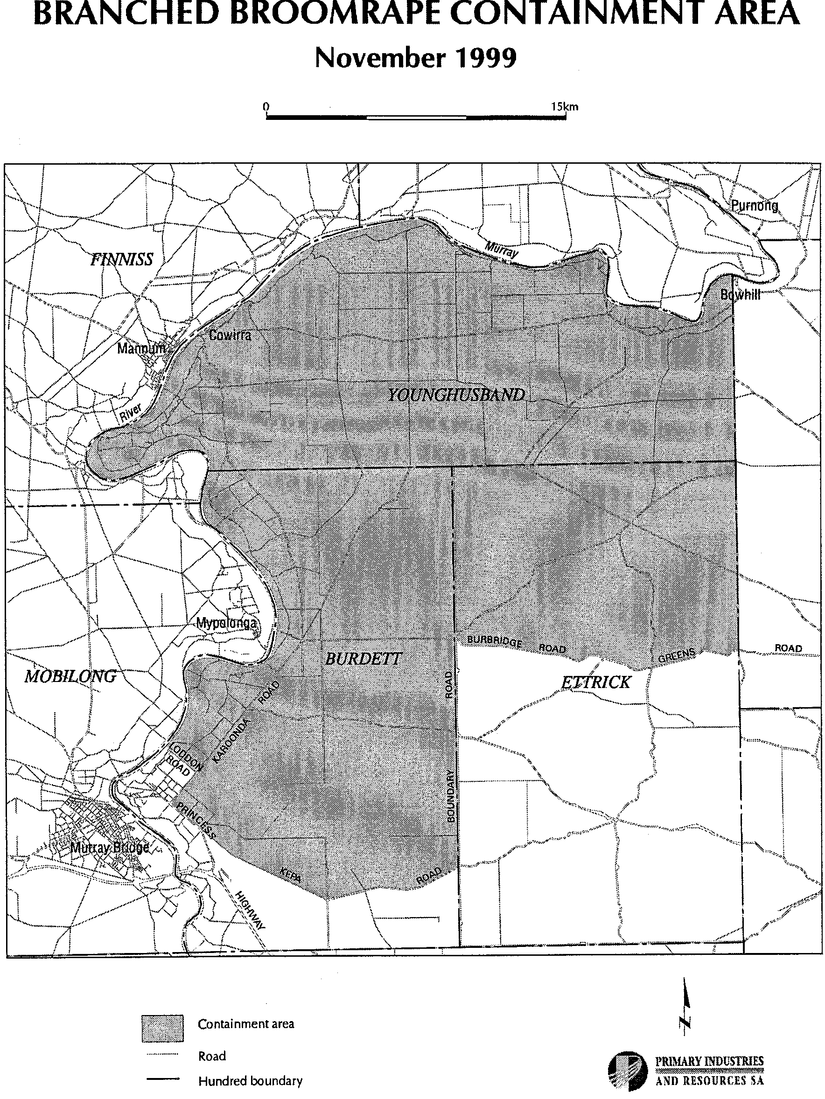

FISHERIES ACT 1982: SECTION 59
TAKE notice that pursuant to section 59 of the Fisheries Act 1982, Mario Georgaris (M171), 25 Richard Avenue, Mitchell Park, S.A. 5043 (hereinafter referred to as the ‘fisher’) is exempt from the provision of Schedule 1, clause 63 of the Fisheries (General) Regulations 1984, subject to the conditions specified in Schedule 1, in that the fisher shall not be guilty of an offence when taking up to 150 razor fish (Pinna bicolor) in any one day, from South Australian coastal marine waters from the date of gazettal of this notice until 30 June 2000.
Schedule 1
1. All razor fish (Pinna bicolor) taken shall be used for bait only.
2. The total number of razor fish (Pinna bicolor) taken in any one day, shall be no greater than 150.
3. The fisher must include all razor fish (Pinna bicolor) taken under this permit on his monthly catch and effort summary provided to the South Australian Research and Development Institute (SARDI).
4. The fisher shall not contravene or fail to comply with the Fisheries Act 1982, or any regulations made under the Act, except where specifically exempted by this notice.
5. Whilst engaged in the collection activity the fisher must have in or about his possession the copy of this notice with which the Director of Fisheries has provided and produce that notice to a PIRSA Fisheries and Aquaculture Compliance Officer forthwith, if and when an officer requests the fisher to produce it.
Dated 18 November 1999.
S. Miller, for W. Zacharin, Principal Fisheries Manager

FISHERIES ACT 1982: SECTION 59
TAKE notice that pursuant to section 59 of the Fisheries Act 1982, Bernard S. Starkey (M436), c/o P.O. Port Kenny, S.A. 5671 (hereinafter referred to as the ‘fisher’) is exempt from the provision of Schedule 1, clause 63 of the Fisheries (General) Regulations 1984, subject to the conditions specified in Schedule 1, in that the fisher shall not be guilty of an offence when taking up to 150 razor fish (Pinna bicolor) in any one day, from South Australian coastal marine waters from the date of gazettal of this notice until 30 June 2000.
Schedule 1
1. All razor fish (Pinna bicolor) taken shall be used for bait only.
2. The total number of razor fish (Pinna bicolor) taken in any one day, shall be no greater than 150.
3. The fisher must include all razor fish (Pinna bicolor) taken under this permit on his monthly catch and effort summary provided to the South Australian Research and Development Institute (SARDI).
4. The fisher shall not contravene or fail to comply with the Fisheries Act 1982, or any regulations made under the Act, except where specifically exempted by this notice.
5. Whilst engaged in the collection activity the fisher must have in or about his possession the copy of this notice with which the Director of Fisheries has provided and produce that notice to a PIRSA Fisheries and Aquaculture Compliance Officer forthwith, if and when an officer requests the fisher to produce it.
Dated 18 November 1999.
S. Miller, for W. Zacharin, Principal Fisheries Manager

FISHERIES ACT 1982: SECTION 59
TAKE notice that pursuant to section 59 of the Fisheries Act 1982, the class of persons specified in Schedule 1 and Hayden Bentley of Cabin Park Port Pirie, Warneton Road, Port Pirie, S.A. 5540 (hereinafter referred to as the ‘charter boat operator’) is exempt from the provisions of Clause 71AA and Clause 70 (b) of Schedule 1 of the Fisheries (General) Regulations 1984, and section 41 of the Fisheries Act 1982, insofar as the charter boat operator may exceed the boat limits as specified in Schedule 2, subject to the conditions specified in Schedule 3.
Schedule 1
Any person or persons who charter the boat unnamed (hereinafter referred to as the ‘permitted boat’) from the charter boat operator in South Australia, for the purpose of recreational fishing for scalefish, abalone and rock lobster.
Schedule 2
1. The charter boat operator may engage in the taking of no more than one rock lobster (Jasus edwardsii) per paying passenger in any one day where the number of paying passengers exceeds five.
2. The charter boat operator may engage in the taking of no more than one abalone (Haliotis spp.) per paying passenger in any one day where the number of paying passengers exceeds ten.
3. The charter boat operator may engage in the taking of no more than one half of the daily bag limit (for those species of scalefish subject to such a limit as specified in the Fisheries (General) Regulations 1984, per paying passenger in any one day where the number of paying passengers exceeds five.
Schedule 3
1. This exemption is valid from the date of gazettal of this notice until 30 June 2000.
2. The charter boat operator shall not use any other boats for the purpose of engaging in the permitted activity except the unnamed.
3. The charter boat operator shall not sell any fish taken pursuant to this notice.
4. The charter boat operator shall not contravene or fail to comply with the Fisheries Act 1982, or any regulations made under that Act except where specifically exempted by this notice.
5. While engaged in the permitted activity the charter boat operator shall have in their possession a copy of this notice. Such notice must be produced to a PIRSA Fisheries and Aquaculture Compliance Officer if such an officer requests that it be so produced.
Dated 18 November 1999.
S. Miller, for W. Zacharin, Principal Fisheries Manager

M. G. O’CALLAGHAN, Acting Government Printer, South Australia

