No. 140 1415

THE SOUTH AUSTRALIAN

GOVERNMENT GAZETTE

PUBLISHED BY AUTHORITY

ALL PUBLIC ACTS appearing in this GAZETTE are to be considered official, and obeyed as such

ADELAIDE, THURSDAY, 7 OCTOBER 1999

CONTENTS

Page
Appointments, Resignations, Etc. 1416
Associations Incorporation Act 1985—Notice 1417
Corporations and District Councils—Notices 1460
Development Act 1993—Notices 1417
Electoral Act 1985—Notice 1418
Gaming Machines Act 1992—Notices 1418
Gas Act 1997—Notice 1438
Geographical Names Act 1991—Notice 1419
Land Acquisition Act 1969-1972—Notice 1419
Land and Business (Sale and Conveyancing) Act 1994—
Notices 1419
Liquor Licensing Act 1997—Notices 1420
Mining Act 1971—Notice 1423
National Parks and Wildlife Act 1972—Notice 1423
National Parks Regulations 1990—Notice 1423
Outback Areas Community Development Trust—Notice 1423
Page
Private Advertisements 1461
Proclamations 1416
Public Trustee Office—Administration of Estates 1461
REGULATIONS
Fisheries Act 1982 (No. 202 of 1999) 1446
Fisheries (Gulf St Vincent Prawn Fishery Rationalization)
Act 1987 (No. 203 of 1999) 1448
Fisheries Act 1982 (No. 204 of 1999) 1449
Nurses Act 1999 (No. 205 of 1999) 1450
Renmark Irrigation Trust, The—Notice 1423
Roads (Opening and Closing) Act 1991—Notice 1423
Road Traffic Act 1961—Notices 1426
Sale of Property 1462
Water Mains and Sewers—Mains Laid, Replaced, Etc. 1424
Water Resources Act 1997—Notice 1424
Wilderness Protection Act 1992—Notice 1423

GOVERNMENT GAZETTE NOTICES
ALL poundkeepers' and private advertisements forwarded for publication in the South Australian Government Gazette must be PAID FOR PRIOR TO INSERTION; and all notices, from whatever source, should be legibly written on one side of the paper only and sent to Riverside 2000 so as to be received no later than 4 p.m. Tuesday preceding the day of publication. Phone 8207 1045 or Fax 8207 1040. E-mail: govgaz@riv.ssa.sa.gov.au. Send as attachments in Word format and please confirm your transmission with a faxed copy of your document, including the date the notice is to be published and to whom the notice will be charged.

DOG FENCE ACT 1946 SECTION 35C: VARIATION OF MEMBERSHIP OF FROME LOCAL DOG FENCE BOARD
Proclamation By The Governor
(l.s.) E. J. Neal
PURSUANT to section 35C of the Dog Fence Act 1946, on the recommendation of the Dog Fence Board, and with the advice and consent of the Executive Council, I vary the proclamation made under that Act on 2 October 1975 (see Gazette 2 October 1975 p. 1819), as varied, by striking out from the list of names under the heading Frome Local Dog Fence Board in the Second Schedule "John Lindsay Clarke" and substituting "James Alexander Irwin".
Given under my hand and the Public Seal of South Australia, at Adelaide, 7 October 1999.
By command,
Iain Evans, for Premier
MPNR 56/99 CS

FISHERIES (GULF ST. VINCENT PRAWN FISHERY RATIONALIZATION) (CHARGES ON LICENCES) AMENDMENT ACT 1999 (Act No. 49 of 1999): DAY OF COMMENCEMENT
Proclamation By The Governor
(l.s.) E. J. Neal
WITH the advice and consent of the Executive Council, I fix 7 October 1999 as the day on which the Fisheries (Gulf St. Vincent Prawn Fishery Rationalization) (Charges on Licences) Amendment Act 1999 will come into operation.
Given under my hand and the Public Seal of South Australia, at Adelaide, 7 October 1999.
By command,
Iain Evans, for Premier
MPNR 43/99 CS

HIGHWAYS ACT 1926 SECTION 30(2a): PROCLAMATION OF KINGSTON TO MILLICENT (VIA ROBE AND BEACHPORT) ROADS AS SOUTHERN PORTS HIGHWAY
Proclamation By The Governor
(l.s.) E. J. Neal
PURSUANT to section 30(2a) of the Highways Act 1926, on the recommendation of the Commissioner of Highways made pursuant to that section and with the advice and consent of the Executive Council, I give the name "Southern Ports Highway" to those portions of main roads RN 8326, RN 8486, RN 8492, RN 8646 and RN 8661 more particularly described in the schedule.
Schedule
• The portion of RN 8326 (Kingston to Robe) ("the road") that lies between an imaginary line formed by the prolongation of the southern boundary of RN 8400 (Princes Highway) across the road and an imaginary line formed by the prolongation of the northern boundary of RN 8486 (Robe to Clay Wells) across the road;
• The portion of RN 8486 (Robe to Clay Wells) ("the road") that lies between an imaginary line formed by the prolongation of the western boundary of RN 8326 (Kingston to Robe) across the road and an imaginary line formed by the prolongation of the eastern boundary of RN 8492 (Bray Junction to Beachport) across the road;
• The portion of RN 8492 (Bray Junction to Beachport) ("the road") that lies between an imaginary line formed by the prolongation of the southern boundary of RN 8486 (Robe to Clay Wells) across the road and an imaginary line formed by the prolongation of the northern boundary of RN 8646 (Beachport to Millicent) across the road;
• The portion of RN 8646 (Beachport to Millicent) ("the road") that lies between an imaginary line formed by the prolongation of the western boundary of RN 8492 (Bray Junction to Beachport) across the road and an imaginary line formed by the prolongation of the northern boundary of RN 8661 (Ridge Terrace, Millicent) across the road;
• The portion of RN 8661 (Ridge Terrace, Millicent) ("the road") that lies between an imaginary line formed by the prolongation of the southern boundary of RN 8646 (Beachport to Millicent) across the road and an imaginary line formed by the prolongation of the southern boundary of RN 8400 (George Street, Millicent) across the road.
Given under my hand and the Public Seal of South Australia, at Adelaide, 7 October 1999.
By command,
Iain Evans, for Premier
DTRN 9011/98 CS

NURSES ACT 1999 (Act No. 19 of 1999): DAY OF COMMENCEMENT
Proclamation By The Governor
(l.s.) E. J. Neal
WITH the advice and consent of the Executive Council, I fix 7 October 1999 as the day on which the remaining provisions of the Nurses Act 1999 will come into operation.
Given under my hand and the Public Seal of South Australia, at Adelaide, 7 October 1999.
By command,
Iain Evans, for Premier
MHS 15/99 CS

STATUTES AMENDMENT (LOCAL GOVERNMENT AND FIRE PREVENTION) ACT 1999 (Act No. 12 of 1999): DAY OF COMMENCEMENT
Proclamation By The Governor
(l.s.) E. J. Neal
WITH the advice and consent of the Executive Council, I—
(a) fix 7 October 1999 as the day on which the Statutes Amendment (Local Government and Fire Prevention) Act 1999, other than section 6, will come into operation;
(b) fix 1 July 2000 as the day on which section 6 of the Statutes Amendment (Local Government and Fire Prevention) Act 1999 will come into operation.
Given under my hand and the Public Seal of South Australia, at Adelaide, 7 October 1999.
By command,
Iain Evans, for Premier
LG 13/99 CS

Department of the Premier and Cabinet
Adelaide, 7 October 1999
HIS Excellency the Governor in Executive Council has been pleased to appoint the undermentioned to the Nurses Board of South Australia, pursuant to the provisions of the Nurses Act 1984:
Member (from 7 October 1999 until 6 October 2002)
Lynette Cusack
David John Thompson
Anita King
Robin Bentley Genders
Gina Greentree
Grant Walter Gilbert
Lorraine Bahr
Riccardo Einar Gabrielsen
Roslyn Donnellan-Fernandez
Lynette Joy Hepburn-Brown
Robyn Janette Parkes
Presiding Member (from 7 October 1999 until 6 October 2002)
Lynette Cusack
By command,
Iain Evans, for Premier
MHS 030/004/032CS

Department of the Premier and Cabinet
Adelaide, 7 October 1999
HIS Excellency the Governor in Executive Council has been pleased to appoint the undermentioned to the State Theatre Company of South Australia—Board of Governors, pursuant to the provisions of the State Theatre Company of South Australia Act 1972:
Governor (from 7 October 1999 until 30 June 2001)
Catherine Fitzgerald
Peter Vaughan
By command,
Iain Evans, for Premier
ACD 003/94CS

Department of the Premier and Cabinet
Adelaide, 7 October 1999
HIS Excellency the Governor in Executive Council has been pleased to appoint the Honourable Robert Gerard Kerin, MP, Deputy Premier and Minister for Primary Industries, Natural Resources and Regional Development to be also Acting Premier, Acting Minister for State Development and Acting Minister for Multicultural Affairs for the period 10 October 1999 to 17 October 1999 inclusive, during the absence of the Honourable John Wayne Olsen, FNIA, MP.
By command,
Iain Evans, for Premier
DPC 030/96PT2CS

ASSOCIATIONS INCORPORATION ACT 1985
Deregistration of Associations
NOTICE is hereby given that the Corporate Affairs Commission will deregister the associations named below in accordance with the application received from the associations pursuant to section 43A of the Associations Incorporation Act 1985. Deregistration will take effect on the date of publication of this notice:
Brighton Oval Bowling Club Inc.
Fulham Gardens Tennis Club Inc.
Glenelg Women’s Bowling Club Inc.
Reception and Convention Centres Association of South Australia Inc.
Returned Services League of Australia Mount Compass Sub Branch Inc.
A. J. Griffiths, a delegate of the Corporate Affairs Commission

DEVELOPMENT ACT 1993: SECTION 48
Decision By The Governor
Preamble
1. A proposal to develop in 10 stages the Mildara Blass Winery located on the Sturt Highway, 2 kilometres north-east of Nuriootpa has been under consideration under Division 2 of Part 4 of the Development Act 1993.
2. The development has been the subject of a Development Report and an Assessment Report and an Amendment to the Assessment Report under sections 46 and 46D of the Development Act 1993.
3. Application has now been made to the Governor under section 48 of the Development Act 1993 for the approval of the development. The application dated 2 December 1998 (amended by the Development Report dated May 1999 and letters dated 9 July 1999 and 28 September 1999), includes the following plans:
(a) Drawing titled: Bilyara Site Stage V10 Sheet 1 of 3, Drawing Number: BYA-1999-0012 B;
(b) Drawing titled: Bilyara Site Stage V10 Sheet 2 of 3, Drawing Number: BYA-1999-0012 B;
(c) Drawing titled: Bilyara Site Stage V10 Sheet 3 of 3, Drawing Number: BYA-1999-0012 B;
(d) Drawing titled: Elevations and Sections, Dated 11 March 1999;
(e) Drawing titled: Elevations and Detail, Drawing Number: BYA-1999-00013 A.
4. I am satisfied that an appropriate Development Report and an Assessment Report, that encompass the development have been prepared in relation to development, in accordance with the requirements of Division 2 of Part 4 of the Development Act 1993.
5. I have, in considering the application, had regard to all relevant matters under section 48 (5) of the Development Act 1993.
Decision
PURSUANT to section 48 of the Development Act 1993 and with the advice and consent of the Executive Council, in relation to the Development in 10 stages of the Mildara Blass Winery located on the Sturt Highway, 2 kilometres north-east of Nuriootpa, as described in the application dated 2 December 1998 (amended by the Development Report dated May 1999 and letters dated 9 July 1999 and 28 September 1999) submitted on behalf of Mildara Blass Limited, I grant development approval for the development subject to conditions.
Conditions of approval:
1. No works may be commenced on a particular stage of the proposal on the site unless and until:
(a) a building certifier or The Barossa Council has certified to the Development Assessment Commission that any work for that stage that constitutes building work under the Development Act 1993 complies with the Building Rules;
(b) an Environmental Management Plan has been produced and approved by the Development Assessment Commission for each construction stage. The Environmental Management Plan shall detail the final overall management of the facility and include:
• Wastewater treatment including the proposed wetlands; and
• Solid waste treatment or disposal.
2. The development hereby approved must be undertaken in accordance with the following plans comprising part of the application:
• Drawing titled: Bilyara Site Stage V10 Sheet 1 of 3, Drawing Number: BYA-1999-0012 B;
• Drawing titled: Bilyara Site Stage V10 Sheet 2 of 3, Drawing Number; BYA-1999-0012 B;
• Drawing titled: Bilyara Site Stage V10 Sheet 3 of 3, Drawing Number: BYA-1999-0012 B;
• Drawing titled: Elevations and Sections, Dated 11 March 1999;
• Drawing titled: Elevations and Detail, Drawing Number: BYA-1999-00013 A,
except that access should be via one only of the two alternate access points identified as Option A and B on Drawing titled: Bilyara Site Stage V10 Sheet 1 of 3, Drawing Number: BYA-1999-0012 B.
The access point not utilised must not be available for traffic movement and must be incorporated into the site boundary landscape strip.
3. The proponent must either:
(a) implement Option A identified in condition 2 by contributing to the cost of upgrading and sealing of Light Pass Road, from the junction with Pipe Line Road to a point where Light Pass Road meets the junction (such modification to be carried out by Transport SA) as proposed in its letter dated 28 September 1999, to the Minister for Transport and Urban Planning; or
(b) implement Option B identified in condition 2 by contributing to the cost of upgrading the western end of Pipeline Road and associated works at the junction of Pipeline Road and the Sturt Highway as proposed in its letter dated 28 September 1999 to the Minister for Transport and Urban Planning.
4. Mature trees must be planted to reduce impacts of the proposal at the earliest stage.
5. Lighting for monitoring purposes must be switched off at all times when tasks are not being undertaken in that particular area.
6. All lights must be directed and shielded in such a way as to prevent glare from the site.
7. The proponent must comply with the design and noise attenuation measures recommended on pages 3, 4 and 5 of the Environmental Noise Assessment report prepared by Bassett Acoustics on 13 May 1999 for the proposed 75 000 tonne crush Mildara Blass Ltd Bilyara Winery.
8. The proponent must not discharge winery effluent into the existing wetland system unless the effluent meets the following minimum quality criteria: pH 6.5-8; total Dissolved Solids less than 2 500 mg/L; Biochemical Oxygen Demand less than 600 mg/L; Suspended Solids less than 100 mg/L.
9. No trucks or heavy vehicles are to access the site from the southern portion of Light Pass Road.
10. If Option B identified in condition 2 is pursued:
(a) The access point off Pipeline Road must be designed in such a way to ensure that in and out access is at the western end of Pipeline Road (as shown in Drawing titled: Bilyara Site Stage V10 Sheet 1 of 3, Drawing Number: BYA-1999-0012 B) only and that the operator of the site must advise deliverers and contractors entering the site that access is from the western end of Pipeline Road only;
(b) Access to the Mildara Blass property for heavy vehicles must not be allowed from Light Pass Road.
Notes to the Applicant:
1. The preparation of a Management Plan for the waste water treatment system be prepared in accordance with the South Australian Health Commission code—“Standards for Construction, Installation and Operation of Septic Tank Systems in South Australia”.
2. The removal of native trees along the road reserve requires the approval of The Barossa Council.
Given under my hand at Adelaide, 7 October 1999.
E. J. Neal, Governor

DEVELOPMENT ACT 1993: SECTION 48
Notice By The Governor
Preamble
1. I have given a development authorisation pursuant to section 48 of the Development Act 1993 concerning the development in 10 stages of the Mildara Blass Winery located on the Sturt Highway, 2 kilometres north-east of Nuriootpa.
2. It is appropriate to delegate certain powers to the Development Assessment Commission in relation to this matter.
Delegation
PURSUANT to section 48 (8) of the Development Act 1993 and with the advice and consent of the Executive Council, I delegate to the Development Assessment Commission, the power to approve amendments of the development referred to in paragraph 1 of the preamble in this notice and of any future development approved by the Development Assessment Commission under this delegation, provided that any such amendment does not require the preparation of a further or amended Development Report.
Given under my hand at Adelaide, 7 October 1999.
E. J. Neal, Governor

ELECTORAL ACT 1985
Registration of Political Parties
NOTICE is hereby given that the following application for registration as a registered political party under the provisions of Part 6 of the Electoral Act 1985, has been received:
Name of Party:
Country Labor Party
Abbreviation of Name of Party:
Country Labor
Name of Applicant:
Ian Keith Hunter
Any elector who believes that the party should not be registered:
• because the party does not have as a purpose, the promotion of the election to the State Parliament of its endorsed candidate(s); or
• because the application does not fulfil the technical requirements specified in the Act; or
• because the party’s name is likely to be confused with that of another registered party,
can formally object in writing to the Electoral Commissioner by close of business on 8 November 1999. Objections must contain the postal address and signature of the objector.
Dated 7 October 1999.
S. H. Tully, Electoral Commissioner
SEO 99/97

GAMING MACHINES ACT 1992
Notice of Application for the Grant of a Gaming Machine Licence
NOTICE is hereby given, pursuant to section 29 of the Gaming Machines Act 1992, that P. & J. Hurley Pty Ltd, c/o Kelly & Co. Solicitors, Level 17, 91 King William Street, Adelaide, S.A. 5000 has applied to the Liquor and Gaming Commissioner for the Grant of a Gaming Machine Licence in respect of premises situated at corner Edward Beck Drive and Lemon Road, Sheidow Park, S.A. 5158 and to be known as Woodend Community Tavern.
The application has been set down for hearing on 5 November 1999 at 9 a.m.
Any person may object to the application by lodging a notice of objection in the prescribed form with the Liquor Licensing Commissioner, and serving a copy of the notice on the applicant at the applicant’s address given above, at least seven days before the hearing date.
Plans in respect of the premises the subject of the application are open to public inspection without fee at the Office of the Liquor Licensing Commissioner, 9th Floor, East Wing, G.R.E. Building, 50 Grenfell Street, Adelaide 5000.
Dated 29 September 1999.
Applicant

GAMING MACHINES ACT 1992
Notice of Application for the Grant of a Gaming Machine Licence
NOTICE is hereby given, pursuant to section 29 of the Gaming Machines Act 1992, that Neil John O’Connell and Lynette Adeline O’Connell, c/o Kelly & Co. Solicitors, Level 17, 91 King William Street, Adelaide, S.A. 5000 have applied to the Liquor Licensing Commissioner for the Grant of a Gaming Machine Licence in respect of premises situated at Gorge Road, Cudlee Creek, S.A. 5232 and known as Cudlee Creek Restaurant & Tavern.
The application has been set down for hearing on 5 November 1999.
Any person may object to the application by lodging a notice of objection in the prescribed form with the Liquor Licensing Commissioner, and serving a copy of the notice on the applicants at the applicants’ address given above, at least seven days before the hearing date.
Plans in respect of the premises the subject of the application are open to public inspection without fee at the Office of the Liquor Licensing Commissioner, 9th Floor, East Wing, G.R.E. Building, 50 Grenfell Street, Adelaide 5000.
Dated 29 September 1999.
Applicants

GEOGRAPHICAL NAMES ACT 1991
For Public Consultation
Second Notice of Intention to Alter the Names of Places
NOTICE of hereby given pursuant to the provisions of the above Act that the Surveyor-General proposes to assign the following names to those features detailed below and shown on the plan below:
(a) MARY ELLIS WRECK BEACH, locally known as Wreck Beach and located at grid reference 566150 East, 6142000 North, on 1:50 000 mapsheet Sleaford (6028-3),
(b) TINAH BEACH, locally known as Wiseman Beach, starting at grid reference 570500 East, 6142100 North on 1:50 000 mapsheet Jussieu (6028-2) and finishing at grid reference 566400 East, 6412100 North on 1:50 000 mapsheet Sleaford (6028-3),
(c) CHAPMAN ROCKHOLES located at grid reference 572800 East, 6141980 North, on 1:50 000 mapsheet Jussieu (6028-2).
(d) MILLER HOLE, located at grid reference 572560 East, 6141710 North, on 1:50 000 mapsheet Jussieu (6028-2).
(e) WISEMAN ROCK, located at grid reference 571670 East, 6142030 North on 1:50 000 mapsheet Jussieu (6028-2).
The Plan
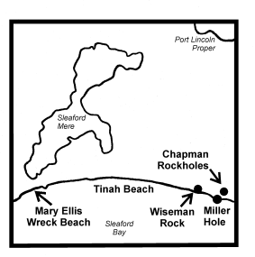
Submissions in writing regarding this proposal may be lodged with the Secretary, Geographical Names Advisory Committee, c/o Department for Environment, Heritage and Aboriginal Affairs, 300 Richmond Road, Netley, S.A. 5037 (P.O. Box 550, Marleston, S.A. 5033) within one month of the publication of this notice.
Dated 24 September 1999.
P. M. Kentish, Surveyor-General, Department for Administrative and Information Services
DEHAA 04/0104

LAND ACQUISITION ACT 1969
(Section 16)
Notice of Acquisition
SOUTH AUSTRALIAN WATER CORPORATION (the Authority), 18th Level, Australis Building, 77 Grenfell Street, Adelaide, S.A. 5000 acquiries the following interests in the following land:
An estate in fee simple in that piece of land more particularly delineated as 11 on the plan lodged in the Lands Titles Office and numbered as Deposited Plan 52834 being portion of the land comprised and described in Certificate of Title Register Book Volume 5682, Folio 878. This notice is given under section 16 of the Land Acquisition Act 1969.
Offer of Compensation
A person who has or had an interest in the land that is divested or diminished by the acquisition or the enjoyment of which is adversely affected by the acquisition who does not receive an offer of compensation from the Authority may apply to the authority for compensation.
Inquiries
Inquiries should be directed to:
The Property Manager,
S.A. Water Corporation,
18th Level, Australis Building,
77 Grenfell Street, Adelaide, S.A. 5000
Tel. 8204 1674
Dated 28 September 1999.
By Order of the Authority,
E. Lewandowski

LAND AND BUSINESS (SALE AND CONVEYANCING) ACT 1994
Section 23
TAKE notice that, pursuant to section 23 (3) of the Land and Business (Sale and Conveyancing) Act 1994, I, Kenneth Trevor Griffin, Minister for Consumer Affairs, do hereby exempt the person named in Schedule 1 from the application of section 23 (2) of the Act in relation to the purchase of the land specified in Schedule 2.
Schedule 1
Michael Stillwell, officer/employee of Southern Vales Real Estate Pty Ltd.
Schedule 2
The whole of the land described in certificate of title register book volume 5033, folio 840, situated at Unit 2, 23 Hunt Crescent, Christies Beach, S.A. 5165.
Dated 7 October 1999.
Signed for and on behalf of the Minister for Consumer Affairs by the Acting Commissioner for Consumer Affairs:
W. J. Spehr, Acting Commissioner

LAND AND BUSINESS (SALE AND CONVEYANCING) ACT 1994
Section 23
TAKE notice that, pursuant to section 23 (3) of the Land and Business (Sale and Conveyancing) Act 1994, I, Kenneth Trevor Griffin, Minister for Consumer Affairs, do hereby exempt the person named in Schedule 1 from the application of section 23 (2) of the Act in relation to the purchase of the land specified in Schedule 2.
Schedule 1
Richard Douglas Osborne, officer/employee of Delfin Realty Pty Ltd.
Schedule 2
The whole of the land described in certificate of title register book volume 5223, folio 503, situated at Lot 322, McArdle Place, Greenwith, S.A. 5125.
Dated 7 October 1999.
Signed for and on behalf of the Minister for Consumer Affairs by the Acting Commissioner for Consumer Affairs:
W. J. Spehr, Acting Commissioner

LIQUOR LICENSING ACT 1997
Notice of Application
NOTICE is hereby given, pursuant to section 52 (2) (b) of the Liquor Licensing Act 1997, that Timotheus Bitter has applied to the Licensing Authority for an Entertainment Consent in respect of premises situated at 29 Park Lane, Burra North, S.A. 5417 and known as Bon Accord Hotel.
The application has been set down for hearing on 5 November 1999 at 9 a.m.
Any person may object to the application by lodging a notice of objection in the prescribed form with the Licensing Authority, and serving a copy of the notice on the applicant at the applicant’s address given above, at least seven days before the hearing date.
Plans in respect of the premises the subject of the application are open to public inspection without fee at the Office of the Liquor and Gaming Commissioner, 9th Floor, East Wing, 50 Grenfell Street, Adelaide, S.A. 5000.
Dated 29 September 1999.
Applicant

LIQUOR LICENSING ACT 1997
Notice of Application
NOTICE is hereby given, pursuant to section 52 (2) (b) of the Liquor Licensing Act 1997, that Sonja Priess and Brett John Priess have applied to the Licensing Authority for a Restaurant Licence in respect of premises to be situated at 4/237 Main Road, Blackwood, S.A. 5051 and to be known as BJ’s Kitchen.
The application has been set down for hearing on 5 November 1999.
Any person may object to the application by lodging a notice of objection in the prescribed form with the Licensing Authority, and serving a copy of the notice on the applicants at the applicants’ address given above, at least seven days before the hearing date.
Plans in respect of the premises the subject of the application are open to public inspection without fee at the Office of the Liquor and Gaming Commissioner, 9th Floor, East Wing, 50 Grenfell Street, Adelaide, S.A. 5000.
Dated 28 September 1999.
Applicants

LIQUOR LICENSING ACT 1997
Notice of Application
NOTICE is hereby given, pursuant to section 52 (2) (b) of the Liquor Licensing Act 1997, that Andrew Popovich, Dragan Takov, Dmitar Uzelac and Zeljko Cosic have applied to the Licensing Authority for an Entertainment Venue Licence in respect of premises to be situated at Basement, 107 King William Street, Adelaide, S.A. 5000 and to be known as Underground Bar and Nightclub.
The application has been set down for hearing on 5 November 1999.
Any person may object to the application by lodging a notice of objection in the prescribed form with the Licensing Authority, and serving a copy of the notice on the applicants at the applicants’ address given above, at least seven days before the hearing date.
Plans in respect of the premises the subject of the application are open to public inspection without fee at the Office of the Liquor and Gaming Commissioner, 9th Floor, East Wing, 50 Grenfell Street, Adelaide, S.A. 5000.
Dated 30 September 1999.
Applicants

LIQUOR LICENSING ACT 1997
Notice of Application
NOTICE is hereby given, pursuant to section 52 (2) (b) of the Liquor Licensing Act 1997, that Annette Marie Matuchet has applied to the Licensing Authority for the transfer of the Residential Licence in respect of premises situated at 82 Mount Gambier Road, Millicent, S.A. 5280 and known as Millicent Motel and to be known as Wattle Lodge Motel.
The application has been set down for hearing on 2 November 1999 at 9.30 a.m.
Any person may object to the application by lodging a notice of objection in the prescribed form with the Licensing Authority, and serving a copy of the notice on the applicant at the applicant’s address given above, at least seven days before the hearing date.
Plans in respect of the premises the subject of the application are open to public inspection without fee at the Office of the Liquor and Gaming Commissioner, 9th Floor, East Wing, 50 Grenfell Street, Adelaide, S.A. 5000.
Applicant

LIQUOR LICENSING ACT 1997
Notice of Application
NOTICE is hereby given, pursuant to section 52 (2) (b) of the Liquor Licensing Act 1997, that Neil John O’Connell and Lynette Adeline O’Connell, c/o Kelly & Co. Solicitors, Level 17, 91 King William Street, Adelaide, S.A. 5000 have applied to the Licensing Authority for a Hotel Licence with Extended Trading Authorisation in respect of premises situated at Gorge Road, Cudlee Creek, S.A. 5232 and known as Cudlee Creek Restaurant & Tavern.
The application has been set down for hearing on 5 November 1999.
Conditions
The following licence conditions are sought:
Extended Trading Authorisation to enable the sale of liquor for on premises consumption on the following days:
Monday to Sunday, midnight to 5 a.m. the following day;
Sunday, 8 a.m. to 11 a.m. and 8 p.m. to 5 a.m. the following day;
Christmas Eve, midnight to 2 a.m. Christmas Day,
For consumption off the licensed premises:
Sunday, 8 a.m. to 11 a.m. and 8 p.m. to 9 p.m.
Any person may object to the application by lodging a notice of objection in the prescribed form with the Licensing Authority, and serving a copy of the notice on the applicants at the applicants’ address given above, at least seven days before the hearing date.
Plans in respect of the premises the subject of the application are open to public inspection without fee at the Office of the Liquor and Gaming Commissioner, 9th Floor, East Wing, 50 Grenfell Street, Adelaide, S.A. 5000.
Dated 29 September 1999.
Applicants

LIQUOR LICENSING ACT 1997
Notice of Application
NOTICE is hereby given, pursuant to section 52 (2) (b) of the Liquor Licensing Act 1997, that P. & J. Hurley Pty Ltd, c/o Kelly & Co., Level 17, 91 King William Street, Adelaide, S.A. 5000 has applied to the Licensing Authority for a Hotel Licence with Extended Trading Authorisation and Entertainment Consent in respect of premises situated at corner Edward Beck Drive and Lemon Road, Sheidow Park, S.A. 5158 to be known as Woodend Community Tavern.
The application has been set down for hearing on 5 November 1999 at 9 a.m.

Conditions
The following licence conditions are sought:
Extended Trading Authorisation to authorise the sale of liquor for off premises consumption on Sunday between 8 p.m. and 9 p.m.
Authorise the sale of liquor for consumption on the premises on Wednesday from midnight to 1 a.m. the next day, on Thursday, Friday and Saturday from midnight to 2 a.m. the next day, on Sunday from 8 p.m. to midnight and on Christmas Eve from midnight to 2 a.m. on Christmas Day.
Any person may object to the application by lodging a notice of objection in the prescribed form with the Licensing Authority, and serving a copy of the notice on the applicant at the applicant’s address given above, at least seven days before the hearing date.
Plans in respect of the premises the subject of the application are open to public inspection without fee at the Office of the Liquor and Gaming Commissioner, 9th Floor, East Wing, 50 Grenfell Street, Adelaide, S.A. 5000.
Dated 29 September 1999.
Applicant

LIQUOR LICENSING ACT 1997
Notice of Application
NOTICE is hereby given, pursuant to section 52 (2) (b) of the Liquor Licensing Act 1997, that Captain’s Gourmet & Pizzeria Pty Ltd (ACN 089 561 151) has applied to the Licensing Authority for a Special Circumstances Licence in respect of premises to be situated at R13/14 Marina Pier, Holdfast Shores, Glenelg, S.A. 5045 and to be known as Captain’s Gourmet & Pizzeria.
The application has been set down for hearing on 5 November 1999.
Conditions
The following licence conditions are sought:
• To authorise the sale of liquor at any time on any day with or ancillary to a meal provided by the licensee;
• For consumption on the licensed premises between the following hours, Sunday to Thursday, 9 a.m. to 11.30 p.m. and Friday, Saturday and Public Holidays 9 a.m. to 12.30 a.m. the following morning (except Good Friday);
• Authorisation to sell bottled wine and beer with food for consumption off the licensed premises with room service to apartments in the Holdfast Shores Complex and to boat operators in the Holdfast Shores Marina between the following hours: Sunday to Thursday, 9 a.m. to 11.30 p.m. and Friday, Saturday and Public Holidays, 9 a.m. to 12.30 a.m. the following morning (except Good Friday).
Any person may object to the application by lodging a notice of objection in the prescribed form with the Licensing Authority, and serving a copy of the notice on the applicant at the applicant’s address given above, at least seven days before the hearing date.
Plans in respect of the premises the subject of the application are open to public inspection without fee at the Office of the Liquor and Gaming Commissioner, 9th Floor, East Wing, 50 Grenfell Street, Adelaide, S.A. 5000.
Dated 5 October 1999.
Applicant

LIQUOR LICENSING ACT 1997
Notice of Application
NOTICE is hereby given, pursuant to section 52 (2) (b) of the Liquor Licensing Act 1997, that Australian Wine & Liquor Wholesalers Pty Ltd has applied to the Licensing Authority for a Wholesale Liquor Merchant’s Licence in respect of premises to be situated at 489 The Parade, Magill, S.A. 5072 and to be known as Australian Wine & Liquor Wholesalers Pty Ltd.
The application has been set down for hearing on 5 November 1999.
Any person may object to the application by lodging a notice of objection in the prescribed form with the Licensing Authority, and serving a copy of the notice on the applicant at the applicant’s address given above, at least seven days before the hearing date.
Plans in respect of the premises the subject of the application are open to public inspection without fee at the Office of the Liquor and Gaming Commissioner, 9th Floor, East Wing, 50 Grenfell Street, Adelaide, S.A. 5000.
Dated 27 September 1999.
Applicant

LIQUOR LICENSING ACT 1997
Notice of Application
NOTICE is hereby given, pursuant to section 52 (2) (b) of the Liquor Licensing Act 1997, that South Lakes Golf Club Inc. has applied to the Licensing Authority for a Variation to an Extended Trading Authorisation in respect of premises situated at Billabong Road, South Lakes, S.A. 5214 and known as South Lakes Golf Club.
The application has been set down for hearing on 5 November 1999 at 9 a.m.
Conditions
The following licence conditions are sought:
Hours of operation: Sunday, 8 p.m. to midnight.
Any person may object to the application by lodging a notice of objection in the prescribed form with the Licensing Authority, and serving a copy of the notice on the applicant at the applicant’s address given above, at least seven days before the hearing date.
Plans in respect of the premises the subject of the application are open to public inspection without fee at the Office of the Liquor and Gaming Commissioner, 9th Floor, East Wing, 50 Grenfell Street, Adelaide, S.A. 5000.
Dated 29 September 1999.
Applicant

LIQUOR LICENSING ACT 1997
Notice of Application
NOTICE is hereby given, pursuant to section 52 (2) (b) of the Liquor Licensing Act 1997, that Lyceum Club Adelaide Incorporated has applied to the Licensing Authority for a Removal of Licence in respect of premises situated at 1/54 Currie Street, Adelaide, S.A. 5000 and to be situated at 1/20-24 Leigh Street, Adelaide, S.A. 5000 and known as Lyceum Club Adelaide Incorporated.
The application has been set down for hearing on 5 November 1999 at 9 a.m.
Any person may object to the application by lodging a notice of objection in the prescribed form with the Licensing Authority, and serving a copy of the notice on the applicant at the applicant’s address given above, at least seven days before the hearing date.
Plans in respect of the premises the subject of the application are open to public inspection without fee at the Office of the Liquor and Gaming Commissioner, 9th Floor, East Wing, 50 Grenfell Street, Adelaide, S.A. 5000.
Dated 1 October 1999.
Applicant

LIQUOR LICENSING ACT 1997
Notice of Application
NOTICE is hereby given, pursuant to section 52 (2) (b) of the Liquor Licensing Act 1997, that Alex Horbenko and Eleanor Moinohatey Farley, 83 Penny’s Hill Road, Onkaparinga Hills, S.A. 5163 have applied to the Licensing Authority for the transfer of a Restaurant Licence in respect of premises situated at 55 Bridge Street, Murray Bridge and known as Amorosa Restaurant.
The application has been set down for hearing on 5 November 1999.
Any person may object to the application by lodging a notice of objection in the prescribed form with the Licensing Authority, and serving a copy of the notice on the applicants at the applicants’ address given above, at least seven days before the hearing date.
Plans in respect of the premises the subject of the application are open to public inspection without fee at the Office of the Liquor and Gaming Commissioner, 9th Floor, East Wing, 50 Grenfell Street, Adelaide, S.A. 5000.
Dated 30 September 1999.
Applicants

LIQUOR LICENSING ACT 1997
Notice of Application
NOTICE is hereby given, pursuant to section 52 (2) (b) of the Liquor Licensing Act 1997, that Kinstow Pty Ltd has applied to the Licensing Authority for the transfer of a Restaurant Licence in respect of premises situated at 300 Rundle Street, Adelaide, S.A. 5000 and known as Caffe San Marco and to be known as Servizio Ristorante.
The application has been set down for hearing on 8 November 1999.
Conditions
The following licence conditions are sought:
• The licensee is authorised to sell liquor on any day except Good Friday and Christmas Day for consumption on the licensed premises by persons:
(a) seated at a table; or
(b) attending a function at which food is provided.
• Extended Trading Authorisation:
Hours of operation: Monday to Saturday, midnight to 2 a.m. the following morning; Sunday, 8 a.m. to 11 a.m. and 8 p.m. to midnight.
Any person may object to the application by lodging a notice of objection in the prescribed form with the Licensing Authority, and serving a copy of the notice on the applicant at the applicant’s address given above, at least seven days before the hearing date.
Plans in respect of the premises the subject of the application are open to public inspection without fee at the Office of the Liquor and Gaming Commissioner, 9th Floor, East Wing, 50 Grenfell Street, Adelaide, S.A. 5000.
Dated 30 September 1999.
Applicant

LIQUOR LICENSING ACT 1997
Notice of Application
NOTICE is hereby given, pursuant to section 52 (2) (b) of the Liquor Licensing Act 1997, that Kenoake Pty Ltd has applied to the Licensing Authority for the transfer of a Restaurant Licence in respect of premises situated at Shop 12, Balhannah Junction Shopping Centre, Balhannah, S.A. 5242 and known as Fresh Temptations.
The application has been set down for hearing on 8 November 1999.
Any person may object to the application by lodging a notice of objection in the prescribed form with the Licensing Authority, and serving a copy of the notice on the applicant at the applicant’s address given above, at least seven days before the hearing date.
Plans in respect of the premises the subject of the application are open to public inspection without fee at the Office of the Liquor and Gaming Commissioner, 9th Floor, East Wing, 50 Grenfell Street, Adelaide, S.A. 5000.
Dated 29 September 1999.
Applicant

LIQUOR LICENSING ACT 1997
Notice of Application
NOTICE is hereby given, pursuant to section 52 (2) (b) of the Liquor Licensing Act 1997, that Lo & Sons Pty Ltd (ACN 007 966 305), 15 Redgum Drive, Pasadena, S.A. 5042 has applied to the Licensing Authority for the transfer of a Restaurant Licence in respect of premises situated at 160 Morphett Street, Glengowrie, S.A. 5044 and known as Fortune Court Restaurant.
The application has been set down for hearing on 8 November 1999.
Any person may object to the application by lodging a notice of objection in the prescribed form with the Licensing Authority, and serving a copy of the notice on the applicant at the applicant’s address given above, at least seven days before the hearing date.
Plans in respect of the premises the subject of the application are open to public inspection without fee at the Office of the Liquor and Gaming Commissioner, 9th Floor, East Wing, 50 Grenfell Street, Adelaide, S.A. 5000.
Dated 27 September 1999.
Applicant

MINING ACT 1971
NOTICE is hereby given in accordance with section 28 (5) of the Mining Act 1971, that the Minister for Primary Industries, Natural Resources and Regional Development proposes to grant an Exploration Licence over the undermentioned area:
Applicant: Adelaide Resources NL
Location: Wudinna Hill area⎯Approximately 130 km east-south-east of Streaky Bay, bounded as follows: Commencing at a point being the intersection of latitude 32°57′S and longitude 135°32′E, thence east to a western boundary of Pinkawillinie Conservation Park, thence generally southerly and easterly along the boundary of the said Conservation Park to longitude 135°40′E, south to latitude 33°03′S, west to longitude 135°33′E, north to latitude 33°01′S, east to longitude 135°34′E, north to latitude 32°59′S, west to longitude 135°33′E, north to latitude 32°58′S, west to longitude 135°32′E, and north to the point of commencement, all the within latitudes and longitudes being geodetic and expressed in terms of the Australian Geodetic Datum as defined on p. 4984 of Commonwealth Gazette number 84 dated 6 October 1966.
Term: 1 year
Area in km²: 111
Ref. D.M.E. No.: 597/1996
Dated 7 October 1999.
L. Johnston, Mining Registrar

NATIONAL PARKS AND WILDLIFE ACT 1972
Parks of Coffin Bay Area Draft Management Plan
Incorporating Coffin Bay National Park, Kellidie Bay Conservation Park, Mount Dutton Bay Conservation Park, Whidbey Isles Conservation Park and Avoid Bay Islands Conservation Park
I, DOROTHY KOTZ, Minister for Environment and Heritage, hereby give notice under the provisions of section 38 of the National Parks and Wildlife Act 1972, that I vary the notice issued on Thursday, 8 July 1999 (see Gazette 8 July 1999, p. 172) such that any person may make representations in connection with these Draft Management Plans during the period up to and including Friday, 17 December 1999.
Written comments should be forwarded to the Manager, Parks and Wildlife West, Department for Environment, Heritage and Aboriginal Affairs, P.O. Box 22, Port Lincoln, S.A. 5606.
D. C. Kotz, Minister for Environment and Heritage

WILDERNESS PROTECTION ACT 1992
Proposal to Proclaim Wilderness Protection Areas on Southern Eyre Peninsula
I, DOROTHY KOTZ, Minister for Environment and Heritage, hereby give notice under the provisions of section 22 of the Wilderness Protection Act 1992, that I vary the notice issued on Thursday, 8 July 1999 (see Gazette 8 July 1999, p. 172) such that any person may make submissions in relation to the proposals during the period up to and including Friday, 17 December 1999.
Written comments should be forwarded to Manager, Parks and Wildlife West, Department for Environment, Heritage and Aboriginal Affairs, P.O. Box 22, Port Lincoln, S.A. 5606.
D. C. Kotz, Minister for Environment and Heritage

NATIONAL PARKS REGULATIONS 1990
Closure of the Gammon Ranges National Park
PURSUANT to Regulation 7 (3) (c) of the National Parks Regulations 1990, I, Anne Elisabeth HARVEY, the Acting Director of National Parks and Wildlife, close to the public the whole of the Gammon Ranges National Park from sunrise on Saturday, 6 November 1999 until sunset on Sunday, 14 November 1999.
The internal roads within the Park will be closed to the public, however, the following roads within the Park will be exempted from the closure:
The main road connecting Copley, Nepabunna and Balcanoona.
The main road connecting Blinman, Wirrealpa, Balcanoona and Arkaroola.
The main road connecting Yunta and Arkaroola.
The purpose of the closure is to ensure the safety of the public during a feral animal-culling program within the Reserve during the period.
Use of Firearms within the Reserve
Pursuant to Regulations 7 (4), 18 (1) and 37 of the National Parks Regulations 1990, I, Anne Elisabeth HARVEY, the Acting Director of National Parks and Wildlife grant permission to members of the Hunting and Conservation Branch of the Sporting Shooters Association of Australia, in possession of both a current Hunting Permit and a firearm to enter and remain in the Gammon Ranges National Park from sunrise on Saturday, 6 November 1999 until sunset on Sunday, 14 November 1999, for the purpose of taking feral animals.
This permission is conditional upon the observance by each of those persons of the requirements of the National Parks and Wildlife Act 1972, the National Parks Regulations 1990, and the National Parks and Wildlife (Hunting) Regulations 1996, including those requiring compliance with the directions, requests, requirements and orders of a Warden.
Dated 27 September 1999.
A. E. Harvey, Acting Director, National Parks and Wildlife

OUTBACK AREAS COMMUNITY DEVELOPMENT TRUST
Appointment
NOTICE is hereby given that the Outback Areas Community Development Trust has appointed Shawn O’Toole as Dog and Cat Management Officer to take effect from 1 September 1999, pursuant to sections 27 and 28 of the Dog and Cat Management Act 1995 of South Australia, vide Helen O’Toole resigned.
Bill McIntosh, Chairman

THE RENMARK IRRIGATION TRUST
Notice of General Irrigation Rate
AT a meeting of the Renmark Irrigation Trust, duly held 30 August 1999, a General Irrigation Rate for the half-year ending 31 December 1999 was declared of $184.50 per hectare upon the land included in the assessment for the district and all persons liable are required to pay the amount of the rate, according to the assessment, to the Secretary at the Trust Office.
Dated 27 September 1999.
W. D. Morris, Secretary Manager

ROADS (OPENING AND CLOSING) ACT 1991:
SECTION 24
NOTICE OF CONFIRMATION OF ROAD
PROCESS ORDER
Portion of Nerida Drive, North Haven
Deposited Plan 52779
BY Road Process Order made on 28 May 1999, the City of Port Adelaide Enfield ordered that:
1. Portion of the public road (Nerida Drive—Lady Gowrie Drive intersection) adjoining the north-eastern corner of Allotment 11 in Deposited Plan 35563 more particularly delineated and lettered ‘A’ in Preliminary Plan No. PP32/0396 be closed.
2. The whole of the land subject to closure be transferred to Ron Bruno in accordance with agreement for transfer dated 25 May 1999 entered into between the City of Port Adelaide Enfield and R. Bruno.
3. The following easements are granted over the land subject to that closure:
Grant to the South Australian Water Corporation an easement for sewerage purposes over the whole of the land.
Grant to ETSA Utilities Pty Ltd an easement for underground electricity supply purposes over the whole of the land.
On 29 July 1999 that order was confirmed by the Minister for Administrative Services, conditionally on approval and deposit of the survey plan by the Registrar-General. The condition has now been fulfilled.
Pursuant to section 24 (5) of the Roads (Opening and Closing) Act 1991, notice of the order referred to above and its confirmation is hereby given.
Dated 7 October 1999.
P. M. Kentish, Surveyor-General

WATER RESOURCES ACT 1997
Notice of Restriction on the Taking of Water from a Watercourse or a Well in the Clare Valley Prescribed Wells Area and Watercourses, Pursuant to Section 16 (1) of the Water Resources Act 1997
PURSUANT to section 16 (1) of the Water Resources Act 1997, I, Dorothy Kotz, Minister for Environment and Heritage in the State of South Australia, being of the opinion that the rate at which water is being taken from watercourses or wells in the Clare Valley Prescribed Wells Area and Watercourses as bounded by the bold line in GRO Plan No. 368/96 (the ‘defined area’):
(a) is such that there is a risk that the available water will not be sufficient to meet future demand; and
(b) in the case of water taken from a watercourse, is having a serious effect on another watercourse, or the level of water in an underground aquifer, that depends on water from the watercourse in the ‘defined area’ for replenishment,
hereby restrict the taking of water from a watercourse or well in the ‘defined area’ except:
(a) by a person who is already authorised to take the water from a watercourse or well by a water licence under section 11 of the Water Resources Act 1997; or
(b) where the water is taken for domestic purposes or for watering stock (other than stock subject to intensive farming within the meaning of the Water Resources Act 1997).
In this notice:
‘watercourse’ means a river, creek or other natural watercourse (whether modified or not) and includes:
(a) a dam or reservoir that collects water flowing in a watercourse; and
(b) a lake through which water flows; and
(c) a channel (but not a channel declared by regulation to be excluded from the ambit of this definition) into which the water of a watercourse has been diverted; and
(d) part of a watercourse;
‘well’ means:
(a) an opening in the ground excavated for the purpose of obtaining access to underground water;
(b) an opening in the ground excavated for some other purpose but that gives access to underground water;
(c) a natural opening in the ground that gives access to underground water.
This notice comes into effect at the expiration of seven days from the publication of this notice in the Gazette and in a newspaper, which ever is the latter. This notice will remain in effect for 10 months unless earlier varied or revoked.
Dated 20 September 1999.
Dorothy Kotz, Minister for Environment and Heritage

WATER MAINS AND SEWERS

Office of the South Australian Water Corporation
Adelaide, 7 October 1999.

WATER MAINS LAID

Notice is hereby given that the following main pipes or parts of main pipes have been laid down by the South Australian Water Corporation in or near the undermentioned water districts and are now available for a constant supply of water to adjacent land.

ADELAIDE WATER DISTRICT

CITY OF CAMPBELLTOWN
King George Avenue, Athelstone. p3

CITY OF HOLDFAST BAY
Kauri Parade, Kingston Park. p5

CITY OF MARION
Hamilton Court, Sheidow Park. p4
Grand Central Avenue, Hallett Cove. p21
Easement in lots 99-101, River Lane and lots 6 and 5, Marine Avenue, Hallett Cove. p21

DISTRICT OF MOUNT BARKER
Henry Road, Blakiston. p11

CITY OF ONKAPARINGA
Reynell Road, Woodcroft. p2
Illman Crescent, Aldinga Beach. p7
Wilma Court, Aberfoyle Park. p9

BEETALOO COUNTRY LANDS WATER DISTRICT

DISTRICT OF THE COPPER COAST
Easement in lot 122, Karkarilla Road, Moonta Mines. p15
Hamley Hill Road, Hamley. p15
Cowling Terrace, Hamley. p16
Mitchell Street, Hamley. p14

KAPUNDA WATER DISTRICT

DISTRICT OF KAPUNDA AND LIGHT
Wheatley Street, Kapunda. p1

PORT ELLIOT WATER DISTRICT

DISTRICT OF ALEXANDRINA
Port Elliot Road, Hayborough. p12

PORT LINCOLN WATER DISTRICT

CITY OF PORT LINCOLN
St. Andrews Terrace, Port Lincoln. p18
Luke Street, Port Lincoln. p17
Verran Terrace, Port Lincoln. p17
Le Brun Street, Port Lincoln. p17
Mark Street, Port Lincoln. p17
Seaton Avenue, Port Lincoln. p17
Riversdale Avenue, Port Lincoln. p18
Ravendale Road, Port Lincoln. p18

PORT VICTOR WATER DISTRICT

DISTRICT OF VICTOR HARBOR
Ridge Avenue, Encounter Bay. p10

WATER MAINS ABANDONED

Notice is hereby given that the undermentioned water mains have been abandoned by the South Australian Water Corporation.

ADELAIDE WATER DISTRICT

CITY OF MARION
Grand Central Avenue, Hallett Cove. p21

CITY OF ONKAPARINGA
Reynell Road, Woodcroft. p2
Waterworks land (lot 4), Chandlers Hill Road, Happy Valley. p22 and 23

BEETALOO COUNTRY LANDS WATER DISTRICT

DISTRICT OF THE COPPER COAST
Easements in lot A, Karkarilla Road, Hamley. p13
Mitchell Street, Hamley. p13
Easements in lots 121 and 105, Karkarilla Road, lots 154 and 151, Hamley Hill Road and lot 156, Mitchell Street, Moonta Mines and Hamley. p13
Easements in lot 3, Karkarilla Road and section 1972 (hundred of Wallaroo), Cowling Terrace, Hamley. p13
Cowling Terrace, Hamley. p13
Easement in section 2758 (hundred of Wallaroo), and lot 3, Gray Terrace, Hamley. p13

OUTSIDE WATER DISTRICTS

DISTRICT OF THE FLINDERS RANGES
Easements in lots 1 and 6, government road, Saltia. p19

PORT LINCOLN WATER DISTRICT

CITY OF PORT LINCOLN
St. Andrews Terrace, Port Lincoln. P17 and 18
Luke Street, Port Lincoln. p17
Verran Terrace, Port Lincoln. p17
Le Brun Street, Port Lincoln. p17
Mark Street, Port Lincoln. p17
Seaton Avenue, Port Lincoln. p17
Riversdale Avenue, Port Lincoln. p18
Ravendale Road, Port Lincoln. p18

WATER MAINS LAID

Notice is hereby given that the undermentioned water main has been laid down by the South Australian Water Corporation and is not available for a constant supply of water to adjacent land.

ADELAIDE WATER DISTRICT

CITY OF ONKAPARINGA
Waterworks land (lot 4), Chandlers Hill Road, Happy Valley. p22 and 23

CORRECTIONS

Corrections to notices in “Government Gazette” of 23 September 1999.

“WATER MAINS LAID”

“BEETALOO COUNTRY LANDS WATER DISTRICT”

“PORT PIRIE REGIONAL COUNCIL”
“Crystal Brook bypass (across Frith Road), Crystal Brook. p27”

“WATER MAINS ABANDONED”

“BEETALOO COUNTRY LANDS WATER DISTRICT”

“PORT PIRIE REGIONAL COUNCIL”
“Crystal Brook bypass (across Frith Road), Crystal Brook. p27”

For “p27” read “p28”

SEWERS LAID

Notice is hereby given that the following sewers have been laid down by the South Australian Water Corporation in the undermentioned drainage areas and are now available for house connections.

ADELAIDE DRAINAGE AREA

CITY OF BURNSIDE
Union Street, Dulwich. FB 1081 p47
Cator Street, Glenside. FB 1081 p58

CITY OF CAMPBELLTOWN
Easements in reserve (lot 60), Tom Packer Drive and lot 70, Gorge Road, Athelstone. FB 1081 p53 and 54
Across Gorge Road, Athelstone. FB 1081 p53 and 54
Easements in lot 1, Gorge Road and lots 114-118, King George Avenue, Athelstone. FB 1081 p53 and 54
King George Avenue, Athelstone. FB 1081 p53-55
Easements in lots 113, 110 and 109, King George Avenue, Athelstone. FB 1081 p53 and 55
Hawker Street, Magill. FB 1082 p1

CITY OF HOLDFAST BAY
Gemmell Road, Brighton. FB 1082 p3

CITY OF MARION
Easement in reserve (lot 400), Lander Road, Sheidow Park. FB 1081 p56 and 57
Hamilton Court, Sheidow Park. FB 1081 p56 and 57
Sherwood Avenue, Sturt. FB 1082 p2

CITY OF MITCHAM
Easement in lot 334, Deepdene Avenue, Bellevue Heights. FB 1081 p48

CITY OF ONKAPARINGA
Horseshoe Drive, Woodcroft. FB 1081 p59
Easement in reserve (lot 268), Horseshoe Drive, Woodcroft. FB 1081 p59
Easement in lots 100 and 56, Main Road, Coromandel Valley. FB 1081 p60

CITY OF PLAYFORD
Easement in lots 43 and 341, Bubner Street, Elizabeth South. FB 1081 p49
Easement in lot 2, Turnbull Road, Elizabeth Downs. FB 1081 p50

CITY OF PORT ADELAIDE ENFIELD
Queensborough Avenue, Hillcrest. FB 1082 p7

HAHNDORF COUNTRY DRAINAGE AREA

DISTRICT OF MOUNT BARKER
Easements in lots 261 and 262, Bernhardt Crescent and lots 111 and 112, Windsor Avenue, Hahndorf. FB 1082 p4

STIRLING COUNTRY DRAINAGE AREA

DISTRICT OF ADELAIDE HILLS COUNCIL
Easement in lot 69, Anzac Ridge, Bridgewater. FB 1082 p5

VICTOR HARBOR COUNTRY DRAINAGE AREA

DISTRICT OF VICTOR HARBOR
Bay Road, Encounter Bay. FB 1082 p6

SEWERS LAID

Notice is hereby given that the undermentioned sewers have been laid down by the South Australian Water Corporation and are not available for house connections.

VICTOR HARBOR COUNTRY DRAINAGE AREA

DISTRICT OF VICTOR HARBOR
Canterbury Road, Victor Harbor – 100 CI and PVCR pumping main. FB 1082 p9
Jenkins Avenue, Victor Harbor – 100 PVCR pumping main. FB 1082 p9

ADMENDMENTS

Amendment to notice in “Government Gazette” of 22 August 1963.

“SEWERS LAID”

“ANGASTON COUNTRY DRAINAGE AREA”

“DISTRICT OF THE BAROSSA COUNCIL”
“Road easterly of blocks 746, 745 and 743, Angaston North. – Northerly for 661.7 m (2,171ft.) from a point 338.0 m (1,109ft.) from Murray Street. This sewer is available for house connections on the eastern side only for the first 182.9 m (600ft.).”

For “This sewer is available, etc.” read “This sewer is available for house connections on the eastern side only for the first 483.1 m and on application only on the eastern side for the next 173.0 m. FB 1081 p51”

Amendment to notice in “Government Gazette” of 6 February 1969.

“SEWERS LAID”

“MANNUM COUNTRY DRAINAGE AREA”

“DISTRICT OF MID MURRAY COUNCIL”
“Street known as Busch Street, Mannum – North-easterly for 160.3 m (526 ft.) from Wanke Road. This sewer is available for house connections on the north-western side only for the first 91.4m (300 ft.).”

For “This sewer is available, etc” read “This sewer is available for house connections on application only on the south-eastern side. FB 1081 p52”

DELETIONS

Deletion of notice in “Government Gazette” of 17 June 1982.

“SEWERS LAID”

“Notice is hereby given that the undermentioned sewer has been laid down by the South Australian Water Corporation and is not available for house connections.”

“VICTOR HARBOR COUNTRY DRAINAGE AREA”

“DISTRICT OF VICTOR HARBOR”
“Canterbury Road, Victor Harbor – 6.0 m of 100 mm PVC rising main from pumping station (in manhole opposite lot 117) running south-westerly and north-westerly to 300 mm rising main, connecting sewers.”

Delete this notice.

S. Sullivan, Chief Executive Officer, South Australian Water Corporation

ROAD TRAFFIC ACT 1961
Designation of Speed Zone
PURSUANT to section 32 of the Road Traffic Act 1961, I, Diana Laidlaw, Minister for Transport and Urban Planning, designate the area set out below as a speed zone and fix a speed limit of 40 km/h for that zone.
This notice will take effect on 7 October 1999.
This notice may be varied or revoked by subsequent notice.
Designated area
All that portion of the City of Mitcham named Westbourne Park to be designated by the eastern boundary of Goodwood Road, the southern boundary of Cross Road, the western boundary of Hilda Terrace, the western boundary of Sussex Terrace and the northern boundary of Grange Road but not including the carriageways of the aforementioned boundaries.
All that portion of the City of Mitcham named Hawthorn to be designated by the eastern boundary of Hilda Terrace, the eastern boundary of Sussex Terrace, the northern boundary of Grange Road, the western boundary of Belair Road and the southern boundary of Cross Road, but, not including the carriageways of the aforementioned boundaries.
All that portion of the City of Mitcham named Urrbrae to be designated by the western boundary of Mount Barker Road, the southern boundary of Cross Road, the eastern boundary of Waite Road but not including the carriageway of the aforementioned boundaries and an imaginary line starting from the south-western most point of Greenwood Grove to the southern most point of Birksgate Drive, (including the carriageway) and due east until the intersection of Mount Barker Road.
Dated 5 October 1999.
Diana Laidlaw, Minister for Transport and Urban Planning

Designation of Speed Zone
Pursuant to section 32 of the Road Traffic Act 1961, I, Diana Laidlaw, Minister for Transport and Urban Planning, designate the area set out below as a speed zone and fix a speed limit of 40 km/h for that zone.
This notice will take effect on 7 October 1999.
This notice may be varied or revoked by subsequent notice.
Designated area
All that portion of the City of Port Adelaide Enfield bounded on the north by the whole of Shamrock Court, the northern boundary of South Australia One Drive and the southern boundary of Lady Ruthven Drive; on the east by the western boundary of Lady Gowrie Drive; on the south by the whole of Anaconda Drive and the southern boundary of Cooroyba Court and on the west by the whole of Spinnaker Court, the western boundary of Gulf Point Drive and drawing an imaginary line generally north to south from the southern end of Gulf Point Drive and the western end of Cooroyba Court, but not including the carriageways of Lady Gowrie Drive and Lady Ruthven Drive.
Dated 5 October 1999.
Diana Laidlaw, Minister for Transport and Urban Planning

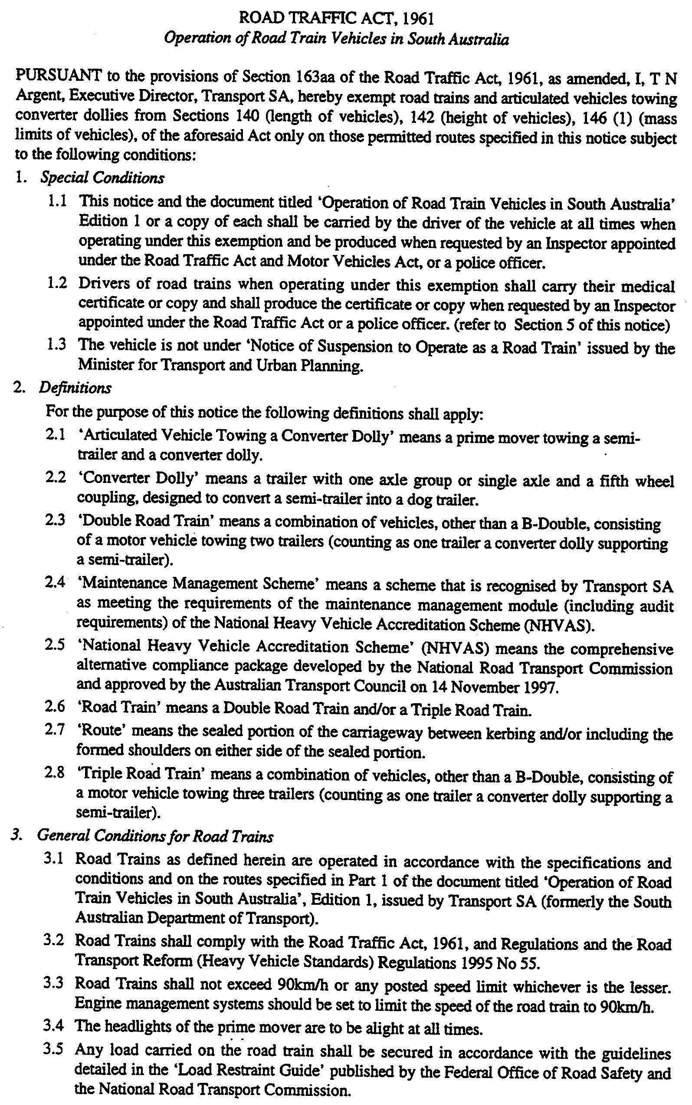
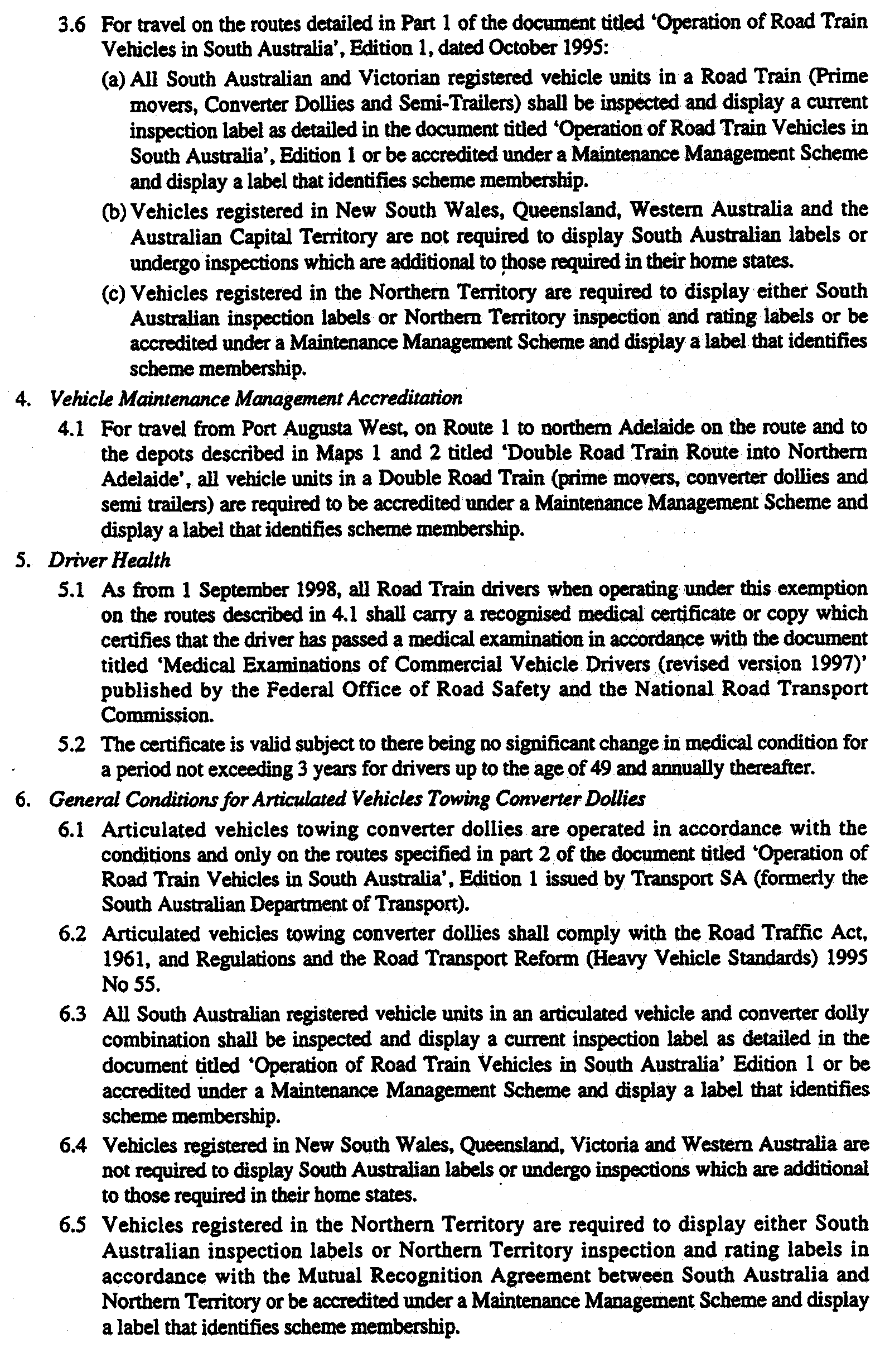
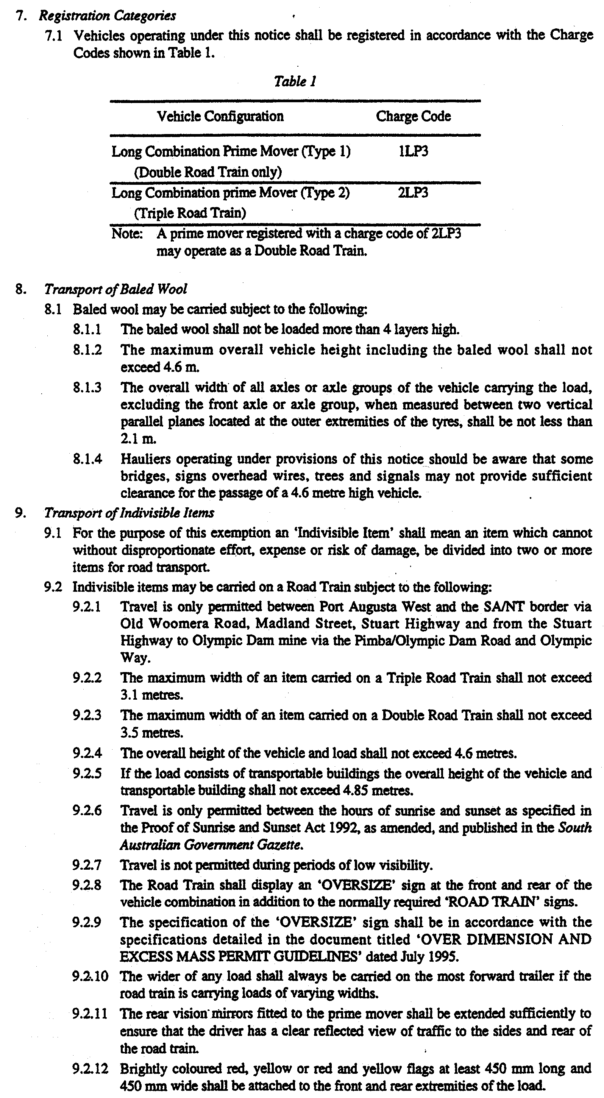
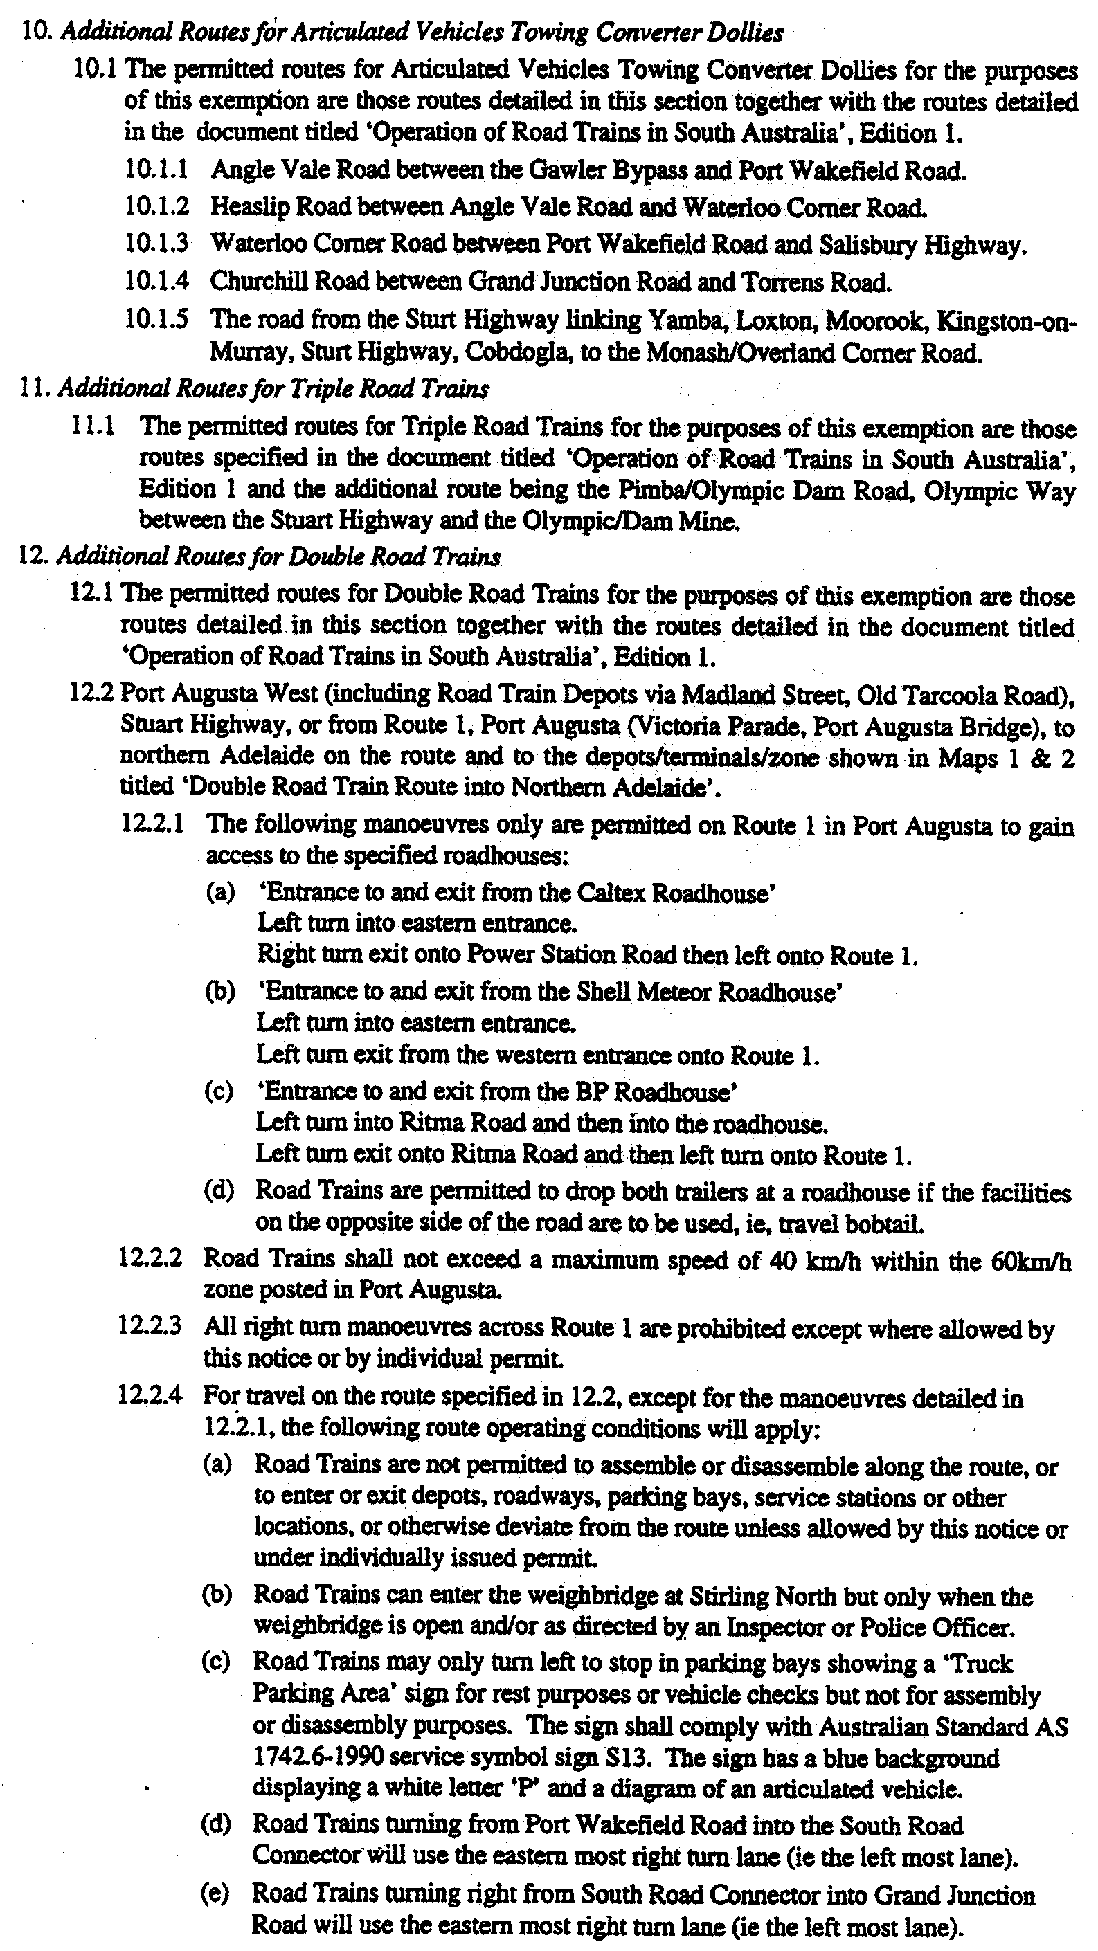
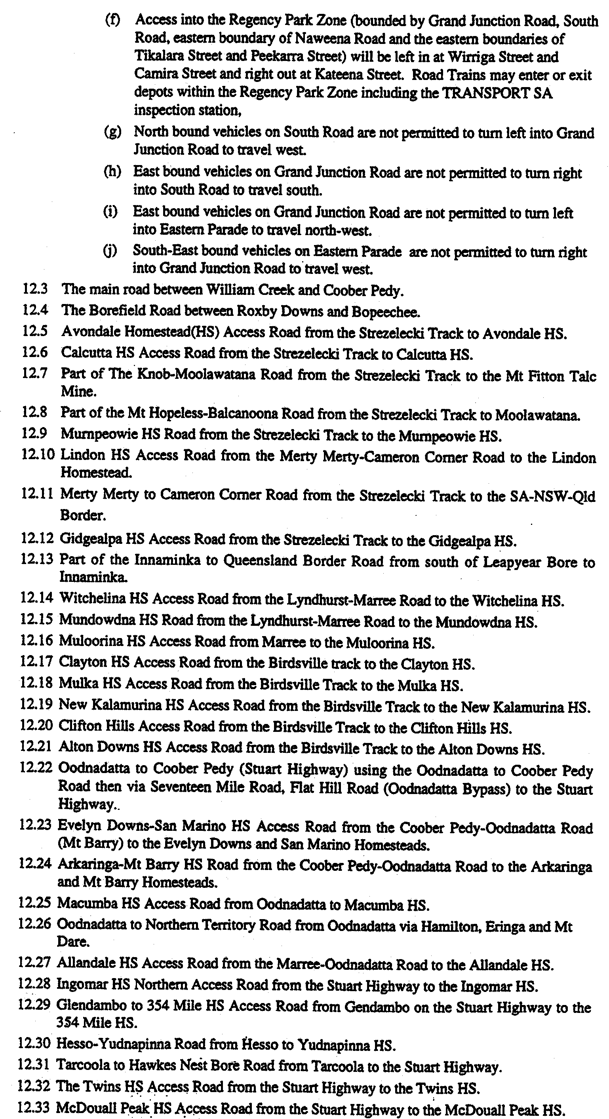
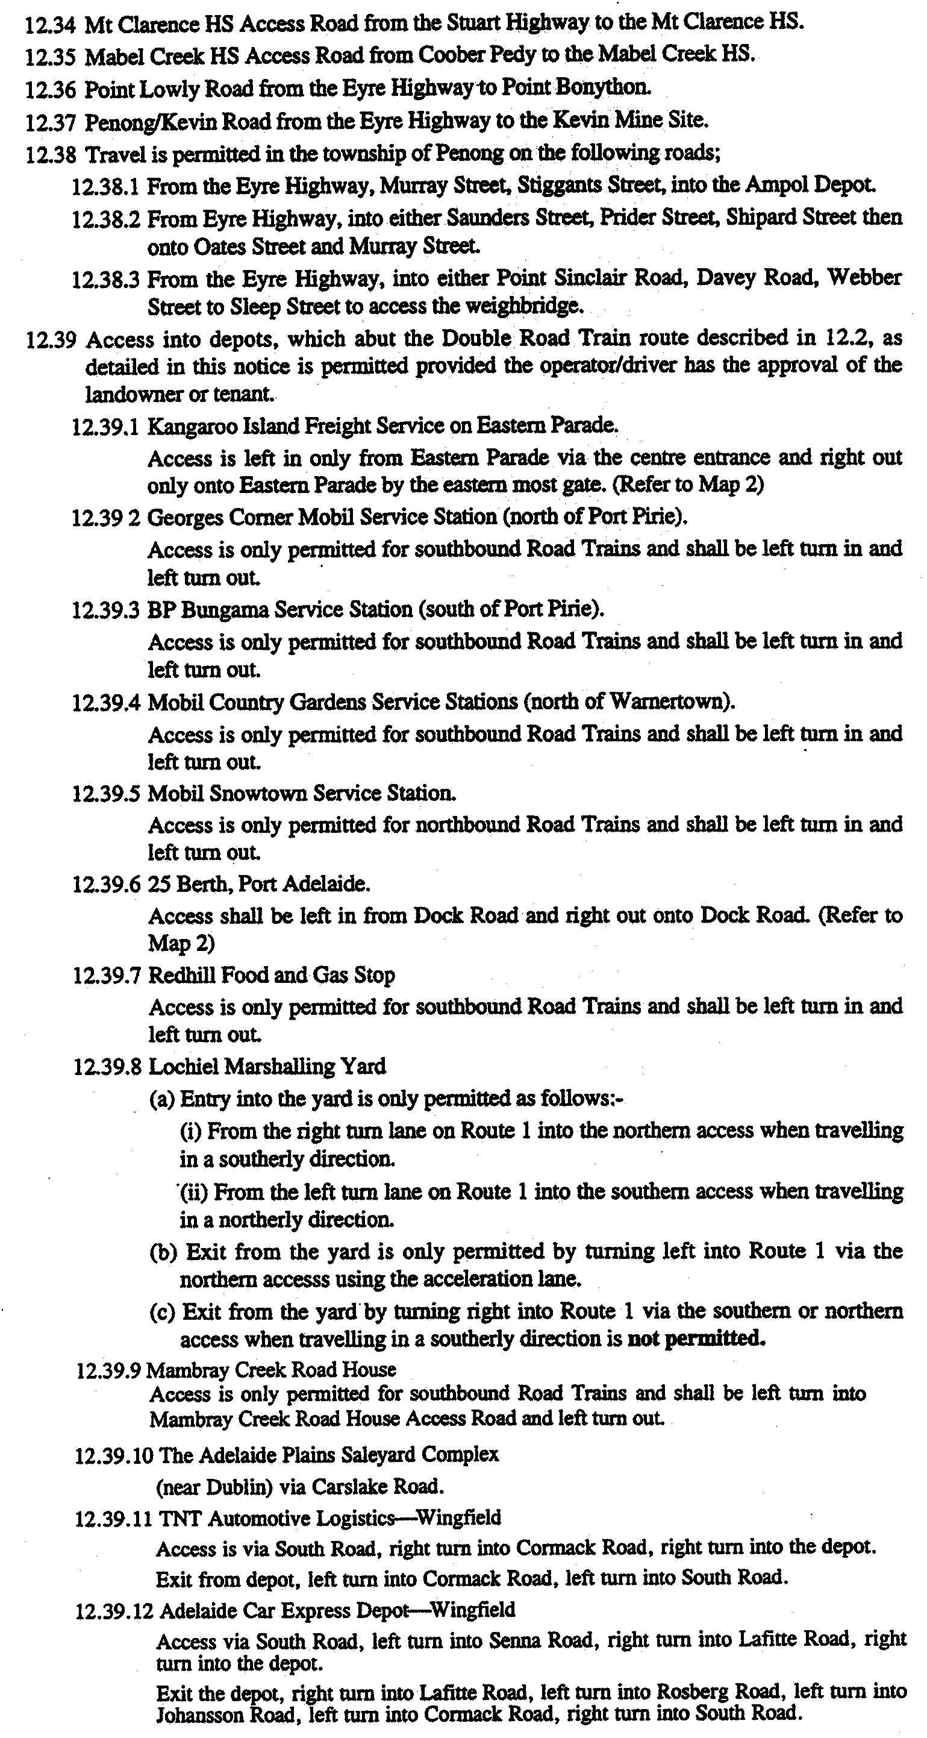
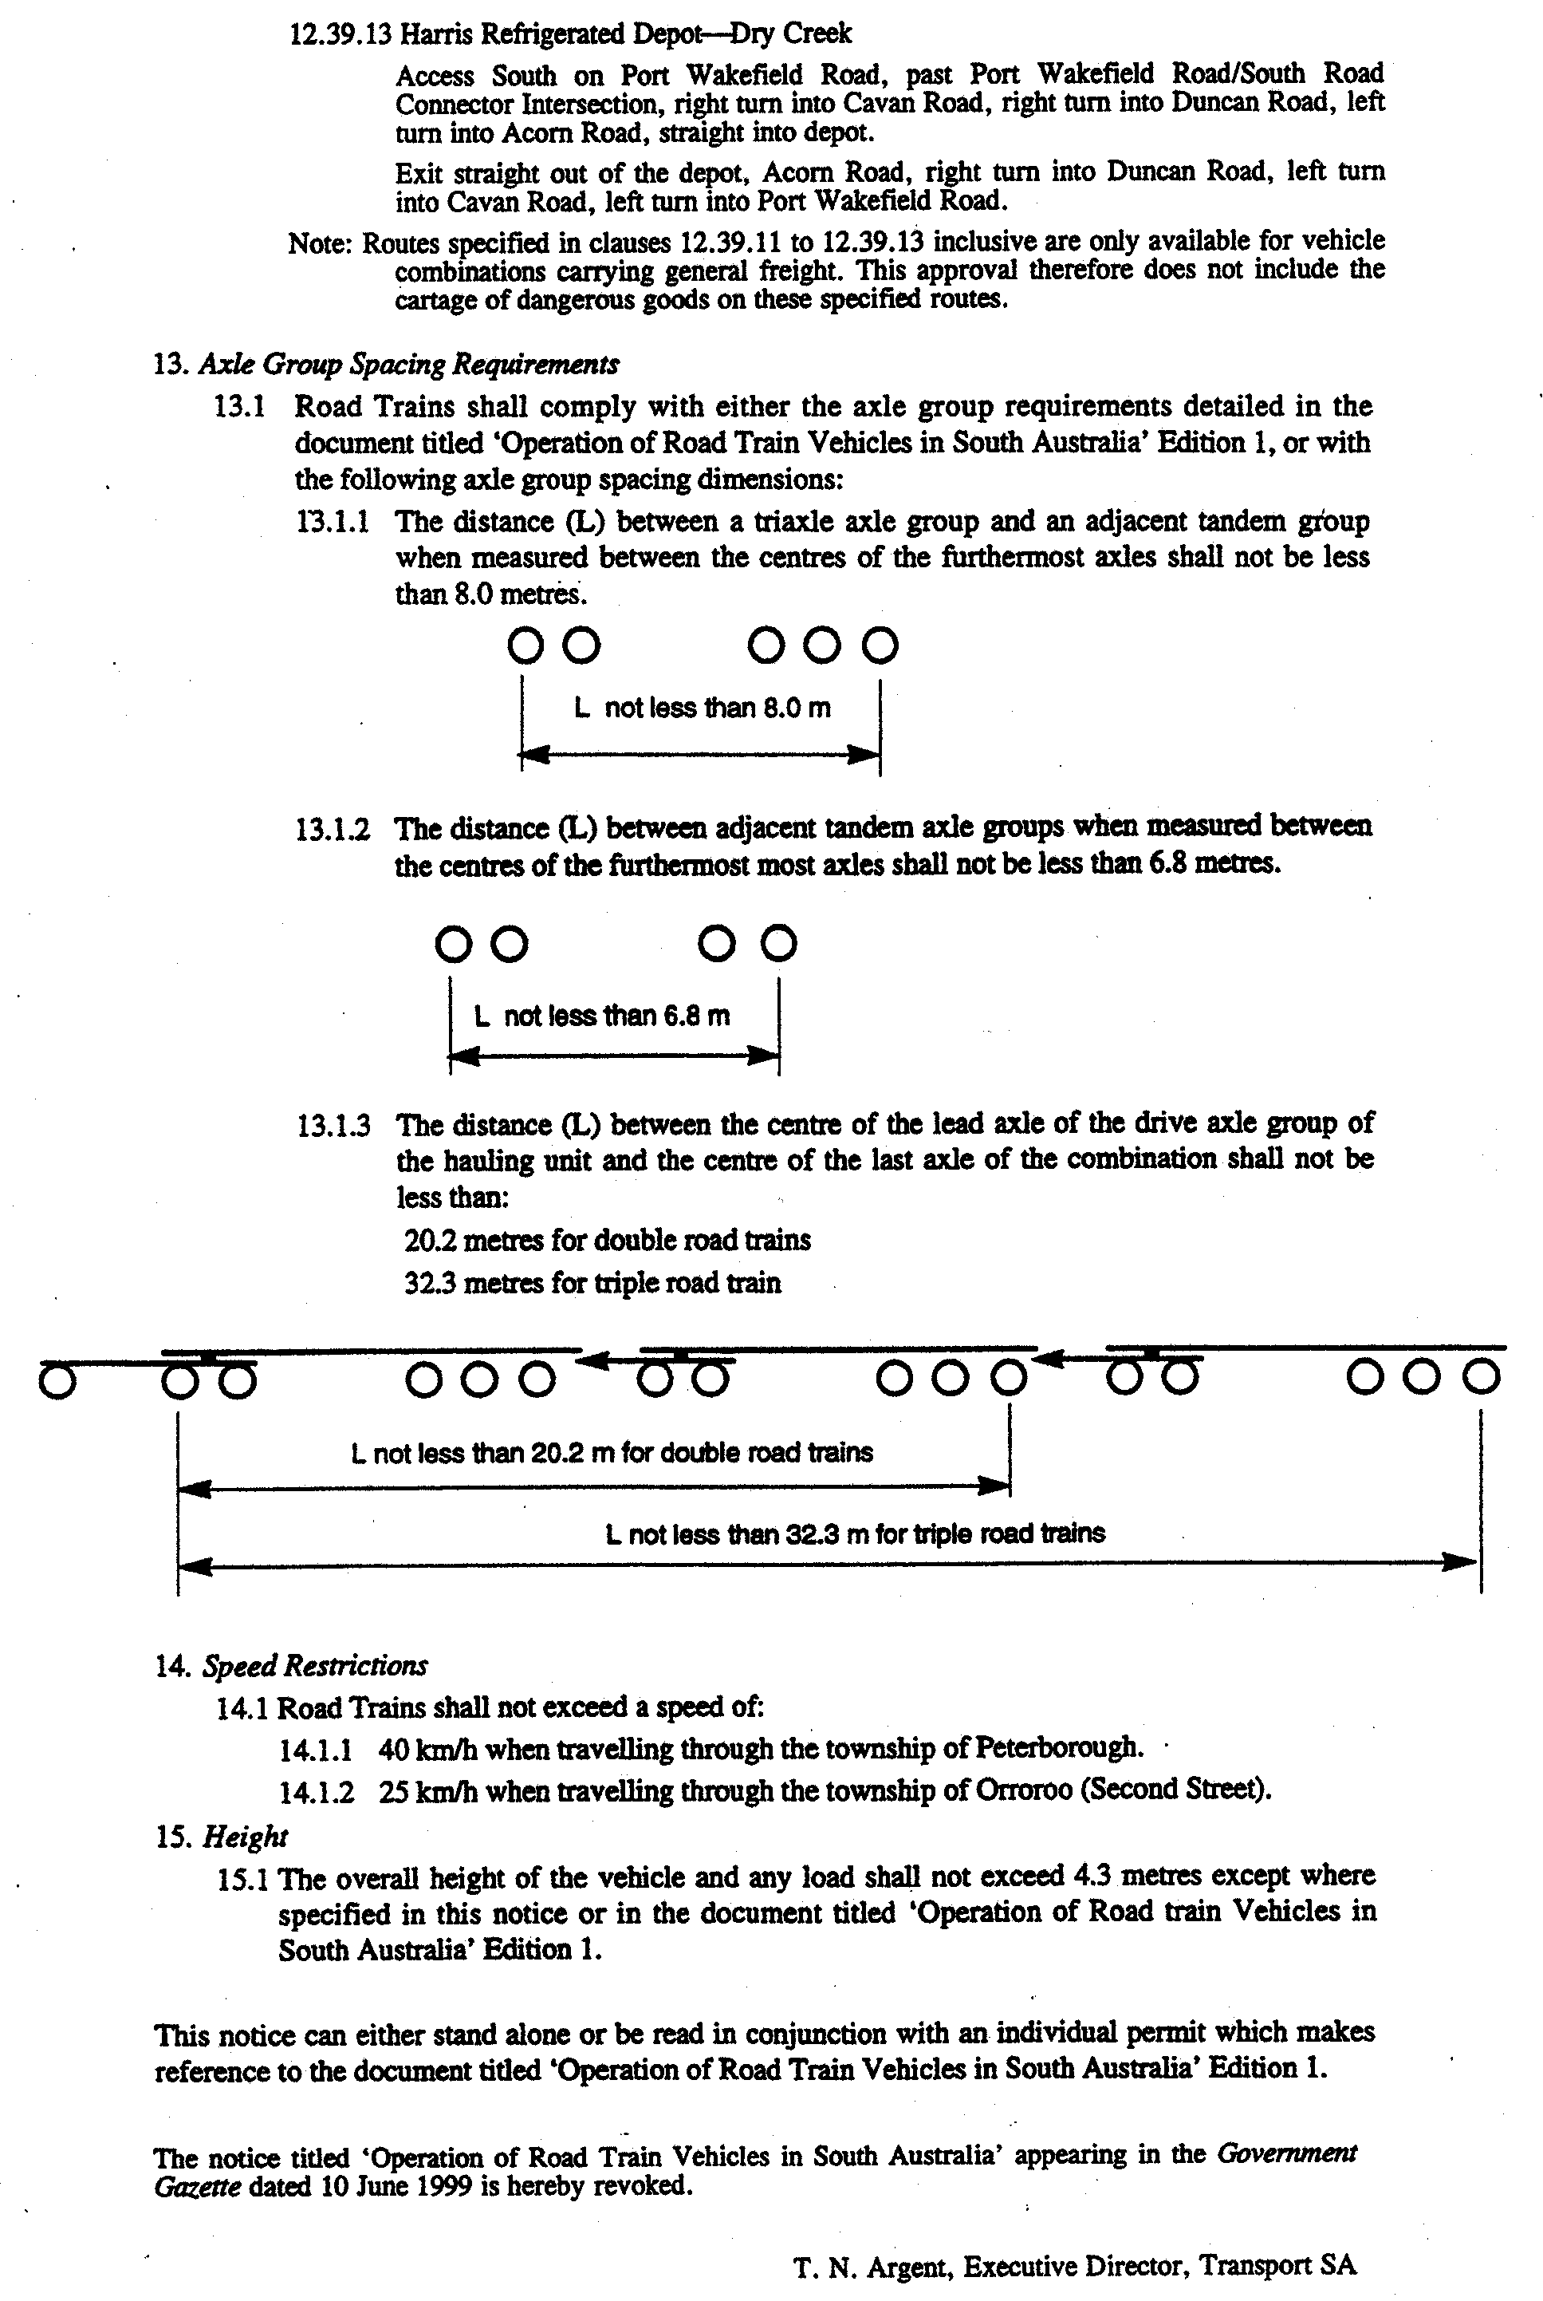
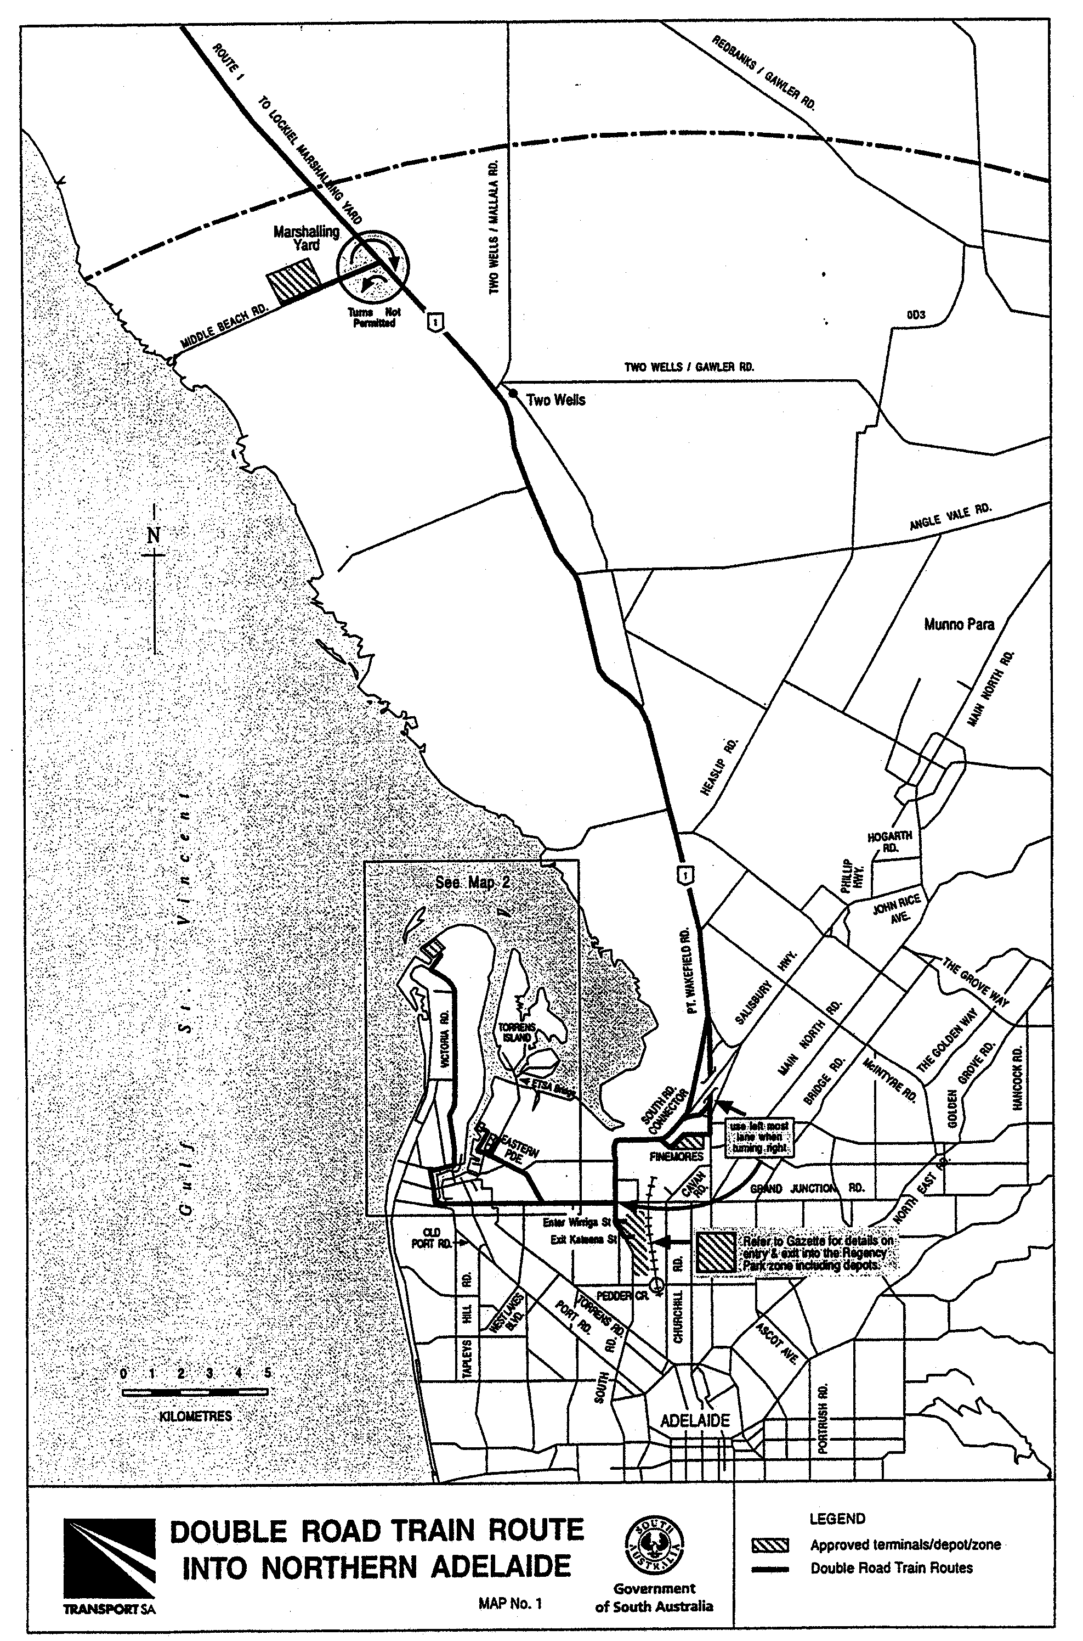
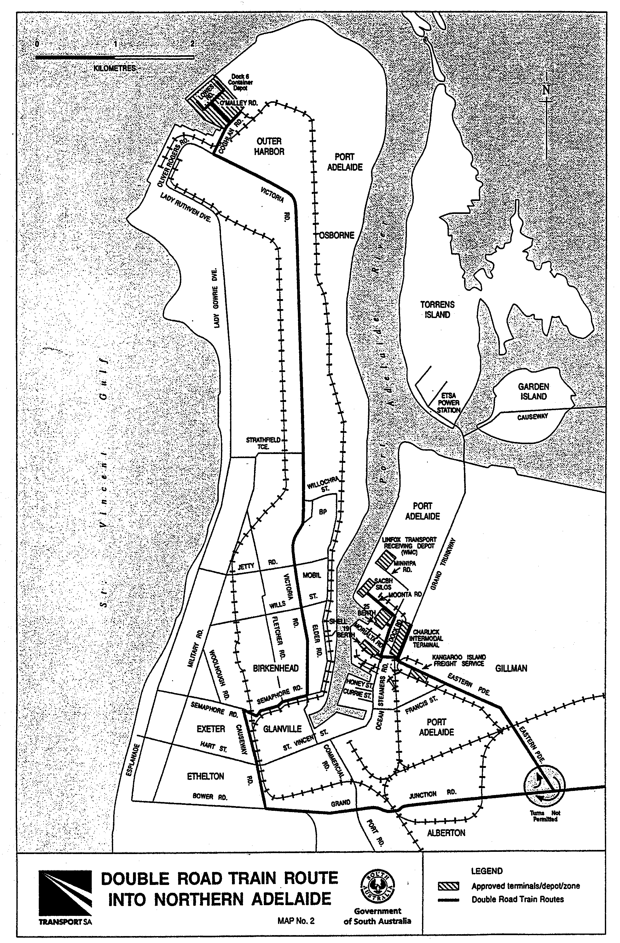
MISCELLANEOUS LEGISLATION AND GOVERNMENT PUBLICATIONS PRICES AS FROM 1 JULY 1999

Acts, Bills, Rules, Parliamentary Papers and Regulations
Pages | Main | Amends | Pages | Main | Amends

1-16 | 1.60 | 0.75 | 497-512 | 23.30 | 22.40
17-32 | 2.30 | 1.45 | 513-528 | 23.90 | 23.00
33-48 | 2.90 | 2.10 | 529-544 | 24.70 | 23.80
49-64 | 3.70 | 2.75 | 545-560 | 25.30 | 24.50
65-80 | 4.35 | 3.55 | 561-576 | 26.00 | 25.20
81-96 | 5.00 | 4.20 | 577-592 | 26.75 | 25.75
97-112 | 5.75 | 4.85 | 593-608 | 27.50 | 26.50
113-128 | 6.40 | 5.60 | 609-624 | 28.25 | 27.50
129-144 | 7.20 | 6.30 | 625-640 | 28.75 | 28.00
145-160 | 7.90 | 6.95 | 641-656 | 29.50 | 28.50
161-176 | 8.60 | 7.70 | 657-672 | 30.00 | 29.25
177-192 | 9.25 | 8.40 | 673-688 | 31.00 | 30.00
193-208 | 9.95 | 9.10 | 689-704 | 31.75 | 30.75
209-224 | 10.60 | 9.75 | 705-720 | 32.25 | 31.50
225-240 | 11.25 | 10.50 | 721-736 | 33.25 | 32.00
241-257 | 12.05 | 11.10 | 737-752 | 33.75 | 32.75
258-272 | 12.80 | 11.80 | 753-768 | 34.50 | 33.25
273-288 | 13.45 | 12.60 | 769-784 | 35.00 | 34.25
289-304 | 14.10 | 13.20 | 785-800 | 35.75 | 35.00
305-320 | 14.80 | 13.90 | 801-816 | 36.25 | 35.50
321-336 | 15.55 | 14.60 | 817-832 | 37.25 | 36.25
337-352 | 16.20 | 15.40 | 833-848 | 38.00 | 37.00
353-368 | 16.90 | 16.05 | 849-864 | 38.50 | 37.75
369-384 | 17.60 | 16.80 | 865-880 | 39.25 | 38.50
385-400 | 18.30 | 17.50 | 881-896 | 39.75 | 39.00
401-416 | 19.00 | 18.10 | 897-912 | 40.75 | 39.75
417-432 | 19.75 | 18.90 | 913-928 | 41.25 | 40.75
433-448 | 20.40 | 19.50 | 929-944 | 42.00 | 41.25
449-464 | 21.15 | 20.20 | 945-960 | 43.00 | 41.75
465-480 | 21.75 | 20.90 | 961-976 | 43.50 | 42.50
481-496 | 22.40 | 21.50 | 977-992 | 44.25 | 43.00

Legislation—Acts, Regulations, etc: $
Subscriptions:
Acts 144.00
All Bills as Laid 344.00
Rules and Regulations 344.00
Parliamentary Papers 344.00
Bound Acts 159.00
Index 77.00
Government Gazette
Copy 3.85
Subscription 190.00

Hansard
Copy 10.30
Subscription—per session (issued weekly) 298.00
Cloth bound—per volume 128.00
Subscription—per session (issued daily) 298.00
Legislation on Disk
Whole Database 2 201.00
Annual Subscription for fortnightly updates 677.00
Individual Act(s) including updates POA
Postage Extra on Individual Copies

All Legislation, Government Gazette, Hansard and Legislation on disk are available from:
Counter Sales: Information SA (State Government Bookshop)
Australis Centre, Ground Floor, 77 Grenfell Street, Adelaide, S.A. 5000.
Phone: (08) 8204 1900. Fax: (08) 8204 1909
S.A. Country Customer Free Call: 1800 182 234
TTY (Hearing Impaired): (08) 8204 1923
Mail Orders: Subscriptions and Standing Orders:
Phone: (08) 8204 9447, (08) 8204 9448. Fax: (08) 8204 1898
P.O. Box 1, Rundle Mall, Adelaide, S.A. 5000.

GOVERNMENT GAZETTE ADVERTISEMENT RATES

To apply from 1 July 1999

$  Agents, Ceasing to Act as 28.50  Associations:  Incorporation 14.50  Intention of Incorporation 35.75  Transfer of Properties 35.75  Attorney, Appointment of 28.50  Bailiff’s Sale 35.75  Cemetery Curator Appointed 21.20  Companies:  Alteration to Constitution 28.50  Capital, Increase or Decrease of 35.75  Ceasing to Carry on Business 21.20  Declaration of Dividend 21.20  Incorporation 28.50  Lost Share Certificates:  First Name 21.20  Each Subsequent Name 7.30  Meeting Final 23.80  Meeting Final Regarding Liquidator’s Report on  Conduct of Winding Up (equivalent to ‘Final  Meeting’)  First Name 28.50  Each Subsequent Name 7.30  Notices:  Call 35.75  Change of Name 14.50  Creditors 28.50  Creditors Compromise of Arrangement 28.50  Creditors (extraordinary resolution that ‘the Com-pany be wound up voluntarily and that a liquidator be appointed’) 35.75  Release of Liquidator⎯Application⎯Large Ad. 57.00  ⎯Release Granted 35.75  Receiver and Manager Appointed 33.25  Receiver and Manager Ceasing to Act 28.50  Restored Name 27.00  Petition to Supreme Court for Winding Up 49.50  Summons in Action 42.25  Order of Supreme Court for Winding Up Action 28.50  Register of Interests⎯Section 84 (1) Exempt 64.00  Removal of Office 14.50  Proof of Debts 28.50  Sales of Shares and Forfeiture 28.50  Estates:  Assigned 21.20  Deceased Persons⎯Notice to Creditors, etc. 35.75  Each Subsequent Name 7.30  Deceased Persons⎯Closed Estates 21.20  Each Subsequent Estate 0.90  Probate, Selling of 28.50  Public Trustee, each Estate 7.30 |  | $  Firms:  Ceasing to Carry on Business (each insertion) 21.20  Discontinuance Place of Business 21.20  Land⎯Real Property Act:  Intention to Sell, Notice of 35.75  Lost Certificate of Title Notices 35.75  Cancellation, Notice of (Strata Plan) 35.75  Mortgages:  Caveat Lodgment 14.50  Discharge of 15.30  Foreclosures 14.50  Transfer of 14.50  Sublet 7.30  Leases⎯Application for Transfer (2 insertions) each 7.30  Lost Treasury Receipts (3 insertions) each 21.20  Licensing 42.25  Municipal or District Councils:  Annual Financial Statement⎯Forms 1 and 2 400.00  Electricity Supply⎯Forms 19 and 20 283.00  Default in Payment of Rates:  First Name 57.00  Each Subsequent Name 7.30  Noxious Trade 21.20  Partnership, Dissolution of 21.20  Petitions (small) 14.50  Registered Building Societies (from Registrar-  General) 14.50  Register of Unclaimed Moneys⎯First Name 21.20  Each Subsequent Name 7.30  Registers of Members⎯Three pages and over:  Rate per page (in 8pt) 181.00  Rate per page (in 6pt) 239.00  Sale of Land by Public Auction 36.25  Advertisements 2.00  Advertisements, other than those listed are charged at $2.00 per column line, tabular one-third extra.  Notices by Colleges, Universities, Corporations and District Councils to be charged at $2.00 per line.  Where the notice inserted varies significantly in length from that which is usually published a charge of $2.00 per column line will be applied in lieu of advertisement rates listed.  South Australian Government publications are sold on the condition that they will not be reproduced without prior permission from the Government Printer.

GOVERNMENT GAZETTE NOTICES
ALL private advertisements forwarded for publication in the South Australian Government Gazette must be PAID FOR PRIOR TO INSERTION; and all notices, from whatever source, should be legibly written on one side of the paper only and sent to Riverside 2000 so as to be received no later than 4 p.m. Tuesday preceding the day of publication. Phone 8207 1045 or Fax 8207 1040. E-mail: govgaz@riv.ssa.sa.gov.au. Send as attachments in Word format and please confirm your transmission with a faxed copy of your document, including the date the notice is to be published and to whom the notice will be charged.

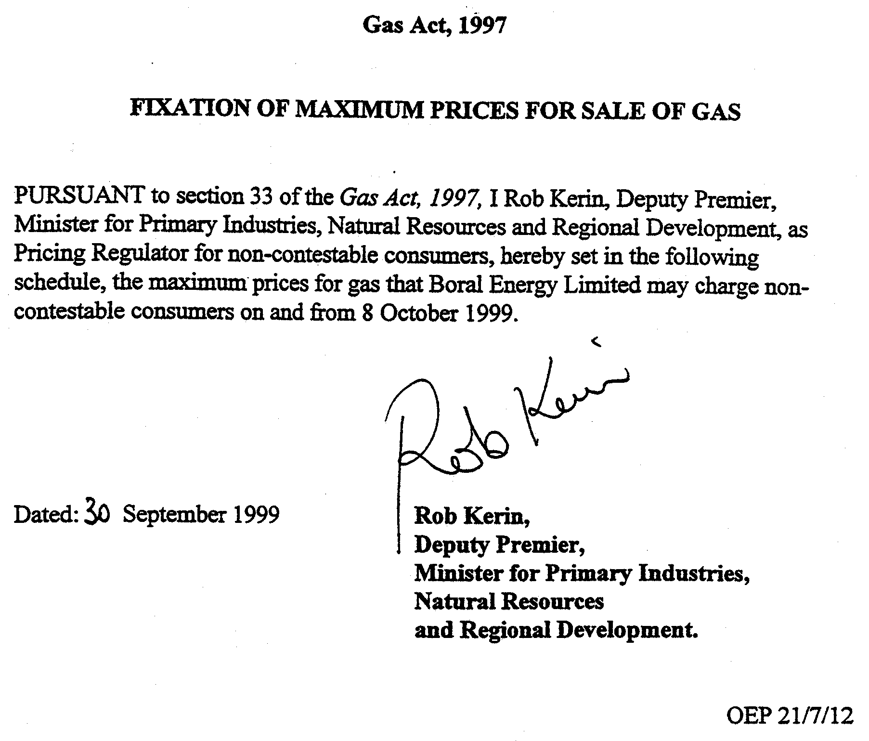
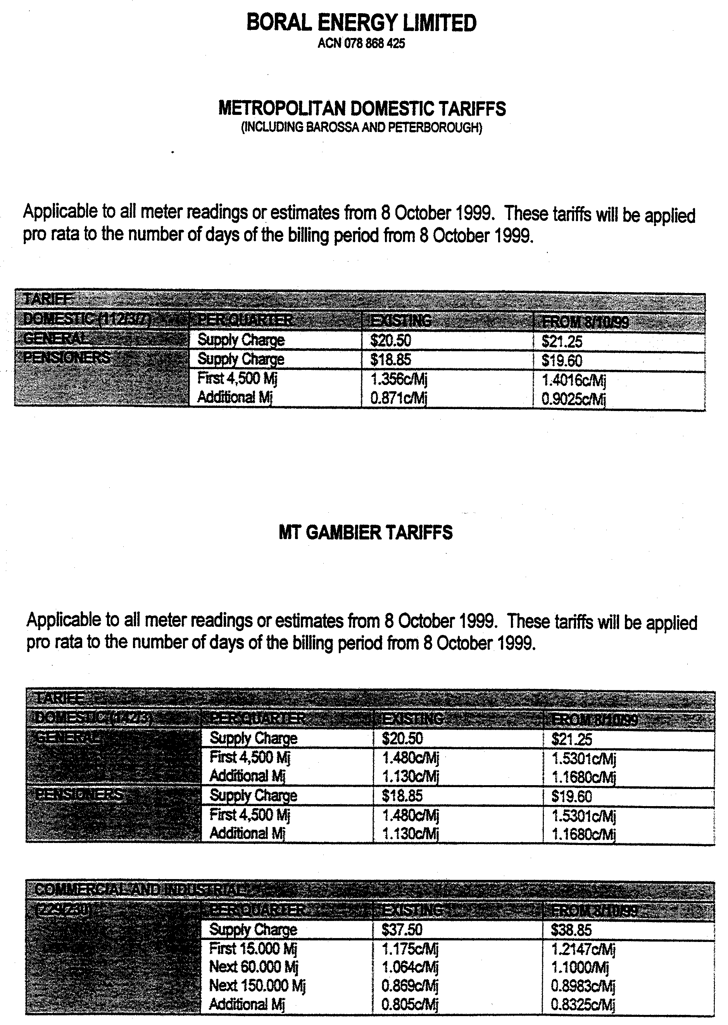
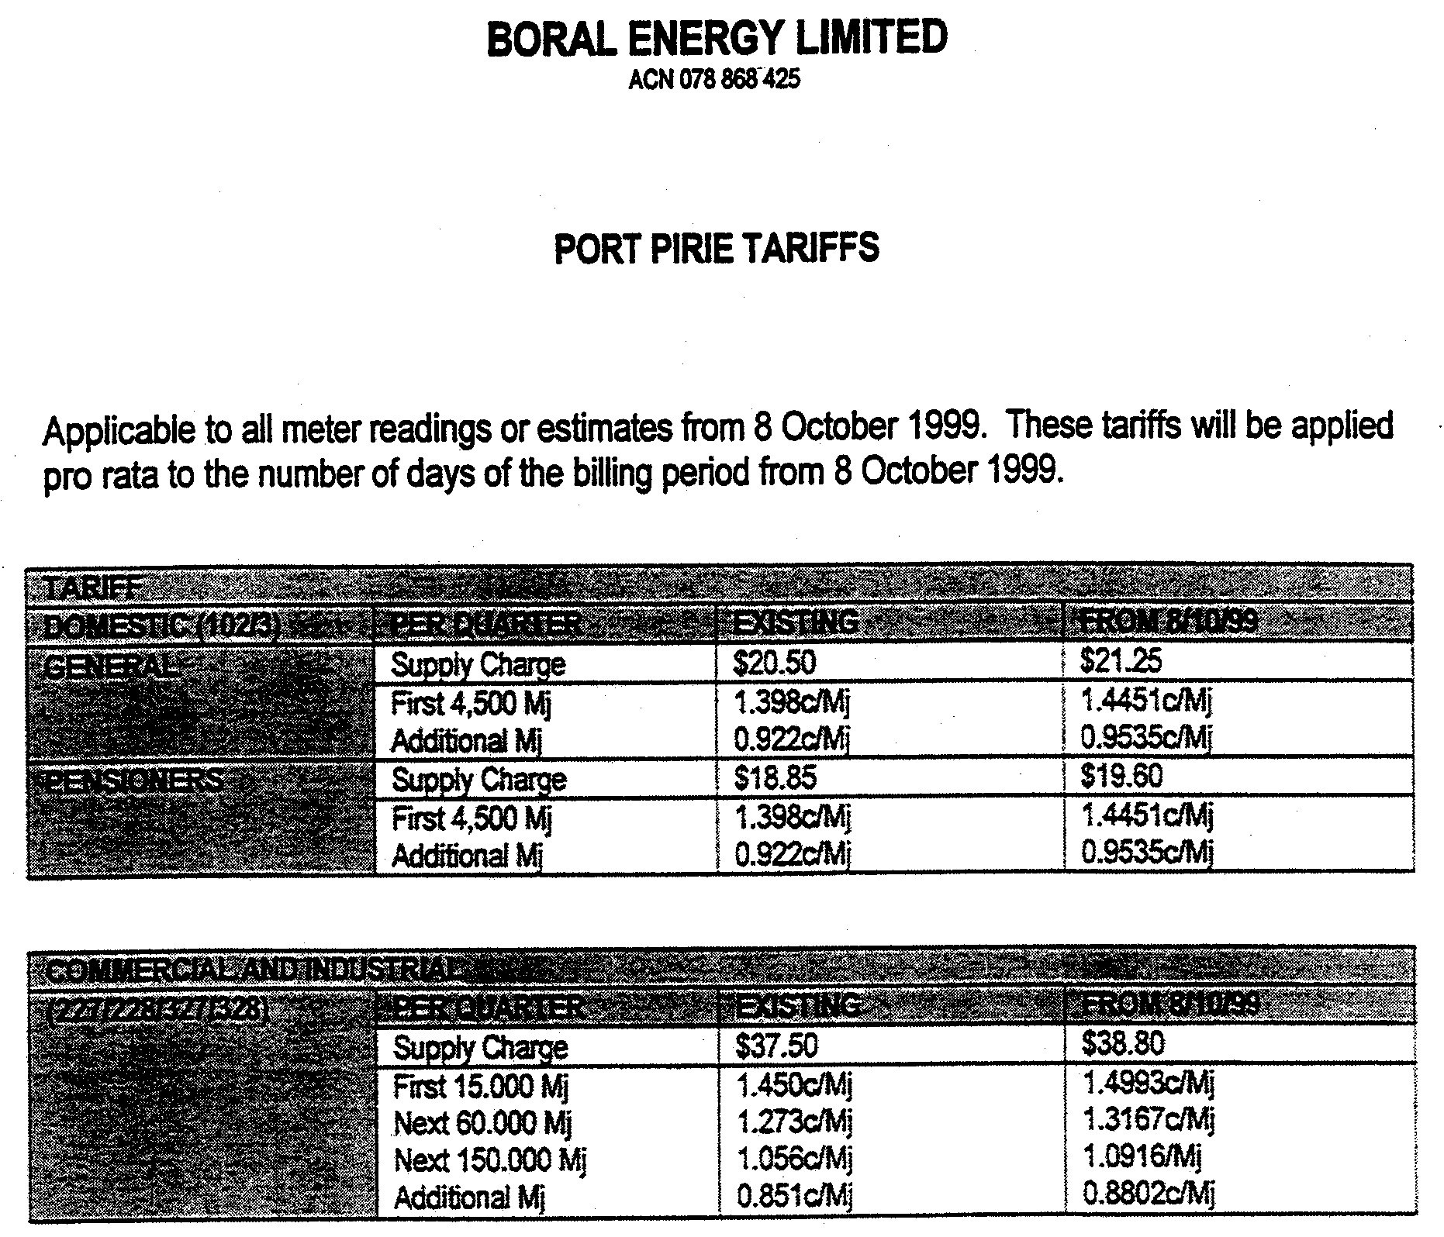
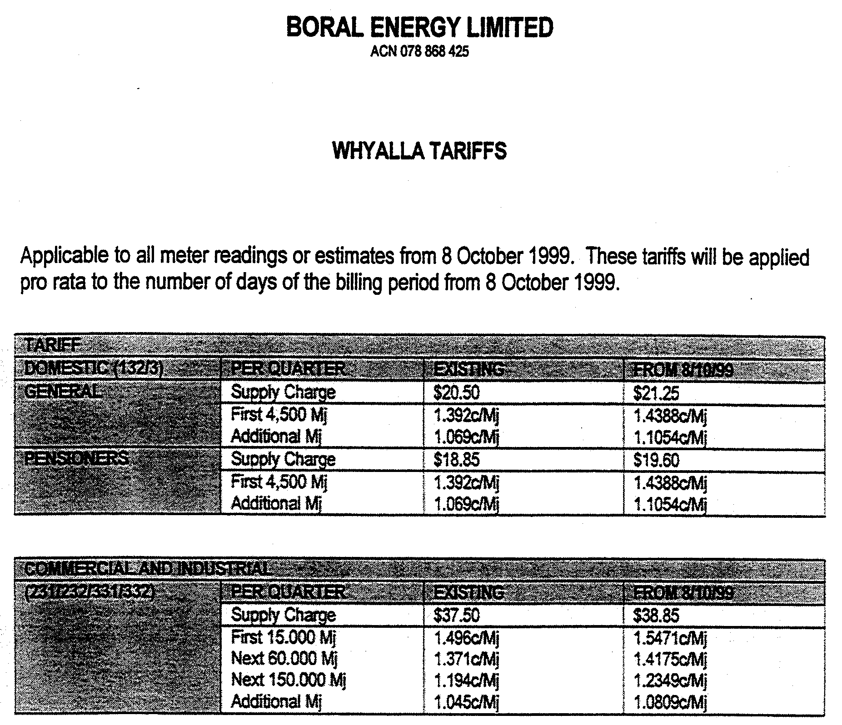
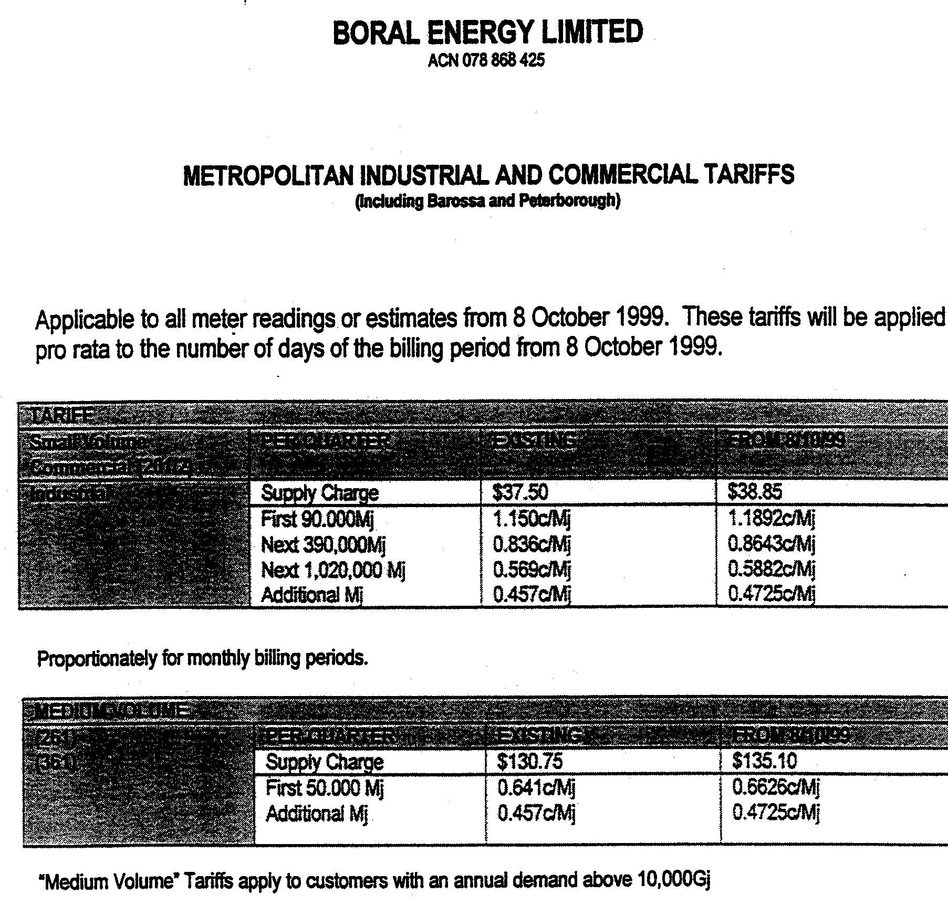
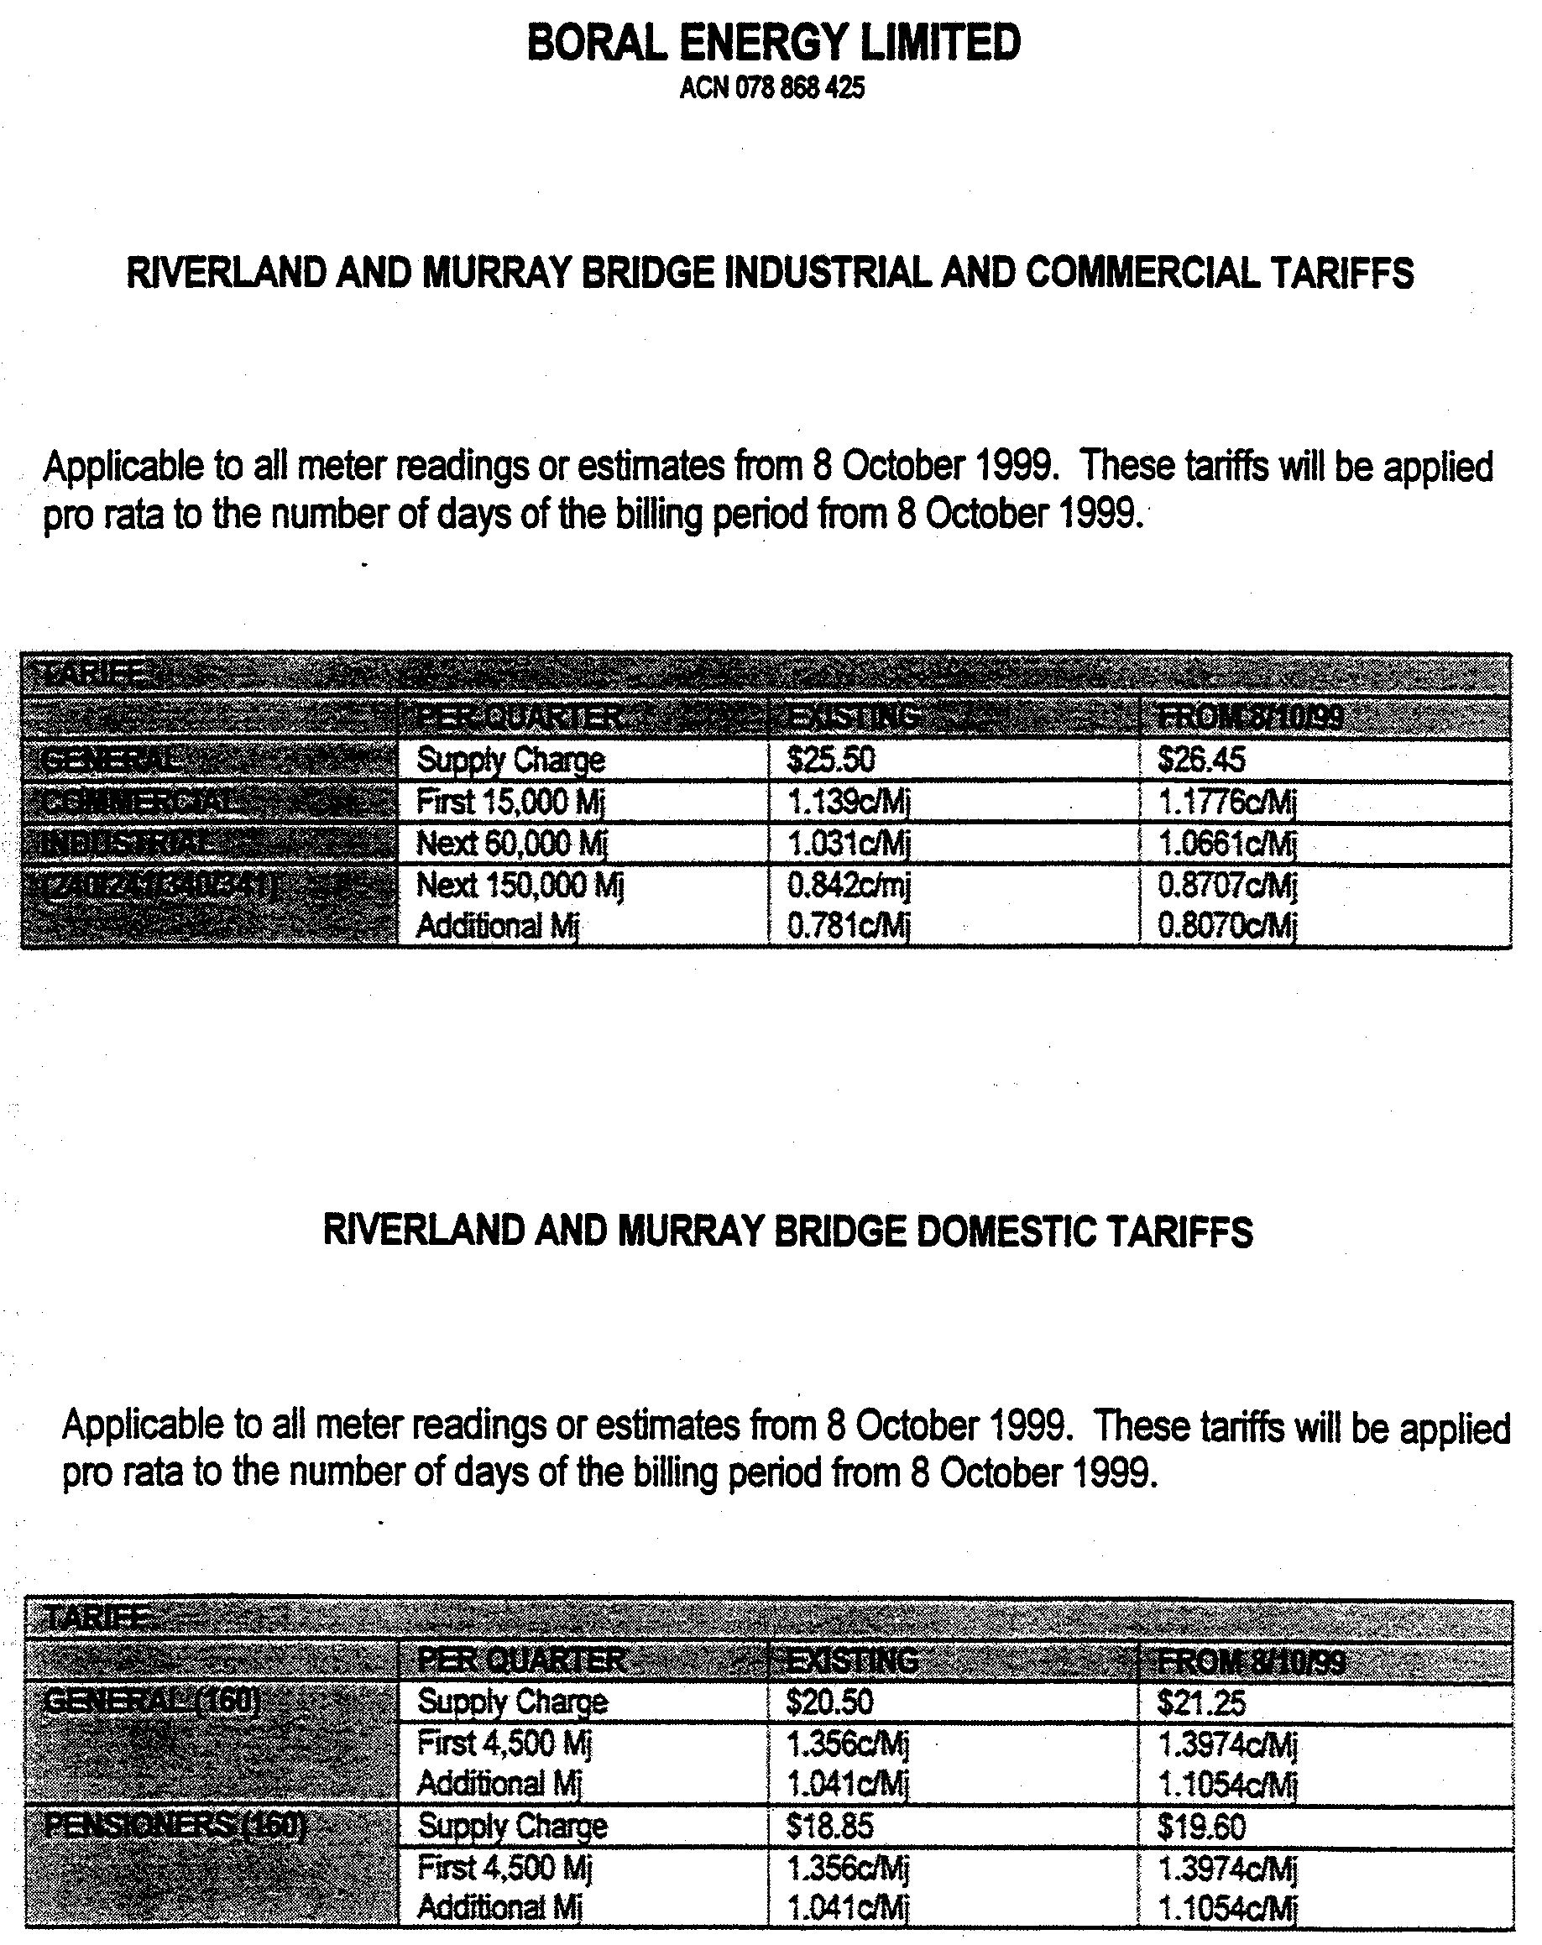

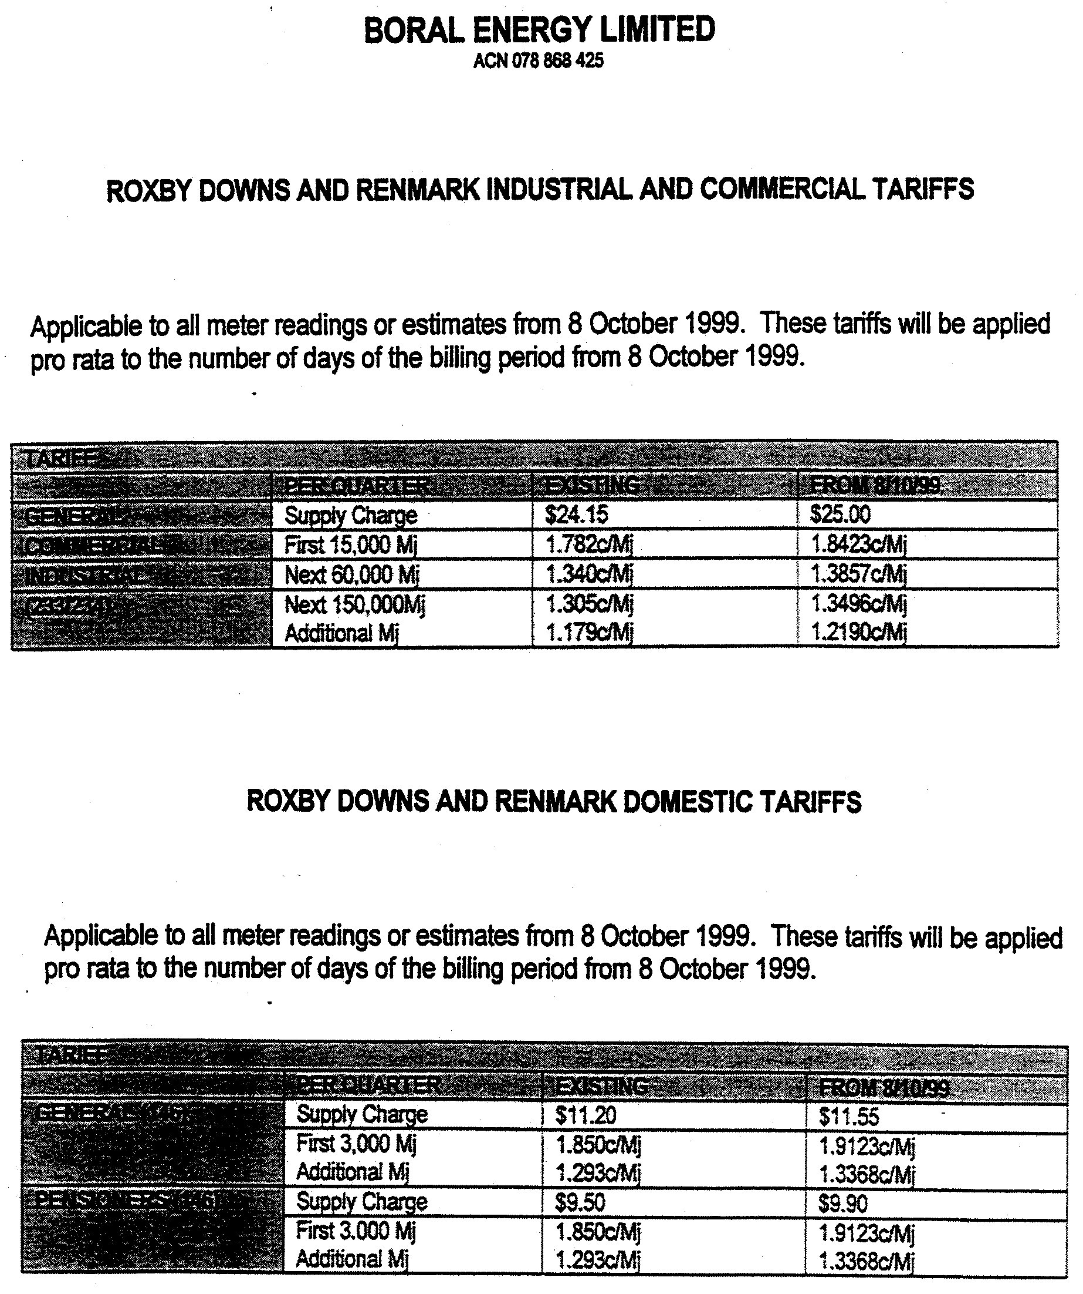

Christmas/New Year Holiday Publishing Information

Last Gazette for 1999 will be Thursday, 23 December 1999

Closing date for notices for publication will be
4 p.m. Tuesday, 21 December 1999

First Gazette for 2000 will be Thursday,6 January 2000

Closing date for notices for publication will be
4 p.m. Tuesday, 4 January 2000

(There will not be a Gazette in the period between these two dates)

It would be appreciated if Government Gazette notices for publication be addressed to:

Riverside 2000
Box 9
Plaza Level
Riverside Centre
North Terrace, Adelaide, S.A. 5000

AusDoc subscribers:

Riverside 2000
DX 56508

Facsimile transmission of notices:
(08) 8207 1040
Attention: Government Gazette Section

Inquiries telephone: 8207 1045

Private advertisements can be lodged and paid for at:

Information SA
Australis House
77 Grenfell Street
Adelaide, S.A. 5000

Phone: 8204 1906

Email address for Government Gazette notices:

govgaz@riv.ssa.sa.gov.au

When sending a document via Email please confirm your transmission with a faxed copy, including the date the notice is to be published.

REGULATIONS UNDER THE FISHERIES ACT 1982
────
No. 202 of 1999
────
At the Executive Council Office at Adelaide 7 October 1999

PURSUANT to the Fisheries Act 1982 and with the advice and consent of the Executive Council, I make the following regulations.
E. J. NEAL Governor

PURSUANT to section 10AA(2) of the Subordinate Legislation Act 1978, I certify that, in my opinion, it is necessary or appropriate that the following regulations come into operation as set out below.

ROB KERIN Minister for Primary Industries, Natural Resources and Regional Development
───────────────────
SUMMARY OF PROVISIONS

1. Citation
2. Commencement
3. Variation of reg. 8
4. Variation of Sched. 1—Fishing activities of a prescribed class for the purposes of s. 41 of the Act

───────────────────
Citation
1. The Fisheries (General) Regulations 1984 (see Gazette 28 June 1984 p. 1947), as varied, are referred to in these regulations as "the principal regulations".

Commencement
2. These regulations come into operation on the day on which they are made.

Variation of reg. 8
3. Regulation 8 of the principal regulations is varied by inserting after subregulation (5) the following subregulation:

(5a) An application cannot be made or granted for registration of a rock lobster pot in the name of a person under the age of 15 years.

Variation of Sched. 1—Fishing activities of a prescribed class for the purposes of s. 41 of the Act
4. Schedule 1 of the principal regulations is varied—

(a) by striking out clause 74 and substituting the following clause:

74. The setting in the waters of the State for purposes other than trade or business by any person of a rock lobster pot that contains rock lobster.;

(b) by inserting after subparagraph (iii) of paragraph (d) of clause 111 the following proviso:

Provided that for the purposes of this paragraph a rock lobster pot need not be fitted with escape gaps if its sides are covered with mesh of not less than 5 centimetres which is such that a cylindrical rod 5 centimetres in diameter is able to be passed through it freely without distorting it.;

(c) by inserting after subparagraph (iii) of paragraph (d) of clause 112 the following proviso:

Provided that for the purposes of this paragraph a rock lobster pot need not be fitted with escape gaps if its sides are covered with mesh of not less than 5 centimetres which is such that a cylindrical rod 5 centimetres in diameter is able to be passed through it freely without distorting it.

MPNR 45/99 CS SUZANNE M. CARMAN Clerk of the Council
REGULATIONS UNDER THE FISHERIES (GULF ST. VINCENT PRAWN FISHERY RATIONALIZATION) ACT 1987
────
No. 203 of 1999
────
At the Executive Council Office at Adelaide 7 October 1999

PURSUANT to the Fisheries (Gulf St. Vincent Prawn Fishery Rationalization) Act 1987 and with the advice and consent of the Executive Council, I make the following regulations.
E. J. NEAL Governor

PURSUANT to section 10AA(2) of the Subordinate Legislation Act 1978, I certify that, in my opinion, it is necessary or appropriate that the following regulations come into operation as set out below.

ROB KERIN Minister for Primary Industries, Natural Resources and Regional Development
───────────────────
SUMMARY OF PROVISIONS

1. Citation
2. Commencement
3. Revocation
───────────────────
Citation
1. These regulations may be cited as the Fisheries (Gulf St. Vincent Prawn Fishery Rationalization) Revocation Regulations 1999.

Commencement
2. These regulations will come into operation on the day on which the Fisheries (Gulf St. Vincent Prawn Fishery Rationalization) (Charges on Licences) Amendment Act 1999 comes into operation.

Revocation
3. The Fisheries (Gulf St. Vincent Prawn Fishery Rationalization) Regulations 1990 (see Gazette 1 March 1990 p. 608), as varied, are revoked.

MPNR 43/99 CS SUZANNE M. CARMAN Clerk of the Council

REGULATIONS UNDER THE FISHERIES ACT 1982
────
No. 204 of 1999
────
At the Executive Council Office at Adelaide 7 October 1999

PURSUANT to the Fisheries Act 1982 and with the advice and consent of the Executive Council, I make the following regulations.
E. J. NEAL Governor

PURSUANT to section 10AA(2) of the Subordinate Legislation Act 1978, I certify that, in my opinion, it is necessary or appropriate that the following regulations come into operation as set out below.

ROB KERIN Minister for Primary Industries, Natural Resources and Regional Development
───────────────────
SUMMARY OF PROVISIONS

1. Citation
2. Commencement
3. Variation of reg. 4—Interpretation
4. Variation of reg. 12—Transfer of licence
────────────────────
Citation
1. The Scheme of Management (Prawn Fisheries) Regulations 1991 (see Gazette 27 June 1991 p. 2133), as varied, are referred to in these regulations as "the principal regulations".

Commencement
2. These regulations will come into operation on the day on which the Fisheries (Gulf St. Vincent Prawn Fishery Rationalization) (Charges on Licences) Amendment Act 1999 comes into operation.

Variation of reg. 4—Interpretation
3. Regulation 4 of the principal regulations is varied by striking out the definition of "renewal fee" in subregulation (1).

Variation of reg. 12—Transfer of licence
4. Regulation 12 of the principal regulations is varied by striking out subregulation (2).

MPNR 43/99 CS SUZANNE M. CARMAN Clerk of the Council

REGULATIONS UNDER THE NURSES ACT 1999
────
No. 205 of 1999
────
At the Executive Council Office at Adelaide 7 October 1999

PURSUANT to the Nurses Act 1999 and with the advice and consent of the Executive Council, I make the following regulations.
E. J. NEAL Governor

PURSUANT to section 10AA(2) of the Subordinate Legislation Act 1978, I certify that, in my opinion, it is necessary or appropriate that the following regulations come into operation as set out below.

DEAN BROWN Minister for Human Services
───────────────────
SUMMARY OF PROVISIONS

PART 1
PRELIMINARY

1. Citation
2. Commencement
3. Interpretation

PART 2
CERTIFICATES OF REGISTRATION OR ENROLMENT

4. Certificates of registration or enrolment
5. Issue of duplicate if certificate lost, etc.
6. Return of certificate

PART 3
PROVISION OF INFORMATION

7. Information to be provided by nurses (s. 35)
8. Obligation to report incapacity (s. 43)
9. Obligation to report unprofessional conduct (s. 45)

PART 4
FEES

10. Fees and charges
11. Temporary practice in the State
12. Remission of fees

PART 5
MISCELLANEOUS

13. Badges
14. Wearing of badges
15. Information from employer
16. Information from agents
17. Evidence of registration or enrolment
18. Transitional provisions
───────────────────

PART 1
PRELIMINARY

Citation
1. These regulations may be cited as the Nurses Regulations 1999.

Commencement
2. These regulations will come into operation on the day on which section 4 of the Nurses Act 1999 comes into operation.

Interpretation
3. In these regulations—

"Act" means the Nurses Act 1999;

"authorised badge" means a badge issued under these regulations;

"authorised person" means a person authorised by the Board to exercise the powers of an authorised person under these regulations;

"business day" means any day other than a Saturday, Sunday or public holiday.

PART 2
CERTIFICATES OF REGISTRATION OR ENROLMENT

Certificates of registration or enrolment
4. (1) The Board will issue to each nurse a certificate of registration or enrolment.

(2) The certificate will be in a form determined by the Board.

(3) The certificate must note, in a manner determined by the Board, any condition, limitation or restriction that applies to the person under the Act.

Issue of duplicate if certificate lost, etc.
5. If—

(a) a nurse satisfies the Board that his or her certificate of registration or enrolment has been lost or destroyed; or

(b) a certificate that has become illegible in a particular is delivered to the Board,

the Board may, on payment of a fee determined by the Board, issue a duplicate certificate (and the former certificate is null and void).

Return of certificate
6. A nurse must within two business days deliver his or her certificate of registration or enrolment to the Board—

(a) if there is a change in the accuracy of a particular specified in the certificate; or

(b) on receiving notice of the suspension or cancellation of the registration or enrolment of the nurse; or

(c) on being required by the Board by notice in writing to deliver the certificate to the Board.

Maximum penalty: $2 500.

PART 3
PROVISION OF INFORMATION

Information to be provided by nurses (s. 35)
7. For the purposes of section 35(1) of the Act, the following information is prescribed:

(a) the full address of the nurse's current place of employment; and

(b) the full address of the nurse's previous place of employment (if any); and

(c) the full name and business address of the nurse's current employer; and

(d) the field of nursing in which the nurse is currently practising; and

(e) the fields of nursing in which the nurse has practised during the preceding five years; and

(f) the position held by the nurse in the nurse's current employment; and

(g) full details of the nurse's qualifications.

Obligation to report incapacity (s. 43
8. For the purposes of section 43 of the Act, the following information is prescribed:

(a) the prognosis of the illness or incapacity of the nurse; and

(b) full details of any treatment being received by the nurse for any illness or incapacity; and

(c) full details of any form of nursing care that, in the opinion of the health professional, the nurse is unfit to provide; and

(d) if the nurse has received treatment for a mental incapacity—whether the nurse has been the subject to any proceedings under the Mental Health Act 1993.

Obligation to report unprofessional conduct (s. 45)
9. For the purposes of section 45 of the Act, the following information is prescribed:

(a) full details of the date and circumstances surrounding the alleged conduct; and

(b) full details of the nature of the conduct that was observed or is alleged to have occurred; and

(c) the names and contact details of any person who observed the conduct or who has investigated the matter; and

(d) full details of any statement, comment or admissions made by the nurse in relation to the matter; and

(e) full details of the duties currently being undertaken by the nurse or, if relevant, information on any suspension or dismissal of the nurse from his or her employment.
PART 4
FEES

Fees and charges
10. The Board may fix fees or charges (including differential fees and charges) for the following:

(a) applications for registration or enrolment;

(b) applications for reinstatement on the register or roll;

(c) applications for the renewal of registration or enrolment;

(d) practice (see section 34(1) and (2) of the Act);

(e) issue of duplicate certificates, instruments or documents;

(f) assessment of nursing qualifications or experience;

(g) obtaining an approval of the Board;

(h) issue of badges;

(i) sale of publications;

(j) examinations;

(k) provision of reports;

(l) preparation of statements verifying registration or enrolment;

(m) inspection of the register or roll.

Temporary practice in the State
11. A nurse who—

(a) is employed as a nurse in another State; and

(b) is required as a condition of the nurse's employment to practise nursing in this State for a period not exceeding one month; and

(c) is registered or enrolled as a nurse in the other State; and

(d) has paid the appropriate fees currently payable under the law of the other State in relation to—

(i) practice; and

(ii) registration or enrolment as a nurse,

is exempt from the obligation to pay the registration or enrolment, and practice, fees under the Act.

Remission of fees
12. The Board may, on application, in its discretion, waive payment of the whole or a part of a fee, or refund a fee (in whole or in part).

PART 5
MISCELLANEOUS

Badges
13. (1) The Board may issue to a person who is registered or enrolled under the Act an appropriate badge.

(2) A badge will, for the purposes of the Act and these regulations, be in a form determined by the Board.

(3) A badge issued to a person who is entitled to practise in a special practice area must bear a set of letters, determined by the Board, to signify the person's qualification in the relevant area.

Wearing of badges
14. (1) A person who is not a nurse must not wear an authorised badge.

(2) A nurse must not wear an authorised badge other than a badge appropriate to the field of nursing in relation to which the nurse is registered or enrolled.

(3) A person who contravenes subregulation (1) or (2) is guilty of an offence.

Maximum penalty: $1 250.

(4) An authorised person who reasonably suspects that a person is wearing a badge in contravention of subregulation (1) may request the person to produce to the authorised person evidence of that person's registration or enrolment.

(5) An authorised person who reasonably suspects that a nurse is wearing a badge in contravention of subsection (2) may request the nurse to produce to the authorised person evidence of the nurse's registration or enrolment in the field of nursing indicated by the badge.

(6) If a person fails to comply with a request made by an authorised person pursuant to subregulation (4) or (5) the authorised person may request that person to—

(a) state the person's full name and residential address; and

(b) state the full address of the person's current place of employment; and

(c) state the full name and business address of the person's current employer.

(7) A person who fails to comply with a request under subregulation (6) is guilty of an offence.

Maximum penalty: $2 500.

Information from employer
15. (1) In this regulation—

"employee" means a person employed as a nurse;

"employer" means a person who employs a person to practise as a nurse.

(2) An authorised person may request an employer to produce to the authorised person all books, papers and other documents in relation to an employee that are in the possession or under the control of the employer.

(3) A person who fails to comply with a request under subregulation (2) is guilty of an offence.

Maximum penalty: $1 250.

(4) An authorised person may examine books, papers or other documents produced under subregulation (2) and take extracts and make copies.

Information from agents
16. (1) In this regulation—

"agent" means a person who acts on behalf of another person, with or without reward, for the purpose of procuring employment as a nurse for that other person;

"client" means a person on whose behalf an agent acts.

(2) An authorised person may request an agent to produce to the authorised person all books, papers and other documents in relation to a client that are in the possession or under the control of the agent.

(3) A person who fails to comply with a request under subregulation (2) is guilty of an offence.

Maximum penalty: $1 250.

(4) An authorised person may examine books, papers or other documents produced under subregulation (2) and take extracts and make copies.

Evidence of registration or enrolment
17. (1) An authorised person who reasonably suspects that a person who appears to be practising as a nurse is unqualified may request that person to produce to the authorised person evidence of that person's registration or enrolment under the Act.

(2) If a person fails to produce evidence of registration or enrolment to an authorised person pursuant to a request under subregulation (1), the authorised person may request that person to state—

(a) the person's full name and residential address; and

(b) the address of the person's current place of employment; and

(c) the full name and business address of the person's current employer.

(3) A person who fails to comply with a request under subregulation (2) is guilty of an offence.

Maximum penalty: $2 500.

Transitional provisions
18. (1) In this regulation—

"the former Board" means the Nurses Board under the Nurses Act 1984;

"the new Board" means the Nurses Board of South Australia under the Act;
"the relevant day" means the day on which these regulations come into operation.

(2) A person who is taken to be registered or enrolled under the Act by virtue of the operation of clause 4 of the schedule of the Act will be taken to be registered or enrolled—

(a) subject to the same conditions, limitations or restrictions (if any) that applied to the person immediately before the repeal of the Nurses Act 1984; and

(b) subject to the Act (and any other regulations made under the Act) and the Nurses Act 1984, for a period equal to the balance of the period of registration or enrolment existing immediately before the repeal of the Nurses Act 1984.

(3) For the purposes of clause 4(1) of the schedule of the Act, the appropriate register for the registration of a mental deficiency nurse is the general nurses register.

(4) Proceedings instituted before the former Board under Part 4 of the Nurses Act 1984 that have been the subject of a preliminary conference conducted on behalf of that Board before the relevant day will continue before that Board¹.

^{1.} See also section 16 of the Acts Interpretation Act 1915.

(5) Unless or until otherwise determined by the new Board—

(a) any determination or decision of the former Board having effect immediately before the relevant day will continue to have effect as a determination or decision of the new Board; and

(b) any policy, principle or code adopted by the former Board and having effect immediately before the relevant day will continue as a policy, principle or code of the new Board; and

(c) any approval given by the former Board and having effect immediately before the relevant day will continue after the relevant day; and

(d) any committee established by the former Board and in existence immediately before the relevant day will continue as a committee of the new Board; and

(e) a delegation of the former Board in operation immediately before the relevant day will continue as a delegation of the new Board.

MHS 15/99 CS SUZANNE M. CARMAN Clerk of the Council

FAXING COPY?

IF you fax copy to Riverside 2000, for inclusion in the Government Gazette, there is no need to send a Confirmation Copy to us as well.

This creates confusion and may well result in your notice being printed twice.

Please use the following fax number:

Fax transmission: (08) 8207 1040
Phone Inquiries: (08) 8207 1045

Please include a contact person, phone number and order number so that we can phone back with any queries we may have regarding the fax copy.

NOTE: Closing time for lodging new copy (either fax or hard copy) is 4 p.m. on Tuesday preceding the day of publication.

Government Gazette notices can be E-mailed.

The address is:

govgaz@riv.ssa.sa.gov.au

Documents should be sent as attachments in Word format.

When sending a document via E-mail, please confirm your transmission with a faxed copy of your document, including the date the notice is to be published.

Fax transmission: (08) 8207 1040
Enquiries: (08) 8207 1045

CITY OF CAMPBELLTOWN
Supplementary Election
Nominations
NOTICE is hereby given, pursuant to the provisions of section 96 (14) of the Local Government Act 1934, as amended, that when nominations closed for the Supplementary Election for Gorge Ward and Woodforde Ward on 30 September 1999, the following nominations had been received for the vacancies:
Gorge Ward
Antonio Centofanti
Frederick Wayne Goldstone
Lealand Wayne Aldenhoven
Luciano Mercurio
Woodforde Ward
Jennifer Anne Drewett
There being no more than the required number of nominations for the office of Councillor for Woodforde Ward the following candidate was declared elected to that office for a term of office concluding on the first Saturday in May 2000:
Jennifer Anne Drewett.
There being more than the required number of nominations for the office of Councillor for Gorge Ward, an election by ballot will be held on 30 October 1999, between the hours of 8 a.m. and 6 p.m.
Polling Places and Counting Place
Pursuant to the provisions of section 89 of the Local Government Act 1934, notice is hereby given that the following polling places and counting place have been appointed for the Supplementary Election to be held on 30 October 1999:
Polling Places
Council Committee Rooms,
172 Montacute Road, Rostrevor;
Athelstone Community Centre,
338 Gorge Road, Athelstone;
The above polling places will be open between 8 a.m. and 6 p.m. on 30 October 1999.
Counting Place
Council Committee Rooms,
172 Montacute Road, Rostrevor;
Voting Otherwise Than at Polling Places
Any person who desires to vote in respect of the above election otherwise than by attending at a polling place during voting hours on 30 October 1999 may apply to the returning officer.
Application may be made:
(a) personally to the returning officer; or
(b) by writing addressed to the returning officer at P.O. Box 1, Campbelltown, S.A. 5074.
Applications must be received before 5 p.m. on 29 October 1999. No reason needs to be given for voting in advance.
R. Smith, Returning Officer

CITY OF HOLDFAST BAY
Periodical Review of Elector Representation (1999)—Second Consultation
NOTICE is hereby given that the City of Holdfast Bay has completed a review to determine whether a change of arrangements in respect to elector representation, including ward structure and the composition of council, would result in the electors within the city being more adequately and fairly represented.
Council has prepared a report which details the review process, the public consultation undertaken and the proposal which it considers should be implemented to best serve the community. The proposal makes provision for a four ward structure with three elected representatives per ward and a Mayor. Copies of this report are available from:
Head Office, 24 Jetty Road, Brighton;
Branch Office, 1 Moseley Square, Glenelg;
Brighton Library, 20 Jetty Road, Brighton;
Glenelg Library, 2 Colley Terrace, Glenelg,
during normal business hours, or by contacting Ross Baker on telephone 8229 9921.
Pursuant to the provisions of section 24 (7) (b) (ii) of the Local Government Act 1934, as amended, interested persons are invited to make a written submission in respect to the report.
These should be directed to:
Chief Executive Officer,
City of Holdfast Bay,
P.O. Box 19,
Brighton, S.A. 5048,
to be received by close of business on Monday, 1 November 1999.
Any persons making a written submission will be invited to appear before council, or a committee thereof, to be heard in respect to their submission.
D. Aylen, Chief Executive Officer

DISTRICT COUNCIL OF THE COPPER COAST
Temporary Road Closure
NOTICE is hereby given that the council, pursuant to section 359 of the Local Government Act 1934, as amended, resolved to exclude vehicles generally, except council vehicles:
• from that portion of Bagot Street, Wallaroo, between Young Street and May Street, from 11 a.m. to 3 p.m. on Sunday, 7 November 1999, for the purpose of 130 year celebrations.
J. W. Shane, Chief Executive Officer

Temporary Road Closure
NOTICE is hereby given that the council, pursuant to section 359 of the Local Government Act 1934, as amended, resolved to exclude vehicles generally, except council vehicles:
• from that portion of Ewing Street, Kadina, between Graves Street and Taylor Street, from 10 a.m. to 2 p.m. on Sunday, 17 October 1999, for the purpose of NYP Juvenile Diabetes Support Group ‘Walk for the Cure’.
J. W. Shane, Chief Executive Officer

DISTRICT COUNCIL OF NARACOORTE AND LUCINDALE
Change of Name
NOTICE is hereby given that, pursuant to section 26 of the Local Government Act 1934, as amended, the District Council of Naracoorte and Lucindale changes its name to Naracoorte Lucindale Council to take effect from 1 October 1999.
D. Beaton, Chief Executive Officer

DISTRICT COUNCIL OF RENMARK PARINGA
Notice of Appointment
NOTICE is hereby given, pursuant to section 66 of the Local Government Act 1934, as amended, that at a duly constituted meeting of the District Council of Renmark Paringa held on 24 August 1999, Dr Ali Khan was appointed to the position of District Manager/Chief Executive Officer, with effect from 4 October 1999.
B. Waples, Acting District Manager

DISTRICT COUNCIL OF RENMARK PARINGA
Temporary Road Closure
NOTICE is hereby given that, pursuant to section 359 of the Local Government Act 1934, as amended, the District Council of Renmark Paringa has resolved that Murray Avenue between Para Street and the traffic island adjacent to the Renmark Visitor Information Centre shall be closed between 11 a.m. Sunday, 24 October 1999 and 11 a.m. Monday, 25 October 1999 to all vehicles except emergency vehicles and vehicles associated with the Channel 9 Today Show.
B. Waples, Acting District Manager

DISTRICT COUNCIL OF YORKE PENINSULA
Elector Representation⎯Proposal
NOTICE is hereby given that a proposal has now been prepared following the consultation period.
The proposal retains the four Wards and fifteen Councillors:
Kalkabury⎯5 councillors
Gum Flat⎯5 councillors
Penton Vale⎯3 councillors
Innes⎯2 councillors
and amends the Ward boundaries of the Innes, Penton Vale and Gum Flat Wards to achieve representation within the + or –10 per cent tolerance as required by the Local Government Act 1934, as amended.
A copy of the proposal may be obtained from the Principal Office at:
• 8 Elizabeth Street, Maitland, S.A. 5573 (Phone: 8832 2701)
or the Branch Offices at:
• 18 Main Street, Minlaton, S.A. 5575 (Phone: 8853 2102)
• 15 Edithburgh Road, Yorketown, S.A. 5576 (Phone: 8852 1433)
• Player Street, Warooka, S.A. 5577 (Phone: 8854 5055)
Comments on the proposal will be received until 5 p.m. on Friday, 29 October 1999 and should be addressed to the undersigned at the Principal Office, 8 Elizabeth Street, Maitland, S.A. 5573.
R. A. Wood, Chief Executive Officer

IN the matter of the estates of the undermentioned deceased persons:
Allbon, Ronald Ernest, late of 1a Arnold Street, Underdale, retired gardener, who died on 11 August 1999.
Allen, Douglas Stanley, late of Grainger Road, Somerton Park, retired departmental manager, who died on 26 August 1999.
Bowden, Jean Amelia, late of 7 Lancelot Drive, Daw Park, of no occupation, who died on 31 July 1999.
Cormack, William, late of 15 Hancock Drive, Lewiston, retired technical officer, who died on 22 August 1999.
Coull, Alexander, late of Blamey Road, Elizabeth East, retired driver, who died on 9 August 1999.
Critchley, Frank Vincent, late of 33 Halmon Avenue, Everard Park, retired turner, who died on 17 August 1999.
Dack, Edith Esther, late of 150 Adams Road, Craigmore, retired secretary, who died on 10 August 1999.
Daniels, David Joseph, late of 6 Turner Road, Elizabeth Park, retired mines labourer, who died on 30 November 1998.
Diack, Philip George Anthony, late of 276 Portrush Road, Beulah Park, retired company director, who died on 19 July 1999.
Ewins, Caroline Elizabeth, late of 6 Ellis Street, Enfield, of no occupation, who died on 7 August 1999.
Gill, Lorna Jessie, late of 29 Austral Terrace, Morphettville, widow, who died on 24 August 1999.
Gordon, Byron Clifford, late of 12 Raymond Grove, Warradale, retired driver, who died on 7 September 1999.
Hiern, Ross Noel, late of 34 Austral Terrace, Morphettville, retired sales assistant, who died on 21 August 1999.
MacKenzie, Sylvia Edna Phyllis, late of 51 Eve Road, Bellevue Heights, widow, who died on 19 August 1999.
Miller, Shirley Irene, late of 58 Barbados Drive, Seaford Rise, home duties, who died on 17 July 1999.
Penney, Elizabeth, late of 8 Mine Street, Kadina, widow, who died on 27 July 1999.
Petney, Grace Edith, late of 86 Oaklands Road, Glengowrie, of no occupation, who died on 8 September 1999.
Pitman, Evelyn Gladys May, late of 580 Lower North East Road, Campbelltown, or no occupation, who died on 6 September 1999.
Polmear, Ian Douglas, late of 848 Torrens Road, Rosewater, mail officer, who died on 16 June 1999.
Purser, Margaret, late of 106 Halsey Road, Elizabeth East, widow, who died on 25 August 1999.
Scutt, Maisie Joy, late of 148 Beulah Road, Norwood, retired sales assistant, who died on 28 August 1999.
Todd, William Henry, late of Sir James Hardy Way, Woodcroft, of no occupation, who died on 17 May 1999.
Vears, Teresa Elizabeth, late of 6 Mersey Street, Cumberland Park, retired laundress, who died on 21 August 1999.
Welsby, Helen Marianne, late of 50 Queen Street, Peterborough, of no occupation, who died on 22 August 1999.
Notice is hereby given pursuant to the Trustee Act 1936, the Inheritance (Family Provision) Act 1972, and the Family Relationships Act 1975, that all creditors, beneficiaries, and other persons having claims against the said estates are required to send, in writing, to the Public Trustee, 25 Franklin Street, Adelaide, S.A. 5000, full particulars and proof of such claims, on or before 5 November 1999, otherwise they will be excluded from the distribution of the said estate; and notice is also hereby given that all persons who are indebted to the said estates are required to pay the amount of their debts to the Public Trustee or proceedings will be taken for the recovery thereof; and all persons having any property belonging to the said estates are forthwith to deliver the same to the Public Trustee.
Dated 7 October 1999.
J. H. Worrall, Public Trustee

SOUTH AUSTRALIA—In the Supreme Court. No. 2644 of 1992. In the matter of Adelaide Opticians Pty Limited (ACN 008 101 700) and in the matter of the Corporations Law.
Notice by a Liquidator of His Intention to Seek His Release
Take notice that, I, Peter Ivan Macks, 26 Flinders Street, Adelaide, S.A. 5000 the liquidator of the abovenamed company, intend to make application to the Supreme Court of South Australia for my release as a liquidator of the abovenamed company.
And take further notice that if you have any objection to the granting of my release you must file at the Supreme Court and also forward to me within 21 days of the publication in the Gazette of the notice of my intention to apply for a release a notice of objection in the form laid down by the Corporations (South Australia) Rules 1993.
Dated 16 August 1999.
P. I. Macks, Liquidator
Note: Section 481 of the Corporations Law enacts that an order of the Court releasing a liquidator shall discharge him/her in the administration of the affairs of the company, or otherwise in relation to his or her conduct as liquidator, but any such order may be revoked on proof that it was obtained by fraud or by suppression or by concealment of any material fact.
Accounts in the form prescribed in section 539 of the Corporations Law have been prepared and filed with the Australian Securities and Investments Commission.

CAB PUBLICATIONS PTY LTD (IN LIQUIDATION)
(ACN 076 107 410)
Notice Convening Final Meeting of Members and Creditors
NOTICE is hereby given, pursuant to section 509 of the Corporations Law that a general meeting of the members and creditors of the abovenamed company will be held at the offices of Sheahan Coope, Level 8, 26 Flinders Street, Adelaide, S.A. 5000, on Tuesday, 9 November 1999 at 10 a.m. for the purpose of having an account laid before them showing the manner in which the winding up has been conducted and the property of the company disposed of and of hearing any explanations that may be given by the liquidator.
Dated 29 September 1999.
J. Sheahan, Liquidator

NEZUM PTY LIMITED
(ACN 009 640 742)
THE DEPUTY COMMISSIONER OF TAXATION, of the Adelaide Branch of the Australian Taxation Office located at 191 Pulteney Street, Adelaide, S.A. 5000 has brought a Summons in Action No. 1100 of 1999 in the Supreme Court of South Australia seeking the winding up of Nezum Pty Limited. The summons is listed for hearing on Tuesday, 19 October 1999 at not before 2.15 p.m. Any creditor or contributory of Nezum Pty Limited wishing to be heard on the summons must file and serve a Notice in accordance with Rule 20 of the Corporations (South Australia) Rules 1993 at least three business days before the day on which the summons is listed for hearing and must attend at the Supreme Courthouse, Victoria Square, Adelaide at the time set for the hearing of the summons. A copy of the summons and affidavit in support can be obtained on payment of the proper cost from the Deputy Commissioner of Taxation, 1991 Pulteney Street, Adelaide, S.A. 5000.

SALE OF PROPERTY
Italo-Australian Miners Club, Italian Club Road, Coober Pedy
NOTICE is hereby given that on the above date at the time and place stated, by virtue of the Warrant of Sale issued out of the District Court of South Australia, Adelaide Registry, Action No. 267 of 1999, directed to the Sheriff of South Australia in an action wherein Westpac Banking Corporation, is Plaintiff and Michael & Carole Brownbill are Defendants, I, John Andrew Carr, Sheriff of the State of South Australia, will by my auctioneers, Elders Real Estate, make sale of the estate, right, title or interest whatsoever it may be of the defendants Michael and Carole Brownbill as the registered proprietor of an estate in fee simple in the following:
That piece of land situated in the area named Coober Pedy, being Lot 312, Eyre Street, being the property comprised in Certificate of Title Register Book volume 5184, folio 788.
Further particulars from the auctioneers: Elders Real Estate, 34 Hutchinson Street, Coober Pedy, S.A. 5723, Phone: (08) 8672 5686.

ATTENTION

CUSTOMERS requiring a proof of their notice for inclusion in the Government Gazette, please note that the onus is on you to inform Riverside 2000 of any subsequent corrections by 10 a.m. on Thursday, which is our publication deadline.

For any corrections to your notice please phone 8207 1045 or Fax 8207 1040 before 10 a.m. on Thursday.

If we do not receive any communication by 10 a.m. on Thursday (day of publication) we will presume the notice is correct and will print it as it is.

Remember—the onus is on you to inform us of any corrections necessary to your notice.

NOTE: Closing time for lodging new copy (either fax or hard copy) is 4 p.m. on Tuesday preceding the day of publication. Ph. 8207 1045—Fax 8207 1040.

Printed and published by authority every Thursday by M. E. JONES, Acting Government Printer, South Australia
Price: $3.85, plus postage; to subscribers, $190 per annum.

