SUPPLEMENTARY GAZETTE



THE SOUTH AUSTRALIAN

GOVERNMENT GAZETTE

PUBLISHED BY AUTHORITY

ALL PUBLIC ACTS appearing in this GAZETTE are to be considered official, and obeyed as such

ADELAIDE, MONDAY, 11 OCTOBER 1999

RULES UNDER THE RACING ACT 1976
PURSUANT to the Racing Act 1976, the South Australian Harness Racing Authority makes the following Rules:
The Common Seal of the South Australian Harness Racing Authority was affixed hereto on 18 August 1999 in the presence of:
(l.s.) B. Grant, Deputy Chair
K. Bartlett, Authority Member
Pursuant to Section 10AA (2) of the Subordinate Legislation Act 1978, I certify that, in my opinion, it is necessary or appropriate that the following Rules come into operation as set out below.
Iain Evans, Minister for Recreation, Sport and Racing

Summary of Contents
Citation
1. These Rules may be cited as the Rules of the South Australian Harness Racing Authority.
Commencement
2. These Rules will come into operation on 1 October 1999.
Revocation
3. The South Australian Harness Racing Board Rules of Harness Racing 1992, are revoked.

SOUTH AUSTRALIAN

HARNESS RACING AUTHORITY

THE RULES
of

HARNESS RACING

The Rules numbered 1 to 314 (inclusive) are the Australian Rules of Harness Racing. The Rules preceded by the letters SLR are the Local Rules of the
South Australian Harness Racing Authority.

The Australian Rules of Harness Racing and the Local Rules are to be read, interpreted and construed together, and as so combined shall be and be known as ‘The Rules of the South Australian Harness Racing Authority’.

Effective: 1 October 1999

South Australian Harness Racing Authority: |  | PO Box 225  Salisbury SA 5108  Tel: (08) 8285 2899 Fax: (08) 8285 2961  Email: saharness@harness.org.au
TABLE OF CONTENTS

Part | Subject | Rule Numbers
 | Dictionary
1 | Clubs | 1-13
2 | Stewards | 14-20
3 | Meetings and Races | 21-89
4 | Licences | 90-91
5 | Horses | 92-122
6 | Handicapping | 123-125
7 | Starting | 126-146
8 | Required Racing Standard | 147-150
9 | Drivers | 151-174
10 | Objections and Protests | 175-180
11 | Inquiries and Investigations | 181-187
12 | Prohibited Substances | 188-196
13 | Prizemoneys | 197-201
14 | General Offences | 202-255
15 | Penalties | 256-258
16 | Disqualified Persons | 259-267
17 | Equipment and Colours | 268-273
18 | Studs and Sires | 274-280
19 | Artificial Breeding | 281-290
20 | Unpaid Forfeit List | 291-296
21 | General Matters | 297-314
22 | Forms
23 | Bookmakers and Betting | SLR 1
24 | Appeals | SLR 2

DICTIONARY
‘Agricultural show’ includes district shows, sports meetings and gymkhanas.
‘Arrears’ mean moneys owed for not less than 30 days.
‘Artificial breeding station’ means a place where artificial breeding is attempted or carried on.
‘Australian Harness Racing Council’ or ‘Council’ means the body incorporated under the Australian Capital Territory Associations Incorporation Ordinance 1953, under the name Australian Harness Racing Council Incorporated.
‘Authorised agent’ and ‘Authorised person’ means a person recognised as such by the Controlling Body.
‘Birdcage’ means an enclosure or place on a racecourse where horses are stabled, marshalled or paraded for events.
‘Body’ includes a corporation, a body corporate, an unincorporated association and a recognised harness racing authority.
‘Competing’ for the purposes of insurance has the following applications:
a driver, who is not also the trainer of a horse or the trainer’s agent, is deemed to be competing in a race from the time that the driver first sits in the sulky of the horse for the purpose of parading the horse for the race until the reins of the horse are taken by the trainer or the trainer’s agent following the finish of a race;
a driver, who is also the trainer of a horse or the trainer’s agent, is deemed to be competing in a race from the time that the driver first sits in the sulky of the horse for the purpose of parading the horse for the race until the horse leaves that part of the racecourse on which the race takes place following the finish of the race.
‘Connections’ includes the persons who are the owners or lessees of a horse or who otherwise have a legal interest in it, a trainer, a manager of a syndicate, a studmaster, and the authorised agents of such persons.
‘Controlling Body’ means an organisation which by convention, recognition or law is or is deemed to be in control of harness racing in a State or Territory of Australia or in part of or the whole of a country.
‘Determination’ includes requirements, orders, directions, decisions, and the like, made, given or imposed on or about any subject matter, person, group or class of persons, or any club, organisation or body, with or without sanctions attaching thereto.
‘Driver’ includes a person who though not holding a licence granted under these rules drives a horse in a race or does other things which are only done or usually done by drivers.
‘Drug of Abuse’ means a drug within the scope of that expression as used in the document published by Standards Australia entitled ‘Recommended practice for the collection, detection and quantitation of drugs of abuse in urine’ numbered AS 4308—1995 and any subsequent amendment or replacement of that document.
‘Family interest’ refers to a situation other than a bet on a horse in a race, where if a steward or handicapper were to exercise a power under the rules, the spouse, domestic partner, parent, sibling or child of, or person residing with, the steward or handicapper would have, or be likely to have, a financial or other significant interest in the outcome.
‘Handicapper’ means a person appointed by the Controlling Body to handicap.
‘Harness racing association’ or ‘association’ means any organisation which represents harness racing clubs or other bodies which promote or conduct races or meetings.
‘Harness racing club’ or ‘club’ means any body, other than a Controlling Body, which promotes or conducts races or meetings.
‘Horse’ means a horse bred, cared for, managed, trained, raced or otherwise dealt with for purposes connected with the harness racing industry.
‘Jurisdiction’ means that country or State or Territory of Australia in which a Controlling Body or recognised harness racing authority has by law the power to control and regulate harness racing.
‘Licence’ includes permit.
‘List’ means the unpaid forfeit list except where some other list is identified in the rules.
‘Meeting’ means a meeting at which harness racing horses race or participate in events or were scheduled to do so.
‘Official’ includes an official of a club.
‘Person’ includes an individual, a syndicate, a corporation, a body corporate, and an unincorporated association.
‘Race’ means a race or event in which harness racing horses race or participate.
‘Racecourse’ or ‘course’ means a place at which harness racing horses race or participate in events, and includes all the land and improvements—such as stands, seats, stables, enclosures, rooms, offices, betting and recreational areas, carparks—used in connection with the conduct or observation of races, meetings or events by persons engaged in the harness racing industry or by members of the public.
‘Racetrack’ or ‘track’ means that part of a racecourse on which harness racing horses race.
‘Racing year’ means the period commencing 1 September in a calendar year and ending 31 August in the following calendar year.
‘Recognised harness racing authority’ means an organisation accepted by the Controlling Body as controlling the harness racing industry in a State or Territory of Australia or in part of or the whole of a country.
‘Semen’ includes frozen, and chilled semen.
‘Sprint Lane’ means a clearly identified inward expansion of the inside of the straight immediately preceding the winning post.
‘Standardbred’ when used with reference to a horse means a horse which is the progeny of a registered sire and registered dam.
‘Stewards’ means stewards appointed under these rules.
‘Stud’ means a place where the breeding of horses is attempted or carried on.
‘Swab’ means the taking, or a procedure for the taking, of blood, urine, saliva, or other matter or sample or specimen from a horse for the purpose of testing for the presence of a prohibited substance and ‘positive swab’ means that the swab, when tested, reveals such a presence.
‘TAB’ means the organisation appointed or established by or under the law in the jurisdiction of the Controlling Body to regulate off course betting and when used in connection with a race or meeting means off course betting so regulated.
‘Trainer’ includes a person who though not holding a licence granted under these rules trains a horse or does other things which are only done or usually done by trainers.
‘Training’ includes the preparation, education and exercising of a horse to race, but not the mere process of keeping a horse in good health.
‘Warned Off’ or ‘Warning Off’ means a decision or penalty prohibiting a person from entering any racecourse or place under the control of a club or the Controlling Body.
Notes:
(1) Part headings and brief descriptions in bold type are inserted in the rules solely for ease of reference and do not form part of the text.
(2) Offence provisions are found throughout the rules and are not confined to those in Part 14 or under the bold type heading ‘Offences’. An offence provision is identified by use of the words in it, or with reference to it, that failure to comply or contravention of it makes a person guilty of an offence.
(3) In the interpretation of these rules nothing turns on the fact that in some instances capital letters may be used and in others letters in lower case.
PART 1
CLUBS
Registration of clubs and other bodies
1. The Controlling Body shall keep a register of all harness racing clubs granted registration.
2. (1) A club desiring to promote or conduct meetings or races may make application to the Controlling Body for registration.
(2) An application shall be made in the manner and form and be accompanied by such documentation, information and fees as the Controlling Body may determine.
(3) The Controlling Body may grant registration upon such terms and conditions as it thinks fit.
(4) Registration may be refused by the Controlling Body without assigning any reason.
(5) Registration may be cancelled by the Controlling Body for breach of a rule or a term or condition of registration.
2A. (1) An application for registration shall be made to the Controlling Body not less than 2 months before the expiration of any existing registration.
(2) An applicant shall forward copies of its financial reports and accounts to the Controlling Body not less than 2 weeks before the expiration of any existing registration.
(3) An unregistered club may make application for registration at any time and its application shall be accompanied by copies of its financial reports and accounts.
(4) An application shall be made on form R2-A.
(5) Any change to the information furnished on the form shall be notified to the Controlling Body within 7 days of the change occurring.
(6) It is a term and condition of registration under Rule 2 that a registered club shall keep worker’s compensation and public risk insurance current during the term of registration.
(7) It is a term and condition of registration under Rule 2 that a registered club which makes application to a person or body (other than the Controlling Body) for permission to conduct a meeting or race or for the allocation of dates for a meeting or race, shall forward a copy of its application and any associated correspondence and documentation to the Controlling Body.
3. (1) Persons or bodies who desire to promote or conduct races at agricultural shows or similar events may make application to the Controlling Body for permission to do so or for registration.
(2) The application shall be made in the manner and form and be accompanied by such documentation, information and fees as the Controlling Body may determine.
(3) The Controlling Body may grant permission or registration upon such terms and conditions as it thinks fit.
(4) Permission or registration may be refused by the Controlling Body without assigning any reason.
(5) At the conclusion of the agricultural show or event the person or body granted permission or registration under this rule shall forthwith supply to the Controlling Body such reports, documents and other information as the Controlling Body may require.
3A. (1) An application for registration shall be made to the Controlling Body not less than 2 months before the expiration of any existing registration.
(2) An unregistered show society may make application for registration at any time.
(3) An application shall be made on form R3-A.
(4) Any change to the information furnished on the form shall be notified to the Controlling Body within 7 days of the change occurring.
(5) It is a term and condition of registration under Rule 3 that a registered show society shall keep workers’ compensation and public risk insurance current during the term of registration.
(6) It is a term and condition of registration under Rule 3 that a registered show society shall promptly supply the Controlling Body with such reports, documents and information as the Controlling Body may require.
Inspection and measurement of tracks
4. Before registration can be granted under Rule 2 the track proposed to be used for the conduct of meetings or races must be inspected by a person nominated by the Controlling Body and the Controlling Body must approve the use of the track.
5. Each club shall whenever required by the Controlling Body to do so, furnish the Controlling Body with a certificate relating to the dimensions of the club’s track made by such person and containing such information and certification and complying with such requirements as the Controlling Body may determine.
5A. (1) A club seeking registration for the first time must furnish the Controlling Body with a surveyor’s certificate relating to the dimensions, features and composition of the club’s track.
(2) A surveyor’s certificate must be furnished by a club to the Controlling Body whenever the club’s track is modified or race distances are changed or distance or start markers are removed or altered.
Qualifying/requalifying supervisors
6. (1) Clubs, persons or bodies granted permission or registration under Rule 3, and such other persons as the Controlling Body may determine, may make application to the Controlling Body for the appointment of persons as qualifying/requalifying supervisors.
(2) The application shall be made in the manner and form and be accompanied by such documentation, information and fees as the Controlling Body may determine.
(3) The Controlling Body may make appointments upon such terms and conditions as it thinks fit.
(4) An application may be refused by the Controlling Body without assigning any reason.
(5) Subject to the terms and conditions imposed under subrule (3), qualifying/requalifying supervisors may:
(a) at or in respect of races promoted or conducted at agricultural shows or similar events exercise the powers conferred on stewards by these rules;
(b) supervise the conduct of official trials.
6A. Application for appointment of a person as a Qualifying/Requalifying supervisor shall be made on form R6-A.
Harness racing associations
7. (1) The secretary or other office holder of a harness racing association shall submit the association’s constitution, rules, or any amendments thereto, to the Controlling Body for approval.
(2) The constitution, rules, or amendments thereto, as the case may be, have no force or effect unless approval is given by the Controlling Body.
(3) The secretary or other office holder of a harness racing association shall comply with a direction or request of the Controlling Body.
(4) A person who fails to comply with subrule (1) or subrule (3) is guilty of an offence.
Information and reports
8. A club or an official shall when directed by the Controlling Body furnish it with information or investigate and report upon a matter.
Exclusion from racecourse
9. (1) A club may exclude from its racecourse, premises or other place under its control, a person under disqualification or a person currently warned off or excluded from a racecourse.
(2) A club shall immediately inform the Controlling Body of action taken under subrule (1) and the reasons for that action.
(3) If the Controlling Body disallows the action the club shall rescind it.
(4) A club shall act under subrule (1) if so directed by the Controlling Body.
(5) A club which fails to comply with subrule (2) or subrule (3) or a direction given under subrule (4) is guilty of an offence.
Offences and related matters
10. (1) A club shall not promote or conduct meetings or races unless it is registered under these rules.
(2) A club which fails to comply with subrule (1) is guilty of an offence.
(3) An office bearer of a club or body which fails to comply with subrule (1) is guilty of an offence.
11. (1) A person or body shall not, in the absence of permission or registration granted under Rule 3, promote or conduct races at agricultural shows or similar events.
(2) A person or body shall not promote or conduct races at agricultural shows or similar events otherwise than in accordance with the terms and conditions of permission or registration granted under Rule 3.
(3) A person or body who fails to comply with any provision of this rule or with Rule 3 (5) is guilty of an offence.
(4) An office bearer of a body which fails to comply with any provision of this rule or with Rule 3 (5) is guilty of an offence.
12. (1) A person shall not take part in, or be employed or engaged in or about, or be connected with, any meeting, race or event promoted or conducted by a club not registered under these rules.
(2) A person who fails to comply with subrule (1) is guilty of an offence.
13. Any horse owned, trained, raced or driven by any person convicted of an offence under Rule 12, may be disqualified from racing and prevented from being trained on any racecourse or track.
PART 2
STEWARDS
Appointment
14. (1) The Controlling Body may appoint stewards.
(2) One steward shall be appointed Chairman of Stewards and another may be appointed Deputy Chairman of Stewards.
(3) The Chairman shall be the Chief Steward at any meeting or race officially attended by the Chairman unless the Chairman otherwise directs.
(4) The Deputy Chairman shall be the Chief Steward at any meeting or race officially attended by the Deputy Chairman unless the Chairman is also in official attendance or the Deputy Chairman otherwise directs.
(5) At any meeting or race attended by stewards one shall be the Chief Steward including the case where only one steward is in attendance.
(6) At any meeting or race attended by more than one steward the Chief Steward shall have a casting as well as a deliberative vote.
(7) The Controlling Body may substitute other names for Chairman of Stewards and Deputy Chairman of Stewards and these rules will then be read accordingly.
Powers
15. Stewards are empowered:
(a) to direct and control at any meeting or race the activities of officials, owners, qualifying/requalifying supervisors, trainers, drivers, bookmakers, clerks, persons attending horses and anyone else appointed, employed or engaged in or about the meeting or race;
(b) to entertain and determine all matters under question or in dispute at or arising out of a meeting or race, or concerning the meaning or application of these rules, or concerning any aspect of the harness racing industry;
(c) at any meeting or race to appoint or remove any person from or to any office, position, responsibility or task;
(d) to exclude or direct the removal of a person from a racecourse;
(e) to suspend or disqualify any person from participating in or being employed or engaged in or about the harness racing industry;
(f) to furnish information about any person excluded, directed or warned off any racecourse to such persons and in such form as they consider appropriate;
(g) to stop, restart, rerun, postpone or abandon any race;
(h) to declare any race void;
(i) to postpone any meeting;
(j) to make announcements or issue publications or notices;
(k) to inspect, examine or test in such manner as they consider appropriate any person, horse, racetrack, stable, stud, artificial breeding station or other place, document, equipment, vehicle or substance;
(l) to provide reports and recommendations about or arising out of any inquiry, investigation or determination or upon any subject connected with the harness racing industry to the Controlling Body;
(m) to impose fines;
(n) to impose any other penalties provided for in these rules;
(o) to utilise any equipment;
(p) to confiscate or take possession of any substance or equipment or document permanently or for a period;
(q) to substitute any driver at a meeting or race;
(r) to suspend or disqualify any driver;
(s) to control the number of starters in a race;
(t) to withdraw, bar or disqualify a horse from a race, or declare a horse to be a non starter, or late scratching;
(u) to reinstate a horse withdrawn or scratched or direct that a horse start in a race;
(v) to exclude a horse from a barrier draw;
(w) to handicap or rehandicap a horse;
(x) to take possession of a horse, alive or dead;
(y) to order the removal or destruction of a horse;
(z) to authorise or direct an autopsy of a horse;
(aa) to bar a horse from racing;
(ab) to make declarations and orders with respect to betting;
(ac) to engage the assistance or services of any person as a deputy or in any other capacity;
(ad) to order payment by a person of costs or expenses incurred by the stewards in the performance of their duties; and
(ae) to do anything else reasonably necessary to the performance of their duties.
Entry upon land
15A. (1) Without limiting Rule 15, the stewards are empowered to enter upon land and premises owned or occupied by a licensed or registered person, or occupied by permission or licence of a licensed or registered person or where any registered horse is kept in the performance of any of the stewards’ powers under these Rules.
(2) A steward who enters and remains upon land or premises under this Rule shall not thereby commit a trespass thereon and no action shall be brought or maintained against the stewards or the controlling body for any damages or relief in respect of such entry or remainder.
16. The stewards may, at races conducted at agricultural shows or similar events and at official trials and time trials, exercise the powers conferred upon them by these Rules.
17. (1) The stewards may require a horse to be trialled.
(2) If the stewards are not satisfied with the performance of a horse trialled pursuant to subrule (1), they may declare it ineligible to race for such period as they think fit.
Presence of stewards at meetings
18. Except with the approval of the Controlling Body, a club shall not conduct a meeting or race in the absence of the stewards.
Cadet and assistant stewards
19. (1) The Controlling Body may appoint cadet and assistant stewards.
(2) Persons appointed under subrule (1) may exercise such powers of a steward as the Controlling Body may determine and are subject to the provisions of Rule 20.
Conflicts of interest
20. (1) No steward shall exercise any power conferred by these rules in respect of any matter in which the steward has a financial or family interest or which in any other way gives rise to a conflict of interest.
(2) No steward shall bet or have a financial interest in any bet on a race.
(3) No steward shall be engaged, whether alone or in any type of association with others, in any business or activity involving the ownership, breeding, sale, lease, training, racing or management of horses connected with the harness racing industry.
(4) Unless the Controlling Body directs otherwise, the office of a steward is vacated if the steward does any of the things mentioned in this rule.
(5) Unless the Controlling Body directs otherwise, a steward’s office is vacated if the steward’s spouse or domestic partner becomes involved in or acquires an interest in any business or activity described in subrule (3).
PART 3
MEETINGS AND RACES
Dates for meetings and races
21. (1) The Controlling Body may allocate to clubs and associations the dates on which meetings and races may be conducted.
(2) Applications for dates must be lodged with the Controlling Body by the time stipulated by the Controlling Body.
22. The date of a meeting shall not be changed except with the consent of the Controlling Body.
Nominations and acceptances
23. (1) A horse may be nominated for acceptance in a race.
(2) Only the Controlling Body can accept nominations.
(3) A horse shall be nominated by the persons, in the manner and form, and with the accompanying documentation, information and fees determined by the Controlling Body.
(4) Without limiting subrule (3), the Controlling Body may require the nominator of a horse to supply names and particulars of persons with an interest in the horse.
(5) A horse cannot be nominated if it is not registered under these Rules or if a current stable return has not been lodged.
(6) A donor mare from which a fertilised ovum has been removed cannot be nominated for a race.
(7) A horse in which a disqualified person and the spouse or other domestic partner, or parent, sibling or child of a disqualified person have an interest shall not be nominated for a race without the consent of the Controlling Body.
(8) A nomination is not voided by the death of one or more of the connections or nominator of the horse.
(9) A nomination cannot be made after the closing time shown on the approved program except when the closing time is extended by the Controlling Body.
(10) A nomination cannot be altered or otherwise changed after the closing time except with the consent of the Controlling Body or the stewards.
(11) The Controlling Body shall not accept the nomination of a horse after attaining the age of 14 years.
(12) A disqualified horse cannot be nominated for or start in a race.
(13) The Controlling Body may reject a nomination without assigning any reason.
23A. (1) Where nomination is made in writing form R23-A shall be used.
(2) Nominations shall be lodged with the Controlling Body in accordance with the advertised racing program.
(3) If the last race of a nominated horse was outside the jurisdiction of the Controlling Body it must receive clearance from the Controlling Body of the place where that race occurred.
24. Nominations for any race may be called for in heats or in qualifying divisions.
Stable returns
25. (1) A stable return must be lodged with the Controlling Body by the connections of a horse within the time and in the manner and form determined by the Controlling Body.
(2) On a change of trainer or any other particular specified by the Controlling Body a fresh stable return must be lodged.
(3) If, after a horse is accepted but before the race is run, some dealing in or change of interest or event specified by the Controlling Body occurs, particulars thereof shall be furnished to, and in the manner and form determined by, the Controlling Body.
(4) A person who fails to comply with any provision of this Rule is guilty of an offence.
25A. (1) A stable return shall be made on form R25-A.
(2) Whenever a horse comes under the control of a trainer with the intention of preparing the horse to participate in racing, Part A of the form R25-A shall immediately be completed and lodged with the Controlling Body.
(3) In the event of a change to any of the particulars entered on Part A of form R25-A a fresh stable return containing the current particulars shall immediately be lodged with the Controlling Body.
Security of horses
26. (1) The Controlling Body may in respect of any race determine that security arrangements apply.
(2) Where a determination is made under subrule (1) the connections of every horse accepted for the race shall upon acceptance or by such other time determined by the Controlling Body, notify the Controlling Body where the horse will be located from the time of notification until the start of the race.
(3) Notification under subrule (2) shall be in writing or given in such other form as the Controlling Body may require.
(4) From the time of notification until the start of the race the connections shall ensure that the horse is located where it is notified to be and that it is available for inspection and testing by the stewards.
(5) A horse tested under subrule (4) which is found to have a prohibited substance in or on its body or is considered by the stewards to be otherwise unfit to race shall be withdrawn from the race.
(6) Where security arrangements apply the Controlling Body may appoint persons to maintain surveillance of a horse.
(7) The connections or other persons in charge of a horse shall not frustrate or hinder, or endeavour to frustrate or hinder, persons appointed under subrule (6) from carrying out their duties.
(8) Where security arrangements apply the connections shall comply with any direction given by the Controlling Body which, in its opinion, is necessary or conducive to the more effective implementation of those arrangements.
(9) Without restricting the scope of subrule (8), the Controlling Body may direct that a horse be brought to a nominated place by a certain time.
(10) Where the connections or other persons fail to comply with any provision of this rule, the stewards may withdraw the horse from the race.
(11) A person who fails to comply with any provision of this Rule is guilty of an offence.
Programs
27. (1) No club or other person or body shall publish or issue a program for a meeting or race except with the approval of the Controlling Body.
(2) A draft of the proposed program shall be sent to the Controlling Body within the time, in the manner and form, and containing the information specified by the Controlling Body.
(3) The Controlling Body may amend the draft or require the club or other person or body to amend it.
(4) Approved programs shall be published or issued in accordance with the directions of the Controlling Body.
Starters
28. (1) The number of starters in a race is not to exceed the number fixed by the Controlling Body.
(2) The Controlling Body shall determine the starting positions for a race.
Divisions
29. With the approval of the Controlling Body a race may be run in divisions.
Unfitness to race
30. (1) The connections of a horse accepted for a race who are aware that the horse is not fit to race shall withdraw it.
(2) The connections of a horse brought to a meeting to compete shall immediately inform the stewards if the horse shows signs of unfitness to race or has been injured in any way.
(3) A horse described in subrule (2) shall not start except with the approval of the stewards.
(4) A person who fails to comply with subrule (1) or subrule (2) is guilty of an offence.
31. A horse withdrawn from a race because of unfitness or injury shall not race within 6 days next following the date of withdrawal and within 6 days next following the date of the race from which it was withdrawn, except with the permission of the stewards.
32. A horse may race twice at the same meeting provided the races are not less than 1 hour apart and the horse is passed by veterinary examination as fit to compete.
Notification of win
33. If a horse handicapped for a race wins another before the first race is run, the connections must as soon as possible after the win notify the stewards in the manner and form determined by the Controlling Body.
Conditions and restrictions
34. (1) The Controlling Body may make determinations concerning the conduct of a meeting or the running of a race.
(2) Without restricting the scope of subrule (1) determinations made thereunder may relate to the conditions, requirements, rights and privileges attaching to a meeting or race and the racing procedure which must or may be adopted by drivers during the course of a race.
35. The Controlling Body may impose conditions or restrictions concerning the ages at which and distances over which horses may be trialled or raced.
35A. (1) A horse shall not compete in a race before 1 October in the racing year in which it attains the age of 2 years.
(2) A horse shall not before 1 May in the racing year in which it attains the age of 2 years compete in a race in excess of 2 200 m.
(3) A horse shall not compete in a trial before it attains the age of 2 years.
36. A race shall not be less than 1 609 m except with the approval of the Controlling Body.
Officials
37. A club shall ensure that all officials necessary in the opinion of the Controlling Body for the proper conduct of a meeting and its associated activities are appointed and are in attendance at the meeting.
38. (1) The Controlling Body may at any time disallow the appointment of a person as an official of a club or direct the removal from office of a person appointed as an official.
(2) A club which fails to comply with any direction given under subrule (1) is guilty of an offence.
39. An official at a meeting may not appoint a deputy or assistant except with the approval of the stewards.
40. (1) A person acting as an official at a meeting or a deputy of such person shall not:
(a) bet or have a financial interest in any bet at that meeting; or
(b) discharge any official function in respect of a race in which the person or deputy is financially interested or which may otherwise give rise to a conflict of interest.
(2) A person who fails to comply with subrule (1) is guilty of an offence.
Appointed times
41. At all meetings, the appointed time for a race in relation to a horse entered for it is 60 minutes before the time fixed for the start of the race or such other period determined by the Controlling Body.
42. (1) If a horse is not at the racecourse by the appointed time mentioned in or determined under Rule 41, the owner or trainer shall notify the club or other body conducting the meeting of that fact and the club or other body shall inform the stewards.
(2) A horse not at the racecourse by the appointed time mentioned in or determined under Rule 41 may be withdrawn by the stewards.
(3) An owner or trainer who fails to comply with subrule (1) or an official or representative of a club or other body who has been notified by an owner or trainer and fails to inform the stewards or fails to ensure they are informed, is guilty of an offence.
43. (1) A driver engaged to drive a horse in a race shall report his or her attendance at the racecourse to the trainer of the horse at least 60 minutes before the time fixed for the start of the race.
(2) If a driver fails to report as required by subrule (1) the trainer shall immediately notify the stewards.
(3) A person who fails to comply with any provision of this rule is guilty of an offence.
Tactics
44. (1) A driver or one or more of the connections of a horse intending to adopt during a race tactics contrary to the horse’s usual racing pattern shall, as soon as practicable, so notify the stewards.
(2) The stewards may approve or disapprove the change of tactics.
(3) A person who fails to comply with subrule (1) or changes tactics without approval given under subrule (2) is guilty of an offence.
Inspection
45. (1) A horse is ineligible to start in a race unless a steward or other person authorised by the Controlling Body is satisfied by physical inspection that the horse is the horse described in the registration certificate.
(2) Where a steward or authorised person is satisfied in terms of subrule (1), but considers some amendment is required to the certificate, the steward or authorised person shall take delivery of the certificate from the holder and forward the same and explanatory report and recommendation to the Controlling Body.
(3) Where a steward or authorised person is not satisfied in terms of subrule (1) the steward or authorised person shall prohibit the horse from racing and take possession of the certificate.
(4) Where a steward or authorised person is satisfied in terms of subrule (1) the steward or authorised person shall sign the certificate in the space provided thereon.
Medical matters
46. A club conducting a meeting shall have in attendance 2 trained ambulance officers properly equipped and an ambulance or some other suitable vehicle.
47. A driver involved in an accident at a meeting must attend the medical or ambulance officer for assessment and any consequential treatment and must not drive in any subsequent race except with the approval of the stewards.
Human Consumption of Products
48. The Controlling Body may make determinations concerning consumption of food, beverages, drugs, and substances by persons discharging official duties, driving or managing horses or otherwise participating in meetings or races or having a connection with the harness racing industry and for the testing and examining of such persons.
Judging
49. (1) Races shall be judged by the judge or the judge’s substitute.
(2) Horses may be photographed at the finish of a race to assist the judge to determine finishing positions.
(3) Horses shall be placed by the judge according to the order in which the horses’ noses pass the winning post.
(4) Provided part of its driver’s body is in or touching the sulky as a horse passes the winning post, it is a finisher.
(5) The judge may correct a mistake.
(6) The judge’s decision is final.
(7) Notwithstanding subrule (6) where, in the opinion of the stewards, the judge has made a manifest error, which the judge declines to correct having been afforded opportunity to do so, or where in the opinion of the stewards the judge was not in a position to determine the result, the stewards shall stand the judge down for such period as they think fit.
(8) Where subrule (7) applies, the stewards become the judges of the race in question.
(9) Notwithstanding subrule (8) the stewards may declare a race void if the judge or a substitute was not in a position to determine the result.
Timekeeping
50. (1) The timekeeper shall take the time of the first horse and, where possible, the times of all other finishers.
(2) A manual or electronic timing device or both of them may be used.
(3) The timekeeper shall make an appropriate entry of the times taken and sign it.
(4) Times so taken and entered are the official times and upon entry are to be publicly announced.
(5) Times taken and entered cannot be altered except at the direction of the stewards.
Recording races
51. (1) A club shall video tape to a standard required by the Controlling Body each race conducted by the club and furnish a copy of the tape to the stewards.
(2) If so directed by the Controlling Body a club shall record races in some other way and furnish a copy of the recording to the stewards.
All clear
52. (1) The All clear steward at a meeting shall be the Chief Steward or some other steward appointed by the Chief Steward.
(2) Where only one steward attends a meeting, that steward shall be the All Clear steward.
(3) After each race the All Clear steward shall inspect placed horses and their drivers.
(4) Placed horses and their drivers shall attend for inspection in the order in which they were placed.
(5) A driver who fails to attend for inspection is guilty of an offence.
(6) The horse driven by a driver found guilty of an offence under subrule (5) may be disqualified from the race.
(7) Subrules (5) and (6) do not apply where the attendance of the driver has been dispensed with by the All clear steward.
(8) After inspection and if there is no protest the All Clear steward shall declare ‘all clear’ and the declaration shall be announced or published by the club or other body conducting the meeting.
(9) Unplaced horses and their drivers shall remain on the track as directed by the All clear steward until inspection under subrule (3) is concluded.
(10) In this rule ‘placed horses’ are horses so designated by the All Clear steward.
Cancellation—transfer—postponement
53. (1) Subject to the approval of the Controlling Body a meeting may be cancelled or postponed for a period not exceeding 7 days.
(2) A postponed meeting is cancelled if not held within 7 days of the date originally allocated to it.
54. If a meeting is cancelled nomination and acceptance fees shall be returned to the nominators.
55. A horse nominated for a race may be transferred to another race at the same meeting by the stewards or handicappers.
56. (1) Where the Controlling Body considers that insufficient nominations have been received for a race the Controlling Body or with its approval the club conducting the meeting, may cancel the race or transfer the nominations to another race or extend nominations for such race.
(2) Where action is taken under subrule (1) the club or a person authorised by the Controlling Body shall before declaration of acceptances inform the nominators of the affected horses of such action.
(3) A nominator on being informed pursuant to subrule (2) may withdraw the nomination.
57. If a meeting is postponed scratchings may be rescinded with the approval of the stewards.
Stops reruns and related matters
58. If during a race held under artificial lights, a lighting failure occurs which is either total or would render racing hazardous, drivers shall pull up their horses and the race will cease.
59. Where a race is rerun all horses shall compete unless permission to withdraw is given by the stewards.
Forfeits and fees
60. The nominator and owner of a horse is each liable for all fees relating to nomination or acceptance.
61. (1) A club must give reasonable notice to a nominator of the amount and payment date of any fee due and payable in respect of any race.
(2) A club which fails to comply with subrule (1) loses any right to the fees payable.
Disqualification for non payment
62. (1) If fees payable in respect of a horse’s participation in a race are not paid before the start, the stewards may disqualify the horse.
(2) If fees are paid by cheque or other instrument requiring clearance, then if that cheque or instrument is not cleared with the bank or financial house the stewards may disqualify the horse.
Review of racing performance
63. (1) The stewards may review the racing performance of a horse.
(2) If the stewards are satisfied that the racing performance of a horse is inconsistent or otherwise unsatisfactory they may declare it ineligible to race for such period as they think fit.
(3) The Chairman or Deputy Chairman of Stewards may form the opinion and exercise the power conferred by subrule (2).
(4) To act under subrule (3) it is not necessary that the Chairman or Deputy Chairman should have been present on any occasion when the horse concerned raced and the Chairman or Deputy Chairman as the case may be may form an opinion and reach a decision on the basis of information furnished by stewards who were present.
Disqualification
64. If a horse fails to start in a race from its correct handicap mark or its correct barrier position it may be disqualified or declared a non-starter in that race.
65. If the stewards find that a horse was ineligible to compete in a race they may disqualify it from the race or declare such horse a non-starter and make any consequent changes to the placings.
66. A horse may be disqualified from a race or placed behind another runner if the horse:
(a) crosses a horse without being clear of it;
(b) jostles or interferes with a horse unless solely in response to the action taken by another horse or driver;
(c) forces a passage where there is insufficient room;
(d) forces a horse out of its ground;
(e) races on the inside of a marker post or if its sulky or part thereof goes on the inside of a marker post;
(f) interferes with another runner so as to cause that runner, or cause its sulky or any part thereof, to go inside a marker post;
(g) being in the home straight and having a clear uninterrupted run to the post, changes course and thereby prejudices the chances of another runner.
Information and reports
67. At the conclusion of a meeting the club which conducted it shall immediately forward to the Controlling Body such information about the meeting, and in such manner and form, as the Controlling Body may require.
68. The Chief Steward of a meeting shall forward to the Controlling Body within such time after the conclusion of the meeting as the Controlling Body may appoint, a report about the meeting in such form and with such content as the Controlling Body may direct.
Match races
69. A match race will not be run with less than 2 starters.
Futurity races
70. (1) The Controlling Body may determine a race to be a futurity race.
(2) Futurity races shall be run under such rules as the Controlling Body may determine.
Derby
71. The word ‘Derby’ in the name of a race shall be used only in respect of a race for 3 year old horses.
Claiming races
72. (1) The Controlling Body may determine a race to be a claiming race.
(2) Subject to Rule 77 a horse cannot be claimed unless a claiming race is conducted and an official result declared.
(3) An official who is in any way involved in the conduct of a claiming race is ineligible to claim a horse from that race.
73. (1) In or with respect to a claiming race a person shall not:
(a) claim directly or indirectly a horse owned, trained or driven by that person;
(b) claim a horse for another person unless authorised in writing to do so;
(c) enter into an agreement to claim or not to claim or to prevent or attempt to prevent a person from claiming a horse.
(2) A person who fails to comply with any provision of this rule is guilty of an offence.
74. Nothwithstanding Rule 73 a horse owned by a syndicate or otherwise jointly owned may, where the syndicate or joint ownership arrangement is being dissolved, be claimed by a member of that syndicate or party to the joint ownership arrangement.
75. (1) The terms, conditions and procedures relating to the nomination of horses in a claiming race, the organisation and conduct of the race and the claiming of a horse from the race, shall be as determined by the Controlling Body.
(2) Subject to any determination made under subrule (1) the following applies:
(a) a claimant must lodge with the Controlling Body or club conducting the race before its commencement, in cash or by bank cheque, the amount of the claiming price plus the fees payable in respect of transfer of registration;
(b) a current claiming race authorisation form duly completed and signed by the owner must be on file with the Controlling Body before the close of nominations for the claiming race in which the owner’s horse is to be a starter;
(c) the claiming price for a horse in a claiming race is to be printed in the racebook;
(d) a claim must be made on the approved form and be placed in the claim box not less than 15 minutes before the start of the race;
(e) the claim box shall be under the control of the Chief Steward;
(f) the Chief Steward shall open the claim box immediately after the race and determine the claims;
(g) should more than one claim be made for the same horse the successful claimant shall be determined by the Chief Steward by conducting a ballot;
(h) a claimed horse with its head collar or halter and a detailed schedule in writing of the harness used on the horse and without altering or removing the horse’s shoes, shall be delivered immediately by the original owner or his trainer or authorised agent to the successful claimant upon authorisation of the Chief Steward;
(i) every horse claimed shall race in the claiming event in the interest and for the account of the person who owned it at the time of acceptance for the race but, subject to paragraph (m) of this subrule, title to the horse shall vest in the person who becomes the successful claimant immediately upon the start of the race and regardless of death or injury to the horse during the race;
(j) the Chief Steward may require a claimant to declare that he or she is claiming the horse on the claimant’s own account;
(k) for 30 days after claiming, a horse is ineligible to start in a race in the interest and for the account of the person who owned it at the time of acceptance for the claiming race, nor during that period shall the horse remain in or return to the ownership, care or management of that person or of the trainer who trained it while owned by that person, unless it be reclaimed out of another claiming race;
(l) any eligible horse in the declared field for a claiming race including emergencies can be claimed;
(m) if a claimed horse returns a positive swab, the claimant may repudiate the claim and deliver the horse to the person who was the owner at the time of its acceptance for the claiming race;
(n) where a horse is accepted for a claiming race, no transfer of ownership shall have any legal effect during the period commencing from date of acceptance and terminating upon the declaration of an official result in the claiming race;
(o) the club conducting a claiming race shall pay the price to the former owner as soon as possible after the transfer to the successful claimant has been registered by the Controlling Body.
75A. (1) The owner, lessee and any other person with an interest in a horse to be nominated for a claiming race must complete form R75-A and lodge it with the Controlling Body.
(2) A person claiming a horse in a claiming race must complete form R75-B and place it in the claim box.
(3) If required by the Controlling Body a claimant shall pay as directed a sum by way of premium to insure the claimant’s risk.
76. (1) A person who fails to comply with paragraph (h) or paragraph (j) of Rule 75 (2) is guilty of an offence.
(2) A person who deals with a horse contrary to the requirements of paragraph (k) of Rule 75 (2) is guilty of an offence.
(3) Where a claimant repudiates a claim under paragraph (m) of Rule 75 (2) the owner of the horse at the time of its acceptance for the claiming race:
(a) is liable to reimburse the claimant for moneys spent on the horse’s care and sustenance;
(b) shall hold the claimant indemnified against any claim for the horse’s care and sustenance and also any claim arising out of the death of, or injury to, the animal not directly attributable to the negligence of the claimant.
(4) A person who fails to comply with any provision of subrule (3) is guilty of an offence.
(5) A person who refuses to accept delivery of a horse pursuant to paragraph (m) of Rule 75 (2) is guilty of an offence.
(6) Where a horse is involved in an offence arising under this rule, the Controlling Body may take such action with respect to the horse as it thinks fit.
77. (1) With the approval of the Controlling Body a horse may be claimed in a race which is not a claiming race.
(2) Where approval is given under subrule (1) the provisions of Rules 73, 74, 75 and 76 apply to the race in question unless the Controlling Body makes any alterations to suit the requirements of a particular race.
Official trials and other matters
78. (1) The Controlling Body may determine a race or event to be an official trial, or a time trial.
(2) A race or event referred to in subrule (1) shall be conducted in accordance with the conditions determined by the Controlling Body.
Time performances and records
79. (1) The Controlling Body may determine a race or event to be a performance against time.
(2) Performances against time must take place at meetings held in accordance with these rules.
(3) The club conducting the meeting shall give such notice and publish such advertisement as the Controlling Body determines.
80. (1) In performances against time a horse must endeavour to equal or better a specified time.
(2) A losing performance shall not be recorded.
81. (1) In performances against time a horse may be assisted by one or more horses acting as pacemakers.
(2) Pacemakers must not precede the assisted horse nor be harnessed with or otherwise attached to it.
82. If a horse breaks during a performance against time it shall be disqualified from that trial.
83. In performances against time the whip shall be used solely in a way which complies with these Rules.
84. The result of a performance against time shall not be an official record unless a swab is taken before and/or after the trial and found negative.
85. (1) A record time, whether in respect of a race or performance against time, is one which has been approved as a record time by the Controlling Body.
(2) Application for approval may be made in the manner and form determined by the Controlling Body.
(3) An application shall be accompanied by such documentation, information and fees as the Controlling Body may determine.
85A. A person seeking approval of a record time must arrange for form R85-A to be completed and submitted to the Controlling Body.
Offences and related matters
86. A person who allows a horse to start or fails to prevent it from starting in a race from an incorrect handicap mark or from an incorrect barrier position is guilty of an offence.
87. (1) If a horse is ineligible for a race, its connections shall not nominate it for the race, or allow it to start or fail to prevent it starting, in a race.
(2) A person who fails to comply with subrule (1) is guilty of an offence.
88. (1) Where a horse is withdrawn:
(a) after the declaration of acceptances for a race; or
(b) where there is no TAB betting on the race, after the declaration of handicaps,
the stewards may require the owner or trainer to satisfy them that there was good and sufficient reason for such withdrawal.
(2) A person who fails to give the satisfaction required under subrule (1) is guilty of an offence.
(3) The horse concerned may be barred by the stewards from participating in a race for a period specified by them, or pending satisfaction of such conditions as they impose.
89. (1) After the running of any race and for a period of 7 days thereafter if the owner, trainer, driver, stablehand or any person in charge of a horse is aware of or has knowledge of anything which may have affected the horse’s performance in that race, he or she shall report it immediately to the stewards.
(2) A person who fails to comply with subrule (1) is guilty of an offence.
PART 4
LICENCES
Grant of licences and other matters
90. (1) The Controlling Body may by licence regulate any activity connected with the harness racing industry.
(2) An application for a licence shall be made by the persons in the manner and form and be accompanied by such documentation, information and fees as the Controlling Body may determine.
(3) The Controlling Body may grant a licence for such period and upon such terms and conditions as it thinks fit.
(4) An application for a licence may be refused by the Controlling Body without assigning any reason.
(5) A licence may be suspended or cancelled by the Controlling Body or the stewards for breach of a term or condition of the licence.
(6) The type, grade or class of a licence held by a person may be varied by the Controlling Body or by the stewards.
(7) The terms or conditions attaching to a type, grade or class of licence may be varied by the Controlling Body.
Driver’s Licence
90A. (1.1) Application for a driver’s licence Grades C, B or A shall be made on form R90-A.
(1.2) A Grade C licence shall not be granted to a person younger than 15 years and a Grade B or Grade A licence shall not be granted to a person younger than 16 years.
(1.3) Unless the material is already on file with the Controlling Body an applicant for a driver’s licence of each grade shall furnish with the application:
(a) two recent passport photographs;
(b) certified extract of birth;
(c) the applicant’s police record.
(1.4) The Controlling Body at any time may request an applicant or licensee to furnish further copies of the material mentioned in subrule (1.3).
(1.5) An applicant for a driver’s licence shall be interviewed by the stewards.
(1.6) A successful applicant will be issued with a licence card or document by the Controlling Body which must be produced to the stewards or persons authorised by the Controlling Body on demand.
(1.7) An applicant or licensee shall immediately notify the Controlling Body of any change to personal particulars.
(1.8) It is a term and condition of a driver’s licence that all training modules specified by the Controlling Body shall be completed satisfactorily by the licensee.
(1.9) The holder of a driver’s licence:
(a) Grade C, is licensed to drive at trials, shows and gymkhanas;
(b) Grade B, has the driving licence rights mentioned in (a) and is licensed to drive at graduation meetings and, other than in races of a metropolitan class, at country or provincial meetings, including country or provincial class meetings at metropolitan sites;
(c) Grade A, has the driving licence rights mentioned in (a) and (b) and is licensed to drive at any meeting.
(1.10) The holder of a driver’s licence who, on expiration of the licence, desires to make application for a new licence of the same grade may make such application on form R90-B.
(1.11) The holder of a driver’s licence Grade C who desires to upgrade to a Grade B licence, shall make application on form R90-C.
(1.12) The holder of a driver’s licence Grade B who desires to upgrade to a Grade A licence, shall make application on form R90-D.
(1.13) If required by the Controlling Body an applicant for a driver’s licence shall pay as directed a sum to effect insurance relating to the applicant in such amount and of such type as the Controlling Body may decide.
Trainer’s Licence
(2.1) Application for a trainer’s licence Grades C, B or A shall be made on form R90-A.
(2.2) A trainer’s licence will not be granted to a person younger than 18 years.
(2.3) Subrules (1.3), (1.4), (1.5), (1.6), (1.7), (1.8), (1.10) and (1.13) in Part 1 above apply equally to an applicant for a trainer’s licence, a licensed trainer and a trainer’s licence, as the case may be.
(2.4) An applicant for a trainer’s licence must furnish two references from licensed trainers with the application and must own, lease or otherwise have available for use stables which in the opinion of the Controlling Body are suitable for the training of standardbred horses.
(2.5) If required by the Controlling Body evidence shall be furnished of the financial capacity of an applicant for a trainer’s licence Grade’s C or A to operate a training establishment.
(2.6) An applicant for a trainer’s licence Grade A must have satisfactorily completed all training modules applicable to a trainer’s licence Grade B and held such licence for not less than 12 months unless the Controlling Body decides otherwise.
(2.7) The holder of a trainer’s licence:
(a) Grade C, is licensed to prepare, educate and exercise a horse, but cannot trial it or nominate it to race;
(b) Grade B, is licensed to train a horse which the person owns or partly owns or which is owned by the person’s spouse, other domestic partner, parent, sibling or child;
(c) Grade A, is licensed to train any horse.
(2.8) The Controlling Body may grant a trainer’s licence to a person to train only in partnership and each partner shall be subject to any disability, fine, suspension, disqualification or other penalty that may be imposed under the rules on any partner.
Stablehand’s Licence
(3.1) Application for a stablehand’s licence shall be made on form R90-A.
(3.2) A stablehand’s licence shall not be granted to a person younger than 14 years.
(3.3) Subrules (1.3), (1.4), (1.6), (1.7), (1.8), (1.10) and (1.13) apply equally to an applicant for a stablehand’s licence, a licensed stablehand and a stablehand’s licence, as the case may be.
(3.4) The holder of a stablehand’s licence is licensed, under the supervision or instructions of a licensed trainer, to:
(a) carry out trackwork;
(b) assist with the training, management, care and control of horses;
(c) assist with pre-race preparation of, and post race procedures affecting, a horse.
Studmasters and Artificial Breeding Technicians Licence
(4.1) Application for a studmaster’s licence or an artificial breeding technician’s licence shall be made on form R90-E.
(4.2) A licence referred to in subrule (4.1) will not be granted to a person younger than 18 years.
(4.3) Subrules (1.3), (1.4), (1.6), (1.7), (1.8), (1.10) and (1.13) apply equally to an applicant for a studmaster’s licence or an artificial breeding technician’s licence, a person holding either licence, and to either licence, as the case may be.
(4.4) The holder of a studmaster’s licence is licensed:
(a) to take responsibility for the care and control of horses at a stud;
(b) to take responsibility for breeding activities at a stud other than those for which an artificial breeding technician is responsible.
(4.5) The holder of an artificial breeding technician’s licence who is a registered veterinary surgeon, is licensed to carry out all techniques and procedures of artificial breeding.
(4.6) The holder of an artificial breeding technician’s licence who is not a registered veterinary surgeon, is licensed to carry out all techniques and procedures of artificial breeding apart from those relating to embryo transfer.
(4.7) The holder of an artificial breeding technician’s licence may hold and deal with semen collected from a stallion not standing in Australia during the breeding season.
Medical Standards
(5.1) An applicant who fails to satisfy the medical requirements attaching to a licence, may be licensed to perform such activities as the Controlling Body deems appropriate.
(5.2) Subrule (5.1) does not apply to an applicant for a driver’s licence.
Offences
91. (1) A person shall not carry on an activity regulated by licence:
(a) if that person is not the holder of a current licence;
(b) if the person’s licence is suspended; or
(c) except in accordance with the terms and conditions of the licence.
(2) A person who fails to comply with any provision of subrule (1) is guilty of an offence.
(3) Nothing in subrule (1) precludes a driver suspended for a period not exceeding 3 months from driving in a trial other than a time trial.
PART 5
HORSES
Age
92. The age of a horse shall be reckoned as beginning on 1 September in the racing year in which it is foaled provided however that if a horse is foaled in New Zealand between 1 August and 31 August inclusive its age shall be reckoned as beginning on 1 September next following.
Eligibility for registration
93. (1) A horse shall not be eligible for registration unless it is the progeny of a registered standardbred sire and a registered standardbred mare and its registration conforms with the Stud Book Regulations of the Australian Harness Racing Council.
(2) A horse shall not be eligible for naming and/or registration and entry in the Australian Stud Book if it is the produce of genetic engineering procedures other than embryo transfer or some other procedure approved by the Controlling Body.
(3) The progeny of a mare inseminated by transported semen shall not be eligible for naming and/or registration and entry in the Australian Stud Book unless all steps taken to bring that progeny into being have been in accordance with these rules and the regulations made thereunder.
(4) The Controlling Body shall not register a horse foaled outside its jurisdiction unless the horse is eligible for registration in an Australian State or Territory or its place of foaling.
94. (1) A horse shall not be eligible for registration unless it is branded or otherwise identified in accordance with the requirements of the Controlling Body.
(2) A person seeking registration shall pay to the Controlling Body such fees relating to branding or identification as it may determine.
(3) The connections shall keep clipped that area of a horse’s body adjacent to or surrounding its brand.
(4) In the event of the branding or other identification of a horse becoming indistinct, illegible or otherwise unsatisfactory to the Controlling Body, the connections shall comply with any directions given by the Controlling Body to rectify the matter.
(5) A person who fails to comply with subrule (3) or a direction given under subrule (4) is guilty of an offence.
(6) Where a person is guilty of an offence under this Rule, the Controlling Body may take such action with regard to the horse as it may determine.
Naming and registration
95. (1) A person desiring to register a horse may make application to the Controlling Body.
(2) A person desiring to name a horse may make application to the Controlling Body.
(3) An application under this Rule is to be made in the manner and form and be accompanied by such documentation, information and fees as the Controlling Body may determine.
(4) The Controlling Body may grant or refuse an application under this Rule.
(5) The Controlling Body may cancel the registration of a horse.
95A. Application to name or register a horse shall be made on form R95-A.
Registration certificate
96. (1) When a horse is named and registered the Controlling Body shall issue a registration certificate.
(2) The registration certificate shall be issued to the owner of the horse or to some other person considered appropriate by the Controlling Body, but remains the property of the Controlling Body.
(3) The registration certificate shall at all times be in possession of the trainer or other person in charge of the horse from time to time.
(4) The Controlling Body may substitute some other document or record for a registration certificate and the rules relating to such certificates shall then be read accordingly.
(5) The person who is required under this Rule to have possession of the registration certificate shall produce same to the Controlling Body or stewards on demand.
(6) A person not authorised in that behalf by the Controlling Body shall not erase or alter any information or particulars on a registration certificate.
(7) A person who fails to comply with subrule (3) or subrules (5) and (6) is guilty of an offence.
Gait Change
97. (1) The connections of a horse may make application to the Controlling Body to change the gait of the horse.
(2) The application shall be made in the manner and form and be accompanied by such documentation information and fees as the Controlling Body may determine.
(3) The application may be refused by the Controlling Body without assigning any reason.
97A. Application to change the gait of a horse shall be made on Part B of form R25-A.
Medical and surgical procedures
98. (1) A horse which has had a limb neurectomy is ineligible to race.
(2) An owner, trainer or other person who permits a horse which has had a limb neurectomy to race is guilty of an offence.
99. Where a horse has undergone a procedure of either pin firing or bar firing (Thermacautery) after February 1994 it is ineligible to compete in any race.
100. (1) A person who has a horse gelded or submits it to a medical, surgical or other procedure of a type specified by the Controlling Body, shall notify the Controlling Body of that fact.
(2) Notification under subrule (1) shall be given within 28 days of the gelding or other procedure occurring, in writing or such other form as the Controlling Body may determine and, if the horse is named, notification shall be accompanied by the horse’s registration certificate.
(3) Where a horse has been gelded the connections of such gelding shall not nominate such gelding for a race to be run within a period of 28 days of the horse being gelded.
(4) A person who fails to comply with any provision of this Rule is guilty of an offence.
100A. Notification of gelding or performance of other specified procedures shall be given to the Controlling Body on Part B of form R25-A.
Bleeding attacks
101. (1) Anytime a horse suffers a bleeding attack the trainer shall immediately and in any event within 24 hours notify the stewards.
(2) The appearance of blood at both nostrils constitutes a bleeding attack.
(3) If after inspection by a veterinary surgeon the stewards are satisfied that a horse has suffered a bleeding attack which has originated from the respiratory system the stewards shall bar the horse from racing:
(a) after the first bleeding attack for 3 months;
(b) after the second bleeding attack for life.
(4) A horse which has been barred under subrule 3 (a) shall not resume racing until it has been trialled to the satisfaction of the stewards and they have been furnised with certificates:
(a) from the trainer certifying that the horse has not suffered a bleeding attack since the last notification;
(b) from a veterinary surgeon certifying that in the veterinary surgeon’s opinion the horse is fit to resume racing.
(5) A trainer who fails to comply with subrule (1) or races a horse in contravention of subrule (4) is guilty of an offence.
(6) Any person who furnishes the stewards with a false certificate is guilty of an offence.
101A. (1) Where a horse is barred from racing under Rule 101 the stewards shall issue a notice in terms of form R134-A and give it to the trainer or authorised agent.
(2) Subrules (2), (3) and (4) of Rule 134A apply.
Blindness
102. (1) The owner or trainer of a horse which is blind in one eye or has visual impairment may apply to the Chairman of Stewards for permission to race the horse.
(2) The Chairman of Stewards may grant permission subject to such conditions as the Chairman sees fit to impose.
(3) A person shall not permit a horse which is blind in one eye or which has visual impairment to race without permission, or contrary to or in non compliance with a condition imposed by the Chairman of Stewards on granting permission.
(4) A person who fails to comply with any provision of subrule (3) is guilty of an offence.
Vice in horse
103. The Controlling Body, or the stewards on forming the opinion that a horse has a defect, habit or vice which endangers or might endanger itself or other horses or drivers may bar the horse from racing for any period of time.
103A. (1) Where the stewards deem it appropriate, they may issue a notice in terms of form R134-A in respect of a horse which has a defect, habit or vice and give it to the trainer or authorised agent.
(2) Where the stewards act under subrule (1), subrules (2), (3) and (4) of Rule 134 apply.
Notification of disease or death
104. (1) If a horse contracts or is suffering any contagious disease or condition specified by the Controlling Body, the connections of the horse must immediately and in any event within 24 hours of the horse being diagnosed as suffering from the disease or condition, notify the Controlling Body in writing of that fact.
(2) A person who fails to comply with subrule (1) is guilty of an offence.
(3) The Controlling Body may take such action with regard to the horse as it may determine.
(4) Action under subrule (3) may include ordering the destruction of the horse.
105. (1) On the death of a foal or a named horse, the owner or authorised agent or person in charge of the horse at the time of its death shall:
(a) in the case of a horse entered for a trial or race or which has started in a race at any time within a period of 14 days immediately prior to its death, notify the Controlling Body of the death within 24 hours of its occurrence;
(b) in any other case notify the Controlling Body within 28 days of its occurrence.
(2) A notification of death under subrule (1) shall be in writing or such other form as the Controlling Body may determine.
(3) The person in possession of the dead horse’s registration certificate shall promptly and in any event within 7 days of such notification return the certificate to the Controlling Body.
(4) The owner or authorised agent or person in charge shall comply with any direction given by the Controlling Body to verify the death.
(5) The owner or authorised agent or other person in charge of a horse whose death has been notified, or which should have been notified, under subrule (1) (a) shall not dispose of the carcass without the permission of the Controlling Body or the Stewards.
(6) A person who fails to comply with any provision of this Rule is guilty of an offence.
105A. Notification of death shall be given to the Controlling Body on Part B of form R25-A.
Advertisements for service, sale and related matters
106. (1) No person shall advertise any sire for service or any horse for sale, lease or syndication with the representation that the sire or horse has run a certain time unless it is an official winning time, or an official registered time trial time.
(2) For the purposes of an advertisement:
(a) an official winning time recorded overseas shall be converted where necessary to reflect the Australian timing method (i.e. tenths of seconds);
(b) where the time mentioned is that of an official registered time trial that fact shall be indicated;
(c) an official registered time trial time does not include a qualifying trial time.
(3) A person advertising other than in accordance with this Rule is guilty of an offence.
(4) Where a person is guilty of an offence under this Rule then, in addition to any penalty imposed on that person, registration of a sire the subject of that person’s advertisement may be withdrawn or, if the horse is a dam, registration of the dam’s foaling may be refused.
Minimum age of owner
107. Unless the Controlling Body approves, a person under the age of 18 years cannot own, lease or otherwise have a legal interest in a horse.
Registration of owners
108. The Controlling Body may register the owners of horses and registration may be effected in such manner and form and with such particulars and information as the Controlling Body considers appropriate.
Ownership, legal interests, leases
109. (1) Within 7 days of entering into a lease or prior to the horse next racing whichever is the earlier the lessee shall lodge a notification of the lease with the Controlling Body.
(2) Notification shall be made in the manner and form and be accompanied by such documentation, information and fees as the Controlling Body may determine.
(3) The Controlling Body may register or refuse to register the notification.
(4) The lease becomes effective on registration of the notification by the Controlling Body.
(5) The Controlling Body may cancel the registration of the notification and the lease thereupon becomes ineffective.
109A. Notification of a lease shall be given on form R109-A.
110. (1) If the term of a notified lease is extended or if a notified lease is surrendered, or otherwise terminated before the conclusion of its term, the lessor or the lessee shall within 7 days of the event occurring or prior to the horse next racing whichever is earlier notify the Controlling Body.
(2) Notification shall be made in the manner and form and be accompanied by such documentation, information and fees as the Controlling Body may determine.
(3) An event described in subrule (1) becomes effective when approval thereto is given by the Controlling Body.
110A. (1) Notification of surrender or other termination of a lease shall be made on form R110-A.
(2) Notification of extension of lease shall be made on form R109-A.
111. (1) A change in the ownership of a registered horse or notified foal shall be made in accordance with this Rule.
(2) Within 7 days of agreeing to the change or prior to the horse next racing whichever is earlier or such other time as the Controlling Body may determine the transferee shall make application to the Controlling Body to register the change.
(3) An application under this Rule shall be made in the manner and form, and be accompanied by the horse’s registration certificate and such other documentation, information and fees as the Controlling Body may determine.
(4) The Controlling Body may register or refuse to register the change.
(5) A change becomes effective on registration.
(6) The Controlling Body may cancel the registration of a change and it thereupon becomes ineffective.
111A. An application under Rule 111 shall be made on form R111-A.
112. (1) A person who fails to comply with a provision of Rule 109 or Rule 110 or Rule 111 is guilty of an offence.
(2) Where an offence is committed under Rule 109 or Rule 110 or Rule 111 the Controlling Body may take such action with regard to the horse concerned in the offence and take such action with regard to the registration of the ownership in the horse as it may determine.
(3) The Controlling Body may register or cancel the registration of notification of a lease, or approve an event of the type described in subrule 110 (1) or register or cancel the registration of a change in the ownership of a horse, on the basis of such documentation or information as it considers suitable and notwithstanding the failure of any person to comply with a provision of Rule 109 or Rule 110 or Rule 111.
Passing of engagements and related matters
113. (1) The engagements of a horse and the rights and liabilities attaching thereto shall pass:
(a) to the new owner when a change in ownership is registered under Rule 111;
(b) to the lessee when notification of a lease is registered under Rule 109.
(2) The engagements of a horse and the rights and liabilities attaching thereto shall revert to the lessor on cancellation of notification of a lease under Rule 109.
(3) Notwithstanding anything in this Rule, the Controlling Body may make such determinations and give such directions with regard to the engagements of a horse and the rights and liabilities attaching thereto as it thinks fit.
Syndicates & Groups
114. (1) The connections of a horse may make application to the Controlling Body to register a syndicate in respect of the horse.
(2) If 11 or more persons own a horse application to register a syndicate shall be made under subrule (1).
(3) An application under subrule (1) shall be made in the manner and form and be accompanied by such documentation, information and fees as the Controlling Body determines.
(4) The Controlling Body may grant or refuse an application under subrule (1).
(5) The Controlling Body may at any time cancel the registration of a syndicate.
114A. (1) Application to register a syndicate shall be made on form R114-A.
(2) Application to renew the registration of a syndicate shall be made on form R114-C.
115. (1) A syndicate shall appoint a natural person as its manager.
(2) An appointment under subrule (1) can only be made with the approval of the Controlling Body.
(3) Ten or fewer persons who jointly own a horse shall appoint a natural person as the joint ownership manager.
(4) A manager appointed pursuant to this Rule shall act for and on behalf of the syndicate or joint ownership as the case may be in all harness racing matters and is responsible for ensuring that the obligations of the syndicate or joint ownership arising under these Rules are met.
(5) The Controlling Body may at any time cancel the appointment of a manager of a syndicate.
116. (1) The manager shall notify the Controlling Body of any change in the composition of the syndicate within 7 days of the change occurring or prior to the horse next racing whichever is earlier.
(2) A manager who fails to comply with subrule (1) is guilty of an offence.
116A. Notification of change in the membership of a syndicate shall be made on form R114-B.
117. If a member of a syndicate or a party to a joint ownership arrangement is under disqualification a horse owned by the syndicate or in joint ownership as the case may be, cannot be nominated for or start in a race except with the approval of the Controlling Body.
118. (1) A person shall not use a syndicate name if the syndicate is not registered under these Rules.
(2) A person shall not assert that he or she is a manager of a syndicate if that person is not appointed as such manager in accordance with these Rules.
(3) A person who fails to comply with any provision of this Rule is guilty of an offence.
Relinquishment of training
119. (1) A trainer shall on relinquishing the training of a horse immediately give notification of that fact to the Controlling Body.
(2) Notification shall be given in the manner and form, and be accompanied by such documentation information and fees as the Controlling Body may determine.
(3) A trainer who fails to comply with any provision of this Rule is guilty of an offence.
Transfer from disqualified trainer
120. (1) A horse trained but not owned by a trainer whose licence has been suspended or cancelled or who is disqualified (in this Rule called the ‘disqualified person’) is ineligible to race until it is transferred to the control of a licensed trainer.
(2) A transfer must be approved by the Controlling Body.
(3) The Controlling Body may at any time revoke the approval of a transfer if it forms the view that the disqualified person is involved with or influencing the training of the horse.
(4) If a transfer is not approved or is revoked the horse is ineligible to race.
(5) A horse may be declared ineligible to race by the Controlling Body if it forms the view that the disqualified person is involved with or influencing the training of the horse.
121. (1) A horse registered or notified under these Rules shall not be offered for sale, or sold, unless its owner or trainer has first matched the identity of the horse with its official description maintained in the records of the Controlling Body.
(2) The registration certificate of a horse offered for sale must be available for inspection by prospective purchasers and must be handed over to the purchaser on sale.
(3) The stewards may cause a horse offered for sale, or sold, to be swabbed or otherwise examined or tested.
(4) A horse shall not be offered for sale, or sold, in a condition which infringes a determination made under Rule 188.
(5) A person who fails to comply with any provision of this rule or who frustrates or impedes, or endeavours to frustrate or impede, action taken by the stewards under subrule (3), is guilty of an offence.
Offences
122. (1) Unless the Controlling Body otherwise approves a person shall not nominate for or start in a race a horse which has not been named or registered under these Rules.
(2) A person shall not cause someone to believe that an unnamed horse has been named under these Rules.
(3) A person shall not cause a horse to take part in a race under a name other than the name shown on the horse’s registration certificate.
(4) A person shall not cause another person to believe that a horse has a name other than that shown on the horse’s registration certificate.
(5) A person shall not change or abandon the name shown on a horse’s registration certificate except with the approval of the Controlling Body.
(6) Where a horse’s name has been changed the old name (in parenthesis) as well as the new, shall be shown in every program for a meeting or race in which the horse participates for a period of 3 months or until the horse has competed under the new name on at least six occasions, whichever shall be longer.
(7) A person who fails to comply with any provision of this rule is guilty of an offence.
PART 6
HANDICAPPING
Rules
123. (1) The Controlling Body may make handicapping Rules or adopt the handicapping Rules of another body.
(2) Handicapping Rules whether made or adopted may be amended or repealed by the Controlling Body.
Conflicts of interest
124. (1) No handicapper shall exercise any power conferred by these Rules or the handicapping Rules in respect of any matter in which the handicapper has a financial or family interest or which in any other way gives rise to a conflict of interest.
(2) No handicapper shall bet or have a financial interest in any bet on a race.
(3) No handicapper shall be engaged, whether alone or in any type of association with others, in any business or activity involving the ownership, breeding, sale, lease, training, racing or management of horses connected with the harness racing industry.
(4) Unless the Controlling Body directs otherwise, the office of a handicapper is vacated if the handicapper does any of the things mentioned in this Rule.
(5) Unless the Controlling Body directs otherwise, a handicapper’s office is vacated if the handicapper’s spouse, or domestic partner becomes involved in or acquires an interest in any business or activity described in subrule (3).
Offences
125. (1) A person shall not improperly influence, or attempt to improperly influence, a handicapper in the performance of the handicapper’s duties.
(2) A person who fails to comply with subrule (1) is guilty of an offence.
PART 7
STARTING
Appointment
126. (1) The Controlling Body or the club conducting a meeting shall appoint a starter.
(2) An appointment of a starter by a club must be approved by the Controlling Body.
Starters
127. A list of the horses competing in a race and their handicaps shall not less than 60 minutes before the appointed time for the race be supplied to the starter by the club or other body conducting the meeting.
128. (1) Subject to the following provisions of this Rule, all horses drawn up behind the mobile barrier are starters in the race regardless of their positions.
(2) A horse may be declared a non starter and a late scratching by the stewards where in their opinion it has failed to participate in the score up and its driver has made every effort to have the horse score up.
(3) If a horse causes two false starts through its own intractability, it is automatically withdrawn and declared a late scratching.
129. The Chief Steward shall, after consulting with the starter, determine any question concerning whether a horse has been started for a race.
How horses drawn up
130. (1) As far as practicable horses shall be drawn up before the start according to their handicaps.
(2) Horses on the same mark shall be drawn up in their barrier positions.
(3) The Chief Steward shall determine the number of horses to start abreast in any line.
(4) If there are too many horses to form one line, outside draws will be placed as close as practicable behind the front line.
(5) Drivers shall not permit their horses to deviate from their barrier positions during the score up of a mobile start.
(6) During the score up of a mobile start the starter may give such directions as in the starter’s opinion would be conducive to a fair start.
Barrier positions
131. Barrier positions shall be filled at the time and in the manner determined by the Controlling Body.
132. If at any time after publication of a barrier draw in any race an apparent error is found in the barrier position of a horse the draw shall remain unchanged.
133. (1) If at any time after publication of a selected race field, it is found that a horse has been omitted in error from the field the Controlling Body may determine that the horse omitted in error be included in the field so long as it is practicable to do so.
(2) Notwithstanding Rule 132, if a horse is included in a race field pursuant to subrule (1) the Controlling Body may determine the correct barrier position of such horse by random draw from the barrier positions available to that horse and the horse previously drawn in such position and all horses drawn outside that horse shall then move out one barrier position.
Outside draw
134. (1) Where the stewards are of the opinion that the behaviour of a horse at the start has affected its chances of winning a standing start event or has affected the chances of another runner, they may make the horse Outside Draw Stands (ODS) for such period as they think fit and may require it to requalify for standing starts.
(2) Should the horse offend in the same manner thereafter the stewards may ban the horse from competing in standing start events.
(3) A horse while ODS shall be drawn in outside barrier positions in standing start events.
(4) If a horse behaves intractably in the score up of a mobile start or at the start or within a reasonably short distance from the start the stewards may exclude it from the barrier draw (ODM) for such period as they think fit and require it to requalify for mobile starts.
(5) Should the horse offend in the same manner thereafter the stewards may ban the horse from competing in mobile start events.
(6) A horse while ODM shall be drawn in outside barrier positions in mobile start events.
(7) If a horse is made ODS or ODM after the draw for barrier positions in a race has been completed such horse shall be placed in the outside of the line in which it is drawn.
134A. (1) Where a horse is required to requalify pursuant to subrules (1) or (4) of Rule 134 the stewards shall issue a notice in terms of Form R134-A and give it to the trainer or authorised agent.
(2) The trainer or authorised agent, after reading the requirements specified in the notice, shall sign it.
(3) Each trainer having control of the horse during the requalifying period shall sign the notice.
(4) The notice, duly completed, shall be returned to the stewards after completion of the required trials or races.
Starter’s orders
135. (1) Horses competing in a race shall parade not less than 12 minutes before the appointed time for the race in the area designated by the stewards.
(2) Horses competing in a race shall be on the track not less than 7 minutes before the appointed time for the race.
(3) Horses shall move to their allotted barrier positions on the blow of the starter’s whistle or as otherwise signalled.
(4) Once on the track drivers are under starter’s orders and remain so until the race is started.
(5) A driver who fails to have his or her horse in the relevant place by the times mentioned in subrule (1) or subrule (2) or fails to drive to the correct barrier position on the blow of the starter’s whistle or as otherwise signalled, is guilty of an offence.
(6) This Rule does not affect the powers of the stewards conferred by these rules.
136. (1) The starter may give such orders and take such measures as the starter considers necessary to secure a fair start.
(2) The starter shall report to the stewards any driver who disobeys the starter’s orders, starts before the signal or from the wrong barrier position, takes an unfair advantage at the start, or otherwise appears to the starter to have infringed these Rules.
Positioning horses
137. A horse rehandicapped for a standing start race after the barrier positions are determined shall be positioned on the outside of the horses on the same handicap mark but on the inside of horses excluded from the barrier draw.
138. (1) The starter may reposition a horse which is misbehaving and is thereby in the starter’s opinion likely to prevent a fair start, provided the handicap mark of the horse is not thereby altered.
(2) Where the starter acts under subrule (1) the remaining horses on the same handicap mark shall have their positions correspondingly adjusted, but they are not to be placed in another line.
139. If a driver informs the starter that a horse has been placed in the wrong position the starter shall not start the race until the stewards on being informed by the starter have determined the correct position.
Horse causing delay
140. (1) If in the opinion of the starter a horse is likely to cause delay at the start, the starter shall warn the driver but not delay the start and may recommend to the stewards that the horse be declared a non starter.
(2) If the stewards accept a recommendation made under subrule (1) they shall also declare the horse a late scratching.
False start
141. (1) In mobile start races the starter may declare a false start if at or before the starting point a horse breaks gait, causes interference to another runner, falls, breaks gear or scores up in front of the gate.
(2) Where a horse offends in the first score up resulting in a false start, it will remain in its allotted position for the subsequent score up.
(3) In standing start races the starter may declare a false start if the starter considers a horse’s prospects in the race are adversely affected by any incident that occurs immediately prior to or at the time of start not directly related to the behaviour of another runner.
Starts
142. Races shall be run from mobile starts unless the Controlling Body or Chairman of Stewards otherwise approves.
Approvals
143. (1) Unless the Controlling Body otherwise directs or permits all races shall be started by means of a starting barrier approved by the stewards and which functions to their satisfaction.
(2) The stewards shall record details of their approval including, where applicable, the make, motor vehicle registration number, name of operator and width of track on which barrier and vehicle is permitted to be used.
144. (1) The starting points of mobile start races shall be approved by the stewards.
(2) Starting points shall be clearly marked by prominent markers on the inside or outside of the track.
Offences
145. (1) A person with a direct or indirect interest in the ownership of a horse or otherwise being one of its connections shall not act as starter in a race in which that horse is competing.
(2) A person who fails to comply with subrule (1) is guilty of an offence.
146. (1) A person who is not the starter, operator or someone authorised by the stewards, shall not mount or ride on the starting gate.
(2) A person who fails to comply with subrule (1) is guilty of an offence.
PART 8
REQUIRED RACING STANDARD
Racing on merits
147. (1) A driver shall race a horse on its merits.
(2) Action or non action by a driver during the course of a race which prevents or impedes the horse driven by that driver from racing on its merits shall be sufficient to establish non compliance with subrule (1).
(3) Subrule (2) does not preclude non compliance being established by other means.
(4) A driver who fails to comply with subrule (1) is guilty of an offence.
148. (1) A person shall not direct, coerce, persuade, or assist a driver to race a horse otherwise than on its merits.
(2) A person who fails to comply with subrule (1) is guilty of an offence.
Race to win or for best position
149. (1) A driver shall take all reasonable and permissible measures during the course of a race to ensure that the horse driven by that driver is given full opportunity to win or obtain the best possible position in the field.
(2) A driver who fails to comply with subrule (1) is guilty of an offence.
Charges
150. (1) Charges may be laid under Rules 147 and 149 arising out of the same circumstances.
(2) If an offence is established under each Rule penalties may be imposed in respect of each offence.
(3) Where penalties are imposed in respect of each offence the penalty imposed in respect of breach of Rule 149 (1) shall be suspended pending the decision on any appeal.
(4) Subject to orders made on appeal, the suspension of a penalty occurring under subrule (3) shall become permanent where an appeal against conviction under Rule 147 is dismissed or abandoned.
(5) Subject to orders made on appeal, the suspension of a penalty occurring under subrule (3) is removed where an appeal relating to conviction under Rule 147 is successful.
PART 9
DRIVERS
Driver’s fee
151. A driver’s fee shall be paid in an amount determined by the Controlling Body.
Priorities concerning horse to be driven
152. (1) The owner or trainer of a horse in a race shall not drive any other horse in the race except with the permission of the Chairman of Stewards.
(2) A person who owns or trains more than one horse starting in a race and who desires to drive in that race must observe the order of priority set out in this subrule:
First: The person shall drive the horse the person owns and trains.
Second: The person shall drive the horse which the person owns but which is trained by someone else.
Third: The person shall drive the horse trained but not owned by the person.
(3) The order of priority set out in subrule (2) may be varied by the stewards.
(4) Application to the stewards to vary the order of priority must be made in such manner as the Chairman of Stewards determines.
(5) In this rule ‘person’ means in relation to horses starting in a race, an owner, trainer, part owner and lessee and a ‘trainer’ includes a driver temporarily in charge of a horse in a trainer’s absence.
Pregnant Driver
153. (1) Immediately a driver becomes aware that she is pregnant she shall notify the Controlling Body.
(2) During the course of her pregnancy the driver shall provide evidence from a medical practitioner, when requested to do so by the Controlling Body or the stewards, that she is not endangering herself or her unborn child by participating in harness racing activities.
(3) If the driver fails to produce such medical evidence her licence or any other authorisation to engage in harness racing activities shall forthwith be suspended and remain suspended until the evidence is provided.
(4) A driver who fails to comply with subrule (1) is guilty of an offence.
Horse breaking gait
154. (1) If a horse breaks gait during a race its driver shall take immediate action to restrain the horse to its correct gait.
(2) Where in the opinion of the stewards a driver fails to comply with subrule (1) the horse may be disqualified for the race or placed in a lower finishing position and the driver is guilty of an offence.
155. (1) If a horse breaks gait during a race and the stewards are of the opinion that the horse thereby gained ground, or caused interference to or obtained an advantage to the detriment of another runner, the stewards may disqualify the horse from the race or place it in a lower finishing position.
(2) If the stewards form the opinion referred to in subrule (1) and are further of the opinion that the driver could or should have prevented the horse from gaining ground or causing interference or obtaining an advantage to another runner’s detriment, the driver is guilty of an offence.
Whips
156. (1) A driver shall only use a whip of the type approved by the Controlling Body.
(2) (a) A whip shall not be used so as to obstruct, strike or endanger another driver or horse;
(b) a driver shall not use a whip excessively;
(c) a driver shall not allow a whip to project outside the sulky or be drawn further back than the sulky seat;
(d) a whip shall not be used in show events;
(e) a horse shall not be whipped after it has passed the winning post at the finish of a race, its run is finished, or if it cannot maintain or improve its position in the race.
(3) A person who fails to comply with any provision of subrule (1) and (2) is guilty of an offence.
156A. The approved whip is a flexible whip of black or dark tan colour with a core of fibreglass with a handle base and shaft which measures 1 060 mm in length and a one piece leather keeper of 60 mm in length and 20 mm in width amounting to an overall length of 1 120 mm.
Offences relating to eligibility to drive
157. (1) A person shall not drive in a race unless qualified and eligible to do so.
(2) A person who fails to comply with subrule (1) is guilty of an offence.
Relating to engagements
158. (1) A driver shall fulfil an engagement to drive in a race except when the stewards give permission not to do so.
(2) A driver shall not substitute for another driver in a race except with the permission of the stewards.
(3) A driver who fails to comply with subrule (1) or subrule (2) is guilty of an offence.
Relating to dress
159. (1) A driver shall dress for a race in the manner determined by the Controlling Body.
(2) The stewards may confiscate any item of dress which they consider should not be worn by a driver in a race.
(3) A driver who fails to comply with subrule (1) is guilty of an offence.
159A. (1) A driver shall wear a helmet which meets Australian Standards Association Standard 1698 or 2063.3 or is approved by the Snell Foundation (1984 Snell ‘H’ Standard) or the U.S. Department of Transportation Standard 218 and the brand name of which has been approved and entered in the Register of Approved Helmets kept by the Australian Harness Racing Council.
(2) A driver shall at all times when driving a horse, keep his or her helmet correctly fastened.
(3) A driver’s jacket shall be of approved material and colour, and trousers shall be white and made of suitable material.
(4) A driver shall wear boots which may be black or dark tan and which entirely cover feet and ankles and afford reasonable protection.
(5) A driver’s dress shall be clean and tidy.
(6) Where the stewards consider that the climatic conditions at a meeting warrant the wearing of gear other than or in addition to that mentioned in the foregoing subrules, such as the wearing of gumboots, they may direct or give permission for this to be done.
(7) A driver shall in a race wear a body protector that conforms to and complies with the requirements of Standards Australia if any and the brand name of which has been approved by the Australian Harness Racing Council.
Relating to the preliminary
160. (1) Every driver when entering upon the track to compete in a race must drive the horse in its preliminary the correct way of the course only, except when being paraded by the Clerk of the Course.
(2) A driver who fails to comply with subrule (1) is guilty of an offence,
Relating to the instructions of the Clerk of the Course
161. (1) Subject to the powers of the stewards, drivers shall obey the instructions and requirements of the Clerk of the Course.
(2) A driver who fails to comply with subrule (1) is guilty of an offence.
Relating to matters at the start and during the race
162. (1) A driver shall not:
(a) dismount or move the horse off the track when under starter’s orders except with the permission of the starter or at the direction of the stewards;
(b) disobey orders given by the starter;
(c) once on the track speak, communicate or signal to any person other than an authorised official;
(d) delay the start;
(e) come to the barrier out of position;
(f) cross over before reaching the starting point;
(g) start from the wrong barrier position;
(h) fail to come up into position;
(i) fail to come up to the starting gate by the time the candy pole or other nominated marker is reached;
(j) fail to maintain position behind the starting gate until the start;
(k) start before the signal is given;
(l) rush ahead of the wings of the starting gate;
(m) interfere with a driver or horse during the start;
(n) take or attempt to take an unfair advantage in a race;
(o) look around unduly during a race;
(p) fail promptly to report to the stewards an incident in the course of a race affecting, or which might have affected, the performance of a horse or the true running of the race;
(q) lose or drop any part of his attire, gear or equipment during a race;
(r) if the gear of the driver’s horse is broken, lost, damaged, malfunctions, tampered or interfered with during a race, fail promptly to report the same to the stewards;
(s) carry or use a stop watch in a race;
(t) shout loudly, make any improper noise, or do or attempt anything which interferes or is designed to interfere with the progress of a runner;
(u) abruptly reduce or check the speed of the driver’s horse in a way which could cause interference or jostling;
(v) whip the driver’s horse with the reins;
(w) do anything to hinder or prevent a runner from passing where that runner has sufficient room to do so;
(x) set an excessively slow pace; or
(y) fail to adhere to minimum time standards for sections of a race.
(2) A driver who fails to comply with any provision of subrule (1) is guilty of an offence.
163. (1) A driver shall not:
(a) cause or contribute to any crossing, jostling or interference;
(b) subject to Rules 164 and 164A make another horse cover more ground than necessary;
(c) allow the driver’s horse or the sulky or any part thereof to shift inside or make contact with the marker post;
(d) directly or indirectly cause another runner to shift inside of the line of marker posts or into the sprint lane.
(2) If a driver’s horse or sulky shifts inside the line of marker posts the driver shall restrain the horse and, without interference to another runner, regain position in the true running line at the first opportunity.
(3) A driver shall trail with the head of the driver’s horse behind the seat of the sulky being trailed.
(4) A driver who, in the opinion of the stewards, fails to comply with any provision of this rule is guilty of an offence.
(5) For the purposes of subrule (1) ‘crossing’ occurs when a driver changing the position of the driver’s horse, compels another runner to shorten stride or the driver of that other horse to pull it out of its stride.
164. The Controlling Body may determine the circumstances in which a driver who does not have a clear passage in the course of a race may take action to secure such a passage.
164A. Horses may ease out during the final lap of a race calculated from the position of the winning post, provided they do not cause or contribute to interference.
165. (1) A driver shall on the first turn after the start and until reaching the next straight:
(a) maintain with the inside wheel of the sulky a course which is at least 30 cm wider on the track than the course being made good by the outside wheel of the sulky of the horse that is racing in the next position closer to the inside running line;
(b) not move the driver’s horse towards the inside running line unless the rear of the driver’s sulky is at least 1 m clear of the extended front legs of the horse racing in the next position closer to the inside running line.
(2) A driver who fails to comply with any provision of this Rule is guilty of an offence.
166. (1) Except in the final lap of a race a horse shall not enter any part of the sprint lane in an attempt to pass other horses or improve its position.
(2) The driver of a horse in contravention of subrule (1) is guilty of an offence and the horse may be disqualified or given a lower placing.
167. (1) From the time the sprint lane becomes available for racing purposes, the leading horse closest to the inside running line and any horse in advance of and outside that horse shall not enter any part of the sprint lane.
(2) The driver of a horse in contravention of subrule (1) is guilty of an offence and the horse may be disqualified or given a lower placing.
Relating to careless driving
168. (1) A person shall not before, during or after a race drive in a manner which in the opinion of the stewards is careless, reckless, intimidatory, foul or likely to endanger persons or horses.
(2) A person who fails to comply with subrule (1) is guilty of an offence.
169. (1) A person shall not drive in a manner which in the opinion of the stewards is unacceptable.
(2) A person who fails to comply with subrule (1) is guilty of an offence.
Relating to sulkies
170. (1) A driver shall, throughout the course of a race, drive with both feet in the rests of the sulky.
(2) A driver shall not drive in a race with part of the driver’s body protruding beyond the sulky.
(3) A driver who fails to comply with any provision of this Rule is guilty of an offence.
Relating to obstructions on the track
171. (1) In the event of an obstruction occurring on the track during a race, drivers shall observe due caution and obey instructions given by the stewards or any appointed person.
(2) A driver who fails to comply with subrule (1) is guilty of an offence.
Relating to production of licence
172. (1) A driver shall produce his driver’s licence to the stewards on demand.
(2) A driver who fails to comply with subrule (1) is guilty of an offence.
Relating to betting
173. (1) A driver shall not bet on any horse in a race in which the driver participates, unless the bet includes the horse for which the driver is engaged.
(2) A driver engaged to drive at a meeting shall not enter the betting area of the racecourse during the period commencing 60 minutes before the time fixed for the first race and finishing at the completion of the driver’s engagements at the meeting.
(3) A driver who fails to comply with any provision of this Rule is guilty of an offence.
Disqualification of horse and related matters
174. (1) Where a driver is found guilty of an offence under a rule contained in Part 9 and the offence relates to the way in which the driver has driven or behaved or controlled or failed to control the driver’s horse at the start or during a race, the stewards in relation to the race in which the offence occurred may place the driver’s horse behind placed horses or disqualify it for such period they think fit.
(2) A disqualification under subrule (1) or alteration of placings does not affect settlement of bets or wagers.
PART 10
OBJECTIONS AND PROTESTS
Lodgment
175. (1) A person who questions the eligibility of a horse to start in a race may lodge an objection with the stewards.
(2) A person upon coming into possession of information which might establish a horse’s ineligibility to race shall immediately lodge an objection with the stewards.
(3) A person who fails to comply with subrule (2) is guilty of an offence.
(4) For the purpose of this Rule ‘person’ means a person licensed under these Rules, an official of the club conducting the meeting, an owner of a horse competing in the race, or such owner’s authorised agent.
176. (1) A person who considers that a horse is not entitled to be placed in a race as the judge has decided, may lodge a protest with the All Clear steward.
(2) A protest can relate only to an incident which occurred during the running of a race.
(3) A protest must state the grounds.
(4) A protest must be made before the declaration of all clear.
(5) For the purposes of this Rule ‘person’ means a steward, the starter of the race, a connection or driver of any horse competing in the race or an authorised agent.
177. (1) A person may after the declaration of all clear lodge with the stewards an objection against the judge’s placings in a race.
(2) An objection must be lodged within 7 days of the race.
(3) An objection does not affect settlement of bets or wagers.
(4) For the purposes of this Rule ‘person’ means a person licensed under these Rules, an official of the club conducting the meeting, an owner of a horse competing in the race, or an owner’s authorised agent.
Announcement and inquiry
178. (1) Upon lodgment of a protest the stewards shall immediately make a public announcement of the nature of the protest and the horses involved and proceed with an inquiry.
(2) At the inquiry the owners or authorised agent and the trainers and drivers of the horses involved are entitled to be present.
(3) Persons entitled to be present may address the stewards, but may question witnesses only with the stewards’ permission.
(4) The stewards may disqualify any horse from the race or give it a lower placing and otherwise decide the protest in such manner as they see fit.
Payment of stakes and bets
179. If a protest is upheld, stakes and bets shall be paid in accordance with the stewards’ decision.
Frivolous protest or objection
180. A person who lodges a frivolous protest or objection is guilty of an offence.
PART 11
INQUIRIES AND INVESTIGATIONS
Conduct and scope
181. The stewards may, and when directed by the Controlling Body shall, conduct inquiries or investigations in such manner as they think fit into any occurrence or matter at or arising out of or connected with a meeting, race or event, or into any aspect of the harness racing industry, or into anything concerning the administration or enforcement of these Rules.
Legal representation and other matters
182. At an inquiry conducted under these Rules:
(a) a person or body is not entitled to have a legal representative present in the room or place where the inquiry is being conducted but the stewards may permit such a representative to be present and to take such part in the inquiry as they consider appropriate;
(b) a person under the age of 18 may be represented by an agent or parent;
(c) a person with an english language disability may be assisted by an interpreter;
(d) a club or other body may be represented by a member or official;
(e) where scientific, medical or veterinary questions arise a person affected may have present an adviser in such a field to hear evidence and to assist in the framing of questions and submissions and at the discretion of the stewards to question a witness;
(f) written or oral evidence may be tendered;
(g) a written or oral opinion on legal, scientific, medical or veterinary matters may be tendered in evidence;
(h) unless the stewards permit, a legal practitioner cannot represent or assist a person, club or other body pursuant to paragraph (b), paragraph (c), or paragraph (d) of this Rule.
Action pending outcome
183. Pending the outcome of an inquiry, investigation or objection, or where a person has been charged with an offence, the stewards may direct one or more of the following:
(a) that a horse shall not be nominated for or compete in a race;
(b) that a driver shall not drive or otherwise take part in a race;
(c) that the horses of certain connections shall not be nominated for or start in a race;
(d) that a licence or any other type of authority or permission be suspended.
Rehearings
184. On application by anyone affected adversely by a decision of the stewards they may proceed to a rehearing if fresh evidence relevant to the matter is produced to them within 14 days of the decision.
185. (1) The stewards shall within a reasonable time before a rehearing give appropriate notice to affected persons.
(2) On a rehearing the stewards may depart from normal procedural arrangements to meet the convenience of parties or otherwise for purposes considered appropriate by the stewards.
186. The stewards shall not have any power to commence or proceed with a rehearing once an appeal to an Appeals Tribunal or a proceeding in a Court of Law relating to the matter is initiated.
Offences
187. (1) A person who is directed to do so by the stewards shall attend an inquiry or investigation convened or conducted by them.
(2) A person shall not refuse to answer questions or to produce a horse, document, substance or piece of equipment, or give false or misleading evidence or information at an inquiry or investigation.
(3) A person shall comply with an order or direction given by the stewards.
(4) A person shall undergo any inspection, examination or test required by the stewards.
(5) A person shall not abuse, intimidate or be deliberately obstructive of the stewards.
(6) A person shall not frustrate or endeavour to frustrate an inquiry or investigation.
(7) A person who fails to comply with any provision of this Rule is guilty of an offence.
PART 12
PROHIBITED SUBSTANCES
Determination of prohibited substance
188. (1) The Controlling Body may determine:
(a) anything to be a substance;
(b) a substance to be a prohibited substance;
(c) a substance which in the opinion of the Controlling Body has or may have a certain effect to be a prohibited substance;
(d) a substance coming within a nominated category or class to be a prohibited substance;
(e) a substance when in or on a horse to be a prohibited substance;
(f) a substance when in or on a horse at or above a nominated level to be a prohibited substance;
(g) a substance when in or on a horse for a nominated time to be a prohibited substance.
(2) When making a determination under subrule (1) the Controlling Body may act under any paragraph or any combination of paragraphs in that subrule.
188A. (1) The following are prohibited substances:
(a) Substances capable at any time of acting on one or more of the following mammalian body systems:
the central and/or peripheral nervous systems
the cardiovascular system
the respiratory system
the alimentary digestive system
the musculo-skeletal system
the uro-genital system
the endocrine system
(b) Substances falling within the following categories of substances:
acidifying agents
adrenergic blocking agents
adrenergic stimulants
alkalinising agents
anabolic agents
analgesics
antiangina agents
antiarrhythmic agents
anticholinergic agents
anticoagulants
antidepressants
antihistamines
antihypertensives
anti-inflammatory agents
blood coagulants
bronchodilators
bronchospasm relaxants
buffering agents
central nervous system stimulants
cholinergic agents
corticosteroids
depressants
diuretics
general anaesthetics
haematopoietic agents
hormones (including trophic hormones) and their synthetic counterparts
hypnotics
local anaesthetics
muscle relaxants
narcotic analgesics
neuromuscular agents
plasma volume expanders
respiratory stimulants
sedatives
tranquillisers
vasodilators
vitamins administered by injection
(c) Metabolites, artifacts and isomers of the prohibited substances prescribed by subrules (1) (a) and (1) (b).
(2) The following substances when present below the levels set out are excepted from the provisions of subrule 1:
(a) Total carbon dioxide (TCO₂) at a level of 35.0 millimoles per litre in plasma.
(b) Arsenic at a level of 0.30 micrograms per millilitre in urine.
(c) Dimethyl sulphoxide at a level of 15.0 micrograms per millilitre in urine or 1 000 nanograms per millilitre in plasma.
(d) Nandrolone, where free and conjugated 5α -estrane—3β, 17α-diol to 5(10) -estrene-3β, 17 α-diol in urine is present at a ratio of 1.0.
(e) Salicylic acid at a level of 750 micrograms per millilitre in urine or 6.50 micrograms per millilitre in plasma.
(f) Free hydrocortisone at a level of 1.00 micrograms per millilitre in urine.
(g) Free and conjugated testosterone at a level of 20.0 nanograms per millilitre in urine from geldings.
(h) Free and conjugated testosterone to epitestosterone in urine from fillies and mares at a ratio of 12.0.
Testing
189. (1) The stewards may carry out tests and examinations to determine whether a prohibited substance was or is in or on a horse.
(2) A test or examination may be made at any time and place.
(3) A test or examination may be conducted on a horse alive or dead.
(4) For purposes of testing or examining the stewards may take possession of a horse for such period and subject to such conditions as they think fit.
(5) The connections of a horse shall comply with any directions relating to testing and examining given by the stewards.
(6) For purposes of testing and examining a horse the stewards may use the services of a veterinary surgeon or other appropriately qualified person.
(7) Blood, urine, saliva, or other matter or samples or specimens may be taken from a horse for purposes of testing and examining and may be stored, frozen or otherwise dealt with, and shall be disposed of only as the stewards may direct.
(8) Where the stewards suspect that a prohibited substance was or is in or on a horse or that blood, urine, saliva, or other matter or sample or specimen taken from a horse may contain a prohibited substance, they may withdraw the horse from a race, bar it from racing for a period, or give such direction about the horse as they consider appropriate.
(9) It is an offence for a person to fail to comply with a direction given under subrule (5) or subrule (7) or subrule (8) or to interfere with or prevent or endeavour to interfere with or prevent the carrying out of a test or examination.
Presentation free of prohibited substances
190. (1) A horse shall be presented for a race free of prohibited substances.
(2) If a horse is presented for a race otherwise than in accordance with subrule (1) the trainer of the horse is guilty of an offence.
(3) If a person is left in charge of a horse and the horse is presented for a race otherwise than in accordance with subrule (1), the trainer of the horse and the person left in charge is each guilty of an offence.
(4) An offence under subrule (2) or subrule (3) is committed regardless of the circumstances in which the prohibited substance came to be present in or on the horse.
(5) A horse is presented for a race during the period commencing at 8.00 a.m. on the day of the race for which the horse is nominated and ending at the time it is removed from the racecourse after the running of that race.
(6) Where a person is left in charge of a horse the trainer must give notification to the Chairman of Stewards, and the notification must be in the manner, within the time, and containing the information determined by the Controlling Body or the Chairman of Stewards.
(7) A person can only be left in charge of a horse by a trainer with the approval of the Chairman of Stewards.
(8) A trainer who fails to comply with subrule (6) or subrule (7) is guilty of an offence.
Evidentiary certificates
191. (1) A certificate from a person or drug testing laboratory approved by the Controlling Body which certifies the presence of a prohibited substance in or on a horse at, or approximately at, a particular time, or in blood, urine, saliva, or other matter or sample or specimen tested, or that a prohibited substance had at some time been administered to a horse is prima facie evidence of the matters certified.
(2) If such a certificate is confirmed by another drug testing laboratory or person approved by the Controlling Body, it is conclusive evidence of the matters certified.
(3) A certificate furnished under this Rule which relates to blood, urine, saliva, or other matter or sample or specimen taken from a horse at a meeting shall be prima facie evidence if subrule (1) only applies, and conclusive evidence if both subrules (1) and (2) apply, that the horse was presented for a race not free of prohibited substances.
(4) A certificate furnished under this rule which relates to blood, urine, saliva, or other matter or sample or specimen taken from a horse shall be prima facie evidence if subrule (1) only applies, and conclusive evidence if both subrules (1) and (2) apply, that the prohibited substance was present in or on the horse at the time the blood, urine, saliva, or other matter or sample or specimen was taken from the horse.
(5) Subrules (1) and (2) do not preclude the presence of a prohibited substance in or on a horse, or in blood, urine, saliva, or other matter or sample or specimen, or the fact that a prohibited substance had at some time been administered to a horse, being established in other ways.
(6) Subrule (3) does not preclude the fact that a horse was presented for a race not free of prohibited substances being established in other ways.
(7) Notwithstanding the provisions of this Rule, certificates do not possess evidentiary value nor establish an offence, where it is proved that the certification procedure or any act or omission forming part of or relevant to the process resulting in the issue of a certificate, was materially flawed.
Possession on course
192. (1) No person, unless he has first obtained the permission of the stewards, shall have in his possession either on a racecourse or in any motor vehicle or trailer being used for the purpose of travelling to or from a racecourse any prohibited substance or a syringe, needle or other instrument which could be used:
(a) to administer a prohibited substance to a horse; or
(b) to produce a prohibited substance in a horse.
(2) The stewards may impose terms and conditions when giving permission under subrule (1).
(3) A person who fails to comply with subrule (1) or with a term or condition imposed under subrule (2) is guilty of an offence.
(4) For the purposes of subrule (1) possession includes control of and right of access to the prohibited substance or syringe, needle or other instrument.
Stomach tubing, atomisers and other devices
193. (1) A person shall not stomach tube a horse nominated for a race or event within 48 hours of the commencement of the race or event.
(2) A person shall not use an atomiser, face mask or other device for the administration of a prohibited substance to a horse nominated for a race or event within 48 hours of the commencement of the race or event.
(3) A person who fails to comply with subrule (1) or subrule (2) is guilty of an offence.
Holding of Drugs
194. A person who holds or controls drugs unlawfully or which are unlabelled or without a supporting prescription is, if those drugs are capable of being administered to a horse, guilty of an offence.
Disqualification
195. A horse which has been presented for a race shall be disqualified from it if blood, urine, saliva, or other matter or sample or specimen taken from the horse is found to contain a prohibited substance.
Administering substances
196. (1) The Controlling Body may make determinations concerning the feeding, injecting, inserting or otherwise administering substances or prohibited substances to a horse.
(2) A person who fails to comply with a determination made under subrule (1) is guilty of an offence.
PART 13
PRIZEMONEYS
Percentages
197. Prizemoneys shall be paid in the percentages and in any manner determined from time to time by the Controlling Body.
Winner only
198. (1) Where only one horse takes part in a race it must complete the course at the specified gait unless the stewards otherwise direct.
(2) Where a horse takes part in a race in accordance with subrule (1), only one half of the winner’s prizemoneys shall be paid.
(3) Where two or more horses take part in a race but no horse is placed except the winner, prizemoneys for the second or lower placed horse shall be retained by the club or other body conducting the meeting.
Dead heats
199. (1) Subject to subrule (2), in the case of a dead heat for any place by two or more horses, the owners thereof shall divide equally all the money or other prize which any of them would have received if there had not been a dead heat.
(2) Where the owners of horses running a dead heat cannot agree who is to have a cup or other indivisible prize the matter shall be determined by the stewards by lot.
Refund of prizemoney
200. (1) Any prizemoney or trophy won by a horse which has been disqualified under these Rules shall, if paid out or presented, be refunded or returned immediately by the connections to the club which conducted the race or to the Controlling Body.
(2) A person who fails to comply with subrule (1) is guilty of an offence.
Objections
201. (1) Prizemoney which might be affected by:
(a) an objection;
(b) the carrying out of any test;
(c) the analysis of any blood, urine, saliva, or other matter or sample or specimen;
(d) an inquiry or investigation;
(e) an appeal to the Controlling Body or an Appeals Tribunal,
shall be withheld.
(2) Should prizemoneys be paid out before an objection is lodged, the decision reached on the objection does not affect the payment.
PART 14
GENERAL OFFENCES
Racecourses
202. A person shall not drive a horse on a racecourse or training track unless that person holds a driving licence, training licence or a stablehand licence or other licence authorising that activity.
203. A person shall not train a horse on a racecourse or training track unless that person holds a training licence.
204. A person shall not carry out the duties of a stablehand on a racecourse unless that person holds a trainer’s, driver’s or stablehand’s licence.
The track
205. A person not being a steward, a driver engaged in a race, a club official or someone authorised by the stewards, shall not be on the track during a meeting.
Information
206. A person shall not inform the Controlling Body, a club or other body conducting a meeting, a drivers’ check clerk, or some other official or representative, that a driver shall drive at a meeting if that driver is unavailable to do so.
207. A person shall not seek or obtain improperly information from anyone employed, engaged or participating in the harness racing industry.
208. A person employed, engaged or participating in the harness racing industry shall not divulge information to anyone improperly.
209. A person employed, engaged or participating in the harness racing industry shall not knowingly furnish false information to the Controlling Body, the stewards or anyone else.
Notifications
210. Notification of a driver for a horse taking part in a race shall be given by the nominator, trainer, owner or other authorised person to the Controlling Body at a time designated by the Controlling Body.
Horses
211. An owner, trainer or other person for the time being in charge of a horse shall not leave the horse unattended at a racecourse whether in a stable or elsewhere before it has completed all its racing on the program.
212. A person shall not whether alone or in association with others nominate or start a horse in a race for which the horse is disqualified or otherwise ineligible.
213. A person shall not by use of harness, gear, equipment, device, substance or any other thing inflict suffering on a horse.
214. A person shall not do anything which prevents or impedes a horse from doing its best in a race.
215. A person shall not alter or manipulate gear or other equipment so as improperly to advantage or disadvantage a horse in a race.
216. A person whether alone or in association with others shall not nominate or start a horse in a race fraudulently.
217. A person whether alone or in association with others shall not conceal or attempt to conceal the identity of a horse.
218. A person having responsibility for the welfare of a horse shall not fail to care for it properly.
219. A person shall not do or fail to do anything which results in the inconsistent running of a horse.
220. A person shall not lead a horse at a racecourse other than by way of a lead attached to a rearing bit in the horse’s mouth.
221. A person whether alone or in association with others shall not threaten, coerce or improperly influence anyone to refrain from nominating or starting a horse in a race.
222. A person whether alone or in association with others shall not threaten, coerce or improperly influence anyone to withdraw a horse from a race.
Protective gear
223. A person when engaged in any activity relating to the care, control, training or management of a horse shall wear adequate footwear, clothing and other protective bodily coverings.
224. A person when engaged in driving or riding a horse shall wear, correctly fastened, a helmet approved under these rules.
Trainers
225. A trainer shall adequately condition, prepare and supervise horses trained by that trainer.
226. A trainer shall not knowingly permit a person to drive, train or carry out duties in breach of Rule 202, Rule 203 or Rule 204.
Money or other inducements
227. A person shall not give or offer any money or other inducement improperly to anyone employed, engaged or participating in the harness racing industry.
228. A person employed, engaged or participating in the harness racing industry shall not accept or agree to accept any money or other inducement improperly.
229. A person employed, engaged or participating in the harness racing industry who is offered or given any money or other inducement improperly shall immediately inform the Chairman of Stewards or Chief Steward.
Association with disqualified persons
230. Except with the consent of the Controlling Body a person shall not associate for purposes relating to the harness racing industry with a disqualified person or a person whose name appears in the current list of disqualifications published or adopted by a recognised harness racing authority.
Assault and interference
231. A person shall not assault, abuse or otherwise interfere improperly with anyone employed, engaged or participating in the harness racing industry or otherwise having a connection with it.
Weapons and related matters
232. A person while on a racecourse shall not, except with the approval of the stewards, have in his or her possession or control a firearm or other weapon.
Conversing with driver
233. A person shall not converse with a driver after the driver is checked out for a race and is on the track.
Illegal betting
234. A person shall not lay or accept an illegal bet.
235. A person who believes that another person is likely to participate in or be connected with illegal betting shall not communicate with that other person in connection with such betting.
Employment
236. Except with the approval of the Controlling Body, a person shall not knowingly employ or use a disqualified person in connection with the care, training, management, supervision or racing of horses.
Registration
237. A person shall not fail to register anything which these rules require to be registered.
Orders and related matters
238. A person shall not fail to comply with any order, direction or requirement of the Controlling Body or the stewards.
239. A person shall not do anything which can only be done at the order, direction or requirement of the Controlling Body or the stewards in the absence of or contrary to, such order, direction or requirement.
Corruption and related matters
240. A person shall not whether alone or in association with others, do permit or suffer anything before, during or after a race which in the opinion of the stewards or Controlling Body may cause someone to be unlawfully disadvantaged or be penalised or is corrupt or otherwise improper.
241. A person shall not in connection with any part of the harness racing industry do anything which is fraudulent or corrupt.
242. A person shall not furnish the Controlling Body with a document purporting to describe the ownership of a horse which is false or fails to mention a person with ownership rights or interests.
243. A person employed, engaged or participating in the harness racing industry shall not behave in a way which is detrimental to the industry.
244. A person whether alone or in association with others shall not communicate improperly with the Controlling Body, its members or employees about anything which is or is likely to be the subject of an inquiry by or appeal to the Controlling Body.
245. A person shall not direct, persuade, encourage or assist anyone to breach these Rules or otherwise engage in an improper practice.
246. A person who has reasonable grounds for believing that someone is behaving or may behave in a way causing or likely to cause a breach of these Rules shall promptly bring the matter to the notice of the Controlling Body or the stewards.
247. A person attending before the Controlling Body its members or employees, the stewards, officials, or at any proceeding under these rules, shall not speak or behave in a malicious, intimidatory or otherwise improper manner.
Publications and related matters
248. A person shall not say, publish or write or cause to be said, published or written anything malicious, intimidatory or otherwise improper about the Controlling Body, its members and employees or the stewards or anyone else associated with the harness racing industry.
249. A person whether alone or in association with others shall not say, publish or write or cause to be said, published or written anything intended improperly to influence a decision of the Controlling Body, its members or employees, or the stewards, on any matter.
Alcohol and related matters
250. A person at a meeting when carrying on or purporting to carry on a licensed activity shall not be, in the opinion of the stewards, under the influence of alcohol or other drugs.
251. A person at a meeting when carrying on or purporting to carry on official duties related to the care and control of horses or the conduct of a race shall not be, in the opinion of the stewards, under the influence of alcohol or other drugs.
252. (1) A person shall not have any alcohol or drug of abuse in his or her body when carrying on or purporting to carry on a licensed activity or official duties at a meeting.
(2) Subrule (1) does not apply to an official or employee of a club whose official duties at a meeting are unrelated to the care and control of horses or the conduct of a race.
Illegal communications
253. A person on a racecourse shall not use a telephone or other communication device for an illegal or otherwise improper purpose or contrary to a restriction on such use imposed by the stewards.
Assumed Names
254. Unless the Controlling Body otherwise approves a person shall not use an assumed name or alias.
Creation of offences
255. A person who fails to comply with any provision of a rule contained in Part 14 is guilty of an offence.
PART 15
PENALTIES
256. (1) One or more of the penalties set out in subrule (2) may be imposed on a person, club or body guilty of an offence under these rules.
(2) (a) A fine within the limits fixed by legislation or by the Controlling Body;
(b) conditional or unconditional suspension for a period;
(c) disqualification, either for a period or permanently;
(d) warning off, either for a period or permanently;
(e) exclusion from a racecourse, either for a period or permanently;
(f) a bar, either for a period or permanently, from training or driving a horse on a racecourse, track or training ground;
(g) conditional or unconditional suspension of registration for a period or cancellation of registration;
(h) conditional or unconditional suspension of a licence for a period or cancellation of a licence;
(i) a severe reprimand;
(j) a reprimand.
(3) Should a Rule of its own terms impose a penalty in respect of an offence created by that Rule then, subject to any contrary intention expressed or otherwise apparent in that Rule, that penalty is the only one which can be imposed in respect of that offence.
(4) Penalties, whether under this or any other Rule, attach from the time they are imposed, except that the Controlling Body or the stewards may postpone such attachment.
(5) (a) Penalties other than a period of disqualification or a warning off under this or any other Rule may be suspended for a period not exceeding 12 months upon such terms and conditions as the Controlling Body or stewards see fit;
(b) If the offender does not breach any term or condition imposed during the period of suspension, the penalty shall be waived;
(c) If the offender breaches any term or condition imposed during the period of suspension then, unless the Controlling Body or stewards otherwise order, the suspended penalty thereupon comes into force and penalties may also be imposed in respect of any offence constituted by the breach.
(6) Although an offence is found proven a conviction need not necessarily be entered or a penalty imposed.
(7) Before an offence is found proven, the following conditions shall be satisfied:
(a) the offender shall be afforded reasonable opportunity to cross examine witnesses, make submissions, present evidence to the Controlling Body or the stewards as the case may be;
(b) those submissions or evidence shall be taken into account;
(c) evidence relied upon in establishing the offence shall be identified;
(d) in a matter before the stewards, those stewards who finally determine that an offence has been committed shall be present during the whole of the proceedings.
Cumulative penalties
257. Unless the Controlling Body or the stewards direct otherwise, a penalty by way of suspension or disqualification shall be served cumulatively to any other penalty of suspension or disqualification being served or ordered to be served.
Horse connected with offence
258. (1) Where the commission of an offence under these Rules involves a horse, the stewards may make such orders and give such directions concerning the horse as they think fit.
(2) Without limiting the scope of subrule (1) a horse may be barred or disqualified from a race or for a period or permanently, be placed behind other runners in a race, removed from one place to another, directed to be trained at a particular place or by a particular person, or be placed under the care, control and management of some person, club or other body.
PART 16
DISQUALIFIED PERSONS
Restrictions
259. (1) A disqualified person or a person whose name appears in the current list of disqualifications published or adopted by a recognised harness racing authority cannot do any of the following:
(a) associate with persons connected with the harness racing industry for purposes relating to that industry;
(b) be a member or employee of the Controlling Body;
(c) be an office holder, official, member or employee of a club;
(d) enter a racecourse or any place under the control of a club or Controlling Body;
(e) race, lease, train, drive or nominate a horse;
(f) conduct breeding activities;
(g) enter any premises used for the purposes of the harness racing industry;
(h) participate in any manner in the harness racing industry.
(2) A licence or other authority held by a disqualified person to do any of the things mentioned in subrule (1) automatically lapses upon disqualification.
(3) The prohibitions mentioned in subrule (1) come into effect immediately upon disqualification, subject to any contrary directions which might be given by the stewards.
(4) If during a period of disqualification the stewards form the opinion that the circumstances relating to the disqualified person have materially changed, they may remove one or more of the prohibitions set out in subrule (1) either permanently or for a time.
(5) The power conferred by subrule (4) does not empower the stewards to remove the prohibition on an activity which can only lawfully be carried on under licence.
(6) Notwithstanding the foregoing provisions of this Rule the Controlling Body may make determinations waiving, varying or qualifying the prohibitions set out in the Rule.
(7) A disqualified person who fails to comply with this Rule is guilty of an offence.
Making payments
260. A disqualified person may during the period of disqualification make payments in respect of a horse entered before the commencement of that period for a race to be run after it expires.
Ineligibility of horse
261. (1) A horse is ineligible to be nominated for or start in a race if it is owned wholly or in part by a disqualified person or a person whose name appears in the current list of disqualifications published or adopted by a recognised harness racing authority.
(2) The same ineligibility attaches to a horse which is established to the satisfaction of the Controlling Body to be wholly or in part under the care, training, management or supervision of a person mentioned in subrule (1).
Leases
262. (1) The lease of a disqualified lessee becomes void at disqualification and a horse subject to the lease must be returned to the owner within 14 days thereof unless otherwise determined by the Controlling Body.
(2) A person who fails to return a horse as required by subrule (1) is guilty of an offence.
263. (1) If a disqualified lessee is not sole lessee that person’s interest in the lease becomes void at disqualification and the persons with continuing legal interests in the matter shall submit a proposal to the Controlling Body for the regulation of those interests.
(2) Pending the Controlling Body’s approval of a proposal, it may make such determination concerning the nomination and start in a race of a horse affected, or likely to be affected, by the proposal as it sees fit.
264. If the lessor of a horse is disqualified such lessor unless the Controlling Body otherwise determines shall not receive or be paid or be entitled to recover from any club or Controlling Body any stake and the lessee shall pay to the Controlling Body any part of the stake to which such lessor would have been entitled by virtue of any agreement between the lessor and the lessee of the horse.
Sale of horses
265. (1) Unless the Controlling Body otherwise approves, a disqualified person must within 28 days from the date of disqualification or such further period as the Controlling Body may allow, sell by public auction or any other way approved by the Controlling Body, any horse of which that person is the owner.
(2) A sale must be advertised to the satisfaction of the Controlling Body.
(3) Where the sale occurs other than in the jurisdiction of the Controlling Body the recognised harness racing authority in the place of sale must be given reasonable notice of sale and it must be advertised to that authority’s satisfaction.
(4) If the Controlling Body is not satisfied that a sale was effected in good faith it may refuse to approve a transfer or lease of a horse subject to the sale whether from the disqualified owner or anyone else.
(5) If the Controlling Body is satisfied that horses owned by a disqualified person are not being used and will not be used for any purpose connected with the harness racing industry, it may permit the disqualified person not to sell them.
(6) A person in breach of any provision of this Rule or who is guilty of lack of good faith in effecting a sale is guilty of an offence.
266. (1) If a disqualified person is part owner of a horse the owners instead of proceeding to sale may submit a proposal to the Controlling Body for the transfer of the disqualified person’s interest.
(2) Where the owners act under subrule (1), then pending the Controlling Body’s approval of the proposal it may make such determination concerning the nomination and start in a race of a horse affected by the proposal as it sees fit.
(3) Where the owners proceed to sale, the provisions of Rule 265 apply.
Disqualification by conviction
267. The Controlling Body may for such period and on such conditions as it thinks fit, disqualify a person who is convicted of a crime or an offence in any State or Territory of Australia or in any country.
PART 17
EQUIPMENT AND COLOURS
Gear
268. Gear used in connection with racing shall be approved by the Controlling Body.
268A. (1) Applications concerning gear shall be made on Form R25-A
(2) Part B of Form R25-A must be completed and lodged with the Controlling Body no later than 48 hours before the nomination of a horse for a race.
(3) In the event of a change to any of the particulars entered on Part B of Form R25-A a fresh gear form containing current particulars shall immediately be lodged with the Controlling Body.
Application to change gear
269. In the case of a horse to compete in a race, application to change any gear must be made to the Controlling Body by the connections on the day preceding the date of the race at a time to be determined by the Controlling Body.
269A. An application to change any gear shall be made to the Controlling Body on Part B of form R25-A.
Hopples
270. A horse having competed in hopples in a race shall not compete unhoppled within a period of 6 months thereafter, and vice versa, except at the direction or with the permission of the stewards.
Sulkies
271. Only sulkies of the type, dimensions and materials approved by the Controlling Body may be used.
271A. A sulky shall conform to the standards set out in the document adopted by the Australian Harness Racing Council entitled ‘Standard For Safety and Performance of Sulkies’ and sub-titled ‘The Sulky Standard.’
Colours
272. (1) The connections of a horse may make application to the Controlling Body for the registration of colours.
(2) The application is to be made in the manner and form and be accompanied by such documentation, information and fees as the Controlling Body may determine.
(3) The application may be refused by the Controlling Body without assigning any reason.
(4) Subject to subrule (6) registration shall remain in force for such time as is determined by the Controlling Body.
(5) Registration may be granted subject to terms and conditions and these may be varied by the Controlling Body during the currency of the registration.
(6) Registration shall lapse forthwith if a term or condition of registration is not complied with.
(7) A person shall not start a horse in a race at a meeting unless the driver is dressed in registered colours.
(8) If for some reason the colours described in the race book are unavailable, club colours approved by the Controlling Body shall be worn.
(9) Each club shall keep and maintain in good condition not less than two sets of approved club colours.
(10) Colours registered in the name of a person who has been disqualified shall not be used in a race during the period of disqualification.
(11) Notwithstanding subrule (7) and subrule (8) the stewards may give such directions as they think fit about the colours to be worn or the advertising to be displayed in a race.
(12) A person who fails to comply with subrule (7) or with a direction given under subrule (11) or who is responsible, whether wholly or in part, for a breach of subrule (8) or (10) is guilty of an offence.
272A. An application for registration of colours shall be made to the Controlling Body on form R272-A.
Offences
273. (1) A person shall not use or permit the use of unapproved gear except with the permission of the Chairman of Stewards.
(2) A person shall not present to start or start a horse in a race in insecure gear or gear of inferior quality, or in poor order and condition, or of insufficient strength and quality to cope with the stresses likely to be imposed on it in a race.
(3) A person shall not start a horse in a race unless the horse is fitted with a false belly band or retaining straps except with permission of the Chairman of Stewards.
(4) A person who fails to comply with any provision of this Rule is guilty of an offence.
PART 18
STUDS AND SIRES
Registration
274. (1) A person desiring to use a place as a stud may make application for registration of the place to the Controlling Body.
(2) A person desiring to register a stallion as a sire may make application for registration of the horse to the Controlling Body.
(3) An application under this Rule is to be made within the time, in the manner and form, and be accompanied by such documentation, information and fees as the Controlling Body may determine.
(4) The Controlling Body may grant registration for such period and upon such terms and conditions as it thinks fit or it may refuse registration.
(5) Registration may be cancelled by the Controlling Body.
(6) A person who uses or permits or connives at the use of a place as a stud which is not registered for such use under these Rules, or in breach of a term or condition of registration, is guilty of an offence.
(7) A person who uses or permits or connives at the use of a stallion as a sire when the stallion is not registered as a sire under these Rules, or in breach of a term or condition of registration, is guilty of an offence.
274A. (1) Application to register a place as a stud or register a stallion as a sire shall be made on form
R274-A.
(2) A place will not be registered as a stud if the owner or studmaster is younger than 18 years.
(3) Unless the material is already on file with the Controlling Body an applicant for registration of a place as a stud shall furnish with the application:
(a) certified extracts of the birth of the stud owner and studmaster;
(b) the police records of the stud owner and studmaster.
(4) The Controlling Body at any time may request a stud owner or studmaster to furnish further copies of the material relating to the owner or studmaster, as the case may be, mentioned in subrule 3.
(5) (a) A certificate from a veterinary surgeon approved by the Controlling Body:
(i) supporting the registration of a place as a stud; and/or
(ii) supporting the registration of a stallion as a sire,
must be furnished with the initial application made under subrule 1 and with each subsequent application.
(b) Subrule (a) (i) does not apply to the registration of a place as a stud if the applicant holds a current licence, authority or approval from a state government department or other state body licensing or authorising the use of the place as a stud.
(6) Where application is made to register a place as a stud and it is inconvenient to obtain signed authorisation on form R274-A from a stallion owner to stand the stallion at the stud, the Controlling Body may accept written authorisation in some other manner from the stallion owner.
(7) It is a condition of registration that a stud shall always be maintained in a fit and proper condition.
(8) Any change to any of the particulars entered on an application made under subrule 1 shall immediately be notified to the Controlling Body.
(9) Notification or certification of registration under Rule 274 shall be prominently displayed on the registered premises.
Sire summary sheet and related matters
275. (1) The connections of a sire shall keep a written record of all mares served by the sire.
(2) The record shall contain the names of mares served, the dates of first and last service and the method of service.
(3) The connections of the sire shall lodge the record with the Controlling Body before such date as determined by the Controlling Body accompanied by such fees as the Controlling Body determines.
(4) If a mare is served after lodgement of the record the connections shall, within 28 days of the last date of service, apply to the Controlling Body to add to the record the particulars required under subrule (2).
(5) The connections of a sire shall issue to the owner of a served mare a document containing details of the mare and service performed.
(6) The Controlling Body may from time to time change the information required to be recorded under this Rule, the way in which it is recorded and the manner, form and time in which information is to be supplied, materials or documents lodged or issued, or application made to the Controlling Body or other person.
(7) A person who fails to comply with any provision of this Rule is guilty of an offence.
275A. (1) The written record of service referred to in subrule (1) of Rule 275 shall be kept on form R275-A.
(2) Form R275-A shall be lodged with the Controlling Body no later than 31 March each year.
(3) The document issued under subrule (5) of Rule 275 shall be form R277-A.
Identity verification
276. (1) The connections of a mare that is to be served by a sire shall, before service, supply to the studmaster of the sire the mare’s registration certificate.
(2) Subject to subrule (3), the connections of a sire shall, in respect of each service by the sire, ensure by reference to the registration certificate of the mare being served, that it is the mare whose name will appear in the record kept under Rule 275.
(3) The connections of a sire, not being in possession of a mare’s registration certificate, shall not permit the mare to be serviced by the sire unless the mare’s identity is verified by the Controlling Body or by reference to a publication of the Controlling Body or the Australian Harness Racing Council containing the mare’s identification details.
(4) A person who fails to comply with any provision of this Rule is guilty of an offence.
Notification of foaling
277. (1) The connections of a standardbred mare shall within such time after foaling as the Controlling Body determines notify the Controlling Body of the foaling and supply particulars of any prominent markings on the foal and its location.
(2) Notification shall be made on the document provided under Rule 275 (5) and shall be accompanied by such fees as the Controlling Body may determine.
(3) If a mare fails to produce a live foal from a service conducted under these Rules the connections shall so notify the Controlling Body within 12 months of the last date of service.
(4) A person who fails to comply with any provision of this Rule is guilty of an offence.
(5) The Controlling Body may from time to time change the details, time and form of notification required under this Rule.
(6) Unless the Controlling Body otherwise determines, a horse is ineligible for registration if notification of its foaling is made after it attains the age of 2 years.
277A. (1) Notification of foaling shall be made on form R277-A.
(2) Notification shall be given within 21 days of foaling.
Bodily samples
278. (1) If so directed by the Controlling Body, the connections of any standardbred horse shall furnish the Controlling Body with any bodily specimen or sample from the horse.
(2) A person who fails to comply with subrule (1) is guilty of an offence.
Ineligibility to race
279. Except where the Controlling Body otherwise determines a horse shall be ineligible to race unless the provisions of the Rules in Part 18 and Part 19 applicable to or in respect of that horse have been complied with.
Offences
280. (1) The connections of a sire shall not lodge or cause to be lodged with the Controlling Body any record containing information relating to services performed by the sire in respect of serviced mares which is incorrect or incomplete.
(2) A person who fails to comply with subrule (1) is guilty of an offence.
PART 19
ARTIFICIAL BREEDING
Techniques and Procedures
281. Artificial breeding consists of all techniques and procedures:
(a) whereby semen can be obtained from a stallion and introduced into a mare;
(b) relating to the collection, storage, chilling, freezing, transportation and use of semen;
(c) relating to the extraction of an embryo from a mare, and the placement of an embryo into a mare, and the transfer of an embryo from one mare to another;
(d) which are determined by the Controlling Body to be techniques or procedures relating to artificial breeding.
Licences
282. (1) The owner or lessee of a place who desires to use it as an artificial breeding station may make application to the Controlling Body for a licence.
(2) A person who desires to practise as an artificial breeding technician may make application to the Controlling Body for a licence.
(3) An application under subrule (1) or subrule (2) shall be made within the time, in the manner and form and be accompanied by such documentation, information and fees as the Controlling Body may determine.
(4) The Controlling Body may grant a licence for such period and upon such terms and conditions as it thinks fit, or it may refuse to grant a licence.
(5) The Controlling Body may suspend or cancel a licence for breach of a term or condition.
282A. (1) Application to license a place as an artificial breeding station shall be made on form R274-A.
(2) Subrules (2), (3), (4), (5), (7), (8) and (9) of Rule 274A apply equally to an applicant to license a place as an artificial breeding station, to supporting certificates or documentation, to the holder of such a licence, and to the subject premises, as the case may be.
Note:
Applicants for an artificial breeding technician’s licence are referred to subrules (4.1), (4.2), (4.3), (4.4), (4.5), (4.6) and (4.7) of Rule 90A.
Importation of Semen
283. (1) A person who desires to import semen from a source outside Australia must comply with the requirements in that regard imposed by the Australian Harness Racing Council.
(2) A person holding or dealing with semen collected from a stallion not standing in Australia at any time that semen is held or dealt with must comply with the requirements in that regard imposed by the Australian Harness Racing Council
(3) The Controlling Body may make determinations governing the importation into its jurisdiction of semen from any source or place or the holding or dealing with semen collected from a stallion standing anywhere in Australia or overseas.
(4) A person who fails to comply with subrule (1) or subrule (2) or with a determination made under subrule (3) is guilty of an offence.
Semen Controller
284. (1) A person may make application to the Controlling Body for registration as a semen controller.
(2) An application under subrule (1) shall be made within the time, in the manner and form and be accompanied by such documentation, information and fees as the Controlling Body may determine.
(3) The Controlling Body may grant registration for such period and upon such terms and conditions as it thinks fit or may refuse to grant registration.
(4) The Controlling Body may cancel registration for breach of a term or condition.
(5) The Controlling Body may make determinations as to the matters or things which a semen controller shall or may do or not do.
(6) A semen controller who fails to comply with a determination made under subrule (5) is guilty of an offence.
(7) A person not registered under this rule who acts or purports to act as a semen controller or who without the Controlling Body’s permission does things which the Controlling Body has determined that semen controllers shall or may do, is guilty of an offence.
284A. (1) Application for registration as a semen controller shall be made on form R284-A.
(2) A semen controller may hold and deal with semen collected from a stallion not standing in Australia during the breeding season.
(3) Subrule (1.6) of Rule 90A and subrules (2), (3), (4), (5), (7) and (8) of Rule 274A apply equally to an applicant for registration as a semen controller, to supporting certificates or documentation required in respect of the applicant or the semen storage facility, to the state and condition of such facility and to a registered semen controller as the case may be.
4. A semen controller shall keep a record of all incoming semen and its dispersal and shall make such records available to the Controlling Body on request.
Artificial Breeding Requirements
285. (1) The Controlling Body may impose requirements relating to artificial breeding.
(2) The requirements in force from time to time so far as they are applicable, form part of the terms and conditions attaching to licences granted under Rule 282.
(3) If requirements are infringed then, in addition to any other penalty or consequence, the Controlling Body may refuse to register any progeny from mares however served or from mares which have been the subject of a technique or procedure of artificial breeding, owned by the persons responsible for, or who could or should have prevented the infringement.
Transported Semen
285A. (1) When semen is collected for transportation section 1 of form R285-A is to be completed and signed and the form sent to the receiving artificial breeding station with the semen.
(2) When the semen is received and used, section 2 of form R285-A is to be completed and signed and sent to the Controlling Body within 7 days of insemination.
(3) Transported semen may be used for artificial breeding only if:
(a) the collection, storage and transportation of semen from the stallion complies with these rules;
(b) the studmaster standing the stallion or the person having the control of the semen (for the purpose of this rule also called ‘the studmaster’) obtains from the controlling body semen transportation certificate in quadruplicate pre-printed with the names of the mare and stallion;
(c) the studmaster inserts on the certificate the date and time the semen was despatched;
(d) the semen is transported in an approved sealed container;
(e) the sealed container together with the original and two duplicates of the semen transportation certificate is forwarded to the person carrying out the insemination and the fourth duplicate copy is returned to the issuing Controlling Body;
(f) the certificate and copies accompanying the transported semen are completed by the person carrying out the insemination by inserting the date and time of insemination together with the registered identification number of the mare at the time of insemination;
(g) after completion of the certificates by the person carrying out the insemination the original certificate is returned to the issuing Controlling Body, the second copy is retained by the receiving stud, the third copy is returned to the collecting studmaster; and
(h) the horse foaled as a result of insemination by transported semen and the dam thereof are DNA genotyped for parentage verification at the cost of the broodmare owner and the result lodged with the Controlling Body.
(4) Transported semen shall be securely stored at a veterinary surgeon’s clinic or at an artificial breeding station or such other premises as may be approved by the Controlling Body for that purpose.
(5) Any transported semen found to be diseased or defective in any way or found to be fraudulently certified shall be destroyed immediately.
Artificial Breeding Station
(6) The licensee of an artificial breeding station, an artificial breeding technician and a studmaster operating an artificial breeding station shall:
(a) comply with requirements relating to artificial breeding imposed by departments of the Commonwealth and State Governments;
(b) conduct artificial breeding wholly within the licensed premises;
(c) have such facilities and equipment as are deemed by the Controlling Body to be necessary for the conduct of artificial breeding;
(d) maintain the facilities of and equipment in or used at the licensed premises to the satisfaction of the Controlling Body;
(e) for each stallion whose semen is collected for artificial breeding within the licensed premises:
(i) possess and use separate semen handling and collecting equipment and without limiting the generality of the foregoing this shall include a separate liner, reservoir and semen processing vessels;
(ii) clearly mark each item of semen handling and collecting equipment with the name or identification of the stallion for which it is used;
(f) clean and sterilise every item of semen handling and collecting equipment before each occasion on which it is used for any purpose;
(g) store in a separate locker marked with the name or identification of the stallion for which it is used all semen handling and collection equipment when not being used for artificial breeding;
(h) only permit semen handling and collecting equipment of one stallion to be within the licensed premises at any one time save for that equipment which is securely stored in lockers;
(i) ensure that no stallion enter the artificial breeding station if semen of any other stallion or semen handling and collecting equipment used for any other stallion is within the artificial breeding station save for that equipment which is securely stored in lockers;
(j) ensure that the semen of only one stallion shall be used within the artificial breeding station at any one time;
(k) ensure the semen from one stallion shall not be mixed with semen from any other stallion;
(l) perform the artificial breeding operation in respect of each mare with gloves, syringes, pipettes which are stored and maintained in a clean, hygienic state and are disposed of after each insemination operation.
Semen Generally
(7) Semen imported into Australia cannot be used unless a copy of the import permit is first lodged with the Australian Harness Racing Council.
(8) Semen with the exception of that approved for transportation or freezing shall be used immediately upon its collection.
(9) In respect of any stallion whose semen is stored for artificial breeding purposes:
(a) Where such stallion dies or is injured or becomes infertile or castrated during a breeding season frozen semen of that stallion may be utilised to meet written contractual obligations entered into for that season and the breeding season immediately following including free return services.
(b) Where such stallion dies or is injured or becomes infertile or castrated after a breeding season but before the commencement of the one immediately following frozen semen of that stallion may be utilised to meet written contractual obligations entered into for that immediately following season, including free return services.
Embryo Transfer
(10) Application for approval to perform an embryo transfer procedure is to be made on form R285-B.
(11) A mare cannot be used as a donor for an embryo transfer procedure unless a veterinary surgeon certifies in writing that:
(a) the mare is pathologically infertile due to a previous infection or injury; or
(b) the mare carries cervical damage due to injury or infection which impairs its ability to foal naturally; or
(c) to allow a pregnancy and foaling to proceed naturally could endanger the mare and/or resultant foal.
(12) A donor mare which has been used for an embryo transfer procedure resulting in a successful pregnancy in any country shall not be used for a subsequent embryo transfer procedure in the same breeding season, nor be permitted to be bred naturally to produce in the same or a subsequent breeding season.
(13) In a breeding season only one fertilised ovum may be transferred from the donor mare to a recipient mare at each breeding cycle until a successful pregnancy results.
(14) A recipient mare must be of a breed type which in the opinion of the veterinary surgeon is compatible.
Notification
286. (1) A person practising a technique or procedure of artificial breeding shall in each case sign a notification which declares that person to be the one who practised the technique or procedure and which contains such information and particulars as the Controlling Body may determine.
(2) A person who fails to comply with subrule (1) is guilty of an offence.
286A. The notification to be signed under subrule (1) of Rule 286 is that set out on form R275-A and/or form R285-A or form R285-B.
Verification procedures
287. (1) Any stallion whose semen is used for transportation and any stallion and donor mare used for embryo transfer shall be blood typed or DNA genotyped before the commencement of the procedure by the owner of such animal and the result thereof lodged with the Controlling Body where the stallion is registered.
(2) A foal resulting from embryo transfer or the use of transported semen shall be blood typed or DNA genotyped and the result thereof shall be lodged with the Controlling Body where the foal is to be registered.
(3) The Controlling Body may direct the owner, lessee, studmaster, authorised agent or person in charge of an artificial breeding station on which artificial breeding is being conducted to DNA genotype or otherwise test stock for parentage verification.
(4) A person who fails to comply with any provisions of this Rule or with a direction given under subrule (3) is guilty of an offence.
Refusal to register stock
288. Stock produced by artificial breeding in breach of any provision of a Rule in Part 19 may be refused registration by the Controlling Body.
Offences
289. (1) A person who performs a technique or procedure of artificial breeding at a place not licensed for use under these Rules as an artificial breeding station is guilty of an offence.
(2) A person who permits or connives at a technique or procedure of artificial breeding being performed at a place not licensed for use under these Rules as an artificial breeding station is guilty of an offence.
(3) A person other than a licensed artificial breeding technician who performs a technique or procedure of artificial breeding is guilty of an offence.
(4) A person who performs a technique or procedure of artificial breeding in breach of a term or condition of a licence is guilty of an offence.
(5) If a technique or procedure of artificial breeding is performed at a place not licensed for use under these Rules as an artificial breeding station, the owner, lessee, studmaster, authorised agent, or person in charge of that place is guilty of an offence.
(6) If a technique or procedure of artificial breeding is performed by someone other than a licensed artificial breeding technician, the owner, lessee, studmaster, authorised agent or person in charge of the place where the technique or procedure is performed, is guilty of an offence.
(7) A person who holds or deals in frozen semen without a licence, registration or other authorisation under these Rules relating to such holding or dealing is guilty of an offence.
(8) A horse involved in the commission by a person of an offence under this Rule may be disqualified and/or its registration refused or cancelled.
Legal use of unlicenced premises
290. (1) The Controlling Body may determine that a technique or procedure of artificial breeding can be performed at a place not licensed for use under these Rules as an artificial breeding station.
(2) Provided a determination made under subrule (1) is complied with, the owner, lessee, studmaster, authorised agent or person in charge of the place at which the technique of artificial breeding is performed, and the person performing that technique or procedure, is not guilty of an offence.
PART 20
UNPAID FORFEIT LIST
The list
291. The Controlling Body shall keep a list known as the ‘Unpaid Forfeit List’.
Notifications
292. (1) Clubs, and other persons or bodies determined by the Controlling Body, may notify it of arrears owed to them.
(2) Notification under this Rule shall be made in the manner and form and with such information and other particulars as the Controlling Body determines.
(3) The Controlling Body may require the notifier to give security including security for the costs and expenses incurred by the Controlling Body.
(4) The Controlling Body shall not make an entry in the list without giving notification to the person or body by whom such arrears are owed specifying the amount and particulars and affording such person or body an opportunity to be heard.
(5) Upon being satisfied of the accuracy and completeness of a notification and upon the giving of security, if any, as may be required, the Controlling Body may make an appropriate entry in the list.
(6) The Controlling Body may make entries in the list of arrears owed to it.
(7) An entry may be removed from the list at the discretion of the Controlling Body.
Payments
293. (1) All arrears shall be paid to the Controlling Body.
(2) If arrears are paid to a club, person or body, the receiver must promptly inform the Controlling Body and pay to it 10 per cent thereof.
(3) The Controlling Body may keep for its own use out of any amounts received a sum not exceeding 10 per cent of the amount paid.
Mode of payment
294. Unless the Controlling Body otherwise determines payment of all arrears, fees, charges or other amounts under Part 20 shall be made in cash or by bank cheque.
Restrictions
295. (1) The provisions of this Rule apply to or with reference to a person named in the list, or in the equivalent list of a recognised harness racing authority as someone owing arrears, fees, charges or other amounts.
(2) The person or authorised agent or other representative of the person cannot nominate or start a horse in a race whether as owner or agent.
(3) A horse nominated by the person or authorised agent or other representative is ineligible to start in a race.
(4) The person cannot drive a horse in a race.
(5) A horse under the training, management, control or superintendence of the person or authorised agent or other representative or which is on the property of the person or authorised agent or other representative is ineligible to be nominated or start in a race.
(6) Notwithstanding the provisions of subrules (2), (3) and (5) where the person is a part owner of the horse the other owners may submit a proposal to the Controlling Body concerning the training, management, control or superintendence of the horse or its nomination for or start in a race.
(7) The Controlling Body may waive or vary the restrictions imposed by provisions of this Rule subject to such conditions as the Controlling Body sees fit.
(8) Pending the Controlling Body’s approval of a proposal, the stewards may make such determinations concerning the matters mentioned in subrule (6) as they see fit.
Transfer of horse
296. (1) Rule 295 does not apply to a horse otherwise within its scope, where a transfer of the horse has been approved by the Controlling Body.
(2) The transfer may be subject to such conditions as the Controlling Body thinks fit.
PART 21
GENERAL MATTERS
Matters related to recognised harness racing authorities
297. (1) A person possessing a right, privilege or thing granted by a recognised harness racing authority may, as far as practicable, exercise that right, privilege or thing in accordance with its terms and conditions within the jurisdiction of the Controlling Body.
(2) A person suspended or placed under disability by a recognised harness racing authority shall, during its currency and as far as practicable, observe within the jurisdiction of the Controlling Body the terms and conditions of the suspension or disability.
(3) A person intending to participate in a harness racing activity shall give reasonable notice to the Controlling Body or the stewards of any current suspension or disability imposed on the person by a recognised harness racing authority.
(4) The stewards may direct a person to do or not to do something which, in the opinion of the stewards, is consistent with a right, privilege or thing granted, or suspension or disability imposed, by a recognised harness racing authority.
(5) The Controlling Body may make determinations, and the stewards may exercise the powers granted to them by these Rules, to ensure or facilitate within the jurisdiction of the Controlling Body:
(a) the exercise of a right, privilege or thing; or
(b) the observation of the terms and conditions of a suspension or disability granted to or imposed on a person by a recognised harness racing authority.
(6) A person who fails to comply with subrule (2) or subrule (3) or with a direction given under subrule (4) is guilty of an offence.
(7) Notwithstanding the foregoing provisions of this Rule, the Controlling Body may determine that one or more of subrules (1), (2), (3) and (4) do not apply in certain circumstances or to a particular person.
(8) In this Rule a recognised harness racing authority includes the officials, officers and stewards of the authority.
Matter related to other racing codes
298. (1) A person subject to disqualification, suspension or some other disability imposed by an approved body shall during its currency and as far as practicable, observe within the jurisdiction of the Controlling Body the terms and conditions of the disqualification, suspension or other disability as if they applied to the person’s harness racing activities.
(2) A person intending to participate in a harness racing activity shall give reasonable notice to the Controlling Body or the stewards of any current disqualification, suspension or other disability imposed on the person by an approved body.
(3) The stewards may direct a person to do or not to do something which in the opinion of the stewards is consistent with a disqualification, suspension or other disability imposed by an approved body.
(4) The Controlling Body may make determinations, and the stewards may exercise the powers granted to them by these Rules, to ensure or facilitate within the jurisdiction of the Controlling Body the observation of the terms and conditions of a disqualification, suspension or other disability imposed on a person by an approved body as if those terms and conditions applied to the person’s harness racing activities.
(5) A person who fails to comply with subrule (1) or subrule (2) or with a direction given under subrule (3) is guilty of an offence.
(6) Notwithstanding the foregoing provisions of this Rule the Controlling Body may determine that one or more of subrules (1), (2) and (3) do not apply in certain circumstances or to a particular person.
(7) In this Rule an approved body means an organisation accepted by the Controlling Body as controlling thoroughbred or greyhound racing in a State or Territory of Australia or in part of or the whole of a country and the officials, officers and stewards of such an organisation.
Scope of rules and related matters
299. All persons:
(a) licensed under these rules;
(b) carrying on or purporting to carry on activities related to the harness racing industry; or
(c) who in some other way are affected by the Rules, are deemed to have knowledge of and be bound by them and of all things done under them.
Stewards’ powers exerciseable by controlling body
300. The Controlling Body or a person authorised by the Controlling Body may exercise the powers conferred on the stewards or upon the Chairman of Stewards or Deputy Chairman of Stewards, by these Rules.
Indemnity Against Claims
301. No claim at law or in equity shall be maintainable by a person to whom these Rules apply against any steward, authorised person or official in respect of any action performed by him for the purpose of giving effect to his powers or duties under the Rules and he shall stand indemnified against any such claim by all licensed or registered persons or bodies in relation to whom any action is being taken or enquiry is being made by him.
Overcoming wrongs and correcting errors
302. The Controlling body may take whatever measure it considers appropriate:
(a) to prevent or overcome what it considers to be a corrupt, wrong or unfair practice affecting or likely to affect, any meeting, race or event or any other aspect of the harness racing industry;
(b) to rectify an error which has occurred because of some mistake or mishap in the administration of these Rules whether by itself, the stewards, a club or any person.
Instruments and forms
303. (1) The Controlling body may create, use and issue any instrument, form or document which it considers necessary or convenient to give effect to these Rules.
(2) The Controlling Body may maintain registers and records for the purposes of these Rules in such manner and form as it thinks fit.
(3) The Controlling Body may determine procedures and impose requirements which it considers necessary or convenient for the administration of these Rules.
Powers exerciseable at discretion
304. The powers conferred on the Controlling Body by these Rules may be exercised from time to time at the Controlling Body’s discretion.
Appointments, suspension and termination
305. Where power is conferred on the Controlling Body by these rules to make appointments that power includes the right to suspend someone so appointed, whether with or without remuneration or compensation, and the right to terminate the appointment.
Time at which rights cease
306. Unless a Rule or form provides otherwise licences, registrations, rights and privileges granted under these Rules cease at the end of the racing year.
Notification
307. (1) Where the Controlling Body imposes a requirement or makes or gives an order, direction, decision, determination or the like under these Rules which is of general application or of general interest to participants in the harness racing industry, it may give notice thereof:
(a) by publishing it in a recognised harness racing publication;
(b) by publishing it in the racing calendar;
(c) by publishing it in a newspaper; or
(d) by publishing it in some other format of general distribution.
(2) A person is deemed to have notice of anything published pursuant to subrule (1).
Service of notices
308. (1) Service of a notice or any document on a person under these Rules may be effected:
(a) personally;
(b) by registered, certified or similarly secured letter posted to the person’s last known or usual place of abode or business;
(c) by leaving the notice or document with someone apparently of or above the age of 16 years at such place of abode or business; or
(d) by such electronic or other means of communication or substituted service as the Controlling Body may determine.
(2) Service on a person who is a partner under a trainer’s licence is deemed service on each of the partners.
Regard to be had to purpose
309. In the interpretation of a Rule a construction that would promote the purpose or object underlying it, whether expressly stated or not or which would facilitate or extend its application, is to be preferred to a construction that would not promote that purpose or object or which would impede or restrict its application.
Fees
310. (1) The Controlling Body may impose and recover fees in respect of anything done under these Rules.
(2) Without limiting the scope of subrule (1) fees may be imposed and recovered in respect of any application, grant, approval, notification, report, publication, nomination, registration, inspection, test, examination, inquiry, authority, transfer, licence, lease or permit.
(3) Information about fees may be given in such manner as the Controlling Body considers appropriate.
Advice and other matter
311. The Controlling Body may:
(a) act on such advice, information and documentary material as it sees fit and regardless of whether Rules, determinations or forms made under Rules, have been complied with or properly completed;
(b) disregard the rights or privileges of anyone who has failed to comply with or complete Rules, determinations or forms made under Rules.
Dictionary and notes
312. (1) Expressions used in these Rules which are defined in the dictionary have or include as indicated the meanings given to them in the dictionary.
(2) Notes in the dictionary are explanatory and do not form part of the Rules.
Singular and plural form
313. (1) Words or expressions in the singular form in these Rules include the plural form and words or expressions in the plural form include the singular form.
(2) Subrule (1) does not apply where it is obvious from the context that either the singular form or the plural form solely applies.
Date Rules take effect and related matters
314. (1) These Rules take effect on 1 October 1999.
(2) The previous Rules are repealed on that date.
(3) The repeal does not affect any then existing right, privilege, obligation, disability, disqualification, suspension or other penalty.
(4) All inquiries, investigations and similar proceedings on foot at the date of repeal or which subsequently commence in respect of circumstances or events occurring before that date shall be governed by the repealed Rules and may continue on or be instituted and proceed as the case may be and decisions may be made and enforced and penalties imposed as if the repealed Rules were still in force.
PART 22
FORMS

Form R2-A | Harness Racing Clubs—Registration Form
Form R3-A | Harness Racing Show Society—Registration Form
Form R6-A | Application for Official Qualifying/Requalifying Supervisor
Form R23-A | Nomination Form
Form R25-A | Stable Return and Gear Form
Form R75-A | Authority to Nominate and Transfer Horses in Claiming Races
Form R75-B | Claiming Form (to enter a claim)
Form R85-A | Time Trial
Form R90-A | Application for Licence
Form R90-B | Application for Licence (Renewal)
Form R90-C | Driving Record
Form R90-D | Driving Record
Form R90-E | Application for Studmaster/Artificial Breeding Technician Licence
Form R95-A | Application for Naming and Registration
Form R109-A | Notification of Lease of a Horse
Form R110-A | Notification of Surrender of Lease
Form R111-A | Application for Change in Horse Ownership
Form R114-A | Application to Register A Syndicate
Form R114-B | Notification of Change In Syndicate Membership
Form R114-C | Renewal of Syndicate Registration
Form R134-A | Notice of The Terms of A Bar From Racing
Form R272-A | Application for Registration of Harness Racing Colours
Form R274-A | Application to Register Stud/Stallion or Licence Artificial Breeding Station
Form R275-A | Sire Summary Sheet
Form R277-A | Certificate Of Service
Form R284-A | Application for Registration as Semen Controller
Form R285-A | Semen Transport Certificate
Form R285-B | Embryo Transfer

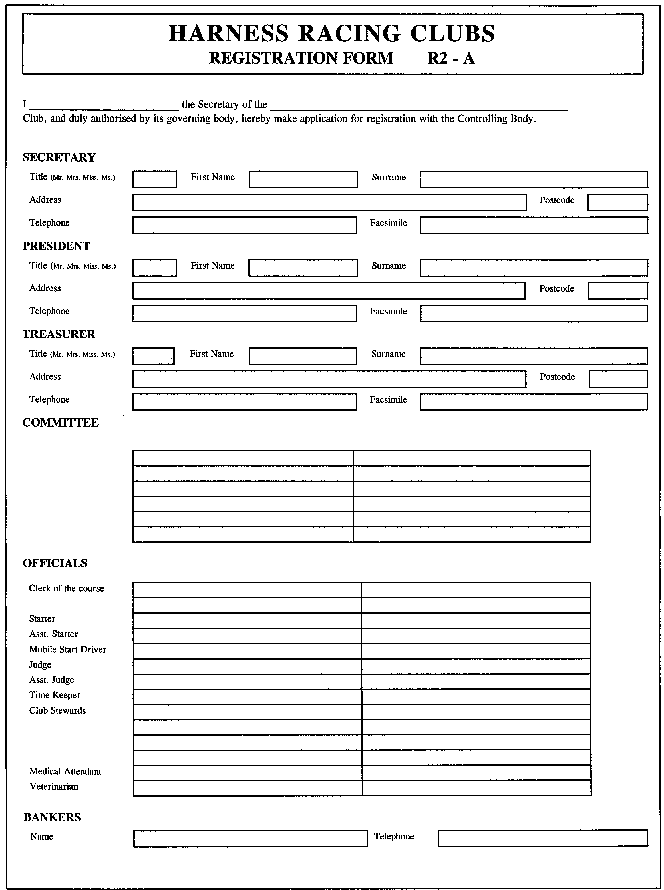
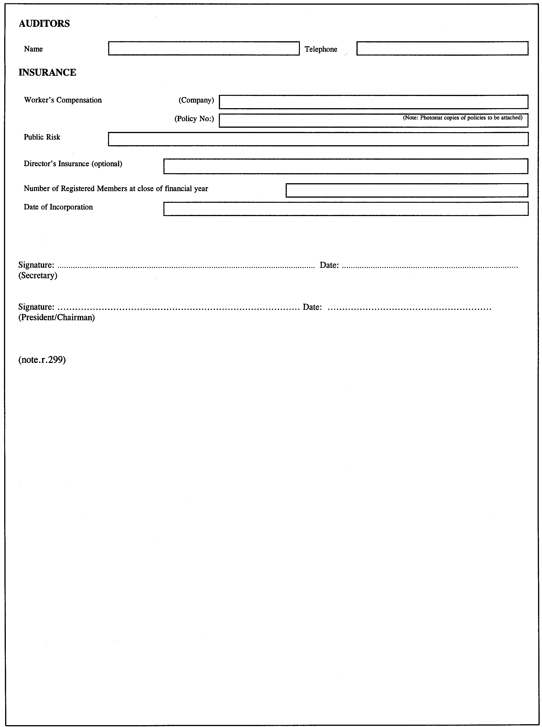
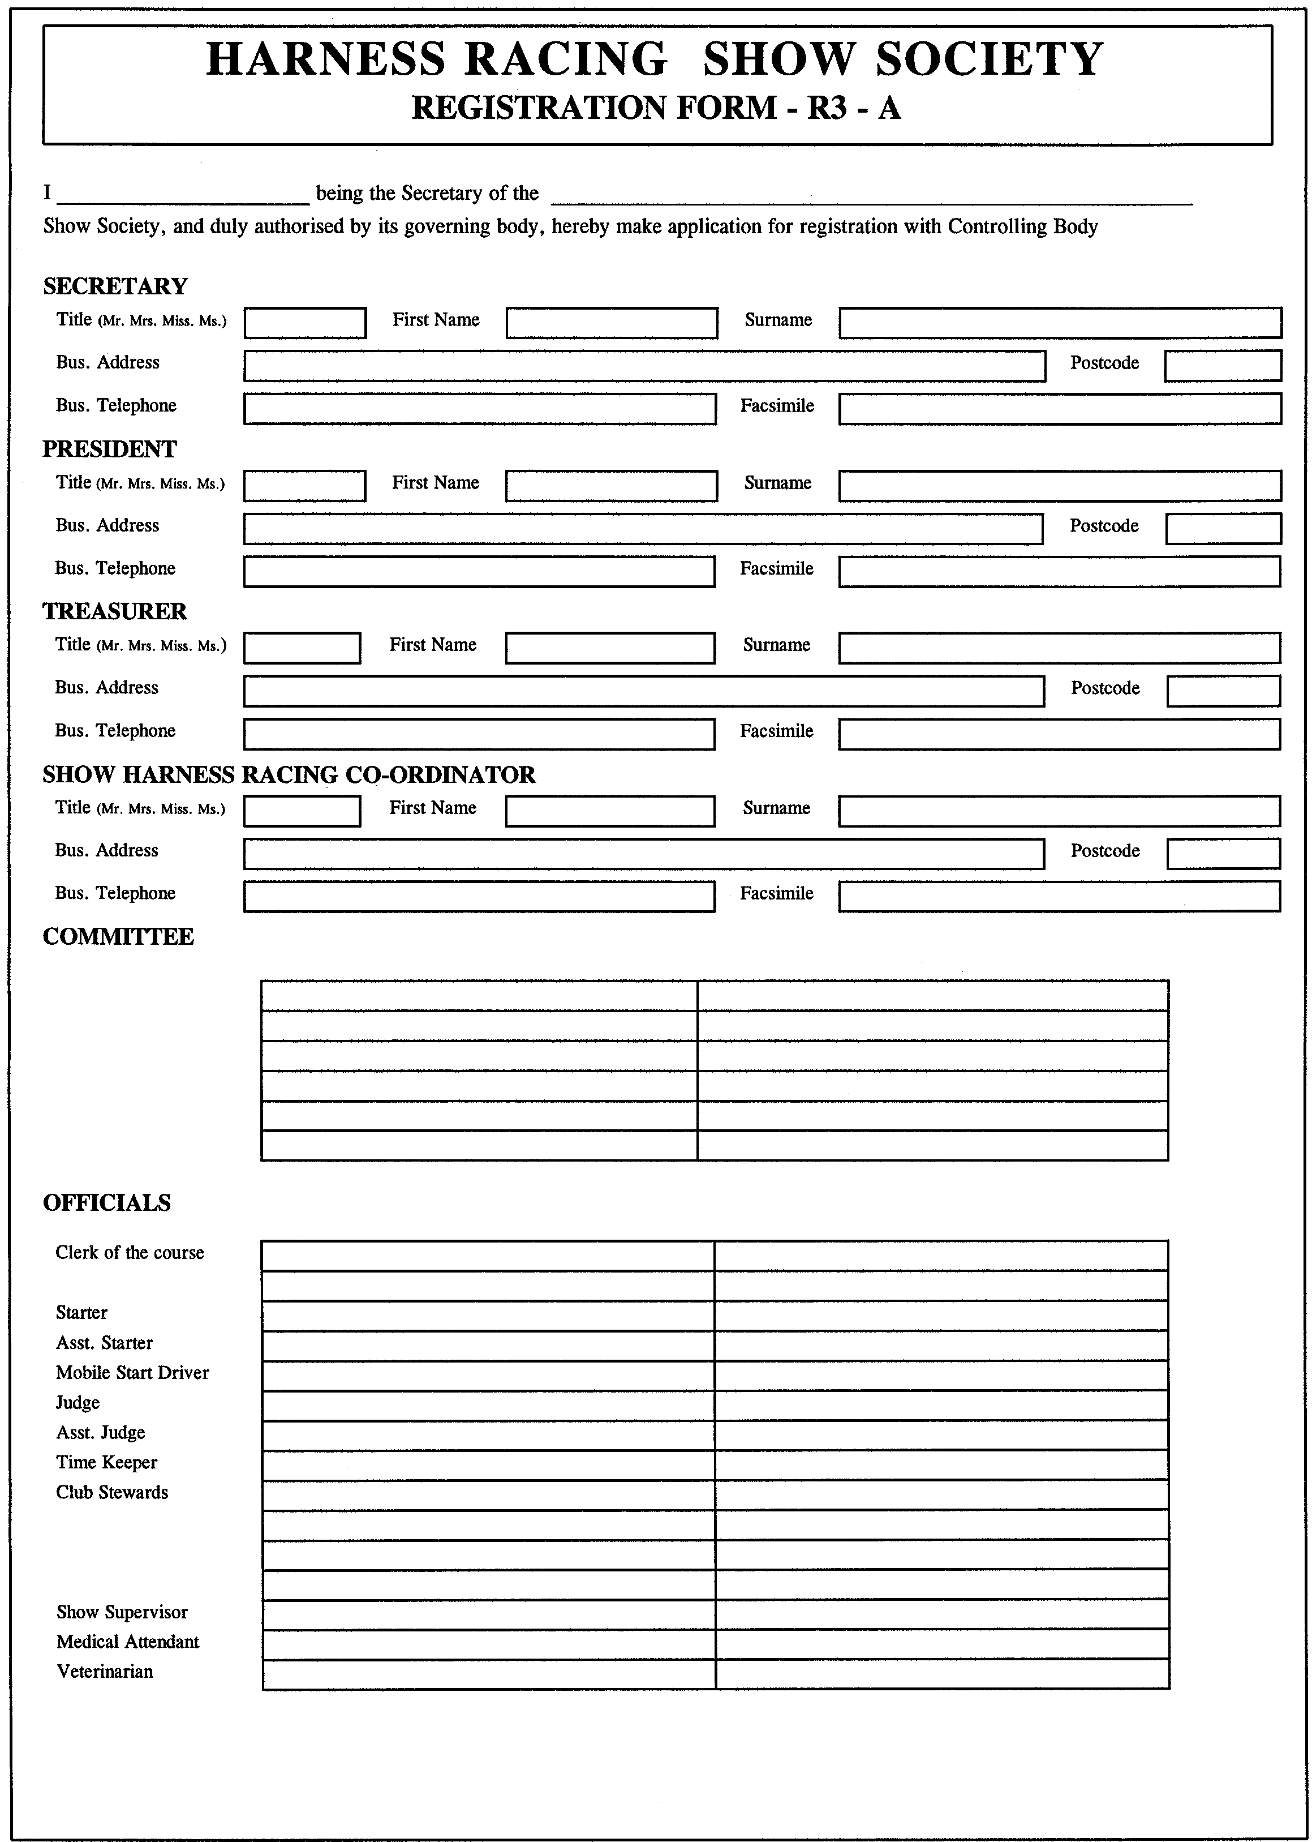
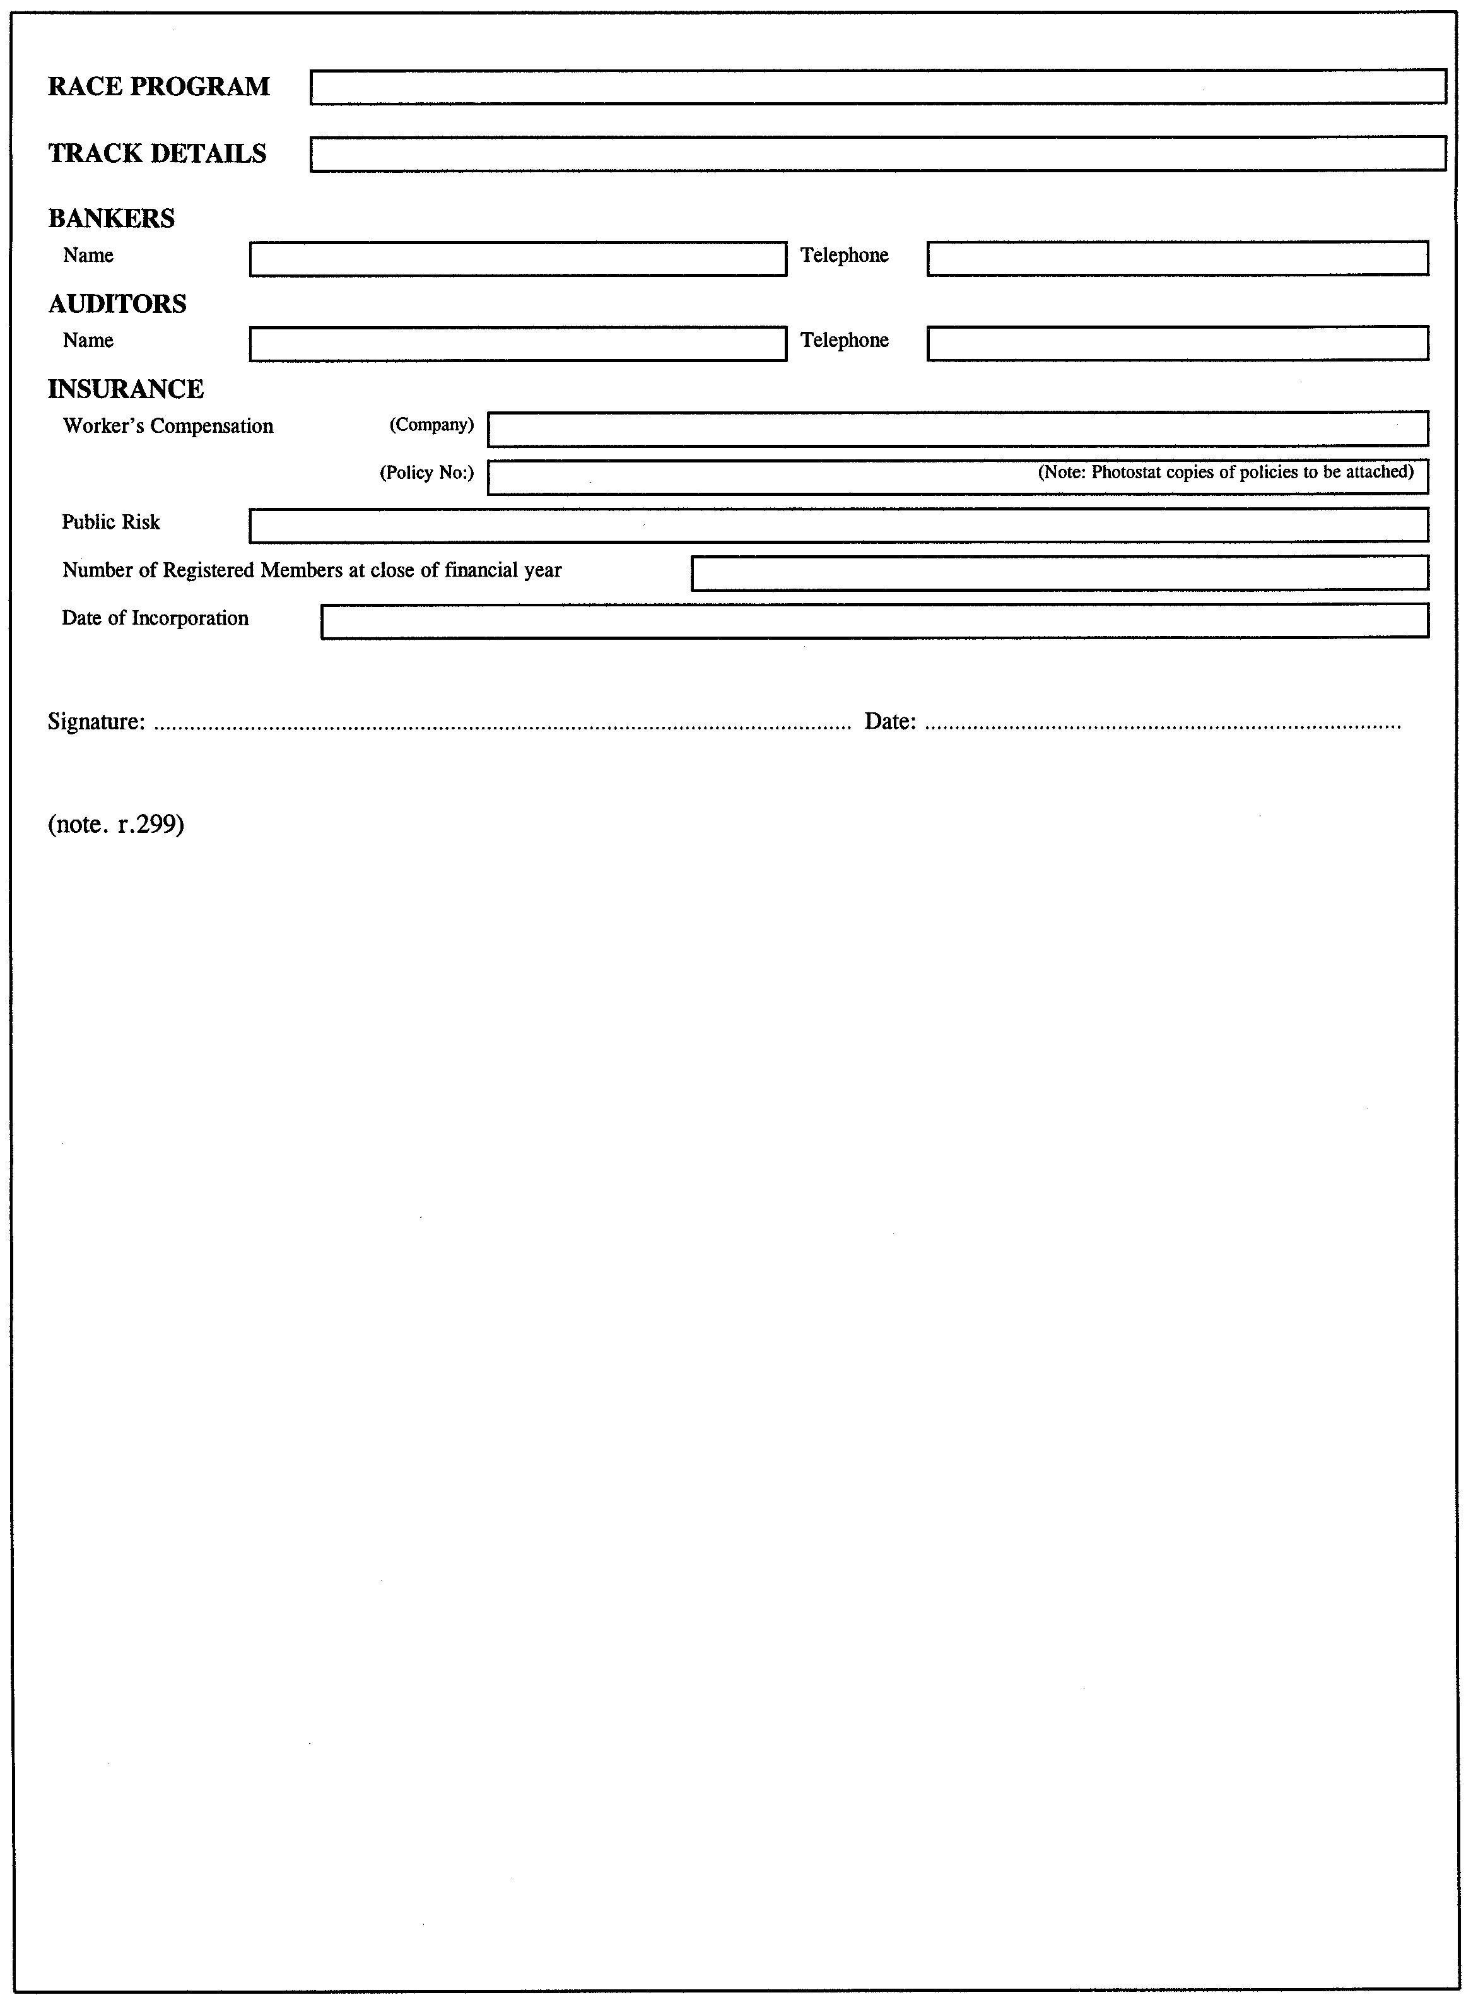
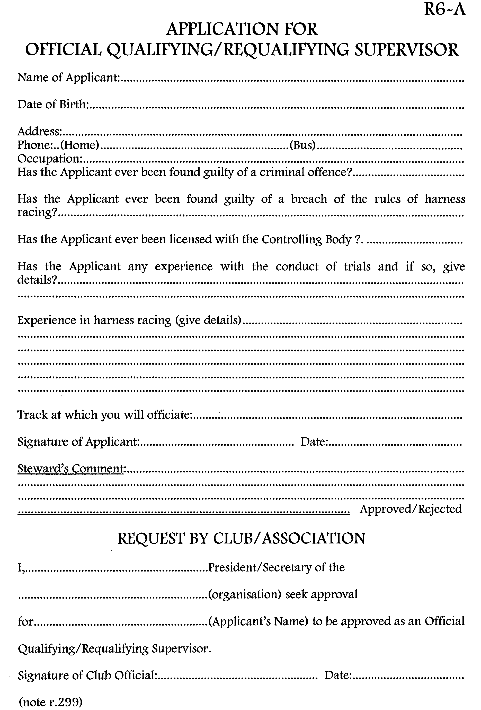
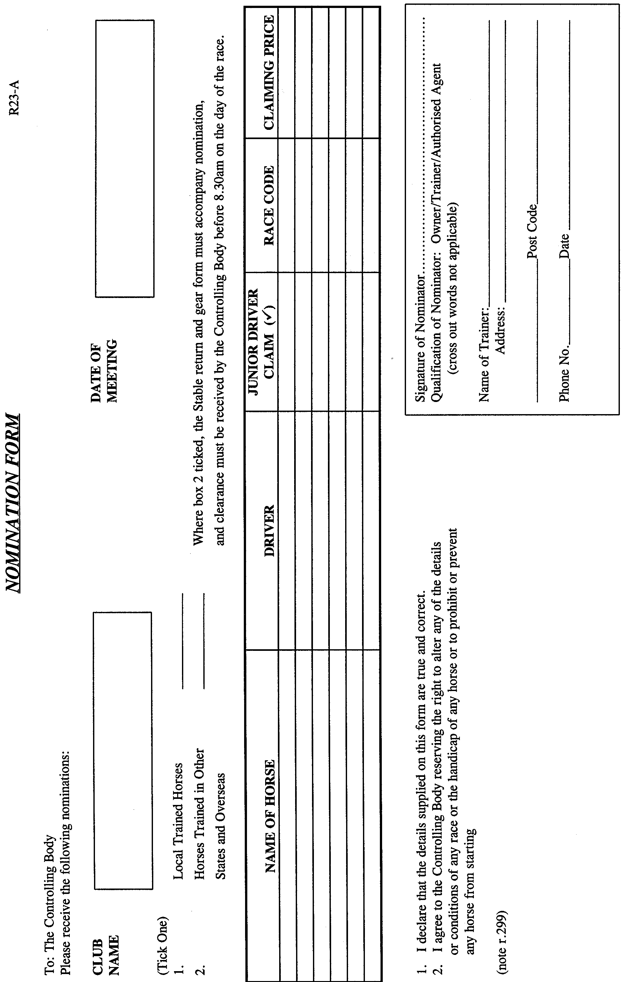
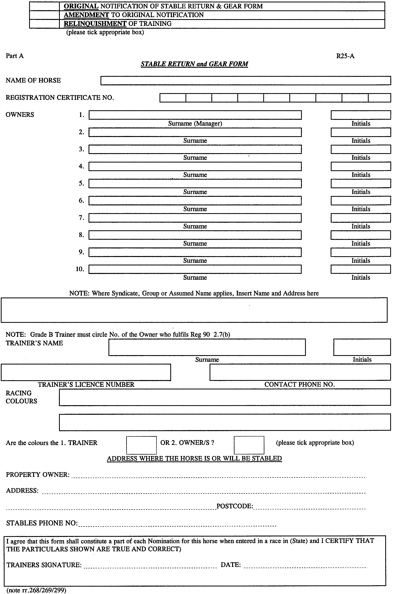
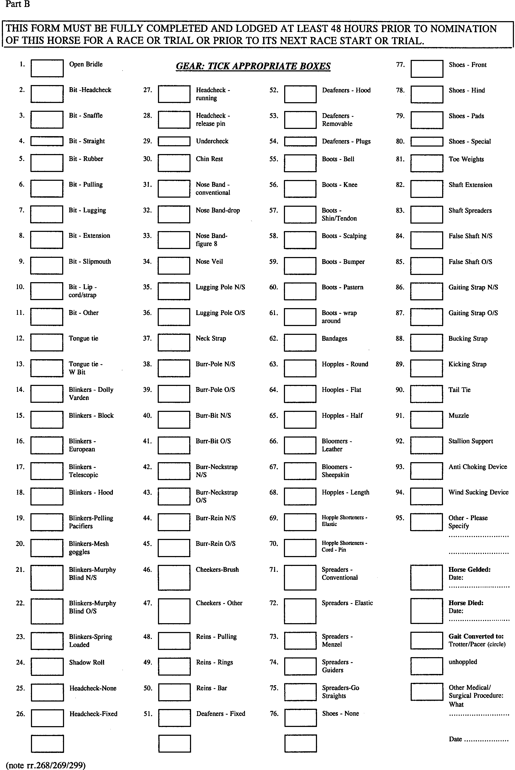
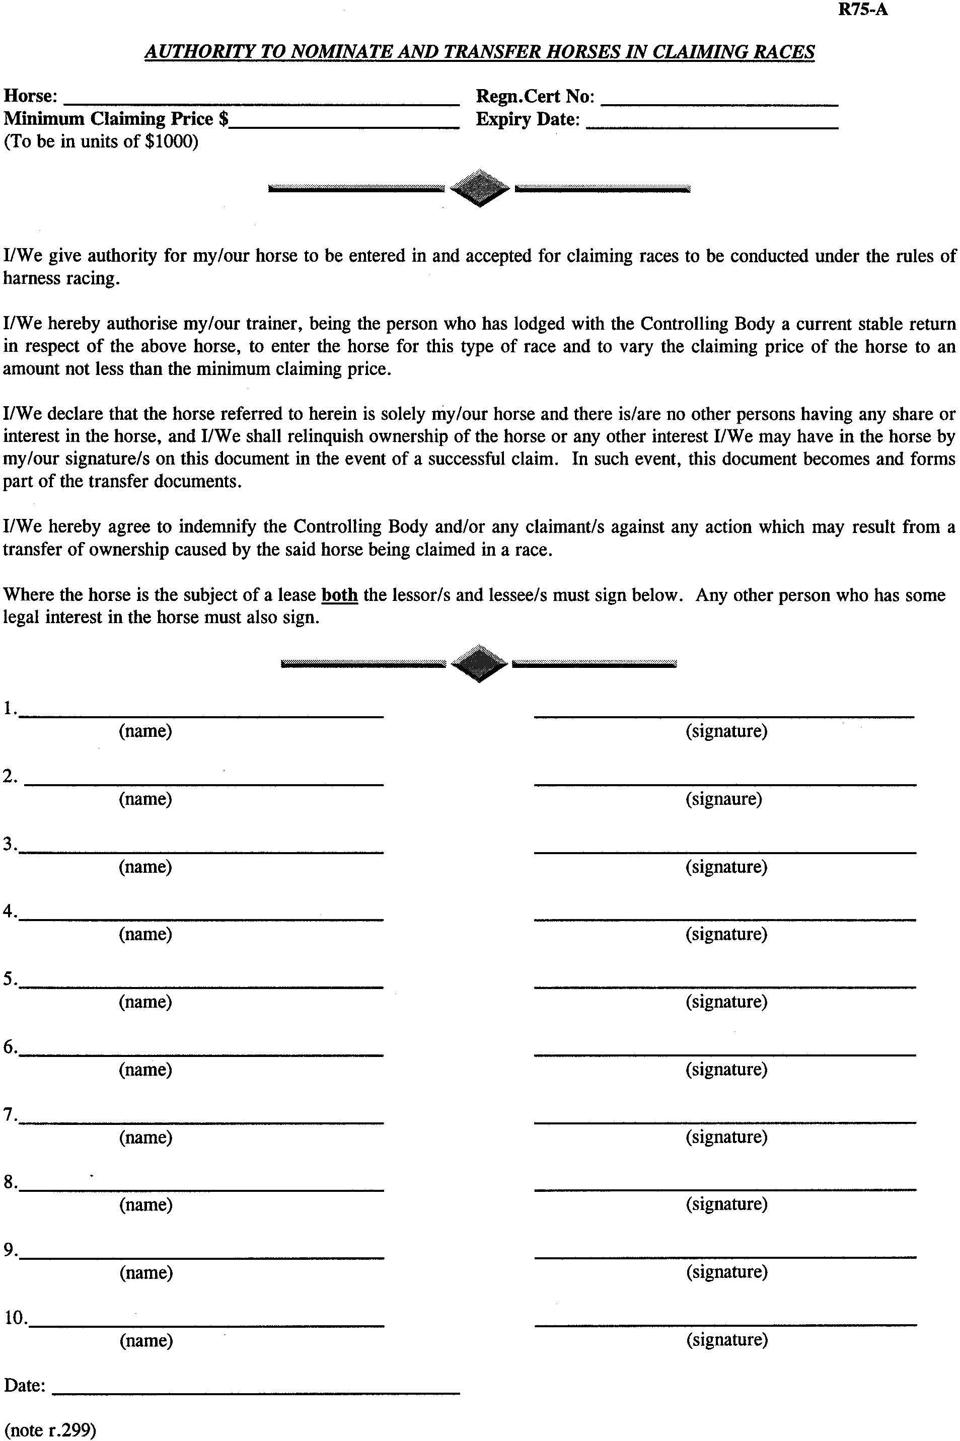
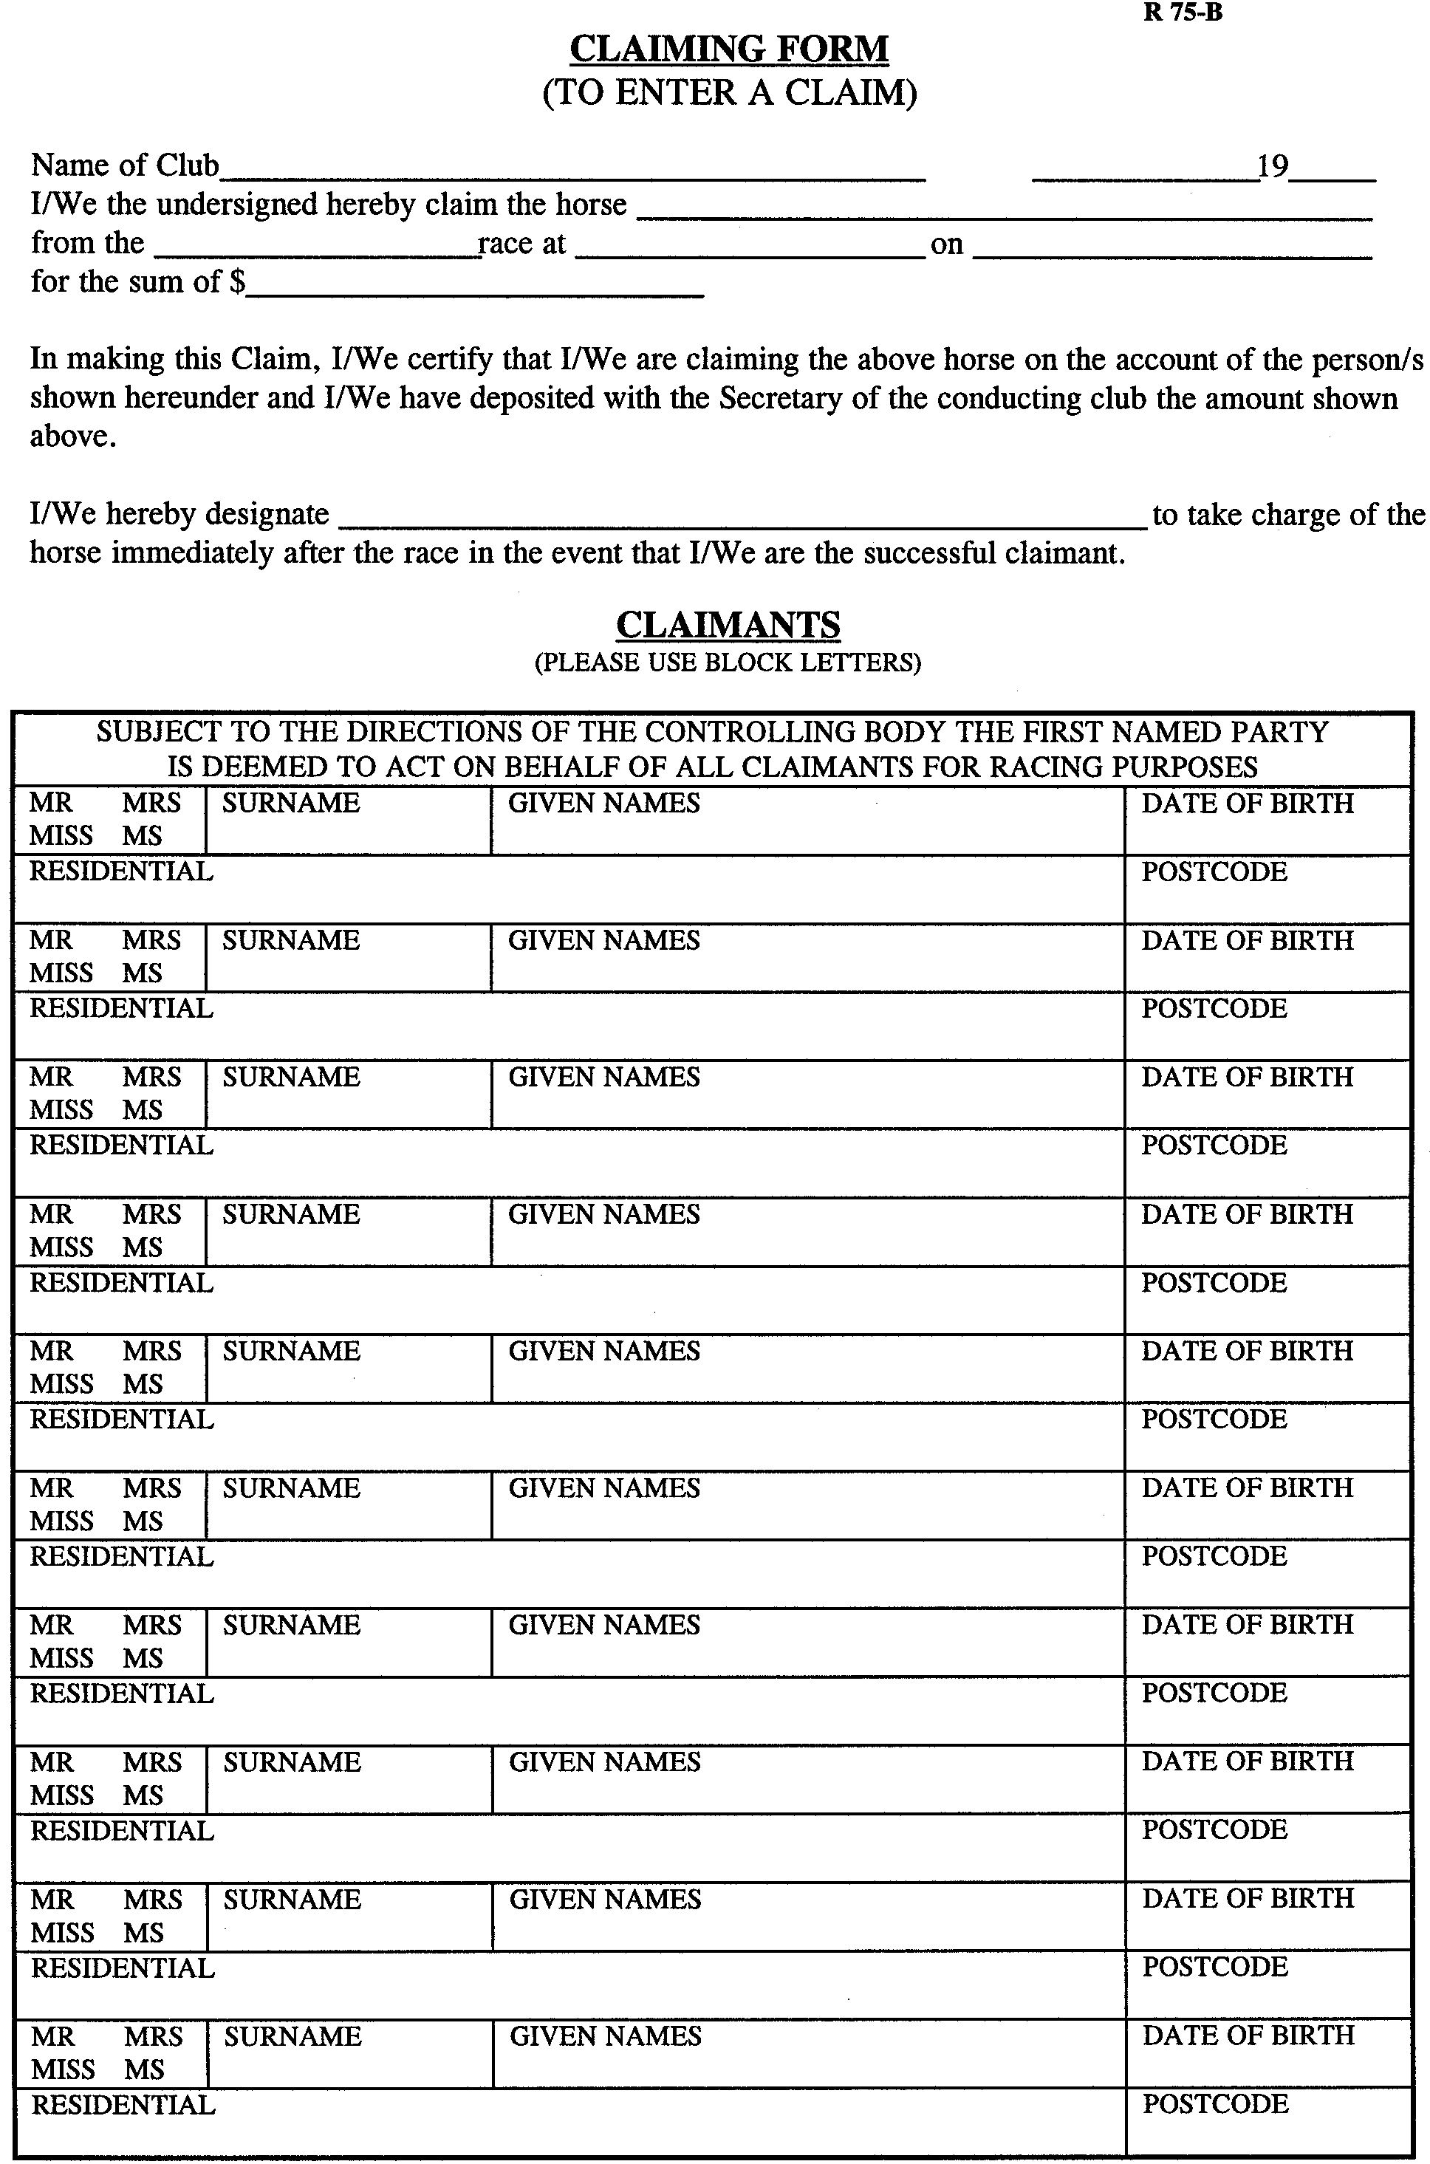
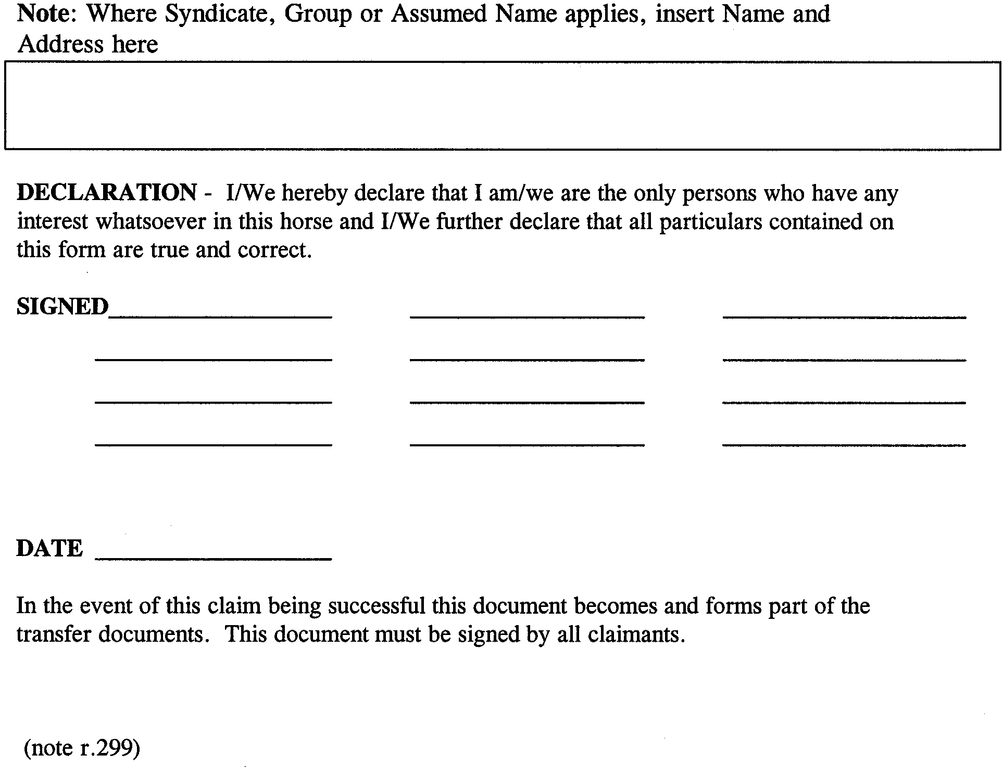
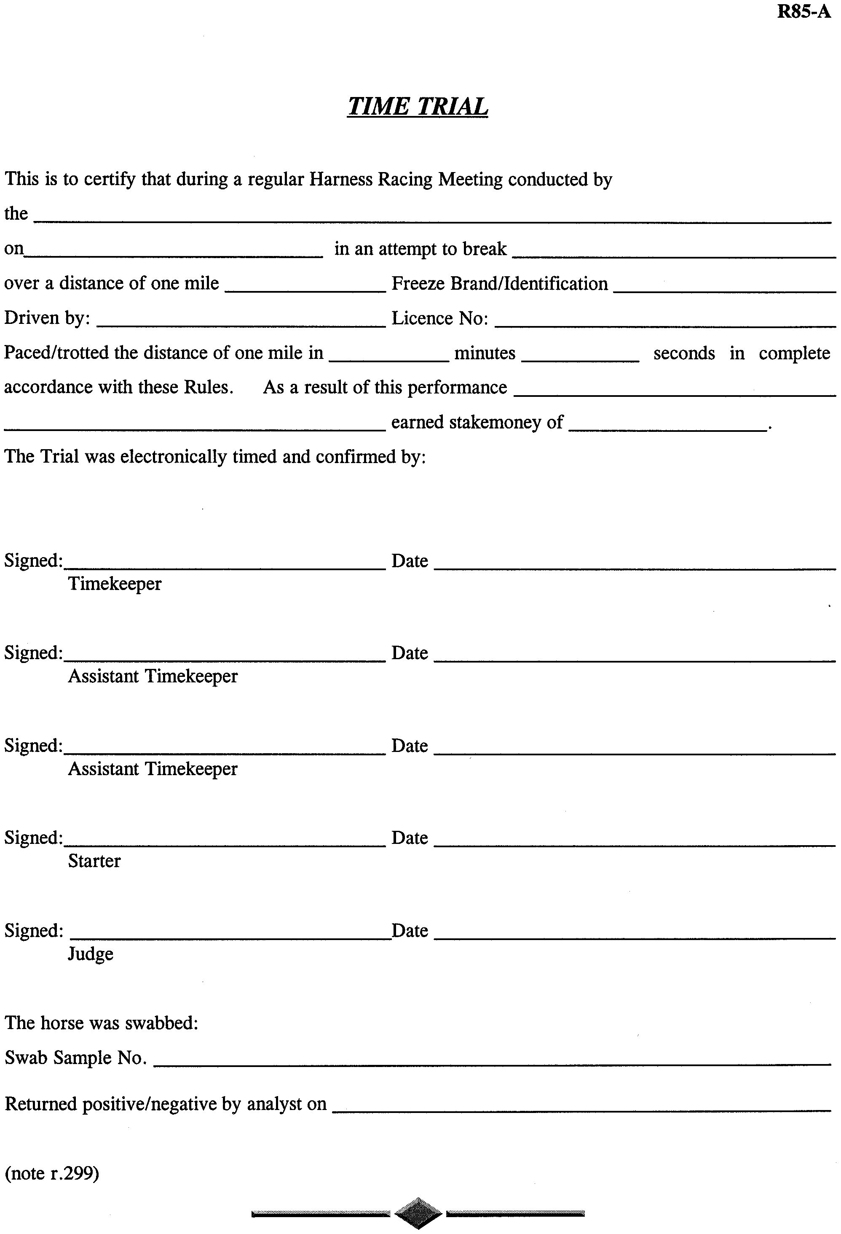
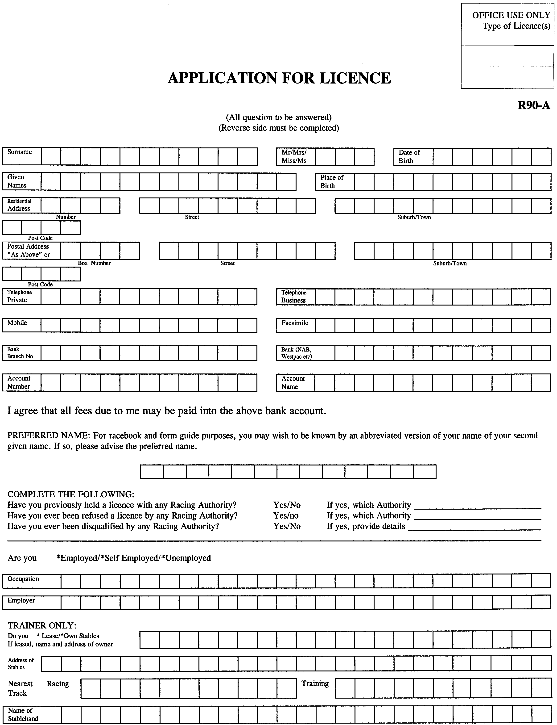
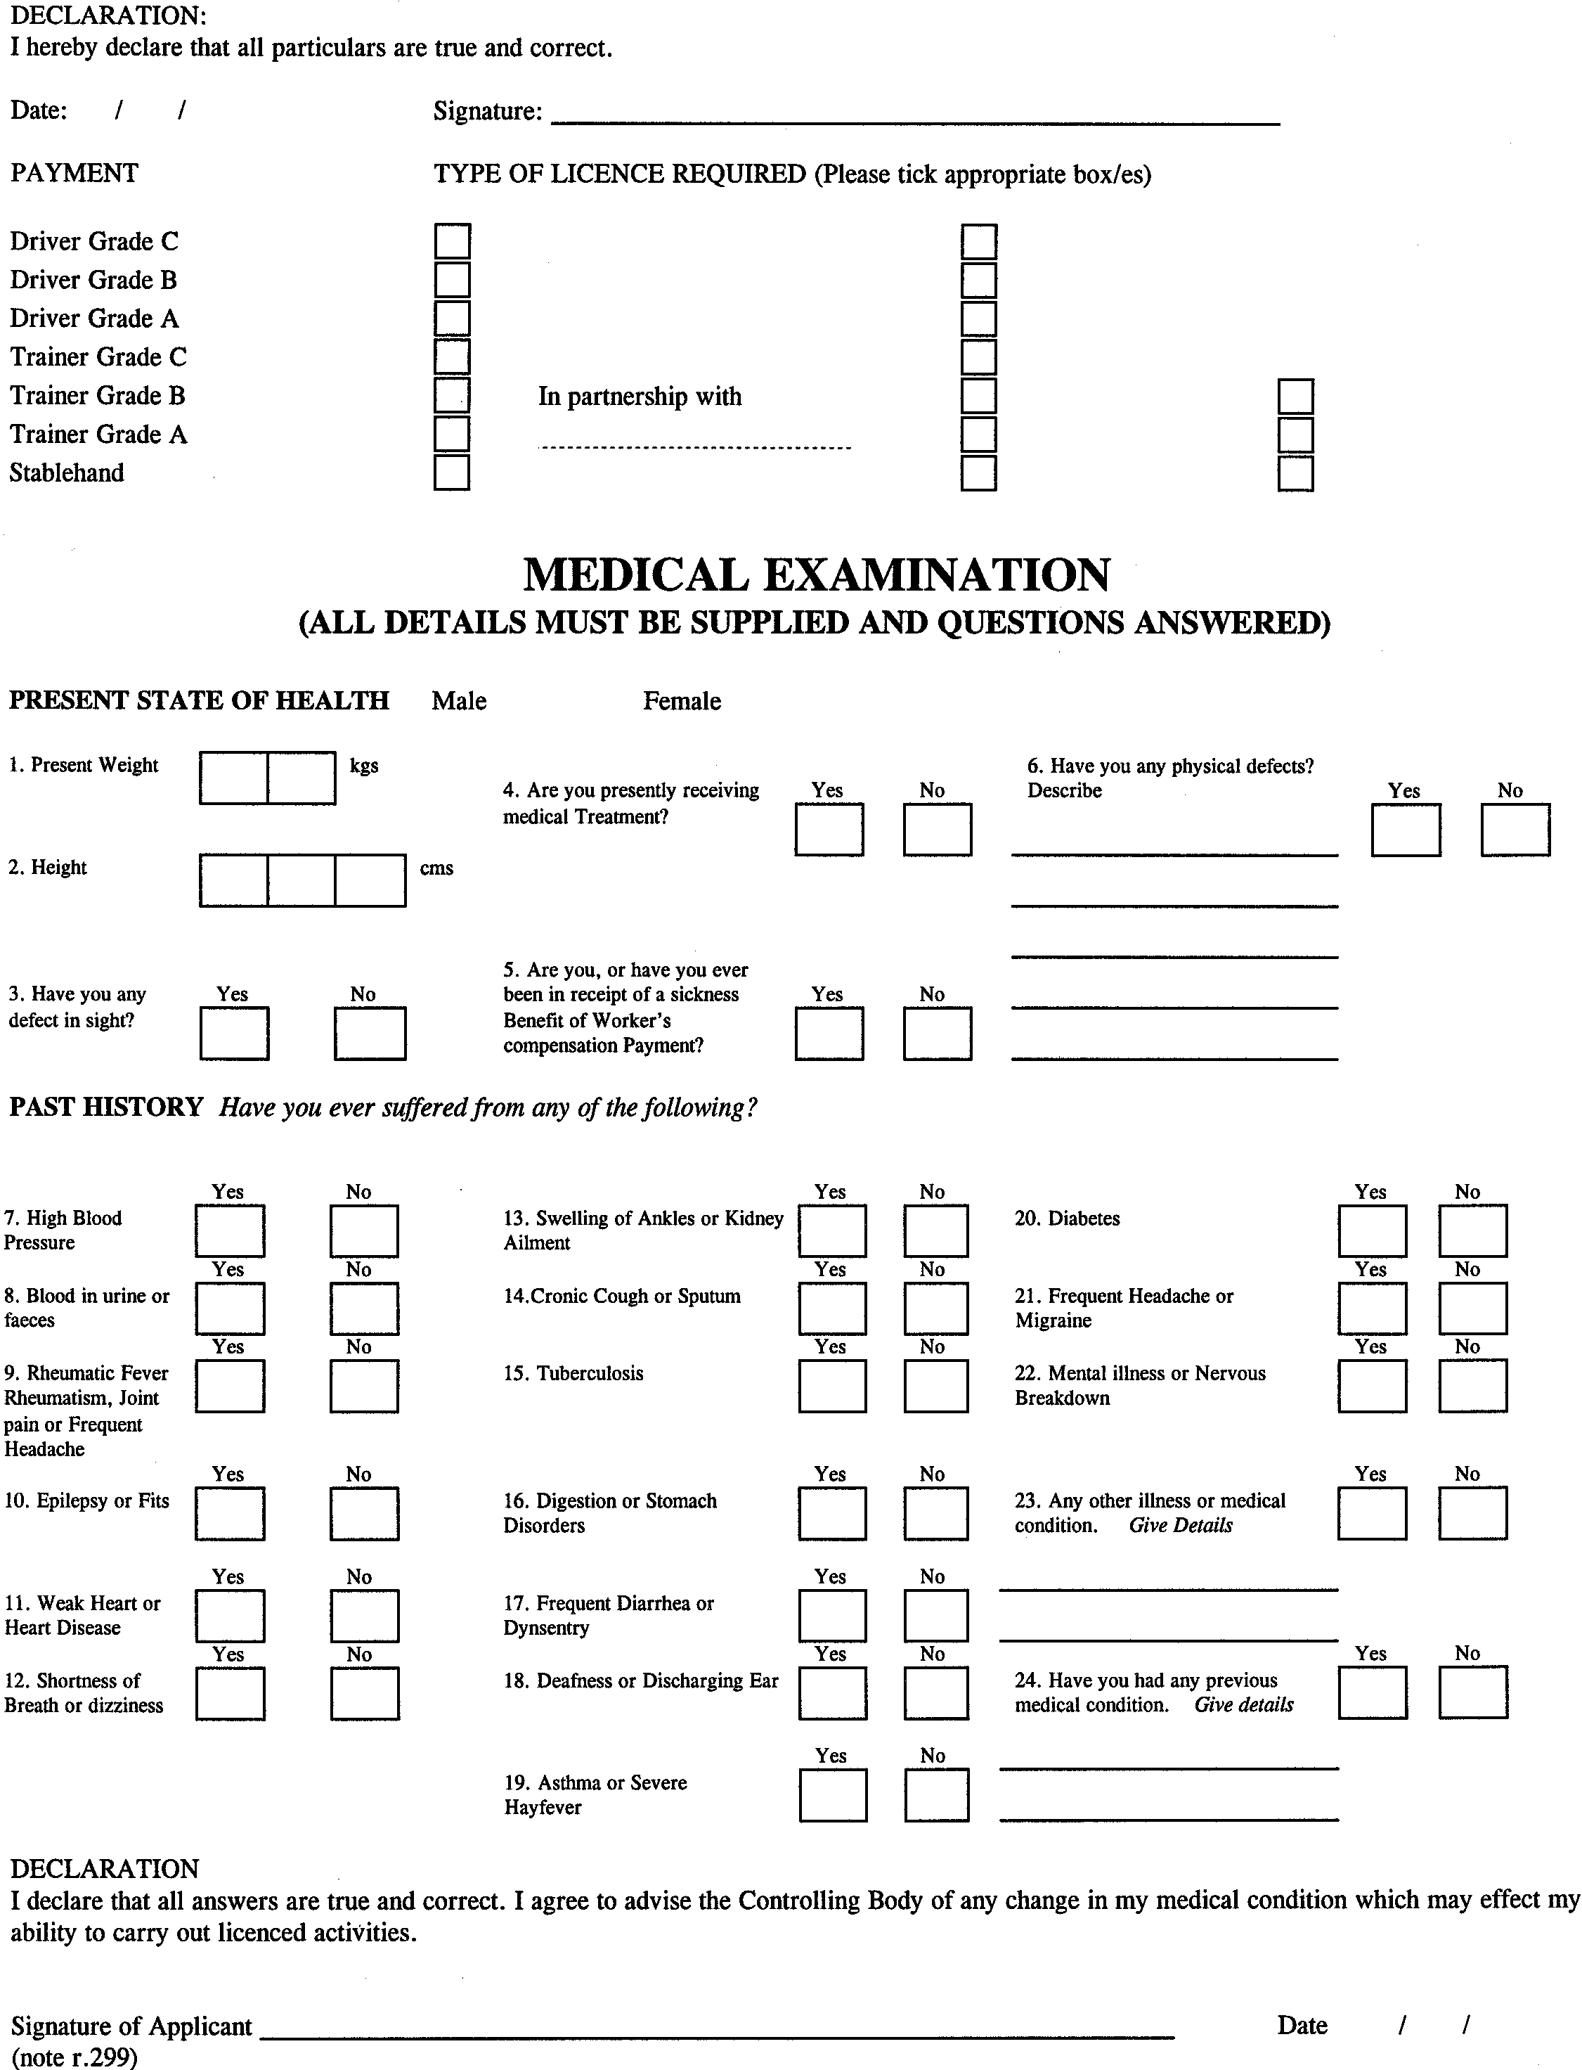
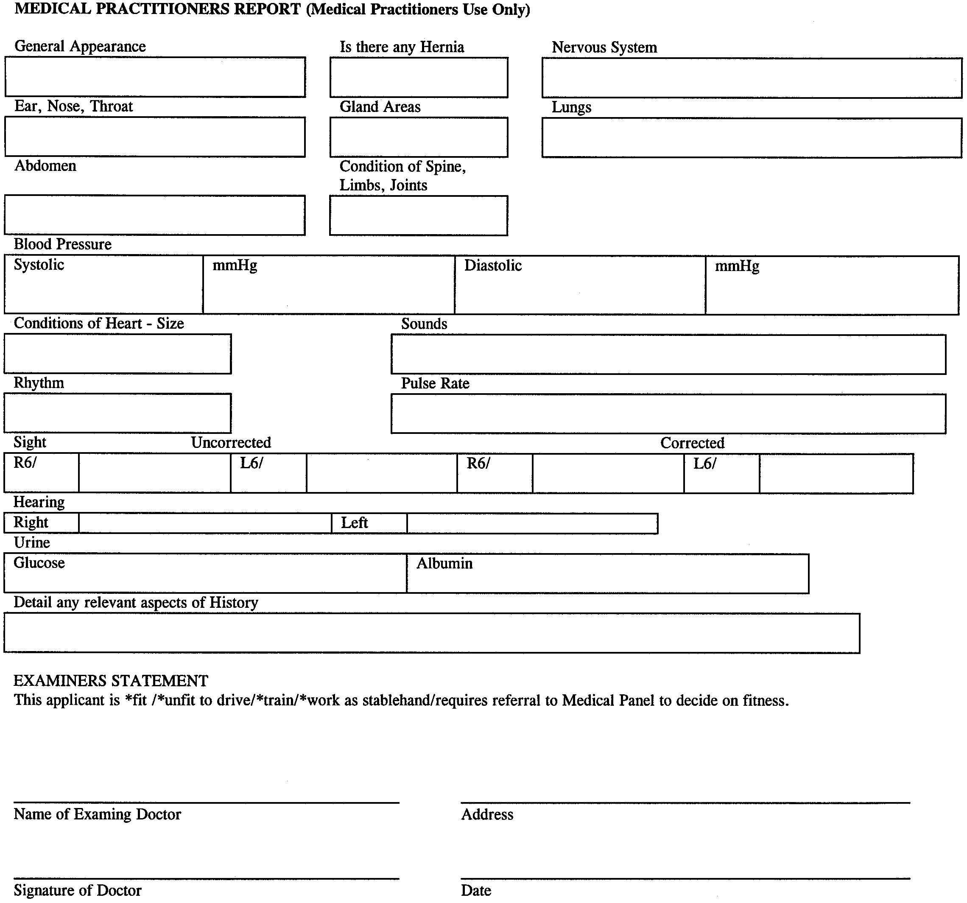
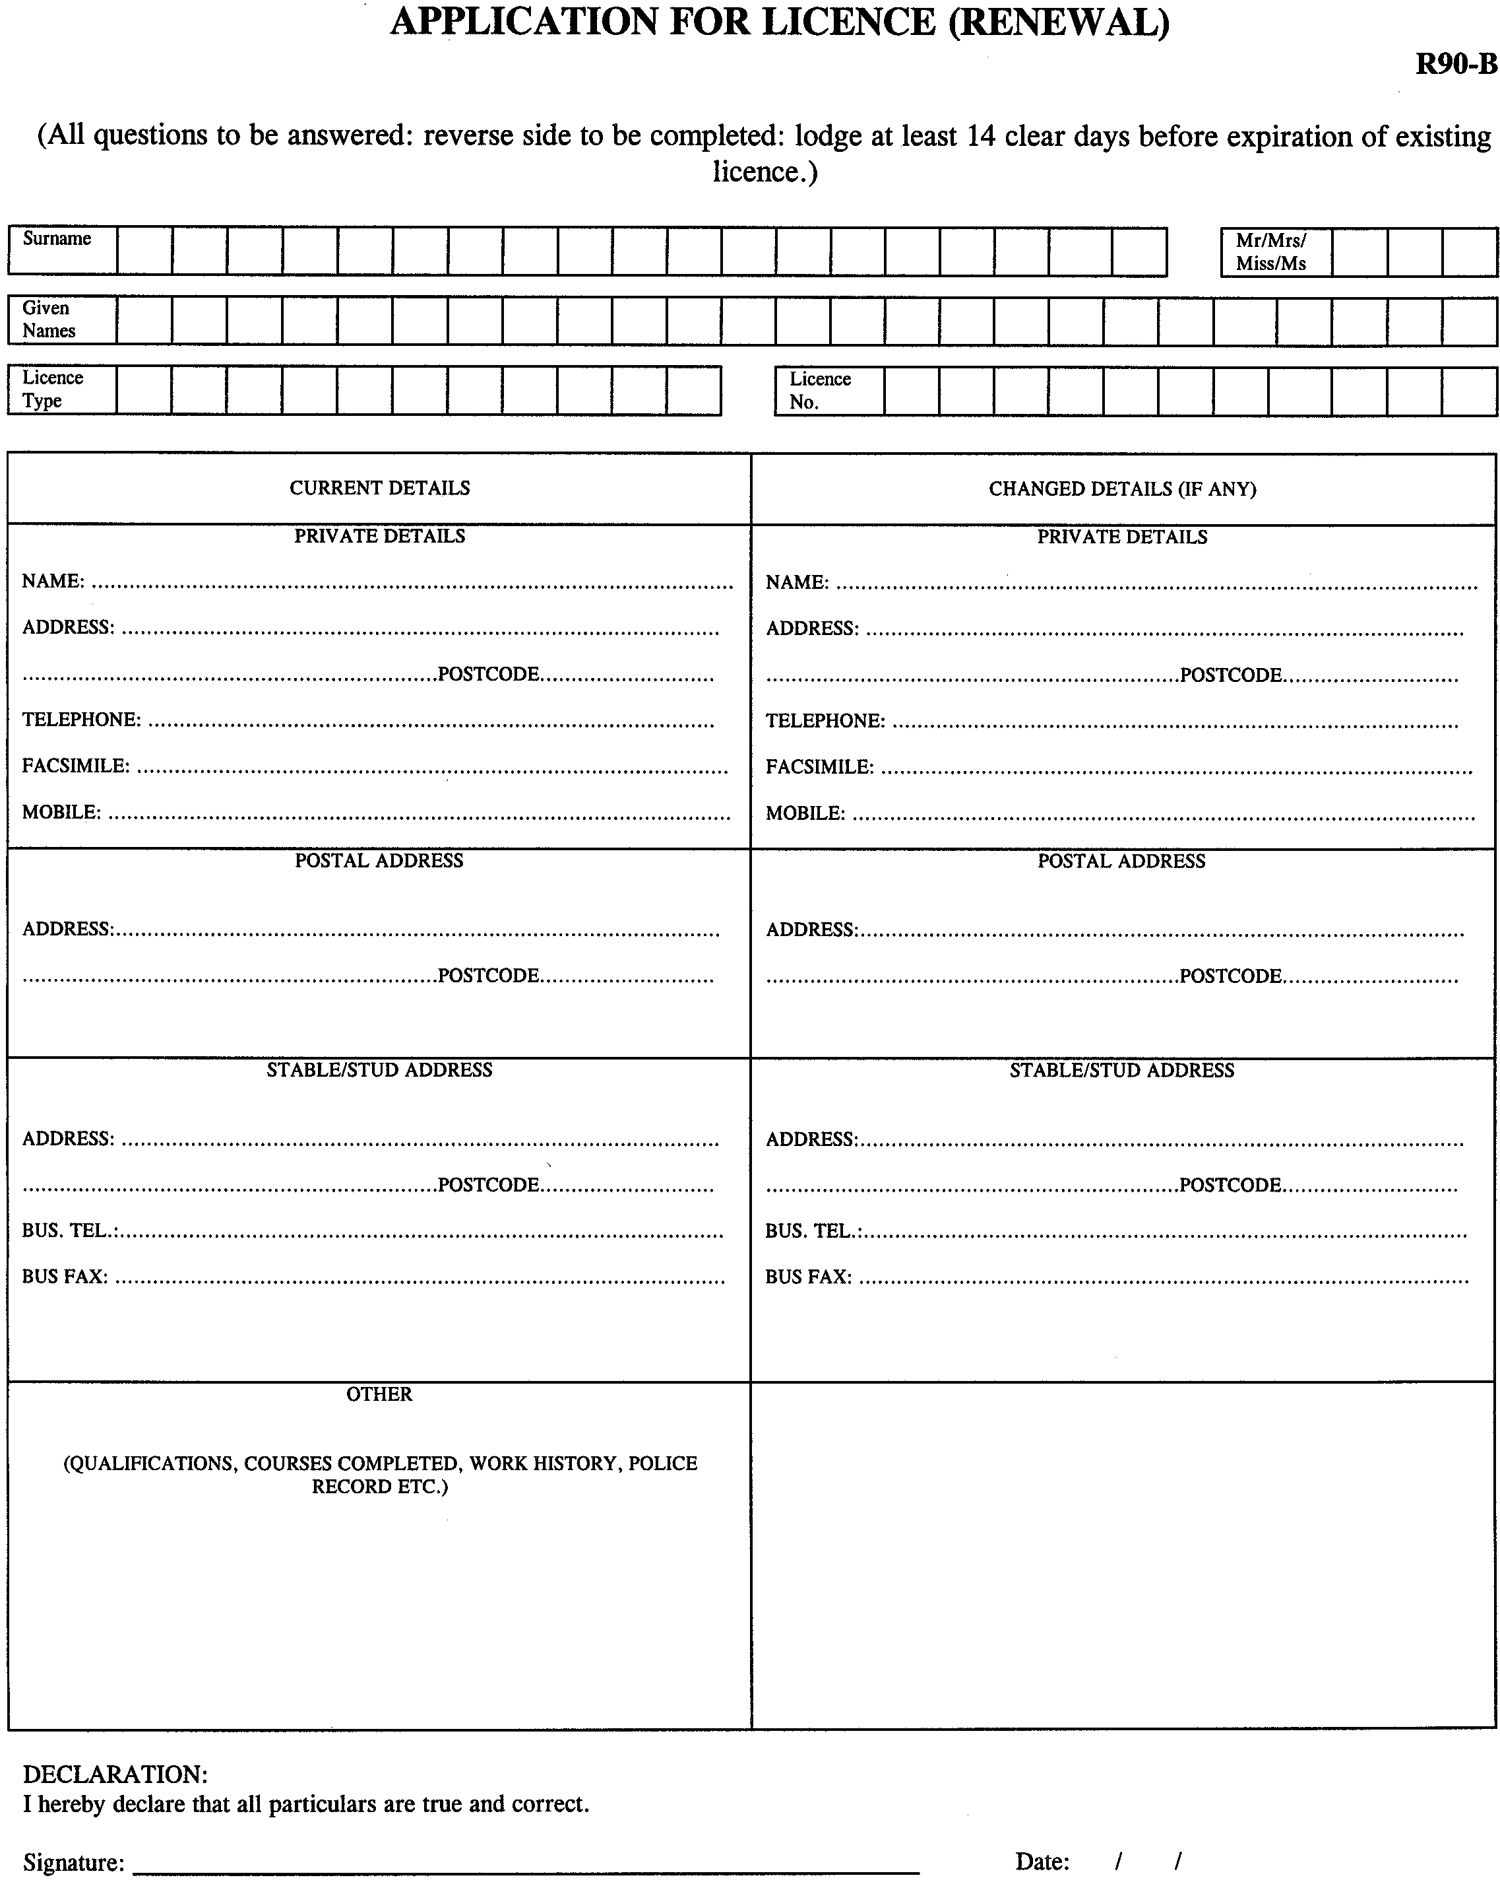
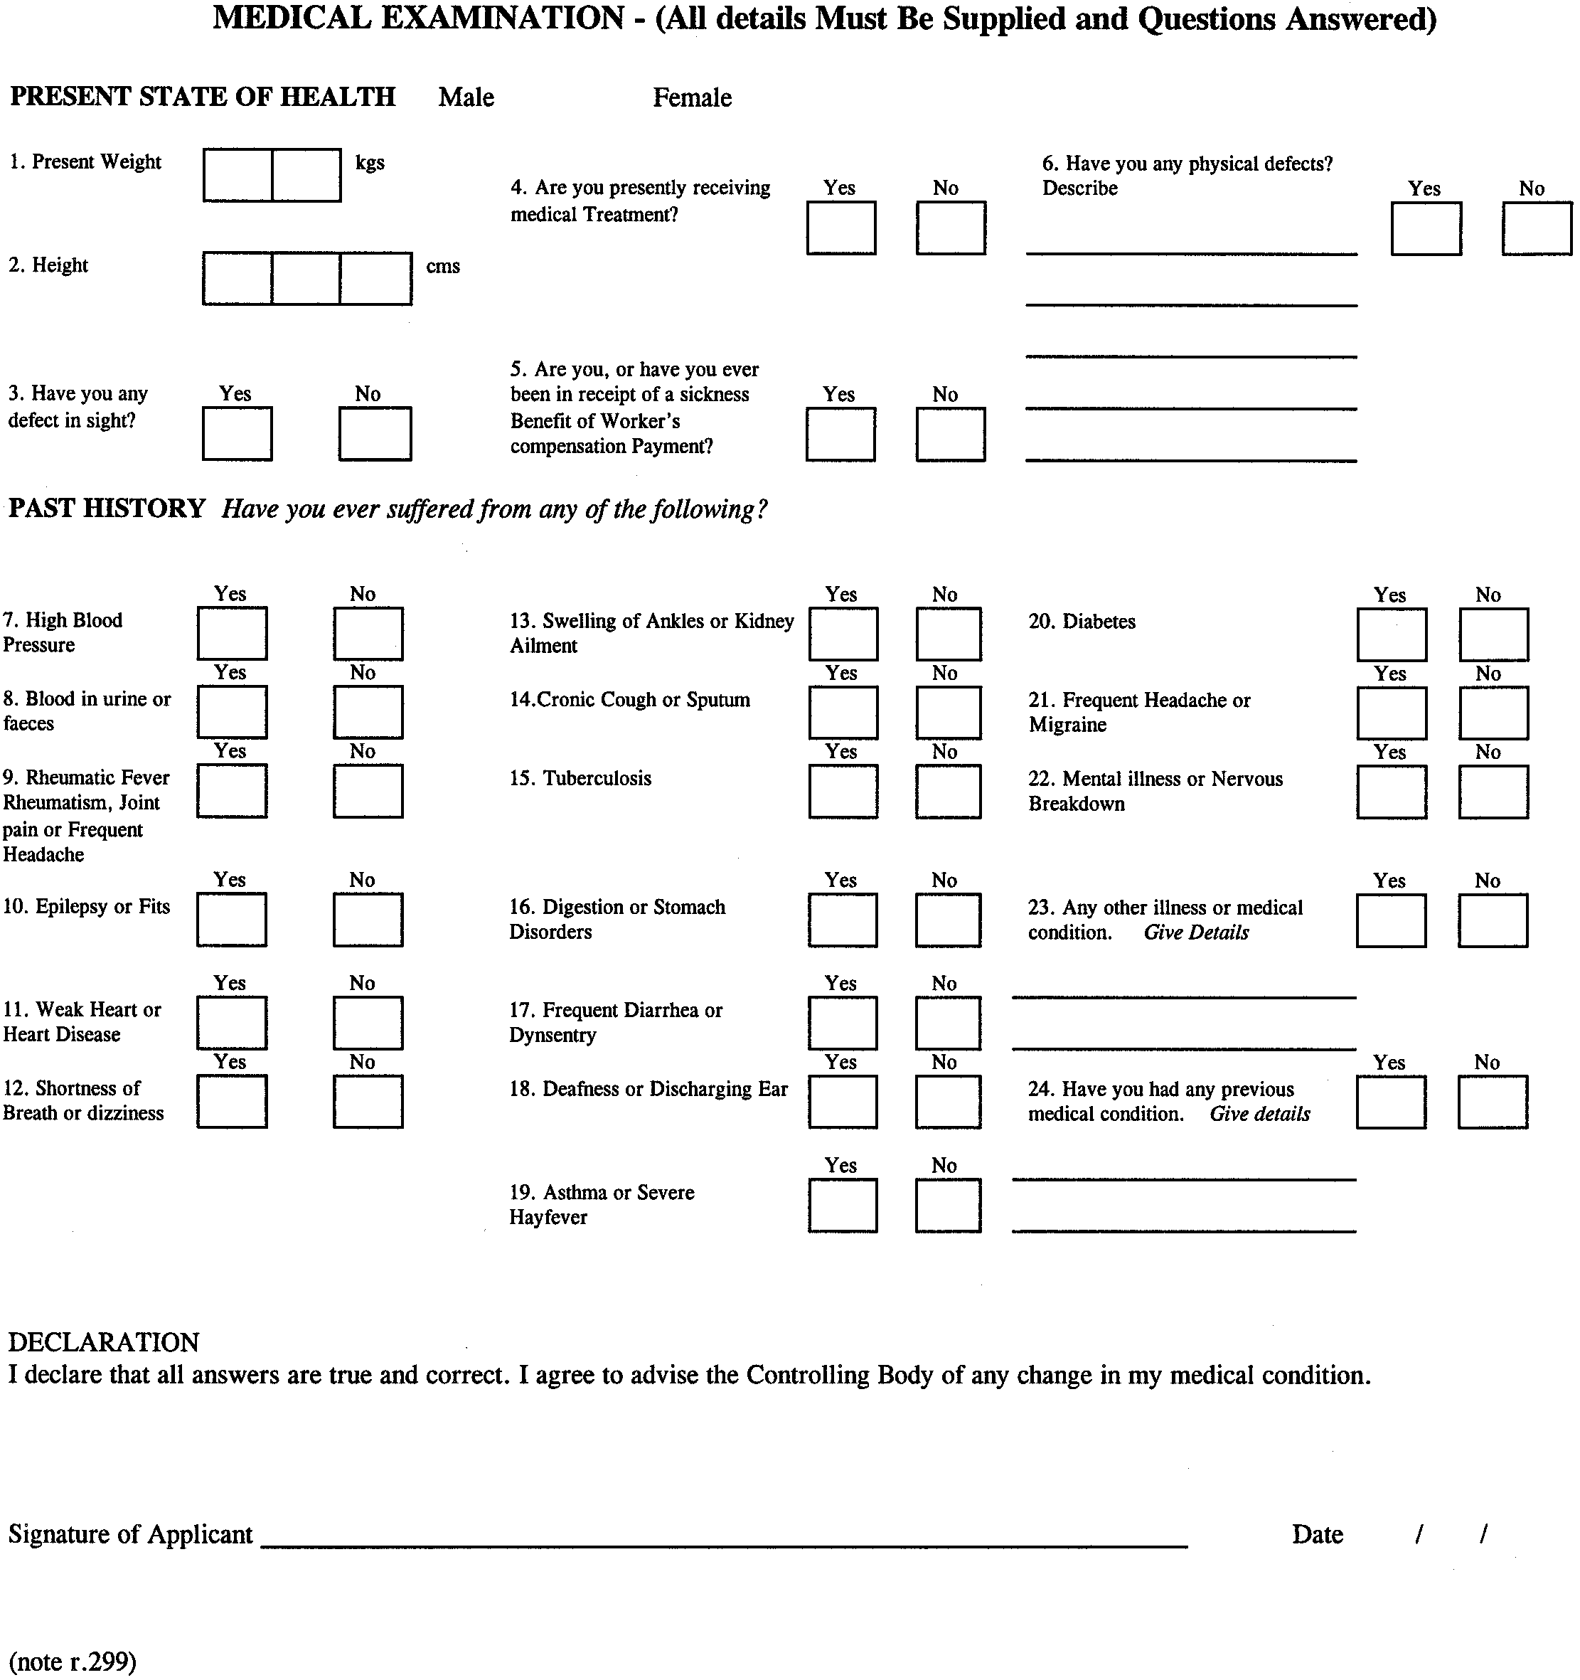
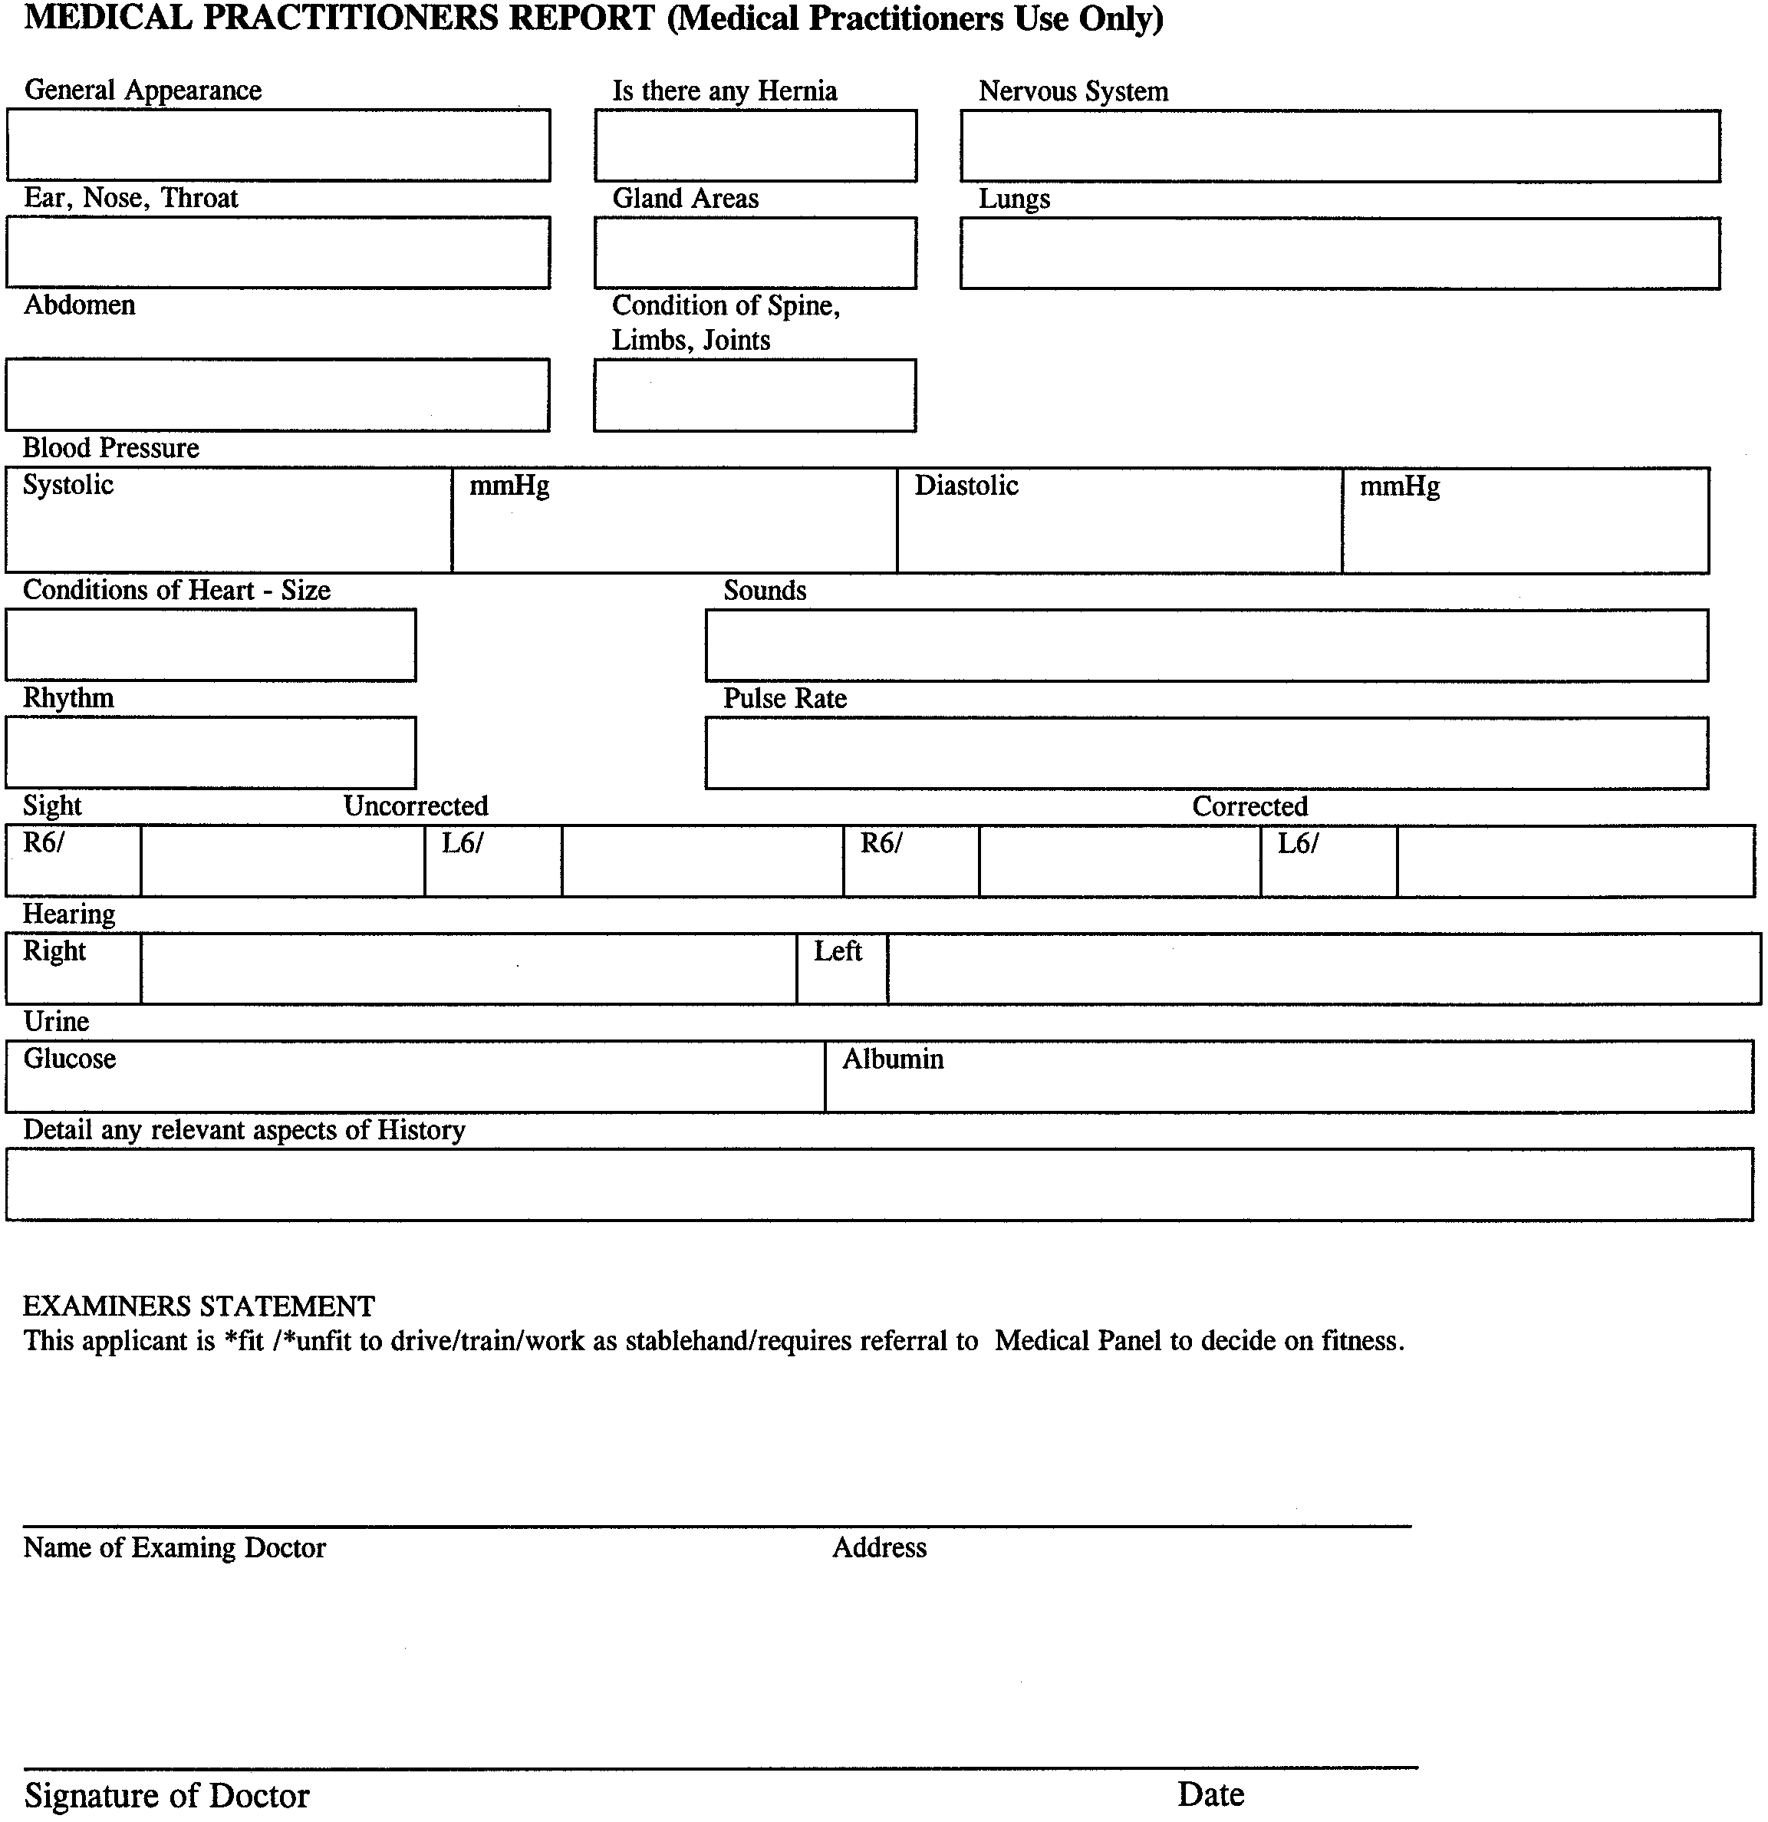
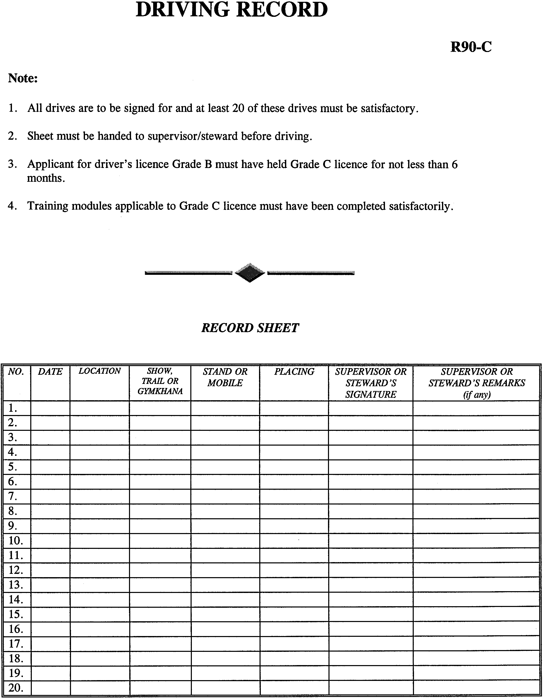
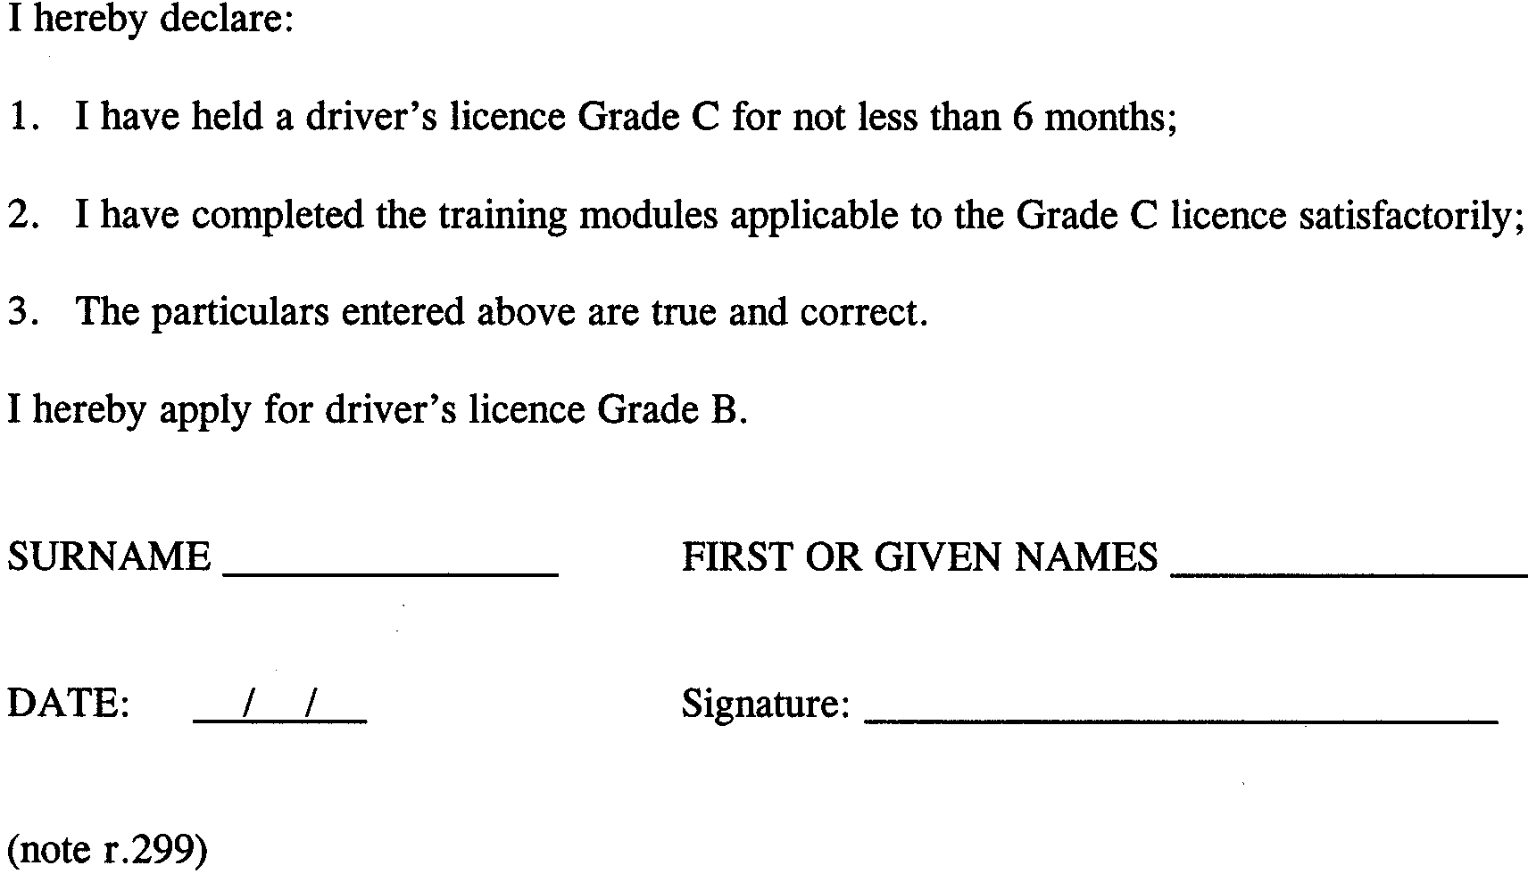
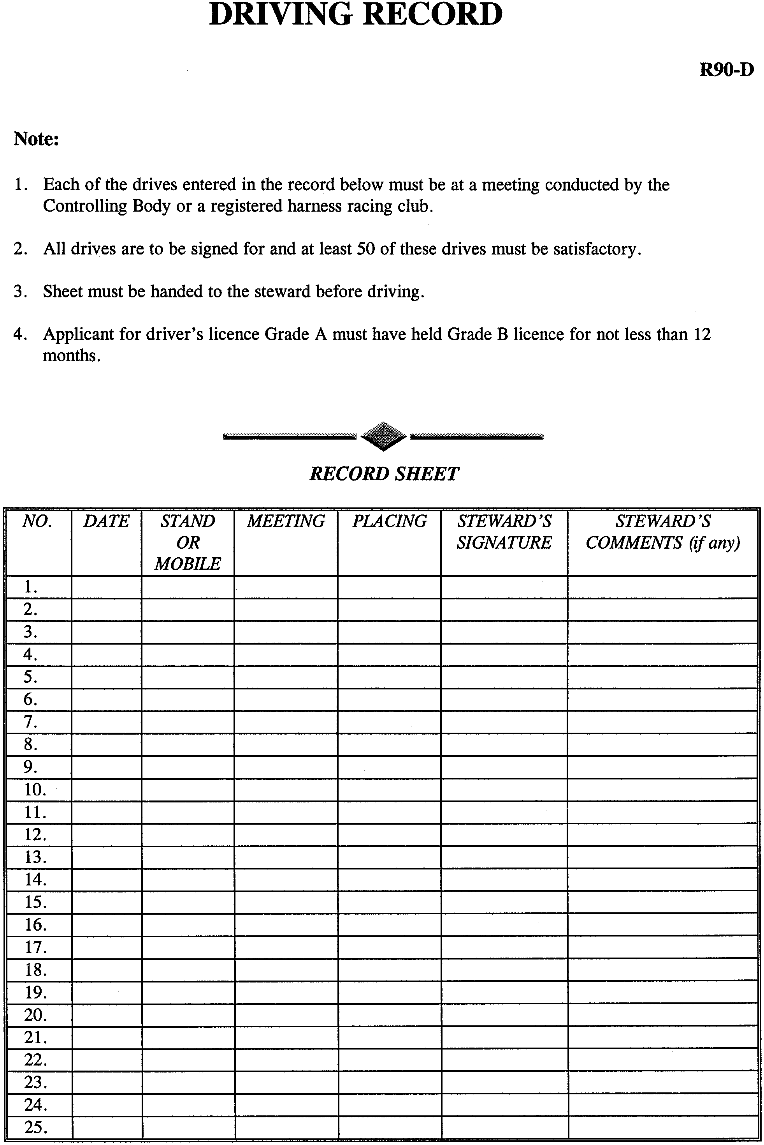
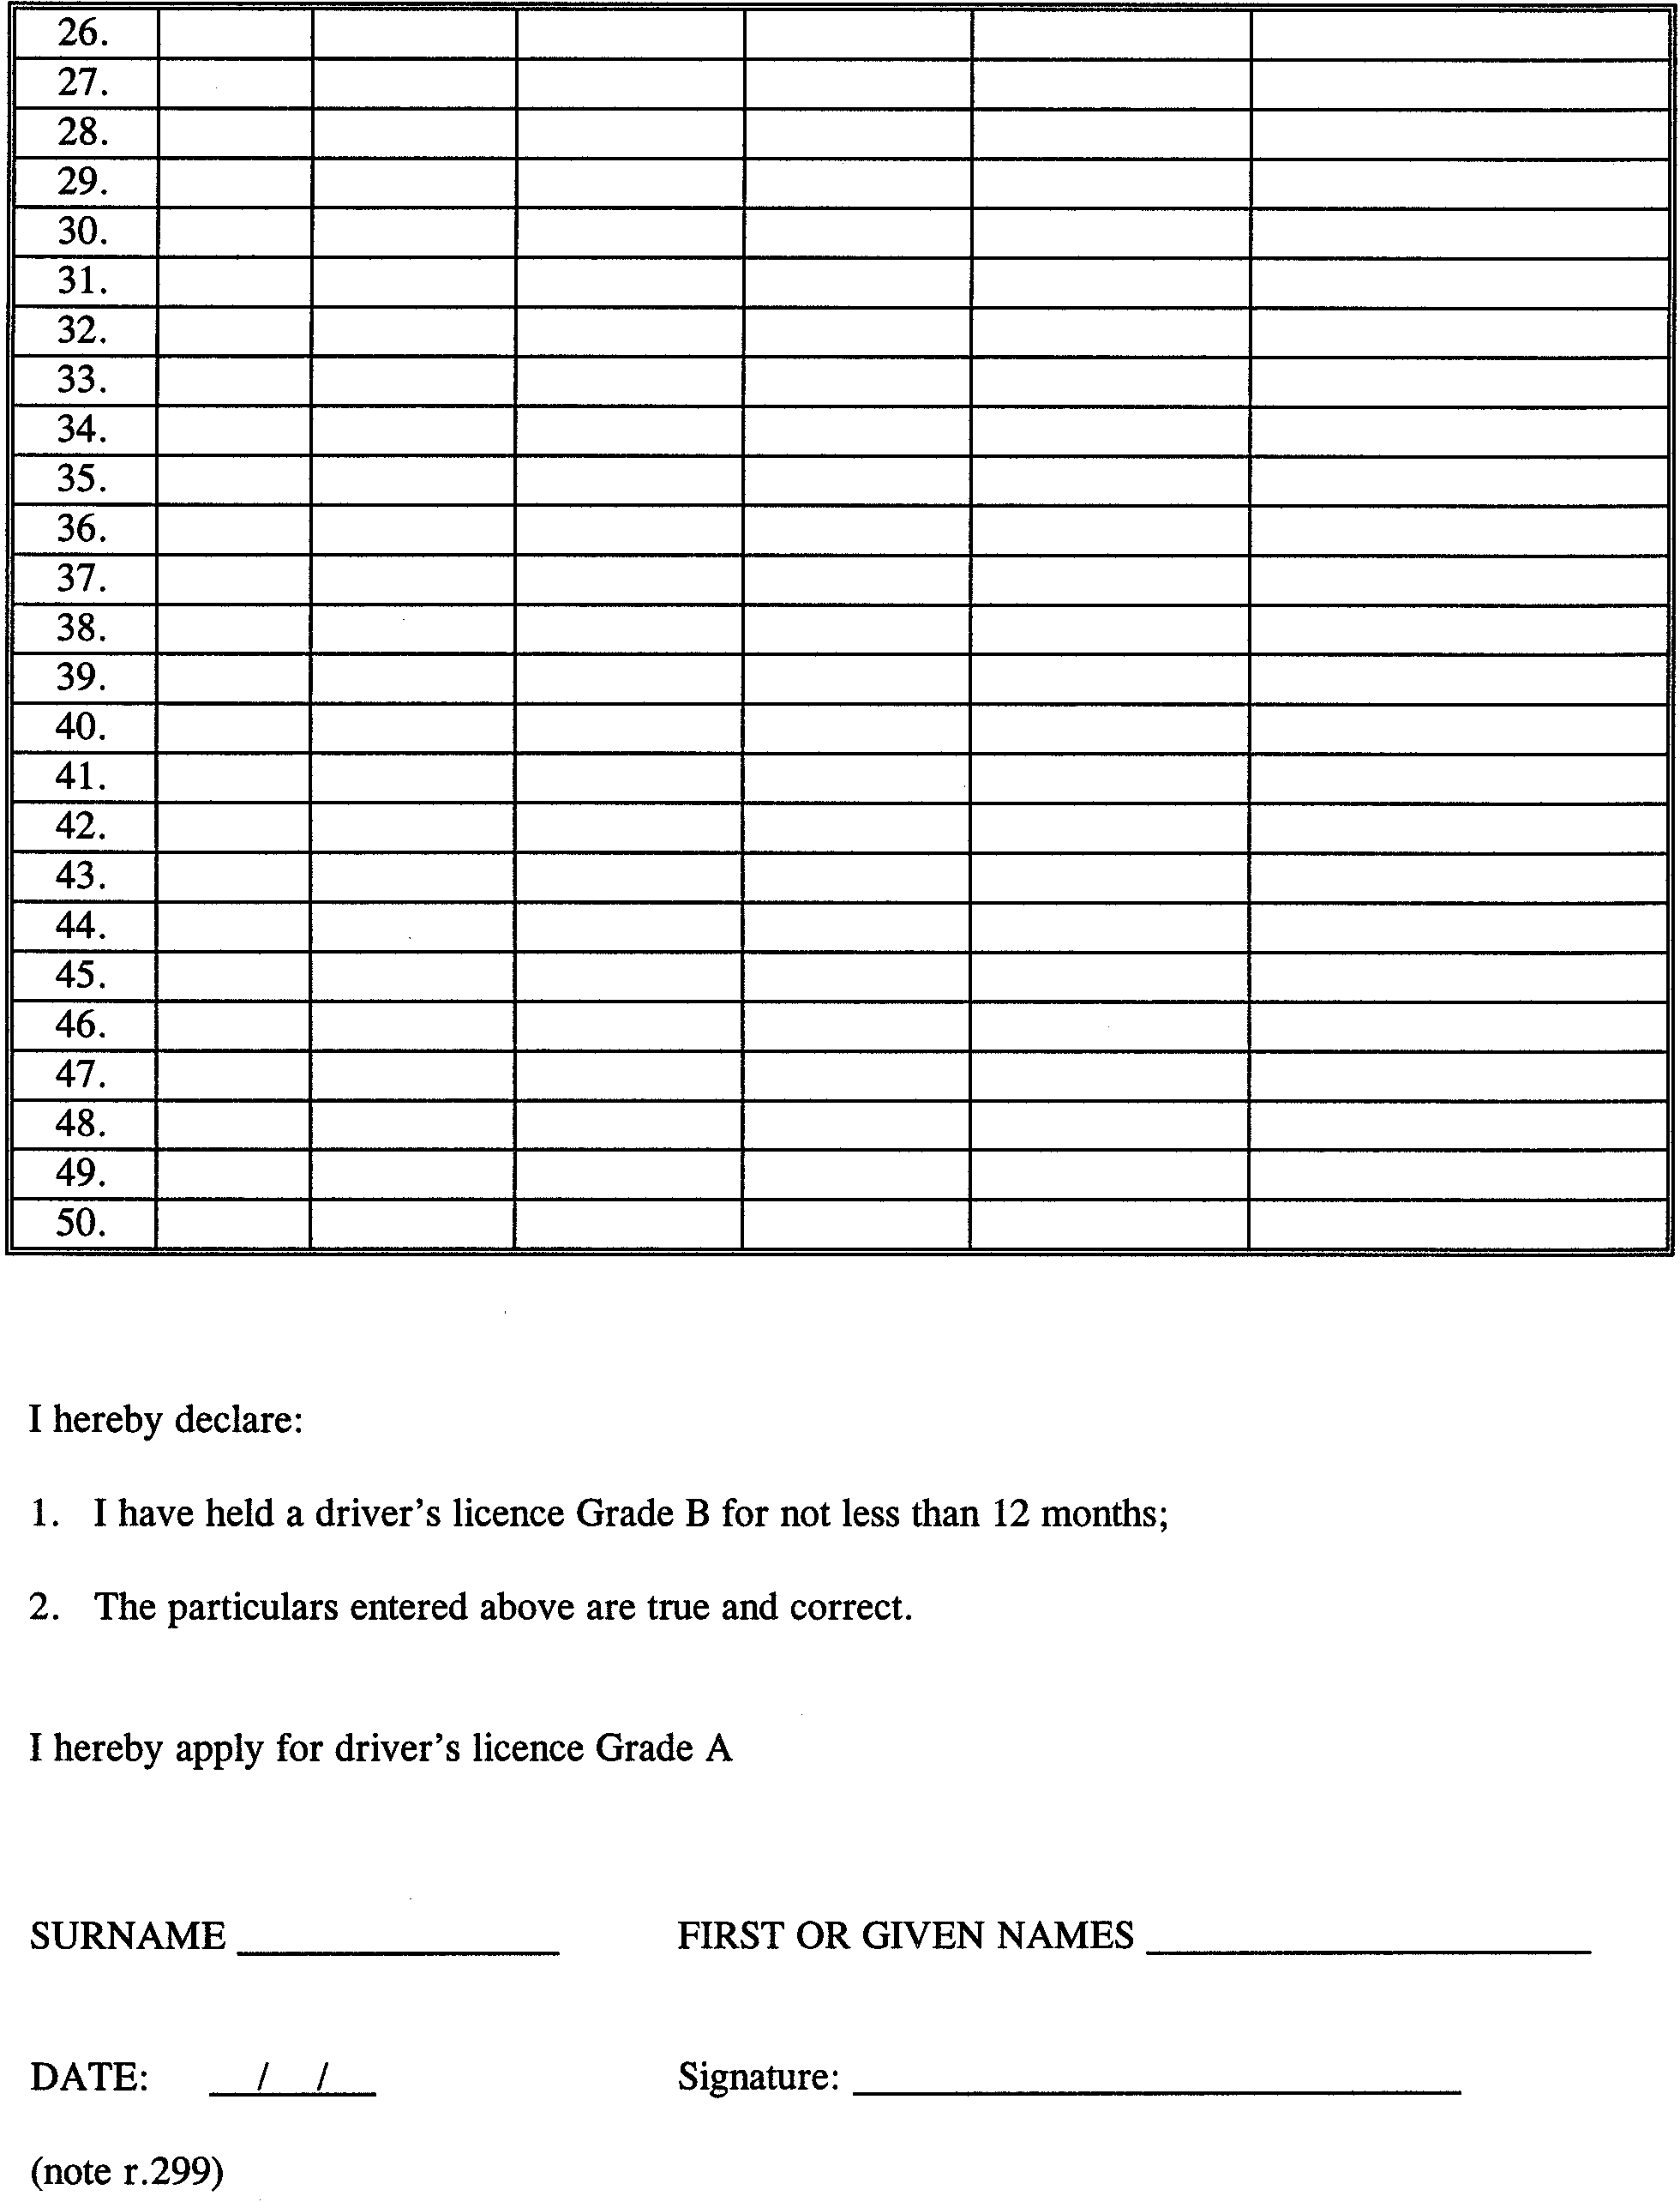
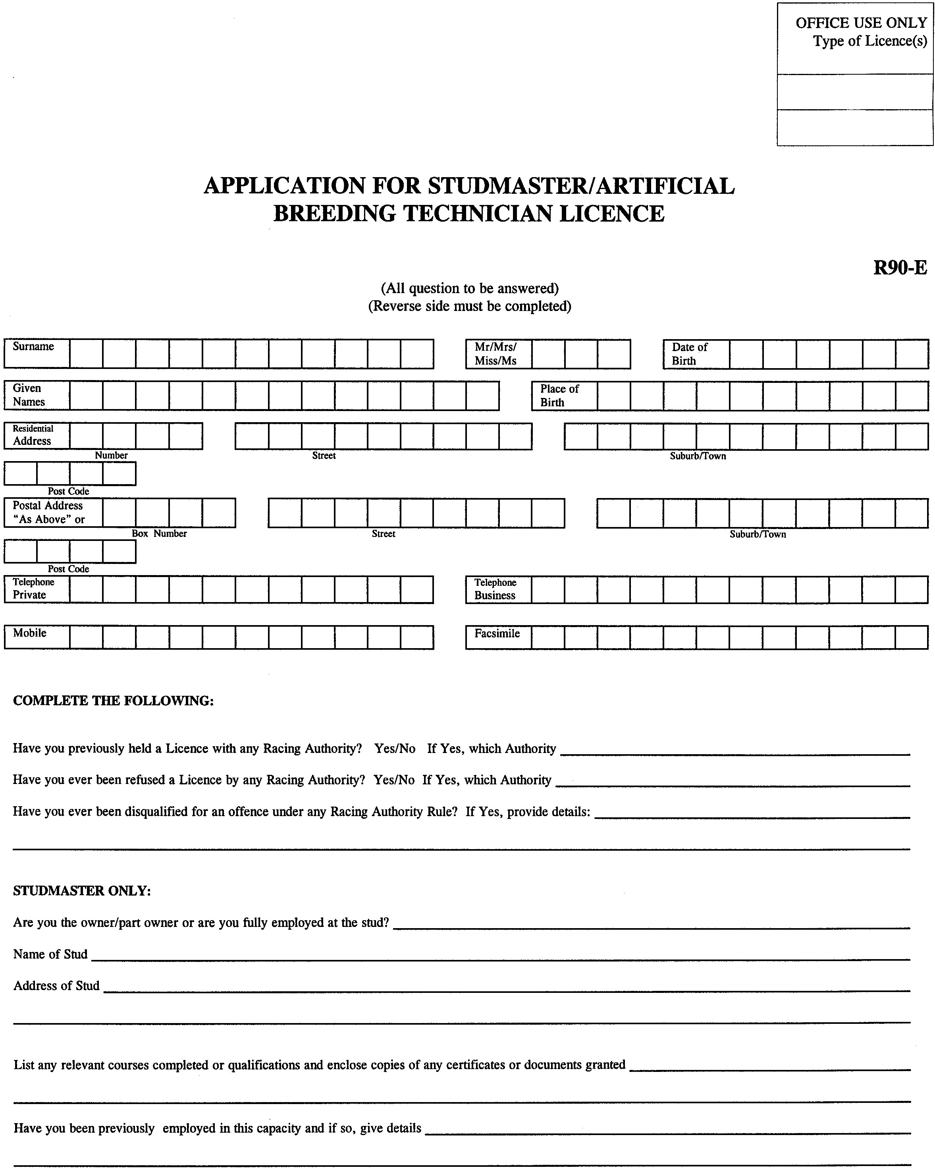

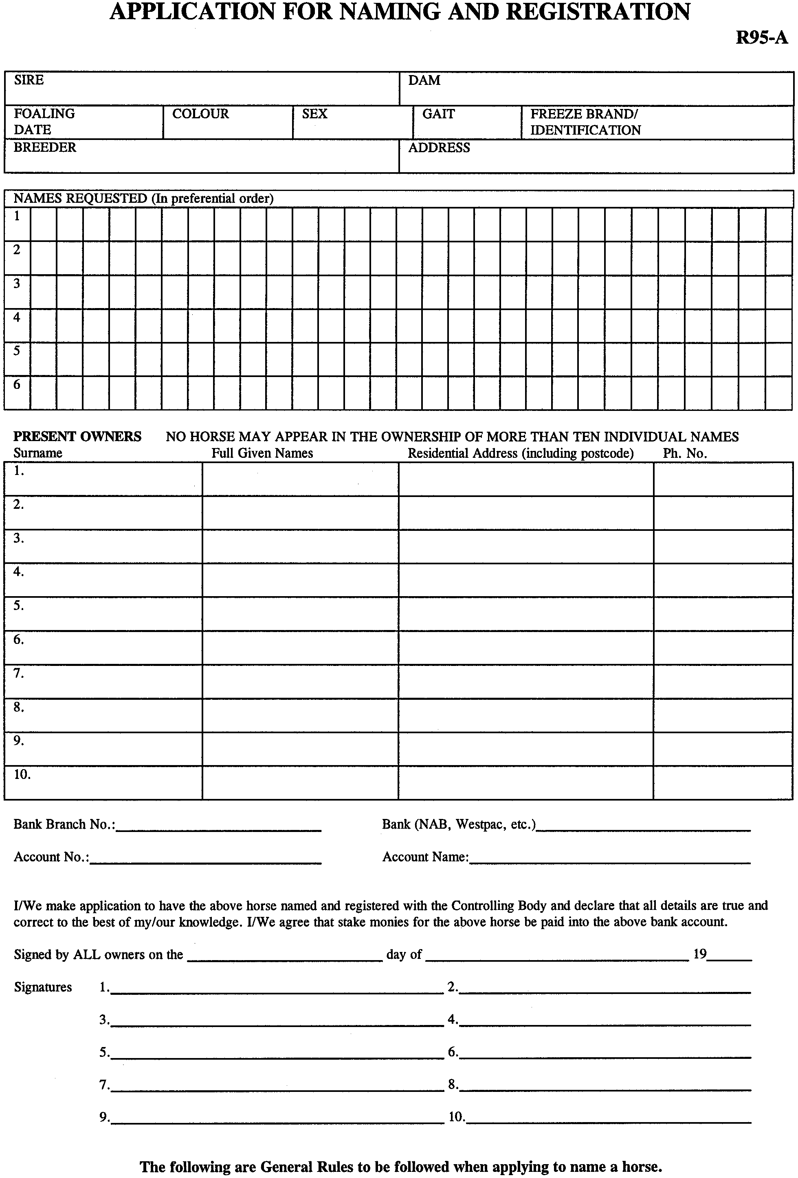
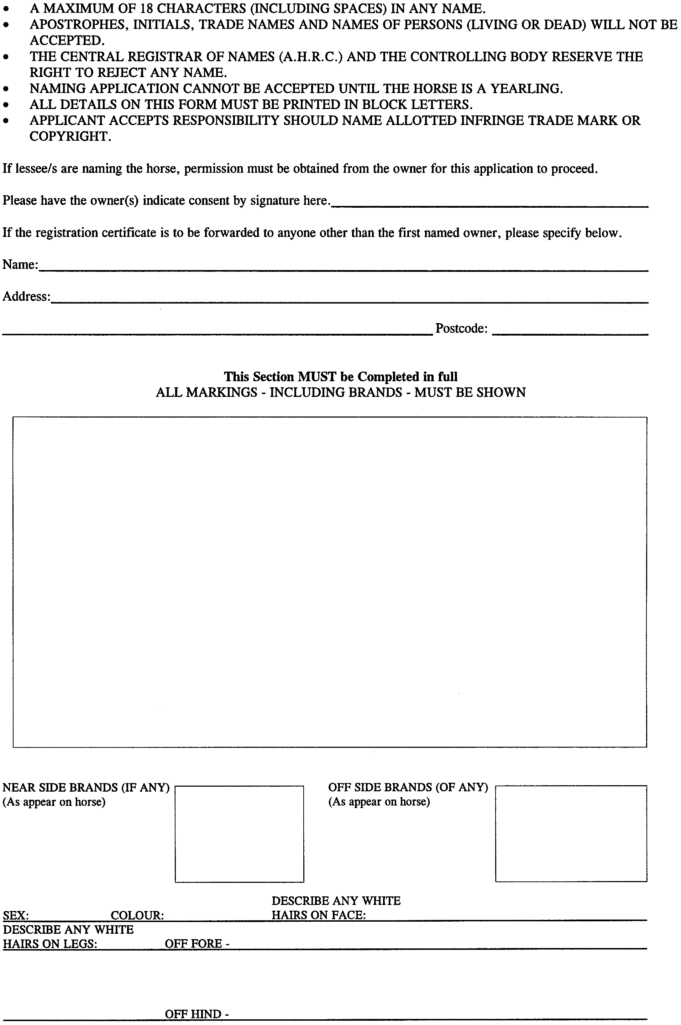
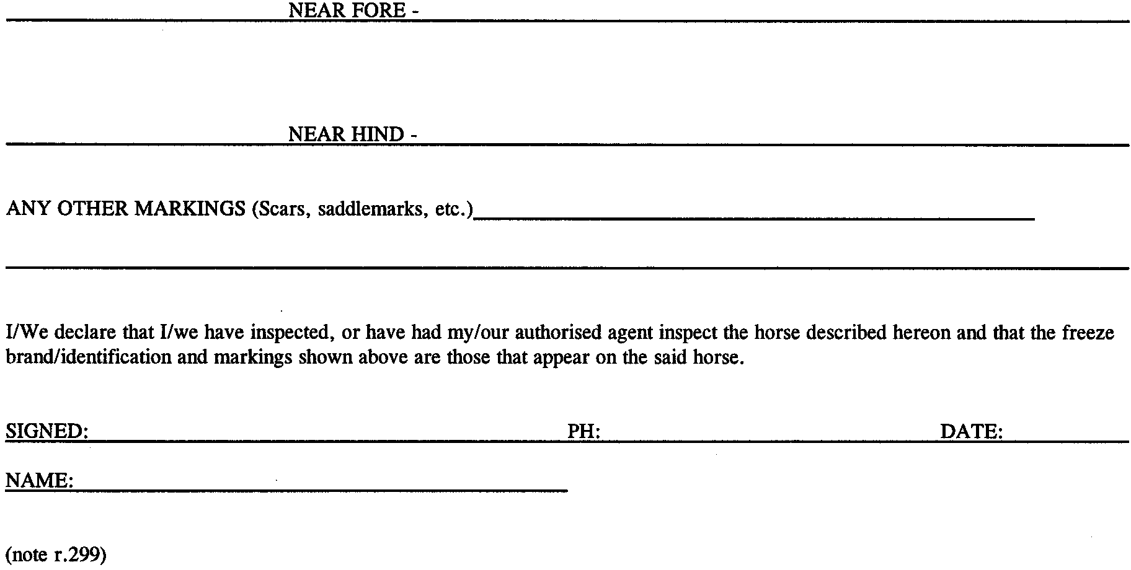
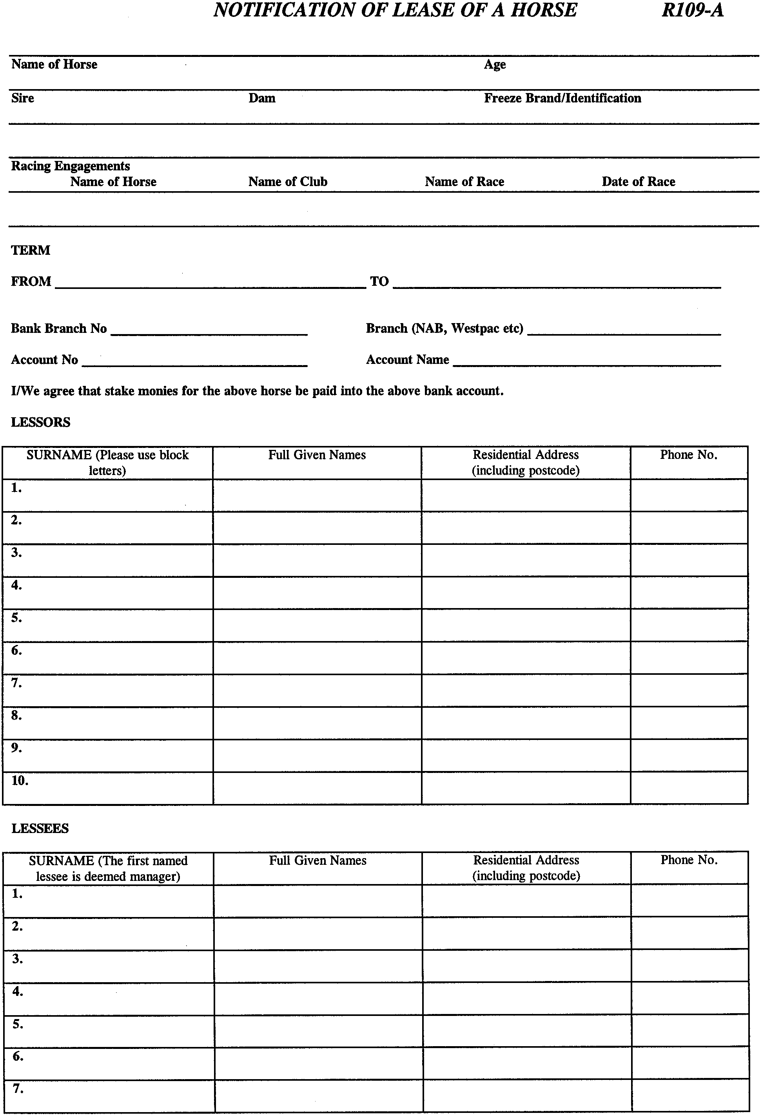
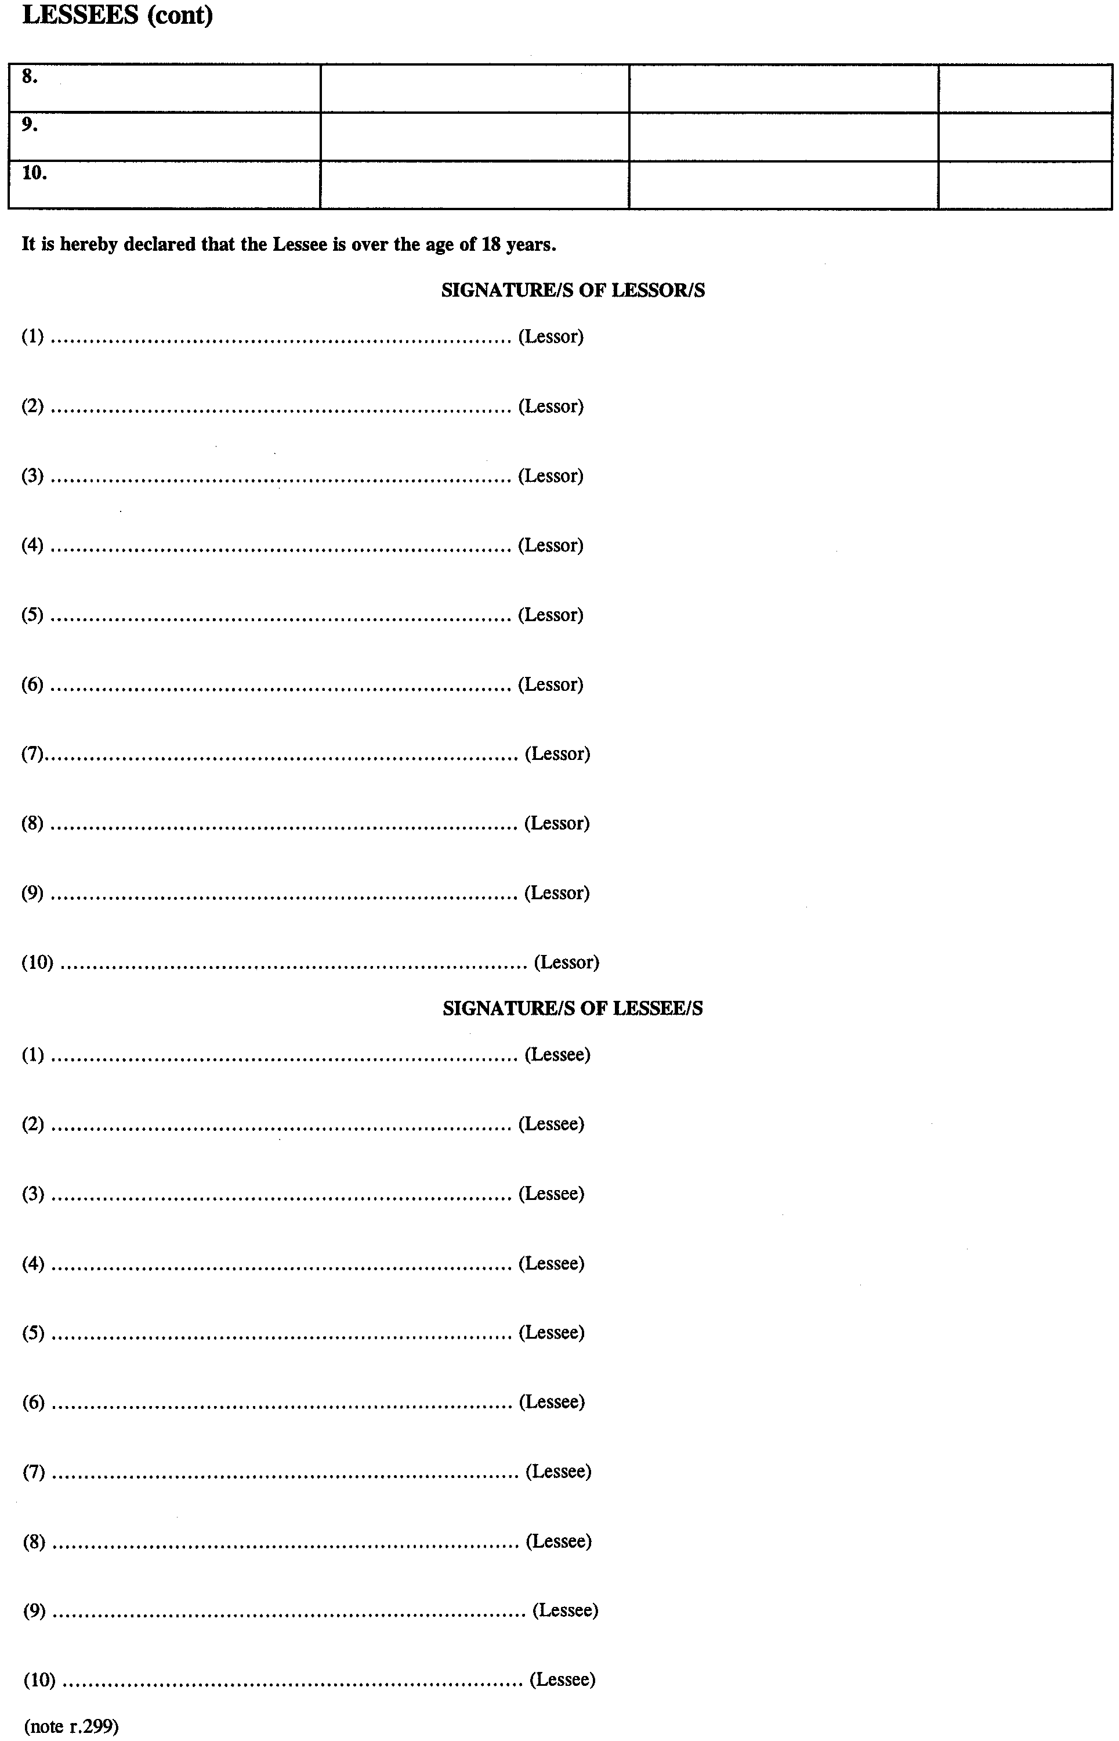
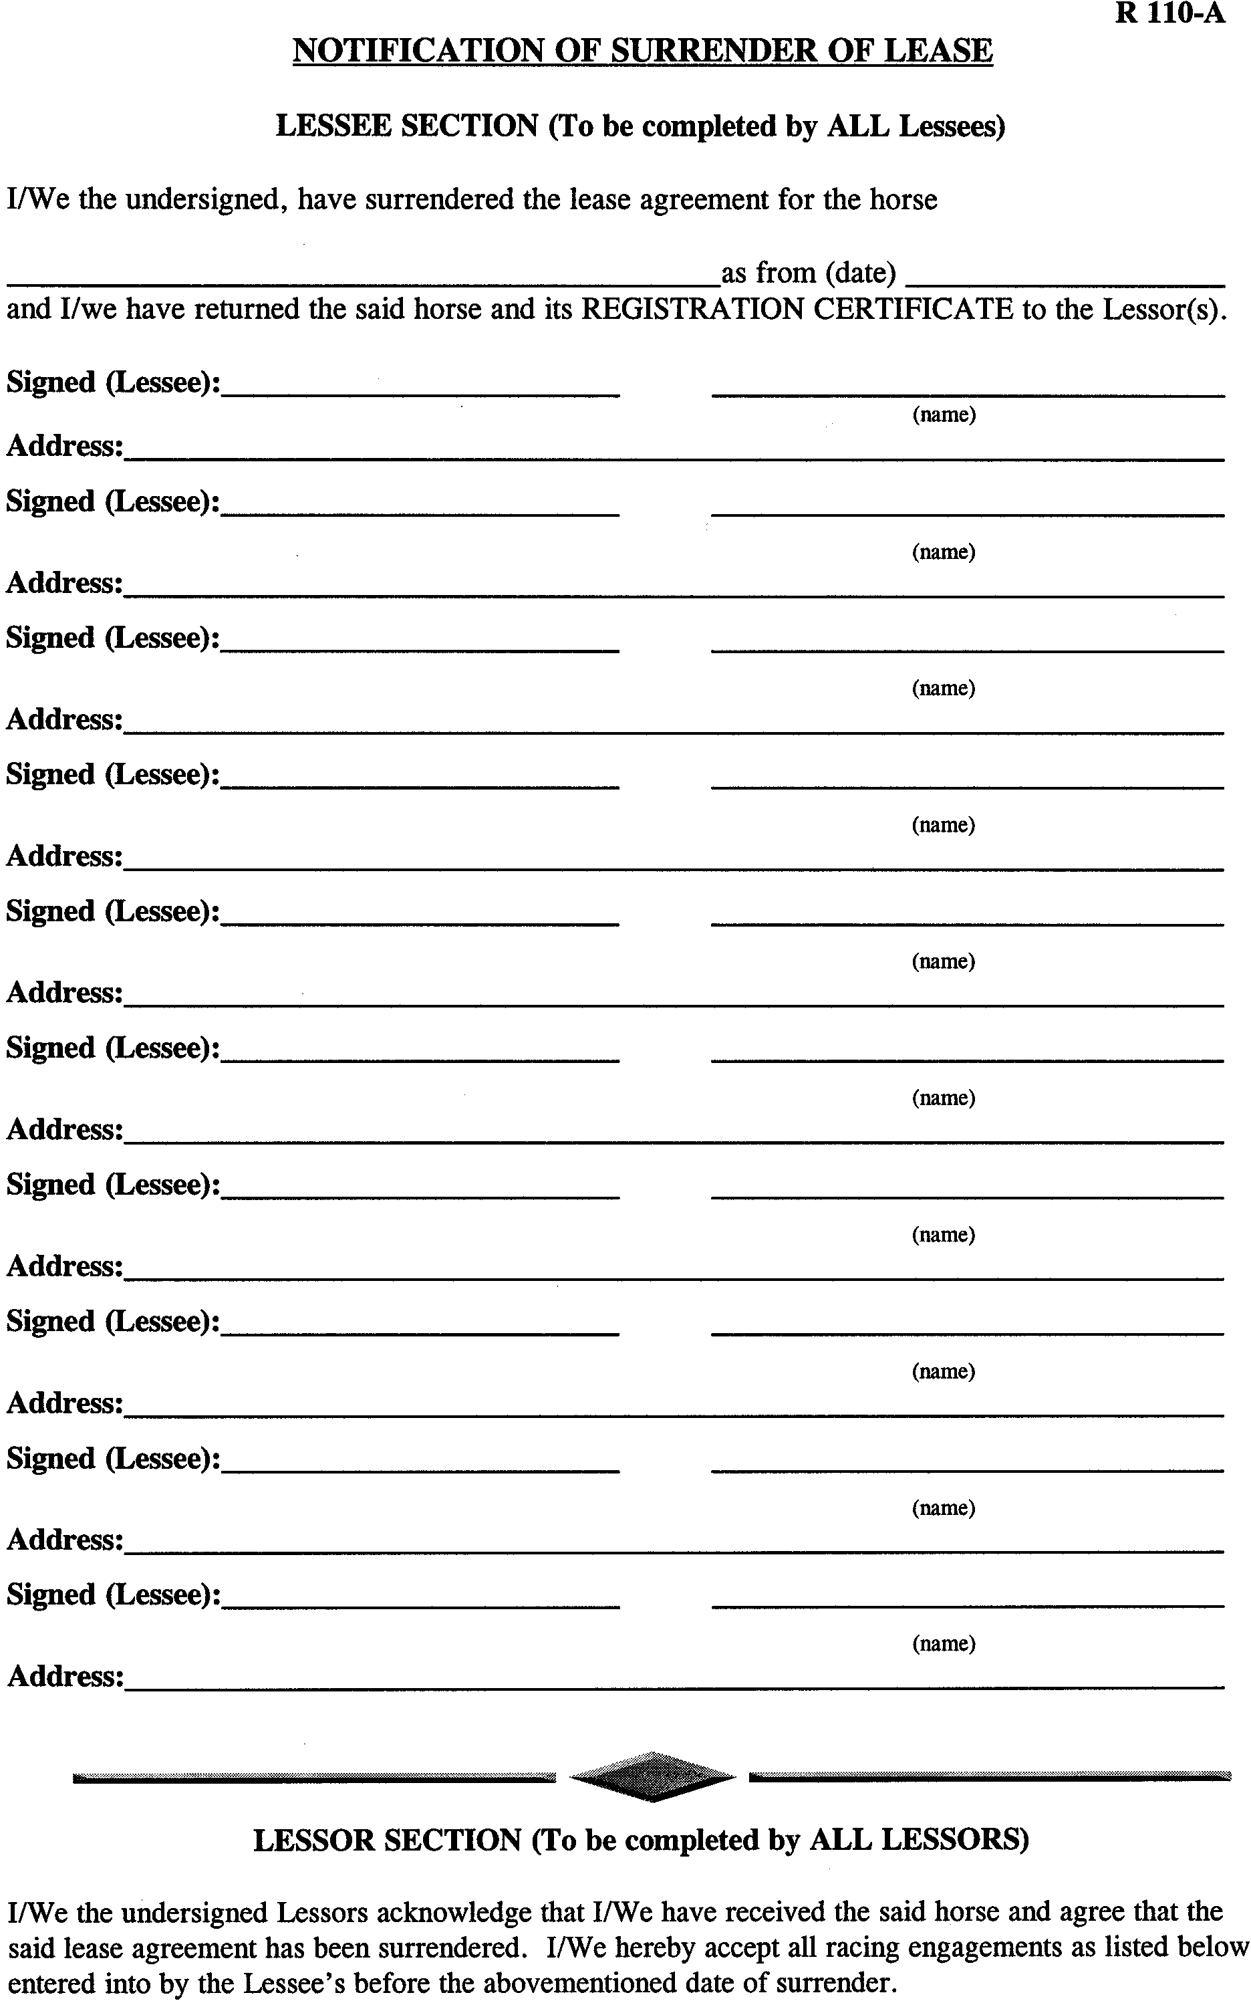
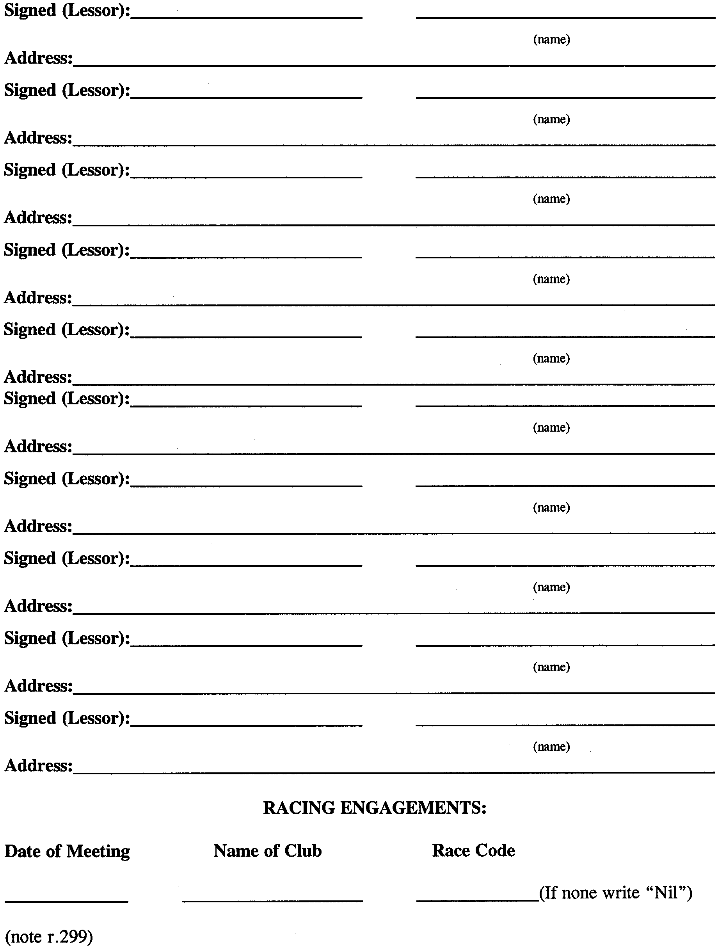
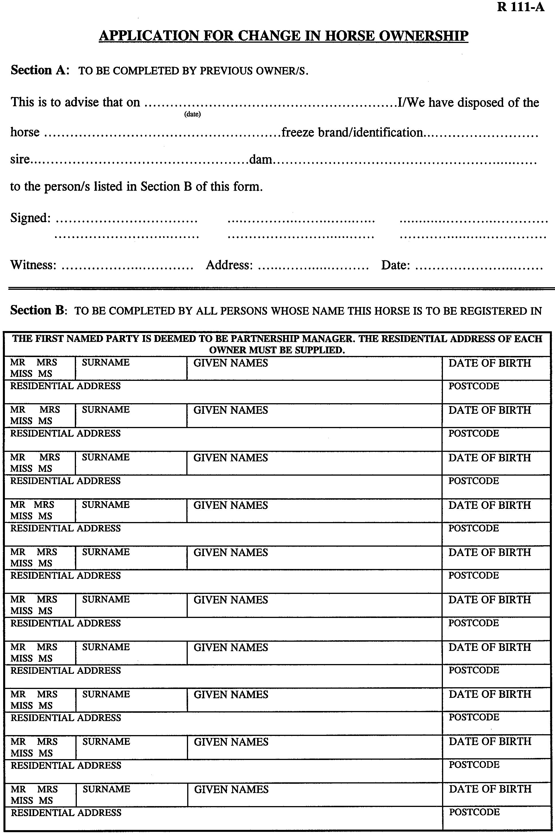

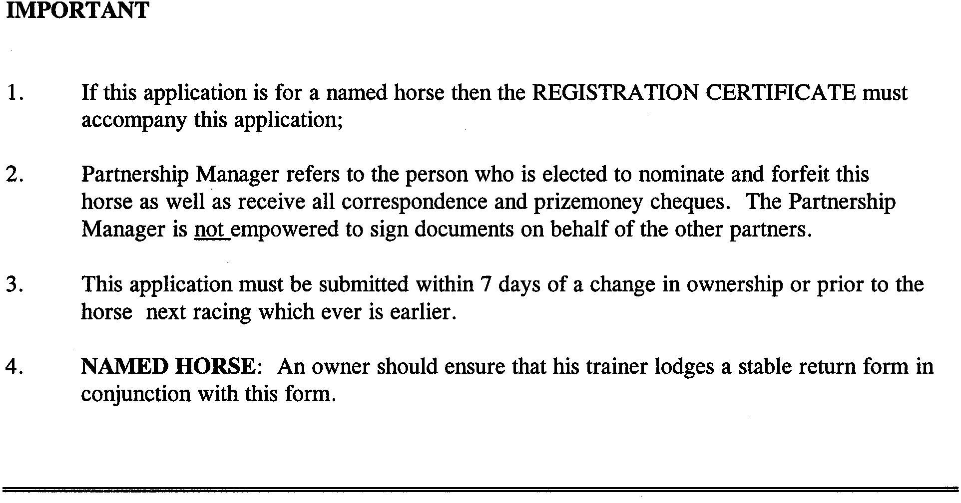
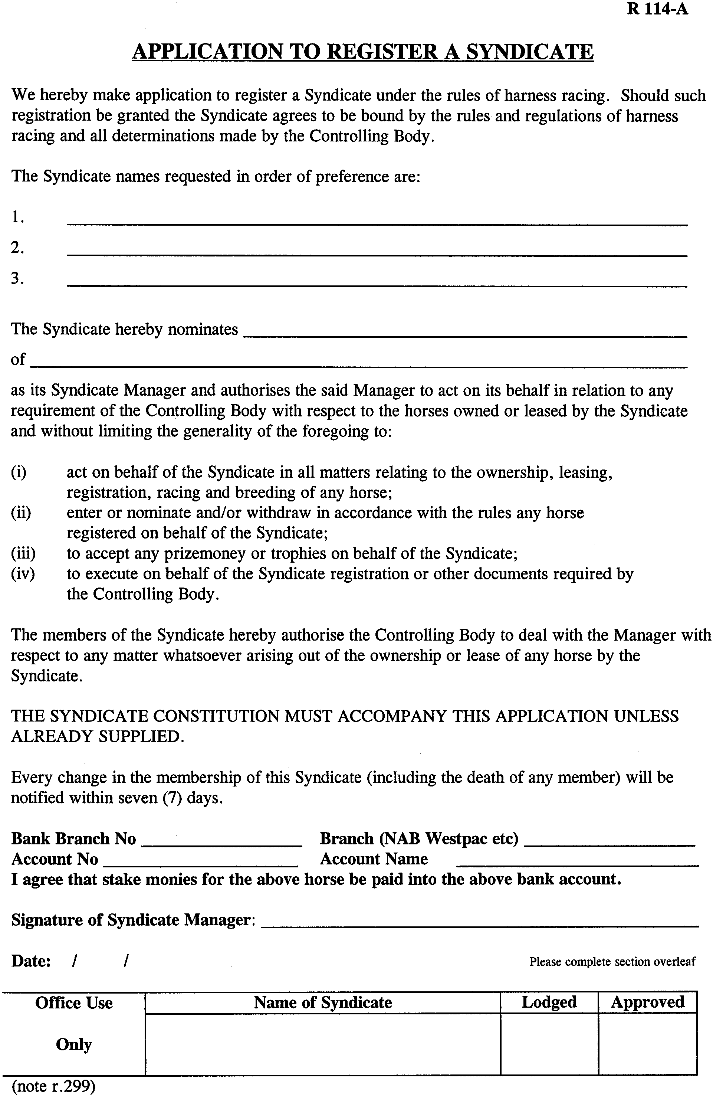
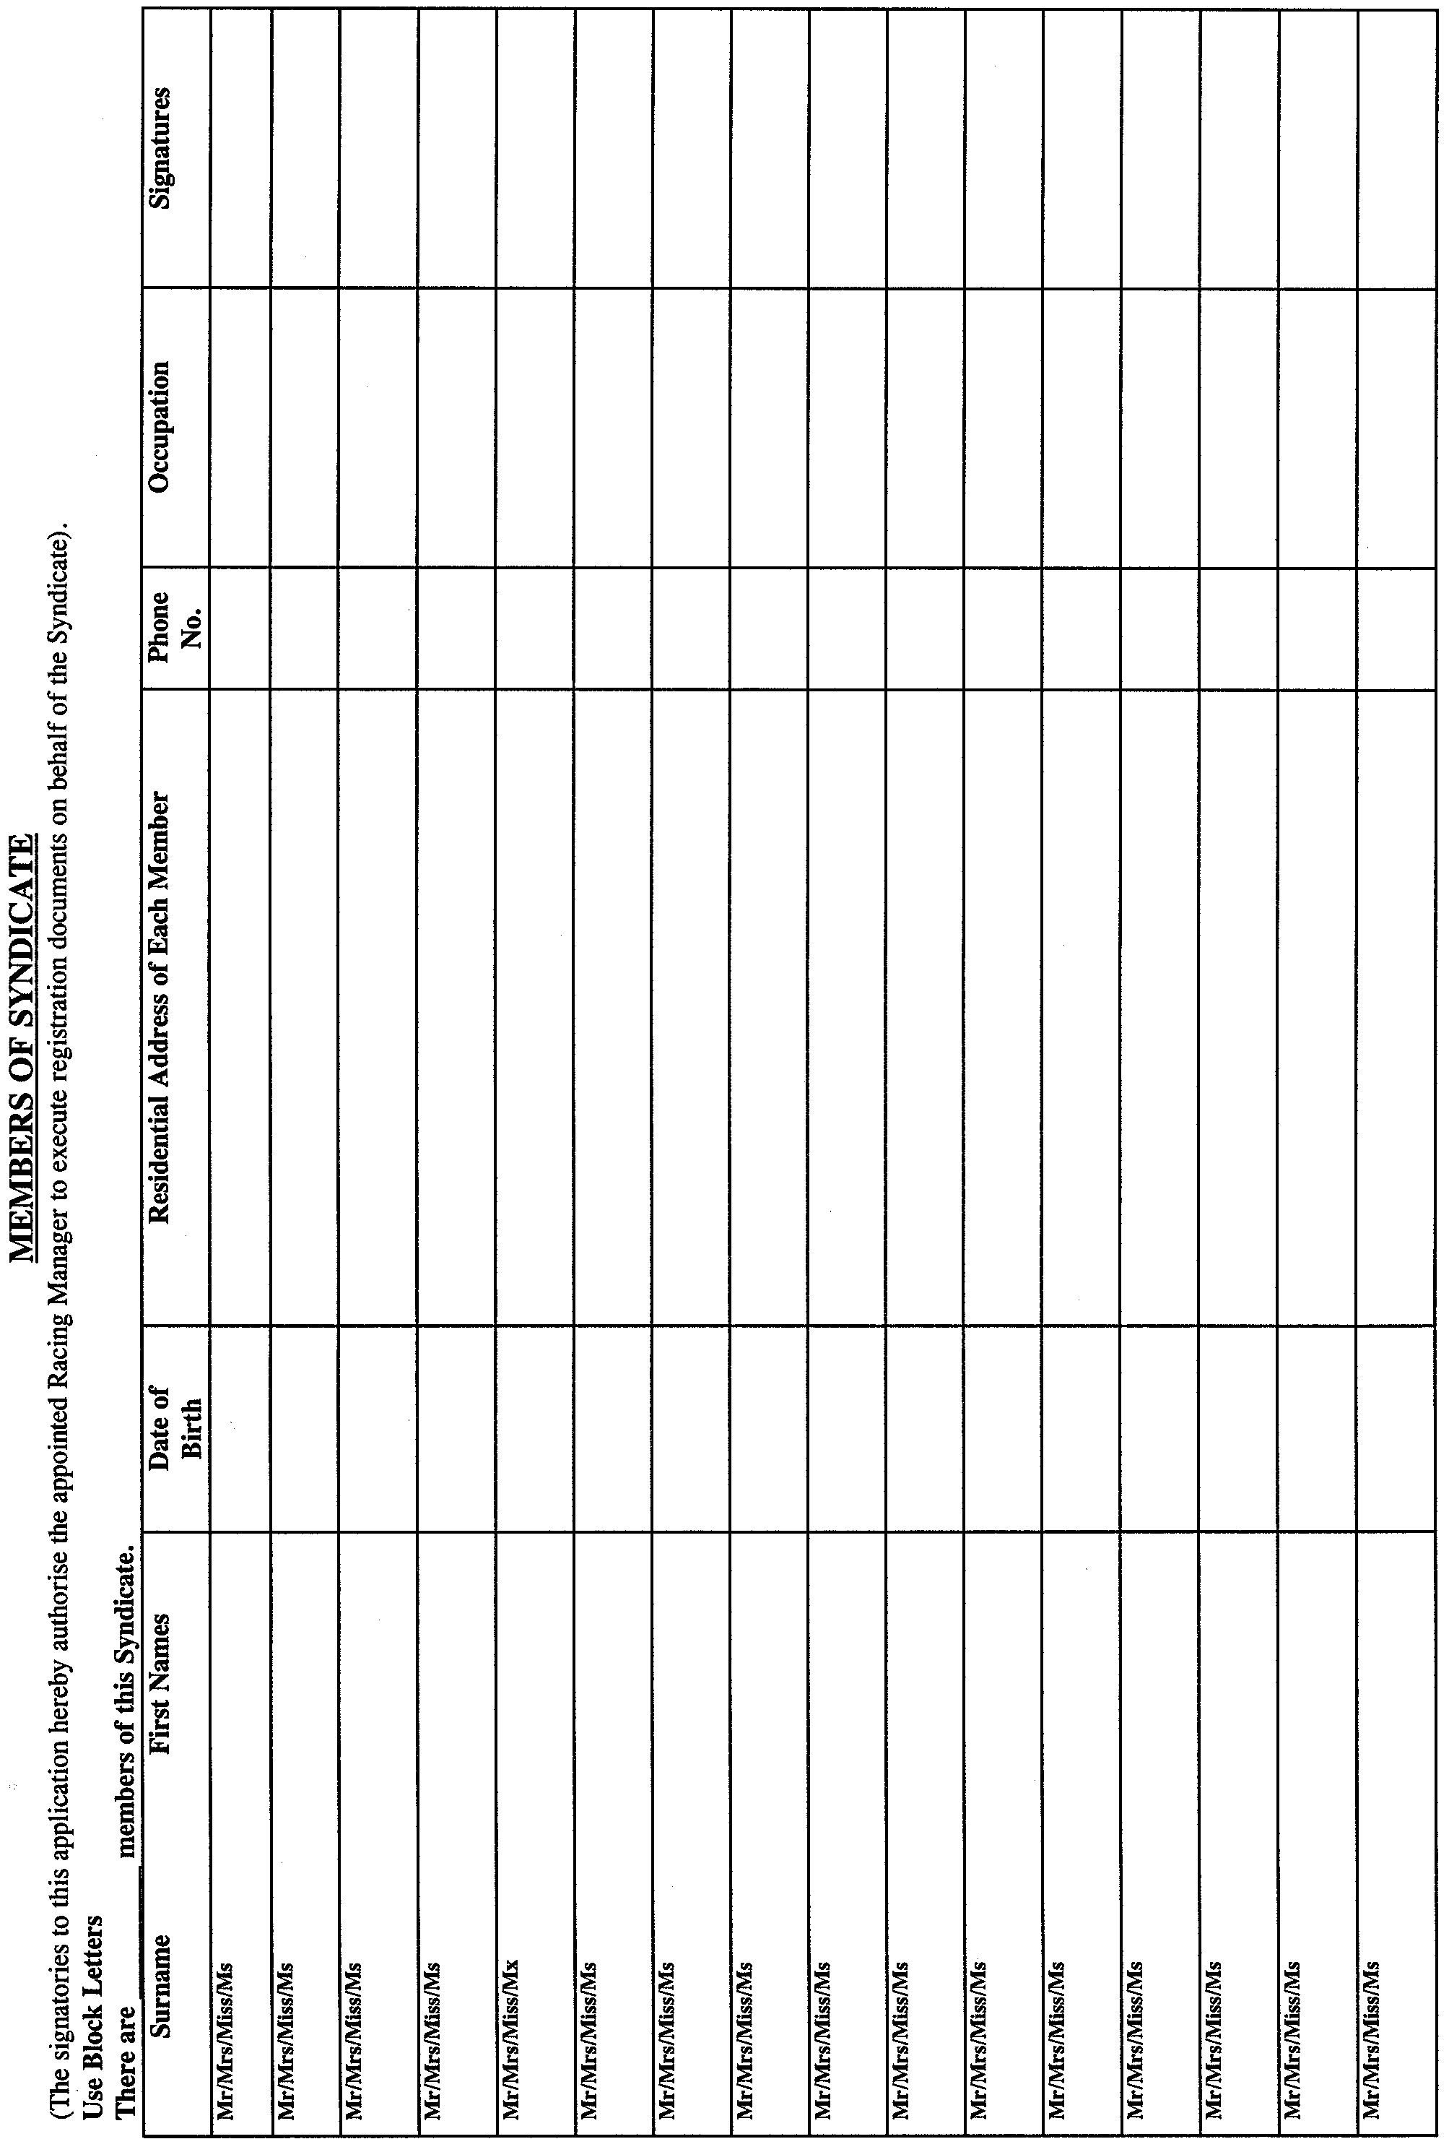
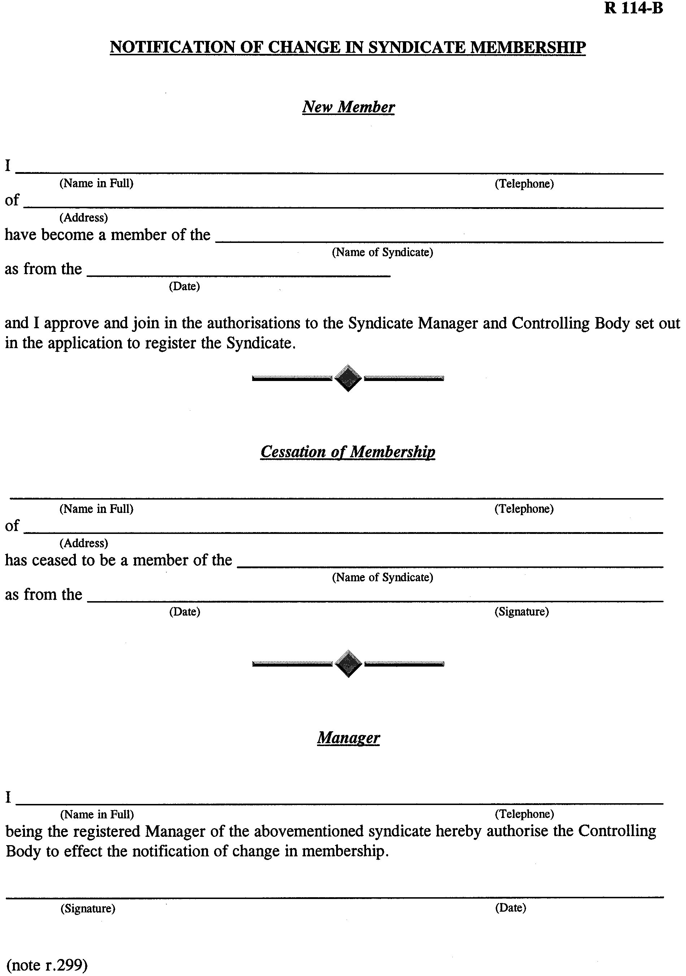
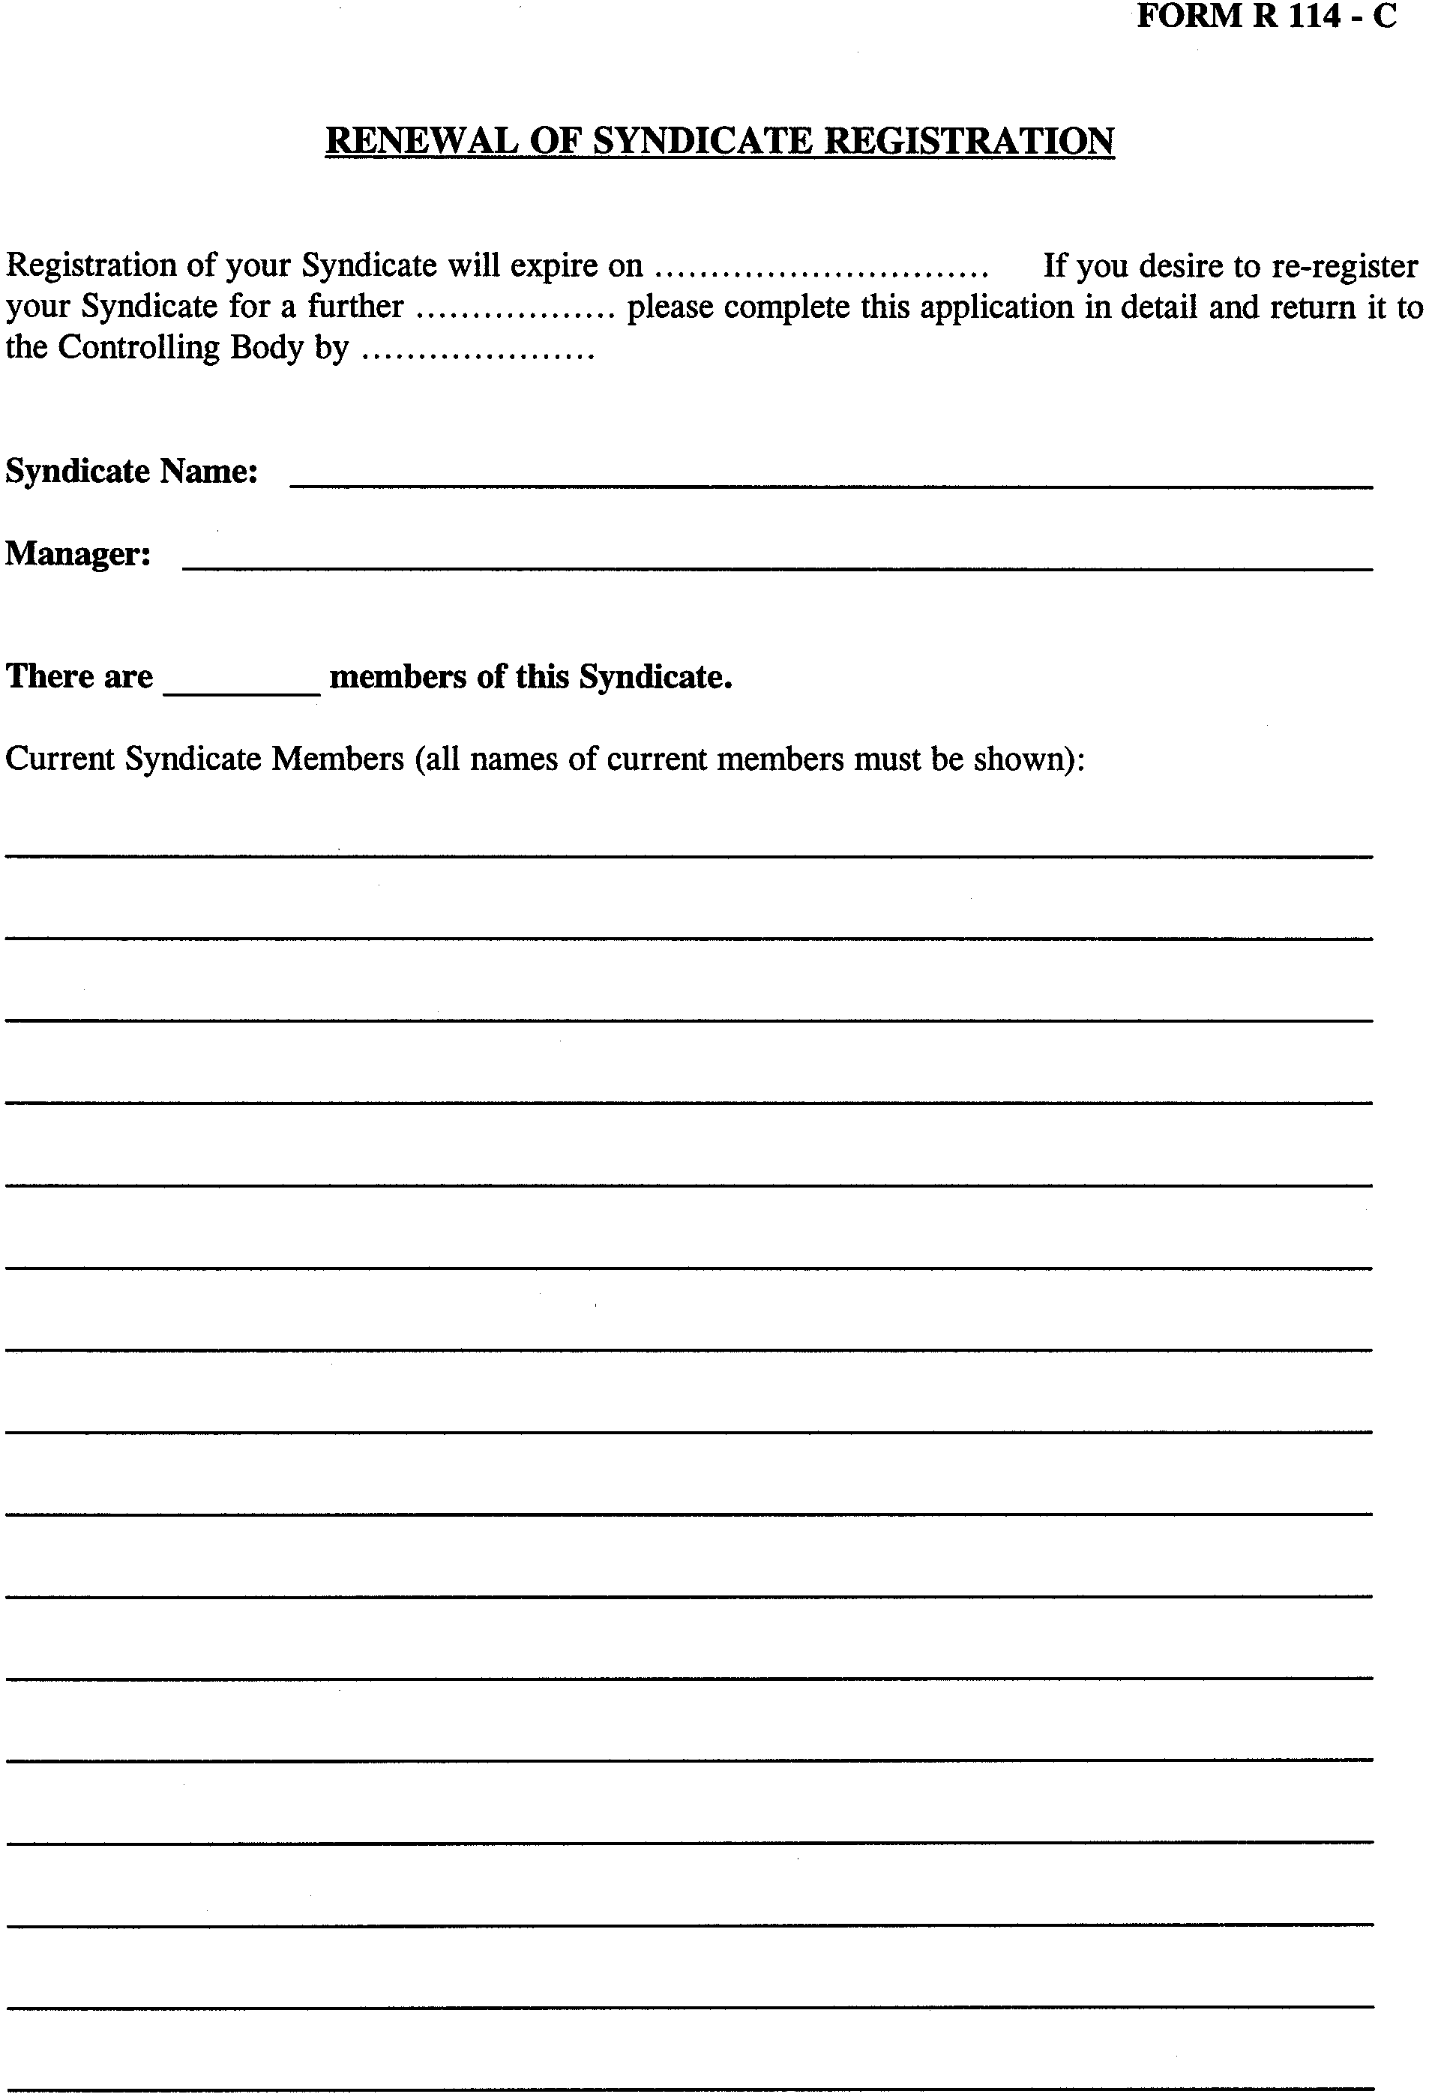
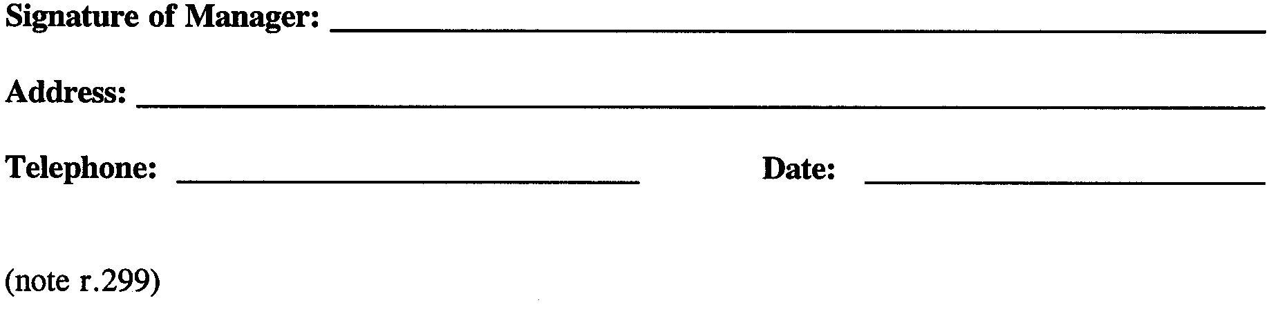
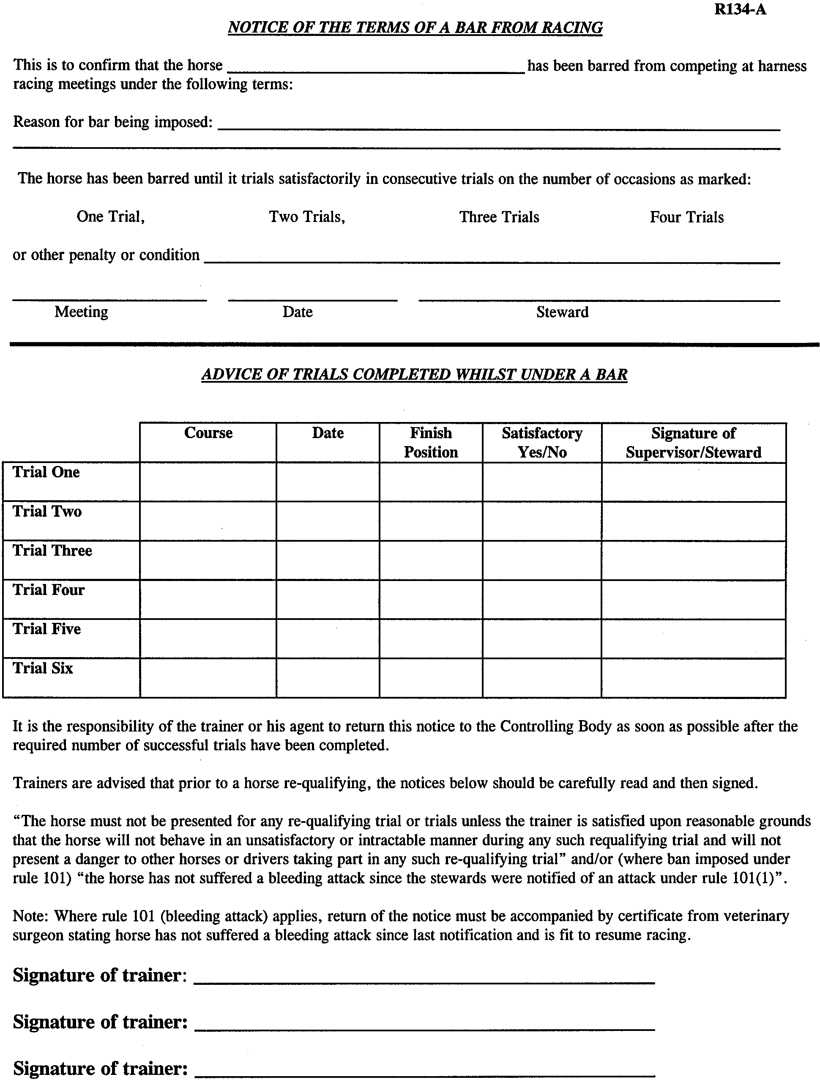
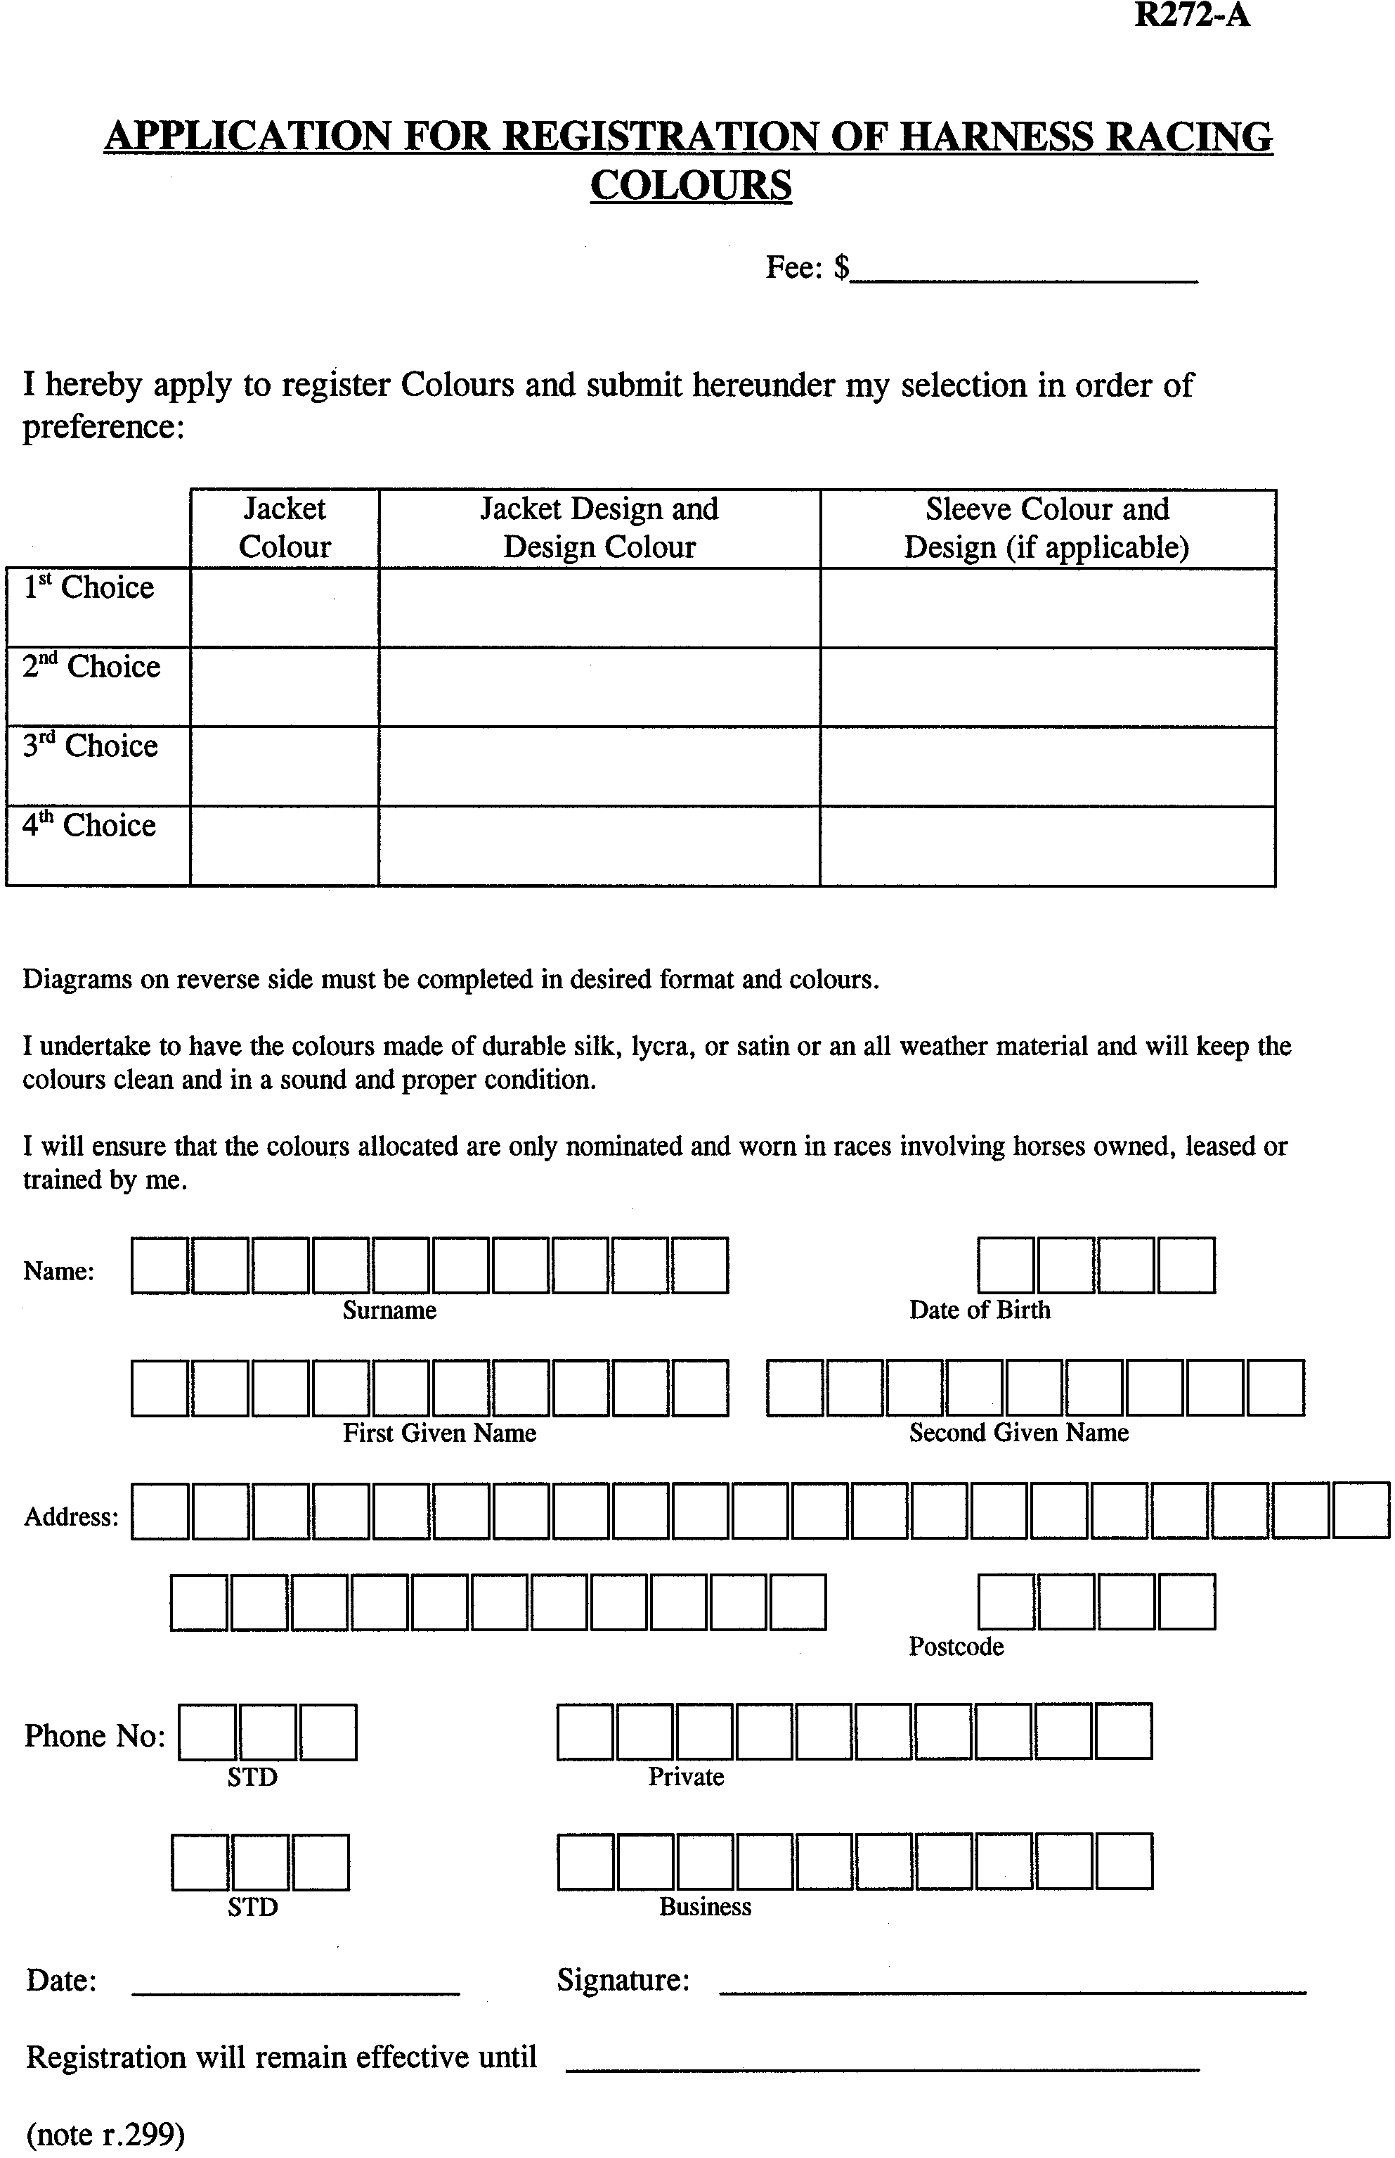
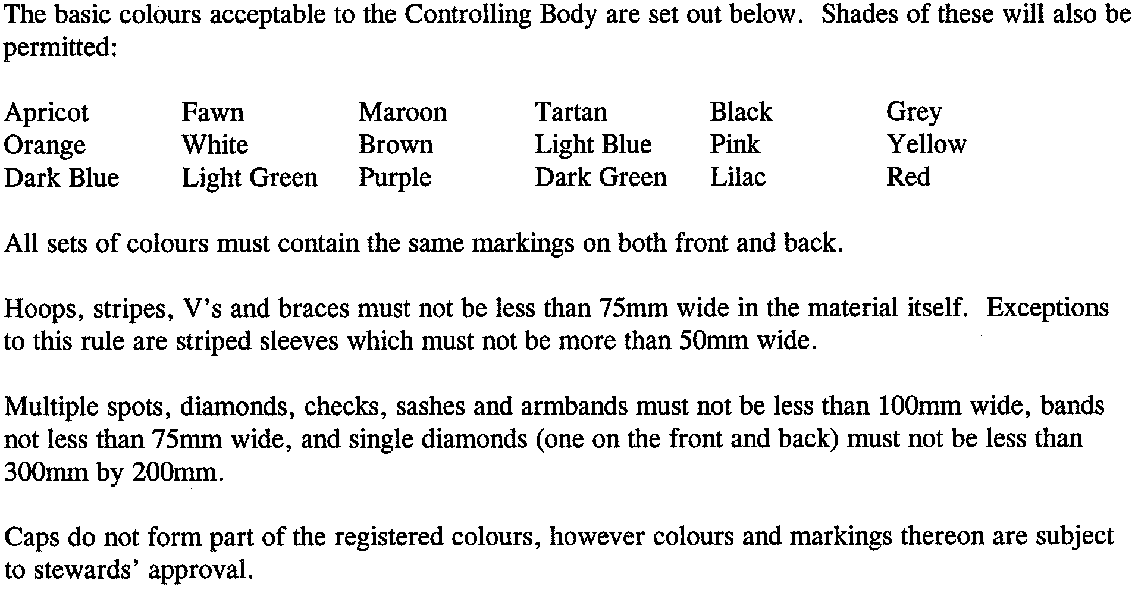
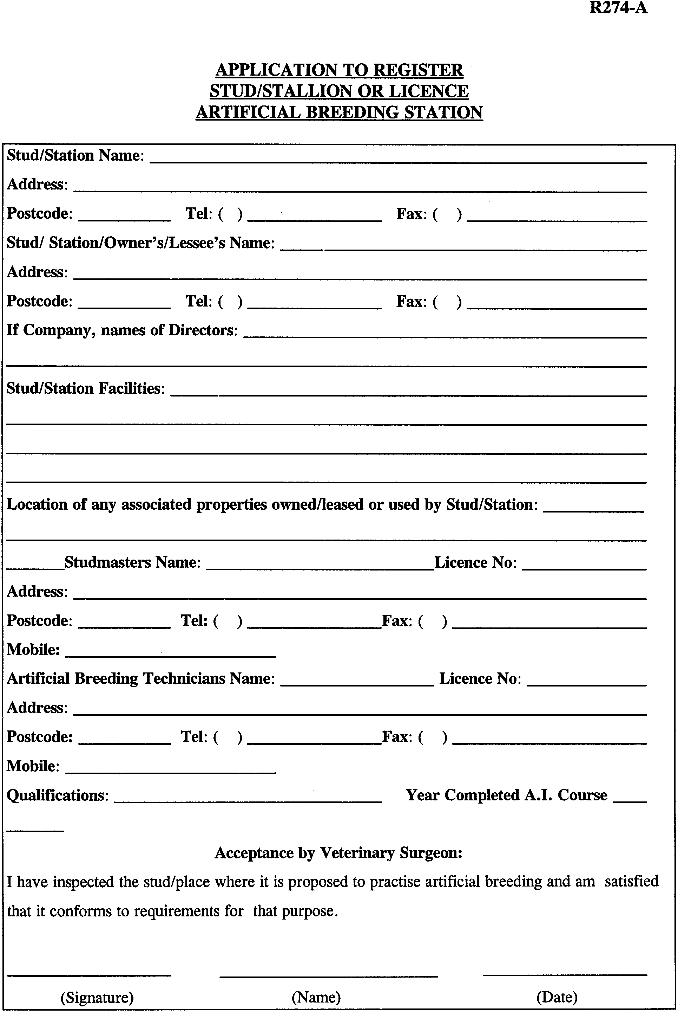
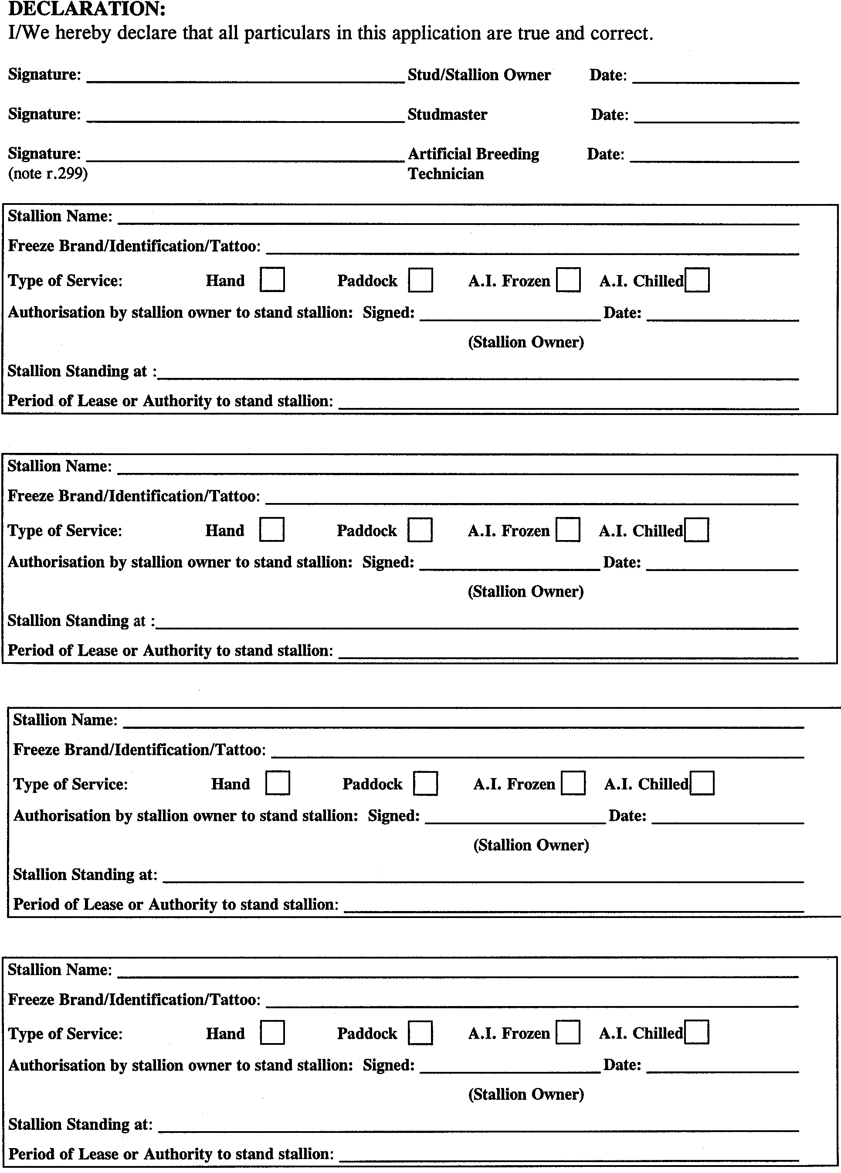
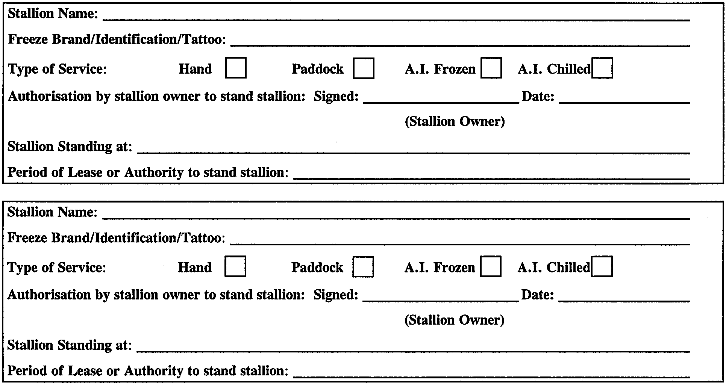
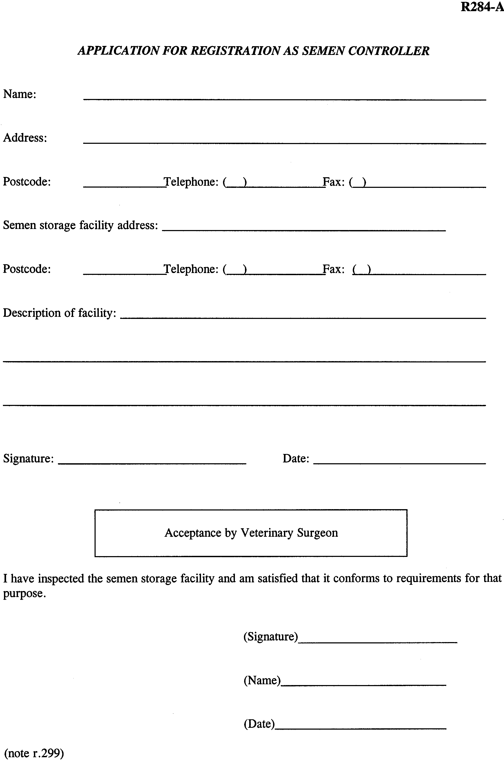
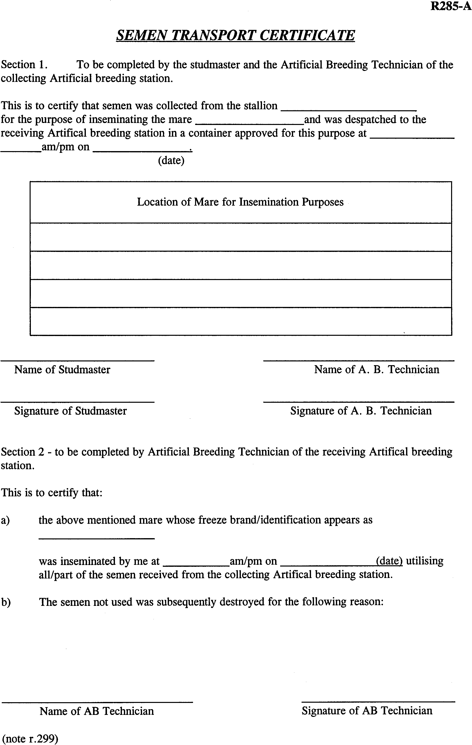
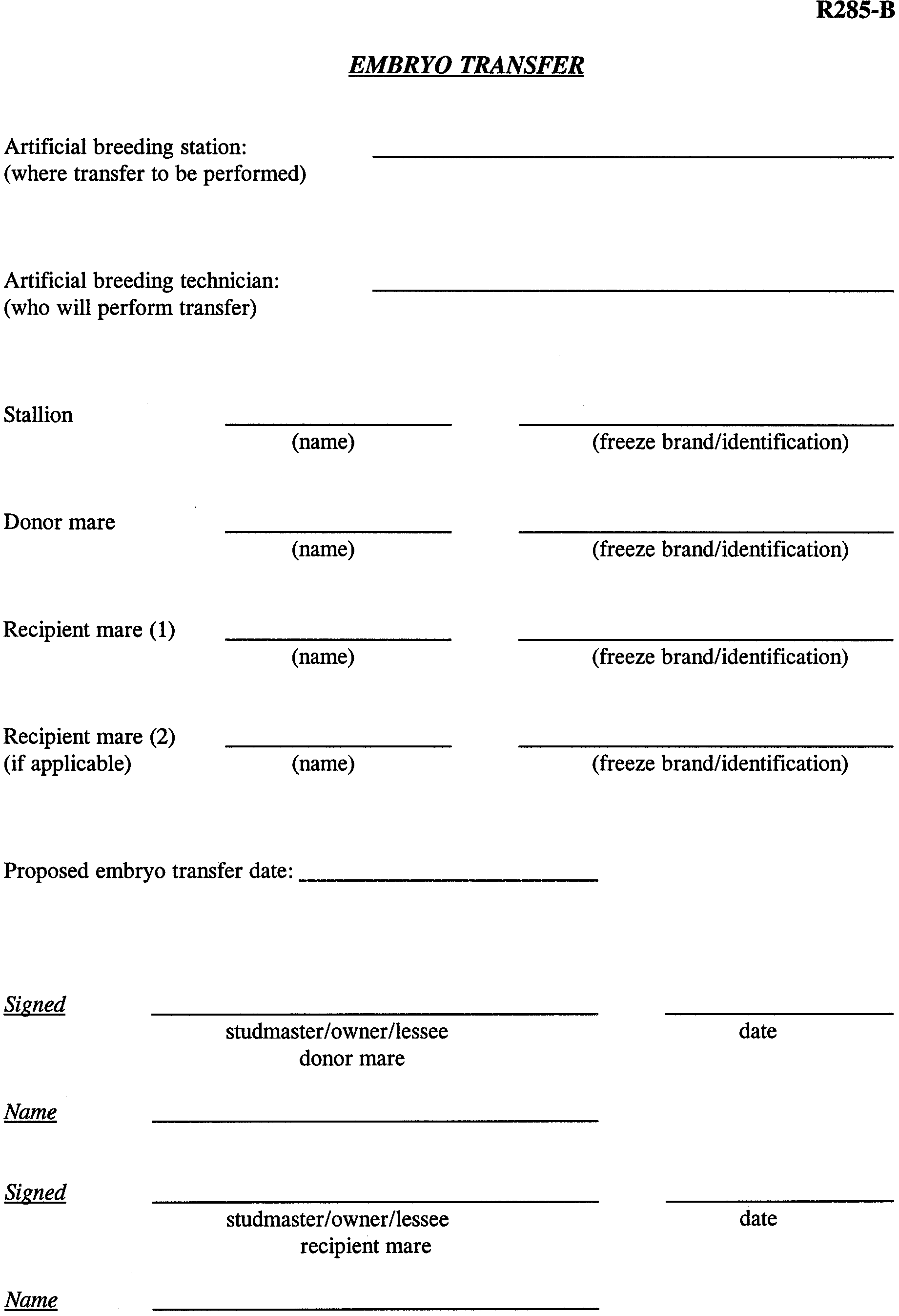
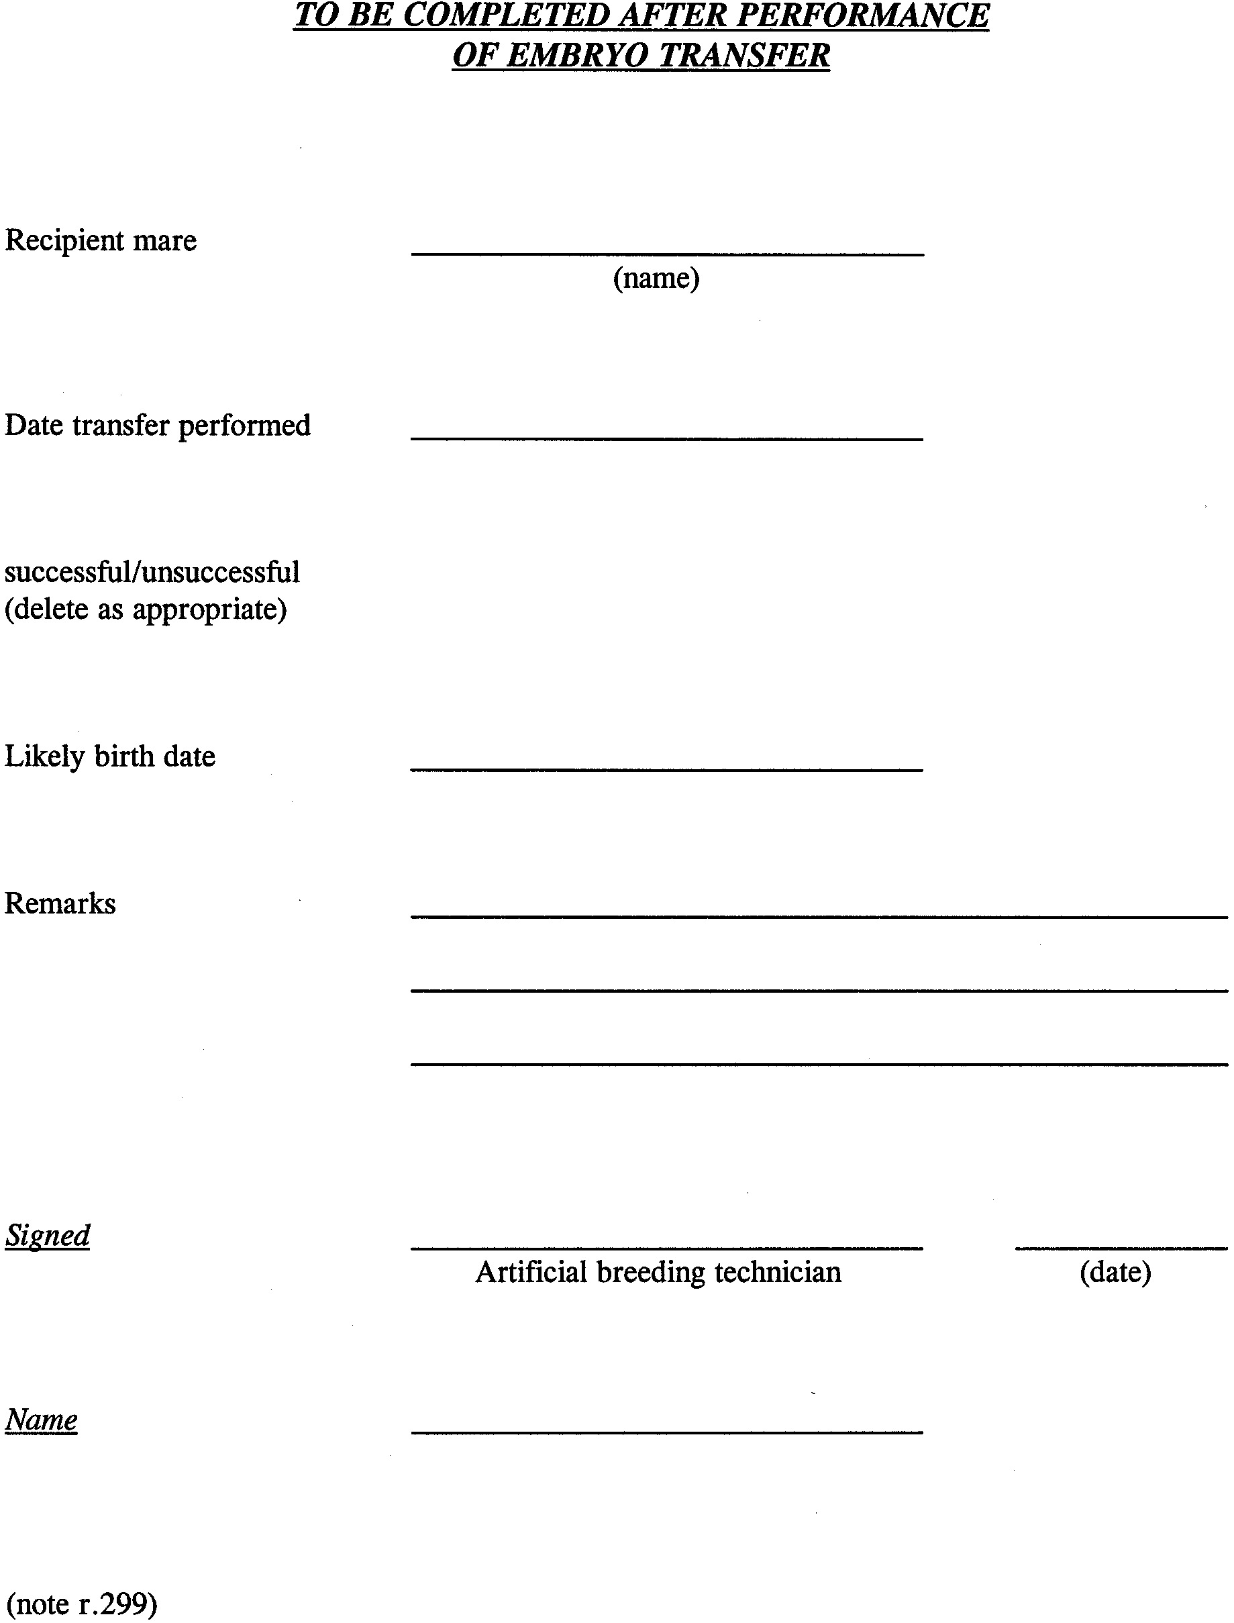
PART 23
BOOKMAKERS AND BETTING
SLR1 Rules in relation to betting shall be as prescribed by the South Australian Racing Act 1976, as amended, and the rules made pursuant thereto.
PART 24
APPEALS
SLR2 Rules in relation to Appeals shall be as prescribed by the South Australian Racing Act 1976, as amended, and the rules made pursuant thereto.

GENERAL INDEX
(Note: numbers refer to rule numbers)
ALL CLEAR STEWARD
52 appointment
52 declaration of all clear
52 inspection of horses
APPEALS
Refer to the South Australian Racing Act 1976, as amended
ARTIFICIAL BREEDING
281 artificial breeding: defined
285 artificial breeding requirements
artificial breeding station
282 —application for licence
artificial breeding technician
282 —application for licence
286 —signing notification
290 —performance of procedures at unlicensed premises
horses
279 ⎯ineligibility to race
285, 288, 289 ⎯may be disqualified or registration refused or cancelled where artificial breeding offence committed
offences
289 —breaching terms or conditions of licence
287 —failure to carry out verification procedures
283 —non compliance with semen importation controls
286 —failure to sign notification of practising artificial breeding procedures
289 —performance of procedures at unlicensed premises
289 —permitting procedures at unlicensed premises
289 —unlicensed person performing procedures
284 —unlicensed semen controller
287 parentage verification procedures
semen controller
284 —application for registration
semen importation
283 —compliance with AHRC requirements
283 —Controlling Body determinations
unlicensed premises
290 —lawful use of
BARRIER POSITIONS
131 determined by Controlling Body
132 error in position
128 exclude from draw: mobile
133 omission of horse from field
134, 134A outside draw stand
133 random draw
BOOKMAKERS AND BETTING
Refer to the South Australian Racing Act 1976 (as amended)
CHAIRMAN OF STEWARDS
14 appointment
273 false belly band: permission not to use
152 horse to be driven: change in priorities
273 retaining straps: permission not to use
273 unapproved gear: permission to use
CHIEF STEWARD
75 claiming race responsibilities
129 determining whether horse started
68 report of meeting
14 voting
14 who is
CLAIMING RACE
77 claim in non-claiming race
72 determination of race to be claiming race
76 offences
73 restrictions on claims
74 syndicates and joint ownership: claim when being dissolved
75, 75A terms and conditions
CLUBS
9 exclusion of persons from course and other places
8 furnishing information reports and conducting investigations
21 meeting dates: allocation
10 offence: promoting races when unregistered
officials
37 —full complement at meetings
40 —conflict of interest
39 —deputies
register of
2, 2A registration
stewards must attend meetings
CONTROLLING BODY
311 advice to: may act as it sees fit
305 appointments: includes right to suspend and right to terminate
appointments
artificial breeding
281 —artificial breeding procedures: determinations
285, 285A —artificial breeding requirements: imposing
282, 282A —artificial breeding station: application for licence
282, 282A —artificial breeding technician: application for licence
285, 288, 289 —horses: disqualification or registration refused or cancelled
where artificial breeding offence committed
286 —notification of practising artificial breeding procedure: determining requirements
284 —semen controller: application for registration
283 —semen importation: determinations governing
290 —unlicensed premises: determining procedures to be performed
287 —verification procedures: directions
clubs
67, 68 —information, reports investigations
1 —register of
2, 2A —registration
272, 272A colours: registration
disqualified persons
236 —approving employment
267 —disqualification for criminal conviction
264 —leases: determination about stake money
263, 266 —proposals concerning lease or sale
265 —sale of horse: regulating
drivers
159, 159A —dress: determination
151 —fees: determination
153 —pregnant driver
164, 164A —securing clear passage: determination
156, 156A —whip: approval
191 drug testing laboratory: approval
302 errors and wrongs: taking measures to correct
310 fees: imposing and recovering
303 forms: creation and use
70 futurity races: rules
gear
269, 269A —application to change
268, 268A —approval
123 handicapping⎯making rules
7 harness racing associations: approval of constitution
horses
278 ⎯bodily samples: furnish if directed
94 ⎯branding or identification requirements
279 ⎯breeding irregularities: cannot race without approval
105, 105A ⎯death of: notification
104 ⎯diseased horse: action
113 ⎯engagements of: determinations
277, 277A ⎯foaling: notification
97, 97A ⎯gait change: application
276 ⎯mare: identify verification
100 ⎯medical procedures: specifying
122 ⎯name: approval to change or abandon
95, 95A ⎯naming: application for
⎯owners
107 —approval below age 18
108 —register of
111, 111A ⎯ownership: registration of change in
⎯registration
95, 95A ⎯application for
112 ⎯various actions
96 ⎯registration certificate: issue
122 —unnamed or unregistered horse: approval to nominate or start
181, 184 inquiries and investigation: directions
109, 110 lease: notifications
90, 90A licences: grant of
interstate and overseas bodies
297 —making determinations concerning rights or disabilities
meeting and races
23, 23A —acceptance of nominations
21, 22 —allocation of dates
131 —barrier positions: determining
—claiming races
72 —determining a race to be one
75 —determining terms and conditions
48 —consumption of products: determinations
34, 35, 36 —imposing conditions, restrictions, distances
78 —official trials: determination
notice
307 —manner given on matter of general interest
308 —service of notice options
other racing codes: making determinations concerning disabilities
79 performance against time: determinations
powers
304 —exercisable at discretion
300 —includes those conferred on the stewards
300 —person may be authorised to exercise stewards’ powers
197 prizemoneys: determination of percentages
188, 188A prohibited substances:
6 qualifying / requalifying supervisors: appointment
85 record times: approval
311 rights and privileges: may be disregarded if rules not complied with
3 show societies: registration or permission
274, 274A sire: registration
275, 275A sire summary sheet: lodgment with
143 starting barriers: directions
14, 19 stewards: appointment
274, 274A studs: registration
271, 271A sulkies: approval
syndicates
117 —disqualified member: approval to nominate or start horse
—manager
115 —approval to appoint
116 —notification of change in syndicate
114, 114A —registration application
4,5 tracks: inspection and certificates
trainer
190 —approval to leave horse in charge of a person
120 —transfer of horse from disqualified trainer: approval
unpaid forfeit list
293 —arrears to be paid to
292 —entries on list
296 —transfer of horse—approval
295 —varying or waiving restrictions
DEPUTY CHAIRMAN OF STEWARDS
14 appointment
DERBY
71 when name may be used
DISQUALIFIED PERSONS
267 criminal conviction: ground for disqualification
horses
261 —ineligible for nomination
262 —lease of horse void
265 —to be sold
260 —payments made in respect of race in future
leases
263 —proposal for regulating joint interests
264 —stake money
259 prohibitions and restrictions
266 sale: proposal for transfer of interest
DRIVERS
90, 90A application for licence
58 lighting failure during race
47 medical assessment following accident
offences
43 —attendance at course: failing to report
173 —betting
168, 169 —careless, unacceptable, and other improper ways of driving
158 —engagements: failure to fulfil
154, 155 —horse breaking gait
162, 163 —matters generally at start and during race
—not
160 —driving correctly in preliminary
165 —maintaining correct course
161 —obeying instruction of clerk of course
159, 159A —properly dressed and protected
172 —producing licence on demand
157 —qualified and eligible to drive
147 —racing on merits
149 —racing to win
171 —obstruction on track
166, 167 —sprint lane: improperly entering
158 —substituting driver without permission
170 —sulky: position of feet or body
44 —tactics: change of without approval
156, 156A —whips: generally
EQUIPMENT AND COLOURS
colours
272, 272A —application for
—disqualified person
—driver’s dress
—obligation of clubs
—stewards’ directions
gear
269, 269A —application to change
268 —approval
273 —offences
270 hopples: changing from hopples to unhoppled
271, 271A sulkies: approval
FEES
61 club to give reasonable notice of fees to nominator
310 Controlling Body: may impose and recover fees in respect of anything done under rules
60 nominator liable for all fees
FORMS
Form R2-A Harness Racing Clubs—Registration Form
Form R3-A Harness Racing Show Society—Registration Form
Form R6-A Application for Official Qualifying/Requalifying Supervisor
Form R23-A Nomination Form
Form R25-A Stable Return and Gear Form
Form R75-A Authority to Nominate and Transfer Horses in Claiming Races
Form R75-B Claiming Form (to enter a claim)
Form R85-A Time Trial
Form R90-A Application for Licence
Form R90-B Application for Licence (Renewal)
Form R90-C Driving Record—Grade C Driver
Form R90-D Driving Record—Grade B Driver
Form R90-E Application for Studmaster/Articicial Breeding Technician Licence
Form R95-A Application for Naming and Registration
Form R109-A Notification of Lease of a Horse
Form R110-A Notification of Surrender of Lease
Form R111-A Application for Change in Horse Ownership
Form R114-A Application to Register A Syndicate
Form R114-B Notification of Change In Syndicate Membership
Form R114-C Renewal of Syndicate Registration
Form R134-A Notice of The Terms of A Bar From Racing
Form R272-A Application for Registration of Harness Racing Colours
Form R274-A Application to Register Stud/Stallion or Licence Artificial Breeding Station
Form R275-A Sire Summary Sheet
Form R277-A Certificate of Service
Form R284-A Application for Registration as Semen Controller
Form R285-A Semen Transport Certificate
Form R285-B Embryo Transfer
FUTURITY RACE
70 Controlling Body: determination and rules
HANDICAPPER
124 betting
124 conflict of interests
125 offence: improperly influencing
HANDICAPPING
123 rules
HANDICAPS
130 horses to be drawn up according to handicaps
HARNESS RACING ASSOCIATION
7 obligations
HORSES
106 advertisements for service
92 age
artificial breeding
285, 288, 289 —may be disqualified or registration refused or cancelled where artificial breeding offence committed
287 —verification directives
101, 101A bleeding attacks
102 blindness
94 branding
279 breeding: must comply with requirements to race
104, 105 disease or death: notification
disqualification
154, 155 —breaking gait
66 —changing course in home straight
13 —connected with person involved with unregistered club
66 —crossing
174 —driver guilty of certain offences
64 —failing to start from correct mark or position
62 —fees: non payment
66 —forcing horse out of ground
66 —forcing a passage
65 —ineligible to compete
66 —interference
66 —inside marker post
195 —presentation for race not free of prohibited substance
166, 167 —sprint lane: improperly entering
277, 277A foals: notification of
97 gait change
63 inconsistent performance
45 inspection for identification
109, 110 lease: lodgment of notification
130 manner drawn up for racing
mares
275, 275A —record of service
276 —verification of identity on service
98, 100 medical and surgical procedures
95, 95A naming
23, 23A, 24 nominations
owner
111, 111A —change of: registration
107 —minimum age of
108 —register of
113 passing of engagements
99 pin firing—bar firing
95, 95A registration
93, 94 —eligibility
96 registration certificate
121 sale: identity must be established
26 security arrangements
sires
280 —furnishing false information of service
276 —mare to be identified before service
274, 274A —registration
275, 275A —sire summary sheet
25, 25A stable returns
32 starts: number permissible at same meeting
syndicates⎯
—horses
117 —cannot be nominated or start if member disqualified
—manager
115, 116, 116A —appointment and duties
118 —syndicate name: improper use
135 time to be on track
120 trainer disqualified: horse must be transferred to race
55 transfer from one race to another
30, 31 unfitness to race
103 vice in
INQUIRIES AND INVESTIGATIONS
181, 184 Controlling Body: directions
186 effect of appeals and judicial proceedings
181 manner of conduct
178 on lodgment of protest
184, 185 rehearings
182 representation
stewards
187 —direction to attend
183 —directions pending outcome
185 —notice on rehearing
INTER-STATE AND OVERSEAS JURISDICTIONS
298 disabilities imposed by other racing codes
297 rights granted or disabilities imposed by recognised harness racing authorities
JOINT OWNERSHIP
manager
—acts for joint owners
115 —appointment
JUDGING
49 matters relating to judge
49 stewards may judge
LEASES
109, 110, 110A lodgment of notification
LICENCES
90, 90A application
91 offences
MATCH RACE
69 cannot have less than two starters
MEETINGS AND RACES
21, 22 allocation of dates
46 ambulance officers
41, 42 appointed times
53, 56 cancellation of race or meeting
34, 35 conditions and restrictions
48 consumption of products by persons at meetings
36 distances
29 divisions
54 fees: return on cancellation of meeting
horses
131, 132, 133 —barrier positions
140 —causing delay
141 —false start
130 —how drawn up
137, 138, 139 —positioning
45 inspection to establish identity of horse
49 judges
58 lighting failure during race
23, 23A, 24 nominations
33 notification of win
32 number of starts at one meeting
37, 38, 39, 40 officials
53 postponement of meeting
27 programs
51 recording race by tape
59 rerun of race
57 scratchings: may be rescinded if meeting postponed
26 security of horses
28 starters: numbers and positions
55, 56 transfer of horse to another race
30, 31 unfit horse
NOMINATIONS
23, 23A nomination details
23 horses not eligible for nomination
NOTICE
307 matters of general interest by publication
308 form of service
NOTIFICATION OF WIN
33 where horse handicapped for race wins another before race run
OBJECTION AND PROTESTS
lodgment of objection
175 —questioning eligibility of horse to start
177 —against judge’s placing
176 lodgment of protest against placing
offences
175 —failing to lodge objection when in possession of information
180 —frivolous objection or protest
179 stakes and bets
178 stewards inquiry
OFFENCES
alcohol
252 —present in body
250, 251 —under influence
artificial breeding (see entries under artificial breeding)
231 assault and interference
254 assumed name: use of
234, 235 betting: illegal
76 claiming races: variety of matters
colours
272 —disqualified person
—driver not dressed in
—steward’s directions
244, 253 communicating illegally or improperly
240, 241 corruption
243 detrimental behaviour
disqualified person
230 —associating with
262 —failure by disqualified lessee to return horse
265 —failure to observe conditions on sale of horses
236 —employing improperly
driver
173 —betting
168, 169 —careless, unacceptable, and other improper ways of driving
148 —coercing
233 —conversing with
158 —engagements: failure to fulfil
—horse
154, 155 —breaking gait
160 —driven incorrectly in preliminary
162, 163 —matters generally at start and during race
—not
159, 272 —dressed in registered colours
165 —maintaining proper course
161 —obeying clerk of course
156 —using whip properly
157 —qualified or eligible to drive
147 —racing on merits
149 —racing to win
171 —obstruction on track
172 —production of licence
166, 167 —sprint lane
158 —substituting another driver without permission
165, 170 —sulky
44 —tactics: change of without approval
drugs
194 —holding unlawfully
252 —present in body
250, 251 —under the influence
125 handicapper improperly influencing
horse
106 —advertisement for sale: failure to comply with conditions
86 —allowing to start from wrong position
—bleeding attacks
101 —failure to notify
101 —furnish false certificate
101 —racing improperly
102 —blindness: improperly racing
278 —bodily sample: not furnished as directed
—brand
94 —failure to clip relevant area
94 —failure to rectify indistinct identification
217 —concealment of indentity
—disease or death
104, 105 —failure to notify
105 —failure to verify death
105 —improper disposition of carcass
218 —failure to care for properly
89 —failure to report matter affecting horse’s performance in race
277 —foal: failure to notify foaling
216 —fraudulent nomination
214 —impeding in a race
219 —inconsistent running
87, 212 —ineligible: nominating or starting
213 —infliction of suffering
220 —leading with other than rearing bit
109, 110 —lease: failure to notify
211 —left unattended on course
98 —limb neurectomy: horse not to race
276 —mare: improperly identified before service
215 —manipulating gear improperly
100 —medical or surgical procedures: failure to notify
122 —name of horse
⎯abandoning or changing improperly
—causing belief that name is other than on registration certificate
—causing horse to race under name not shown on registration certificate
111 —ownership change: failure to notify
190 —presented for race not free of prohibited substance
193, 196 —prohibited substance: administration
96 —registration certificate
—erasing particulars
—failure to produce on demand
121 —sale of: impeding testing by stewards
88 —withdrawn after declaration of acceptances or handicaps
275 sire summary sheet—improperly kept or lodged
sires
275 —failure to keep or lodge record of service
280 —furnishing false information
276 —mare: failure to identify
274 —use of unregistered sire
193 stomach tubing improperly
unnamed horse
122 —causing someone to believe horse named
unnamed or unregistered horse
122 —nominating or starting in a race
improper behaviour in connection with
245 —encouraging or persuading others to do something improper
246 —failing to notify breach of rules
221 —nominating or starting a horse
248 —publication of malicious or intimidatory character
249 —seeking improperly to influence decision
247 —seeking to intimidate
222 —withdrawing a horse
information
209 —furnishing false information
206 —furnishing wrong information about a driver
208 —improperly divulging
207 —improperly obtaining or seeking
inquiries
187 —abuse of stewards
—failure to answer questions
—failure to attend
—failure to comply with order
—failure to undergo inspection
—frustration of inquiry
244 —improper communication
91 licences: carrying on activity without one
money or inducements
228 —accepting improperly
227 —giving or offering improperly
229 —not informing stewards of improper offer or gift
objection
175 —failing to lodge
180 —frivolous
40 officials: betting and conflict of interest
other racing codes
298 —failure to give reasonable notice of disabilities imposed
—failure to obey directions given by stewards
—failure to observe within the jurisdiction disabilities imposed by other racing codes
orders
239 —acting contrary or without
238 —failure to comply
121 owner: failure to match identity on sale of horse
223, 224 protective gear and helmet: not wearing
180 protest: frivolous
racecourse
202 —horse driven on by unlicensed person
203 —horse trained on by unlicensed person
192 —possession of prohibited substance on
232 —possession of weapons on
205 —unauthorised person on track
204 —unlicensed person carrying on stable hand’s duties
recognised harness racing authority
297 —failure to give reasonable notice of disabilities imposed
—failure to obey directions given by stewards
—failure to observe within the jurisdiction disabilities imposed by recognised harness racing authorities
237 registration: failure to do so
145 starter: conflict of interest
146 starting gate: riding on
274 stud: use of unregistered premises
syndicates
118 —improperly asserting to be manager
118 —improperly use syndicate name
116 —manager failing to notify syndicate change
time
210 —non compliance with time for notification of driver
trainer
119 —failure to notify relinquishment of training
89 —failure to report matter affecting horse’s performance in race
225 —improper care and preparation of horses
226 —permitting unlicensed persons to work on course
121 —sale of horse: failure to match identity
12 unregistered clubs: involvement with
11 unregistered shows: promoting races
OFFICIAL TRIALS
78 Controlling Body: determination of race to be official trial
OTHER RACING CODES
(see under inter-state and overseas jurisdictions)
OUTSIDE DRAW
134, 134A matters relating to horses made ODM or ODS
OWNERSHIP
108 register
111, 111A registration of change
PENALTIES
256 conditions to be satisfied to prove offence
257 cumulative penalties
258 horse: giving of directions
256 suspension
256 waiver
256 when attaching
PERFORMANCE AGAINST TIME
79 determination of race to be performance against time
82 horse breaks during performance
80 obligation of horse
81 pacemakers
84 swab
83 whip
PRIZEMONEYS
199 dead heats
197 percentages
200 refund or return of trophy where horse disqualified
198 winner only
201 withheld due to objection, testing etc
PROGRAMS
27 to be approved by Controlling Body
PROHIBITED SUBSTANCES
188, 188A Controlling Body: determinations
194 Drugs: held unlawfully
191 evidentiary certificates
horse
195 —disqualification
190 —presentation free of prohibited substances
193 —stomach tubing
189 —testing by stewards
192 —possession by person on course
QUALIFYING/REQUALIFYING SUPERVISORS
6 appointment: powers
RECORD TIMES
85 must be approved by Controlling Body
REQUIRED RACING STANDARD
148 coercing driver
150 laying of charges
147 racing on merits
149 racing to win
RULES
305 appointments under: includes right to suspend and terminate appointments
299 persons deemed to have knowledge of and be bound by
304 powers under: exercisable at discretion
309 regard to be had to purpose
314 repealed rules: inquiries under
314 rules: when taking effect
SERVICE OF NOTICES
307 form of
SHOW SOCIETIES
3, 3A registration
SIRES
277, 277A notification of foaling
mares
275, 275A —record of mares served
276 —verifying identity before service
280 —offence: false information furnished by connections
274, 274A —registration
275, 275A —sire summary sheet
SPRINT LANE
166, 167 when horse shall not enter
STABLE HANDS
90, 90A application for licence
STABLE RETURNS
25, 25A to be lodged when horse comes under trainer’s control
STARTER
126 appointment
145 conflict of interest
141 false start
horse
140 —causing delay
127 —list of starters
138 —misbehaving
139 —wrong position
146 riding on starting gate
136 securing fair start
135 starter’s order
STARTING
horses
138 —behaviour
140 —causing delay
141 —false start
130 —how draw up
128, 137, 138, 139 —positioning
128, 140 —starter or non-starter
142, 143 starting barriers
144 starting points
STEWARDS
14 appointment
approvals, directions
272 —colours, advertising
39 —deputies of officials
270 —hopples: changing from hopples to unhoppled
192 —possession of drugs on course
232 —possession of weapons on course
57 —rescission of scratchings if meeting postponed
142, 143 —starting barriers
59 —withdrawal of horse where race rerun
19 assistant stewards
18 attendance at meetings
20 betting
19 cadet stewards
20 conflict of interest
disqualifying horses
154, 155 —breaking gait
65 —ineligible to compete
62 —non payment of fees
174 —where driver found guilty or certain offences
drivers
159 —confiscating items of dress
152 —driving priorities: alteration
—produce licence on demand
15A entry on land
horses
140 —declaring non starter
139 —determining position
295 —unpaid forfeit list: arrangement about horse
63 ⎯review of racing performance
121, 189 —testing for prohibited substance
—vice in: barring from racing
301 indemnity against claims
inquiries
183, 187 —directions
178 —on lodgment of protest
181 —procedure
184, 185, 186 —rehearings
182 —representation
49 judging races
298 other racing codes: directions about disabilities
15 powers generally
297 recognised harness racing authorities: direction about disabilities
16 show societies
17 trialling horses
20 vacation of office
STUDMASTERS
90, 90A application for licence
STUDS
274, 274A registration
SYNDICATES
117 restrictions on racing where member disqualified
manager
115 —appointment
118 — false assertion that person manager
116, 116A —notification of change in syndicate
118 name: improper use
114, 114A registration
TIME
306 at which rights cease
TIME KEEPING
50 times of finishers to be taken and entered
TIME TRIALS
78 Controlling Body: determination of race to be time trial
TRACKS
5, 5A certificate of dimensions
4 inspection
TRAINERS
90 application for licence
190 person left in charge of a horse
119 relinquishment of training a horse
25, 25A stable returns
120 transfer from disqualified trainer
TROPHY
200 return where horse disqualified
UNPAID FORFEIT LIST
291 list
292 notification of arrears
293, 294 payments
295 restrictions on listed persons
296 transfer of horse: restrictions inapplicable
WORDS AND EXPRESSIONS
313 singular and plural form

M. E. JONES, Acting Government Printer, South Australia

