No. 149 1949

THE SOUTH AUSTRALIAN

GOVERNMENT GAZETTE

PUBLISHED BY AUTHORITY

ALL PUBLIC ACTS appearing in this GAZETTE are to be considered official, and obeyed as such

ADELAIDE, THURSDAY, 14 OCTOBER 1999

CONTENTS

Page
Appointments, Resignations, Etc. 1950
Corporations and District Councils—Notices 1983
Country Fires Act 1989—Notice 1950
Crown Lands Act 1929—Notices 1951
Development Act 1993—Notice 1952
Fisheries Act 1982—Notices 1964
Geographical Names Act 1991—Notices 1964
Housing Improvement Act 1940—Corrigendum 1965
Land and Business (Sale and Conveyancing) Act 1994—
Notices 1965
Liquor Licensing Act 1997—Notices 1965
Mining Act 1971—Notices 1969
Motor Vehicles Act 1959—Notice 1969

Page
Mount Gambier Circuit Court—Notice 1951
National Parks Regulations 1990—Notice 1969
Private Advertisements 1985
Proof of Sunrise and Sunset Act 1923—Almanac 1971
Public Trustee Office—Administration of Estates 1985
Radiation Protection and Control Act 1982—Notice 1970

REGULATION
Harbors and Navigation Act 1993 (No. 206 of 1999) 1979
Roads (Opening and Closing) Act 1991—Notices 1970
Vocational Education, Employment and Training Act
1994—Contracts of Training 1973
Water Resources Act 1997—Notice 1970

GOVERNMENT GAZETTE NOTICES
ALL poundkeepers' and private advertisements forwarded for publication in the South Australian Government Gazette must be PAID FOR PRIOR TO INSERTION; and all notices, from whatever source, should be legibly written on one side of the paper only and sent to Riverside 2000 so as to be received no later than 4 p.m. Tuesday preceding the day of publication. Phone 8207 1045 or Fax 8207 1040. E-mail: govgaz@riv.ssa.sa.gov.au. Send as attachments in Word format and please confirm your transmission with a faxed copy of your document, including the date the notice is to be published and to whom the notice will be charged.

Department of the Premier and Cabinet
Adelaide, 14 October 1999
HIS Excellency the Governor in Executive Council has been pleased to appoint the undermentioned to the South East Catchment Water Management Board, pursuant to the provisions of the Water Resources Act 1997:
Member: (from 14 October 1999 until 13 October 2003)
Robert James Mock
By command,
Iain Evans, for Acting Premier
MEH 66/99CS

Department of the Premier and Cabinet
Adelaide, 14 October 1999
HIS Excellency the Governor in Executive Council has been pleased to appoint the undermentioned to the Torrens Catchment Water Management Board, pursuant to the provisions of the Water Resources Act 1997:
Member: (from 14 October 1999 until 13 October 2003)
Peter George Cooper
Peter Stanley Koukourou
Valerie Fay Bonython
Cathryn May Hamilton
By command,
Iain Evans, for Acting Premier
MEH 67/99CS

Department of the Premier and Cabinet
Adelaide, 14 October 1999
HIS Excellency the Governor in Executive Council has been pleased to appoint the undermentioned to the Guardianship Board, pursuant to the provisions of the Guardianship and Administration Act 1993:
Deputy President: (from 14 October 1999 until 13 October 2004)
Jacqueline Woodhead
Philip James Harris
Lin Gilfillan
By command,
Iain Evans, for Acting Premier
MH 030/004/008CS

Department of the Premier and Cabinet
Adelaide, 14 October 1999
HIS Excellency the Governor in Executive Council has been pleased to appoint James Wright as a Director of the Superannuation Funds Management Corporation of South Australia for a period expiring on 13 October 2002, compliance with the Funds SA Code of Ethics for Directors being a condition of appointment, pursuant to the provisions of the Superannuation Funds Management Corporation of South Australia Act 1995.
By command,
Iain Evans, for Acting Premier
DT&F 084/99CS

Department of the Premier and Cabinet
Adelaide, 14 October 1999
HIS Excellency the Governor in Executive Council has been pleased to re-appoint Lewis William Owens as Chief Executive Officer of the Superannuation Funds Management Corporation of South Australia from 19 October 1999 until 31 December 1999, pursuant to section 19 of the Superannuation Funds Management Corporation of South Australia Act 1995.
By command,
Iain Evans, for Acting Premier
DT&F 088/99CS

Department of the Premier and Cabinet
Adelaide, 14 October 1999
HIS Excellency the Governor in Executive Council has been pleased to appoint Anthony David Zidarich as an Inspector, for a period until 31 July 2000, pursuant to section 28 of the Prevention of Cruelty to Animals Act 1985.
By command,
Iain Evans, for Acting Premier
MEH 69/99CS

COUNTRY FIRES ACT 1989
Section 35
Fire Danger Season
THE Country Fire Service hereby:
1. Fixes the date of the fire danger season within the part of the State defined as the Adelaide Metropolitan Fire Ban District so as to commence on 1 December 1999 and to end on 30 April 2000.
2. Fixes the date of the fire danger season within that part of the State defined as the Eastern Eyre Peninsula Fire Ban District so as to commence on 1 November 1999 and to end on 15 April 2000.
3. Fixes the date of the fire danger season within that part of the State defined as the Flinders Fire Ban District so as to commence on 1 November 1999 and to end on 15 April 2000.
4. Fixes the date of the fire danger season within that part of the State defined as the Kangaroo Island Fire Ban District so as to commence on 1 December 1999 and to end on 30 April 2000.
5. Fixes the date of the fire danger season within that part of the State defined as the Lower Eyre Peninsula Fire Ban District so as to commence on 1 November 1999 and to end on 15 April 2000.
6. Fixes the date of the fire danger season within that part of the State defined as the Lower South East Fire Ban District so as to commence on 22 November 1999 and to end on 30 April 2000.
7. Fixes the date of the fire danger season within that part of the State defined as the Mid North Fire Ban District so as to commence on 15 November 1999 and to end on 30 April 2000.
8. Fixes the date of the fire danger season within that part of the State defined as the Mt Lofty Ranges Fire Ban District so as to commence on 1 December 1999 and to end on 30 April 2000.
9. Fixes the date of the fire danger season within that part of the State defined as the Murraylands Fire Ban District so as to commence on 15 November 1999 and to end on 15 April 2000.
10. Fixes the date of the fire danger season within that part of the State defined as the North East Pastoral Fire Ban District so as to commence on 1 November 1999 and to end on 31 March 2000.
11. Fixes the date of the fire danger season within that part of the State defined as the North West Pastoral Fire Ban District so as to commence on 1 November 1999 and to end on 31 March 2000.
12. Fixes the date of the fire danger season within that part of the State defined as the Riverland Fire Ban District so as to commence on 15 November 1999 and to end on 15 April 2000.
13. Fixes the date of the fire danger season within that part of the State defined as the Upper South East Fire Ban District so as to commence on 15 November 1999 and to end on 15 April 2000.
14. Fixes the date of the fire danger season within that part of the State defined as the West Coast Fire Ban District so as to commence on 1 November 1999 and to end on 15 April 2000.
15. Fixes the date of the fire danger season within that part of the State defined as the Yorke Peninsula Fire Ban District so as to commence on 15 November 1999 and to end on 30 April 2000.
Dated 14 October 1999.
S. Ellis, Chief Executive Officer

CROWN LANDS ACT 1929: SECTION 5
TAKE NOTICE that pursuant to the Crown Lands Act 1929, I PETER MACLAREN KENTISH, Surveyor-General and Delegate appointed by DOROTHY KOTZ, Minister for Environment and Heritage, Minister of the Crown to whom the administration of the Crown Lands Act 1929 is committed DO HEREBY:
1. Resume the land defined in The First Schedule.
2. Dedicate the Crown Land defined in The Second Schedule as Park Lands and declare that such land shall be under the care, control and management of The District Council of Tatiara.
The First Schedule
Park Lands Reserve, now numbered as sections 1012, 1013 and 1014, Hundred of Tatiara, the proclamation of which, together with other land was published in the Government Gazette of 3 March 1892 at pages 529, 530, 531 and 532, Hundred of Tatiara, third appearing, and amended by proclamation published in the Government Gazette of 9 January 1941 at page 10, being the whole of the land comprised in Crown Record Volume 5647 Folio 989.
The Second Schedule
Allotment 101 of DP 53044, adjacent to the Town of Wolseley, Hundred of Tatiara, County of Buckingham, exclusive of all necessary roads.
Dated 12 October 1999.
P. M. Kentish, Surveyor-General
DENR 09/0820

CROWN LANDS ACT 1929: SECTION 5
TAKE NOTICE that pursuant to the Crown Lands Act 1929, I PETER MACLAREN KENTISH, Surveyor-General and Delegate appointed by DOROTHY KOTZ, Minister for Environment and Heritage, Minister of the Crown to whom the administration of the Crown Lands Act 1929 is committed DO HEREBY dedicate the Crown Land defined in The Schedule as Public Roads.
The Schedule
Those four irregularly shaped portions of land, formerly portions of sections 336, 345, 348 and 349, Hundred of Walloway, County of Dalhousie, more particularly delineated and marked “Road to be Opened” on Diagram Book Page 63, Hundred of Walloway, deposited in the Department for Administrative and Information Services at Adelaide, being within the Orroroo/Carrieton district.
Dated 12 October 1999.
P. M. Kentish, Surveyor-General
DENR 4137/1995

CROWN LANDS ACT 1929: SECTION 5
TAKE NOTICE that pursuant to the Crown Lands Act 1929, I PETER MACLAREN KENTISH, Surveyor-General and Delegate appointed by DOROTHY KOTZ, Minister for Environment and Heritage, Minister of the Crown to whom the administration of the Crown Lands Act 1929 is committed DO HEREBY dedicate the Crown Land defined in The Schedule as a Grave Reserve and declare that such land shall be under the care, control and management of the Andamooka Progress and Opal Miners Association Incorporated.
The Schedule
Allotment 551, Town of Andamooka, Out of Hundreds (Andamooka), exclusive of all necessary roads, being the whole of the land comprised in Crown Record Volume 5572 Folio 121.
Dated 12 October 1999.
P. M. Kentish, Surveyor-General
DL 1757/1985

DISTRICT COURT OF SOUTH AUSTRALIA
MOUNT GAMBIER CIRCUIT
Sheriff’s Office, Adelaide, 6 October 1999
IN pursuance of a precept from the District Court of South Australia to me directed, I do hereby give notice that the said Court will sit as a Court of Oyer and Terminer and General Gaol Delivery at the Courthouse at Mount Gambier on the day and at the time undermentioned and all parties bound to prosecute and give evidence and all jurors summoned and all others having business at the said Court are required to attend the sittings thereof and the order of such business will be unless a Judge otherwise orders as follows:
Monday, 25 October 1999 at 10 a.m. on the first day of the sittings the only business taken will be the arraignment of prisoners in gaol and the passing of sentences on prisoners in gaol committed for sentence; the surrender of prisoners on bail committed for sentence; the surrender of persons in response to ex officio informations or of persons on bail and committed for trial who have signified their intentions to plead guilty and the passing of sentences.
Juries will be summoned for Tuesday, 26 October 1999 and persons will be tried on this and subsequent days of the sittings.
Prisoners in H.M. Gaol and on Bail for Sentence and for Trial at the Sittings of the Mount Gambier Courthouse, commencing Monday, 25 October 1999.
Haydon, Ronald James |  | Assault occasioning actual bodily harm | In Gaol
Bozic, Manda |  | Falsification of accounts | On Bail
C. |  | Inciting a child to commit an indecent act | On Bail
Cox, Kevin John |  | Larceny; unit breaking and larceny | On Bail
Whitehead, Amanda Dee |  | Burglary | In Gaol
Smith, Daryl John |  | Manufacturing a controlled substance; possessing a controlled substance for sale | On Bail
O’Keefe, Michael John Patrick |  | Threatening life | On Bail
Cox, Kevin John |  | Urinate in a public place | On Bail
Cox, Kevin John |  | Larceny | On Bail
Cox, Kevin John |  | Larceny | On Bail
Jackway, Gregory Norman |  | Producing a controlled substance | On Bail
Sneath, Mark John |  | False imprisonment; common assault; using a motor vehicle without consent | On Bail
McIntosh, Edgar James |  | Wounding with intent to do grievous bodily harm | On Bail
Gogel, Phillip Andrew |  | Producing a controlled substance | On Bail
B. |  | Rape | On Bail
Prisoners on bail must surrender at 10 a.m. on the day appointed for their respective trials. If they do not appear when called upon their recognizances and those of their bail will be estreated and a bench warrant will be issued forthwith.
By order of the Court,
J. A. Carr, Sheriff

DEVELOPMENT ACT 1993, SECTION 27 (5): TATIARA (DC)—GENERAL REVIEW AMENDMENT
Preamble
Pursuant to Section 27 (3) (b) of the Development Act 1993, the Environment, Resources and Development Committee of Parliament has suggested amendment to the Tatiara (DC) Development Plan, as recently amended by the Tatiara (DC) General Review—Plan Amendment and the Waste Disposal (Landfill) Ministerial Plan Amendment.
Following this, pursuant to Section 27 (5) (a), it is necessary to amend the Tatiara Development Plan dated 16 September 1999.
Notice
PURSUANT to Section 27 (5) of the Development Act 1993, I, the Governor, with the advice and consent of the Executive Council, declare the amendment, as attached, to be an authorised amendment to the District Council of Tatiara Development Plan dated 16 September 1999, and fix 14 October 1999, as the day on which it will come into operation.
Dated 14 October 1999.
E. J. Neal, Governor
MFTUP CAB 59/98

THE AMENDMENT
SOUTH AUSTRALIAN DEVELOPMENT ACT 1993
District Council of Tatiara
Amendment to the Tatiara (DC) Development Plan
THE Development Plan dated 16 September 1999 is amended as follows:
Delete the whole of the contents of the General Farming Zone pages 67 to 74 and insert the contents of Attachment A.
Attachment A
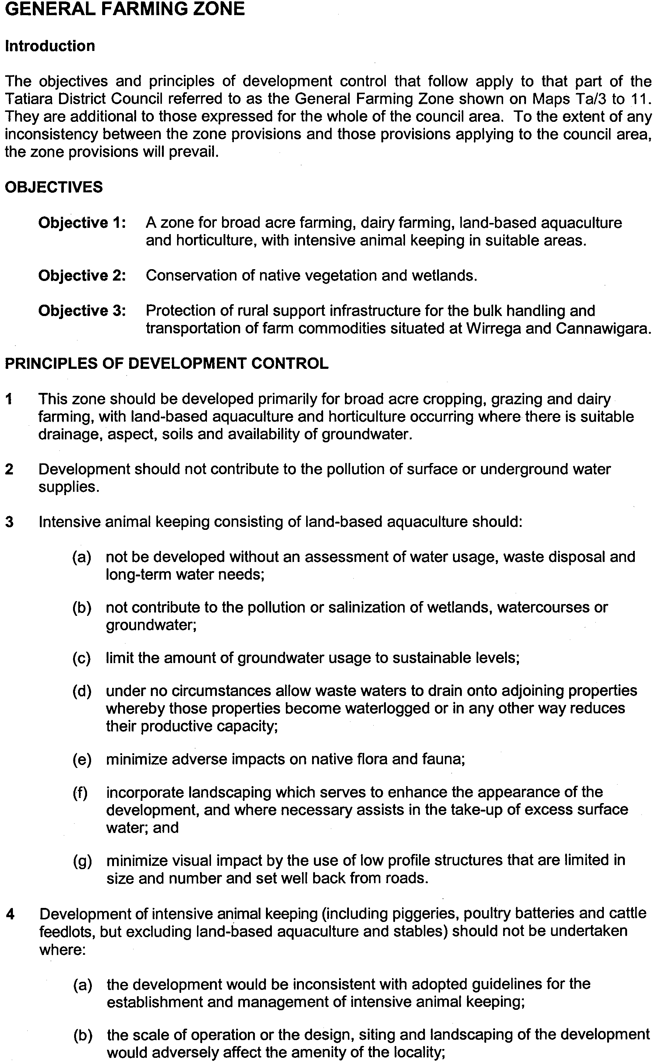
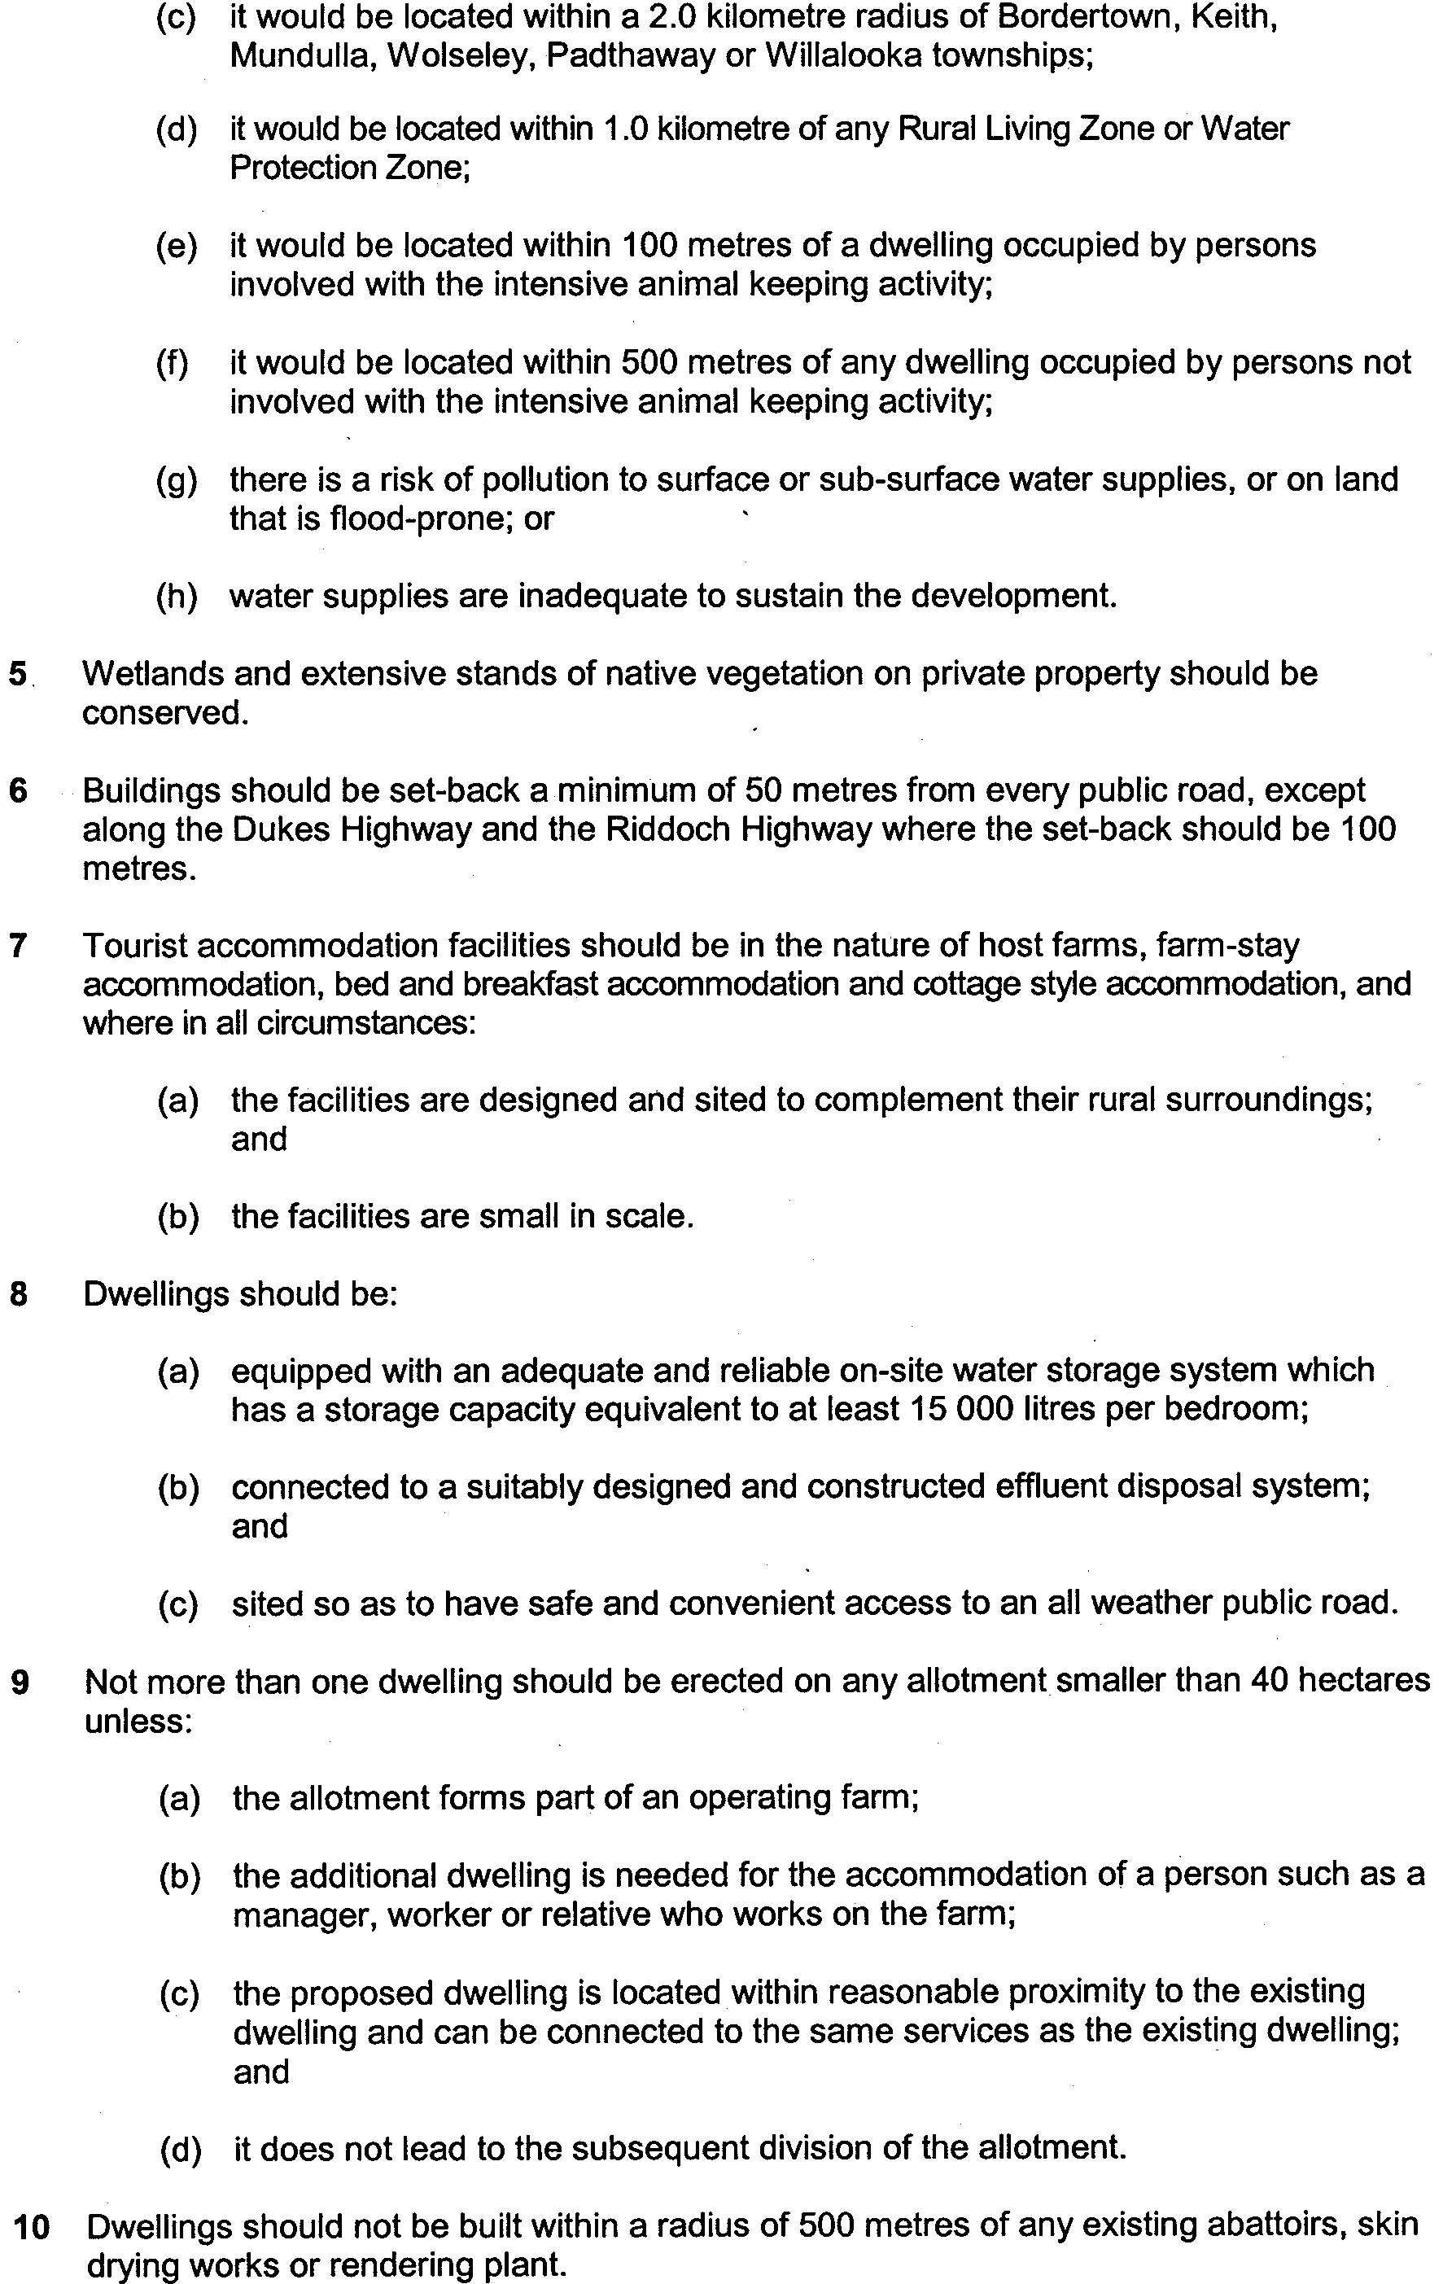
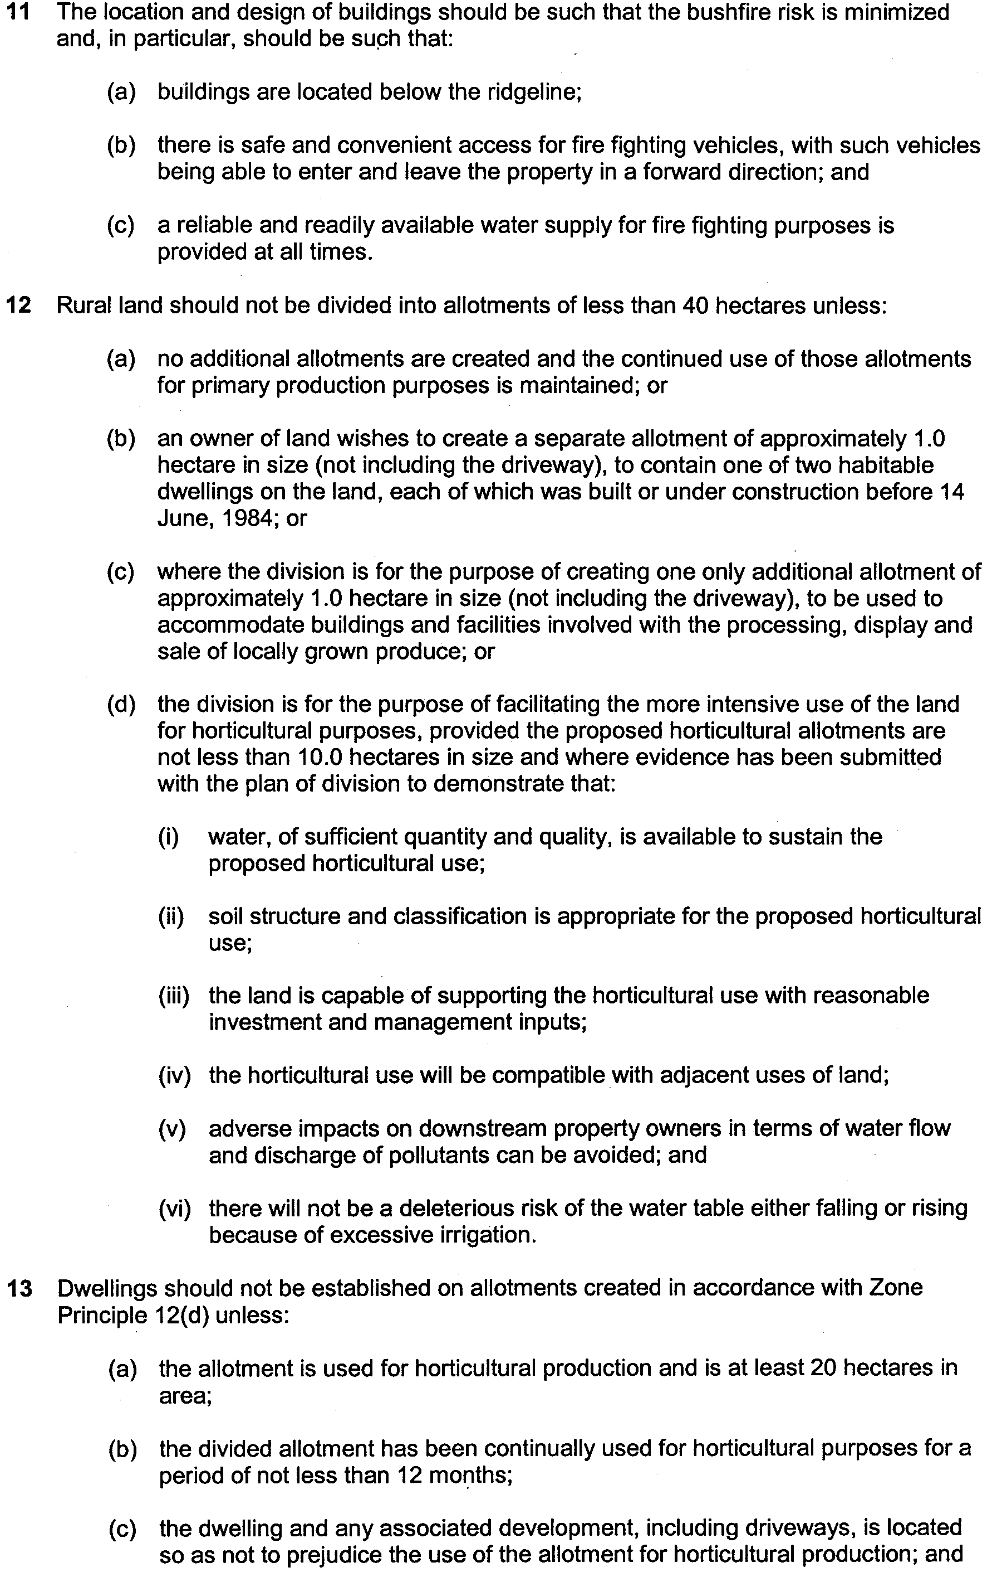
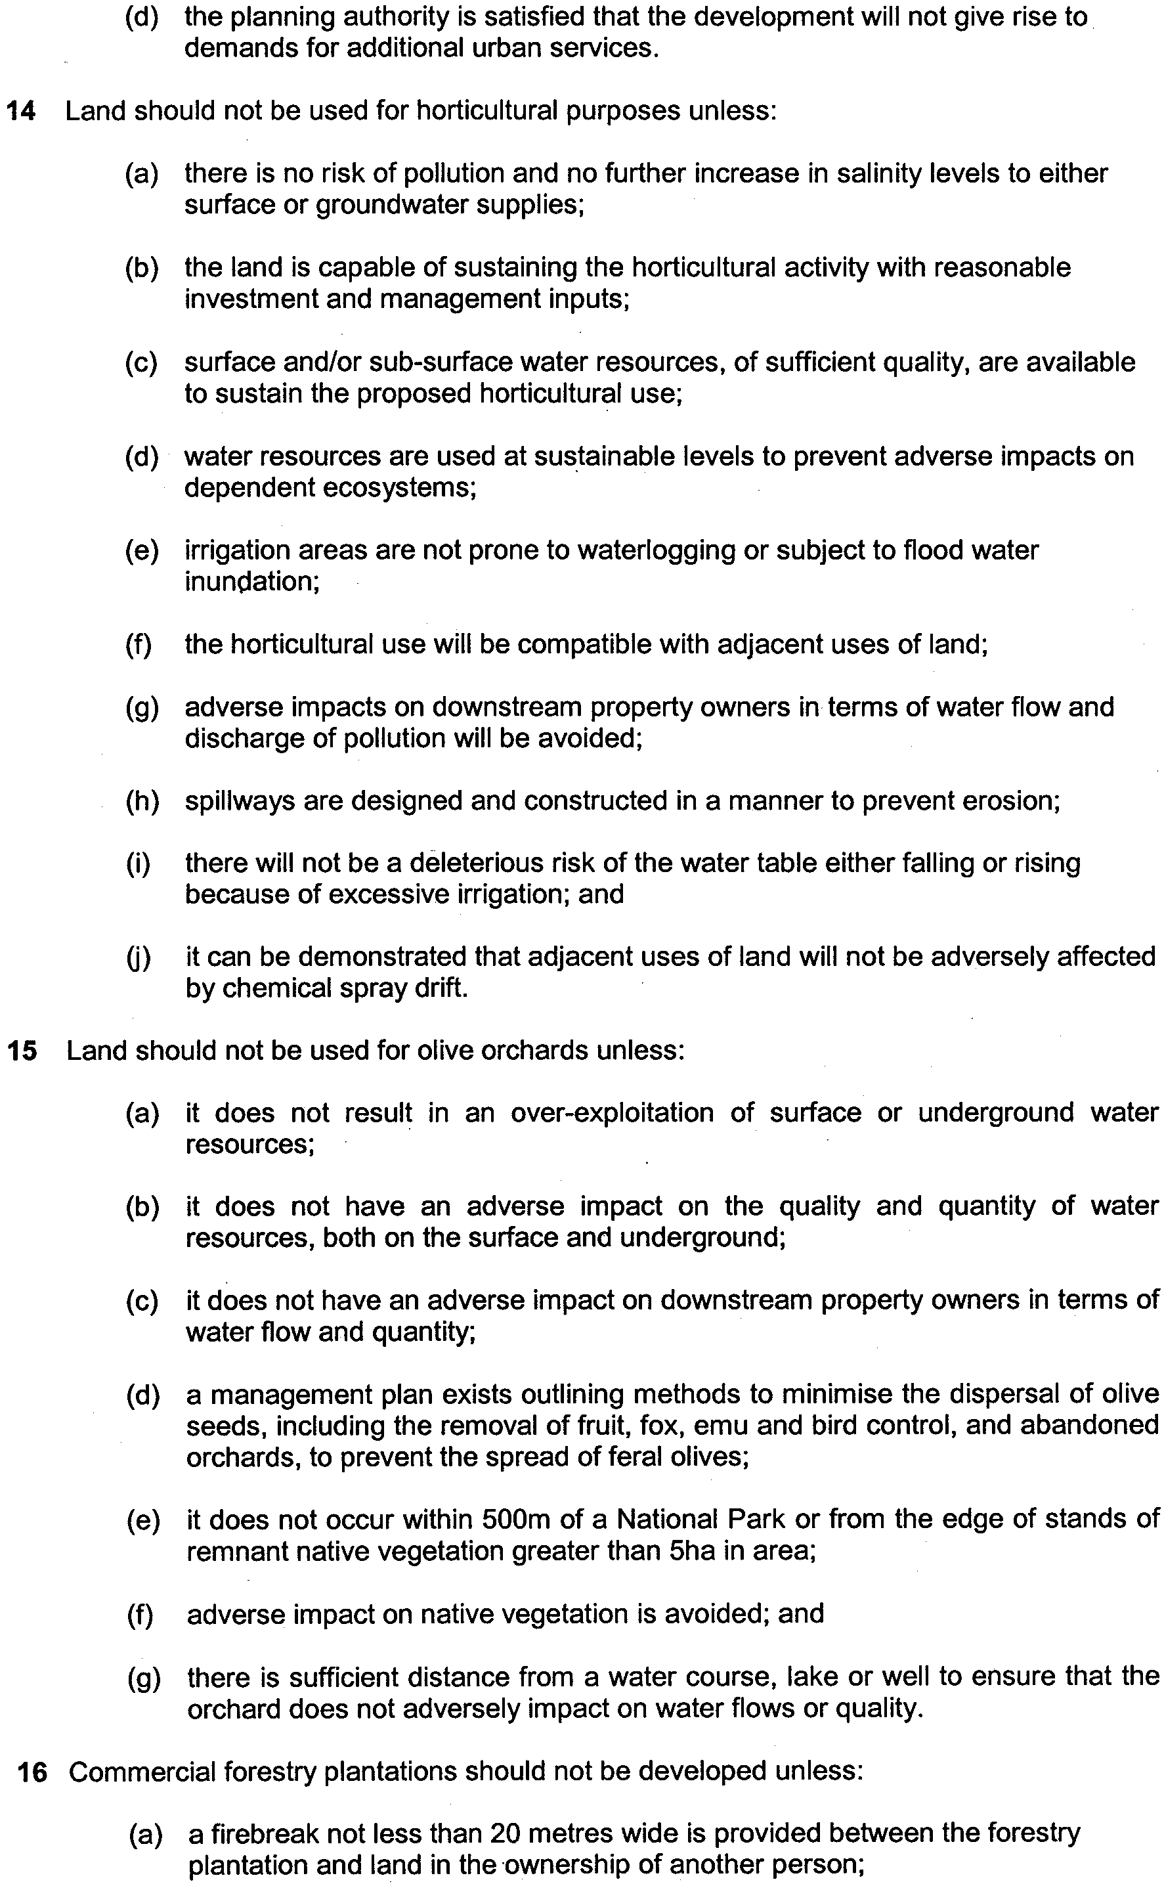
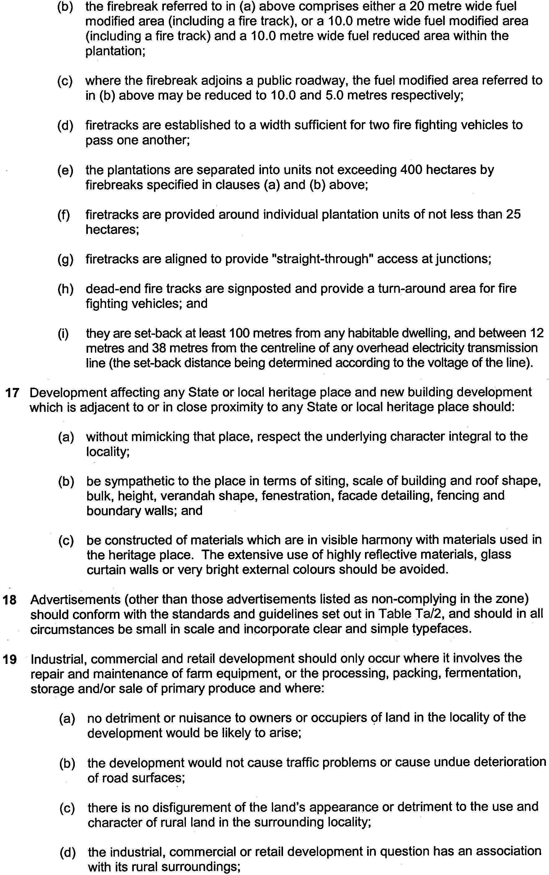
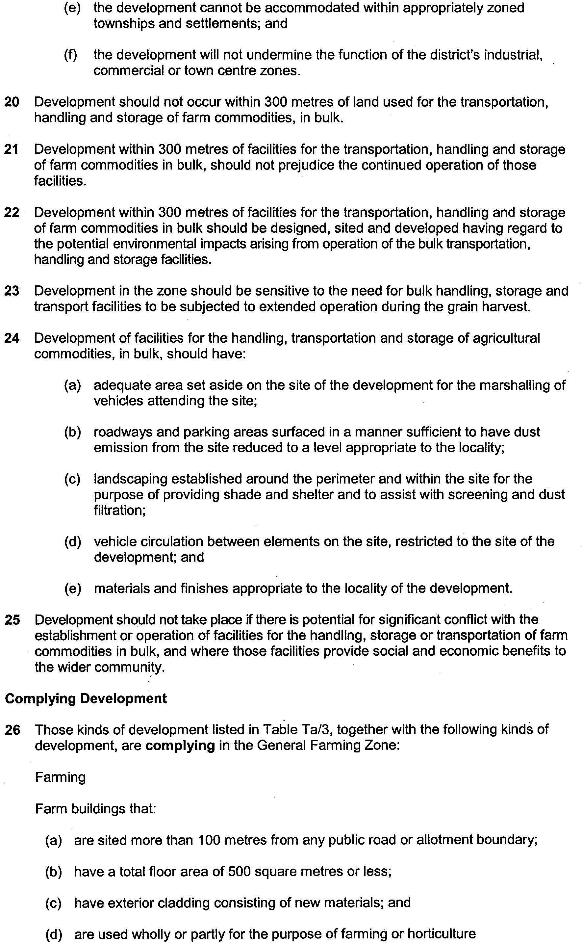
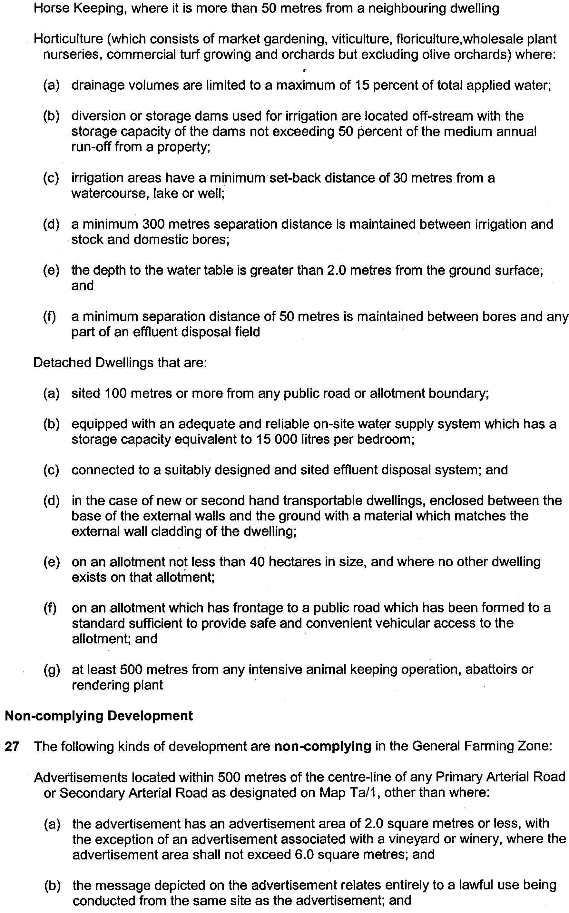
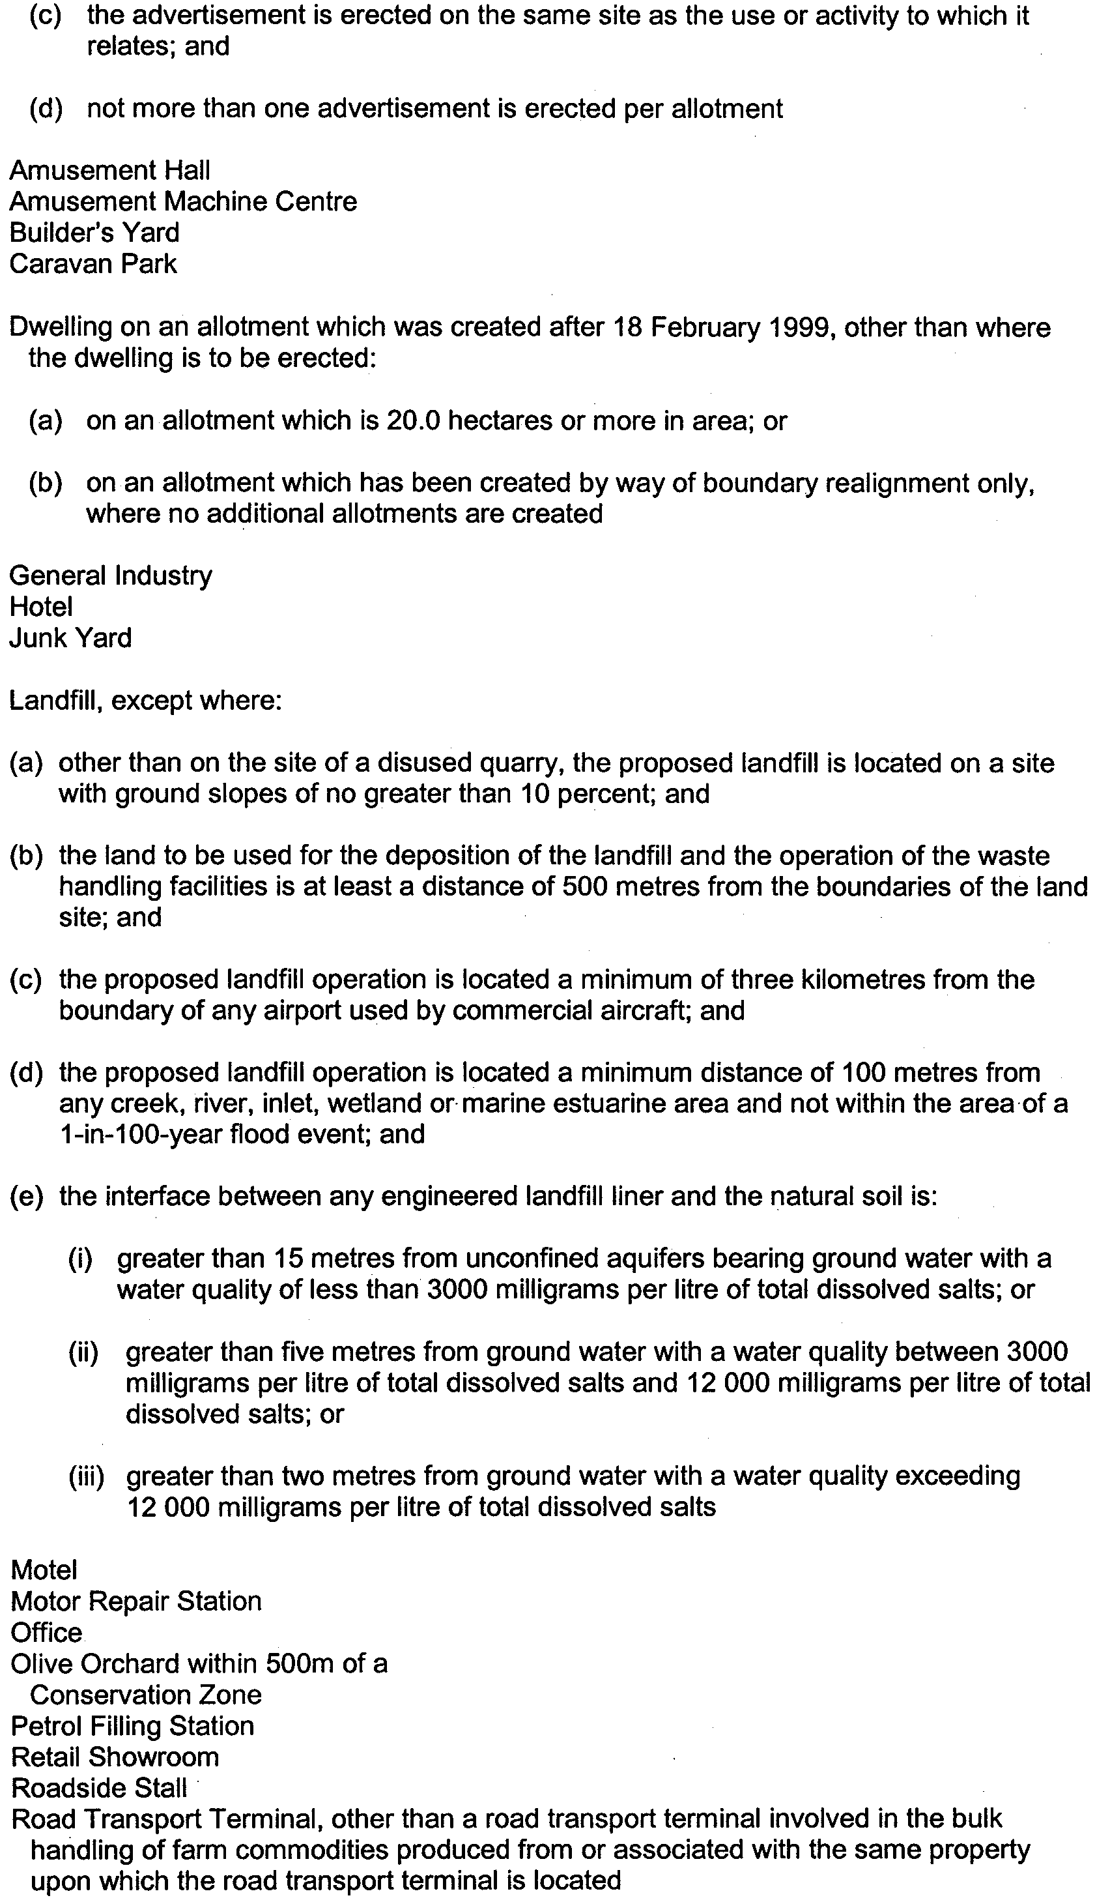
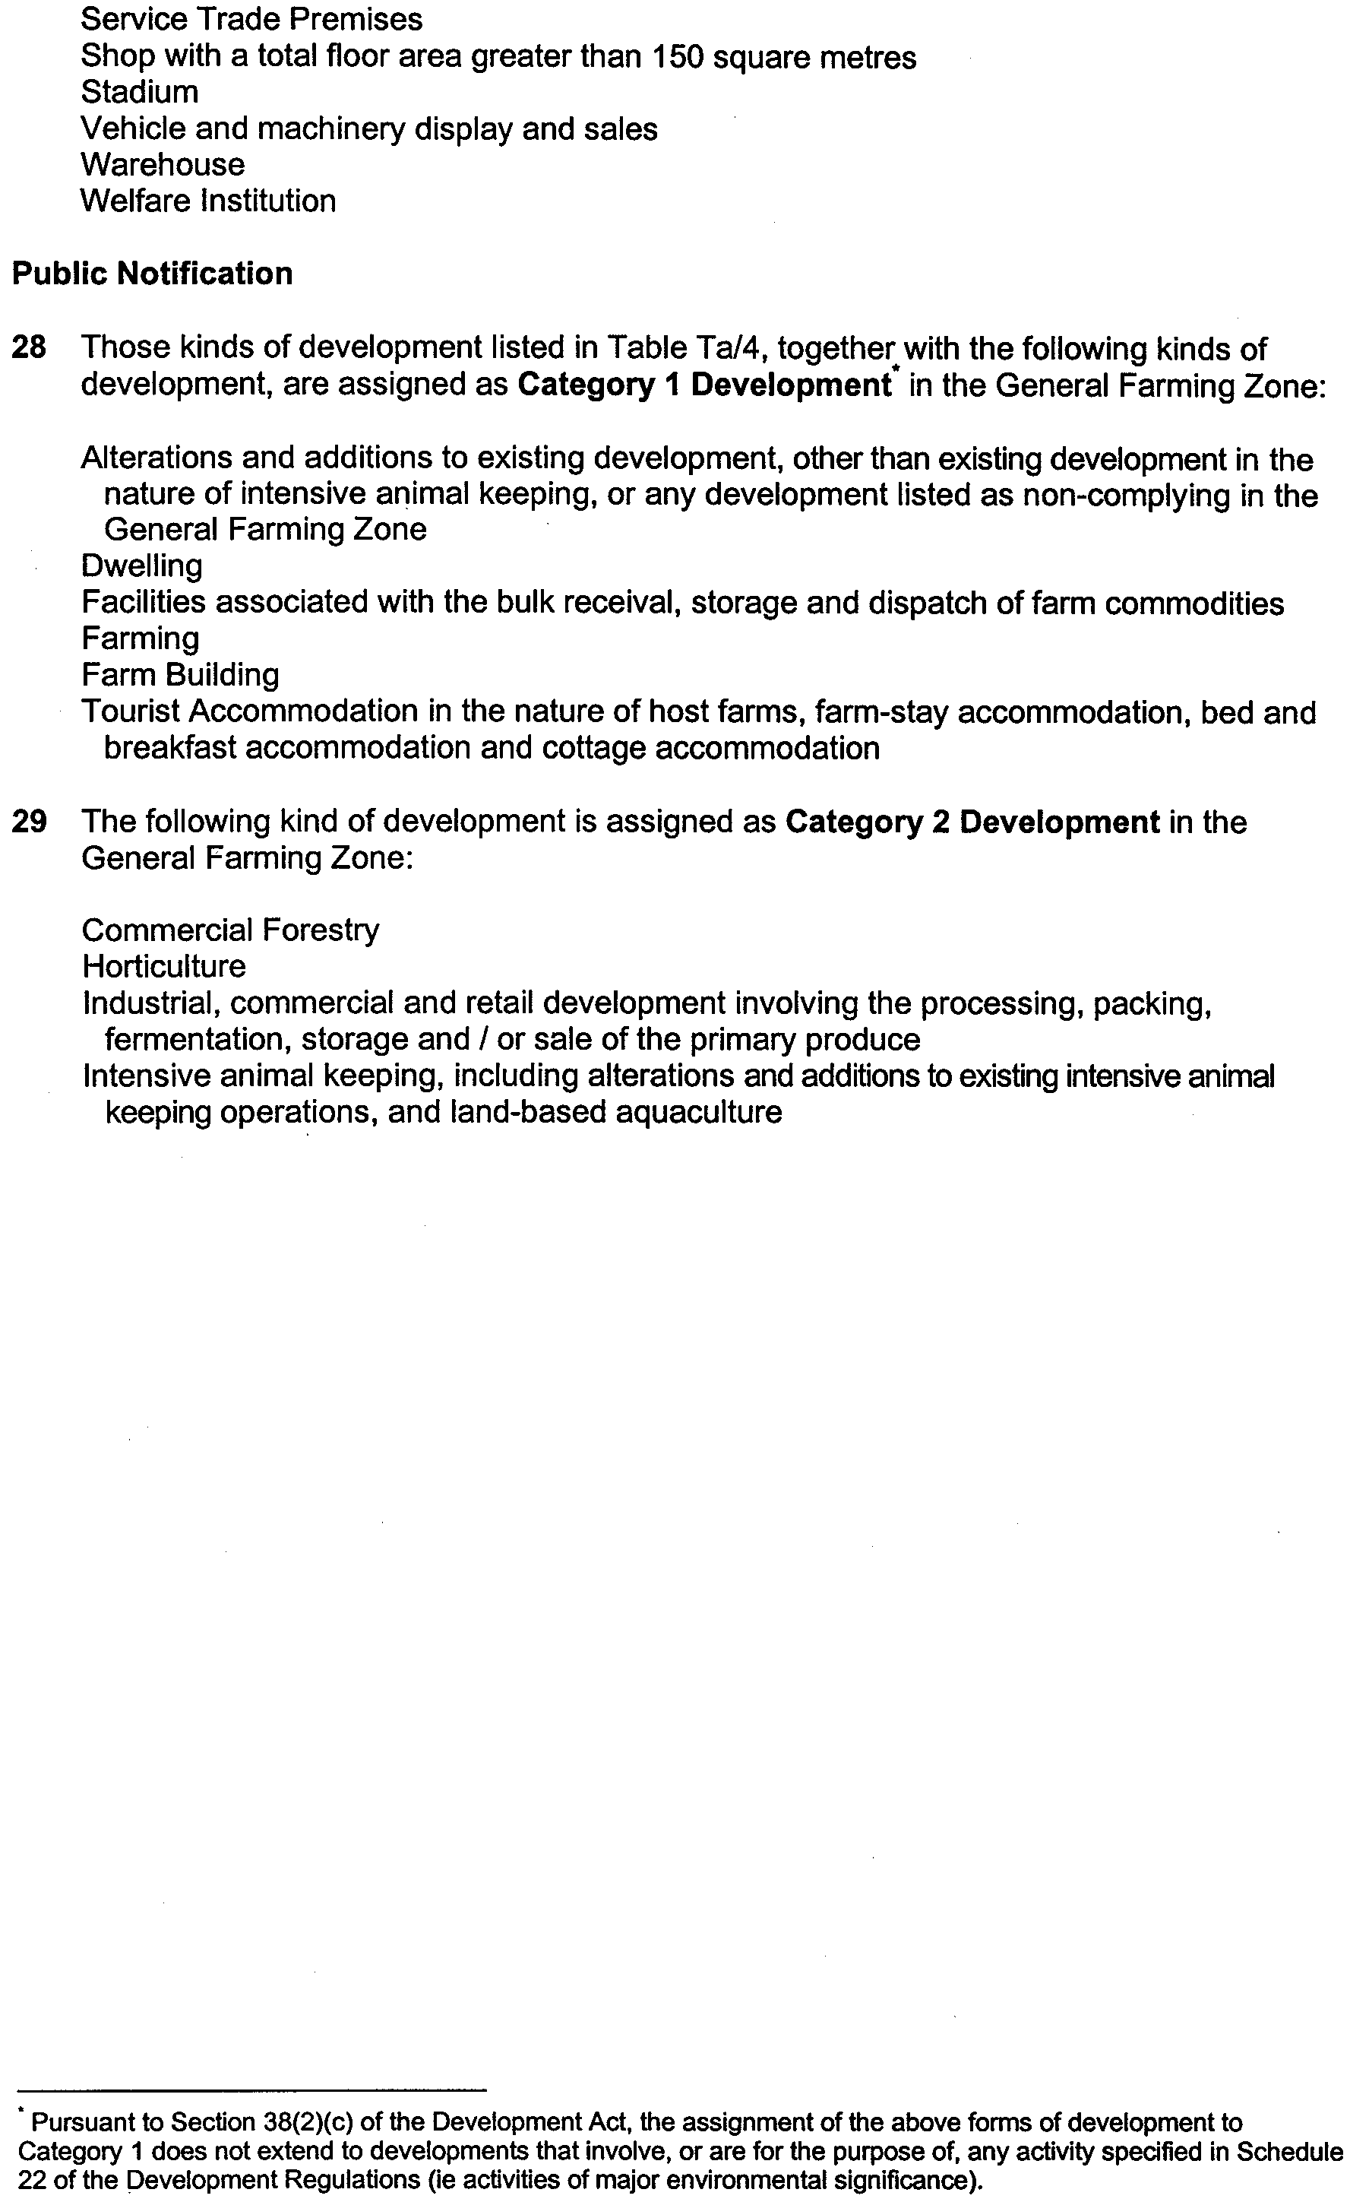
GOVERNMENT GAZETTE ADVERTISEMENT RATES

To apply from 1 July 1999

$  Agents, Ceasing to Act as 28.50  Associations:  Incorporation 14.50  Intention of Incorporation 35.75  Transfer of Properties 35.75  Attorney, Appointment of 28.50  Bailiff’s Sale 35.75  Cemetery Curator Appointed 21.20  Companies:  Alteration to Constitution 28.50  Capital, Increase or Decrease of 35.75  Ceasing to Carry on Business 21.20  Declaration of Dividend 21.20  Incorporation 28.50  Lost Share Certificates:  First Name 21.20  Each Subsequent Name 7.30  Meeting Final 23.80  Meeting Final Regarding Liquidator’s Report on  Conduct of Winding Up (equivalent to ‘Final  Meeting’)  First Name 28.50  Each Subsequent Name 7.30  Notices:  Call 35.75  Change of Name 14.50  Creditors 28.50  Creditors Compromise of Arrangement 28.50  Creditors (extraordinary resolution that ‘the Com-pany be wound up voluntarily and that a liquidator be appointed’) 35.75  Release of Liquidator⎯Application⎯Large Ad. 57.00  ⎯Release Granted 35.75  Receiver and Manager Appointed 33.25  Receiver and Manager Ceasing to Act 28.50  Restored Name 27.00  Petition to Supreme Court for Winding Up 49.50  Summons in Action 42.25  Order of Supreme Court for Winding Up Action 28.50  Register of Interests⎯Section 84 (1) Exempt 64.00  Removal of Office 14.50  Proof of Debts 28.50  Sales of Shares and Forfeiture 28.50  Estates:  Assigned 21.20  Deceased Persons⎯Notice to Creditors, etc. 35.75  Each Subsequent Name 7.30  Deceased Persons⎯Closed Estates 21.20  Each Subsequent Estate 0.90  Probate, Selling of 28.50  Public Trustee, each Estate 7.30 |  | $  Firms:  Ceasing to Carry on Business (each insertion) 21.20  Discontinuance Place of Business 21.20  Land⎯Real Property Act:  Intention to Sell, Notice of 35.75  Lost Certificate of Title Notices 35.75  Cancellation, Notice of (Strata Plan) 35.75  Mortgages:  Caveat Lodgment 14.50  Discharge of 15.30  Foreclosures 14.50  Transfer of 14.50  Sublet 7.30  Leases⎯Application for Transfer (2 insertions) each 7.30  Lost Treasury Receipts (3 insertions) each 21.20  Licensing 42.25  Municipal or District Councils:  Annual Financial Statement⎯Forms 1 and 2 400.00  Electricity Supply⎯Forms 19 and 20 283.00  Default in Payment of Rates:  First Name 57.00  Each Subsequent Name 7.30  Noxious Trade 21.20  Partnership, Dissolution of 21.20  Petitions (small) 14.50  Registered Building Societies (from Registrar-  General) 14.50  Register of Unclaimed Moneys⎯First Name 21.20  Each Subsequent Name 7.30  Registers of Members⎯Three pages and over:  Rate per page (in 8pt) 181.00  Rate per page (in 6pt) 239.00  Sale of Land by Public Auction 36.25  Advertisements 2.00  Advertisements, other than those listed are charged at $2.00 per column line, tabular one-third extra.  Notices by Colleges, Universities, Corporations and District Councils to be charged at $2.00 per line.  Where the notice inserted varies significantly in length from that which is usually published a charge of $2.00 per column line will be applied in lieu of advertisement rates listed.  South Australian Government publications are sold on the condition that they will not be reproduced without prior permission from the Government Printer.

GOVERNMENT GAZETTE NOTICES
ALL private advertisements forwarded for publication in the South Australian Government Gazette must be PAID FOR PRIOR TO INSERTION; and all notices, from whatever source, should be legibly written on one side of the paper only and sent to Riverside 2000 so as to be received no later than 4 p.m. Tuesday preceding the day of publication. Phone 8207 1045 or Fax 8207 1040. E-mail: govgaz@riv.ssa.sa.gov.au. Send as attachments in Word format and please confirm your transmission with a faxed copy of your document, including the date the notice is to be published and to whom the notice will be charged.

MISCELLANEOUS LEGISLATION AND GOVERNMENT PUBLICATIONS PRICES AS FROM 1 JULY 1999

Acts, Bills, Rules, Parliamentary Papers and Regulations
Pages | Main | Amends | Pages | Main | Amends

1-16 | 1.60 | 0.75 | 497-512 | 23.30 | 22.40
17-32 | 2.30 | 1.45 | 513-528 | 23.90 | 23.00
33-48 | 2.90 | 2.10 | 529-544 | 24.70 | 23.80
49-64 | 3.70 | 2.75 | 545-560 | 25.30 | 24.50
65-80 | 4.35 | 3.55 | 561-576 | 26.00 | 25.20
81-96 | 5.00 | 4.20 | 577-592 | 26.75 | 25.75
97-112 | 5.75 | 4.85 | 593-608 | 27.50 | 26.50
113-128 | 6.40 | 5.60 | 609-624 | 28.25 | 27.50
129-144 | 7.20 | 6.30 | 625-640 | 28.75 | 28.00
145-160 | 7.90 | 6.95 | 641-656 | 29.50 | 28.50
161-176 | 8.60 | 7.70 | 657-672 | 30.00 | 29.25
177-192 | 9.25 | 8.40 | 673-688 | 31.00 | 30.00
193-208 | 9.95 | 9.10 | 689-704 | 31.75 | 30.75
209-224 | 10.60 | 9.75 | 705-720 | 32.25 | 31.50
225-240 | 11.25 | 10.50 | 721-736 | 33.25 | 32.00
241-257 | 12.05 | 11.10 | 737-752 | 33.75 | 32.75
258-272 | 12.80 | 11.80 | 753-768 | 34.50 | 33.25
273-288 | 13.45 | 12.60 | 769-784 | 35.00 | 34.25
289-304 | 14.10 | 13.20 | 785-800 | 35.75 | 35.00
305-320 | 14.80 | 13.90 | 801-816 | 36.25 | 35.50
321-336 | 15.55 | 14.60 | 817-832 | 37.25 | 36.25
337-352 | 16.20 | 15.40 | 833-848 | 38.00 | 37.00
353-368 | 16.90 | 16.05 | 849-864 | 38.50 | 37.75
369-384 | 17.60 | 16.80 | 865-880 | 39.25 | 38.50
385-400 | 18.30 | 17.50 | 881-896 | 39.75 | 39.00
401-416 | 19.00 | 18.10 | 897-912 | 40.75 | 39.75
417-432 | 19.75 | 18.90 | 913-928 | 41.25 | 40.75
433-448 | 20.40 | 19.50 | 929-944 | 42.00 | 41.25
449-464 | 21.15 | 20.20 | 945-960 | 43.00 | 41.75
465-480 | 21.75 | 20.90 | 961-976 | 43.50 | 42.50
481-496 | 22.40 | 21.50 | 977-992 | 44.25 | 43.00

Legislation—Acts, Regulations, etc: $
Subscriptions:
Acts 144.00
All Bills as Laid 344.00
Rules and Regulations 344.00
Parliamentary Papers 344.00
Bound Acts 159.00
Index 77.00
Government Gazette
Copy 3.85
Subscription 190.00

Hansard
Copy 10.30
Subscription—per session (issued weekly) 298.00
Cloth bound—per volume 128.00
Subscription—per session (issued daily) 298.00
Legislation on Disk
Whole Database 2 201.00
Annual Subscription for fortnightly updates 677.00
Individual Act(s) including updates POA
Postage Extra on Individual Copies

All Legislation, Government Gazette, Hansard and Legislation on disk are available from:
Counter Sales: Information SA (State Government Bookshop)
Australis Centre, Ground Floor, 77 Grenfell Street, Adelaide, S.A. 5000.
Phone: (08) 8204 1900. Fax: (08) 8204 1909
S.A. Country Customer Free Call: 1800 182 234
TTY (Hearing Impaired): (08) 8204 1923
Mail Orders: Subscriptions and Standing Orders:
Phone: (08) 8204 9447, (08) 8204 9448. Fax: (08) 8204 1898
P.O. Box 1, Rundle Mall, Adelaide, S.A. 5000.

FISHERIES ACT 1982: SECTION 59
TAKE notice that John A. Paepke, Marine Scalefish Fishery Licence holder M342, 1 Buller, Kingscote, S.A. 5223 (hereinafter referred to as the ‘fisher’) is exempt from the provisions of section 41 of the Fisheries Act 1982, subject to the conditions specified in Schedule 1 in that he shall not be guilty of an offence when taking undersized fish of the species cockles (Katelysia spp.) from the date of gazettal of this notice until 30 June 2000.
Schedule 1
1. The fisher may engage in the following fishing activity (hereinafter referred to as the ‘permitted activity’) namely the taking of undersized fish as specified in Schedule 2, within those waters specified in Schedule 3.
2. Any fish taken by the fisher pursuant to this notice must be used for bait only and must not be sold.
3. While engaged in the permitted activity, the fisher shall carry or have about or near his person, a copy of this notice. Such notice must be produced to a Fisheries Officer upon request.
4. The fisher shall not contravene or fail to comply with the Fisheries Act 1982, or any regulation made under that Act, except where specifically exempted by this notice.
Schedule 2
Cockles (Katelysia spp.) not less than 27 mm in length.
Schedule 3
The waters in the vicinity of Kingscote bounded as follows:
Commencing at a point at high water mark at Cape Rouge, latitude 35°35′52″S and longitude 137°37′32″E, then along the geodesic (190°T) to a point at high water mark on the south coast on the Bay of Shoals, latitude 35°38′18″S and longitude 137°37′05″E, then following the line of high water mark in a generally easterly and southerly direction to a point at high water mark at the landward end of the Kingscote jetty, latitude 35°39′15″S and longitude 137°38′32″E, then along the geodesic (133°T) for a distance of 2.3 nautical miles to position latitude 35°40′32″S and longitude 137°41′00″E, then along the geodesic (033°T) for a distance of 2.1 nautical miles to a position latitude 35°38′50″S and longitude 137°42′15″E, then along the geodesic (325°T) to a point at high water mark on Marsden Point, latitude 35°33′55″S and longitude 137°38′07″E, then following the line of high water mark in a generally southerly direction back to the point of commencement.
Dated 12 October 1999.
W. Zacharin, Principal Fisheries Manager

FISHERIES ACT 1982: SECTION 59
TAKE notice that pursuant to section 59 of the Fisheries Act 1982, Rolf Czabayski, 5 Willowbridge Grove, Burnside, S.A. 5066 (hereinafter referred to as the ‘permit holder’) is exempt from Regulation 35C of the Fisheries (General) Regulations 1984, in that the permit holder shall not be guilty of an offence when using berley within the waters specified in Schedule 1 to attract white sharks (Carchardon carcharias) for the purpose of cage viewing only (hereinafter referred to as the ‘permitted activity’), subject to the conditions specified in Schedule 2, for the dates specified in Schedule 3.
Schedule 1
Coastal waters contained within the Neptune Islands Conservation Park, and the following portions of the Sir Joseph Banks Islands Conservation Park; English and Sibsey Islands.
Note: Dangerous Reef is not available under this permit due to sea lion breeding between 1 May 1999 and 1 January 2000.
Schedule 2
1. The permit holder must be on board the boat when conducting the permitted activity.
2. All berley used while conducting the permitted activity must consist of fish based products only. All berley (other than fish oil) must be stored below a maximum temperature of 4°C.
3. The permit holder must notify the public by a Notice to Mariners through the Australian Maritime Safety Authority, by public notice in the Adelaide Advertiser at least 24 hours in
advance of berleying operations, advising the local coastguard and the Fisheries Compliance Unit on 1800 065 522 at least two hours prior to conducting the permitted activities.
4. The permit holder shall allow an officer of the Department for Environment, Heritage and Aboriginal Affairs (DEHAA) or nominee to be present on board the boat during the permitted activities if requested and subject to negotiation and availability of space.
5. The permit holder must comply with all instructions (including ceasing to berley if so instructed) given by an officer from DEHAA.
6. Whilst engaged in the permitted activity, a pennant (approved by DEHAA) must be flown from the boat so as to be clearly visible.
7. Whilst engaged in the permitted activity the permit holder must have in his/her possession a copy of this notice and produce a copy of the notice if required by a Fisheries Compliance Officer.
8. The permit holder shall not contravene or fail to comply with the Fisheries Act 1982, or any regulations made under the Act, except where specifically exempted by this notice.
9. The permit holder must maintain a log whilst engaged in the permitted activity which includes the date and location, number of passengers, number of hours berleying, number of sharks observed and any other relevant observations or comments. Records must be kept in a form determined by the operators association in conjunction with CSIRO Marine Research Unit and endorsed by the Minister for Environment and Heritage. A copy of the log must be provided to the relevant DEHAA office within 14 days of each calendar month. Failure to submit a log within the agreed time period may preclude the provision of future permits until such outstanding logs are received by the relevant DEHAA office.
10. The permit holder must conform to a code of ethics developed by the operators association and endorsed by the Minister for Environment and Heritage.
11. The permit holder will operate in co-operation with and in agreement of any other approved operator at the same location.
12. The permit holder must have public liability insurance to an amount determined by the Minister for Environment and Heritage and ensure vessels are surveyed and staffed as per Department of Transport regulations.
Schedule 3
28 October 1999 to 30 October 1999.
Dated 12 October 1999.
Ross Allen, Manager Parks and Wildlife West

GEOGRAPHICAL NAMES ACT 1991
For Public Consultation
Notice of Intention to Assign Boundaries and Names to Places
NOTICE is hereby given pursuant to the provisions of the above Act, that the Surveyor-General proposes to assign the names BARNDIOOTA, HAWKER, KANYAKA, CRADOCK, YARRAH, WILLOCHRA, MOOCKRA, QUORN and STEPHENSTON to those areas within the Flinders Ranges Council and shown numbered 1 to 9 respectively on Rack Plan 843.
Copies of Rack Plan 843 can be viewed in the Office of the Surveyor-General, Adelaide and the offices of the Flinders Ranges Council.
Submissions in writing regarding this proposal may be lodged with the Secretary, Geographical Names Advisory Committee, c/o Department for Environment, Heritage and Aboriginal Affairs, 300 Richmond Road, Netley, S.A. 5037 (P.O. Box 550, Marleston, S.A. 5033) within one month of the publication of this notice.
Dated 5 October 1999.
P. M. Kentish, Surveyor-General, Department for Administrative and Information Services
DEHAA 04/0219

GEOGRAPHICAL NAMES ACT 1991
Corrigendum
Notice of Intention to Assign Boundaries and Names to Places
IN notice appearing in Government Gazette of 30 September 1999 at page 1346, paragraph 2. in the text should read as follows:
2. Assign the names; Gemmells, Tinpot Hill, Red Creek, Salem, Callington, Hartley, Woodchester, Macclesfield, Paris Creek, Strathalbyn, Betchley, Langhorne Creek, Tolderol, Lake Plains, Angas Plains, Belvidere, Willyaroo, Sander-grove, Ashbourne, Bull Creek, McHarg Creek, Prospect Hill, Blackfellows Creek, Kuitpo, The Range, Montarra, Dingable-dinga, Kyeema, Kuitpo Colony, Mount Magnificent, Yundi, Hope Forest, Willunga Hill, Pages Flat, Mount Compass, Nangkita, Mount Observation, Finniss, Nurragi, Milang, Clayton, Mundoo Island, Hindmarsh Island, Currency Creek, Tooperang, Mount Jagged, Mosquito Hill, Port Elliot, Middleton, Goolwa, Goolwa North, Point Sturt, Goolwa South and Goolwa Beach to those areas within the Alexandrina Council and shown numbered 1 to 54 respectively on Rack Plan 827.
Dated 6 October 1999.
P. M. Kentish, Surveyor-General, Department for Administrative and Information Services.
DEHAA 04/0083

HOUSING IMPROVEMENT ACT 1940
Corrigendum
IN Government Gazette of 30 September 1999, page 1349 for Flat 2/266 Marion Road, Netley, read Flat 5/266 Marion Road, Netley.

LAND AND BUSINESS (SALE AND CONVEYANCING) ACT 1994
Section 23
TAKE notice that, pursuant to section 23 (3) of the Land and Business (Sale and Conveyancing) Act 1994, I, KENNETH TREVOR GRIFFIN, Minister for Consumer Affairs, DO HEREBY exempt the person named in Schedule 1 from the application of section 23 (2) of the Act in relation to the purchase of the land specified in Schedule 2.
Schedule 1
Bridget Hazel Hemsley, officer/employee of Blights Real Estate Pty Ltd.
Schedule 2
The whole of the land described in Certificate of Title Register Book Volume 5081, folio 268 situated at 4 Hannan Court, Whyalla Stuart, S.A. 5608.
Signed for and on behalf of the Minister for Consumer Affairs by the Acting Commissioner for Consumer Affairs:
W. J. Spehr, Acting Commissioner for Consumer Affairs

LAND AND BUSINESS (SALE AND CONVEYANCING) ACT 1994
Section 23
TAKE notice that, pursuant to section 23 (3) of the Land and Business (Sale and Conveyancing) Act 1994, I, KENNETH TREVOR GRIFFIN, Minister for Consumer Affairs, DO HEREBY exempt the person named in Schedule 1 from the application of section 23 (2) of the Act in relation to the purchase of the land specified in Schedule 2.
Schedule 1
Michael Donald Heasman, officer/employee of W. B. Real Estate Pty Ltd.
Schedule 2
The whole of the land described in Certificate of Title Register Book Volume 5066, folio 163 situated at 21 Tyrone Court, Wynn Vale, S.A. 5127.
Signed for and on behalf of the Minister for Consumer Affairs by the Acting Commissioner for Consumer Affairs:
W. J. Spehr, Acting Commissioner for Consumer Affairs

LIQUOR LICENSING ACT 1997 AND GAMING MACHINES ACT 1992
Notice of Transfer
NOTICE is hereby given, pursuant to section 52 of the Liquor Licensing Act 1997 and section 29 of the Gaming Machines Act 1992, that Michael Turner & Associates Pty Ltd (ACN 053 165 576) and James-Martin Nominees Pty Ltd (ACN 065 285 878), c/o Bonnins Commercial Lawyers, Level 14, 100 King William Street, Adelaide, S.A. 5000, have applied to the Liquor and Gaming Commissioner for the transfer of a Hotel Licence and a Gaming Machine Licence in respect of premises situated at 247 Gouger Street, Adelaide, S.A. 5000 and known as Directors Hotel.
The applications have been set down for hearing on 12 November 1999.
Any person may object to the transfer by lodging a notice of objection in the prescribed form with the Licensing Authority, and serving a copy of the notice on the applicants at the applicants’ address given above, at least seven days before the hearing date.
Plans in respect of the premises the subject of the application are open to public inspection without fee at the Office of the Liquor and Gaming Commissioner, 9th Floor, East Wing, 50 Grenfell Street, Adelaide, S.A. 5000.
Dated 6 October 1999.
Applicants

LIQUOR LICENSING ACT 1997 AND GAMING MACHINES ACT 1992
Notice of Transfer
NOTICE is hereby given, pursuant to section 52 of the Liquor Licensing Act 1997 and section 29 of the Gaming Machines Act 1992, that Mark Andrew Jericho and Joan Leslie Jericho as Trustees for the Mark & Joan Jericho Family Trust, c/o Bonnins Commercial Lawyers, Level 14, 100 King William Street, Adelaide, S.A. 5000 have applied to the Liquor and Gaming Commissioner for the transfer of a Hotel Licence and a Gaming Machine Licence in respect of premises situated at 348 Port Road, Hindmarsh, S.A. 5007 and known as Hope Inn Hotel.
The applications have been set down for hearing on 12 November 1999.
Any person may object to the transfer by lodging a notice of objection in the prescribed form with the Licensing Authority, and serving a copy of the notice on the applicants at the applicants’ address given above, at least seven days before the hearing date.
Plans in respect of the premises the subject of the application are open to public inspection without fee at the Office of the Liquor and Gaming Commissioner, 9th Floor, East Wing, 50 Grenfell Street, Adelaide, S.A. 5000.
Applicants

LIQUOR LICENSING ACT 1997 AND GAMING MACHINES ACT 1992
Notice of Transfer
NOTICE is hereby given, pursuant to section 52 of the Liquor Licensing Act 1997 and section 29 of the Gaming Machines Act 1992, that David Norman Pearce and Jacinta Marie Pearce have applied to the Liquor and Gaming Commissioner for the transfer of a Hotel Licence and a Gaming Machine Licence in respect of premises situated at 47 Railway Terrace, Crystal Brook, S.A. 5023 and known as The Crystal Brook Hotel.
The applications have been set down for hearing on 12 November 1999.
Any person may object to the transfer by lodging a notice of objection in the prescribed form with the Licensing Authority, and serving a copy of the notice on the applicants at the applicants’ address given above, at least seven days before the hearing date.
Plans in respect of the premises the subject of the application are open to public inspection without fee at the Office of the Liquor and Gaming Commissioner, 9th Floor, East Wing, 50 Grenfell Street, Adelaide, S.A. 5000.
Applicants

LIQUOR LICENSING ACT 1997 AND GAMING MACHINES ACT 1992
Notice of Transfer
NOTICE is hereby given, pursuant to section 52 of the Liquor Licensing Act 1997 and section 29 of the Gaming Machines Act 1992, that Preece Hotel Pty Ltd, 78 George Street, Millicent has applied to the Liquor and Gaming Commissioner for the transfer of a Hotel Licence and a Gaming Machine Licence in respect of premises situated at 121 Main Road, Peterborough, S.A. 5422 and known as Junction Hotel.
The applications have been set down for hearing on 5 November 1999.
Any person may object to the transfer by lodging a notice of objection in the prescribed form with the Licensing Authority, and serving a copy of the notice on the applicant at the applicant’s address given above, at least seven days before the hearing date.
Plans in respect of the premises the subject of the application are open to public inspection without fee at the Office of the Liquor and Gaming Commissioner, 9th Floor, East Wing, 50 Grenfell Street, Adelaide, S.A. 5000.
Dated 7 October 1999.
Applicant

LIQUOR LICENSING ACT 1997 AND GAMING MACHINES ACT 1992
Notice of Variation and Grant of Gaming Machine Licence
NOTICE is hereby given, pursuant to section 52 of the Liquor Licensing Act 1997 and section 29 of the Gaming Machines Act 1992, that Dalemede Pty Ltd has applied to the Liquor and Gaming Commissioner for a variation to an existing Extended Trading Authorisation and grant of a Gaming Machine Licence in respect of premises situated at 13 North Parade, Port Adelaide, S.A. 5015 and known as British Hotel.
The applications have been set down for hearing on 12 November 1999.
Conditions
The following licence conditions are sought:
• To authorise the sale of liquor for consumption on the licensed premises between the following hours:
Thursday: midnight to 2 a.m. the following morning.
Friday and Saturday: midnight to 4 a.m. the following morning.
Sunday: 8 a.m. to 11 a.m. and 8 p.m. to midnight.
• To authorise the sale of liquor for consumption off the licensed premises on Sunday, 8 a.m. to 11 a.m. and 8 p.m. to 9 p.m.
Any person may object to the transfer by lodging a notice of objection in the prescribed form with the Licensing Authority, and serving a copy of the notice on the applicant at the applicant’s address given above, at least seven days before the hearing date.
Plans in respect of the premises the subject of the application are open to public inspection without fee at the Office of the Liquor and Gaming Commissioner, 9th Floor, East Wing, 50 Grenfell Street, Adelaide, S.A. 5000.
Dated 6 October 1999.
Applicant

LIQUOR LICENSING ACT 1997
Notice of Application
NOTICE is hereby given, pursuant to section 52 (2) (b) of the Liquor Licensing Act 1997, that Kylie Anne Haack, c/o Bonnins, Level 14, 100 King William Street, Adelaide, S.A. 5000, has applied to the Licensing Authority for the Transfer of a Restaurant Licence in respect of the premises situated at 108 Kelly Road, Modbury, S.A. 5092 and currently known as Tandoor Shalimar but to be known as Curry and Spice.
The application has been set down for hearing on 4 November 1999 at 9 a.m.
Any person may object to the application by lodging a notice of objection in the prescribed form with the Licensing Authority, and serving a copy of the notice on the applicant at the applicant’s address given above, at least seven days before the hearing date.
Plans in respect of the premises the subject of the application are open to public inspection without fee at the Office of the Liquor and Gaming Commissioner, 9th Floor, East Wing, 50 Grenfell Street, Adelaide, S.A. 5000.
Dated 6 October 1999.
Applicant

LIQUOR LICENSING ACT 1997
Notice of Application
NOTICE is hereby given, pursuant to section 52 (2) (b) of the Liquor Licensing Act 1997, that Barrington Catering and Management Services Pty Ltd, has applied to the Licensing Authority for the Transfer of a Special Circumstances Licence in respect of the premises situated at Beverley Uranium Mine, latitude 30.10°S, longitude 139.32°E and known as Beverley Canteen.
The application has been set down for hearing on 1 November 1999.
Any person may object to the application by lodging a notice of objection in the prescribed form with the Licensing Authority, and serving a copy of the notice on the applicant at the applicant’s address given above, at least seven days before the hearing date.
Plans in respect of the premises the subject of the application are open to public inspection without fee at the Office of the Liquor and Gaming Commissioner, 9th Floor, East Wing, 50 Grenfell Street, Adelaide, S.A. 5000.
Dated 6 October 1999.
Applicant

LIQUOR LICENSING ACT 1997
Notice of Application
NOTICE is hereby given, pursuant to section 52 (2) (b) of the Liquor Licensing Act 1997, that Holroyd Hotels Pty Ltd. (ACN 007 922 303), has applied to the Licensing Authority for a variation to the Extended Trading Authorisation which is in force in recpect of premises situated at Railway Terrace, Goolwa and known as Corio Hotel.
The application has been set down for hearing on Friday, 5 November 1999 at 9 a.m.
Conditions
The following licence conditions are sought:
That the licensee be permitted to sell liquor for consumption off the licensed premises from 8 a.m. to 11 a.m. and from 8 p.m. to 9 p.m. each Sunday, not being Christmas Day.
Any person may object to the application by lodging a notice of objection in the prescribed form with the Licensing Authority, and serving a copy of the notice on the applicant at the applicant’s address given above, at least seven days before the hearing date.
Plans in respect of the premises the subject of the application are open to public inspection without fee at the Office of the Liquor and Gaming Commissioner, 9th Floor, East Wing, 50 Grenfell Street, Adelaide, S.A. 5000.
Dated 30 September 1999.
Applicant

LIQUOR LICENSING ACT 1997
Notice of Application
NOTICE is hereby given, pursuant to section 52 (2) (b) of the Liquor Licensing Act 1997, that Babette’s Feasts Pty Ltd, has applied to the Licensing Authority for a Special Circumstances Licence with Entertainment Consent in respect of premises situated at 631 Glynburn Road, Beaumont, S.A. 5066 and known as Beaumont House.
The application has been set down for hearing on 12 November 1999 at 9 a.m.
Conditions
The following licence conditions are sought:
• Hours of Operation
Monday to Thursday—noon to 11 p.m.
Friday to Saturday—10 a.m. to midnight.
Sunday—10 a.m. to 9 p.m.
Any day preceding a Public Holiday—noon to 11 p.m.
Any person may object to the application by lodging a notice of objection in the prescribed form with the Licensing Authority, and serving a copy of the notice on the applicant at the applicant’s address given above, at least seven days before the hearing date.
Plans in respect of the premises the subject of the application are open to public inspection without fee at the Office of the Liquor and Gaming Commissioner, 9th Floor, East Wing, 50 Grenfell Street, Adelaide, S.A. 5000.
Dated 6 October 1999.
Applicant

LIQUOR LICENSING ACT 1997
Notice of Application
NOTICE is hereby given, pursuant to section 52 (2) (b) of the Liquor Licensing Act 1997, that Cape D’Estaing Pty Ltd has applied to the Licensing Authority for a Producer’s Licence in respect of premises situated at section 107, Hundred of Menzies and known as Cape D’Estaing Pty Ltd.
The application has been set down for hearing on 12 November 1999 at 9 a.m.
Any person may object to the application by lodging a notice of objection in the prescribed form with the Licensing Authority, and serving a copy of the notice on the applicant at the applicant’s address given above, at least seven days before the hearing date.
Plans in respect of the premises the subject of the application are open to public inspection without fee at the Office of the Liquor and Gaming Commissioner, 9th Floor, East Wing, 50 Grenfell Street, Adelaide, S.A. 5000.
Dated 6 October 1999.
Applicant

LIQUOR LICENSING ACT 1997
Notice of Application
NOTICE is hereby given, pursuant to section 52 (2) (b) of the Liquor Licensing Act 1997, that Woolies Liquor Stores Pty Ltd has applied to the Licensing Authority for the removal of a Retail Liquor Merchant’s Licence in respect of premises currently situated at Lot 1, corner Smith Street and Butler Terrace Naracoorte, S.A. 5271 and currently known as Smith Street Cellars to the premises to be situated at Woolworth’s Shopping Centre, Naracoorte, Robertson Street, Naracoorte and to be known as Mac’s Liquor—Naracoorte.
The application has been set down for hearing on 12 November 1999 at 9 a.m.
Any person may object to the application by lodging a notice of objection in the prescribed form with the Licensing Authority, and serving a copy of the notice on the applicant at the applicant’s address given above, at least seven days before the hearing date.
Plans in respect of the premises the subject of the application are open to public inspection without fee at the Office of the Liquor and Gaming Commissioner, 9th Floor, East Wing, 50 Grenfell Street, Adelaide, S.A. 5000.
Dated 8 October 1999.
Applicant

LIQUOR LICENSING ACT 1997
Notice of Application
NOTICE is hereby given, pursuant to section 52 (2) (b) of the Liquor Licensing Act 1997, that Woolies Liquor Stores Pty Ltd has applied to the Licensing Authority for the removal of a Retail Liquor Merchant’s Licence held at 91 Main Road, Solomontown, Port Pirie and known as Main Road Cellars to premises situated at Shops 7A and 7B Pirie Plaza Shopping Centre, Grey Terrace, Port Pirie and to be known as Mac’s Liquor—Pirie Plaza.
The application has been set down for hearing on 12 November 1999.
Any person may object to the application by lodging a notice of objection in the prescribed form with the Licensing Authority, and serving a copy of the notice on the applicant at the applicant’s address given above, at least seven days before the hearing date.
Plans in respect of the premises the subject of the application are open to public inspection without fee at the Office of the Liquor and Gaming Commissioner, 9th Floor, East Wing, 50 Grenfell Street, Adelaide, S.A. 5000.
Applicant

LIQUOR LICENSING ACT 1997
Notice of Application
NOTICE is hereby given, pursuant to section 52 (2) (b) of the Liquor Licensing Act 1997, that Tekin Sabuncu has applied to the Licensing Authority for a Restaurant Licence in respect of premises situated at 1 Marine Parade, Marino, S.A. 5058 and to be known as Marino Rocks Cafe Restaurant.
The application has been set down for hearing on 12 November 1999.
Conditions
The following licence condition is sought:
• Entertainment consent is sought for the areas outlined in blue on the deposited plan.
Any person may object to the application by lodging a notice of objection in the prescribed form with the Licensing Authority, and serving a copy of the notice on the applicant at the applicant’s address given above, at least seven days before the hearing date.
Plans in respect of the premises the subject of the application are open to public inspection without fee at the Office of the Liquor and Gaming Commissioner, 9th Floor, East Wing, 50 Grenfell Street, Adelaide, S.A. 5000.
Dated 6 October 1999.
Applicant

LIQUOR LICENSING ACT 1997
Notice of Application
NOTICE is hereby given, pursuant to section 52 (2) (b) of the Liquor Licensing Act 1997, that Remo Porcaro and Dora Elizabeth Porcaro have applied to the Licensing Authority for a Restaurant Licence in respect of premises situated at 358 King William Street, Adelaide, S.A. 5000 and to be known as Country Kitchen Gourmet.
The application has been set down for hearing on 12 November 1999.
Any person may object to the application by lodging a notice of objection in the prescribed form with the Licensing Authority, and serving a copy of the notice on the applicants at the applicants’ address given above, at least seven days before the hearing date.
Plans in respect of the premises the subject of the application are open to public inspection without fee at the Office of the Liquor and Gaming Commissioner, 9th Floor, East Wing, 50 Grenfell Street, Adelaide, S.A. 5000.
Dated 8 October 1999.
Applicants

LIQUOR LICENSING ACT 1997
Notice of Application
NOTICE is hereby given, pursuant to section 52 (2) (b) of the Liquor Licensing Act 1997, that A. & S. G. Chatz, 38 Main Road, Myponga, S.A. 5202 have applied to the Licensing Authority for a Restaurant Licence in respect of premises to be situated at 36 Main Road, Myponga, S.A. 5202 and to be known as Myponga Mews Cottage.
The application has been set down for hearing on 12 November 1999.
Any person may object to the application by lodging a notice of objection in the prescribed form with the Licensing Authority, and serving a copy of the notice on the applicants at the applicants’ address given above, at least seven days before the hearing date.
Plans in respect of the premises the subject of the application are open to public inspection without fee at the Office of the Liquor and Gaming Commissioner, 9th Floor, East Wing, 50 Grenfell Street, Adelaide, S.A. 5000.
Dated 8 October 1999.
Applicants

LIQUOR LICENSING ACT 1997
Notice of Application
NOTICE is hereby given, pursuant to section 52 (2) (b) of the Liquor Licensing Act 1997, that Sumo Station Pty Ltd, 172 Pulteney Street, Adelaide, S.A. 5000 has applied to the Licensing Authority for a Restaurant Licence in respect of premises currently situated at the corner of George Street and The Parade, Norwood, S.A. 5067 and known as Sumo Station on Parade.
The application has been set down for hearing on 12 November 1999.
Any person may object to the application by lodging a notice of objection in the prescribed form with the Licensing Authority, and serving a copy of the notice on the applicant at the applicant’s address given above, at least seven days before the hearing date.
Plans in respect of the premises the subject of the application are open to public inspection without fee at the Office of the Liquor and Gaming Commissioner, 9th Floor, East Wing, 50 Grenfell Street, Adelaide, S.A. 5000.
Dated 8 October 1999.
Applicant

LIQUOR LICENSING ACT 1997
Notice of Application
NOTICE is hereby given, pursuant to section 52 (2) (b) of the Liquor Licensing Act 1997, that The Olympic Employee Plan Pty Ltd (ACN 063 567 724), c/o Griffins Lawyers, Level 14, 26 Flinders Street, Adelaide, S.A. 5000, has applied to the Licensing Authoirty for a variation to an Extended Trading Authorisation in respect of premises situated at South Road, Darlington and known as Flagstaff Hotel.
The application has been set down for hearing on 12 November 1999.
Condition
The following licence condition is sought:
• Variation of Extended Trading Authorisation permitting trade in liquor for consumption on the licensed premises on Thursday, Friday and Saturday until 4 a.m. the following morning in the area shown as Area 3 on the approved plan and known as the Club Bar.
Any person may object to the application by lodging a notice of objection in the prescribed form with the Licensing Authority, and serving a copy of the notice on the applicant at the applicant’s address given above, at least seven days before the hearing date.
Plans in respect of the premises the subject of the application are open to public inspection without fee at the Office of the Liquor and Gaming Commissioner, 9th Floor, East Wing, 50 Grenfell Street, Adelaide, S.A. 5000.
Dated 5 October 1999.
Applicant

LIQUOR LICENSING ACT 1997
Notice of Application
NOTICE is hereby given, pursuant to section 52 (2) (b) of the Liquor Licensing Act 1997, that Geraldine Anne Parsons and Leslie John Parsons have applied to the Licensing Authority for the transfer of a Residential Licence in respect of premises situated at Lot 273 South Road, Meningie, S.A. 5264 and known as Lake Albert Motel.
The application has been set down for hearing on 15 November 1999 at 9.30 a.m.
Any person may object to the application by lodging a notice of objection in the prescribed form with the Licensing Authority, and serving a copy of the notice on the applicants at the applicants’ address given above, at least seven days before the hearing date.
Plans in respect of the premises the subject of the application are open to public inspection without fee at the Office of the Liquor and Gaming Commissioner, 9th Floor, East Wing, 50 Grenfell Street, Adelaide, S.A. 5000.
Dated 8 October 1999.
Applicants

LIQUOR LICENSING ACT 1997
Notice of Application
NOTICE is hereby given, pursuant to section 52 (2) (b) of the Liquor Licensing Act 1997, that F. P. Mount Gambier, No. 2 Pty Ltd has applied to the Licensing Authority for the transfer of a Restaurant Licence in respect of premises situated at 102 Commercial Street West, Mount Gambier, S.A. 5290 and known as Fasta Pasta Mount Gambier.
The application has been set down for hearing on 15 November 1999.
Any person may object to the application by lodging a notice of objection in the prescribed form with the Licensing Authority, and serving a copy of the notice on the applicant at the applicant’s address given above, at least seven days before the hearing date.
Plans in respect of the premises the subject of the application are open to public inspection without fee at the Office of the Liquor and Gaming Commissioner, 9th Floor, East Wing, 50 Grenfell Street, Adelaide, S.A. 5000.
Dated 8 October 1999.
Applicant

LIQUOR LICENSING ACT 1997
Notice of Application
NOTICE is hereby given, pursuant to section 52 (2) (b) of the Liquor Licensing Act 1997, that Pittard & Miller Pty Ltd has applied to the Licensing Authoirty for a Special Circumstances Licence in respect of premises situated at 205 Main South Road, Morphett Vale, S.A. 5162 and known as Morphett Vale Indoor Cricket Club.
The application has been set down for hearing on 19 November 1999.
Conditions
The following licence conditions are sought:
• To authorise the sale of liquor for consumption on the licensed premises between the following hours:
Monday to Friday—6 p.m. to 1 a.m. the following morning.
Saturday and Sunday—noon to 1 a.m. the following morning.
• Entertainment consent is sought for the whole of the licensed premises.
Any person may object to the application by lodging a notice of objection in the prescribed form with the Licensing Authority, and serving a copy of the notice on the applicant at the applicant’s address given above, at least seven days before the hearing date.
Plans in respect of the premises the subject of the application are open to public inspection without fee at the Office of the Liquor and Gaming Commissioner, 9th Floor, East Wing, 50 Grenfell Street, Adelaide, S.A. 5000.
Dated 11 October 1999.
Applicant

MINING ACT 1971
NOTICE is hereby given in accordance with section 28 (5) of the Mining Act 1971, that the Minister for Primary Industries, Natural Resources and Regional Development proposes to grant an Exploration Licence over the undermentioned area:
Applicant: David Creagh Watkins and Ivan Peter Lewis
Location: Waukaringa area⎯Approximately 35 km north of Yunta, bounded as follows: Commencing at a point being the intersection of latitude 32°07′S and longitude 139°13′E, thence east to longitude 139°22′E, south to latitude 32°13′S, east to longitude 139°30′E, south to latitude 32°20′S, west to longitude 139°13′E, and north to the point of commencement, all the within latitudes and longitudes being geodetic and expressed in terms of the Australian Geodetic Datum as defined on p. 4984 of Commonwealth Gazette number 84 dated 6 October 1966.
Term: 6 months
Area in km²: 502
Ref. D.M.E. No.: 038/1999
Dated 14 October 1999.
L. Johnston, Mining Registrar

MINING ACT 1971
NOTICE is hereby given in accordance with section 28 (5) of the Mining Act 1971, that the Minister for Primary Industries, Natural Resources and Regional Development proposes to grant an Exploration Licence over the undermentioned area:
Applicant: Platsearch NL
Location: Kalabity area⎯Approximately 38 km north of Olary, bounded as follows: Commencing at a point being the intersection of latitude 31°52′S and longitude 140°18′E, thence east to longitude 140°25′E, south to latitude 31°58′S, west to longitude 140°15′E, north to latitude 31°55′S, east to longitude 140°18′E, and north to the point of commencement, all the within latitudes and longitudes being geodetic and expressed in terms of the Australian Geodetic Datum as defined on p. 4984 of Commonwealth Gazette number 84 dated 6 October 1966.
Term: 1 year
Area in km²: 148
Ref. D.M.E. No.: 101/1999
Dated 14 October 1999.
L. Johnston, Mining Registrar

MOTOR VEHICLES ACT 1959
Recognised Historic Motor Vehicle Club
NOTICE is hereby given that the undermentioned club is recognised as an historic motor vehicle club in accordance with Schedule 1 Clause 3 (3) (a) of the Motor Vehicles Regulations, for the purposes of section 25 of the Motor Vehicles Act 1959.
Barossa Valley Ford Club Incorporated
Dated 24 September 1999.
R. J. Frisby, Registrar of Motor Vehicles

NATIONAL PARKS REGULATIONS 1990
Closure of the Chowilla Game Reserve, Chowilla Regional Reserve, Katarapko section of the Murray River National Park, Lyrup Flats section of the Murray River National Park, Pike River Conservation Park, Moorook Game Reserve, Loch Luna Game Reserve, Cooltong Conservation Park
PURSUANT to Regulation 7 (3) (c) of the National Parks Regulations 1990, I, Allan Norman Holmes, the Director of National Parks and Wildlife, close to the public the whole of the Chowilla Game Reserve, including Chowilla Island, Monoman Island, Boat Creek Island, Slaney Island, Punkah Island (including Horseshoe Lagoon), Grand Junction Island, Wilperna Island and Hypurna Island and extending to the New South Wales and Victorian Borders from 5 p.m. on Friday, 29 October 1999 until 7 a.m. on Tuesday, 2 November 1999.
Pursuant to Regulation 7 (3) (c) of the National Parks Regulations 1990, I, Allan Norman Holmes, the Director of National Parks and Wildlife, close to the public the whole of the Chowilla Regional Reserve, from 5 p.m. on Friday, 29 October 1999 until 7 a.m. on Tuesday, 2 November 1999.
Pursuant to Regulation 7 (3) (c) of the National Parks Regulations 1990, I, Allan Norman Holmes, the Director of National Parks and Wildlife, close to the public the whole of the Katarapko section of the Murray River National Park including Katarapko Island from 5 p.m. on Friday, 29 October 1999 until 7 a.m. on Tuesday, 2 November 1999.
Pursuant to Regulation 7 (3) (c) of the National Parks Regulations 1990, I, Allan Norman Holmes, the Director of National Parks and Wildlife, close to the public the whole of the Lyrup Flats section of the Murray River National Park from 5 p.m. on Friday, 29 October 1999 until 7 a.m. on Tuesday, 2 November 1999.
Pursuant to Regulation 7 (3) (c) of the National Parks Regulations 1990, I, Allan Norman Holmes, the Director of National Parks and Wildlife, close to the public the whole of the Moorook Game Reserve from 5 p.m. on Friday, 29 October 1999 until 7 a.m. on Tuesday, 2 November 1999.
Pursuant to Regulation 7 (3) (c) of the National Parks Regulations 1990, I, Allan Norman Holmes, the Director of National Parks and Wildlife, close to the public the whole of the Loch Luna Game Reserve from 5 p.m. on Friday, 29 October 1999 until 7 a.m. on Tuesday, 2 November 1999.
Pursuant to Regulation 7 (3) (c) of the National Parks Regulations 1990, I, Allan Norman Holmes, the Director of National Parks and Wildlife, close to the public the whole of the Pike River Conservation Park, from 5 p.m. on Friday, 29 October 1999 until 7 a.m. on Tuesday, 2 November 1999.
Pursuant to Regulation 7 (3) (c) of the National Parks Regulations 1990, I, Allan Norman Holmes, the Director of National Parks and Wildlife, close to the public the whole of the Cooltong Conservation Park, from 5 p.m. on Friday, 29 October 1999 until 7 a.m. on Tuesday, 2 November 1999.
The purpose of the abovementioned closures is to ensure the safety of the public during a feral animal culling program within the Reserves during the period.
Use of Firearms within the Reserve
Pursuant to Regulations 7 (4), 18 (1) and 37 of the National Parks Regulations 1990, I, Allan Norman Holmes, the Director of National Parks and Wildlife, grant permission to members of the Field and Game Association and the Sporting Shooters Association of Australia, in possession of both a current Hunting Permit and a firearm to enter and remain in the Chowilla Game Reserve, Chowilla Regional Reserve, Katarapko section of the Murray River National Park, Lyrup Flats section of the Murray River National Park, Pike River Conservation Park, Moorook Game Reserve, Loch Luna Game Reserve, Cooltong Conservation Park from 5 p.m. on Friday, 29 October 1999 until 7 a.m. on Tuesday, 2 November 1999 for the purpose of taking feral animals.
This permission is conditional upon the observance by each of those persons of the requirements of the National Parks and Wildlife Act 1972, the National Parks Regulations 1990, and the National Parks and Wildlife (Hunting) Regulations 1996, including those requiring compliance with the directions, requests, requirements and orders of Wardens.
Dated 5 October 1999.
A. N. Holmes, Director, National Parks and Wildlife

RADIATION PROTECTION AND CONTROL ACT 1982
Section 44
TAKE notice that the Varian Ximatron CX Simulator X-ray apparatus owned by Adelaide Radiotherapy Centre, and installed at Flinders Private Hospital, is exempted from the requirements of Regulations 118 (3) and (16) (b) of the Ionizing Radiation Regulations 1985, until 1 January 2000, subject to the following conditions:
(1) The apparatus must be maintained in good working order and condition.
(2) The operator of the apparatus shall comply with the protocol for its operation prepared by the Adelaide Radiotherapy Centre.
Prof. B. Kearney, Executive Director, Statewide Division, Department of Human Services.

ROADS (OPENING AND CLOSING) ACT 1991:
SECTION 24
NOTICE OF CONFIRMATION OF ROAD
PROCESS ORDER
Greenhill Road, Summertown
Deposited Plan 52315
BY Road Process Order made on 23 February 1999, the Adelaide Hills Council ordered that:
1. Portion of the public road (Greenhill Road) adjoining the southern boundary of allotment 38 (Reserve) in Deposited Plan 15325 more particularly delineated and lettered ‘A’ in Preliminary Plan No. PP32/0311 be closed.
2. Issue a Certificate of Title to the ADELAIDE HILLS COUNCIL for the whole of the land subject to closure which land is being retained by Council for merging with the adjoining Council owned land (Reserve) for Public Purposes.
3. The following easement be granted over portion of the land subject to that closure:
Grant to ETSA Utilities Pty Ltd an easement for underground electricity supply purposes.
On 26 May 1999, that order was confirmed by the Minister for Administrative Services, conditionally on approval and deposit of the survey plan by the Registrar-General. The condition has now been fulfilled.
Pursuant to section 24(5) of the Roads (Opening and Closing) Act 1991, NOTICE of the order referred to above and its confirmation is hereby given.
Dated 14 October 1999.
P. M. Kentish, Surveyor-General

ROADS (OPENING AND CLOSING) ACT 1991
Road Opening—St Vincents Avenue, Hallett Cove
NOTICE is hereby given, pursuant to section 10 of the Roads (Opening and Closing) Act 1991, that THE CORPORATION OF THE CITY OF MARION proposes to make a Road Process Order to open as road portion of allotment 282 (Reserve) in Deposited Plan 44673, more particularly delineated and numbered ‘1’ on Preliminary Plan No. PP32/0498, forming a widening of the adjoining road St Vincents Avenue.
A copy of the plan and a statement of persons affected are available for public inspection at the office of the Council at 245 Sturt Road, Sturt and the Adelaide Office of the Surveyor-General during normal office hours.
Any objection must set out the full name, address and details of the submission and must be fully supported by reasons.
The objection must be made in writing to the Council at P.O. Box 21, Sturt, S.A. 5046 WITHIN 28 DAYS OF THIS NOTICE and a copy must be forwarded to the Surveyor-General at G.P.O. Box 1354, Adelaide, S.A. 5001. Where a submission is made, the Council will give notification of a meeting at which the matter will be considered.
Dated 14 October 1999.
P. M. Kentish, Surveyor-General

WATER RESOURCES ACT 1997
Notice of Restriction on the Taking of Water from Wells in the area east of the Willunga Fault in the McLaren Vale Prescribed Wells Area, Pursuant to Section 16 (1) of the Water Resources Act 1997
PURSUANT to section 16 (1) of the Water Resources Act 1997, I, Dorothy Kotz, Minister for Environment and Heritage in the State of South Australia, being of the opinion that the rate at which water is being taken from wells in the area east of the Willunga Fault in the McLaren Vale Prescribed Wells Area as defined in GRO Plan No. 497 of 1998 (the ‘defined area’):
(a) is such that the quantity of water available can no longer be met and that there is a risk that the available water will not be sufficient to meet future demand; and
(b) is affecting or is likely to affect, the quality of water in the underground aquifer,
hereby restrict the taking of water from a well in the ‘defined area’ except:
(a) by a person who is already authorised to take water from wells by a water licence or an authorisation under section 11 of the Water Resources Act 1997; or
(b) where the water is taken for domestic purposes or for watering stock (other than stock subject to intensive farming within the meaning of the Water Resources Act 1997).
In this notice:
‘well’ means:
(a) an opening in the ground excavated for the purpose of obtaining underground water;
(b) an opening in the ground excavated for some other purpose but that gives access to underground water;
(c) a natural opening in the ground that gives access to underground water.
This notice comes into effect at the expiration of seven days from the publication of this notice in the Gazette and in The Advertiser, which ever is the latter. This notice will remain in effect for 12 months unless earlier varied or revoked.
Dated 5 October 1999.
Dorothy Kotz, Minister for Environment and Heritage.

PROOF OF SUNRISE AND SUNSET ACT 1923—ALMANAC FOR JANUARY, FEBRUARY AND MARCH 2000
PURSUANT to the requirements of the Proof of Sunrise and Sunset Act 1923, I, Trevor Noel Argent, Commissioner of Highways, at the direction of the Honourable the Minister for Transport, Urban Planning and the Arts, publish in the Schedule hereto an almanac setting out the times of sunrise and sunset on every day for the three calendar months of January, February and March 2000.
Dated at Adelaide, 8 October 1999.
T. N. Argent, Comissioner of Highways
97/03263

The Schedule
Times of sunrise and sunset during the months of January, February and March 2000.
Month | January |  | February |  |  | March
Date | Sunrise  a.m. | Sunset  p.m. |  | Sunrise  a.m. | Sunset  p.m. |  | Sunrise  a.m. | Sunset  p.m.

1  2  3  4  5  6  7  8  9  10  11  12  13  14  15  16  17  18  19  20  21  22  23  24  25  26  27  28  29  30  31 | 6.06  6.06  6.07  6.08  6.09  6.09  6.10  6.11  6.12  6.13  6.14  6.15  6.16  6.16  6.17  6.18  6.19  6.20  6.21  6.22  6.23  6.24  6.25  6.26  6.28  6.29  6.30  6.31  6.32  6.33  6.34 | 8.34  8.34  8.34  8.34  8.34  8.34  8.34  8.34  8.34  8.34  8.34  8.34  8.34  8.33  8.33  8.33  8.32  8.32  8.31  8.31  8.31  8.30  8.30  8.29  8.29  8.28  8.27  8.27  8.26  8.26  8.25 | 6.35  6.36  6.37  6.38  6.39  6.40  6.41  6.42  6.43  6.44  6.45  6.46  6.47  6.48  6.49  6.50  6.51  6.52  6.53  6.54  6.55  6.56  6.57  6.58  6.59  7.00  7.00  7.01  7.02 | 8.24  8.23  8.22  8.21  8.20  8.20  8.19  8.18  8.17  8.16  8.15  8.14  8.13  8.12  8.11  8.10  8.09  8.08  8.06  8.05  8.04  8.03  8.01  8.00  7.59  7.58  7.56  7.55  7.54 | 7.03  7.04  7.05  7.05  7.05  7.05  7.05  7.07  7.09  7.10  7.12  7.13  7.14  7.14  7.15  7.16  7.17  7.17  7.18  7.19  7.20  7.21  7.22  7.23  7.24  6.24  6.25  6.26  6.27  6.27  6.28 | 7.53  7.51  7.50  7.49  7.48  7.46  7.45  7.44  7.42  7.41  7.39  7.38  7.37  7.35  7.34  7.33  7.31  7.30  7.28  7.27  7.26  7.24  7.23  7.22  7.20  6.19  6.17  6.16  6.14  6.13  6.11

Note: Under the Daylight Saving Act 1971 all times up to and including 26 March 2000, have been corrected to South Australian Summer Time.

Christmas/New Year Holiday Publishing Information

Last Gazette for 1999 will be Thursday, 23 December 1999

Closing date for notices for publication will be
4 p.m. Tuesday, 21 December 1999

First Gazette for 2000 will be Thursday, 6 January 2000

Closing date for notices for publication will be
4 p.m. Tuesday, 4 January 2000

(There will not be a Gazette in the period between these two dates)

It would be appreciated if Government Gazette notices for publication be addressed to:

Riverside 2000
Box 9
Plaza Level
Riverside Centre
North Terrace, Adelaide, S.A. 5000

AusDoc subscribers:

Riverside 2000
DX 56508

Facsimile transmission of notices:
(08) 8207 1040
Attention: Government Gazette Section

Inquiries telephone: 8207 1045

Private advertisements can be lodged and paid for at:

Information SA
Australis House
77 Grenfell Street
Adelaide, S.A. 5000

Phone: 8204 1906

Email address for Government Gazette notices:

govgaz@riv.ssa.sa.gov.au

When sending a document via Email please confirm your transmission with a faxed copy, including the date the notice is to be published.

VOCATIONAL EDUCATION, EMPLOYMENT AND TRAINING ACT 1994

PART 4 - CONTRACTS OF TRAINING

Pursuant to the provisions of the Vocational Education, Employment and Training Act (VEET Act) the Accreditation and Registration Council (ARC) gives notice that it has determined the following:

Occupations that Constitute Trades and Other Declared Vocations
The following schedule is additional to:

1. the gazettal of 24 April 1996 (page 2045) | 2. the gazettal of 31 October 1996 (page 1544)
3. the gazettal of 5 December 1996 (page 1818) | 4. the gazettal of 6 February 1997 (page 830)
5. the gazettal of 17 April 1997 (page 1571) | 6. the gazettal of 29 May 1997 (page 2758)
7. the gazettal of 12 June 1997 (page 2984) | 8. the gazettal of 3 July 1997 (page 33)
9. the gazettal of 7 August 1997 (page 311) | 10. the gazettal of 18 December 1997 (page 1677)
11. the gazettal of 22 December 1997 (page 1776) | 12. the gazettal of 23 April 1998 (page 1959)
13. the gazettal of 18 June 1998 (page 2594) | 14. the gazettal of 6 August 1998 (page 339)
15. the gazettal of 24 September (page 990) | 16. the gazettal of 1 October 1998 (page 1038)
17. the gazettal of 15 October 1998 (page 1150) | 18. the gazettal of 12 November 1998 (page 1389)
19. the gazettal of 19 November 1998 (page 1583) | 20. the gazettal of 3 December 1998 (page 1742)
21. the gazettal of 10 December 1998 (page 1870) | 22. the gazettal of 17 December 1998 (page 1954)
23. the gazettal of 23 December 1998 (page 2039) | 24. the gazette of 11 March 1999 (page 1359)
25. the gazette of 25 March 1999 (page 1480) | 26. the gazette of 1 April 1999 (page 1605) (Errata)
27. the gazette of 22 April 1999 (page 2219) | 28. the gazettal of 29 April 1999 (page 2381) (Errata)
29. the gazettal of 6 May 1999 (page 2482) | 30. the gazettal of 13 May 1999 (page 2595)
31. the gazettal of 27 May 1999 (Errata) (page 2723) | 32. the gazettal of 17 June 1999 (page 3123)
33. the gazettal of 24 June 1999 (page 3261) | 34. the gazettal of 1 July 1999 (page 22)
35. the gazettal of 29 July 1999 (page 602) | 36. the gazettal of 30 September 1999 (page 1364)

which set out the occupations that constitute trades and other declared vocations and the terms and conditions applicable to such declared vocations.

SCHEDULE - DECLARED VOCATIONS, REQUIRED COURSES OF INSTRUCTION AND ASSOCIATED CONDITIONS

Entries recorded in italics denote previous courses and conditions determined by ARC for existing Declared Vocations. Variations appear in bold.

Occupation/Occupation Levels  Declared Vocation  * Trade  # Other than trade | Course code  National / State  and expiry date | Approved Course of Instruction and Stream | Nominal Term of  Contract of  Training | Nominal hours of  attendance at  approved course | Probationary Period

New Declared Vocations
 |  | Veterinary Industry Training Package
# Veterinary Animal Attendant |  | Qualifications
New Apprenticeships for these qualifications will be available from 1 October 1999. From 1 October 1999 contract of training will be registered only for qualifications from the Training Package.
Entry Requirements: Participants need to be employed for an average of 20 hours per week.
Trainees employed under existing related contracts of training may complete their current training.
 | RUV20198  June 2001 | Certificate II In Animal Studies | 12 months | 205 hours | 1 month
 | RUV30198  June 2001 | Certificate III in Animal Studies | 18 months | 435 hours | 6 weeks
 |  | Certificate III in Animal Studies incorporates the Certificate II in Animal Studies
 |  | Veterinary Industry Training Package
# Veterinary Nursing (Level 1) |  | Qualifications
Level 1 | RUV40198  June 2001 | Certificate IV in Veterinary Nursing | 18 months | 605 to 675 hours | 6 weeks
 |  | Certificate IV in Veterinary Nursing incorporates the Certificate III in Animal Studies
Level 1 | RUV40298  June 2001 | Certificate IV in Veterinary Nursing (Surgical) | 18 months | 605 to 675 hours | 6 weeks
Level 1 | RUV40398  June 2001 | Certificate IV in Veterinary Nursing (Dental) | 18 months | 605 to 675 hours | 6 weeks
Level 1 | RUV40498  June 2001 | Certificate IV in Veterinary Nursing (Critical Care and Emergency) | 18 months | 605 to 675 hours | 6 weeks

# Veterinary Nursing (Level 2)
Level 2 | RUV50198  June 2001 | Diploma of Veterinary Nursing | 12 months | 250 hours | 1 month
Successful completion of the Certificate IV in Veterinary Nursing is a prerequisite for entry to the Diploma of Veterinary Nursing.
New Apprenticeships for these qualifications will be available from 1 October 1999. From 1 October 1999 contracts of training will be registered only for qualifications from the Training Package.
Entry Requirements: Participants need to be employed for an average of 20 hours per week.
Trainees employed under existing related contracts of training may complete their current training.
 | Employer Approval: Employers employing trainees in the Veterinary Nursing Industry must be approved by the Accreditation and Registration Council and must meet the minimum requirements set out in the Employer Requirements Template.
# Farriery | 5030/  V12301AEA  December 2000 | Certificate III in Farriery | 48 months | 905 hours | 3 months

Variations to Existing Declared Vocations
* Roof Plumbing | --- / X735  31 Dec 2003 | Certificate III in Roof Plumbing  replacing the following course of instruction: | 48 months | 876 hours | 3 months
 | --- / FDT  November 1998 | Certificate in Roof Plumbing (FDT)  current course expired | 48 months | 800 hours | 3 months
* Carpentry and/or Joinery | 15408SA/AGL  31 May 2004 | Alternate Course of Instruction:  Certificate III in Joinery | 48 months | 864 hours | 3 months
 | endorsed to  22/10/01 | General Construction Training Package
 | BCG30798 | Certificate III in General Construction (Carpentry - Framework /Formwork / Finishing) | 48 months | 1100 hours | 3 months
 |  | replacing the following course of instruction with effect from 1/7/99
 | --- / GDA  December 1999 | Certificate III in Building and Construction | 48 months | 898 hours | 3 months
# Racing Operations
 | endorsed to June 2001 | Racing Industry Training Package
 |  | New Apprenticeships for these qualifications are available from 15 April 1999. From 15 April 1999 contracts of training will be registered only for qualifications from the Training Package with the exception of Certificate II in Sport and Recreation Traineeship (Horse Racing). Trainees employed under existing related contracts of training in the declared vocations of Jockey or Stablehand/Trackrider may complete their current training.
 |  | Entry Requirements:- Size and weight are critical for Jockeys All trainees must be licensed by the relevant racing authority.
 |  | Licensing Requirements:- All persons employed in the Racing Industry must be licensed by the relevant racing authority. This must be done before the trainee commences employment.
 |  | Pre-requisite for Certificate IV in Racing (Thoroughbred) – Jockey, is Certificate II in Racing (Thoroughbred) – Stablehand Level 1, or through means other than the completion of a contract of training.
Thoroughbred Level 1 | RGR20198 | Certificate II in Racing (Thoroughbred) - Stablehand Level 1 | 12 months | 380 hours | 1 month
Level 2 | RGR30198 | Certificate III in Racing (Thoroughbred) - Stablehand Level 2 | 24 months | 700 hours | 2 months
Level 2 | RGR30298 | Certificate III in Racing (Thoroughbred) - Track Work Rider | 24 months | 700 hours | 2 months
Variation in Nominal Term of Contract | RGR40198 | Certificate IV in Racing (Thoroughbred) - Jockey | 48 months | 1080 hours | 3 months
 | RGR40298 | Certificate IV in Racing (Thoroughbred) -Thoroughbred Trainer Level 1 | 36 months | 1040 hours | 3 months
 | RGR50198 | Diploma of Racing (Thoroughbred) - Thoroughbred Level 2 | 48 months | 1180 hours | 3 months
Standardbred Level 1 | RGR20298 | Certificate II in Racing (Standardbred) - Stablehand Level 1 | 12 months | 380 hours | 1 month
Level 2 | RGR30398 | Certificate III in Racing (Standardbred) - Stablehand Level 2 | 24 months | 528 hours | 2 months
Level 2 | RGR30498 | Certificate III in Racing (Standardbred) - Track Work Driver | 24 months | 680 hours | 2 months
 | RGR40398 | Certificate IV in Racing (Standardbred) -Harness Driver | 36 months | 1010 hours | 3 months
 | RGR40498 | Certificate IV in Racing (Standardbred) -Harness Trainer Level 1 | 36 months | 1240 hours | 3 months
 | RGR50298 | Diploma of Racing (Standardbred) - Harness Trainer Level 2 | 48 months | 1380 hours | 3 months
Greyhound Level 1 | RGR20398 | Certificate II in Racing (Greyhound) - Kennelhand Level 1 | 12 months | 240 hours | 1 month
Level 2 | RGR30598 | Certificate III in Racing (Greyhound) - Kennelhand Level 2 | 12 months | 373 hours | 1 month
 | RGR40598 | Certificate IV in Racing (Greyhound) - Greyhound Trainer Level 1 | 24 months | 815 hours | 2months
 | RGR50398 | Diploma of Racing (Greyhound) - Trainer Level 2 | 36 months | 955 hours | 3 months
# Customer Servicing (Real Estate Operations - Sales) |  | The ARC has determined that the following ratio will apply for employers respondent to awards or registered enterprise agreements in the real estate sales sector as follows:  - One to one relationship between a trainer* and a trainee.  * Trainer is to have a minimum of two (2) years’ experience as a qualified sales representative.
 | 0684  VI3222DCH  Dec 1999 | Certificate IV in Real Estate Operations (Sales Consulting) | 12 months | 520 hours | 6 weeks
 |  | Alternative course of instruction:
 | 10930SA  CFY  28 Dec 2001 | Certificate IV in Business (Real Estate Sales) | 12 months | 520 hours | 1 month

Errata

- In the Government Gazette of 30 September 1999, the information appearing on page1367 relating to the Declared Vocation of Furniture Tradesperson was incomplete. The corrected notice appears below:

Occupation/Occupation Levels  Declared Vocation  * trade  # Other than trade | Course code numbers  National / State  and expiry date | Approved Course of Instruction and Stream | Nominal Term of  Contract of  Training | Nominal hours of  Attendance | Probationary Period

Variations to Existing Declared Vocations

* Furniture Tradesperson | 13211SA / FAA  December 1999 | Certificate III in Furnishing | 48 months | 800 hours | 3 months
 |  | Alternative courses of instruction - traineeship streams
 | 5873  NS95/130  May 1999 | Furniture Polishing:  Certificate II in Furnishings (Surface Finishing Operations) | 12 months | 340 hours | 1 month
 | 5874  NS/130I  May 2000 | Cabinet Making:  Certificate II in Furnishings (Cabinet Assembly Operations) | 12 months | 340 hours | 1 month
 | 3370/AHA | Certificate II in Furniture (Furniture Production Traineeship | 12 months | 378 hours | 1 month
 | 13211SA/AHG | Certificate III in Furnishing (Cabinet Making) | 48 months | 800 hours | 3 months
 | 13211SA/AHH | Certificate III in Furnishing (Furniture Polishing) | 48 months | 800 hours | 3 months

- In the Government Gazette of 1 July 1999, the notice appearing on page 31 relating to the Declared Vocation of Engineering Production Employee Level IV showed incorrect nominal hours of attendance. Correction: Nominal Hours of Attendance are 608.

REGULATIONS UNDER THE HARBORS AND NAVIGATION ACT 1993
────
No. 206 of 1999
────
At the Executive Council Office at Adelaide 14 October 1999

PURSUANT to the Harbors and Navigation Act 1993 and with the advice and consent of the Executive Council, I make the following regulations.

E. J. NEAL Governor

PURSUANT to section 10AA(2) of the Subordinate Legislation Act 1978, I certify that, in my opinion, it is necessary or appropriate that the following regulations come into operation as set out below.

DIANA LAIDLAW Minister for Transport and Urban Planning
───────────────────
SUMMARY OF PROVISIONS
1. Citation
2. Commencement
3. Variation of reg. 14—Restricted areas: s. 27
4. Variation of Schedule 4
5. Variation of Schedule 5
───────────────────
Citation
1. The Harbors and Navigation Regulations 1994 (see Gazette 20 October 1994 p. 987), as varied, are referred to in these regulations as "the principal regulations".

Commencement
2. These regulations will come into operation on 25 October 1999.

Error! Bookmark not defined.Variation of reg. 14—Restricted areas: s. 27
3. Regulation 14 of the principal regulations is varied by inserting after subregulation (4) the following subregulation:

(5) A control applying in a restricted area according to schedule 4 does not apply in relation to an authorised person in the exercise of powers under the Act or these regulations.

Variation of Schedule 4
4. Schedule 4 of the principal regulations is varied—

(a) by inserting in paragraph 1 of clause 1(2) "or remain in" after "enter";

(b) by inserting alphabetically in the table in clause 2 the following:

Goolwa Area 8 | Controls 1, 4 and 6 | A person must not wade in the specified waters.;
(c) by inserting after clause 4 the following clause:

Application of controls to certain vessels in Goolwa Area 8
5. The controls set out in the table in clause 2 in relation to Goolwa Area 8 do not apply to—

(a) the Goolwa-Hindmarsh Island Ferry; or

(b) a vessel entering, or remaining in, the area for the purposes of the construction of a bridge within the area; or

(c) a vessel permitted to use the Goolwa Wharf in accordance with a lease or other agreement granted by the District Council of Alexandrina while using the wharf in accordance with the lease or agreement; or

(d) a vessel while moving along a channel indicated on one side by a row of red buoys and on the other side by a row of green buoys (the placement of which has been approved by the CEO) provided that the vessel is not operated at a speed in excess of 4 knots or in a planing attitude.

Variation of Schedule 5
5. Schedule 5 of the principal regulations is varied—

(a) by striking out the item describing Goolwa Area 3 and substituting the following:

Area 3: the portion of the River Murray at Goolwa bounded as follows:

⋅ on the south-west by a straight line 100 metres downstream from the south-east corner of the Goolwa wharf and at right angles to the production of the face of the wharf;

⋅ on the north-west by the edge of the water;

⋅ on the north by a straight line 50 metres downstream from the south-east corner of the Goolwa wharf and at right angles to the edge of the water;

⋅ on the south-east by a line 30 metres from and parallel to the edge of the water.

(b) by inserting after the item describing Goolwa Area 7 the following:

Area 8: the portion of the River Murray at Goolwa bounded as follows:

⋅ on the south by a straight line 50 metres downstream from the south-east corner of the Goolwa wharf and at right angles to the edge of the water;

⋅ on the east by the edge of the water on the western side of Hindmarsh Island;

⋅ on the north-east by a straight line along the alignment of the ferry crossing to the northern tip of the causeway and then along the edge of the water on the southern side of the causeway;

⋅ on the north-west by the face of the wharf and the edge of the water.

(c) by striking out the map showing Goolwa Restricted Areas 2 and 3 and substituting the following:
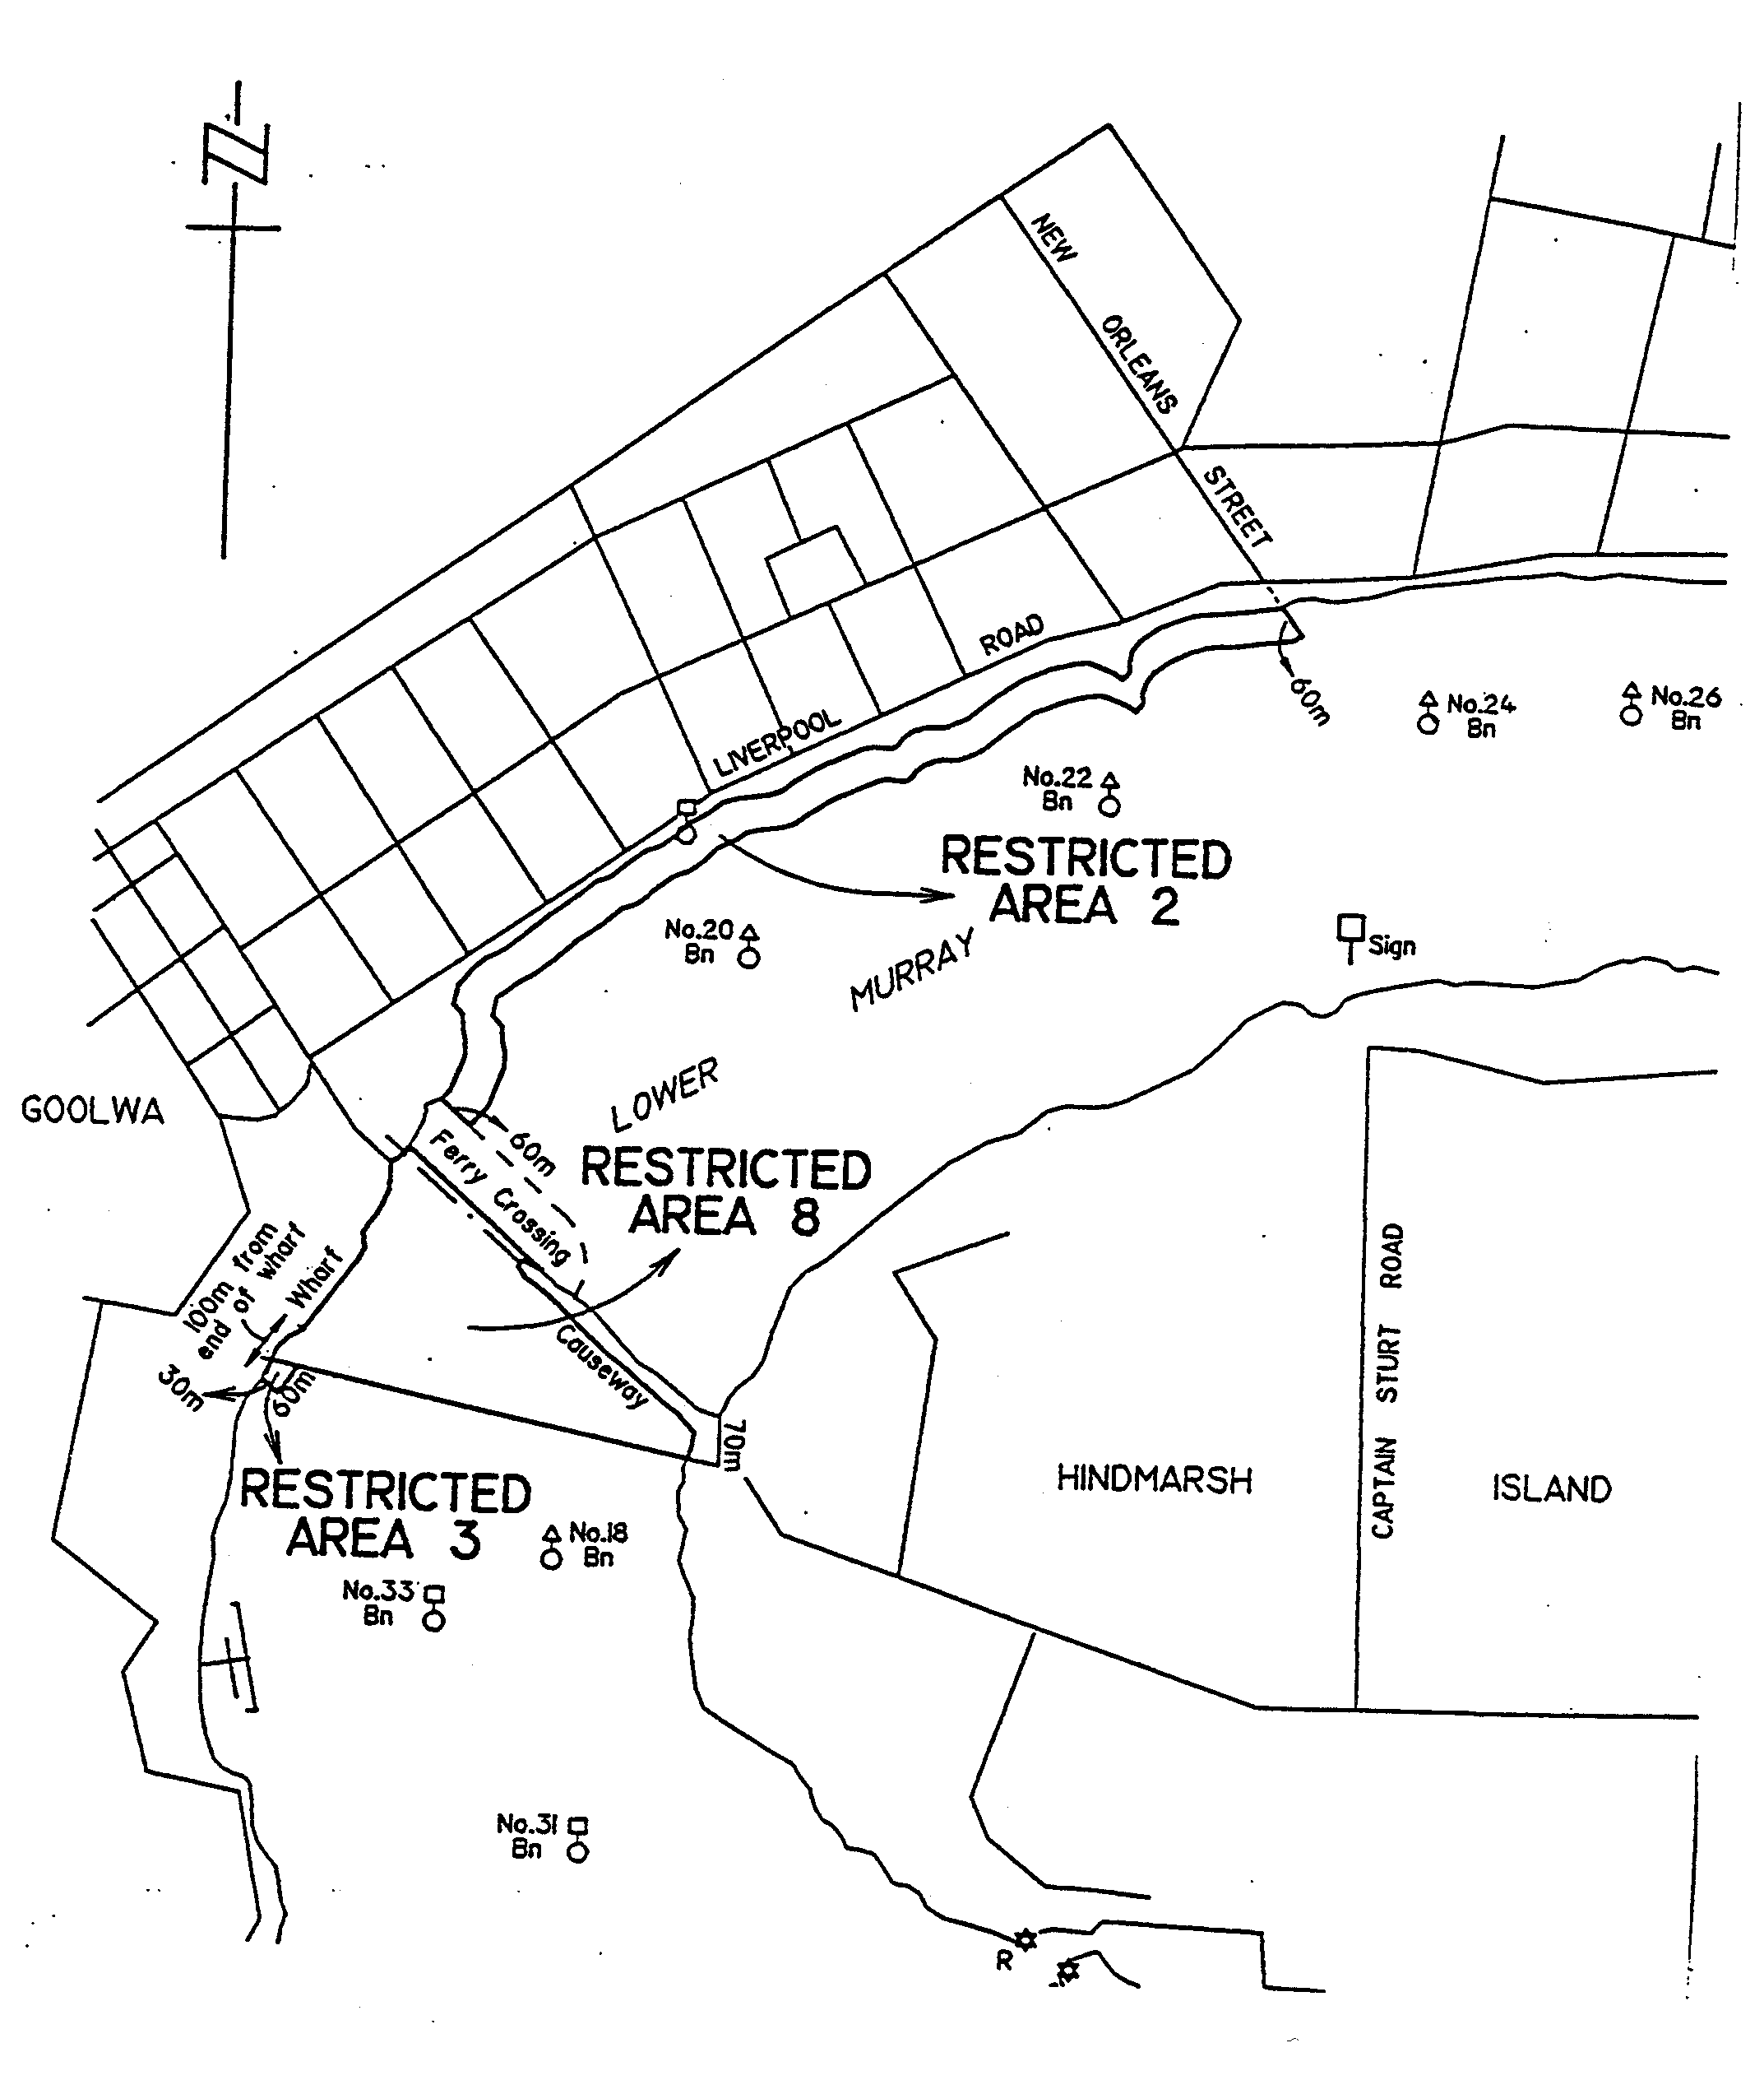

DTRN 8443/99 CS R. DENNIS Clerk of the Council

FAXING COPY?

IF you fax copy to Riverside 2000, for inclusion in the Government Gazette, there is no need to send a Confirmation Copy to us as well.

This creates confusion and may well result in your notice being printed twice.

Please use the following fax number:

Fax transmission: (08) 8207 1040
Phone Inquiries: (08) 8207 1045

Please include a contact person, phone number and order number so that we can phone back with any queries we may have regarding the fax copy.

NOTE: Closing time for lodging new copy (either fax or hard copy) is 4 p.m. on Tuesday preceding the day of publication.

Government Gazette notices can be E-mailed.

The address is:

govgaz@riv.ssa.sa.gov.au

Documents should be sent as attachments in Word format.

When sending a document via E-mail, please confirm your transmission with a faxed copy of your document, including the date the notice is to be published.

Fax transmission: (08) 8207 1040
Enquiries: (08) 8207 1045

CITY OF CHARLES STURT
Erratum
NOTICE is hereby given that at a council meeting held on 27 September 1999 resolved:
That the council resolution of Technical Services, 24 May 1999, item 1.25 as appearing in the Government Gazette of 3 June 1999 on page 3033 be amended to read ‘lot 694 in deposited plan 4822’ in lieu of lot 894 and the date appearing in part 3 to read 18 March 1999 in lieu of 1997.
S. Law, Chief Executive

CITY OF CHARLES STURT
Declaration of Public Road
NOTICE is hereby given that at a council meeting held on 27 September 1999 resolved:
That pursuant to section 301 (1) iii of the Local Government Act 1934, as amended, allotment 111 in Deposited Plan 50316, being portion of the land comprised in certificate of title register book volume 5679, folio 525 being transferred to the City of Charles Sturt from South Australian Housing Trust be accepted by the council as public road, and is hereby declared to be public road and named Gilbert Street.
S. Law, Chief Executive

CITY OF CHARLES STURT
Temporary Road Closure
NOTICE is hereby given, pursuant to section 359 of the Local Government Act 1934, as amended, that council has resolved that the following street will be closed to traffic between 10 a.m. and 2 p.m. on Saturday, 16 October 1999 for an annual fete:
Ethelbert Square, Brompton, between Chief and Third Streets adjacent to Ashman Grove Hostel.
S. Law, Chief Executive

CITY OF NORWOOD PAYNEHAM AND ST PETERS
Periodical Review of Elector Representation
NOTICE is hereby given that pursuant to the provisions of section 24 (7) of the Local Government Act 1934, as amended, the City of Norwood Payneham and St Peters has completed a report on a review of Elector Representation for the council area in accordance with section 24 (3) of the Act.
The report details the public consultation undertaken and a proposal preferred by the council. Copies of the report are available from:
Head Office: 175 The Parade, Norwood;
Payneham Customer Service Centre: 196 O.G. Road, Felixstow;
St Peters Customer Service Centre: 101 Payneham Road, St Peters,
during opening hours or by contacting John Reynolds on (08) 8366 4527.
Written submissions on the preferred council proposal are invited from interested persons and should be directed to the Chief Executive Officer, City of Norwood Payneham and St Peters, P.O. Box 204, Kent Town, S.A. 5071, to be received by 5 p.m. on Thursday, 4 November 1999.
Any persons making a written submission will be also invited to appear before a meeting of council, or a council committee, to be heard in respect of their submission.
M. Barone, Chief Executive Officer

CITY OF PLAYFORD
Supplementary Election—Results
NOTICE is hereby given that the following candidate was elected to fill the vacancy for councillor at the Supplementary Election for Ward 5 held on Saturday, 2 October 1999.
Ward 5
First preferences received by each candidate were as follows:
Brian Leslie Gooley 419
Iris Mabel Shaw 896
Informal 5
1 320
Resulting in the election of Iris M. Shaw.
S. H. Tully, Returning Officer

CITY OF SALISBURY
Declaration of Public Road
PURSUANT to section 303 (1) of the Local Government Act 1934, as amended, the City of Salisbury resolved at its meeting held on 27 September 1999, that portion of land shown as right of way known as allotment 145 in deposited plan 6618 be declared as public road.
S. Hains, City Manager

CITY OF SALISBURY
Development Act 1993
Walkley Heights Plan Amendment Report—Draft for Public Consultation
NOTICE is hereby given that the City of Salisbury has prepared a draft Plan Amendment Report to amend the Development Plan. The amendment applies to the Walkley Heights Development bordered by Walkleys Road, Wright Road, Dry Creek and the Transport SA Stores site.
The Plan Amendment Report will amend the Development Plan by relocating the Walkley Heights Neighbourhood Centre Zone to a site bordered by Wright Road and RM Williams Drive and introducing a new Concept Plan for the Neighbourhood Centre Zone. The Residential (Walkley Heights) Zone will also be amended to remove maximum allotment size, increase minimum setback requirements and introduce a consistent approach to outbuilding dimensions across the City of Salisbury’s residential zones.
The draft Plan Amendment Report and Statement of Investigations will be available for public inspection and purchase during normal office hours at the Council Office, 12 James Street, Salisbury from Thursday, 14 October 1999 to Tuesday, 14 December 1999. A copy of the Plan Amendment Report can be purchased at $7.50 per copy from the council office.
Written submissions regarding the draft amendment will be accepted by the City of Salisbury until 5 p.m. on Tuesday, 14 December 1999. The written submission should also clearly indicate whether you would wish to speak at the public hearing on your submission. All written submissions should be addressed to the City Manager, City of Salisbury, P.O. Box 8, Salisbury, S.A. 5108.
Copies of all submissions received will be available for inspection by interested persons at 12 James Street, Salisbury from Wednesday, 15 December 1999 until the date of the public hearing.
Should an opportunity to present a submission be sought by any person, a public hearing will be held at 5 p.m. in the Council Chambers, 12 James Street, Salisbury on Monday, 20 December 1999.
Dated 14 October 1999.
S. Hains, City Manager

THE BAROSSA COUNCIL
Temporary Street Closure
NOTICE is hereby given that pursuant to the provisions of section 359 of the Local Government Act 1934, as amended, the Barossa Council resolves that the following public road will be closed to all vehicles, except emergency vehicles and authorised service vehicles, between 8.30 a.m. and 10.30 a.m. on Saturday, 16 October 1999:
Murray Street, Tanunda, from the northern side of Basedow Road to Mill Street.
J. G. Jones, Chief Executive Officer

DISTRICT COUNCIL OF GRANT
One Way Street⎯Milstead Street, Port MacDonnell
NOTICE is hereby given, that pursuant to section 359 of the Local Government Act 1934, as amended, the District Council of Grant, at a meeting held on 6 September 1999, resolved to create Milstead Street as a One Way Street in Port MacDonnell, from Standish Street, in a westerly direction to Charles Street.
M. Hutchesson, Works Administration Manager

DISTRICT COUNCIL OF KAPUNDA AND LIGHT
Change of Council Name
NOTICE is hereby given that at the meeting of council held on 21 September 1999, it was resolved that council proposes to change its name to Light Regional Council or Light Council and that notice be given to bring this into effect.
In accordance with section 26 (1) of the Local Government Act 1934, as amended, an invitation is extended to interested persons to make written submissions to council by Friday, 19 November 1999. Any person making a submission will be given the opportunity to appear personally before council to support their submission.
G. W. Sheridan, Chief Executive Officer

DISTRICT COUNCIL OF MALLALA
Periodical Review of Elector Representation
NOTICE is hereby given that the District Council of Mallala has completed a review to determine whether a change of arrangements in respect to elector representation, including ward structure and the composition of council, would result in the electors within the council area being more adequately and fairly represented.
Council has prepared a report which details the review process; the public consultation undertaken; and the proposal which it considers should be implemented. Copies of this report are available from the council office and the Community Library and branches situated at Two Wells, Mallala and Windsor during normal business hours, or by contacting Colin Dunlop on telephone 8527 2006.
Pursuant to the provisions of section 24 (7) (b) (ii) of the Local Government Act 1934, as amended, interested persons are invited to make a written submission in respect to the report. These should be directed to:
Chief Executive Officer,
District Council of Mallala,
P.O. Box 18,
Mallala, S.A. 5502
by close of business on 5 November 1999.
Any person(s) making a written submission will be invited to appear before council, or a committee thereof, to be heard in respect to their submission.
C. Dunlop, Chief Executive Officer

MID MURRAY COUNCIL
Temporary Road Closure
NOTICE is hereby given that at a meeting of council held on 13 September 1999, it was resolved that pursuant to section 359 of the Local Government Act 1934, as amended, for the purpose of conducting a parade of school children, that part of the Tea Tree Gully/Mannum Road, Palmer, from the intersection of Rathjen Road to the intersection of Lindner Avenue, be closed to all vehicular traffic other than vehicles associated with the parade, from 9.30 a.m. to 10.45 a.m. on Wednesday, 3 November 1999.
G. R. Brus, Chief Executive Officer

MID MURRAY COUNCIL
Temporary Road Closure
NOTICE is hereby given that at a meeting of council held on 11 October 1999, it was resolved that pursuant to section 359 of the Local Government Act 1934, as amended, the following street closures in the Mannum Township be authorised:
(1) the entire length of Trewartha Street and Wattle Street and section of River Lane from the Wattle Street junction to the southern end of the Mary Ann Reserve, be closed to all vehicular traffic other than vehicles associated with the Golden Oldies International Rugby Tour, from 10 a.m. to 4 p.m. on Thursday, 21 October 1999;
(2) that section of Randell Street from the McLaren Street junction to the William Street junction, be closed to all vehicular traffic other than vehicles associated with the Golden Oldies International Rugby Tour, from 11 a.m. to 1.30 p.m. and 3.30 p.m. to 4.30 p.m. on Thursday, 21 October 1999.
G. R. Brus, Chief Executive Officer

MID MURRAY COUNCIL
Supplementary Election⎯Sturt Ward
NOTICE is hereby given that as a result of the supplementary election held on 9 October 1999, Norman Valentine Peterson was elected to fill the casual vacancy in the office of councillor for the Sturt Ward for the remainder of the term up to the next periodical election.
G. R. Brus, Returning Officer

DISTRICT COUNCIL OF RENMARK PARINGA
Temporary Road Closure
NOTICE is hereby given that pursuant to section 359 of the Local Government Act 1934, as amended, the District Council of Renmark Paringa has resolved that the carparks adjacent to the BankSA premises at the junction of Ral Ral Avenue and Murray Avenue, Renmark, shall be closed between the hours of 6 a.m. and 2 p.m. Saturday, 30 October 1999, to all vehicles except emergency vehicles, and vehicles participating in the Tri-State Rodders Show and Shine event.
B. Waples, Acting District Manager

DISTRICT COUNCIL OF YANKALILLA
Roads (Opening and Closing) Act 1991
Gold Coast/Lyddon Roads, Carrickalinga
NOTICE is hereby given pursuant to section 10 of the Roads (Opening and Closing) Act 1991, that the District Council of Yankalilla proposes to make a Road Process Order to close and transfer those portions of public road marked ‘A’, ‘B’, ‘B1’, ‘C’, ‘C1’, ‘D’, ‘D1’ and ‘E’ on the Preliminary Plan No. PP32/0496.
Transfer ‘A’ to M. and S. Ascensio, 7 James Street, Campbelltown, S.A. 5074 and to merge that portion with certificate of title volume 4263, folio 302.
Transfer ‘B’ and ‘B1’ to M. and S. Ascensio, 7 James Street, Campbelltown, S.A. 5074 and to merge that portion with certificate of title volume 4263, folio 303.
Transfer ‘C’ and ‘C1’ to M. and S. Ascensio, 7 James Street, Campbelltown, S.A. 5074 and to merge that portion with certificate of title volume 4263, folio 304.
Transfer ‘D’ and ‘D1’ to V. Ascensio, 7 James Street, Campbelltown, S.A. 5074 and to merge that portion with certificate of title volume 2913, folio 7.
Transfer ‘E’ to O. Ascensio, 7 James Street, Campbelltown, S.A. 5074 and to merge that portion with certificate of title volume 2691, folio 178.
A copy of the plan and a statement of persons affected are available for public inspection at the offices of the District Council of Yankalilla, Main Road, Yankalilla and the Adelaide office of the Surveyor-General during normal office hours, 101 Grenfell Street, Adelaide, S.A. 5000.
Any person is entitled to object to the proposed road process, or any person affected by the proposed closure is entitled to apply for an easement to be granted in that person’s favour over the land subject to the proposed closure. Such objection or application for an easement must set out the full name and address of the person making the objection or application and must be fully supported by reasons. Any application for an easement must give full particulars of the nature and location of the easement and where made by a person as the owner of adjoining land or nearby land, specify the land to which the easement is to be annexed.
The objection or application for an easement must be made in writing to the District Council of Yankalilla, P.O. Box 9, Yankalilla, S.A. 5203 within 28 days of this notice, and a copy shall be forwarded to the Surveyor-General’s office in Adelaide, G.P.O. Box 1354, Adelaide, S.A. 5001. Where a submission is made, the District Council of Yankalilla will give notification of a meeting at which the matter will be considered, so that the person making the submission or a representative may attend, if desired.
Dated 14 October 1999.
M. Davis, Chief Executive Officer

IN the matter of the estates of the undermentioned deceased persons:
Brown, Lillian Ethel Mary, late of 37 Fifth Street, Ardrossan, of no occupation, who died on 3 August 1999.
Burt, Andrew Stewart, late of 19 Amberly Drive, Happy Valley, fitter and turner, who died on 24 August 1998.
Clayton, Phyllis Emily Rose, late of 50 Peachey Road, Davoren Park, home duties, who died on 26 August 1999.
Currie, Ellen, late of 49 Smith Road, Salisbury East, home duties, who died on 25 July 1999.
Edson, Glen Andrew, late of 193-193A Anzac Highway, Plympton, training manager, who died on 21 July 1999.
Ellis, James Ian, late of 8 Clifton Street, Hawthorn, of no occupation, who died on 6 September 1999.
Hamalainen, Lempi, late of 12 Braund Road, Fitzroy, home duties, who died on 21 August 1999.
Hennig, Jason Scott, late of Tschirpig Lane, Lyrup, meat worker, who died on 15 March 1998.
Hosking, Hilda May, late of Everard Street, Largs Bay, widow, who died on 7 August 1999.
Jackson, John Sparks, late of 22 Lefevre Terrace, North Adelaide, of no occupation, who died on 19 January 1999.
O’Neill, Joseph Charles, late of 287 Hampstead Road, Northfield, retired engineer, who died on 14 August 1999.
Pratten, Florence Irene, late of Grainger Road, Somerton Park, widow, who died on 16 August 1999.
Robins, Phyllis Emily, late of 39 Fisher Street, Myrtle Bank, of no occupation, who died on 26 August 1999.
Notice is hereby given pursuant to the Trustee Act 1936, the Inheritance (Family Provision) Act 1972, and the Family Relationships Act 1975, that all creditors, beneficiaries, and other persons having claims against the said estates are required to send, in writing, to the Public Trustee, 25 Franklin Street, Adelaide, S.A. 5000, full particulars and proof of such claims, on or before 12 November 1999, otherwise they will be excluded from the distribution of the said estate; and notice is also hereby given that all persons who are indebted to the said estates are required to pay the amount of their debts to the Public Trustee or proceedings will be taken for the recovery thereof; and all persons having any property belonging to the said estates are forthwith to deliver the same to the Public Trustee.
Dated 14 October 1999.
J. H. Worrall, Public Trustee

IN the matter of the estates of the undermentioned deceased persons:
Foster, Olive Barbara, late of Unit 37, Ackland Park Estate, 631 South Road, Everard Park, spinster, who died on 18 February 1999.
Hornhardt, Melvis Jean, late of Helping Hand Aged Care, 437 Salisbury Highway, Parafield Gardens, widow, who died on 3 September 1999.
Howson, Ernest George, late of The Pines Nursing Home, 336 Marion Road, North Plympton, retired driver, who died on 25 September 1999.
Kerslake, Raymond John, late of 25 Osmond Street, Maitland, insurance agent, who died on 24 April 1999.
Loftes, Ernest, late of 115 Senate Road, Port Pirie, retired storekeeper, who died on 6 October 1998.
Pearce, Audrey May, late of Valley View Nursing Home, 66 Nelson Road, Valley View, widow, who died on 7 September 1996.
Scott, Graham Ross, late of 120 Maple Avenue, Royal Park, retired store supervisor, who died on 12 September 1999.
Sinclair, James Allan, late of 3 Cannon Street, Wallaroo, retired labourer, who died on 1 June 1997.
Notice is hereby given pursuant to the Trustee Act 1936, as amended, the Inheritance (Family Provision) Act 1972-1975 and the Family Relationships Act 1975, that all creditors, beneficiaries, and other persons having claims against any of the abovenamed estates are directed to send full particulars of such claims to the undersigned on or before 11 November 1999, otherwise they will be excluded from the distribution of the said estate.
Dated 14 October 1999.
IOOF Australia Trustees Limited (ACN 007 870 644), and Bagot’s Executor & Trustee Company Limited (ACN 007 869 829), 212 Pirie Street, Adelaide, S.A. 5000.

ALEXANDERS TRANSPORT PTY LTD
(ACN 066 517 922)
TRUCK & CAR BRAKE SERVICE PTY LTD has brought a summons in Action No. 1192 of 1999, in the Supreme Court of South Australia seeking the winding up of Alexanders Transport Pty Ltd. The summons is listed for hearing on 2 November 1999 at not before 2.30 p.m. Any creditor or contributory of Alexanders Transport Pty Ltd wishing to be heard on the summons must file and serve a notice in accordance with Rule 20 of the Corporations (South Australia) Rules 1993, at least three business days before the day on which the summons is listed for hearing and must attend at the Supreme Courthouse, Victoria Square, Adelaide at the time set for the hearing of the summons. A copy of the summons and the affidavit in support can be obtained on payment of the proper costs from Marshalls, Level 2, 81 Flinders Street, Adelaide, S.A. 5000.

B. & S. FREIGHTLINES AUSTRALIA PTY LIMITED
(ACN 074 235 117)
ON 5 October 1999, the Supreme Court of South Australia in Action No. 1025 of 1999, made an order for the winding up of B. & S. Freightlines Australia Pty Limited and appointed Bruce James Carter, 81 Flinders Street, Adelaide, S.A. 5000, to be the liquidator of that company.
Deputy Commissioner of Taxation, 191 Pulteney Street, Adelaide, S.A. 5000.

DELBLOCK PTY LTD
(trading as BROADLINE PLUMBING CONTRACTORS)
(ACN 008 277 718)
ON 5 October 1999, the Supreme Court of South Australia in Action No. 944 of 1999, made an order for the winding up of Delblock Pty Ltd (trading as Broadline Plumbing Contractors) and appointed Robert Anthony Ferguson, 190 Flinders Street, Adelaide, S.A. 5000 to be the liquidator of that company.
Marshalls, Level 2, 81 Flinders Street, Adelaide, S.A. 5000.

E. J. WARD & CO. PTY LIMITED
(ACN 007 908 590)
THE DEPUTY COMMISSIONER OF TAXATION of the Adelaide Branch of the Australian Taxation Office, 191 Pulteney Street, Adelaide, S.A. 5000 has brought a summons in Action No. 1159 of 1999, in the Supreme Court of South Australia seeking the winding up of E. J. Ward & Co. Pty Limited. The summons is listed for hearing on Tuesday, 2 November 1999 at not before 2.15 p.m. Any creditor or contributory of E. J. Ward & Co. Pty Limited wishing to be heard on the summons must file and serve a notice in accordance with Rule 20 of the Corporations (South Australia) Rules 1993, at least three business days before the day on which the summons is listed for hearing and must attend at the Supreme Courthouse, Victoria Square, Adelaide at the time set for the hearing of the summons. A copy of the summons and affidavit in support can be obtained on payment of the proper cost from The Deputy Commissioner of Taxation, 191 Pulteney Street, Adelaide, S.A. 5000.

FRASER PRECISION ENGINEERING PTY LTD
(ACN 061 775 817)
ON Tuesday, 5 October 1999, the Supreme Court of South Australia in Action No. 864 of 1999 made an order for the winding up of Fraser Precision Engineering Pty Ltd and appointed John Sheahan, Sheahan Coope, Level 8, 26 Flinders Street, Adelaide, S.A. 5000 to be the liquidator of that company.
Barratt Lindquist, 162 Halifax Street, Adelaide, S.A. 5000. Solicitors for Workers Rehabilitation and Compensation Corporation.

GUARDIAN SECURITY AGENCIES PTY LTD
(ACN 081 372 090)
ON Tuesday, 7 September 1999 the Supreme Court of South Australia in Action No. 974 of 1999 made an order for the winding up of Guardian Security Agencies Pty Ltd and appointed Mark Hall, Prentice Parbery Barilla (S.A.), 26 Flinders Street, Adelaide, S.A. 5000 to be the liquidator of that company.
Barratt Lindquist, 162 Halifax Street, Adelaide, S.A. 5000 Solicitors for Workers Rehabilitation and Compensation Corporation.

G. P. & M. I. CLAYTON PTY LTD
(ACN 008 122 254)
ON Tuesday, 5 October 1999, the Supreme Court of South Australia in Action No. 926 of 1999, made an order for the winding up of G. P. & M. I. Clayton Pty Ltd and appointed Anthony Stevens Smith, Level 21, Santos Building, 91 King William Street, Adelaide, S.A. 5000, to be the liquidator of that company.

HADDIN PTY LTD
(ACN 065 366 529)
ON Tuesday, 5 October 1999, the Supreme Court of South Australia in Action No. 1067 of 1999, made an order for the winding up of Haddin Pty Ltd and appointed Hillary Elizabeth Orr, Level 4, 28 Grenfell Street, Adelaide, S.A. 5000 to be the liquidator of that company.
Martirovs & Co., 3rd Floor, 44 Pirie Street, Adelaide, S.A. 5000, solicitors for the plaintiff.

INFLUENTIAL MARKETING PTY LTD
(ACN 081 416 926)
ON 5 October 1999 the Supreme Court of South Australia in Action No. 898 of 1999 made an order for the winding up of Influential Marketing Pty Ltd and appointed John Ronald Hart, Level 5, 81 Flinders Street, Adelaide, S.A. 5000 to be the liquidator of that company.
Marshalls, Level 2, 81 Flinders Street, Adelaide, S.A. 5000.

SOUTH AUSTRALIA—In the Supreme Court. No. 1407 of 1998. In the matter of J. Trembath & Co. Pty Limited (in liquidation) (ACN 065 430 506) and in the matter of the Corporations Law.
Notice of Release of Liquidator
Take notice that by an order of the Supreme Court of South Australia, dated 28 September 1999, I, David John Olifent of PricewaterhouseCoopers, 14th Floor, 91 King William Street, Adelaide, S.A. 5000, the liquidator of the abovenamed company was granted my release as liquidator.
Dated 1 October 1999.
D. J. Olifent, Liquidator

K. & K. RADIATORS PTY LTD
(trading as BOB WALKERS RADIATOR SERVICE)
(ACN 081 843 174)
ON 5 October 1999 the Supreme Court of South Australia in Action No. 1060 of 1999 made an order for the winding up of K & K. Radiators Pty Ltd (trading as Bob Walkers Radiator Service) and appointed Alan Geoffrey Scott, Level 6, 81 Flinders Street, Adelaide, S.A. 5000 to be the liquidator of that company.
Marshalls, Level 2, 81 Flinders Street, Adelaide, S.A. 5000.

SOUTH AUSTRALIA—In the Supreme Court. No. 1352 of 1998. In the matter of Keybro Pty Limited (in liquidation) (ACN 064 968 485) and in the matter of the Corporations Law.
Notice of Release of Liquidator
Take notice that by an order of the Supreme Court of South Australia, dated 28 September 1999, I, David John Olifent of PricewaterhouseCoopers, 14th Floor, 91 King William Street, Adelaide, S.A. 5000, the liquidator of the abovenamed company was granted my release as liquidator.
Dated 1 October 1999.
D. J. Olifent, Liquidator

M. W. & R. D. RATHJEN PTY LIMITED
(ACN 008 091 941)
THE DEPUTY COMMISSIONER OF TAXATION of the Adelaide Branch of the Australian Taxation Office, 191 Pulteney Street, Adelaide, S.A. 5000 has brought a summons in Action No. 1158 of 1999, in the Supreme Court of South Australia seeking the winding up of M. W. & R. D. Rathjen Pty Limited. The summons is listed for hearing on Tuesday, 2 November 1999 at not before 2.15 p.m. Any creditor or contributory of M. W. & R. D. Rathjen Pty Limited wishing to be heard on the summons must file and serve a notice in accordance with Rule 20 of the Corporations (South Australia) Rules 1993, at least three business days before the day on which the summons is listed for hearing and must attend at the Supreme Courthouse, Victoria Square, Adelaide at the time set for the hearing of the summons. A copy of the summons and affidavit in support can be obtained on payment of the proper cost from The Deputy Commissioner of Taxation, 191 Pulteney Street, Adelaide, S.A. 5000.

MATANGA PTY LTD
(ACN 008 222 393)
ON Tuesday, 5 October 1999, the Supreme Court of South Australia in Action No. 893 of 1999, made an order for the winding up of Matanga Pty Ltd and appointed Mark Christopher Hall, 26 Flinders Street, Adelaide, S.A. 5000 to be the liquidator of that company.
Lynch and Meyer, 190 Flinders Street, Adelaide, S.A. 5000, solicitors for the plaintiff.

NICHE PROJECTS PTY LTD
(ACN 070 487 571)
STUDMASTERS AUSTRALIA PTY LTD, trading as Banner Master & Design Signs, has brought a summons in Action No. 1193 of 1999, in the Supreme Court of South Australia seeking the winding up of Niche Projects Pty Ltd. The summons is listed for hearing on 2 November 1999 at not before 2.30 p.m. Any creditor or contributory of Niche Projects Pty Ltd wishing to be heard on the summons must file and serve a notice in accordance with Rule 20 of the Corporations (South Australia) Rules 1993, at least three business days before the day on which the summons is listed for hearing and must attend at the Supreme Courthouse, Victoria Square, Adelaide at the time set for the hearing of the summons. A copy of the summons and the affidavit in support can be obtained on payment of the proper costs from Marshalls, Level 2, 81 Flinders Street, Adelaide, S.A. 5000.

STADCOTE PTY LIMITED
(ACN 009 632 160)
ON 5 October 1999, the Supreme Court of South Australia in Action No. 991 of 1999, made an order for the winding up
of Stadcote Pty Limited and appointed Alan Geoffrey Scott, 81 Flinders Street, Adelaide, S.A. 5000, to be the liquidator of that company.
Deputy Commissioner of Taxation, 191 Pulteney Street, Adelaide, S.A. 5000.

SASUKAME PTY LTD
(ACN 001 240 348)
ON Tuesday, 5 October 1999, the Supreme Court of South Australia in Action No. 921 of 1999, made an order for the winding up of Sasukame Pty Ltd and appointed Hillary Elizabeth Orr, Level 4, 28 Grenfell Street, Adelaide, S.A. 5000 to be the liquidator of that company.
Martirovs & Co., 3rd Floor, 44 Pirie Street, Adelaide, S.A. 5000, solicitors for the plaintiff.

ATTENTION

CUSTOMERS requiring a proof of their notice for inclusion in the Government Gazette, please note that the onus is on you to inform Riverside 2000 of any subsequent corrections by 10 a.m. on Thursday, which is our publication deadline.

For any corrections to your notice please phone 8207 1045 or Fax 8207 1040 before 10 a.m. on Thursday.

If we do not receive any communication by 10 a.m. on Thursday (day of publication) we will presume the notice is correct and will print it as it is.

Remember—the onus is on you to inform us of any corrections necessary to your notice.

NOTE: Closing time for lodging new copy (either fax or hard copy) is 4 p.m. on Tuesday preceding the day of publication. Ph. 8207 1045—Fax 8207 1040.

Printed and published by authority every Thursday by M. E. JONES, Acting Government Printer, South Australia
Price: $3.85, plus postage; to subscribers, $190 per annum.

