No. 136 1339

THE SOUTH AUSTRALIAN

GOVERNMENT GAZETTE

PUBLISHED BY AUTHORITY

ALL PUBLIC ACTS appearing in this GAZETTE are to be considered official, and obeyed as such

ADELAIDE, THURSDAY, 30 SEPTEMBER 1999

CONTENTS

Page
Appointments, Resignations, Etc. 1342
Erratum 1342
Corporations and District Councils—Notices 1403
Crown Lands Act 1929—Notice 1342
Development Act 1993—Notice 1342
Fisheries Act 1982—Notices 1342
Gaming Machines Act 1992—Notice 1346
Geographical Names Act 1991⎯Notices 1346
Governors’ Pensions Act 1976⎯Notice 1347
Harbors and Navigation Act 1993⎯Notices 1347
Housing Improvement Act 1940—Notices 1348
Land Acquisition Act 1969-1972⎯Notice 1353
Land and Business (Sale and Conveyancing) Act 1994⎯
Notice 1353
Liquor Licensing Act 1997—Notices 1353
Livestock Act 1997—Notice 1350
Lower North Animal and Plant Control Board⎯Notice 1358
Mining Act 1971—Notice 1358
Motor Vehicles 1959⎯Notice 1358
Partnership Act 1891⎯Notices 1406
Page
Prices Act 1948⎯Notice 1350
Private Advertisements 1406
Proclamations 1340
Public Trustee Office—Administration of Estates 1406
REGULATIONS
Electricity Act 1996 (No. 195 of 1999) 1370
Liquor Licensing Act 1997 (No. 196 of 1999) 1386
Real Property Act 1886⎯
(No. 197 of 1999) 1390
(No. 198 of 1999) 1392
Harbors and Navigation Act 1993 (No. 199 of 1999) 1393
Land and Business (Sale and Conveyancing) Act
1994 (No. 200 of 1999) 1395
Agricultural Chemicals Act 1955 (No. 201 of 1999) 1397
Roads (Opening and Closing) Act 1991—Notices 1359
Road Traffic Act 1961⎯Notice 1342
Rules of Court 1362
Soil Conservation and Land Care Act 1989—Notice 1358
Vocational Education, Employment and Training Act
1994⎯Contracts of Training 1364

GOVERNMENT GAZETTE NOTICES
ALL poundkeepers' and private advertisements forwarded for publication in the South Australian Government Gazette must be PAID FOR PRIOR TO INSERTION; and all notices, from whatever source, should be legibly written on one side of the paper only and sent to Riverside 2000 so as to be received no later than 4 p.m. Tuesday preceding the day of publication. Phone 8207 1045 or Fax 8207 1040. E-mail: govgaz@riv.ssa.sa.gov.au. Send as attachments in Word format and please confirm your transmission with a faxed copy of your document, including the date the notice is to be published and to whom the notice will be charged.

ANIMAL AND PLANT CONTROL (AGRICULTURAL PROTECTION AND OTHER PURPOSES) ACT 1986 SECTION 51: VARIATION OF DECLARATION OF CLASSES OF PLANTS TO WHICH ACT APPLIES
Proclamation By The Governor
(l.s.) E. J. Neal
PURSUANT to section 51 of the Animal and Plant Control (Agricultural Protection and Other Purposes) Act 1986, on the recommendation of the Animal and Plant Control Commission and with the advice and consent of the Executive Council, I vary the declaration made under that section on 3 October 1991 (see Gazette 3 October 1991 p. 990), as varied⎯
(a) by striking out from clause 3 "and 10" and substituting ", 10 and 11";
(b) by striking out all the words in the third column of the entry in the Schedule in respect of Class: 5d Olive and substituting "Whole of the State";
(c) by striking out from the third column of the entry in the Schedule in respect of Class: 7a Onion weed "Goyder," and substituting "Coorong, Goyder, Lacepede Tatiara Robe,";
(d) by inserting after the entry in the Schedule in respect of Class 10: Noxious seeds the following entry:

Class 11: Salix
Salix ssp.
Willows of all species
(excluding the following:
Salix apoda
Salix arctica
Salix babylonica
var. babylonica
Salix calodendron
Salix chilensis
Salix myrtilloides
Salix reichardii
Salix serpyllifolia
Salix sepulcralis
var. sepulcralis)

Given under my hand and the Public Seal of South Australia, at Adelaide, 30 September 1999.
By command,
Iain Evans, for Premier
MPNR 35/99 CS
MPNR 50/99 CS

GOVERNMENT FINANCING AUTHORITY ACT 1982 SECTION 4(3): DECLARATION OF A SEMI-GOVERN-MENT AUTHORITY⎯VARIATION OF DECLARATION
Proclamation By The Governor
(l.s.) E. J. Neal
PURSUANT to section 4(3) of the Government Financing Authority Act 1982 and with the advice and consent of the Executive Council, I vary the declaration made on 13 January 1983 (see Gazette 13 January 1983 p. 41) by striking out from the schedule "Australian Barley Board".
Given under my hand and the Public Seal of South Australia, at Adelaide, 30 September 1999.
By command,
Iain Evans, for Premier
T&F 74/99 CS

SHOP TRADING HOURS ACT 1977 SECTION 13: ALTERA-TION OF SHOP TRADING HOURS⎯PORT LINCOLN SHOPPING DISTRICT
Proclamation By The Governor
(l.s.) E. J. Neal
PURSUANT to section 13 of the Shop Trading Hours Act 1977 and with the advice and consent of the Executive Council, I authorise the opening of all shops in the Port Lincoln Shopping District from 11 a.m. until 5 p.m. on Sunday, 3 October 1999, subject to the conditions specified in the schedule.
Schedule
This proclamation only authorises the opening of a shop if—
(a) all relevant industrial awards, workplace agreements and enterprise agreements are observed by the shopkeeper and persons employed in the business of the shop during and in relation to the hours specified in this proclamation during which the shop is open; and
(b) subject to an industrial award, workplace agreement or enterprise agreement to the contrarya person who is employed in the business of the shop is entitled to refuse to work at the shop during the hours specified in this proclamation unless he or she has agreed with the shopkeeper to work during those hours.
Given under my hand and the Public Seal of South Australia, at Adelaide, 30 September 1999.
By command,
Iain Evans, for Premier
MGE 96/99 CS

SHOP TRADING HOURS ACT 1977 SECTION 13: ALTERA-TION OF SHOP TRADING HOURS⎯LOXTON SHOPPING DISTRICT
Proclamation By The Governor
(l.s.) E. J. Neal
PURSUANT to section 13 of the Shop Trading Hours Act 1977 and with the advice and consent of the Executive Council, I authorise the opening of all shops in the Loxton Shopping District from 10 a.m. until 4 p.m. on Sunday, 17 October 1999, subject to the conditions specified in the schedule.
Schedule
This proclamation only authorises the opening of a shop if—
(a) all relevant industrial awards, workplace agreements and enterprise agreements are observed by the shopkeeper and persons employed in the business of the shop during and in relation to the hours specified in this proclamation during which the shop is open; and
(b) subject to an industrial award, workplace agreement or enterprise agreement to the contrarya person who is employed in the business of the shop is entitled to refuse to work at the shop during the hours specified in this proclamation unless he or she has agreed with the shopkeeper to work during those hours.
Given under my hand and the Public Seal of South Australia, at Adelaide, 30 September 1999.
By command,
Iain Evans, for Premier
MGE 95/99 CS

STATUTES AMENDMENT (TRUSTS) ACT 1999 (Act No. 56 of 1999): DAY OF COMMENCEMENT
Proclamation By The Governor
(l.s.) E. J. Neal
WITH the advice and consent of the Executive Council, I fix 18 October 1999 as the day on which the Statutes Amendment (Trusts) Act 1999 will come into operation.
Given under my hand and the Public Seal of South Australia, at Adelaide, 30 September 1999.
By command,
Iain Evans, for Premier
AG 33/99 CS

RESIDENTIAL TENANCIES (MISCELLANEOUS) AMEND-MENT ACT 1999 (Act No. 55 of 1999): DAY OF COMMENCEMENT
Proclamation By The Governor
(l.s.) E. J. Neal
WITH the advice and consent of the Executive Council, I fix 3 October 1999 as the day on which the Residential Tenancies (Miscellaneous) Amendment Act 1999 will come into operation.
Given under my hand and the Public Seal of South Australia, at Adelaide, 30 September 1999.
By command,
Iain Evans, for Premier
OCBA 8/98 CS

ELECTRICITY (MISCELLANEOUS) AMENDMENT ACT 1999 (Act No. 60 of 1999): DAY OF COMMENCEMENT OF SUSPENDED PROVISIONS
Proclamation By The Governor
(l.s.) E. J. Neal
WITH the advice and consent of the Executive Council, I fix 11 October 1999 as the day on which the remaining provisions of the Electricity (Miscellaneous) Amendment Act 1999 will come into operation.
Given under my hand and the Public Seal of South Australia, at Adelaide, 30 September 1999.
By command,
Iain Evans, for Premier
T&F 80/99 CS

NATIONAL PARKS AND WILDLIFE ACT 1972 SECTION 34(1): CONSTITUTION OF GRANITE ISLAND RECREATION PARK
Proclamation By The Governor
(l.s.) E. J. Neal
PURSUANT to section 34(1) of the National Parks and Wildlife Act 1972, being of the opinion that the land described in the schedule should be conserved and managed for public recreation and enjoyment and with the advice and consent of the Executive Council, I⎯
(a) constitute the land described in the schedule as a recreation park; and
(b) assign to it the name "Granite Island Recreation Park".
Schedule
Allotment 1 and pieces 2, 3, 4 and 5 of DP 43331 in the Hundred of Encounter Bay, extending to low water mark.
Given under my hand and the Public Seal of South Australia, at Adelaide, 30 September 1999.
By command,
Iain Evans, for Premier
MEH 27/99 CS

NATIONAL WINE CENTRE (LAND OF CENTRE) AMENDMENT ACT 1998 (Act No. 15 of 1998): DAY OF COMMENCEMENT
Proclamation By The Governor
(l.s.) E. J. Neal
WITH the advice and consent of the Executive Council, I fix 30 September 1999 as the day on which the National Wine Centre (Land of Centre) Amendment Act 1998 will come into operation.
Given under my hand and the Public Seal of South Australia, at Adelaide, 30 September 1999.
By command,
Iain Evans, for Premier
DPC 12/98CS

AGRICULTURAL CHEMICALS ACT 1955 SECTION 4(4): EXEMPTIONS—VARIATION OF PROCLAMATION
Proclamation By The Governor
(l.s.) E. J. Neal
Preamble
1. By proclamation made under the Agricultural Chemicals Act 1955 on 27 June 1957 (see Gazette 27 June 1957 p. 1564, first occurring) certain provisions of the Act were declared not to apply to certain substances.
2. The declaration referred to in clause 1 has been varied by subsequent proclamation (see Gazette 21 August 1958 p. 442; 20 December 1973 p. 3336; 20 December 1973 p. 3340).
3. It is now intended that the declaration be further varied.
Proclamation
PURSUANT to section 4(4) of the Agricultural Chemicals Act 1955 and with the advice and consent of the Executive Council, I vary the proclamation referred to in clause 1 of the preamble by striking out paragraph 2 of that proclamation and substituting the following paragraphs:
2. Sections 8 and 9 and 12 to 23 (inclusive) of the Act do not apply to⎯
(a) any substance delivered in bulk (that is to say not in bags or sacks) to the buyer pursuant to the sale or contract of sale of a quantity exceeding 3 tonnes; or
(b) fertiliser.
3. In this proclamation⎯
"fertiliser" means any substance⎯
(a) commonly used; or
(b) represented expressly or impliedly by a person selling, offering for sale, exposing for sale or having in his or her possession for the purpose of sale, the substance, as capable of being used,
for any one or more of the following purposes:
(c) for promoting the growth of any vegetation or any part of any vegetation;
(d) for improving the fertility or structure of soil in any way.
Given under my hand and the Public Seal of South Australia, at Adelaide, 30 September 1999.
By command,
Iain Evans, for Premier
MPNR 25/99 CS

Department of the Premier and Cabinet
Adelaide, 16 September 1999
Erratum
IN Government Gazette dated 16 September 1999, at page 1153, first notice appearing on that page, Michael Darner Hannell, should read Michael Damer Hannell.
By command,
Diana Laidlaw, for Premier
ATTG 38/94 TC1CS

Department of the Premier and Cabinet
Adelaide, 30 September 1999
HIS Excellency the Governor in Executive Council has been pleased to appoint Derek Yorke Nevill Sprod as a Stipendiary Magistrate from 11 October 1999, pursuant to the provisions of the Magistrates Act 1983.
By command,
Iain Evans, Acting Premier
ATTG 26/99CS

CROWN LANDS ACT 1929: SECTION 5
TAKE NOTICE that pursuant to the Crown Lands Act 1929, I PETER MACLAREN KENTISH, Surveyor-General and Delegate appointed by DOROTHY KOTZ, Minister for Environment and Heritage, Minister of the Crown to whom the administration of the Crown Lands Act 1929 is committed DO HEREBY:
1. Resume the land defined in The First Schedule.
2. Dedicate the Crown Land defined in The Second Schedule as a Renewable Power Generation and Waterworks Reserve and declare that such land shall be under the care, control and management of the Minister for Government Enterprises.
The First Schedule
Portion of Waterworks Reserve, sections 28, 34 and 35, Hundred of Uley, County of Flinders, the proclamation of which, together with other land was published in the Government Gazette of 24 July 1980 at page 293, being the whole of the land comprised in Crown Record Volume 5694 Folio 152.
The Second Schedule
Sections 28, 34 and 35, Hundred of Uley, County of Flinders, exclusive of all necessary roads, being the whole of the land comprised in Crown Record Volume 5694 Folio 152.
Dated 28 September 1999.
P. M. Kentish, Surveyor-General
DENR 08/0412

DEVELOPMENT ACT 1993, SECTION 27 (1): BAROSSA VALLEY REGION—INDUSTRY PLAN AMENDMENT
Preamble
The Minister for Transport and Urban Planning has approved the amendment entitled ‘Barossa Valley Region—Industry Plan Amendment’ (the Plan Amendment) and has referred it to the Governor.
Notice
PURSUANT to section 27 (1) of the Development Act 1993, I, the Governor with the advice and consent of the Executive Council, declare the Plan Amendment to be an authorised Plan Amendment and fix 30 September 1999 as the day on which it will come into operation.
Dated 30 September 1999.
E. J. Neal, Governor
MFTUP CAB 37/99CS

ROAD TRAFFIC ACT 1961 SECTION 53A: APPROVAL OF TRAFFIC SPEED ANALYSER
Notice By The Governor
PURSUANT to section 53A of the Road Traffic Act 1961 and with the advice and consent of the Executive Council, I approve apparatus of the following kind as a traffic speed analyser:
Traffipax Speedophot II
Dated 30 September 1999.
E. J. Neal, Governor
TSA 6883/98 CS

FISHERIES ACT 1982: SECTION 53
TAKE note that the notice made under section 53 of the Fisheries Act 1982, and published in the South Australian Government Gazette, dated 2 July 1999, on page No. 109, being the first notice on that page, which refers to S. & Z. Lukin Pty Ltd, is hereby revoked.
Dated 22 September 1999.
G. R. Morgan, Director of Fisheries

FISHERIES ACT 1982: SECTION 59
TAKE notice that pursuant to section 59 of the Fisheries Act 1982, Rolf Czabayski, 5 Willowbridge Grove, Burnside, S.A. 5066 (hereinafter referred to as the ‘permit holder’) is exempt from Regulation 35C of the Fisheries (General) Regulations 1984, in that the permit holder shall not be guilty of an offence when using berley within the waters specified in Schedule 1 to attract white sharks (Carchardon carcharias) for the purpose of cage viewing only (hereinafter referred to as the ‘permitted activity’), subject to the conditions specified in Schedule 2, for the dates specified in Schedule 3.
Schedule 1
Coastal waters contained within the Neptune Islands Conservation Park, and the following portions of the Sir Joseph Banks Islands Conservation Park; English and Sibsey Islands.
Note: Dangerous Reef is not available under this permit due to Sea lion breeding between 1 May 1999 and 1 January 2000.
Schedule 2
1. The permit holder must be on board the boat when conducting the permitted activity.
2. All berley used while conducting the permitted activity must consist of fish based products only. All berley (other than fish oil) must be stored below a maximum temperature of 4°C.
3. The permit holder must notify the public by a Notice to Mariners through the Australian Maritime Safety Authority, by public notice in the Adelaide Advertiser at least 24 hours in advance of berleying operations, advising the local coastguard and the Fisheries Compliance Unit on 1800 065 522 at least two hours prior to conducting the permitted activities.
4. The permit holder shall allow an officer of the Department for Environment Heritage and Aboriginal Affairs (DEHAA) or nominee to be present on board the boat during the permitted activities if requested and subject to negotiation and availability of space.
5. The permit holder must comply with all instructions (including ceasing to berley if so instructed) given by an officer from DEHAA.
6. Whilst engaged in the permitted activity, an pennant (approved by DEHAA) must be flown from the boat so as to be clearly visible.
7. Whilst engaged in the permitted activity the permit holder must have in his/her possession a copy of this notice and produce a copy of the notice if required by a Fisheries Compliance Officer.
8. The permit holder shall not contravene or fail to comply with the Fisheries Act 1982, or any regulations made under the Act, except where specifically exempted by this notice.

9. The permit holder must maintain a log whilst engaged in the permitted activity which includes the date and location, number of passengers, number of hours berleying, number of sharks observed and any other relevant observations or comments. Records must be kept in a form determined by the operators association in conjunction with CSIRO Marine Research Unit and endorsed by the Minister for Environment and Heritage. A copy of the log must be provided to the relevant DEHAA office within 14 days of each calender month. Failure to submit a log within the agreed time period may preclude the provision of future permits until such outstanding logs are received by the relevant DEHAA office.
10. The permit holder must conform to a code of ethics developed by the operators association and endorsed by the Minister for Environment and Heritage.
11. The permit holder will operate in co-operation with and in agreement of any other approved operator at the same location.
12. The permit holder must have public liability insurance to an amount determined by the Minister for Environment and Heritage and ensure vessels are surveyed and staffed as per Department of Transport regulations.
Schedule 3
4 September to 6 September 1999.
Dated 27 September 1999.
R. Allen, Manager Parks and Wildlife West

FISHERIES ACT 1982
Marine Tuna Farming Licence FB00005
(Previous Licence No. F607)
Licence to Farm Fish under section 53 of the Fisheries
Act 1982
WHEREAS the Director of Fisheries has, pursuant to section 50 (2) of the Fisheries Act 1982 (‘the Act’), issued a permit to the undermentioned licensee to release the fish specified in Schedule 2 of this licence (‘the permitted species’) and, pursuant to section 48G (2) of the Act, the Director of Fisheries has also issued a permit to disturb the seabed for the purpose of installing structures necessary for the licensed activity at the below mentioned site, the Minister for Primary Industries, Natural Resources and Regional Development (‘the Minister’) hereby grants to:
S. & Z. Lukin Nominees Pty Ltd (13044)
62 Lincoln Highway
Port Lincoln, S.A. 5606,
a non-exclusive licence to occupy and use the waters specified in Item 1 of Schedule 1 of this licence (‘the site’) for the purpose of farming and taking the permitted species (‘the permitted use’) for the period commencing on 1 July 1999 and ending, subject to any earlier termination under this licence, on 30 June 2000 (‘the term’) subject to the following terms and conditions:
Conditions of This Licence
1. Licence
The parties acknowledge and agree that:
1.1 the rights, powers and privileges granted to or vested in the licensee under this licence are contractual only and shall not create or vest in the licensee any estate, interest or right of a proprietary nature in the site; and
1.2 that, subject to section 53A of the Fisheries Act 1982, this licence does not entitle the licensee to exclusive rights of entry to and occupation of the site and that the rights granted by this licence are exercisable by the licensee in common with any other occupiers of the site from time to time.
2. Marked-off Areas
For the purposes of section 53A of the Fisheries Act 1982, the marked-off areas within the site is that area or those areas marked-off or indicated in the manner set out in Item 2 of Schedule 1 of this licence.
3. Permitted Species
The licensee:
3.1 must not farm or introduce any species at the site other than the permitted species; and
3.2 must not take any wild fish from the site except for recreational purposes.
4. Permitted Use
The licensee must not use the site for any purpose other than the permitted use.
5. Permitted Methods
The licensee:
5.1 must not stock the permitted species at a rate greater than that specified in Schedule 2 of this licence;
5.2 must not use the anti-fouling chemical tributyltin (TBT) on any equipment used at the site;
5.3 must not use any chemical or drug for either therapeutic or prophylactic purpose except with the prior approval of the Minister;
5.4 must apply the permitted farming methods set out in Schedule 2 of this licence.
6. Sea Cages
The licensee:
6.1 must ensure that all sea cages on the site have anti-predator protection satisfactory to the Minister at all times during the term; and
6.2 must immediately inform an officer of PIRSA (Fisheries) on 1800 065 522 or such other officer as the Minister from time to time notifies to the licensee in writing if any marine animal, other than the permitted species, is caught in any sea cage or other farm structure used by the licensee on the site.
7. Location of Sea Cages
The licensee must not erect or use any sea cages in any location on the site where stocked sea cages have been used in the immediately preceding two year period.
8. Marking and Maintaining the Site
The licensee:
8.1 must ensure that the site is maintained in a good, tidy and safe condition to the satisfaction of the Minister;
8.2 must remove and lawfully dispose of any waste or debris on the site as soon as is reasonably practicable and in particular must comply with any guidelines issued from time to time by the Minister in relation to the removal from the site of any unhealthy or dead fish;
8.3 must maintain all buoys, crosses, and markers on the site in good condition and in accordance with the colours specified in Schedule 1 of this licence; and
8.4 must mark the site boundary in accordance with the specifications in Schedule 1 of this licence.
9. Site Inspection and Supervision
The licensee:
9.1 must at all times permit the Minister, his employees, agents or contractors or any employees, agents or contractors of the Crown to enter the site for the purposes of inspecting the site, the sea floor and the flora and fauna on or in the vicinity of the site; and
9.2 must comply with all reasonable directions of any such person authorised by the Director of Fisheries to inspect the conduct of the licensee’s activities at the site.
10. Fees and Returns
The licensee:
10.1 must pay to the Minister the licence fee in accordance with Item l of Schedule 3 of this licence;
10.2 must on or before 31 January and 31 July during the term, submit to the Minister a return supplying all of the information described in Schedule 4 of this licence.
11. Compliance With Relevant Laws
11.1 the licensee must at all times comply with all laws, by-laws or regulations in force which relate to the site or the activities conducted in the site and with all notices, orders or requirements lawfully given or made by any authority or authorities in respect of the site;
11.2 in particular, without derogating from the general requirement under condition 11 of this licence:
11.2.1 the licensee must not do or permit to be done in upon or about the site anything which in the opinion of the Minister would cause or contribute to the degradation or pollution of any coastal land or the surrounding marine environment; and
11.2.2 in the event that the Minister is satisfied, on reasonable grounds, that the fish taken from the waters are not fit for human consumption or that consumption of fish taken from the waters could present a danger to the health of the consumer, the licensee must, in accordance with a written notice from the Minister, cease or suspend the conduct of the permitted use or else conduct the permitted use as directed within the notice.
12. Public Risk Indemnity
The licensee must at all times indemnify the Minister, his officers, employees, contractors and agents from and against all claims, demands, actions, judgments, proceedings, damages, losses, costs, charges and expenses in respect of any loss of life, personal injury and/or damage to property caused or suffered in any manner in or about the site.
13. Release
The licensee must use and keep the site at the risk in all things of the licensee and the licensee must release to the full extent permitted by law the Minister, his agents, contractors and servants in the absence of any wilful act, omission, default or neglect on their part from all claims and demands of every kind resulting from any accident damage or injury to persons or property occurring at the site, including loss or damage to the licensee’s fixtures or personal property of the licensee.
14. Public Risk Insurance
The licensee shall at its own cost and expense during the term effect and keep in full force and effect in respect of the site and the permitted use a policy of public risk insurance in the joint names of the licensee and the Minister in which the limits of public risk shall not be less than the amount specified in Item 2 of Schedule 3 of this licence, or such further amount as the Minister may from time to time reasonably require, as the amount which may be paid out in respect of any one single claim and a policy of insurance or copy thereof or a certificate of insurance shall be produced by the licensee to the Minister on request in writing being made by the Minister for its production.
15. Guarantee or Indemnity Scheme
The licensee must either:
15.1 provide a guarantee from its bankers; or
15.2 contribute to an indemnity scheme established for the aquaculture and fisheries industry and approved by the Minister,
to and in favour of and for the benefit of the Minister by way of security for the due and punctual performance by the licensee of the terms and conditions of this licence and in particular the obligations of the licensee to rehabilitate the site immediately prior to the expiration or sooner determination of the term of this licence. Such guarantee or indemnity scheme must have effect from the date of commencement of the term.
16. No Assignment
The licensee acknowledges that this licence is personal and it must not assign or sublet or deal in any other way with any interest in this licence.
17. Default by Licensee and Termination
The Minister may terminate this licence immediately by notice in writing served on the licensee if:
17.1 the licensee commits or permits any breach or default of the obligations imposed on the licensee by this licence, and following the giving by the Minister of written notice of such breach or default, the licensee either fails to rectify such breach or default within one calendar month of the date of such notice (or earlier if the circumstances require) or fails to make diligent progress towards rectifying any such breach which is incapable of rectification within the time so limited; or
17.2 the licensee commits or permits any further breach or default of the obligations imposed on the licensee by this licence for which the Minister has previously given notice in writing of such breach or default pursuant to paragraph 1 of condition 17.1 notwith-standing rectification of the previous breach or default; or
17.3 the licence fee referred to in condition 10 is unpaid for a period of 14 days after notice has been given to the licensee that it is outstanding; or
17.4 if the licensee is a body corporate, any of the following occur:
17.4.1 the licensee is unable to pay its debts as and when they fall due or is otherwise insolvent;
17.4.2 an order is made for the winding up or liquidation of the licensee;
17.4.3 the licensee enters into a scheme of arrangement, compromise, moratorium or other form of composition with its creditors or any class of its creditors;
17.4.4 a receiver, a manager or a receiver and manager, a company administrator or other insolvency administrator is appointed to the licensee; or
17.4.5 a mortgagee, chargee or other encum-brancee is appointed over or takes possession of or appoints an agent to take possession of all or any of the licensee’s assets; or
17.5 if the licensee is an individual, the licensee:
17.5.1 becomes bankrupt or assigns its estate or enters into a deed of arrangement or other form of composition for the benefit of the licensee’s creditors; or
17.5.2 is convicted of an indictable offence.
Termination of this licence by the Minister shall be without prejudice to any rights, remedies or actions that the Minister may have against the licensee in respect of any antecedent breach by the licensee of the terms and conditions contained in this licence.
18. Interpretation
Subject to any inconsistency of subject or context, the following rules of construction shall be used in the interpretation of this licence:
18.1 any word importing the plural includes the singular and vice versa;
18.2 any wording importing a gender shall include all other genders;
18.3 a reference to a body corporate shall include a natural person and vice versa;
18.4 a reference to a recital, party, clause, Schedule or Annexure is a reference to a recital, party, clause, Schedule or Annexure of this licence;
18.5 the captions, headings, section numbers and clause numbers appearing in this licence are inserted only as a matter of convenience and in no way affect the construction of this licence;
18.6 a reference to a statute shall include all statutes amending, consolidating or replacing the statutes referred to;
18.7 where two or more persons are named as licensees, this licence shall bind the licensees jointly and each of them severally; and
18.8 time is of the essence in respect of any obligation relating to time in this licence.
19. Delegation
Any consent, notice, any consultation or any other thing which is pursuant to the terms of this licence either required to be given, done or performed or which may be given, done or performed by the Minister may for the purposes of this licence be properly given, done or performed by any duly authorised agent or employee of the Minister.
20. Severance
If any term or condition of this licence should be for any reason unlawful, void, invalid or unenforceable then the offending term or condition shall be severed from this licence without affecting the validity or enforceability of the remainder of this licence.
21. Modification
No variation of or addition to any provision of this licence shall be binding upon the Minister and the licensee unless such variation or addition is made in writing, signed by both the Minister and the licensee and expressed to be either supplemental to or in substitution for the whole or a part of this licence.
22. Waiver
22.1 A waiver of any provision of this licence by the Minister must both be in writing and be signed by the Minister or by persons duly authorised to execute such a document on the Minister’s part.
22.2 No waiver by the Minister of a breach of a term or condition contained in this licence shall operate as a waiver of any breach of the same or any other term or condition contained in this licence.
22.3 No forbearance, delay or indulgence by the Minister in enforcing the provisions of this licence shall prejudice or restrict the rights of the Minister.
23. Notices
23.1 Notices may be served by delivering the same personally, by mail or facsimile transmission and shall be:
23.1.1 in writing addressed to the Director of Fisheries, PIRSA, 16th Floor, 25 Grenfell Street, Adelaide, S.A. 5000 (in the case of the Minister) and to the address of the licensee set out above (in the case of the licensee);
23.1.2 signed by or on behalf of the sender or by a person duly authorised in that regard by the sender;
23.1.3 deemed to be duly served or made in the following circumstances:
(a) if delivered, upon delivery;
(b) if sending by mail, upon posting;
(c) if sent by facsimile transmission, upon the sender’s facsimile producing a transmission report that the facsimile was satisfactorily sent in its entirety to the addressee’s facsimile number,
but if delivery is not made before 5 p.m. on any day it shall be deemed to be received at 9 a.m. on the next day in that place.
23.2 The Minister and the licensee may each vary their address or facsimile number at any time by written notice.
Granted on behalf of the Minister by Director of Fisheries, delegate of the Minister, on 22 September 1999.
G. Morgan, Director of Fisheries
The licensee hereby acknowledges and agrees to the terms and conditions of this licence.
The Common Seal of S. & Z. Lukin Nominees Pty Ltd was hereunto affixed in the presence of:
(l.s.) L. Lukin, Director
Z. Lukin, Secretary
Schedule 1
Item 1—The Site
Area applicable to this licence:
Licensed Area Licensed
Hectares
AGD 66⎯Zone 53
587797E 6155738N 20
587445E 6155547N
587697E 6155116N
588045E 6155308N
All structures, equipment, buoys and flotations (except for that required by the Department for Transport, Urban Planning and the Arts) must be black, dark grey, dark blue, dark brown, or dark green coloured materials.
The boundary of the site to be marked either with:
(a) (1) At the corners with posts extending 900 mm above mean high water springs. Such posts to be marked with a St Andrews cross, each cross arm measuring 900 mm from tip to tip, minimum width 75 mm.
(2) Posts to be not less than 125 mm in diameter.
(3) Posts and crosses to be painted yellow.
(4) The ends of each cross to be marked with a 200 mm strip of yellow retro-reflective tape.
(5) Between the corner posts at intervals not exceeding 50 m, buoys not less than 300 mm in diameter.
(6) All buoys, posts, crosses and markers must be maintained in good condition.
or
(b) (1) At each corner, yellow spar buoys with a St Andrews cross as a top mark placed at least 900 mm above the buoy, cross arms 900 mm long x 75 mm wide.
(2) The buoys and topmarks must all be coloured yellow and marked with a yellow retro-reflective as in (a) (4).
(3) All buoys, posts, crosses and markers must be maintained in good condition.
When the site is in navigable water and possible danger to navigation, lights must be yellow in colour and flashing once every 4 seconds and visible over an arc of 360 degrees for a distance of at least one mile.
All sea cages on the site must be marked with a unique sea cage number and the site’s unique ‘FB number’; that is, the licence number. All St Andrew’s crosses must be marked with the site’s unique ‘FB number’; that is the licence number.
Item 2—Marked-Off Areas
Marked-off areas must be marked with no less than eight equally spaced white buoys, each of at least 12 inches in diameter, each positioned no more than 70 m from each relevant sea cage situated on the site.
Schedule 2
Permitted Species
The Director of Fisheries has, pursuant to section 50 (2) of the Act, issued a permit for the release of the fish specified in this Schedule:
Snapper (Pagrus auratus)
Southern Bluefin Tuna (Thunnus maccoyii)
Australian Herring (Tommy Ruff) (Arripis georgianus)
Yellowtail King Fish (Seriola Ialandii)
Silver Trevally (Pseudocaranx dentex)

Permitted Farming Methods
The Director of Fisheries has, pursuant to section 48G (2) of the Act, issued a permit to disturb the seabed for the purpose of installing the structures specified in this Schedule.
Sea Cages 12
Stocking Rates
The maximum stocking density of fish, other than Southern Bluefish Tuna (Thunnus maccoyii), on the site must not exceed 10 kg/m³.
12 seacages each with a maximum diameter of 20 m.
The maximum standing stock of all fish on the site must not exceed 250 tonnes.
The maximum stocking density of Southern Bluefin Tuna (Thunnus maccoyii) must not exceed 4 kg/m³.
The maximum weight of Southern Bluefin Tuna (Thunnus maccoyii) introduced into the site must not exceed 162 tonnes in total during the term of the licence.
Schedule 3
Item 1—Fees
Annual licence fees are:
$
TEMP Environmental Monitoring Fee (per hectare)
20 at $136 each 2 720.00
Base Licence Fee (per hectare) 20 at $183 each 3 660.00
Fisheries Research & Development Corporation
(per hectare) 20 at $342 each 6 840.00
Total Annual Licence Fee 13 220.00
Quarterly Instalments 3 305.00
Item 2—Public Risk Insurance
Five million dollars ($5 000 000).
Schedule 4
Returns
The licensee must submit the following information to the Minister, c/o Director of Fisheries, PIRSA, 16th Floor, 25 Grenfell Street, Adelaide, S.A. 5000 on or before 31 January and 31 July during the term of this licence:
1. Name of licensee.
2. Address of licensee.
3. Species of fish farmed and held on the site.
4. Location of aquaculture operation.
5. Period covered by return.
6. Number of life stage of each species of fish held.
7. Number, weight and value of each species of fish held.
8. Details of any disease detected in any fish kept.
9. Source (whether interstate or intrastate) of any stock acquired and date of acquisition (if relevant, include name of authority that provided certification that stock was free from disease).
10. If any fish were brought into the state, the number of fish and the life stage of the fish.
11. If fish were brought into the state, the purpose for which they were brought in.
12. Method of disposal of water and packaging use for transporting the fish.
13. If any disease or symptom of disease occurred in the acquired fish.
14. Method of disposal of diseased or dead fish and the number disposed of.
15. Signature, date and telephone number.
16. Use of any chemicals for fish husbandry—type of chemical and quantity used, purpose and date of use.

GAMING MACHINES ACT 1992
Notice of Application for Grant or Transfer of a
Gaming Machine Licence
NOTICE is hereby given, pursuant to section 29 of the Gaming Machines Act 1992, that Pellegrino and Ann De-Francesca have applied to the Liquor and Gaming Commissioner for the grant/transfer of a Gaming Machine Licence in respect of premises situated at 20 Francis Terrace, Lochiel, S.A. 5010 and known as Lake View Hotel.
The application has been set down for hearing on 29 October 1999 at 9 a.m.
Any person may object to the application by lodging a notice of objection in the prescribed form with the Liquor Licensing Commissioner, and serving a copy of the notice on the applicants at the applicants’ address given above, at least seven days before the hearing date.
Plans in respect of the premises the subject of the application are open to public inspection without fee at the Office of the Liquor Licensing Commissioner, 9th Floor, East Wing, G.R.E. Building, 50 Grenfell Street, Adelaide, S.A. 5000.
Dated 27 September 1999.
Applicants

GEOGRAPHICAL NAMES ACT 1991
For Public Consultation
Notice of Intention to Assign Boundaries and Names to Places
NOTICE is hereby given pursuant to the provisions of the above Act, that the Surveyor-General proposes to:
1. Discontinue the boundaries of Port Elliot, Middleton, Goolwa, Goolwa North and Goolwa South.
2. Assign the names; Gemmells, Tinpot Hill, Red Creek, Salem, Callington, Hartley, Woodchester, Macclesfield, Paris Creek, Strathalbyn, Betchley, Langhorne Creek, Tolderol, Lake Plains, Angas Plains, Belvidere, Willyaroo, Sander-grove, Ashborne, Bull Creek, McHarg Creek, Prospect Hill, Blackfellows Creek, Kuitpo, The Range, Montarra, Dingable-dinga, Kyeema, Kuitpo Colony, Mount Magnificent, Yundi, Hope Forest, Willunga Hill, Pages Flat, Mount Compass, Nangkita, Mount Observation, Finniss, Nurragi, Milang, Clayton, Mundoo Island, Hindmarsh Island, Currency Creek, Tooperang, Mount Jagged, Mosquito Hill, Port Elliot (extended), Middleton, Goolwa, Goolwa North, Point Sturt, Goolwa South and Goolwa Beach to those areas within the Alexandrina Council and shown numbered 1 to 54 respectively on Rack Plan 827.
Copies of Rack Plan 827 can be viewed in the office of the Surveyor-General, Adelaide and the offices of the Alexandrina Council.
Submissions in writing regarding this proposal may be lodged with the Secretary, Geographical Names Advisory Committee, c/o Department for Environment, Heritage and Aboriginal Affairs, 300 Richmond Road, Netley, S.A. 5037 (P.O. Box 550, Marleston, S.A. 5033) within one month of the publication of this notice.
Dated 15 September 1999.
P. M. Kentish, Surveyor-General, Department for Administrative and Information Services.
DEHAA 04/0083

GEOGRAPHICAL NAMES ACT 1991
For Public Consultation
Notice of Intention to Assign Boundaries to Places
NOTICE is hereby given pursuant to the provisions of the above Act, that the Surveyor-General proposes to assign the names PORT KENNY, VENUS BAY, MOUNT DAMPER, TALIA, MOUNT WEDGE, COLTON, MOUNT JOY, ELLISTON, BRAMFIELD, COOLILLIE, KAPPAWANTA, SHERINGA, PALKAGEE, POLDA, ULYERRA, HAMBIDGE, LOCK, MURDINGA, and TOOLIGIE to those areas within the District Council of Elliston shown numbered 1 to 19 respectively on Rack Plan 841.
Copies of Rack Plan 841 can be viewed at the office of the Surveyor-General, 101 Grenfell Street, Adelaide or at the office of the District Council of Elliston.
Submissions in writing regarding this proposal may be lodged with the Secretary, Geographical Names Advisory Committee, Building 2, 300 Richmond Road, Netley, S.A. 5037 (P.O. Box 550, Marleston, S.A. 5033) within one month of the publication of this notice.
Dated 21 September 1999.
P. M. Kentish, Surveyor-General, Department for Administrative and Information Services.
DEHAA 04/0089

GEOGRAPHICAL NAMES ACT 1991
Notice to Assign Names and Boundaries to Places
NOTICE is hereby given pursuant to the provisions of the above Act that I, PETER MACLAREN KENTISH, Surveyor-General and delegate appointed by Hon. Robert Lawson, QC MLC, Minister for Administrative Services, Minister of the Crown to whom the administration of the Geographical Names Act 1991, is committed, DO HEREBY assign the names ROXBY DOWNS and OLYMPIC DAM to those areas numbered 1 and 2 respectively on Rack Plan 856.
Dated 21 September 1999.
P. M. Kentish, Surveyor-General, Department for Administrative and Information Services.
DEHAA 04/0220

GEOGRAPHICAL NAMES ACT 1991
For Public Consultation
Notice of Intention to Assign Boundaries to Places
NOTICE is hereby given pursuant to the provisions of the above Act, that the Surveyor-General proposes to assign the names KARKULTABY, MINNIPA, YANINEE, MOUNT DAMPER, PYGERY, WUDINNA, KYANCUTTA, WARRAMBOO, KOONGAWA, PINKAWILLINIE, COCATA, and PANEY to those areas within the District Council of Le Hunte shown numbered 1 to 12 respectively on Rack Plan 828.
Copies of Rack Plan 828 can be viewed at the office of the Surveyor-General, 101 Grenfell Street, Adelaide or at the office of the District Council of Le Hunte.
Submissions in writing regarding this proposal may be lodged with the Secretary, Geographical Names Advisory Committee, Building 2, 300 Richmond Road, Netley, S.A. 5037 (P.O. Box 550, Marleston, S.A. 5033) within one month of the publication of this notice.
Dated 21 September 1999.
P. M. Kentish, Surveyor-General, Department for Administrative and Information Services.
DEHAA 04/0098

GOVERNORS’ PENSIONS ACT 1976
Pension Increase
PURSUANT to section (4) (2) of the Governors’ Pensions Act 1976, I hereby direct that the ‘adjustment percentage’ for the first pension payment in the month of October 1999, shall be +0.98% and shall operate to increase pensions.
Dated 21 September 1999.
J. T. Hill, Acting Under Treasurer

HARBORS AND NAVIGATION ACT 1993
Recognition of Certificates of Survey
I, PETER MURRAY SWIFT, Manager, Marine Operations, in accordance with the delegation granted to me by the Chief Executive Officer, Transport SA dated 23 December 1998, pursuant to section 11(2) of the Harbors and Navigation Act 1993, and the powers given to me by Regulation 125 of the Harbors and Navigation Regulations 1994, give notice that a valid certificate of survey issued by the Government of another Australian jurisdiction in accordance with the National Marine Safety Committee’s Protocol on the Mutual Recognition of Certificates of Survey, is equivalent to a certificate of survey issued pursuant to the Harbors and Navigation Act 1993, subject to compliance with the requirements of the SA Marine Policy No. 1 issued on 28 May 1999, or as varied from time to time.
This notice may be varied or revoked at any time.
Dated 25 August 1999.
P. M. Swift, Manager, Marine Operations

HARBORS AND NAVIGATION ACT 1993
Determination of State Crewing Committee
THE following determination made on 27 August 1999 by the State Crewing Committee is published pursuant to part 6, section 45 of the Harbors and Navigation Act 1993.
Diana Laidlaw, Minister for Transport and Urban Planning.
TSA 99/06471

HARBORS AND NAVIGATION ACT 1993
Determination of State Crewing Committee in respect of the
M.V. ‘Sea Eagle’
THE following determination is made by the State Crewing Committee pursuant to part 6, section 45 of the Harbors and Navigation Act 1993, in respect of the Sea Eagle whilst operating within 15 nautical miles of the coast of South Australia.
Minimum complement
During Daylight hours
One person⎯Master
During the hours of Darkness
Two persons—Master and GP (General Purpose Person)
Minimum Qualifications of Crew
Master⎯Certificate of Competency as Coxswain and has successfully completed elements of Shipboard Safety and Restricted Radio Telephony courses.
GP—General purpose person, an able bodied person not less than 16 years of age with not less than 3 months experience on vessels, and has successfully completed an approved elements of Ship Safety course.
Capt. W. J. Stuart, Presiding Member, State Crewing Committee.

HOUSING IMPROVEMENT ACT 1940
NOTICE is hereby given that the South Australian Housing Trust in the exercise of the powers conferred by the Housing Improvement Act 1940, does hereby declare the houses described in the table hereunder to be substandard for the purposes of Part VII of the Housing Improvement Act 1940.
No. of House and Street | Locality | Allotment, Section, etc. | Certificate of Title  Volume Folio

Unit 2/11 Williams Avenue |  | Dulwich | Unit 2, Strata Plan 5389, Hundred of Adelaide | 5028 | 348
Flat 9/168D Jetty Road |  | Glenelg | Allotment 78 in Filed Plan 6534, Hundred of Noarlunga | 5078 | 141
63 Avenue Road |  | Highgate | Allotment 115 of subdivision of Block 7 of portion of section 251, Hundred of Adelaide | 1040 | 199
2 Burchett Avenue |  | Magill | Allotment 130 in Deposited Plan 5521, Hundred of Adelaide | 5649 | 983
305 Main South Road |  | Morphett Vale | Allotment 178 in Deposited Plan 6583, Hundred of Noarlunga | 5400 | 385
Section 490-494 Government Road (Hundred of Stanley) |  | Waterloo | Allotments 96, 97 and 98 in Filed Plan 213730, Hundred of Stanley | 5613 | 493

Dated at Adelaide, 30 September 1999. G. Black, General Manager, Housing Trust

HOUSING IMPROVEMENT ACT 1940
WHEREAS by notice published in the Government Gazette on the dates mentioned in the following table the South Australian Housing Trust did declare the houses described in the said table to be substandard for the purposes of Part VII of the Housing Improvement Act 1940, the South Australian Housing Trust in the exercise of the powers conferred by the said Part, does hereby fix as the maximum rental per week which shall be payable subject to section 55 of the Residential Tenancies Act 1995, in respect of each house described in the following table the amount shown in the said table opposite the description of such house and this notice shall come into force on the date of this publication in the Gazette.
Address of House | Allotment, Section, etc. | Certificate of Title  Volume Folio | Date and page of Government Gazette in which notice declaring house to be substandard published | Maximum rental per week payable in respect of each house  $

Part Lot K, Olivedale Street (also known as 1 Edward Street), Birdwood |  | Allotment 3 in Filed Plan 142802, Hundred of Talunga | 5261 | 514 |  | 25.6.81, page 2006 | 90.00
5 Twelfth Street, Gawler South |  | Allotment 9 in Filed Plan 154310, Hundred of Mudla Wirra | 5439 | 425 |  | 27.6.91, page 2033 | 82.00
7 Twelfth Street, Gawler South |  | Allotments 14 and 22 of portion of allotment 13, Hundred of Mudla Wirra | 651 | 178 |  | 6.9.84, page 826 | 87.00
Detached flat at rear of 18 Kitchener Street, Kilburn |  | Allotment 62 in Deposited Plan 2344, Hundred of Yatala | 5225 | 277 |  | 13.5.76, page 2568 | 45.00
39 Da Costa Avenue, Prospect |  | Allotment 86 of subdivision of portion of Blocks 48 and 50 of section 348, Hundred of Yatala | 1780 | 93 |  | 29.6.95, page 3061 | 125.00
71 East Street, Torrensville |  | Allotment 18 in Deposited Plan 857, Hundred of Adelaide | 5667 | 850 |  | 13.12.73, page 3306 | 140.00
Lot 101 (house 2), Port Wakefield Road, Waterloo Corner |  | Allotment 101 in Filed Plan 30418, Hundred of Port Adelaide | 5412 | 286 |  | 29.4.93, page 1556 | 70.00

Dated at Adelaide, 30 September 1999. G. Black, General Manager, Housing Trust

HOUSING IMPROVEMENT ACT 1940
WHEREAS by notice published in the Government Gazette on the dates mentioned in the following table the South Australian Housing Trust did declare the houses described in the following table to be substandard for the purposes of Part VII of the Housing Improvement Act 1940, and whereas the South Australian Housing Trust is satisfied that each of the houses described hereunder has ceased to be substandard, notice is hereby given that, in exercise of the powers conferred by the said Part, the South Australian Housing Trust does hereby revoke the said declaration in respect of each house.
Address of House | Allotment, Section, etc. | Certificate of Title  Volume Folio | Date and page of Government Gazette in which notice declaring house to be substandard published

59 Buller Terrace, Alberton |  |  | Allotment 70 in Deposited Plan 535, Hundred of Yatala | 5649 |  | 6 |  |  | 7.5.98, page 2133
Unit 1/2 Marlborough Street, College Park |  |  | Allotment comprising pieces 1 and 3 in Filed Plan 40044, Hundred of Adelaide | 5105 |  | 183 |  |  | 4.5.95, page 1714
Address of House |  | Allotment, Section, etc. |  |  | Certificate of Title  Volume Folio |  |  | Date and page of Government Gazette in which notice declaring house to be substandard published
139 Sampson Road, Elizabeth Grove |  |  | Allotment 14 in Deposited Plan 45118, Hundred of Munno Para | 5346 |  | 758 |  |  | 26.6.97, page 3078
126 Wattle Street, Fullarton |  |  | Allotment 22 in Deposited Plan 51599, Hundred of Adelaide | 5683 |  | 490 |  |  | 24.8.95, page 508
38 Fourth Street, Gawler South |  |  | Allotment 31 in Filed Plan 153832, Hundred of Mudla Wirra | 5570 |  | 905 |  |  | 28.2.74, page 696
Detached Mount Gambier Stone House situated at sections 3 and 4, Hundred of Duffield, known as ‘The White Hut’, Old Coorong Road, Kingston, SE |  |  | Allotment 14 in Deposited Plan 47461, Hundred of Duffield | 5672 |  | 158 |  |  | 29.10.92, page 1438
Flat 1/2 Railway Terrace, Mile End |  |  | Allotment 68 in Filed Plan 5976, Hundred of Adelaide | 4086 |  | 751 |  |  | 11.11.76, page 1612
Flat 2/2 Railway Terrace, Mile End |  |  | Allotment 68 in Filed Plan 5976, Hundred of Adelaide | 4086 |  | 751 |  |  | 11.11.76, page 1612
Flat 3/2 Railway Terrace, Mile End |  |  | Allotment 68 in Filed Plan 5976, Hundred of Adelaide | 4086 |  | 751 |  |  | 11.11.76, page 1612
Flat 4/2 Railway Terrace, Mile End |  |  | Allotment 68 in Filed Plan 5976, Hundred of Adelaide | 4086 |  | 751 |  |  | 11.11.76, page 1612
Flat 5/2 Railway Terrace, Mile End |  |  | Allotment 68 in Filed Plan 5976, Hundred of Adelaide | 4086 |  | 751 |  |  | 11.11.76, page 1612
Flat 6/2 Railway Terrace, Mile End |  |  | Allotment 68 in Filed Plan 5976, Hundred of Adelaide | 4086 |  | 751 |  |  | 11.11.76, page 1612
Flat 7/2 Railway Terrace, Mile End |  |  | Allotment 68 in Filed Plan 5976, Hundred of Adelaide | 4086 |  | 751 |  |  | 11.11.76, page 1612
12 Railway Terrace, Mile End |  |  | Portion of allotment 35 of portion of section 2, Hundred of Adelaide | 3209 |  | 79 |  |  | 27.6.91, page 2033
58 Rose Street, Mile End |  |  | Portion of allotment 47 of subdivision of portion of section 2, Hundred of Adelaide | 3708 |  | 77 |  |  | 30.10.86, page 1503
23-25 MacDonnell Street, Naracoorte |  |  | Allotment 12 in Deposited Plan 30845, Hundred of Naracoorte | 5117 |  | 407 |  |  | 28.5.87, page 1408
Flat 1/266 Marion Road, Netley |  |  | Allotment 14 in Filed Plan 2038, Hundred of Adelaide | 5084 |  | 687 |  |  | 30.3.95, page 1141
Flat 2/266 Marion Road, Netley |  |  | Allotment 14 in Filed Plan 2038, Hundred of Adelaide | 5084 |  | 687 |  |  | 30.3.95, page 1141
27 Farrant Street, Prospect |  |  | Allotment 64 in Deposited Plan 1280, Hundred of Yatala | 5525 |  | 648 |  |  | 6.12.84, page 1791
Flat 1/110 Prospect Road, Prospect |  |  | Allotment 9 in Deposited Plan 864, Hundred of Yatala | 5195 |  | 522 |  |  | 11.6.87, page 1531
Flat 2/110 Prospect Road, Prospect |  |  | Allotment 9 in Deposited Plan 864, Hundred of Yatala | 5195 |  | 522 |  |  | 7.7.94, page 21
15 Rose Street, Prospect |  |  | Allotment 201 in Deposited Plan 864, Hundred of Yatala | 1553 |  | 60 |  |  | 30.3.95
10 Alsop Street, Semaphore |  |  | Allotment 16 in Deposited Plan 1152, Hundred of Port Adelaide | 5440 |  | 294 |  |  | 3.7.69, page 39
Flat 1/25 Company Street, Semaphore (also known as 23-35 Company Street) |  |  | Allotments 140 and 141 in Deposited Plan 385, Hundred of Port Adelaide | 5586 |  | 86 |  |  | 15.7.76, page 178
Flat 2/25 Company Street, Semaphore (also known as 23-35 Company Street) |  |  | Allotments 140 and 141 in Deposited Plan 385, Hundred of Port Adelaide | 5586 |  | 86 |  |  | 15.7.76, page 178
Flat 3/25 Company Street, Semaphore (also known as 23-35 Company Street) |  |  | Allotments 140 and 141 in Deposited Plan 385, Hundred of Port Adelaide | 5586 |  | 86 |  |  | 15.7.76, page 178
Flat 4/25 Company Street, Semaphore (also known as 23-35 Company Street) |  |  | Allotments 140 and 141 in Deposited Plan 385, Hundred of Port Adelaide | 5586 |  | 86 |  |  | 15.7.76, page 178
4 Bartley Terrace, Semaphore Park |  |  | Allotment 49 in Deposited Plan 398, Hundreds of Port Adelaide and Yatala | 5217 |  | 201 |  |  | 26.8.71, page 715
220 Henley Beach Road, Torrensville |  |  | Allotment 20 in Deposited Plan 1730, Hundred of Adelaide | 5380 |  | 297 |  |  | 8.11.79, page 1187
39 Huntriss Street, Torrensville |  |  | Allotment 31 of subdivision of Block G of section 47, Hundred of Adelaide | 944 |  | 160 |  |  | 15.1.96
27 Shipster Street, Torrensville |  |  | Allotments 160 and 161 of portion of section 47, Hundred of Adelaide | 916 |  | 78 |  |  | 18.5.78, page 1792
20 Glanton Street, West Hindmarsh |  |  | Allotment 94 in Deposited Plan 1342, Hundred of Yatala | 5554 |  | 265 |  |  | 8.12.96
2 Prior Street, Willunga |  |  | Allotment 72 in Deposited Plan 20517, Hundred of Willunga | 5449 |  | 983 |  |  | 24.8.95, page 508

Dated at Adelaide, 30 September 1999. G. Black, General Manager, Housing Trust

STATE OF SOUTH AUSTRALIA
Prices Act 1948
Prices Order No. 006722
To: Wyeth Pharmaceuticals Pty Ltd
480 Port Road
Hindmarsh, S.A. 5007
TAKE notice that, in pursuance of the powers delegated to me by the Minister pursuant to section 7 (2) of the above Act, I hereby fix the maximum prices at which the declared goods specified in the Schedule to this Order may be sold by you to be the prices therein specified. The maximum prices so fixed are to operate on and after 4 October 1999.
S-26 Powder, S-26 Progress, S.M.A., S-26AR, S-26LF and
S-26 Gold (to Wholesaler $ each)
S-26 Powder: $
450 g cans 7.4359
900 g cans 14.0331
10 x 90 g sachets 17.5406
S-26 Progress:
900 g cans 14.0331
10 x 93 g sachets 17.5406
S.M.A:
450 g cans 4.7778
900 g cans 8.8968
10 x 90 g sachets 12.2702
S-26 AR:
900 g cans 14.2786
10 x 93 g sachets 19.6085
S-26 LF:
10 x 93 g sachets 19.6085
S-26 Gold:
900 g cans 14.8627
10 x 99 g sachets 19.6085
Dated 21 September 1999.
M. Phelps, Commissioner for Prices Delegate

LIVESTOCK ACT 1997, SECTIONS 33 AND 87: VARIATION TO THE DOCUMENTATION REQUIRED TO ACCOMPANY LIVESTOCK OR LIVESTOCK PRODUCTS EN ROUTE INTO THE STATE
Notice by the Minister
Preamble
1. On 30 June 1999 the Minister, by notice in the Gazette (dated 8 July 1999, pages 169, 170 and 171), required that certain documentation, as described in the notice, accompany livestock or livestock products of a certain class en route into the State.
2. It is now considered appropriate to vary certain conditions within the notice in relation to the movement of sheep into South Australia.
Notice
PURSUANT to sections 33 and 87 of the Livestock Act 1997, I, Rob Kerin, Minister for Primary Industries, Natural Resources and Regional Development, vary the notice referred to in clause 1 of the Preamble by replacing the documentation required to accompany sheep en route into the State with the following:
Species | Documentation
Sheep or goats | Health certificate known as a Form 2 containing a declaration by the owner or manager of the livestock (known as Part 1) completed within the preceding 7 days.  If none of the Special Conditions numbered 1, 2, 3, 4 or 5 within Part 1 apply then the sections known as Part 2 (Footrot), Part 3 (Ovine Johne’s Disease) and Part 4 (Certificate by Inspector) must be completed.  If Special Condition number 5 within Part 1 applies then only those sections known as Part 2 (Footrot) and Part 3 (Ovine Johne’s Disease) must be completed.
Dated 18 September 1999.
Rob Kerin, Deputy Premier, Minister For Primary Industries, Natural Resources and Regional Development.

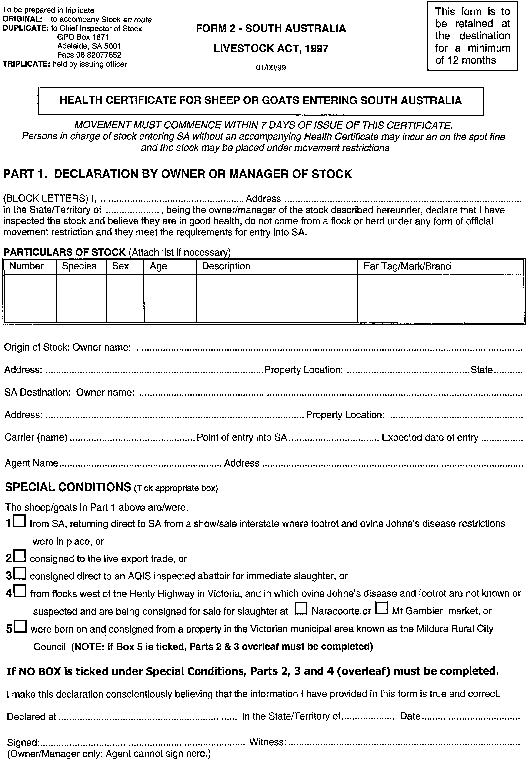
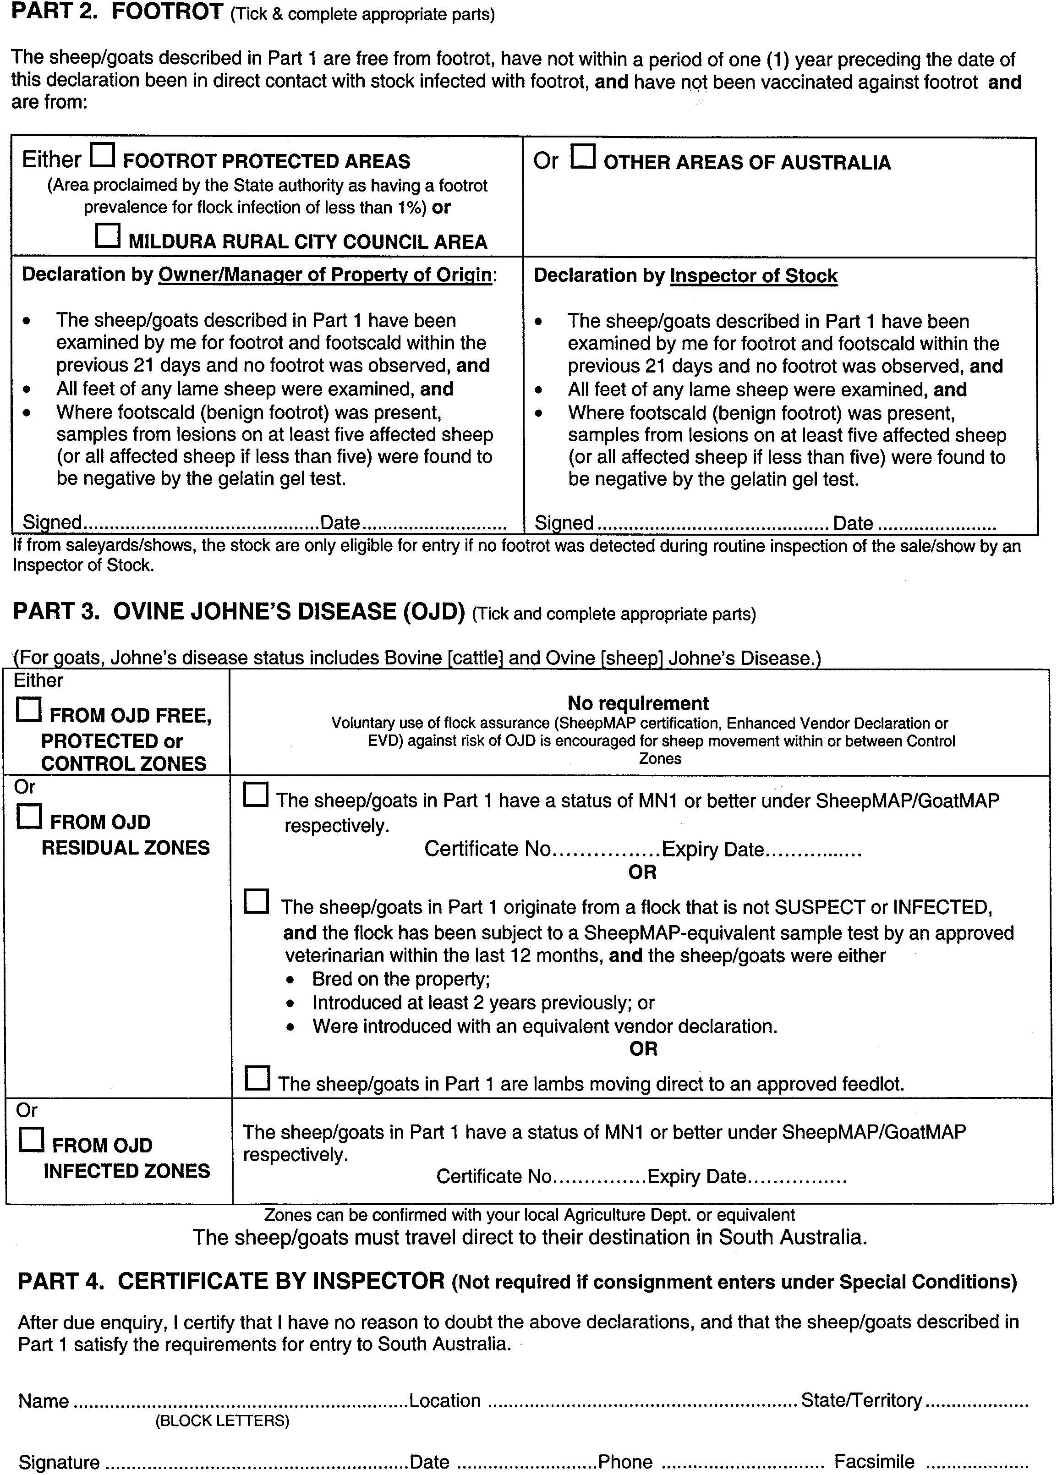

LAND ACQUISITION ACT 1969
(Section 16)
Notice of Acquisition
THE Commissioner of Highways (the ‘Authority’), 33 Warwick Street, Walkerville, S.A. 5081, acquires the following interests in the following land:
Firstly, the fee simple of that piece of land situated at 142 Burbridge Road, Hilton, S.A. 5033, being portion of the land contained in certificate of title register book volume 5244, folio 978 and being the whole of the land delineated and numbered 140 on the plan lodged in the Lands Titles Office, numbered Deposited Plan 48957; and
Secondly, the fee simple of that piece of land situated at 142 Burbridge Road, Hilton, S.A. 5033, being portion of the land contained in certificate of title register book volume 5349, folio 340 and being the whole of the land delineated and numbered 141 on the plan lodged in the Lands Titles Office, numbered Deposited Plan 48957; and
Thirdly, the fee simple of that piece of land situated at 142 Burbridge Road, Hilton, S.A. 5033, being portion of the land contained in certificate of title register book volume 5349, folio 339 and being the whole of the land delineated and numbered 142 on the plan lodged in the Lands Titles Office, numbered Deposited Plan 48957.
This notice is given under section 16 of the Land Acquisition Act 1969.
Compensation
A person who has or had an interest in the land that is divested or diminished by the acquisition or the enjoyment of which is adversely affected by the acquisition who does not receive an offer of compensation from the Authority may apply to the Authority for compensation.
Inquiries
Inquiries should be directed to:
Mary Trestrail
P.O. Box 1
Walkerville, S.A. 5081
Telephone: (08) 8343 2753.
Dated 24 September 1999.
The common seal of the Commissioner of Highways was hereto affixed by direction of the Commissioner of Highways in the presence of:
R. G. Bevan, Manager, Land Acquisition and Disposal, Transport SA

LAND AND BUSINESS (SALE AND CONVEYANCING) ACT 1994
Section 23
TAKE notice that, pursuant to section 23 (3) of the Land and Business (Sale and Conveyancing) Act 1994, I, Kenneth Trevor Griffin, Minister for Consumer Affairs, do hereby exempt the person named in Schedule 1 from the application of section 23 (2) of the Act in relation to the purchase of the land specified in Schedule 2.
Schedule 1
John Joseph Sexton, office/employee of Sexton & Glover Real Estate Pty Ltd.
Schedule 2
The whole of the land described in certificate of title register book volume 5593, folio 414, situated at allotment 302 Ridley Avenue, Mount Barker, S.A. 5251.
Dated 30 September 1999.
Signed for and on behalf of the Minister for Consumer Affairs by the Acting Commissioner for Consumer Affairs:
W. J. Spehr, Acting Commissioner

LIQUOR LICENSING ACT 1997
Notice of Application
NOTICE is hereby given, pursuant to section 52 (2) (b) of the Liquor Licensing Act 1997, that Amin Francis Chehade, 422 Henley Beach Road, Lockleys, S.A. 5032 has applied to the Licensing Authority for the grant of a Special Circumstances Licence under section 40 of the Liquor Licensing Act 1997, in respect of premises to be situated at 106 O’Connell Street, North Adelaide, S.A. 5006 and to be known as The North Adelaide Piano and Billiard Saloon.
The application has been set down for hearing on 29 October 1999.
Conditions
The following licence conditions are sought:
1. That the licence shall authorise the sale, supply and consumption of liquor on the licensed premises. That no liquor shall be sold or supplied for consumption off the licensed premises.
2. That the premises must be used predominantly as a piano bar and pool hall.
3. That the days of operation will be Wednesday, Thursday, Friday, Saturday and Sunday.
4. That the hours of operation will be from 5 p.m. to 1 a.m. on Wednesdays and from 5 p.m. to 2 a.m. on Thursdays, Fridays, Saturdays and Sundays.
5. That entertainment shall be limited to that of a piano style bar.
6. That the licensee shall at any time provide no less than three good quality pool tables and maintain them in good condition.
7. That the premises shall not try to advertise as under the name including any of the words hotel, tavern or inn.
8. That minors will not be permitted entry onto the premises.
Any person may object to the application by lodging a notice of objection in the prescribed form with the Licensing Authority, and serving a copy of the notice on the applicant at the applicant’s address given above, at least seven days before the hearing date.
Plans in respect of the premises the subject of the application are open to public inspection without fee at the Office of the Liquor and Gaming Commissioner, 9th Floor, East Wing, 50 Grenfell Street, Adelaide, S.A. 5000.
Applicant

LIQUOR LICENSING ACT 1997
Notice of Application
NOTICE is hereby given, pursuant to section 52 (2) (b) of the Liquor Licensing Act 1997, that P. J. Sandhu Pty Ltd has applied to the Licensing Authority for the transfer and removal of a Restaurant Licence in respect of premises currently situated at Shop 6, 259-269 Unley Road, Malvern S.A. 5061 to the premises situated at 292-294 Unley Road, Hyde Park, S.A. 5061 and known as Tandoori Oven.
The application has been set down for hearing on 29 October 1999.
Any person may object to the application by lodging a notice of objection in the prescribed form with the Licensing Authority, and serving a copy of the notice on the applicant at the applicant’s address given above, at least seven days before the hearing date.
Plans in respect of the premises the subject of the application are open to public inspection without fee at the Office of the Liquor and Gaming Commissioner, 9th Floor, East Wing, 50 Grenfell Street, Adelaide, S.A. 5000.
Dated 24 September 1999.
Applicant

LIQUOR LICENSING ACT 1997
Notice of Application
NOTICE is hereby given, pursuant to section 52 (2) (b) of the Liquor Licensing Act 1997, that Lido of Glenelg Pty Ltd (ACN 081 964 507), c/o Scott Lumsden, Thomson Playford, 101 Pirie Street, Adelaide, S.A. 5000, has applied to the Licensing Authority for the grant of a Restaurant Licence in respect of premises to be situated at Shop 2, Marina Pier Plaza at Holdfast Shores.
The application has been set down for hearing on 29 October 1999.
Conditions
The following licence conditions are sought:
Approval be granted to trade pursuant to section 34 (1) (c) of the Liquor Licensing Act 1997.
Extended Trading Authorisation to apply from midnight to 2 a.m. on each day of the week and 8 a.m. to midnight on Sundays.
Any person may object to the application by lodging a notice of objection in the prescribed form with the Licensing Authority, and serving a copy of the notice on the applicant at the applicant’s address given above, at least seven days before the hearing date.
Plans in respect of the premises the subject of the application are open to public inspection without fee at the Office of the Liquor and Gaming Commissioner, 9th Floor, East Wing, 50 Grenfell Street, Adelaide, S.A. 5000.
Dated 23 September 1999.
Applicant

LIQUOR LICENSING ACT 1997
Notice of Application
NOTICE is hereby given, pursuant to section 52 (2) (b) of the Liquor Licensing Act 1997, that Lorne Hill Pty Ltd, has applied to the Licensing Authority for the variation to an Extended Trading Authorisation, redefinition of Licensed Area, to vary the Entertainment Consent, increase in the number of Gaming Machines from 20 to 40 and redefinition of Gaming Area in respect of premises situated at Murray Street, Gawler, S.A. 5118 and known as Kingsford Hotel.
The application has been set down for hearing on 29 October 1999.
Conditions
The following licence conditions are sought:
• Extended Trading Authorisation to include 34-36 Murray Street, Gawler.
• Extended Trading Authorisation to sell liquor on Sunday for consumption off the licensed premises from 8 a.m. to 11 a.m. and from 8 p.m. to 9 p.m.
• Entertainment Consent to include 34-36 Murray Street, Gawler.
• Redefinition of Licensed Area to include 34-36 Murray Street, Gawler.
• Redefinition of Gaming Area to include 34-36 Murray Street, Gawler.
Any person may object to the application by lodging a notice of objection in the prescribed form with the Licensing Authority, and serving a copy of the notice on the applicant at the applicant’s address given above, at least seven days before the hearing date.
Plans in respect of the premises the subject of the application are open to public inspection without fee at the Office of the Liquor and Gaming Commissioner, 9th Floor, East Wing, 50 Grenfell Street, Adelaide, S.A. 5000.
Dated 21 September 1999.
Applicant

LIQUOR LICENSING ACT 1997
Notice of Application
NOTICE is hereby given, pursuant to section 52 (2) (b) of the Liquor Licensing Act 1997, that Vincenzo Antonio Nesci has applied to the Licensing Authority for the transfer and removal of a Wholesale Liquor Merchant’s Licence in respect of premises currently situated at 345 The Parade, Norwood, S.A. 5067, to the premises situated at 21 Tobruk Avenue, Kensington Park, S.A. 5068 and known as Ilario’s Fine Wines and Spirits.
The application has been set down for hearing on 29 October 1999.
Any person may object to the application by lodging a notice of objection in the prescribed form with the Licensing Authority, and serving a copy of the notice on the applicant at the applicant’s address given above, at least seven days before the hearing date.
Plans in respect of the premises the subject of the application are open to public inspection without fee at the Office of the Liquor and Gaming Commissioner, 9th Floor, East Wing, 50 Grenfell Street, Adelaide, S.A. 5000.
Dated 20 September 1999.
Applicant

LIQUOR LICENSING ACT 1997
Notice of Application
NOTICE is hereby given, pursuant to section 52 (2) (b) of the Liquor Licensing Act 1997, that Turlingdon Pty Ltd has applied to the Licensing Authority for a variation to an existing Extended Trading Authorisation in respect of premises situated at 239 South Terrace, Adelaide, S.A. 5000 and known as Frost Bites Adelaide.
The application has been set down for hearing on 29 October 1999.
Conditions
The following licence conditions are sought:
Monday—midnight to 1 a.m. the following morning.
Tuesday—midnight to 1 a.m. the following morning.
Wednesday—midnight to 2 a.m. the following morning.
Thursday—midnight to 2 a.m. the following morning.
Friday—midnight to 3 a.m. the following morning.
Saturday—midnight to 3 a.m. the following morning.
Sunday—8 a.m. to 11 a.m. and 8 p.m. to 1 a.m. the following morning.
Any person may object to the application by lodging a notice of objection in the prescribed form with the Licensing Authority, and serving a copy of the notice on the applicant at the applicant’s address given above, at least seven days before the hearing date.
Plans in respect of the premises the subject of the application are open to public inspection without fee at the Office of the Liquor and Gaming Commissioner, 9th Floor, East Wing, 50 Grenfell Street, Adelaide, S.A. 5000.
Dated 21 September 1999.
Applicant

LIQUOR LICENSING ACT 1997
Notice of Application
NOTICE is hereby given, pursuant to section 52 (2) (b) of the Liquor Licensing Act 1997, that Bellissimo 2 Patisserie Cafe Pty Ltd, has applied to the Licensing Authority for a Restaurant Licence in respect of premises situated at 36 King William Road, Goodwood, S.A. 5034 and known as Bellissimo 2 Patisserie Cafe.
The application has been set down for hearing on 29 October 1999.
Conditions
The following licence conditions are sought:
• The licensee is authorised to sell liquor on any day except Good Friday and Christmas Day for consumption on the licensed premises by persons:
(a) seated at a table; or
(b) attending a function at which food is provided.
• Extended Trading Authorisation:
Hours of Operation:
Friday and Saturday—midnight to 1 a.m. the following morning.
Sunday—8 a.m. to 11 a.m. and 8 p.m. to midnight.
Any person may object to the application by lodging a notice of objection in the prescribed form with the Licensing Authority, and serving a copy of the notice on the applicant at the applicant’s address given above, at least seven days before the hearing date.
Plans in respect of the premises the subject of the application are open to public inspection without fee at the Office of the Liquor and Gaming Commissioner, 9th Floor, East Wing, 50 Grenfell Street, Adelaide, S.A. 5000.
Dated 27 September 1999.
Applicant

LIQUOR LICENSING ACT 1997
Notice of Application
NOTICE is hereby given, pursuant to section 52 (2) (b) of the Liquor Licensing Act 1997, that P.S. Pty Ltd (ACN 088 094 160), c/o Griffins Lawyers, Level 14, 26 Flinders Street, Adelaide, S.A. 5000, has applied to the Licensing Authority for the transfer of a Hotel Licence in respect of premises situated at 121 Pirie Street, formerly known as Simone’s—The Best In Corporate Dining.
The application has been set down for hearing on 29 October 1999.
Any person may object to the application by lodging a notice of objection in the prescribed form with the Licensing Authority, and serving a copy of the notice on the applicant at the applicant’s address given above, at least seven days before the hearing date.
Plans in respect of the premises the subject of the application are open to public inspection without fee at the Office of the Liquor and Gaming Commissioner, 9th Floor, East Wing, 50 Grenfell Street, Adelaide, S.A. 5000.
Dated 13 September 1999.
Applicant

LIQUOR LICENSING ACT 1997
Notice of Application
NOTICE is hereby given, pursuant to section 52 (2) (b) of the Liquor Licensing Act 1997, that Angas Park Cellars Pty Ltd, c/o Kelly & Co., Level 17, 91 King William Street, Adelaide, S.A. 5000, has applied to the Licensing Authority for the grant of a Retail Liquor Merchant’s Licence in respect of premises situated at Shop 6, Barossa Shopping Centre, Murray Street, Nuriootpa and to be known as Angas Park Cellars.
The application has been set down for hearing on 29 October 1999 at 9 a.m.
Any person may object to the application by lodging a notice of objection in the prescribed form with the Licensing Authority, and serving a copy of the notice on the applicant at the applicant’s address given above, at least seven days before the hearing date.
Plans in respect of the premises the subject of the application are open to public inspection without fee at the Office of the Liquor and Gaming Commissioner, 9th Floor, East Wing, 50 Grenfell Street, Adelaide, S.A. 5000.
Dated 22 September 1999.
Applicant

LIQUOR LICENSING ACT 1997
Notice of Application
NOTICE is hereby given, pursuant to section 52 (2) (b) of the Liquor Licensing Act 1997, that Sophie Kate Newland and Heather Ann Newland have applied to the Licensing Authority for a Restaurant Licence in respect of premises to be situated at 190 Main Road, McLaren Vale, S.A. 5171 and to be known as Market 190.
The application has been set down for hearing on 29 October 1999 at 9 a.m.
Conditions
The following licence conditions are sought:
• Extended Trading Authorisation:
Hours of Operation:
Sunday—8 a.m. to 11 a.m.
• The licensee is authorised to sell liquor on any day except Good Friday and Christmas Day for consumption on the licensed premises by person:
(a) seated at a table; or
(b) attending a function at which food is provided.
• Entertainment consent to apply to the whole of the licensed premises including the above hours sought.
Any person may object to the application by lodging a notice of objection in the prescribed form with the Licensing Authority, and serving a copy of the notice on the applicants at the applicants’ address given above, at least seven days before the hearing date.
Plans in respect of the premises the subject of the application are open to public inspection without fee at the Office of the Liquor and Gaming Commissioner, 9th Floor, East Wing, 50 Grenfell Street, Adelaide, S.A. 5000.
Dated 24 September 1999.
Applicants

LIQUOR LICENSING ACT 1997
Notice of Application
NOTICE is hereby given, pursuant to section 52 (2) (b) of the Liquor Licensing Act 1997, that Diakou Nominees Pty Ltd, has applied to the Licensing Authority for a Restaurant Licence with Entertainment Consent in respect of premises situated at 31 Moonta Street, Adelaide, S.A. 5000 and known as Talbot Village Seafood Restaurant (presently part of the Hotel Licence of the Talbot Hotel, but previously separately licensed as a restaurant).
The application has been set down for hearing on 29 October 1999.
Conditions
The following licence conditions are sought:
• The licensee is authorised to sell liquor on any day except Good Friday and Christmas Day for consumption on the licensed premises by persons:
(a) seated at a table; or
(b) attending a function at which food is provided.
• Extended Trading Authorisation:
Hours of Operation:
Monday to Saturday—midnight to 5 a.m. the following morning.
Sunday—8 a.m. to 11 a.m. and 8 p.m. to 5 a.m. the following morning.
Christmas Day—midnight to 2 a.m.
Any person may object to the application by lodging a notice of objection in the prescribed form with the Licensing Authority, and serving a copy of the notice on the applicant at the applicant’s address given above, at least seven days before the hearing date.
Plans in respect of the premises the subject of the application are open to public inspection without fee at the Office of the Liquor and Gaming Commissioner, 9th Floor, East Wing, 50 Grenfell Street, Adelaide, S.A. 5000.
Dated 24 September 1999.
Applicant

LIQUOR LICENSING ACT 1997
Notice of Application
NOTICE is hereby given, pursuant to section 52 (2) (b) of the Liquor Licensing Act 1997, that Pearler Investments Pty Ltd (ACN 089 324 872), c/o Griffins Lawyers, Level 14, 26 Flinders Street, Adelaide, S.A. 5000 has applied to the Licensing Authority for the grant of a Restaurant Licence in respect of premises to be situated at Retail Level Tenancy R10, Marina Pier Building, Holdfast Shores, Glenelg and to be known as Oyster Bar—Holdfast Shores.
The application has been set down for hearing on 29 October 1999.
Conditions
The following licence conditions are sought:
Authorisation, including Extended Trading Authorisation, is sought permitting trade in liquor for consumption on the licensed premises, during the following hours:
• Sunday—8 a.m. to 11.30 p.m.
• Monday to Thursday inclusive—6 a.m. to 11.30 p.m.
• Friday, Saturday and Public Holidays—6 a.m. to 12.30 a.m. the following day.
Entertainment consent is sought for the entire licensed premises.
Authorisation is sought permitting the licensee to sell liquor on any day except Good Friday and Christmas Day for consumption on the premises by patrons seated at a table or attending a function at which food is provided.
Any person may object to the application by lodging a notice of objection in the prescribed form with the Licensing Authority, and serving a copy of the notice on the applicant at the applicant’s address given above, at least seven days before the hearing date.
Plans in respect of the premises the subject of the application are open to public inspection without fee at the Office of the Liquor and Gaming Commissioner, 9th Floor, East Wing, 50 Grenfell Street, Adelaide, S.A. 5000.
Applicant

LIQUOR LICENSING ACT 1997
Notice of Application
NOTICE is hereby given, pursuant to section 52 (2) (b) of the Liquor Licensing Act 1997, that Dial A Tour Bus Pty Ltd has applied to the Licensing Authority for a Special Circumstances Licence in respect of premises situated at 206 Portrush Road, Trinity Gardens, S.A. 5068 and known as Coachlines of Australia.
The application has been set down for hearing on 29 October 1999.
Conditions
The following licence conditions are sought:
• The licence shall authorise the sale, supply and consumption of liquor only to persons travelling on the bus for consumption on the bus and areas adjacent on any day and at any time except Sunday between 5 a.m. and 8 a.m., Good Friday, midnight to 5 a.m. the day after Good Friday and midnight to 5 a.m. the day after Christmas Day.
• No sale of liquor to or consumption of liquor by an employee of the licensee whilst in the course of his employment on the bus is permitted.
• The licensee shall ensure that no public nuisance, disturbance or disorder is caused by the passengers whilst on the buses whilst embarking or disembarking.
Any person may object to the application by lodging a notice of objection in the prescribed form with the Licensing Authority, and serving a copy of the notice on the applicant at the applicant’s address given above, at least seven days before the hearing date.
Plans in respect of the premises the subject of the application are open to public inspection without fee at the Office of the Liquor and Gaming Commissioner, 9th Floor, East Wing, 50 Grenfell Street, Adelaide, S.A. 5000.
Dated 23 September 1999.
Applicant

LIQUOR LICENSING ACT 1997
Notice of Application
NOTICE is hereby given, pursuant to section 52 (2) (b) of the Liquor Licensing Act 1997, that Samuel Donald Taylor and Donna Taylor as Trustee for the Samuel Taylor Family Trust have applied to the Licensing Authority for a Producer’s Licence in respect of premises to be situated at Linden Hill, Harris Road, Lenswood, S.A. 5240 and to be known as Samuel Donald Taylor and Donna Taylor as Trustee for the Samuel Taylor Family Trust.
The application has been set down for hearing on 29 October 1999.
Any person may object to the application by lodging a notice of objection in the prescribed form with the Licensing Authority, and serving a copy of the notice on the applicants at the applicants’ address given above, at least seven days before the hearing date.
Plans in respect of the premises the subject of the application are open to public inspection without fee at the Office of the Liquor and Gaming Commissioner, 9th Floor, East Wing, 50 Grenfell Street, Adelaide, S.A. 5000.
Dated 23 September 1999.
Applicants

LIQUOR LICENSING ACT 1997
Notice of Application
NOTICE is hereby given, pursuant to section 52 (2) (b) of the Liquor Licensing Act 1997, that Nadreg Holdings Pty Ltd has applied to the Licensing Authority for an Extended Trading Authorisation in respect of premises situated at 92 Franklin Street, Adelaide, S.A. 5000 and known as Hotel Franklin.
The application has been set down for hearing on 29 October 1999.
Conditions
The following licence conditions are sought:
To authorise the sale of liquor for consumption on the licensed premises in respect of the licensed premises during the following hours:
• Wednesday to Saturday—midnight to 5 a.m. the following day.
• Sunday—8 a.m. to 11 a.m. and 8 p.m. to midnight.
Any person may object to the application by lodging a notice of objection in the prescribed form with the Licensing Authority, and serving a copy of the notice on the applicant at the applicant’s address given above, at least seven days before the hearing date.
Plans in respect of the premises the subject of the application are open to public inspection without fee at the Office of the Liquor and Gaming Commissioner, 9th Floor, East Wing, 50 Grenfell Street, Adelaide, S.A. 5000.
Dated 22 September 1999.
Applicant

LIQUOR LICENSING ACT 1997
Notice of Application
NOTICE is hereby given, pursuant to section 52 (2) (b) of the Liquor Licensing Act 1997, that Susan Jennifer Gilbey, 84 Sturt Street, Adelaide, S.A. 5000 has applied to the Licensing Authority for the transfer of a Restaurant Licence in respect of premises situated at 174A Hutt Street, Adelaide and known as Lizard Lounge Supper House.
The application has been set down for hearing on 29 October 1999.
Any person may object to the application by lodging a notice of objection in the prescribed form with the Licensing Authority, and serving a copy of the notice on the applicant at the applicant’s address given above, at least seven days before the hearing date.
Plans in respect of the premises the subject of the application are open to public inspection without fee at the Office of the Liquor and Gaming Commissioner, 9th Floor, East Wing, 50 Grenfell Street, Adelaide, S.A. 5000.
Dated 22 September 1999.
Applicant

LIQUOR LICENSING ACT 1997
Notice of Application
NOTICE is hereby given, pursuant to section 52 (2) (b) of the Liquor Licensing Act 1997, that Richard George Simpson, 23 Weaton Road, Stepney, S.A. 5069 and George Ranembe Morgan, 32 Eighth Street, St Peters, S.A. 5069 have applied to the Licensing Authority for a Producer’s Licence in respect of premises situated at McMurtrie Road, McLaren Vale and to be known as Clos Robert.
The application has been set down for hearing on 29 October 1999.
Any person may object to the application by lodging a notice of objection in the prescribed form with the Licensing Authority, and serving a copy of the notice on the applicants at the applicants’ address given above, at least seven days before the hearing date.
Plans in respect of the premises the subject of the application are open to public inspection without fee at the Office of the Liquor and Gaming Commissioner, 9th Floor, East Wing, 50 Grenfell Street, Adelaide, S.A. 5000.
Dated 21 September 1999.
Applicants

LIQUOR LICENSING ACT 1997
Notice of Application
NOTICE is hereby given, pursuant to section 52 (2) (b) of the Liquor Licensing Act 1997, that Bonalex Pty Ltd has applied to the Licensing Authority for the transfer of a Restaurant Licence in respect of premises situated at 179 Glen Osmond Road, Frewville, S.A. 5063 and known as Fisherman’s Basket.
The application has been set down for hearing on 1 November 1999.
Any person may object to the application by lodging a notice of objection in the prescribed form with the Licensing Authority, and serving a copy of the notice on the applicant at the applicant’s address given above, at least seven days before the hearing date.
Plans in respect of the premises the subject of the application are open to public inspection without fee at the Office of the Liquor and Gaming Commissioner, 9th Floor, East Wing, 50 Grenfell Street, Adelaide, S.A. 5000.
Dated 22 September 1999.
Applicant

LIQUOR LICENSING ACT 1997
Notice of Application
NOTICE is hereby given, pursuant to section 52 (2) (b) of the Liquor Licensing Act 1997, that Martin Cellars Pty Ltd, 4 Robe Terrace, Medindie has applied to the Licensing Authority for the transfer of a Producer’s Licence (No. 5080337) in respect of premises situated at 290 Port Road, Hindmarsh, S.A. 5007 and known as Martin Cellars.
The application has been set down for hearing on 1 November 1999.
Any person may object to the application by lodging a notice of objection in the prescribed form with the Licensing Authority, and serving a copy of the notice on the applicant at the applicant’s address given above, at least seven days before the hearing date.
Plans in respect of the premises the subject of the application are open to public inspection without fee at the Office of the Liquor and Gaming Commissioner, 9th Floor, East Wing, 50 Grenfell Street, Adelaide, S.A. 5000.
Dated 20 September 1999.
Applicant

LIQUOR LICENSING ACT 1997
Notice of Application
NOTICE is hereby given, pursuant to section 52 (2) (b) of the Liquor Licensing Act 1997, that David Ronald Reid and Claire Louise Reid, 5 Lisa Court, Macclesfield, S.A. 5153 have applied to the Licensing Authority for the transfer of a Restaurant Licence (No. 50613879) in respect of premises situated at 52 Main Street, Normanville, S.A. 5204 and known as The Old Courthouse Restaurant.
The application has been set down for hearing on 1 November 1999.
Any person may object to the application by lodging a notice of objection in the prescribed form with the Licensing Authority, and serving a copy of the notice on the applicants at the applicants’ address given above, at least seven days before the hearing date.
Plans in respect of the premises the subject of the application are open to public inspection without fee at the Office of the Liquor and Gaming Commissioner, 9th Floor, East Wing, 50 Grenfell Street, Adelaide, S.A. 5000.
Applicant

LIQUOR LICENSING ACT 1997
Notice of Application
NOTICE is hereby given, pursuant to section 52 (2) (b) of the Liquor Licensing Act 1997, that Blueberry’s Bar Pty Ltd (ACN 089 607 714), c/o Bonnins, Level 14, 100 King William Street, Adelaide, S.A. 5000, has applied to the Licensing Authority for the transfer of a Special Circumstances Licence held in respect of premises situated at 7 Percy Street, Mount Gambier, S.A. 5290 and currently known as Ball Room but to be known as Blueberry’s Bar.
The application has been set down for hearing on 2 November 1999 at 9 a.m.
Any person may object to the application by lodging a notice of objection in the prescribed form with the Licensing Authority, and serving a copy of the notice on the applicant at the applicant’s address given above, at least seven days before the hearing date.
Plans in respect of the premises the subject of the application are open to public inspection without fee at the Office of the Liquor and Gaming Commissioner, 9th Floor, East Wing, 50 Grenfell Street, Adelaide, S.A. 5000.
Dated 22 September 1999.
Applicant

LIQUOR LICENSING ACT 1997 AND GAMING MACHINE ACT 1992
Notice of Application
NOTICE is hereby given, pursuant to section 52 of the Liquor Licensing Act 1997 and section 29 of the Gaming Machine Act 1992, that Pretty Nominees Pty Ltd, Cutler Nominees Pty Ltd and John Wallace Nominees Pty Ltd have applied to the Liquor and Gaming Commissioner for the transfer of a Hotel and Gaming Machine Licence in respect of premises situated at 9 Manton Street, Hindmarsh and known as Joiners Arms and to be known as The Stadium Tavern.
The applications have been set down for hearing on 29 October 1999 at 9 a.m.
Any person may object to the application by lodging a notice of objection in the prescribed form with the Licensing Authority, and serving a copy of the notice on the applicants at the applicants’ address given above, at least seven days before the hearing date.
Plans in respect of the premises the subject of the application are open to public inspection without fee at the Office of the Liquor and Gaming Commissioner, 9th Floor, East Wing, 50 Grenfell Street, Adelaide, S.A. 5000.
Dated 24 September 1999.
Applicants

LIQUOR LICENSING ACT 1997 AND GAMING MACHINE ACT 1992
Notice of Application
NOTICE is hereby given, pursuant to section 52 of the Liquor Licensing Act 1997 and section 29 of the Gaming Machine Act 1992, that ALH Group Pty Ltd has applied to the Liquor and Gaming Commissioner for the transfer of a Hotel and Gaming Machine Licence in respect of premises situated at corner Forsyth and Farrell Streets, Whyalla, S.A. 5600 and known as Hotel Bay View.
The applications have been set down for hearing on 29 October 1999.
Any person may object to the application by lodging a notice of objection in the prescribed form with the Licensing Authority, and serving a copy of the notice on the applicant at the applicant’s address given above, at least seven days before the hearing date.
Plans in respect of the premises the subject of the application are open to public inspection without fee at the Office of the Liquor and Gaming Commissioner, 9th Floor, East Wing, 50 Grenfell Street, Adelaide, S.A. 5000.
Dated 27 September 1999.
Applicant

LIQUOR LICENSING ACT 1997 AND GAMING MACHINE ACT 1992
Notice of Application
NOTICE is hereby given, pursuant to section 52 of the Liquor Licensing Act 1997 and section 29 of the Gaming Machine Act 1992, that ALH Group Pty Ltd has applied to the Liquor and Gaming Commissioner for the transfer of a Hotel and Gaming Machine Licence in respect of premises situated at 22 Moppett Road, Port Pirie, S.A. 5540 and known as Hotel Risdon.
The applications have been set down for hearing on 29 October 1999.
Any person may object to the application by lodging a notice of objection in the prescribed form with the Licensing Authority, and serving a copy of the notice on the applicant at the applicant’s address given above, at least seven days before the hearing date.
Plans in respect of the premises the subject of the application are open to public inspection without fee at the Office of the Liquor and Gaming Commissioner, 9th Floor, East Wing, 50 Grenfell Street, Adelaide, S.A. 5000.
Dated 27 September 1999.
Applicant

LIQUOR LICENSING ACT 1997 AND GAMING MACHINE ACT 1992
Notice of Application
NOTICE is hereby given, pursuant to section 52 of the Liquor Licensing Act 1997 and section 29 of the Gaming Machine Act 1992, that ALH Group Pty Ltd has applied to the Liquor and Gaming Commissioner for the transfer of a Hotel and Gaming Machine Licence in respect of premises situated at 10 Park Terrace, Salisbury, S.A. 5108 and known as Eureka Tavern.
The applications have been set down for hearing on 29 October 1999.
Any person may object to the application by lodging a notice of objection in the prescribed form with the Licensing Authority, and serving a copy of the notice on the applicant at the applicant’s address given above, at least seven days before the hearing date.
Plans in respect of the premises the subject of the application are open to public inspection without fee at the Office of the Liquor and Gaming Commissioner, 9th Floor, East Wing, 50 Grenfell Street, Adelaide, S.A. 5000.
Dated 24 September 1999.
Applicant

LOWER NORTH ANIMAL AND PLANT CONTROL BOARD
Appointments
NOTICE is hereby given that Melanie Jo McDermid and Charmaine Joy Gray have been appointed Authorised Officers for the Board for a six month contract period commencing on 20 September 1999.
T. Peek, Secretary

MINING ACT 1971
NOTICE is hereby given in accordance with section 28 (5) of the Mining Act 1971, that the Minister for Primary Industries, Natural Resources and Regional Development proposes to grant an Exploration Licence over the undermentioned area:
Applicant: Flinders Power Pty Ltd
Location: Lyndhurst area⎯Approximately 20 km north of Leigh Creek, bounded as follows: Commencing at a point being the intersection of latitude 30°33′42″S and longitude 138°25′48″E, thence east to longitude 138°27′E, south to latitude 30°36′S, west to longitude 138°25′E, north to latitude 30°35′S, east to longitude 138°25′48″E and north to the point of commencement, all the within latitudes and longitudes being geodetic and expressed in terms of the Australian Geodetic Datum as defined on p. 4984 of Commonwealth Gazette number 84 dated 6 October 1966.
Term: 1 year
Area in km²: 11
Ref. D.M.E. No.: 073/1999
Dated 30 September 1999.
L. Johnston, Mining Registrar

MOTOR VEHICLES ACT 1959
NOTICE is hereby given that the undermentioned club is recognised as an historic motor vehicle club in accordance with Schedule 1, Clause 3 (3) (a) of the Motor Vehicles Regulations, for the purposes of section 25 of the Motor Vehicles Act 1959:
Ford Owners Car Club of South Australia Incorporated
Dated 22 September 1999.
R. J. Frisby, Registrar of Motor Vehicles

SOIL CONSERVATION AND LAND CARE ACT 1989
Appointment
I, ROBERT GERARD KERIN, Deputy Premier, Minister for Primary Industries, Natural Resources and Regional Development in the State of South Australia to whom the administration of the Soil Conservation and Land Care Act 1989, has been committed, do hereby appoint Peter Andrew Treloar as a member of the Lower Eyre Peninsula Soil Conservation Board, pursuant to section 24 of the Act until 30 December 2000.
Dated 18 September 1999.
Rob Kerin, Deputy Premier, Minister for Primary Industries, Natural Resources and Regional Development.

ROADS (OPENING AND CLOSING) ACT 1991:
SECTION 24
NOTICE OF CONFIRMATION OF ROAD
PROCESS ORDER
Second Street, Bowden
Deposited Plan 52176
BY Road Process Order made on 12 March 1999, the City of Charles Sturt ordered that:
1. Portion of the public roads, (Second Street) between Gibson Street and Park Terrace and the whole of (Side Street) more particularly lettered ‘A’ and ‘B’ in the Preliminary Plan No. PP32/0324 be closed.
2. Portion of the land subject to closure lettered ‘A’ be transferred to TOPCURL PTY LTD in accordance with agreement for transfer dated 12 March 1999, entered into between the City of Charles Sturt and Topcurl Pty Ltd.
3. Portion of the land subject to closure lettered ‘B’ be transferred to Gerard Industries Pty Ltd in accordance with agreement for transfer dated 12 March 1999, entered into between the City of Charles Sturt and Gerard Industries Pty Ltd.
4. The following easements are granted over the land subject to that closure:
Grant to AYERS NET Ltd an easement for gas supply purposes over portion of the land.
Grant to South Australian Water Corporation easements for water supply and sewerage purposes over the whole of the land.
Grant a right of way appurtenant to CT5360/286 over portion of the land.
Grant free and unrestricted rights of way appurtenant to CT5270/665, CT5241/812, CT5558/588, CT5594/861, CT1965/36, CT5424/402 and CT5384/822 over portions of the land.
On 24 May 1999, that order was confirmed by the Minister for Administrative Services, conditionally on approval and deposit of the survey plan by the Registrar-General. The condition has now been fulfilled.
Pursuant to section 24(5) of the Roads (Opening and Closing) Act 1991, NOTICE of the order referred to above and its confirmation is hereby given.
Dated 30 September 1999.
P. M. Kentish, Surveyor-General

ROADS (OPENING AND CLOSING) ACT 1991:
SECTION 24
NOTICE OF CONFIRMATION OF ROAD
PROCESS ORDER
Clems Lane, Littlehampton
Deposited Plan 53113
BY Road Process Order made on 3 September 1999, the District Council of Mount Barker ordered that:
1. Portion of the piece 2 in Filed Plan 159179 forming a re-alignment of Clems Lane more particularly delineated and numbered ‘1’ in the Preliminary Plan No. PP32/0025 be opened as road.
2. Portion of the public road (Clems Lane) adjoining allotment 1 in Filed Plan 159178 and piece 2 in Filed Plan 159179 more particularly lettered portion of ‘A’ in Preliminary Plan No. PP32/0025 be closed.
3. Portion of the land subject to closure lettered portion ‘A’ be transferred to JACQUELINE FRANCES TAYLOR in accordance with agreement for transfer dated 26 March 1999, entered into between the District Council of Mount Barker and J. F. Marshall.
4. Portion of the land subject to closure lettered portion ‘A’ be transferred to DAVID RONALD KEANE in accordance with agreement for transfer dated 26 March 1999, entered into between the District Council of Mount Barker and D. R. Keane.
5. Vest in the Crown the remainder of the portion of the land subject to closure lettered portion ‘A’.
6. The following easement be granted over portion of the land subject to that closure:
Grant to ETSA Utilities an easement for overhead electricity supply purposes.
On 20 September 1999, that order was confirmed by the Minister for Administrative Services conditionally on approval and deposit of the survey plan by the Registrar-General. The condition has now been fulfilled.
Pursuant to section 24(5) of the Roads (Opening and Closing) Act 1991, NOTICE of the order referred to above and its confirmation is hereby given.
Dated 30 September 1999.
P. M. Kentish, Surveyor-General

ROADS (OPENING AND CLOSING) ACT 1991:
SECTION 24
NOTICE OF CONFIRMATION OF ROAD
PROCESS ORDER
Cross Keys Road, The Levels (Mawson Lakes)
Deposited Plan 53160
BY Road Process Order made on 7 July 1999, the City of Salisbury ordered that:
1. Portion of the public road (Cross Keys Road) north of Levels Road adjoining the north-eastern boundary of Allotment 503 in Deposited Plan 50045, more particularly delineated and lettered ‘A’ in the Preliminary Plan No. PP32/0399 be closed.
2. The whole of the land subject to closure be transferred to the LAND MANAGEMENT CORPORATION in accordance with agreement for transfer dated 7 July 1999, entered into between the City of Salisbury and the Land Management Corporation.
On 20 September 1999, that order was confirmed by the Minister for Administrative Services conditionally on approval and deposit of the survey plan by the Registrar-General. The condition has now been fulfilled.
Pursuant to section 24(5) of the Roads (Opening and Closing) Act 1991, NOTICE of the order referred to above and its confirmation is hereby given.
Dated 30 September 1999.
P. M. Kentish, Surveyor-General

ROADS (OPENING AND CLOSING) ACT 1991
Road closure public road (walkway)
Burford Avenue/Oval Terrace, Ardrossan
NOTICE is hereby given, pursuant to section 10 of the Roads (Opening and Closing) Act 1991, that the DEVELOPMENT ASSESSMENT COMMISSION proposes to make a Road Process Order to close and retain by the District Council of Yorke Peninsula the whole of public road (walkway being allotment 36 in Deposited Plan 45043) shown as ‘A’ on the Preliminary Plan No. PP32/0466.
A copy of the plan and a statement of persons affected are available for public inspection at the offices of the District Council of Yorke Peninsula, 8 Elizabeth Street, Maitland, S.A. 5573 and the Adelaide office of the Surveyor-General during normal office hours.
Any application for easements or objections must give full details of name, address and particulars of the easements or objections, and must be forwarded to the Commission, 136 North Terrace, Adelaide, S.A. 5000 and the Surveyor-General at G.P.O. Box 1354, Adelaide, S.A. 5001, WITHIN 28 DAYS OF THIS NOTICE. Where a submission is made, the Commission will give notification of a meeting at which the matter will be considered.
Commission contact Ms H. Goess, telephone 8303 0650
Ref: Dev: 544/D017/99
Dated 30 September 1999.
P. M. Kentish, Surveyor-General

MISCELLANEOUS LEGISLATION AND GOVERNMENT PUBLICATIONS PRICES AS FROM 1 JULY 1999

Acts, Bills, Rules, Parliamentary Papers and Regulations
Pages | Main | Amends | Pages | Main | Amends

1-16 | 1.60 | 0.75 | 497-512 | 23.30 | 22.40
17-32 | 2.30 | 1.45 | 513-528 | 23.90 | 23.00
33-48 | 2.90 | 2.10 | 529-544 | 24.70 | 23.80
49-64 | 3.70 | 2.75 | 545-560 | 25.30 | 24.50
65-80 | 4.35 | 3.55 | 561-576 | 26.00 | 25.20
81-96 | 5.00 | 4.20 | 577-592 | 26.75 | 25.75
97-112 | 5.75 | 4.85 | 593-608 | 27.50 | 26.50
113-128 | 6.40 | 5.60 | 609-624 | 28.25 | 27.50
129-144 | 7.20 | 6.30 | 625-640 | 28.75 | 28.00
145-160 | 7.90 | 6.95 | 641-656 | 29.50 | 28.50
161-176 | 8.60 | 7.70 | 657-672 | 30.00 | 29.25
177-192 | 9.25 | 8.40 | 673-688 | 31.00 | 30.00
193-208 | 9.95 | 9.10 | 689-704 | 31.75 | 30.75
209-224 | 10.60 | 9.75 | 705-720 | 32.25 | 31.50
225-240 | 11.25 | 10.50 | 721-736 | 33.25 | 32.00
241-257 | 12.05 | 11.10 | 737-752 | 33.75 | 32.75
258-272 | 12.80 | 11.80 | 753-768 | 34.50 | 33.25
273-288 | 13.45 | 12.60 | 769-784 | 35.00 | 34.25
289-304 | 14.10 | 13.20 | 785-800 | 35.75 | 35.00
305-320 | 14.80 | 13.90 | 801-816 | 36.25 | 35.50
321-336 | 15.55 | 14.60 | 817-832 | 37.25 | 36.25
337-352 | 16.20 | 15.40 | 833-848 | 38.00 | 37.00
353-368 | 16.90 | 16.05 | 849-864 | 38.50 | 37.75
369-384 | 17.60 | 16.80 | 865-880 | 39.25 | 38.50
385-400 | 18.30 | 17.50 | 881-896 | 39.75 | 39.00
401-416 | 19.00 | 18.10 | 897-912 | 40.75 | 39.75
417-432 | 19.75 | 18.90 | 913-928 | 41.25 | 40.75
433-448 | 20.40 | 19.50 | 929-944 | 42.00 | 41.25
449-464 | 21.15 | 20.20 | 945-960 | 43.00 | 41.75
465-480 | 21.75 | 20.90 | 961-976 | 43.50 | 42.50
481-496 | 22.40 | 21.50 | 977-992 | 44.25 | 43.00

Legislation—Acts, Regulations, etc: $
Subscriptions:
Acts 144.00
All Bills as Laid 344.00
Rules and Regulations 344.00
Parliamentary Papers 344.00
Bound Acts 159.00
Index 77.00
Government Gazette
Copy 3.85
Subscription 190.00

Hansard
Copy 10.30
Subscription—per session (issued weekly) 298.00
Cloth bound—per volume 128.00
Subscription—per session (issued daily) 298.00
Legislation on Disk
Whole Database 2 201.00
Annual Subscription for fortnightly updates 677.00
Individual Act(s) including updates POA
Postage Extra on Individual Copies

All Legislation, Government Gazette, Hansard and Legislation on disk are available from:
Counter Sales: Information SA (State Government Bookshop)
Australis Centre, Ground Floor, 77 Grenfell Street, Adelaide, S.A. 5000.
Phone: (08) 8204 1900. Fax: (08) 8204 1909
S.A. Country Customer Free Call: 1800 182 234
TTY (Hearing Impaired): (08) 8204 1923
Mail Orders: Subscriptions and Standing Orders:
Phone: (08) 8204 9447, (08) 8204 9448. Fax: (08) 8204 1898
P.O. Box 1, Rundle Mall, Adelaide, S.A. 5000.

GOVERNMENT GAZETTE ADVERTISEMENT RATES

To apply from 1 July 1999

$  Agents, Ceasing to Act as 28.50  Associations:  Incorporation 14.50  Intention of Incorporation 35.75  Transfer of Properties 35.75  Attorney, Appointment of 28.50  Bailiff’s Sale 35.75  Cemetery Curator Appointed 21.20  Companies:  Alteration to Constitution 28.50  Capital, Increase or Decrease of 35.75  Ceasing to Carry on Business 21.20  Declaration of Dividend 21.20  Incorporation 28.50  Lost Share Certificates:  First Name 21.20  Each Subsequent Name 7.30  Meeting Final 23.80  Meeting Final Regarding Liquidator’s Report on  Conduct of Winding Up (equivalent to ‘Final  Meeting’)  First Name 28.50  Each Subsequent Name 7.30  Notices:  Call 35.75  Change of Name 14.50  Creditors 28.50  Creditors Compromise of Arrangement 28.50  Creditors (extraordinary resolution that ‘the Com-pany be wound up voluntarily and that a liquidator be appointed’) 35.75  Release of Liquidator⎯Application⎯Large Ad. 57.00  ⎯Release Granted 35.75  Receiver and Manager Appointed 33.25  Receiver and Manager Ceasing to Act 28.50  Restored Name 27.00  Petition to Supreme Court for Winding Up 49.50  Summons in Action 42.25  Order of Supreme Court for Winding Up Action 28.50  Register of Interests⎯Section 84 (1) Exempt 64.00  Removal of Office 14.50  Proof of Debts 28.50  Sales of Shares and Forfeiture 28.50  Estates:  Assigned 21.20  Deceased Persons⎯Notice to Creditors, etc. 35.75  Each Subsequent Name 7.30  Deceased Persons⎯Closed Estates 21.20  Each Subsequent Estate 0.90  Probate, Selling of 28.50  Public Trustee, each Estate 7.30 |  | $  Firms:  Ceasing to Carry on Business (each insertion) 21.20  Discontinuance Place of Business 21.20  Land⎯Real Property Act:  Intention to Sell, Notice of 35.75  Lost Certificate of Title Notices 35.75  Cancellation, Notice of (Strata Plan) 35.75  Mortgages:  Caveat Lodgment 14.50  Discharge of 15.30  Foreclosures 14.50  Transfer of 14.50  Sublet 7.30  Leases⎯Application for Transfer (2 insertions) each 7.30  Lost Treasury Receipts (3 insertions) each 21.20  Licensing 42.25  Municipal or District Councils:  Annual Financial Statement⎯Forms 1 and 2 400.00  Electricity Supply⎯Forms 19 and 20 283.00  Default in Payment of Rates:  First Name 57.00  Each Subsequent Name 7.30  Noxious Trade 21.20  Partnership, Dissolution of 21.20  Petitions (small) 14.50  Registered Building Societies (from Registrar-  General) 14.50  Register of Unclaimed Moneys⎯First Name 21.20  Each Subsequent Name 7.30  Registers of Members⎯Three pages and over:  Rate per page (in 8pt) 181.00  Rate per page (in 6pt) 239.00  Sale of Land by Public Auction 36.25  Advertisements 2.00  Advertisements, other than those listed are charged at $2.00 per column line, tabular one-third extra.  Notices by Colleges, Universities, Corporations and District Councils to be charged at $2.00 per line.  Where the notice inserted varies significantly in length from that which is usually published a charge of $2.00 per column line will be applied in lieu of advertisement rates listed.  South Australian Government publications are sold on the condition that they will not be reproduced without prior permission from the Government Printer.

GOVERNMENT GAZETTE NOTICES
ALL private advertisements forwarded for publication in the South Australian Government Gazette must be PAID FOR PRIOR TO INSERTION; and all notices, from whatever source, should be legibly written on one side of the paper only and sent to Riverside 2000 so as to be received no later than 4 p.m. Tuesday preceding the day of publication. Phone 8207 1045 or Fax 8207 1040. E-mail: govgaz@riv.ssa.sa.gov.au. Send as attachments in Word format and please confirm your transmission with a faxed copy of your document, including the date the notice is to be published and to whom the notice will be charged.

RULES OF COURT
Amending the Supreme Court Rules 1987
Amendment No. 69 to the Supreme Court Rules
BY virtue and in pursuance of section 72 of the Supreme Court Act 1935, and all other enabling powers, We, the Judges of the Supreme Court of South Australia, make the following Rules to take effect as amendments to the Supreme Court Rules 1987, as amended:
1. These Rules may be cited as the ‘Supreme Court Rules 1987, Amendment
No. 69’.
2. The Supreme Court Rules 1987, as amended, by these Rules may be cited as the ‘Supreme Court Rules 1987’.
3. After Rule 123 there shall be inserted a Rule 123A as follows:
‘123A.01 Scope of Rule
Rule 123A applies to proceedings under the Federal Courts (State Jurisdiction) Act 1999, which for the purpose of Rule 123A only is referred to as ‘the Act’.
123A.02 Interpretation
For the purpose of this rule, unless the context or subject matter otherwise indicates or requires: ‘ineffective judgment’ and ‘relevant order’ shall have, unless the contrary intention appears in relation to proceedings under the Act, the same meaning as in the Act.
123A.03 Application for order under Section 7
A person seeking the aid of the Court in respect of a right or liability to which Section 7 of the Act refers, other than in respect of an appeal, shall commence proceedings by summons joining as defendants all persons whose interests may be affected by the application.
123A.04 Application for order under Section 10
An applicant for an order under Section 10 of the Act shall commence proceedings for the order by summons joining as defendants all other parties to the proceedings in which the ineffective judgment was given or recorded.
123A.05 Application for order under Section 11(2)
(1) An applicant for an order under Section 11(2) of the Act (‘the order’) shall commence proceedings for the order by summons, joining as defendants all other parties to the proceeding in which the relevant order was made (‘the relevant proceedings’).
(2) Where the order is made:
(a) subject to any order of the Court:
(i) the Registrar or like Officer of the Court in which the relevant proceedings were brought will be requested to send the record of the proceedings to the Court; and
(ii) the Court shall proceed as if:
(A) the relevant proceedings had been originally com-menced in the Court;
(B) the same steps had been taken in the Court as have been taken in any other Court or Courts in which the relevant proceedings were for the time being pending; and
(C) any order made by any other Court or Courts in which the relevant proceedings were for the time being pending had been made by the Court;
(b) the plaintiff shall, within 28 days of the order being made, apply to the Court for directions pursuant to Rule 55.’
Given under our hands and the Seal of the Supreme Court of South Australia, 1 September 1999.
(l.s.) J. DOYLE, CJ
ROBIN MILLHOUSE, J
G. C. PRIOR, J
L. T. OLSSON, J
J. W. PERRY, J
K. P. DUGGAN, J
E. P. MULLIGHAN, J
B. M. DEBELLE, J
M. J. NYLAND, J
B. T. LANDER, J
H. C. WILLIAMS, J
D. J. BLEBY, J
D. F. WICKS, J
BRIAN MARTIN, J

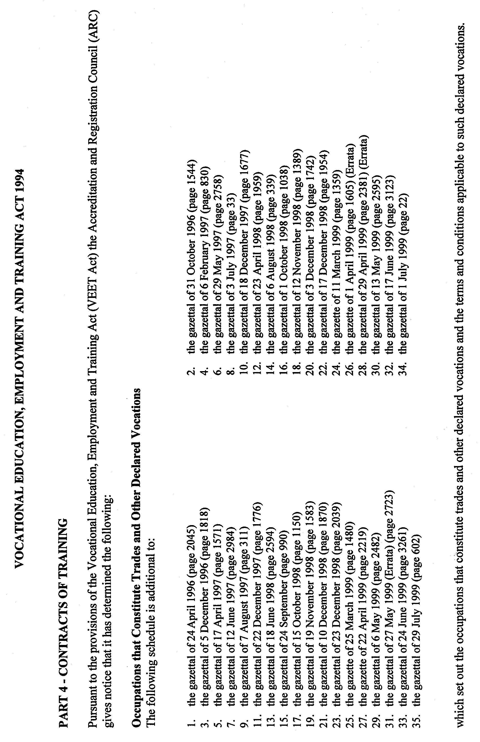
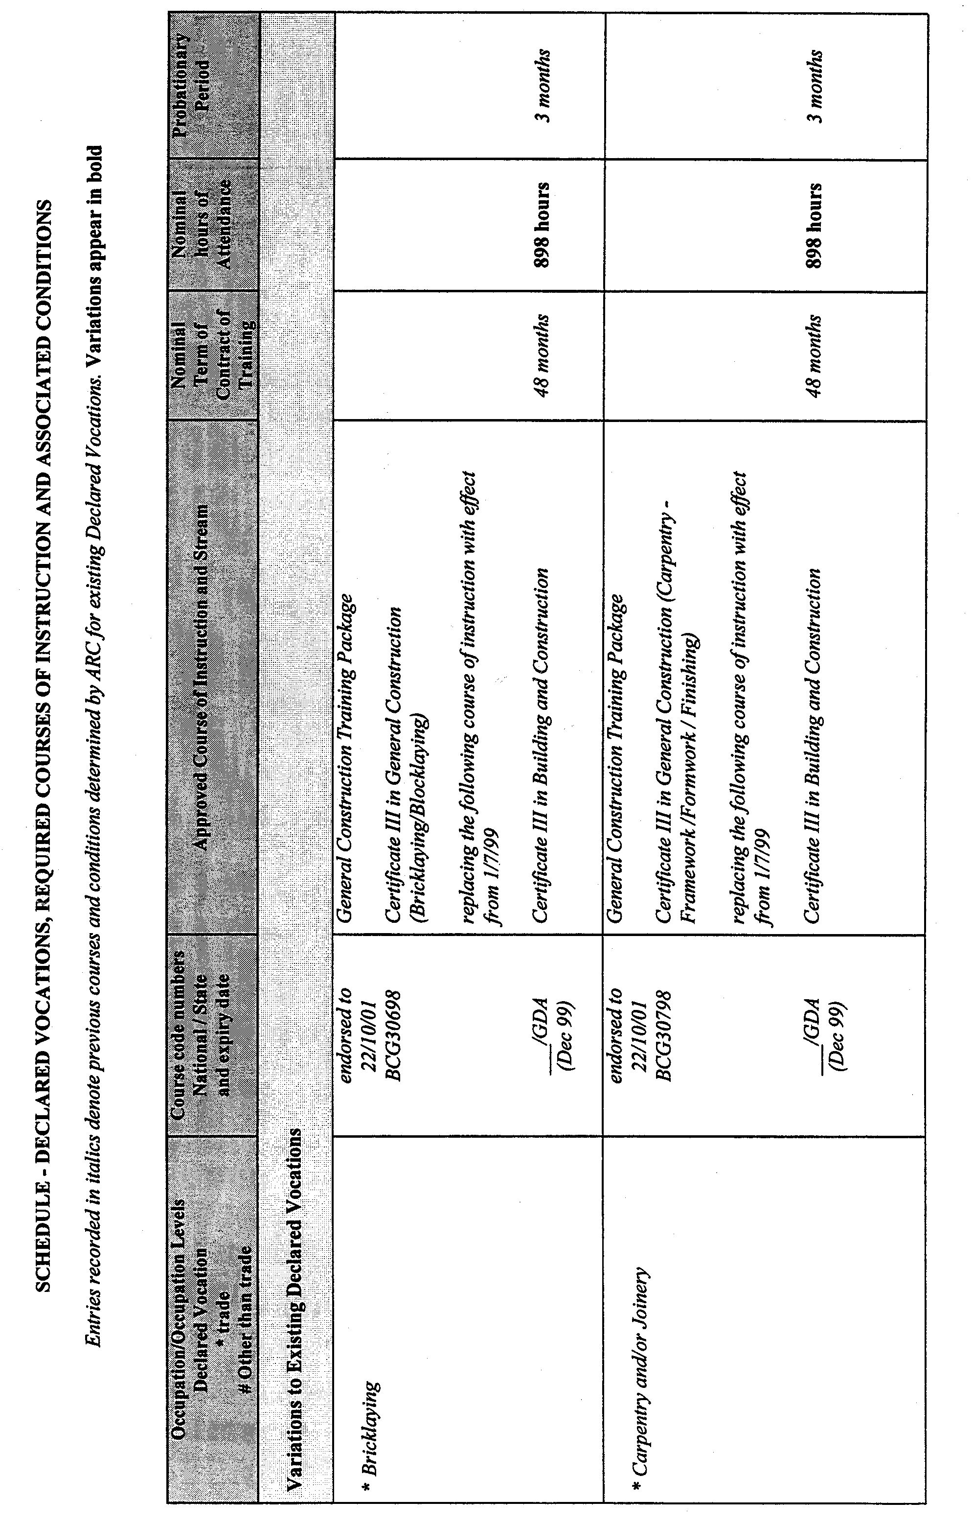
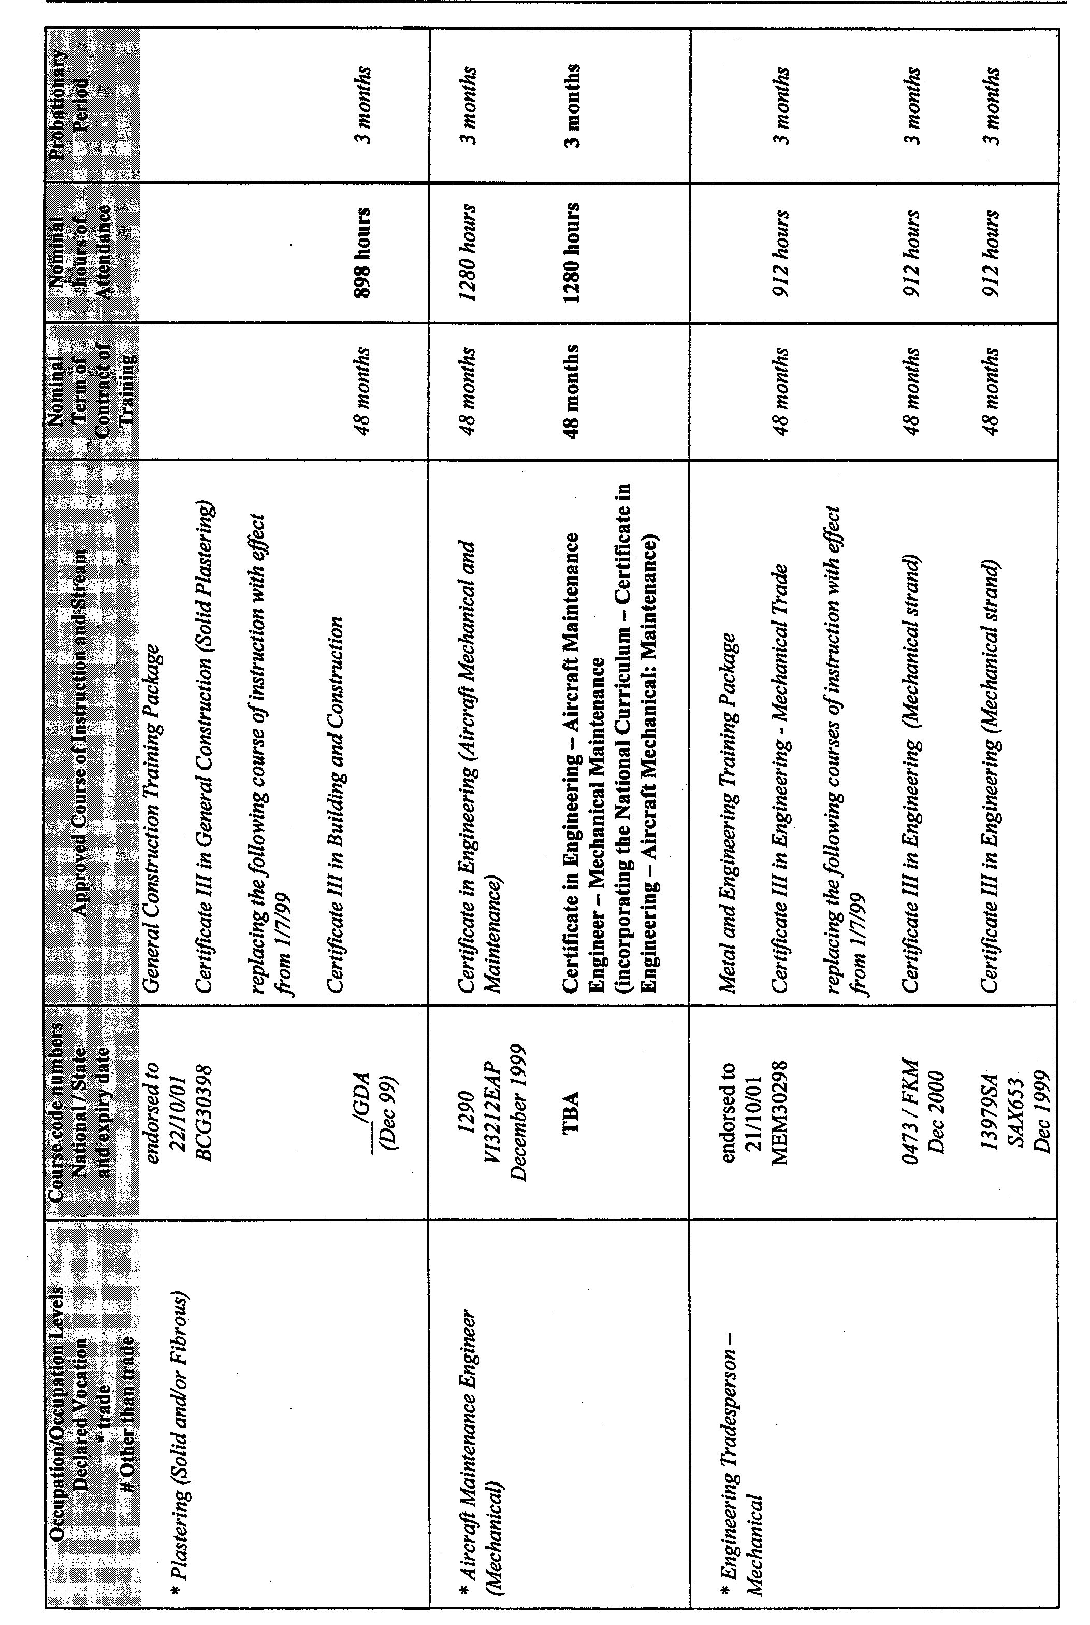
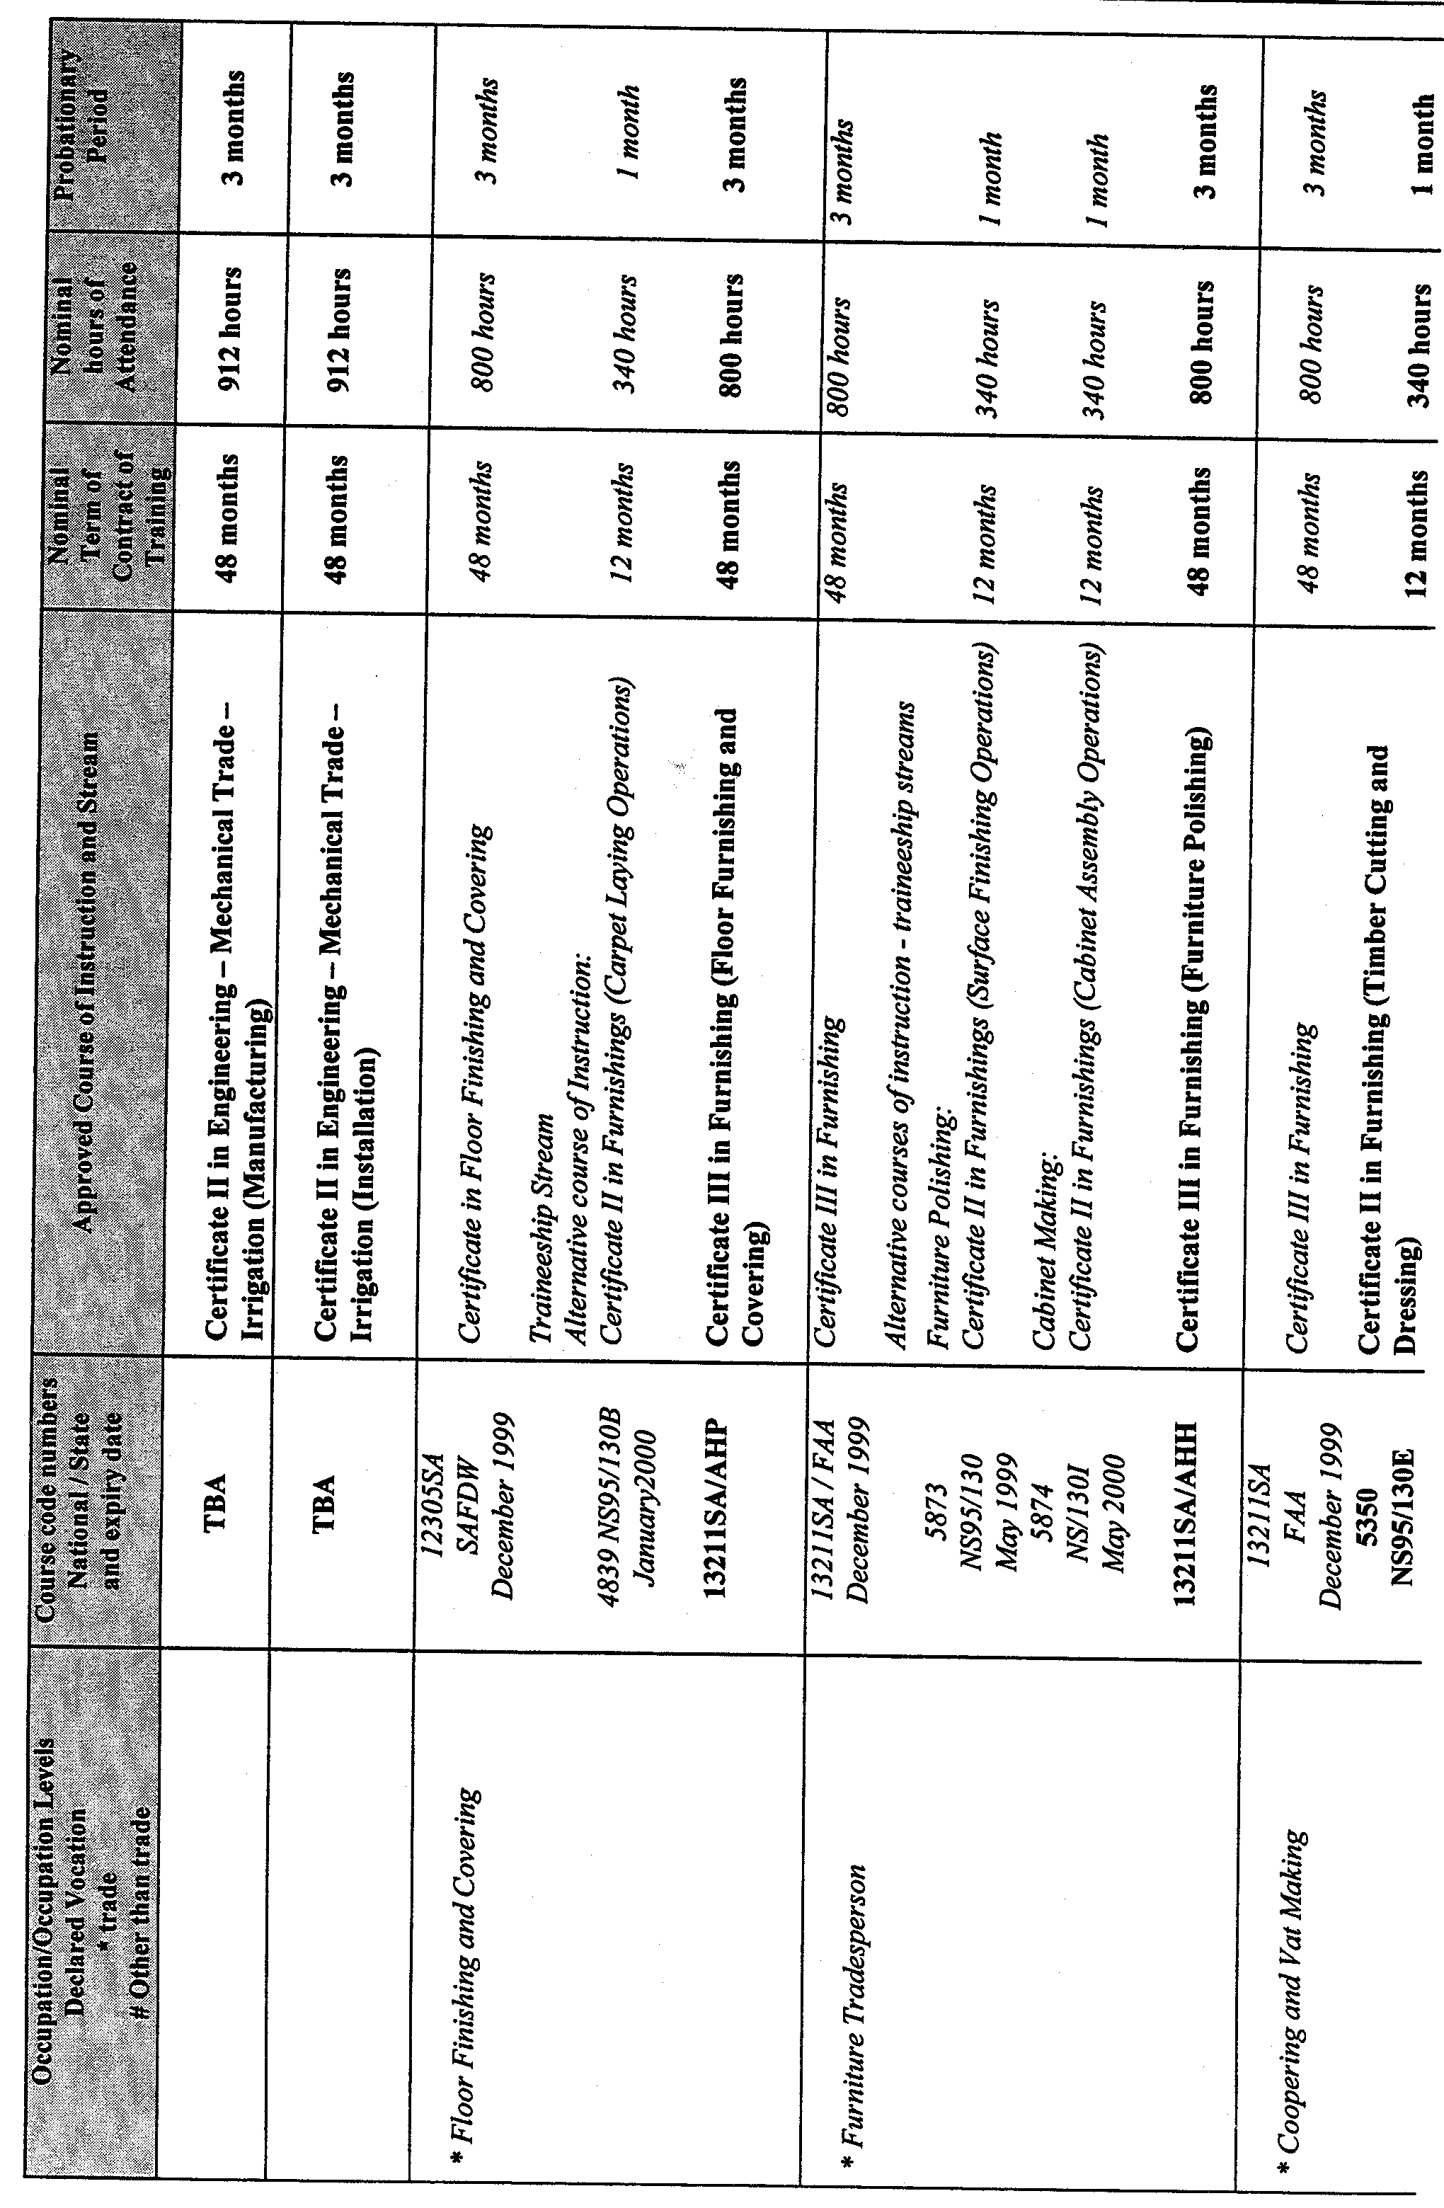
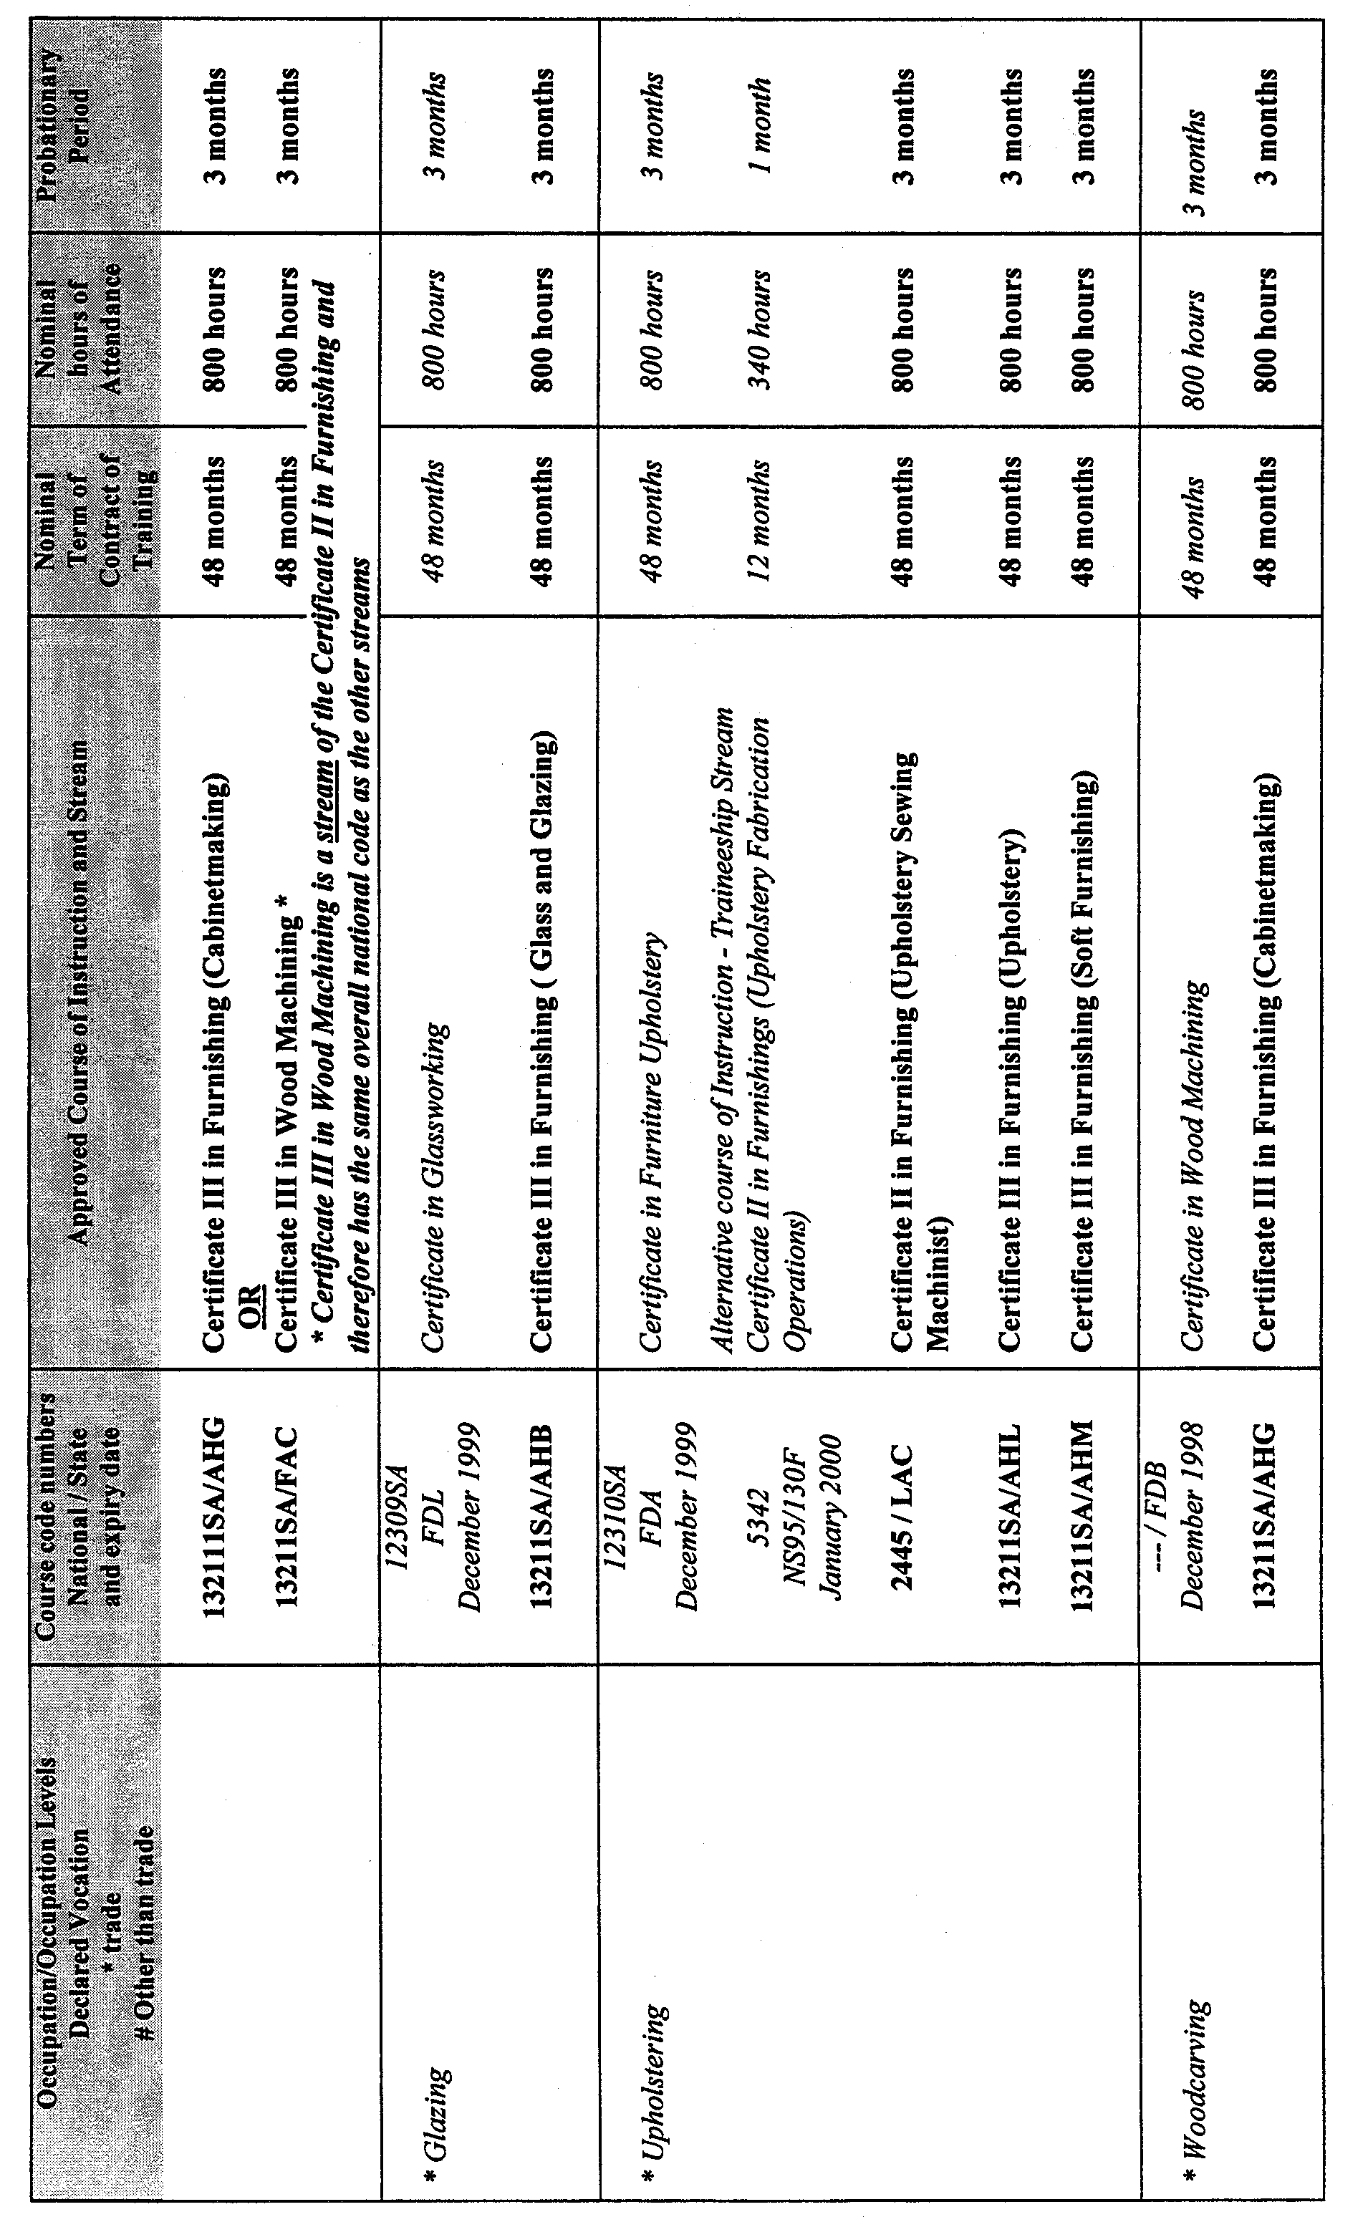
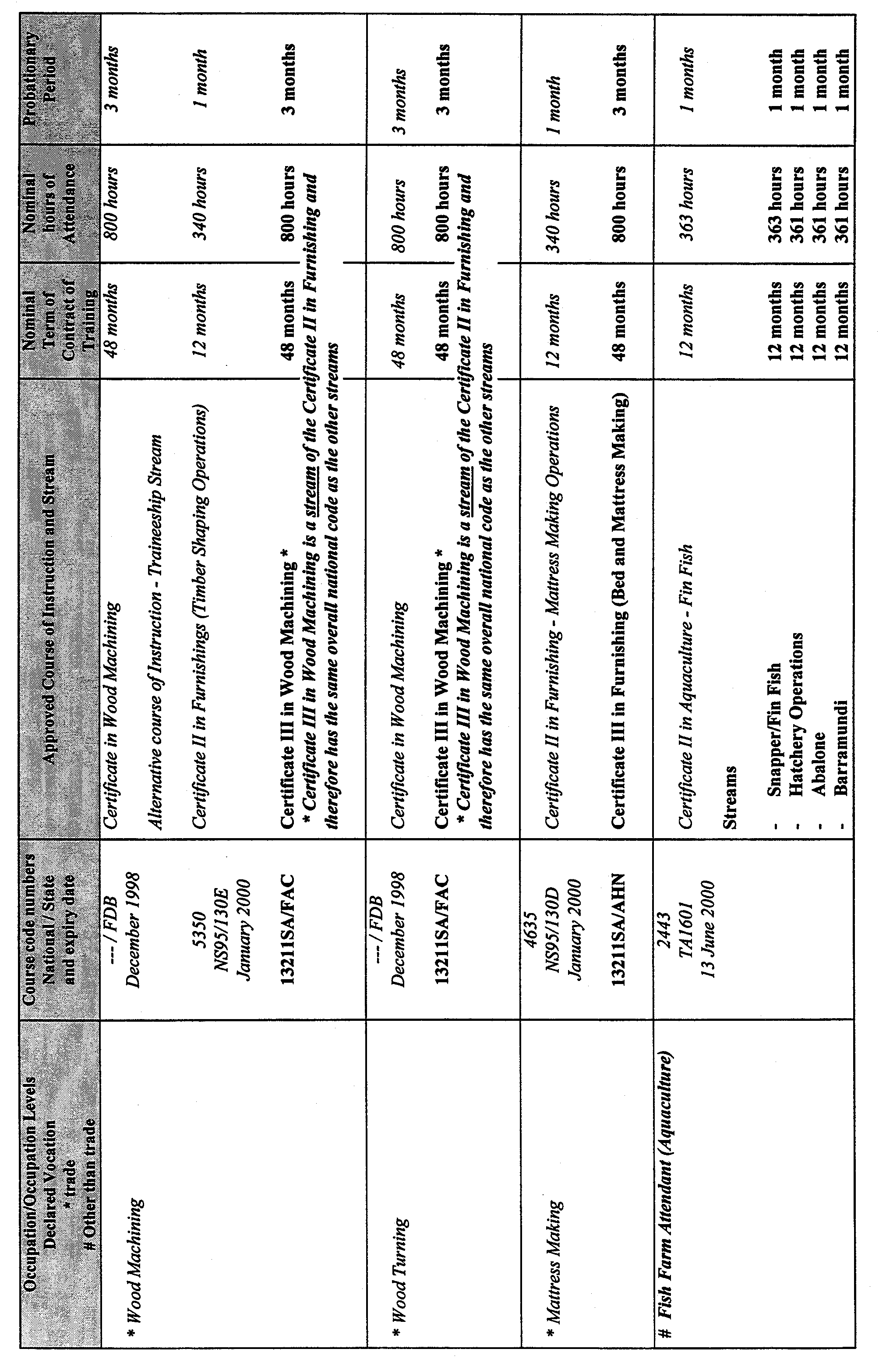
REGULATIONS UNDER THE ELECTRICITY ACT 1996
────
No. 195 of 1999
────
At the Executive Council Office at Adelaide 30 September 1999

PURSUANT to the Electricity Act 1996 and with the advice and consent of the Executive Council, I make the following regulations.
E. J. NEAL Governor

PURSUANT to section 10AA(2) of the Subordinate Legislation Act 1978, I certify that, in my opinion, it is necessary or appropriate that the following regulations come into operation as set out below.

ROB LUCAS Treasurer
───────────────────
SUMMARY OF PROVISIONS

1. Citation
2. Commencement
3. Variation of reg. 5A—Interpretation—definition of contestable customer
4. Insertion of reg. 5AB
5AB. Interpretation—definition of electricity supply industry
5. Variation of reg. 5B—Customers of a prescribed class
6. Insertion of Part 1A
PART 1A
ADMINISTRATION
5C. Functions and powers of Industry Regulator
5D. Application of Public Corporations Act 1993 to Electricity Supply Industry Planning Council
7. Variation of reg. 6—Exemptions from requirement to be licensed
8. Insertion of reg. 7A
7A. Consideration of application for licence
9. Insertion of Part 2A
PART 2A
SYSTEM CONTROLLER
7B. Functions and powers of system controller
10. Variation of reg. 10—Quality of electricity supply
11. Variation of reg. 11—General requirements for electricity infrastructure
12. Variation of reg. 12—Aerial lines
13. Variation of reg. 13—Underground lines
14. Variation of reg. 14—Powerlines other than aerial or underground lines
15. Variation of reg. 15—Substations
16. Variation of reg. 16—Earthing and electrical protection systems
17. Variation of reg. 18—Certain electrical installation work and certificates of compliance
18. Insertion of reg. 23A
23A. Work in proximity to exposed conductors, etc.
19. Revocation of reg. 25
20. Variation of reg. 26—Work by direct contact with exposed high voltage conductors, etc.
21. Revocation of reg. 27
22. Variation of reg. 28—Live high voltage line work
23. Variation of reg. 30—Suitability of testing instruments
24. Variation of heading to Part 4 Division 4
25. Variation of reg. 31—Reporting of accidents
26. Insertion of reg. 31A and Part 4 Division 5
31A. Investigation of accidents
DIVISION 5—SAFETY AND TECHNICAL MANAGEMENT PLANS
AND REPORTS
31B. Application of Division
31C. Safety and technical management plan
31D. Safety and technical management reports
27. Revocation of reg. 34
28. Variation of reg. 39—Erection of buildings in proximity to aerial lines
29. Insertion of reg. 39A
39A. Erection of buildings in proximity to underground lines
30. Revocation of Sched. 1
31. Variation of Sched. 2—Requirements for Aerial Lines
32. Variation of Sched. 3—Requirements for Underground Lines and Certain Other Powerlines
33. Variation of Sched. 5—Requirements for Earthing and Electrical Protection Systems

SCHEDULE
Figure to be substituted in Sched. 2 of principal regulations
───────────────────

Citation
1. The Electricity (General) Regulations 1997 (see Gazette 26 June 1997 p. 3144), as varied, are referred to in these regulations as "the principal regulations".

Commencement
2. (1) Subject to this regulation, these regulations will come into operation on the day on which section 23 of the Electricity (Miscellaneous) Amendment Act 1999 comes into operation.

(2) The following regulations will come into operation on the day on which they are made:

regulations 11 to 16 (inclusive)
regulations 18 to 25 (inclusive)
regulation 31A of the principal regulations inserted by regulation 26 of these regulations
regulation 28
regulations 30 to 32 (inclusive)
Schedule.

(3) Regulation 5D of the principal regulations inserted by regulation 6 of these regulations will come into operation on the day on which Division 2 of Part 2 of the Electricity Act 1996 comes into operation.

Variation of reg. 5A—Interpretation—definition of contestable customer
3. Regulation 5A of the principal regulations is varied—

(a) by striking out from subregulation (3)(b) "Technical Regulator" and substituting "Industry Regulator";

(b) by striking out from subregulation (3)(c) "Technical Regulator" twice occurring and substituting, in each case, "Industry Regulator";

(c) by striking out from subregulation (4) "Technical Regulator" and substituting "Industry Regulator".

Insertion of reg. 5AB
4. The following regulation is inserted after regulation 5A of the principal regulations:

Interpretation—definition of electricity supply industry
5AB. For the purposes of the definition of "electricity supply industry" in section 4 of the Act, the provision, operation or maintenance of poles, equipment, fittings or wiring associated with the provision of lighting in a street or other place is an operation of a prescribed kind.

Variation of reg. 5B—Customers of a prescribed class
5. Regulation 5B of the principal regulations is varied—

(a) by striking out "sections 23(1)(b)(i)" and substituting "sections 23(1)(n)(iv), 24(2)(g)";

(b) by inserting after paragraph (e) the following paragraph:

(f) customers to whom electricity must be sold or supplied under a retailer of last resort requirement (see section 23(1)(n)(ix) of the Act).;

(c) by inserting after its present contents, as varied by this regulation (now to be designated as subregulation (1)) the following subregulation:

(2) For the purposes of section 35D(1)(a) of the Act, contestable customers with electricity consumption levels of less than 160 MW.h per year, as determined in accordance with an electricity pricing order under Division 2A of Part 3 of the Act in respect of a single site, are customers of a prescribed class.

Insertion of Part 1A
6. The following Part is inserted after Part 1 of the principal regulations:

PART 1A
ADMINISTRATION

Functions and powers of Industry Regulator
5C. (1) Pursuant to section 6A of the Act, the Industry Regulator has (in addition to the Industry Regulator's functions and powers under the Act and the Independent Industry Regulator Act 1999) the following functions and powers:

(a) to disclose, with the consent of the customer of the holder of a licence authorising the retailing of electricity, the name, address and other contact details from time to time of the customer to the holders of other licences authorising the retailing of electricity;

(b) if the Industry Regulator has agreed in writing to determine matters under a contract between two or more electricity entities at the expense of one or more of the entities—to determine those matters in accordance with the terms of the contract;

(c) subject to subregulation (2), functions and powers conferred on the Jurisdictional Regulator under the National Electricity Code to the extent that those functions and powers are not authorised by the State, pursuant to the National Electricity Code, to be exclusively performed or exercised by some other body or bodies.

(2) The Industry Regulator must only approve a distribution loss factor that has been calculated for the purposes of the National Electricity Code by the holder of a licence authorising the operation of a distribution network if the distribution loss factor—

(a) has been calculated on a State-wide basis by reference to voltage level and proximity of a customer's metering point to a transformer; and

(b) is not related to the relative length of a distribution line involved in supplying electricity to the customer.

(3) Terms defined in an electricity pricing order under Division 2A of Part 3 of the Act have the same meaning when used in subregulation (2).

Application of Public Corporations Act 1993 to Electricity Supply Industry Planning Council
5D. Pursuant to section 6D of the Act, the Public Corporations Act 1993 applies to the Electricity Supply Industry Planning Council subject to the following exclusions and modifications:

(a) section 13 of that Act does not apply;

(b) section 19 of that Act is modified in its application to a director appointed after consultation under section 6G(3b) of the Act with licensees of a particular class so that—

(i) nothing in the section is to be taken to prevent the director from representing the interests of licensees of that class and participating in meetings or discussions and voting accordingly; and

(ii) a general disclosure of an interest that the director has by reason of his or her relationship with a licensee of that class will be sufficient disclosure of the interest for the purposes of the section if made in advance in a general form.

Variation of reg. 6—Exemptions from requirement to be licensed
7. Regulation 6 of the principal regulations is varied—

(a) by striking out paragraph (c) of subregulation (1) and substituting the following paragraph:

(c) the electricity is generated only for the consumption of either or both of the following:

(i) that person;

(ii) a designated body.;

(b) by striking out subregulations (2) and (3) and substituting the following subregulations:

(2) A person who carries on the operation of a transmission or distribution network is not required to be licensed under the Act if the electricity transmitted or distributed through the network is only for the consumption of one or more of the following:

(a) that person;

(b) others who, in pursuance of rights deriving (whether immediately or otherwise) from that person, occupy or use land or premises served by the network;

(c) a designated body.

(3) A person who carries on retailing of electricity or system control over a power system is not required to be licensed under the Act if the electricity retailed or provided through the power system is only for the consumption of a designated body.

(4) However, a person exempted under this regulation from the requirement to be licensed to carry on operations in the electricity supply industry must comply with any requirement imposed by or under the Act or these regulations as if it were an electricity entity licensed under the Act to carry on those operations.

(5) The Technical Regulator may grant an exemption from subregulation (4), or from specified requirements referred to in that subregulation, on terms and conditions the Technical Regulator considers appropriate.

(6) In this regulation—

"designated body" means a body or group of persons designated by the Minister by notice in the Gazette.

(7) The Minister may, by subsequent notice in the Gazette, vary or revoke a notice under subregulation (6).

Insertion of reg. 7A
8. The following regulation is inserted after regulation 7 of the principal regulations:

Consideration of application for licence
7A. Pursuant to section 17(3)(d) of the Act, the following are prescribed as matters that the Industry Regulator may consider in deciding whether an applicant is a suitable person to hold a licence authorising the retailing of electricity:

(a) whether the applicant holds or has held such a licence;

(b) if the applicant holds such a licence—the duration of contracts for the retailing of electricity entered into by the applicant;

(c) if the applicant holds or has held such a licence—whether the applicant has been guilty of a contravention of a condition of the licence or any other contravention of a requirement imposed by or under the Act in connection with the operations authorised by the licence.

Insertion of Part 2A
9. The following Part is inserted after Part 2 of the principal regulations:

PART 2A
SYSTEM CONTROLLER

Functions and powers of system controller
7B. (1) Pursuant to section 31 of the Act, the functions of a system controller for a power system operated in the National Electricity Market are limited to the following:

(a) when required to do so under the National Electricity (South Australia) Law or any Act, giving appropriate directions to electricity entities that are engaged in the operation of the power system, or contribute electricity to, or take electricity from, the system, for the purposes of maintaining the system in, or restoring it to, a safe and reliable state of operation;

(b) functions or powers performed or exercised as an agent employed by, or pursuant to a contractual arrangement with, NEMMCO under Chapter 4 of the National Electricity Code;

(c) when required to do so under the National Electricity Code, under an agency or contractual arrangement of a kind referred to in paragraph (b) or under any other agreement—

(i) undertaking action to protect such parts of the transmission network as are necessary to maintain the security of the power system;

(ii) managing the interruption of, and coordinating the restoration of, loads placed on the power system;

(iii) taking specified steps to restore the power system to a safe and reliable state of operation;

(iv) monitoring the operation of the power system with a view to ensuring that the system operates safely and reliably;

(v) maintaining voltage control throughout the power system;

(vi) shedding loads placed on the power system to the extent necessary during emergency situations.

(2) A system controller for a power system operated in the National Electricity Market has all powers necessary for, or incidental to, the proper performance of the functions set out in subregulation (1).

(3) In this regulation—

"National Electricity Market" means the market regulated by the National Electricity Law;

"NEMMCO" means National Electricity Market Management Company Limited A.C.N. 072 010 327.

Variation of reg. 10—Quality of electricity supply
10. Regulation 10 of the principal regulations is varied by striking out paragraphs (b) and (c).

Variation of reg. 11—General requirements for electricity infrastructure
11. Regulation 11 of the principal regulations is varied by striking out from subregulation (1) "the proper manner for circuits of that class" and substituting "a safe manner".

Variation of reg. 12—Aerial lines
12. Regulation 12 of the principal regulations is varied by inserting in subregulation (3) "installed after 1 July 1997" after "(including service lines)".

Variation of reg. 13—Underground lines
13. Regulation 13 of the principal regulations is varied by inserting in subregulation (2) "installed after 1 July 1997" after "(including service lines)".

Variation of reg. 14—Powerlines other than aerial or underground lines
14. Regulation 14 of the principal regulations is varied by inserting in subregulation (2) "installed after 1 July 1997" after "powerlines".

Variation of reg. 15—Substations
15. Regulation 15 of the principal regulations is varied by inserting in subregulation (2) "installed after 1 July 1997" after "substations".

Variation of reg. 16—Earthing and electrical protection systems
16. Regulation 16 of the principal regulations is varied by inserting in subregulation (2) "installed after 1 July 1997" after "systems".

Variation of reg. 18—Certain electrical installation work and certificates of compliance
17. Regulation 18 of the principal regulations is varied by striking out subregulations (1) and (2) and substituting the following subregulations:

(1) The following provisions apply for the purposes of section 61(1) of the Act:

(a) work on an electrical installation or proposed electrical installation that is work of any kind referred to in AS 3000 or another Australian Standard called up by AS 3000 must be carried out, and the installation must be examined and tested—

(i) in accordance with AS 3000 and any Australian Standard called up by or under AS 3000 and so that the installation complies with any other technical and safety requirements under these regulations; and

(ii) in accordance with any requirements specified by the operator of the transmission or distribution network to which the installation is or is to be connected;

(b) the registered electrical worker personally carrying out the examinations and tests must, when satisfied that the work has been carried out in accordance with the standards and requirements referred to in paragraph (a) and before the installation is made available for energisation, complete and sign a certificate of compliance in a form approved by the Technical Regulator to that effect;

(c) if the worker signing the certificate was employed or engaged to carry out the examinations and tests (whether or not together with other work on the installation) by a licensed electrical contractor or licensed building work contractor, that contractor, or a person who has or had a supervisory role in relation to the worker and who is acting as a duly authorised agent of the contractor, must, being satisfied that the standards and requirements referred to in paragraph (a) have been complied with in relation to the work, also complete and sign the certificate in accordance with the directions contained in it;

(d) if the work is associated with the making of a connection to a transmission or distribution network, a copy of the certificate (completed and signed in accordance with paragraphs (b) and (c)) must be furnished to the operator of the network before the energisation of the work or a part of the work;

(e) if the work was carried out on behalf of the owner or occupier of the premises concerned (whether under a contract or arrangement made directly between the owner or occupier and the person to whom section 61 of the Act applies, under a subcontract or otherwise), a copy of the certificate (completed and signed in accordance with paragraphs (b) and (c)) must be furnished to the owner or occupier within 30 days after the installation was made available for energisation;

(f) a copy of the certificate (completed and signed in accordance with paragraphs (b) and (c)) must be kept at the business premises of the person to whom section 61 of the Act applies or, if that person does not have business premises, at that person's residence for at least five years after the installation was made available for energisation.

(2) A certificate of compliance may not be relied on by an owner or operator of an electrical installation under section 60(2) of the Act if the certificate has been issued in relation to the installation by a registered electrical worker who is an employee of the owner or occupier.

Insertion of reg. 23A
18. The following regulation is inserted after regulation 23 of the principal regulations:

Work in proximity to exposed conductors, etc.
23A. (1) Work must not be carried out in proximity to exposed conductors or exposed parts of electrical equipment unless—

(a) it is carried out—

(i) by a person who is suitably trained and qualified for such work beyond the approach limits set out in this regulation for such persons; or

(ii) by a person who has been instructed in the identification of high and low voltage overhead conductors and the safety aspects of work near live powerlines beyond the approach limits set out in this regulation for such persons; and

(b) it is carried out beyond the approach limits set out in this regulation that are applicable in the circumstances.

(2) However, a person may work within the approach limits if—

(a) the work can be carried out safely in any of the following circumstances:

(i) there are installed suitable barriers or earthed metal shields between the person carrying out the work and the conductors or electrical equipment;

(ii) the work to be carried out is testing of equipment and the equipment is designed such that the approach limits cannot be complied with;

(iii) the work to be carried out is earthing of the conductors or equipment and is carried out after the exposed conductors have been isolated and proved to be de-energised; and

(b) written instructions have been given, either generally or in a particular case, about the work and the precautions to be taken.

(3) For the purposes of this regulation, the approach limits for a person, including an article of clothing worn by a person, or a conductive object held or carried by the person, are set out below—
Voltage of conductor or equipment | Approach limit A | Approach limit B | Approach limit C
 |  |  | (i) | (ii)
 | (Distance in metres)
Not more than 1000V | 0 | 0.3 | 3.0 | 1.0
More than 1000V but not more than 11kV | 0.3 | 0.6 | 3.0 | 2.0
More than 11kV but not more than 33kV | 0.45 | 0.9 | 3.0 | 3.0
66kV | 0.7 | 1.4 | 4.0 | 4.0
132kV | 1.2 | 2.4 | 5.0 | 5.0
275kV | 2.0 | 4.0 | 6.0 | 6.0

where—

(a) approach limit A applies to a person suitably qualified and trained to work in proximity to exposed high and low voltage conductors or exposed parts of high and low voltage electrical equipment;

(b) approach limit B applies to a person who has been instructed in the identification of high and low voltage overhead conductors and the safety aspects of work near live powerlines;

(c) approach limit C(i) applies to a person using power operated tools;

(d) approach limit C(ii) applies to a person using manually operated tools.

Revocation of reg. 25
19. Regulation 25 of the principal regulations is revoked.

Variation of reg. 26—Work by direct contact with exposed high voltage conductors, etc.
20. Regulation 26 of the principal regulations is varied by striking out from subregulation (1) "Work may be carried out by direct contact if" and substituting "Work must not be carried out by direct contact with exposed high voltage conductors or exposed parts of high voltage electrical equipment unless".

Revocation of reg. 27
21. Regulation 27 of the principal regulations is revoked.

Variation of reg. 28—Live high voltage line work
22. Regulation 28 of the principal regulations is varied by inserting in subregulation (1) "high voltage" after "live parts of".

Variation of reg. 30—Suitability of testing instruments
23. Regulation 30 of the principal regulations is varied—

(a) by striking out from paragraph (a) "test" and substituting "testing";

(b) by inserting in paragraph (c) "on testing instruments" after "performed".

Variation of heading to Part 4 Division 4
24. The heading to Division 4 of Part 4 is varied by inserting "AND INVESTIGATION" after "REPORTING".

Variation of reg. 31—Reporting of accidents
25. Regulation 31 of the principal regulations is varied by inserting after its present contents (now to be designated as subregulation (1)) the following subregulation:

(2) An electricity entity or person who is required to report an accident in accordance with section 63 of the Act must provide the Technical Regulator with such further details of the accident as the Technical Regulator reasonably requires.

Insertion of reg. 31A and Part 4 Division 5
26. The following regulation and Division are inserted after regulation 31 of the principal regulations:

Investigation of accidents
31A. (1) An electricity entity that operates a transmission or distribution network must promptly investigate any accident that involves electric shock that may have been caused by the operation or condition of the transmission or distribution network or an electrical installation connected to the network and report the results of the investigation to the Technical Regulator in the form, and containing the details, required by the Technical Regulator.

(2) If in the course of an investigation under subregulation (1) it is determined that the electric shock was caused by an electrical installation connected to the network, the electricity entity must report that result to the Technical Regulator and need not proceed further with the investigation.

DIVISION 5—SAFETY AND TECHNICAL MANAGEMENT PLANS
AND REPORTS

Application of Division
31B. (1) This Division applies to a licensee holding a licence authorising the generation of electricity or the operation of a transmission or distribution network or a person exempted from the requirement to hold such a licence.

(2) However, the Technical Regulator may grant an exemption from this Division, or specified provisions of this Division, on terms and conditions the Technical Regulator considers appropriate.

Safety and technical management plan
31C. (1) A person to whom this Division applies who is exempted from the requirement to hold a licence must, if so required by the Technical Regulator by notice in writing—

(a) prepare and periodically revise a safety and technical management plan dealing with matters prescribed by subregulation (2);

(b) obtain the approval of the Technical Regulator to the plan and any revision;

(c) comply with the plan as approved from time to time;

(d) audit from time to time the person's compliance with the plan and report the results of those audits to the Technical Regulator.

(2) For the purposes of sections 22(1)(c) and 23(1)(c) of the Act and subregulation (1), the following are matters that must be dealt with by a safety and technical management plan:

(a) the safe design, installation, commissioning, operation, maintenance and decommissioning of electricity infrastructure owned or operated by the person;

(b) the maintenance of a supply of electricity of the quality required to be maintained by or under the Act, these regulations, the person's licence or the conditions of any exemption granted to the person;

(c) the implementation and conduct of safety measures and training programs for the purpose of—

(i) reducing the risk of death or injury, or damage to property, arising out of the operation of electricity infrastructure owned or operated by the person;

(ii) ensuring that employees performing work in respect of electricity infrastructure owned or operated by the person are competent and properly trained, perform their work safely and are provided with a safe system of work;

(d) ensuring that contractors performing work in respect of electricity infrastructure owned or operated by the person have processes and procedures for ensuring that the persons personally performing the work are competent and properly trained, perform their work safely and are provided with a safe system of work;

(e) the manner in which accidents and unsafe situations are to be dealt with, reported and investigated;

(f) monitoring compliance with safety and technical requirements imposed by or under the Act, these regulations, the person's licence or the conditions of any exemption granted to the person;

(g) monitoring electricity infrastructure owned or operated by the person for the purposes of identifying infrastructure that is unsafe or at risk of failing or malfunctioning;

(h) in the case of a person who operates a transmission or distribution network—

(i) monitoring compliance with requirements for vegetation clearance;

(ii) the communication of information to the public for the purpose of reducing the risk of death or injury, or damage to property, arising out of the operation of electricity infrastructure owned or operated by the person;

(iii) the communication of information to existing and potential customers about the facilities that customers must provide for connection to the network and procedures that customers must follow in order to prevent damage to or interference with the network.

(3) A person to whom this Division applies must, at the request of the Technical Regulator, provide the Technical Regulator with such information and access to such officers, employees and contractors as the Technical Regulator reasonably requires for the purposes of determining whether a safety and technical management plan prepared by the person is operating effectively and whether that person is complying with the plan.

Safety and technical management reports
31D. (1) A person to whom this Division applies who operates a transmission or distribution network must, within 21 working days after the end of each month, lodge with the Technical Regulator a report—

(a) stating in relation to each unplanned interruption to the supply of electricity during that month that—

(i) affected the supply of electricity to customers such that the aggregate of the periods for which the customers' supply was affected exceeded 120 000 minutes; or

(ii) affected for 30 minutes or more the supply of electricity to one or more customers with a demand of greater than 1 MVA,

the following:

(iii) the date, time and cause of the interruption;

(iv) the number of customers affected by the interruption;

(v) the time taken to restore supply to all of the customers affected;

(vi) the time taken to restore supply to the majority of the customers affected;

(b) stating in relation to all unplanned interruptions to the supply of electricity during that month and in relation to each region as defined by the Technical Regulator—

(i) the aggregate of the periods for which customers' supply was affected by the interruptions; and

(ii) the average time taken to restore supply to all of the customers affected.

(2) Subclause (1) does not apply in relation to—

(a) an interruption to the supply of electricity to a customer if the interruption was in accordance with an interruptible or curtailable supply contract with the customer; or

(b) an interruption to the supply of electricity to a customer that occurred at the request of the customer or that was caused by the customer; or

(b) an interruption that was rectified by an automatic supply restoration operation.

(3) A person to whom this Division applies must, on or before 31 August in each year, lodge with the Technical Regulator a report relating to the previous financial year containing the following information:

(a) a general description of the circumstances in which electricity infrastructure owned or operated by the person has failed or malfunctioned or been found to be unsafe and of the action taken to rectify, or to prevent or minimise the risk or recurrence of, the failure, malfunction or unsafe situation;

(b) the total costs actually incurred to maintain, repair and replace electricity infrastructure owned or operated by the person, together with an estimate of the total costs likely to be incurred for those purposes in the financial year following that to which the report relates;

(c) whether the person has been able to comply with all aspects of the person's safety and technical management plan and whether the person considers the plan to have been operating effectively.

Revocation of reg. 34
27. Regulation 34 of the principal regulations is revoked.

Variation of reg. 39—Erection of buildings in proximity to aerial lines
28. Regulation 39 of the principal regulations is varied by inserting after subregulation (1) the following subregulation:

(1a) Despite regulation 12(3), for the purposes of subregulation (1)(b) the distances set out in Table 1 in Schedule 2 apply in relation to aerial lines whether installed before, on or after 1 July 1997.

Insertion of reg. 39A
29. The following regulation is inserted after regulation 39 of the principal regulations:

Erection of buildings in proximity to underground lines
39A. (1) For the purposes of section 86 of the Act, a person must not, except as approved by the Technical Regulator, erect a building or structure—

(a) above or below an underground powerline; or

(b) within the prescribed distance of an underground powerline measured from vertical planes extending above and below each outer edge of the conductor comprising the powerline or, in the case of a powerline that consists of more than one conductor, each outer edge of each outer conductor.

(2) Before giving approval under subregulation (1), the Technical Regulator must consult with the electricity entity operating the underground powerline.

(3) In this regulation—

"prescribed distance" means—

(a) in relation to an underground powerline designed to operate at a voltage of 33kV or less—2 metres;

(b) in any other case—3 metres.

Revocation of Sched. 1
30. Schedule 1 of the principal regulations is revoked.

Variation of Sched. 2—Requirements for Aerial Lines
31. Schedule 2 of the principal regulations is varied—

(a) by striking out paragraph (a) of clause 10(4) and substituting the following paragraphs:

(a) for all aerial lines constructed to operate at a voltage of 33kV or less (other than "facade mounted lines", ie, lines attached to buildings)—so that the distance from any building or structure (other than a support to which a line under consideration is attached or a support of another overhead line which crosses the line under consideration) to any position to which a conductor in the aerial line may sag at maximum design temperature or move as a result of normal prevailing wind pressures is not less than the relevant distance set out in Table 1 (Figure 1 is to be used to assist in understanding the information contained in Table 1.);

(ab) for all aerial lines constructed to operate at a voltage of more than 33kV (other than "facade mounted lines", ie, lines attached to buildings)—so that the distance from any building or structure (other than a support to which a line under consideration is attached or a support of another overhead line which crosses the line under consideration) to the centre of any pole which supports the aerial line is not less than the relevant distance set out in Table 1 (Figure 1 is to be used to assist in understanding the information contained in Table 1.);;

(b) by striking out Figure 1 and substituting the figure set out in the Schedule of these regulations.

Variation of Sched. 3—Requirements for Underground Lines and Certain Other Powerlines
32. Schedule 3 of the principal regulations is varied—

(a) by striking out the definition of "listed standards" from clause 1 and substituting the following definition:

"listed standards" means the standards (both national and international), codes, guides and other documents listed in the Appendix at the end of this Schedule as published as referred to in the Appendix or, if no such reference is included in the Appendix, as published from time to time.;

(b) by striking out from the Appendix—

Code of Practice for the coordination of work and allocation of
space on roads and footpaths for underground and overhead
services (PUACC guidelines)

and substituting—

Services in Streets—A Code for the Placement of Infrastructure
Services in New and Existing Streets
(prepared for P.U.A.C.C. and published September 1997)

Variation of Sched. 5—Requirements for Earthing and Electrical Protection Systems
33. Schedule 5 of the principal regulations is varied by striking out from the Appendix—

Substations, earthing guide ESAA EG1.

SCHEDULE
Figure to be substituted in Sched. 2 of principal regulations

FIGURE 1
1. Figure 1 illustrates the application of Table 1 to a particular structure. The letters A to D refer to distances A to D as set out in Table 1. The letter G refers to distance to ground of insulated cables.

2. The clearances specified in A and B of Table 1 must be maintained above a horizontal line extending outward for the distance specified in C from the outer extremities of those parts of any building or structure on which a person can stand.

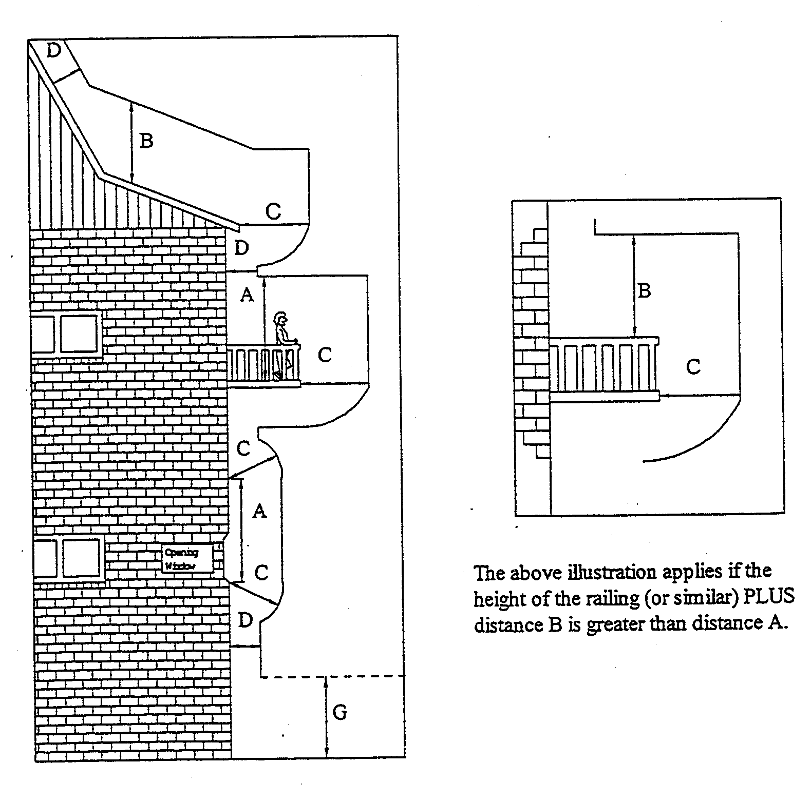

T&F 80/99 CS R. DENNIS Clerk of the Council

REGULATIONS UNDER THE LIQUOR LICENSING ACT 1997
────
No. 196 of 1999
────
At the Executive Council Office at Adelaide 30 September 1999

PURSUANT to the Liquor Licensing Act 1997 and with the advice and consent of the Executive Council, I make the following regulations.
E. J. NEAL Governor

PURSUANT to section 10AA(2) of the Subordinate Legislation Act 1978, I certify that, in my opinion, it is necessary or appropriate that the following regulations come into operation as set out below.

K. T. GRIFFIN Minister for Consumer Affairs
───────────────────
SUMMARY OF PROVISIONS

1. Citation
2. Commencement
3. Variation of Sched. 1—Short Term Dry Areas
4. Variation of Sched. 2—Plans of Short Term Dry Areas
───────────────────

Citation
1. The Liquor Licensing (Dry Areas—Short Term) Regulations 1997 (see Gazette 2 October 1997 p. 965), as varied, are referred to in these regulations as "the principal regulations".

Commencement
2. These regulations come into operation on the day on which they are made.

Variation of Sched. 1—Short Term Dry Areas
3. Schedule 1 of the principal regulations is varied by inserting after the item headed "Normanville—Area 1" the following items:

Port Augusta—Area 1
(see schedule 2 : Port Augusta—Plan 1)

Area | Period | Extent of prohibition
The area in Port Augusta bounded on the north by Flinders Terrace, on the west by Victoria Parade, on the south by Carlton Parade and on the east by Augusta Terrace, together with the footpaths of Flinders Terrace, Victoria Parade, Carlton Parade and Augusta Terrace immediately abutting that area. | 12.01 a.m. on 1 October 1999 to 12.01 a.m. on 6 October 1999. | The consumption of liquor is prohibited and the possession of liquor is prohibited.

Port Augusta—Area 2
(see schedule 2 : Port Augusta—Plan 2)

Area | Period | Extent of prohibition
The area in Port Augusta bounded on the south by Artlett Avenue, on the west and north by William Street (and the walkway connecting William Street with Railway Parade) and on the east by Railway Parade and Hospital Road, together with the footpaths of Artlett Avenue, William Street, Railway Parade and Hospital Road (and the whole of the walkway connecting William Street with Railway Parade) immediately abutting that area. | 12.01 a.m. on 1 October 1999 to 12.01 a.m. on 6 October 1999. | The consumption of liquor is prohibited and the possession of liquor is prohibited.

Variation of Sched. 2—Plans of Short Term Dry Areas
4. Schedule 2 of the principal regulations is varied by inserting after the plan headed "Normanville—Plan 1" the following plans:

Port Augusta—Plan 1

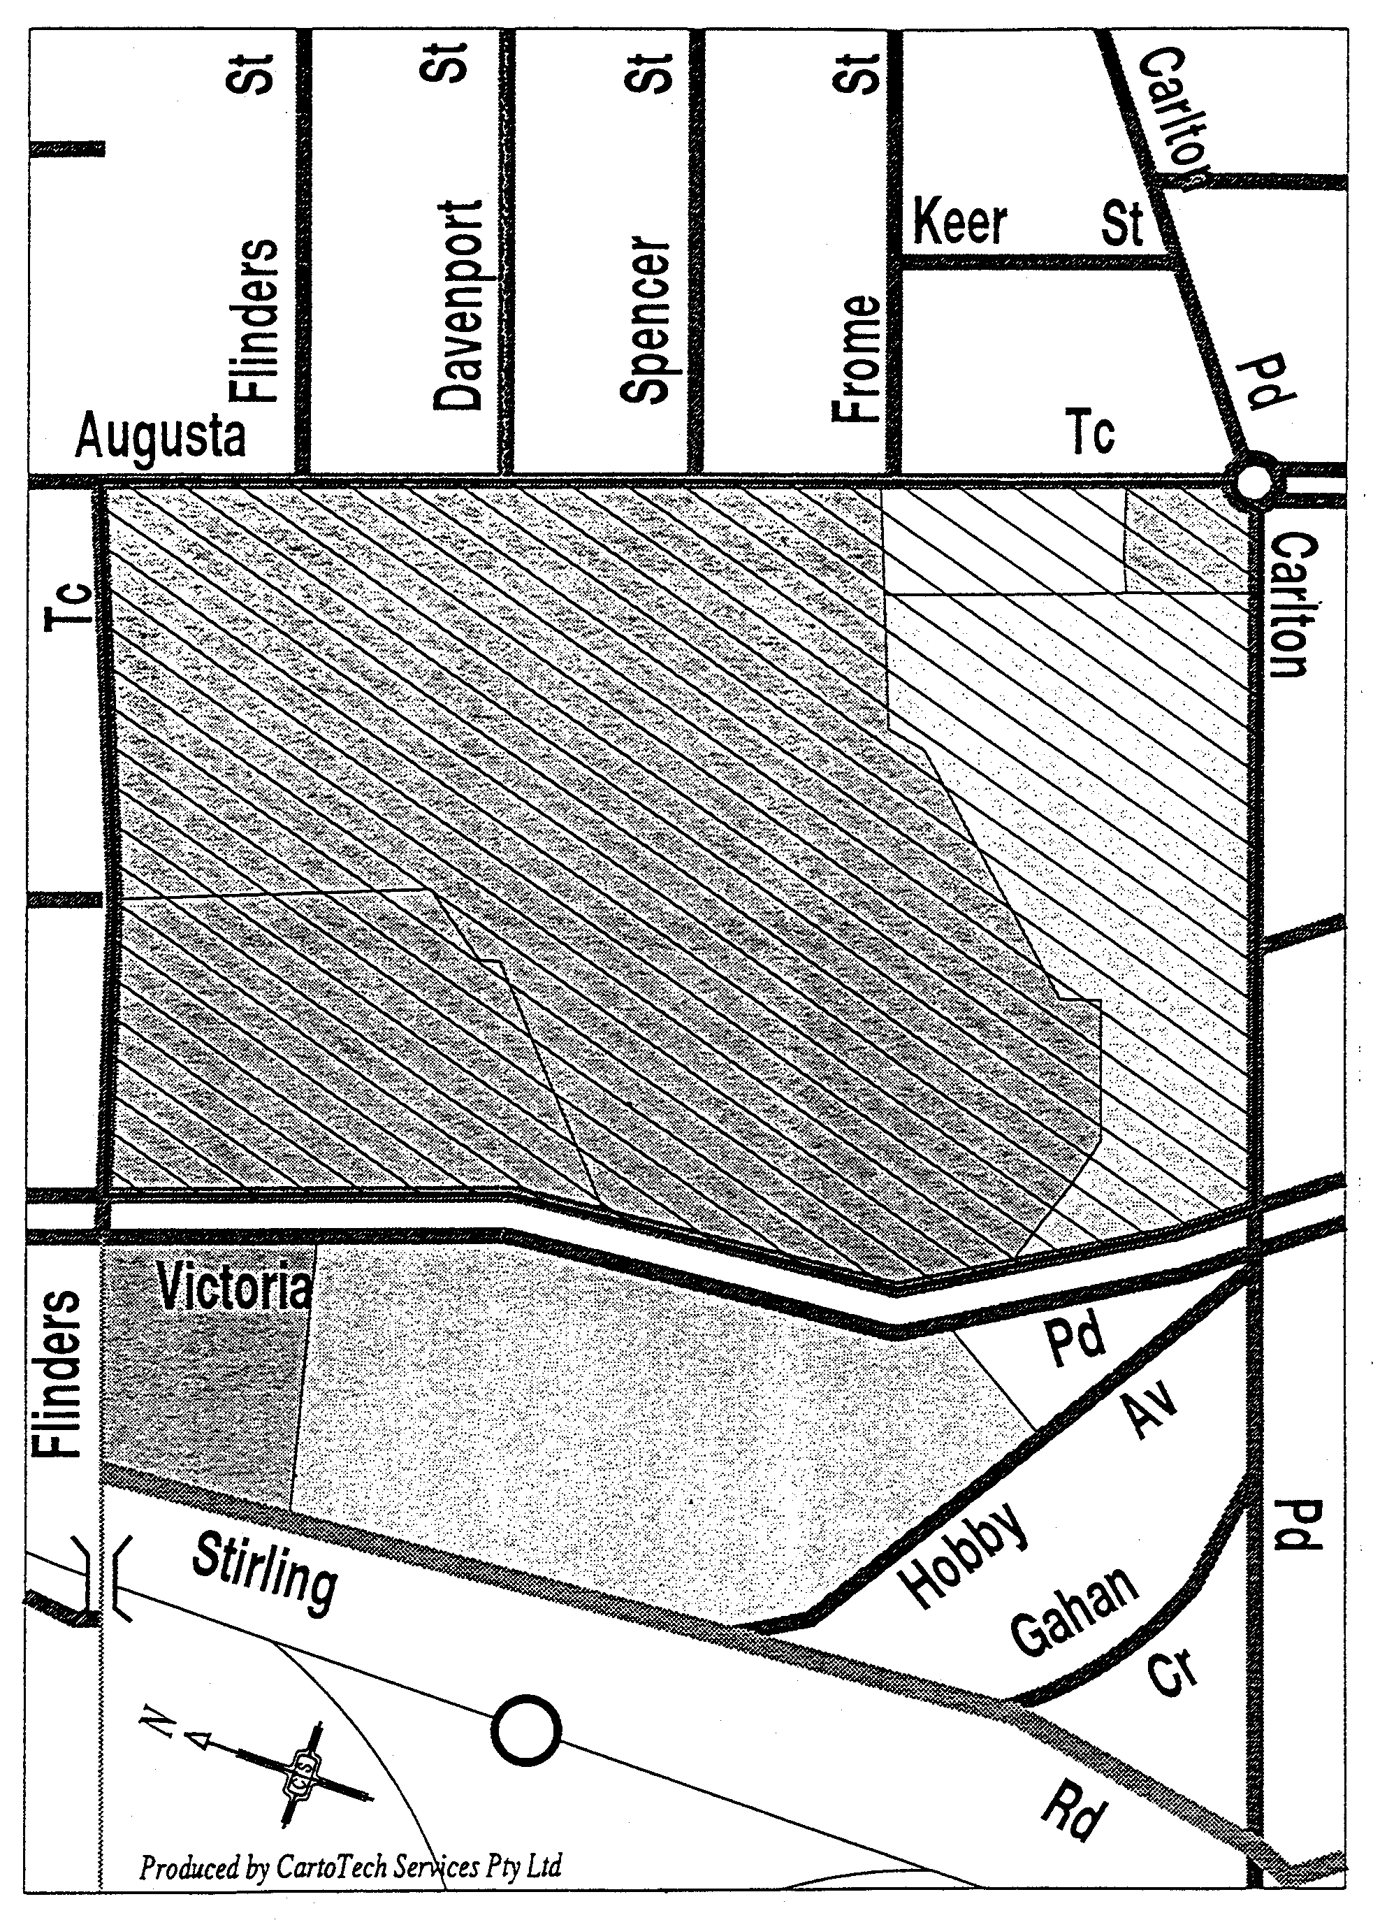
Port Augusta—Plan 2
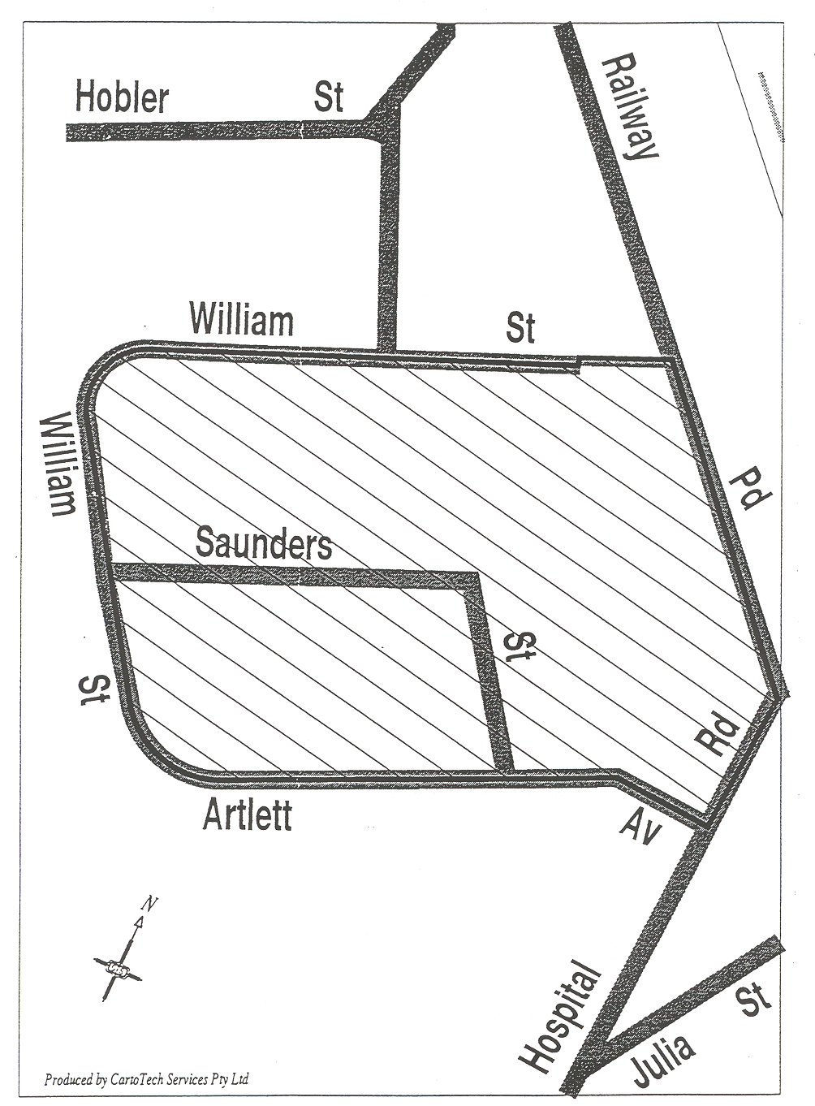

LL 2/94 CS R. DENNIS Clerk of the Council

REGULATIONS UNDER THE REAL PROPERTY ACT 1886
────
No. 197 of 1999
────
At the Executive Council Office at Adelaide 30 September 1999

PURSUANT to the Real Property Act 1886 and with the advice and consent of the Executive Council, I make the following regulations.
E. J. NEAL Governor

PURSUANT to section 10AA(2) of the Subordinate Legislation Act 1978, I certify that, in my opinion, it is necessary or appropriate that the following regulations come into operation as set out below.

K. T. GRIFFIN Attorney-General
───────────────────
SUMMARY OF PROVISIONS

1. Citation
2. Commencement
3. Variation of reg. 4—Interpretation
4. Variation of Schedule—Fees
───────────────────

Citation
1. The Real Property (Fees) Regulations 1991 (see Gazette 27 June 1991 p. 2219), as varied, are referred to in these regulations as "the principal regulations".

Commencement
2. These regulations come into operation on the day on which they are made.

Variation of reg. 4—Interpretation
3. Regulation 4 of the principal regulations is varied by inserting the following definition after the definition of "the Act":

"the Mount Lofty Catchment Area" means the part of the State delineated in G.R.O. Plan No. 180 of 1992 and described in that plan as "Water Supply Protection Zone".

Variation of Schedule—Fees
4. The Schedule of the principal regulations is varied—

(a) by striking out item 9 and substituting the following item:

9. Unless otherwise specified—

(a) (except where paragraph (b) applies) for the issue of a new certificate
of title or a substituted lessee's copy of a Crown lease or duplicate
certificate of title 49

(b) for the issue of a new certificate of title on the amalgamation of allotments
wholly within the Mount Lofty Catchment Area no fee;

(b) by striking out item 12 and substituting the following item:

12. For the deposit or acceptance for filing by the Registrar-General—

(a) of a plan of amalgamation of allotments wholly within the Mount Lofty
Catchment Area no fee

(b) of any other plan 82;

(c) by inserting after "data plan" in paragraph (b) of item 13 "(except a plan of a kind referred to in paragraph (ba))";

(d) by inserting the following paragraph after paragraph (b) of item 13:

(ba) of an uncertified data plan lodged with or submitted to the Registrar-General
for the amalgamation of allotments wholly within the Mount Lofty Catchment
Area no fee.

AG 78/93 CS R. DENNIS Clerk of the Council

REGULATIONS UNDER THE REAL PROPERTY ACT 1886
────
No. 198 of 1999
────
At the Executive Council Office at Adelaide 30 September 1999

PURSUANT to the Real Property Act 1886 and with the advice and consent of the Executive Council, I make the following regulations.
E. J. NEAL Governor

PURSUANT to section 10AA(2) of the Subordinate Legislation Act 1978, I certify that, in my opinion, it is necessary or appropriate that the following regulations come into operation as set out below.

K. T. GRIFFIN Attorney-General
───────────────────
SUMMARY OF PROVISIONS

1. Citation
2. Commencement
3. Variation of reg. 4—Interpretation
4. Variation of Sched. 1—Fees
───────────────────

Citation
1. The Real Property (Land Division) Regulations 1995 (see Gazette 31 August 1995 p. 616), as varied, are referred to in these regulations as "the principal regulations".

Commencement
2. These regulations come into operation on the day on which they are made.

Variation of reg. 4—Interpretation
3. Regulation 4 of the principal regulations is varied by inserting the following definition after the definition of "the Act":

"the Mount Lofty Catchment Area" means the part of the State delineated in G.R.O. Plan No. 180 of 1992 and described in that plan as "Water Supply Protection Zone".

Variation of Sched. 1—Fees
4. Schedule 1 of the principal regulation is varied—

(a) by striking out "The fee" from clause 2 and substituting "Subject to clause 3, the fee";

(b) by inserting the following clause after clause 2:

3. There is no fee for an application for the amalgamation of allotments that are wholly within the Mount Lofty Catchment Area.

AG 78/93 CS R. DENNIS Clerk of the Council

REGULATIONS UNDER THE HARBORS AND NAVIGATION ACT 1993
────
No. 199 of 1999
────
At the Executive Council Office at Adelaide 30 September 1999

PURSUANT to the Harbors and Navigation Act 1993 and with the advice and consent of the Executive Council, I make the following regulations.
E. J. NEAL Governor

PURSUANT to section 10AA(2) of the Subordinate Legislation Act 1978, I certify that, in my opinion, it is necessary or appropriate that the following regulations come into operation as set out below.

DIANA LAIDLAW Minister for Transport and Urban Planning
───────────────────
SUMMARY OF PROVISIONS

1. Citation
2. Commencement
3. Variation of Schedule 4
4. Variation of Schedule 5
───────────────────
Citation
1. The Harbors and Navigation Regulations 1994 (see Gazette 20 October 1994 p. 987), as varied, are referred to in these regulations as "the principal regulations".

Commencement
2. These regulations will come into operation on 1 November 1999.

Variation of Schedule 4
3. Schedule 4 of the principal regulations is varied by inserting alphabetically in the table in clause 2 the following:

Robe | Controls 3 and 5

Variation of Schedule 5
4. Schedule 5 of the principal regulations is varied by inserting alphabetically the following item:

Robe

The portion of the sea at Robe bounded as follows:

⋅ on the west by a straight line being the production seaward of the western boundary of Bagot Street;

⋅ on the east by a straight line extending seaward in a northerly direction from Robe Point;

⋅ on the south by high water mark;

⋅ on the north by a line approximately 200 metres seaward of, and parallel to, high water mark.

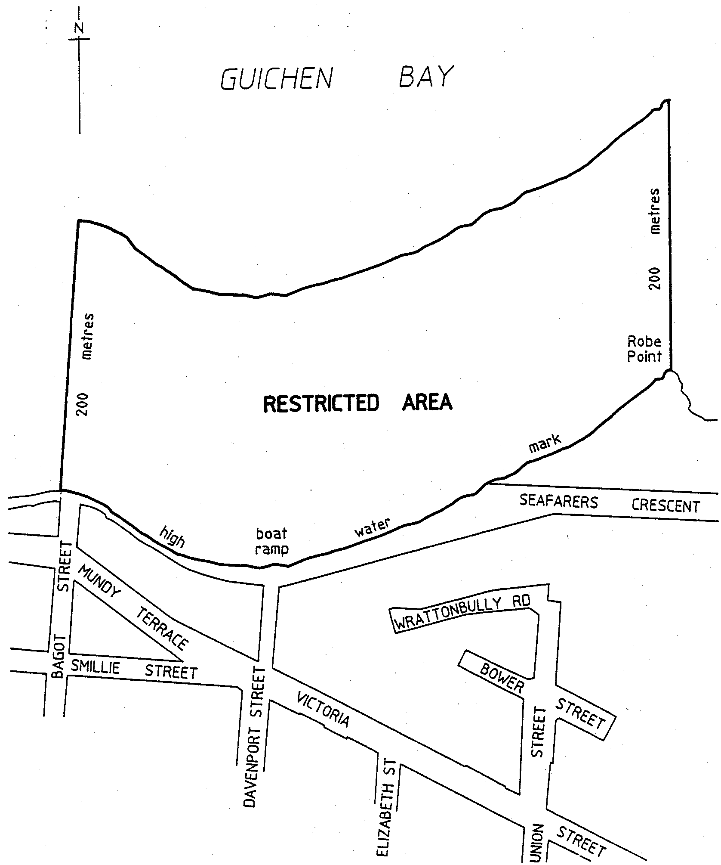

MTUP 15055/96 CS R. DENNIS Clerk of the Council

REGULATIONS UNDER THE LAND AND BUSINESS
(SALE AND CONVEYANCING) ACT 1994
────
No. 200 of 1999
────
At the Executive Council Office at Adelaide 30 September 1999

PURSUANT to the Land and Business (Sale and Conveyancing) Act 1994 and with the advice and consent of the Executive Council, I make the following regulations.
E. J. NEAL Governor

PURSUANT to section 10AA(2) of the Subordinate Legislation Act 1978, I certify that, in my opinion, it is necessary or appropriate that the following regulations come into operation as set out below.

K. T. GRIFFIN Minister for Consumer Affairs
───────────────────
SUMMARY OF PROVISIONS

1. Citation
2. Commencement
3. Variation of Schedule 1—Contracts for Sale of Land or Businesses—Forms
4. Variation of Schedule 2—Contracts for Sale of Land or Businesses—Bodies to whom Inquiries are to be made
───────────────────

Citation
1. The Land and Business (Sale and Conveyancing) Regulations 1995 (see Gazette 27 April 1995 p. 1577), as varied, are referred to in these regulations as "the principal regulations".

Commencement
2. These regulations come into operation on the day on which they are made.

Variation of Schedule 1—Contracts for Sale of Land or Businesses—Forms
3. Schedule 1 of the principal regulations is varied—

(a) by inserting the following item in the Table of Particulars in Division 1 of the Schedule of Form 1 after item number 57:

58. Notice to pay levy under section 16 of the Emergency Services Funding Act 1998 |  | Date of notice:  Amount of levy payable:

(b) by inserting the following item in the Table of Particulars in Division 1 of Schedule 2 of Form 2 after item number 57:

58. Notice to pay levy under section 16 of the Emergency Services Funding Act 1998 |  | Date of notice:  Amount of levy payable:

Variation of Schedule 2—Contracts for Sale of Land or Businesses—Bodies to whom Inquiries are to be made
4. Schedule 2 of the principal regulations is varied by inserting after "57" in Column 1 of the first item of Table 1 ", 58".

CSE 8/99B R. DENNIS Clerk of the Council

REGULATIONS UNDER THE AGRICULTURAL CHEMICALS ACT 1955
────
No. 201 of 1999
────
At the Executive Council Office at Adelaide 30 September 1999

PURSUANT to the Agricultural Chemicals Act 1955 and with the advice and consent of the Executive Council, I make the following regulations.
E. J. NEAL Governor

PURSUANT to section 10AA(2) of the Subordinate Legislation Act 1978, I certify that, in my opinion, it is necessary or appropriate that the following regulations come into operation as set out below.

ROB KERIN Minister for Primary Industries, Natural Resources and Regional Development
───────────────────
SUMMARY OF PROVISIONS

1. Citation
2. Commencement
3. Variation of reg. 4—Interpretation
4. Insertion of reg. 5A
5A. Standards
5. Insertion of regs. 10 and 11
10. Sale of fertilisers containing cadmium, mercury or lead
11. Sale of gypsum
6. Insertion of Sched. 1A
SCHEDULE 1A
Prescribed Standards for Fertilisers
───────────────────
Citation
1. The Agricultural Chemicals Regulations 1996 (see Gazette 29 August 1996 p. 996) are referred to in these regulations as "the principal regulations".

Commencement
2. These regulations come into operation on the day on which they are made.

Variation of reg. 4—Interpretation
3. Regulation 4 of the principal regulations is varied by inserting after the definition of "Act" the following definition:

"fertiliser" means an agricultural chemical—

(a) commonly used; or

(b) represented expressly or impliedly by a person selling, offering for sale, exposing for sale or having in his or her possession for the purpose of sale, the agricultural chemical, as capable of being used,

for either or both of the following purposes:

(c) for promoting the growth of any vegetation or any part of any vegetation;

(d) for improving the fertility or structure of soil in any way.

Insertion of reg. 5A
4. The following regulation is inserted after regulation 5 of the principal regulations:

Standards
5A. For the purposes of section 11 of the Act, the prescribed standards applicable to fertilisers are set out in Schedule 1A.

Insertion of regs. 10 and 11
5. The following regulations are inserted after regulation 9 of the principal regulations:

Sale of fertilisers containing cadmium, mercury or lead
10. (1) A person must not sell, offer for sale, expose for sale, or have in his or her possession for the purpose of sale, fertiliser—

(a) in which the concentration of cadmium exceeds 0.001 grams for each kilogram of the fertiliser, in a package that does not have affixed to it a label that includes the following statement:

WARNING—Use of this product may result in cadmium residues in excess of the Maximum Permissible Concentration (MPC) in plant and animal products and may also result in accumulation of these residues in soils.; or

(b) in which the concentration of mercury exceeds 0.0002 grams for each kilogram of the fertiliser, in a package that does not have affixed to it a label that includes the following statement:

WARNING—Continued use of this product may result in mercury residues in excess of the Maximum Permissible Concentration (MPC) in plant and animal products and may also result in accumulation of these residues in soils.; or

(c) in which the concentration of lead exceeds 0.02 grams for each kilogram of the fertiliser, in a package that does not have affixed to it a label that includes the following statement:

WARNING—Continued use of this product may result in lead residues in excess of the Maximum Permissible Concentration (MPC) in plant and animal products and may also result in accumulation of these residues in soils.

Maximum penalty: $5 000.

(2) A person who sells in bulk fertiliser containing cadmium, mercury or lead (as the case may be) must, within seven days after the sale of the fertiliser, advise the purchaser in writing as follows:

(a) if the concentration of cadmium exceeds 0.001 grams for each kilogram of the fertiliser—that use of the fertiliser may result in cadmium residues in excess of the maximum permissible concentration in plant and animal products and in accumulation of the residues in soils;

(b) if the concentration of mercury exceeds 0.0002 grams for each kilogram of the fertiliser—that continued use of the fertiliser may result in mercury residues in excess of the maximum permissible concentration in plant and animal products and in accumulation of the residues in soils;

(c) if the concentration of lead exceeds 0.02 grams for each kilogram of the fertiliser—that continued use of the fertiliser may result in lead residues in excess of the maximum permissible concentration in plant and animal products and in accumulation of the residues in soils.

Maximum penalty: $5 000.

Sale of gypsum
11. (1) A person must not sell, offer for sale, expose for sale, or have in his or her possession for the purpose of sale, fertiliser represented expressly or impliedly as gypsum in a package that does not have affixed to it a label that—

(a) includes a statement specifying—

(i) whether the grade of the fertiliser is Premium Grade, Grade 1, Grade 2 or Grade 3 (see clause 1 of Part 2 of Schedule 1A); and

(ii) the minimum amount (expressed as a percentage weight in weight (w/w)) of each of the following substances in the fertiliser:

gypsum (a naturally occurring substance composed of calcium sulphate dihydrate (CaSO₄2H₂O));
calcium (Ca);
sulphur (S); and

(iii) the minimum percentage of the fertiliser that will pass through a 2 mm sieve; and

(iv) the minimum percentage of the fertiliser that will pass through a 5.6 mm sieve; and

(b) if the concentration of sodium in the fertiliser exceeds 0.8% w/w—includes one or both of the following statements:

Continual application may have a detrimental effect on soil.

WARNING—This product is not suitable for reclamation of saline sodic soils.

Maximum penalty: $5 000.

(2) Subject to subregulation (3), a person who sells in bulk fertiliser represented expressly or impliedly as gypsum must, within seven days after the sale of the fertiliser, advise the purchaser in writing of the following specifications:

(a) whether the grade of the fertiliser is Premium Grade, Grade 1, Grade 2 or Grade 3 (see clause 1 of Part 2 of Schedule 1A);

(b) the minimum amount (expressed as a percentage weight in weight (w/w)) of each of the following substances in the fertiliser:

gypsum (a naturally occurring substance composed of calcium sulphate dihydrate (CaSO₄2H₂O));
calcium (Ca);
sulphur (S);

(c) the minimum percentage of the fertiliser that will pass through a 2 mm sieve;

(d) the minimum percentage of the fertiliser that will pass through a 5.6 mm sieve;

(e) if the concentration of sodium in the fertiliser exceeds 0.8% w/w, that—

(i) continual application of the fertiliser may have a detrimental effect on soil; and

(ii) the fertiliser is not suitable for reclamation of saline sodic soils.

Maximum penalty: $5 000.

(3) However, if a person sells in bulk to a purchaser, on more than one occasion during a year, fertiliser represented expressly or impliedly as gypsum and the fertiliser has, on each occasion, the same specifications, the person is only required to advise the purchaser of the specifications in respect of the first sale made during the year.

Insertion of Sched. 1A
6. The following Schedule is inserted after Schedule 1 of the principal regulations:

SCHEDULE 1A
Prescribed Standards for Fertilisers

Part 1
Allowable concentration of heavy metal contaminants in fertilisers

1. Interpretation
In this Part—

wholly constituted of trace elements, in relation to fertiliser, means that the nutritional value of the fertiliser is derived only from the trace elements boron, cobalt, copper, iron, manganese, molybdenum, selenium or zinc, or the salts of those trace elements;

partially constituted of trace elements, in relation to fertiliser, means that the nutritional value of the fertiliser is partially derived from the trace elements boron, cobalt, copper, iron, manganese, molybdenum, selenium or zinc, or the salts of those trace elements.

2. Cadmium
(1) The concentration of cadmium (Cd) in a phosphatic fertiliser must not exceed 0.35 grams for each kilogram of phosphorus in the fertiliser.

(2) The concentration of cadmium (Cd) in a non-phosphatic fertiliser wholly constituted by trace elements must not exceed 0.05 grams for each kilogram of the fertiliser.

(3) The concentration of cadmium (Cd) in any other non-phosphatic fertiliser must not exceed 0.01 grams for each kilogram of the fertiliser.

3. Mercury
The concentration of mercury (Hg) in a fertiliser must not exceed 0.005 grams for each kilogram of the fertiliser.

4. Lead
(1) The concentration of lead (Pb) in a fertiliser wholly constituted by trace elements must not exceed 2 grams for each kilogram of the fertiliser.

(2) The concentration of lead (Pb) in a fertiliser partially constituted by trace elements must not exceed 0.5 grams for each kilogram of the fertiliser.

(3) The concentration of lead (Pb) in a fertiliser that does not contain trace elements must not exceed 0.1 grams for each kilogram of the fertiliser.

Part 2
Quality standards applicable to fertilisers that are gypsum products

1. Grades
(1) A fertiliser represented expressly or impliedly as premium grade gypsum must include at least 16.7% weight in weight (w/w) sulphur.

(2) A fertiliser represented expressly or impliedly as Grade 1 gypsum must include at least 15% w/w sulphur.

(3) A fertiliser represented expressly or impliedly as Grade 2 gypsum must include at least 12.5% w/w sulphur.

(4) A fertiliser represented expressly or impliedly as Grade 3 gypsum must include at least 10% w/w sulphur.

3. Fineness
(1) At least 50% of the total amount of a fertiliser represented expressly or impliedly as gypsum must be able to pass through a 2 mm sieve.

(2) At least 80% of the total amount of a fertiliser represented expressly or impliedly as gypsum must be able to pass through a 5.6 mm sieve.

4. Moisture content
(1) The moisture content of a fertiliser represented expressly or impliedly as gypsum must not exceed 15% of the total amount of the fertiliser.

(2) For the purposes of subclause (1), water bound in the gypsum mineral structure of the fertiliser is not to be taken into account.

MPNR 25/99 CS R. DENNIS Clerk of the Council

FAXING COPY?

IF you fax copy to Riverside 2000, for inclusion in the Government Gazette, there is no need to send a Confirmation Copy to us as well.

This creates confusion and may well result in your notice being printed twice.

Please use the following fax number:

Fax transmission: (08) 8207 1040
Phone Inquiries: (08) 8207 1045

Please include a contact person, phone number and order number so that we can phone back with any queries we may have regarding the fax copy.

NOTE: Closing time for lodging new copy (either fax or hard copy) is 4 p.m. on Tuesday preceding the day of publication.

Government Gazette notices can be E-mailed.

The address is:

govgaz@riv.ssa.sa.gov.au

Documents should be sent as attachments in Word format.

When sending a document via E-mail, please confirm your transmission with a faxed copy of your document, including the date the notice is to be published.

Fax transmission: (08) 8207 1040
Enquiries: (08) 8207 1045

CITY OF ADELAIDE
Temporary Road Closure
NOTICE is hereby given that the council of the Corporation of the City of Adelaide at its meeting held on 27 September 1999, passed, inter alia, the following resolution:
Pursuant to section 359 of the Local Government Act 1934, as amended, the road described in the following schedule, between the hours specified in the schedule, be closed to all vehicles except for emergency vehicles or those given express permission to enter by the Chief Executive Officer.
Schedule
Location |  | From |  | To
Gouger Street, between Morphett Street and a point 55 m west of the western building alignment of Victoria Square |  | 4 p.m. on Friday, 19 November 1999 |  | 10 p.m. on Friday, 19 November 1999
Jude Munro, Chief Executive Officer

CITY OF ADELAIDE
Temporary Road Closure
NOTICE is hereby given that the council of the Corporation of the City of Adelaide at its meeting held on 27 September 1999, passed, inter alia, the following resolution:
Pursuant to section 359 of the Local Government Act 1934, as amended, the road described in the following schedule, between the hours specified in the schedule, be closed to all vehicles except for emergency vehicles or those given express permission to enter by the Chief Executive Officer.
Schedule
Location |  | From |  | To
Hyde Street, between Pirie Street and Flinders Street |  | 12 p.m. on Sunday, 3 October 1999 |  | 6 a.m. on Monday, 4 November 1999
Jude Munro, Chief Executive Officer

CITY OF CAMPBELLTOWN
Temporary Road Closure
NOTICE is hereby given that pursuant to the provisions of section 359 of the Local Government Act 1934, as amended, the council excludes vehicles generally but with the exception of emergency vehicles from that section of Benjamin Street, Newton between the eastern boundary of No. 17 and the western end on Saturday, 16 October 1999, between the hours of 7 a.m. and noon for the Campbelltown Rotary Club annual rotary auction and street sale.
P. Vlatko, Chief Executive Officer

CITY OF CAMPBELLTOWN
Sale of Portion of Reserve
NOTICE is hereby given that at its meeting held on Monday, 6 September 1999, council resolved that the whole of the Padova Court reserve not be sold and that having considered all of the issues raised in the submissions received from the community, the council is still of the opinion that the southern portion of Padova Court Reserve as detailed in the report is surplus to requirements and further that the staff be instructed to seek pursuant to section 459a of the Local Government Act 1934, as amended, the consent of the Minister to sell the southern portion of the Padova Court Reserve subject to the following conditions:
(1) The purchaser shall pay the council current market value for the land as determined by a licensed valuer selected by the council together with all costs incurred in the process of dividing the land and completing the transfer.
(2) The land shall be consolidated with the adjacent land.
(3) The 5 m wide strip adjacent to 5 Padova Court shall be planted to the reasonable satisfaction of council with appropriate screen plants by the purchaser.
(4) All excess storm water from the subject land shall be controlled and disposed of in a manner to the reasonable satisfaction of council.
(5) There shall at no time be vehicular access between the subject land and Padova Court.
(6) Pedestrian access shall be provided and maintained at all times by the purchaser between the remaining portion of Padova Court Reserve and Montacute Road such access to be provided adjacent to the eastern boundary of the subject land.
(7) The purchaser shall install along the northern and western boundaries of the subject land a screen fence at least 2 m high of material to the reasonable satisfaction of council,
and the submission to the Minister shall include the undertaking that all proceeds from the sale will be used to develop the remnant Padova Court Reserve as soon as practicable and shall include a summary of the reasons for the council’s decision.
The reserve in question was vested in Deposited Plan 11111 and the portion considered to be surplus to requirements is located at the southern end of the property and has an area of approximately 560 m² (or approximately 10 per cent of the total reserve area). A sketch showing the land can be viewed at the Council Offices, 172 Montacute Road, Rostrevor during normal office hours. Enquiries should be directed to Rod Harvey (telephone 8366 9204).
Any person wishing the make representations concerning this proposal to dispose of a small part of the reserve should do so in writing, addressed to the Chief Executive Officer, P.O. Box 1, Campbelltown, S.A. 5074. Any representations should arrive at the council offices before 5.30 p.m. on Monday, 1 November 1999.
P. Vlatko, Chief Executive Officer

CITY OF HOLDFAST BAY
Declaration of Public Road
NOTICE is hereby given that at a council meeting held on Tuesday, 14 September 1999, it was resolved, pursuant to section 302 (1) (a) of the Local Government Act 1934, as amended, that Lot 241 in Filed Plan 7182 be declared a public road and known as Giles Avenue, Glenelg.
D. R. Aylen, Chief Executive Officer

CITY OF HOLDFAST BAY
Renaming of Street
NOTICE is hereby given that at the council meeting held on Tuesday, 14 September 1999, it was resolved pursuant to section 353 of the Local Government Act 1934, as amended, to rename public road being Lot 28 in Deposited Plan 5039, in memory of Christopher Marshall Good, Warrant Officer 417476 of the Royal Australian Air Force, as Goods Crescent.
D. R. Aylen, Chief Executive Officer

RURAL CITY OF MURRAY BRIDGE
Periodical Review of Elector Representation
NOTICE is hereby given that the Rural City of Murray Bridge has completed a review to determine whether a change of arrangements in respect to elector representation, including ward boundaries and the composition of council, would result in the electors of the council are being more adequately and fairly represented.
Council has prepared a report which details the review process, the public consultation undertaken, and the proposal which it considers should be implemented. Copies of the report are available at the Local Government Centre or by contacting Jenine Daniels, telephone 8532 1288.
Pursuant to the provisions of section 24 (7) (b) (ii) of the Local Government Act 1934, as amended, interested persons are invited to make a written submission in respect to the reports. These should be directed to the Chief Executive Officer, P.O. Box 421, Murray Bridge by close of business on Friday, 22 October 1999.
Any person who makes a written submission will be afforded an opportunity to appear before council, or a committee thereof, to be heard in respect of his/her submission.
R. J. Foster, Chief Executive Officer

CITY OF SALISBURY
Roads (Opening and Closing) Act 1991
Walkway between Beafield Road and Dienelt Drive,
Para Hills West
NOTICE is hereby given, pursuant to section 10 of the Roads (Opening and Closing) Act 1991, that the City of Salisbury proposes to make a Road Process Order to close the whole of the public road (walkway) between allotments 4 and 10 in Deposited Plan 10179, allotment 27 in Filed Plan 2794 and allotment 42 in Filed Plan 3303 more particularly delineated as ‘A’ and ‘B’ in Preliminary Plan No. PP32/0494 (‘the plan’) subject to any easements that may be required.
The whole of the closed road marked ‘A’ on the plan is to be merged with the adjoining land (allotment 4 in Deposited Plan 10179, CT5145/939) held by Peter Ian Penfold and Marisa Penfold; and the portion of the closed road marked ‘A’ the whole of the road marked ‘B’ on the plan is to be merged with the adjoining land (allotment 10 in Deposited Plan 10179, CT5526/777) held by Robert McFadden and Margaret McFadden.
A copy of the plan and a statement of persons affected are available for public inspection at the offices of the council at 12 James Street, Salisbury, S.A. 5108, between the hours of 8.30 a.m. and 5 p.m. weekdays only and the Adelaide office of the Surveyor-General at 25 Pirie Street, Adelaide, S.A. 5000 during normal office hours.
Any application for easement or objection must set out the full name, address and details of the submission and must be fully supported by reasons.
The application for easement or objection must be made in writing to the council at P.O. Box 8, Salisbury, S.A. 5108 within 28 days of the public notice of 30 September 1999, and a copy must be forwarded to the Surveyor-General at G.P.O. Box 1354, Adelaide, S.A. 5001. Where a submission is made, the council will give notification of a meeting at which the matter will be considered.
Dated 30 September 1999.
S. Hains, City Manager

TOWN OF WALKERVILLE
Periodical Review of Elector Representation
NOTICE is hereby given that the Corporation of the Town of Walkerville has reviewed its composition and elector representation arrangements, in accordance with the requirements of section 24 (2) of the Local Government Act 1934, as amended.
Pursuant to the provisions of section 24 (11) of the said Act, the Electoral Commissioner has certified that the review undertaken by council satisfied the requirements of section 24, and therefore may now be put into effect, as from the day of the first general election held after the expiration of five (5) months from the publication of this notice.
The findings of the review were that there were no changes necessary to council’s current composition and/or ward structure.
R. Wallace, Chief Executive Officer

DISTRICT COUNCIL OF CEDUNA
Appointments
NOTICE is hereby given that pursuant to the provisions of the Dog and Cat Management Act 1995, the following person be appointed Dog and Cat Management Officer:
Brett Andrew Willcox
Pursuant to the provisions of section 41 of the Local Government Act 1934, as amended, and the Dog and Cat Management Act 1995, the council hereby delegates to Brett Andrew Willcox the power, function and duty of the council to administer and to do whatever is reasonable and necessary to administer and enforce the provisions of the Dog and Cat Management Act 1995.
That pursuant to the provisions of section 41 of the Local Government Act 1934, the council hereby delegates to the Acting Manager, Technical Services and Works (Brett Andrew Willcox), the power to take all the necessary actions (including Court Action), to recover all outstanding expiation fees, including costs, from those persons who have failed to pay their expiation notices and costs.
In regard to the provisions of section 41 of the Local Government Act 1934, the powers, functions and duties of the District Council of Ceduna in respect to section 880a (tree removal) of the Local Government Act 1934, are hereby delegated to any group of three of the following Officers: Chief Executive Officer (Anthony John Irvine); Manager, Corporate Services (Trevor John Smart); Acting Manager, Technical Services and Works (Brett Andrew Willcox) and Manager, Environmental Services and Planning (Laurie William George Collins).
A. J. Irvine, Chief Executive Officer

DISTRICT COUNCIL OF ELLISTON
Supplementary Election
NOTICE is hereby given that nominations are invited and will be received by me at the District Council Office, Beach Terrace, Elliston, S.A. 5670, from Friday, 1 October 1999, until noon on Thursday, 21 October 1999, from any persons eligible to be a candidate for election to the vacancies of:
Elliston/Sheringa Ward:
One councillor.
Should more than the required nominations be received, an election will be held on Friday, 12 November 1999.
Voting for this election will be held by way of postal voting (no polling booths open), pursuant to section 106a of the Local Government Act 1934, as amended, further notice of which will be given.
Forms of nomination are available for the District Office, Elliston.
D. E. Hitchcock, Returning Officer

DISTRICT COUNCIL OF LACEPEDE
Appointment
NOTICE is hereby given that Peter W. Wegener has been appointed Acting Chief Executive Officer for the period 22 November 1999 to 3 December 1999, vide Chief Executive Officer on leave.
S. J. Rufus, Chief Executive Officer

DISTRICT COUNCIL OF LACEPEDE
Periodical Review of Elector Representation
(Extention of Invitation for Submissions)
NOTICE is hereby given that pursuant to the provisions of section 24 (3) of the Local Government Act 1934, as amended, the District Council of Lacepede has completed a review to determine whether a change to the ward boundaries and/or composition would result in electors of the area being more fairly represented.
Council has prepared a report which details the review process, public consultation undertaken and the proposal it considers should be implemented. Copies of this report are available from the Council Office, 29 Holland Street, Kingston SE.
Written submissions are invited from interested persons and should be directed to the Chief Executive Officer, District Council of Lacepede, P.O. Box 321, Kingston, S.E., S.A. 5275 to be received before 5 p.m. on 8 October 1999.
Any persons making a written submission will also be invited to appear personally, or by representation before a meeting of the council committee to be heard in support of their submission.
S. J. Rufus, Chief Executive Officer

MID MURRAY COUNCIL
Roads (Opening and Closing) Act 1991
NOTICE is hereby given, pursuant to section 10 of the Roads (Opening and Closing) Act 1991, that Mid Murray Council intends to make a Road Process Order to close and transfer to A. A. & R. D. Thomas portion of North Terrace and the unnamed public road adjoining North Terrace and dividing allotments 178, 179 and 180 from section 150 in the Town of Blanchetown, Hundred of Skurray, more particularly delineated and marked ‘A’ on Preliminary Plan No. PP32/0478. A copy of this plan and a statement of persons affected are available for public inspection at the Council Office, 49 Adelaide Road, Mannum, S.A. 5238 and at the Adelaide office of the Surveyor-General during normal office hours.
Any person is entitled to object to the proposed closure. The reasons for such objection must be fully supported in the submission and include the objector’s full name and address.
Any person who desires to make application for a grant of easement over all or portion of the road to be closed must include the full name and address of the applicant, full details of the nature and location of the proposed easement and full description and title of the land to which the easement is to be annexed.
The objection and/or application for an easement must be made in writing to Mid Murray Council, P.O. Box 28, Mannum, S.A. 5238 within 28 days of this notice, and a copy shall be forwarded to the Surveyor-General at Adelaide.
Where a submission is made the council will give notification of a meeting at which the matter will be considered, so that the person making the submission or a representative may attend, if desired.
Dated 22 September 1999.
G. R. Brus, Chief Executive Officer

DISTRICT COUNCIL OF MOUNT REMARKABLE
Periodical Review
NOTICE is hereby given that council has completed a review of electors representation.
A report is available for public consultation. Copies of the report are available from the Council Office at Melrose.
Invitation is given to interested persons to make written submissions on this report and the position adopted by council.
Written submissions should be addressed to the Chief Executive Officer, District Council of Mount Remarkable, P.O. Box 94, Melrose, S.A. 5483 or should be delivered to the Melrose Office of the Council by Thursday, 21 October 1999.
Persons making written submissions will be given the opportunity to address council either in person or by representation.
Council’s proposal is to remain with four wards and nine councillors.
P. J. Moore, Chief Executive Officer

NARACOORTE LUCINDALE COUNCIL
Temporary Road Closure
NOTICE is hereby given that the council, pursuant to section 359 of the Local Government Act 1934, as amended, has granted approval for the temporary road closure of Ormerod Street. Road works will be undertaken on Tuesday, 28 September 1999, between the hours of 8 a.m. and 4 p.m.
D. L. Beaton, Chief Executive Officer

MUNICIPAL COUNCIL OF ROXBY DOWNS
Adoption of Valuation and Declaration of Rates
NOTICE is hereby given that on 24 September 1999, I, William J. Boehm, as Administrator of the Municipal Council of Roxby Downs, pursuant to and in accordance with section 12 of the Roxby Downs (Indenture Ratification) Act 1982, the joint venturers and the Municipal Council having reached agreement in accordance with Clause 29 of the Indenture set out in the Schedule to that Act, and the Minister having given approval pursuant to section 174 (3) of the Local Government Act 1934, as amended, (the ‘Act’) for the declaration of general rates after 31 August 1999, in exercise of the powers contained in Parts ix and x of the Act, and in respect of the financial year ending 30 June 2000:
1. Adopted the valuation that is to apply in the area of the council for rating purposes for the 1999-2000 financial year, being the capital valuations of the Valuer-General, totalling $213 232 300. ($172 275 200 for rateable land and $40 957 100 for non-rateable land).
2. Declared differential general rates on rateable land within the area as follows:
(a) a rate of 0.498 cents in the dollar of the capital value of such land on rateable land of categories 1 and 8 use (residential and vacant land uses);
(b) a rate of 1.067 cents in the dollar of the capital value of such land on rateable land of categories 2, 3, 4 and 9 use (commercial and ‘other’ uses);
(c) a rate of 0.861 cents in the dollar of the capital value of such land on rateable land of categories 5, 6 and 7 use (industrial and primary production uses),
with reference to land being of a certain category use meaning the use indicated by that category number in the Local Government (Land Use) Regulations 1989.
W. J. Boehm, Administrator

DISTRICT COUNCIL OF TATIARA
Temporary Street Closure
NOTICE is hereby given that the District Council of Tatiara at a meeting held on Tuesday, 14 September 1999, resolved that portion of Makin Street, Keith between Hender Street and Tolmer Terrace would be closed to traffic from 6 p.m. on 31 December 1999 to 3 a.m. on 1 January 2000, to enable a street party to be held.
J. G. Stephens, Chief Executive Officer

DISTRICT COUNCIL OF TUMBY BAY
Periodical Review of Elector Representation
NOTICE is hereby given that pursuant to the provisions of section 24 (3) of the Local Government Act 1934, as amended, the District Council of Tumby Bay has completed a review to determine whether a change to ward boundaries and/or composition would result in the electors of the area being more fairly represented.
Council has prepared a report which details the review process, public consultation undertaken and the proposal it considers should be implemented. Copies of this report are available from the Council Office at Mortlock Street, Tumby Bay.
Written submissions are invited from interested persons and should be directed to the District Clerk, District Council of Tumby Bay, P.O. Box 61, Tumby Bay, S.A. 5605 to be received before 4 p.m. on Tuesday, 26 October 1999.
Any persons making a written submission will also be invited to appear personally, or by representation before a meeting of council or a council committee to be heard in support of their submission.
E. A. Roberts, District Clerk

IN the matter of the estates of the undermentioned deceased persons:
Barker, John Edward, late of 46 Charles Sturt Avenue, Grange, retired fitter, who died on 25 July 1999.
Cahill, Laurel Mildred, late of 61 Seaview Road, Tennyson, of no occupation, who died on 6 August 1999.
Clifton, Barbara Dawn, late of 15 Elizabeth Street, Wallaroo, widow, who died on 26 August 1999.
Dunkley, Edith Eveline, late of 39 Fisher Street, Myrtle Bank, of no occupation, who died on 24 July 1999.
Fitzgerald, Joy St Claire, late of 15 Middleton Street, Salisbury, home duties, who died on 5 July 1999.
Friers, Bessie, late of Blamey Road, Elizabeth East, widow, who died on 3 August 1999.
Gale, John Stanley, late of 71 Ward Street, Whyalla, retired grocer, who died on 18 July 1999.
Gangemi, Rocchina, late of 410 Henley Beach Road, Lockleys, of no occupation, who died on 7 May 1999.
Gepp, Hazel Viola, late of 42 Carlisle Road, Westbourne Park, of no occupation, who died on 12 August 1999.
Graham, Winifred Emma, late of 51 Eve Road, Bellevue Heights, of no occupation, who died on 15 August 1999.
Hanka, Eugene Joseph, late of 178 Liverpool Road, Goolwa, retired plumbing engineer, who died on 5 August 1999.
Hatherly, Neville George, late of 20 Mantissa Road, Salisbury North, retired hotel manager, who died on 14 July 1999.
Hayward, Jean Lorraine, late of 52 Dunrobin Road, Hove, of no occupation, who died on 12 June 1999.
Height, Myra Correll Jean, late of 101 Lake Terrace East, Mount Gambier, widow, who died on 1 August 1999.
Mahoney, Howard Malcolm, late of 12 Hill Street, Victor Harbor, retired farmer, who died on 10 June 1999.
Michael, Grace Elizabeth Skeels, late of 23 Moorhouse Terrace, Riverton, of no occupation, who died on 26 March 1999.
Pashley, Emma Isabel, late of 157 Beulah Road, Norwood, of no occupation, who died on 30 July 1999.
Putland, Cyril Frederick, late of 20 Alpha Road, Prospect, retired silverer, who died on 29 August 1999.
Salmon, Dulcie Victoria, late of 110 Strathfield Terrace, Largs North, of no occupation, who died on 12 August 1999.
Shiell, Violet Della, late of 33 Bray Avenue, Semaphore Park, widow, who died on 10 July 1999.
Smith, Clara, late of 7 Partridge Street, Goolwa, of no occupation, who died on 31 July 1999.
Notice is hereby given pursuant to the Trustee Act 1936, the Inheritance (Family Provision) Act 1972, and the Family Relationships Act 1975, that all creditors, beneficiaries, and other persons having claims against the said estates are required to send, in writing, to the Public Trustee, 25 Franklin Street, Adelaide, S.A. 5000, full particulars and proof of such claims, on or before 29 October 1999, otherwise they will be excluded from the distribution of the said estate; and notice is also hereby given that all persons who are indebted to the said estates are required to pay the amount of their debts to the Public Trustee or proceedings will be taken for the recovery thereof; and all persons having any property belonging to the said estates are forthwith to deliver the same to the Public Trustee.
Dated 30 September 1999.
J. H. Worrall, Public Trustee

BEMI CONSULTING ENGINEERS PTY LIMITED
(ACN 065 419 632)
THE DEPUTY COMMISSIONER OF TAXATION of the Adelaide Branch of the Australian Taxation Office located at 191 Pulteney Street, Adelaide, S.A. 5000 has brought a summons in Action No. 1101 of 1999, in the Supreme Court of South Australia seeking the winding up of Bemi Consulting Engineers Pty Limited. The summons is listed for hearing on Tuesday, 19 October 1999 at not before 2.15 p.m. Any creditor of contributory of Bemi Consulting Engineers Pty Limited wishing to be heard on the summons must file and serve a notice in accordance with Rule 20 of the Corporations (South Australia) Rules 1993, at least three business days before the day on which the summons is listed for hearing and must attend at the Supreme Courthouse, Victoria Square, Adelaide at the time set for the hearing of the summons. A copy of the summons and the affidavit in support can be obtained on payment of the proper cost from The Deputy Commissioner of Taxation, 191 Pulteney Street, Adelaide, S.A. 5000.

PARTNERSHIP ACT 1891
TAKE notice that pursuant to the Partnership Act 1891, the partnership between D. R. and J. D. Dickson, of Mount Gambier was dissolved on 20 September 1999.
Dated 22 September 1999.
Thomas Rymill & Co., solicitors for Dean Dickson

PARTNERSHIP ACT 1891
Dissolution of Partnership
TAKE notice that as from 30 August 1999, the partnership of Julie Jonasson, 21 Clement Street, Plympton, S.A. 5038 and Andrei Gostin, 1 Rhyl Avenue, Wayville, S.A. 5034 who traded as Videoworks Productions was dissolved. Julie Jonasson has withdrawn from the partnership. Andrei Gostin will continue to operate the business under the name of Videoworks Productions, and shall be responsible for all the debts and liabilities thereof.
Dated 30 August 1999.
J. Jonasson
A. Gostin

ATTENTION

CUSTOMERS requiring a proof of their notice for inclusion in the Government Gazette, please note that the onus is on you to inform Riverside 2000 of any subsequent corrections by 10 a.m. on Thursday, which is our publication deadline.

For any corrections to your notice please phone 8207 1045 or Fax 8207 1040 before 10 a.m. on Thursday.

If we do not receive any communication by 10 a.m. on Thursday (day of publication) we will presume the notice is correct and will print it as it is.

Remember—the onus is on you to inform us of any corrections necessary to your notice.

NOTE: Closing time for lodging new copy (either fax or hard copy) is 4 p.m. on Tuesday preceding the day of publication. Ph. 8207 1045—Fax 8207 1040.

Printed and published by authority every Thursday by M. E. JONES, Acting Government Printer, South Australia
Price: $3.85, plus postage; to subscribers, $190 per annum

