No. 129 497

THE SOUTH AUSTRALIAN

GOVERNMENT GAZETTE

PUBLISHED BY AUTHORITY

ALL PUBLIC ACTS appearing in this GAZETTE are to be considered official, and obeyed as such

ADELAIDE, THURSDAY, 17 AUGUST 2000

CONTENTS

Page
Appointments, Resignations, Etc. 498
Corporations and District Councils—Notices 580
Crown Lands Act 1929—Notices 499
Development Act 1993—Notices 499
Environment Protection Act 1993—Notice 567
Fisheries Act 1982—Notices 527
Fruit and Plant Protection Act 1992—Notice 544
Groundwater (Qualco-Sunlands) Control Act 2000—Notice 544
Liquor Licensing Act 1997—Notices 547
Mining Act 1971—Notices 549
Private Advertisements 585
Proclamations 498
Public Trustee Office—Administration of Estates 585
REGULATIONS
Plumbers, Gas Fitters and Electricians Act 1995—
(No. 187 of 2000) 568
Police Superannuation Act 1990 (No. 188 of 2000) 569
Dangerous Substances Act 1979 (No. 189 of 2000) 571
Lottery and Gaming Act 1936 (No. 190 of 2000) 572
Land Agents Act 1994 (No. 191 of 2000) 573
Conveyancers Act 1994 (No. 192 of 2000) 574
Superannuation Act 1988 (No. 193 of 2000) 575
Roads (Opening and Closing) Act 1991—Notices 565
Rules of Court 552
South Eastern Water Conservation and Drainage Act 1992—
Notice 544
Survey Act 1992—Notice 563
Water Mains and Sewers—Mains Laid, Replaced, Etc. 565
Water Resources Act 1997—Notice 567

GOVERNMENT GAZETTE NOTICES
ALL poundkeepers' and private advertisements forwarded for publication in the South Australian Government Gazette must be PAID FOR PRIOR TO INSERTION; and all notices, from whatever source, should be legibly written on one side of the paper only and sent to Riverside 2000 so as to be received no later than 4 p.m. Tuesday preceding the day of publication. Phone 8207 1045 or Fax 8207 1040. E-mail: Riv2000@saugov.sa.gov.au. Send as attachments in Word format and please confirm your transmission with a faxed copy of your document, including the date the notice is to be published and to whom the notice will be charged.

ADMINISTRATIVE ARRANGEMENTS ACT 1994 SECTION 5: ADMINISTRATION OF HINDMARSH ISLAND BRIDGE ACT 1999 COMMITTED TO THE TREASURER
Proclamation By The Governor
(l.s.) E. J. Neal
PURSUANT to section 5 of the Administrative Arrangements Act 1994 and with the advice and consent of the Executive Council, I commit the administration of the Hindmarsh Island Bridge Act 1999 to the Treasurer.
Given under my hand and the Public Seal of South Australia at Adelaide, 17 August 2000.
By command,
Mark Brindal, for Premier
AG 55/2000 CS

ADMINISTRATIVE ARRANGEMENTS ACT 1994 SECTION 6(1): CONFERRAL OF MINISTERIAL FUNCTIONS AND POWERS ON MINISTER FOR HUMAN SERVICES
Proclamation By The Governor
(l.s.) E. J. Neal
PURSUANT to section 6(1) of the Administrative Arrangements Act 1994 and with the advice and consent of the Executive Council, I confer all ministerial functions and powers under Part 2 of the Sexual Reassignment Act 1988 on the Minister for Human Services.
Given under my hand and the Public Seal of South Australia at Adelaide, 17 August 2000.
By command,
Mark Brindal, for Premier
AG 56/2000 CS

CROWN LANDS ACT 1929 SECTION 5AA(1)(c): HUNDRED OF BARNDIOOTA—DEDICATED LAND RESUMED
Proclamation By The Governor
(l.s.) E. J. Neal
Preamble
1. The following land is dedicated as a reserve for the purposes of the Electricity Trust of South Australia (see Gazette 31 August 1978 p. 716):
Allotment 500 of Plan No. DP 53817 accepted for deposit in the Lands Titles Registration Office at Adelaide, being portion of Section 113, Hundred of Barndioota, County of Blachford, and being portion of the land contained in Certificate of Title Register Book Volume 5506 Folio 974.
2. The registered proprietor of the land has requested the resumption of the land.
Proclamation
PURSUANT to section 5AA(1)(c) of the Crown Lands Act 1929 and with the advice and consent of the Executive Council, I resume the land defined in the preamble to this proclamation.
Given under my hand and the Public Seal of South Australia at Adelaide, 17 August 2000.
By command,
Mark Brindal, for Premier
MEH 29/2000 CS

HINDMARSH ISLAND BRIDGE ACT 1999
(Act No. 82 of 1999): DAY OF COMMENCEMENT
Proclamation By The Governor
(l.s.) E. J. Neal
WITH the advice and consent of the Executive Council, I fix 17 August 2000 as the day on which the Hindmarsh Island Bridge Act 1999 will come into operation.
Given under my hand and the Public Seal of South Australia at Adelaide, 17 August 2000.
By command,
Mark Brindal, for Premier
AG 55/2000 CS

SUPERANNUATION (MISCELLANEOUS) AMENDMENT ACT 2000 (Act No. 41 of 2000): DAY OF COMMENCEMENT
Proclamation By The Governor
(l.s.) E. J. Neal
WITH the advice and consent of the Executive Council, I fix 17 August 2000 as the day on which the Superannuation (Miscellaneous) Amendment Act 2000 will come into operation.
Given under my hand and the Public Seal of South Australia at Adelaide, 17 August 2000.
By command,
Mark Brindal, for Premier
T&F 30/99 CS

Department of the Premier and Cabinet
Adelaide, 17 August 2000
HIS Excellency the Governor in Executive Council has been pleased to appoint the undermentioned to the Juvenile Justice Advisory Committee, pursuant to the provisions of the Young Offenders Act 1993:
Member: (from 17 August 2000 until 15 July 2001)
John Adrian Fitzgerald
Deputy Member: (from 17 August 2000 until 15 July 2001)
Peter John Evans (Deputy to Fitzgerald)
By command,
Mark Brindal, for Premier
ATTG 57/94CS

Department of the Premier and Cabinet
Adelaide, 17 August 2000
HIS Excellency the Governor in Executive Council has been pleased to appoint the undermentioned to the Legal Services Commission of South Australia, pursuant to the provisions of the Legal Services Commission Act 1977:
Member: (from 21 August 2000 until 20 August 2003)
David Johnathon Meyer
By command,
Mark Brindal, for Premier
ATTG 17/99CS

Department of the Premier and Cabinet
Adelaide, 17 August 2000
HIS Excellency the Governor in Executive Council has been pleased to appoint the undermentioned to the South Australian Community Housing Authority, pursuant to the provisions of the South Australian Co-operative and Community Housing Act 1991:
Member: (from 2 September 2000 until 1 September 2003)
Kevin Francis Kelly
Presiding Member: (from 2 September 2000 until 1 September 2003)
Kevin Francis Kelly
By command,
Mark Brindal, for Premier
MHS 21/98CS

Department of the Premier and Cabinet
Adelaide, 17 August 2000
HIS Excellency the Governor in Executive Council has been pleased to execute the document constituting the ‘Offshore Constitutional Settlement Arrangements between the Common-wealth of Australia and the State of South Australia with respect to the School and Gummy Shark Fishery in Waters Relevant to South Australia’, on behalf of the State of South Australia.
By command,
Mark Brindal, for Premier
MPRI 024/2000CS

Department of the Premier and Cabinet
Adelaide, 17 August 2000
HIS Excellency the Governor in Executive Council has been pleased to allow and countersign the proposed amendments to Statutes 7.1 and 7.4 of The Flinders University of South Australia, sealed on 21 July 2000, pursuant to section 20 (3) of The Flinders University of South Australia Act 1966.
By command,
Mark Brindal, for Premier
MECS 1/00CS

Department of the Premier and Cabinet
Adelaide, 17 August 2000
HIS Excellency the Governor in Executive Council has been pleased to terminate the interim operation of the ‘Ministers—Horticulture in The Hills Face Zone Plan Amendment’, pursuant to section 28 (4) (a) of the Development Act 1993.
By command,
Mark Brindal, for Premier
MTUP-PL 40/00CS

Department of the Premier and Cabinet
Adelaide, 17 August 2000
HIS Excellency the Governor in Executive Council has been pleased to appoint Timothy William O’Loughlin to the position of Chief Executive, Department of Transport, Urban Planning and the Arts, for a term of five years commencing on 2 October 2000, pursuant to Part 4 of the Public Sector Management Act 1995.
By command,
Mark Brindal, for Premier
DPC 024/00CS

CROWN LANDS ACT 1929: SECTION 5
TAKE NOTICE that pursuant to the Crown Lands Act 1929, I PETER MACLAREN KENTISH, Surveyor-General and Delegate appointed by IAIN EVANS, Minister for Environment and Heritage, Minister of the Crown to whom the administration of the Crown Lands Act 1929 is committed DO HEREBY:
1. Dedicate the Crown Land defined in The First Schedule as a Public Road.
2. Dedicate the Crown Land defined in The Second Schedule as Walkway Reserves (two) and declare that such land shall be under the care, control and management of the Mid Murray Council.
The Schedule
Allotments 98 and 99 of DP 53187, Hundred of Fisher, County of Eyre, being within the Mid Murray district.
The Second Schedule
Allotments 100 and 101 of DP 53187, Hundred of Fisher, County of Eyre, exclusive of all necessary roads.
Dated 14 August 2000.
P. M. Kentish, Surveyor-General
DENR 11/0301

CROWN LANDS ACT 1929: SECTION 5
TAKE NOTICE that pursuant to the Crown Lands Act 1929, I PETER MACLAREN KENTISH, Surveyor-General and Delegate appointed by IAIN EVANS, Minister for Environment and Heritage, Minister of the Crown to whom the administration of the Crown Lands Act 1929 is committed DO HEREBY:
1. Resume the land defined in The First Schedule.
2. Dedicate the Crown Land defined in The Second Schedule as a Fire Station Reserve and declare that such land shall be under the care, control and management of the South Australian Metropolitan Fire Service.
3. Dedicate the Crown Land defined in The Third Schedule as Park Lands and declare that such lands shall be under the care, control and management of the District Council of Renmark Paringa, subject to the condition that the Crown’s interest in the land be paid to Transport SA if the land is resumed and sold at a later stage.
The First Schedule
Park Lands, allotment 2 of Filed Plan No. 14131, allotment 101 of Deposited Plan No. 27036 and allotment 111 of Deposited Plan No. 27669, Renmark Irrigation District, County of Hamley, the notice of which was published in the Government Gazette of 16 January 1992 at page 140, being the whole of the land comprised in Crown Record Volume 5577 Folio 523.
The Second Schedule
Allotment 700 of DP 55041, Renmark Irrigation District, County of Hamley, exclusive of all necessary roads.
The Third Schedule
Allotment 702 of DP 55041, Renmark Irrigation District, County of Hamley, exclusive of all necessary roads.
Dated 14 August 2000.
P. M. Kentish, Surveyor-General
DL 3088/1990

DEVELOPMENT ACT 1993: SECTION 28 (1): DECLARA-TION OF INTERIM OPERATION OF HILLS FACE ZONE AMENDMENT PLAN AMENDMENT
Notice
PURSUANT to section 28 (1) of the Development Act 1993, I, the Governor, with the advice and consent of the Executive Council, being of the opinion that it is necessary in the interest of the orderly and proper development of the area affected by the ‘Hills Face Zone Amendment Plan Amendment’ that the Plan Amendment should come into operation without delay, declare that the Plan Amendment will come into operation on an interim basis on 17 August 2000.
Given under my hand at Adelaide, 17 August 2000.
E. J. Neal, Governor
MTUP 30/00CS

DEVELOPMENT ACT 1993, SECTION 29 (2) (b): AMENDMENT TO THE TUMBY BAY (DC) DEVELOPMENT PLAN
Preamble
It is necessary to amend the Tumby Bay (DC) Development Plan dated 11 May 2000.
Notice
PURSUANT to Section 29 (2) (b) of the Development Act 1993, I, Diana Laidlaw, being the Minister administering the Act, amend the Tumby Bay (DC) Development Plan, dated 11 May 2000 as follows:
(a) delete Maps TuB/1 to TuB/10;
(b) insert the contents of Attachment A; and
(c) adjust the mapping references in the Tumby Bay (DC) Development Plan text accordingly.
Attachment A
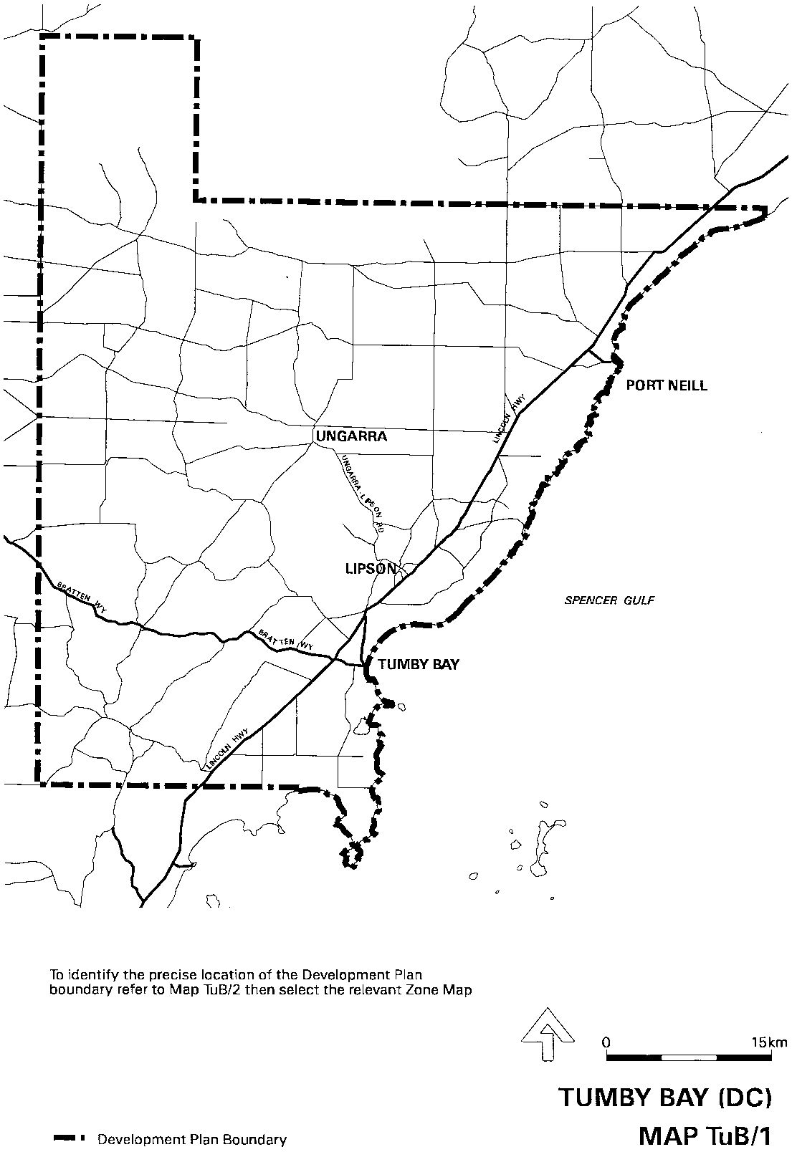
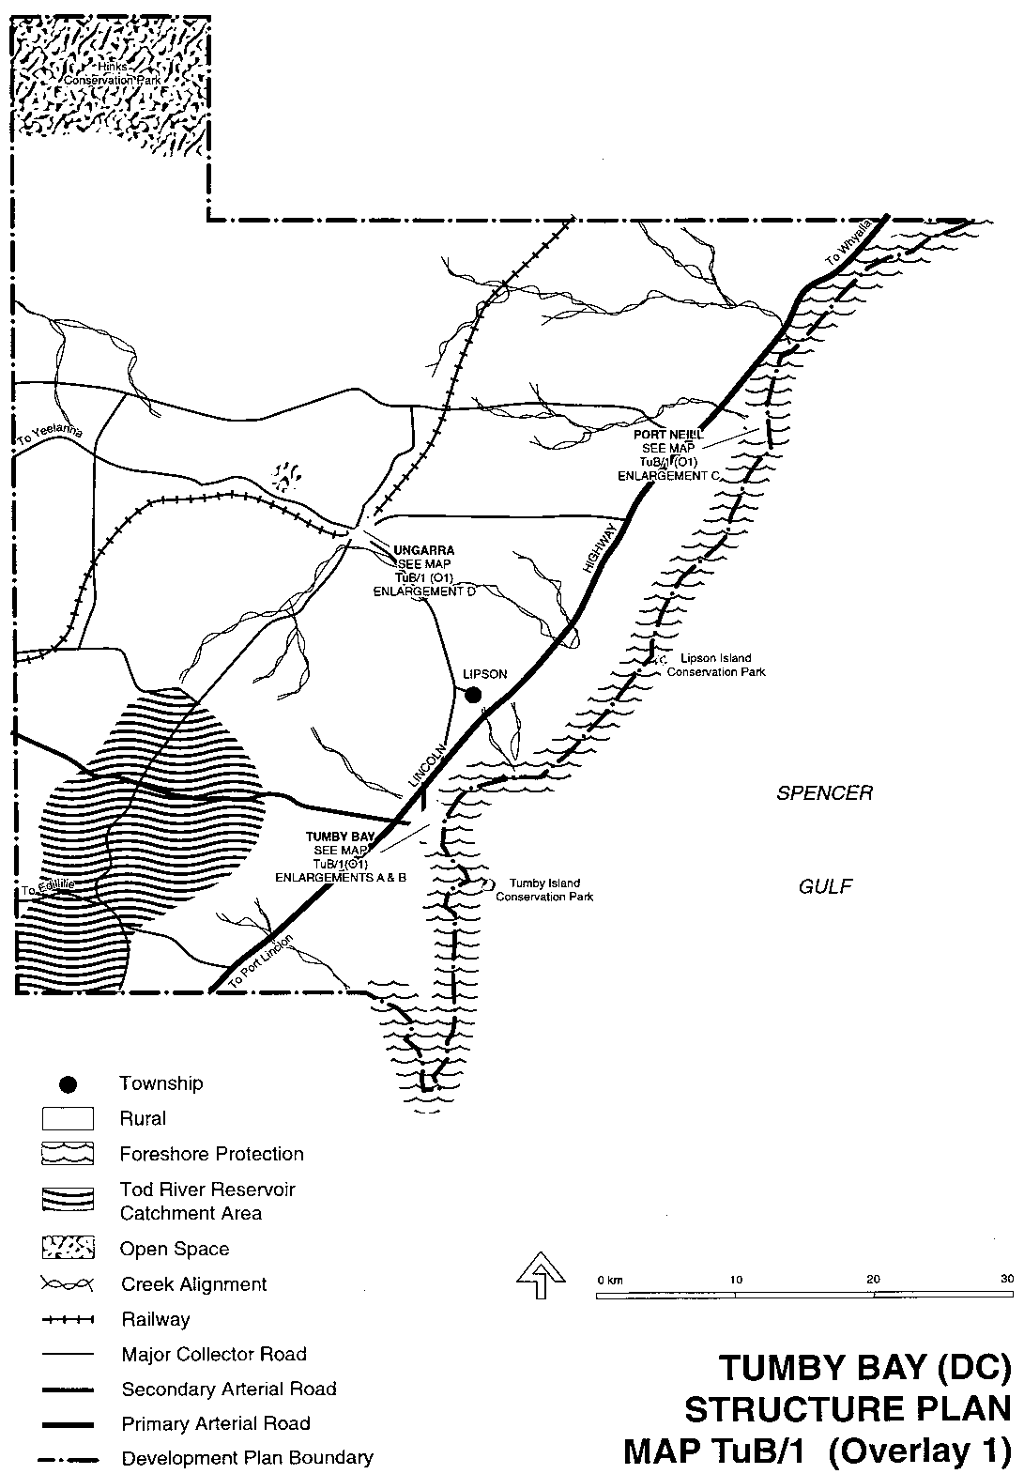
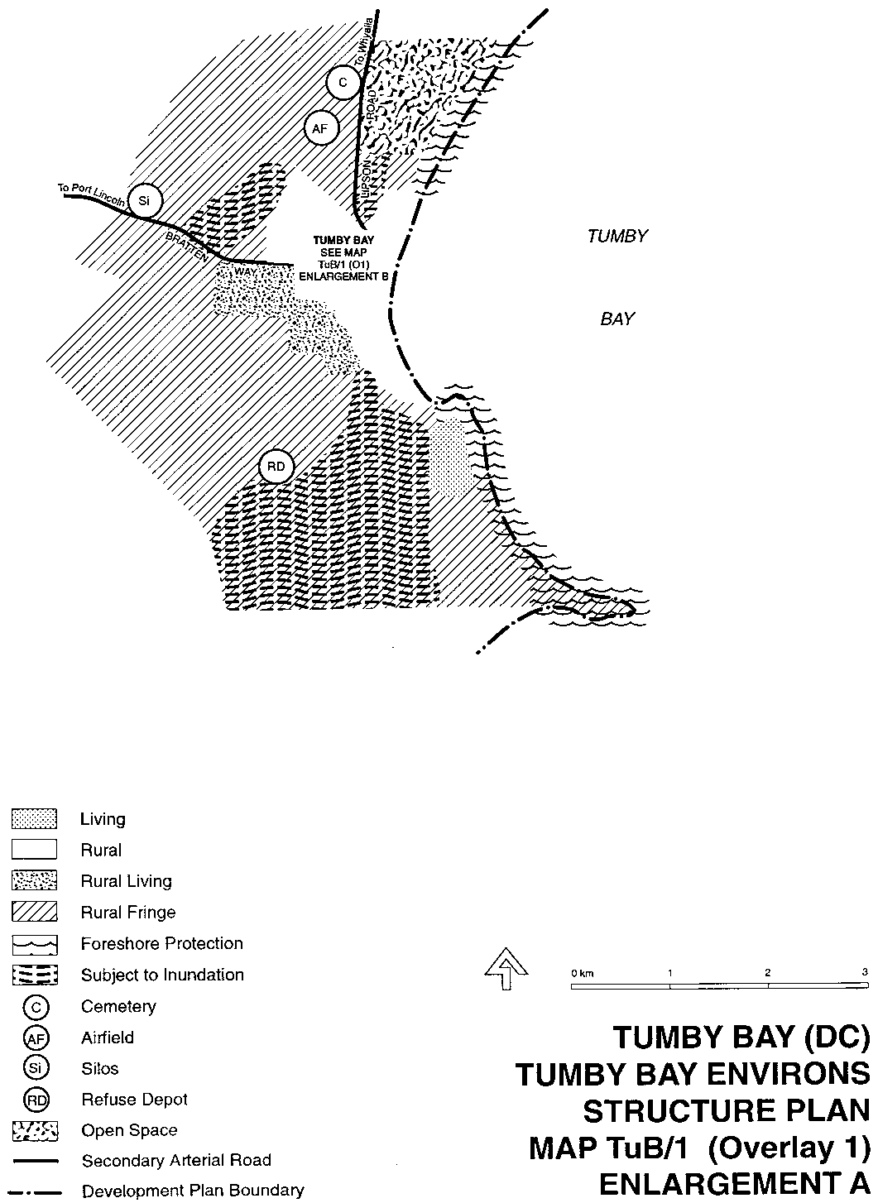
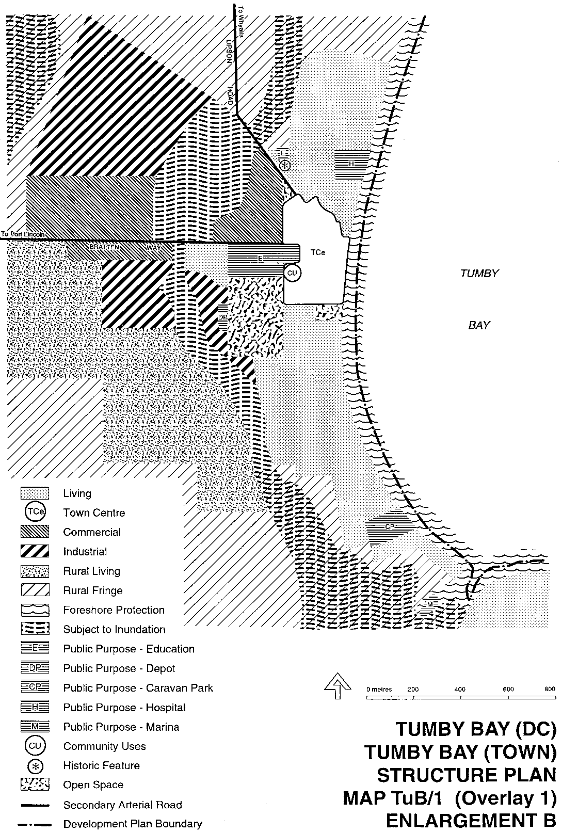
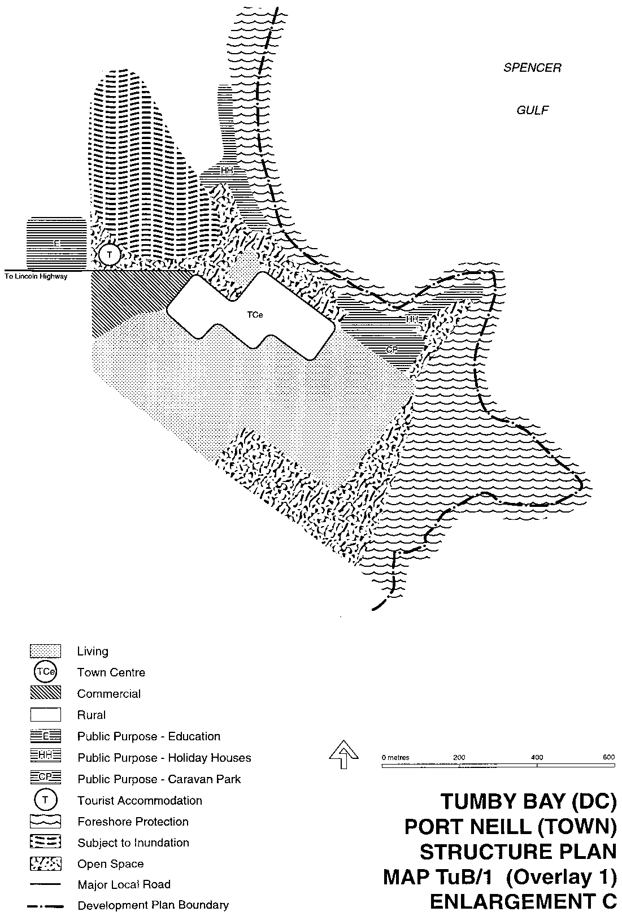
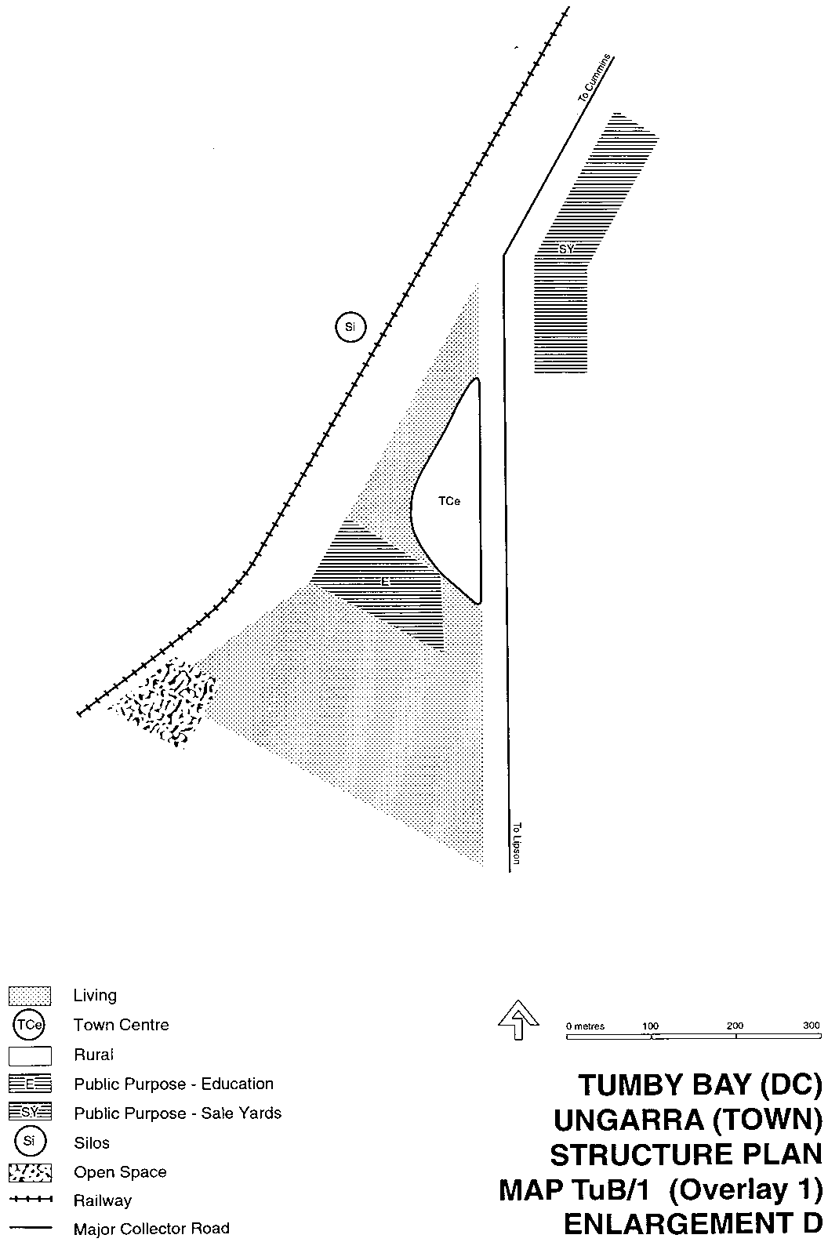
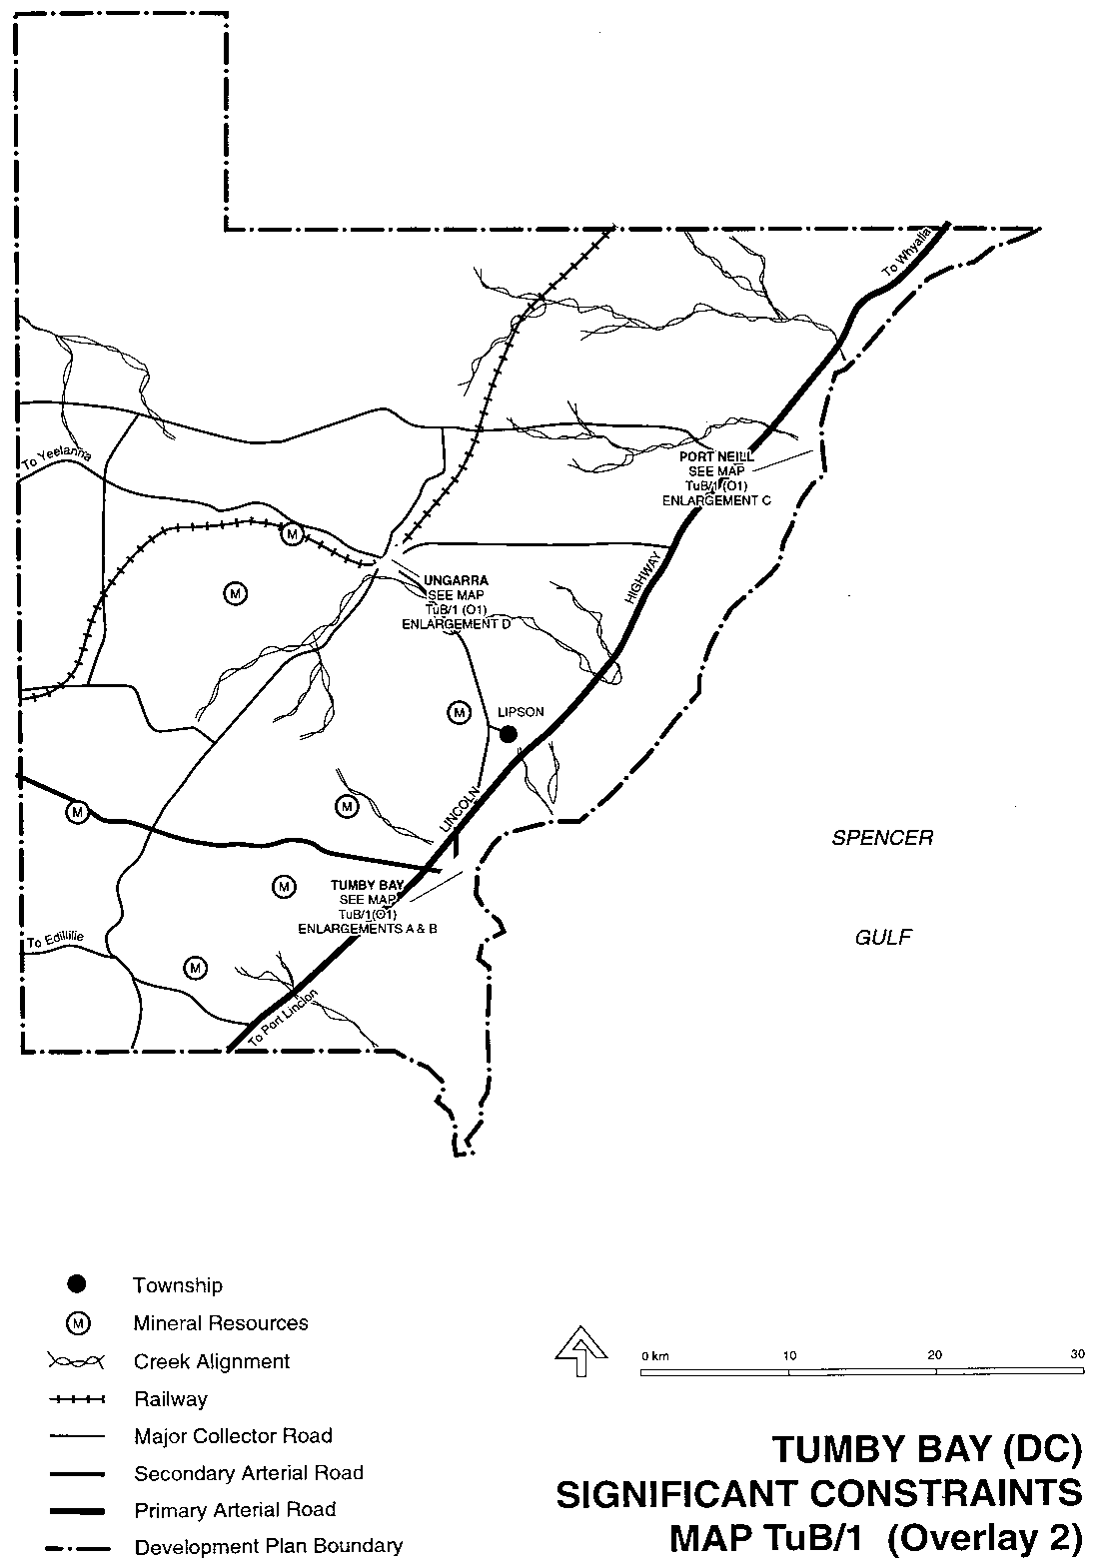
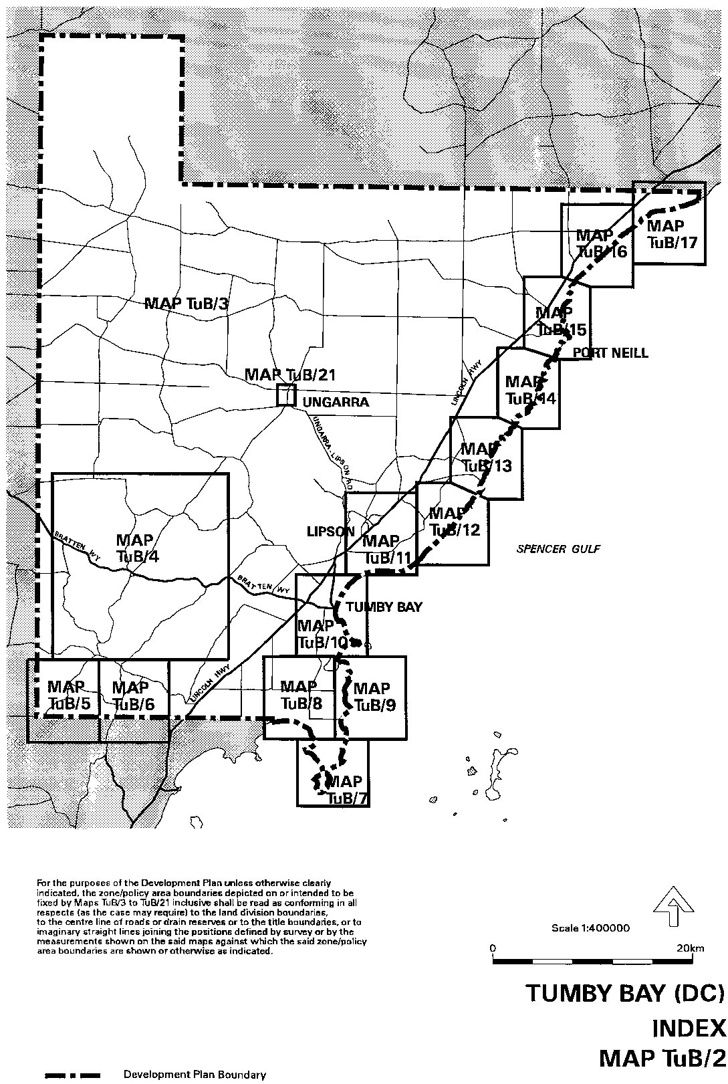
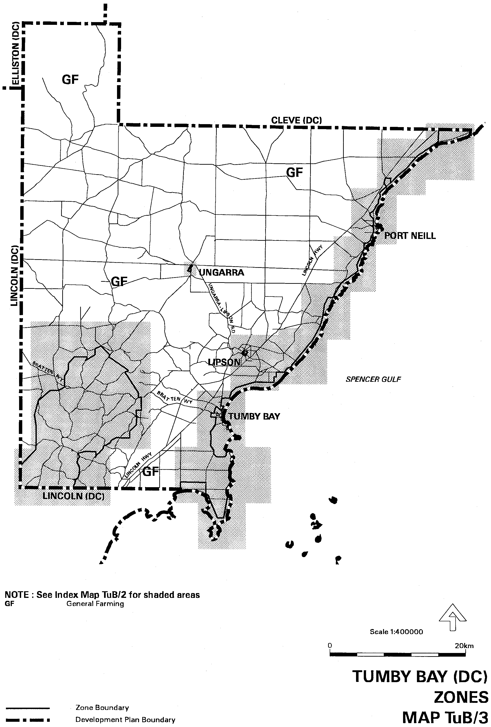
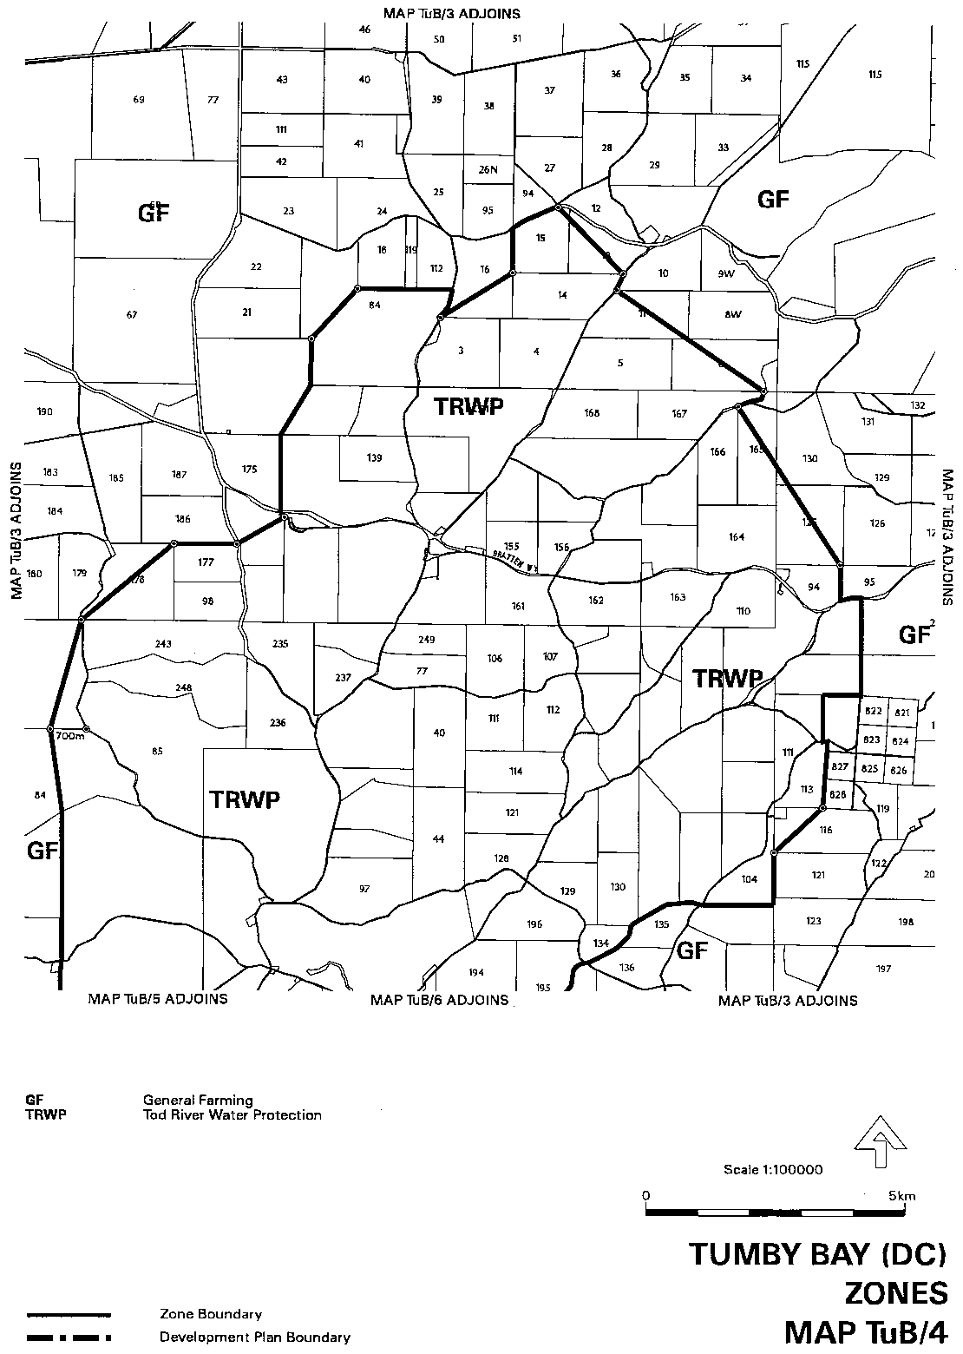
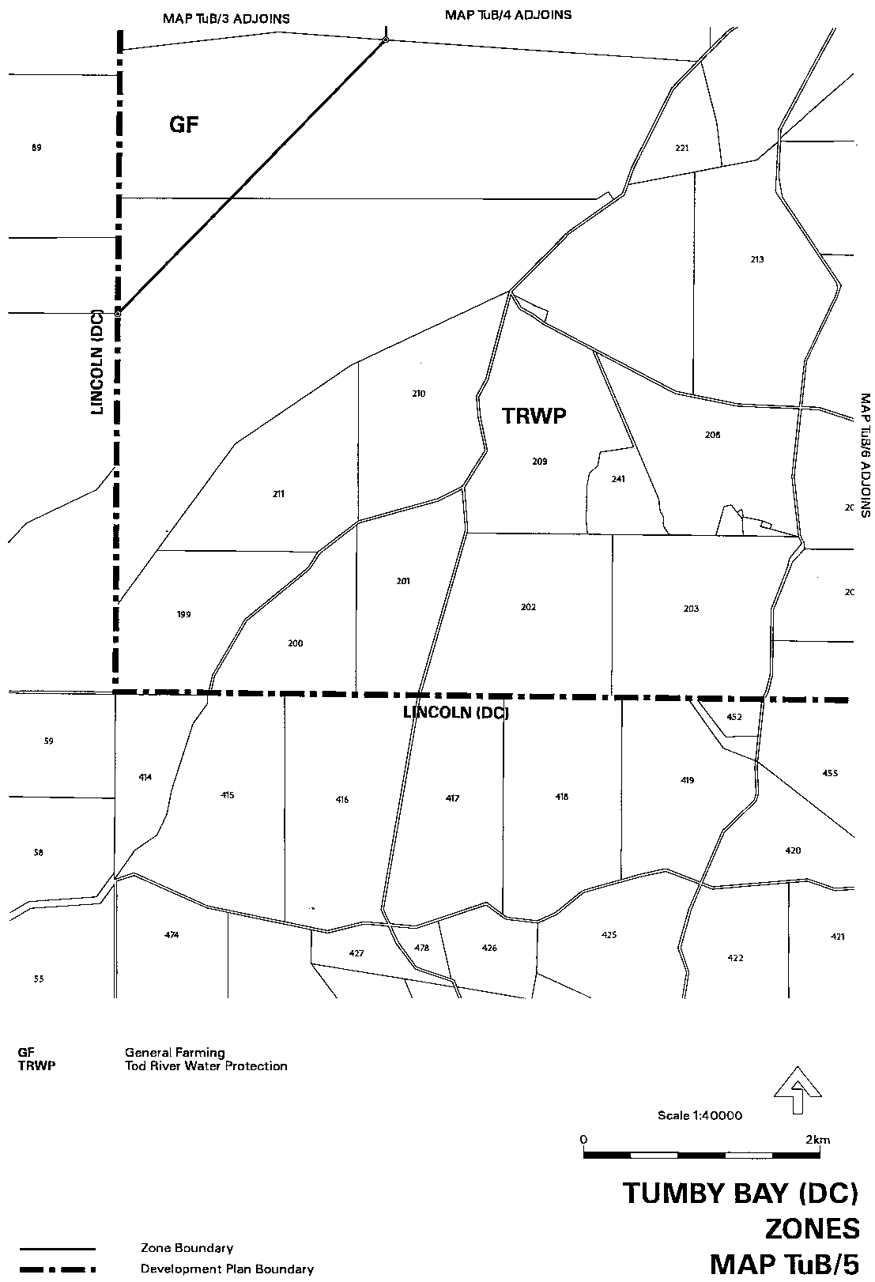
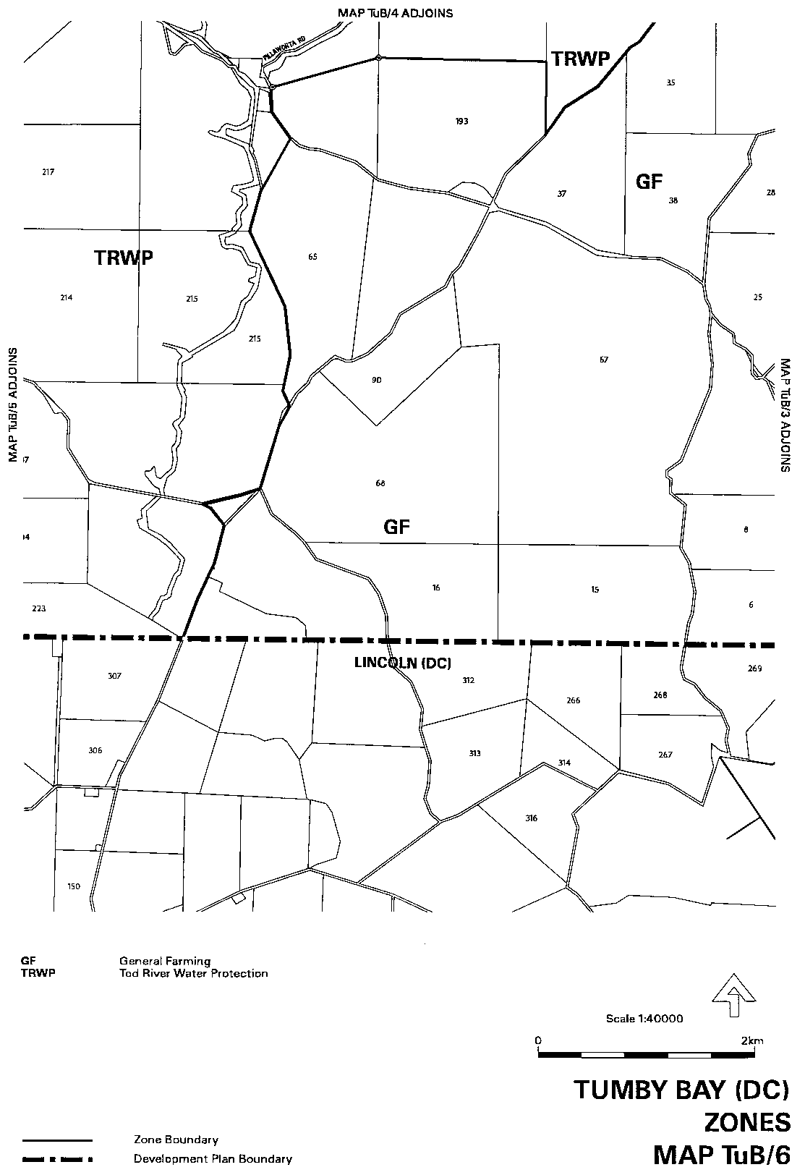
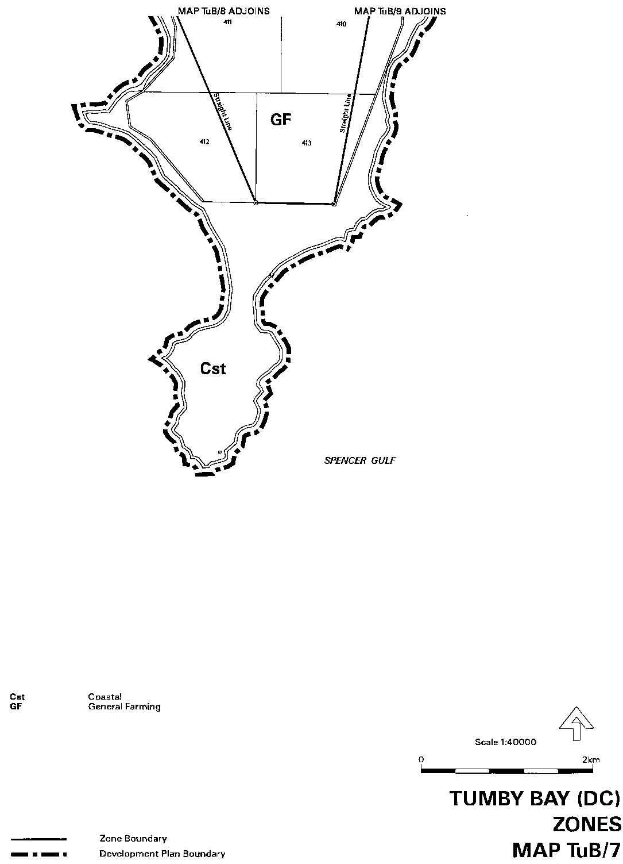
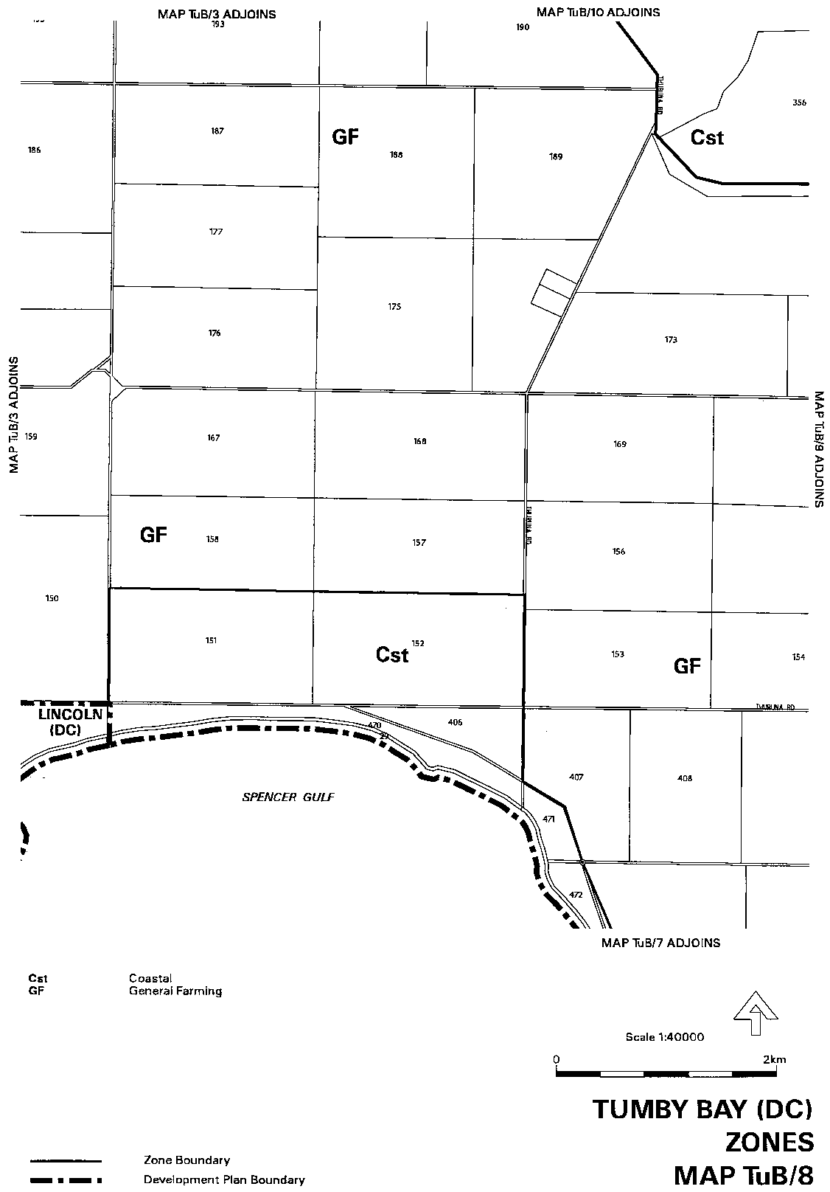
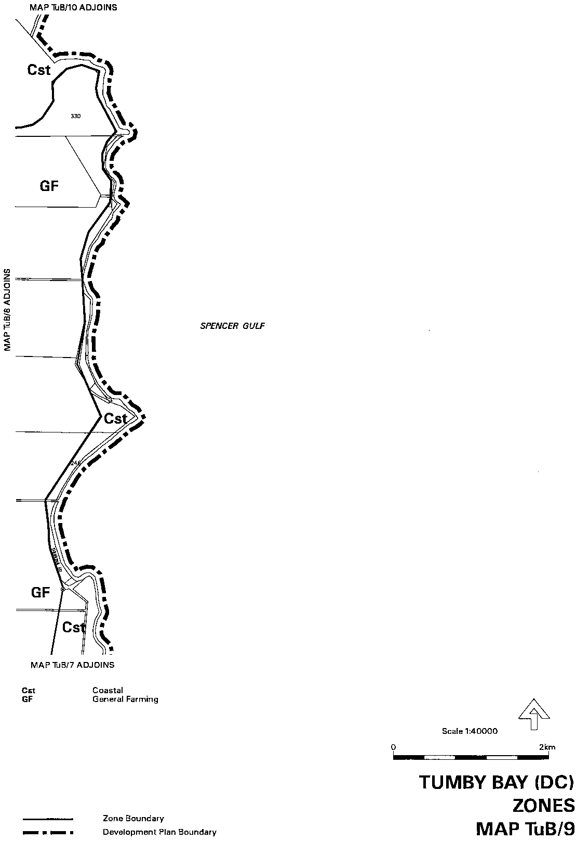
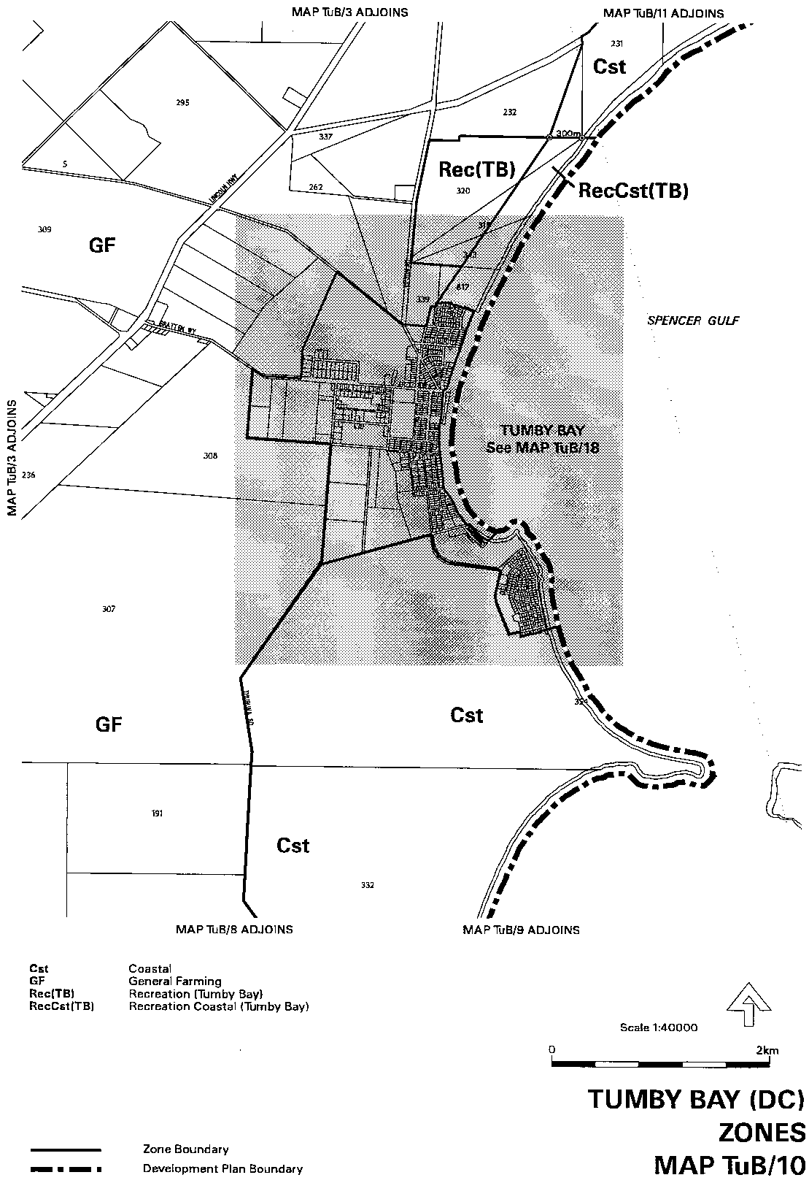
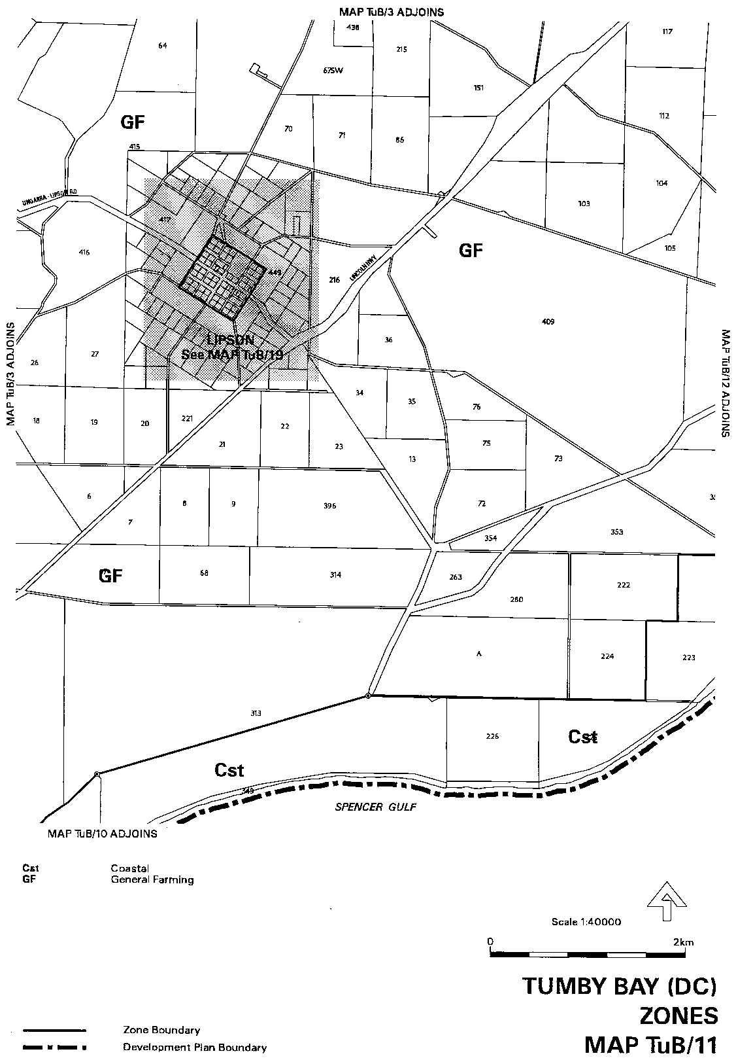
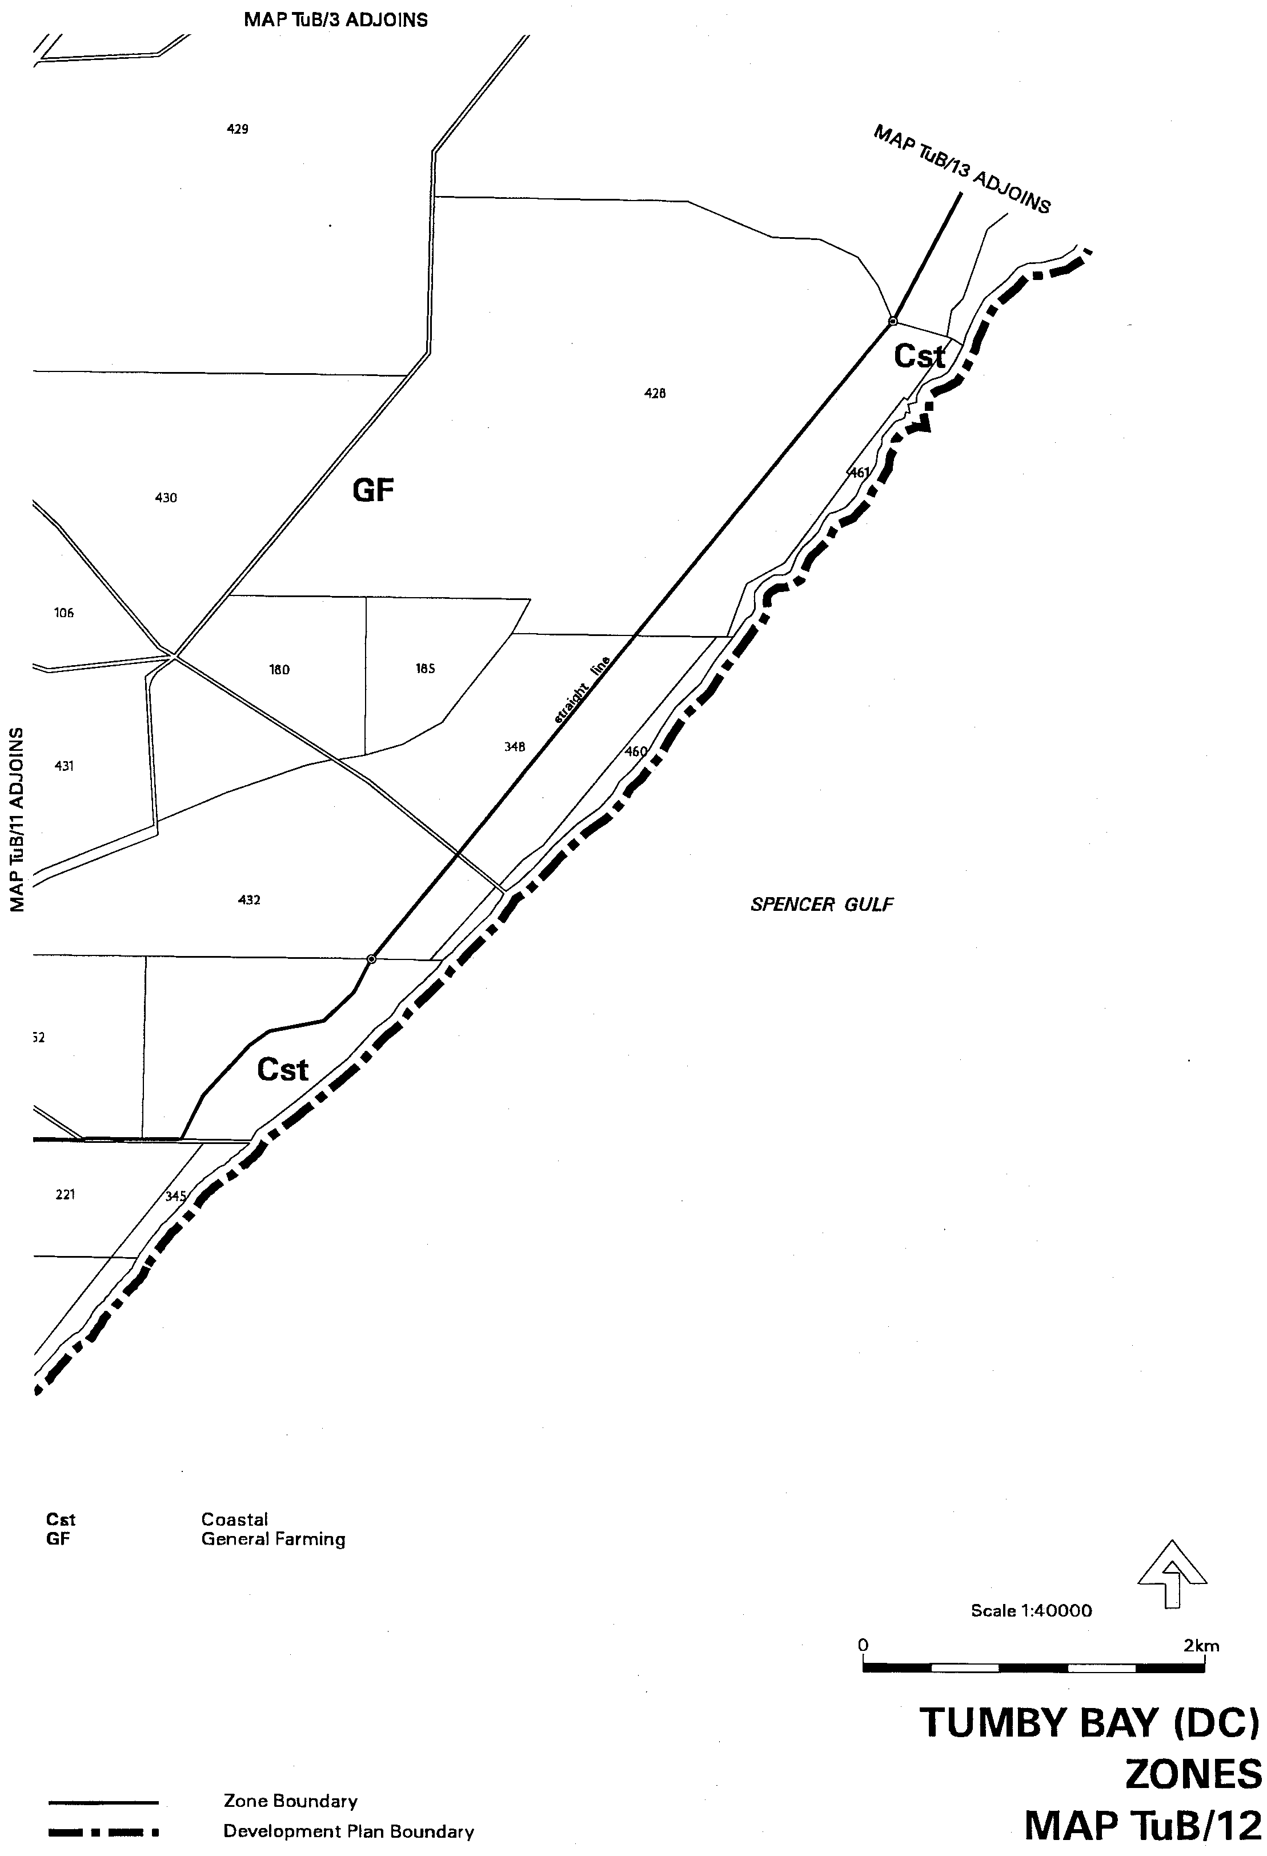
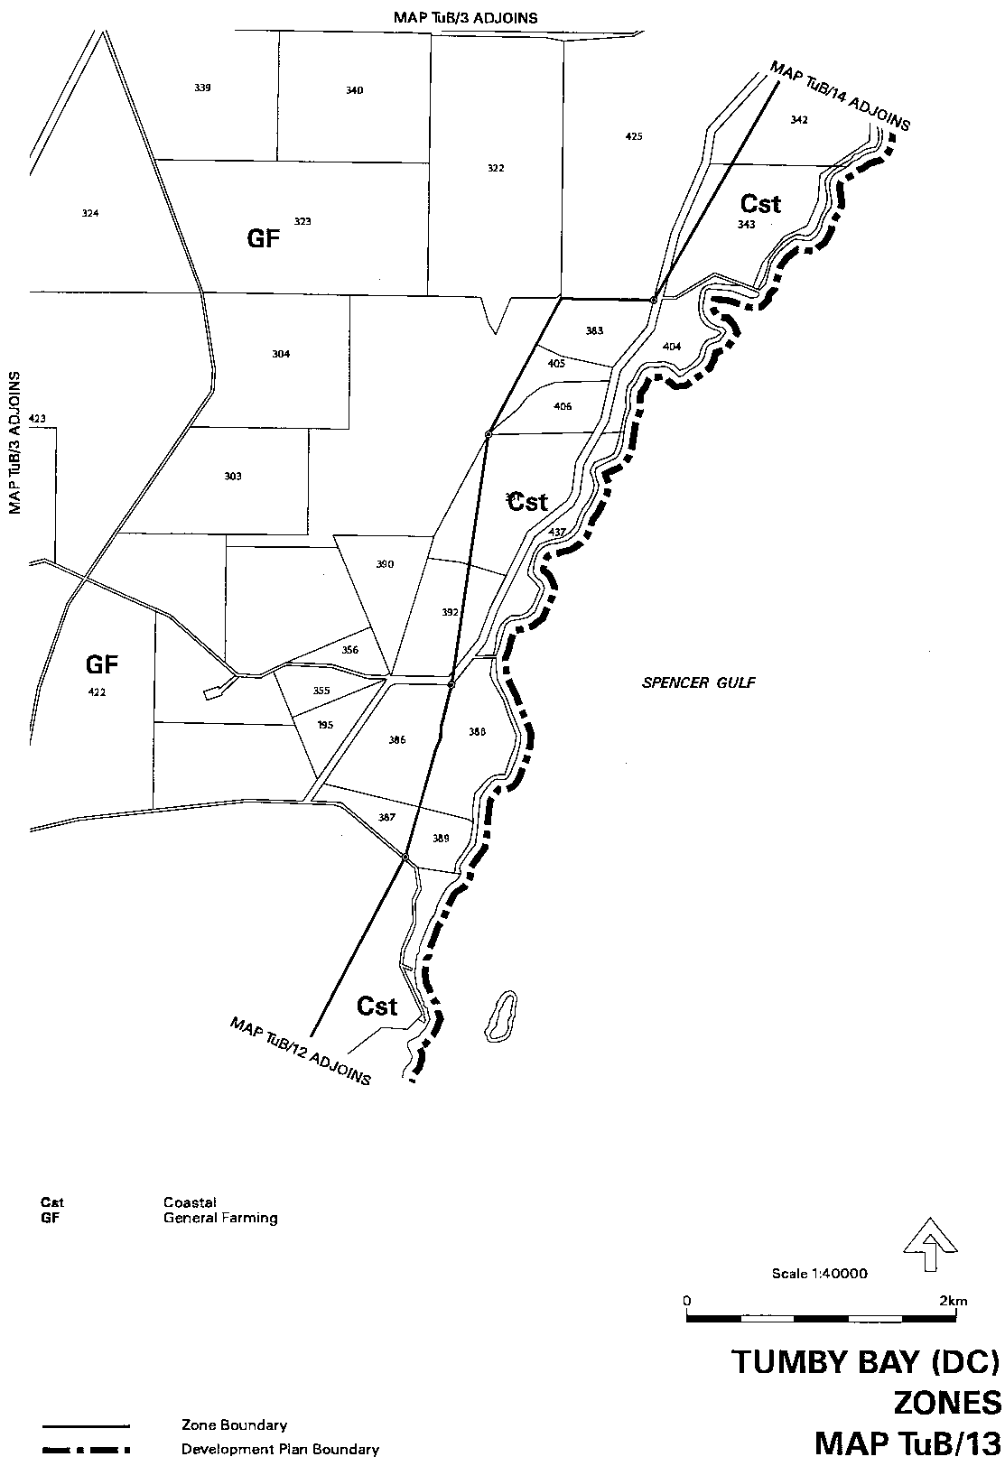
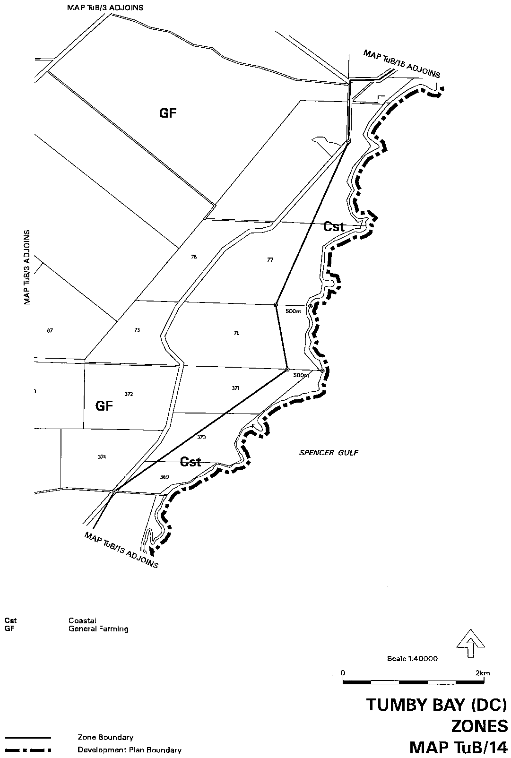
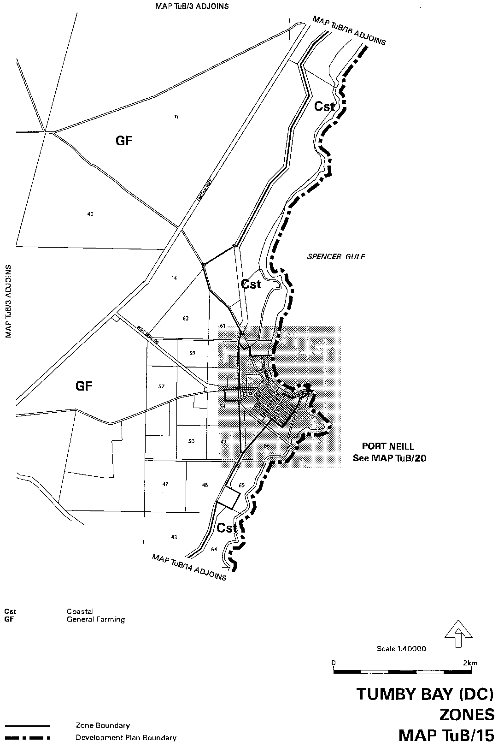
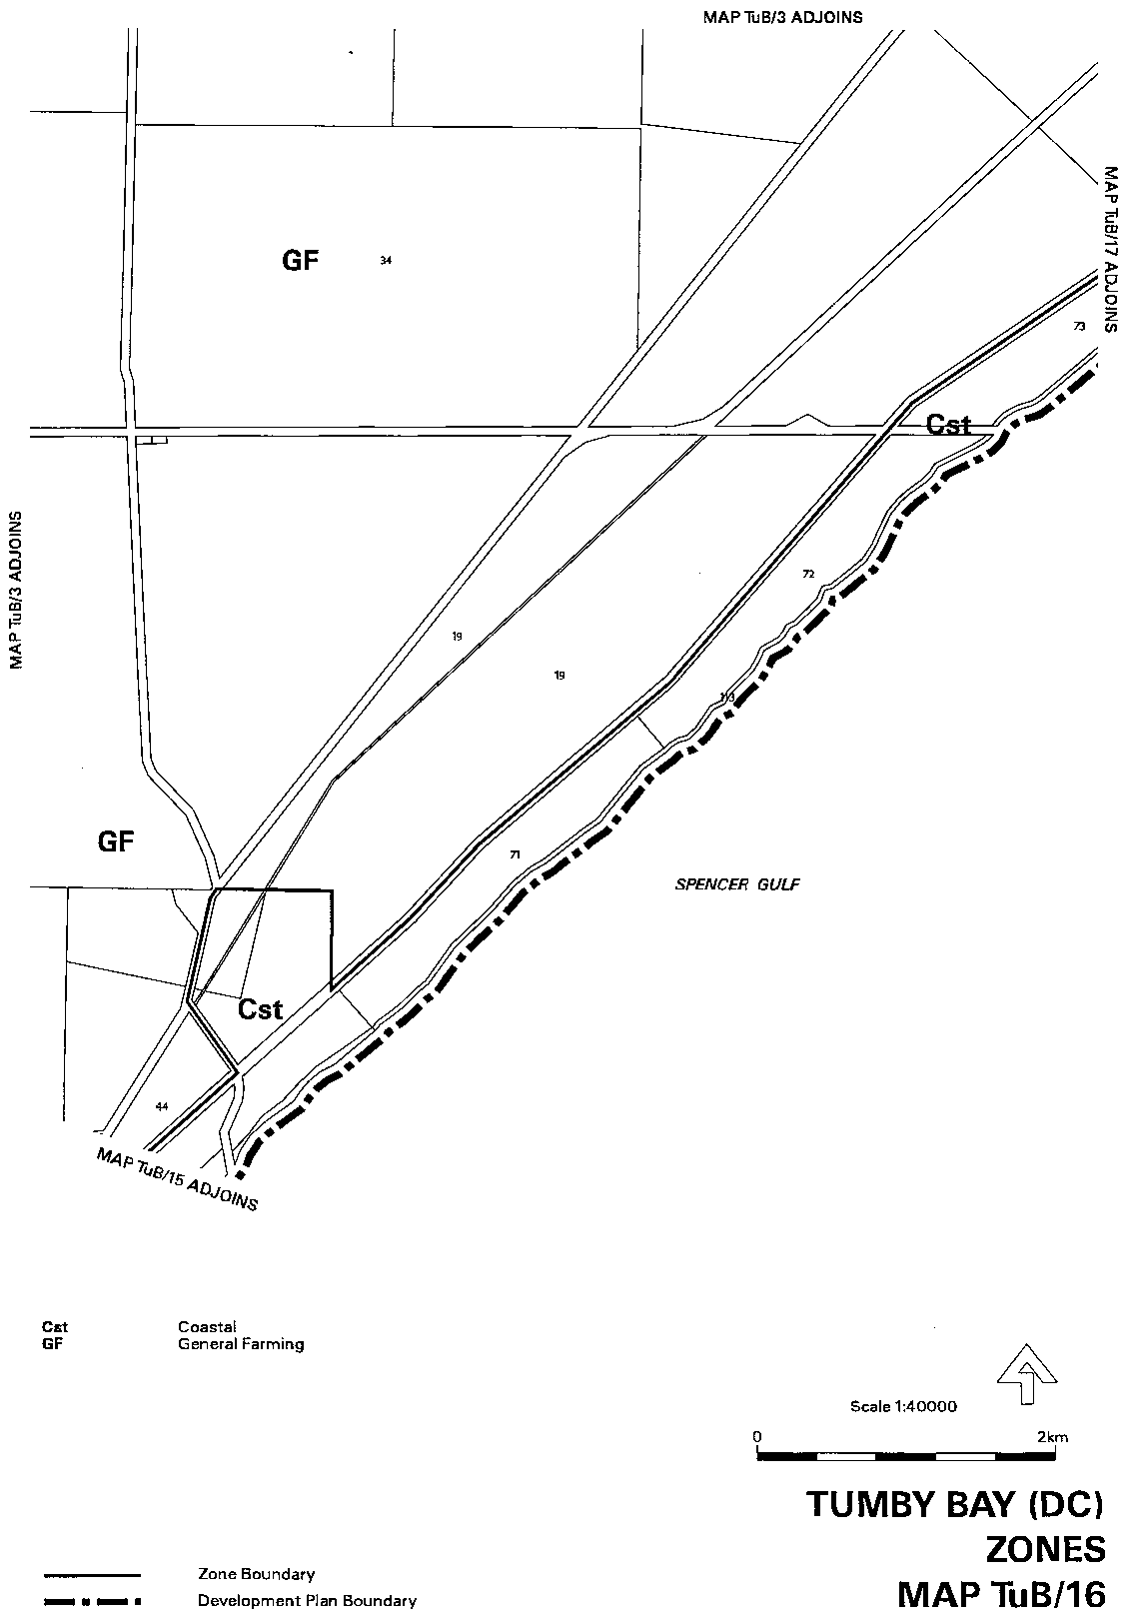
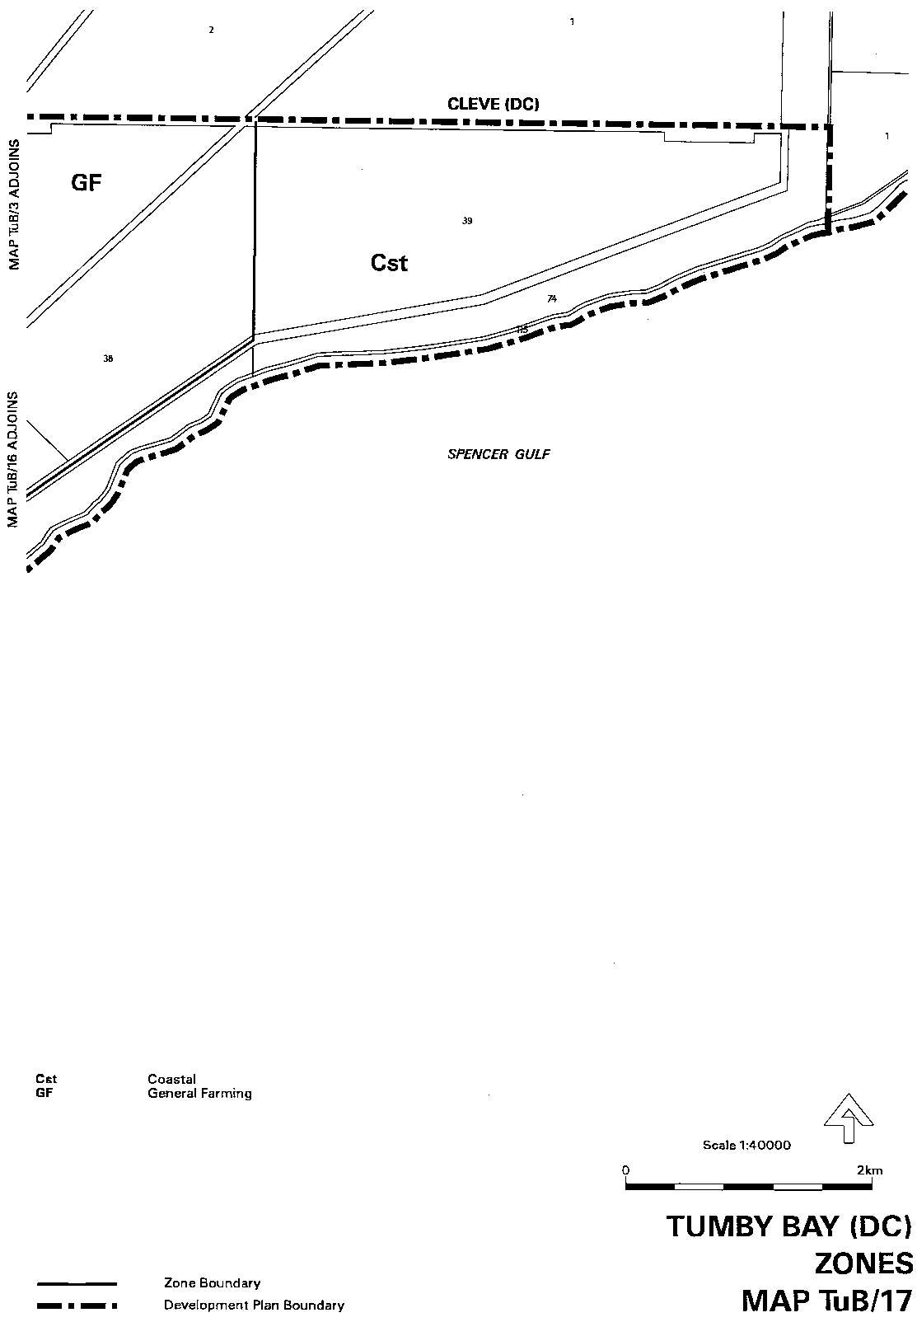
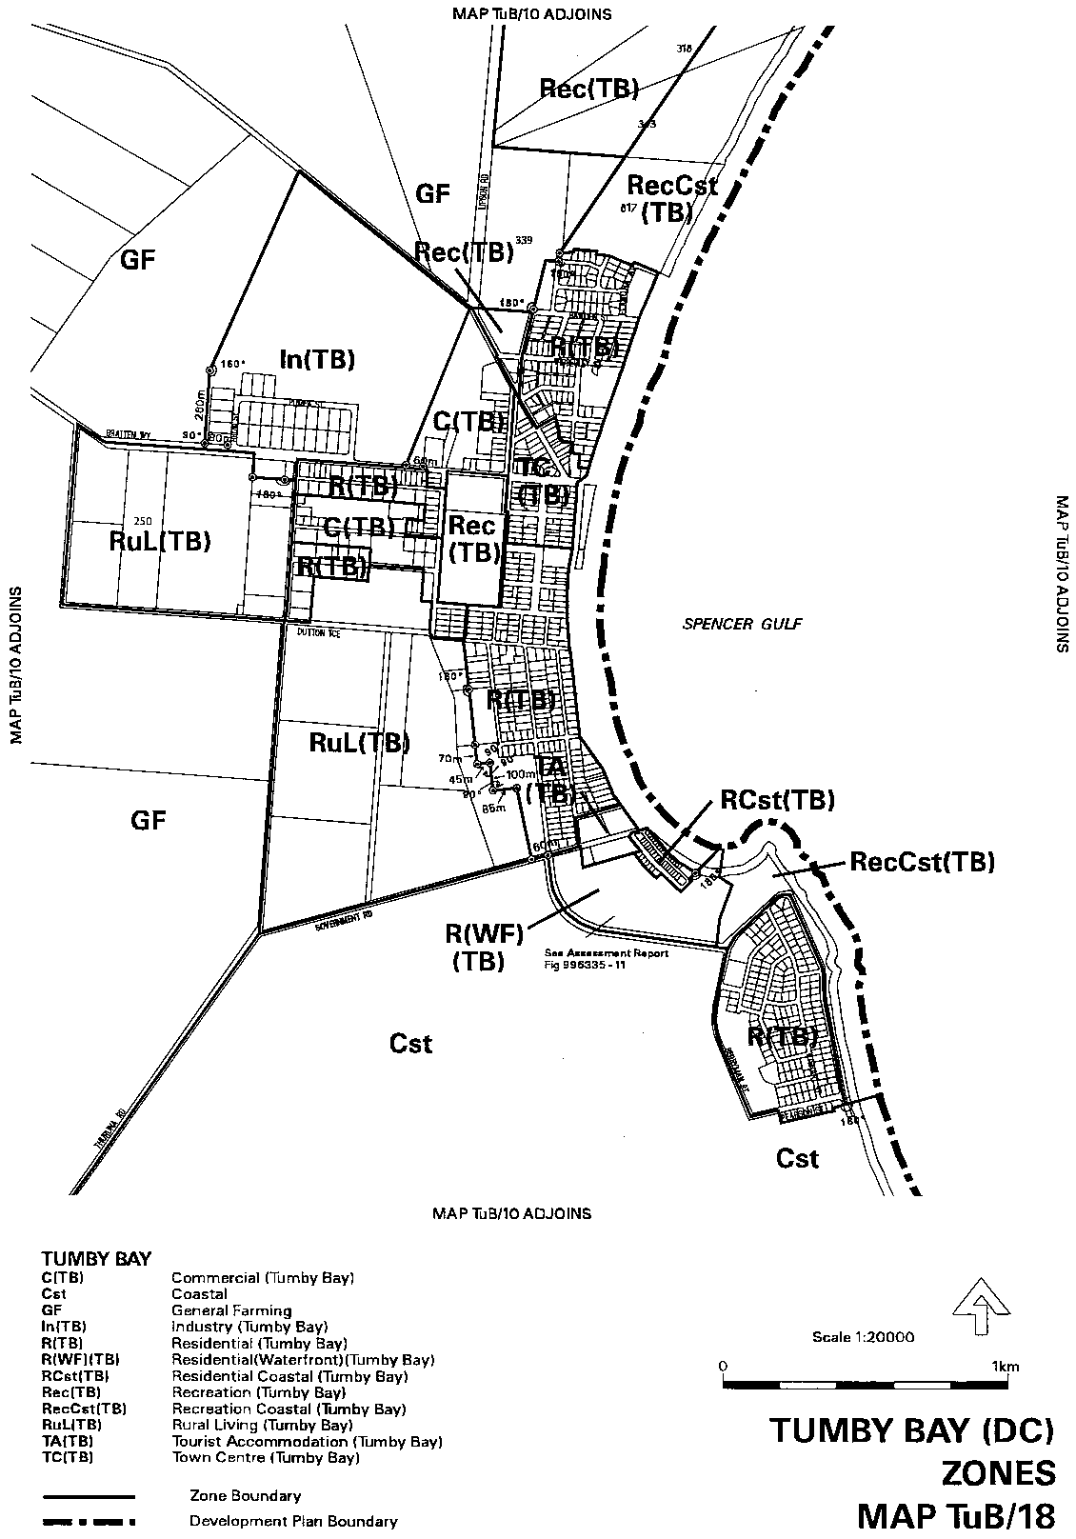
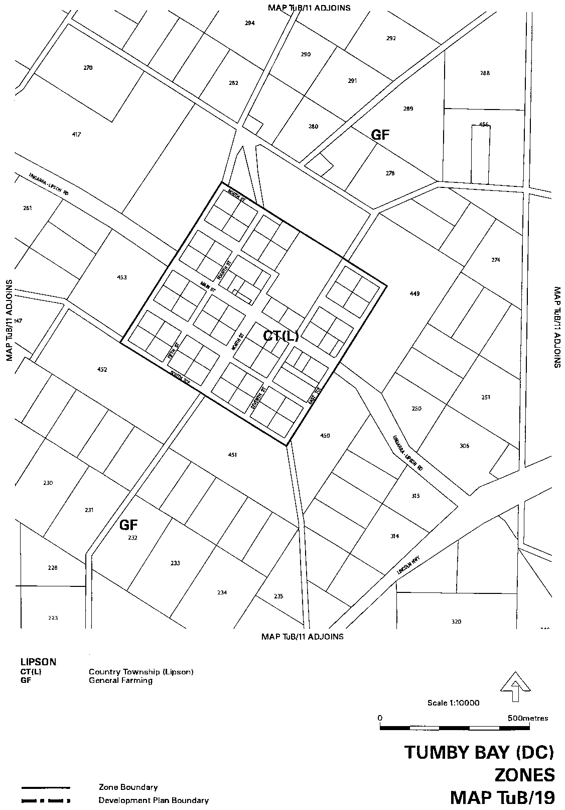
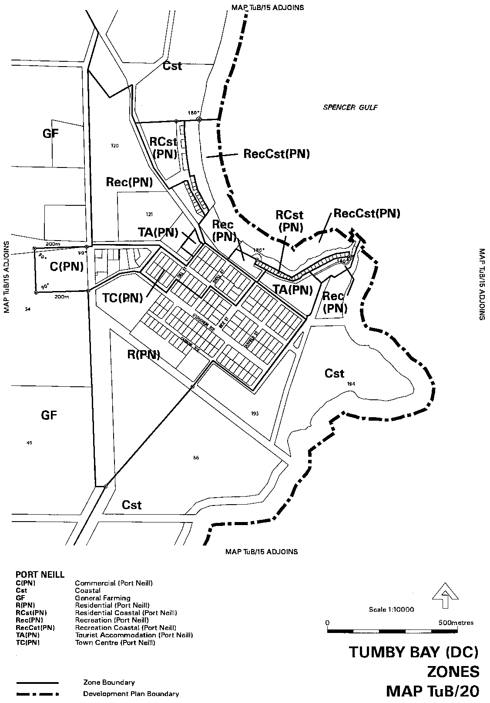
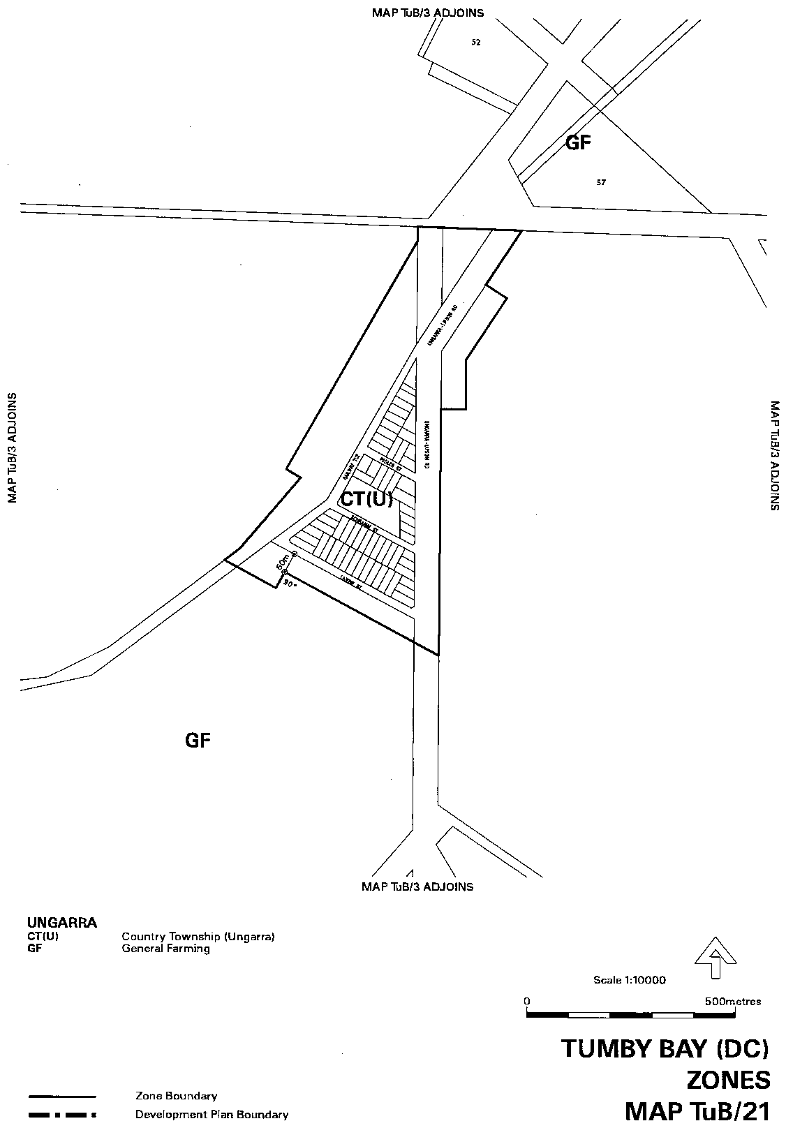
Dated 17 August 2000.
Diana Laidlaw, Minister for Transport, Urban Planning and the Arts

DEVELOPMENT ACT 1993
Hills Face Zone Amendment Plan Amendment Report by the Minister⎯Draft for Public Consultation
NOTICE is hereby given that the Minister for Transport and Urban Planning has, pursuant to section 26 of the Development Act 1993, prepared a draft Plan Amendment Report relating to the control of horticulture and some other activities in the Hills Face Zone as a replacement to the ‘Horticulture in the Hills Face Zone’ Plan Amendment Report.
The draft Plan Amendment Report will amend the Hills Face Zone policies in Development Plans by introducing policies to clarify and strengthen controls for horticulture and some other activities.
Copies of this draft Plan Amendment Report will be available for public inspection and purchase during normal office hours at the Department for Transport, Urban Planning and the Arts (Planning SA), Level 5, 136 North Terrace, Adelaide or can be viewed on the internet (www.planning.sa.gov.au). Alternatively, the draft Plan Amendment Report can be viewed during office hours at the following council offices:
• Adelaide Hills Council
• City of Burnside
• City of Campbelltown
• City of Marion
• City of Mitcham
• City of Onkaparinga
• City of Playford
• City of Salisbury
• City of Tea Tree Gully
The draft Plan Amendment Report will be on display from 17 August 2000 to 17 October 2000.
Written submissions regarding the draft Plan Amendment Report should be submitted no later than 17 October 2000. All submissions should be addressed to the Presiding Member, Development Policy Advisory Committee, G.P.O. Box 1815, Adelaide, S.A. 5001 and should clearly indicate whether you wish to be heard in support of your submission.
Copies of all submissions will be available for inspection by interested persons at the Department of Transport, Urban Planning and the Arts (Planning SA), Level 5, 136 North Terrace, Adelaide from 18 October 2000 to 2 November 2000.
A public hearing will be held on 2 November 2000 at the Mitcham Institute, 103B Princes Road, Mitcham commencing at 7 p.m., at which time interested persons may appear to be heard in relation to the draft Hills Face Zone Amendment Plan Amendment Report and the submissions. The public hearing will not be held if no submissions are received or no submission makes a request to be heard.
Any enquires on the draft Hills Face Zone Amendment Plan Amendment Report should be directed to Planning SA on 8303 0742 or 8303 0655.
G. Holland-Booker, Secretary Development Policy Advisory Committee

FISHERIES ACT 1982
Marine Tuna Farming Licence FB00019
Licence to Farm Fish under section 53 of the Fisheries
Act 1982
WHEREAS the Director of Fisheries has, pursuant to section 50 (2) of the Fisheries Act 1982 (‘the Act’), issued a permit to the undermentioned licensee to release the fish specified in Schedule 2 of this licence (‘the permitted species’) the Minister for Primary Industries, Natural Resources and Regional Development (‘the Minister’) hereby grants to:
Ajka Pty Ltd (1673)
7 Riversdale Avenue
Port Lincoln, S.A. 5606
a non-exclusive licence to occupy and use the waters specified in Item 1 of Schedule 1 of this licence (‘the site’) for the purpose of farming and taking the permitted species (‘the permitted use’) for
the period commencing on 1 July 2000 and ending, subject to any earlier termination under this licence, on 30 June 2001 (‘the term’) subject to the following terms and conditions:
Conditions of This Licence
1. Licence
The parties acknowledge and agree that:
1.1 the rights, powers and privileges granted to or vested in the licensee under this licence are contractual only and shall not create or vest in the licensee any estate, interest or right of a proprietary nature in the site; and
1.2 that, subject to section 53A of the Fisheries Act 1982, this licence does not entitle the licensee to exclusive rights of entry to and occupation of the site and that the rights granted by this licence are exercisable by the licensee in common with any other occupiers of the site from time to time.
2. Marked-off Areas
For the purposes of section 53A of the Fisheries Act 1982, the marked-off areas within the site is that area or those areas marked-off or indicated in the manner set out in Item 2 of Schedule 1 of this licence.
3. Permitted Species
The licensee:
3.1 must not farm or introduce any species at the site other than the permitted species; and
3.2 must not take any wild fish from the site except for recreational purposes.
4. Permitted Use
The licensee must not use the site for any purpose other than the permitted use.
5. Permitted Methods
The licensee:
5.1 must not stock the permitted species at a rate greater than that specified in Schedule 2 of this licence;
5.2 must not use the anti-fouling chemical tributyltin (TBT) on any equipment used at the site;
5.3 must not use any chemical or drug for either therapeutic or prophylactic purpose except with the prior approval of the Minister;
5.4 must apply the permitted farming methods set out in Item 2 of Schedule 2 of this licence.
5.5 must conduct an environmental monitoring program as set out in Schedule 5 of this licence.
6. Sea Cages
The licensee:
6.1 must ensure that all sea cages on the site have anti-predator protection satisfactory to the Minister at all times during the Term; and
6.2 must immediately inform an officer of PIRSA Fisheries on 1800 065 522 or such other officer as the Minister from time to time notifies to the licensee in writing if any marine animal, other than the Permitted Species, is caught in any sea cage or other form structure used by the Licensee on the site.
7. Location of Sea Cages
The licensee must not erect or use any sea cages in any location on the site where stocked sea cages have been used in the immediately preceding a 2 year period.
8. Marking and Maintaining the Site
The licensee:
8.1 must ensure that the site is maintained in a good, tidy and safe condition to the satisfaction of the Minister;
8.2 must remove and lawfully dispose of any waste or debris on the site as soon as is reasonably practicable and in particular must comply with any guidelines issued from time to time by the Minister in relation to the removal from the site of any unhealthy or dead fish;
8.3 must maintain all buoys, crosses, and markers on the site in good condition and in accordance with the colours specified in Schedule 1 of this licence; and
8.4 must mark the site boundary in accordance with the specifications in Schedule 1 of this licence.
9. Site Inspection and Supervision
The licensee:
9.1 must at all times permit the Minister, his employees, agents or contractors or any employees, agents or contractors of the Crown to enter the site for the purposes of inspecting the site, the sea floor and the flora and fauna on or in the vicinity of the site; and
9.2 must comply with all reasonable directions of any such person authorised by the Director of Fisheries to inspect the conduct of the licensee’s activities at the site.
10. Fees and Returns
The licensee:
10.1 must pay to the Minister the licence fee in accordance with Item l of Schedule 3 of this licence;
10.2 must on or before 31 January and 31 July during the term, submit to the Minister a return supplying all of the information described in Schedule 4 of this licence.
11. Compliance With Relevant Laws
11.1 the licensee must at all times comply with all laws, by-laws or regulations in force which relate to the site or the activities conducted in the site and with all notices, orders or requirements lawfully given or made by any authority or authorities in respect of the site;
11.2 in particular, without derogating from the general requirement under condition 11 of this licence:
11.2.1 the licensee must not do or permit to be done in upon or about the site anything which in the opinion of the Minister would cause or contribute to the degradation or pollution of any coastal land or the surrounding marine environment; and
11.2.2 in the event that the Minister is satisfied, on reasonable grounds, that the fish taken from the waters are not fit for human consumption or that consumption of fish taken from the waters could present a danger to the health of the consumer, the licensee must, in accordance with a written notice from the Minister, cease or suspend the conduct of the permitted use or else conduct the permitted use as directed within the notice.
12. Public Risk Indemnity
The licensee must at all times indemnify the Minister, his officers, employees, contractors and agents from and against all claims, demands, actions, judgments, proceedings, damages, losses, costs, charges and expenses in respect of any loss of life, personal injury and/or damage to property caused or suffered in any manner in or about the site.
13. Release
The licensee must use and keep the site at the risk in all things of the licensee and the licensee must release to the full extent permitted by law the Minister, his agents, contractors and servants in the absence of any wilful act, omission, default or neglect on their part from all claims and demands of every kind resulting from any accident damage or injury to persons or property occurring at the site, including loss or damage to the licensee’s fixtures or personal property of the licensee.
14. Public Risk Insurance
The licensee shall at its own cost and expense during the term effect and keep in full force and effect in respect of the site and the permitted use a policy of public risk insurance in the joint names of the licensee and the Minister in which the limits of public risk shall not be less than the amount specified in Item 2 of Schedule 3 of this licence, or such further amount as the Minister may from time to time reasonably require, as the amount which may be paid out in respect of any one single claim and a policy of insurance or copy thereof or a certificate of insurance shall be produced by the licensee to the Minister on request in writing being made by the Minister for its production.
15. Guarantee or Indemnity Scheme
The licensee must either:
15.1 provide a guarantee from its bankers; or
15.2 contribute to an indemnity scheme established for the aquaculture and fisheries industry and approved by the Minister,
to and in favour of and for the benefit of the Minister by way of security for the due and punctual performance by the licensee of the terms and conditions of this licence and in particular the obligations of the licensee to rehabilitate the site immediately prior to the expiration or sooner determination of the term of this licence. Such guarantee or indemnity scheme must have effect from the date of commencement of the term.
16. No Assignment
The licensee acknowledges that this licence is personal and it must not assign or sublet or deal in any other way with any interest in this licence.
17. Default by Licensee and Termination
The Minister may terminate this licence immediately by notice in writing served on the licensee if:
17.1 the licensee commits or permits any breach or default of the obligations imposed on the licensee by this licence, and following the giving by the Minister of written notice of such breach or default, the licensee either fails to rectify such breach or default within one calendar month of the date of such notice (or earlier if the circumstances require) or fails to make diligent progress towards rectifying any such breach which is incapable of rectification within the time so limited; or
17.2 the licensee commits or permits any further breach or default of the obligations imposed on the licensee by this licence for which the Minister has previously given notice in writing of such breach or default pursuant to paragraph 1 of condition 17.1 notwith-standing rectification of the previous breach or default; or
17.3 the licence fee referred to in condition 10 is unpaid for a period of 14 days after notice has been given to the licensee that it is outstanding; or
17.4 if the licensee is a body corporate, any of the following occur:
17.4.1 the licensee is unable to pay its debts as and when they fall due or is otherwise insolvent;
17.4.2 an order is made for the winding up or liquidation of the licensee;
17.4.3 the licensee enters into a scheme of arrangement, compromise, moratorium or other form of composition with its creditors or any class of its creditors;
17.4.4 a receiver, a manager or a receiver and manager, a company administrator or other insolvency administrator is appointed to the licensee; or
17.4.5 a mortgagee, chargee or other encum-brancee is appointed over or takes possession of or appoints an agent to take possession of all or any of the licensee’s assets; or
17.5 if the licensee is an individual, the licensee:
17.5.1 becomes bankrupt or assigns its estate or enters into a deed of arrangement or other form of composition for the benefit of the licensee’s creditors; or
17.5.2 is convicted of an indictable offence.
Termination of this licence by the Minister shall be without prejudice to any rights, remedies or actions that the Minister may have against the licensee in respect of any antecedent breach by the licensee of the terms and conditions contained in this licence.
18. Interpretation
Subject to any inconsistency of subject or context, the following rules of construction shall be used in the interpretation of this licence:
18.1 any word importing the plural includes the singular and vice versa;
18.2 any wording importing a gender shall include all other genders;
18.3 a reference to a body corporate shall include a natural person and vice versa;
18.4 a reference to a recital, party, clause, Schedule or Annexure is a reference to a recital, party, clause, Schedule or Annexure of this licence;
18.5 the captions, headings, section numbers and clause numbers appearing in this licence are inserted only as a matter of convenience and in no way affect the construction of this licence;
18.6 a reference to a statute shall include all statutes amending, consolidating or replacing the statutes referred to;
18.7 where two or more persons are named as licensees, this licence shall bind the licensees jointly and each of them severally; and
18.8 time is of the essence in respect of any obligation relating to time in this licence.
19. Delegation
Any consent, notice, any consultation or any other thing which is pursuant to the terms of this licence either required to be given, done or performed or which may be given, done or performed by the Minister may for the purposes of this licence be properly given, done or performed by any duly authorised agent or employee of the Minister.
20. Severance
If any term or condition of this licence should be for any reason unlawful, void, invalid or unenforceable then the offending term or condition shall be severed from this licence without affecting the validity or enforceability of the remainder of this licence.
21. Modification
No variation of or addition to any provision of this licence shall be binding upon the Minister and the licensee unless such variation or addition is made in writing, signed by both the Minister and the licensee and expressed to be either supplemental to or in substitution for the whole or a part of this licence.
22. Waiver
22.1 A waiver of any provision of this licence by the Minister must both be in writing and be signed by the Minister or by persons duly authorised to execute such a document on the Minister’s part.
22.2 No waiver by the Minister of a breach of a term or condition contained in this licence shall operate as a waiver of any breach of the same or any other term or condition contained in this licence.
22.3 No forbearance, delay or indulgence by the Minister in enforcing the provisions of this licence shall prejudice or restrict the rights of the Minister.
23. Notices
23.1 Notices may be served by delivering the same personally, by mail or facsimile transmission and shall be:
23.1.1 in writing addressed to the Director of Fisheries, PIRSA, 16th Floor, 25 Grenfell Street, Adelaide, S.A. 5000 (in the case of the Minister) and to the address of the licensee set out above (in the case of the licensee);
23.1.2 signed by or on behalf of the sender or by a person duly authorised in that regard by the sender;
23.1.3 deemed to be duly served or made in the following circumstances:
(a) if delivered, upon delivery;
(b) if sending by mail, upon posting;
(c) if sent by facsimile transmission, upon the sender’s facsimile producing a transmission report that the facsimile was satisfactorily sent in its entirety to the addressee’s facsimile number,
but if delivery is not made before 5 p.m. on any day it shall be deemed to be received at 9 a.m. on the next day in that place.
23.2 The Minister and the licensee may each vary their address or facsimile number at any time by written notice.
Granted by the General Manager Aquaculture, delegate of the Minister, on 19 July 2000.
I. Nightingale, General Manager Aquaculture
The licensee hereby acknowledges and agrees to the terms and conditions of this licence.
The Common Seal of Ajka Pty Ltd (ACN 007 912 861) was hereunto affixed in the presence of:
(l.s.) L. Gobin, Director
A. Gobin, Secretary
Schedule 1
Item 1—The Site
Area applicable to this licence:
Licensed Area Licensed
Hectares
AGD 66—Zone 53
591746E 6173100N 20
591750E 6173599N
591350E 6173603N
591345E 6173104N
All structures, equipment, buoys and flotations (except for that required by the Department for Transport, Urban Planning and the Arts) must be black, dark grey, dark blue, dark brown, or dark green coloured materials.
The boundary of the site to be marked either with:
(a) (1) At the corners with posts extending 900 mm above mean high water springs. Such posts to be marked with a St Andrews cross, each cross arm measuring 900 mm from tip to tip, minimum width 75 mm.
(2) Posts to be not less than 125 mm in diameter.
(3) Posts and crosses to be painted yellow.
(4) The ends of each cross to be marked with a 200 mm strip of yellow retro-reflective tape.
(5) Between the corner posts at intervals not exceeding 50 m, buoys not less than 300 mm in diameter.
(6) All buoys, posts, crosses and markers must be maintained in good condition.
or
(b) (1) At each corner, yellow spar buoys with a St Andrews cross as a top mark placed at least 900 mm above the buoy, cross arms 900 mm long x 75 mm wide.
(2) The buoys and topmarks must all be coloured yellow and marked with a yellow retro-reflective as in (a) (4).
(3) All buoys, posts, crosses and markers must be maintained in good condition.
When the site is in navigable water and possible danger to navigation, lights must be placed on the top of each St Andrews cross that is located at each corner of the site and these lights must be yellow in colour and flashing once every 4 seconds and visible over an arc of 360 degrees for a distance of at least one mile.
All sea cages on the site must be marked with a unique sea cage number and the site’s unique ‘FB number’; that is, the licence number. All St Andrew’s crosses must be marked with the site’s unique ‘FB number’; that is the licence number.
Item 2—Marked-Off Areas
Marked-off areas must be marked with no less than 8 equally spaced white buoys, each of at least 12 inches in diameter, each positioned no more than 70 m from each relevant seacage situated on the site.
Schedule 2
Item 1⎯Permitted Species
The Director of Fisheries has, pursuant to section 50 (2) of the Act, issued a permit for the release of the fish specified in this Schedule.
Southern Bluefin Tuna (Thunnus maccoyii)
Item 2⎯Permitted Farming Methods
Sea Cages
Item 3⎯Stocking Rates
The maximum stocking density of fish introduced into the site must not exceed 4 kg/m³
Seven sea cages each with a maximum diameter of 40 m. The maximum weight of fish introduced to the site must not exceed 240 tonnes in total during the term of the licence.
Schedule 3
Item 1—Fees
Annual licence fees are:
$
Base Licence Fee per hectare 20 at $228 each 4 560.00
FRDC Levy per hectare 20 at $342 each 6 840.00
Total Annual Licence Fee 11 400.00
Quarterly Instalments 2 850.00
Item 2—Public Risk Insurance
Five million dollars ($5 000 000).
Schedule 4
Returns
The licensee must submit the following information to the Minister, c/o Director of Fisheries, PIRSA, 16th Floor, 25 Grenfell Street, Adelaide, S.A. 5000 on or before 31 January and 31 July during the term of this licence:
1. Name of licensee.
2. Address of licensee.
3. Species of fish farmed and held on the site.
4. Location of aquaculture operation.
5. Period covered by return.
6. Number of life stage of each species of fish held.
7. Number, weight and value of each species of fish held.
8. Details of any disease detected in any fish kept.
9. Source (whether interstate or intrastate) of any stock acquired and date of acquisition (if relevant, include name of authority that provided certification that stock was free from disease).
10. If any fish were brought into the state, the number of fish and the life stage of the fish.
11. If fish were brought into the state, the purpose for which they were brought in.
12. Method of disposal of water and packaging use for transporting the fish.
13. If any disease or symptom of disease occurred in the acquired fish.
14. Method of disposal of diseased or dead fish and the number disposed of.
15. Signature, date and telephone number.
16. Use of any chemicals for fish husbandry—type of chemical and quantity used, purpose and date of use.
Schedule 5
Approved Environmental Monitoring Program
An Environmental Monitoring Program for the site must comply with the general requirements for environmental monitoring specified in the notes to the Decision Notification Form issued for the site under Regulation 42 of the Development Regulations 1993.
An Environmental Monitoring Program for the site must comply with Schedule 10 of the Environment Protection (Marine) Policy 1994.
The licensee must submit a draft Environmental Monitoring Program in writing to the General Manager Aquaculture within 60 days after the grant of the licence by the Minister.

FISHERIES ACT 1982
Marine Finfish Farming Licence FF00030
Licence to Farm Fish under section 53 of the Fisheries
Act 1982
WHEREAS the Director of Fisheries has, pursuant to section 50 (2) of the Fisheries Act 1982 (‘the Act’), issued a permit to the undermentioned licensee to release the fish specified in Schedule 2 of this licence (‘the permitted species’) the Minister for Primary Industries, Natural Resources and Regional Development (‘the Minister’) hereby grants to:
Craig N. Edwards (1186)
1 Blesing Street,
Whyalla Playford, S.A. 5600,
a non-exclusive licence to occupy and use the waters specified in Item 1 of Schedule 1 of this licence (‘the site’) for the purpose of farming and taking the permitted species (‘the permitted use’) for the period commencing on 1 July 2000 and ending, subject to any earlier termination under this licence, on 30 June 2001 (‘the term’) subject to the following terms and conditions:
Conditions of This Licence
1. Licence
The parties acknowledge and agree that:
1.1 the rights, powers and privileges granted to or vested in the licensee under this licence are contractual only and shall not create or vest in the licensee any estate, interest or right of a proprietary nature in the site; and
1.2 that, subject to section 53A of the Fisheries Act 1982, this licence does not entitle the licensee to exclusive rights of entry to and occupation of the site and that the rights granted by this licence are exercisable by the licensee in common with any other occupiers of the site from time to time.
2. Marked-off Areas
For the purposes of section 53A of the Fisheries Act 1982, the marked-off areas within the site is that area or those areas marked-off or indicated in the manner set out in Item 2 of Schedule 1 of this licence.
3. Permitted Species
The licensee:
3.1 must not farm or introduce any species at the site other than the permitted species; and
3.2 must not take any wild fish from the site except for recreational purposes.
4. Permitted Use
The licensee must not use the site for any purpose other than the permitted use.
5. Permitted Methods
The licensee:
5.1 must not stock the permitted species at a rate greater than that specified in Schedule 2 of this licence;
5.2 must not use the anti-fouling chemical tributyltin (TBT) on any equipment used at the site;
5.3 must not use any chemical or drug for either therapeutic or prophylactic purpose except with the prior approval of the Minister;
5.4 must apply the permitted farming methods set out in Schedule 2 of this licence.
5.5 must conduct an environmental monitoring program as set out in Schedule 5 of this licence.
6. Sea Cages
The licensee:
6.1 must ensure that all sea cages on the site have anti-predator protection satisfactory to the Minister at all times during the term; and
6.2 must immediately inform an officer of PIRSA (Fisheries) on 1800 065 522 or such other officer as the Minister from time to time notifies to the licensee in writing if any marine animal, other than the permitted species, is caught in any sea cage or other farm structure used by the licensee on the site.
7. Location of Sea Cages
The licensee must not erect or use any sea cages in any location on the site where stocked sea cages have been used in the immediately preceding two year period.
8. Marking and Maintaining the Site
The licensee:
8.1 must ensure that the site is maintained in a good, tidy and safe condition to the satisfaction of the Minister;
8.2 must remove and lawfully dispose of any waste or debris on the site as soon as is reasonably practicable and in particular must comply with any guidelines issued from time to time by the Minister in relation to the removal from the site of any unhealthy or dead fish;
8.3 must maintain all buoys, crosses, and markers on the site in good condition and in accordance with the colours specified in Schedule 1 of this licence; and
8.4 must mark the site boundary in accordance with the specifications in Schedule 1 of this licence.
9. Site Inspection and Supervision
The licensee:
9.1 must at all times permit the Minister, his employees, agents or contractors or any employees, agents or contractors of the Crown to enter the site for the purposes of inspecting the site, the sea floor and the flora and fauna on or in the vicinity of the site; and
9.2 must comply with all reasonable directions of any such person authorised by the Director of Fisheries to inspect the conduct of the licensee’s activities at the site.
10. Fees and Returns
The licensee:
10.1 must pay to the Minister the licence fee in accordance with Item l of Schedule 3 of this licence;
10.2 must on or before 31 January and 31 July during the term, submit to the Minister a return supplying all of the information described in Schedule 4 of this licence.
11. Compliance With Relevant Laws
11.1 the licensee must at all times comply with all laws, by-laws or regulations in force which relate to the site or the activities conducted in the site and with all notices, orders or requirements lawfully given or made by any authority or authorities in respect of the site;
11.2 in particular, without derogating from the general requirement under condition 11 of this licence:
11.2.1 the licensee must not do or permit to be done in upon or about the site anything which in the opinion of the Minister would cause or contribute to the degradation or pollution of any coastal land or the surrounding marine environment; and
11.2.2 in the event that the Minister is satisfied, on reasonable grounds, that the fish taken from the waters are not fit for human consumption or that consumption of fish taken from the waters could present a danger to the health of the consumer, the licensee must, in accordance with a written notice from the Minister, cease or suspend the conduct of the permitted use or else conduct the permitted use as directed within the notice.
12. Public Risk Indemnity
The licensee must at all times indemnify the Minister, his officers, employees, contractors and agents from and against all claims, demands, actions, judgments, proceedings, damages, losses, costs, charges and expenses in respect of any loss of life, personal injury and/or damage to property caused or suffered in any manner in or about the site.
13. Release
The licensee must use and keep the site at the risk in all things of the licensee and the licensee must release to the full extent permitted by law the Minister, his agents, contractors and servants in the absence of any wilful act, omission, default or neglect on their part from all claims and demands of every kind resulting from any accident damage or injury to persons or property occurring at the site, including loss or damage to the licensee’s fixtures or personal property of the licensee.
14. Public Risk Insurance
The licensee shall at its own cost and expense during the term effect and keep in full force and effect in respect of the site and the permitted use a policy of public risk insurance in the joint names of the licensee and the Minister in which the limits of public risk shall not be less than the amount specified in Item 2 of Schedule 3 of this licence, or such further amount as the Minister may from time to time reasonably require, as the amount which may be paid out in respect of any one single claim and a policy of insurance or copy thereof or a certificate of insurance shall be produced by the licensee to the Minister on request in writing being made by the Minister for its production.
15. Guarantee or Indemnity Scheme
The licensee must either:
15.1 provide a guarantee from its bankers; or
15.2 contribute to an indemnity scheme established for the aquaculture and fisheries industry and approved by the Minister,
to and in favour of and for the benefit of the Minister by way of security for the due and punctual performance by the licensee of the terms and conditions of this licence and in particular the obligations of the licensee to rehabilitate the site immediately prior to the expiration or sooner determination of the term of this licence. Such guarantee or indemnity scheme must have effect from the date of commencement of the term.
16. No Assignment
The licensee acknowledges that this licence is personal and it must not assign or sublet or deal in any other way with any interest in this licence.
17. Default by Licensee and Termination
The Minister may terminate this licence immediately by notice in writing served on the licensee if:
17.1 the licensee commits or permits any breach or default of the obligations imposed on the licensee by this licence, and following the giving by the Minister of written notice of such breach or default, the licensee either fails to rectify such breach or default within one calendar month of the date of such notice (or earlier if the circumstances require) or fails to make diligent progress towards rectifying any such breach which is incapable of rectification within the time so limited; or
17.2 the licensee commits or permits any further breach or default of the obligations imposed on the licensee by this licence for which the Minister has previously given notice in writing of such breach or default pursuant to paragraph 1 of condition 17.1 notwith-standing rectification of the previous breach or default; or
17.3 the licence fee referred to in condition 10 is unpaid for a period of 14 days after notice has been given to the licensee that it is outstanding; or
17.4 if the licensee is a body corporate, any of the following occur:
17.4.1 the licensee is unable to pay its debts as and when they fall due or is otherwise insolvent;
17.4.2 an order is made for the winding up or liquidation of the licensee;
17.4.3 the licensee enters into a scheme of arrangement, compromise, moratorium or other form of composition with its creditors or any class of its creditors;
17.4.4 a receiver, a manager or a receiver and manager, a company administrator or other insolvency administrator is appointed to the licensee; or
17.4.5 a mortgagee, chargee or other encum-brancee is appointed over or takes possession of or appoints an agent to take possession of all or any of the licensee’s assets; or
17.5 if the licensee is an individual, the licensee:
17.5.1 becomes bankrupt or assigns its estate or enters into a deed of arrangement or other form of composition for the benefit of the licensee’s creditors; or
17.5.2 is convicted of an indictable offence.
Termination of this licence by the Minister shall be without prejudice to any rights, remedies or actions that the Minister may have against the licensee in respect of any antecedent breach by the licensee of the terms and conditions contained in this licence.
18. Interpretation
Subject to any inconsistency of subject or context, the following rules of construction shall be used in the interpretation of this licence:
18.1 any word importing the plural includes the singular and vice versa;
18.2 any wording importing a gender shall include all other genders;
18.3 a reference to a body corporate shall include a natural person and vice versa;
18.4 a reference to a recital, party, clause, Schedule or Annexure is a reference to a recital, party, clause, Schedule or Annexure of this licence;
18.5 the captions, headings, section numbers and clause numbers appearing in this licence are inserted only as a matter of convenience and in no way affect the construction of this licence;
18.6 a reference to a statute shall include all statutes amending, consolidating or replacing the statutes referred to;
18.7 where two or more persons are named as licensees, this licence shall bind the licensees jointly and each of them severally; and
18.8 time is of the essence in respect of any obligation relating to time in this licence.
19. Delegation
Any consent, notice, any consultation or any other thing which is pursuant to the terms of this licence either required to be given, done or performed or which may be given, done or performed by the Minister may for the purposes of this licence be properly given, done or performed by any duly authorised agent or employee of the Minister.
20. Severance
If any term or condition of this licence should be for any reason unlawful, void, invalid or unenforceable then the offending term or condition shall be severed from this licence without affecting the validity or enforceability of the remainder of this licence.
21. Modification
No variation of or addition to any provision of this licence shall be binding upon the Minister and the licensee unless such variation or addition is made in writing, signed by both the Minister and the licensee and expressed to be either supplemental to or in substitution for the whole or a part of this licence.
22. Waiver
22.1 A waiver of any provision of this licence by the Minister must both be in writing and be signed by the Minister or by persons duly authorised to execute such a document on the Minister’s part.
22.2 No waiver by the Minister of a breach of a term or condition contained in this licence shall operate as a waiver of any breach of the same or any other term or condition contained in this licence.
22.3 No forbearance, delay or indulgence by the Minister in enforcing the provisions of this licence shall prejudice or restrict the rights of the Minister.
23. Notices
23.1 Notices may be served by delivering the same personally, by mail or facsimile transmission and shall be:
23.1.1 in writing addressed to the Director of Fisheries, PIRSA, 16th Floor, 25 Grenfell Street, Adelaide, S.A. 5000 (in the case of the Minister) and to the address of the licensee set out above (in the case of the licensee);
23.1.2 signed by or on behalf of the sender or by a person duly authorised in that regard by the sender;
23.1.3 deemed to be duly served or made in the following circumstances:
(a) if delivered, upon delivery;
(b) if sending by mail, upon posting;
(c) if sent by facsimile transmission, upon the sender’s facsimile producing a transmission report that the facsimile was satisfactorily sent in its entirety to the addressee’s facsimile number,
but if delivery is not made before 5 p.m. on any day it shall be deemed to be received at 9 a.m. on the next day in that place.
23.2 The Minister and the licensee may each vary their address or facsimile number at any time by written notice.
Granted by the General Manager Aquaculture, delegate of the Minister, on 19 July 2000.
I. Nightingale, General Manager Aquaculture
The licensee hereby acknowledges and agrees to the terms and conditions of this licence.
Signed by the said C. N. Edwards in the presence of:
S. W. Rodgers, Witness
Schedule 1
Item 1—The Site
Area applicable to this licence:
Licensed Area Licensed
Hectares
AGD 66—Zone 53
759519E 6352164N 20
759974E 6352152N
759971E 6351714N
759513E 6351725N
All structures, equipment, buoys and flotations (except for that required by the Department for Transport, Urban Planning and the Arts) must be black, dark grey, dark blue, dark brown, or dark green coloured materials.
The boundary of the site to be marked either with:
(a) (1) At the corners with posts extending 900 mm above mean high water springs. Such posts to be marked with a St Andrews cross, each cross arm measuring 900 mm from tip to tip, minimum width 75 mm.
(2) Posts to be not less than 125 mm in diameter.
(3) Posts and crosses to be painted yellow.
(4) The ends of each cross to be marked with a 200 mm strip of yellow retro-reflective tape.
(5) Between the corner posts at intervals not exceeding 50 m, buoys not less than 300 mm in diameter.
(6) All buoys, posts, crosses and markers must be maintained in good condition.
or
(b) (1) At each corner, yellow spar buoys with a St Andrews cross as a top mark placed at least 900 mm above the buoy, cross arms 900 mm long x 75 mm wide.
(2) The buoys and topmarks must all be coloured yellow and marked with a yellow retro-reflective as in (a) (4).
(3) All buoys, posts, crosses and markers must be maintained in good condition.
When the site is in navigable water and possible danger to navigation, lights must be yellow in colour and flashing once every 4 seconds and visible over an arc of 360 degrees for a distance of at least one mile.
All sea cages on the site must be marked with a unique sea cage number and the site’s unique ‘F number’; that is, the licence number. All St Andrew’s crosses must be marked with the site’s unique ‘F number’; that is the licence number.
Item 2—Marked-Off Areas
Marked-off areas must be marked with no less the 8 equally spaced white buoys, each of at least 12 inches in diameter, each positioned no more than 70 m from each relevant sea cage situated on the site.
Schedule 2
Permitted Species
The Director of Fisheries has, pursuant to section 50 (2) of the Act, issued a permit for the release of the fish specified in this Schedule.
Snapper (Pagrus auratus)
Yellowtail King Fish (Seriola lalandi)
Permitted Farming Methods
Sea Cages 12
Stocking Rates
The maximum stocking density of all fish on the site must not exceed 10 kg/m³. The maximum standing stock on the site must not exceed 200 tonnes. Twelve sea cages each with a maximum circumference of 80 m.
Schedule 3
Item 1—Fees
Annual licence fees are:
$
Base Licence Fee 876.00
Total Annual Licence Fee 876.00
Quarterly Instalments 219.00
Item 2—Public Risk Insurance
Five million dollars ($5 000 000).
Schedule 4
Returns
The licensee must submit the following information to the Minister, c/o Director of Fisheries, PIRSA, 16th Floor, 25 Grenfell Street, Adelaide, S.A. 5000 on or before 31 January and 31 July during the term of this licence:
1. Name of licensee.
2. Address of licensee.
3. Species of fish farmed and held on the site.
4. Location of aquaculture operation.
5. Period covered by return.
6. Number of life stage of each species of fish held.
7. Number, weight and value of each species of fish held.
8. Details of any disease detected in any fish kept.
9. Source (whether interstate or intrastate) of any stock acquired and date of acquisition (if relevant, include name of authority that provided certification that stock was free from disease).
10. If any fish were brought into the state, the number of fish and the life stage of the fish.
11. If fish were brought into the state, the purpose for which they were brought in.
12. Method of disposal of water and packaging use for transporting the fish.
13. If any disease or symptom of disease occurred in the acquired fish.
14. Method of disposal of diseased or dead fish and the number disposed of.
15. Signature, date and telephone number.
16. Use of any chemicals for fish husbandry—type of chemical and quantity used, purpose and date of use.
Schedule 5
Approved Environmental Monitoring Program
An Environmental Monitoring Program for the site must comply with the general requirements for environmental monitoring specified in the Decision Notification Form issued for the Site under Regulation 42 of the Development Regulations 1993.
An Environmental Monitoring Program for the site must comply with Schedule 10 of the Environment protection (Marine) Policy 1994.
The licensee must submit a draft Environmental Monitoring Program in writing to the Director of Fisheries within 60 days after the grant of the Licence by the Minister.

FISHERIES ACT 1982
Marine Mollusc Farming Licence FM00148
(Previous Licence No. F829)
Licence to Farm Fish under section 53 of the Fisheries
Act 1982
WHEREAS the Director of Fisheries has, pursuant to section 50 (2) of the Fisheries Act 1982 (‘the Act’), issued a permit to the undermentioned licensee to release the fish specified in Item 1 of Schedule 2 of this licence (‘the permitted species’) the Minister for Primary Industries, Natural Resources and Regional Development (‘the Minister’) hereby grants to:
Philip Tattersall (12240)
11 Keith Lewis Court
Wynn Vale, S.A. 5127
a non-exclusive licence to occupy and use the waters specified in Item 1 of Schedule 1 of this licence (‘the site’) for the purpose of farming and taking the permitted species (‘the permitted use’) for the period commencing on 1 July 2000 and ending, subject to any earlier termination under this licence, on 30 June 2001 (‘the term’) subject to the following terms and conditions:
Conditions of This Licence
1. Licence
The parties acknowledge and agree that:
1.1 the rights, powers and privileges granted to or vested in the licensee under this licence are contractual only and shall not create or vest in the licensee any estate, interest or right of a proprietary nature in the site; and
1.2 that, subject to section 53A of the Fisheries Act 1982, this licence does not entitle the licensee to exclusive rights of entry to and occupation of the site and that the rights granted by this licence are exercisable by the licensee in common with any other occupiers of the site from time to time.
2. Marked-off Areas
For the purposes of section 53A of the Fisheries Act 1982, the marked-off areas within the site is that area or those areas marked-off or indicated in the manner set out in Item 2 of Schedule 1 of this licence.
3. Permitted Species
The licensee:
3.1 must not farm or introduce any species at the site other than the permitted species; and
3.2 must not take any wild fish from the site except for recreational purposes.
4. Permitted Use
The licensee must not use the site for any purpose other than the permitted use.
5. Permitted Methods
The licensee:
5.1 must not stock the permitted species at a rate greater than that specified in Schedule 2 of this licence;
5.2 must not use the anti-fouling chemical tributyltin (TBT) on any equipment used at the site;
5.3 must not use any chemical or drug for either therapeutic or prophylactic purpose except with the prior approval of the Minister;
5.4 must apply the permitted farming methods set out in Item 2 of Schedule 2 of this licence.
5.5 must conduct an environmental monitoring program as set out in Schedule 5 of this licence.
6. Marking and Maintaining the Site
The licensee:
6.1 must ensure that the site is maintained in a good, tidy and safe condition to the satisfaction of the Minister;
6.2 must remove and lawfully dispose of any waste or debris on the site as soon as is reasonably practicable and in particular must comply with any guidelines issued from time to time by the Minister in relation to the removal from the site of any unhealthy or dead fish;
6.3 must maintain all buoys, crosses, and markers on the site in good condition and in accordance with the colours specified in Schedule 1 of this licence; and
6.4 must mark the site boundary in accordance with the specifications in Schedule 1 of this licence.
7. Site Inspection and Supervision
The licensee:
7.1 must at all times permit the Minister, his employees, agents or contractors or any employees, agents or contractors of the Crown to enter the site for the purposes of inspecting the site, the sea floor and the flora and fauna on or in the vicinity of the site; and
7.2 must comply with all reasonable directions of any such person authorised by the Director of Fisheries to inspect the conduct of the licensee’s activities at the site.
8. Fees and Returns
The licensee:
8.1 must pay to the Minister the licence fee in accordance with Item l of Schedule 3 of this licence;
8.2 must on or before 31 January and 31 July during the term, submit to the Minister a return supplying all of the information described in Schedule 4 of this licence.
9. Compliance With Relevant Laws
9.1 the licensee must at all times comply with all laws, by-laws or regulations in force which relate to the site or the activities conducted in the site and with all notices, orders or requirements lawfully given or made by any authority or authorities in respect of the site;
9.2 in particular, without derogating from the general requirement under condition 9 of this licence:
9.2.1 the licensee must not do or permit to be done in upon or about the site anything which in the opinion of the Minister would cause or contribute to the degradation or pollution of any coastal land or the surrounding marine environment; and
9.2.2 in the event that the Minister is satisfied, on reasonable grounds, that the fish taken from the waters are not fit for human consumption or that consumption of fish taken from the waters could present a danger to the health of the consumer, the licensee must, in accordance with a written notice from the Minister, cease or suspend the conduct of the permitted use or else conduct the permitted use as directed within the notice.
10. Public Risk Liability
The licensee must at all times indemnify the Minister, his officers, employees, contractors and agents from and against all claims, demands, actions, judgments, proceedings, damages, losses, costs, charges and expenses in respect of any loss of life, personal injury and/or damage to property caused or suffered in any manner in or about the site.
11. Release
The licensee must use and keep the site at the risk in all things of the licensee and the licensee must release to the full extent permitted by law the Minister, his agents, contractors and servants in the absence of any wilful act, omission, default or neglect on their part from all claims and demands of every kind resulting from any accident damage or injury to persons or property occurring at the site, including loss or damage to the licensee’s fixtures or personal property of the licensee.
12. Public Risk Insurance
The licensee shall at its own cost and expense during the term effect and keep in full force and effect in respect of the site and the permitted use a policy of public risk insurance in the joint names of the licensee and the Minister in which the limits of public risk shall not be less than the amount specified in Item 2 of Schedule 3 of this licence, or such further amount as the Minister may from time to time reasonably require, as the amount which may be paid out in respect of any one single claim and a policy of insurance or copy thereof or a certificate of insurance shall be produced by the licensee to the Minister on request in writing being made by the Minister for its production.
13. Guarantee or Indemnity Scheme
The licensee must either:
13.1 provide a guarantee from its bankers; or
13.2 contribute to an indemnity scheme established for the aquaculture and fisheries industry and approved by the Minister,
to and in favour of and for the benefit of the Minister by way of security for the due and punctual performance by the licensee of the terms and conditions of this licence and in particular the obligations of the licensee to rehabilitate the site immediately prior to the expiration or sooner determination of the term of this licence. Such guarantee or indemnity scheme must have effect from the date of commencement of the term.
14. No Assignment
The licensee acknowledges that this licence is personal and it must not assign or sublet or deal in any other way with any interest in this licence.
15. Default by Licensee and Termination
The Minister may terminate this licence immediately by notice in writing served on the licensee if:
15.1 the licensee commits or permits any breach or default of the obligations imposed on the licensee by this licence, and following the giving by the Minister of written notice of such breach or default, the licensee either fails to rectify such breach or default within one calendar month of the date of such notice (or earlier if the circumstances require) or fails to make diligent progress towards rectifying any such breach which is incapable of rectification within the time so limited; or
15.2 the licensee commits or permits any further breach or default of the obligations imposed on the licensee by this licence for which the Minister has previously given notice in writing of such breach or default pursuant to paragraph 1 of condition 15.1 notwith-standing rectification of the previous breach or default; or
15.3 the licence fee referred to in condition 8 is unpaid for a period of 14 days after notice has been given to the licensee that it is outstanding; or
15.4 if the licensee is a body corporate, any of the following occur:
15.4.1 the licensee is unable to pay its debts as and when they fall due or is otherwise insolvent;
15.4.2 an order is made for the winding up or liquidation of the licensee;
15.4.3 the licensee enters into a scheme of arrangement, compromise, moratorium or other form of composition with its creditors or any class of its creditors;
15.4.4 a receiver, a manager or a receiver and manager, a company administrator or other insolvency administrator is appointed to the licensee; or
15.4.5 a mortgagee, chargee or other encum-brancee is appointed over or takes possession of or appoints an agent to take possession of all or any of the licensee’s assets; or
15.5 if the licensee is an individual, the licensee:
15.5.1 becomes bankrupt or assigns its estate or enters into a deed of arrangement or other form of composition for the benefit of the licensee’s creditors; or
15.5.2 is convicted of an indictable offence.
Termination of this licence by the Minister shall be without prejudice to any rights, remedies or actions that the Minister may have against the licensee in respect of any antecedent breach by the licensee of the terms and conditions contained in this licence.
16. Interpretation
Subject to any inconsistency of subject or context, the following rules of construction shall be used in the interpretation of this licence:
16.1 any word importing the plural includes the singular and vice versa;
16.2 any wording importing a gender shall include all other genders;
16.3 a reference to a body corporate shall include a natural person and vice versa;
16.4 a reference to a recital, party, clause, Schedule or Annexure is a reference to a recital, party, clause, Schedule or Annexure of this licence;
16.5 the captions, headings, section numbers and clause numbers appearing in this licence are inserted only as a matter of convenience and in no way affect the construction of this licence;
16.6 a reference to a statute shall include all statutes amending, consolidating or replacing the statutes referred to;
16.7 where two or more persons are named as licensees, this licence shall bind the licensees jointly and each of them severally; and
16.8 time is of the essence in respect of any obligation relating to time in this licence.
17. Delegation
Any consent, notice, any consultation or any other thing which is pursuant to the terms of this licence either required to be given, done or performed or which may be given, done or performed by the Minister may for the purposes of this licence be properly given, done or performed by any duly authorised agent or employee of the Minister.
18. Severance
If any term or condition of this licence should be for any reason unlawful, void, invalid or unenforceable then the offending term or condition shall be severed from this licence without affecting the validity or enforceability of the remainder of this licence.
19. Modification
No variation of or addition to any provision of this licence shall be binding upon the Minister and the licensee unless such variation or addition is made in writing, signed by both the Minister and the licensee and expressed to be either supplemental to or in substitution for the whole or a part of this licence.
20. Waiver
20.1 A waiver of any provision of this licence by the Minister must both be in writing and be signed by the Minister or by persons duly authorised to execute such a document on the Minister’s part.
20.2 No waiver by the Minister of a breach of a term or condition contained in this licence shall operate as a waiver of any breach of the same or any other term or condition contained in this licence.
20.3 No forbearance, delay or indulgence by the Minister in enforcing the provisions of this licence shall prejudice or restrict the rights of the Minister.
21. Notices
21.1 Notices may be served by delivering the same personally, by mail or facsimile transmission and shall be:
21.1.1 in writing addressed to the Director of Fisheries, PIRSA, 16th Floor, 25 Grenfell Street, Adelaide, S.A. 5000 (in the case of the Minister) and to the address of the licensee set out above (in the case of the licensee);
21.1.2 signed by or on behalf of the sender or by a person duly authorised in that regard by the sender;
21.1.3 deemed to be duly served or made in the following circumstances:
(a) if delivered, upon delivery;
(b) if sending by mail, upon posting;
(c) if sent by facsimile transmission, upon the sender’s facsimile producing a transmission report that the facsimile was satisfactorily sent in its entirety to the addressee’s facsimile number,
but if delivery is not made before 5 p.m. on any day it shall be deemed to be received at 9 a.m. on the next day in that place.
21.2 The Minister and the licensee may each vary their address or facsimile number at any time by written notice.
22. SASQAP
22.1 The licensee:
22.1.1 must submit to the Manager, South Australian Shellfish Quality Assurance Program (‘SASQAP’) for testing such sample as the Manager, SASQAP requires of the fish farmed at the site and specified in Item 1.1 of Schedule 2;
22.1.2 must comply with all reasonable require-ments of the Manager, SASQAP in relation to such testing; and
22.1.3 must obtain the written consent of the Manager, SASQAP, prior to making any of the fish farmed at the site and specified in Item 1.1 of Schedule 2, available for human consumption.
Granted by the General Manager Aquaculture, delegate of the Minister, on 19 July 2000.
I. Nightingale, General Manager Aquaculture
The licensee hereby acknowledges and agrees to the terms and conditions of this licence.
Signed by the said P. Tattersall
In the presence of: C. D. Tattersall, Witness
Schedule 1
Item 1—The Site
Area applicable to this licence:
Licensed Area Licensed
Hectares
AGD 66—Zone 53
765703E 6278045N 2
765534E 6278130N
765486E 6278038N
765656E 6277950N
All structures, equipment, buoys and flotations (except for that required by the Department for Transport, Urban Planning and the Arts) must be black, dark grey, dark blue, dark brown, or dark green coloured materials.
The boundary of the site to be marked either with:
(a) (1) At the corners with posts extending 900 mm above mean high water springs. Such posts to be marked with a St Andrews cross, each cross arm measuring 900 mm from tip to tip, minimum width 75 mm.
(2) Posts to be not less than 125 mm in diameter.
(3) Posts and crosses to be painted yellow.
(4) The ends of each cross to be marked with a 200 mm strip of yellow retro-reflective tape.
(5) Between the corner posts at intervals not exceeding 50 m, buoys not less than 300 mm in diameter.
(6) All buoys, posts, crosses and markers must be maintained in good condition.
or
(b) (1) At each corner, yellow spar buoys with a St Andrews cross as a top mark placed at least 900 mm above the buoy, cross arms 900 mm long x 75 mm wide.
(2) The buoys and topmarks must all be coloured yellow and marked with a yellow retro-reflective as in (a) (4).
(3) All buoys, posts, crosses and markers must be maintained in good condition.
When the site is in navigable water and possible danger to navigation, lights must be placed on the top of each St Andrews cross that is located at each corner of the site and these lights must be yellow in colour and flashing once every 4 seconds and visible over an arc of 360 degrees for a distance of at least one mile.
Item 2—Marked-Off Areas
[Co-ordinates of developed areas within the site to be provided by the licensee.]
White buoys of at least 12 inches in diameter must be placed around the whole of the perimeter of the developed areas within the site at a distance of no less than 50 m from one another.
Schedule 2
Item 1⎯Permitted Species
The Director of Fisheries has, pursuant to section 50 (2) of the Act, issued a permit for the release of the fish specified in this Schedule.
Pacific Oysters (Crassostrea gigas)
Item 1.1—Fish subject to SASQAP testing
Pacific Oysters (Crassostrea gigas)
Item 2⎯Permitted Farming Methods
Racks
Longlines
Each unit must not exceed 100 m in length and 2 m in width, and each unit must be at least 6 m from any other unit.
Item 3⎯Stocking Rates
Oysters
Size (mm) Number per Hectare
3 2 500 000
10 1 600 000
20 1 100 000
30 750 000
40 500 000
50 350 000
60 200 000
70 150 000
80 100 000
Schedule 3
Item 1—Fees
Annual licence fees are:
$
FRDC Levy per hectare 2 at $9.50 each 19.00
EMP fee per hectare 2 at $17.70 each 35.40
Base Licence Fee per hectare 2 at $66 each 132.00
SASQAP (Classified Area) per hectare 2 at $80 each 160.00
Total Annual Licence Fee 346.40
Quarterly Instalments 86.60
Item 2—Public Risk Insurance
Five million dollars ($5 000 000).
Schedule 4
Returns
The licensee must submit the following information to the Minister, c/o Director of Fisheries, PIRSA, 16th Floor, 25 Grenfell Street, Adelaide, S.A. 5000 on or before 31 January and 31 July during the term of this licence:
1. Name of licensee.
2. Address of licensee.
3. Species of fish farmed and held on the site.
4. Location of aquaculture operation.
5. Period covered by return.
6. Number of life stage of each species of fish held.
7. Number, weight and value of each species of fish held.
8. Details of any disease detected in any fish kept.
9. Source (whether interstate or intrastate) of any stock acquired and date of acquisition (if relevant, include name of authority that provided certification that stock was free from disease).
10. If any fish were brought into the state, the number of fish and the life stage of the fish.
11. If fish were brought into the state, the purpose for which they were brought in.
12. Method of disposal of water and packaging use for transporting the fish.
13. If any disease or symptom of disease occurred in the acquired fish.
14. Method of disposal of diseased or dead fish and the number disposed of.
15. Signature, date and telephone number.
16. Use of any chemicals for fish husbandry—type of chemical and quantity used, purpose and date of use.
Schedule 5
Approved Environmental Monitoring Program
An Environmental Monitoring Program for the site must comply with the general requirements for environmental monitoring specified in the notes to the Decision Notification Form issued for the site under Regulation 42 of the Development Regulations 1993.
The licensee must submit a draft Environmental Monitoring Program in writing to the General Manager Aquaculture within 60 days after the grant of the licence by the Minister.

FISHERIES ACT 1982
Marine Mollusc Farming Licence FM00339
Licence to Farm Fish under section 53 of the Fisheries
Act 1982
WHEREAS the Director of Fisheries has, pursuant to section 50 (2) of the Fisheries Act 1982 (‘the Act’), issued a permit to the undermentioned licensee to release the fish specified in Item 1 of Schedule 2 of this licence (‘the permitted species’) the Minister for Primary Industries, Natural Resources and Regional Development (‘the Minister’) hereby grants to:
R. J. Walsh (5918)
P.O. Box 53
Cowell, S.A. 5602,
a non-exclusive licence to occupy and use the waters specified in Item 1 of Schedule 1 of this licence (‘the site’) for the purpose of farming and taking the permitted species (‘the permitted use’) for the period commencing on 1 July 2000 and ending, subject to any earlier termination under this licence, on 30 June 2001 (‘the term’) subject to the following terms and conditions:
Conditions of This Licence
1. Licence
The parties acknowledge and agree that:
1.1 the rights, powers and privileges granted to or vested in the licensee under this licence are contractual only and shall not create or vest in the licensee any estate, interest or right of a proprietary nature in the site; and
1.2 that, subject to section 53A of the Fisheries Act 1982, this licence does not entitle the licensee to exclusive rights of entry to and occupation of the site and that the rights granted by this licence are exercisable by the licensee in common with any other occupiers of the site from time to time.
2. Marked-off Areas
For the purposes of section 53A of the Fisheries Act 1982, the marked-off areas within the site is that area or those areas marked-off or indicated in the manner set out in Item 2 of Schedule 1 of this licence.
3. Permitted Species
The licensee:
3.1 must not farm or introduce any species at the site other than the permitted species; and
3.2 must not take any wild fish from the site except for recreational purposes.
4. Permitted Use
The licensee must not use the site for any purpose other than the permitted use.
5. Permitted Methods
The licensee:
5.1 must not stock the permitted species at a rate greater than that specified in Schedule 2 of this licence;
5.2 must not use the anti-fouling chemical tributyltin (TBT) on any equipment used at the site;
5.3 must not use any chemical or drug for either therapeutic or prophylactic purpose except with the prior approval of the Minister;
5.4 must apply the permitted farming methods set out in Item 2 of Schedule 2 of this licence.
6. Marking and Maintaining the Site
The licensee:
6.1 must ensure that the site is maintained in a good, tidy and safe condition to the satisfaction of the Minister;
6.2 must remove and lawfully dispose of any waste or debris on the site as soon as is reasonably practicable and in particular must comply with any guidelines issued from time to time by the Minister in relation to the removal from the site of any unhealthy or dead fish;
6.3 must maintain all buoys, crosses, and markers on the site in good condition and in accordance with the colours specified in Schedule 1 of this licence; and
6.4 must mark the site boundary in accordance with the specifications in Schedule 1 of this licence.
7. Site Inspection and Supervision
The licensee:
7.1 must at all times permit the Minister, his employees, agents or contractors or any employees, agents or contractors of the Crown to enter the site for the purposes of inspecting the site, the sea floor and the flora and fauna on or in the vicinity of the site; and
7.2 must comply with all reasonable directions of any such person authorised by the Director of Fisheries to inspect the conduct of the licensee’s activities at the site.
8. Fees and Returns
The licensee:
8.1 must pay to the Minister the licence fee in accordance with Item l of Schedule 3 of this licence;
8.2 must on or before 31 January and 31 July during the term, submit to the Minister a return supplying all of the information described in Schedule 4 of this licence.
9. Compliance With Relevant Laws
9.1 the licensee must at all times comply with all laws, by-laws or regulations in force which relate to the site or the activities conducted in the site and with all notices, orders or requirements lawfully given or made by any authority or authorities in respect of the site;
9.2 in particular, without derogating from the general requirement under condition 9 of this licence:
9.2.1 the licensee must not do or permit to be done in upon or about the site anything which in the opinion of the Minister would cause or contribute to the degradation or pollution of any coastal land or the surrounding marine environment; and
9.2.2 in the event that the Minister is satisfied, on reasonable grounds, that the fish taken from the waters are not fit for human consumption or that consumption of fish taken from the waters could present a danger to the health of the consumer, the licensee must, in accordance with a written notice from the Minister, cease or suspend the conduct of the permitted use or else conduct the permitted use as directed within the notice.
10. Public Risk Liability
The licensee must at all times indemnify the Minister, his officers, employees, contractors and agents from and against all claims, demands, actions, judgments, proceedings, damages, losses, costs, charges and expenses in respect of any loss of life, personal injury and/or damage to property caused or suffered in any manner in or about the site.
11. Release
The licensee must use and keep the site at the risk in all things of the licensee and the licensee must release to the full extent permitted by law the Minister, his agents, contractors and servants in the absence of any wilful act, omission, default or neglect on their part from all claims and demands of every kind resulting from any accident damage or injury to persons or property occurring at the site, including loss or damage to the licensee’s fixtures or personal property of the licensee.
12. Public Risk Insurance
The licensee shall at its own cost and expense during the term effect and keep in full force and effect in respect of the site and the permitted use a policy of public risk insurance in the joint names of the licensee and the Minister in which the limits of public risk shall not be less than the amount specified in Item 2 of Schedule 3 of this licence, or such further amount as the Minister may from time to time reasonably require, as the amount which may be paid out in respect of any one single claim and a policy of insurance or copy thereof or a certificate of insurance shall be produced by the licensee to the Minister on request in writing being made by the Minister for its production.
13. Guarantee or Indemnity Scheme
The licensee must either:
13.1 provide a guarantee from its bankers; or
13.2 contribute to an indemnity scheme established for the aquaculture and fisheries industry and approved by the Minister,
to and in favour of and for the benefit of the Minister by way of security for the due and punctual performance by the licensee of the terms and conditions of this licence and in particular the obligations of the licensee to rehabilitate the site immediately prior to the expiration or sooner determination of the term of this licence. Such guarantee or indemnity scheme must have effect from the date of commencement of the term.
14. No Assignment
The licensee acknowledges that this licence is personal and it must not assign or sublet or deal in any other way with any interest in this licence.
15. Default by Licensee and Termination
The Minister may terminate this licence immediately by notice in writing served on the licensee if:
15.1 the licensee commits or permits any breach or default of the obligations imposed on the licensee by this licence, and following the giving by the Minister of written notice of such breach or default, the licensee either fails to rectify such breach or default within one calendar month of the date of such notice (or earlier if the circumstances require) or fails to make diligent progress towards rectifying any such breach which is incapable of rectification within the time so limited; or
15.2 the licensee commits or permits any further breach or default of the obligations imposed on the licensee by this licence for which the Minister has previously given notice in writing of such breach or default pursuant to paragraph 1 of condition 15.1 notwith-standing rectification of the previous breach or default; or
15.3 the licence fee referred to in condition 8 is unpaid for a period of 14 days after notice has been given to the licensee that it is outstanding; or
15.4 if the licensee is a body corporate, any of the following occur:
15.4.1 the licensee is unable to pay its debts as and when they fall due or is otherwise insolvent;
15.4.2 an order is made for the winding up or liquidation of the licensee;
15.4.3 the licensee enters into a scheme of arrangement, compromise, moratorium or other form of composition with its creditors or any class of its creditors;
15.4.4 a receiver, a manager or a receiver and manager, a company administrator or other insolvency administrator is appointed to the licensee; or
15.4.5 a mortgagee, chargee or other encum-brancee is appointed over or takes possession of or appoints an agent to take possession of all or any of the licensee’s assets; or
15.5 if the licensee is an individual, the licensee:
15.5.1 becomes bankrupt or assigns its estate or enters into a deed of arrangement or other form of composition for the benefit of the licensee’s creditors; or
15.5.2 is convicted of an indictable offence.
Termination of this licence by the Minister shall be without prejudice to any rights, remedies or actions that the Minister may have against the licensee in respect of any antecedent breach by the licensee of the terms and conditions contained in this licence.
16. Interpretation
Subject to any inconsistency of subject or context, the following rules of construction shall be used in the interpretation of this licence:
16.1 any word importing the plural includes the singular and vice versa;
16.2 any wording importing a gender shall include all other genders;
16.3 a reference to a body corporate shall include a natural person and vice versa;
16.4 a reference to a recital, party, clause, Schedule or Annexure is a reference to a recital, party, clause, Schedule or Annexure of this licence;
16.5 the captions, headings, section numbers and clause numbers appearing in this licence are inserted only as a matter of convenience and in no way affect the construction of this licence;
16.6 a reference to a statute shall include all statutes amending, consolidating or replacing the statutes referred to;
16.7 where two or more persons are named as licensees, this licence shall bind the licensees jointly and each of them severally; and
16.8 time is of the essence in respect of any obligation relating to time in this licence.
17. Delegation
Any consent, notice, any consultation or any other thing which is pursuant to the terms of this licence either required to be given, done or performed or which may be given, done or performed by the Minister may for the purposes of this licence be properly given, done or performed by any duly authorised agent or employee of the Minister.
18. Severance
If any term or condition of this licence should be for any reason unlawful, void, invalid or unenforceable then the offending term or condition shall be severed from this licence without affecting the validity or enforceability of the remainder of this licence.
19. Modification
No variation of or addition to any provision of this licence shall be binding upon the Minister and the licensee unless such variation or addition is made in writing, signed by both the Minister and the licensee and expressed to be either supplemental to or in substitution for the whole or a part of this licence.
20. Waiver
20.1 A waiver of any provision of this licence by the Minister must both be in writing and be signed by the Minister or by persons duly authorised to execute such a document on the Minister’s part.
20.2 No waiver by the Minister of a breach of a term or condition contained in this licence shall operate as a waiver of any breach of the same or any other term or condition contained in this licence.
20.3 No forbearance, delay or indulgence by the Minister in enforcing the provisions of this licence shall prejudice or restrict the rights of the Minister.
21. Notices
21.1 Notices may be served by delivering the same personally, by mail or facsimile transmission and shall be:
21.1.1 in writing addressed to the Director of Fisheries, PIRSA, 16th Floor, 25 Grenfell Street, Adelaide, S.A. 5000 (in the case of the Minister) and to the address of the licensee set out above (in the case of the licensee);
21.1.2 signed by or on behalf of the sender or by a person duly authorised in that regard by the sender;
21.1.3 deemed to be duly served or made in the following circumstances:
(a) if delivered, upon delivery;
(b) if sending by mail, upon posting;
(c) if sent by facsimile transmission, upon the sender’s facsimile producing a transmission report that the facsimile was satisfactorily sent in its entirety to the addressee’s facsimile number,
but if delivery is not made before 5 p.m. on any day it shall be deemed to be received at 9 a.m. on the next day in that place.
21.2 The Minister and the licensee may each vary their address or facsimile number at any time by written notice.
22. SASQAP
22.1 The licensee:
22.1.1 must submit to the Manager, South Australian Shellfish Quality Assurance Program (‘SASQAP’) for testing such sample as the Manager, SASQAP requires of the fish farmed at the site and specified in Item 1.1 of Schedule 2;
22.1.2 must comply with all reasonable require-ments of the Manager, SASQAP in relation to such testing; and
22.1.3 must obtain the written consent of the Manager, SASQAP, prior to making any of the fish farmed at the site and specified in Item 1.1 of Schedule 2, available for human consumption.
Granted by the General Manager Aquaculture, delegate of the Minister, on 19 July 2000.
I. Nightingale, General Manager Aquaculture
The licensee hereby acknowledges and agrees to the terms and conditions of this licence.
Signed by the said R. J. Walsh
In the presence of: J. L. Walsh, Witness
Schedule 1
Item 1—The Site
Area applicable to this licence:
Licensed Area Licensed
Hectares
AGD 66—Zone 53
684123E 6265589N 2
684320E 6265565N
684312E 6265468N
684119E 6265479N
All structures, equipment, buoys and flotations (except for that required by the Department for Transport, Urban Planning and the Arts) must be black, dark grey, dark blue, dark brown, or dark green coloured materials.
The boundary of the site to be marked either with:
(a) (1) At the corners with posts extending 900 mm above mean high water springs. Such posts to be marked with a St Andrews cross, each cross arm measuring 900 mm from tip to tip, minimum width 75 mm.
(2) Posts to be not less than 125 mm in diameter.
(3) Posts and crosses to be painted yellow.
(4) The ends of each cross to be marked with a 200 mm strip of yellow retro-reflective tape.
(5) Between the corner posts at intervals not exceeding 50 m, buoys not less than 300 mm in diameter.
(6) All buoys, posts, crosses and markers must be maintained in good condition.
or
(b) (1) At each corner, yellow spar buoys with a St Andrews cross as a top mark placed at least 900 mm above the buoy, cross arms 900 mm long x 75 mm wide.
(2) The buoys and topmarks must all be coloured yellow and marked with a yellow retro-reflective as in (a) (4).
(3) All buoys, posts, crosses and markers must be maintained in good condition.
When the site is in navigable water and possible danger to navigation, lights must be placed on the top of each St Andrews cross that is located at each corner of the site and these lights must be yellow in colour and flashing once every 4 seconds and visible over an arc of 360 degrees for a distance of at least one mile.
Item 2—Marked-Off Areas
[Co-ordinates of developed areas within the site to be provided by the licensee.]
White buoys of at least 12 inches in diameter must be placed around the whole of the perimeter of the developed areas within the site at a distance of no less than 50 m from one another.
Schedule 2
Item 1⎯Permitted Species
The Director of Fisheries has, pursuant to section 50 (2) of the Act, issued a permit for the release of the fish specified in this Schedule.
Pacific Oysters (Crassostrea gigas)
Item 1.1—Fish subject to SASQAP testing
All permitted species—Item 1 of Schedule 2.
Item 2⎯Permitted Farming Methods
BST Longlines
Each structure must comply with the construction requirements specified in the Decision Notification Form issued for the site under Regulation 42 of the Development Regulation Act 1993.
Item 3⎯Stocking Rates
Oysters
Size (mm) Number per Hectare
3 2 500 000
10 1 600 000
20 1 100 000
30 750 000
40 500 000
50 350 000
60 200 000
70 150 000
80 100 000
Schedule 3
Item 1—Fees
Annual licence fees are:
$
FRDC Levy per hectare 2 at $9.50 each 19.00
EMP fee per hectare 2 at $17.70 each 35.40
Base Licence Fee per hectare 2 at $66 each 132.00
SASQAP (Classified Area) per hectare 2 at $80 each 160.00
Total Annual Licence Fee 346.40
Quarterly Instalments 86.60
Item 2—Public Risk Insurance
Five million dollars ($5 000 000).
Schedule 4
Returns
The licensee must submit the following information to the Minister, c/o Director of Fisheries, PIRSA, 16th Floor, 25 Grenfell Street, Adelaide, S.A. 5000 on or before 31 January and 31 July during the term of this licence:
1. Name of licensee.
2. Address of licensee.
3. Species of fish farmed and held on the site.
4. Location of aquaculture operation.
5. Period covered by return.
6. Number of life stage of each species of fish held.
7. Number, weight and value of each species of fish held.
8. Details of any disease detected in any fish kept.
9. Source (whether interstate or intrastate) of any stock acquired and date of acquisition (if relevant, include name of authority that provided certification that stock was free from disease).
10. If any fish were brought into the state, the number of fish and the life stage of the fish.
11. If fish were brought into the state, the purpose for which they were brought in.
12. Method of disposal of water and packaging use for transporting the fish.
13. If any disease or symptom of disease occurred in the acquired fish.
14. Method of disposal of diseased or dead fish and the number disposed of.
15. Signature, date and telephone number.
16. Use of any chemicals for fish husbandry—type of chemical and quantity used, purpose and date of use.

FISHERIES ACT 1982
Marine Mollusc Farming Licence FM00027
(Previous Licence No. F522)
Licence to Farm Fish under section 53 of the Fisheries
Act 1982
WHEREAS the Director of Fisheries has, pursuant to section 50 (2) of the Fisheries Act 1982 (‘the Act’), issued a permit to the undermentioned licensee to release the fish specified in Item 1 of Schedule 2 of this licence (‘the permitted species’) the Minister for Primary Industries, Natural Resources and Regional Development (‘the Minister’) hereby grants to:
G. B. Turner (12147)
S. G. Turner (14576)
J. F. Turner (14575)
27 North Terrace
Cowell, S.A. 5602,
a non-exclusive licence to occupy and use the waters specified in Item 1 of Schedule 1 of this licence (‘the site’) for the purpose of farming and taking the permitted species (‘the permitted use’) for the period commencing on 1 July 1999 and ending, subject to any earlier termination under this licence, on 30 June 2001 (‘the term’) subject to the following terms and conditions:
Conditions of This Licence
1. Licence
The parties acknowledge and agree that:
1.1 the rights, powers and privileges granted to or vested in the licensee under this licence are contractual only and shall not create or vest in the licensee any estate, interest or right of a proprietary nature in the site; and
1.2 that, subject to section 53A of the Fisheries Act 1982, this licence does not entitle the licensee to exclusive rights of entry to and occupation of the site and that the rights granted by this licence are exercisable by the licensee in common with any other occupiers of the site from time to time.
2. Marked-off Areas
For the purposes of section 53A of the Fisheries Act 1982, the marked-off areas within the site is that area or those areas marked-off or indicated in the manner set out in Item 2 of Schedule 1 of this licence.
3. Permitted Species
The licensee:
3.1 must not farm or introduce any species at the site other than the permitted species; and
3.2 must not take any wild fish from the site except for recreational purposes.
4. Permitted Use
The licensee must not use the site for any purpose other than the permitted use.
5. Permitted Methods
The licensee:
5.1 must not stock the permitted species at a rate greater than that specified in Schedule 2 of this licence;
5.2 must not use the anti-fouling chemical tributyltin (TBT) on any equipment used at the site;
5.3 must not use any chemical or drug for either therapeutic or prophylactic purpose except with the prior approval of the Minister;
5.4 must apply the permitted farming methods set out in Item 2 of Schedule 2 of this licence.
6. Marking and Maintaining the Site
The licensee:
6.1 must ensure that the site is maintained in a good, tidy and safe condition to the satisfaction of the Minister;
6.2 must remove and lawfully dispose of any waste or debris on the site as soon as is reasonably practicable and in particular must comply with any guidelines issued from time to time by the Minister in relation to the removal from the site of any unhealthy or dead fish;
6.3 must maintain all buoys, crosses, and markers on the site in good condition and in accordance with the colours specified in Schedule 1 of this licence; and
6.4 must mark the site boundary in accordance with the specifications in Schedule 1 of this licence.
7. Site Inspection and Supervision
The licensee:
7.1 must at all times permit the Minister, his employees, agents or contractors or any employees, agents or contractors of the Crown to enter the site for the purposes of inspecting the site, the sea floor and the flora and fauna on or in the vicinity of the site; and
7.2 must comply with all reasonable directions of any such person authorised by the Director of Fisheries to inspect the conduct of the licensee’s activities at the site.
8. Fees and Returns
The licensee:
8.1 must pay to the Minister the licence fee in accordance with Item l of Schedule 3 of this licence;
8.2 must on or before 31 January and 31 July during the term, submit to the Minister a return supplying all of the information described in Schedule 4 of this licence.
9. Compliance With Relevant Laws
9.1 the licensee must at all times comply with all laws, by-laws or regulations in force which relate to the site or the activities conducted in the site and with all notices, orders or requirements lawfully given or made by any authority or authorities in respect of the site;
9.2 in particular, without derogating from the general requirement under condition 9 of this licence:
9.2.1 the licensee must not do or permit to be done in upon or about the site anything which in the opinion of the Minister would cause or contribute to the degradation or pollution of any coastal land or the surrounding marine environment; and
9.2.2 in the event that the Minister is satisfied, on reasonable grounds, that the fish taken from the waters are not fit for human consumption or that consumption of fish taken from the waters could present a danger to the health of the consumer, the licensee must, in accordance with a written notice from the Minister, cease or suspend the conduct of the permitted use or else conduct the permitted use as directed within the notice.
10. Public Risk Liability
The licensee must at all times indemnify the Minister, his officers, employees, contractors and agents from and against all claims, demands, actions, judgments, proceedings, damages, losses, costs, charges and expenses in respect of any loss of life, personal injury and/or damage to property caused or suffered in any manner in or about the site.
11. Release
The licensee must use and keep the site at the risk in all things of the licensee and the licensee must release to the full extent permitted by law the Minister, his agents, contractors and servants in the absence of any wilful act, omission, default or neglect on their part from all claims and demands of every kind resulting from any accident damage or injury to persons or property occurring at the site, including loss or damage to the licensee’s fixtures or personal property of the licensee.
12. Public Risk Insurance
The licensee shall at its own cost and expense during the term effect and keep in full force and effect in respect of the site and the permitted use a policy of public risk insurance in the joint names of the licensee and the Minister in which the limits of public risk shall not be less than the amount specified in Item 2 of Schedule 3 of this licence, or such further amount as the Minister may from time to time reasonably require, as the amount which may be paid out in respect of any one single claim and a policy of insurance or copy thereof or a certificate of insurance shall be produced by the licensee to the Minister on request in writing being made by the Minister for its production.
13. Guarantee or Indemnity Scheme
The licensee must either:
13.1 provide a guarantee from its bankers; or
13.2 contribute to an indemnity scheme established for the aquaculture and fisheries industry and approved by the Minister,
to and in favour of and for the benefit of the Minister by way of security for the due and punctual performance by the licensee of the terms and conditions of this licence and in particular the obligations of the licensee to rehabilitate the site immediately prior to the expiration or sooner determination of the term of this licence. Such guarantee or indemnity scheme must have effect from the date of commencement of the term.
14. No Assignment
The licensee acknowledges that this licence is personal and it must not assign or sublet or deal in any other way with any interest in this licence.
15. Default by Licensee and Termination
The Minister may terminate this licence immediately by notice in writing served on the licensee if:
15.1 the licensee commits or permits any breach or default of the obligations imposed on the licensee by this licence, and following the giving by the Minister of written notice of such breach or default, the licensee either fails to rectify such breach or default within one calendar month of the date of such notice (or earlier if the circumstances require) or fails to make diligent progress towards rectifying any such breach which is incapable of rectification within the time so limited; or
15.2 the licensee commits or permits any further breach or default of the obligations imposed on the licensee by this licence for which the Minister has previously given notice in writing of such breach or default pursuant to paragraph 1 of condition 15.1 notwith-standing rectification of the previous breach or default; or
15.3 the licence fee referred to in condition 8 is unpaid for a period of 14 days after notice has been given to the licensee that it is outstanding; or
15.4 if the licensee is a body corporate, any of the following occur:
15.4.1 the licensee is unable to pay its debts as and when they fall due or is otherwise insolvent;
15.4.2 an order is made for the winding up or liquidation of the licensee;
15.4.3 the licensee enters into a scheme of arrangement, compromise, moratorium or other form of composition with its creditors or any class of its creditors;
15.4.4 a receiver, a manager or a receiver and manager, a company administrator or other insolvency administrator is appointed to the licensee; or
15.4.5 a mortgagee, chargee or other encum-brancee is appointed over or takes possession of or appoints an agent to take possession of all or any of the licensee’s assets; or
15.5 if the licensee is an individual, the licensee:
15.5.1 becomes bankrupt or assigns its estate or enters into a deed of arrangement or other form of composition for the benefit of the licensee’s creditors; or
15.5.2 is convicted of an indictable offence.
Termination of this licence by the Minister shall be without prejudice to any rights, remedies or actions that the Minister may have against the licensee in respect of any antecedent breach by the licensee of the terms and conditions contained in this licence.
16. Interpretation
Subject to any inconsistency of subject or context, the following rules of construction shall be used in the interpretation of this licence:
16.1 any word importing the plural includes the singular and vice versa;
16.2 any wording importing a gender shall include all other genders;
16.3 a reference to a body corporate shall include a natural person and vice versa;
16.4 a reference to a recital, party, clause, Schedule or Annexure is a reference to a recital, party, clause, Schedule or Annexure of this licence;
16.5 the captions, headings, section numbers and clause numbers appearing in this licence are inserted only as a matter of convenience and in no way affect the construction of this licence;
16.6 a reference to a statute shall include all statutes amending, consolidating or replacing the statutes referred to;
16.7 where two or more persons are named as licensees, this licence shall bind the licensees jointly and each of them severally; and
16.8 time is of the essence in respect of any obligation relating to time in this licence.
17. Delegation
Any consent, notice, any consultation or any other thing which is pursuant to the terms of this licence either required to be given, done or performed or which may be given, done or performed by the Minister may for the purposes of this licence be properly given, done or performed by any duly authorised agent or employee of the Minister.
18. Severance
If any term or condition of this licence should be for any reason unlawful, void, invalid or unenforceable then the offending term or condition shall be severed from this licence without affecting the validity or enforceability of the remainder of this licence.
19. Modification
No variation of or addition to any provision of this licence shall be binding upon the Minister and the licensee unless such variation or addition is made in writing, signed by both the Minister and the licensee and expressed to be either supplemental to or in substitution for the whole or a part of this licence.
20. Waiver
20.1 A waiver of any provision of this licence by the Minister must both be in writing and be signed by the Minister or by persons duly authorised to execute such a document on the Minister’s part.
20.2 No waiver by the Minister of a breach of a term or condition contained in this licence shall operate as a waiver of any breach of the same or any other term or condition contained in this licence.
20.3 No forbearance, delay or indulgence by the Minister in enforcing the provisions of this licence shall prejudice or restrict the rights of the Minister.
21. Notices
21.1 Notices may be served by delivering the same personally, by mail or facsimile transmission and shall be:
21.1.1 in writing addressed to the Director of Fisheries, PIRSA, 16th Floor, 25 Grenfell Street, Adelaide, S.A. 5000 (in the case of the Minister) and to the address of the licensee set out above (in the case of the licensee);
21.1.2 signed by or on behalf of the sender or by a person duly authorised in that regard by the sender;
21.1.3 deemed to be duly served or made in the following circumstances:
(a) if delivered, upon delivery;
(b) if sending by mail, upon posting;
(c) if sent by facsimile transmission, upon the sender’s facsimile producing a transmission report that the facsimile was satisfactorily sent in its entirety to the addressee’s facsimile number,
but if delivery is not made before 5 p.m. on any day it shall be deemed to be received at 9 a.m. on the next day in that place.
21.2 The Minister and the licensee may each vary their address or facsimile number at any time by written notice.
Granted by the General Manager Aquaculture, delegate of the Minister, on 19 July 2000.
I. Nightingale, General Manager Aquaculture
The licensee hereby acknowledges and agrees to the terms and conditions of this licence.
Signed by the said G. B. Turner
In the presence of: K. F. Smith, Witness
Schedule 1
Item 1—The Site
Area applicable to this licence:
Licensed Area Licensed
Hectares
AGD 66—Zone 53
676750E 6265210N 10
677212E 6264844N
677522E 6264428N
677439E 6264384N
677146E 6264779N
676698E 6265133N
All structures, equipment, buoys and flotations (except for that required by the Department for Transport, Urban Planning and the Arts) must be black, dark grey, dark blue, dark brown, or dark green coloured materials.
The boundary of the site to be marked either with:
(a) (1) At the corners with posts extending 900 mm above mean high water springs. Such posts to be marked with a St Andrews cross, each cross arm measuring 900 mm from tip to tip, minimum width 75 mm.
(2) Posts to be not less than 125 mm in diameter.
(3) Posts and crosses to be painted yellow.
(4) The ends of each cross to be marked with a 200 mm strip of yellow retro-reflective tape.
(5) Between the corner posts at intervals not exceeding 50 m, buoys not less than 300 mm in diameter.
(6) All buoys, posts, crosses and markers must be maintained in good condition.
or
(b) (1) At each corner, yellow spar buoys with a St Andrews cross as a top mark placed at least 900 mm above the buoy, cross arms 900 mm long x 75 mm wide.
(2) The buoys and topmarks must all be coloured yellow and marked with a yellow retro-reflective as in (a) (4).
(3) All buoys, posts, crosses and markers must be maintained in good condition.
When the site is in navigable water and possible danger to navigation, lights must be placed on the top of each St Andrews cross that is located at each corner of the site and these lights must be yellow in colour and flashing once every 4 seconds and visible over an arc of 360 degrees for a distance of at least one mile.
Item 2—Marked-Off Areas
[Co-ordinates of developed areas within the site to be provided by the licensee.]
White buoys of at least 12 inches in diameter must be placed around the whole of the perimeter of the developed areas within the site at a distance of no less than 50 m from one another.
Schedule 2
Item 1⎯Permitted Species
The Director of Fisheries has, pursuant to section 50 (2) of the Act, issued a permit for the release of the fish specified in this Schedule.
Pacific Oysters (Crassostrea gigas)
Item 2⎯Permitted Farming Methods
Longlines
Each unit must not exceed 100 m in length and 2 m in width, and each unit must be at least 6 m from any other unit.
Item 3⎯Stocking Rates
Oysters
Size (mm) Number per Hectare
3 2 500 000
10 1 600 000
20 1 100 000
30 750 000
40 500 000
50 350 000
60 200 000
70 150 000
80 100 000
Schedule 3
Item 1—Fees
Annual licence fees are:
$
FRDC Levy per hectare 10 at $9.50 each 95.00
EMP fee per hectare 10 at $17.70 each 177.00
Base Licence Fee per hectare 10 at $66 each 660.00
SASQAP (Classified Area) per hectare 10 at
$80 each 800.00
Total Annual Licence Fee 1 732.00
Quarterly Instalments 433.00
Item 2—Public Risk Insurance
Five million dollars ($5 000 000).
Schedule 4
Returns
The licensee must submit the following information to the Minister, c/o Director of Fisheries, PIRSA, 16th Floor, 25 Grenfell Street, Adelaide, S.A. 5000 on or before 31 January and 31 July during the term of this licence:
1. Name of licensee.
2. Address of licensee.
3. Species of fish farmed and held on the site.
4. Location of aquaculture operation.
5. Period covered by return.
6. Number of life stage of each species of fish held.
7. Number, weight and value of each species of fish held.
8. Details of any disease detected in any fish kept.
9. Source (whether interstate or intrastate) of any stock acquired and date of acquisition (if relevant, include name of authority that provided certification that stock was free from disease).
10. If any fish were brought into the state, the number of fish and the life stage of the fish.
11. If fish were brought into the state, the purpose for which they were brought in.
12. Method of disposal of water and packaging use for transporting the fish.
13. If any disease or symptom of disease occurred in the acquired fish.
14. Method of disposal of diseased or dead fish and the number disposed of.
15. Signature, date and telephone number.
16. Use of any chemicals for fish husbandry—type of chemical and quantity used, purpose and date of use.

FISHERIES ACT 1982: SECTION 59
TAKE notice that Jeffrey Wait (hereinafter referred to as the ‘exemption holder’), 31 Sir Keith Smith Drive, North Haven, S.A. 5018, holder of Marine Scalefish Fishery Licence No. M492, is exempt from the provisions of section 41 of the Fisheries Act 1982, regulation 5 and paragraph 33 of Schedule 1 of the Fisheries (General) Regulations 1984, but only insofar as the exemption holder may use a fish net specified in schedule 1 for the purpose of trade or business in waters greater than 5 m in depth (hereinafter referred to as the ‘permitted activity’) specified in schedule 2, subject to the conditions in Schedule 3 from the date of gazettal of this notice until 30 June 2001.
Schedule 1
One floating hauling net or purse seine net not exceeding 600 m in length and 160 meshes in depth, and with a mesh size of not less than 3 cm.
Schedule 2
The waters of Gulf St Vincent and Investigator Strait within blocks 34, 35, 36, 43 and 44 as defined in the South Australian Commercial Fishing Summary Sheets (copy attached).
Schedule 3
1. The exemption holder may only conduct the permitted activity from a boat registered on Marine Scalefish Fishery Licence No. M492.
2. PIRSA fisheries retains the right for a departmental officer or an officer of the South Australian Research and Development Institute to accompany the exemption holder at any time while engaged in the permitted activity.
3. The exemption holder must provide separate statistical catch and effort information, in the form of a daily log, with details of fishing conducted pursuant to the permitted activity.
4. Whilst engaged in the permitted activity the exemption holder must have in his possession a copy of this notice and produce a copy of the notice if required by a PIRSA Fisheries Compliance Officer.
5. The exemption holder shall not contravene or fail to comply with the Fisheries Act 1982 or any regulation made under that Act except where specifically exempted by this notice.
Dated 15 August 2000.
W. Zacharin, Director of Fisheries

FISHERIES ACT 1982: SECTION 59
TAKE notice that pursuant to section 59 of the Fisheries Act 1982, I hereby authorise B. C. Mills or persons acting as his agents (hereinafter referred to as the ‘permit holder’) of Beachport Sea Products, P.O. Box 217, Beachport, S.A. 5280, to engage in the activities specified in Schedule 1, subject to the conditions specified in Schedule 2, in the waters specified in Schedule 3 (hereinafter referred to as the ‘permitted area’) from the date of this permit to 30 June 2001.
Schedule 1
The collection and sale of no more than 100 tonnes (wet weight) of drift-cast seagrass and macroalgae.
Schedule 2
1. Whilst engaged in the permitted activity the permit holder must be in possession of a copy of this notice. Such notice must be produced to a PIRSA Fisheries and Aquaculture Officer if such an officer requests that it be produced.
2. The permit holder shall not contravene or fail to comply with the Fisheries Act 1982, or any regulations made under that Act, except where specifically permitted by this notice.
3. The permit holder shall use non-mechanical means only to engage in the permitted activity from the waters described in Schedule 3.
4. No equipment used during the permitted activity shall be left within the permitted area at the completion of daily collection activities.
5. No harvesting is to take place within 4 m of the toe of the foredune.
6. No material is to be stored or processed in any way on the foreshore.
7. Only unattached beach-cast seagrass and macroalgae shall be harvested.
8. The permit holder must provide reports at the end of each month to PIRSA Fisheries detailing for each species harvested:
• the species harvested;
• the amount harvested;
• the location species are harvested from;
• the length of time taken to collect the species;
• the use of the species harvested.
Schedule 3
An area of foreshore above the low water line commencing at the Lake George outlet and proceeding in a south-easterly direction for 8 km.
Dated 16 August 2000.
W. Zacharin, Principal Fisheries Manager

FRUIT AND PLANT PROTECTION ACT 1992
Establishment of a Quarantine Area with respect to Declared Potato Diseases (Bacterial Wilt and Potato Cyst Nematodes)
PURSUANT to the Fruit and Plant Protection Act 1992, I, Robert Gerard Kerin, Minister for Primary Industries and Resources, hereby:
1. Declare the whole of Kangaroo Island to be a quarantine area with respect to the declared diseases of potato, namely bacterial wilt (Ralstonia solanacearum) and potato cyst nematodes (Globodera rostochinesis and Globodera pallida). This quarantine area to be known as the ‘Kangaroo Island Protected Production Area’.
2. Prohibit the introduction onto the Kangaroo Island Protected Production Area of potatoes for sowing unless they are:
(i) minitubers or plantlets grown by accredited laboratories using micro-propagation techniques.
3. Prohibit the sowing of potatoes within the Kangaroo Island Protected Production Area unless they are:
(i) minitubers or plantlets grown by accredited laboratories using micro-propagation techniques; or
(ii) generation 1 (G1), generation 2 (G2) or generation 3 (G3) potato seed which have been grown within the Kangaroo Island Protected Production Area.
4. Prohibit the introduction onto the Kangaroo Island Protected Production Area of machinery which is to be used in the production or manipulation of potatoes unless:
(i) in the case of used machinery, it has been thoroughly cleaned and disinfected in a manner approved by the Chief Inspector or his delegate; and
(ii) in the case of all machinery, it has been subject to inspection by an authorised inspector or by an accredited officer as recognised by the Department of Primary Industries and Resources under an approved Compliance Arrangement for the purpose; and
(iii) Assurance Certificate indicating that the conditions specified under 4. (i) and 4. (ii) have been met.
5. Prohibit the introduction onto the Kangaroo Island Protected Production Area of plastic potato bins unless:
(i) they are new; or
(ii) they have been cleaned and disinfected using a method approved by the Chief Inspector; and
(iii) have been inspected by an authorised inspector or by an accredited officer as recognised by the Department of Primary Industries and Resources under an approved Compliance Arrangement for the purpose; and
(iv) are accompanied by a Plant Health Certificate or approved Plant Health Assurance Certificate indicating that the conditions specified under 5. (ii) and (iii) have been met.
6. Prohibit the introduction onto the Kangaroo Island Protected Production Area of other containers that have been used in the storage and/or manipulation of potatoes including, but not limited to, second-hand timber potato bins, used bulker bags, used jute bags.
7. Prohibit the introduction onto the Kangaroo Island Protected Production Area of potatoes for consumption unless they are washed or brushed and in new packaging.
Dated 12 August 2000.
Rob Kerin, Minister for Primary Industries and Resources

SOUTH EASTERN WATER CONSERVATION AND
DRAINAGE ACT 1992
Board Elections
PURSUANT to the provisions of the South Eastern Water Conservation and Drainage Act 1992, Arthur Douglas Ashby, Christopher Robert England and Richard George Ogilvie are the elected landholder members of the SE Water Conservation and Drainage Board from 13 August 2000 to 12 August 2004.
Dated 8 August 2000.
E. C. Pettingill, Executive Officer, SE Water Conservation and Drainage Board.

GROUNDWATER (QUALCO-SUNLANDS) CONTROL
ACT 2000
Classification of Land
PURSUANT to the requirements of section 33 of the Groundwater (Qualco-Sunlands) Control Act 2000, the Minister and the Qualco-Sunlands Groundwater Control Trust publish the initial classification of land in the district as defined in Schedule 1 of the Act and as shown on the accompanying drawings:
• QSGWCLL 04/00—Classification of Irrigated Land based on Groundwater Risk.
• QSPWCLL 08/00—Classification of Irrigated Land based on Perched Water Risk.
J. Dawes, Chairman, Qualco-Sunlands Groundwater Control Trust.

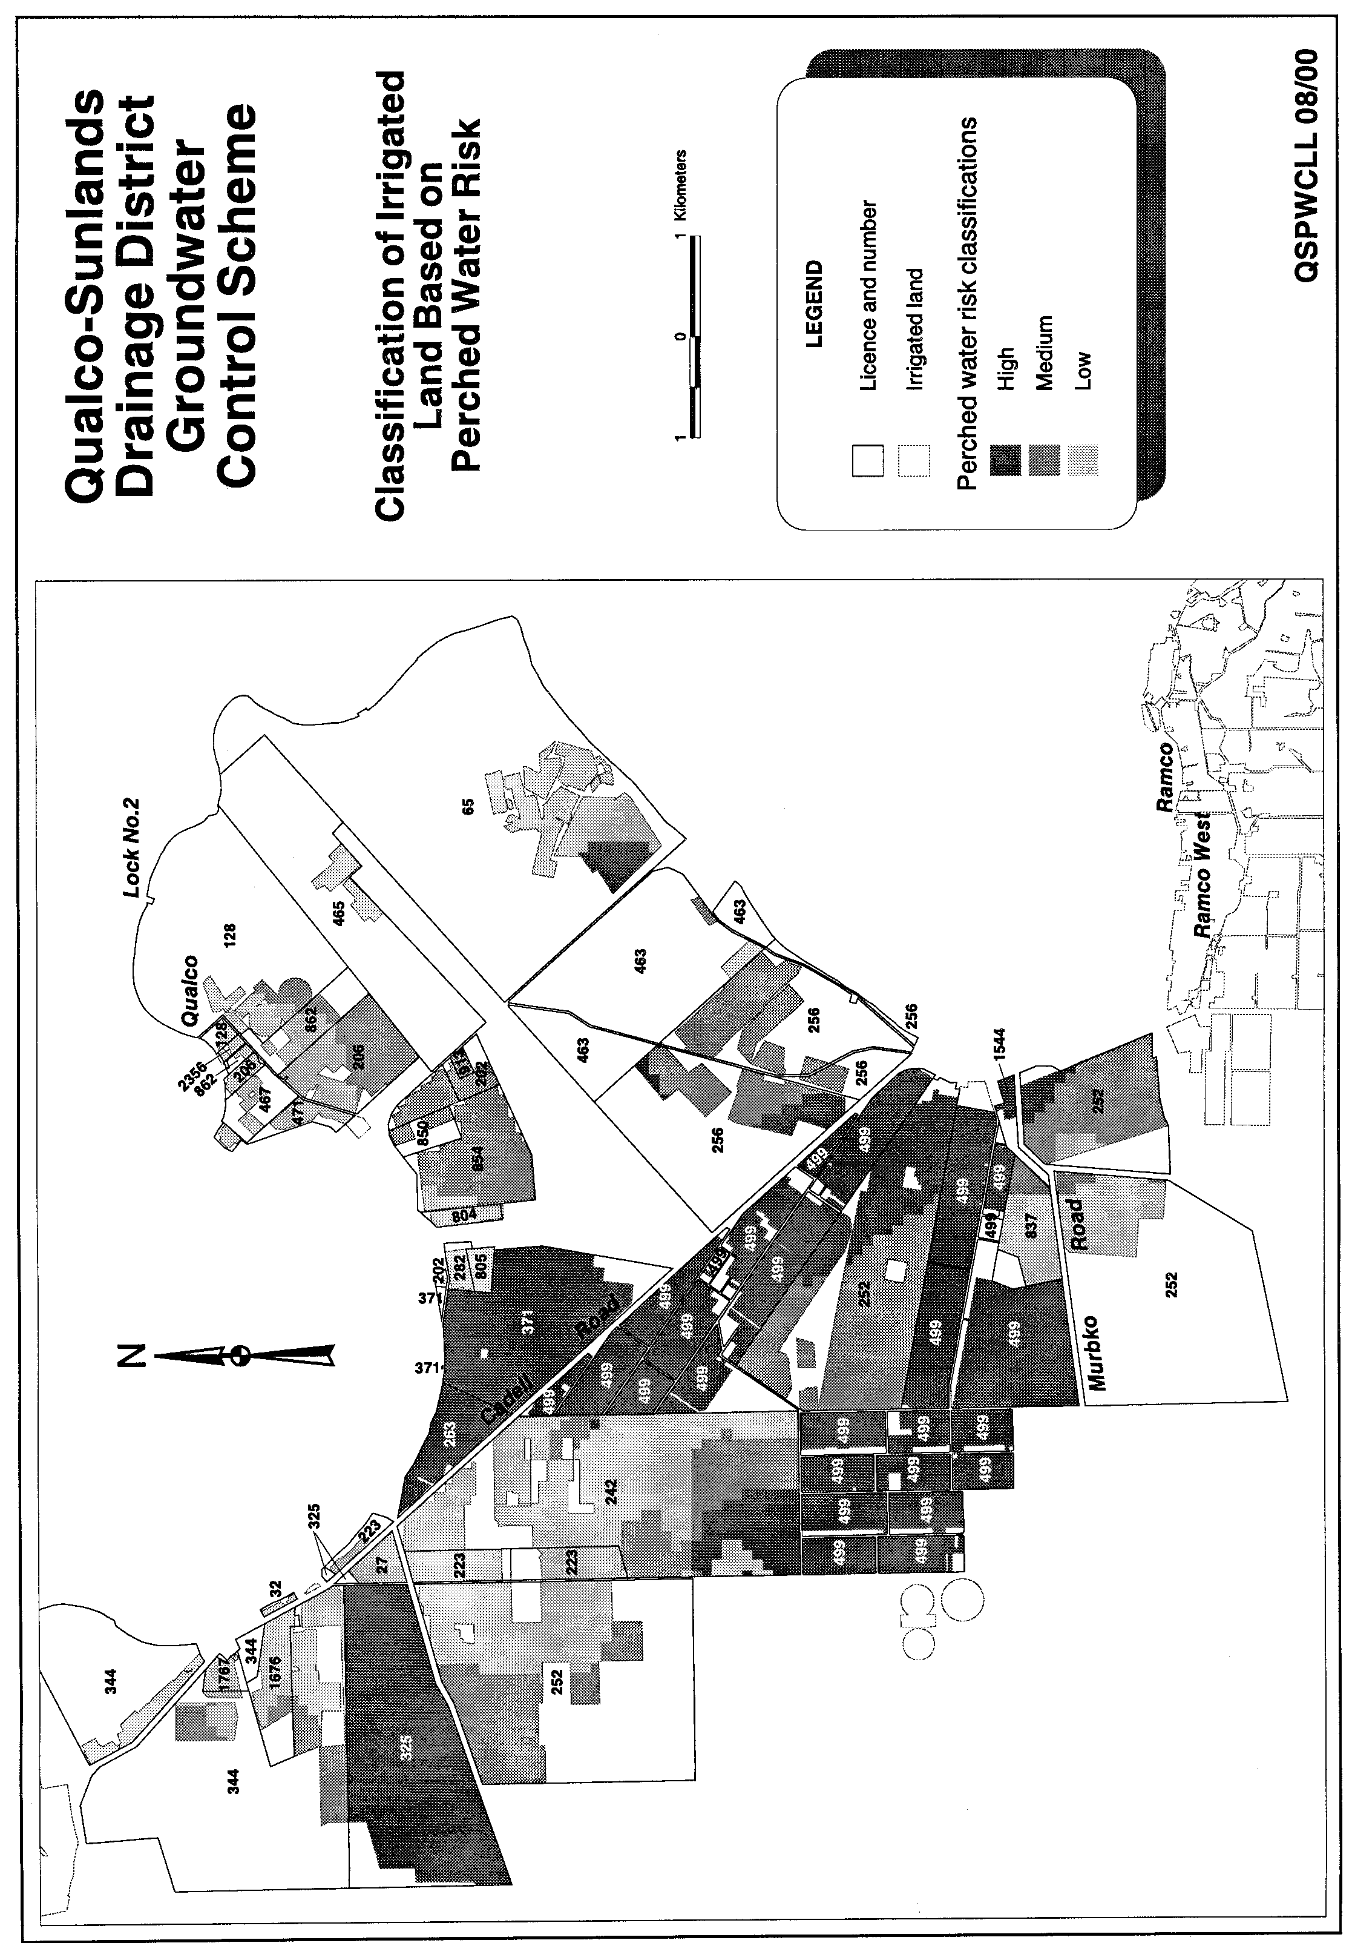
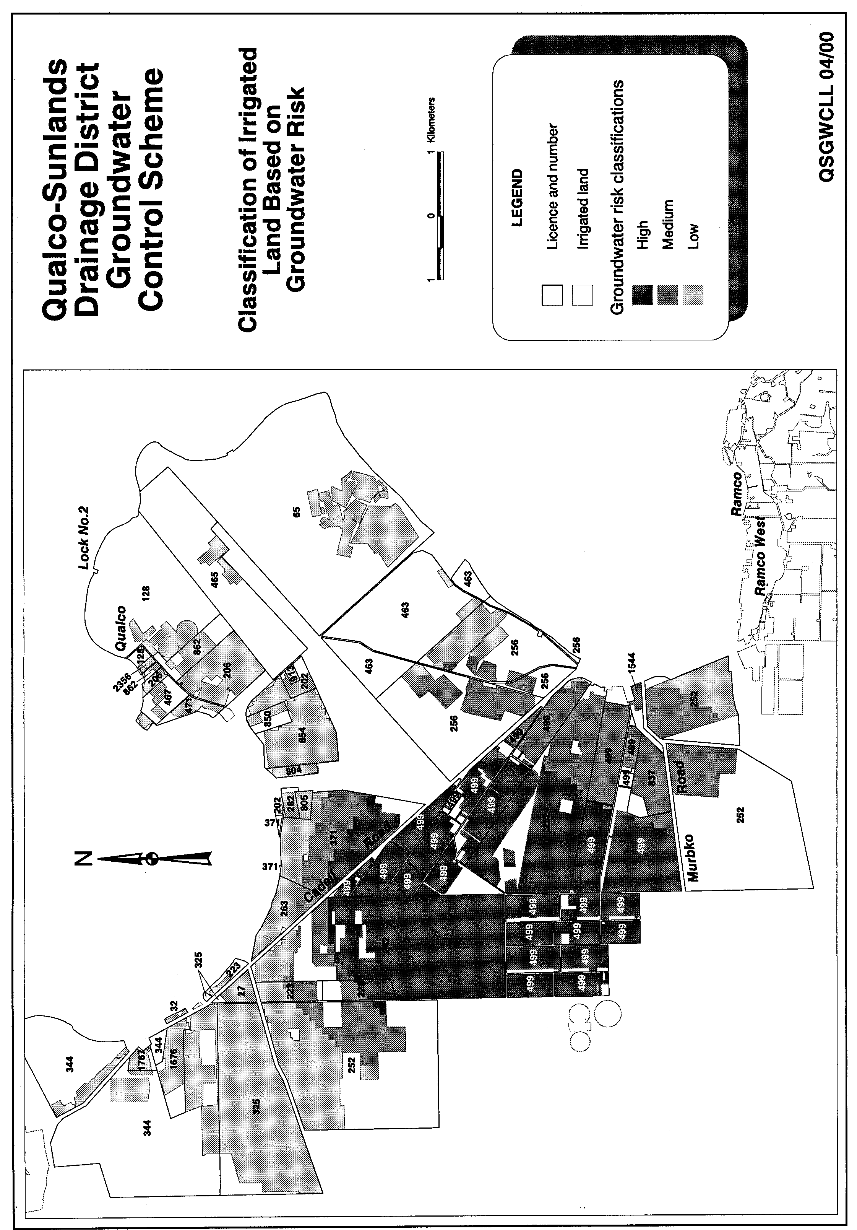
LIQUOR LICENSING ACT 1997 AND GAMING MACHINES ACT 1992
Notice of Transfer of Application
NOTICE is hereby given, pursuant to section 52 of the Liquor Licensing Act 1997 and section 29 of the Gaming Machines Act 1992, that Mark Andrew Jericho and Joan Leslie Jericho, 348 Port Road, Hindmarsh, S.A. 5007 and Kaben (S.A.) Pty Ltd (ACN 061 332 732), 185 Victoria Square, Adelaide, S.A. 5000 and Jusard Pty Ltd (ACN 007 649 470), 115 Grenfell Street, Adelaide, S.A. 5000 have applied to the Liquor and Gaming Commissioner for the transfer of a Hotel Licence and Gaming Machine Licence in respect of premises situated at 348 Port Road, Hindmarsh and known as the Hope Inn Hotel.
The applications have been set down for hearing on 15 September 2000.
Any person may object to the application by lodging a notice of objection in the prescribed form with the Licensing Authority, and serving a copy of the notice on the applicants at the applicants’ addresses given above, at least seven days before the hearing date.
Plans in respect of the premises the subject of the application are open to public inspection without fee at the Office of the Liquor and Gaming Commissioner, 9th Floor, East Wing, 50 Grenfell Street, Adelaide, S.A. 5000.
Dated 4 August 2000.
Applicants

LIQUOR LICENSING ACT 1997
Notice of Application
NOTICE is hereby given, pursuant to section 52 (2) (b) of the Liquor Licensing Act 1997, that Stephen Leslie Payn and Rebecca Isabel Payn, 12 The Strand, Port Elliot, S.A. 5212 have applied to the Licensing Authority for the transfer of a Restaurant Licence and Variation to Entertainment Consent in respect of premises situated at 12 The Strand, Port Elliot, S.A. 5212, currently known as Sitar Indian Restaurant and to be known as Paradiso Pizzeria.
The application has been set down for hearing on 15 September 2000.
Condition
The following licence condition is sought:
To vary the current Entertainment Consent to include the areas outlined in blue on the deposited plan.
Any person may object to the application by lodging a notice of objection in the prescribed form with the Licensing Authority, and serving a copy of the notice on the applicants at the applicants’ address given above, at least seven days before the hearing date.
Plans in respect of the premises the subject of the application are open to public inspection without fee at the Office of the Liquor and Gaming Commissioner, 9th Floor, East Wing, 50 Grenfell Street, Adelaide, S.A. 5000.
Dated 11 August 2000.
Applicants

LIQUOR LICENSING ACT 1997
Notice of Application
NOTICE is hereby given, pursuant to section 52 (2) (b) of the Liquor Licensing Act 1997, that Bull & Bear Wine Company Pty Ltd has applied to the Licensing Authority for a Producer’s Licence in respect of premises situated at 4 Bridge Street, Tanunda, S.A. 5352 and to be known as Bull & Bear Wine Company Pty Ltd.
The application has been set down for hearing on 15 September 2000.
Any person may object to the application by lodging a notice of objection in the prescribed form with the Licensing Authority, and serving a copy of the notice on the applicant at the applicant’s address given above, at least seven days before the hearing date.
Plans in respect of the premises the subject of the application are open to public inspection without fee at the Office of the Liquor and Gaming Commissioner, 9th Floor, East Wing, 50 Grenfell Street, Adelaide, S.A. 5000.
Dated 8 May 2000.
Applicant

LIQUOR LICENSING ACT 1997
Notice of Application
NOTICE is hereby given, pursuant to section 52 (2) (b) of the Liquor Licensing Act 1997, that D. K. Parade Pty Ltd, c/o Moody Rossi & Co., 185 Victoria Square, Adelaide, S.A. 5000 has applied to the Licensing Authority for a Restaurant Licence in respect of premises situated at 125A The Parade, Norwood, S.A. 5067 and known as Red Rock Noodle Bar & Restaurant-Norwood.
The application has been set down for hearing on 15 September 2000.
Conditions
The following licence conditions are sought:
The licensee is authorised to sell liquor on any day except Good Friday and Christmas Day, for consumption on the licensed premises by persons:
(a) seated at a table; or
(b) attending a function at which food is provided.
Extended Trading Authorisation hours of operation: Monday to Saturday, 11 a.m. to 2 a.m. the following day and Sunday, 11 a.m. to midnight.
Any person may object to the application by lodging a notice of objection in the prescribed form with the Licensing Authority, and serving a copy of the notice on the applicant at the applicant’s address given above, at least seven days before the hearing date.
Plans in respect of the premises the subject of the application are open to public inspection without fee at the Office of the Liquor and Gaming Commissioner, 9th Floor, East Wing, 50 Grenfell Street, Adelaide, S.A. 5000.
Dated 11 August 2000.
Applicant

LIQUOR LICENSING ACT 1997
Notice of Application
NOTICE is hereby given, pursuant to section 52 (2) (b) of the Liquor Licensing Act 1997, that Peter Polson, 15 Carter Street, Thorngate, S.A. 5082 has applied to the Licensing Authority for a Producer’s Licence in respect of premises situated at Lot 56, Blewitt Springs Road, McLaren Vale, S.A. 5171 and to be known as Bent Creek Vineyards.
The application has been set down for hearing on 15 September 2000 at 9 a.m.
Any person may object to the application by lodging a notice of objection in the prescribed form with the Licensing Authority, and serving a copy of the notice on the applicant at the applicant’s address given above, at least seven days before the hearing date.
Plans in respect of the premises the subject of the application are open to public inspection without fee at the Office of the Liquor and Gaming Commissioner, 9th Floor, East Wing, 50 Grenfell Street, Adelaide, S.A. 5000.
Dated 10 August 2000.
Applicant

LIQUOR LICENSING ACT 1997
Notice of Application
NOTICE is hereby given, pursuant to section 52 (2) (b) of the Liquor Licensing Act 1997, that ACN 092 002 232 Pty Ltd (to be known as West Torrens Birkalla Soccer Club Pty Ltd) as trustee of the Birkalla Unit Trust has applied to the Licensing Authority for a Special Circumstances Licence in respect of premises situated at corner Saratoga Drive and Morphett Road, Novar Gardens, S.A. 5038 and known as West Torrens Birkalla Soccer Club.
The application has been set down for hearing on 15 September 2000.
Conditions
The following licence conditions are sought:
The licence authorises the licensee to sell and supply liquor for consumption on the licensed premises, Monday to Friday, 5 a.m. to midnight; Saturday, 5 a.m. to 1 a.m. the following morning and Sunday, 10 a.m. to 8 p.m.
Entertainment Consent is sought.
Any person may object to the application by lodging a notice of objection in the prescribed form with the Licensing Authority, and serving a copy of the notice on the applicant at the applicant’s address given above, at least seven days before the hearing date.
Plans in respect of the premises the subject of the application are open to public inspection without fee at the Office of the Liquor and Gaming Commissioner, 9th Floor, East Wing, 50 Grenfell Street, Adelaide, S.A. 5000.
Dated 9 August 2000.
Applicant

LIQUOR LICENSING ACT 1997
Notice of Application
NOTICE is hereby given, pursuant to section 52 (2) (b) of the Liquor Licensing Act 1997, that Rockbrew Pty Ltd (ACN 007 939 531), c/o Griffins Lawyers, Level 14, 26 Flinders Street, Adelaide, S.A. 5000 has applied to the Licensing Authority for the transfer and removal of a Special Circumstances Licence in respect of premises situated at 125A The Parade, Norwood, S.A. 5067 and to be situated at Parade Central Tenancy, 13A and Part Tenancy 12, 177-193 The Parade, Norwood, S.A. 5067 and known as Red Rock Noodle Bar and Restaurant.
The application has been set down for hearing on 15 September 2000 at 9 a.m.
Any person may object to the application by lodging a notice of objection in the prescribed form with the Licensing Authority, and serving a copy of the notice on the applicant at the applicant’s address given above, at least seven days before the hearing date.
Plans in respect of the premises the subject of the application are open to public inspection without fee at the Office of the Liquor and Gaming Commissioner, 9th Floor, East Wing, 50 Grenfell Street, Adelaide, S.A. 5000.
Dated 8 August 2000.
Applicant

LIQUOR LICENSING ACT 1997
Notice of Application
NOTICE is hereby given, pursuant to section 52 (2) (b) of the Liquor Licensing Act 1997, that David Norman Pearce and Jacinta Marie Pearce have applied to the Licensing Authority for an Extended Trading Authorisation in respect of premises situated at Railway Terrace, Crystal Brook and known as Crystal Brook Hotel.
The application has been set down for hearing on 15 September 2000 at 9 a.m.
Conditions
The following licence conditions are sought:
1. That the licensee be permitted to sell liquor for consumption on the licensed premises each Friday and Saturday from midnight to 2 a.m. the following morning; each Sunday from 8 p.m. to 10 p.m. and on Christmas Day from midnight to 2 a.m.
2. That the licensee be permitted to sell liquor for consumption off the licensed premises each Sunday from 8 p.m. to 9 p.m.
3. That the Extended Trading Authorisation shall apply to the areas referred to on the deposited plan as Areas 1, 2, 3
and 4.
Any person may object to the application by lodging a notice of objection in the prescribed form with the Licensing Authority, and serving a copy of the notice on the applicant at the applicant’s address given above, at least seven days before the hearing date.
Plans in respect of the premises the subject of the application are open to public inspection without fee at the Office of the Liquor and Gaming Commissioner, 9th Floor, East Wing, 50 Grenfell Street, Adelaide, S.A. 5000.
Dated 3 August 2000.
Applicant

LIQUOR LICENSING ACT 1997
Notice of Application
NOTICE is hereby given, pursuant to section 52 (2) (b) of the Liquor Licensing Act 1997, that Paul Andrew Lindner, 88 Langmeil Road, Tanunda, S.A. 5352 has applied to the Licensing Authority for a Producer’s Licence in respect of premises situated at 88 Langmeil Road, Tanunda, S.A. 5352 and to be known as Linshank Vintners.
The application has been set down for hearing on 15 September 2000 at 9 a.m.
Any person may object to the application by lodging a notice of objection in the prescribed form with the Licensing Authority, and serving a copy of the notice on the applicant at the applicant’s address given above, at least seven days before the hearing date.
Plans in respect of the premises the subject of the application are open to public inspection without fee at the Office of the Liquor and Gaming Commissioner, 9th Floor, East Wing, 50 Grenfell Street, Adelaide, S.A. 5000.
Dated 7 August 2000.
Applicant

LIQUOR LICENSING ACT 1997
Notice of Application
NOTICE is hereby given, pursuant to section 52 (2) (b) of the Liquor Licensing Act 1997, that Peter John Clarke and Andrew James Wardlaw have applied to the Licensing Authority for a Producer’s Licence in respect of premises situated at Lot 1, Menge Road, Tanunda, S.A. 5352 and to be known as Tinshed Wines.
The application has been set down for hearing on 15 September 2000.
Any person may object to the application by lodging a notice of objection in the prescribed form with the Licensing Authority, and serving a copy of the notice on the applicants at the applicants’ address given above, at least seven days before the hearing date.
Plans in respect of the premises the subject of the application are open to public inspection without fee at the Office of the Liquor and Gaming Commissioner, 9th Floor, East Wing, 50 Grenfell Street, Adelaide, S.A. 5000.
Dated 2 July 2000.
Applicants

LIQUOR LICENSING ACT 1997
Notice of Application
NOTICE is hereby given, pursuant to section 52 (2) (b) of the Liquor Licensing Act 1997, that Holdcroft Brothers Pty Ltd has applied to the Licensing Authority for an Extended Trading Authorisation in respect of premises situated at Venables Street, Macclesfield and known as The Three Brothers Arms.
The application has been set down for hearing on Friday, 15 September 2000 at 9 a.m.
Conditions
The following licence conditions are sought:
1. That the licensee be permitted to sell liquor for consumption on the licensed premises each Monday to Saturday inclusive from midnight to 2 a.m. the following morning; each Sunday from 8 p.m. to 11 p.m. and on Christmas Day from midnight to 2 a.m.
2. That the licensee be permitted to sell liquor for consumption off the licensed premises from 8 p.m. to 9 p.m. each Sunday.
3. That the Extended Trading Authorisation shall apply to the areas referred to on the deposited plan as Areas 1 and 2.
It is proposed that entertainment may occasionally be con-ducted during the extended trading hours.
Any person may object to the application by lodging a notice of objection in the prescribed form with the Licensing Authority, and serving a copy of the notice on the applicant at the applicant’s address given above, at least seven days before the hearing date.
Plans in respect of the premises the subject of the application are open to public inspection without fee at the Office of the Liquor and Gaming Commissioner, 9th Floor, East Wing, 50 Grenfell Street, Adelaide, S.A. 5000.
Dated 3 August 2000.
Applicant

LIQUOR LICENSING ACT 1997
Notice of Application
NOTICE is hereby given, pursuant to section 52 (2) (b) of the Liquor Licensing Act 1997, that Shane Seyair, 33 Kirra Avenue, Mitchell Park, S.A. 5043 has applied to the Licensing Authority for the transfer of a Restaurant Licence in respect of premises situated at 590C Lower North East Road, Campbelltown, S.A. 5074 and known as Ginger Lime Restaurant.
The application has been set down for hearing on 18 September 2000 at 10 a.m.
Any person may object to the application by lodging a notice of objection in the prescribed form with the Licensing Authority, and serving a copy of the notice on the applicant at the applicant’s address given above, at least seven days before the hearing date.
Plans in respect of the premises the subject of the application are open to public inspection without fee at the Office of the Liquor and Gaming Commissioner, 9th Floor, East Wing, 50 Grenfell Street, Adelaide, S.A. 5000.
Dated 8 August 2000.
Applicant

LIQUOR LICENSING ACT 1997
Notice of Application
NOTICE is hereby given, pursuant to section 52 (2) (b) of the Liquor Licensing Act 1997, that Turocam Investments Pty Ltd (ACN 093 874 527), c/o C. P. & A. Consulting, 245 Currie Street, Adelaide, S.A. 5000 has applied to the Licensing Authority for the transfer of a Restaurant Licence in respect of premises situated at 438 Brighton Road, Brighton, S.A. 5048 and known as Fasta Pasta Brighton.
The application has been set down for hearing on 18 September 2000.
Any person may object to the application by lodging a notice of objection in the prescribed form with the Licensing Authority, and serving a copy of the notice on the applicant at the applicant’s address given above, at least seven days before the hearing date.
Plans in respect of the premises the subject of the application are open to public inspection without fee at the Office of the Liquor and Gaming Commissioner, 9th Floor, East Wing, 50 Grenfell Street, Adelaide, S.A. 5000.
Dated 8 August 2000.
Applicant

LIQUOR LICENSING ACT 1997
Notice of Application
NOTICE is hereby given, pursuant to section 52 (2) (b) of the Liquor Licensing Act 1997, that Victor Motel Investments Pty Ltd (ACN 079 148 879) has applied to the Licensing Authority for the transfer of a Residential Licence in respect of premises situated at 15 Hindmarsh Road, Victor Harbor, S.A. 5211 and known as Apollon Motor Inn.
The application has been set down for hearing on 18 September 2000.
Any person may object to the application by lodging a notice of objection in the prescribed form with the Licensing Authority, and serving a copy of the notice on the applicant at the applicant’s address given above, at least seven days before the hearing date.
Plans in respect of the premises the subject of the application are open to public inspection without fee at the Office of the Liquor and Gaming Commissioner, 9th Floor, East Wing, 50 Grenfell Street, Adelaide, S.A. 5000.
Dated 27 July 2000.
Applicant

Mining Act 1971
Notice is hereby given in accordance with section 28 (5) of the Mining Act 1971, that the Minister for Minerals and Energy proposes to grant an Exploration Licence over the under-mentioned area:
Applicant: Rio Tinto Exploration Pty Limited
Location: Douglas Creek Area—Approximately 170 km east-north-east of Coober Pedy, bounded as follows: Commencing at a point being the intersection of latitude 28°34′S and longitude 136°31′E, thence east to longitude 136°43′E, south to latitude 28°38′S, east to longitude 136°48′E, south to latitude 28°47′S, west to longitude 136°27′E, north to latitude 28°45′S, west to longitude 136°25′E, north to latitude 28°38′S, west to longitude 136°22′E, north to latitude 28°35′S, east to longitude 136°31′E, and north to the point of commencement, all the within latitudes and longitudes being geodetic and expressed in terms of the Australian Geodetic Datum as defined on p. 4984 of Commonwealth Gazette number 84 dated 6 October 1966 (AGD66).
Term: 1 year
Area in km²: 827
Ref: 036/00
L. Johnston, Mining Registrar, Department Primary Industries and Resources

MINING ACT 1971
Notice is hereby given in accordance with section 35A (1) of the Mining Act 1971, that an application for a mining lease over the undermentioned mineral claim has been received. Details of the proposal may be inspected at the Department of Primary Industries and Resources, Mineral Resources Group, Level 5, 101 Grenfell Street, Adelaide, S.A. 5000:
Applicant: Alan Harcourt Gibbons
Claim No.: 3172
Location: In section 450, Hundred of Waterhouse, approx-imately 8 km north-west of Robe.
Purpose: To excavate dune sand.
Reference: T2209
A copy of the proposal has been provided to the District Council of Robe.
Written submissions in relation to the granting of the mining lease are invited to be received at the Department of Primary Industries and Resources, Mineral Resources Group, Level 5, 101 Grenfell Street, Adelaide, S.A. 5000 or G.P.O. Box 1671, Adelaide, S.A. 5001 no later than 15 September 2000.
L. Johnston, Mining Registrar

MISCELLANEOUS LEGISLATION AND GOVERNMENT PUBLICATIONS PRICES AS FROM 1 JULY 2000

Acts, Bills, Rules, Parliamentary Papers and Regulations
Pages | Main | Amends | Pages | Main | Amends

1-16 | 1.80 | 0.80 | 497-512 | 26.25 | 25.25
17-32 | 2.55 | 1.60 | 513-528 | 27.00 | 26.00
33-48 | 3.25 | 2.35 | 529-544 | 27.75 | 26.75
49-64 | 4.15 | 3.10 | 545-560 | 28.50 | 27.75
65-80 | 4.90 | 4.00 | 561-576 | 29.25 | 28.50
81-96 | 5.60 | 4.70 | 577-592 | 30.25 | 29.00
97-112 | 6.45 | 5.45 | 593-608 | 31.00 | 30.00
113-128 | 7.20 | 6.30 | 609-624 | 31.75 | 31.00
129-144 | 8.10 | 7.10 | 625-640 | 32.50 | 31.50
145-160 | 8.90 | 7.85 | 641-656 | 33.25 | 32.25
161-176 | 9.70 | 8.70 | 657-672 | 33.75 | 33.00
177-192 | 10.40 | 9.50 | 673-688 | 35.00 | 33.75
193-208 | 11.20 | 10.30 | 689-704 | 35.75 | 34.75
209-224 | 12.00 | 11.00 | 705-720 | 36.25 | 35.50
225-240 | 12.70 | 11.80 | 721-736 | 37.50 | 36.00
241-257 | 13.60 | 12.50 | 737-752 | 38.00 | 37.00
258-272 | 14.40 | 13.30 | 753-768 | 39.00 | 37.50
273-288 | 15.20 | 14.20 | 769-784 | 39.50 | 38.75
289-304 | 15.90 | 14.90 | 785-800 | 40.25 | 39.50
305-320 | 16.70 | 15.70 | 801-816 | 41.00 | 40.00
321-336 | 17.50 | 16.50 | 817-832 | 42.00 | 41.00
337-352 | 18.30 | 17.40 | 833-848 | 42.75 | 41.75
353-368 | 19.10 | 18.10 | 849-864 | 43.50 | 42.50
369-384 | 19.90 | 19.00 | 865-880 | 44.25 | 43.50
385-400 | 20.60 | 19.70 | 881-896 | 44.75 | 44.00
401-416 | 21.40 | 20.40 | 897-912 | 46.00 | 44.75
417-432 | 22.30 | 21.30 | 913-928 | 46.50 | 46.00
433-448 | 23.00 | 22.00 | 929-944 | 47.50 | 46.50
449-464 | 23.90 | 22.80 | 945-960 | 48.50 | 47.00
465-480 | 24.50 | 23.60 | 961-976 | 49.00 | 48.00
481-496 | 25.25 | 24.30 | 977-992 | 50.00 | 48.50

Legislation—Acts, Regulations, etc: $
Subscriptions:
Acts 162.85
All Bills as Laid 388.90
Rules and Regulations 388.90
Parliamentary Papers 388.90
Bound Acts 179.75
Index 87.05
Government Gazette
Copy 4.30
Subscription 214.85
Hansard
Copy 11.60
Subscription—per session (issued weekly) 336.95
Cloth bound—per volume 144.70
Subscription—per session (issued daily) 336.95
Legislation on Disk
Whole Database 2 488.80
Annual Subscription for fortnightly updates 765.20
Individual Act(s) including updates POA
Compendium
Subscriptions:
New Subs 1 476.60
Updates 527.10

(All the above prices include GST)

All Legislation, Government Gazette, Hansard and Legislation on disk are available from:
Counter Sales Information SA (State Government Bookshop)
and Mail Orders: Australis Centre, Ground Floor, 77 Grenfell Street, Adelaide, S.A. 5000.
Phone: (08) 8204 1900. Fax: (08) 8204 1909
S.A. Country Customer Free Call: 1800 182 234
TTY (Hearing Impaired): (08) 8204 1923
Subscriptions and Standing Orders:
Phone: (08) 8204 9447, (08) 8204 9448. Fax: (08) 8204 1898
P.O. Box 1, Rundle Mall, Adelaide, S.A. 5000.

GOVERNMENT GAZETTE ADVERTISEMENT RATES

To apply from 1 July 2000

$  Agents, Ceasing to Act as 32.00  Associations:  Incorporation 16.30  Intention of Incorporation 40.25  Transfer of Properties 40.25  Attorney, Appointment of 32.00  Bailiff’s Sale 40.25  Cemetery Curator Appointed 23.90  Companies:  Alteration to Constitution 32.00  Capital, Increase or Decrease of 40.25  Ceasing to Carry on Business 23.90  Declaration of Dividend 23.90  Incorporation 32.00  Lost Share Certificates:  First Name 23.90  Each Subsequent Name 8.20  Meeting Final 26.75  Meeting Final Regarding Liquidator’s Report on  Conduct of Winding Up (equivalent to ‘Final  Meeting’)  First Name 32.00  Each Subsequent Name 8.20  Notices:  Call 40.25  Change of Name 16.30  Creditors 32.00  Creditors Compromise of Arrangement 32.00  Creditors (extraordinary resolution that ‘the Com-pany be wound up voluntarily and that a liquidator be appointed’) 40.25  Release of Liquidator⎯Application⎯Large Ad. 64.00  ⎯Release Granted 40.25  Receiver and Manager Appointed 37.25  Receiver and Manager Ceasing to Act 32.00  Restored Name 30.25  Petition to Supreme Court for Winding Up 55.50  Summons in Action 47.50  Order of Supreme Court for Winding Up Action 32.00  Register of Interests⎯Section 84 (1) Exempt 72.00  Removal of Office 16.30  Proof of Debts 32.00  Sales of Shares and Forfeiture 32.00  Estates:  Assigned 23.90  Deceased Persons⎯Notice to Creditors, etc. 40.25  Each Subsequent Name 8.20  Deceased Persons⎯Closed Estates 23.90  Each Subsequent Estate 1.00  Probate, Selling of 32.00  Public Trustee, each Estate 8.20 |  | $  Firms:  Ceasing to Carry on Business (each insertion) 21.30  Discontinuance Place of Business 21.30  Land⎯Real Property Act:  Intention to Sell, Notice of 40.25  Lost Certificate of Title Notices 40.25  Cancellation, Notice of (Strata Plan) 40.25  Mortgages:  Caveat Lodgment 16.30  Discharge of 17.20  Foreclosures 16.30  Transfer of 16.30  Sublet 8.20  Leases⎯Application for Transfer (2 insertions) each 8.20  Lost Treasury Receipts (3 insertions) each 23.90  Licensing 47.50  Municipal or District Councils:  Annual Financial Statement⎯Forms 1 and 2 451.00  Electricity Supply⎯Forms 19 and 20 319.00  Default in Payment of Rates:  First Name 64.00  Each Subsequent Name 8.20  Noxious Trade 23.90  Partnership, Dissolution of 23.90  Petitions (small) 16.30  Registered Building Societies (from Registrar-  General) 16.30  Register of Unclaimed Moneys⎯First Name 23.90  Each Subsequent Name 8.20  Registers of Members⎯Three pages and over:  Rate per page (in 8pt) 204.00  Rate per page (in 6pt) 269.00  Sale of Land by Public Auction 40.75  Advertisements 2.25  Advertisements, other than those listed are charged at $2.25 per column line, tabular one-third extra.  Notices by Colleges, Universities, Corporations and District Councils to be charged at $2.25 per line.  Where the notice inserted varies significantly in length from that which is usually published a charge of $2.25 per column line will be applied in lieu of advertisement rates listed.  South Australian Government publications are sold on the condition that they will not be reproduced without prior permission from the Government Printer.
All the above prices include GST

GOVERNMENT GAZETTE NOTICES
ALL private advertisements forwarded for publication in the South Australian Government Gazette must be PAID FOR PRIOR TO INSERTION; and all notices, from whatever source, should be legibly written on one side of the paper only and sent to Riverside 2000 so as to be received no later than 4 p.m. Tuesday preceding the day of publication. Phone 8207 1045 or Fax 8207 1040. E-mail: Riv2000@saugov.sa.gov.au. Send as attachments in Word format and please confirm your transmission with a faxed copy of your document, including the date the notice is to be published and to whom the notice will be charged.

RULES OF COURT
Amending the Supreme Court Rules 1987
Amendment No. 75 to the Supreme Court Rules
BY virtue and in pursuance of Section 72 of the Supreme Court Act 1935, and all other enabling powers, We, the Judges of the Supreme Court of South Australia, make the following Rules to take effect as amendments to the Supreme Court Rules 1987, as amended:
1. These Rules may be cited as the “Supreme Court Rules 1987, Amendment No. 75”.
2. The Supreme Court Rules 1987, as amended, by these Rules may be cited as the “Supreme Court Rules 1987”.
3. Rule 101A.01 be amended by adding the following sub-paragraph:
“(e) In respect of work done on and after the 1st day of July 2000 costs shall be allowed and paid in accordance with the scale of costs in the Seventh Schedule to these Rules.”
4. The following schedule is added immediately after the Sixth Schedule.
“SEVENTH SCHEDULE
Preparation of documents $
1. Drawing any document which is necessary to originate, or for use in, or in connection with, any proceeding or in a matter whether litigious or otherwise, including the engrossment of the original per A4 page. | 44.00
PROVIDED THAT a greater amount may be allowed where the matter is of importance and/or difficulty.
2. Where any document is partly printed and partly drawn, the drawing fee for the drawn part shall be allowed and, in addition, for the printed matter (including all perusals thereof) per A4 page. | 10.00
2A. Engrossing the original of any document where no allowance is made for such engrossment elsewhere, including the solicitor’s own copy, per A4 page. | 10.00
3. Where a document is prepared on other than A4 paper the amounts to be allowed under items 1 and 2 may be increased or decreased in the discretion of the taxing officer. The fees under items 1 and 2 shall include the preparation of a backsheet.
4. Photocopying any document:  (a) per sheet;  (b) where a substantial number of sheets are or should be photo-copied at the same time, in respect of multiple copies of the same document for each sheet after the first regard may be had to commercial photocopying rates. | 0.55
5. Perusing document, per A4 page or the equivalent thereof (See Note J).  If of substance, not exceeding per A4 page. | 5.00  13.40
6. Scanning of documents where full perusal is not justified, per A4 page or the equivalent thereof. | 1.30
Attendances (See Note K)  7. The attendance of a solicitor where the nature of the work requires the exercise of special skill or legal knowledge, per hour. | 180.00
8. The attendance of a solicitor where work done does not require special skills or legal knowledge, but where it is proper that a solicitor should personally attend, and travelling time, per hour. | 110.00
9. Attending on any application, matter or taxation in chambers or on a pre-trial conference, or a conciliation conference (not certified fit for counsel) or on any callover:  (a) if short or matter adjourned without substantial argument;  (b) if ordinary;  (c) if protracted or of difficulty, per hour. | 65.00  110.00  180.00
10. Attendance of a clerk on work not properly able to be carried out by a junior clerk, including travelling time, per hour. | 86.00
11. Attending at Court to file or lodge documents or papers, or to set down, attendance to deliver documents or any other attendance capable of performance by a junior clerk, including attending to set down any Chamber application and to search the list for Chamber appointments and all attendances necessary to settle and seal an order or other document, per attendance. | 14.50
12. An attendance by telephone of a solicitor, for each six minute interval thereof or part thereof. | 16.50
13. An attendance by telephone of a clerk:  (a) on a matter of substance;  (b) on a short call where a message is left. | 8.80  2.20
14. An attendance on the swearing of an affidavit:  (a) of a solicitor to be sworn to an affidavit;  (b) of a solicitor to take an affidavit where he or his firm has prepared the affidavit;  (c) of a clerk to be sworn to an affidavit;  (d) of a solicitor on any other person to be sworn to an affidavit where no charge is made under (b),  (such fee is to include all charges for marking exhibits and for perusing or reading over the affidavit when the attendance properly does not exceed 15 minutes. If the attendance exceeds 15 minutes, the attendance will be allowed proportionately, at the rate fixed by Item 8 of the Scale.) | 22.00  10.00  14.50  22.50
Letters  15. Any letter:  (a) not exceeding one A4 page;  (b) exceeding more than one A4 page:  for the first page  and for subsequent pages  (c) circular letters (including the cost of copying) per A4 page. | 16.00  28.00  28.00  5.50
16.  (a) For incoming facsimile transmissions per page;  (b) For outgoing facsimile transmissions:  for the first page  for each subsequent page  Where applicable, STD and ISD charges will be allowed as a dis-bursement. | 0.55  4.50  1.10
17. For the payment of any account where an account in writing has been rendered and which is in order, including any letter sent with the payment of the account, if the letter relates solely to the account, and to include all disbursements on cheques. | 5.50
Registration of Certificate of Judgment Under Service and Execution of Process Act  18. Instructions for and attending to registration of a certificate of judgment pursuant to the Service and Execution of Process Act including all correspondence documents, attendances in relation thereto as assessed pursuant to section 22A(1) of the Act but not exceeding. | 245.00
Miscellaneous  19. Paging, collating, binding and indexing copy documents for use of the Trial Judge, including the index:  (a) where the copy documents are 10 A4 pages or less;  (b) more than 10 A4 page. | 6.50  12.20

20. Paging, collating, binding and indexing a brief, of:  (a) 10 pages or less;  (b) more than 10 pages and less than 50 pages;  (c) more than 50 pages and less than 100 pages;  (d) more than 100 pages and less than 200 pages;  (e) more than 200 pages.  Where it is proper to deliver more than one brief, and in respect of appeal books after the first, an additional amount of one half of the amount allowable under this time for the first copy of the brief or appeal book for each additional brief or appeal book will be allowed. Where a brief or appeal book exceeds 300 pages, the pages in excess of 300 may be treated as a separate brief or appeal book. | 13.00  50.00  83.00  132.00  193.00
21. Care and consideration in the preparation of a brief to be an amount in the discretion of the taxing Master but in cases where oral evidence is to be called on disputed matters or where there is to be substantial argument on legal matters. | 56.00
22. Preparation of short form Bill of Costs, per A4 page. | 44.00
23. Drawing and the engrossment of the original, and of the solicitor’s own copy, of:  (a) a proof of a witness for a brief, where it is not necessary substantially to recast any notes made of the statement of the witness or to collate any number of previous statements;  (b) indices (where not otherwise provided);  (c) formal lists;  (d) copies of extracts from other documents, per A4 page. | 22.00

Notes:
A. The amount allowed for each of the above items is to be at the discretion of the taxing officer, who shall be at liberty in the particular circumstances of the matter to disallow any item entirely or to allow a greater or a lesser amount for any item AND PROVIDED THAT a greater amount may be allowed where the matter is of importance or difficulty.
B. Each bill of costs (other than a short form bill of costs) must show:
(1) the time spent on any attendance;
(2) the number of A4 pages (or the equivalent thereof) contained in any document for which a charge is made;
(3) the name of any solicitor and the status of any clerk in respect of whom any attendance is charged;
(4) a separate identifying number for each item and the date thereof;
(5) the items of work and disbursements in chronological order.
C. Where the time for any attendance is only a portion of an hour, such amount may be allowed in accordance with the scale as the proportion of the hour bears to the amount allowed for the whole of an hour.
D. Where in this schedule fees (other than for photocopying) are set by reference to an A4 page, such fee is fixed (except in the case of correspondence) on the basis that the typed or printed content of each page consists of 30 lines in courier 10 size print with margins approximating the minimum referred to in R 102.02(b). Where correspondence is concerned, the fee is fixed on the basis that the typed content of each page after the first page consists of 45 lines in courier 10 sized print with margins approximating the minimum referred to in Rule 102.02(b). The fee allowable may be adjusted by the taxing officer depending on whether the document in question exceeds or falls short of those standards.
E. Only the amount of disbursements actually paid or payable are to be shown in the bill as disbursements. Where a disbursement is yet to be paid, this must be specially stated.
F. Where the contents of a document (or page thereof) are less than one A4 page in length the fee allowed therefor is to be at the discretion of the taxing officer.
G. For drawing any bill of costs (not including a short form bill of costs) the taxing officer may allow an additional 50 per cent on all drawing fees.
H. Such allowance for kilometreage by motor vehicle or other conveyance will be made as the taxing officer shall consider reasonable.
I. Where the Court orders a party, or a party or person is otherwise required, to tax costs both as between party and party and solicitor and client, Form 37 of the Supreme Court Rules shall be modified by the applicant so as to provide for the inclusion of both party and party and solicitor and client costs and the respondents’ respective responses thereto.
J. The maximum rate is appropriate for documents such as pleadings, particulars, advices and opinions and for the more complicated medical and expert reports. A middle range figure will be appropriate for standard expert reports, lists of documents and medical reports. The lower rate will apply to appearances, ordinary corres-pondence, special damages, vouchers and the like. In cases where a large volume of documents is required to be perused, an hourly rate may be allowed by the Taxing Officer in lieu of a perusal fee.
K. When an instructing solicitor is in Court the lower rate should be allowed if the solicitor is merely assisting counsel by being present, but the higher rate should be allowed if the solicitor is more actively involved, eg by proofing witnesses, preparing indices, etc.
L. The costs allowed in this scale are inclusive of the Goods and Services Tax (GST).”
GIVEN under our hands and the Seal of the Supreme Court of South Australia this 31st day of July 2000.
(l.s.) J. DOYLE, CJ
G. C. PRIOR, J
J. W. PERRY, J
K. P. DUGGAN, J
B. T. LANDER, J
H. C. WILLIAMS, J
D. J. BLEBY, J.
D. F. WICKS, J
B. MARTIN, J
T. A. GRAY, J

RULES OF COURT
Amending the Supreme Court Rules 1987
Amendment No. 76 to the Supreme Court Rules
BY virtue and in pursuance of Section 72 of the Supreme Court Act 1935, and all other enabling powers, We, the Judges of the Supreme Court of South Australia, make the following Rules to take effect as amendments to the Supreme Court Rules 1987, as amended:
1. These Rules may be cited as the “Supreme Court Rules 1987, Amendment No. 76”.
2. The Supreme Court Rules 1987, as amended, by these Rules may be cited as the “Supreme Court Rules 1987”.
3. Rule 6.06 is repealed and the following inserted in its place:
“6.06 The Registry shall be open for public business except on Saturdays, Sundays, public holidays and the days between Christmas and New Year’s Day and at such times as may be fixed by the Registrar, with the approval of the Chief Justice, by practice direction.”
4. Form 37 is deleted and the form annexed hereto and marked “Form 37” is inserted in its place:

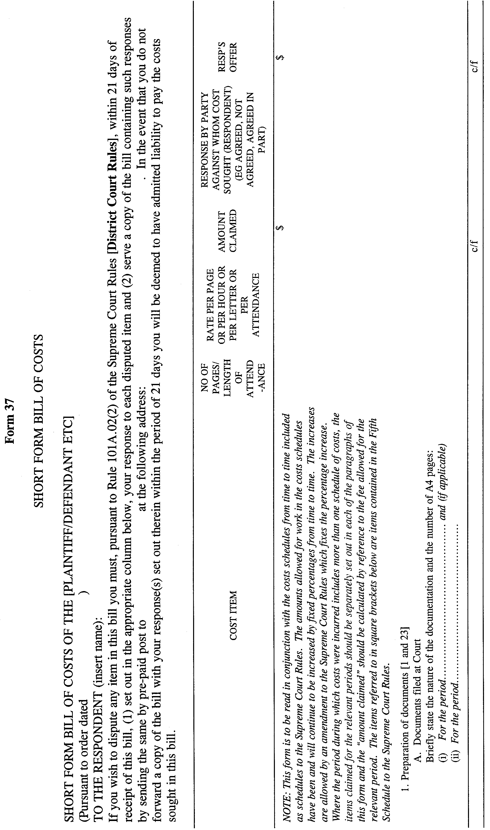
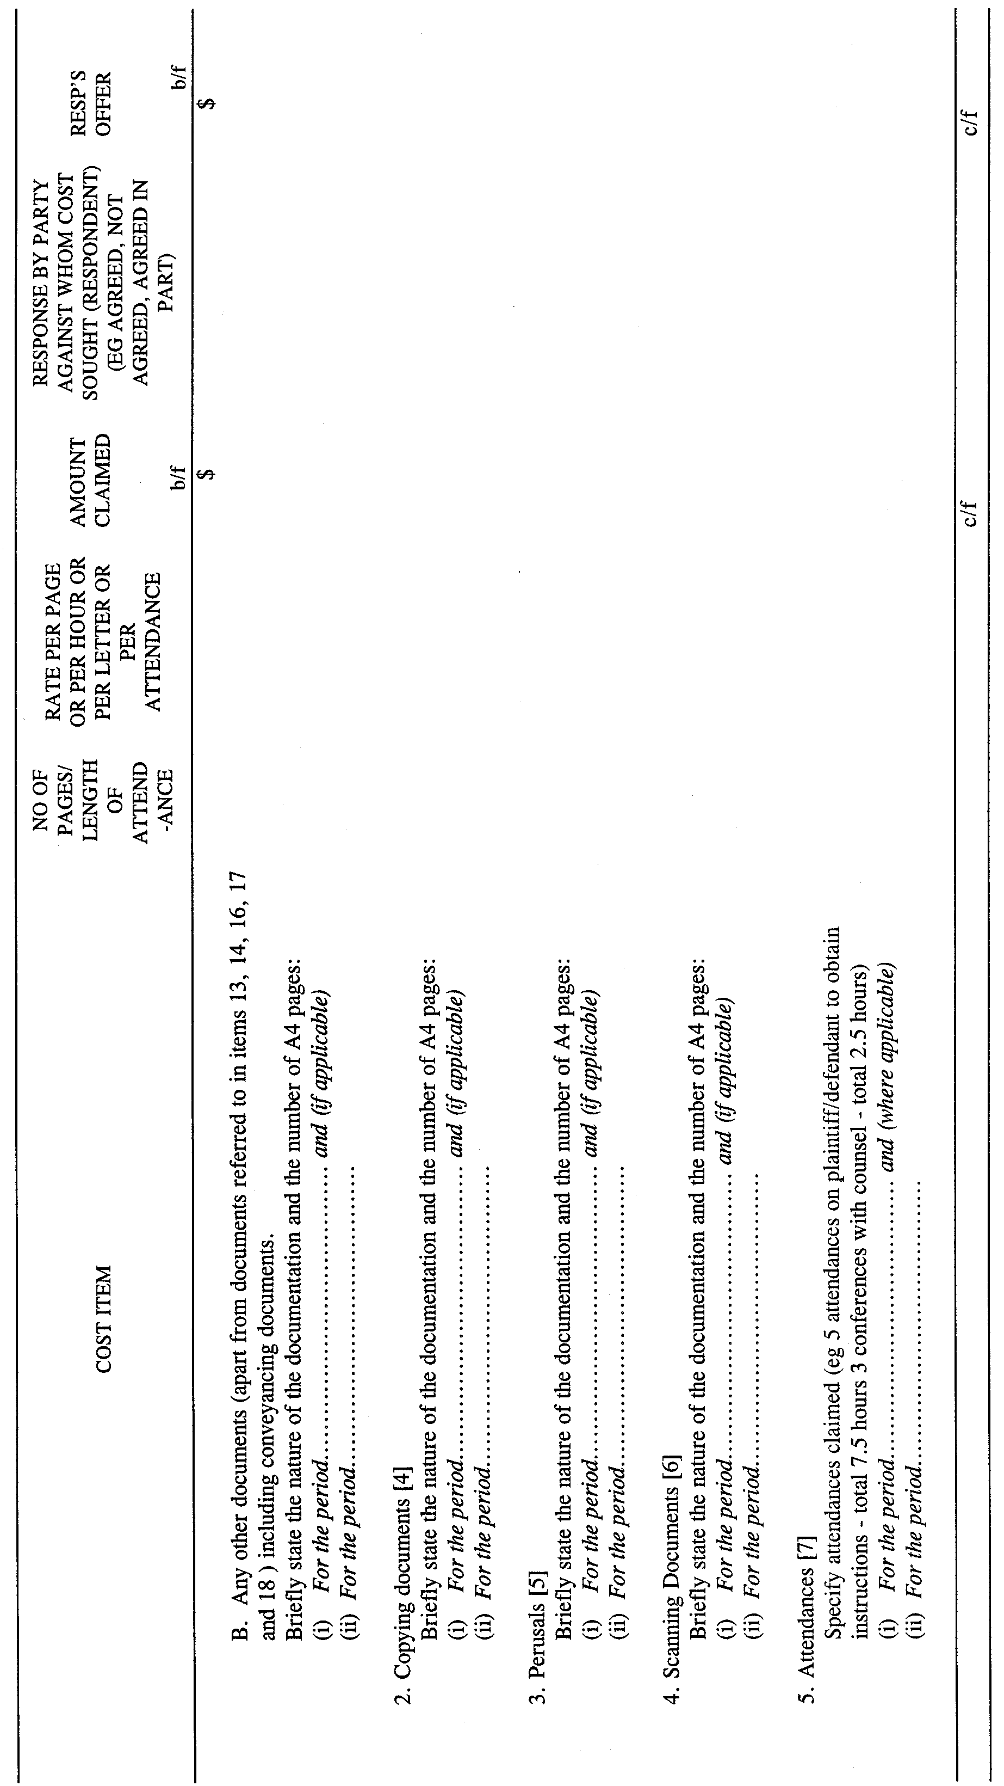
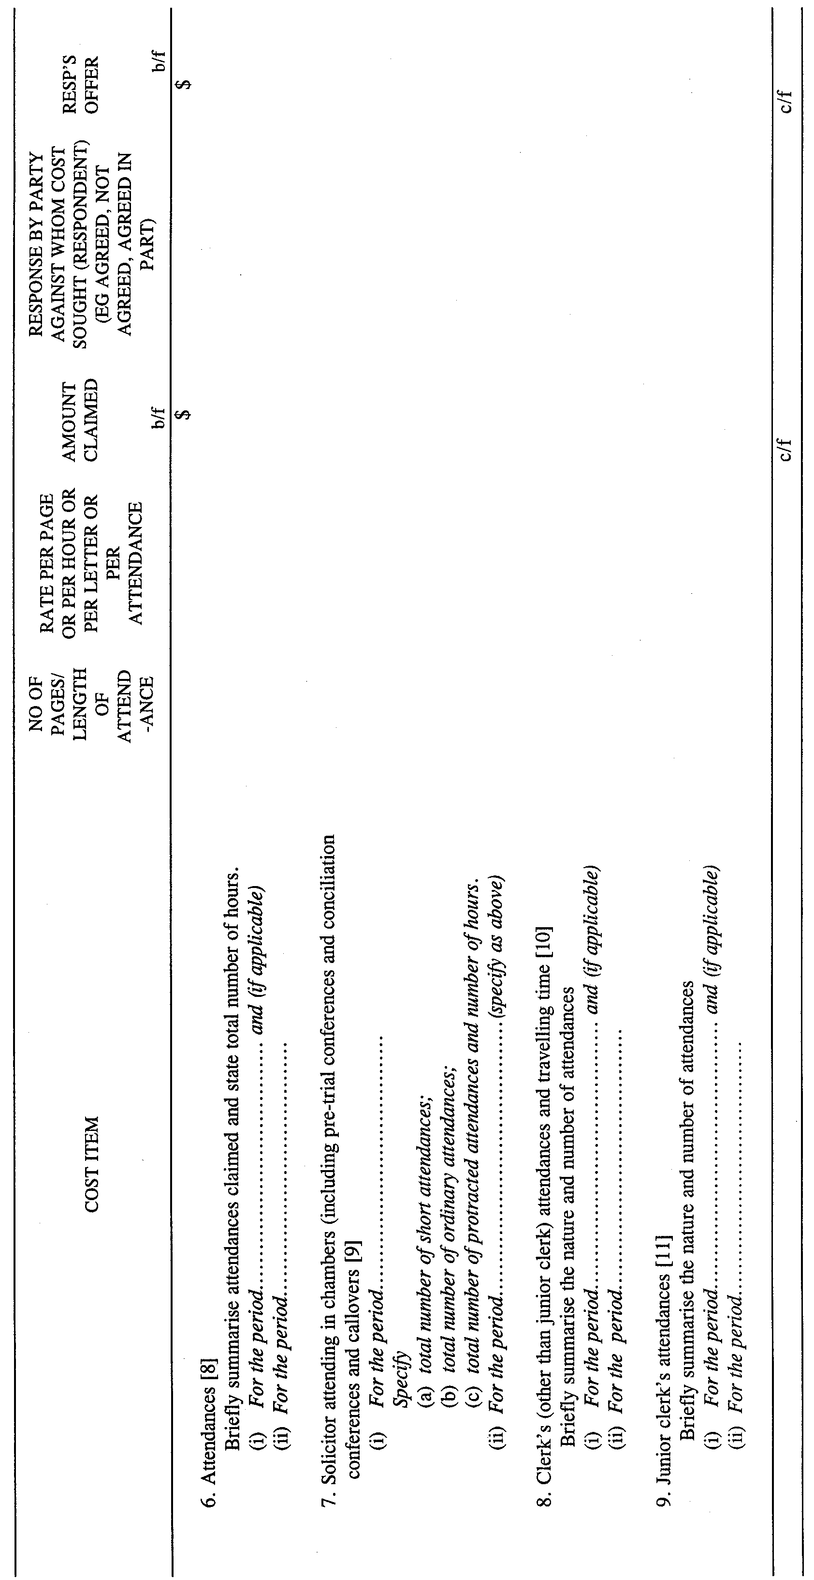
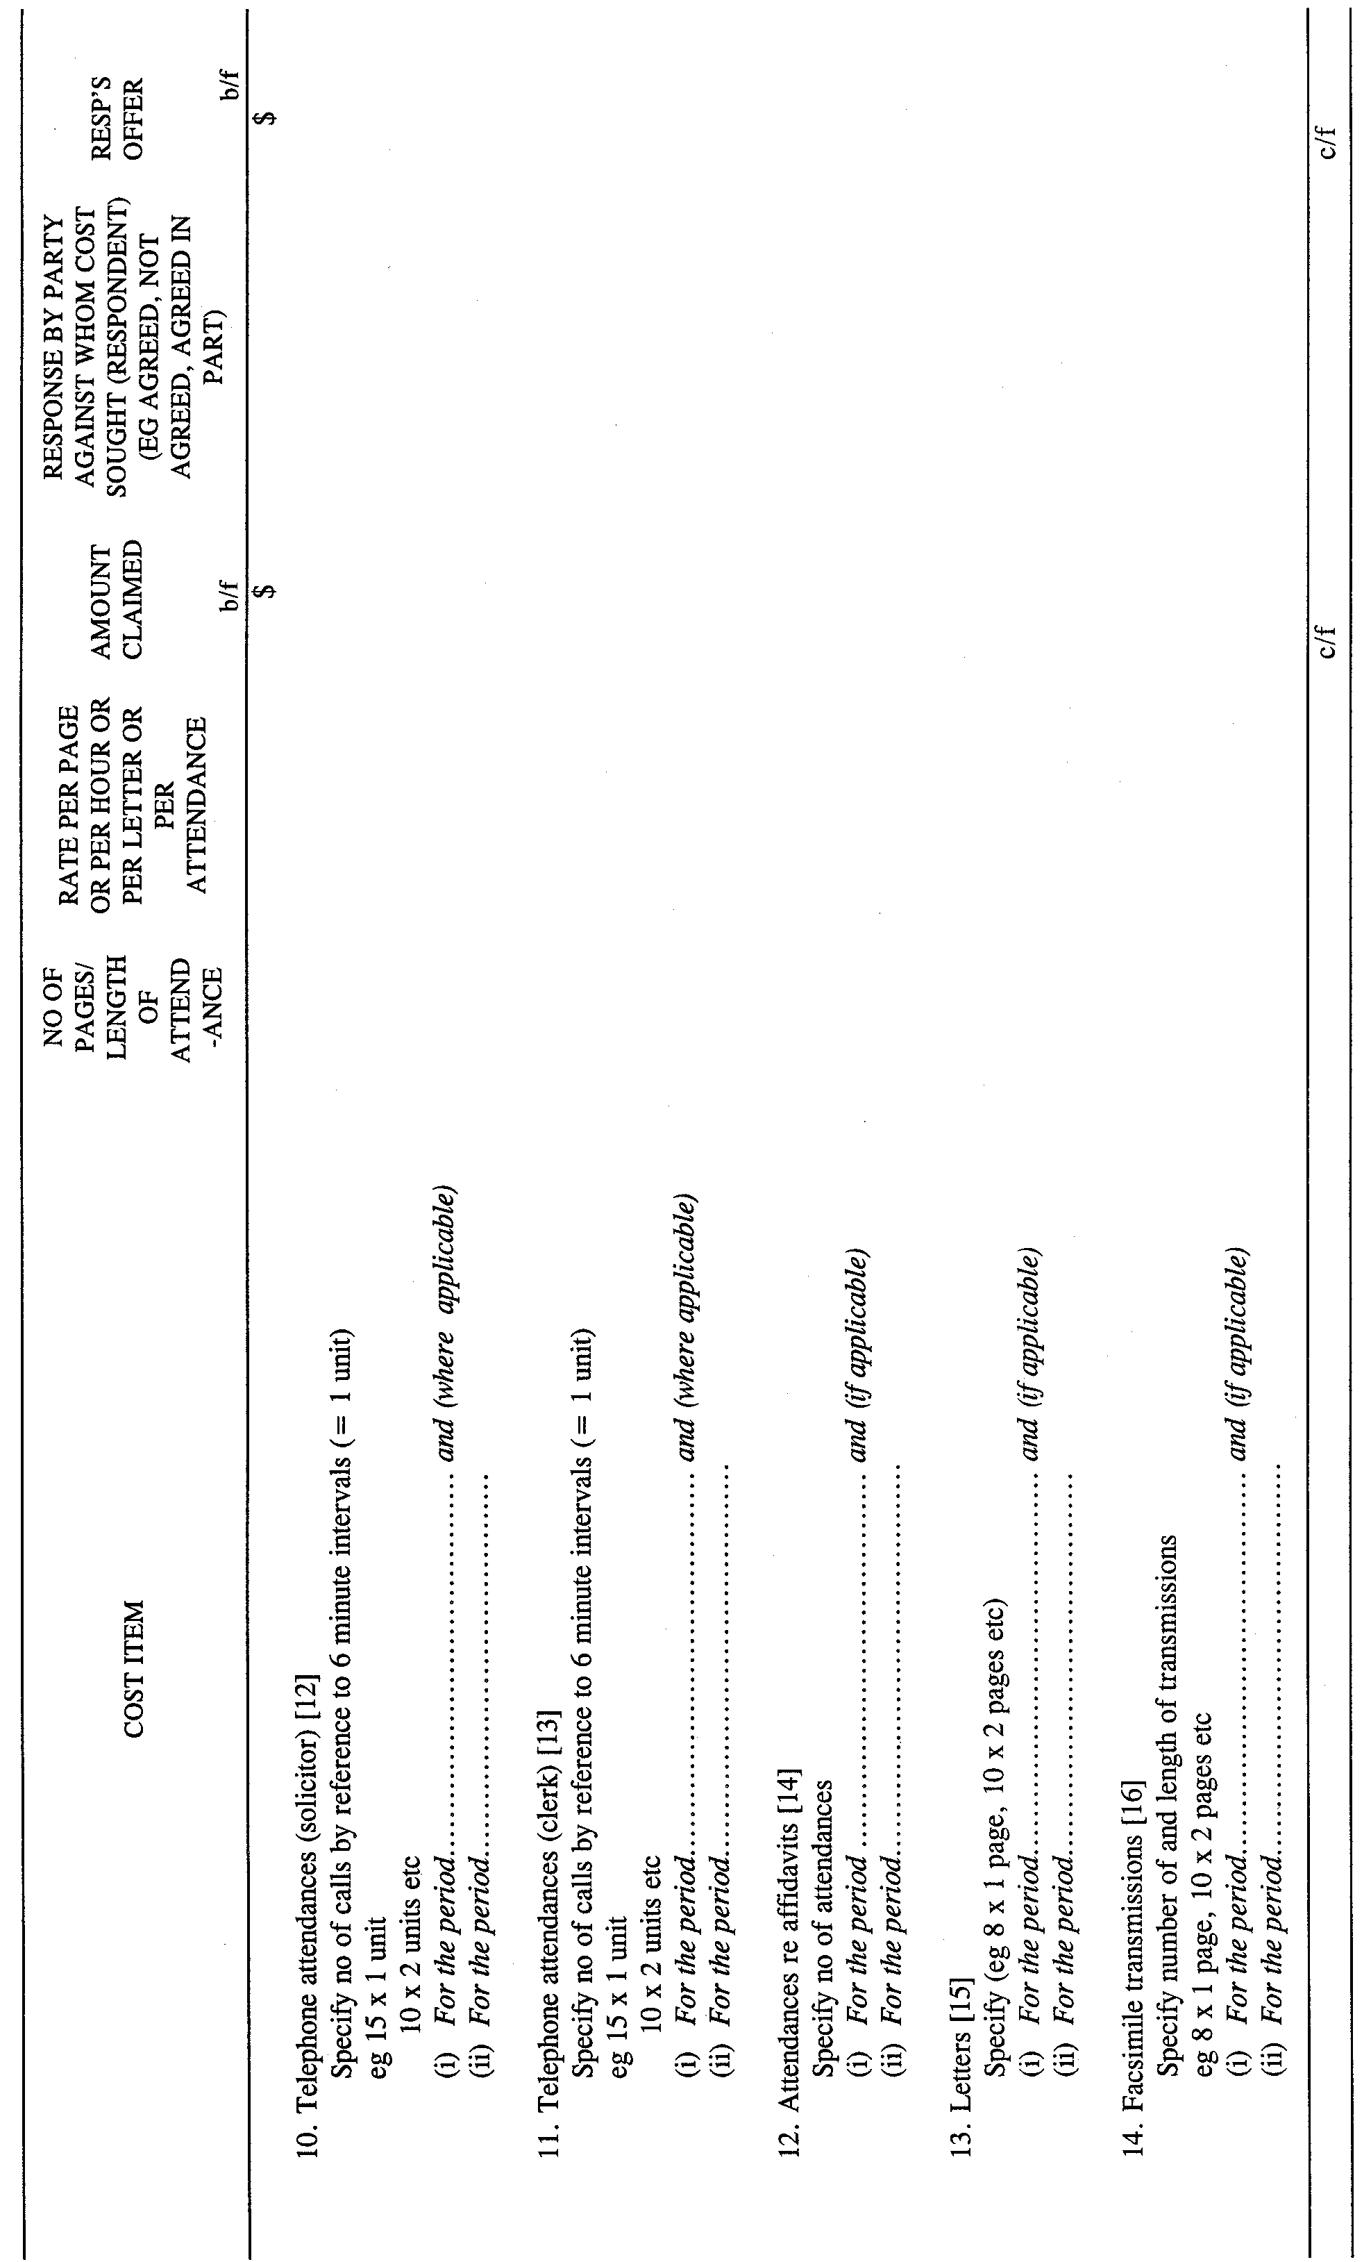
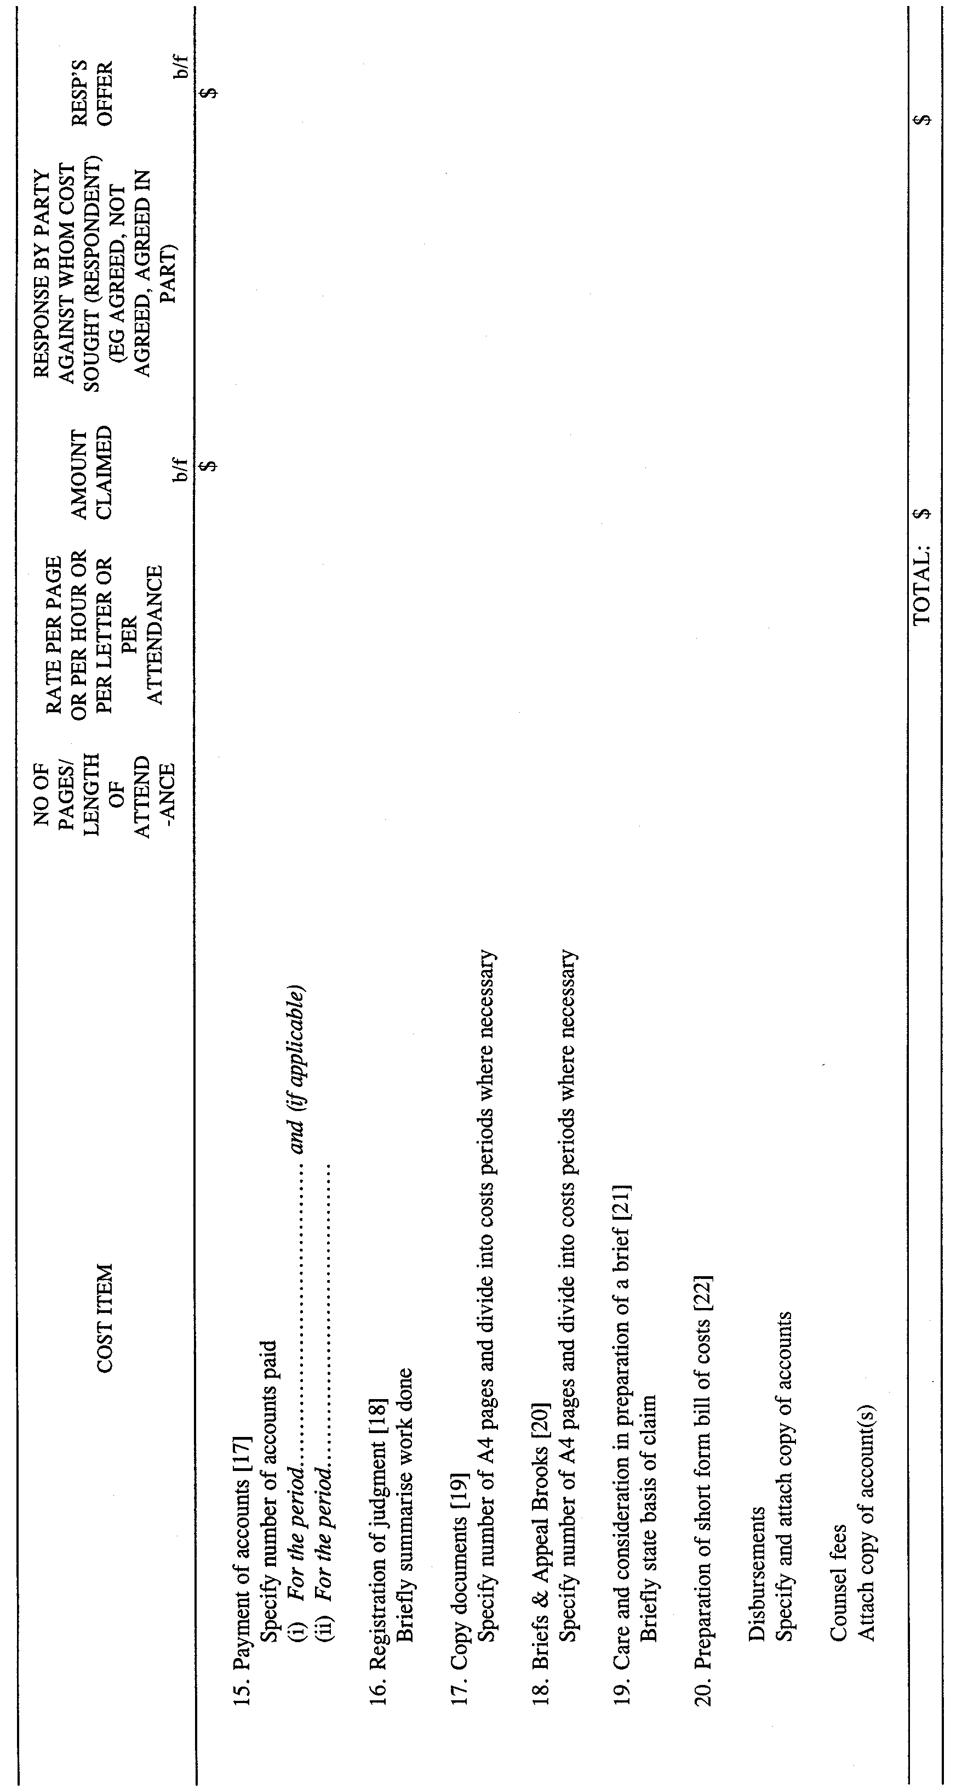
GIVEN under our hands and the Seal of the Supreme Court of South Australia this 31st day of July 2000.
(l.s.) J. DOYLE, CJ
G. C. PRIOR, J
L. T. OLSSON, J
J. W. PERRY, J
K. P. DUGGAN, J
B. T. LANDER, J
H. C. WILLIAMS, J
D. J. BLEBY, J.
D. F. WICKS, J
B. MARTIN, J
T. A. GRAY, J

SURVEY ACT 1992
Notices
PURSUANT to section 49 (1) (b) of the Survey Act 1992, I declare that from 1 December 2000:
• designated survey area numbers 12 and 17 are revoked, and
• the following areas of the State, numbered 12 and 17 outlined in black on the following plans, to be designated survey areas.
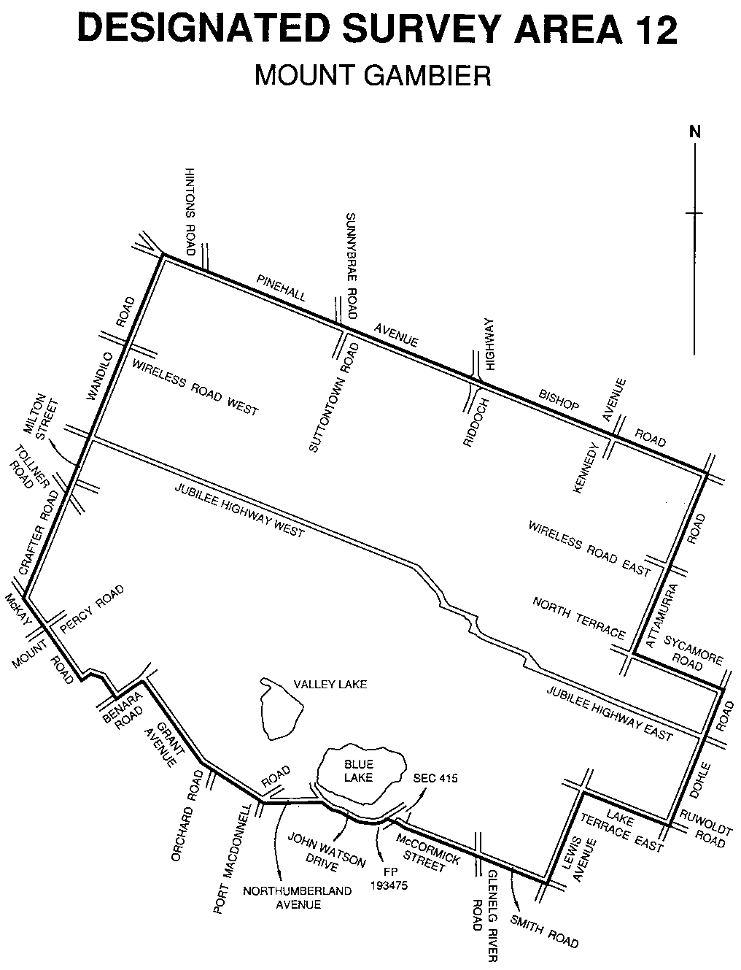

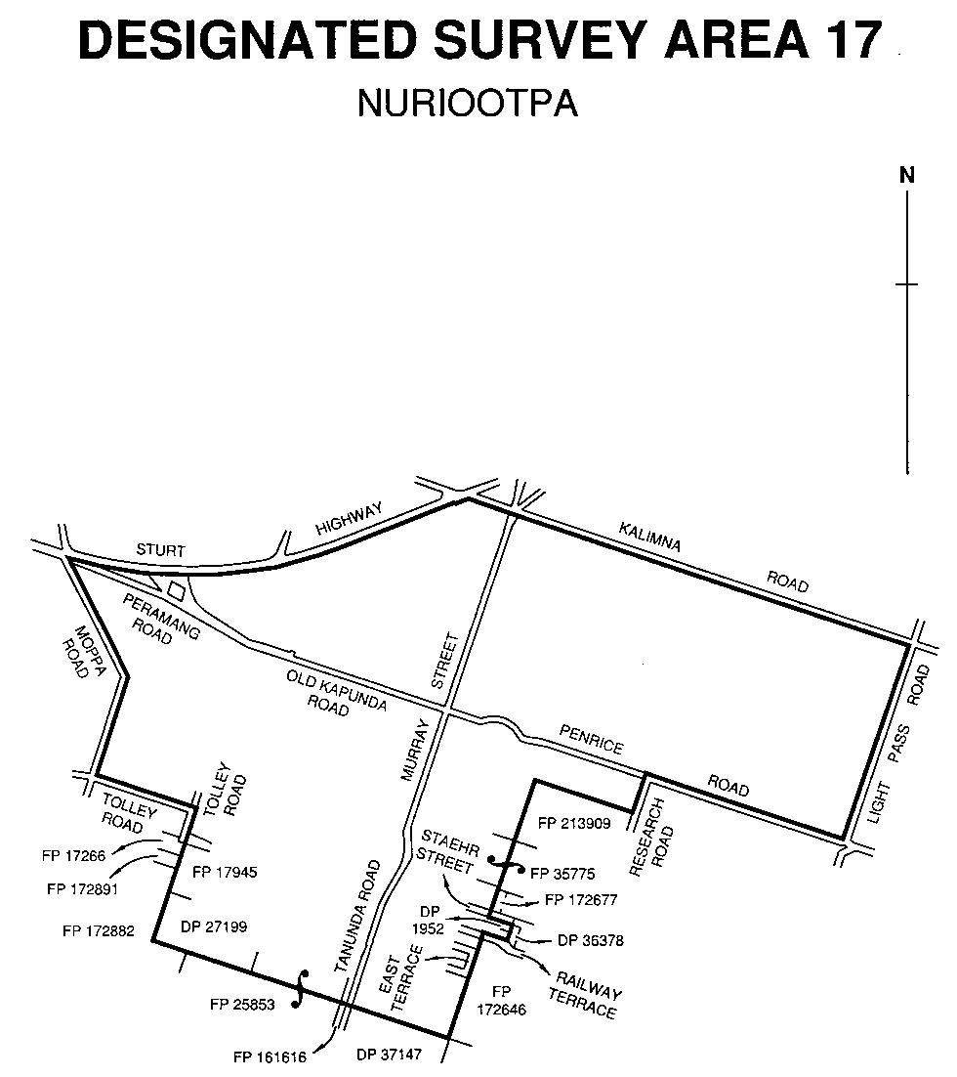

Dated 17 August 2000.
P. M. Kentish, Surveyor-General

ROADS (OPENING AND CLOSING) ACT 1991:
SECTION 24
NOTICE OF CONFIRMATION OF ROAD
PROCESS ORDER
Grenfell Road, Wynn Vale
Deposited Plan 55263
BY Road Process Order made on 13 June 2000, the City of Tea Tree Gully ordered that:
1. Portion of the public road (Grenfell Road) adjoining De Castella Avenue and allotment 107 in Deposited Plan 10931 more particularly lettered ‘A’ in Preliminary Plan No. PP32/0562 be closed.
2. The whole of the land subject to closure be transferred to PAUL OVENDEN and ADELHEID OVENDEN in accordance with agreement for transfer dated 10 May 2000 entered into between the City of Tea Tree Gully and P. and A. Ovenden.
On 21 July 2000 that order was confirmed by the Minister for Administrative and Information Services conditionally on approval and deposit of the survey plan by the Registrar-General. The condition has now been fulfilled.
Pursuant to section 24 (5) of the Roads (Opening and Closing) Act 1991, NOTICE of the order referred to above and its confirmation is hereby given.
Dated 17 August 2000.
P. M. Kentish, Surveyor-General

Roads (Opening and Closing) Act 1991
Corrigendum
IN notices appearing in Government Gazette dated 3 August 2000, pursuant to section 24 (5) of the Roads (Opening and Closing) Act 1991, should read as follows:
NOTICE OF CONFIRMATION OF ROAD
PROCESS ORDER
Public road, Hundred of Fisher
Deposited Plan 55194
The confirmation appearing on page 415:
‘Preliminary Plan No. PP32/0388 . . .’ to read as ‘Pre-liminary Plan No. PP32/0334 . . .’
NOTICE OF CONFIRMATION OF ROAD
PROCESS ORDER
Reid Avenue, Ashford
Deposited Plan 55388
The confirmation appearing on page 416:
‘Preliminary Plan No. PP32/0391 . . .’ to read as ‘Pre-liminary Plan No. PP32/0359 . . .’
Dated 17 August 2000.
P. M. Kentish, Surveyor-General

ROADS (OPENING AND CLOSING) ACT 1991
Road Closure—Sturt Highway, Barmera
NOTICE is hereby given, pursuant to section 10 of the Roads (Opening and Closing) Act 1991, that The Berri Barmera Council proposes to close and transfer to ANTHONY JOHN TAYLOR, ELEANOR MARY TAYLOR, RODNEY LEONARD FORD and GAYLE MAREE FORD portion of the public road (Sturt Highway) adjoining the southern boundary of section 637, Cobdogla Irrigation Area shown delineated and lettered ‘A’ on Preliminary Plan No. PP32/0593.
A copy of the plan and a statement of persons affected are available for public inspection at the office of the Council, 19 Wilson Street, Berri, S.A. 5343 and the Adelaide office of the Surveyor-General during normal office hours.
Any application for easement or objection must set out the full name, address and details of the submission and must be fully supported by reasons.
The application for easement or objection must be made in writing to the Council, P.O. Box 229, Berri, S.A. 5343 WITHIN 28 DAYS OF THE DATE OF THIS NOTICE and a copy must be forwarded to the Surveyor-General, G.P.O. Box 1354, Adelaide, S.A. 5001. Where a submission is made, the Council will give notification of a meeting at which the matter will be considered.
Dated 17 August 2000.
P. M. Kentish, Surveyor-General

ROADS (OPENING AND CLOSING) ACT 1991
Road Closure—Cross Keys Road, Mawson Lakes
NOTICE is hereby given, pursuant to section 10 of the Roads (Opening and Closing) Act 1991, that CITY OF SALISBURY proposes to close and transfer to the LAND MANAGEMENT CORPORATION the great portion of public road (Cross Keys Road) south of Bennett Road adjoining allotment 11 in Deposited Plan 51194 shown delineated and lettered ‘A’ on Preliminary Plan No. PP32/0591.
A copy of the plan and a statement of persons affected are available for public inspection at the offices of the Council, 8 James Street, Salisbury, S.A. 5108 and the Adelaide office of the Surveyor-General during normal office hours.
Any application for easement or objection must set out the full name, address and details of the submission and must be fully supported by reasons.
The application for easement or objection must be made in writing to the Council, P.O. Box 8, Salisbury, S.A. 5108 WITHIN 28 DAYS OF THE DATE OF THIS NOTICE and a copy must be forwarded to the Surveyor-General, G.P.O. Box 1354, Adelaide, S.A. 5001. Where a submission is made, the Council will give notification of a meeting at which the matter will be considered.
Dated 17 August 2000.
P. M. Kentish, Surveyor-General

WATER MAINS AND SEWERS

Office of the South Australian Water Corporation
Adelaide, 17 August 2000.

WATER MAINS LAID

Notice is hereby given that the following main pipes or parts of main pipes have been laid down by the South Australian Water Corporation in or near the undermentioned water districts and are now available for a constant supply of water to adjacent land.

ADELAIDE WATER DISTRICT

CITY OF MITCHAM
Batley Avenue, Hawthorndene. p12

CITY OF ONKAPARINGA
Sturt Approach, Flagstaff Hill. p3 and 4

DISTRICT OF PORT ADELAIDE ENFIELD
Buckingham Street, Oakden. p1
Trinity Way, Oakden. p1
Easement in lot 25, Trinity Way, Oakden. p1

CITY OF SALISBURY
Sheaoak Drive, Mawson Lakes. p2
Greengate Lane, Mawson Lakes. p2
Easement in lot 553, Greengate Lane, Mawson Lakes. p2
Queensborough Drive, Salisbury Heights. p5
Bushman Drive, Walkley Heights. p13
Farmhouse Avenue, Walkley Heights. p13
Station Crescent, Walkley Heights. p13

CEDUNA WATER DISTRICT

DISTRICT OF CEDUNA
Easement in lot 312, Kent Street, Thevenard. p7

KINGSTON S.E. WATER DISTRICT

DISTRICT OF KINGSTON
Strickland Street, Kingston S.E. p27

PORT WAKEFIELD WATER DISTRICT

WAKEFIELD REGIONAL COUNCIL
George Street, Port Wakefield. p35

ROWLAND FLAT WATER DISTRICT

THE BAROSSA COUNCIL
Barossa Valley Highway, Rowland Flat. This main is available for connections on application only. p15
Golflinks Road, Rowland Flat. This main is available for connections on application only. p15

TRURO WATER DISTRICT

DISTRICT OF MID MURRAY COUNCIL
The Esplanade, Truro. This main is available for connections on application only on the southern side. p38

TUMBY BAY WATER DISTRICT

DISTRICT OF TUMBY BAY
McCallum Terrace, Tumby Bay. p28
Nelcebee Terrace, Tumby Bay. p28 and 29
Marina Place, Tumby Bay. p28
Yaringa Avenue, Tumby Bay. p30
Viking Street, Tumby Bay. p30
Wandana Place, Tumby Bay. p31
Morialta Drive, Tumby Bay. p31 and 30

WARREN COUNTRY LANDS WATER DISTRICT

THE BAROSSA COUNCIL
Jacob Road, Rowland Flat. This main is available for connections on application only. p14-17
Barossa Valley Highway, Rowland Flat. This main is available for connections on application only. p15
Sugar Loaf Road, hundred of Barossa. This main is available for connections on application only. p19 and 20
Miamba Road, hundred of Barossa. This main is available for connections on application only. p20-22
Mahlo Road, hundred of Barossa. This main is available for connections on application only. p22 and 23
Lorke Road, hundred of Barossa. This main is available for connections on application only. p23 and 24

LIGHT REGIONAL COUNCIL
Jenke Road, Marananga. This main is available for connections on application only. p6
Neldner Road, Marananga. This main is available for connections on application only. p6
Research Road, Ebenezer. This main is available for connections on application only from 200 mm AC main Carrara Hill Road to 100 mm CICL main Ebenezer Road. p8-10
Carrara Hill Road, Ebenezer. p9 and 10

WATER MAINS ABANDONED

Notice is hereby given that the undermentioned water mains have been abandoned by the South Australian Water Corporation.

ADELAIDE WATER DISTRICT

DISTRICT OF TEA TREE GULLY
Across Aeolian Drive (formerly easement in lot 1025), Golden Grove. p39

WARREN COUNTRY LANDS WATER DISTRICT

LIGHT REGIONAL COUNCIL
Research Road, Ebenezer. p8-10
Carrara Hill Road, Ebenezer. p9 and 10

ADDENDA

Addendum to notices in “Government Gazette” of 23 March 1995.

“WATER MAINS LAID”

“Notice is hereby given that the following main pipes or parts of main pipes have been laid down by the South Australian Water Corporation in or near the undermentioned water districts and are now available for a constant supply of water to adjacent land.”

“PORT LINCOLN WATER DISTRICT”

“DISTRICT OF LOWER EYRE PENINSULA”
“Howard Avenue, Port Lincoln. p68”

“TOD RIVER COUNTRY LANDS WATER DISTRICT”

“DISTRICT OF LOWER EYRE PENINSULA”
“Howard Avenue, Port Lincoln. p68”

To these notices add “This main is available for connections on application only. p25”

SEWERS LAID

Notice is hereby given that the following sewers have been laid down by the South Australian Water Corporation in the undermentioned drainage areas and are now available for house connections.

ADELAIDE DRAINAGE AREA

CITY OF CAMPBELLTOWN
Judith Street, Rostrevor. FB 1089 p1
Dennis Avenue, Newton. FB 1089 p27

CITY OF CHARLES STURT
Easement in lots 2, Trimmer Parade, Grange. FB 1089 p26

CITY OF ONKAPARINGA
Easements in reserves (lots 507 and 601), The Parkway and reserve (lot 614), Bushland Drive, Aberfoyle Park. FB 1089 p13 and 15
Easements in lot 1000, Scenic Court and lots 1-7, 14 , 39 and 38, Corella Avenue, Chandlers Hill. FB 1089 p13-16
Fidge Street, Aldinga Beach. FB 1089 p18
Gulfview Road, Christies Beach. FB 1089 p19

CITY OF PLAYFORD
Easement in lot 92, Stebonheath Road, Munno Para West. FB 1088 p59
Counter Road, Elizabeth Downs. FB 1088 p60

CITY OF PORT ADELAIDE ENFIELD
Buckingham Street, Oakden. FB 1089 p7 and 8
Trinity Way, Oakden. FB 1089 p7 and 8
Audrey Avenue, Blair Athol. FB 1089 p5
Osborne Road, North Haven. FB 1089 p17

CITY OF SALISBURY
Queensborough Drive, Salisbury Heights. FB 1089 p6
Easements in lots 4, 817-820, Rivergum Close and lots 1022, 617-611 and reserve (lot 704) Farmhouse Avenue, Walkley Heights. FB 1089 p9-12
Farmhouse Avenue, Walkley Heights. FB 1089 p10 and 11
Bushman Drive, Walkley Heights. FB 1089 p10 and 11
Station Crescent, Walkley Heights. FB 1089 p10 and 12

MOUNT GAMBIER COUNTRY DRAINAGE AREA

CITY OF MOUNT GAMBIER
Easement in reserve (lot 307), Saint Martins Drive and lot 17, Warrick Close, Mount Gambier. FB 1066 p55 and 56
Warrick Close, Mount Gambier. FB 1066 p55 and 56
Max Young Drive, Mount Gambier. FB 1066 p55 and 56
Saint Martins Drive, Mount Gambier. FB 1066 p55-57
Kyrenia Court, Mount Gambier. FB 1066 p57
Easement in lot 31, Saint Martins Drive and lot 34, Dalkeith Drive, Mount Gambier. FB 1066 p57

OUTSIDE ADELAIDE DRAINAGE AREA

CITY OF ONKAPARINGA
Easements in lot 503, Mitchell Road and lot 16, Gleneagles Road, Aberfoyle Park and Chandlers Hill. This sewer is available for house connections on application only. FB 1089 p13-15

PORT LINCOLN COUNTRY DRAINAGE AREA

CITY OF PORT LINCOLN
Milton Avenue, Port Lincoln. This sewer main is not available for house connections except to lot 5 in LTRO DP 22874. FB 1089 p3
Conrad Street, Port Lincoln. FB 1089 p4

SEWERS ABANDONED

Notice is hereby given that the undermentioned sewers have been abandoned by the South Australian Water Corporation.

ADELAIDE DRAINAGE AREA

CITY OF PORT ADELAIDE ENFIELD
Audrey Avenue, Blair Athol. FB 1089 p5
Easement in lot 101, North East Road, Hillcrest. FB 1089 p2

CITY OF ONKAPARINGA
Easement in lots 35-39, Corella Avenue, Chandlers Hill. FB 1089 p14

S. Sullivan, Chief Executive Officer, South Australian Water Corporation

WATER RESOURCES ACT 1997
Variation to Water Allocation Plans
Pursuant to subclause 2 (15a) of Schedule 3 of the Water Resources Act 1997, I, Mark Brindal, Minister for Water Resources, hereby give notice of the variation of the Water Allocation Plans for the Padthaway, Lacepede-Kongorong, Tatiara, Comaum-Caroline and Naracoorte Ranges Prescribed Wells Areas (as varied by the notice in the Gazette dated 27 July 2000) in accordance with Schedule A. This variation takes effect from 10 August 2000.
Schedule A
1. Clause 29 of the water allocation plans for the Lacepede-Kongorong, Tatiara, Comaum-Caroline and Naracoorte Ranges Prescribed Wells Areas is varied by inserting after subclause (c) the following:
‘(d) agriculture or horticulture where the produce:
(i) is to be refined, altered, cleaned, washed, packed, bottled, canned, or adapted for sale by some form of industry; and
(ii) the industry is created, developed or established after 1 September 2000 and is undertaken or is to be undertaken in South Australia.’
2. Clause 37 of the Water Allocation Plans for the Tatiara, Comaum-Caroline and Naracoorte Ranges Prescribed Wells Areas is amended by deleting the reference in subclause 37 (a) to ‘General Registry Office Plan 364/00’ and inserting ‘General Registry Office Plan 395/00’.
3. Clause 45 of the water allocation plans for the Lacepede-Kongorong, Tatiara, Comaum-Caroline and Naracoorte Ranges Prescribed Wells Areas and clause 15 of the water allocation plan for the Padthaway Prescribed Wells Area is varied by inserting the word ‘seasonal’ before the term ‘draw-down’ and by deleting the words ‘at peak demand’.
Dated 14 August 2000.
P. Butler, Acting Chief of Staff to the Minister for Water Resources

ENVIRONMENT PROTECTION ACT 1993
Exemption
THE Environment Protection Authority has issued to Multiplex Constructions Pty Ltd an exemption from the Environmental Protection (Industrial Noise) Policy 1994 with respect to construction activities at the site known as Embassy Apartments, 92-97 North Terrace, Adelaide, between the period 17 June 2000 to 30 June 2001.
Excessive noise as a result of construction activity is permitted only between the hours of:
7 a.m. to 5 p.m. Monday to Saturday, inclusive
9 a.m. to 4 p.m. Sunday
At all other times, noise emissions from the construction site must comply with the Environment Protection Act 1993 and the Environment Protection (Industrial Noise) Policy 1994.
G. Sclare, Manager Environment Licensing, Environment Protection Agency

REGULATIONS UNDER THE PLUMBERS, GAS FITTERS AND ELECTRICIANS ACT 1995
────
No. 187 of 2000
────
At the Executive Council Office at Adelaide 17 August 2000

PURSUANT to the Plumbers, Gas Fitters and Electricians Act 1995 and with the advice and consent of the Executive Council, I make the following regulations.
E. J. NEAL Governor

PURSUANT to section 10AA(2) of the Subordinate Legislation Act 1978, I certify that, in my opinion, it is necessary or appropriate that the following regulations come into operation as set out below.

K. T. GRIFFIN Minister for Consumer Affairs
───────────────────
SUMMARY OF PROVISIONS

1. Citation
2. Commencement
3. Variation of reg. 4—Exemptions
───────────────────

Citation
1. The Plumbers, Gas Fitters and Electricians Regulations 1995 (see Gazette 29 June 1995 p. 3085), as varied, are referred to in these regulations as "the principal regulations".

Commencement
2. These regulations come into operation on the day on which they are made.

Variation of reg. 4—Exemptions
3. Regulation 4 of the principal regulations is varied by inserting after subregulation (5) the following subregulation:

(5a) An employee of The Smith's Snackfood Company Ltd (the Company) is exempt from the requirement to be registered under the Act as a plumbing worker in respect of cold water plumbing carried out in the course of his or her employment in relation to any food processing plant or associated pipes or equipment downstream from a secondary testable backflow prevention device that is downstream from the primary testable backflow prevention device connecting the Company's pipes and equipment at the Company's site at 553-567 South Road, Regency Park, 5010 to the public water supply system.

OCBA 13/2000 CS R. DENNIS Clerk of the Council

REGULATIONS UNDER THE POLICE SUPERANNUATION ACT 1990
────
No. 188 of 2000
────
At the Executive Council Office at Adelaide 17 August 2000

PURSUANT to the Police Superannuation Act 1990 and with the advice and consent of the Executive Council, I make the following regulations.
E. J. NEAL Governor

PURSUANT to section 10AA(2) of the Subordinate Legislation Act 1978, I certify that, in my opinion, it is necessary or appropriate that the following regulations come into operation as set out below.

ROB LUCAS Treasurer
───────────────────
SUMMARY OF PROVISIONS

1. Citation
2. Commencement
3. Variation of reg. 5—Right to apply for commutation
───────────────────

Citation
1. The Police Superannuation Regulations 1990 (see Gazette 31 May 1990 p. 1491), as varied, are referred to in these regulations as "the principal regulations".

Commencement
2. These regulations come into operation on the day on which they are made.

Variation of reg. 5—Right to apply for commutation
3. Regulation 5 of the principal regulations is varied—

(a) by striking out "An application" from subregulation (3) and substituting "Subject to subregulation (3a), an application";

(b) by inserting the following subregulations after subregulation (3):

(3a) Where a contributor is unable to apply for commutation of a pension in accordance with subregulation (3) because the pension is suspended, he or she may apply for commutation of the pension within three months after the pension ceases to be suspended.

(3b) Where—

(a) part only of an invalidity pension or a retrenchment pension is available to a contributor because the pension is reduced under section 40 of the Act; and

(b) the contributor has commuted the whole, or a part, of that part of the pension,

the contributor may, in accordance with this Division within three months after he or she reaches the age of 60 years, commute the whole or a part of the part of the pension previously denied to him or her because of the reduction.;

(c) by striking out "An application" from subregulation (4) and substituting "Subject to subregulation (4a), an application";

(d) by inserting the following subregulations after subregulation (4):

(4a) Where a spouse of a contributor is unable to apply for commutation of his or her pension in accordance with subregulation (4) because the pension is suspended, he or she may apply for commutation of the pension within three months after the pension ceases to be suspended.

(4b) Where—

(a) part only of a pension is available to the spouse of a contributor because the pension is reduced under section 40 of the Act; and

(b) the spouse has commuted the whole, or a part, of that part of the pension,

the spouse may within three months after he or she first becomes entitled to the other part of the pension commute the whole or a part of it in accordance with this Division.

(4c) The spouse of a contributor who before the commencement of subregulations (4a) and (4b) was unable to apply for commutation of the whole or part of his or her pension by reason only of the fact that those subregulations were not in force may, within six months after the commencement of those subregulations, apply for commutation of the whole or part of his or her pension in accordance with whichever of them is applicable.;

(e) by inserting the following subregulation after subregulation (5):

(5a) The Board may extend the time within which a person may apply for commutation of a pension if, in the Board's opinion, the person was not at fault in failing to apply within the time prescribed by this regulation and the Minister has given his or her consent to the extension.

T&F 13/2000 CS R. DENNIS Clerk of the Council

REGULATIONS UNDER THE DANGEROUS SUBSTANCES ACT 1979
────
No. 189 of 2000
────
At the Executive Council Office at Adelaide 17 August 2000

PURSUANT to the Dangerous Substances Act 1979 and with the advice and consent of the Executive Council, I make the following regulations.
E. J. NEAL Governor

PURSUANT to section 10AA(2) of the Subordinate Legislation Act 1978, I certify that, in my opinion, it is necessary or appropriate that the following regulations come into operation as set out below.

MICHAEL ARMITAGE Minister for Government Enterprises
───────────────────
SUMMARY OF PROVISIONS

1. Citation
2. Commencement
3. Variation of reg. 10—Application of Commonwealth regulations
4. Revocation of reg. 14
5. Variation of reg. 72—Expiry
───────────────────

Citation
1. The Dangerous Substances Regulations 1998 (see Gazette 27 August 1998 p. 703), as varied, are referred to in these regulations as "the principal regulations".

Commencement
2. These regulations come into operation on the day on which they are made.

Variation of reg. 10—Application of Commonwealth regulations
3. Regulation 10 of the principal regulations is varied by striking out from the definition of "the Commonwealth regulations" in subregulation (1) "(1997)" and substituting "1997".

Revocation of reg. 14
4. Regulation 14 of the principal regulations is revoked.

Variation of reg. 72—Expiry
5. Regulation 72 of the principal regulations is varied by striking out "1 September 2000" and substituting "1 September 2002".

MWR 16/2000 CS R. DENNIS Clerk of the Council

REGULATIONS UNDER THE LOTTERY AND GAMING ACT 1936
────
No. 190 of 2000
────
At the Executive Council Office at Adelaide 17 August 2000

PURSUANT to the Lottery and Gaming Act 1936 and with the advice and consent of the Executive Council, I make the following regulations.
E. J. NEAL Governor

PURSUANT to section 10AA(2) of the Subordinate Legislation Act 1978, I certify that, in my opinion, it is necessary or appropriate that the following regulations come into operation as set out below.

ROB LUCAS Treasurer
───────────────────
SUMMARY OF PROVISIONS

1. Citation
2. Commencement
3. Variation of reg. 4—Interpretation
4. Variation of reg. 24A—Trade promotion lottery rules
───────────────────

Citation
1. The Lottery and Gaming Regulations 1993 (see Gazette 27 October 1993 p. 1901), as varied, are referred to in these regulations as "the principal regulations".

Commencement
2. These regulations come into operation on the day on which they are made.

Variation of reg. 4—Interpretation
3. Regulation 4 of the principal regulations is varied by inserting the following definitions after the definition of "fundraiser" in subregulation (1):

"GST" means the tax payable under the GST law;

"GST law" means—

(a) A New Tax System (Goods and Services Tax) Act 1999 of the Commonwealth; and

(b) the related legislation of the Commonwealth dealing with the imposition of a tax on the supply of goods, services and other things;.

Variation of reg. 24A—Trade promotion lottery rules
4. Regulation 24A of the principal regulations is varied by striking out subparagraph (ii) of paragraph (a) of subregulation (1) and substituting the following subparagraphs:

(ii) the cost of entering the lottery by telephone must not exceed the cost of the telephone call which must not exceed an amount that, after deduction of the GST payable in respect of it, is 50 cents; and

(iii) the cost of entering the lottery by post must not exceed the normal cost of postage;.

T&F 69/2000 CS R. DENNIS Clerk of the Council

REGULATIONS UNDER THE LAND AGENTS ACT 1994
────
No. 191 of 2000
────
At the Executive Council Office at Adelaide 17 August 2000

PURSUANT to the Land Agents Act 1994 and with the advice and consent of the Executive Council, I make the following regulations.
E. J. NEAL Governor

PURSUANT to section 10AA(2) of the Subordinate Legislation Act 1978, I certify that, in my opinion, it is necessary or appropriate that the following regulations come into operation as set out below.

K. T. GRIFFIN Minister for Consumer Affairs
───────────────────
SUMMARY OF PROVISIONS

1. Citation
2. Commencement
3. Insertion of reg. 9A
9A. Exemption from trust account provisions for third party cheques
───────────────────

Citation
1. The Land Agents Regulations 1995 (see Gazette 25 May 1995 p. 2464), as varied, are referred to in these regulations as "the principal regulations".

Commencement
2. These regulations come into operation on the day on which they are made.

Insertion of reg. 9A
3. The following regulation is inserted after regulation 9 of the principal regulations:

Exemption from trust account provisions for third party cheques
9A. An agent is exempt from the operation of Division 2 of Part 3 of the Act and regulations 12(2) and 16(1)(d) in respect of the receipt and delivery of a cheque by the agent if the cheque—

(a) is a crossed cheque expressed to be payable to a person or persons not being or including the agent (whether or not it is also expressed to be payable to bearer); and

(b) is held by the agent for the purpose of delivery to a person to whom the cheque is expressed to be payable (or such a person's agent), and is so delivered.

OCBA 1/2000 CS R. DENNIS Clerk of the Council

REGULATIONS UNDER THE CONVEYANCERS ACT 1994
────
No. 192 of 2000
────
At the Executive Council Office at Adelaide 17 August 2000

PURSUANT to the Conveyancers Act 1994 and with the advice and consent of the Executive Council, I make the following regulations.
E. J. NEAL Governor

PURSUANT to section 10AA(2) of the Subordinate Legislation Act 1978, I certify that, in my opinion, it is necessary or appropriate that the following regulations come into operation as set out below.

ROB LUCAS Acting Minister for Consumer Affairs
───────────────────
SUMMARY OF PROVISIONS

1. Citation
2. Commencement
3. Insertion of reg. 7C
7C. Exemption from trust account provisions for third party cheques
───────────────────

Citation
1. The Conveyancers Regulations 1995 (see Gazette 25 May 1995 p. 2479), as varied, are referred to in these regulations as "the principal regulations".

Commencement
2. These regulations come into operation on the day on which they are made.

Insertion of reg. 7C
3. The following regulation is inserted after regulation 7B of the principal regulations:

Exemption from trust account provisions for third party cheques
7C. A conveyancer is exempt from the operation of Division 2 of Part 4 of the Act and regulations 10(2) and 14(1)(d) in respect of the receipt and delivery of a cheque by the conveyancer if the cheque—

(a) is a crossed cheque expressed to be payable to a person or persons not being or including the conveyancer (whether or not it is also expressed to be payable to bearer); and

(b) is held by the conveyancer for the purpose of delivery to a person to whom the cheque is expressed to be payable (or such a person's agent), and is so delivered.

OCBA 1/2000 CS R. DENNIS Clerk of the Council

REGULATIONS UNDER THE SUPERANNUATION ACT 1988
────
No. 193 of 2000
────
At the Executive Council Office at Adelaide 17 August 2000

PURSUANT to the Superannuation Act 1988 and with the advice and consent of the Executive Council, I make the following regulations.
E. J. NEAL Governor

PURSUANT to section 10AA(2) of the Subordinate Legislation Act 1978, I certify that, in my opinion, it is necessary or appropriate that the following regulations come into operation as set out below.

ROB LUCAS Treasurer
───────────────────
SUMMARY OF PROVISIONS

1. Citation
2. Commencement
3. Substitution of heading
PART 4
SALARY
DIVISION 1—NON TEC SALARY
4. Insertion of reg. 23C
23C. Interpretation
5. Variation of reg. 24—Exclusion of certain remuneration from salary
6. Substitution of reg. 24A
24A. Exclusion of non-monetary remuneration
24AB. Prescription of enterprise agreement
DIVISION 2—TEC SALARY
24AC. Proportion of remuneration package that is salary
7. Insertion of heading
DIVISION 3—PROVISIONS APPLICABLE TO BOTH TEC
SALARY AND NON TEC SALARY
8. Variation of reg. 24B—Salary in relation to fixed term appointments
9. Insertion of heading
PART 5
GENERAL
10. Revocation of reg. 36a
───────────────────

Citation
1. The Superannuation Regulations 1988 (see Gazette 30 June 1988 p. 2090), as varied, are referred to in these regulations as "the principal regulations".

Commencement
2. These regulations come into operation on the day on which they are made.

Substitution of heading
3. The heading between regulations 23b and 24 of the principal regulations is revoked and the following headings are substituted:

PART 4
SALARY

DIVISION 1—NON TEC SALARY

Insertion of reg. 23C
4. The following regulation is inserted in Division 1 of Part 4 of the principal regulations immediately before regulation 24:

Interpretation
23C. In this Division, unless the contrary intention appears—

"salary" means salary as defined by the second definition of "salary" in section 4(1) of the Act.

Variation of reg. 24—Exclusion of certain remuneration from salary
5. Regulation 24 of the principal regulations is varied by inserting before "definition" in subregulations (4) and (5) "second".

Substitution of reg. 24A
6. Regulation 24A of the principal regulations is revoked and the following regulations and Division are substituted:

Exclusion of non-monetary remuneration
24A. Where a non-monetary component of a contributor's remuneration that is excluded from the definition of "salary" is changed—

(a) to a monetary amount that is included as salary under the Act and these regulations for the purpose of determining both contributions and benefits; or

(b) to another form of non-monetary remuneration that is included as salary under section 4(2d) of the Act for the purpose of determining both contributions and benefits,

the amount of the contributor's salary will be taken not to include that component for the purpose of determining benefits unless at least five years has elapsed since the change occurred and the value of the component has been included as a component of salary for the purpose of calculating contributions continuously since the change occurred.

Prescription of enterprise agreement
24AB. The South Australian Government Wages Parity Enterprise Agreement 1999 is prescribed for the purposes of section 4(2c)(b) of the Act.

DIVISION 2—TEC SALARY

Proportion of remuneration package that is salary
24AC. (1) Subject to this regulation, the proportion of the value of the total remuneration package specified in a TEC contract for the purposes of the first definition of "salary" in section 4(1) of the Act is—

(a) in respect of a new scheme contributor—82.5 per cent;

(b) in respect of an old scheme contributor—78.5 per cent.

(2) Where a component of the total remuneration package specified in a TEC contract is—

(a) an allowance to compensate an employee for being denied a right of private practice or for being unable to exercise a right of private practice because of the nature of his or her employment; or

(b) an allowance or payment to compensate an employee in respect of money that was earnt by the employee in the exercise of a right of private practice but was paid to his or her employer,

the amount of the contributor's salary for the purpose of determining both contributions and benefits will be taken to be an amount equivalent to the relevant proportion prescribed by subregulation (1) of the value of the total remuneration package excluding the value of that component.

(3) If, on the commencement of this regulation, the salary of a contributor whose salary is to be determined under the first definition of "salary" in section 4(1) of the Act is less than it would be if determined under the second definition of "salary" in the Act, the proportion of the value of the total remuneration package specified in the contributor's TEC contract is the proportion that will ensure that the value of the contributor's salary under both definitions of "salary" in the Act is the same at the commencement of this regulation.

(4) The proportion determined under subregulation (3) as at the commencement of this regulation will continue to apply in relation to the contributor during his or her membership of the Scheme.

Insertion of heading
7. The following heading is inserted immediately before regulation 24B of the principal regulations:

DIVISION 3—PROVISIONS APPLICABLE TO BOTH TEC SALARY AND NON TEC SALARY

Variation of reg. 24B—Salary in relation to fixed term appointments
8. Regulation 24B of the principal regulations is varied by inserting the following subregulation before subregulation (1):

(a1) This regulation applies to, and in relation to, a contributor whether he or she is employed pursuant to a TEC contract or not.

Insertion of heading
9. The following heading is inserted immediately before regulation 25 of the principal regulations:

PART 5
GENERAL

Revocation of reg. 36a
10. Regulation 36a of the principal regulations is revoked.

T&F 75/2000 CS R. DENNIS Clerk of the Council

FAXING COPY?

IF you fax copy to Riverside 2000, for inclusion in the Government Gazette, there is no need to send a Confirmation Copy to us as well.

This creates confusion and may well result in your notice being printed twice.

Please use the following fax number:

Fax transmission: (08) 8207 1040
Phone Inquiries: (08) 8207 1045

Please include a contact person, phone number and order number so that we can phone back with any queries we may have regarding the fax copy.

NOTE: Closing time for lodging new copy (either fax or hard copy) is 4 p.m. on Tuesday preceding the day of publication.

Government Gazette notices can be E-mailed.

The address is:

Riv2000@saugov.sa.gov.au

Documents should be sent as attachments in Word format.

When sending a document via E-mail, please confirm your transmission with a faxed copy of your document, including the date the notice is to be published.

Fax transmission: (08) 8207 1040
Enquiries: (08) 8207 1045

CITY OF CHARLES STURT
Temporary Road Closure—Olympic Football Tournament
NOTICE is hereby given that the council of the City of Charles Sturt, at its meeting held on 24 July 2000, resolved that pursuant to section 359 of the Local Government Act 1934, as amended, council prohibit all vehicles, except those so authorised, on the following road during the period commencing at 7 a.m. on 10 September 2000 and ending at 11 p.m. on 26 September 2000:
That portion of Holden Street, Hindmarsh that lies generally between the eastern boundary of Holden Street, Hindmarsh and an imaginary line 10 m east of the western boundary of Holden Street and extending from the alignment of Manton Street, Hindmarsh to the alignment of Richard Street, Hindmarsh.
That pursuant to section 359 of the Local Government Act 1934, as amended, council declares that all vehicles travelling along the western carriageway of Holden Street, Hindmarsh commencing at its junction with Manton Street and extending 125 m south of Susan Street, travel in a northerly direction only during the period commencing at 7 a.m. on 10 September 2000 and ending at 11 p.m. on 26 September 2000.
S. Law, Chief Executive Officer

CITY OF PORT ADELAIDE ENFIELD
Adoption of Valuation and Declaration of Rates
NOTICE is hereby given that, at its meeting held on 2 August 2000, the council:
1. Adopted the valuations that are to apply in its area for
rating purposes for the 2000-2001 financial year, totalling $6 550 220 921.
2. Declared differential general rates on rateable land within its area as follows:
2.1 Land situated within the area of the former City of Enfield:
• Residential
A differential general rate of 0.00495 cents in the dollar on the value of the land subject to the rate.
• Commercial—Shop
A differential general rate of 0.00839 cents in the dollar on the value of the land subject to the rate.
• Commercial—Office
A differential general rate of 0.00839 cents in the dollar on the value of the land subject to the rate.
• Commercial—Other
A differential general rate of 0.00839 cents in the dollar on the value of the land subject to the rate.
• Industry—Light
A differential general rate of 0.00839 cents in the dollar on the value of the land subject to the rate.
• Industry—Other
A differential general rate of 0.00839 cents in the dollar on the value of the land subject to the rate.
• Primary Production
A differential general rate of 0.00839 cents in the dollar on the value of the land subject to the rate.
• Vacant Land
A differential general rate of 0.01031 cents in the dollar on the value of the land subject to the rate.
• Other
A differential general rate of 0.00839 cents in the dollar on the value of the land subject to the rate.
2.2 Land situated within the area of the former City of Port Adelaide:
• Residential
A differential general rate of 0.00495 cents in the dollar on the value of the land subject to the rate.
• Commercial—Shop
A differential general rate of 0.01132 cents in the dollar on the value of the land subject to the rate.
• Commercial—Office
A differential general rate of 0.01132 cents in the dollar on the value of the land subject to the rate.
• Commercial—Other
A differential general rate of 0.01132 cents in the dollar on the value of the land subject to the rate.
• Industry—Light
A differential general rate of 0.01132 cents in the dollar on the value of the land subject to the rate.
• Industry—Other
A differential general rate of 0.01132 cents in the dollar on the value of the land subject to the rate.
• Primary Production
A differential general rate of 0.01132 cents in the dollar on the value of the land subject to the rate.
• Vacant Land
A differential general rate of 0.01224 cents in the dollar on the value of the land subject to the rate.
• Other
A differential general rate of 0.01132 cents in the dollar on the value of the land subject to the rate.
3. Fixed a minimum amount payable by way of rates, pursuant to section 158 of the Local Government Act 1999, in respect of the 2000-2001 financial year, in respect of rateable land within all parts of its area excluding the following:
• The area defined as Industry (Port) Zone by the Port Adelaide Enfield (City) Development Plans.
• The Business Policy Area of the Marina (North Haven) Zone in Development Plan Map PAdE/43, 6 May 1999, referred to in the Port Adelaide Enfield (City) Develop-ment Plans.
• The Boat Haven Policy Area of the Marina (North Haven) Zone in Development Plan Map PAdE/43, 6 May 1999, referred to in the Port Adelaide Enfield (City) Development Plans, of $356.
4. Declared a separate rate in respect to the 2000-2001 financial year of 0.0001224 cents in the dollar on the value of rateable land in the catchment area of the Torrens Catchment Water Management Board.
5. Declared a separate rate in respect to the 2000-2001 financial year of 0.00017 cents in the dollar on the value of rateable land in the catchment area of the Northern Adelaide and Barossa Water Management Board.
6. Declared a separate rate in respect to the 2000-2001 financial year of 0.0943 cents in the dollar on the value of rateable land for each allotment contained within Deposited Plan No. 42580 comprising the New Haven Village at Osborne.
7. Declared that all rates are payable in a single instalment (unless otherwise agreed with the principal ratepayer) by 18 October 2000,
with reference to categories of uses being the categories of uses as differentiating factors referred to in the Local Government (General) Regulations 1999.
H. J. Wierda, City Manager

TOWN OF GAWLER
Declaration of Rates
NOTICE is hereby given that in exercise of the powers contained in Chapters 8, 9 and 10 of the Local Government Act 1999 (the Act) and in respect of the financial year ending 30 June 2001, the Corporation of the Town of Gawler (the Council) declares as follows:
Adoption of Rating Policy
That pursuant to section 171 of the Act, the Rating Policy being Attachment 1, is adopted.
Adoption of Budget
That pursuant to section 123 (2) (b) of the Act, the budget for the year is adopted, as detailed in the papers before the council, including:
• budgeted statement as to the basis for the determination of the rates: Attachment 2 (as tabled);
• budgeted cash flow statement: Attachment 3 (as tabled);
• budgeted operating statement: Attachment 4 (as tabled);
• budgeted statement of financial position: Attachment 5 (as tabled);
• budgeted statement of changes in equity: Attachment 6 (as tabled),
and all recommendations within these documents, providing for:
Total estimated expenditure—$9 803 727;
Total estimated income from sources other than rates— $3 675 861;
Total amount required to be raised from rates—$6 127 866.
Adoption of Valuation
1. That pursuant to section 167 (2) (a) of the Act, the council adopts, for rating purposes for the year, the Valuer-General’s valuation of site values applicable to land within the area of the council, totalling $316 562 100 and that 1 August 2000, is specified as the date on which such values are adopted.
Attribution of Land Uses
2.1 The numbers indicated against the various categories of land use prescribed by Regulation 10 of the Local Government (General) Regulations 1999, are used to designate land uses in the Assessment Record.
2.2 The use indicated by those numbers in respect of each separate assessment of land described in the assessment record (as laid before the council) is attributed to each such assessment respectively.
2.3 Reference in the council resolutions to land being of a certain category use means the use indicated by that category number in the Regulations.
Declaration of Rates
3.1 That pursuant to section 152 (1) (c) of the Local Govern-ment Act 1999, council declares the basis of general rates for the year ending 30 June 2001, to be that consisting of two components:
(a) one being based on the value of land subject to the rate; and
(b) the other being a fixed charge.
3.2 Differential general rates be declared as follows:
3.2.1 Pursuant to section 156 of the Act, 1.52996 cents in the dollar of the site value on rateable land of land use categories 1, 8 and 9 (Residential, Vacant Land and Other).
3.2.2 2.45133 cents in the dollar of the site value of rateable land of categories 2, 3 and 4 use (Commercial—Shop, Commercial—Office and Commercial—Other).
3.2.3 2.94672 cents in the dollar of the site value of rateable land of categories 5 and 6 use (Industry—Light and Industry—Other).
3.2.4 0.69729 cents in the dollar of the site value of rateable land of category 7 use (Primary Production).
3.3 Pursuant to section 152 (c) (ii) of the Local Government Act 1999, the council hereby declares a fixed charge of $225 on each separate piece of rateable land for the year ending 30 June 2001.
Declaration of Water Catchment Rates
4. Notice is hereby given that the Corporation of the Town of Gawler, pursuant to section 154 of the Local Government Act 1999, and pursuant to the provisions of section 138 of the Water Resources Act 1997, for the financial year 2000-2001 declares a separate rate of 0.04277 cents in the dollar on the site value of all rateable land in the council area within the Catchment Area of the Northern Adelaide and Barossa Water Catchment Board.
Payment
5.1 Pursuant to section 181 (1) (c) all rates be payable in a single instalment (unless otherwise agreed with the principal ratepayer) by 23 October 2000, provided that in cases where the initial account requiring payment of rates is not sent at least 60 days prior to this date, or an amended account is required to be sent, authority to fix the date by which rates must be paid in respect of those assessments affected, is hereby delegated to the Chief Executive Officer.
5.2 Pursuant to section 44 of the Act the Chief Executive Officer be authorised to enter into agreements with principal ratepayers pursuant to section 181 (5) of the Act for the payment of rates in any case where he considers it necessary or desirable to do so.
Rebate of Rates
6. In exercise of the powers contained in section 166 (1) (a) of the Act, principal ratepayers of rateable land in land use category 9 where such rateable land is equal or greater than 0.4 ha and will not receive a rebate for any other circum-stances within Chapter 10, Part 1, Division 5—Rebate of Rates be granted, for the 2000-2001 financial year a rebate of 0.83267 cents in the dollar of the site value of the rateable land.
S. Carter, Acting Town Manager

ALEXANDRINA COUNCIL
Roads (Opening and Closing) Act 1991
Public Road, Milang
PURSUANT to section 10 of the Roads (Opening and Closing) Act 1991, the Alexandrina Council hereby gives notice of its intent to implement a road process to close the portion marked ‘A’ in the Hundred of Alexandrina being portion of public road, between D’Aranda Terrace and the foreshore and the portion marked ‘B’ in the Hundred of Bremer being portion of D’Aranda Terrace, on Preliminary Plan No. PP32/0592 generally situated at Milang.
The whole of the closed roads are to vest in the Crown under the Crown Lands Act 1929.
A statement of persons affected by the road process together with a copy of the preliminary plan are available for public inspection at the Council Offices, Dawson Street, Goolwa, between the hours of 9 a.m. and 5 p.m. weekdays only. Copies may also be inspected at the Adelaide office of the Surveyor-General during normal office hours.
Any person who may wish to object to the proposed road process must lodge with the said council a notice of objection within 28 days of the date of this notice.
All objections should be in writing giving the objector’s full name and address, reasons for the objection and whether the objector wishes to appear in person or be represented at a subsequent meeting when the objection will be determined by council.
An application for an easement shall be in writing, giving the full name and address of the person applying for the grant, full details of the nature and location of the requested easement whether it will be in favour of the owner of adjoining or nearby land, and if so, specify the land to which the easement will be annexed and reasons for the grant of easement.
A copy of any submission must be forwarded to the Surveyor-General in Adelaide.
Dated 16 August 2000.
J. Coombe, Chief Executive Officer

DISTRICT COUNCIL OF CEDUNA
By-laws
NOTICE is hereby given that council in exercise of the powers contained in sections 238, 239 and Chapter 12 of the Local Government Act 1999, the Local Government Act 1934, as amended, the Local Government (Implementation) Regulations 1999, section 90 of the Dog and Cat Management Act 1995, and of every other power thereunto enabling, the following by-laws be hereby made and passed.
Part A⎯Definitions and Construction
1. In these by-laws, unless the context otherwise indicates:
‘camp’ includes setting up a camp, or allowing a caravan or tent or motor home to remain on land whether or not any person is in attendance or sleeps on the land;
‘camping reserve’ means land vested in or under the control of the council which the council has set aside as a camping reserve and which is identified by one or more signs bearing the words ‘camping reserve’ with or without other words;
‘council land’ means any land vested in or under the care, control or management of the council, but does not include a road unless specifically mentioned;
‘footpath area’ means that part of a road between a road boundary and the edge of the carriageway on the same side as that boundary;
‘permission’ means permission of the council given in writing.
2. These by-laws are subject to any Act of Parliament and the general law of the State.
Part B⎯Moveable Signs
Construction of Moveable Signs
1. A moveable sign displayed on a road:
(1) shall be of a kind known as an ‘A’ Frame or Sandwich Board sign, an ‘inverted “T”’ sign, or a flat sign;
(2) (a) shall be constructed and maintained in good quality and condition;
(b) shall be of strong construction with no sharp or jagged edges or corners;
(c) shall not be unsightly or offensive in appearance;
(3) shall⎯
(a) be constructed of timber, metal, plastic or plastic coated cardboard, or a mixture of such materials;
(b) not exceed 900 mm in height, 600 mm in width or 600 mm in depth;
(4) shall not be likely to fall over or collapse;
(5) in the case of an ‘A’ Frame or Sandwich Board sign:
(a) shall be hinged or joined at the top;
(b) shall be of such construction that its sides shall be securely fixed or locked in position when erected; and
(6) in the case of an inverted ‘T’ sign, shall contain no struts or members that run between the display area and the base of the sign.
Appearance
2. A moveable sign displayed on a road shall:
(1) be painted or otherwise detailed in a competent and professional manner;
(2) be attractive, legible and simply worded to convey a precise message;
(3) be of such design and contain such colours which are compatible with the architectural design of the premises adjacent to the sign, and which relate well to the townscape and overall amenity of the locality in which it is situated;
(4) contain combinations of colour and typographical styles which blend in with and reinforce the heritage qualities of the locality and the buildings where it is situated;
(5) not rotate, contain a flashing light, or have balloons, flags, streamers or other things attached to it.
Position
3. A moveable sign shall not be positioned on a road:
(1) so that it obstructs or impedes a vehicle door being opened that is parked lawfully on the carriageway;
(2) so that it prevents a clear passage of 1.9 m in width for users of the footpath area;
(3) on a footpath area that is of less width than 2 m;
(4) unless it rests on the surface of the footpath area;
(5) on a footpath area attached to or within 1.4 m of any other structure, fixed object, tree, bush or plant (excepting a building adjacent to the footpath area);
(6) within 1 m of an entrance to premises adjacent thereto or the corner of a road;
(7) on the sealed part of any footpath area, if there is any unsealed part of that area on which the sign can be placed in accordance with this by-law;
(8) on or attached to a vehicle or another object, tree, bush or plant; or
(9) on a carriageway or traffic island.
Restrictions
4. A moveable sign shall not be placed on a road:
(1) (a) unless it only displays material which advertises a business being conducted on premises which are adjacent to the sign, or the products available from that business, but no brand names of products shall be displayed;
(b) if another moveable sign which relates to the same business is already displayed on the street or road;
(c) unless the business to which it relates is open;
(2) in a wind if it is likely to be blown over or swept away;
(3) in such a position or in such circumstances that the safety of any user of the street or road is at risk;
(4) during the hours of darkness unless it is clearly lit.
Offence
5. No person shall display, position or place a moveable sign contrary to these by-laws.
Part C⎯Council Land
General provisions
1. No person shall on any council land:
improper use of things
(1) improperly remove or improperly interfere with or use or wilfully damage any chattel or thing the property of the council;
organised or dangerous sports
(2) (a) promote or conduct any organised athletic sport;
(b) to which this by-law C1 (2) (b) applies, play or practise any game which involves kicking, hitting or throwing a ball or other object;
removal of soil, plants, etc.
(3) remove therefrom any mineral or vegetable matter that is part of the land (unless the land is a reserve and the taking of that item is permitted by the purpose for which that land has been reserved);
attaching objects
(4) attach, hang or fix any rug, blanket, sheet, rope or other material to any tree, shrub, plant, tree guard, tree stake, notice board, seat, fence, post, wall or other item or structure the property of the council;
tents and structures
(5) erect or construct any tent, building or other structure thereon, unless in the case of a tent, the land is a camping reserve and the tent is for the purpose of camping overnight;
camping
(6) camp or stay overnight thereon (but this by-law C1 (6) does not apply to a camping reserve);
lighting fires
(7) light or maintain a fire except in places set aside by the council for that purpose, (but a gas fire or gas barbeque may be used for cooking purposes);
use of rubbish bins
(8) (a) place any rubbish of a certain kind in a rubbish bin where a sign or signs indicate that rubbish of another kind only is permitted to be placed in that bin; or
(b) place any rubbish in a rubbish bin otherwise than in accordance with a sign or signs which give directions in relation to the placement of rubbish in that bin;
alcoholic beverages
(9) comprising a park or reserve to which this by-law C1 (9) applies, consume or possess or be in charge of any alcoholic beverage;
levying charges
(10) levy or collect a charge for admission to any part thereof;
interference with use
(11) (a) annoy or unreasonably interfere with any other person’s normal use of the land by making a noise or creating a disturbance;
(b) interrupt or disrupt or interfere with any person’s use of the land for which permission has been granted;
firearms, etc.
(12) shoot or discharge a firearm, or ignite any firework thereon;
directions
(13) fail to comply with any reasonable direction or request from an authorised officer of the council relating to:
(a) that person’s use of the land;
(b) that person’s conduct and behaviour on the land;
(c) that person’s safety on the land; or
(d) the safety and enjoyment of the land by other persons.
Vehicles on council land
2. No person shall on any council land:
speed of vehicles
(1) to which this by-law C2 (1) applies, drive or propel a vehicle at a greater speed than 25 km/h;
exclusion of vehicles
(2) to which this by-law C2 (2) applies, drive or propel a vehicle on such land; or
vehicles on parklands and cemeteries
(3) comprising a cemetery or parklands or a reserve:
(a) drive or propel a vehicle thereon, (except a wheelchair), unless for the purpose of attending to stock (depasturing thereon with permission), or unless on an area, path, or road constructed or set aside by the council for the parking or travelling of that kind of vehicle; or
(b) promote, organise or take part in any race, test or trial of any kind in which motor vehicles, motor cycles, motor scooters or bicycles take part (except in parklands or a reserve on a properly constructed area for the purpose).
Animals on council land
3. No person shall on any council land:
animals causing pollution or damage
(1) being the person responsible for an animal, fail to ensure that the animal does not pollute any lake, dam, channel or other body of water, or does not cause any damage to council property;
depasturing
(2) cause, suffer or allow any animal under his or her control to depasture thereon;
dog free areas
(3) to which this by-law C3 (3) applies, cause, suffer or permit any dog under that person’s control, charge or authority to be or remain in that place;
dog on leash areas
(4) to which this by-law C3 (4) applies, cause, suffer or permit any dog under that person’s control, charge or authority to be or remain in that place unless such dog is restrained by a strong leash not exceeding 2 m in length and either tethered securely to a fixed object or held by a person capable of controlling the dog and preventing it from being a nuisance or a danger to other persons; or
horse free areas
(5) to which this by-law C3 (5) applies, cause, suffer or permit any horse under that person’s control, charge or authority to be or remain in that place.
Vehicle access to foreshore
4. No person shall drive or propel a vehicle onto or from the foreshore other than by a ramp or thoroughfare constructed or provided by the Council or the Government for that purpose.
Camping reserves
5. No person shall:
(1) camp on a camping reserve for a period in excess of six consecutive weeks;
(2) having camped on a camping reserve for six consecutive weeks, camp on any camping reserve until a further period of four consecutive weeks has expired.
Rubbish dumps
6. No person shall interfere with, remove or take away any rubbish that has been discarded at any rubbish dump on council land.
Restricted lands
7. No person shall enter or remain on any part of council land:
(1) at any time during which the council has by resolution declared that part to be closed to the public, and which is indicated by sign adjacent to the entrance to that part; or
(2) where the land is enclosed with fences and/or walls and gates, at any time when the gates have been closed and locked; or
(3) at any time when the council has fixed a fee for entry to or use of that part, without payment of the fee, or, otherwise without permission; or
(4) where that person has been requested by an officer, employee or agent of the council or a council subsidiary to leave that land.
Removal of unauthorised things
8. If a person has placed or erected a substance, object or structure on council land without lawful authority or without permission, or has apparently abandoned the same thereon, the council may remove and dispose of it, and recover the cost of so doing from the person who placed or erected it thereon.
Part D—Use of Tents and Certain Buildings for Human Habitation
(1) No person shall erect any tent or building constructed of other than brick, stone, concrete or similar material, which is used or adapted for the purpose of human habitation, on any land which is not council land and which is abutting or within view of any public road or any reserve or foreshore.
Part E—Exemptions
1. By-law B4 (1) does not apply to a flat sign the message of which only contains newspaper headlines and the name of a newspaper.
2. A requirement of Part B of these by-laws will not apply where permission has been granted for the sign to be displayed contrary to that requirement.
3. A person can perform the acts prohibited in Parts C or D of these by-laws:
(1) with permission; or
(2) if they are performed during the course of and as part of their official duties as a public official or an officer, employee, agent or contractor of the council; and
(3) it is otherwise lawful to do so.
4. A person granted permission under these by-laws shall comply with any conditions imposed thereon.
Part F—Application
1. Any of by-laws C1 (2) (b), C1 (9), C1 (10), C2 (1), C2 (2), C3 (3), C3 (4) and C3 (5) shall apply only within such part or parts of the area as the council may determine from time to time.
Part G—Penalties
1. A person who breaches any of these by-laws is guilty of an offence and is liable to a penalty being the maximum amount that can be generally prescribed by by-law for any breach of a by-law. As at August 2000 this amount is $750.
2. Unless otherwise decided by resolution of the council, the expiation fee for an alleged offence against these by-laws is 25 per cent of the maximum penalty.
Schedule
Repeal of By-laws
All by-laws of the council made prior to the date this by-law is made are hereby repealed.
The foregoing by-laws were duly made and passed at a meeting of the District Council of Ceduna held on Thursday, 10 August 2000, by an absolute majority of the members for the time being constituting the council, there being at least two-thirds of the members present.
Dated 11 August 2000.
A. J. Irvine, Chief Executive Officer

DISTRICT COUNCIL OF CLEVE
Roads (Opening and Closing) Act 1991
NOTICE is hereby given that pursuant to section 10 of the Roads (Opening and Closing) Act 1991, the District Council of Cleve hereby gives notice of its intent to make a Road Process Order to close two portions of road marked ‘B’ and ‘C’ as delineated on Preliminary Plan No. PP32/0475. The road marked ‘B’ is to be transferred to Stavaiger Pty Ltd and merged with allotment 5 in DP 35379. The road marked ‘C’ is to be vested in the Crown and merged with allotment 1 in Filed Plan 14818. Portion of allotment 1 in Filed Plan 14818 marked ‘10’ on Preliminary Plan No. PP32/0475 is to be opened as road.
A copy of the Preliminary Plan and statement of persons affected are available for public inspection at the Council Office, 13 Main Street, Cleve, S.A. 5640 or the Adelaide office of the Surveyor-General during normal office hours.
Any application for easement or objection must set out the full name, address and details of the submission and must be fully supported by reasons.
The application for easement or objection must be made in writing to the Council, P.O. Box 36, Cleve, S.A. 5640 within 28 days of this notice and a copy must be forwarded to the Surveyor-General, G.P.O. Box 1354, Adelaide, S.A. 5001. Where a submission is made, the council will give notification of a meeting at which the matter will be considered.
F. L. Gillings, Chief Executive Officer

THE COORONG DISTRICT COUNCIL
Declaration of General Rates
Erratum
IN Government Gazette dated 10 August 2000 on page 488, second notice appearing under subheading ‘Declaration of General Rates’ paragraph 2.1 should read 0.531 cents in the dollar and paragraph 2.2 should read 0.498 cents in the dollar.
W. R. Paterson, Chief Executive Officer

DISTRICT COUNCIL OF THE COPPER COAST
Erratum
NOTICE is hereby given that the date of declaration of rates is 5 July 2000 not 16 June 2000, as printed in the Government Gazette, page 145 of 13 July 2000.

DISTRICT COUNCIL OF FRANKLIN HARBOUR
Appointment of Acting District Clerk
NOTICE is hereby given that the District Council of Franklin Harbour at a meeting held on 4 August 2000, appointed Stuart Leonard Wiseman as Acting District Clerk (Chief Executive Officer) for the period from 14 August 2000 to 6 October 2000, whilst the District Clerk is on leave.
Adoption of Valuation
Notice is hereby given that the District Council of Franklin Harbour at a meeting held on 4 August 2000, by virtue of the powers contained in section 167 (2) (a) of the Local Government Act 1999, resolved to adopt, for rating purposes for the financial year ending 30 June 2001, the Valuer-General’s valuation of
site values applicable to land within the council, totalling $36 633 860 and that 4 August 2000, is specified as the date on which such values are adopted.
Declaration of Rates
Notice is hereby given that in exercise of the powers contained in sections 153, 156 (1) (b) and 158 of the Local Government Act 1999, the District Council of Franklin Harbour at a meeting held on 4 August 2000, resolved to declare the following rates for the financial year ending 30 June 2001:
1. Differential general rates:
(a) within the township of Cowell, 2.87 cents in the dollar;
(b) within the Lucky Bay Shack area, being sections 38 to 44, Hundred of Wilton, 1.89 cents in the dollar;
(c) within the Port Gibbon Shack area, being Part Block 1 and sections 566 to 571, Hundred of Hawker, 2.66 cents in the dollar;
(d) within the remainder of the district, 1.41 cents in the dollar.
2. A minimum amount payable by way of rates on any one assessment throughout the whole of the district of $210.
Payment of Rates
Notice is hereby given that pursuant to section 181 of the Local Government Act 1999, the District Council of Franklin Harbour resolved to declare that the rates and charges payable in respect of the financial year ending 30 June 2001, are payable in a single instalment falling due on 11 January 2001.
B. A. Francis, District Clerk

DISTRICT COUNCIL OF LE HUNTE
Public Consultation Policy
NOTICE is hereby given that closure for submissions on council’s public consultation policy occurred on 30 June 2000. There being no submissions or comment received, council has formally adopted the policy at an ordinary meeting held on 17 July 2000.
A. F. McGuire, Chief Executive Officer

MID MURRAY COUNCIL
Temporary Road Closure
NOTICE is hereby given that at a meeting of council held on 14 August 2000, it was resolved that pursuant to section 359 of the Local Government Act 1934, as amended, Morrell Road be closed from 4 September 2000 to 6 November 2000, between sections 172 to 149, Hundred of Younghusband, for the purpose of road construction and that exemptions be granted to local traffic, emergency vehicles and construction vehicles.
G. R. Brus, Chief Executive Officer

IN the matter of the estates of the undermentioned deceased persons:
Alexander, Winifred Lucy, late of 26 River Road, Port Noarlunga, of no occupation, who died on 24 May 2000.
Boehnke, Ernst Guenther, late of 31 Vine Terrace, Klemzig, retired fitter, who died on 31 May 2000.
Burns, Almida Olive, late of 44 Williams Avenue, St Morris, home duties, who died on 13 July 2000.
Carpenter, Eva Margaret, late of 150 Adams Road, Craig-more, of no occupation, who died on 23 December 1999.
Creaser, Margaret Maud, late of 4 Market Corner, Fulham Gardens, home duties, who died on 2 June 2000.
Dustan, Sybil Mildred, late of 2 Vardon Street, Seacombe Gardens, home duties, who died on 10 May 2000.
Evans, Marcia Joan, late of 6 Ellis Street, Enfield, of no occupation, who died on 15 July 2000.
Gore, Mona Muriel, late of 247 Belair Road, Torrens Park, home duties, who died on 15 June 2000.
Hearn, Mollie Marie, late of 6 Emerald Street, Edwardstown, of no occupation, who died on 1 July 1999.
Levi, Claude Frederick, late of 324 Military Road, Semaphore Park, retired waterside worker, who died on 21 June 2000.
Mooney, Patricia Martin, late of 33 Myall Avenue, Kensing-ton Gardens, widow, who died on 19 April 2000.
O’Donnell, Laurence Raymond, late of 44 Belford Avenue, Devon Park, retired labourer, who died on 9 March 2000.
Paris, Thelma Mavis, late of 66 Nelson Road, Valley View, widow, who died on 5 July 2000.
Rankin, Charlotte Elizabeth, late of 23 Hurlstone Street, Peter-borough, widow, who died on 4 January 2000.
Roberts, Violet Muriel, late of 25 Newton Street, Whyalla, widow, who died on 29 May 2000.
Unceanschi, Pera, late of Sixth Street, Merbein, Victoria, vineyard labourer, who died on 3 February 2000.
Veal, Beryl May, late of 336 Kensington Road, Leabrook, widow, who died on 13 May 2000.
Notice is hereby given pursuant to the Trustee Act 1936, as amended, the Inheritance (Family Provision) Act 1972, and the Family Relationships Act 1975, that all creditors, beneficiaries, and other persons having claims against the said estates are required to send, in writing, to the Public Trustee, 25 Franklin Street, Adelaide, S.A. 5000, full particulars and proof of such claims, on or before 15 September 2000, otherwise they will be excluded from the distribution of the said estate; and notice is also hereby given that all persons who are indebted to the said estates are required to pay the amount of their debts to the Public Trustee or proceedings will be taken for the recovery thereof; and all persons having any property belonging to the said estates are forthwith to deliver the same to the Public Trustee.
Dated 17 August 2000.
J. H. Worrall, Public Trustee

R.F.G. MANAGEMENT PTY LTD
(ACN 087 693 856)
Winding Up
IN the Supreme Court of South Australia, No. 745 of 2000:
1. A proceeding for the winding up of R.F.G. Management Pty Ltd was commenced by the plaintiffs, John William deVisser and Craig John Bates, on 9 August 2000 and will be heard by Judge Kelly, 1 Gouger Street, Adelaide, S.A. 5000, at 2.15 p.m. on 5 September 2000. Copies of documents filed may be obtained from the plaintiffs’ address for service.
2. The plaintiffs’ address for service is c/o Norman Waterhouse, Level 15, 45 Pirie Street, Adelaide, S.A. 5000.
3. Any person intending to appear at the hearing must file a notice of appearance, in accordance with the prescribed form, together with any affidavit on which the person intends to rely, and serve a copy of the notice and any affidavit on the plaintiffs at the plaintiffs’ address at least three days before the date fixed for the hearing.
Plaintiffs’ legal practitioner: Norman Waterhouse.
Dated 17 August 2000.
S. Evans, Law Clerk

ATTENTION

CUSTOMERS requiring a proof of their notice for inclusion in the Government Gazette, please note that the onus is on you to inform Riverside 2000 of any subsequent corrections by 10 a.m. on Thursday, which is our publication deadline.

For any corrections to your notice please phone 8207 1045 or Fax 8207 1040 before 10 a.m. on Thursday.

If we do not receive any communication by 10 a.m. on Thursday (day of publication) we will presume the notice is correct and will print it as it is.

Remember—the onus is on you to inform us of any corrections necessary to your notice.

NOTE: Closing time for lodging new copy (either fax or hard copy) is 4 p.m. on Tuesday preceding the day of publication. Ph. 8207 1045—Fax 8207 1040.

Printed and published by authority every Thursday by M. G. O’CALLAGHAN, Government Printer, South Australia
Price: $4.30, plus postage; to subscribers, $214.85 per annum.
(The above prices are inclusive of GST)

