No. 132 591

THE SOUTH AUSTRALIAN

GOVERNMENT GAZETTE

PUBLISHED BY AUTHORITY

ALL PUBLIC ACTS appearing in this GAZETTE are to be considered official, and obeyed as such

ADELAIDE, THURSDAY, 24 AUGUST 2000

CONTENTS

Page
Appointments, Resignations, Etc. 593
Associations Incorporation Act 1985—Notice 593
Development Act 1993—Notices 594
Fisheries Act 1982—Notices 595
Gaming Machines Act 1992—Notices 596
Geographical Names Act 1991—Notices 596
Housing Improvement Act 1940—Notices 597
Human Services, Department of—Code of Practice for the
Storage and Transport of Drugs of Dependence 599
Land and Business (Sale and Conveyancing) Act 1994—
Notices 610
Liquor Licensing Act 1997—Notices 610
Local Government Act 1999—Notices 613
Mining Act 1971—Notices 614
Motor Vehicles Act 1959—Notice 615
Page
Port Augusta Circuit Court—Notice 593
Proclamations 592
Proof of Sunrise and Sunset Act 1923—Almanac 636
REGULATIONS
Radiation Protection and Control Act 1982—
(No. 194 of 2000) 645
Motor Vehicles Act 1959 (No. 195 of 2000) 802
Controlled Substances Act 1984 (No. 196 of 2000) 833
Roads (Opening and Closing) Act 1991—Notices 637
Rules of Court 638
Soil Conservation and Land Care Act 1989—Notice 614
Trans-Tasman Mutual Recognition Act 1997—Notice 640
Vocational Education, Employment and Training Act
1994—Contracts of Training 643
Wilderness Protection Act 1992—Notice 637

GOVERNMENT GAZETTE NOTICES
ALL poundkeepers' and private advertisements forwarded for publication in the South Australian Government Gazette must be PAID FOR PRIOR TO INSERTION; and all notices, from whatever source, should be legibly written on one side of the paper only and sent to Riverside 2000 so as to be received no later than 4 p.m. Tuesday preceding the day of publication. Phone 8207 1045 or Fax 8207 1040. E-mail: Riv2000@saugov.sa.gov.au. Send as attachments in Word format and please confirm your transmission with a faxed copy of your document, including the date the notice is to be published and to whom the notice will be charged.

NATIONAL PARKS AND WILDLIFE (MISCELLANEOUS) AMENDMENT ACT 2000 (Act No. 62 of 2000): DAY OF COMMENCEMENT
Proclamation By The Governor’s Deputy
(l.s.) J. Doyle
WITH the advice and consent of the Executive Council, I fix 24 August 2000 as the day on which the National Parks and Wildlife (Miscellaneous) Amendment Act 2000 will come into operation.
Given under my hand and the Public Seal of South Australia, at Adelaide, 24 August 2000.
By command,
Diana Laidlaw, for Premier
MEH 30/2000 CS

ROAD TRAFFIC (RED LIGHT CAMERA OFFENCES) AMENDMENT ACT 2000 (Act No. 28 of 2000): DAY OF COMMENCEMENT
Proclamation By The Governor’s Deputy
(l.s.) J. Doyle
WITH the advice and consent of the Executive Council, I—
(a) fix 31 August 2000 as the day on which the Road Traffic (Red Light Camera Offences) Amendment Act 2000 will come into operation; and
(b) suspend the operation of section 3 of that Act until a day to be fixed by subsequent proclamation.
Given under my hand and the Public Seal of South Australia, at Adelaide, 24 August 2000.
By command,
Diana Laidlaw, for Premier
TSA 1568/97CS

LIQUOR LICENSING (MISCELLANEOUS) AMENDMENT ACT 2000 (Act No. 55 of 2000): DAY OF COMMENCE-MENT
Proclamation By The Governor’s Deputy
(l.s.) J. Doyle
WITH the advice and consent of the Executive Council, I fix
1 September 2000 as the day on which the Liquor Licensing (Miscellaneous) Amendment Act 2000 will come into operation.
Given under my hand and the Public Seal of South Australia, at Adelaide, 24 August 2000.
By command,
Diana Laidlaw, for Premier
AG 53/99 CS

SHOP TRADING HOURS ACT 1977 SECTION 13: ALTERATION OF SHOP TRADING HOURS—NOVEMBER 2000
Proclamation By The Governor’s Deputy
(l.s.) J. Doyle
PURSUANT to section 13 of the Shop Trading Hours Act 1977 and with the advice and consent of the Executive Council, I authorise the opening of all shops (other than shops the business of which is solely or predominantly the retail sale of boats or motor vehicles) in the Metropolitan Shopping District from
11 a.m. until 5 p.m. on the following days, subject to the condition set out in the schedule:
Sunday, 19 November 2000
Sunday, 26 November 2000.
Schedule
This proclamation only authorises the opening of a shop if, subject to an industrial agreement or an enterprise agreement to the contrary, a person who is employed in the business of the shop is entitled to refuse to work at the shop during the hours specified in this proclamation unless he or she has agreed with the shopkeeper to work during those hours.
Given under my hand and the Public Seal of South Australia, at Adelaide, 24 August 2000.
By command,
Diana Laidlaw, for Premier
MGE 67/2000CS

SHOP TRADING HOURS ACT 1977 SECTION 13: ALTERATION OF SHOP TRADING HOURS—DECEMBER 2000
Proclamation By The Governor’s Deputy
(l.s.) J. Doyle
PURSUANT to section 13 of the Shop Trading Hours Act 1977 and with the advice and consent of the Executive Council—
1. I authorise the opening of all shops, excluding those shops the business of which is solely or predominantly the retail sale of boats or motor vehicles, in the Metropolitan Shopping District from 7 p.m. until 9 p.m. on the following days, subject to the condition set out in the schedule:
Monday, 18 December 2000,
Tuesday, 19 December 2000,
Wednesday, 20 December 2000,
Wednesday, 27 December 2000.
2. I authorise the opening of all shops in the Metropolitan Shopping District from 7 p.m. until 9 p.m. on Friday, 22 December 2000, subject to the condition set out in the schedule.
Schedule
This proclamation only authorises the opening of a shop if, subject to an industrial agreement or an enterprise agreement to the contrary, a person who is employed in the business of the shop is entitled to refuse to work at the shop during the hours specified in this proclamation unless he or she has agreed with the shopkeeper to work during those hours.
Given under my hand and the Public Seal of South Australia, at Adelaide, 24 August 2000.
By command,
Diana Laidlaw, for Premier
MGE 67/2000CS

HIGHWAYS (MISCELLANEOUS) AMENDMENT ACT 2000 (Act No. 48 of 2000): DAY OF COMMENCEMENT
Proclamation By The Governor’s Deputy
(l.s.) J. Doyle
WITH the advice and consent of the Executive Council, I fix
1 September 2000 as the day on which the Highways (Miscellaneous) Amendment Act 2000 will come into operation.
Given under my hand and the Public Seal of South Australia, at Adelaide, 24 August 2000.
By command,
Diana Laidlaw, for Premier
TSA 7826/97 TC1 CS

Department of the Premier and Cabinet
Adelaide, 24 August 2000
HIS Excellency the Governor’s Deputy in Executive Council has been pleased to appoint the undermentioned to the Residential Tenancies Tribunal, pursuant to the provisions of the Residential Tenancies Act 1995:
Acting Registrar: (from 18 September 2000 until 26 September 2000)
Vincenzo Migliarese
By command,
Diana Laidlaw, for Premier
OCBA 002/93TC1CS

Department of the Premier and Cabinet
Adelaide, 24 August 2000
HIS Excellency the Governor’s Deputy in Executive Council has been pleased to appoint the Honourable Robert Gerard Kerin, MP, Deputy Premier, Minister for Primary Industries and Resources and Minister for Regional Development to be also Acting Minister for Education and Children’s Services for the period 18 September 2000 to 1 October 2000 inclusive, during the absence of the Honourable Malcolm Robert Buckby, MP.
By command,
Diana Laidlaw, for Premier
MPRI 024/2000CS

ASSOCIATIONS INCORPORATION ACT 1985
Deregistration of Associations
NOTICE is hereby given that the Corporate Affairs Commission approves the applications for deregistration received from the associations named below pursuant to section 43A of the Associations Incorporation Act 1985. Deregistration takes effect on the date of publication of this notice.
Bayanihan Group (Northern Filipino/Australian Social Club) Incorporated
Bridging The Gap Incorporated
Classic Country Tourism Board Incorporated
Council of Ex-servicewomen’s Associations (S.A.) Incorporated
Eastern Districts Employers Network Incorporated
Gateway Community Church Incorporated
Gateway Community Services Incorporated
The Karoonda and District Agricultural and Horticultural Society Incorporated
Music Teachers’ Council (S.A.) Incorporated
South Australian Christian Rallies Incorporated
South Australian Trampoline Sports Association Incorporated
Yookamurra Society Incorporated
Given at Adelaide, 21 August 2000.
A. J. Griffiths, a delegate of the Corporate Affairs Commission

PORT AUGUSTA CIRCUIT COURT
The Combined Sittings of the Supreme and District Courts of South Australia
Sheriff’s Office, Adelaide, 4 September 2000
IN pursuance of a precept from the Supreme Court to me directed, I do hereby give notice that the said court will sit as a Court of Oyer and Terminer and Gaol Delivery at the Courthouse at Port Augusta on the day and time undermentioned and all parties bound to prosecute and give evidence and all jurors summoned and all others having business at the said Court are required to attend the sittings thereof and the order of business will be, unless a Judge otherwise orders, as follows:
Monday, 4 September 2000, at 10 a.m. the first day of the sittings the only business taken will be the arraignment of prisoners in gaol and the passing of sentences on prisoners in gaol committed for sentence; the surrender of persons on bail committed for sentence; the surrender of persons in response to ex officio informations or of persons on bail and committed for trial who have signified their intentions to plead guilty and the passing of sentences for all matters listed for disposition by the District Court. Matters listed for disposition before the Supreme Court will be listed for a date to be fixed.
Juries will be summoned for Wednesday, 6 September 2000 and persons will be tried on this and subsequent days of the sittings.
Prisoners in HM Gaol and on bail for sentence and for trial at the sittings of the Port Augusta Courthouse, commencing Monday, 4 September 2000.
Supreme Court
Vincent, Shane William Jason |  | Murder | In gaol
District Court
Phanos, Dean Ron |  | Possessing amphetamine and methylamphetamine for sale (2), unlawful possession, possessing cannabis for sale | On bail
Schupelius, Bronte John |  | Non-aggravated serious criminal trespass (place of residence) | On bail
Williams, Trevor Richard |  | Threatening life | In gaol
B |  | Rape (2) | In gaol
O’Toole, Peter Wayne |  | Causing death by dangerous driving, causing bodily harm by dangerous driving | On bail
Bundy, Michael Van |  | Break out of residence, after committing offence | On bail
R |  | Rape (3), unlawful sexual intercourse by guardian or teacher | On bail
Ross, Graham Noel |  | Unlawful wounding | On bail
Dearing, Lance Raymond |  | Selling heroin | On bail
Humphrey, Dallas Craig |  | Non-aggravated serious criminal trespass (place of residence) | On bail
Stephens, Darren Michael |  | Non-aggravated serious criminal trespass (place of residence) | On bail
Moulden, Anthony Mark |  | Causing bodily harm by dangerous driving | On bail
Swalue, Harry |  | Make false entry in accounts | On bail
T |  | Unlawful sexual intercourse | On bail
Wilton, William Percival |  | Threatening life, assault police (2), resist police | In gaol
L |  | Rape | On bail
Miller, Adrian Wayne |  | Aggravated serious criminal trespass in place of residence, unlawful possession, possess housebreaking implement | On bail
Gonzales, Rafael |  | Threatening life (3), threatening to cause harm (4), damaging property | On bail
W |  | Assault with intent to commit offence, indecent assault | On bail
Geue, Bradley John |  | False imprisonment, non-aggravated serious criminal trespass (place of residence), non-aggravated serious criminal trespass (non residential) | On bail
Geue, Bradley John |  | Robbery with violence, damaging property | On bail
Tiller, Michael John |  | Produced cannabis | On bail
Burk, Christopher Scott |  | Endangering life, burglary | On bail
Powell, Corey Daryl |  | Threatening life (2) | On bail
Prisoners on bail must surrender at 10 a.m. of the day appointed for their respective trials. If they do not appear when called upon their recognizances and those of their bail will be estreated and a bench warrant will be issued forthwith.
By order of the Court,
M. Stokes, Acting Sheriff

DEVELOPMENT ACT 1993, SECTION 27 (1): CITY OF NORWOOD, PAYNEHAM AND ST PETERS—KENSING-TON AND NORWOOD (CITY)—LOCAL HERITAGE PLACES (BUILT HERITAGE) PLAN AMENDMENT
Preamble
The Minister for Transport and Urban Planning has approved the amendment entitled ‘City of Norwood, Payneham and St Peters—Kensington and Norwood (City)—Local Heritage Places (Built Heritage) Plan Amendment’ (the Plan Amendment) and has referred it to the Governor’s Deputy.
Notice
PURSUANT to section 27 (1) of the Development Act 1993, I, the Governor’s Deputy with the advice and consent of the Executive Council, declare the Plan Amendment to be an authorised Plan Amendment and fix 24 August 2000, as the day on which it will come into operation.
Dated 24 August 2000.
J. Doyle, Governor’s Deputy
MTUP-PL 8/99CS

DEVELOPMENT ACT 1993
Amendment to Minister’s Specification SA H2.2—Construction of Bulk Grain Storage Facilities
Preamble
1. Section 108(6) of the Development Act 1993 provides that “a code adopted by the regulations may refer to . . . a standard or other document prepared or published by a prescribed body . . .”. Regulation 102(2) prescribes the Minister as a prescribed body for the purposes of section 108(6).
2. The Building Code of Australia is adopted by the Development Regulations 1993 as part of the Building Rules under the Development Act 1993.
3. Clause SA H2.2 of the 1996 edition of the Building Code of Australia—Volume 1 as amended refers to Minister’s Specification SA H2.2—Construction of bulk grain storage facilities.
4. Minister’s Specification SA H2.2 has been published to provide a standard for bulk grain storage facilities which will be deemed-to-satisfy the relevant performance requirements of the Building Code.
5. The Development Act 1993 requires that for any alteration to a code, standard or other document to take effect, notice of that alteration must be published by the Minister in the Gazette.
Notice
PURSUANT to section 108(7) of the Development Act 1993, notice is given of alteration to Minister’s Specification SA H2.2 as published in July 1997; that alteration being Amendment
No 1—August 2000, published by the Minister for Transport and Urban Planning.
The alteration made by Amendment No 1 to Minister’s Specification SA H2.2 will take effect for the purposes of the Development Act 1993 on this day.
Dated 17 August 200.
Diana Laidlaw, Minister for Transport and Urban Planning

DEVELOPMENT ACT 1993: SECTION 48
Decision by the Development Assessment Commission as
Delegate of the Governor
Preamble
1. An amended proposal for the construction of a department store, specialty shopping and food hall distributed over 7 levels including a basement and lower ground floor (Adelaide Central Plaza) in the City of Adelaide fronting both North Terrace and Rundle Mall has been under consideration, under Division 2 of Part 4 of the Development Act 1993.
2. The development has been the subject of a Development Report and an Assessment Report under Sections 46 and 46D of the Development Act 1993.
3. Application has now been made by the proponent in a letter dated 9 August 2000 to the Development Assessment Commission as delegate of the Governor under Section 48 of the Development Act 1993 to vary the approval to:
(a) allow six months from the date of first occupation of the development to complete the 400 mm wide kerb on the western side of the service lane.
(b) allow six months from the date of first occupation of the development to erect the gate at the North Terrace entrance to the service lane.
(c) allow six months from the date of first occupation of the development to complete the surfacing of the western portion of the service lane to the same standard as the existing surface treatment on the eastern portion.
4. The Development Assessment Commission has, in considering the application, had regard to all relevant matters under Section 48(5) of the Development Act 1993.
5. The Development Assessment Commission is satisfied that the amendments do not require the preparation of a further or amended Development Report.
Decision
PURSUANT to section 48 of the Development Act 1993 the Development Assessment Commission grants development approval for the amended Adelaide Central Plaza development as described in the Amended Development Report dated 6 April, 1998, except where amended by the “Responses to Issues Raised by Representors” dated 13 May, 1998, letters dated 19 May 1998, 5 April 2000 (deleting the first floor connection to the “Gallerie” development to the west) , 9 August 2000 seeking approval to:
(a) allow six months from the date of first occupation of the development to complete the 400 mm wide kerb on the western side of the service lane.
(b) allow six months from the date of first occupation of the development to erect the gate at the North Terrace entrance to the service lane.
(c) allow six months from the date of first occupation of the development to complete the surfacing of the western portion of the service lane to the same standard as the existing surface treatment on the eastern portion,
and the application dated 19 June, 1998, including the following plans:
• AA0089/DD/01—Basement Floor Plan dated 19 June, 1998
• AA0089/DD/02—Lower Ground Floor Plan dated 19 June, 1998
• AA0089/DD/03—Ground Floor Plan dated 19 June, 1998
• AA0089/DD/04—First Floor Plan dated 19 June, 1998
• AA0089/DD/05—Second Floor Plan dated 19 June, 1998
• AA0089/DD/06—Third Floor Plan dated 19 June, 1998
• AA0089/DD/07—Fourth Floor Plan dated 19 June, 1998
• AA0089/DD/09—Elevations dated 19 June, 1998
• AA0089/DD/10—Elevations dated 19 June, 1998
• AA0089/DD/011—Section A-A dated 19 June, 1998
• AA0089/DD/012—Sections dated 19 June, 1998; and
• AA0089-CD1.09—First Floor Plan dated 5 April 2000,
subject to the conditions attached and entitled “Conditions (3) for Development Approval (Application dated 19 June, 1998)—Adelaide Central Plaza”.
CONDITIONS (3) FOR DEVELOPMENT APPROVAL (APPLICATION DATED 19 JUNE, 1998)—ADELAIDE CENTRAL PLAZA
1. That an Environmental Management Plan for demolition and construction be prepared incorporating statutory and recognised industry practices in accordance with the details in the Development Report and the Assessment Report and in consultation with the Corporation of the City of Adelaide, the Environment Protection Agency and Heritage South Australia and be communicated to appropriate adjoining land owners.
2. That a Dilapidation Survey be undertaken of the adjoining building at 206-207 North Terrace before work commences. Monitoring is to occur during construction and a post-construction survey is to be undertaken.
3. Certification to be granted by a suitably qualified person for compliance with the Building Rules as required by Section 33 (b) of the Development Act 1993 for the development described in this approval.
NOTES TO THE APPLICANT
1. During the demolition and construction phases of the development there is a particular need to comply with relevant legislation, particularly the Environment Protection Act 1993 and the Heritage Act 1993.
2. Prior to demolition and construction, consultation will need to be undertaken with the Corporation of the City of Adelaide with respect to encroachments, hoardings and access during the demolition and construction phases.
3. Consultation will need to be undertaken with the Corporation of the City of Adelaide with respect to the following matters:
• lighting and street upgrade for Charles Street
• street trees and furniture
• the design of sewerage serving the development
• retention of footpath levels
• stormwater connection
• garbage bin storage areas
Consultation will need to be undertaken with the Environment Protection Agency to resolve the proposal for disposal of groundwater from an internal basement perimeter drain into the street stormwater system and the pumping of waste water collected by the basement underfloor drainage system.
Dated 17 August 2000.
G. Holland-Booker, Secretary, Development Assessment Commission

FISHERIES ACT 1982: SECTION 43
TAKE notice that it is hereby declared that it shall be unlawful for any person to engage in the class of fishing activity specified in Schedule 1 during the periods specified in Schedule 2.
Schedule 1
The act of taking or the act preparatory to or involved in the taking of western king prawn (Penaeus latisulcatus) in all waters of the West Coast northerly of a line from position latitude 33°12.00′S, longitude 134°20.00′E, then to position latitude 33°22.00′S, longitude 134°43.00′E, then to position latitude 33°35.50′S, longitude 134°47.50′E.
Schedule 2
1830 hours on 25 August 2000 to 0630 hours on 4 September 2000.
Dated 24 August 2000.
W. Zacharin, Director of Fisheries
D0081/00

FISHERIES ACT 1982: SECTION 43
TAKE notice that it is hereby declared that it shall be unlawful for any person to engage in the class of fishing activity specified in Schedule 1 during the periods specified in Schedule 2.
Schedule 1
The act of taking or the act preparatory to or involved in the taking of western king prawn (Penaeus latisulcatus) in all waters of the West Coast north of latitude 33°50.00′S.
Schedule 2
1830 hours on 4 September 2000 to 0630 hours on 6 September 2000.
Dated 24 August 2000.
W. Zacharin, Director of Fisheries
D0082/00

FISHERIES ACT 1982: SECTION 43
TAKE notice that it is hereby declared that it shall be unlawful for any person to engage in the class of fishing activity specified in Schedule 1 during the periods specified in Schedule 2.
Schedule 1
The act of taking or the act preparatory to or involved in the taking of western king prawn (Penaeus latisulcatus) in all waters of the West Coast prawn fishery.
Schedule 2
Between 0630 hours and 1830 hours from 26 August 2000 to 5 September 2000.
Dated 24 August 2000.
W. Zacharin, Director of Fisheries
D0083/00

FISHERIES ACT 1982: SECTION 43
TAKE notice that it is hereby declared that it shall be unlawful for any person to engage in the class of fishing activity specified in Schedule 1 during the periods specified in Schedule 2.
Schedule 1
The act of taking or the act preparatory to or involved in the taking of western king prawn (Penaeus latisulcatus) in all waters of the West Coast prawn fishery.
Schedule 2
0630 hours on 6 September 2000 to 31 December 2000.
Dated 24 August 2000.
W. Zacharin, Director of Fisheries
D0084/00

FISHERIES ACT 1982: SECTION 43
TAKE note that notice number D0080/00 made under section 43 of the Fisheries Act 1982 dated 17 July 2000 and published in the South Australian Supplementary Government Gazette, page 155, being the fourth notice on that page, which refers to the West Coast Gulf prawn fishery is hereby revoked as of 1830 hours on 25 August 2000.
Dated 24 August 2000.
W. Zacharin, Director of Fisheries
R0065/00

GAMING MACHINES ACT 1992
Notice of Application for an Increase in Gaming Machines
NOTICE is hereby given, pursuant to section 29 (1) (d) of the Gaming Machines Act 1992, that S. & J. White Pty Ltd, c/o The Australian Hotels Association (S.A. Branch), 4th Floor, 60 Hindmarsh Square, Adelaide, S.A. 5000, the licensee of Arab Steed Hotel situated at 241 Hutt Street, Adelaide, has applied to the Liquor and Gaming Commission for an increase in the number of approved gaming machines from 6 to 25.
The application has been set down for hearing on Friday, 22 September 2000 at 9 a.m.
Any person may object to the application by lodging a notice of objection in the prescribed form with the Liquor Licensing Commissioner, and serving a copy of the notice on the applicant at the applicant’s address given above, at least seven days before the hearing date.
Plans in respect of the premises the subject of the application are open to public inspection without fee at the Office of the Liquor Licensing Commissioner, 9th Floor, East Wing, G.R.E. Building, 50 Grenfell Street, Adelaide 5000.
Dated 21 August 2000.
Applicant

GAMING MACHINES ACT 1992
Notice of Application for an Increase in Gaming Machines
NOTICE is hereby given, pursuant to section 29 of the Gaming Machines Act 1992, that M. L. Baker Pty Ltd has applied to the Liquor Licensing Commissioner for an increase in the number of gaming machines from 12 to 32 in respect of premises situated at Main Street, Nairne, S.A. 5252 and known as District Hotel.
The application has been set down for hearing on 22 September 2000.
Any person may object to the application by lodging a notice of objection in the prescribed form with the Liquor Licensing Commissioner, and serving a copy of the notice on the applicant at the applicant’s address given above, on or before 14 September 2000.
Plans in respect of the premises the subject of the application are open to public inspection without fee at the Office of the Liquor Licensing Commissioner, 9th Floor, East Wing, G.R.E. Building, 50 Grenfell Street, Adelaide 5000.
Dated 16 August 2000.
Applicant

GEOGRAPHICAL NAMES ACT 1991
Notice to Assign Names and Boundaries to Places
NOTICE is hereby given pursuant to the provisions of the above Act that I, Robert David Lawson, Minister for Administrative and Information Services, Minister of the Crown to whom the administration of the Geographical Names Act 1991 is committed do hereby assign NATURI, TAILEM BEND, MOORLANDS, SHERLOCK, PEAKE, JABUK, NETHERTON, KI KI, YUMALI, COOMANDOOK, COOKE PLAINS, WELLING-TON EAST, POLTALLOCH, NARRUNG, MENINGIE WEST, MENINGIE, WALTOWA, ASHVILLE, MALINONG, MENINGIE EAST, COONALPYN, CARCUMA, CUL-BURRA, FIELD, COORONG, COLEBATCH, TINTINARA, BUNBURY, DEEPWATER, SALT CREEK, COOMBE, ELWOMPLE, MAKIN and NGARKAT to those areas within the Coorong District Council and shown numbered 1 to 34 respectively on Rack Plan 832.
Dated 4 August 2000.
Hon. Robert Lawson Minister for Administrative and Information Services
DEHAA 04/0187

GEOGRAPHICAL NAMES ACT 1991
Notice to Assign Names and Boundaries to Places
NOTICE is hereby given pursuant to the provisions of the above Act that I, Robert David Lawson, Minister for Administrative and Information Services, Minister of the Crown to whom the administration of the Geographical Names Act 1991, is committed do hereby assign the names CANOWIE BELT, TEROWIE, WHYTE YARCOWIE, ULOOLOO, WONNA, FRANKLYN, PINE CREEK, CANOWIE, HALLETT, MOUNT BRYAN EAST, COLLINSVILLE, WILLALO, NORTH BOOBOROWIE, BOOBOROWIE, MOUNT BRYAN, LEIGHTON, GUM CREEK, HANSON, FARRELL FLAT, PORTER LAGOON, BURRA, MONGOLATA, BALDINA, WORLDS END, BURRA EASTERN DISTRICTS, APOINGA, EMU DOWNS, HALLELUJAH HILLS, BRADY CREEK, ROBERTSTOWN, GERANIUM PLAIN, BUNDEY, NGAPALA, JULIA, HAMPDEN, POINT PASS, EUDUNDA, AUSTRALIA PLAINS, PEEP HILL, SUTHERLANDS, BOWER, BUCHANAN, HANSBOROUGH, NEALES FLAT, DUTTON, FRANKTON, BROWNLOW, STEINFELD, ROCKY PLAIN, KOONOONA and BRIGHT to those areas within the Regional Council of Goyder and shown numbered 1 to 51 respectively on Rack Plan 858.
Dated 4 August 2000.
Hon. Robert Lawson Minister for Administrative and Information Services
DEHAA 04/0213

HOUSING IMPROVEMENT ACT 1940
WHEREAS by notice published in the Government Gazette on the dates mentioned in the following table, the South Australian Housing Trust did declare the houses described in the said table to be substandard for the purposes of Part VII of the Housing Improvement Act 1940, the South Australian Housing Trust in the exercise of the powers conferred by the said Part, does hereby fix as the maximum rental per week which shall be payable subject to section 55 of the Residential Tenancies Act 1995, in respect of each house described in the following table the amount shown in the said table opposite the description of such house and this notice shall come into force on the date of this publication in the Gazette.
Address of House | Allotment, Section, etc. | Certificate of Title  Volume Folio | Date and page of Government Gazette in which notice declaring house to be substandard published | Maximum rental per week payable in respect of each house  $

160 Drayton Street, Bowden |  | Allotments 8 and 9 in deposited plan 522, Hundred of Yatala | 5411 | 773 |  | 29.6.00, page 3453 | 95.00
26A Branson Avenue, Clearview |  | Allotment 84 in deposited plan 3418 in the area named Clearview, Hundred of Yatala | 5596 | 689 |  | 26.1.96, page 828 | 120.00
68 Railway Terrace, Cummins |  | Allotment 20 of subdivision of portion of section 2W, Hundred of Cummins, County of Flinders | 5188 | 137 |  | 29.7.93, page 715 | 60.00
Unit 1/11 Williams Street, Dulwich |  | Community Property Strata Plan 5389, Hundred of Adelaide Unit 1 | 5028  5028 | 347  349 |  | 29.10.98, page 1289 | 150.00
9 Nimitz Road, Elizabeth East |  | Lot 1 part section 3130, Hundred of Munno Para | 5129 | 155 |  | 2.2.95, page 207 | 119.00
45 Fosters Road, Greenacres |  | Allotment 86 in filed plan 127320, Hundred of Yatala | 5412 | 835 |  | 29.6.00, page 3453 | 110.00
18 Surrey Road, Keswick |  | Allotment 303 in filed plan 19503, Hundred of Adelaide | 5651 | 137 |  | 29.6.00, page 3453 | 90.00
2 Henley Street, Mile End |  | Allotment 34 in filed plan 144362, Hundred of Adelaide | 5602 | 470 |  | 29.6.00, page 3453 | 95.00
7 Newland Street, Mount Barker |  | Allotment 153 in filed plan 9188 in the area named Mount Barker, Hundred of Macclesfield | 5779 | 10 |  | 28.7.77, page 263 | 60.00
160 Strathalbyn Road, Mylor (also known as Aldgate) |  | Section 926, Hundred of Noarlunga | 5221 | 505 |  | 29.6.00, page 3453 | 85.00
198 Sixteenth Street, Renmark |  | Allotments 123 and 124 in filed plan 208189 in the area named Renmark out of Hundreds (Renmark) | 5491 | 28 |  | 24.9.92, page 1183 | 132.00
26 Edinburgh Street, Port Lincoln |  | Allotment 38, Town of Port Lincoln | 4071 | 987 |  | 29.4.93, page 1556 | 75.00
15A Stuart Street (rear flat), Port Lincoln |  | Allotment 35 in deposited plan 3850 in the area named Port Lincoln | 5714 | 141 |  | 7.7.94, page 21 | 50.00
49 Tennant Street, Port Lincoln |  | Allotment 298 in filed plan 179520 in the area named Port Lincoln, Hundred of Lincoln | 5706  5711 | 805  223 |  | 24.3.88, page 700 | 70.00
54 New West Road, Port Lincoln |  | Allotment 67 of subdivision of section 359 | 5340 | 880 |  | 7.7.94, page 21 | 115.00
24 Benny Avenue, Port Noarlunga |  | Allotment 93 in filed plan 215838 in the area named Port Noarlunga, Hundred of Noarlunga | 5732 | 452 |  | 20.4.00, page 2265 | 60.00

Dated at Adelaide, 24 August 2000. G. Black, Chief General Manager, Housing Trust

HOUSING IMPROVEMENT ACT 1940
WHEREAS by notice published in the Government Gazette on the dates mentioned in the following table, the South Australian Housing Trust did declare the houses described in the following table to be substandard for the purposes of Part VII of the Housing Improvement Act 1940, and whereas the South Australian Housing Trust is satisfied that each of the houses described hereunder has ceased to be substandard, notice is hereby given that, in exercise of the powers conferred by the said Part, the South Australian Housing Trust does hereby revoke the said declaration in respect of each house.
Address of House | Allotment, Section, etc. | Certificate of Title  Volume Folio | Date and page of Government Gazette in which notice declaring house to be substandard published

277 Semaphore Road, Birkenhead |  | Allotment 10 in filed plan 4202 in the area named Birkenhead, Hundred of Port Adelaide | 5094 | 603 |  | 2.3.95, page 752
34 The Strand, Colonel Light Gardens |  | Allotment 545 in deposited plan 3176 in the area named Colonel Light Gardens | 5288 | 160 |  | 30.11.95, page 1513
12 Baltimore Street, Port Lincoln |  | Allotment 852, Town of Port Lincoln, Hundred of Lincoln | 5460 | 190 |  | 5.6.84, page 1539
158 Prospect Road, Prospect |  | Allotments 5 and 6 in filed plan 110061 in the area named Prospect, Hundred of Yatala | 5356 | 325 |  | 9.1.97, page 92
160 Prospect Road, Prospect |  | Allotments 5 and 6 in filed plan 110061 in the area named Prospect, Hundred of Yatala | 5356 | 325 |  | 14.9.89, page 880

Dated at Adelaide, 24 August 2000. G. Black, Chief General Manager, Housing Trust

HOUSING IMPROVEMENT ACT 1940
NOTICE is hereby given that the South Australian Housing Trust in the exercise of the powers conferred by the Housing Improvement Act 1940, does hereby declare the houses described in the table hereunder to be substandard for the purposes of Part VII of the Housing Improvement Act 1940.
No. of House and Street | Locality | Allotment, Section, etc. | Certificate of Title  Volume Folio

15A Holthouse Road |  | Fulham Gardens | Allotment 2 in filed plan 2692 in the area named Fulham Gardens | 5080 | 923
41 Fisher Street |  | Georgetown | Allotment 3 in filed plan 138096, Hundred of Bundaleer | 5254 | 457
21 Seventh Street |  | Port Pirie West | Allotment 198 in filed plan 184280, Hundred of Pirie | 5733 | 762
27 Arthur Crescent |  | Risdon Park | Allotment 8 in filed plan 106624, Hundred of Pirie | 5174 | 130
Unit 1/27 Arthur Crescent |  | Risdon Park | Allotment 8 in filed plan 106624, Hundred of Pirie | 5174 | 130

Dated at Adelaide, 24 August 2000. G. Black, Chief General Manager, Housing Trust

DEPARTMENT OF HUMAN SERVICES
CODE OF PRACTICE FOR THE STORAGE
AND TRANSPORT OF DRUGS OF DEPENDENCE
31 July 2000
CONTENTS
SCOPE
APPLICATION
INTERPRETATION
PART 1—STORAGE
HEALTH SERVICE AND SURGERY
PHARMACY
RESEARCH, INSTRUCTION OR TRAINING PERMIT HOLDERS
MANUFACTURER AND WHOLESALE DEALER
OTHER PLACES OF STORAGE
QUICK REFERENCE TO STORAGE REQUIREMENTS
PART 2—TRANSPORT
PACKAGING FOR TRANSPORT
LOCAL DELIVERIES
POST
RAIL
AIR FREIGHT
ROAD
RECEIVING DRUGS OF DEPENDENCE
SCOPE
1. This code describes:
1.1 the level of security required for the storage of these drugs by manufacturers, wholesale dealers, pharmacists, hospitals and other persons who manufacture, possess, sell, supply or administer drugs of dependence in South Australia; and
1.2 how to pack, dispatch and transport drugs of dependence within or from South Australia for manufacturers, wholesale dealers, pharmacists, carriers and other persons involved with the transportation of these drugs.
APPLICATION
2. The principles in this code of practice apply to the storage and transport of all declared drugs of dependence other than drugs stored or transported by patients for whom they are legally prescribed.
INTERPRETATION
3. For the purposes of this code, unless the context otherwise requires, the following words and expressions have the meanings hereby respectively assigned to them:
“authorised person” means a person authorised under the Controlled Substances Act 1984 or its regulations to possess, manufacture, produce, sell, supply or administer a drug of dependence;
“dose” means⎯
(a) for divided preparations (eg tablets, capsules, ampoules, etc) one discrete dosage unit;
(b) for undivided preparations (eg bulk powders, mixtures etc) the normal amount administered as a single adult therapeutic dose;
“drugs of dependence” means those substances declared to be drugs of dependence under the Controlled Substances (Poisons) Regulations 1996;
“key” means any means for unlocking a drug storage cabinet, safe or strong room and includes a combination, personal identification number (PIN), password, electronic card or other device;
“ward” means a ward, operating theatre, clinic, day surgery unit, section or department of a health service in which patients are treated;
“supervised” means that an authorised person is physically on the premises near where the drugs of dependence are stored.
PART 1⎯STORAGE
HEALTH SERVICE AND SURGERY
4. All drugs of dependence stored in a health service, ward, day surgery unit, or medical, dental or veterinary surgery, must be placed in a securely locked storage cabinet that meets or exceeds the following requirements:
4.1 Where the quantity of drugs stored is not more than 15 doses:
4.1.1 made of 15 mm thick hardwood; and
4.1.2 fitted with a 5 lever key lock or equivalent locking mechanism; and
4.1.3 securely fixed to the wall or floor; or
4.2 where the quantity of drugs stored is more than 15 doses and the immediate area in which the cabinet is situated is supervised at all times, the requirements specified in sub-paragraphs 4.1.1 to 4.1.3 above; or
4.3 where the quantity of drugs stored is more than 15 doses and the immediate area in which the cabinet is situated is not supervised at all times (eg nights) the requirements of Australia/New Zealand Standard for Safes and Strongrooms (AS/NZS 3809:1998) Resistance Grade 1; or
4.4 as approved by the Director, Pharmaceutical Services.
Restricted access
5. No person other than an authorised person shall have a key to the cabinet.
5.1 At all times, while on duty, the authorised person for the time being in charge of a ward, medical, dental or veterinary surgery, day surgery unit or nursing home must keep the key to the cabinet in his or her control and possession.
5.2 Where the key is a combination, PIN or password it must not be divulged to any unauthorised person. Combinations and passwords must be changed at regular intervals and de-activated when a person having knowledge of the combination or password ceases employment at the hospital, surgery or nursing home.
5.3 No person other than an authorised person shall lock or unlock the cabinet or remove or add to or in any way interfere with drugs in the cabinet.
5.4 The cabinet must only be unlocked for the purposes of:
5.4.1 the storage of drugs;
5.4.2 supply, administration or destruction of a drug; or
5.4.3 the examination and counting of drugs for audit purposes.
5.5 The cabinet must be re-locked immediately after use.
PHARMACY
6. All drugs of dependence stored in a pharmacy must be placed in a securely locked drug safe that meets or exceeds the following requirements:
6.1 where the quantity of drugs held at any time is equivalent to 500 doses or less and the area in which the storage receptacle is situated is supervised 24 hours per day, the requirements of Australia/New Zealand Standard for Safes and Strongrooms (AS/NZS 3809:1998) Resistance Grade 0; or
6.2 where the quantity of drugs held at any time is equivalent to 500 doses or less and the area in which the storage receptacle is situated is unsupervised for periods of time (eg: nights), requirements of Australia/New Zealand Standard for Safes and Strongrooms (AS/NZS 3809:1998) Resistance Grade 1; or
6.3 where the quantity of drugs held at any time is equivalent to more than 500 but less than 1000 doses, the requirements of Australia/New Zealand Standard for Safes and Strongrooms (AS/NZS 3809:1998) Resistance Grade II; or
6.4 where the quantity of drugs held at any time is equivalent to more than 1 000 doses, the requirements of Australia/New Zealand Standard for Safes and Strongrooms (AS/NZS 3809:1998) Resistance Grade III; or
6.5 where the pharmacy is fitted with an alarm system monitored by a security company or the premises are supervised 24 hours a day, or the premises are patrolled by a security guard when not supervised, the resistance grade specified in paragraphs 6.2, 6.3 or 6.4 may be reduced by one resistance grade respectively.
Pharmacy Drug Safes
6.6 For the purposes of this code a drug safe having the following specifications is deemed to be equivalent to Resistance grade I:
6.6.1 constructed of black mild steel plate built not less than 10 mm thick;
6.6.2 with continuous welding of all edges;
6.6.3 fitted with a flush fitting door constructed of mild steel plate not less than 10 mm thick, with a clearance around the door of not more than 1.6 mm;
6.6.4 with a fixed locking bar welded to the inside face of the door near the hinged edge which engages in a rebate in the safe body when the door is closed;
6.6.5 with a five lever key lock or locking mechanism providing at least equivalent security either of which shall be securely affixed to the rear face of the door;
6.6.6 attached to a wall or the floor of the premises away from external walls, where it is not visible from outside the room in which it is situated and in accordance with subparagraph 6.6.7 or subparagraph 6.6.8;
6.6.7 where mounted on a brick or concrete wall or floor, be attached to such wall or floor by means of suitably sized expanding bolts through holes 9.5 mm diameter drilled in the rear or bottom of the safe;
6.6.8 where mounted on a timber frame wall or floor, be attached to such wall or floor frame by means of suitably sized coach screws through holes 9.5 mm diameter drilled in the rear or bottom of the safe;
6.6.9 where the wall or floor is constructed of material other than brick or concrete or with other than a timber frame, be attached to such wall, floor or frame in such manner as to provide equivalent security to a mounting made pursuant to subparagraph 6.6.7 or subparagraph 6.6.8.
Restricted access
7. A pharmacist must retain the keys to the drug safe in his or her personal possession at all times when such keys are not in use.
7.1 Where the key is a combination, PIN or password it must not be divulged to any unauthorised person. Combinations and passwords must be changed at regular intervals and de-activated when a person having knowledge of the combination or password ceases employment at the pharmacy.
7.2 No person other than a pharmacist shall lock or unlock a drug safe in a pharmacy.
7.3 A drug safe must only be unlocked for the following purposes:
7.3.1 the storage of drugs;
7.3.2 the supply or dispensing of drugs;
7.3.3 the examination and counting of drugs for audit purposes.
7.4 No person other than a pharmacist shall remove, add to or in any way interfere with any drugs in a drug safe.
7.5 The drug safe must be re-locked immediately after use.
RESEARCH, INSTRUCTION OR TRAINING PERMIT HOLDERS
8. All drugs of dependence stored by the holder of a research, instruction or training permit must be placed and securely locked in a drug safe that meets or exceeds the requirements of Australia/New Zealand Standard for Safes and Strongrooms (AS/NZS 3809:1998) Resistance Grade III or as approved by the Director, Pharmaceutical Services.
Restricted access
9. The person named on a research, instruction or training permit as the person responsible for the drugs must retain the keys to the drug safe in his or her personal possession at all times when such keys are not in use.
9.1 Where the key is a combination, PIN or password it must not be divulged to any unauthorised person. Combinations and passwords must be changed at regular intervals and de-activated when a person having knowledge of the combination or password ceases employment at the research, instruction or training premises.
9.2 No person other than a person named on a research, instruction or training permit shall open the drug safe.
9.3 A drug safe must only be unlocked for the following purposes:
9.3.1 the storage of drugs;
9.3.2 the use of drugs for the purpose specified on the permit;
9.3.3 the examination and counting of drugs for audit purposes.
9.4 No person other than a person named on the permit shall remove, add to or in any way interfere with any drugs in a drug safe.
9.5 The drug safe must be re-locked immediately after use.
MANUFACTURER AND WHOLESALE DEALER
10. All drugs of dependence stored by a manufacturer or wholesale dealer must be placed in a securely locked safe or strongroom that meets or exceeds the requirements of Australia/New Zealand Standard for Safes and Strongrooms (AS/NZS 3809:1998) Resistance Grade VII.
10.1 The safe or strongroom must be situated away from the external walls of the building.
10.2 The building and the area in which the safe or strongroom is situated must be fitted with an alarm system monitored by a security company.
Restricted access
11. The person named on a licence as the person responsible for the drugs must retain the keys to the safe or strong room in his or her personal possession at all times when such keys are not in use.
11.1 Where the key is a combination, PIN or password it must not be divulged to any unauthorised person. Combinations and passwords must be changed at regular intervals and de-activated when a person having knowledge of the combination or password ceases employment at the licensed premises.
11.2 No person other than a person named on the licence as having access to the drugs shall open the safe or strong room.
11.3 The safe or strong room must only be unlocked for the following purposes:
11.3.1 the storage of drugs;
11.3.2 the supply of drugs;
11.3.3 the examination and counting of drugs for audit purposes.
11.4 No person other than a person named on the licence shall remove, add to or in any way interfere with any drugs in the safe or strong room.
11.5 The safe or strong room must be re-locked immediately after use.
OTHER PLACES OF STORAGE
12. Subject to the above requirements where drugs are temporarily or permanently stored in any other place, including but without limiting the generality of the foregoing, in a vehicle, any such place of storage must be so constructed, secured and used as to prevent the unauthorised removal of, or interference with, the drugs.
QUICK REFERENCE TO STORAGE REQUIREMENTS
Storage place | Doses stored | Hours per day supervised | Security level
Hospitals  Nursing homes  Surgeries | ≤15 | ⎯ | Locked hardwood receptacle
Hospitals  Nursing homes  Surgeries | > 15 | 24 hours | Locked hardwood receptacle
Hospitals  Nursing homes  Surgeries | >15 | <24 hours | AS/NZS 3809:1998 Resistance Grade I
Pharmacies | < or = 500 | 24 hours | AS/NZS 3809:1998 Resistance Grade 0
Pharmacies | < or = 500 | <24 hours | AS/NZS 3809:1998 Resistance Grade I
Pharmacies | < or = 500 | 24 hour monitored alarm system | AS/NZS 3809:1998 Resistance Grade 0
Pharmacies | >500 but <1000 | <24 hours | AS/NZS 3809:1998 Resistance Grade II
Pharmacies | >500 but <1000 | 24 hour monitored alarm system | AS/NZS 3809:1998 Resistance Grade I
Pharmacies | = or >1000 | <24 hours | AS/NZS 3809:1998 Resistance Grade III
Pharmacies | = or >1000 | 24 hour monitored alarm system | AS/NZS 3809:1998 Resistance Grade II
Holders of research, instruction or training permits. | Any quantity | ⎯ | AS/NZS 3809:1998 Resistance Grade III
Manufacturers &  Wholesalers | Any quantity | monitored alarm system required | AS/NZS 3809:1998 Resistance Grade VII

PART 2⎯TRANSPORT
PACKAGING FOR TRANSPORT
13. When packaging drugs of dependence for delivery or transport the following precautions must be observed:
13.1 Drugs of dependence must be enclosed in a package that does not contain any other goods and which is labelled with the following statement:
SCHEDULE 8⎯PLEASE CHECK CAREFULLY
13.2 A multi-part document (packing slip) stating the contents of the package must be enclosed within or attached to the package.
13.3 This package must be re-enclosed in a carton or other opaque container addressed to the purchaser or person authorised to receive it (the consignee). No indication that it contains a drug of dependence is to be on this outer package.
LOCAL DELIVERIES
14. When making local deliveries that contain drugs of dependence the following precautions are to be observed:
14.1 Delivery runs to retail pharmacists and other recipients of drugs of dependence must be made with a view to maximising security.
14.2 Where possible, drugs of dependence must be delivered in unmarked company vehicles, however, contract carriers may be utilised.
14.3 Vehicles must not be marked so that they may be identified as being used for the carriage of drugs.
14.4 Common carriers must not be used as a matter of routine.
14.5 When a carrier is used it is the responsibility of the consignor to engage a carrier who complies with this code. It is also the responsibility of the consignor to ensure that pick-up and delivery are arranged with the object of the drugs spending as little time as possible at the carrier’s premises (every effort must be made not to leave parcels at a depot over a weekend or public holidays).
14.6 When making local deliveries of drugs of dependence vehicles used must be fully enclosed with metal or other substantial material sufficient to retard unauthorised access to the vehicle’s load. The enclosure must have a well fitting door or shutter and security lock.
14.7 Vehicles must be kept locked at all times and the key must be carried by the driver and not left in the vehicle.
14.8 Vehicles must be effectively immobilised when unattended for delivery of parcels into consignee’s premises.
14.9 Vehicles must not be left unattended for any extended period, such as meal breaks etc, while carrying parcels for delivery.
14.10 Delivery schedules that provide for the recipient to sign for the delivery are essential but the contents of the parcel must not be described on the schedule.
POST
15. Drugs of dependence must not be sent through the mail unless absolutely necessary and then only in small quantities and in accordance with the following precautions.
15.1 Postal regulations require the sender’s and recipient’s name and address to be on the parcel.
15.2 The contents of the parcel must not be disclosed on the package.
15.3 Certified mail does not provide acceptable security for drugs of dependence and is not permitted by Australia Post.
15.4 Postal regulations require any parcel containing a drug of dependence to be sent by express post.
15.5 The sender must request automatic advice of receipt of the parcel from Australia Post.
15.6 Delivery to and pick-up from the Post Office are to be timed with the object of the drugs spending as little time as possible en route. Every effort must be made not to store parcels at a depot over a weekend or public holidays.
15.7 The sender must notify the receiver that the parcel has been dispatched and the expected time and place of delivery.
RAIL
16. The principles set out in this section apply to the consignment of drugs of dependence by rail.
16.1 Parcels containing drugs of dependence must be packaged as specified in clause 13.
16.2 Where small quantities of ampoules or tablets are sent by rail they should be included in a larger consignment of other goods.
16.3 Where larger quantities are sent by rail the parcel must be insured with the railway or be consigned in such a manner that the consignment will be specially handled and a signature obtained each time the consignment changes hands.
16.4 Bulk consignments must not be sent by rail.
16.5 Delivery to and pick-up from the carrier’s premises must be timed with the object of the drugs spending as little time as possible at the premises (eg: Every effort must be made not to store parcels at a depot over a weekend or public holidays).
16.6 A signature must be obtained from the recipient every time a consignment changes hands.
16.7 The sender must notify the receiver that the consignment has been dispatched and the expected time and place at which it is due to arrive.
AIR FREIGHT
17. The principles set out in this section apply to the consignment of drugs of dependence by air freight.
17.1 Parcels must be packaged as specified in clause 13.
17.1 The contents of the parcel must not be revealed unnecessarily to airline employees other than the cargo terminal manager or security officer.
17.2 When consigned by air freight, other than as part of a normal delivery from a wholesaler to a pharmacy, drugs of dependence, where practicable, must be classified as “vulnerable”.
17.3 Care must be taken to ensure that cargo handling, storage, loading and unloading at either end of the journey is not accessible to the public.
17.4 Consignors, where possible, must ascertain the flight number on which the drugs will be carried and insist on notification of any change before the flight commences.
17.5 Parcels containing drugs of dependence must not be delivered to a city terminal for transportation to the airport in airline vehicles but must be taken to the cargo establishment at the airport in a company or contract carrier’s vehicle.
17.6 Delivery to and pick-up from the carrier’s premises must be timed with the object of the drugs spending as little time as possible at the premises (eg: Every effort must be made not to store consignments at a depot over a weekend or public holidays).
17.7 A signature must be obtained from the recipient every time a consignment changes hands.
17.8 The sender must notify the receiver that the consignment has been dispatched and the expected time and place at which it is due to arrive and any changes in flights.
ROAD
18. The principles set out in this section apply to the transport of drugs of dependence by road other than local deliveries to which clause 14 applies.
18.1 Parcels are to be packaged as specified in clause 13.
18.2 Where possible, drug parcels must be consigned to a particular person.
18.3 The contents of a drug parcel should not be unnecessarily revealed to carrier employees.
18.4 When consigning drugs of dependence by road, the consignor must engage, where possible, a carrier:
18.4.1 who uses standard cargo containers or fully enclosed trucks on which the enclosure is metal or other substantial material sufficient to retard unauthorised access to the cargo. The containers or enclosures must be fitted with high standard security locks which are kept locked at all times en route;
18.4.2 with vehicles fitted with automatic logs;
18.4.3 who operates a service where no avoidable stops are made and where scheduled stops are made the vehicle is not left unattended unless parked in a security area. (Note: this could be difficult in the case of long distance haulage when drivers should stop for meal and rest breaks);
18.4.4 who provides a terminal where goods being loaded or unloaded are not easily accessible to the public or unauthorised personnel.
18.5 Deliveries to and from the premises of the carrier must be subject to similar stringent security precautions.
18.6 Delivery to and from the carrier’s premises must be timed with the object of the drugs spending as little time as possible at the premises (eg: Every effort must be made not to store consignments at a depot over a weekend or public holidays).
18.7 A signature must be obtained from the recipient every time a consignment changes hands. It should be the general practice of any carrier employed to obtain a receipt for the delivery of all goods.
18.8 The sender must notify the consignee that the consignment has been dispatched and the expected time and place at which it is due to arrive.
RECEIVING DRUGS OF DEPENDENCE
19. The receiver must ensure that he or she or an authorised person will be on hand to receive the consignment.
19.1 A receipt must be given for the consignment. A signature on a carrier’s delivery schedule is deemed to comply with this requirement.
19.2 The receiver must immediately check the contents of the parcel.
19.3 In the event of any shortages the receiver must immediately notify the sender. If the matter cannot be resolved the sender must notify the police and the Pharmaceutical Services Branch within 24 hours.
Dated 16 August 2000.
Bill Dollman, Director Pharmaceutical Services Branch

MISCELLANEOUS LEGISLATION AND GOVERNMENT PUBLICATIONS PRICES AS FROM 1 JULY 2000

Acts, Bills, Rules, Parliamentary Papers and Regulations
Pages | Main | Amends | Pages | Main | Amends

1-16 | 1.80 | 0.80 | 497-512 | 26.25 | 25.25
17-32 | 2.55 | 1.60 | 513-528 | 27.00 | 26.00
33-48 | 3.25 | 2.35 | 529-544 | 27.75 | 26.75
49-64 | 4.15 | 3.10 | 545-560 | 28.50 | 27.75
65-80 | 4.90 | 4.00 | 561-576 | 29.25 | 28.50
81-96 | 5.60 | 4.70 | 577-592 | 30.25 | 29.00
97-112 | 6.45 | 5.45 | 593-608 | 31.00 | 30.00
113-128 | 7.20 | 6.30 | 609-624 | 31.75 | 31.00
129-144 | 8.10 | 7.10 | 625-640 | 32.50 | 31.50
145-160 | 8.90 | 7.85 | 641-656 | 33.25 | 32.25
161-176 | 9.70 | 8.70 | 657-672 | 33.75 | 33.00
177-192 | 10.40 | 9.50 | 673-688 | 35.00 | 33.75
193-208 | 11.20 | 10.30 | 689-704 | 35.75 | 34.75
209-224 | 12.00 | 11.00 | 705-720 | 36.25 | 35.50
225-240 | 12.70 | 11.80 | 721-736 | 37.50 | 36.00
241-257 | 13.60 | 12.50 | 737-752 | 38.00 | 37.00
258-272 | 14.40 | 13.30 | 753-768 | 39.00 | 37.50
273-288 | 15.20 | 14.20 | 769-784 | 39.50 | 38.75
289-304 | 15.90 | 14.90 | 785-800 | 40.25 | 39.50
305-320 | 16.70 | 15.70 | 801-816 | 41.00 | 40.00
321-336 | 17.50 | 16.50 | 817-832 | 42.00 | 41.00
337-352 | 18.30 | 17.40 | 833-848 | 42.75 | 41.75
353-368 | 19.10 | 18.10 | 849-864 | 43.50 | 42.50
369-384 | 19.90 | 19.00 | 865-880 | 44.25 | 43.50
385-400 | 20.60 | 19.70 | 881-896 | 44.75 | 44.00
401-416 | 21.40 | 20.40 | 897-912 | 46.00 | 44.75
417-432 | 22.30 | 21.30 | 913-928 | 46.50 | 46.00
433-448 | 23.00 | 22.00 | 929-944 | 47.50 | 46.50
449-464 | 23.90 | 22.80 | 945-960 | 48.50 | 47.00
465-480 | 24.50 | 23.60 | 961-976 | 49.00 | 48.00
481-496 | 25.25 | 24.30 | 977-992 | 50.00 | 48.50

Legislation—Acts, Regulations, etc: $
Subscriptions:
Acts 162.85
All Bills as Laid 388.90
Rules and Regulations 388.90
Parliamentary Papers 388.90
Bound Acts 179.75
Index 87.05
Government Gazette
Copy 4.30
Subscription 214.85
Hansard
Copy 11.60
Subscription—per session (issued weekly) 336.95
Cloth bound—per volume 144.70
Subscription—per session (issued daily) 336.95
Legislation on Disk
Whole Database 2 488.80
Annual Subscription for fortnightly updates 765.20
Individual Act(s) including updates POA
Compendium
Subscriptions:
New Subs 1 476.60
Updates 527.10

(All the above prices include GST)

All Legislation, Government Gazette, Hansard and Legislation on disk are available from:
Counter Sales Information SA (State Government Bookshop)
and Mail Orders: Australis Centre, Ground Floor, 77 Grenfell Street, Adelaide, S.A. 5000.
Phone: (08) 8204 1900. Fax: (08) 8204 1909
S.A. Country Customer Free Call: 1800 182 234
TTY (Hearing Impaired): (08) 8204 1923
Subscriptions and Standing Orders:
Phone: (08) 8204 9447, (08) 8204 9448. Fax: (08) 8204 1898
P.O. Box 1, Rundle Mall, Adelaide, S.A. 5000.

GOVERNMENT GAZETTE ADVERTISEMENT RATES

To apply from 1 July 2000

$  Agents, Ceasing to Act as 32.00  Associations:  Incorporation 16.30  Intention of Incorporation 40.25  Transfer of Properties 40.25  Attorney, Appointment of 32.00  Bailiff’s Sale 40.25  Cemetery Curator Appointed 23.90  Companies:  Alteration to Constitution 32.00  Capital, Increase or Decrease of 40.25  Ceasing to Carry on Business 23.90  Declaration of Dividend 23.90  Incorporation 32.00  Lost Share Certificates:  First Name 23.90  Each Subsequent Name 8.20  Meeting Final 26.75  Meeting Final Regarding Liquidator’s Report on  Conduct of Winding Up (equivalent to ‘Final  Meeting’)  First Name 32.00  Each Subsequent Name 8.20  Notices:  Call 40.25  Change of Name 16.30  Creditors 32.00  Creditors Compromise of Arrangement 32.00  Creditors (extraordinary resolution that ‘the Com-pany be wound up voluntarily and that a liquidator be appointed’) 40.25  Release of Liquidator⎯Application⎯Large Ad. 64.00  ⎯Release Granted 40.25  Receiver and Manager Appointed 37.25  Receiver and Manager Ceasing to Act 32.00  Restored Name 30.25  Petition to Supreme Court for Winding Up 55.50  Summons in Action 47.50  Order of Supreme Court for Winding Up Action 32.00  Register of Interests⎯Section 84 (1) Exempt 72.00  Removal of Office 16.30  Proof of Debts 32.00  Sales of Shares and Forfeiture 32.00  Estates:  Assigned 23.90  Deceased Persons⎯Notice to Creditors, etc. 40.25  Each Subsequent Name 8.20  Deceased Persons⎯Closed Estates 23.90  Each Subsequent Estate 1.00  Probate, Selling of 32.00  Public Trustee, each Estate 8.20 |  | $  Firms:  Ceasing to Carry on Business (each insertion) 21.30  Discontinuance Place of Business 21.30  Land⎯Real Property Act:  Intention to Sell, Notice of 40.25  Lost Certificate of Title Notices 40.25  Cancellation, Notice of (Strata Plan) 40.25  Mortgages:  Caveat Lodgment 16.30  Discharge of 17.20  Foreclosures 16.30  Transfer of 16.30  Sublet 8.20  Leases⎯Application for Transfer (2 insertions) each 8.20  Lost Treasury Receipts (3 insertions) each 23.90  Licensing 47.50  Municipal or District Councils:  Annual Financial Statement⎯Forms 1 and 2 451.00  Electricity Supply⎯Forms 19 and 20 319.00  Default in Payment of Rates:  First Name 64.00  Each Subsequent Name 8.20  Noxious Trade 23.90  Partnership, Dissolution of 23.90  Petitions (small) 16.30  Registered Building Societies (from Registrar-  General) 16.30  Register of Unclaimed Moneys⎯First Name 23.90  Each Subsequent Name 8.20  Registers of Members⎯Three pages and over:  Rate per page (in 8pt) 204.00  Rate per page (in 6pt) 269.00  Sale of Land by Public Auction 40.75  Advertisements 2.25  Advertisements, other than those listed are charged at $2.25 per column line, tabular one-third extra.  Notices by Colleges, Universities, Corporations and District Councils to be charged at $2.25 per line.  Where the notice inserted varies significantly in length from that which is usually published a charge of $2.25 per column line will be applied in lieu of advertisement rates listed.  South Australian Government publications are sold on the condition that they will not be reproduced without prior permission from the Government Printer.
All the above prices include GST

GOVERNMENT GAZETTE NOTICES
ALL private advertisements forwarded for publication in the South Australian Government Gazette must be PAID FOR PRIOR TO INSERTION; and all notices, from whatever source, should be legibly written on one side of the paper only and sent to Riverside 2000 so as to be received no later than 4 p.m. Tuesday preceding the day of publication. Phone 8207 1045 or Fax 8207 1040. E-mail: Riv2000@saugov.sa.gov.au. Send as attachments in Word format and please confirm your transmission with a faxed copy of your document, including the date the notice is to be published and to whom the notice will be charged.

LAND AND BUSINESS (SALE AND CONVEYANCING) ACT 1994
Exemption
TAKE notice that, pursuant to section 23 (3) of the Land and Business (Sale and Conveyancing) Act 1994, I, Kenneth Trevor Griffin, Minister for Consumer Affairs, do hereby exempt the person named in Schedule 1 from the application of section 23 (2) of the Act in relation to the purchase of the land specified in Schedule 2.
Schedule 1
Ronald Maxwell Bowering, officer/employee of Leslie Jason Malseed.
Schedule 2
The whole of the land described in Certificate of Title Register Book Volume 5271, Folio 634, situated at 10 (Lot 13), Elle Court, Mount Gambier, S.A. 5290.
Signed for and on behalf of the Minister for Consumer Affairs by the Commissioner for Consumer Affairs:
M. D. Bodycoat, Commissioner

LAND AND BUSINESS (SALE AND CONVEYANCING) ACT 1994
Exemption
TAKE notice that, pursuant to section 23 (3) of the Land and Business (Sale and Conveyancing) Act 1994, I, Kenneth Trevor Griffin, Minister for Consumer Affairs, do hereby exempt the person named in Schedule 1 from the application of section 23 (2) of the Act in relation to the purchase of the land specified in Schedule 2.
Schedule 1
Ronald Maxwell Bowering, officer/employee of Leslie Jason Malseed.
Schedule 2
The whole of the land described in Certificate of Title Register Book Volume 1337, Folio 112, situated at 39 Milstead Street, Port MacDonnell, S.A. 5291.
Signed for and on behalf of the Minister for Consumer Affairs by the Commissioner for Consumer Affairs:
M. D. Bodycoat, Commissioner

LIQUOR LICENSING ACT 1997
Notice of Application
NOTICE is hereby given, pursuant to section 52 (2) (b) of the Liquor Licensing Act 1997, that Imax Australia Pty Ltd (ACN 093 736 308) has applied to the Licensing Authority for the transfer of a Special Circumstances Licence held in respect of premises situated at 10 Vaughan Place, Adelaide S.A. 5000 and known as Cinema Plus.
The application has been set down for hearing on 15 September 2000.
Any person may object to the application by lodging a notice of objection in the prescribed form with the Licensing Authority, and serving a copy of the notice on the applicant at the applicant’s address given above, at least seven days before the hearing date.
Plans in respect of the premises the subject of the application are open to public inspection without fee at the Office of the Liquor and Gaming Commissioner, 9th Floor, East Wing, 50 Grenfell Street, Adelaide, S.A. 5000.
Dated 17 August 2000.
Applicant

LIQUOR LICENSING ACT 1997
Notice of Application
NOTICE is hereby given, pursuant to section 52 (2) (b) of the Liquor Licensing Act 1997, that Paulmara Estates Pty Ltd, (ACN 086 070 448) (as trustee for the Georgiadis Estate Family Trust) has applied to the Licensing Authority for a Producer’s Licence in respect of premises situated at 47 Park Avenue, Rosslyn Park, S.A. 5072 and to be known as Paulmara Estates.
The application has been set down for hearing on 22 September 2000.
Any person may object to the application by lodging a notice of objection in the prescribed form with the Licensing Authority, and serving a copy of the notice on the applicant at the applicant’s address given above, at least seven days before the hearing date.
Plans in respect of the premises the subject of the application are open to public inspection without fee at the Office of the Liquor and Gaming Commissioner, 9th Floor, East Wing, 50 Grenfell Street, Adelaide, S.A. 5000.
Dated 15 August 2000.
Applicant

LIQUOR LICENSING ACT 1997
Notice of Application
NOTICE is hereby given, pursuant to section 52 (2) (b) of the Liquor Licensing Act 1997, that Goodwood Baseball Club Inc., P.O. Box 27, Daw Park, S.A. 5041 has applied to the Licensing Authority for a Limited Club Licence in respect of premises situated at Mortlock Park, Sturt Avenue, Colonel Light Gardens, S.A. 5041 and known as Goodwood Baseball Club Inc.
The application has been set down for hearing on 22 September 2000.
Conditions
The following licence conditions are sought:
• Extended Trading Authority
Hours of Operation:
Saturday—midnight to 1 a.m. the following morning;
Sunday—10 a.m. to 11 a.m.
• Entertainment consent is sought.
• The premises shall operate in pursuance of the licence only from 1 October until 31 March on the following year.
Any person may object to the application by lodging a notice of objection in the prescribed form with the Licensing Authority, and serving a copy of the notice on the applicant at the applicant’s address given above, at least seven days before the hearing date.
Plans in respect of the premises the subject of the application are open to public inspection without fee at the Office of the Liquor and Gaming Commissioner, 9th Floor, East Wing, 50 Grenfell Street, Adelaide, S.A. 5000.
Dated 15 August 2000.
Applicant

LIQUOR LICENSING ACT 1997
Notice of Application
NOTICE is hereby given, pursuant to section 52 (2) (b) of the Liquor Licensing Act 1997, that Robert Anthony Bader and Stephen John Black, c/o Ward and Partners, Level 12, 26 Flinders Street, Adelaide, S.A. 5000 has applied to the Licensing Authority for a Producer’s Licence in respect of premises situated at Unit 30, 9-11 South Esplanade, Glenelg, S.A. 5045 and to be known as B. & B. Wines.
The application has been set down for hearing on 22 September 2000.
Any person may object to the application by lodging a notice of objection in the prescribed form with the Licensing Authority, and serving a copy of the notice on the applicants at the applicants’ address given above, at least seven days before the hearing date.
Plans in respect of the premises the subject of the application are open to public inspection without fee at the Office of the Liquor and Gaming Commissioner, 9th Floor, East Wing, 50 Grenfell Street, Adelaide, S.A. 5000.
Dated 15 August 2000.
Applicants

LIQUOR LICENSING ACT 1997
Notice of Application
NOTICE is hereby given, pursuant to section 52 (2) (b) of the Liquor Licensing Act 1997, that Starlight Reception Centre Pty Ltd (ACN 092 107 849) has applied to the Licensing Authority for a Restaurant Licence in respect of premises situated at 7 Church Street, Port Adelaide, S.A. 5015 and to be known as Starlight Reception and Function Centre.
The application has been set down for hearing on 22 September 2000.
Conditions
The following licence conditions are sought:
• The licensee is authorised to sell liquor on any day except Good Friday and Christmas Day for consumption on the licensed premises by persons:
(a) seated at table; or
(b) attending a function at which food is provided.
• Extended Trading Authorisation
Hours of Operation:
Monday to Saturday—midnight to 3 a.m. the following morning;
Sunday—8 a.m. to 11 a.m. and 8 p.m. to midnight;
Public Holidays—midnight to 3 a.m.
• Entertainment consent is sought.
Any person may object to the application by lodging a notice of objection in the prescribed form with the Licensing Authority, and serving a copy of the notice on the applicant at the applicant’s address given above, at least seven days before the hearing date.
Plans in respect of the premises the subject of the application are open to public inspection without fee at the Office of the Liquor and Gaming Commissioner, 9th Floor, East Wing, 50 Grenfell Street, Adelaide, S.A. 5000.
Dated 15 August 2000.
Applicant

LIQUOR LICENSING ACT 1997
Notice of Application
NOTICE is hereby given, pursuant to section 52 (2) (b) of the Liquor Licensing Act 1997, that Janu Pty Ltd has applied to the Licensing Authority for the transfer of a Restaurant Licence and a Variation of Conditions of Licence in respect of premises situated at 117 Gouger Street, Adelaide and known as Silk Road Cafe.
The application has been set down for hearing on 22 September 2000.
Conditions
The following licence conditions are sought:
To delete Condition 1—‘The premises shall be closed to the public from midnight on any day and not re-open to the public before 7 a.m.’
Any person may object to the application by lodging a notice of objection in the prescribed form with the Licensing Authority, and serving a copy of the notice on the applicant at the applicant’s address given above, at least seven days before the hearing date.
Plans in respect of the premises the subject of the application are open to public inspection without fee at the Office of the Liquor and Gaming Commissioner, 9th Floor, East Wing, 50 Grenfell Street, Adelaide, S.A. 5000.
Applicant

LIQUOR LICENSING ACT 1997
Notice of Application
NOTICE is hereby given, pursuant to section 52 (2) (b) of the Liquor Licensing Act 1997, that Lorne Hill Pty Ltd has applied to the Licensing Authority for a variation to Conditions of Licence and a variation to Entertainment Consent in respect of premises situated at 32 Murray Street, Gawler, S.A. 5118 and known as Kingsford Hotel.
The application has been set down for hearing on 22 September 2000.
Conditions
The following licence conditions are sought:
• To remove the following condition which relates to an Extended Trading Authorisation from the licence:
This authorisation is subject to there being no live amplified music on the premises after midnight on Mondays to Saturdays inclusive and after 10 p.m. on Sundays.
• To vary the existing Entertainment Consent to include Area 5 and Area 1 on the deposited plan (front bar and
al fresco dining area).
Any person may object to the application by lodging a notice of objection in the prescribed form with the Licensing Authority, and serving a copy of the notice on the applicant at the applicant’s address given above, at least seven days before the hearing date.
Plans in respect of the premises the subject of the application are open to public inspection without fee at the Office of the Liquor and Gaming Commissioner, 9th Floor, East Wing, 50 Grenfell Street, Adelaide, S.A. 5000.
Dated 18 August 2000.
Applicant

LIQUOR LICENSING ACT 1997
Notice of Application
NOTICE is hereby given, pursuant to section 52 (2) (b) of the Liquor Licensing Act 1997, that Beach Leasehold Pty Ltd, 221 The Esplanade, Seacliff, S.A. 5049 has applied to the Licensing Authority for a variation to an Extended Trading Authorisation in respect of premises situated at 221 The Esplanade, Seacliff and known as the Seacliff Beach Hotel.
The application has been set down for hearing on 22 September 2000.
Conditions
The following licence conditions are sought:
Hours of Operation: Sunday, 8 a.m. to 11 a.m. and 8 p.m. to 9 p.m. for consumption off the licensed premises.
Any person may object to the application by lodging a notice of objection in the prescribed form with the Licensing Authority, and serving a copy of the notice on the applicant at the applicant’s address given above, at least seven days before the hearing date.
Plans in respect of the premises the subject of the application are open to public inspection without fee at the Office of the Liquor and Gaming Commissioner, 9th Floor, East Wing, 50 Grenfell Street, Adelaide, S.A. 5000.
Dated 15 August 2000.
Applicant

LIQUOR LICENSING ACT 1997
Notice of Application
NOTICE is hereby given, pursuant to section 52 (2) (b) of the Liquor Licensing Act 1997, that Woolies Liquor Stores Pty Ltd (ACN 007 939 531), c/o Griffins Lawyers, Level 14, 26 Flinders Street, Adelaide, S.A. 5000 has applied to the Licensing Authority for the grant of a Retail Liquor Merchant’s Licence in respect of premises situated at Shop 45, Unley Shopping Centre, 204 Unley Road, Unley and to be known as Mac’s Liquor—Unley.
The application has been set down for hearing on 22 September 2000.
Any person may object to the application by lodging a notice of objection in the prescribed form with the Licensing Authority, and serving a copy of the notice on the applicant at the applicant’s address given above, at least seven days before the hearing date.
Plans in respect of the premises the subject of the application are open to public inspection without fee at the Office of the Liquor and Gaming Commissioner, 9th Floor, East Wing, 50 Grenfell Street, Adelaide, S.A. 5000.
Dated 17 August 2000.
Applicant

LIQUOR LICENSING ACT 1997
Notice of Application
NOTICE is hereby given, pursuant to section 52 (2) (b) of the Liquor Licensing Act 1997, that Nardonebaker Wines Pty Ltd (ACN 091 032 049), has applied to the Licensing Authority for a Wholesale Liquor Merchant’s Licence in respect of premises situated at 287 Torrens Road, West Croydon, S.A. 5008 and to be known as Nardonebaker Wines Pty Ltd.
The application has been set down for hearing on 22 September 2000.
Any person may object to the application by lodging a notice of objection in the prescribed form with the Licensing Authority, and serving a copy of the notice on the applicant at the applicant’s address given above, at least seven days before the hearing date.
Plans in respect of the premises the subject of the application are open to public inspection without fee at the Office of the Liquor and Gaming Commissioner, 9th Floor, East Wing, 50 Grenfell Street, Adelaide, S.A. 5000.
Dated 18 August 2000.
Applicant

LIQUOR LICENSING ACT 1997
Notice of Application
NOTICE is hereby given, pursuant to section 52 (2) (b) of the Liquor Licensing Act 1997, that Silenus Pty Ltd, c/o Bonnins, Level 14, 100 King William Street, Adelaide, S.A. 5000 has applied to the Licensing Authority for a Variation to the Extended Trading Authorisation in respect of the premises situated at 215 Port Road, Queenstown, S.A. 5014 and known as Prince of Wales Hotel.
The application has been set down for hearing on 22 September 2000.
Conditions
The following licence conditions are sought:
Monday: Midnight to 3 a.m. the following day.
Tuesday: Midnight to 3 a.m. the following day.
Wednesday: Midnight to 3 a.m. the following day (currently 2 a.m.).
Thursday: Midnight to 3 a.m. the following day (currently 2 a.m.).
Friday: Midnight to 3 a.m. the following day (currently 2 a.m.).
Saturday: Midnight to 3 a.m. the following day (currently 2 a.m.).
Sunday: No change.
Christmas Day: No change.
New Years Day (being a Sunday): Midnight to 3 a.m. (currently 2 a.m.).
Any person may object to the application by lodging a notice of objection in the prescribed form with the Licensing Authority, and serving a copy of the notice on the applicant at the applicant’s address given above, at least seven days before the hearing date.
Plans in respect of the premises the subject of the application are open to public inspection without fee at the Office of the Liquor and Gaming Commissioner, 9th Floor, East Wing, 50 Grenfell Street, Adelaide, S.A. 5000.
Dated 17 August 2000.
Applicant

LIQUOR LICENSING ACT 1997
Notice of Application
NOTICE is hereby given, pursuant to section 52 (2) (b) of the Liquor Licensing Act 1997, that Adam Street Tavern Pty Ltd, 94-98 Sturt Street, Adelaide, S.A. 5000, has applied to the Licensing Authority for Alterations to Licensed Premises and Redefinition of Licensed Area in respect of premises situated at 14 Adam Street, Hindmarsh, S.A. 5007 and known as Jolly Miller Hotel.
The application has been set down for hearing on 22 September 2000.
Any person may object to the application by lodging a notice of objection in the prescribed form with the Licensing Authority, and serving a copy of the notice on the applicant at the applicant’s address given above, at least seven days before the hearing date.
Plans in respect of the premises the subject of the application are open to public inspection without fee at the Office of the Liquor and Gaming Commissioner, 9th Floor, East Wing, 50 Grenfell Street, Adelaide, S.A. 5000.
Dated 21 August 2000.
Applicant

LIQUOR LICENSING ACT 1997
Notice of Application
NOTICE is hereby given, pursuant to section 52 (2) (b) of the Liquor Licensing Act 1997, that William John Sellen, Peter John Mullen and June Dorothy Mullen, c/o Fisher Jeffries, SGIC Building, 211 Victoria Square, Adelaide, S.A. 5000 have applied to the Licensing Authority for the transfer of a Hotel licence held in respect of the premises situated at Main North Road, Watervale, S.A. 5452 and known as The Watervale Hotel.
The application has been set down for hearing on 25 September 2000 at 10 a.m.
Any person may object to the application by lodging a notice of objection in the prescribed form with the Licensing Authority, and serving a copy of the notice on the applicants at the applicants’ address given above, at least seven days before the hearing date.
Plans in respect of the premises the subject of the application are open to public inspection without fee at the Office of the Liquor and Gaming Commissioner, 9th Floor, East Wing, 50 Grenfell Street, Adelaide, S.A. 5000.
Dated 14 August 2000.
Applicants

LIQUOR LICENSING ACT 1997
Notice of Application
NOTICE is hereby given, pursuant to section 52 (2) (b) of the Liquor Licensing Act 1997, that Cibolini Pty Ltd (ACN 084 635 281) has applied to the Licensing Authority for the transfer of a Restaurant Licence in respect of premises situated at 218 Rundle Street, East End, Adelaide, S.A. 5006 and known as Caffe Villa Borghese.
The application has been set down for hearing on 25 September 2000.
Any person may object to the application by lodging a notice of objection in the prescribed form with the Licensing Authority, and serving a copy of the notice on the applicant at the applicant’s address given above, at least seven days before the hearing date.
Plans in respect of the premises the subject of the application are open to public inspection without fee at the Office of the Liquor and Gaming Commissioner, 9th Floor, East Wing, 50 Grenfell Street, Adelaide, S.A. 5000.
Dated 14 August 2000.
Applicant

LIQUOR LICENSING ACT 1997
Notice of Application
NOTICE is hereby given, pursuant to section 52 (2) (b) of the Liquor Licensing Act 1997, that Hugh McLuskie Kerr and Kaja Remme Kerr, Burra Street, Mintaro, S.A. have applied to the Licensing Authority for the transfer of a Special Circumstances Licence in respect of premises situated at Burra Street, Mintaro, S.A. and known as Mintaro Mews.
The application has been set down for hearing on 25 September 2000.
Any person may object to the application by lodging a notice of objection in the prescribed form with the Licensing Authority, and serving a copy of the notice on the applicants at the applicants’ address given above, at least seven days before the hearing date.
Plans in respect of the premises the subject of the application are open to public inspection without fee at the Office of the Liquor and Gaming Commissioner, 9th Floor, East Wing, 50 Grenfell Street, Adelaide, S.A. 5000.
Dated 31 July 2000.
Applicants

LOCAL GOVERNMENT ACT 1999
Northern Adelaide Development Board
Notice of Winding Up of a Regional Subsidiary
Preamble
1. The Northern Adelaide Development Board was established as a controlling authority pursuant to section 200 of the Local Government Act 1934. Pursuant to section 25 of the Local Government (Implementation) Act 1999, it was continued as a subsidiary under Part 2 of Schedule 2 of the Local Government Act 1999.
2. The constituent councils for this subsidiary are the City of Playford, the City of Salisbury and the Town of Gawler. These councils have requested that the subsidiary be wound up.
Notice
PURSUANT to clause 33 (1) (a) of Part 2 of Schedule 2 of the Local Government Act 1999, I have approved the winding up of the Northern Adelaide Development Board.
Dated 10 August 2000.
Hon. Dorothy Kotz, Minister for Local Government

LOCAL GOVERNMENT ACT 1999
Regulations by the Local Government Superannuation Board
THE Local Government Superannuation Board makes the following regulations pursuant to Part 2 of Schedule 1 of the Local Government Act 1999.
A. The Rules constituting the Local Super Scheme are amended with effect from the date of gazettal as follows:
1. Rule 51A is amended by:
1.1 deleting the reference to ‘1096’ and substituting ‘1095’;
1.2 deleting paragraph (c) without replacement.
2. Rule 51B(b) is amended by deleting the reference to ‘1096’ and substituting ‘1095’.
3. Schedule I is amended by:
3.1 deleting the reference to ‘controlling authorities’ and substituting ‘subsidiaries’;
3.2 deleting the reference to ‘all boards established under the Vertebrate Pests Act 1975’ without replacement;
3.3 deleting the reference to ‘all County Boards of Health constituted under the Health Act 1935’ and substituting the following:
‘Public and Environmental Health Council and any committees constituted under the Public and Environmental Health Act 1987’;
3.4 deleting the reference to ‘all Pest Plant Control Boards established under the Pest Plants Act 1975’ and substituting the following:
‘control boards established under the Animal and Plant Control (Agricultural Protection and Other Purposes) Act 1986’;
3.5 deleting the following references without replacement:
3.5.1 ‘The Coober Pedy Progress and Miners’ Association Incorporated’;
3.5.2 ‘Local Government Training Authority (SA) Inc.’;
3.5.3 ‘Fleurieu Regional Development Committee Inc.’;
3.5.4 ‘Local Government Recycling and Waste Management Board’;
3.5.5 ‘Barossa Region School Industry Links Inc.’;
3.5.6 ‘Glendambo & District Progress Assoc.’;
3.6 deleting the reference to ‘The South Australian Local Government Industry Training Committee Incorporated’ and ‘South Australian Local Government Group Apprenticeship Scheme Incorporated’ and substituting the following:
‘Maxima Training Group Incorporated’;
3.7 inserting the following references immediately after the reference to ‘Adelaide Community Healthcare Alliance’:
3.7.1 ‘Enterprise Partnerships Pty Ltd’;
3.7.2 ‘Local Government System Inc.’;
3.7.3 ‘Southern Hills Soil Conservation Board’;
3.8 Inserting ‘Inc.’ after the references to each of:
3.8.1 ‘Southern Success Business Enterprise Centre’;
3.8.2 ‘Davenport Community Council’.
4. Schedule ii is amended by deleting the reference to ‘controlling authority’ and substituting ‘subsidiary’.
B. The Rules constituting the Local Super Scheme are amended as follows:
1. Rule 2(a) is amended by deleting paragraph (i) of the definition of ‘Retrenchment’ and substituting the following:
‘(i) that the work for which the Member was engaged has been completed or that the Member’s position has ceased to exist, other than:
(A) as a result of the expiration of a contract pursuant to which the Member was engaged for a specified term; or
(B) as a result of the completion of a contract pursuant to which the Member was engaged for the provision of specified services.’
2. Rule 2(a) is amended by deleting paragraph (ii) of the definition of ‘Service’ and substituting the following:
‘(ii) in respect of a person employed or engaged on a fixed term contract or a contract for the provision of specified services or on a casual basis—service shall be construed by the Board in a manner consistent with the nature of the working relationship between the Council and the Member.’
Dated 14 August 2000.
B. Ryland, Chief Executive Officer

MINING ACT 1971
NOTICE is hereby given in accordance with section 28 (5) of the Mining Act 1971, that the Minister for Minerals and Energy proposes to grant an Exploration Licence over the under-mentioned area.
Applicant: Reedy Lagoon Corporation NL
Location: KRYSTAL AREA—Approximately 120 km north-east of Coober Pedy, bounded as follows: Commencing at a point being the intersection of latitude 28°15′S and longitude 135°37′E, thence east to longitude 135°41′E, south to latitude 28°17′S, east to longitude 135°42′E, south to latitude 28°19′S, east to longitude 135°45′E, south to latitude 28°32′S, east to longitude 135°55′E, south to latitude 28°38′S, east to longitude 136°00′E, north to latitude 28°32′S, east to longitude 136°06′E, south to latitude 28°34′S, east to longitude 136°08′E, south to latitude 28°45′S, east to longitude 136°15′E, south to latitude 28°55′S, west to longitude 136°00′E, north to latitude 28°45′S, west to longitude 135°50′E, north to latitude 28°38′S, west to longitude 135°37′E and north to the point of commencement, all the within latitudes and longitudes being geodetic and expressed in terms of the Australian Geodetic Datum as defined on
p. 4984 of Commonwealth Gazette number 84 dated 6 October 1966 (AGD66).
Term: 1 year
Area in km²: 1 655
Ref No.: 012/2000
L. Johnston, Mining Registrar, Department of Primary Industries and Resources

MINING ACT 1971
NOTICE is hereby given in accordance with section 28 (5) of the Mining Act 1971, that the Minister for Minerals and Energy proposes to grant an Exploration Licence over the under-mentioned area.
Applicant: Reedy Lagoon Corporation NL
Location: BALTA AREA—Approximately 120 km ENE of Coober Pedy, bounded as follows: Commencing at a point being the intersection of latitude 28°38′S and longitude 135°37′E, thence east to longitude 135°50′E, south to latitude 28°45′S, east to longitude 136°00′E, south to latitude 29°00′S, west to longitude 135°55′E, south to latitude 29°04′S, west to longitude 135°45′E, south to latitude 29°05′S, west to longitude 135°37′E, south to latitude 29°07′S, west to longitude 135°30′E, north to latitude 29°00′S, west to longitude 135°26′E, north to latitude 28°55′S, east to longitude 135°37′E, and north to the point of commencement, all the within latitudes and longitudes being geodetic and expressed in terms of the Australian Geodetic Datum as defined on p. 4984 of Commonwealth Gazette number 84 dated 6 October 1966 (AGD66).
Term: 1 year
Area in km²: 1 861
Ref No.: 13/2000
L. Johnston, Mining Registrar, Department of Primary Industries and Resources

MINING ACT 1971
NOTICE is hereby given in accordance with section 28 (5) of the Mining Act 1971, that the Minister for Minerals and Energy proposes to grant an Exploration Licence over the under-mentioned area.
Applicant: Helix Resources NL
Location: VERRAN AREA—Approximately 60 km west of Cowell, bounded as follows:
Area ‘A’—Commencing at a point being the intersection of latitude 33°37′S and longitude 136°18′E, thence east to longitude 136°20′E, south to latitude 33°40′S, west to longitude 136°19′E, south to latitude 33°41′S, west to longitude 136°18′E, and north to the point of commencement, but excluding Rudall Conservation Park.
Area ‘B’—Commencing at a point being the intersection of latitude 33°45′S and longitude 136°20′E, thence east to longitude 136°22′E, south to latitude 33°49′S, east to longitude 136°30′E, south to latitude 33°53′S, west to longitude 136°27′E, south to latitude 33°56′S, west to longitude 136°26′E, south to latitude 33°57′S, west to longitude 136°21′E, south to latitude 33°58′S, west to longitude 136°17′E, south to latitude 34°00′S, west to longitude 136°14′E, north to latitude 33°53′S, east to longitude 136°16′E, north to latitude 33°48′S, east to longitude 136°18′E, south to latitude 33°49′S, east to longitude 136°19′E, north to latitude 33°47′S, west to longitude 136°18′E, north to latitude 33°46′S, west to longitude 136°20′E, and north to the point of commencement, but excluding area bounded as follows, Commencing at a point being the intersection of latitude 33°51′S, and longitude 136°20′E, thence east to longitude 136°22′E, south to latitude 33°52′S, east to longitude 136°23′E, south to latitude 33°54′S, west to longitude 136°22′E, north to latitude 33°53′S, west to longitude 136°21′E, north to latitude 33°52′S, west to longitude 136°20′E, and north to the point of commencement.
All the within latitudes and longitudes are geodetic and expressed in terms of the Australian Geodetic Datum as defined on p. 4984 of Commonwealth Gazette number 84 dated 6 October 1966 (AGD66).
Term: 1 year
Area in km²: 370
Ref No.: 40/2000
L. Johnston, Mining Registrar, Department of Primary Industries and Resources

SOIL CONSERVATION AND LAND CARE ACT 1989
Appointments
I, ROBERT GERARD KERIN, Minister for Primary Industries and Resources, in the State of South Australia to whom the administration of the Soil Conservation and Land Care Act 1989 has been committed, do hereby appoint the following people as members of the Central Eyre Peninsula Soil Conservation Board, pursuant to section 24 of the Act until 30 June 2003:
Nigel Scott Scholz
Glen Lloyd Habner
Veronica Claire Robinson
Neville Gregory Jericho
Roger Lionel Scholz
Sean Gregory O’Brien,
with Anita Crisp as the Local Government Representative.
Dated 16 August 2000.
Rob Kerin, Minister for Primary Industries and Resources







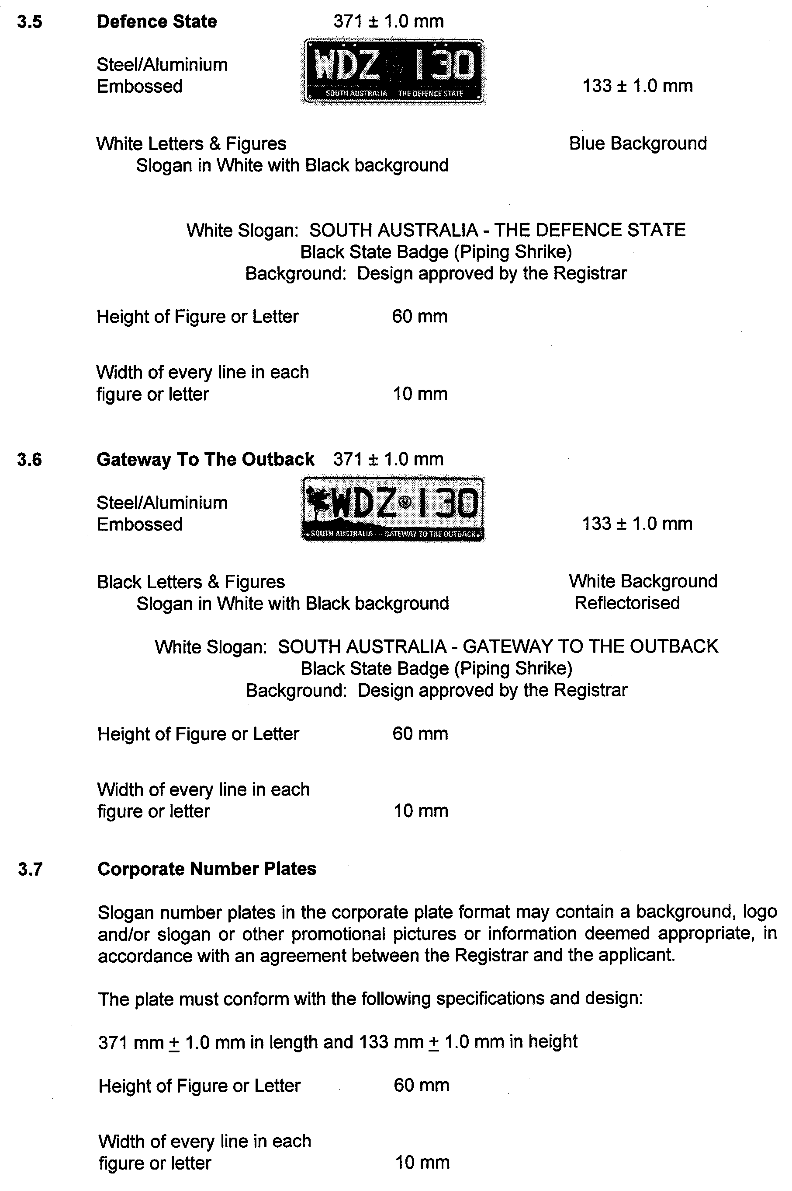





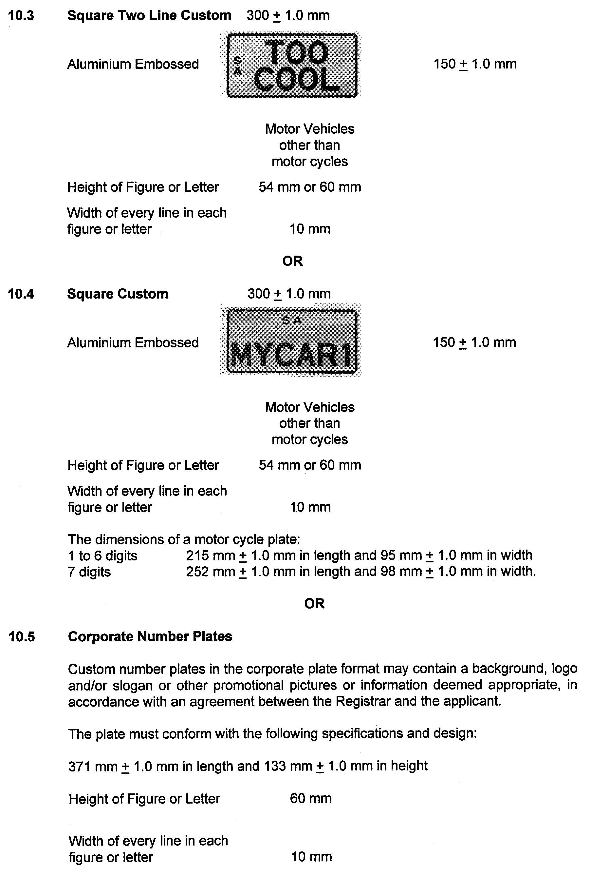




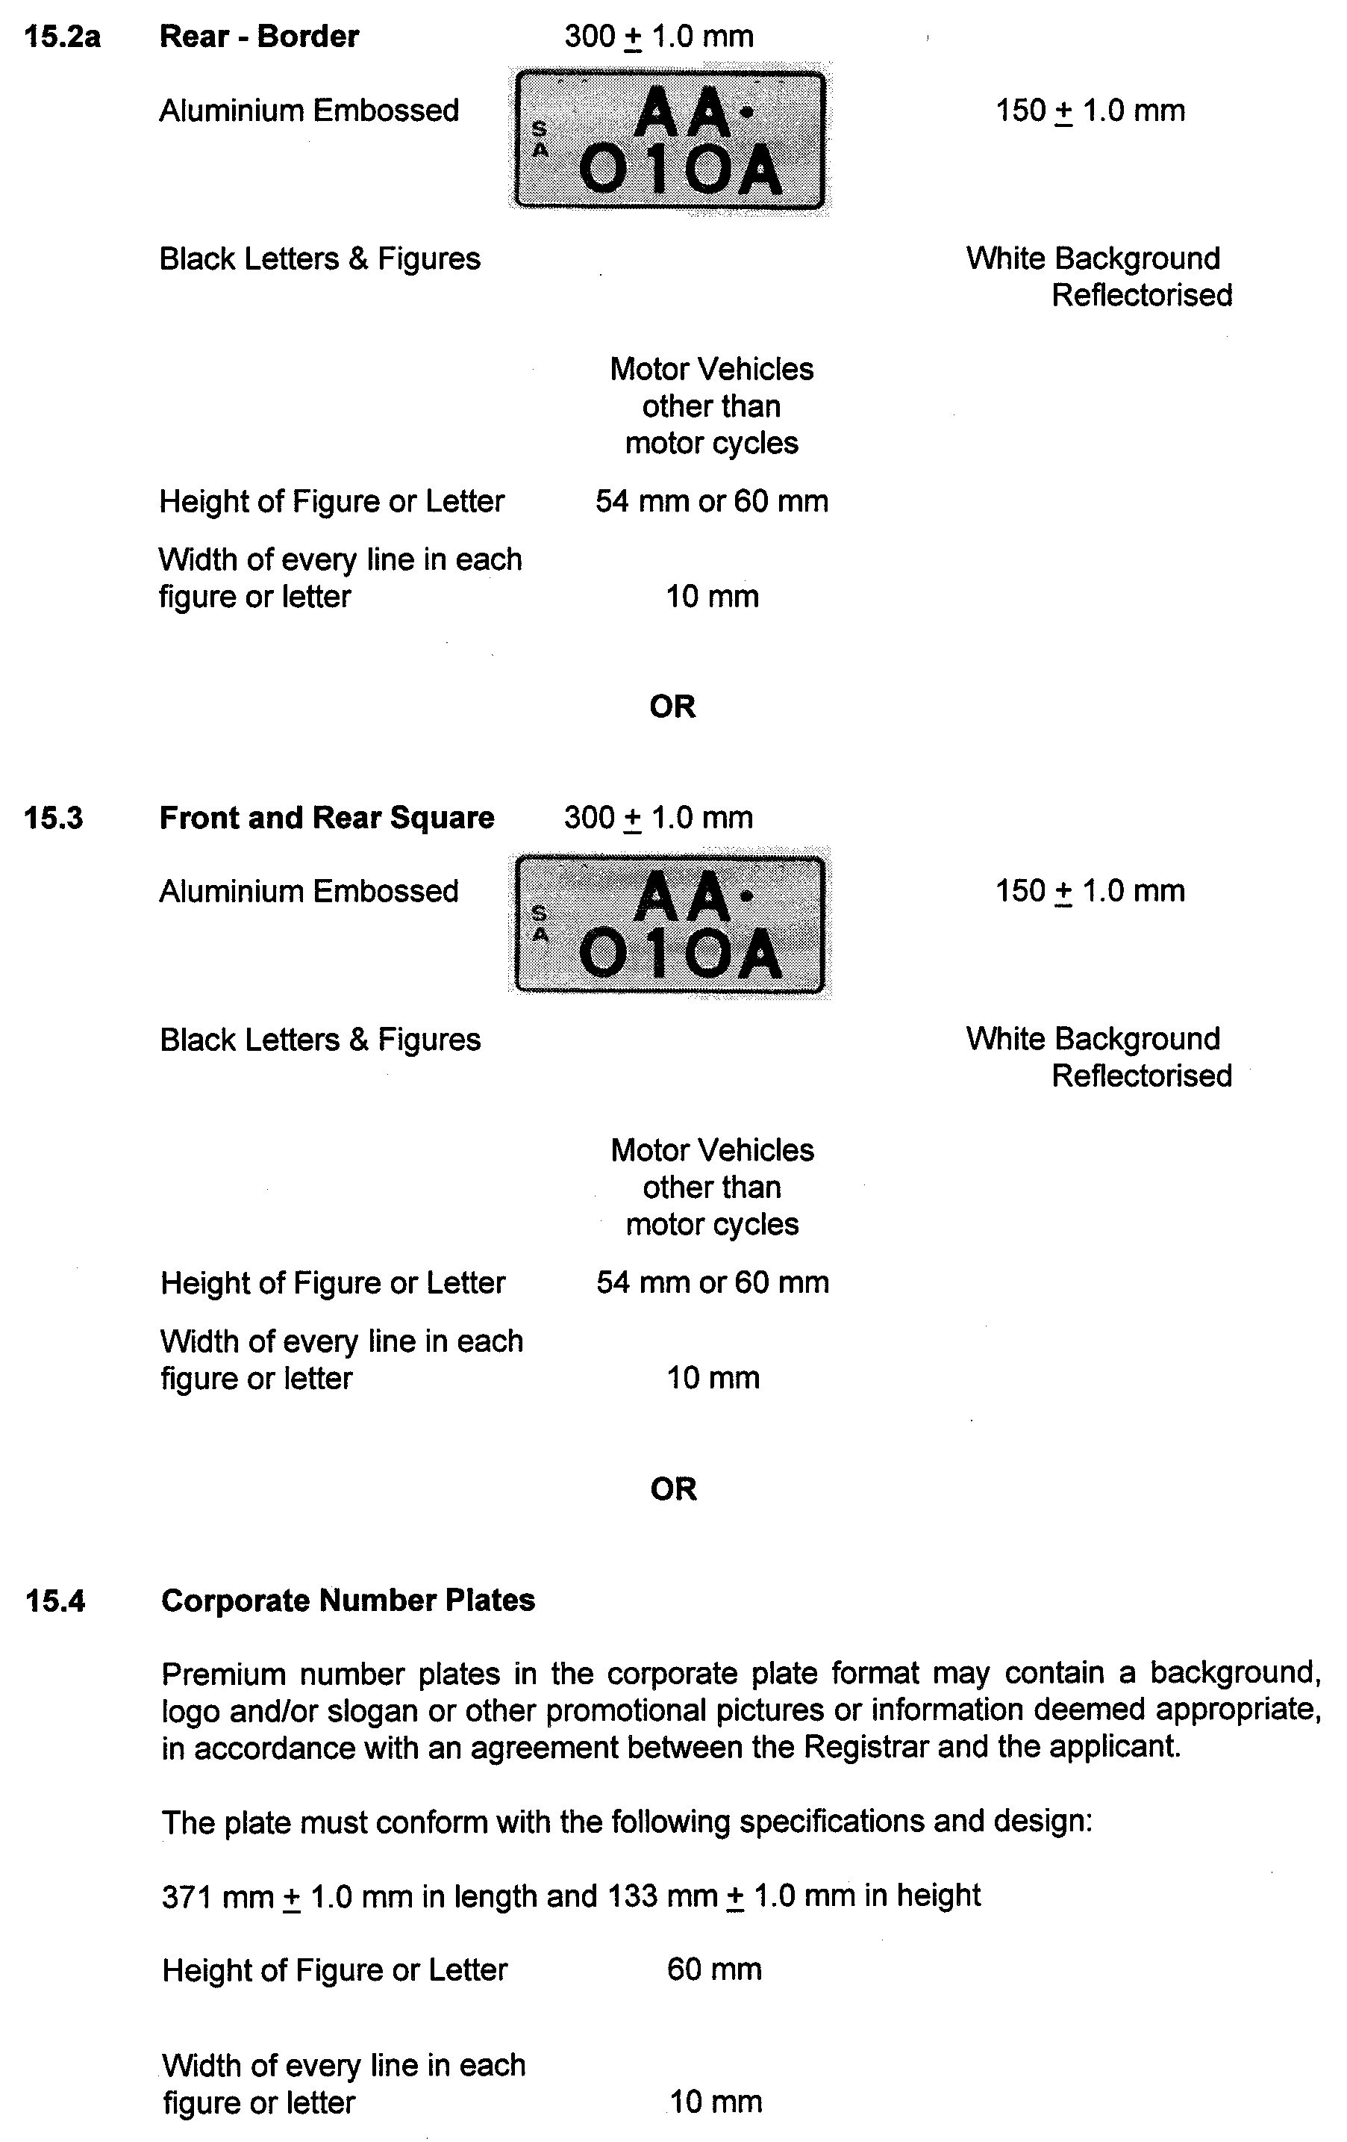


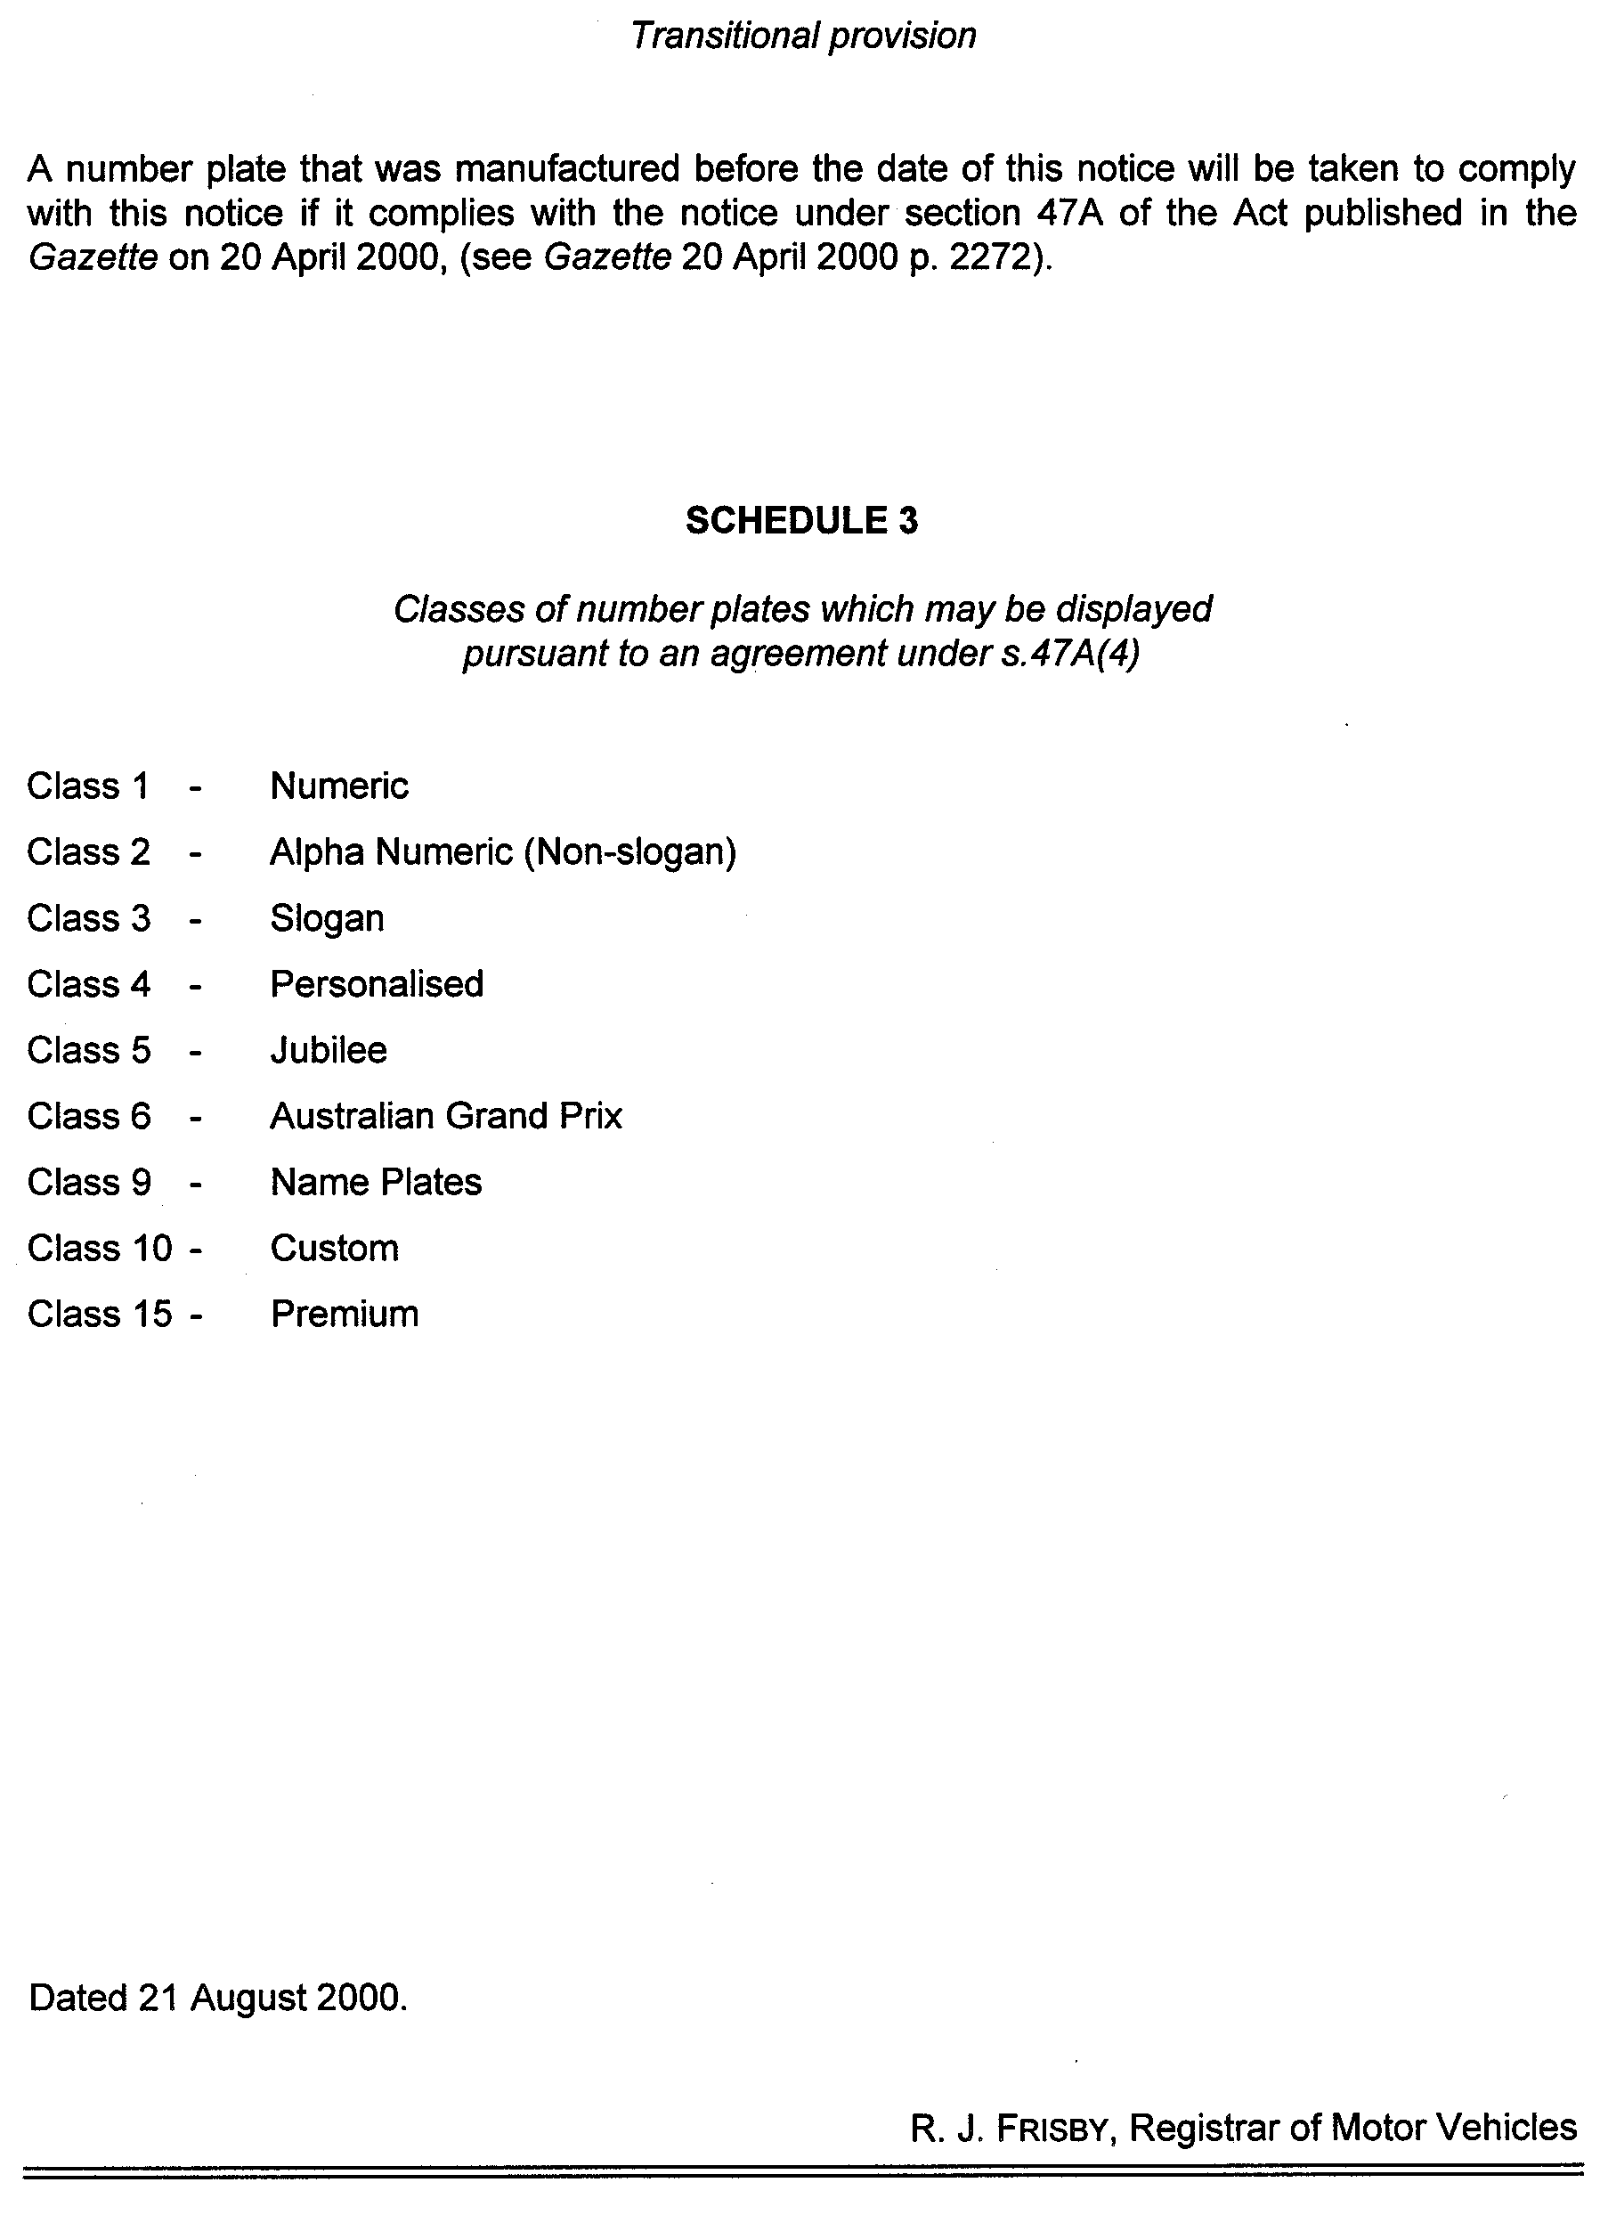
PROOF OF SUNRISE AND SUNSET ACT 1923—ALMANAC FOR OCTOBER, NOVEMBER AND DECEMBER 2000
PURSUANT to the requirements of the Proof of Sunrise and Sunset Act 1923, I, Trevor Noel Argent, Commissioner of Highways, at the direction of the Honourable the Minister for Transport, Urban Planning and the Arts, publish in the Schedule hereto an almanac setting out the times of sunrise and sunset on every day for the three calendar months of October, November and December 2000.
Dated at Adelaide, 15 August 2000.
T. N. Argent, Comissioner of Highways
97/03263

The Schedule
Times of sunrise and sunset during the months of October, November and December 2000.
Month | October |  | November |  |  | December
Date | Sunrise  a.m. | Sunset  p.m. |  | Sunrise  a.m. | Sunset  p.m. |  | Sunrise  a.m. | Sunset  p.m.

1  2  3  4  5  6  7  8  9  10  11  12  13  14  15  16  17  18  19  20  21  22  23  24  25  26  27  28  29  30  31 | 5.52  5.51  5.50  5.48  5.47  5.46  5.44  5.43  5.41  5.40  5.39  5.37  5.36  5.35  5.34  5.32  5.31  5.30  5.29  5.27  5.26  5.25  5.24  5.22  5.21  5.20  5.19  5.18  6.17  6.16  6.15 | 6.19  6.20  6.21  6.22  6.23  6.24  6.25  6.25  6.26  6.27  6.28  6.28  6.29  6.30  6.31  6.31  6.32  6.33  6.34  6.35  6.36  6.37  6.38  6.39  6.40  6.41  6.42  6.42  7.43  7.44  7.45 | 6.14  6.13  6.12  6.11  6.10  6.09  6.08  6.07  6.06  6.05  6.04  6.04  6.03  6.02  6.02  6.01  6.01  6.00  6.00  5.59  5.59  5.58  5.58  5.57  5.57  5.56  5.56  5.56  5.55  5.55 | 7.46  7.47  7.48  7.49  7.50  7.51  7.52  7.53  7.54  7.55  7.56  7.57  7.58  7.59  8.00  8.01  8.02  8.03  8.04  8.05  8.06  8.07  8.08  8.09  8.10  8.11  8.12  8.13  8.13  8.14 | 5.55  5.55  5.55  5.55  5.55  5.55  5.55  5.55  5.55  5.56  5.56  5.56  5.56  5.57  5.57  5.57  5.57  5.58  5.58  5.58  5.59  5.59  6.00  6.00  6.01  6.02  6.02  6.03  6.04  6.05  6.05 | 8.15  8.16  8.17  8.18  8.19  8.20  8.20  8.21  8.22  8.23  8.23  8.24  8.25  8.26  8.26  8.27  8.28  8.28  8.29  8.29  8.30  8.30  8.31  8.31  8.31  8.32  8.32  8.32  8.32  8.33  8.33

Note: Under the Daylight Saving Act 1971, all times from 29 October 2000 inclusive, have been corrected to South Australian Summer Time.

ROADS (OPENING AND CLOSING) ACT 1991:
SECTION 24
NOTICE OF CONFIRMATION OF ROAD
PROCESS ORDER
Littles Road, Hundred of Benara
Deposited Plan 55227
BY Road Process Order made on 8 June 2000, the District Council of Grant ordered that:
The whole of the closed roads ‘C’ and ‘D’ in Road Plan 1841 more particularly delineated and numbered ‘1’ and ‘2’ respectively in Preliminary Plan No. PP32/0537, be opened as road (forming an extension of Littles Road).
On 10 July 2000, that order was confirmed by the Minister for Administrative and Information Services, conditionally on approval and deposit of the survey plan by the Registrar-General. The condition has now been fulfilled.
Pursuant to section 24(5) of the Roads (Opening and Closing) Act 1991, NOTICE of the order referred to above and its confirmation is hereby given.
Dated 24 August 2000.
P. M. Kentish, Surveyor-General

ROADS (OPENING AND CLOSING) ACT 1991:
SECTION 24
NOTICE OF CONFIRMATION OF ROAD
PROCESS ORDER
Sixteenth Street, Orroroo
Deposited Plan 51580
BY Road Process Order made on 23 November 1998, the District Council of Orroroo/Carrieton ordered that:
1. Portion of the public road (Sixteenth Street) between Railway Terrace and Jervoise Street adjoining allotments 5 and 22 in Deposited Plan 845 more particularly lettered ‘A’ in Preliminary Plan No. PP32/0317 be closed.
2. The whole of the land subject to closure be transferred to MARIE-ANNE FIELD in accordance with agreement for transfer dated 23 November 1998, entered into between the District Council of Orroroo/Carrieton and M. Field.
On 2 March 1999, that order was confirmed by the Minister for Administrative and Information Services conditionally on approval and deposit of the survey plan by the Registrar-General. The condition has now been fulfilled.
Pursuant to section 24(5) of the Roads (Opening and Closing) Act 1991, NOTICE of the order referred to above and its confirmation is hereby given.
Dated 24 August 2000.
P. M. Kentish, Surveyor-General

WILDERNESS PROTECTION ACT 1992
Public Submissions on the Proposals to Proclaim Memory Cove Wilderness Protection Area and Point Whidbey Wilderness Protection Area
I, IAIN EVENS, Minister for Environment and Heritage, hereby give notice that copies of public submissions made in response to proposals to proclaim Memory Cove Wilderness Protection Area and Point Whidbey Wilderness Protection Area are available for inspection or purchase at the Environment Shop, 77 Grenfell Street, Adelaide, S.A. 5000.
Iain Evans, Minister for Environment and Heritage

RULES OF COURT
Amending the District Court Rules 1992
Amendment No. 29 of the District Court Rules
BY virtue and in pursuance of Section 51 of the District Court Act 1991, and all other powers us thereunto enabling, We, Terence Anthony Worthington, Chief Judge, and Barrie Kitchen and Peter Anthony John Herriman, Judges of the District Court of South Australia, do hereby make the following Rules of Court:
1. These Rules may be cited as the “District Court Rules 1992, Amendment No. 29”.
2. The District Court Rules 1992, as amended, by these Rules, may be cited as the “District Court Rules 1992”.
3. That Rule II-1 be amended by:
(1) Designating the existing rule as “(1)”;
(2) Substituting in (1) “all of the schedules” in place of “the first, second, third, fourth, fifth and sixth schedules”; and
(3) Adding at the end a new subrule (2) as follows:
“(2) Wherever by virtue of (1) above a Rule of the Supreme Court applies to the District Court any reference to the “Chief Justice” in that Supreme Court Rule is to be a reference to the “Chief Judge” insofar as that Rule applies to the District Court.”
Dated this 10th day of August 2000.
T. A. WORTHINGTON, CJ
B. KITCHEN, J
P. A. J. HERRIMAN, J

RULES OF COURT
Amending the Supreme Court Rules 1987
Amendment No. 77 to the Supreme Court Rules
BY virtue and in pursuance of Section 72 of the Supreme Court Act 1935, and all other enabling powers, We, the Judges of the Supreme Court of South Australia, make the following Rules to take effect as amendments to the Supreme Court Rules 1987, as amended:
1. These Rules may be cited as the "Supreme Court Rules 1987 Amendment No. 77".
2. The Supreme Court Rules 1987 as amended by these Rules may be cited as the “Supreme Court Rules 1987”.
3. That the Third Schedule be amended
(a) by deleting subparagraph (19) and inserting in lieu thereof:
“(19) For the purposes of all Rules referring to this schedule from and including 6 April 2000 to and including 17 September 2000 at the rate of 6.5 per centum per annum.”
(b) by deleting subparagraph (20) and inserting in lieu thereof:
“(20) For the purposes of all Rules referring to this schedule from and including 18 September 2000 at the rate of 7 per centum per annum.”
GIVEN under our hands and the Seal of the Supreme Court of South Australia this 10th day of August 2000.
(l.s.) J. DOYLE, CJ
G. C. PRIOR, J
J. W. PERRY, J
K. P. DUGGAN, J
E. P. MULLIGHAN, J
B. M. DEBELLE, J
M. J. NYLAND, J
B. T. LANDER, J
H. C. WILLIAMS, J
D. J. BLEBY, J
D. F. WICKS, J
B. MARTIN, J
T. A. GRAY, J


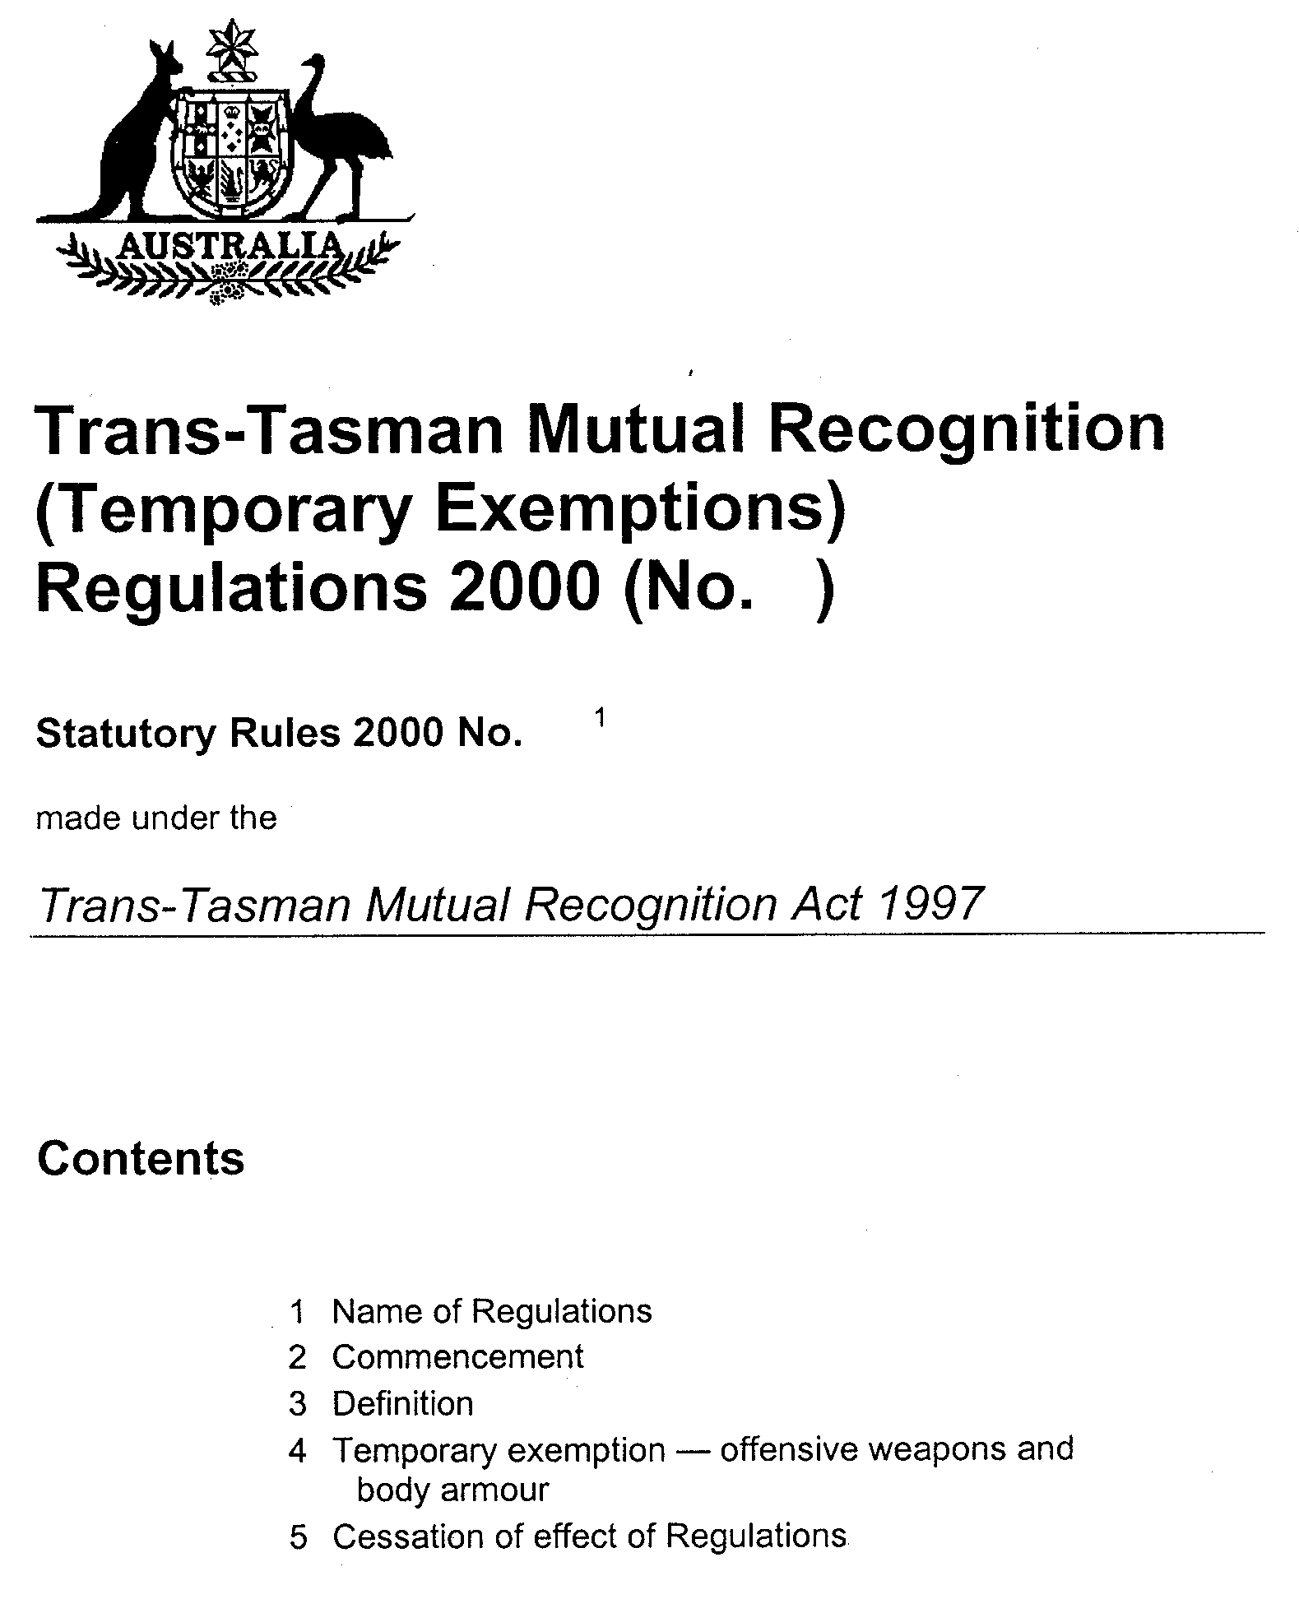


VOCATIONAL EDUCATION, EMPLOYMENT AND TRAINING ACT 1994

PART 4 - CONTRACTS OF TRAINING
Pursuant to the provisions of the Vocational Education, Employment and Training Act (VEET Act) the Accreditation and Registration Council (ARC) gives notice that it has determined the following:

Occupations that Constitute Trades and Other Declared Vocations
The following schedule is additional to:
1. the gazettal of 24 April 1996 (page 2045) | 2. the gazettal of 31 October 1996 (page 1544)
3. the gazettal of 5 December 1996 (page 1818) | 4. the gazettal of 6 February 1997 (page 830)
5. the gazettal of 17 April 1997 (page 1571) | 6. the gazettal of 29 May 1997 (page 2758)
7. the gazettal of 12 June 1997 (page 2984) | 8. the gazettal of 3 July 1997 (page 33)
9. the gazettal of 7 August 1997 (page 311) | 10. the gazettal of 18 December 1997 (page 1677)
11. the gazettal of 22 December 1997 (page 1776) | 12. the gazettal of 23 April 1998 (page 1959)
13. the gazettal of 18 June 1998 (page 2594) | 14. the gazettal of 6 August 1998 (page 339)
15. the gazettal of 24 September (page 990) | 16. the gazettal of 1 October 1998 (page 1038)
17. the gazettal of 15 October 1998 (page 1150) | 18. the gazettal of 12 November 1998 (page 1389)
19. the gazettal of 19 November 1998 (page 1583) | 20. the gazettal of 3 December 1998 (page 1742)
21. the gazettal of 10 December 1998 (page 1870) | 22. the gazettal of 17 December 1998 (page 1954)
23. the gazettal of 23 December 1998 (page 2039) | 24. the gazette of 11 March 1999 (page 1359)
25. the gazette of 25 March 1999 (page 1480) | 26. the gazette of 1 April 1999 (page 1605) (Errata)
27. the gazette of 22 April 1999 (page 2219) | 28. the gazettal of 29 April 1999 (page 2381) (Errata)
29. the gazettal of 6 May 1999 (page 2482) | 30. the gazettal of 13 May 1999 (page 2595)
31. the gazettal of 27 May 1999 (Errata) (page 2723) | 32. the gazettal of 17 June 1999 (page 3123)
33. the gazettal of 24 June 1999 (page 3261) | 34. the gazettal of 1 July 1999 (page 22)
35. the gazettal of 29 July 1999 (page 602) | 36. the gazettal of 30 September 1999 (page 1364)
37. the gazettal of 14 October 1999 (page 1973) | 38. the gazettal of 11 November 1999 (page 2327)
39. the gazettal of 6 January 2000 (page 1169) | 40. the gazettal of 30 March 2000 (page 1921)
- the gazettal of 6 April 2000 (page 2047) | - the gazettal of 13 April 2000 (Errata) (page 2167)
- the gazettal of 4 May 2000 (page 2416) | - the gazettal of 18 May 2000 (page 2606) Errata (page 2609)
- the gazettal of 15 June 2000 (page 3282) Errata (page 3285) | - the gazettal of 29 June 2000 (page 3490)
- the gazettal of 6 July 2000 (page 22) Errata (page 24) | - the gazettal of 20 July 2000 (page 267)
- the gazettal of 10 August 2000 (page 467)

which set out the occupations that constitute trades and other declared vocations and the terms and conditions applicable to such declared vocations.

SCHEDULE - DECLARED VOCATIONS, REQUIRED COURSES OF INSTRUCTION AND ASSOCIATED CONDITIONS

Changes to courses and conditions determined by ARC for existing Declared Vocations appear in Bold.

Occupation/Occupation Levels  Declared Vocation  * Trade  # Other than trade | Course code  National / State  and expiry date | Approved Course of Instruction and Stream | Nominal Term of  Contract of  Training | Nominal hours of  attendance at  approved course | Probationary Period
# Marine Engine Driver II  ARC July 2000 | Endorsed to  15/07/01  SFI30200 | Certificate III in Seafood Industry (Fishing Operations) | 15 months Full time  or  30 months  Part time | 671 hours | 3 months Full time & part time
 |  | A NTW of level 2 is part of Spencer Gulf Mariculture Farmhand (Oyster and Tuna) and Wildcatch Trainee Enterprise Agreement 1996, but a training wage may not be available under other awards under which a Marine Engine Driver II may be employed.

REGULATIONS UNDER THE RADIATION PROTECTION AND CONTROL ACT 1982
────
No. 194 of 2000
────
At the Executive Council Office at Adelaide 24 August 2000

PURSUANT to the Radiation Protection and Control Act 1982 and with the advice and consent of the Executive Council, I make the following regulations.
J. DOYLE Governor's Deputy

PURSUANT to section 10AA(2) of the Subordinate Legislation Act 1978, I certify that, in my opinion, it is necessary or appropriate that the following regulations come into operation as set out below.

DEAN BROWN Minister for Human Services

───────────────────
SUMMARY OF PROVISIONS

PART 1
PRELIMINARY

1. Citation
2. Commencement
3. Revocation
4. Interpretation
5. Definition of "annual effective dose"
6. Application of regulations to apparatus
7. Definition of "radioactive ore"—prescribed concentrations of uranium and thorium
8. Application of regulations to radioactive substances

PART 2
RADIATION CONTROL

DIVISION 1—GENERAL PROVISIONS

9. Duties of specified employer
10. Specified employer to give radiation worker certain information
11. Specified employer to prepare radiation safety manual, etc.
12. Duties of radiation worker
13. Display of radiation symbol

DIVISION 2—RADIATION PROTECTION STANDARDS AND LIMITS

14. Specified employer to prevent exposures above certain dose limits

DIVISION 3—RADIATION SAFETY OFFICERS

15. Appointment of radiation safety officers
16. Duties of radiation safety officer
17. Specified employer to make certain things available to radiation safety officer

DIVISION 4—MONITORING

18. Specified employer to issue personal monitoring device to radiation worker
19. Minister's power to direct specified employer to place monitoring equipment on premises where radiation worker employed
20. Minister's power to direct specified employer to place monitoring equipment on affected premises
21. Minister's power to approve monitoring devices

DIVISION 5—RECORDS, REPORTS AND INVESTIGATIONS

22. Specified employer to keep personal radiation exposure record for each radiation worker
23. Alteration of personal radiation exposure records
24. Confidentiality of personal radiation exposure records
25. Specified employer to make certain enquiries before radiation worker commences duties
26. Specified employer to maintain records of certain measurements
27. Specified employer to investigate exposure of radiation workers to certain ionizing radiation doses

DIVISION 6—RADIATION INCIDENTS, RADIATION ACCIDENTS AND RADIATION
EMERGENCIES

28. Radiation worker to report radiation incident involving worker
29. Specified employer to investigate reported radiation incidents
30. Radiation worker to report radiation accident involving worker
31. Specified employer to investigate reported radiation accidents
32. Specified employer to report radiation emergencies, etc. to Minister
33. Specified employer to prepare contingency plans

DIVISION 7—MEDICAL EXAMINATIONS

34. Minister's power to direct radiation worker to undergo medical examination
35. Conduct of medical examination
36. Employer of designated employee to make arrangements for employee to undergo required medical examinations
37. Duties of medical practitioner carrying out medical examination
38. Specified employer to retain and keep confidential reports, etc. relating to medical examinations
39. Costs of medical examination to be borne by specified employer

PART 3
IRRADIATION OF HUMANS FOR DIAGNOSTIC, THERAPEUTIC OR RESEARCH
PURPOSES

DIVISION 1—DIAGNOSTIC AND THERAPEUTIC PURPOSES

40. Prohibition on unauthorised exposure to ionizing radiation
41. Persons who may authorise exposure to ionizing radiation
42. Authorisation
43. Duties of persons giving authorisation and carrying out treatment to make records

DIVISION 2—RESEARCH PURPOSES

44. Interpretation
45. Prohibition on certain research without Minister's approval

PART 4
IONIZING RADIATION APPARATUS

DIVISION 1—SALE OR DISPOSAL OF APPARATUS

46. Application of Division
47. Duty to give Minister notice before selling, installing or maintaining apparatus in course of business
48. Duty to give Minister notice of defective apparatus sold or installed
49. Duty to notify Minister of changes, etc. to information supplied about defective apparatus sold or installed
50. Minister's power to require further information
51. Duties of person receiving order for sale of apparatus
52. Duty to notify Minister of sale of portable or mobile apparatus
53. Duty to notify Minister of intention to install fixed apparatus
54. Duty to notify Minister of sale or replacement of certain components of apparatus
55. Duty to notify Minister of sale or disposal of apparatus
56. Certain apparatus to be made inoperable before sale or disposal

DIVISION 2—LICENCE TO OPERATE APPARATUS

57. Licences to operate radiation apparatus (s. 31 of Act)—prescribed classes of apparatus and persons
58. Licences to operate radiation apparatus (s. 31 of Act)—prescribed qualifications
59. Licence holder to notify Minister of change of address for service

DIVISION 3—REGISTRATION OF APPARATUS

60. Registration of radiation apparatus (s. 32 of Act)—prescribed classes of apparatus
61. Application for registration of apparatus
62. Registered owner of apparatus to notify change of address for service
63. Registered owner of apparatus to notify change of location of fixed apparatus

DIVISION 4—SPECIAL REQUIREMENTS FOR APPARATUS

64. Labelling requirements
65. Signage requirements
66. Construction of cabinet X-ray unit
67. Owner of cabinet X-ray unit to carry out regular checks
68. X-ray analysis systems used for fluorescence analysis
69. X-ray tubes incorporated in X-ray analysis apparatus
70. Shutters fitted to X-ray analysis apparatus
71. Lights and signs fitted to X-ray analysis apparatus
72. Owner of open-beam X-ray analysis system to display signs
73. Registered owner of X-ray analysis apparatus to carry out regular radiation monitoring surveys
74. Registered owner of X-ray analysis apparatus to carry out regular checks
75. By-passing of safety device or interlock fitted to X-ray analysis apparatus
76. Registered owner of X-ray analysis system to prepare separate working rules in certain cases
77. Duties of registered owner of open-beam X-ray analysis system
78. Registered owner of X-ray analysis apparatus to record radiation surveys, etc.
79. Registered owner of X-ray analysis apparatus to make available radiation monitoring instrument for radiation surveys
80. Duties of user of X-ray analysis apparatus
81. Person carrying out site radiography using apparatus to be accompanied by person trained in emergency procedures
82. Person carrying out site radiography using apparatus, etc. to wear chirper and have radiation survey meter
83. Duties of owner of apparatus used for site radiography when using apparatus on premises owned by another
84. Apparatus used for site radiography to incorporate collimating device
85. Duty of person carrying out site radiography using apparatus with remote control unit
86. Duty of person intending to carry out site radiography using apparatus to mark out area around exposure
87. Owner of apparatus used for industrial radiography to regularly inspect apparatus
88. Prohibition on use of device, etc. in course of industrial radiography unless in good working order
89. Apparatus used for industrial radiography
90. Requirement to provide warning devices when carrying out site radiography using apparatus
91. Apparatus used for dental radiography with extra-oral X-ray tube
92. Prohibition on use of apparatus designed for dental radiography with intra-oral X-ray tube
93. Fixed apparatus used for medical or veterinary diagnostic radiography or by chiropractor
94. Portable or mobile apparatus used for medical or veterinary plain radiography
95. Capacitor discharge apparatus
96. Portable apparatus used for veterinary plain radiography
97. Orthopantomographic apparatus
98. Prohibition on use of orthopantomographic apparatus with person positioned in apparatus while tube current being preset
99. Apparatus used for mammography or soft tissue radiography
100. Apparatus used for medical or veterinary fluoroscopy
101. Fixed and mobile fluoroscopic apparatus
102. Apparatus used for treatment at accelerating voltages up to 0.5MV
103. Apparatus producing X-rays or electron beams (energy range 0.5-20 MeV) used for medical radiation therapy
104. Fixed apparatus used for medical, veterinary or chiropractic radiography
105. Installation of radiation therapy apparatus operating above 50kV
106. Minister's power to prohibit use of certain apparatus designed for medical, dental or chiropractic use pending consideration of application for registration of apparatus
107. Duty of person licensed to operate apparatus in relation to persons other than patients during medical, etc. radiographic procedure
108. Persons other than patient not to remain in room during fluoroscopic procedure or test procedure
109. Prohibition on use of direct exposure film for mammography
110. Manual processing of radiographic films
111. Persons other than patient not to remain in treatment room where apparatus operated or used for radiation therapy above certain voltages
112. Minister's power to require registered owner of diagnostic radiography apparatus to maintain quality assurance test program

PART 5
RADIOACTIVE SUBSTANCES

DIVISION 1—SALE OF RADIOACTIVE SUBSTANCES

113. Duty to give Minister notice before carrying on certain business
114. Duty to notify Minister of defective registrable device sold or installed in course of business
115. Minister's power to require additional information
116. Person selling registrable device to give purchaser certain information
117. Duty to notify Minister of sale of mobile registrable device
118. Duty to notify Minister of intention to install fixed registrable device
119. Person selling sealed radioactive source required to be registered to supply ISO certificate
120. Duty to notify Minister of sale of registered sealed radioactive source
121. Duty to notify Minister of sales of radioactive substances
122. Prohibition on selling consumer product
123. Prohibition on selling unapproved ionization chamber smoke detector

DIVISION 2—LICENCE TO USE OR HANDLE RADIOACTIVE SUBSTANCES

124. Prescribed classes of persons and substances (s. 28(2) of Act)
125. Prescribed form (s. 28(3) of Act)
126. Holder of licence under s. 28 of Act to notify Minister of change of address for service

DIVISION 3—ACCOUNTING FOR AND STORAGE AND LABELLING OF RADIOACTIVE
SUBSTANCES

127. Registered occupier of premises in which unsealed radioactive substance is kept or handled to maintain register of unsealed radioactive substances
128. Person in possession of sealed radioactive source to maintain register of sealed radioactive sources
129. Storage of sealed radioactive sources and unsealed radioactive substances
130. Owner of sealed radioactive source, etc. to mark doors and entrances to areas where source or unsealed radioactive substance kept
131. Owner of sealed radioactive source, etc. to mark sources and vessels containing unsealed radioactive substance

DIVISION 4—DISPOSAL OF RADIOACTIVE SUBSTANCES

132. Application of Division
133. Prohibition on disposal of radioactive substance without Minister's approval
134. Application for approval to dispose of unsealed radioactive substance
135. Application for approval to dispose of sealed radioactive source
136. Minister's power to require applicant to supply further information
137. Matters to be taken into account by Minister in deciding application for approval
138. Approval of application
139. Minister to notify applicant of decision on application
140. Minister's power to vary or impose conditions during currency of approval
141. Right to apply for reconsideration of decision refusing application or imposing or varying condition

DIVISION 5—REGISTRATION OF SEALED RADIOACTIVE SOURCES

142. Prescribed classes of sealed radioactive sources
143. Application for registration of sealed radioactive source
144. Duty of registered owner of sealed radioactive source to notify Minister of change of address for service
145. Duty of registered owner of sealed radioactive source to notify Minister of modifications to source container

DIVISION 6—SPECIAL REQUIREMENTS FOR SEALED RADIOACTIVE SOURCES

146. Design and construction of capsules and source holders
147. Sealed radioactive source to be used in device, etc.
148. Sealed radioactive source to be in chemical and physical form minimising corrosion, etc.
149. Minister's power to require owner of sealed radioactive source to carry out tests
150. Owner of sealed radioactive source to keep register of location if moved for use
151. Source container used for radiation gauge, etc.
152. Radioactive substance used for bore hole logging
153. Owner of sealed radioactive source used for bore hole logging to provide radiation survey meter
154. Duty of operator of bore hole logging tool
155. Person carrying out site radiography using sealed radioactive source to be accompanied by person trained in emergency procedures
156. Person carrying out site radiography using sealed radioactive source to wear chirper and have radiation survey meter
157. Duties of owner of sealed radioactive source carrying out site radiography on premises owned by another person
158. Person carrying out site radiography using sealed radioactive source to use collimating device
159. Person carrying out site radiography using sealed radioactive source to mark out area around exposure site
160. Source container used for industrial radiography and equipment used for handling source
161. Owner of certain devices used for industrial radiography to carry out regular inspections
162. Prohibition of use of device, etc. in course of industrial radiography not in good working order
163. Sealed radioactive source used for external beam radiation therapy
164. Design and construction of sealed radioactive source used for external beam radiation therapy
165. Installation of sealed radioactive source used for external beam therapy
166. Duty of person administering human brachytherapy using sealed radioactive source
167. Duties of person carrying out veterinary radiation therapy involving insertion or attachment of sealed radioactive source
168. Duties of person carrying out veterinary radiation therapy involving implanting of sealed radioactive source in an animal
169. Duty of owner, etc. of animal undergoing certain veterinary radiation therapy

DIVISION 7—REGISTRATION OF PREMISES

170. Registration of premises in which unsealed radioactive substances are kept or handled—prescribed classes of substances and prescribed classes of premises
171. Application for registration of premises under s. 29 of Act
172. Registered occupier to notify change of address for service or structural alterations to registered premises

DIVISION 8—SPECIAL REQUIREMENTS FOR PREMISES

173. Interpretation
174. Laboratory in which unsealed radioactive substance is kept or handled
175. Requirement to provide fume cupboard or total enclosure in certain cases
176. Type B laboratory
177. Type A laboratory
178. Duties of registered occupier of premises in which unsealed radioactive substance is kept or handled

DIVISION 9—LICENCE TO MINE OR MILL RADIOACTIVE ORES

179. Prescribed classes of operations
180. Prescribed form of application for licence

PART 6
MISCELLANEOUS

DIVISION 1—USE OF IONIZING RADIATION IN SCHOOLS

181. Interpretation
182. Use of radioactive substance, etc. in secondary school to be in accordance with Code

DIVISION 2—MISCELLANEOUS

183. Certificate of identification of authorised officer—prescribed form
184. Application for licence to mine or mill radioactive ores (s. 24 of Act)—prescribed form
185. Application forms for renewal of licences and registrations
186. Register of licences under s. 24 of Act
187. Registers of licences under ss. 28 and 31 of Act
188. Register of sealed radioactive sources and apparatus registered under ss. 30 and 32 of Act
189. Register of premises registered under s. 29 of Act
190. Procedure for obtaining Minister's approval to destroy certain documents
191. Release of information obtained in administration of Act—prescribed body
192. Use of codes of practice and standards in these regulations
193. Service of documents
194. Manner of giving directions or approvals required by these regulations
195. Fees
196. General penalty

SCHEDULE 1
Classification of Radionuclides into Groups

SCHEDULE 2

Radiation Symbol

SCHEDULE 3

Classification of Premises

SCHEDULE 4

Fees

SCHEDULE 5

Forms

SCHEDULE 6

Certificate of Identification of Authorised Officer

SCHEDULE 7

Minimum Half Value Layers for Diagnostic Apparatus

SCHEDULE 8

Error Distances for Automatic Collimation to a Spot Film Device

SCHEDULE 9

Error Distances for Automatic Collimation to an Image Intensifier
────────────────────

PART 1
PRELIMINARY

Citation
1. These regulations may be cited as the Ionizing Radiation Regulations 2000.

Commencement
2. These regulations will come into operation on 1 September 2000.

Revocation
3. The Ionizing Radiation Regulations 1985 (see Gazette 4 April 1985 p. 993), as varied, are revoked.

Interpretation
4. (1) In these regulations, unless the contrary intention appears—

"absorbed dose" means the energy absorbed per unit mass by matter from ionizing radiation that impinges on it, as defined in Annex B of the NHMRC and NOHSC Recommendations;

"Act" means the Radiation Protection and Control Act 1982;

"adequately shielded", in relation to a component of an X-ray analysis apparatus, means that the equivalent dose rate as measured at any accessible point 50mm from the surface of the component does not exceed 25 microsievert per hour when the X-ray tube is operated at any of the permissible ratings specified by the manufacturer of the X-ray analysis apparatus;

"annual effective dose"—see reg. ;

"annual limit on intake" means a quantity of a radionuclide which, if taken into the body during one year, would lead to a committed effective dose equal to the annual effective dose limit for a radiation worker specified in Division 2 of Part 2;

"aperture" means a gap in the protective material of a tube housing through which ionizing radiation from an X-ray tube within the tube housing may pass with little or no attenuation;

"apparatus" means ionizing radiation apparatus;

"approved" means approved by the Minister;

"AS" means a standard published or approved by Standards Australia, as in force from time to time;

"bore hole logging" means the use of a sealed radioactive source to acquire geophysical information about geological strata by lowering the source and a detector down a bore hole which has been drilled through the strata being investigated;

"bore hole logging tool" means a device containing a sealed radioactive source that is designed and constructed to be lowered and raised at the end of a cable during bore hole logging;

"cabinet X-ray unit" means apparatus in a shielded enclosure into which articles may be placed for radiographic (including fluoroscopic) examination;

"chiropodist" means a person registered as a chiropodist under the Chiropodists Act 1950;

"chiropractor" means a person registered as a chiropractor under the Chiropractors Act 1991;

"committed effective dose" means the effective dose that a person is committed to receive from an intake of radioactive material as defined in Annex B of the NHMRC and NOHSC Recommendations;

"committed equivalent dose" means the equivalent dose that an organ or tissue is committed to receive from an intake of radioactive material as defined in Annex B of the NHMRC and NOHSC Recommendations;

"consumer product" means a device, article or thing that contains a radioactive substance and is designed and constructed for personal or domestic use and not for use during the course of employment or the carrying on of any occupation, but does not include an ionization chamber smoke detector approved by the Minister;

"cumulative" means the sum of all the results obtained for a parameter since the beginning of the relevant year;

"dental therapist" has the same meaning as in section 85 of the Dentists Act 1984;

"dentist" means a person registered as a dentist under the Dentists Act 1984;
"dermatologist" means a medical practitioner registered as a specialist in dermatology under the Medical Practitioners Act 1983;

"designated employee" means a designated employee as defined in the Radiation Protection (Mining and Milling) Code;

"disposal", in relation to a radioactive substance, does not include sale;

"durably marked", in relation to an article, device or thing, means that the article, device or thing is so marked that it is likely to retain the marking—

(a) during its normal working life; and

(b) despite any occurrence or accident that is reasonably foreseeable as being likely to happen to the article, device or thing, or in which the article, device or thing may become involved;

"effective dose" means a measure of dose that takes into account both the radiation involved and the radiological sensitivities of the organs or tissue irradiated as defined in Annex B of the NHMRC and NOHSC Recommendations;

"equivalent dose" means a measure of dose in organs and tissue that takes into account the type of radiation involved as defined in Annex B of the NHMRC and NOHSC Recommendations;

"emergency exposure" means a voluntary exposure to ionizing radiation in an emergency situation;

"enclosed X-ray analysis apparatus" means X-ray analysis apparatus that complies with regulation (3);

"external radiation", in relation to the exposure of a natural person to ionizing radiation, means ionizing radiation that is not internal radiation;

"fail safe", in relation to a warning device or interlock, means that the failure of the device or interlock results in the inability to produce useable ionizing radiation from the apparatus or sealed radioactive source to which the device or interlock is connected;

"fixed apparatus" means any apparatus that is neither a mobile apparatus nor a portable apparatus;

"fully protected enclosure", in relation to industrial radiography, means an enclosure on or in respect of which—

(a) all doors and other openings into the enclosure are interlocked with either the apparatus or the source control mechanism so that the apparatus is de-energised or the source is returned to the shielded ("off") position whenever a door or other opening is opened; and

(b) a warning device inside the enclosure sounds continuously for at least five seconds when an exposure commences; and

(c) a red warning light marked "Radiation On" that remains on throughout an exposure, is readily visible from all normal routes of access; and

(d) the warning lights are fail safe; and

(e) the equivalent dose rate at a distance of 50mm from any readily accessible point on the surface of the enclosure never exceeds 25 microsievert per hour; and

(f) a door can be readily opened from inside the enclosure;

"gaseous tritium light device" means an instrument, device, article or thing that contains one or more gaseous tritium light sources;

"gaseous tritium light source" means a sealed glass container filled with gaseous tritium and coated internally with a phosphor;

"general objective" means the objective contained in section 23 of the Act;

"group", in relation to a radionuclide, means the group to which the radionuclide is assigned in Schedule 1;

"industrial radiography" means the process of radiographing the whole or any part of any pipes, welds, vessels, or any other constructed, fabricated or manufactured object or article by the use of a sealed radioactive source or an apparatus other than a cabinet X-ray unit;

"internal radiation", in relation to the exposure of a person to ionizing radiation, means ionizing radiation from a radioactive substance located within the person's body;

"ionization chamber smoke detector" means a device containing a radioactive substance that is designed and constructed to detect the presence of smoke or other combustion product aerosols;

"laboratory" means premises in which unsealed radioactive substances are—

(a) used for the purposes of scientific investigation or testing; or

(b) prepared for use for the treatment of patients or for medical or scientific investigation or testing; or

(c) prepared for sale;

"medical practitioner" has the same meaning as in the Medical Practitioners Act 1983;

"member of the public" means a person who is not a radiation worker;

"mobile apparatus" means apparatus that is designed and constructed so as to be moveable from place to place for use as required but does not include a portable apparatus;

"NHMRC and NOHSC Recommendations" means the Recommendations for limiting exposure to ionizing radiation (1995) (Guidance note [NOHSC:3022(1995)]) and the National standard for limiting occupational exposure to ionizing radiation (1995) [NOHSC:1013(1995)] adopted or endorsed by the National Health and Medical Research Council and published as Radiation Health Series No. 39 in June 1995 by the Commonwealth Department of Human Services and Health (ISBN 0644 35659 6);

"normal operation", in relation to X-ray analysis apparatus, means the step-by-step procedures necessary to accomplish X-ray analysis, including sample insertion and manipulation, equipment alignment and data recording;

"nuclear medicine physician" means a medical practitioner registered as a specialist in nuclear medicine under the Medical Practitioners Act 1983;

"open-beam X-ray analysis system" means an X-ray analysis system that does not comply with regulation (3) or regulation (4) but complies with regulation (5);

"ophthalmologist" means a medical practitioner registered as a specialist in ophthalmology under the Medical Practitioners Act 1983;

"oral surgeon" means a dentist registered as a specialist in oral and maxillo facial surgery under the Dentists Act 1984;

"partly enclosed X-ray analysis apparatus" means X-ray analysis apparatus that does not comply with regulation (3) but complies with regulation (4);

"physiotherapist" means a person registered as a physiotherapist under the Physiotherapists Act 1991;

"plain radiography" means the technique for obtaining, recording and processing directly or after transfer, static information contained in an X-ray image at an image receptor where the X-ray tube is stationary throughout the exposure;

"portable apparatus" means any apparatus that is designed to be carried manually from place to place for use as required;

"primary beam" means that part of the X-radiation that passes through an aperture of a tube housing by a direct path from an X-ray tube;

"radiation accident" means an abnormal occurrence in which a source of ionizing radiation is out of control and in which one or more of the following occurs:

(a) control over the source of ionizing radiation is not totally regained;

(b) a significant dispersal of radioactive substances takes place;

(c) a person receives or is likely to have received an effective dose or intake of radioactive substances of at least twice the amount of that which he or she is likely to receive during the course of operations normally carried out with the source of ionizing radiation involved;

"radiation emergency" means a situation in which a source of ionizing radiation is out of control to such an extent that the continued exposure of a person to excessive amounts of ionizing radiation while the source of ionizing radiation remains out of control is unavoidable unless the normal functions or operations of the facility or place in which the source of ionizing radiation is being used are grossly disrupted (and for the purposes of this definition "excessive amounts of ionizing radiation" means effective doses or intakes of radioactive substances that, if continued for the normal hours of occupancy of the facility or place for three months, would result in an exposure contrary to Division 2 of Part 2);

"radiation incident" means an abnormal occurrence in which a source of ionizing radiation is temporarily out of control, but in which no significant dispersal of any radioactive substance takes place, and in which no person receives or is likely to have received an effective dose or an intake of any radioactive substance more than twice that which is likely to occur during any operation normally carried out with that source of ionizing radiation (and for the purposes of this definition, an abnormal occurrence involving radioactive substances is not to be regarded as being a radiation incident unless—

(a) if the occurrence is one in which a radioactive substance is swallowed by a person—the activity of the radioactive substance swallowed exceeds the following amounts:

for group 1 radionuclides: 5 kBq
for group 2 radionuclides: 50 kBq
for group 3 radionuclides: 500 kBq
for group 4 radionuclides: 5 MBq; or

(b) in any other case—the activity of the radioactive substance involved exceeds the following amounts:

for group 1 radionuclides: 50 kBq
for group 2 radionuclides: 500 kBq
for group 3 radionuclides: 5 MBq
for group 4 radionuclides: 50 MBq);

"radiation gauge" means a device containing a sealed radioactive source that uses the detection of a beam of radiation transmitted through or scattered by an item or material of interest to measure a parameter associated with the item or material of interest, including the whole of the device, consisting of the sealed source, the source container or housing, and the detector and associated controls, but does not include a device that does not need to be permanently fixed in place to be used;

"radiation oncologist" means a medical practitioner registered as a specialist in radiation oncology under the Medical Practitioners Act 1983;

"Radiation Protection (Mining and Milling) Code" means the Code of Practice on Radiation Protection in the Mining and Milling of Radioactive Ores, approved under section 9 of the Environment Protection (Nuclear Codes) Act 1978 of the Commonwealth, as in force on 1 January 2000;

"radiation symbol" means the radiation symbol described and shown in Schedule 2;

"radiation worker" means a person who by reason of his or her profession, trade or occupation—

(a) uses any source of ionizing radiation; or

(b) is directly involved in any activity or operation in which any source of ionizing radiation is used and who may be exposed to ionizing radiation from that source as a result of being directly involved in such activity or operation; or

(c) is a designated employee; or

(d) is directly involved in the transport of a radioactive substance and is likely in the course of that profession, trade or occupation to receive an annual effective dose in excess of 1 millisievert;

"radiologist" means a medical practitioner registered as a specialist in diagnostic radiology under the Medical Practitioners Act 1983;

"registrable device" means a device or instrument that contains a sealed radioactive source which is required to be registered under section 30 of the Act;

"registered nurse" has the same meaning as in the Nurses Act 1999;

"revoked Health Act regulations" means the Radioactive Substances and Irradiating Apparatus Regulations 1962 made under the Health Act 1935 on 29 March 1962 (see Gazette 29 March 1962 p. 661), as varied;

"sell" means—

(a) sell; or

(b) supply by way of barter, exchange or gift; or

(c) let on hire; or

(d) bail; or

(e) authorise, direct, cause, suffer or permit any of the acts referred to in paragraphs (a) to (d);

"shutter" means a controllable aperture cover that adequately shields an aperture when closed;

"significant dispersal" means a dispersal of a radioactive substance where the activity of that radioactive substance exceeds the following amounts:

for group 1 radionuclides: 50 kBq
for group 2 radionuclides: 500 kBq
for group 3 radionuclides: 5 MBq
for group 4 radionuclides: 50 MBq,

but does not include the dispersal of a radioactive substance that is in accordance with Division 4 of Part 5;

"site radiography" means industrial radiography other than that done within a fully protected enclosure;

"source container" means an enclosure for a sealed radioactive source that provides, by shielding and by distance, protection against radiation emitted by the source;

"source holder", in relation to bore hole logging, means the component of a bore hole logging tool that—

(a) houses the sealed radioactive source to protect it from damage; and

(b) fits into the source container when the source is not being used; and

(c) fits onto the bore hole logging tool when the source is being used;

"source of ionizing radiation" means an apparatus or a radioactive substance to which these regulations apply;

"specified employer" means a person—

(a) who employs a radiation worker; or

(b) who is a registered occupier; or

(c) in whose name a sealed radioactive source or ionizing radiation apparatus is registered under Part 3 of the Act; or

(d) who holds a licence granted under section 24 of the Act;

"technologically enhanced", in relation to exposure to natural background radiation, means exposure resulting from natural sources of radiation whose original state has been changed by human activity in such a way that the exposure of any person to ionizing radiation has been increased;

"tube housing", in relation to an ionizing radiation apparatus, means a container in which an X-ray tube is mounted for normal use, providing protection against electric shock and against ionizing radiation except for an aperture for the useful beam;

"type", in relation to premises in which an unsealed radioactive substance is kept or handled, means the type of premises established by the classification scheme set out in Schedule 3;

"veterinary surgeon" means a person registered as a veterinary surgeon under the Veterinary Surgeons Act 1985;

"X-ray analysis apparatus" means an apparatus that is used to analyse the properties or composition of materials by the techniques of X-ray fluorescence or X-ray diffraction;

"X-ray analysis system" means apparatus that consists of an X-ray analysis apparatus and ancillary devices or equipment necessary to determine the elemental composition or to examine the microstructure of matter, but does not include power supplies, transformers, amplifiers, readout devices and associated electronics and control panel;

"X-ray tube", in relation to an ionizing radiation apparatus, means an evacuated glass envelope in which electrons are accelerated for the purposes of the production of ionizing radiation.

(2) In these regulations a reference to a radiation worker being employed by a specified employer is to be taken to include the acceptance of a person as—

(a) a voluntary worker; or

(b) a student,

and the person who accepts a person as a voluntary worker or student will, for the purposes of these regulations, be taken to be a specified employer in relation to that person.
(3) If a person who is a specified employer engages an independent contractor to carry out for the specified employer radiation work of a kind normally carried out by the specified employer, that person is, for the purposes of these regulations, to be taken to be a specified employer in relation to—

(a) that independent contractor; and

(b) any person employed by that independent contractor to do the radiation work that the independent contractor has been engaged to carry out.

(4) In subregulation (3)—

"radiation work" means work of the kind referred to in the definition of "radiation worker" in subregulation (1).

(5) In these regulations, a reference to a radioactive substance or sealed radioactive source is to be taken to be a reference to a radioactive substance or sealed radioactive source to which these regulations apply.

(6) In these regulations a requirement on a specified employer to do or provide any matter or thing for or in relation to a radiation worker employed by the specified employer is, in relation to a specified employer who is himself or herself a radiation worker, to be taken to require that the person do or provide for himself or herself any matter or thing that a specified employer would be required to provide for or in relation to a radiation worker employed by him or her.

Definition of "annual effective dose"
5. (1) In these regulations—

"annual effective dose" means the sum of—

(a) the effective dose received from external radiation during a calendar year; and

(b) the committed effective dose received from radionuclides taken into the body during that year calculated in the manner set out in subregulation (2).

(2) The committed effective dose received from radionuclides taken into the body must be calculated—

(a) using the methods recommended by the International Commission on Radiological Protection in—

(i) Publication 68 Dose Co-efficients for Intakes of Radionuclides by Workers published by the Commission, as varied from time to time; and

(ii) (if applicable), Publication 65 Protection Against Radon-222 at Home and at Work published by the Commission, as varied from time to time; and

(b) if some of the data relevant to the circumstances of a case is not available—using the data recommended or adopted by the International Commission on Radiological Protection in the publications referred to in paragraph (a).

(3) For the purposes of subregulation (2), if—

(a) the International Commission on Radiological Protection recommends or adopts more than one value for an item of data; and

(b) the information required so as to choose which of those values is relevant to the circumstances of the case has not been obtained by the specified employer,

the value that gives rise to the largest value of committed equivalent dose must be used in the calculation.

Application of regulations to apparatus
6. These regulations do not apply to or in relation to apparatus that produces ionizing radiation incidental to its function (including electron microscopes and apparatus containing a cathode ray tube or an electronic valve) if the apparatus does not, in normal operating conditions, cause an equivalent dose rate exceeding 1 microsievert per hour at a distance of 0.1 metre from any accessible surface of the apparatus.

Definition of "radioactive ore"—prescribed concentrations of uranium and thorium
7. For the purposes of the definition of "radioactive ore" in section 5 of the Act, the following concentrations of uranium and thorium are prescribed:

(a) if uranium (but no thorium) occurs in the ore—a concentration of 0.02 per cent by weight;

(b) if thorium (but no uranium) occurs in the ore—a concentration of 0.05 per cent by weight;

(c) if both uranium and thorium occur in the ore—a concentration "X" of uranium, expressed as a percentage by weight, and a concentration "Y" of thorium, expressed as a percentage by weight, provided that—

X + Y is greater than or equal to one,
0.02 0.05

Where—

X is the percentage by weight of uranium in the ore

Y is the percentage by weight of thorium in the ore.

Application of regulations to radioactive substances
8. (1) Subject to subregulation (3), these regulations apply only to or in relation to radioactive substances—

(a) that are—

(i) a radioactive ore; or

(ii) a radioactive substance with a specific activity of more than 35 kBq/kg; and

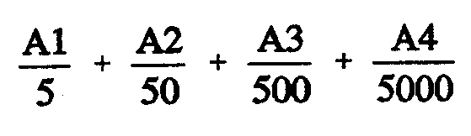
(b) that contain one or more radionuclides so that—

is more than or equal to one.

(2) In subregulation (1)—

"A1" means the total activity of group 1 radionuclides (in kBq);

"A2" means the total activity of group 2 radionuclides (in kBq);

"A3" means the total activity of group 3 radionuclides (in kBq);

"A4" means the total activity of group 4 radionuclides (in kBq).

(3) These regulations do not apply to or in relation to tritium contained in an instrument, device, article or thing if—

(a) less than 20 GBq of tritium is contained in the instrument, device, article or thing; and

(b) the tritium is wholly confined to a gaseous tritium light source; and

(c) the gaseous tritium light source is accessible only with the use of a tool designed for the specific task of gaining access to the gaseous tritium light source in the instrument, article, device or thing; and

(d) the activity in the form of tritiated water is less than 50 MBq; and

(e) the instrument, article, device or thing is not a consumer product.

PART 2
RADIATION CONTROL

DIVISION 1—GENERAL PROVISIONS

Duties of specified employer
9. (1) This regulation applies to—

(a) apparatus; and

(b) source control mechanisms and other devices containing a sealed radioactive source; and

(c) radiation monitoring equipment; and

(d) radiation warning devices; and

(e) protective clothing, fume cupboards, interlocks, signs, labels and any other radiation protection equipment or devices,

supplied by a specified employer for his or her use during the course of his or her profession, trade or occupation or for the use of any radiation worker during the course of the worker's employment with the specified employer.

(2) A specified employer must at all times keep or cause to be kept in good working order and condition any article, device or thing to which this regulation applies.

(3) If a specified employer discovers in any article, device or thing to which this regulation applies a fault or defect that is likely to increase the exposure to ionizing radiation of any person, the specified employer must—

(a) immediately inform all persons who use, work with, inspect, test, handle, are protected from exposure to ionizing radiation by or otherwise deal with the article, device or thing of the nature of the fault or defect; and

(b) cause the fault or defect to be remedied as soon as is reasonably practicable.

Specified employer to give radiation worker certain information
10. (1) A specified employer must, before a radiation worker employed by him or her first commences any duties as a radiation worker—

(a) inform the worker of the potential hazards from ionizing radiation to which the worker is likely to be subject during the course of employment; and

(b) inform the worker of the name of the radiation safety officer appointed by the specified employer together with the name of any assistant radiation safety officer who has responsibilities pertaining to such worker's duties; and

(c) inform the worker of all safety arrangements that have been made to protect the worker from the effects of ionizing radiation; and

(d) give directions in the form of working rules to the worker as to all steps that the worker must take in order to achieve the general objective; and

(e) inform the worker of the existence of the Act, these regulations and any radiation safety manual prepared under regulation ; and

(f) make available to the worker for perusal a copy of the Act, these regulations and any radiation safety manual prepared under regulation .

(2) Wherever there is a change in any of the matters referred to in subregulation (1), a specified employer must immediately inform a radiation worker who is likely to be affected by any such change of the particulars of the change.

Specified employer to prepare radiation safety manual, etc.
11. (1) A specified employer must, within a reasonable time of first employing a radiation worker, prepare a radiation safety manual containing—

(a) information on the potential hazards in respect of exposure to ionizing radiation that any radiation worker is likely to face during the course of employment; and

(b) the name and full contact details of the radiation safety officer and assistant radiation safety officers who have been appointed; and

(c) the arrangements made by the specified employer for the radiation protection of all persons employed by him or her; and

(d) the directions which the specified employer has given pursuant to regulation (1)(d) as to the steps to be taken to achieve the general objective; and

(e) the requirements of regulation .

(2) A specified employer who has prepared a radiation safety manual must supply a copy of the manual to the Minister if directed to do so by the Minister by notice in writing.

(3) If a specified employer has supplied a copy of a radiation safety manual to the Minister under this regulation, the Minister may serve on the specified employer a notice in writing directing him or her to make specified changes to the manual that the Minister regards as appropriate, having regard to the general objective.

(4) A specified employer must comply with a notice served on the employer by the Minister under subregulation (3).

Duties of radiation worker
12. A radiation worker must—

(a) obey all notices displayed in accordance with these regulations; and

(b) not wilfully or recklessly do any act, or omit to do any act, the doing or omission of which is likely to result in a radiation incident, radiation accident or radiation emergency; and

(c) report immediately to his or her supervisor any fault or defect in any device, article or thing that the radiation worker uses, inspects, tests, handles or otherwise deals with during the course of employment, being a fault or defect that is likely to result in a radiation incident, radiation accident or radiation emergency; and

(d) use, in the manner set out in these regulations and in the radiation safety manual applicable to the duties the radiation worker performs, all radiation protection equipment furnished for his or her use in accordance with these regulations and that manual.

Display of radiation symbol
13. A person must not exhibit, display or otherwise use, or cause or permit another to exhibit, display or otherwise use, the radiation symbol except—

(a) on a container used for the storage of a sealed radioactive source; or

(b) on apparatus to which these regulations apply (see reg. ); or

(c) on a sign erected in connection with—

(i) premises registered under section 29 of the Act; or

(ii) a place in which a radioactive substance to which these regulations apply (see reg. ) is stored; or

(iii) a place in which radioactive material within the meaning of the Radiation Protection and Control (Transport of Radioactive Substances) Regulations 1991 is stored; or

(iv) a place in which apparatus to which these regulations apply (see reg. ) is installed, stored or used; or

(d) as required by these regulations or any other law.

DIVISION 2—RADIATION PROTECTION STANDARDS AND LIMITS

Specified employer to prevent exposures above certain dose limits
14. (1) Subject to subregulation (1), a specified employer must not expose, or cause, suffer or permit the exposure of, himself or herself or a radiation worker employed by him or her to—

(a) an annual effective dose exceeding—

(i) 20 millisievert averaged over a period of 5 consecutive years; or

(ii) 50 millisievert in any single year; or

(b) an equivalent dose, during any calendar year, exceeding—

(i) 150 millisievert in the lens of the eye; or

(ii) 50 millisievert in the skin, averaged over any one square centimetre of the skin, regardless of the total area exposed; or

(iii) 500 millisievert in the hands and feet.

(2) The Minister may, on application by a specified employer, if satisfied that exceptional circumstances exist, grant the specified employer permission to exceed the annual effective dose limit prescribed by subregulation (1) subject to a condition that—

(a) the specified employer does not expose, or cause, suffer or permit the exposure of, himself or herself or a radiation worker employed by him or her to annual effective dose exceeding 20 millisievert averaged over a period of not more than 10 consecutive years; or

(b) the specified employer does not expose, or cause, suffer or permit the exposure of, himself or herself or a radiation worker employed by him or her to annual effective dose exceeding 50 millisievert for a period not exceeding 5 years.

(3) If—

(a) a specified employer is pregnant; or

(b) a radiation worker employed by a specified employer is pregnant and the worker has informed the specified employer of the pregnancy,

the specified employer must not expose, or cause, suffer or permit the exposure of, the unborn child in utero to an annual effective dose or equivalent dose exceeding the limit prescribed by subregulation (4) in relation to a member of the public.

(4) Subject to subregulation (5), a specified employer must not expose, or cause, suffer or permit the exposure of, a member of the public to—

(a) an annual effective dose exceeding 1 millisievert; or

(b) an equivalent dose, in any calendar year, exceeding—

(i) 15 millisievert in the lens of the eye; or

(ii) 50 millisievert in the skin, averaged over any one square centimetre of the skin, regardless of the total area exposed.

(5) The Minister may, on application by a specified employer, if satisfied that special circumstances exist, grant the specified employer permission to exceed the annual effective dose limit prescribed by subregulation (3) or (4) subject to a condition that the specified employer does not expose, or cause, suffer or permit the exposure of, an unborn child referred to in subregulation (3) or a member of the public (as the case may require) to an annual effective dose exceeding 1 millisievert averaged over a period of 5 consecutive years.

(6) In calculating doses for the purposes of this regulation, the following must be disregarded:

(a) except where directed otherwise by the Minister—doses received by a person due to natural background radiation that has not been technologically enhanced; and

(b) doses received by a person participating as a volunteer in medical research approved by the Minister under regulation ; and

(c) doses received by a person as a patient for the purposes of diagnosis or treatment; and

(d) doses received by a person (other than a radiation worker) who knowingly and willingly supports a patient undergoing an exposure for the purposes of diagnosis or treatment; and

(e) doses received by a person as a result of an emergency exposure.

(7) A specified employer must not contravene or fail to comply with a condition imposed on a permission granted by the Minister to the specified employer under this regulation.

DIVISION 3—RADIATION SAFETY OFFICERS

Appointment of radiation safety officers
15. (1) A person must, within three months of becoming a specified employer, appoint a person to be a radiation safety officer.

(2) A specified employer must appoint a radiation safety officer in respect of each separate establishment—

(a) at which the specified employer carries on any operation for the mining or milling of radioactive ore; or

(b) of which the specified employer is a registered occupier; or

(c) at which the specified employer employs a radiation worker.

(3) A specified employer must not appoint a person to be a radiation safety officer unless that person has detailed knowledge of the principles and practices of all aspects of radiation protection applicable to the activities carried out by the specified employer at the establishment in respect of which the radiation safety officer is appointed.

(4) A specified employer must not appoint a person to be an assistant radiation safety officer unless that person has detailed knowledge of the principles and practices of all aspects of radiation protection applicable to those activities of the specified employer in respect of which the person is to assist the radiation safety officer.

(5) A specified employer must, within seven days of appointing a radiation safety officer or assistant radiation safety officer, serve on the Minister a notice in writing setting out—

(a) the full name and date of birth of the person appointed; and

(b) the business and residential address of the person appointed and full contact details at those addresses; and

(c) details of the educational qualifications of the person appointed; and

(d) details of any formal training in radiation protection undergone by the person appointed; and

(e) details of the practical experience in radiation protection of the person appointed; and

(f) in the case of the appointment of an assistant radiation safety officer—details of the activities of the specified employer in respect to which the assistant radiation safety officer will assist the radiation safety officer.

(6) Subregulation (5) does not apply to a specified employer who—

(a) holds a licence under section 28 or 31 of the Act; and

(b) is the only person so licensed working at the establishment under his or her control; and

(c) is the radiation safety officer for that establishment.

(7) If, after a specified employer gives notice to the Minister under subregulation (5)—

(a) any information contained in that notice relating to the radiation safety officer or an assistant radiation safety officer changes; or

(b) the specified employer becomes aware of additional information relating to the radiation safety officer or assistant radiation safety officer,

and such changed or additional information is of a kind that the specified employer would have been required by these regulations to have included in the notice had he or she known of it at the time the notice was served, the specified employer must, within 14 days of becoming aware of the changed or additional information, serve on the Minister a notice in writing that complies with subregulation (5).

Duties of radiation safety officer
16. The duties of a radiation safety officer appointed by a specified employer are—

(a) to assist the specified employer in complying with the requirements of the Act and these regulations; and

(b) to advise the specified employer on all aspects of radiation safety applicable to the activities carried out by the specified employer; and

(c) to perform the duties imposed upon a radiation safety officer by these regulations.

Specified employer to make certain things available to radiation safety officer
17. A specified employer must make available to a radiation safety officer appointed by the specified employer such equipment, time and assistance, including such assistant radiation safety officers, as are necessary to enable the radiation safety officer to satisfactorily perform his or her duties under these regulations.

DIVISION 4—MONITORING

Specified employer to issue personal monitoring device to radiation worker
18. (1) A specified employer must issue to each radiation worker employed by him or her an approved personal monitoring device or devices for detecting and measuring a time integrated exposure to ionizing radiation, so that each radiation worker has such a device or devices on issue to the worker at all times while he or she is at his or her place of employment.

(2) If the type of ionizing radiation emitted by a source of ionizing radiation is of such a nature that there is no approved personal monitoring device for measuring a person's exposure to that type of radiation, the specified employer must—

(a) immediately advise the Minister accordingly and set out the arrangements the specified employer proposes to make to monitor the exposure to ionizing radiation of persons employed by him or her; and

(b) make such arrangements as the Minister directs in writing for the monitoring of that type of radiation and for the calculation of personal exposures from that monitoring.

(3) A specified employer who issues a personal monitoring device to a radiation worker must give to the radiation worker—

(a) instructions; or

(b) if directed in writing by the Minister—instructions approved by the Minister,

on the wearing, operation or use of the personal monitoring device.

(4) A radiation worker to whom a personal monitoring device is issued must wear, operate or use, as the case requires, the personal monitoring device—

(a) in accordance with any instructions or approved instructions given to the worker under subregulation (3); and

(b) whenever the worker is likely to be exposed to ionizing radiation as a result of his or her employment.

(5) A specified employer who has issued to a radiation worker a personal monitoring device must, whenever it is necessary for the device to be examined or processed—

(a) cause the device to be examined or processed, as the case requires; and

(b) cause the effective dose to be calculated and recorded,

by such persons, in such manner and at such times as are approved by the Minister.

(6) A specified employer who issues a personal monitoring device to a radiation worker must not subsequently issue the same device to any other person unless the dose measured by the device has been assessed and recorded.

(7) A radiation worker must not permit any other person to wear, operate or use a personal monitoring device issued to him or her during the period for which it is so issued.

Minister's power to direct specified employer to place monitoring equipment on premises where radiation worker employed
19. (1) A specified employer must, if directed in writing by the Minister to do so, place on any premises at which any radiation worker is employed by him or her, from time to time in accordance with that direction, approved equipment or devices for detecting and measuring ionizing radiation for the purpose of monitoring the presence and amounts of ionizing radiation on those premises.

(2) A person who has placed approved equipment or devices in accordance with a direction given under subregulation (1) must, whenever it is necessary for the approved equipment or devices to be examined, or for any film or other substance used to detect ionizing radiation in the device to be processed in order to ascertain the amount of radiation present on the premises concerned, cause the approved equipment or devices to be examined, or that film or substance to be processed or changed, and the amount of ionizing radiation detected to be measured, in such manner, by such persons and at such times as the Minister directs in writing.

Minister's power to direct specified employer to place monitoring equipment on affected premises
20. (1) If any premises are in proximity to any other premises at which an activity is carried on by a specified employer involving the use or handling of a source of ionizing radiation and the Minister is of the opinion that the first-mentioned premises (the "affected premises") are likely to be affected by ionizing radiation emanating from the second-mentioned premises, the Minister may, by notice in writing—

(a) direct the specified employer to place on the affected premises, from time to time, in accordance with such direction, approved equipment or devices for detecting and measuring ionizing radiation for the purpose of monitoring the presence and amounts of ionizing radiation on the affected premises; and

(b) direct the owner of the affected premises to permit the specified employer to enter into and on the affected premises from time to time and to place on the affected premises in accordance with that direction approved equipment or devices for detecting and measuring ionizing radiation for the purpose of monitoring the presence and amounts of ionizing radiation on the affected premises.

(2) A person who has placed approved equipment or devices in accordance with a direction given under subregulation (1) must, whenever it is necessary for the approved equipment or devices to be examined, or for any film or other substance used to detect ionizing radiation in the device to be processed in order to ascertain the amount of radiation present on the premises concerned, cause the approved equipment or devices to be examined, or that film or substance to be processed or changed, and the amount of ionizing radiation detected to be measured, in such manner, by such persons and at such times as the Minister directs in writing.

(3) The owner of any affected premises on which a specified employer has placed approved equipment or devices under this regulation must permit the specified employer to enter into and on the affected premises at all reasonable times so as to enable the specified employer to comply with subregulation (2).

Minister's power to approve monitoring devices
21. (1) The Minister may, by notice published in the Gazette, approve a specified monitoring device or kind or class of monitoring device to be an approved monitoring device for the purposes of this Division.

(2) The Minister may, by notice in writing served on the person to whom the notice is addressed, give such directions and indicate such approvals as are referred to in this Division.

DIVISION 5—RECORDS, REPORTS AND INVESTIGATIONS

Specified employer to keep personal radiation exposure record for each radiation worker
22. (1) A specified employer must immediately establish a personal radiation exposure record in respect of each radiation worker employed by him or her.

(2) A specified employer must maintain the record and keep it up to date at all times.

(3) A specified employer must, immediately after establishing a personal exposure record, inform the radiation worker that the record has been established and is being maintained.

(4) A specified employer must allow each radiation worker to have access to his or her own personal radiation exposure record.

(5) A specified employer must not destroy or dispose of a personal radiation exposure record except—

(a) in accordance with an approval given by the Minister; or

(b) in the case of disposal—if the record is transferred to another specified employer under regulation .

(6) A personal radiation exposure record must contain the following information:

(a) the full name, sex and date of birth of the radiation worker; and

(b) the current home address of the radiation worker, and if no longer employed by the specified employer his or her last known home address; and

(c) the date of commencement of employment (and if applicable the date of cessation) as a radiation worker; and

(d) the kind of work performed by the radiation worker; and

(e) details of the types of ionizing radiation to which the radiation worker may have been exposed as a result of his or her work, including information about radioactive substances in unsealed form (if any) to which the radiation worker may have been exposed; and

(f) the monitoring devices worn by the radiation worker; and

(g) the results of monitoring the levels of radiation exposure of the radiation worker in accordance with these regulations, and the conditions, if any, on the authority of the specified employer, indicating—

(i) the measurement periods of such monitoring, the result for each period, and the cumulative result since the beginning of the calendar year; and

(ii) the cumulative result for each calendar year; and

(iii) the cumulative result for previous calendar years and the calendar year being recorded.

Alteration of personal radiation exposure records
23. If an entry has been made in a personal radiation exposure record relating to the levels of radiation exposure received by a radiation worker, a person must not change the entry unless the change—

(a) is to correct an arithmetical error or transcription error; or

(b) is made following a report signed by the radiation safety officer stating that the entry to be changed does not accurately record the levels of radiation exposure received by the worker and the Minister has received the report and approved of the change to be made.

Confidentiality of personal radiation exposure records
24. A person must not disclose to another person information contained in a personal radiation exposure record established under this Division unless—

(a) to do so is a normal part of his or her duties as an employee; or
(b) being a specified employer, the person does so in order to comply with these regulations; or

(c) the disclosure is authorised by the radiation worker to whom the record relates; or

(d) the disclosure is approved by the Minister; or

(e) the disclosure is authorised by law; or

(f) the disclosure is in the form of statistical or other information that could not reasonably be expected—

(i) to identify any particular radiation worker; or

(ii) to relate to any particular radiation worker.

Specified employer to make certain enquiries before radiation worker commences duties
25. (1) A specified employer who employs a person as a radiation worker must, before the person first commences duties as a radiation worker, ask the person whether or not he or she has been employed previously as a radiation worker.

(2) If a specified employer makes enquiries of a radiation worker under subregulation (1), the radiation worker must—

(a) confirm whether or not he or she has been employed previously as a radiation worker; and

(b) if he or she has been so employed—supply details of that employment.

(3) If a specified employer discovers that a radiation worker has been employed previously as a radiation worker, the specified employer must request the former employer of the worker to supply the specified employer with any personal radiation exposure record that is in the former employer's possession and relates to that worker.

(4) A former employer must immediately comply with a request made under subregulation (3).

Specified employer to maintain records of certain measurements
26. (1) A specified employer who receives a direction from the Minister under regulation or must maintain records of all measurements made by him or her in accordance with the direction.

(2) The records maintained under subregulation (1) must contain—

(a) the type of measurements made; and

(b) the times and places at which the measurements were made; and

(c) the results of the measurements; and

(d) details of the instruments and methods used to make the measurements; and

(e) details of the calibration of the radiation monitoring equipment used to make the measurements; and

(f) such additional information relating to the matters referred to in paragraphs (a) to (e) as the Minister may, by notice in writing given to the specified employer, direct the specified employer to make.

(3) The Minister may, by notice in writing served on a specified employer, require the employer to record such additional information on the records as is referred to in subregulation (2)(f).

(4) A specified employer must not destroy or dispose of any records kept under this regulation except with the approval of the Minister.

(5) A specified employer must, if directed in writing to do so by the Minister, supply the Minister with a copy of any record kept by the employer under this regulation.

Specified employer to investigate exposure of radiation workers to certain ionizing radiation doses
27. (1) If a radiation worker's cumulative effective dose received from ionizing radiation in any calendar year exceeds a value (in millisievert) of 0.5 multiplied by n, where "n" is the number of months since the beginning of the calendar year for which data are available, the specified employer must cause an investigation to be carried out immediately to ascertain whether the exposure of the worker to ionizing radiation is in accordance with the general objective.

(2) If an investigation is carried out under this regulation, the person carrying out the investigation must—

(a) compile a written report of the investigation made by him or her; and

(b) hand the report to the specified employer immediately after it is completed.

(3) If—

(a) subregulation (1) applies to more than one radiation worker; and

(b) all such radiation workers are employed in circumstances that are similar as to radiation exposure and the methods by which such exposure is controlled,

then, for the purposes of this regulation, all of those radiation workers will be regarded as a class, and it will be sufficient compliance with this regulation if there is one investigation and a report of that investigation, both of which relate to the radiation workers of the class.

(4) If a radiation worker's cumulative effective dose received from ionizing radiation in any calendar year exceeds a value of n in millisievert (where "n" is the number of months since the beginning of the calendar year for which data are available), the specified employer must immediately give the Minister a notice in writing informing the Minister of that fact.

(5) For the purposes of this regulation, the effective dose received by a radiation worker from ionizing radiation will be taken to be the dose as measured by a personal monitoring device or devices worn in accordance with regulation .

DIVISION 6—RADIATION INCIDENTS, RADIATION ACCIDENTS AND RADIATION
EMERGENCIES

Radiation worker to report radiation incident involving worker
28. (1) A radiation worker who is involved in a radiation incident during the course of his or her employment must, as soon as is reasonably practicable after the incident, give the specified employer a report in writing that—

(a) sets out in full the details of the radiation incident including the probable cause, the length of time the source of ionizing radiation was temporarily out of control, and the extent of any dispersal of any radioactive substance; and

(b) is signed by the radiation worker.

(2) If more than one radiation worker is involved in a radiation incident it is not necessary for each radiation worker to report the incident, provided that a report is made in accordance with this regulation and each of the radiation workers involved in the incident has assisted in compiling the report and each of them has signed the report.

Specified employer to investigate reported radiation incidents
29. (1) A specified employer must—

(a) immediately investigate all radiation incidents reported to him or her under regulation ; and

(b) maintain a register of radiation incidents.

(2) A specified employer who receives a report of a radiation incident under regulation must immediately enter in the register of radiation incidents—

(a) the date, time and place of the incident; and

(b) the name of any radiation worker involved in the incident; and

(c) full details of the incident, including the probable cause, the length of time the source of ionizing radiation was temporarily out of control, the extent of any dispersal of any radioactive substance that may have occurred and the name of any person involved; and

(d) the result of any investigation undertaken in respect of the incident; and

(e) details of any steps that have been taken to minimise the possibility of any further incident occurring.

Radiation worker to report radiation accident involving worker
30. (1) A radiation worker who is involved in a radiation accident during the course of his or her employment must as soon as is reasonably practicable report the accident to—

(a) the radiation safety officer; and

(b) the specified employer.

(2) For the purposes of this regulation—

(a) a report to the radiation safety officer may be made orally and must include full details of the radiation accident including the time and place it occurred, the probable cause, possible effects and the name of any person likely to have been affected by it;

(b) a report to the specified employer must be in writing and be signed by the radiation worker and must contain—

(i) full details of the accident indicating the time the source of ionizing radiation was out of control, and the extent of any dispersal of any radioactive substance; and

(ii) the time it was reported to the radiation safety officer; and

(iii) the probable cause of the accident.

(3) If more than one radiation worker is involved in a radiation accident it is not necessary for each radiation worker to report the accident to the radiation safety officer, provided that one of the radiation workers makes a report and the other radiation workers know or have reasonable cause to believe that such a report has been made.

(4) If more than one radiation worker is involved in a radiation accident it is not necessary for each radiation worker to report the accident to the specified employer, provided that a report is made to the specified employer in accordance with this regulation and each of the radiation workers involved in the accident has assisted in compiling the report and each of them has signed the report.

Specified employer to investigate reported radiation accidents
31. (1) A specified employer must—

(a) immediately investigate all radiation accidents reported to him or her under regulation ; and

(b) maintain a register of radiation accidents.

(2) The investigation referred to in subregulation (1) must include the making of estimates of any equivalent doses that may have been received by any person.

(3) A specified employer who receives a report of a radiation accident under regulation must immediately enter in the register of radiation accidents—

(a) the date, time and place of the accident; and

(b) the name of any radiation worker involved in the accident; and

(c) full details of the accident including the length of time the source of ionizing radiation was out of control, the extent of any dispersal of any radioactive substance, the estimate of equivalent doses received by any person, the time it was reported to the radiation safety officer and the probable cause; and

(d) the result of any investigation undertaken in respect of the accident; and

(e) details of steps taken to minimise the possibility of any similar accident occurring in the future.

(4) A specified employer must, within seven days of making an entry in the register of radiation accidents under subregulation (3), serve a copy of the entry on the Minister.

Specified employer to report radiation emergencies, etc. to Minister
32. (1) This regulation applies to the following kinds of events:

(a) radiation emergencies; and

(b) radiation accidents in which control is not fully regained; and

(c) loss or theft of any apparatus; and

(d) loss or theft of any radioactive substance with an activity in excess of the following amounts:

for group 1 radionuclides: 50 kBq
for group 2 radionuclides: 500 kBq
for group 3 radionuclides: 5 MBq
for group 4 radionuclides: 50 MBq; or

(e) damage to any sealed radioactive source resulting in leakage or suspected leakage of its contents.

(2) If an event of a kind to which this regulation applies occurs, a specified employer must, as soon as is reasonably practicable after becoming aware of the event, give or cause to be given to the Minister a report of the event.

(3) A report may be given orally.

(4) A report must contain as much detail of the event as is known to the specified employer.

(5) If a written report is made to a specified employer under regulation , the specified employer must, within seven days of receiving the report, serve on the Minister a copy of the report.

Specified employer to prepare contingency plans
33. (1) A specified employer must, in respect of every kind of operation carried out by him or her that involves the use, handling, storage or disposal of any radioactive substance, prepare in respect of that operation a contingency plan.

(2) A contingency plan must be prepared before the commencement of the kind of operation to which it relates.

(3) A contingency plan must—

(a) take into account every radiation accident and radiation emergency that is reasonably foreseeable; and

(b) contain specific instructions as to how each such accident and emergency is to be dealt with, paying particular regard as to how control may be restored and the exposure of persons may be kept to a minimum; and

(c) be incorporated into the radiation safety manual prepared in accordance with regulation .

(4) A specified employer must provide the equipment and facilities (including any monitoring instrument, detector or alarm) that is necessary for the effective operation of the contingency plan.

(5) If a specified employer discovers that any monitoring instrument, detector, or alarm that is required by subregulation (4) is not in correct working order, the specified employer must immediately replace it by a monitoring instrument, detector, or alarm that is in correct working order.

(6) The Minister may, by notice in writing given to a specified employer, require the specified employer to supply to the Minister a copy of any contingency plan that the employer has prepared under this regulation.

(7) A specified employer must not fail to comply with a notice given by the Minister on the specified employer under subregulation (6).

DIVISION 7—MEDICAL EXAMINATIONS

Minister's power to direct radiation worker to undergo medical examination
34. (1) The Minister may, by notice in writing served on a specified employer, direct a specified employer to undergo or to cause a radiation worker employed by him or her to undergo a medical examination to be conducted in accordance with the notice.

(2) The notice must specify—

(a) the name of the person to be examined; and

(b) the purpose for which the examination is to be carried out; and

(c) the nature and content of the examination; and

(d) the period within which the examination is to be carried out.

(3) A specified employer who is served with a notice under subregulation (1) that relates to a radiation worker employed by him or her must—

(a) inform the radiation worker that he or she has been served with such a notice; and

(b) request the radiation worker to undergo the medical examination; and

(c) arrange for the radiation worker to undergo the medical examination; and

(d) organise the radiation worker's duties so that the radiation worker is able to undergo the medical examination.

(4) If a specified employer—

(a) informs a radiation worker that he has been served with a notice under subregulation (1) that relates to that radiation worker; and

(b) requests the radiation worker to undergo the medical examination as required by the notice; and

(c) arranges for the radiation worker to undergo the medical examination; and

(d) organises the radiation worker's duties so that he is able to undergo the medical examination,

the radiation worker must undergo the medical examination as required by the notice.

(5) If a specified employer is directed by notice under subregulation (1) to undergo a medical examination, the specified employer must undergo the examination as required by the notice.

Conduct of medical examination
35. (1) A medical examination must be carried out in accordance with the notice referred to in regulation .

(2) The medical practitioner who carries out a medical examination must prepare a report of his or her findings.

Employer of designated employee to make arrangements for employee to undergo required medical examinations
36. (1) A person who employs a designated employee must make such arrangements as are necessary for the employee to undergo a medical examination conducted in accordance with this Division—

(a) within a period of six months prior to the date on which he or she commences employment or within a period of four weeks after that date;

(b) at intervals during the period of his or her employment not longer than two years apart; and

(c) on the date on which the employee ceases employment or within a period of four weeks after that date unless the employee had undergone a medical examination conducted in accordance with this Division within the period of six months immediately preceding the date on which his or her employment ceased.

(2) If the employer of a designated employee makes an arrangement for the employee to undergo a medical examination to be conducted in accordance with this Division, the employer must inform the designated employee of the arrangements he or she has made, and the employee must comply with the arrangement.

(3) If a medical examination of a designated employee is conducted, a questionnaire for uranium industry workers in the form of form 1 of Schedule 5 must be completed in respect of that employee.

(4) A person to be examined under subregulation (1)(a) must—

(a) as far as he or she is able to do so—complete Parts 1, 2 and 3 of the questionnaire under the heading "TO BE COMPLETED BY YOU; and

(b) hand the completed questionnaire to the examining medical practitioner.

(5) A person to be examined under subregulation (1)(b) or (c) must—

(a) as far as he or she is able to do so—complete Parts 1, 2 and 4 of the questionnaire under the heading "TO BE COMPLETED BY YOU"; and

(b) hand the completed questionnaire to the examining medical practitioner.

(6) The examining medical practitioner must peruse the questionnaire in the presence of the person to be examined, and complete that part of the questionnaire under the heading "TO BE COMPLETED BY THE EXAMINING DOCTOR".

Duties of medical practitioner carrying out medical examination
37. (1) A medical practitioner who carries out a medical examination under this Division must send—

(a) in the case of an examination conducted under regulation —a copy of the questionnaire completed by the medical practitioner and by the person examined; or

(b) in the case of an examination conducted under regulation —a copy of the report prepared by the medical practitioner,

to the person examined, the employer of the person examined and the Minister.

(2) A medical practitioner must send the copies of the questionnaire or report within 21 days of completing the medical examination.

(3) A medical practitioner who wilfully contravenes or fails to comply with this regulation is guilty of an offence.

Specified employer to retain and keep confidential reports, etc. relating to medical examinations
38. (1) If a copy of a report or questionnaire prepared in accordance with this Division is received by a specified employer he or she must retain it for as long as the person examined is employed by him or her.

(2) A specified employer or employee of a specified employer must not reveal the contents of such a report or questionnaire except to the person examined or an officer or employee of the Department.

Costs of medical examination to be borne by specified employer
39. The cost of a medical examination conducted in accordance with this Division and of any report supplied on the examination must be borne by the specified employer—

(a) if the specified employer is the person examined; or

(b) if the specified employer is the employer of the person examined.

PART 3
IRRADIATION OF HUMANS FOR DIAGNOSTIC, THERAPEUTIC OR RESEARCH
PURPOSES

DIVISION 1—DIAGNOSTIC AND THERAPEUTIC PURPOSES

Prohibition on unauthorised exposure to ionizing radiation
40. A person must not expose himself or herself or any other person to ionizing radiation for the purposes of diagnosis or treatment unless the exposure has first been authorised in accordance with this Division.

Persons who may authorise exposure to ionizing radiation
41. An exposure to ionizing radiation for a purpose set out below may be authorised by a person of a class set out opposite.

Purpose | Person who may authorise
Diagnostic radiography or purposes associated with treatment | Medical practitioner
Diagnostic radiography of the dento-maxillo-facial region and of the hand and wrist | Dentist
Diagnostic radiography of the spine, pelvis or limbs distal to and including the shoulder or hip but not involving tomography, fluoroscopy or the use of contrast media | Chiropractor
Bite-wing diagnostic radiography of the teeth | Dental therapist
Nuclear medicine diagnosis | Nuclear medicine specialist
Radiation therapy | Radiation oncologist
Radiation therapy of disorders of the skin | Dermatologist
Diagnostic radiography of the lower limbs distal to the knee (other than by fluoroscopy or the use of contrast media) | Chiropodist
Ophthalmic brachytherapy | Ophthalmologist
Diagnostic radiography (by plain radiography) of the musculo-skeletal system to be interpreted by a radiologist | Physiotherapist
Diagnostic radiography (by plain radiography) | Oral surgeon
Diagnostic radiography (by plain radiography) of the chest or abdomen | If urgent circumstances exist in which the life or health of a patient is seriously threatened—Dentist

Authorisation
42. (1) Subject to this regulation, an authorisation under this Division must—

(a) be in writing; and

(b) contain details of the examination or treatment that is to be authorised; and

(c) contain the clinical indications for the examination or treatment; and

(d) be signed by the person giving the authorisation; and

(e) be given before the examination or treatment that is the subject of the authorisation has been given.

(2) An authorisation under this Division is not required if the person who carries out the examination or treatment is a person who may lawfully authorise the examination or treatment under this Division.

(3) An authorisation under this Division is not required to comply with subregulation (1)(a), (b), (c) and (d) if the examination or treatment is given in an emergency.

(4) If an authorisation under this Division is given in accordance with subregulation (3), the person who gave the authorisation must confirm the authorisation within 24 hours of giving the authorisation and the confirmation must—

(a) be in writing; and

(b) contain details of the examination or treatment that had been authorised; and

(c) contain the clinical indications for the examination or treatment; and

(d) be signed by the person who gave the authorisation.

Duties of persons giving authorisation and carrying out treatment to make records
43. (1) A person who authorises the exposure of a person to ionizing radiation for the purposes of radiation therapy must, immediately after giving the authorisation make a record containing the following information:

(a) the full name, date of birth and residential address of the person to be treated; and

(b) the type of ionizing radiation to be given as treatment; and

(c) the date on which treatment was authorised; and

(d) the equivalent doses to be given; and

(e) details of the organs and tissues (or anatomical regions) to be given those equivalent doses; and

(f) the indications for the treatment.

(2) A person carrying out a treatment referred to in subregulation (1) must, immediately after carrying out that treatment—

(a) enter in the record—

(i) the date on which the treatment was carried out; and

(ii) full details of the treatment factors and parameters actually employed to deliver the dose to the patient; and

(b) sign the entry immediately after it has been made.

(3) A person must not destroy or dispose of a record made under this regulation except as is approved by the Minister.

DIVISION 2—RESEARCH PURPOSES

Interpretation
44. In this Division—

"research" means in vivo research the subject of which is a human being and during the course of which that human being is exposed to ionizing radiation which he or she would not have received but for the research.

Prohibition on certain research without Minister's approval
45. (1) A person must not—

(a) undertake any research without the prior approval of the Minister; or

(b) expose himself or herself or any other person to ionizing radiation in the course of research unless—

(i) the research has been approved by the Minister; and

(ii) the person to be exposed has given his or her consent in writing to being so exposed.

(2) An application for approval must be made in writing and set out—

(a) full details of the research that the applicant intends to undertake; and

(b) the reasons why it is necessary to expose a person to ionizing radiation for the purposes of the research; and

(c) the number of persons who may be exposed to ionizing radiation in the course of the research; and

(d) the extent to which the persons may be exposed; and

(e) the possible benefits of the research to the community; and

(f) the steps the applicant intends to take to monitor the levels of ionizing radiation to which persons may be exposed; and

(g) the precautions that the applicant will be taking to keep such exposure to a minimum.

(3) In considering whether to approve an application under this regulation, the Minister must have regard to—

(a) the levels of ionizing radiation to which any person may be exposed; and

(b) the number of persons who may be exposed; and

(c) the steps to be taken by the applicant to monitor radiation levels; and

(d) the steps to be taken by the applicant to keep such exposure to a minimum; and
(e) the purpose of the research; and

(f) the possible benefits of the research to the community; and

(g) the risk, if any, to the health of the community that may be caused by the research; and

(h) the general objective.

PART 4
IONIZING RADIATION APPARATUS

DIVISION 1—SALE OR DISPOSAL OF APPARATUS

Application of Division
46. This Division applies to a business during the course of which apparatus is sold, installed or maintained.

Duty to give Minister notice before selling, installing or maintaining apparatus in course of business
47. A person must not carry on a business to which this Division applies unless he or she has served on the Minister a notice in writing that—

(a) contains the full name and address of the person carrying on the business or, in the case of a company, the name of the company and the address of its registered office; and

(b) states whether it is intended to hold a stock of apparatus, and if so, what kind of apparatus is likely to be held, where it is likely to be held and in what quantities; and

(c) states whether any apparatus that is likely to be held in stock is likely to be operable; and

(d) states whether any person (whether the person carrying on the business or his or her employees) is likely to be called on to operate any apparatus in the course of carrying on the business; and

(e) if apparatus is likely to be sold during the course of carrying on the business—contains a statement setting out full details of the kind of apparatus that is likely to be sold.

Duty to give Minister notice of defective apparatus sold or installed
48. (1) If, during the course of carrying on a business to which this Division applies, a person sells or installs apparatus and after the sale or installation becomes aware that—

(a) the apparatus he or she has sold or installed has a defect; or

(b) apparatus of the same class or kind as the apparatus he or she has sold or installed has a defect,

the person must, within seven days of becoming aware of the defect, serve on the Minister a notice in writing that contains the following information:

(c) details of the defect; and

(d) the class or kind of apparatus affected by the defect; and

(e) the likely effects of the defect; and

(f) details of the steps the person is taking or intends to take to rectify the defect.

(2) In this regulation—

"defect" means a fault in the design or construction of the apparatus that is likely to increase the dose of ionizing radiation that may be received by a person from the apparatus.

(3) A person who contravenes or fails to comply with this regulation is guilty of a minor indictable offence.

Maximum penalty: $50 000 or imprisonment for 5 years.

Duty to notify Minister of changes, etc. to information supplied about defective apparatus sold or installed
49. If a person who serves a notice on the Minister under regulation becomes aware of—

(a) a change in any information he or she has supplied; or

(b) additional information relating to the information supplied,

the person must, within seven days of becoming aware of the changed or additional information, serve on the Minister a further notice in writing setting out in full the details of the change to or information additional to the information supplied.

Minister's power to require further information
50. (1) If a person has served a notice or supplied information to the Minister in accordance with this Division, the Minister may require the person, by notice in writing, to supply such additional information as the Minister thinks fit.

(2) A person must comply with the requirements of a notice under subregulation (1) within 28 days of service of the notice.

Duties of person receiving order for sale of apparatus
51. If a person who carries on a business to which this Division applies receives an order for the sale of any apparatus, the person must, if he or she intends to accept the order, serve on the person making the order—

(a) a notice in the form of form 2 of Schedule 5; and

(b) an application form in the form of form 3 of Schedule 5.

Duty to notify Minister of sale of portable or mobile apparatus
52. If a person who carries on a business to which this Division applies delivers to another person a portable or mobile apparatus, the person must, within seven days of the delivery, serve on the Minister a notice in writing containing—

(a) the name of the person selling the apparatus; and

(b) the name of the person to whom the apparatus has been sold; and

(c) a statement setting out the make, model, class or kind of apparatus that has been sold, and the address to which it has been delivered.

Duty to notify Minister of intention to install fixed apparatus
53. If a person who carries on a business to which this Division applies intends to install any fixed apparatus, the person must, at least seven days before commencing the installation, serve on the Minister a notice in writing containing—

(a) the name of the person selling the apparatus; and

(b) the name of the person to whom the apparatus has been sold; and

(c) a statement setting out the make, model, class or kind of apparatus that has been sold and the address at which it will be installed.

Duty to notify Minister of sale or replacement of certain components of apparatus
54. If a person who carries on a business to which this Division applies sells or replaces—

(a) the X-ray tube housing in a medical, dental or veterinary apparatus; or

(b) the high voltage generator in a medical, dental or veterinary apparatus; or

(c) the high voltage generator, tube housing or sample changer in an X-ray analysis apparatus,

the person must, within seven days of carrying out the sale or replacement, serve on the Minister a notice in writing—

(d) identifying the owner of the apparatus; and

(e) containing the address at which the apparatus is located; and

(f) containing details of the make and model of the components sold or replaced.

Duty to notify Minister of sale or disposal of apparatus
55. If a person who does not carry on a business to which this Division applies sells or otherwise disposes of any apparatus the person must, within 14 days of the sale or disposal, serve on the Minister a notice in writing containing a statement setting out—

(a) the name and address of the person making the sale or disposal; and

(b) the registration number of the apparatus sold or disposed of; and

(c) the date of the sale or disposal; and

(d) the manner of the sale or disposal; and

(e) the name and address of the person to whom the apparatus was sold.

Certain apparatus to be made inoperable before sale or disposal
56. (1) A person who sells or otherwise disposes of apparatus and believes on reasonable grounds that the apparatus will not be operated after the sale or disposal must make the apparatus incapable of operation before he or she sells or otherwise disposes of it.

(2) For the purposes of this regulation, apparatus is incapable of operation if it would require specialist knowledge to make it operable.

DIVISION 2—LICENCE TO OPERATE APPARATUS

Licences to operate radiation apparatus (s. 31 of Act)—prescribed classes of apparatus and persons
57. (1) For the purposes of section 31(2) of the Act the following classes of apparatus are prescribed:

(a) apparatus to which these regulations do not apply by virtue of regulation ;

(b) closed cabinet X-ray equipment for the examination of letters, packages, baggage, freight and other articles that has been designed and constructed so as to prevent a person entering the cabinet while the equipment is being put to its normal use.

(2) For the purposes of section 31(2) of the Act, the following classes of persons are prescribed:

(a) persons who operate apparatus according to the instructions of a veterinary surgeon who—

(i) holds a licence under section 31 of the Act; and

(ii) is present in the room or other place in which the apparatus is located; and

(iii) is not able to operate the apparatus himself or herself by reason of the nature of the radiological examination being carried out;

(b) persons who operate any enclosed X-ray analysis apparatus, but only when the interlocked barriers are in place and who operate such apparatus under the directions of a person who holds a licence under section 31 of the Act;

(c) persons who operate for the purposes of industrial radiography an apparatus that is located in a fully protected enclosure, and who operate that apparatus under the directions of a person who holds a licence under section 31 of the Act.

(3) For the purposes of section 31(3) of the Act, the form set out in form 3 of Schedule 5 is prescribed.

Licences to operate radiation apparatus (s. 31 of Act)—prescribed qualifications
58. For the purposes of section 31(4)(b)(i) of the Act, the qualifications listed below are prescribed in relation to the operations listed opposite.

Operations | Qualifications
The practice of diagnostic radiography | (a) a Diploma of Qualification as a diagnostic radiographer, or the Certificate of Competence in diagnostic radiography, issued by the Conjoint Board of the Royal Australasian College of Radiologists and the Australian Institute of Radiography; or  (b) a Statement of Accreditation as a diagnostic radiographer issued by the Professional Accreditation and Education Board of the Australian Institute of Radiography.
Diagnostic radiography in the practice of radiology | Registration as a specialist in diagnostic radiology under the Medical Practitioners Act 1983.
Diagnostic radiography (except fluoroscopy or tomography) in the practice of medicine | (a) a licence, held as at January 1983, to use irradiating apparatus under the revoked Health Act regulations; and  (b) completion of a course or examination established by the Minister for such licensees.
Diagnostic radiography in the practice of chiropractic | Registration as a chiropractor under the Chiropractors Act 1991 and—  (a) —  (i) a degree of Bachelor of Applied Science in Chiropractic granted by the Phillip Institute of Technology, Victoria; or  (ii) a Graduate Diploma in Chiropractic, or a Diploma of Doctor of Chiropractic, granted by the Sydney College of Chiropractic, New South Wales after November 1983; or  (iii) a degree of Master of Chiropractic granted by Macquarie University, New South Wales; or  (iv) a double degree of Bachelor of Applied Science (Clinical Science) and Bachelor of Chiropractic Science granted by the RMIT University, Victoria; or  (b) successful completion of an examination on chiropractic diagnostic radiography to the satisfaction of the Minister.
Diagnostic radiography in the practice of dentistry | (a) registration as a dentist or dental hygienist under the Dentists Act 1984; or  (b) the qualifications and experience determined by the Minister under section 85 of the Dentists Act 1984 as necessary to be held by a dental therapist; or  (c) successful completion of the Post-Certificate Study Course in Dental Radiography to the satisfaction of the Dental Assistants Education Council of Australia.
Diagnostic radiography in the practice of veterinary science | Registration as a veterinary surgeon or veterinary practitioner under the Veterinary Surgeons Act 1985.
The practice of radiation oncology | Registration as a specialist in radiation oncology under the Medical Practitioners Act 1983.

The practice of radiation therapy | (a) a Diploma of Qualification as a therapy radiographer, or the Certificate of Competence in therapeutic radiography, issued by the Conjoint Board of the Royal Australasian College of Radiologists and the Australian Institute of Radiography; or  (b) a Statement of Accreditation as a radiation therapist issued by the Professional Accreditation and Education Board of the Australian Institute of Radiography.

Licence holder to notify Minister of change of address for service
59. If the address for service of a holder of a licence granted under section 31 of the Act is changed, the holder of the licence must, within 14 days of the change, serve on the Minister notice in writing setting out the new address for service.

DIVISION 3—REGISTRATION OF APPARATUS

Registration of radiation apparatus (s. 32 of Act)—prescribed classes of apparatus
60. For the purposes of section 32(3) of the Act, the following classes of apparatus are prescribed:

(a) apparatus to which these regulations do not apply by virtue of regulation ; and

(b) apparatus made incapable of operation in accordance with Division 1 of this Part; and

(c) apparatus held as stock by a person who has complied with regulation (other than apparatus operated by another person and located at premises of a person who has not complied with that regulation); and

(d) apparatus being installed by a person who has complied with regulation ; and

(e) apparatus the subject of an application under consideration by the Minister for registration in accordance with these regulations.

Application for registration of apparatus
61. An applicant for registration of apparatus under section 32 of the Act must—

(a) complete and sign a form in the form of form 4 set out in Schedule 5; and

(b) send the form to the Minister together with the application and registration fees specified in Schedule 4.

Registered owner of apparatus to notify change of address for service
62. If the address for service of the registered owner of an apparatus is changed, the registered owner must, within 14 days of the change, serve on the Minister a notice in writing setting out the new address for service.

Registered owner of apparatus to notify change of location of fixed apparatus
63. If the location of any fixed apparatus is changed, the registered owner of the apparatus must, within 14 days of the change, serve on the Minister a notice in writing setting out the new location of the apparatus.

DIVISION 4—SPECIAL REQUIREMENTS FOR APPARATUS

Labelling requirements
64. All apparatus must have attached to, or adjacent to, the control which actuates the production of ionizing radiation a label that—

(a) complies with the requirements of AS 1319—1994 Safety Signs for the Occupational Environment applying to warning signs; and

(b) bears the words "RADIATION PRODUCED WHEN ENERGISED" or words to that effect; and

(c) bears the radiation symbol; and

(d) is clearly legible at a distance of two metres.

Signage requirements
65. (1) Subject to subregulation (3), a sign complying with subregulation (2) must be clearly displayed at—

(a) each entrance to any room—

(i) in which a fixed apparatus is installed; or

(ii) that is designated as the room in which a mobile or portable apparatus is normally kept and used; or

(b) in the case of an open area installation—at each walkway or access route to the installation.

(2) The sign must—

(a) comply with the requirements of AS 1319—1994 Safety Signs for the Occupational Environment applying to warning signs; and

(b) if it bears words—bear the words "RADIATION AREA" or "X-RAYS" or words of similar effect; and

(c) bear the radiation symbol; and

(d) have a total surface area of not less than 4 500mm²; and

(e) be clearly legible at a distance of two metres.

(3) Subregulation (1) does not apply to an entrance to the room from a place or another room which can only be entered from the room.

Construction of cabinet X-ray unit
66. (1) A cabinet X-ray unit must be constructed so that it conforms with the requirements of the Statement on cabinet X-ray equipment for examination of letters, packages, baggage, freight and other articles for security, quality control and other purposes approved by the National Health and Medical Research Council in 1987 as modified in accordance with this regulation.

(2) Paragraph 5.1 of Section 5 "Access" of the Statement is to be modified as follows:

"Where a door is provided for insertion of items to be examined, it must have a minimum of two safety interlocks, which must be arranged so that any one of them will disconnect the supply of the high voltage transformer when the door is opened.".

(3) Section 8 "X-ray indicator lights" is modified by inserting the following sentence immediately after the third sentence:

"Alternatively, only one indicator light may be used, provided that:

(a) it is readily visible from all doors, ports and access panels; and

(b) the failure of this single indicator light results in the failure of the unit to produce X-rays.".

(4) The Statement must be read as if Section 9 "Warning Sign" is deleted.

Owner of cabinet X-ray unit to carry out regular checks
67. (1) The owner of a cabinet X-ray unit must—

(a) at intervals of not more than three months, test the operation of every safety interlock and fail safe indicator light fitted to the unit; and

(b) establish a register of all tests done under this regulation.

(2) The test will consist of determining whether the production of ionizing radiation ceases when the door or access panel, with which the interlock is associated, is opened.

(3) If the unit is fitted with a fail safe indicator light, the test will consist of determining whether the production of ionizing radiation is possible if the light is removed.

(4) After a test has been carried out the owner must immediately enter in the register—

(a) the date on which the test was carried out; and

(b) the name of the person who carried out the test; and

(c) the kind of test done; and

(d) the results of the test.

(5) A person who carries out a test must immediately after the entry has been made add his or her signature at the end of the entry.

X-ray analysis systems used for fluorescence analysis
68. (1) An X-ray analysis system used for fluorescence analysis must comply with the requirements of subregulation (3) or (4).

(2) An X-ray analysis system used for diffraction analysis must comply with the requirements of subregulation (3), (4) or (5).

(3) An X-ray analysis system must incorporate an adequately shielded enclosure that—

(a) completely encloses the primary X-ray beams generated within the apparatus; and

(b) prevents access to such X-ray beams during normal operations with such apparatus; and

(c) is comprised of sections that are permanently attached to each other or are interlocked so that removal of any part of the complete enclosure—

(i) can be done only when the shutter admitting the primary beam to that part of the enclosure is closed, and the shutter can be opened only when the enclosure is complete; or

(ii) de-energises the X-ray tube; or

(iii) closes the shutter.

(4) An X-ray analysis system must incorporate an adequately shielded enclosure that—

(a) encloses the primary X-ray beam to the extent that it prevents entry of any part of the body into the primary beam, the enclosure being comprised of sections that—

(i) are securely attached to each other; or

(ii) are interlocked so that the removal of any part of the enclosure de-energises the X-ray tube; or

(iii) are such that the removal of any part of the enclosure—

(A) can be done only when the shutter admitting the primary beam to that part of the enclosure is closed; or

(B) prevents the shutter from being opened; or

(C) closes the shutter; and

(b) is constructed so that all operations other than adjustments and alignments can be performed when all sections of the enclosure are in place and all interlocks in operation.

(5) An X-ray analysis system must be such that—

(a) under all conditions the equivalent dose rate at any point on the surface of a volume defined by—

(i) the floor of the room in which the analysis system is housed; or

(ii) the vertical projection of the plan outline of the analysis system; or

(iii) a horizontal plane whose height above the floor is the height of the highest point of the X-ray analysis system,

does not exceed 25 microsievert per hour; and

(b) radiation shielding used to assist in complying with paragraph (a) is securely attached to—

(i) the X-ray analysis system; or

(ii) except in the case of a mobile apparatus—the walls, floor or ceiling.

(6) A person must not operate an X-ray analysis apparatus that does not comply with sub-
regulation (5).

X-ray tubes incorporated in X-ray analysis apparatus
69. (1) An X-ray tube incorporated in an X-ray analysis apparatus must be enclosed in a tube housing every aperture of which is covered—

(a) by a shutter; or

(b) by a completely shielded enclosure, all entrances to which (apart from the aperture) are interlocked so that the opening of any such entrance immediately de-energises the X-ray tube.

(2) The tube housing and the enclosure referred to in subregulation (1) must be adequately shielded.

(3) The X-ray tube and the tube housing of an X-ray analysis apparatus must be interlocked so that the removal of one from the other de-energises the X-ray tube.

(4) If a cover providing direct access to the inside of the X-ray tube housing is removed from an X-ray analysis apparatus, the X-ray tube must be de-energised.

Shutters fitted to X-ray analysis apparatus
70. A shutter fitted to an X-ray analysis apparatus must—

(a) be fitted with a closing device that, in the absence of an external applied force, keeps the shutter closed; and

(b) either—

(i) be fitted to the apparatus so that the use of a tool is required to remove it; or

(ii) be interlocked so that removal of the shutter de-energises the X-ray tube.

Lights and signs fitted to X-ray analysis apparatus
71. An X-ray analysis apparatus must be fitted with an illuminated sign or a combination of a light and sign that—

(a) is activated only when the X-ray tube is energised; and

(b) when activated, indicates that the X-ray tube is operating; and

(c) is readily visible from all accessible sides of the apparatus; and

(d) bears letters that are legible and readily discernible from a distance of two metres.

(1) A shutter fitted to an X-ray analysis apparatus must be linked to a light that—

(a) is illuminated only when the shutter to which it is linked is open; and

(b) clearly indicates which shutter is open.

(2) The lights referred to in subregulations (1) and (2) must—

(a) be red or amber in colour; and

(b) be fail safe; or

(c) consist of two lights, each of which is on a separate circuit from the other.

Owner of open-beam X-ray analysis system to display signs
72. (1) The owner of an open-beam X-ray analysis system must display a sufficient number of signs that comply with subregulation (2) so as to be clearly visible from all normal routes of access to the X-ray analysis system.

(2) A sign must—

(a) consist of two panels—

(i) the top panel of which—

(A) complies with the requirements of AS 1319—1994 Safety Signs for the Occupational Environment applying to danger signs; and

(B) bears the word "DANGER"; and

(C) in the case of a panel that contains additional words—contains the words "KEEP AWAY - RADIATION" or words to that effect; and

(ii) the bottom panel of which—

(A) complies with the requirements of AS 1319—1994 Safety Signs for the Occupational Environment applying to warning signs; and

(B) bears the words "OPEN BEAM X-RAY ANALYSIS UNIT"; and

(C) bears the radiation symbol; and

(b) be clearly legible from a distance of two metres.

(3) The signs referred to in subregulation (1) must be displayed no closer to the X-ray tube than the surface of the volume referred to in regulation (5).

Registered owner of X-ray analysis apparatus to carry out regular radiation monitoring surveys
73. (1) The registered owner of an X-ray analysis apparatus must, at least once every six months, carry out regular radiation monitoring surveys of the apparatus in order to detect unintended radiation emissions from the apparatus.

(2) The registered owner must carry out an additional radiation monitoring survey in order to detect unintended radiation emissions from that apparatus—

(a) wherever a new X-ray analysis apparatus is installed; and

(b) after the apparatus has been reassembled; and

(c) after any radiation incident or radiation accident in which the apparatus has been involved.

(3) The surveys referred to in subregulations (1) and (2) must be conducted—

(a) by using a monitoring instrument of the kind referred to in regulation ; and

(b) with the X-ray tube of the apparatus operated at the maximum rated voltage and the maximum rated current for continuous operation at that voltage.

Registered owner of X-ray analysis apparatus to carry out regular checks
74. (1) The registered owner of an X-ray analysis apparatus must, at least every six months, carry out regular checks of the operation of every interlock or warning light fitted to an X-ray analysis system.

(2) The checks referred to in subregulation (1) need not include checks on interlocks the checking of which is not possible unless other interlocks are deliberately over-ridden.

(3) The registered owner of an X-ray apparatus, in addition to the checks required by subregulation (1), carry out additional checks of all interlocks—

(a) after or during the reassembly of the apparatus; and

(b) after any radiation incident or radiation accident in which the apparatus has been involved.

By-passing of safety device or interlock fitted to X-ray analysis apparatus
75. (1) The registered owner of an X-ray analysis apparatus may permit a person specified by the owner to bypass a safety device or interlock fitted to an X-ray analysis apparatus for a period specified by the owner.

(2) A person who has bypassed a safety device or interlock must at all times while the safety device or interlock is bypassed display on the control panel of the apparatus a sign that—

(a) complies with the requirements of AS 1319—1994 Safety Signs for the Occupational Environment applying to warning signs; and

(b) bears the words "WARNING — SAFETY DEVICE NOT WORKING"; and

(c) is clearly legible from a distance of two metres.

(3) Subregulation (2) does not apply if the interlock or safety device is bypassed for the purpose of converting an X-ray analysis system to an open beam X-ray analysis system.

(4) A person must not bypass a safety device or interlock fitted to an X-ray analysis apparatus unless permitted by the registered owner to do so.

Registered owner of X-ray analysis system to prepare separate working rules in certain cases
76. (1) If an X-ray analysis system is used so that the configuration of the system changes or is likely to change from any one of the three categories described by regulation (3), (4) and (5) to any other such category, the registered owner of such apparatus must prepare separate working rules in accordance with regulation (1)(d) relevant to each category to which the apparatus is likely to belong.

(2) If the configuration of an X-ray analysis system is changed so that the category of the apparatus is changed, the registered owner of the apparatus must immediately give notice in writing to all persons who operate the apparatus that such a change has been made.

Duties of registered owner of open-beam X-ray analysis system
77. (1) The registered owner of an open-beam X-ray analysis system must—

(a) keep the system in a room or other enclosed area that has a door that is capable of being locked; and

(b) display on the outside of all doors of the room or other enclosed area a sign that—

(i) complies with the requirements of AS 1319—1994 Safety Signs for the Occupational Environment applying to danger signs; and

(ii) bears the word "DANGER"; and

(iii) bears the words "KEEP OUT"; and

(iv) is clearly legible from a distance of two metres.

(2) If a person has been operating an open-beam X-ray analysis system in a room or other enclosed area and on leaving that room or other enclosed area, the X-ray analysis system remains energised and that room or other enclosed area is left unsupervised, the person must lock all doors to the room or other enclosed area.

(3) If a person who holds a licence under section 31 of the Act is in a room or other enclosed area which contains an open-beam X-ray analysis system that is energised and in which other persons are present none of whom holds such a licence, the licensed person must not leave the room or other enclosed area while those other persons remain there.

(4) A person who holds a licence under section 31 of the Act may, so as to enable him or her to lawfully leave a room or other enclosed area that contains an open beam X-ray analysis system that is energised, request any person who is not the holder of a licence under section 31 of the Act to leave that room or other enclosed area.

(5) If a person who does not hold a licence under section 31 of the Act is requested under subregulation (4) to leave a room or other enclosed area by a person who holds such a licence, the person must immediately comply with that request.

Registered owner of X-ray analysis apparatus to record radiation surveys, etc.
78. The registered owner of X-ray analysis apparatus must—

(a) maintain a record of all radiation surveys and checks performed on the apparatus under regulations and ; and

(b) within seven days of a survey or check, make in respect of that survey or check an entry that—

(i) identifies the apparatus involved; and

(ii) contains the date upon which each survey or check took place; and

(iii) in the case of surveys—records whether any change in radiation emission was detected since the previous survey, and if so, what that change was; and

(iv) in the case of checks on safety devices—records which of the safety devices were checked, and whether they passed or failed the check; and
(v) records the name of the person performing the survey or carrying out the checks; and

(vi) indicates what action, if any, was taken as a result of the survey or check.

Registered owner of X-ray analysis apparatus to make available radiation monitoring instrument for radiation surveys
79. (1) The registered owner of X-ray analysis apparatus must have or make available a radiation monitoring instrument that complies with subregulation (2) for the purpose of carrying out the radiation surveys required by regulation .

(2) A radiation monitoring instrument must—

(a) be accurate to within ± 50% for the energy range of the primary beam radiation produced over the operating kilovoltage range of the X-ray analysis apparatus for which it is to be used; and

(b) have a sensitivity which gives a positive response at an equivalent dose rate of at least 10 microsievert per hour, measured in a field of radiation uniform over the sensitive volume of the detector with the energy range specified in paragraph (a); and

(c) have a meter or similar read-out device that—

(i) is calibrated in units of exposure rate, equivalent dose rate or absorbed dose rate; or

(ii) is calibrated in arbitrary units, but has indicated on the instrument the appropriate method of conversion from those units to exposure rate, equivalent dose rate or absorbed dose rate for a radiation field uniform over the sensitive volume of the detector.

Duties of user of X-ray analysis apparatus
80. (1) If a user of X-ray analysis apparatus detects or suspects an unnecessary or unexpected radiation field, he or she must immediately—

(a) de-energise the apparatus; and

(b) notify the radiation safety officer of the unnecessary or unexpected radiation field.

(2) A person must not re-energise or modify an apparatus that has been de-energised under subregulation (1) until such time as the radiation safety officer has—

(a) inspected the apparatus; and

(b) approved of the proposed action.

Person carrying out site radiography using apparatus to be accompanied by person trained in emergency procedures
81. A person must not carry out site radiography using apparatus unless the person is, at all times while engaged in carrying out site radiography, accompanied by a person who has been trained in the emergency procedures to be carried out in the event of a radiation incident, radiation accident or other mishap of a kind that is reasonably foreseeable during the course of site radiography.

Person carrying out site radiography using apparatus, etc. to wear chirper and have radiation survey meter
82. (1) A person must not carry out, or assist in the carrying out, of site radiography using apparatus unless—

(a) the person is wearing or has affixed to his or her person a device of a kind specified in subregulation (2); and

(b) the person has a radiation survey meter of a kind specified in subregulation (3) immediately available for his or her use.

(2) The device referred to in subregulation (1)(a) of this regulation (commonly known as a "chirper") must be a device that—

(a) is capable of detecting the type and energy of radiation being used; and

(b) emits an audible signal upon detecting radiation, the rate at which the audible signal is produced being proportional to the equivalent dose rate incident upon the device; and

(c) is of a kind that has been approved by the Minister.

(3) The radiation survey meter referred to in subregulation (1)(b) must be a device that—

(a) is designed to measure radiation of the type and energy emitted by the apparatus in use; and

(b) has a measurement range of equivalent dose rate from 10 microsievert per hour to at least 10 000 microsievert per hour; and

(c) continues to indicate, either visibly or audibly, when the radiation level exceeds the maximum of the measurement range being used; and

(d) indicates the measured quantity with a measurement uncertainty of no more than ± 30%, inclusive of uncertainty due to variations in response with energy over the range of energies of the radiation to be measured.

(4) An owner of apparatus used for site radiography must provide every person who uses apparatus of which he or she is the owner with the chirper and radiation survey meter of the kind required by subregulation (1).

(5) It is sufficient compliance with subregulation (1) if the same radiation survey meter is available for use by the person carrying out the site radiography and the person assisting him or her.

(6) An owner of apparatus used for site radiography must, in respect of a radiation survey meter he or she provides under subregulation (4)—

(a) calibrate the survey meter at intervals not exceeding 12 months; and

(b) cause the calibration of the survey meter to be carried out by a body or organisation approved by the Minister; and

(c) keep a record of each calibration, which may consist of calibration certificates issued by the body or organisation that performed the calibration.

(7) An owner of apparatus used for site radiography must in respect of a chirper he or she provides under subregulation (4)—

(a) test the chirper at intervals not exceeding three months; and

(b) make or cause to be made records of each test so performed.

(8) The test referred to in subregulation (7) must—

(a) test the response of the chirper to the type and energies of radiation used by the owner for the purposes of site radiography; and

(b) test the dependence of the chirp rate upon the equivalent dose rate received by the chirper; and

(c) be of a kind approved by the Minister.

(9) An owner of an apparatus used for site radiography must maintain in good order and condition the chirper and survey meter provided by him or her under this regulation.

Duties of owner of apparatus used for site radiography when using apparatus on premises owned by another
83. (1) If the owner of apparatus used for site radiography carries out site radiography using that apparatus on premises owned by another person, the owner of the apparatus and the person on whose behalf the site radiography is being carried out must comply with this regulation.

(2) Before the owner of the apparatus begins to carry out the site radiography—

(a) the owner must provide the person on whose behalf the site radiography is to be carried out with an instrument in writing setting out the safety precautions to be adopted so that the exposure to ionizing radiation of any person who is likely to be on the premises on which the site radiography is being carried out (not being the person carrying out or assisting in the carrying out of the site radiography) is as low as is reasonably achievable and is no more than the exposure limits for members of the public; and

(b) the owner must request the person on whose behalf the site radiography is to be carried out to nominate a person who is to be responsible for ensuring that the safety precautions referred to in paragraph (a) are carried out; and

(c) the person on whose behalf the site radiography is to be carried out must nominate a person to be responsible for carrying out the safety precautions referred to in paragraph (a).

(3) If a person on whose behalf site radiography is to be carried out is requested to nominate a person to be responsible for carrying out the safety precautions referred to in subregulation (2), the person must comply with that request before the owner of the apparatus begins to carry out the site radiography.

(4) During the time site radiography using apparatus is being carried out on the premises—

(a) the person nominated as being responsible for carrying out the safety precautions referred to in subregulation (2)(a) must give such instructions as are necessary so that such safety precautions are carried out by all persons who are on the premises (not being the persons who are carrying out or assisting in the carrying out of the site radiography); and

(b) a person on the premises (not being a person carrying out or assisting in the carrying out of the site radiography) must obey all reasonable instructions given to him or her by the person nominated as being responsible for carrying out the safety precautions referred to in subregulation (2)(a).

Apparatus used for site radiography to incorporate collimating device
84. A person must not carry out site radiography that involves the use of apparatus unless the apparatus incorporates a collimating device that is designed to limit the primary beam to a size that is, as far as is reasonably practicable, limited to the minimum necessary for the radiographic exposure.

Duty of person carrying out site radiography using apparatus with remote control unit
85. If a person carries out site radiography involving the use of apparatus with a remote control unit, the person must locate the remote control unit so that the equivalent dose rate at the remote control unit is as low as is reasonably achievable.

Duty of person intending to carry out site radiography using apparatus to mark out area around exposure
86. A person who intends to carry out site radiography involving the use of apparatus must, before commencing to do so, mark out the area around the exposure site with—

(a) barriers that—

(i) are marked with bunting of a vivid colour; and

(ii) are placed so that the equivalent dose rate outside the barrier does not exceed 25 microsievert per hour; and

(b) signs that—

(i) consist of two panels—

(A) the top panel of which—

(·) complies with the requirements of AS 1319—1994 Safety Signs for the Occupational Environment applying to danger signs; and

(·) bears the word "DANGER"; and

(·) bears the words "KEEP OUT: RADIOGRAPHY IN PROGRESS" or other words to that effect; and

(B) the bottom panel of which—

(·) complies with the requirements of AS 1319—1994 Safety Signs for the Occupational Environment applying to warning signs; and

(·) bears the words "WARNING" and "RADIATION"; and

(·) bears the radiation symbol; and

(ii) are clearly legible from a distance of five metres.

Owner of apparatus used for industrial radiography to regularly inspect apparatus
87. (1) The owner of apparatus used for industrial radiography must, at intervals not exceeding three months, have the apparatus inspected by a competent person for the purpose of determining whether or not the apparatus is in good working order and condition.

(2) A person who carries out an inspection of an apparatus under subregulation (1) must check the apparatus to determine whether or not it is in good working order and condition.

Prohibition on use of device, etc. in course of industrial radiography unless in good working order
88. A person must not use a device, article, or thing in the course of industrial radiography unless the device, article or thing is in good working order and condition.

Apparatus used for industrial radiography
89. (1) Apparatus used for industrial radiography must be durably marked with a label containing the following information:

(a) the serial number of the apparatus; and

(b) the maximum accelerating voltage (kV) at which the tube can be operated; and

(c) the maximum continuous current (mA) at which the tube can be operated.

(2) Apparatus used for industrial radiography must—

(a) have a key operated device which controls, and when locked, prevents the supply of power to the high voltage generator; and

(b) have a red or amber fail safe light that indicates when X-rays are being produced.

Requirement to provide warning devices when carrying out site radiography using apparatus
90. (1) If site radiography is carried out using apparatus, a red or amber rotating or flashing light visible at all points along the barriers referred to in regulation must be provided and activated whenever the X-ray tube is energised.

(2) A person must not carry out or cause or permit another person to carry out site radiography using apparatus unless warning devices as specified in subregulation (1) have been provided in accordance with that subregulation.

Apparatus used for dental radiography with extra-oral X-ray tube
91. (1) Apparatus, not including orthopantomographic or cephalometric apparatus, that is used for dental radiography with an extra-oral X-ray tube must—

(a) if the apparatus had been registered under the revoked Health Act regulations—comply with—

(i) the requirements of subregulations (3), (7), (10), (11), (12), (13), (14)(b), (15)(a) and (19); and

(ii) the requirements of subregulation (5), except that the beam limiting device need not be open ended; and

(iii) the requirements of subregulation (6), except that the minimum distance referred to must be 100mm; and

(iv) the requirements of either subregulations (8)(a) and (9) or subregulation (8)(b);

(b) in any other case—comply with the requirements of subregulations (2) to (20).

(2) The X-ray tube must be enclosed in a housing in such a manner that the equivalent dose rate from leakage radiation at a distance of 1 metre from the focus of the tube does not exceed 1 millisievert in 1 hour at every rating specified by the manufacturer for that tube in the housing and, to determine compliance with this requirement, measurements must be made over an area not larger than 10 000mm² at a distance of 1 metre from that tube.

(3) The X-ray tube housing must remain stationary when placed in position for radiography.

(4) A device that serves to limit the size of the useful beam must be constructed so that, in combination with the tube housing, it complies with the leakage radiation limits set out in subregulation (2).

(5) The X-ray tube housing must be fitted with an open ended beam limiting device that limits the maximum dimension of the useful beam in a plane at right angles to the central ray of the beam located at the end of that cone or diaphragm to a length not exceeding 60mm.

(6) A beam limiting device referred to in subregulation (5) must be constructed so that the minimum distance from the outer end of the cone or diaphragm to the X-ray tube focus is not less than 200mm.

(7) The half value layer of the primary beam must—

(a) if the nominal kilovoltage is less than 50kV—be not less than 1.2mm of aluminium; or

(b) if the nominal kilovoltage is equal to or more than 50kV—be not less than the value appropriate to the nominal kilovoltage set out in Schedule 7.

(8) The apparatus must incorporate a device that provides a warning to the operator whenever the tube is energised and that warning must consist of—

(a) a red or amber light; and

(b) an audible signal provided by a device incorporated into the apparatus for that purpose.

(9) There must be no indicator light on the control panel of the apparatus of the same colour as the light referred to in subregulation (8) other than that complying with that subregulation.

(10) The exposure control switch must be arranged so that the operator can remain—

(a) outside the useful X-ray beam and at least 2 metres from the X-ray tube and from the patient; or

(b) behind a fixed protective barrier which complies with subregulation (12),

while the X-ray tube is energised.

(11) Whenever the primary beam from such apparatus is likely to be directed at an area normally occupied by a person, being an area less than 5 metres from the X-ray tube, a fixed protective barrier that complies with subregulation (12) must be provided.

(12) The protective barrier referred to in subregulations (10) and (11) must have a lead equivalent of at least 0.15mm.

(13) The exposure control switch must have a circuit closing contact that can be maintained only by continuous pressure and it must not be possible to make repeat exposures without releasing the switch.

(14) A timer must be provided that will terminate the exposure after a preset time setting or at a preset product of current and time and—

(a) termination of exposure must cause automatic resetting of the timer to its initial setting or zero; and

(b) it must not be possible to energise the X-ray tube if the timer is set to zero.

(15) If X-ray tube potential, current or exposure time—

(a) are capable of being varied—control settings must be provided so that the required value of tube potential, current or exposure time or a combination thereof can be set without a trial exposure being made; or

(b) are not capable of being varied—the values of that potential, current or exposure time must be indicated on labels affixed to the tube housing or to the control panel.

(16) The apparatus must have a mains switch that controls the supply of mains power to the apparatus but does not control the supply of power to any other device and a mains indicator light to indicate when the control panel is energised and the mains switch is in the "ON" position.

(17) The position of the focal spot must be clearly indicated on the X-ray tube housing.

(18) When more than one X-ray tube can be operated from a single control panel, it must not be possible to energise more than one X-ray tube at the same time and there must be an indication at or near each tube housing and on the control panel showing which X-ray tube is selected.

(19) The apparatus must produce a consistent radiation output so that the coefficient of variation of at least five measurements of the radiation output taken at the same exposure settings is less than or equal to 0.05.

(20) The apparatus must produce a linear radiation output so that if at least five measurements of radiation output of the machine are made at a range of exposure times from 0.1 second to 1 second, the coefficient of variation of the quotients formed by dividing each radiation output by the associated timer setting is less than or equal to 0.1.

Prohibition on use of apparatus designed for dental radiography with intra-oral X-ray tube
92. Apparatus that is designed to be used with the X-ray tube inside the patient's mouth must not be used to irradiate human beings.

Fixed apparatus used for medical or veterinary diagnostic radiography or by chiropractor
93. (1) Subject to subregulation (2), fixed apparatus that is used for medical or veterinary diagnostic radiography or by a chiropractor, but is not used for fluoroscopy, computed tomography, mammography, or soft tissue radiography must—

(a) if the apparatus had been registered under the revoked Health Act regulations—

(i) comply with the requirements of subregulations (4) to (7)(a), (8), (9) and (12); and

(ii) except in the case of a special purpose fixed geometry apparatus, comply with subregulation (3); and

(iii) comply with the requirements of either subregulations (10)(a) and (11) or subregulation (10)(b);

(b) in any other case—comply with the requirements of subregulations (3) to (18).

(2) This regulation does not apply to—

(a) apparatus capable of both fluoroscopy and plain radiography; or

(b) orthopantomographic apparatus.

(3) The X-ray tube must be fitted with a continuously adjustable collimator that—

(a) has a light beam—

(i) the centre of which is indicated; and

(ii) the alignment of which with any boundary of the X-ray beam does not exceed 1% of the distance between the focus of the X-ray tube and the image receptor; and

(b) can be rotated around the centre of the X-ray beam; and

(c) the minimum distance of which between the focal spot and the patient's entrance surface is 300mm.

(4) If X-ray tube potential, current or exposure time—

(a) are capable of being varied, control settings must be provided on the control panel so that the required value of tube potential, current and exposure time or a combination thereof can be set without a trial exposure being made; or

(b) are not capable of being varied, the values of that potential, current or exposure time must be indicated on the control panel.

(5) The half value layer of the primary beam must, for every available kilovoltage, be not less than the value of half value layer shown in the table set out in Schedule 7 as being appropriate to the selected kilovoltage.

(6) The apparatus must be fitted with a device that will terminate the exposure after a preset—

(a) time interval; or

(b) product of tube current and time; or

(c) programmed exposure.

(7) The exposure switch fitted to the apparatus must—

(a) have a circuit closing contact that—

(i) can be maintained only by continuous pressure; and

(ii) makes it impossible to make repeat exposures without releasing the switch; and

(iii) in the case of programmed exposures—makes it possible to interrupt the exposure at any stage of the programme; and

(b) not be operable in parallel with any other exposure switch.

(8) The X-ray tube housing must be supported so that it remains stationary when placed in position for plain radiography.

(9) The apparatus must produce a consistent, linear radiation output so that—

(a) the coefficient of variation of at least five measurements of radiation output taken at the same exposure settings must be less than or equal to 0.05; and

(b) the coefficient of variation of at least five values of the ratio of radiation output to charge, where the radiation output is measured at a fixed kilovoltage and the charge is that indicated on the control panel and is varied from measurement to measurement, must be less than or equal to 0.1.

(10) The apparatus must incorporate a device that provides a warning to the operator whenever the tube is energized, being a warning that consists of—

(a) a clearly distinguishable red or amber light; and

(b) an audible signal that is audible at the location from which the equipment is operated and indicates either the duration or termination of the exposure.

(11) If the apparatus does not have the audible signal referred to in subregulation (10) it must not have an indicator light on the control panel that is the same colour as the light referred to in that subregulation.

(12) The apparatus must have a readily accessible mains switch to control the supply of mains power to the apparatus and a mains indicator light to indicate when the control panel is energised and the mains switch is in the "ON" position.

(13) The X-ray tube must be enclosed in a housing so that the equivalent dose rate from leakage radiation at a distance of 1 metre from the focus of that tube does not exceed 1 millisievert in 1 hour at each rating specified by the manufacturer for that tube in that housing and, in order to determine compliance with this requirement, measurements must be made over an area not larger than 10 000mm² at a distance of 1 metre from that tube.

(14) Any diaphragm, cone or collimator used to limit the useful beam to the area of clinical interest must be so constructed that, in combination with the tube housing, it complies with the leakage radiation limits set out in subregulation (13).

(15) A continuously adjustable collimator fitted to an X-ray tube must—

(a) have a light beam the illuminance of which is not less than 100 lux at a distance of 1 metre from the light source; and

(b) where provision is made for the automatic adjustment of the size of the irradiated area—be fitted with a manual override that permits the selection of a smaller area.

(16) If more than one X-ray tube can be operated from a single control panel, except in the case of diagnostic X-ray apparatus specifically designed for two tube techniques, it must not be possible to energise more than one X-ray tube at the same time and there must be an indication showing which X-ray tube is selected—

(a) on the control panel; and

(b) except in the case of the undertable and associated overtable X-ray tubes on fluoroscopic apparatus—at or near the tube housing.

(17) If an apparatus is fitted with an automatic exposure control—

(a) the selection of the control must, when it takes place, be clearly indicated on the control panel; and

(b) the control must limit—

(i) the exposure time to no more than six seconds; or

(ii) the product of the tube current selected and exposure time delivered to no more than 600 milli-ampere seconds; and

(c) where an exposure has been terminated after the period referred to in paragraph (b)—a visible or audible signal must indicate that termination has occurred and manual resetting of the control must then be required before further automatically timed exposures can be made.

(18) The position of the focal spot must be clearly indicated on the tube housing.

Portable or mobile apparatus used for medical or veterinary plain radiography
94. (1) Portable or mobile apparatus used for medical plain radiography or mobile apparatus used for veterinary plain radiography, not including fluoroscopy or tomography, must—

(a) if the apparatus had been registered under the revoked Health Act regulations—comply with—

(i) the requirements of subregulations (2), (3)(a), (4) to (8), (9)(a) and (12); and

(ii) the requirements of either subregulations (10)(a) and (11) or subregulation (10)(b); and

(iii) in the case of an apparatus other than a capacitor discharge apparatus—the requirements of subregulations (9)(b) and (13)(a); and

(iv) in the case of a capacitor discharge apparatus—

(A) that is not fitted with a multiple exposure facility—the requirements of subregulation (13)(a); or

(B) that is fitted with a multiple exposure facility—the requirements of subregulation (13)(a) when that facility is not activated; and

(b) in any other case—comply with—

(i) the requirements of subregulations (2), (3), (4) to (8), (9)(a) to (13)(b) and (15) to (19); and

(ii) in the case of apparatus other than capacitor discharge apparatus—the requirements of subregulation (9)(b);

(iii) in the case of an apparatus other than a capacitor discharge apparatus fitted with a multiple exposure facility—the requirements of subregulation (13)(a); and

(iv) in the case of a capacitor discharge apparatus fitted with a multiple exposure facility—

(A) the requirements of subregulation (13)(a) when that facility is not activated; or

(B) the requirements of subregulation (14) when that facility is activated.

(2) The cord attaching the exposure switch to the apparatus must be no shorter than 2 metres.

(3) The X-ray tube must be fitted with a continuously adjustable collimator that—

(a) has a light beam—

(i) the centre of which is indicated; and

(ii) the alignment of which with any boundary of the X-ray beam does not exceed 1% of the distance between the focus of the X-ray tube and the image receptor; and

(b) can be rotated around the centre of the X-ray beam.

(4) If the apparatus is used for medical plain radiography, the focal spot of the X-ray tube must not be less than 200mm from the patient's skin.

(5) If X-ray tube potential, current or exposure time—

(a) are capable of being varied—control settings must be provided on the control panel so that the required value of tube potential, current and exposure time or a combination thereof can be set without a trial exposure being made; or

(b) are not capable of being varied—the values of that potential, current or exposure time must be indicated on the control panel.

(6) The half value layer of the primary beam must, for every available kilovoltage, be not less than the value of half value layer shown in the table set out in Schedule 7 as being appropriate to the selected kilovoltage.

(7) The apparatus must be fitted with a device that will terminate the exposure after a preset—

(a) time interval; or

(b) product of tube current and time; or

(c) programmed exposure.

(8) The X-ray tube housing must be supported in such a way that it remains stationary when placed in position for plain radiography.

(9) The apparatus must produce a consistent, linear radiation output so that—

(a) the coefficient of variation of at least five measurements of radiation output taken at the same exposure settings must be less than or equal to 0.05; and

(b) the coefficient of variation of at least five values of the ratio of radiation output to charge, where the radiation output is measured at a fixed kilovoltage, the charge is that indicated on the control panel and is varied from measurement to measurement, must be less than or equal to 0.1.

(10) The apparatus must incorporate a device that provides a warning to the operator whenever the tube is energized, being a warning that consists of—

(a) a clearly distinguishable red or amber light; and

(b) an audible signal that is audible at the location from which the equipment is operated and indicates either the duration or termination of the exposure.

(11) If the apparatus does not have the audible signal referred to in subregulation (10) it must not have an indicator light on the control panel that is the same colour as the light referred to in that subregulation.

(12) The apparatus must have a readily accessible mains switch to control the supply of mains power to the apparatus and a mains indicator light to indicate when the control panel is energised and the mains switch is in the "ON" position.

(13) The exposure switch fitted to the apparatus must—

(a) have a circuit closing contact that—

(i) can be maintained only by continuous pressure; and

(ii) makes it impossible to make repeat exposures without releasing the switch; and

(iii) in the case of programmed exposures—makes it possible to interrupt the exposure at any stage of the programme; and

(b) is not operable in parallel with any other exposure switch.
(14) Capacitor discharge apparatus fitted with a multiple exposure facility must—

(a) be fitted with a control by means of which the operator of the apparatus can select the number of exposures in the multiple exposure; and

(b) during a multiple exposure, cease producing ionizing radiation when—

(i) the preset number of exposures has occurred; or

(ii) the operator of the apparatus releases the exposure switch.

(15) The X-ray tube must be enclosed in a housing so that the equivalent dose rate from leakage radiation at a distance of 1 metre from the focus of that tube does not exceed 1 millisievert in 1 hour at each rating specified by the manufacturer for that tube in that housing and, in order to determine compliance with this requirement, measurements must be made over an area not larger than 10 000mm² at a distance of 1 metre from that tube.

(16) Any diaphragm, cone or collimator used to limit the useful beam to the area of clinical interest must be constructed so that, in combination with the tube housing, it complies with the leakage radiation limits set out in subregulation (15).

(17) A continuously adjustable collimator fitted to an X-ray tube must—

(a) have a light beam the illuminance of which is not less than 100 lux at a distance of 1 metre from the light source; and

(b) where provision is made for the automatic adjustment of the size of the irradiated area—be fitted with a manual override that permits the selection of a smaller area.

(18) If an apparatus is fitted with an automatic exposure control—

(a) the selection of the control must, when it takes place, be clearly indicated on the control panel; and

(b) the control must limit—

(i) the exposure time to no more than 6 seconds; or

(ii) the product of the tube current selected and exposure time delivered to no more than 600 milli-ampere seconds; and

(c) if an exposure has been terminated after the period referred to in paragraph (b)—a visible or audible signal must indicate that termination has occurred and manual resetting of the control must then be required before further automatically timed exposures can be made.

(19) The position of the focal spot must be clearly indicated on the tube housing.

Capacitor discharge apparatus
95. Capacitor discharge apparatus must be such that—

(a) the equivalent dose rate from the X-ray tube when the exposure switch or timer is not activated must not exceed 20 microsievert per hour at 50mm from any accessible surface of the X-ray tube or associated diaphragm or collimator with the collimator fully open and, to determine compliance with this regulation, measurements must be made over an area not exceeding 10 000mm² with no linear dimension greater than 200mm; and

(b) at least four different values of the product of the tube current and exposure time are available.

Portable apparatus used for veterinary plain radiography
96. (1) Portable apparatus that is used for veterinary plain radiography must—

(a) if the apparatus had been registered under the revoked Health Act regulations—comply with—

(i) the requirements of subregulations (2) to (8)(a), (9) and (12); and

(ii) the requirements of either subregulations (10)(a) and (11) or subregulation (10)(b);

(b) in any other case—comply with the requirements of subregulations (2) to (16).

(2) The apparatus must be provided with an X-ray tube stand designed and constructed to support the X-ray tube during radiography.

(3) The cord attaching the exposure switch to the apparatus must be no shorter than 2 metres.

(4) The X-ray tube must be fitted with a continuously adjustable collimator that must have a light beam—

(a) the centre of which must be indicated; and

(b) the edge of which does not fall outside or inside the edge of the irradiated area by more than 10mm at a focal spot image receptor distance of 800mm.

(5) If X-ray tube potential, current or exposure time—

(a) are capable of being varied—control settings must be provided on the control panel so that the required value of tube potential, current and exposure time or a combination of these can be set without a trial exposure being made; or

(b) are not capable of being varied—the values of that potential, current or exposure time must be indicated on the control panel.

(6) The half value layer of the primary beam must, for every available kilovoltage, be not less than the value of the half value layer shown in the table set out in Schedule 7 as being appropriate to the selected kilovoltage.

(7) The apparatus must be fitted with a device that will terminate the exposure after a preset—

(a) time interval; or

(b) product of tube current and time; or

(c) programmed exposure.

(8) The exposure switch fitted to the apparatus must—

(a) have a circuit closing contact that—

(i) can be maintained only by continuous pressure; and

(ii) makes it impossible to make repeat exposures without releasing the switch; and

(iii) in the case of programmed exposures—makes it possible to interrupt the exposure at any stage of the programme; and

(b) be not operable in parallel with any other exposure switch.

(9) The apparatus must produce a consistent radiation output so that the coefficient of variation of at least five measurements of radiation output taken at the same exposure settings must be less than or equal to 0.05.

(10) The apparatus must incorporate a device that provides a warning to the operator whenever the tube is energized, being a warning that consists of—

(a) a clearly distinguishable red or amber light; and

(b) an audible signal that is audible at the location from which the equipment is operated and indicates either the duration or termination of the exposure.

(11) If the apparatus does not have the audible signal referred to in subregulation (10) it must not have an indicator light on the control panel that is the same colour as the light referred to in that subregulation.

(12) The apparatus must have a readily accessible mains switch to control the supply of mains power to the apparatus and a mains indicator light to indicate when the control panel is energised and the mains switch is in the "ON" position.

(13) The collimator must be provided with a device or other means to indicate the X-ray field size at various focus-film distances.

(14) The X-ray tube must be enclosed in a housing so that the equivalent dose rate from leakage radiation at a distance of 1 metre from the focus of that tube does not exceed 1 millisievert in 1 hour at each rating specified by the manufacturer for that tube in that housing and, in order to determine compliance with this requirement, measurements must be made over an area not larger than 10 000mm² at a distance of 1 metre from that tube.

(15) Any collimator used to limit the useful beam to the area of clinical interest must be constructed so that, in combination with the tube housing, it complies with the leakage radiation limits set out in subregulation (14).

(16) The position of the focal spot must be clearly indicated on the tube housing.

Orthopantomographic apparatus
97. (1) Orthopantomographic apparatus must—

(a) if the apparatus had been registered under the revoked Health Act regulations—comply with—

(i) the requirements of subregulations (2) to (7)(a) and (10) to (13); and

(ii) the requirements of either subregulations (8)(a) and (9) or subregulation (8)(b);

(b) in any other case—comply with the requirements of subregulations (2) to (4) and subregulations (6) to (17).

(2) The focal spot to skin distance determined by the location of the X-ray tube and the patient positioning device must not be less than 180mm at any time during the exposure.

(3) The X-ray beam at the secondary collimator must not fall outside the aperture in the secondary collimator.

(4) The primary beam must not fall outside the film.

(5) If the apparatus must be energised in order to preset the current, it must be provided with a lead protective cap designed to fit over the exit slit of the X-ray tube.

(6) The half value layer of the primary beam must, for every available kilovoltage, be not less than the value of half value layer shown in the table set out in Schedule 7 as being appropriate to the selected kilovoltage.

(7) The exposure switch fitted to the apparatus must—

(a) have a circuit closing contact that—

(i) can be maintained only by continuous pressure; and

(ii) makes it impossible to make repeat exposures without releasing the switch; and

(iii) in the case of programmed exposures—makes it possible to interrupt the exposure at any stage of the programme; and

(b) not be operable in parallel with any other exposure switch.

(8) The apparatus must incorporate a device that provides a warning to the operator whenever the tube is energized, being a warning that consists of—

(a) a clearly distinguishable red or amber light; and

(b) an audible signal that is audible at the location from which the equipment is operated and indicates either the duration or termination of the exposure.

(9) If the apparatus does not have the audible signal referred to in subregulation (10) it must not have an indicator light on the control panel that is the same colour as the light referred to in that subregulation.

(10) The apparatus must have a readily accessible mains switch to control the supply of mains power to the apparatus and a mains indicator light to indicate when the control panel is energised and the mains switch is in the "ON" position.

(11) The exposure control switch must be arranged so that the operator can remain—

(a) outside the useful X-ray beam and at least 2 metres from the X-ray tube and from the patient; or

(b) behind a fixed protective barrier that complies with subregulation (13),

while the X-ray tube is energised.

(12) Whenever the primary beam from such apparatus is likely to be directed at an area normally occupied by a person, which area is less than 5 metres from the X-ray tube, a fixed protective barrier that complies with subregulation (13) must be provided.

(13) The protective barrier referred to in subregulations (11) and (12) must have a lead equivalent of at least 0.15mm.

(14) The X-ray tube must be enclosed in a housing so that the equivalent dose rate from leakage radiation at a distance of 1 metre from the focus of that tube does not exceed 1 millisievert in 1 hour at each rating specified by the manufacturer for that tube in that housing and, in order to determine compliance with this requirement, measurements must be made over an area not larger than 10 000mm² at a distance of 1 metre from that tube.

(15) A diaphragm, cone or collimator used to limit the useful beam to the area of clinical interest must be so constructed that, in combination with the tube housing, it complies with the leakage radiation limits set out in subregulation (14).

(16) If X-ray tube potential, current or exposure time—

(a) are capable of being varied—control settings must be provided on the control panel so that the required value of tube potential, current and exposure time or a combination of these can be set without a trial exposure being made; or

(b) are not capable of being varied—the values of that potential, current or exposure time must be indicated on the control panel.

(17) The position of the focal spot must be clearly indicated on the tube housing.

Prohibition on use of orthopantomographic apparatus with person positioned in apparatus while tube current being preset
98. A person must not use, or cause, suffer or permit another person to use orthopantomographic apparatus so that a person is positioned in the apparatus while the tube current is being preset.

Apparatus used for mammography or soft tissue radiography
99. (1) Apparatus that is used for mammography or soft tissue radiography must—

(a) if the apparatus had been registered under the revoked Health Act regulations—comply with—

(i) the requirements of subregulations (2) to (6)(a), (7), (8) and (11); and

(ii) the requirements of either subregulations (9)(a) and (10) or subregulation (9)(b);

(b) in any other case—comply with the requirements of subregulations (2) to (16).

(2) A device or stand designed to hold the image receptor must have a protective backing with a lead equivalent of at least 0.25mm.

(3) If X-ray tube potential, current or exposure time—

(a) are capable of being varied—control settings must be provided on the control panel so that the required value of tube potential, current and exposure time or a combination of these can be set without a trial exposure being made; or

(b) are not capable of being varied—the values of that potential, current or exposure time must be indicated on the control panel.

(4) The half value layer of the primary beam must, for every available kilovoltage, be not less than the value of half value layer shown in the table set out in Schedule 7 as being appropriate to the selected kilovoltage.

(5) The apparatus must be fitted with a device that will terminate the exposure after a preset—

(a) time interval; or

(b) product of tube current and time; or

(c) programmed exposure.

(6) The exposure switch fitted to the apparatus must—

(a) have a circuit closing contact that—

(i) can be maintained only by continuous pressure; and

(ii) makes it impossible to make repeat exposures without releasing the switch; and

(iii) in the case of programmed exposures—makes it possible to interrupt the exposure at any stage of the programme; and

(b) not be operable in parallel with any other exposure switch.

(7) The X-ray tube housing must be supported so that it remains stationary when placed in position for radiography.

(8) The apparatus must produce a consistent linear radiation output so that—

(a) the coefficient of variation of at least five measurements of radiation output taken at the same exposure settings must be less than or equal to 0.05; and

(b) the coefficient of variation of at least five values of the ratio of radiation output to charge, where the radiation output is measured at a fixed kilovoltage and the charge is that indicated on the control panel and is varied from measurement to measurement, must be less than or equal to 0.1.
(9) The apparatus must incorporate a device that provides a warning to the operator whenever the tube is energized, being a warning that consists of—

(a) a clearly distinguishable red or amber light; and

(b) an audible signal that is audible at the location from which the equipment is operated and indicates either the duration or termination of the exposure.

(10) If the apparatus does not have the audible signal referred to in subregulation (10) it must not have an indicator light on the control panel that is the same colour as the light referred to in that subregulation.

(11) The apparatus must have a readily accessible mains switch to control the supply of mains power to the apparatus and a mains indicator light to indicate when the control panel is energised and the mains switch is in the "ON" position.

(12) The X-ray field—

(a) must extend to the edge of the patient support that is designed to be adjacent to the chest wall of the patient and must not extend beyond that edge by more than 5mm; and

(b) must not extend beyond any edges of the image receptor by a distance greater than 2% of the focal spot to image receptor distance.

(13) The X-ray tube must be enclosed in a housing so that the equivalent dose rate from leakage radiation, measured at a distance of 1 metre from the focus of that tube over a detection area not larger than 10 000mm², does not exceed 1 millisievert in 1 hour at each rating specified by the manufacturer for that tube in that housing.

(14) If more than one X-ray tube can be operated from a single control panel, except in the case of diagnostic X-ray apparatus specifically designed for two tube techniques, it must not be possible to energise more than one X-ray tube at the same time and there must be an indication—

(a) on the control panel; and

(b) at or near the tube housing,

showing which X-ray tube is selected.

(15) If an apparatus is fitted with an automatic exposure control—

(a) the selection of the control must, when it takes place, be clearly indicated on the control panel; and

(b) the control must limit—

(i) the exposure time to no more than six seconds; or

(ii) the product of the tube current selected and exposure time delivered to no more than 600 milli-ampere seconds; and

(c) where an exposure has been terminated after the period referred to in paragraph (b)—a visible or audible signal must indicate that termination has occurred and manual resetting of the control must then be required before further automatically timed exposures can be made.

(16) The position of the focal spot must be clearly indicated on the tube housing.

Apparatus used for medical or veterinary fluoroscopy
100. (1) Apparatus used for medical or veterinary fluoroscopy (including apparatus capable of both fluoroscopy and plain radiography) must—

(a) if the apparatus had been registered under the revoked Health Act regulations—comply with—

(i) the requirements of subregulations (2) to (7), (9), (10), (11)(a) and (14); and

(ii) in the case of an apparatus fitted with an automatic collimation system—the requirements of subregulation (15); and

(iii) the requirements of subregulation (8) provided that, if an optional high level control is not provided, the maximum equivalent dose rate must not exceed 100 millisievert per minute; and

(iv) in respect of the operation in radiographic mode of apparatus that is capable of both fluoroscopy and plain radiography—the requirements of regulation (4), (5), (6), (7)(a), (8), (9), (12) and either (10)(a) and (11) or (10)(b); or

(b) in any other case—comply with—

(i) the requirements of subregulations (2) to (24); and

(ii) except in the case of fixed apparatus—as from 1 April 1987, the requirements of subregulation (25); and

(iii) in respect of the operation in radiographic mode of apparatus that is capable of both fluoroscopy and plain radiography—the requirements of regulation (4) to (18).

(2) If a fixed apparatus is fitted with an automatic collimation system that complies with subregulation (15), it must be fitted with a manual override that permits the selection of a smaller radiation field.

(3) The apparatus must be fitted with an image intensifier.

(4) The apparatus must be fitted with electrical meters or other visual indicators on the control panel that provide a continuous indication of X-ray tube potential and current.

(5) Except in the case of over table fluoroscopic X-ray tubes, a fluoroscopic exposure switch must be located at the image explorator.

(6) A fluoroscopic table designed also for radiography must be provided with a bucky slot radiation protective cover.

(7) If the apparatus is fitted with an optional high level control, the control must—

(a) require continuous activation by the operator of the apparatus for its operation; and

(b) have a continuous signal audible to the operator to indicate that the high level control is being employed.

(8) For any combination of X-ray tube potential and current, the equivalent dose rate—

(a) in the case of an undertable X-ray tube, when the patient support is permanently between the X-ray tube and the patient, at a distance of 10mm from the patient support on the patient side of the support; or

(b) in the case of an overtable X-ray tube, when a patient support is permanently between the patient and the X-ray image receptor, at a distance of 300 mm above the patient support on the X-ray tube side of the support; or

(c) in the case of C or U arm systems, where the X-ray tube and image receptor are mechanically linked and where a patient support may or may not be permanently in the radiation beam, at a distance of 300 mm from the front surface of the image intensifier but not less than 400 mm from the focal spot; or

(d) in the case where no patient support is permanently in the radiation beam, at a distance of 400 mm from the focal spot or the minimum distance, whichever is greater,

during fluoroscopy, but not during the recording of images from the image intensifier must not exceed—

(e) 50 millisievert per minute if the system is manually controlled; or

(f) 100 millisievert per minute if the system is operated under automatic brightness control (ABC); or

(g) where an optional high level control is provided, 150 millisievert per minute with the high level control activated (and the high control must only be activated through the ABC mode of operation).

(9) In the case of a fixed undertable fluoroscopic X-ray tube, the apparatus must be provided with removable drapes that—

(a) have a lead equivalent of no less than 0.5mm; and

(b) are designed to attach to the lower edge of the image explorator.

(10) The half value layer of the primary beam must, for every available kilovoltage, be not less than the value of half value layer shown in the table set out in Schedule 7 as being appropriate to the selected kilovoltage.

(11) The exposure switch fitted to the apparatus must have a circuit closing contact that—

(a) can be maintained only by continuous pressure; and

(b) makes it impossible to make repeat exposures without releasing the switch; and

(c) in the case of programmed exposures—makes it possible to interrupt the exposure at any stage of the programme.

(12) The apparatus must incorporate a device that provides a warning to the operator whenever the tube is energised and that warning must consist of—

(a) a red or amber light incorporated on the explorator of the apparatus; or

(b) an audible signal provided by a device incorporated into the apparatus for that purpose.

(13) If the apparatus incorporates a device that provides a warning to the operator and that device consists of a red or amber light required by subregulation (12), the apparatus must not have an indicator light on the control panel that is the same colour as the light referred to in subregulation (12) other than that complying with that subregulation.

(14) The apparatus must have a readily accessible mains switch to control the supply of mains power to the apparatus and a mains indicator light to indicate when the control panel is energised and the mains switch is in the "ON" position.

(15) The X-ray tube, collimating device, spot film device, and image intensifier must be linked together so that under all operating conditions—

(a) in radiographic mode—the X-ray field at the image receptor is not larger than the area being imaged on the film to the extent that none of the error distances defined in Schedule 8 exceeds the limits set out in that Schedule; and

(b) in all other modes—the X-ray field at the input phosphor of the image intensifier is not larger than the area being imaged on the television monitor to the extent that none of the error distances defined in Schedule 9 exceeds the limits set out in that Schedule.

(16) The apparatus must be interlocked so that the fluoroscopic X-ray tube is de-energised whenever the image receptor is taken out of the path of the primary X-ray beam.

(17) The apparatus must be fitted with an adjustable timing device that is activated when the X-ray tube is activated for fluoroscopy, and that has a maximum setting of 10 minutes in order to give the operator of the apparatus an audible signal at the termination of a preset time.

(18) If the apparatus is fitted with a foot actuated exposure switch, the switch must have a cover designed to prevent accidental activation.

(19) The position of the focal spot must be clearly indicated on the tube housing.

(20) The X-ray tube must be enclosed in a housing so that the equivalent dose rate from leakage radiation at a distance of 1 metre from the focus of that tube does not exceed 1 millisievert in 1 hour at each rating specified by the manufacturer for that tube in that housing and, in order to determine compliance with this requirement, measurements must be made over an area not larger than 10 000mm² at a distance of 1 metre from that tube.

(21) A collimator used to limit the useful beam to the area of clinical interest must be constructed so that, in combination with the tube housing, it complies with the leakage radiation limits set out in subregulation (20).

(22) If more than one X-ray tube can be operated from a single control panel, except in the case of diagnostic X-ray apparatus specifically designed for two tube techniques, it must not be possible to energise more than one X-ray tube at the same time and there must be an indication—

(a) on the control panel; and

(b) except in the case of the undertable and associated overtable X-ray tubes on fluoroscopic apparatus—at or near the tube housing,

showing which X-ray tube is selected.

(23) In the case of a fixed undertable fluoroscopic X-ray tube, the drapes referred to in subregulation (9) must—

(a) consist of overlapping sheets; and

(b) be attached to the image explorator in such a way that there is no gap between the drape and the image explorator; and

(c) reach the table top when the image explorator is in its maximum vertical position; and

(d) be adjustable to protect the operator of the apparatus when the table is in the tilted position.

(24) In the case of apparatus with an overtable fluoroscopic tube—

(a) the collimator must be a light beam unit; and

(b) an exposure switch must be located at the control panel; and

(c) there must not be an exposure switch at the table.

(25) Mobile apparatus must be fitted with an image storage device that is capable of storing an image and maintaining that image on a television monitor without subjecting the patient to further irradiation.

Fixed and mobile fluoroscopic apparatus
101. (1) Fixed fluoroscopic apparatus must be designed and constructed so that the minimum distance between the focus of the X-ray tube and the patient entrance surface is—

(a) in the case of apparatus that has a patient support permanently between the X-ray tube and the patient—not less than 400mm;

(b) in any other case—not less than 300mm.

(2) Mobile fluoroscopic apparatus must be designed and constructed so that—

(a) the distance between the focus and the X-ray tube and the patient entrance surface is not less than 200mm other than in the case of a mini C-arm apparatus that has a maximum tube current not exceeding 200 microamperes; and

(b) the radiographic exposure switch is attached to the apparatus by a cord that is not less than 2 metres in length.

(3) Except where it is not reasonably practicable to do so, a person must not operate mobile fluoroscopic apparatus so that the distance between the focus of the X-ray tube and the patient entrance surface is less than 300mm.

Apparatus used for treatment at accelerating voltages up to 0.5MV
102. (1) If apparatus is used for treatment at accelerating voltages of up to and including 0.5 megavolts, it must comply with subregulations (2) to (13).

(2) The X-ray tube must be enclosed in such a housing that, at every specified rating of that tube in that housing, the equivalent dose rate from the leakage radiation—

(a) at a distance of 1 metre from the focus—does not exceed 10 millisievert per hour, nor 300 millisievert per hour at any position accessible to the patient at a distance of 50mm from the surface of that housing or its accessory equipment; and

(b) in the case of an X-ray tube which is operated at a peak potential of 50 kilovolts or less—does not exceed 1 millisievert per hour at any position 50mm from the surface of that housing or its accessory equipment.

(3) For the purpose of determining compliance with subregulation (2), measurements must be made over an area not exceeding 10 000mm² at a distance of 1 metre or 1 000mm² at a distance of 50mm, as the case requires, from the X-ray tube housing.

(4) Control settings, meters or other means must be provided at the control panel of the apparatus to indicate X-ray tube potential and current when these can be varied and for indication of the filtration being used.

(5) Permanent diaphragms or cones fitted to the apparatus must be so constructed that, in combination with the X-ray tube housing, they comply with the requirements for leakage radiation set out in subregulation (2).

(6) Additional diaphragms or cones provided with the apparatus must not transmit more than 2% of the primary beam.

(7) The apparatus must have a clear mark on the exterior of the X-ray tube housing to indicate the position of the focal spot.

(8) The X-ray tube housing must remain stationary during stationary portal treatment.

(9) The apparatus must have a clearly visible indicator on the control panel that indicates when X-rays are being produced.

(10) Apparatus in which the useful beam is controlled by a shutter must have clearly visible indicators on the control panel that indicate whether the shutter is open or closed.

(11) The apparatus must be provided with an automatic timer that terminates an exposure by de-energising the X-ray tube after the preset time has elapsed and that timer must preserve its accumulated response in the event of any failure or interruption in the operation of the apparatus during treatment.

(12) Apparatus that can operate at tube potentials exceeding 150 kilovolts must be provided with a transmission monitoring ionization chamber or equivalent device positioned in the useful beam to provide a continuous check on the constancy of the radiation output, and, when that chamber is also employed as an integrating meter, the integrating meter must preserve its accumulated response in the event of any failure or interruption in the operation of the apparatus during treatment.

(13) Apparatus that had not been registered under the revoked Health Act regulations must be provided with a means of selecting the filtration to be used at the control panel so that it cannot be operated—

(a) without the filtration selected being placed in the primary beam; and

(b) at unintended combinations of kilovoltage and filtration.

Apparatus producing X-rays or electron beams (energy range 0.5-20 MeV) used for medical radiation therapy
103. (1) Apparatus that produces either X-rays or an electron beam with energies above 0.5 megaelectronvolts and less than 20 megaelectronvolts and is operated or used for medical radiation therapy must comply with the requirements of subregulations (2) and (3).

(2) The apparatus must be shielded so that the equivalent dose rate due to leakage radiation (excluding neutrons)—

(a) at any point outside the maximum useful beam, but inside a plane circular area of radius 2 metres centred around, and perpendicular to, the central axis of the beam at 1 metre from the focal spot—must not exceed 0.2% of the equivalent dose rate on the axis at the same distance; and

(b) at 1 metre from the path of the electrons between their origin and the target or the electron window—must not exceed 0.5% of the equivalent dose rate on the central axis of the beam at 1 metre from the focal spot for areas not included in paragraph (a).

(3) The apparatus must have two independent dose monitoring systems so that any failure or malfunction in one system does not influence the function of the other system and both systems must be capable of independently terminating the irradiation.

Fixed apparatus used for medical, veterinary or chiropractic radiography
104. (1) Fixed apparatus used for medical, veterinary or chiropractic radiography, including fluoroscopy, tomography, computed tomography, mammography and including apparatus designed for soft tissue radiography, but excluding orthopantomographic apparatus, must be installed in premises so that—

(a) if the apparatus was installed before 1 April 1986—subregulations (2) to (5)(a) are complied with; or

(b) in any other case—subregulations (2) to (9) are complied with.

(2) The control panel must be isolated—

(a) in a room, space or enclosure adjacent to but separate from the room, space or enclosure in which the apparatus is installed; or

(b) behind a fixed screen, situated within the room, space or enclosure in which the apparatus is installed, such screen to include radiation shielding material and, where reasonably practicable, arranged so that the radiation emitted by the apparatus is scattered at least twice before it can enter the area behind the screen from which the apparatus is operated.

(3) The apparatus must be installed so that the operator of the apparatus is able to see the patient—

(a) by means of closed circuit television or a mirror; or

(b) through a viewing window.

(4) The apparatus must be installed so that the operator of the apparatus is able to communicate with the patient from a shielded position.

(5) The room, space or enclosure in which such apparatus is installed must be of sufficient size to—

(a) allow all the uses to which the apparatus is to be put to be readily carried out; and

(b) allow distance from the X-ray tube and from the primary X-ray beam to be used as a means of complying with the general objective.

(6) The equivalent dose rate—

(a) 50mm from any wall, door, window, floor or ceiling outside a room, space or enclosure in which the apparatus is installed, being—

(i) an area continuously occupied by a radiation worker; or

(ii) a corridor, walkway, lift, stairway, carpark, toilet or other area that is normally occupied by a member of the public for a short time; and

(b) 50mm from behind a protective screen,

must not exceed 25 microsievert per hour when the apparatus is operated at its maximum rated X-ray tube potential and one half of its maximum continuous tube current at that potential.

(7) The equivalent dose rate 50mm from any wall, door, window, floor or ceiling outside a room, space or enclosure in which the apparatus is installed, being an area occupied by a member of the public for other than a short period of time, must not exceed 2.5 microsievert per hour when the apparatus is operated at its maximum rated X-ray tube potential and one tenth of its maximum continuous tube current at that potential.

(8) The viewing window referred to in subregulation (3) must be at least 300mm wide and 400mm high.

(9) The protective screen referred to in subregulation (2)(b) must have a minimum height of 2 metres and a minimum width of 1 metre.

Installation of radiation therapy apparatus operating above 50kV
105. Radiation therapy apparatus that can operate at voltages above 50 kilovolts must be installed so that—

(a) the control panel for the apparatus is located outside the treatment room and in a shielded position; and

(b) safety interlocks are provided so that when any door to the treatment room is opened—

(i) the production of ionizing radiation ceases; or

(ii) the equivalent dose rate within the treatment room is reduced to a maximum of 100 microsievert per hour at a distance of 1 metre in any direction from the source of radiation; and

(c) if an interlock referred to in paragraph (b) has caused the apparatus to cease producing useful ionizing radiation—useful ionizing radiation must not be produced when the door is closed until the apparatus is re-activated from the control panel; and

(d) a red warning light to indicate the production of ionizing radiation is fitted adjacent to any door to the treatment room which is not visible from the control panel; and

(e) a shielded window, mirror, closed circuit television system or other means are provided so that it is possible to continuously observe and communicate with the patient undergoing treatment from the control panel; and

(f) the equivalent dose rate 50mm from any wall, door, entrance, window, floor or ceiling outside a room, space or enclosure in which the apparatus is installed, being—

(i) an area continuously occupied by a radiation worker; or

(ii) a corridor, walkway, lift, stairway, carpark, toilet or other area that is normally occupied by a member of the public for a short time,

does not exceed 25 microsievert per hour when the apparatus is operated at the maximum potential to be used and one half of the maximum radiation output available at that potential; and

(g) the equivalent dose rate 50mm from any wall, door, window, entrance, floor or ceiling outside a room, space or enclosure in which the apparatus is installed, being an area occupied by a member of the public for other than a short period of time, does not exceed 2.5 microsievert per hour when the apparatus is operated at the maximum potential to be used and one half of the maximum radiation output available at that potential.

Minister's power to prohibit use of certain apparatus designed for medical, dental or chiropractic use pending consideration of application for registration of apparatus
106. (1) If an apparatus—

(a) had not been registered under the revoked Health Act regulations; and

(b) is designed for medical, dental or chiropractic use; and

(c) is the subject of an application for registration in accordance with these regulations and the application is under consideration by the Minister,

the Minister may serve on the owner a notice in writing that contains a direction prohibiting the owner or any other person from operating the apparatus until the apparatus has been registered under section 32 of the Act.

(2) A person must not contravene a notice under subregulation (1).

(3) For the purposes of subregulation (1), the testing of apparatus solely with the irradiation of inanimate objects is not to be regarded as the operation of the apparatus.

Duty of person licensed to operate apparatus in relation to persons other than patients during medical, etc. radiographic procedure
107. A person licensed to operate apparatus in accordance with section 31 of the Act must not cause, suffer or permit any person other than the patient, during any medical, dental, veterinary or chiropractic radiographic procedure, to—

(a) expose his or her chest or abdomen to scattered radiation unless he or she is wearing a protective apron with a shielding value of not less than 0.25mm lead equivalent; or

(b) expose his or her hands to the useful X-ray beam unless he or she is wearing protective gloves with a shielding value of not less than 0.25mm lead equivalent; or

(c) remain in the room in which the procedure is being carried out unless—

(i) his or her presence is necessary; or

(ii) he or she is receiving instruction from the person conducting the procedure.

Persons other than patient not to remain in room during fluoroscopic procedure or test procedure
108. A person other than the patient must not, during any fluoroscopic procedure or any test procedure, remain in the room in which the procedure is being carried out unless—

(a) he or she has been granted permission by the person operating the apparatus; and

(b) he or she is wearing a protective apron with a shielding value of not less than 0.25mm lead equivalent; or

(c) he or she is shielded by a protective screen of a kind referred to in regulation (2)(b).

Prohibition on use of direct exposure film for mammography
109. A person must not use direct exposure film for the purpose of mammography.

Manual processing of radiographic films
110. (1) A person licensed to operate apparatus in accordance with section 31 of the Act must not—

(a) manually process; or

(b) cause, suffer or permit any other person to manually process,

a radiographic film of a human patient otherwise than in accordance with this regulation.

(2) The processing must be carried out as follows:

(a) developer and fixer chemicals must be diluted as recommended by the manufacturer of those chemicals, be replenished as necessary, and replaced at intervals as recommended by the manufacturer of those chemicals; and

(b) the developer and fixer must be maintained within the temperature range recommended by the manufacturer of those chemicals; and

(c) the developer and fixer must be stirred thoroughly prior to each use of those chemicals; and

(d) the temperature of the developer must be measured with a thermometer prior to each use of the developer; and

(e) the film must be developed for the developing time recommended by the manufacturer of the developer according to the measured temperature of the developer; and

(f) the film must be fixed and washed in the manner recommended by the manufacturer of the fixing chemicals used.

(3) Subregulation (2) does not apply to a radiographic film taken by a dentist during the course of endodontic treatment provided that the processing method used does not necessitate radiation exposures greater than those which would be required in order to comply with that subregulation.

Persons other than patient not to remain in treatment room where apparatus operated or used for radiation therapy above certain voltages
111. A person other than a patient must not, where apparatus is operated or used for radiation therapy at voltages—

(a) above 50 kilovolts—remain in; or

(b) at or below 50 kilovolts—remain in an unshielded area of,

the treatment room during the treatment of the patient.

Minister's power to require registered owner of diagnostic radiography apparatus to maintain quality assurance test program
112. (1) For the purpose of attaining the general objective, the Minister may direct a registered owner of apparatus used for diagnostic radiography to institute and maintain a program of quality assurance tests on the apparatus and on the equipment ancillary to it.

(2) The program referred to in subregulation (1) will consist of such tests as the Minister directs.

(3) A direction from the Minister must be in writing served on the registered owner of the apparatus and must specify—

(a) the apparatus or ancillary equipment to be tested; and

(b) the methods to be used in carrying out the tests; and

(c) the time within which the tests must be carried out; and

(d) the frequency at which the tests are to be carried out; and
(e) the criteria to be used in deciding whether or not the apparatus or ancillary equipment has passed the tests; and

(f) the action to be taken upon a failure to pass a test being detected.

(4) A person who has been directed by the Minister to carry out tests in accordance with this regulation must keep a register for the purpose of recording the tests.

(5) If a person carries out tests in accordance with this regulation, the person must, within 14 days of carrying out the tests, make an entry in the register containing—

(a) sufficient details to identify the apparatus or ancillary equipment tested; and

(b) the date of the tests; and

(c) the results of the tests.

(6) The tests referred to in this regulation may include, but need not be limited to—

(a) tests of the performance of automatic film processors;

(b) tests of the alignment of the light beam from a light beam diaphragm with the primary radiation beam;

(c) tests of consistency of radiation output;

(d) tests of linearity of radiation output with charge (mAs);

(e) tests of accuracy of selected kilovoltage;

(f) tests of timer accuracy;

(g) tests on automatic exposure control systems;

(h) tests on radiographic cassettes and viewing boxes;

(i) for fluoroscopic apparatus—

(i) tests on automatic collimation systems;

(ii) measurements of the maximum equivalent dose rate at the patient's skin;

(iii) measurements of the equivalent dose or equivalent dose rate at the image intensifier;

(iv) measurements of the product of the equivalent dose and primary beam area at the exit surface of the beam limiting device;

(v) tests on the synchronisation of a pulsed X-ray tube with a cine camera shutter; and

(vi) tests on the imaging performance of the system.

PART 5
RADIOACTIVE SUBSTANCES

DIVISION 1—SALE OF RADIOACTIVE SUBSTANCES

Duty to give Minister notice before carrying on certain business
113. A person must not carry on a business during the course of which he or she sells, installs or maintains a radioactive substance or a device that contains a radioactive substance unless he or she has first served on the Minister a notice in writing that—

(a) contains the full name and address of the person carrying on the business or, in the case of a company, the name of the company and the address of its registered office; and

(b) states the number of persons who will in the course of carrying on the business handle any radioactive substance or device containing any radioactive substance; and

(c) states whether or not any radioactive substance or device containing any radioactive substance will be stowed or stored during the course of carrying on the business and, if so, where it is likely that it will be stowed or stored; and

(d) if it is proposed to sell any radioactive substance or any device containing any radioactive substance, states details of the substance or device.

Duty to notify Minister of defective registrable device sold or installed in course of business
114. (1) If, during the course of carrying on a business to which Division 1 of Part 5 applies, a person sells or installs a registrable device and after the sale or installation becomes aware that—

(a) the registrable device the person has sold or installed has a defect; or

(b) registrable devices of the same class or kind as the registrable device the person has sold or installed, have a defect,

the person must, within seven days of becoming aware of the defect, serve on the Minister a notice in writing containing—

(c) details of the defect; and

(d) the class or kind of registrable device affected by the defect; and

(e) the likely effects of the defect; and

(f) details of the steps the person is taking or intends to take to rectify the defect.

(2) A person who fails to comply with subregulation (1) is guilty of a minor indictable offence.

Maximum penalty: $50 000 or imprisonment for 5 years.

(3) If a person serves a notice on the Minister in accordance with subregulation (1), the person must, within seven days of becoming aware of—

(a) any change in the information he or she has already supplied; or

(b) any additional information relating to the information already supplied,

serve on the Minister a further notice in writing setting out full details of the change or the information additional to the information already supplied.

(4) In this regulation—

"defect" means a fault in the design or the construction of the registrable device that is likely to increase the dose of ionizing radiation that may be received by any person from the registrable device.

Minister's power to require additional information
115. (1) The Minister may, by notice in writing served on a person who has served notice in accordance with this Part, require the person to supply such additional information as the Minister thinks fit.

(2) A person on whom notice is served under subregulation (1) must comply with the notice within 28 days of service of the notice.

Person selling registrable device to give purchaser certain information
116. If a person who carries on a business to which Division 1 of Part 5 applies receives an order for the sale of a registrable device, the person must, if intending to sell the device, serve on the person to whom he or she intends to sell the device—

(a) a form in the form of form 5 of Schedule 5; and

(b) a form in the form of form 6 of Schedule 5.

Duty to notify Minister of sale of mobile registrable device
117. If a person who carries on a business to which Division 1 of Part 5 applies delivers a mobile registrable device that he or she has sold, the person must, within seven days of the date of the delivery, serve on the Minister a notice in writing containing—

(a) the name of the person to whom the device has been sold; and

(b) the address to which the device was delivered; and

(c) full details of the device sold and delivered.

Duty to notify Minister of intention to install fixed registrable device
118. A person who carries on a business to which Division 1 of Part 5 applies and who intends to install at any premises a registrable device that is to be fixed, the person must, at least seven days before commencing the installation give, to the Minister a notice in writing containing—

(a) the name of the person to whom the device has been sold; and

(b) the address at which the device is to be installed; and

(c) full details of the device to be installed.

Person selling sealed radioactive source required to be registered to supply ISO certificate
119. A person must not sell a sealed radioactive source that is required by the Act to be registered unless at the time of such sale the person supplies with the source a certificate that meets the relevant requirements of International Standard ISO 2919:1999 (E) Radiation protection — sealed radioactive sources — General requirements and classification published by the International Organisation for Standardisation reference number ISO 2919:1999 (E).

Duty to notify Minister of sale of registered sealed radioactive source
120. If a person, not being a person who carries on a business to which Division 1 of Part 5 applies, sells a sealed radioactive source that is registered under section 30 of the Act, the person must, within seven days of the sale, serve on the Minister a notice in writing containing—

(a) the name and address of the registered owner of the source prior to the sale; and

(b) the name and address of the person to whom the source has been sold; and

(c) the registered number of the source.

Duty to notify Minister of sales of radioactive substances
121. A person who carries on a business to which Division 1 of Part 5 applies must—

(a) within three months of first notifying the Minister in accordance with regulation ; and

(b) thereafter at intervals of not longer than three months,

serve on the Minister a notice in writing containing—

(c) details of all sales of radioactive substances made by the person during the preceding three months or since the last notice given by the person in accordance with this regulation; and

(d) in respect of each sale—

(i) the name and address of the person to whom the sale was made; and

(ii) the radionuclides sold and total activity of each radionuclide sold; and

(iii) if the device sold is a sealed radioactive source larger than 50 MBq—the activity of each such sealed radioactive source sold; and

(iv) for each radionuclide sold, the total activity of each such radionuclide supplied in unsealed form.

Prohibition on selling consumer product
122. A person must not sell a consumer product.

Prohibition on selling unapproved ionization chamber smoke detector
123. A person must not sell an ionization chamber smoke detector unless that model of detector has been approved by the Minister.

DIVISION 2—LICENCE TO USE OR HANDLE RADIOACTIVE SUBSTANCES

Prescribed classes of persons and substances (s. 28(2) of Act)
124. For the purposes of section 28(2)(b) of the Act—

(a) substances to which these regulations do not apply by virtue of regulation are a prescribed class of substances;

(b) the following classes of persons are prescribed:

(i) persons who use or handle any sealed radioactive source, being a source with an activity of less than the following—

(A) for group 1 and 2 radionuclides: 5 MBq;

(B) for group 3 and 4 radionuclides (not including tritium in gaseous tritium light sources): 50 MBq;

(C) for tritium in gaseous tritium light sources: 20 GBq,

and who use or handle such a sealed radioactive source under the directions of a person who holds a licence under section 28 of the Act;

(ii) persons who use a sealed radioactive source that is contained in a radiation gauge but do not use or handle the source at any time other than by operating the source control mechanism under the directions of a person who holds a licence under section 28 of the Act;

(iii) persons who handle a sealed radioactive source that is contained in a radiation gauge under the direct supervision of a person who holds a licence under section 28 of the Act, and do not dismantle the source container nor handle the source while it is out of the source container;

(iv) persons who use or handle an unsealed radioactive substance in type C premises and are working under the directions of a person who—

(A) supervises the persons who work in those premises; and

(B) holds a licence pursuant to section 28 of the Act entitling the holder to use or handle the radioactive substances used or handled in those premises in the manner in which they are used or handled in those premises;

(v) persons, being members of the public, who handle any radioactive substance that is packaged for transport in accordance with the Radiation Protection and Control (Transport of Radioactive Substances) Regulations 1991;

(vi) persons who, being members of the nursing staff employed in a hospital ward in which patients are treated by the use of a radioactive substance, are supervised by a registered nurse in charge of that ward who holds a licence pursuant to section 28 of the Act that entitling the holder to use or handle such a radioactive substance in that ward;

(vii) persons who are patients undergoing diagnosis or treatment by use of a radioactive substance;
(viii) persons who use, for the purpose of industrial radiography, a sealed radioactive source that is located in a fully protected enclosure and who use that source under the supervision of a person who holds a licence under section 28 of the Act.

Prescribed form (s. 28(3) of Act)
125. For the purposes of section 28(3) of the Act, the form set out in form 6 of Schedule 5 is prescribed.

Holder of licence under s. 28 of Act to notify Minister of change of address for service
126. If the address for service of a holder of a licence granted under section 28 of the Act is changed, the holder of the licence must, within 14 days of the change, serve on the Minister a notice in writing setting out the new address for service.

DIVISION 3—ACCOUNTING FOR AND STORAGE AND LABELLING OF RADIOACTIVE
SUBSTANCES

Registered occupier of premises in which unsealed radioactive substance is kept or handled to maintain register of unsealed radioactive substances
127. The registered occupier of premises in which an unsealed radioactive substance is kept or handled must—

(a) maintain a register of unsealed radioactive substances; and

(b) within 24 hours after each unsealed radioactive substance kept or handled at the premises is first taken onto the premises, enter in the register an entry containing—

(i) the radionuclide contained in the substance; and

(ii) the activity or nominal activity; and

(iii) the date to which the activity refers; and

(iv) the name of the person in whose care the substance has been placed; and

(v) the date upon which the substance was first taken onto the premises.

Person in possession of sealed radioactive source to maintain register of sealed radioactive sources
128. A person in possession of a sealed radioactive source (whether or not registered under section 30 of the Act) must—

(a) maintain a register of sealed radioactive sources; and

(b) within 24 hours of taking possession of a sealed radioactive source, enter in the register in respect of the source—

(i) the name of the manufacturer of the source; and

(ii) the manufacturer's model or type number; and

(iii) the serial number of the source; and

(iv) the radionuclide enclosed in the source; and

(v) if it is a non-fissile neutron source—the target element; and

(vi) the activity or nominal activity; and

(vii) the date to which the activity refers; and

(viii) if the source is permanently mounted in a device, article or thing—sufficient information to identify the device article or thing; and

(ix) if the source is permanently fixed—the place where it is located; and

(x) the name of the person in whose care the source has been placed; and

(xi) if the source is not permanently fixed—the place at which it is usually stored; and

(xii) the date on which the person took possession of the source.

Storage of sealed radioactive sources and unsealed radioactive substances
129. A person who owns a sealed radioactive source or is the registered occupier of any premises in which an unsealed radioactive substance is stored, being a source or substance that is not being handled or used, must—

(a) store the source or substance so that—

(i) the equivalent dose rate in any area accessible to members of the public and outside the place of storage is as low as is reasonably achievable and in no case exceeds 25 microsievert per hour; and

(ii) no person receives an effective dose exceeding the appropriate dose limit referred to in Part 2 Division 2; and

(iii) the place of storage is ventilated in such a way that the concentration of airborne radioactive substances within the place of storage will, for any period of time that the place of storage is occupied, be as low as is reasonably achievable; and

(b) take reasonable precautions to prevent unauthorised access to the source or substance or unauthorised removal of the source or substance from the place of storage; and

(c) if it is reasonably foreseeable that, during a period of time, chemical, radiation or other action may weaken or rupture a container in which the source or substance is stored so as to cause leakage from that container—provide suitable secondary containment adequate to contain the entire quantity of radioactive substance.

Owner of sealed radioactive source, etc. to mark doors and entrances to areas where source or unsealed radioactive substance kept
130. (1) A person who owns a sealed radioactive source or is the registered occupier of any premises in which an unsealed radioactive substance is kept, handled or stored must mark every door and every entrance to the area in which the source or substance is kept, handled or stored with a sign that—

(a) complies with the requirements of AS 1319—1994 Safety Signs for the Occupational Environment applying to warning signs; and

(b) if it bears words—bears the words "RADIATION AREA" or "STORE FOR RADIOACTIVE SUBSTANCES" or other words to that effect; and

(c) bears the name and telephone number of a person to contact in the event of any emergency arising within or emanating from that area; and

(d) bears the radiation symbol; and

(e) has a total surface area of not less than 4 500mm²; and

(f) is clearly legible from a distance of two metres.

(2) Subregulation (1) does not apply to a sealed radioactive source that is contained in a radiation gauge.

Owner of sealed radioactive source, etc. to mark sources and vessels containing unsealed radioactive substance
131. (1) A person who owns a sealed radioactive source or is the registered occupier of any premises in which an unsealed radioactive substance is kept must mark each source and every vessel containing the substance with a sign that—

(a) bears the radiation symbol; and

(b) bears the word "RADIOACTIVE"; and

(c) contains the identity and activity of the radionuclide.

(2) A person need not mark a source or a vessel containing a radioactive substance if by reason of the size of the source or vessel it is not reasonably practicable to do so.

DIVISION 4—DISPOSAL OF RADIOACTIVE SUBSTANCES

Application of Division
132. This Division does not apply to—

(a) radioactive substances to which these regulations do not apply by virtue of regulation ; or

(b) any radioactive ore; or

(c) the discharge from a place other than a hospital or health service that occupies registered premises into a sewerage system of a radioactive substance contained in excreta from a person who is or has been undergoing medical diagnosis or treatment with a radioactive substance.

Prohibition on disposal of radioactive substance without Minister's approval
133. A person must not dispose of a radioactive substance without the prior approval of the Minister.

Application for approval to dispose of unsealed radioactive substance
134. (1) An application for approval to dispose of an unsealed radioactive substance must be made by—

(a) in the case of a substance kept or handled in registered premises—the occupier of the registered premises;

(b) in any other case—the owner of the substance.

(2) An application may relate to the disposal of one or more unsealed radioactive substances on one occasion or a proposal to dispose of more than one or a variety of unsealed radioactive substances on more than one occasion extending over a period of up to twelve months from the date of the approval.

(3) An application must—

(a) be in writing; and

(b) specify the substance or substances to be disposed of; and

(c) contain details of the substance or substances to be disposed of including their chemical and physical form; and

(d) specify the maximum activities of the substances likely to be disposed of, and the arrangements to prevent the maximum activities from being exceeded; and

(e) contain details of the place or places where the substance or substances will be disposed of; and

(f) contain the approximate date or dates when the substance or substances will be disposed of; and

(g) contain details of the method of the proposed disposal including details of packaging, storage, segregation, labelling, monitoring and transport; and

(h) contain the name of any person or persons who it is proposed will handle the substance or substances during the course of their disposal.

Application for approval to dispose of sealed radioactive source
135. (1) An application for approval to dispose of a sealed radioactive source must be made by—

(a) in the case of a registered source—the registered owner of the source; or

(b) in any other case—the owner of the source.

(2) An application may relate to the disposal of one or more sealed radioactive sources.

(3) An application must—

(a) be in writing; and

(b) specify the source or sources to be disposed of; and

(c) contain details of the source or sources to be disposed of including their chemical and physical form and the activity of such source or sources; and

(d) contain details of the place or places where the source or sources will be disposed of; and

(e) contain the approximate date or dates when the source or sources will be disposed of; and

(f) contain details of the method of the proposed disposal including details of segregation, labelling, monitoring, and transport; and

(g) contain details of any container or device in which the source is housed; and

(h) contain the name of any person or persons who it is proposed will handle the source or sources during the course of their disposal.

Minister's power to require applicant to supply further information
136. Before the Minister determines an application for approval to dispose of a radioactive substance—

(a) the Minister may, by notice in writing, direct the applicant to supply the Minister with such further information as the Minister considers is necessary to enable the Minister to give full consideration to the application; and

(b) the Minister must, if the Minister gives such a notice to the applicant, defer consideration of the application until the applicant has complied with the notice.

Matters to be taken into account by Minister in deciding application for approval
137. The Minister may grant or refuse an application for approval to dispose of an unsealed radioactive substance or a sealed radioactive source and, in deciding whether to grant or refuse such an application, must have regard to the following matters:

(a) the nature of the substance or source; and

(b) the activity of the substance or source; and

(c) whether the substance or source may be safely disposed of; and

(d) whether the method of disposal proposed by the applicant is appropriate; and

(e) whether the place at which it is proposed to dispose of the substance or source is appropriate; and

(f) whether the proposed disposal will adversely affect the health of any person, any class of person or members of the public generally; and

(g) whether the proposed disposal is consistent with the general objective.

Approval of application
138. (1) If the Minister grants an approval to a proposal to dispose of an unsealed radioactive substance or a sealed radioactive source, the Minister may do so unconditionally or subject to such conditions as the Minister considers ought to be imposed so that the disposal may take place in accordance with the general objective.

(2) An approval of the Minister may relate to the disposal of one or more sealed radioactive sources or to one or more unsealed radioactive substances on one occasion, or to the disposal of more than one or a variety of unsealed radioactive substances on more than one occasion extending over a period of up to 12 months from the date of the approval.

Minister to notify applicant of decision on application
139. (1) If the Minister approves an application to dispose of an unsealed radioactive substance or a sealed radioactive source, the Minister must notify the applicant in writing of the granting of the approval and of the precise nature of any conditions to which the approval is subject.

(2) If the Minister refuses an application for approval to dispose of an unsealed radioactive substance or a sealed radioactive source, the Minister must give the applicant a notice in writing stating—

(a) that the application is refused; and

(b) the reasons for its refusal.

Minister's power to vary or impose conditions during currency of approval
140. (1) The Minister may, at any time during the period for which an approval has been granted, by notice in writing served upon the applicant—

(a) vary any condition which it had imposed; or

(b) impose a condition on an approval that had been granted unconditionally; or

(c) impose an additional condition.

(2) An applicant must comply with a condition imposed on an approval.

Right to apply for reconsideration of decision refusing application or imposing or varying condition
141. (1) If the Minister—

(a) refuses an application; or

(b) imposes a condition on an approval; or

(c) varies a condition to which an approval is subject,

the applicant may, within 14 days of receiving notice of the refusal or imposition or variation of conditions, apply to the Minister for a reconsideration of the Minister's decision.

(2) An application for reconsideration must be in writing and set out fully any representations the applicant wishes to make in support of the application.

(3) The Minister must, within 28 days of receiving an application, reconsider the decision the subject of the application and inform the applicant of the Minister's further decision.

(4) In reconsidering an application the Minister must have regard to the matters contained in regulation and to any written representations made by the applicant.

DIVISION 5—REGISTRATION OF SEALED RADIOACTIVE SOURCES

Prescribed classes of sealed radioactive sources
142. For the purposes of section 30(3) of the Act, the following classes of sealed radioactive sources are prescribed:

(a) sealed radioactive sources to which these regulations do not apply by reason of regulation 8;

(b) sealed radioactive sources that consist solely of H-3 or Po-210;

(c) sealed radioactive sources that consist solely of Au-198, are in the form of seeds or grains, and are used for radiation therapy;

(d) sealed radioactive sources that contain Co-60 or Ir-192, are in the form of wire or pins, and are used for radiation therapy;

(e) sealed radioactive sources that are kept, stored and used while contained in an instrument or device that contains another sealed radioactive source that is registered under section 30 of the Act;

(f) sealed radioactive sources that contain Ir-192 and are used for industrial radiography if—

(i) the source replaces a source in a source container; and

(ii) the replaced source is registered under section 30 of the Act; and

(iii) the source replacing the registered source has a maximum activity no greater than the maximum activity of the source it has replaced;

(g) sealed radioactive sources that are held as stock for sale by a person who has complied with regulation 113;

(h) sealed radioactive sources that are being installed by a person who has complied with regulation 113;

(i) sealed radioactive sources that are the subject of an application for registration in accordance with these regulations under consideration by the Minister;

(j) sealed radioactive sources that contain a group 1 or 2 radionuclide with an activity of less than 50 MBq except—

(i) Ra-226; and

(ii) Sr-90 used for ophthalmological radiation therapy;

(k) sealed radioactive sources that contain less than 25 MBq of Ra-226;

(l) sealed radioactive sources that contain a group 3 or 4 radionuclide with an activity of less than 500 MBq.

Application for registration of sealed radioactive source
143. An applicant for registration of a sealed radioactive source must—

(a) complete and sign a form in the form of form 7 of Schedule 5; and

(b) send the form to the Minister together with the application and registration fees specified in Schedule 4.

Duty of registered owner of sealed radioactive source to notify Minister of change of address for service
144. If the address for service of the registered owner of a sealed radioactive source is changed, the registered owner must, within 14 days of the change, serve on the Minister a notice in writing setting out the new address for service.

Duty of registered owner of sealed radioactive source to notify Minister of modifications to source container
145. If a source container housing a registered sealed radioactive source is modified, the registered owner of the sealed radioactive source must, within 14 days of the modification, serve on the Minister a notice setting out the particulars of the modification that has been made.

DIVISION 6—SPECIAL REQUIREMENTS FOR SEALED RADIOACTIVE SOURCES

Design and construction of capsules and source holders
146. (1) A capsule must be designed and constructed so that any radioactive substance within the capsule remains effectively enclosed within the capsule—

(a) during all the conditions that are likely to arise when the source is being put to its normal use; and

(b) during all the conditions that are likely to arise if the source is involved in an accident of a kind that is likely to arise when the source is being put to its normal use.

(2) A source holder that is a component of a bore hole logging tool must be designed and constructed so that any sealed radioactive source housed within the holder will remain so housed, and will resist dispersal of the radioactive substance in the event of the integrity of the source capsule failing, during—

(a) all the conditions that are likely to arise when the bore hole logging tool is being put to its normal use; and

(b) all the conditions that are likely to arise if the bore hole logging tool is involved in an accident of a kind that is likely to arise when the tool is being put to its normal use.

(3) For the purposes of this regulation, a capsule complies with the requirements of subregulation (1) if it complies with the requirements of the International Standard ISO 2919:1999 (E) Radiation protection — sealed radioactive sources — General requirements and classification published by the International Organisation for Standardisation reference number ISO 2919:1999 (E) as those requirements relate to the usage to which the sealed radioactive source is to be put, as expressed in Table 4 of that standard.

Sealed radioactive source to be used in device, etc.
147. If a sealed radioactive source is to be used in a device, article or thing, the radionuclide to be used in the source must be one—

(a) the activity which is not larger than is necessary for the satisfactory operation of the device, article or thing beyond its normal working life; and

(b) the energy and type of radiation emitted from which are appropriate to the use for which the device, article or thing has been designed; and

(c) the half life of which is as short as is practicable; and

(d) from a group other than group 1 unless there are no other radionuclides readily available with the necessary properties.

Sealed radioactive source to be in chemical and physical form minimising corrosion, etc.
148. A sealed radioactive source must be in a chemical and physical form that will throughout its ordinary working life—

(a) minimise corrosion; and

(b) minimise the build up of internal pressure; and

(c) minimise the dispersal of the radioactive substance or the dissolution of the radioactive substance in water in the event of the capsule being ruptured.

Minister's power to require owner of sealed radioactive source to carry out tests
149. (1) The Minister may, by notice in writing served on the owner of a sealed radioactive source, direct the owner to carry out in respect of the source such tests as the Minister directs.

(2) A notice under subregulation (1) must—

(a) identify the source to be tested; and

(b) specify the method to be used in carrying out the tests; and

(c) specify the time within which the tests must be carried out; and

(d) specify the frequency at which the tests are to be carried out; and

(e) specify the criteria to be used in deciding whether or not the source passes the tests.

(3) A person who has been required by the Minister to carry out tests in accordance with this regulation must—

(a) keep a register for the purpose of recording such tests; and

(b) within 14 days of carrying out tests in accordance with this regulation—make an entry in the register containing—

(i) sufficient details to identify the source tested; and

(ii) the date of the tests; and
(iii) the results of the tests.

(4) If a source fails to pass a test carried out under this regulation, the owner of the source must immediately—

(a) cease to use the source; and

(b) prevent any other person from using the source; and

(c) notify the Minister that the source has failed to pass the test.

Owner of sealed radioactive source to keep register of location if moved for use
150. (1) If in order to use a sealed radioactive source it is necessary for that source to be moved away from the premises controlled by the owner of the source, the owner must, in respect of the source—

(a) keep a separate register for the purpose of establishing, so far as is possible, the location of a sealed radioactive source at any given time; and

(b) in respect of the source, make entries in the register containing—

(i) registered number of the source; and

(ii) if the source is being moved in a vehicle—the registered number of that vehicle; and

(iii) the site, district or other locality at which the source is to be used; and

(iv) if the source is to be used pursuant to a contract between the owner and another person—the name of the other person; and

(v) the name of the person who has taken charge of the source; and

(vi) the date on which the source was taken by the person who has taken charge of the source; and

(vii) the date on which the source was returned to the premises controlled by the owner.

(2) A person who takes charge of a sealed radioactive source to which subregulation (1) applies must sign the register on the date on which he or she takes charge of the source.

(3) When the source is returned to the premises controlled by the owner, the person returning it must sign the register on the date on which it is returned and indicate in the register—

(a) details of any abnormal occurrence which had occurred while he was in charge of the source, being an occurrence that—

(i) is indicative of some fault or defect in the source, its capsule, container or source control mechanism; and

(ii) may have damaged the source, its capsule, container or source control mechanism; and

(b) details of any fault or defect he or she observed in the source, source capsule, source container or source control mechanism.

Source container used for radiation gauge, etc.
151. (1) In this regulation—

"Code" means the Code of Practice for the Safe Use of Radiation Gauges published by the National Health and Medical Research Council.

(2) A reference in the Code to the "Statutory Authority" or the "relevant Statutory Authority" will be taken to be a reference to the Minister.

(3) A source container used for a radiation gauge first installed after 1 April 1986 must comply with the design and construction requirements set out in the following paragraphs of the Code:

3.1.1, 3.1.2, 3.1.3, 3.1.4, 3.1.5, 3.1.6, 3.1.7, 3.1.9, 3.1.10, 3.1.11, 3.1.12, 3.1.13, 3.1.14 and 3.1.15.

(4) The owner of a radiation gauge must comply with the following requirements of the Code:

Paragraphs 4.3.2, 4.3.5, 4.3.7, 4.3.8, 4.3.9, 4.3.10, 4.3.11, 4.3.14, 4.3.15, 4.3.16, 4.3.17, 4.3.18, 4.3.19, 7.2.3 and 7.2.4.

(5) The owner of a radiation gauge first installed after 1 April 1986 must comply with the requirements of paragraph 4.3.6 of the Code.

(6) The owner of a radiation gauge must—

(a) make available at least one radiation survey meter at each separate establishment at which a radiation gauge owned by him or her is used; and

(b) provide survey meters that comply with the requirements of paragraph 5.2.1 of the Code; and

(c) calibrate each survey meter provided at intervals not exceeding 12 months; and

(d) cause the calibration of the survey meter to be carried out by a body or organisation approved by the Minister for that purpose; and

(e) keep a record of each calibration (which may consist of calibration certificates issued by the body or organisation that performed the calibration); and

(f) maintain each survey meter in good order and condition.

Radioactive substance used for bore hole logging
152. (1) A radioactive substance used for bore hole logging must be in a capsule that consists of at least two layers of metal so that the radioactive substance within the capsule is contained within two separate metal casings.

(2) A source container used to house a sealed radioactive source used for bore hole logging must be durably marked with a label containing the following:

(a) the radiation symbol; and

(b) the word "RADIOACTIVE" in black letters on a yellow or white background; and

(c) the name of the radioactive substance; and

(d) if it is a non-fissile neutron source—the target element; and

(e) the activity of the radioactive source and the date on which the activity was measured; and

(f) the total equivalent dose rate from all types of ionizing radiation at a distance of 1 metre from the source container and the date on which the measurement was made; and

(g) the name, address and full contact details of the owner of the container; and

(h) the name and address of the manufacturer or supplier of the container; and

(i) the manufacturer's identification number of the container.

Owner of sealed radioactive source used for bore hole logging to provide radiation survey meter
153. (1) An owner of a sealed radioactive source used for bore hole logging must provide a radiation survey meter that—

(a) is designed to measure the gamma radiation emissions from the bore hole logging source and bore hole logging source containers; and

(b) has a measurement range of equivalent dose rate from 10 microsievert per hour to at least 1 000 microsievert per hour; and

(c) continues to indicate, either visibly or audibly, when the radiation level exceeds the maximum of the measurement range being used; and

(d) indicates the measured quantity with a measurement uncertainty of no more than ± 30%, inclusive of uncertainty due to variations in response with energy over the range of energies of radiation to be measured.

(2) An owner of a sealed radioactive neutron source used for bore hole logging must provide ready access to a radiation monitor capable of detecting the X-rays or gamma rays emitted by the radioactive substance contained in that source which is sufficiently sensitive to detect background levels of that radiation.

(3) An owner to whom subregulation (1) applies, must in respect of any survey meter that he or she is required to provide by that subregulation—

(a) calibrate each survey meter so provided at intervals not exceeding 12 months; and

(b) cause the calibration of the survey meter to be carried out by a body or organisation approved for that purpose; and

(c) keep a record of each calibration (which may consist of calibration certificates issued by the body or organisation which performed the calibration).

(4) An owner to whom subregulation (1) applies must maintain in good order and condition the survey meters referred to in subregulations (1) and (2).

Duty of operator of bore hole logging tool
154. (1) If the operator of a bore hole logging tool fails to raise the tool from a bore hole by the means usually employed to raise the tool, the operator must immediately inform the owner of the sealed radioactive source contained in the bore hole logging tool of that fact.

(2) If the owner has been informed by an operator under subregulation (1), the owner must—

(a) take all reasonable precautions to prevent the cable attached to the tool from becoming broken until he or she has decided that the tool cannot be retrieved; and

(b) during any operation to recover the tool—

(i) prevent the source holder from becoming damaged; and

(ii) make available a device sufficiently sensitive to detect background radiation of the type and energy emitted by the radioactive substance involved and cause it to be used to monitor all equipment, materials and other matter brought to the surface; and

(c) if the owner becomes aware that a bore hole logging tool cannot be raised—inform the Minister of that fact.

(3) If an owner has informed the Minister that a bore hole logging tool cannot be raised, the owner must—

(a) unless otherwise directed by the Minister, cease all operations to recover the tool immediately a device of a kind referred to in subregulation (2) detects a level of radiation above background; and

(b) immediately inform the Minister of that fact.

(4) A person who contravenes or fails to comply with this regulation is guilty of a minor indictable offence.

Maximum penalty: $50 000 or imprisonment for 5 years, or both.

Person carrying out site radiography using sealed radioactive source to be accompanied by person trained in emergency procedures
155. A person must not carry out site radiography using a sealed radioactive source unless the person is, at all times while engaged in carrying out site radiography, accompanied by a person who has been trained in the emergency procedures to be carried out in the event of a radiation incident, radiation accident or other mishap of a kind the occurrence of which is reasonably foreseeable during the course of site radiography.

Person carrying out site radiography using sealed radioactive source to wear chirper and have radiation survey meter
156. (1) A person must not carry out or assist in the carrying out of site radiography using a sealed radioactive source unless—

(a) the person is wearing or has affixed to his or her person a device of a kind specified in subregulation (2); and

(b) the person has a radiation survey meter of a kind specified in subregulation (3) immediately available for his or her use.
(2) The device referred to in subregulation (1)(a) (commonly known as a "chirper") must be a device that—

(a) is capable of detecting the type and energy of radiation being used; and

(b) emits an audible signal upon detecting radiation, the rate at which the audible signal is produced being proportional to the equivalent dose rate incident upon the device; and

(c) is of a kind that has been approved by the Minister.

(3) The radiation survey meter referred to in subregulation (1)(b) must be a device that—

(a) is designed to measure radiation of the type and energy emitted by the sealed radioactive source in use; and

(b) has a measurement range of equivalent dose rate from 10 microsievert per hour to at least 10 000 microsievert per hour; and

(c) continues to indicate, either visibly or audibly, when the radiation level exceeds the maximum of the measurement range being used; and

(d) indicates the measured quantity with a measurement uncertainty of no more than ± 30%, inclusive of uncertainty due to variations in response with energy over the range of energies of radiation to be measured.

(4) An owner of a sealed radioactive source used for site radiography must provide every person who uses a sealed radioactive source of which he or she is the owner with a chirper and radiation survey meter of the kind required by subregulation (1).

(5) It is sufficient compliance with subregulation (1) if the same radiation survey meter is available for use by both the person carrying out the site radiography and the person assisting him or her.

(6) An owner of a sealed radioactive source used for site radiography must, in respect of a radiation survey meter he or she provides under subregulation (4)—

(a) calibrate the survey meter at intervals not exceeding 12 months; and

(b) cause the calibration of the survey meter to be carried out by a body or organisation approved for that purpose; and

(c) keep a record of each calibration (which may consist of calibration certificates issued by the body or organisation that performed the calibration).

(7) An owner of a sealed radioactive source used for site radiography must, in respect of a chirper he or she provides pursuant to subregulation (4)—

(a) test the chirper at intervals not exceeding 3 months; and

(b) make or cause to be made records of each test so performed.

(8) The tests referred to in subregulation (7) must—

(a) test the response of the chirper to the type and energies of radiation used by the owner for the purposes of site radiography; and

(b) test the dependence of the chirp rate upon the absorbed dose rate received by the chirper; and

(c) be of a kind that have been approved by the Minister.

(9) An owner of a sealed radioactive source used for site radiography must maintain in good order and condition the chirper and survey meter provided by him or her pursuant to subregulation (4).

Duties of owner of sealed radioactive source carrying out site radiography on premises owned by another person
157. (1) If the owner of a sealed radioactive source used for site radiography carries out site radiography using that source on premises owned by another person, the owner of the source and the person on whose behalf the site radiography is being carried out must comply with this regulation.

(2) Before the owner of the source begins to carry out the site radiography—

(a) the owner must provide the person on whose behalf the site radiography is to be carried out with an instrument in writing setting out the safety precautions to be adopted so that the exposure to ionizing radiation of any person who is likely to be on the premises on which the site radiography is being carried out (not being the person carrying out or assisting in the carrying out of the site radiography) is as low as is reasonably achievable and is no more than the exposure limits for members of the public; and

(b) the owner must request the person on whose behalf the site radiography is to be carried out to nominate a person who is to be responsible for ensuring that the safety precautions referred to in paragraph (a) are carried out; and

(c) the person on whose behalf the site radiography is to be carried out must have nominated a person to be responsible for carrying out the safety precautions referred to in paragraph (a).

(3) If a person for whom site radiography is to be carried out is requested to nominate a person to be responsible for carrying out the safety precautions referred to in subregulation (2)(a), he or she must comply with the request before the owner of the source begins to carry out the site radiography.

(4) During the time site radiography using a sealed radioactive source is being carried out on the premises—

(a) the person nominated by the person on whose behalf the site radiography is being carried out must give such instructions as are necessary so that such safety precautions are carried out by all persons who are on the premises, not being the persons who are carrying out or assisting in the carrying out of the site radiography; and

(b) a person on the premises (other than a person carrying out or assisting in the carrying out of the site radiography) must obey all reasonable instructions given to him or her by the person nominated as being responsible for carrying out the safety precautions referred to in subregulation (2)(a).

Person carrying out site radiography using sealed radioactive source to use collimating device
158. A person must not carry out site radiography that involves the use of a sealed radioactive source unless—

(a) the person uses a collimating device designed to limit the radiation beam from the source to a size which is, as far as is reasonably practicable, limited to the minimum necessary for the radiographic exposure; and

(b) if a remotely operated source control mechanism is used—the person locates the control mechanism so that the equivalent dose rate at the control position is as low as is reasonably achievable.

Person carrying out site radiography using sealed radioactive source to mark out area around exposure site
159. A person who intends to carry out site radiography that involves the use of a sealed radioactive source must, before commencing to do so, mark out the area around the exposure site with—

(a) barriers that—

(i) are marked with bunting of a vivid colour; and

(ii) are placed so that the equivalent dose rate outside the barrier does not exceed 25 microsievert per hour; and

(b) signs—

(i) that consist of two panels—

(A) the top panel of which—

(·) complies with the requirements of AS 1319-1994 Safety Signs for the Occupational Environment applying to danger signs; and

(·) bears the word "DANGER"; and

(·) bears the words "KEEP OUT: RADIOGRAPHY IN PROGRESS" or other words to that effect; and

(B) the bottom panel of which—

(·) complies with the requirements of AS 1319-1994 Safety Signs for the Occupational Environment applying to warning signs; and

(·) bears the words "WARNING" and "RADIATION"; and

(·) bears the radiation symbol; and

(ii) are clearly legible from a distance of five metres.

Source container used for industrial radiography and equipment used for handling source
160. (1) Subject to this regulation, a source container used for industrial radiography, and any equipment used for handling the source, must comply with section 3 of the Code of Practice for the Safe Use of Industrial Radiography Equipment (1989) published by the National Health and Medical Research Council.

(2) The label with which the source container is to be marked under section 3.1.15 of the Code must incorporate a warning of the presence of radioactive materials but need not do so by use of the symbols and words required by that section.

(3) For the purposes of this regulation, a reference in the Code to the Statutory Authority is to be taken to be a reference to the Minister.

Owner of certain devices used for industrial radiography to carry out regular inspections
161. (1) This regulation applies to source containers, transfer containers and remote control mechanisms used for industrial radiography.

(2) The owner of any device of a kind to which this regulation applies must have the device inspected by a competent person at intervals not exceeding 3 months for the purpose of determining whether or not the device is in good working order and condition.

(3) A person who carries out an inspection of a device under subregulation (2) must check the device in order to determine whether or not it is in good working order and condition.

Prohibition of use of device, etc. in course of industrial radiography not in good working order
162. A person must not use a device, article or thing in the course of industrial radiography unless the device, article or thing is in good working order and condition.

Sealed radioactive source used for external beam radiation therapy
163. (1) A sealed radioactive source used for external beam radiation therapy must be enclosed in a housing so that when the beam control mechanism is in the "off" position—

(a) the equivalent dose rate from leakage radiation at a distance of 1 metre from the source does not exceed 10 microsievert per hour; and

(b) the equivalent dose rate from leakage radiation at any accessible point 50mm from the surface of the housing does not exceed 200 microsievert per hour.

(2) For the purposes of this regulation leakage radiation must be measured over an area not greater than—

(a) 10 000mm² at a distance of 1 metre from the source; or

(b) 1 000mm² at a distance of 50mm from the source housing.

Design and construction of sealed radioactive source used for external beam radiation therapy
164. (1) A sealed radioactive source used for external beam radiation therapy must—

(a) have adjustable or interchangeable beam limiting devices that are designed and constructed so that leakage radiation through those devices does not exceed 2% of the useful beam; and

(b) be designed and constructed so that—

(i) the beam control mechanism automatically returns to the "off" position—

(A) at the end of an exposure; and

(B) when there is a breakdown or interruption of the force that holds it in the "on" position; and

(ii) the "off" position is maintained at all times except when the beam control mechanism is activated from the control panel; and

(iii) in the event of failure of the automatic return system referred to in paragraph (b)(i) the source can be returned by some alternative means; and

(iv) there is a reliable indicator at the control panel and near to or at the source that indicates when the source is in the "on" and "off" positions; and

(v) the beam control mechanism returns to the "off" position after a preset time period has elapsed.

(2) The source housing of a sealed radioactive source used for external beam therapy must be fire resistant so that in the event of it being involved in a fire the radiation shielding provided by the source housing is preserved.

Installation of sealed radioactive source used for external beam therapy
165. (1) A sealed radioactive source used for external beam therapy must be installed in a room or other enclosed area—

(a) near to the entrance to which is a reliable indicator that indicates when the source is in the "on" and "off" position; and

(b) the entrance to which is provided with interlocks that cause the return of the source to the "off" position when the door to the room or area is opened; and

(c) if an interlock referred to in paragraph (b) has caused the return of the source to the "off" position—the source must not move to the "on" position when the door is closed until the source control is activated from the control panel; and

(d) the door to which may be opened from the inside; and

(e) so that when the source is in the "on" position the equivalent dose rate 50mm from any wall, door, entrance, floor or ceiling of the room or enclosed area—

(i) does not exceed 25 microsievert per hour in any area outside the room or enclosed area, being an area continuously occupied by any radiation worker or any corridor, walkway, lift, stairway, car park, toilet or any other area which is normally occupied by a member of the public for a short time; or

(ii) does not exceed 2.5 microsievert per hour in any area outside the room or enclosed area, being an area occupied by any member of the public for other than a short period of time.

(2) A sealed radioactive source used for external beam therapy must be installed so that—

(a) the control panel is located in a shielded position outside the treatment room or area; and

(b) a shielded window, mirror, closed circuit television system or other means is provided so that it is possible to continuously observe and communicate from the control panel with a patient undergoing treatment.

Duty of person administering human brachytherapy using sealed radioactive source
166. (1) If a sealed radioactive source is used for the purpose of human brachytherapy, the person administering the brachytherapy must, where the patient undergoing treatment is in hospital, post on the patient's bed a sign containing—

(a) the radiation symbol; and

(b) the number of sealed radioactive sources being used to treat the patient; and

(c) the type and activity of each source being used to treat the patient; and

(d) the equivalent dose rate 1 metre from the patient and the time the equivalent dose rate was measured; and

(e) the date on which the equivalent dose rate was measured; and

(f) the name and signature of the person who measured the equivalent dose rate; and

(g) the name and phone number of the person to be contacted in the event of a radiation incident, radiation accident or radiation emergency involving any of the sealed radioactive sources being used to treat the patient.

(2) If a sign has been placed on a patient's bed under subregulation (1), a person must not interfere with or remove the sign unless he or she is removing it to make an entry on it or until—

(a) the patient is discharged from the hospital; or

(b) all sealed radioactive sources are removed from the patient; or

(c) the equivalent dose rate 1 metre from the patient falls below 1 microsievert per hour.

(3) This regulation does not apply to the use of a sealed radioactive source for brachytherapy if that source is used in a remote controlled afterloading device.

Duties of person carrying out veterinary radiation therapy involving insertion or attachment of sealed radioactive source
167. (1) In this regulation—

"patient" means an animal undergoing veterinary radiation therapy of the kind referred to in subregulation (2).

(2) If a sealed radioactive source used for the purpose of veterinary radiation therapy is intended to be inserted in or attached to an animal and some time later removed or detached from the animal, as the case may be, the person carrying out the veterinary radiation therapy must comply with subregulations (3) to (6) and subregulation (8).
(3) The person must not commence the radiation therapy until the patient is locked in a kennel, yard, box, stable or other enclosure that—

(a) is designed and constructed to house an animal of the same kind as the patient; and

(b) is designed and constructed so that it can be secured in such a manner so that the patient is unlikely to be able to leave it without human assistance; and

(c) is located in a position that is at least 3 metres from—

(i) any part of any other kennel, yard, box, stable or other enclosure that is normally occupied by another animal; and

(ii) any part of any area that is normally used as a corridor or thoroughfare by any person or other animal.

(4) Before commencing the radiation therapy the person must give to the owner of the patient, or the person in whose care the patient has been placed by the owner, a written notice containing the following instructions—

(a) that until any sealed radioactive source inserted into or attached to the patient has been removed or detached, as the case may be—

(i) the patient must remain in the kennel, yard, stable, box or other enclosure in which it is to be housed at the commencement of the radiation therapy; and

(ii) apart from the essential feeding and care of the patient a person must not enter the kennel, yard, stable, box or other enclosure in which the patient is housed; and

(b) that a person must not remain in the kennel, yard, stable, box or other enclosure in which the patient is housed for any one period or periods, exceeding or exceeding in aggregate, as the case may be, 15 minutes in any one day; and

(c) that the person must prevent any person who is a member of the public and who is not a person involved in the essential care of the animal from entering any area that is less than 1 metre from any part of the kennel, yard, stable, box or other enclosure in which the patient is housed.

(5) The person must keep a register and immediately enter in the register—

(a) the serial number, if any, of the sealed radioactive source inserted into or attached to the patient; and

(b) the physical or chemical form of the radioactive substance; and

(c) the date the person received any source used; and

(d) the activity of the source and the date to which the activity refers; and

(e) the date on which any source was inserted into or attached to the patient; and

(f) the date on which any source was removed or detached from the patient.

(6) At all times while carrying out the veterinary radiation therapy, the person must have in his or her immediate possession or control a radiation monitoring instrument that is—

(a) suitable for monitoring the kind of ionizing radiation that is likely to be produced; and

(b) in good working order and condition.

(7) If the patient dies before the veterinary radiation therapy has been completed, the owner of the patient or the person in whose care the patient has been placed by the owner must immediately notify the person carrying out the radiation therapy.

(8) If the person carrying out the radiation therapy has been notified in accordance with subregulation (7), he or she must remove the source as soon as is reasonably practicable.

Duties of person carrying out veterinary radiation therapy involving implanting of sealed radioactive source in an animal
168. (1) In this regulation—

"companion animal" means a domestic pet or other animal that is normally in regular contact with humans;

"field animal" means an animal that is normally housed in a paddock or other large area and is not in regular contact with humans;

"patient" means an animal undergoing veterinary radiation therapy of the kind referred to in subregulation (2).

(2) If a sealed radioactive source used for the purpose of veterinary radiation therapy is intended to be permanently implanted in an animal, the person carrying out the veterinary radiation therapy must comply with subregulations (3) to (9).

(3) The person must not commence the radiation therapy until the patient is housed in a kennel, yard, box, stable or other enclosure of a kind referred to in regulation 167(3).

(4) Before commencing the radiation therapy the person must give to the owner of the patient, or the person in whose care the patient has been placed by the owner, a written notice containing the following instructions:

(a) that until the total activity contained in the patient is less than—

For companion animals:
Rn - 222: 400 MBq Au - 198: 1200 MBq;

For field animals:
Rn - 222: 2000 MBq Au - 198: 6000 MBq,

the patient must remain in the kennel, yard, stable, box or other enclosure in which it is to be housed at the commencement of the radiation therapy; and

(b) apart from the essential feeding and care of the patient a person must not enter the kennel, yard, stable, box or other enclosure in which the patient is housed; and

(c) a person must not remain in the kennel, yard, stable, box or other enclosure in which the patient is housed for any one period or periods, exceeding or exceeding in aggregate, as the case may be, 15 minutes in any one day; and

(d) the person must prevent any person who is a member of the public and who is not a person involved in the essential care of the animal from entering any area that is less than 1 metre from any part of the kennel, yard, stable, box or other enclosure in which the patient is housed.

(5) If the patient's total activity becomes less than the activity specified in subregulation (4), the person who carried out the veterinary radiation therapy must give the owner of the patient or the person in whose care the patient has been placed by the owner a written notice containing the following instructions:

(a) that apart from essential feeding and care, a person must not come closer to the patient than 1 metre for the first four days after the discharge of the patient; and

(b) that the patient must not be ridden, groomed or be allowed to have any other form of close contact with any human for a period of at least 14 days; and

(c) that if any seed or grain from an implant becomes dislodged—

(i) it must be handled only by means of tweezers, pliers or other similar tool; and

(ii) the fact that it has become dislodged must be immediately reported to the person who carried out the radiation therapy or the Minister and kept in a place away from other persons until it is disposed of by the person who carried out the radiation therapy or an officer of the Department.

(6) The person must keep a register and enter in the register, as soon as is reasonably practicable—

(a) the serial number, if any, of any sealed radioactive source implanted in the patient; and

(b) the physical or chemical forms of the radioactive substance; and

(c) the date the person received the source; and

(d) the activity of the source and the date to which the activity refers.

(7) The person must, at all times while carrying out veterinary radiation therapy, have in his or her immediate possession or control a radiation monitoring instrument that is—

(a) suitable for monitoring the kind of ionizing radiation that is likely to be produced; and

(b) in good working order and condition.

(8) If a patient dies before the total activity contained in the patient has fallen to one thousandth of the value given in subregulation (4), the carcass of the patient must not be disposed of except as is approved by the Minister.

Duty of owner, etc. of animal undergoing certain veterinary radiation therapy
169. (1) In this regulation—

"patient" means an animal undergoing veterinary radiation therapy of the kinds referred to in regulations 167 and 168.

(2) The owner of the patient or the person in whose care the patient has been placed by the owner must keep the patient in a kennel, yard, box, stable or other enclosure of the kind referred to in regulation 167(3) until—

(a) all sealed radioactive sources have been removed or detached from the patient; or

(b) the total activity contained in the patient is less than that specified in the table in regulation 168(4).

(3) The owner of the patient or the person in whose care the patient has been placed by the owner must attend the patient in the manner referred to in regulation 167(4) until—

(a) all sealed radioactive sources have been removed or detached from the patient; or

(b) the total activity contained in the patient is less than that specified in the table in regulation 168(4).

DIVISION 7—REGISTRATION OF PREMISES

Registration of premises in which unsealed radioactive substances are kept or handled—prescribed classes of substances and prescribed classes of premises
170. For the purposes of section 29(3)(b) of the Act—

(a) substances to which these regulations do not apply by virtue of regulation are a prescribed class of substances; and

(b) the following classes of premises are prescribed:

(i) premises in which radioactive substances are stored in transit during the course of transport in accordance with the Radiation Protection and Control (Transport of Radioactive Substances) Regulations 1991; and

(ii) premises in respect of which an application has been made to the Minister for registration and in respect of which the Minister has not made a determination.

Application for registration of premises under s. 29 of Act
171. (1) An applicant for registration of premises under section 29 of the Act must—

(a) complete and sign a form in the form of form 8 of Schedule 5; and

(b) send the form to the Minister together with the application and registration fees specified in Schedule 4.

(2) If an application for registration relates to part of any land, building or structure the applicant must submit with the application a plan of the land, building or structure clearly identifying the part of the land, building or structure to which the application relates.

Registered occupier to notify change of address for service or structural alterations to registered premises
172. (1) If the address for service of a registered occupier is changed, the registered occupier must, within 14 days of the change, serve on the Minister a notice in writing setting out the new address for service.

(2) If any structural alterations are made to any registered premises, the registered occupier must, within 14 days of the alteration, serve on the Minister a notice in writing setting out details of the alterations that have been made.

DIVISION 8—SPECIAL REQUIREMENTS FOR PREMISES

Interpretation
173. For the purposes of this Division—

(a) a reference to premises is a reference to those parts of premises that are registered under section 29 of the Act or in respect of which registration has been applied for;

(b) premises are classified accordingly as type A, type B or type C as set out in Schedule 3.

Laboratory in which unsealed radioactive substance is kept or handled
174. (1) A laboratory in which an unsealed radioactive substance is kept or handled must comply with the requirements set out in subregulations (2) to (7).

(2) A sign that displays—

(a) the type of the laboratory (as set out in Schedule 3); and

(b) the name and full contact details of the person in charge of the laboratory (being a person who holds a licence under section 28 of the Act),

must be displayed at each entrance to the laboratory.

(3) The sign referred to in subregulation (2) may be part of or separate to the sign required to be displayed under regulation .

(4) In respect of any laboratory where any unsealed radioactive substance the half life of which is 12 hours or longer, is likely to be kept or handled, the surfaces of the walls, floors, ceilings and fittings of the laboratory must either—

(a) be smooth and free from cracks and crevices; or

(b) consist of or be covered by a substance that—

(i) in the case of bench or floor coverings—prevents the spread of any radioactive liquid beyond the confines of such substance; and

(ii) is readily removable, disposable as radioactive waste and replaceable.

(5) Furniture must be moveable so as to facilitate the decontamination and cleaning of the surfaces of walls, ceilings, floors and fittings of the laboratory.

(6) Pipes and drains that are connected to the laboratory must be installed so that—

(a) they are readily accessible for maintenance; and

(b) they do not affect the surfaces of the walls, ceilings, floors and fittings of the laboratory in such a way that those surfaces cease to be smooth or contain cracks or crevices in which contamination with radioactive substances is likely to accumulate.

(7) Drains that are used to carry radioactive effluent must comply with the requirements of subregulation (6) and must be labelled at all points at which there is access to them for the purposes of maintenance with a label that—

(a) complies with the requirements applying of AS 1319-1994 Safety Signs for the Occupational Environment applying to warning signs; and

(b) contains the radiation symbol.

(8) Subregulation (6) does not apply to a laboratory in which an unsealed radioactive substance was kept or handled before 1 September 1985.

Requirement to provide fume cupboard or total enclosure in certain cases
175. (1) If an operation or process that is likely to produce airborne radioactivity in excess of the concentration that could result in a radiation worker receiving an annual limit on intake due to inhalation is carried out in a laboratory, a fume cupboard or total enclosure that complies with this regulation must be provided.

(2) The fume cupboard or total enclosure provided in accordance with this regulation must be designed, constructed, maintained and used so that the concentration of airborne radioactivity in the air breathed by a radiation worker is not likely to exceed the concentration that could result in a radiation worker receiving an annual limit on intake due to inhalation of airborne radioactivity.

(3) If the laboratory referred to in subregulation (1) had before 1 September 1985 not been used for the keeping or handling of unsealed radioactive substances, a fume cupboard provided in accordance with that subregulation must comply with subregulations (5) to (8).

(4) For the purposes of subregulation (3) and regulation 176, the requirements with which a fume cupboard must comply are set out in subregulations (5) to (8).

(5) The fume cupboard must be designed and constructed so that—

(a) there is a constant non-turbulent flow of air at a rate sufficient to prevent the movement of radioactive substances from its interior into the laboratory and in any case the flow of air must be at a rate not less than 0.5 metres per second; and

(b) the efficiency of the fume cupboard is not impaired by changing the position of the sash; and

(c) the accumulation of contamination with radioactive substances in any part of the fume cupboard or the fume extraction system is minimised; and

(d) its internal surfaces and the surfaces of any of its fittings comply with regulation 174(4)(a).

(6) The fume extraction system must be labelled at all accessible points with signs that comply with the requirements of regulation 174(7).

(7) The extraction system must be designed and constructed so that there is no escape of air from the fume cupboard into a part of the laboratory or to a part of the premises in which the laboratory is situated if such part of the laboratory or premises is normally occupied by any person.

(8) The extraction system must be sited in such a position so that the opening of any door or window or the presence of any furniture or other object in the laboratory does not significantly disturb the flow of air into the fume cupboard.

(9) Subregulation (5)(a) does not apply to a fume cupboard that is a laminar flow cupboard.

Type B laboratory
176. (1) A type B laboratory must, in addition to complying with the requirements of regulations 174 and 175, have—

(a) if volatile radioactive substances, or radioactive substances in the form of dry powders are kept or handled—a fume cupboard that complies with the requirements of regulation 175 or a glovebox or other total enclosure that encloses such radioactive substances and has an extraction system that complies with that regulation; and

(b) an area at or near to the entrance but separated from the remaining part of the laboratory by a barrier suitable for changing into and out of protective clothing; and

(c) an eyewash facility; and

(d) a hand basin fitted with taps that are connected to the mains water supply; and

(e) a shower connected to the mains water supply; and

(f) a ventilation system that complies with subregulation (2).

(2) The ventilation system for a type B laboratory must be such as to maintain a negative air pressure in the laboratory relative to areas immediately outside the laboratory but which does not interfere with the proper operation of the fume cupboard or glovebox.

(3) The surfaces of any furniture used in a type B laboratory must comply with regulation 174(4).

Type A laboratory
177. (1) A type A laboratory must comply with—

(a) the requirements for all laboratories, including a type B laboratory; and

(b) any additional requirements that the Minister may direct by notice in writing served on the registered occupier of the laboratory.

(2) A notice under subregulation (1)(b) must—

(a) specify the requirements with which the laboratory must comply; and

(b) specify a reasonable time within which the laboratory must be made to comply with the additional requirements.
Duties of registered occupier of premises in which unsealed radioactive substance is kept or handled
178. The registered occupier of any premises in which an unsealed radioactive substance is kept or handled must—

(a) provide monitoring equipment suitable for detecting radioactive contamination by the types of radioactive substances kept or handled on the premises; and

(b) post in a prominent position near to all parts of the premises where a radioactive substance is kept or handled, a summary of—

(i) the working rules referred to in regulation 10; and

(ii) the contingency plan prepared in accordance with regulation 33; and

(c) display in a prominent position on the premises a sign that contains a prohibition against eating, drinking and smoking on the premises.

DIVISION 9—LICENCE TO MINE OR MILL RADIOACTIVE ORES

Prescribed classes of operations
179. For the purposes of section 24 of the Act, the following classes of operations are prescribed:

(a) operations for the milling of radioactive ore in which the radioactive ore is not subjected to a process of chemical treatment and the amount of radioactive ore milled is less than 10 tonnes of ore per calendar month;

(b) operations for the milling of radioactive ore in which the ore is subjected to a process of chemical treatment including leaching, dissolution, solvent extraction or ion exchange but the amount of ore involved in the operation is less than 10 tonnes in any one year.

Prescribed form of application for licence
180. For the purposes of section 24(3) of the Act, the form of application for a licence is that set out in form 9 of Schedule 5.

PART 6
MISCELLANEOUS

DIVISION 1—USE OF IONIZING RADIATION IN SCHOOLS

Interpretation
181. (1) In this Division—

"the Code" means the Code of Practice for the Safe Use of Ionizing Radiation in Secondary Schools (1986) published by the National Health and Medical Research Council, as modified by this regulation.

(2) For the purposes of this Division, the Code is modified—

(a) by striking out from the glossary the definition of "Ionizing radiation" and substituting the following definition:

Ionizing radiation has the same meaning as in the Radiation Protection and Control Act 1982.;

(b) by striking out from the glossary the definition of "Radioactive material" and substituting the following definition:

Radioactive material has the meaning given to "radioactive substance" in the Radiation Protection and Control Act 1982.;

(c) by striking out from the glossary the definition of "Sealed source" and substituting the following definition:

Sealed source has the meaning given to "sealed radioactive source" in the Radiation Protection and Control Act 1982.;

(d) by inserting in the glossary after the definition of "Sievert" the following definition:

Statutory authority means the Minister for Human Services.;

(e) by striking out from the glossary the definition of "Unsealed source" and substituting the following definition:

Unsealed source has the meaning given to "unsealed radioactive substance" in the Radiation Protection and Control Act 1982.;

(f) by striking out sections 10.1 and 11.

Use of radioactive substance, etc. in secondary school to be in accordance with Code
182. (1) The use of a radioactive substance or apparatus in a secondary school must be in accordance with the Code.

(2) A person in charge of a secondary school must ensure that at all times there is a person designated to act as the responsible teacher for the purposes of compliance with the Code.

(3) If this regulation is not complied with, the person in charge of the school is guilty of an offence.
DIVISION 2—MISCELLANEOUS

Certificate of identification of authorised officer—prescribed form
183. For the purposes of section 16(3) of the Act, the form set out in Schedule 6 is prescribed.

Application for licence to mine or mill radioactive ores (s. 24 of Act)—prescribed form
184. An applicant for renewal of a licence under section 24 of the Act must—

(a) complete and sign a form in the form of form 9 in Schedule 5; and

(b) send the form to the Minister not less than 28 days prior to the expiry of the term of the licence.

Application forms for renewal of licences and registrations
185. An applicant for renewal of—

(a) a licence granted under section 28 of the Act; or

(b) a registration under section 29 of the Act; or

(c) a registration under section 30 of the Act; or

(d) a licence granted under section 31 of the Act; or

(e) a registration under section 32 of the Act,

must complete and sign a form in the form set out in form 10 or 11 (as the case may be) of Schedule 5 and send the form to the Minister.

Register of licences under s. 24 of Act
186. The register of licences under section 24 of the Act must contain the following information in respect of each licence:

(a) the name and postal address of the licence holder; and

(b) the address and location of—

(i) the mine; and

(ii) the mill; and

(c) the name and address of the manager; and

(d) the date of first issue of the licence; and

(e) the date of last renewal of the licence; and

(f) the current expiry date of the licence; and

(g) the conditions imposed on the licence.

Registers of licences under ss. 28 and 31 of Act
187. (1) The register of licences in respect of licences granted under sections 28 and 31 of the Act must—

(a) contain the information specified in subregulation (2); and

(b) be kept in electronic form and a printout made available for public inspection.

(2) The register must contain the following information in respect of each licence:

(a) the name, postal address and occupation of licence holder; and

(b) the name, postal address and principal business activity of the employer of the licence holder; and

(c) in the case of apparatus—the kind of work performed with the apparatus; and

(d) in the case of radioactive substances—the kind of work performed with radioactive substances, and whether the radioactive substances are sealed or unsealed; and

(e) the conditions imposed on the licence; and

(f) the date the licence was first issued; and

(g) the most recent date upon which the licence was renewed; and

(h) the date the current licence expires.

Register of sealed radioactive sources and apparatus registered under ss. 30 and 32 of Act
188. (1) The register in respect of sealed radioactive sources and apparatus registered under sections 30 and 32 of the Act must—

(a) contain the information specified in subregulation (2); and

(b) be kept in electronic form and a printout made available for public inspection.

(2) The register must contain the following information in respect of each registration:

(a) the name, postal address and occupation or principal business activity of the registered owner; and

(b) the make, model, and serial number of the apparatus and of the sealed radioactive source or the registrable device; and

(c) the address at which the apparatus or sealed radioactive source is located or at which it is stored when not in use; and

(d) the purposes to which the apparatus or sealed radioactive source are put; and

(e) in the case of a sealed radioactive source—the radionuclide involved; and

(f) in the case of a sealed radioactive source with a half life of less than one year—the maximum activity registered by the registered owner; and
(g) in the case of a sealed radioactive source with a half life of more than one year—the activity of the source, and the date to which that activity refers; and

(h) the conditions imposed upon the registration; and

(i) the date the registration was first granted; and

(j) the most recent date upon which the registration was renewed; and

(k) the date the current registration expires.

Register of premises registered under s. 29 of Act
189. (1) The register of premises registered under section 29 of the Act must—

(a) contain the information specified in subregulation (2); and

(b) be kept in electronic form and a printout made available for public inspection.

(2) The register must contain the following information in respect of each registration:

(a) the name, postal address, and occupation or principal business activity of the registered occupier; and

(b) the address of the registered premises; and

(c) a description sufficient to identify the premises at that address so registered; and

(d) the type of premises; and

(e) the kind of work performed on the premises; and

(f) the date the registration was first granted; and

(g) the most recent date upon which the registration was renewed; and

(h) the date the current registration expires; and

(i) the conditions imposed upon the registration.

Procedure for obtaining Minister's approval to destroy certain documents
190. (1) A person seeking approval of the Minister to dispose of or destroy a document under regulation , or must apply to the Minister in writing.

(2) The application must contain—

(a) details of the document to be disposed of and the proposed manner of disposal; and

(b) details of the document to be destroyed and the proposed manner of destruction; and

(c) the reasons for the disposal or destruction.

(3) The Minister may approve the application if satisfied that the document is not required for the purposes of the Act or these regulations.
Release of information obtained in administration of Act—prescribed body
191. (1) For the purposes of section 43(3)(m) of the Act, the Australian Radiation Protection and Nuclear Safety Agency of the Commonwealth is a prescribed body.

(2) The Minister, the Department or the Commission may release to the Australian Radiation Protection and Nuclear Safety Agency of the Commonwealth any information relating to radiation incidents, radiation accidents or radiation emergencies.

Use of codes of practice and standards in these regulations
192. (1) For the purposes of section 43(4)(a) of the Act, the International Organization for Standardization is a prescribed body.

(2) A code of practice or standard referred to or incorporated in these regulations is referred to or incorporated as in force from time to time.

Service of documents
193. A notice or other document required or authorised by these regulations to be served on or given to the Minister or the Department may be served or given—

(a) by sending it by certified mail addressed to the Department at its postal address; or

(b) by leaving it at the principal place of business of the Department with a person who is apparently—

(i) over 16 years of age; and

(ii) in the employment of the Department.

Manner of giving directions or approvals required by these regulations
194. Subject to these regulations, the Minister may give any direction or approval that is required by these regulations by serving notice in writing on the person to whom the notice is addressed.

Fees
195. (1) The fees set out in Schedule 4 are prescribed for the purposes of the Act and these regulations.

(2) If for any reason an application for a licence or registration is not granted, any fee (other than an application fee) paid by the applicant for the licence or registration must be returned to the applicant.

General penalty
196. A person who contravenes or fails to comply with a provision of these regulations for which a specific penalty is not provided is guilty of an offence.

Maximum penalty: $10 000.

SCHEDULE 1
Classification of Radionuclides into Groups

GROUP 1  Pb-210  Pa-231  Pu-241  Cf-249 | Po-210  U-230  Pu-242  Cf-250 | Ra-223  U-232  Am-241  Cf-252 | Ra-226  U-233  Am-243 | Ra-228  U-234  Cm-242 | Ac-227  Np-237  Cm-243 | Th-227  Pu-238  Cm-244 | Th-228  Pu-239  Cm-245 | Th-230  Pu-240  Cm-246
GROUP 2  Na-22  Sr-90  Te-127m  Ba-140  Ir-192  Th-234 | Cl-36  Y-91  Te-129m  Ce-144  Tl-204  U-236 | Ca-45  Zr-95  I-124  Eu-152  Bi-207  Bk-249 | Sc-46  Ru-106  I-125  Bi-210 | Mn-54  Ag-110m  I-126  Eu-154  At-211 | Co-56  Cd-115m  I-131  Tb-160  Pb-212 | Co-60  In-114m  I-133  Tm-170  Ra-224 | Ge-68  Sb-124  Cs-134  Hf-181  Ac-228 | Sr-89  Sb-125  Cs-137  Ta-182  Pa-230
GROUP 3  Be-7  Ar-41  Mn-56  Zn-65  Br-82  Y-92  Tc-99  Cd-109  Te-131m  Cs-131  Nd-149  Dy-165  W-181  Ir-190  Hg-197m  Rn-222 | C-14  K-42  Fe-52  Zn-69m  Kr-85m  Y-93  Ru-97  Cd-115  Te-132  Cs-136  Pm-147  Dy-166  W-185  Ir-194  Hg-203  Th-231 | F-18  K-43  Fe-55  Ga-67  Kr-87  Zr-97  Ru-103  In-115m  I-123  Ba-131  Pm-149  Ho-166  W-187  Pt-191  Tl-200  Pa-233 | Na-24  Ca-47  Fe-59  Ga-72  Rb-81  Nb-93m  Ru-105  Sn-113  I-130  La-140  Sm-151  Er-169  Re-183  Pt-193  Tl-201  Np-239 | Cl-38  Sc-47  Co-57  As-73  Rb-86  Nb-95  Rh-105  Sn-125  I-132  Ce-141  Sm-153  Er-171  Re-186  Pt-197  Tl-202 | Si-31  Sc-48  Co-58  As-74  Sr-85  Mo-99  Pd-103  Sb-122  I-134  Ce-143  Eu-152m  Re-188  Au-196  Pb-203 | P-32  V-48  Ni-63  As-76  Sr-91  Tc-96  Pd-109  Te-125m  I-135  Pr-142  Eu-155  Tm-171  Os-185  Au-198  Bi-206 | P-33  Cr-51  Ni-65  As-77  Y-87  Tc-97m  Ag-105  Te-127  Xe-135  Pr-143  Gd-153  Yb-175  Os-191  Au-199  Bi-212 | S-35  Mn-52  Cu-64  Se-75  Y-90  Tc-97  Ag-111  Te-129  Cs-129  Nd-147  Gd-159  Lu-177  Os-193  Hg-197  Rn-220
GROUP 4  H-3  Ge-71  Tc-99m  Re-187 | C-11  Kr-85  Rh-103m  Os-191m | N-13  Sr-85m  In-113m  Pt-193m | O-15  Sr-87m  I-129  Pt-197m | Ar-37  Rb-87  Xe-131m  Th-232 | Co-58m  Y-91m  Xe-133  Th-Nat | Ni-59  Zr-93  Cs-134m  U-235 | Ga-68  Nb-97  Cs-135  U-238 | Zn-69  To-96m  Sm-147  U-Nat

Notes: (1) An alpha emitting radionuclide not listed in this Schedule will be taken to be in Group 1.

(2) A radionuclide that is not an alpha emitter and is not listed in this Schedule will be taken to be in Group 2.

SCHEDULE 2
Radiation Symbol

The radiation symbol consists of the conventional three blade design shown below.
The symbol and background colours must comply with the requirements of AS 1319-1994 Safety Signs for the Occupational Environment.

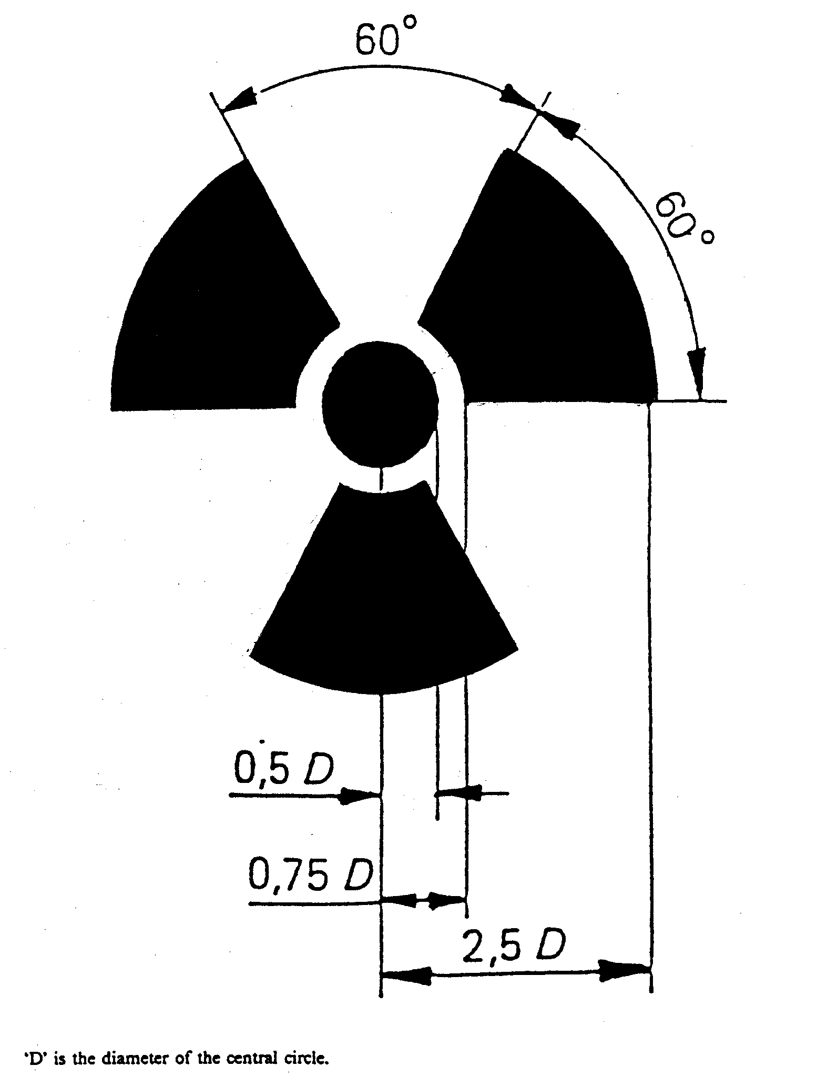
SCHEDULE 3
Classification of Premises

1. The classification of premises into Type A, Type B or Type C depends on—

(a) the groups to which the radionuclides kept or handled belong; and

(b) the maximum activities handled; and

(c) the type of operations performed on the premises.

2. If more than one radionuclide is handled, or if more than one type of operation is performed, then the highest classification found when all radionuclides and operations are separately considered is the classification of the premises (Type A = highest classification, Type C = lowest classification).

3. The maximum activity of a particular radionuclide handled on the premises should be multiplied by the modifying factors given in Table 1, and the results applied to Table 2 to determine the premises classification.

TABLE 1 MODIFYING FACTORS

Type of Operation Factor

Simple storage (no operations) 0.01
Simple wet operations such as preparation of aliquots of stock solutions 0.1
Normal chemical operations involving few transfers 1
Complex chemical operations involving many transfers or complex apparatus 10
Simple dry operations (e.g. manipulation of powders) 10
Work with volatile radioactive compounds 10
Dry, dust producing operations such as grinding 100

TABLE 2 PREMISES CLASSIFICATION

Group of radionuclide | Allowable Activity Range for:
 | TYPE C | TYPE B | TYPE A
1  2  3  4 | less than 400 kBq  less than 40 MBq  less than 4 GBq  less than 400 GBq | 400 kBq-40MBq  40 MBq-4 GBq  4 GBq-400 GBq  400 GBq-40 TBq | more than 40 MBq  more than 4 GBq  more than 400 GBq  more than 40 TBq

SCHEDULE 4
Fees

Licence to mine or mill radioactive ores (s. 24 of Act)

1. (1) Annual fee for a licence under s. 24 of the Act to mine or mill radioactive ores—

(a) in relation to a site containing one or more mines or mills in commercial production—an amount calculated in accordance with the following formula:

Where—

A is the amount to be paid;

CPI 2 is the C.P.I. for the March quarter ended immediately prior to the date on which the fee being calculated is payable;

CPI 1 is the C.P.I. for the March 1998 quarter; or

(b) in relation to a site containing a non-commercial mine or mill used for the purpose of exploration or developmental testing of a process—an amount calculated in accordance with the following formula:

A = $200 × I2
I1

Where—

A is the amount to be paid;

I2 is the A.B.S. Index for the March quarter ended immediately prior to the date on which the fee being calculated is payable;

I1 is the A.B.S. Index for the March 1988 quarter.

(2) In this clause—

"A.B.S. Index" means the Gross Non Farm Product Implicit Price Deflator Index published quarterly in catalogue number 5206 by the Australian Bureau of Statistics;

"C.P.I." means the Consumer Price Index (All groups index for Adelaide).

Licence to use or handle radioactive substances (s. 28 of Act)
2. (1) For issue of a licence under s. 28 of the Act to use or handle radioactive substances—

(a) application fee $47.00

(b) licence fee $47.00

No additional licence fee or application fee is payable by a person who applies for a temporary licence and a permanent licence at the same time where the subject matter of both applications is the same.

(2) For renewal of a licence issued under s. 28 of the Act $47.00

Registration of premises in which unsealed radioactive substances are handled or kept (s. 29 of Act)
3. (1) For registration under s. 29 of the Act of premises in which unsealed radioactive substances are handled or kept—

(a) application fee $47.00

(b) registration fee—

(i) for registration for one year $81.00

(ii) for registration for three years $243.00

(2) For renewal of registration of premises registered under s. 29 of the Act—

(a) for one year $81.00

(b) for three years $243.00

Registration of a sealed radioactive source (s. 30 of Act)
4. (1) For registration under s. 30 of the Act of a sealed radioactive source—

(a) application fee—

(i) for the first sealed radioactive source registered by the registered owner $47.00

(ii) for each subsequent sealed radioactive source registered by the registered owner $17.50

(b) registration fee—

(i) for registration for one year $17.50

(ii) for registration for three years $52.50

(2) For renewal of registration of a sealed radioactive source registered under s. 30 of the Act—

(a) for registration for one year $17.50

(b) for registration for three years $52.50

Licence to operate radiation apparatus (s. 31 of Act)
5. (1) For issue of a licence under s. 31 of the Act to operate radiation apparatus—

(a) application fee $47.00

(b) licence fee $47.00

No additional licence fee or application fee is payable by a person who applies for a temporary licence and a permanent licence at the same time where the subject matter of both applications is the same.

(2) For renewal of a licence issued under s. 31 of the Act $47.00

Registration of radiation apparatus (s. 32 of Act)
6. (1) For registration of radiation apparatus (s. 32 of Act)—

(a) application fee $47.00

(b) registration fee—

(i) for registration for one year $81.00

(ii) for registration for three years $243.00

(2) For renewal of registration of radiation apparatus registered under s. 32 of the Act—

(a) for registration for one year $81.00

(b) for registration for three years $243.00

SCHEDULE 5
Forms

Form 1

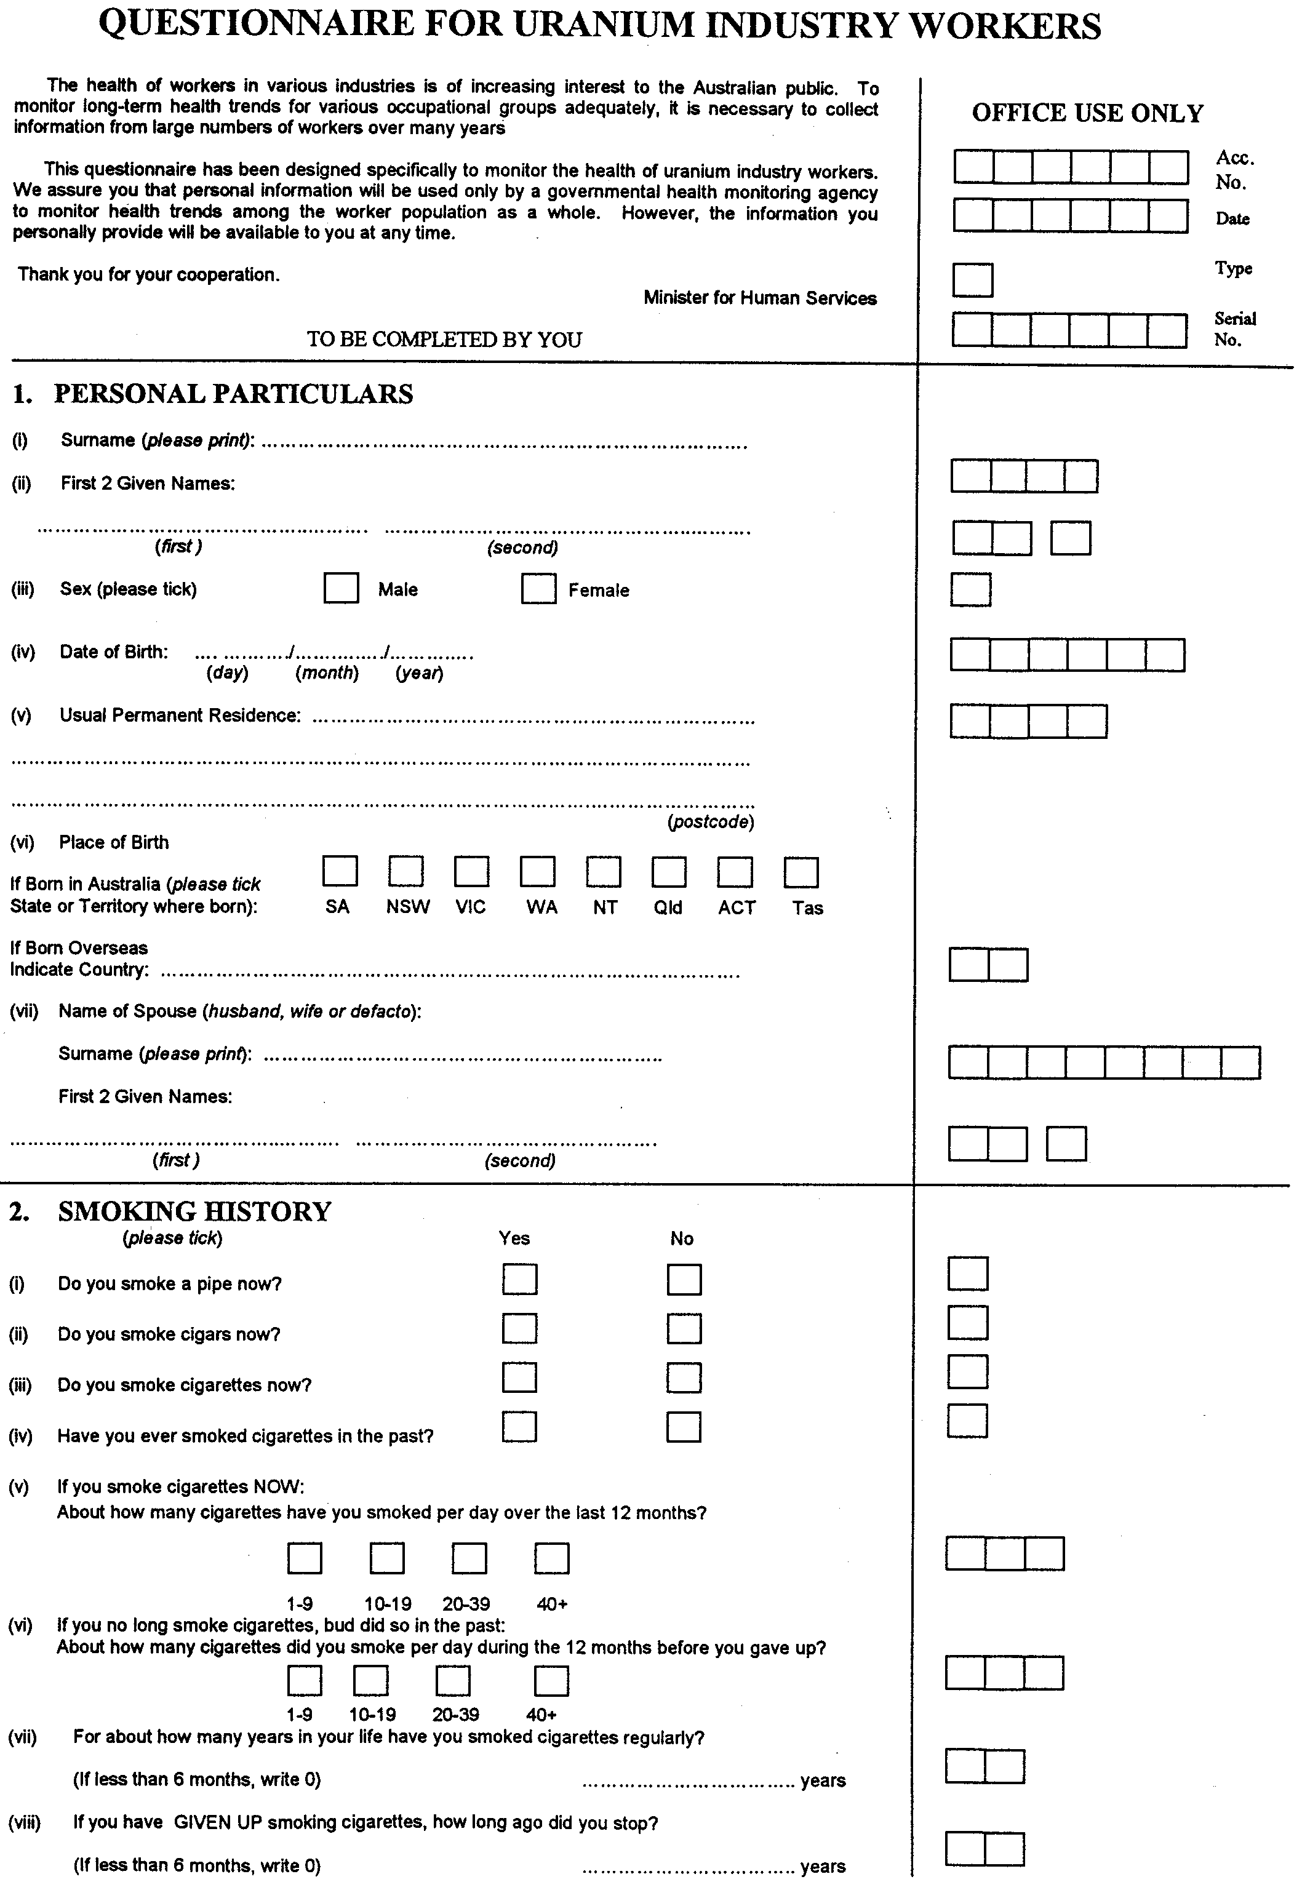

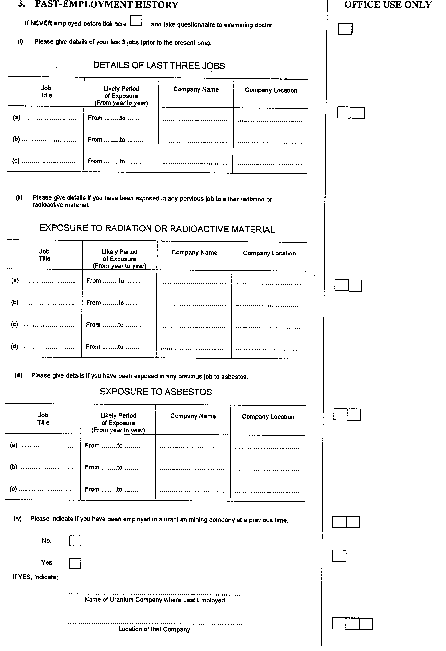

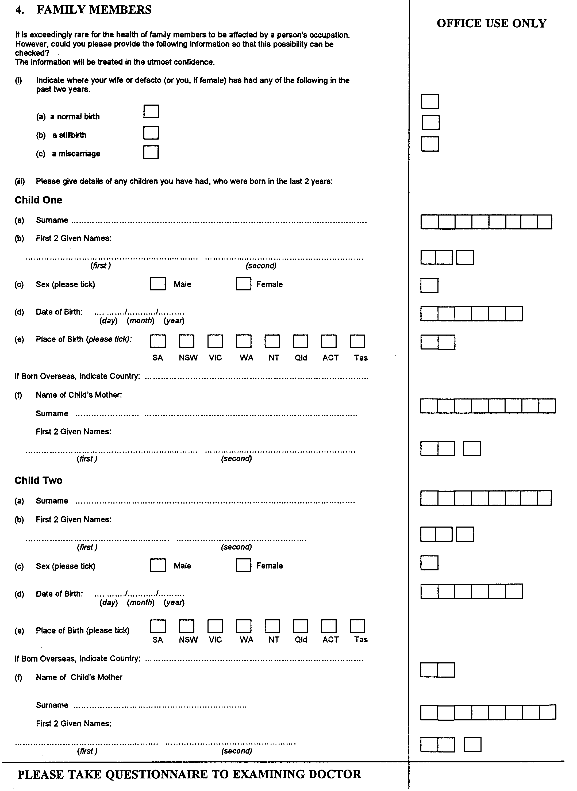

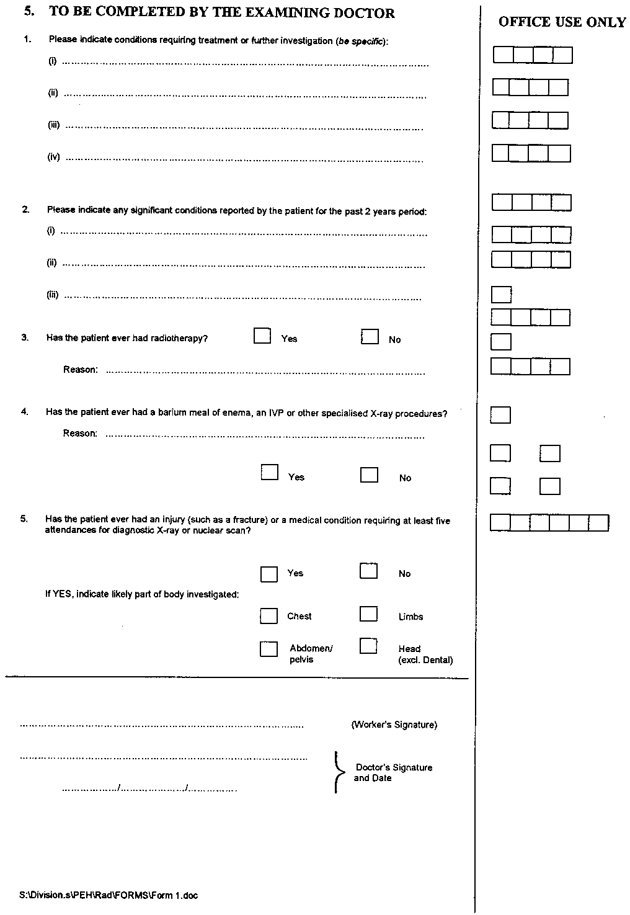
Form 2

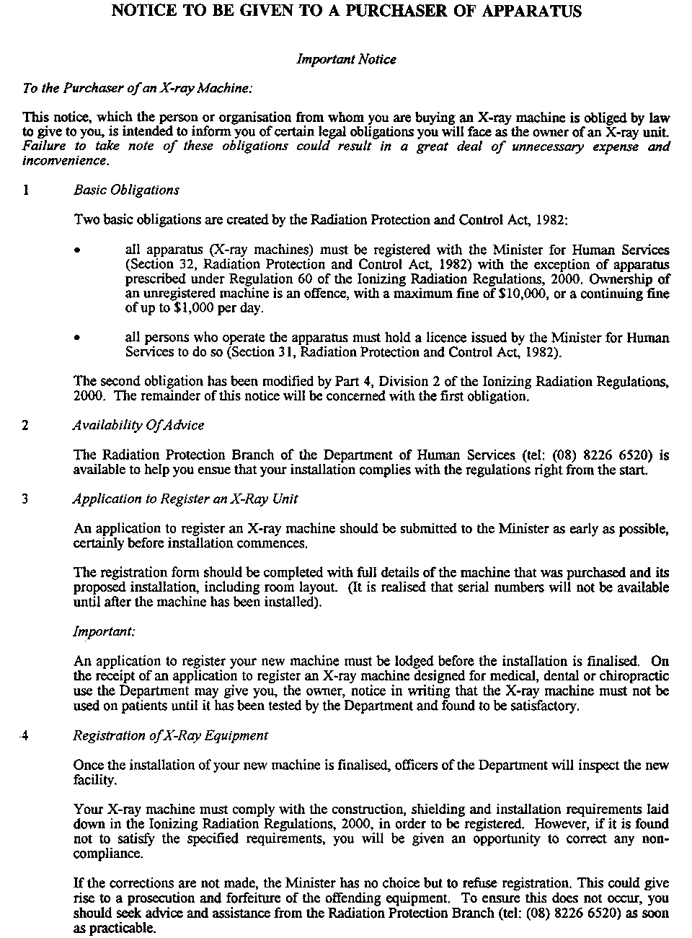
Form 3







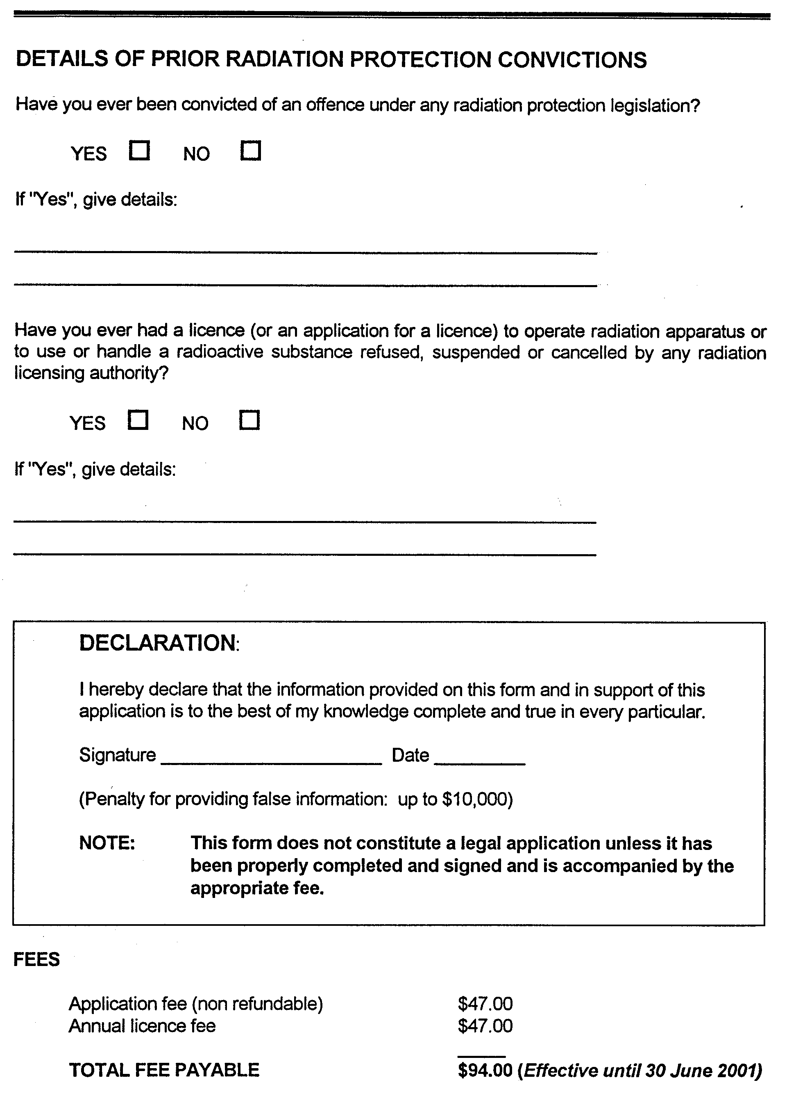
Form 4

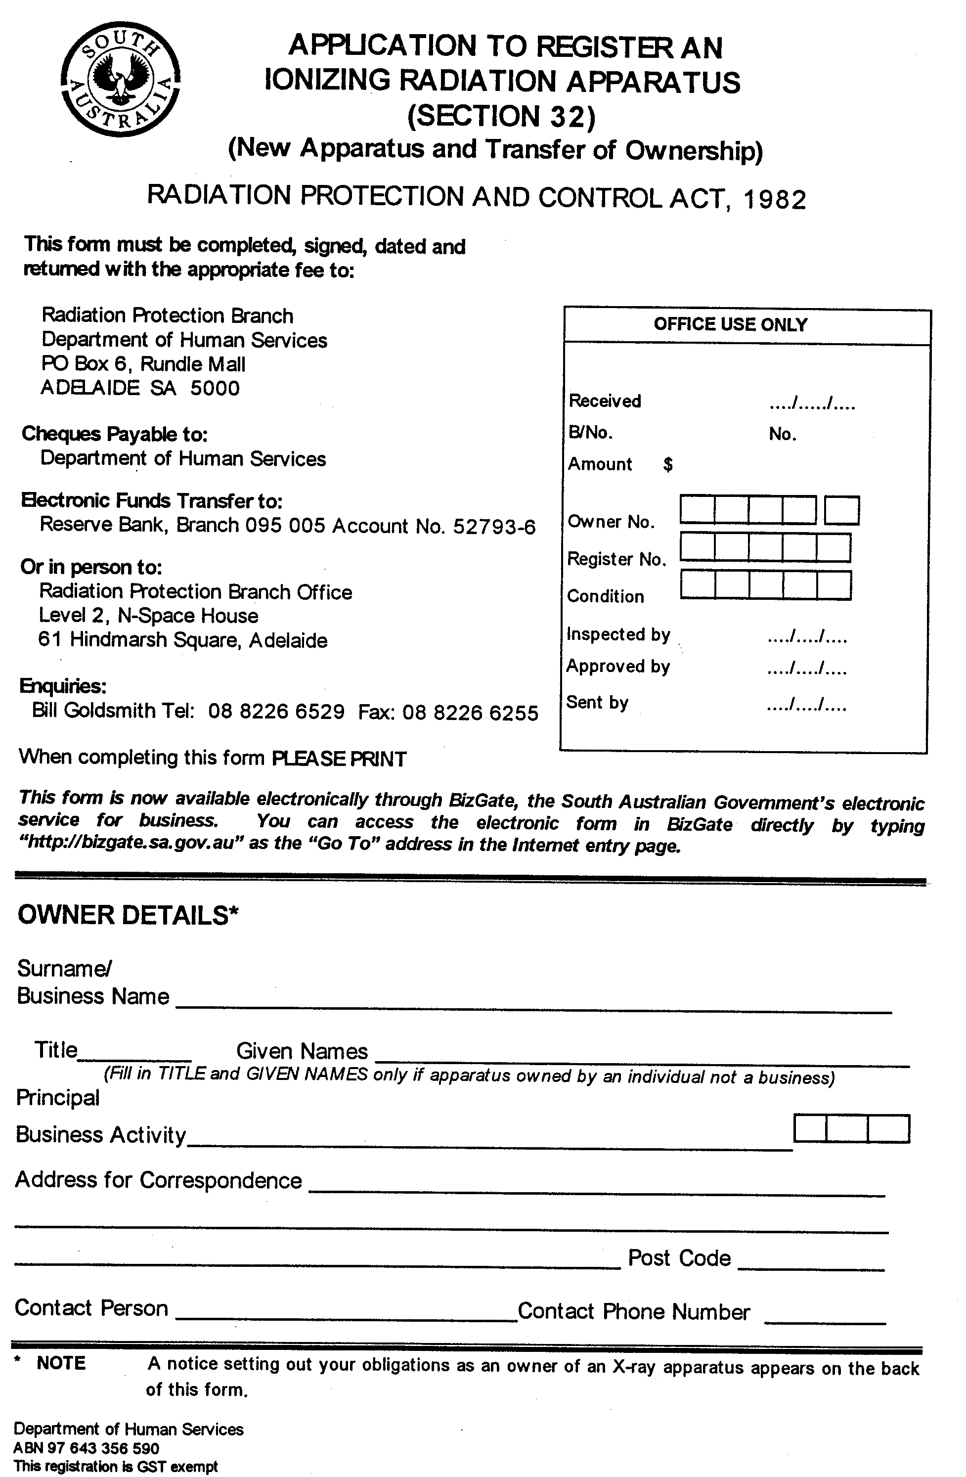

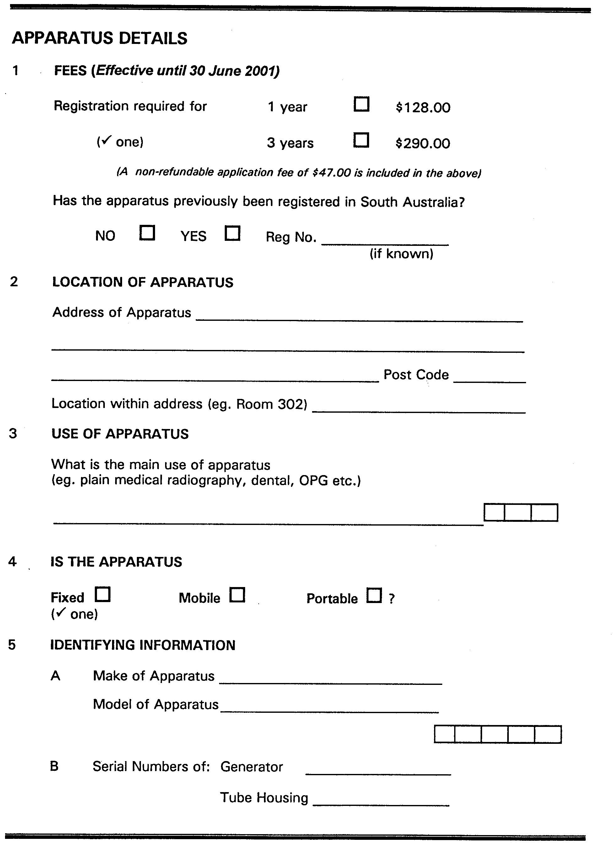


Form 5

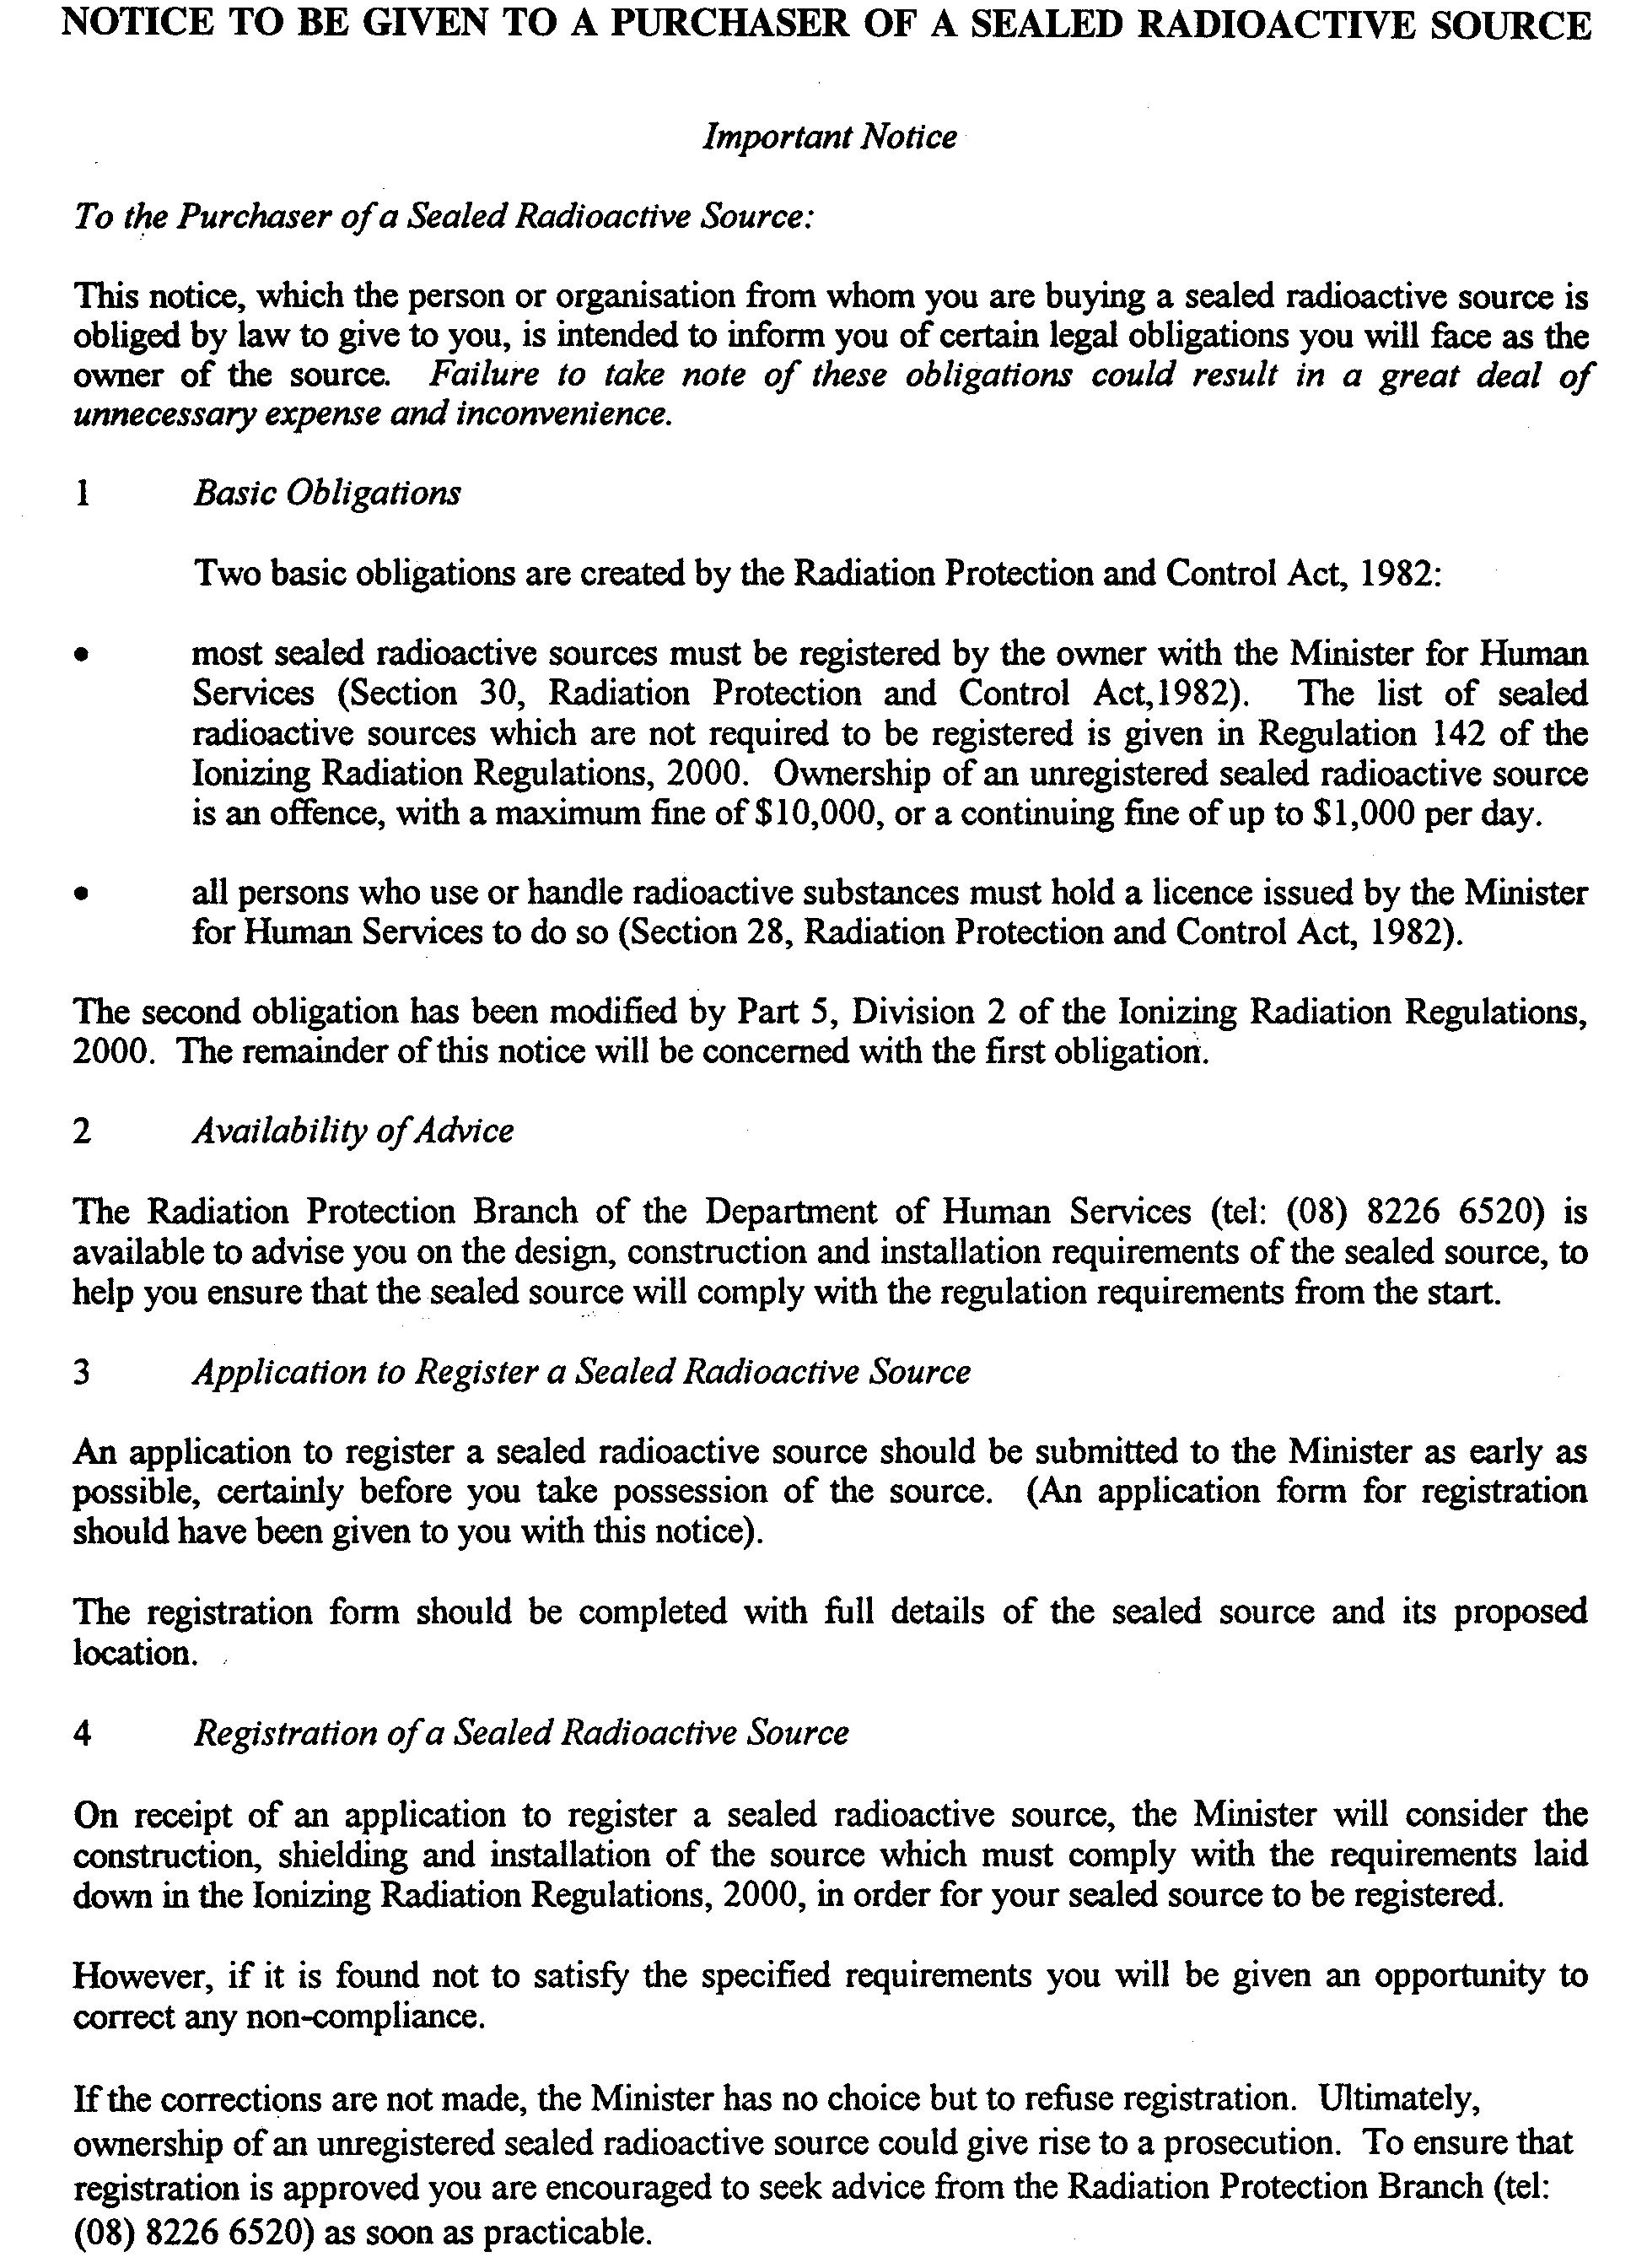
Form 6

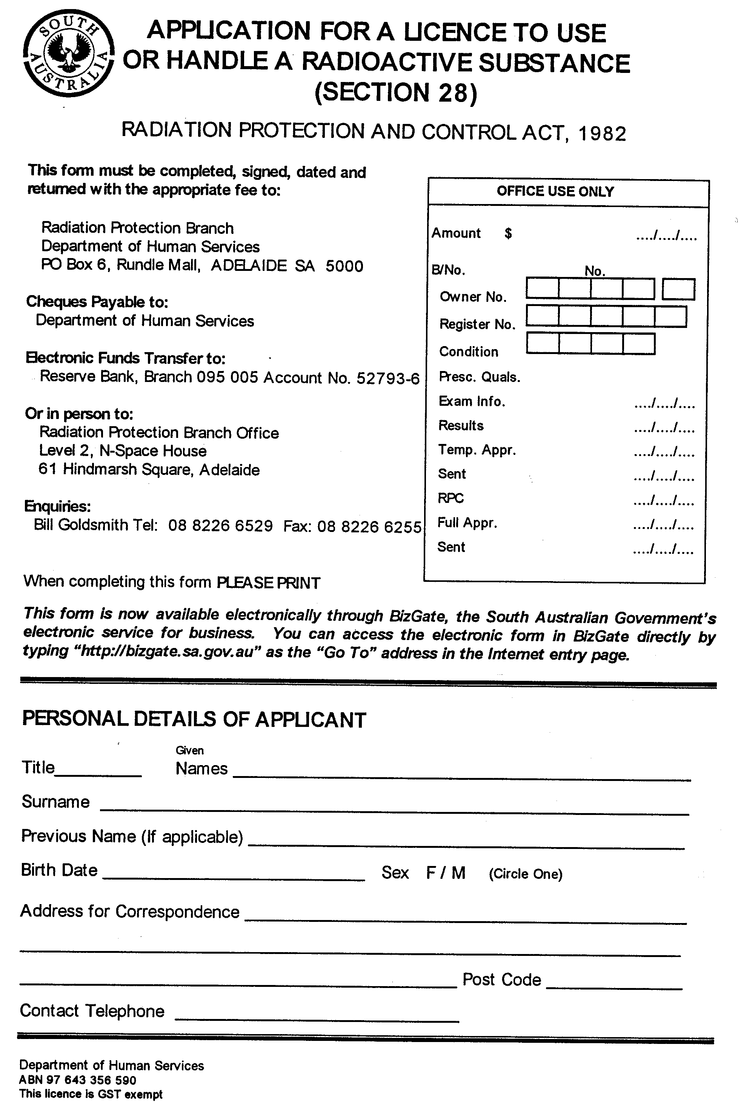

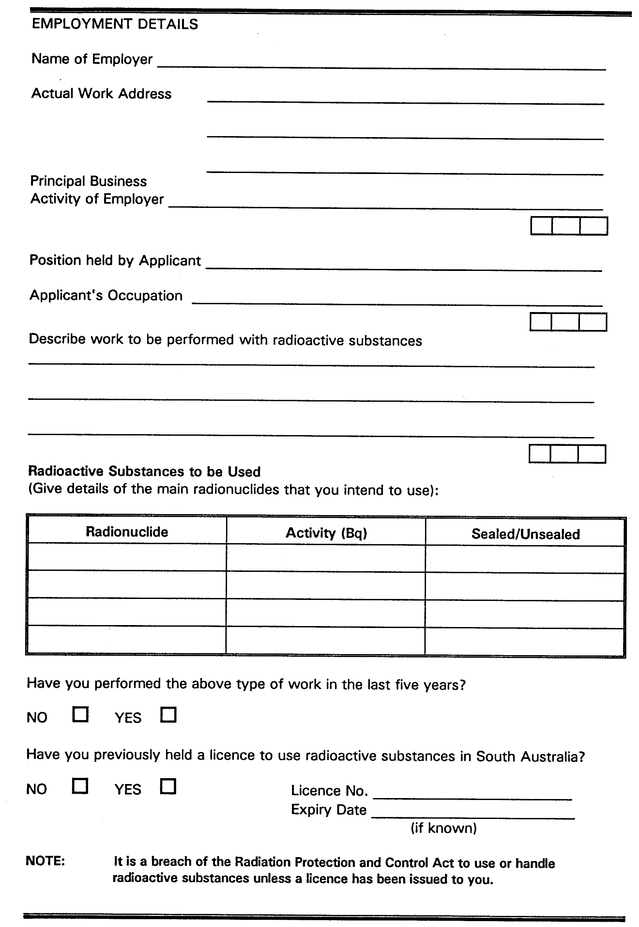

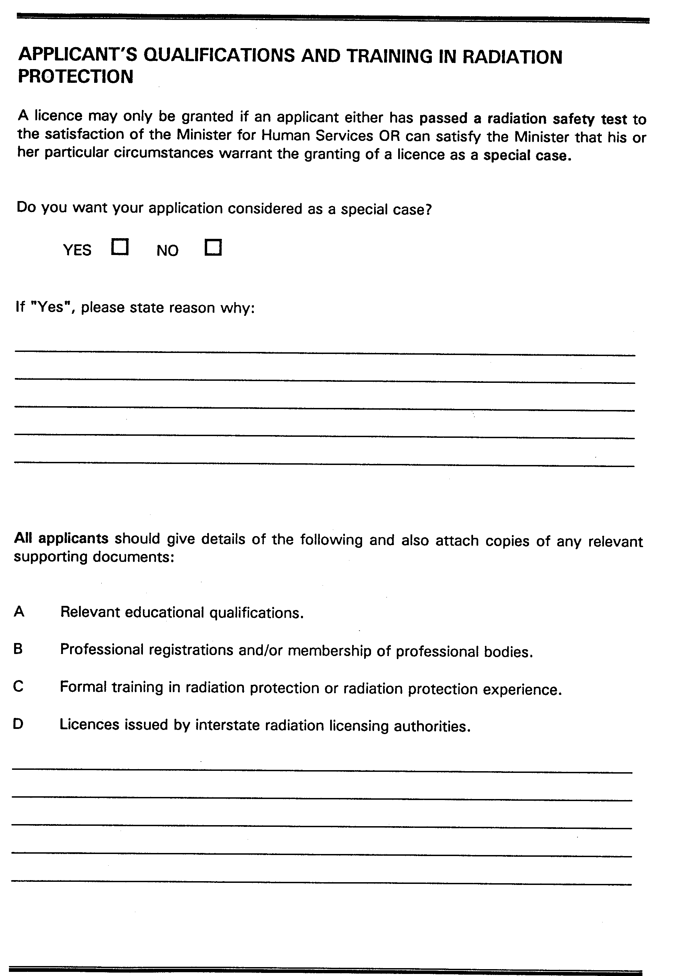

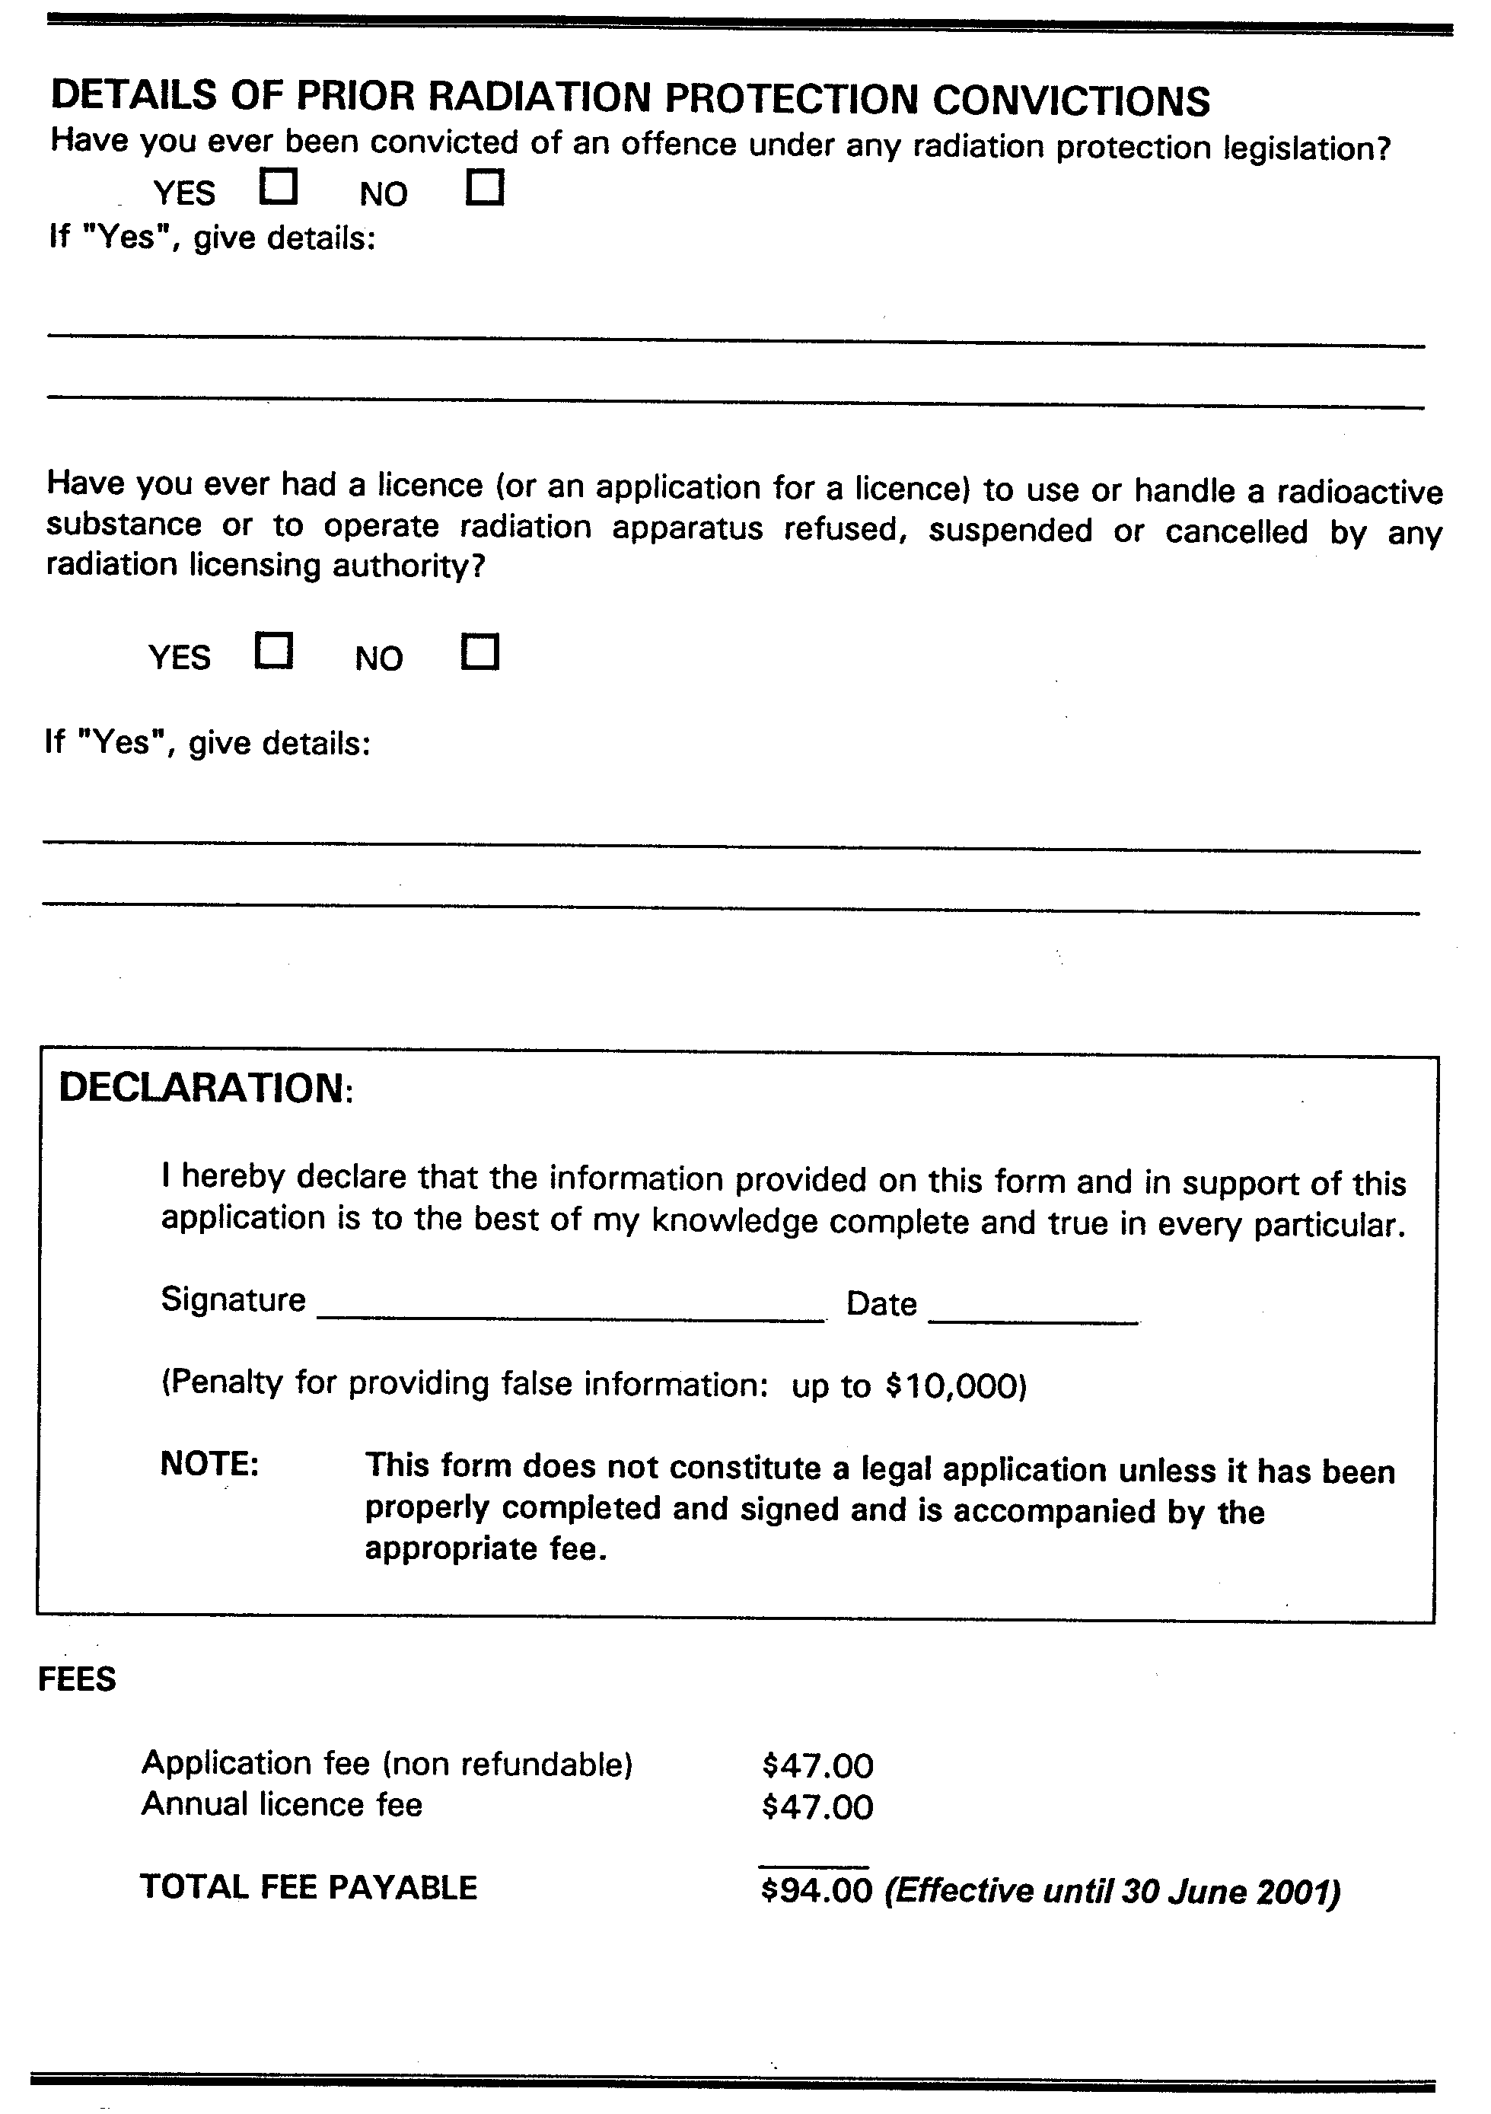
Form 7
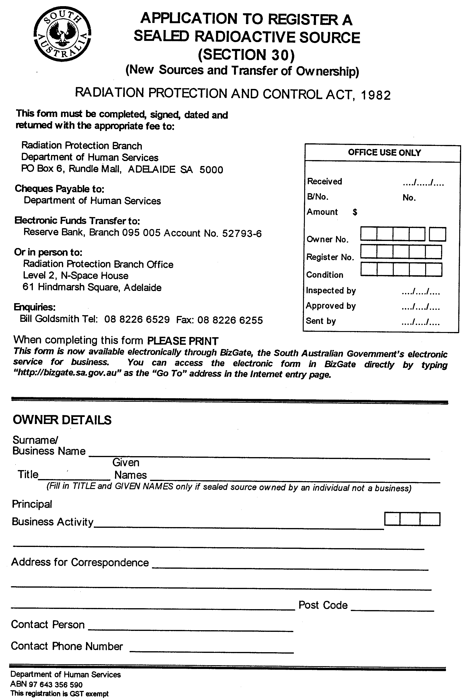

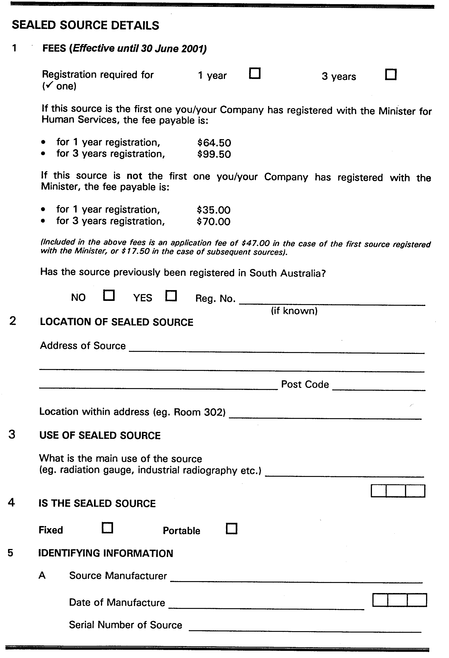


Form 8
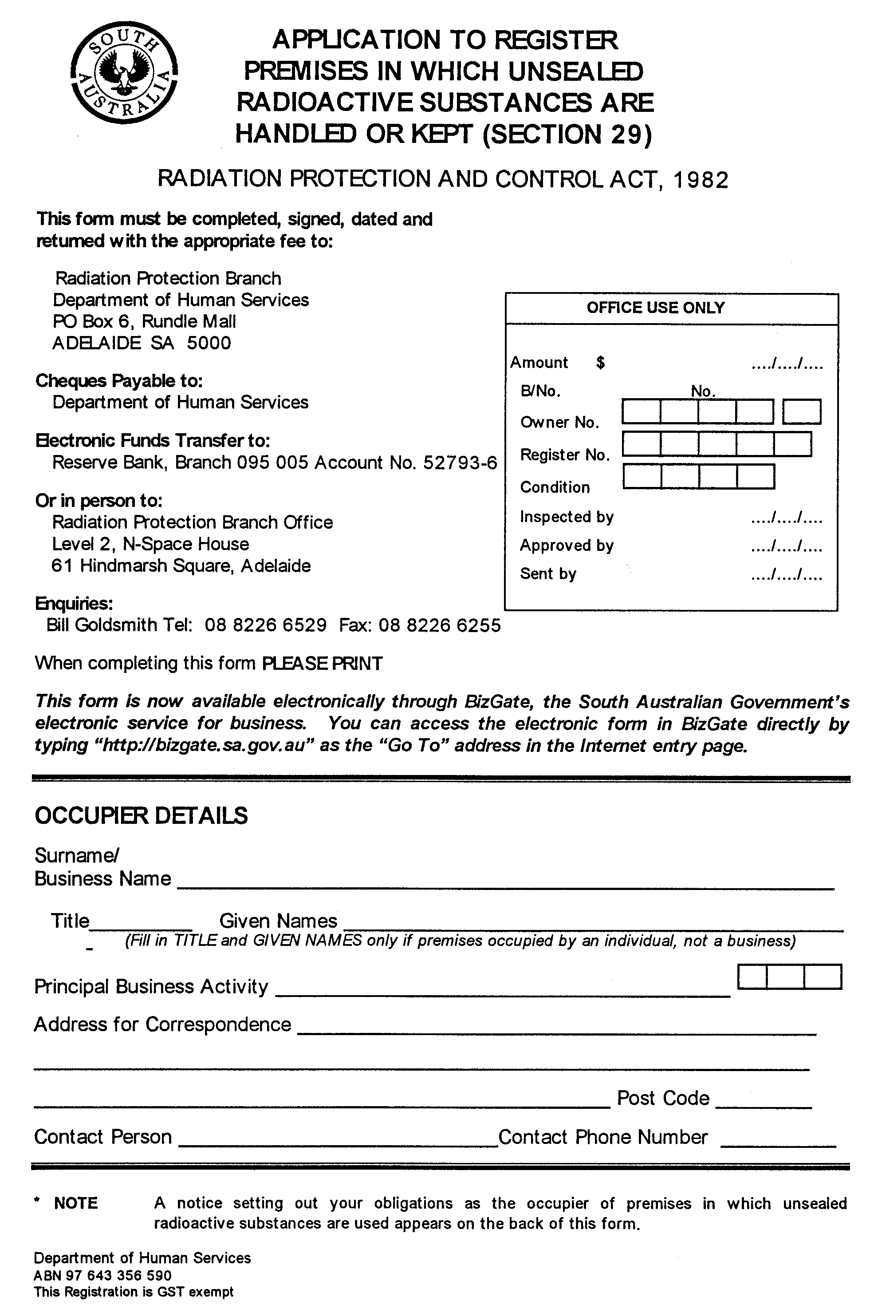

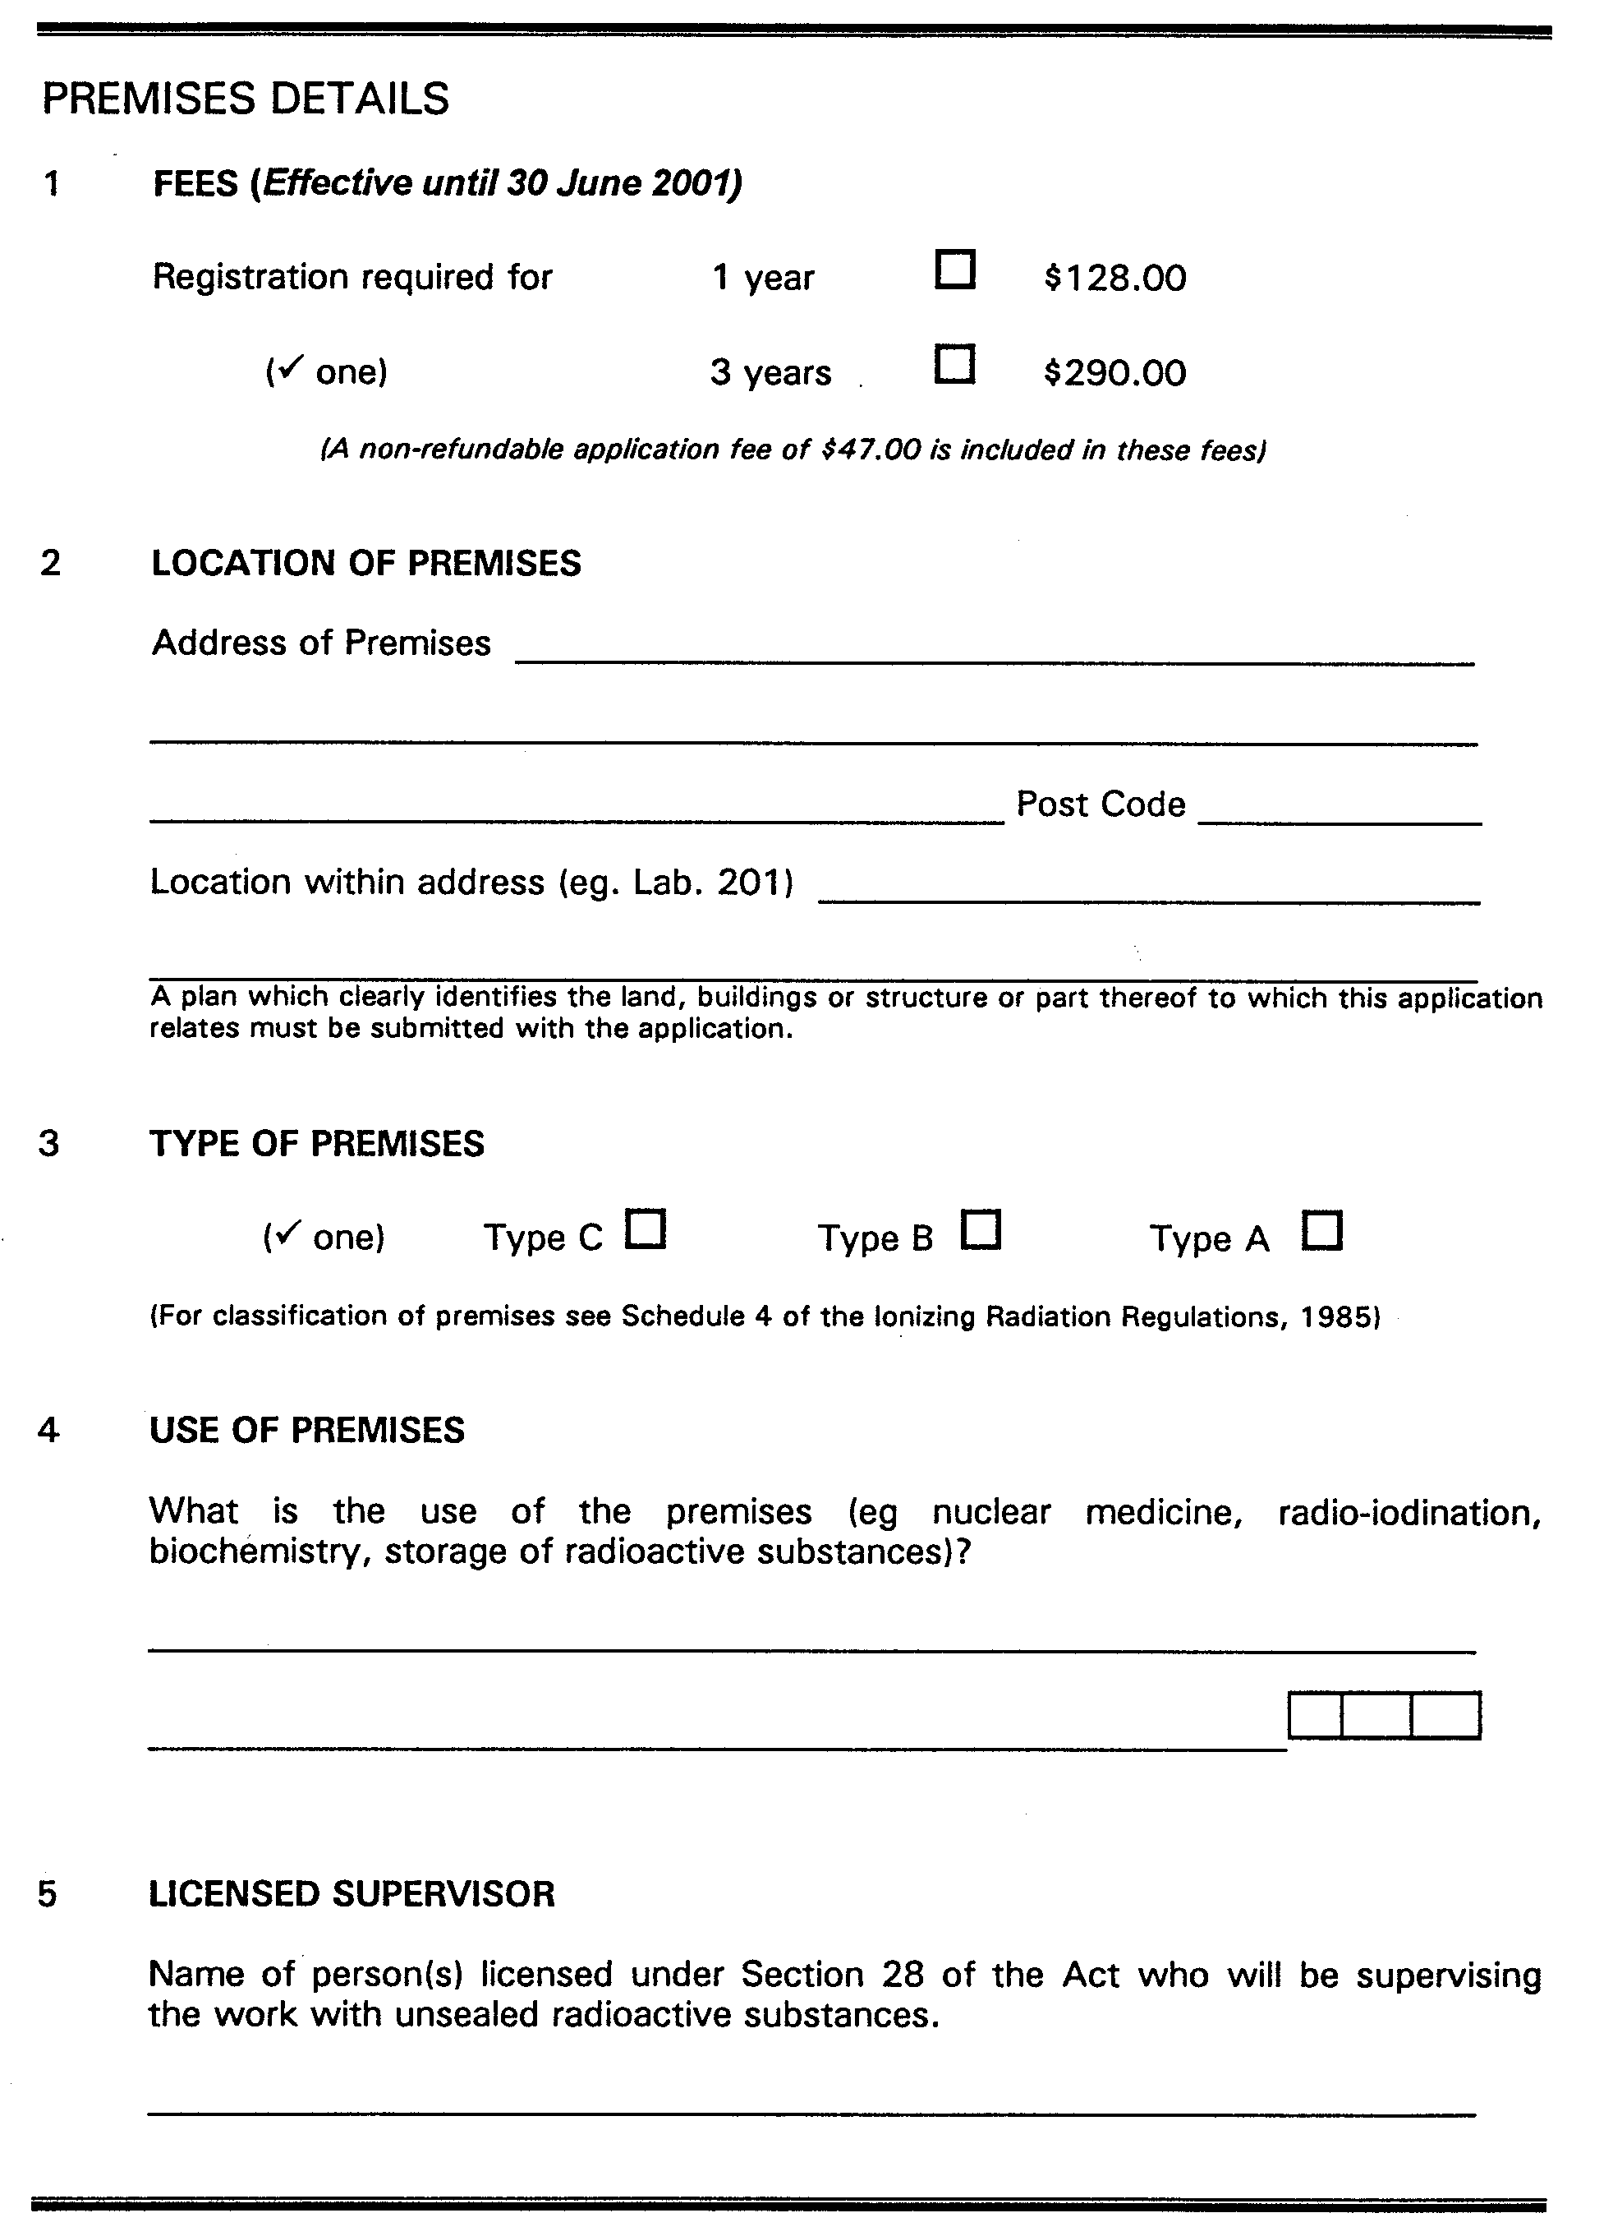




Form 9

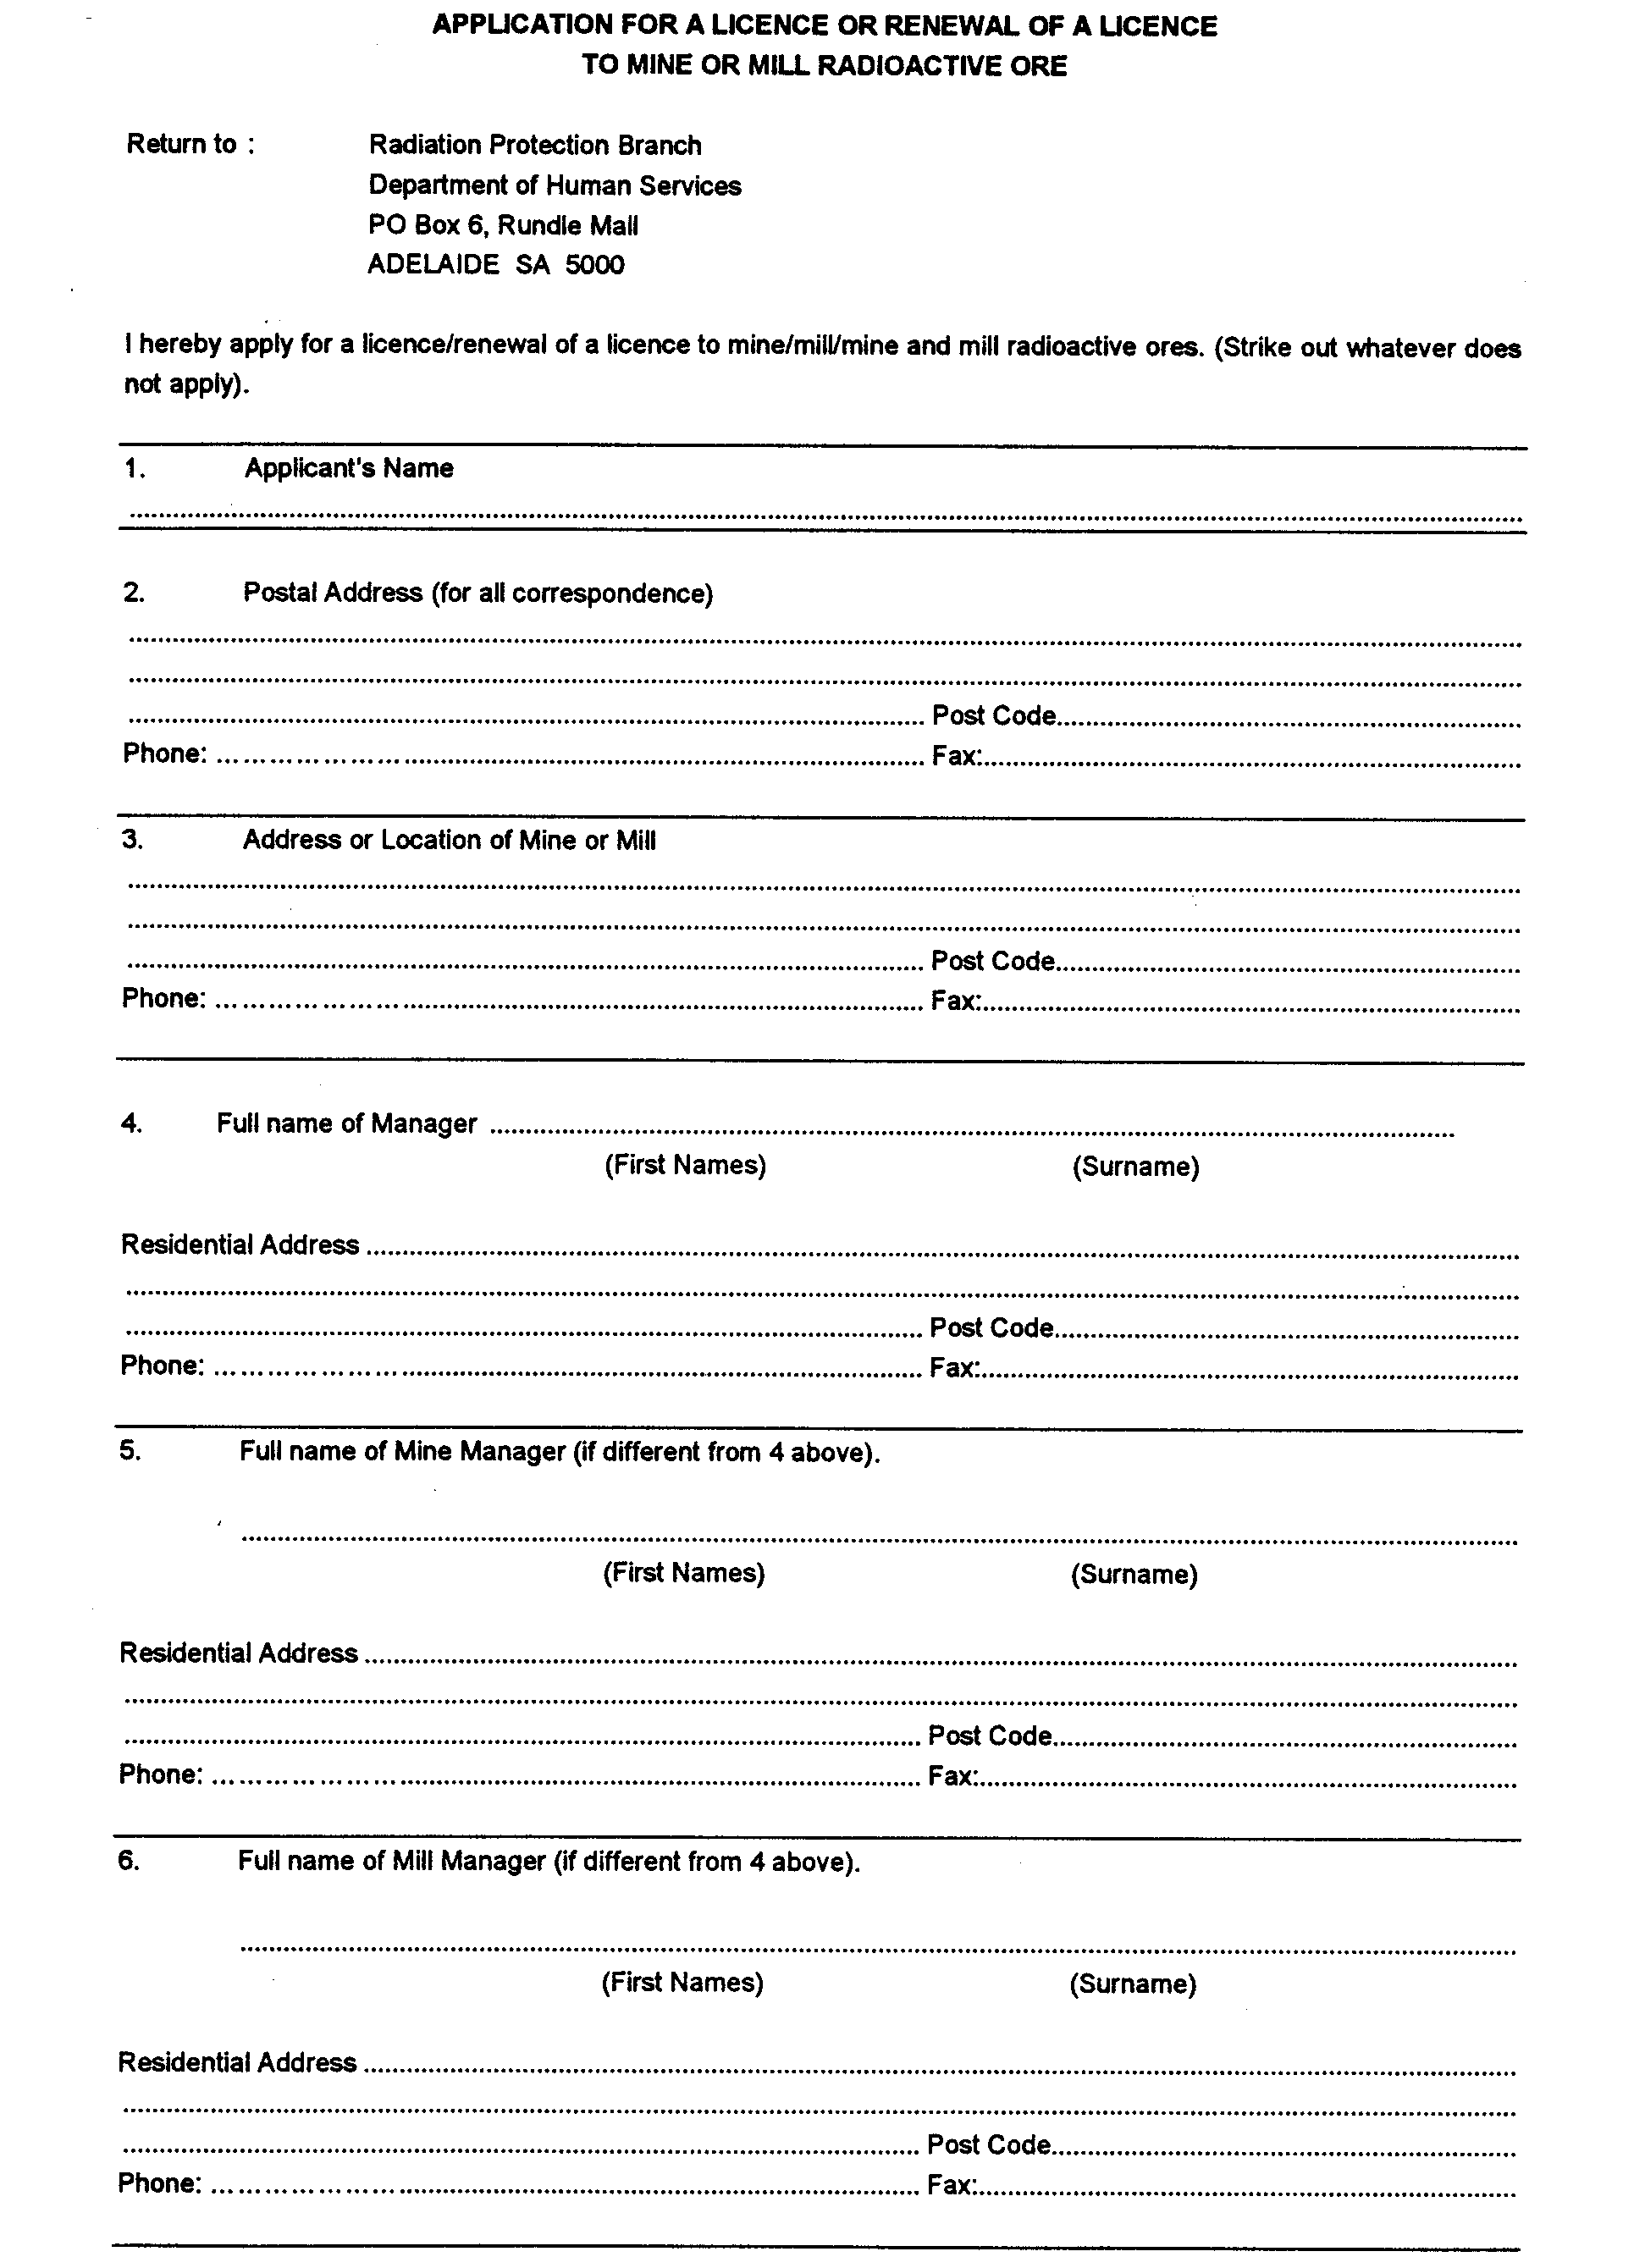

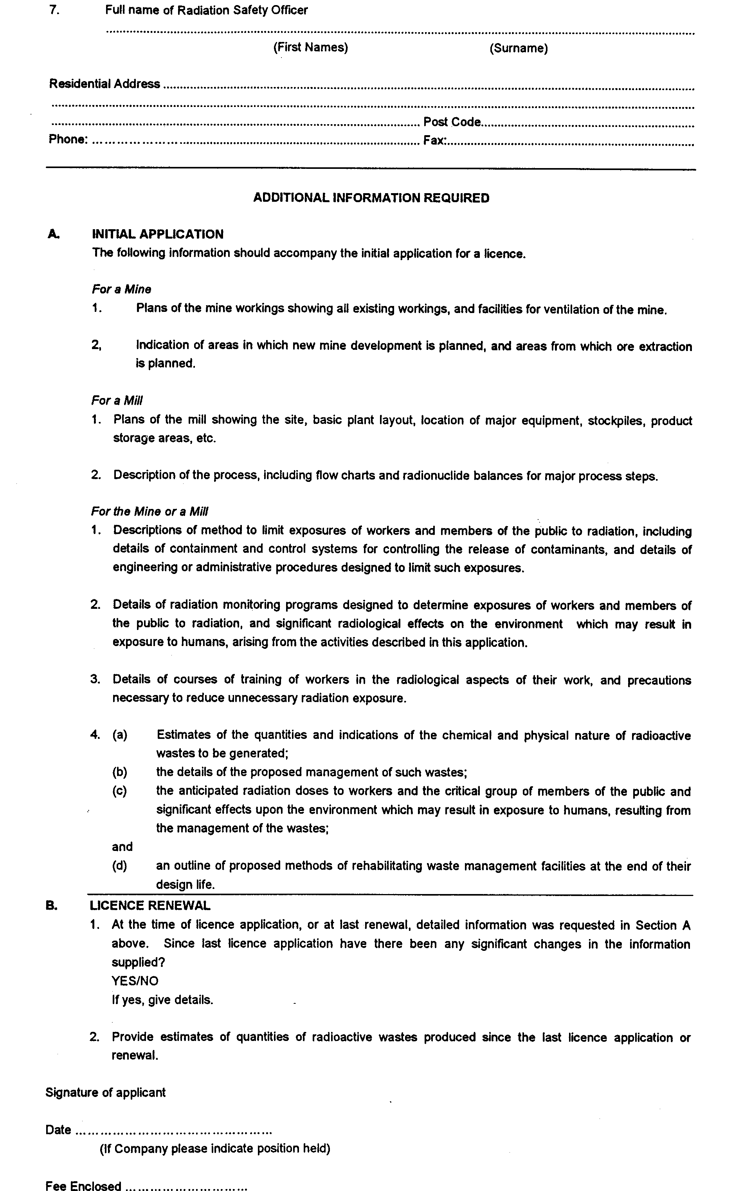
Form 10



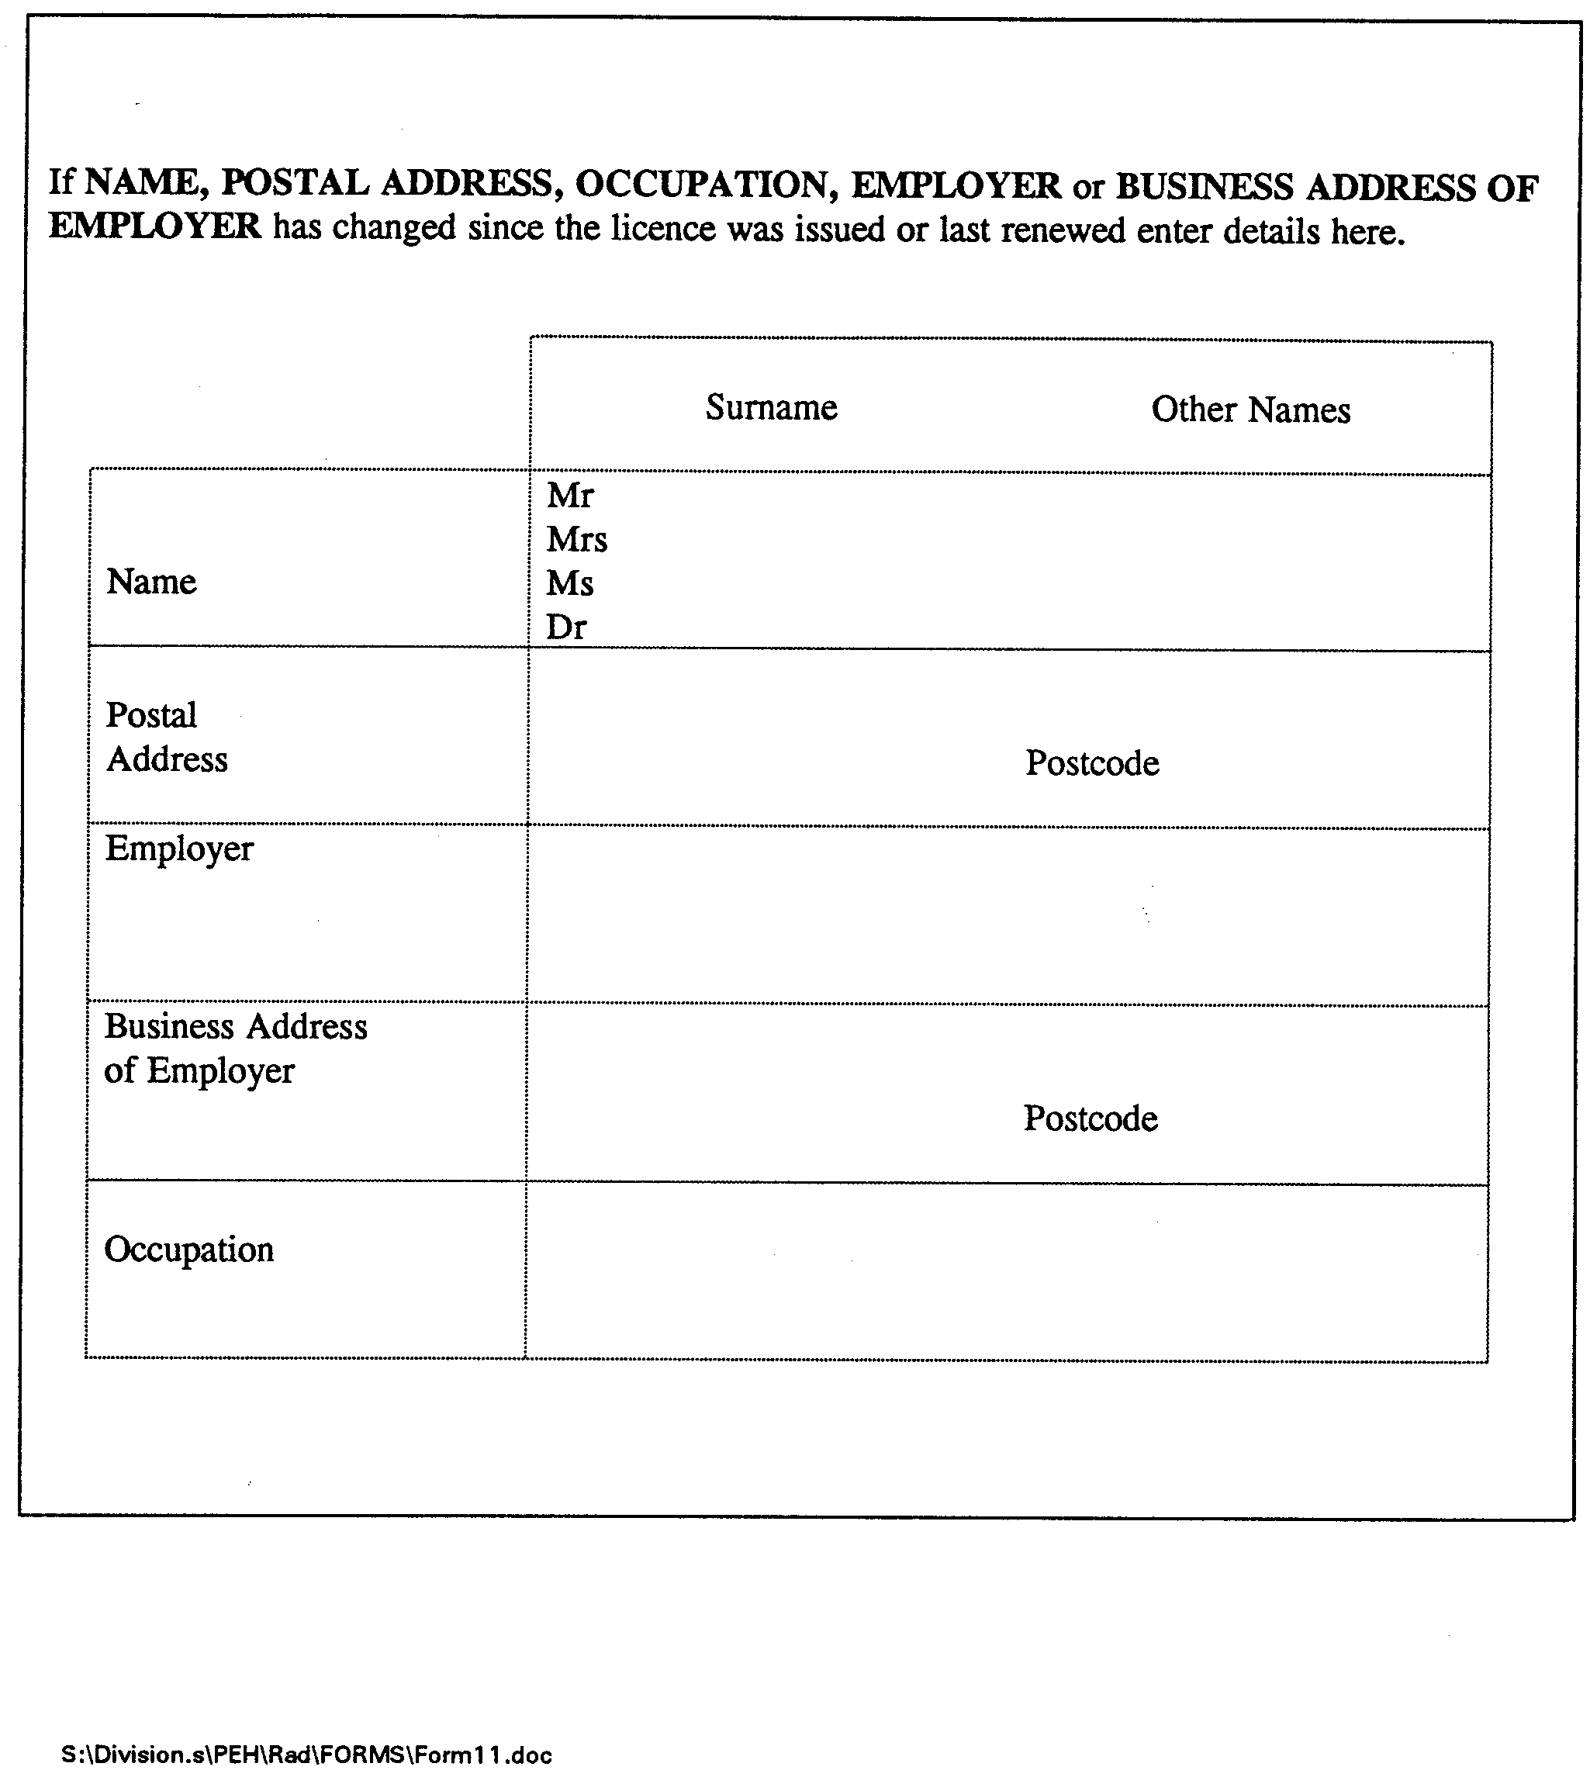
Form 11

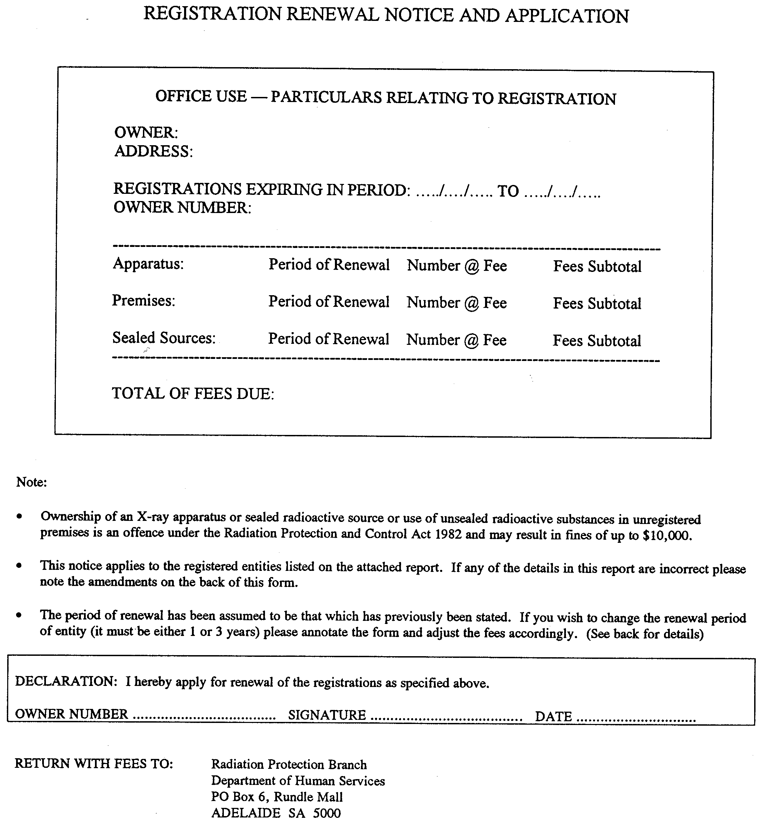

Department of Human Services
ABN 97 643 356 590
This registration is GST exempt.


SCHEDULE 6
Certificate of Identification of Authorised Officer

Name:

Title:

Specimen signature:

Card no.:

Pursuant to section 16 of the Radiation Protection and Control Act 1982, I certify that the person whose name, title, signature and photograph appear on this certificate is an authorised officer under that Act.

Date: . . . . . . . . . . . . . .
Minister

SCHEDULE 7
Minimum Half Value Layers for Diagnostic Apparatus

 | Indicated potential kV (peak) | Half value layer mm Al
 | 30  40  49  50  60  70  71  80  90  100  110  120  130  140  150 | 0.3  0.4  0.5  1.2  1.3  1.5  2.1  2.3  2.5  2.7  3.0  3.2  3.5  3.8  4.1

SCHEDULE 8
Error Distances for Automatic Collimation to a Spot Film Device

1. For the purposes of this Schedule—

"area being imaged" means the area of X-ray film available for imaging but does not include any area of the film covered by X-ray opaque masks or any area of the X-ray film which has previously been imaged by X-rays; and

"error distance" means the lack of alignment between the X-ray field and the area being imaged, where the X-ray field lies outside the area being imaged.

2. For a polygonal X-ray field, measurements of the error distance are taken perpendicularly from the mid-point of each side of the X-ray field, which is outside of the area being imaged, to the corresponding boundary of the area being imaged.

3. For an X-ray field with a curved boundary (e.g. a circular X-ray field) the error distance is defined for all points on the boundary of the X-ray field which lie outside of the area being imaged. For any such point the error distance is measured perpendicularly from the tangent to the boundary at that point to the corresponding boundary of the area being imaged.

4. In no case must the error distance, measured in the way described above, exceed 1½ per cent of the focal spot to film distance.

SCHEDULE 9
Error Distances for Automatic Collimation to an Image Intensifier

1. For the purposes of this Schedule—

"area being imaged" means the area of the input phosphor which produces an image on the television monitor;

"error distance" means the lack of alignment between the X-ray field and the area being imaged, where the X-ray field lies outside the area being imaged.

2. For a polygonal X-ray field, measurements of the error distance are taken perpendicularly from the mid-point of each side of the X-ray field, which is outside of the area being imaged, to the corresponding boundary of the area being imaged.

3. For an X-ray field with a curved boundary (e.g. a circular X-ray field) the error distance is defined for all points on the boundary of the X-ray field which lie outside of the area being imaged. For any such point the error distance is measured perpendicularly from the tangent to the boundary at that point to the corresponding boundary of the area being imaged.

4. In no case must the error distance, measured in the way described above, exceed 1 per cent of the focal spot to image receptor distance.

DHS 009/99/0103 CS SUZANNE M. CARMAN Clerk of the Council

REGULATIONS UNDER THE MOTOR VEHICLES ACT 1959
────
No. 195 of 2000
────
At the Executive Council Office at Adelaide 24 August 2000

PURSUANT to the Motor Vehicles Act 1959 and with the advice and consent of the Executive Council, I make the following regulations.
J. DOYLE Governor's Deputy

PURSUANT to section 10AA(2) of the Subordinate Legislation Act 1978, I certify that, in my opinion, it is necessary or appropriate that the following regulations come into operation as set out below.

DIANA LAIDLAW Minister for Transport and Urban Planning
───────────────────
SUMMARY OF PROVISIONS

PART 1
PRELIMINARY

1. Citation
2. Commencement
3. Revocation
4. Interpretation
5. Forms
6. Fees

PART 2
ACCIDENT TOWING ROSTER REVIEW COMMITTEE

7. Continuation of Accident Towing Roster Review Committee
8. Appointment of deputies
9. Functions of Committee
10. Committee proceedings
11. Committee may establish subcommittees

PART 3
ACCIDENT TOWING ROSTER SCHEME

12. Continuation of accident towing roster scheme
13. Functions of Registrar
14. Functions of Commissioner of Police
15. Zones
16. Rosters
17. Accident towing directions
18. Towtruck operator's turn on roster
19. Offence to give accident towing direction other than in accordance with regulations

PART 4
REGISTERED PREMISES

20. Only registered premises to be used for purpose associated with scheme
21. Standards and requirements for registered premises
22. Signs

PART 5
TOWTRUCKS

23. Towtrucks to comply with certain standards
24. Requirements for approval of towtruck
25. Surrender of towtruck number plates
26. Registrar must be advised of dealings with approved towtrucks

PART 6
QUALIFICATIONS OF APPLICANTS

27. Qualifications of applicants
28. Applicant to satisfy Registrar as to qualifications

PART 7
POSITIONS ON ROSTERS

29. Applications for positions on rosters
30. Restrictions on granting positions on more than one roster
31. Granting of position on roster
32. Deemed vacancies on rosters
33. Renewals
34. Registrar may defer grant or renewal in certain circumstances
35. Authorisation Notices
36. Surrender of positions

PART 8
DUTIES AND CONDUCT OF TOWTRUCK OPERATORS

37. Duties
38. Registrar may authorise telephone calls to be diverted from registered premises
39. Stipulated conditions

PART 9
DISCIPLINE

40. Registrar's powers
41. Registrar may grant removed operator position on roster
42. Cause for disciplinary action

PART 10
AUTHORITIES TO TOW

43. Authorities to tow
44. Completion of authorities to tow
45. Loss of or damage to authority to tow

PART 11
RECORDS

46. Records

PART 12
MISCELLANEOUS

DIVISION 1—POLICE POWERS

47. Decisions as to zones
48. Accident towing directions
49. Attendance of other recovery vehicle may be called for in certain circumstances

DIVISION 2—GENERAL

50. Exemptions
51. Immunity from liability
52. Prohibition on use of official telephone number
53. Towtruck certificate (s. 98ML of Act)
54. Complaints
55. General offence

SCHEDULE 1
Forms

SCHEDULE 2

Fees

SCHEDULE 3

Transitional Provisions
───────────────────

PART 1
PRELIMINARY

Citation
1. These regulations may be cited as the Motor Vehicles (Accident Towing Roster Scheme) Regulations 2000.

Commencement
2. These regulations will come into operation on 1 September 2000.

Revocation
3. The Accident Towing Roster Scheme Regulations 1984 (see Gazette 30 August 1984 p. 707), as varied, are revoked.

Interpretation
4. In these regulations, unless the contrary intention appears—

"Act" means the Motor Vehicles Act 1959;

"Committee" means the Accident Towing Roster Review Committee;

"inspector" means an inspector appointed under Part 3C of the Act;

"position on a roster" includes the position originally granted by the Registrar on a roster and any renewal or re-grant of position;

"revoked regulations" means the Accident Towing Roster Scheme Regulations 1984 revoked by regulation ;

"roster" means an accident towing roster prepared by the Registrar under Part 3;

"scheme" means the accident towing roster scheme continued under regulation ;

"storage area" means the part of registered premises set aside for the storage of vehicles that have been towed in compliance with an accident towing direction.

Forms
5. (1) The forms set out in Schedule 1 are prescribed for the purposes of the Act.

(2) Subject to these regulations, a form set out in Schedule 1 must—

(a) be used for the purposes specified in the Schedule; and

(b) contain the information required by, and be completed in accordance with, the instructions contained in the forms; and

(c) in the case of Form 1 (Notice—Storage Charges)—be delivered personally or by registered post to the owner of the stored vehicle.

Fees
6. (1) The fees set out in Schedule 2 are prescribed for the purposes set out in the Schedule and are payable to the Registrar.

(2) No fee (or part of a fee) set out in Schedule 2 is refundable or transferable and, despite the provisions of the Act, a person may not receive a concession or reduction of any such fee.

(3) The scale of fees set out in Prices Order No. 1125 (S.A.) made under the Prices Act 1948 (see Gazette 13 July 2000 p. 135) is prescribed for the purposes of sections 98ME(15) and 98MF(2)(b) of the Act, but, if that Order has been superseded, then the prescribed scale of fees is that set out in the Order under that Act that is in force for the time being.

PART 2
ACCIDENT TOWING ROSTER REVIEW COMMITTEE

Continuation of Accident Towing Roster Review Committee
7. (1) The Accident Towing Roster Review Committee established under the repealed regulations continues in existence.

(2) The Committee consists of eight members appointed by the Minister, of whom—

(a) one (who will be the presiding member of the Committee) must be a person with substantial knowledge of the motor vehicle towing industry nominated by the Minister; and

(b) one will be the Commissioner of Police, or the Commissioner's nominee; and

(c) one (who will be the Secretary) will be the officer in charge of the Towing Authority, or the officer's nominee; and

(d) one will either be a person selected by the Minister from a panel of three candidates nominated by the Motor Trade Association of SA Inc or, in default of a nomination by the Motor Trade Association of SA Inc, a person whom the Minister considers will satisfactorily represent the interests of the motor vehicle towing industry; and

(e) one will either be a person selected by the Minister from a panel of three candidates nominated by the Royal Automobile Association of (SA) Incorporated or, in default of a nomination by the Royal Automobile Association of (SA) Incorporated, a person whom the Minister considers will satisfactorily represent the interests of motorists; and

(f) one will either be a person selected by the Minister from a panel of three candidates nominated by the Towtruck Operators and Owners Association of South Australia Incorporated or, in default of a nomination by the Towtruck Operators and Owners Association of South Australia Incorporated, a person whom the Minister considers will satisfactorily represent the interests of the motor vehicle towing industry; and

(g) two will be persons selected by the Minister to represent community interests.

(3) At least one member of the Committee must be a woman and one a man.

(4) If, in the opinion of the Minister, an incorporated body referred to in this regulation, fails to comply with its constitution in a material particular, the Minister may remove the representative of that body from the Committee and replace that representative with a person whom the Minister considers will satisfactorily represent the interests of motorists or of the motor vehicle towing industry (as the case requires).

Appointment of deputies
8. The Minister may appoint a suitable person, with equivalent qualifications, to be a deputy of a member of the Committee and any such person will, while acting in the absence of the member, be taken to be a member of the Committee with all the powers, authorities, duties and obligations of a member of the Committee.

Functions of Committee
9. The functions of the Committee are—

(a) to make recommendations to the Minister or the Registrar on any matters about which the Act or these regulations require the Committee's recommendations; and

(b) to advise and make recommendations to the Minister or the Registrar on any matters referred to it by the Minister or the Registrar; and

(c) to consider the methods and procedures used in the administration of the scheme and to advise and make recommendations to the Minister and the Registrar on any matter pertaining to the administration and operation of the scheme; and

(d) to inform the Minister and the Registrar of practices within the motor vehicle towing industry.

Committee proceedings
10. (1) The Committee must meet at such times as are decided by the presiding member.

(2) Five members of the Committee constitute a quorum.

(3) Subject to there being a quorum, the Committee may act despite a vacancy in its membership.

(4) All decisions and recommendations of the Committee will be made by a majority of the members present.

Committee may establish subcommittees
11. The Committee may establish subcommittees and invite any person to appear before it for the purpose of advising or informing the Committee.

PART 3
ACCIDENT TOWING ROSTER SCHEME

Continuation of accident towing roster scheme
12. (1) The accident towing roster scheme established under the revoked regulations continues in existence as if it had been established under these regulations.

(2) The purpose of the scheme continues to be the regulation and control of towtruck operators and towtruck drivers involved in the recovery, towing and storage of vehicles involved in accidents within the declared area and the proper and orderly recovery, towing and storage of such vehicles.

Functions of Registrar
13. (1) The Registrar is responsible for the administration of the scheme.

(2) The Registrar—

(a) must refer to the Committee those matters about which the Committee's recommendation is required by these regulations; and

(b) may refer any other matter concerning the administration or operation of the scheme to the Committee for its advice and recommendation.

Functions of Commissioner of Police
14. The Commissioner of Police is responsible—

(a) for receiving all requests for the services of a towtruck for any purpose related to the recovery or towing of a vehicle at or from the scene of an accident occurring within the declared area; and

(b) for the giving of all accident towing directions under the Act.

Zones
15. (1) The division of the declared area into zones for general accident towing rosters and zones for heavy vehicle accident towing rosters in operation immediately before the commencement of these regulations continues in operation under these regulations.

(2) The Minister may, on the recommendation of the Committee, by notice in the Gazette, alter the boundaries of a zone.

Rosters
16. (1) The general accident towing roster prepared by the Registrar for each general accident towing zone and the heavy vehicle towing roster for each heavy vehicle accident towing zone in operation immediately before the commencement of these regulations continue in operation as if they had been prepared under this regulation.

(2) An accident towing roster must be in the form determined by the Minister and contain the following information:

(a) the names and contact telephone numbers of the towtruck operators and towtrucks in the roster; and

(b) any other information that the Registrar considers necessary.

(3) The Registrar must, if the Committee so recommends, endorse on any heavy vehicle accident towing roster, recognition of a contract between the owner of heavy vehicles and a towtruck operator for the towing of that owner's heavy vehicles.

(4) An accident towing roster comes into force at 0001 hours on the first day of the commencement period nominated by the Registrar for that roster and remains in force until 2400 hours on the day nominated by the Registrar.

(5) A person must not at any time alter, or change in any manner, an accident towing roster or accident towing roster form without the express permission of the Registrar or an officer appointed under section 7 of the Act and authorised by the Registrar to so act.

Accident towing directions
17. (1) The Commissioner of Police must direct members of the police force on duty at the Police Communications Centre to—

(a) receive all requests for the services of a towtruck for any purpose related to the recovery or towing of a vehicle at or from the scene of an accident that has occurred within the declared area; and

(b) give an accident towing direction directly to the towtruck operator next listed on the appropriate accident towing roster for the zone in which the accident occurred; and

(c) identify to the towtruck operator the vehicle to be towed.

(2) However, if—

(a) an accident towing direction is to be given to a towtruck operator listed on the heavy vehicle accident towing roster; and

(b) there is endorsed on the heavy vehicle accident towing roster recognition of a contract between a towtruck operator and the owner of the vehicle to be towed,

the accident towing direction must be given to that towtruck operator.

Towtruck operator's turn on roster
18. (1) An accident towing direction given to a towtruck operator constitutes that towtruck operator's turn on the roster.

(2) No towtruck operator is entitled to receive an accident towing direction, fee, benefit, advantage, reward or compensation in respect of an act or activity that does not result effectively in the towing of a vehicle pursuant to an accident towing direction having been given.

(3) Despite subregulation (2), if a towtruck operator included on a roster can substantiate that he or she has lost four or more accident tows during a calendar month under circumstances that appear to be unduly harsh or unfair, or as a result of the misuse or abuse of the scheme, he or she may make written application to the Registrar for the reallocation of turns on a roster.

(4) The Registrar must refer all matters associated with the reallocation of turns on a roster to the Committee to determine the manner and number of turns (if any) to be reallocated to the towtruck operator.

Offence to give accident towing direction other than in accordance with regulations
19. A person must not give an accident towing direction except in accordance with the Act and these regulations.
PART 4
REGISTERED PREMISES

Only registered premises to be used for purpose associated with scheme
20. (1) A person must not use, or cause or permit to be used, any premises or place for a purpose associated with the operation of the scheme unless the premises are registered under this Part.

(2) No premises may be registered unless they are approved by the Registrar.

(3) For the purposes of these regulations, registered premises may include a number of buildings or allotments adjacent to, or within the immediate vicinity of, the main place of business of the registered premises.

Standards and requirements for registered premises
21. (1) The Registrar may not approve premises for registration unless, in the opinion of the Committee, the premises—

(a) comply with all requirements of the relevant local government council; and

(b) are situated wholly within the boundaries of the zone for the roster on which the towtruck operator holds a position or for which the operator has applied for a position; and

(c) are premises at and from which the towtruck operator seeking registration of the premises conducts the operator's towing business; and

(d) are used by only one towtruck operator or as otherwise recommended by the Committee; and

(e) are owned or leased solely by the towtruck operator seeking registration of the premises; and

(f) include a permanent building that is suitable for use as business premises; and

(g) comprise an area or areas each of which is enclosed by a boundary fence or wall and lockable gates or doors being—

(i) of sound structure; and

(ii) securely fastened at ground level; and

(iii) not less than 2.1 metres in height from the ground; and

(iv) considered by the Registrar to be adequate to prevent the entry of unauthorised persons and to prevent the unauthorised removal of vehicles or goods; and

(h) have a telephone service; and

(i) include a secure office area; and

(j) are equipped with operative base station radio equipment suitable for the deployment of mobile units; and

(k) include within the boundary fences or walls an area for the storage of vehicles that are towed to those premises in compliance with an accident towing direction which area—

(i) is at ground level; and

(ii) is large enough to store not less than five passenger vehicles for each position on a roster; and

(iii) has a well maintained ground surface; and

(iv) is constructed and located in such a way that a vehicle can be released from the storage area within a period of 30 minutes of any request being made for such release; and

(v) is designated "storage area" by clearly visible signs; and

(l) comply with any conditions stipulated by the Registrar under these regulations.

(2) The Registrar may exempt a towtruck operator from compliance with subregulation (1)(b) if the Committee is of the opinion that the towtruck operator can supply a prompt and efficient accident towing service to an adjacent zone.

(3) Registration of premises approved by the Registrar takes effect on them being entered in a register kept under the Registrar's control.

(4) A person must not make any structural alteration to any part of registered premises that does not comply with the standards and requirements set out in this regulation.

Signs
22. (1) A towtruck operator must ensure that a sign clearly displaying the information set out in subregulation (2) is erected and maintained near to the main entrance of the registered premises used by the operator in a position clearly visible from the road.

(2) A sign erected and maintained for the purposes of subregulation (1) must contain the following information:

(a) the trading name of the business;

(b) the name of the person in charge of the business;

(c) the hours of business;

(d) the telephone number for the business.

PART 5
TOWTRUCKS

Towtrucks to comply with certain standards
23. A person must not use a towtruck, or cause or permit a towtruck to be used, for the recovery or towing of any vehicle at or from the scene of an accident unless—

(a) it has been approved by the Registrar; and

(b) it is registered under Part 2 of the Act in the name of a person who has been granted a position on a roster by the Registrar; and

(c) it has the legal capacity to tow the vehicle that is to be towed; and

(d) it complies with the Road Traffic Act 1961 and any regulations or rules made under that Act.

Requirements for approval of towtruck
24. The Registrar may not approve a towtruck unless—

(a) it complies with the requirements of the Road Traffic Act 1961 and any regulations or rules made under that Act; and

(b) it complies with the standards fixed by the Registrar on the recommendation of the Committee; and

(c) it is fitted with and carries radio equipment which is capable of receiving messages transmitted from the registered premises of the towtruck operator who owns it; and

(d) it complies with any conditions stipulated by the Registrar under these regulations.

Surrender of towtruck number plates
25. If an approved towtruck ceases to be used in the operation of the scheme, the owner of that towtruck must, within the time specified by the Registrar, surrender to the Registrar the number plates issued in respect of that towtruck.

Registrar must be advised of dealings with approved towtrucks
26. A person must not sell, transfer, give away, lend, wreck or otherwise dispose of an approved towtruck unless the Registrar has been advised in writing of the intention to do so.
PART 6
QUALIFICATIONS OF APPLICANTS

Qualifications of applicants
27. (1) An applicant for a position on an accident towing roster qualifies for a position if the applicant satisfies each of the following:

(a) the applicant is the owner or sole lessee of premises approved by the Registrar under Part 4;

(b) the applicant satisfies the Registrar that, for a period of not less than the 12 months prior to the application—

(i) he or she has been continuously engaged as a proprietor in the business of towing vehicles for or on behalf of the public; and

(ii) the business has provided a satisfactory service at all times and on all occasions;

(c) the applicant employs, at each of the premises approved by the Registrar under Part 4, the equivalent of not less than four persons—

(i) whose combined hours of work per week amount to a minimum of 160 hours; and

(ii) who are engaged in the business of towing, storing and repairing vehicles; and

(iii) who are paid by the applicant a wage of not less than the applicable award rate or, in the case of a manager, an annual salary commensurate with the manager's duties;

(d) the applicant owns not less than two towtrucks for the first position for which the applicant applies on a general accident towing roster and one additional towtruck for every additional position which the applicant may be allocated on the roster;

(e) the applicant owns not less than one towtruck for each heavy vehicle accident towing roster on which the applicant applies for a position;

(f) in the case of a natural person applicant—

(i) the applicant is not an undischarged bankrupt or subject to a composition or deed or scheme of arrangement with or for the benefit of creditors; and

(ii) the applicant has a sound knowledge of the law applicable to motor vehicle towing; and

(iii) the applicant is a fit and proper person; and

(g) in the case of a body corporate applicant—

(i) the body corporate is not in any way in the course of being wound up for the benefit of creditors; and

(ii) the body corporate employs, for the purpose of managing its towing business, a person who has adequate experience in the management of a towtruck operator's business and who has a sound knowledge of the law applicable to motor vehicle towing; and

(iii) each director, manager and any other person who substantially controls or could substantially control the affairs of the body corporate, is a fit and proper person.

(2) If the proprietor in a business of towing vehicles for or on behalf of the public is a member of a partnership, each member of the partnership must satisfy the requirements of subregulation (1)(f).

Applicant to satisfy Registrar as to qualifications
28. The Registrar may, for the purpose of determining an applicant's qualifications for a position on an accident towing roster, require an applicant to—

(a) submit himself or herself or, if the applicant is a body corporate, the manager of the applicant's towing business, to an examination of the provisions of—

(i) the Motor Vehicles Act 1959; and

(ii) the Road Traffic Act 1961 and the regulations and rules made under that Act relating to towtrucks and towtruck equipment; and

(iii) these regulations; and

(iv) any other law applicable to the business of motor vehicle towing; and

(b) furnish such further information, books, documents and records as the Registrar may require; and

(c) make any vehicle, towing equipment or premises available for inspection.

PART 7
POSITIONS ON ROSTERS

Applications for positions on rosters
29. (1) The Registrar will determine each application for a position on a roster.

(2) A person who seeks to be granted a position on a roster must apply to the Registrar in the form and in the manner determined by the Minister.

(3) Each application must be accompanied by the prescribed fee and such other documents and things as the Registrar may require.

(4) The Registrar must grant an applicant a position on a roster if—

(a) the applicant—

(i) satisfies the Registrar that the applicant has the qualifications required by these regulations; and

(ii) has paid the prescribed fee; and

(iii) has otherwise complied with the requirements of the Act and these regulations; and

(b) there is a vacant position on the roster for which the applicant qualifies.

Restrictions on granting positions on more than one roster
30. (1) A towtruck operator may not be granted more positions on any one roster than the Committee recommends.

(2) A towtruck operator may not be granted a position on more than one general accident towing roster and one heavy vehicle accident towing roster except in the following circumstances:

(a) the Registrar has invited the operator to apply for a position on an additional roster; and

(b) if the Registrar so requires, the operator must, within the time specified by the Registrar, establish and maintain within the zone for which the operator has been invited to apply, premises that qualify for registration under Part 4; and

(c) the operator has made an application and paid the prescribed fees.

(3) The Registrar may not invite a towtruck operator to apply for a position on an additional roster except on the recommendation of the Committee.

(4) The Committee may not make such a recommendation to the Registrar unless the number of vacant positions on the roster for which an application is invited exceeds the number of qualified applicants.

Granting of position on roster
31. (1) Subject to this Part, the first position on a roster granted to a towtruck operator is for a period of one year and each subsequent position on the same roster is granted for a period such that the position will expire at the same time as the first position.

(2) Each renewal of a position is for a period of one year.
(3) However, a towtruck operator's position or positions on a roster lapse immediately if—

(a) the operator leases, sells, transfers or disposes of his or her business, or the operation of the business, to some other person; or

(b) the operator ceases to carry on business as a towtruck operator.

(4) A towtruck operator must give the Registrar written notice of any change in circumstances that would result in the lapsing of a position held by the operator on a roster under this regulation within three days of the change.

(5) The Registrar must, if a towtruck operator—

(a) leases, sells, transfers or disposes of his or her business, or the operation of the business, to some other person; or

(b) operator ceases to carry on business as a towtruck operator,

transfer the position or positions held on a roster by the operator to the other person if that other person has made application, and qualified, under this Part for a position on a roster.

Deemed vacancies on rosters
32. If the Committee advises the Registrar that a vacancy on a roster exists, then it will be taken that there is such a vacancy.

Renewals
33. (1) The Registrar must forward an application for renewal of a position on a roster to a towtruck operator's registered premises at least two calendar months before the expiration of the operator's position.

(2) The Registrar must renew a towtruck operator's position (or positions) if—

(a) the Registrar receives a duly completed application for renewal together with the prescribed fee at least 28 days prior to the expiration of the position; and

(b) the applicant continues to have the qualifications required by this Part and to comply with the requirements of the Act and these regulations; and

(c) a vacancy exists for the position for which renewal is applied.

(3) The Registrar may accept a late application, on the payment of the prescribed fee, if the application is made not less than 14 days before the expiry date.

(4) The Registrar must, when considering the renewal of positions on a specific roster, give priority to qualified towtruck operators currently holding a position on the roster for that zone.

Registrar may defer grant or renewal in certain circumstances
34. Despite regulation , the Registrar may defer the grant or renewal of a position on a roster pending determination of the applicant's qualification or the existence of a vacancy.

Authorisation Notices
35. (1) The Registrar must, on granting a towtruck operator a position on a roster, send to the towtruck operator an Authorisation Notice in a form determined by the Minister containing the following information:

(a) the accident towing roster and the zone to which the operator has been allocated;

(b) the towtrucks approved for use by the operator for accident towing;

(c) the registration number issued to each of the operator's approved accident towtrucks;

(d) the address of the registered premises at and from which the operator is authorised to operate;

(e) any other information that the Registrar considers necessary.

(2) The towtruck operator must display the Authorisation Notice as directed by the Registrar.

(3) An Authorisation Notice must be immediately surrendered to an inspector attending at the registered premises who presents a notice signed by the Registrar requiring surrender of the Authorisation Notice.

Surrender of positions
36. (1) A towtruck operator may surrender a position on a roster.

(2) A towtruck operator intending to surrender a position on a roster must notify the Registrar in writing of the intention not less than seven days prior to the date that the surrender is to take place.

PART 8
DUTIES AND CONDUCT OF TOWTRUCK OPERATORS

Duties
37. (1) In addition to any other duty imposed by the Act and these regulations, a towtruck operator holding a position on an accident towing roster must—

(a) be ready and able to receive and comply with an accident towing direction at all times each day; and

(b) comply promptly with every accident towing direction given; and

(c) conduct the towing business at and from the registered premises; and

(d) keep the storage area for motor vehicles that have been towed to the registered premises pursuant to an accident towing direction open for business for not less than eight hours between 7 a.m. and 6 p.m. each day, other than—

(i) Saturday; and

(ii) Sunday or any other public holiday; and

(iii) the day in each month that the towtruck operator has rostered as a day off for persons employed at the premises; and

(e) maintain, at all times, a telephone service to the registered premises; and

(f) ensure that, at all times at the registered premises or at the premises to which telephone calls have been diverted, there is an employee or other adult person directly responsible to the towtruck operator to—

(i) answer all telephone, radio and personal calls; and

(ii) provide necessary information; and

(iii) carry out any effective action that the operator would be required to give or take; and

(g) at all times at each of the registered premises, employ the equivalent of not less than four persons—

(i) whose combined hours of work per week amount to a minimum of 160 hours; and

(ii) who are engaged in the business of towing, storing and repairing vehicles; and

(iii) who are paid by the operator a wage of not less than the applicable award rate or, in the case of a manager, an annual salary commensurate with the manager's duties; and

(h) have at all times at the registered premises or within the zone for which the towtruck operator holds a position, not less than one approved accident towtruck for the first position held on a roster and one additional towtruck for each additional position that—

(i) is in operating order; and

(ii) is capable of towing a vehicle of the type designated by the Registrar for which the towtruck operator is rostered; and

(iii) can be despatched to the scene of an accident immediately on receipt of an accident towing direction; and

(i) provide at all times a prompt and efficient towing and storage service; and

(j) not cause or permit any person, other than a person employed by the towtruck operator, to drive or proceed by any means to the scene of an accident in response to an accident towing direction; and

(k) not tow a vehicle or cause or permit a vehicle to be towed at or from the scene of an accident with a towtruck that does not have the legal capacity to tow such vehicle except in compliance with a direction given by an inspector or member of the police force at the scene of an accident; and

(l) only permit or cause a person who is the holder of a current towtruck driver's certificate to drive or operate any towtruck; and

(m) exercise proper supervision and control over the towtruck operator's employees and all other persons acting in the course of the business; and

(n) maintain at all times the whole of the towtruck operator's registered premises in good repair and clean condition; and

(o) store every vehicle towed to the registered premises in compliance with an accident towing direction in the storage area; and

(p) use the storage area for no purpose other than the storage of vehicles towed in compliance with accident towing directions; and

(q) keep at all times each vehicle being towed or that has been towed in compliance with an accident towing direction, or stored in the storage area, and all accessories and items in or about every such vehicle, safe from damage, loss or theft; and

(r) not establish, erect or maintain, or cause or permit to be established, erected or maintained, equipment of any kind capable of receiving, transmitting, intercepting or overhearing a message by means of wireless telegraphy on a frequency allocated under Commonwealth law for use by the police, an emergency or taxi service, or some other towtruck operator; and

(s) maintain at all times a policy of insurance with a recognised insurer in respect of all liability that may be incurred by the towtruck operator in respect of any loss, theft or damage to any vehicle, vehicle accessory or any item in or about a vehicle being towed or that has been towed in compliance with an accident towing direction; and

(t) charge no more than the prescribed fees for the recovery, towing, storage and quotation for repair of a vehicle involved in an accident, and for mileage; and

(u) comply at all times with the lawful directions given by the Minister, the Registrar, an inspector or a member of the police force; and

(v) comply at all times with—

(i) the Act and the applicable regulations made under the Act; and

(ii) the Road Traffic Act 1961 and the regulations and rules made under that Act; and

(iii) the laws applicable to motor vehicle towing.

(2) A towtruck operator who is granted a position on a roster must agree in writing to perform and accept the duties required under this regulation.

(3) A towtruck operator holding a position on an accident towing roster is responsible for the acts and omissions (including wrongful acts and omissions) of every employee and every other person while the employee or person is or should be engaged in the performance of work relating to the operator's accident towing business.

Registrar may authorise telephone calls to be diverted from registered premises
38. (1) The Registrar may authorise a towtruck operator to have telephone calls diverted, during times when the operator is not required to keep his or her premises open, from the registered premises to another place which has the same telephone number.

(2) If a towtruck operator has an accident towing direction diverted from the registered premises to another place, the operator—

(a) is responsible for compliance with the Act and these regulations as if he or she had received such accident towing direction in the first instance; and

(b) must advise the Registrar in writing of the location of the other place to where accident towing directions are to be diverted.

Stipulated conditions
39. (1) The Registrar may, on the recommendation of the Committee, stipulate such conditions as the Registrar thinks necessary, with which towtruck operators applying for or holding a position on a roster must comply.

(2) The Registrar must notify each towtruck operator who may be affected by a stipulated condition in writing of the condition.

PART 9
DISCIPLINE

Registrar's powers
40. (1) If, after receiving a report from an inspector, the Registrar considers that there may be proper cause to discipline a towtruck operator, the Registrar must refer the matter to the Committee.

(2) If the Committee recommends that disciplinary action be taken and the Registrar is satisfied that there is proper cause to discipline the towtruck operator, the Registrar may do one or more of the following:

(a) reprimand the operator;

(b) reduce the number of positions held by the operator on any roster;

(c) suspend the operator from a roster for a specified time or until the operator has fulfilled a requirement or satisfied a condition;

(d) remove the operator from a roster and specify a date before which the operator may not reapply for a position on a roster;

(e) remove the operator from a roster for an unspecified time;

(f) remove the operator from a roster permanently.

(3) Without limiting the Registrar's power to discipline a towtruck operator more severely, the Registrar must—

(a) if satisfied that there is proper cause to discipline a towtruck operator who has been reprimanded on two separate occasions within the previous year—suspend the operator for not less than three months from all rosters on which the operator holds a position;

(b) if satisfied that there is proper cause to discipline a towtruck operator who has been previously suspended or removed from a roster within the previous three years—suspend the operator for not less than six months from all rosters on which the operator holds a position.

Registrar may grant removed operator position on roster
41. The Registrar may grant a towtruck operator who has been removed from a roster another position on a roster if satisfied that—

(a) the time before which the operator may not reapply for a position, specified by the Registrar or the District Court, has elapsed; and

(b) the operator qualifies for a position on the roster; and

(c) the operator has rectified any matter which was a cause for the operator being disciplined that is able to be rectified; and

(d) there is a vacant position on an appropriate roster; and

(e) the operator's re-inclusion on a roster would not prejudice the efficient operation of the scheme.

Cause for disciplinary action
42. There is proper cause for the Registrar to discipline a towtruck operator if the operator—

(a) has improperly obtained a position on a roster; or

(b) has furnished any information, orally or otherwise, that is false or misleading in a material particular; or

(c) has failed to comply with an accident towing direction or a direction given by an inspector or a member of the police force under the Act; or

(d) has contravened or failed to comply with any of the provisions of the Radiocommunications Act 1992 (Commonwealth), as amended from time to time, or an Act of the Commonwealth enacted in substitution for that Act; or

(e) has habitually contravened the provisions of the Road Traffic Act 1961 or the regulations or rules made under that Act; or

(f) has been convicted of an offence involving any dishonest, threatening or violent conduct or any other offence involving the use of a motor vehicle; or

(g) has, in the course of business as a towtruck operator or vehicle repairer, acted in a dishonest, unfair, unethical or improper manner by—

(i) failing to observe or contravening any duty or obligation under any Act or law of the State or Commonwealth; or

(ii) by failing to have due and proper regard for the rights, duties or obligations on the part of any other person under any Act or law of the State or Commonwealth; or

(h) has caused, or has attempted to cause, a person to do or omit to do anything relating to—

(i) the towing, storage or repair of a vehicle; or

(ii) the administration or operation of the scheme,

by means of any misrepresentation, intimidation, threat, violence, persistent soliciting or by any other unethical, improper or unfair device, means or conduct; or

(i) has contravened or failed to comply with the Act, these regulations, or a condition stipulated or imposed by the Registrar under these regulations.

PART 10
AUTHORITIES TO TOW

Authorities to tow
43. (1) The Registrar must, on payment of the prescribed fee, issue each towtruck operator holding a position on a roster with books of forms for use as authorities to tow.

(2) The forms—

(a) will be in the form determined by the Minister; and

(b) will be issued in triplicate in books on the cover of which is written the registration number of the towtruck for which the forms are to be used; and

(c) may only be used for the towtruck for which they are issued.

(3) A person must not use any other document or thing as an authority to tow.

Completion of authorities to tow
44. (1) A towtruck driver who has obtained an authority to tow or the towtruck operator who employs the driver must—

(a) write in the appropriate place on the duplicate and triplicate copies of the authority to tow the following information:

(i) all services performed and additional kilometres travelled after leaving the scene of the accident for which the towtruck operator intends to charge a fee;

(ii) the fee charged for each service;

(iii) the total amount of fees charged;

(iv) the registration number of any vehicle lent or hired by the operator or driver to the person who gave the authority to tow or the owner of the vehicle recovered or towed; and

(b) give the duplicate copy of the authority to tow to the Registrar within 24 hours of the authority to tow being given.

(2) The burden of proving that the duplicate copy of the authority to tow has been given to the Registrar lies with the towtruck operator.

Loss of or damage to authority to tow
45. (1) If an authority to tow or a copy of an authority to tow is lost, destroyed, rendered unusable, illegible or cancelled—

(a) the towtruck operator or driver who has or had possession of it must—

(i) write, date and sign on the authority to tow (or in the case of loss, destruction or mutilation, by separate explanatory report) an explanation of that happening; and

(ii) as soon as practicable but, in any case, within 10 hours of that happening, deliver the original and copies of the authority to tow (or the explanatory report) to the registered premises of the towtruck operator to whom the authority to tow was issued; and

(b) the towtruck operator to whom it was issued must deliver the authority to tow and duplicate copy (or the explanatory report) to the Registrar within 24 hours of receiving or writing the explanation.

(2) The burden of proving that the duplicate copy of the authority to tow and duplicate copy (or the explanatory report) have been delivered to the Registrar lies with the towtruck operator.

PART 11
RECORDS

Records
46. (1) A towtruck operator must keep for not less than three years at the operator's registered premises in good order and condition the following records (required records):

(a) in chronological order—all forms, notices and documents required by the Act or these regulations to be made, completed or kept;

(b) in alphabetical order—lists of—

(i) the names of employees; and

(ii) the job classification of each employee; and

(iii) the number of hours worked each week by each employee; and

(iv) the weekly wage or salary and all other remuneration paid to each employee; and

(v) the commencement and termination dates of the employment of each employee.

(2) A towtruck operator who formerly held a position on an accident towing roster, or who is suspended from a roster, must—

(a) in the case where he or she sells or otherwise transfers the business to another towtruck operator who holds or is granted a position on a roster—deliver the required records to the second towtruck operator who must keep them in accordance with subregulation (1); and

(b) in any other case—continue to keep the required records.

(3) A towtruck operator who continues to keep required records under subregulation (2)(b)—

(a) may keep and make them available for inspection at a place within the declared area other than the formerly registered premises; and

(b) must give the Registrar written notice of the place where the records are kept within seven days of the operator ceasing to carry on the business of accident towing.

(4) A person who—

(a) fails to keep required records in accordance with this regulation; or

(b) falsifies, mutilates or destroys required records ; or

(c) causes or permits another person—

(i) to fail to keep required records in accordance with this regulation; or

(ii) to falsify, mutilate or destroy or remove from his or her control, required records,

is guilty of an offence.

(5) A towtruck operator may, where reasonable cause exists, keep required records at a place provided by the Registrar.
PART 12
MISCELLANEOUS

DIVISION 1—POLICE POWERS

Decisions as to zones
47. (1) If there is any doubt as to the zone for which an accident towing direction is to be given, the officer in charge of the Police Communications Centre at the time the direction is to be given will decide which zone applies.

(2) In making such a decision, the police officer may—

(a) assume that, where the boundary of the zone falls on a road, railway or river, the mid-point of the width of that road, railway or river is the boundary;

(b) base the decision on the place at which the damaged vehicle came to rest and not the point of impact;

(c) consider the welfare and safety of members of the public;

(d) consider traffic requirements and congestion generally.

(3) A decision made pursuant to this regulation may not be challenged.

Accident towing directions
48. (1) If the officer in charge of the Police Communications Centre at the time is of the opinion that there has been or may be a delay in a towtruck operator complying with an accident towing direction, or that a towtruck may not have the capacity to tow the vehicle to be towed, the officer may—

(a) cancel the accident towing direction previously given; and

(b) give an accident towing direction to the next appropriate towtruck operator on the roster for the zone in which the accident occurred.

(2) If an accident towing direction is cancelled—

(a) the towtruck driver whose direction was cancelled must be notified of the cancellation as soon as reasonably possible; and

(b) the cancellation and subsequent direction must be recorded on the roster.

(3) A towtruck operator is not entitled to receive an accident towing direction in place of the cancelled direction or any fee, advantage, reward or compensation when an accident towing direction given to the operator is cancelled.

Attendance of other recovery vehicle may be called for in certain circumstances
49. (1) If the holder of a current towtruck certificate attending the scene of an accident in response to an accident towing direction forms the opinion that a vehicle, other than an approved accident towtruck, is required for a purpose related to the recovery or towing of a damaged vehicle, he or she may (with the approval of the officer in charge of the Police Communications Centre at the time or an inspector) cause that other vehicle to attend the scene of that accident and recover or tow the damaged vehicle.

(2) The attendance, identity and owner of that other vehicle, and any other relevant fact, must be recorded on the accident towing roster and the authority to tow.

DIVISION 2—GENERAL

Exemptions
50. (1) The Registrar may exempt the Crown, an agent of the Crown, or any other person from compliance with such provisions of Part 3C of the Act or these regulations as the Registrar specifies for such periods and on such conditions as the Registrar may specify.

(2) However, the Registrar may not give an exemption in respect of the requirement to call a towtruck under the accident towing roster scheme, except for the towing of vehicles in conjunction with the heavy vehicle towing roster.

(3) All vehicles (including court exhibits) under the control of the Commissioner of Police are exempt from compliance with Part 3C of the Act and these regulations.

Immunity from liability
51. (1) A person engaged in the administration or enforcement of these regulations incurs no liability for an honest act or omission in the exercise or discharge or purported exercise or discharge of a power, duty or function under these regulations.

(2) A liability that would, but for subregulation (1), lie against the person lies against the Crown.

Prohibition on use of official telephone number
52. Subject to these regulations, a person must not use, or cause or permit to be used, an official telephone number allocated for use in conjunction with the operation of the scheme in any advertising, display, correspondence or communication unless the Registrar has, on the recommendation of the Committee, given written permission to do so.

Towtruck certificate (s. 98ML of Act)
53. The holder of a current towtruck certificate or current temporary towtruck certificate must securely fix the certificate in a conspicuous position on the clothing covering the left side of his or her chest and must ensure that it is clearly visible at all times when he or she is driving or riding in or on a towtruck, operating the equipment of a towtruck or in attendance at the scene of an accident.

Complaints
54. Subject to section 98PD of the Act, all complaints or reports concerning—

(a) the administration or operation of the scheme; or

(b) the conduct of a towtruck operator who holds a position on a roster; or

(c) an employee or person acting in the course of the business of a towtruck operator who holds a position on a roster,

must be lodged with the Registrar.

General offence
55. A person who is in breach of, or who fails to comply with, a regulation is guilty of an offence.

Maximum penalty: $1 250.
Expiation fee: $310.
SCHEDULE 1
Forms

FORM 1 NOTICE—STORAGE CHARGES
FORM 2 CONTRACT FOR QUOTATION FOR REPAIR OF MOTOR VEHICLE

FORM 1
NOTICE—STORAGE CHARGES
TO (insert name)
of (insert address

Claim is made for the sum of $
being charges for . . . . . . . . . . . . . . . . . . days storage of vehicle,
Registered Number
Make
Type
Odometer Reading
presently stored by (insert business name)
at (insert business address)

Telephone No:
You are advised that failure to arrange removal of the vehicle from the business premises will make you liable for further storage charges at the rate of $ . . . . . . . . . . . . . . . . . . . . a day.
Signature:
Title:
Date:
NOTES: (1) Charges may not exceed the fees prescribed in the current applicable Price Order under the Prices Act 1948.
(2) This notice must be either delivered personally to the owner of the vehicle or sent by registered post to the address of the owner of the vehicle.

FORM 2
CONTRACT FOR QUOTATION FOR REPAIR OF MOTOR VEHICLE

I (insert full name)
of (insert address)

Business telephone number:
Private telephone number:
*being/*for the owner of the following motor vehicle:
Registered Number:
Make:
Colour:
Type:
Odometer Reading:
Authorise a Quotation for Repair to be prepared by—
(insert business name)
of (insert business address and phone no.)

on the understanding that fees charged, if any, will be in compliance with the relevant current Prices Order as published in the Government Gazette.
I acknowledge that I have been given a duplicate copy of this contract.
Signature:
Date:
Time:
NOTE: THIS CONTRACT IS UNENFORCEABLE UNLESS THE OWNER OF THE MOTOR VEHICLE OR SOME PERSON DULY AUTHORISED TO ACT ON BEHALF OF THE OWNER CONFIRMS THE CONTRACT NOT LESS THAN 6 HOURS NOR MORE THAN 14 DAYS AFTER THE SIGNING OF THE CONTRACT.

Confirmed by (print full name)

of (insert address and phone no.)

Signature of authorising person:

Title:

Date:

Time:

* Strike out what is inapplicable

SCHEDULE 2
Fees

The fees set out below are payable to the Registrar.
Towtruck certificates
1. | On application for a towtruck certificate | $53
2. | For a practical test for a towtruck certificate | $56
3. | For a towtruck certificate—
 | (a) when the holder will be proceeding to and attending at the scene of an accident | $150 per annum
 | (b) when the holder will not be proceeding to or attending at the scene of an accident | $75 per annum
4. | For a temporary towtruck certificate | $53
5. | For a duplicate towtruck certificate | $53
Accident towing roster scheme
6. | On application for the first position on a roster | $424
7. | On application for renewal of each position on a roster | $250
8. | On late application for renewal of a position on a roster | $212
9. | On application for re-inclusion on a roster | $424
Books of forms
10. | For authority to tow forms (books of 10) | $198
11. | For direction to remove vehicle forms (book of 20) | $11
12. | For quotation to repair vehicle contract forms (book of 80) | $11
13. | For storage notice forms (book of 20) | $11

SCHEDULE 3
Transitional Provisions

Accident Towing Roster Committee
1. The members, and any deputies of members, of the Accident Towing Roster Committee under Part II of the revoked regulations immediately before the commencement of these regulations will continue to hold office as if they had been appointed as members, or deputies of members, of the Accident Towing Roster Committee under Part 2 of these regulations.

Registered premises
2. Premises that were registered premises under Part IV of the revoked regulations immediately before the commencement of these regulations will be taken to have been registered under Part 4 of these regulations.

Approved towtrucks
3. The approval of a towtruck by the Registrar under Part V of the revoked regulations in operation immediately before the commencement of these regulations will continue to operate as if it had been approved under Part 5 of these regulations.

Qualification of applicants for position on accident towing roster
4. A person who qualified under Part VI of the revoked regulations for a position on an accident towing roster immediately before the commencement of these regulations will be taken to have qualified for a position on an accident towing roster under Part 6 of these regulations.

Positions on rosters
5. A person granted a position on a roster under Part VII of the revoked regulations immediately before the commencement of these regulations will be taken to have been granted the position on the roster under Part 7 of these regulations.

Authorisation notices
6. An authorisation notice issued under Part VII of the revoked regulations in operation immediately before the commencement of these regulations will continue to operate as if it had been issued under Part 7 of these regulations.

Stipulated conditions
7. Conditions stipulated by the Registrar under Part VIII of the revoked regulations in operation immediately before the commencement of these regulations will continue to operate as if they had been stipulated under Part 8 of these regulations.

Books of forms
8. Books of forms obtained from the Registrar under the revoked regulations may be used for the purposes of these regulations.

Exemptions
9. An exemption given under Part XII of the revoked regulations in force immediately before the commencement of these regulations will continue in force as if it had been given under these regulations.

TSA 8703/98 CS SUZANNE M. CARMAN Clerk of the Council

REGULATIONS UNDER THE CONTROLLED SUBSTANCES ACT 1984
────
No. 196 of 2000
────
At the Executive Council Office at Adelaide 24 August 2000

PURSUANT to the Controlled Substances Act 1984, on the recommendation of the Controlled Substances Advisory Council and with the advice and consent of the Executive Council, I make the following regulations.

J. DOYLE, Governor's Deputy

PURSUANT to section 10AA(2) of the Subordinate Legislation Act 1978, I certify that, in my opinion, it is necessary or appropriate that the following regulations come into operation as set out below.

DEAN BROWN Minister for Human Services
───────────────────
SUMMARY OF PROVISIONS

1. Citation
2. Commencement
3. Variation of reg. 4
4. Variation of reg. 5
5. Transitional provision
───────────────────

Citation
1. The Controlled Substances (Expiation of Simple Cannabis Offences) Regulations 1987 (see Gazette 30 April 1987 p. 1190), as varied, are referred to in these regulations as "the principal regulations".

Commencement
2. These regulations come into operation on the day on which they are made.

Variation of reg. 4
3. Regulation 4 of the principal regulations is varied by striking out from subregulation (3) "ten" and substituting "3".

Variation of reg. 5
4. Regulation 5 of the principal regulations is varied by striking out from subparagraph (e) "ten" and substituting "3".

Transitional provision
5. The principal regulations (as in force immediately prior to the commencement of these regulations) continue to apply in relation to offences alleged to have been committed before that commencement.

SAHC 001/097/197 CS SUZANNE M. CARMAN Clerk of the Council

ATTENTION

CUSTOMERS requiring a proof of their notice for inclusion in the Government Gazette, please note that the onus is on you to inform Riverside 2000 of any subsequent corrections by 10 a.m. on Thursday, which is our publication deadline.

For any corrections to your notice please phone 8207 1045 or Fax 8207 1040 before 10 a.m. on Thursday.

If we do not receive any communication by 10 a.m. on Thursday (day of publication) we will presume the notice is correct and will print it as it is.

Remember—the onus is on you to inform us of any corrections necessary to your notice.

NOTE: Closing time for lodging new copy (either fax or hard copy) is 4 p.m. on Tuesday preceding the day of publication. Ph. 8207 1045—Fax 8207 1040.

Printed and published by authority every Thursday by M. G. O’CALLAGHAN, Government Printer, South Australia
Price: $4.30, plus postage; to subscribers, $214.85 per annum.
(The above prices are inclusive of GST)

