EXTRAORDINARY GAZETTE



THE SOUTH AUSTRALIAN

GOVERNMENT GAZETTE

PUBLISHED BY AUTHORITY

ALL PUBLIC ACTS appearing in this GAZETTE are to be considered official, and obeyed as such

ADELAIDE, THURSDAY, 31 AUGUST 2000

CONTENTS
Page
REGULATIONS
Fisheries Act 1982—
(No. 221 of 2000) 1222
(No. 222 of 2000) 1235
(No. 223 of 2000) 1312
(No. 224 of 2000) 1369

REGULATIONS UNDER THE FISHERIES ACT 1982
────
No. 221 of 2000
────
At the Executive Council Office at Adelaide 31 August 2000

PURSUANT to the Fisheries Act 1982 and with the advice and consent of the Executive Council, I make the following regulations.
E. J. NEAL Governor

PURSUANT to section 10AA(2) of the Subordinate Legislation Act 1978, I certify that, in my opinion, it is necessary or appropriate that the following regulations come into operation as set out below.

ROB KERIN Minister for Primary Industries and Resources
───────────────────
SUMMARY OF PROVISIONS
1. Citation
2. Commencement
3. Revocation
4. Interpretation
5. Constitution of the fishery
6. Issue of licences
7. Expiry of licences
8. Renewal of licences
9. Refund on surrender of licence
10. Power of Director to limit fishing activities
11. Individual giant crab quota system
12. Registration of boats
13. Registration as master
14. Revocation of registration
15. Fishing activities on the shore
16. Furnishing of returns
17. Copies of returns must be made

SCHEDULE 1
Fish prescribed for the Miscellaneous Fishery

SCHEDULE 2
Competitive tender procedure for issue of licences

SCHEDULE 3
Information required to be included in application for licence

SCHEDULE 4
Fees
───────────────────

Citation
1. These regulations may be cited as the Scheme of Management (Miscellaneous Fishery) Regulations 2000.

Commencement
2. These regulations will come into operation on 1 September 2000.

Revocation
3. The Scheme of Management (Miscellaneous Fishery) Regulations 1984 (see Gazette 14 June 1984 p. 1686), as varied, are revoked.

Interpretation
4. (1) In these regulations, unless the contrary intention appears—

"Act" means the Fisheries Act 1982;

"director", in relation to a body corporate, has the same meaning as in the Corporations Law;

"fishery" means the Miscellaneous Fishery constituted by these regulations;

"licence period" means the period of 12 months commencing on 1 July in any year;

"revoked regulations" means the regulations revoked by regulation ;

"SARDI" means the South Australian Research and Development Institute.

(2) For the purposes of these regulations, a person is an associate of another if—

(a) they are partners; or

(b) they are parties to a contract, arrangement or understanding, the purpose or effect of which is that one will act at the direction of, or in accordance with the wishes or instructions of, another when, for the purpose of trade or business, he or she engages or refrains from engaging in a fishing activity of a class that constitutes a fishery; or

(c) one is a body corporate and the other is a director or secretary of, or the holder of a share in, that body corporate; or

(d) they are bodies corporate that are related to each other for the purposes of the Corporations Law; or

(e) they are both trustees or beneficiaries of the same trust, or one is a trustee and the other is a beneficiary of the same trust; or

(f) a chain of relationships can be traced between them under one or more of the above paragraphs.

(3) For the purposes of these regulations—

(a) a person is the holder of a share in a body corporate if—

(i) he or she is beneficially entitled to that share; or

(ii) he or she has a relevant interest in that share; and

(b) a person has a relevant interest in a share in a body corporate if the person has a relevant interest in the share for the purposes of the Corporations Law.

(4) In these regulations, a reference to the taking of fish includes a reference to an act preparatory to, or involved in, the taking of the fish.
Constitution of the fishery
5. (1) The Miscellaneous Fishery is constituted.

(2) The Miscellaneous Fishery consists of the taking of fish specified in Schedule 1 in the waters of the State.

Issue of licences
6. (1) The licences in respect of the fishery in force under the revoked regulations immediately before the commencement of these regulations continue in force as licences in respect of the fishery subject to the provisions of the Act and these regulations.

(2) If—

(a) the Director considers that it would not be detrimental to the living resources of the waters of the fishery to issue an additional licence in respect of the fishery; or

(b) a licence that was in force in respect of the fishery has ceased to be held by any person,

the Director may make a call for applications in respect of that licence in accordance with the competitive tender procedure prescribed by Schedule 2.

(3) If a person who is a successful applicant at a tender conducted in accordance with the procedure prescribed by Schedule 2—

(a) fails to make an application for the licence in respect of which he or she was a successful applicant; or

(b) having made an application for that licence, the licence is for any reason not granted,

the Director must call for applications in respect of that licence in accordance with the competitive tender procedure prescribed by Schedule 2.

(4) An application for a licence in respect of the fishery must—

(a) be made in writing in a form approved by the Director; and

(b) contain the information specified in Schedule 3; and

(c) be signed by the applicant.

(5) Before granting a licence in respect of the fishery the Director must be satisfied of the following matters:

(a) that the applicant—

(i) is a natural person of at least 15 years of age; and

(ii) does not already hold a licence in respect of the fishery or any other fishery; and

(iii) is not an associate of a person who holds such a licence; and

(iv) was a successful applicant for the licence at a tender conducted in accordance with the procedure prescribed by Schedule 2;
(b) that no conviction for an offence involving a breach of any legislation relating to fishing has, within the period of three years preceding the date of the application, been recorded in the State or elsewhere in Australia against the applicant;

(c) that no proceedings alleging an offence involving a breach of any legislation relating to fishing are pending or likely to be commenced in the State or elsewhere in Australia against the applicant.

(6) The Director may not grant a licence in respect of the fishery unless the applicant has paid—

(a) the licence fee specified in Schedule 4 less $90; or

(b) the first instalment of the licence fee specified in Schedule 4, in accordance with subregulation (7).

(7) A licence fee payable in respect of a licence for a term of more than three months may be paid by instalments as follows:

(a) in the case of a licence issued for the term of a licence period—by four instalments of 25 per cent payable on or before the date of the grant of the licence and 1 October, 1 January and 1 April following the date of the grant of the licence;

(b) in any other case—by instalments of such amounts, and payable on such dates, as are fixed by the Director.

(8) The Director may impose a condition of a licence requiring payment of an additional fee not exceeding 10 per cent of the amount of any instalment not paid in full within 21 days after the instalment became payable.

(9) If—

(a) an instalment of a licence fee is not paid in full on or before the due date; or

(b) an additional fee is required to be paid for late payment of an instalment of a licence fee,

the amount unpaid may be recovered from the holder of the licence as a debt due to the Crown.

(10) The Director must return any licence fee that accompanied the application if the application is not successful.

Expiry of licences
7. A licence in respect of the fishery expires on 30 June following the date of its grant or last renewal.

Renewal of licences
8. (1) A licence in respect of the fishery may be renewed by the Director on application made before the expiry of the licence or before the end of the licence period following the expiry of the licence.

(2) An application to renew a licence in respect of the fishery must—

(a) be made by the holder of the licence or, if the licence has expired, by the person who last held the licence; and

(b) be made in writing in a form approved by the Director and signed by the applicant.

(3) If an application to renew a licence is made before the expiry of the licence, the renewal of the licence takes effect from the expiry of the licence.

(4) If an application to renew a licence is made after the expiry of the licence, the renewal of the licence takes effect from the date on which the application is granted.

(5) The Director may not renew a licence unless the applicant has paid—

(a) —

(i) the renewal fee specified in Schedule 4 less $90; or

(ii) the first instalment of the renewal fee specified in Schedule 4, in accordance with subregulation (6); and

(b) the amount of any licence fee or previous renewal fee remaining payable in respect of the licence, together with any additional fee payable for late payment of an instalment of the licence fee or renewal fee.

(6) If an application to renew a licence is made before or within three months after the expiry of the licence, the renewal fee may be paid by four instalments of 25 per cent on or before the date of renewal of the licence and 1 October, 1 January and 1 April following the date of renewal.

(7) The Director may impose a condition of a licence requiring payment of an additional fee not exceeding 10 per cent of the amount of any instalment not paid in full within 21 days after the instalment became payable.

(8) If—

(a) an instalment of a renewal fee for a licence is not paid in full on or before the due date; or

(b) an additional fee is required to be paid for late payment of an instalment of a renewal fee,

the amount unpaid may be recovered from the holder of the licence or the person who last held the licence as a debt due to the Crown.

Refund on surrender of licence
9. If a licence in respect of the fishery is surrendered, the Director must, on application by the former licensee, refund an amount that bears to the licence or renewal fee last paid in respect of the licence the same proportion as the number of complete months from the date of surrender to the day on which the following licence period commences bears to the number of months in the licence period during which the licence was surrendered.

Power of Director to limit fishing activities
10. The Director may impose conditions on a licence in respect of the fishery limiting the class of fishing activities that may be engaged in pursuant to the licence.

Individual giant crab quota system
11. (1) This regulation applies only in relation to licences in respect of the fishery that authorise the taking of giant crabs by use of rock lobster pots.
(2) In this regulation—

"giant crab" means giant crab (Pseudocarcinus gigas);

"giant crab quota", in relation to a licence in respect of the fishery, means the maximum number of kilograms of giant crab that may be lawfully taken by the holder of the licence during a licence period, being the product of—

(a) the unit entitlement of that licence; and

(b) the unit value for the fishery and that licence period,

subject to any variation of the giant crab quota of the licence applying during that licence period;

"rock lobster pot" has the same meaning as in the Fisheries (General) Regulations 2000;

"unit entitlement" means the number of giant crab units for the time being allocated to a licence;

"unit value" means the number of kilograms of giant crab determined by the Director to be the value of a giant crab unit for the fishery and a licence period.

(3) The Director may impose or vary conditions on licences in respect of the fishery fixing giant crab quotas as follows:

(a) all licences in respect of the fishery must be allocated numbers of giant crab units to be determined by the Director having regard to—

(i) the respective number of rock lobster pots that the holders of the licences are permitted to use pursuant to the licences to take giant crab; and

(ii) the respective quantities of giant crab taken pursuant to the licences during a period determined by the Director (as recorded on returns lodged under regulation or the corresponding regulation previously in force);

(b) the Director must, on the commencement of each licence period, determine the number of kilograms of giant crab that is to be the value of a giant crab unit for the fishery and the licence period;

(c) the conditions of any two licences in respect of the fishery may, on application made to the Director by the holders of those licences in a manner and form approved by the Director, be varied so as to increase the unit entitlement of one of the licences and decrease the unit entitlement of the other licence by a corresponding number of units;

(d) the Director may, if the total giant crab catch taken pursuant to a licence during a licence period exceeded the giant crab quota of the licence for that licence period, vary the conditions of the licence so as to decrease the quota—

(i) where the catch exceeded the quota by not more than 20 kilograms of giant crab—by one kilogram for each kilogram in excess of the quota; or

(ii) where the catch exceeded the quota by more than 20 kilograms but not more than 50 kilograms of giant crab—by two kilograms for each kilogram in excess of the quota;

(e) any variation of—

(i) a unit entitlement made pursuant to paragraph (c); or

(ii) a giant crab quota made pursuant to paragraph (d),

must be expressed to apply only for the licence period during which the variation is made;

(f) unit entitlements and giant crab quotas must not be varied except as provided by this regulation.

(4) If—

(a) a court convicts the holder of a licence in respect of the fishery of an offence of contravening a condition of the licence imposing a giant crab quota on the licence; and

(b) the conduct constituting the offence involved the taking of more than 50 kilograms of giant crab in excess of the quota,

the court must make an order requiring the Director to vary the conditions of the licence so as to reduce the giant crab quota of the licence for three licence periods following the conviction by one kilogram for each kilogram in excess of the quota for the licence period during which the offence was committed.

Registration of boats
12. (1) An application to register a boat to be used in the fishery must be made in writing in a form approved by the Director and be accompanied by the applicant's licence in respect of the fishery.

(2) Before granting an application for registration of a boat the Director must be satisfied that the applicant is the holder of a licence in respect of the fishery.

Registration as master
13. (1) An application to be registered as the master of a boat must be made in writing in a form approved by the Director and be accompanied by the applicant's licence in respect of the fishery.

(2) No person other than the holder of the licence may be registered as the master of a boat used pursuant to a licence in respect of the fishery.

Revocation of registration
14. (1) The Director may, on application by the holder of a licence in respect of the fishery, revoke any registration effected by endorsement of the licence.

(2) An application for revocation of a registration must be made in writing in a form approved by the Director and be accompanied by the licence on which the registration is endorsed.

Fishing activities on the shore
15. The holder of a licence in respect of the fishery must not cause or permit—

(a) a person to be engaged on the shore as his or her agent in a fishing activity of a class that constitutes the fishery unless—

(i) the holder of the licence is at the same time also engaged on the shore in a fishing activity of a class that constitutes the fishery; and
(ii) the holder of the licence and the other person remain, while so engaged, within 700 metres of each other; or

(b) more than two persons to be engaged at the same time on the shore as his or her agents in a fishing activity of a class that constitutes the fishery.

Maximum penalty: $2 500.

Furnishing of returns
16. (1) The holder of a licence in respect of the fishery must—

(a) fill out a return, in a form determined by the Minister, in respect of each calendar month during the currency of the licence; and

(b) include in the return such information as the Chief Executive Officer of SARDI, with the approval of the Minister, requires; and

(c) date and sign the return and certify that the information contained in the return is complete and accurate, and post or deliver the return to the office of the Chief Executive Officer of SARDI within 15 days of the end of the month to which it relates.

Maximum penalty: $2 500.

(2) If the holder of a licence in respect of the fishery takes no fish pursuant to the licence during a particular calendar month, he or she is required by subregulation (1) to furnish a return in respect of that period indicating that no fish were taken.

(3) If the fishery has been closed for a whole calendar month, the holder of a licence need not furnish a return for that month.

Copies of returns must be made
17. The holder of a licence in respect of the fishery must—

(a) make a copy of each return that he or she fills out pursuant to these regulations before the return is sent or delivered to the Chief Executive Officer of SARDI; and

(b) retain the copy for the period of one year from the last day of the month to which the return relates.

Maximum penalty: $2 500.

SCHEDULE 1
Fish prescribed for the Miscellaneous Fishery

The following fish are specified for the fishery:

All fish other than—

Abalone of all species (Haliotis spp.)
Southern rock lobster (Jasus novaehollandiae)
Western king prawn (Penaeus latisulcatus).

SCHEDULE 2
Competitive tender procedure for issue of licences

Competitive tender procedure
1. (1) If the Director proposes to call applications for the issue of a licence in respect of the fishery, the Director must cause an advertisement, in a form determined by the Director, to be published in the Gazette and in a newspaper circulating generally throughout the State—

(a) calling for tenders for such number of licences in respect of the fishery as are to be granted; and

(b) fixing a time and date on which tenders will close (being a date that is at least one month after the publication of the advertisement); and

(c) requiring each tender to be accompanied by an ADI guarantee equal to 10% of the amount tendered; and

(d) requiring all tenders to be made in a manner and form approved by the Director.

(2) All tenders must be enclosed in a sealed envelope and forwarded to the office of the Director.

(3) The Director must provide at his or her office a locked box into which all tenders must be deposited.

(4) All tenders deposited in the locked box must remain there until the close of tenders.

(5) A person must not interfere with or remove a tender from the locked box prior to the close of tenders.

Maximum penalty: $1 250.

(6) At the close of tenders the Director must open the locked box in the presence of two persons appointed by the Director for this purpose.

(7) One of those persons must remove each of the envelopes from the box taking each one singly and at random and, after removing an envelope from the box, that person must open the envelope and hand the contents to the other person.

(8) On receiving the contents of an envelope the other person must prepare a schedule of tenderers containing—

(a) the name of each tenderer; and

(b) the amount tendered; and

(c) the order in which the envelopes containing the tenders were removed from the box.

(9) When all the tenders have been removed from the box and the schedule of tenderers has been completed the Director must examine each tender and the schedule of tenderers.

(10) If one licence in respect of the fishery is to be granted—

(a) the amount payable for the licence will be an amount equal to the highest amount tendered; and

(b) the successful applicant will be the person who tenders an amount equal to the highest amount.

(11) If one licence in respect of the fishery is to be granted and more than one person tenders an amount equal to the highest amount—

(a) one of the persons who tendered an amount equal to the highest amount will be the successful applicant; and

(b) the successful applicant will be the person whose tender was removed from the box before the tenders of the other persons who tendered an amount equal to the highest amount.

(12) If more than one licence in respect of the fishery is to be granted and the number of licences to be granted is equal to the number of persons who have tendered an amount equal to or greater than the clearing price, those persons who have tendered an amount equal to or greater than the clearing price will be the successful applicants.

(13) If the number of licences to be granted in respect of the fishery is less than the number of persons who have tendered an amount equal to or greater than the clearing price, the successful applicants will be selected as follows:

(a) each of the persons who tendered an amount greater than the clearing price will be a successful applicant; and

(b) the name of the other persons who have tendered an amount equal to the clearing price will be put on a list in the order in which their tender was removed from the box and the successful applicant will be the person whose name appears first on the list; and

(c) if, after following the procedure specified in paragraph (b), there remains one or more licences to be granted in respect of the fishery, the successful applicant or applicants in respect of that licence or those licences will be the person whose name appears next on the list prepared under paragraph (b) and so on in descending order until a successful applicant has been determined in respect of each licence to be granted.

(14) If more than one licence is to be granted in respect of the fishery the amount payable for that licence will be the clearing price determined by the Director at the close of tenders.

(15) If person makes a tender that is successful but—

(a) the person fails, within a reasonable time, to make an application for the licence in respect of which his or her tender was accepted; or

(b) the person makes such an application but for any reason does not accept the licence that the Director is prepared to grant in the person's favour,

the person forfeits an amount equal to 10 per cent of the amount tendered on the Director making a demand on the guarantee referred to in subclause (1).

(16) If a person makes a tender that is not successful, or the tender is successful but the Director is not prepared to grant the licence in the person's favour, the person does not forfeit the amount of 10 per cent of the amount tendered.

(17) In this Schedule—

"clearing price" means an amount equal to the lowest amount that, having regard to the number of licences to be granted in respect of the fishery, would have to be tendered by an applicant to enable that applicant to be a successful applicant.

SCHEDULE 3
Information required to be included in application for licence

The following information must be contained in an application for a licence:

1. Full name, date of birth, address (for service, residential and postal) and telephone number of the applicant.

2. Details of any boat to be used by the applicant to take fish including, in respect of each boat:

(a) length (where surveyed—surveyed length); and

(b) number of current survey certificate; and

(c) year of construction; and

(d) material of which hull is made; and

(e) main colour; and

(f) name; and

(g) registration number.

3. Details of the number of persons who are to assist the applicant to take fish from the boat or otherwise.

4. Details of the person who is to be the registered master of the boat.

5. Details of any device to be used to take fish.

6. Statements by the applicant as to—

(a) whether or not the applicant holds a licence in respect of any fishery; and

(b) whether or not the applicant is the associate of a person who holds a licence in respect of any fishery; and

(c) whether or not the applicant is a party to a contract, arrangement or understanding, the purpose or effect of which is that the applicant will act at the direction of, or in accordance with, the wishes or instruction of another in relation to the applicant's activities pursuant to the licence; and

(d) whether or not the applicant has, during the three years immediately preceding the date of the application, been convicted by a court of a State or Territory of the Commonwealth of an offence involving a breach of legislation relating to fishing; and

(e) whether or not the applicant has, at the date of the application, any proceedings alleging an offence involving a breach of any legislation relating to fishing pending or likely to be commenced against the applicant.

7. Details in respect of any of the statements made by the applicant in respect of the matters referred to in clause 6.

SCHEDULE 4
Fees

1. The following fees are payable under the Act and these regulations:

(a) on application for the issue or renewal of a licence in respect of the fishery—

(i) in the case of a licence for the term of the licence period $3 183

(ii) in the case of a licence for a term of less than the term of the licence period—a proportion of the fee specified in subparagraph (i), being the proportion that the number of months (part of a month being treated as a whole month) in the term of the licence bears to the number of months in the licence period;

(b) on application under regulation by the holder of a licence in respect of the fishery to vary a condition of the licence so as to decrease the unit entitlement of the licence in respect of giant crab and increase the unit entitlement under one or more other licences—$100 plus a fee of an amount obtained by multiplying $20 by the number of licences the unit entitlements of which are to be increased.

MPIR 41/2000 CS R. DENNIS Clerk of the Council
REGULATIONS UNDER THE FISHERIES ACT 1982
────
No. 222 of 2000
────
At the Executive Council Office at Adelaide 31 August 2000

PURSUANT to the Fisheries Act 1982 and with the advice and consent of the Executive Council, I make the following regulations.
E. J. NEAL Governor

PURSUANT to section 10AA(2) of the Subordinate Legislation Act 1978, I certify that, in my opinion, it is necessary or appropriate that the following regulations come into operation as set out below.

ROB KERIN Minister for Primary Industries and Resources
───────────────────
SUMMARY OF PROVISIONS

PART 1
PRELIMINARY

1. Citation
2. Commencement
3. Revocation
4. Interpretation

PART 2
REGULATION OF FISHING

5. Fishing activities of a prescribed class (s. 41 of the Act)
6. Protected fish (s. 42 of the Act)
7. Sale, purchase or possession of fish (s. 44 of the Act)
8. Registration of devices for recreational use
9. Registration of devices for commercial use
10. Inspection of certificate of registration of devices registered for recreational use
11. Requirements relating to buoys
12. Requirements relating to tags
13. Carriage of certain devices in specified areas
14. Carriage of certain devices while using scuba, etc.
15. Carriage of devices near lock and weirs of Murray River
16. Distinguishing marks on boats (s. 34 of the Act)
17. Aquatic or benthic flora or fauna (s. 48G(9) of the Act)
18. Mutilation of certain fish
19. Provisions relating to abalone fishing
20. Keeping of fish in corfs
21. Keeping of rock lobster in corf
22. Duty of rock lobster fishery licence holder to mark buoys
23. Duty to clip tail fan of rock lobster
24. Berleying
25. Requirement to remove anchors, etc. from nets removed from Lakes and Coorong Fishery
26. Marking of receptacles in which fish are transported, consigned for sale, etc.

PART 3
MISCELLANEOUS

27. Fees
28. Notice of seizure of device
29. Research and Development Fund—prescribed fishing industry body
30. Notice of address for service of documents

31. Evidentiary provision
32. Expiation of alleged offences

SCHEDULE 1
Fishing activities of a prescribed class for the purposes of s. 41 of the Act

SCHEDULE 2
Areas in which use of fish nets is prohibited (Sched. 1, cl. 30)

SCHEDULE 3
Areas and carrying of explosive devices when diving (reg. 13)

SCHEDULE 4
Rock lobster—removal of middle tail fan (reg. 23)

SCHEDULE 5
Fees (reg. 27)

SCHEDULE 6
Undersize fish

SCHEDULE 7
Species of fish prescribed for the purposes of s. 48G of the Act

SCHEDULE 8
Classes of fish prescribed for the purposes of s. 44(4) of the Act

SCHEDULE 9
Expiation of offences (reg. 32)
───────────────────
PART 1
PRELIMINARY

Citation
1. These regulations may be cited as the Fisheries (General) Regulations 2000.

Commencement
2. These regulations will come into operation on 1 September 2000.

Revocation
3. The Fisheries (General) Regulations 1984 (see Gazette 28 June 1984 p. 1947), as varied, are revoked.

Interpretation
4. (1) In these regulations, unless the contrary intention appears—

"Act" means the Fisheries Act 1982;

"coastal waters" means the waters of the ocean and all bays, gulfs, straits, passages, inlets and estuaries of the State that are subject to the tidal influence of the sea; but does not include Coorong (area 1), Coorong (area 2) and Lake George;

"cockle rake" means a device designed and constructed to be held in the hand and consisting of a pole attached to one end of which is—

(a) a cross-bar mounted upon which is a rake; and

(b) a net bag;
"continuous brake power rating", in relation to an engine of a boat, means the continuous brake power rating of the engine as stated by the engine manufacturer's specifications and in accordance with Australian Standard 4594-1999 published by Standards Australia;

"Coorong" means that area of water known as the Coorong, separated from that area of water known as the `Lower Murray' at Goolwa, and from Lake Alexandrina, by the barrages known as the Goolwa, Mundoo, Boundary Creek, Ewe Island and Tauwitchere Barrages, and separated from the ocean by Sir Richard Peninsula and Younghusband Peninsula and by the geodesic from the mouth of the River Murray where it enters the ocean from high water mark on the seaward side of the headland of Sir Richard Peninsula to high water mark on the seaward side of the headland of Younghusband Peninsula;

"Coorong (area 1)" means the waters of the Coorong separated from that area of water known as the `Lower Murray' at Goolwa, and from Lake Alexandrina, by the barrages known as the Goolwa, Mundoo, Boundary Creek, Ewe Island and Tauwitchere Barrages, separated from the waters of the Coorong south east of Tauwitchere Barrage by a straight line drawn westerly from Pelican Point to Gnurlung Point on Younghusband Peninsula, and separated from the ocean by Sir Richard Peninsula and Younghusband Peninsula and the geodesic from the mouth of the River Murray where it enters the ocean from high water mark on the seaward side of the headland of Sir Richard Peninsula to high water mark on the seaward side of the headland of Younghusband Peninsula;

"Coorong (area 2)" means the waters of the Coorong bounded at its north western extremity by a straight line drawn westerly from Pelican Point to Gnurlung Point on Younghusband Peninsula, then in a generally south easterly direction to the most southerly limit of the lagoon proper, and separated from the ocean by the Younghusband Peninsula;

"Coorong coastal waters" means the waters of the ocean from position latitude 35° 31.3′ south, longitude 138° 46.3′ east (Goolwa Beach Road) to position latitude 36° 49.7′ south, longitude 139° 51.1′ east (Kingston Jetty);

"crab net" means a hoop net or drop net that is designed and constructed for the purpose of taking blue crabs (Portunus pelagicus);

"crab pot" means a fish trap that—

(a) is designed and constructed for the purpose of taking blue crabs (Portunus pelagicus); and

(b) has a maximum height of 650 millimetres; and

(c) has a maximum diameter of 2 metres; and

(d) is covered with a fish net that has—

(i) a minimum mesh size of 75 millimetres; or

(ii) an escape panel that has a minimum mesh size of 75 millimetres and is at least 700 millimetres by 300 millimetres;

"crab rake" means a device designed and constructed to be held in the hand and consisting of a pole attached to one end of which is—

(a) a cross-bar mounted on which is a rake; and

(b) a circular metal framed mesh;

"depth", in relation to a net, means the distance from the cork line, buoyant line or other line on which the net is slung to the lead line or to the bottom of the net if there is no lead line such distance to be measured when the cork line, buoyant line or other line on which the net is slung is taut and the lead line or the bottom of the net, if there is no lead line, is hanging free and out of water;

"drop line" means a device consisting of a length of line with hooks attached by snoods along its length and that is anchored by a weight, buoyed at the surface and deployed vertically through the water;

"drop net" means a net that consists of two hoops, the top hoop having a diameter not smaller than that of the bottom hoop, to which netting is attached so as to form a cylindrical bag or cone shaped bag;

"drum net" means a fish trap consisting of mesh supported by three large diameter bands to form a body or shape which is closed at one end and a cove at the other;

"electro-fishing" means the taking of fish by using a device consisting of a power source anode or cathode designed and constructed to apply an electric field to water so as to attract or stun fish;

"fishing reach" means a reach of the River Murray proper in which the holder of a fishery licence in respect of the River Fishery may, pursuant to that licence, take fish for the purpose of trade or business;

"fish net" means any net other than a hand net (including a dab net, dip net or shrimp net), hoop net, drop net or a prawn trawl net;

"fish trap" means any device that is designed and constructed to trap fish and has an entrance or cove;

"fyke net" means a fish trap consisting of a series of large diameter rings which support mesh on the exterior and a series of coves along the interior with a wing or wings at one end;

"gill net" means a length of mesh net supported along its length by a rope attached to the top and bottom of the mesh and designed and constructed to be used as a static device to enmesh fish;

"hand net" (including a dab net, dip net or shrimp net) means a net being conical in shape attached to a hoop or ring and extending not more than 1 metre in depth from the hoop or ring, the hoop and ring being attached to a rigid handle and having a diameter that does not exceed 1 metre;

"hand fish spear" means a fish spear propelled by human power without the use of any explosive, spring, elastic material or mechanism;

"hand line" means fishing line used without a rod and to which not more than three fishing hooks are attached (for the purpose of this definition not more than five hooks joined by threading the point of one through the eye of another, or by fastening their shanks together will be taken to be one hook);

"hauling net" means a net hauled by a rope one end of which is securely anchored to the sea bed or attached to a securely anchored boat or securely attached to the shore;

"hoop net" means a net consisting of one hoop of a diameter not exceeding 107 centimetres to which netting is attached in the form of a cone or bag that does not extend more than 92 centimetres from the hoop;

"in any one day" means during the period commencing at midnight and ending at the midnight next following;

"inland waters" means the River Murray and its tributaries, Lakes Albert and Alexandrina, Lake George, the Coorong above the Murray Mouth and all the waters of the State that are fresh waters;

"Lakes Albert and Alexandrina" means all of the waters of Lake Albert and Lake Alexandrina situated downstream of the punt that services the main road joining the township of Wellington to the township of Wellington East, and separated from the Coorong by land and by the barrages known as Goolwa, Boundary Creek, Ewe Island and Tauwitchere Barrages, and includes those waters of the Finnis River and Currency Creek situated upstream from Lake Alexandrina to the first road bridge by which they are crossed;

"large mesh monofilament net" means a monofilament mesh net that—

(a) has a mesh size exceeding 115 millimetres; and

(b) consists of line with a minimum breaking strain of not less than 7 kilograms;

"large mesh multifilament hauling net" means a multifilament hauling net that—

(a) has a mesh size exceeding 95 millimetres; and

(b) consists of line with a minimum ply of not less than 21;

"large mesh net" means a mesh net or gill net with a mesh size of not less than 150 millimetres;

"length", in relation to a net, means the length of that part of the cork line, buoyant line or other line on which the net is slung;

"licensed person", in relation to a fishing activity, means—

(a) a person who, for the purpose of trade or business, is engaged in a fishing activity of a class that constitutes the fishery in respect of which the person holds a licence; or

(b) a person acting as the agent of a holder of such a licence;

"long line" means a length of line to which is attached one or more traces or hooks and which is anchored and buoyed at one or both ends;

"mesh net" means a net designed and constructed to enmesh fish;

"Murray cod" means Murray cod (Maccullochella peeli);

"Murray Mouth" means those waters within 500 metres from any point on the geodesic from a point at high water mark on the most south-easterly corner from the seaward side of Younghusband Peninsula to a point at high water mark on the most south-westerly corner from the seaward side of Sir Richard Peninsula;

"mussel dredge" means a device that—

(a) is designed and constructed to be held in the hand so as to facilitate the taking of fish by scraping the bed of any waters; and

(b) is not more than one metre wide; and

(c) has attached to it a net not more than one metre deep;

"on the same day" means during the period commencing at midnight and ending at the midnight next following;

"overall length", in relation to a boat, means the horizontal distance between—

(a) a perpendicular dropped from the extremity of the bow of the boat, or, if a fixture or structure attached to the bow projects beyond the bow, from the extremity of that fixture or structure; and

(b) a perpendicular dropped from the extremity of the stern of the boat, or, if a fixture or structure attached to the stern projects beyond the stern, from the extremity of that fixture or structure;

"permitted device" means a mesh net, a hand net (including a dab net, dip net or shrimp net), hand fish spear, spear gun, bow and arrow other than a crossbow, set line, drum net, shrimp trap, mussel dredge, rock lobster pot, rock lobster snare, yabbie pot, drop net, hoop net, bait pump, bait fork, bait spade, razor fish tongs, crab rake, crab net, scallop dredge, cockle net and cockle rake squid jig;

"pilchard net" means a purse seine net that—

(a) is no more than 600 metres in length; and

(b) is no more than 100 metres in depth; and

(c) has a minimum mesh size of 16 millimetres; and

(d) has a maximum mesh size of 20 millimetres;

"power hauling method of fishing" means a fishing activity involving the use of a fish net where—

(a) the net is hauled through the water by means other than by hand; and

(b) not more than one boat is used to haul the net; and
(c) one end of the net is anchored so as to secure that end to the sea bed while—

(i) the net is shot out; or

(ii) one end of the net is being hauled back to the other end;

"prawn" means western king prawn (Penaeus latisulcatus);

"prawn trawl net" means a trawl net that is designed and constructed for the taking of prawn;

"purse seine net" means a long winged hauling net with a bunt and a pursing line attached by rings to the bottom mesh or foot rope;

"revoked regulations" means the regulations revoked by regulation ;

"ring net" means a mesh net that has floats on the head line and leads on the bottom line and is designed and constructed to encircle a school of fish;

"River Murray proper" means all the waters of the River Murray and its anabranches, tributaries, lagoons and lakes situated upstream of the punt which services the main road joining the township of Wellington to the township of Wellington East;

"rock lobster" means southern rock lobster (Jasus edwardsii);

"rock lobster pot" means a fish trap that is designed and constructed for the purpose of taking rock lobster;

"rock lobster snare" means a device that—

(a) consists of a noose attached to a length of tubing; and

(b) is designed and constructed for the taking of rock lobster;

"rod and line" means a rod to which is attached a fishing line having not more than three fishing hooks attached to it (and for the purpose of this definition not more than five hooks joined by threading the point of one through the eye of another or by fastening their shanks to each other will be taken to be one hook);

"scallop dredge" means a device consisting of mesh supported by framework that is designed and constructed to be pulled behind a boat so as to facilitate the taking of fish by scraping the bed of any waters;

"set line" includes any device using hooks and known as a cross line, springer, side line, long line or buoyed line;

"set net" means any static mesh net;

"set-net method of fishing" means a fishing activity involving the use of a fish net—

(a) of up to 600 metres in length; and

(b) having a mesh size of at least 50 millimetres and less than 150 millimetres,

and in which the fish net is run out into the water and set, the ends of the fish net not meeting or being joined;

"shrimp trap" means a fish trap that is designed and constructed for the purpose of taking shrimps (Suborder Natantia);

"small mesh monofilament net" means a monofilament mesh net that—

(a) has a mesh size exceeding 50 millimetres but not exceeding 64 millimetres; and

(b) consists of line with a minimum breaking strain of not less than 5.5 kilograms;

"small mesh multifilament hauling net" means a multifilament hauling net that—

(a) has a mesh size exceeding 50 millimetres but not exceeding 64 millimetres; and

(b) consists of line with a minimum ply of not less than 15;

"spear gun" means a device for spearing fish consisting of a spear and an apparatus for discharging the spear by means of explosive, spring or elastic material or other mechanical means;

"swinger net" means a non-static gill net with a rope attached which rope is anchored to the shore so as to enable the net to drift with the aid of offshore and longshore currents;

"trawl net" includes a lampara net, Danish seine net, beam trawl net or otter trawl net and any net towed by a boat;

"trot line" means a combination of—

(a) buoyed lines anchored or weighted; and

(b) a line or lines connecting the buoyed lines and supported under the surface of the waters by a line of floats; and

(c) a line or lines attached to the connecting line and weighted to which are attached hooks or snoods with hooks;

"undersize fish" means fish that are undersize as determined in accordance with Schedule 6 but does not include—

(a) flounder (Family Pleuronectidae) (Family Bothidae) taken by an unlicensed person; or

(b) fish taken by a person under the Fisheries (Exotic Fish, Fish Farming and Fish Diseases) Regulations 2000 from a fish farming operation in respect of which the person is registered;

"unlicensed person", in relation to a fishing activity, means a person who is not a licensed person in relation to that activity;

"waters of the State" means all the waters to which the Act applies;
"yabbie pot" means a fish trap designed and constructed for the purpose of taking yabbie (Cherax destructor).

(2) In these regulations, a reference to the taking of fish or a particular species of fish is to be taken to include any act that is preparatory to or involved in the taking of that fish or species of fish, whether or not any such fish or species of fish have been taken.

(3) In these regulations, a reference to "using" or to "the use of a device" by a person engaged in a fishing activity includes a reference to using the device—

(a) to take fish; and

(b) in or as part of any act preparatory to, or involved in, the taking of fish.

(4) In these regulations, a reference to a person "carrying a device" includes a reference to—

(a) having the device on or about his or her person; or

(b) having the device so near to his or her person that he or she is able to exercise physical control over the device.

(5) For the purposes of these regulations, the mesh size of a net is to be determined as follows:

(a) 10 meshes of the net are to be measured by the method referred to in paragraph (b) and the sum is to be divided by 10;

(b) the distance between one corner of the mesh of the net and the corner of the same mesh diagonally opposite to that corner (with the corners extended so that as near as is practicable there is no space between adjacent threads of mesh) is to be measured by the following method:

(i) that part of the net containing the mesh to be measured must be soaked in water for at least five minutes; and

(ii) immediately after soaking a weight of 1.5 kilograms must be attached or slung to one corner of the mesh to be measured (the "weighted corner"); and

(iii) while the weight is attached to or slung on the weighted corner the distance between the weighted corner and the corner of the same mesh diagonally opposite to the weighted corner must be measured, the measurement being taken from the inside of each corner.

(6) For the purposes of these regulations, a device is attended only if it is at all times actually being attended by the person in whose name it is registered under these regulations and that person is at all times—

(a) while the device is in the waters of Lake George—no more than 50 metres from the high water mark of the Lake;

(b) while the device is in any other waters of the State—no more than 50 metres from any part of the device.

PART 2
REGULATION OF FISHING

Fishing activities of a prescribed class (s. 41 of the Act)
5. For the purposes of section 41 of the Act, each class of fishing activity described in Schedule 1 is a fishing activity of a prescribed class.

Protected fish (s. 42 of the Act)
6. For the purposes of section 42 of the Act, the following classes of fish are declared to be protected:

(a) fish of the genus Ambassis, Mogurnda or Nannoperca;

(b) female fish of the following species if carrying external eggs:

Blue crab (Portunus pelagicus)
Giant crab (Pseudocarcinus gigas)
Rock lobster (Jasus edwardsii)
Yabbie (Cherax destructor);

(c) fish of the following species:

Freshwater catfish (Tandanus tandanus)
Leafy sea dragon (Phycodurus eques eques)
Murray River crayfish (Euastacus armatus)
River blackfish (Gadopsis marmoratus)
Silver perch (Bidyanus bidyanus)
Trout cod (Maccullochella macquariensis)
White pointer shark (Carcharodon carcharias);

(d) blue groper (Achoerodus gouldii) in the following waters:

All of the waters of the ocean north of the geodesic: Commencing at high water mark on the shore at Newland Head, position latitude 35° 39′ 00″ south, and longitude 138° 31′ 00″ east, then in a direction of 238°T, to high water mark on the shore at Cape Willoughby in position latitude 35° 51′ 10″ south, and longitude 138° 07′ 40″ east, then from high water mark on the shore in position latitude 35° 53′ 10″ south and longitude 136° 32′ 00″ east, (West Coast of Kangaroo Island adjacent to West Bay), in a direction of 321°T to high water mark on the shore at Cape Carnot, position latitude 34° 56′ 45″ south, and longitude 135° 37′ 30″ east.

Sale, purchase or possession of fish (s. 44 of the Act)
7. (1) For the purposes of section 44(2) of the Act, undersize fish are fish of a prescribed class.

(2) For the purposes of section 44(2AA) of the Act, 25 abalone is the prescribed quantity.

(3) For the purposes of section 44(4) of the Act—

(a) fish of a class set out in column 1 of Schedule 8 are fish of a prescribed class; and

(b) the quantity set out in column 2 of that Schedule alongside a class of fish is the prescribed quantity of fish of that class.

Registration of devices for recreational use
8. (1) This regulation applies in relation to a mesh net or rock lobster pot to be used by a person (including the holder of a fishery licence) for purposes other than trade or business.

(2) An application for registration of a device to which this regulation applies must—

(a) be made to the Director in a form approved by the Director; and

(b) be accompanied by the fee (if any) specified in Schedule 5.

(3) Before registering a device under this regulation the Director may require the applicant to produce the device for examination by a fisheries officer.

(4) The Director must refuse to register a device if—

(a) it is not produced for examination pursuant to a requirement made under subregulation (3); or

(b) the applicant could not, on registration of the device, lawfully use it for the purpose of taking fish in the waters of the State; or

(c) registration would result in the number of devices registered in the applicant's name being in excess of the greatest number of devices that the applicant may lawfully use, at any one time, in the waters of the State.

(5) If the Director is satisfied that—

(a) an application to register a device has been made in accordance with this regulation; and

(b) the device complies with these regulations,

the Director may register the device in the name of the applicant—

(c) in the case of a rock lobster pot—for a period not exceeding 12 months; or

(d) in any other case—for a period not exceeding three years.

(6) The Director must, on registering a device, allot a registered number to the device.

Registration of devices for commercial use
9. (1) This regulation applies in relation to any device, other than a rod and line or hand line, to be used by the holder of a fishery licence pursuant to the licence (being a device that may be lawfully used for that purpose).

(2) An application for registration of a device to which this regulation applies must—

(a) be made to the Director in a form approved by the Director; and

(b) be accompanied by—

(i) the fee (if any) specified in Schedule 5; or

(ii) the first instalment of the fee (if any) specified in Schedule 5, in accordance with that Schedule.
(3) Before registering a device under this regulation the Director may require the applicant to produce the device for examination by a fisheries officer.

(4) The Director must refuse to register a device if—

(a) it is not produced for examination pursuant to a requirement made under subregulation (3); or

(b) the applicant could not, on registration of the device, lawfully use it for the purpose of taking fish in the waters of the State; or

(c) registration would result in the number of devices registered in the applicant's name being in excess of the greatest number of devices that the applicant may lawfully use, at any one time, in the waters of the State.

(5) The Director may refuse to register a device despite the fact that the effect of the refusal is to prevent the taking of one or more species of fish that could otherwise lawfully be taken pursuant to the licence.

(6) If the Director is satisfied that—

(a) an application to register a device has been made in accordance with this regulation; and

(b) the device complies with these regulations; and

(c) registration of the device would not be inconsistent with the objectives set out in section 20 of the Act,

the Director may register the device in the name of the applicant for a period not exceeding 12 months.

(7) The Director must, on registering a device, allot a registered number to the device.

Inspection of certificate of registration of devices registered for recreational use
10. A person using a registered device for purposes other than trade or business must, on demand by a fisheries officer, produce for inspection by a fisheries officer the certificate of registration of the device within 48 hours of that demand.

Maximum penalty: $2 500.

Requirements relating to buoys
11. (1) A buoy will be taken to comply with these regulations if—

(a) it is constructed of material that is durable in water; and

(b) it displays the marks required by these regulations in letters and figures of not less than 7 centimetres in height; and

(c) —

(i) in the case of a buoy attached to a yabbie pot, shrimp trap, hoop net, drop net or drum net used by any person to take fish in the River Murray proper, Lakes Albert and Alexandrina or the Coorong—it has a volume of not less than two litres;

(ii) in any other case—it has a volume of not less than four litres.

Requirements relating to tags
12. (1) A tag will be taken to comply with these regulations if—

(a) it is made of material that is durable and non-corrodible in water; and

(b) it is not less than—

(i) 10 centimetres in length; and

(ii) 5 centimetres in width; and

(c) it clearly display the marks required by these regulations in letters and figures of not less than 2 centimetres in height.

Carriage of certain devices in specified areas
13. (1) A person must not carry a hand fish spear, spear gun or device that operates by means of an explosive cartridge in the areas specified in Schedule 3.

Maximum penalty: $2 500.

(2) It is a defence to a charge of an offence against this regulation to prove that the defendant was carrying the spear, spear gun or device only for the purpose of transporting it across the area.

Carriage of certain devices while using scuba, etc.
14. (1) Subject to subregulation (2), a person must not, while using a scuba, hookah or other apparatus for breathing underwater, carry a hand fish spear, spear gun or device that operates by means of an explosive cartridge.

Maximum penalty: $2 500.

(2) A person may, while using a scuba, hookah or other apparatus for breathing under water, carry a device that operates by means of an explosive cartridge if—

(a) the device is not attached to a hand fish spear or spear gun; and

(b) the device is carried only for protection; and

(c) any fish that is injured or killed is left in the water.

(3) Subregulation (2) does not permit the carrying of a device in an aquatic reserve or an area specified in Schedule 3.

Carriage of devices near lock and weirs of Murray River
15. A person must not carry a device within 150 metres of each side of each lock and weir of the River Murray proper.

Maximum penalty: $2 500.

Distinguishing marks on boats (s. 34 of the Act)
16. (1) The Director must, on registering a boat under section 34 of the Act, allot to the boat a distinguishing mark consisting of one or more numbers or letters or a combination of numbers and letters.
(2) The holder of a fishery licence must not use a registered boat for the purposes of engaging in a fishing activity of a class that constitutes the fishery in respect of which he or she holds a licence unless the registered boat bears distinguishing marks that—

(a) are painted or otherwise marked on each side of the registered boat; and

(b) are painted or otherwise marked in legible figures; and

(c) contain figures each of which—

(i) are not less than 150 millimetres high; and

(ii) are not less than 100 millimetres wide; and

(iii) contains no line that is less than 30 millimetres broad; and

(d) are clearly visible above the water line; and

(e) are painted in—

(i) black paint or otherwise marked in black if painted on a light coloured background; or

(ii) white paint or otherwise marked in white if painted or marked on a dark coloured background.

Maximum penalty: $2 500.

(3) A person must not use a dinghy as a tender to a registered boat unless it bears bear the same distinguishing marks as the registered boat to which it is used as a tender with the addition of the letter "T" forming part of the distinguishing marks as a prefix to them.

Maximum penalty: $2 500.

(4) If a boat that has been a registered boat ceases to be a registered boat the owner must, as soon as practicable after the boat ceases to be a registered boat, remove or cause to be removed any distinguishing mark that had been painted or otherwise marked on the boat.

Maximum penalty: $2 500.

Aquatic or benthic flora or fauna (s. 48G(9) of the Act)
17. For the purposes of section 48G(9) of the Act, the species of fish specified in Schedule 7 are prescribed.

Mutilation of certain fish
18. (1) If fish of a class or species referred to in Schedule 6 (other than in clause of that Schedule) are taken in the course of fishing from a boat, a person must not mutilate those fish before they are brought ashore or landed on a jetty or other landing place.

Maximum penalty: $2 500.
(2) In proceedings for an offence against subregulation (1) it will be presumed, in the absence of proof to the contrary, that any mutilated fish on a boat have been mutilated by the person in charge of the boat unless that person proves that some other person mutilated them and that he or she made reasonable efforts to prevent the mutilation.

(3) This regulation does not apply in relation to—

(a) fish that are on a boat and that within 24 hours of mutilation are to be consumed as food on that boat by persons who are on that boat; or

(b) fish that are on a boat and that within 24 hours of mutilation are to be used as bait in the course of a fishing activity in which persons on that boat intend, and are lawfully entitled, to engage in.

(4) In this regulation—

"mutilate" means to divide, cut up, mangle or dismember in any way except by scaling and gutting.

Provisions relating to abalone fishing
19. (1) A person must not remove from the shell abalone taken pursuant to a licence in respect of the Central Zone Abalone Fishery or the Southern Zone Abalone Fishery unless the abalone is removed on land at the premises of a registered fish processor in the course of the business of the fish processor.

Maximum penalty: $2 500.

(2) An unlicensed person who takes abalone in the waters of the State must bring the abalone to a position above high water mark before the abalone is removed from its shell.

Maximum penalty: $2 500.

(3) A person who takes abalone in the waters of the State must have attached to his or her person an effective and accurate measuring device suitable for measuring abalone.

Maximum penalty: $2 500.

(4) A person who takes abalone in the waters of the State must measure each abalone by using a device of a kind referred to in subregulation (3) immediately after detaching the abalone from the rock or other place to which it was attached and must immediately, with care, replace on that rock or other place to which the abalone had been attached any abalone that is undersize.

Maximum penalty: $2 500.

(5) Subject to subregulation (6), a person must not have in his or her possession, control or custody abalone that has been removed from its shell.

Maximum penalty: $2 500.

(6) Subregulation (5) does not apply to a person who has in his or her possession, control or custody abalone that has been removed from its shell if—

(a) being an unlicensed person, the person has complied with subregulation (2); or
(b) the person is acting during the course of his or her work or employment at the premises of a registered fish processor that are situated on land; or

(c) the abalone has previously been delivered to and processed at the premises of a registered fish processor that are situated on land; or

(d) the abalone was taken pursuant to a licence in respect of the Western Zone Abalone Fishery.

(7) In this regulation—

"land" does not include waters over land.

Keeping of fish in corfs
20. A person must not store or confine fish in a corf unless, there is attached to it a red buoy that—

(a) complies with these regulations; and

(b) is marked with the letter "C"; and

(c) —

(i) in the case of a corf owned by the holder of a fishery licence—is marked with the licence number;

(ii) in any other case—has attached to it a tag bearing the name and address of the owner of the corf.

Maximum penalty: $2 500.

Keeping of rock lobster in corf
21. A person must not store or confine a rock lobster in a corf unless he or she holds a licence in respect of a rock lobster fishery.

Maximum penalty: $2 500.

Duty of rock lobster fishery licence holder to mark buoys
22. The holder of a licence in respect of a rock lobster fishery must not deposit a buoy that is not attached to a device unless the buoy—

(a) complies with these regulations; and

(b) is marked with the letter "M" and the licence number.

Maximum penalty: $2 500.

Duty to clip tail fan of rock lobster
23. (1) A person who takes a rock lobster in the waters of the State must, before the rock lobster is brought ashore or landed, clip its middle tail fan in half horizontally (across the tail) and remove it (see Schedule 4).

Maximum penalty: $2 500.
(2) Subregulation (1) does not apply in relation to rock lobster taken pursuant to a licence in respect of a rock lobster fishery.

Berleying
24. (1) A person must not use blood, bone, meat, offal or skin of an animal as berley (otherwise than in a rock lobster pot or other fish trap) within two nautical miles of—

(a) the mainland of the State; or

(b) any island or reef that forms part of the State and is exposed at low water mark.

Maximum penalty: $2 500.

(2) A person must not deposit or use in marine waters of the State the body, or part of the body, of a mammal.

Maximum penalty: $2 500.

Requirement to remove anchors, etc. from nets removed from Lakes and Coorong Fishery
25. (1) A person who—

(a) for the purpose of trade or business engages in a fishing activity of a class that constitutes the Lakes and Coorong Fishery; and

(b) for the purposes of engaging in that activity places a net in the waters of the Fishery,

must, on removing the net from those waters, immediately remove from those waters any buoy, anchor or other device or thing to which the net was attached.

Maximum penalty: $2 500.

(2) For the purposes of subregulation (1), if—

(a) a net is removed from the waters of the Lakes and Coorong Fishery for the purpose of carrying out an action that is part of a fishing activity of a class that constitutes the Fishery; and

(b) the net is returned to those waters immediately after the action is carried out,

the net will not be taken to have been removed from the waters.

Marking of receptacles in which fish are transported, consigned for sale, etc.
26. (1) A person who is—

(a) the holder of a fishery licence; or

(b) a registered fish processor; or

(c) otherwise involved in a business that involves, the handling, storage, movement or dealing with fish,

must not transport, consign for or have on sale, in a receptacle any fish unless there is legibly marked on the outside of the receptacle or on a label attached to the outside of the receptacle—
(d) the person's full name or initials and surname; and

(e) the person's address; and

(f) if the person—

(i) is the holder of a fishery licence—the person's licence number; or

(ii) is a person registered under the Fisheries (Exotic Fish, Fish Farming and Fish Diseases) Regulations 2000—the name of the fish farming operation in respect of which the person is registered and any identifying number allocated by the Director.

Maximum penalty: $2 500.

(2) In subregulation (1)—

"receptacle" includes any container, box or other package.

PART 3
MISCELLANEOUS

Fees
27. The fees set out in Schedule 5 are prescribed for the purposes of the Act and these regulations.

Notice of seizure of device
28. Pursuant to section 28(10)(d) of the Act, notice of seizure of a device must be given by notice published in the Gazette within 28 days of the seizure of the device containing—

(a) a description of the device; and

(b) the place where, and the date on which, it was seized; and

(c) the place where it may be inspected for a period of one month following the date of the notice.

Research and Development Fund—prescribed fishing industry body
29. For the purposes of section 32(3)(b)(ii) of the Act, the South Australian Fishing Industry Council is a prescribed fishing industry body.

Notice of address for service of documents
30. Pursuant to section 71 of the Act, notice of an address for service must be given to the Director—

(a) in the case of a person applying for a fishery licence—in the application for the licence;

(b) in the case of a person applying for renewal of a fishery licence—in the application for the renewal;

(c) in the case of a person who has given notice in accordance with paragraph (a) or (b) but who wishes to change the address given—by notice in writing left at or sent by prepaid post to the office of the Director.

Evidentiary provision
31. In proceedings for an offence against these regulations or any other regulations made under the Act, if it is proved that a person apparently over the age of 15 years was on board a registered boat on a particular day while the registered boat was being used for the purpose of engaging in a fishing activity of a class that constitutes a fishery, it will be presumed, in the absence of proof to the contrary, that the person was on that day engaged in the fishing activity for which purpose the registered boat was being used.

Expiation of alleged offences
32. (1) The expiation fees set out in Schedule 9 are fixed for alleged offences against the Act or the regulations specified in the Schedule.

(2) Text set out in italic type in a column headed "Description of Offence" in the tables in Schedule 9 is a description for convenience purposes only and is not to be taken to define the offence for which a particular amount is fixed as the expiation fee.

SCHEDULE 1
Fishing activities of a prescribed class for the purposes of s. 41 of the Act

1. The taking of fish in the waters of the State by any person for purposes other than trade or business by using a device other than—

(a) a permitted device; or

(b) a rod and line; or

(c) a hand line.

2. The taking of fish by any person in the waters of the State by using wire trace of 2mm or greater gauge in conjunction with fishing hooks size 12/0 or greater.

3. The taking of fish in the waters of the State for purposes other than trade or business by using a mesh net other than a mesh net registered under regulation 8 in the name of a person who—

(a) registered a mesh net under that regulation (or the regulation previously in force) before 30 January 1986; and

(b) registered or applied for the registration of a mesh net pursuant to that regulation within 12 months after the expiration of the term of each such registration granted to that person whether before or after that date.

4. The taking of fish in coastal waters by an unlicensed person, otherwise than the taking of fish (other than rock lobster) in coastal waters by an unlicensed person by using a number of hoop nets such number being no less than 4 and no more than 10, if at the same time he is using no other device—

(a) by using, at any one time, more than the permitted number of any kind of device referred to in column 1 of Table 1 the permitted number in respect of each device being the number appearing immediately alongside of each device in column 2 of Table 1; or

(b) by using, at any one time, a combination of the different kinds of devices referred to in column 1 of Table 1 where such combination consists of or includes—

(i) more than two kinds of the different kinds of devices referred to in Part A of Table 1; or

(ii) more than one kind of the different kinds of devices referred to in Part B of Table 1.

TABLE 1
Part A

Column 1 Column 2
hand net 1
spear gun 2
mussel dredge 1

Part B

Column 1 Column 2
rock lobster pot 2
hoop net 3
drop net 3

5. The taking of fish in coastal waters by an unlicensed person by using a fish net.

6. The taking of fish in coastal waters by a licensed person by using a hauling net—

(a) from 1 a.m. on 23 December in any year to midnight on 1 January in the following year; or

(b) from 1 a.m. on the Thursday preceding Easter Sunday in any year to midnight on the following Monday; or

(c) from 1 a.m. hours on a Thursday in any year to midnight on the following Sunday if the Friday in that period is a public holiday; or

(d) from 1 a.m. hours on a Friday in any year to midnight on the following Monday if that Monday is a public holiday.

7. The taking of fish in coastal waters by an unlicensed person by using a long line.

8. The taking of fish in the waters of the State by a licensed person by using a long line without attending the line.

9. The taking of fish by an unlicensed person in the waters of the River Murray, Lakes Albert and Alexandrina or the Coorong by using a set line.

10. The taking of fish by an unlicensed person in the River Murray proper by using—

(a) a drum net; or

(b) a fish net; or

(c) at any one time—

(i) more hand nets than 1; or

(ii) more shrimp traps than 1; or

(iii) more yabbie pots than 3; or

(iv) more drop nets than 3; or

(v) more hoop nets than 10; or

(vi) more than 1 kind of the kinds of devices referred to in subparagraphs (iii) and (iv); or

(vii) more than 3 hoop nets and 2 different kinds of the kinds of devices referred to in subparagraphs (i) and (ii).

11. The taking of fish by any person in the waters of the State by use of a bow and arrow, except for the taking of carp (Family Cyprinidae)—

(a) in the waters of the River Murray other than the main stream; and

(b) during daylight hours; and

(c) by use of a bow and arrow (not being a crossbow) where the person keeps, while using the bow and arrow, a distance of at least 50 metres from all other persons not directly involved in that fishing activity.

12. The taking of fish by an unlicensed person in Coorong (area 1) by using a fish net between midnight on 24 December in any year and sunset on 7 January in the following year.

13. The taking of fish by an unlicensed person—

(a) in Coorong (area 1) during l April to 31 October (both inclusive); or

(b) in Coorong (area 2),

by using—

(c) a mesh net—

(i) the length of which exceeds 75 metres; or

(ii) the mesh of which does not exceed 50 millimetres or exceeds 64 millimetres; or

(d) a mesh net—

(i) otherwise than by setting it so that it floats with no part of the net more than 1 metre below the surface of the water; or

(ii) without attending the net; or

(e) by using at any one time—

(i) more mesh nets than 1; or

(ii) more hand nets than 1; or

(iii) more hoop nets than 10; or

(iv) more than 3 hoop nets and 1 mesh net; or

(v) more than 3 hoop nets and 1 hand net.

14. The taking of fish by an unlicensed person in Coorong (area 1) during 1 November to 31 March (both inclusive) by using—

(a) a fish net; or

(b) at any one time—

(i) more hand nets than 1; or

(ii) more hoop nets than 10; or

(iii) more than 3 hoop nets and 1 hand net.

15. The taking of fish by an unlicensed person in Lakes Albert and Alexandrina by using—

(a) a drum net; or

(b) a mesh net—

(i) the length of which exceeds 75 metres; or

(ii) the mesh of which does not exceed 110 millimetres or exceeds 150 millimetres; or

(c) a mesh net—

(i) otherwise than by setting it so that it floats with no part of the net more than 2 metres below the surface of the water; or

(ii) without attending the net; or

(d) at any one time—

(i) more mesh nets than 1; or

(ii) more hand nets than 1; or

(iii) more shrimp traps than 1; or

(iv) more yabbie pots than 3; or

(v) more drop nets than 3; or

(vi) more hoop nets than 10; or

(vii) more than 2 different kinds of the kinds of devices referred to in subparagraphs (i), (ii) and (iii); or

(viii) more than 1 kind of the kinds of devices referred to in subparagraphs (iv) and (v); or

(ix) more than 3 hoop nets and 2 different kinds of the kinds of devices referred to in subparagraphs (i), (ii) and (iii).

16. The taking of fish in Lake George by an unlicensed person—

(a) by using, at any one time, more than the permitted number of any kind of device referred to in column 1 of Table 5 the permitted number in respect of each device being the number appearing immediately alongside of each device in column 2 of Table 5; or

(b) by using, at any one time, a combination of the different kinds of devices referred to in column 1 of Table 5 where such combination consists of or includes more than two kinds of the different kinds of devices referred to in Table 5.

TABLE 5

Column 1 Column 2
mesh net 2
hand net 1
drum net 1

In this table "mesh net" means a mesh net of not more than 75 metres in length and having a mesh of not less than 7 centimetres.

17. The taking of fish in the waters of the State by any person by using, at any one time, more than two rods and lines.

18. The taking of fish in the waters of the State by any person by using, at any one time, more than two hand lines.

19. The taking of fish in the waters of the State by any person by using—

(a) a rod and line if at the same time he or she is using more than one hand line; or

(b) a hand line if at the same time he or she is using more than one rod and line.

20. (1) The use of teaser lines by any person from a jetty, pier, wharf or breakwater abutting land where more than three such lines are used by the person at the same time or one or more such lines having been deployed in the water are left unattended by the person.

(2) For the purposes of this clause, a "teaser line" is a line (without an attached hook) used to lure or attract fish.

21. The taking of fish in the waters of the State by any person for purposes other than trade or business by using a mesh net or rock lobster pot that is not registered pursuant to regulation 8.

22. The taking of fish in the waters of the State by a licensed person for the purposes of trade or business by using any device (other than a rod and line or hand line) that is not registered under regulation 9.

23. The taking of fish by any person—

(a) in the waters of Lakes Albert and Alexandrina, the Coorong or in any contiguous waterway downstream of Wellington by using a mesh net or set line unless—

(i) one extremity of the net or line is marked by two floating black buoys that comply with these regulations; and

(ii) the other extremity of the net or line is marked by a floating yellow buoy that complies with these regulations; and

(iii) if the net or line exceeds 50 metres in length, the net or line is marked with floating red buoys that comply with these regulations and are placed at intervals not exceeding 50 metres; or

(b) in the waters of the River Murray upstream of Wellington or in any contiguous waterway by using a mesh net or set line placed at a depth beneath the water of less than 1.7 metres unless—

(i) the extremity of the net or line that is closest to the shore is marked by a floating yellow buoy that complies with these regulations; and

(ii) the extremity of the net or line that is furthest from the shore is marked by a floating white buoy that complies with these regulations; and

(iii) if the net or line exceeds 50 metres in length—the net or line is marked with floating red buoys that comply with these regulations and are placed at intervals not exceeding 50 metres; or

(c) in the waters of the River Murray upstream of Wellington or in any contiguous waterway by using a mesh net or set line placed at a depth beneath the water of not less than 1.7 metres unless—

(i) the extremity of the net or line that is closest to the shore is marked by a floating yellow buoy that complies with these regulations; and

(ii) the net or line is marked with a floating white buoy that complies with these regulations and the buoy is placed at a distance of at least three metres from the yellow buoy, indicating the direction in which the net or line is placed; or

(d) in any other waters of the State by using a mesh net or set line unless—

(i) one extremity of the net or line is marked by a floating yellow buoy that complies with these regulations; and

(ii) the other extremity of the net or line is marked by two floating black buoys that comply with these regulations.

24. The taking of fish by any person in the waters of the State by using a fish net (other than a mesh net or drum net) unless—

(a) one extremity of the net is marked by a floating yellow buoy that complies with these regulations; and

(b) the other extremity of the net is marked by two floating black buoys that comply with these regulations.

25. The taking of fish by a licensed person by using a drop line that is not marked by a floating yellow buoy that complies with these regulations.

26. The taking of fish by a licensed person by using a trot line that is not marked—

(a) at one end by a floating yellow buoy that complies with these regulations; and

(b) at the other end by 2 floating black buoys both of which comply with these regulations.

27. The taking of fish in the waters of the State by a licensed person by using more than 400 hooks attached to a set line or set lines.

28. (1) The taking of fish by a licensed person by using a device (other than a rod and line, handline or hand held device) that does not have—

(a) in the case of a device required by these regulations to have a buoy or buoys attached to it—the person's licence number marked on the buoy or buoys or on a tag that complies with these regulations and is attached to the device;

(b) in any other case—a tag attached to the device that complies with these regulations and bears the person's licence number.

(2) For the purposes of subclause (1), "licensed person" does not include a person who holds a licence in respect of the River Fishery.

29. The taking of fish by any person in inland waters by using a yabbie pot that—

(a) is more than 1 metre at its greatest dimension; or

(b) has no more than two entrance funnels; or

(c) has an entrance funnel that exceeds 7.5 centimetres at its narrowest part.

30. The taking of fish by any person by using a fish net in any of the waters of the State described in Schedule 2.

31. The taking of fish by any person by using a fish net in the following waters between 1 January and 31 March (both days inclusive) in any year:

Bay of Shoals

Comprising all the waters of the Bay of Shoals inside a line drawn from The Bluff (latitude 35°38.30′S, longitude 137°37.08′E) to Cape Rouge (latitude 35°35.87′S, longitude 137°37.53′E).

32. The taking of fish by any person in the waters of the State, except the waters of the Coorong and the River Murray, by using a fish net within 100 metres of any line or part of a line which is held in the hand of any person or is attached to any rod or reel which is held in the hand of any person.

33. The taking of fish by any person by using a hauling net that exceeds 370 metres in length in the following waters:

Venus Bay (West Coast)

Comprising all the waters of Venus Bay adjoining the hundreds of Wright and Rounsevell, county of Robinson bounded as follows:

Situated west of a straight line extending southerly across Venus Bay from the most westerly corner of section 72, hundred of Wright to the Trigonometrical Station on Point Weyland, south of Block C, hundred of Rounsevell.

34. The taking of fish by any person by using a fish net—

(a) in the waters of Spencer Gulf situated northerly from the parallel of latitude passing through the beacon on Douglas Bank (being latitude 32°48.54′S); or

(b) in the waters of Spencer Gulf commencing at the 5 metre mark near Gibbon Point, longitude 136°47.00′E, then easterly along latitude 33°50.00′S to intersect longitude 137°14.00′E, then northerly to the 5 metre mark near Shoal Water Light; or

(c) in any other waters of Spencer Gulf (being waters that are deeper than 5 metres), other than—

(i) the taking of fish by any person by using a large mesh net; or

(ii) the taking of salmon (Arripis truttaceus) by a licensed person by using a fish net; or

(iii) the taking of fish by a licensed person by using a fish net, such fish being taken for live bait for tuna poling.

35. The taking of fish by any person by using a fish net, otherwise than the taking of fish by a licensed person by using a fish net to take live bait for tuna poling, in the following waters:

Streaky Bay—Blanche Port

Those waters of Streaky Bay and Blanche Port bounded as follows:

Commencing at a point at high water mark on Point De Mole, latitude 32° 30′ 25″ south and longitude 133° 59′ 20″ east, then along the geodesic (165°T) to a point at high water mark on Cape Bauer, (Wandoma) latitude 32° 43′ 22″ south and longitude 134° 03′ 25″ east, then following the line of high water mark around Blanche Port and Streaky Bay back to the point of commencement.

36. The taking of fish by any person by using a fish net having a mesh of less than 7 centimetres in the following waters:

Lake George, Beachport

All the waters of Lake George situated in the Hundreds of Lake George and Rivoli Bay.

37. The taking of fish by any person by using a fish net in any of the waters of the ocean and bays and gulfs of the State between the meridians of longitude 129° east and 140° 58′ 00″ east at a depth exceeding 5 metres otherwise than—

(a) the taking of fish by a large mesh net; or

(b) the taking of salmon (Arripis truttaceus) by a licensed person by using a fish net; or

(c) the taking of fish by a licensed person by using a fish net for the purposes of live bait for tuna poling; or

(d) the taking of fish by a licensed person by using a fish net which does not exceed 150 metres in length and which has a mesh size of less than 150 millimetres for the purpose of bait to be used for the taking of rock lobster within the waters of the fishery in respect of which he or she holds a licence.

38. (1) The taking of fish by any person by using any device (other than a rod and line, hand line or hand net) in the following waters:

Kangaroo Island Rivers

The waters of Chapman's River (Hundred of Dudley), Harriet River (Hundred of Newland), Eleanor River (Hundreds of Newland and Seddon), Western River (Hundreds of Duncan and Gosse) and Middle River (Hundred of Duncan), together with all waters of the sea within a radius of 50 metres of the mouth of each of those rivers.

River Onkaparinga

The waters of the River Onkaparinga.

Baird Bay

The waters of Baird Bay (West Coast).

Port MacDonnell

Those waters of the ocean bounded as follows:

All the waters below high water mark within a radius of 0.55 of a nautical mile from the seaward lead light at the shoreward end of the Port MacDonnell jetty, position latitude 38° 03.4′ south and longitude 140° 42.2′ east (excluding the waters referred to in subclause (2)).

(2) The taking of fish—

(a) by any unlicensed person by using any device other than a rod and line, hand line or hand net; or

(b) by any licensed person by using any device other than a rod and line, hand line or hand net,

in the following waters:

Port MacDonnell (Special Area)

The waters of Port MacDonnell bounded as follows:

Commencing at a point at high water mark on the shore at the western edge of Hammond's Drain, latitude 38° 03′ 20″ south, longitude 140° 42′ 32″ east, then in a direction of 170°T towards the navigation light on the seaward end of the Port MacDonnell breakwater, for a distance of 300 metres, then in a generally easterly direction, remaining 300 metres from the high water mark on the shore, to the point of intersection with the 0.55 nautical mile radial line described in subclause (1), then following that line to high water mark on the shore, then along the high water mark in a generally westerly direction to the point of commencement.

39. (1) The taking of fish by any person in the waters described in subclause (2)—

(a) other than the taking of short finned eel (Anguilla australis occidentalis) using a fyke net that complies with the following requirements:

(i) the net must not be more than 1.5 metres in height, length and width; and

(ii) none of the entrance funnels of the net may exceed 6 centimetres at their narrowest part; and

(iii) if made of mesh material, (whether rigid or flexible), the mesh must be such as to allow a cylindrical rod 0.9 centimetres in diameter to be passed freely through it; and

(iv) if made of fish netting, the mesh of the netting must be of at least 3 centimetres; and

(b) other than the taking of any fish (other than short finned eel) by a rod and line, hand line, hand net or yabbie pot.

(2) The waters referred to are as follows:

Counties of MacDonnell, Robe and Grey

The inland waters within the counties of MacDonnell, Robe and Grey bounded by the geodesic commencing at a point on high water mark on the seashore on the northern boundary of the county of MacDonnell, then along that boundary to the Victorian Border, then around the corner to the southern boundary of the county of Grey on the seashore, then following high water mark to the point of commencement, but excluding the waters of Lake George.

40. The taking of fish (other than by the power hauling method of fishing) by any person in coastal waters by using a hauling net or seine net that—

(a) exceeds 600 metres in length; or

(b) exceeds 10 metres in depth; or

(c) has a mesh size of less than 30 millimetres; or

(d) has attached to it a rope or ropes the length or combined lengths of which exceed 100 metres.

41. The taking of fish by a licensed person in coastal waters by using a mesh net or gill net that—

(a) exceeds 600 metres in length; or

(b) exceeds 5 metres in depth; or

(c) has a mesh of less than 5 centimetres; or

(d) has attached to it a rope or ropes, other than floating rope; or

(e) has, except where such net is used as a swinger net, attached to it a rope or ropes the length or combined length of which exceeds 100 metres.

42. The taking of fish by any person in the waters of the State by using a large mesh net that exceeds 600 metres in length.

43. The taking of fish by any person by using a large mesh net that has been left in the waters of the State for any period comprised of more than four consecutive hours.

44. The taking of fish in the waters of the State by any person by using, at any one time, more than 5 large mesh nets.

45. The taking of fish by any person in the waters of Gulf St. Vincent or Spencer Gulf by using a large mesh net that has not been shot out in a straight line.

46. (1) The taking of fish (other than prawn) and other than by the power hauling method of fishing) by any person in any of the following waters by the use of a net being towed behind a moving boat or by the hauling of a net through the water by means other than by hand from a boat:

(a) those waters of Spencer Gulf of a depth of less than 40 metres;

(b) all those waters of Gulf St. Vincent north of the geodesic joining Troubridge Point, Yorke Peninsula and Cape Jervis, Fleurieu Peninsula;

(c) all those waters of the State of a depth of less than 20 metres.

47. The taking of fish by any person by using a pipeline through which water is pumped from any waters of the State.

48. The taking of fish in the waters of the State by any person by—

(a) the explosion of any substance (other than by use of a spear gun); or

(b) the use of any anaesthetic, narcotic or poisonous substance.

49. The taking of fish by any person by using a fish net that has been fixed, set or staked across any bay, inlet, river, creek or tidal water or the greater part of any bay, inlet, river, creek or tidal water.

50. The taking of fish by any person by fixing or placing any stake, log, stone or other article or thing, other than a fish net, across—

(a) the whole or any part of the mouth of any waters; or

(b) the whole or any part of any channel, creek, stream, river or tidal waters,

in such a manner as is likely to impair the free passage of fish in those waters.

51. The taking of salmon (Arripis truttaceus) by any person in the waters of the State by using a purse seine net that—

(a) exceeds 900 metres in length; or

(b) exceeds 13 metres in depth; or

(c) has a mesh size of less than 50 millimetres.

52. The taking of fish by any person in the waters of the State by using a drum net that is set within 20 metres of a drum net previously set by another person.

53. The taking of fish by any person in the waters of the State by using a shrimp trap that—

(a) exceeds 400 millimetres at its greatest dimension; or

(b) exceeds 200 millimetres in height; or

(c) has a net forming part of the trap which has a mesh of less than 5 millimetres; or

(d) has an entrance or opening the diameter of which exceeds 30 millimetres.

54. (1) The taking of fish by a licensed person by means of a fish trap unless—

(a) the fish trap has a buoy attached that complies with these regulations and is marked with a black stripe 5 centimetres in width visible above the water; and

(b) the fish trap does not exceed 2.0 metres at its greatest dimension; and

(c) each opening in the fish trap is either—

(i) rectangular; or

(ii) the shape of a funnel; and

(d) in the case of an opening in the fish trap that is rectangular, the opening—

(i) is not greater in size than 20 centimetres × 6 centimetres; and

(ii) has a rigid frame of steel rod not less than 1.25 centimetres in diameter; and

(e) in the case of an opening in a fish trap that is the shape of a funnel, the inner opening of the funnel is—

(i) rectangular; and

(ii) not greater in size than 20 centimetres × 6 centimetres; and

(iii) has a rigid frame of steel rod not less than 1.25 centimetres in diameter.

55. The taking of ocean leather jacket (Nelusetta ayraudi) in waters deeper than 60 metres by a licensed person by means of a fish trap unless—

(a) the trap complies with the following requirements:

(i) the trap must not, when calculated by measuring its outside dimensions, exceed one cubic metre in volume;

(ii) the trap must be cylindrical, rectangular or square in shape;

(iii) the trap must—

(A) have not more than two openings each not exceeding 30 centimetres in length and 8 centimetres in width; and

(B) be constructed of rigid steel rod not less than 0.8 centimetres in diameter; and

(b) a buoy that—

(i) complies with these regulations; and

(ii) is marked with a black stripe that is 5 centimetres wide and visible above the water,

is attached to the trap.

56. (1) The taking of prawn by a licensed person in coastal waters by using a prawn trawl net that—

(a) has a mesh size of less than 45 millimetres; or

(b) has a headline the length of which exceeds 40 metres.

(2) For the purpose of this clause, the mesh must be measured from the middle of the knot and the length of the headline includes the length of the headline of any other net combined with it if used at the same time.

57. (1) The taking of fish by any person pursuant to a licence under the Scheme of Management (Prawn Fisheries) Regulations 1991 in Gulf St. Vincent (as defined in those regulations) by use of—

(a) a trawl net the length of the headline of which exceeds 29.26 metres; or

(b) more than one trawl net at any one time where the combined length of the headlines of all the nets exceeds 29.26 metres; or

(c) —

(i) a boat that has—

(A) an overall length exceeding 15.2 metres; and

(B) a main engine the continuous brake power rating of which exceeds 224 kW; and

(ii) a trawl net or trawl nets other than as a single or double rig.

(2) The taking of fish by any person pursuant to a licence under the Scheme of Management (Prawn Fisheries) Regulations 1991 in Gulf St. Vincent (within the meaning of those regulations) by use of—

(a) a boat that has—

(i) an overall length not exceeding 15.2 metres; and

(ii) a main engine the continuous brake horse power rating does not exceed 224 kW; and

(b) —

(i) a trawl net the length of the headline of which exceeds 27.43 metres; or

(ii) more than one trawl net at any one time where the combined length of the headlines of all the nets exceeds 27.43 metres; or

(iii) a trawl net or trawl nets other than as a single, double or triple rig.

58. The taking of fish by any person pursuant to a licence under the Scheme of Management (Prawn Fisheries) Regulations 1991 in Spencer Gulf (as defined in those regulations) by use of—

(a) a boat that has—

(i) an overall length exceeding 22 metres; and

(ii) a main engine the continuous brake power of which exceeds 272 kW; or

(b) a trawl net the length of the headline of which exceeds 29.26 metres; or

(c) more than one trawl net at any one time where the combined length of the headlines of all the nets exceeds 29.26 metres; or

(d) a trawl net or trawl nets other than as a single or double rig.

59. The taking of fish by any person pursuant to a licence under the Scheme of Management Prawn (Fisheries) Regulations 1991 in West Coast Waters (as defined in those regulations) by use of—

(a) a boat that has—

(i) an overall length exceeding 22 metres; and

(ii) a main engine the continuous brake power rating of which exceeds 272 kW; or

(b) a trawl net the length of the headline of which exceeds 29.26 metres; or

(c) more than one trawl net at any one time where the combined length of the headlines of all the nets exceeds 29.26 metres; or

(d) a trawl net or trawl nets other than as a single or double rig.

60. The taking of undersize fish by any person in the waters of the State.

61. The taking in any one day by any person of more than 50 razor fish (Pinna bicolor) in the waters of the State.

62. The taking of razor fish (Pinna bicolor) by a person during the months of January, February, October, November and December in waters bounded by an imaginary line commencing at high water mark on the western shoreline of Spencer Gulf position latitude 32° 41.5′ south, longitude 137° 45.2′ east, then due east to Beacon No. 8, then generally northerly following a line which is drawn through Beacons No. 9, 13, 20, 19, 21, 23 to Beacon No. 28 then due west to high water mark on the shore at Curlew Point at position latitude 32° 32.6′ south, longitude 137° 45.9′ east, then generally southerly along high water mark back to the point of commencement.

63. The taking of molluscs by any person in the waters known as West Lakes and foreshore areas (including reserves for public use) adjacent to those waters.

64. The taking of cockle (Katelysia spp.) by a licensed person for the purposes of trade or business from waters—

(a) within 50 metres of the shore along the Coffin Bay township from Quinlan Point, position latitude 34° 37′S, longitude 135° 27′E, to the point where the underground cable enters the water, position latitude 34° 37.2′S, longitude 135° 28.6′E; or

(b) within 50 metres of the shore of Goat Island.

65. The taking by any person of a benthic marine organism in the area of a rocky reef and its waters—

(a) adjacent to the State; or

(b) adjacent to an off-shore island forming part of the State,

being the area that extends from the high water mark seawards to a depth of waters of two metres.

66. (1) The taking by an unlicensed person, in the waters specified in column 1 of the table below—

(a) of fish of the species specified in column 2 from a boat from which the quantity specified in column 3 has already been taken on the same day; or

(b) of more fish of the species specified in column 2 than the quantity specified in column 4 in any one day.

(2) In this clause—

"Gulf St. Vincent, Investigator Strait and Backstairs Passage" means those waters of Gulf St. Vincent, Investigator Strait and Backstairs Passage bounded by a line commencing at the high water mark at Cape Spencer on Yorke Peninsula, then a generally south south-westerly direction to Cape Borda on Kangaroo Island, then in an easterly direction along the high water mark of the Island to Cape Willoughby, then in a generally north-easterly direction to Newland Head on Fleurieu Peninsula, then along the high water mark of the eastern and western shore shoreline of Gulf St. Vincent back to the point of commencement;

"large salmon" means salmon that is at least 35 centimetres in length;

"large snapper" means snapper that exceeds 60 centimetres in length;

"length", in relation to salmon or snapper, means the distance from the foremost part of the head to the end of the tail;

"salmon" means salmon (Arripis truttaceus);

"small snapper" means snapper that is at least 38 centimetres in length but does not exceed 60 centimetres in length;

"snapper" means snapper (Pagrus auratus).

TABLE
Recreational fishing daily limits

Column 1  Waters | Column 2  Species of fish | Column 3  Maximum quantity  (from the same boat on the same day) | Column 4  Maximum quantity  per person per day
The waters of the State | Calamary  (Sepioteuthis australis) | 45 | 15
The waters of the State | Blue crab  (Portunus pelagicus) | 120 | 40
The waters of the State | Sand crab  (Ovalipes australiensis) | 120 | 40
The waters of the State | Flounder  (Family Pleuronectidae)  (Family Bothidae) | 60 | 20
The waters of the State | Garfish  (Hyporhamphus melanochir) | 240 | 80
The waters of the State (other than those waters specified in regulation 7(2)) | Blue groper  (Achoerodus gouldii) | 6 | 2
The waters of the State | Large salmon  (Arripis truttaceus) | 45 | 15
The waters of Gulf St. Vincent, Investigator Strait and Backstairs Passage | Large snapper  (Pagrus auratus) | 6 | 2
The waters of the State other than the waters of Gulf St. Vincent, Investigator Strait and Backstairs Passage | Large snapper  (Pagrus auratus) | 6 | 2
The waters of Gulf St. Vincent, Investigator Strait and Backstairs Passage | Small snapper  (Pagrus auratus) | 15 | 5
The waters of the State other than the waters of Gulf St. Vincent, Investigator Strait and Backstairs Passage | Small snapper  (Pagrus auratus) | 30 | 10
The waters of the State | Snook  (Sphyraena novaehollandiae) | 75 | 25
The waters of the State | King George whiting  (Sillaginodes punctatus) | 60 | 20
The waters of the State | Yellowfin whiting  (Sillago schombergkii) | 75 | 25

67. The taking in any one day by any person of more than one black cowrie (Zoila friendii thersites) in the waters of the State.

68. (1) The taking in any one day by an unlicensed person in Coorong (area 1) or Coorong (area 2)—

(a) from a jetty, pier, wharf or breakwater abutting land—

(i) of more than 10 mulloway that do not exceed 75 centimetres in length;

(ii) of more than 3 large mulloway;

(b) in any other case—

(i) of more than 10 small mulloway;

(ii) of more than 3 large mulloway;

(iii) of any mulloway less than 46 centimetres in length.

(2) The taking in any one day by an unlicensed person in the waters of the State (other than Coorong (area 1) or Coorong (area 2))—

(a) from a jetty, pier, wharf or breakwater abutting land—of more than 3 mulloway;

(b) in any other case—

(i) of more than 3 large mulloway;

(ii) of any mulloway less than 46 centimetres in length.
(3) In this clause—

"large mulloway" means a mulloway that exceeds 75 centimetres in length:

"length" in relation to mulloway, means the distance from the foremost part of the head to the end of the tail:

"mulloway" means Mulloway (Argyrosomus hololepidotus):

"small mulloway" means a mulloway that is at least 46 centimetres in length but does not exceed 75 centimetres.

69. The taking in any one day by an unlicensed person of more than 5 abalone in the waters of the State.

70. The taking of abalone in any one day in the waters of the State by an unlicensed person by using a boat if that boat—

(a) has previously been used on that day by an unlicensed person or persons for the purpose of taking abalone in the waters of the State; and

(b) 10 abalone have been taken on that day by that person or those persons by using that boat.

71. The taking in any one day by any person of more than four rock lobster by diving in the waters of the State.

72. The taking in any one day by an unlicensed person of more than 200 yabbies (Cherax destructor) in the waters of the State.

73. The taking by an unlicensed person in the waters of the Northern Zone Rock Lobster Fishery or the Southern Zone Rock Lobster Fishery of—

(a) any rock lobster from a boat from which eight rock lobster have already been taken on the same day; or

(b) more than four rock lobster in any one day.

74. The taking in any one day by an unlicensed person of more than 6 callop (Golden perch Macquaria ambigua) in the waters of the State.

75. The taking in any one day by an unlicensed person of more than 200 scallop (Family Pectinidae).

76. (1) The taking in any one day by an unlicensed person in the waters of the State of more than two Murray cod.

(2) The taking by any person in the waters of the State of a Murray cod that exceeds 110 centimetres in length.

(3) The taking by any person in the waters of the State of Murray cod between 1 September and 31 December (both days inclusive) in any year.

(4) In this clause—

"length", in relation to Murray cod, means the distance from the foremost part of the head to the end of the tail.

77. (1) The taking in any one day by an unlicensed person in the waters of the Cooper Creek or the Diamantina Creek (including the anabranches and lakes of those creeks) of—

(a) more than 5 Lake Eyre callop (Genus Macquaria); or

(b) more than 5 grunter (Family Teraponidae).

(2) The taking in any one day by an unlicensed person in the waters of the Cooper Creek or the Diamantina Creek (including the anabranches and lakes of those creeks) of—

(a) more than 10 catfish (Family Plotosidae); or

(b) more than 2 catfish that exceed 33 centimetres in length.

(3) In this clause—

"length", in relation to catfish, means the distance from the foremost part of the head to the end of the tail.

78. The taking of blue crab (Portunus pelagicus) in the waters of Spencer Gulf north of the geodesic from Cape Catastrophe (latitude 34°59.4′ south, longitude 136°00.1′ east) to Cape Spencer (latitude 35°18.3′ south, longitude 136°52.9′ east) for the purpose of trade or business during the months of January or December of any year.

79. The taking of blue crab (Portunus pelagicus) for the purpose of trade or business in the waters of Gulf St. Vincent north of the geodesic from Troubridge Point (latitude 35° 10.5′ south, longitude 137° 41.0′ east) to Cape Jervis (latitude 35° 36.8′ south, longitude 138° 05.8′ east)—

(a) from 1 January to 15 January of any year (both days inclusive); or

(b) during the months of November and December of any year.

80. The taking of blue crab (Portunus pelagicus) by the holder of a fishery licence granted under the Scheme of Management (Blue Crab Fishery) Regulations 1998 or the Scheme of Management (Marine Scalefish Fisheries) Regulations 1991—

(a) in the waters of Spencer Gulf north of latitude 32°43.66′ south; or

(b) in the waters of Spencer Gulf north westerly of an imaginary straight line from Stony Point (latitude 32°59.76′ south, longitude 137°45.40′ east) to latitude 33°05.20′ south, longitude 137°34.0′ east being the north eastern corner of the Cowled's Landing aquatic reserve and from there to the shore and then back to the point of commencement; or

(c) in the waters of Spencer Gulf south and easterly of an imaginary straight line from latitude 33°32.8′ south longitude 137°56.25′ east, to a position on the eastern point of Shag Island (latitude 33°33.34′ south, longitude 137°55.25′ east), then to a position on the northern shore of Webling Point (latitude 33°35.33′ south, longitude 137°55.53′ east), including the waters of Fisherman Bay, Mundoora Bay and Mundoora Arm, and the anabranches and tributaries of those waters.

81. (1) The taking of blue crab (Portunus pelagicus) by a licensed person in the waters of the State east of longitude 135°E other than the waters of the Blue Crab Fishery.

(2) In this clause—

"Blue Crab Fishery" has the same meaning as in the Scheme of Management (Blue Crab Fishery) Regulations 1998.

82. The taking of prawn by any person in the following waters:

Waters less than 10 Metres Deep

All waters of the ocean and the bays and gulfs of the State between meridians of longitude 129° east and 140° 58′ 00″ east of a depth of less than 10 metres at low water mark.

83. The setting in the waters of the State for purposes other than trade or business by any person of a rock lobster pot that contains rock lobster.

84. The taking of rock lobster for purposes other than trade or business by any person in the waters of the State by using a rock lobster pot registered under regulation 8 in the name of another person.

85. The taking of rock lobster by any person in the following waters:

(a) Cape Jaffa

The waters adjoining the hundred of Mount Benson, bounded as follows:

Commencing at the intersection of high water mark with the production westerly of the northern boundary of Cape Jaffa Lighthouse Reserve; then seawards along that production for 1 kilometre; generally northerly and easterly by a line distant 1 kilometre from and parallel to high water mark (to near Kings Camp), to intersect a line extending due north from the north-western corner of section 62, hundred of Mount Benson; southerly along that line to high water mark; generally westerly and southerly following high water mark to the point of commencement.

(b) Margaret Brock Reef

All of the waters surrounding the light on Margaret Brock Reef, position latitude 36° 57′ 08″ south and longitude 139° 35′ 45″ east, within a distance of 0.55 of a nautical mile from any part of the said light.

(c) Rivoli Bay (including Penguin Island)

Those waters of Rivoli Bay bounded as follows:

From high water mark at Glen Point, position latitude 37° 29′ 35″ south and longitude 140° 00′ 50″ east, then seaward in a direction of 180°T to within a distance of 100 metres of Penguin Island, then around that island at a distance of 100 metres of its extremities, then to a point at high water mark on Cape Martin, position latitude 37° 29′ 58″ south, and longitude 140° 00′ 30″ east, then along the high water mark, generally north-north-easterly, to the point of commencement.

(d) Gleesons Landing

All the waters of Spencer Gulf situated adjacent to the Hundred of Carribie on Yorke Peninsula, bounded as follows:

Commencing at a point (latitude 34° 57′ 18″ south, longitude 136° 58′ 18″ east) at high water mark on the shore, then extending in a generally south-westerly direction on the geodesic to a point (latitude 34° 58′ 00″ south, longitude 136° 57′ 12″ east) situated on the most westerly of two exposed rocks, then in a generally southerly direction on the geodesic to a point (latitude 35° 00′ 54″ south, longitude 136° 56′ 36″ east) at high water mark on the shore, then in a generally northerly direction following high water mark to the point of commencement.

86. The taking of rock lobster by any person from 1800 hours on 31 May to 1200 hours on 1 November of each year in the waters of the Northern Zone Rock Lobster Fishery.

87. The taking of rock lobster by any person from 1800 hours on 30 April to 0600 hours on 1 October of each year in the waters of the Southern Zone Rock Lobster Fishery.

88. The retrieval by any person, between sunset on any day and 30 minutes before sunrise on the following day, of a rock lobster pot placed in the waters of the Southern Zone Rock Lobster Fishery for the purposes of taking rock lobster pursuant to a licence in respect of the Fishery.

89. The taking of rock lobster by a licensed person in the waters of the Southern Zone Rock Lobster Fishery by using a rock lobster pot that—

(a) exceeds 150 centimetres at its widest part; or

(b) exceeds 120 centimetres in height; or

(c) is not attached by a line to a floating buoy that complies with these regulations;

(d) does not have its cove or mouth at the top; or

(e) is not fitted with two rectangular escape gaps—

(i) that are on opposite sides; and

(ii) each of which is not less than 15 centimetres in length and 5.5 centimetres in depth; and

(iii) the highest point of each is no more than 11 centimetres above the base,

provided that for the purposes of this paragraph, a rock lobster pot need not be fitted with escape gaps if its sides are covered with mesh of a size of not less than 5 centimetres which is such that a cylindrical rod 5 centimetres in diameter is able to be passed through it freely without distorting it.

90. The taking of rock lobster by a licensed person in the waters of the Northern Zone Rock Lobster Fishery by using a rock lobster pot that—

(a) exceeds 40 kilograms in weight; or

(b) exceeds 122 centimetres in width at its base; or

(c) exceeds 61 centimetres in height; or

(d) is not attached by a line to a floating buoy which complies with these regulations; or

(e) does not have its mouth or cove at the top; or

(f) is not fitted with two rectangular escape gaps—

(i) that are on opposite sides; or

(ii) each of which is not less than 15 centimetres in length and 5.5 centimetres in depth; or

(iii) the highest point of each is no more than 11 centimetres above the base,

provided that for the purposes of this paragraph, a rock lobster pot need not be fitted with escape gaps if its sides are covered with wire netting which has a diameter of at least 5 centimetres or with rectangular weldmesh measuring not less than 5 centimetres by 7.5 centimetres; or

(g) does not have its sides covered with mesh of not less than 5 centimetres which is such that a cylindrical rod 5 centimetres in diameter is able to be passed through it freely without distorting it.

91. The taking of rock lobster by a licensed person in the waters of the Northern Zone Rock Lobster Fishery by using a boat that has—

(a) an overall length exceeding 18.3 metres; and

(b) a main engine the continuous brake power rating of which exceeds 895 kW.

92. The retrieval by a licensed person, from the waters of the Northern Zone Rock Lobster Fishery, of a rock lobster pot placed in those waters for the purposes of taking rock lobster pursuant to a licence in respect of the Fishery if the pot has previously been retrieved from those waters for those purposes within 24 hours.

93. The taking of rock lobster in the waters of the State by any person by using a fish spear, hand fish spear, spear gun or other pointed instrument.

94. The taking, from 1800 hours on 31 May to 1200 hours on 1 November in each year and pursuant to a licence in respect of the Northern Zone Rock Lobster Fishery, of fish other than shark in the waters of that Fishery by the holder of a licence in respect of that Fishery who is not registered as the master of the boat used pursuant to the licence.

95. The taking of bream (Acanthopagrus butcheri) by any person during the months of January, November and December of each year in the following waters:

River Onkaparinga

All those waters of the River Onkaparinga upstream from the bridge on the Main South Road at Noarlunga.

96. The taking of fish by any person by using a mesh net as a set net between midnight on Friday and sunset on the following Sunday in those waters between the Goolwa Barrage and the geodesic commencing at the south-easterly corner of allotment 109 section 601 Hundred of Nangkita then due south across Goolwa Channel to a point being high water mark on the shore of Sir Richard Peninsula.

97. The taking of fish by any person by using a mesh net that exceeds 150 metres in length, on any day of any week except Saturday and Sunday in those waters between the Goolwa Barrage and the geodesic commencing at the south-easterly corner of allotment 109 section 601 Hundred of Nangkita then due south across Goolwa Channel to a point being high water mark on the shore of Sir Richard Peninsula.

98. The taking of fish by any person by using a hauling net between midnight on Friday and sunset on the following Sunday in that part of those waters described in clauses 96 and 97 that is usually marked by beacons and commonly known as the "boating channel".

99. The taking of fish by any person by using a fish net or set line in those waters commencing at Mundoo Light then generally north-westerly to the north-east corner of section 601 Hundred of Nangkita then generally south-westerly to the south-east corner of allotment 109, section 601 Hundred of Nangkita then due south across the Goolwa Channel to a point being high water mark on the shore of Sir Richard Peninsula then generally at high water mark around the headland of Sir Richard Peninsula to the entrance of the River Murray, then south-easterly across the entrance of the River Murray to the high water mark on the shore of Younghusband Peninsula then generally around the headland of Younghusband Peninsula at high water mark to a point due south of the Mundoo Light then to the point of commencement.

100. The taking of fish by any person by using a mesh net that exceeds 150 metres in length, in those waters of the Coorong within the geodesic due south from the Mundoo Light to high water mark on Younghusband Peninsula and the geodesic joining Pelican Point and Gnurlung Point on Younghusband Peninsula.

101. The taking of fish by any person in the waters of Lakes Albert and Alexandrina by using a mesh net that—

(a) exceeds 550 metres in length; or

(b) exceeds 5 metres in depth; or

(c) has a mesh size of less than 50 millimetres.

102. The taking of fish by any person in the Murray Mouth by using a long line.

103. The taking of fish by a licensed person in the waters of the River Murray proper by using any device other than a rod and line, hand line, yabbie pot, shrimp trap, hoop net, drum net, set line, mesh net, gill net, bait net or drop net.

104. The taking of fish by a licensed person in the waters of the River Murray proper by using at any one time more than 100 yabbie pots.

105. The taking of fish by the holder of a licence in respect of the River Fishery or an agent of such a person in the waters of the Fishery by using a device (other than a rod and line or hand line) if the device does not have attached to it a tag or buoy that—

(a) complies with these regulations; and

(b) bears the number of the fishing reach in which that person may lawfully take fish pursuant to his or her licence.

106. The taking of fish by any person by using a mesh net as a set net in the following waters:

The Murray Lakes, Murray Mouth and Coorong

All waters within 150 metres on each side of the barrages known as Goolwa, Mundoo, Boundary Creek, Ewe Island and Tauwitchere Barrages situated near Goolwa and erected across the River Murray and its outlets.

107. The taking of fish by any person by using a fish net in the waters of Lakes Albert and Alexandrina, the Murray Mouth and Coorong within 200 metres of any other fish net.

108. The taking of fish by any person in the waters within 150 metres of each side of each lock and weir of the River Murray proper.

109. The taking of Goolwa cockle (Donax deltoides) by any person during the months of June, July, August, September and October of each year in the waters of the State.

110. The taking of fish by an unlicensed person in the waters of the State by using a device (other than a device being held in the hand, a rod and line, hand line, mesh net or rock lobster pot registered under regulation 8) if the device does not have attached to it a tag that—

(a) complies with these regulations; and

(b) bears the name and address of the person using it.

111. The taking of fish by an unlicensed person in the waters of the State by using a device registered under these regulations if the device does not have attached to it a tag that—

(a) complies with these regulations; and

(b) bears the name of the person in whose name the device is registered and the registration number.

112. The taking of fish by an unlicensed person in the waters of the State by using a drum net that does not have attached to it a floating white buoy that complies with these regulations.

113. The taking of fish by an unlicensed person in the waters of the State by using an unattended hoop net that does not have attached to it a floating white buoy that complies with these regulations.

114. The taking of fish by an unlicensed person in the waters of the State by using an unattended drop net that does not have attached to it by a line—

(a) a floating white buoy that complies with these regulations; and

(b) a tag that bears a number painted or marked on it in white, being a number that is the same as the number of drop nets attached to the line.

115. The taking of fish by an unlicensed person in the waters of the State by using an unattended yabbie pot or shrimp trap that does not have attached to it—

(a) a line with a tag that—

(i) complies with these regulations; and

(ii) bears the name and address of the person using it; and

(b) when set away from the shore—a white surface buoy that complies with these regulations.

116. The taking of rock lobster by an unlicensed person in the waters of the Southern Zone Rock Lobster Fishery by using a rock lobster pot that—

(a) exceeds 1.5 metres at its widest part; or

(b) exceeds 1.2 metres in height; or

(c) is not attached by a line to a red coloured floating buoy that complies with these regulations; or

(d) does not have its cove or mouth at the top; or

(e) is not fitted with two rectangular escape gaps—

(i) that are on opposite sides; and

(ii) each of which is not less than 15 centimetres in length and 5.5 centimetres in depth; and

(iii) the highest point of each is no more than 11 centimetres above the base,

provided that for the purposes of this paragraph, a rock lobster pot need not be fitted with escape gaps if its sides are covered with mesh of not less than 5 centimetres which is such that a cylindrical rod 5 centimetres in diameter is able to be passed through it freely without distorting it.

117. The taking of rock lobster by an unlicensed person in the waters of the Northern Zone Rock Lobster Fishery by using a rock lobster pot that—

(a) exceeds 1.5 metres at its widest part; or

(b) exceeds 1.2 metres in height; or

(c) is not attached by a line to a red coloured floating buoy that complies with these regulations; or

(d) does not have its mouth or cove at the top; or

(e) is not fitted with two rectangular escape gaps—

(i) that are on opposite sides; and

(ii) each of which is not less than 15 centimetres in length and 5.5 centimetres in depth; and

(iii) the highest point of each is no more than 11 centimetres above the base,

provided that for the purposes of this clause, a rock lobster pot need not be fitted with escape gaps if its sides are covered with mesh of not less than 5 centimetres which is such that a cylindrical rod 5 centimetres in diameter is able to be passed through it freely without distorting it.

118. The taking of fish by an unlicensed person by using a device other than a rod and line, hand line, shrimp trap, yabbie pot or shrimp net in a fishing reach.

119. The taking of fish by an unlicensed person by using a shrimp trap or yabbie pot in a fishing reach if the device is not set from the shore.

120. The taking of fish by an unlicensed person by trolling in a fishing reach.

121. The taking of crabs of any species (Family Portunidae) by any person in the waters of the State by using a crab net or hand net that—

(a) is fitted with a hoop the diameter of which is greater than 107 centimetres; or

(b) has a cone or bag any part of which extends more than 92 centimetres from the hoop.

122. The taking of fish by any person using a fish net, fish trap, hand fish spear, speargun or long line within 0.5 of a nautical mile from an artificial reef laid near any of the following:

(a) Ardrossan, position latitude 34° 31.9′S, longitude 138° 03.7′E;

(b) Giles Point, position latitude 35° 02.8′S, longitude 137° 47.4′E;

(c) Glenelg—

(i) position latitude 34° 58.803′S, longitude 138° 26.359′E (the dredge); or

(ii) position latitude 34° 58.817′S, longitude 138° 26.384′E (the sunken barge); or

(iii) position latitude 34° 59′S, longitude 138° 26.6′E (the tyre module);

(d) Grange, position latitude 34° 55′S, longitude 138° 24′E;

(e) Kingscote, Kangaroo Island, position latitude 35° 41.2′S, longitude 137° 40.2′E;

(f) Port Augusta, position latitude 32° 40′S, longitude 137° 45.8′E;

(g) Port Broughton, position latitude 33° 33′S, longitude 137° 51.4′E;

(h) Port Germein, position latitude 33° 03.7′S, longitude 137° 59.8′E;

(i) Port Lincoln, position latitude 34° 41′S, longitude 135° 52.4′E;

(j) Port Neill, position latitude 34° 06.7′S, longitude 136° 22.6′E;

(k) Port Noarlunga, position latitude 35° 08.9′S, longitude 138° 26.5′E;

(l) Port Pirie, position latitude 33° 05.2′S, longitude 137° 54.3′E;

(m) Wallaroo, position latitude 33° 51.5′S, longitude 137° 34.3′E;

(n) Whyalla—

(i) position latitude 32° 58.1′S, longitude 137° 46.9′E; or

(ii) position latitude 32° 59.7′S, longitude 137° 47.1′E; or

(iii) position latitude 33° 06.3′S, longitude 137° 36.3′E.

123. The taking of fish by any person in the waters of the State from a registered boat other than the taking of fish for the purposes of trade or business.

124. The taking of fish by an unlicensed person in the waters of Lake George between one and a half hours after sunrise and one and a half hours before sunset on the same day by using a mesh net without attending the net.

125. The taking of fish by an unlicensed person in the waters of Lake George by using a mesh net that exceeds 75 metres in length.

126. The taking of scallop (Family Pectinidae) by any person by using a scallop dredge in the following waters:

Coffin Bay

All the waters of Kellidie Bay, Mt. Dutton Bay, Yangie Bay and Port Douglas or in the waters of Coffin Bay southerly of the geodesic commencing at high water mark on the eastern shore of Coffin Bay, latitude 34° 27′ 58″ south and longitude 135° 23′ 20″ east (generally south-westerly of Cliff Hill) then due westerly to a point at high water mark on the western shore of Coffin Bay, latitude 34° 27′ 58″ south and longitude 135° 12′ 40″ east.

127. The taking of scallop (Family Pectinidae) by any person by using a scallop dredge in the following waters:

Gulf St. Vincent

All the waters of Gulf St. Vincent which are north of the geodesic joining Troubridge Point, Yorke Peninsula and Cape Jervis, Fleurieu Peninsula.

128. The taking of scallop (Family Pectinidae) by any person by using a scallop dredge in the following waters:

Spencer Gulf

All the waters of Spencer Gulf which are north of the geodesic joining Cape Catastrophe, Eyre Peninsula and Cape Spencer, Yorke Peninsula.

129. The taking of prawn by any person in the waters of the State by using the power hauling method of fishing.

130. The taking of fish by any person in the waters of the State by using the power hauling method of fishing if the hauling net used—

(a) exceeds 600 metres in length; or

(b) has a depth exceeding 10 metres; or

(c) has more than 100 metres of floating rope attached to it; or

(d) does not have attached to the bunt end—

(i) a flag buoy that complies with these regulations and has a yellow flag not less than 30 centimetres by 30 centimetres displayed from the top so as to be visible at least 1 metre above the water; and

(ii) if used between sunset and sunrise—a flashing white light visible all around the bunt end for at least one nautical mile.

131. The taking of fish by any person in the waters of the State by using a drum net that—

(a) is not made of cotton or synthetic twine; or

(b) has more than 3 bands; or

(c) has a band the outside diameter of which exceeds 115 centimetres; or

(d) has a body covered with a mesh of less than 7.5 centimetres; or

(e) has a body which is not covered with cotton or synthetic mesh; or

(f) has a body that exceeds 2 metres in length; or

(g) has a wing that exceeds 3 metres in length; or

(h) has a wing covered with cotton or synthetic mesh of less than 15 centimetres; or

(i) has a wing not covered with cotton or synthetic mesh.

132. The taking of fish by a licensed person in coastal waters other than those parts of coastal waters that are between Goolwa Beach Road and Kingston Jetty by using a swinger net.

133. The taking of fish by any person from an aquatic reserve except for those fishing activities allowed by the Fisheries Act (Aquatic Reserves) Regulations 1989.

134. The taking of fish by an unlicensed person in the waters of the State by using a fish trap, other than a drum net, rock lobster pot registered under regulation 8, a shrimp trap or a yabbie pot.

135. The taking of fish by a licensed person in Coorong (area 1), Coorong (area 2) or Coorong coastal waters by using a net other than—

(a) a small mesh monofilament net; or

(b) a large mesh monofilament net; or

(c) a small mesh multifilament hauling net; or

(d) a large mesh multifilament hauling net.

136. The taking of fish by a licensed person in Coorong (area 1) by using—

(a) a fish net during 25 December to 7 January (both inclusive); or

(b) a small mesh monofilament net as a set net or a small mesh multifilament hauling net during 1 November to 31 March (both inclusive).

137. The taking of fish by a licensed person in Coorong (area 1), Coorong (area 2) or Coorong coastal waters by using a small mesh monofilament net—

(a) as a set net if—

(i) in the case of Coorong (area 1)—

(A) the length of the net, or, if the net is being used by the person together with other nets, the total length of the nets exceeds 500 metres; or

(B) the depth of the net from the surface of the water exceeds 33 meshes of the net;

(ii) in the case of Coorong (area 2)—

(A) the length of the net exceeds 550 metres; or

(B) the depth of the net from the surface of the water exceeds 50 meshes of the net;

(iii) in the case of Coorong coastal waters—

(A) the length of the net exceeds 600 metres; or

(B) any part of the net extends more than one metre below the surface of the water; or

(b) otherwise than as a set net if—

(i) the depth of the net from the surface of the water exceeds 50 meshes of the net; or

(ii) the length of the net exceeds 100 metres; or

(iii) the net is not, at least once an hour, physically examined and cleared of any fish.

138. The taking of fish by a licensed person in Coorong (area 1) or Coorong (area 2) by using a large mesh monofilament net otherwise than as a set net.

139. The taking of fish by a licensed person in Coorong (area 1), Coorong (area 2) or Coorong coastal waters by using a large mesh monofilament net as a set net if—

(a) the depth of the net exceeds 2 metres; or

(b) in the case of—

(i) Coorong (area 1)—the length of the net, or, if the net is being used by the person together with other nets, the total length of the nets, exceeds 500 metres;

(ii) Coorong (area 2)—the length of the net exceeds 550 metres;

(iii) Coorong coastal waters—the length of the net exceeds 600 metres.

140. The taking of fish by a licensed person in Coorong coastal waters by using a large mesh monofilament net otherwise than as a set net if—

(a) the net has a mesh that does not exceed 120 millimetres; or

(b) the net consists of line with a minimum breaking strain of less than 9 kilograms; or

(c) the net has attached to it a rope or ropes the length or total length of which exceeds 600 metres; or

(d) the length of the net exceeds 100 metres.

141. The taking of fish by a licensed person in Coorong (area 1), Coorong (area 2) or Coorong coastal waters by using a small mesh multifilament hauling net if—

(a) the net has attached to it a rope or ropes the length or total length of which exceeds 100 metres; or

(b) the length of the net exceeds 400 metres.

142. The taking of fish by a licensed person in Coorong (area 1), Coorong (area 2) or Coorong coastal waters by using a large mesh multifilament hauling net if—

(a) the net has attached to it a rope or ropes the length or total length of which exceeds 50 metres; or

(b) the length of the net exceeds—

(i) in the case of Coorong (area 1)—240 metres;

(ii) in the case of Coorong (area 2)—400 metres;

(iii) in the case of Coorong coastal waters—600 metres; or

(c) the net is hauled by the aid of mechanical power.

143. The taking of a species of fish referred to in Schedule 1 of the Scheme of Management (Lakes and Coorong Fishery) Regulations 1991 by any person in the waters of the Lakes and Coorong Fishery for the purpose of trade or business by the use of—

(a) a hauling net and a purse seine net at any one time; or

(b) more than one hauling net, purse seine net or swinger net or, in coastal marine waters more than one mesh net, at any one time.

144. The taking of a species of fish referred to in Schedule 1 of the Scheme of Management (Lakes and Coorong Fishery) Regulations 1991 by any person in the waters of the Lakes and Coorong Fishery for the purpose of trade or business by electrofishing (other than the taking from Lakes Albert and Alexandrina of bony bream (Nematalosa erebi) or European carp (Cyprinus carpio)).

145. (1) The taking of a native fish (except bony bream (Nematalosa erebi)) by a licensed person in those waters of the River Murray proper that do not include the main stream of the river.

(2) In this clause—

"native fish" means a fish of a species listed in Part 1 of Schedule 2 of the Fisheries (Exotic Fish, Fish Farming and Fish Diseases) Regulations 2000.

SCHEDULE 2
Areas in which use of fish nets is prohibited (Sched. 1, cl. 30)

Fowlers Bay
The waters of Fowlers Bay within a line drawn from the point on the land known locally as First Point (latitude 32°00.72′S, longitude 132°27.50′E) to a point in the bay 200 metres northwest of the end of the Fowlers Bay jetty (latitude 31°59.32′S, longitude 132°26.22′E) and then generally westward to a point on the mainland 200 metres north of the jetty (latitude 31°59.41′S, longitude 132°27.50′E).

Denial Bay and Smoky Bay
All of those waters of Denial Bay, Smoky Bay, Tourville Bay, Murat Bay, Bosanquet Bay and Decres Bay, situated northward and eastward of the geodesic (314° True), commencing at high water mark on the shore at Point Brown (latitude 32° 32′ 35″ south, longitude 133° 50′ 50″ east), and terminating at high water mark on the shore at Point James, (latitude 32° 11′ 50″ south, longitude 133° 25′ 25″ east).

Baird Bay West Coast
The waters of Baird Bay.

Waterloo Bay
All of the waters of Waterloo Bay, (Elliston), situated northward and eastward of the geodesic, (311° True), commencing at high water mark on the shore at Wellington Point (latitude 33° 39′ 15″ south, longitude 134° 52′ 35″ east), and terminating at high water mark on the shore at Salmon Point (latitude 33° 38′ 40″ south, longitude 134° 51′ 50″ east).

Venus Bay (West Coast)
All those waters of the eastern section of Venus Bay adjoining the hundreds of Wright and Rounsevell, county of Robinson bounded as follows:

Situated east of a straight line extending southerly across Venus Bay from the most westerly corner of section 72, hundred of Wright, to the Trigonometrical Station on Point Weyland, south of Block C, hundred of Rounsevell.

Coffin Bay
The waters of Coffin Bay southerly of the geodesic from Point Sir Isaac on Coffin Bay Peninsula situated at latitude 34°25.81′S, longitude 135°12.3′E, to Frenchman Bluff on Eyre Peninsula situated at latitude 34°25.14′S, longitude 135°21.4′E.

Port Lincoln
The waters of Port Lincoln contained within the geodesic from Point Bolingbroke situated at latitude 34° 32.51′S, longitude 136° 05.33′E, to Cape Donington situated at latitude 34° 43.73′S, longitude 135° 59.63′E.

Tod River
The waters of the Tod River.

The waters of Spencer Gulf within a radius of 200 metres of the mouth of the Tod River.

Tumby Bay
The waters of Tumby Bay within a line from a point on the mainland adjacent to Tumby Island (latitude 34°24.55′S, longitude 136°07.75′E) to the southern point of Tumby Island (latitude 34°24.85′S, longitude 136°08.40′E), then following the high water mark on the eastern side of the island to a point on the northeastern side of the island (latitude 34°24.55′S, longitude 136°08.50′E) to a point on the mainland approximately 2.5 kilometres north of the Tumby Bay jetty (latitude 34°21.45′S, longitude 136°06.85′E).

The waters of Tumby Bay within a 500 metre radius of the mouth of Second Creek (latitude 34°25.43′S, longitude 136°06.40′E) south of Tumby Bay.

Port Neill
The waters of Port Neill within a line drawn from Cape Burr (latitude 34°07.42′S, longitude 136°21.37′E) to a point on the mainland approximately 1.5 kilometres north of the Port Neill jetty (latitude 34°06.40′S, longitude 136°21.02′E).

Arno Bay
The waters of Arno Bay westerly of the geodesic from the high water mark at a point 200 metres north of the Arno Bay jetty situated at latitude 33° 55.0′S, longitude 136° 34.57′E, to the high water mark at a point due south known as South Point situated at latitude 33° 55.99′S, longitude 136° 34.57′E.

Cowell: Franklin Harbour
The waters of Franklin Harbour contained within the geodesic from Germain Point situated at latitude 33° 44.63′S, longitude 136° 58.0′E, to Victoria Point situated at latitude 33° 43.65′S, longitude 136° 59.31′E.

Germein Bay
The waters of Germein Bay within a line drawn from the mouth of Second Creek (latitude 33°09.03′S, longitude 137°56.3′E), northwards to a point in the bay (latitude 33°06.97′S, longitude 137°56.3′E), then north-westerly to Ward Spit light (latitude 33°02.8′S, longitude 137°49.4′E) and then generally east-north-east to Ward Point (latitude 33°00.22′S, longitude 137°57.08′E).

Port Broughton—Fisherman Bay
The waters of Spencer Gulf in the vicinity of Port Broughton and Fisherman Bay bounded as follows:

Commencing at a point at high water mark on the shore adjacent to the northern side of the entrance to Fisherman Bay, latitude 33° 32′ 59″ south, longitude 137° 56′ 14″ east, then in a direction of 232°T to a position on the eastern point of Shag Island, latitude 33° 33′ 34″ south, longitude 137° 55′ 25″ east, then in a direction of 183°T to a position on the northern shore of Webling Point, latitude 33° 35′ 25″ south, longitude 137° 55′ 18″ east, and including the waters of Fisherman Bay, Mundoora Bay and Mundoora Arm, and the anabranches and tributaries of those waters.

Port Victoria
Comprising those waters of Spencer Gulf exceeding five metres in depth bounded as follows:

Commencing at high water mark at Point Gawler, (position latitude 34° 30′ 38″ south, and longitude 137° 28′ 25″ east), then along the geodesic (300°T), to the north-western point on Goose Island, (position latitude 34° 27′ 25″ south, and longitude 137° 21′ 40″ east), then along the geodesic (050°T), to high water mark at Reef Point, (position latitude 34° 24′ 00″ south, and longitude 137° 26′ 40″ east), then along high water mark back to the point of commencement.

Pondalowie Bay
The waters of Spencer Gulf bounded as follows:

Commencing at a point at high water mark at the most northerly point of Royston Head (latitude 35° 11′ 30″ south, longitude 136° 50′ 46″ east), then along the geodesic to the most easterly point of North Islet (Pondalowie Bay) (latitude 35° 11′ 50″ south, longitude 136° 50′ 33″ east), then along the geodesic to the most easterly point of Middle Islet (Pondalowie Bay) (latitude 35° 13′ 03″ south, longitude 136° 50′ 12″ east), then along the geodesic to the most easterly point of South Islet (Pondalowie Bay) (latitude 35° 13′ 54″ south, longitude 136° 50′ 04″ east), then following the line of high water mark generally southerly to a point at high water mark near the south-easterly corner of the said South Islet (latitude 35° 14′ 00″ south, longitude 136° 49′ 58″ east), then along the geodesic due south to a point at high water mark on the southern shore of Pondalowie Bay (latitude 35° 14′ 06″ south, longitude 136° 49′ 56″ east), then following the line of high water mark along the shore of Pondalowie Bay to the point of commencement.

Wedge Island
The waters of Spencer Gulf bounded as follows:

Commencing at a point at high water mark on the most western point of Wedge Island, (latitude 35° 09′ 03″ south, and longitude 136° 26′ 20″ east), then along the geodesic (031°T), to a point at high water mark on the most western point of North Islet, (latitude 35° 07′ 08″ south, and longitude 136° 27′ 45″ east), then following the line of high water mark generally south-easterly and then north-easterly to a point at high water mark on the most south-easterly point of North Islet, (latitude 35° 07′ 17″ south, and longitude 136° 28′ 40″ east), then along the geodesic (164°T), to a point at high water mark on the most north-eastern point of Wedge Island, (latitude 35° 09′ 54″ south, and longitude 136° 29′ 33″ east), then following the line of high water mark generally north-westerly, southerly and westerly to the point of commencement.

Brown's Beach—Yorke Peninsula
All those waters in the vicinity of Brown's Beach, Yorke Peninsula, bounded as follows:

Commencing at a point at high water mark at the northern end of the beach (latitude 35° 09′ 45″ south, longitude 136° 53′ 42″ east), then in a direction of 197°T, directly through the reef approximately ¼ mile offshore to a prominent point at the southern end of the beach (latitude 35° 11′ 10″ south, longitude 136° 53′ 10″ east), then along the high water mark in a generally easterly and northerly direction to the point of commencement.

Stansbury
The waters within a line drawn from the end of the groyne at Oyster Point (latitude 34°54.80′S, longitude 137°48.40′E) to a point in the bay 200 metres north of the Stansbury jetty (latitude 34°54.05′S, longitude 137°48.00′E) and then southwesterly to a point on the mainland 200 metres north of the jetty.

Coobowie
The waters within a line drawn from the causeway at Salt Swamp Creek (latitude 35°03.22˜S, longitude 137°43.91˜E) to a point at the end of the old Coobowie jetty structure (as defined by a "H" shaped pylon) (latitude 35°02.86˜S, longitude 137°43.88˜E) and from there to a point on the mainland adjacent to the area known locally as Hickies Point (latitude 35°02.76˜S, longitude 137°45.00˜E).

Edithburgh
The waters within a line drawn from Sultana Point (latitude 35°08.25′S, longitude 137°45.50′E) to a point on the mainland adjacent to the roadway running between sections 185 and 205 Hd Melville - in line with the watertower - (latitude 35°06.10′S, longitude 137°44.50′E).

The waters of Gulf St. Vincent, adjacent to the township of Edithburgh, that exceed 5 metres in depth and are comprised within the area bounded as follows:

Commencing at a point at highwater mark at Sultana Point, (position latitude 35° 06′ 50″ south, and longitude 137° 45′ 38″ east) then in a direction of 141°T to Marion Reef Buoy, (position latitude 35° 10′ 30″ south, and longitude 137° 49′ 16″ east), then in a direction of 006°T to Troubridge Lighthouse, (position latitude 35° 07′ 08″ south and longitude 137° 49′ 42″ east, then in a direction of 326°T to a point at high water mark, (adjacent to Giles Point), position latitude 35° 02′ 25″ south, and longitude 137° 45′ 52″ east, then generally westerly and southerly following high water mark to the point of commencement.

Price
The waters of Gulf St. Vincent in the vicinity of Port Price bounded as follows:

All those waters below high water mark within a radius of 1.1 nautical miles from the Will Creek Light Beacon north of Mangrove Point and all the waters of Will Creek together with the waters of its anabranches and tributaries.

Port Wakefield
The waters of Gulf St. Vincent situated within a distance of 100 metres of the dredged channel extending generally south-westerly from the mouth of the River Wakefield to low water mark.

Port Adelaide River
The waters of the Port Adelaide River upstream of the geodesic joining position latitude 34° 47.42′S, longitude 138° 27.92′E and position latitude 34° 47.15′S, longitude 138° 28.1′E (the entrance to the Port Adelaide River at Outer Harbour), including the waters of Gulf St. Vincent, adjoining the Port Adelaide River, and bounded within a line commencing at the north eastern end of the northern revetment mound (breakwater) at Outer Harbour, position latitude 34° 45.8′S, longitude 138° 29.18′E, then generally north westerly to the Section Bank pile beacon (Black Pole), latitude 34° 44.15′S, longitude 138° 27.84′E, then generally south easterly to the Middle Ground Outer Beacon position latitude 34° 45.23′S, longitude 138° 30.88′E, then generally south westerly to the northern extremity of the mangroves north of Torrens Island at position latitude 34° 45.42′S, longitude 138° 30.6′E, then in a generally south westerly direction contiguous with the northern extremity of the mangroves to Point Grey, at position latitude 34° 45.53′S, longitude 138° 30.48′E, then in a generally south easterly direction contiguous with the western extremity of the mangroves to the northern side of Torrens Island (in proximity to a marker beacon and pile situated opposite Snapper Point on Le Fevre Peninsula) at position latitude 34° 46.3′S, longitude 138° 31.3′E including the waters of North Arm west of the Grand Trunkway Road Bridge.

(CHART REFERENCE: DMH—TORRENS ISLAND AND ENVIRONS SMALL BOAT CHART).

Outer Harbour to Aldinga
Comprising all the waters of Gulf St. Vincent within 600 metres from the high water mark on the shore of the Gulf between the seaward end of the southernmost Outer Harbour breakwater and the southern boundary of the Aldinga Aquatic Reserve where latitude 35°17.1′S meets the high water mark on the eastern shore of Gulf St. Vincent.

Patawalonga Lake

The waters of the Patawalonga lake.

The waters of Gulf St. Vincent within a radius of 500 metres from the northernmost part of the sluice gates at the mouth of the Patawalonga Lake.

Kangaroo Island—Kingscote Spit
The waters in the vicinity of Kingscote bounded as follows:

Commencing at a point at high water mark at Cape Rouge, latitude 35° 35′ 52″ south, and longitude 137° 37′ 32″ east, then along the geodesic (190°T), to a point at high water mark on the south coast of the Bay of Shoals, latitude 35° 38′ 18″ south, and longitude 137° 37′ 05″ east, then following the line of high water mark in a generally easterly and southerly direction to a point at high water mark at the landward end of the Kingscote Jetty, latitude 35° 39′ 15″ south, and longitude 137° 38′ 32″ east, then along the geodesic (123°T), for a distance of 2.3 nautical miles to position latitude 35° 40′ 32″ south, and longitude 137° 41′ 00″ east, then along the geodesic (033°T), for a distance of 2.1 nautical miles to position latitude 35° 38′ 50″ south, and longitude 137° 42′ 15′ east, then along the geodesic (325°T) to a point at highwater mark on Marsden Point, latitude 35° 33′ 55″ south, and longitude 137° 38′ 07″ east, then following the line of high water mark in a generally southerly direction back to the point of commencement.

American River—Eastern Cove
All the waters below high water mark in the vicinity of American River and Eastern Cove bounded as follows:

Commencing at a point at high water mark at American Beach latitude 35° 46′ 02″ south, and longitude 137° 52′ 51″ east, then along the geodesic (268°T), to a point at high water mark on the western shore of Eastern Cove, latitude 35° 46′ 13″ south, and longitude 137° 47′ 06″ east, then in a generally south-westerly direction along the high water mark to a position, (0.8 of a nautical mile) upstream from the American River Town Jetty, latitude 35° 47′ 30″ south, and longitude 137° 45′ 30″ east, then along the geodesic (154°T) to a point of land latitude 35° 48′ 00″ south, and longitude 137° 45′ 50″ east, then following high water mark in a generally north-easterly direction back to the point of commencement.

Parson's Beach—Fleurieu Peninsula
All those waters in the vicinity of Parson's Beach, Fleurieu Peninsula, bounded as follows:

Commencing at a point at high water mark at the eastern end of Parsons Beach (latitude 35° 38′ 06″ south, longitude 138° 28′ 30″ east), then in a direction of 275°T to a point at the western end of Parsons Beach (latitude 35° 38′ 00″ south, longitude 138° 27′ 25″ east), then along the high water mark in a generally easterly direction to the point of commencement.

Waitpinga Beach—Fleurieu Peninsula
All those waters in the vicinity of Waitpinga Beach, Fleurieu Peninsula, bounded as follows:

Commencing at a point at high water mark at Newland Head, (latitude 35° 38′ 38″ south, longitude 138° 31′ 22″ east), then in a direction of 284°T to a rocky headland at the western end of Waitpinga Beach (latitude 35° 38′ 08″ south, longitude 138° 28″ 50″ east), then following the high water mark in a generally easterly direction to the point of commencement.

Encounter Bay
The waters of Encounter Bay contained within the geodesics from the mouth of the River Hindmarsh situated at latitude 35° 32.74′S, longitude 138° 37.79′E, to the end of the breakwater on Granite Island situated at latitude 35° 33.83′S, longitude 138° 38.21′E, then to Rosetta Head situated at latitude 35° 35.59′S, longitude 138° 36.26′E.

Murray Mouth
Those waters within 500 metres of any part of the geodesic from a point at high water mark on the most south-easterly corner from the seaward side of Younghusband Peninsula to a point at high water mark on the most south-westerly corner from the seaward side of Sir Richard Peninsula.

Guichen Bay, Robe
All those waters of Guichen Bay bounded as follows:

Commencing at the prominent point located approximately one tenth of a nautical mile north-east of Cape Dombey (latitude 37° 09′ 24″ south, longitude 139° 44′ 50″ east), then in a direction of 109°T to an unnamed point (latitude 37° 09′ 57″ south, longitude 139° 46′ 48″ east), then along the high water mark in a generally westerly direction to the point of commencement.

Robe Lakes
The waters situated in the Hundred of Waterhouse.

Rivoli Bay, Beachport
The waters below high water mark of that portion of Rivoli Bay adjoining the hundred of Rivoli Bay, county of Grey, north-westerly of the geodesic joining the south-western corner of section 217, hundred of Rivoli Bay, to a point being the intersection of the jetty situated on block 15 adjacent to the town of Beachport, hundred of Rivoli Bay, with high water mark; and

The waters contained in the drainage channel connecting the waters of Lake George to the waters of Rivoli Bay.

Admella Dunes
Those waters of the ocean bounded as follows:

Commencing at a point on high water mark at Cape Banks, position latitude 37° 54′ 00″ south and longitude 140° 22′ 30″ east, then in a generally north-westerly direction along high water mark to a position latitude 37° 52′ 00″ south, and longitude 140° 21′ 40″ east, and all of the waters within 300 metres to seaward of the area of coastline defined.

Brown Bay
The waters of Brown Bay bounded as follows:

Commencing at a point on high water mark at Green Point, latitude 38° 03′ 10″ south, and longitude 140° 52′ 15″ east, then in a generally westerly direction along high water mark to Dangerous Point, latitude 38° 02′ 58″ south, and longitude 140° 48′ 10″ east, and all of the waters within 300 metres to seaward of the area of coastline defined.

Cooper Creek
The waters of Cooper Creek, its anabranches and lakes.

Other waters
All the inland waters of the State other than the inland waters specified in these regulations and the waters of the River Murray, the Coorong, Lakes Albert and Alexandrina and Lake George.

Jetties, Piers and Wharves
The waters within—

(a) a distance of 500 metres from any portion of any of the following jetties, namely, the jetties at Brighton, Glenelg, Henley Beach, Grange, Semaphore and Largs Bay; and

(b) a distance of 100 metres of any pier, wharf or other jetty.

Salmon Hole—Beachport
Those waters contained landwards of a straight line drawn from Cape Martin at position latitude 37° 29.41′S, longitude 140° 00.03′E to Post Office Rock at position latitude 37° 29.17′S, longitude 139° 59.59′E.

SCHEDULE 3
Areas and carrying of explosive devices when diving (reg. 13)

1. The waters of the River Murray and all other fresh water streams of the State, and the area of land adjacent to those waters and which is within 100 metres of those waters.

2. The waters of the River Hindmarsh and River Inman and the waters of the sea within a radius of 200 metres from the mouth of each of those rivers.

3. The waters of Gulf St. Vincent within 600 metres of high water mark on the shore of the Gulf between the seaward end of the southernmost breakwater at Outer Harbour, (position latitude 34° 47′ 30″ south, and longitude 138° 28′ 05″ east), and a position at high water mark on the eastern shore of the Gulf at latitude 35° 07.97′ south (adjacent to Gulfview Road), and adjoining the Port Noarlunga aquatic reserve.

4. The waters and adjacent foreshore areas within a distance of 100 metres from any part of any jetty, landing or wharf which is not within any of the areas defined in clauses 1, 2 or 3 of this Schedule.

5. The waters known as West Lakes and foreshore areas (including reserves for public use) adjacent to those waters.

6. The waters adjacent to Second Valley contained within a line commencing at a point on the seaward extremity of the western side of the bay at position latitude 35° 30.66′ south, longitude 138° 12.82′ east, then in a generally east-south-easterly direction to a point on the rocky shoreline of the eastern side of the bay at position latitude 35° 30.69′ south, longitude 138° 13.13′ east.

SCHEDULE 4
Rock lobster—removal of middle tail fan (reg. 23)

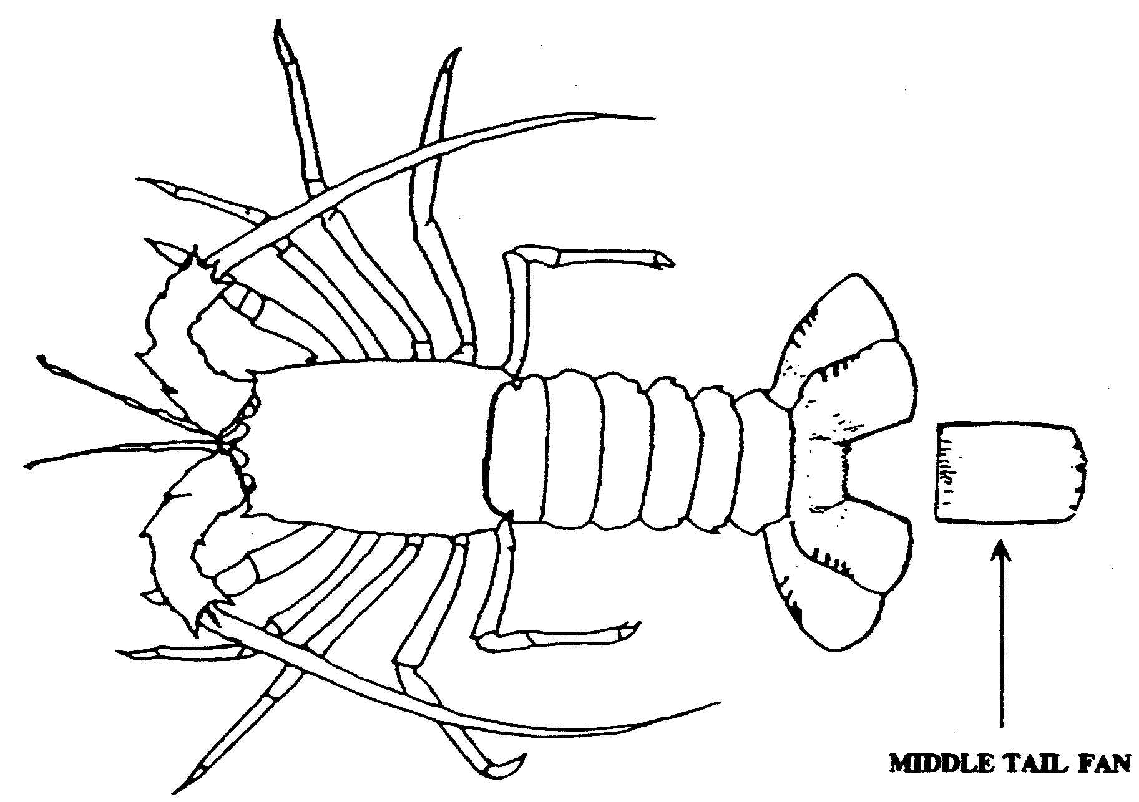

SCHEDULE 5
Fees (reg. 27)

Registration of devices to be used by any person other than for trade or business
1. (1) For registration under regulation 8 of—

(a) a mesh net (per annum) $30

(b) a rock lobster pot (per annum) $45

(2) If a person produces evidence to the satisfaction of the Director that he or she is in receipt of an age or invalid pension or is the holder of a State Concession Card issued by the Department of Human Services the annual fee payable for the registration of a mesh net is $15.

(3) No fee is payable where the Director registers the registration of a net or pot for a period of less than one year for the purpose of achieving a common expiry date for that registration and the registration of any other net or pot owned by the one person.

Registration of devices to be used by holder of fishery licence pursuant to the licence
2. For registration under regulation 9 of—

(a) one or more of the following fish nets to be used in the waters
of the Lakes and Coorong Fishery:

(i) swinger nets no fee

(ii) fish nets other than swinger nets $1 451

(b) one or more fish nets to be used in the waters of either of the
following fisheries:

Northern Zone Rock Lobster Fishery
Southern Zone Rock Lobster Fishery $1 451

(c) one or more fish nets to be used in coastal waters of any of the following fisheries:

Miscellaneous Fishery
Marine Scalefish Fishery
Restricted Marine Scalefish Fishery—

(i) pilchard nets $23 633

(ii) fish nets other than pilchard nets $2 434

(d) a rock lobster pot to be used in the waters of the Miscellaneous Fishery to take giant crab $53.70

(e) a crab net (per annum) $44.83

(f) a fish net used solely to take fish for bait provided that the bait is not for sale no fee

(g) a dredge to be used in any of the following fisheries:

Northern Zone Rock Lobster Fishery
Southern Zone Rock Lobster Fishery
Marine Scalefish Fishery
Restricted Marine Scalefish Fishery
Miscellaneous Fishery
(per annum) $50

Variation of endorsements on fishery licences
3. On application—

(a) to vary the endorsement on a fishery licence of—

(i) a boat used pursuant to the licence $60

(ii) the person registered as the master of a boat used pursuant to the licence $60

(b) to endorse an additional boat on a fishery licence $60

Registration of interests in fishery licences
4. On application under section 65(3) of the Act to register an interest in a fishery licence $100

Application for permit or exemption
5. On application for—

(a) a permit under the Act $60

(b) an exemption under section 59 of the Act $60

Issue of duplicate authority
6. On application for the issue of a duplicate authority under the Act $20

Waiver of certain fees
7. (1) If application is made for the issue of a permit or the granting of an exemption by the Minister, the Minister may waive the prescribed fee if satisfied that it is appropriate to do so in a particular case.

(2) If application is made for the issue of a permit or duplicate authority by the Director, the Director may waive the prescribed fee if satisfied that it is appropriate to do so in a particular case.

Payment of certain fees by instalments
8. The fee prescribed by clause 2(c)(i) for registration of pilchard nets under regulation 9 may be paid by four equal instalments payable on or before the date of issue or renewal of the licence pursuant to which the nets are to be used and 1 October, 1 January and 1 April following the date of that issue or renewal.

SCHEDULE 6
Undersize fish

Abalone taken by licensed person
1. (1) Abalone of all species (except blacklip and greenlip) is undersize if—

(a) it is less than 13 centimetres in length; or

(b) the meat, having been removed from the shell, weighs less than 113 grams.

(2) Abalone, blacklip is undersize—

(a) if taken in the waters of the Southern Zone—

(i) it is less than 12.5 centimetres in length; or

(ii) the meat, having been removed from the shell, weighs less than 106 grams; or

(b) if taken in any other waters of the State—

(i) it is less than 13 centimetres in length; or

(ii) the meat, having been removed from the shell, weighs less than 113 grams.

(3) Abalone, greenlip is undersize—

(a) if taken in the waters of the Western Zone—

(i) it is less than 14.5 centimetres in length; or

(ii) the meat, having been removed from the shell, weighs less than 140 grams; or

(b) if taken in any other waters of the State—

(i) it is less than 13 centimetres in length; or

(ii) the meat, having been removed from the shell, weighs less than 113 grams.

(4) Despite subclauses (1), (2) and (3), abalone of all species is not to be taken to be undersize if the meat when removed is below the minimum weight referred to in those subclauses provided that—

(a) the abalone is brought ashore and before shucking is delivered to a registered fish processor at premises at which that fish processor is registered to carry on business as a fish processor by virtue of the Act; and

(b) the length of the abalone is not below that required by this clause.

(5) In this clause—

"length", of an abalone, means the length of the abalone as measured at its greatest dimension as shown in diagram 1;

"meat", in relation to an abalone, means all the muscular foot from which the viscera have been detached by the usual shucking procedure;

"Southern Zone" means all coastal waters east of the meridian of longitude 139° east (not including the waters of the Coorong or any other waters above the Murray Mouth);

"Western Zone" means all coastal waters west of the meridian of longitude 136° 30′ 00″ east.

(6) This clause applies only in relation to abalone taken by a licensed person.

Diagram 1
Abalone (Haliotis spp.)

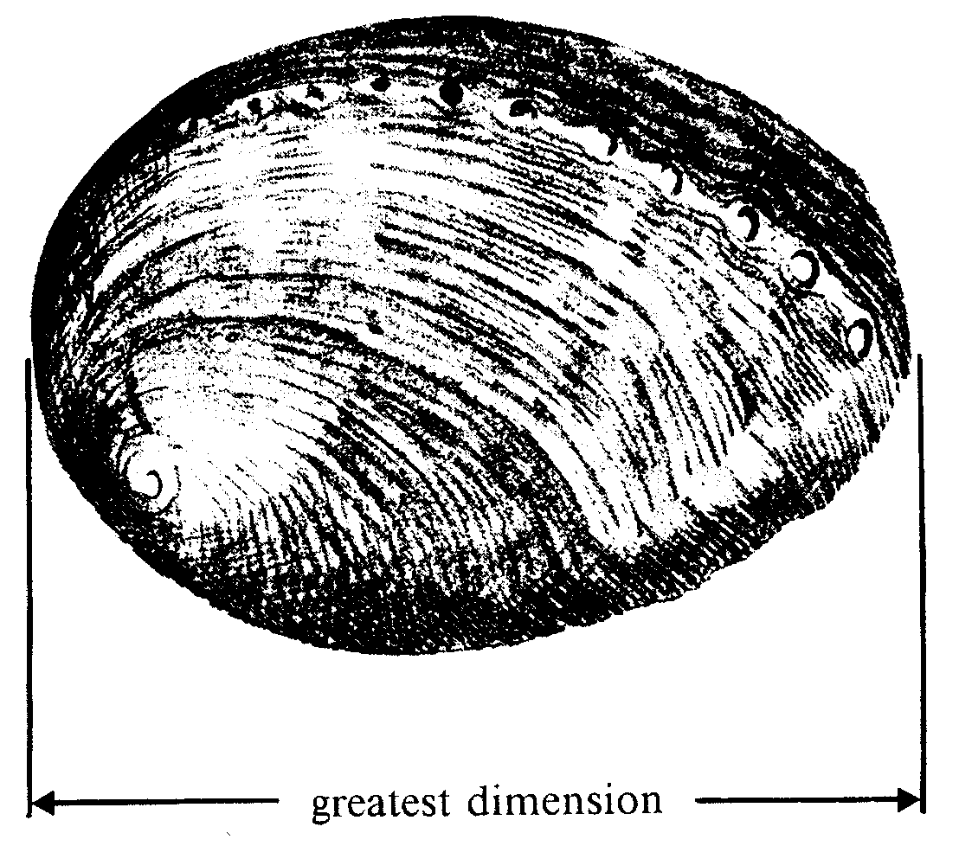

Abalone taken by unlicensed person
2. (1) Abalone of all species (except greenlip) is undersize—

(a) if it is less than 13 centimetres in length; or

(a) if the meat, having been removed from the shell, weighs less than 113 grams.

(2) Abalone, greenlip is undersize—

(a) if taken in the waters of the Western Zone—

(i) it is less than 14.5 centimetres in length; or

(ii) the meat, having been removed from the shell, weighs less than 140 grams; or

(b) if taken in any other waters of the State—

(i) it is less than 13 centimetres in length; or

(ii) the meat, having been removed from the shell, weighs less than 113 grams.

(3) In this clause—

"length", of an abalone, means the length of the abalone as measured at its greatest dimension as shown in diagram 1 in clause 1;

"meat", in relation to an abalone, means all the muscular foot from which the viscera have been detached by the usual shucking procedure;

"Southern Zone" means all coastal waters east of the meridian of longitude 139° east such waters not including the waters of the Coorong or any other waters above the Murray Mouth;

"Western Zone" means all coastal waters west of the meridian of longitude 136° 30′ 00″ east;

(4) This clause applies only in relation to abalone taken by an unlicensed person.

Cockle
3. (1) A cockle is undersize, if when measured at its greatest dimension as shown in diagram 2—

(a) in the case of cockle taken from the waters of the Coffin Bay complex south of a line drawn due east from Point Longnose to the mainland along the parallel of latitude 34° 31.4′S—the cockle is less than 3.8 centimetres; or

(b) in any other case—the cockle is less than 3 centimetres.

Diagram 2
Cockle (Katelysia spp.)
(Where taken from the waters of Coffin Bay)
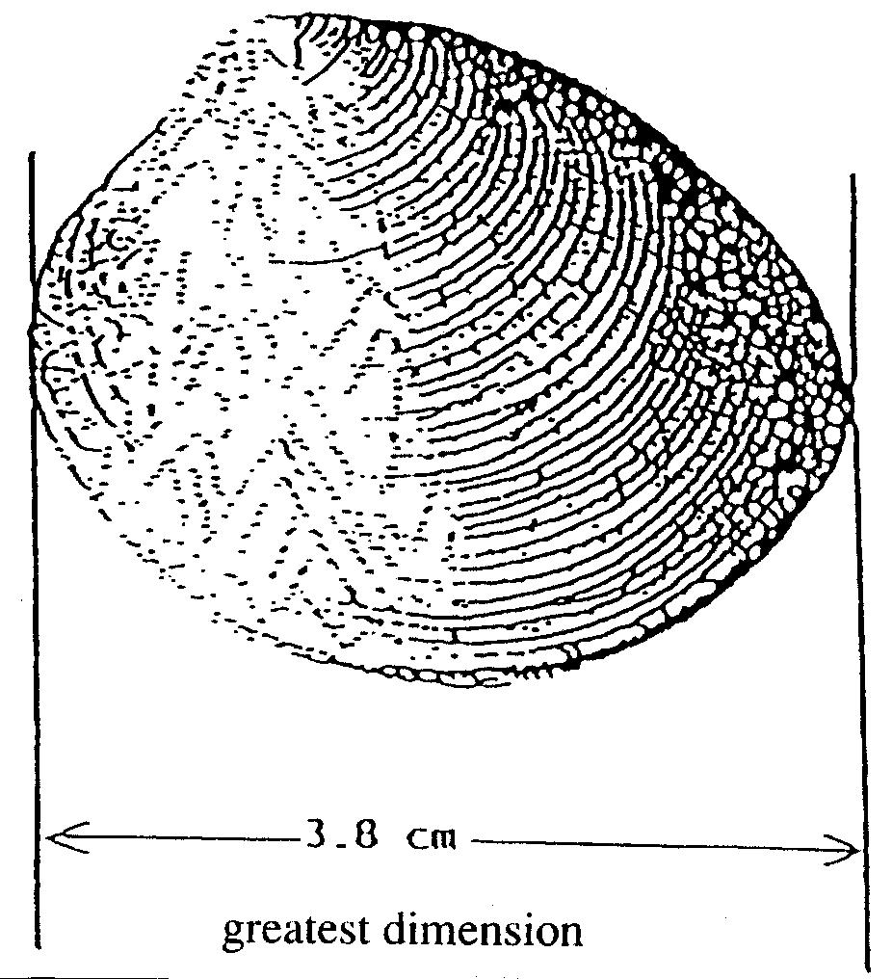

(Where taken from any other waters of the State)

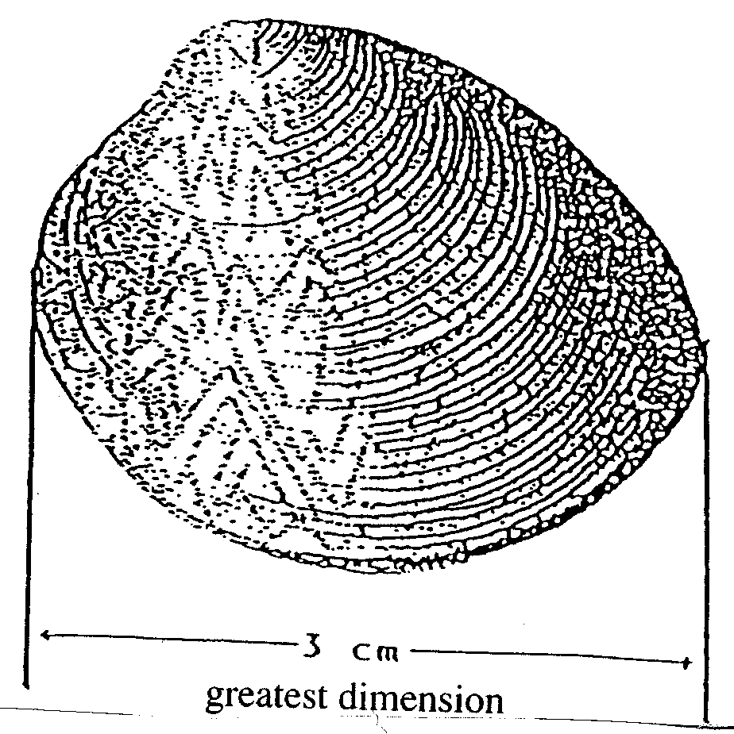

(2) A Goolwa cockle is undersize if, when measured at its greatest dimension as shown in diagram 3, it is less than 3.5 centimetres.

Diagram 3
Goolwa cockle (Donax deltoides)
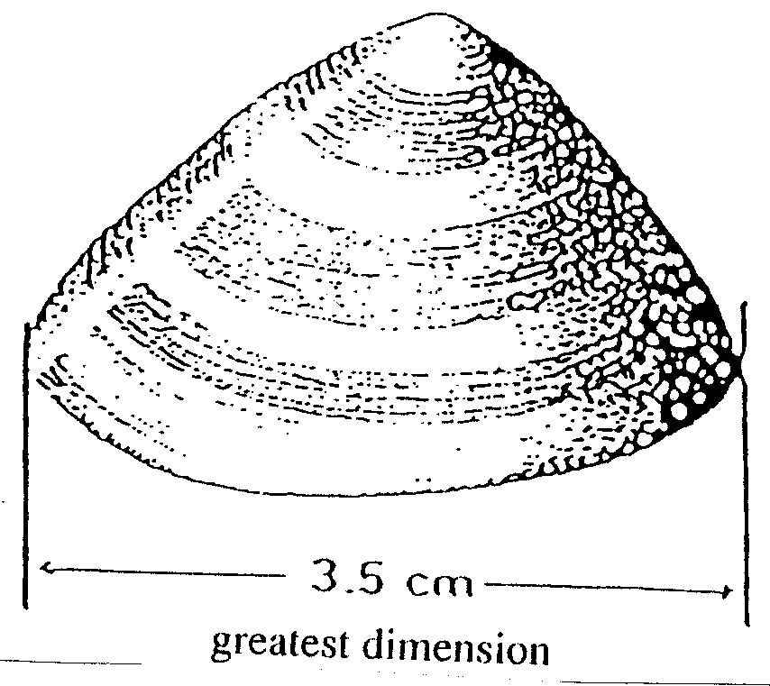

Crab
4. (1) A blue crab is undersize if its length as shown in diagram 4 is less than 11 centimetres when measured from side to side at the base of the spines.

Diagram 4
Blue crab (Portunus pelagicus)

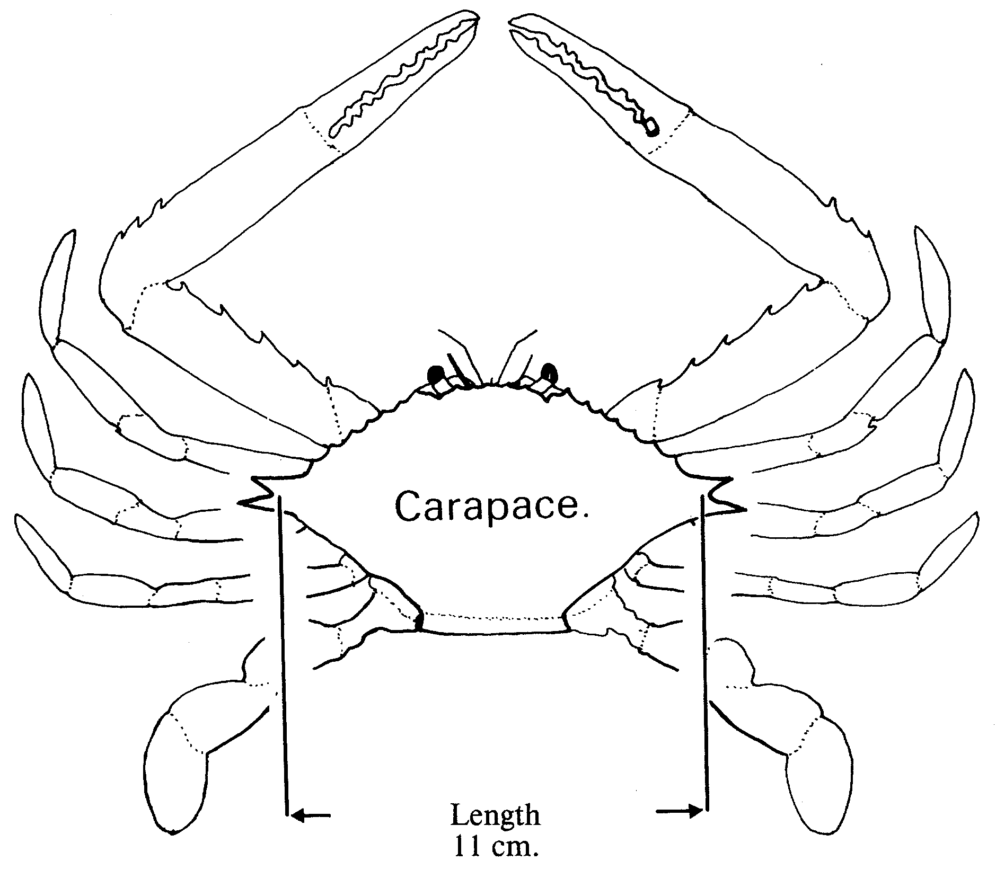

(2) A giant crab is undersize if its length, as shown in diagram 5, is less than 15 centimetres when measured from the top to the bottom of its carapace.

Diagram 5
Giant crab (Ovalipes australiensis)

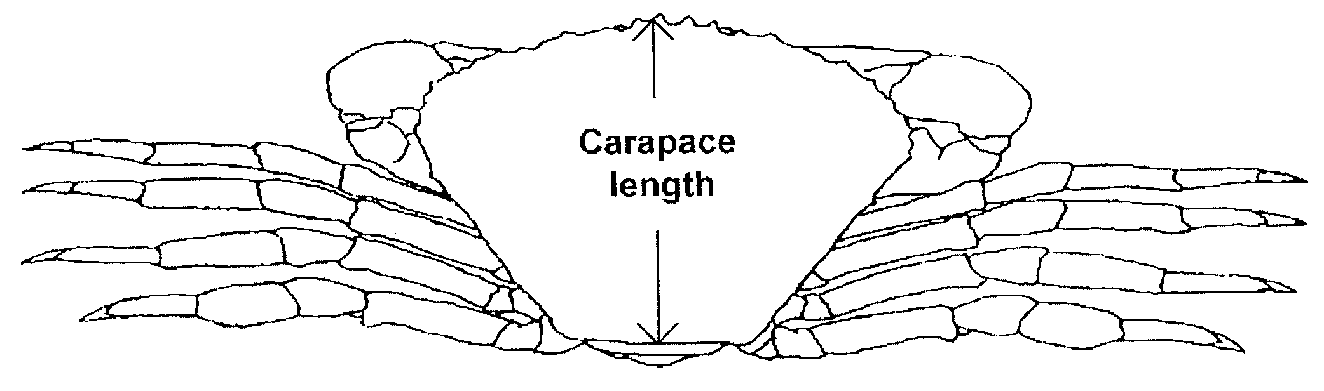

(3) A sand crab is undersize if its length, as shown in diagram 6, is less than 10 centimetres when measured from side to side at the widest point of its carapace.

Diagram 6
Sand crab (Pseudocarcinus gigas)

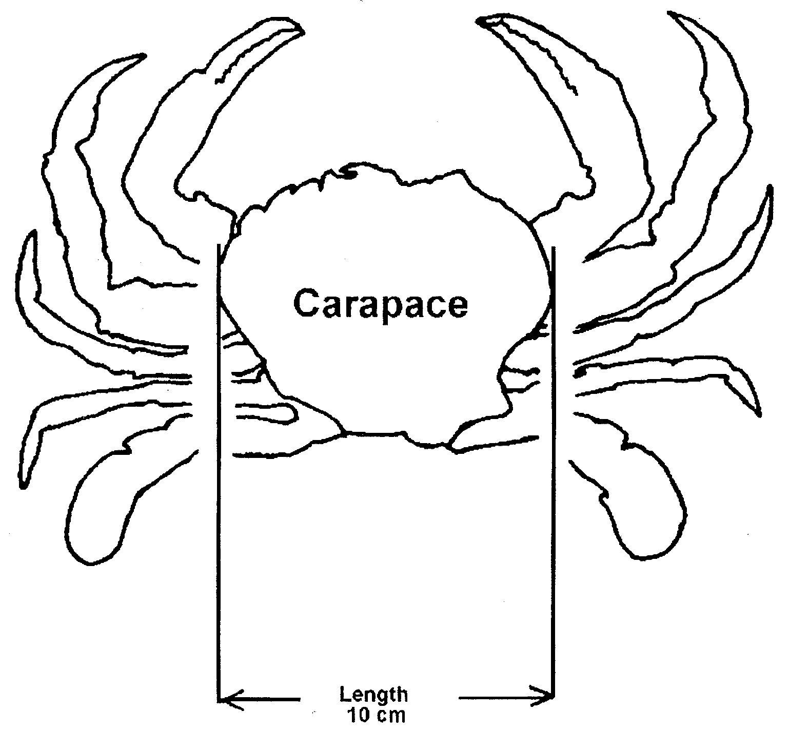

Garfish
5. A garfish is undersize if its length, as shown in diagram 7, is less than 21 centimetres from the foremost part of the upper jaw to the end of the tail fin.

Diagram 7
Garfish (Hyporhamphus melanochir)

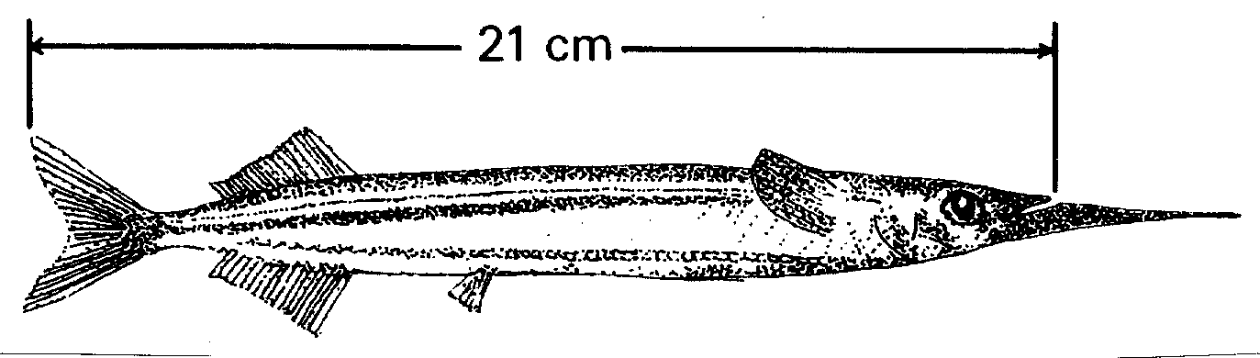

Mulloway
6. (1) A mulloway is undersize if—

(a) in the case of mulloway taken in Coorong (area 1) or Coorong (area 2)—it is less than 46 centimetres in length; or

(b) in any other case—it is less than 75 centimetres in length.

(2) In subclause (1)—

"length", in relation to mulloway, means the distance from the foremost part of the head to the end of the tail.

Rock lobster
7. (1) A rock lobster is undersize if—

(a) in the case of a rock lobster taken from the waters of the Northern Zone Rock Lobster Fishery—it is less than 10.5 centimetres in length as shown in diagram 8; or

(b) in any other case—it is less than 9.85 centimetres in length as shown in diagram 9.

Diagram 8
Rock lobster (Jasus edwardsii)—Taken in the Northern Zone

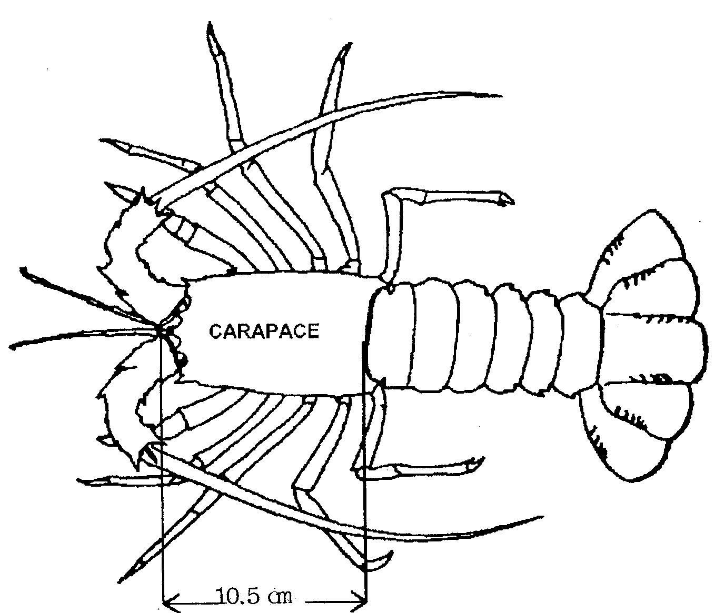

Minimum length 10.5cm from anterior of frontal tubercle to posterior edge of carapace

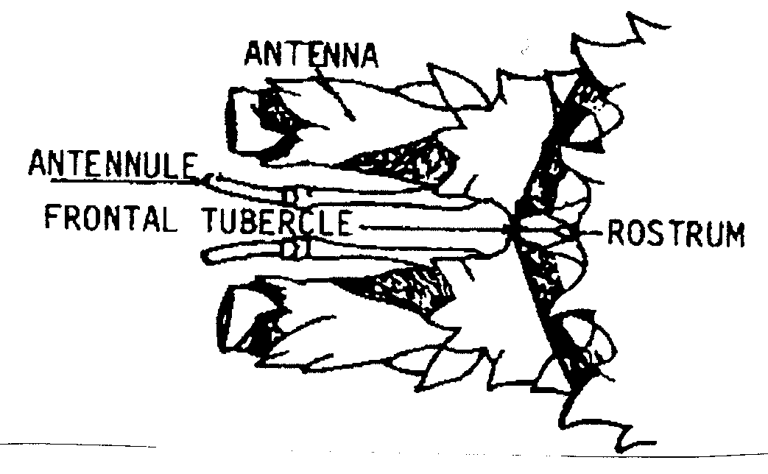

Diagram 9
Rock lobster (Jasus edwardsii)—Taken in other waters

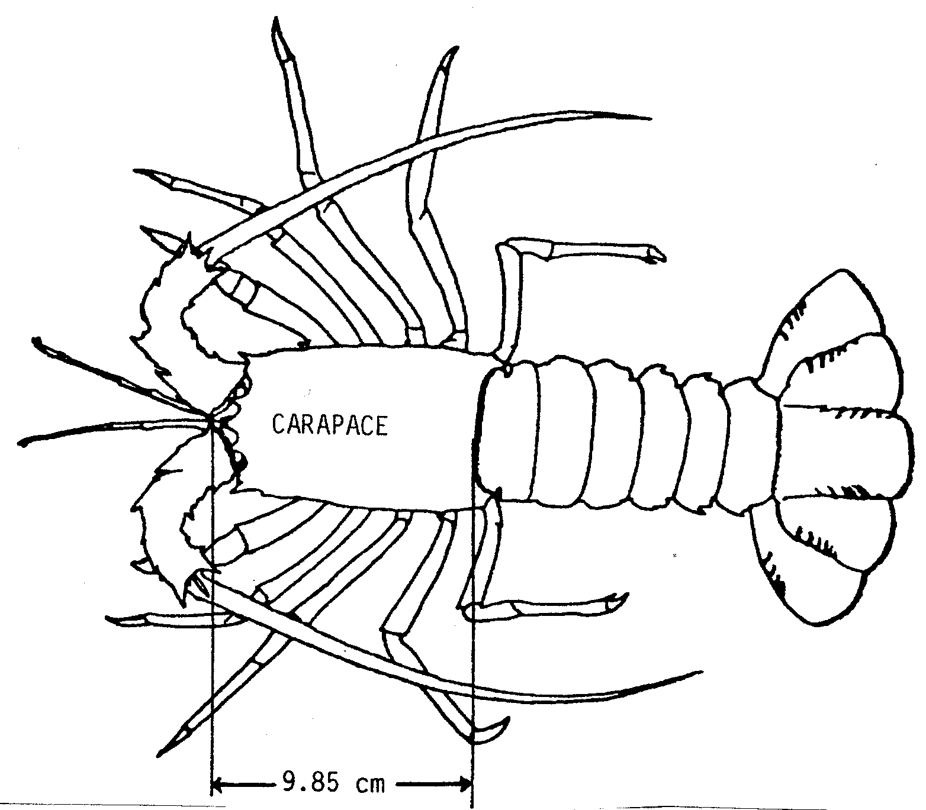

Minimum length 9.85cm from anterior of frontal tubercle to posterior edge of carapace

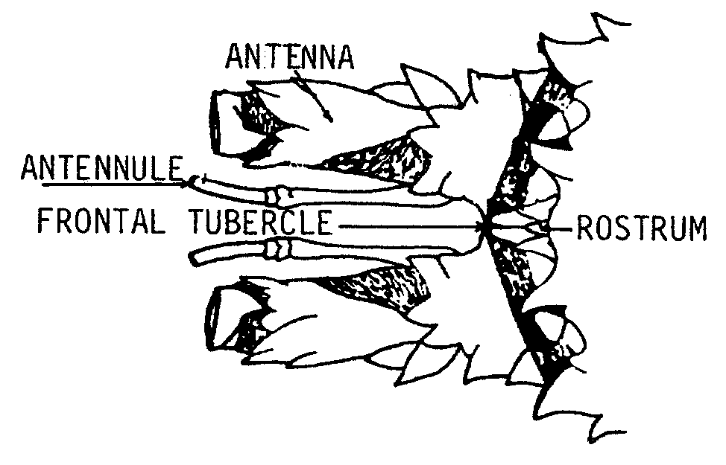

(2) In subclause (1)—

"length", in relation to rock lobster, means the length of the carapace measured in a direct medial line from the most forward part of the median suture marked on the frontal tubercle that is situated between the epimeral plates below and in front of the rostrum to the centre of the posterior edge of the carapace (but not including any hairs on the carapace).

Scallop
8. A scallop is undersize if, when measured at its greatest dimension as shown in diagram 10, it is less than 6.5 centimetres.

Diagram 10
Scallop (Family PECTINIDAE)

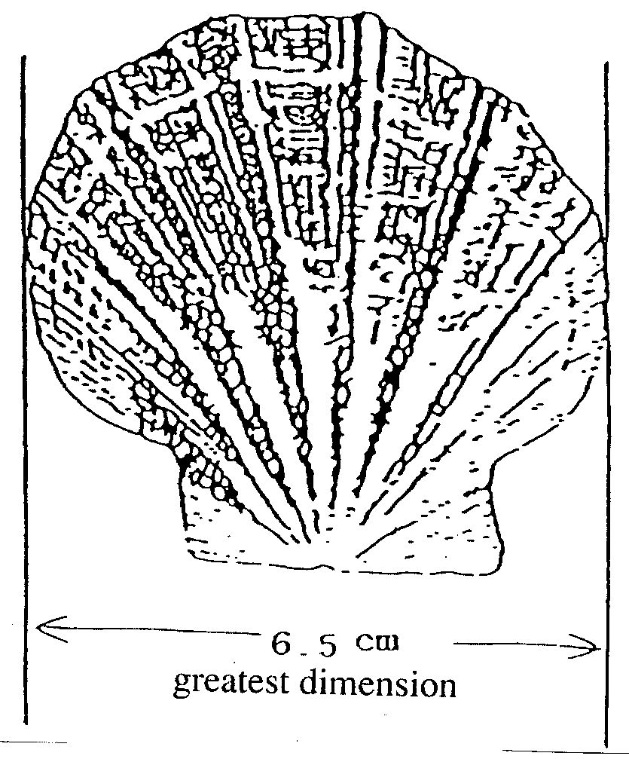

Shark
9. (1) A gummy shark is undersize if it is less than 45 centimetres in length.

(2) A school shark is undersize if it is less than 40 centimetres in length.

(3) In this clause—

"length", in relation to a shark, means the partial length of the shark from the fifth gill slit to the base of the tail, measured in a straight line from the middle of the posterior edge of the gill slit nearest the tail to the ventral insertion of the caudal fin, as shown in diagram 11.

Diagram 11
Gummy shark (Mustelus antarcticus)

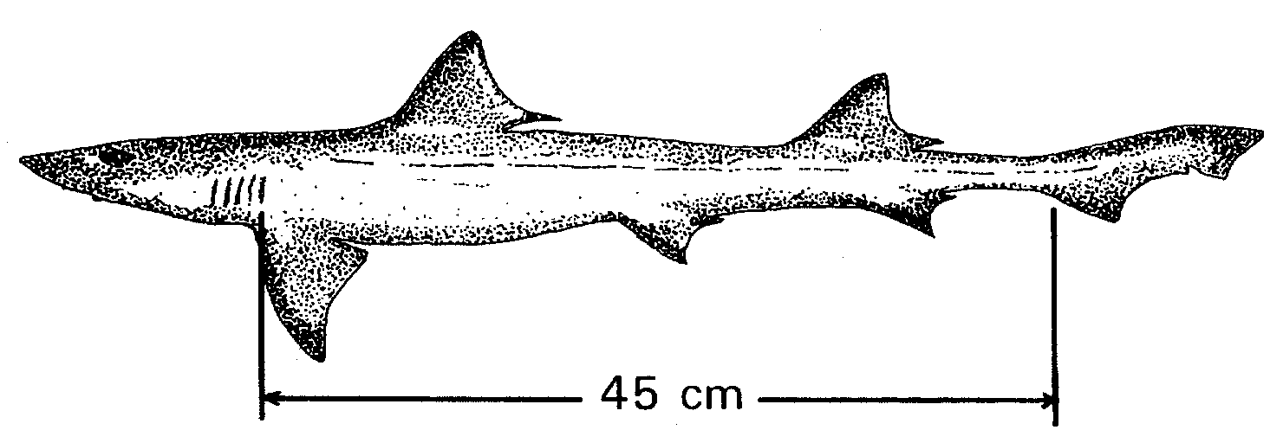

School shark (Galeorhinus australis)

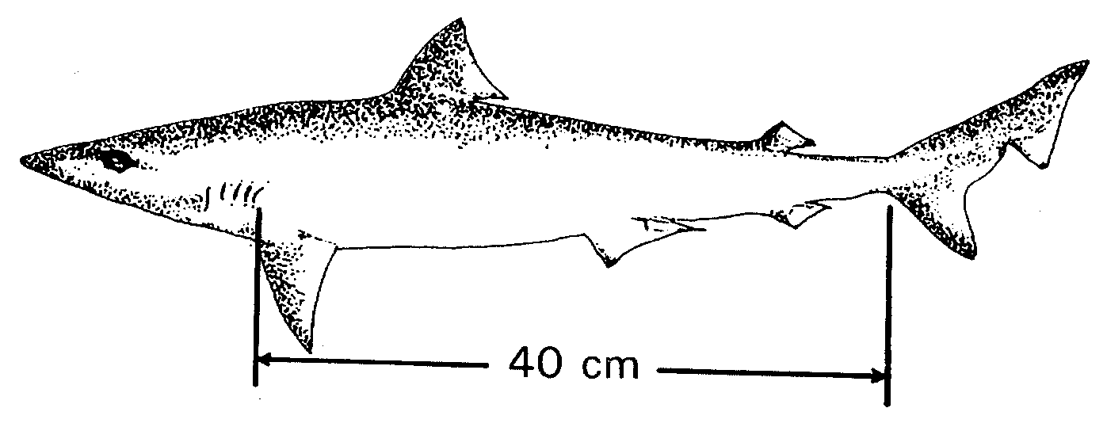

Other species and classes of fish
10. A fish of a class or species specified in column 1 of the table below is undersize if that fish is, when measured from the foremost part of the head to the end of the tail, less than the length (in centimetres) shown in column 2 of the table immediately alongside of the class or species so specified.

Column 1  Class or species of fish | Column 2  Length (cm)
Bream (Acanthopagrus butcheri)  Flounder (Family Pleuronectidae)(Family Bothidae)  Groper, Blue (Achoerodus gouldii)  Mullet (Family Mugilidae)  Murray cod (Maccullochella peeli)  Perch, golden (callop) (Macquaria ambigua)  Perch, Lake Eyre callop (Macquaria n.sp)  Perch, silver (Bidyanus bidyanus)  Salmon (Arripis truttaceus)  Snapper (Pagrus auratus)  Snook (Sphyraena novaehollandiae)  Sweep (Genus Scorpis)  Trout, brown (Salmo trutta  Trout, rainbow (Oncorhynchus mykiss)  Whiting, King George, spotted (Sillaginodes punctatus)  Whiting, yellowfin, western sand (Sillago schomburgkii)  Yellowtail, kingfish (Seriola grandis) | 28  25  60  21  50  33  33  33  21  38  36  24  28  28  30  24  40
SCHEDULE 7
Species of fish prescribed for the purposes of s. 48G of the Act

Annelids
blood worm Class POLYCHAETA
tube worm Class POLYCHAETA
beach worm Class POLYCHAETA

Coelenterata
jellyfish

Crustaceans
southern rock lobster Jasus edwardsii
western king prawn Penaeus latisulcatus
blue crab Portunus pelagicus
yabbies Cherax destructor
freshwater shrimp Macrobrachium australiensis
sand crab Ovalipis australiensis
rock crab Nectocarcinus integrifrons
velvet crab Nectocarcinus tuperculosus
giant crab Psuedo-carcinus gigas
slipper lobster Ibacus spp.

Echinoderms
sea urchin Heliocidaris erythrogramma

Fin fish Class TELEOSTOMI

Molluscs
abalone Haliotis laevigata
Haliotis rubra
Haliotis roei
allied cowrie, bean cowrie Triviida
arrow squid Nototodarus gouldi
black cowrie Zoila friendii thersites
calamary Sepioteuthis australis
cardita Carditidae
chiton Chitonidae
cockle Catelysia spp.
cone shell Conidae
cowrie Cypraeidae
cuttlefish Sepia spp.
dog welk Nassaridae
dove shell Calumbellidae
eulima Eulimidae
fingernail, jackknife shell Solenidae
Goolwa cockle Donax deltoides
harp shell Harpidae
heart cockle Cardiidae
helmut shell Cassidae
keyhole limpet and shield shell Fissurellidae
ladder Epitoniidae
limpet Patellidae
limpet—air breathing Siphonariidae
mactra, cockle Mactridae
margin shell Marginellidae
mitre shell Mitridae
moon shell Nacticidae
murex, droop, purple/rock shell Muricidae
mussels Mytilus spp.
nutmeg shell Cancellaridae
octopus Octopus spp.
olive shell Olividae
oyster Family Ostridae
periwinkle, black crow Neritidae
pheasant shell or painted lady Phasianellidae
razor fish Pinna bicolor
ring mouth shell Liotiidae
scallop Family Pectinidae
spindle shell Faxialariidae
tellin, sunset shell Tellinidae
thai, droop Thaididae
thorny oyster Spondylidae
triton Cymatiidae
trochus, top, weed shell Trochidae
turban and star shell Turbinidae
turbo shell Turbo torquatus
Turbo undulatus
turid Turridae
vase, chank shell Vasidae
venus cockle Veneridae
volute, baler Volutidae
watering pot shell Clavagellidae
welk Buccinidae

Sharks Class ELASMOBRANCHII

SCHEDULE 8
Classes of fish prescribed for the purposes of s. 44(4) of the Act

Column 1  Class of fish | Column 2  Quantity
Abalone (Haliotis spp.) | more than 25
Australian salmon (Arripis truttaceus)  Over 35 cm in length | more than 40
Blue crab (Portunus pelagicus) | more than 100
Blue groper (Achoerodus gouldii) | more than 5
Calamary (Sepioteuthis australis) | more than 40
Flounder (Family Pleuronectidae) (Family Bothidae) | more than 50
Garfish (Hyporhamphus melanochir) | more than 200
King George whiting (Sillaginodes punctatus) | more than 75
Mulloway (Argyrosomus hololepidotus)  75 cm more in length  Less than 75 cm in length | more than 10  more than 25
Razorfish (Pinna bicolor) | more than 125
Rock lobster (Jasus edwardsii) | more than 15
Sand crab (Ovalipes australiensis) | more than 100
Snapper (Pagrus auratus)  60 cm or more in length  less than 60 cm in length | more than 5  more than 40
Snook (Sphyraena novaehollandiae) | more than 65
Yellowfin whiting (Sillago schombergkii) | more than 65

SCHEDULE 9
Expiation of offences (reg. 32)

Fisheries Act 1982 section 41  Clause of Sched. 1 Description of offence |  |  | Expiation  Fee
 | Engaging in a fishing activity of a prescribed class:
1 | Taking fish using certain devices (recreational) | $100
2 | Taking fish using 2mm or greater gauge trace wire with fishing hooks size 12/0 or greater | $100
4 | Taking fish using more than specified number of certain devices incoastal waters (recreational) | $100
5 | Taking fish using fish net in coastal waters (recreational) | $100
6 | Taking fish using hauling net in coastal waters during specified times (commercial) | $100
7 | Taking fish using long line in coastal waters (recreational) | $100
8 | Taking fish using unattended long line (commercial) | $100
9 | Taking fish using set line in River Murray, Lakes Albert and Alexandrina or the Coorong (recreational) | $100
10 | Taking fish using certain devices or more than specified number of certain devices in River Murray (recreational) | $100
12 | Taking fish using fish net in Coorong (area 1) during specified period (recreational) | $100
13 | Taking fish using certain devices or more than specified number of certain devices in Coorong (area 1) or Coorong (area 2) (recreational) | $100
14 | Taking fish using certain devices or more than specified number of certain devices in Coorong (area 1) during specified period (recreational) | $100
15 | Taking fish using certain devices or more than specified number of certain devices in Lakes Albert and Alexandrina (recreational) | $100
16 | Taking fish using more than specified number of certain devices in Lake George (recreational) | $100
17 | Taking fish using more than two rods and lines at any one time | $50
18 | Taking fish using more than two hand lines at any one time | $50
19 | Taking fish using rod and line at same time as more than one hand line or using hand line at same time as more than one rod and line | $50
20 | Using more than three "teaser" lines from jetty, etc. | $50
21 | Taking fish using unregistered device for purpose other than trade or business (recreational) | $100
22 | Taking fish using unregistered device for trade or business (commercial) | $200
23 | Taking fish without buoying fish net or set line in specified waters | $50
24 | Taking fish without buoying fish net | $50
25 | Taking fish using drop line not marked with buoy (commercial) | $50
26 | Taking fish using trot line not marked with buoys (commercial) | $50
27 | Taking fish using set line with more than 400 hooks (commercial) | $200
28(1) | Taking fish using untagged device (commercial) | $50
29 | Taking fish using yabbie pot of unlawful specifications in inland waters | $50

Fisheries Act 1982 section 41  Clause of Sched. 1 Description of offence |  |  | Expiation  Fee
30 | Taking fish using fish net in waters specified in Schedule 2 | $200
32 | Taking fish using fish net within 100 metres of line in certain waters | $50
33 | Taking fish using hauling net of unlawful specifications in Venus Bay | $200
34 | Taking fish using fish net in certain waters of Spencer Gulf | $200
35 | Taking fish using fish net in Streaky Bay-Blanche Port | $200
36 | Taking fish using fish net of unlawful specifications in Lake George | $200
37 | Taking fish using fish net in State waters deeper than 5 metres | $200
38 | Taking fish using certain devices in specified waters | $200
39 | Taking fish using certain devices in specified waters within Counties MacDonnell, Robe and Grey | $200
40 | Taking fish using hauling net or seine net of unlawful specifications in coastal waters | $200
41 | Taking fish using mesh net or gill net of unlawful specifications in coastal waters (commercial) | $200
42 | Taking fish using large mesh net exceeding 600 metres in length | $200
43 | Taking fish using large mesh net left in waters for more than 4 hours | $100
44 | Taking fish using more than 5 large mesh nets at any one time | $200
45 | Taking fish using large mesh net not shot out in straight line in Gulf St. Vincent or Spencer Gulf | $50
49 | Taking fish using fish net fixed, etc. across bay, inlet, etc. | $200
50 | Taking fish by fixing or placing stake, log, etc. across mouth of waters, channel,etc. so as to impair free passage of fish | $100
51 | Taking salmon using purse seine net of unlawful specifications | $200
52 | Taking fish using drum net set within 20 metres of another drum net | $50
53 | Taking fish using shrimp trap of unlawful specifications | $50
54 | Taking fish using fish trap of unlawful specifications (commercial) | $50
55 | Taking ocean leather jacket using fish trap of unlawful specifications in waters deeper than 60 metres (commercial) | $50
56 | Taking prawns using prawn trawl net of unlawful specifications (commercial) | $200
60 | Taking undersize fish:
 | · up to 10 fish | $50
 | · more than 10 fish | $100
61 | Taking razor fish (bag limit)—exceeding limit:
 | · by up to 20 razor fish | $50
 | · by 21 to 40 razor fish | $100
 | · by more than 40 razor fish | $200
62 | Taking razor fish during closed season in specified waters | $100
63 | Taking molluscs from waters of West Lakes, etc. | $100
64 | Taking cockle from specified waters (commercial) | $100

Fisheries Act 1982 section 41  Clause of Sched. 1 Description of offence |  |  | Expiation  Fee
65 | Taking benthic marine organism from specified waters of rocky reef | $300
66 | Taking fish (recreational bag or boat limit)—exceeding limit:
 | · by up to 10 fish | $50
 | · by 11 to 20 fish | $100
 | · by more than 20 fish | $200
67 | Taking black cowrie (bag limit)—exceeding limit:
 | · by up to 5 black cowrie | $200
 | · by more than 5 black cowrie | $300
68 | Taking mulloway in Coorong (area 1) or Coorong (area 2) (recreational bag limit)—exceeding limit:
 | · by up to 10 mulloway | $50
 | · by 11 to 20 mulloway | $100
 | · by more than 20 mulloway | $200
69 | Taking abalone (recreational bag limit)—exceeding limit:
 | · by up to 5 abalone | $50
 | · by 6 to 10 abalone | $100
 | · by more than 10 abalone | $200
70 | Taking abalone (recreational boat limit)—exceeding limit:
 | · by up to 5 abalone | $50
 | · by 6 to 10 abalone | $100
 | · by more than 10 abalone | $200
71 | Taking rock lobster by diving (bag limit)—exceeding limit:
 | · by up to 5 rock lobster | $50
 | · by 6 to 10 rock lobster | $100
 | · by more than 10 rock lobster | $200
72 | Taking yabbies—exceeding bag limit (recreational) | $300
73 | Taking rock lobster—exceeding bag or boat limit in a rock lobster fishery (recreational) | $300
74 | Taking callop (recreational bag limit)—exceeding limit:
 | · by up to 10 callop | $50
 | · by 11 to 20 callop | $100
 | · by more than 20 callop | $200
75 | Taking scallop (recreational bag limit)—exceeding limit:
 | · by up to 50 scallop | $50
 | · by 51 to 100 scallop | $100
 | · by more than 100 scallop | $200

Fisheries Act 1982 section 41  Clause of Sched. 1 Description of offence |  |  | Expiation  Fee
76(1) | Taking Murray cod (recreational bag limit)—exceeding limit:
 | · by up to 5 Murray cod | $100
 | · by more than 5 Murray cod | $200
76(2) | Taking Murray cod—exceeding maximum length limit:
 | · by up to 5 Murray cod | $100
 | · by more than 5 Murray cod | $200
76(3) | Taking Murray cod during closed season | $200
77(1) | Taking Lake Eyre callop or grunter (recreational bag limit)—exceeding limit:
 | · by up to 10 fish | $50
 | · by 11 to 20 fish | $100
 | · by more than 20 fish | $200
77(2)(a) | Taking catfish (recreational bag limit)—exceeding limit:
 | · by up to 10 catfish | $50
 | · by 11 to 20 catfish | $100
 | · by more than 20 catfish | $200
77(2)(b) | Taking catfish (recreational)—exceeding maximum length limit:
 | · by up to 5 catfish | $100
 | · by more than 5 catfish | $200
78 | Taking blue crab during closed season in Spencer Gulf (commercial) | $200
79 | Taking blue crab during closed season in Gulf St. Vincent (commercial) | $200
80 | Taking blue crab in specified waters of Spencer Gulf (commercial) | $300
81 | Taking blue crab in specified waters (commercial) | $300
83 | Setting rock lobster pot containing rock lobster (recreational) | $100
84 | Taking rock lobster using rock lobster pot registered under regulation 8 in name of another person (recreational) | $300
85 | Taking rock lobster in specified waters | $200
86 | Taking rock lobster during closed season in Northern Zone Rock Lobster Fishery | $200
87 | Taking rock lobster during closed season in Southern Zone Rock Lobster Fishery | $200
89 | Taking rock lobster using rock lobster pot of unlawful specifications in Southern Zone Rock Lobster Fishery (commercial) | $50
90 | Taking rock lobster using rock lobster pot of unlawful specifications in Northern Zone Rock Lobster Fishery (commercial) | $50
93 | Taking rock lobster using fish spear, etc. | $200
95 | Taking bream during closed season in specified waters of Onkaparinga River | $100
96 | Taking fish using mesh net in Goolwa Channel on weekend | $100
97 | Taking fish using mesh net of certain specifications in Goolwa Channel on weekdays | $100
98 | Taking fish using hauling net in Goolwa Channel on weekend | $100

Fisheries Act 1982 section 41  Clause of Sched. 1 Description of offence |  |  | Expiation  Fee
99 | Taking fish using fish net or set line near Murray Mouth | $100
100 | Taking fish using mesh net of unlawful specifications in specified waters of Coorong | $100
101 | Taking fish in Lakes Albert and Alexandrina using mesh net of unlawful specifications | $100
102 | Taking fish in Murray Mouth using long line | $100
103 | Taking fish using certain devices in River Murray (commercial) | $100
104 | Taking fish in River Murray using more than permitted number of yabbie pots (commercial) | $100
105 | Taking fish in River Murray using unmarked device (commercial) | $150
106 | Taking fish in specified waters near barrages using mesh net as set net | $100
107 | Taking fish in waters of Lakes Albert and Alexandrina, Murray Mouth or Coorong using fish net within 200 metres of another net | $50
108 | Taking fish near River Murray locks | $100
109 | Taking Goolwa cockles during closed season | $50
110 | Taking fish using untagged device (recreational) | $50
111 | Taking fish using untagged registered device (recreational) | $50
112 | Taking fish using unbuoyed drum net (recreational) | $50
113 | Taking fish using unattended and unbuoyed hoop net (recreational) | $50
114 | Taking fish using unattended and unbuoyed drop net (recreational) | $50
115 | Taking fish using unattended and untagged yabbie pot or shrimp trap (recreational) | $50
116 | Taking rock lobster in Southern Zone Rock Lobster Fishery using rock lobster pot of unlawful specifications (recreational) | $50
117 | Taking rock lobster in Northern Zone Rock Lobster Fishery using rock lobster pot of unlawful specifications (recreational) | $50
118 | Taking fish using certain devices in fishing reach (recreational) | $100
119 | Taking fish in fishing reach using shrimp trap or yabbie pot not set from shore (recreational) | $50
120 | Taking fish in fishing reach by trolling (recreational) | $100
121 | Taking crabs using crab net or hand net of unlawful specifications | $50
122 | Taking fish using certain devices near specified artificial reefs | $100
123 | Taking fish from registered boat for purposes other than trade or business | $100
124 | Taking fish in Lake George during specified hours using unattended mesh net (recreational) | $100
125 | Taking fish in Lake George using mesh net exceeding 75 metres in length (recreational) | $100
126 | Taking scallop using scallop dredge in Coffin Bay | $200
127 | Taking scallop using scallop dredge in Gulf St. Vincent | $200
128 | Taking scallop using scallop dredge in Spencer Gulf | $200
129 | Taking prawns by power hauling method | $200

Fisheries Act 1982 section 41  Clause of Sched. 1 Description of offence |  |  | Expiation  Fee
130 | Taking fish by power hauling method using hauling net of unlawful specifications or unmarked hauling net | $100
131 | Taking fish using drum net of unlawful specifications | $50
132 | Taking fish in certain coastal waters using swinger net (commercial) | $100
133 | Taking fish in aquatic reserve | $100
134 | Taking fish using certain fish traps (recreational) | $100
135 | Taking fish in Coorong using certain net (commercial) | $100
136 | Taking fish in Coorong (area 1) using certain net during closed season (commercial) | $200
137 | Taking fish in Coorong using small mesh monofilament net of unlawful specifications or used in unlawful manner (commercial) | $100
138 | Taking fish in Coorong using large mesh monofilament net otherwise than as set net (commercial) | $100
139 | Taking fish in Coorong using large mesh monofilament net of unlawful specifications as set net (commercial) | $100
140 | Taking fish in Coorong coastal waters using small mesh monofilament hauling net of unlawful specifications (commercial) | $100
141 | Taking fish in Coorong using small mesh monofilament hauling net of unlawful specifications, etc. (commercial) | $100
142 | Taking fish in Coorong using large mesh multifilament hauling net of unlawful specifications, etc. (commercial) | $100
143 | Taking fish in Lakes and Coorong Fishery for trade or business using more than specified number of devices | $100
144 | Taking fish in Lakes and Coorong Fishery for trade or business by electrofishing | $100
145 | Taking native fish in specified waters of River Murray (commercial) | $100

Fisheries (General) Regulations 2000  Regulation Description of offence |  |  | Expiation  Fee
10 | Failing to produce certificate of registration (recreational) | $50
13 | Carrying spear, etc. in specified areas defined in Schedule 3 | $50
14 | Carrying spear, etc. while using scuba | $50
15 | Carrying devices in specified waters—locks/weirs of River Murray | $100
16(2) | Using registered boat not bearing distinguishing marks | $100
16(3) | Using dinghy not bearing distinguishing marks as tender to registered boat | $50
16(4) | Failing to remove distinguishing marks from boat no longer registered | $100
18(1) | Mutilating certain fish | $100
19(2) | Failing to bring abalone above high water mark before removing shell (recreational) | $100
19(3) | Failing to carry measuring device for measuring abalone | $100
19(4) | Failing to replace undersize abalone | $100

Fisheries (General) Regulations 2000  Regulation Description of offence |  |  | Expiation  Fee
19(5) | Having possession, control or custody of abalone removed from shell | $200
20 | Storing or confining fish in corf not tagged and marked as required | $50
21 | Storing or confining rock lobster in corf | $300
22 | Depositing buoy not marked as required (holder of rock lobster fishery licence) | $50
23(1) | Failing to remove middle fan tail of rock lobster before landing (recreational) | $100
24(1) | Using berley in certain waters | $100
24(2) | Depositing or using in marine waters body or part of body of mammal | $50
25(1) | Failing to remove net buoys, anchors, etc. after completing netting in Lakes and Coorong (commercial) | $300
26(1) | Failing to mark receptacles in which fish transported, etc. (commercial) | $50

Fisheries (Exotic Fish, Fish Farming and Fish Diseases) Regulations 2000  Regulation Description of offence |  |  | Expiation  Fee
9(1) | Conducting fish farming operation without being registered | $200
9(5) | Failing to lodge statistical returns | $100
26(1) | Failing to keep records | $100

Fisheries (Fish Processors) Regulations 1991  Regulation Description of offence |  |  | Expiation  Fee
8(4) | Failing to keep records of fish purchases | $100
9(4) | Failing to lodge statistical returns | $100
11(4) | Failing to keep records required by regulation 11(1) | $100
12(4) | Failing to complete or deliver form CR3 | $100
13(4) | Failing to complete or deliver form CDR1 | $100
14(5) | Failing to complete or deliver form SZRL2 or form SZRL3 | $100

Regulation | Description of offence | Expiation  Fee
Scheme of Management (Abalone Fisheries) Regulations 1991
14(1) | Failing to lodge statistical returns | $100
Scheme of Management (Blue Crab Fishery) Regulations 1998
17(1) | Failing to lodge statistical returns | $100
Scheme of Management (Lakes and Coorong Fishery) Regulations 1991

Regulation | Description of offence | Expiation  Fee
17(1) | Failing to lodge statistical returns | $100
Scheme of Management (Marine Scalefish Fisheries) Regulations 1991
14 | Registered master causing or permitting more than one person to assist on board boat in fishing activities (Restricted Marine Scalefish Fishery) | $100
16(1) | Failing to lodge statistical returns | $100
Scheme of Management (Miscellaneous Fishery) Regulations 2000
16(1) | Failing to lodge statistical returns | $100
Scheme of Management (Prawn Fisheries) Regulations 2000
13(1) | Failing to lodge statistical returns | $100
Scheme of Management (River Fishery) Regulations 1991
15(1) | Failing to lodge statistical returns | $100
Scheme of Management (Rock Lobster Fisheries) Regulations 1991
15(1) | Failing to lodge statistical returns | $100
17 | Failing to give notice within 14 days of becoming, or ceasing to be, holder of Victorian licence | $50
18(1) | Selling live rock lobster during closed season | $200

MPIR 41/2000 CS R. DENNIS Clerk of the Council
MPIR 46/2000 CS
REGULATIONS UNDER THE FISHERIES ACT 1982
────
No. 223 of 2000
────
At the Executive Council Office at Adelaide 31 August 2000

PURSUANT to the Fisheries Act 1982 and with the advice and consent of the Executive Council, I make the following regulations.
E. J. NEAL Governor

PURSUANT to section 10AA(2) of the Subordinate Legislation Act 1978, I certify that, in my opinion, it is necessary or appropriate that the following regulations come into operation as set out below.

ROB KERIN Minister for Primary Industries and Resources
───────────────────
SUMMARY OF PROVISIONS

1. Citation
2. Commencement
3. Revocation
4. Interpretation
5. Declaration of exotic fish
6. Exotic fish to which s. 49 of the Act does not apply
7. Permit to import, sell, etc. certain exotic fish
8. Release of certain fish into natural waters
9. Registration of fish farming operations
10. Keeping of farm fish in area of non-natural waters
11. Drainage of waters in area of natural waters where farm fish kept
12. Farm fish in area of natural waters to be kept in moveable cages, etc.
13. Erection and maintenance of minor and temporary structural works
14. Duty to notify Director of disease in fish
15. Requirement to display notice of prescribed notifiable disease
16. Prohibition against treating farm fish suffering from prescribed notifiable disease
17. Prohibition against removing farm fish suffering from prescribed notifiable disease
18. Powers of fisheries officer in relation to farm fish affected by prescribed notifiable disease
19. Povidone-iodine treatment
20. Heating systems
21. Powers of fisheries officer to examine certain equipment
22. Powers of fisheries officer in relation to diseased farm fish kept in cages, etc.
23. Powers of fisheries officer in relation to fish suffering from prescribed notifiable disease
24. Power of fisheries officer to give directions for treatment of disease in farm fish
25. Power of fisheries officer to require assistance from certain persons
26. Records to be kept by owner of farm fish
27. Prohibition against importation or possession of live fish
28. Manner of giving directions, etc.
29. Duty to comply with directions and requirements

SCHEDULE 1
Prescribed notifiable diseases (reg. 4)

SCHEDULE 2
Definition of exotic fish (reg. 5)

SCHEDULE 3
Exotic fish to which s. 49 of the Act does not apply (reg. 6)

SCHEDULE 4
Exotic fish in relation to which s. 49 permit will be granted (reg. 7)

SCHEDULE 5
Fish prescribed for the purposes of s. 50(2) of the Act (reg. 8)

SCHEDULE 6
Notice (reg. 14)
───────────────────
Citation
1. These regulations may be cited as the Fisheries (Exotic Fish, Fish Farming and Fish Diseases) Regulations 2000.

Commencement
2. These regulations will come into operation on 1 September 2000.

Revocation
3. The Fisheries (Exotic Fish, Fish Farming and Fish Diseases) Regulations 1984 (see Gazette 28 June 1984 p. 1910), as varied, are revoked.

Interpretation
4. In these regulations, unless the contrary intention appears—

"Act" means the Fisheries Act 1982;

"environment" includes waters and land;

"fisheries authority" means—

(a) the person or body responsible for administering the laws of another State relating to fishing; or

(b) the CSIRO Australian Animal Health Laboratory (AAHL) Fish Diseases Laboratory (AFDL);

"fish farm" means—

(a) in relation to a fish farming operation conducted within an area subject to a lease or licence under Division 4 of Part 4 of the Act—the land and waters within that area;

(b) in relation to any other fish farming operation—the land and waters used for the purposes of the operation;

"natural waters" means any flowing or standing waters occurring from natural causes;

"non-natural waters" means any flowing or standing waters in existence in any place as the result of non-natural causes;

"operator" of a fish farm means—

(a) in relation to a fish farming operation conducted within an area subject to a lease or licence under Division 4 of Part 4 of the Act—the holder of the lease or licence;

(b) in relation to any other fish farming operation—the person who conducts the operation;

"povidone-iodine" has the meaning assigned by The Merck Index 12th edition (1996) published by Merck & Co., Rahway, New Jersey, USA (ISBN 091190123);

"prescribed notifiable disease" means any of the diseases or pathogens specified in Schedule 1;

"State" includes a Territory of Australia.

Declaration of exotic fish
5. For the purposes of the definition of "exotic fish" in section 5(1) of the Act, live fish of species (other than species listed in Part 1 of Schedule 2) that are non-autochthonous to this State and belong to a kingdom or phylum specified in Part 2 of Schedule 2 are declared to be exotic fish.

Exotic fish to which s. 49 of the Act does not apply
6. For the purposes of section 49(7) of the Act, live exotic fish of the classes specified in Schedule 3 are prescribed.

Permit to import, sell, etc. certain exotic fish
7. (1) The Director must determine—

(a) an application for a permit under section 49 of the Act relating to a class of exotic fish specified in Schedule 4 in favour of the applicant;

(b) any other application for a permit under section 49 of the Act in favour of the applicant unless satisfied that—

(i) the introduction into this State of exotic fish of the species to which the application relates would create a risk of harm to indigenous fish, or other living resources, of the waters to which the Act applies; or

(ii) there is insufficient scientifically accredited information available within Australia concerning the species to which the application relates to enable the Director to be satisfied that the introduction of the fish would not create a risk of harm to indigenous fish, or other living resources, of the waters to which the Act applies.

(2) The Director may require a person who makes an application to be determined in accordance with subregulation (1)(b) to provide a certificate from a person who is, in the Director's opinion, appropriately qualified to give the certificate, certifying that the species of fish to which the application relates is not likely to create a risk of harm to indigenous fish, or other living resources, of the waters to which the Act applies.

Release of certain fish into natural waters
8. For the purposes of section 50(2) of the Act, fish of the families and species specified in Schedule 5 are fish are prescribed.

Registration of fish farming operations
9. (1) A person must not conduct a fish farming operation unless registered under this regulation.

Maximum penalty: $2 500.

(2) An application for registration must—

(a) be made to the Director in a form approved by the Director; and

(b) be signed by the applicant; and

(c) be accompanied by a fee of $60.

(3) An applicant for registration must furnish the Director with such information as the Director reasonably requires for the purposes of determining the application.

(4) Registration under this regulation remains in force until—

(a) —

(i) in the case of a natural person—the person dies; or

(ii) in the case of a body corporate—the body corporate is dissolved; or

(b) the registration is surrendered or cancelled.

(5) A person registered under this regulation must, within one month after 1 January and 1 July in each year—

(a) fill out a return, in a form approved by the Director, relating to the preceding six months; and

(b) include in the return such information as the Director requires; and

(c) date and sign the return, certify that the information contained in the return is complete and accurate and post or deliver the return to the office of the Director.

Maximum penalty: $2 500.

(6) If a person fails to lodge a return in accordance with subregulation (5), the Director may, by notice in writing to the person, require the person to make good the default.

(7) If a person fails to comply with a notice under subregulation (6) within 14 days after service of the notice, the person's registration is, by force of this subregulation, suspended until the notice is complied with.

(8) If a registration has been suspended by virtue of subregulation (7) for a continuous period of six months, the registration is, by force of this subregulation, cancelled.

Keeping of farm fish in area of non-natural waters
10. (1) The operator of a fish farm in an area of non-natural waters constructed for the purpose must—

(a) construct and maintain the area in such a manner that water for the time being in the area cannot escape into the environment outside the area, including by seepage (other than by being properly discharged from the area in accordance with these regulations); and

(b) ensure that the water supply for the area can only enter the area through pipes or flumes constructed, installed, maintained and used solely for the purpose of the supply of water to the area; and

(c) fit to each of those pipes or flumes a suitable valve or stopcock capable of regulating the water supply to the area in such a manner as will ensure that any overflowing of the area due to an excessive water supply can be virtually prevented at all times by adjusting or closing off the valve or stopcock; and

(d) fit to the pipes or flumes additional pipes or flumes equipped with suitable valves or stopcocks so that the supply of water to the area can be entirely diverted away from the area at any time and for an indefinite period to ensure that any overflowing of the area due to an excessive water supply can be entirely prevented; and

(e) ensure that water to be discharged from the area can only be discharged by the passage of the water into a sump that, in conjunction with the apparatus referred to in this regulation, is capable of properly regulating the volume of water in the area so as to prevent the water from overflowing into the environment outside the area; and

(f) ensure that the sump is—

(i) constructed and maintained in such a manner that water in the sump cannot escape into the environment outside the sump (whether by overflowing, the leaking of apparatus connected to the sump or by seepage) other than by discharge from the outlet of the sump in accordance with these regulations; and

(ii) securely fitted at its point of discharge with a valve or stopcock for connection to the pipes or flumes referred to in this regulation; and

(iii) constructed in such a manner that water to be discharged from the sump can be discharged only through pipes or flumes that are connected to the valve or stopcock on the sump and are constructed, installed, constructed, maintained and used solely for the purpose of draining water out of the sump in accordance with these regulations; and

(g) ensure that water being drained out of the sump of an area through the pipes or flumes is passed through a suitable screen fitted with a mesh that prevents the eggs or larvae of fish (including farm fish) in the area from passing through or around the screen into the environment outside the area; and

(h) ensure that the screen—

(i) is fitted in such a manner as to be capable at any time of being easily backflushed and removed for cleaning purposes and replaced in an effective manner; and

(ii) is properly maintained so that it does not permit the eggs or larvae of any farm fish to escape through or around the screen into the environment outside the area in which the farm fish are kept (whether through a sewerage system or otherwise).

Maximum penalty: $2 500.

(2) Subject to these regulations, water passing through a screen referred to in subregulation (1) may be discharged into the environment outside the area (whether through a sewerage system or otherwise).

Drainage of waters in area of natural waters where farm fish kept
11. (1) The operator of a fish farm in an area of natural waters the volume of which is diminished and increased partially by natural forces and partially by non-natural forces must, whenever it is possible to do so, ensure that water to be drained away from the area in which farm fish are kept, being waters to be drained away by non-natural forces, can only be drained away—

(a) by first passing into a sump that—

(i) is connected to the outlet point of the area; and

(ii) together with the apparatus referred to in this regulation, is capable of regulating the volume of water in the area so as to prevent the water in the area from extending beyond the average level usually reached by the water in the area (whether or not the area is being used for the keeping of farm fish); and

(iii) has securely fitted at its point of discharge a valve or stopcock for connection to the pipes or flumes referred to in this regulation; and

(b) through pipes or flumes that are connected to the valve or stopcock on the sump and are constructed, installed, maintained and used solely for the purpose of discharging drained waters from the sump.

Maximum penalty: $2 500.

(2) A person does not contravene subregulation (1) if the level of the water in the area referred to in subregulation (1)(a)(ii) exceeds the average level usually reached by the water in the area (whether or not the area is being used for keeping farm fish) as the result of natural forces beyond the control of that person.

(3) A person to whom this regulation applies must, for the purpose of minimising or preventing overflow of water from the area in which farm fish are kept into the environment outside the area, construct drainage works that comply with subregulation (4), including pipes or flumes where necessary, to provide for the diversion away from the area of any natural waters, that, if allowed to flow into the area, would cause, or be likely to cause water in the area to overflow into the environment outside the area.

Maximum penalty: $2 500.

(4) The drainage works must—

(a) in the case of pipes or flumes—be fitted with suitable valves or stopcocks so that the level of water in the area can be kept reasonably constant, under normal weather conditions, by the opening or closing of the valves or stopcocks;

(b) in any other case—be fitted with suitable equipment for controlling the flow of water through the drainage works so that by the proper use of such equipment the level of water in the area can be kept reasonably constant under normal weather conditions.

(5) A person to whom this regulation applies must ensure that—

(a) all water passing through the outlet to the drainage works is discharged into the environment outside the area on a site sufficiently remote from the boundary of the area and the environment immediately outside it, so as to prevent any such natural waters flowing into the area, and from adversely affecting the boundary of the area, including the washing away of part of the boundary; and

(b) water being drained out of the sump through any pipes or flumes referred to in this regulation is passed through a suitable screen that—

(i) is fitted with a mesh that prevents the eggs or larvae of any fish (including farm fish) in the area from passing through or around the screen into the environment outside the area; and

(ii) is fitted in a manner that it is capable at any time of being easily backflushed and removed for cleaning purposes and replaced in an effective manner; and

(iii) is properly maintained so that it does not permit the eggs or larvae of farm fish to escape through or around the screen into the environment outside the area in which the farm fish are kept (whether through a sewerage system or otherwise).

Maximum penalty: $2 500.

Farm fish in area of natural waters to be kept in moveable cages, etc.
12. The operator of a fish farm in an area of natural waters the volume of which is diminished or increased solely by natural forces must keep the fish in moveable cages or attached to moveable structures (depending on the species of farm fish being kept in those waters) so that all the farm fish that are kept in those cages or attached to those moveable structures—

(a) are unable to escape into the environment outside the area in which the fish are farmed; and

(b) can be quickly removed from the waters.

Maximum penalty: $2 500.

Erection and maintenance of minor and temporary structural works
13. A fisheries officer may direct the operator of a fish farm or a person who has the custody or control of fish at a fish farm to undertake the erection or maintenance of structural works of a minor and temporary nature if, in the officer's opinion, the erection or maintenance of those works is necessary for the detection, elimination or control of disease in fish.

Duty to notify Director of disease in fish
14. (1) If—

(a) farm fish are showing symptoms of disease; or

(b) a quantity of fish at a fish farm die within a period of 24 hours, that quantity of dead fish is apparently in excess of the usual quantity of fish that die at the fish farm within a 24 hour period and that excess of deaths in a 24 hour period may have resulted from disease,

the person having the custody or control of those fish must—

(c) immediately give the Director oral notice of those facts; and

(d) as soon as practicable after giving oral notice—

(i) prepare and sign a written notice containing details of all information that the person believes to be relevant to enable a fisheries officer or person assisting a fisheries officer to properly investigate the matter; and

(ii) deliver or post the notice to the office of the Director.

Maximum penalty: $2 500.

(2) A person who keeps fish, other than farm fish, in waters to which the Act applies must, within 24 hours of suspecting that any of the fish are suffering from a prescribed notifiable disease, give the Director oral or written notice of that fact.

Maximum penalty: $2 500.

Requirement to display notice of prescribed notifiable disease
15. (1) If a fisheries officer reasonably suspects that some or all fish at a fish farm in relation to which notice has been given under regulation (1) may be affected by a prescribed notifiable disease, the fisheries officer may direct—

(a) the operator of the fish farm; or

(b) the person having the custody or control of fish at the fish farm,

to prominently display the notice referred to in subregulation (2) at such place or places at the fish farm as the fisheries officer directs.

(2) A notice to be erected under subregulation (1) must—

(a) be in the form set out in Schedule 6; and

(b) be printed or painted in black coloured block letters and be indelibly printed or painted on a white signboard made of weatherproof materials or materials protected by a suitable weatherproof cover.

(3) A person to whom a direction is given under subregulation (1) must comply with the direction within 24 hours after it is given.

Maximum penalty: $2 500.

(4) The costs of erecting a notice under subregulation (1) must be borne by the operator of the fish farm to which the notice relates.

(5) A person must not interfere with or remove a notice erected under subregulation (1) unless a fisheries officer has authorised the interference or removal or has given notice in writing to the operator of the fish farm that no prescribed notifiable disease exists or is believed to exist at the fish farm.

Maximum penalty: $2 500.

Prohibition against treating farm fish suffering from prescribed notifiable disease
16. A person must not, except with the approval of a fisheries officer and under a fisheries officer's supervision, treat, or cause or suffer or permit to have treated, fish kept as farm fish that are or are apparently suffering from a prescribed notifiable disease or are reasonably suspected by the person to be suffering from a prescribed notifiable disease.

Maximum penalty: $2 500.

Prohibition against removing farm fish suffering from prescribed notifiable disease
17. (1) If a person who has the custody or control of fish at a fish farm suspects that any fish (including farm fish) at the fish farm are suffering from a prescribed notifiable disease—

(a) the person must not, without the approval of a fisheries officer, remove any of those fish from the fish farm or cause, suffer or permit the removal or egress of any fish from the fish farm; and

(b) if the ingress of fish (other than farm fish) into the fish farm or the egress of fish (other than farm fish) from the fish farm cannot be wholly prevented—the person must take all practicable steps to restrict the ingress into and the egress from the fish farm by those fish.

Maximum penalty: $2 500.

(2) Subregulation (1)(b) does not apply where the ingress and egress of fish (other than farm fish) cannot, owing to the nature of the fish farm, reasonably be restricted or prevented by the person having the custody or control of the farm fish in the fish farm.

Powers of fisheries officer in relation to farm fish affected by prescribed notifiable disease
18. (1) If a fisheries officer reasonably suspects that farm fish being kept—

(a) in an area of natural waters the volume of which is diminished or increased partially by natural forces and partially by non-natural forces; or

(b) in an area of non-natural waters,

are or may be affected by a prescribed notifiable disease, the fisheries officer may direct the operator of the fish farm or the person having the custody or control of the fish—

(c) whenever it is possible to do so—to reduce or stop the water supply for the area for such period as the fisheries officer thinks fit (and the reduction or stoppage must be carried out by the person having the custody or control of the farm fish under the supervision of a fisheries officer);

(d) to immediately reduce or stop, for such period as the fisheries officer thinks fit, the discharge of water into the environment outside the area (whether through a sewerage system or otherwise) other than a discharge of water from an area which takes place as the result of natural forces;

(e) to immediately fit or cause to be fitted to all pipes and flumes through which water from the area is to be discharged into the environment outside that area (whether through a sewerage system or otherwise)—

(i) the povidone-iodine treatment equipment referred to in regulation ; or

(ii) a heating system that complies with regulation ,

and to keep that heating equipment or povidone-iodine treatment equipment in continuous operation in accordance with these regulations;

(f) immediately on being required to do so by a fisheries officer—to produce any farm fish in the area to that fisheries officer for examination or destruction in the manner provided in this regulation.

(2) A person to whom a direction is given by a fisheries officer under subregulation (1)(e)(i)—

(a) must properly clean any filter used in connection with the povidone-iodine treatment of water whenever necessary; and

(b) must ensure that the treatment tank is constructed and located so as to be readily accessible at all times to fisheries officers exercising powers and functions under the Act and these regulations; and

(c) must not use the treatment tank for a purpose other than povidone-iodine treatment of water under these regulations; and

(d) must ensure that all povidone-iodine used for the treatment of water in a treatment tank is added to the water in the correct proportions and is properly dissolved in the water; and

(e) must not discharge water from the treatment tank into the environment outside the area (whether through a sewerage system or otherwise) until the expiry of one hour after the addition of povidone-iodine to the water.

Maximum penalty: $2 500.

(3) A person to whom a direction is given by a fisheries officer under subregulation (1)(e)(ii) must ensure that all water passing through a heating system is heated to a temperature of 85°C for at least one hour before being discharged into the environment outside the area (whether discharged through a sewerage system or otherwise).

Maximum penalty: $2 500.

(4) A fisheries officer may examine farm fish produced under subregulation (1) (and may in doing so be assisted by any other suitably qualified person).

(5) A fisheries officer and a person assisting the fisheries officer may examine farm fish—

(a) at or in the vicinity of the area from which the farm fish were taken for examination; or

(b) at some other suitable place chosen by the fisheries officer.

(6) If, after examining farm fish, a fisheries officer reasonably suspects that any or all farm fish at a fish farm are or may be affected by a prescribed notifiable disease, the fisheries officer may—

(a) direct the person having the custody or control of the farm fish to immediately destroy them in such manner as a fisheries officer directs; or

(b) take possession of the farm fish and destroy them in such manner as the fisheries officer thinks fit.

(7) If a fisheries officer reasonably suspects that farm fish at a fish farm are suffering from a prescribed notifiable disease, the officer may direct the operator of the fish farm or the person having the custody or control of the fish—

(a) to permit a fisheries officer to pump all the water out of the fish farm onto a piece of dry land in the environment outside the fish farm, chosen by the fisheries officer, so that the water may be disposed of by evaporation from the dry land;

(b) to add povidone-iodine to any water in the fish farm in such quantities and in such manner as the fisheries officer considers necessary to minimise the spread of prescribed notifiable disease.

(8) The costs and expenses of pumping and ancillary apparatus and povidone-iodine to be used under this regulation must be borne by the Minister.

Povidone-iodine treatment
19. (1) Povidone-iodine treatment equipment directed to be fitted under regulation 18 must consist of an appropriate filter connected in a watertight manner in series with any pipe or flume carrying water away from the point of discharge of the sump with that filter having its point of discharge connected by a pipe or flume to the treatment tank that has its inlet connected in a watertight manner to the outlet of the filter.

(2) The treatment tank must—

(a) be constructed of a material with smooth interior surfaces designed to minimise the retention of any form of solid matter; and

(b) be fitted with a suitable outlet pipe for the discharge of water out of the tank; and

(c) have a suitable stopcock in series with the outlet pipe to control or stop the discharge of water out of the tank; and

(d) have the outlet of the stopcock connected to a point of discharge in the environment outside the area in which farm fish are kept (through a sewerage system or otherwise).

(3) Whenever water is passed into the treatment tank in povidone-iodine treatment equipment the water must have povidone-iodine continuously dissolved into it at the rate of at least 500 parts per million so as to maintain the active povidone-iodine level in all water for the time being in the treatment tank at the rate of at least 500 parts per million.

Heating systems
20. A heating system must—

(a) be capable of continuously heating all of the water passed into it to a temperature of 85°C; and

(b) be fitted with a suitable temperature recorder; and

(c) be fitted with a suitable flow recorder; and

(d) be capable of maintaining water at a temperature of 85°C for at least 35 minutes (when the maximum rate of water flow for the heating system is passing through it).
Powers of fisheries officer to examine certain equipment
21. (1) A fisheries officer may at any time examine a screen, heating system or povidone-iodine treatment equipment installed as a requirement of these regulations to ensure that it is being used and operated in accordance with these regulations.

(2) Without limiting the generality of subregulation (1), a fisheries officer may—

(a) take for examination any samples of solid or liquid matter on in or about the screen, heating system or povidone-iodine treatment equipment;

(b) temporarily remove for examination the screen, heating equipment or povidone-iodine treatment equipment, or part of the screen, heating equipment or povidone-iodine treatment equipment.

(3) An examination of a screen, heating equipment or povidone-iodine treatment equipment may—

(a) be conducted by a fisheries officer alone or with the assistance of any other suitably qualified person; and

(b) be conducted at the place at which the screen, heating equipment or povidone-iodine treatment equipment is installed or at any other place chosen by the fisheries officer.

(4) A fisheries officer may, for the purpose of eliminating or controlling a prescribed notifiable disease—

(a) direct a person having the custody or control of a screen, heating equipment or povidone-iodine treatment equipment or other apparatus used for fish farming at or in the vicinity of an area in which farm fish are kept—

(i) to remove and treat the equipment or apparatus or part of the equipment or apparatus in such manner as the fisheries officer considers necessary; and

(ii) to use such substances for that treatment as the fisheries officer considers necessary;

(b) destroy a screen, heating equipment, povidone-iodine treatment equipment or other apparatus or part of a screen or such equipment or apparatus if it cannot be effectively treated so as to eliminate or control a prescribed notifiable disease.

Powers of fisheries officer in relation to diseased farm fish kept in cages, etc.
22. (1) If a fisheries officer reasonably suspects that farm fish kept in cages or attached to movable structures in natural waters are or may be affected by disease, the fisheries officer may—

(a) direct any person having the control or custody of the fish to remove one or more cages or moveable structures for examination by the fisheries officer; and

(b) on removal of a cage of farm fish or a moveable structure with farm fish attached to it—examine the farm fish in that cage or attached to that structure.

(2) If, after examination of farm fish in a cage or attached to a moveable structure, a fisheries officer reasonably suspects that any of the fish are or may be affected by a prescribed notifiable disease, the fisheries officer may—

(a) direct the person having the custody or control of the fish to destroy them immediately in such manner as the fisheries officer directs; or

(b) take possession of all or any of those farm fish for further examination or for destruction in such manner as the fisheries officer thinks fit.

(3) The powers of a fisheries officer under this regulation may be exercised with respect to all or any farm fish under the custody or control of a person.

Powers of fisheries officer in relation to fish suffering from prescribed notifiable disease
23. (1) If a fisheries officer reasonably suspects that fish, other than farm fish, kept in waters to which the Act applies are suffering from a prescribed notifiable disease, the officer may examine the fish and may enter land and exercise such other powers as are reasonably necessary for that purpose.

(2) If the fisheries officer is, on examination of the fish, satisfied that all or some of them are suffering from a prescribed notifiable disease, the fisheries officer may take, or direct the person keeping the fish to take, such measures for the treatment or destruction of fish (or both), as the fisheries officer considers necessary to eliminate the disease.

(3) A fisheries officer may take measures for the treatment or destruction of fish under subregulation (2) either immediately or in the event of non-compliance with a direction given by the officer under that subregulation.

Power of fisheries officer to give directions for treatment of disease in farm fish
24. A fisheries officer may—

(a) give directions to the operator of a fish farm, or the person having the custody or control of farm fish, with respect to the treatment of any disease that is, or that the fisheries officer reasonably suspects is, affecting those farm fish; and

(b) supervise the carrying out of the treatment.

Power of fisheries officer to require assistance from certain persons
25. If a fisheries officer is of the opinion that it is necessary to do so for the proper discharge of powers under these regulations, the fisheries officer may require such assistance as the fisheries officer considers necessary from a person who has the custody or control of farm fish or any other person connected with fish farming.

Records to be kept by owner of farm fish
26. (1) A person who owns farm fish must—

(a) keep accurate written records containing the information prescribed by subregulation (2) at a place as near as practicable to the area in which the fish are kept; and

(b) permit a fisheries officer to examine those records in accordance with a requirement made by the fisheries officer under this regulation; and

(c) retain the records for a period of two years from the date of the making of the record.

Maximum penalty: $2 500.
(2) The information required to be included in a record is as follows:

(a) the date on which any live fish to be kept as farm fish were supplied to the owner;

(b) the name and address of the person who supplied the live fish to the owner;

(c) the date on which any live fish were supplied by wholesale by the owner to another person;

(d) the name and address of the person to whom such farm fish were so supplied by the owner;

(e) details of any prophylactic or therapeutic treatment administered to the farm fish by the owner or any other person;

(f) the dates on which the treatment was administered;

(g) the name (including any trade name or patent name) of any substance used as or as part of the treatment.

(3) A fisheries officer may require a person who keeps records under this regulation to produce the records for inspection by the fisheries officer.

(4) A fisheries officer may examine any records produced under subregulation (3) and make copies of or take extracts from those records.

Prohibition against importation or possession of live fish
27. (1) Subject to subregulation (2), a person must not—

(a) bring into the State any live fish; or

(b) have possession of any live fish brought into the State,

unless the fish have been certified to be free of prescribed notifiable disease by an officer of a fisheries authority in the State of origin of the fish.

Maximum penalty: $2 500.

(2) Subregulation (1) does not apply in relation to live fish that—

(a) are brought into the State by aircraft; and

(b) are kept in an appropriate container during transit within the State; and

(c) are removed from the container at an airport and subjected to quarantine procedures under the Quarantine Act 1908 of the Commonwealth as in force from time to time.

Manner of giving directions, etc.
28. A direction or requirement to be given to or made of a person under these regulations may be given or made orally or in writing.

Duty to comply with directions and requirements
29. A person given a direction, or of whom a requirement is made, pursuant to these regulations must not refuse or fail to comply with the direction or requirement.

Maximum penalty: $2 500.

SCHEDULE 1
Prescribed notifiable diseases (reg. 4)

BACTERIAL PATHOGENS
Aeromonas salmonicida of fin fish (Class TELEOSTOMI)
Gaffkaemia (Aerococcus viridans) of crustaceans

CRUSTACEAN PATHOGENS
Sacculina parasite of crabs (Portunus pelagicus)

MOLLUSCAN PATHOGENS
Mytilicola spp. (Redworm) disease of oysters
Urosalpinx spp. "Drill" mollusc of oysters

MYCOTIC PATHOGENS
Aphanomyces spp. Crayfish plague of freshwater crustaceans
Psorospermium spp. of freshwater crustaceans

PROTOZOAN PATHOGENS
Dermocystidium spp. in oysters
Microsporidium (Thelohania/Pleistophora spp.) of freshwater crustaceans
Minchinia spp. in oysters
Myxosoma cerebralis (Whirling Disease) of salmonidae
Perkinsus spp. in shellfish

VIRAL PATHOGENS
Cichlid virus
Epizootic Haematopoietic Necrosis (EHN)
Infectious Haematopoietic Necrosis (IHN) virus of salmonidae
Infectious Pancreatic Necrosis (IPN) virus of salmonidae
Viral Haemorrhagic Septicaemia (VHS) of salmonidae

DISEASE OF UNKNOWN OR OBSCURE AETIOLOGY
Labyrinthomyxa spp. Malpeque Bay disease of oysters.

SCHEDULE 2
Definition of exotic fish (reg. 5)

PART 1—FISH EXCLUDED FROM DEFINITION

Order AMPHIOXIFORMES
Lancelets (family BRANCHIOSTOMATIDAE)
Bathyamphioxus australis (Raff, 1912)
Paranphioxus bassanus (Gunther, 1884)

Order PETROMYZONTIFORMES
Pouched Lampreys (family GEOTRIIDAE+)
Geotria australis Gray, 1851

Short-headed Lampreys (family MORDACIIDAE+)
Mordacia mordax (Richardson, 1846)
(+ sometimes combined as sub-families under the family name Petromyzontidae).

Order MYXINIFORMES
Hagfishes (family MYXINIDAE)
Eptatretus longipinnis Strahan, 1975

Order HEXANCHIFORMES
Seven-gilled Sharks (family HEXANCHIDAE)
Heptranchias perlo (Bonnaterre, 1788)
Notorhynchus cepedianus (Peron, 1807)

Order SQUALIFORMES
Dogfishes (family SQUALIDAE)
Centrophorus scalpratus (McCulloch, 1915)
Dalatias licha (Bonnaterre, 1788)
Deania calcea (Lowe, 1839)
Deania quadrispinosa (McCulloch, 1915)
Echinorhinus brucus (Bonnaterre, 1788)
Etmopterus lucifer Jordan & Snyder, 1902
Oxynotus bruniensis (Ogilby, 1893)
Squalus acanthias Linnaeus, 1758
Squalus blainvillii (Risso, 1826)
Squalus megalops (Macleay, 1881)

Order PRISTIOPHORIFORMES
Saw Sharks (family PRISTIOPHORIDAE)
Pristiophorus cirratus (Latham, 1794)
Pristiophorus nudipinnis Gunther, 1870

Footnote: Species marked with an asterisk are restricted to freshwater.

Order MYLIOBATIFORMES
Stingrays (family DASYATIDIDAE)
Dasyatis brevicaudata (Hutton, 1875)
Dasyatis thetidis Waite, 1899

Stingarees (family UROLOPHIDAE)
Urolophus cruciatus (Lacepede, 1804)
Urolophus expansus McCulloch, 1916
Urolophus gigas Scott, 1954
Urolophus mucosus Whitley, 1939
Urolophus paucimaculatus Dixon, 1969
Urolophus sp.2 of Hutchins & Thompson, 1983

Eagle Rays (family MYLIOBATIDIDAE)
Myliobatis australis Macleay, 1881

Order RAJIFORMES
Guitarfishes (family RHINOBATIDAE)
Aptychotrema vincentiana (Haacke, 1885)
Trygonorrhina guanerius (Whitley, 1932)
Trygonorrhina melaleuca Scott, 1954

Skates (family RAJIDAE)
Irolita waitei (McCulloch, 1911)
Pavoraja nitida (Gunther, 1880)
Raja cerva Whitley, 1939
Raja gudgeri Whitley, 1940
Raja lemprieri Richardson, 1845
Raja nasuta Muller & Henle, 1941
Raja whitleyi Iredale, 1938
Raja sp.1 of Last, Scott & Talbot, 1983
Raja sp.2 of Last, Scott & Talbot, 1983

Order TORPEDINIFORMES
Numbfish (family HYPNIDAE)
Hypnos monopterygium (Shaw & Nodder, 1795)

Electric rays (family TORPEDINIDAE)
Torpedo macneilli (Whitley, 1932)

Order SQUATINIFORMES
Angel Sharks (family SQUATINIDAE)
Squatina australis Regan, 1906
Squatina tergocellata McCulloch, 1914

Order LAMNIFORMES
Sand Sharks (family ODONTASPIDIDAE)
Odontaspis taurus (Rafinesque, 1810)

Mackerel Sharks (family LAMNIDAE)
Carcharodon carcharias (Linnaeus, 1758)
Isurus oxyrinchus Rafinesque, 1810

Goblin Sharks (family MITSUKURINIDAE)
Mitsukurina owstoni Jordan, 1898

Thresher Sharks (family ALOPIIDAE)
Alopias vulpinus (Bonnaterre, 1788)

Basking Sharks (family CETORHINIDAE)
Cetorhinus maximus (Gunnerus, 1765)

Order ORECTOLOBIFORMES
Carpet Sharks (family ORECTOLOBIDAE)
Orectolobus halei Whitley, 1940?
Orectolobus maculatus (Bonnaterre, 1788)
Parascyllium ferrugineum McCulloch, 1911
Parascyllium variolatum (Dumeril, 1853)
Sutorectus tentaculatus (Peters, 1864)

Order CARCHARHINIFORMES
Catsharks (family SCYLIORHINIDAE)
Asymbolus analis (Ogilby, 1885)
Cephaloscyllium isabella (Bonnaterre, 1788)?
Cephaloscyllium laticeps (Dumeril, 1853)
Galeus boardmani (Whitley, 1928)
Juncrus vincenti (Zietz, 1908)
Whaler Sharks (family CARCHARHINIDAE)
Carcharhinus brachyurus (Gunther, 1870)
Carcharhinus longimanus (Poey, 1861)
Carcharhinus obscurus (Le Sueur, 1818)
Furgaleus ventralis (Whitley, 1943)
Galeorhinus australis (Macleay, 1881)
Mustelus antarcticus Gunther, 1870
Prionace glauca (Linnaeus, 1758)

Hammerhead Sharks (family SPHYRNIDAE)
Sphyrna zygaena (Linnaeus, 1758)

Order HETERODONTIFORMES
Port Jackson Sharks (family HETERODONTIDAE)
Heterodontus portusjacksoni (Meyer, 1793)

Order CHIMAERIFORMES
Ghost Sharks (family CHIMAERIDAE)
Hydrolagus ogilbyi (Waite, 1898)

Elephant Fishes (family CALLORHYNCHIDAE)
Callorhynchus milii Bory de St Vincent, 1823

Order CLUPEIFORMES
Herrings, Sprats, Bony bream (family CLUPEIDAE)
Etrumeus teres (De Kay, 1842)
Hyperlophus vittatus (Castelnau, 1875)
Nematalosa erebi (Gunther, 1868)
Sardinops neopilchardus (Steindachner, 1879)
Spratelloides robustus Ogilby, 1897
Sprattus bassensis (McCulloch, 1911)

Anchovies (family ENGRAULIDIDAE)
Engraulis australis (White, 1790)

Ten Pounders (family ELOPIDAE)
Elops machnata (Forsskal, 1775)

Order ANGUILLIFORMES
Freshwater Eels (family ANGUILLIDAE)
Anguilla australis Richardson, 1841

Moray Eels (family MURAENIDAE)
Gymnothorax prasinus (Richardson, 1848)

Conger Eels (family CONGRIDAE)
Conger verreauxi Kaup 1856
Gnathophis longicauda (Ramsay & Ogilby, 1888)
Scalanago lateralis Whitley, 1935

Snake Eels (family OPHICHTHIDAE)
Muraenichthys australis Macleay, 1881
Muraenichthys breviceps Gunther, 1876
Myrophis sp. of Glover, 1979
Ophisurus serpens (Linnaeus, 1758)

Order NOTACANTHIFORMES
Halosaurs (family HALOSAURIDAE)
Halosaurus pectoralis McCulloch, 1926

Spiny Eels (family NOTACANTHIDAE)
Notacanthus sexspinis Richardson, 1846

Order SALMONIFORMES
Southern Smelts (family RETROPINNIDAE)
*Retropinna semoni (Weber, 1895)

Australian Grayling (family PROTROCTIDAE)
Protroctes maraena Gunther, 1864

Native Trout (family GALAXIIDAE)
Galaxias brevipinnis (Gunther, 1866)
Galaxias maculatus (Jenyns, 1842)
Galaxias olidus Gunther, 1866
Galaxias pusilla (Mack, 1936)
Galaxias rostratus Klunzinger, 1872

Herring Smelts (family ARGENTINIDAE)
Argentina australiae Cohen, 1958
Argentina elongata Hutton, 1879

Slickheads (family ALEPOCEPHALIDAE)
Aleposomus squamilaterus Alcock, 1898

Lightfishes (family PHOTICHTHYIDAE)
Photichthys argenteus Hutton, 1872

Hatchetfishes (family STERNOPTYCHIDAE)
Argyropelecus gigas Norman, 1930
Polyipnus tridentifer McCulloch, 1914

Scaly Dragonfishes (family STOMIIDAE)
Stomias boa (Risso, 1810)

Scaleless Dragonfishes (family MELANOSTOMIIDAE
Echiostoma barbatum Lowe, 1843

Order GONORHYNCHIFORMES
Beaked Salmon (family GONORHYNCHIDAE)
Gonorhynchus greyi (Richardson, 1845)

Order CYPRINIFORMES
Eel-tailed Catfishes (family PLOTOSIDAE)
Cnidoglanis macrocephalus (Cuvier & Valenciennes, 1840)
Neosilurus argenteus (Zietz, 1896)
Neosilurus hyrtlii Steindachner, 1867
2 x Neosilurus spp. of Feinberg (MS, 1979)
*Tandanus tandanus Mitchell, 1838

Order MYCTOPHIFORMES
Sergeant Bakers (family AULOPODIDAE)
Aulopus purpurissatus Richardson, 1843

Lizardfishes (family HARPADONTIDAE)
Saurida undosquamis Richardson, 1848

Green Eyes (family CHLOROPHTHALMIDAE)
Chlorophthalmus nigripinnis Gunther, 1878

Lantern Fishes (family MYCTOPHIDAE)
Diaphus coeruleus Klunzinger, 1871

Long-snouted Lanternfishes (family NEOSCOPELIDAE)
Neoscopelus macrolepidotus Johnson, 1863

Barracudinas (family PARALEPIDIDAE)
Lestidiops pacifica (Parr, 1931)
Macroparalepis macrogeneion Post, 1973

Lancet Fishes (family ALEPISAURIDAE)
Alepisaurus brevirostris Gibbs, 1960

Order GADIFORMES
Morid cods (family MORIDAE
Euclichthys polynemus McCulloch, 1926
Lotella rhacinus (Bloch & Schneider, 1801)
Mora moro Risso, 1810
Pseudophycis bachus (Bloch & Schneider, 1801)
Pseudophycis barbata Gunther, 1863
Tripterophycis gilchristi Boulenger, 1902

Hake (family MERLUCCIIDAE)
Macruronus novaezelandiae (Hector, 1871)

Whiptails (family MACROURIDAE)
Coelorinchus fasciatus (Gunther, 1878)
Coelorinchus innotabilis McCulloch, 1907
Coelorinchus mirus (McCulloch, 1926)
Lepidorhynchus denticulatus (Richardson, 1846)
Nematonurus armatus (Hector, 1875)
Ventrifossa nigromaculata (McCulloch, 1907)

Lings (family OPHIDIIDAE)
Dannevigia tusca Whitley, 1941
Dermatopsis multiradiatus McCulloch & Waite, 1918
Genypterus blacodes (Bloch & Schneider, 1801)
Genypterus tigerinus Klunzinger, 1872
Monothrix sp.

Order LOPHIIFORMES
Handfishes (family BRACHIONICHTHYIDAE)
Sympterichthys verrucosus McCulloch & Waite, 1918

Fishing Frogfishes (family ANTENNARIIDAE)
Allenichthys glauerti (Whitley, 1944
Echinophryne crassispina McCulloch & Waite, 1918
Echinophryne sp. of Pietsch (MS)
Histiophryne bougainvilli (Cuvier & Valenciennes, 1837)
Histiophryne cryptacanthus (Weber, 1913)
Phyllophryne scortea (McCulloch & Waite, 1918)
Rhycherus filamentosus (Castelnau, 1872)
Rhycherus gloveri Pietsch, 1984
Trichophryne mitchelli (Morton, 1897)

Order ATHERINIFORMES
Flyingfishes (family EXOCOETIDAE
Exocoetus volitans Linnaeus, 1758
Hirundichthys rondeleti (Cuvier & Valenciennes, 1846)

Garfishes (family HEMIRAMPHIDAE)
Hyporhamphus melanochir (Cuvier & Valenciennes, 1846)

Billfishes (family SCOMBERESOCIDAE)
Scomberesox saurus Walbaum, 1792

Rainbowfishes (family MELANOTAENIIDAE)
Melanotaenia fluviatilis (Castelnau, 1878)
Melanotaenia splendida (Peters, 1867)

Hardyheads (family ATHERINIDAE)
Atherinasoma lincolnensis (Whitley, 1941)
Atherinasoma microstoma (Gunther, 1861)
Atherinasoma presbyteroides (Richardson, 1843)
Atherinason esox (Klunzinger, 1872)
Atherinason hepsetoides (Richardson, 1843)
Atherinason sp. of Last et al., 1983
Craterocephalus dalhousiensis Ivantsoff & Glover, 1974
Craterocephalus eyresii (Steindachner, 1884)
Craterocephalus stercusmuscarum (Gunther, 1867)
Craterocephahis stercusmuscarum subspec. nov. (Ivantsoff MS, 1984)

Order LAMPRIDIFORMES
Opah (family LAMPRIDIDAE)
Lampris guttatus (Brunnich, 1788)
Lampris regius (Bonnaterre, 1788)

Ribbonfishes (family TRACHIPTERIDAE)
Trachipterus arawatae Clarke, 1881

Oarfishes (family REGALECIDAE)
Regalecus glesne Ascanius, 1772

Order BERYCIFORMES
Sawbellies (family TRACHICHTHYIDAE)
Gephyroberyx darwini (Johnson, 1866)
Hoplostethus gigas McCulloch, 1914
Hoplostethus intermedius (Hector, 1875)
Hoplostethus mediterraneus Cuvier, 1829
Optivus elongatus (Gunther, 1859)
Paratrachichthys trailli (Hutton, 1876)
Trachichthys australis Shaw & Nodder, 1799

Spinyfins (family DIRETMIDAE)
Diretmoides parini Post & Quero, 1981

Red Snappers (family BERYCIDAE)
Beryx splendens Lowe, 1833
Centroberyx affinis (Gunther, 1859)
Centroberyx sp. of Hutchins & Thompson, 1983
Trachichthodes gerrardi (Gunther, 1887)
Trachichthodes lineatus (Cuvier & Valenciennes, 1829)

Order ZEIFORMES
Dories (family ZEIDAE)
Cyttus australis (Richardson, 1843)
Cyttus traversi Hutton, 1872
Zenopsis nebulosus (Temminck & Schlegel, 1845)
Zeus faber (Linnaeus, 1758)

Oreo Dories (family OREOSOMATIDAE)
Allocyttus verrucosus (Gilchrist, 1906)
Neocyttus rhomboidalis (Gilchrist, 1906)
Oreosoma atlanticum Cuvier & Valenciennes, 1829

Order SYNGNATHIFORMES
Flutemouths (family FISTULARIIDAE)
Fistularia petimba Lacepede, 1803

Bellows Fishes (family MACRORHAMPHOSIDAE)
Centriscops humerosus (Richardson, 1846)
Notopogon lilliei (Regan, 1914)

Pipefishes; Seahorses (family SYNGNATHIDAE)
Acentronura australe Waite & Hale, 1921
Campichthys tryoni (Ogilby, 1890)
Filcampus tigris (Castelnau, 1879)
Heraldia nocturna Paxton, 1975
Hippocampus abdominalis Lesson, 1827
Hippocampus breviceps Peters, 1870
Hippocampus whitei Bleeker, 1855
Histiogamphelus gallinaceus Hale, 1941
Histiogamphelus maculatus Hale, 1939
Histiogamphelus robensis Whitley, 1948
Hypselognathus horridus Dawson & Glover, 1982
Hypselognathus rostratus Waite & Hale, 1921

Kaupus costatus (Waite & Hale, 1921)
Leptoichthys fistularius Kaup, 1853
Leptonotus semistriatus Kaup, 1853
Lissocampus affinis Whitley, 1944
Lissocampus caudalis Waite & Hale, 1921
Lissocampus runa Whitley, 1931
Macroubra perserrata Whitley, 1948
Notiocampus ruber (Ramsay & Ogilby, 1886)
Phycodurus eques (Gunther, 1865)
Phyllopteryx taeniolatus (Lacepede, 1804)
Solegnathus robustus McCulloch, 1911
Solegnathus spinosissimus (Gunther, 1870)
Stigmatopora argus (Richardson, 1840)
Stigmatopora nigra Kaup, 1853
Stipecampus cristatus (McCulloch & Waite, 1918)
Syngnathus curtirostris Castelnau, 1872
Syngnathus flindersi (Scott, 1957)
Syngnathus phillipi Lucas, 1891
Syngnathus poecilolaemus Peters, 1869
Syngnathus vercoi Waite & Hale, 1921
Urocampus carinirostris Castelnau, 1872

Order SCORPAENIFORMES
Scorpionfishes (family SCORPAENIDAE)
Centropogon australis (White, 1790)
Glyptauchen panduratus (Richardson, 1850)
Gymnapistes marmoratus (Cuvier & Valenciennes, 1829)
Helicolenis papillosus (Bloch & Schneider, 1801)
Maxillicosta scabriceps (Whitley, 1935)
Maxillicosta whitleyi Eschmeyer & Poss, 1976
Neosebastes nigropunctatus McCulloch, 1915
Neosebastes pandus (Richardson, 1842)
Neosebastes panticus McCulloch & Waite, 1918
Neosebastes scorpaenoides Guichenot, 1867
Neosebastes thetidis (Waite, 1899)
Scorpaena ergastulorum (Richardson, 1842)

Gurnards (family TRIGLIDAE)
Chelidonichthys kumu (Lesson & Garnot, 1826)
Lepidotrigla vanessa (Richardson, 1839)
Paratrigla papilio (Cuvier & Valenciennes, 1829)
Peristedion picturatum McCulloch, 1926
Pterygotrigla picta (Gunther, 1880)
Pterygotrigla polyommata (Richardson, 1839)

Velvetfishes (family APLOACTINIDAE)
Aploactisoma milesii (Richardson, 1850)
Paraploactis trachyderma Bleeker, 1856

Prowfishes (family PATAECIDAE)
Aetapcus maculatus (Gunther, 1861)
Aetapcus vincenti (Steindachner, 1883)
Neopataecus waterhousii (Castelnau, 1872)
Pataecus fronto Richardson, 1844

Red Velvetfish (family GNATHANACANTHIDAE)
Gnathanacanthus goetzeei Bleeker, 1855

Flatheads (family PLATYCEPHALIDAE)
Platycephalus bassensis Cuvier & Valenciennes, 1829
Platycephalus conatus McCulloch & Waite, 1915
Platycephalus haackei Steindachner, 1884?
Platycephalus inops Jenyns, 1940
Platycephalus laevigatus Cuvier & Valenciennes, 1829
Platycephalus speculator Klunzinger, 1872
Thysanophrys cirronasus (Richardson, 1848)

Ghost Flatheads (family HOPLICHTHYIDAE)
Hoplichthys haswelli McCulloch, 1907

Blobfishes (family PSYCHROLUTIDAE)
Neophrynichthys marcidus McCulloch, 1926

Pigfishes (family CONGIOPODIDAE)
Congiopodus leucopaecilus (Richardson, 1846)
Perryena leucometopon (Waite, 1922)

Order PEGASIFORMES
Sea-Moths (family PEGASIDAE)
Acanthopegasus lancifer (Kaup, 1861)

Order PERCIFORMES
Chanda Perches (family CENTROPOMIDAE)
Ambassis castelnaui (Macleay, 1881)

Basses (family PERCICHTHYIDAE)
Apogonops anomalus Ogilby 1896
Maccullochella macquariensis (Cuvier & Valenciennes 1829)
Maccullochella peeli (Mitchell, 1839)
Macquaria ambiguua (Richardson, 1845)
Macquaria australasica Cuvier & Va1enciennes, 1830
Macquaria colonorum (Gunther, 1863)
Polyprion oxygeneios (Bloch & Schneider, 1801)

Sea Basses; Sea Perches (family SERRANIDAE)
Acanthistius serratus (Cuvier & Valenciennes, 1828)
Caesioperca lepidoptera (Bloch & Schneider, 1801)
Caesioperca rasor (Richardson, 1839)
Hypoplectrodes nigrorubrum (Cuvier & Valenciennes, 1828)
Lepidoperca occidentalis Whitley, 1951
Othos dentex (Cuvier & Valenciennes, 1828)
Promicrops lanceolatus (Bloch, 1790)

PERCIFORMES—INCERTAE SEDIS: Callanthias
Callanthias australis Ogilby, 1899

Prettyfins (family PLEISIOPIDAE)
Paraplesiops meleagris (Peters, 1870)
Paraplesiops sp. of Hutchins & Thompson, 1983
Trachinops caudimaculatus McCoy, 1890
Trachinops noarlungae Glover, 1974

Pigmy Perches (family KUHLIIDAE)
*Nannoperca australis Gunther, 1861
*Nannoperca obscura (Klunzinger, 1872)

Grunter Perches (family TERAPONIDAE)
*Bidyanus bidyanus (Mitchell, 1838)
*Bidyanus welchi (McCulloch & Waite, 1917)
*Leiopotherapon unicolor (Gunther, 1859)
Pelates sexlineatus (Quoy & Gaimard, 1825)
Pelsartia humeralis (Ogilby, 1899)
*Scortum barcoo (McCulloch & Waite, 1917)

Cardinalfishes (family APOGONIDAE)
Dinolestes lewini (Griffith, 1834)+
Epigonus denticulatus Dieuzeide, 1950
Epigonus lenimen (Whitley, 1935)
Siphamia cephalotes (Castelnau, 1875)
Vincentia novaehollandiae (Cuvier & Valenciennes, 1832)
(+ Sometimes placed in a separate family: Dinolestidae)

Whiting (family SILLAGINIDAE)
Sillaginodes punctatus (Cuvier & Valenciennes, 1829)
Sillago bassensis Cuvier & Valenciennes, 1829
Sillago schomburgkii Peters, 1865

Bluefishes (family POMATOMIDAE)
Pomatomus saltator (Linnaeus, 1766)

Suckerfishes (family ECHENEIDIDAE)
Remora remora (Linnaeus, 1758)

Trevallies (family CARANGIDAE)
Naucrates ductor (Linnaeus, 1758)
Pseudocaranx dentex (Bloch & Schneider, 1801)
Pseudocaranx wrighti (Whitley, 1931)
Seriola hippos Gunther, 1876
Seriola lalandi Cuvier & Valenciennes, 1833
Trachurus declivis (Jenyns, 1841)
Trachurus novaezelandiae Richardson, 1843

Dolphinfishes (family CORYPHAENIDAE)
Coryphaena hippurus Linnaeus, 1758

Pomfrets (family BRAMIDAE)
Brahma brahma (Bonnaterre, 1788)

Australian Salmons (family ARRIPIDAE)
Arripis esper Whitley, 1951
Arripis georgianus (Cuvier & Valenciennes, 1831)

Bonnetfishes, Rubyfishes (family EMMELICHTHYIDAE
Emmelichthys nitidus Richardson, 1845
Plagiogeneion macrolepis McCulloch, 1914

Silver Biddies (family GERREIDAE)
Parequula melbournensis (Castelnau, 1872)

Bream (family SPARIDAE)
Acanthopagrus butcheri (Munro, 1949)
Chrysophrys auratus (Bloch & Schneider, 1801)

Mulloway; Jewfishes (family SCIAENIDAE)
Argyrosomus hololepidotus (Lacepede, 1802)

Goatfishes (family MULLIDAE)
Upeneichthy porosus (Cuncer & Valenciennes 1829)
Upeneichthys lineatus (Bloch & Schneider, 1801)

Pomfrets (family MONODACTYLIDAE)
Schuettea woodwardi (Waite, 1905)

Bullseyes (family PEMPHERIDIDAE)
Parapriacanthus elongatus (McCulloch, 1911)
Pempheris klunzingeri McCulloch, 1911
Pempheris multiradiatus Klunzinger, 1879
Pempheris sp. of Hutchins & Thompson, 1983

Drummers; Blackfishes (family KYPHOSIDAE)
Girella tricuspidata (Quoy & Garmard, 1824)
Girella zebra (Richardson, 1846)
Kyphosus sydneyanus (Gunther, 1886)

Sweeps (family SCORPIDIDAE)
Scorpis aequipinis Richardson, 1848
Scorpis georgianus Cuvier & Valenciennes, 1832
Vinculum sexfasciatum (Richardson, 1842)
Neatypus obliguus Waite, 1905

Coral Fishes (family CHAETODONTIDAE)
Chelmonops truncatus (Kner, 1859)

Old Wife (family ENOPLOSIDAE)
Enoplosus armatus (White, 1790)

Armourheads (family PENTACEROTIDAE)
Paristiopterus gallipavo Whitley, 1944
Paristiopterus labiosus (Gunther, 1871)
Pentaceropsis recurvirostris (Richardson, 1845)
Pentaceros decacanthus Gunther, 1859
Parazanclistius hutchinsi Hardy, 1983
Zanclistius elevatus (Ramsay & Ogilby, 1889)

Knifejaws (family OPLEGNATHIDAE)
Oplegnathus woodwardi (Waite, 1900)
Ostorhinchus conwaii (Richardson, 1840)

Damselfishes (family POMACENTRIDAE)
Parma victoriae (Gunther, 1863)

Blackfish (family GADOPSIDAE)
Gadopsis marmoratus Richardson, 1848

Kelpfishes (family CHIRONEMIDAE)
Chironemus georgianus Cuvier & Valenciennes, 1829
Chironemus marmoratus Gunther, 1860
Threpterius chalceus Scott, 1954
Threpterius maculosus Richardson, 1850

Marblefishes (family APLODACTYLIDAE)
Dactylosargus arctidens (Richardson, 1839)

Morwongs (family CHEILODACTYLIDAE)
Cheilodactylus nigripes Richardson, 1850
Cheilodactylus rubrolabiatus Allen & Heemstra, 1976
Dactylophora nigricans (Richardson, 1850)
Nemadactylus macropterus (Bloch & Schneider, 1801)
Nemadactylus valenciennesi (Whitley, 1937)

Trumpeters (family LATRIDAE)
Latridopsis forsteri (Castelnau, 1872)
Latris lineate (Bloch & Schneider, 1801)

Bandfishes (family CEPOLIDAE)
Cepola australis Ogilby, 1899

Mullet (family MUGILIDAE)
Aldrichetta forsteri (Cuvier & Valenciennes, 1836)
Liza argentea (Quoy & Gaimard, 1825)
Mugil cephalus Linnaeus, 1758
Myxus elongatus Gunther, 1861

Barracudas; Snook (family SPHYRAENIDAE)
Sphyraena novaehollandiae Gunther, 1860
Sphyraena obtusata Cuvier & Valenciennes, 1829

Wrasses (family LABRIDAE)
Achoerodus gouldii (Richardson, 1843)
Austrolabrus maculatus (Macleay, 1881)
Bodianus frenchii (Klunzinger, 1879)
Dotalabrus aurantiacus (Castelnau, 1872)
Eupetrichthys angustipes Ramsay & Ogilby, 1888
Ophthalmolepis lineolatus (Cuvier & Valenciennes, 1839)
Pictilabrus laticlavius (Richardson, 1839)
Pseudolabrus fucicola (Richardson, 1840)
Pseudolabrus parilus (Richardson, 1850)
Pseudolabrus psittaculus (Richardson, 1840)
Pseudolabrus tetricus (Richardson, 1840)

Rock Whitings (family ODACIDAE)
Odax acroptilus (Richardson, 1846)
Odax cyanomelas (Richardson, 1850)
Haletta semifasciata (Cuvier & Valenciennes, 1840)
Neoodax balteatus (Cuvier & Valenciennes, 1840)
Siphonognathus argyrophanes Richardson, 1858
Siphonognathus attenuatus (Ogilby, 1897)
Siphonognathus beddomei (Johnston, 1885)
Siphonognathus caninis (Scott, 1976)
Siphonognathus radiatus (Quoy & Gaimard, 1835)

Grubfishes (family MUGILOIDIDAE)
Parapercis allporti (Gunther, 1876)
Parapercis haackei (Steindachner, 1884)
Parapercis ramsayi Steindachner, 1884

Tommyfishes (family CREEDIIDAE)
Creedia haswelli (Ramsay, 1881)

Stargazers (family URANOSCOPIDAE)
Ichthyscopus barbatus (Mees, 1960)
Kathetostoma laeve (Bloch & Schneider, 1801)
Kathetostoma nigrofasciatum Waite & McCulloch, 1915
Kathetostoma sp. of Last et al., 1983
Pleuroscopus sp. of Last et al., 1983

Sandfishes (family LEPTOSCOPIDAE)
Crapatalus arenarius McCulloch, 1915
Crapatalus sp. of Last et al., 1983

Temperate Icefishes; Congolli (family BOVICHTHYIDAE)
Bovichthys variegatus Richardson, 1846
Pseudaphritis urvilli (Cuvier & Valenciennes, 1830)

Weedfishes; Snake Blennies (family CLINIDAE)
Cristiceps aurantiacus Castelnau, 1879
Cristiceps australis Cuvier & Valenciennes, 1836
Heteroclinus adelaidae Castelnau, 1873
Heteroclinus eckloniae McKay, 1970
Heteroclinus forsteri (Castelnau, 1872)
Heteroclinus heptaeolus (Ogilby, 1885)
Heteroclinus johnstoni (Saville-Kent, 1886)
Heteroclinus macrophthalmus Hoese, 1976
Heteroclinus perspicillatus (Cuvier & Valenciennes, 1836)
Heteroclinus puellarum Scott, 1955
Heteroclinus roseus (Gunther, 1861)
Heteroclinus wilsoni (Lucas, 1890)
Heteroclinus species 5, 8, 9, 20 of Hoese, (MS, 1984)
Ophioclinops pardalis (McCulloch & Waite, 1918)
Ophioclinops varius (McCulloch & Waite, 1918)
Ophioclinops aethiops McCulloch & Waite 1918
Ophioclinops antarcticus Castelnau, 1872
Ophioclinops gabrieli Waite, 1906
Ophioclinops gracilis Waite, 1906
Ophioclinops ningulus George & Springer, 1980
Peronedeys anguillaris Steindachner, 1884
Sticharium dorsale Gunther, 1867

Threefin Blennies (family TRIPTERYGIIDAE)
Brachynectes fasciatus Scott, 1957
Helcogramma decurrens McCulloch & Waite, 1918
Lepidoblennius marmoratus (Macleay, 1878)
Norfolkia striaticeps (Ramsay & Ogilby, 1888)
2 x Norfolkia spp. of Kuiter & Glover (MS, 1984)
Verconectes bucephalus McCulloch & Waite, 1918

Blennies (family BLENNIIDAE)
Cyneichthys anolius (Cuvier & Valenciennes, 1836)
Pictiblennius tasmanianus (Richardson, 1849)

Gudgeons (family ELEOTRIDIDAE)
*Hypseleotris klunzingeri (Ogilby, 1898)
*Hypseleotris sp. 4 of Heose, Larson & Llewellyn, 1980
*Hypseleotris sp. 5 of Hoese, Larson & Llewellyn, 1980
*Mogurnda adspersa (Castelnau, 1878)
*Mogurnda mogurnda (Richardson, 1844)
*Philypnodon grandiceps (Krefft, 1864)
*Philypnodon sp. of Hoese, Larson & Llewellyn, 1980
Eleotrididae gen. & sp. nov. (as Satulinus sp. in Last et. al., 1983)

Gobies (family GOBIIDAE)
Arenigobius bifrenatus (Kner, 1865)
Callogobius depressus (Ramsay & Ogilby, 1886)
Callogobius mucosus (Gunther, 1872)
*Chlamydogobius eremius (Zietz, 1896)
Eviota bimaculata Lachner & Karnella, 1980
Favonigobius lateralis (Macleay, 1881)
Favonigobius tamarensis (Johnston, 1883)
Gobiopterus semivestitus Munro, 1949
Gobius haackei Steindachner, 1884
Mugilogobius paludis (Whitley, 1930)
Nesogobius pulchellus (Castelnau, 1872)
Nesogobius sp. 1 of Last et al., 1983 (= Nesogobius sp. 2 of Hoese (MS, 1984))
Nesogobius species 5, 6, 7 of Hoese (MS, 1984)
Pseudogobius olorum (Sauvage, 1880)
Tasmanogobius sp. 1 of Last et al., 1983
Tasmanogobius sp. 2 of Last et al., 1983

Gemfishes (family GEMPYLIDAE)
Rexea solandri (Cuvier & Valenciennes 1832)
Ruvettus pretiosus Cocco, 1829
Thyrsites atun (Euphrasen, 1791)

Hairtails (family TRICHIURIDAE)
Lepidopus caudatus (Euphrasen, 1788)
Trichiurus coxii Ramsay & Ogilby, 1887

Mackerels; Tunas (family SCOMBRIDAE)
Allothunnus fallai Serventy, 1948?
Auxis thazard (Lacepede, 1801)
Katsuwonus pelamis (Linnaeus, 1758)
Sarda australis (Macleay, 1880)
Scomber australasicus Cuvier & Valenciennes, 1832
Thunnus albacares (Bonnaterre, 1788)
Thunnus alalunga (Bonnaterre, 1788)
Thunnus maccoyii (Castelnau, 1872)

Swordfish (family XIPHIIDAE)
Xiphias gladius Linnaeus, 1758

Spearfishes; Marlin (family ISTIOPHORIDAE)
Makaira indica (Cuvier & Valenciennes, 1831)
Tetrapturus angustirostris Tanaka, 1914
Tetrapturus audax (Philippi, 1887)

Trevallas; Warehous (family CENTROLOPHIDAE)
Hyperoglyphe antarctica (Carmichael, 1818)
Seriolella brahma (Gunther, 1860)
Seriolella punctata (Forster, 1801)

Order GOBIESOCIFORMES
Clingfishes (family GOBIESOCIDAE)
Alabes dorsalis (Richardson, 1845)
Alabes hoesei Springer & Fraser, 1976
Alabes parvulus (McCulloch, 1909)
Aspasmogaster liorhynchus Briggs, 1955
Aspasmogaster tasmaniensis (Gunther, 1861)
Cochleoceps spatula (Gunther, 1861)
Creocele cardinalis (Ramsay, 1882)
Parvicrepis parvipinnis (Waite, 1906)

Dragonets; Stinkfishes (family CALLIONYMIDAE)
Callionymus calcaratus Macleay, 1881
Synchiropus calauropomus (Richardson, 1844)
Synchiropus papilio (Gunther, 1864)
Synchiropus phasis (Gunther, 1880)

Order PLEURONECTIFORMES
Lefteye Flounders (family BOTHIDAE)
Arnoglossus bassensis Norman, 1926
Arnoglossus muelleri (Klunzinger, 1872)
Lophonectes gallus Gunther, 1880

Lefteye Flounders (family PARALICHTHYIDAE)
Pseudorhombus arsius (Hamilton-Buchanan, 1822)
Pseudorhombus jenynsii (Bleeker, 1855)

Righteye Flounders (family PLEURONECTIDAE)
Ammotretis brevipinnis Norman, 1926
Ammotretis elongatus McCulloch, 1914
Ammotretis lituratus (Richardson, 1843)
Ammotretis rostratus Gunther, 1862
Azygopus pinnifasciatus Norman, 1926
Rhombosolea tapirina Gunther, 1862

Soles (family SOLEIDAE)
Aseraggodes haackeanus (Steindachner, 1883)

Tongue Soles (family CYNOGLOSSIDAE)
Cynoglossus broadhursti Waite, 1905

Order TETRAODONTIFORMES
Leatherjackets (family MONACANTHIDAE)
Acanthaluteres spilomelanurus (Quoy & Gaimard, 1824)
Bigener brownii (Richardson, 1846)
Brachaluteres jacksonianus (Quoy & Gaimard, 1824)
Eubalichthys bucephalus (Whitley, 1931)
Eubalichthys gunnii (Gunther, 1870)
Eubalichthys mosaicus (Ramsay & Ogilby, 1886)
Eubalichthys quadrispinis Hutchins, 1977
Eubalichthys sp. of Hutchins & Thompson, 1983
Meuschenia australis (Donovan, 1824)
Meuschenia flavolineata Hutchins, 1977
Meuschenia freycineti (Quoy & Gaimard, 1824)
Meuschenia galii (Waite, 1905)
Meuschenia hippocrepis (Quoy & Gaimard, 1824)
Meuschenia venusta Hutchins, 1977
Nelusetta ayraudi (Quoy & Gaimard, 1824)
Parika scaber (Bloch & Schneider, 1801)
Penicipelta vittiger (Castelnau, 1873)
Scobinichthys granulatus (Shaw, 1790)
Thamnaconus degeni (Regan, 1903)

Boxfishes (family ARACANIDAE)
Anoplocapros lenticularis (Richardson, 1841)
Aracana aurita (Shaw, 1798)
Aracana ornata (Gray, 1838)
Capropygia unistriata Kaup, 1855

Pufferfishes (family TETRAODONTIDAE)
Contusus brevicaudus Hardy, 1981
Contusus richei (Freminville, 1873)
Lagocephalus sceleratus (Gmelin, 1788)
Omegophora armilla (McCulloch & Waite, 1915)
Omegophora cyanopunctata Hardy & Hutchins 1981
Polyspina piosae (Whitley, 1955)
Tetractenos glaber (Freminville, 1813)
Tetraodon firmamentun Temminck & Schlegel, 1850
Torquigener pleurogramma (Regan, 1903)

Porcupinefishes (family DIODONTIDAE)
Allomycterus pilatus Whitley, 1931
Diodon nicthemerus Cuvier, 1818

Sunfishes (family MOLIDAE)
Masturus lanceolatus (Lienard, 1840)
Mola ramsayi (Giglio, 1883)
Triurus laevis (Pennant, 1776)

PART 2—KINGDOMS AND PHYLA INCLUDED IN DEFINITION

KINGDOM Monera
KINGDOM Protozoa
KINGDOM Plantae
KINGDOM Fungi
KINGDOM Animalia (Phyla)
Acanthocephala
Annelida
Brachiopoda
Chaetognatha
Chelicerata
Chordata
Cnidaria
Crustacea
Ctenophora
Echinodermata
Echiura
Ectoprocta
Entoprocta
Gastrotricha
Gnathostomulida
Hemichordata
Kinorhyncha
Loricifera
Mesozoa
Mollusca
Nematoda
Nematomorpha
Pentastomida
Placozoa
Platyhelmintha
Pogonophora
Porifera
Priapulida
Rhynchocoela
Rotifera
Sipuncula
Tardigrada
Uniramia

SCHEDULE 3
Exotic fish to which s. 49 of the Act does not apply (reg. 6)

FRESHWATER AQUARIUM FISH

(*applies to Australian-only species)

101 ALESTIDAE —African tetras
101.1 Brycinus
101.1.1 B. longipinnis (Gunther) long-finned African tetra

102 ANGUILLIDAE —freshwater eels Australian
*102.1 Anguilla species

103 ANOSTOMIDAE —headstanders
103.1 Abramites
103.1.1 A. hypselonotus (Gunther) headstander
103.2 Anostomus species headstanders; anostomid
103.3 Chilodus
103.3.1 C. punctatus Muller & Troschel spotted headstander
103.4 Leporinus
103.4.1 L. arcus Eigenmann lipstick leporinus
103.4.2 L. fasciatus (Bloch) banded leporinus
103.4.3 L. sp.(=L. maculatus of authors) spotted leporinus

104 APLOCHEILIDAE —rivulins; killiefishes
104.1 Aphyosemeion species killiefish
104.2 Aplocheilus species killiefish, panchax
104.3 Epiplatys species killiefish

*105 APOGONIDAE —cardinal fishes, Australian
105.1 Glossamia species mouth almighty

106 APTERONOTIDAE —knifefishes
106.1 Apteronotus
106.1.1 A. albifrons (Linnaeus) black ghost
106.1.2 A. leptorhynchus long nose brown ghost knifefish

107 ARIIDAE —salmon catfishes, Australian
*107.1 Arius species
*107.2 Cinetodus species

108 ATHERINIDAE —hardyheads
108.1 Bedotia
108.1.1 B. geayi (Pellegrin) Madagascar rainbow
*108.2 Craterocephalus species hardyheads
108.3 Telmatherina
108.3.1 T. ladigesi Ahl Celebes rainbowfish

109 AUCHENIPTERIDAE
109.1 Parauchenipterus
109.1.1 P. fisheri (Eigenmann) (males only, 7 cm min. length)

110 BAGRIDAE
110.1 Bagrichthys
110.1.1 B. hypselopterus (Bleeker) black lancer catfish
110.2 Leiocassis (males only)
110.2.1 L. siamensis Regan barred Siamese catfish (males only)

*111 BELONIDAE —longtoms; needlefish, Australian
111.1 Strongylura species

112 BELONTIIDAE —gouramis; fighting fish; paradise fish
112.1 Betta species fighting fish
112.2 Colisa
112.2.1 C. chuna (Hamilton-Buchanan) honey gourami
112.2.2 C. fasciata (Bloch & Schneider) striped or giant gourami
112.2.3 C. labiosa (Day) thick-lipped gourami
112.2.4 C. lalia (Hamilton-Buchanan) dwarf gourami
112.3 Macropodus
112.3.1 M. opercularis (Linnaeus) paradise fish (males only, min 6 cm length)
112.4 Sphaerichthys
112.4.1 S. osphronemoides Canestrini chocolate gourami
112.5 Trichogaster
112.5.1 T. leeri (Bleeker) pearl or mosaic gourami
112.5.2 T. microlepis (Gunther) moonbeam or silver gourami
112.5.3 T. trichopterus (Pallas) 3-spot, blue & gold gourami
112.6 Trichopsis
112.6.1 T. pumilis (Arnold) pygmy gourami
112.6.2 T. vittatus (Cuv. & Val.) croaking gourami

113 BOVICHTHYIDAE —ice fish, Australian
*113.1 Pseudaphritis
113.1.1 P. urvilli (Cuv. & Val.) congolli

114 CALLICHTHYIDAE —armoured catfishes
114.1 Brochis species blue catfish
114.2 Corydoras species armoured catfish

115 CENTROPOMIDAE —giant perch; glassfish, Australian plus
*115.1 Ambassis species glassy perchlets
115.2 Chanda species glassy perchlets
*115.3 Lates species
*115.4 Psammoperca species bass

116 CHARACIDAE —tetras
116.1 Aphyocharax species tetras; bloodfins
116.2 Arnoldichthys
116.2.1 A. spilopterus (Boulenger) red-eyed characin
116.3 Astyanax blind cave tetra
116.3.1 A. fasciatus mexicanus (de Philippi) (albino form only)
116.4 Boehlkea
116.4.1 B. fredcochui Gery Cochu's blue tetra
116.5 Coelurichthys
116.5.1 C. microlepis (Steindachner) croacking tetra
116.6 Copeina
116.6.1 C. arnoldi (Regan) jumping characin
116.6.2 C. guttata (Steindachner) red spotted copeina
116.7 Corynopoma
116.7.1 C. riisei Gill swordtail characin (males only)
116.8 Gymnocorymbus
116.8.1 G. ternetzi (Boulenger) black tetra, black widow tetra
116.9 Hasemania
116.9.1 H. nana (Lutken) silver-tip tetra
116.10 Hemigrammus species tetras
116.11 Hemiodopsis
116.11.1 H. sterni Gery striped hemiodopsis
116.12 Hyphessobrycon species tetras
116.13 Inpaichthys
116.13.1 I. kerri Gery & Junk blue emperior tetra
116.14 Lepidarchus
116.14.1 L. adonis Roberts flagtail or adonis tetra
116.15 Megalamphodus species
116.16 Metynnis species (4cm min. length)
116.17 Moenkhausia species tetras
116.18 Myleus
116.18.1 M. rubripinnis (Muller & Troschel) red hook (males only, 8cm min. length)
116.19 Nematobrycon species
116.20 Paracheirodon
116.20.1 P. axelrodi Schultz cardinal tetra
116.20.2 P. innesi (Myers) neon tetra
116.21 Petitella
116.21.1 P. georgiae (Gery & Boutiere) false rummy-nose
116.22 Phenacogrammus
116.22.1 P. interruptus (Boulenger) Congo tetra
116.23 Poecilocharax
116.23.1 P. weitzmani Gery shining tetra (males only)
116.24 Prionobrama
116.24.1 P. filigera (Cope) glass bloodfin
116.25 Pristella
116.25.1 P. maxillaris (Ulrey) pristella
116.26 Thayeria species penguin

117 CICHLIDAE —cichlid fishes
117.1 Aequidens
117.1.1 A. curviceps (Ahl) curviceps or flag cichlid
117.1.2 A. dorsigerus (Heckel)
117.1.3 A. maronii (Steindachner) keyhold cichlid
117.1.4 A. pulcher (Gill) blue acara
117.2 Apistogramma species dwarf cichlids
117.3 Astronotus
117.3.1 A. ocellatus (Cuvier) oscar
117.4 Aulonocara species African cichlids
117.4.1 A. nyassae Regan African peacock (5cm min. length)
117.5 Chalinochromis species Lake Tanganyika cichlids
117.5.1 C. brichardi Poll (bridled morph only, 5cm min. length)
117.6 Crenicara
117.6.1 C. filamentosa Ladiges checkerboard lyretail
117.6.2 C. maculata (Steindachner) checkerboard lyretail (5cm min. length
117.7 Cyathopharynx
117.7.1 C. furcifer (Boulenger) threadfin furcifer
117.8 Cyprichromis
117.8.1 C. leptosoma (Boulenger) yellowtail cyprichromis
117.9 Cyrtocara
117.9.1 C. moorii (Boulenger) blue lumphead
117.10 Eretmodus
117.10.1 E. cyanostictus Boulenger dwarf goby cichlid
117.10.2 E. maculatus
117.11 Heros
117.11.1 H. nicaraguense (Gunther) (5 cm min. length)
117.12 Iodotropheus
117.12.1 I. sprengerae Oliver & Loiselle
117.13 Julidochromis species dwarf cichlids
117.14 Lamprologus
117.14.1 L. ocellatus (Brichard) shell dweller cichlid (5 cm min. length)
117.15 Melanochromis
117.15.1 M. auratus (Boulenger) auratus
117.15.2 M. simulans Eccles
117.16 Mesonauta
117.16.1 M. festivus (Heckel) not albino
117.17 Nannacara
117.17.1 N. anomala Regan golden dwarf cichlid
117.17.2 N. aureocephalus Allgayer
117.17.3 N. taenia Regan
117.18 Neolamprologus
117.18.1 N. brichardi (Poll) Princess of Burundi
117.18.2 N. leleupi Poll lemon cichlid (yellow morph only, 5 cm min. length)
117.18.3 N. meeli Poll meeli (5 cm min. length)
117.19 Ophthalmotilapia species threadfin; blacknosed cichlid
117.20 Papiliochromis Bolivian butterfly cichlid
117.20.1 P. altispinosa (Haseman)
117.20.2 P. ramirezi (Myers & Harry) ram
117.21 Pelvicachromis
117.21.1 P. pulcher (Boulenger) kribensis
117.21.2 P. subocellatus (Gunther) ocellated kribensis
117.21.3 P. taeniatus (Boulenger) striped kribensis
117.22 Pterophyllum species angelfish
117.23 Spathodus
117.23.1 S. erythrodon (Boulenger) blue spotted goby cichlid
117.24 Symphysodon species discus
117.25 Tanganicodus
117.25.1 T. irsacae Poll goby cichlid
117.26 Tropheus species blunt headed cichlids

118 CLUPEIDAE —herring, Australian
*118.1 Nematalosa species bony bream
*118.2 Potamalosa species freshwater herring

119 COBITIDIDAE —loaches
119.1 Acanthophthalmus species kuhlii loaches
119.2 Botia
119.2.1 B. macracantha (Bleeker) clown loach

120 CURIMATIDAE —curimatas
120.1 Semaprochilodus
120.1.1 S. insignis (Schomburgk) prochilodus
120.1.2 S. taeniurus (Steindachner) flagtail prochilodus

121 CYPRINIDAE —carp; barbs; danios
121.1 Balantiocheilus
121.1.1 B. melanopterus (Bleeker) silver shark
121.2 Barbodes
121.2.1 B. everetti (Boulenger) clown barb
121.2.2 B. fasciatus (Bleeker) striped barb
121.2.3 B. hexazona (Weber & de Beaufort) tiger barb
121.2.4 B. lateristriga (Valenciennes) spanner barb
121.2.5 B. pentazona (Boulenger) banded barb
121.3 Brachydanio
121.3.1 B. albolineatus (Blyth) pearl danio
121.3.2 B. frankei Meinken danio
121.3.3 B. kerri (Smith) kerr's danio
121.3.4 B. nigrofasciatus (Day) spotted danio
121.3.5 B. rerio (Hamilton-Buchanan) long-finned zebra danio
121.4 Capoeta
121.4.1 C. arulius (Jerdon) longfin barb
121.4.2 C. oligolepis (Bleeker) checker barb
121.4.3 C. partipentazona (Fowler) banded barb
121.4.4 C. semifasciolatus (Gunther) half-striped barb
121.4.5 C. tetrazona (Bleeker) tiger barb
121.4.6 C. titteya (Deraniyagala) cherry barb
121.5 Carassius
121.5.1 C. auratus (Linnaeus) goldfish
121.6 Danio
121.6.1 D. devario (Hamilton-Buchanan)
121.6.2 D. malabaricus (Jerdon) giant danio
121.7 Epalzeorhynchus
121.7.1 E. kallopterus (Bleeker) flying fox
121.7.2 E. siamensis Smith Siamese flying fox
121.8 Esomus
121.8.1 E. malayensis Mandee flying barb
121.9 Labeo
121.9.1 L. bicolor Smith redtail shark
121.9.2 L. erythrurus Fowler redfin shark
121.9.3 L. frenatus Fowler rainbow shark
121.9.4 L. variegatus Pellegrin variegated shark
121.10 Laubuca
121.10.1 L. laubuca (Hamilton-Buchanan) Indian hatchetfish
121.11 Morulius
121.11.1 M. chrysophekadion (Bleeker) black shark
121.12 Osteochilus
121.12.1 O. hasselti (Cuv. & Val.) bony-lipped barb
121.12.2 O. vittatus (Cuv. & Val.) bony-lipped barb
121.13 Oxygaster
121.13.1 O. oxygastroides (Bleeker) glass barb
121.14 Puntius
121.14.1 P. bimaculatus (Bleeker) two spot barb
121.14.2 P. conchonius (Hamilton-Buchanan) rosy barb
121.14.3 P. cumingi Bleeker Cumming's barb
121.14.4 P. filamentosus (Cuv. & Val.) black spot barb
121.14.5 P. lineatus (Duncker) striped barb
121.14.6 P. nigrofasciatus (Gunther) ruby barb
121.14.7 P. ticto (Hamilton-Buchanan) ticto barb
121.14.8 P. vittatus Day kooli barb
121.15 Rasbora
121.15.1 R. argyrotaenia (Bleeker) silver rasbora
121.15.2 R. borapetensis Smith redtailed rasbora
121.15.3 R. caudimaculata Volz greater scissortail
121.15.4 R. dorsiocellata Duncker hi-spot rasbora
121.15.5 R. dusonensis (Bleeker) yellow-tail rasbora
121.15.6 R. einthoveni (Bleeker) brilliant rasbora
121.15.7 R. elegans (Volz) two-spot rasbora
121.15.8 R. hengeli Meinken
121.15.9 R. heteromorpha Duncker harlequin fish
121.15.10 R. kalochroma (Bleeker) bigspot rasbora
121.15.11 R. leptosoma (Bleeker) copperstriped rasbora
121.15.12 R. maculata Duncker spotted rasbora
121.15.13 R. pauciperforata Weber & de Beaufort redline rasbora
121.15.14 R. sarawakensis Brittan Sarawak rasbora
121.15.15 R. steineri Nichols & Pope Chinese rasbora
121.15.16 R. taeniata (Ahl) black-striped rasbora
121.15.17 R. trilineata Steindachner three-lined rasbora
121.15.18 R. vaterifloris Deraniyagala Ceylonese firebarb
121.16 Rhodeus
121.16.1 R. amarus Bloch bitterling
121.16.2 R. sericeus (Pallas) bitterling
121.17 Tanichthys
121.17.1 T. albonubes Lin white cloud

122 DORADIIDAE —thorny catfishes
122.1 Dianema
122.1.1 D. urostriata Miranda-Ribeiro striped-tail catfish

*123 ELEOTRIDIDAE —gudgeons; sleepers, Australian

*124 ENGRAULIDIDAE —anchovies, Australian

125 GADOPSIDAE —blackfish, Australian
*125.1 Gadopsis species blackfish

126 GALAXIIDAE —galaxiids; native minnows; native trout, Australian
*126.1 Galaxias species
*126.2 Galaxiella species
*126.3 Lovettia species
*126.4 Paragalaxias species

127 GASTEROPELECIDAE —hatchetfishes
127.1 Carnegiella species hatchetfish
127.2 Gasteropelecus species silver hatchetfish
127.3 Thoracocharax species —false hatchetfish
127.4 Triportheus species

*128 GOBIIDAE —gobies
128.1 Brachygobius species bumble bee fish

129 GYRINOCHEILIIDAE —algae-eaters
129.1 Gyrinocheilus
129.1.1 G. aymonieri (Tirant) Chinese algae-eater

130 HELOSTOMATIDAE —kissing gouramis
130.1 Helostoma
130.1.1 H. rudolfi (Machan) kissing gourami
130.1.2 H. temminckii Cuvier & Valenciennes kissing gourami

131 HEMIRAMPHIDAE —garfish; halfbeaks
*131.1 Arrhamphus species
131.2 Dermogenys
131.2.1 D. pusillus van Hasselt Malayan halfbeak
*131.3 Hemiramphus species
*131.4 Hyporhamphus species

132 HOMALOPTERIDAE —hillstream loaches
132.1 Pseudogastromyzon
132.1.1 P. myersi Herre dwarf stonesucker
132.2 Homaloptera
132.2.1 H. orthogoniata Vaillant Indonesian lizardfish

133 KUHLIIDAE —jungle perch, Australian
*133.1 Kuhlia species jungle perch
*133.2 Nannoperca species pygmy perch

134 KURTIDAE —nurseryfish, Australian
*134.1 Kurtus species nurseryfish

135 LEBIASINIDAE —pencilfish
135.1 Nannostomus species pencilfish

*136 LEPIDOGALAXIIDAE —salamanderfish, Australian
136.1 Lepidogalaxias species salamanderfish

137 LORICARIIDAE —whiptail catfishes
137.1 Farlowella
137.1.1 F. acus (Kner) slender whiptial catfish
137.2 Loricaria
137.2.1 L. filamentosa (Steindachner) whiptail
137.3 Otocinclus
137.3.1 O. arnoldi Regan Arnold's sucker catfish
137.4 Sturisoma
137.4.1 S. panamense Eigenmann & Eigenmann Panama sturisoma (females only, 8 cm min. length)

138 LUTJANIDAE —snappers; bass, Australian
*138.1 Lutjanus species bass

139 MASTACEMBELIDAE —spiny eels
139.1 Macrognathus
139.1.1 M. aculeatus (Bloch) spiny eel

*140 MEGALOPIDAE —ox-eye herring, Australian
140.1 Megalops
140.1.1 M. cyprinoides (Broussonet) ox-eye herring

141 MELANOTAENIIDAE —rainbowfish, Australian
*141.1 Cairnsichthys species
*141.2 Iriatherina species
*141.3 Melanotaenia species
*141.4 Pseudomugil species
*141.5 Rhadinocentrus species

142 MOCHOKIDAE —upsidedown catfish
142.1 Synodontis
142.1.1 S. multipunctatus Boulenger cuckoo synodontis
142.1.2 S. nigriventris Davis upsidedown catfish

143 MONODACTYLIDAE —monos
143.1 Monodactylus
143.1.1 M. argenteus (Linnaeus) silver batfish
143.1.2 M. sebae (Cuv. & Val.) fingerfish

144 MORMYRIDAE —elephantfish
144.1 Gnathonemus
144.1.1 G. macrolepidotus (Peters) scaly mormyrid
144.1.2 G. petersi (Gunther) Peter's elephant nose

*145 MUGILIDAE —mullet, Australian

146 ORYZIATIDAE —ricefish; medaka
146.1 Oryzias
146.1.1 O. latipes (Schlegel) golden medaka

147 OSTEOGLOSSIDAE —bonytongues; saratoga, Australian
147.1 Scleropages
*147.1.1 S. jardini Saville-Kent Jardine's saratoga
147.1.2 S. leichhardti Gunther Leichhardt's saratoga

148 PANTODONTIDAE —butterflyfish
148.1 Pantodon
148.1.1 P. buchholzi Peters butterflyfish

149 PERCICHTHYIDAE —freshwater bass; cod; perch, Australian
*149.1 Bostockia species
*149.2 Maccullochella species
*149.3 Macquaria species

150 PETROMYZONTIDAE —lampreys, Australian
*150.1 Mordacia species

151 PIMELODIDAE —pictus catfishes
151.1 Pimelodus
151.1.1 P. ornatus Kner pictus or ornate pimelodus (also known as Pimelodella pictus)

152 PLOTOSIDAE —eel-tailed catfish; tandans, Australian
*152.1 Anodontiglanis species
*152.2 Neosilurus species
*152.3 Tandanus species

153 POECILIIDAE —livebearers
153.1 Poecilia
153.1.1 P. latipinna (Le Sueur) sailfin molly
153.1.2 P. reticulata Peters guppy
153.1.3 P. sphenops (Valenciennes) sphenops molly
153.1.4 P. velifera (Regan) Yucatan sailfin molly
153.2 Xiphophorus
153.2.1 X. helleri Heckel swordtail
153.2.2 X. maculatus (Gunther) common platy
153.2.3 X. variatus (Meek) sunset platy

154 RETROPINNIDAE —smelts; graylings, Australian
*154.1 Prototroctes species grayling
*154.2 Retropinna species smelt

155 SCATOPHAGIDAE —scats, Australian
*155.1 Scatophagus species
*155.2 Selenotoca species

156 SILURIDAE —glass catfish
156.1 Kryptopterus
156.1.1 K. bicirrhis (Valenciennes) glass catfish
156.1.2 K. macrocephalus (Bleeker) poorman's glass catfish

*157 SOLEIDAE —soles
157.1 Trinectes
157.1.1 T. maculatus (Bloch & Schneider) spotted sole

*158 SYNBRANCHIDAE —swamp eels, Australian

*159 TERAPONIDAE —grunters, Australian

*160 TOXOTIDAE —archerfish
160.1 Toxotes
160.1.1 T. jaculator (Pallas) archerfish

MARINE AQUARIUM FISH

Order MYLIOBATIFORMES
Stingrays (family DASYATIDIDAE)
Taeniura lymma (Forsskal, 1775)

Order HETERODONTIFORMES
Port Jackson sharks (family HETERODONTIDAE)
Heterodontus japonicus (Dumeril)
Heterodontus zebra (Gray)

Order ANGUILLIFORMES
Moray eels (family MURAENIDAE)
Echidna nebulosa (Ahl, 1789)
Echidna zebra (Shaw, 1797)
Gymnothorax favagineus Bloch & Schneider, 1801
Gymnothorax meleagris (Shaw & Nodder, 1795)
Gymnothorax undulatus (Lacepede, 1803)
Gymnothornx zonipectus (Seale, 1906)
Muraena grisea (Lacepede, 1803)
Rhinomuraena quaesita Garman, 1803

Snake eels (family OPHICHTHIDAE)
Gorgasia maculata Klausewitz & Eibil-Eibesfeldt, 1959
Myrichthys oculatus (Kaup, 1856)

Order MYCTOPHIFORMES
Lizardfishes (family SYNODONTIDAE)
Synodus spp. (all species)

Order GADIFORMES
Cuskeels; Pearlfishes (family OPHIDIIDAE)
Dinematichthys spp. species
Stygnobrotula latebricola Bohlke, 1957

Order LOPHIIFORMES
Fishing frogfishes (family ANTENNARIIDAE)
Antennarius bigibbus Lacepede, 1798*
Antennarius chironectes (Lacepede, 1798)*
Antennarius coccineus (Lesson, 1830)
Antennarius commersoni (Latreille, 1804)
Antennarius hispidus (Bloch & Schneider, 1801)
Antennarius nummifer (Cuvier, 1817)
Antennarius phymatodes Bleeker, 1857*
Antennarius striatus (Shaw, 1794)
Histrio histrio (Linnaeus, 1758)

(* Species name will change—revision in press by Pietsch & Grobecker)

Order BERYCIFORMES
Pineapplefishes (family MONOCENTRIDIDAE)
Monocentrus japonicus (Houttuyn, 1782)

Midnightfishes (family ANOMALOPIDAE)
Anomalops katoptron (Bleeker, 1856)

Squirrelfishes (family HOLOCENTRIDAE)
Holocentrus ascensionis (Osbeck, 1765)
Holocentrus rufus (Walbaum, 1792)
Myripristis jacobus Cuvier & Valenciennes, 1829
Myripristis kuntee Cuvier & Valenciennes, 1831
Mtripristis murdjan (Forsskal 1775)
Myripristis pralinius Cuvier & Valenciennes, 1829
Myripristis violaceus Bleeker, 1851
Neoniphon marianus (Cuvier & Valenciennes, 1829)
Neoniphon opercularis (Cuvier & Valenciennes, 1831)
Neoniphon sammara (Forsskal, 1775)
Neoniphon scythrops (Jordan & Evermann, 1903)
Plectrypops lima (Cuvier & Valenciennes, 1831)
Plectrypops retrospinis (Guichenot, 1853)
Sargocentron caudimaculatus (Ruppell, 1835)
Sargocentron coruscus (Poey, 1860)
Sargocentron diadema (Lacepede, 1801)
Sargocentron lacteoguttatus (Cuvier & Valenciennes, 1829)
Sargocentron microstomus (Gunther, 1859)
Sargocentron ruber (Forsskal, 1775)
Sargocentron spinifer (Forsskal, 1775)
Sargocentron tiere (Cuvier & Valenciennes, 1829)
Sargocentron tieroides (Bleeker, 1853)
Sargocentron vexillarius (Poey, 1860)
Sargocentron xantherythrus (Jordan & Evermann, 1903)

Order SYNGNATHIFORMES
Shrimpfishes (family CENTRISCIDAE)
Aeoliscus strigatus (Gunther, 1861)

Pipefishes; Seahorses (family SYNGNATHIDAE)
Dunckerocampus dactyliophorus (Bleeker, 1853)
Entelurus aequoreus (Linnaeus, 1758)
Hippocampus erectus Perry,
Hippocampus guttulatus Gunther, 1870
Hippocampus hippocampus (Linnaeus, 1758
Hippocampus hudsonius De Kay, 1842
Hippocampus kuda Bleeker, 1852

Order SCORPAENIFORMES
Scorpionfishes; Butterflycod (family SCORPAENIDAE)
Dendrochirus brachypterus (Cuvier & Valenciennes, 1829)
Dendrochirus zebra (Cuvier & Valenciennes, 1829)
Pterois antennata (Bloch, 1787)
Pterois radiata Cuvier & Valenciennes, 1829
Pterois sphex Jordan & Evermann, 1903
Pterois volitans (Linnaeus, 1758)
Taenianotus triacanthus Lacepede, 1802)

Lumpfishes (family CYCLOPTERIDAE)
Cyclopterus lumpus Linnaeus, 1758

Order DACTYLOPTERIFORMES
Flying Gurnards (family DACTYLOPTERIDAE)
Dactyloptena macracanthus (Bleeker, 1854)
Dactylopterus volitans (Linnaeus, 1758)

Order PERCIFORMES
Rock-cod; Sea perch
Anthias bimaculatus Smith, 1955
Anthias dispar (Herre, 1955)
Anthias evansi (Smith, 1955)
Anthias hutchii Bleeker, 1857
Anthias squamipinnis (Peters, 1855)
Liopropoma carmabi (Randall, 1963)
Liopropoma rubre Poey, 1861
Anthias tuka (Herre & Montalban, 1927)
Cromileptes altivelis (Cuvier & Valenciennes 1828)

Soapfishes (family GRAMMISTIDAE)
Diploprion bifasciatum (Kuhl & Van Hasselt in Cuvier & Valenciennes, 1828)
Grammistes sexlineatus (Thunberg, 1792)

Basslets (family PSEUDOCHROMIDAE)
Pseudochromis cyanotaenia Bleeker 1857
Pseudochromis paccagnellae Axelrod, 1973

Basslets (family GRAMMIDAE)
Gramma loreto Poey, 1868
Gramma melacara Bohlke & Randall, 1963

Comet; Long-fin (family PLESIOPIDAE)
Calloplesiops altivelis (Steindachner, 1903)
Plesiops caeruleolineatus Ruppell, 1835

Bullseyes (family PRIACANTHIDAE)
Priacanthus arenatus Cuvier & Valenciennes, 1829
Priacanthus cruentatus (Lacepede, 1802)
Pristigenys alta (Gill)

Cardinalfishes (family APOGONIDAE)
Apogon binotatus (Poey, 1867)
Apogon coccineus Ruppell, 1835
Apogon exostigma (Jordan & Starks, 1906)
Apogon fasciatus (Shaw in White, 1790)
Apogon fraenatus Cuvier & Valenciennes, 1832
Apogon leptacanthus Bleeker, 1856
Apogon maculatus (Poey, 1858)
Apogon maculiferus Garrett, 1863
Apogon novaeguineae Cuvier & Va1enciennes, 1832
Apogon novemfasciatus Cuvier & Valenciennes, 1832
Apogon quadrifasciatus Cuvier & Valenciennes, 1828
Apogon sangiensis Bleeker, 1857
Apogon savayensis Gunther, 1871
Apogon sealei (Fowler, 1918)
Apogon taeniopterus (Bennett, 1835)
Astrapogon stellatus (Cope, 1869)
Cheilodipterus macrodon (Lacepede, 1802)
Phaeoptyx conklini (Silvester, 1915)
Sphaeramia orbicularis (Kuhl & Van Hasselt in Cuvier & Valenciennes, 1828)

Blanquillos (family MALACANTHIDAE)
Malacanthus latovittatus (Lacepede, 1802)

Suckerfishes (family ECHENEIDIDAE)
Echeneis naucrates Linnaeus, 1758

Sea-perch (family LUTJANIDAE)
Ocyurus chrysurus (Bloch, 1791)

Monoclebream (family NEMIPTERIDAE)
Scolopsis bilineatus (Bloch, 1793)
Scolopsis taeniopterus (Kohl & Van Hasselt in Cuvier & Valenciennes, 1830)

Sweetlips; Grunts (family HAEMULIDAE)
Diagramma pictum (Thunberg, 1792)
Haemulon aurolineatum Cuvier & Valenciennes, 1830
Haemulon chrysargyreum Gunther, 1859
Haemulon flavolineatum (Desmaret, 1823)
Haemulon macrostomum Gunther, 1859
Plectorhinchus albovittatus (Ruppell, 1835)
Plectorhinchus chaetodontoides Lacepede, 1800
Plectorhinchus goldmani (Bleeker, 1853)
Plectorhinchus lineatus (Cuvier & Valenciennes, 1830)
Plectorhinchus orientalis (Bloch, 1793)

Goatfishes (family MULLIDAE)
Mulloides martinicus (Cuvier & Valenciennes, 1829)
Parupeneus barberinoides Bleeker, 1852
Parupeneus cyclostomus (Lacepede, 1802)
Parupeneus pleurostigma Bennett, 1831
Upeneus vittatus (Forsskal, 1775)

Croakers (family SCIAENIDAE)
Equetus acuminatus (Bloch & Schneider, 1801)
Equetus lanceolatus (Linnaeus, 1758)

Sweep (family PEMPHERIDIDAE)
Pempheris oualensis Cuvier & Valenciennes, 1831
Pempheris schomburgki Muller & Troschel, 1848

Stripey (family SCORPIDIDAE)
Microcanthus strigatus (Cuvier & Valenciennes, 1831)

Batfish (family EPHIPPIDIDAE)
Drepane punctata (Linnaeus, 1758)
Platax batavianus Cuvier & Valenciennes, 1831
Platax orbicularis (Forsskal, 1775)
Platax pinnatus (Linnaeus, 1758)
Platax teira (Forsskal, 1775)

Coralfishes (family CHAETODONTIDAE)
Chaetodon aculeatus (Poey, 1860)
Chaetodon argentatus Smith & Radcliffe, 1911
Chaetodon auriga Forsskal, 1775
Chaetodon baronessa Cuvier & Valenciennes, 1831
Chaetodon bennetti Cuvier & Valenciennes, 1831
Chaetodon capistratus Linnaeus, 1758
Chaetodon citrinellus Cuvier & Valenciennes, 1831
Chaetodon collare Bloch, 1787
Chaetodon decussatus Cuvier & Valenciennes, 1831
Chaetodon ephippium Cuvier & Valenciennes, 1831
Chaetodon falcula Bloch, 1793
Chaetodon fasciatus Forsskal, 1775
Chaetodon fremblii Bennett, 1828
Chaetodon kleinii Bloch, 1790
Chaetodon larvatus Cuvier & Valenciennes, 1831
Chaetodon leucopleura Playfair, 1866
Chaetodon lineolatus Cuvier & Valenciennes, 1831
Chaetodon lunula (Lacepede, 1803)
Chaetodon melannotus Bloch & Schneider, 1801
Chaetodon mertsensii Cuvier & Valenciennes, 1831
Chaetodon mesoleucos Forsskal, 1775
Chaetodon meyeri Bloch & Schneider, 1801
Chaetodon miliaris Quoy & Gaimard, 1824
Chaetodon multicinctus Garrett, 1863
Chaetodon ocellatus Bloch, 1781
Chaetodon octofasciatus Bloch, 1787
Chaetodon ornatissimus Cuvier & Valenciennes, 1831
Chaetodon pelewensis Kner, 1868
Chaetodon plebeius Cuvier & Valenciennes, 1831
Chaetodon punctatofasciatus Cuvier & Valenciennes, 1831
Chaetodon quadrimaculatus Gray, 1831
Chaetodon rafflesi Bennett, 1830
Chaetodon rainfordi McCulloch, 1923
Chaetodon reticulatus Cuvier & Valenciennes, 1831
Chaetodon sedentarius Poey, 1858
Chaetodon semeion Bleeker, 1855
Chaetodon semilarvatus Cuvier & Valenciennes, 1831
Chaetodon speculum Cuvier & Valenciennes, 1831
Chaetodon striatus Linnaeus, 1758
Chaetodon tinkeri Schultz, 1951
Chaetodon triangulum Cuvier & Valenciennes, 1831
Chaetodon trifascialis Quoy & Gaimard, 1824
Chaetodon trifasciatus Park, 1797
Chaetodon unimaculatus Bloch, 1787
Chaetodon vagabundus Linnaeus, 1758
Chaetodon xanthurus Bleeker, 1857
Chelmon rostratus (Linnaeus, 1758)
Coradion chrysozonus (Kuhl & Van Hasselt in Cuvier & Valenciennes, 1831)
Forcipiger fiavissimus Jordan & McGreggor, 1898
Forcipiger longirostris (Broussonet, 1782)
Hemitaurichthys polylepis (Bleeker, 1857)
Hemitaurichthys zoster (Bennett, 1831)
Heniochus acuminatus (Linnaeus, 1758)
Heniochus chrysostomus Cuvier & Valenciennes, 1831
Heniochus intermedius Steindachner, 1839
Heniochus monoceros Cuvier & Valenciennes, 1831
Heniochus pleurotaenia Ahl, 1923
Heniochus singularius Smith & Radcliffe, 1911
Heniochus Varius (Cuvier & Valenciennes, 1829)
Johnrandallia nigrirostris (Gill, 1862)
Parachaetodon ocellatus (Cuvier & Valenciennes, 1831)

Angelfishes (family POMACANTHIDAE)
Apolemichthys arcuatus (Gray, 1831)
Apolemichthys trimaculatus (Lacepede in Cuvier & Valenciennes, 183l)
Centropyge acanthops (Norman, 1922)
Centropyge argi Woods & Kanazawa, 1951
Centropyge bicolor (Bloch, 1787)
Centropyge bispinosus (Gunther, 1860)
Centropyge eibli Klausewitz 1963
Centropyge ferrugatus Randall & Burgess, 1972
Centropyge fisheri (Snyder, 1904)
Centropyge flavissimus (Cuvier & Valenciennes, 1831)
Centropyge heraldi Woods & Schultz, 1953
Centropyge loriculus (Gunther, 1860)
Centropyge nox (Bleeker, 1853)
Centropyge potteri Jordan & Metz, 1912
Centropyge tibicen (Cuvier & Valenciennes, 1831)
Centropyge vroliki (Bleeker, 1853)
Chaetodontoplus chrysocephalus Bleeker, 1854
Chaetodontoplus duboulayi (Gunther, 1867)
Chaetodontoplus melanosoma (Bleeker, 1853)
Chaetodontoplus mesoleucus (Bloch, 1787)
Genicanthus lamarck (Lacepede, 1802)
Genicanthus melanospilos (Bleeker, 1857)
Genicanthus semifasciatus (Kamohara, 1934)
Holacanthus bermudensis Jordan & Rutter, 1898
Holancanthus ciliaris (Linnaeus, 1758)
Holancanthus tricolor (Bloch, 1795)
Pomacanthus annularis (Bloch, 1787)
Pomacanthus arcuatus (Linnaeus, 1758)
Pomacanthus asfur (Forsskal 1775)
Pomacanthus imperator (Bloch, 1787)
Pomacanthus maculosus (Forsskal, 1775)
Pomacanthus navarchus (Cuvier & Valenciennes, 1831)
Pomacanthus paru (Bloch, 1787)
Pomacanthus semicirculatus (Cuvier & Valenciennes, 1831)
Pomacanthus sexstriatus (Cuvier & Valenciennes, 1831)
Pomacanthus xanthometopon (Bleeker, 1853)
Pygoplites diacanthus (Boddaert, 1772)

Damselfishes (family POMACENTRIDAE)
Abudefduf saxatilis (Linnaeus, 1758)
Abudefduf sexfasciatus (Lacepede, 1801)
Abudefduf sordidus (Forsskal, 1775)
Amblyglyphidodon aureus (Cuvier & Valenciennes, 1830)
Amblyglyphidodon curacao (Bloch, 1787)
Amblyglyphidodon leucogaster (Bleeker, 1847)
Amphiprion bicinctus Ruppell, 1828
Amphiprion chrysopterus Cuvier & Valenciennes, 1830
Amphiprion clarkii (Bennett, 1830)
Amphiprion ephippium (Bloch, 1790)
Amphiprion leucokranos Allen, 1973
Amphiprion percula (Lacepede, 1802)
Amphiprion perideraion Bleeker, 1855
Amphiprion polymnus (Linnaeus, 1758)
Amphiprion rubrocinctus Richardson, 1842
Amphiprion sandaracinos Allen, 1972
Chromis caerulea (Cuvier & Valenciennes, 1830)
Chromis margaritifer Fowler, 1946
Chromis multilineatus (Guichenot, 1853)
Dascyllus albisella Gill, 1862
Dascyllus aruanus (Linnaeus, 1758)
Dascyllus carneus (Fischer, 1885)
Dascyllus melanurus Bleeker, 1854
Dascyllus reticulatus (Richardson, 1846)
Dascyllus trimaculatus (Ruppell, 1828)
Eupomacentrus fuscus (Cuvier & Valenciennes, 1830)
Eupomacentrus leucostictus (Muller & Troschel, 1848)
Eupomacentrus partitus (Poey, 1867)
Eupomacentrus planifrons (Cuvier & Valenciennes, 1830)
Eupomacentrus variabilis (Castelnau, 1855)
Glyphidodontops cyaneus (Quoy & Gaimard, 1825)
Glyphidodontopa glaucus (Cuvier & Valenciennes, 1830)
Glyphidodontops leucopomus (Lesson, 1830)
Gyphidodontops rex (Snyder, 1909)
Microspathodon chrysurus (Cuvier & Valenciennes, 1830)
Paraglyphidodon melas Cuvier 1830
Paraglyphidodon nigroris (Cuvier & Valenciennes)
Plectroglyphidodon dickii (Lienard, 1839)
Plectroglyphidodon lacrymatus (Quoy & Gaimard, 1825)
Plectroglyphidodon leucozonus (Bleeker, 1859)
Plectroglyphtdodon phoenixensis (Schultz, 1943)
Pomacentrus amboinensis Bleeker, 1868
Pomacentrus coelestis Jordan & Starks, 1901
Pomacentrus melanochir Bleeker
Pomacentrus vaiuli Jordan & Seale, 1906
Premnas biaculeatus (Bloch, 1790)

Hawkfishes (family CIRRHITIDAE)
Amblycirrhitus pinos (Mowbray, 1927)
Cirrhitichthys aprinus (Cuvier & Valenciennes, 1829)
Cirrhitichthys oxycephalus (Bleeker, 1855)
Cyprinocirrhites polyactis (Bleeker, 1875)
Oxycirrhites typus Bleeker, 1857
Paracirrhites arcatus (Cuvier, 1829)
Paracirrhites typee Randall, 1963

Wrasses; Pigfishes (family LABRIDAE)
Anampses caeruleopunctatus Ruppell, 1828
Anampses chrysocephalus Randall, 1958
Anampses cuvieri Quoy & Gaimard, 1824
Anampses twistii Bleeker, 1856
Bodianus anthioides (Bennett, 1831)
Bodianus axillaris (Bennett, 1831)
Bodianus bilunulatus (Lacepede, 1802)
Bodianus diana (Lacepede, 1802)
Bodianus mesothorax (Bloch & Schneider, 1801)
Bodianus pulchellus (Poey, 1860)
Bodianus rufus (Linnaeus, 1758)
Cheilio inermis (Forsskal, 1775)
Cirrhilabrus temminckii Bleeker, 1853
Clepticus parrae (Bloch & Schneider, 1801)
Coris aygula Lacepede, 1802
Coris ballieui Vaillant & Sauvage, 1875
Coris flavovittata (Bennett, 1829)
Coris gaimard (Quoy & Gaimard, 1824)
Coris variegata (Ruppell, 1835)
Doratonotus megalepis Gunther, 1862
Epibulus insidiator (Pallas, 1770)
Gomphosus varius Lacepede, 1802
Halichoeres argus (Bloch & Schneider, 1791)
Halichoeres biocellatus Schultz, 1960
Halichoeres bivittatus (Bloch, 1791)
Halichoeres centiquadrus (Lacepede, 1802)
Halichoeres garnoti (Cuvier & Valenciennes, 1839)
Halichoeres margaritaceus (Cuvier & Valenciennes, 1839)
Hemigymnus fasciatus (Bloch, 1792)
Hemigymnus melapterus (Bloch, 1791)
Labrichthys unilineatus (Guichenot, 1847)
Labroides bicolor Fowler & Bean, 1928
Labroides dimidiatus (Cuvier & Valenciennes, 1839)
Labroides rubrolabiatus Randall, 1958
Lienardella fasciata (Gunther, 1867)
Macropharyngodon meleagris (Cuvier & Valenciennes, 1839)
Novaculichthys taeniourus (Lacepede, 1802)
Pseudocheilinus evanidus Jordan & Evermann, 1903
Pseudocheilinus hexataenia (Bleeker, 1857)
Pseudocheilinus octotaenia Jenkins, 1899
Pseudocheilinus tetrataenia Schultz, 1960
Stethojulis albovittata (Bonnaterre, 1788)
Stethojulis balteata (Quoy Gaimard, 1824)
Stethojulis strigiventer (Bennett, 1832)
Thalassoma amblycephalus (Bleeker, 1856)
Thalassoma ballieui (Vaillant & Sauvage, 1875)
Thalassoma bifasciatum (Bloch, 1791)
Thalassoma hardwicki (Bennett, 1830)
Thalassoma lunare (Linnaeus, 1758)
Wetmorella ocellata Schultz & Marshall, 1954
Xyrichtys martinicus (Cuvier & Valenciennes, 1839)
Xyrichtys novacula (Linnaeus, 1758)
Xyrichtys pentadactylus (Linnaeus, 1758)

Parrotfishes (family SCARIDAE)
Bolbometopon bicolor (Ruppell, 1828)
Cryptotomus roseus Cope, 1871
Scarus croicensis Bloch, 1790
Scarus frenatus Lacepede, 1802
Scarus ghobban Forsskal, 1775
Scarus gibbus Ruppell, 1828
Scarus guacamaia Cuvier, 1829
Scarus jonesi (Streets, 1877)
Scarus psittacus Forsskal, 1775
Scarus taeniopterus Desmaret in Cuvier & Valenciennes, 1839
Sparisoma chrysopterum (Bloch & Schneider, 1801)
Sparisoma rubripinne (Cuvier & Valenciennes, 1839)
Sparisoma viride (Bonnaterre, 1788)

Smilers (family OPISTOGNATHIDAE)
Opistognathus aurifrons (Jordan & Thompson, 1905)

Grubfishes (family MUGILOIDIDAE)
Parapercis schauinslandi (Steindachner, 1900)
Parapercis species

Worm Goby (family PHOLIDICHTHYIDAE)
Pholidichthys leucotaenia Bleeker, 1956

Blennies (family BLENNIIDAE)
Aspidontus taeniatus taeniatus Quoy & Gaimard, 1834
Blennius cristatus Linnaeus, 1758
Blennius nigriceps Vinciguerra, 1883
Blennius pavo Risso, 1810
Blennius rouxi Cocco, 1833
Blennius tentacularis Brunnich, 1768
Ecsenius bicolor (Day, 1888)
Ecsenius pulcher (Murray, 1887)
Meiacanthus atrodorsalis atrodorsalis (Gunther, 1877)
Meiacanthus atrodorsalis ovalauensis (Gunther, 1880)
Meiancanthus mossambicus Smith, 1959
Ophioblennius atlanticus (Cuvier & Valenciennes, 1836)
Petroscirtes breviceps (Cuvier & Valenciennes, 1836)
Plagiotremus rhinorhynchos (Bleeker, 1852)
Plagiotremus tapeinosoma (Bleeker, 1857)
Stanulus seychellensis Smith, 1959

Gobies (family GOBIIDAE)
Amblygobius phalaena (Cuvier & Valenciennes, 1837)
Eleotriodes sexguttatus (Cuvier & Valenciennes, 1837)
Eleotriodes strigatus (Broussonet, 1782)
Gobiodon citrinus (Ruppell, 1838)
Gobiodon quinquestrigatus (Cuvier & Valenciennes, 1837)
Gobiosoma evelynae Bohlke & Robins, 1968
Gobiosoma oceanops (Jordan)
Lythrypnus dalli (Gilbert)
Rhinogobius viridipunctatus (Cuvier & Va1enciennes, 1837)
Vanderhorstia ornatissima Smith, 1959
Zonogobius semidoliatus (Cuvier & Valenciennes, 1837)

Gudgeons (family ELEOTRIDIDAE)
Nemateleotris magnifica Fowler, 1928
Ptereleotris microlepis (Bleeker, 1856)
Ptereleotris tricolor Smith, 1956

Surgeonfishes (family ACANTHURIDAE)
Acanthurus achilles Shaw, 1803
Acanthurus bleekeri Gunther, 1861
Acanthurus coeruleus Bloch & Schneider 1801
Acanthurus dussumieri Cuvier & Valenciennes, 1835
Acanthurus gahhm (Forsskal, 1775)
Acanthurus glaucopareius Cuvier, 1829
Acanthurus guttatus Bloch & Schneider, 1801
Acanthurus leucosternon Bennett, 1832
Acanthurus lineatus (Linnaeus, 1758)
Acanthurus nigricauda Duncker & Mohr, 1929
Acanthurus olivaceus Bloch & Schneider, 1801
Acanthurus pyroferus Kittlitz, 1834
Acanthurus triostegus (Linnaeus, 1758)
Acanthurus sohal (Forsskal, 1775)
Acanthurus xanthopterus Cuvier & Valenciennes, 1835
Ctenochaetus strigosus (Bennett, 1828)
Naso brevirostris (Cuvier & Valenciennes, 1835)
Naso lituratus (Bloch & Schneider, 1801)
Paracanthurus hepatus (Linnaeus, 1766)
Zebrasoma flavescens (Bennett, 1828)
Zebrasoma scopas (Cuvier, 1829)
Zebrasoma veliferum (Bloch, 1795)
Zebrasoma xanthurus (Blyth, 1852)

Tangs (family ZANCLIDAE)
Zanclus cornutus (Linnaeus, 1758)

Rabbitfishes; Spinefeet (family SIGANIDAE)
Lo vulpinus (Schlegel & Muller, 1844)
Siganus corallinus (Cuvier & Valenciennes, 1835)
Siganus vermiculatus (Cuvier & Valenciennes, 1835)
Siganus virgatus (Cuvier & Valenciennes, 1835)

Order GOBIESOCIFORMES
Clingfishes (family GOBIESOCIDAE)
Lepadogaster gouani Lacepede

Dragonets (family CALLIONYMIDAE)
Callionymus bairdi Jordan, 1887
Synchiropus splendidus (Herre, 1927)

Order PLEURONECTIFORMES
Left-eye Flounders (family BOTHIDAE)
Bothus lunatus (Linnaeus, 1758)
Bothus mancus (Broussonet, 1782)

Order TETRAODONTIFORMES
Tripodfish (family TRIACANTHIDAE)
Triacanthus biaculeatus (Bloch, 1786)

Triggerfishes (family BALISTIDAE)
Abalistes stellatus Anon., 1798 (after Lacepede, 1798)
Balistapus undulatus (Park, 1797)
Balistes vetula Linnaeus, 1758
Balistoides conspicillum (Bloch & Schneider, 1801)
Balistoides viridescens (Bloch & Schneider, 1801)
Melichthys indicus Randall & Klausewitz, 1973
Melichthys vidua (Solander, 1844)
Odonus niger (Ruppell, 1835)
Pseudobalistes fuscus (Bloch & Schneider, 1801)
Rhinecanthus aculeatus (Linnaeus, 1758)
Rhinecanthus rectangulus (Bloch & Schneider)
Rhinecanthus verrucosus (Linnaeus, 1758)
Sufflamen bursa (Bloch & Schneider, 1801)
Sufflamen chrysoptera (Bloch & Schneider, 1801)
Xanthichthys mento (Jordan & Gilbert, 1882)

Leatherjackets (family MONACANTHIDAE)
Alutera scripta (Osbeck, 1765)
Cantherhines macrocerus (Hollard, 1854)
Cantherhines pardalis (Ruppell, 1835)
Cantherhines pullus (Ranzani, 1842)
Cantherhines sandwichiensis (Quoy & Gaimard, 1824)
Chaetoderma penicilligera (Cuvier, 1817)
Oxymonacanthus longirostris (Bloch & Schneider, 1801)
Paraluteres prionurus (Bleeker, 1851)
Pervagor melanocephalus (Bleeker, 1853)
Pervagor spilosoma Lay & Bennett, 1839
Pervagor tomentosus (Linnaeus, 1758)

Boxfishes (family OSTRACIIDAE)
Acanthostracion quadricornis (Linnaeus, 1758)
Lactophrys quadricornis (Linnaeus, 1758)
Lactoria cornuta (Linnaeus, 1758)
Ostracion cubicus Linnaeus, 1758
Ostracion meleagris Shaw, 1796
Tetrosomus gibbosus (Linnaeus, 1758)

Pufferfishes (family TETRAODONTIDAE)
Arothron meleagris (Lacepede, 1798)
Arothron nigropunctatus (Bloch & Schneider, 1801)
Arothron reticularis (Bloch & Schneider, 1801)
Canthigaster bennetti (Bleeker, 1854)
Canthigaster coronata (Vaillant & Sauvage, 1875)
Canthigaster jactator (Jenkins, 1901)
Canthigaster rostrata (Bloch, 1782)
Canthigaster solandri (Richardson, 1844)
Canthigaster valentini (Bleeker, 1853)

Porcupinefishes (family DIODONTIDAE)
Diodon holacanthus Linnaeus, 1758
Diodon hystrix Linnaeus, 1758

AMPHIBIANS KEPT IN AQUARIA

Order CAUDATA
Axolotls
Ambystoma mexicana (Shaw 1789)

LIVE FOOD FISH

Brine shrimp (Artemia salina) eggs
Mussels (Family Mytilidae)
Oyster (Family Ostreidae)
Rock lobster (Genus Jasus)
Salmon and trout (Family Salmonidae)

SCHEDULE 4
Exotic fish in relation to which s. 49 permit will be granted (reg. 7)

201 ALESTIDAE —African tetras
201.1 Hemigrammopetersius species

202 ASPREDINIDAE —catfish
202.1 Bunocephalus
202.1.1 B. coracoideus (Cope) two-coloured banjo catfish

203 BAGRIDAE —catfish
203.1 Leiocassis
203.1.1 L. siamensis (Regan) barred Siamese catfish

204 CICHLIDAE —cichlid fishes
204.1 Acarichthys
204.1.1 A. geayi (Pellegrin)
204.2 Acaronia
204.2.1 A. nassa (Heckel) big-eyed cichlid
204.3 Aequidens
204.3.1 A. itanyi Puyo dolphin cichlid
204.3.2 A. portalegrense (Hensel) Port acara
204.3.3 A. rivulatus (Gunther) green terror
204.3.4 A. tetramerus (Heckel) saddle cichlid
204.4 Altolamprologus
204.4.1 A. calvus (Poll)
204.4.2 A. compressiceps (Boulenger)
204.5 Anomalochromis
204.5.1 A. thomasii (Boulenger) African butterfly cichlid; dwarf jewel cichlid
204.6 Aristochromis
204.6.1 A. christyi (Trewavas)
204.7 Astatotilapia
204.7.1 A. burtoni (Gunther) Nigerian mouthbrooder
204.8 Biotodoma
204.8.1 B. cupido (Heckel) cupid cichlid
204.8.2 B. wavrini Gosse
204.9 Champsochromis
204.9.1 C. spilorhynchus (Regan)
204.10 Cheilochromis
204.10.1 C. euchilus (Trewavas)
204.11 Chilotilapia
204.11.1 C. rhoadesii Boulenger Rhoades' chilo
204.12 Cichlasoma
204.12.1 C. sajica Bussing
204.12.2 C. severum (Heckel) severum
204.12.3 C. synspilum Hubbs redheaded cichlid
204.13 Copadichromis
204.13.1 C. boadzulu (Iles)
204.13.2 C. borleyi (Iles)
204.13.3 C. jacksoni (Iles)
204.13.4 C. mloto (Iles)
204.13.5 C. quadrimaculatus (Regan)
204.13.6 C. trimaculatus (Iles)
204.14 Cynotilapia
204.14.1 C. afra Gunther dogtooth cichlid
204.15 Cyphotilapia
204.15.1 C. frontosa (Boulenger)
204.16 Dimidiochromis
204.16.1 D. compressiceps (Boulenger) Malawian eye-biter
204.17 Eclectochromis
204.17.1 E. ornatus (Regan)
204.18 Etroplus
204.18.1 E. suratensis (Bloch) green chromide
204.19 Fossorochromis
204.19.1 F. rostratus (Boulenger)
204.20 Geophagus
204.20.1 G. jurupari (Heckel) eartheater
204.20.2 G. steindachneri Eigenmann & Hildebrand redhump geophagus
204.20.3 G. surinamensis (Bloch) Surinam geophagus
204.21 Gymnogeophagus
204.21.1 G. balzanii Perugia Paraguay mouthbrooder
204.22 Haplochromis
204.22.1 H. lividus Greenwood
204.23 Hemichromis
204.23.1 H. bimaculatus (Gill) jewel cichlid
204.24 Hemitilapia
204.24.1 H. oxyrhynchus Boulenger
204.25 Heros
204.25.1 H. aureus Gunther yellow firemouth; golden cichlid
204.25.2 H. psittacus Heckel falsemouth cichlid
204.25.3 H. atromaculatus (Regan) three spot cichlid
204.25.4 H. septemfasciatus Regan
204.25.5 H. spilurus Gunther blue-eyed convict
204.25.6 H. spinosissimus (Vaillant & Pellegrin)
204.26 Herotilapia
204.26.1 H. multispinosa (Gunther) rainbow cichlid
204.27 Hypselecara
204.27.1 H. coryphaenoides (Heckel) chocolate cichlid
204.28 Labeotropheus
204.28.1 L. fuelleborni Ahl
204.28.2 L. trewavasae (Fryer) red-top cichlid
204.29 Labidochromis
204.29.1 L. caeruleus Fryer sky-blue labido
204.29.2 L. freibergi Johnson
204.30 Maravichromis
204.30.1 M. epichorialis (Trewavas)
204.30.2 M. ericotaenia (Trewavas)
204.30.3 M. incola (Trewavas)
204.30.4 M. obtusus (Trewavas)
204.31 Melanochromis
204.31.1 M. joanjohnsonae Johnson
204.31.2 M. johanni Eccles Johanni
204.31.3 M. labrosus (Mayland)
204.31.4 M. parallelus Burgess & Axelrod
204.32 Nanochromis
204.32.1 N. parilus Roberts & Stewart "nudiceps"
204.33 Neetroplus
204.33.1 N. nematopus (Gunther) little lake cichlid
204.34 Neochromis
204.34.1 N. nigricans (Boulenger)
204.35 Neolamprologus
204.35.1 N. brevis (Boulenger)
204.35.2 N. calliurus (Boulenger)
204.35.3 N. moorii (Boulenger)
204.35.4 N. mustax (Poll)
204.35.5 N. sexfasciatus (Trewavas and Poll)
204.35.6 N. tretocephalus (Boulenger)
204.36 Nimbochromis
204.36.1 N. fuscotaeniatus (Regan) fuscotaeniatus
204.36.2 N. linni (Burgess & Axelrod) Linn's haplochromis
204.36.3 N. livingstonii (Gunther) Livingstoni
204.36.4 N. polystigma (Regan) poly; leopard
204.36.5 N. venustus (Boulenger) venustus
204.37 Otopharynx
204.37.1 O. heterodon (Trewavas)
204.38 Placidochromis
204.38.1 P. electra (Burgess) deep water hap
204.38.2 P. johnstonii (Gunther)
204.39 Protomelas
204.39.1 P. annectens (Regan) annectens
204.39.2 P. fenestratus (Trewavas)
204.39.3 P. similis (Regan) red empress
204.39.4 P. taeniolatus (Trewavas)
204.39.5 P. triaenodon (Trewavas)
204.40 Pseudocrenilabrus
204.40.1 P. multicolor (Hilgendorf) Egyptian mouth brooder
204.41 Pseudotropheus species (but no
unknown forms)
204.42 Sciaenochromis
204.42.1 S. ahli (Trewavas) electric blue hap
204.43 Simochromis
204.43.1 S. auritus Boulenger
204.43.2 S. dardennei (Boulenger)
204.44 Steatocranus
204.44.1 S. casuarius Poll lionhead cichlid
204.45 Stigmatochromis
204.45.1 S. pleurospilus (Trewavas) red top molla cichlid
204.46 Telmatochromis
204.46.1 T. bifrenatus Myers
204.46.2 T. vittatus Boulenger
204.46.3 T. caninus Poll
204.47 Thorichthys
204.47.1 T. meeki (Brind) firemouth
204.48 Tyrannochromis
204.48.1 T. macrostoma (Regan)
204.49 Uaru
204.49.1 U. amphiacanthoides Heckel triangle cichlid

205 COBITIDIDAE —loaches
205.1 Acanthopsis
205.1.1 A. choirorhynchus (Bleeker) long-nosed loach
205.2 Botia
205.2.1 B. morleti Smith Hora's loach
205.2.2 B. sidthimunki Klausewitz dwarf loach

206 CYPRINIDAE
206.1 Barbodes
206.1.1 B. schwanenfeldi (Bleeker) tinfoil barb

207 DORADIIDAE —catfish
207.1 Acanthodoras
207.1.1 A. spinosissimus (Eigenmann & Eigenmann) spiny catfish
207.2 Dianema
207.2.1 D. longibarbis Cope porthole catfish
207.3 Platydoras
207.3.1 P. costatus (Linnaeus)

208 ELEOTRIDIDAE —gudgeons
208.1 Tateurndina
208.1.1 T. ocellicauda Nichols New Guinea peacock gudgeon

209 LORICARIIDAE —catfish
209.1 Ancistrus species bristlenose
209.2 Hemiancistrus species sucker catfish
209.3 Panaque
209.3.1 P. nigrolineatus (Peters) panaque
209.4 Pterygoplichthys
209.4.1 P. anisitsi Eigenmann & Kennedy snow king pleco

210 MELANOTAENIIDAE —rainbowfish
210.1 Chilatherina species
210.2 Glossolepis species
210.3 Melanotaenia species —non Australian species
210.4 Popondetta species

SCHEDULE 5
Fish prescribed for the purposes of s. 50(2) of the Act (reg. 8)

Abalone (Haliotis spp.)
Callop/golden perch (Macquaria ambiqua)
Crimson spotted rainbow fish (Melanotaenia fluviatilis)
Eel (Anquilla australis)
Freshwater catfish (Tandanus tandanus)
King George whiting (Sillaginodes punctatus)
Marron (Cherax tenuimanus)
Murray cod (Maccullochella peeli)
Mussel (Mytilus edulis)
Oyster (Family Ostreidae)
Pigmy perch (Nannoperca australis)
Prawn (Family Penaeidae)
Salmon and trout (Family Salmonidae)
Silver perch (Bidyanus bidyanus)
Snapper (Chrysophrys auratus)
Yabbie (Cherax destructor)
Yellowfin whiting (Sillago schomburgkii)

SCHEDULE 6
Notice (reg. 14)

FISHERIES ACT 1982
WARNING OF PRESCRIBED NOTIFIABLE DISEASE IN FARM FISH

Farm fish in this area are suspected of carrying a prescribed notifiable disease. No fish (including farm fish) may be removed from this area until further notice.

Director of Fisheries

MPIR 41/2000 CS R. DENNIS Clerk of the Council
REGULATIONS UNDER THE FISHERIES ACT 1982
────
No. 224 of 2000
────
At the Executive Council Office at Adelaide 31 August 2000

PURSUANT to the Fisheries Act 1982 and with the advice and consent of the Executive Council, I make the following regulations.
E. J. NEAL Governor

PURSUANT to section 10AA(2) of the Subordinate Legislation Act 1978, I certify that, in my opinion, it is necessary or appropriate that the following regulations come into operation as set out below.

ROB KERIN Minister for Primary Industries and Resources
───────────────────
SUMMARY OF PROVISIONS

1. Citation
2. Commencement
3. Variation of reg. 4—Interpretation
4. Variation of reg. 9—Registration of boats
5. Variation of Sched. 3—Information required in application for consent to licence transfer
───────────────────
Citation
1. The Scheme of Management (Prawn Fisheries) Regulations 1991 (see Gazette 27 June 1991 p. 2133), as varied, are referred to in these regulations as "the principal regulations".

Commencement
2. These regulations will come into operation on 1 September 2000.

Variation of reg. 4—Interpretation
3. Regulation 4 of the principal regulations is varied—

(a) by striking out the definitions of "continuous brake horse power rating" and "director" in subregulation (1) and substituting the following definitions:

"continuous brake power rating" has the same meaning as in the Fisheries (General) Regulations 2000;

"director", in relation to a body corporate, has the same meaning as in the Corporations Law;;

(b) by striking out the definition of "proprietary company" in subregulation (1) and substituting the following definition:

"proprietary company" has the same meaning as in the Corporations Law;;

(c) by striking out from the definition of "surveyed length" in subregulation (1) "survey certificate issued under the Marine Act 1936" and substituting "certificate of survey issued under the Harbors and Navigation Act 1993";

(d) by striking out paragraph (a) of subregulation (3).

Variation of reg. 9—Registration of boats
4. Regulation 9 of the principal regulations is varied by striking out paragraph (c) of subregulation (2) and substituting the following paragraph:

(c) the boat has—

(i) an overall length not exceeding 22 metres; and

(ii) a main engine the continuous brake power rating of which does not exceed 272 kW.

Variation of Sched. 3—Information required in application for consent to licence transfer
5. Schedule 3 of the principal regulations is varied by striking out paragraph (h) of clause 5 and substituting the following paragraph:

(h) a description of the boat's engine, including the make, year of manufacture and continuous brake power rating.

MPIR 46/2000 CS R. DENNIS Clerk of the Council

M. G. O'CALLAGHAN, Government Printer, South Australia

