No. 197 3687

THE SOUTH AUSTRALIAN

GOVERNMENT GAZETTE

PUBLISHED BY AUTHORITY

ALL PUBLIC ACTS appearing in this GAZETTE are to be considered official, and obeyed as such

ADELAIDE, THURSDAY, 21 DECEMBER 2000

CONTENTS

Page
Acts Assented To 3688
Appointments, Resignations, Etc. 3689
Associations Incorporation Act 1985—Notice 3792
Co-operatives Act 1997—Notice 3693
Corporations and District Councils—Notices 3789
Crown Lands Act 1929—Notice 3693
Development Act 1993—Notices 3693
Fisheries Act 1982—Notices 3697
Fruit and Plant Protection Act 1992—Notice 3699
Gaming Machines Regulations 1993—Notice 3699
Housing Improvement Act 1940—Notices 3706
Land and Business (Sale and Conveyancing) Act 1994—
Notices 3707
Liquor Licensing Act 1997—Notices 3707
Local Government Act 1934—Notice 3710
Mining Act 1971—Notices 3710
Motor Vehicles Act 1959—Notices 3710
National Electricity (South Australia) Act 1996—Notices 3710
National Parks and Wildlife Act 1972—Notice 3714
Passenger Transport Act 1994—Notice 3715
Prevention of Cruelty to Animals Act 1985—Notice 3715
Private Advertisements 3792
Proclamations 3688
Public Trustee Office—Administration of Estates 3792
Remuneration Tribunal—Determination 3739
Roads (Opening and Closing) Act 1991—Notice 3715

Page
REGULATIONS
Alice Springs to Darwin Railway Act 1997
(No. 282 of 2000) 3755
Passenger Transport Act 1994 (No. 283 of 2000) 3760
Development Act 1993—
(No. 284 of 2000) 3761
(No. 285 of 2000) 3763
Road Traffic Act 1961—
(No. 286 of 2000) 3767
(No. 287 of 2000) 3768
(No. 288 of 2000) 3769
Liquor Licensing Act 1997—
(No. 289 of 2000) 3770
(No. 290 of 2000) 3771
(No. 291 of 2000) 3772
(No. 292 of 2000) 3775
(No. 293 of 2000) 3779
Primary Industry Funding Schemes Act 1998
(No. 294 of 2000) 3781
Water Resources Act 1997 (No. 295 of 2000) 3787
Road Traffic Act 1961—Notices 3716
Rules of Court 3754
Sale of Property 3793
Soil Conservation and Land Care Act 1989—Notices 3715
South Australian Heath Commission Act 1976—
Authorisation 3692

GOVERNMENT GAZETTE NOTICES
ALL poundkeepers’ and private advertisements forwarded for publication in the South Australian Government Gazette must be PAID FOR PRIOR TO INSERTION; and all notices, from whatever source, should be legibly written on one side of the paper only and sent to Government Publishing SA (formerly Riverside 2000) so as to be received no later than 4 p.m. on the Tuesday preceding the day of publication. Phone 8207 1045 or Fax 8207 1040. E-mail: governmentgazette@saugov.sa.gov.au. Send as attachments in Word format and please confirm your transmission with a faxed copy of your document, including the date the notice is to be published and to whom the notice will be charged.

Department of the Premier and Cabinet
Adelaide, 21 December 2000
HIS Excellency the Governor directs it to be notified for general information that he has in the name and on behalf of Her Majesty The Queen, this day assented to the undermentioned Acts passed by the Legislative Council and House of Assembly in Parliament assembled, viz.:
No. 88 of 2000—Development (System Improvement Program) Amendment Act 2000—An Act to amend the Development Act 1993 and to make related amendments to the Environment Protection Act 1993, the Environment, Resources and Development Court Act 1993, the Irrigation Act 1994, the Native Vegetation Act 1991, the Roads (Opening and Closing) Act 1991 and the Water Resources Act 1997.
No. 89 of 2000—Country Fires (Incident Control) Amend-ment Act 2000—An Act to amend the Country Fires Act 1989.
No. 90 of 2000—Racing (Proprietary Business Licensing) Act 2000—An Act to provide for the licensing of persons carrying on certain businesses involving the conduct of races on which betting is to occur; to amend the Gaming Supervisory Authority Act 1995 and the Racing Act 1976 and for other purposes.
No. 91 of 2000—Road Traffic (Alcohol Interlock Scheme) Amendment Act 2000—An Act to amend the Road Traffic Act 1961, and to make related amendments to the Motor Vehicles Act 1959.
No. 92 of 2000—Education (Councils and Charges) Amend-ment Act 2000—An Act to amend the Education Act 1972 and to make a related amendment to the Children’s Services Act 1985.
No. 93 of 2000—South Australian Ports (Disposal of Maritime Assets) Act 2000—An Act to provide for the disposal of assets of the South Australian Ports Corporation; to provide for the repeal of the South Australian Ports Corporation Act 1994 and for other purposes.
No. 94 of 2000—TAB (Disposal) Act 2000—An Act to make provision for the disposal of the business of the South Australian Totalizator Agency Board; to amend and sub-sequently repeal the Racing Act 1976; to amend the Stamp Duties Act 1923 and the State Lotteries Act 1966 and for other purposes.
No. 95 of 2000—Authorised Betting Operations Act 2000—An Act to provide for the licensing and regulation of totalisator and other betting operations and to amend the Criminal Law (Undercover Operations) Act 1995, the Gaming Supervisory Authority Act 1995, the Lottery and Gaming Act 1936 and the Workers Rehabilitation and Compensation Act 1986.
By command,
Mark Brindal, for Premier
DPC 97/0415

ALICE SPRINGS TO DARWIN RAILWAY (MISCELL-ANEOUS) AMENDMENT ACT 2000 (Act No. 42 of 2000): DAY OF COMMENCEMENT
Proclamation By The Governor
(l.s.) E. J. Neal
WITH the advice and consent of the Executive Council, I fix 21 December 2000 as the day on which the Alice Springs to Darwin Railway (Miscellaneous) Amendment Act 2000 will come into operation.
Given under my hand and the Public Seal of South Australia, at Adelaide, 21 December 2000.
By command,
Mark Brindal, for Premier
DIT 537/006/054 CS

CONSTRUCTION INDUSTRY LONG SERVICE LEAVE (MISCELLANEOUS) AMENDMENT ACT 2000 (Act No. 83 of 2000): DAY OF COMMENCEMENT
Proclamation By The Governor
(l.s.) E. J. Neal
WITH the advice and consent of the Executive Council, I fix 21 December 2000 as the day on which the Construction Industry Long Service Leave (Miscellaneous) Amendment Act 2000 will come into operation.
Given under my hand and the Public Seal of South Australia, at Adelaide, 21 December 2000.
By command,
Mark Brindal, for Premier
MGE 98/096 CS

HARBORS AND NAVIGATION (MISCELLANEOUS) AMENDMENT ACT 2000 (Act No. 79 of 2000): DAY OF COMMENCEMENT
Proclamation By The Governor
(l.s.) E. J. Neal
WITH the advice and consent of the Executive Council, I—
(a) fix 2 January 2001 as the day on which the Harbors and Navigation (Miscellaneous) Amendment Act 2000 will come into operation; and
(b) suspend the operation of sections 6, 7 and 13 of that Act until a day to be fixed by subsequent proclamation.
Given under my hand and the Public Seal of South Australia, at Adelaide, 21 December 2000.
By command,
Mark Brindal, for Premier
TSA C2000/03994/T2

OATHS ACT 1936 SECTION 33 (1): APPOINTMENT OF MEMBERS OF THE POLICE FORCE TO TAKE DECLARATIONS AND ATTEST THE EXECUTION OF INSTRUMENTS
Proclamation By The Governor
(l.s.) E. J. Neal
PURSUANT to section 33 (1) of the Oaths Act 1936 and with the advice and consent of the Executive Council, I appoint the following members of South Australia Police to take declarations and attest the execution of instruments:
Senior Sergeant Terence John ANDERSON
Senior Sergeant Ashley Francis GORDON
Senior Sergeant Keith PARRY-JONES
Senior Sergeant Gayle Marea RAVEN
Sergeant James Adrian BLANDFORD
Sergeant Kym Maxwell COCKS
Sergeant Phillip DONNITHORNE
Sergeant Maxwell Bruce DRINKWATER
Sergeant Graeme William EDWARDS
Sergeant Jeffrey Kim FISHER
Sergeant Anthony Howard FLAVEL
Sergeant Thaddeus GALKOWSKI
Sergeant Ian Francis GOLDSMITH
Sergeant Graham Malcolm GOODWIN
Sergeant Colin Peter HEATH
Sergeant Barry Radford HOLLITT
Sergeant Gary Owen JEFFERY
Sergeant Paul LEWANDOWSKI
Sergeant John Hamilton LIERSCH
Sergeant Brian Edward MATTNER
Sergeant Andrew Peter MINNIS
Sergeant Darcie Richard NEWELL
Sergeant Dean Clyde PROBERT
Sergeant Michael Allan Guy RICHARDS
Sergeant Paul William ROBERTS
Sergeant David John ROWE
Sergeant Roger Wayne SAMPSON
Sergeant Keith Philip WHEELER
Senior Constable Neil ANDERSON
Senior Constable Andrew Craig BALDWIN
Senior Constable David Richard BALLARD
Senior Constable Christopher William BASTIAN
Senior Constable Robert Neil BEATTIE
Senior Constable Barry Desmond BLUNDELL
Senior Constable Christopher Graham BONYTHON
Senior Constable Andrew Brian BREWER
Senior Constable Deborah Joanne BURNETT
Senior Constable Peter Ronald CAREY
Senior Constable Allan Lindsay DAWSON
Senior Constable Robert Mills DELAINE
Senior Constable Sean EVANS
Senior Constable Andrew David FRANCIS
Senior Constable Donald Raymond HODGE
Senior Constable James Andrew JEFFERY
Senior Constable David Eric JOHNSON
Senior Constable Peter Martin KENNEDY
Senior Constable Andrew James LESKE
Senior Constable Graeme Edwin LOWRY
Senior Constable David Steven LYAS
Senior Constable Michael James MILLAR
Senior Constable Pieter Willem MUR
Senior Constable Richard Anthony NORRIS
Senior Constable Alan James ORCHARD
Senior Constable Derek ROBB
Senior Constable Peter Bruce RODNEY
Senior Constable Robert Paul ROSSER
Senior Constable Peter William SCHULZE
Senior Constable Robert Matthew SCURRAH
Senior Constable Paul Michael SHERIDAN
Senior Constable Michael Charles John SHERRY
Senior Constable Stephen Wayne SIMS
Senior Constable Narelle Lesley SMITH
Senior Constable David Karston UTHENWOLDT
Senior Constable Mark Scott WILLIAMS
Constable Amanda Jayne BRATCHELL
Constable Peter Robert CLIFTON
Constable Mark David JARMAN
Constable David Mark WALKER
Given under my hand and the Public Seal of South Australia, at Adelaide, 21 December 2000.
By command,
Mark Brindal, for Premier
AGCS55-99

OCCUPATIONAL HEALTH, SAFETY AND WELFARE (PENALTIES) AMENDMENT ACT 2000 (Act No. 86 of 2000): DAY OF COMMENCEMENT
Proclamation By The Governor
(l.s.) E. J. Neal
WITH the advice and consent of the Executive Council, I fix 1 January 2001 as the day on which the Occupational Health, Safety and Welfare (Penalties) Amendment Act 2000 will come into operation.
Given under my hand and the Public Seal of South Australia, at Adelaide, 21 December 2000.
By command,
Mark Brindal, for Premier
MGE 99/043 CS

SHOP TRADING HOURS (GLENELG TOURIST PRECINCT) AMENDMENT ACT 2000 (Act No. 77 of 2000): DAY OF COMMENCEMENT
Proclamation By The Governor
(l.s.) E. J. Neal
WITH the advice and consent of the Executive Council, I fix 21 December 2000 as the day on which the Shop Trading Hours (Glenelg Tourist Precinct) Amendment Act 2000 will come into operation.
Given under my hand and the Public Seal of South Australia, at Adelaide, 21 December 2000.
By command,
Mark Brindal, for Premier
MWR 00/037 CS

SHOP TRADING HOURS ACT 1977 SECTION 11: ABOLITION OF MOUNT BARKER SHOPPING DISTRICT
Proclamation By The Governor
(l.s.) E. J. Neal
PURSUANT to section 11 of the Shop Trading Hours Act 1977, on the application of The District Council of Mount Barker made in accordance with section 12 of that Act and with the advice and consent of the Executive Council, I abolish the Mount Barker Shopping District.
This proclamation will come into operation on 1 January 2001.
Given under my hand and the Public Seal of South Australia, at Adelaide, 21 December 2000.
By command,
Mark Brindal, for Premier
MWR 00/042 CS

Department of the Premier and Cabinet
Adelaide, 21 December 2000
HIS Excellency the Governor in Executive Council has been pleased to appoint the undermentioned to the Guardianship Board, pursuant to the provisions of the Guardianship and Administration Act 1993:
Section 8 (2) Panel Member: (from 21 December 2000 until 20 December 2003)
Douglas Turner
By command,
Mark Brindal, for Premier
MH 030/004/008CS

Department of the Premier and Cabinet
Adelaide, 21 December 2000
HIS Excellency the Governor in Executive Council has been pleased to appoint the undermentioned to the South Australian Housing Trust Board of Management, pursuant to the provisions of the South Australian Housing Trust Act 1995:
Member: (from 3 January 2001 until 2 January 2004)
Jim Davidson
Donald Ralph Lee
Paul Thomas Madden
By command,
Mark Brindal, for Premier
MHS 23/98CS

Department of the Premier and Cabinet
Adelaide, 21 December 2000
HIS Excellency the Governor in Executive Council has been pleased to appoint the undermentioned to the Dental Professional Conduct Tribunal, pursuant to the provisions of the Dentists Act 1984:
Member: (from 24 December 2000 until 23 December 2003)
David Cyril Gurry
Mira Canala
Anthony Lake
Ian McInnes Smylie
Barry James Newman
Virginia Ann Street
Philip John Carr
Chairman: (from 24 December 2000 until 23 December 2003)
David Cyril Gurry
Deputy Member: (from 24 December 2000 until 23 December 2003)
Grantley Bruce Harris (Deputy to Gurry)
By command,
Mark Brindal, for Premier
MH 030/075/002CS

Department of the Premier and Cabinet
Adelaide, 21 December 2000
HIS Excellency the Governor in Executive Council has been pleased to appoint the undermentioned to the Clinical Dental Technicians Registration Committee, pursuant to the provisions of the Dentists Act 1984:
Member: (from 24 December 2000 until 23 December 2003)
David Burrow
Allan Joslin
Donald David Schrapel
By command,
Mark Brindal, for Premier
MH 030/004/051CS

Department of the Premier and Cabinet
Adelaide, 21 December 2000
HIS Excellency the Governor in Executive Council has been pleased to appoint the undermentioned to the Dental Board of South Australia, pursuant to the provisions of the Dentists Act 1984 (Section 12):
Member: (from 24 December 2000 until 23 December 2003)
Peter Ronald Noblet
Marie Reichstein
Don Wilson
John Cummins
Robyn Brown
Susan Joan Gaffney
David Burrow
Vivian Brian Burgess
By command,
Mark Brindal, for Premier
MH 030/004/018CS

Department of the Premier and Cabinet
Adelaide, 21 December 2000
HIS Excellency the Governor in Executive Council has been pleased to appoint the undermentioned to the Radiation Protection Committee, pursuant to the provisions of the Radiation Protection and Control Act 1982:
Deputy Member: (from 21 December 2000 until 29 April 2001)
Barry Ernest Chatterton (Deputy to Kitchener)
Serge Caplygin (Deputy to Mathews)
By command,
Mark Brindal, for Premier
DHS 55/00CS

Department of the Premier and Cabinet
Adelaide, 21 December 2000
HIS Excellency the Governor in Executive Council has been pleased to appoint the undermentioned to the South Australian Council on Reproductive Technology, pursuant to the provisions of the Reproductive Technology Act 1988:
Member: (from 24 December 2000 until 23 December 2003)
Robert John Norman
Stephen John Judd
Christine Anne Waldock Kirby
Anusha Visvanathan
John Fleming
Lindsay Smith
Annie Braendler
Andrew Fergus Dutney
Jennifer Patricia Harvey
Su-Ann Cox
Brian Stoffell
Deputy Member: (from 24 December 2000 until 23 December 2003)
Oswald Marino Petrucco (Deputy to Norman)
Catherine Ann Jeffries (Deputy to Smith)
Michele Anne Grimbaldeston (Deputy to Dutney)
Cate Howell (Deputy to Visvanathan)
By command,
Mark Brindal, for Premier
MH 030/075/009CS

Department of the Premier and Cabinet
Adelaide, 21 December 2000
HIS Excellency the Governor in Executive Council has been pleased to appoint the undermentioned to the Optometrists Board, pursuant to the provisions of the Optometrists Act 1920:
Member: (from 21 December 2000 until 16 December 2001)
Meredith Ann Strain
By command,
Mark Brindal, for Premier
MHS 28/98CS

Department of the Premier and Cabinet
Adelaide, 21 December 2000
HIS Excellency the Governor in Executive Council has been pleased to appoint the undermentioned to the Residential Tenancies Tribunal, pursuant to the provisions of the Residential Tenancies Act 1995:
Acting Deputy Presiding Officer: (from 15 January 2001 until 19 January 2001)
Jane Caroline Welch
By command,
Mark Brindal, for Premier
ATTG 7/99CS

Department of the Premier and Cabinet
Adelaide, 21 December 2000
HIS Excellency the Governor in Executive Council has been pleased to appoint the undermentioned to the South Australian Tourism Commission Board, pursuant to the provisions of the South Australian Tourism Commission Act 1993:
Director: (from 1 January 2001 until 30 June 2001)
Phillip Wesley Styles
Michael George Angelakis
Nicola Rosemary Downer
Linda Jillian Bowes
Philip James Hoffmann
Peter Hurley
Tom Bettess
Chair: (from 1 January 2001 until 30 June 2001)
Roger Anthony Cook
By command,
Mark Brindal, for Premier
MTOR 06/94CS

Department of the Premier and Cabinet
Adelaide, 21 December 2000
HIS Excellency the Governor in Executive Council has been pleased to appoint the undermentioned to the Industrial Relations Advisory Committee, pursuant to the provisions of the Industrial and Employee Relations Act 1994:
Member: (from 21 December 2000 until 20 December 2002)
Mark Butler
Janet Giles
Anne McEwen
Rodney Paul Morrison
Russell Paul Wortley
Christopher Desmond White
Jennifer Corkhill
Paul George Eblen
Maurice John Howard
Stephen Kenseley Myatt
David George Steel
Jo Parsons
By command,
Mark Brindal, for Premier
MWPR 0047/00CS

Department of the Premier and Cabinet
Adelaide, 21 December 2000
HIS Excellency the Governor in Executive Council has been pleased to appoint the undermentioned to the Outback Areas Community Development Trust, pursuant to the provisions of the Outback Areas Community Development Trust Act 1978:
Member: (from 1 January 2001 until 31 December 2001)
William Raymond McIntosh
Nancy Joy Baluch
Maurice Kenworthy Francis
Gary Colin Fuller
Harry Douglas Miller
Deputy Member: (from 1 January 2001 until 31 December 2001)
Bernadette Elizabeth Giles (Deputy to McIntosh, Francis and Miller)
Dorothy Anne Stimson (Deputy to Baluch and Fuller)
Chairman: (from 1 January 2001 until 31 December 2001)
William Raymond McIntosh
By command,
Mark Brindal, for Premier
MLG 20/2000CS

Department of the Premier and Cabinet
Adelaide, 21 December 2000
HIS Excellency the Governor in Executive Council has been pleased to appoint the undermentioned to the South Australian Multicultural and Ethnic Affairs Commission, pursuant to the provisions of the South Australian Multicultural and Ethnic Affairs Commission Act 1980:
Member: (from 1 January 2001 until 2 March 2001)
Basil Taliangis
Helena Alide Jasinski
John Di Fede
Hieu Van Le
Paremjeet Singh Sandhu
Chairperson: (from 1 January 2001 until 2 March 2001)
Basil Taliangis
Deputy Chairperson: (from 1 January 2001 until 2 March 2001)
Helena Alide Jasinski
By command,
Mark Brindal, for Premier
DPC 042/95CS

Department of the Premier and Cabinet
Adelaide, 21 December 2000
HIS Excellency the Governor in Executive Council has been pleased to appoint the Hon. Rob Kerin, MP, Deputy Premier, Minister for Primary Industries, Minister for Regional Develop-ment to be appointed as Acting Premier, Acting Minister for State Development and Acting Minister for Multicultural Affairs for the period 1 January 2001 to 19 January 2001 inclusive, during the absence of the Hon. John Olsen, MP, and Acting Minister for Education and Children’s Services for the period 8 January 2001 to 19 January 2001, during the absence of the Hon. Malcolm Buckby, MP.
By command,
Mark Brindal, for Premier
DPC 082/94CS

Department of the Premier and Cabinet
Adelaide, 21 December 2000
HIS Excellency the Governor in Executive Council has been pleased to appoint the Hon. Rob Lucas, MLC, Treasurer, Minister for Industry and Trade to be appointed as Acting Attorney-General, Acting Minister for Justice and Acting Minister for Consumer Affairs for the period 8 January 2001 to 21 January 2001 inclusive, during the absence of the Hon. Trevor Griffin, MLC, and Acting Minister for Government Enterprises and Acting Minister for Information Economy for the period 27 December 2000 to 7 January 2001 inclusive and 22 January 2001 to 27 January 2001 inclusive, during the absence of the Hon. Michael Armitage, MP.
By command,
Mark Brindal, for Premier
DPC 082/94CS

Department of the Premier and Cabinet
Adelaide, 21 December 2000
HIS Excellency the Governor in Executive Council has been pleased to appoint the Hon. Dean Brown, MP, Minister for Human Services to be appointed as Acting Minister for Government Enterprises and Acting Minister for Information Economy for the period 28 January 2001 to 11 February 2001 inclusive, during the absence of the Hon. Michael Armitage, MP.
By command,
Mark Brindal, for Premier
DPC 082/94CS

Department of the Premier and Cabinet
Adelaide, 21 December 2000
HIS Excellency the Governor in Executive Council has been pleased to appoint the Hon. Diana Laidlaw, MLC, Minister for Transport and Urban Planning, Minister for the Arts, Minister for the Status of Women to be appointed as Acting Minister for Human Services for the period 15 January 2001 to 28 January 2001 inclusive, during the absence of the Hon. Dean Brown, MP.
By command,
Mark Brindal, for Premier
DPC 082/94CS

Department of the Premier and Cabinet
Adelaide, 21 December 2000
HIS Excellency the Governor in Executive Council has been pleased to appoint the Hon. Malcolm Buckby, MP, Minister for Education and Children’s Services to be appointed Acting Deputy Premier, Acting Minister for Primary Industries and Resources and Acting Minister for Regional Development for the period 28 January 2001 to 6 February 2001 inclusive, during the absence of the Hon. Rob Kerin, MP, and Acting Minister for Environment and Heritage, and Acting Minister for Recreation, Sport and Racing for the period 27 December 2000 to 29 December 2000 inclusive, during the absence of the Hon. Iain Evans, MP.
By command,
Mark Brindal, for Premier
DPC 082/94CS

Department of the Premier and Cabinet
Adelaide, 21 December 2000
HIS Excellency the Governor in Executive Council has been pleased to appoint the Hon. Mark Brindal, MP, Minister for Water Resources, Minister for Employment and Training, Minister for Youth to be appointed as Acting Minister for Environment and Heritage, and Acting Minister for Recreation, Sport and Racing for the period 8 January 2001 to 12 January 2001 inclusive, during the absence of the Hon. Iain Evans, MP.
By command,
Mark Brindal, for Premier
DPC 082/94CS

SOUTH AUSTRALIAN HEALTH COMMISSION ACT 1976, SECTION 64D: AUTHORISATION OF ACCESS TO CONFIDENTIAL INFORMATION
Authorisation By The Governor
PURSUANT to section 64D of the South Australian Health Commission Act 1976, and with the advice and consent of the Executive Council, I authorise persons listed below and members from time to time of a group or body listed below to have access to confidential information in accordance with that section.
Additions:
Abergeldie Hospital
Medical Advisory Committee
Quality Improvement Committee
Anti-Cancer Foundation of South Australia
Cancer Statistics Unit
Calvary Hospital Adelaide Inc.
Quality Committee
Central Districts Private Hospital
Improving Performance Committee
Medical Advisory Committee
Obstetric Management Committee
Theatre Management Committee
Department of Human Services
South Australian Hospitals Safety and Quality Council
State Trauma Registry Management Committee
Eastern Eyre Health and Aged Care Incorporated
Quality Improvement Committee
Flinders Medical Centre
Division of Medicine, Cardiac and Critical Care Services Quality Improvement Committee
Flinders Private Hospital
Clinical Review Committee
Port Augusta Hospital and Regional Health Services Incorporated
Continuous Quality Improvement Committee
Sportsmed SA
Clinical Audit Committee
Clinical Outcome Review Committee
Continuous Quality Improvement Committee
Medical Advisory Committee
Theatre Committee
Statewide Mental Health Service
Glenside Campus:
Clinical Indicators Committee
Stirling and Districts Hospital
Medical Advisory and Education Committee
Theatre Suite Committee
Medical Privileges Advisory Committee
Patient Care Committee
Obstetric Advisory Committee
Wakefield Hospital
Medical Executive Committee
Name Changes:
Calvary Hospital Adelaide Inc.
‘Physiotherapy Committee’ to be changed to ‘Allied Health Committee’
‘Pharmacy Advisory Committee’ to be changed to ‘Pharmacy Committee (a Sub-Committee of the Medical Committee)’
‘Infection Control Committee’ to be changed to ‘Infection Control Committee (a Sub-Committee of the Medical Committee)’
Deletions:
Calvary Hospital Adelaide Inc.
Patient Care Committee
Quality Improvement Working Group
Casemix/Medical Record Committee
Department of Human Services
Project Officer, Trauma Registry
Trauma Services Working Party
Trauma Systems Committee for South Australia
Anton Bonnett
Aileen Forsyth Connon
Anthony John McMichael
Flinders Medical Centre
Nursing Quality Assurance Committee
Emergency Services Quality Assurance Sub-Committee
Port Augusta Hospital and Regional Health Services Incorporated
Port Augusta Hospital Inc. Quality Assurance Committee
Nursing Research Committee
Nursing Quality Assurance Committee
Dated 21 December 2000.
E. J. Neal, Governor
DHS 001/097/024PT2CS

CO-OPERATIVES ACT 1997
Deregistration of Defunct Co-operative
PURSUANT to subsection 601AA (4) of the Corporations Law as adopted by section 311 of the Co-operatives Act 1997, the Corporate Affairs Commission (‘the Commission’) gives notice that when two months have passed since the publication of this notice the Commission may deregister the co-operative referred to in the Schedule.
Schedule
The McLaren Vale Crafts Co-operative Limited.
Given at Adelaide, 15 December 2000.
A. J. Griffiths, A delegate of the Corporate Affairs Commission

CROWN LANDS ACT 1929: SECTION 5
TAKE NOTICE that pursuant to the Crown Lands Act 1929, I PETER MACLAREN KENTISH, Surveyor-General and Delegate appointed by IAIN EVANS, Minister for Environment and Heritage, Minister of the Crown to whom the administration of the Crown Lands Act 1929 is committed DO HEREBY dedicate the Crown Land defined in The Schedule as a Public Road.
The Schedule
Allotment 126 of DP 55504, Hundred of Cultana, County of York, being within the municipality of Whyalla.
Dated 18 December 2000.
P. M. Kentish, Surveyor-General
DENR 13/0609

DEVELOPMENT ACT 1993: SECTION 48
Preamble
1. The decision of the Governor under section 51 of the Planning Act 1982, to approve the development of the Marina Goolwa including a marina extension and stages of waterfront development situated on the south-western end of Hindmarsh Island was made on 12 April 1990.
2. Following various amendments to the proposal for the development of a marina extension and stages of waterfront development, the current approval for Stages 2-6 of the Marina Goolwa, now known as The Marina Hindmarsh Island, was granted by the Governor on 1 July 1993.
3. Application has now been made under section 48 of the Development Act 1993, for the approval of further amendments to The Marina Hindmarsh Island.
4. The proposed amendments are:
(a) amended staging of the development;
(b) the creation of an additional 117 allotments contained within the area identified as Stages 4 and 5 on the drawing entitled ‘Staging Plan’ dated March 1990 and now identified as Stages 3 and 5 on Figure 3 of the amended Assessment Report dated November 2000 entitled ‘Proposed Amended Staging Plan (General Layout)’ by reducing the size of a number of allotments;
(c) a minor expansion of the golf course area;
(d) the replacement of the previously approved motel with timeshare accommodation;
(e) the inclusion of an additional tennis court;
(f) the addition of second caretaker accommodation building and increase in the size of the relevant allotment;
(g) the addition of a real estate sales office building;
(h) the addition of travel lift jetties;
(i) an additional storage shed between the dry stand control centre and the undercover boat storage;
(j) the relocation of a second fuel dock;
(k) the replacement of the previously approved earthmoving facility to a trailer/boat storage facility;
(l) minor variations to the location, layout or design of buildings for the:
(i) marine service and boat construction facility;
(ii) trailer/boat storage facility;
(iii) marina office;
(iv) earth moving facility;
(v) heliport;
(vi) tree nursery;
(vii) bulk store; and
(viii) marina works depot;
(m) minor variations to the shape of the lagoons and service infrastructure for the development; and
(n) minor variations to the road and parking layout.
5. The proposed amendments to the development are contained in:
(a) the letter from QED Pty Ltd, on behalf of Kebaro Pty Ltd, to the Environmental Impact Assessment Branch, Planning SA dated 16 June 2000;
(b) the document entitled ‘Review and Amendment of the Environmental Impact Statement on the Hindmarsh Island Bridge Marina Extensions and Waterfront Development’ dated 16 June 2000 (‘the amended EIS’);
(c) the letter from The Marina Hindmarsh Island to the Environmental Impact Assessment Branch, Planning SA dated 2 October 2000;
(d) the letter from The Marina Hindmarsh Island to the Environmental Impact Assessment Branch, Planning SA dated 1 December 2000;
(e) the drawing entitled ‘Figure 3: Proposed Amended Staging Plan (General Layout)’ in the amended Assessment Report; and
(f) the drawing entitled ‘Figure 4: Amended Staging Plan (Residential Component)’ in the amended Assessment Report.
6. I am satisfied that an appropriate amended EIS, and an amended Assessment Report, that encompass the proposed amendments have been prepared in relation to the development, in accordance with the requirements of Division 2 of Part 4 of the Development Act 1993.
7. I have, in considering the application, had regard to all relevant matters under section 48 (5) of the Development Act 1993.
Decision
PURSUANT to section 48 of the Development Act 1993, and with the advice and consent of the Executive Council, I grant development approval in relation to the amended The Marina Hindmarsh Island marina extension and waterfront development proposal situated on the south-western end of Hindmarsh Island subject to conditions.
Conditions of Approval:
1. The Marina Hindmarsh Island proposal must be undertaken in accordance with:
(a) the following drawings contained in the application by Binalong Pty Ltd dated March 1990, except to the extent that they are varied by the drawings described in Conditions 1 (b)-(e) and the documents described in Condition 1 (f):
(i) Site Plan, Project No. 86.1512A Sheet P1 dated March 1990;
(ii) Land Division Application plans, Job No. 88A7091 Sheets 1A, 2A and 21 dated 16 March 1990;
(iii) Land Division Application plans, Job No. 88A7091 Sheets 3-20 dated 29 July 1988;
(iv) Marina Administration and Sales. Boat Broker-age. Marine Retail Services. Plan, Project No. 86.1512A Sheet P3;
(v) Marina Administration and Sales. Boat Broker-age. Marine Retail Services. Elevations, Project No. 86.1512A Sheet P4;
(vi) Tavern, Bottle Shop and Convention Centre. Plan and Elevations, Project No. 86.1512A Sheet P5;
(vii) Resort Village. Site Plan, Project No. 86.1512A Sheet P7;
(viii) Resort Village—Typical Villa. Plans and Eleva-tions, Project No. 86.1512A Sheet P8;
(ix) Resort Village. Elevations, Project No. 86.1512A Sheet P9;
(x) Resort Recreation Facility. Plan and Elevations, Project No. 86.1512A Sheet P10;
(xi) Marina Constructions and Operations Depot. Plan and Elevations, Project No. 86.1512A Sheet P11;
(xii) Heli-Port, Project No. 86.1512A Sheet P12;
(xiii) Caretakers Residence. Dry Stand Control Toilet and Shower Block. Yacht Club. Plans and Eleva-tions, Project No. 86.1512A Sheet P13;
(xiv) Undercover Boat Storage and Lockers. Plan and Elevations, Project No. 86.1512A Sheet P14;
(xv) Marine Service and Boat Construction Facility. Marine Dry-Stand Servicing and Fuel Dock. Plan and Elevations, Project No. 86.1512A Sheet P15;
(xvi) Marine Village (Stage One). Plan and Eleva-tions, Project No. 86.1512A Sheet P16;
(xvii) Residential Apartments. Plan and Elevations, Project No. 86.1512A Sheet P17;
(xviii) Goolwa Marina Sewage Treatment Works, Job No. AFT 0172, Drawing No. 01, Issue A dated 14 June 1989;
(xix) the drawing entitled ‘Marina Entry’ and marked as having a 1:200 scale within the report entitled ‘Marina Goolwa Landscape Guidelines’ and dated July 1989, prepared by Land Systems Pty Ltd;
(xx) the drawing entitled ‘Marina Entry’ and marked as having a 1:500 scale within the report entitled ‘Marina Goolwa Landscape Guidelines’ and dated July 1989, prepared by Land Systems Pty Ltd;
(xxi) the drawing entitled ‘Typical Road Edge Treat-ment’ within the report entitled ‘Marina Goolwa Landscape Guidelines’ and dated July 1989, prepared by Land Systems Pty Ltd;
(xxii) the drawing entitled ‘Screen Mounding on Roads’ within the report entitled ‘Marina Goolwa Landscape Guidelines’ and dated July 1989, prepared by Land Systems Pty Ltd;
(xxiii) the drawing entitled ‘Marina Complex’ within the report entitled ‘Marina Goolwa Landscape Guidelines’ and dated July 1989, prepared by Land Systems Pty Ltd;
(xxiv) the drawing entitled ‘Marina Apartments’ and marked as having a 1:500 scale within the report entitled ‘Marina Goolwa Landscape Guidelines’ and dated July 1989, prepared by Land Systems Pty Ltd;
(xxv) the drawing entitled ‘Marina Apartments’ and marked as having a 1:100 scale within the report entitled ‘Marina Goolwa Landscape Guidelines’ and dated July 1989, prepared by Land Systems Pty Ltd;
(xxvi) the drawing entitled ‘Waterfront Residential’ within the report entitled ‘Marina Goolwa Landscape Guidelines’ and dated July 1989, prepared by Land Systems Pty Ltd;
(xxvii) the drawing entitled ‘Coastal Area’ within the report entitled ‘Marina Goolwa Landscape Guidelines’ and dated July 1989, prepared by Land Systems Pty Ltd;
(xxviii) the drawing entitled ‘Resort Development’ within the report entitled ‘Marina Goolwa Landscape Guidelines’ and dated July 1989, prepared by Land Systems Pty Ltd; and
(xxix) the drawing entitled ‘Landscaped Precincts’ within the report entitled ‘Marina Goolwa Landscape Guidelines’ and dated July 1989, prepared by Land Systems Pty Ltd;
(b) the following drawings contained in the draft Environ-mental Impact Statement by Binalong Pty Ltd dated November 1989, except to the extent that they are varied by the drawings described in Conditions 1 (c)-(e) and the documents described in Condition 1 (f):
(i) Figure 8: Open space and public access;
(ii) Figure 9: Site earthworks;
(iii) Figure 10: Typical section through lagoon and allotments;
(iv) Figure 11: Design guidelines for islands;
(v) Figure 12: Design guidelines for woodlot;
(vi) Figure 13: Design guidelines for the entrance; and
(vii) Figure 14: Design guidelines for the recreation area;
(c) the drawing entitled ‘Marina Goolwa. Proposed Lagoon Development Stage 2. Hindmarsh Island’ granted approval by the Governor on 22 April 1993, except to the extent that it is amended by the drawings in Conditions 1 (d) and 1 (e);
(d) the following drawings contained in the amended EIS:
(i) Part Site Plan, Project No. 86-1512K Sheet No. P2A dated 26 October 1999;
(ii) Part Site Plan, Project No. 86-1512K Sheet No. P18A dated 26 October 1999;
(iii) Residential Sales Centre. Plan and Elevation, Project No. 86-1512K Sheet No. P18 dated 26 October 1999; and
(iv) Redesign of Stages 4 and 5, Reference No. G20037 Revision 01 dated May 2000;
(e) the following drawings contained in the amended Assessment Report dated November 2000:
(i) Figure 3: Proposed Amended Staging Plan (General Layout); and
(ii) Figure 4: Amended Staging Plan (Residential Component); and
(f) the following documents as they relate to the marina extension and waterfront development except to the extent that they are varied by the drawings described in Conditions 1 (c)-(e):
(i) the Draft Environmental Impact Statement by Binalong Pty Ltd dated November 1989;
(ii) the Supplement to the Draft Environmental Impact Statement by Binalong Pty Ltd dated January 1990;
(iii) the application by Binalong Pty Ltd dated March 1990;
(iv) the letter from QED Pty Ltd, on behalf of Kebaro Pty Ltd, to the Environmental Impact Assessment Branch, Planning SA dated 16 June 2000;
(v) the document entitled ‘Review and Amendment of the Environmental Impact Statement on the Hind-marsh Island Bridge Marina Extensions and Water-front Development’ dated 16 June 2000 (‘the amended EIS’);
(vi) the letter from the Marina Hindmarsh Island to the Environmental Impact Assessment Branch, Plan-ning SA dated 2 October 2000;
(vii) the letter from the Marina Hindmarsh Island to the Environmental Impact Assessment Branch, Plan-ning SA dated 1 December 2000.
2. No works may be commenced on a particular Stage of the proposal as depicted on the drawing entitled ‘Figure 3: Proposed Amended Staging Plan (General Layout)’ in the amended Assessment Report dated November 2000, unless and until:
(a) a building certifier or the Alexandrina Council has certified to the Development Assessment Commission that any work in the Stage that constitutes building work under the Development Act 1993, complies with the Building Rules;
(b) a registered engineer has produced to the Development Assessment Commission a certificate as to the structural soundness of any boat ramp, slip-way facilities, travel-lift jetty and boat effluent pump-out facilities in the Stage (unless such work has been certified under condition 2 (b));
(c) compaction specifications (certified by a registered engineer) for the areas for any residential allotments, commercial development, carpark, dry stand and boat ramp and slip-way facilities in the Stage have been produced to the Development Assessment Commission; and
(d) binding arrangements (to the reasonable satisfaction of the Development Assessment Commission) have been made for the permanent management and maintenance of any public reserves in the Stage.
3. No works may commence on the undertaking of the boating hub area until a Soil Erosion and Drainage Management Plan for the construction and operational stages of the boating hub area has been prepared to the reasonable satisfaction of the Development Assessment Commission in consultation with the Environment Protection Agency (a branch of the Department for Environment and Heritage). The Soil Erosion and Drainage Management Plan must ensure that drainage practices are based on the principles outlined in the Stormwater Pollution Prevention Code of Practice for the Building and Construction Industry (1997) and the Stormwater Pollution Prevention Code of Practice for General
Industry, Retail and Commercial Premises (1998) prepared by the Environment Protection Agency (a branch of the Department for Environment and Heritage) and must include appropriate strategies for the collection, treatment, storage and disposal of stormwater from the boating hub area.
4. An application pursuant to the Real Property Act 1886 for the deposit of a plan of division must not be submitted for:
(a) Stage 3 until at least 50% of Stage 2 allotments have been sold and transferred;
(b) Stage 4 until at least 50% of Stage 3 allotments have been sold and transferred;
(c) Stage 5 (excluding allotments numbered 200-227 inclusive and 848-874 inclusive Land Division Application plans, Job No. 88A7091 Sheets 5 and 8 dated 29 July 1988) until at least 50% of Stage 4 allotments have been sold and transferred; and
(d) Stage 6 until at least 50% of Stage 5 allotments have been sold and transferred.
5. All water supply connections within the development must satisfy the requirements of the South Australian Water Corporation.
6. Water contained in the marina basin and residential lagoons must be maintained at not less than the quality of the water of the River Murray adjacent to the site at all times.
7. Edge treatments and the channel and basin depths must be maintained to the specifications depicted on the plans in the application by Binalong Pty Ltd dated March 1990.
8. Any population of Wilsonia backhousei on the site must be either:
(i) clearly identified by signposting and protected from damage; or
(ii) transplanted, at the applicant’s cost, to another location or locations on Hindmarsh Island specified in writing by the Chief Executive Officer of the Department for Environment and Heritage.
9. The woodlot depicted on the drawing entitled ‘Figure 3: Proposed Amended Staging Plan (General Layout)’ in the amended Assessment Report dated November 2000 and the drawing entitled ‘Figure 12: Design guidelines for woodlot’ in the draft Environmental Impact Statement by Binalong Pty Ltd dated January 1990, must be established in the first growing season occurring after waste water levels are sufficient, in the opinion of the Development Assessment Commission, to enable adequate irrigation of plantings.
10. Public access must be provided from the entrance road to the reserve depicted as allotment 909 on Land Division Application plans, Job No. 88A7091 Sheets 20 and 21 dated 29 July 1988.
11. Public access must be provided to the marina basin.
12. Public access must be provided to council owned or managed reserves along the Island foreshore.
13. A Waste Management Plan to cater for the existing marina facilities and the boating hub area that incorporates the findings of the Marine Wastes Reception Facilities Needs Analysis—Site Needs Analysis for the Marina Hindmarsh Island (2000) prepared by Sinclair Knight Merz for the Marine Group of Environment Australia (Commonwealth Government) must be prepared and submitted to Planning SA (a branch of the Department for Transport, Urban Planning and the Arts) by 30 June 2001. The waste management plan must detail the different waste streams generated, outline any opportunities for recycling, and allocate responsibilities for the collection and disposal of waste and recyclable materials. The Waste Management Plan must be prepared in consultation with the Environment Protection Agency (a branch of the Department for Environment and Heritage) and the Alexandrina Council.
14. A salinity monitoring program for the marina basin and residential lagoons must be prepared and submitted to Planning SA (a branch of the Department for Transport, Urban Planning and the Arts) by 30 June 2001.
15. All work must be undertaken in accordance with:
(a) The Soil Erosion and Drainage Management Plan referred to in Condition 3;
(b) The Waste Management Plan referred to in Condition 13; and
(c) The salinity monitoring program referred to in Condition 14.
In respect of Conditions 3 and 14, the boating hub area means the following elements of the approved development as depicted on the drawing entitled Part Site Plan, Project No. 86-1512K Sheet No. P2A dated 26 October 1999 in the amended EIS:
(a) marine service and boat construction facility;
(b) dry stand and parking area;
(c) marine dry stand servicing facility;
(d) dry stand control centre;
(e) under cover boat storage and lockers;
(f) slip shed;
(g) trailer/boat storage and parking area;
(h) boat repair facility; and
(i) marine village commercial and retail precinct.
For the purposes of section 48 (7) of the Development Act 1993 I specify water quality, stormwater management and waste management to be matters in relation to which the Governor may vary, revoke or attach new conditions.
Notes:
1. Although the general concept of each of the following elements as amended is considered acceptable, no development approval is hereby granted for:
• the division of the land comprised in proposed allotments numbered 1000 to 1450 inclusive as depicted on the drawing entitled ‘Figure 3: Proposed Amended Staging Plan (General Layout)’ in the amended Assessment Report;
• the two caretaker accommodation dwellings;
• the additional slipway storage shed;
• the second storey on the marina office;
• the enlargement of buildings 7A, 7B and 7C in the marine service and boat construction facility area;
• the revised building design in the tree nursery, bulk store and marina construction and operations area; and
• the additional timeshare unit building.
These elements will require the approval of an amendment of the development hereby approved. Detailed plans and, except in relation to the land division, elevations of each of these elements will be required for assessment.
2. A common building scheme encumbrance or equivalent device for development on residential allotments with similar terms to the current Memorandum of Encumbrance between Kebaro Pty Ltd and purchasers of allotments in Stages 1 and 2 should be made with purchasers for each further Stage to ensure compliance with consistent design standards.
3. Development approval under the Development Act 1993, only has been granted for the marina extension and waterfront development as amended. Compliance is still required with all other relevant legislation, including the Environment Protection Act 1993 (SA) and the Aboriginal Heritage Act 1988 (SA).
Given under my hand at Adelaide, 21 December 2000.
E. J. Neal, Governor
MTUP-PL 0056/00CS

DEVELOPMENT ACT 1993, SECTION 27 (1): METRO-POLITAN ADELAIDE DEVELOPMENT PLAN—SIGNIFICANT TREE CONTROL PLAN AMENDMENT
Preamble
The Minister for Transport and Urban Planning has approved the amendment entitled ‘Metropolitan Adelaide Development Plan—Significant Tree Control Plan Amendment’ (the Plan Amendment) and has referred it to the Governor.
Notice
PURSUANT to section 27 (1) of the Development Act 1993, I, the Governor with the advice and consent of the Executive Council, declare the Plan Amendment to be an authorised Plan Amendment and fix 21 December 2000, as the day on which it will come into operation.
Dated 21 December 2000.
E. J. Neal, Governor
MTUP CAB 19/00CS

DEVELOPMENT ACT 1993: SECTION 48
Notice By The Governor
Preamble
1. I have given a development authorisation pursuant to section 48 of the Development Act 1993, in relation to the amended The Marina Hindmarsh Island marina extension and waterfront development proposal situated on the south-western end of Hindmarsh Island.
2. It is appropriate to delegate certain powers to the Develop-ment Assessment Commission in relation to this matter.
Delegation
PURSUANT to section 48 (8) of the Development Act 1993, and with the advice and consent of the Executive Council, I delegate to the Development Assessment Commission:
(a) the power to approve amendments of the development referred to in paragraph 1 of the preamble (including the development as it may be amended from time to time), provided that any such amendment does not require the preparation of a further or amended Environmental Impact Statement; and
(b) the power to vary or revoke any condition to which the relevant development authorisation is subject, or to attach new conditions (subject to the operation of section 48 (7) (b) of the Development Act 1993).
Given under my hand at Adelaide, 21 December 2000.
E. J. Neal, Governor

DEVELOPMENT ACT 1993
Alteration to the Building Code of Australia
Preamble
1. The Building Code of Australia as in force from time to time is adopted by the Development Regulations 1993 as part of the Building Rules under the Development Act 1993.
2. The Code has been altered.
3. The Development Act 1993 requires that notice of the alteration must be published before the alteration can take effect.
Notice
PURSUANT to sections 4 (7) and 108 (7) of the Development Act 1993, notice is given of an alteration to the 1996 Edition of the Building Code of Australia, that alteration being Amendment No. 8, published by the Australian Building Codes Board, as modified by the variations and additions for South Australia contained in the appendix to that Code.
The alterations made by Amendment No. 8 to the Building Code of Australia will take effect for the purposes of the Development Act 1993 on 1 January 2000.
Dated 20 December 2000.
Diana Laidlaw, Minister For Transport and Urban Planning

DEVELOPMENT ACT 1993, SECTION 29 (2) (b): AMEND-MENT TO THE TEA TREE GULLY (City) DEVELOP-MENT PLAN
Preamble
It is necessary to amend the Tea Tree Gully (City) Develop-ment Plan dated 16 November 2000.
Notice
PURSUANT to section 29 (2) (b) of the Development Act 1993, I, Diana Laidlaw, being the Minister administering the Act, amend:
The Tea Tree Gully (City) Development Plan dated 16 November 2000, as follows:
In the Rural Living Zone, principle of development control number 27:
(a) Delete ‘Land division which creates allotments less than 2 ha east of Bellerophon Street in Yatala Vale’; and insert:
‘Land division which creates or results in an allotment or allotments less than 2 ha in area in that part of the Rural Living Zone north, north-east, east, south-east or south of Bellerophon Street, Yatala Vale’;
(b) Delete ‘Land division which creates allotments less than 4 000 m² and with a frontage less than 45 m to a public road in the area bounded by Yatala Vale Road, Bellerophon Street and Seaview Road, Yatala Vale’; and insert:
‘Land division which creates or results in an allotment or allotments less 4 000 m² in area in that part of the Rural Living Zone bounded by Yatala Vale Road, Bellerophon Street and Seaview Road, Yatala Vale’;
and
‘Land division which creates or results in an allotment or allotments with a frontage to a public road less than 45 m in that part of the Rural Living Zone bounded by Yatala Vale Road, Bellerophon Street and Seaview Road, Yatala Vale’;
(c) Delete ‘Land division which creates additional allotments west of Seaview Road in Yatala Vale’; and insert:
‘Land division which creates or results in an additional allotment or allotments in that part of the Rural Living Zone bounded by Seaview Road, Yatala Vale Road, Hancock Road and the boundary of the Rural Living Zone in Yatala Vale’;
and
(d) Delete the term ‘Zone’ from ‘Light Industry Zone’.
Dated 21 December 2000.
Diana Laidlaw, Minister for Transport and Urban Planning
PLN 99/0345

FISHERIES ACT 1982: SECTION 59
TAKE note that the notice made under section 59 of the Fisheries Act 1982, and published in the South Australian Supplementary Government Gazette on page numbers 2856 and 2857, dated 31 October 2000, referring to Aquaculture Research Pty Ltd and the taking of undersize Roe’s abalone, is hereby revoked effective as of 1 January 2001.
Dated 20 December 2000.
W. Zacharin, Director of Fisheries

FISHERIES ACT 1982: SECTION 59
TAKE note that the notice made under section 59 of the Fisheries Act 1982, and published in the South Australian Supplementary Government Gazette on page numbers 2868 and 2869, dated 31 October 2000, referring to Aquaculture Research Pty Ltd and the taking of undersize Roe’s abalone, is hereby revoked effective as of 1 January 2001.
Dated 20 December 2000.
W. Zacharin, Director of Fisheries

FISHERIES ACT 1982: SECTION 59
TAKE note that the notice made under section 59 of the Fisheries Act 1982, and published in the South Australian Supplementary Government Gazette on page numbers 2857 and 2858, dated 31 October 2000, referring to Tamatoa Fishing Co. Pty Ltd and the taking of undersize Roe’s abalone, is hereby revoked effective as of 1 January 2001.
Dated 20 December 2000.
W. Zacharin, Director of Fisheries

FISHERIES ACT 1982: SECTION 59
TAKE note that the notice made under section 59 of the Fisheries Act 1982, and published in the South Australian Supplementary Government Gazette on page numbers 2872, 2873 and 2874, dated 31 October 2000, referring to Tamatoa Fishing Co. Pty Ltd and the taking of undersize Roe’s abalone, is hereby revoked effective as of 1 January 2001.
Dated 20 December 2000.
W. Zacharin, Director of Fisheries

FISHERIES ACT 1982: SECTION 59
TAKE note that the notice made under section 59 of the Fisheries Act 1982, and published in the South Australian Supplementary Government Gazette on page numbers 3190 and 3191, dated 13 November 2000, referring to Wayrob Pty Ltd and the taking of undersize Roe’s abalone, is hereby revoked effective as of 1 January 2001.
Dated 20 December 2000.
W. Zacharin, Director of Fisheries

FISHERIES ACT 1982: SECTION 59
TAKE note that the notice made under section 59 of the Fisheries Act 1982, and published in the South Australian Supplementary Government Gazette on page numbers 3188, 3189 and 3190, dated 13 November 2000, referring to Wayrob Pty Ltd and the taking of undersize Roe’s abalone, is hereby revoked effective as of 1 January 2001.
Dated 20 December 2000.
W. Zacharin, Director of Fisheries

FISHERIES ACT 1982: SECTION 59
TAKE note that the notice made under section 59 of the Fisheries Act 1982, and published in the South Australian Supplementary Government Gazette on page numbers 3295 and 3296, dated 23 November 2000, referring to Eyrewoolf Enterprises Pty Ltd and the taking of undersize Roe’s abalone, is hereby revoked effective as of 1 January 2001.
Dated 20 December 2000.
W. Zacharin, Director of Fisheries

FISHERIES ACT 1982: SECTION 59
TAKE note that the notice made under section 59 of the Fisheries Act 1982, and published in the South Australian Supplementary Government Gazette on page numbers 3293, 3294 and 3295, dated 23 November 2000, referring to Eyrewoolf Enterprises Pty Ltd and the taking of undersize Roe’s abalone, is hereby revoked effective as of 1 January 2001.
Dated 20 December 2000.
W. Zacharin, Director of Fisheries

FISHERIES ACT 1982: SECTION 59
TAKE note that the notice made under section 59 of the Fisheries Act 1982, and published in the South Australian Supplementary Government Gazette on page numbers 3493 and 3494, dated 8 December 2000, referring to Leonard S. Newton and the taking of undersize Roe’s abalone, is hereby revoked effective as of 1 January 2001.
Dated 20 December 2000.
W. Zacharin, Director of Fisheries

FISHERIES ACT 1982: SECTION 59
TAKE note that the notice made under section 59 of the Fisheries Act 1982, and published in the South Australian Supplementary Government Gazette on page numbers 3496 and 3497, dated 8 December 2000, referring to Leonard S. Newton and the taking of undersize Roe’s abalone, is hereby revoked effective as of 1 January 2001.
Dated 20 December 2000.
W. Zacharin, Director of Fisheries

FISHERIES ACT 1982: SECTION 59
TAKE note that the notice made under section 59 of the Fisheries Act 1982, and published in the South Australian Supplementary Government Gazette on page numbers 3494, 3495 and 3496, dated 8 December 2000, referring to John C. Haagmans and the taking of undersize Roe’s abalone, is hereby revoked effective as of 1 January 2001.
Dated 20 December 2000.
W. Zacharin, Director of Fisheries

FISHERIES ACT 1982: SECTION 59
TAKE note that the notice made under section 59 of the Fisheries Act 1982, and published in the South Australian Supplementary Government Gazette on page numbers 3491, 3492 and 3293, dated 8 December 2000, referring to John C. Haagmans and the taking of undersize Roe’s abalone, is hereby revoked effective as of 1 January 2001.
Dated 20 December 2000.
W. Zacharin, Director of Fisheries

FISHERIES ACT 1982: SECTION 59
TAKE note that the notice made under section 59 of the Fisheries Act 1982, and published in the South Australian Supplementary Government Gazette on page numbers 3682 and 3683, dated 15 December 2000, referring to Garry J. Black and the taking of undersize Roe’s abalone, is hereby revoked effective as of 1 January 2001.
Dated 20 December 2000.
W. Zacharin, Director of Fisheries

FISHERIES ACT 1982: SECTION 59
TAKE note that the notice made under section 59 of the Fisheries Act 1982, and published in the South Australian Supplementary Government Gazette on page numbers 3681 and 3682, dated 15 December 2000, referring to Garry J. Black and the taking of undersize Roe’s abalone, is hereby revoked effective as of 1 January 2001.
Dated 20 December 2000.
W. Zacharin, Director of Fisheries

FISHERIES ACT 1982: SECTION 59
TAKE notice that pursuant to section 59 of the Fisheries Act 1982, those holders of a Northern Zone Rock Lobster Fishery Licence issued pursuant to the Scheme of Management (Rock Lobster Fisheries) Regulations 1991, listed in Schedule 1 (hereinafter referred to as the ‘exemption holders’) are exempt from the provisions of Regulation 14 (1) (a) (i) of the Scheme of Management (Rock Lobster Fisheries) Regulations 1991, but only insofar as they may use up to 100 rock lobster pots for the taking of giant crabs (Pseudocarcinus gigas) (hereinafter referred to as the ‘exempted activity’), subject to the conditions specified in Schedule 2, from 20 December 2000 to 31 May 2001.
Schedule 1
N009 John R. Theakstone
N014 Jennifer H. Barwick
N039 Stephen B. Hinge
N040 Debra L. Ferguson
N056 Richard W. Howard
N097 Lindsay D. Bott
Schedule 2
1. The exemption holder must ensure that no rock lobster pots are in the water and no rock lobsters are on board the registered boat prior to engaging in the exempted activity.
2. All species taken whilst conducting the exempted activity other than giant crabs must be immediately returned to the water.
3. Whilst engaging in the exempted activity, no fishing activity may be conducted within the waters of the northern zone rock lobster fishery north of a line commencing at position latitude 36°40.00′S, longitude 138°20.00′E, then to position latitude 36°27.00′S, longitude 137°02.30′E, then to position latitude 36°28.06′S, longitude 136°55.54′E, then to position latitude 36°23.48′S, longitude 136°44.54′E, then to position latitude 36°16.06′S, longitude 136°28.54′E, then to position latitude 36°12.24′S, longitude 136°21.30′E, then to position latitude 36°06.24′S, longitude 136°20.30′E, then to position latitude 36°02.00′S, longitude 136°20.54′E, then to position latitude 35°57.36′S, longitude 136°21.30′E, then to position latitude 35°49.48′S, longitude 136°21.12′E, then to position latitude 35°40.18′S, longitude 136°24.30′E, then to position latitude 35°31.42′S, longitude 136°13.24′E, then to position latitude 35°22.12′S, longitude 135°55.36′E, then to position latitude 35°20.36′S, longitude 135°42.54′E, then to position latitude 35°14.48′S, longitude 135°28.00′E, then to position latitude 35°02.48′S, longitude 134°59.12′E, then to position latitude 34°31.36′S, longitude 133°35.12′E, then to position latitude 33°40.00′S, longitude 132°41.00′E, then to position latitude 33°16.24′S, longitude 131°44.00′E, then to position latitude 33°08.00′S, longitude 129º02.48'E.
4. The exemption holders shall not contravene or fail to comply with the Fisheries Act 1982, or any regulations made under that Act, except where specifically exempted by this notice.
Dated 20 December 2000.
W. Zacharin, Director of Fisheries

FRUIT AND PLANT PROTECTION ACT 1992
Notice Concerning the Control of Branched Broomrape
PURSUANT to the Fruit and Plant Protection Act 1992, I, Robert Gerard Kerin, Minister for Primary Industries and Resources, vary the notice under the Act published at page 2352 of the Government Gazette of 12 November 1999, as follows:
1. Paragraph 5 is revoked and replaced with the following:
Prohibit the removal from the Branched Broomrape Quarantine Area of any grain, soil, hay, farm machinery, livestock or horticultural produce which does not comply with the Code—Control of Branched Broomrape, approved by the Minister for Primary Industries and Resources.
Dated 15 December 2000.
Rob Kerin, Minister for Primary Industries and Resources

GAMING MACHINES REGULATIONS 1993
Regulation 10
Notice of Exemption by the Treasurer
(Finance)
Preamble
1. The acquisition of gaming machines by the holders of gaming machine licences will in some cases be financed under normal commercial credit arrangements (whether by secured loan, hire purchase, lease, operating lease, rental, sale and lease back of machines to licensees or otherwise) and a person who provides such a credit arrangement is referred to in this Notice as ‘a credit provider’.
2. The existing businesses or undertakings of the holders of gaming machine licences may also be or become subject to credit arrangements in the nature of floating charges that will extend over the gaming machines purchased by those licences.
3. Some credit arrangements, and the repossession and sale of gaming machines in the event of default under, or expiry of, credit arrangements, would constitute an infringement of the Gaming Machines Act 1993 (‘the Act’).
Notice
PURSUANT to regulation 10 of the Gaming Machine Regulations 1993, I, the Treasurer:
1. Grant to the following persons an exemption from section 45 of the Act (Offence of being unlicensed) and section 77 (1) of the Act (Certain agreements and arrangement are unlawful):
(a) a credit provider;
(b) the holder of a gaming machine licence;
(c) the State Supply Board (‘the board’);
(d) a licensed gaming machine dealer.
2. Declare that the exemption under clause 1 has effect only in respect of:
(a) the purchase of a gaming machine by a credit provider from the State Supply Board for supply to the holder of a gaming machine licence under a credit arrangement provided that the licensee already has the approval of the Liquor and Gaming Commissioner to possess the machine;
(b) the entering into a credit arrangement by a credit provider and the holder of a gaming machine licence;
(c) the repossession of a gaming machine by a credit provider on the default of a licensee under a credit arrangement;
(d) the acquisition of a gaming machine by a credit provider on the expiration of a credit arrangement;
(e) the sale by a credit provider to the Board or a licensed gaming machine dealer of a repossessed gaming machine or machine acquired on expiration of a credit arrangement and the purchase of such a machine by the Board or a licensed gaming machine dealer.
3. Declare that any agreement or arrangement entered into or made pursuant to the exemption under clauses 1 and 2 is exempt from section 77 of the Act.
4. Declare that the exemption granted under this Notice to a credit provider in respect of the repossession and sale of a gaming machine is subject to the following conditions:
(a) the credit provider must give at least 48 hours written notice to the Liquor and Gaming Commissioner of the credit provider’s intention to repossess or re-acquire the machine and must satisfy the Commissioner that the machine will be stored in secure premises until its sale; and
(b) the credit provider may only sell the gaming machine to a licensed gaming machine dealer where the terms of the agreement have first been approved by the State Supply Board.
5. Declare that the exemption granted under this Notice to the Board in respect of the purchase of a gaming machine from a credit provider is subject to the condition that the Board must not enter into a contract for the purchase of such a machine unless the board has negotiated the sale of the machine to the holder of a gaming machine licence.
Dated 17 December 2000.
R. Lucas, Treasurer

   

Please Note: The Business Unit which publishes the South Australian Government Gazette has changed its name, effective from Friday, 1st December 2000.
Riverside 2000 is now known as:

Government Publishing SA

Any relevant queries, should be directed to Richard Hood on 8207 1045.

  

Notices for inclusion in the Gazette, should be sent to the new e-mail address, which is:

governmentgazette@saugov.sa.gov.au

   

Attention: Government Gazette Subscribers

The Subscriptions and Mail Order Service wish to advise of the following changes, effective as of Friday, 15th December 2000:

New name will be: Government Publishing SA

New phone numbers are: 8207 0908 and
8207 0910

New fax number will be: 8207 1040

New DX box number: 56508

New mail box number: Box 9, Plaza Level,
Riverside Centre, North Terrace, Adelaide, S.A. 5000

Any relevant queries can be directed to the above numbers.

Attention: Government Gazette Subscribers

The Subscriptions and Mail Order Service is relocating from Chesser Street to the Riverside Centre, North Terrace.

Please be advised of new telephone numbers, effective as of Friday, 15th December 2000.

New numbers are: 8207 0908 and 8207 0910

New name will be: Government Publishing SA

Any relevant queries can be directed to the above numbers.



MISCELLANEOUS LEGISLATION AND GOVERNMENT PUBLICATIONS PRICES AS FROM 1 JULY 2000

Acts, Bills, Rules, Parliamentary Papers and Regulations
Pages | Main | Amends | Pages | Main | Amends

1-16 | 1.80 | 0.80 | 497-512 | 26.25 | 25.25
17-32 | 2.55 | 1.60 | 513-528 | 27.00 | 26.00
33-48 | 3.25 | 2.35 | 529-544 | 27.75 | 26.75
49-64 | 4.15 | 3.10 | 545-560 | 28.50 | 27.75
65-80 | 4.90 | 4.00 | 561-576 | 29.25 | 28.50
81-96 | 5.60 | 4.70 | 577-592 | 30.25 | 29.00
97-112 | 6.45 | 5.45 | 593-608 | 31.00 | 30.00
113-128 | 7.20 | 6.30 | 609-624 | 31.75 | 31.00
129-144 | 8.10 | 7.10 | 625-640 | 32.50 | 31.50
145-160 | 8.90 | 7.85 | 641-656 | 33.25 | 32.25
161-176 | 9.70 | 8.70 | 657-672 | 33.75 | 33.00
177-192 | 10.40 | 9.50 | 673-688 | 35.00 | 33.75
193-208 | 11.20 | 10.30 | 689-704 | 35.75 | 34.75
209-224 | 12.00 | 11.00 | 705-720 | 36.25 | 35.50
225-240 | 12.70 | 11.80 | 721-736 | 37.50 | 36.00
241-257 | 13.60 | 12.50 | 737-752 | 38.00 | 37.00
258-272 | 14.40 | 13.30 | 753-768 | 39.00 | 37.50
273-288 | 15.20 | 14.20 | 769-784 | 39.50 | 38.75
289-304 | 15.90 | 14.90 | 785-800 | 40.25 | 39.50
305-320 | 16.70 | 15.70 | 801-816 | 41.00 | 40.00
321-336 | 17.50 | 16.50 | 817-832 | 42.00 | 41.00
337-352 | 18.30 | 17.40 | 833-848 | 42.75 | 41.75
353-368 | 19.10 | 18.10 | 849-864 | 43.50 | 42.50
369-384 | 19.90 | 19.00 | 865-880 | 44.25 | 43.50
385-400 | 20.60 | 19.70 | 881-896 | 44.75 | 44.00
401-416 | 21.40 | 20.40 | 897-912 | 46.00 | 44.75
417-432 | 22.30 | 21.30 | 913-928 | 46.50 | 46.00
433-448 | 23.00 | 22.00 | 929-944 | 47.50 | 46.50
449-464 | 23.90 | 22.80 | 945-960 | 48.50 | 47.00
465-480 | 24.50 | 23.60 | 961-976 | 49.00 | 48.00
481-496 | 25.25 | 24.30 | 977-992 | 50.00 | 48.50

Legislation—Acts, Regulations, etc: $
Subscriptions:
Acts 162.85
All Bills as Laid 388.90
Rules and Regulations 388.90
Parliamentary Papers 388.90
Bound Acts 179.75
Index 87.05
Government Gazette
Copy 4.30
Subscription 214.85
Hansard
Copy 11.60
Subscription—per session (issued weekly) 336.95
Cloth bound—per volume 144.70
Subscription—per session (issued daily) 336.95
Legislation on Disk
Whole Database 2 488.80
Annual Subscription for fortnightly updates 765.20
Individual Act(s) including updates POA
Compendium
Subscriptions:
New Subs 1 476.60
Updates 527.10

(All the above prices include GST)

All Legislation, Government Gazette, Hansard and Legislation on disk are available from:
Counter Sales Information SA (State Government Bookshop)
and Mail Orders: Australis Centre, Ground Floor, 77 Grenfell Street, Adelaide, S.A. 5000.
Phone: (08) 8204 1900. Fax: (08) 8204 1909
S.A. Country Customer Free Call: 1800 182 234
TTY (Hearing Impaired): (08) 8204 1923
Subscriptions and Standing Orders:
Phone: (08) 8207 0908, (08) 8207 0910. Fax: (08) 8207 1040
P.O. Box 1, Rundle Mall, Adelaide, S.A. 5000.

GOVERNMENT GAZETTE ADVERTISEMENT RATES

To apply from 1 July 2000

$  Agents, Ceasing to Act as 32.00  Associations:  Incorporation 16.30  Intention of Incorporation 40.25  Transfer of Properties 40.25  Attorney, Appointment of 32.00  Bailiff’s Sale 40.25  Cemetery Curator Appointed 23.90  Companies:  Alteration to Constitution 32.00  Capital, Increase or Decrease of 40.25  Ceasing to Carry on Business 23.90  Declaration of Dividend 23.90  Incorporation 32.00  Lost Share Certificates:  First Name 23.90  Each Subsequent Name 8.20  Meeting Final 26.75  Meeting Final Regarding Liquidator’s Report on  Conduct of Winding Up (equivalent to ‘Final  Meeting’)  First Name 32.00  Each Subsequent Name 8.20  Notices:  Call 40.25  Change of Name 16.30  Creditors 32.00  Creditors Compromise of Arrangement 32.00  Creditors (extraordinary resolution that ‘the Com-pany be wound up voluntarily and that a liquidator be appointed’) 40.25  Release of Liquidator⎯Application⎯Large Ad. 64.00  ⎯Release Granted 40.25  Receiver and Manager Appointed 37.25  Receiver and Manager Ceasing to Act 32.00  Restored Name 30.25  Petition to Supreme Court for Winding Up 55.50  Summons in Action 47.50  Order of Supreme Court for Winding Up Action 32.00  Register of Interests⎯Section 84 (1) Exempt 72.00  Removal of Office 16.30  Proof of Debts 32.00  Sales of Shares and Forfeiture 32.00  Estates:  Assigned 23.90  Deceased Persons⎯Notice to Creditors, etc. 40.25  Each Subsequent Name 8.20  Deceased Persons⎯Closed Estates 23.90  Each Subsequent Estate 1.00  Probate, Selling of 32.00  Public Trustee, each Estate 8.20 |  | $  Firms:  Ceasing to Carry on Business (each insertion) 21.30  Discontinuance Place of Business 21.30  Land⎯Real Property Act:  Intention to Sell, Notice of 40.25  Lost Certificate of Title Notices 40.25  Cancellation, Notice of (Strata Plan) 40.25  Mortgages:  Caveat Lodgment 16.30  Discharge of 17.20  Foreclosures 16.30  Transfer of 16.30  Sublet 8.20  Leases⎯Application for Transfer (2 insertions) each 8.20  Lost Treasury Receipts (3 insertions) each 23.90  Licensing 47.50  Municipal or District Councils:  Annual Financial Statement⎯Forms 1 and 2 451.00  Electricity Supply⎯Forms 19 and 20 319.00  Default in Payment of Rates:  First Name 64.00  Each Subsequent Name 8.20  Noxious Trade 23.90  Partnership, Dissolution of 23.90  Petitions (small) 16.30  Registered Building Societies (from Registrar-  General) 16.30  Register of Unclaimed Moneys⎯First Name 23.90  Each Subsequent Name 8.20  Registers of Members⎯Three pages and over:  Rate per page (in 8pt) 204.00  Rate per page (in 6pt) 269.00  Sale of Land by Public Auction 40.75  Advertisements 2.25  Advertisements, other than those listed are charged at $2.25 per column line, tabular one-third extra.  Notices by Colleges, Universities, Corporations and District Councils to be charged at $2.25 per line.  Where the notice inserted varies significantly in length from that which is usually published a charge of $2.25 per column line will be applied in lieu of advertisement rates listed.  South Australian Government publications are sold on the condition that they will not be reproduced without prior permission from the Government Printer.
All the above prices include GST

GOVERNMENT GAZETTE NOTICES
ALL private advertisements forwarded for publication in the South Australian Government Gazette must be PAID FOR PRIOR TO INSERTION; and all notices, from whatever source, should be legibly written on one side of
the paper only and sent to Government Publishing SA (formerly Riverside 2000) so as to be received no later than 4 p.m. Tuesday preceding the day of publication. Phone 8207 1045 or Fax 8207 1040. E-mail: governmentgazette@saugov.sa.gov.au. Send as attachments in Word format and please confirm your transmission with a faxed copy of your document, including the date the notice is to be published and to whom the notice will be charged.

HOUSING IMPROVEMENT ACT 1940
WHEREAS by notice published in the Government Gazette on the dates mentioned in the following table the South Australian Housing Trust did declare the houses described in the said table to be substandard for the purposes of Part VII of the Housing Improvement Act 1940, the South Australian Housing Trust in the exercise of the powers conferred by the said Part, does hereby fix as the maximum rental per week which shall be payable subject to section 55 of the Residential Tenancies Act 1995, in respect of each house described in the following table the amount shown in the said table opposite the description of such house and this notice shall come into force on the date of this publication in the Gazette.
Address of House | Allotment, Section, etc. | Certificate of Title  Volume Folio | Date and page of Government Gazette in which notice declaring house to be substandard published | Maximum rental per week payable in respect of each house  $

154 Esplanade, Aldinga Beach |  | Allotment 8 in deposited plan 3244, Hundred of Willunga | 5807 | 950 |  | 26.10.00, page 2812 | 95.00
23 Barham Street, Allenby Gardens |  | Allotment 79 in filed plan 116291, Hundred of Yatala | 5714 | 591 |  | 29.6.95, page 3061 | 100.00
509 Adelaide Road (also known as 509 Main North Road), Evanston Park |  | Allotment 100 in filed plan 18277, Hundred of Munno Para | 5086 | 263 |  | 21.9.00, page 2147 | 100.00
19 North Street, Frewville |  | Allotment 62 in filed plan 15858, Hundred of Adelaide | 5394 | 886 |  | 21.9.00, page 2147 | 123.00
Lot 12, Main Street, Hampden |  | Allotment 12 in deposited plan 1787, Hundred of Julia Creek | 5190 | 790 |  | 29.6.00, page 3453 | 80.00
46 Dauncey Street, Kingscote KI |  | Allotment 770 in filed plan 180802, Hundred of Menzies | 5779 | 597 |  | 25.1.96, page 828 | 94.00
Ground Floor, Flat 1, 134 Gover Street, North Adelaide |  | Allotment 412 in filed plan 183684, Hundred of Yatala | 5676 | 780 |  | 15.3.73, page 975 | 70.00
Upper Floor, Flat 4, 134 Gover Street, North Adelaide |  | Allotment 412 in filed plan 183684, Hundred of Yatala | 5676 | 780 |  | 15.3.73, page 975 | 70.00
Ground Floor, Flat 2, 136 Gover Street, North Adelaide |  | Allotment 412 in filed plan 183684, Hundred of Yatala | 5676 | 780 |  | 15.3.73, page 975 | 70.00
Upper Floor, Flat 5, 136 Gover Street, North Adelaide |  | Allotment 412 in filed plan 183684, Hundred of Yatala | 5676 | 780 |  | 15.3.73, page 975 | 70.00
75 Webb Street, Port Adelaide |  | Allotment 515 in deposited plan 3, Hundreds of Port Adelaide and Yatala | 5164 | 638 |  | 28.9.95, page 831 | 90.00
Lots 5 and 6, Tareena Street, Renmark North |  | Allotments 3 and 4 in filed plan 147671, Renmark Irrigation District | 5268 | 658 |  | 28.9.95, page 831 | 80.00
113 Hawker Street, Ridleyton |  | Allotment 12 in filed plan 107702, Hundred of Yatala | 5189 | 32 |  | 21.9.00, page 2147 | 110.00
145 Graeber Road, Smithfield |  | Allotment 4 in deposited plan 17830, Hundred of Munno Para | 5459 | 662 |  | 29.4.93, page 1556 | 77.00
Lot 6 (now Lot 448) Robert Road, Virgina |  | Allotment 448 in filed plan 162797, Hundred of Munno Para | 5806 | 147 |  | 8.11.84, page 1530 | 89.00
26 Yeltana Avenue, Wattle Park |  | Allotment 43 in filed plan 141904, Hundred of Adelaide | 5391 | 208 |  | 26.10.00, page 2812 | 275.00

Dated at Adelaide, 21 December 2000. G. Black, Chief General Manager, Housing Trust

HOUSING IMPROVEMENT ACT 1940
WHEREAS by notice published in the Government Gazette on the dates mentioned in the following table the South Australian Housing Trust did declare the houses described in the said table to be substandard for the purposes of Part VII of the Housing Improvement Act 1940, and whereas the South Australian Housing Trust is satisfied that each of the houses described hereunder has ceased to be substandard, notice is hereby given that, in exercise of the powers conferred by the said Part, the South Australian Housing Trust does hereby revoke the said declaration in respect of each house.
Address of House | Allotment, Section, etc. | Certificate of Title  Volume Folio | Date and page of Government Gazette in which notice declaring house to be substandard published

6 Clarence Drive, Athelstone |  | Allotment 19 in deposited plan 6859, Hundred of Adelaide | 5566 | 545 |  | 28.11.96, page 1755
18 Oliver Street, Goolwa |  | Allotment 44 in filed plan 11292, Hundred of Goolwa | 5377 | 962 |  | 27.6.91, page 2033
20 Oliver Street, Goolwa |  | Allotment 45 in filed plan 11292, Hundred of Goolwa | 5377 | 963 |  | 30.6.88, page 2128
40 Castle Street, Parkside |  | Allotment 520 in filed plan 14934, Hundred of Adelaide | 5120 | 181 |  | 27.3.97, page 1362
307 Churchill Road, Prospect |  | Allotment 50 in deposited plan 46155, Hundred of Yatala | 5385 | 216 |  | 26.8.93, page 989

Dated at Adelaide, 21 December 2000. G. Black, Chief General Manager, Housing Trust

LAND AND BUSINESS (SALE AND CONVEYANCING) ACT 1994
Exemption
TAKE notice that, pursuant to section 23 (3) of the Land and Business (Sale and Conveyancing) Act 1994, I, Kenneth Trevor Griffin, Minister for Consumer Affairs, do hereby exempt the person named in Schedule 1 from the application of section 23 (2) of the Act in relation to the purchase of the land specified in Schedule 2.
Schedule 1
Paul Cardone, an officer/employee of Taplin Glenelg Pty Ltd.
Schedule 2
The whole of the land described in certificate of title register book volume 5020, folio 855, situated at 2/3 Ronald Terrace, Glenelg North, S.A. 5045.
Dated 21 December 2000.
Signed for and on behalf of the Minister for Consumer Affairs by the Commissioner for Consumer Affairs:
M. Bodycoat, Commissioner

LAND AND BUSINESS (SALE AND CONVEYANCING) ACT 1994
Exemption
TAKE notice that, pursuant to section 23 (3) of the Land and Business (Sale and Conveyancing) Act 1994, I, Kenneth Trevor Griffin, Minister for Consumer Affairs, do hereby exempt the person named in Schedule 1 from the application of section 23 (2) of the Act in relation to the purchase of the land specified in Schedule 2.
Schedule 1
Nicholas George, an officer of Nicholas George Real Estate Pty Ltd.
Schedule 2
The whole of the land described in certificate of title register book volume 5229, folio 798, situated at 16 Salisbury Highway, Salisbury, S.A. 5108.
Dated 21 December 2000.
Signed for and on behalf of the Minister for Consumer Affairs by the Commissioner for Consumer Affairs:
M. Bodycoat, Commissioner

LIQUOR LICENSING ACT 1997 AND GAMING MACHINES ACT 1992
Notice of Application
NOTICE is hereby given, pursuant to section 52 of the Liquor Licensing Act 1997 and section 29 of the Gaming Machines Act 1992 that Susan Eldred Blum c/o Bonnins Lawyers, Level 14, 100 King William Street, Adelaide has applied to the Liquor and Gaming Commissioner for the transfer of a Hotel Licence and Gaming Machine Licence in respect of premises situated at Main Road, Roseworthy, S.A. 5371 and known as Leitch’s Hotel.
The applications have been set down for hearing on 19 January 2001 at 9 a.m.
Any person may object to the application by lodging a notice of objection in the prescribed form with the Licensing Authority, and serving a copy of the notice on the applicant at the applicant’s address given above, at least seven days before the hearing date.
Plans in respect of the premises the subject of the application are open to public inspection without fee at the Office of the Liquor and Gaming Commissioner, 9th Floor, East Wing, 50 Grenfell Street, Adelaide, S.A. 5000.
Dated 14 December 2000.
Applicant

LIQUOR LICENSING ACT 1997
Notice of Application
NOTICE is hereby given, pursuant to section 52 (2) (b) of the Liquor Licensing Act 1997, that Jack Daher has applied to the Licensing Authority for a Special Circumstances Licence with Entertainment Consent in respect of premises situated at 1512 South Road, Darlington, S.A. 5047 and to be known as La Casa Café.
The application has been set down for hearing on 19 January 2001.
Conditions
The following licence conditions are sought:
For consumption on the premises, Sunday to Wednesday, 11 a.m. to 1 a.m. the following day; Thursday to Saturday, 11 a.m. to 6 a.m. the following day and Good Friday only with or ancillary to a meal.
Any person may object to the application by lodging a notice of objection in the prescribed form with the Licensing Authority, and serving a copy of the notice on the applicant at the applicant’s address given above, at least seven days before the hearing date.
Plans in respect of the premises the subject of the application are open to public inspection without fee at the Office of the Liquor and Gaming Commissioner, 9th Floor, East Wing, 50 Grenfell Street, Adelaide, S.A. 5000.
Applicant

LIQUOR LICENSING ACT 1997
Notice of Application
NOTICE is hereby given, pursuant to section 52 (2) (b) of the Liquor Licensing Act 1997, that Burgundy Brothers Pty Ltd has applied to the Licensing Authority for a Redefinition of the Licensed Premises in respect of premises situated at corner Port Wakefield and Diagonal Roads and known as Cavan Hotel.
The application has been set down for hearing on 19 January 2001.
Condition
The following licence condition is sought:
Seeking to Redefine the existing Entertainment Consent into the newly proposed area as per the plan lodged with the Commissioner.
Any person may object to the application by lodging a notice of objection in the prescribed form with the Licensing Authority, and serving a copy of the notice on the applicant at the applicant’s address given above, at least seven days before the hearing date.
Plans in respect of the premises the subject of the application are open to public inspection without fee at the Office of the Liquor and Gaming Commissioner, 9th Floor, East Wing, 50 Grenfell Street, Adelaide, S.A. 5000.
Applicant

LIQUOR LICENSING ACT 1997
Notice of Application
NOTICE is hereby given, pursuant to section 52 (2) (b) of the Liquor Licensing Act 1997, that Andrew John Wilson Ewart and James Andrew Ewart have applied to the Licensing Authority for a Producer’s Licence in respect of premises to be situated at Mount Road, Mount Crawford, S.A. 5351 and to be known as Mount Crawford Vineyard.
The application has been set down for hearing on 19 January 2001.
Any person may object to the application by lodging a notice of objection in the prescribed form with the Licensing Authority, and serving a copy of the notice on the applicants at the applicants’ address given above, at least seven days before the hearing date.
Plans in respect of the premises the subject of the application are open to public inspection without fee at the Office of the Liquor and Gaming Commissioner, 9th Floor, East Wing, 50 Grenfell Street, Adelaide, S.A. 5000.
Applicants

LIQUOR LICENSING ACT 1997
Notice of Application
NOTICE is hereby given, pursuant to section 52 (2) (b) of the Liquor Licensing Act 1997, that Chefs of Tandoori Pty Ltd has applied to the Licensing Authority for a Restaurant Licence in respect of premises to be situated at 259-269 Unley Road, Malvern, S.A. 5061 and to be known as Chefs of Tandoori.
The application has been set down for hearing on 19 January 2001.
Any person may object to the application by lodging a notice of objection in the prescribed form with the Licensing Authority, and serving a copy of the notice on the applicant at the applicant’s address given above, at least seven days before the hearing date.
Plans in respect of the premises the subject of the application are open to public inspection without fee at the Office of the Liquor and Gaming Commissioner, 9th Floor, East Wing, 50 Grenfell Street, Adelaide, S.A. 5000.
Applicant

LIQUOR LICENSING ACT 1997
Notice of Application
NOTICE is hereby given, pursuant to section 52 (2) (b) of the Liquor Licensing Act 1997, that Marcus Noel Schulz and Roslyn Irene Schulz, c/o Heuzenroeder & Heuzenroeder, Solicitors, 49 Murray Street, Tanunda, S.A. 5352 have applied to the Licensing Authority for a Producer’s Licence in respect of premises situated at section 54, Hundred of Belvidere being all the land comprised in certificate of title, register book, volume 5516, folio 514, situated at corner Belvidere Road and Carrara Hill Road, Nuriootpa, S.A. 5355 and to be known as Schulz Vignerons.
The application has been set down for hearing on 19 January 2001 at 9 a.m.
Any person may object to the application by lodging a notice of objection in the prescribed form with the Licensing Authority, and serving a copy of the notice on the applicants at the applicants’ address given above, at least seven days before the hearing date.
Plans in respect of the premises the subject of the application are open to public inspection without fee at the Office of the Liquor and Gaming Commissioner, 9th Floor, East Wing, 50 Grenfell Street, Adelaide, S.A. 5000.
Dated 15 December 2000.
Applicants

LIQUOR LICENSING ACT 1997
Notice of Application
NOTICE is hereby given, pursuant to section 52 (2) (b) of the Liquor Licensing Act 1997, that Italo Australian Miners Club, Italian Club Road, Coober Pedy, S.A. 5723 has applied to the Licensing Authority for an Extended Trading Authorisation in respect of premises situated at Italian Club Road, Coober Pedy and known as Italo Australian Miners Club.
The application has been set down for hearing on 19 January 2001 at 9 a.m.
Condition
The following licence condition is sought:
Extended Trading Authorisation: Thursday, midnight to 1 a.m. the following day.
Any person may object to the application by lodging a notice of objection in the prescribed form with the Licensing Authority, and serving a copy of the notice on the applicant at the applicant’s address given above, at least seven days before the hearing date.
Plans in respect of the premises the subject of the application are open to public inspection without fee at the Office of the Liquor and Gaming Commissioner, 9th Floor, East Wing, 50 Grenfell Street, Adelaide, S.A. 5000.
Dated 12 December 2000.
Applicant

LIQUOR LICENSING ACT 1997
Notice of Application
NOTICE is hereby given, pursuant to section 52 (2) (b) of the Liquor Licensing Act 1997, that Encounter Bay Excavations, 19 Burton Terrace, Wudinna, S.A. 5652 has applied to the Licensing Authority for an Extended Trading Authorisation in respect of premises situated at 19 Burton Terrace, Wudinna and known as Wudinna Hotel-Motel.
The application has been set down for hearing on 19 January 2001 at 9 a.m.
Conditions
The following licence conditions are sought:
Extended Trading Authorisation: Sunday, 8 a.m. to 11 a.m. and 8 p.m. to midnight.
Any person may object to the application by lodging a notice of objection in the prescribed form with the Licensing Authority, and serving a copy of the notice on the applicant at the applicant’s address given above, at least seven days before the hearing date.
Plans in respect of the premises the subject of the application are open to public inspection without fee at the Office of the Liquor and Gaming Commissioner, 9th Floor, East Wing, 50 Grenfell Street, Adelaide, S.A. 5000.
Dated 14 November 2000.
Applicant

LIQUOR LICENSING ACT 1997
Notice of Application
NOTICE is hereby given, pursuant to section 52 (2) (b) of the Liquor Licensing Act 1997, that Woolies Liquor Stores Pty Ltd (ACN 007 939 531), c/o Griffins Lawyers, Level 14, 26 Flinders Street, Adelaide, S.A. 5000 has applied to the Licensing Authority for a Retail Liquor Merchant’s Licence in respect of premises situated at George Street, Millicent, S.A. 5280 and to be known as Mac’s Liquor—Millicent.
The application has been set down for hearing on 19 January 2001 at 9 a.m.
Any person may object to the application by lodging a notice of objection in the prescribed form with the Licensing Authority, and serving a copy of the notice on the applicant at the applicant’s address given above, at least seven days before the hearing date.
Plans in respect of the premises the subject of the application are open to public inspection without fee at the Office of the Liquor and Gaming Commissioner, 9th Floor, East Wing, 50 Grenfell Street, Adelaide, S.A. 5000.
Dated 11 December 2000.
Applicant

LIQUOR LICENSING ACT 1997
Notice of Application
NOTICE is hereby given, pursuant to section 52 (2) (b) of the Liquor Licensing Act 1997, that JRE Holdings Pty Ltd (ACN 007 564 203), c/o Wallmans Lawyers, 173 Wakefield Street, Adelaide, S.A. 5000 has applied to the Licensing Authority for the transfer of a Retail Liquor Merchant’s Licence in respect of premises situated at 56 Hutchinson Street, Mount Barker, S.A. 5251 and known as Heinrich’s Liquor Store.
The application has been set down for hearing on 22 January 2001.
Any person may object to the application by lodging a notice of objection in the prescribed form with the Licensing Authority, and serving a copy of the notice on the applicant at the applicant’s address given above, at least seven days before the hearing date.
Plans in respect of the premises the subject of the application are open to public inspection without fee at the Office of the Liquor and Gaming Commissioner, 9th Floor, East Wing, 50 Grenfell Street, Adelaide, S.A. 5000.
Dated 14 December 2000.
Applicant

LIQUOR LICENSING ACT 1997
Notice of Application
NOTICE is hereby given, pursuant to section 52 (2) (b) of the Liquor Licensing Act 1997, that Roger Leon Moore and Helen Mary Moore have applied to the Licensing Authority for the transfer of a Restaurant Licence in respect of premises situated at 65 Gouger Street, Adelaide, S.A. 5000 and known Hooked on Fish Café/Restaurant.
The application has been set down for hearing on 22 January 2001.
Any person may object to the application by lodging a notice of objection in the prescribed form with the Licensing Authority, and serving a copy of the notice on the applicants at the applicants’ address given above, at least seven days before the hearing date.
Plans in respect of the premises the subject of the application are open to public inspection without fee at the Office of the Liquor and Gaming Commissioner, 9th Floor, East Wing, 50 Grenfell Street, Adelaide, S.A. 5000.
Applicants

LIQUOR LICENSING ACT 1997
Notice of Application
NOTICE is hereby given, pursuant to section 52 (2) (b) of the Liquor Licensing Act 1997, that Wuneta Pty Ltd, 172 Unley Road, Unley, S.A. 5061 has applied to the Licensing Authority for the transfer of a Restaurant Licence in respect of premises situated at 172 Unley Road, Unley, S.A. 5061 and known as D D Bistrot and to be known as Silk Ribbon.
The application has been set down for hearing on 22 January 2001 at 9 a.m.
Any person may object to the application by lodging a notice of objection in the prescribed form with the Licensing Authority, and serving a copy of the notice on the applicant at the applicant’s address given above, at least seven days before the hearing date.
Plans in respect of the premises the subject of the application are open to public inspection without fee at the Office of the Liquor and Gaming Commissioner, 9th Floor, East Wing, 50 Grenfell Street, Adelaide, S.A. 5000.
Dated 14 December 2000.
Applicant

LIQUOR LICENSING ACT 1997
Notice of Application
NOTICE is hereby given, pursuant to section 52 (2) (b) of the Liquor Licensing Act 1997, that Kelcath Pty Ltd (ACN 008 022 231), has applied to the Licensing Authority for the grant of a Special Circumstances Licence in respect of premises situated at 2 Clayson Road, Salisbury East, S.A. 5109 and known as Salisbury Ten Pin Bowl and in respect of premises situated at Lot 100, Winterslow Road, Elizabeth West, S.A. 5113, and known as Elizabeth Ten Pin Bowl.
The application has been set down for hearing on 25 January 2001.
Conditions
The following licence conditions are sought:
(1) That the licence authorises the sale of liquor for consumption on the licensed premises:
(i) between the hours of 11 a.m. to midnight, Sunday to Thursday inclusive;
(ii) Friday and Saturday, 11 a.m. to 3 a.m. the following morning;
(iii) Public Holidays, 11 a.m. to midnight.
(2) Entertainment consent is sought only for a pre-booked function.
Any person may object to the application by lodging a notice of objection in the prescribed form with the Licensing Authority, and serving a copy of the notice on the applicant at the applicant’s address given above, at least seven days before the hearing date.
Plans in respect of the premises the subject of the application are open to public inspection without fee at the Office of the Liquor and Gaming Commissioner, 9th Floor, East Wing, 50 Grenfell Street, Adelaide, S.A. 5000.
Applicant

LOCAL GOVERNMENT ACT
PURSUANT to section 309 of the Local Government Act 1934, as amended, notice is hereby given that it is proposed to determine the alignment of the following roads and the boundaries of any or all or any part of any allotments or sections and the like which abut thereto, in the area of Seacliff, being subdivisions of part sections 242 and 243, Hundred of Noarlunga laid out in L.T.R.O. Filed Plan No. 41192, and being firstly, the northern boundary of allotment 2 in Filed Plan 12100; secondly, the western boundary of Yacca Road between the northern boundary of allotment 2 in Filed Plan 12100 and Wheatland Street; thirdly, the northern boundary of Wheatland Street between Kauri Parade and Yacca Road; fourthly, the eastern boundary of Kauri Parade between Wheatland Street and the northern boundary of Strata Plan 12954; fifthly, the northern boundary of Strata Plan 12954; sixthly, the western boundary of allotment P in Road Plan 1194; seventhly, the western boundary of part allotment 168 of limited certificate of title J/9; eighthly, the western boundary of allotment 2 in Filed Plan 12100 and ninthly, the northern boundary of allotment 2 in Filed Plan 12100.
A plan showing the said alignment may be inspected at the office of the Surveyor-General, Department for Administrative and Information Services, Land Boundaries Branch, 1st Floor, 101 Grenfell Street, Adelaide, S.A. 5000 or at the office of the City of Holdfast Bay during office hours.
Notice is hereby further given that any person who so desires may, within one month of the date hereof, make representation that the said plan does not give effect to the provisions of Division iii of Part XVII of the said Act.
Dated 21 December 2000.
P. M. Kentish, Surveyor-General
DAIS 30/0329

MINING ACT 1971
NOTICE is hereby given in accordance with section 35A (1) of the Mining Act 1971, that an application for a mining lease over the undermentioned mineral claim has been received. Details of the proposal may be inspected at the Department of Primary Industries and Resources, Mineral Resources Group, Level 5, 101 Grenfell Street, Adelaide, S.A. 5000:
Applicant: District Council of Grant
Claim Number: 3175
Location: Approximately 8 km east-south-east of Mount Gambier, section 367, Hundred of Gambier.
Purpose: For the recovery of Limestone Rubble.
Reference: T2206
A copy of the proposal has been provided to the District Council of Grant.
Written submissions in relation to the granting of the mining lease are invited to be received at the Department of Primary Industries and Resources, Mineral Resources Group, Level 5, 101 Grenfell Street, Adelaide, S.A. 5000 or G.P.O. Box 1671, Adelaide, S.A. 5001 no later than 9 January 2001.
H. Tyrteos, Acting Mining Registrar

MINING ACT 1971
NOTICE is hereby given in accordance with section 28 (5) of the Mining Act 1971, that the Minister for Minerals and Energy proposes to grant an Exploration Licence over the under-mentioned area:
Applicant: ACI Operations Pty Ltd
Location: Mt Compass area—Approximately 40 km south of Adelaide, bounded as follows: Commencing at a point being the intersection of latitude 35°18′S and longitude 138°30′E, thence east to longitude 138°42′E, south to latitude 35°22′S, west to longitude 138°40′E, south to latitude 35°25′S, west to longitude 138°30′E, and north to the point of commencement, but excluding Mount Magnificent Conservation Park, Finniss Conservation Park, Cox Scrub Conservation Park and area reserved (see Government Gazette 18.3.82), all the within latitudes and longitudes being geodetic and expressed in terms of the Australian Geodetic Datum as defined on p. 4984 of Commonwealth Gazette number 84 dated 6 October 1966 (AGD66).
Term: 1 year
Area in km²: 216
Ref. No.: 094/00
H. Tyrteos, Acting Mining Registrar, Department of Primary Industries and Resources

MOTOR VEHICLES ACT 1959
Recognised Historic Motor Vehicle Club
NOTICE is hereby given that the undermentioned club is recognised as an historic motor vehicle club in accordance with Schedule 1, Clause 3 (3) (a) of the Motor Vehicles Regulations, for the purposes of section 25 of the Motor Vehicles Act 1959:
Pontiac Car Club of Australia (SA Chapter) Incorporated.
Dated 7 December 2000.
R. J. Frisby, Registrar of Motor Vehicles

NATIONAL ELECTRICITY (SOUTH AUSTRALIA)
ACT 1996
Notices Under National Electricity Law and National
Electricity Code
NOTICE is hereby given pursuant to section 6 (2) of the National Electricity Law, which forms the Schedule to the National Electricity (South Australia) Act 1996 and Clause 8.3.9 (d) of the National Electricity Code approved under section 6 of the National Electricity Law, that Clauses 3.6.5, 3.8.19 (b), 3.8.22, 3.13.4, 3.15.18, 3.15.19, 3.15.20 and Chapter 10, definitions relevant to rebidding and the revision of settlement statements are amended or inserted as applicable.
The amendments to the National Electricity Code will commence one week after the date of gazettal, except Clause 3.8.22, where the change will take effect on 29 January 2001.
As required by Clause 8.3.9 (d) of the National Electricity Code, a copy of the ACCC’s letters dated 6 December 2000 and 19 December 2000 are set out below.
The amendments referred to above and copies of the ACCC’s letter dated 6 December 2000, providing authorisation and further letter of 19 December 2000, confirming the conditions of authorisation have been met for these amendments are set out in full in the documents entitled ‘Rebidding’ and ‘Revision of Settlement Statements’ which can be viewed on the Internet website of National Electricity Code Administrator Limited (ACN 073 942 775) (‘NECA’) at www.neca.com.au under ‘The Code’ section of that website.
The National Electricity Code can be viewed on the NECA Internet website at www.neca.com.au and at the offices of NECA and National Electricity Market Management Company Limited (ACN 072 010 327). A list of addresses where the Code can be viewed is available on the NECA website.
Dated 21 December 2000.
National Electricity Code Administrator

ACCC Letter of Authorisation
6 December 2000
Stephen Kelly
Managing Director
National Electricity Code Administrator
Level 4, 41 Currie Street
ADELAIDE, S.A. 5000
Dear Stephen
Applications for Authorisation of National Electricity Code Changes
On 6 December 2000, the Australian Competition and Consumer Commission (Commission) made a number of decisions regarding applications for authorisation of amendments to the National Electricity Code (Code). This letter is to notify you of the decisions and includes a copy of each determination.
Determination
Applications for Authorisation of National Electricity Code—Rebidding, VoLL Scaling and Settlements Statements
(A90730-A90732)
On 15 March 2000, the Commission received applications for authorisation (Nos A90730, A90731 and A90732) of amend-ments to the Code to introduce modified rules for rebidding. These applications were amended on 27 March 2000, to include Code changes relating to VoLL scaling and settlement statements.
On 3 November 2000, the Commission released a draft determination outlining its analysis and views on the proposed Code changes. You and other interested persons were invited to notify the Commission within 14 days whether you wished the Commission to hold a conference in relation to the draft determination.
The Commission received no such notification, consequently the Commission has made this determination. A copy of the determination is included with this letter.
The Commission authorises the amendments to the Code as specified in the applications Nos A90730, A90731 and A90732, subject to the conditions of authorisation outlined in section 5 of the determination. This authorisation is subject to any application to the Australian Competition Tribunal for its review.
Determination
Applications for Authorisation of National Electricity Code—Introduction of the Goods and Services Tax
(A90735-A90737)
On 15 June 2000, you requested authorisation of amendments to the Code—application Nos A90735, A90736 and A90737—to accommodate the introduction of the Goods and Services Tax (GST) from 1 July 2000. The Commission granted interim authorisation to these amendments on 21 June 2000.
The Commission released a draft determination outlining its analysis and views on the Code changes on 3 November 2000. You and other interested persons were invited to notify the Commission within 14 days as to whether you wished the Commission to hold a conference in relation to the draft determination.
The Commission received no such notification and hence, the draft determination has become the final determination. A copy of the determination has been included with this letter.
The Commission authorises the amendments to the Code as specified in the applications Nos A90735, A90736 and A90737, subject to the conditions of authorisation outlined in section 7 of that determination. A person dissatisfied with the determination may apply to the Australian Competition Tribunal for its review.
Draft Determination
Applications for Authorisation of National Electricity Code—IRPC Consideration of Basslink Technical Issues
(A90747, A90748, A90749)
On 13 September 2000, you lodged applications for authorisation (Nos A90747, A90748 and A90749) of amend-ments to the Code with the Commission.
These Code changes are designed to facilitate consideration by the Inter-Regional Planning Committee (IRPC) of the technical network issues associated with Basslink and empower the National Electricity Market Management Company (NEMMCO) to impose any necessary technical requirements on its connection to the mainland grid.
The Commission proposes granting authorisation to the applications. A copy of the draft determination is included with this letter.
The Commission proposes, subject to any pre-determination conference pursuant to section 90A of the TPA that might be requested, to grant authorisation in respect of applications A90747, A90748 and A90749.
The Commission now invites you and other interested persons to notify it within 14 days whether you wish the Commission to hold a conference, pursuant to section 90A of the TPA in relation to this draft determination.
Interim Authorisation
Applications for Authorisation of National Electricity Code—Amendments to Queensland Derogations
(A90751, A90752 and A90753)
On 24 October 2000, the Commission received applications from you and on behalf of the Queensland Government, an application for authorisation (Nos A90751, A90752 and A90753) of amendments to the Code.
These amendments to the Code:
• extend the end dates of eight derogations from the date of the commissioning of the Queensland-New South Wales interconnector (QNI) to 31 December 2002; and
• make minor clarifications to definitions contained in the Queensland derogations.
The Commission was requested to consider these applications as soon as possible, in order to ensure that QNI is available to assist in meeting Queensland’s increased energy demands over the forthcoming summer.
The Commission has decided to grant conditional interim authorisation to the applications. The Commission requires that proposed wording for Clause 9.37.15 (a) be deleted and replaced with:
The requirements for stability as defined in paragraph S5.1.8 of Schedule 5.1 of the Code are modified, for both NEMMCO and the relevant Network Service Provider, by the requirement that, until the end of 31 December 2002, and to the extent that they apply to localised supply arrangements in the Queensland region, a Network Service Provider whose network is a Queensland transmission network must use reasonable endeavours to ensure that the stability criteria are met except for events that the Network Service Provider reasonably believes to be low probability events or where it may be uneconomic to augment the transmission network to an extent that satisfies the above stability requirements. The relevant Network Service Provider must seek NEMMCO’s consent prior to relying on this Clause 9.37.15 (a). NEMMCO may refuse to grant such consent where NEMMCO reasonably considers that there is a risk of cascading effects on power system security or a material impact on the power system outside the Queensland region.
This condition is designed to ensure that an independent umpire, NEMMCO, determines security risk to systems outside Queensland in the period after the Queensland-New South Wales interconnector is commissioned.
This interim authorisation takes effect from Wednesday, 6 December 2000, and will lapse when the Commission reaches a final determination.
The Commission will recommence its statutory public consultation process regarding the applications as soon as possible, and hopes to release its draft determination early in the new year. Please note that under subsection 91 (2) of the TPA, the Commission may revoke an interim authorisation at any time.
If you have any queries on any of the issues in this letter please contact me on (02) 6243 1254.
Yours sincerely,
P. Bilyk, Acting General Manager, Regulatory Affairs—Electricity.

ACCC Letter of Authorisation
19 December 2000
Stephen Kelly
Managing Director
National Electricity Code Administrator
Level 5, 41 Currie Street
ADELAIDE, S.A. 5000
Dear Stephen
I advise that, on the basis of the material you have put forward in your letter faxed to myself on 15 December 2000. The Commission is presently of the view that the conditions subject to which it granted authorisation regarding the introduction of the Goods and Services Tax (A90735, A90736 and A90737) namely:
C4.1 Clause 3.15.11A (b) must be amended by deleting the words ‘but subject to Clause 3.15.11A(d)’.
C4.2 The second of the two paragraphs numbered as ‘3.15.11A (b) (2)’ should be renumbered to read ‘3.15.11A (b) (3)’.
Rebidding and settlement statements (A90730, A90731 and A90732):
C2.1 Clause 3.8.22 (d) must be amended to require market participants to comply with Clauses 3.8.22 (c) (1), 3.8.22 (c) (2) (i) and (ii).
C2.2 Clause 3.8.22 (c) (3) must be amended to provide that the guidelines to be developed by NECA, subject to the Code consultation procedures include:
• guidelines on the acceptable amount of detail to be included in the information provided to NEMMCO at the time a rebid is made; and
• processes for dealing with claims of commercial sensitive information contained in information provided to NECA under Clauses 3.8.22 (c) (3) and 3.8.19 (b) (2).
C2.3 Clause 3.8.22 (c) (3) must be amended such that the guidelines to be developed by NECA must be finalised within three months of these Code changes being gazetted.
C2.4 Clauses 3.8.22 (c) (3) and 3.8.19 (b) (2) must be amended to such that NECA must provide the informa-tion gathered by NECA under Clauses 3.8.22 (c) (3) and 3.8.19 (b) (2) to any market participant that requests such information, except where such informa-tion can be reasonably claimed to be confidential.
C4.1 Clause 3.15.19 (b) must be amended to allow for NEMMCO to routinely recalculate settlements at periods of both 20 weeks and 30 weeks.
C4.2 Clause 3.15.18 (c) (1) must be amended so both market participants and NEMMCO can raise a dispute.
C4.3 The definition for routine revised statement should refer to Clause 3.15.19 (b) rather than 3.15.19 (a) (2).
C4.4 NECA must amend Clause 3.15.19 (d) to address the concerns raised by NEMMCO regarding the clarity and accuracy of the clause,
have been complied with.
However, please note that the Commission’s view expressed above is an informal view in the sense that the Commission has no formal functions under the Trade Practices Act in relation to compliance with conditions attached to authorisations. As a result, the view expressed above is not stated as part of any consideration by the Commission of matters required to be considered by it.
The Commission understands that the changes to the Code regarding VoLL scaling (A90730, A90731 and A90732) shall be forwarded in conjunction with the VoLL Code changes (A90711, A90712 and A90713).
Yours sincerely,
P. Bilyk, Acting General Manager, Regulatory Affairs—Electricity.

NATIONAL ELECTRICITY (SOUTH AUSTRALIA)
ACT 1996
Notices Under National Electricity Law and National
Electricity Code
NOTICE is hereby given pursuant to section 6 (2) of the National Electricity Law, which forms the Schedule to the National Electricity (South Australia) Act 1996 and Clause 8.3.9 (d) of the National Electricity Code approved under section 6 of the National Electricity Law, that the amendments to Clauses 3.6.5 (a) (6) and 3.15.19, and the insertion of a new Clause 3.15.11A have received authorisation.
These amendments to Clauses 3.6.5 (a) (6) and 3.15.11A of the National Electricity Code received interim authorisation on 21 June 2000 and commenced at noon on 30 June 2000. The further amendments to Clauses 3.15.11A and 3.15.19 required by the ACCC as a condition of authorisation will commence operation one week after the date of gazettal.
As required by Clause 8.3.9 (d) of the National Electricity Code, a copy of the ACCC’s letters dated 6 December 2000 and 19 December 2000 are set out below.
The amendments referred to above and copies of the ACCC’s letter dated 6 December 2000, providing authorisation and further letter of 19 December 2000, confirming the conditions of authorisation have been met for these amendments can be viewed on the Internet website of National Electricity Code Administrator Limited (ACN 073 942 775) (‘NECA’) at www.neca.com.au under ‘The Code’ section of that website.
The National Electricity Code can be viewed on the NECA Internet website at www.neca.com.au and at the offices of NECA and National Electricity Market Management Company Limited (ACN 072 010 327). A list of addresses where the Code can be viewed is available on the NECA website.
Dated 21 December 2000.
National Electricity Code Administrator

ACCC Letter of Authorisation
6 December 2000
Stephen Kelly
Managing Director
National Electricity Code Administrator
Level 4, 41 Currie Street
ADELAIDE, S.A. 5000
Dear Stephen
Applications for Authorisation of National Electricity Code Changes
On 6 December 2000, the Australian Competition and Consumer Commission (Commission) made a number of decisions regarding applications for authorisation of amendments to the National Electricity Code (Code). This letter is to notify you of the decisions and includes a copy of each determination.
Determination
Applications for Authorisation of National Electricity Code—Rebidding, VoLL Scaling and Settlements Statements
(A90730-A90732)
On 15 March 2000, the Commission received applications for authorisation (Nos A90730, A90731 and A90732) of amend-ments to the Code to introduce modified rules for rebidding. These applications were amended on 27 March 2000, to include Code changes relating to VoLL scaling and settlement statements.
On 3 November 2000, the Commission released a draft determination outlining its analysis and views on the proposed Code changes. You and other interested persons were invited to notify the Commission within 14 days whether you wished the Commission to hold a conference in relation to the draft determination.
The Commission received no such notification, consequently the Commission has made this determination. A copy of the determination is included with this letter.
The Commission authorises the amendments to the Code as specified in the applications Nos A90730, A90731 and A90732, subject to the conditions of authorisation outlined in section 5 of the determination. This authorisation is subject to any application to the Australian Competition Tribunal for its review.
Determination
Applications for Authorisation of National Electricity Code—Introduction of the Goods and Services Tax
(A90735-A90737)
On 15 June 2000, you requested authorisation of amendments to the Code—application Nos A90735, A90736 and A90737—to accommodate the introduction of the Goods and Services Tax (GST) from 1 July 2000. The Commission granted interim authorisation to these amendments on 21 June 2000.
The Commission released a draft determination outlining its analysis and views on the Code changes on 3 November 2000. You and other interested persons were invited to notify the Commission within 14 days as to whether you wished the Commission to hold a conference in relation to the draft determination.
The Commission received no such notification and hence, the draft determination has become the final determination. A copy of the determination has been included with this letter.
The Commission authorises the amendments to the Code as specified in the applications Nos A90735, A90736 and A90737, subject to the conditions of authorisation outlined in section 7 of that determination. A person dissatisfied with the determination may apply to the Australian Competition Tribunal for its review.
Draft Determination
Applications for Authorisation of National Electricity Code—IRPC Consideration of Basslink Technical Issues
(A90747, A90748, A90749)
On 13 September 2000, you lodged applications for authorisation (Nos A90747, A90748 and A90749) of amend-ments to the Code with the Commission.
These Code changes are designed to facilitate consideration by the Inter-Regional Planning Committee (IRPC) of the technical network issues associated with Basslink and empower the National Electricity Market Management Company (NEMMCO) to impose any necessary technical requirements on its connection to the mainland grid.
The Commission proposes granting authorisation to the applications. A copy of the draft determination is included with this letter.
The Commission proposes, subject to any pre-determination conference pursuant to section 90A of the TPA that might be requested, to grant authorisation in respect of applications A90747, A90748 and A90749.
The Commission now invites you and other interested persons to notify it within 14 days whether you wish the Commission to hold a conference, pursuant to section 90A of the TPA in relation to this draft determination.
Interim Authorisation
Applications for Authorisation of National Electricity Code—Amendments to Queensland Derogations
(A90751, A90752 and A90753)
On 24 October 2000, the Commission received applications from you and on behalf of the Queensland Government, an application for authorisation (Nos A90751, A90752 and A90753) of amendments to the Code.
These amendments to the Code:
• extend the end dates of eight derogations from the date of the commissioning of the Queensland-New South Wales interconnector (QNI) to 31 December 2002; and
• make minor clarifications to definitions contained in the Queensland derogations.
The Commission was requested to consider these applications as soon as possible, in order to ensure that QNI is available to assist in meeting Queensland’s increased energy demands over the forthcoming summer.
The Commission has decided to grant conditional interim authorisation to the applications. The Commission requires that proposed wording for Clause 9.37.15 (a) be deleted and replaced with:
The requirements for stability as defined in paragraph S5.1.8 of Schedule 5.1 of the Code are modified, for both NEMMCO and the relevant Network Service Provider, by the requirement that, until the end of 31 December 2002, and to the extent that they apply to localised supply arrangements in the Queensland region, a Network Service Provider whose network is a Queensland transmission network must use reasonable endeavours to ensure that the stability criteria are met except for events that the Network Service Provider reasonably believes to be low probability events or where it may be uneconomic to augment the transmission network to an extent that satisfies the above stability requirements. The relevant Network Service Provider must seek NEMMCO’s consent prior to relying on this Clause 9.37.15 (a). NEMMCO may refuse to grant such consent where NEMMCO reasonably considers that there is a risk of cascading effects on power system security or a material impact on the power system outside the Queensland region.
This condition is designed to ensure that an independent umpire, NEMMCO, determines security risk to systems outside Queensland in the period after the Queensland-New South Wales interconnector is commissioned.
This interim authorisation takes effect from Wednesday, 6 December 2000, and will lapse when the Commission reaches a final determination.
The Commission will recommence its statutory public consultation process regarding the applications as soon as possible, and hopes to release its draft determination early in the new year. Please note that under subsection 91 (2) of the TPA, the Commission may revoke an interim authorisation at any time.
If you have any queries on any of the issues in this letter please contact me on (02) 6243 1254.
Yours sincerely,
P. Bilyk, Acting General Manager, Regulatory Affairs—Electricity.

ACCC Letter of Authorisation
19 December 2000
Stephen Kelly
Managing Director
National Electricity Code Administrator
Level 5, 41 Currie Street
ADELAIDE, S.A. 5000
Dear Stephen
I advise that, on the basis of the material you have put forward in your letter faxed to myself on 15 December 2000. The Commission is presently of the view that the conditions subject to which it granted authorisation regarding the introduction of the Goods and Services Tax (A90735, A90736 and A90737) namely:
C4.1 Clause 3.15.11A (b) must be amended by deleting the words ‘but subject to Clause 3.15.11A (d)’.
C4.2 The second of the two paragraphs numbered as ‘3.15.11A (b) (2)’ should be renumbered to read ‘3.15.11A (b) (3)’.
Rebidding and settlement statements (A90730, A90731 and A90732):
C2.1 Clause 3.8.22 (d) must be amended to require market participants to comply with Clauses 3.8.22 (c) (1), 3.8.22 (c) (2) (i) and (ii).
C2.2 Clause 3.8.22 (c) (3) must be amended to provide that the guidelines to be developed by NECA, subject to the Code consultation procedures include:
• guidelines on the acceptable amount of detail to be included in the information provided to NEMMCO at the time a rebid is made; and
• processes for dealing with claims of commercial sensitive information contained in information provided to NECA under Clauses 3.8.22 (c) (3) and 3.8.19 (b) (2).
C2.3 Clause 3.8.22 (c) (3) must be amended such that the guidelines to be developed by NECA must be finalised within three months of these Code changes being gazetted.
C2.4 Clauses 3.8.22 (c) (3) and 3.8.19 (b) (2) must be amended to such that NECA must provide the informa-tion gathered by NECA under Clauses 3.8.22 (c) (3) and 3.8.19 (b) (2) to any market participant that requests such information, except where such informa-tion can be reasonably claimed to be confidential.
C4.1 Clause 3.15.19 (b) must be amended to allow for NEMMCO to routinely recalculate settlements at periods of both 20 weeks and 30 weeks.
C4.2 Clause 3.15.18 (c) (1) must be amended so both market participants and NEMMCO can raise a dispute.
C4.3 The definition for routine revised statement should refer to Clause 3.15.19 (b) rather than 3.15.19 (a) (2).
C4.4 NECA must amend Clause 3.15.19 (d) to address the concerns raised by NEMMCO regarding the clarity and accuracy of the clause,
have been complied with.
However, please note that the Commission’s view expressed above is an informal view in the sense that the Commission has no formal functions under the Trade Practices Act in relation to compliance with conditions attached to authorisations. As a result, the view expressed above is not stated as part of any consideration by the Commission of matters required to be considered by it.
The Commission understands that the changes to the Code regarding VoLL scaling (A90730, A90731 and A90732) shall be forwarded in conjunction with the VoLL Code changes (A90711, A90712 and A90713).
Yours sincerely,
P. Bilyk, Acting General Manager, Regulatory Affairs—Electricity.

NATIONAL ELECTRICITY (SOUTH AUSTRALIA)
ACT 1996
Notice Under National Electricity Law and National
Electricity Code
NOTICE is hereby given pursuant to section 6 (2) of the National Electricity Law, which forms the Schedule to the National Electricity (South Australia) Act 1996 and Clause 8.3.9 (d) of the National Electricity Code approved under section 6 of the National Electricity Law, that Clauses 3.6.5 and 6.7.3, Schedule 3.2.6 (Treatment of Connection Points without Historical Data) and the Chapter 8, Part 4, Derogation (time-varying loss factor derogation granted to NEMMCO) are amended.
The amendment to Clause 6.7.3 commences on 1 January 2001. The amendments to Clause 3.6.5, Schedule 3.2.6 and the Chapter 8, Part 4, Derogation commence one week after the date of this gazettal.
As required by Clause 8.3.9 (d) of the National Electricity Code, a copy of the ACCC’s letter of interim authorisation dated 12 December 2000, is set out below.
The amendments referred to above and a copy of the ACCC’s letter dated 12 December 2000, providing interim authorisation can be viewed on the Internet website of National Electricity Code Administrator Limited (ACN 073 942 775) (‘NECA’) at www.neca.com.au under ‘The Code’ section of that website.
The National Electricity Code can be viewed on the NECA Internet website at www.neca.com.au and at the offices of NECA and National Electricity Market Management Company Limited (ACN 072 010 327). A list of addresses where the Code can be viewed is available on the NECA website.
Dated 21 December 2000.
National Electricity Code Administrator

ACCC Letter of Authorisation
12 December 2000
Stephen Kelly
Managing Director
National Electricity Code Administrator
Level 5, 41 Currie Street
ADELAIDE, S.A. 5000
Dear Stephen
National Electricity Code—Applications for Authorisation
Nos: A90766, A90767 and A90768
I refer to your applications for authorisation of the amendments to National Electricity Code, as submitted to the Commission on 8 December 2000.
Pursuant to subsection 91 (2) of the Trade Practices Act (TPA), the Commission hereby grants interim authorisation for the amendments to the Code in the applications A90766, A90767 and A90768. These two elements relate to inter-regional transfers of transmission use of system charges (Clauses 6.7.3 and 3.6.5) and treatment of losses, interim issues (Schedule 3.2.6 and the NEMMCO Chapter 8, Derogation).
These interim authorisations take effect from Tuesday, 12 December 2000 and will lapse when the Commission reaches a final determination in regard to each application.
The Commission has commenced its statutory public consultation process regarding the application, and hopes to release its draft determination in the new year. Please note that under subsection 91 (2) of the TPA, the Commission may revoke an interim authorisation at any time.
If you have any queries about any issue raised in this letter, please contact myself on (02) 6243 1254 or Rick Miles on (02) 6243 1243.
Yours sincerely,
P. Bilyk, Acting General Manager, Regulatory Affairs—Electricity.

NATIONAL PARKS WILDLIFE ACT 1972
Killing of Birds in Commercially operated Orchards and Vineyards
PURSUANT to section 51A (1) of the National Parks and Wildlife Act 1972, I, Iain Frederick Evans, Minister for Environment and Heritage, being the Minister of the Crown to whom the administration of the National Parks and Wildlife Act 1972, is for the time being committed, declare that the protected animals identified in Clause 1 of this notice may be killed in the circumstances, and on the conditions, set out in Clauses 2, 3 and 4 of this notice.
Clause 1—Protected animals which may be killed
Musk Lorikeet (Glossopsitta concinna)
Rainbow Lorikeet (Trichoglossus haematodus)
Adelaide Rosella (Platycercus elegans adelaidae)
Clause 2—Parts of the State in which animals may be killed
Adelaide Rosella (Platycercus elegans adelaidae) may only be killed in commercially operated orchards and vineyards located within the following council districts: Mount Lofty Ranges/Barossa/Fleurieu Peninsula regions: Adelaide Hills, Alexandrina, Barossa, Gawler, Kapunda and Light, Mitcham, Mount Barker, Onkaparinga, Playford, Tea Tree Gully, Victor Harbor, Yankalilla.
Musk Lorikeet (Glossopsitta concinna) and Rainbow Lorikeet (Trichoglossus haematodus) may only be killed in commercially operated orchards and vineyards located within the following council districts: Mount Lofty Ranges/Barossa/ Fleurieu Peninsula regions: Adelaide Hills, Alexandrina, Barossa, Gawler, Kapunda and Light, Mitcham, Mount Barker, Onkaparinga, Playford, Tea Tree Gully, Victor Harbor, Yankalilla.
Murraylands region: Berri Barmera, Loxton Waikerie, Mid Murray, Murray Bridge, Renmark Paringa.
Clause 3—Classes of persons who may kill animals
The persons who may kill the animals listed in Clause 1 are persons owning commercially operated orchards and vineyards within those council districts identified in Clause 2, and their employees and agents.
Clause 4—Circumstances in which and the methods by which animals may be killed
The protected animals listed in Clause 1 may only be killed:
4.1 by means of a firearm, operated in accordance with all legislation pertaining to the use of firearms, animal welfare and noise, and all other relevant legislation, and
4.2 in accordance with the Code of Practice for the Humane Destruction of Birds by Shooting in South Australia (dated 1 December 2000).
Clause 5—Period of notice
This notice will remain in force from 14 December 2000 to 30 June 2001.
Dated 14 December 2000.
Iain Evans, Minister for Environment and Heritage

PASSENGER TRANSPORT ACT 1994
Appointment of Authorised Officers
PURSUANT to section 53 of the Passenger Transport Act 1994 (‘the Act’), I appoint the persons referred to in the schedule as Authorised Officers under the Act.
Schedule
Philip Hudson
Stefan Constantinou
Dave Wallis
Paul Fanning
Jason Brown
Greg McPhedran
Tony Defazio
Attilio Dibrino
Larry Cutufia
Agostino Franze
Dated 18 December 2000.
Diana Laidlaw, Minister for Transport and Urban Planning

PREVENTION OF CRUELTY TO ANIMALS ACT 1985
Appointments
PURSUANT to section 28 of the Prevention of Cruelty to Animals Act 1985, I, Iain Evans, Minister for Environment and Heritage, appoint the following persons nominated by the Royal Society for the Prevention of Cruelty to Animals South Australia Incorporated to be Inspectors for the purposes of the Act. These appointments shall come into effect on 1 January 2001:
Colin Douglas Thyer
Richard Kym Baty
Tania Reid Michelmore
Christopher Dale Turner
Dated 18 December 2000.
Iain Evans, Minister for Environment and Heritage

ROADS (OPENING AND CLOSING) ACT 1991:
SECTION 24
NOTICE OF CONFIRMATION OF ROAD
PROCESS ORDER
Public Road, Town of Wolseley
Deposited Plan 55986
BY Road Process Order made on 31 October 2000, The District Council of Tatiara ordered that:
1. The greater portion of the unnamed public road adjoining the western boundary of section 1012 (Parklands) Hundred of Tatiara, more particularly lettered ‘A’ in Preliminary Plan No. PP32/0582 be closed.
2. Vest the whole of the land subject to closure in the Crown.
On 15 December 2000, that order was confirmed by the Minister for Administrative and Information Services.
Pursuant to section 24(5) of the Roads (Opening and Closing) Act 1991, NOTICE of the order referred to above and its confirmation is hereby given.
Dated 21 December 2000.
P. M. Kentish, Surveyor-General

SOIL CONSERVATION AND LAND CARE ACT 1989
Appointments
I, ROBERT GERARD KERIN, Deputy Premier, Minister for Primary Industries and Resources, Minister for Regional Development in the State of South Australia to whom the administration of the Soil Conservation and Land Care Act 1989 has been committed, do hereby appoint the following people as members of the Lower Eyre Peninsula Soil Conservation Board, pursuant to section 24 of the Act until 30 December 2003:
Terence Donald Gill
Freeman John Puckridge
Max Roland Wilksch
Robyn Denise Modra
Ian Reginald Charlton
Peter Andrew Treloar
with Cathy Myers as the Local Government Representative.
Dated 16 December 2000.
Rob Kerin, Deputy Premier, Minister for Primary Industries and Resources, Minister for Regional Development

SOIL CONSERVATION AND LAND CARE ACT 1989
Appointments
I, ROBERT GERARD KERIN, Deputy Premier, Minister for Primary Industries and Resources, Minister for Regional Development in the State of South Australia to whom the administration of the Soil Conservation and Land Care Act 1989 has been committed, do hereby appoint the following people as members of the Southern Hills Soil Conservation Board, pursuant to section 24 of the Act until 31 December 2003:
Peter John Michelmore
Beryl Rachel Belford
Victor Lawrence Walter
Roger David Farley
Mary Ann Crawford
Tim Dunstan
with Trevor Steinwedel as the Local Government Representative.
Dated 18 December 2000.
Rob Kerin, Deputy Premier, Minister for Primary Industries and Resources, Minister for Regional Development

ROAD TRAFFIC ACT 1961

Approval for Opal Mining Vehicles to Exceed a Width of 2.5 metres and a Height of 4.3 metres
and Exemption from Lighting and other Equipment Requirements.

PURSUANT to the provisions of section 161A of the Road Traffic Act 1961, and Regulation 35 of the Road Traffic (Miscellaneous) Regulations 1999, I, T. N. Argent, Executive Director, Transport SA, as an authorised delegate of the Minister for Transport and Urban Planning, hereby approve opal mining vehicles which exceed 4.3 metres in height, to operate on South Australian roads; and

PURSUANT to the provisions of section 163AA of the Road Traffic Act 1961, I, T. N Argent, Executive Director, Transport SA, as an authorised delegate of the Minister for Transport and Urban Planning, hereby exempt vehicles used solely for the purpose of mining opal:

From the following provisions of the Road Traffic (Vehicle Standards) Rules 1999:

- Part 8—Lights and reflectors;
- Rule 19—Compliance with second edition Australian Design Rules;
- Rule 20—Compliance with third edition Australian Design Rules;
- Rule 28—Turning ability;
- Rule 30—Protrusions;
- Rule 33—Mudguards and spray suppression;
- Rule 38—Automatic transmissions;
- Rule 45—Windscreen wipers and washers;
- Rule 66—Width;
- Rule 72—Height;
- Rule 146—Crank case gases;
- Rule 147—Visible emissions;
- Rule 148—Exhaust systems; and

From the following provisions of the Road Traffic (Miscellaneous) Regulations 1999:

- Regulation 25—Modification to motor vehicles;
- Regulation 26—Wheels and tyres;
- Regulation 36—Seat belts and seat belt anchorages;
- Regulation 37—Child restraints; and

From the following provision of the Road Traffic Act, 1961:

- Section 110B—Motor vehicle or trailer shall bear a vehicle identification plate:

Subject to the following conditions:

- Special Conditions

  - This notice or a legible copy shall be carried by the driver of the vehicle at all times when operating under this exemption and be produced when requested by an inspector appointed under the Road Traffic Act 1961 and/or the Motor Vehicles Act 1959, or a Police Officer.

  - Except as otherwise specified in this exemption notice, the standard form conditions prescribed in the Road Traffic (Oversize or Overmass Vehicle Exemptions) Regulations 1999 for the purposes of section 115 of the Act, shall not apply.

  - This notice shall stand alone. It cannot be used in conjunction with any other exemption, notice or permit.

- Vehicle Description

  - This notice only applies to vehicles or machines commonly known as blowers, noodling machines, elevators and prospecting drills.

- Area of Operation

  - Travel is permitted on roads, other than those maintained by the Commissioner of Highways (although such roads may be crossed) that are within a 150 kilometre radius of Coober Pedy, provided that the lights and reflectors as specified in Clause 11 of this notice are met.

  - Travel is permitted on roads within a 150 kilometre radius of Coober Pedy and a 150 kilometre radius of Marla including roads maintained by the Commissioner of Highways, provided that the vehicle is fitted with all lights, reflectors and rear marking plates required by Part 8—Lights and Reflectors, of the Road Traffic (Vehicle Standards) Rules 1999.
- Dimensions

  - The overall width of the vehicle shall not exceed 4 metres.

  - If the vehicle exceeds 5.7 metres in height, written approval of the District Council of Coober Pedy is required to determine escort requirements prior to travelling within the local government area of Coober Pedy.

- Times of Travel

  - Travel is not permitted between the hours of sunset and sunrise or during periods of low visibility.

  - For the purposes of this notice ‘a period of low visibility’ means any time, when, owing to insufficient daylight or unfavourable conditions, persons or vehicles on a road are not clearly visible at a distance of 250 metres to a person of normal vision.

- Warning Signs

  - When travelling along the Stuart Highway or within the Coober Pedy township, a warning sign complying with the requirements of Clause 7 of this notice, shall be affixed to the front and rear of the vehicle.

- Warning Sign Specifications

  - Face of warning sign

    - The warning sign shall comply with the following specifications.

OVERSIZE VEHICLE WARNING SIGN

    - The face of the warning sign shall have a yellow surface which complies with Class 1 or 2 of Australian/New Zealand Standard AS/NZS 1906.1, ‘Retro-reflective Materials and Devices for Road Traffic Control Purposes’ Part 1: Retro-reflective Materials.

    - The face of the warning sign shall show the words “OVERSIZE” in black upper-case lettering at least 200 millimetres high, conforming with Australian Standard AS 1744, ‘Forms of Letters and Numerals for Road Signs’, in type face Series C(N).

    - The face of the warning sign must have a black border at least 20 millimetres wide.

    - The outermost edge of the border of the warning sign must be set at least 10 millimetres in from the edge of the sign unless the sign has been made with a box edge.

  - Material for warning signs

    - A warning sign must be made of stiff, flat, weatherproof material, for example zincalume at least 0.8 millimetres thick or aluminium at least 1.6 millimetres thick.

    - In spite of Clause 7.2.1. a warning sign may be made of a flexible material provided that it complies with all other requirements as if it were a stiff sign and it is mounted in accordance with Clause 8.4.

- Mounting of Warning Signs

  - The warning sign shall be mounted vertically

  - The lower edge of the warning sign shall be:

    - Above the bottom of the bumper bar; or

    - If there is no bumper bar fitted at least 500 millimetres from ground level.

  - If the warning sign is split into two parts each part shall be fitted at the same height to each other.

  - If a flexible warning sign is fitted it shall be:

    - Held taught and be clearly visible; and

    - Unlikely to become dislocated, furl or otherwise become difficult to read by other road users.

- Flags

  - Brightly coloured red, yellow, or red and yellow flags, at least 450 millimetres long and at least 450 millimetres wide shall be attached to the extremities of the vehicle which shall:

    - Be positioned with one of the flags on each side of the front and rear of any projecting load or if there is no projecting load the flags shall be positioned at the vehicle or vehicle combination extremities; and

    - Be clearly visible at a distance of 100 metres to any person with normal vision.

- General Conditions

  - The person driving the vehicle or combination shall, at regular intervals, when it is practicable to do so and there is not a separate lane available for overtaking, move off the carriageway to allow other vehicles to overtake.

  - The driver shall avoid all overhead obstructions.

  - Travel is not permitted on wet roads.

  - Travel is not permitted in the rain.

  - This notice shall operate only with respect to the vehicles, loads, routes and times specified, and does not relieve the owner and/or driver of the duty to observe all other provisions of the Road Traffic Act and Regulations and Local Government by-laws.

- Lights and Reflectors.

  - The vehicle is fitted with rear direction indicator lights, brake lights, parking lights and rear reflector(s).

  - Motor vehicles with a Gross Vehicle Mass over 12 tonnes and trailers with a Gross Trailer Mass over 10 tonnes shall be fitted with rear marking plates.

  - All lights, reflectors and rear marking plates required by this notice shall meet the location and performance requirements of Part 8—Lights and Reflectors, of the Road Traffic (Vehicle Standards) Rules 1999.

Note: Persons operating under the provisions of this notice are advised that some parts of the road system bridges, signs, roadside furniture and vegetation may not provide sufficient clearance for the passage of a vehicle and load at the dimensions permitted by this notice.

Note: Section 106 of the Road Traffic Act—Damage to roads and works, includes provisions concerning damage to roads, bridges and culverts, interference with roadside furniture and the obligations of persons causing such damage to notify the appropriate authority.

This exemption expires at midnight on 31 December 2001.

This notice is valid from 8 January 2001 and the notice titled ‘Notice Concerning Travel of Overdimensional Opal Mining Vehicles’ appearing in the South Australian Government Gazette, dated 6 December 1990 and the notice titled ‘Notice of Dispensation from Part 5 and 7 of the Regulations for Opal Mining Vehicles’ appearing in the South Australian Government Gazette, dated 28 October 1993, are revoked at midnight on 7 January 2001.

T. N. Argent, Executive Director, Transport SA

ROAD TRAFFIC ACT 1961
Approval for Vehicle Combinations Used to Transport Motor Vehicles to
Exceed a Height of 4.3 metres and a Length of 19 metres
PURSUANT to the provisions of section 161A of the Road Traffic Act 1961, and Regulation 35 of the Road Traffic (Miscellaneous) Regulations 1999, I, T. N. Argent, Executive Director, Transport SA, as an authorised delegate of the Minister for Transport and Urban Planning, hereby approve commercial motor vehicles and trailers used solely for the transport of motor vehicles which exceed 4.3 metres in height and 19 metres in length, to operate in South Australia; and
PURSUANT to the provisions of section 163AA of the Road Traffic Act 1961, I, T. N. Argent, Executive Director, Transport SA, as an authorised delegate of the Minister for Transport and Urban Planning, hereby exempt commercial motor vehicles and trailers used solely for the transport of motor vehicles:

From the following provisions of the Road Traffic (Vehicle Standards) Rules 1999:

- Rule 69—Length of Combinations; and
- Rule 72—Height:

Subject to the following conditions:

- Special Conditions

  - This notice or a legible copy shall be carried by the driver of the vehicle at all times when operating under this exemption and be produced when requested by an inspector appointed under the Road Traffic Act 1961 and/or the Motor Vehicles Act 1959, or a Police Officer.

  - Except as otherwise specified in this exemption notice, the standard form conditions prescribed in the Road Traffic (Oversize or Overmass Vehicle Exemptions) Regulations 1999 for the purposes of section 115 of the Act, shall not apply.

  - This notice shall stand alone. It cannot be used in conjunction with any other exemption, notice or permit.

- Height

  - The overall height of the transporting vehicle including motor vehicles carried as load does not exceed 4.6 metres.

  - If the vehicle is constructed as a multiple deck vehicle transporter that it does not exceed a constructed height of 4.3 metres.

  - No vehicles are loaded on the upper deck unless each deck below is fully loaded.

- Length

  - The overall length of the vehicle combination including motor vehicles carried as load shall not exceed 21.4 metres.

  - The overall constructed length of the vehicle combination used to transport the vehicles does not exceed 19 metres.

  - The distance from the centre of the trailer rear axle group to the rear most point of the rearmost motor vehicle carried as load on the trailer shall not exceed the lesser of:

    - 4.9 metres; or

    - 60 percent of the distance measured from the centre of the trailer rear axle group to the point of articulation on the hauling unit.

  - Any motor vehicle carried as load on the vehicle combination shall not project more than 1.2 metres in front of the vehicle or 1.2 metres behind the vehicle combination.

- General Conditions

  - The conditions set out in this notice apply to the vehicles, loads, routes and times specified, and does not relieve the owner and/or driver of the duty to observe all other provisions of the Road Traffic Act and Regulations and Local Government by-laws.

  - The conditions set out in this notice may be overridden by a limitation fixed at any time on a bridge, culvert, causeway, road or road ferry.

Note: Persons operating under the provisions of this notice are advised that some parts of the road system bridges, signs, roadside furniture and vegetation may not provide sufficient clearance for the passage of a vehicle and load at the dimensions permitted by this notice.
Note: Section 106 of the Road Traffic Act—Damage to roads and works, includes provisions concerning damage to roads, bridges and culverts, interference with roadside furniture and the obligations of persons causing such damage to notify the appropriate authority.

This notice is valid from 8 January 2001 and the notice titled ‘Notice Concerning Increased Height and Length Limit for Vehicles Used to Transport Motor Vehicles’ appearing in the South Australian Government Gazette, dated 6 October 1994, is revoked at midnight on 7 January 2001.

T. N. Argent, Executive Director, Transport SA

ROAD TRAFFIC ACT 1961

Approval for Vehicles to Exceed a Height of 4.3 metres while Transporting 2.9 metre High Shipping Containers

PURSUANT to the provisions of section 161A of the Road Traffic Act 1961, and Regulation 35 of the Road Traffic (Miscellaneous) Regulations 1999, I, T. N. Argent, Executive Director, Transport SA, as an authorised delegate of the Minister for Transport and Urban Planning, hereby approve articulated motor vehicles which exceed 4.3 metres in height when carrying 2.9 metre high shipping containers, to operate in South Australia; and

PURSUANT to the provisions of section 163AA of the Road Traffic Act 1961, I, T. N. Argent, Executive Director, Transport SA, as an authorised delegate of the Minister for Transport and Urban Planning, hereby exempt articulated motor vehicles carrying 2.9 metre high shipping containers:

From the provisions of Rule 72 —Height of Vehicles, of the Road Traffic (Vehicle Standards) Rules 1999:

Subject to the following conditions:

- Special Conditions

  - This notice or a legible copy shall be carried by the driver of the vehicle at all times when operating under this exemption and be produced when requested by an inspector appointed under the Road Traffic Act 1961and/or the Motor Vehicles Act 1959, or a Police Officer.

  - Except as otherwise specified in this exemption notice, the standard form conditions prescribed in the Road Traffic (Oversize or Overmass Vehicle Exemptions) Regulations 1999 for the purposes of section 115 of the Act, shall not apply.

  - This notice shall stand alone. It cannot be used in conjunction with any other exemption, notice or permit.

- General Conditions

  - The shipping containers shall have a maximum overall height not exceeding 2.9 metres.

  - The overall height of the vehicle and load shall not exceed 4.6 metres.

  - The overall width of all axles or axle groups of the vehicle carrying the load, excluding the front axle or front axle group, when measured between two vertical parallel planes located at the outer extremities of the tyres, shall not be less than 2.1 metres.

  - The conditions set out in this notice apply to the vehicles, loads, routes and times specified, and does not relieve the owner and/or driver of the duty to observe all other provisions of the Road Traffic Act and Regulations and Local Government by-laws.

  - The conditions set out in this notice may be overridden by a limitation fixed at any time on a bridge, culvert, causeway road or road ferry.

Note: Persons operating under the provisions of this notice are advised that some parts of the road system bridges, signs, roadside furniture and vegetation may not provide sufficient clearance for the passage of a vehicle and load at the dimensions permitted by this notice.

Note: Section 106 of the Road Traffic Act—Damage to roads and works, includes provisions concerning damage to roads, bridges and culverts, interference with roadside furniture and the obligations of persons causing such damage to notify the appropriate authority.

Note: This concession has been made available to provide time for the transport industry to re-equip with low profile vehicles so that these containers can be carried within an overall vehicle height limit of 4.3 m.

This exemption will expire at midnight on 1 January 2002.
This notice is valid from 8 January 2001 and the notice titled ‘Transport of 2.9 m High Shipping Containers’ appearing in the South Australian Government Gazette, dated 23 December 1999, is revoked at midnight on 7 January 2001.

T. N. Argent, Executive Director, Transport SA

ROAD TRAFFIC ACT 1961

Exemption for the Transport of Sheaved Hay to Exceed a Width of 2.5 metres

PURSUANT to the provisions of section 163AA of the Road Traffic Act 1961, I, T. N. Argent, Executive Director, Transport SA, as an Executive Director, Transport SA, as an authorised delegate of the Minister for Transport and Urban Planning, hereby exempt commercial motor vehicles and trailers, carrying a load consisting solely of sheaved hay:

From the following provision of the Road Traffic (Vehicle Standards) Rules 1999:

- Rule 66—Width; and

From the following provision of the Road Traffic (Mass and Loading Requirements) Regulations 1999:

- Schedule 1 Part 2, Regulation 6 (side projections):

Subject to the following conditions:

- Special Conditions

  - This notice or a legible copy shall be carried by the driver of the vehicle at all times when operating under this exemption and be produced when requested by an inspector appointed under the Road Traffic Act 1961and/or the Motor Vehicles Act 1959, or a Police Officer.

  - Except as otherwise specified in this exemption notice, the standard form conditions prescribed in the Road Traffic (Oversize or Overmass Vehicle Exemptions) Regulations 1999 for the purposes of section 115 of the Act, shall not apply.

  - This notice shall stand alone. It cannot be used in conjunction with any other exemption, notice or permit.

- Dimensions

  - The overall width of the vehicle, including the load shall not exceed 3.4 metres.

  - The overall width of all axles or axle groups of the vehicle carrying the load, excluding the front axle or front axle group, when measured between two vertical parallel planes located at the outer extremities of the tyre, shall not be less than 2.1 metres.

  - No part of the vehicle or any trailer attached shall exceed a width of 2.5 metres.

  - The overall length of the vehicle, including any load shall not exceed 19 metres

- Times of Travel

  - Travel is not permitted between the hours of sunset and sunrise or in periods of low visibility.

  - For the purposes of this notice ‘a period of low visibility’ means any time when, owing to insufficient daylight or unfavourable conditions, persons or vehicles on a road are not clearly visible at a distance of 250 metres to a person of normal vision.

- Route Details

  - Travel is only permitted within a radius of 40 kilometres from the place of production of the hay.

  - Travel is not permitted through the Port Germein Gorge on the road between Port Germein and Murray Town, Horrocks Pass on the road between Stirling North and Wilmington or the Pichi Richi Pass on the road between Stirling North and Quorn.

  - Travel is not permitted in the Adelaide Area (Metropolitan) and the Adelaide Hills Area

  - For the purposes of this notice the ‘Adelaide Area (Metropolitan)’ and the ‘Adelaide Hills Area’ is defined as the shaded area shown in Map 1 ‘Combined Adelaide Area (Metropolitan) and Adelaide Hills Area’ of this notice.

- Warning Signs

  - A warning sign complying with the requirements of Clause 6 of this notice, shall be affixed to the front of the towing vehicle and to the rear of the towed vehicle, however an oversize vehicle sign is not required to be affixed to the front of the towing vehicle if it is a tractor.

- Warning Sign Specifications

  - Face of warning sign

    - The warning sign shall comply with the following specifications.

OVERSIZE VEHICLE WARNING SIGN

    - The face of the warning sign shall have a yellow surface which complies with Class 1 or 2 of Australian/New Zealand Standard AS/NZS 1906.1, ‘Retro-reflective Materials and Devices for Road Traffic Control Purposes’ Part 1: Retro-reflective Materials.

    - The face of the warning sign shall show the words “OVERSIZE” in black upper-case lettering at least 200 millimetres high, conforming with Australian Standard AS 1744, ‘Forms of Letters and Numerals for Road Signs’, in type face Series C(N).

    - The face of the warning sign must have a black border at least 20 millimetres wide.

    - The outermost edge of the border of the warning sign must be set at least 10 millimetres in from the edge of the sign unless the sign has been made with a box edge.

  - Material for warning signs

    - A warning sign must be made of stiff, flat, weatherproof material, for example zincalume at least 0.8 millimetres thick or aluminium at least 1.6 millimetres thick.

- Flags

  - Brightly coloured red, yellow, or red and yellow flags, at least 450 millimetres long and at least 450 millimetres wide shall be attached to the extremities of the vehicle which shall:

    - Be positioned with one of the flags on each side of the front and rear of any projecting load or if there is no projecting load the flags shall be positioned at the vehicle or vehicle combination extremities; and

    - Be clearly visible at a distance of 100 metres to any person with normal vision.

- General Conditions

  - The person driving the vehicle or combination shall, at regular intervals, when it is practicable to do so and there is not a separate lane available for overtaking, move off the carriageway to allow other vehicles to overtake.

  - The conditions set out in this notice apply to the vehicles, loads, routes and times specified, and does not relieve the owner and/or driver of the duty to observe all other provisions of the Road Traffic Act and Regulations and Local Government by-laws.

  - The conditions set out in this notice may be overridden by a limitation fixed at any time on a bridge, culvert, causeway road or road ferry.

Note: Persons operating under the provisions of this notice are advised that some parts of the road system bridges, signs, roadside furniture and vegetation may not provide sufficient clearance for the passage of a vehicle and load at the dimensions permitted by this notice.

Note: Section 106 of the Road Traffic Act—Damage to roads and works, includes provisions concerning damage to roads, bridges and culverts, interference with roadside furniture and the obligations of persons causing such damage to notify the appropriate authority.

This notice is valid from 8 January 2001 and the notice titled ‘Notice Concerning the Transport of Sheaved Hay’ appearing in the South Australian Government Gazette, dated 11 February 1988, is revoked at midnight on 7 January 2001.

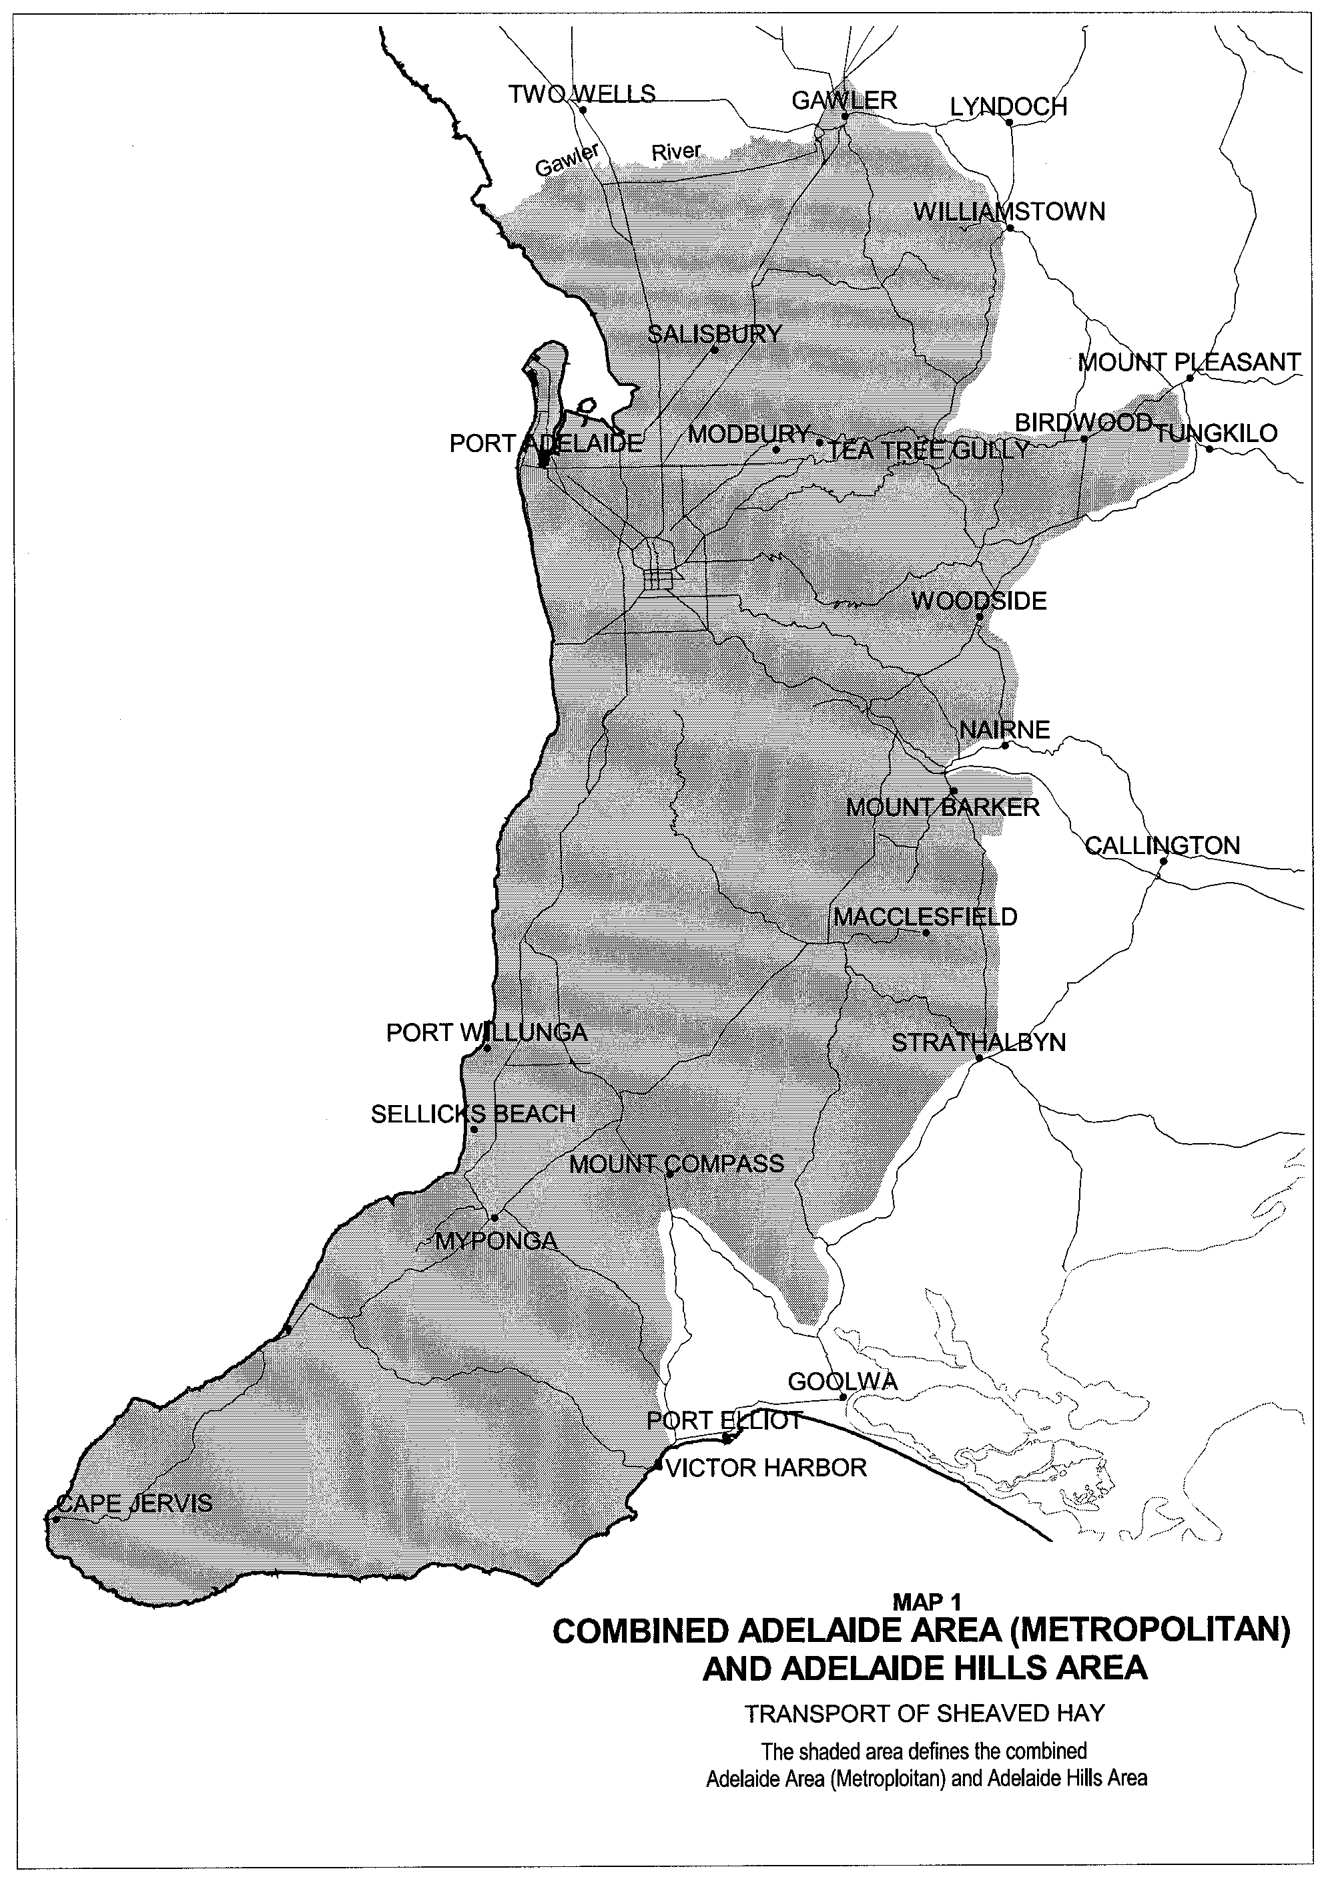
T. N. Argent, Executive Director, Transport SA

ROAD TRAFFIC ACT 1961

Exemption for Articulated Motor Vehicles Transporting Baled Wool to Exceed a Height of 4.3 metres

PURSUANT to the provisions of section 161A of the Road Traffic Act 1961, and Regulation 35 of the Road Traffic (Miscellaneous) Regulations 1999, I, T. N. Argent, Executive Director, Transport SA, as an authorised delegate of the Minister for Transport and Urban Planning, hereby approve articulated motor vehicles carrying baled wool which exceed 4.3 metres in height, to operate in South Australia; and

PURSUANT to the provisions of section 163AA of the Road Traffic Act 1961, I, T. N. Argent, Executive Director, Transport SA, as an authorised delegate of the Minister for Transport and Urban Planning, hereby exempt articulated motor vehicles carrying baled wool which exceed 4.3 metres in height:

From the following provision of the Road Traffic (Vehicle Standards) Rules:

- Rule 72—Height

Subject to the following conditions:

- Special Conditions

  - This notice or a legible copy shall be carried by the driver of the vehicle at all times when operating under this exemption and be produced when requested by an inspector appointed under the Road Traffic Act 1961 and/or the Motor Vehicles Act 1959, or a Police Officer.

  - Except as otherwise specified in this exemption notice, the standard form conditions prescribed in the Road Traffic (Oversize or Overmass Vehicle Exemptions) Regulations 1999 for the purposes of section 115 of the Act, shall not apply.

  - This notice shall stand alone. It cannot be used in conjunction with any other exemption, notice or permit.

- Dimensions

  - The maximum overall vehicle height including the load shall not exceed 4.6 metres.

  - The overall width of all axles or axle groups of the vehicle carrying the load, excluding the front axle or axle group, when measured between two vertical parallel planes located at the outer extremities of the tyres, shall not be less than 2.1 metres.

- General Conditions

  - The baled wool shall not be loaded more than 4 layers high.

  - The conditions set out in this notice apply to the vehicles, loads and routes specified, and does not relieve the owner and/or driver of the duty to observe all other provisions of the Road Traffic Act and Regulations and Local Government by-laws.

Note: Persons operating under the provisions of this notice are advised that some parts of the road system bridges, signs, roadside furniture and vegetation may not provide sufficient clearance for the passage of a vehicle and load at the dimensions permitted by this notice.

Note: Section 106 of the Road Traffic Act—Damage to roads and works, includes provisions concerning damage to roads, bridges and culverts, interference with roadside furniture and the obligations of persons causing such damage to notify the appropriate authority.

This notice is valid from 8 January 2001 and the notice titled ‘Transport of baled Wool up to an Overall Vehicle Height of 4.6 m’ appearing in the South Australian Government Gazette, dated 16 January 1997, is revoked at midnight on 7 January 2001.

T. N. Argent, Executive Director, Transport SA

ROAD TRAFFIC ACT 1961

Exemption for the Transport of Baled Wool and/or Baled Hay to Exceed a Width of 2.5 metres

PURSUANT to the provisions of section 163AA of the Road Traffic Act 1961, I, T. N. Argent, Executive Director, Transport SA, as an authorised delegate of the Minister for Transport and Urban Planning, hereby exempt articulated motor vehicles, rigid motor vehicles and rigid motor vehicles towing one trailer, carrying a load consisting solely of baled wool and/or baled hay:

From the following provision of the Road Traffic (Vehicle Standards) Rules 1999:

- Rule 66—Width; and

From the following provision of the Road Traffic (Mass and Loading Requirements) Regulations 1999:

- Schedule 1 Part 2, Regulation 6 (side projections)

Subject to the following conditions:

- Special Conditions

  - This notice or a legible copy shall be carried by the driver of the vehicle at all times when operating under this exemption and be produced when requested by an inspector appointed under the Road Traffic Act 1961and/or the Motor Vehicles Act 1959, or a Police Officer.

  - Except as otherwise specified in this exemption notice, the standard form conditions prescribed in the Road Traffic (Oversize or Overmass Vehicle Exemptions) Regulations 1999 for the purposes of section 115 of the Act, shall not apply.

  - This notice shall stand alone. It cannot be used in conjunction with any other exemption, notice or permit.

- Dimensions

  - The overall width of the vehicle, including the load shall not exceed 2.75 metres.

  - The overall width of all axles or axle groups of the vehicle carrying the load, excluding the front axle or front axle group, when measured between two vertical parallel planes located at the outer extremities of the tyre, shall not be less than 2.1 metres.

  - No part of the vehicle or any trailer attached shall exceed a width of 2.5 metres.

  - The load shall be placed on the load carrying area of the vehicle so that the projection of the load is the same on both sides of the vehicle.

- Times of Travel

  - Travel is not permitted between the hours of sunset and sunrise or in periods of low visibility.

  - For the purposes of this notice ‘a period of low visibility’ means any time when, owing to insufficient daylight or unfavourable conditions, persons or vehicles on a road are not clearly visible at a distance of 250 metres to a person of normal vision.

  - Travel is not permitted in the Adelaide Area (Metropolitan), between the hours of 7.00 am to 9.00 am and 4.00 pm to 6.00 pm Monday to Friday inclusive.

  - For the purposes of this notice the Adelaide Area (Metropolitan) is defined as the area described in Map 1 ‘Adelaide Area (Metropolitan) Transport of Baled Wool and Baled Hay’ of this notice.

- General Conditions

  - The person driving the vehicle or combination shall, at regular intervals, when it is practicable to do so and there is not a separate lane available for overtaking, move off the carriageway to allow other vehicles to overtake.

  - The conditions set out in this notice apply to the vehicles, loads, routes and times specified, and does not relieve the owner and/or driver of the duty to observe all other provisions of the Road Traffic Act and Regulations and Local Government by-laws.

Note: Persons operating under the provisions of this notice are advised that some parts of the road system bridges, signs, roadside furniture and vegetation may not provide sufficient clearance for the passage of a vehicle and load at the dimensions permitted by this notice.

Note: Section 106 of the Road Traffic Act—Damage to roads and works, includes provisions concerning damage to roads, bridges and culverts, interference with roadside furniture and the obligations of persons causing such damage to notify the appropriate authority.

This notice is valid from 8 January 2001 and the notice titled ‘Notice Concerning the Transport of Baled Wool and/or Baled Hay’ appearing in the South Australian Government Gazette, dated 24 January 1991 is revoked at midnight on 7 January 2001.

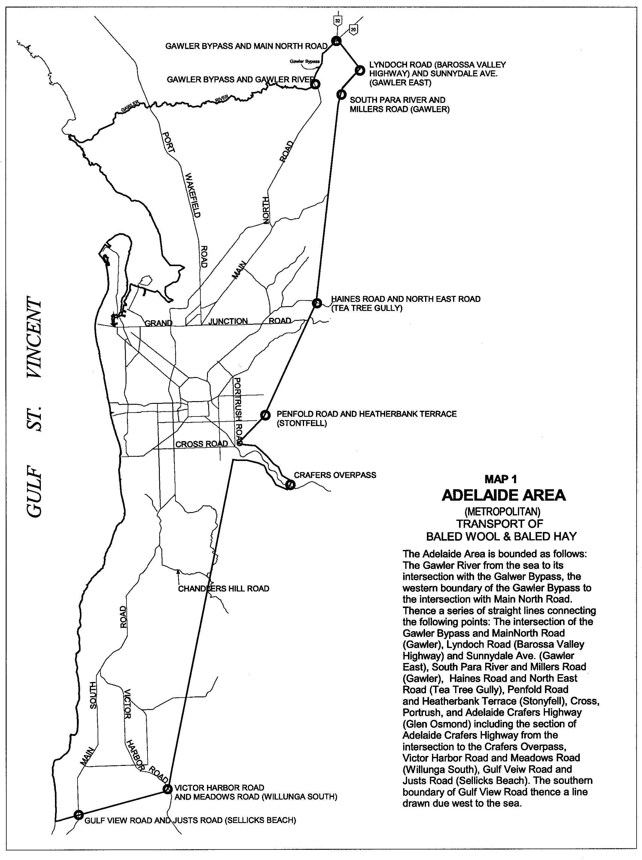
T. N. Argent, Executive Director, Transport SA

ROAD TRAFFIC ACT 1961
Approval for Vehicles Constructed for the Transport of Livestock to Exceed a Height of 4.3 metres
PURSUANT to the provisions of section 161A of the Road Traffic Act 1961, and Regulation 35 of the Road Traffic (Miscellaneous) Regulations 1999, I, T. N. Argent, Executive Director, Transport SA, as an authorised delegate of the Minister for Transport and Urban Planning, hereby approve articulated motor vehicles fitted with multi deck stock crates which exceed 4.3 metres in height, to operate in South Australia:

Subject to the following conditions:

- Special Conditions

  - This notice or a legible copy shall be carried by the driver of the vehicle at all times when operating under this exemption and be produced when requested by an inspector appointed under the Road Traffic Act 1961and/or the Motor Vehicles Act 1959, or a Police Officer.

  - Except as otherwise specified in this exemption notice, the standard form conditions prescribed in the Road Traffic (Oversize or Overmass Vehicle Exemptions) Regulations 1999 for the purposes of section 115 of the Act, shall not apply.

  - This notice shall stand alone. It cannot be used in conjunction with any other exemption, notice or permit.

- Vehicle Carrying Livestock

  - The height of the vehicle and load shall not exceed 4.6 metres.

  - The load shall consist solely of livestock.

  - For the purposes of this notice ‘livestock’ means live animals commonly known as cattle, pigs, sheep and goats.

  - The prime mover shall have a tandem axle group towards the rear.

  - The semi-trailer shall have a tri-axle group towards the rear.

  - No animals shall be loaded on an upper deck unless each deck below is fully loaded except for a compartment being used for storing the loading ramps.

  - If any deck on the vehicle is not fully loaded, the animals shall be confined in a full width compartment that is fully loaded.

  - Operators and drivers while transporting livestock shall comply with the requirements of the:

    - Prevention of Cruelty to Animals Act and Regulations; and

    - Australian Model Code of Practice for the Welfare of Animals and the Road Transport of Livestock.

or

- Vehicle Travelling Unladen

  - The height of the vehicle shall not exceed 4.6 metres.

or

- Vehicle Carrying Freight Other Than Livestock

  - The height of the vehicle shall not exceed 4.6 metres.

  - Where the load consists of freight other than livestock, the load height shall not exceed 4.3 metres and;

  - The semi trailer shall have a tri-axle group toward the rear.

- General Conditions

The conditions set out in this notice apply to the vehicles, loads, routes and times specified, and does not relieve the owner and/or driver of the duty to observe all other provisions of the Road Traffic Act and Regulations and Local Government by-laws.

Note: Persons operating under the provisions of this notice are advised that some parts of the road system bridges, signs, roadside furniture and vegetation may not provide sufficient clearance for the passage of a vehicle and load at the dimensions permitted by this notice.

Note: Section 106 of the Road Traffic Act—Damage to roads and works, includes provisions concerning damage to roads, bridges and culverts, interference with roadside furniture and the obligations of persons causing such damage to notify the appropriate authority.

This notice is valid from 8 January and the notice titled ‘Increased Height Limit for Vehicles Constructed for the Transport of Animals’ appearing in the South Australian Government Gazette, dated 19 August 1993, is revoked at midnight on 7 January 2001.

T. N. Argent, Executive Director, Transport SA

ROAD TRAFFIC ACT 1961

Exemption for Oyster Boats and Trailers to be Fitted with Brakes and to Exceed a Width of 2.5 metres

PURSUANT to the provisions of section 163AA of the Road Traffic Act 1961, I, T. N. Argent, Executive Director, Transport SA, as an authorised delegate of the Minister for Transport and Urban Planning hereby exempt rigid motor vehicles towing one trailer carrying an oyster boat or an oyster boat on its own wheels:

From the following provisions of the Road Traffic (Mass and Loading Requirements) Regulations 1999:

- Schedule 1, Part 2, Regulation 6—Front and side projections;
- Schedule 2, Regulation 2(c) & (d)—Mass of a vehicle towed by a light vehicle; and

From the following provisions of the Road Traffic (Vehicle Standards) Rules 1999:

- Rule 66—Width;
- Rule 132—Trailer braking requirements;
- Rule 133—Operation of brakes on trailers:

Subject to the following conditions:

- Special Conditions

  - This notice or a legible copy shall be carried by the driver of the vehicle at all times when operating under this exemption and be produced when requested by an inspector appointed under the Road Traffic Act 1961 and/or the Motor Vehicles Act 1959, or a Police Officer.

  - Except as otherwise specified in this exemption notice, the standard form conditions prescribed in the Road Traffic (Oversize or Overmass Vehicle Exemptions) Regulations 1999 for the purposes of section 115 of the Act, shall not apply.

  - This notice shall stand alone. It cannot be used in conjunction with any other exemption, notice or permit.

- Width

  - The overall width of the vehicle combination including the oyster boat trailer, oyster boat and any framework used to support the boat shall not exceed 3.5 m.

- Restricted Routes

  - Travel is only permitted for transporting the oyster boat from the place of processing to the beach and return or from the place of processing to the boat launching ramp and return.

- Times of Travel

  - Travel is only permitted between sunrise and sunset, except where transporting of the boat is directly related to the harvesting of oysters.

  - For travel between sunset and sunrise, or during periods of low visibility, the vehicle combination shall comply with all lighting requirements as specified under Part 8—Lights and Reflectors of the Road Traffic (Vehicles Standards) Rules 1999.

    - For the purposes of this notice ‘a period of low visibility’ means any time, when, owing to insufficient daylight or unfavourable conditions, persons or vehicles on a road are not clearly visible at a distance of 250 metres to a person of normal vision.

- Speed Restrictions

  - The vehicle combination shall not exceed a maximum speed of 25 kilometres per hour.

- Brakes and Towing Requirements

  - Brakes are not required to be fitted to the trailer or oyster boat fitted with its own wheels provided the laden mass of trailer or oyster boat including its load, does not exceed six tonnes.

  - Notwithstanding clause 6.1 the brakes of the towing vehicle/oyster trailer combination shall comply with the requirements of Rule 128—Performance of braking systems, of the Road Traffic (Vehicle Standards) Rules 1999.

  - The Gross Combination Mass (GCM) or Towing Capacity, of the towing vehicle, as specified by the vehicle manufacturer or specified on the certificate of registration, shall not be exceeded.

Note: It remains the responsibility of the vehicle owner/driver to ensure that the braking system of the vehicle combination is capable of achieving the performance and stopping distances described in Rule 128 of the Road Traffic (Vehicle Standards) Rules 1999.

- Warning Signs

  - A warning sign which complies with the requirements of Clause 8 of this notice, shall be affixed to the front of the towing vehicle and to the rear of the towed vehicle, however an oversize vehicle sign is not required to be affixed to the front if the towing vehicle is a tractor.

- Warning Sign Specifications

  - Face of warning sign

    - The warning sign shall comply with the following specifications.

OVERSIZE VEHICLE WARNING SIGN

    - The face of the warning sign shall have a yellow surface which complies with Class 1 or 2 of Australian/New Zealand Standard AS/NZS 1906.1, ‘Retro-reflective Materials and Devices for Road Traffic Control Purposes’ Part 1: Retro-reflective Materials.

    - The face of the warning sign shall show the words “OVERSIZE” in black upper-case lettering at least 200 millimetres high, conforming with Australian Standard AS 1744, ‘Forms of Letters and Numerals for Road Signs’, in type face Series C(N).

    - The face of the warning sign must have a black border at least 20 millimetres wide.

    - The outermost edge of the border of the warning sign must be set at least 10 millimetres in from the edge of the sign unless the sign has been made with a box edge.

  - Material for warning signs

    - A warning sign must be made of stiff, flat, weatherproof material, for example zincalume at least 0.8 millimetres thick or aluminium at least 1.6 millimetres thick.

- Flags

  - Brightly coloured red, yellow, or red and yellow flags, at least 450 millimetres long and at least 450 millimetres wide shall be attached to the extremities of the vehicle which shall:

    - Be positioned with one of the flags on each side of the front and rear of any projecting load or if there is no projecting load the flags shall be positioned at the vehicle or vehicle combination extremities; and

    - Be clearly visible at a distance of 100 metres to any person with normal vision; and

- Warning Light (Rotating Flashing Yellow Light)

  - The overwidth vehicle combination shall display a warning light or lights visible from all sides, fixed to the highest practicable point on the vehicle combination which meet the following specifications:

    - Emit a rotating, flashing, yellow coloured light; and

    - Flash at a rate between 120 and 200 times per minute; and

    - Have a power of at least 55 watts; and

    - Be clearly visible to other road users at a distance of 500 metres; and

    - Not be a strobe light.

  - Warning light(s) shall be either permanently connected into the electrical system of the vehicle or use standard automotive connectors to allow easy electrical disconnection and removal of the light(s) when not required.

  - Warning light(s) shall have incorporated into their electrical system an on/off switch control which is located within easy reach of the driver.

- General Conditions

  - The person driving the vehicle or combination shall, at regular intervals, when it is practicable to do so and there is not a separate lane available for overtaking, move off the carriageway to allow other vehicles to overtake.

  - This notice shall operate only with respect to the vehicles, loads, routes and times specified, and does not relieve the owner and/or driver of the duty to observe all other provisions of the Road Traffic Act and Regulations and Local Government by-laws.

Note: Persons operating under the provisions of this notice are advised that some parts of the road system bridges, signs, roadside furniture and vegetation may not provide sufficient clearance for the passage of a vehicle and load at the dimensions permitted by this notice.

Note: Section 106 of the Road Traffic Act—Damage to roads and works, includes provisions concerning damage to roads, bridges and culverts, interference with roadside furniture and the obligations of persons causing such damage to notify the appropriate authority.

This notice is valid from 8 January 2001 and the notice titled ‘Overwidth Oyster Boats and Trailers’ appearing in the South Australian Government Gazette, dated 25 September 1997, is revoked at midnight on 7 January 2001.

T. N. Argent, Executive Director, Transport SA

ROAD TRAFFIC ACT 1961

Exemption for Road Maintenance and Construction Equipment to Exceed Mass and Dimension Limits

PURSUANT to the provisions of section 161A of the Road Traffic Act 1961, and Regulation 35 of the Road Traffic (Miscellaneous) Regulations 1999, I, T. N. Argent, Executive Director, Transport SA, as an authorised delegate of the Minister for Transport and Urban Planning, hereby approve Road Maintenance and Construction Equipment where such vehicles exceed 19 metres in length, 4.3 metres in height and a Gross Combination Mass of 42.5 tonnes, to operate in South Australia; and

PURSUANT to the provisions of section 163AA of the Road Traffic Act 1961, I, T. N. Argent, Executive Director, Transport SA, as an authorised delegate of the Minister for Transport and Urban Planning, hereby exempt Road Maintenance and Construction Equipment which exceeds 19 metres in length, 4.3 metres in height and a Gross Combination Mass of 42.5 tonnes, working on roads or road related areas:

From the following provisions of the Road Traffic (Vehicles Standards) Rules 1999:

- Rule 64 —Disposition of axles and axle groups;
- Rule 66—Width;
- Rule 67—Length;
- Rule 72—Height; and

From the following provisions of the Road Traffic (Mass and Loading Requirements) Regulations 1999:

- Schedule 1, Part 1(1)—Mass limits of vehicles
- Schedule 1, Part 1(4)—Mass limits for combinations:

Subject to the following conditions:

- Special Conditions

  - This notice or a legible copy shall be carried by the driver of the vehicle at all times when operating under this exemption and be produced when requested by an inspector appointed under the Road Traffic Act 1961and/or the Motor Vehicles Act 1959, or a Police Officer.

  - Except as otherwise specified in this exemption notice, the standard form conditions prescribed in the Road Traffic (Oversize or Overmass Vehicle Exemptions) Regulations 1999 for the purposes of section 115 of the Act, shall not apply.

  - This notice shall stand alone. It cannot be used in conjunction with any other exemption, notice or permit.

- General Conditions

  - The vehicle is only permitted to be operated on a road or road related area for the purpose of undertaking activities involved directly with road construction and/or maintenance.

  - The vehicle is only permitted to be operated or to be left standing on a road or road related area within a designated worksite.

  - The worksite is signed in accordance with Australian Standard 1742.3, Part 3 ‘Traffic Control Devices for Works on Roads’.

  - The vehicle is transported by float (not driven) to and/or between worksites.

  - The vehicle is only used for the maintenance and/or construction of roads, road related areas, bridges or culverts.

  - The conditions set out in this notice apply to the vehicles, locations and times specified, and does not relieve the owner and/or driver of the duty to observe all other provisions of the Road Traffic Act and Regulations and Local Government by-laws.

Note: Drivers of plant and equipment operating under the provisions of this notice are advised that some parts of the road system bridges, signs, roadside furniture and vegetation may not provide sufficient clearance for the passage of a vehicle and load at the dimensions permitted by this notice.

Note: Section 106 of the Road Traffic Act—Damage to roads and works, includes provisions concerning damage to roads, bridges and culverts, interference with roadside furniture and the obligations of persons causing such damage to notify the appropriate authority.

This notice is valid from 8 January 2001 and the notice titled ‘Exemption from Mass and Dimension Limits for Road Maintenance and Construction Equipment’ appearing in the South Australian Government Gazette, dated 19 September 1996, is revoked at midnight on 7 January 2001.

T. N. Argent, Executive Director, Transport SA

ROAD TRAFFIC ACT 1961

Approval for Increased Gross Combination Mass for Truck and Trailer Combinations

PURSUANT to the provisions of section 161A of the Road Traffic Act 1961, and Regulation 35 of the Road Traffic (Miscellaneous) Regulations 1999, I, T. N. Argent, Executive Director, Transport SA, as an authorised delegate of the Minister for Transport and Urban Planning, hereby approve rigid truck and dog trailer combinations to exceed a Gross Combination Mass of 42.5 tonnes, to operate in South Australia; and
PURSUANT to the provisions of section 163AA of the Road Traffic Act, 1961, I, T. N. Argent, Executive Director, Transport SA, as an authorised delegate of the Minister for Transport and Urban Planning, hereby exempt rigid truck and dog trailer combinations:
From the following provision of the Road Traffic (Mass and Loading Requirements) Regulations 1999:
- Schedule 1, Part 1(4)—Mass limits for combinations:
Subject to the following conditions:
- Special Conditions:
  - This notice or a legible copy shall be carried by the driver of the vehicle at all times when operating under this exemption and be produced when requested by an inspector appointed under the Road Traffic Act 1961 and/or the Motor Vehicles Act 1959, or a Police Officer.
  - Except as otherwise specified in this exemption notice, the standard form conditions prescribed in the Road Traffic (Oversize or Overmass Vehicle Exemptions) Regulations 1999 for the purposes of section 115 of the Act, shall not apply.
  - This notice shall stand alone. It cannot be used in conjunction with any other exemption, notice or permit.

- Definitions

For the purposes of this notice the following definitions shall apply:

  - A ‘Rigid Truck and Dog Trailer’ means a rigid motor vehicle towing a trailer (which includes a trailer consisting of a semi-trailer and a converter dolly);

    - Where the rigid truck has a single steer axle or twin steer axle group at the front and a tandem drive axle group at the rear; and

    - Where the trailer has a single axle or a tandem axle group at the front that is steered by connection to the towing vehicle by means of a drawbar and a tandem axle group at the rear.

  - ‘Gross Combination Mass’ (GCM) means the greatest possible sum of the maximum loaded mass of the motor vehicle and of any vehicles that may lawfully be towed by it at one time.

  - ‘Maintenance Management Scheme’ means a scheme that is recognised by Transport SA as meeting the requirements of the Maintenance Management Module (including audit requirements) of the National Heavy Vehicle Accreditation Scheme (NHVAS).

  - ‘National Heavy Vehicle Accreditation Scheme (NHVAS) means a comprehensive accreditation package developed by the National Road transport Commission and approved by the Australian Transport Council on November 1997.

- Dimensions

  - The overall length of the vehicle combination shall not exceed 19 metres.

  - The overall width of the vehicle combination shall not exceed 2.5 metres.

  - The overall height of the vehicle combination shall not exceed 4.3 metres.

- Vehicle Configuration and Mass Limits

  - All vehicles shall comply with the statutory axle and axle group mass limits as set out in Schedule 1, Part 1(3) of the Road Traffic (Mass and Loading Requirements) Regulations 1999.

  - The gross mass of a 3 axle dog trailer shall not exceed 22.5 tonnes.

  - The gross mass of a 4 axle dog trailer shall not exceed:

    - 27 tonnes when towed by a three axle rigid truck.

    - 27.5 tonnes when towed by a 4 axle rigid truck.

  - The gross combination mass shall not exceed the maximum GCM figure shown in Table 1 for that configuration.

  - Vehicle Configurations approved under this exemption are as follows:

Table 1
Vehicle Configuration | Maximum GCM Tonnes
3 axle rigid truck towing a 3 axle dog trailer  4 axle rigid truck towing a 3 axle dog trailer  3 axle rigid truck towing a 4 axle dog trailer  4 axle rigid truck towing a 4 axle dog trailer | 45.0  45.0  49.5  50.0

- Mass Ratio

  - The laden mass of a triaxle dog trailer shall not exceed the laden mass of the hauling unit.

  - The laden mass of a 4 axle dog trailer shall not exceed the laden mass of the hauling unit by more than 20 per cent.

- Drawbar Length

  - The length of the dog trailer drawbar when measured from the centreline of the towing pivot to the centreline of the leading axle or axle group of the trailer shall exceed 3.0 metres but not exceed 5.0 metres.

- Axle Spacing Requirements

  - All combinations shall comply with the axle spacing requirements shown in the configurations (1-4) for the respective combination.

Note: Except where stated otherwise, all dimension limits shall be equal to or greater than those specified.
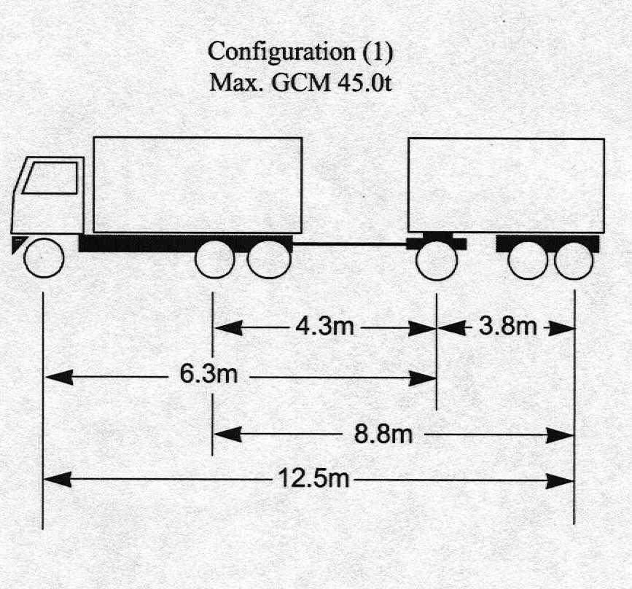

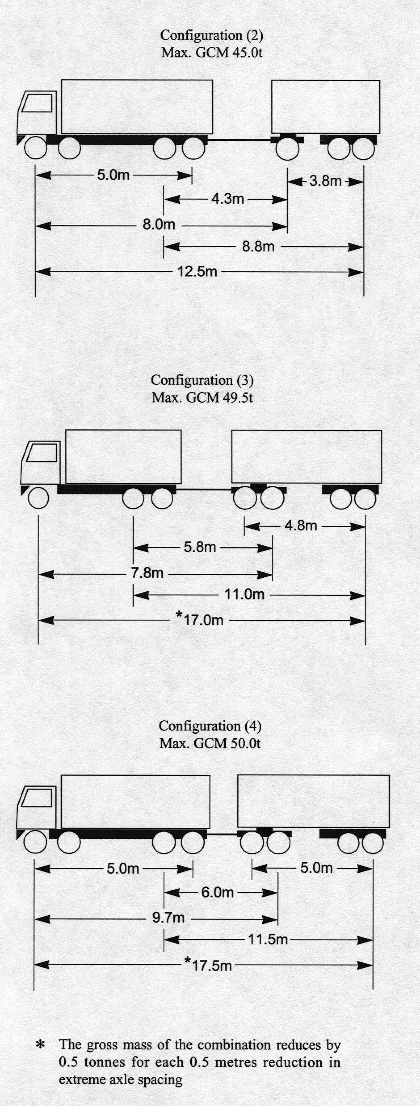

- Suspension Systems

  - The drive axle group on the hauling unit and all axles and axle groups on the trailers shall be fitted with air suspension and effective dampers.

- Vehicle Specifications

  - The vehicle shall not be driven or loaded in excess of the manufacturer’s rating for axle, tyre, and coupling capacity, or in excess of the manufacturer’s gross vehicle mass (GVM) and/or gross combination mass (GCM) ratings.

  - South Australian registered vehicles shall not exceed the GVM and/or GCM as shown on the certificate of registration for that vehicle.

  - Vehicles registered in other states and territories shall either comply with the requirements of clause 9.1 of this notice or shall not exceed the gross vehicle mass, gross trailer mass or gross combination mass as shown on the certificate of registration for that vehicle.

- Vehicle Speed

  - The vehicle combination shall not exceed a speed of 100 kilometres per hour or any posted speed limit whichever is the lesser.

- Inspection and Compliance

  - The vehicle combination shall be accredited under a recognised Maintenance Management Scheme and display a label that identifies scheme membership.

- Power to Mass Ratio

  - The engine power to gross mass ratio shall not be less than 6.4 brake horse power per tonne or 4.8 kilowatts per tonne. (e.g. a engine with a 320 brake horsepower rating is required for a combination operating at 50 tonne.)

- Route Details

  - Travel is permitted on roads in South Australia except for the bridge structures listed in 13.2.

  - For combinations which have a total of six axles, travel is not permitted on the following bridge structures:

- Gumeracha Bridge—Over River Torrens at Gumeracha.

- Chain of Ponds Creek Bridge—Near Chain of Ponds on the Tea Tree Gully to Gumeracha Road.

- Murray Bridge—Over the River Murray at Murray Bridge (Old Bridge).

- Spring Creek Bridge—8.7 km South of Wilmington on Main North Road.

- Birkenhead Bridge—Over Port River at Port Adelaide (the lifting bridge).

- Onkaparinga River Bridge —Saltfleet St, Port Noarlunga.

- Railway Bridge at Gawler—On Overway Bridge Road, Gawler.

- Bakewell Bridge—Over Railway on Henley Beach Road, Mile End.

For combinations which have more than six axles travel is not permitted on the bridge structures listed in (a) to (h) above and in addition the Paringa Bridge—over the River Murray on National Route 20 at Paringa.

- General Conditions

  - The conditions set out in this notice apply to the vehicles, loads and routes specified, and does not relieve the owner and/or driver of the duty to observe all other provisions of the Road Traffic Act and Regulations and Local Government by-laws.

  - The conditions set out in this notice may be overridden by a limitation fixed at any time on a bridge, culvert, causeway road or road ferry.

Note: Persons operating under the provisions of this notice are advised that some parts of the road system bridges, signs, roadside furniture and vegetation may not provide sufficient clearance for the passage of a vehicle and load at the dimensions permitted by this notice.

Note: Section 106 of the Road Traffic Act—Damage to roads and works, includes provisions concerning damage to roads, bridges and culverts, interference with roadside furniture and the obligations of persons causing such damage to notify the appropriate authority.

This notice is valid from the 8 January 2001 and the notice titled ‘Increased Mass for Truck and Trailer Combinations’ appearing in the South Australian Government Gazette, dated 19 November 1998, is revoked at midnight on 7 January 2001.

T. N. Argent, Executive Director, Transport SA

ROAD TRAFFIC ACT 1961

Approval for a Bus Towing a Disabled Bus to exceed an overall length of 19 metres

PURSUANT to the provisions of section 161A of the Road Traffic Act 1961, and Regulation 35 of the Road Traffic (Miscellaneous) Regulations 1999, I, T. N. Argent, Executive Director, Transport SA, as an authorised delegate of the Minister for Transport and Urban Planning, hereby approve a bus towing a disabled bus where the combination exceeds 19 metres in length, to operate in South Australia; and

PURSUANT to the provisions of section 163AA of the Road Traffic Act 1961, I, T. N. Argent, Executive Director, Transport SA, as an authorised delegate of the Minister for Transport and Urban Planning, hereby exempt a bus towing a disabled bus from Rule 69(1)(d)—Length, of combinations, of the Road Traffic (Vehicle Standards) Rules 1999:

Subject to the following conditions:

- Special Conditions

  - This notice or a legible copy shall be carried by the driver of the vehicle at all times when operating under this exemption and be produced when requested by an inspector appointed under the Road Traffic Act 1961 and/or the Motor Vehicles Act 1959, or a Police Officer.

  - Except as otherwise specified in this exemption notice, the standard form conditions prescribed in the Road Traffic (Oversize or Overmass Vehicle Exemptions) Regulations 1999 for the purposes of section 115 of the Act, shall not apply.

  - This notice shall stand alone. It cannot be used in conjunction with any other exemption, notice or permit.

- Speed

  - The speed under tow shall not exceed 40 kilometres per hour.

- Oversize signs and Delineation

  - A reflectorized “Long Vehicle, Bus Under Tow” sign, 1600 millimetres long and 600 millimetres high shall be displayed on the front and rear of the combination. The letters of the words “Long Vehicle” shall be 200 millimetres high and 25 millimetres wide. The letters of the words “Bus Under Tow” shall be 160 millimetres high and 20 millimetres wide.

  - The towbar shall be painted with alternate black and white stripes 230 millimetres wide.

- General Conditions

  - The person driving the vehicle while towing the disabled bus shall, at regular intervals, when it is practicable to do so and there is not a separate lane available for overtaking, move off the carriageway to allow other vehicles to overtake.

  - The conditions set out in this notice apply to the vehicles and loads specified and does not relieve the owner and/or driver of the duty to observe all other provisions of the Road Traffic Act and Regulations and Local Government by-laws.

  - The conditions set out in this notice may be overridden by a limitation fixed at any time on a bridge, culvert, causeway road or road ferry.

- Towing Requirements

  - The towed vehicle and the towing vehicle are unladen.

  - Travel is only for the purpose of towing a disabled bus from breakdown point to the nearest point where repairs can be effected.

  - A rigid towbar shall be used.

  - The mass of the bus being towed must not be greater than the mass of the towing bus.

Note: Persons operating under the provisions of this notice are advised that some parts of the road system bridges, signs, roadside furniture and vegetation may not provide sufficient clearance for the passage of a vehicle and load at the dimensions permitted by this notice.

Note: Section 106 of the Road Traffic Act—Damage to roads and works, includes provisions concerning damage to roads, bridges and culverts, interference with roadside furniture and the obligations of persons causing such damage to notify the appropriate authority.

This notice is valid from the 8 January 2001 and the notice titled ‘Buses Towing a Disabled’ appearing in the South Australian Government Gazette, dated 6 October 1994, is revoked at midnight on 7 January 2001.

T. N. Argent, Executive Director, Transport SA

ROAD TRAFFIC ACT 1961

Exemption for Buses to Exceed a Width of 2.5 metres

PURSUANT to the provisions of section 163AA of the Road Traffic Act 1961, I, T. N. Argent, Executive Director, Transport SA, as an authorised delegate of the Minister for Transport and Urban Planning, hereby exempt ex State Transport Authority buses originally manufactured with an overall width greater than 2.5 metres:

From the following provision of the Road Traffic (Vehicle Standards) Rules 1999:

- Rule 66—Width:

Subject to the following conditions:

- The vehicle is used solely as a bus for the carriage of passengers.

- Travel is not permitted on roads in the Adelaide Hills Area.

- For the purposes of this notice the ‘Adelaide Hills Area’ is defined as the shaded areas shown in ‘Map 1, Adelaide Hills Area—Overwidth Buses’ of this notice.

- The width of the vehicle must not exceed 2.6 metres at any part excluding any anti-skid device mounted on the wheels, central tyre inflation systems, lights, mirrors, reflectors, signalling devices and tyre pressure gauges.

- Except as otherwise specified in this exemption notice, the standard form conditions prescribed in the Road Traffic (Oversize or Overmass Vehicle Exemptions) Regulations 1999 for the purposes of section 115 of the Act, shall not apply.

- The vehicle shall be fitted with a Transport SA, Modification Plate which:

  - Is supplied and marked by Transport SA.

  - Is permanently affixed to the bus with rivets or hammer driven screws. The use of adhesive or other types of screws is not acceptable.

  - Is not removed, relocated, modified or defaced in anyway without the formal consent of Transport SA.

  - Is located within the passenger compartment in the front door footwell area adjacent to the Australian Design Rule compliance plate.

  - Is marked with:

    - A reference number of V7743/93.

    - The Vehicle Identification Number or Chassis Number allocated to the bus.

    - The Approval Code ‘2.6W’

- The conditions set out in this notice apply to the vehicles specified and does not relieve the owner and/or driver of the duty to observe all other provisions of the Road Traffic Act and Regulations and Local Government by-laws.

Note: The owner and/or driver operating under the provisions of this notice are advised that some parts of the road system bridges, signs, roadside furniture and vegetation may not provide sufficient clearance for the passage of a vehicle and load at the dimensions permitted by this notice.

Note: Section 106 of the Road Traffic Act—Damage to roads and works, includes provisions concerning damage to roads, bridges and culverts, interference with roadside furniture and the obligations of persons causing such damage to notify the appropriate authority.

This exemption expires at midnight on 31 December 2002.

The notice titled ‘Notice Concerning Overwidth Omnibuses’ appearing in the South Australian Government Gazette, dated 8 July 1993, is hereby revoked.

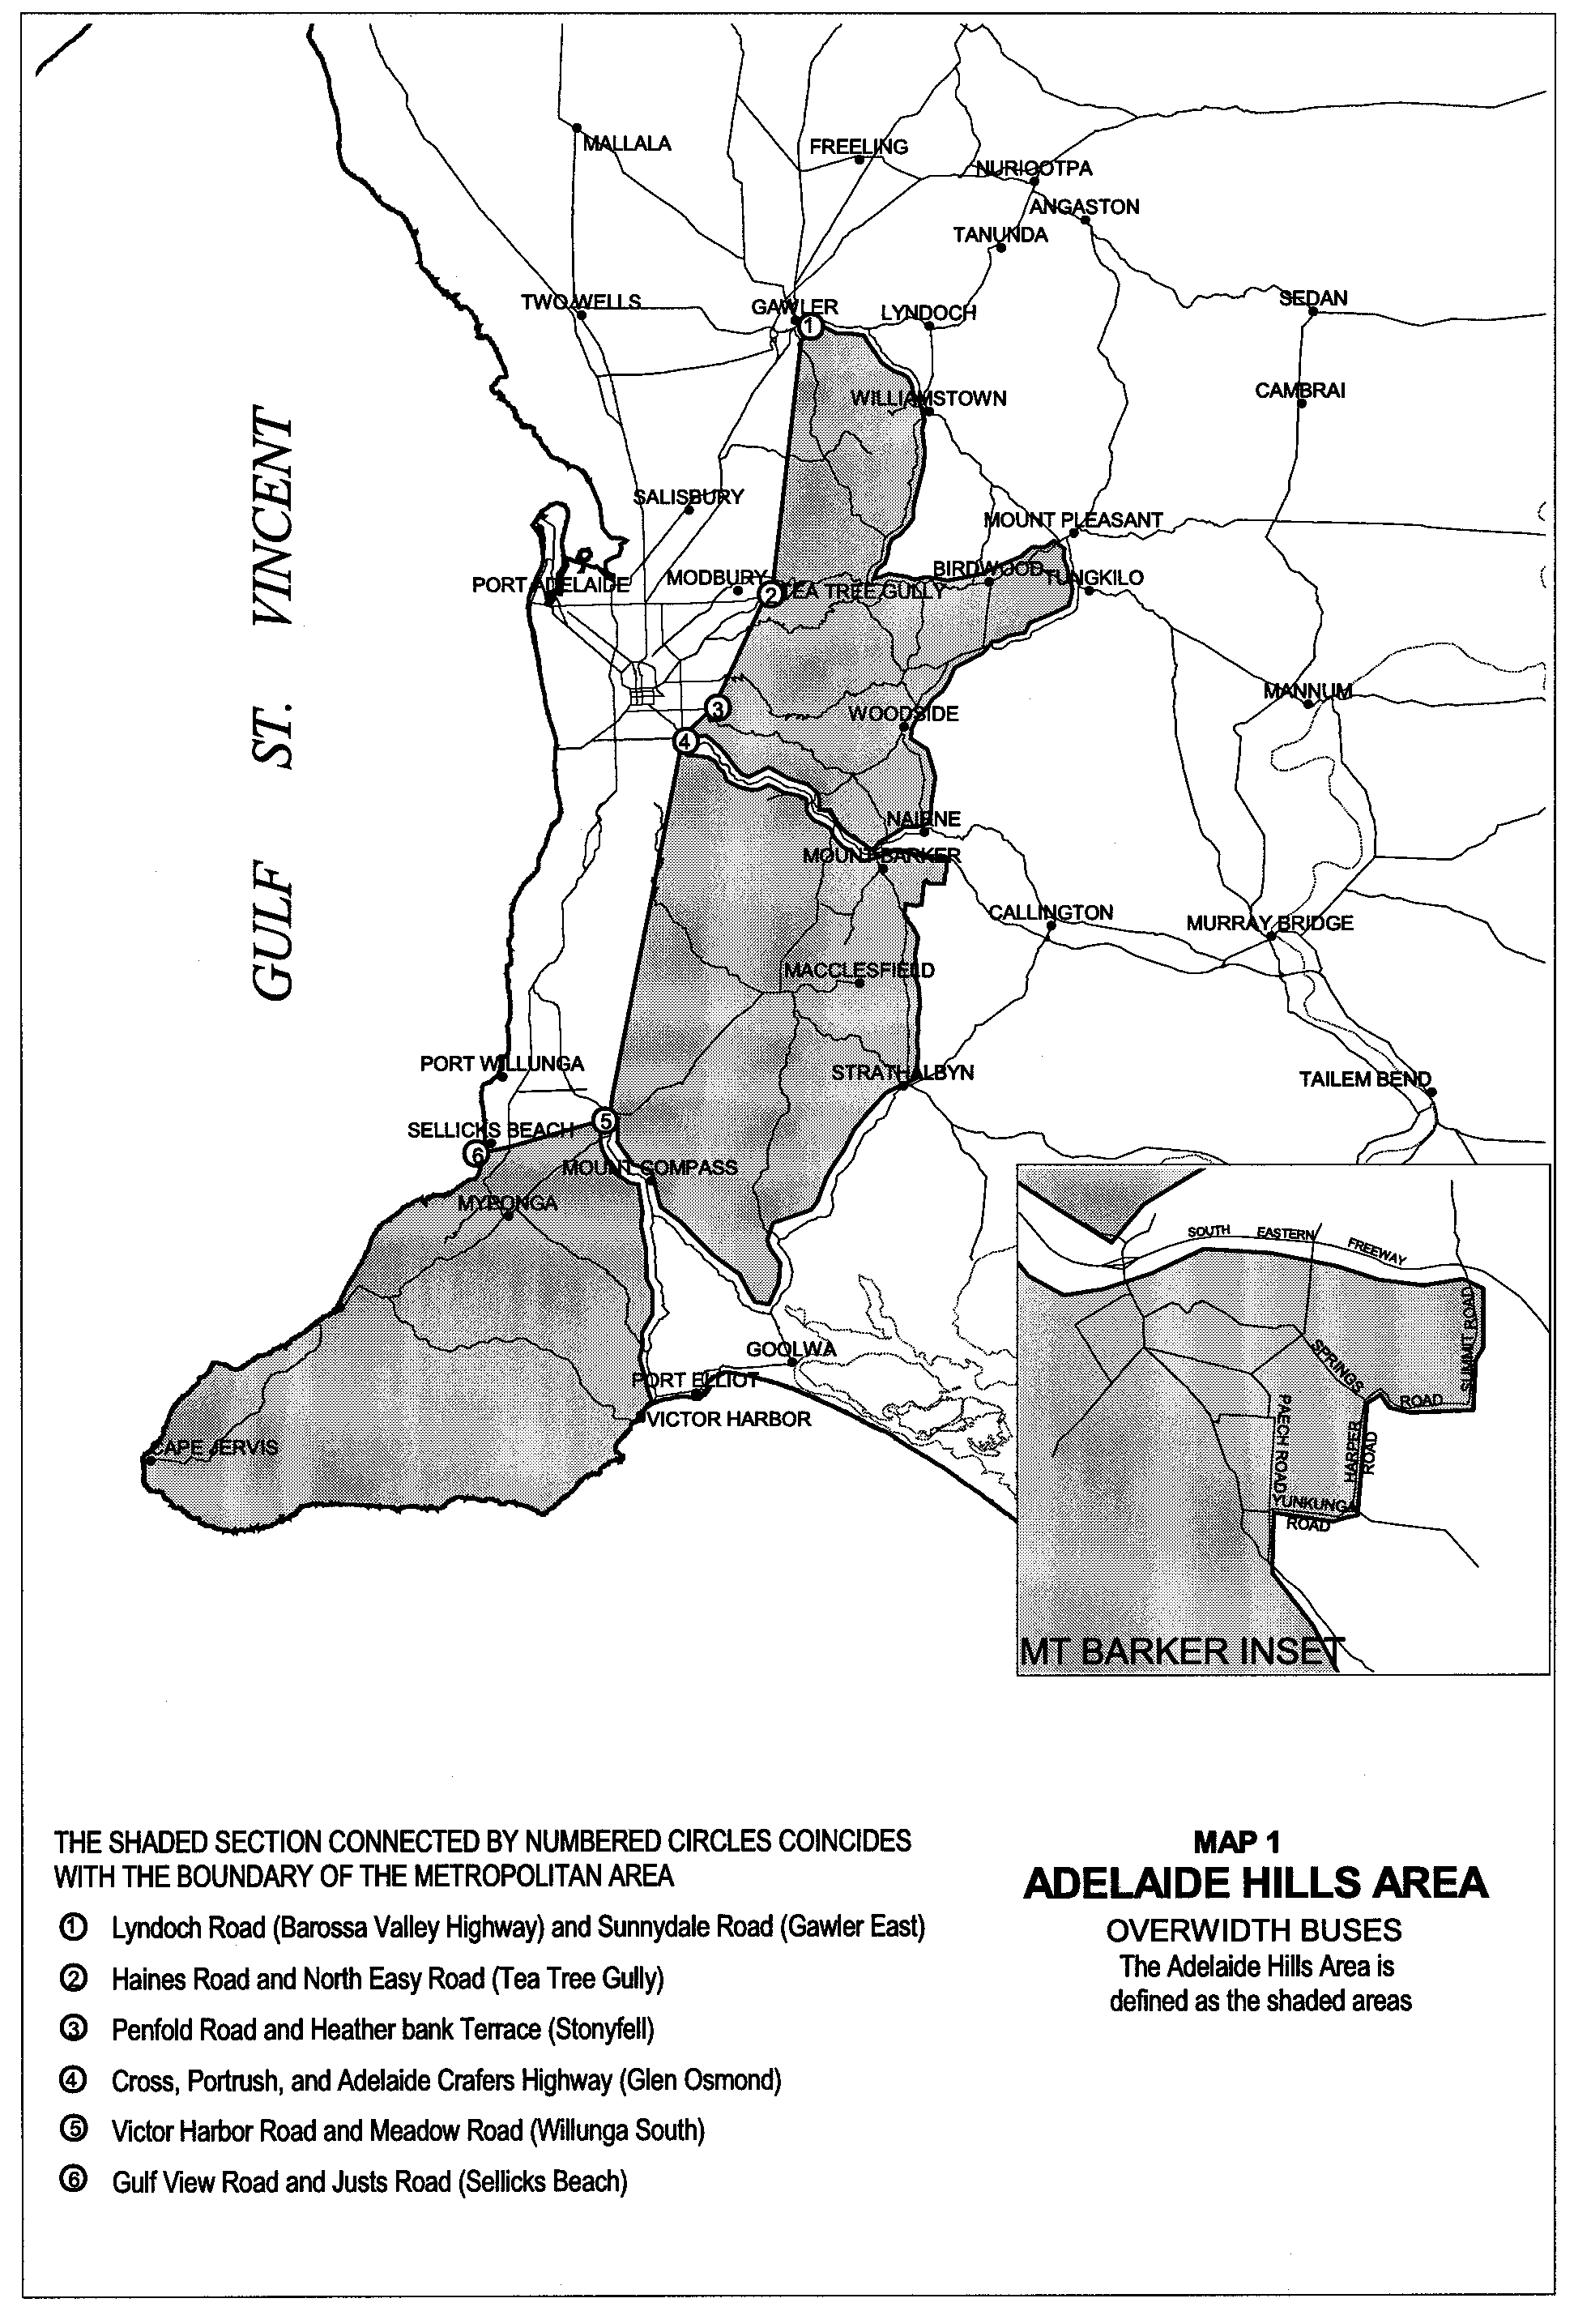
T. N. Argent, Executive Director, Transport SA

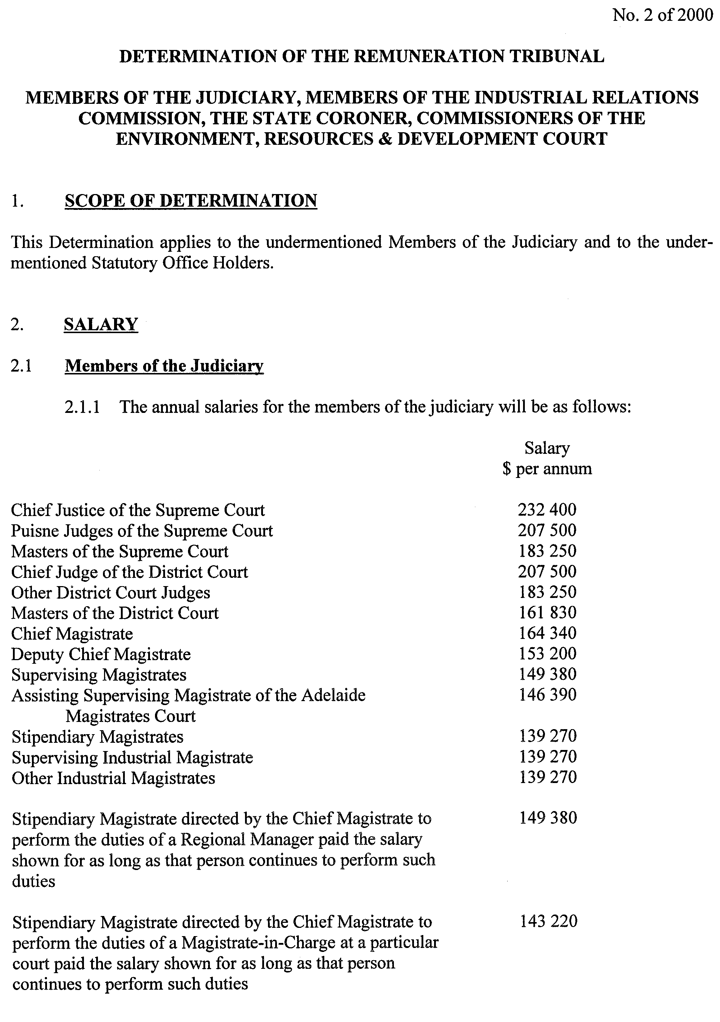
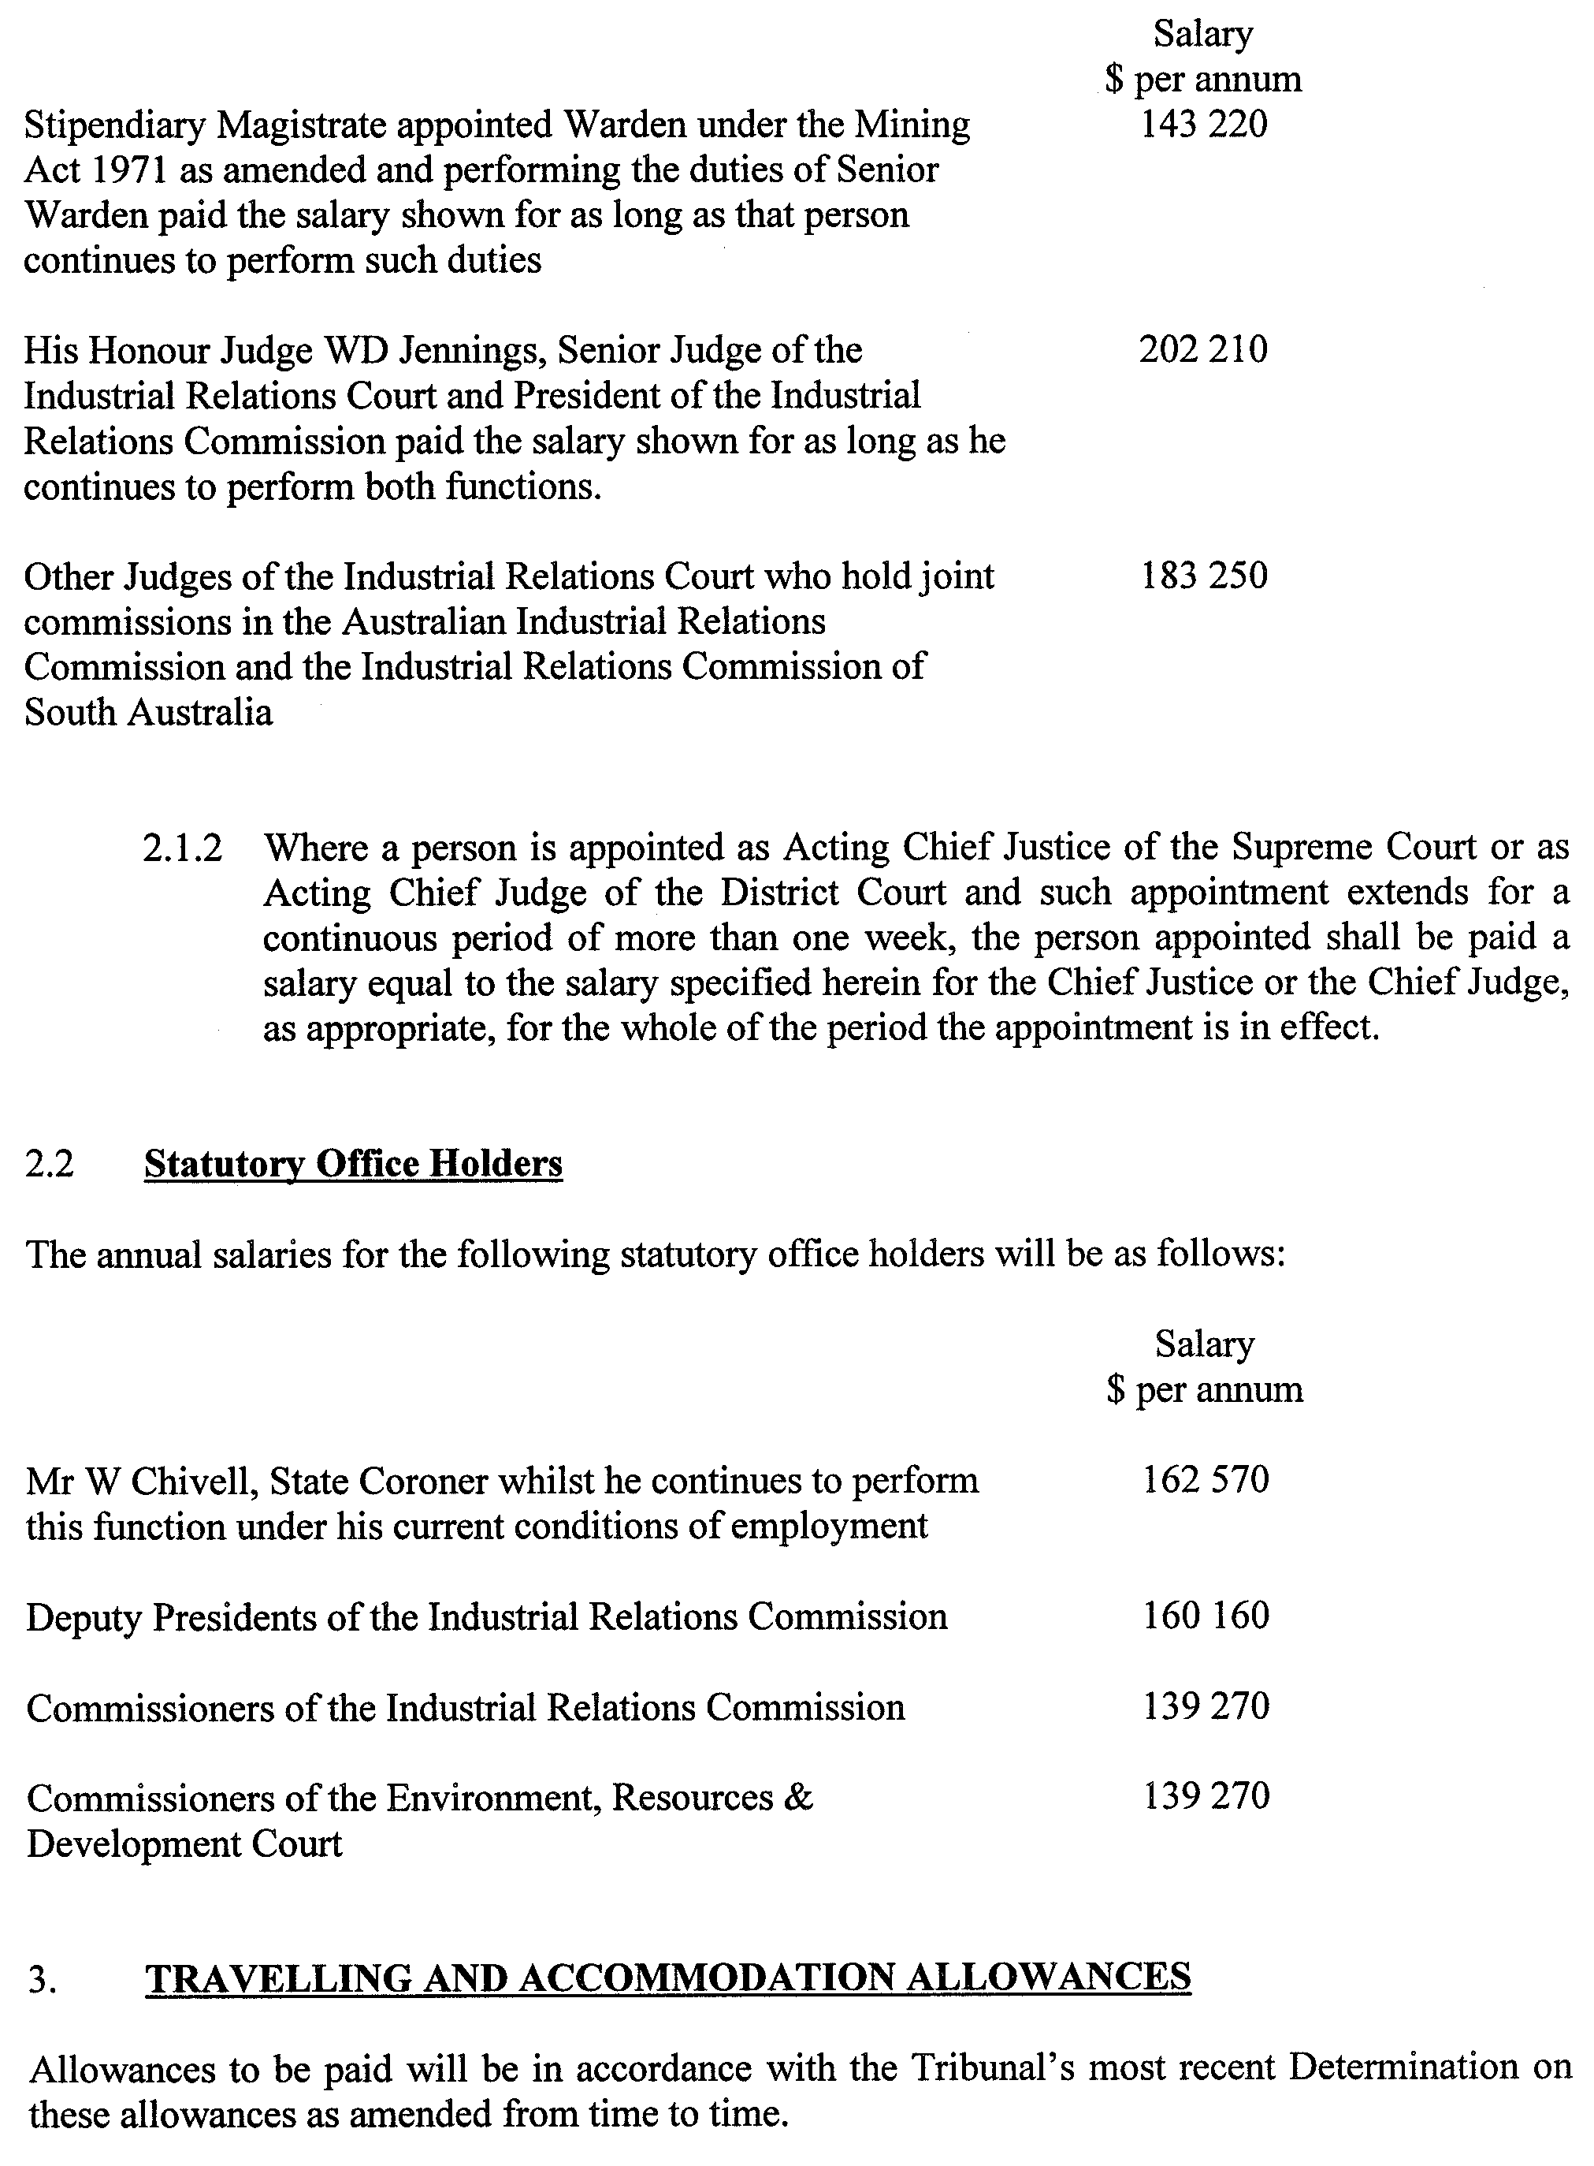
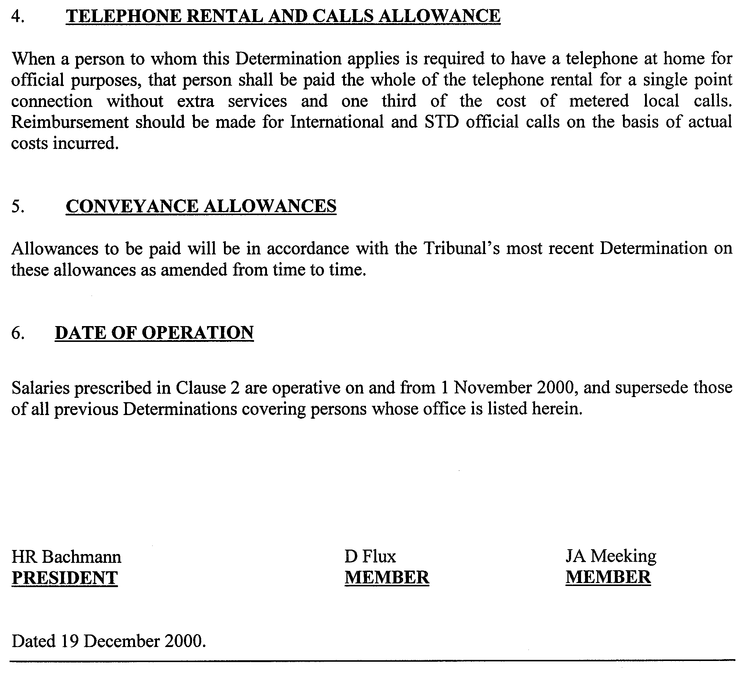
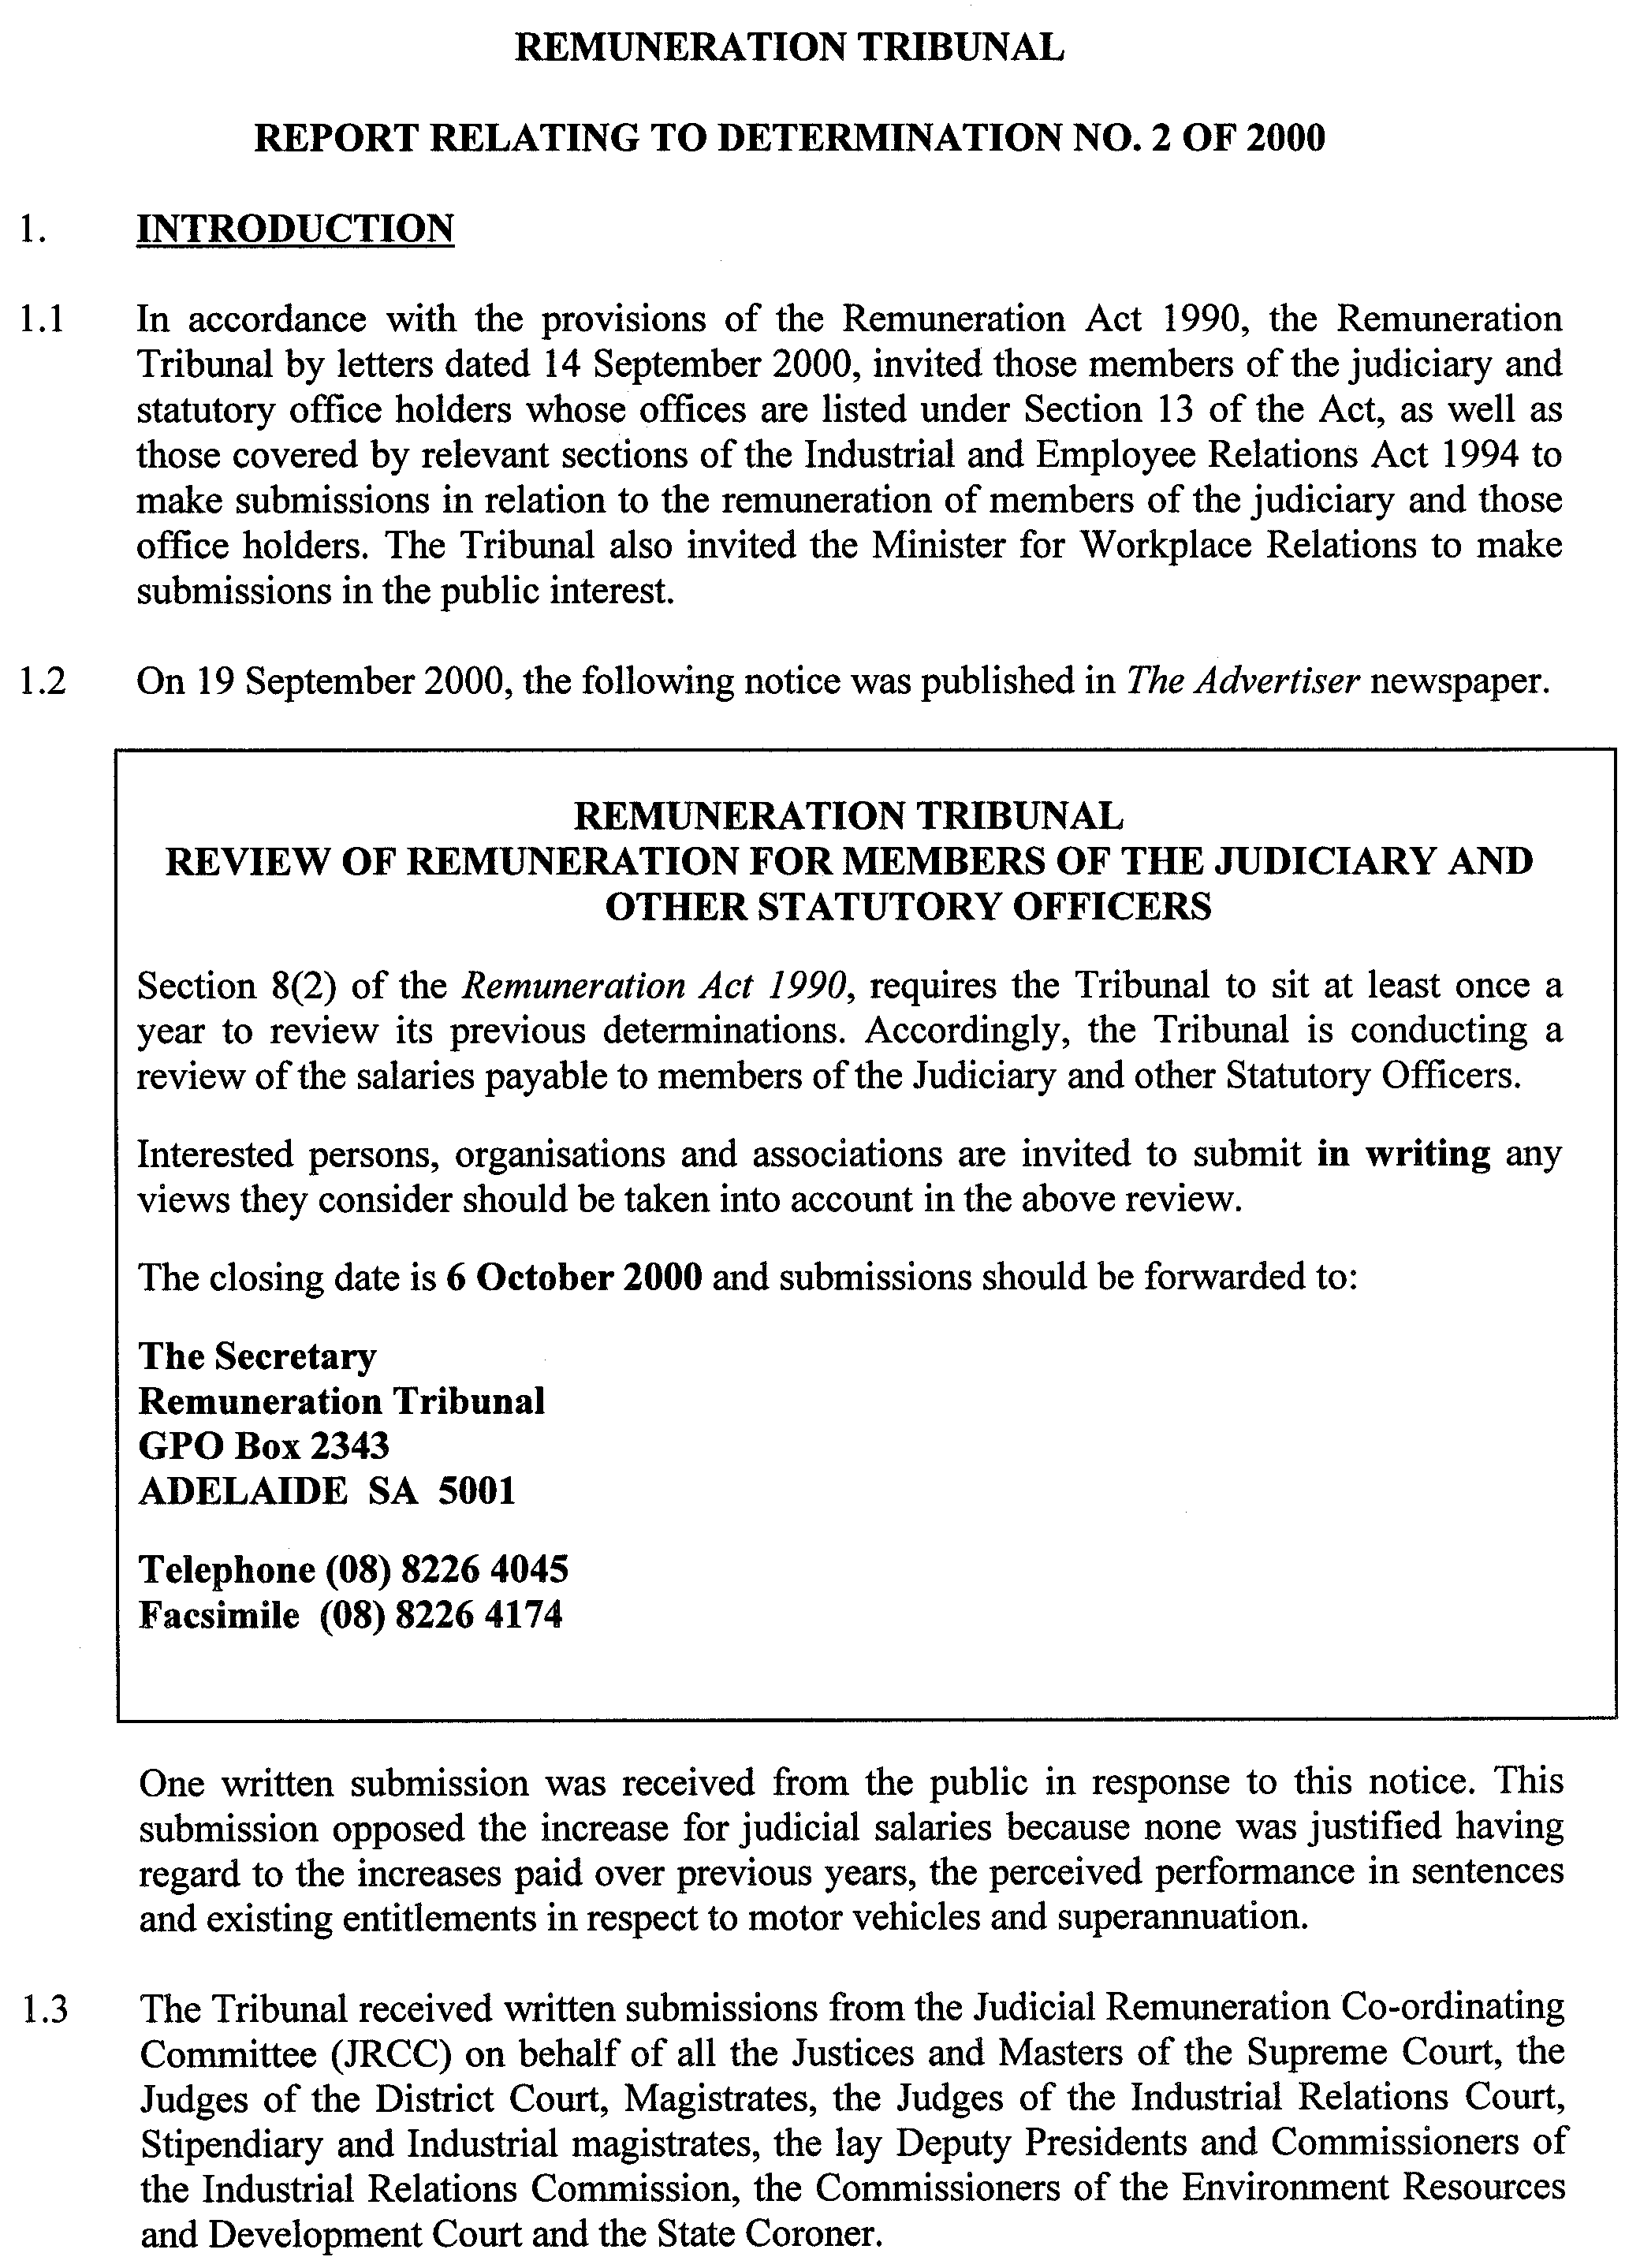
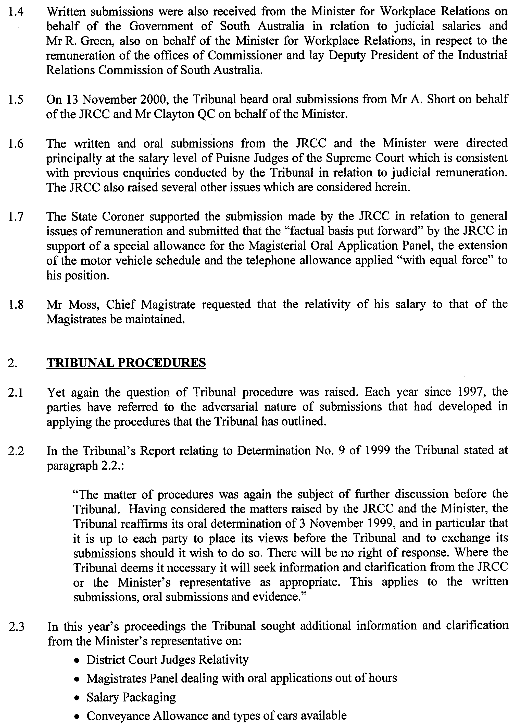
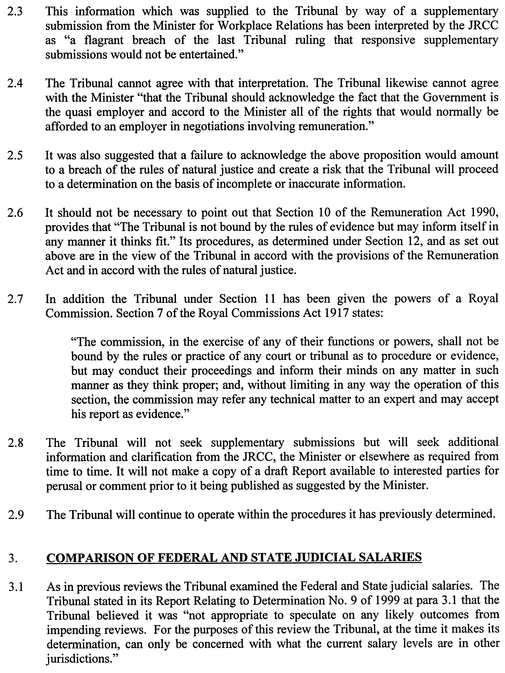
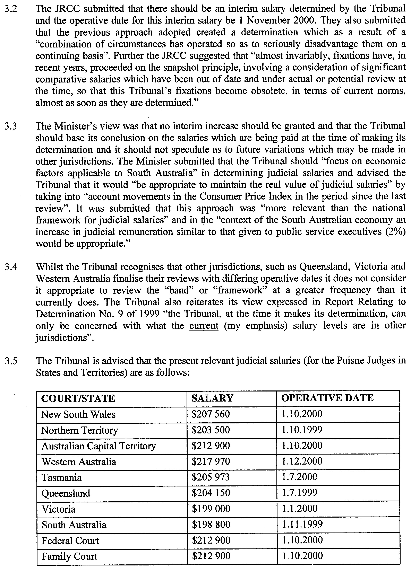

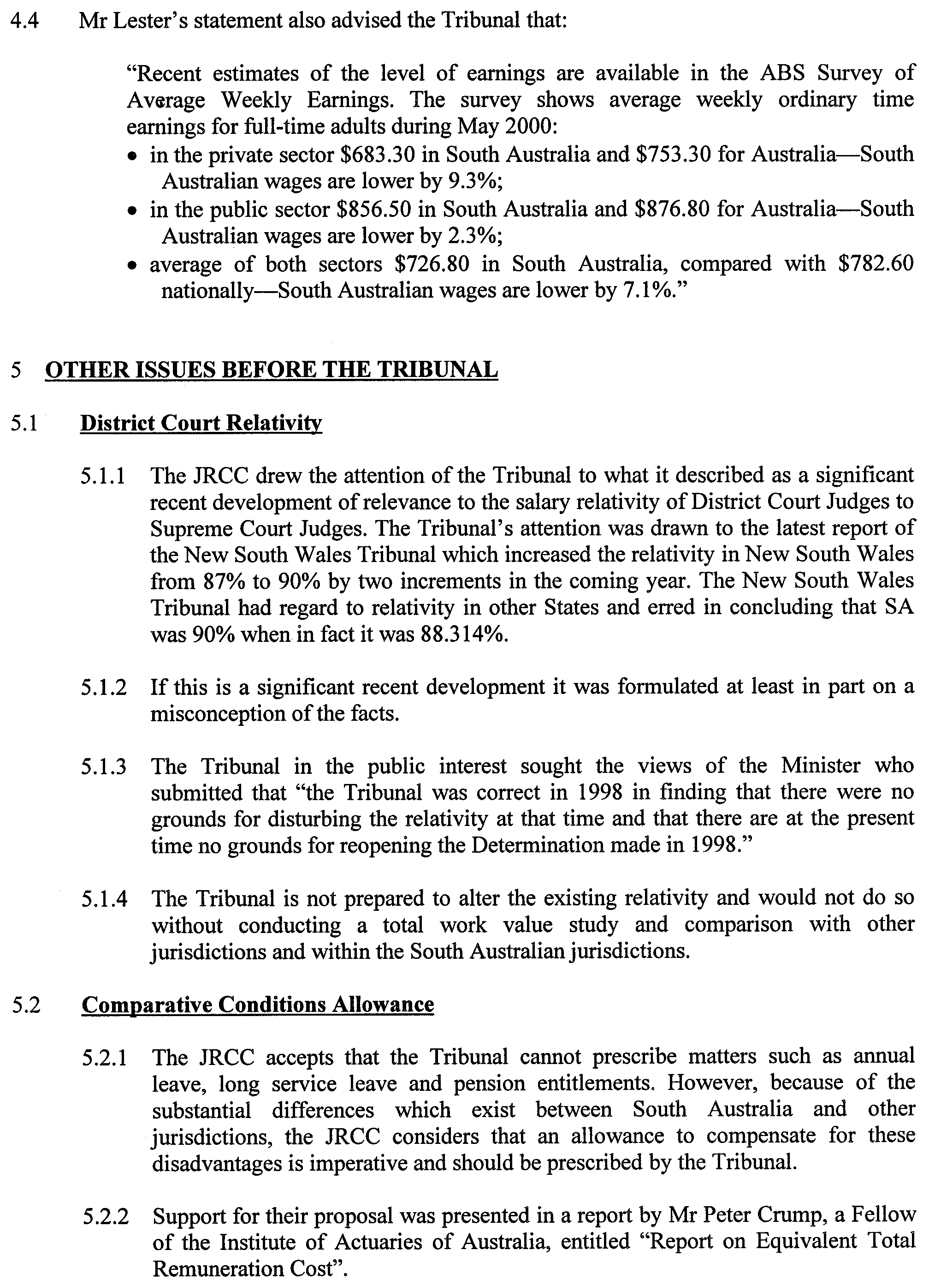
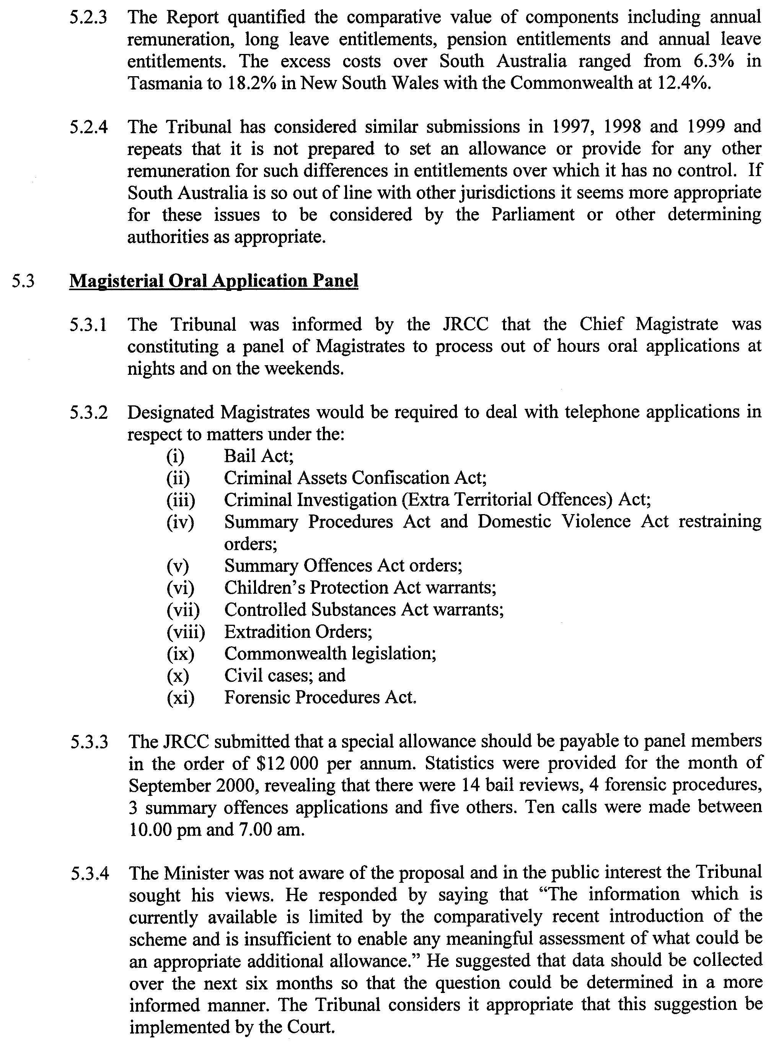
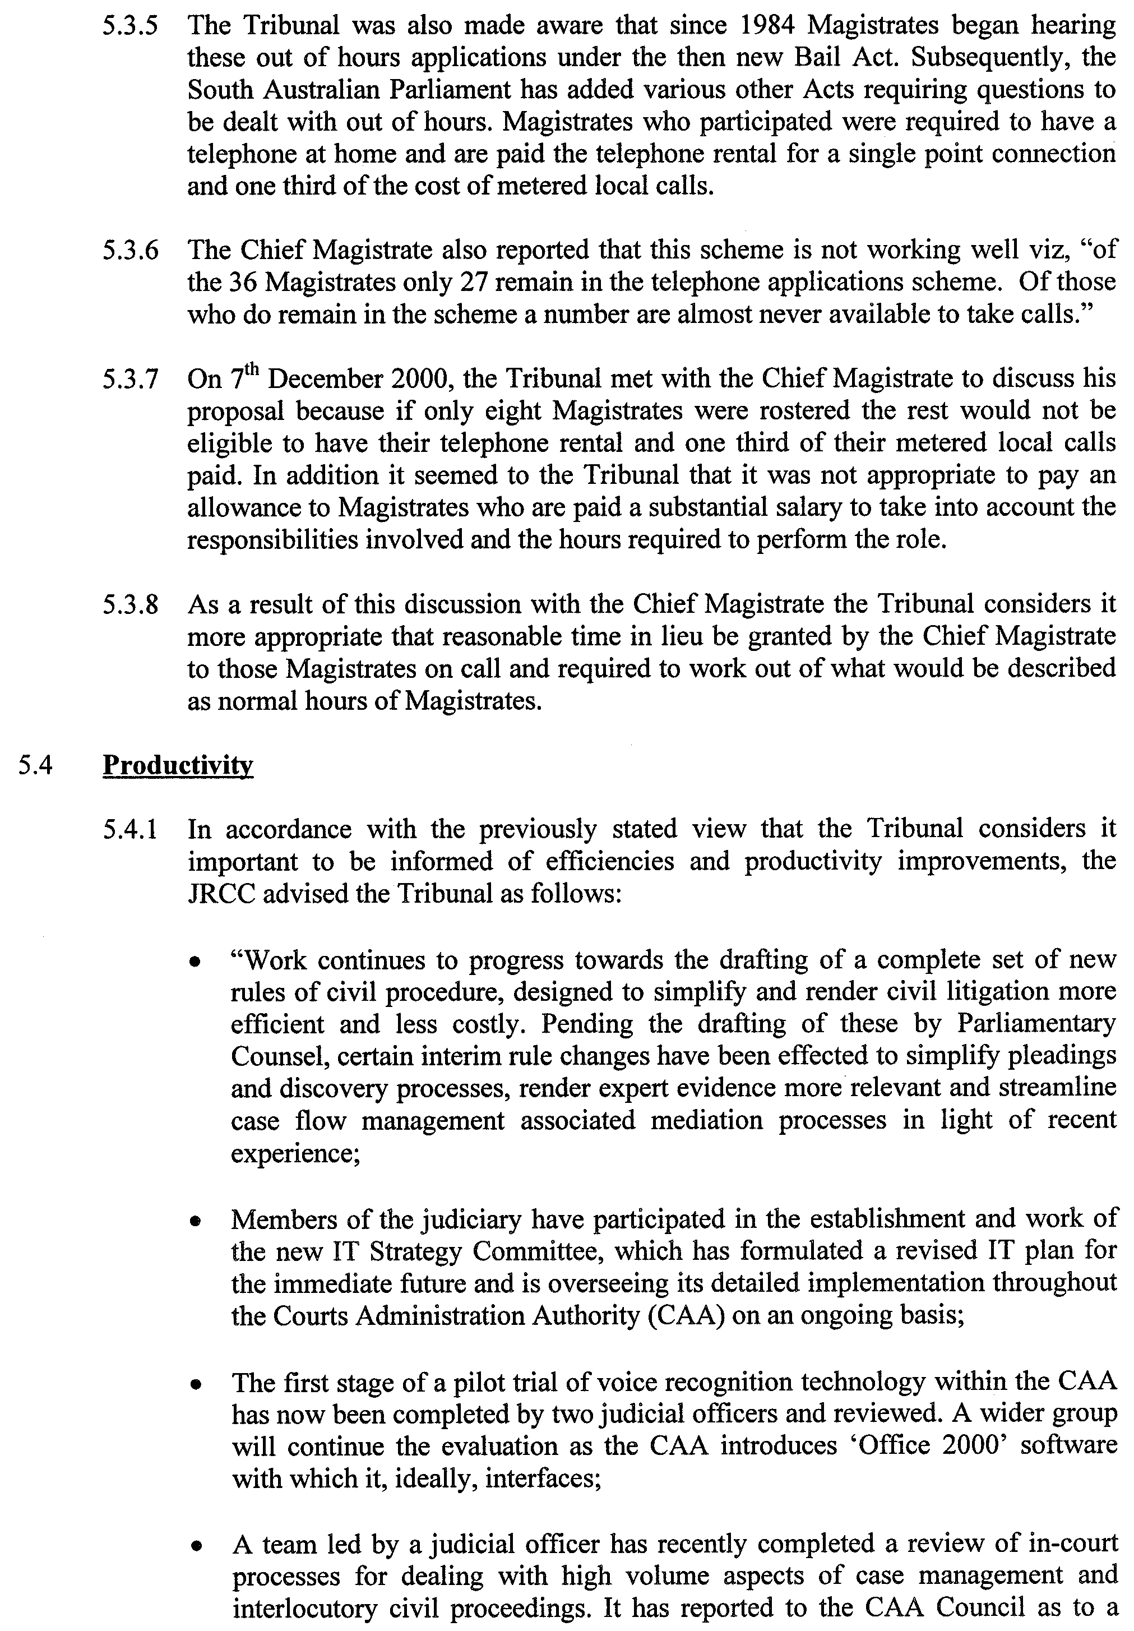
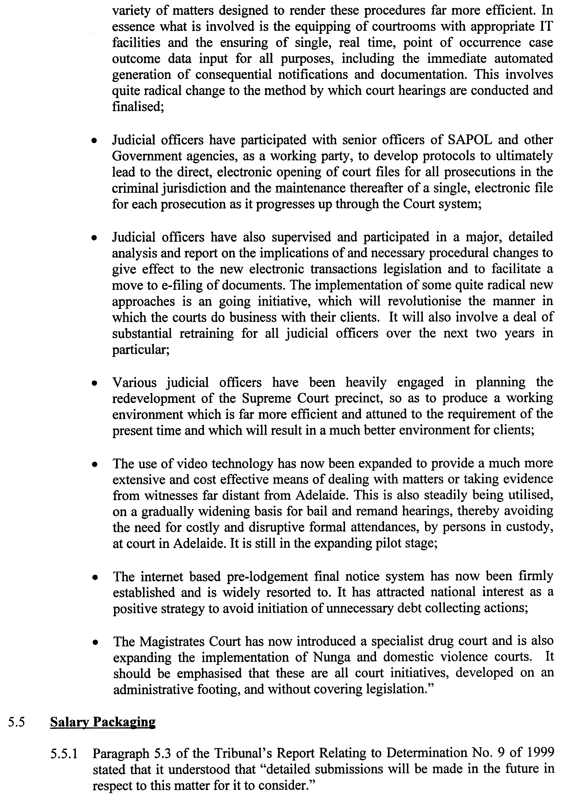
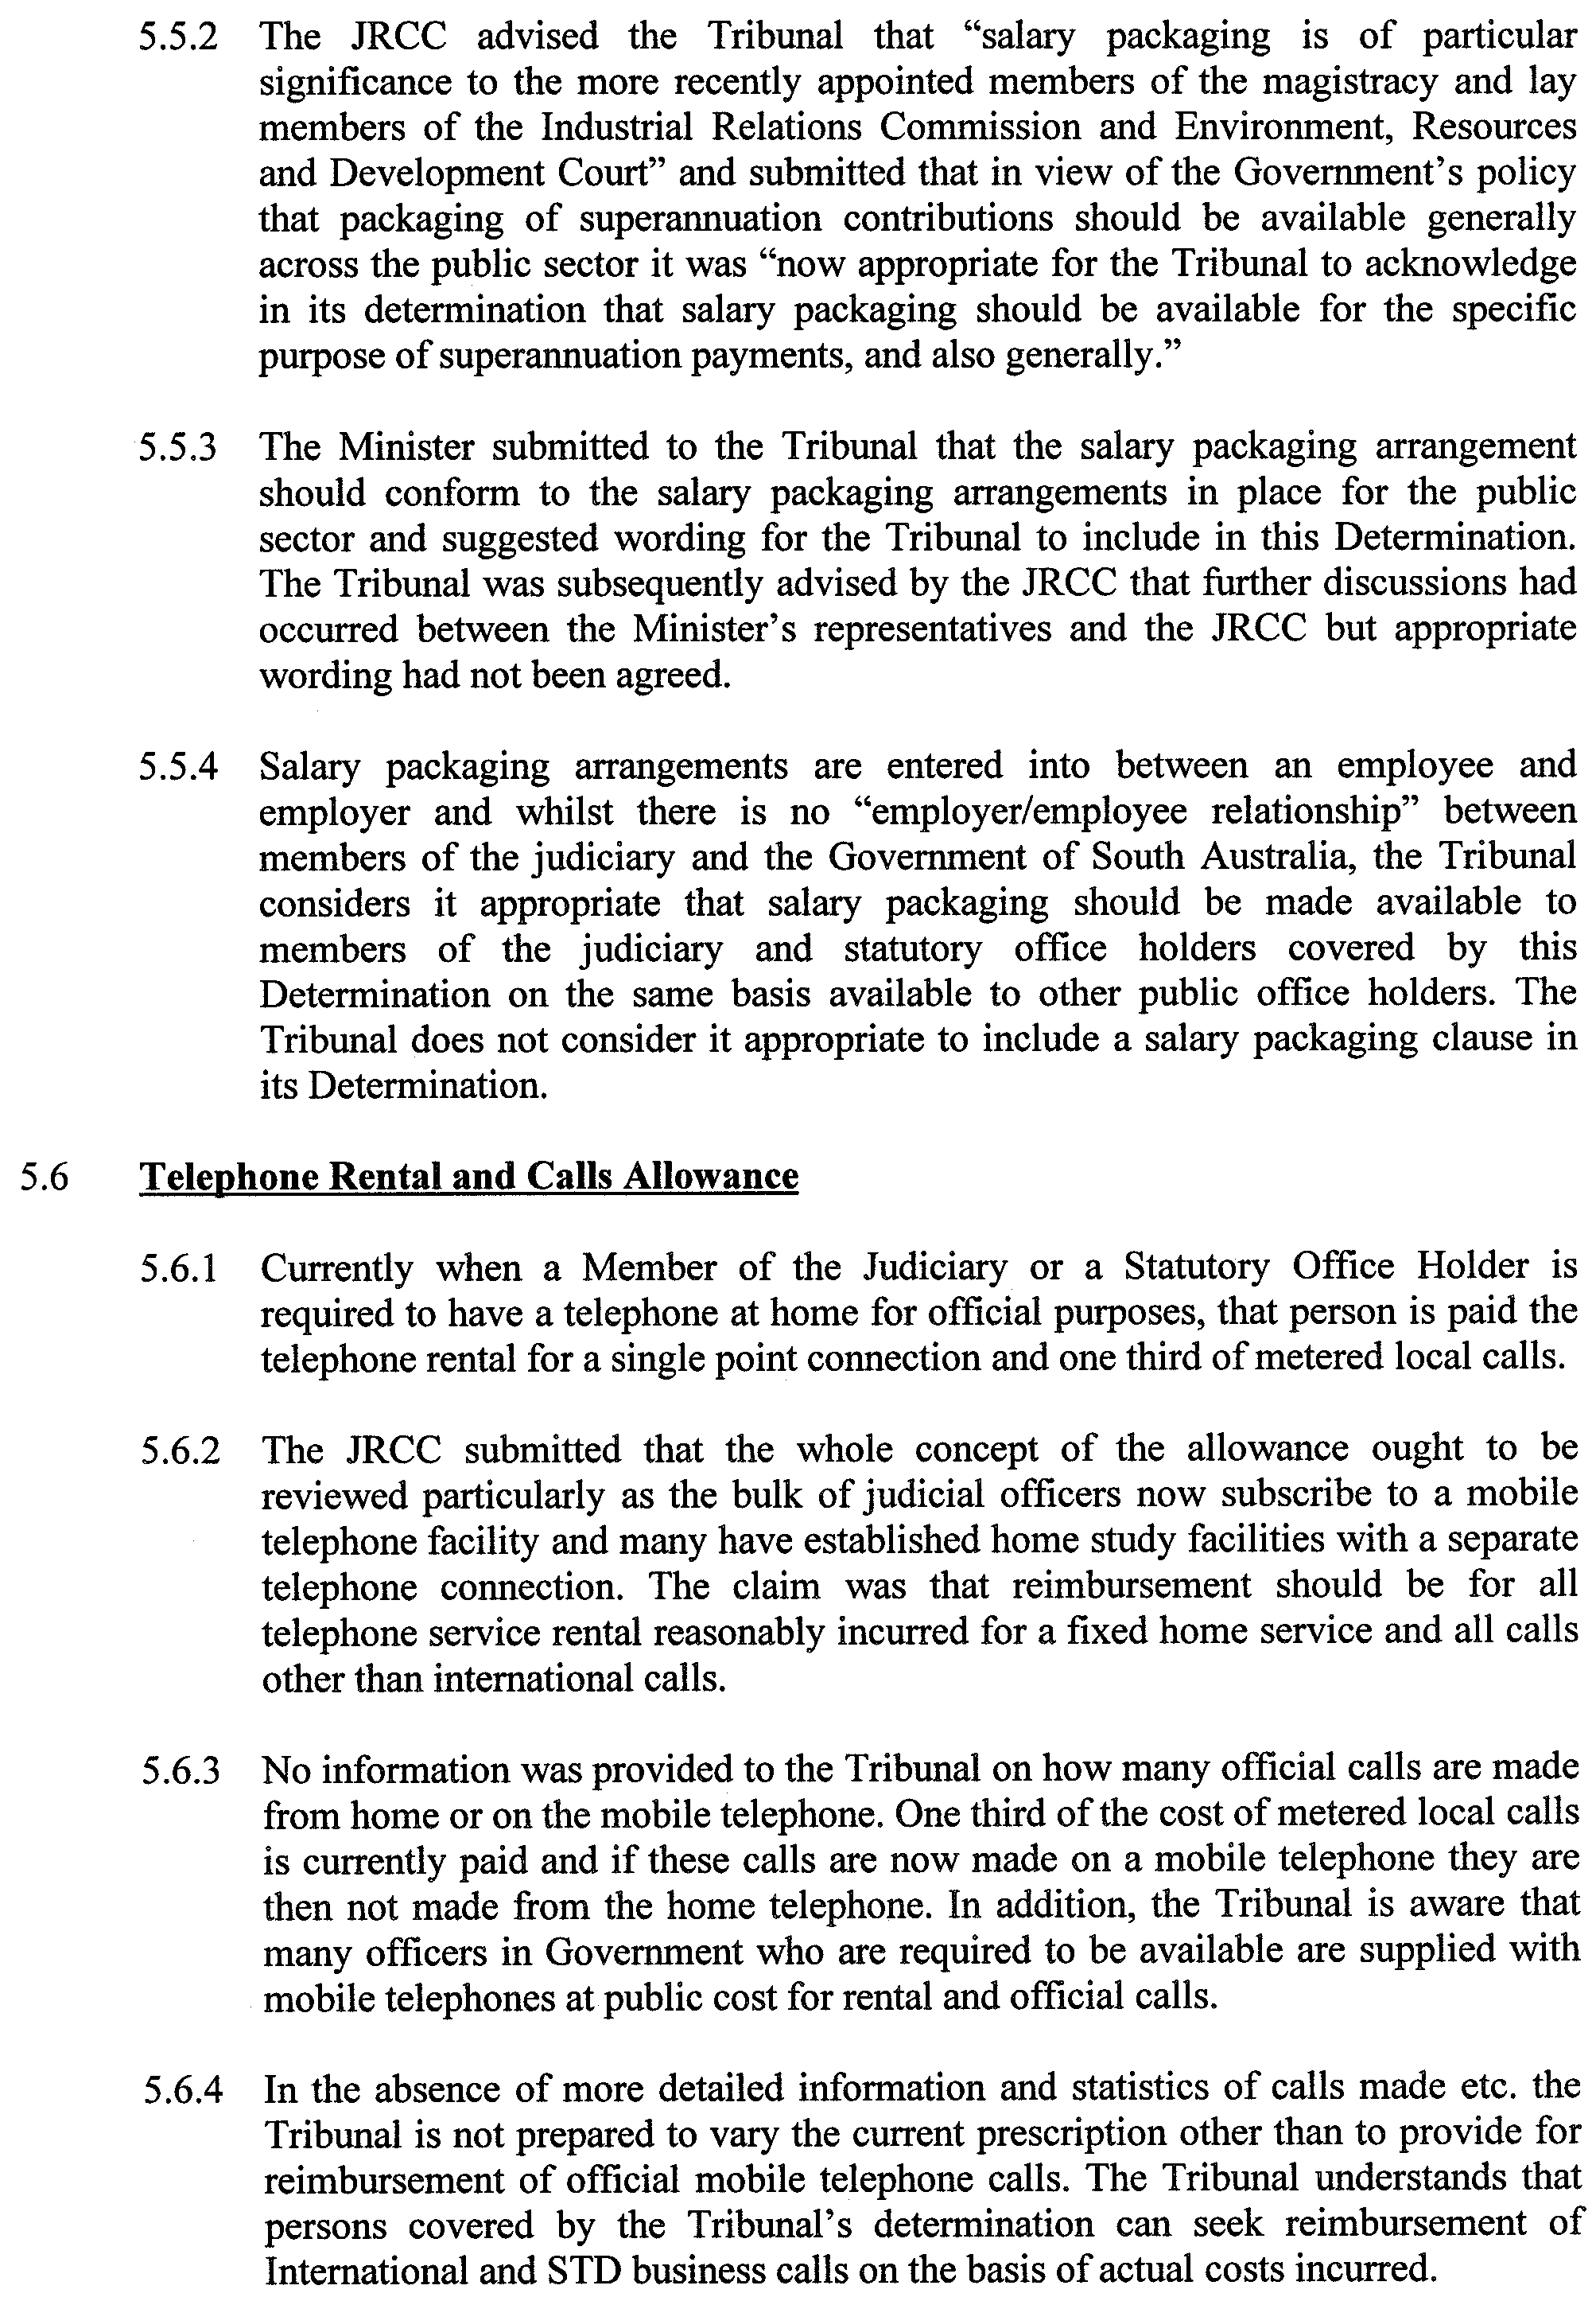
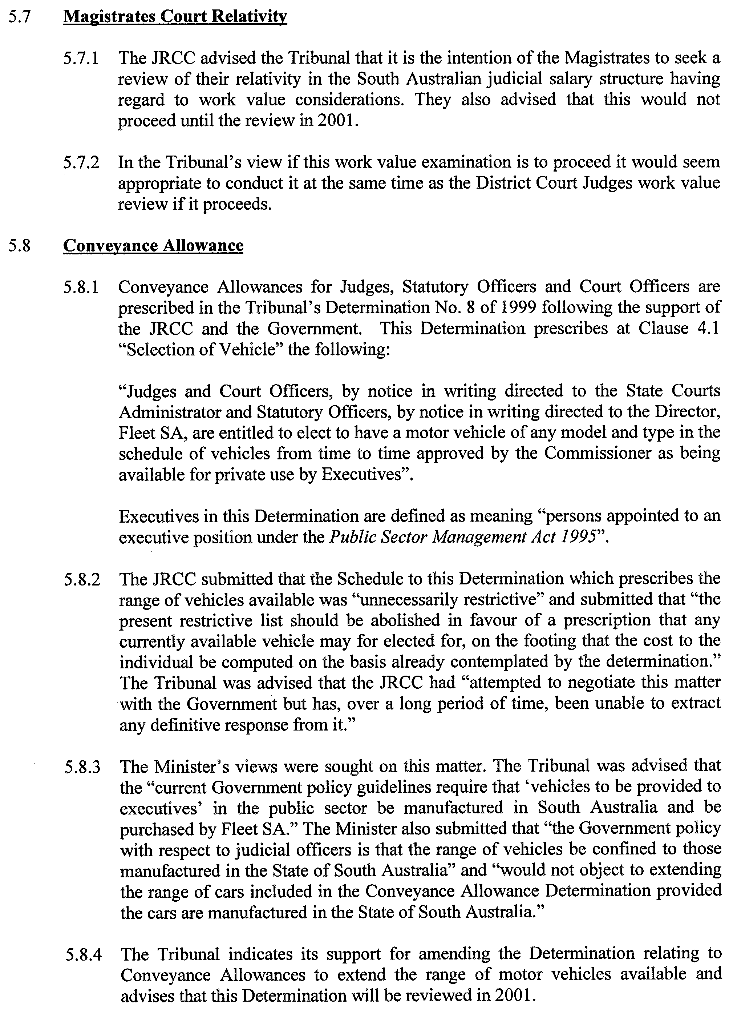
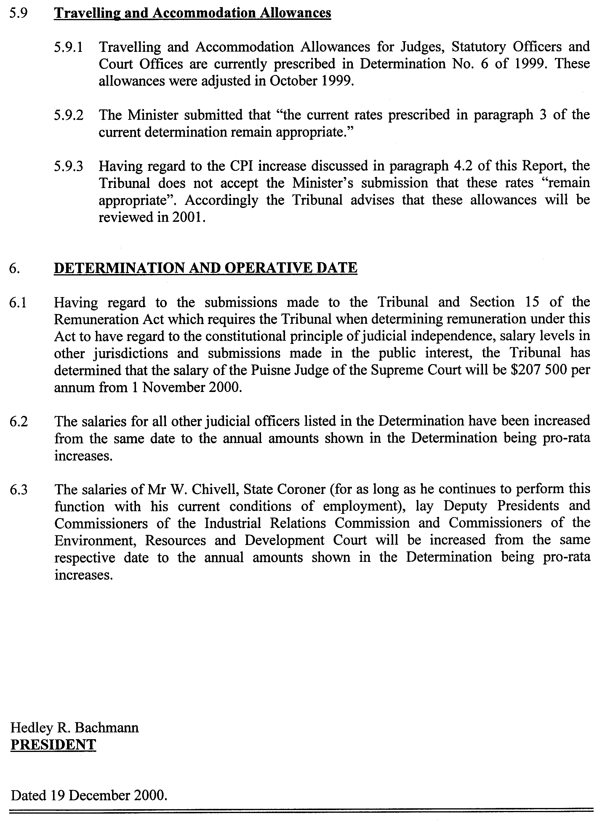

RULES OF COURT
Amending the Supreme Court Rules 1987
Amendment No. 81 to the Supreme Court Rules
BY virtue and in pursuance of Section 72 of the Supreme Court Act 1935, and all other enabling powers, We, the Judges of the Supreme Court of South Australia, make the following Rules to take effect as amendments to the Supreme Court Rules 1987, as amended:
1. These Rules may be cited as the ‘Supreme Court Rules 1987 Amendment No. 81’.
2. The Supreme Court Rules 1987 as amended by these Rules may be cited as the ‘Supreme Court Rules 1987.
3. That Rule 64 be amended by adding after Rule 64.02 the following:
‘ACTIONS TRANSFERRED FROM THE MAGISTRATES COURT
64.03 Where any civil proceedings in the Magistrates Court are transferred into this Court prior to final judgment being entered therein, subject to any direction to the contrary being given:
(a) the proceedings shall continue in this Court in the action in which the removal was ordered;
(b) where proceedings if transferred from the Magistrates Court would be consolidated with an action in this Court the order for the transfer may be sought by an application in the existing action in this Court;
(c) each pleading filed in the proceedings in the Magistrates Court shall stand as if it were the equivalent pleading under these Rules;
(d) where the pleadings in the Magistrates Court refer to a monetary limit upon the amount of the claim the plaintiff shall be at liberty without further leave to amend that pleading within 21 days of the receipt of the file of the Magistrates Court in the Registry by deleting that monetary limit;
(e) The time limited for the taking of the next necessary interlocutory step in the proceedings under these Rules shall run from the date of the receipt of the file of the Magistrates Court in the Registry;
(f) without the need for any leave to amend, or any amendment, the heading on all documents filed in the proceedings in this Court after the filing of the sealed Order for the removal shall be changed (if need be) to delete any reference to the Magistrates Court Act 1991 and to show the party being the plaintiff in the Magistrates Court as the plaintiff, the defendant in the Magistrates Court as the defendant and any third or subsequent parties in the Magistrates Court as such third or subsequent parties in this Court.
64.04 (1) Where any order has been made for the transfer or the removal of any proceedings or judgment into this Court from the Magistrates Court an office copy of such order shall be served by the plaintiff upon the Registrar of the lower Court within 14 days of the making of the order.
(2) Upon service of the order pursuant to subrule (1) above the Registrar of the Court on whom such order has been served shall forthwith forward to the Registrar of this Court the complete file kept in that lower Court for such proceedings.’
GIVEN under our hands and the Seal of the Supreme Court of South Australia this 4th day of December 2000.
(l.s.) J. DOYLE, CJ
G. C. PRIOR, J
L. T. OLSSON, J
J. W. PERRY, J
K. P. DUGGAN, J
E. P. MULLIGHAN, J
B. M. DEBELLE, J
M. J. NYLAND, J
B. T. LANDER, J
H. C. WILLIAMS, J
D. J. BLEBY, J
D. F. WICKS, J
BRIAN MARTIN, J
T. A. GRAY, J

REGULATIONS UNDER THE ALICE SPRINGS TO DARWIN RAILWAY ACT 1997
────
No. 282 of 2000
────
At the Executive Council Office at Adelaide 21 December 2000

PURSUANT to the Alice Springs to Darwin Railway Act 1997 and with the advice and consent of the Executive Council, I make the following regulations.
E. J. NEAL Governor

PURSUANT to section 10AA(2) of the Subordinate Legislation Act 1978, I certify that, in my opinion, it is necessary or appropriate that the following regulations come into operation as set out below.

JOHN OLSEN Premier
───────────────────
SUMMARY OF PROVISIONS

1. Citation
2. Commencement
3. Interpretation
4. Amendment of Act
───────────────────

Citation
1. These regulations may be cited as the Alice Springs to Darwin Railway (Special Provisions) Regulations 2000.

Commencement
2. These regulations will come into operation on the day on which the Alice Springs to Darwin Railway (Miscellaneous) Amendment Act 2000 comes into operation.

Interpretation
3. In these regulations, unless the contrary intention appears—

"Act" means the Alice Springs to Darwin Railway Act 1997.

Amendment of Act
4. Pursuant to section 14(2) of the Act, the Act is amended—

(a) by inserting in section 6(1)(c) ", and to grant indemnities in connection with the authorised project" after "in connection with the authorised project";

(b) by inserting after subsection (2) of section 10 the following subsections:

(3) For the purposes of subsection (1), an interest or right does not include an interest or right granted to or by the AustralAsia Railway Corporation or the consortium.

(4) Without limiting subsection (1), the modification of interests and rights under that subsection operates so as to enable the consortium to construct, operate and maintain a railway over a road that intersects with the rail corridor.

(5) Despite any other Act or law, if a road intersecting the rail corridor established between Tarcoola and the Northern Territory is permanently closed, the land comprising that part of the road that intersects the rail corridor merges with the corridor and becomes subject to any lease or sublease over that part of the corridor.

(6) Despite any other law, fixed railway infrastructure within the rail corridor established between Tarcoola and the Northern Territory border does not merge with the land to which it is affixed and may be dealt with and disposed of as personal property.;

(c) by inserting in section 11(1) "registered" after "For the purposes of any";

(d) by striking out from paragraph (a) of section 11(1) "(as in force from time to time)" and substituting "(as enacted as Act No. 1 of 2000 of the Northern Territory without amendment)";

(e) by striking out subsections (2) to (7) (inclusive) of section 11 and substituting the following subsections:

(2) Relief against forfeiture of a lease (whether under section 138 or 139 of the applied provisions or any other law of the State, including the common law and the law of equity) is not available if the lease is being terminated as a consequence of the lawful termination of the Concession Deed.

(3) On an application for relief against forfeiture of a registered lease of land forming part of the rail corridor established between Tarcoola and the Northern Territory border under section 138 of the applied provisions, subject to subsections (2) and (11), the court must grant the relief unless the court is satisfied—

(a) that there has been a material breach of the lease; and

(b) that written notice of the breach has been given to the lessee, any sublessee under a registered sublease and the holder of any registered security over the lease or any registered sublease requiring—

(i) in the case of a remediable breach, including a breach for non-payment of rent, the breach to be remedied; or

(ii) in the case of a non-remediable breach, the payment of reasonable compensation; or

(iii) in the case of a breach which is partly remediable and partly non-remediable, the breach to be remedied to the extent that it is capable of remedy and otherwise the payment of reasonable compensation; and

(c) that a reasonable period of time to comply with the requirements set out in the notice under paragraph (b) has been given; and

(d) in the case of a breach which is remediable or partly remediable, that the breach has not been remedied and none of the lessee, any sublessee under a registered sublease or the holder of any registered security over the lease or any registered sublease is diligently pursuing the remedy of the breach or that part of the breach that is remediable; and

(e) in the case of a breach which is non-remediable or partly non-remediable, that reasonable compensation has not been paid.

(4) If a lessee under a registered lease is not entitled to relief under subsection (3), subject to subsection (2), the court may grant the lessee relief in accordance with section 138(2) and (3) of the applied provisions.

(5) Section 138 of the applied provisions (as modified by the operation of subsection (3) of this section) is to operate as if the section included a provision allowing a sublessee under a registered sublease or the holder of any registered security over a registered sublease to make application under that section in relation to the registered headlease (and such an application may be made even though the headlessee has not applied for relief under that section).

(6) Section 139 of the applied provisions is to operate as if the section included a provision allowing the holder of any registered security over a registered sublease to make application under that section as if the holder of the security were a sublessee.

(7) On an application in relation to a registered headlease of land forming part of the rail corridor established between Tarcoola and the Northern Territory border under section 139 of the applied provisions by a sublessee under a registered sublease or the holder of any registered security over a registered sublease, the court must, subject to subsections (8) and (11), grant the application unless—

(a) the granting of the application would be inconsistent with a decision on an application under section 138 of the applied provisions; or

(b) the court is satisfied, in respect of any breach of the headlease, that the headlessee has not had a reasonably opportunity—

(i) to remedy the breach or to pay reasonable compensation or both; or

(ii) to apply for relief against forfeiture,

taking into account—

(iii) sections 137 and 138 of the applied provisions and this section; and

(iv) the principle that the preservation of the headlease (and any registered sublease) by way of orders under section 138 of the applied provisions (as modified by the operation of subsection (3) of this section) is to be preferred to the making of an order under section 139 of the applied provisions; or

(c) the court is satisfied, in respect of any breach of the headlease that is attributable to any act, omission or default of the sublessee or the holder of any registered security over the sublease—

(i) that written notice of the breach has been given to the sublessee and the holder of any registered security over the sublease requiring—

(A) in the case of a remediable breach, including a breach for non-payment of rent, the breach to be remedied; or

(B) in the case of a non-remediable breach, the payment of reasonable compensation; or

(C) in the case of a breach which is partly remediable and partly non-remediable, the breach to be remedied to the extent that it is capable of remedy and otherwise the payment of reasonable compensation; and

(ii) that a reasonable period of time to comply with the requirements set out in the notice under subparagraph (i) has been given; and

(iii) in the case of a breach which is remediable or partly remediable, that the breach has not been remedied and neither the sublessee nor the holder of any registered security over the sublease is diligently pursuing the remedy of the breach or that part of the breach that is remediable; and

(iv) in the case of a breach which is non-remediable or partly non-remediable, that reasonable compensation has not been paid.

(8) Subsection (7) does not derogate from the operation of section 139(2) and (3) of the applied provisions.

(9) If a sublessee under a registered sublease is not entitled to an order under subsection (7), subject to subsection (2), the court may grant an order in accordance with section 139 of the applied provisions.

(10) If the court makes an order under section 139(1)(d) of the applied provisions in respect of a registered lease of land forming part of the rail corridor established between Tarcoola and the Northern Territory border, the lease granted to the sublessee by virtue of the order (the "new lease") is to include a provision to the effect—

(a) that despite any law to the contrary or any provisions as to the period of the new lease, the new lease will be automatically and simultaneously determined on the termination of the Concession Deed and without necessity of notice; and

(b) that if the new lease is determined in the manner contemplated by paragraph (a), the new lease and any interests derived or dependent on the new lease will be determined for all time; and

(c) that, for the avoidance of doubt, it is expressly acknowledged and agreed by the parties to the new lease that, on the termination of the Concession Deed, the new lease is intended to and will expire by effluxion of time, despite any law.

(11) The court must not make an order under section 138 or 139 of the applied provisions in relation to a registered headlease on the application of a sublessee under a registered sublease or the holder of any registered security over a registered sublease unless—

(a) the headlessee; and

(b) any sublessee under a registered sublease or holder of any registered security over a registered sublease who is not the applicant,

has had notice of the application and the court has given each of those persons who is entitled to such notice a reasonable opportunity to be heard on the application.

(12) In this section, unless the contrary intention appears—

"applied provisions" means the provisions applied by subsection (1)(a);

"lease" includes—

(a) a sublease; and

(b) a lease granted by virtue of an order under section 139(1)(d) of the applied provisions;

"lessee" includes—

(a) a sublessee; and

(b) the executors, administrators and assigns of a lessee.;

(f) by inserting in section 12(6) "relevant" after "in any such".

DIT 537/006/017 CS R. DENNIS Clerk of the Council

REGULATIONS UNDER THE PASSENGER TRANSPORT ACT 1994
────
No. 283 of 2000
────
At the Executive Council Office at Adelaide 21 December 2000

PURSUANT to the Passenger Transport Act 1994 and with the advice and consent of the Executive Council, I make the following regulations.
E. J. NEAL Governor

PURSUANT to section 10AA(2) of the Subordinate Legislation Act 1978, I certify that, in my opinion, it is necessary or appropriate that the following regulations come into operation as set out below.

DIANA LAIDLAW Minister for Transport and Urban Planning
───────────────────
SUMMARY OF PROVISIONS

1. Citation
2. Commencement
3. Variation of schedule 2
───────────────────

Citation
1. The Passenger Transport (General) Regulations 1994 (see Gazette 28 July 1994 p. 254), as varied, are referred to in these regulations as "the principal regulations".

Commencement
2. These regulations will come into operation on 29 January 2001.

Variation of schedule 2
3. Schedule 2 of the principal regulations is varied—

(a) by striking out from clause 1(1)(b)(i) "92.24 metres" and substituting "89.47 metres";

(b) by striking out from clause 1(1)(b)(ii) "86.14 metres" and substituting "83.55 metres";

(c) by striking out from clause 2(1) "$0.72" and substituting "$0.75".

PTB 943/2000 CS R. DENNIS Clerk of the Council

REGULATIONS UNDER THE DEVELOPMENT ACT 1993
────
No. 284 of 2000
────
At the Executive Council Office at Adelaide 21 December 2000

PURSUANT to the Development Act 1993 and with the advice and consent of the Executive Council, I make the following regulations.
E. J. NEAL Governor

PURSUANT to section 10AA(2) of the Subordinate Legislation Act 1978, I certify that, in my opinion, it is necessary or appropriate that the following regulations come into operation as set out below.

DIANA LAIDLAW Minister for Transport and Urban Planning
───────────────────
SUMMARY OF PROVISIONS

1. Citation
2. Commencement
3. Variation of reg. 6A—Significant trees
4. Insertion of reg. 18
18. Notification of application for tree-damaging activity to owner of land
5. Variation of schedule 9
6. Variation of schedule 10
───────────────────

Citation
1. The Development Regulations 1993 (see Gazette 27 October 1993 p. 1954), as varied, are referred to in these regulations as "the principal regulations".

Commencement
2. These regulations come into operation on the day on which they are made.

Variation of reg. 6A—Significant trees
3. Regulation 6A of the principal regulations is varied—

(a) by striking out from subregulation (1)(a) "Metropolitan Adelaide" and substituting "the designated area";

(b) by inserting after subregulation (1) the following subregulation:

(1a) For the purposes of subregulation (1)(a), the designated area will be constituted by—

(a) the whole of Metropolitan Adelaide, other than—

(i) those parts of the area of the Adelaide Hills Council within the Extractive Industry Zone, the Public Purpose Zone or the Watershed (Primary Production) Zone in the Development Plan that relates to that area; and

(ii) those parts of the area of the City of Playford within the Watershed Zone or the Mount Lofty Ranges Rural Zone on the eastern side of the Hills Face Zone in the Development Plan that relates to that area; and

(b) any part of the area of the Adelaide Hills Council outside Metropolitan Adelaide that is within a Country Township Zone in the Development Plan that relates to that area.

Insertion of reg. 18
4. The following regulation is inserted after regulation 17 of the principal regulations:

Notification of application for tree-damaging activity to owner of land
18. If an owner of land to which an application for a tree-damaging activity in relation to a significant tree relates is not a party to the application, the relevant authority must—

(a) give the owner notice of the application within five business days after the application is made; and

(b) give due consideration in its assessment of the application to any submissions made by the owner within a reasonable time after the giving of notice under paragraph (a).

Variation of schedule 9
5. Schedule 9 of the principal regulations is varied by striking out from clause 7 in Part 2 "Any development" and substituting "Except where the activity is undertaken under section 54A of the Act, any development".

Variation of schedule 10
6. Schedule 10 of the principal regulations is varied by inserting after subparagraph (iv) of clause 1(a) the following subparagraph:

(iva) a tree-damaging activity undertaken in relation to a significant tree; or.

MFTUCAB 32/00 R. DENNIS Clerk of the Council

REGULATIONS UNDER THE DEVELOPMENT ACT 1993
────
No. 285 of 2000
────
At the Executive Council Office at Adelaide 21 December 2000

PURSUANT to the Development Act 1993 and with the advice and consent of the Executive Council, I make the following regulations.
E. J. NEAL Governor

PURSUANT to section 10AA(2) of the Subordinate Legislation Act 1978, I certify that, in my opinion, it is necessary or appropriate that the following regulations come into operation as set out below.

DIANA LAIDLAW Minister for Transport and Urban Planning
───────────────────
SUMMARY OF PROVISIONS

1. Citation
2. Commencement
3. Variation of Schedule 3
4. Variation of Schedule 4
5. Variation of Schedule 9
6. Variation of Schedule 10
───────────────────

Citation
1. The Development Regulations 1993 (see Gazette 27 October 1993 p. 1954), as varied, are referred to in these regulations as "the principal regulations".

Commencement
2. These regulations will come into operation on the day on which they are made.

Variation of Schedule 3
3. Schedule 3 of the principal regulations is varied—

(a) by inserting after subclause (5) of clause 3 the following subclause:

(5a) The division of an allotment—

(a) for the purpose of widening or adding to an existing rail corridor or rail reserve, subject to the condition that any land that is being added to the rail corridor or rail reserve is, or is to be, vested in an owner or operator of the relevant railway; or

(b) for purposes associated with the construction, use, alteration, extension, repair or maintenance of any form of infrastructure*, or with gaining access to any form of infrastructure*, located on a rail corridor or rail reserve.

*The infrastructure need not be rail infrastructure.;

(b) by inserting after clause 12 the following clause:

Railway activities
13. (1) Other than in respect of a local heritage place, the construction, alteration, extension, repair or maintenance (including any incidental excavation or filling) of any of the following:

(a) railway track, other than—

(i) track for a new railway line, but not including a siding or passing or crossing loop outside Metropolitan Adelaide that is to be less than 1 kilometre in length; or

(ii) track for an extension to an existing railway line where the length of new track is to be at least—

(A) within Metropolitan Adelaide—300 metres;

(B) outside Metropolitan Adelaide—1 kilometre;

(b) rail infrastructure;

(c) if associated with a railway—

(i) a culvert or drain not more than 1 metre deep; or

(ii) a pipe not more than 1 metre in diameter.

(2) Building work in relation to a Class 10 building under the Building Code on railway land which is not within the area of a council, other than where the building is, or is to be, within a township or 50 metres from the boundary of a township.

(3) The alteration, extension, repair or maintenance of—

(a) a bridge over railway land; or

(b) a railway tunnel, or a tunnel under railway land.

(4) An alteration to an area used for vehicle access, carparking, or the standing of vehicles, in association with the use of a railway or other railway activities.

(5) In this clause—

"rail infrastructure" means—

(a) track structures (including over or under track structures);

(b) track supports;

(c) any structure or equipment associated with any signalling, control or communications system (including signalling boxes, huts, gantries, masts, towers, poles and frames) associated with the movement of trains or the use of any railway;

(d) installations or equipment for lighting platforms or other parts of a railway station, railway yards or railway sidings, other than within Area A or Area C described in a map entitled "Airport Building Heights" if that map is contained in the relevant Development Plan;

(e) warning, directional or other signs associated with a railway;

(f) railway furniture, including information boards and seating;

"railway land" means—

(a) land within a rail corridor or rail reserve, including any associated sidings; and

(b) railway yards; and

(c) other land over which a railway track passes;

"railway line" includes sidings and crossing or passing loops.

Variation of Schedule 4
4. Schedule 4 of the principal regulations is varied—

(a) by inserting in Part 1 after clause 3 the following clause:

Railway activities
4. (1) Other than in respect of a local heritage place, development for purposes connected with the operation of a railway that is to be undertaken on railway land, other than—

(a) the construction or extension of—

(i) a passenger station or freight terminal building; or

(ii) a railway workshop; or

(iii) any other kind of building if the total floor area exceeds, or will exceed, 200 square metres; or

(b) the construction of a new railway line^{1.}, but not including a line that is replacing an existing line or following the route of a previous line; or

(c) the extension of an existing railway line^{1.}; or

(d) the construction of a new bridge; or

(e) the construction of a new tunnel.

1. Note: Certain activities do not constitute development under the Act—see clause 13 of Schedule 3.

(2) In this clause—

"bridge" includes a bridge designed to be used by—

(a) vehicles other than trains; or

(b) people;

"railway land" and "railway line" have the same meanings as in clause 13 of Schedule 3.;

(b) by inserting in Part 2 after clause 11 the following clause:

12. (1) Other than in respect of a local heritage place, building work undertaken for the purposes of the construction, alteration, extension, repair or maintenance of railway track (including track for a siding or a crossing or passing loop), other than building work associated with a new bridge or tunnel.

(2) In this clause—

"bridge" has the same meaning as in clause 4 of Part 1 of this Schedule;.

Variation of Schedule 9
5. Schedule 9 of the principal regulations is varied—

(a) by inserting after paragraph (p) of clause 6(1) in Part 1 the following paragraphs:

(q) the construction of a building for the purposes of, or a change in use to, railway activities in an industrial or commercial zone, or in a Public Purpose or Service Depot zone, as delineated in the relevant Development Plan;

(r) the construction of a building on railway land which is not within the area of a council.;

(b) by inserting the following definition in clause 6(3) in Part 1 before the definition of "telecommunications facility":

"railway land" has the same meaning as in clause 13 of Schedule 3;;

(c) by inserting in Part 1 after clause 13 the following clause:

14. (1) The construction of a new railway line, or the extension of an existing railway line, in a rail corridor or rail reserve.

(2) In subclause (1)—

"railway line" has the same meaning as in clause 13 of Schedule 3.

Variation of Schedule 10
6. Schedule 10 of the principal regulations is varied by inserting after clause 16 the following clause:

Railways

17. (1) Development for purposes connected with the construction or operation of a railway that is to be undertaken on railway land.

(2) In subclause (1)—

"railway land" has the same meaning as in clause 13 of Schedule 3.

MFTUP 46/00 CS R. DENNIS Clerk of the Council

REGULATIONS UNDER THE ROAD TRAFFIC ACT 1961
────
No. 286 of 2000
────
At the Executive Council Office at Adelaide 21 December 2000

PURSUANT to the Road Traffic Act 1961 and with the advice and consent of the Executive Council, I make the following regulations.
E. J. NEAL Governor

PURSUANT to section 10AA(2) of the Subordinate Legislation Act 1978, I certify that, in my opinion, it is necessary or appropriate that the following regulations come into operation as set out below.

DIANA LAIDLAW Minister for Transport and Urban Planning
───────────────────
SUMMARY OF PROVISIONS

1. Citation
2. Commencement
3. Variation of reg. 13—Declaration of hospitals for compulsory blood testing
───────────────────

Citation
1. The Road Traffic (Miscellaneous) Regulations 1999 (see Gazette 25 November 1999 p. 2690), as varied, are referred to in these regulations as "the principal regulations".

Commencement
2. These regulations come into operation on the day on which they are made.

Variation of reg. 13—Declaration of hospitals for compulsory blood testing
3. Regulation 13 of the principal regulations is varied—

(a) by striking out "Ceduna Hospital Incorporated" and substituting "Ceduna District Health Services Incorporated";

(b) by striking out "Leigh Creek Hospital Incorporated" and substituting "Leigh Creek Health Services Incorporated".

TSA C98/03588 R. DENNIS Clerk of the Council

REGULATIONS UNDER THE ROAD TRAFFIC ACT 1961
────
No. 287 of 2000
────
At the Executive Council Office at Adelaide 21 December 2000

PURSUANT to the Road Traffic Act 1961 and with the advice and consent of the Executive Council, I make the following regulations.
E. J. NEAL Governor

PURSUANT to section 10AA(2) of the Subordinate Legislation Act 1978, I certify that, in my opinion, it is necessary or appropriate that the following regulations come into operation as set out below.

DIANA LAIDLAW Minister for Transport and Urban Planning
───────────────────
SUMMARY OF PROVISIONS

1. Citation
2. Commencement
3. Variation of reg. 14—Photographic detection devices
───────────────────

Citation
1. The Road Traffic (Miscellaneous) Regulations 1999 (see Gazette 25 November 1999 p. 2690), as varied, are referred to in these regulations as "the principal regulations".

Commencement
2. These regulations come into operation on the day on which they are made.

Variation of reg. 14—Photographic detection devices
3. Regulation 14 of the principal regulations is varied by inserting after subparagraph (ii) of paragraph (a) the following subparagraph:

(iii) a Traffipax Traffiphot III-SR, manufactured by Robot Foto Und Electronic GMBH of Germany, linked to and used in conjunction with an induction loop vehicle detector;.

TSA C2000/04479 R. DENNIS Clerk of the Council

REGULATIONS UNDER THE ROAD TRAFFIC ACT 1961
────
No. 288 of 2000
────
At the Executive Council Office at Adelaide 21 December 2000

PURSUANT to the Road Traffic Act 1961 and with the advice and consent of the Executive Council, I make the following regulations.
E. J. NEAL Governor

PURSUANT to section 10AA(2) of the Subordinate Legislation Act 1978, I certify that, in my opinion, it is necessary or appropriate that the following regulations come into operation as set out below.

DIANA LAIDLAW Minister for Transport and Urban Planning
───────────────────
SUMMARY OF PROVISIONS

1. Citation
2. Commencement
3. Variation of reg. 19—Operation and testing of photographic detection device for speeding offences
───────────────────

Citation
1. The Road Traffic (Miscellaneous) Regulations 1999 (see Gazette 25 November 1999 p. 2690), as varied, are referred to in these regulations as "the principal regulations".

Commencement
2. These regulations come into operation on the day on which they are made.

Variation of reg. 19—Operation and testing of photographic detection device for speeding offences
3. Regulation 19 of the principal regulations is varied—

(a) by inserting in paragraph (a)(ii) "and direction of travel" after "speed";

(b) by striking out paragraph (e) and substituting the following paragraph:

(e) if a photograph produced from an exposure obtained in accordance with the provisions of paragraph (a) depicts the whole or part of more than 1 vehicle—

(i) in the portion of the photograph specified by the device's manufacturer as the portion that should depict the vehicle whose speed is being registered; and

(ii) travelling in the direction recorded on the exposure as the direction of travel of the vehicle whose speed is being registered,

that photograph must be rejected for evidentiary purposes;.

TSA C98/06883 R. DENNIS Clerk of the Council

REGULATIONS UNDER THE LIQUOR LICENSING ACT 1997
────
No. 289 of 2000
────
At the Executive Council Office at Adelaide 21 December 2000

PURSUANT to the Liquor Licensing Act 1997 and with the advice and consent of the Executive Council, I make the following regulations.
E. J. NEAL Governor

PURSUANT to section 10AA(2) of the Subordinate Legislation Act 1978, I certify that, in my opinion, it is necessary or appropriate that the following regulations come into operation as set out below.

K. T. GRIFFIN Minister for Consumer Affairs
───────────────────
SUMMARY OF PROVISIONS

1. Citation
2. Commencement
3. Variation of Sched. 1—Long Term Dry Areas
───────────────────

Citation
1. The Liquor Licensing (Dry Areas—Long Term) Regulations 1997 (see Gazette 6 November 1997 p. 1217), as varied, are referred to in these regulations as "the principal regulations".

Commencement
2. These regulations come into operation on the day on which they are made.

Variation of Sched. 1—Long Term Dry Areas
3. Schedule 1 of the principal regulations is varied—

(a) by striking out from the column headed "Period" in the item headed "Adelaide—Area 1" "2000" and substituting "2002";

(b) by striking out from the column headed "Extent of prohibition" in the item headed "Adelaide—Area 1" "The consumption of liquor is prohibited" and substituting "The consumption and possession of liquor are prohibited";

(c) by striking out from the column headed "Period" in the item headed "Coober Pedy—Area 1" "31 December 2000" and substituting "30 June 2001".

LLCS9/94 R. DENNIS Clerk of the Council
LLCS3/96

REGULATIONS UNDER THE LIQUOR LICENSING ACT 1997
────
No. 290 of 2000
────
At the Executive Council Office at Adelaide 21 December 2000

PURSUANT to the Liquor Licensing Act 1997 and with the advice and consent of the Executive Council, I make the following regulations.
E. J. NEAL Governor

PURSUANT to section 10AA(2) of the Subordinate Legislation Act 1978, I certify that, in my opinion, it is necessary or appropriate that the following regulations come into operation as set out below.

K. T. GRIFFIN Minister for Consumer Affairs
───────────────────
SUMMARY OF PROVISIONS

1. Citation
2. Commencement
3. Variation of Sched. 1—Long Term Dry Areas
───────────────────

Citation
1. The Liquor Licensing (Dry Areas—Long Term) Regulations 1997 (see Gazette 6 November 1997 p. 1217), as varied, are referred to in these regulations as "the principal regulations".

Commencement
2. These regulations come into operation on the day on which they are made.

Variation of Sched. 1—Long Term Dry Areas
3. Schedule 1 of the principal regulations is varied by striking out from the column headed "Period" in the item headed "Port Lincoln—Area 1" "2000" and substituting "2001".

LLCS8/95 R. DENNIS Clerk of the Council

REGULATIONS UNDER THE LIQUOR LICENSING ACT 1997
────
No. 291 of 2000
────
At the Executive Council Office at Adelaide 21 December 2000

PURSUANT to the Liquor Licensing Act 1997 and with the advice and consent of the Executive Council, I make the following regulations.
E. J. NEAL Governor

PURSUANT to section 10AA(2) of the Subordinate Legislation Act 1978, I certify that, in my opinion, it is necessary or appropriate that the following regulations come into operation as set out below.

K. T. GRIFFIN Minister for Consumer Affairs
───────────────────
SUMMARY OF PROVISIONS

1. Citation
2. Commencement
3. Variation of Sched. 1—Long Term Dry Areas
4. Variation of Sched. 2—Plans of Long Term Dry Areas
───────────────────

Citation
1. The Liquor Licensing (Dry Areas—Long Term) Regulations 1997 (see Gazette 6 November 1997 p. 1217), as varied, are referred to in these regulations as "the principal regulations".

Commencement
2. These regulations come into operation on the day on which they are made.

Variation of Sched. 1—Long Term Dry Areas
3. Schedule 1 of the principal regulations is varied—

(a) by inserting after the item headed "Hallett Cove—Area 2" the following items:

Hallett Cove—Area 3
(see schedule 2: Hallett Cove—Plan No. 3, Area A)

Area | Period | Extent of prohibition
The area (generally known as the Hallett Cove Shopping Centre) in Hallett Cove bounded on the south-east by Lonsdale Road, on the north-east by Ramrod Avenue, on the north-west by Zwerner Drive and Gledsdale Road, and on the south-west by Shakes Crescent Reserve, but excluding any building within that area. | Continuous until 30 March 2002. | The consumption and  possession of liquor  are prohibited.

Hallett Cove—Area 4
(see schedule 2: Hallett Cove—Plan No. 3, Area B)

Area | Period | Extent of prohibition
The area known as Shakes Crescent Reserve in Hallett Cove, being that portion of Lot 469 Capella Drive bounded on the south-east by Lonsdale Road, on the north-east by the Hallett Cove Shopping Centre, on the north-west by Gledsdale Road and on the south-west by Shakes Crescent. | From 8 p.m. on each day to 8 a.m. on the following day, until 8 a.m. on 30 March 2002. | The consumption and  possession of liquor  are prohibited.

(b) by striking out from the column headed "Period" in the item headed "Oaklands Park—Area 1" "23 December 2000" and substituting "30 March 2002".

Variation of Sched. 2—Plans of Long Term Dry Areas
4. Schedule 2 of the principal regulations is varied by inserting after the plan headed "Hallett Cove—Plan No. 2" the following plan:

Hallett Cove—Plan No. 3
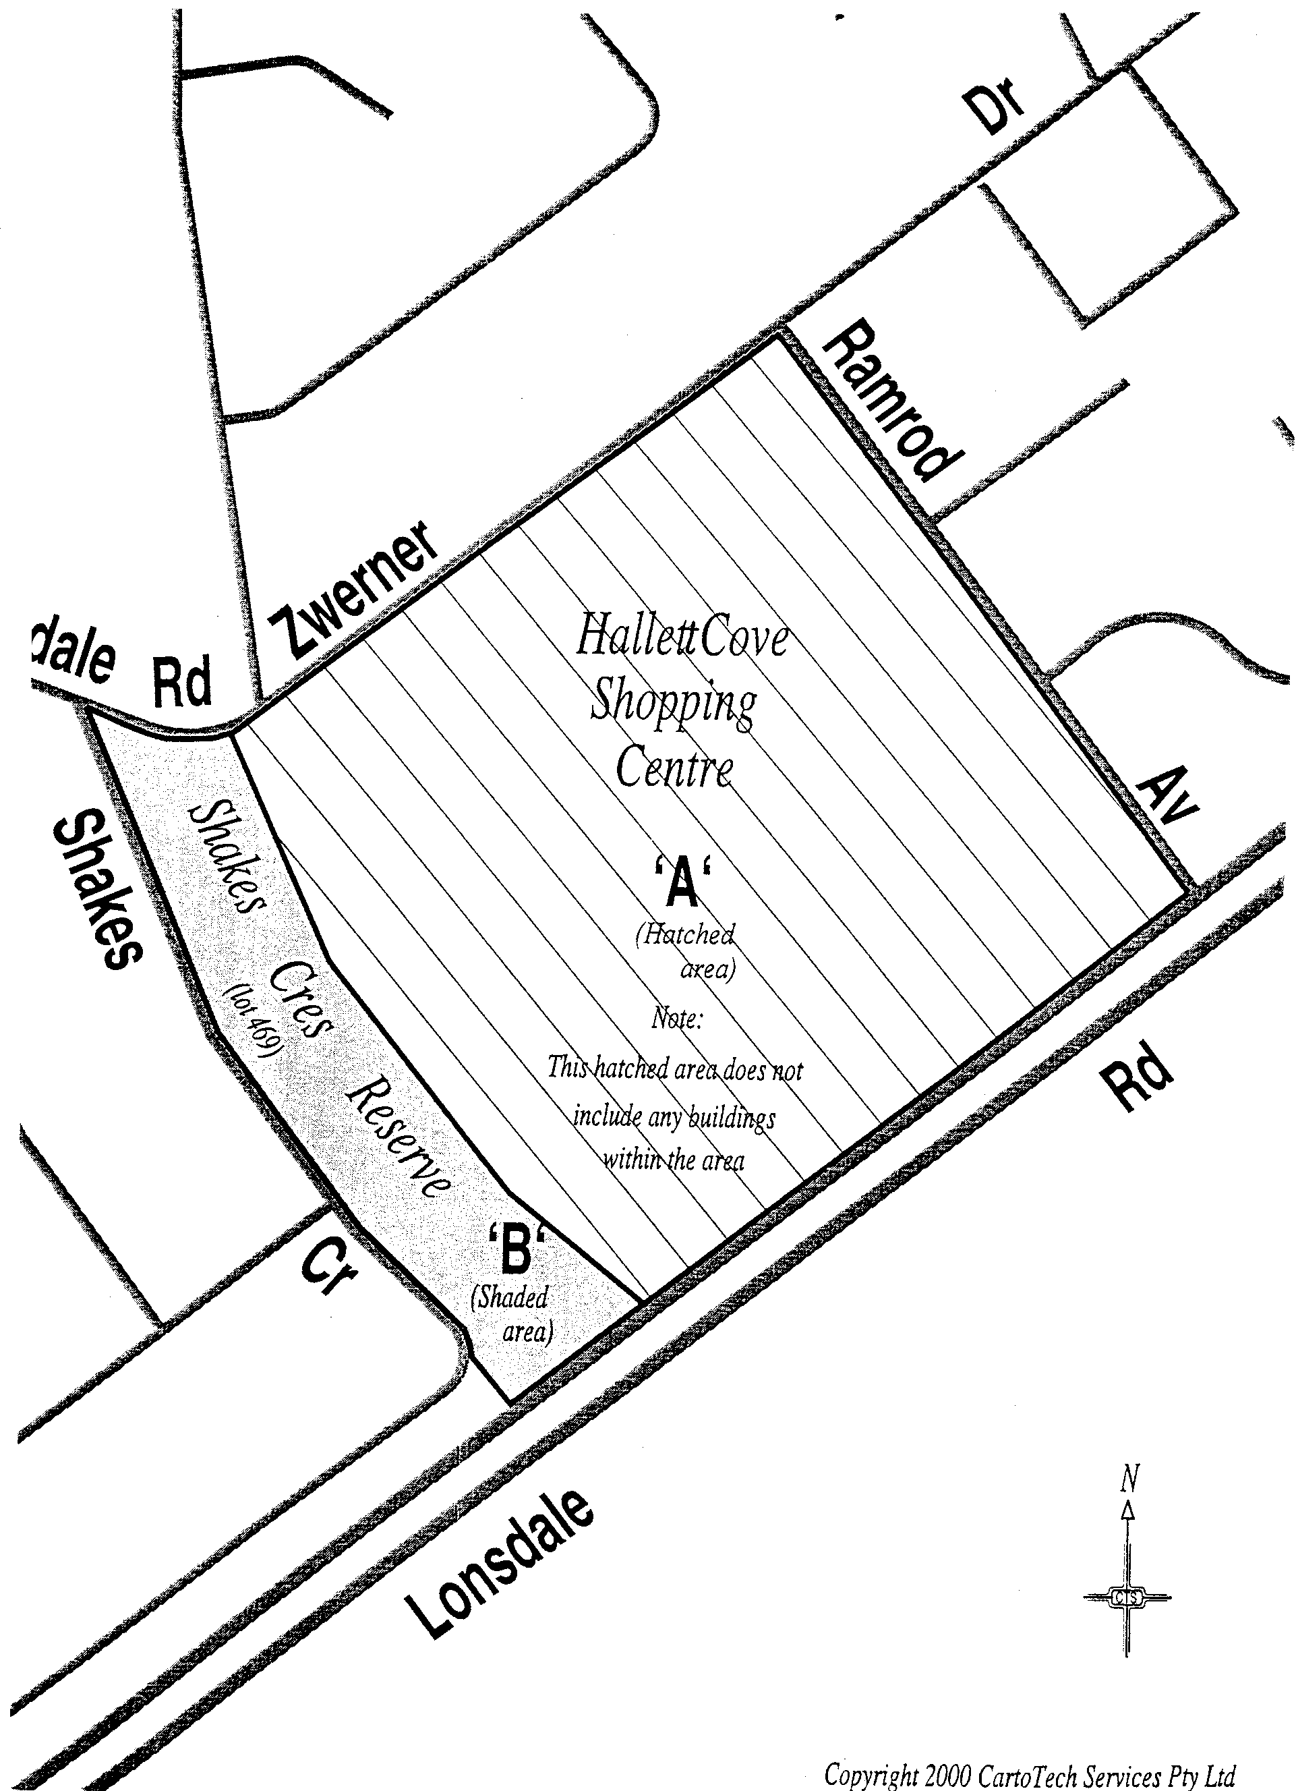

LLCS10/97 R. DENNIS Clerk of the Council
LLCS9/99
REGULATIONS UNDER THE LIQUOR LICENSING ACT 1997
────
No. 292 of 2000
────
At the Executive Council Office at Adelaide 21 December 2000

PURSUANT to the Liquor Licensing Act 1997 and with the advice and consent of the Executive Council, I make the following regulations.
E. J. NEAL Governor

PURSUANT to section 10AA(2) of the Subordinate Legislation Act 1978, I certify that, in my opinion, it is necessary or appropriate that the following regulations come into operation as set out below.

K. T. GRIFFIN Minister for Consumer Affairs
───────────────────
SUMMARY OF PROVISIONS

1. Citation
2. Commencement
3. Variation of Sched. 1—Short Term Dry Areas
4. Variation of Sched. 2—Plans of Short Term Dry Areas
───────────────────

Citation
1. The Liquor Licensing (Dry Areas—Short Term) Regulations 1997 (see Gazette 2 October 1997 p. 965), as varied, are referred to in these regulations as "the principal regulations".

Commencement
2. These regulations come into operation on the day on which they are made.

Variation of Sched. 1—Short Term Dry Areas
3. Schedule 1 of the principal regulations is varied—

(a) by striking out from the column headed "Period" in the item headed "Alexandrina Council—Area 1 (Chiton Rocks)" "1999" and "2000" and substituting, respectively, "2000" and "2001";

(b) by striking out from the column headed "Period" in the item headed "Alexandrina Council—Area 2 (Port Elliot)" "1999" and "2000" and substituting, respectively, "2000" and "2001";

(c) by striking out from the column headed "Period" in the item headed "Alexandrina Council—Area 3 (Middleton)" "1999" and "2000" and substituting, respectively, "2000" and "2001";

(d) by striking out from the column headed "Period" in the item headed "Alexandrina Council—Area 4 (Goolwa Beach Carpark)" "1999" and "2000" and substituting, respectively, "2000" and "2001";

(e) by striking out from the column headed "Period" in the item headed "Alexandrina Council—Area 5 (Rotunda Reserve Area)" "1999" and "2000" and substituting, respectively, "2000" and "2001";

(f) by striking out from the column headed "Period" in the item headed "Beachport—Area 1" "1999" and "2000" and substituting, respectively, "2000" and "2001";

(g) by striking out from the column headed "Period" in the item headed "Glenelg—Area 1" "1999" and "2000" and substituting, respectively, "2000" and "2001";

(h) by striking out the item headed "Robe—Area 1" and substituting the following item:

Robe—Area 1
(see schedule 2: Robe—Plan 1, Area "A")

Area | Period | Extent of prohibition
The area in Robe as follows: commencing at the point at which the prolongation in a straight line of the western boundary of Squire Drive intersects with the low water mark, then southerly along that prolongation and western boundary of Squire Drive to the northern boundary of Lord Syleham Street, then westerly along the northern boundary of Lord Syleham Street and O'Halloran Street to the point at which it intersects the prolongation in a straight line of the eastern boundary of Section 128, Hundred of Waterhouse (the Robe Oval), then southerly and westerly along that prolongation and the eastern and southern boundaries of Section 128 to the western boundary of that Section, then northerly along the western boundary and the prolongation in a straight line of the western boundary of Section 128 to its intersection with the northern boundary of O'Halloran Street, then westerly along the northern boundary of O'Halloran Street to the western boundary of Hagen Street, then northerly along that boundary of Hagen Street to the northern boundary of Sturt Street, then westerly along the northern boundary of Sturt Street to the south-west corner of the area known as Lipson Park, then north-easterly along the fence line forming the western boundary of the Park and the prolongation in a straight line of that fence line to the low water mark on Lake Butler, then generally north-easterly along the low water mark to its intersection with the south-westerly prolongation in a straight line of the eastern boundary of Lot 1 of DP 33446, Hundred of Waterhouse (the boundary between that Lot and Lipson Terrace) then north-easterly along that prolongation to the western boundary of Lipson Terrace, then north-easterly and easterly along the western boundary of Lipson Terrace and the northern boundary of Mundy Terrace to the eastern boundary of Lot 4 of DP 33446, Hundred of Waterhouse, then north-easterly along the eastern boundary of Lot 4, the eastern boundary of Lot 3 of DP 33446 and the prolongation in a straight line of the eastern boundary of Lot 3 to the low water mark, then generally easterly along the low water mark to the point of commencement. | 3.00 p.m. on 30 December 2000 to 9.00 a.m. on 1 January 2001. | The consumption of liquor is prohibited and the possession of liquor is prohibited.

(i) by striking out from the column headed "Period" in the item headed "Robe—Area 2" "12.01 a.m. on 31 December 1999 to 12.01 a.m. on 3 January 2000" and substituting "3.00 p.m. on 30 December 2000 to 9.00 a.m. on 1 January 2001";

(j) by striking out from the column headed "Period" in the item headed "Robe—Area 3" "12.01 a.m. on 31 December 1999 to 12.01 a.m. on 3 January 2000" and substituting "3.00 p.m. on 30 December 2000 to 9.00 a.m. on 1 January 2001";

(k) by striking out from the column headed "Period" in the item headed "Victor Harbor—Area 1" "1999", twice occurring, and substituting, in each case, "2000";

(l) by striking out from the column headed "Period" in the item headed "Victor Harbor—Area 2" "1999", twice occurring, and substituting, in each case, "2000".

Variation of Sched. 2—Plans of Short Term Dry Areas
4. Schedule 2 of the principal regulations is varied by striking out the plan headed "Robe—Plan 1" and substituting the following plan:

Robe—Plan 1
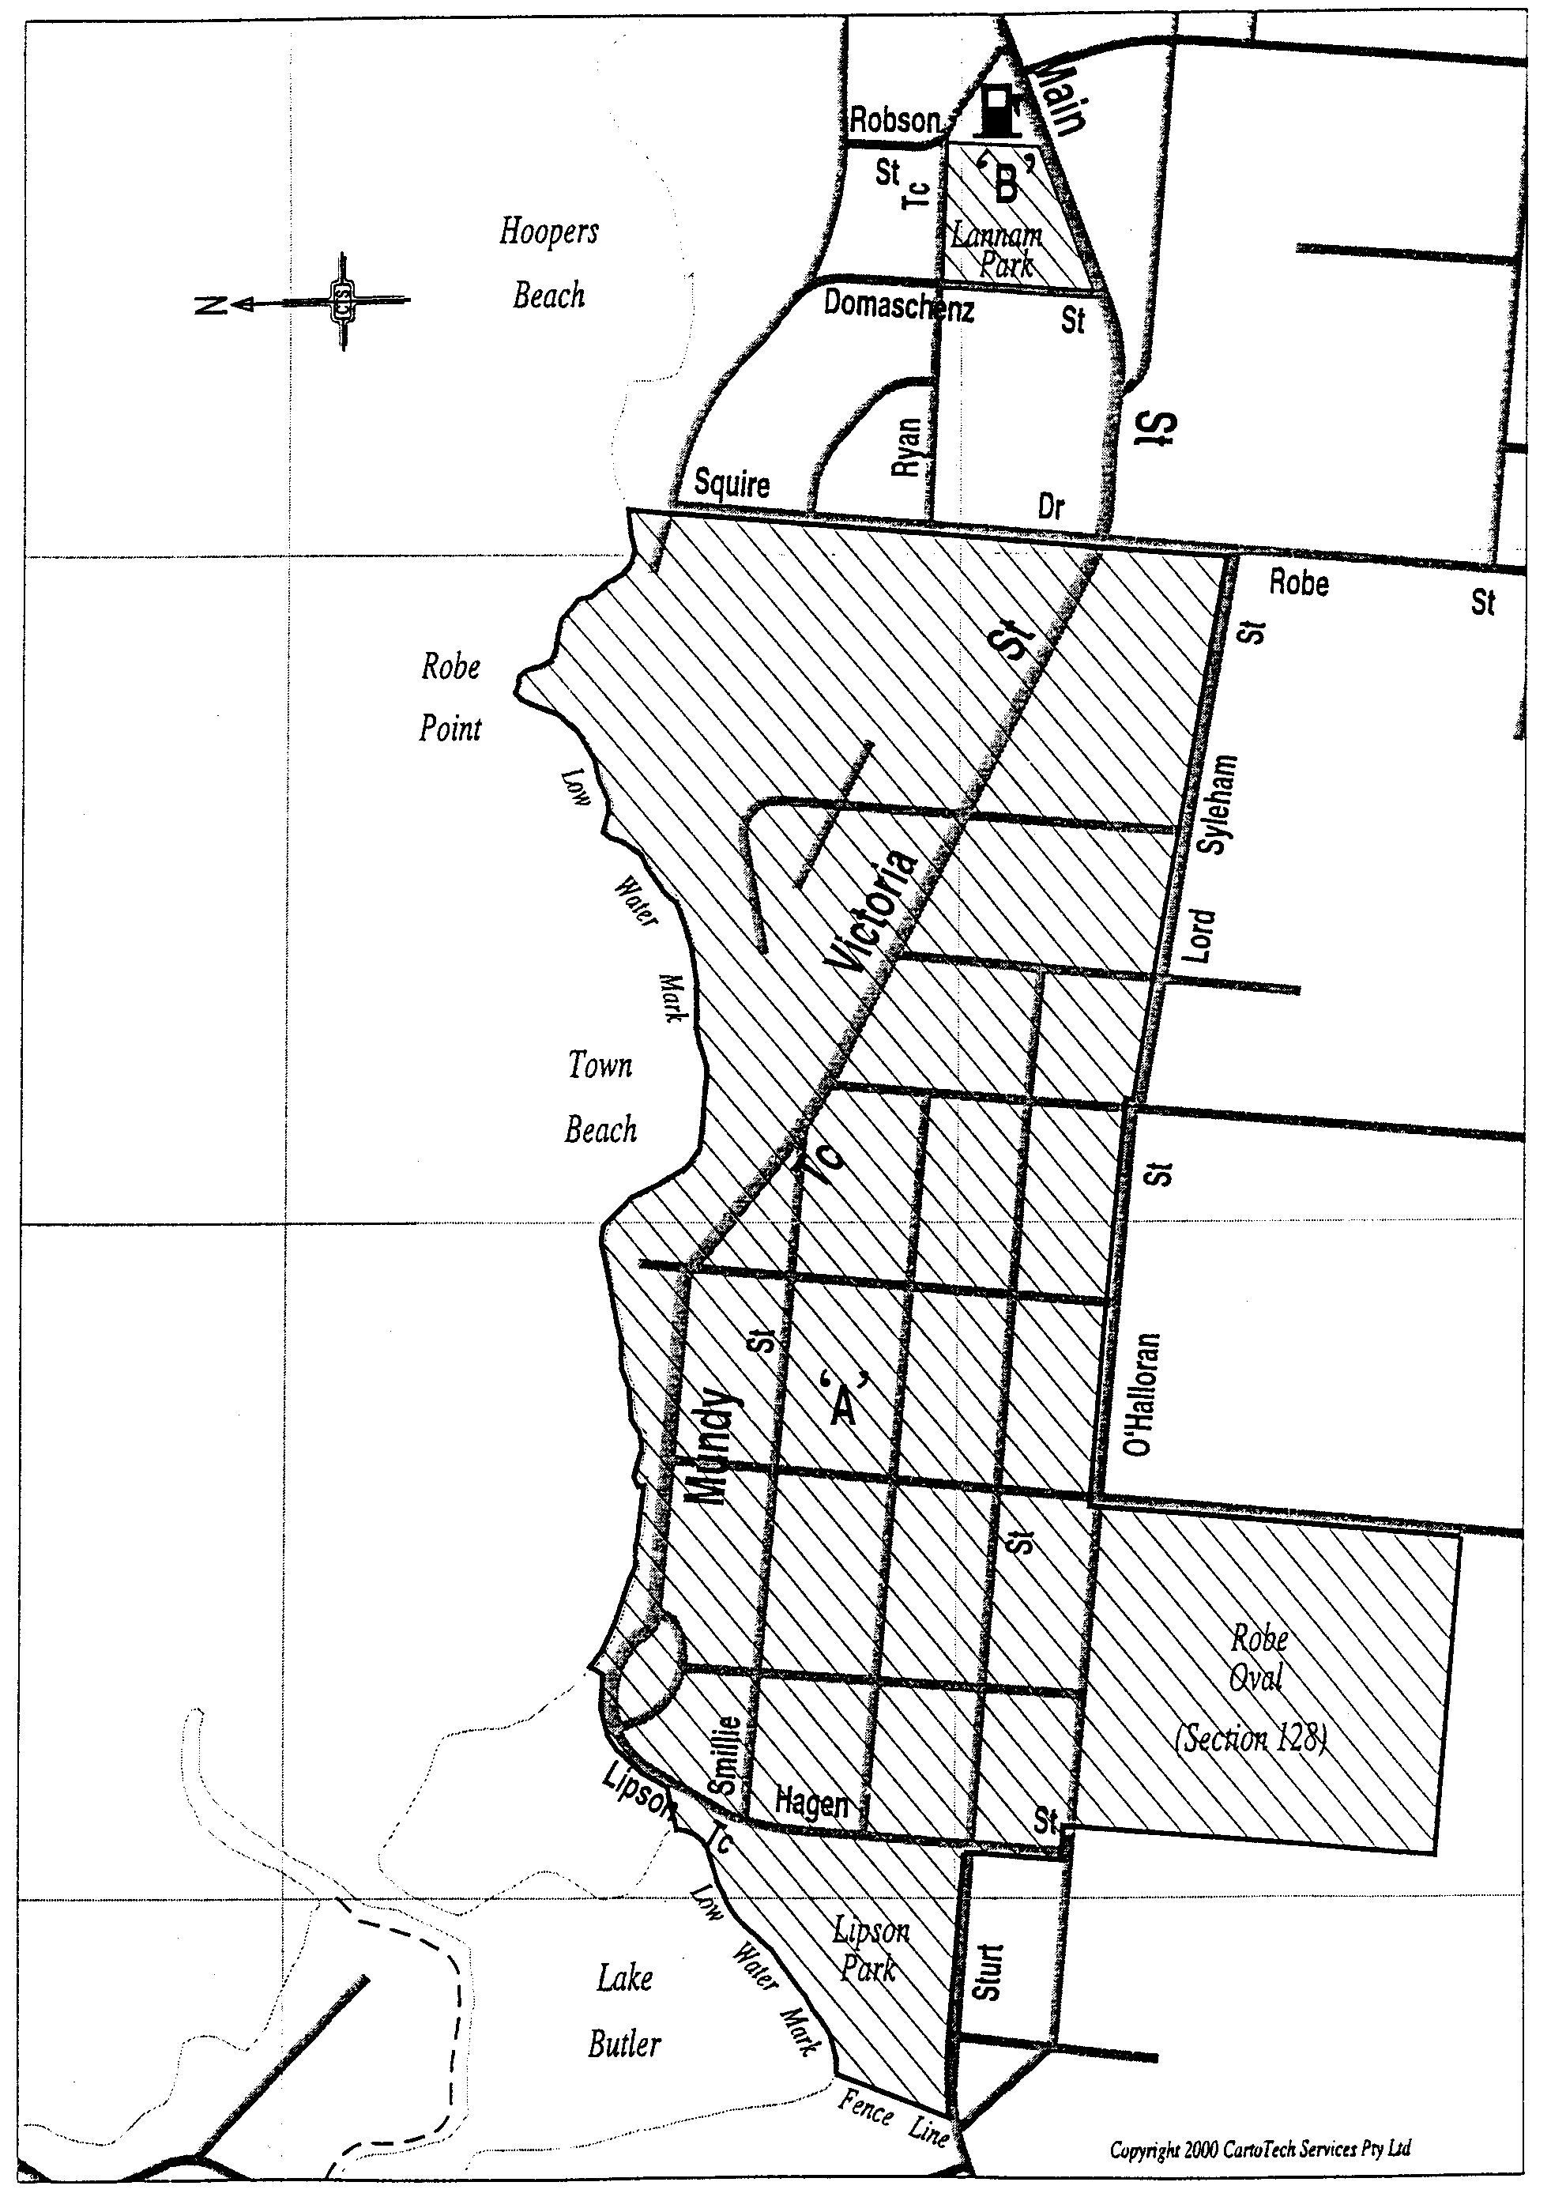

LLCS 5/99 LLCS 13/94 Temp 1
LLCS 6/99 LLCS 2/94 R. DENNIS Clerk of the Council
LLCS 1/96

REGULATIONS UNDER THE LIQUOR LICENSING ACT 1997
────
No. 293 of 2000
────
At the Executive Council Office at Adelaide 21 December 2000

PURSUANT to the Liquor Licensing Act 1997 and with the advice and consent of the Executive Council, I make the following regulations.
E. J. NEAL Governor

PURSUANT to section 10AA(2) of the Subordinate Legislation Act 1978, I certify that, in my opinion, it is necessary or appropriate that the following regulations come into operation as set out below.

K. T. GRIFFIN Minister for Consumer Affairs
───────────────────
SUMMARY OF PROVISIONS

1. Citation
2. Commencement
3. Variation of Sched. 1—Long Term Dry Areas
───────────────────

Citation
1. The Liquor Licensing (Dry Areas—Long Term) Regulations 1997 (see Gazette 6 November 1997 p. 1217), as varied, are referred to in these regulations as "the principal regulations".

Commencement
2. These regulations come into operation on the day on which they are made.

Variation of Sched. 1—Long Term Dry Areas
3. Schedule 1 of the principal regulations is varied—

(a) by striking out from the column headed "Period" in the item headed "Aberfoyle Park—Area 1" "16 December 2000" and substituting "31 March 2001";

(b) by striking out from the column headed "Period" in the item headed "Morphett Vale—Area 1" "16 December 2000" and substituting "31 March 2001";

(c) by striking out from the column headed "Period" in the item headed "Port Augusta—Area 1" "2001" and substituting "2004";

(d) by striking out from the column headed "Period" in the item headed "Port Augusta—Area 2" "2001" and substituting "2004";

(e) by striking out from the column headed "Period" in the item headed "Port Augusta—Area 3" "2001" and substituting "2004";

(f) by striking out from the column headed "Period" in the item headed "Port Augusta—Area 4" "2001" and substituting "2004";

(g) by striking out from the column headed "Period" in the item headed "Port Augusta—Area 5" "2001" and substituting "2004";

(h) by striking out from the column headed "Period" in the item headed "Woodcroft—Area 1" "16 December 2000" and substituting "31 March 2001".

LL CS 14/94
LL CS 0119/97 R. DENNIS Clerk of the Council

REGULATIONS UNDER THE PRIMARY INDUSTRY FUNDING SCHEMES ACT 1998
────
No. 294 of 2000
────
At the Executive Council Office at Adelaide 21 December 2000

PURSUANT to the Primary Industries Funding Schemes Act 1998 and with the advice and consent of the Executive Council, I make the following regulations.
E. J. NEAL Governor

PURSUANT to section 10AA(2) of the Subordinate Legislation Act 1978, I certify that, in my opinion, it is necessary or appropriate that the following regulations come into operation as set out below.

ROB KERIN Minister for Primary Industries and Resources
───────────────────
SUMMARY OF PROVISIONS

1. Citation
2. Commencement
3. Insertion of heading to Part 1
PART 1
PRELIMINARY
4. Variation of reg. 3—Interpretation
5. Insertion of heading to Part 2
PART 2
SOUTH AUSTRALIAN SHEEP INDUSTRY FUND
6. Substitution of reg. 6
6. Contributions
7. Variation of reg. 7—Application of Fund
8. Insertion of Parts 3 and 4
PART 3
PAYMENTS FOR ERADICATION OF JOHNE'S DISEASE
9. Financial assistance for Johne's disease property eradication plans
10. Effect of breach of order or default in contributions
11. Ex gratia payments
12. Guidelines
PART 4
MISCELLANEOUS
13. False or misleading statements
──────────────────

Citation
1. The Primary Industry Funding Schemes (Sheep Industry Fund) Regulations 1999 (see Gazette 28 October 1999 p. 2117) are referred to in these regulations as "the principal regulations".

Commencement
2. These regulations come into operation on the day on which they are made.

Insertion of heading to Part 1
3. The following heading is inserted before regulation 1 of the principal regulations:

PART 1
PRELIMINARY

Variation of reg. 3—Interpretation
4. Regulation 3 of the principal regulations is varied—

(a) by inserting after the definition of "Act" the following definition:

"collection agent" means—

(a) for a contract of sale where the sale is conducted by a stock agent—that stock agent; or

(b) for a contract of sale where the sale is to a person who operates an abattoir (and the sale is not conducted by a stock agent)—that person; or

(c) for a contract of sale where the sale is to a person who carries on a business involving the purchase of sheep for slaughter and the sale of the carcasses (and the sale is not conducted by a stock agent)—that person;;

(b) by inserting after the definition of "Fund" the following definitions:

"Johne's disease order" means an order issued under the Livestock Act 1997 for the control of Johne's disease that prohibits or restricts the pasturing or keeping of sheep on land for a specified period and regulates the removal and destruction of sheep on the land;

"Johne's disease property eradication plan" means a plan signed by the owner of sheep and attached to a Johne's disease order;

"owner" of sheep does not include a mortgagee of the sheep not in possession;

"prescribed amount" means—

(a) for an adult ewe (ie a ewe that has had one or both of its two permanent incisor teeth erupt through the gum) $30;

(b) for an adult ram (ie a ram that has had one or both of its two permanent incisor teeth erupt through the gum) other than an adult ram that has undergone a vasectomy $150;

(c) for a sheep other than of a kind referred to in paragraph (a) or
(b) $20;;

(c) by inserting after the definition of "quarter" the following definition:

"vendor" of sheep means the owner of the sheep immediately prior to sale of the sheep;;

(d) by inserting after its present contents (now to be designated as subregulation (1)) the following subsection:

(2) A vendor of sheep is in default in relation to contributions to the Fund if, within the immediately preceding two financial years—

(a) all or some of the contributions payable to the Fund in respect of contracts of sale of the vendor's sheep have not been paid; or

(b) the vendor has been refunded contributions from the Fund.

Insertion of heading to Part 2
5. The following heading is inserted before regulation 4 of the principal regulations:

PART 2
SOUTH AUSTRALIAN SHEEP INDUSTRY FUND

Substitution of reg. 6
6. Regulation 6 of the principal regulations is varied and the following regulation is substituted:

Contributions
6. (1) A contribution of $0.20 per sheep must be paid to the Minister for payment into the Fund in respect of each contract of sale under which 5 or more sheep are sold for an average price of $5.00 or more per sheep.

(2) For the purposes of subregulation (1), if, in a financial year, a person enters into more than one contract with the same purchaser for the sale of less than 5 sheep, the contracts will be taken to be a single contract.

(3) Subject to subregulation (4), the contribution must be paid by the vendor of the sheep.

(4) If there is a collection agent for the contract of sale of sheep, the collection agent must pay the contribution on behalf of the vendor of the sheep.

(5) The relevant collection agent or, in respect of contract of sale for which there is no collection agent, the vendor of sheep must—

(a) keep proper records relating to contracts of sale of sheep entered into by the person (either as principal or agent) and the contributions required to be made in respect of those contracts; and

(b) make those records available for inspection at any reasonable time by a person authorised by the Minister for the purpose.

(6) The relevant collection agent or, in the case of a contract of sale for which there is no collection agent, the vendor of sheep must—

(a) within 14 days after the end of each quarter, furnish the Minister with a financial statement relating to the contributions arising from contracts of sale of sheep entered into by the person (either as principal or agent) during that quarter that—

(i) is in the form, and contains the information, required by the Minister; and

(ii) is, if the person has the necessary equipment, in an electronic form acceptable to the Minister; and

(b) receive and forward to the Minister, with the quarterly financial statement required by paragraph (a), the required contributions for contracts of sale entered into during the quarter to which the financial statement relates.

(7) A person who was the vendor of sheep at the time contributions became payable under this regulation in respect of a contract of sale may claim a refund from the Fund for the contributions made in the financial year immediately preceding the financial year in which the person makes the claim in respect of contracts of sale of the person's sheep.

(8) If a person, by written notice to the Minister, requests the Minister to refund contributions, the Minister must, on being satisfied that the person is entitled to the refund, pay to the person an amount determined in accordance with the following formula:
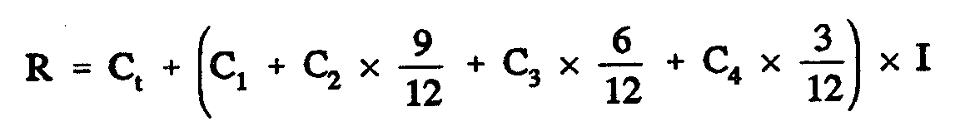

where—

R is the total amount of the refund;

C_{t} is the total amount of contributions paid during the financial year immediately preceding the financial year in which the person claims the refund in respect of contracts of sale of the person's sheep;

C₁ is the contribution paid during the first quarter of that financial year in respect of contracts of sale of the person's sheep;

C₂ is the contribution paid during the second quarter of that financial year in respect of contracts of sale of the person's sheep;

C₃ is the contribution paid during the third quarter of that financial year in respect of contracts of sale of the person's sheep;

C₄ is the contribution paid during the fourth quarter of that financial year in respect of contracts of sale of the person's sheep;

I is the annual short term interest for that financial year (as published by the Reserve Bank of Australia) expressed as a percentage.

Variation of reg. 7—Application of Fund
7. Regulation 7 of the principal regulations is varied by inserting after paragraph (a) the following paragraph:

(ab) payments for financial assistance or ex gratia payments authorised under Part 3;.

Insertion of Parts 3 and 4
8. The following Parts are inserted after regulation 8 of the principal regulations:

PART 3
PAYMENTS FOR ERADICATION OF JOHNE'S DISEASE

Financial assistance for Johne's disease property eradication plans
9. (1) The Minister may make a payment of financial assistance out of the Fund to an owner of sheep who has been issued a Johne's disease order and has signed a Johne's disease property eradication plan attached to the order (whether before or after the commencement of this regulation).

(2) A payment of financial assistance out of the Fund under this regulation must not exceed the prescribed amount.

Effect of breach of order or default in contributions
10. (1) A person is not eligible to receive financial assistance under regulation 9, and must repay to the Minister the amount of any such financial assistance received by the person, if—

(a) sheep enter or remain on land in breach of the Johne's disease order or Johne's disease property eradication plan; or

(b) the person is in default in relation to contributions to the Fund.

(2) The Minister may recover an amount payable under subregulation (1) as a debt.

(3) The Minister may exempt a person from the application of subregulation (1) if satisfied that the circumstances of the particular case justify the exemption.

Ex gratia payments
11. (1) The Minister may make an ex gratia payment of an amount out of the Fund to an owner of sheep destroyed pursuant to an order issued, or action taken or caused to be taken by an inspector, under the Livestock Act 1997 for the purpose of an investigation relating to Johne's disease.

(2) The amount of an ex gratia payment under this regulation must not exceed the prescribed amount.

(3) An ex gratia payment will not be paid to a person who is in default in relation to contributions to the Fund unless the Minister is satisfied that the circumstances of the particular case justify the payment.

Guidelines
12. The Minister may, after consultation with the consultative committee, publish guidelines relating to payments under this Part, including guidelines about procedures for making claims for payments or resolving disputes about payments.

PART 4
MISCELLANEOUS

False or misleading statements
13. A person must not make a statement that is false or misleading in a material particular (whether by reason of the inclusion or omission of any particular) in information provided, or record kept, for the purposes of these regulations.

Maximum penalty: $5 000.

MPIR 067/2000 CS R. DENNIS Clerk of the Council

REGULATIONS UNDER THE WATER RESOURCES ACT 1997
────
No. 295 of 2000
────
At the Executive Council Office at Adelaide 21 December 2000

PURSUANT to the Water Resources Act 1997 and with the advice and consent of the Executive Council, I make the following regulations.
E. J. NEAL Governor

PURSUANT to section 10AA(2) of the Subordinate Legislation Act 1978, I certify that, in my opinion, it is necessary or appropriate that the following regulations come into operation as set out below.

MARK BRINDAL Minister for Water Resources
───────────────────
SUMMARY OF PROVISIONS

1. Citation
2. Commencement
3. Variation of reg. 4—Extension of period
───────────────────

Citation
1. The Water Resources (Extension of Adopted Management Policies) Regulations 1998 (see Gazette 30 June 1998 p. 2771), as varied, are referred to in these regulations as "the principal regulations".

Commencement
2. These regulations come into operation on the day on which they are made.

Variation of reg. 4—Extension of period
3. Regulation 4 of the principal regulations is varied by striking out "that relate to the underground water resources of the prescribed wells areas listed in the schedule" from subregulation (1) and substituting "that relate to—

(a) the underground water resources of the prescribed wells areas listed in the schedule; and

(b) the River Murray prescribed watercourse".

DEHA 33/0582 R. DENNIS Clerk of the Council

FAXING COPY?

IF you fax copy to Government Publishing SA (formerly Riverside 2000), for inclusion in the Government Gazette, there is no need to send a Confirmation Copy to us as well.

This creates confusion and may well result in your notice being printed twice.

Please use the following fax number:

Fax transmission: (08) 8207 1040
Phone Inquiries: (08) 8207 1045

Please include a contact person, phone number and order number so that we can phone back with any queries we may have regarding the fax copy.

NOTE: Closing time for lodging new copy (either fax or hard copy) is 4 p.m. on Tuesday preceding the day of publication.

Government Gazette notices can be E-mailed.

The address is:

governmentgazette@saugov.sa.gov.au

Documents should be sent as attachments in Word format.

When sending a document via E-mail, please confirm your transmission with a faxed copy of your document, including the date the notice is to be published.

Fax transmission: (08) 8207 1040
Enquiries: (08) 8207 1045

CITY OF ADELAIDE
Declaration of Public Roads
NOTICE is hereby given pursuant to Section 210 of the Local Government Act 1999, that at its meeting of 11 December 2000, council declared the following roads to be public roads:
1. Bank Street in Town Acres 14 and 49 as delineated on LTO plan DP19233 but excluding CT5688/305, CT2468/28 and CT2642/5 which are already Public;
2. Blyth Street in Town Acres 13 and 50 as delineated on LTO plan DP19233;
3. Gresham Street and Gresham Place in Town Acres 16 and 47 as as delineated on LTO plans Tube 18 and C-1419;
4. Peel Street in Town Acres 77 and 110 as delineated on LTO plan FP24484;
5. Rosina Street, Solomon Street, Burnett Street, Kingston Street and Schrader Street in Town Acres 73, 112, 113 and 114 and as delineated on LTO plans FP10116, FP13385 and B4176;
6. The land now forming part of Morphett Street and contained within Certificate of Title Volume 3452, Folio 149.
Susan Law, Chief Executive Officer

CITY OF CAMPBELLTOWN
Sale of Community Land
NOTICE is hereby given pursuant to the provisions of section 194 of the Local Government Act 1999 the council proposes to revoke the classification of that land as community land in order that it be transferred and consolidated with the four adjoining residential allotments.
Allotment 10 in Deposited Plan 10059 was created as a public reserve in 1975. The land is located on the southern side of Sprankling Avenue, Newton and is approximately 71 m wide and 3 m deep.
Any person wishing to comment on this proposal is invited to make a written submission addressed to the Chief Executive Officer, P.O. Box 1, Campbelltown, S.A. 5074 before 5 February 2001.
Further information concerning this proposal may be obtained from Mario Scalzi by telephoning 8366 9215.
H. Sturt, Executive Support Officer

CITY OF CHARLES STURT
Hindmarsh Urban Village Plan Amendment Report—Draft for Public Consultation
NOTICE is hereby given that the City of Charles Sturt, pursuant to section 25 of the Development Act 1993, has prepared the Hindmarsh Urban Village Plan Amendment Report (PAR) in order to amend the Hindmarsh and Woodville (City) Development Plan.
The Hindmarsh Urban Village PAR has been prepared in order to implement the Development Plan changes identified through the Hindmarsh Precinct Action Plan during 1999. In particular, the PAR amends the Development Plan in order to seek medium density housing throughout the District Centre (Hindmarsh) Zone, as well as proposing other changes regarding industrial zones south of Manton Street, Hindmarsh Stadium area zoning and urban design and heritage policies.
The Hindmarsh Urban Village PAR is available for inspection and purchase ($5 per copy) during opening hours at the council office, 72 Woodville Road, Woodville and also at council’s libraries at Woodville, Findon, West Lakes and Henley Beach from Thursday, 21 December 2000 to Monday, 5 March 2001. The Hindmarsh Urban Village PAR is also available for inspection (but not purchase) during business hours (Monday to Friday) at the Education Development Centre, 4 Milner Street, Hindmarsh (main entrance to Education Development Centre).
Persons interested in making submissions in relation to the Hindmarsh Urban Village PAR, for consideration by council, should do so by Monday, 5 March 2001. All submissions should be addressed to the Acting Chief Executive, City of Charles Sturt, P.O. Box 1, Woodville, S.A. 5011. Submissions will be available for inspection by any interested party at the Council Office, 72 Woodville Road, Woodville, until the conclusion of the public hearing.
Pursuant to Regulation 12 of the Development Regulations 1993, a public hearing will be held on Wednesday, 14 March 2001, commencing at 5 p.m. The public hearing will be held at the office of the City of Charles Sturt, 72 Woodville Road, Woodville. Persons interested in being heard at the public hearing are requested to indicate their interest to be heard on their submission.
Interested persons may appear and be heard in relation to the Hindmarsh Urban Village PAR and/or the submissions.
If no submissions are received or no submission indicates an interest to be heard, the public hearing will not be held.
P. Perry, Acting Chief Executive

CITY OF CHARLES STURT
Revocation of Land
NOTICE is hereby given that council at its meeting held on 18 December 2000, resolved in accordance with section 193 of the Local Government Act 1999, to exclude that piece of land described as Lot 101 in Deposited Plan 20151 and contained in Certificate of Title Volume 5178, Folio 136, from classification as community land.
P. Perry, Acting Chief Executive Officer

CITY OF MOUNT GAMBIER
Supplementary Election for South East Ward—
Nominations Received
NOTICE is hereby given that at the close of nominations at 12 noon on Thursday, 14 December 2000, the following persons have been accepted as candidates and are listed in the order in which they will appear on the ballot paper:
Councillor for South East Ward (one vacancy):
White, Mervyn Robert
Cleggett, Alan
Newberry, Malcolm
Schubert, Ruth
Gould, Bev
Postal Voting
The elections will be conducted entirely by postal voting. No polling booth will be open for voting on polling day. Voting is not compulsory.
Voting material will be despatched by post to every natural person, body corporate and group who were listed on the voters’ roll as at the roll closure on 31 October 2000.
The mail out will commence on Tuesday, 23 January 2001, with all voting materials to be delivered by Monday, 29 January 2001.
A person who has not received voting material and who believes that he or she is entitled to vote should apply to the Australian Electoral Commission Divisional Office, 2 Mitchell Street, Mount Gambier on 8723 1366.
A pre-paid addressed envelope for each elector entitlement will be provided. Completed ballot material must be returned to reach the Deputy Returning Officer no later than 12 noon on Monday, 12 February 2001.
A ballot box will be provided at the Council Office and the Australian Electoral Commission Divisional Office, 2 Mitchell Street, Mount Gambier for electors who wish to personally deliver their completed ballot material during office hours.
Place of Counting of Votes
The scrutiny and counting of votes will take place at the Council Office, Civic Centre, 10 Watson Terrace, Mount Gambier as soon as practicable after 12.30 p.m. on Monday, 12 February 2001. A provisional declaration will be made at the conclusion of the election.
Campaign Donations Return
Candidates must forward a campaign donations return to the Council Chief Executive Officer within six weeks after the conclusion of the election.
S. H. Tully, Returning Officer

CITY OF ONKAPARINGA
Supplementary Election for Thalassa Ward—
Nominations Received
NOTICE is hereby given that at the close of nominations at 12 noon on Thursday, 14 December 2000, the following persons have been accepted as candidates and are listed in the order in which they will appear on the ballot paper:
The result of the draw was as follows:
Councillor for Thalassa Ward (one vacancy):
Bayliss, Brett
Rogers, Paul
Wrobel, Charlie
Pine, Graham M.
Chandler, Susanne Gillian
McFarlane, Bevan
Simes, Grant M.
Postal Voting
The elections will be conducted entirely by postal voting. No polling booth will be open for voting on polling day. Voting is not compulsory.
Voting material will be despatched by post to every natural person, body corporate and group who were listed on the voters’ roll as at the roll closure on 31 October 2000.
The mail out will commence on Tuesday, 23 January 2001, with all voting materials to be delivered by Monday, 29 January 2001.
A person who has not received voting material and who believes that he or she is entitled to vote should apply to the State Electoral Office, 134 Fullarton Road, Rose Park, S.A. 5067—Phone 8401 4300.
A pre-paid addressed envelope for each elector entitlement will be provided. Completed ballot material must be returned to reach the Returning Officer no later than 12 noon on Monday, 12 February 2001.
A ballot box will be provided at the City of Onkaparinga Council Offices and at the State Electoral Office, 134 Fullarton Road, Rose Park, S.A. 5067, for electors who wish to personally deliver their completed ballot material during office hours.
Place of Counting of Votes
The scrutiny and counting of votes will take place at the City of Onkaparinga Council Office, Ramsay Place, Noarlunga Centre as soon as practicable after 12.30 p.m. on Monday, 12 February 2001. A provisional declaration will be made at the conclusion of the election.
Campaign Donations Return
Candidates must forward a campaign donations return to the Council’s Chief Executive Officer within six weeks after the conclusion of the election.
S. H. Tully, Returning Officer

CITY OF ONKAPARINGA
Proposed Declaration of Public Road
NOTICE is hereby given that pursuant to section 208 of the Local Government Act 1999, the City of Onkaparinga resolved at its meeting held on 12 December 2000, that a notice of Proposed Declaration of Public Road be made in relation to Allotments 3 and 4 in Deposited Plan 56030, Main Road, Coromandel Valley.
J. Tate, Chief Executive Officer

CITY OF PROSPECT
Temporary Street Closure
NOTICE is hereby given that in the interests of traffic control and public safety and pursuant to powers contained in section 359 of the Local Government Act 1934, as amended, all classes of motor vehicles, with the exception of emergency vehicles and vehicles of residents of Craddock Street, Broadview, living between Le Cornu Street and the northern boundary of No. 6 Craddock Street, Broadview, between the hours of 6 p.m. on 31 December 2000 and 2 a.m. on 1 January 2001 for the purpose of a street party.
M. Llewellyn-Smith, City Manager

CITY OF VICTOR HARBOR
Appointment
NOTICE is hereby given pursuant to the provisions of section 102 (b) of the Local Government Act 1999, that Jane Bohnsack has been appointed Acting Chief Executive Officer for the period 2 January 2001 to 19 January 2001 vide City Manager on annual leave.
G. K. Maxwell, City Manager

BAROSSA COUNCIL
Temporary Street Closure
NOTICE is hereby given that pursuant to the provisions of section 359 of the Local Government Act 1934, as amended, the Barossa Council resolves that the following public road will be closed to all vehicles, except emergency vehicles and authorised service vehicles, between 5 p.m. and 10 p.m. on Friday, 22 December 2000:
Washington Street—from Fife Street to Murray Street;
Fife Street—from Washington Street to Sturt Street;
Sturt Street—from Fife Street to Murray Street,
for the staging of the Angaston Traders’/Lions Club Children’s Christmas Party 2000.
J. G. Jones, Chief Executive Officer

DISTRICT COUNCIL OF CEDUNA
Council Representation Review
NOTICE is hereby given that the District Council of Ceduna has undertaken a review for the purposes of consideration of:
(a) altering the composition of the council;
(b) divide, or redivide the area of the council into wards, alter the division of the area of the council into wards.
and this review was adopted at the Ordinary Meeting of Council on 14 December 2000.
A copy of this report is now available for the public to view at the council offices, or may be purchased for a small fee.
Any person wishing to make a written submission in relation to the report may do so by addressing a submission to the Chief Executive Officer, District Council of Ceduna, P.O. Box 175, Ceduna, S.A. 5690. Submissions should be received by no later than 4 p.m. on Thursday, 11 January 2001.
Any person providing a submission will be given the opportunity to address the council on their submission.
T. Irvine, Chief Executive Officer

FLINDERS RANGES COUNCIL
Temporary Road Closure
NOTICE is hereby given that council at its meeting held on Tuesday, 12 December 2000, and in accordance with section 359 of the Local Government Act 1934, as amended, resolved to exclude all vehicles, except council and emergency vehicles in that portion of First Street, Quorn, between lot 65 (Austral Hotel/Motel) and lot 58 (Mr and Mrs Millington’s residence) including access from Seventh Street, between 6 p.m. and 9 p.m. on Friday, 22 December 2000 for the purposes of holding a Christmas Street Party.
D. A. Cearns, Chief Executive Officer

DISTRICT COUNCIL OF FRANKLIN HARBOUR
Temporary Road Closure
NOTICE is hereby given that at a meeting held on 13 December 2000 the District Council of Franklin Harbour, pursuant to section 359 of the Local Government Act 1934, as amended, resolved to close the following roads to vehicular traffic for the Annual Christmas Pageant and visit of Father Christmas on Friday, 22 December 2000.
Between the hours of 6 p.m. and 8 p.m:
South Terrace—between West Terrace and Fifth Street;
Fifth Street—between South Terrace and Main Street;
Main Street—between Fifth Street and the Esplanade.
Between the hours of 8 p.m. and 9 p.m:
Main Street—between High Street and the Esplanade.
For the Annual Pyrotechnics Display on Saturday, 30 December 2000, between the hours of 5 p.m. on 30 December 2000 and 2 a.m. on 31 December 2000.
Between the hours of 7.30 p.m. and 11 p.m. 30 December 2000:
Foreshore Access Road—from the Esplanade to the Boat ramp.
B. A. Francis, District Clerk

DISTRICT COUNCIL OF KAROONDA EAST MURRAY
Temporary Road Closures
NOTICE is hereby given that pursuant to section 359 of the Local Government Act 1934, as amended, council resolved that all vehicles other than emergency vehicles and vehicles forming stationary stalls, stages and displays are to be excluded from:
1. That portion of Railway Terrace, Karoonda from East Terrace to West Terrace, Karoonda, from 5 p.m. to 11 p.m. on Saturday, 23 December 2000 for the purpose of the Apex Community Christmas Festival.
2. That portion of Railway Terrace, Karoonda from East Terrace to West Terrace, Karoonda, from 5 p.m. on Sunday, 31 December 2000 to 3 a.m. on Monday, 1 January 2001 for the purpose of the New Year’s Eve Street Party.
P. Smithson, District Clerk

DISTRICT COUNCIL OF LE HUNTE
Poll to Change Council Name
NOTICE is hereby given that the District Council of Le Hunte has resolved to undertake a poll of electors in respect to changing the name of the Council.
The voters’ roll to conduct this poll will close at 5 p.m. on Friday, 29 December 2000.
The poll will be conducted entirely by post with the return of ballot material to the Returning Officer no later than 12 noon on Monday, 26 February 2001.
S. H. Tully, Returning Officer

DISTRICT COUNCIL OF ROBE
Temporary Road Closure
NOTICE is hereby given that pursuant to section 359 of the Local Government Act 1934, as amended, council hereby resolves that the following public road will be closed to all vehicles except emergency vehicles and authorised vehicles between 5 p.m. and 10 p.m. on Sunday, 17 December 2000:
Mundy Terrace between Bagot Street and Morphett Street,
for the Robe Christmas Pageant.
R. J. Kay, Chief Executive Officer

DISTRICT COUNCIL OF STREAKY BAY
Temporary Road Closure
NOTICE is hereby given that the District Council of Streaky Bay at its meeting held on 13 December 2000, pursuant to section 359 of the Local Government Act 1934, as amended, approved the following temporary road closure:
Alfred Terrace, Streaky Bay from Bay Road to Linklater Street and Streaky Bay from the Police Station to the Foreshore, adjacent Eyre Avenue on Saturday, 13 January 2001 from 9.30 a.m. to midnight for the purpose of the Family Fun Day and Mardi Gras.
Office Closure
The public are advised that the council office will be closed at 12 noon on Friday, 22 December 2000 and will reopen at 8.30 a.m. on Tuesday, 2 January 2001.
Emergency Contact Numbers:
Administration: 8626 1692
Works: 8626 1067 or 8626 1075
Inspectorial: 8626 1434
Change Of Meeting Time
Notice is hereby given that the January council meeting will commence at 9 a.m. in leiu of 9.30 a.m.
J. Rumbelow, General Manager

DISTRICT COUNCIL OF TATIARA
Temporary Road Closures
NOTICE is hereby given that council at its meeting held on 12 December 2000 authorised the temporary closure of the following streets, pursuant to section 33 of the Road Traffic Act 1961 and Clause F of the Instrument of General Approval of the Minister dated 28 November 1999:
• DeCourcey Street, Bordertown between Binnie Street and the western boundary of the 5TCB FM Radio Station building between the hours of 3 p.m. and 9 p.m. on Friday, 22 December 2000 to enable the opening of 5TCB FM Radio Station’s new premises.
• Woolshed Street, Bordertown between DeCourcey Street and North Terrace and Farquhar Street between Binnie Street and Scott Street on Friday, 22 December 2000 between the hours of 5 p.m. and 10 p.m. to allow a Christmas celebration to be held.
• Woolshed Street, Bordertown between Crocker Street and North Terrace on Sunday, 24 December 2000 between the hours of 8 p.m. and midnight to enable a street party to take place.
Pursuant to section 33 (1) of the Road Traffic Act 1961, council declares that these are events to which section 33 applies.
Pursuant to section 33 (1)(b) of the Road Traffic Act 1961, council makes an order directing that persons taking part in these events be exempted in relation to the road, from the duty to observe the Australian Road Rules specified below:
• Rule 230, crossing a road—general.
• Rule 238, pedestrians travelling along a road (exempt in or on a wheeled recreational device or toy).
G. W. Piesse, Chief Executive Officer

IN the matter of the estates of the undermentioned deceased persons:
Bailey, Irene Ellen Mabel, late of 24 Hanson Road, Woodville Gardens, widow, who died on 25 September 2000.
Cabrie, John Brand, late of 59 Parks Street Solomontown, retired electrical fitter, who died on 18 October 2000.
Caire, William Nicholas, late of 13 Scotia Street, West Croydon, retired carpenter, who died on 30 October 2000.
Collins, Edmund Keith, late of 156 Main North Road, Prospect, retired engineering company manager, who died on 3 October 2000.
Day, Michael Selwyn, late of 570 Cross Road, South Plympton, personnel officer, who died on 10 October 2000.
Dennes, Patricia Anne, late of 34 Boronia Drive, Hope Valley, who died on 7 October 2000.
Dick, Robert Andrew, late of 39 Myall Avenue, Kensington Gardens, retired farm hand, who died on 2 September 2000.
Faulds, Hazel Doreen, late of 38 Buxton Street, North Adelaide, home duties, who died on 15 October 2000.
Gifford, Neil Matthew, late of 6 Cross Street, Port Broughton, retired clerk, who died on 27 September 2000.
Gillies, Marjorie Branford, late of 40 Winchester Street, Malvern, retired nursing sister, who died on 15 October 2000.
Haskett, Donald Gordon, late of 26 Boston Street, Port Lincoln, retired spare parts person, who died on 18 September 2000.
Hector, Stanley Robert, late of 34 Jervois Street, Glenelg North, retired bank manager, who died on 20 May 2000.
McKenzie, Molly, late of 251 Payneham Road, Joslin, of no occupation, who died on 22 October 2000.
Markham, Dorothea Marie, late of 342 Marion Road, North Plympton, widow, who died on 7 November 2000.
Marriott, Joan Lesley, late of 46 Strathcona Avenue, Clapham, packer, who died on 30 September 2000.
Quinn, John, late of 15-19 Woodville Road, Woodville South, retired waterside worker, who died on 2 November 2000.
Rayney, Helen Elizabeth, late of 336 Marion Road, North Plympton, of no occupation, who died on 14 October 2000.
Reaney, George James, late of 11 Hibiscus Court, Morphett Vale, retired tool maker, who died on 26 August 2000.
Yuan, Frederick Fan Fu, late of 4 Wakefield Street, Kent Town, retired lecturer, who died on 20 October 2000.
Notice is hereby given pursuant to the Trustee Act 1936, as amended, the Inheritance (Family Provision) Act 1972, and the Family Relationships Act 1975, that all creditors, beneficiaries, and other persons having claims against the said estates are required to send, in writing, to the Public Trustee, 25 Franklin Street, Adelaide, S.A. 5000, full particulars and proof of such claims, on or before 19 January 2001, otherwise they will be excluded from the distribution of the said estate; and notice is
also hereby given that all persons who are indebted to the said estates are required to pay the amount of their debts to the Public Trustee or proceedings will be taken for the recovery thereof; and all persons having any property belonging to the said estates are forthwith to deliver the same to the Public Trustee.
Dated 21 December 2000.
J. H. Worrall, Public Trustee

IN the matter of the estate of the undermentioned deceased person:
Venning, John, formerly of 31 Wilson Terrace, Glenelg East, but late of Oxford Nursing Home, 35 Hubert Street, Hove, retired bank officer, who died on 25 August 2000.
Notice is hereby given pursuant to the Trustee Act 1936, as amended, the Inheritance (Family Provision) Act 1972-1975 and the Family Relationships Act 1975, that all creditors, beneficiaries, and other persons having claims against the abovenamed estate are directed to send full particulars and evidence of such claims to the undersigned on or before 29 January 2001; otherwise they will be excluded from the distribution of the said estate, and notice is also hereby given that all persons who are indebted to the above estate are required to pay the amount of their debt to the undersigned or proceedings will be taken for the recovery thereof; and all persons having any property belonging to the said estate are forthwith to deliver the same to the undersigned.
ANZ Executors & Trustee Company Limited, (ACN 006 132 332), 530 Collins Street, Melbourne, Victoria 3000.

ESTATE OF VANDA LESLEY GRAY
NOTICE is hereby given pursuant to the Trustee Act 1936, the Inheritance (Family Provision) Act 1972 and the Family Relationships Act 1975, that all creditors, beneficiaries and other persons having claims against the estate of Vanda Lesley Gray, late of Acacia Court Aged Complex, 81 Tapleys Hill Road, Hendon, S.A. 5014, who died at Hendon on 14 September 2000, and probate of whose will was granted to AXA Trustees Limited, 80 King William Street, Adelaide, S.A. 5000, the executor therein named are required to send full particulars of their claim in writing to the executor at 80 King William Street, Adelaide on or before 18 January 2001, otherwise they will be excluded from the distribution of the estate.
Treloar and Treloar, Barristers and Solicitors, 22 Grenfell Street, Adelaide, S.A. 5000.

ASSOCIATIONS INCORPORATION ACT 1985
Software Quality Association (SA) Incorporated
(ACN A0022 704M)
Voluntary Winding Up
NOTICE is hereby given that at a meeting of members of the abovementioned association held on 4 December 2000, it was resolved that the association be wound up voluntarily and that Richard George Freer, 40 Sturt Street, Adelaide, S.A. 5000, be appointed liquidator for the purpose of such winding up.
Dated 4 December 2000.
P. Relf, Committee Member

SOUTH AUSTRALIA—In the Supreme Court of South Australia. No. 2797 of 1991. In the matter of Essington Limited and the Corporations Law.
Notice of Release of Liquidator and Dissolution of the Company
TAKE notice that by order of the Supreme Court of South Australia dated 5 December 2000, I, John Sheahan, Level 8, 26 Flinders Street, Adelaide, S.A. 5000, the liquidator of the above-named company, was granted my release as liquidator and the company was dissolved as at the date of this order.
Dated 12 December 2000.
J. Sheahan, Liquidator

SOUTH AUSTRALIA—In the Supreme Court. No. 2548 of 1993. In the matter of Freightmasters Pty Limited (ACN 008 806 713) and in the matter of the Corporations Law.
Notice by a Liquidator of His Intention to Seek His Release
Take notice that I, Barrie Malcolm Mansom, 1st Floor, Menai House, 17 Bagot Street, North Adelaide, S.A. 5006, the liquidator of the abovenamed company, intend to make application to the Supreme Court of South Australia for my release as the liquidator of the abovenamed company.
And take further notice that if you have any objection to the granting of my release you must file at the Supreme Court and also forward to me within 21 days of the publication in the Gazette of the notice of my intention to apply for a release a notice of objection in the form laid down by the Corporations (South Australia) Rules 1993.
Dated 15 December 2000.
B. M. Mansom, Liquidator
Note: Section 481 of the Corporations Law enacts that an order of the Court releasing a liquidator shall discharge him/her in the administration of the affairs of the company, or otherwise in relation to his or her conduct as liquidator, but any such order may be revoked on proof that it was obtained by fraud or by suppression or by concealment of any material fact.

SOUTH AUSTRALIA—In the Supreme Court. No. 187 of 1987. In the matter of Qube Nominees (No. 1) Pty Limited (ACN 008 055 123) and in the matter of the Corporations Law.
Notice by a Liquidator of His Intention to Seek His Release
Take notice that I, Barrie Malcolm Mansom, 1st Floor, Menai House, 17 Bagot Street, North Adelaide, S.A. 5006, the liquidator of the abovenamed company, intend to make application to the Supreme Court of South Australia for my release as the liquidator of the abovenamed company.
And take further notice that if you have any objection to the granting of my release you must file at the Supreme Court and also forward to me within 21 days of the publication in the Gazette of the notice of my intention to apply for a release a notice of objection in the form laid down by the Corporations (South Australia) Rules 1993.
Dated 14 December 2000.
B. M. Mansom, Liquidator
Note: Section 481 of the Corporations Law enacts that an order of the Court releasing a liquidator shall discharge him/her in the administration of the affairs of the company, or otherwise in relation to his or her conduct as liquidator, but any such order may be revoked on proof that it was obtained by fraud or by suppression or by concealment of any material fact.

SALE OF PROPERTY
Auction Date: Thursday, 25 January 2001 at 1.15 p.m.
Location: Midcity Motor Auctions, 165 Richmond Road, Richmond
NOTICE is hereby given that on the above date at the time and place stated, by virtue of Orders for Sale issued by the Fines Payment Unit, South Australia, Penalty No Exreg-00-17443/1 and others are directed to the Sheriff of South Australia in an action wherein the Estate of Derrick John Stone is Defendant, I, Tim Goodes, Sheriff, of the State of South Australia, will be my auctioneers, Midcity Motor Auctions make sale of the following:
1990 EA Ford Falcon
Registration No. VBT 179.

ATTENTION

CUSTOMERS requiring a proof of their notice for inclusion in the Government Gazette, please note that the onus is on you to inform Government Publishing SA (formerly Riverside 2000) of any subsequent corrections by 10 a.m. on Thursday, which is our publication deadline.

For any corrections to your notice please phone 8207 1045 or Fax 8207 1040 before 10 a.m. on Thursday.

If we do not receive any communication by 10 a.m. on Thursday (day of publication) we will presume the notice is correct and will print it as it is.

Remember—the onus is on you to inform us of any corrections necessary to your notice.

NOTE: Closing time for lodging new copy (either fax or hard copy) is 4 p.m. on Tuesday preceding the day of publication. Ph. 8207 1045—Fax 8207 1040.

Printed and published by authority every Thursday by M. G. O’CALLAGHAN, Government Printer, South Australia
Price: $4.30, plus postage; to subscribers, $214.85 per annum.
(The above prices are inclusive of GST)

