No. 27 953

THE SOUTH AUSTRALIAN

GOVERNMENT GAZETTE

PUBLISHED BY AUTHORITY

ALL PUBLIC ACTS appearing in this GAZETTE are to be considered official, and obeyed as such

ADELAIDE, THURSDAY, 17 FEBRUARY 2000

CONTENTS

Page
Appointments, Resignations, Etc. 954
AustralAsia Railway (Third Party Access) Code—Notice 964
Corporations and District Councils—Notices 1038
Development Act 1993—Notice 954
ETSA Power—Notice 955
Fisheries Act 1982—Notices 955, 1045
Gaming Machines Act 1992—Notice 956
Geographical Names Act 1991—Notice 956
Harbors and Navigation Act 1993—Notices 956
Housing Improvement Act 1940—Erratum 958
Land and Business (Sale and Conveyancing) Act 1994—
Notices 958
Liquor Licensing Act 1997—Notices 959
Page
Mining Act 1971—Notices 961
Private Advertisements 1040
Proclamations 954
Public Trustee Office—Administration of Estates 1039
Racing Act 1976—Amendment to Rules 961
REGULATIONS
Expiation of Offences Act 1996 (No. 11 of 2000) 1028
Land Agents Act 1994 (No. 12 of 2000) 1033
Liquor Licensing Act 1997 (No. 13 of 2000) 1036
Roads (Opening and Closing) Act 1991—Notices 1025
Road Traffic Act 1961—Notices 992
Unclaimed Moneys Act 1891—Notices 1040
Water Mains and Sewers—Mains Laid, Replaced, Etc. 1026

GOVERNMENT GAZETTE NOTICES
ALL poundkeepers' and private advertisements forwarded for publication in the South Australian Government Gazette must be PAID FOR PRIOR TO INSERTION; and all notices, from whatever source, should be legibly written on one side of the paper only and sent to Riverside 2000 so as to be received no later than 4 p.m. Tuesday preceding the day of publication. Phone 8207 1045 or Fax 8207 1040. E-mail: Riv2000@saugov.sa.gov.au. Send as attachments in Word format and please confirm your transmission with a faxed copy of your document, including the date the notice is to be published and to whom the notice will be charged.

MINING ACT 1971 SECTION 19 (7): HUNDRED OF NURIOOTPA—REVOCATION OF PRIVATE MINE
Proclamation By The Governor
(l.s.) E. J. Neal
Preamble
1. The following area was declared to be a private mine by proclamation on 8 November 1973 (see Gazette 8 November 1973 p. 2797):
That portion of section 1619, Hundred of Nuriootpa, county of Light south-easterly of a line parallel to and distant 302 m north-westerly of the south-eastern boundary of the said section 1619 and being portion of the land comprised and described in certificate of title register book volume 1902, folio 167.
2. The Warden’s Court has determined that proper ground exists for revocation of the declaration referred to in clause 1.
Proclamation
PURSUANT to section 19 (7) of the Mining Act 1971, being of the opinion that the private mine referred to in the preamble is not being effectively operated and with the advice and consent of the Executive Council, I revoke the declaration referred to in clause 1 of the preamble.
Given under my hand and the Public Seal of South Australia, at Adelaide, 17 February 2000.
By command,
Mark Brindal, for Premier
AG 26/94 CS

SHOP TRADING HOURS ACT 1977 SECTION 13: ALTERATION OF SHOP TRADING HOURS—BERRI SHOPPING DISTRICT
Proclamation By The Governor
(l.s.) E. J. Neal
PURSUANT to section 13 of the Shop Trading Hours Act 1977 and with the advice and consent of the Executive Council, I authorise the opening of all shops in the Berri Shopping District from 10 a.m. until 5 p.m. on Sunday, 19 March 2000, subject to the conditions specified in the schedule.
Schedule
This proclamation only authorises the opening of a shop if—
(a) all relevant industrial awards, workplace agreements and enterprise agreements are observed by the shopkeeper and persons employed in the business of the shop during and in relation to the hours specified in this proclamation during which the shop is open; and
(b) subject to an industrial award, workplace agreement or enterprise agreement to the contrary—a person who is employed in the business of the shop is entitled to refuse to work at the shop during the hours specified in this proclamation unless he or she has agreed with the shopkeeper to work during those hours.
Given under my hand and the Public Seal of South Australia, at Adelaide, 17 February 2000.
By command,
Mark Brindal, for Premier
MGE 7/2000 CS

Department of the Premier and Cabinet
Adelaide, 17 February 2000
HIS Excellency the Governor in Executive Council has been pleased to appoint the undermentioned to the Supported Residential Facilities Advisory Committee, pursuant to the provisions of the Supported Residential Facilities Act 1992:
Member (from 17 February 2000 until 8 December 2001)
Andrew Marshall
By command,
Mark Brindal, for Premier
MHS 001/00CS

Department of the Premier and Cabinet
Adelaide, 17 February 2000
HIS Excellency the Governor in Executive Council has been pleased to appoint the undermentioned to the Administrative and Disciplinary Division of The District Court, pursuant to the provisions of the Guardianship and Administration Act 1993:
Assessor: (from 17 February 2000 until 16 February 2003)
Dr Ute Yvonne Rozenbilds
By command,
Mark Brindal, for Premier
MHS 002/00CS

Department of the Premier and Cabinet
Adelaide, 17 February 2000
HIS Excellency the Governor in Executive Council was pleased to appoint the following persons as Justices of the Peace for South Australia, pursuant to section 4 of the Justices of the Peace Act 1991:
Carmen Aragon
Shirley Anne Cox
Graham Allan Ewens
Julie Dianne Forgan
Maria Gigos
Kym Clifford Gillett
Rachel Anne Gleeson
Brian Kenneth Gorringe, AM
Robert James Howard
Peter David Meline
Ann Elizabeth Nitschke
Michelle Gaye Rippin
Diana Mary Rudd
Christopher Lendon Russack
Kym Althorp Sandercock
Lucas Mathew Seebohm
Margaret Soumelidis
Melody Frances Twelftree
Kirsty Racquel Van Loon
By command,
Mark Brindal, for Premier
ATTG 43/99CS

DEVELOPMENT ACT 1993: SECTION 48 DECISION BY THE DEVELOPMENT ASSESSMENT COMMISSION AS DELEGATE OF THE GOVERNOR
Preamble
1. An application from Crystalcorp Developments Pty Ltd (formerly Crystalmede Pty Ltd) to vary a condition attached to the approval given by the Governor under Division 2 of Part 4 of the Development Act 1993 on 11 March 1999 (see Gazette 11 March 1999 pages 1338 to 1341) in relation to the Wallaroo Marina Proposal has been under consideration.
2. The proposed use of the land for such purposes has been the subject of an amended Environmental Impact Statement and an amended Assessment Report under section 47 of the Development Act 1993.
3. The application has been made to the Development Assessment Commission as the delegate of the Governor under section 48 of the Development Act 1993.
4. The Development Assessment Commission is satisfied that an appropriate Environmental Impact Statement, and an Assessment Report, have been prepared in relation to the development in accordance with the requirements of Division 2 of Part 4 of the Development Act 1993.
5. The Development Assessment Commission has, in considering the application, had regard to all relevant matters under section 48 (5) of the Development Act 1993.
Decision
PURSUANT to section 48 of the Development Act 1993, the Development Assessment Commission varies Condition (12) of the development approval referred to in clause 1 of the preamble appearing on page 1339 of the Government Gazette published on 11 March 1999, in accordance with the following application:
• Application dated 4 February 2000 requesting a variation to condition 1(12) of the Governor’s approval dated 11 March 1999,
by striking out the words ‘prior to flooding of waterways’ and substituting with the words ‘prior to operation of the waterways’.
Dated 17 February 2000.
G. Holland-Booker, Secretary, Development Assessment Commission

ETSA POWER
Customer Sale Contract
NOTICE is hereby given that the Standard Customer Sale Contract governing the sale of electricity by AGL South Australia Pty Ltd (ACN 091 105 092) and published on 11 October 1999 has been amended as set out below. These amendments are published in accordance with section 36 (2) of the South Australian Electricity Act 1996.
These amendments to the Standard Customer Sale Contract will come into force on 17 February 2000 and when in force will be contractually binding on AGL South Australia Pty Ltd and the class of customers to whom these terms and conditions are expressed to apply.
Amend clause 2 by replacing the word ‘issued’ with ‘applying to you’ in the definition of price list.
Amend clause 7.1 (b) by replacing ‘concerned’ with ‘provided under this contract to your supply address.’
In Special Condition A2 insert the following paragraph after the existing paragraph:
‘The grace period tariffs will apply to the electricity you purchase from us through those connection points at your supply address that existed at the time you became a grace period customer (including where you augment the capacity of those connection points). However, the grace period tariffs will not apply to any new connection point at your supply address that did not exist at the time you became a grace period customer.’

ETSA UTILITIES CONNECTION AND SUPPLY CONTRACT
NOTICE is hereby given that the Standard Connection and Supply Contract governing the supply of electricity by ETSA Utilities Pty Ltd (ACN 082 711 895) and published on 11 October 1999 has been amended as set out below. These amendments are published in accordance with section 36 (2) of the South Australian Electricity Act 1996.
These amendments will come into force on 17 February 2000 and when in force will be contractually binding on the partnership trading as ETSA Utilities and the class of customers to whom these terms and conditions are expressed to apply.
Amend clause 2 by replacing the word ‘issued’ with ‘applying to you’ in the definition of price list.
Amend clause 6.1 (b) by replacing ‘concerned’ with ‘provided under this contract to your supply address.’
Amend clause 15.1 by inserting ‘or limit’ after ‘interrupt’ in the first line of this clause.
Amend clause 15.2 by inserting ‘or limiting’ after ‘interrupting’ in the first line of this clause.
Amend clause 16.1 (b) by replacing ‘a licensed contractor’ with ‘an electrician lawfully permitted to do the work’ and deleting ‘by the licensed contractor’ from the third line.
Amend clause 16.1 by inserting a new subparagraph (f) after subparagraph (e) which reads ‘obtaining our consent before changing your electricity supply requirements where that change may affect our network or your connection’.
Amend clause 16.1 (d) by deleting the word ‘and’ from the end of the subparagraph.
Amend clause 16.1 (e) by adding the word ‘and’ to the end of the subparagraph.
Amend clause 16.2 (h) by replacing ‘a licensed electrical contractor’ with ‘an electrician lawfully permitted to do the work’.
Amend clause 16.2 by inserting a new sub-paragraph (l) which reads ‘change your electricity supply requirements without our consent where there may be a potential effect on our network or your connection; or’.
Amend clause 16.2 by deleting the word ‘or’ from 16.2 (k).
Amend clause 16.2 by changing the original paragraph (l) to the new paragraph (m).

ETSA UTILITIES CONNECTION AND SUPPLY CONTRACT
NOTICE is hereby given that the Standard Connection and Supply Contract governing the supply of electricity by ETSA Utilities Pty Ltd (ACN 082 711 895) and published on 11 October 1999 has been amended as set out below.
The amendment arises due to the sale/lease of the South Australian Distribution Company ETSA Utilities Pty Ltd which took place on 28 January 2000. In accordance with sections 13 and 14 of the South Australian Electricity Corporations (Restructure and Disposal) Act 1999, the Treasurer has transferred the existing Connection and Supply Contracts between ETSA Utilities Pty Ltd and the class of customers to whom those terms and conditions were expressed to apply to the partnership of:
• CKI Utilities Development Limited (ARBN 090 718 880)
• HEI Utilities Development Limited (ARBN 090 718 951)
• CKI Utilities Holdings Limited (ARBN 091 142 380)
• HEI Utilities Holdings Limited (ARBN 091 142 362)
• CKI/HEI Utilities Distribution Limited (ARBN 091 143 038) trading as ETSA Utilities.
The amendment is published in accordance with section 36 (2) of the South Australian Electricity Act 1996.
Amend clause 1 by replacing ‘ETSA Utilities Pty Ltd (ACN 082 711 895)’ with ‘CKI Utilities Development Limited (ARBN 090 718 880), HEI Utilities Development Limited (ARBN 090 718 951), CKI Utilities Holdings Limited (ARBN 091 142 380), HEI Utilities Holdings Limited (ARBN 091 142 362), CKI/HEI Utilities Distribution Limited (ARBN 091 143 038) trading as ETSA Utilities’.
This amendment will come into force on 17 February 2000 and when in force will be contractually binding on the partnership trading as ETSA Utilities and the class of customers to whom these terms and conditions are expressed to apply.
This amendment is as a result of the change in ownership. The conditions of supply to customers remains unaffected.

FISHERIES ACT 1982: SECTION 23
TAKE notice that pursuant to section 23 of the Fisheries Act 1982, I, Rob Kerin, Minister for Primary Industries and Resources, being the Minister to whom the administration of the Fisheries Act 1982, is committed hereby:
1. Revoke any previous delegations of my powers under section 53.
2. Delegate to the person for the time being holding or acting in the position of General Manager, Aquaculture of the Department of Primary Industries and Resources, my powers under section 53 of the Fisheries Act 1982.
Dated 14 February 2000.
Rob Kerin, Deputy Premier, Minister for Primary Industries and Resources

FISHERIES ACT 1982: SECTION 23
TAKE notice that pursuant to section 23 of the Fisheries Act 1982, I, Rob Kerin, Minister for Primary Industries and Resources, being the Minister to whom the administration of the Fisheries Act 1982, is committed hereby delegate to the person for the time being holding or acting in the position of General Manager, Aquaculture of the Department of Primary Industries and Resources, my powers under section 59 of the Fisheries Act 1982.
Dated 14 February 2000.
Rob Kerin, Deputy Premier, Minister for Primary Industries and Resources

FISHERIES ACT 1982: SECTION 59
TAKE notice that pursuant to section 59 of the Fisheries Act 1982, the Director of Fisheries (hereinafter referred to as the ‘permit holder’) is exempt from the provisions of Regulation 9 (2) (c) (i) of the Scheme of Management (Prawn Fisheries) Regulations 1991, in that the permit holder shall not be guilty of an offence when registering a boat which exceeds 15.2 m in length and 300 continuous brake horse power on Gulf St Vincent prawn fishery licence V06.
Dated 15 February 2000.
Rob Kerin, Deputy Premier, Minister for Primary Industries and Resources

GAMING MACHINES ACT 1992
Notice of Application for Increase in Number of Gaming Machines
NOTICE is hereby given, pursuant to section 29 (1) (d) of the Gaming Machines Act 1992, that (ACN 085 955 184) Pty Ltd as trustee for the Barossa Brauhaus Hotel Unit Trust, c/o Kelly & Co., Level 17, 91 King William Street, Adelaide has applied to the Liquor Licensing Commissioner for an increase in the number of Gaming Machines from 15 to 40 in respect of premises situated at 41 Murray Street, Angaston and known as the Barossa Brauhaus.
The application has been set down for hearing on 17 March 2000.
Any person may object to the application by lodging a notice of objection in the prescribed form with the Liquor Licensing Commissioner, and serving a copy of the notice on the applicant at the applicant’s address given above, at least seven days before the hearing date.
Plans in respect of the premises the subject of the application are open to public inspection without fee at the Office of the Liquor Licensing Commissioner, 9th Floor, East Wing, G.R.E. Building, 50 Grenfell Street, Adelaide 5000.
Dated 10 February 2000.
Applicant

GEOGRAPHICAL NAMES ACT 1991
For Public Consultation
Notice of Intention to Assign the Name of a Feature
NOTICE is hereby given pursuant to the provisions of the above Act that the Minister for Administrative Services seeks public comment on a proposal to assign the name INGALALLA WATERFALL to that waterfall locally identified as either INGALALLA WATERFALL or HAY FLAT WATERFALL, located on 1:50 000 mapsheet 6526-1 ‘Torrens Vale’ at grid reference 258950 East, 6064600 North as shown on the plan below.
The Plan

Submissions in writing regarding this proposal may be lodged with the Secretary, Geographical Names Advisory Committee, Building 2, 300 Richmond Road, Netley, S.A. 5037 (P.O. Box 550, Marleston, S.A. 5033), within one month of the publication of this notice.
Dated 11 January 2000.
P. M. Kentish, Surveyor-General, Department for Administrative and Information Services
DEHAA 04/0263

HARBORS AND NAVIGATION ACT 1993
Determination of the State Crewing Committee
THE following determination made on 22 December 1999 by the State Crewing Committee is published pursuant to part 6, section 45 of the Harbors and Navigation Act 1993.
Diana Laidlaw, Minister for Transport and Urban Planning.
TSA 99/10670

HARBORS AND NAVIGATION ACT 1993
Determination of the State Crewing Committee in respect of the
M.V. ‘Time Out’
THE following determination is made by the State Crewing Committee pursuant to part 6, section 45 of the Harbors and Navigation Act 1993, in respect of the Time Out whilst operating within 15 nautical miles of the coast of South Australia.
Minimum complement
One person⎯Master.
Minimum Qualifications of Crew
Master⎯Certificate of Competency as Coxswain and has successfully completed approved Elements of Shipboard Safety and Restricted Radio Telephony courses.
Capt. W. J. Stuart, Presiding Member, State Crewing Committee.

HARBORS AND NAVIGATION ACT 1993
Determination of the State Crewing Committee
THE following determination made on 3 February 2000 by the State Crewing Committee is published pursuant to part 6, section 45 of the Harbors and Navigation Act 1993.
Diana Laidlaw, Minister for Transport and Urban Planning.
TSA 98/08909

HARBORS AND NAVIGATION ACT 1993
Determination of the State Crewing Committee in respect of the
M.V. ‘Phantasea’
THE following determination is made by the State Crewing Committee pursuant to part 6, section 45 of the Harbors and Navigation Act 1993, in respect of the Phantasea whilst operating within 15 nautical miles of the coast of South Australia.
Minimum complement
Diving Operations Only
Two persons⎯Master and GP (General Purpose Person).
Minimum Qualifications of Crew
Master⎯Certificate of Competency as Coxswain and has successfully completed approved Elements of Shipboard Safety and Restricted Radio Telephony courses.
GP⎯General purpose person, an able bodied person not less than 16 years of age with not less than 3 months sea experience and has successfully completed an approved Elements of Shipboard Safety Course.
Capt. W. J. Stuart, Presiding Member, State Crewing Committee.

HARBORS AND NAVIGATION ACT 1993
Determination of the State Crewing Committee
THE following additional determination made on 3 February 2000 of the State Crewing Committee is published pursuant to part 6, section 45 of the Harbors and Navigation Act 1993.
Diana Laidlaw, Minister for Transport and Urban Planning.
TSA 99/02672

HARBORS AND NAVIGATION ACT 1993
Determination of the State Crewing Committee in respect of the
M.T. ‘Wiabuna’
THE following additional determination is made by the State Crewing Committee pursuant to part 6, section 45 of the Harbors and Navigation Act 1993, in respect of the Wiabuna whilst operating within 200 nautical miles of the coast of South Australia.
Minimum complement
Six persons⎯Master, Mate, Chief Engineer, 2nd Engineer and 2 GPs (General Purpose Persons).
Minimum Qualifications of Crew
Master⎯Certificate of Competency as Master Class 4.
Mate—Certificate of Competency as Master Class 5 with a 200 nautical mile endorsement.
Chief Engineer—Certificate of Competency as Marine Engine Driver Grade I.
2nd Engineer—Certificate of Competency as Marine Engine Driver Grade I.
GP—General purpose person, an able bodies person not less than 16 years of age with not less than 3 months experience and has successfully completed an approved Elements of Shipboard Safety Course.
Capt. W. J. Stuart, Presiding Member, State Crewing Committee.

HARBORS AND NAVIGATION ACT 1993
Determination of the State Crewing Committee
THE following determination made on 3 February 2000 by the State Crewing Committee is published pursuant to part 6, section 45 of the Harbors and Navigation Act 1993.
Diana Laidlaw, Minister for Transport and Urban Planning.
TSA 2000/01062

HARBORS AND NAVIGATION ACT 1993
Determination of the State Crewing Committee in respect of the
M.V. ‘Queen Adelaide’
THE following determination is made by the State Crewing Committee pursuant to part 6, section 45 of the Harbors and Navigation Act 1993, in respect of the Queen Adelaide whilst operating within the Port River to Outer Harbor.
Further to the determination by the State Crewing Committee for this vessel as published in the Government Gazette of 20 November 1997, the following additional minimum complements have been determined.
Minimum complement
For 201-250 passengers
Eight persons⎯Master, Mate and 6 GPs (General Purpose Persons).
For 251-300 passengers
Nine persons—Master, Mate and 7 GPs (General Purpose Persons).
For 301-350 Passengers
Ten persons—Master, Mate and 8 GPs (General Purpose Persons).
Minimum Qualifications of Crew
Master⎯Certificate of Competency as Master Class 5.
Mate—Certificate of Competency as Master Class 5.
GP⎯General purpose person, an able bodied person not less than 16 years of age with not less than 3 months sea experience and has successfully completed an approved Elements of Shipboard Safety Course.
Note: Either the Master, Mate or one of the GPs must possess a Certificate of Competency as Marine Engine Driver Grade III.
Capt. W. J. Stuart, Presiding Member, State Crewing Committee.

HARBORS AND NAVIGATION ACT 1993
Determination of the State Crewing Committee
THE following determination made on 3 February 2000 by the State Crewing Committee is published pursuant to part 6, section 45 of the Harbors and Navigation Act 1993.
Diana Laidlaw, Minister for Transport and Urban Planning.
TSA 97/14175

HARBORS AND NAVIGATION ACT 1993
Determination of the State Crewing Committee in respect of the
M.V. ‘Enigma III’
THE following determination is made by the State Crewing Committee pursuant to part 6, section 45 of the Harbors and Navigation Act 1993, in respect of the Enigma III whilst operating within 30 nautical miles of the coast of South Australia.
Minimum complement
Seven persons⎯Master, Mate, Chief Engineer, 2nd Engineer and 3 GPs (General Purpose Persons).
Minimum Qualifications of Crew
Master⎯Certificate of Competency as Master Class 4.
Mate—Certificate of Competency as Master Class 5.
Chief Engineer—Certificate of Competency as Marine Engineer Class 3.
2nd Engineer—Certificate of Competency as Marine Engineer Class 3.
GP⎯General purpose person, an able bodied person not less than 16 years of age with not less than 3 months sea experience and has successfully completed an approved Elements of Shipboard Safety Course.
Capt. W. J. Stuart, Presiding Member, State Crewing Committee.

HARBORS AND NAVIGATION ACT 1993
Determination of the State Crewing Committee
THE following determination made on 3 February 2000 by the State Crewing Committee is published pursuant to part 6, section 45 of the Harbors and Navigation Act 1993.
Diana Laidlaw, Minister for Transport and Urban Planning.
TSA 2000/00810

HARBORS AND NAVIGATION ACT 1993
Determination of the State Crewing Committee in respect of the
A.Y. ‘Bolero’
THE following determination is made by the State Crewing Committee pursuant to part 6, section 45 of the Harbors and Navigation Act 1993, in respect of the Bolero whilst operating within Partially Smooth Waters limits of South Australia as per Schedule 1 of the Harbors and Navigation Act 1993.
Minimum complement
Two persons⎯Master and GP (General Purpose Person).
Minimum Qualifications of Crew
Master⎯Certificate of Competency as Coxswain and has successfully completed approved Elements of Shipboard Safety and Radio Telephony courses.
GP—General purpose person, an able bodies person not less than 16 years of age with not less than 3 months experience and has successfully completed an approved Elements of Shipboard Safety Course.
Capt. W. J. Stuart, Presiding Member, State Crewing Committee.

HARBORS AND NAVIGATION ACT 1993
Determination of the State Crewing Committee
THE following determination made on 27 August 1999 by the State Crewing Committee is published pursuant to part 6, section 45 of the Harbors and Navigation Act 1993.
Diana Laidlaw, Minister for Transport and Urban Planning.
TSA 99/03967

HARBORS AND NAVIGATION ACT 1993
Determination of the State Crewing Committee in respect of the
M.V. ‘Harlequin’
THE following determination is made by the State Crewing Committee pursuant to part 6, section 45 of the Harbors and Navigation Act 1993, in respect of the Harlequin whilst operating within 15 nautical miles of the coast of South Australia
within the waters of Spencer Gulf, Gulf St Vincent, Investigator Strait and Backstairs Passage, east of a line drawn from Cape Catastrophe to Cape Borda and west of a line drawn from Cape Willoughby to the Murray Mouth when within range of a south Australian OTC Seaphone Installation.
Minimum complement
One person⎯Master.
Minimum Qualifications of Crew
Master⎯Certificate of Competency as Coxswain and has successfully completed approved Elements of Shipboard Safety and Restricted Radio Telephony courses.
Capt. W. J. Stuart, Presiding Member, State Crewing Committee.

HOUSING IMPROVEMENT ACT 1940
Erratum
IN Government Gazette of 3 February 2000, page 713 for 19 Krase Street, Kapunda read 19 Crase Street, Kapunda.

LAND AND BUSINESS (SALE AND CONVEYANCING) ACT 1994
Exemption
TAKE notice that, pursuant to section 23 (3) of the Land and Business (Sale and Conveyancing) Act 1994, I, Kenneth Trevor Griffin, Minister for Consumer Affairs, do hereby exempt the person named in Schedule 1 from the application of section 23 (2) of the Act in relation to the purchase of the land specified in Schedule 2.
Schedule 1
Barrie Winston Moyle, officer/employee of Elders Ltd.
Schedule 2
The whole of the land described in certificate of title register book volume 5218, folio 992, situated at 108 Gordon Street, Naracoorte, S.A. 5271.
Dated 14 February 2000.
Signed for and on behalf of the Minister for Consumer Affairs by the Commissioner for Consumer Affairs:
M. Bodycoat, Commissioner

LAND AND BUSINESS (SALE AND CONVEYANCING) ACT 1994
Exemption
TAKE notice that, pursuant to section 23 (3) of the Land and Business (Sale and Conveyancing) Act 1994, I, Kenneth Trevor Griffin, Minister for Consumer Affairs, do hereby exempt the person named in Schedule 1 from the application of section 23 (2) of the Act in relation to the purchase of the land specified in Schedule 2.
Schedule 1
Nicholas George, officer/employee of Mark Forde Pty Ltd.
Schedule 2
The whole of the land described in certificate of title register book volume 5296, folio 265 situated at allotment 53, deposited plan 42841, Hundred of Clare.
Dated 14 February 2000.
Signed for and on behalf of the Minister for Consumer Affairs by the Commissioner for Consumer Affairs:
M. Bodycoat, Commissioner

LAND AND BUSINESS (SALE AND CONVEYANCING) ACT 1994
Exemption
TAKE notice that, pursuant to section 23 (3) of the Land and Business (Sale and Conveyancing) Act 1994, I, Kenneth Trevor Griffin, Minister for Consumer Affairs, do hereby exempt the person named in Schedule 1 from the application of section 23 (2) of the Act in relation to the purchase of the land specified in Schedule 2.
Schedule 1
Raymond Malcolm Lewis McGrath, officer/employee of Ray McGrath Ltd.
Schedule 2
The whole of the land described in certificate of title register book volume 5547, folio 178, situated at 1 Herbert Avenue, Torrensville, S.A. 5031.
Dated 14 February 2000.
Signed for and on behalf of the Minister for Consumer Affairs by the Commissioner for Consumer Affairs:
M. Bodycoat, Commissioner

LAND AND BUSINESS (SALE AND CONVEYANCING) ACT 1994
Exemption
TAKE notice that, pursuant to section 23 (3) of the Land and Business (Sale and Conveyancing) Act 1994, I, Kenneth Trevor Griffin, Minister for Consumer Affairs, do hereby exempt the person named in Schedule 1 from the application of section 23 (2) of the Act in relation to the purchase of the land specified in Schedule 2.
Schedule 1
Donna Lee Mader, officer/employee of Neil Ottoson Real Estate Pty Ltd.
Schedule 2
The whole of the land described in certificate of title register book volume 5368, folios 314 and 313 situated at Lots 19 and 20 Lapwing Avenue, Robe, S.A. 5276.
Dated 14 February 2000.
Signed for and on behalf of the Minister for Consumer Affairs by the Commissioner for Consumer Affairs:
M. Bodycoat, Commissioner

LIQUOR LICENSING ACT 1997
Notice of Application
NOTICE is hereby given, pursuant to section 52 (2) (b) of the Liquor Licensing Act 1997, that Beverley Dawn Pfeiffer has applied to the Licensing Authority for a Residential Licence in respect of premises situated at 4 Carter Street, Thorngate, S.A. 5082 and to be known as Myoora Heritage Accommodation.
The application has been set down for hearing on 10 March 2000.
Any person may object to the application by lodging a notice of objection in the prescribed form with the Licensing Authority, and serving a copy of the notice on the applicant at the applicant’s address given above, at least seven days before the hearing date.
Plans in respect of the premises the subject of the application are open to public inspection without fee at the Office of the Liquor and Gaming Commissioner, 9th Floor, East Wing, 50 Grenfell Street, Adelaide, S.A. 5000.
Applicant

LIQUOR LICENSING ACT 1997
Notice of Application
NOTICE is hereby given, pursuant to section 52 (2) (b) of the Liquor Licensing Act 1997, that Adrian Cyril Irlam and Michelle Lyn Keen have applied to the Licensing Authority for the transfer of a Special Circumstances Licence in respect of premises situated at 258A Hindley Street, Adelaide, S.A. 5000 and known as C. J’s Tavern.
The application has been set down for hearing on 10 March 2000 at 11 a.m.
Any person may object to the application by lodging a notice of objection in the prescribed form with the Licensing Authority, and serving a copy of the notice on the applicants at the applicants’ address given above, at least seven days before the hearing date.
Plans in respect of the premises the subject of the application are open to public inspection without fee at the Office of the Liquor and Gaming Commissioner, 9th Floor, East Wing, 50 Grenfell Street, Adelaide, S.A. 5000.
Applicants

LIQUOR LICENSING ACT 1997
Notice of Application
NOTICE is hereby given, pursuant to section 52 (2) (b) of the Liquor Licensing Act 1997, that Keith Smith and Marilyn Smith have applied to the Licensing Authority for a Restaurant Licence in respect of premises to be situated at 61A Edward Street, Norwood, S.A. 5067 and to be known as Lemon Tree Gourmet.
The application has been set down for hearing on 17 March 2000.
Any person may object to the application by lodging a notice of objection in the prescribed form with the Licensing Authority, and serving a copy of the notice on the applicants at the applicants’ address given above, at least seven days before the hearing date.
Plans in respect of the premises the subject of the application are open to public inspection without fee at the Office of the Liquor and Gaming Commissioner, 9th Floor, East Wing, 50 Grenfell Street, Adelaide, S.A. 5000.
Applicants

LIQUOR LICENSING ACT 1997
Notice of Application
NOTICE is hereby given, pursuant to section 52 (2) (b) of the Liquor Licensing Act 1997, that Knappstein Lenswood Vineyards Pty Ltd has applied to the Licensing Authority for a Producer’s Licence in respect of premises situated at Crofts Road, Lenswood, S.A. 5240 and to be known as Knappstein Lenswood Vineyards.
The application has been set down for hearing on 17 March 2000.
Any person may object to the application by lodging a notice of objection in the prescribed form with the Licensing Authority, and serving a copy of the notice on the applicant at the applicant’s address given above, at least seven days before the hearing date.
Plans in respect of the premises the subject of the application are open to public inspection without fee at the Office of the Liquor and Gaming Commissioner, 9th Floor, East Wing, 50 Grenfell Street, Adelaide, S.A. 5000.
Dated 10 February 2000.
Applicant

LIQUOR LICENSING ACT 1997
Notice of Application
NOTICE is hereby given, pursuant to section 52 (2) (b) of the Liquor Licensing Act 1997, that Pardana Community Hotel Pty Ltd has applied to the Licensing Authority for an Extended Trading Authorisation in respect of premises situated at Main Road, Parndana, S.A. 5220 and known as Parndana Community Hotel.
The application has been set down for hearing on 17 March 2000.
Conditions
The following licence conditions are sought:
Monday to Saturday, midnight to 3 a.m. the following day and Sunday, 8 a.m. to 11 a.m. and 8 p.m. to midnight for consumption on the licensed premises.
Sunday, 8 p.m. to 9 p.m. for consumption off the licensed premises.
Any person may object to the application by lodging a notice of objection in the prescribed form with the Licensing Authority, and serving a copy of the notice on the applicant at the applicant’s address given above, at least seven days before the hearing date.
Plans in respect of the premises the subject of the application are open to public inspection without fee at the Office of the Liquor and Gaming Commissioner, 9th Floor, East Wing, 50 Grenfell Street, Adelaide, S.A. 5000.
Applicant

LIQUOR LICENSING ACT 1997
Notice of Application
NOTICE is hereby given, pursuant to section 52 (2) (b) of the Liquor Licensing Act 1997, that David John Major and Felicity Rosemary Major have applied to the Licensing Authority for a Special Circumstances Licence in respect of premises to be situated at the corner of Main North and Port Wakefield Roads, Leasingham, S.A. 5452 and to be known as Leasingham Restaurant and Juds Hill Brian Barry Wines Cellar Door Sales.
The application has been set down for hearing on 17 March 2000.
Conditions
The following licence conditions are sought:
To sell liquor for consumption on the licensed premises during the following hours—Monday to Sunday, 10 a.m. to midnight.
To sell liquor produced by Brian Barry Wines for consumption off the licensed premises during the following hours—Monday to Sunday, 10 a.m. to 5 p.m.
Any person may object to the application by lodging a notice of objection in the prescribed form with the Licensing Authority, and serving a copy of the notice on the applicants at the applicants’ address given above, at least seven days before the hearing date.
Plans in respect of the premises the subject of the application are open to public inspection without fee at the Office of the Liquor and Gaming Commissioner, 9th Floor, East Wing, 50 Grenfell Street, Adelaide, S.A. 5000.
Applicants

LIQUOR LICENSING ACT 1997
Notice of Application
NOTICE is hereby given, pursuant to section 52 (2) (b) of the Liquor Licensing Act 1997, that Mauviel Holdings Pty Ltd, 22 Chatswood Grove, Golden Grove, S.A. 5125 has applied to the Licensing Authority for the transfer of a Restuarant Licence in respect of premises situated at Shop 258-259 West Lakes Mall, West Lakes, S.A. 5021 and known as Billy Baxter’s Cafe.
The application has been set down for hearing on 20 March 2000.
Any person may object to the application by lodging a notice of objection in the prescribed form with the Licensing Authority, and serving a copy of the notice on the applicant at the applicant’s address given above, at least seven days before the hearing date.
Plans in respect of the premises the subject of the application are open to public inspection without fee at the Office of the Liquor and Gaming Commissioner, 9th Floor, East Wing, 50 Grenfell Street, Adelaide, S.A. 5000.
Dated 9 February 2000.
Applicant

LIQUOR LICENSING ACT 1997
Notice of Application
NOTICE is hereby given, pursuant to section 52 (2) (b) of the Liquor Licensing Act 1997, that Teale Johnson c/o Wallmans Solicitors, 173 Wakefield Street, Adelaide, S.A. 5000 has applied to the Licensing Authority for the transfer of a Hotel Licence in respect of premises situated at 121 Pirie Street, Adelaide, S.A. 5000 known as Simone’s—The Best In Corporate Dining and to be known as Teale’s.
The application has been set down for hearing on 20 March 2000.
Any person may object to the application by lodging a notice of objection in the prescribed form with the Licensing Authority, and serving a copy of the notice on the applicant at the applicant’s address given above, at least seven days before the hearing date.
Plans in respect of the premises the subject of the application are open to public inspection without fee at the Office of the Liquor and Gaming Commissioner, 9th Floor, East Wing, 50 Grenfell Street, Adelaide, S.A. 5000.
Dated 10 February 2000.
Applicant

LIQUOR LICENSING ACT 1997
Notice of Application
NOTICE is hereby given, pursuant to section 52 (2) (b) of the Liquor Licensing Act 1997, that Henry Sang Long Vong, 5 Itala Crescent, Hackham, S.A. 5163 has applied to the Licensing Authority for a Restaurant Licence in respect of premises situated at 220 Main Road, McLaren Vale, S.A. 5171 and known as Red Gum Chinese Restaurant.
The application has been set down for hearing on 20 March 2000.
Any person may object to the application by lodging a notice of objection in the prescribed form with the Licensing Authority, and serving a copy of the notice on the applicant at the applicant’s address given above, at least seven days before the hearing date.
Plans in respect of the premises the subject of the application are open to public inspection without fee at the Office of the Liquor and Gaming Commissioner, 9th Floor, East Wing, 50 Grenfell Street, Adelaide, S.A. 5000.
Dated 9 February 2000.
Applicant

LIQUOR LICENSING ACT 1997 AND GAMING MACHINES ACT 1992
Notice of Application for Transfer of Hotel Licence and Grant of a Gaming Machine Licence
NOTICE is hereby given, pursuant to section 52 of the Liquor Licensing Act 1997 and section 29 of the Gaming Machines Act 1992, that J. & S. Maylands Holdings Pty Ltd has applied to the Liquor and Gaming Commissioner for the transfer of a Hotel Licence and grant of a Gaming Machine Licence in respect of premises situated at 65-67 Phillis Street, Maylands, S.A. 5069 and known as Maylands Hotel.
The application has been set down for hearing on 17 March 2000.
Any person may object to the application by lodging a notice of objection in the prescribed form with the Licensing Authority, and serving a copy of the notice on the applicant at the applicant’s address given above, at least seven days before the hearing date.
Plans in respect of the premises the subject of the application are open to public inspection without fee at the Office of the Liquor and Gaming Commissioner, 9th Floor, East Wing, 50 Grenfell Street, Adelaide, S.A. 5000.
Dated 11 February 2000.
Applicant

LIQUOR LICENSING ACT 1997 AND GAMING MACHINES ACT 1992
Notice of Application for Grant of a Club Licence and Grant of a Gaming Machine Licence
NOTICE is hereby given, pursuant to section 52 of the Liquor Licensing Act 1997 and section 29 of the Gaming Machines Act 1992, that South Australian Harness Racing Club Inc., has applied to the Liquor and Gaming Commissioner for a Club Licence and a Gaming Machine Licence in respect of premises situated at Globe Derby Park, Port Wakefield Road, Bolivar, S.A. 5110 and known as South Australian Harness Racing Club.
The application has been set down for hearing on 17 March 2000 at 9 a.m.
Conditions
The following licence conditions are sought:
An Extended Trading Authorisation to authorise the sale of liquor for consumption on the licensed premises between the following hours—Friday and Saturday, midnight to 2 a.m. the following morning and Sunday, 10 a.m. to 11 a.m. and 8 p.m. to midnight.
Entertainment Consent is sought for the whole of the licensed premises.
Any person may object to the application by lodging a notice of objection in the prescribed form with the Licensing Authority, and serving a copy of the notice on the applicant at the applicant’s address given above, at least seven days before the hearing date.
Plans in respect of the premises the subject of the application are open to public inspection without fee at the Office of the Liquor and Gaming Commissioner, 9th Floor, East Wing, 50 Grenfell Street, Adelaide, S.A. 5000.
Dated 11 February 2000.
Applicant

MINING ACT 1971
NOTICE is hereby given in accordance with section 28 (5) of the Mining Act 1971, that the Minister for Primary Industries, Minerals and Energy and Regional Development proposes to grant an Exploration Licence over the undermentioned area:
Applicant: South Australian Coal Corporation Pty Ltd
Location: Lake Phillipson area⎯Approximately 60 km south-west of Coober Pedy, bounded as follows: Commencing at a point being the intersection of latitude 29°18′S and longitude 134°12′E, thence east to longitude 134°27′E, south to latitude 29°19′S, east to longitude 134°30′E, south to latitude 29°22′S, east to longitude 134°35′E, south to latitude 29°26′S, east to longitude
134°39′E, south to latitude 29°30′S, east to longitude 134°40′E, south to latitude 29°32′S, east to longitude 134°42′E, south to latitude 29°33′S, east to longitude 134°44′E, south to latitude 29°35′S, east to longitude 134°47′E, south to latitude 29°37′S, east to longitude 134°49′E, south to latitude 29°41′S, west to longitude 134°46′E, north to latitude 29°40′S, west to longitude 134°30′E, north to latitude 29°38′S, west to longitude 134°28′E, north to latitude 29°36′S, west to longitude 134°25′E, north to latitude 29°34′S, west to longitude 134°23′E, north to latitude 29°31′S, west to longitude 134°21′E, north to latitude 29°30′S, west to longitude 134°15′E, north to latitude 29°27′S, west to longitude 134°12′E, and north to the point of commencement, but excluding the Tarcoola-Alice Springs Railway (see Government Gazette 13.11.75), all the within latitudes and longitudes being geodetic and expressed in terms of the Australian Geodetic Datum as defined on p. 4984 of Commonwealth Gazette number 84 dated 6 October 1966 (AGD 66).
Term: 2 years
Area in km²: 1 367
Ref. D.M.E. No.: 6/2000
Dated 17 February 2000.
L. Johnston, Mining Registrar

MINING ACT 1971
NOTICE is hereby given in accordance with section 28 (5) of the Mining Act 1971, that the Minister for Primary Industries, Minerals and Energy and Regional Development proposes to grant an Exploration Licence over the undermentioned area:
Applicant: Goldstream Mining NL
Location: Mount Paisley area⎯Approximately 160 km south-east of Coober Pedy, bounded as follows: Commencing at a point being the intersection of latitude 29°57′S and longitude 135°45′E, thence east to longitude 136°12′E, south to latitude 30°15′S, west to longitude 135°45′E, and north to the point of commencement, all the within latitudes and longitudes being geodetic and expressed in terms of the Australian Geodetic Datum as defined on p. 4984 of Commonwealth Gazette number 84 dated 6 October 1966.
Term: 1 year
Area in km²: 1 442
Ref. D.M.E. No.: 142/1999
Dated 17 February 2000.
L. Johnston, Mining Registrar

RACING ACT 1976
Amendment to Rules
PURSUANT to section 67 of the Racing Act 1976, I, Iain Evans, the Minister of the Crown to whom the administration of the Act is for the time being committed by His Excellency the Governor after consultation with the controlling authorities and the Totalizator Agency Board vary the Racing Act (Conduct of On-Course Totalizator Betting) Rules 1986, in the following manner:
1. By replacing the word ‘ninety’ with the words ‘one hundred and ten’ in rule 5.
2. These rules shall come into operation on 1 February 2000.
Signed this 31 January 2000.
Iain Evans, Minister for Recreation, Sport and Racing

MISCELLANEOUS LEGISLATION AND GOVERNMENT PUBLICATIONS PRICES AS FROM 1 JULY 1999

Acts, Bills, Rules, Parliamentary Papers and Regulations
Pages | Main | Amends | Pages | Main | Amends

1-16 | 1.60 | 0.75 | 497-512 | 23.30 | 22.40
17-32 | 2.30 | 1.45 | 513-528 | 23.90 | 23.00
33-48 | 2.90 | 2.10 | 529-544 | 24.70 | 23.80
49-64 | 3.70 | 2.75 | 545-560 | 25.30 | 24.50
65-80 | 4.35 | 3.55 | 561-576 | 26.00 | 25.20
81-96 | 5.00 | 4.20 | 577-592 | 26.75 | 25.75
97-112 | 5.75 | 4.85 | 593-608 | 27.50 | 26.50
113-128 | 6.40 | 5.60 | 609-624 | 28.25 | 27.50
129-144 | 7.20 | 6.30 | 625-640 | 28.75 | 28.00
145-160 | 7.90 | 6.95 | 641-656 | 29.50 | 28.50
161-176 | 8.60 | 7.70 | 657-672 | 30.00 | 29.25
177-192 | 9.25 | 8.40 | 673-688 | 31.00 | 30.00
193-208 | 9.95 | 9.10 | 689-704 | 31.75 | 30.75
209-224 | 10.60 | 9.75 | 705-720 | 32.25 | 31.50
225-240 | 11.25 | 10.50 | 721-736 | 33.25 | 32.00
241-257 | 12.05 | 11.10 | 737-752 | 33.75 | 32.75
258-272 | 12.80 | 11.80 | 753-768 | 34.50 | 33.25
273-288 | 13.45 | 12.60 | 769-784 | 35.00 | 34.25
289-304 | 14.10 | 13.20 | 785-800 | 35.75 | 35.00
305-320 | 14.80 | 13.90 | 801-816 | 36.25 | 35.50
321-336 | 15.55 | 14.60 | 817-832 | 37.25 | 36.25
337-352 | 16.20 | 15.40 | 833-848 | 38.00 | 37.00
353-368 | 16.90 | 16.05 | 849-864 | 38.50 | 37.75
369-384 | 17.60 | 16.80 | 865-880 | 39.25 | 38.50
385-400 | 18.30 | 17.50 | 881-896 | 39.75 | 39.00
401-416 | 19.00 | 18.10 | 897-912 | 40.75 | 39.75
417-432 | 19.75 | 18.90 | 913-928 | 41.25 | 40.75
433-448 | 20.40 | 19.50 | 929-944 | 42.00 | 41.25
449-464 | 21.15 | 20.20 | 945-960 | 43.00 | 41.75
465-480 | 21.75 | 20.90 | 961-976 | 43.50 | 42.50
481-496 | 22.40 | 21.50 | 977-992 | 44.25 | 43.00

Legislation—Acts, Regulations, etc: $
Subscriptions:
Acts 144.00
All Bills as Laid 344.00
Rules and Regulations 344.00
Parliamentary Papers 344.00
Bound Acts 159.00
Index 77.00
Government Gazette
Copy 3.85
Subscription 190.00
Hansard
Copy 10.30
Subscription—per session (issued weekly) 298.00
Cloth bound—per volume 128.00
Subscription—per session (issued daily) 298.00
Legislation on Disk
Whole Database 2 201.00
Annual Subscription for fortnightly updates 677.00
Individual Act(s) including updates POA

Postage Extra on Individual Copies

All Legislation, Government Gazette, Hansard and Legislation on disk are available from:
Counter Sales: Information SA (State Government Bookshop)
Australis Centre, Ground Floor, 77 Grenfell Street, Adelaide, S.A. 5000.
Phone: (08) 8204 1900. Fax: (08) 8204 1909
S.A. Country Customer Free Call: 1800 182 234
TTY (Hearing Impaired): (08) 8204 1923
Mail Orders: Subscriptions and Standing Orders:
Phone: (08) 8204 9447, (08) 8204 9448. Fax: (08) 8204 1898
P.O. Box 1, Rundle Mall, Adelaide, S.A. 5000.

GOVERNMENT GAZETTE ADVERTISEMENT RATES

To apply from 1 July 1999

$  Agents, Ceasing to Act as 28.50  Associations:  Incorporation 14.50  Intention of Incorporation 35.75  Transfer of Properties 35.75  Attorney, Appointment of 28.50  Bailiff’s Sale 35.75  Cemetery Curator Appointed 21.20  Companies:  Alteration to Constitution 28.50  Capital, Increase or Decrease of 35.75  Ceasing to Carry on Business 21.20  Declaration of Dividend 21.20  Incorporation 28.50  Lost Share Certificates:  First Name 21.20  Each Subsequent Name 7.30  Meeting Final 23.80  Meeting Final Regarding Liquidator’s Report on  Conduct of Winding Up (equivalent to ‘Final  Meeting’)  First Name 28.50  Each Subsequent Name 7.30  Notices:  Call 35.75  Change of Name 14.50  Creditors 28.50  Creditors Compromise of Arrangement 28.50  Creditors (extraordinary resolution that ‘the Com-pany be wound up voluntarily and that a liquidator be appointed’) 35.75  Release of Liquidator⎯Application⎯Large Ad. 57.00  ⎯Release Granted 35.75  Receiver and Manager Appointed 33.25  Receiver and Manager Ceasing to Act 28.50  Restored Name 27.00  Petition to Supreme Court for Winding Up 49.50  Summons in Action 42.25  Order of Supreme Court for Winding Up Action 28.50  Register of Interests⎯Section 84 (1) Exempt 64.00  Removal of Office 14.50  Proof of Debts 28.50  Sales of Shares and Forfeiture 28.50  Estates:  Assigned 21.20  Deceased Persons⎯Notice to Creditors, etc. 35.75  Each Subsequent Name 7.30  Deceased Persons⎯Closed Estates 21.20  Each Subsequent Estate 0.90  Probate, Selling of 28.50  Public Trustee, each Estate 7.30 |  | $  Firms:  Ceasing to Carry on Business (each insertion) 21.20  Discontinuance Place of Business 21.20  Land⎯Real Property Act:  Intention to Sell, Notice of 35.75  Lost Certificate of Title Notices 35.75  Cancellation, Notice of (Strata Plan) 35.75  Mortgages:  Caveat Lodgment 14.50  Discharge of 15.30  Foreclosures 14.50  Transfer of 14.50  Sublet 7.30  Leases⎯Application for Transfer (2 insertions) each 7.30  Lost Treasury Receipts (3 insertions) each 21.20  Licensing 42.25  Municipal or District Councils:  Annual Financial Statement⎯Forms 1 and 2 400.00  Electricity Supply⎯Forms 19 and 20 283.00  Default in Payment of Rates:  First Name 57.00  Each Subsequent Name 7.30  Noxious Trade 21.20  Partnership, Dissolution of 21.20  Petitions (small) 14.50  Registered Building Societies (from Registrar-  General) 14.50  Register of Unclaimed Moneys⎯First Name 21.20  Each Subsequent Name 7.30  Registers of Members⎯Three pages and over:  Rate per page (in 8pt) 181.00  Rate per page (in 6pt) 239.00  Sale of Land by Public Auction 36.25  Advertisements 2.00  Advertisements, other than those listed are charged at $2.00 per column line, tabular one-third extra.  Notices by Colleges, Universities, Corporations and District Councils to be charged at $2.00 per line.  Where the notice inserted varies significantly in length from that which is usually published a charge of $2.00 per column line will be applied in lieu of advertisement rates listed.  South Australian Government publications are sold on the condition that they will not be reproduced without prior permission from the Government Printer.

GOVERNMENT GAZETTE NOTICES
ALL private advertisements forwarded for publication in the South Australian Government Gazette must be PAID FOR PRIOR TO INSERTION; and all notices, from whatever source, should be legibly written on one side of the paper only and sent to Riverside 2000 so as to be received no later than 4 p.m. Tuesday preceding the day of publication. Phone 8207 1045 or Fax 8207 1040. E-mail: Riv2000@saugov.sa.gov.au. Send as attachments in Word format and please confirm your transmission with a faxed copy of your document, including the date the notice is to be published and to whom the notice will be charged.

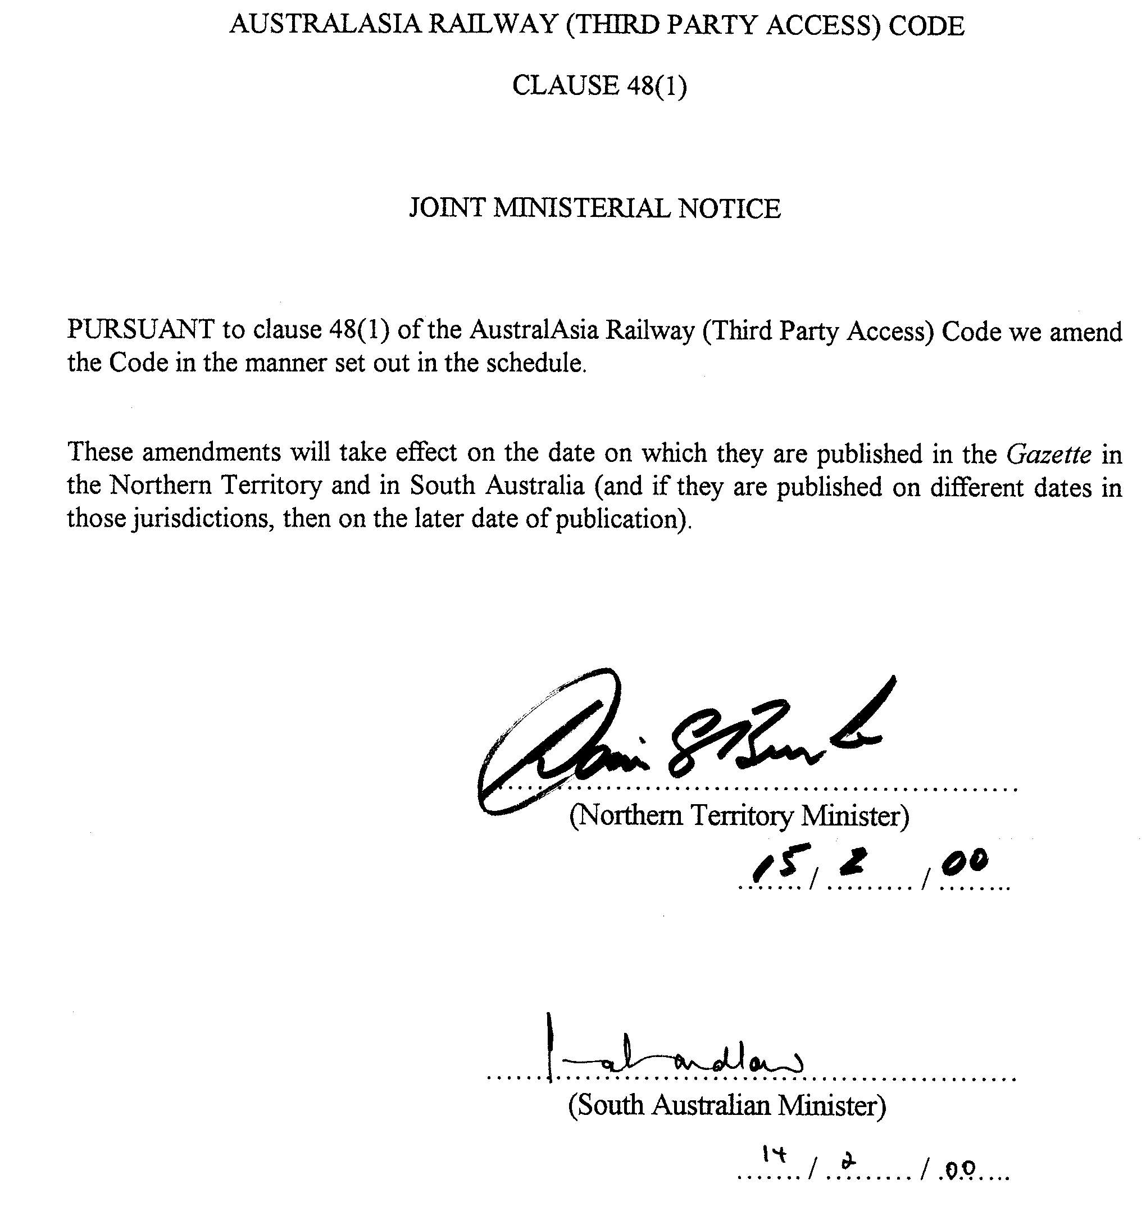
SCHEDULE
Amendments to Code
1. Amendment of clause 1—Title
Clause 1—Leave out “(Third Party) Access” and insert “(Third Party Access)”.
2. Amendment of clause 3—Interpretation
(1) Clause 3(1)—Definition of “access holder”—After “infrastructure facilities” insert “and includes the access provider if or when the access provider is providing a freight service or a passenger service by means of the railway”.
(2) Clause 3(1)—After the definition of “award” insert:
“corresponding access regime” means—
(a) —
(i) in respect of a service that is declared under Part IIIA of the Trade Practices Act 1974 of the Commonwealth, Part IIIA of that Act;
(ii) an access regime in respect of which there is a decision in force by the Commonwealth Minister under section 44N of the Trade Practices Act 1974 of the Commonwealth that the regime is an effective access regime;
(iii) an arrangement under an undertaking in operation under section 44ZZA of the Trade Practices Act 1974 of the Commonwealth; or
(iv) a code accepted by the Australian Competition and Consumer Commission under section 44ZZAA of the Trade Practices Act 1974 of the Commonwealth,
if and only to the extent that the regime allows for the resolution of interface issues arising under two or more railway access regimes; or
(b) a law, code, instrument or arrangement declared by the Northern Territory Minister and the South Australian Minister jointly, by notice in the Gazette, to be a corresponding access regime for the purposes of this definition;.
(3) Clause 3(1)—After the definition of “freight service” insert:
“interface issues”—these are issues which directly affect two or more railways (including the railway to which this Code applies) and which relate to operating a freight service or a passenger service by means of such railways;.
(4) Clause 3(1)—Definition of “railway infrastructure facilities”—Leave out this definition and insert:
"railway infrastructure facilities" means facilities necessary for the operation or use of the railway, including—
(a) the railway track;
(b) the signalling systems, train control systems and communications systems; and
(c) such other facilities as may be prescribed,
but not including rolling stock;.
(5) Clause 3(1)—Definition of “regulator”—Leave out this definition and insert:
“regulator”—see clause 5;.
(6) Clause 3(1)—After definition of “related body corporate” insert:
“required railway infrastructure”, in relation to an access seeker or access holder, means that portion of the railway infrastructure facilities required from the access provider in order to provide the relevant railway infrastructure service to the access seeker or access holder (as the case may be); .
(7) Clause 3—After subclause (2) insert:
(3) A reference in this Code to a person seeking access to a railway infrastructure service includes a reference to a person seeking access on behalf of another person or other persons.
(4) For the purposes of the pricing principles, an effective constraint will be taken to exist when it is likely that a supplier (or the threat of entry by a potential supplier) of transportation services by a mode other than rail (supplier A) will prevent another supplier of the same or similar transportation services by rail (supplier B) from sustaining prices materially above supplier B’s long term efficient costs of supply without offering materially more in return.
(5) The following provisions apply with respect to the prescription of any facilities under paragraph (c) of the definition of “railway infrastructure facilities” in subclause (1):
(a) the Ministers must not prescribe a facility without first consulting with the regulator; and
(b) the prescription of a facility must be consistent with the criteria set out in Clause 6(3)(a) of the Competition Principles Agreement referred to in the Trade Practices Act 1974 of the Commonwealth.
3. Substitution of clause 5
Clause 5—Leave out this clause and insert:
5. The regulator
The South Australian Independent Industry Regulator established under the Independent Industry Regulator Act 1999 of South Australia is the regulator under this Code (and may exercise and perform the powers and functions of the regulator under this Code for the purposes of both the law of the Northern Territory and the law of South Australia).
4. Amendment of clause 6—Powers and functions of regulator
(1) Clause 6(1)—Leave out “functions of the regulator are—” and insert “following functions are assigned to the regulator:”.
(2) Clause 6(1)(b)—Leave out “imposed on the regulator by” and insert “contemplated for the regulator under”.
(3) Clause 6(2)—Leave out “of the regulator” and insert “assigned to the regulator under this Code”.
5. Substitution of clause 8
Clause 8—Leave out this clause and insert:
8. Public consultation
(1) The regulator must undertake a public consultation process whenever the regulator—
(a) is undertaking a review under clause 50; or
(b) is considering the adoption of a guideline, or the adoption of a variation to a guideline, under this Code.
(2) A public consultation process under subclause (1) must provide for—
(a) the publication in a newspaper circulating generally in Australia of a notice describing the matter under consideration and inviting interested persons to make submissions in relation to the matter within a period stated in the notice; and
(b) the consideration by the regulator of any submissions made in response to an invitation under paragraph (a),
(and may include other consultation processes considered appropriate by the regulator).
6. Amendment of clause 9–Obligation of access provider to provide information about access
(1) Clause 9(1)—Leave out paragraph (c) (and the word “and” immediately before that paragraph) and insert:
(c) time-path allocation and reallocation policies for the railway;
(d) service quality and train management standards; and
(e) relevant prices and costs associated with railway infrastructure services provided by the access provider, prepared by the access provider for reference purposes in accordance with guidelines developed and published by the regulator.
(2) Clause 9—After subclause (2) insert:
(3) The access provider must, for the purposes of subclause (1)(c) and (d), develop and maintain time-path allocation and reallocation policies and service quality and train management standards in accordance with principles contained in guidelines developed and published by the regulator.
7. Amendment of clause 10—Access proposal
(1) Clause 10(1)—Leave out paragraph (b) and insert:
(b) any other information relevant to formulating a response to the access proposal, including information relevant to determining the price to be charged for access or on account of the variation (as the case may be).
(2) Clause 10(2)—Leave out “addition or extension to” twice occurring and insert, in both cases, “expansion or extension of”.
(3) Clause 10—Leave out the note after subclause (2).
(4) Clause 10—After subclause (2) insert:
(2a) An access proposal may involve—
(a) a proposal relating to one or more freight services or passenger services and one or more time paths for such services; and
(b) a person other than the access seeker who will ultimately require the railway infrastructure services which are the subject of the access request.
(5) Clause 10(4)—Leave out “and” appearing after paragraph (a).
(6) Clause 10(4)—After paragraph (b) insert:
and
(c) provide to the access seeker an indication (even if only a preliminary indication) of the terms and conditions on which the access provider would be prepared to grant access or to make the variation.
(7) Clause 10—After subclause (5) insert:
(5a) A written notice under subclause (4)(a)(ii) will be limited to providing the name and contact details of the access seeker and technical details concerning the nature and extent of the required access or variation.
8. Insertion of clauses 12A and 12B
After clause 12 (in Part 2 Division 1) insert:
12A. Protection of confidential information
(1) Information obtained under this Division that—
(a) could affect the competitive position of an access seeker or a respondent; or
(b) is commercially valuable or sensitive for some other reason,
is to be regarded as confidential information.
(2) A person who obtains confidential information under this Division must not disclose that information unless—
(a) the disclosure is reasonably required for the purposes of this Code;
(b) the disclosure is made with the consent of the person who supplied the information;
(c) the disclosure is required or allowed by law;
(d) the disclosure is required by a court or tribunal constituted by law; or
(e) the disclosure is in prescribed circumstances.
Penalty: $10 000.
(3) A person who obtains confidential information under this Division must not (unless authorised by the person who supplied the information)—
(a) disclose the information to an unauthorised person; or
(b) use (or attempt to use) the information for a purpose which is not authorised or contemplated by this Code.
Penalty: $10 000.
(4) Subclauses (1), (2) and (3) do not prevent or restrict the disclosure of information to the regulator and the regulator may in any event disclose confidential information if the regulator is of the opinion that the public benefit in making the disclosure outweighs any detriment that might be suffered by a person in consequence of the disclosure.
(5) A person who obtains confidential information under this Division must not use the information for the purpose of securing an advantage for himself or herself or for some other person in competition to the person who provided the information.
Penalty: $100 000.
(6) The access provider must, in connection with the operation of this clause, develop and maintain policies to ensure that confidential information obtained by the access provider under this Division is not—
(a) used in any unauthorised way or for an unauthorised purpose; or
(b) provided to an unauthorised person.
(7) The access provider must provide a copy of a policy that applies under subclause (6) to the regulator, and to any other person who requests a copy from the access provider.
(8) In this clause—
“unauthorised person” means a person who is directly involved, on behalf of the access provider, in the promotion or marketing of freight services or passenger services but does not include a person whose involvement is limited to—
(a) strategic decision making;
(b) performing general supervisory or executive functions; or
(c) providing technical, administrative, accounting, service or other support functions.
12B. Referral of issues to regulator
(1) An access seeker, the access provider or any other respondent to an access proposal may request the regulator to consider and, if appropriate, to give advice or directions with respect to any matter that has arisen in connection with the operation of this Division in order to facilitate the conduct of negotiations under this Division.
(2) A person making a request under subclause (1) must comply with any requirement published by the regulator for the purposes of this clause.
(3) The regulator may decline to consider or act on a request under subclause (1) for any reasonable cause.
(4) The regulator may, if the regulator thinks fit, give a general direction to the access provider under subclause (1) in respect of a particular matter under this Division.
(5) A person must not, without reasonable excuse, contravene or fail to comply with a direction given by the regulator under this clause.
Penalty: $10 000.
(6) This clause does not limit or affect the ability of an access seeker at any time to request that an access dispute be referred to arbitration under Division 2.
9. Amendment of clause 13—Access disputes
Clause 13(b)—Leave out “within 180 days after the response date”.
10. Amendment of clause 15—Conciliation and reference to arbitration
Clause 15(2)(c)—After “good faith” insert “or has resorted to arbitration prematurely or unreasonably”.
11. Amendment of clause 16—Arbitrator to be qualified
Clause 16—After subclause (3) insert:
(4) If it appears to the regulator—
(a) that a dispute includes, or may include, an interface issue; and
(b) that the access seeker is, or may be, involved in a dispute under a corresponding access regime,
then the regulator should, in making an appointment under this clause, endeavour to appoint a person who can also act under the corresponding access regime.
(5) If the regulator is unable to appoint a person under subclause (4) who is able to act under a corresponding access regime, the person appointed under this clause to act as an arbitrator must, in respect of any interface issues involved in a dispute, endeavour to consult with any person appointed to act as an arbitrator under the corresponding access regime.
12. Amendment of clause 17—Parties to arbitration
After the present contents of clause 17 (now to be designated as subclause (1)) insert:
(2) The regulator may participate in an arbitration under this Part.
(3) The participation of the regulator may include—
(a) providing or calling evidence;
(b) making representations on questions arising during the arbitration; and
(c) assisting the parties or the arbitrator with any matter (as may be appropriate).
13. Amendment of clause 19—Award by arbitrator
(1) Clause 19(2)(d)—Leave out “clause 20(1)” and insert “clause 20”.
(2) Clause 19(2)(d)—After “access provider to” insert “expand or”.
(3) Clause 19(2)(e)—Leave out “clause 20(2)” and insert “clause 20”.
(4) Clause 19(4)—After “arbitration and” insert “the regulator and”.
(5) Clause 19—After subclause (5) insert:
(6) The arbitrator may, in providing a draft award or making an award, do either or both of the following:
(a) divide the award into parts and limit distribution of a part in order to protect confidential commercial information from unnecessary publication;
(b) impose conditions with respect to the disclosure of confidential commercial information in order to prevent unnecessary publication.
(7) Despite any other provision, the regulator may disclose confidential commercial information if the regulator is ofT the opinion that it is in the public interest to do so.
14. Amendment of clause 20—Restrictions on access awards
(1) Clause 20(1)(a)(iii)—Leave out “addition or extension to” and insert “expansion or extension of”.
(2) Clause 20—After subclause (2) insert:
(3) Despite subclause (1), the arbitrator may make an award that would have the effect of requiring the access provider to expand or extend the railway infrastructure facilities, or to permit an expansion or extension of the railway infrastructure facilities, if—
(a) the expansion or extension is technically and economically feasible and consistent with the safe and reliable operation of the railway infrastructure facilities;
(b) the access provider’s legitimate business interests in the railway infrastructure facilities are protected; and
(c) the terms and conditions on which access is to be permitted are reasonable taking into account the costs to be borne by the parties and the economic benefits to the parties resulting from the expansion or extension.
(4) For the purposes of subclause (3)(b), it will be considered not to be in the access provider’s legitimate business interests to require the access provider to take action that would—
(a) result in a breach of—
(i) a reasonable financial or other covenant or commitment given by the access provider to a third party; or
(ii) a reasonable security obligation of the access provider to a third party; or
(b) result in the access provider having to assume an unreasonable financial, business or other risk, liability or detriment associated with the cost of the expansion or extension.
(5) However, subclause (4)(a) does not apply if it is found that the financial or other covenant or commitment was given, or the security obligation was undertaken, (as the case may be) by the access provider for the purpose of preventing or hindering access to a railway infrastructure service.
15. Amendment of clause 21—Matters arbitrator must take into account
(1) Clause 21(1)(b)—Leave out “high” (twice occurring).
(2) Clause 21(1)—After paragraph (e) insert:
(ea) in relation to an interface issue involving a corresponding access regime–the interests of the access seeker in having efficient access to the railway;.
(3) Clause 21(1)(i)—Leave out “facilities.” and insert “facilities,”.
(4) Clause 21(1)—Insert at the end of subclause (1) (i.e., after (and not forming part of) paragraph (i)) “(and may take into account any other matters, not inconsistent with the matters referred to above, that the arbitrator thinks are relevant).”.
(5) Clause 21—Leave out subclause (2) and insert:
(2) Subclause (1)(b) must be read in a manner that is not inconsistent with the principles set out in clause 6(4)(i) of the Competition Principles Agreement referred to in the Trade Practices Act 1974 of the Commonwealth.
16. Amendment of clause 22—Arbitrator may terminate arbitration in certain cases
Clause 22(1)(b)—After “good faith” insert “or is acting unreasonably”.
17. Amendment of heading to Part 2 Division 5
Heading to Part 2 Division 5—After “principles” insert “on an arbitration”.
18. Amendment of heading to clause 23
Leave out the heading to clause 23 and insert “Arbitrated prices for access relating to passenger or freight services”.
19. Repeal of clause 24
Leave out clause 24.
20. Amendment of clause 34—Costs of arbitration
Clause 34—Leave out subclause (1) and insert:
(1) The costs of an arbitration (including each party’s reasonable costs and expenses) are to be borne by the parties in proportions decided by the arbitrator.
21. Amendment of clause 35—Operation of award
Clause 35—Leave out subclauses (5) and (6) and insert:
(5) If the access seeker elects not to be bound by an award, the award is rescinded.
(6) If—
(a) an award is rescinded under subclause (5); and
(b) the access seeker who elected not to be bound by the award makes a new access proposal under this Code,
the regulator may, on application by the access provider, determine that the new access proposal should not proceed if, in the opinion of the regulator—
(c) in a case where the new access proposal is the same as, or similar to, the access proposal in relation to which the award was made—the access seeker is acting unreasonably in view of the period of time between the rescission of the award and the making of the new access proposal;
(d) the access seeker has not acted, or is not acting, in good faith; or
(e) there is some other good reason why the new access proposal should not proceed.
(7) A determination of the regulator under subclause (6) will have effect according to its terms.
22. Amendment of clause 40—Confidentiality
(1) Clause 40(2)—Leave out paragraph (a) and insert:
(a) if the regulator is of the opinion that it is in the public interest for the regulator so to do; or.
(2) Clause 40—After subclause (2) insert:
(2a) The regulator must, before taking action under subclause (2)(a), give the person who supplied the relevant information a reasonable opportunity to make submissions to the regulator in relation to the potential disclosure of the information.
23. Amendment of clause 41—Duty to report to Ministers
After the present contents of clause 41 (now to be designated as subclause (1)) insert:
(2) If the regulator provides a report to a Minister under subclause (1), the regulator must furnish a copy of the report to the other Minister.
24. Insert of clause 45A
After the heading to Part 6 insert:
45A. Power to vary guidelines
(1) The regulator may, from time to time as the regulator thinks fit, vary or revoke guidelines developed and published by the regulator under this Code, or develop and publish new or substitute guidelines.
(2) The regulator should, in developing (or varying) guidelines under this Code, take into account interface issues that may arise under a corresponding access regime (insofar as this may be relevant and insofar as this is consistent with, and not in derogation of the operation of, the other provisions of this Code).
25. Amendment of clause 46—Segregation of access provider’s accounts and records
Clause 46—Leave out subclause (2) and insert:
(2) The accounts and records must comply with any guidelines developed and published by the regulator and be kept in a way that gives—
(a) a comprehensive view of the access provider’s legal and equitable rights and liabilities in relation to railway infrastructure services;
(b) a true and fair view of—
(i) income and expenditure derived from, or relating to, railway infrastructure services; and
(ii) assets and liabilities of the access provider’s business so far as they relate to railway infrastructure services; and
(c) sufficient information to enable the pricing principles to be applied in a reasonable manner.
26. Substitution of clause 50
Clause 50—Leave out this clause and insert:
50. Review of Code
(1) The Northern Territory Minister and South Australian Minister jointly may, at any time, review the operation of this Code but, in any case, must do so—
(a) firstly, not later than 30 June in the 3rd year of operations of the railway; and
(b) secondly, not later than 12 months before the expiration of the period for which the Commonwealth Minister has specified under section 44N of the Trade Practices Act 1974 of the Commonwealth that the access regime, of which this Code is a part, is to remain in force.
(2) To enable the Ministers to perform their function under subclause (1), the regulator must prepare such reports to the Ministers as the Ministers may require.
(3) The Ministers must, in relation to a review under subclause (1)(a) or (b)—
(a) —
(i) by notice published in a newspaper circulating generally in Australia, invite interested persons to make submissions in relation to the review within a period stated in the notice; and
(ii) give consideration to any submissions made in response to an invitation under subparagraph (i); and
(b) —
(i) in the case of the Northern Territory Minister—cause a report on the outcome of the review to be laid before the Legislative Assembly of the Northern Territory within 12 sitting days after the completion of the review; and
(ii) in the case of the South Australian Minister—cause a report on the outcome of the review to be laid before both Houses of the South Australian Parliament within 12 sitting days after the completion of the review.
(4) The regulator must, at the intervals referred to in subclause (10), review the revenues paid or payable by access holders to the access provider for railway infrastructure services where no sustainable competitive prices exist (“relevant revenues”), being revenues derived under either:
(a) awards by arbitrators to the extent the awards involve the application of section 2 of the pricing principles; or
(b) access contracts to the extent that the regulator considers sustainable competitive prices did not or do not exist in relation to the transportation of the freight the subject of those access contracts,
and determine whether the relevant revenues paid or payable by such access holders (the “relevant access holders”) for those railway infrastructure services are excessive having regard to the factors referred to in subclause (5).
(5) In determining whether the relevant revenues are excessive the regulator must have regard to the following:
(a) the relevant revenues are to be measured against the costs associated with the required railway infrastructure required by the relevant access holders including an appropriate commercial return on the required railway infrastructure used by the relevant access holders in the circumstances referred to in subclause (4) (the “relevant required railway infrastructure”);
(b) the investment in all of the railway infrastructure facilities by the access provider or any other person and all of the revenues earned by the access provider from the provision of railway infrastructure services including, if the access provider, a related body corporate or an associate has conducted transportation services on the railway, revenues at market rates in relation to those services;
(c) an appropriate commercial return on the relevant required railway infrastructure, determined having regard to—
(i) the appropriate risk premium associated with the construction, development and operation of the railway infrastructure facilities, based on both of the following:
(A) the expected risks prevailing as at the date of commencement of construction of the railway by the access provider; and
(B) in respect of any expansion or extension of the railway after the date of commencement of construction of the railway by the access provider—the expected risks prevailing as at the date of the commencement of construction of that expansion or extension; and
(ii) the relevant financial market rates (including the risk free rate for return on investments and the rate of inflation) prevailing at the time of the regulator’s review;
(d) when comparing the relevant revenues to the costs under paragraph (a), the regulator must subtract from those costs an amount determined by the regulator to be the aggregate of—
(i) the avoidable costs attributable to the usage of the relevant required railway infrastructure by all other access holders (being avoidable costs of the kind referred to in section 3 of the pricing principles); and
(ii) a reasonable contribution to fixed costs of the relevant required railway infrastructure (“R”) from all other access holders using that required railway infrastructure, where R has the same meaning as in section 2(2)(c) of the pricing principles.
(6) The costs to be applied under subclause (5) must be efficient.
(7) For the purposes of determining expected risks under subclause (5)(c)(i), the regulator must have regard to information provided by the access provider with respect to the contents of any financing plan of the access provider.
(8) If the regulator determines that revenues are excessive under subclause (4)—
(a) the regulator must promptly give the access provider written notice of the regulator’s determination, including the reasons for his or her determination;
(b) within 2 months of receiving the regulator’s determination under paragraph (a), the access provider must prepare and submit to the regulator for approval a plan under which the access provider will reduce future relevant revenues so that such revenues are not excessive (having regard to the matters referred to in subclause (5)), when measured over the next regulatory review period (the “remedial plan”);
(c) the regulator will consider the remedial plan submitted to it with a view to reaching agreement with the access provider on the terms which are acceptable to the regulator for the remedial plan;
(d) if the regulator and the access provider agree on the terms of a remedial plan, the access provider must implement that plan;
(e) if the regulator and the access provider are unable to reach agreement on a remedial plan that is acceptable to the regulator within 1 month of receiving the remedial plan, the regulator must make a determination under subclause (9) and the access provider must observe the terms of that determination.
(9) If subclause (8)(e) applies, the regulator will make a determination to regulate prices, and/or to establish conditions relating to prices or price fixing factors in relation to the future provision of railway infrastructure services in any manner the regulator considers appropriate, including—
(a) fixing a price or the rate of increase or decrease in a price;
(b) fixing a maximum price or rate of increase or decrease in a maximum price;
(c) fixing an average price for specified railway infrastructure services or an average rate of increase or decrease in an average price;
(d) specifying pricing policies or principles;
(e) fixing a maximum revenue in relation to railway infrastructure services,
provided the effect of the determination is limited to reducing revenues of the type referred to in paragraphs (a) and (b) of subclause (4) derived from railway infrastructure services so that the total of such revenues so derived do not result in excessive revenues (having regard to the matters referred to in subclause (5)), when measured over the next regulatory review period.
(10) The regulator’s reviews under subclause (4) are to be conducted in relation to the following periods:
(a) the first review must be in respect of the period ending on 30 June in the 10th year of operations of the railway;
(b) the second review must be in respect of the 5 year period commencing immediately after the end of the period of the first review; and
(c) the third and subsequent reviews must be in respect of successive 5 year periods.
27. Substitution of schedule
Leave out the schedule and insert:
SCHEDULE
Access Pricing Principles
Division 1—Access pricing in connection with freight services
1. Sustainable competitive prices
(1) The access price payable to the access provider by an access seeker for a railway infrastructure service provided to enable the access seeker to deliver a freight service will be determined by the arbitrator and will depend on whether there is—
(a) a sustainable competitive price (as to which see subsections (2) to (6)); or
(b) no sustainable competitive price (as to which see section 2).
(2) A sustainable competitive price will exist in relation to the transportation of a particular type of freight where it can be demonstrated that—
(a) there are no regulatory, technical or other practical impediments to transport of the freight by a mode of transport other than the railway or combination of such alternative modes; and
(b) the availability or potential availability of modes of transport other than the railway is an effective constraint on the price of transporting such freight on the railway having regard to the following factors:
(i) the number and size of participants in the market;
(ii) the type and volume of freight involved and any unequal backhaul loadings;
(iii) whether there are any regulatory, technical or other practical barriers to entry;
(iv) the extent of product differentiation in the market, including the differences in the ancillary services and convenience offered by different modes of transport;
(v) the dynamic characteristics of the market including any fluctuations in demand for transportation services;
(vi) the costs and service characteristics of transporting freight by different modes of transport (including the time for delivery of the freight, rail rolling stock or other vehicle axle loadings, length and speed of trains, and any infrastructure upgrade requirements);
(vii) contractual terms (such as duration and frequency of service, whether for a specific volume or at call);
(viii) congestion and bottleneck inefficiencies caused by constraining points on the road, railway or other relevant infrastructure;
(ix) the safety requirements the different modes of transport are required to meet;
(x) the direct and indirect costs of environmental impacts of the different modes of transport; and
(xi) any other relevant matters.
(3) Where there is a sustainable competitive price, the access price (AP) payable to the access provider by an access seeker for the railway infrastructure service will be a price determined by the arbitrator which is—
(a) not more than the ceiling price for the provision of the railway infrastructure service (see subsection (4)); and
(b) not less than the floor price for the provision of the railway infrastructure service (see subsection (5)),
but subject to these qualifications the price so determined will be calculated in accordance with subsection (6).
(4) The ceiling price is to be an amount equal to the costs associated with the operation of the required railway infrastructure needed by the access seeker for the provision of the freight service involving the transportation of freight on the railway between one point (point A) and another point (point B), calculated assuming the access seeker is the sole user of that required railway infrastructure and calculated in a manner consistent with section 2(2)(d) and (7)(a).
(5) The floor price is to be calculated in accordance with section 3.
(6) Subject to subsections (4) and (5), the access price payable where there is a sustainable competitive price is to be an amount calculated in accordance with the following formula:
AP = CRLP_{AB} – IC_{AR}
Where—
AP is the access price payable by the access seeker to the access provider for the railway infrastructure service used by the access seeker to provide a freight service to its customers involving the transportation of freight on the railway between one point (point A) and another point (point B);
CRLP_{AB} is the competitive rail-linehaul price, being the maximum competitive price that the access provider could charge for the transport of freight between one point (point A) and another point (point B) on the railway having regard to the nature of the railway infrastructure service being sought and—
(a) the prices charged (on the basis of long term efficient costs of supply) for transporting on the railway the same or similar freight where some other mode of transport (or a combination of modes) provide an effective constraint on prices, taking into account, and where appropriate removing the effect of, any differences in—
(i) the type and volume of freight product involved;
(ii) cost or service characteristics (such as the time for delivery of the freight, rolling stock axle loadings, train length and train speed);
(iii) contractual terms (such as the duration and frequency of the access contract and whether the contract involves a take-or-pay obligation for specific volumes of freight or some other risk allocation arrangement);
(iv) the amount of freight and the prices charged in each direction; and
(v) the origin and the ultimate destination of the freight; and
(b) the prices charged (on the basis of long term efficient costs of supply) for the use of alternative modes of transport (for example, by road, sea, air or some other mode of transport or a combination of such means) for transporting the same or similar freight taking into account, and where appropriate removing the effect of, any differences in—
(i) any additional handling or transportation costs required in order to compare the total price of delivering the relevant freight product from the linehaul point of pick-up (of the alternative mode of transport) to the final linehaul point of delivery of the freight product, when compared to transporting the freight product from the linehaul point of pick-up to the final linehaul point of delivery via the relevant section of the railway between point A and point B;
(ii) the type of freight product involved, including its handling characteristics and the volumes of the freight product to be hauled and the contributions, if any, required to upgrade necessary infrastructure;
(iii) contractual terms (such as the duration and frequency of the service relating to the delivery of freight and whether the contract for the delivery of freight involves a take-or-pay obligation for specific volumes of freight or some other risk allocation arrangement);
(iv) the amount of freight and the prices charged in each direction; and
(v) the origin and ultimate destination of the freight; and
IC_{AR} is the incremental cost (above-rail) of providing the relevant freight service (including, if the relevant freight service is not provided, an estimate of that cost) involving the transport of freight between point A and point B on the railway of whichever of the following entities that conducts freight services:
(a) the access provider;
(b) if the access provider does not conduct freight services, a related body corporate or an associate of the access provider;
(c) if neither the access provider nor a related body corporate or an associate of the access provider conduct any freight services, an operator of freight services operating in accordance with good railway industry practice,
(the relevant entity being referred to as the "designated service provider"), such costs to be calculated having regard to the total above-rail incremental costs, being the costs the designated service provider would avoid if it did not provide the freight service, including—
(d) operating costs, being the on-going operational costs of providing the freight service, including the labour and material costs that are causally related to the provision of the freight service, including
– train crew labour costs;
– rollingstock maintenance costs;
– fuel costs; and
– terminal handling costs;
(e) administrative costs; and
(f) an appropriate allowance for capital costs, which reflects the opportunity costs of the relevant above-rail assets of the designated service provider where they exist or otherwise the acquisition cost of the relevant above-rail assets (which may not be new assets), comprising both depreciation and return on assets, determined in accordance with guidelines developed and published by the regulator.
(7) The guidelines referred to in paragraph (f) above must—
(a) adopt an approach for valuing capital assets; and
(b) provide guidance on the timeframes within which the regulator considers costs could be avoided,
(and may include other provisions considered appropriate by the regulator).
2. No sustainable competitive prices
(1) Where there is not a sustainable competitive price, the access price payable to the access provider by an access seeker for a railway infrastructure service that is provided to enable the access seeker to deliver a freight service will be a reasonable price determined by the arbitrator which is—
(a) not more than the ceiling price for the provision of the railway infrastructure service (see subsection (2)); and
(b) not less than the floor price for the provision of the railway infrastructure service (see subsection (4)),
and the price so determined must take into account the matters set out in clause 21 of this Code.
(2) The ceiling price is to be an amount equal to whichever is the lesser of:
(a) the costs associated with the operation of the required railway infrastructure needed by the access seeker for the provision of the freight service involving the transportation of freight on the railway between one point (point A) and another point (point B), calculated assuming the access seeker is the sole user of that required railway infrastructure; and
(b) the costs associated with the operation of the required railway infrastructure needed by the access seeker for the provision of the freight service involving the transportation of freight on the railway between one point (point A) and another point (point B), less an amount determined by the arbitrator to be the aggregate of—
(i) the avoidable costs attributable to the usage of that required railway infrastructure by all other access holders; and
(ii) a reasonable contribution to the fixed costs of that required railway infrastructure (“R”) from all other access holders using that required railway infrastructure,
where—
(c) R is to be an amount which is not greater than the amount, if any, by which revenues of the access provider attributable to access holders’ (other than the access seeker’s) usage of the required railway infrastructure required by those access holders exceeds the avoidable costs attributable to those access holders’ usage of that required railway infrastructure; and
(d) the costs are to be on-going costs that are causally related to the relevant required railway infrastructure, including—
(i) labour and material costs associated with the operation and maintenance of the required railway infrastructure (including major periodic maintenance);
(ii) an appropriate allocation of administrative costs;
(iii) an appropriate allocation of capital costs, including both depreciation and a return on assets, determined in accordance with guidelines developed and published by the regulator.
(3) The costs to be applied in subsection (2) must be forward-looking and efficient.
(4) The floor price is to be calculated in accordance with section 3.
(5) The arbitrator must, in determining a price under this section, have regard to economic efficiency taking into account the prices being charged by the access provider to access holders for the same or similar services (including, if the access provider, a related body corporate or an associate has conducted the same or similar services on the railway, the actual prices charged in relation to those services).
(6) The regulator must develop and publish guidelines in connection with the operation of this section (in addition to the guidelines specifically required under subsection (2)(d)(iii)).
(7) The guidelines must—
(a) subject to subsection (8), adopt an approach for valuing capital assets which reflects the Depreciated Optimised Replacement Cost for those assets;
(b) provide guidance on the timeframes within which the regulator considers costs could be avoided; and
(c) in relation to a return on assets, have regard to—
(i) the appropriate risk premium associated with the construction, development and operation of the railway infrastructure facilities, based on both of the following:
(A) the expected risks prevailing as at the date of commencement of construction of the railway by the access provider; and
(B) in respect of any expansion or extension of the railway after the date of commencement of construction of the railway by the access provider—the expected risks prevailing as at the date of the commencement of construction of that expansion or extension; and
(ii) the relevant financial market rates (including the risk free rate for return on investments and the rate of inflation),
(and may include other provisions considered appropriate by the regulator).
(8) The guidelines may, if the regulator thinks it appropriate to do so, allow an adjustment to the Depreciated Optimised Replacement Cost valuation of capital assets under subsection (7)(a) on account of government-contributed assets and other government financial assistance after taking into account any associated liabilities assumed by the access provider, subject to the qualifications that any such adjustment:
(a) must not, when used in calculating the ceiling prices specified in sections 1(4) and 2(2), prevent the access provider earning a reasonable risk-adjusted return on the capital invested in the railway (disregarding government-contributed assets and other government financial assistance); and
(b) must be made on a pro-rated basis over the entirety of the capital assets comprising the railway infrastructure facilities.
3. Access price not below economic cost
(1) The access price must not be less than the economic cost of providing the railway infrastructure service, and accordingly the access price calculated in accordance with section 1 or section 2 (as the case may be) must not be less (but may be greater) than an amount which is equal to the avoidable costs (below-rail) associated with the access provider providing access to the required railway infrastructure for the access seeker to deliver the relevant freight service involving the transport of freight between point A and point B on the railway, being:
(a) labour and material costs which vary directly with the usage of the access seeker (including major periodic maintenance);
(b) administrative costs which vary directly with the usage of the access seeker; and
(c) capital costs which vary directly with the usage of the access seeker, including the costs of replacing the required railway infrastructure assets being brought forward by the operation of the freight service (such as wear and tear of the track).
(2) The costs to be applied in subsection (1) must be forward-looking and efficient.
(3) The regulator must develop and publish guidelines in connection with the operation of this section.
(4) The guidelines must—
(a) subject to subsection (5), adopt an approach for valuing capital assets which reflects the Depreciated Optimised Replacement Cost of those assets;
(b) provide guidance on the timeframes within which the regulator considers costs could be avoided; and
(c) in relation to a return on assets, have regard to—
(i) the appropriate risk premium associated with the construction, development and operation of the railway infrastructure facilities, based on both of the following:
(A) the expected risks prevailing as at the date of commencement of construction of the railway by the access provider; and
(B) in respect of any expansion or extension of the railway after the date of commencement of construction of the railway by the access provider—the expected risks prevailing as at the date of the commencement of construction of that expansion or extension; and
(ii) the relevant financial market rates (including the risk free rate for return on investments and the rate of inflation),
(and may include other provisions considered appropriate by the regulator).
(5) The guidelines may, if the regulator thinks it appropriate to do so, allow an adjustment to the Depreciated Optimised Replacement Cost valuation of capital assets under subsection (4)(a) on account of government-contributed assets and other government financial assistance after taking into account any associated liabilities assumed by the access provider, subject to the qualifications that any such adjustment:
(a) must not, when used in calculating the floor prices specified in sections 1(5) and 2(4), prevent the access provider earning a reasonable risk-adjusted return on the capital invested in the railway (disregarding government-contributed assets and other government financial assistance); and
(b) must be made on a pro-rated basis over the entirety of the capital assets comprising the railway infrastructure facilities.
Division 2—Access pricing in connection with passenger services
4. Access pricing for passenger access
(1) The access price payable to the access provider by an access seeker for a railway infrastructure service that is provided to enable the access seeker to deliver a passenger service will be a price determined by the arbitrator which is—
(a) not more than the ceiling price for the provision of the railway infrastructure service (see subsection (2)); and
(b) not less than the floor price for the provision of the railway infrastructure service (see subsection (3)).
(2) The ceiling price is to be determined by the arbitrator reflecting the highest price that could fairly be asked by the access provider for the provision of the railway infrastructure service having regard to the principles used to calculate the ceiling price set out in section 2(2).
(3) The floor price for the provision of railway infrastructure services is to be determined by the arbitrator reflecting the lowest price at which the access provider could provide the railway infrastructure service without incurring a loss, having regard to the principles set out in section 3.
Division 3—Worked examples
5. Introduction
The process an arbitrator should follow is illustrated in Attachment A. Three worked examples are provided in this section to illustrate application of the pricing principles. One example is for a service covering freight traffics that are already hauled by the railway and the second and third examples are for new freight traffics, with and without a sustainable competitive price respectively.
(1) Example 1—Existing freight traffic
This example assumes that the access proposal relates to the operation of general freight services over the length of the railway (Tarcoola to Darwin), i.e. it will attract existing freight from the incumbent general rail freight operator but also potentially new freight of the same type (either transferred from road or generated).
Following the process illustrated in Attachment A, a number of discrete steps are required:
(a) Is there a sustainable competitive price for such a freight service in the corridor?
· For general freight services, the road linehaul rate is likely to provide an effective constraint on the pricing of the railway for these services, given the:
— highly competitive road market; and
— low switching costs between road and rail.
· For this example, it is assumed that this threshold test is met.
(b) What is the competitive imputation access price (CRLP_{AB} – IC_{AR})?
• If the railway hauls the same or similar freight in the corridor, the railway’s current freight rates will be a strong guide to the competitive rail linehaul price for the service for which access is being sought.
- Other value-added services provided by the railway may have to be disaggregated from the rail price delivered to the customer (e.g. road pickup and delivery charges).
- Other adjustments might be required to account for differences in the type of service being operated, for instance:
... time of day/peak issues; or
... conditions of contract (e.g. long-term freight haulage contract vs. spot rates).
· Assume for this example, that existing freight of the same or similar type was carried for an average rate of 3.5 cents per net tonne kilometre and that this was considered to be the sustainable competitive rail linehaul price (CRLP_{AB}).
· The incremental above rail cost (IC_{AR}) represents the costs which the integrated freight operator would avoid if it did not provide the freight service.
· IC_{AR} would be determined with regard to the actual above rail costs of the integrated access provider (where they exist). Attachment B illustrates an example railway owner’s cost structure.
· The competitive imputation access price (2.17 c/ntk) is the difference between the competitive rail linehaul price (CRLP_{AB}) of 3.50 c/ntk and the incremental above rail costs (IC_{AR}) of 1.33 c/ntk (1.03 + 0.3 being the sum of the incremental above rail operating cost and the rollingstock capital charge). Expressed in terms of cents per gross-tonne-kilometre, the equivalent competitive imputation access price is 0.99 c/gtk.
- It was assumed that all costs, except administration/management costs and 50% of the terminal costs would be avoidable with the loss of freight business.
- If the freight service for which access was being sought would replace the entire above rail business of the access provider, then all above rail costs are likely to be avoidable in which case, IC_{AR} increases to 1.55 (1.25+0.30) and the access price falls from 2.17 c/ntk to 2.00 c/ntk (0.89 c/gtk).
(c) What is the ceiling price?
· Stand-alone operating costs are taken to be $16.18 million, which is less than operating costs of the total railway of $24 million allowing for minimum requirements of the access seeker as a stand-alone operation (see Attachment C).
• It is assumed that track depreciates with use and a depreciation charge of 0.05c/gtk has been applied (i.e. the usage of the service of 3.6 billion gtk x 0.05c/gtk). Other infrastructure is depreciated on a time basis assuming a 50 year life. The total depreciation charge is $15.3 million.
· The replacement value of the railway from Tarcoola to Darwin might be $1500 million, which might correspond to a written-down value of $1000 million.
— The interest charge after tax is $180 million (assuming an allowable rate of return of 18%) which grosses up to $281.25 million (assuming an effective tax rate of 36%) before tax. Guidelines on the method to be applied in calculating the stand-alone cost will be developed and published by the regulator.
— Total stand-alone below rail costs of the relevant infrastructure, including operations and maintenance costs, are $312.73 million as shown in Attachment C.
• If the relevant traffic was to generate 2 billion ntk, the ceiling price would be 15.64 c/ntk or 8.69 c/gtk (@1.8 ntk:gtk).
(d) What is the floor price?
· The floor price is the incremental below rail cost, i.e. the below rail costs which could be avoided if it were not for the use of the network by the freight service seeking access.
- Typically, this will include both maintenance costs and capital consumption costs attributable to the individual service. Some operations (signalling) costs may also be avoided depending on the nature of the train control operations and the nature of the service for which access is being sought. Guidelines on the method to be used to calculate the floor price will be developed and published by the regulator.
- In Attachment B, the track variable cost, i.e. the component of infrastructure maintenance which varies directly with the usage of the access seeker, is 0.07 c/gtk ($6m/8800m gtk). In this example there are no directly variable operations (train control) and administration costs.
- The capital costs which will vary directly as result of the access seeker’s usage will relate to components of infrastructure where renewal is typically related to use (as opposed to time). For higher density lines, this will typically include rails, sleepers and ballast. Assuming a track replacement cost of $500,000 per kilometre (including rails, sleepers and ballast but excluding initial formation works and structures), and an economic life of 1 billion gross tonnes, gives a depreciation charge of 0.05 c/gtk. Assuming an equivalent interest charge, gives a total incremental below rail cost of 0.17 c/gtk (0.07+0.05+0.05).
(e) What is the final access price?
• The final access price is determined as the CIPR price (0.99 c/gtk) but is to be not less than the floor price (0.17 c/gtk) or more than the ceiling price (8.69 c/gtk).
(2) Example 2—New freight traffic—sustainable competitive price
This example assumes that the access proposal relates to the operation of a new mineral freight service over 300 kms of the railway. Again, following the process illustrated in Attachment A, a number of discrete steps are required:
(a) Is there a sustainable competitive price for such a freight service in the corridor?
• Developments in road transport technologies have meant that road transport is now a viable competitor for the transport of bulk mineral flows in non-urban areas.
- Various examples now exist in the Northern Territory and Queensland where large volumes of mineral traffic are hauled by road (several hundreds of thousands of tonnes over several hundred kilometres).
- Where sufficient differences in the characteristics of the haul exist, cost modelling could be undertaken to develop alternative road costs for the freight service for which access has been sought.
... The cost of any road upgrades required would need to be factored into the analysis.
... The costs would include capital charges for the vehicles over their economic life (which may be the economic life of the mine rather than the engineering life of the vehicles).
· Assume for this example, that the competitive alternative price was determined to be 4.0 cents per net tonne kilometre which was considered to be an effective constraint on the pricing of the railway, having regard to the:
— relative costs of transport by road and rail; and
— low switching costs between road and rail.
(b) What is the competitive imputation access price (CRLP_{AB} –IC_{AR})?
• Because it is a new traffic, CRLP_{AB} will be determined with regard to the competitive alternative mode.
– Rail rates charged to existing customers might however assist the arbitrator in making judgements about adjustments for contract conditions, service quality factors etc.
· Assume for this example that the CRLP_{AB} was 4.0 c/ntk.
· The incremental above rail cost (IC_{AR}) represents the costs that the integrated freight operator would avoid if it did not provide the freight service:
– In this case, IC_{AR} would still be based on the integrated access provider’s actual costs, but adjusted for the avoidable resources assuming it did not undertake the freight service.
– The avoidable resources required (i.e. locomotives, wagons, train hours etc) are valued using a set of unit costs (developed from the railway’s accounts). Attachment D provides example unit costs.
– The derivation of IC_{AR} for the new traffic example is shown in Attachment E. It was assumed that some additional terminal costs would be required (@ $0.50 per tonne) but no additional shunting or administration/overhead costs would be incurred.
· The competitive imputation access price (2.23 c/ntk) is the difference between the competitive rail linehaul price (CRLP_{AB}) of 4.00 c/ntk and the incremental above rail costs (IC_{AR}) of 1.77 c/ntk. Expressed in terms of cents per gross-tonne-kilometre the equivalent competitive imputation access price is 1.24c/gtk (2.23/1.80).
(c) What is the ceiling price?
· The replacement value of the 300 kms of the railway being used by the new traffic might be $200 million, which might correspond to a written-down value of $160 million.
— The interest charge after tax is $29 million (assuming an allowable rate of return of 18%) which grosses up to $45 million (assuming an effective tax rate of 36%) before tax. Guidelines on the method to be applied in calculating the stand-alone cost will be developed and published by the regulator.
— Total stand-alone below rail costs of the relevant infrastructure, including operations and maintenance costs, are $47.7 million as shown in Attachment F.
• If the new traffic was to generate 1 billion ntk, the ceiling price would be 4.77 c/ntk or 2.65 c/gtk (@1.8 ntk:gtk).
(d) What is the floor price?
• Following the example in the previous section, the floor price is 0.17 c/gtk.
(e) What is the final access price?
• The final access price is determined as the CIPR price (1.24 c/gtk) but is to be not less than the floor price (0.17 c/gtk) or more than the ceiling price (2.65 c/gtk).
(3) Example 3—New freight traffic—no sustainable competitive price
This example similarly assumes that the access proposal relates to the operation of a new mineral freight service over 300 kms of the railway. Again, following the process illustrated in Attachment A, a number of discrete steps are required:
(a) Is there a sustainable competitive price for such a freight service in the corridor?
• Assume for this example, that the competitive alternative was considered not to be a substitutable service and did not provide an effective constraint on the pricing of the railway, i.e. no sustainable competitive price exists.
(b) What is the ceiling price?
· The replacement value of the 300 kms of the railway being used by the new traffic might be $200 million, which might correspond to a written-down value of $160 million.
— The interest charge after tax is $29 million (assuming an allowable rate of return of 18%) which grosses up to $45 million (assuming an effective tax rate of 36%) before tax. Guidelines on the method to be applied in calculating the stand-alone cost will be developed and published by the regulator.
— Total stand-alone below rail costs of the relevant infrastructure, including operations and maintenance costs, are $47.7 million as shown in Attachment G.
• If there are multiple users of the relevant railway infrastructure, the arbitrator may choose to determine an amount "R", being a reasonable contribution to shared costs from those other users.
— The contribution to "R" from any single access holder would not exceed the amount by which their access revenue exceeds their avoidable costs and would not be less than the additional costs they impose from their use of the relevant railway infrastructure.
— Assume for this example that the arbitrator determined that amount to be $23.85 million (50% of the stand-alone cost).
• If the new traffic was to generate 1 billion ntk, the ceiling price would be 2.39 c/ntk or 1.33 c/gtk (@1.8 ntk:gtk).
(c) What is the floor price?
· Following the calculations from the previous example, the incremental below rail cost is 0.17 c/gtk.
(d) What is the final access price?
· The arbitrator would then set an access price between the ceiling price (of 1.33 c/gtk) and the floor price (of 0.17 c/gtk).
· When determining the final access price, the arbitrator may take into account a range of factors considered relevant, such as
— the potential impact on the access provider’s legitimate business interests, having regard to the access provider’s investment in above-rail rollingstock and infrastructure; and
— the potential for the new entrant to create additional economic value (as opposed to merely transferring value from the access provider).

ATTACHMENT A. PROCESS FOR DETERMINING THE ARBITRATED ACCESS PRICE
ATTACHMENT B. RAILWAY OWNER’S COST STRUCTURE
Existing fleet
Locomotives | 15
Wagons | 600
Trains per week | 10
Above rail services | ($ pa)
Train crew | $6,000,000
Fuel | $16,000,000
Locomotive maintenance | $8,000,000
Wagon maintenance | $7,000,000
Terminal and shunting operations | $8,000,000
Administration/management | $5,000,000
Total above rail services | $50,000,000
Below rail services
Track access charges (Tarcoola—Adelaide) |  |  | $6,000,000
Train control (Darwin—Tarcoola) | $1,000,000
Variable infrastructure maintenance (Darwin—Tarcoola) | $6,000,000
Fixed infrastructure maintenance (Darwin—Tarcoola) |  |  | $14,000,000
Administration, management | $3,000,000
Total below rail services | $30,000,000
Total | $80,000,000
Net tonne kilometres | 4,000,000,000
Gross tonne kilometres |  |  | 8,800,000,000
Above rail operating costs (cents per ntk) |  |  | 1.25
Incremental above rail operating cost (cents per ntk)¹ | 1.03
Total operating cost (cents per ntk) | 2.00
Average operating revenue per ntk (CRLP_{AB}) | 3.50
Total operating revenue | $140,000,000
Surplus to common costs, rollingstock capital and track² | $99,000,000
Surplus to common costs, rollingstock capital and track (cents per ntk) |  |  | 2.47
Annual capital charge (per locomotive) | $266,667
Annual capital charge (per wagon) | $13,333
Annual capital charges for locomotives | $4,000,000
Annual capital charges for wagons | $8,000,000
Total rollingstock capital charge | $12,000,000
Remaining surplus to common costs and track | $87,000,000
Total rollingstock capital charge (cents per ntk) | 0.30
Incremental Above Rail Cost (IC_{AR}) (cents per ntk) | 1.33
Equivalent access charge (cents per ntk) | 2.17
Approximate equivalent gtk charge (@2.2 ntk:gtk) |  |  | 0.99

Notes:
1. Total above rail cost ($50m) less admin/management ($5m) and 50% terminal costs ($4m) divided by ntk (4b).
2. Revenue ($140m) less incremental above rail costs ($41m).

ATTACHMENT C. CEILING PRICE (COMPETITIVE MARKET)
 | Total Railway  ($ pa) | Stand-alone  Cost  ($ pa)
Below rail operations and maintenance
Train control (Darwin—Tarcoola) | 1,000,000 | 1,000,000
Track variable (Darwin—Tarcoola) | 6,000,000 | 680,000
Fixed infrastructure maintenance (Darwin—Tarcoola) | 14,000,000 | 14,000,000
Administration, management | 3,000,000 | 500,000
Total below rail services | 24,000,000 | 16,180,000
Below rail capital charges
Depreciation—track (0.05 c/gtk) |  | 1,800,000
Depreciation—other infrastructure ($300,000/km@50 yrs) |  |  | 13,500,000
Return on investment ($180m@18%/0.64) |  |  | 281,250,000
Total below rail capital charges |  | 296,550,000
Total stand-alone cost |  | 312,730,000
Calculation of ceiling price:
Usage (ntk pa) |  | 2,000,000,000
Ceiling price (c/ntk) |  | 15.64
Ceiling price (c/gtk @1.8 ntk:gtk) |  | 8.69

ATTACHMENT D. RAILWAY OWNER’S UNIT RATES
Cost Area | Cost Driver | Unit rate
Train crew | train hour | $150.00
Fuel | 000 gtk | $2.50
Locomotive maintenance | loco kms | $1.50
Wagon maintenance | 000 wagon kms | $80.00
Train control (Darwin—Tarcoola) | route kms | $300.00
Track variable | 000 gtk | $0.50
Fixed infrastructure maintenance | track kms | $5,000.00
Administration, management | % mark up on other operating costs | 8%
Terminal operations | per tonne | $4.00
Shunting | per tonne | $4.00

ATTACHMENT E. NEW TRAFFIC EXAMPLE
Operating assumptions
Freight task (tonnes pa) |  | 2,500,000
Average haul (kms) |  | 300
Net tonne kms pa |  | 750,000,000
Av. Gross trailing load (per train)¹ |  | 6,000
Train load (net tonnes per train) |  | 4,560
Number of trains pa |  | 548
Locomotives per train |  | 3
Wagons per train |  | 60
Round-trip cycle time (hrs) |  | 24
Cycles per week |  | 7
Locomotive fleet requirement |  | 7
Wagon fleet requirement |  | 132
Train hours pa |  | 13,158
Gross tonne kms pa (000) |  | 1,351,974
Wagon kms pa (000) |  | 19,737
Locomotive kms pa |  | 986,842
Incremental above rail costs
 | Cost driver | Unit rate | Total cost pa
Train crew | train hour | $150.00 | $1,973,700
Fuel | 000 gtk | $2.50 | $3,379,935
Locomotive maintenance | locomotive kms | $1.50 | $1,480,263
Wagon maintenance | 000 wagon kms | $80.00 | $1,578,960
Administration, management | % mark up | 8.0% | 0
Terminal operations | per tonne | $0.50 | $1,249,440
Shunting | per tonne |  | 0
Incremental operating costs |  |  | $9,662,298
Incremental capital charges | locomotives | $266,667 | $1,866,669
 | wagons | $13,333 | $1,759,956
Total incremental above rail cost |  |  | $13,288,923
Incremental above rail cost (c/ntk) (IC_{AR}) |  |  | 1.77
Incremental above rail cost (c/gtk) (@1.80 ntk:gtk) |  |  | 0.98

Note: 1. Gross trailing load is the gross weight hauled behind the locomotive(s) and is the sum of the weight of the freight and the tare weight of the wagons (it excludes the weight of the locomotives).

ATTACHMENT F. CEILING PRICE (NEW TRAFFIC – COMPETITIVE MARKET)
 | Total Railway  ($ pa) | Relevant Infrastructure  ($ pa)
Below rail operations and maintenance
Train control (Darwin—Tarcoola) | 1,000,000 | 133,333
Track variable (Darwin—Tarcoola) | 6,000,000 | 800,000
Fixed infrastructure maintenance (Darwin—Tarcoola) | 14,000,000 | 1,866,667
Administration, management | 3,000,000 | 400,000
Total below rail services | 24,000,000 | 3,200,000
Below rail capital charges
Depreciation—track (0.05 c/gtk) |  | 900,000
Depreciation—other infrastructure ($300,000/km@50 yrs) |  |  | 1,800,000
Return on investment ($160m@18%/0.64) |  |  | 45,000,000
Total stand-alone cost |  | 47,700,000
Calculation of ceiling price:
Usage (ntk pa) |  | 1,000,000,000
Ceiling price (c/ntk) |  | 4.77
Ceiling price (c/gtk @1.8 ntk:gtk) |  | 2.65

ATTACHMENT G. CEILING PRICE (NEW TRAFFIC - NO COMPETITIVE MARKET)
 | Total Railway  ($ pa) | Relevant Infrastructure  ($ pa)
Below rail operations and maintenance
Train control (Darwin—Tarcoola) | 1,000,000 | 133,333
Track variable (Darwin—Tarcoola) | 6,000,000 | 800,000
Fixed infrastructure maintenance (Darwin—Tarcoola) | 14,000,000 | 1,866,667
Administration, management | 3,000,000 | 400,000
Total below rail services | 24,000,000 | 3,200,000
Below rail capital charges
Depreciation—track (0.05 c/gtk) |  | 900,000
Depreciation—other infrastructure ($300,000/km@50 yrs) |  |  | 1,800,000
Return on investment ($160m@18%/0.64) |  |  | 45,000,000
Total stand-alone cost |  | 47,700,000
Contribution from other users ("R") |  | 23,850,000
Total Cost |  | 23,850,000
Calculation of ceiling price:
Usage (ntk pa) |  | 1,000,000,000
Ceiling price (c/ntk) |  | 2.39
Ceiling price (c/gtk @1.8 ntk:gtk) |  | 1.33

ROAD TRAFFIC ACT 1961

Operation of B-Double Vehicles up to 25 m in Length

PURSUANT to the provisions of Section 161A of the Road Traffic Act 1961 and Regulation 35 of the Road Traffic (Miscellaneous) Regulations 1999, I, T. N. Argent, Executive Director, Transport SA, as an authorised delegate of the Minister for Transport and Urban Planning, hereby approve B-Double Vehicles up to an overall length not exceeding 25 metres, to operate on routes specified by this Notice and in accordance with the document titled Operation of Medium Combination Vehicles in South Australia, Edition No. 1 (clauses 1-6 and 8-10 only), issued by Transport SA, and

PURSUANT to the provisions of Section 163AA of the Road Traffic Act 1961, I, T. N. Argent, Executive Director, Transport SA, as an authorised delegate of the Minister for Transport and Urban Planning, hereby exempt B-Doubles transporting baled wool from Rule 72 Height of the Road Traffic (Vehicle Standards) Regulations 1999.

Both the exemption and approval are subject to the following conditions:

- Special Conditions
  - This Notice and the document titled ‘Operation of Medium Combination Vehicles in South Australia’, Edition 1 (clauses 1-6 and 8-10 only), issued by Transport SA or a legible copy of each shall be carried by the driver of the vehicle at all times when operating under this approval and exemption and be produced when requested by an Inspector appointed under the Road Traffic Act 1961, or a Police Officer.
1.2 This Notice can stand alone or can be read in conjunction with an individual permit issued by Transport SA.
  - The vehicle is not under ‘Notice of Suspension to Operate as a Medium Combination Vehicle’ issued by the Minister for Transport and Urban Planning.

- Definitions
For the purpose of this Notice the following definitions shall apply:
2.1 A ‘B-Double’ means a combination consisting of a prime mover towing 2 semi-trailers where the first semi-trailer is connected to the prime mover by a fifth wheel coupling and the second semi-trailer is connected to the first semi-trailer by a fifth wheel coupling;

- General Conditions
  - The vehicles defined herein are operated in accordance with the conditions specified in the document titled ‘Operation of Medium Combination Vehicles in South Australia’ Edition 1, (clauses 1-6, 8-10 only) issued by Transport SA and as amended by this Notice.
  - The gross mass of the vehicle and/or combination does not exceed the gross vehicle and/or gross combination mass limits specified on the vehicle registration certificate and label.
  - All South Australian registered vehicle units (prime movers and semi-trailers), shall be inspected and display a current inspection label as detailed in the document titled ‘Operation of Medium Combination Vehicles in South Australia’ Edition 1, issued by Transport SA, or display a Roadworthiness Accreditation label in accordance with either a National or South Australian Alternative Compliance Scheme.
  - Vehicles registered in New South Wales, Victoria, Queensland and Western Australia are not required to display South Australian labels or undergo inspections which are additional to those required in their home states.
  - Vehicles registered in the Northern Territory are required to display either South Australian inspection labels or Northern Territory inspection and rating labels in accordance with the Mutual Recognition Agreement between South Australia and Northern Territory.

- Registration Categories
4.1 Vehicles operating under this Notice shall be registered in accordance with the Charge Codes shown in Table 1.

Table 1
Vehicle Configuration Charge Code
B-Double Combination | 2 axle prime mover hauling 2 semi-trailers (5 axle combination) | MP2
B-Double Combination | 3 axle prime mover hauling 2 semi-trailers (7,8, or 9 axle combination) | MP3  1LP3  2LP3
Note: A charge code is displayed on the truck and prime mover registration certificate and registration label.

5. Transport of Baled Wool
5.1 Baled wool may be carried subject to the following conditions:
5.1.1 The baled wool shall not be loaded more than four layers high.
5.1.2 The maximum overall vehicle height including the baled wool shall not exceed 4.6 m.
5.1.3 The overall width of all axles or axle groups of the vehicle carrying the load, excluding the front axle or axle group, when measured between two vertical parallel planes located at the outer extremities of the tyres, shall be not less than 2.1 m.
5.1.4 Hauliers operating under provisions of this notice should be aware that some bridges, signs, overhead wires, trees and signals may not provide sufficient clearance for the passage of a 4.6 m high vehicle.

6. Routes
- B-Double Vehicles up to 25 metres in length operating in accordance with this Notice shall operate only on the approved routes specified in the maps ‘Route Network for B-Double Vehicles up to 25 m in Length’ as included in this Notice.
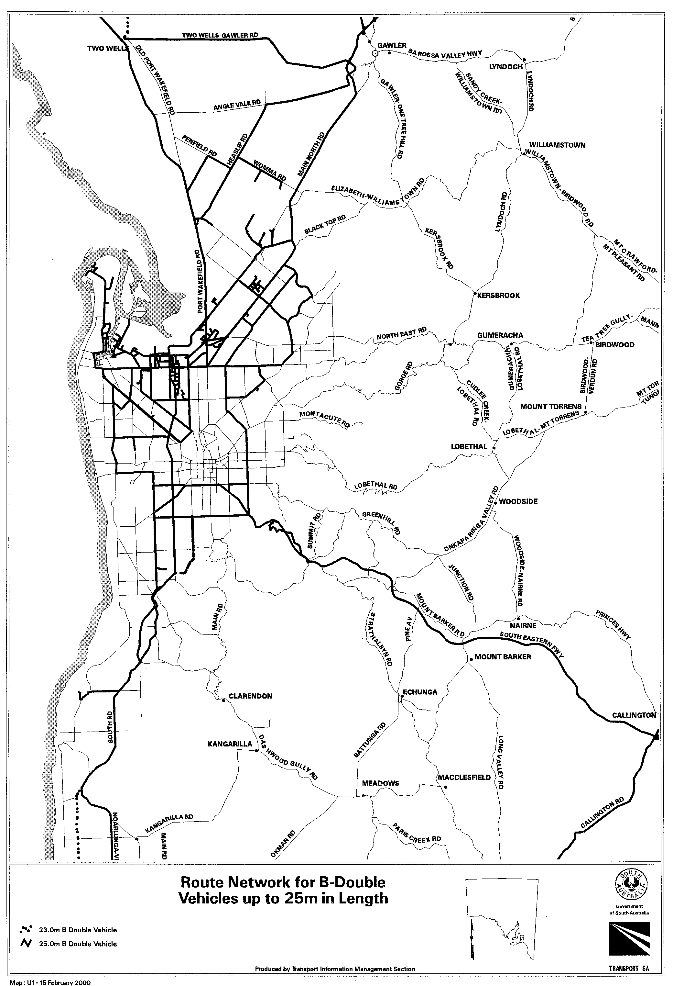
- Approval to operate B-Double Vehicles up to 25 metres in length in accordance with the route maps ‘Medium Combination Vehicles Route Network’ included in the document ‘Operation of Medium Combination Vehicles in South Australia’ Edition 1, issued by Transport SA, is revoked.

This Notice is valid from midnight 17 February 2000 and the Notice titled ‘Operation of B-Double Vehicles up to 25 m in Length on Specified Routes’ that appeared in the South Australian Government Gazette, dated 16 December 1999, is revoked at midnight on 17 February 2000.

T. N. Argent, Executive Director, Transport SA

ROAD TRAFFIC ACT 1961
Operation of Road Train Vehicles in South Australia
PURSUANT to the provisions of Section 161A of the Road Traffic Act 1961, as amended and Regulation 35 of the Road Traffic (Miscellaneous) Regulations 1999, I, T. N. Argent, Executive Director, Transport SA, as an authorised delegate of the Minister for Transport and Urban Planning hereby approve road trains to operate on routes specified by this Notice and in accordance with the document titled Operation of Road Train Vehicles in South Australia, Edition No. 1 (Part 1 clauses 1-6, 8-10 and Part 2 clauses 11-17 only), issued by Transport SA; and
PURSUANT to the provisions of Sections 163AA of the Road Traffic Act 1961, as amended, I, T. N. Argent, Executive Director, Transport SA, as an authorised delegate of the Minister for Transport and Urban Planning, hereby exempt Road Trains transporting baled wool or motor cars from Rule 72 Height and for Road Trains transporting Indivisible Items from Rule 66 Width of the Road Traffic (Vehicle Standards) Regulations 1999.
Both the exemption and approval are subject to the following conditions:

Special Conditions
  - This Notice and the document titled ‘Operation of Road Train Vehicles in South Australia’ Edition 1 (Part 1 clauses 1-6, 8-10 and Part 2 clauses 11-17 only), issued by Transport SA or a legible copy of each shall be carried by the driver of the vehicle at all times when operating under this approval and exemption and be produced when requested by an Inspector appointed under the Road Traffic Act 1961, or a Police Officer.
  - Drivers of road trains when operating under this approval and exemption shall carry their medical certificate or legible copy and shall produce the certificate or legible copy when requested by an Inspector appointed under the Road Traffic Act 1961 or a Police Officer. (refer to Section 5 of this notice)
  - This notice can either stand alone or be read in conjunction with an individual permit issued by Transport SA.
1.4 The vehicle is not under ‘Notice of Suspension to Operate as a Road Train’ issued by the Minister for Transport and Urban Planning.
- Definitions
For the purpose of this notice the following definitions shall apply:
  - ‘Articulated Vehicle Towing a Converter Dolly’ means a prime mover towing a semi-trailer and a converter dolly.
  - ‘Converter Dolly’ means a trailer with one axle group or single axle and fifth wheel coupling, designed to convert a semi-trailer into a dog trailer.
  - ‘Double Road Train’ means a combination of vehicles, other than a B-Double, consisting of a motor vehicle towing two trailers (counting as one trailer a converter dolly supporting a semi-trailer).
  - ‘Maintenance Management Scheme’ means a scheme that is recognised by Transport SA as meeting the requirements of the maintenance management module (including audit requirements) of the National Heavy Vehicle Accreditation Scheme (NHVAS).
  - ‘National Heavy Vehicle Accreditation Scheme’ (NHVAS) means the comprehensive alternative compliance package developed by the National Road Transport commission and approved by the Australian Transport Council on 14 November 1997.
  - ‘Road Train’ means a Double Road Train and/or a Triple road Train.
  - ‘Route’ means the sealed portion of the carriageway between kerbing and/or including formed shoulder on either side of the sealed portion.
  - ‘Triple Road Train’ means a combination of vehicles, other than a B-Double, consisting of a motor vehicle towing three trailers (counting as one trailer a converter dolly supporting a semi-trailer).
- General Conditions for Road Trains
  - Road Trains as defined in this Notice are operated in accordance with the specifications and conditions specified in the document titled ‘Operation of Road Train Vehicles in South Australia’, Edition 1 (Part 1 clauses 1-6, 8-10 and Part 2 clauses 11-17 only), issued by Transport SA as amended by this Notice.
  - Road Trains shall not exceed 90 km/h or any posted speed limit whichever is the lesser. Engine management systems should be set to limit the speed of the road train to 90 km/h. (refer to Section 14 of this notice)
  - The headlights of the prime mover are to be alight at all times.
  - For travel on the routes detailed in this Notice:
(a) All South Australian and Victorian registered vehicle units in a Road Train (prime movers, converter dollies and semi-trailers) shall be inspected and display a current inspection label as detailed in the document titled ‘Operation of Road Train Vehicles in South Australia’, Edition 1, issued by Transport SA, or be accredited under a Maintenance Management Scheme and display a label that identifies scheme membership.
(b) Vehicles registered in New South Wales, Queensland, Western Australia and the Australian Capital Territory are not required to display South Australian labels or undergo inspections which are additional to those required in their home states.
(c) Vehicles registered in the Northern Territory are required to display either South Australian inspection labels or Northern Territory inspection and rating labels or be accredited under a Maintenance Management Scheme and display a label that identifies scheme membership.
- Vehicle Maintenance Management Accreditation
  - For travel from Port Augusta West, on National Highway 1 to northern Adelaide on the route and to the depots described in this Notice in the maps Route Network for Road Train Vehicles in SA, all vehicle units in a Double Road Train (prime movers, converter dollies and semi trailers) are required to be accredited under a Maintenance Management Scheme and display a label that identifies scheme membership.
- Driver Health
  - As from 1 September 1998, all Road Train drivers when operating under this approval and exemption on the routes described in 4.1 shall carry a recognised medical certificate or legible copy which certifies that the driver has passed a medical examination in accordance with the document titled ‘Medical Examination of Commercial Vehicle Drivers (revised version 1997)’ published by the Federal Office of Road Safety and the National Road Transport Commission.
  - The certificate is valid subject to there being no significant change in medical condition for a period not exceeding 3 years for drivers up to the age of 49 and annually thereafter.
- General Conditions for Articulated Vehicles Towing Converter Dollies
  - Articulated vehicles towing converter dollies are operated on the routes detailed in this Notice in accordance with the maps Route Network for Road Train Vehicles in SA and Additional Converter Dolly Routes and in accordance with conditions specified in (Part 2 clause 11-17) of the document titled ‘Operation of Road Train Vehicles in South Australia’, Edition 1 issued by Transport SA.
  - Articulated vehicles towing converter dollies shall comply with the Road Traffic Act 1961, and Regulations and the Road Transport Reform (Heavy Vehicle Standards) 1995 No. 55.
  - All South Australia registered vehicles units in an articulated vehicle and converter dolly combination shall be inspected and display a current inspection label as detailed in document titled ‘Operation of Road Train Vehicles in South Australia’ Edition 1 (Part 1 clause 6.3), issued by Transport SA or be accredited under a Maintenance Management Scheme and display a label that identifies scheme membership.
  - Vehicles registered in New South Wales, Queensland, Victoria and Western Australia are not required to display South Australian labels or undergo inspections which are additional to those required in their home states.
  - Vehicles registered in the Northern Territory are required to display either South Australian inspection labels or Northern Territory inspection and rating labels in accordance with the Mutual Recognition Agreement between South Australian and the Northern Territory or be accredited under a Maintenance Management Scheme and display a label that identifies scheme membership.
7. Registration Categories
  - Vehicles operating under this notice shall be registered in accordance with the Charge Codes shown in Table 1.

Table 1
Vehicle Configuration Charge Code
Long Combination Prime Mover (Type 1)  (Double Road Train only) | 1LP3
Long Combination Prime Mover (Type 2)  (Triple Road Train) | 2LP3
Note: A prime mover registered with a charge code of 2LP3 may operate as a Double Road Train.

8. Height
8.1 The overall height of the vehicle and any load shall not exceed 4.3 metres except where specified in this notice or in the document titled ‘Operation of Road Train Vehicles in South Australia’ Edition 1, issued by Transport SA.
- Transport of Baled Wool
  - Baled wool may be carried subject to the following:
    - The baled wool shall not be loaded more than four layers high.
9.1.2 The maximum overall vehicle height including the baled wool shall not exceed 4.6 m.
9.1.3 The overall width of all axles or axle groups of the vehicle carrying the load, excluding the front axle or axle group, when measured between two vertical parallel plains located at the outer extremities of the tyres, shall be not less than 2.1 m.
9.1.4 Hauliers operating under the provisions of this notice should be aware that some bridges, signs overhead wires, trees and signals may not provide sufficient clearance for the passage of 4.6 m high vehicle.
- Transport of indivisible Items
  - For the purpose of this exemption an ‘Indivisible Item’ shall be an item which cannot without disproportionate effort, expense or risk of damage, be divided into two or more items for road transport.
  - Indivisible items may be carried on a Road Train subject to the following:
    - Travel is only permitted between Port Augusta West and the SA/NT border via Old Woomera Road, Madland Street, Stuart Highway and from the Stuart Highway to Olympic Dam mine via the Pimba/Olympic Dam Road and Olympic Way.
    - The maximum width of an item carried on a Triple Road Train shall not exceed 3.1 m.
    - The maximum width of an item carried on a Double Road Train shall not exceed 3.5 m.
    - The overall height of the vehicle and load shall not exceed 4.6 m.
    - If the load consists of transportable building the overall height of the vehicle and transportable building shall not exceed 4.85 m.
    - Travel is only permitted between the hours of sunrise and sunset as specified in the Proof of Sunrise and Sunset Act 1923, as amended, and published in the South Australian Government Gazette.
    - Travel is not permitted during periods of low visibility.
    - The Road Train shall display an ‘OVERSIZE’ sign at the front and rear of the vehicle combination in addition to the normally required’ ROAD TRAIN’ signs.
    - The specification of the ‘OVERSIZE’ sign shall be in accordance with the specifications detailed in the document titled ‘OVER DIMENSION AND EXCESS MASS PERMIT GUIDELINES’ dated July 1995.
    - The wider of any load shall always be carried on the most forward trailer if the road train is carrying loads of varying widths.
    - The rear vision mirrors fitted to the prime mover shall be extended sufficiently to ensure that the driver has a clear reflected view of traffic to the sides and rear of the road train.
- Routes
  - Road Trains operating in accordance with this Notice shall operate only on the approved routes specified in the maps Route Network for Road Train Vehicles in SA as included in this Notice.
  - Articulated vehicles towing converter dollies operating in accordance with this Notice shall operate only on the approved routes specified in the maps Route Network for Road Train Vehicles in SA and Additional Converter Dolly Routes as included in this Notice.
  - Approval to operate Road Trains and articulated vehicles towing converter dollies in accordance with the route maps ‘Road Train Vehicle Route Network’ and ‘Converter Dolly Route Network’ included in the document ‘Operation of Road Train Vehicles in South Australia’, Edition 1 issued by Transport SA, is revoked.
Note: Routes specified in this Notice are only available for vehicle combinations carrying general freight. This approval does not include the cartage of dangerous goods (in bulk) on these specified routes.
12. Route Restrictions
  - All right turn manoeuvres across National Highway 1 are prohibited except where allowed by this notice or by individual permit.
  - Road Trains are not permitted to assemble disassemble along the route, or enter or exit depots, roadways parking bays service stations or otherwise deviate from the route unless allowed by this notice or under individually issued permit.
  - Road trains may only turn left to stop in parking bays showing a ‘Truck Parking Area’ sign for rest purposes or vehicle checks but not for assembly or disassembly purposes. The sign shall comply with Australian Standard AS 1742.6 service symbol sign S13. The signs displays a white ‘P’ and symbolic articulated vehicle on a blue background.
  - Access into depots, which abut the Double Road Train route detailed in this notice is permitted provided the operator/driver has the approval of the land owner or tenant.

Axle Group Spacing Requirements
  - Road trains shall comply with either the axle group requirements detailed in the document titled ‘Operation of Road Train Vehicles in South Australia’ Edition 1 (Part 1 clause 5) , issued by Transport SA or with the following axle group spacing dimensions:
    - The distance (L) between a triaxle axle group and an adjacent tandem group when measured between the centres of the furthermost axles shall not be less than 8.0 m.

L not less than 8.0 m

    - The distance (L) between adjacent tandem axle groups when measured between the centres of the furthermost axles shall not be less than 6.8 m.

L not less than 6.8 m

    - The distance (L) between the centre of the lead axle of the drive axle group of the hauling unit and the centre of the last axle of the combination shall not be less than:
20.2 m for double road trains
32.3 m for triple road train

L not less than 20.2 m for double road trains

L not less than 32.3m for triple road trains
L not less than 32.3 m for triple road trains

Speed Restrictions
  - Road Trains shall not exceed a maximum speed of:
    - 40 km/h within the 60 km/h zone posted in Port Augusta.
    - 40 km/h when travelling through the township of Peterborough.
    - 25 km/h when travelling through the township of Orroroo (Second Street)
This Notice is valid from midnight 24 February 2000 and the Notice titled ‘Operation of Road Train Vehicles in South Australia’ that appeared in the South Australia Government Gazette dated 16 December 1999 is revoked at midnight 24 February 2000.
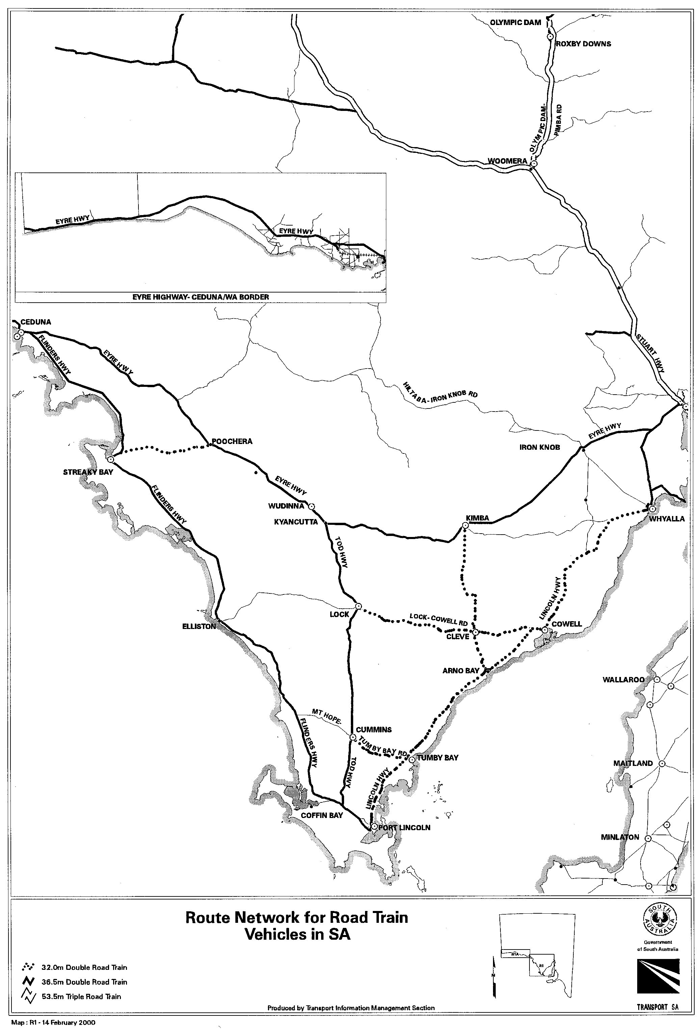
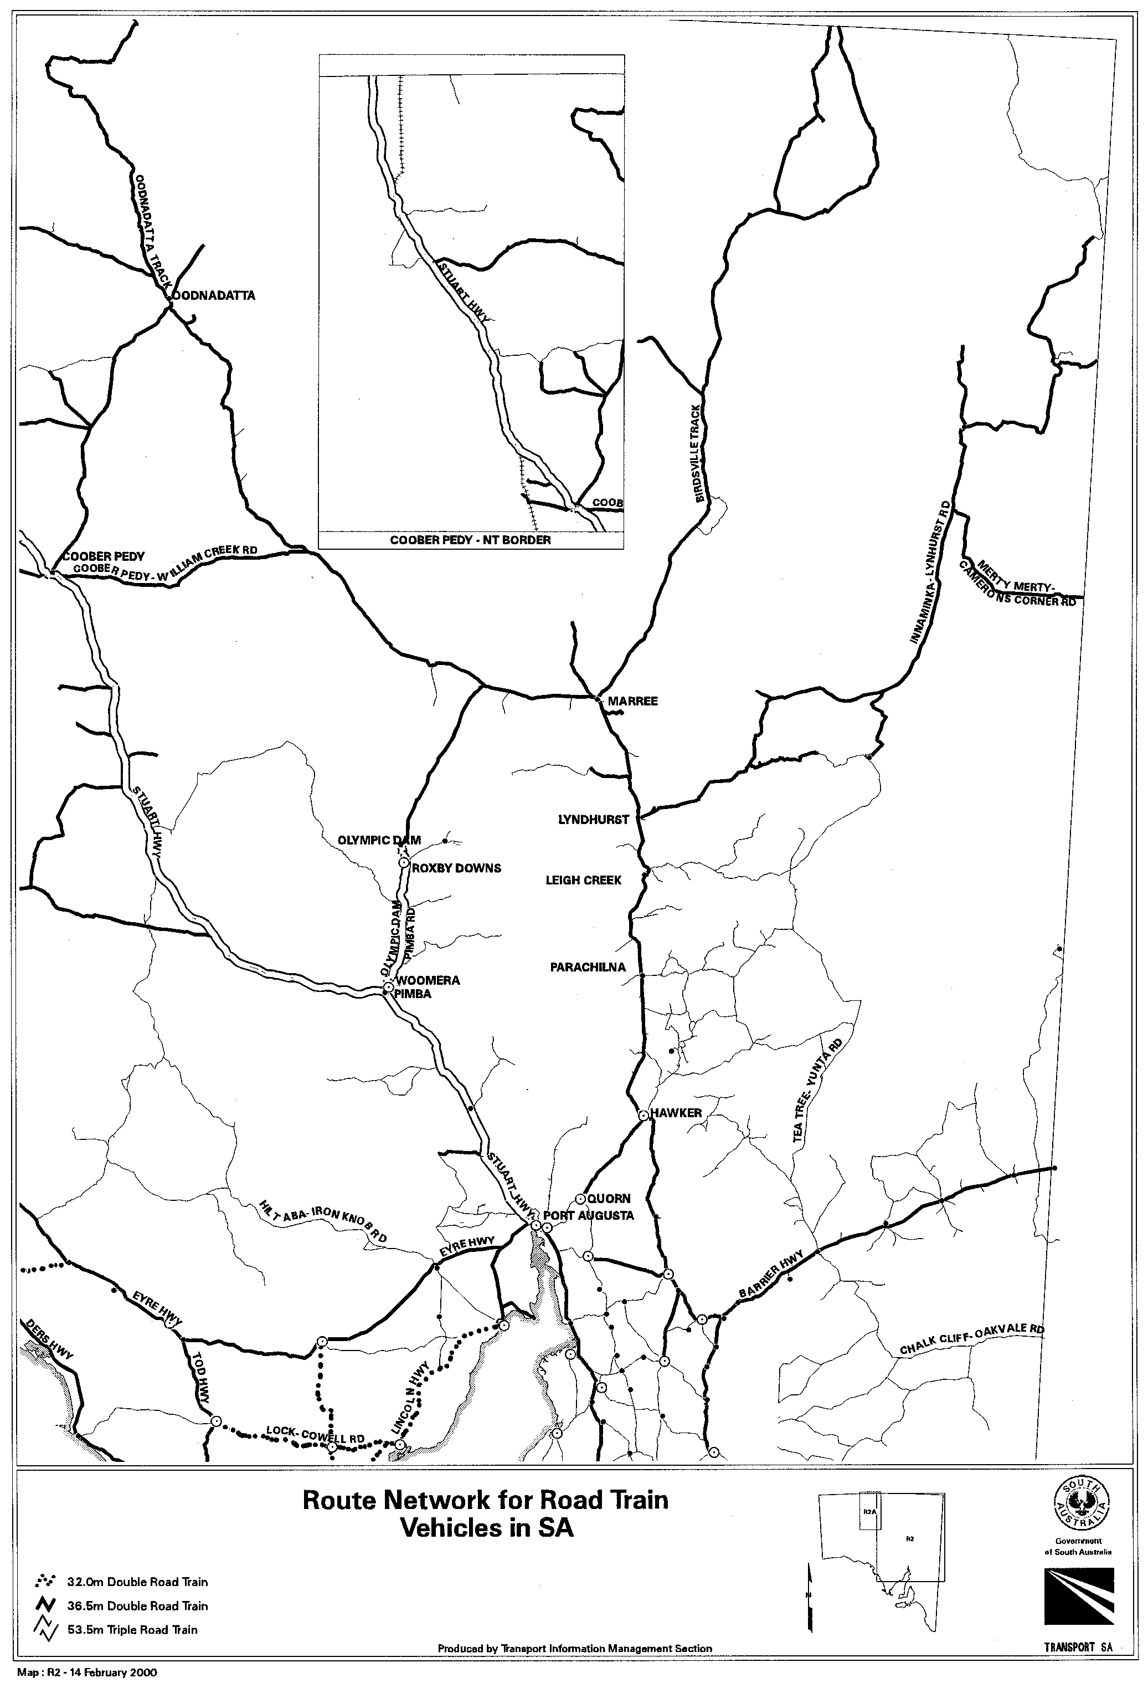
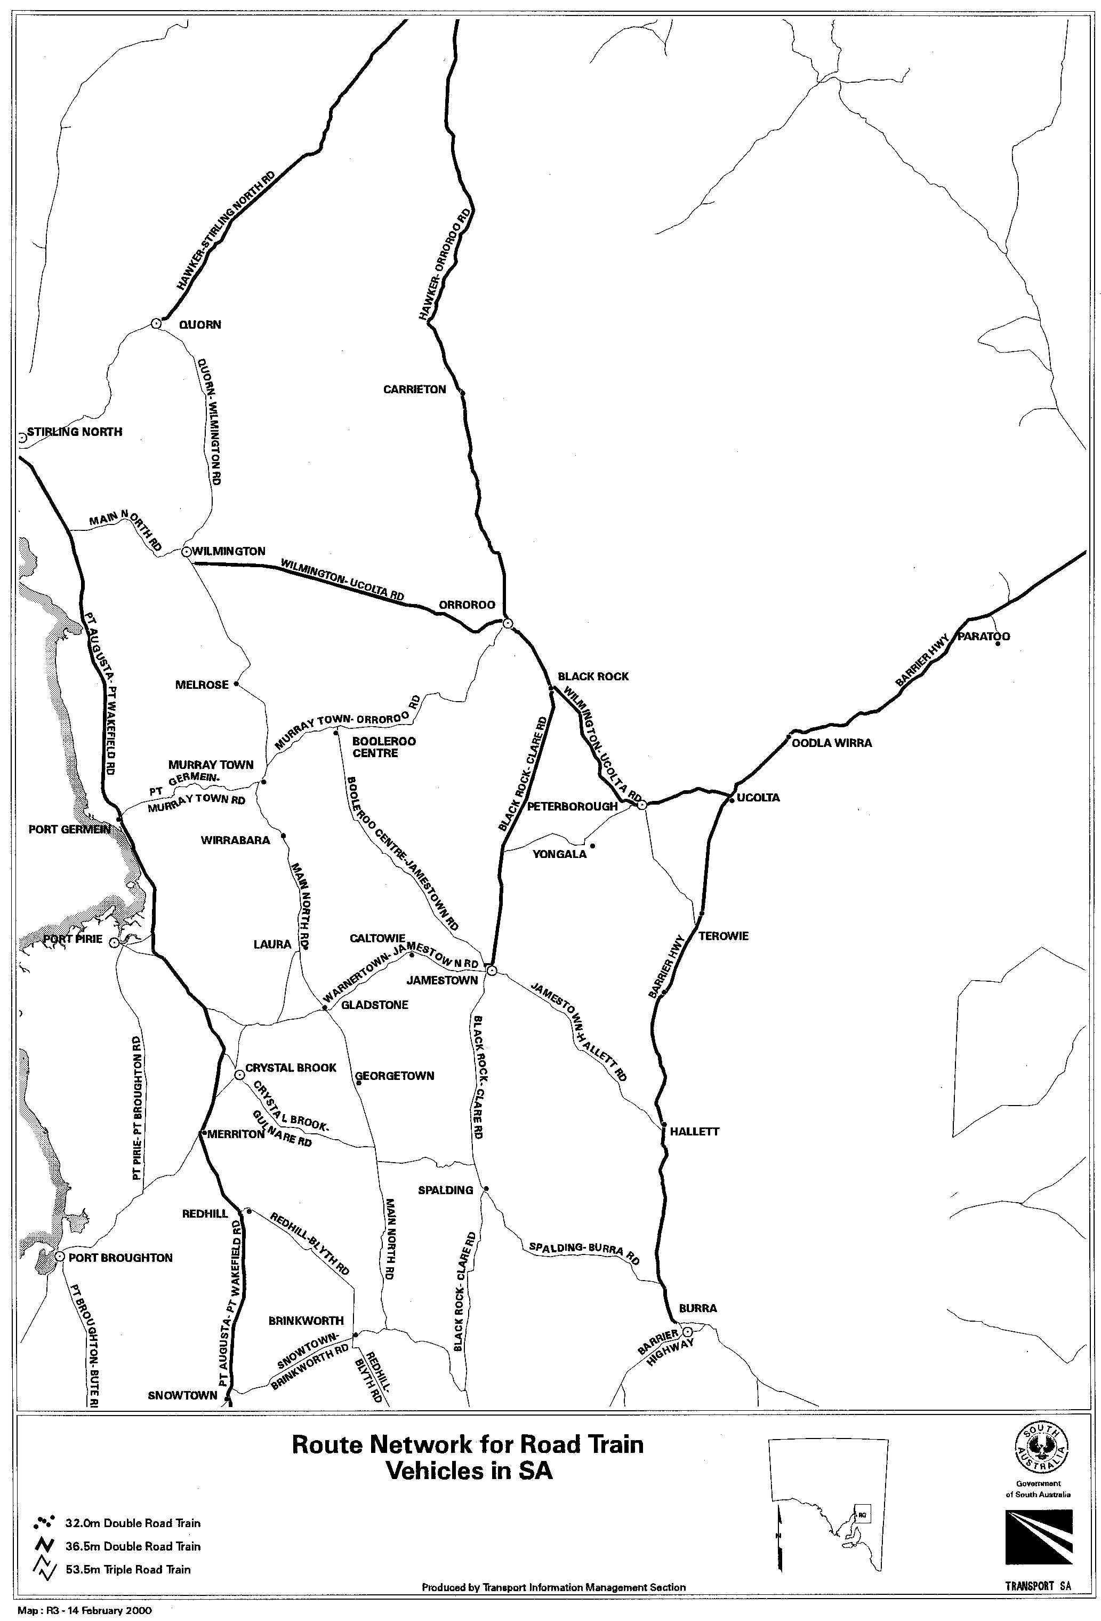
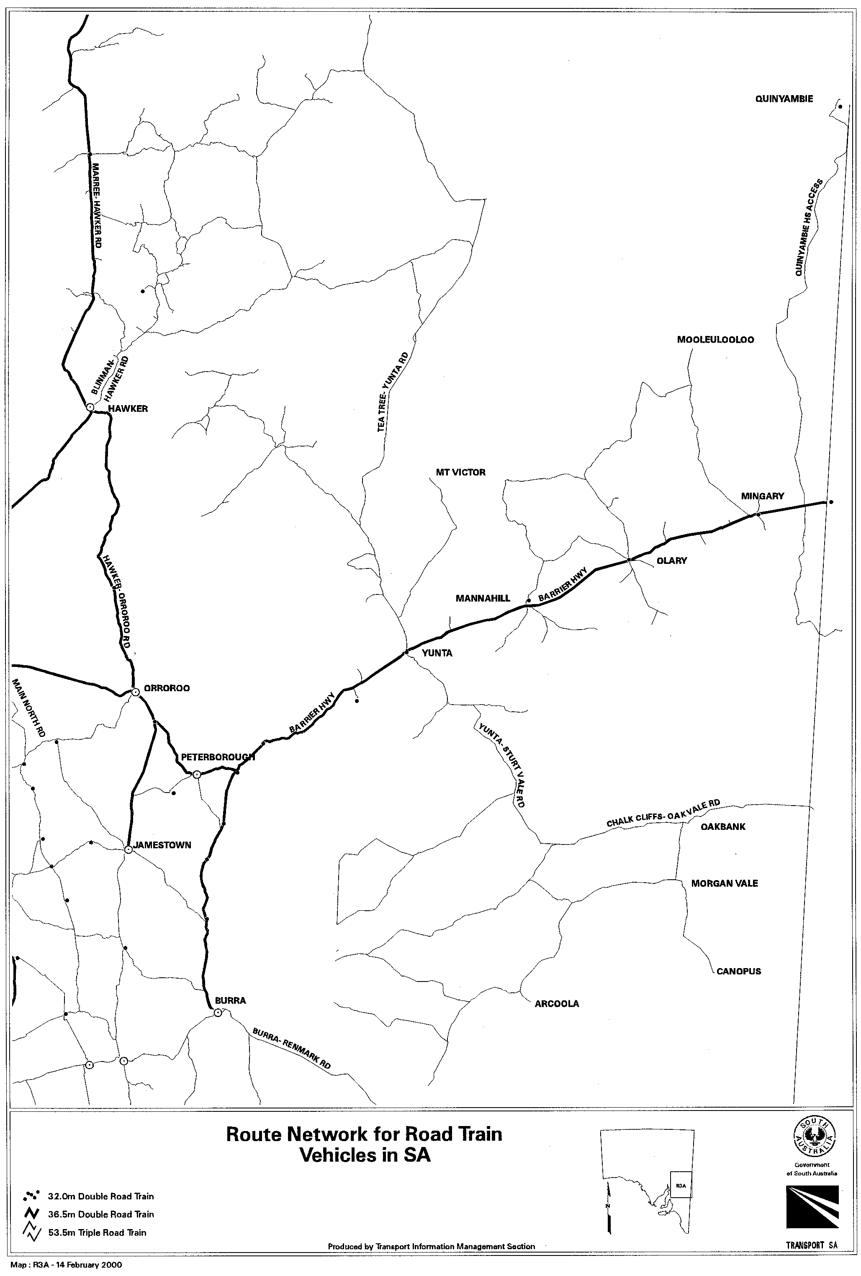
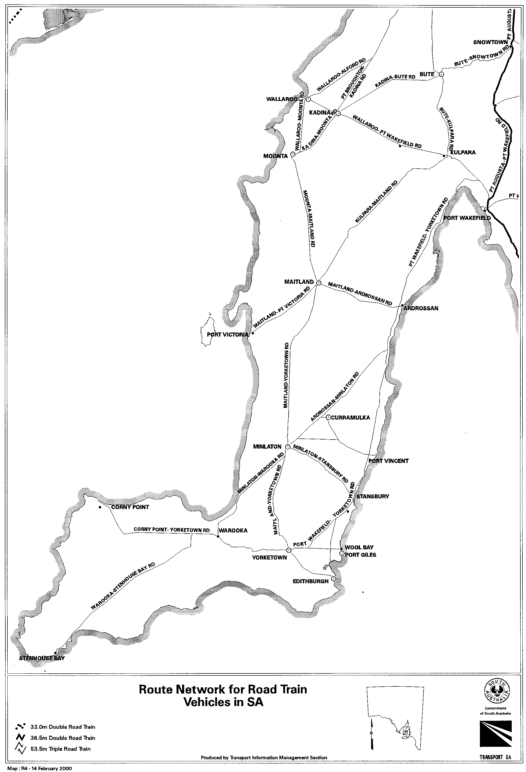
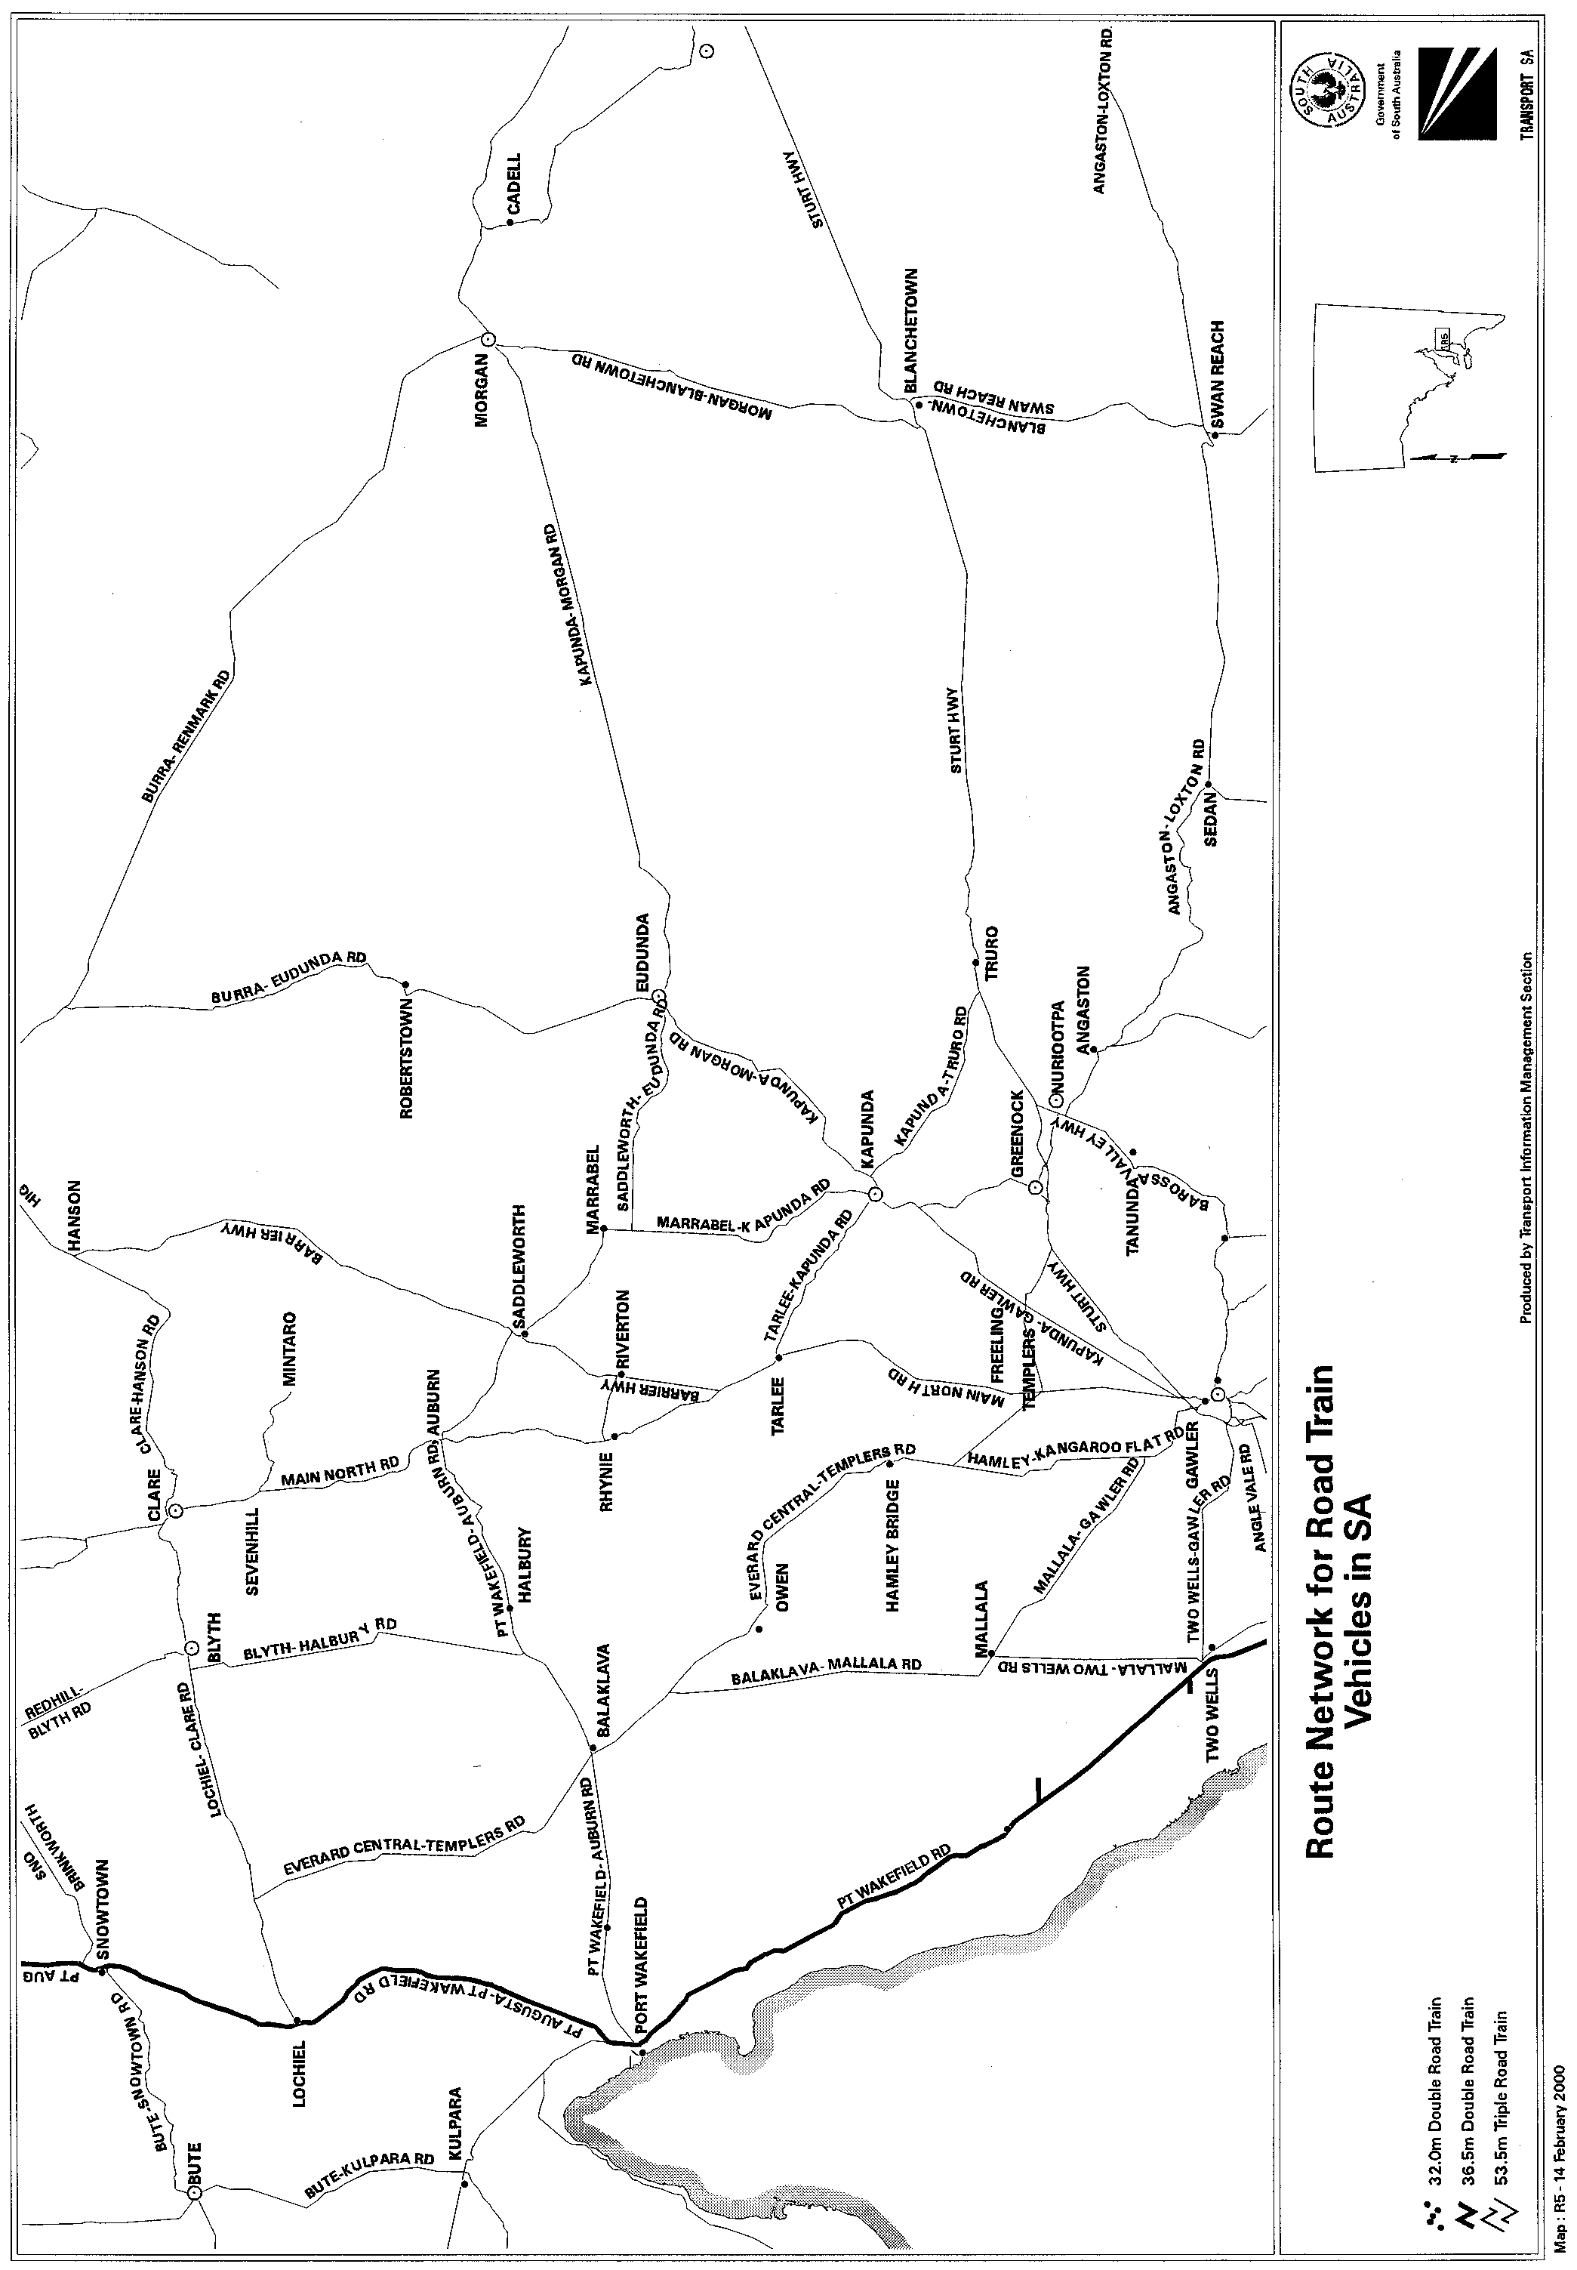
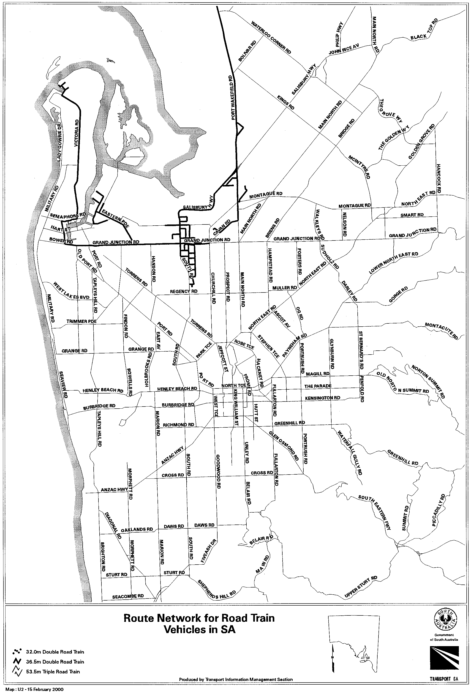
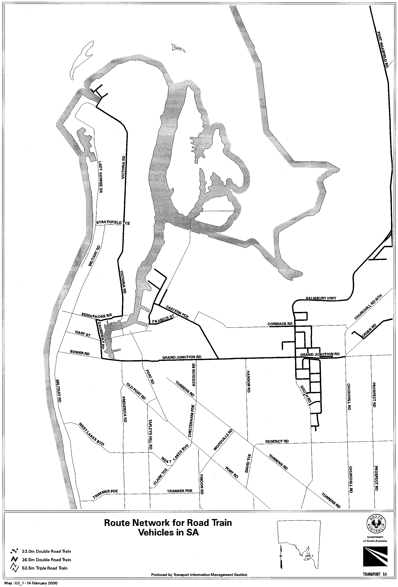
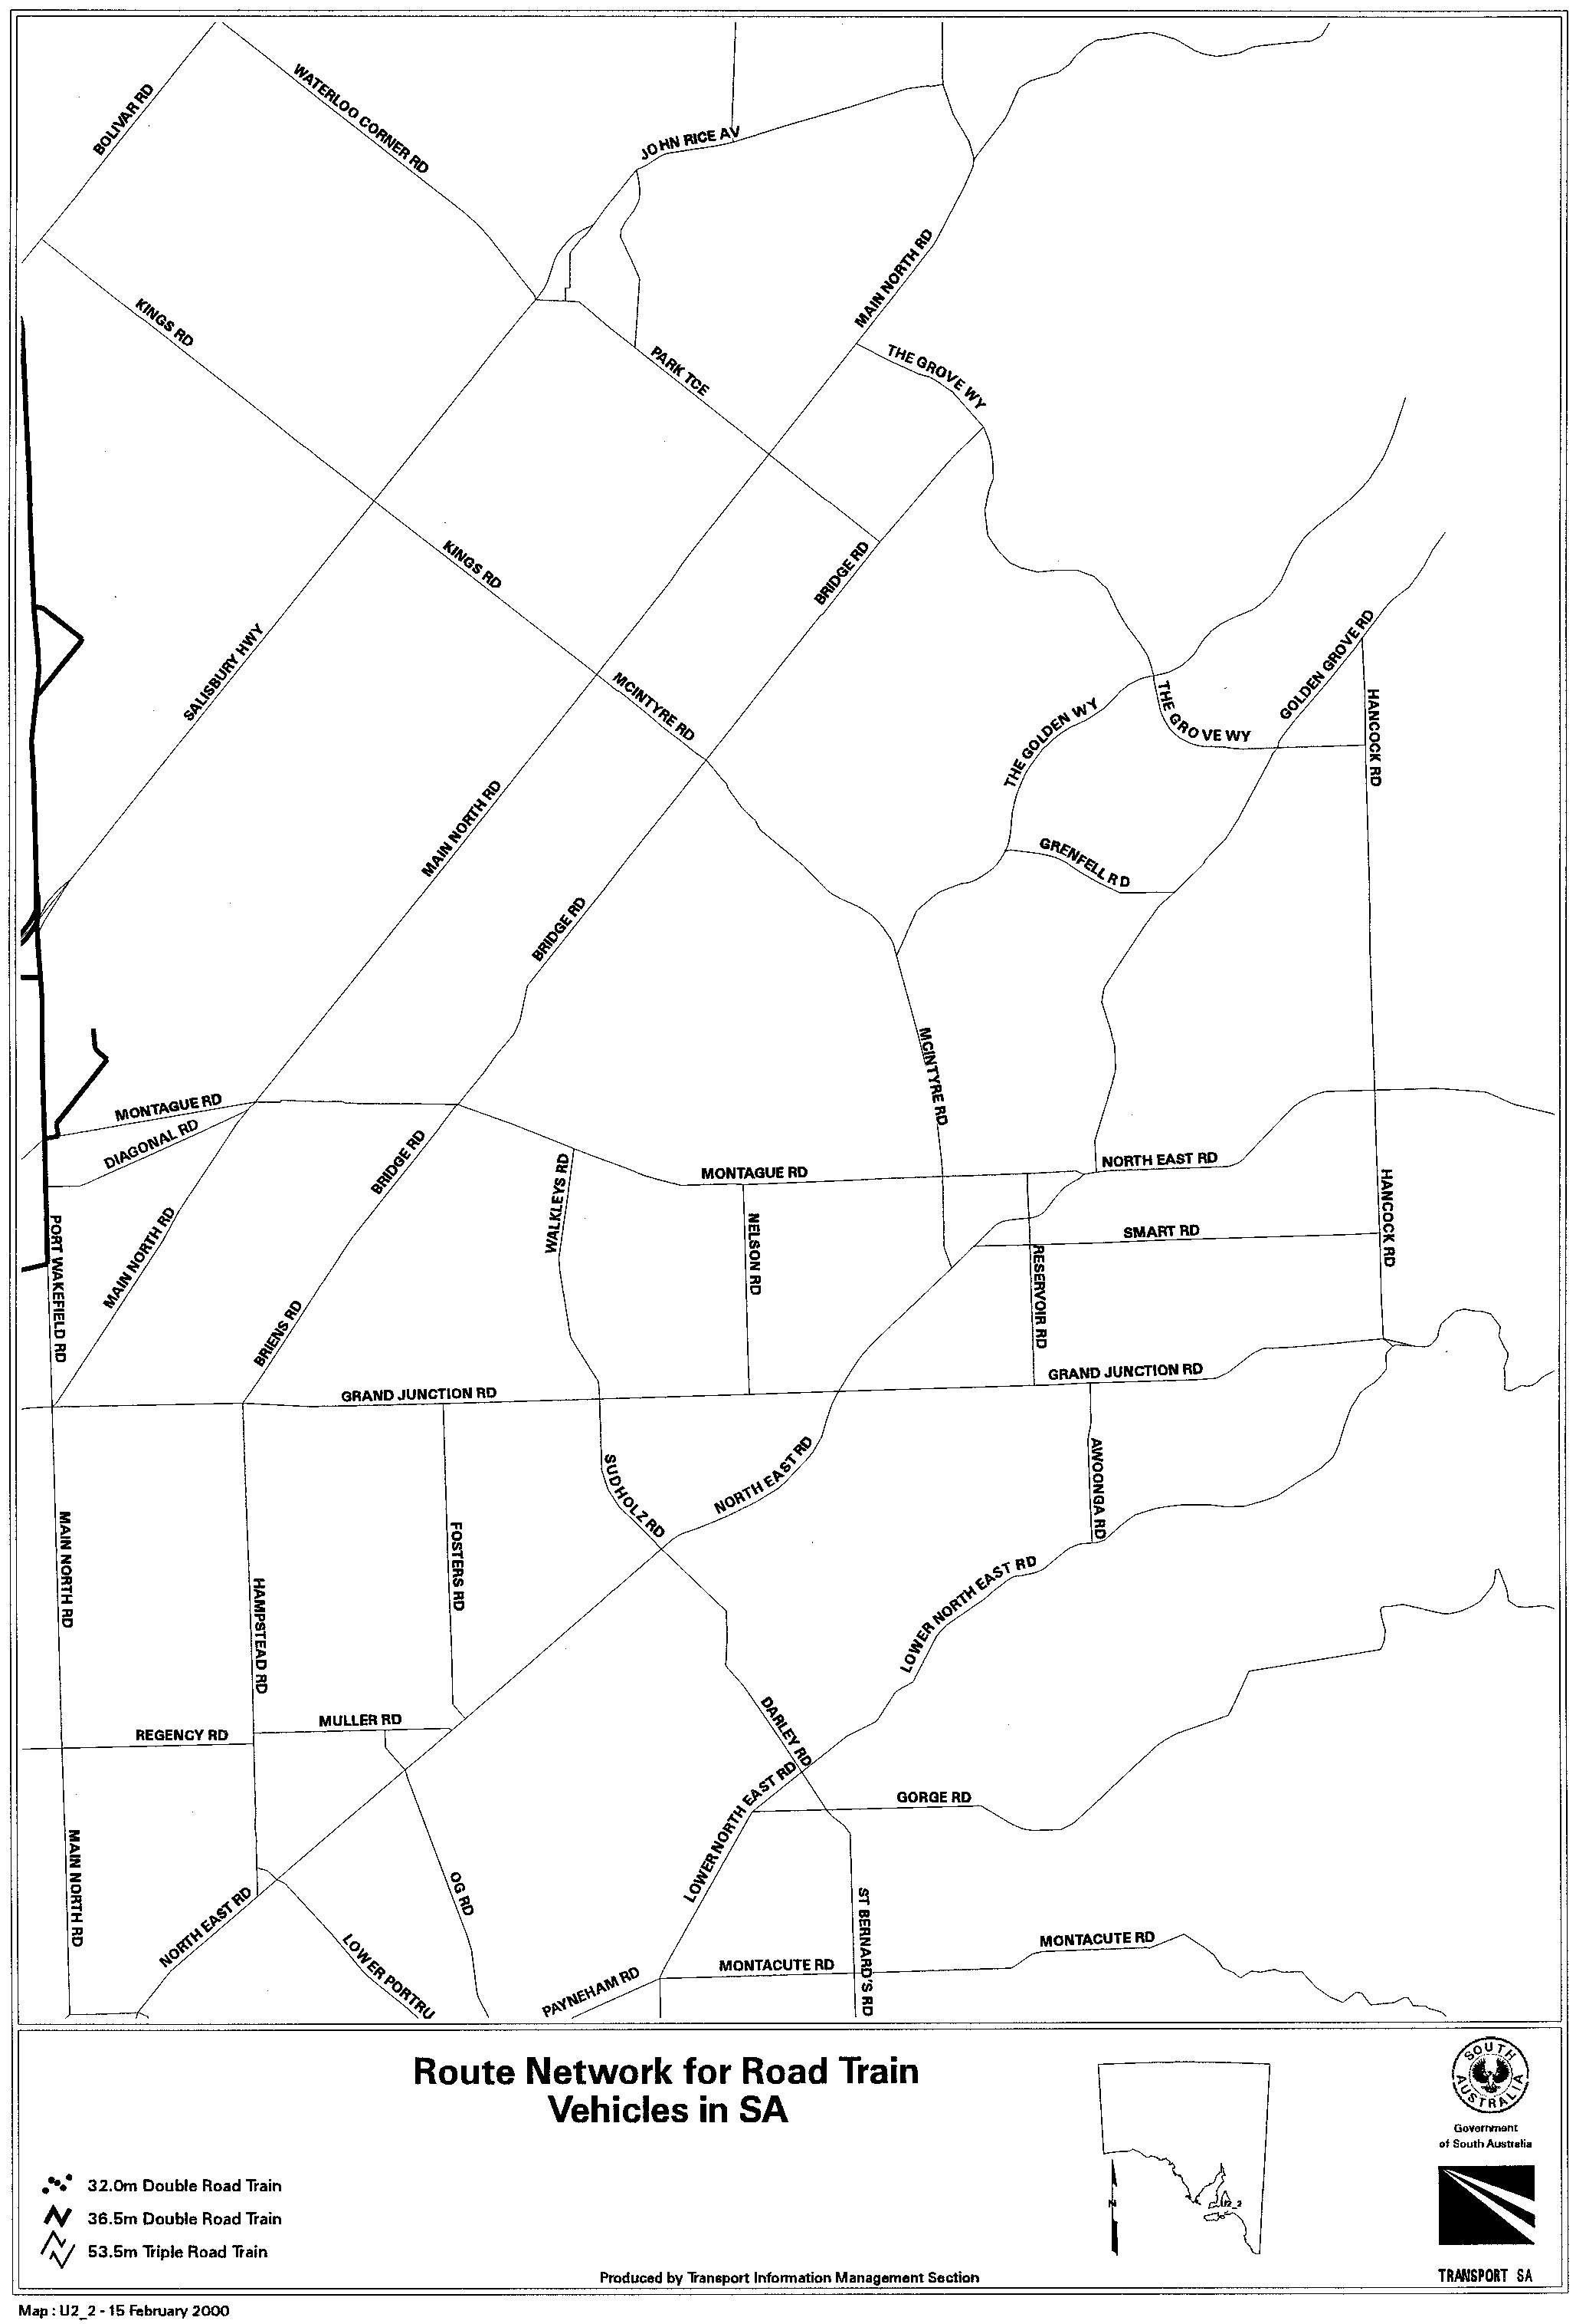
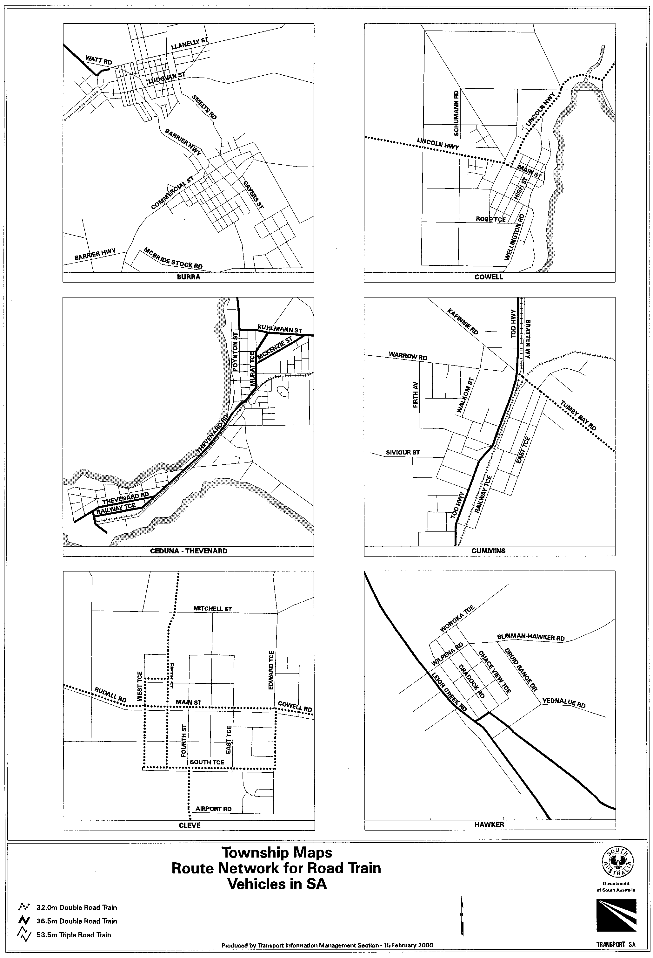
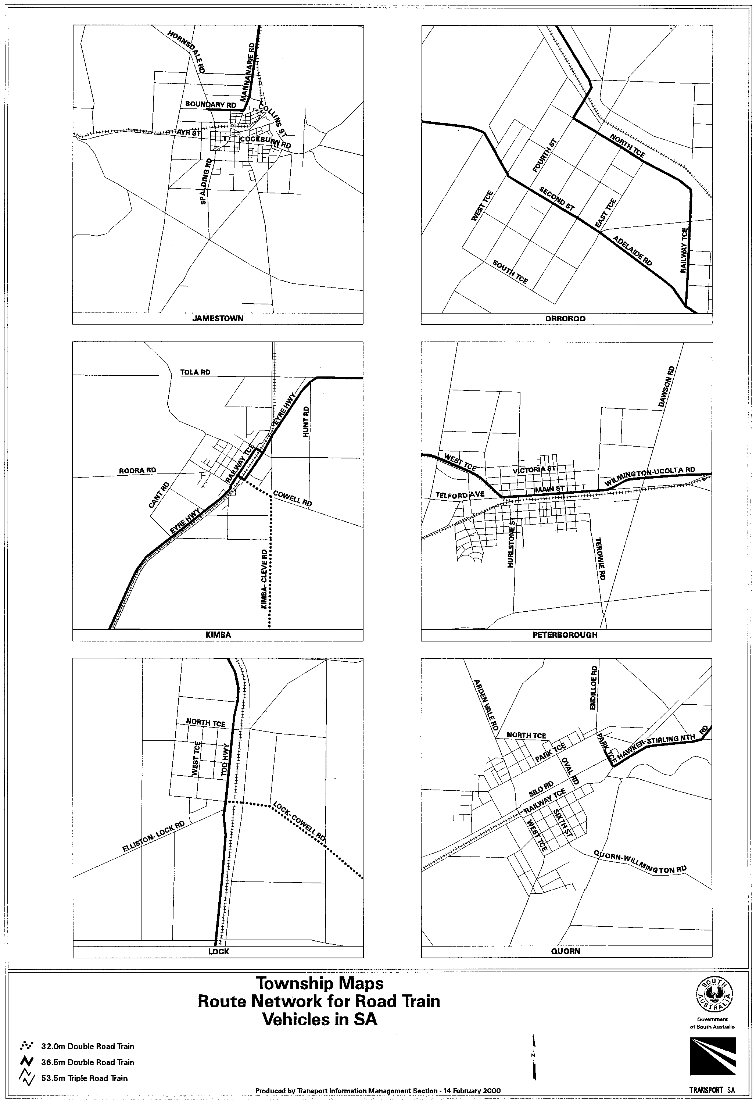
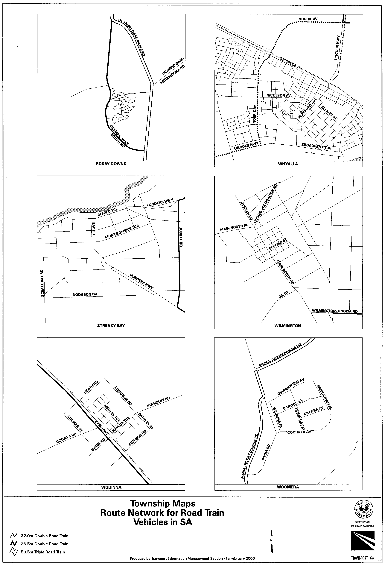
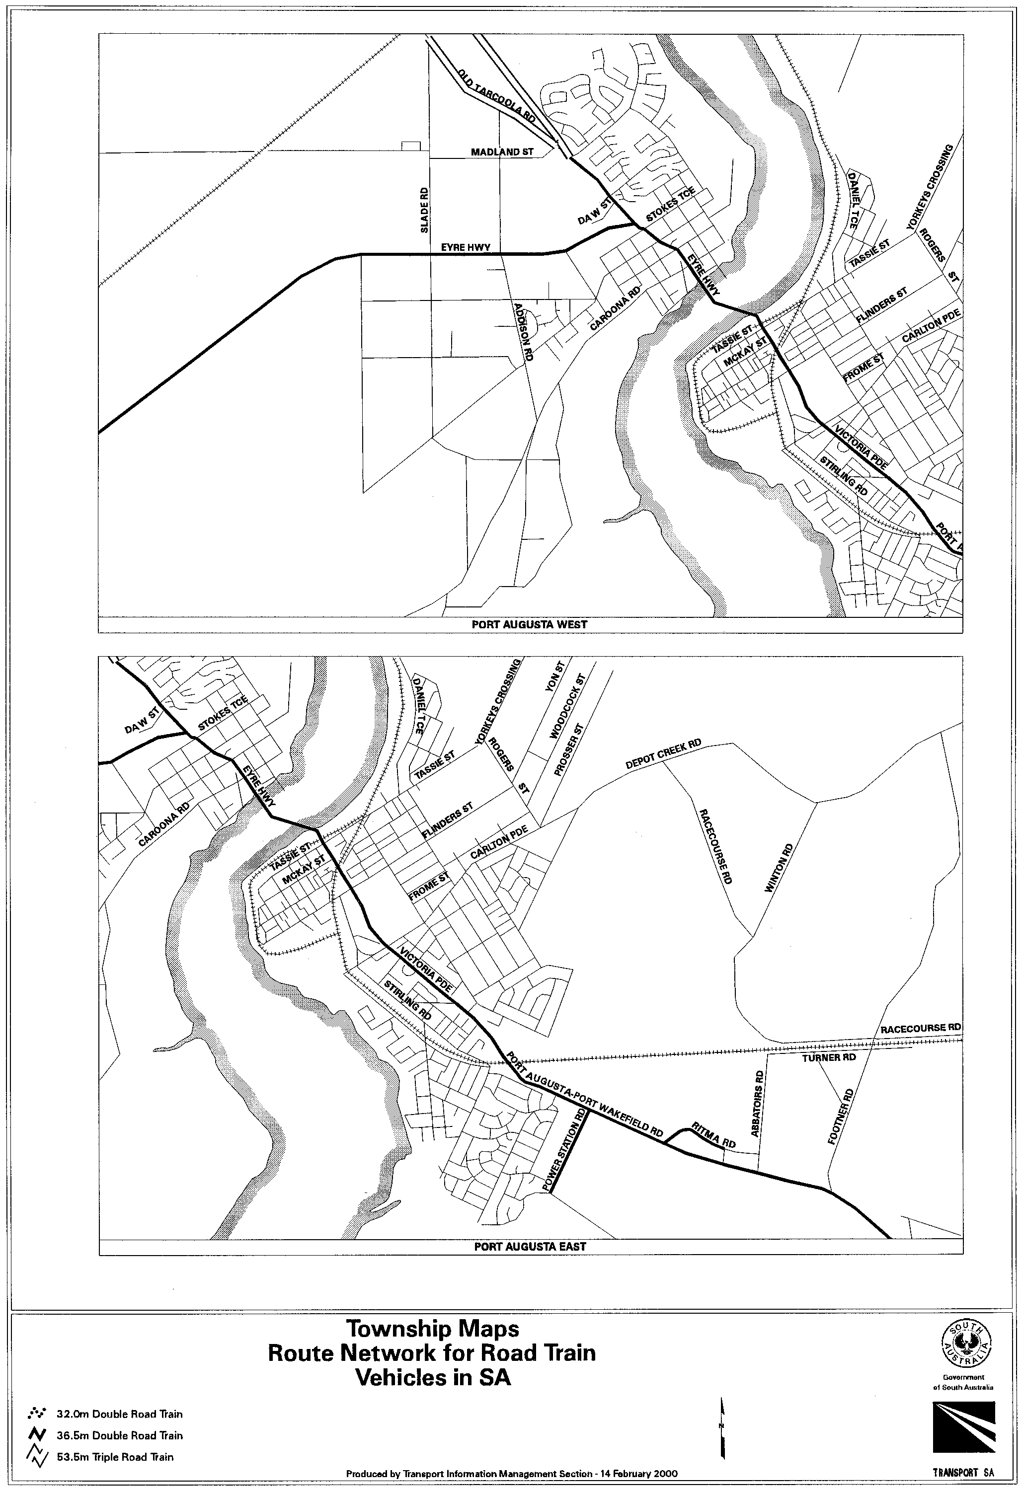
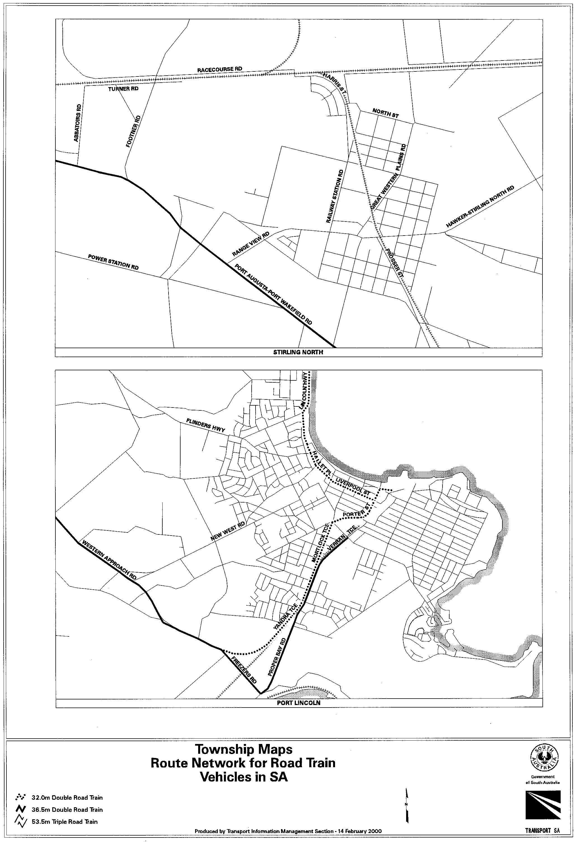
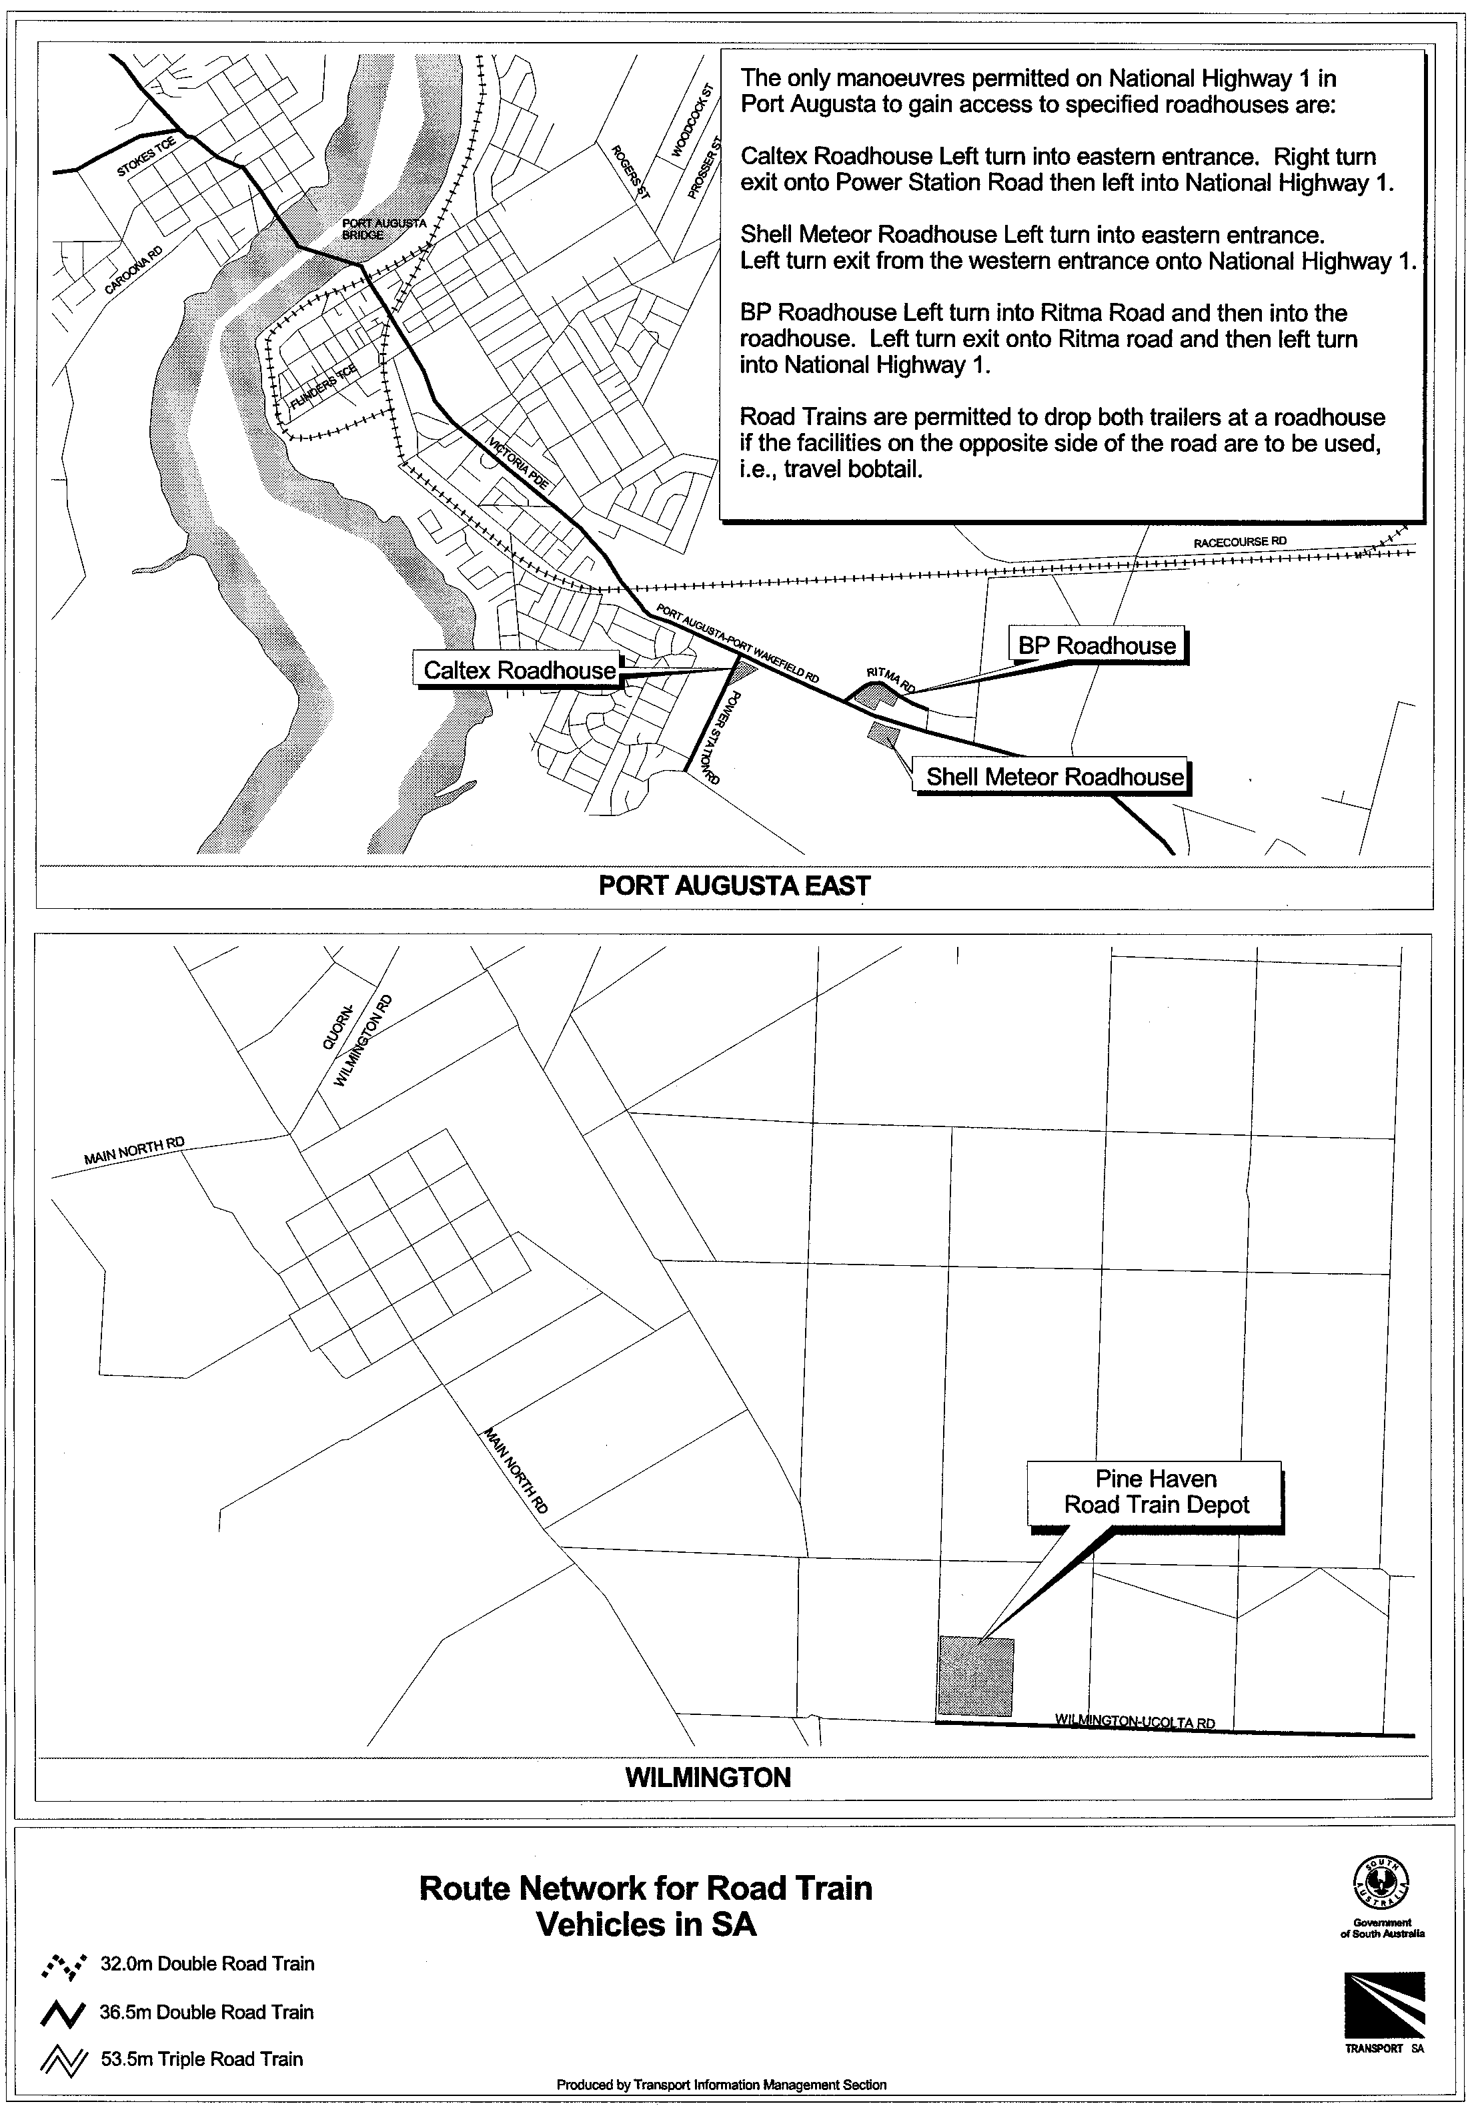
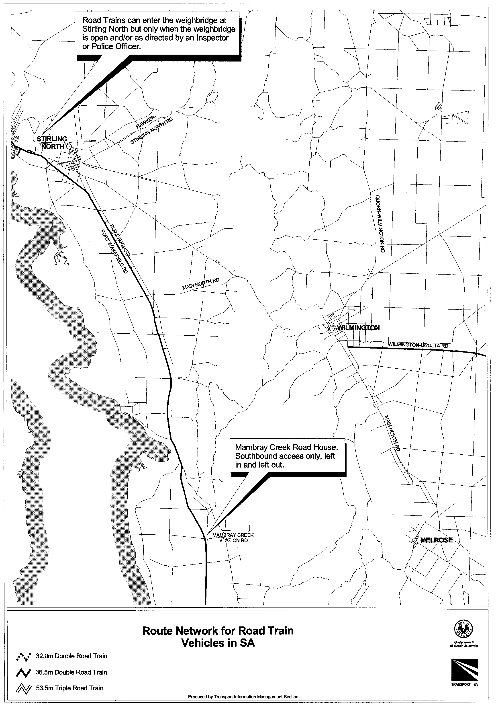
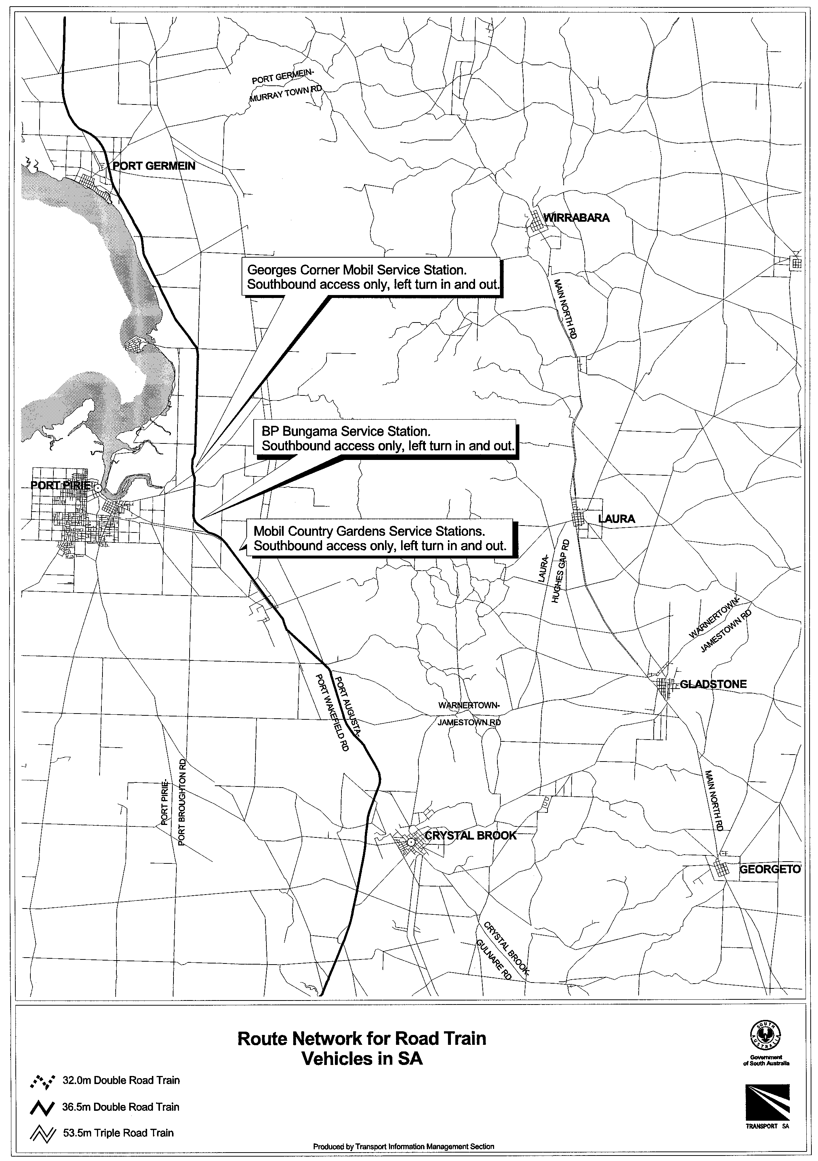
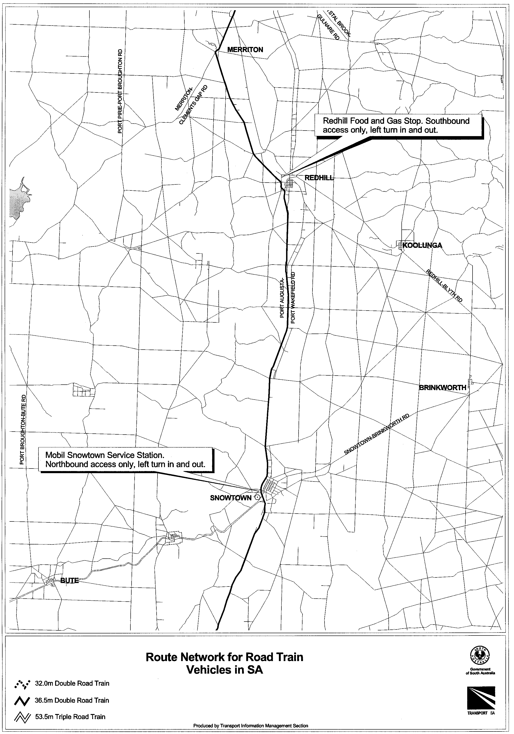
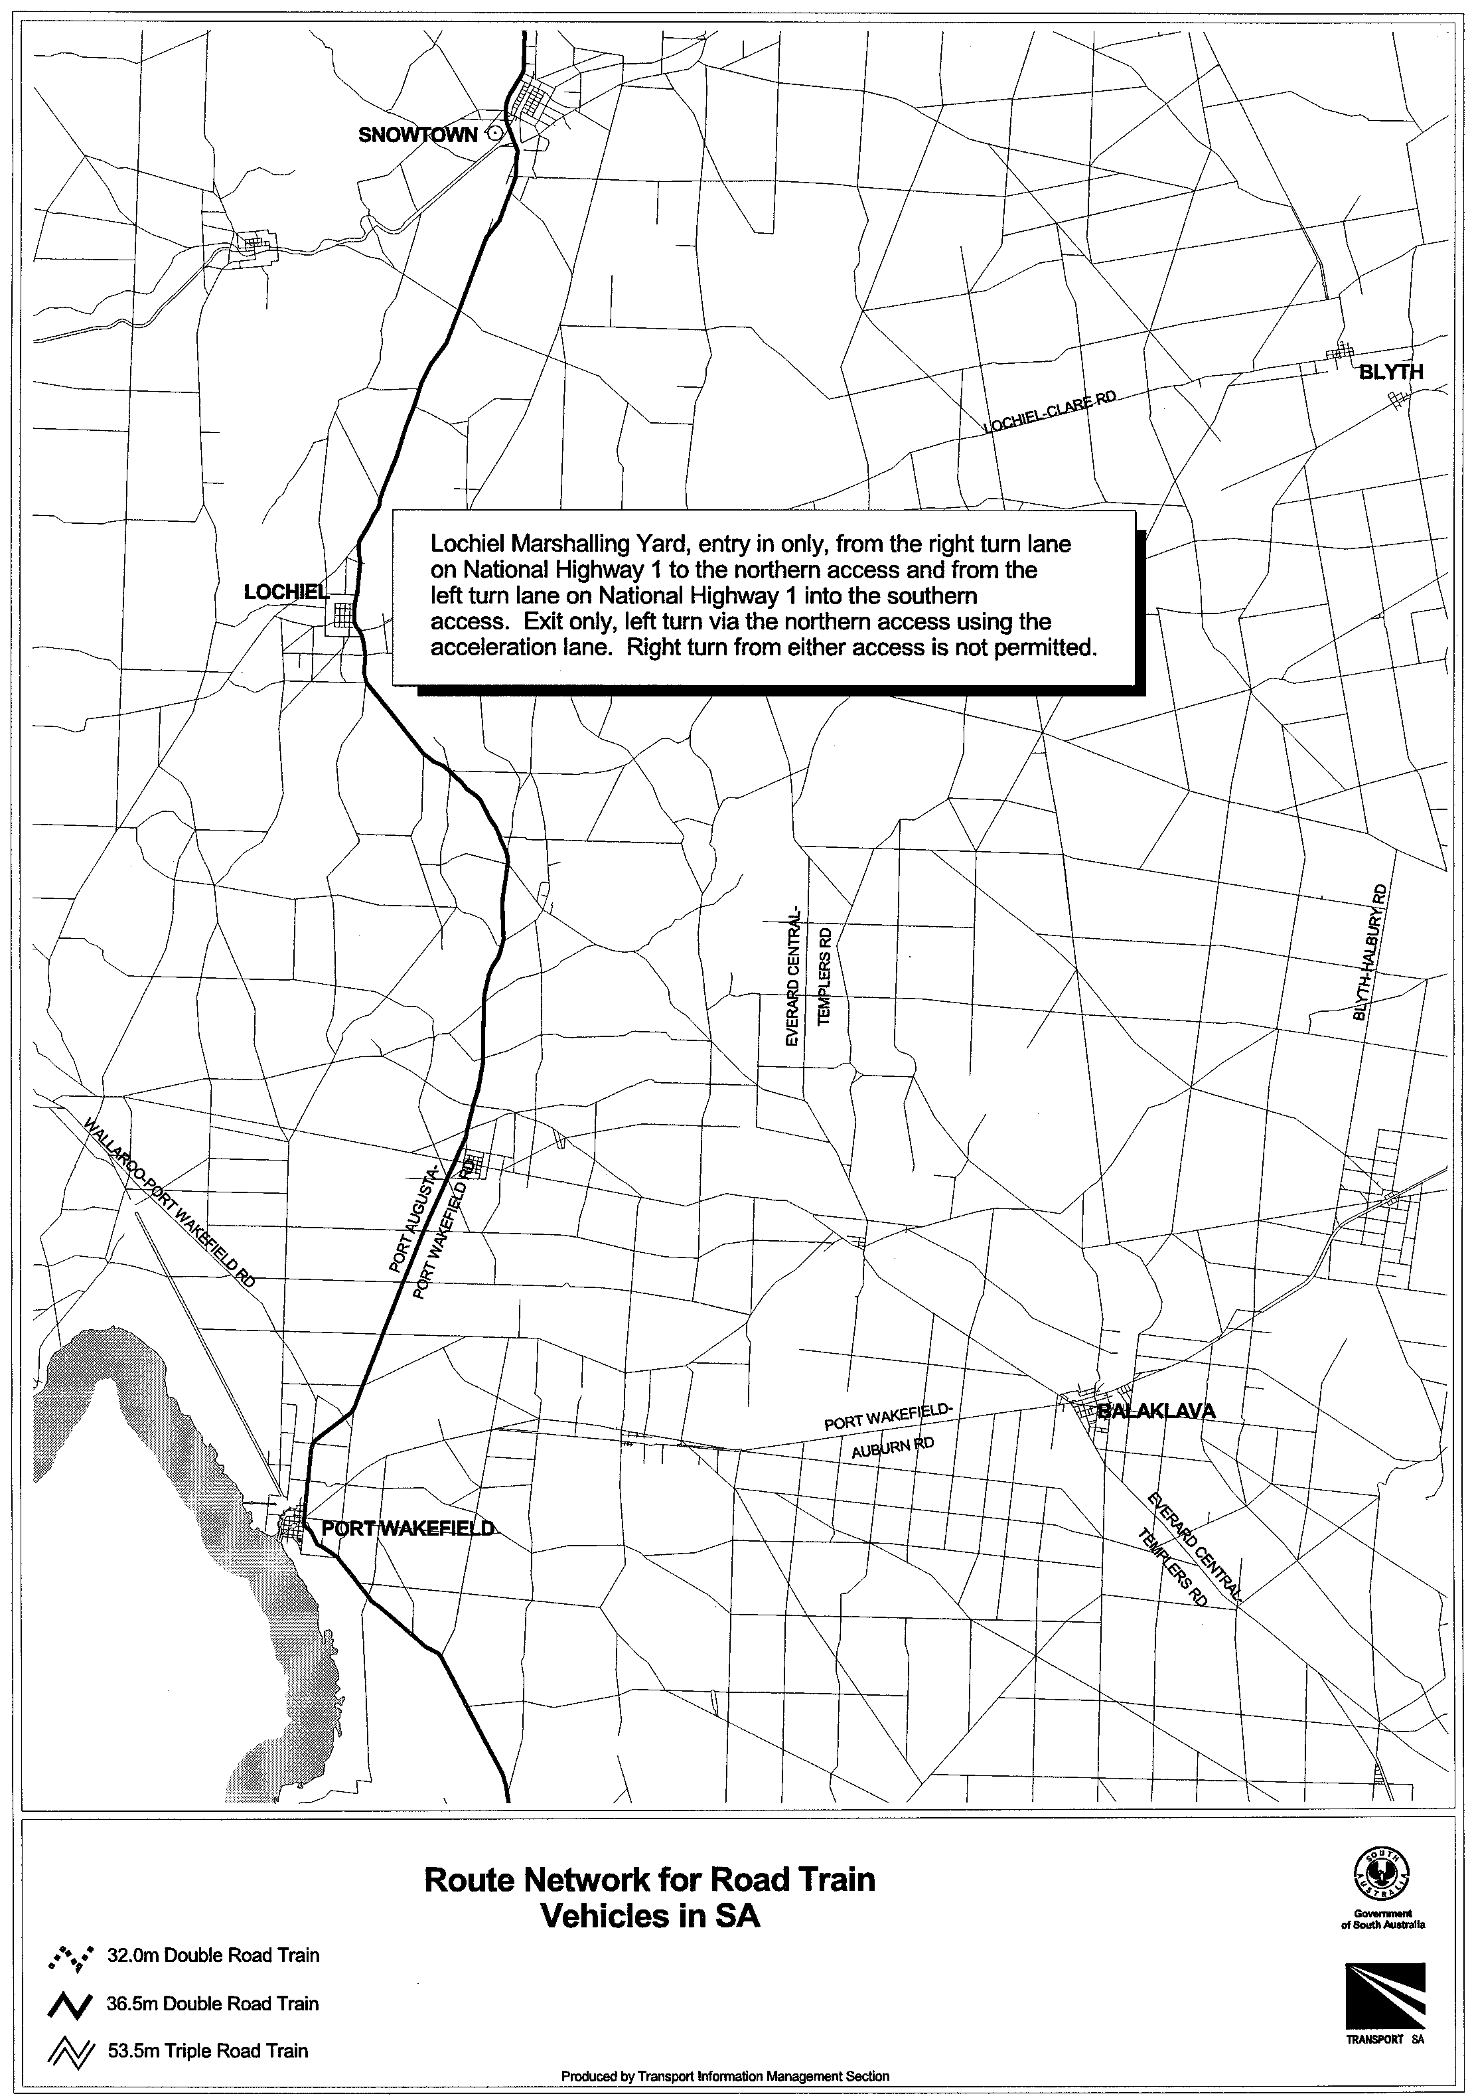
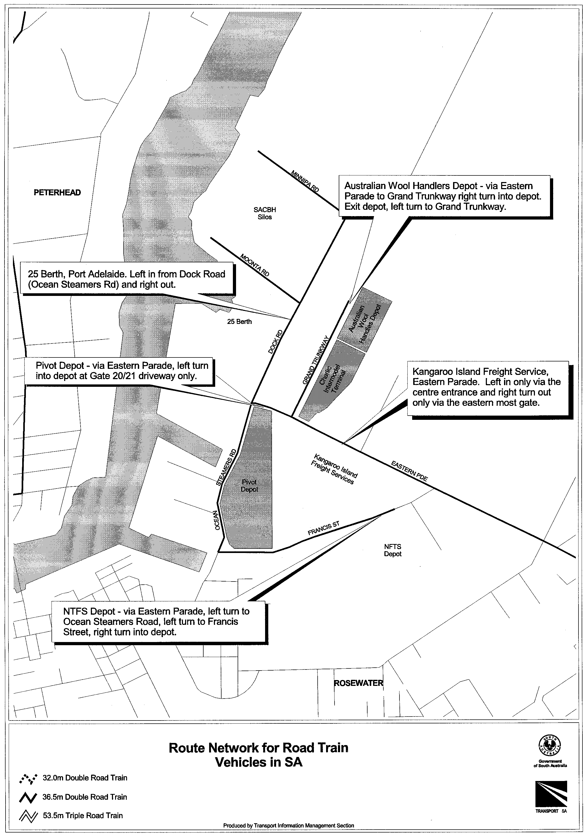
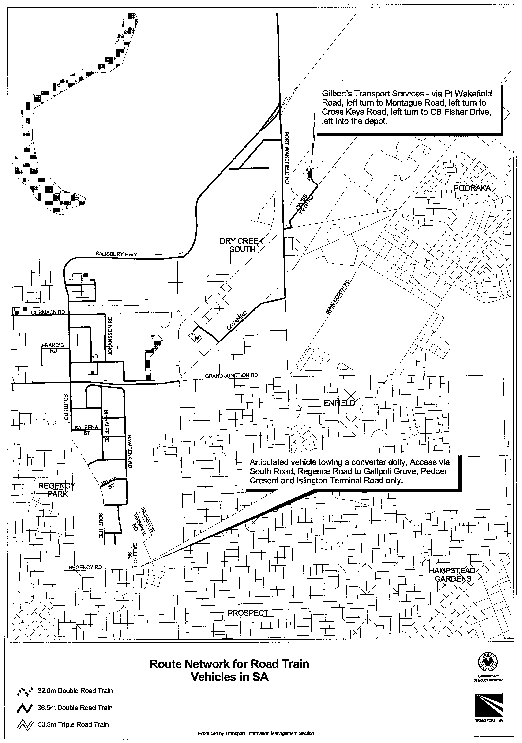
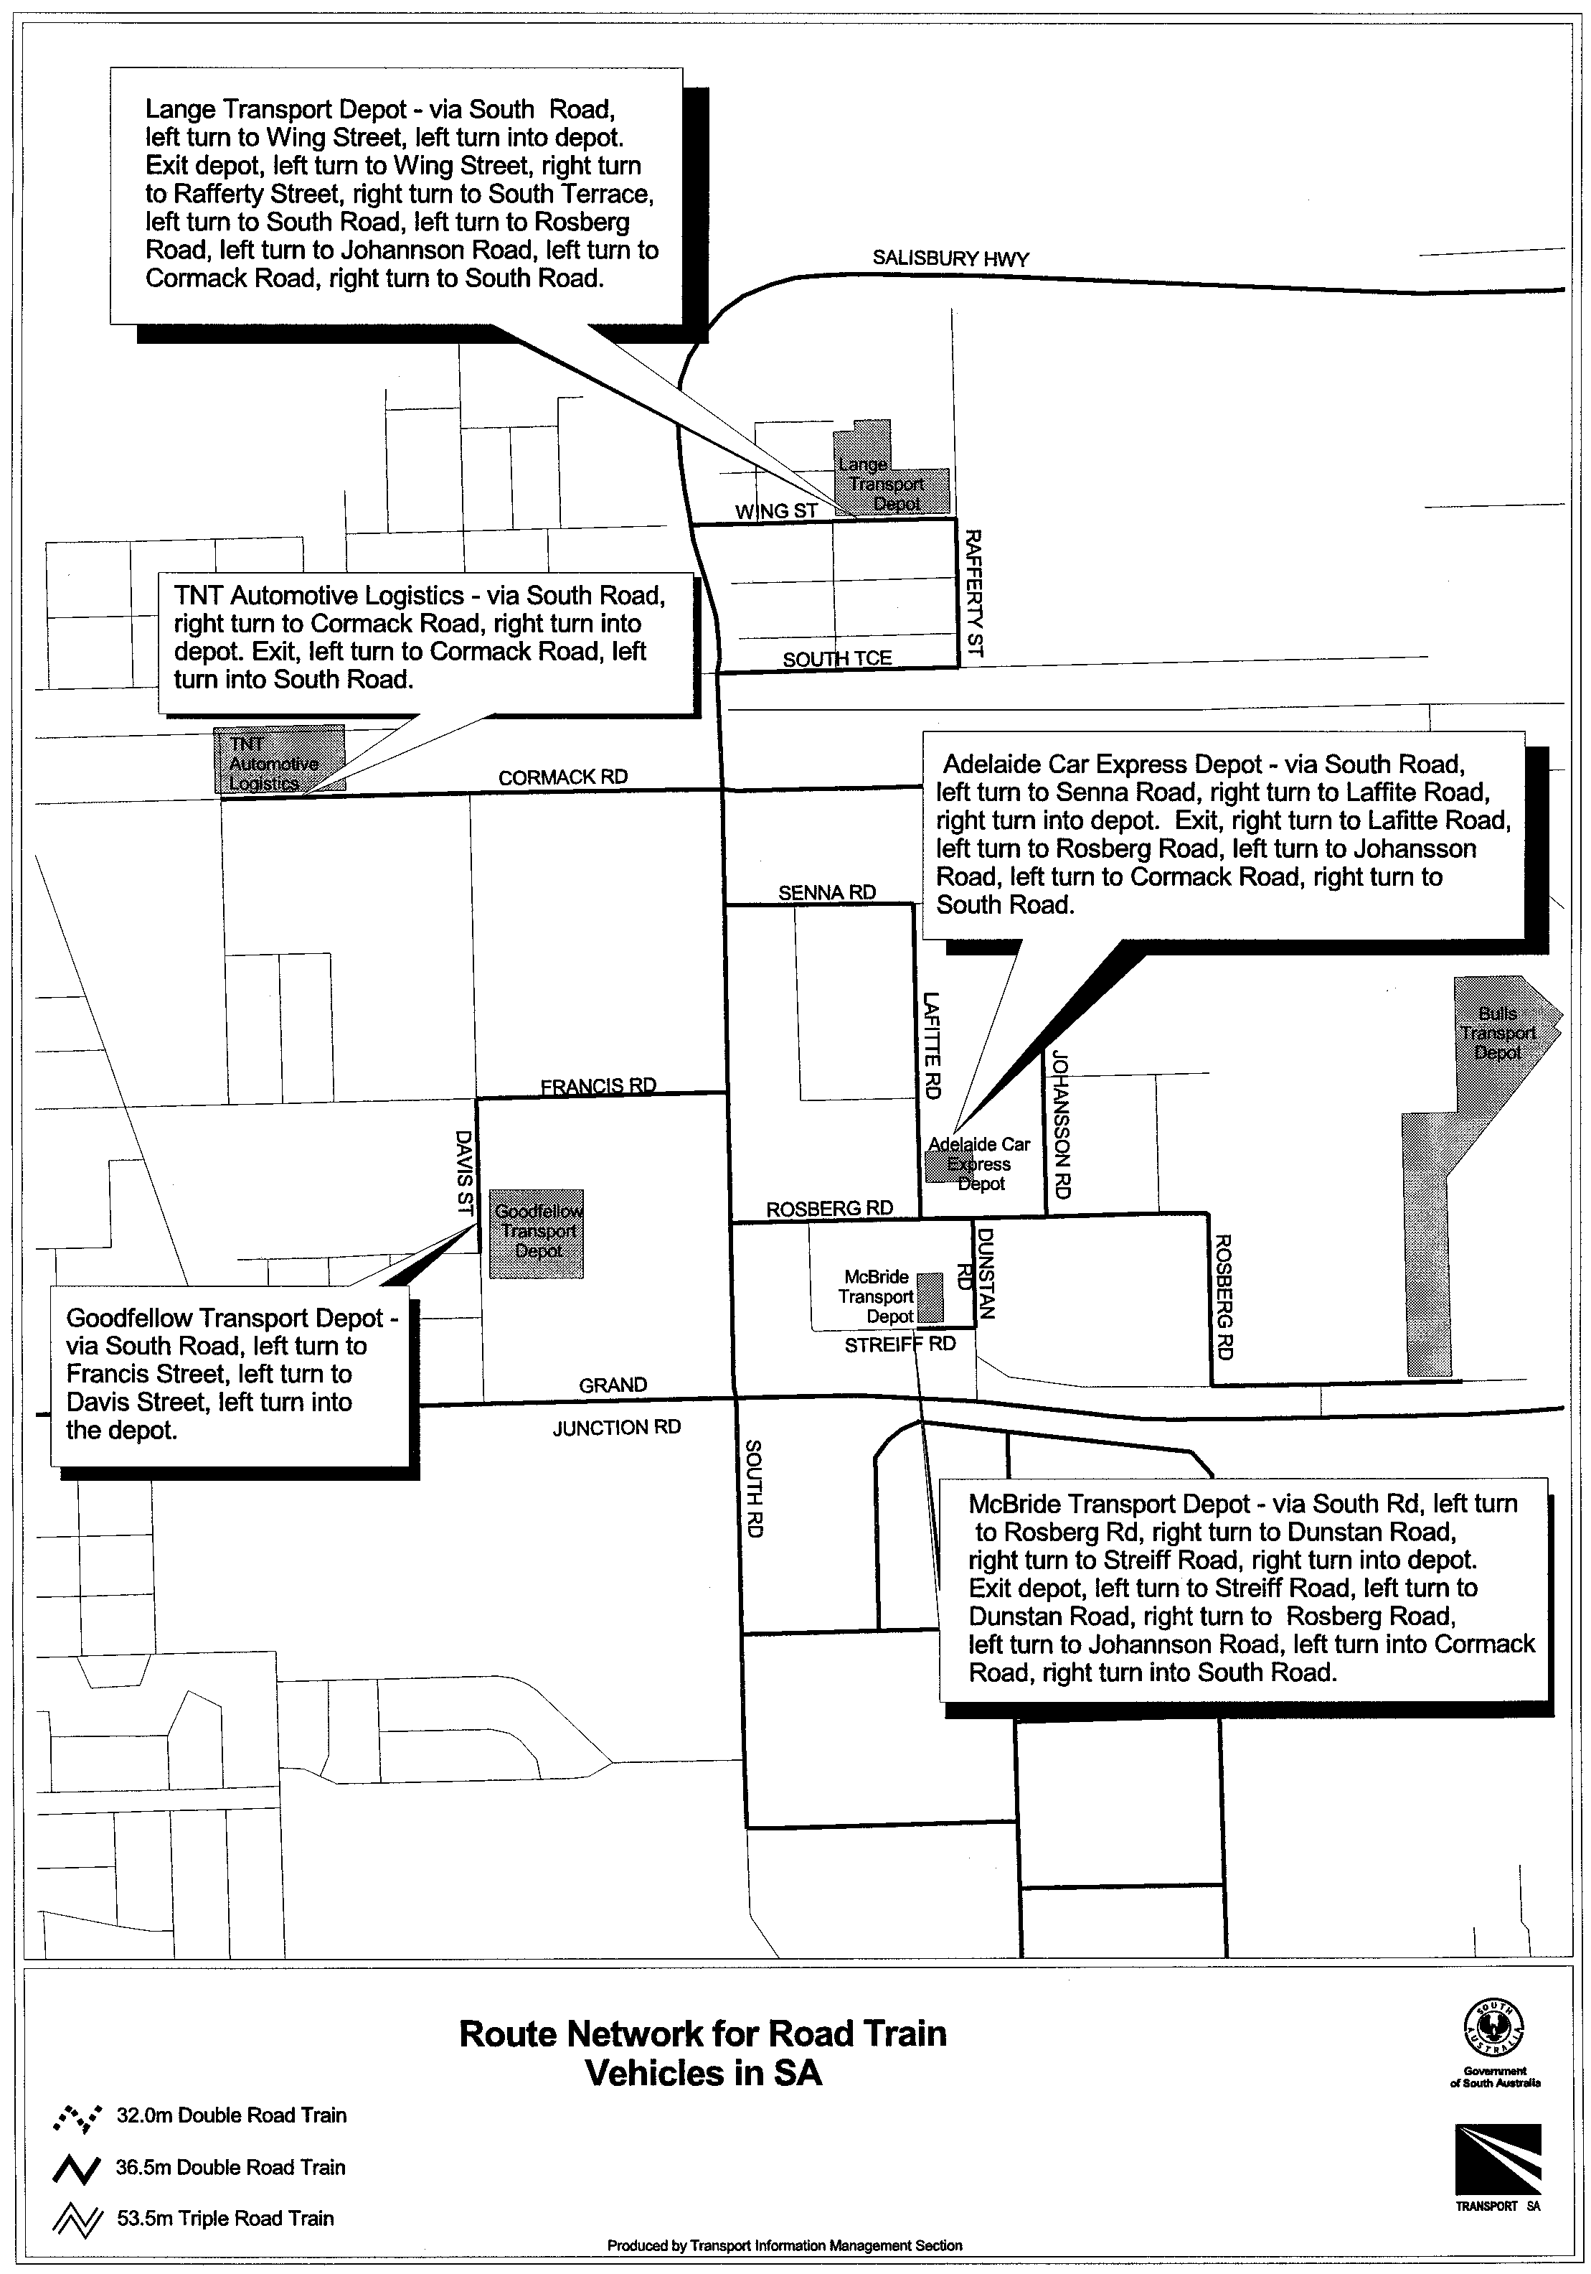
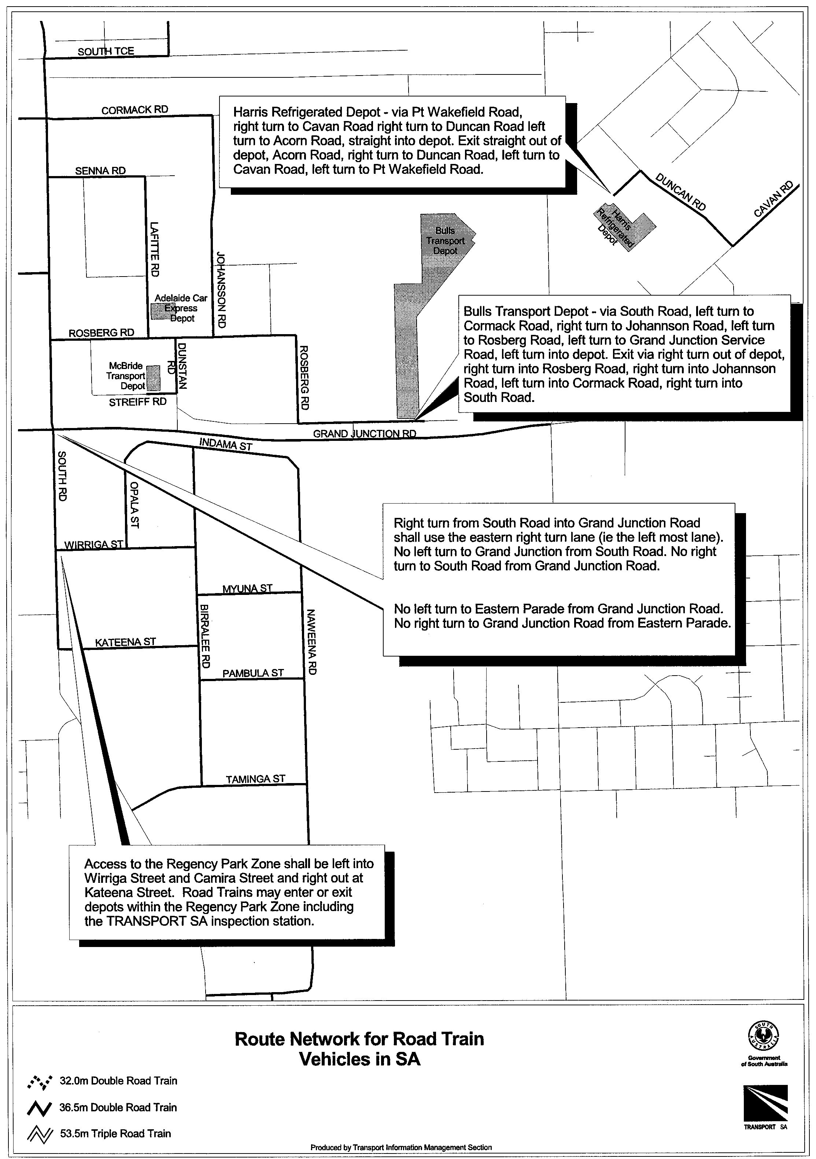
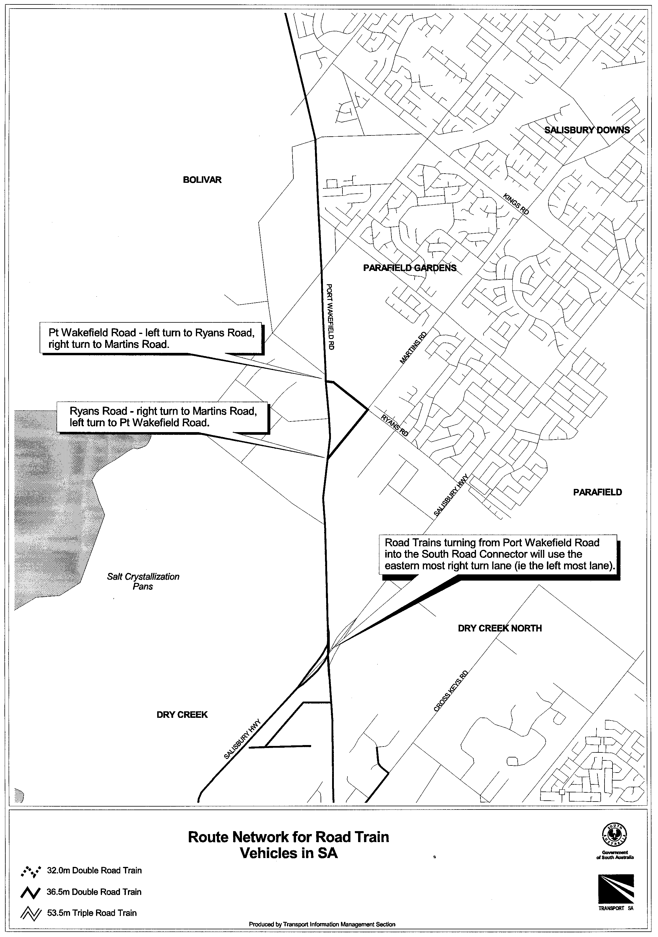
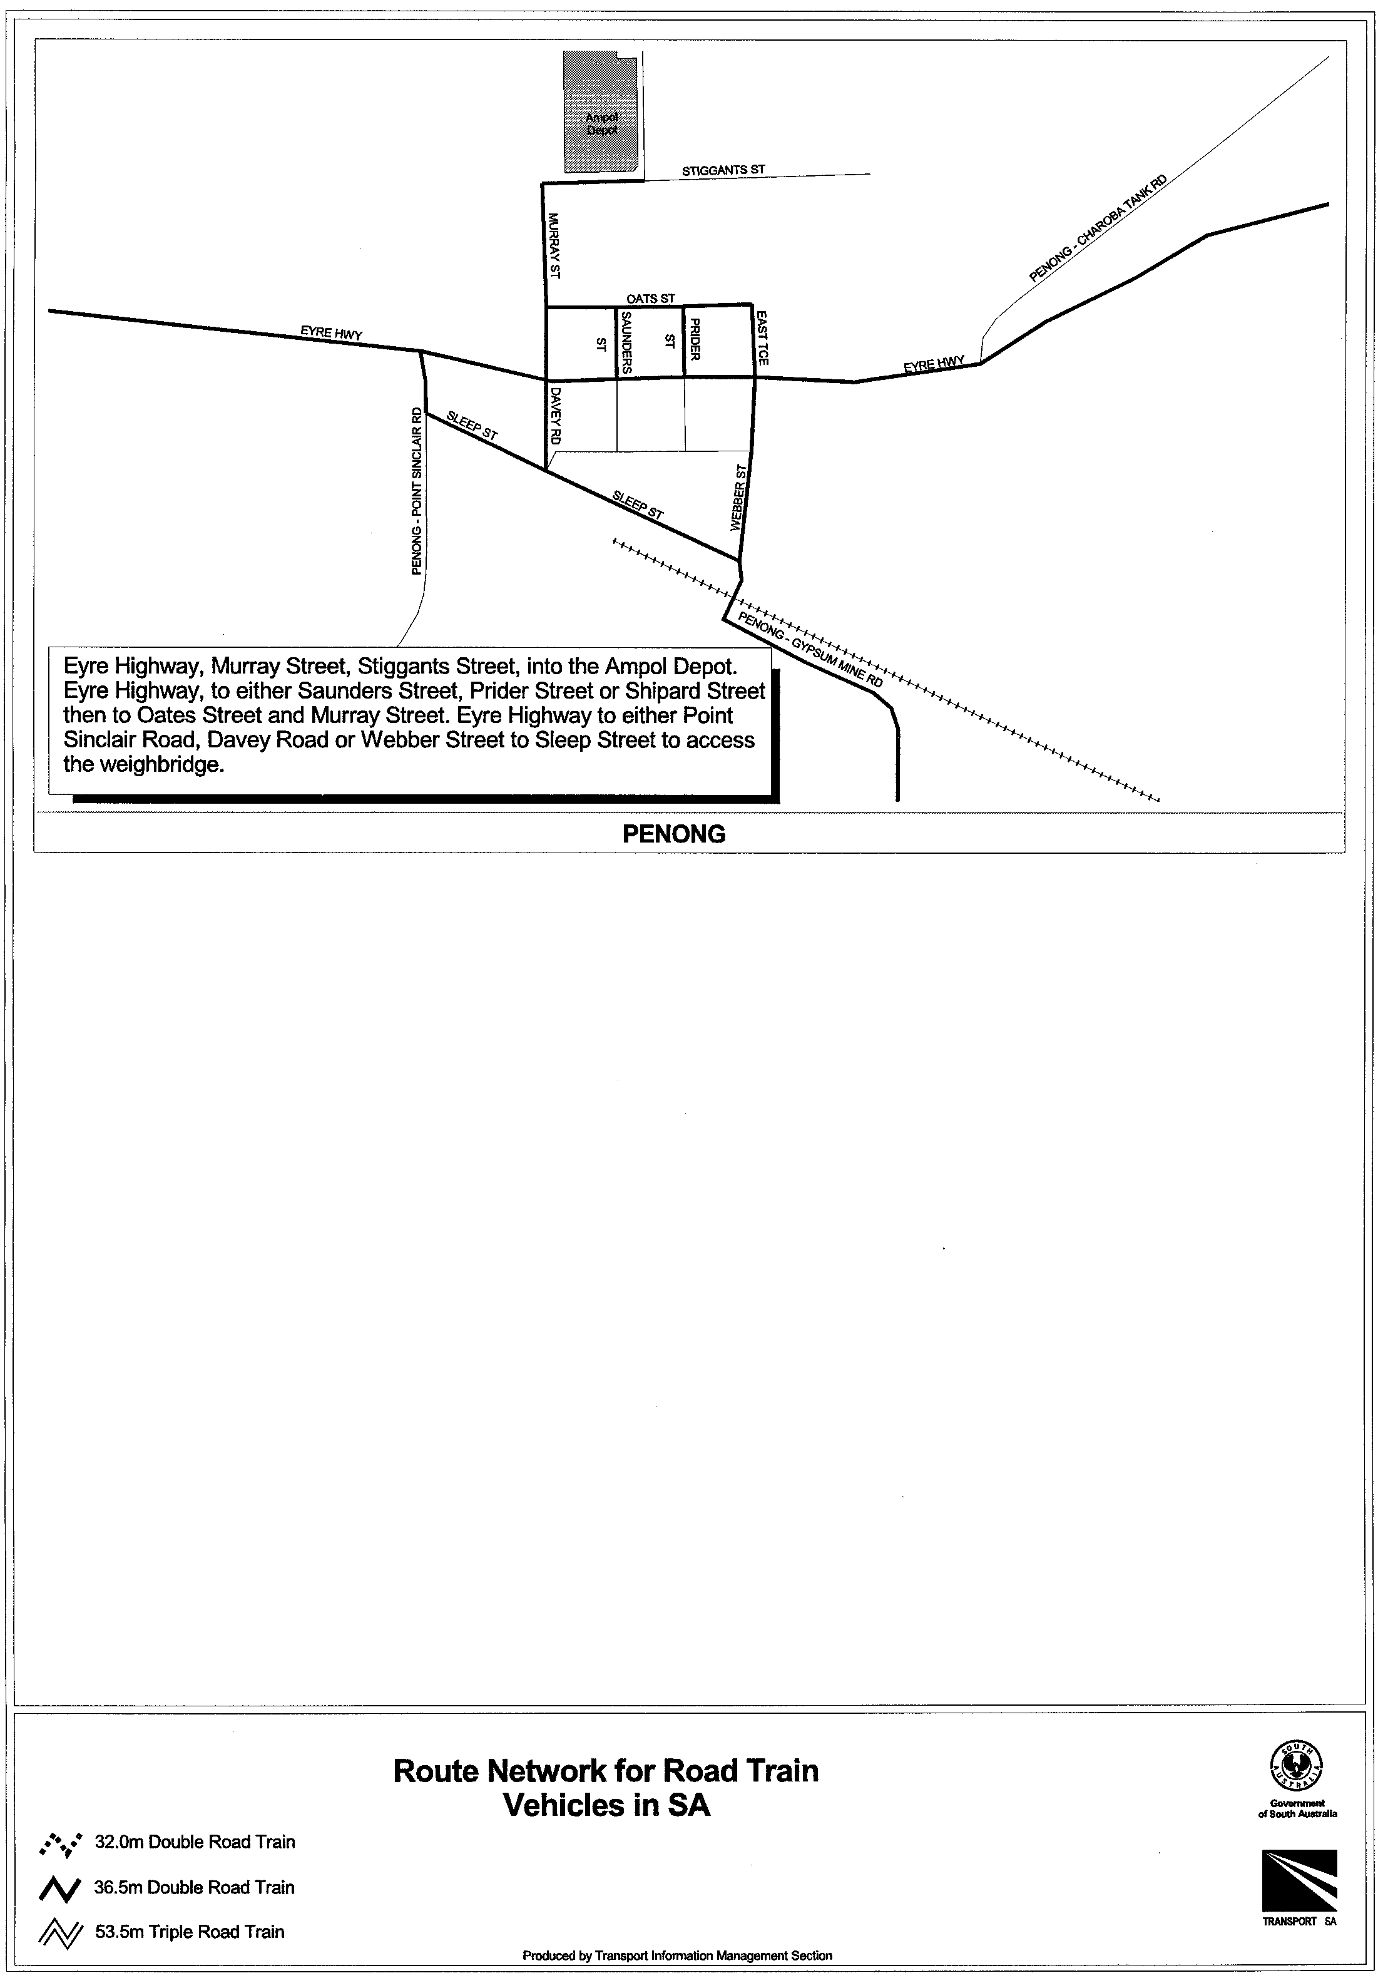
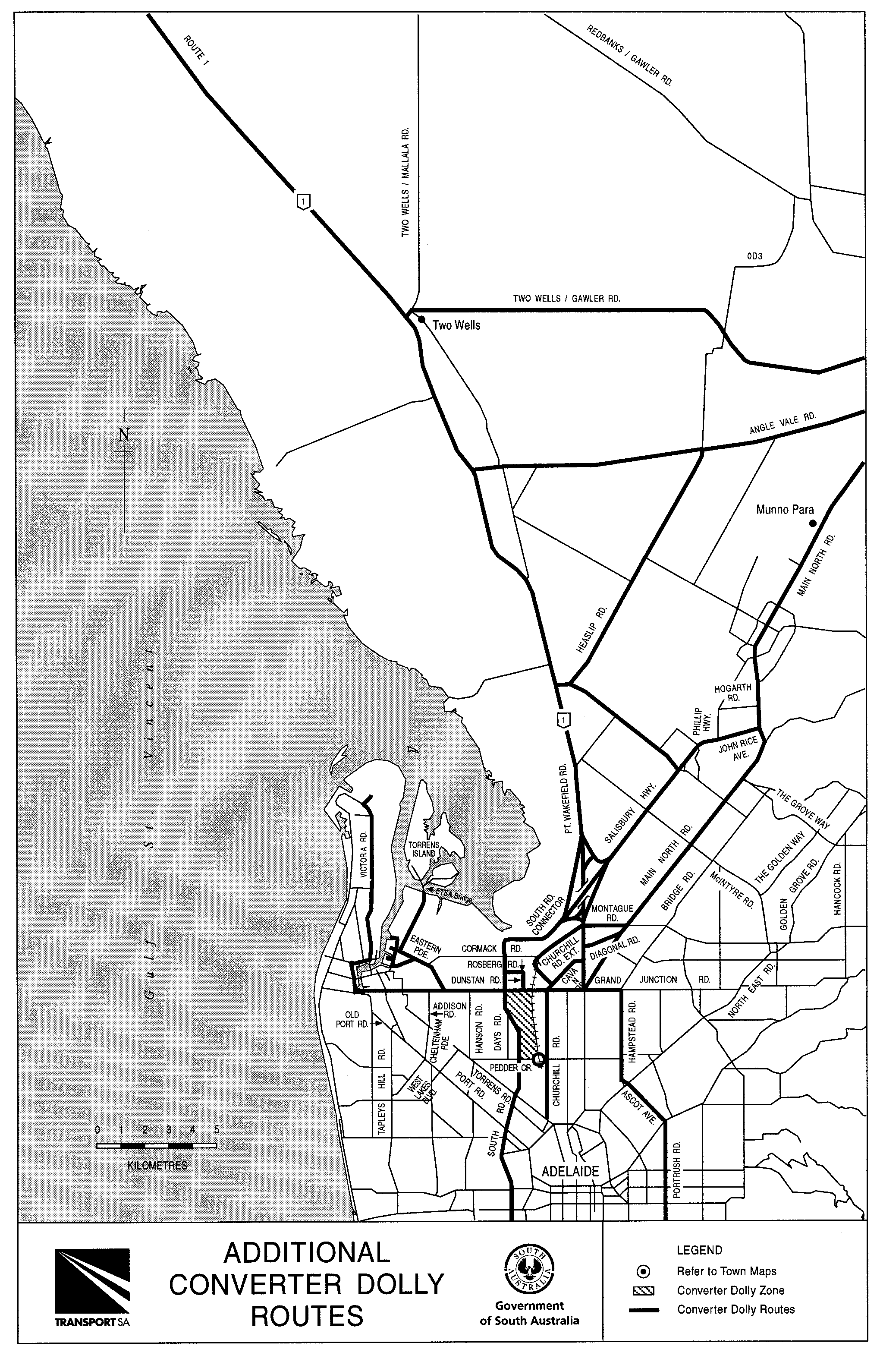
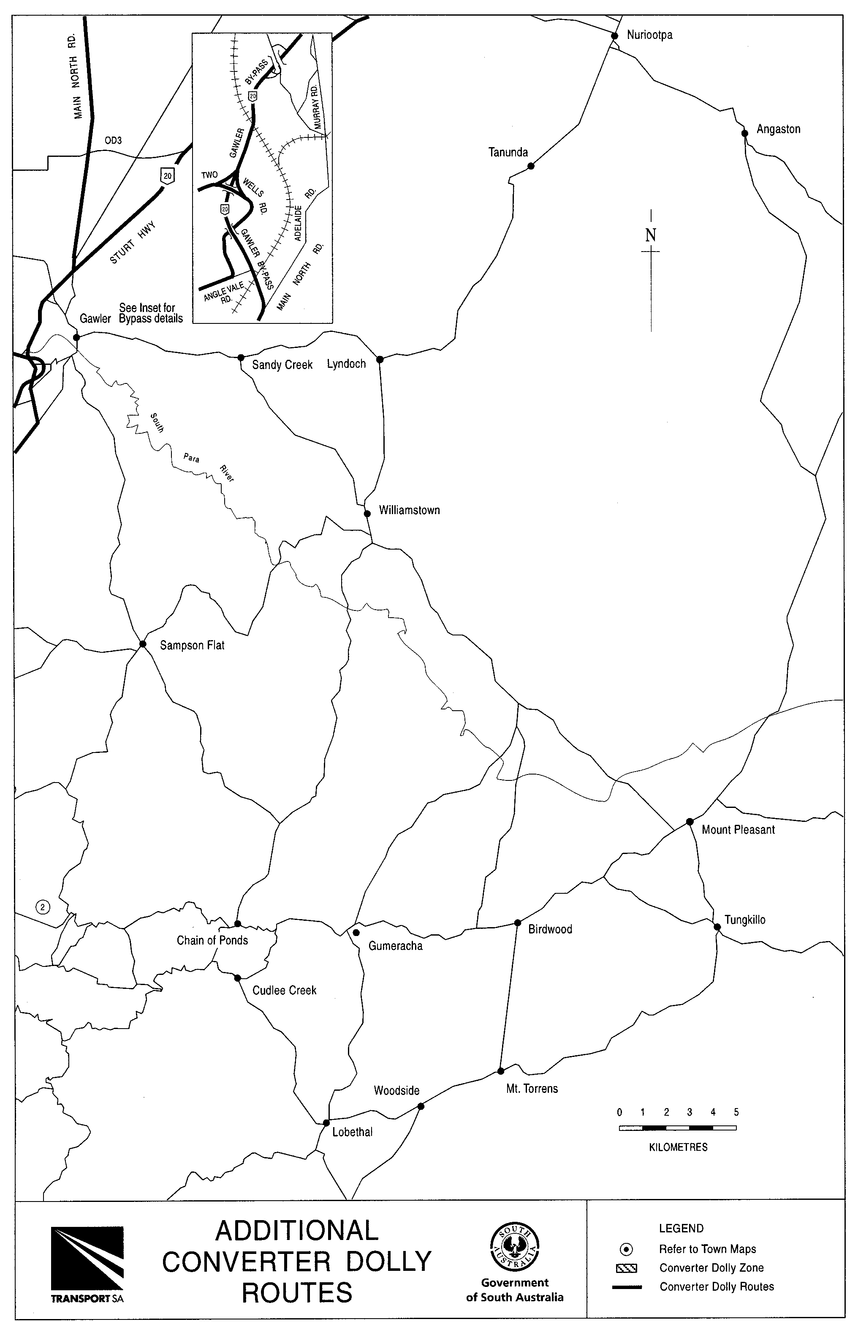
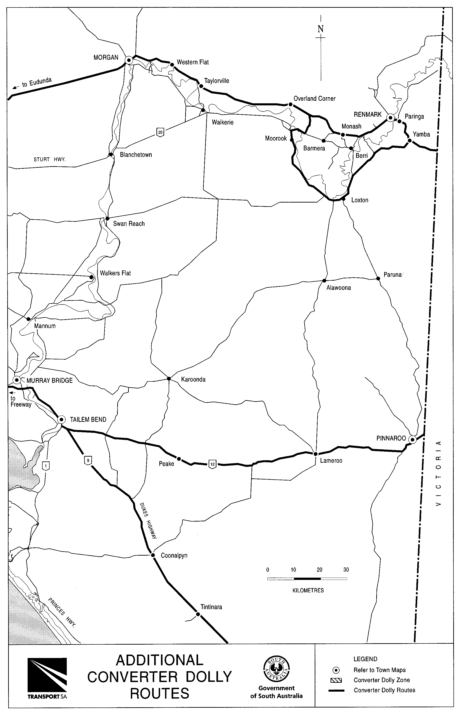

T. N. Argent, Executive Director, Transport SA

ROADS (OPENING AND CLOSING) ACT 1991:
SECTION 24
NOTICE OF CONFIRMATION OF ROAD
PROCESS ORDER
Public Road, Cape Douglas Hundred of Kongorong
Deposited Plan 53261
BY Road Process Order made on 1 December 1999, the District Council of Grant ordered that:
1. Portions of section 343 and portions of piece 91 in Filed Plan 200285 more particularly delineated and numbered ‘16’, ‘17’, ‘18’ and ‘19’ (forming a road re-alignment) in Preliminary Plan No. PP32/0345 be opened as road.
2. Portions of the public road intersecting section 343 and adjoining piece 92 in Filed Plan 200285 more particularly delineated and lettered ‘A’, ‘B’, and ‘E’ (respectively) in Preliminary Plan No. PP32/0345 be closed.
3. Portion of the public road adjoining closed road ‘A’ on Road Plan 519A (CT 5394/325) and lettered ‘D’ in Preliminary Plan No. PP32/0345 be closed.
4. Portion of the public road adjoining sections 635 to 649 inclusive (Umpherstone shack area) more particularly delineated and lettered ‘C’ and ‘F’ to ‘S’ (inclusive) in Preliminary Plan No. PP32/0345 be closed.
5. The whole of the land subject to closure lettered ‘A’, ‘B’ and ‘E’ be transferred to CHRISTINE GAYE SIMS in accordance with agreements for exchange dated 1 December 1999 entered into between the District Council of Grant and C. G. Sims.
6. Issue a Certificate of Title to THE DISTRICT COUNCIL OF GRANT over the whole of the land subject to closure lettered ‘D’ being retained for public purposes.
7. Vest in the Crown the whole of the land subject to closure lettered ‘F’ to ‘S’ (inclusive).
On 10 December 1999 that order was confirmed by the Minister for Administrative Services conditionally on approval and deposit of the survey plan by the Registrar-General. The condition has now been fulfilled.
Pursuant to section 24(5) of the Roads (Opening and Closing) Act 1991, NOTICE of the order referred to above and its confirmation is hereby given.
Dated 17 February 2000.
P. M. Kentish, Surveyor-General

ROADS (OPENING AND CLOSING) ACT 1991:
SECTION 24
NOTICE OF CONFIRMATION OF ROAD
PROCESS ORDER
Rockford Place, Marino
Deposited Plan 53637
BY Road Process Order made on 8 November 1999, The Corporation of the City of Marion ordered that:
1. Portion of the public road (Rockford Place) adjoining allotment 182 in Deposited Plan 3146 more particularly lettered ‘A’ in Preliminary Plan No. PP32/0477 be closed.
2. The whole of the land subject to closure be transferred to JOHN ALEXANDER MEREDITH and OLGA MEREDITH in accordance with agreement for transfer 5 November 1999 entered into between The Corporation of The City of Marion and J. A. Meredith and O. Meredith.
3. The following easements are granted over the whole of the land subject to that closure:
Grant to the South Australian Water Corporation easements for water supply purposes and sewerage purposes.
On 10 December 1999 that order was confirmed by the Minister for Administrative Services conditionally on approval and deposit of the survey plan by the Registrar-General. The condition has now been fulfilled.
Pursuant to section 24(5) of the Roads (Opening and Closing) Act 1991, NOTICE of the order referred to above and its confirmation is hereby given.
Dated 17 February 2000.
P. M. Kentish, Surveyor-General

ROADS (OPENING AND CLOSING) ACT 1991:
SECTION 24
NOTICE OF CONFIRMATION OF ROAD
PROCESS ORDER
Burge Road, Williamstown
Deposited Plan 52615
BY Road Process Order made on 3 August 1999, The Barossa Council ordered that:
1. Portion of the public road (Burge Road) south of Williamstown Road adjoining the western boundary of allotment 117 in Filed Plan 215609 more particularly lettered ‘A’ in Preliminary Plan No. PP32/0421 be closed.
2. The whole of the land subject to closure be transferred to CHAMBERLAIN INVESTMENTS PTY LTD in accordance with agreement for transfer dated 3 August 1999 entered into between The Barossa Council and Chamberlain Investments Pty Ltd.
On 23 August 1999 that order was confirmed by the Minister for Administrative Services conditionally on approval and deposit of the survey plan by the Registrar-General. The condition has now been fulfilled.
Pursuant to section 24(5) of the Roads (Opening and Closing) Act 1991, NOTICE of the order referred to above and its confirmation is hereby given.
Dated 17 February 2000.
P. M. Kentish, Surveyor-General

ROADS (OPENING AND CLOSING) ACT 1991
Road Closure—Willoughby and Perth Streets,
Ferryden Park
NOTICE is hereby given, pursuant to section 10 of the Roads (Opening and Closing) Act 1991, that the CITY OF PORT ADELAIDE ENFIELD proposes to make a Road Process Order to close and transfer to the South Australian Housing Trust portions of the public roads (Willoughby Street) adjoining allotments 282, 283, 284, 286, 287 and 288 in Deposited Plan 4973 and (Perth Street) adjoining allotment 304 in Deposited Plan 4970, shown more particularly delineated and lettered ‘A’, ‘B’, ‘C’, ‘D’ and ‘E’ (respectively) on Preliminary Plan No. PP32/0544.
A copy of the plan and a statement of persons affected are available for public inspection at the office of the Council at 163 St Vincent Street, Port Adelaide and the Adelaide office of the Surveyor-General during normal office hours.
Any application for easement or objection must set out the full name, address and details of the submission and must be fully supported by reasons.
The application for easement or objection must be made in writing to the Council at P.O. Box 110, Port Adelaide 5015 WITHIN 28 DAYS OF THIS NOTICE and a copy must be forwarded to the Surveyor-General at G.P.O. Box 1354, Adelaide, S.A. 5001. Where a submission is made, the Council will give notification of a meeting at which the matter will be considered.
Dated 17 February 2000.
P. M. Kentish, Surveyor-General

WATER MAINS AND SEWERS

Office of the South Australian Water Corporation
Adelaide, 17 February 2000.

WATER MAINS LAID

Notice is hereby given that the following main pipes or parts of main pipes have been laid down by the South Australian Water Corporation in or near the undermentioned water districts and are now available for a constant supply of water to adjacent land.

ADELAIDE WATER DISTRICT

CITY OF MITCHAM
Carr Street, Blackwood. p18

CITY OF PORT ADELAIDE ENFIELD
Westwood Boulevard, Ferryden Park. p10
Kinross Street, Ferryden Park. p10

CITY OF PROSPECT
Edinburgh Street, Prospect. p13

CITY OF SALISBURY
General Drive, Paralowie. p9
Tarqui Drive, Paralowie. p9
Brion Drive, Paralowie. p9
Stanford Road, Salisbury Heights. p20-22

CITY OF TEA TREE GULLY
Highview Circuit, Greenwith. p8

CITY OF UNLEY
Washington Avenue, Myrtle Bank. p12
Glenrowan Avenue, Myrtle Bank. p11

GOOLWA WATER DISTRICT

DISTRICT OF ALEXANDRINA COUNCIL
Golfview Road, Goolwa Beach. p4
Aldam Avenue, Goolwa Beach. p5

KINGSCOTE WATER DISTRICT

DISTRICT OF KANGAROO ISLAND
Vivonne Avenue, Kingscote. p3

STRATHALBYN WATER DISTRICT

DISTRICT OF ALEXANDRINA COUNCIL
Guernsey Court, Strathalbyn. p2

WATER MAINS ABANDONED

Notice is hereby given that the undermentioned water mains have been abandoned by the South Australian Water Corporation.

ADELAIDE WATER DISTRICT

DISTRICT OF ADELAIDE HILLS COUNCIL
Easements in lot 2, Bon Street, lots 116, 117, 125, 126, 130 and 132, Main Street and lots 4, 5, 10 and 11, Noske Court, Lobethal. p1

CITY OF PORT ADELAIDE ENFIELD
Kinross Street, Ferryden Park. p10

CITY OF SALISBURY
Stanford Road, Salisbury Heights. p20-22

STRATHALBYN WATER DISTRICT

DISTRICT OF ALEXANDRINA COUNCIL
Jersey Way, Strathalbyn. p2

SEWERS LAID

Notice is hereby given that the following sewers have been laid down by the South Australian Water Corporation in the under-mentioned drainage areas and are now available for house connections.

ADELAIDE DRAINAGE AREA

CITY OF BURNSIDE
Roslind Street, Kensington Gardens. FB 1085 p23
Easements in lots 48, 49 and 15-19, Allandale Avenue, Glen Osmond. FB 1061 p36 and 37

CITY OF CAMPBELLTOWN
Glen Avenue, Tranmere. FB 1085 p24
Koongarra Avenue, Magill. FB 1085 p26
Prosperity Way, Athelstone. FB 1085 p25

CITY OF CHARLES STURT
Across and in Tapleys Hill Road (opposite Elaine Avenue), Seaton. FB 3/46 p55A
Across Rowley Terrace, Woodville. FB 16/32 p28
Easement in railway land and lot 127, Rowley Terrace, Woodville. FB 16/32 p28
Easements in lots 20 and 4, Sheffield Street, Woodville North. FB 18/32 p2A
Audley Street, Woodville North. FB 104 p3
Easements in lots 2 and 4, Ninth Avenue, Woodville North. FB 104 p3 and 14/32 p36

CITY OF ONKAPARINGA
River Road, Port Noarlunga. FB 364 p7 and 1

CITY OF PORT ADELAIDE ENFIELD
Westwood Boulevard, Ferryden Park. FB 1085 p15 and 16
Kinross Street, Ferryden Park. FB 1085 p15 and 16
Across Esplanade, Semaphore. FB 6/16 p34
Easement in recreation reserve (section 370, hundred of Port Adelaide), Esplanade, Semaphore. FB 6/16 p34

CITY OF SALISBURY
General Drive, Paralowie. FB 1085 p13 and 14
Tarqui Drive, Paralowie. FB 1085 p13 and 14
Brion Drive, Paralowie. FB 1085 p13 and 14
Brookside Drive, Mawson Lakes. FB 1085 p17 and 18
Coopers Crescent, Mawson Lakes. FB 1085 p17 and 20

CITY OF TEA TREE GULLY
Highview Circuit, Greenwith. FB 1085 p21 and 22

CITY OF WEST TORRENS
William Street, Mile End South. FB 44/15 p13A
Across Henley Beach Road (opposite lot 83 in LTRO DP 4676), Lockleys. FB 25/32 p14

MOUNT GAMBIER COUNTRY DRAINAGE AREA

CITY OF MOUNT GAMBIER
Sewerage land (lot 61), Commercial Street West and lot 60, Saint Street, Mount Gambier. FB 196 p33

STIRLING COUNTRY DRAINAGE AREA

DISTRICT OF ADELAIDE HILLS COUNCIL
Easement in lot 3, Oak Avenue, Bridgewater. FB 1085 p10

SEWERS ABANDONED

Notice is hereby given that the undermentioned sewers have been abandoned by the South Australian Water Corporation.

ADELAIDE DRAINAGE AREA

CITY OF ONKAPARINGA
Easement in lot 30 (formerly sewerage land), River Road, Port Noarlunga. FB 364 p1
River Road, Port Noarlunga. FB 364 p7 and 1

SEWERS LAID

Notice is hereby given that the undermentioned sewers have been laid down by the South Australian Water Corporation and are not available for house connections.

ADELAIDE DRAINAGE AREA

CITY OF ONKAPARINGA
River Road, Port Noarlunga – 300 mm MSCL pumping main. FB 619 p42 and 49

CITY OF PORT ADELAIDE ENFIELD
Across Crossley Avenue, Croydon Park. FB 106 p30

ADDITION

Addition to notice in “Government Gazette” of 7 April 1988.

“SEWERS LAID”

“ADELAIDE DRAINAGE AREA”

“CITY OF (HAPPY VALLEY) ONKAPARINGA”
“Homestead Drive, Aberfoyle Park – 250.1 m of 150 mm PVC sewer from 225 mm sewer easement in lot 1 running easterly to lot 229. This sewer is available for house connections on the southern side only. FB 551 p16”

To this notice add “for the first 43.0 m and the last 28.7 m. FB 1085 p12”

CORRECTION

Correction to notice in “Government Gazette” of 18 April 1963

“SEWERS LAID”

“ADELAIDE DRAINAGE AREA”

“CITY OF (BRIGHTON) HOLDFAST BAY”
“Muriel Avenue, Somerton Park (formerly Paringa Park). – Northerly for 39.0 m (128ft.) from Wilton Avenue. This sewer is available for house connections on the eastern side only. FB 10/41 p30”

For “39.0 m” read “41.8 m”

DELETION

Deletion to notice in “Government Gazette” of 9 December 1982.

“SEWERS LAID”

“ADELAIDE DRAINAGE AREA”

“DISTRICT OF (MUNNO PARA) PLAYFORD”

“Smith Street, Smithfield – 179.6 m of 150 mm PVC sewer from 150 mm sewer Churcher Avenue running south-westerly to lot 31. This sewer is available for house connections on the north-western side only. FB 245 p47 and 48”

Delete “This sewer is available for house connections on the north-western side only. FB 1085 p11”

S. Sullivan, Chief Executive Officer, South Australian Water Corporation.

REGULATIONS UNDER THE EXPIATION OF OFFENCES ACT 1996
────
No. 11 of 2000
────
At the Executive Council Office at Adelaide 17 February 2000

PURSUANT to the Expiation of Offences Act 1996 and with the advice and consent of the Executive Council, I make the following regulations.
E. J. NEAL Governor

PURSUANT to section 10AA(2) of the Subordinate Legislation Act 1978, I certify that, in my opinion, it is necessary or appropriate that the following regulations come into operation as set out below.

K. T. GRIFFIN Attorney-General
───────────────────
SUMMARY OF PROVISIONS

1. Citation
2. Commencement
3. Variation of reg. 5—Prescribed forms
4. Revocation of reg. 6—Community service requirements
5. Variation of reg. 8—Expiation and reminder notices relating to more than one offence
6. Variation of Schedule—Forms
───────────────────

Citation
1. The Expiation of Offences Regulations 1996 (see Gazette 23 December 1996, p. 2237), as varied, are referred to in these regulations as "the principal regulations".

Commencement
2. These regulations will come into operation on 6 March 2000.

Variation of reg. 5—Prescribed forms
3. Regulation 5 of the principal regulations is varied—

(a) by inserting ", charge card" after "credit card" first occurring;

(b) by striking out "credit card or debit card" second occurring and substituting "such a card".

Revocation of reg. 6—Community service requirements
4. (1) Regulation 6 of the principal regulations is revoked.

(2) However, regulation 6 of the principal regulations continues to have force and effect, despite its revocation, in relation to an order for community service that was in force immediately before the commencement of these regulations.

Variation of reg. 8—Expiation and reminder notices relating to more than one offence
5. Regulation 8 of the principal regulations is varied by striking out from subregulation (3) "or community service performed".

Variation of Schedule—Forms
6. The Schedule of the principal regulations is varied as follows:

(a) Form 1 is varied—

(i) by striking out from the second dot point "to work it off by community service" and substituting "for an extension of time in which to pay it";

(ii) by striking out from the second dot point "Community service is only available if you owe $150 or more by way of expiation fees and cannot pay in instalments.";

(iii) by striking out from the fourth dot point "naming" and substituting "stating the name and address of";

(iv) by inserting in the box immediately below the dot points "(a reminder fee will apply)" after "one reminder notice will be sent";

(b) Form 2 is varied—

(i) by striking out "A" from the box appearing at the top of the form and substituting "EXPIATION NOTICE NUMBER:";

(ii) by inserting "DUE DATE FOR PAYMENT- - - - - - - -" in the bottom line of the expiation fee box before "TOTAL AMOUNT PAYABLE";

(iii) by striking out the whole of the box headed "DUE DATE FOR PAYMENT";

(iv) by striking out from the second dot point "to work it off by community service" and substituting "for an extension of time in which to pay it";

(v) by striking out from the second dot point "Community service is only available it you owe $150 or more by way of expiation fees and cannot pay in instalments.";

(vi) by inserting in the box immediately below the dot points "(a reminder fee will apply)" after "one reminder notice will be sent";

(c) Form 3 is varied—

(i) by striking out from the third dot point "to work it off by community service" and substituting "for an extension of time in which to pay it";

(ii) by striking out from the third dot point "Community service is only available if you owe $150 or more by way of expiation fees and cannot pay in instalments.";

(iii) by striking out from the fourth dot point "naming" and substituting "stating the name and address of";

(d) Form 4 is varied—

(i) by striking out from the box headed "PAY BY DATE" the line "(You must work this date out yourself)" and the whole of the entry immediately below that line relating to calculation of the pay by date;

(ii) by striking out "please" from each tear off slip at the bottom of the form and substituting in each case "you may (but need not)";

(iii) by striking out from the second dot point on the back of the form "to work it off by community service" and substituting "for an extension of time in which to pay it";
(iv) by striking out from the second dot point on the back of the form "Community service is only available if you owe $150 or more by way of expiation fees and cannot pay in instalments.";

(v) by striking out from the third dot point on the back of the form "naming" and substituting "stating the name and address of";

(vi) by inserting in each tear off slip on the back of the form "(you do not have to, but may, fill this in)" after "reasons";

(e) Form 5 is varied—

(i) by striking out from the box headed "PAY BY DATE" the line "(You must work this date out yourself)" and the whole of the entry immediately below that line relating to calculation of the pay by date;

(ii) by striking out "please" from the first tear off slip at the bottom of the form and substituting "you may (but need not)";

(iii) by striking out from the second dot point on the back of the form "to work it off by community service" and substituting "for an extension of time in which to pay it";

(iv) by striking out from the second dot point on the back of the form "Community service is only available if you owe $150 or more by way of expiation fees and cannot pay in instalments.";

(v) by striking out from the third dot point on the back of the form "naming" and substituting "stating the name and address of";

(vi) by inserting in the second tear off slip at the bottom of the back of the form "(you do not have to, but may, fill this in)" after "reasons";

(f) Form 6 is varied—

(i) by striking out from the box headed "PAY BY DATE" the line "(You must work this date out yourself)" and the whole of the entry immediately below that line relating to calculation of the pay by date;

(ii) by inserting in the first tear off slip at the bottom of the form "(you do not have to, but may, fill this in)" after "reasons";

(iii) by striking out from the second dot point on the back of the form "to work it off by community service" and substituting "for an extension of time in which to pay it";

(iv) by striking out from the second dot point on the back of the form "Community service is only available if you owe $150 or more and cannot pay in instalments.";
(v) by striking out from the third dot point on the back of the form "naming" and substituting "stating the name and address of";

(g) Form 7 is varied—

(i) by striking out from the back of the form "to work it off by community service" and substituting "for an extension of time in which to pay it";
(ii) by striking out from the third dot point on the back of the form "naming" and substituting "stating the name and address of";

(h) Form 8 is varied—

(i) by striking out from the box headed "PAY BY DATE" the line "(You must work this date out yourself)" and the whole of the entry immediately below that line relating to calculation of the pay by date;

(ii) by striking out "please" from each tear off slip at the bottom of the form and substituting in each case "you may (but need not)";

(iii) by striking out from the second dot point on the back of the form "to work it off by community service" and substituting "for an extension of time in which to pay it";

(iv) by striking out from the second dot point on the back of the form "Community service is only available if you owe $150 or more by way of expiation fees and cannot pay in instalments.";

(v) by striking out from the third dot point on the back of the form "naming" and substituting "stating the name and address of";

(vi) by inserting in each tear off slip at the bottom of the back of the form "(you do not have to, but may, fill this in)" after "reasons";

(i) Form 9 is varied—

(i) by striking out from the box headed "PAY BY DATE" the line "(You must work this date out yourself)" and the whole of the entry immediately below that line relating to calculation of the pay by date;

(ii) by striking out "please" from the first tear off slip at the bottom of the form and substituting "you may (but need not)";

(iii) by striking out from the second dot point on the back of the form "to work it off by community service" and substituting "for an extension of time in which to pay it";

(iv) by striking out from the second dot point on the back of the form "Community service is only available if you owe $150 or more by way of expiation fees and cannot pay in instalments.";

(v) by striking out from the third dot point on the back of the form "naming" and substituting "stating the name and address of";

(vi) by inserting in the second tear off slip at the bottom of the back of the form "(you do not have to, but may, fill this in)" after "reasons";

(j) Form 10 is varied—

(i) by striking out "please" from the first tear off slip at the bottom of the form and substituting "you may (but need not)";

(ii) by striking out from the first dot point on the back of the form "naming" and substituting stating the name and address of";

(iii) by striking out from the fourth dot point on the back of the form "to work it off by community service" and substituting "for an extension of time in which to pay it";

(iv) by striking out from the fourth dot point on the back of the form "Community service is only available if you owe $150 or more by way of expiation fees and cannot pay in instalments.";

(v) by inserting in the second tear off slip at the bottom of the back of the form "(you do not have to, but may, fill this in)" after "reasons";

(k) Form 11 is varied—

(i) by striking out "please" from the first tear off slip at the bottom of the form and substituting "you may (but need not)";

(ii) by striking out from the first dot point on the back of the form "naming" and substituting "stating the name and address of";

(iii) by striking out from the fourth dot point on the back of the form "to work if off by community service" and substituting "for an extension of time in which to pay it";

(iv) by striking out from the fourth dot point on the back of the form "Community service is only available if you owe $150 or more by way of expiation fees and you cannot pay in instalments.";

(v) by inserting in the second tear off slip at the bottom of the back of the form "(you do not have to, but may, fill this in)" after "reasons";

(l) Form 12 is varied—

(i) by inserting in the first tear off slip at the bottom of the form "(you do not have to, but may, fill this in)" after "reasons";

(ii) by striking out from the first dot point on the back of the form "naming" and substituting "stating the name and address of";

(iii) by striking out from the fourth dot point on the back of the form "to work it off by community service" and substituting "for an extension of time in which to pay it";

(iv) by striking out from the fourth dot point on the back of the form "Community service is only available if you owe $150 or more by way of expiation fees and cannot pay in instalments.";

(m) Form 13 is varied by inserting "(you do not have to, but may, fill this in)" after "reasons".

AG 9/98 CS R. DENNIS Clerk of the Council

REGULATIONS UNDER THE LAND AGENTS ACT 1994
────
No. 12 of 2000
────
At the Executive Council Office at Adelaide 17 February 2000

PURSUANT to the Land Agents Act 1994 and with the advice and consent of the Executive Council, I make the following regulations.
E. J. NEAL Governor

PURSUANT to section 10AA(2) of the Subordinate Legislation Act 1978, I certify that, in my opinion, it is necessary or appropriate that the following regulations come into operation as set out below.

K. T. GRIFFIN Minister for Consumer Affairs
───────────────────
SUMMARY OF PROVISIONS

1. Citation
2. Commencement
3. Variation of reg. 4A—Fees
4. Variation of reg. 9—Entitlement to be sales representative—qualifications
5. Insertion of Sched. 2
SCHEDULE 2
Qualifications of Sales Representative
───────────────────

Citation
1. The Land Agents Regulations 1995 (see Gazette 25 May 1995 p. 2464), as varied, are referred to in these regulations as "the principal regulations".

Commencement
2. These regulations come into operation on the day on which they are made.

Variation of reg. 4A—Fees
3. Regulation 4A of the principal regulations is varied by striking out from subregulation (1) "the Schedule" and substituting "Schedule 1".

Variation of reg. 9—Entitlement to be sales representative—qualifications
4. Regulation 9 of the principal regulations is varied by striking out paragraph (c) of subregulation (1) and substituting the following paragraph:

(c) at least one of the qualifications listed in Schedule 2, obtained after 31 May 1993; or.

Insertion of Sched. 2
5. The following Schedule is inserted after the Schedule of the principal regulations (now to be designated as Schedule 1):

SCHEDULE 2
Qualifications of Sales Representative

1. Certificate in Real Estate Sales conferred by the Department for Employment, Training and Further Education.

2. Certificate IV in Business (Real Estate Sales) conferred by the Department of Education, Training and Employment (TAFE SA) or the former Department for Employment, Training and Further Education.

3. Certificate IV in Business (Real Estate Sales) conferred by the Real Estate Industry Training Centre (being a body registered under Part 3 of the Vocational Education, Employment and Training Act 1994 as a provider of an accredited course for that certificate).

4. Satisfactory completion of, or status granted in, the following subjects offered by the University of South Australia as part of the course for the degree of Bachelor of Business (Property):

(a) Introduction to Law; and

(b) Law of Property; and

(c) Real Estate Management and Agency Practice; and

(d) Physical Aspects of Real Estate; and

(e) if the date of completion or the granting of status in any of the subjects referred to in paragraphs (a) to (d) is on or after 1 January 1999—Real Estate Documentation 1.

5. Satisfactory completion of, or status granted in, the following subjects offered by the University of South Australia as part of the course for the degree of Bachelor of Business in Property:

(a) Property Law 1, 2, 3 and 4; and

(b) Property Studies 2 and 3; and

(c) Property Fieldwork 1 and 2.

6. Satisfactory completion of, or status granted in, the following subjects offered by the University of South Australia as part of the course for the Graduate Diploma in Property or the degree of Master of Business in Property:

(a) —

(i) Property Law 1G and 2G; or

(ii) Property Law 2M; and

(b) —

(i) if the date of completion or the granting of status is before 1 January 1999—

(A) Real Estate Marketing and Property Case Studies; or

(B) Real Estate Marketing and Agency Practice G;

(ii) if the date of completion or the granting of status is on or after 1 January 1999—

(A) Real Estate Business and Marketing Management; or

(B) —

⋅ Real Estate Management and Agency Practice G; and

⋅ Conveyancing 1G.

OCBA 14/99 CS R. DENNIS Clerk of the Council

REGULATIONS UNDER THE LIQUOR LICENSING ACT 1997
────
No. 13 of 2000
────
At the Executive Council Office at Adelaide 17 February 2000

PURSUANT to the Liquor Licensing Act 1997 and with the advice and consent of the Executive Council, I make the following regulations.
E. J. NEAL Governor

PURSUANT to section 10AA(2) of the Subordinate Legislation Act 1978, I certify that, in my opinion, it is necessary or appropriate that the following regulations come into operation as set out below.

K. T. GRIFFIN Minister for Consumer Affairs
───────────────────
SUMMARY OF PROVISIONS

1. Citation
2. Commencement
3. Variation of Sched. 1—Long Term Dry Areas
───────────────────

Citation
1. The Liquor Licensing (Dry Areas—Long Term) Regulations 1997 (see Gazette 6 November 1997 p. 1217), as varied, are referred to in these regulations as "the principal regulations".

Commencement
2. These regulations come into operation on the day on which they are made.

Variation of Sched. 1—Long Term Dry Areas
3. Schedule 1 of the principal regulations is varied by striking out from the column headed "Period" in the item headed "Normanville—Area 1" "25 February 2000" and substituting "25 February 2002".

LL 16/94 TC1 CS R. DENNIS Clerk of the Council

FAXING COPY?

IF you fax copy to Riverside 2000, for inclusion in the Government Gazette, there is no need to send a Confirmation Copy to us as well.

This creates confusion and may well result in your notice being printed twice.

Please use the following fax number:

Fax transmission: (08) 8207 1040
Phone Inquiries: (08) 8207 1045

Please include a contact person, phone number and order number so that we can phone back with any queries we may have regarding the fax copy.

NOTE: Closing time for lodging new copy (either fax or hard copy) is 4 p.m. on Tuesday preceding the day of publication.

Government Gazette notices can be E-mailed.

The address is:

Riv2000@saugov.sa.gov.au

Documents should be sent as attachments in Word format.

When sending a document via E-mail, please confirm your transmission with a faxed copy of your document, including the date the notice is to be published.

Fax transmission: (08) 8207 1040
Enquiries: (08) 8207 1045

CITY OF ADELAIDE
Temporary Road Closure
NOTICE is hereby given that the council of the corporation of the City of Adelaide at its meeting held on 14 February 2000, passed inter alia the following resolutions:
Pursuant to section 359 of the Local Government Act 1934, as amended, the roads described in the following schedule, between the hours specified in the schedule, be closed to all vehicles except for emergency vehicles or those given express permission to enter by the Chief Executive Officer.
Schedule
Location |  | From |  | To
The Western Roadway of Hindmarsh Square from a point 31.8 m north of the northern building alignment of Pirie Street to a point 71.4 m north of the northern building alignment of Pirie Street |  | 7 a.m. on Friday, 18 February 2000 |  | 6 p.m. on Friday, 18 February 2000
Jude Munro, Chief Executive Officer

THE RURAL CITY OF MURRAY BRIDGE
Erratum
Naming of Roads
IN Government Gazette of 26 August 1999, page 1027 the notice contained errors. Items 1. and 2. in that notice shoud read:

Name |  | Commencing  Adjoining | Finishing Adjoining
Shankland Road |  | Sections 173  and 174 | Sections 172 and 174, Hundred of Brinkley
McCulloch Road |  | Sections 452  and 1447 | Sections 227 and 1442, Hundred of Brinkley
T. Jordan, Technical Assistant

CITY OF PLAYFORD
Prohibition of Traffic⎯Hope Street, Smithfield
NOTICE is hereby given that the Council of the City of Playford under delegated authority to the Chief Executive Officer, resolved pursuant to section 359 of the Local Government Act 1934, as amended, that all vehicles be excluded from a portion of Hope Street, Smithfield, commencing at the south-west property boundary of Charlotte Street for a distance of 29.4 m in a south-westerly direction from Charlotte Street.
T. R. S. Jackson, Chief Executive Officer

CITY OF PROSPECT
Appointment
NOTICE is hereby given that the Council of the City of Prospect has been pleased to appoint Michael John Llewellyn-Smith, to the position of Chief Executive Officer (City Manager) of the City of Prospect on a fixed term contract from 1 July 2000 to 28 November 2002.
F. Stock, Mayor

TOWN OF WALKERVILLE
Periodical Election
NOTICE is hereby given that nominations are hereby invited and will be received at the Corporation of the Town of Walkerville, 66 Walkerville Terrace, Gilberton, S.A. 5081 from Thursday, 9 March 2000 until noon on Thursday, 30 March 2000, from any person eligible to be a candidate for election to the vacancies of:
Mayor (one vacancy)
Councillor:
Medindie/Gilbert Ward (three vacancies)
Walkerville Ward (three vacancies)
Vale Park Ward (three vacancies).
Nomination forms and candidate’s handbooks are available from the Corporation of the Town of Walkerville, 66 Walkerville Terrace, Gilberton, S.A. 5081.
A candidate must submit a profile of not more than 150 words with the nomination form. A recent photograph (predominantly head and shoulders) may also be submitted.
A briefing for prospective candidates will be conducted at 6 p.m. on Monday, 27 March 2000 in the Committee Rooms at the Walkerville Town Hall.
If more than the required number of nominations are received for any vacancy, an election will be conducted entirely by postal ballot with the return of the completed ballot papers to reach the Deputy Returning Officer no later than noon on Tuesday, 16 May 2000.
N. Watson, Deputy Returning Officer

ADELAIDE HILLS COUNCIL
Temporary Road Closure
NOTICE is hereby given that the Adelaide Hills Council at its meeting held on 8 February 2000, resolved pursuant to section 359 of the Local Government Act 1934, as amended, to close Checker Hill Road, Forreston from 28 February 2000 to 10 March, 2000 for the purpose of replacing a bridge. Detours will be in place via Little Para Road/Adelaide-Mannum Road/Forreston Road or Hill Road/Norsworthy Road/Forreston Road.
Enquiries can be directed to Dehlia on 8408 0410 or Rhonda on 8408 0448.
R. D. Blight, Chief Executive Officer

DISTRICT COUNCIL OF CLEVE
Development Act 1993
General Plan Amendment Report Prepared by the Council —Draft for Public Consultation
NOTICE is hereby given that the District Council of Cleve has pursuant to section 24 of the Development Act 1993, prepared a draft Plan Amendment Report to amend the District Council of Cleve Development Plan.
The Plan Amendment Report will amend the District Council of Cleve Development Plan by:
(a) the establishment of a Commercial (Bulk Handling) Zone to define land currently occupied by the South Australian Cooperative Bulk Handling Limited company at Arno Bay, Rudall, Darke Peak, Kielpa and Wharminda in place of the present Special Industry Zone;
(b) creation of a new Commercial Bulk Handling Zone at Rudall;
(c) changes to boundaries of the Rural Living Zone;
(d) modification to boundaries of the Residential Zone;
(e) modification to the boundary of the Industry Zone at the western edge of the town;
(f) amendment to the boundary of the Commercial Zone on the eastern side of the town;
(g) a policy to enable roadside information bays to provide tourism information on the outskirts of towns;
(h) removal of the restriction on land division in the Rural Zone;
(i) creation of a new zone to encompass the Yeldulknie Weir site.
Copies of the draft Plan Amendment Report will be available for public inspection and purchase during normal office hours at the Council Office, Main Street, Cleve.
The draft Plan Amendment Report will be on display from 18 February 2000 until 26 April 2000.
Written submissions regarding the draft Plan Amendment Report should be submitted no later than 5 p.m. on Wednesday, 26 April 2000. All submissions should be addressed to the Chief Executive Officer, District Council of Cleve, P.O. Box 36, Cleve, S.A. 5640 and should clearly indicate whether you wish to be heard in support of your submission.
Copies of all submissions will be available for inspection by interested persons as the District Council of Cleve, Main Street, Cleve from 18 February 2000 until 26 April 2000 during normal office hours.
A public hearing will be heard on 3 May 2000 at 10 a.m. at the Council Offices, Main Street, Cleve, at which time interested persons may appear to be heard in relation to the draft Plan Amendment Report and the submissions. The public hearing will not be held if no submissions are received or if no submission makes a request to be heard.
F. Gillings, Chief Executive Officer

KANGAROO ISLAND COUNCIL
Temporary Road Closure
NOTICE is hereby given that council has resolved pursuant to section 359 of the Local Government Act 1934, as amended, to exclude all vehicles generally from Christmas Terrace, Penneshaw from 5 p.m. until 9 p.m. on Saturday, 26 February 2000 for the purpose of community activities.
B. C. Hurst, Chief Executive Officer

DISTRICT COUNCIL OF LOXTON WAIKERIE
Temporary Road Closure
NOTICE is hereby given that the District Council of Loxton Waikerie, at a meeting held on 15 December 1999, resolved to exclude all vehicles, with the exception of Emergency Vehicles and vehicles participating in the Loxton Mardi Gras Pageant on 26 February 2000, from the following roads:
1. The Drabsch Street, East Terrace crossover between 8 a.m. and noon.
2. View Street, Drabsch Street from View Street to East Terrace, the western carriageway of East Terrace from Drabsch Street to and including the Murray Street crossover, the eastern carriageway of East Terrace from the Murray Street crossover to Bookpurnong Terrace, Bookpurnong Terrace from East Terrace to and including the William Street crossover and Pine Avenue from 11 a.m. to noon.
T. L. Burgemeister, District Manager

DISTRICT COUNCIL OF ORROROO/CARRIETON
Change of Meeting Date
NOTICE is hereby given that the next ordinary meeting of council will be held on Monday, 13 March 2000, commencing at 10 a.m. in lieu of the meeting that was scheduled to be held on Tuesday, 14 March 2000.
J. W. Oliver, Chief Executive Officer

DISTRICT COUNCIL OF TUMBY BAY
Periodical Election
NOTICE is hereby given that nominations are hereby invited and will be received at the District Council of Tumby Bay office located at Mortlock Street, Tumby Bay from Thursday, 9 March 2000 until noon on Thursday, 30 March 2000, from any person eligible to be a candidate for election to the vacancies of:
Councillor⎯9 vacancies
Nomination forms and candidate’s handbooks are available from the District Council of Tumby Bay office.
A candidate must submit a profile of not more than 150 words with the nomination form. A recent candidate photograph (predominantly head and shoulders, passport size) may also be submitted.
A briefing for prospective candidates will be conducted at 6 p.m. on Monday, 27 March 2000 in the Council Chamber at the District Council of Tumby Bay.
If more than the required number of nominations are received for any vacancy, an election will be conducted entirely by postal ballot with the return of the completed ballot papers to reach the Deputy Returning Officer no later than noon on Tuesday, 16 May 2000.
E. A. Roberts, Deputy Returning Officer

IN the matter of the estates of the undermentioned deceased persons:
Ackland, Violet Hazel, late of 44 Rutherford Street, Swan Hill, Victoria, home duties, who died on 16 November 1999.
Adams, Bessie Pretoria, late of 336 Kensington Road, Leabrook, of no occupation, who died on 5 December 1999.
Brewer, Maxwell Edward, late of 55-59 Ferguson Avenue, Myrtle Bank, retired salesman, who died on 26 August 1999.
Carroll, Winifred Ada, late of 580 Brighton Road, South Brighton, of no occupation, who died on 21 December 1999.
Chennells, Leonard, late of 34 Molesworth Street, North Adelaide, retired caretaker, who died on 14 November 1999.
Cobb, Anna, late of 50 Jetty Road, Brighton, retired registered nurse, who died on 3 November 1999.
Cummings, Ian John, late of 23 Field Street, Reynella, retired clerk, who died on 17 December 1999.
Fullgrabe, Ellen Joyce, late of 110 Strathfield Terrace, Largs North, of no occupation, who died on 9 December 1999.
Gepp, Malcolm Oswald, late of 9 Tatiara Drive, Banksia Park, retired caretaker, who died on 9 November 1999.
Hawk, Stanford George, late of 20-36 Gardenia Drive, Parafield Gardens, retired shop assistant, who died on 19 November 1999.
Jones, Irene Sylvia, late of 51 Eighth Avenue, St Peters, widow, who died on 5 November 1999.
Kemp, Ronald James, late of 564 Tapleys Hill Road, Fulham Gardens, retired quality control supervisor, who died on 11 January 2000.
Liston, Doreen, late of 6 Hackett Terrace, Marryatville, widow, who died on 8 November 1999.
Mattner, Aneta Clare, late of 21 Wattle Street, Lobethal, home duties, who died on 29 October 1999.
Naulty, Marjorie Jean, late of 3 Montana Drive, Novar Gardens, of no occupation, who died on 28 November 1999.
Pecze, Gustav Frank, late of 113 Esplanade, Henley Beach South, retired flat proprietor, who died on 3 November 1999.
Phillips, Mary, late of 8 Ti Tree Road, Stirling, home duties, who died on 7 January 2000.
Pilkington, Thomas Herbert Russell, late of 1 Lawrie Terrace, Waikerie, of no occupation, who died on 17 November 1999.
Roberts, Audrey Gertrude, late of 10 Shanks Road, Aldgate, married woman, who died on 25 November 1999.
Roberts, Jean Manly, late of 45 Denning Street, Hawthorn, of no occupation, who died on 18 November 1999.
Robins, Barry Frederick, late of 7 Duryea Street, Port Clinton, retired technical officer, who died on 25 August 1999.
Scheid, Veronica Margaret, late of 20 Third Avenue, St Peters, widow, who died on 26 November 1999.
Schooler, Harold, late of 37 Methodist Street, Willunga, retired textile worker, who died on 30 December 1999.
Tully, Elsie Edna, late of 22 Norman Street, Port Pirie, of no occupation, who died on 18 November 1999.
Viitanen, Daniel Heikki, late of 5 Sharley Avenue, Mount Gambier, of no occupation, who died on 10 October 1999.
Waters, Patricia Olive, late of 160 O.G. Road, Felixstow, of no occupation, who died on 2 December 1999.
Wood, Keith Douglas, late of 30 Sussex Terrace, Westbourne Park, retired army officer, who died on 16 September 1998.
Notice is hereby given pursuant to the Trustee Act 1936, as amended, the Inheritance (Family Provision) Act 1972, and the Family Relationships Act 1975, that all creditors, beneficiaries, and other persons having claims against the said estates are required to send, in writing, to the Public Trustee, 25 Franklin Street, Adelaide, S.A. 5000, full particulars and proof of such claims, on or before 17 March 2000, otherwise they will be excluded from the distribution of the said estate; and notice is also hereby given that all persons who are indebted to the said estates are required to pay the amount of their debts to the Public Trustee or proceedings will be taken for the recovery thereof; and all persons having any property belonging to the said estates are forthwith to deliver the same to the Public Trustee.
Dated 17 February 2000.
J. H. Worrall, Public Trustee

IN the matter of the estate of the undermentioned deceased person:
Longmire, Magreta Johanna, late of Barunga Village, 11 Edmund Street, Port Broughton, who died on 13 January 2000.
Notice is hereby given pursuant to the Trustee Act 1936, as amended, the Inheritance (Family Provision) Act 1972-1975, and the Family Relationships Act 1975, that all creditors, beneficiaries, and other persons having claims against the abovenamed estate are directed to send full particulars of such claims to the undersigned on or before 16 March 2000, otherwise they will be excluded from the distribution of the said estate.
Dated 17 February 2000.
National Australia Trustees Limited, (ACN 007 350 405), 22-28 King William Street, Adelaide, S.A. 5000.

IN the matter of the estate of the undermentioned deceased person:
Moodie, Colin Troup, late of Hillcrest Hospital, Fosters Road, Gilles Plains, formerly of 14 Vansittart Place, Beaumont, retired Commonwealth public servant, who died on 6 February 2000.
Notice is hereby given pursuant to the Trustee Act 1936, as amended, The Inheritance (Family Provision) Act 1972-1975 and The Family Relationships Act 1975, that all creditors, beneficiaries and other persons having claims against the abovenamed estate, are directed to send full particulars of such claims, to the undersigned on or before 30 March 2000, otherwise they will be excluded from the distribution of the said estate.
Perpetual Trustees S.A. Limited (ACN 008 273 916), 89 King William Street, Adelaide, S.A. 5001.

GURUS PTY LTD
(ACN 082 368 769)
ON 8 February 2000, the Supreme Court of South Australia in Proceedings No. 1391 of 1999, ordered the winding up of Gurus Pty Ltd and I was appointed as liquidator of the company.
Dated 10 February 2000.
J. Morgan, c/o Lock LSH, Chartered Accountants, 121 Greenhill Road, Unley, S.A. 5061

MAYNARD O’CONNOR (AUST) PTY LTD
(ACN 008 139 651)
ON 8 February 2000, the Supreme Court of South Australia in Action No. 1452 of 1999, made an order for the winding up of Maynard O’Connor (Aust) Pty Ltd and appointed Russell Henry Heywood-Smith of 248 Flinders Street, Adelaide, S.A. 5000, to be the liquidator of that company.
Cresswell & Hewitt, Solicitors, 34 Gilbert Street, Gilberton, S.A. 5081.

UNCLAIMED MONEYS ACT 1891
Register of Unclaimed Moneys Held by Holden Ltd for Year Ended 31 December 1993

Name of Owner Total Amount Description on Books Due to Owner of Unclaimed
$ Moneys

M. A. Miller 29.60 w/e 25.10.93
S. A. Storrie 21.70 w/e 13.12.93

$51.30

UNCLAIMED MONEYS ACT 1891
Register of Unclaimed Moneys held by Australian Guarantee Corporation Limited for South Australia for
Year ended 31 December 1992

Name and Address of Owner |  |  | Total  Amount  Due  $ |  | Description  of Unclaimed  Money |  |  | Date Amount  Became  Payable
Dennis J. Blake, address unknown |  | 33.85 |  |  |  | Interest due | 18.12.92
Hasman Chin, 17 Salisbury Road, Salisbury, S.A. 5108 |  | 126.06 |  |  |  | Interest due | 31.12.92
Brett Duckworth, address unknown |  | 16.91 |  |  |  | Interest due | 31.12.92
Robert Paul and Donna Marie Griffin, Box 760, Port Adelaide, S.A. 5015 |  | 24.57 |  |  |  | Over payment on loan | 6.8.92
Vincent Geoffrey Henry, 53 Jackson Avenue, Whyalla Norrie, S.A. 5608 |  | 140.00 |  |  |  | Over payment on loan | 16.9.92
John D. Henson, 260 South Terrace, Adelaide, S.A. 5000 |  | 16.81 |  |  |  | Interest due | 31.12.92
Benjamin Johnson, 15 Station Avenue, Blackwood, S.A. 5051 |  | 16.81 |  |  |  | Interest due | 31.12.92
Felicity Johnson, 15 Station Avenue, Blackwood, S.A. 5051 |  | 16.81 |  |  |  | Interest due | 31.12.92
Kym M. Kenny, address unknown |  | 30.46 |  |  |  | Interest due | 18.12.92
Neil and Irene Kilpatrick, address unknown |  | 27.08 |  |  |  | Interest due | 31.12.92
Taralye Lampshire, address unknown |  | 20.66 |  |  |  | Interest due | 8.7.92
Vici Martin, 24/336 Sturt Road, Mitchell Park, S.A. 5043 |  | 59.68 |  |  |  | Interest due | 15.6.92
F. G. Miller, address unknown |  | 135.62 |  |  |  | Interest due | 30.6.89
Lawrence Mulvihill, 3 Victoria Street, Mannum, S.A. 5238 |  | 211.50 |  |  |  | Interest due | 30.9.92
Jane E. M. Paull, 44 Young Street, Parkside, S.A. 5063 |  | 84.04 |  |  |  | Interest due | 31.12.92
T. Perry, address unknown |  | 168.07 |  |  |  | Interest due | 31.12.92
Peter Florence Fund, address unknown |  | 46.96 |  |  |  | Interest due | 31.12.92
Paul and Tracy Ann Peverley, 29 Southern Cross Drive, Happy Valley, S.A. 5159 11111713 |  | 173.81 |  |  |  | Over payment on loan | 16.9.92
Nicholas, Sekouroglou, address unknown |  | 93.94 |  |  |  | Interest due | 31.12.92
Gladys Sharpe, address unknown |  | 24.90 |  |  |  | Interest due | 31.12.92
Ivy V. Spencer, 9 Mill Street, Dulwich, S.A. 5065 |  | 108.05 |  |  |  | Interest due | 31.10.92
Julis K. Tripp, address unknown |  | 29.02 |  |  |  | Interest due | 15.7.92
Wayne William Walkley, 1 Cecilia Road, Christie Downs, S.A. 5164 |  | 48.98 |  |  |  | Over payment on loan | 6.8.92
Sharon Whop, 8 Moreton Place, Karama, N.T. 0812 |  | 10.06 |  |  |  | Interest due | 31.10.92
 |  | $1 664.67

UNCLAIMED MONEYS ACT 1891
Register of Unclaimed Moneys held by Australian Guarantee Corporation Limited for South Australia for
Year ended 31 December 1993

Name and Address of Owner |  |  | Total  Amount  Due  $ |  | Description  of Unclaimed  Money |  |  | Date Amount  Became  Payable
Christopher Ainsworth, 32 Kyeema Avenue, Cumberland Park, S.A. 5041 |  | 16.75 |  |  |  | Interest due | 31.12.93
Kate Baldwin (granddaughter of Jack), address unknown |  | 14.18 |  |  |  | Interest due | 31.12.93
Helmut A. Bernhard, 100 South Road, Torrensville, S.A. 5031 |  | 395.64 |  |  |  | Interest due | 15.7.92
Dennis J. Blake, address unknown |  | 37.04 |  |  |  | Interest due | 18.12.92
Blandis Management Corporation Pty Ltd, 6 Brecon Road, Aldgate, S.A. 5154 |  | 223.25 |  |  |  | Over payment | 10.12.93
C. J. Clarke Associates Pty Ltd, P.O. Box 8197, Adelaide, S.A. 5001 |  | 290.90 |  |  |  | Overpayment | 9.9.93
Lyndal Cooper, address unknown |  | 14.18 |  |  |  | Interest due | 31.12.93
Nancy Margaret Coventry, 5 Rajah Street, Oaklands Park, S.A. 5046 |  | 1 132.43 |  |  |  | Interest due | 8.3.93
Elizabeth Dally, address unknown |  | 14.18 |  |  |  | Interest due | 31.12.93
Christine J. Davey, c/o Mrs C. Vale, Women’s Investment Network,  68 Grenfell Street, Adelaide, S.A. 5000 |  | 221.27 |  |  |  | Interest due | 21.3.93
Angela Dempsey, P.O. Box 1779, Katherine, NT 0850 |  | 16.81 |  |  |  | Interest due | 31.12.92
Elaine Donaldson, address unknown |  | 18.90 |  |  |  | Interest due | 31.10.93
Brett Duckworth, address unknown |  | 18.53 |  |  |  | Interest due | 31.12.92
Simon John Duckworth, 2/93 JTOC JTS, Cabarlah, Qld 4352 |  | 39.83 |  |  |  | Over payment | 8.10.93
Margaret M. Harris, 8 Manly Circuit, West Lakes, S.A. 5021 |  | 334.03 |  |  |  | Interest due | 20.2.91
Home Freezer Foods, address unknown |  | 5 917.45 |  |  |  | Commission
Jill Kendall, 36 Pertwood Road, Elizabeth North, S.A. 5113 |  | 39.96 |  |  |  | Over payment
Kym M. Kenny, address unknown |  | 33.37 |  |  |  | Interest due | 18.12.92
Neil and Irene Kilpatrick, address unknown |  | 29.66 |  |  |  | Interest due | 31.12.92
Taralye Lampshire, address unknown |  | 14.18 |  |  |  | Interest due | 8.7.92
Le Van Le, 29 Sutherland Road, Ferryden Park, S.A. 5010 |  | 61.09 |  |  |  | Over payment | 19.8.93
Natalie Mander (daughter of Gillian), 13 West Street, Seacliff Park, S.A. 5043 |  | 354.15 |  |  |  | Interest due | 31.12.93
Vici Martin, 24/336 Sturt Road, Mitchell Park, S.A. 5043 |  | 41.06 |  |  |  | Interest due | 15.6.92
Howard McMillan, P.O. Box 24, Parke Holme, S.A. 5043 |  | 270.00 |  |  |  | Interest due | 26.11.93
O’Donnell, address unknown |  | 514.62 |  |  |  | Over payment | 15.1.93
Guilio and Caterina Pacifico, 2 Ashleigh Street, Felixstow, S.A. 5070 |  | 104.30 |  |  |  | Over payment | 9.9.93
Peter Florence Fund, address unknown |  | 37.06 |  |  |  | Interest due | 31.12.92
Christopher Phillips, address unknown |  | 12.15 |  |  |  | Interest due | 31.10.93
Nicholas Kekouroglou, address unknown |  | 74.13 |  |  |  | Interest due | 31.12.92
Gladys Sharpe, address unknown |  | 14.83 |  |  |  | Interest due | 31.12.91
David Lawrence Sherrah, 64 Ashton Rise, Hackham West, S.A. 5613 |  | 79.78 |  |  |  | Over payment | 19.4.93
Elizabeth Spacie, address unknown |  | 56.44 |  |  |  | Interest due | 20.11.93
Ivy V. Spender, 9 Mill Street, Dulwich, S.A. 5065 |  | 88.74 |  |  |  | Interest due | 31.10.92
Darryl Peter Stephens, 15 Brown Street, Whyalla Norrie, S.A. 5608 |  | 33.85 |  |  |  | Over payment | 10.12.93
Julis K. Tripp, address unknown |  | 19.92 |  |  |  | Interest due | 15.7.92
Unknown |  | 10.00 |  |  |  | Over payment | 19.11.93
Unknown |  | 20.00 |  |  |  | Over payment | 23.2.93
Unknown |  | 20.00 |  |  |  | Over payment | 19.11.93
Unknown |  | 30.00 |  |  |  | Over payment | 19.11.93
Robert Ian and Raelene Joan Williams, 54 Highview Drive, Port Lincoln, S.A. 5606 |  | 270.45 |  |  |  | Over payment | 10.12.93
Moneys under $10.00 |  | 16.40
 |  | $10 951.53

UNCLAIMED MONEYS ACT 1891
Register of Unclaimed Moneys held by AMP General Insurance Limited as at 31 December 1999

Date |  | Name |  | Reason |  | Amount  $
 |  | NAA⎯No address available
21.1.92 |  | C. D. Bray and D. J. Taylor, 8 Masnolia Avenue, Happy Valley, S.A. 5159 |  | Refund due to cancellation of 5V074381Y |  | 28.14
17.2.92 |  | J. and C. Price, 2A Port Wakefield Road, Burton, S.A. 5110 |  | Refund of policy excess (Our ref. 51V0042J) |  | 200.00
15.6.92 |  | T. L. Davis, 1 Windarra Court, Belair, S.A. 5052 |  | Refund due to cancellation of 5C074830Z |  | 48.00
15.6.92 |  | R. J. and J. S. Maerschel, 10B Euston Avenue, Highgate, S.A. 5063 |  | Claim No. 51C0030Z, balance of impact claim |  | 802.00
17.6.92 |  | C. A. MacDonald, 695 Magill Road, Woodforde, S.A. 5072 |  | Refund due to cancellation of 5C072209A |  | 7.25
17.6.92 |  | P. J. Bayly, Longwood Road, Longwood, S.A. 5153 |  | Refund due to cancellation of 52019273Y, 5C007925B |  | 145.97
17.6.92 |  | D. Bradbury, 4 Langford Street, Evanston, S.A. 5116 |  | Refund due to cancellation of 5C060181B |  | 55.06
17.6.92 |  | Monograms Pty Ltd, P.O. Box 546, Norwood, S.A. 5067 |  | Refund due to cancellation of 5Y004897D |  | 61.76
18.6.92 |  | D. W. Lydeamore, c/o H. and J. Herzog, P.O. Box 249, Waikerie, S.A. 5330 |  | Refund due to cancellation of 5C003282J as of 17.6.91 |  | 15.66
18.6.92 |  | B. D. Wilson, 6/19 Emily Street, Millicent, S.A. 5280 |  | Withdrawal of contents policy as quarterly half-yearly payments not available |  | 32.70
22.6.92 |  | Prima Fashion Pty Ltd, c/o D. Friedrichs, 33 Hill Street, Crafers, S.A. 5152 |  | Refund due to deletion of cover at Shop 7, Old Reynella |  | 20.93
24.8.92 |  | P. A. Tesch, 45 Fawcett Street, Blackket Flat, N.S.W. 2583 |  | Refund due to overpayment of travel policy 50702921E |  | 92.00
Nov. 92 |  | A. S. Lawton, c/o Compass Jns Agency U1/279 Mina Station Road, Morphettvale, S.A. 5162 |  | ⎯ |  | 44.88
Nov. 92 |  | K. T. Short and G. Veeh, c/o 18 Wenlock Street, Brighton, S.A. 5048 |  | UV002385N |  | 62.34
Dec. 92 |  | R. M. Hill |  | No response from client, NAA, no policy details |  | 19.44
Dec. 92 |  | NZI Insurance Ltd |  | No response from client, NAA, no policy details |  | 350.00
Dec. 92 |  | M. M. Barker |  | No response from client, NAA, no policy details |  | 56.93
Dec. 92 |  | A. J. Gilbert |  | No response from client, NAA, no policy details |  | 14.79
Dec. 92 |  | I.S.U. Ltd |  | No response from client, NAA, no policy details |  | 66.00
Dec. 92 |  | I.S.U. Ltd |  | No response from client, NAA, no policy details |  | 93.27
Dec. 92 |  | L. P. Tyler |  | No response from client, NAA, no policy details |  | 17.82
Dec. 92 |  | Estate of M. E. Evans |  | No response from client, NAA, no policy details |  | 52.93
Dec. 92 |  | Ngurratjuta Pmarantjara |  | No response from client, NAA, no policy details |  | 822.00
Dec. 92 |  | Australian Video Football Pty Ltd |  | No response from client, NAA, no policy details |  | 122.88
Dec. 92 |  | M. Hooper |  | No response from client, NAA, no policy details |  | 162.46
Dec. 92 |  | Union Reinsurrance Company |  | No response from client, NAA, no policy details |  | 18.18
Dec. 92 |  | G. Guarino |  | No response from client, NAA, no policy details |  | 105.00
Dec. 92 |  | B. and A. Caton |  | No response from client, NAA, no policy details |  | 70.34
Dec. 92 |  | Carpet Maintenance Service |  | No response from client, NAA, no policy details |  | 13.18
Dec. 92 |  | District Council of Peterborough |  | No response from client, NAA, no policy details |  | 84.99
Dec. 92 |  | P. D. Bailey |  | No response from client, NAA, no policy details |  | 95.95
Dec. 92 |  | G. and H. Kouvoussis |  | No response from client, NAA, no policy details |  | 22.38
Dec. 92 |  | E. C. and P. E. Fitzgerald |  | No response from client, NAA, no policy details |  | 18.60
Dec. 92 |  | A. Farr |  | No response from client, NAA, no policy details |  | 200.00
15.12.92 |  | East Torrens Municipal, c/o CPA Insurance Brokers,  16 Hutt Street, Adelaide, S.A. 5000 |  | Your ref. 10254, Our Ref. U2V1014X |  | 190.00
April 93 |  | H. R. Hoffman |  | Cheque 66543 NAA, no policy details |  | 40.50
June 93 |  | Jacqueline Drake |  | Cheque 703958, no policy details |  | 89.58
1.6.93 |  | K. J. Jaeger |  | Cheque 693399 NAA, no policy details |  | 28.00
21.7.93 |  | R. T. and D. C. Grima |  | Cheque 736440 NAA, no policy details |  | 85.00
9.7.93 |  | Vernan D. Marti |  | NAA, no policy details |  | 29.90
6.7.93 |  | Old Style Furniture Polishers |  | Cheque 728039 NAA, no policy details |  | 200.00
25.8.93 |  | Q. T. Linn and T. N. Luong |  | Cheque 756319 |  | 200.00
16.8.93 |  | Exicom Communication Systems |  | Cheque 750545 NAA, no policy details |  | 85.00
Dec. 93 |  | Matthew P. Kuppe |  | Cheque 032583 NAA, no policy details |  | 77.80
Nov. 93 |  | A. W. Welsh |  | Cheque 029138 NAA, no policy details |  | 132.14
Oct. 93 |  | J. Halliwell |  | Cheque 027296 NAA, no policy details |  | 224.03
 |  |  |  | Total |  | $5 405.78

UNCLAIMED MONEYS ACT 1891
Register of Unclaimed Moneys held by TGI Australia Limited as at 31 December 1999
Date |  |  | Name |  | Date of  Cheque |  |  | Amount  $
 |  |  | NAA⎯No available address
25.8.93 |  |  | L. Moore, NAA, no policy details |  | Not known |  | 59.56
14.9.93 |  |  | F. M. Harris, NAA, no policy details |  | Not known |  | 212.10
 |  |  | A. S. Fisher, NAA, no policy details |  | Not known |  | 57.06
 |  |  |  |  |  |  | $328.72

UNCLAIMED MONEYS ACT 1891
Register of Unclaimed Moneys held by Hallmark Life Insurance Company Ltd after 6 years
Name and Address of Owner on Books | Cheque | Total Amount Due  $ |  | Date of First  Payment
D. Arbon, 174 Epping Road, Marsfield, N.S.W. 2122 | 92981 | 18.65 |  | 29.11.89
P. Blaim, Unit 2, 16 Peters Street, Warramboo, S.A. 5650 | 81836 | 21.73 |  | 14.11.89
Neil Cameron, Naracoorte Caravan Park, 81 Park Terrace, Naracoorte, S.A. 5271 | 52016 | 24.00 |  | 23.7.93
R. Ham, 14 Buttrell Avenue, Ingle Farm, S.A. 5098 | 85474 | 10.98 |  | 15.11.89
B. Kennedy, Unit 2, 62 Wehl Street, Mount Gambier, S.A. 5290 | 81099 | 20.78 |  | 14.11.89
Peter Preiss, 5 Gregory Avenue, Campbelltown, S.A. 5070 | 48051 | 78.53 |  | 16.3.93
J. Taylor, Unit 5, 194 Fullarton Road, Dulwich, S.A. 5065 | 87332 | 10.17 |  | 21.11.89
 | Total | $184.84

UNCLAIMED MONEYS ACT 1891
Register of Unclaimed Moneys held by Hallmark General Insurance Company Ltd after 6 years
Name and Address of Owner on Books | Cheque | Total Amount Due  $ |  | Date of First  Payment
G. Jones, P.O. Box 15, Coober Pedy, S.A. 5723 | 28851 | 20.00 |  | 23.4.90
Dr Graeme Pater, Mitsubishi Motors, Sherriffs Road, Lonsdale, S.A. 5160 | 68873 | 36.00 |  | 6.3.92
 | Total | $56.00

FISHERIES ACT 1982
Marine Mollusc Farming Licence FM00021
(Previous Licence No. F514)
Licence to Farm Fish under section 53 of the Fisheries
Act 1982
WHEREAS the Director of Fisheries has, pursuant to section 50 (2) of the Fisheries Act 1982 (‘the Act’), issued a permit to the undermentioned licensee to release the fish specified in Item 1 of Schedule 2 of this licence (‘the permitted species’) and, pursuant to section 48G (2) of the Act, the Director of Fisheries has also issued a permit to disturb the seabed for the purpose of installing structures necessary for the licensed activity at the undermentioned site, the Minister for Primary Industries, Natural Resources and Regional Development (‘the Minister’) hereby grants to:
Chrisinda Pty Ltd (12141)
15 George Street
Ceduna S.A. 5690
a non-exclusive licence to occupy and use the waters specified in Item 1 of Schedule 1 of this licence (‘the site’) for the purpose of farming and taking the permitted species (‘the permitted use’) for the period commencing on 1 July 1999 and ending, subject to any earlier termination under this licence, on 30 June 2000 (‘the term’) subject to the following terms and conditions:
Conditions of This Licence
1. Licence
The parties acknowledge and agree that:
1.1 the rights, powers and privileges granted to or vested in the licensee under this licence are contractual only and shall not create or vest in the licensee any estate, interest or right of a proprietary nature in the site; and
1.2 that, subject to section 53A of the Fisheries Act 1982, this licence does not entitle the licensee to exclusive rights of entry to and occupation of the site and that the rights granted by this licence are exercisable by the licensee in common with any other occupiers of the site from time to time.
2. Marked-off Areas
For the purposes of section 53A of the Fisheries Act 1982, the marked-off areas within the site is that area or those areas marked-off or indicated in the manner set out in Item 2 of Schedule 1 of this licence.
3. Permitted Species
The licensee:
3.1 must not farm or introduce any species at the site other than the permitted species; and
3.2 must not take any wild fish from the site except for recreational purposes.
4. Permitted Use
The licensee must not use the site for any purpose other than the permitted use.
5. Permitted Methods
The licensee:
5.1 must not stock the permitted species at a rate greater than that specified in Schedule 2 of this licence;
5.2 must not use the anti-fouling chemical tributyltin (TBT) on any equipment used at the site;
5.3 must not use any chemical or drug for either therapeutic or prophylactic purpose except with the prior approval of the Minister;
5.4 must apply the permitted farming methods set out in Item 2 of Schedule 2 of this licence.
6. Marking and Maintaining the Site
The licensee:
6.1 must ensure that the site is maintained in a good, tidy and safe condition to the satisfaction of the Minister;
6.2 must remove and lawfully dispose of any waste or debris on the site as soon as is reasonably practicable and in particular must comply with any guidelines issued from time to time by the Minister in relation to the removal from the site of any unhealthy or dead fish;
6.3 must maintain all buoys, crosses, and markers on the site in good condition and in accordance with the colours specified in Schedule 1 of this licence; and
6.4 must mark the site boundary in accordance with the specifications in Schedule 1 of this licence.
7. Site Inspection and Supervision
The licensee:
7.1 must at all times permit the Minister, his employees, agents or contractors or any employees, agents or contractors of the Crown to enter the site for the purposes of inspecting the site, the sea floor and the flora and fauna on or in the vicinity of the site; and
7.2 must comply with all reasonable directions of any such person authorised by the Director of Fisheries to inspect the conduct of the licensee’s activities at the site.
8. Fees and Returns
The licensee:
8.1 must pay to the Minister the licence fee in accordance with Item l of Schedule 3 of this licence;
8.2 must on or before 31 January and 31 July during the term, submit to the Minister a return supplying all of the information described in Schedule 4 of this licence.
9. Compliance With Relevant Laws
9.1 the licensee must at all times comply with all laws, by-laws or regulations in force which relate to the site or the activities conducted in the site and with all notices, orders or requirements lawfully given or made by any authority or authorities in respect of the site;
9.2 in particular, without derogating from the general requirement under condition 9 of this licence:
9.2.1 the licensee must not do or permit to be done in upon or about the site anything which in the opinion of the Minister would cause or contribute to the degradation or pollution of any coastal land or the surrounding marine environment; and
9.2.2 in the event that the Minister is satisfied, on reasonable grounds, that the fish taken from the waters are not fit for human consumption or that consumption of fish taken from the waters could present a danger to the health of the consumer, the licensee must, in accordance with a written notice from the Minister, cease or suspend the conduct of the permitted use or else conduct the permitted use as directed within the notice.
10. Public Risk Liability
The licensee must at all times indemnify the Minister, his officers, employees, contractors and agents from and against all claims, demands, actions, judgments, proceedings, damages, losses, costs, charges and expenses in respect of any loss of life, personal injury and/or damage to property caused or suffered in any manner in or about the site.
11. Release
The licensee must use and keep the site at the risk in all things of the licensee and the licensee must release to the full extent permitted by law the Minister, his agents, contractors and servants in the absence of any wilful act, omission, default or neglect on their part from all claims and demands of every kind resulting from any accident damage or injury to persons or property occurring at the site, including loss or damage to the licensee’s fixtures or personal property of the licensee.
12. Public Risk Insurance
The licensee shall at its own cost and expense during the term effect and keep in full force and effect in respect of the site and the permitted use a policy of public risk insurance in the joint names of the licensee and the Minister in which the limits of public risk shall not be less than the amount specified in Item 2 of Schedule 3 of this licence, or such further amount as the Minister may from time to time reasonably require, as the amount which may be paid out in respect of any one single claim and a policy of insurance or copy thereof or a certificate of insurance shall be produced by the licensee to the Minister on request in writing being made by the Minister for its production.
13. Guarantee or Indemnity Scheme
The licensee must either:
13.1 provide a guarantee from its bankers; or
13.2 contribute to an indemnity scheme established for the aquaculture and fisheries industry and approved by the Minister,
to and in favour of and for the benefit of the Minister by way of security for the due and punctual performance by the licensee of the terms and conditions of this licence and in particular the obligations of the licensee to rehabilitate the site immediately prior to the expiration or sooner determination of the term of this licence. Such guarantee or indemnity scheme must have effect from the date of commencement of the term.
14. No Assignment
The licensee acknowledges that this licence is personal and it must not assign or sublet or deal in any other way with any interest in this licence.
15. Default by Licensee and Termination
The Minister may terminate this licence immediately by notice in writing served on the licensee if:
15.1 the licensee commits or permits any breach or default of the obligations imposed on the licensee by this licence, and following the giving by the Minister of written notice of such breach or default, the licensee either fails to rectify such breach or default within one calendar month of the date of such notice (or earlier if the circumstances require) or fails to make diligent progress towards rectifying any such breach which is incapable of rectification within the time so limited; or
15.2 the licensee commits or permits any further breach or default of the obligations imposed on the licensee by this licence for which the Minister has previously given notice in writing of such breach or default pursuant to paragraph 1 of condition 15.1 notwith-standing rectification of the previous breach or default; or
15.3 the licence fee referred to in condition 8 is unpaid for a period of 14 days after notice has been given to the licensee that it is outstanding; or
15.4 if the licensee is a body corporate, any of the following occur:
15.4.1 the licensee is unable to pay its debts as and when they fall due or is otherwise insolvent;
15.4.2 an order is made for the winding up or liquidation of the licensee;
15.4.3 the licensee enters into a scheme of arrangement, compromise, moratorium or other form of composition with its creditors or any class of its creditors;
15.4.4 a receiver, a manager or a receiver and manager, a company administrator or other insolvency administrator is appointed to the licensee; or
15.4.5 a mortgagee, chargee or other encum-brancee is appointed over or takes possession of or appoints an agent to take possession of all or any of the licensee’s assets; or
15.5 if the licensee is an individual, the licensee:
15.5.1 becomes bankrupt or assigns its estate or enters into a deed of arrangement or other form of composition for the benefit of the licensee’s creditors; or
15.5.2 is convicted of an indictable offence.
Termination of this licence by the Minister shall be without prejudice to any rights, remedies or actions that the Minister may have against the licensee in respect of any antecedent breach by the licensee of the terms and conditions contained in this licence.
16. Interpretation
Subject to any inconsistency of subject or context, the following rules of construction shall be used in the interpretation of this licence:
16.1 any word importing the plural includes the singular and vice versa;
16.2 any wording importing a gender shall include all other genders;
16.3 a reference to a body corporate shall include a natural person and vice versa;
16.4 a reference to a recital, party, clause, Schedule or Annexure is a reference to a recital, party, clause, Schedule or Annexure of this licence;
16.5 the captions, headings, section numbers and clause numbers appearing in this licence are inserted only as a matter of convenience and in no way affect the construction of this licence;
16.6 a reference to a statute shall include all statutes amending, consolidating or replacing the statutes referred to;
16.7 where two or more persons are named as licensees, this licence shall bind the licensees jointly and each of them severally; and
16.8 time is of the essence in respect of any obligation relating to time in this licence.
17. Delegation
Any consent, notice, any consultation or any other thing which is pursuant to the terms of this licence either required to be given, done or performed or which may be given, done or performed by the Minister may for the purposes of this licence be properly given, done or performed by any duly authorised agent or employee of the Minister.
18. Severance
If any term or condition of this licence should be for any reason unlawful, void, invalid or unenforceable then the offending term or condition shall be severed from this licence without affecting the validity or enforceability of the remainder of this licence.
19. Modification
No variation of or addition to any provision of this licence shall be binding upon the Minister and the licensee unless such variation or addition is made in writing, signed by both the Minister and the licensee and expressed to be either supplemental to or in substitution for the whole or a part of this licence.
20. Waiver
20.1 A waiver of any provision of this licence by the Minister must both be in writing and be signed by the Minister or by persons duly authorised to execute such a document on the Minister’s part.
20.2 No waiver by the Minister of a breach of a term or condition contained in this licence shall operate as a waiver of any breach of the same or any other term or condition contained in this licence.
20.3 No forbearance, delay or indulgence by the Minister in enforcing the provisions of this licence shall prejudice or restrict the rights of the Minister.
21. Notices
21.1 Notices may be served by delivering the same personally, by mail or facsimile transmission and shall be:
21.1.1 in writing addressed to the Director of Fisheries, PIRSA, 16th Floor, 25 Grenfell Street, Adelaide, S.A. 5000 (in the case of the Minister) and to the address of the licensee set out above (in the case of the licensee);
21.1.2 signed by or on behalf of the sender or by a person duly authorised in that regard by the sender;
21.1.3 deemed to be duly served or made in the following circumstances:
(a) if delivered, upon delivery;
(b) if sending by mail, upon posting;
(c) if sent by facsimile transmission, upon the sender’s facsimile producing a transmission report that the facsimile was satisfactorily sent in its entirety to the addressee’s facsimile number,
but if delivery is not made before 5 p.m. on any day it shall be deemed to be received at 9 a.m. on the next day in that place.
21.2 The Minister and the licensee may each vary their address or facsimile number at any time by written notice.
Granted on behalf of the Minister by Director of Fisheries, delegate of the Minister, on 22 October 1999.
G. R. Morgan, Director of Fisheries
The licensee hereby acknowledges and agrees to the terms and conditions of this licence.
The Common Seal of Chrisinda Pty Ltd was hereunto affixed in the presence of:
(l.s.) C. Hank, Director
C. Hank, Secretary
Schedule 1
Item 1—The Site
Area applicable to this licence:
Licensed Area Licensed
Hectares
AGD 66—Zone 53
424314E 6373022N 7.5
424470E 6373116N
424738E 6372748N
424583E 6372655N
All structures, equipment, buoys and flotations (except for that required by the Department for Transport, Urban Planning and the Arts) must be black, dark grey, dark blue, dark brown, or dark green coloured materials.
The boundary of the site to be marked either with:
(a) (1) At the corners with posts extending 900 mm above mean high water springs. Such posts to be marked with a St Andrews cross, each cross arm measuring 900 mm from tip to tip, minimum width 75 mm.
(2) Posts to be not less than 125 mm in diameter.
(3) Posts and crosses to be painted yellow.
(4) The ends of each cross to be marked with a 200 mm strip of yellow retro-reflective tape.
(5) Between the corner posts at intervals not exceeding 50 m, buoys not less than 300 mm in diameter.
(6) All buoys, posts, crosses and markers must be maintained in good condition.
or
(b) (1) At each corner, yellow spar buoys with a St Andrews cross as a top mark placed at least 900 mm above the buoy, cross arms 900 mm long x 75 mm wide.
(2) The buoys and topmarks must all be coloured yellow and marked with a yellow retro-reflective as in (a) (4).
(3) All buoys, posts, crosses and markers must be maintained in good condition.
When the site is in navigable water and possible danger to navigation, lights must be placed on the top of each St Andrews cross that is located at each corner of the site and these lights must be yellow in colour and flashing once every 4 seconds and visible over an arc of 360 degrees for a distance of at least one mile.
Item 2—Marked-Off Areas
[Co-ordinates of developed areas within the site to be provided by the licensee.]
White buoys of at least 12 inches in diameter must be placed around the whole of the perimeter of the developed areas within the site at a distance of no less than 50 m from one another.
Schedule 2
Item 1⎯Permitted Species
The Director of Fisheries has, pursuant to section 50 (2) of the Act, issued a permit for the release of the fish specified in this Schedule.
Pacific Oysters (Crassostrea gigas)
Item 2⎯Permitted Farming Methods
The Director of Fisheries has, pursuant to section 48G (2) of the Act, issued a permit to disturb the seabed for the purpose of installing the structures specified in this Schedule.
Longlines
Each unit must not exceed 100 m in length and 2 m in width, and each unit must be at least 6 m from any other unit.
Item 3⎯Stocking Rates
Oysters
Size (mm) Number per Hectare
3 2 500 000
10 1 600 000
20 1 100 000
30 750 000
40 500 000
50 350 000
60 200 000
70 150 000
80 100 000
Schedule 3
Item 1—Fees
Annual licence fees are:
$
FRDC Levy per hectare 7.5 at $12.50 each 93.75
EMP fee per hectare 7.5 at $22.96 each 172.20
Base Licence Fee per hectare 7.5 at $57 each 427.50
SASQAP (Classified Area) per hectare 7.5 at $60
each 450.00
Total Annual Licence Fee 1 143.45
Quarterly Instalments 285.86
Item 2—Public Risk Insurance
Five million dollars ($5 000 000).
Schedule 4
Returns
The licensee must submit the following information to the Minister, c/o Director of Fisheries, PIRSA, 16th Floor, 25 Grenfell Street, Adelaide, S.A. 5000 on or before 31 January and 31 July during the term of this licence:
1. Name of licensee.
2. Address of licensee.
3. Species of fish farmed and held on the site.
4. Location of aquaculture operation.
5. Period covered by return.
6. Number of life stage of each species of fish held.
7. Number, weight and value of each species of fish held.
8. Details of any disease detected in any fish kept.
9. Source (whether interstate or intrastate) of any stock acquired and date of acquisition (if relevant, include name of authority that provided certification that stock was free from disease).
10. If any fish were brought into the state, the number of fish and the life stage of the fish.
11. If fish were brought into the state, the purpose for which they were brought in.
12. Method of disposal of water and packaging use for transporting the fish.
13. If any disease or symptom of disease occurred in the acquired fish.
14. Method of disposal of diseased or dead fish and the number disposed of.
15. Signature, date and telephone number.
16. Use of any chemicals for fish husbandry—type of chemical and quantity used, purpose and date of use.

FISHERIES ACT 1982
Marine Mollusc Farming Licence FM00044
(Previous Licence No. F577)
Licence to Farm Fish under section 53 of the Fisheries
Act 1982
WHEREAS the Director of Fisheries has, pursuant to section 50 (2) of the Fisheries Act 1982 (‘the Act’), issued a permit to the undermentioned licensee to release the fish specified in Item 1 of Schedule 2 of this licence (‘the permitted species’) the Minister for Primary Industries, Natural Resources and Regional Development (‘the Minister’) hereby grants to:
Theo and Debra Eleftheriou
11 Phillipps Street
Somerton Park, S.A. 5044
a non-exclusive licence to occupy and use the waters specified in Item 1 of Schedule 1 of this licence (‘the site’) for the purpose of farming and taking the permitted species (‘the permitted use’) for the period commencing on 1 July 1999 and ending, subject to any earlier termination under this licence, on 30 June 2000 (‘the term’) subject to the following terms and conditions:
Conditions of This Licence
1. Licence
The parties acknowledge and agree that:
1.1 the rights, powers and privileges granted to or vested in the licensee under this licence are contractual only and shall not create or vest in the licensee any estate, interest or right of a proprietary nature in the site; and
1.2 that, subject to section 53A of the Fisheries Act 1982, this licence does not entitle the licensee to exclusive rights of entry to and occupation of the site and that the rights granted by this licence are exercisable by the licensee in common with any other occupiers of the site from time to time.
2. Marked-off Areas
For the purposes of section 53A of the Fisheries Act 1982, the marked-off areas within the site is that area or those areas marked-off or indicated in the manner set out in Item 2 of Schedule 1 of this licence.
3. Permitted Species
The licensee:
3.1 must not farm or introduce any species at the site other than the permitted species; and
3.2 must not take any wild fish from the site except for recreational purposes.
4. Permitted Use
The licensee must not use the site for any purpose other than the permitted use.
5. Permitted Methods
The licensee:
5.1 must not stock the permitted species at a rate greater than that specified in Schedule 2 of this licence;
5.2 must not use the anti-fouling chemical tributyltin (TBT) on any equipment used at the site;
5.3 must not use any chemical or drug for either therapeutic or prophylactic purpose except with the prior approval of the Minister;
5.4 must apply the permitted farming methods set out in Item 2 of Schedule 2 of this licence.
6. Marking and Maintaining the Site
The licensee:
6.1 must ensure that the site is maintained in a good, tidy and safe condition to the satisfaction of the Minister;
6.2 must remove and lawfully dispose of any waste or debris on the site as soon as is reasonably practicable and in particular must comply with any guidelines issued from time to time by the Minister in relation to the removal from the site of any unhealthy or dead fish;
6.3 must maintain all buoys, crosses, and markers on the site in good condition and in accordance with the colours specified in Schedule 1 of this licence; and
6.4 must mark the site boundary in accordance with the specifications in Schedule 1 of this licence.
7. Site Inspection and Supervision
The licensee:
7.1 must at all times permit the Minister, his employees, agents or contractors or any employees, agents or contractors of the Crown to enter the site for the purposes of inspecting the site, the sea floor and the flora and fauna on or in the vicinity of the site; and
7.2 must comply with all reasonable directions of any such person authorised by the Director of Fisheries to inspect the conduct of the licensee’s activities at the site.
8. Fees and Returns
The licensee:
8.1 must pay to the Minister the licence fee in accordance with Item l of Schedule 3 of this licence;
8.2 must on or before 31 January and 31 July during the term, submit to the Minister a return supplying all of the information described in Schedule 4 of this licence.
9. Compliance With Relevant Laws
9.1 the licensee must at all times comply with all laws, by-laws or regulations in force which relate to the site or the activities conducted in the site and with all notices, orders or requirements lawfully given or made by any authority or authorities in respect of the site;
9.2 in particular, without derogating from the general requirement under condition 9 of this licence:
9.2.1 the licensee must not do or permit to be done in upon or about the site anything which in the opinion of the Minister would cause or contribute to the degradation or pollution of any coastal land or the surrounding marine environment; and
9.2.2 in the event that the Minister is satisfied, on reasonable grounds, that the fish taken from the waters are not fit for human consumption or that consumption of fish taken from the waters could present a danger to the health of the consumer, the licensee must, in accordance with a written notice from the Minister, cease or suspend the conduct of the permitted use or else conduct the permitted use as directed within the notice.
10. Public Risk Liability
The licensee must at all times indemnify the Minister, his officers, employees, contractors and agents from and against all claims, demands, actions, judgments, proceedings, damages, losses, costs, charges and expenses in respect of any loss of life, personal injury and/or damage to property caused or suffered in any manner in or about the site.
11. Release
The licensee must use and keep the site at the risk in all things of the licensee and the licensee must release to the full extent permitted by law the Minister, his agents, contractors and servants in the absence of any wilful act, omission, default or neglect on their part from all claims and demands of every kind resulting from any accident damage or injury to persons or property occurring at the site, including loss or damage to the licensee’s fixtures or personal property of the licensee.
12. Public Risk Insurance
The licensee shall at its own cost and expense during the term effect and keep in full force and effect in respect of the site and the permitted use a policy of public risk insurance in the joint names of the licensee and the Minister in which the limits of public risk shall not be less than the amount specified in Item 2 of Schedule 3 of this licence, or such further amount as the Minister may from time to time reasonably require, as the amount which may be paid out in respect of any one single claim and a policy of insurance or copy thereof or a certificate of insurance shall be produced by the licensee to the Minister on request in writing being made by the Minister for its production.
13. Guarantee or Indemnity Scheme
The licensee must either:
13.1 provide a guarantee from its bankers; or
13.2 contribute to an indemnity scheme established for the aquaculture and fisheries industry and approved by the Minister,
to and in favour of and for the benefit of the Minister by way of security for the due and punctual performance by the licensee of the terms and conditions of this licence and in particular the obligations of the licensee to rehabilitate the site immediately prior to the expiration or sooner determination of the term of this licence. Such guarantee or indemnity scheme must have effect from the date of commencement of the term.
14. No Assignment
The licensee acknowledges that this licence is personal and it must not assign or sublet or deal in any other way with any interest in this licence.
15. Default by Licensee and Termination
The Minister may terminate this licence immediately by notice in writing served on the licensee if:
15.1 the licensee commits or permits any breach or default of the obligations imposed on the licensee by this licence, and following the giving by the Minister of written notice of such breach or default, the licensee either fails to rectify such breach or default within one calendar month of the date of such notice (or earlier if the circumstances require) or fails to make diligent progress towards rectifying any such breach which is incapable of rectification within the time so limited; or
15.2 the licensee commits or permits any further breach or default of the obligations imposed on the licensee by this licence for which the Minister has previously given notice in writing of such breach or default pursuant to paragraph 1 of condition 15.1 notwith-standing rectification of the previous breach or default; or
15.3 the licence fee referred to in condition 8 is unpaid for a period of 14 days after notice has been given to the licensee that it is outstanding; or
15.4 if the licensee is a body corporate, any of the following occur:
15.4.1 the licensee is unable to pay its debts as and when they fall due or is otherwise insolvent;
15.4.2 an order is made for the winding up or liquidation of the licensee;
15.4.3 the licensee enters into a scheme of arrangement, compromise, moratorium or other form of composition with its creditors or any class of its creditors;
15.4.4 a receiver, a manager or a receiver and manager, a company administrator or other insolvency administrator is appointed to the licensee; or
15.4.5 a mortgagee, chargee or other encum-brancee is appointed over or takes possession of or appoints an agent to take possession of all or any of the licensee’s assets; or
15.5 if the licensee is an individual, the licensee:
15.5.1 becomes bankrupt or assigns its estate or enters into a deed of arrangement or other form of composition for the benefit of the licensee’s creditors; or
15.5.2 is convicted of an indictable offence.
Termination of this licence by the Minister shall be without prejudice to any rights, remedies or actions that the Minister may have against the licensee in respect of any antecedent breach by the licensee of the terms and conditions contained in this licence.
16. Interpretation
Subject to any inconsistency of subject or context, the following rules of construction shall be used in the interpretation of this licence:
16.1 any word importing the plural includes the singular and vice versa;
16.2 any wording importing a gender shall include all other genders;
16.3 a reference to a body corporate shall include a natural person and vice versa;
16.4 a reference to a recital, party, clause, Schedule or Annexure is a reference to a recital, party, clause, Schedule or Annexure of this licence;
16.5 the captions, headings, section numbers and clause numbers appearing in this licence are inserted only as a matter of convenience and in no way affect the construction of this licence;
16.6 a reference to a statute shall include all statutes amending, consolidating or replacing the statutes referred to;
16.7 where two or more persons are named as licensees, this licence shall bind the licensees jointly and each of them severally; and
16.8 time is of the essence in respect of any obligation relating to time in this licence.
17. Delegation
Any consent, notice, any consultation or any other thing which is pursuant to the terms of this licence either required to be given, done or performed or which may be given, done or performed by the Minister may for the purposes of this licence be properly given, done or performed by any duly authorised agent or employee of the Minister.
18. Severance
If any term or condition of this licence should be for any reason unlawful, void, invalid or unenforceable then the offending term or condition shall be severed from this licence without affecting the validity or enforceability of the remainder of this licence.
19. Modification
No variation of or addition to any provision of this licence shall be binding upon the Minister and the licensee unless such variation or addition is made in writing, signed by both the Minister and the licensee and expressed to be either supplemental to or in substitution for the whole or a part of this licence.
20. Waiver
20.1 A waiver of any provision of this licence by the Minister must both be in writing and be signed by the Minister or by persons duly authorised to execute such a document on the Minister’s part.
20.2 No waiver by the Minister of a breach of a term or condition contained in this licence shall operate as a waiver of any breach of the same or any other term or condition contained in this licence.
20.3 No forbearance, delay or indulgence by the Minister in enforcing the provisions of this licence shall prejudice or restrict the rights of the Minister.
21. Notices
21.1 Notices may be served by delivering the same personally, by mail or facsimile transmission and shall be:
21.1.1 in writing addressed to the Director of Fisheries, PIRSA, 16th Floor, 25 Grenfell Street, Adelaide, S.A. 5000 (in the case of the Minister) and to the address of the licensee set out above (in the case of the licensee);
21.1.2 signed by or on behalf of the sender or by a person duly authorised in that regard by the sender;
21.1.3 deemed to be duly served or made in the following circumstances:
(a) if delivered, upon delivery;
(b) if sending by mail, upon posting;
(c) if sent by facsimile transmission, upon the sender’s facsimile producing a transmission report that the facsimile was satisfactorily sent in its entirety to the addressee’s facsimile number,
but if delivery is not made before 5 p.m. on any day it shall be deemed to be received at 9 a.m. on the next day in that place.
21.2 The Minister and the licensee may each vary their address or facsimile number at any time by written notice.
Granted by the Deputy Chief Executive of the Department of Primary Industries and Resources, delegate of the Minister, on
10 February 2000.
R. Stevens, Deputy Chief Executive
The licensee hereby acknowledges and agrees to the terms and conditions of this licence.
Signed by the said T. Eleftheriou
D. L. Eleftheriou
R. Cohen, Witness
Schedule 1
Item 1—The Site
Area applicable to this licence:
Licensed Area Licensed
Hectares
AGD 66—Zone 53
366156E 6445058N 10
366162E 6445158N
366062E 6445166N
366076E 6445407N
366260E 6445392N
366261E 6445492N
366361E 6445484N
366360E 6445384N
366356E 6445042N
All structures, equipment, buoys and flotations (except for that required by the Department for Transport, Urban Planning and the Arts) must be black, dark grey, dark blue, dark brown, or dark green coloured materials.
The boundary of the site to be marked either with:
(a) (1) At the corners with posts extending 900 mm above mean high water springs. Such posts to be marked with a St Andrews cross, each cross arm measuring 900 mm from tip to tip, minimum width 75 mm.
(2) Posts to be not less than 125 mm in diameter.
(3) Posts and crosses to be painted yellow.
(4) The ends of each cross to be marked with a 200 mm strip of yellow retro-reflective tape.
(5) Between the corner posts at intervals not exceeding 50 m, buoys not less than 300 mm in diameter.
(6) All buoys, posts, crosses and markers must be maintained in good condition.
or
(b) (1) At each corner, yellow spar buoys with a St Andrews cross as a top mark placed at least 900 mm above the buoy, cross arms 900 mm long x 75 mm wide.
(2) The buoys and topmarks must all be coloured yellow and marked with a yellow retro-reflective as in (a) (4).
(3) All buoys, posts, crosses and markers must be maintained in good condition.
When the site is in navigable water and possible danger to navigation, lights must be placed on the top of each St Andrews cross that is located at each corner of the site and these lights must be yellow in colour and flashing once every 4 seconds and visible over an arc of 360 degrees for a distance of at least one mile.
Item 2—Marked-Off Areas
[Co-ordinates of developed areas within the site to be provided by the licensee.]
White buoys of at least 12 inches in diameter must be placed around the whole of the perimeter of the developed areas within the site at a distance of no less than 50 m from one another.
Schedule 2
Item 1⎯Permitted Species
The Director of Fisheries has, pursuant to section 50 (2) of the Act, issued a permit for the release of the fish specified in this Schedule.
Pacific Oysters (Crassostrea gigas)
Item 2⎯Permitted Farming Methods
Racks
Longlines
Each unit must not exceed 100 m in length and 2 m in width, and each unit must be at least 6 m from any other unit.
Item 3⎯Stocking Rates
Oysters
Size (mm) Number per Hectare
3 2 500 000
10 1 600 000
20 1 100 000
30 750 000
40 500 000
50 350 000
60 200 000
70 150 000
80 100 000
Schedule 3
Item 1—Fees
Annual licence fees are:
$
FRDC Levy per hectare 10 at $12.50 each 125.00
EMP fee per hectare 10 at $22.96 each 229.60
Base Licence Fee per hectare 10 at $57 each 570.00
SASQAP (Classified Area) per hectare 10 at $60
each 600.00
Total Annual Licence Fee 1 524.60
Quarterly Instalments 381.15
Item 2—Public Risk Insurance
Five million dollars ($5 000 000).
Schedule 4
Returns
The licensee must submit the following information to the Minister, c/o Director of Fisheries, PIRSA, 16th Floor, 25 Grenfell Street, Adelaide, S.A. 5000 on or before 31 January and 31 July during the term of this licence:
1. Name of licensee.
2. Address of licensee.
3. Species of fish farmed and held on the site.
4. Location of aquaculture operation.
5. Period covered by return.
6. Number of life stage of each species of fish held.
7. Number, weight and value of each species of fish held.
8. Details of any disease detected in any fish kept.
9. Source (whether interstate or intrastate) of any stock acquired and date of acquisition (if relevant, include name of authority that provided certification that stock was free from disease).
10. If any fish were brought into the state, the number of fish and the life stage of the fish.
11. If fish were brought into the state, the purpose for which they were brought in.
12. Method of disposal of water and packaging use for transporting the fish.
13. If any disease or symptom of disease occurred in the acquired fish.
14. Method of disposal of diseased or dead fish and the number disposed of.
15. Signature, date and telephone number.
16. Use of any chemicals for fish husbandry—type of chemical and quantity used, purpose and date of use.

FISHERIES ACT 1982: SECTION 50 (2)
TAKE notice that pursuant to section 50 (2) of the Fisheries Act 1982, I hereby authorise Theo and Debra Eleftheriou, 11 Philipps Street, Somerton Park, S.A. 5044 (hereinafter referred to as ‘the permit holder’) to engage in the activities and to do the acts specified in Schedule 1, subject to the conditions specified in Schedule 2 from the date of this permit and ending upon the expiration or earlier termination of Licence No. FM00044.
Schedule 1
The importation and release of Pacific Oysters, (Crassostrea gigas), within the water defined by the following co-ordinates:
Licensed Area Licensed
Hectares
AGD 66⎯Zone 53
366156E 6445058N 10
366162E 6445158N
366062E 6445166N
366076E 6445407N
366260E 6445392N
366261E 6445492N
366361E 6445484N
366360E 6445384N
366356E 6445042N
Schedule 2
1. Fish obtained within South Australia for use in the fish farm shall only be obtained from registered fish farmers, licensed fishers or other persons approved by the Director of Fisheries.
2. The permit holder shall not import any live fish (ova, fry or adult) into South Australia unless the shipment has certification from an appropriate authority in the State from which they are obtained that they are free from all relevant notifiable diseases listed in Schedule 4 of the Fisheries (Exotic Fish, Fish Farming and Fish Diseases) Regulations 1984.
3. Any oysters brought into South Australia must undergo a soakage process whereby they are completely submerged in fresh water for a period of not less than two hours before being placed in the approved structures. Fresh water is deemed to be water suitable for human consumption or horticultural and agricultural use.
4. The permit holder shall not contravene or fail to comply with the Fisheries Act 1982, or any regulations made under the Act, except where specifically permitted by this notice.
5. The permit holder must retain the copy of this permit which has been supplied by the Deputy Chief Executive, and if requested by a PIRSA Fisheries and Aquaculture Officer, produce that permit for inspection.
Dated 10 February 2000.
R. Stevens, Deputy Chief Executive, Department of Primary Industries and Resources as delegate of the Director of Fisheries

FISHERIES ACT 1982
Marine Mollusc Farming Licence FM00059
(Previous Licence No. F715)
Licence to Farm Fish under section 53 of the Fisheries
Act 1982
WHEREAS the Director of Fisheries has, pursuant to section 50 (2) of the Fisheries Act 1982 (‘the Act’), issued a permit to the undermentioned licensee to release the fish specified in Item 1 of Schedule 2 of this licence (‘the permitted species’) the Minister for Primary Industries, Natural Resources and Regional Development (‘the Minister’) hereby grants to:
Theo and Debra Eleftheriou
11 Phillipps Street
Somerton Park, S.A. 5044
a non-exclusive licence to occupy and use the waters specified in Item 1 of Schedule 1 of this licence (‘the site’) for the purpose of farming and taking the permitted species (‘the permitted use’) for the period commencing on 1 July 1999 and ending, subject to any earlier termination under this licence, on 30 June 2000 (‘the term’) subject to the following terms and conditions:
Conditions of This Licence
1. Licence
The parties acknowledge and agree that:
1.1 the rights, powers and privileges granted to or vested in the licensee under this licence are contractual only and shall not create or vest in the licensee any estate, interest or right of a proprietary nature in the site; and
1.2 that, subject to section 53A of the Fisheries Act 1982, this licence does not entitle the licensee to exclusive rights of entry to and occupation of the site and that the rights granted by this licence are exercisable by the licensee in common with any other occupiers of the site from time to time.
2. Marked-off Areas
For the purposes of section 53A of the Fisheries Act 1982, the marked-off areas within the site is that area or those areas marked-off or indicated in the manner set out in Item 2 of Schedule 1 of this licence.
3. Permitted Species
The licensee:
3.1 must not farm or introduce any species at the site other than the permitted species; and
3.2 must not take any wild fish from the site except for recreational purposes.
4. Permitted Use
The licensee must not use the site for any purpose other than the permitted use.
5. Permitted Methods
The licensee:
5.1 must not stock the permitted species at a rate greater than that specified in Schedule 2 of this licence;
5.2 must not use the anti-fouling chemical tributyltin (TBT) on any equipment used at the site;
5.3 must not use any chemical or drug for either therapeutic or prophylactic purpose except with the prior approval of the Minister;
5.4 must apply the permitted farming methods set out in Item 2 of Schedule 2 of this licence.
6. Marking and Maintaining the Site
The licensee:
6.1 must ensure that the site is maintained in a good, tidy and safe condition to the satisfaction of the Minister;
6.2 must remove and lawfully dispose of any waste or debris on the site as soon as is reasonably practicable and in particular must comply with any guidelines issued from time to time by the Minister in relation to the removal from the site of any unhealthy or dead fish;
6.3 must maintain all buoys, crosses, and markers on the site in good condition and in accordance with the colours specified in Schedule 1 of this licence; and
6.4 must mark the site boundary in accordance with the specifications in Schedule 1 of this licence.
7. Site Inspection and Supervision
The licensee:
7.1 must at all times permit the Minister, his employees, agents or contractors or any employees, agents or contractors of the Crown to enter the site for the purposes of inspecting the site, the sea floor and the flora and fauna on or in the vicinity of the site; and
7.2 must comply with all reasonable directions of any such person authorised by the Director of Fisheries to inspect the conduct of the licensee’s activities at the site.
8. Fees and Returns
The licensee:
8.1 must pay to the Minister the licence fee in accordance with Item l of Schedule 3 of this licence;
8.2 must on or before 31 January and 31 July during the term, submit to the Minister a return supplying all of the information described in Schedule 4 of this licence.
9. Compliance With Relevant Laws
9.1 the licensee must at all times comply with all laws, by-laws or regulations in force which relate to the site or the activities conducted in the site and with all notices, orders or requirements lawfully given or made by any authority or authorities in respect of the site;
9.2 in particular, without derogating from the general requirement under condition 9 of this licence:
9.2.1 the licensee must not do or permit to be done in upon or about the site anything which in the opinion of the Minister would cause or contribute to the degradation or pollution of any coastal land or the surrounding marine environment; and
9.2.2 in the event that the Minister is satisfied, on reasonable grounds, that the fish taken from the waters are not fit for human consumption or that consumption of fish taken from the waters could present a danger to the health of the consumer, the licensee must, in accordance with a written notice from the Minister, cease or suspend the conduct of the permitted use or else conduct the permitted use as directed within the notice.
10. Public Risk Liability
The licensee must at all times indemnify the Minister, his officers, employees, contractors and agents from and against all claims, demands, actions, judgments, proceedings, damages, losses, costs, charges and expenses in respect of any loss of life, personal injury and/or damage to property caused or suffered in any manner in or about the site.
11. Release
The licensee must use and keep the site at the risk in all things of the licensee and the licensee must release to the full extent permitted by law the Minister, his agents, contractors and servants in the absence of any wilful act, omission, default or neglect on their part from all claims and demands of every kind resulting from any accident damage or injury to persons or property occurring at the site, including loss or damage to the licensee’s fixtures or personal property of the licensee.
12. Public Risk Insurance
The licensee shall at its own cost and expense during the term effect and keep in full force and effect in respect of the site and the permitted use a policy of public risk insurance in the joint names of the licensee and the Minister in which the limits of public risk shall not be less than the amount specified in Item 2 of Schedule 3 of this licence, or such further amount as the Minister may from time to time reasonably require, as the amount which may be paid out in respect of any one single claim and a policy of insurance or copy thereof or a certificate of insurance shall be produced by the licensee to the Minister on request in writing being made by the Minister for its production.
13. Guarantee or Indemnity Scheme
The licensee must either:
13.1 provide a guarantee from its bankers; or
13.2 contribute to an indemnity scheme established for the aquaculture and fisheries industry and approved by the Minister,
to and in favour of and for the benefit of the Minister by way of security for the due and punctual performance by the licensee of the terms and conditions of this licence and in particular the obligations of the licensee to rehabilitate the site immediately prior to the expiration or sooner determination of the term of this licence. Such guarantee or indemnity scheme must have effect from the date of commencement of the term.
14. No Assignment
The licensee acknowledges that this licence is personal and it must not assign or sublet or deal in any other way with any interest in this licence.
15. Default by Licensee and Termination
The Minister may terminate this licence immediately by notice in writing served on the licensee if:
15.1 the licensee commits or permits any breach or default of the obligations imposed on the licensee by this licence, and following the giving by the Minister of written notice of such breach or default, the licensee either fails to rectify such breach or default within one calendar month of the date of such notice (or earlier if the circumstances require) or fails to make diligent progress towards rectifying any such breach which is incapable of rectification within the time so limited; or
15.2 the licensee commits or permits any further breach or default of the obligations imposed on the licensee by this licence for which the Minister has previously given notice in writing of such breach or default pursuant to paragraph 1 of condition 15.1 notwith-standing rectification of the previous breach or default; or
15.3 the licence fee referred to in condition 8 is unpaid for a period of 14 days after notice has been given to the licensee that it is outstanding; or
15.4 if the licensee is a body corporate, any of the following occur:
15.4.1 the licensee is unable to pay its debts as and when they fall due or is otherwise insolvent;
15.4.2 an order is made for the winding up or liquidation of the licensee;
15.4.3 the licensee enters into a scheme of arrangement, compromise, moratorium or other form of composition with its creditors or any class of its creditors;
15.4.4 a receiver, a manager or a receiver and manager, a company administrator or other insolvency administrator is appointed to the licensee; or
15.4.5 a mortgagee, chargee or other encum-brancee is appointed over or takes possession of or appoints an agent to take possession of all or any of the licensee’s assets; or
15.5 if the licensee is an individual, the licensee:
15.5.1 becomes bankrupt or assigns its estate or enters into a deed of arrangement or other form of composition for the benefit of the licensee’s creditors; or
15.5.2 is convicted of an indictable offence.
Termination of this licence by the Minister shall be without prejudice to any rights, remedies or actions that the Minister may have against the licensee in respect of any antecedent breach by the licensee of the terms and conditions contained in this licence.
16. Interpretation
Subject to any inconsistency of subject or context, the following rules of construction shall be used in the interpretation of this licence:
16.1 any word importing the plural includes the singular and vice versa;
16.2 any wording importing a gender shall include all other genders;
16.3 a reference to a body corporate shall include a natural person and vice versa;
16.4 a reference to a recital, party, clause, Schedule or Annexure is a reference to a recital, party, clause, Schedule or Annexure of this licence;
16.5 the captions, headings, section numbers and clause numbers appearing in this licence are inserted only as a matter of convenience and in no way affect the construction of this licence;
16.6 a reference to a statute shall include all statutes amending, consolidating or replacing the statutes referred to;
16.7 where two or more persons are named as licensees, this licence shall bind the licensees jointly and each of them severally; and
16.8 time is of the essence in respect of any obligation relating to time in this licence.
17. Delegation
Any consent, notice, any consultation or any other thing which is pursuant to the terms of this licence either required to be given, done or performed or which may be given, done or performed by the Minister may for the purposes of this licence be properly given, done or performed by any duly authorised agent or employee of the Minister.
18. Severance
If any term or condition of this licence should be for any reason unlawful, void, invalid or unenforceable then the offending term or condition shall be severed from this licence without affecting the validity or enforceability of the remainder of this licence.
19. Modification
No variation of or addition to any provision of this licence shall be binding upon the Minister and the licensee unless such variation or addition is made in writing, signed by both the Minister and the licensee and expressed to be either supplemental to or in substitution for the whole or a part of this licence.
20. Waiver
20.1 A waiver of any provision of this licence by the Minister must both be in writing and be signed by the Minister or by persons duly authorised to execute such a document on the Minister’s part.
20.2 No waiver by the Minister of a breach of a term or condition contained in this licence shall operate as a waiver of any breach of the same or any other term or condition contained in this licence.
20.3 No forbearance, delay or indulgence by the Minister in enforcing the provisions of this licence shall prejudice or restrict the rights of the Minister.
21. Notices
21.1 Notices may be served by delivering the same personally, by mail or facsimile transmission and shall be:
21.1.1 in writing addressed to the Director of Fisheries, PIRSA, 16th Floor, 25 Grenfell Street, Adelaide, S.A. 5000 (in the case of the Minister) and to the address of the licensee set out above (in the case of the licensee);
21.1.2 signed by or on behalf of the sender or by a person duly authorised in that regard by the sender;
21.1.3 deemed to be duly served or made in the following circumstances:
(a) if delivered, upon delivery;
(b) if sending by mail, upon posting;
(c) if sent by facsimile transmission, upon the sender’s facsimile producing a transmission report that the facsimile was satisfactorily sent in its entirety to the addressee’s facsimile number,
but if delivery is not made before 5 p.m. on any day it shall be deemed to be received at 9 a.m. on the next day in that place.
21.2 The Minister and the licensee may each vary their address or facsimile number at any time by written notice.
Granted by the Deputy Chief Executive of the Department of Primary Industries and Resources, delegate of the Minister, on 10 February 2000.
R. Stevens, Deputy Chief Executive
The licensee hereby acknowledges and agrees to the terms and conditions of this licence.
Signed by the said T. Eleftheriou
D. L. Eleftheriou
R. Cohen, Witness
Schedule 1
Item 1—The Site
Area applicable to this licence:
Licensed Area Licensed
Hectares
AGD 66—Zone 53
365137E 6441640N 10
365233E 6441459N
365201E 6441398N
365282E 6441305N
365134E 6441087N
365093E 6441084N
364951E 6441207N
365051E 6441507N
All structures, equipment, buoys and flotations (except for that required by the Department for Transport, Urban Planning and the Arts) must be black, dark grey, dark blue, dark brown, or dark green coloured materials.
The boundary of the site to be marked either with:
(a) (1) At the corners with posts extending 900 mm above mean high water springs. Such posts to be marked with a St Andrews cross, each cross arm measuring 900 mm from tip to tip, minimum width 75 mm.
(2) Posts to be not less than 125 mm in diameter.
(3) Posts and crosses to be painted yellow.
(4) The ends of each cross to be marked with a 200 mm strip of yellow retro-reflective tape.
(5) Between the corner posts at intervals not exceeding 50 m, buoys not less than 300 mm in diameter.
(6) All buoys, posts, crosses and markers must be maintained in good condition.
or
(b) (1) At each corner, yellow spar buoys with a St Andrews cross as a top mark placed at least 900 mm above the buoy, cross arms 900 mm long x 75 mm wide.
(2) The buoys and topmarks must all be coloured yellow and marked with a yellow retro-reflective as in (a) (4).
(3) All buoys, posts, crosses and markers must be maintained in good condition.
When the site is in navigable water and possible danger to navigation, lights must be placed on the top of each St Andrews cross that is located at each corner of the site and these lights must be yellow in colour and flashing once every 4 seconds and visible over an arc of 360 degrees for a distance of at least one mile.
Item 2—Marked-Off Areas
[Co-ordinates of developed areas within the site to be provided by the licensee.]
White buoys of at least 12 inches in diameter must be placed around the whole of the perimeter of the developed areas within the site at a distance of no less than 50 m from one another.
Schedule 2
Item 1⎯Permitted Species
The Director of Fisheries has, pursuant to section 50 (2) of the Act, issued a permit for the release of the fish specified in this Schedule.
Native Oysters (Ostrea angasi)
Pacific Oysters (Crassostrea gigas)
Item 2⎯Permitted Farming Methods
Racks
Longlines
Each unit must not exceed 100 m in length and 2 m in width, and each unit must be at least 6 m from any other unit.
Item 3⎯Stocking Rates
Oysters
Size (mm) Number per Hectare
3 2 500 000
10 1 600 000
20 1 100 000
30 750 000
40 500 000
50 350 000
60 200 000
70 150 000
80 100 000
Schedule 3
Item 1—Fees
Annual licence fees are:
$
FRDC Levy per hectare 10 at $12.50 each 125.00
EMP fee per hectare 10 at $22.96 each 229.60
Base Licence Fee per hectare 10 at $57 each 570.00
SASQAP (Classified Area) per hectare 10 at $60
each 600.00
Total Annual Licence Fee 1 524.60
Quarterly Instalments 381.15
Item 2—Public Risk Insurance
Five million dollars ($5 000 000).
Schedule 4
Returns
The licensee must submit the following information to the Minister, c/o Director of Fisheries, PIRSA, 16th Floor, 25 Grenfell Street, Adelaide, S.A. 5000 on or before 31 January and 31 July during the term of this licence:
1. Name of licensee.
2. Address of licensee.
3. Species of fish farmed and held on the site.
4. Location of aquaculture operation.
5. Period covered by return.
6. Number of life stage of each species of fish held.
7. Number, weight and value of each species of fish held.
8. Details of any disease detected in any fish kept.
9. Source (whether interstate or intrastate) of any stock acquired and date of acquisition (if relevant, include name of authority that provided certification that stock was free from disease).
10. If any fish were brought into the state, the number of fish and the life stage of the fish.
11. If fish were brought into the state, the purpose for which they were brought in.
12. Method of disposal of water and packaging use for transporting the fish.
13. If any disease or symptom of disease occurred in the acquired fish.
14. Method of disposal of diseased or dead fish and the number disposed of.
15. Signature, date and telephone number.
16. Use of any chemicals for fish husbandry—type of chemical and quantity used, purpose and date of use.

FISHERIES ACT 1982: SECTION 50 (2)
TAKE notice that pursuant to section 50 (2) of the Fisheries Act 1982, I hereby authorise Theo and Debra Eleftheriou, 11 Philipps Street, Somerton Park, S.A. 5044 (hereinafter referred to as ‘the permit holder’) to engage in the activities and to do the acts specified in Schedule 1, subject to the conditions specified in Schedule 2 from the date of this permit and ending upon the expiration or earlier termination of Licence No. FM00059.
Schedule 1
The importation and release of Native Oysters, (Ostrea angasi) and Pacific Oysters, (Crassostrea gigas), within the water defined by the following co-ordinates:
Licensed Area Licensed
Hectares
AGD 66⎯Zone 53
365137E 6441640N 10
365233E 6441459N
365201E 6441398N
365282E 6441305N
365134E 6441087N
365093E 6441084N
364951E 6441207N
365051E 6441507N
Schedule 2
1. Fish obtained within South Australia for use in the fish farm shall only be obtained from registered fish farmers, licensed fishers or other persons approved by the Director of Fisheries.
2. The permit holder shall not import any live fish (ova, fry or adult) into South Australia unless the shipment has certification from an appropriate authority in the State from which they are obtained that they are free from all relevant notifiable diseases listed in Schedule 4 of the Fisheries (Exotic Fish, Fish Farming and Fish Diseases) Regulations 1984.
3. Any oysters brought into South Australia must undergo a soakage process whereby they are completely submerged in fresh water for a period of not less than two hours before being placed in the approved structures. Fresh water is deemed to be water suitable for human consumption or horticultural and agricultural use.
4. The permit holder shall not contravene or fail to comply with the Fisheries Act 1982, or any regulations made under the Act, except where specifically permitted by this notice.
5. The permit holder must retain the copy of this permit which has been supplied by the Director of Fisheries, and if requested by a PIRSA Fisheries and Aquaculture Officer, produce that permit for inspection.
Dated 10 February 2000.
R. Stevens, Deputy Chief Executive, Department of Primary Industries and Resources as delegate of the Director of Fisheries

FISHERIES ACT 1982
Marine Mollusc Farming Licence FM00074
(Previous Licence No. F736)
Licence to Farm Fish under section 53 of the Fisheries
Act 1982
WHEREAS the Director of Fisheries has, pursuant to section 50 (2) of the Fisheries Act 1982 (‘the Act’), issued a permit to the undermentioned licensee to release the fish specified in Item 1 of Schedule 2 of this licence (‘the permitted species’) the Minister for Primary Industries, Natural Resources and Regional Development (‘the Minister’) hereby grants to:
Theo and Debra Eleftheriou
11 Phillipps Street
Somerton Park, S.A. 5044,
a non-exclusive licence to occupy and use the waters specified in Item 1 of Schedule 1 of this licence (‘the site’) for the purpose of farming and taking the permitted species (‘the permitted use’) for the period commencing on 1 July 1999 and ending, subject to any earlier termination under this licence, on 30 June 2000 (‘the term’) subject to the following terms and conditions:
Conditions of This Licence
1. Licence
The parties acknowledge and agree that:
1.1 the rights, powers and privileges granted to or vested in the licensee under this licence are contractual only and shall not create or vest in the licensee any estate, interest or right of a proprietary nature in the site; and
1.2 that, subject to section 53A of the Fisheries Act 1982, this licence does not entitle the licensee to exclusive rights of entry to and occupation of the site and that the rights granted by this licence are exercisable by the licensee in common with any other occupiers of the site from time to time.
2. Marked-off Areas
For the purposes of section 53A of the Fisheries Act 1982, the marked-off areas within the site is that area or those areas marked-off or indicated in the manner set out in Item 2 of Schedule 1 of this licence.
3. Permitted Species
The licensee:
3.1 must not farm or introduce any species at the site other than the permitted species; and
3.2 must not take any wild fish from the site except for recreational purposes.
4. Permitted Use
The licensee must not use the site for any purpose other than the permitted use.
5. Permitted Methods
The licensee:
5.1 must not stock the permitted species at a rate greater than that specified in Schedule 2 of this licence;
5.2 must not use the anti-fouling chemical tributyltin (TBT) on any equipment used at the site;
5.3 must not use any chemical or drug for either therapeutic or prophylactic purpose except with the prior approval of the Minister;
5.4 must apply the permitted farming methods set out in Item 2 of Schedule 2 of this licence.
6. Marking and Maintaining the Site
The licensee:
6.1 must ensure that the site is maintained in a good, tidy and safe condition to the satisfaction of the Minister;
6.2 must remove and lawfully dispose of any waste or debris on the site as soon as is reasonably practicable and in particular must comply with any guidelines issued from time to time by the Minister in relation to the removal from the site of any unhealthy or dead fish;
6.3 must maintain all buoys, crosses, and markers on the site in good condition and in accordance with the colours specified in Schedule 1 of this licence; and
6.4 must mark the site boundary in accordance with the specifications in Schedule 1 of this licence.
7. Site Inspection and Supervision
The licensee:
7.1 must at all times permit the Minister, his employees, agents or contractors or any employees, agents or contractors of the Crown to enter the site for the purposes of inspecting the site, the sea floor and the flora and fauna on or in the vicinity of the site; and
7.2 must comply with all reasonable directions of any such person authorised by the Director of Fisheries to inspect the conduct of the licensee’s activities at the site.
8. Fees and Returns
The licensee:
8.1 must pay to the Minister the licence fee in accordance with Item l of Schedule 3 of this licence;
8.2 must on or before 31 January and 31 July during the term, submit to the Minister a return supplying all of the information described in Schedule 4 of this licence.
9. Compliance With Relevant Laws
9.1 the licensee must at all times comply with all laws, by-laws or regulations in force which relate to the site or the activities conducted in the site and with all notices, orders or requirements lawfully given or made by any authority or authorities in respect of the site;
9.2 in particular, without derogating from the general requirement under condition 9 of this licence:
9.2.1 the licensee must not do or permit to be done in upon or about the site anything which in the opinion of the Minister would cause or contribute to the degradation or pollution of any coastal land or the surrounding marine environment; and
9.2.2 in the event that the Minister is satisfied, on reasonable grounds, that the fish taken from the waters are not fit for human consumption or that consumption of fish taken from the waters could present a danger to the health of the consumer, the licensee must, in accordance with a written notice from the Minister, cease or suspend the conduct of the permitted use or else conduct the permitted use as directed within the notice.
10. Public Risk Liability
The licensee must at all times indemnify the Minister, his officers, employees, contractors and agents from and against all claims, demands, actions, judgments, proceedings, damages, losses, costs, charges and expenses in respect of any loss of life, personal injury and/or damage to property caused or suffered in any manner in or about the site.
11. Release
The licensee must use and keep the site at the risk in all things of the licensee and the licensee must release to the full extent permitted by law the Minister, his agents, contractors and servants in the absence of any wilful act, omission, default or neglect on their part from all claims and demands of every kind resulting from any accident damage or injury to persons or property occurring at the site, including loss or damage to the licensee’s fixtures or personal property of the licensee.
12. Public Risk Insurance
The licensee shall at its own cost and expense during the term effect and keep in full force and effect in respect of the site and the permitted use a policy of public risk insurance in the joint names of the licensee and the Minister in which the limits of public risk shall not be less than the amount specified in Item 2 of Schedule 3 of this licence, or such further amount as the Minister may from time to time reasonably require, as the amount which may be paid out in respect of any one single claim and a policy of insurance or copy thereof or a certificate of insurance shall be produced by the licensee to the Minister on request in writing being made by the Minister for its production.
13. Guarantee or Indemnity Scheme
The licensee must either:
13.1 provide a guarantee from its bankers; or
13.2 contribute to an indemnity scheme established for the aquaculture and fisheries industry and approved by the Minister,
to and in favour of and for the benefit of the Minister by way of security for the due and punctual performance by the licensee of the terms and conditions of this licence and in particular the obligations of the licensee to rehabilitate the site immediately prior to the expiration or sooner determination of the term of this licence. Such guarantee or indemnity scheme must have effect from the date of commencement of the term.
14. No Assignment
The licensee acknowledges that this licence is personal and it must not assign or sublet or deal in any other way with any interest in this licence.
15. Default by Licensee and Termination
The Minister may terminate this licence immediately by notice in writing served on the licensee if:
15.1 the licensee commits or permits any breach or default of the obligations imposed on the licensee by this licence, and following the giving by the Minister of written notice of such breach or default, the licensee either fails to rectify such breach or default within one calendar month of the date of such notice (or earlier if the circumstances require) or fails to make diligent progress towards rectifying any such breach which is incapable of rectification within the time so limited; or
15.2 the licensee commits or permits any further breach or default of the obligations imposed on the licensee by this licence for which the Minister has previously given notice in writing of such breach or default pursuant to paragraph 1 of condition 15.1 notwith-standing rectification of the previous breach or default; or
15.3 the licence fee referred to in condition 8 is unpaid for a period of 14 days after notice has been given to the licensee that it is outstanding; or
15.4 if the licensee is a body corporate, any of the following occur:
15.4.1 the licensee is unable to pay its debts as and when they fall due or is otherwise insolvent;
15.4.2 an order is made for the winding up or liquidation of the licensee;
15.4.3 the licensee enters into a scheme of arrangement, compromise, moratorium or other form of composition with its creditors or any class of its creditors;
15.4.4 a receiver, a manager or a receiver and manager, a company administrator or other insolvency administrator is appointed to the licensee; or
15.4.5 a mortgagee, chargee or other encum-brancee is appointed over or takes possession of or appoints an agent to take possession of all or any of the licensee’s assets; or
15.5 if the licensee is an individual, the licensee:
15.5.1 becomes bankrupt or assigns its estate or enters into a deed of arrangement or other form of composition for the benefit of the licensee’s creditors; or
15.5.2 is convicted of an indictable offence.
Termination of this licence by the Minister shall be without prejudice to any rights, remedies or actions that the Minister may have against the licensee in respect of any antecedent breach by the licensee of the terms and conditions contained in this licence.
16. Interpretation
Subject to any inconsistency of subject or context, the following rules of construction shall be used in the interpretation of this licence:
16.1 any word importing the plural includes the singular and vice versa;
16.2 any wording importing a gender shall include all other genders;
16.3 a reference to a body corporate shall include a natural person and vice versa;
16.4 a reference to a recital, party, clause, Schedule or Annexure is a reference to a recital, party, clause, Schedule or Annexure of this licence;
16.5 the captions, headings, section numbers and clause numbers appearing in this licence are inserted only as a matter of convenience and in no way affect the construction of this licence;
16.6 a reference to a statute shall include all statutes amending, consolidating or replacing the statutes referred to;
16.7 where two or more persons are named as licensees, this licence shall bind the licensees jointly and each of them severally; and
16.8 time is of the essence in respect of any obligation relating to time in this licence.
17. Delegation
Any consent, notice, any consultation or any other thing which is pursuant to the terms of this licence either required to be given, done or performed or which may be given, done or performed by the Minister may for the purposes of this licence be properly given, done or performed by any duly authorised agent or employee of the Minister.
18. Severance
If any term or condition of this licence should be for any reason unlawful, void, invalid or unenforceable then the offending term or condition shall be severed from this licence without affecting the validity or enforceability of the remainder of this licence.
19. Modification
No variation of or addition to any provision of this licence shall be binding upon the Minister and the licensee unless such variation or addition is made in writing, signed by both the Minister and the licensee and expressed to be either supplemental to or in substitution for the whole or a part of this licence.
20. Waiver
20.1 A waiver of any provision of this licence by the Minister must both be in writing and be signed by the Minister or by persons duly authorised to execute such a document on the Minister’s part.
20.2 No waiver by the Minister of a breach of a term or condition contained in this licence shall operate as a waiver of any breach of the same or any other term or condition contained in this licence.
20.3 No forbearance, delay or indulgence by the Minister in enforcing the provisions of this licence shall prejudice or restrict the rights of the Minister.
21. Notices
21.1 Notices may be served by delivering the same personally, by mail or facsimile transmission and shall be:
21.1.1 in writing addressed to the Director of Fisheries, PIRSA, 16th Floor, 25 Grenfell Street, Adelaide, S.A. 5000 (in the case of the Minister) and to the address of the licensee set out above (in the case of the licensee);
21.1.2 signed by or on behalf of the sender or by a person duly authorised in that regard by the sender;
21.1.3 deemed to be duly served or made in the following circumstances:
(a) if delivered, upon delivery;
(b) if sending by mail, upon posting;
(c) if sent by facsimile transmission, upon the sender’s facsimile producing a transmission report that the facsimile was satisfactorily sent in its entirety to the addressee’s facsimile number,
but if delivery is not made before 5 p.m. on any day it shall be deemed to be received at 9 a.m. on the next day in that place.
21.2 The Minister and the licensee may each vary their address or facsimile number at any time by written notice.
Granted by the Deputy Chief Executive of the Department of Primary Industries and Resources, delegate of the Minister, on 10 February 2000.
R. Stevens, Deputy Chief Executive
The licensee hereby acknowledges and agrees to the terms and conditions of this licence.
Signed by the said Theo Eleftheriou
and Debra Eleftheriou
In the presence of: R. Cohen, Witness
Schedule 1
Item 1—The Site
Area applicable to this licence:
Licensed Area Licensed
Hectares
AGD 66—Zone 53
365071E 6441648N 10
365439E 6441983N
365575E 6441840N
665210E 6441498N
All structures, equipment, buoys and flotations (except for that required by the Department for Transport, Urban Planning and the Arts) must be black, dark grey, dark blue, dark brown, or dark green coloured materials.
The boundary of the site to be marked either with:
(a) (1) At the corners with posts extending 900 mm above mean high water springs. Such posts to be marked with a St Andrews cross, each cross arm measuring 900 mm from tip to tip, minimum width 75 mm.
(2) Posts to be not less than 125 mm in diameter.
(3) Posts and crosses to be painted yellow.
(4) The ends of each cross to be marked with a 200 mm strip of yellow retro-reflective tape.
(5) Between the corner posts at intervals not exceeding 50 m, buoys not less than 300 mm in diameter.
(6) All buoys, posts, crosses and markers must be maintained in good condition.
or
(b) (1) At each corner, yellow spar buoys with a St Andrews cross as a top mark placed at least 900 mm above the buoy, cross arms 900 mm long x 75 mm wide.
(2) The buoys and topmarks must all be coloured yellow and marked with a yellow retro-reflective as in (a) (4).
(3) All buoys, posts, crosses and markers must be maintained in good condition.
When the site is in navigable water and possible danger to navigation, lights must be placed on the top of each St Andrews cross that is located at each corner of the site and these lights must be yellow in colour and flashing once every 4 seconds and visible over an arc of 360 degrees for a distance of at least one mile.
Item 2—Marked-Off Areas
[Co-ordinates of developed areas within the site to be provided by the licensee.]
White buoys of at least 12 inches in diameter must be placed around the whole of the perimeter of the developed areas within the site at a distance of no less than 50 m from one another.
Schedule 2
Item 1⎯Permitted Species
The Director of Fisheries has, pursuant to section 50 (2) of the Act, issued a permit for the release of the fish specified in this Schedule.
Native Oysters (Ostrea angasi)
Pacific Oysters (Crassostrea gigas)
Item 2⎯Permitted Farming Methods
Racks
Longlines
Each unit must not exceed 100 m in length and 2 m in width, and each unit must be at least 6 m from any other unit.
Item 3⎯Stocking Rates
Oysters
Size (mm) Number per Hectare
3 2 500 000
10 1 600 000
20 1 100 000
30 750 000
40 500 000
50 350 000
60 200 000
70 150 000
80 100 000
Schedule 3
Item 1—Fees
Annual licence fees are:
$
FRDC Levy per hectare 10 at $12.50 each 125.00
EMP fee per hectare 10 at $22.96 each 229.60
Base Licence Fee per hectare 10 at $57 each 570.00
SASQAP (Classified Area) per hectare 10 at $60 each 600.00
Total Annual Licence Fee 1 524.60
Quarterly Instalments 381.15
Item 2—Public Risk Insurance
Five million dollars ($5 000 000).
Schedule 4
Returns
The licensee must submit the following information to the Minister, c/o Director of Fisheries, PIRSA, 16th Floor, 25 Grenfell Street, Adelaide, S.A. 5000 on or before 31 January and 31 July during the term of this licence:
1. Name of licensee.
2. Address of licensee.
3. Species of fish farmed and held on the site.
4. Location of aquaculture operation.
5. Period covered by return.
6. Number of life stage of each species of fish held.
7. Number, weight and value of each species of fish held.
8. Details of any disease detected in any fish kept.
9. Source (whether interstate or intrastate) of any stock acquired and date of acquisition (if relevant, include name of authority that provided certification that stock was free from disease).
10. If any fish were brought into the state, the number of fish and the life stage of the fish.
11. If fish were brought into the state, the purpose for which they were brought in.
12. Method of disposal of water and packaging use for transporting the fish.
13. If any disease or symptom of disease occurred in the acquired fish.
14. Method of disposal of diseased or dead fish and the number disposed of.
15. Signature, date and telephone number.
16. Use of any chemicals for fish husbandry—type of chemical and quantity used, purpose and date of use.

FISHERIES ACT 1982: SECTION 50 (2)
TAKE notice that pursuant to section 50 (2) of the Fisheries Act 1982, I hereby authorise Theo and Debra Eleftheriou, 11 Philipps Street, Somerton Park, S.A. 5044 (hereinafter referred to as ‘the permit holder’) to engage in the activities and to do the acts specified in Schedule 1, subject to the conditions specified in Schedule 2 from the date of this permit and ending upon the expiration or earlier termination of Licence No. FM00074
Schedule 1
The importation and release of Native Oysters, (Ostrea angasi) and Pacific Oysters, (Crassostrea gigas), within the water defined by the following co-ordinates:
Licensed Area Licensed
Hectares
AGD 66⎯Zone 53
365071E 6441648N 10
365439E 6441983N
365575E 6441840N
365210E 6441498N
Schedule 2
1. Fish obtained within South Australia for use in the fish farm shall only be obtained from registered fish farmers, licensed fishers or other persons approved by the Director of Fisheries.
2. The permit holder shall not import any live fish (ova, fry or adult) into South Australia unless the shipment has certification from an appropriate authority in the State from which they are obtained that they are free from all relevant notifiable diseases listed in Schedule 4 of the Fisheries (Exotic Fish, Fish Farming and Fish Diseases) Regulations 1984.
3. Any oysters brought into South Australia must undergo a soakage process whereby they are completely submerged in fresh water for a period of not less than two hours before being placed in the approved structures. Fresh water is deemed to be water suitable for human consumption or horticultural and agricultural use.
4. The permit holder shall not contravene or fail to comply with the Fisheries Act 1982, or any regulations made under the Act, except where specifically permitted by this notice.
5. The permit holder must retain the copy of this permit which has been supplied by the Director of Fisheries, and if requested by a PIRSA Fisheries and Aquaculture Officer, produce that permit for inspection.
Dated 10 February 2000.
R. Stevens, Deputy Chief Executive, Department of Primary Industries and Resources as delegate of the Director of Fisheries

FISHERIES ACT 1982
Marine Mollusc Farming Licence FM00141
(Previous Licence No. F820)
Licence to Farm Fish under section 53 of the Fisheries
Act 1982
WHEREAS the Director of Fisheries has, pursuant to section 50 (2) of the Fisheries Act 1982 (‘the Act’), issued a permit to the undermentioned licensee to release the fish specified in Item 1 of Schedule 2 of this licence (‘the permitted species’) the Minister for Primary Industries, Natural Resources and Regional Development (‘the Minister’) hereby grants to:
Boston Shellfish Pty Ltd (14423)
64 Cook Street
Port Lincoln, S.A. 5606,
a non-exclusive licence to occupy and use the waters specified in Item 1 of Schedule 1 of this licence (‘the site’) for the purpose of farming and taking the permitted species (‘the permitted use’) for the period commencing on 1 July 1999 and ending, subject to any earlier termination under this licence, on 30 June 2000 (‘the term’) subject to the following terms and conditions:
Conditions of This Licence
1. Licence
The parties acknowledge and agree that:
1.1 the rights, powers and privileges granted to or vested in the licensee under this licence are contractual only and shall not create or vest in the licensee any estate, interest or right of a proprietary nature in the site; and
1.2 that, subject to section 53A of the Fisheries Act 1982, this licence does not entitle the licensee to exclusive rights of entry to and occupation of the site and that the rights granted by this licence are exercisable by the licensee in common with any other occupiers of the site from time to time.
2. Marked-off Areas
For the purposes of section 53A of the Fisheries Act 1982, the marked-off areas within the site is that area or those areas marked-off or indicated in the manner set out in Item 2 of Schedule 1 of this licence.
3. Permitted Species
The licensee:
3.1 must not farm or introduce any species at the site other than the permitted species; and
3.2 must not take any wild fish from the site except for recreational purposes.
4. Permitted Use
The licensee must not use the site for any purpose other than the permitted use.
5. Permitted Methods
The licensee:
5.1 must not stock the permitted species at a rate greater than that specified in Schedule 2 of this licence;
5.2 must not use the anti-fouling chemical tributyltin (TBT) on any equipment used at the site;
5.3 must not use any chemical or drug for either therapeutic or prophylactic purpose except with the prior approval of the Minister;
5.4 must apply the permitted farming methods set out in Item 2 of Schedule 2 of this licence.
6. Marking and Maintaining the Site
The licensee:
6.1 must ensure that the site is maintained in a good, tidy and safe condition to the satisfaction of the Minister;
6.2 must remove and lawfully dispose of any waste or debris on the site as soon as is reasonably practicable and in particular must comply with any guidelines issued from time to time by the Minister in relation to the removal from the site of any unhealthy or dead fish;
6.3 must maintain all buoys, crosses, and markers on the site in good condition and in accordance with the colours specified in Schedule 1 of this licence; and
6.4 must mark the site boundary in accordance with the specifications in Schedule 1 of this licence.
7. Site Inspection and Supervision
The licensee:
7.1 must at all times permit the Minister, his employees, agents or contractors or any employees, agents or contractors of the Crown to enter the site for the purposes of inspecting the site, the sea floor and the flora and fauna on or in the vicinity of the site; and
7.2 must comply with all reasonable directions of any such person authorised by the Director of Fisheries to inspect the conduct of the licensee’s activities at the site.
8. Fees and Returns
The licensee:
8.1 must pay to the Minister the licence fee in accordance with Item l of Schedule 3 of this licence;
8.2 must on or before 31 January and 31 July during the term, submit to the Minister a return supplying all of the information described in Schedule 4 of this licence.
9. Compliance With Relevant Laws
9.1 the licensee must at all times comply with all laws, by-laws or regulations in force which relate to the site or the activities conducted in the site and with all notices, orders or requirements lawfully given or made by any authority or authorities in respect of the site;
9.2 in particular, without derogating from the general requirement under condition 9 of this licence:
9.2.1 the licensee must not do or permit to be done in upon or about the site anything which in the opinion of the Minister would cause or contribute to the degradation or pollution of any coastal land or the surrounding marine environment; and
9.2.2 in the event that the Minister is satisfied, on reasonable grounds, that the fish taken from the waters are not fit for human consumption or that consumption of fish taken from the waters could present a danger to the health of the consumer, the licensee must, in accordance with a written notice from the Minister, cease or suspend the conduct of the permitted use or else conduct the permitted use as directed within the notice.
10. Public Risk Liability
The licensee must at all times indemnify the Minister, his officers, employees, contractors and agents from and against all claims, demands, actions, judgments, proceedings, damages, losses, costs, charges and expenses in respect of any loss of life, personal injury and/or damage to property caused or suffered in any manner in or about the site.
11. Release
The licensee must use and keep the site at the risk in all things of the licensee and the licensee must release to the full extent permitted by law the Minister, his agents, contractors and servants in the absence of any wilful act, omission, default or neglect on their part from all claims and demands of every kind resulting from any accident damage or injury to persons or property occurring at the site, including loss or damage to the licensee’s fixtures or personal property of the licensee.
12. Public Risk Insurance
The licensee shall at its own cost and expense during the term effect and keep in full force and effect in respect of the site and the permitted use a policy of public risk insurance in the joint names of the licensee and the Minister in which the limits of public risk shall not be less than the amount specified in Item 2 of Schedule 3 of this licence, or such further amount as the Minister may from time to time reasonably require, as the amount which may be paid out in respect of any one single claim and a policy of insurance or copy thereof or a certificate of insurance shall be produced by the licensee to the Minister on request in writing being made by the Minister for its production.
13. Guarantee or Indemnity Scheme
The licensee must either:
13.1 provide a guarantee from its bankers; or
13.2 contribute to an indemnity scheme established for the aquaculture and fisheries industry and approved by the Minister,
to and in favour of and for the benefit of the Minister by way of security for the due and punctual performance by the licensee of the terms and conditions of this licence and in particular the obligations of the licensee to rehabilitate the site immediately prior to the expiration or sooner determination of the term of this licence. Such guarantee or indemnity scheme must have effect from the date of commencement of the term.
14. No Assignment
The licensee acknowledges that this licence is personal and it must not assign or sublet or deal in any other way with any interest in this licence.
15. Default by Licensee and Termination
The Minister may terminate this licence immediately by notice in writing served on the licensee if:
15.1 the licensee commits or permits any breach or default of the obligations imposed on the licensee by this licence, and following the giving by the Minister of written notice of such breach or default, the licensee either fails to rectify such breach or default within one calendar month of the date of such notice (or earlier if the circumstances require) or fails to make diligent progress towards rectifying any such breach which is incapable of rectification within the time so limited; or
15.2 the licensee commits or permits any further breach or default of the obligations imposed on the licensee by this licence for which the Minister has previously given notice in writing of such breach or default pursuant to paragraph 1 of condition 15.1 notwith-standing rectification of the previous breach or default; or
15.3 the licence fee referred to in condition 8 is unpaid for a period of 14 days after notice has been given to the licensee that it is outstanding; or
15.4 if the licensee is a body corporate, any of the following occur:
15.4.1 the licensee is unable to pay its debts as and when they fall due or is otherwise insolvent;
15.4.2 an order is made for the winding up or liquidation of the licensee;
15.4.3 the licensee enters into a scheme of arrangement, compromise, moratorium or other form of composition with its creditors or any class of its creditors;
15.4.4 a receiver, a manager or a receiver and manager, a company administrator or other insolvency administrator is appointed to the licensee; or
15.4.5 a mortgagee, chargee or other encum-brancee is appointed over or takes possession of or appoints an agent to take possession of all or any of the licensee’s assets; or
15.5 if the licensee is an individual, the licensee:
15.5.1 becomes bankrupt or assigns its estate or enters into a deed of arrangement or other form of composition for the benefit of the licensee’s creditors; or
15.5.2 is convicted of an indictable offence.
Termination of this licence by the Minister shall be without prejudice to any rights, remedies or actions that the Minister may have against the licensee in respect of any antecedent breach by the licensee of the terms and conditions contained in this licence.
16. Interpretation
Subject to any inconsistency of subject or context, the following rules of construction shall be used in the interpretation of this licence:
16.1 any word importing the plural includes the singular and vice versa;
16.2 any wording importing a gender shall include all other genders;
16.3 a reference to a body corporate shall include a natural person and vice versa;
16.4 a reference to a recital, party, clause, Schedule or Annexure is a reference to a recital, party, clause, Schedule or Annexure of this licence;
16.5 the captions, headings, section numbers and clause numbers appearing in this licence are inserted only as a matter of convenience and in no way affect the construction of this licence;
16.6 a reference to a statute shall include all statutes amending, consolidating or replacing the statutes referred to;
16.7 where two or more persons are named as licensees, this licence shall bind the licensees jointly and each of them severally; and
16.8 time is of the essence in respect of any obligation relating to time in this licence.
17. Delegation
Any consent, notice, any consultation or any other thing which is pursuant to the terms of this licence either required to be given, done or performed or which may be given, done or performed by the Minister may for the purposes of this licence be properly given, done or performed by any duly authorised agent or employee of the Minister.
18. Severance
If any term or condition of this licence should be for any reason unlawful, void, invalid or unenforceable then the offending term or condition shall be severed from this licence without affecting the validity or enforceability of the remainder of this licence.
19. Modification
No variation of or addition to any provision of this licence shall be binding upon the Minister and the licensee unless such variation or addition is made in writing, signed by both the Minister and the licensee and expressed to be either supplemental to or in substitution for the whole or a part of this licence.
20. Waiver
20.1 A waiver of any provision of this licence by the Minister must both be in writing and be signed by the Minister or by persons duly authorised to execute such a document on the Minister’s part.
20.2 No waiver by the Minister of a breach of a term or condition contained in this licence shall operate as a waiver of any breach of the same or any other term or condition contained in this licence.
20.3 No forbearance, delay or indulgence by the Minister in enforcing the provisions of this licence shall prejudice or restrict the rights of the Minister.
21. Notices
21.1 Notices may be served by delivering the same personally, by mail or facsimile transmission and shall be:
21.1.1 in writing addressed to the Director of Fisheries, PIRSA, 16th Floor, 25 Grenfell Street, Adelaide, S.A. 5000 (in the case of the Minister) and to the address of the licensee set out above (in the case of the licensee);
21.1.2 signed by or on behalf of the sender or by a person duly authorised in that regard by the sender;
21.1.3 deemed to be duly served or made in the following circumstances:
(a) if delivered, upon delivery;
(b) if sending by mail, upon posting;
(c) if sent by facsimile transmission, upon the sender’s facsimile producing a transmission report that the facsimile was satisfactorily sent in its entirety to the addressee’s facsimile number,
but if delivery is not made before 5 p.m. on any day it shall be deemed to be received at 9 a.m. on the next day in that place.
21.2 The Minister and the licensee may each vary their address or facsimile number at any time by written notice.
22. SASQAP
22.1 The licensee:
22.1.1 must submit to the Manager, South Australian Shellfish Quality Assurance Program (‘SASQAP’) for testing such sample as the Manager, SASQAP requires of the fish farmed at the site and specified in Item 1.1 of Schedule 2;
22.1.2 must comply with all reasonable require-ments of the Manager, SASQAP in relation to such testing; and
22.1.3 must obtain the written consent of the Manager, SASQAP, prior to making any of the fish farmed at the site and specified in Item 1.1 of Schedule 2, available for human consumption.
Granted by the Deputy Chief Executive of the Department of Primary Industries and Resources, delegate of the Minister, on
9 February 2000.
R. Stevens, Deputy Chief Executive
The licensee hereby acknowledges and agrees to the terms and conditions of this licence.
Signed by the said Guy Manthorpe
In the presence of: Todd Packer, Witness
Schedule 1
Item 1—The Site
Area applicable to this licence:
Licensed Area Licensed
Hectares
AGD 66—Zone 53
579220E 6163492N 10
579220E 6163160N
579551E 6163160N
579551E 6163392N
579451E 6163392N
579451E 6163492N
All structures, equipment, buoys and flotations (except for that required by the Department for Transport, Urban Planning and the Arts) must be black, dark grey, dark blue, dark brown, or dark green coloured materials.
The boundary of the site to be marked either with:
(a) (1) At the corners with posts extending 900 mm above mean high water springs. Such posts to be marked with a St Andrews cross, each cross arm measuring 900 mm from tip to tip, minimum width 75 mm.
(2) Posts to be not less than 125 mm in diameter.
(3) Posts and crosses to be painted yellow.
(4) The ends of each cross to be marked with a 200 mm strip of yellow retro-reflective tape.
(5) Between the corner posts at intervals not exceeding 50 m, buoys not less than 300 mm in diameter.
(6) All buoys, posts, crosses and markers must be maintained in good condition.
or
(b) (1) At each corner, yellow spar buoys with a St Andrews cross as a top mark placed at least 900 mm above the buoy, cross arms 900 mm long x 75 mm wide.
(2) The buoys and topmarks must all be coloured yellow and marked with a yellow retro-reflective as in (a) (4).
(3) All buoys, posts, crosses and markers must be maintained in good condition.
When the site is in navigable water and possible danger to navigation, lights must be placed on the top of each St Andrews cross that is located at each corner of the site and these lights must be yellow in colour and flashing once every 4 seconds and visible over an arc of 360 degrees for a distance of at least one mile.
Item 2—Marked-Off Areas
[Co-ordinates of developed areas within the site to be provided by the licensee.]
White buoys of at least 12 inches in diameter must be placed around the whole of the perimeter of the developed areas within the site at a distance of no less than 50 m from one another.
Schedule 2
Item 1⎯Permitted Species
The Director of Fisheries has, pursuant to section 50 (2) of the Act, issued a permit for the release of the fish specified in this Schedule.
Pacific Oysters (Crassostrea gigas)
Scallops Commercial (King) (Pecten fumatus)
Scallops (Queen) (Equichlamys bifrons)
Scallops (Dough Boy) (Chlamys asperrimus)
Item 1.1⎯Fish subject to SASQAP testing
Pacific Oysters (Crassostrea gigas)
Scallops (Dough Boy) (Chlamys asperrimus)
Scallops (Queen) (Equichlamys bifrons)
Scallops Commercial (King) (Pecten fumatus)
Item 2⎯Permitted Farming Methods
Racks
Longlines
Each unit must not exceed 100 m in length and 2 m in width, and each unit must be at least 6 m from any other unit.
Item 3⎯Stocking Rates
Oysters
Size (mm) Number per Hectare
3 2 500 000
10 1 600 000
20 1 100 000
30 750 000
40 500 000
50 350 000
60 200 000
70 150 000
80 100 000
Scallops
Size (mm) Number per Hectare
3 30 000 000
10 20 000 000
20 16 000 000
30 13 000 000
40 6 000 000
50 4 000 000
60 2 000 000
70 1 500 000
80 1 000 000
90 750 000
100 500 000
Schedule 3
Item 1—Fees
Annual licence fees are:
$
FRDC Levy per hectare 10 at $12.50 each 125.00
EMP fee per hectare at $22.96 each 229.60
Base Licence Fee per hectare 10 at $57 each 570.00
SASQAP (Under Classification) 849.00
Total Annual Licence Fee 1 773.60
Quarterly Instalments 443.40
Item 2—Public Risk Insurance
Five million dollars ($5 000 000).
Schedule 4
Returns
The licensee must submit the following information to the Minister, c/o Director of Fisheries, PIRSA, 16th Floor, 25 Grenfell Street, Adelaide, S.A. 5000 on or before 31 January and 31 July during the term of this licence:
1. Name of licensee.
2. Address of licensee.
3. Species of fish farmed and held on the site.
4. Location of aquaculture operation.
5. Period covered by return.
6. Number of life stage of each species of fish held.
7. Number, weight and value of each species of fish held.
8. Details of any disease detected in any fish kept.
9. Source (whether interstate or intrastate) of any stock acquired and date of acquisition (if relevant, include name of authority that provided certification that stock was free from disease).
10. If any fish were brought into the state, the number of fish and the life stage of the fish.
11. If fish were brought into the state, the purpose for which they were brought in.
12. Method of disposal of water and packaging use for transporting the fish.
13. If any disease or symptom of disease occurred in the acquired fish.
14. Method of disposal of diseased or dead fish and the number disposed of.
15. Signature, date and telephone number.
16. Use of any chemicals for fish husbandry—type of chemical and quantity used, purpose and date of use.

ATTENTION

CUSTOMERS requiring a proof of their notice for inclusion in the Government Gazette, please note that the onus is on you to inform Riverside 2000 of any subsequent corrections by 10 a.m. on Thursday, which is our publication deadline.

For any corrections to your notice please phone 8207 1045 or Fax 8207 1040 before 10 a.m. on Thursday.

If we do not receive any communication by 10 a.m. on Thursday (day of publication) we will presume the notice is correct and will print it as it is.

Remember—the onus is on you to inform us of any corrections necessary to your notice.

NOTE: Closing time for lodging new copy (either fax or hard copy) is 4 p.m. on Tuesday preceding the day of publication. Ph. 8207 1045—Fax 8207 1040.

Printed and published by authority every Thursday by M. G. O’CALLAGHAN, Government Printer, South Australia
Price: $3.85, plus postage; to subscribers, $190 per annum.

Gross tonne kilometres (i.e. net tonne kilometres plus the tare weight of the rollingstock) is a more common measure of usage for access pricing purposes as it more accurately reflects cost causality for an infrastructure owner than ntk and is generally more easily measured by an independent track owner.

