EXTRAORDINARY GAZETTE



THE SOUTH AUSTRALIAN

GOVERNMENT GAZETTE

PUBLISHED BY AUTHORITY

ALL PUBLIC ACTS appearing in this GAZETTE are to be considered official, and obeyed as such

ADELAIDE, THURSDAY, 13 JANUARY 2000

CONTENTS
Page
Development Act 1993—Notice. 146
Workers Rehabilitation and Compensation Act 1986—
Notice 152

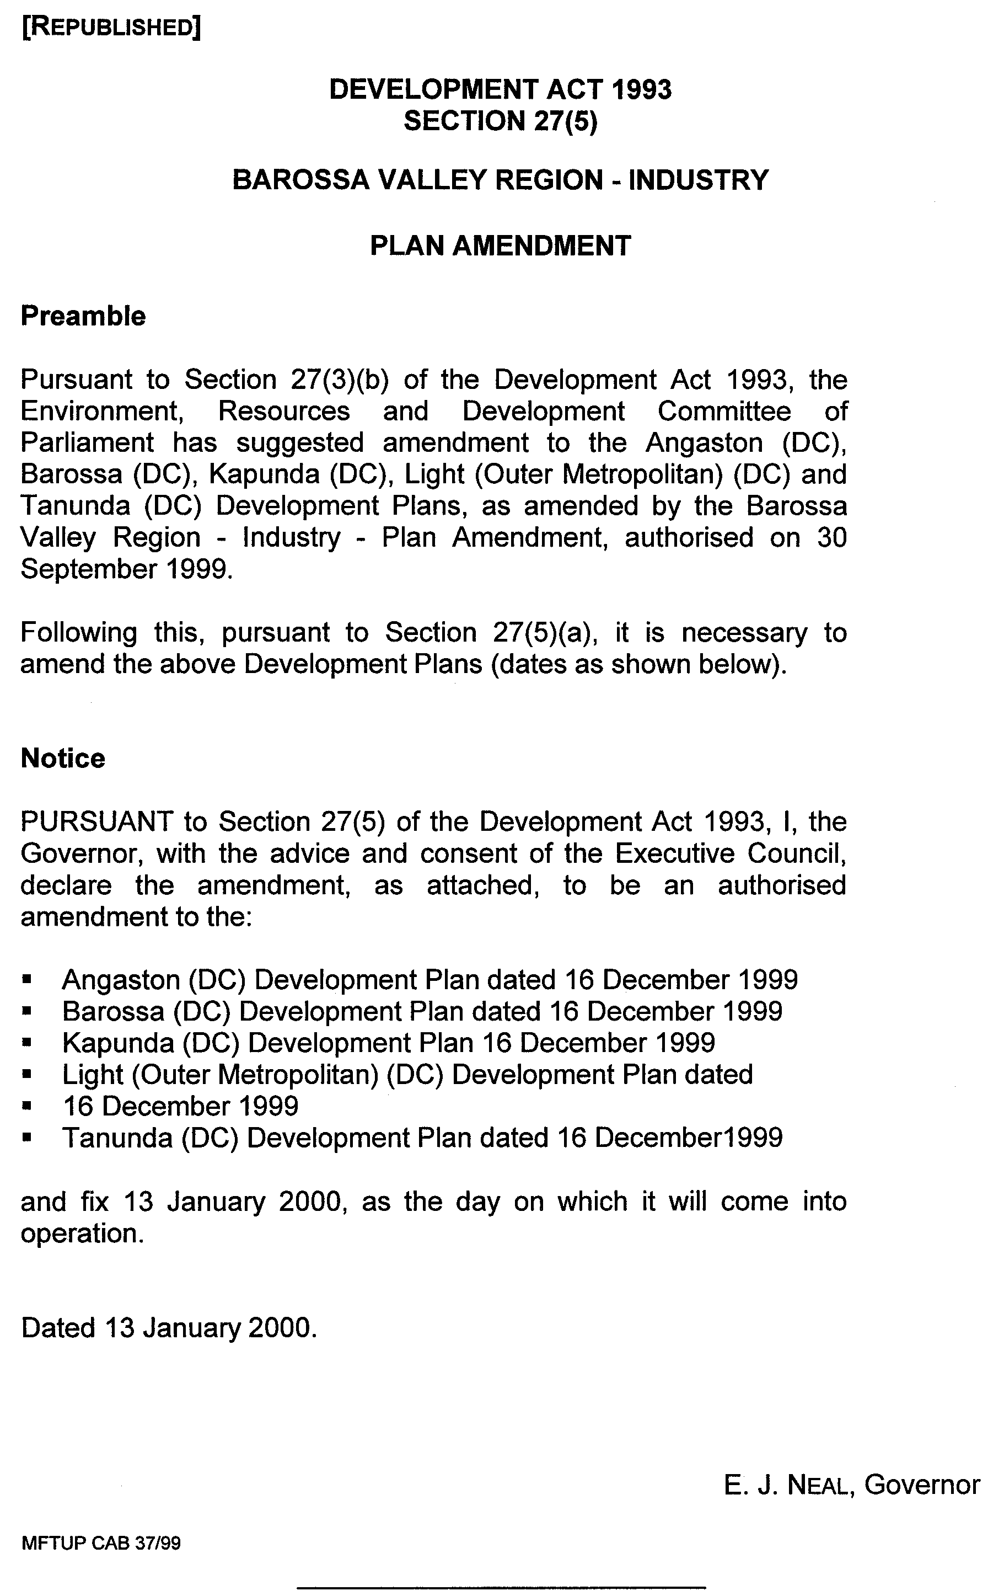
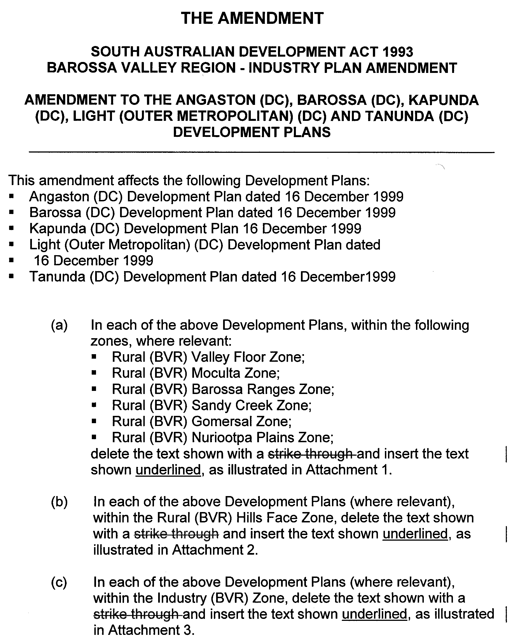
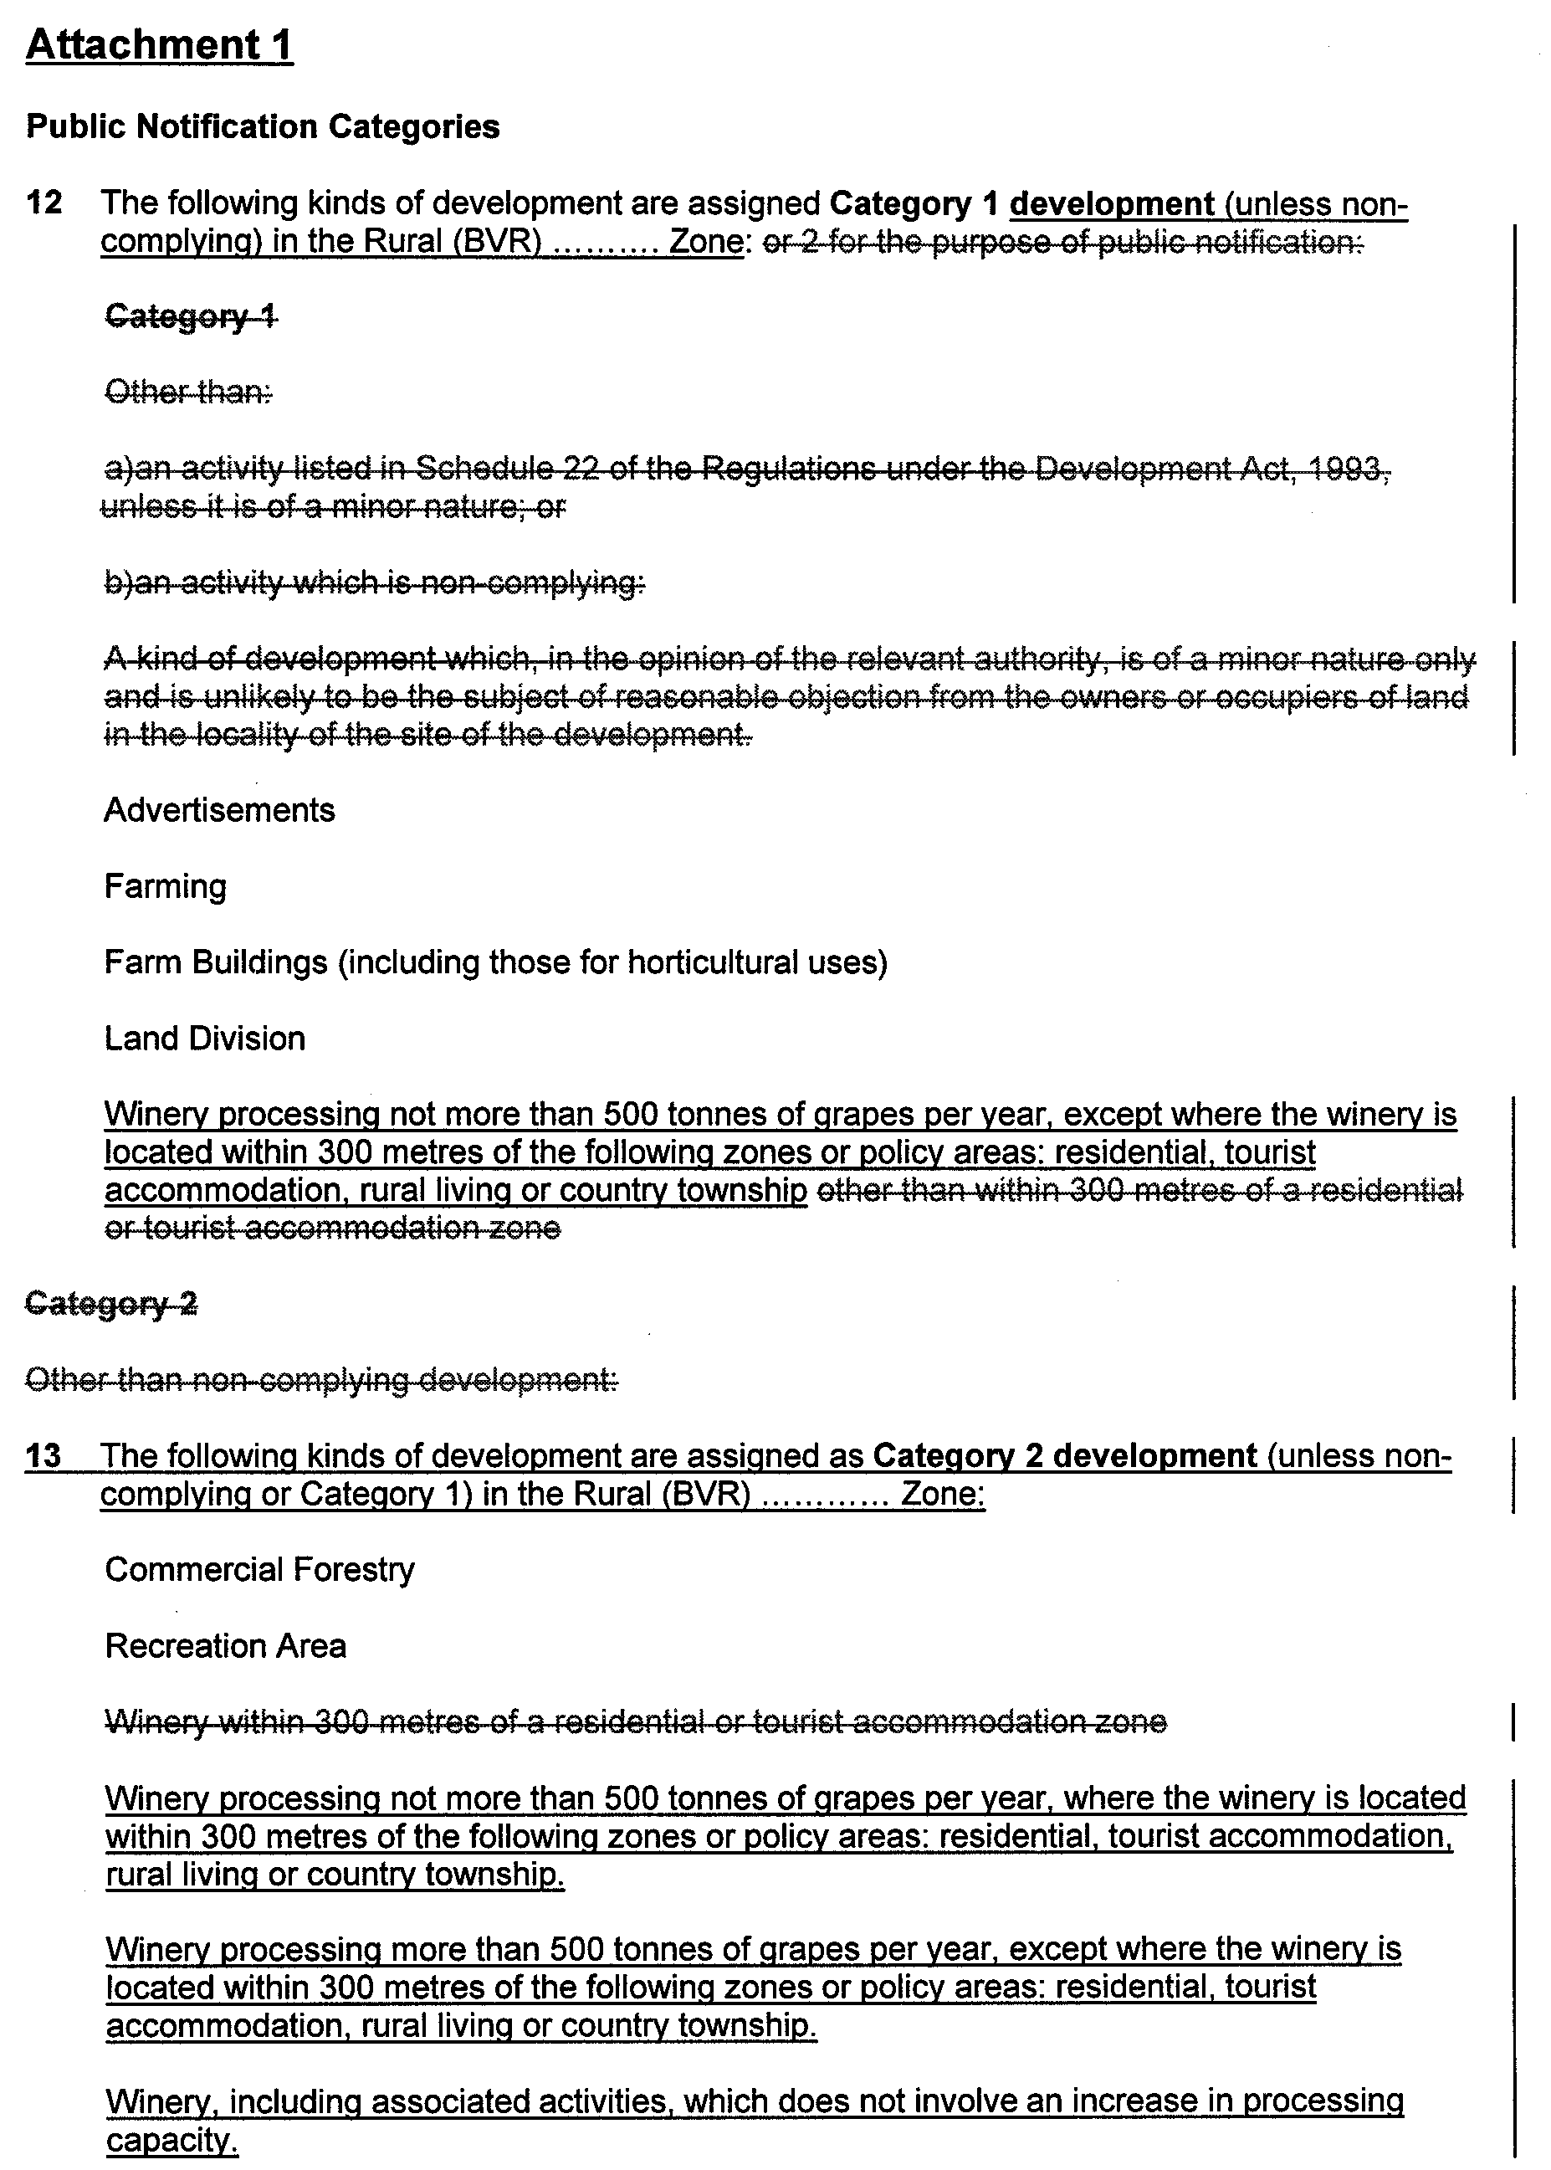
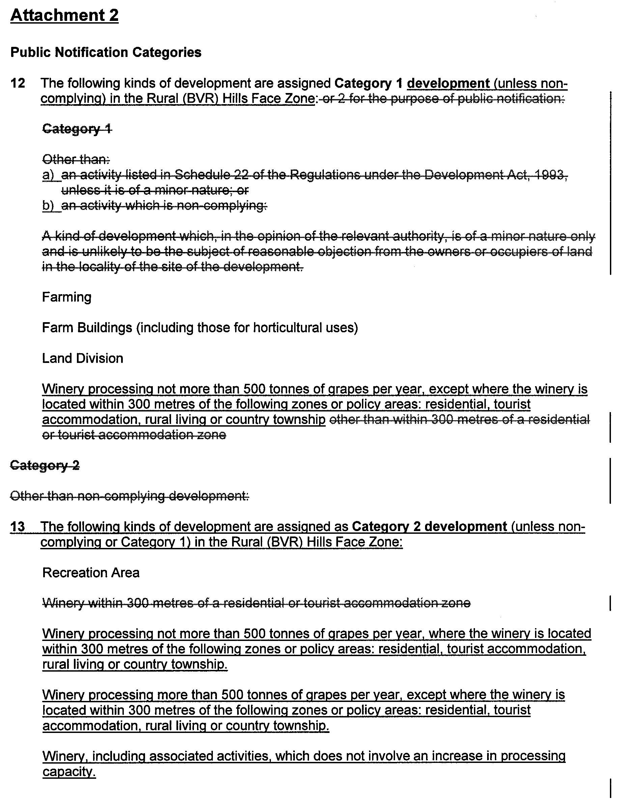
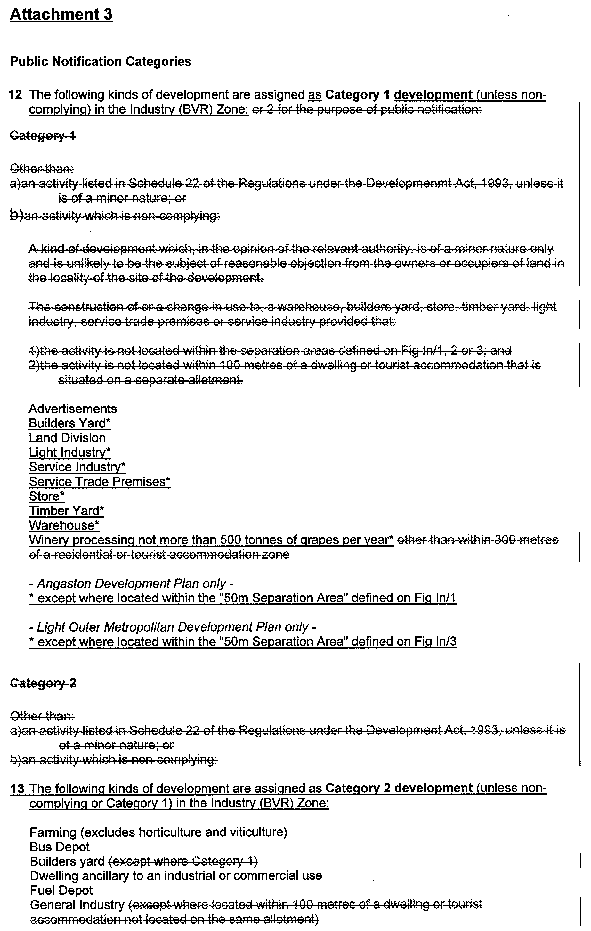
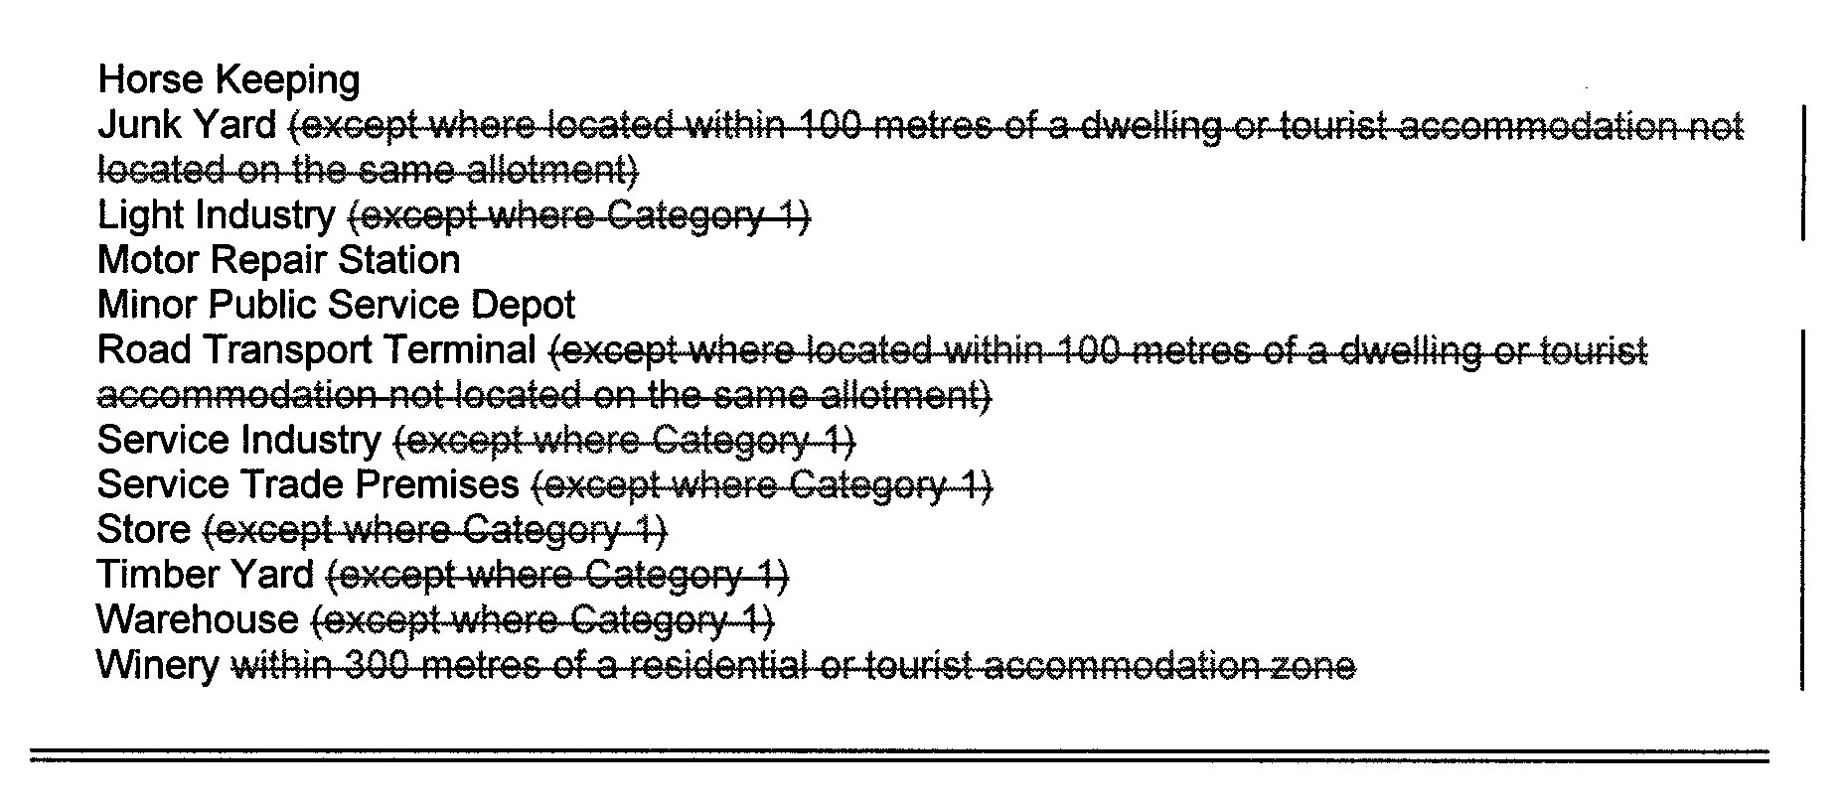
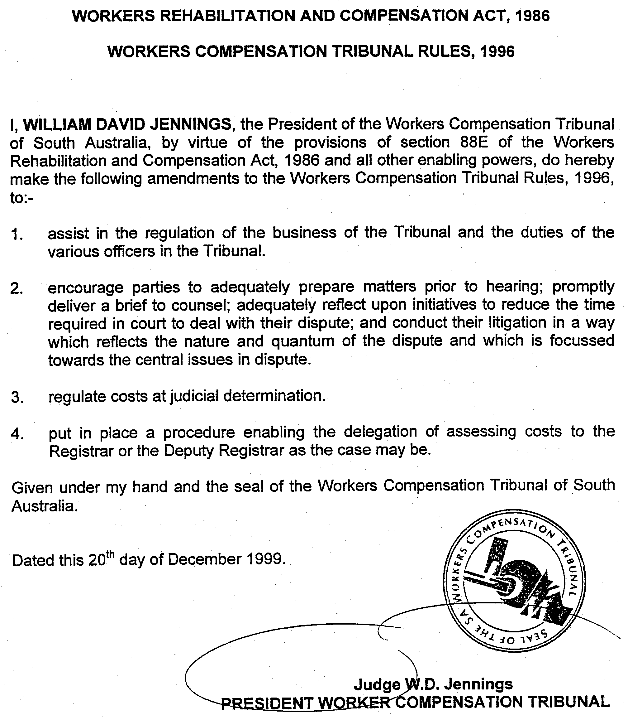
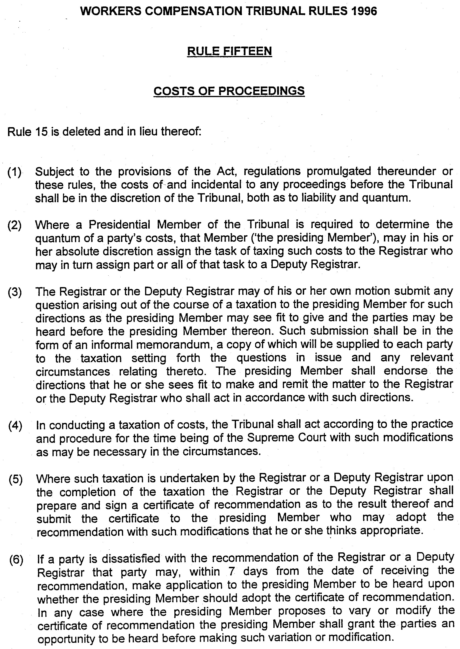
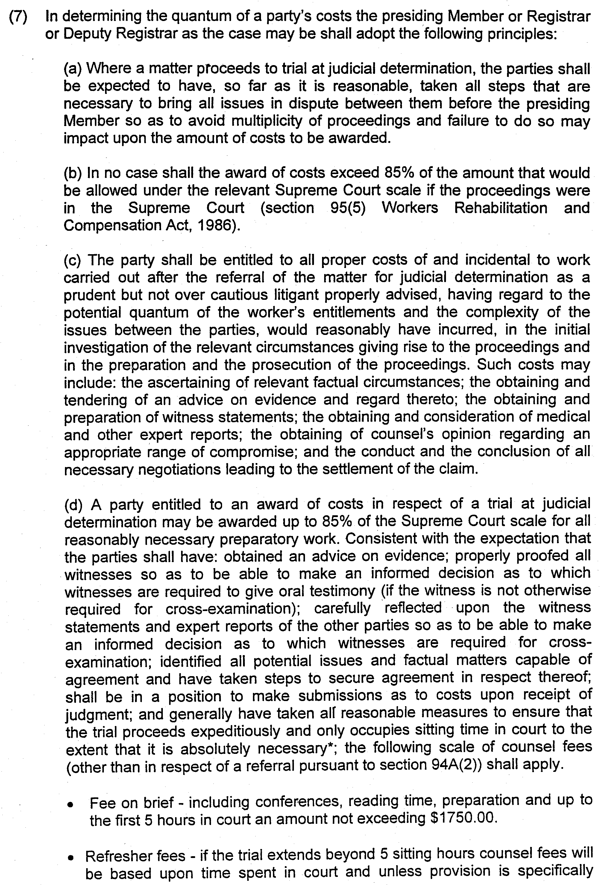

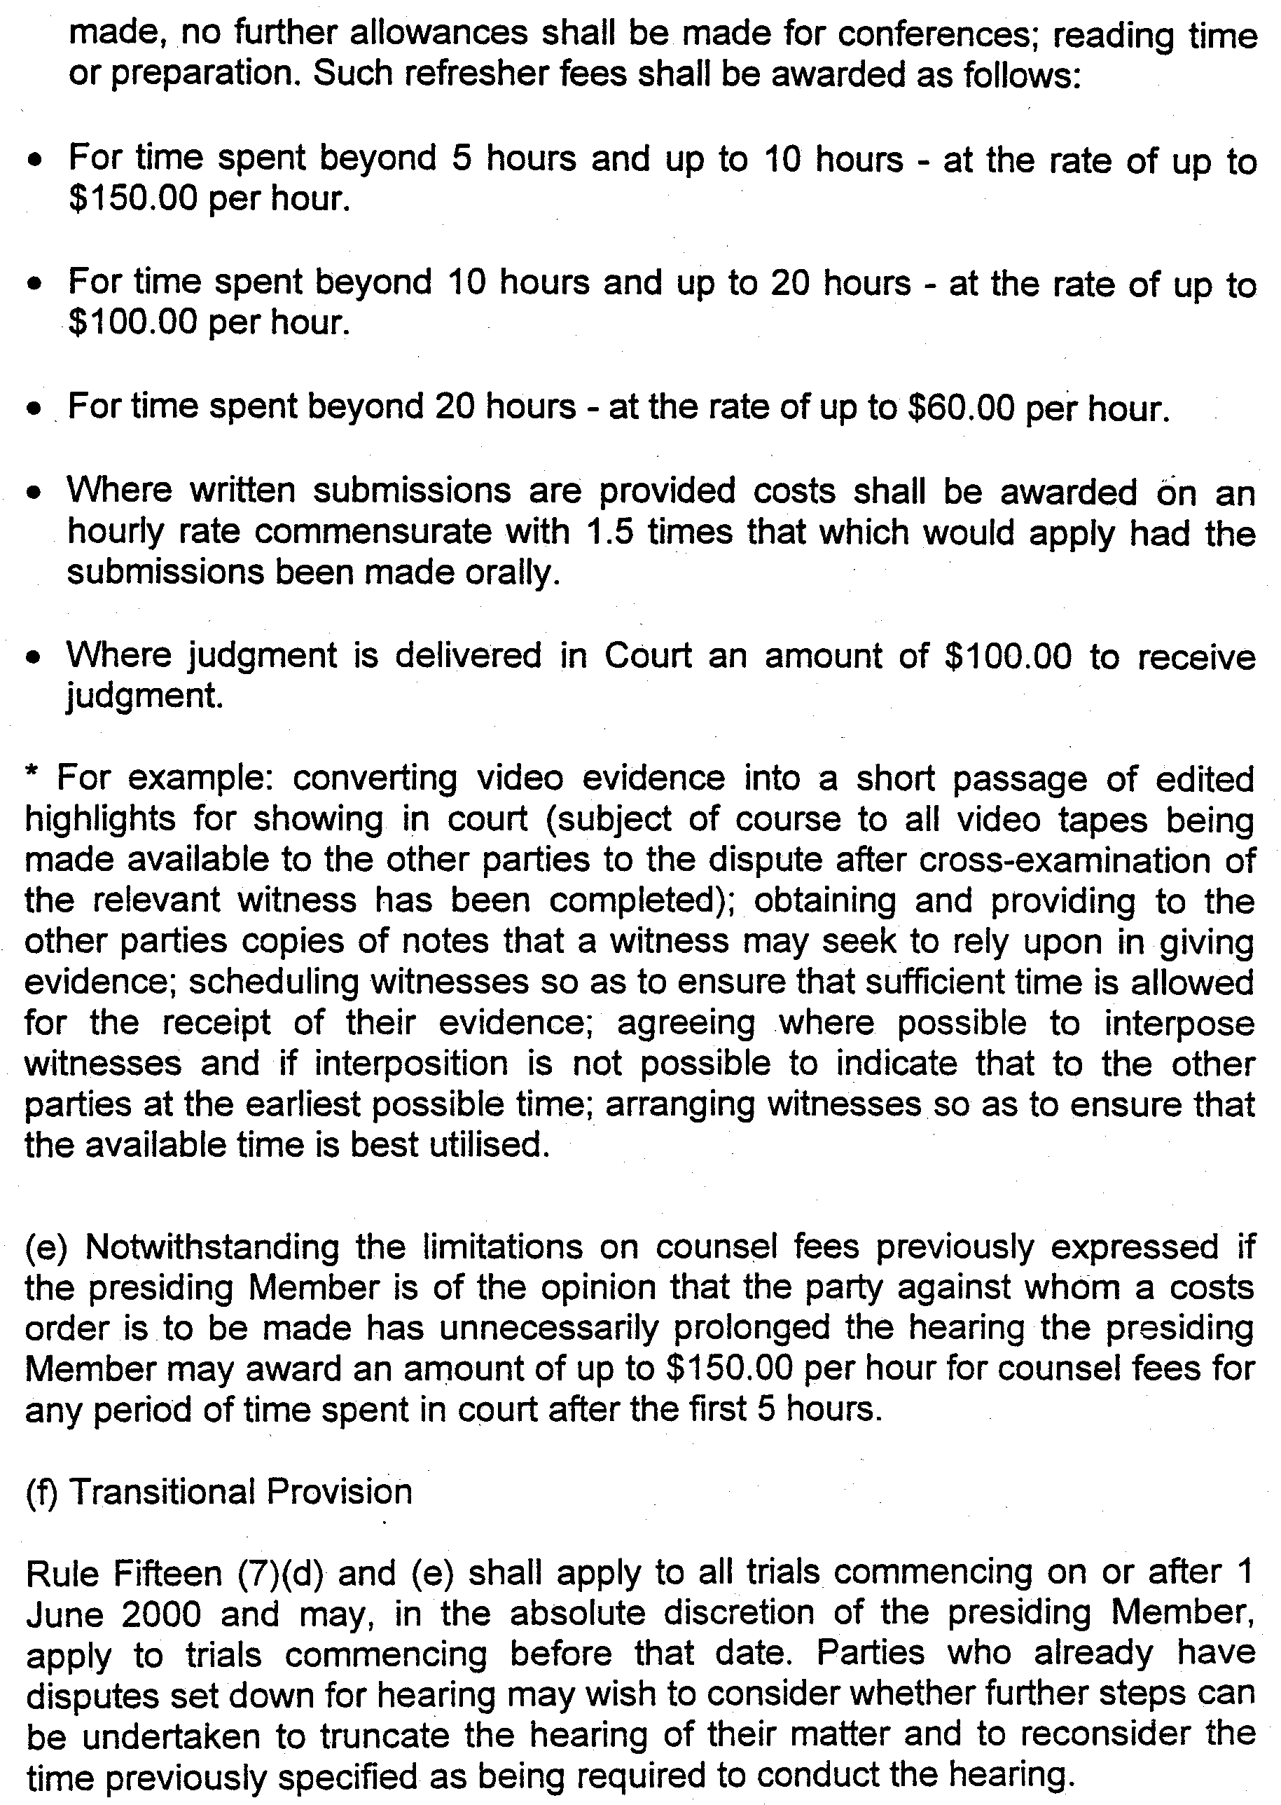

M. G. O’CALLAGHAN, Government Printer, South Australia

