SUPPLEMENTARY GAZETTE



THE SOUTH AUSTRALIAN

GOVERNMENT GAZETTE

PUBLISHED BY AUTHORITY

ALL PUBLIC ACTS appearing in this GAZETTE are to be considered official, and obeyed as such

ADELAIDE, FRIDAY, 21 JANUARY 2000

CONTENTS
Page
Fisheries Act 1982—Notices 476
Livestock Act 1997—Notice 486

FISHERIES ACT 1982: SECTION 59
TAKE notice that, pursuant to section 59 of the Fisheries Act 1982, Australian Fishing Enterprises, P.O. Box 1073, Port Lincoln, S.A. 5606 or the nominated replacement approved by the Director of Fisheries (hereinafter referred to as the ‘fisher’) is exempt from section 41 of the Fisheries Act 1982, subject to the conditions contained in Schedule 1, in that they shall not be guilty of an offence when using a fine mesh purse seine net as described in Schedule 2 for the taking of pilchards (Sardinops neopilchardus) and other species within the Families Clupeidae and Engraulididae (hereinafter referred to as the ‘permitted species’) for the purpose of trade or business in marine waters of South Australia as described in Schedule 3 as Area B (hereinafter referred to as the ‘permitted activity’).
Schedule 1
1. The fisher may engage in the permitted activity from the date of gazettal of this notice until 29 February 2000, or until revoked by the Director of Fisheries.
2. This exemption is valid only in respect of the fishing vessel Maria Luisa (hereinafter referred to as the ‘permitted boat’).
3. The fisher must be on board the permitted boat at all times while the boat is being used for the purpose of engaging in the permitted activity.
4. Whilst engaged in the permitted activity the fisher shall not use any other device than that permitted pursuant to Schedule 2.
5. The fisher must not take or be in possession of any other species of fish, other than the permitted species, while engaging in the permitted activity.
6. Any fish, which are not permitted species, taken as by-catch by the fisher during the permitted activity must be immediately returned to the water.
7. The fisher may only engage in the permitted activity for the purpose of supplying food fish for tuna farms.
8. The fisher shall not, during the period 1 January 2000 to 29 February 2000, take a quantity of permitted species which exceeds his quota of 6.67 units at 7.712 tonnes per unit (which is equal to 51.42 tonnes).
9. The fisher may with the prior approval of the Director of Fisheries transfer uncaught units of quota during the period of this notice.
10. Fish taken pursuant to this notice as the result of a transfer of quota must be taken in the area as described (and disposed of as described) in the permit conditions of the holder of the initial allocation.
11. The fisher may transfer catch taken pursuant to this notice to a carrier boat at sea subject to nominating the boats in advance.
12. The fisher may nominate no more than two carrier boats at any one time. Notification of boat name must be provided to the person or agency responsible for conducting quota monitoring operations.
13. Where the fisher transfers all or part of their catch to a carrier boat that portion of the catch must be accompanied by a South Australian Pilchard Fishery Log Book, completed as required by condition 16 of this notice.
14. The fisher must notify the person nominated for quota monitoring, by telephone, of the intended place of any unloading and the estimated weight of the catch at least one hour prior to the unloading taking place.
15. The fisher must provide the person nominated for quota monitoring with reasonable access to boats and vehicles for the purpose of enabling inspection of the catch and any record relating to the South Australian Pilchard Fishery Log Book required to be completed under this notice.
16. The fisher must complete the South Australian Pilchard Fishery Log Book as described below:
(a) Unloading to a shore based processing plant:
(i) The fisher shall complete all columns of the South Australian Pilchard Fishery Log Book up to but
not including the column titled PILCHARD TONNAGE CAUGHT.
The fish can then be dispatched to the shore based processing plant. It is the responsibility of the fisher to make certain that all fish are accurately weighed within 24 hours of the consignment to the processor:
(ii) The fisher shall upon being notified by the processor of the total weight of fish unloaded complete the columns headed, PILCHARD TONNAGE CAUGHT, OTHER SPECIES, TONNAGE CAUGHT (This refers to other species) and REMARKS.
For any unloading, if fishing has taken place on more than one day then this should be noted and the verified weight split as close as possible to reflect the actual quantities taken on each day of fishing.
(b) Unloading at sea or direct to a tuna cage:
The fisher shall complete all columns of the South Australian Pilchard Fishery Log Book immediately after capture and include an estimated tonnage in the column marked PILCHARD TONNAGE CAUGHT. The estimated tonnage should be based on a recorded number of boxes of a certain capacity (weight) filled.
17. The fisher then shall either by facsimile or in person deliver the completed (South Australian Pilchard Fishery Log Book) form to the person nominated for quota monitoring within 48 hours of the unloading.
18. The fisher must provide regular samples of the permitted species for research analysis and assist in any other South Australian Research and Development Institute (SARDI) sponsored pilchard fishery research program as required by the Chief Scientist, Aquatic Sciences, SARDI.
19. The fisher must complete a monthly return within 14 days of the end of the previous month and forward it to SARDI. This return must be completed regardless of whether the fisher took fish or not, i.e. nil returns are required.
20. While engaged in the permitted activity the fisher must have in his possession the copy of this notice with which the Director of Fisheries hassupplied him and produce that notice to a Fisheries Compliance Officer forthwith, if and when a Fisheries Compliance Officer requests him to produce it.:
21. The fisher shall not contravene or fail to comply with the Fisheries Act 1982, or any regulations made under that Act, except where specifically exempted by this notice.
Schedule 2
In waters described as Area A: one purse seine net having a maximum length of 600 m, a maximum depth of 100 m and a mesh size of between 16 mm and 20 mm.
In waters described as Area B: one purse seine net having a mesh size of between 16 mm and 20 mm.
Schedule 3
For the purposes of this notice, Area A is defined as:
Coastal waters within 3 nautical miles of high water mark or within 3 nautical miles to seaward of the base lines and bay closure lines described in Table 1.
For the purposes of this notice, Area B is defined as:
Coastal waters more than 3 nautical miles to seaward of high water mark or more than 3 nautical miles to seaward of the base lines and bay closure lines described in Table 1.
Dated 14 January 2000.
W. Zacharin, Principal Fisheries Manager

Table 1
Base Lines and Bay Closure Lines of South Australia

Location From to Location

Base Lines
Newland Head 35°38.68′S 138°31.32′E to 35°45.63′S 138°18.17′E The Pages
35°45.63′S 138°18.17′E to 35°46.65′S 138°17.57′E
35°46.88′S 138°17.43′E to 35°47.10′S 138°17.33′E
The Pages 35°47.25′S 138°17.15′E to 35°50.70′S 138°07.95′E Cape Willoughby
Vennachar Point 35°53.25′S 136°31.97′E to 34°57.20′S 135°37.37′E Cape Carnot
34°57.20′S 135°37.37′E to 34°56.90′S 135°37.40′E
Pt Westall 32°54.38′S 134°03.53′E to 32°43.60′S 133°57.77′E Olives Island
Olives Island 32°43.60′S 133°57.77′E to 32°35.18′S 133°17.07′E Fenelon Island
Fenelon Island 32°34.92′S 133°16.73′E to 32°33.80′S 133°16.58′E Masillon Island
Masillon Island 32°33.80′S 133°16.58′E to 32°30.90′S 133°15.03′E West Island
West Island 32°30.47′S 133°14.87′E to 32°13.52′S 133°06.62′E Island 1 mile SW Pt Bell
32°13.52′S 133°06.62′E to 32°08.75′S 132°59.32′E Sinclair Island
Sinclair Island 32°08.67′S 132°59.28′E to 32°07.62′S 132°58.72′E
32°07.62′S 132°58.72′E to 32°01.87′S 132°28.27′E Point Fowler
Anxious Bay 33°12.05′S 134°19.63′E to 33°35.68′S 134°45.05′E
33°35.83′S 134°45.90′E to 33°35.98′S 134°46.50′E
33°36.72′S 134°48.33′E to 33°37.47′S 134°49.67′E
Encounter Bay 35°35.80′S 138°36.10′E to 35°35.80′S 138°57.40′E
Lacepede Bay 36°35.80′S 139°50.00′E to 36°56.60′S 139°40.40′E
Rivoli Bay 37°34.02′S 140°06.33′E to 37°30.05′S 140°00.80′E
37°29.95′S 140°00.68′E to 37°29.87′S 140°00.63′E
Bay Closure Lines
Coffin Bay 34°09.07′S 135°14.39′E to 34°25.86′S 135°12.41′E
Avoid Bay 34°35.49′S 135°06.75′E to 34°41.78′S 135°19.65′E

FISHERIES ACT 1982: SECTION 59
TAKE notice that, pursuant to section 59 of the Fisheries Act 1982, Guiseppina Fishing Company, P.O. Box 1607, Port Lincoln, S.A. 5606, or the nominated replacement approved by the Director of Fisheries (hereinafter referred to as the ‘fisher’) is exempt from section 41 of the Fisheries Act 1982, subject to the conditions contained in Schedule 1, in that they shall not be guilty of an offence when using a fine mesh purse seine net as described in Schedule 2 for the taking of pilchards (Sardinops neopilchardus) and other species within the Families Clupeidae and Engraulididae (hereinafter referred to as the ‘permitted species’) for the purpose of trade or business in marine waters of South Australia as described in Schedule 3 as Area B (hereinafter referred to as the ‘permitted activity’).
Schedule 1
1. The fisher may engage in the permitted activity from the date of gazettal of this notice until 29 February 2000, or until revoked by the Director of Fisheries.
2. This exemption is valid only in respect of the fishing vessel Sardinops (hereinafter referred to as the ‘permitted boat’).
3. The fisher must be on board the permitted boat at all times while the boat is being used for the purpose of engaging in the permitted activity.
4. Whilst engaged in the permitted activity the fisher shall not use any other device than that permitted pursuant to Schedule 2.
5. The fisher must not take or be in possession of any other species of fish, other than the permitted species, while engaging in the permitted activity.
6. Any fish, which are not permitted species, taken as by-catch by the fisher during the permitted activity must be immediately returned to the water.
7. The fisher may only engage in the permitted activity for the purpose of supplying food fish for tuna farms.
8. The fisher shall not, during the period 1 January 2000 to 29 February 2000, take a quantity of permitted species which exceeds his quota of 10.08 units at 7.712 tonnes per unit (which is equal to 77.79 tonnes).
9. The fisher may with the prior approval of the Director of Fisheries transfer uncaught units of quota during the period of this notice.
10. Fish taken pursuant to this notice as the result of a transfer of quota must be taken in the area as described (and disposed of as described) in the permit conditions of the holder of the initial allocation.
11. The fisher may transfer catch taken pursuant to this notice to a carrier boat at sea subject to nominating the boats in advance.
12. The fisher may nominate no more than two carrier boats at any one time. Notification of boat name must be provided to the person or agency responsible for conducting quota monitoring operations.
13. Where the fisher transfers all or part of their catch to a carrier boat that portion of the catch must be accompanied by a South Australian Pilchard Fishery Log Book, completed as required by condition 16 of this notice.
14. The fisher must notify the person nominated for quota monitoring, by telephone, of the intended place of any unloading and the estimated weight of the catch at least one hour prior to the unloading taking place.
15. The fisher must provide the person nominated for quota monitoring with reasonable access to boats and vehicles for the purpose of enabling inspection of the catch and any record relating to the South Australian Pilchard Fishery Log Book required to be completed under this notice.
16. The fisher must complete the South Australian Pilchard Fishery Log Book as described below:
(a) Unloading to a shore based processing plant:
(i) The fisher shall complete all columns of the South Australian Pilchard Fishery Log Book up to but
not including the column titled PILCHARD TONNAGE CAUGHT.
The fish can then be dispatched to the shore based processing plant. It is the responsibility of the fisher to make certain that all fish are accurately weighed within 24 hours of the consignment to the processor:
(ii) The fisher shall upon being notified by the processor of the total weight of fish unloaded complete the columns headed, PILCHARD TONNAGE CAUGHT, OTHER SPECIES, TONNAGE CAUGHT (This refers to other species) and REMARKS.
For any unloading, if fishing has taken place on more than one day then this should be noted and the verified weight split as close as possible to reflect the actual quantities taken on each day of fishing.
(b) Unloading at sea or direct to a tuna cage:
The fisher shall complete all columns of the South Australian Pilchard Fishery Log Book immediately after capture and include an estimated tonnage in the column marked PILCHARD TONNAGE CAUGHT. The estimated tonnage should be based on a recorded number of boxes of a certain capacity (weight) filled.
17. The fisher then shall either by facsimile or in person deliver the completed (South Australian Pilchard Fishery Log Book) form to the person nominated for quota monitoring within 48 hours of the unloading.
18. The fisher must provide regular samples of the permitted species for research analysis and assist in any other South Australian Research and Development Institute (SARDI) sponsored pilchard fishery research program as required by the Chief Scientist, Aquatic Sciences, SARDI.
19. The fisher must complete a monthly return within 14 days of the end of the previous month and forward it to SARDI. This return must be completed regardless of whether the fisher took fish or not, i.e. nil returns are required.
20. While engaged in the permitted activity the fisher must have in his possession the copy of this notice with which the Director of Fisheries hassupplied him and produce that notice to a Fisheries Compliance Officer forthwith, if and when a Fisheries Compliance Officer requests him to produce it.:
21. The fisher shall not contravene or fail to comply with the Fisheries Act 1982, or any regulations made under that Act, except where specifically exempted by this notice.
Schedule 2
In waters described as Area A: one purse seine net having a maximum length of 600 m, a maximum depth of 100 m and a mesh size of between 16 mm and 20 mm.
In waters described as Area B: one purse seine net having a mesh size of between 16 mm and 20 mm.
Schedule 3
For the purposes of this notice, Area A is defined as:
Coastal waters within 3 nautical miles of high water mark or within 3 nautical miles to seaward of the base lines and bay closure lines described in Table 1.
For the purposes of this notice, Area B is defined as:
Coastal waters more than 3 nautical miles to seaward of high water mark or more than 3 nautical miles to seaward of the base lines and bay closure lines described in Table 1.
Dated 14 January 2000.
W. Zacharin, Principal Fisheries Manager

Table 1
Base Lines and Bay Closure Lines of South Australia

Location From to Location

Base Lines
Newland Head 35°38.68′S 138°31.32′E to 35°45.63′S 138°18.17′E The Pages
35°45.63′S 138°18.17′E to 35°46.65′S 138°17.57′E
35°46.88′S 138°17.43′E to 35°47.10′S 138°17.33′E
The Pages 35°47.25′S 138°17.15′E to 35°50.70′S 138°07.95′E Cape Willoughby
Vennachar Point 35°53.25′S 136°31.97′E to 34°57.20′S 135°37.37′E Cape Carnot
34°57.20′S 135°37.37′E to 34°56.90′S 135°37.40′E
Pt Westall 32°54.38′S 134°03.53′E to 32°43.60′S 133°57.77′E Olives Island
Olives Island 32°43.60′S 133°57.77′E to 32°35.18′S 133°17.07′E Fenelon Island
Fenelon Island 32°34.92′S 133°16.73′E to 32°33.80′S 133°16.58′E Masillon Island
Masillon Island 32°33.80′S 133°16.58′E to 32°30.90′S 133°15.03′E West Island
West Island 32°30.47′S 133°14.87′E to 32°13.52′S 133°06.62′E Island 1 mile SW Pt Bell
32°13.52′S 133°06.62′E to 32°08.75′S 132°59.32′E Sinclair Island
Sinclair Island 32°08.67′S 132°59.28′E to 32°07.62′S 132°58.72′E
32°07.62′S 132°58.72′E to 32°01.87′S 132°28.27′E Point Fowler
Anxious Bay 33°12.05′S 134°19.63′E to 33°35.68′S 134°45.05′E
33°35.83′S 134°45.90′E to 33°35.98′S 134°46.50′E
33°36.72′S 134°48.33′E to 33°37.47′S 134°49.67′E
Encounter Bay 35°35.80′S 138°36.10′E to 35°35.80′S 138°57.40′E
Lacepede Bay 36°35.80′S 139°50.00′E to 36°56.60′S 139°40.40′E
Rivoli Bay 37°34.02′S 140°06.33′E to 37°30.05′S 140°00.80′E
37°29.95′S 140°00.68′E to 37°29.87′S 140°00.63′E
Bay Closure Lines
Coffin Bay 34°09.07′S 135°14.39′E to 34°25.86′S 135°12.41′E
Avoid Bay 34°35.49′S 135°06.75′E to 34°41.78′S 135°19.65′E

FISHERIES ACT 1982: SECTION 59
TAKE notice that, pursuant to section 59 of the Fisheries Act 1982, Karina Fisheries Pty Ltd, P.O. Box 951, Port Lincoln, S.A. 5606 or the nominated replacement approved by the Director of Fisheries (hereinafter referred to as the ‘fisher’) is exempt from section 41 of the Fisheries Act 1982, subject to the conditions contained in Schedule 1, in that they shall not be guilty of an offence when using a fine mesh purse seine net as described in Schedule 2 for the taking of pilchards (Sardinops neopilchardus) and other species within the Families Clupeidae and Engraulididae (hereinafter referred to as the ‘permitted species’) for the purpose of trade or business in marine waters of South Australia as described in Schedule 3 as Area B (hereinafter referred to as the ‘permitted activity’).
Schedule 1
1. The fisher may engage in the permitted activity from the date of gazettal of this notice until 29 February 2000, or until revoked by the Director of Fisheries.
2. This exemption is valid only in respect of the fishing vessel Dageraad (hereinafter referred to as the ‘permitted boat’).
3. The fisher must be on board the permitted boat at all times while the boat is being used for the purpose of engaging in the permitted activity.
4. Whilst engaged in the permitted activity the fisher shall not use any other device than that permitted pursuant to Schedule 2.
5. The fisher must not take or be in possession of any other species of fish, other than the permitted species, while engaging in the permitted activity.
6. Any fish, which are not permitted species, taken as by-catch by the fisher during the permitted activity must be immediately returned to the water.
7. The fisher may only engage in the permitted activity for the purpose of supplying food fish for tuna farms.
8. The fisher shall not, during the period 1 January 2000 to 29 February 2000, take a quantity of permitted species which exceeds his quota of 1.77 units at 7.712 tonnes per unit (which is equal to 13.68 tonnes).
9. The fisher may with the prior approval of the Director of Fisheries transfer uncaught units of quota during the period of this notice.
10. Fish taken pursuant to this notice as the result of a transfer of quota must be taken in the area as described (and disposed of as described) in the permit conditions of the holder of the initial allocation.
11. The fisher may transfer catch taken pursuant to this notice to a carrier boat at sea subject to nominating the boats in advance.
12. The fisher may nominate no more than two carrier boats at any one time. Notification of boat name must be provided to the person or agency responsible for conducting quota monitoring operations.
13. Where the fisher transfers all or part of their catch to a carrier boat that portion of the catch must be accompanied by a South Australian Pilchard Fishery Log Book, completed as required by condition 16 of this notice.
14. The fisher must notify the person nominated for quota monitoring, by telephone, of the intended place of any unloading and the estimated weight of the catch at least one hour prior to the unloading taking place.
15. The fisher must provide the person nominated for quota monitoring with reasonable access to boats and vehicles for the purpose of enabling inspection of the catch and any record relating to the South Australian Pilchard Fishery Log Book required to be completed under this notice.
16. The fisher must complete the South Australian Pilchard Fishery Log Book as described below:
(a) Unloading to a shore based processing plant:
(i) The fisher shall complete all columns of the South Australian Pilchard Fishery Log Book up to but
not including the column titled PILCHARD TONNAGE CAUGHT.
The fish can then be dispatched to the shore based processing plant. It is the responsibility of the fisher to make certain that all fish are accurately weighed within 24 hours of the consignment to the processor:
(ii) The fisher shall upon being notified by the processor of the total weight of fish unloaded complete the columns headed, PILCHARD TONNAGE CAUGHT, OTHER SPECIES, TONNAGE CAUGHT (This refers to other species) and REMARKS.
For any unloading, if fishing has taken place on more than one day then this should be noted and the verified weight split as close as possible to reflect the actual quantities taken on each day of fishing.
(b) Unloading at sea or direct to a tuna cage:
The fisher shall complete all columns of the South Australian Pilchard Fishery Log Book immediately after capture and include an estimated tonnage in the column marked PILCHARD TONNAGE CAUGHT. The estimated tonnage should be based on a recorded number of boxes of a certain capacity (weight) filled.
17. The fisher then shall either by facsimile or in person deliver the completed (South Australian Pilchard Fishery Log Book) form to the person nominated for quota monitoring within 48 hours of the unloading.
18. The fisher must provide regular samples of the permitted species for research analysis and assist in any other South Australian Research and Development Institute (SARDI) sponsored pilchard fishery research program as required by the Chief Scientist, Aquatic Sciences, SARDI.
19. The fisher must complete a monthly return within 14 days of the end of the previous month and forward it to SARDI. This return must be completed regardless of whether the fisher took fish or not, i.e. nil returns are required.
20. While engaged in the permitted activity the fisher must have in his possession the copy of this notice with which the Director of Fisheries hassupplied him and produce that notice to a Fisheries Compliance Officer forthwith, if and when a Fisheries Compliance Officer requests him to produce it.:
21. The fisher shall not contravene or fail to comply with the Fisheries Act 1982, or any regulations made under that Act, except where specifically exempted by this notice.
Schedule 2
In waters described as Area A: one purse seine net having a maximum length of 600 m, a maximum depth of 100 m and a mesh size of between 16 mm and 20 mm.
In waters described as Area B: one purse seine net having a mesh size of between 16 mm and 20 mm.
Schedule 3
For the purposes of this notice, Area A is defined as:
Coastal waters within 3 nautical miles of high water mark or within 3 nautical miles to seaward of the base lines and bay closure lines described in Table 1.
For the purposes of this notice, Area B is defined as:
Coastal waters more than 3 nautical miles to seaward of high water mark or more than 3 nautical miles to seaward of the base lines and bay closure lines described in Table 1.
Dated 14 January 2000.
W. Zacharin, Principal Fisheries Manager

Table 1
Base Lines and Bay Closure Lines of South Australia

Location From to Location

Base Lines
Newland Head 35°38.68′S 138°31.32′E to 35°45.63′S 138°18.17′E The Pages
35°45.63′S 138°18.17′E to 35°46.65′S 138°17.57′E
35°46.88′S 138°17.43′E to 35°47.10′S 138°17.33′E
The Pages 35°47.25′S 138°17.15′E to 35°50.70′S 138°07.95′E Cape Willoughby
Vennachar Point 35°53.25′S 136°31.97′E to 34°57.20′S 135°37.37′E Cape Carnot
34°57.20′S 135°37.37′E to 34°56.90′S 135°37.40′E
Pt Westall 32°54.38′S 134°03.53′E to 32°43.60′S 133°57.77′E Olives Island
Olives Island 32°43.60′S 133°57.77′E to 32°35.18′S 133°17.07′E Fenelon Island
Fenelon Island 32°34.92′S 133°16.73′E to 32°33.80′S 133°16.58′E Masillon Island
Masillon Island 32°33.80′S 133°16.58′E to 32°30.90′S 133°15.03′E West Island
West Island 32°30.47′S 133°14.87′E to 32°13.52′S 133°06.62′E Island 1 mile SW Pt Bell
32°13.52′S 133°06.62′E to 32°08.75′S 132°59.32′E Sinclair Island
Sinclair Island 32°08.67′S 132°59.28′E to 32°07.62′S 132°58.72′E
32°07.62′S 132°58.72′E to 32°01.87′S 132°28.27′E Point Fowler
Anxious Bay 33°12.05′S 134°19.63′E to 33°35.68′S 134°45.05′E
33°35.83′S 134°45.90′E to 33°35.98′S 134°46.50′E
33°36.72′S 134°48.33′E to 33°37.47′S 134°49.67′E
Encounter Bay 35°35.80′S 138°36.10′E to 35°35.80′S 138°57.40′E
Lacepede Bay 36°35.80′S 139°50.00′E to 36°56.60′S 139°40.40′E
Rivoli Bay 37°34.02′S 140°06.33′E to 37°30.05′S 140°00.80′E
37°29.95′S 140°00.68′E to 37°29.87′S 140°00.63′E
Bay Closure Lines
Coffin Bay 34°09.07′S 135°14.39′E to 34°25.86′S 135°12.41′E
Avoid Bay 34°35.49′S 135°06.75′E to 34°41.78′S 135°19.65′E

FISHERIES ACT 1982: SECTION 59
TAKE notice that, pursuant to section 59 of the Fisheries Act 1982, Sea Marine Holdings Pty Ltd, P.O. Box 1829, Port Lincoln, S.A. 5606 or the nominated replacement approved by the Director of Fisheries (hereinafter referred to as the ‘fisher’) is exempt from section 41 of the Fisheries Act 1982, subject to the conditions contained in Schedule 1, in that they shall not be guilty of an offence when using a fine mesh purse seine net as described in Schedule 2 for the taking of pilchards (Sardinops neopilchardus) and other species within the Families Clupeidae and Engraulididae (hereinafter referred to as the ‘permitted species’) for the purpose of trade or business in marine waters of South Australia as described in Schedule 3 as Area B (hereinafter referred to as the ‘permitted activity’).
Schedule 1
1. The fisher may engage in the permitted activity from the date of gazettal of this notice until 29 February 2000, or until revoked by the Director of Fisheries.
2. This exemption is valid only in respect of the fishing vessel Pinta 3 (hereinafter referred to as the ‘permitted boat’).
3. The fisher must be on board the permitted boat at all times while the boat is being used for the purpose of engaging in the permitted activity.
4. Whilst engaged in the permitted activity the fisher shall not use any other device than that permitted pursuant to Schedule 2.
5. The fisher must not take or be in possession of any other species of fish, other than the permitted species, while engaging in the permitted activity.
6. Any fish, which are not permitted species, taken as by-catch by the fisher during the permitted activity must be immediately returned to the water.
7. The fisher may only engage in the permitted activity for the purpose of supplying food fish for tuna farms.
8. The fisher shall not, during the period 1 January 2000 to 29 February 2000, take a quantity of permitted species which exceeds his quota of 0.57 units at 7.712 tonnes per unit (which is equal to 4.42 tonnes).
9. The fisher may with the prior approval of the Director of Fisheries transfer uncaught units of quota during the period of this notice.
10. Fish taken pursuant to this notice as the result of a transfer of quota must be taken in the area as described (and disposed of as described) in the permit conditions of the holder of the initial allocation.
11. The fisher may transfer catch taken pursuant to this notice to a carrier boat at sea subject to nominating the boats in advance.
12. The fisher may nominate no more than two carrier boats at any one time. Notification of boat name must be provided to the person or agency responsible for conducting quota monitoring operations.
13. Where the fisher transfers all or part of their catch to a carrier boat that portion of the catch must be accompanied by a South Australian Pilchard Fishery Log Book, completed as required by condition 16 of this notice.
14. The fisher must notify the person nominated for quota monitoring, by telephone, of the intended place of any unloading and the estimated weight of the catch at least one hour prior to the unloading taking place.
15. The fisher must provide the person nominated for quota monitoring with reasonable access to boats and vehicles for the purpose of enabling inspection of the catch and any record relating to the South Australian Pilchard Fishery Log Book required to be completed under this notice.
16. The fisher must complete the South Australian Pilchard Fishery Log Book as described below:
(a) Unloading to a shore based processing plant:
(i) The fisher shall complete all columns of the South Australian Pilchard Fishery Log Book up to but
not including the column titled PILCHARD TONNAGE CAUGHT.
The fish can then be dispatched to the shore based processing plant. It is the responsibility of the fisher to make certain that all fish are accurately weighed within 24 hours of the consignment to the processor:
(ii) The fisher shall upon being notified by the processor of the total weight of fish unloaded complete the columns headed, PILCHARD TONNAGE CAUGHT, OTHER SPECIES, TONNAGE CAUGHT (This refers to other species) and REMARKS.
For any unloading, if fishing has taken place on more than one day then this should be noted and the verified weight split as close as possible to reflect the actual quantities taken on each day of fishing.
(b) Unloading at sea or direct to a tuna cage:
The fisher shall complete all columns of the South Australian Pilchard Fishery Log Book immediately after capture and include an estimated tonnage in the column marked PILCHARD TONNAGE CAUGHT. The estimated tonnage should be based on a recorded number of boxes of a certain capacity (weight) filled.
17. The fisher then shall either by facsimile or in person deliver the completed (South Australian Pilchard Fishery Log Book) form to the person nominated for quota monitoring within 48 hours of the unloading.
18. The fisher must provide regular samples of the permitted species for research analysis and assist in any other South Australian Research and Development Institute (SARDI) sponsored pilchard fishery research program as required by the Chief Scientist, Aquatic Sciences, SARDI.
19. The fisher must complete a monthly return within 14 days of the end of the previous month and forward it to SARDI. This return must be completed regardless of whether the fisher took fish or not, i.e. nil returns are required.
20. While engaged in the permitted activity the fisher must have in his possession the copy of this notice with which the Director of Fisheries hassupplied him and produce that notice to a Fisheries Compliance Officer forthwith, if and when a Fisheries Compliance Officer requests him to produce it.:
21. The fisher shall not contravene or fail to comply with the Fisheries Act 1982, or any regulations made under that Act, except where specifically exempted by this notice.
Schedule 2
In waters described as Area A: one purse seine net having a maximum length of 600 m, a maximum depth of 100 m and a mesh size of between 16 mm and 20 mm.
In waters described as Area B: one purse seine net having a mesh size of between 16 mm and 20 mm.
Schedule 3
For the purposes of this notice, Area A is defined as:
Coastal waters within 3 nautical miles of high water mark or within 3 nautical miles to seaward of the base lines and bay closure lines described in Table 1.
For the purposes of this notice, Area B is defined as:
Coastal waters more than 3 nautical miles to seaward of high water mark or more than 3 nautical miles to seaward of the base lines and bay closure lines described in Table 1.
Dated 14 January 2000.
W. Zacharin, Principal Fisheries Manager

Table 1
Base Lines and Bay Closure Lines of South Australia

Location From to Location

Base Lines
Newland Head 35°38.68′S 138°31.32′E to 35°45.63′S 138°18.17′E The Pages
35°45.63′S 138°18.17′E to 35°46.65′S 138°17.57′E
35°46.88′S 138°17.43′E to 35°47.10′S 138°17.33′E
The Pages 35°47.25′S 138°17.15′E to 35°50.70′S 138°07.95′E Cape Willoughby
Vennachar Point 35°53.25′S 136°31.97′E to 34°57.20′S 135°37.37′E Cape Carnot
34°57.20′S 135°37.37′E to 34°56.90′S 135°37.40′E
Pt Westall 32°54.38′S 134°03.53′E to 32°43.60′S 133°57.77′E Olives Island
Olives Island 32°43.60′S 133°57.77′E to 32°35.18′S 133°17.07′E Fenelon Island
Fenelon Island 32°34.92′S 133°16.73′E to 32°33.80′S 133°16.58′E Masillon Island
Masillon Island 32°33.80′S 133°16.58′E to 32°30.90′S 133°15.03′E West Island
West Island 32°30.47′S 133°14.87′E to 32°13.52′S 133°06.62′E Island 1 mile SW Pt Bell
32°13.52′S 133°06.62′E to 32°08.75′S 132°59.32′E Sinclair Island
Sinclair Island 32°08.67′S 132°59.28′E to 32°07.62′S 132°58.72′E
32°07.62′S 132°58.72′E to 32°01.87′S 132°28.27′E Point Fowler
Anxious Bay 33°12.05′S 134°19.63′E to 33°35.68′S 134°45.05′E
33°35.83′S 134°45.90′E to 33°35.98′S 134°46.50′E
33°36.72′S 134°48.33′E to 33°37.47′S 134°49.67′E
Encounter Bay 35°35.80′S 138°36.10′E to 35°35.80′S 138°57.40′E
Lacepede Bay 36°35.80′S 139°50.00′E to 36°56.60′S 139°40.40′E
Rivoli Bay 37°34.02′S 140°06.33′E to 37°30.05′S 140°00.80′E
37°29.95′S 140°00.68′E to 37°29.87′S 140°00.63′E
Bay Closure Lines
Coffin Bay 34°09.07′S 135°14.39′E to 34°25.86′S 135°12.41′E
Avoid Bay 34°35.49′S 135°06.75′E to 34°41.78′S 135°19.65′E

FISHERIES ACT 1982: SECTION 59
TAKE notice that, pursuant to section 59 of the Fisheries Act 1982, Kerry D. Fisheries Pty Ltd, P.O. Box 1607, Port Lincoln, S.A. 5606 or the nominated replacement approved by the Director of Fisheries (hereinafter referred to as the ‘fisher’) is exempt from section 41 of the Fisheries Act 1982, subject to the conditions contained in Schedule 1, in that they shall not be guilty of an offence when using a fine mesh purse seine net as described in Schedule 2 for the taking of pilchards (Sardinops neopilchardus) and other species within the Families Clupeidae and Engraulididae (hereinafter referred to as the ‘permitted species’) for the purpose of trade or business in marine waters of South Australia as described in Schedule 3 as Area B (hereinafter referred to as the ‘permitted activity’).
Schedule 1
1. The fisher may engage in the permitted activity from the date of gazettal of this notice until 29 February 2000, or until revoked by the Director of Fisheries.
2. This exemption is valid only in respect of the fishing vessel Rhylan (hereinafter referred to as the ‘permitted boat’).
3. The fisher must be on board the permitted boat at all times while the boat is being used for the purpose of engaging in the permitted activity.
4. Whilst engaged in the permitted activity the fisher shall not use any other device than that permitted pursuant to Schedule 2.
5. The fisher must not take or be in possession of any other species of fish, other than the permitted species, while engaging in the permitted activity.
6. Any fish, which are not permitted species, taken as by-catch by the fisher during the permitted activity must be immediately returned to the water.
7. The fisher may only engage in the permitted activity for the purpose of supplying food fish for tuna farms.
8. The fisher shall not, during the period 1 January 2000 to 29 February 2000, take a quantity of permitted species which exceeds his quota of 2.58 units at 7.712 tonnes per unit (which is equal to 19.92 tonnes).
9. The fisher may with the prior approval of the Director of Fisheries transfer uncaught units of quota during the period of this notice.
10. Fish taken pursuant to this notice as the result of a transfer of quota must be taken in the area as described (and disposed of as described) in the permit conditions of the holder of the initial allocation.
11. The fisher may transfer catch taken pursuant to this notice to a carrier boat at sea subject to nominating the boats in advance.
12. The fisher may nominate no more than two carrier boats at any one time. Notification of boat name must be provided to the person or agency responsible for conducting quota monitoring operations.
13. Where the fisher transfers all or part of their catch to a carrier boat that portion of the catch must be accompanied by a South Australian Pilchard Fishery Log Book, completed as required by condition 16 of this notice.
14. The fisher must notify the person nominated for quota monitoring, by telephone, of the intended place of any unloading and the estimated weight of the catch at least one hour prior to the unloading taking place.
15. The fisher must provide the person nominated for quota monitoring with reasonable access to boats and vehicles for the purpose of enabling inspection of the catch and any record relating to the South Australian Pilchard Fishery Log Book required to be completed under this notice.
16. The fisher must complete the South Australian Pilchard Fishery Log Book as described below:
(a) Unloading to a shore based processing plant:
(i) The fisher shall complete all columns of the South Australian Pilchard Fishery Log Book up to but
not including the column titled PILCHARD TONNAGE CAUGHT.
The fish can then be dispatched to the shore based processing plant. It is the responsibility of the fisher to make certain that all fish are accurately weighed within 24 hours of the consignment to the processor:
(ii) The fisher shall upon being notified by the processor of the total weight of fish unloaded complete the columns headed, PILCHARD TONNAGE CAUGHT, OTHER SPECIES, TONNAGE CAUGHT (This refers to other species) and REMARKS.
For any unloading, if fishing has taken place on more than one day then this should be noted and the verified weight split as close as possible to reflect the actual quantities taken on each day of fishing.
(b) Unloading at sea or direct to a tuna cage:
The fisher shall complete all columns of the South Australian Pilchard Fishery Log Book immediately after capture and include an estimated tonnage in the column marked PILCHARD TONNAGE CAUGHT. The estimated tonnage should be based on a recorded number of boxes of a certain capacity (weight) filled.
17. The fisher then shall either by facsimile or in person deliver the completed (South Australian Pilchard Fishery Log Book) form to the person nominated for quota monitoring within 48 hours of the unloading.
18. The fisher must provide regular samples of the permitted species for research analysis and assist in any other South Australian Research and Development Institute (SARDI) sponsored pilchard fishery research program as required by the Chief Scientist, Aquatic Sciences, SARDI.
19. The fisher must complete a monthly return within 14 days of the end of the previous month and forward it to SARDI. This return must be completed regardless of whether the fisher took fish or not, i.e. nil returns are required.
20. While engaged in the permitted activity the fisher must have in his possession the copy of this notice with which the Director of Fisheries hassupplied him and produce that notice to a Fisheries Compliance Officer forthwith, if and when a Fisheries Compliance Officer requests him to produce it.:
21. The fisher shall not contravene or fail to comply with the Fisheries Act 1982, or any regulations made under that Act, except where specifically exempted by this notice.
Schedule 2
In waters described as Area A: one purse seine net having a maximum length of 600 m, a maximum depth of 100 m and a mesh size of between 16 mm and 20 mm.
In waters described as Area B: one purse seine net having a mesh size of between 16 mm and 20 mm.
Schedule 3
For the purposes of this notice, Area A is defined as:
Coastal waters within 3 nautical miles of high water mark or within 3 nautical miles to seaward of the base lines and bay closure lines described in Table 1.
For the purposes of this notice, Area B is defined as:
Coastal waters more than 3 nautical miles to seaward of high water mark or more than 3 nautical miles to seaward of the base lines and bay closure lines described in Table 1.
Dated 14 January 2000.
W. Zacharin, Principal Fisheries Manager

Table 1
Base Lines and Bay Closure Lines of South Australia

Location From to Location

Base Lines
Newland Head 35°38.68′S 138°31.32′E to 35°45.63′S 138°18.17′E The Pages
35°45.63′S 138°18.17′E to 35°46.65′S 138°17.57′E
35°46.88′S 138°17.43′E to 35°47.10′S 138°17.33′E
The Pages 35°47.25′S 138°17.15′E to 35°50.70′S 138°07.95′E Cape Willoughby
Vennachar Point 35°53.25′S 136°31.97′E to 34°57.20′S 135°37.37′E Cape Carnot
34°57.20′S 135°37.37′E to 34°56.90′S 135°37.40′E
Pt Westall 32°54.38′S 134°03.53′E to 32°43.60′S 133°57.77′E Olives Island
Olives Island 32°43.60′S 133°57.77′E to 32°35.18′S 133°17.07′E Fenelon Island
Fenelon Island 32°34.92′S 133°16.73′E to 32°33.80′S 133°16.58′E Masillon Island
Masillon Island 32°33.80′S 133°16.58′E to 32°30.90′S 133°15.03′E West Island
West Island 32°30.47′S 133°14.87′E to 32°13.52′S 133°06.62′E Island 1 mile SW Pt Bell
32°13.52′S 133°06.62′E to 32°08.75′S 132°59.32′E Sinclair Island
Sinclair Island 32°08.67′S 132°59.28′E to 32°07.62′S 132°58.72′E
32°07.62′S 132°58.72′E to 32°01.87′S 132°28.27′E Point Fowler
Anxious Bay 33°12.05′S 134°19.63′E to 33°35.68′S 134°45.05′E
33°35.83′S 134°45.90′E to 33°35.98′S 134°46.50′E
33°36.72′S 134°48.33′E to 33°37.47′S 134°49.67′E
Encounter Bay 35°35.80′S 138°36.10′E to 35°35.80′S 138°57.40′E
Lacepede Bay 36°35.80′S 139°50.00′E to 36°56.60′S 139°40.40′E
Rivoli Bay 37°34.02′S 140°06.33′E to 37°30.05′S 140°00.80′E
37°29.95′S 140°00.68′E to 37°29.87′S 140°00.63′E
Bay Closure Lines
Coffin Bay 34°09.07′S 135°14.39′E to 34°25.86′S 135°12.41′E
Avoid Bay 34°35.49′S 135°06.75′E to 34°41.78′S 135°19.65′E

FISHERIES ACT 1982: SECTION 59
TAKE notice that, pursuant to section 59 of the Fisheries Act 1982, S. & Z. Lukin Pty Ltd, 62 Lincoln Highway, Port Lincoln, S.A. 5606 or the nominated replacement approved by the Director of Fisheries (hereinafter referred to as the ‘fisher’) is exempt from section 41 of the Fisheries Act 1982, subject to the conditions contained in Schedule 1, in that they shall not be guilty of an offence when using a fine mesh purse seine net as described in Schedule 2 for the taking of pilchards (Sardinops neopilchardus) and other species within the Families Clupeidae and Engraulididae (hereinafter referred to as the ‘permitted species’) for the purpose of trade or business in marine waters of South Australia as described in Schedule 3 as Area B (hereinafter referred to as the ‘permitted activity’).
Schedule 1
1. The fisher may engage in the permitted activity from the date of gazettal of this notice until 29 February 2000, or until revoked by the Director of Fisheries.
2. This exemption is valid only in respect of the fishing vessel Aislinn (hereinafter referred to as the ‘permitted boat’).
3. The fisher must be on board the permitted boat at all times while the boat is being used for the purpose of engaging in the permitted activity.
4. Whilst engaged in the permitted activity the fisher shall not use any other device than that permitted pursuant to Schedule 2.
5. The fisher must not take or be in possession of any other species of fish, other than the permitted species, while engaging in the permitted activity.
6. Any fish, which are not permitted species, taken as by-catch by the fisher during the permitted activity must be immediately returned to the water.
7. The fisher may only engage in the permitted activity for the purpose of supplying food fish for tuna farms.
8. The fisher shall not, during the period 1 January 2000 to 29 February 2000, take a quantity of permitted species which exceeds his quota of 0.67 units at 7.712 tonnes per unit (which is equal to 5.16 tonnes).
9. The fisher may with the prior approval of the Director of Fisheries transfer uncaught units of quota during the period of this notice.
10. Fish taken pursuant to this notice as the result of a transfer of quota must be taken in the area as described (and disposed of as described) in the permit conditions of the holder of the initial allocation.
11. The fisher may transfer catch taken pursuant to this notice to a carrier boat at sea subject to nominating the boats in advance.
12. The fisher may nominate no more than two carrier boats at any one time. Notification of boat name must be provided to the person or agency responsible for conducting quota monitoring operations.
13. Where the fisher transfers all or part of their catch to a carrier boat that portion of the catch must be accompanied by a South Australian Pilchard Fishery Log Book, completed as required by condition 16 of this notice.
14. The fisher must notify the person nominated for quota monitoring, by telephone, of the intended place of any unloading and the estimated weight of the catch at least one hour prior to the unloading taking place.
15. The fisher must provide the person nominated for quota monitoring with reasonable access to boats and vehicles for the purpose of enabling inspection of the catch and any record relating to the South Australian Pilchard Fishery Log Book required to be completed under this notice.
16. The fisher must complete the South Australian Pilchard Fishery Log Book as described below:
(a) Unloading to a shore based processing plant:
(i) The fisher shall complete all columns of the South Australian Pilchard Fishery Log Book up to but
not including the column titled PILCHARD TONNAGE CAUGHT.
The fish can then be dispatched to the shore based processing plant. It is the responsibility of the fisher to make certain that all fish are accurately weighed within 24 hours of the consignment to the processor:
(ii) The fisher shall upon being notified by the processor of the total weight of fish unloaded complete the columns headed, PILCHARD TONNAGE CAUGHT, OTHER SPECIES, TONNAGE CAUGHT (This refers to other species) and REMARKS.
For any unloading, if fishing has taken place on more than one day then this should be noted and the verified weight split as close as possible to reflect the actual quantities taken on each day of fishing.
(b) Unloading at sea or direct to a tuna cage:
The fisher shall complete all columns of the South Australian Pilchard Fishery Log Book immediately after capture and include an estimated tonnage in the column marked PILCHARD TONNAGE CAUGHT. The estimated tonnage should be based on a recorded number of boxes of a certain capacity (weight) filled.
17. The fisher then shall either by facsimile or in person deliver the completed (South Australian Pilchard Fishery Log Book) form to the person nominated for quota monitoring within 48 hours of the unloading.
18. The fisher must provide regular samples of the permitted species for research analysis and assist in any other South Australian Research and Development Institute (SARDI) sponsored pilchard fishery research program as required by the Chief Scientist, Aquatic Sciences, SARDI.
19. The fisher must complete a monthly return within 14 days of the end of the previous month and forward it to SARDI. This return must be completed regardless of whether the fisher took fish or not, i.e. nil returns are required.
20. While engaged in the permitted activity the fisher must have in his possession the copy of this notice with which the Director of Fisheries hassupplied him and produce that notice to a Fisheries Compliance Officer forthwith, if and when a Fisheries Compliance Officer requests him to produce it.:
21. The fisher shall not contravene or fail to comply with the Fisheries Act 1982, or any regulations made under that Act, except where specifically exempted by this notice.
Schedule 2
In waters described as Area A: one purse seine net having a maximum length of 600 m, a maximum depth of 100 m and a mesh size of between 16 mm and 20 mm.
In waters described as Area B: one purse seine net having a mesh size of between 16 mm and 20 mm.
Schedule 3
For the purposes of this notice, Area A is defined as:
Coastal waters within 3 nautical miles of high water mark or within 3 nautical miles to seaward of the base lines and bay closure lines described in Table 1.
For the purposes of this notice, Area B is defined as:
Coastal waters more than 3 nautical miles to seaward of high water mark or more than 3 nautical miles to seaward of the base lines and bay closure lines described in Table 1.
Dated 14 January 2000.
W. Zacharin, Principal Fisheries Manager

Table 1
Base Lines and Bay Closure Lines of South Australia

Location From to Location

Base Lines
Newland Head 35°38.68′S 138°31.32′E to 35°45.63′S 138°18.17′E The Pages
35°45.63′S 138°18.17′E to 35°46.65′S 138°17.57′E
35°46.88′S 138°17.43′E to 35°47.10′S 138°17.33′E
The Pages 35°47.25′S 138°17.15′E to 35°50.70′S 138°07.95′E Cape Willoughby
Vennachar Point 35°53.25′S 136°31.97′E to 34°57.20′S 135°37.37′E Cape Carnot
34°57.20′S 135°37.37′E to 34°56.90′S 135°37.40′E
Pt Westall 32°54.38′S 134°03.53′E to 32°43.60′S 133°57.77′E Olives Island
Olives Island 32°43.60′S 133°57.77′E to 32°35.18′S 133°17.07′E Fenelon Island
Fenelon Island 32°34.92′S 133°16.73′E to 32°33.80′S 133°16.58′E Masillon Island
Masillon Island 32°33.80′S 133°16.58′E to 32°30.90′S 133°15.03′E West Island
West Island 32°30.47′S 133°14.87′E to 32°13.52′S 133°06.62′E Island 1 mile SW Pt Bell
32°13.52′S 133°06.62′E to 32°08.75′S 132°59.32′E Sinclair Island
Sinclair Island 32°08.67′S 132°59.28′E to 32°07.62′S 132°58.72′E
32°07.62′S 132°58.72′E to 32°01.87′S 132°28.27′E Point Fowler
Anxious Bay 33°12.05′S 134°19.63′E to 33°35.68′S 134°45.05′E
33°35.83′S 134°45.90′E to 33°35.98′S 134°46.50′E
33°36.72′S 134°48.33′E to 33°37.47′S 134°49.67′E
Encounter Bay 35°35.80′S 138°36.10′E to 35°35.80′S 138°57.40′E
Lacepede Bay 36°35.80′S 139°50.00′E to 36°56.60′S 139°40.40′E
Rivoli Bay 37°34.02′S 140°06.33′E to 37°30.05′S 140°00.80′E
37°29.95′S 140°00.68′E to 37°29.87′S 140°00.63′E
Bay Closure Lines
Coffin Bay 34°09.07′S 135°14.39′E to 34°25.86′S 135°12.41′E
Avoid Bay 34°35.49′S 135°06.75′E to 34°41.78′S 135°19.65′E

LIVESTOCK ACT 1997⎯SECTION 33 DOCUMENTATION TO ACCOMPANY LIVESTOCK OR LIVESTOCK PRODUCTS EN ROUTE INTO THE STATE OR A SPECIFIED PART OF THE STATE
Notice by the Minister
PURSUANT to section 33 of the Livestock Act 1997, I, Robert Gerard Kerin, Minister for Primary Industries, require the documentation set out in column 2 below to accompany livestock or livestock products of a class set out in column 1 en route into the State or those areas of the State as described in Schedule 1 of this Notice.
This notice revokes the notice made by the Minister for Primary Industries on 30 June 1999.
Species | Documentation
Cattle, bison, buffalo, South American camelids, and deer.  The following are exempt from the requirements for documentation in column 2:  beef cattle, bison, buffalo, camelids and deer from Western Australia, the Northern Territory, Queensland and those Rural Lands Protection Districts of New South Wales declared to be Protected Areas by Official Notice under the N.S.W. Stock Diseases Act 1923, from time to time. | Non exempt animals entering South Australia require:  1. A health certificate known as a Form 1 containing a declaration by the owner the livestock (known as Part 1) completed within the preceding 7 days. The section known as Part 2 (Certificate by Inspector) must be completed if none of the Special Conditions within Part 1 apply, and  2. If entering into the Protected Zone for bovine Johne’s disease area of South Australia (as described in Schedule 1), a completed Declaration of Johne’s Disease Status for Cattle/Goats form as approved by the Chief Inspector of Stock.  For South Australian animals entering the Protected Zone for bovine Johne’s disease area of South Australia (as described in Schedule 1), a completed Declaration of Johne’s Disease Status for Cattle/Goats form as approved by the Chief Inspector of Stock is required.  The description of stock eligibility for completion of the required documentation to enter the bovine Johne’s disease Protected Zone area is described in Schedule 2 of this notice.
Swine (Queensland only) | For entry into South Australia: a health certificate known as a Form 1 containing a declaration by the owner the livestock (known as Part 1) completed within the preceding 7 days. The section known as Part 2 (Certificate by Inspector) must be completed if none of the Special Conditions within Part 1 apply.
Sheep | For entry into South Australia: a health certificate known as a Form 2 containing a declaration by the owner or manager of the livestock (known as Part 1) completed within the preceding 7 days.  If none of the Special Conditions numbered 1, 2, 3, 4 or 5 within Part 1 apply then the sections known as Part 2 (Footrot), Part 3 (Ovine Johne’s Disease) and Part 4 (Certificate by Inspector) must be completed.  If Special Condition number 5 within Part 1 applies then only those sections known as Part 2 (Footrot) and Part 3 (Ovine Johne’s Disease) must be completed.
Goats  Exemptions:  Goats originating from Western Australia, the Northern Territory, Queensland and those Rural Lands Protection Districts of New South Wales declared to be Protected Areas by Official Notice under the N.S.W. Stock Diseases Act 1923, from time to time, are exempted from the requirement to be accompanied by a completed Declaration of Johne’s Disease Status for Cattle/Goats. | For animals entering South Australia:  1. A health certificate known as a Form 2 containing a declaration by the owner or manager of the livestock (known as Part 1) completed within the preceding 7 days.  If none of the Special Conditions numbered 1, 2, 3, 4 or 5 within Part 1 apply then the sections known as Part 2 (Footrot), Part 3 (Ovine Johne’s Disease) and Part 4 (Certificate by Inspector) must be completed.  If Special Condition number 5 within Part 1 applies then only those sections known as Part 2 (Footrot) and Part 3 (Ovine Johne’s Disease) must be completed and  2. If entering into the Protected Zone for bovine Johne’s disease area of South Australia (as described in Schedule 1), a completed Declaration of Johne’s Disease Status for Cattle/Goats form as approved by the Chief Inspector of Stock.  For South Australian animals entering the Protected Zone for bovine Johne’s disease area of South Australia (as described in Schedule 1), a completed Declaration of Johne’s Disease Status for Cattle/Goats form as approved by the Chief Inspector of Stock is required.  The description of stock eligibility for completion of the required documentation to enter the bovine Johne’s disease Protected Zone area is described in Schedule 2 of this notice.
Apiary products, bee colonies and appliances used in an apiary | For entry into South Australia: a health certificate known as a Form 3a issued by an inspector within the preceding 1 month and a declaration by the person proposing to introduce the livestock products into the State completed within the preceding 1 month.
Queen bees and escorts, queen cells, or package bees | For entry into South Australia: a health certificate known as a Form 3b issued by an inspector within the preceding 4 months and a declaration by the person proposing to introduce the livestock products into the State completed within the preceding 4 months.
Definitions
In this Notice:
‘Protected Zone’ means the Protected Zone referred to in Schedule 1 of this Notice.
‘Declaration of Johne’s Disease Status for Cattle/Goats’ means an Owner declaration form, indicating herd status for Johne’s disease, as approved from time to time by the Chief Inspector of Stock.
Dated 18 January 2000.
Rob Kerin, Minister for Primary Industries

Schedule 1
1. The Protected Zone for bovine Johne’s disease area of South Australia comprises that portion of the State of South Australia, bounded generally by the northern Pastoral Lease area, as follows:
Commencing at the north-eastern corner of the State of South Australia; thence southerly along portion of the eastern boundary of the State of South Australia to the south-eastern corner of Block 993, Out of Hundreds (Chowilla)—Chowilla Regional Reserve; thence generally south-westerly and generally north-westerly along the southern boundaries of Chowilla Regional Reserve, and the eastern, southern, western and south-western boundaries of Calperum, Hawks Nest, Taylorville, Glenlock, Westons Flat, Oakview and Bunyung Pastoral Runs to the south-western corner of Bunyung Pastoral Run; generally northerly along the western boundaries of Bunyung, Balah, Old Koomooloo, Sturt Vale, Faraway Hill, Ti-Tree Well, Manunda, Tiverton, Oulnina Park and Winnininnie Pastoral Runs; generally westerly along the southern, south-eastern and south-western and western boundaries of Winnininnie, Melton, Minburra and North Hills Pastoral Runs to the south-western corner of North Hills Pastoral Run; generally northerly along the western, northern, southern and north-western boundaries of North Hills, Minburra, Wilcowie, Three Creeks, Worumba, Shaggy Ridge, Black Hill and Willippa Pastoral Runs to a south-eastern boundary of the southern portion of Prelina Pastoral Run; generally westerly, generally easterly, northerly, generally westerly, generally easterly, generally north-westerly and generally north-easterly along the southern, northern, western, south-western and north-western boundaries of the southern portion of Prelina, Baldoora, Willow Springs and Wirrealpa Pastoral Runs to a south-eastern corner of Oratunga Pastoral Run; generally westerly along the southern, south-eastern and south-western boundaries of Oratunga, Gum Creek, Werta, Mt Falkland and Motpena Pastoral Runs; southerly, westerly and southerly along the eastern and southern boundaries of Motpena, Wintabatinyana and Lake Torrens Pastoral Runs to a north-western corner of Wallerberdina Pastoral Run; generally easterly, generally north-easterly, generally south-westerly and northerly along the northern, north-western, eastern, southern and western boundaries of Wallerberdina Pastoral Run to a southern boundary of Lake Torrens Pastoral Run; westerly and generally south-westerly along the southern and eastern boundaries of Lake Torrens, Yadlamulka, Wilkatana, Mt Arden, Cariewerloo and the southern portion of Illeroo Pastoral Runs; generally south-easterly along the northern and eastern boundaries of Pandurra and Tregalana Pastoral Runs to a north-western corner of Lincoln Park Pastoral Run; easterly, generally northerly, generally south-easterly and generally south-westerly along the northern, western, north-eastern, eastern and south-eastern boundaries of Lincoln Park and Tregalana Pastoral Runs to an eastern boundary of Roopena Pastoral Run; generally south-westerly and northerly along the eastern, southern and western boundaries of Roopena, Myola, Cooyerdoo, Shirrocoe and Gilles Downs Pastoral Runs to the south-western corner of Corunna Pastoral Run; generally north-easterly and generally south-westerly along the north-western, south-eastern and southern boundaries of Corunna and Uno Pastoral Runs to the south-western corner of Uno Pastoral Run; generally north-westerly along the western, south-western, southern, eastern, northern, south-eastern and north-western boundaries of Uno, Yeltana, Bungeroo, Buckleboo, Paney, Scrubby Peak, Lockes Claypan, Lake Everard, Kondoolka and Pinjarra Pastoral Runs to the Dog Fence intersecting the western boundary of Kondoolka Pastoral Run; generally south-westerly and generally north-westerly along the Dog Fence to the south-eastern corner of Nanbona Pastoral Run; westerly and northerly along the southern and western boundaries of Nanbona Pastoral Run to the Dog Fence; north-westerly along the Dog Fence to the north-eastern corner of Watna Pastoral Run; southerly, westerly and northerly along the eastern, southern and western boundaries of Watna and Mitchidy Moola Pastoral Runs to the Dog Fence; westerly along the Dog Fence to an eastern boundary of section 728, Out of Hundreds (Fowler and Nullarbor)—Yalata Aboriginal Land; northerly, westerly and southerly along the eastern, northern and western boundaries of the Yalata Aboriginal Land to the south-eastern corner of Block 1211, Out of Hundreds (Nullarbor and Coompana) – Nullarbor National Park; generally westerly along the southern boundaries of Nullarbor National Park to the western boundary of the State of South Australia; thence northerly and easterly along the western and northern boundaries of the State of South Australia to the point of commencement and crossing all intervening roads and railways.
2. The Control Zone for bovine Johne’s disease area of South Australia includes all the lands comprising the rest of the State not included within the Protected Zone described above.
Schedule 2
Description of stock eligibility for completion of documentation required to enter the Protected Zone for bovine Johne’s disease area of the State, described in Schedule 1 of this Notice.
1. In the case of susceptible stock originating from a BJD Control Zone:
(a) The susceptible stock are transported in a vehicle directly to an abattoir, where the stock are slaughtered; or
(b) The susceptible stock are transported in a vehicle directly to an approved feedlot; or
(c) The susceptible stock:
• Originate from a monitored negative (MN) or tested negative (TN) status herd, and
• Have not subsequently lost their status of monitored negative (MN) or tested negative (TN), and
• Are transported in a vehicle, directly or via an approved facility, into the Protected Zone, and
• Are accompanied by a completed Declaration of Johne’s Disease Status for Cattle/Goats form, indicating details of their status of monitored negative (MN) or tested negative (TN), which is given to the person to whom the susceptible stock are delivered; or
(d) The susceptible stock:
• Originate from a non-assessed (NA) herd which has been subjected to a Check Test with negative results within the previous 12 months, and
• Are transported in a vehicle, directly or via an approved facility, into the Protected Zone, and
• Are accompanied by a completed Declaration of Johne’s Disease Status for Cattle/Goats form, indicating those results, which is given to the person to whom the susceptible stock are delivered; or
(e) The susceptible stock:
• Originate from a non-assessed (NA) herd and has been subjected to an approved test with negative results, and
• Are transported in a vehicle, directly or via an approved facility, into the Protected Zone, and
• Are accompanied by a completed Declaration of Johne’s Disease Status for Cattle/Goats form, indicating those results, which is given to the person to whom the susceptible stock are delivered; or
(f) The susceptible stock are transported in a vehicle, directly or via a facility that is used for slaughter only sales, into the same or another Control Zone; or
(g) The susceptible stock:
• Originate from a herd in a Protected Zone or Free Zone, and
• Are transported through a Control Zone or a Residual Zone in a vehicle, directly or via an approved facility, into the same or another part of the Protected Zone, or
(h) The susceptible stock are moved in accordance with a written permit issued by an inspector in circumstances that are of a kind approved from time to time by the Chief Inspector of Stock.
2. In the case of susceptible stock originating from a BJD Residual Zone:
(a) The susceptible stock must:
• Originate from a monitored negative (MN) or tested negative (TN) status herd, and
• Have not subsequently lost their status of monitored negative (MN) or tested negative (TN), and
• be transported in a vehicle, directly or via an approved facility, into the Protected Zone, and
• be accompanied by a completed Declaration of Johne’s Disease Status for Cattle/Goats form, indicating details of their status of monitored negative (MN) or tested negative (TN), which is given to the person to whom the susceptible stock are delivered; or
(b) The susceptible stock are moved in accordance with a written permit issued by an inspector in circumstances that are of a kind approved from time to time by the Chief Inspector of Stock.
Definitions:
‘approved facility’ means a protected sale or other facility that is approved from time to time by the Chief Inspector of Stock
‘approved feedlot’ means a feedlot that transports all its stock directly to slaughter, and is authorised in writing by the Chief Inspector of Stock as a feedlot to which stock from a Control Zone may be moved;
‘approved test’ means a test that is approved from time to time by the Chief Inspector of Stock;
‘BJD’ means bovine Johne’s disease;
‘Check Test’ means a method of herd testing for Check Tested herds as approved from time to time by Veterinary Committee of the Standing Committee on Agriculture and Resource Management.
‘Control Zone’ means the Control Zone referred to in Schedule 1 of this Notice or an area declared, from time to time, as a Control Zone by Veterinary Committee of the Standing Committee on Agriculture and Resource Management.
‘directly’ means without off-loading susceptible stock from a vehicle on-route;
‘herd’ means a group of animals maintained as a discrete unit;
‘inspector’ means a person appointed as an inspector under the law of a State or a Territory of the Commonwealth.
‘monitored negative(MN)’ has the same meaning as in the Rules;
‘non-assessed (NA)’ has the same meaning as in the Rules;
‘Declaration of Johne’s Disease Status for Cattle/Goats’ means an Owner declaration form, indicating herd status for Johne’s disease, as approved from time to time by the Chief Inspector of Stock;
‘Protected Zone’ means the Protected Zone referred to in Schedule 1 of this Notice or an area declared, from time to time, as a Protected Zone by Veterinary Committee of the Standing Committee on Agriculture and Resource Management.
‘protected sale’ means a sale for the appropriate class of stock that is held in accordance with the written approval of the Chief Inspector of Stock.
‘Residual Zone’ means a area declared, from time to time, as a Residual Zone by Veterinary Committee of the Standing Committee on Agriculture and Resource Management.
‘Rules’ means the National Johne’s Disease Program, Standard Definitions and Rules for Cattle, Goats, Alpacas and Deer as approved and published from time to time by the Standing Committee on Agriculture and Resource Management through the Veterinary Committee.
‘slaughter-only sale’ means a sale for the appropriate class of stock that is held in accordance with the written approval of the Chief Inspector of Stock.
‘susceptible stock’ means cattle, bison, buffalo, South American camelids, goats and deer.
‘tested negative’ has the same meaning as in the Rules.
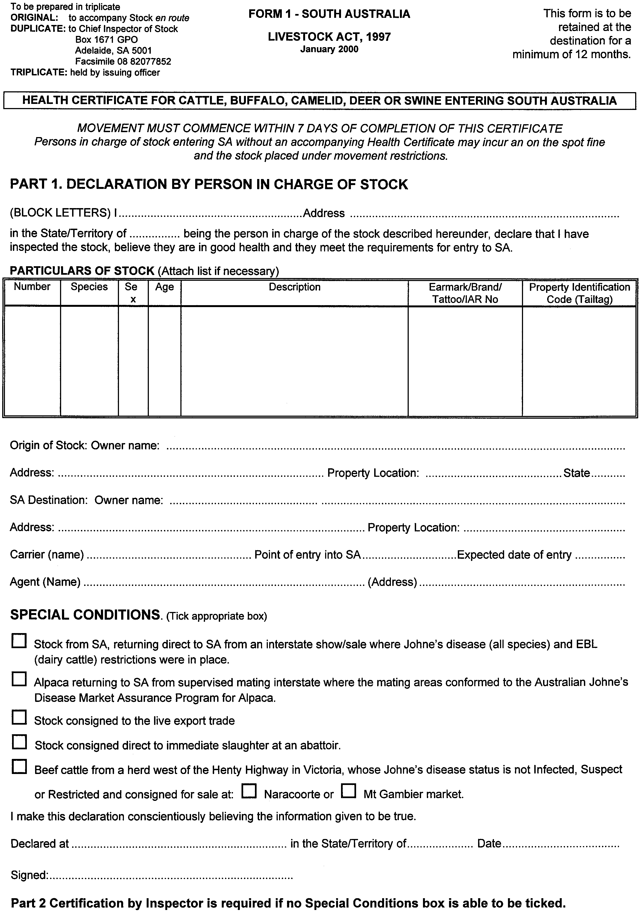
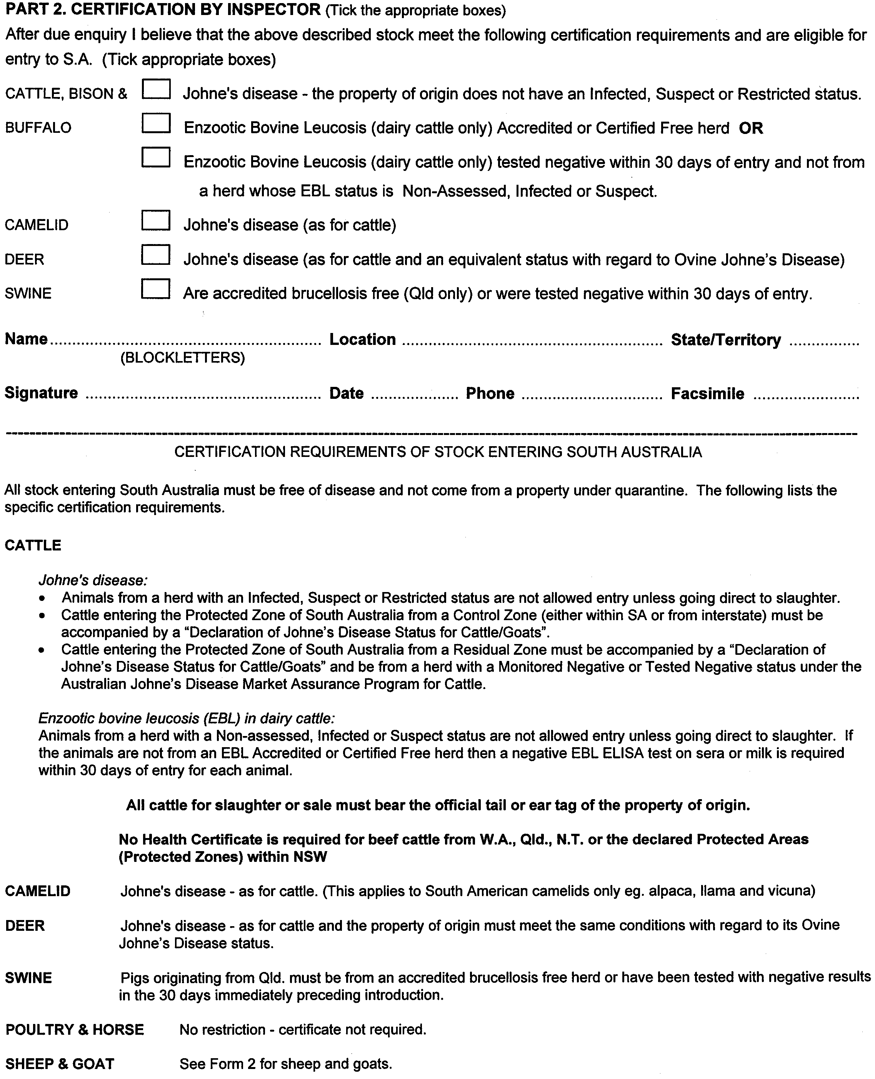
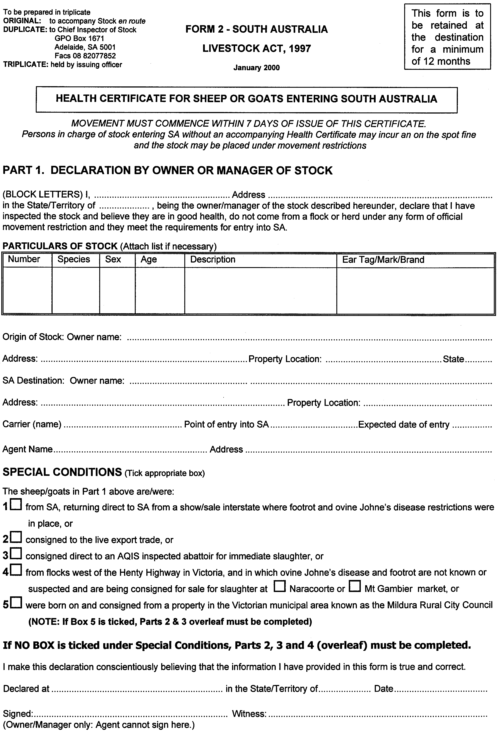
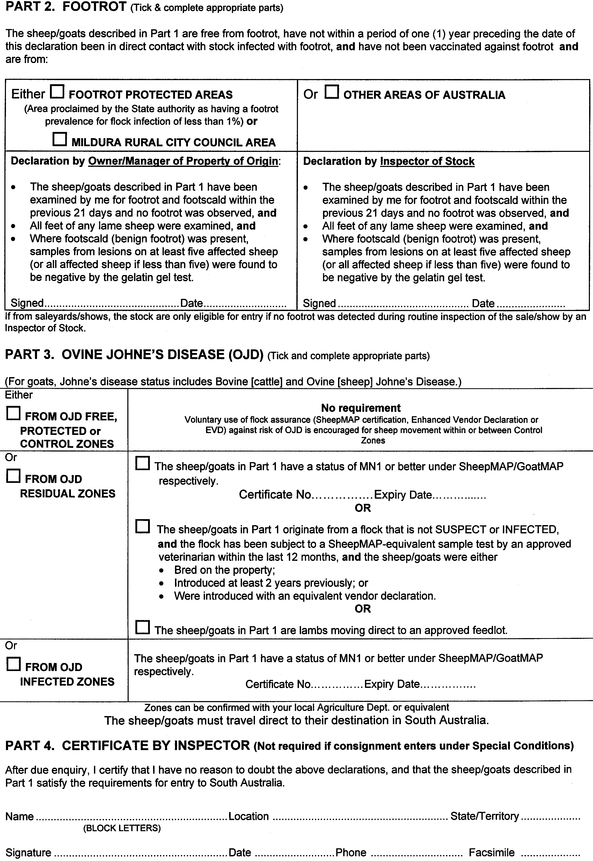
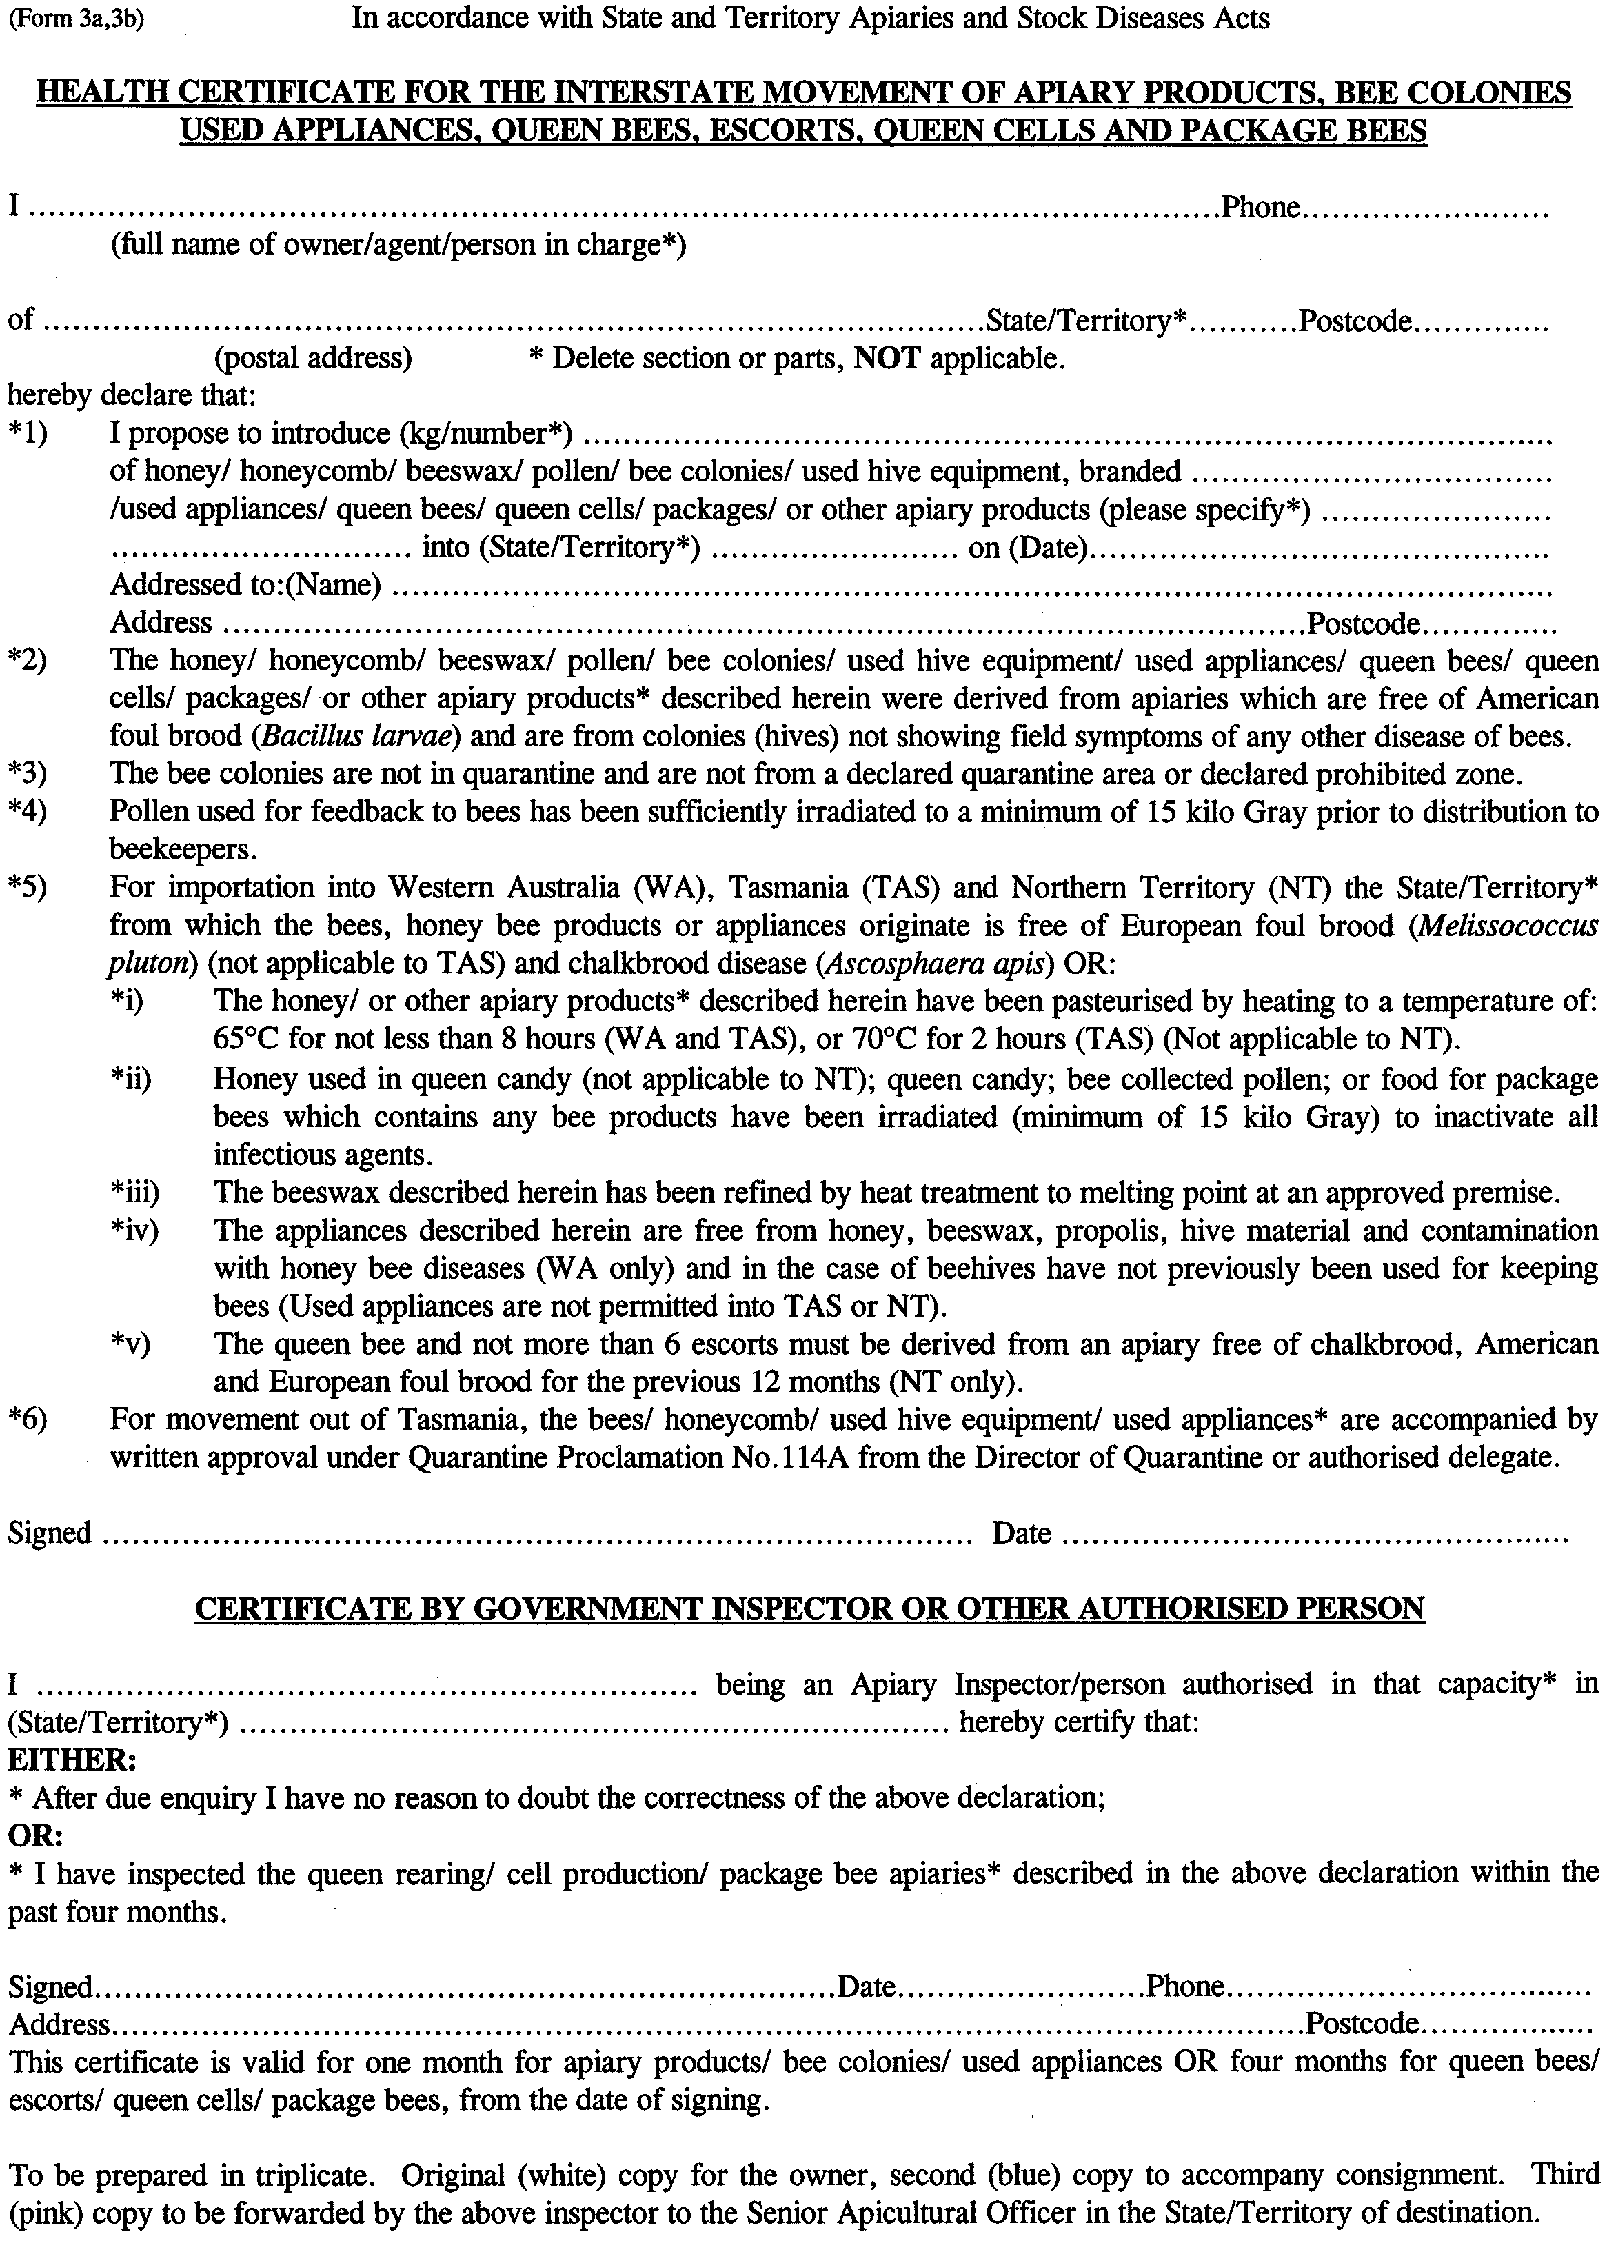
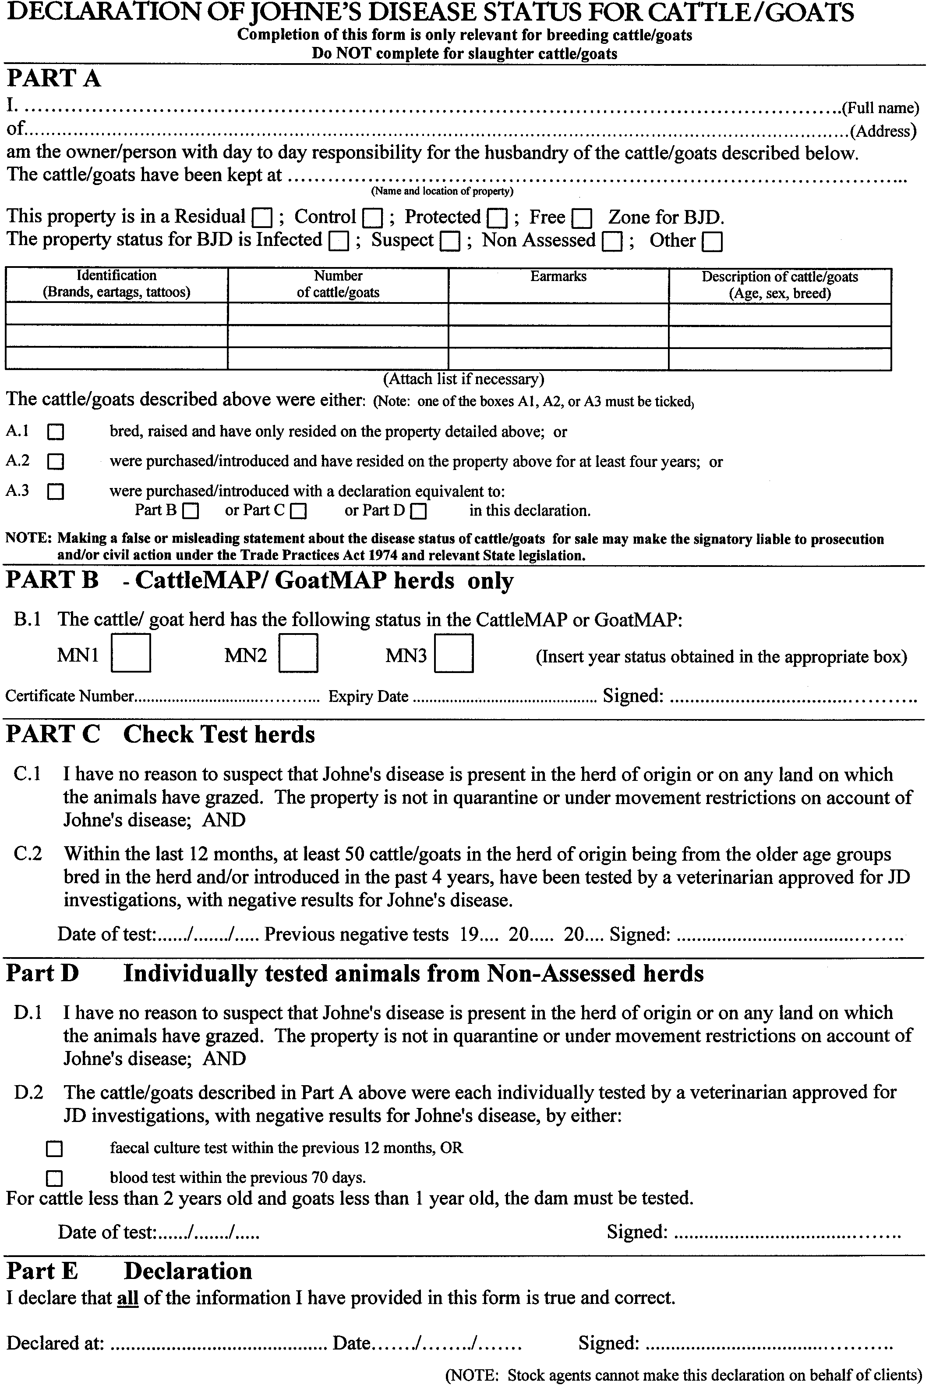
M. G. O’CALLAGHAN, Government Printer, South Australia

