SUPPLEMENTARY GAZETTE



THE SOUTH AUSTRALIAN

GOVERNMENT GAZETTE

PUBLISHED BY AUTHORITY

ALL PUBLIC ACTS appearing in this GAZETTE are to be considered official, and obeyed as such

ADELAIDE, THURSDAY, 20 JULY 2000

FISHERIES ACT 1982: SECTION 59
TAKE notice that pursuant to section 59 of the Fisheries Act 1982, Jode Atterton (hereinafter referred to as the ‘exemption holder’), 90 Mortlock Terrace, Port Lincoln, S.A. 5606 is exempt from sections 34 and 41 of the Fisheries Act 1982, but only insofar as he may take bech-de-mer (Holothuriidae spp. and Stichopodidae spp.) and turbo (Subninella undulatis) (hereinafter referred to as the ‘permitted activity’) subject to the conditions in Schedule 1 for the purposes of trade or business.
Schedule 1
1. The exemption holder may engage in the permitted activity from the date of gazettal of this notice until 1 January 2001.
2. Fish may be taken from all waters of the State west of 138°E excluding the waters of Streaky Bay.
3. The exemption holder may take fish by diving and collection by hand.
4. The exemption holder may take no more than 500 kg of beche-de-mere and 500 kg of turbo in any one week.
5. The exemption holder must provide the Director of Fisheries with separate statistical catch and effort information, in the form of a daily log as provided.
6. The exemption holder shall notify the PIRSA Fisheries Compliance Unit on 1800 065 522 prior to conducting the permitted activity with the following information:
(1) details of the boat that will be used to engage in the permitted activity;
(2) the intended area of conducting the permitted activity; and
(3) The intended place and time of launching and retrieval of the nominated boat for that day.
7. While engaged in the permitted activity the exemption holder shall carry or have about or near his person a copy of this notice. Such notice must be produced to a PIRSA Fisheries Compliance Officer upon request.
8. PIRSA Fisheries retains the right for a departmental officer to accompany the permit holder at any time during fishing operations.
9. The exemption holder shall not contravene or fail to comply with the Fisheries Act 1982, or any regulations made under that Act, except where specifically exempted by this notice.
Dated 19 July 2000.
W. Zacharin, Director of Fisheries

FISHERIES ACT 1982: SECTION 59
TAKE notice that the notice made under section 59 of the Fisheries Act 1982, and published in the South Australian Government Gazette on pages 1410 and 1411, dated 9 March 2000, being the fourth notice on page 1410, referring to the taking of native oysters, is hereby revoked.
Dated 19 July 2000.
W. Zacharin, Director of Fisheries

FISHERIES ACT 1982: SECTION 59
TAKE notice that pursuant to section 59 of the Fisheries Act 1982, Paul Duncan McDermid and Barry James Fryar (hereinafter referred to as the ‘exemption holders’) of Australian Wild Oysters Pty Ltd, 72 Henley Beach Road, Mile End, S.A. 5031 are exempt from section 41 of the Fisheries Act 1982, but only insofar as the exemption holders shall not be guilty of an offence when taking native oysters (Ostrea angasi) for the purpose of trade or business (hereinafter referred to as the ‘per-mitted activity’), subject to the conditions specified in Schedule 1, from the gazettal of this notice until 30 September 2000.
Schedule 1
1. The permitted activity may only be undertaken by diving and collection by hand.
2. A maximum of 1 000 dozen native oysters may be taken pursuant to this exemption.
3. The first batch (100 kg) of oysters taken must be tested after a two week minimum delay period and before sale by SASQAP or other registered testing authority, and have less than 2.3 Escherichia coli per gram.
4. Fish taken inside waters of Boston and Proper Bays must be taken from those waters outside the exclusion zone as detailed in the map in Schedule 2.
5. When conducting the permitted activity the exemption holders must be carrying sufficient navigation equipment to identify the areas of the exclusion zones in Boston and Proper Bays.
6. Fish taken outside waters of Boston and Proper Bays but within 5 km of a sewage outfall must immediately be taken to and remain at a registered aquaculture site for a period of 3 months and be batch tested as described on paragraph 3 prior to sale.
7. The exemption holders must provide the Director of Fisheries with details of catches, dive times, harvest locations and aquaculture sites used on a monthly basis. This report must be forwarded to the Director of Fisheries within 7 days of the completion of each calendar month.
8. PIRSA Fisheries retains the right for a departmental officer to observe the permitted activity at any time.
9. The exemption holders must notify the PIRSA Fisheries Compliance Unit on 1800 065 522 at least two hours prior to conducting the permitted activity.
10. Whilst engaged in the permitted activity the exemption holders must have in their possession a copy of this notice and produce a copy of the notice if required by a PIRSA Fisheries Compliance Officer.
11. The exemption holders shall not contravene or fail to comply with the Fisheries Act 1982, or any regulations made under the Act, except where specifically exempted by this notice.
Schedule 2
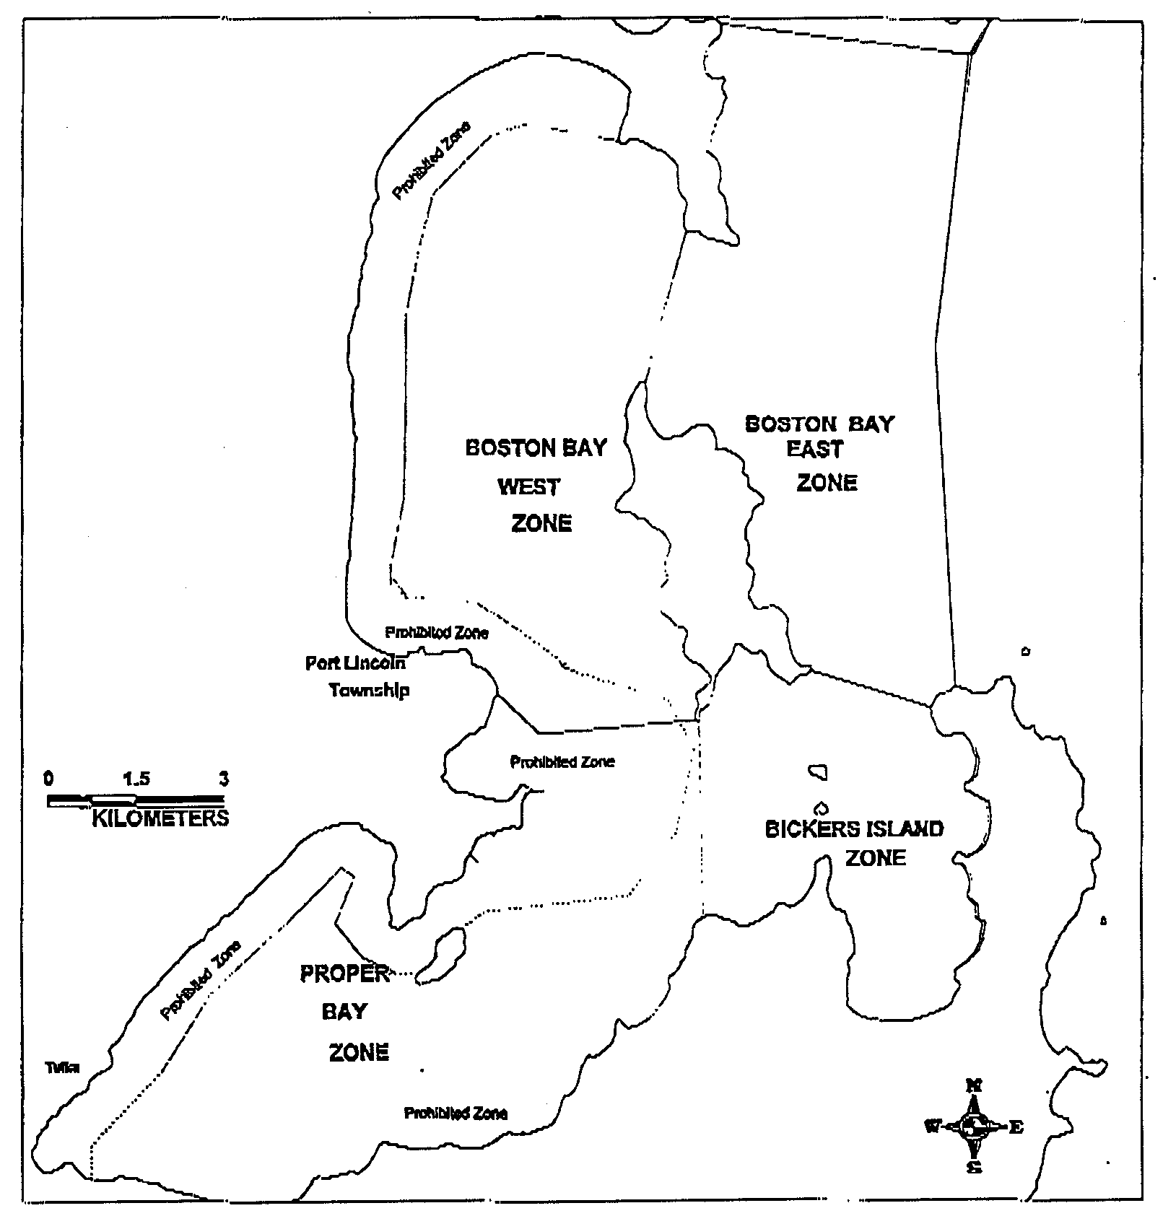
Native Oyster Collection

Dated 19 July 2000.
W. Zacharin, Director of Fisheries

M. G. O’CALLAGHAN, Government Printer, South Australia

