No. 93 3039

THE SOUTH AUSTRALIAN

GOVERNMENT GAZETTE

PUBLISHED BY AUTHORITY

ALL PUBLIC ACTS appearing in this GAZETTE are to be considered official, and obeyed as such

ADELAIDE, THURSDAY, 8 JUNE 2000

CONTENTS

Page
Acts Assented To 3040
Appointments, Resignations, Etc. 3041
Corporations and District Councils—Notices 3107
Crown Lands Act 1929—Notices 3042
Development Act 1993—Notices 3042
Fisheries Act 1982—Notices 3060
Gaming Machines Act 1992—Notices 3070
Geographical Names Act 1991—Notices 3071
Golden Grove (Indenture Ratification) Act 1984—Notice 3060
Harbors and Navigation Act 1993—Notices 3072
Land and Business (Sale and Conveyancing) Act 1994—
Notices 3073
Libraries Board of South Australia—Fees and Charges 3078
Liquor Licensing Act 1997—Notices 3074
Mining Act 1971—Notices 3076
Motor Vehicles Act 1959—Premium Schedule 3094
Petroleum Act 1940—Notices 3087
Page
Proclamations 3040
Public Trustee Office—Administration of Estates 3122
Racing Act 1976—Rules 3088
REGULATIONS
Emergency Services Funding Act 1998—
(No. 125 of 2000) 3099
Controlled Substances Act 1984 (No. 126 of 2000) 3101
Development Act 1993 (No. 127 of 2000) 3103
Stock Foods Act 1941 (No. 128 of 2000) 3104
Roads (Opening and Closing) Act 1991—Notices 3091
Road Traffic Act 1961—Notices 3091
South Eastern Water Conservation and Drainage Act 1992—
Contribution Levy 3093
Valuation of Land Act 1971—Notice 3093
Water Mains and Sewers—Mains Laid, Replaced, Etc. 3096
Water Resources Act 1997—Notices 3097
Wingfield Waste Depot Closure Act 1999—Notice 3098

GOVERNMENT GAZETTE NOTICES
ALL poundkeepers' and private advertisements forwarded for publication in the South Australian Government Gazette must be PAID FOR PRIOR TO INSERTION; and all notices, from whatever source, should be legibly written on one side of the paper only and sent to Riverside 2000 so as to be received no later than 4 p.m. Tuesday preceding the day of publication. Phone 8207 1045 or Fax 8207 1040. E-mail: Riv2000@saugov.sa.gov.au. Send as attachments in Word format and please confirm your transmission with a faxed copy of your document, including the date the notice is to be published and to whom the notice will be charged.

Department of the Premier and Cabinet
Adelaide, 8 June 2000
HIS Excellency the Governor directs it to be notified for general information that he has in the name and on behalf of Her Majesty The Queen, this day assented to the undermentioned Acts passed by the Legislative Council and House of Assembly in Parliament assembled, viz.:
No. 19 of 2000—Corporations (South Australia) (Miscel-laneous) Amendment Act 2000—An Act to amend the Corporations (South Australia) Act 1990.
No. 20 of 2000—Criminal Law Consolidation (Sexual Servitude) Amendment Act 2000—An Act to amend the Criminal Law Consolidation Act 1935; and to make related amendments to the Criminal Assets Confiscation Act 1996 and the Summary Offences Act 1953.
No. 21 of 2000—National Tax Reform (State Provisions) Act 2000—An Act to ratify and give effect to the Intergovernmental Agreement on the Reform of Commonwealth-State Financial Relations; to amend the Financial Institutions Duty Act 1983, the Pay-roll Tax Act 1971 and the Stamp Duty Act 1923; and for other purposes.
No. 22 of 2000—Statutes Amendment (Extension of Native Title Sunset Clauses) Act 2000—An Act to amend the Mining Act 1971 and the Opal Mining Act 1995.
No. 23 of 2000—Statutes Amendment (Public Trustee and Trustee Companies—GST) Act 2000—An Act to amend the Public Trustee Act 1995 and the Trustee Companies Act 1988.
By command,
Mark Brindal, for Premier

ANIMAL AND PLANT CONTROL (AGRICULTURAL PROTECTION AND OTHER PURPOSES) ACT 1986 SECTION 40: VARIATION OF DECLARATION OF CLASSES OF ANIMALS TO WHICH ACT APPLIES
Proclamation By The Governor
(l.s.) E. J. Neal
PURSUANT to section 40 of the Animal and Plant Control (Agricultural Protection and Other Purposes) Act 1986, on the recommendation of the Animal and Plant Control Commission and with the advice and consent of the Executive Council, I vary the declaration made under that section on 25 June 1987 (see Gazette 25 June 1987 p. 1611), as varied—
(a) by striking out from clause 2 ‘classes 4, 6a and 6c’ and substituting ‘classes 4, 6a, 6c and 5f’;
(b) by striking out the entries in Schedule 1 relating to Class 5c Mammals, Order: Lagomorpha and Class 5d Mammals, Order: Lagomorpha and substituting the following entries:
Class 5c  Mammals:  Order: Lagomorpha  Lepus europeus  European hare  Oryctolagus cuniculus  European rabbit  (wild forms) | Sections 41, 42, 44, 46 and 47(1). | All offshore islands, Hindmarsh Island and any vessel adjacent to any such island.
Class 5d  Mammals:  Order: Lagomorpha  Oryctolagus cuniculus  European rabbit  (wild forms) | Sections 41, 42, 44, 46, 47(2). | Whole of the State (excluding the areas specified for Class 5c animals).

Class 5e  Mammals:  Order: Lagomorpha  Oryctolagus cuniculus  European rabbit  (domestic breeds) | Sections 41, 42, 44, 46, 47(1). | All offshore islands, (excluding Wardang Island) and any vessel adjacent to any such island.
Class 5f  Mammals:  Order: Lagomorpha  Oryctolagus cuniculus  European rabbit  (domestic breeds) | Section 44. | Whole of the State (excluding the areas specified for Class 5e animals).
This proclamation will come into effect on 8 June 2000.
Given under my hand and the Public Seal of South Australia, at Adelaide, 8 June 2000.
By command,
Mark Brindal, for Premier
MPIR 26/2000 CS

SHOP TRADING HOURS ACT 1977 SECTION 13: ALTERATION OF SHOP TRADING HOURS—CENTRAL SHOPPING DISTRICT
Proclamation By The Governor
(l.s.) E. J. Neal
PURSUANT to section 13 of the Shop Trading Hours Act 1977 and with the advice and consent of the Executive Council, I authorise the opening of all shops in the Central Shopping District from 5 p.m. until 7 p.m. on Saturday, 15 July 2000, subject to the conditions specified in the schedule.
Schedule
This proclamation only authorises the opening of a shop if—
(a) all relevant industrial awards, workplace agreements and enterprise agreements are observed by the shopkeeper and persons employed in the business of the shop during and in relation to the hours specified in this proclamation during which the shop is open; and
(b) subject to an industrial award, workplace agreement or enterprise agreement to the contrary—a person who is employed in the business of the shop is entitled to refuse to work at the shop during the hours specified in this proclamation unless he or she has agreed with the shopkeeper to work during those hours.
Given under my hand and the Public Seal of South Australia, at Adelaide, 8 June 2000.
By command,
Mark Brindal, for Premier
MWPR 13/2000 CS

SOUTH AUSTRALIAN HEALTH COMMISSION (DIRECTION OF HOSPITALS AND HEALTH CENTRES) AMENDMENT ACT 2000 (Act No. 14 of 2000): DAY OF COMMENCEMENT
Proclamation By The Governor
(l.s.) E. J. Neal
WITH the advice and consent of the Executive Council, I fix 8 June 2000 as the day on which the South Australian Health Commission (Direction of Hospitals and Health Centres) Amendment Act 2000 will come into operation.
Given under my hand and the Public Seal of South Australia, at Adelaide, 8 June 2000.
By command,
Mark Brindal, for Premier
DHS 6/99 CS

Department of the Premier and Cabinet
Adelaide, 8 June 2000
HIS Excellency the Governor in Executive Council has been pleased to appoint the undermentioned to the South Australian Government Financing Advisory Board, pursuant to the provisions of the Government Financing Authority Act 1982:
Member: (from 9 June 2000 until 8 June 2003)
Yvonne Sneddon
Member: (from 9 June 2000 until 8 June 2001)
Alice McCleary
By command,
Mark Brindal, for Premier
TFD 052/99CS

Department of the Premier and Cabinet
Adelaide, 8 June 2000
HIS Excellency the Governor in Executive Council has been pleased to appoint the undermentioned to the Gaming Supervisory Authority, pursuant to the provisions of the Gaming Supervisory Authority Act 1995:
Member: (from 24 July 2000 until 23 July 2003)
Juliet Helena Brown
By command,
Mark Brindal, for Premier
TFD 042/00CS

Department of the Premier and Cabinet
Adelaide, 8 June 2000
HIS Excellency the Governor in Executive Council has been pleased to appoint the undermentioned to the HomeStart Finance Board of Management, pursuant to the provisions of the Housing and Urban Development (Administrative Arrangements) Act 1995:
Member: (from 8 July 2000 until 7 July 2002)
Kate Spargo
Vivienne Pring
Presiding Member: (from 8 July 2000 until 7 July 2002)
Kate Spargo
By command,
Mark Brindal, for Premier
MHS 10/98CS

Department of the Premier and Cabinet
Adelaide, 8 June 2000
HIS Excellency the Governor in Executive Council has been pleased to appoint Bruno Krumins, Member of the Order of Australia, as Governor’s Deputy of South Australia for a period from 10.35 a.m. on Saturday, 17 June 2000 until 10 a.m. on Thursday, 22 June 2000.
By command,
Mark Brindal, for Premier

Department of the Premier and Cabinet
Adelaide, 8 June 2000
HIS Excellency the Governor in Executive Council has been pleased to appoint the following judicial officers to the auxilliary pool for the period 1 July 2000 to 30 June 2001, it being a condition of appointment that the powers and jurisdictions of office should only be exercised during the time or times the actual duties are being undertaken; but at no other time throughout the period of appointment, pursuant to the provisions of the Judicial Administration (Auxillary Appointments and Powers) Act 1998:
Leonard James King to the office of Puisne Judge of the Supreme Court on an auxillary basis;
Derek Willoughby Bollen to the office of Puisne Judge of the Supreme Court on an auxillary basis;
Roderick Grant Matheson to the office of Puisne Judge of the Supreme Court on an auxillary basis;
Donald Malcolm Brebner to the office of Puisne Judge of the Supreme Court on an auxillary basis;
David Hugh Taylor to the office of District Court Judge on an auxillary basis;
Anthony Vincent Russell to the office of District Court Judge on an auxillary basis;
Ian Brandwood Burnett to the office of District Court Judge on an auxillary basis;
Kenneth Edward Berry to the office of Master of the District Court on an auxillary basis;
Anthony Townsend Gun to the office of Magistrate on an auxillary basis;
Graham Elliot Carter to the office of Magistrate on an auxillary basis.
By command,
Mark Brindal, for Premier
ATTG 60/94CS

Department of the Premier and Cabinet
Adelaide, 8 June 2000
THE Council recommends His Excellency the Governor to appoint the following as Justices of the Peace for South Australia, pursuant to section 4 of the Justices of the Peace Act 1991:
Gary John Aldridge
Katherine Clare Andersen
Dennis Boldock
Rosemary Anne Chamberlain
Luisa Josephine Damiani
David Anthony Gittins
Gerard Michael Guerin
Francis Heslop
Matthew John Jacobs
Andrew Mark Jeynes
Zaharoula Karzis
Ali Khan
Dorothy Anne McLennan
Anh-Tuan Ngo
Phillip James Rosevear
Lynette Ruth Steenson
Edna Francis Taylor
Karen Jane Thompson
Dianne Joan Tyrrell
Elizabeth Ann Williams
Janice Margaret Woodward
By command,
Mark Brindal, for Premier
ATTG 43/99CS

CROWN LANDS ACT 1929: SECTION 5
TAKE NOTICE that pursuant to the Crown Lands Act 1929, I PETER MACLAREN KENTISH, Surveyor-General and Delegate appointed by IAIN EVANS, Minister for Environment and Heritage, Minister of the Crown to whom the administration of the Crown Lands Act 1929 is committed DO HEREBY dedicate the Crown Land defined in The Schedule as a Public Road.
The Schedule
Allotments 23 and 24 of DP 52852, Hundred of Ripon, County of Robinson, being within the district of Streaky Bay.
Dated 6 June 2000.
P. M. Kentish, Surveyor-General
DENR 08/0390

CROWN LANDS ACT 1929: SECTION 5
TAKE NOTICE that pursuant to the Crown Lands Act 1929, I PETER MACLAREN KENTISH, Surveyor-General and Delegate appointed by IAIN EVANS, Minister for Environment and Heritage, Minister of the Crown to whom the administration of the Crown Lands Act 1929 is committed DO HEREBY dedicate the Crown Land defined in The Schedule as a Community and Cultural Reserve and declare that such land shall be under the care, control and management of The Corporation of the City of Whyalla.
The Schedule
Allotment 100 of DP 50834, Hundred of Randell, County of York, exclusive of all necessary roads, subject nevertheless to existing easements to ETSA Utilities Pty Ltd for the transmission of electricity by underground cable more particularly described in RLG 8643243 over portion of allotment 100 marked A, C and D and portions marked B on DP 50834.
Dated 6 June 2000.
P. M. Kentish, Surveyor-General
DEHAA 13/0580

DEVELOPMENT ACT 1993, SECTION 27 (1): CITY OF UNLEY—CHARLES STREET UNLEY PRECINCT PLAN AMENDMENT
Preamble
The Minister for Transport and Urban Planning has approved the amendment entitled ‘City of Unley—Charles Street Unley Precinct Plan Amendment’ (the Plan Amendment) and has referred it to the Governor.
Notice
PURSUANT to section 27 (1) of the Development Act 1993, I, the Governor with the advice and consent of the Executive Council, declare the Plan Amendment to be an authorised Plan Amendment and fix 8 June 2000 as the day on which it will come into operation.
Dated 8 June 2000.
E. J. Neal Governor
MTUP CAB 18/00CS

DEVELOPMENT ACT 1993: SECTION 48
Notice by the Governor
Preamble
1. I have given a development authorisation pursuant to section 48 of the Development Act 1993 concerning the proposal to develop a hotel, car parking and associated works comprising the Holdfast Shores Stage 2A development, located adjacent to Chappell Drive, Glenelg.
2. It is appropriate to delegate certain powers to the Development Assessment Commission in relation to this matter.
Delegation
PURSUANT to section 48(8) of the Development Act 1993 and with the advice and consent of the Executive Council, I delegate to the Development Assessment Commission:
(a) the power to approve amendments of the development referred to in paragraph 1 of the preamble (including the development as it may be amended from time to time), provided that any such amendment does not require the preparation of a further or amended Development Report; and
(b) the power to vary or revoke any condition to which the relevant development authorisation is subject, or to attach new conditions (subject to the operation of section 48(7)(b) of the Development Act 1993).
Given under my hand at Adelaide, 6 June 2000.
E. J. Neal Governor

DEVELOPMENT ACT 1993: SECTION 48
Decision By The Governor
Preamble
1. A proposal to develop the Holdfast Shores Stage 2A development comprising a hotel, car parking, landscaping and associated works, located adjacent to Chappell Drive, Glenelg, has been under consideration under Division 2 of Part 4 of the Development Act 1993.
2. The development has been the subject of a Development Report and an Assessment Report under sections 46 and 46D of the Development Act 1993.
3. Application has now been made to the Governor under section 48 of the Development Act 1993 for the approval of the development. The application lodged on 19 July 1999 has been amended and expanded upon by the Development Report dated December 1999 and the following documents and plans:
Plans
Revised hotel plaza plan, supplementary plan SP 6, dated February 2000; revised hotel plaza section, supplementary plan SP 7, dated February 2000; revised hotel plaza details, supplementary plan SP 8, dated February 2000; bridge—plan, elevation and details, supplementary plan SP23, dated February 2000; west plaza level detail, supplementary plan SP 30, dated February 2000; east plaza level detail, supplementary plan SP 31, dated February 2000; open space/vegetation, supplementary plan, SP 32. dated December 1999; amended dining room window, supplementary plan SP 33, dated December 1999; hotel undercroft plan, supplementary plan SP 34 Rev. A, dated 27 March 2000; hotel plaza plan, supplementary plan SP 35 Rev. A, dated 27 March 2000; temporary car parking (behind the police station), supplementary plan SP 36, undated; temporary toilets, supplementary plan SP 39, dated 27 March 2000; hotel western edge, plan detail, supplementary plan SP 40 A, dated April 2000 and hotel western edge, section details, supplementary plan SP 41 A, dated April 2000.
Documents
Facsimiles dated 3 March 2000, 20 March 2000 and 22 March 2000 from Woodhead International to Planning SA; the reports dated 25 February 2000, 28 February 2000, 29 February 2000, 14 March 2000 and 4 April 2000 from Woodhead International and Masterplan to Planning SA; the two reports dated 18 April 2000 from Woodhead International to Planning SA; and the letters from Murray Young and Associates, traffic consultants to Woodhead International dated 3 April 2000, 14 April 2000 and 28 April 2000.
4. I am satisfied that an appropriate Development Report, and an Assessment Report, that encompass the development have been prepared in relation to development, in accordance with the requirements of Division 2 of Part 4 of the Development Act 1993.
5. I have, in considering the application, had regard to all relevant matters under section 48 (5) of the Development Act 1993.
Decision
PURSUANT to section 48 of the Development Act 1993 and with the advice and consent of the Executive Council, in relation to the Holdfast Shores Stage 2A proposal submitted on behalf of Holdfast Shores Consortium to develop a site adjacent to Chappell Drive, Glenelg for a hotel, car parking, landscaping and associated works, I grant development approval for the development subject to conditions.
Conditions of Approval
1. The Holdfast Shores Stage 2A development must be undertaken in accordance with:
(a) the following plans contained in the Development Report dated December 1999 as they relate to the proposals for Stage 2A, except to the extent that they are varied by the plans described in paragraph 1 (c):
• Site plan, Plan 5;
• Pedestrian movement, Plan 7;
• Vehicular movement, Plan 8;
• Urban spaces, Plan 9;
• Hotel environs study, Plan 18;
• Public art masterplan, Plan 21;
• First floor level, Plan 25;
• Upper levels, Plan 26;
• Hotel: first, second, third and fourth floor plans, Plan 30;
• Hotel: fifth, sixth and sixth floor mezzanine, Plan 31;
• Hotel: elevations, Plan 32;
• Hotel: elevations, Plan 33;
• Hotel: sections, Plan 34; and
• Hotel: landscaping plan, Plan 36; and
(b) the following plans contained in the report from Woodhead International and Masterplan to Planning SA (a branch of the Department of Transport, Urban Planning and the Arts) dated 25 February 2000, except to the extent that they are varied by the plans described in paragraph 1 (c):
• Revised hotel plaza plan, supplementary plan SP 6, dated February 2000;
• Revised hotel plaza section, supplementary plan, SP 7, dated February 2000;
• Revised hotel plaza details, supplementary plan SP 8, dated February 2000;
• Bridge—plan, elevation and details, supplementary plan SP 23, dated February 2000;
• West plaza level detail, supplementray plan SP 30, dated February 2000;
• East plaza level detail, supplementray plan SP 31, dated February 2000;
• Open space/vegetation, supplementary plan SP 32, dated December 1999; and
• Amended dining room window, supplementary plan SP 33, dated December 1999; and
(c) the following plans:
• Hotel undercroft plan, supplementary plan SP 34 Rev. A, dated 27 March 2000;
• Hotel plaza plan, supplementary plan SP 35 Rev. A, dated 27 March 2000;
• Temporary carpark option 1, supplementary plan SP 36, undated;
• Temporary toilets, supplementary plan SP 39, dated 27 March 2000;
• Hotel western edge, plan detail, supplementary plan SP 40 A, dated April 2000; and
• Hotel western edge, section details, supplementary plan SP 41 A, dated April 2000; and
(d) the following documents except to the extent that they are varied by the plans decsribed in paragraphs 1 (a), 1 (b) and 1 (c):
• facsimiles dated 3 March 2000, 20 March 2000 and 22 March 2000 from Woodhead International to Planning SA (a branch of the Department of Transport, Urban Planning and the Arts);
• the reports dated 25 February 2000, 28 February 2000, 29 February 2000, 14 March 2000 and 4 April 2000 from Woodhead International and Masterplan to Planning SA (a branch of the Department of Transport, Urban Planning and the Arts:
• the two reports dated 18 April 2000 from Woodhead International to Planning SA (a branch of the Department of Transport, Urban Planning and the Arts); and
• the letters from Murray Young and Associates, traffic consultants to Woodhead International dated 3 April 2000, 14 April 2000 and 28 April 2000.
2. No works may be commenced unless and until:
(a) a private certifier or the City of Holdfast Bay has certified to the Development Assessment Commission that all work constitutes building work under the Development Act 1993 complies with the Building Rules; and
(b) an Environmental Management Plan (EMP) has been prepared in consultation with the Environment Protection Authority and the City of Holdfast Bay to address the management issues during construction. Matters to be addressed in the EMP must include:
• traffic management during construction, including transport beyond the development site;
• control and management of construction noise;
• dust and mud control;
• working hours;
• stormwater management during construction;
• site security and fencing;
• disposal of building waste and refuse;
• protection and cleaning of roads and pathways;
• site clean up; and
• adherence to all relevant Environment Protection Authority codes of practice for construction sites.
3. The hotel must not be used or occupied for the purposes outlined in the application until:
(a) all 302 car parks proposed for Stage 2A have been established in accordance with the plans listed in Condition 1(c);
(b) plans for street furniture and directional signs for Stage 2A (including siting, elevations and materials) have been prepared by the proponent to the satisfaction of the Development Assessment Commission in consultation with the City of Holdfast Bay;
(c) plans for public are for Stage 2A in accordance with plan 21 entitled ‘Public Art Masterplan’ and dated December 1999 (including siting, elevations and materials) have been prepared by the proponent to the satisfaction of the Development Assessment Commission in consultation with the City of Holdfast Bay;
(d) lighting of all external areas has been provided to the satisfaction of the Development Assessment Commission to ensure the safety of users of the pedestrian paths and plazas; and
(e) —
(i) plans for the drainage of stormwater from the Stage 2A site (including siting, elevations and materials) have been prepared by the proponent to the satisfaction of the Development Assessment Commission in consultation with the City of Holdfast Bay;
(ii) stormwater infrastructure has been installed in accordance with the plans prepared pursuant to condition 3(e)(i) to the satisfaction of the Development Assessment Commission in consultation with the City of Holdfast Bay; and
(iii) stormwater infrastructure is operational.
4. Street furniture and directional signs for the Stage 2A development must be established in accordance with the plans prepared pursuant to condition 3(b) within six months of the first occupation of the hotel to the satisfaction of the Development Assessment Commission.
5. Public art for the Stage 2A development must be established in accordance with the plans prepared pursuant to condition 3(c) within six months of the first occupation of the hotel to the satisfaction of the Development Assessment Commission.
6. The car parking areas must be designed in accordance with Australian Standards 2890.1-1993 and line markings must be maintained in good and substantial condition at all times.
7. The pedestrian paths and plazas proposed in the application, including the area situated between the existing Glenelg Surf Life Saving Club and the hotel building, must be open for pedestrian use from the commencement of use and occupation of the hotel and must then be kept open for pedestrian use at all times.
8. An iron-barred gate of at least 1.5 m in height must be constructed at the entrance to the stairwell on the south-eastern corner of the hotel building.
9. Access for service deliveries and waste disposal vehicles at the hotel plaza level must only be allowed between 7 a.m. and 10 a.m. daily.
10. The proposed toilets to replace the existing toilets adjoining the kiosk on the north-east side of the site must be established to the satisfaction of the Development Assessment Commission in consultation with the City of Holdfast Bay prior to the demolition of these existing toilets.
11. Driveways, parking and manoeuvring areas and footpaths must be kept illuminated during the hours of darkness when the bar and lounge facilities are open to the public and such lights must be directed and screened so that drivers are not distracted by lights.
12. Landscaping proposed in the application must be established before the first occupation of the hotel and plants must be maintained in good health and condition at all times. A plant must be replaced if or when it dies or becomes seriously diseased within the first growing season after the plant dies or becomes seriously diseased.
13. Vegetation proposed to be established along the western edge of the undercroft parking of the hotel must:
• provide sufficient foliage and density of planting to screen the undercroft to ensure that the presence of cars is not obtrusive when viewed from the promenade; and
• not unreasonably inhibit ventilation from the undercroft parking areas (which may require pruning or thinning of the vegetation from time to time).
14. Management of stormwater from the Stage 2A site must comply with the Environment Protection Authority’s ‘Stormwater Pollution Prevention Code of Practice for Local, State and Federal Government’ during construction of the Stage 2A development.
15. The quality of any stormwater entering the Holdfast Shores marina from the Stage 2A development must comply with the guidelines applicable to secondary recreational use and the protection of aquatic ecosystems within the ANZECC Australian Water Quality Guidelines for Fresh and Marine Waters (November 1992), or any standard that may be subsequently substituted therefore.
16. Stormwater from the Stage 2A site must not be disposed of by way of a pipe or similar structure that conveys the stormwater to the beach.
17. Site works, construction work and truck movements to and from the site must only be carried out between 7 a.m. and 6 p.m., Monday to Saturday inclusive.
Notes to the Applicant:
1. The plans and documents referred to in Condition 1 of the approval together describe the development hereby approved.
2. No advertising signs are hereby approved. The display of any advertising sign will require separate approval.
3. This approval does not allow the use of any part of the site for outdoor dining. Any such use will require approval of an amendment of the development hereby approved. Detailed information on the use, nature and extent of outdoor dining on the plaza and the parking requirements for this additional dining area would be required in the consideration of any amendment to the development hereby approved. The proponent should also consult with the Council about any proposal for outdoor dining.
4. Noise emissions from the Stage 2A development will be subject to the Environment Protection (Industrial Noise) Policy 1994 and the Environment Protection Act 1993.
5. The proponent should consult with Adelaide Airport Ltd on crane operations prior to construction.
Given under my hand at Adelaide, 8 June 2000.
E. J. Neal Governor

DEVELOPMENT ACT 1993: ALTERATION TO THE BUILDING CODE OF AUSTRALIA
Preamble
1. The Building Code of Australia as in force from time to time is adopted by the Development Regulations 1993 as part of the Building Rules under the Development Act 1993.
2. The Code has been altered.
3. The Development Act 1993 requires that notice of the alteration must be published before the alteration can take effect.
Notice
PURSUANT to sections 4 (7) and 108 (7) of the Development Act 1993, notice is given of an alteration to the 1996 edition of the Building Code of Australia, that alteration being Amendment No. 7, published by the Australian Building Codes Board, as modified by the variations and additions for South Australia contained in the appendix to that Code.
The alterations made by Amendment No. 7 to the Building Code of Australia (other than SA Part G5 in Volume One, the deletion of SA P2.3.4 and the amendments to Part 3.7.4 in Volume Two) will take effect for the purposes of the Development Act 1993 on 1 July 2000.
The alterations made by Amendment No. 7 which are SA Part G5 in Volume One, the deletion of SA P2.3.4 and the amendments to Part 3.7.4 in Volume Two, will take effect for the purposes of the Development Act 1993 on 1 September 2000.
Dated 8 June 2000.
Diana Laidlaw, Minister for Transport and Urban Planning.

DEVELOPMENT ACT 1993: SECTION 48: DECISION BY THE DEVELOPMENT ASSESSMENT COMMISSION AS DELEGATE OF THE GOVERNOR
Preamble
1. The decision of the Governor under section 48 of the Development Act 1993 to approve the development of the Mildara Blass Winery located on the Sturt Highway, 2 km north-east of Nuriootpa in 10 stages was published in the Gazette on 7 October 1999.
2. An amended proposal to develop the Mildara Blass Winery has been under consideration under Division 2 of Part 4 of the Development Act 1993.
3. The amendments to the development are contained in:
(a) the letters from Nolan Rumsby Planners to the Development Assessment Commission dated 20 March 2000 and 5 May 2000; and
(b) the plan numbered BYA-1999-0012 D dated 23 March 2000.
The plan numbered BYA-1999-0012 D dated 23 March 2000, supersedes the three previously approved site plans, being the following plans:
• Drawing titled: Bilyara Site Stage V10 Sheet 1 of 3, Drawing Number: BYA-1999-0012 B;
• Drawing titled: Bilyara Site Stage V10 Sheet 2 of 3, Drawing Number: BYA-1999-0012 B; and
• Drawing titled: Bilyara Site Stage V10 Sheet 3 of 3, Drawing Number: BYA-1999-0012 B.
4. The amendments to the development are:
(a) repositioning of the proposed car park and administration building, and a 144 m² expansion of the administration building;
(b) deferment of the construction of the barrel storage building in the centre of the site—by 6 months—from the 1999-2000 financial year to the 2000-2001 financial year;
(c) a new 24 m² grape sampling building adjacent to the vehicle access point on the southern side of the site;
(d) variations to the perimeter earth mounds that slightly widen some mounds and make gentler slopes—retaining the same 3 m maximum height in the Governor’s approval;
(e) confirmation that, after further consideration of the two optional access points for heavy vehicles in the Governor’s approval, Option A on the eastern (Light Pass Road) side of the site is to proceed. Option B on the southern (Pipeline Road) side of the site will be converted to dry grassland; and
(f) two stormwater culverts to collect rainwater from the site, for drainage to the dam in the south-west corner, are now shown on the amended site plan dated 23 March 2000.
5. Application has now been made to the Development Assessment Commission as delegate of the Governor under section 48 of the Development Act 1993, for the approval of the amended development.
6. The Development Assessment Commission has, in considering the application, had regard to all relevant matters under section 48 (5) of the Development Act 1993.
7. The Development Assessment Commission is satisfied that the amendments do not require the preparation of a further or amended Development Report.
Decision
PURSUANT to section 48 of the Development Act 1993, the Development Assessment Commission, as delegate of the Governor, grants development approval to the amended Development in 10 stages of the Mildara Blass Winery located on the Sturt Highway, 2 km north-east of Nuriootpa, as described in the application dated 2 December 1998 (amended by the Development Report dated May 1999 and letters dated 9 July 1999 and 28 September 1999), and subsequently amended by the letters dated 20 March 2000 and 5 May 2000, submitted on behalf of Mildara Blass Limited subject to conditions.
Conditions of Approval:
1. No works may be commenced on a particular stage of the proposal on the site unless and until:
(a) a building certifier or The Barossa Council has certified to the Development Assessment Commission that any work for that stage that constitutes building work under the Development Act 1993, complies with the Building Rules.
(b) an Environmental Management Plan has been produced and approved by the Development Assessment Commis-sion for each construction stage. The Environmental Management Plan shall detail the final overall manage-ment of the facility and include:
• Wastewater treatment including the proposed wet-lands; and
• Solid waste treatment or disposal.
2. The amended development hereby approved must be undertaken in accordance with:
(a) the following plans comprising part of the application:
• Drawing titled: Bilyara Site Stage V10 Sheet 2 of 3, Drawing Number: BYA-1999-0012 D, dated 23 March 2000;
• Drawing titled: Elevations and Sections, dated 11 March 1999; and
• Drawing titled: Elevations and Detail, Drawing Number:BYA-1999-00013 A; and
(b) the letters from Nolan Rumsby Planners to the Development Assessment Commission dated 20 March 2000 and 5 May 2000.
3. Mature trees must be planted to reduce impacts of the proposal at the earliest stage.
4. Lighting for monitoring purposes must be switched off at all times when tasks are not being undertaken in that particular area.
5. All lights must be directed and shielded in such a way as to prevent glare from the site.
6. The proponent must comply with the design and noise attenuation measures recommended on pages 3, 4 and 5 of the Environmental Noise Assessment report prepared by Bassett Acoustics on 13 May 1999, for the proposed 75 000 tonne crush Mildara Blass Ltd Bilyara Winery.
7. The proponent must not discharge winery effluent into the existing wetland system unless the effluent meets the following minimum quality criteria: pH 6.5-8; Total Dissolved Solids less than 2 500 mg/L; Biochemical Oxygen Demand less than 600 mg/L; Suspended Solids less than 100 mg/L.
8. No trucks or heavy vehicles are to access the site from the portion of Light Pass Road south of the access point.
Notes to the Applicant:
1. No approval is hereby granted for the development of any car parking in the area marked ‘future 126 spaces’ on the plan numbered BYA-1999-0012 D dated 23 March 2000. Any such car parking will require approval of an amendment to the development hereby approved.
2. The preparation of a Management Plan for the waste water treatment system must be prepared in accordance with the South Australian Health Commission code—‘Standards for Con-struction, Installation and Operation of Septic Tank Systems in South Australia’.
3. The removal of native trees along the road reserve requires the approval of The Barossa Council.
G. Holland-Booker, Secretary, Development Assessment Commission.

DEVELOPMENT ACT 1993, SECTION 29 (2) (b): AMENDMENT TO THE ADELAIDE HILLS COUNCIL
DEVELOPMENT PLAN
Preamble
It is necessary to update the maps and figures within the Adelaide Hills Council Development Plan dated 4 May 2000.
Notice
PURSUANT to section 29 (2) of the Development Act 1993, I, Diana Laidlaw, being the Minister administering the Act, amend The Adelaide Hills Council Development Plan dated 4 May 2000 as follows:
(a) Delete Maps AdHi/59 and 60;
(b) Insert Maps AdHi/59 and 60 as contained in Attachment ‘A’;
(c) Delete figures MtLRWA/1 and MtLRWA/2 dated 4 May 2000;
(d) Insert figures MtLRWA/1 and MtLRWA/2 as contained in Attachment ‘B’; and
(e) Amend the associated cross-references throughout the text accordingly.
Attachment A
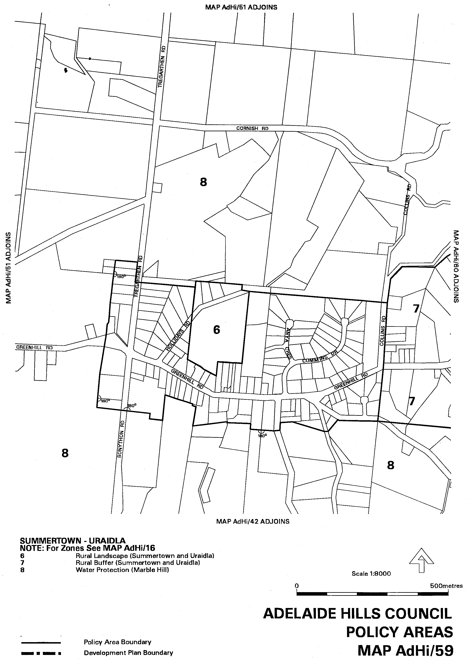
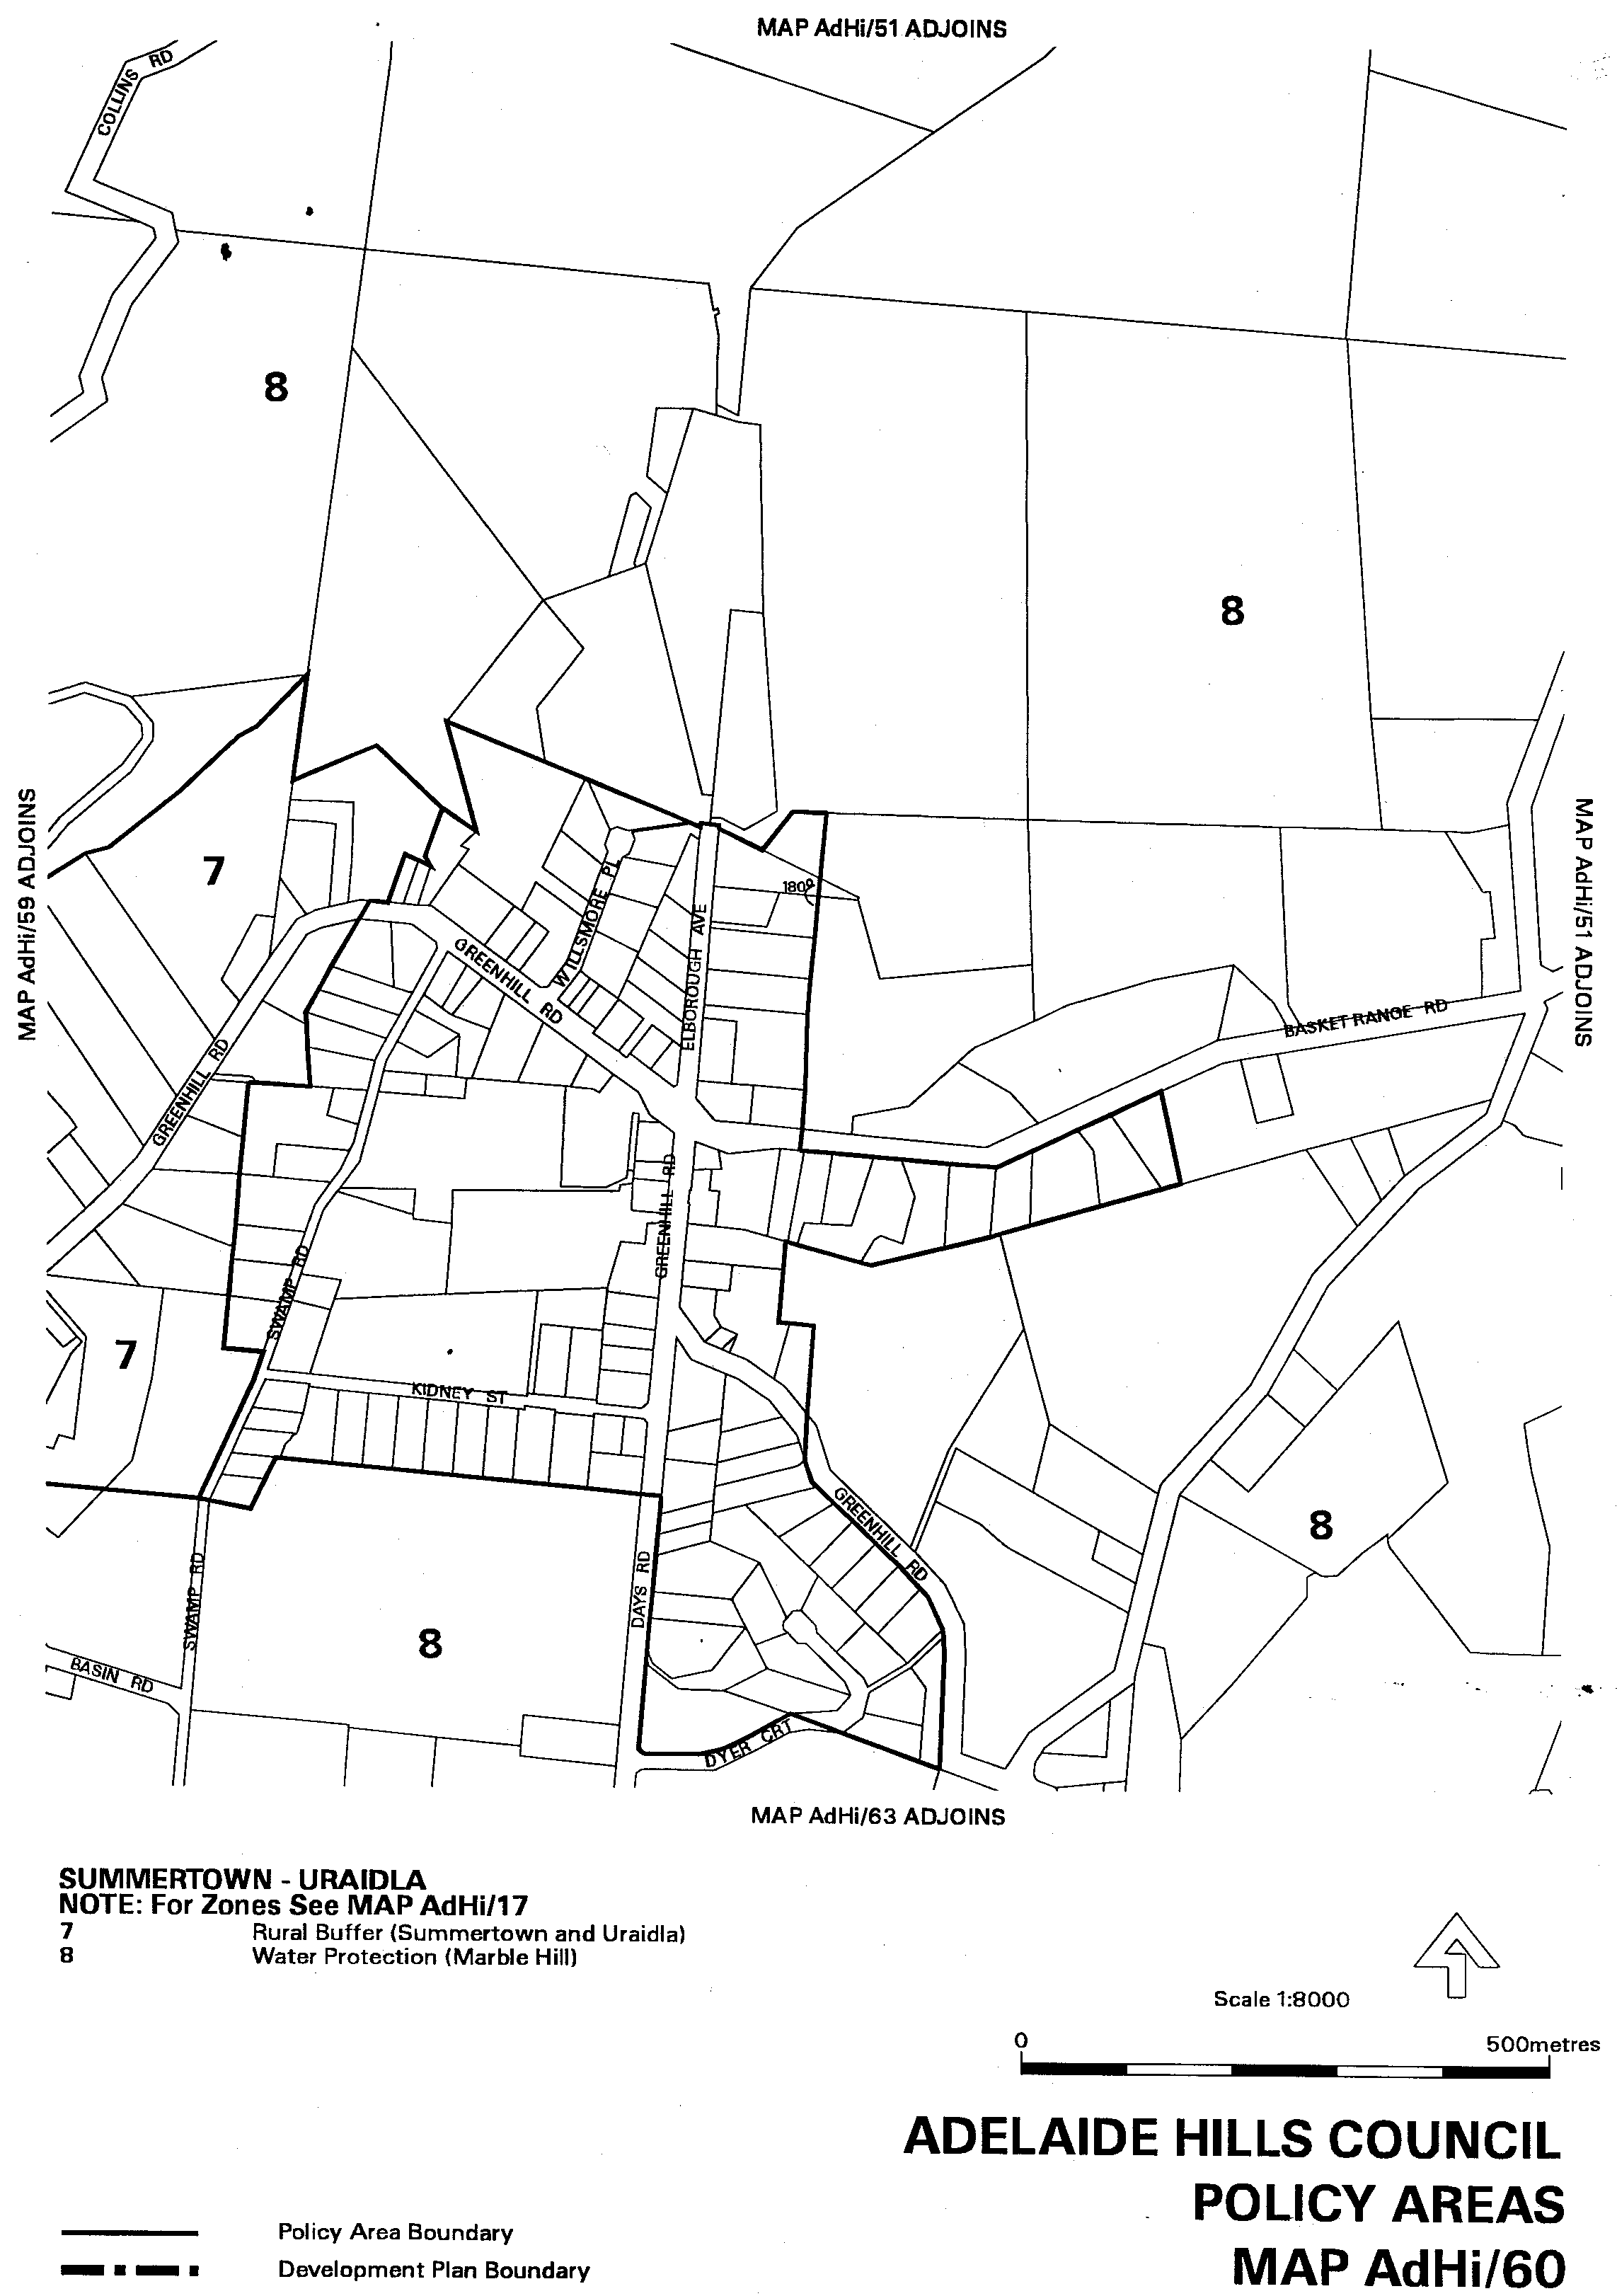
Attachment B
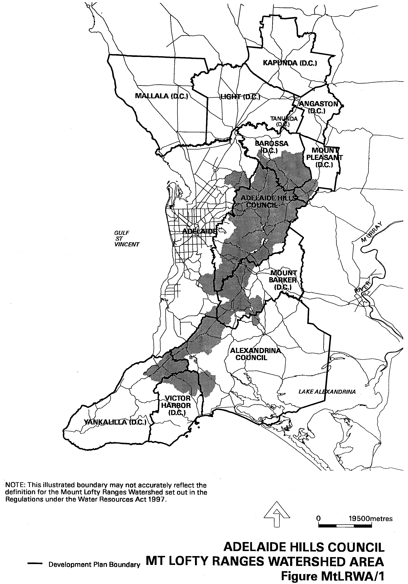
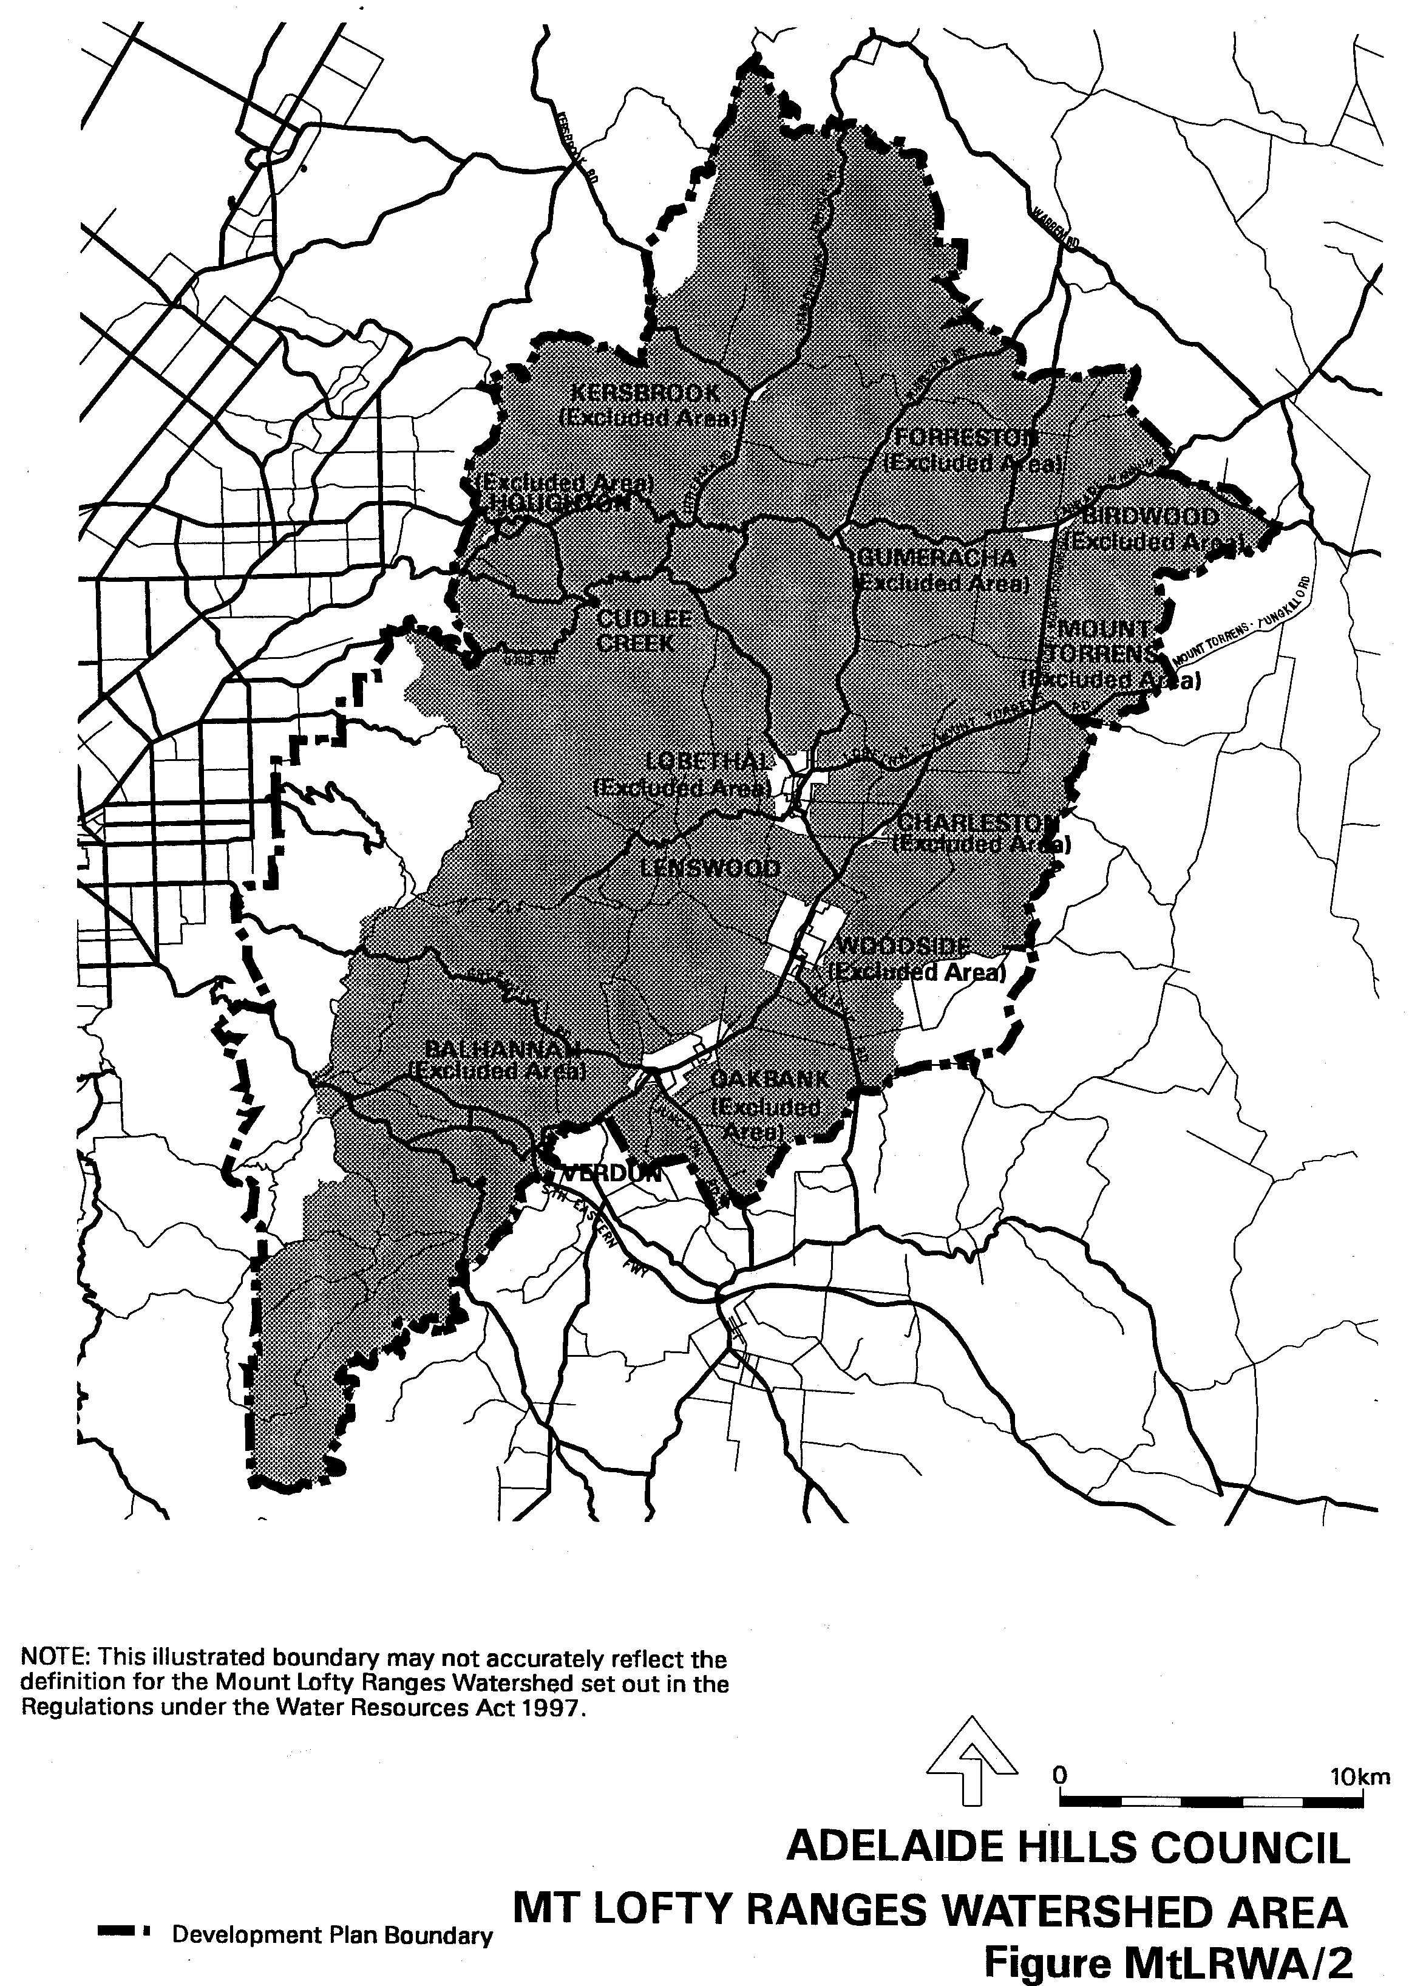

Dated 8 June 2000.
Diana Laidlaw, Minister for Transport and Urban Planning

DEVELOPMENT ACT 1993, SECTION 29 (2) (b): AMENDMENT TO THE UNLEY (CITY) DEVELOPMENT PLAN
Preamble
It is necessary to update the maps and associated cross-referencing, to ensure consistency in the map numbering and standards, within the Unley (City) Development Plan dated 13 January 2000.
Notice
PURSUANT to section 29 (2) of the Development Act 1993, I, Diana Laidlaw, being the Minister administering the Act, amend The Unley (City) Development Plan dated 13 January 2000, as follows:
(a) Delete Maps Un/2, 3, 4, 6, 7, 8, 9, 10, 11 and 12;
(b) Insert Maps Un/2, 3, 4, 6, 7, 8, 9, 10, 11 and 12 as contained in Attachment ‘A’; and
(c) Amend the associated cross-references throughout the text accordingly.
Attachment A
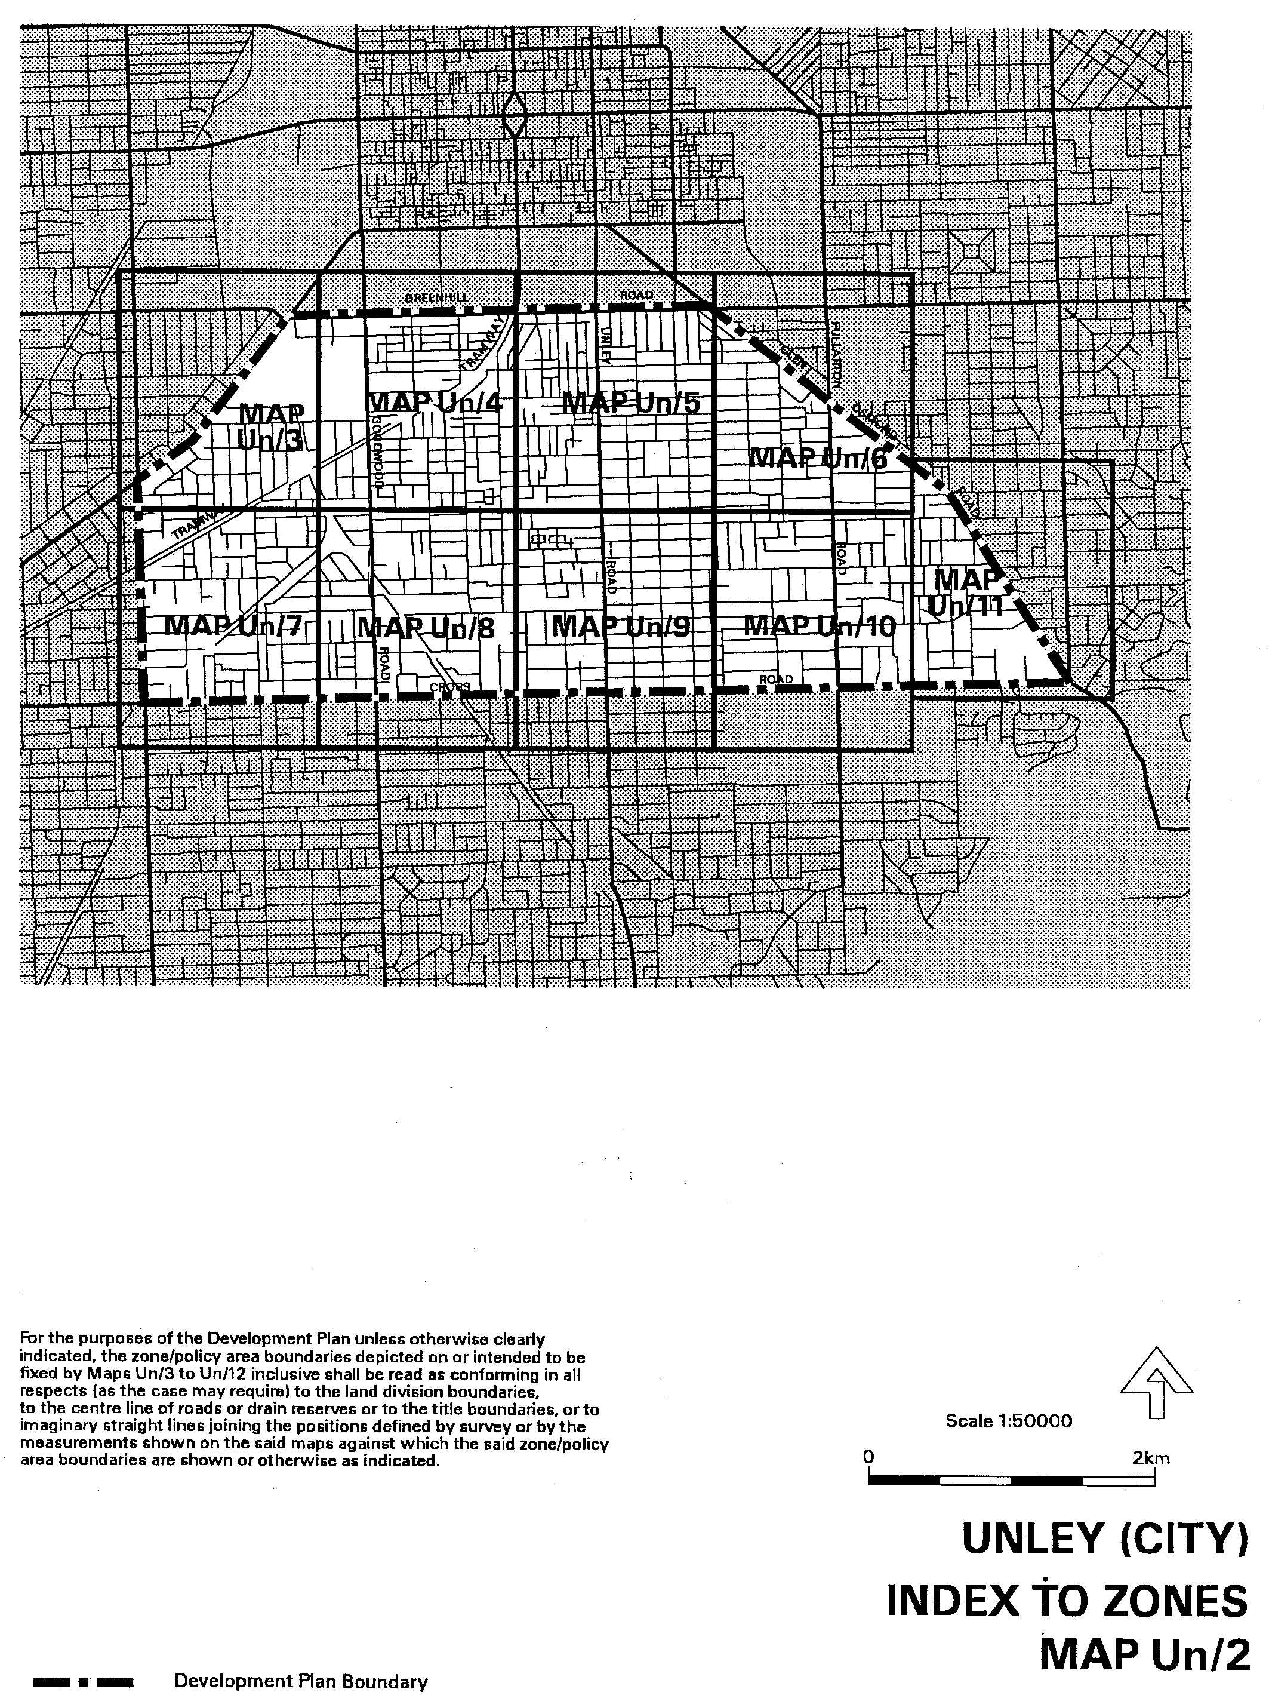
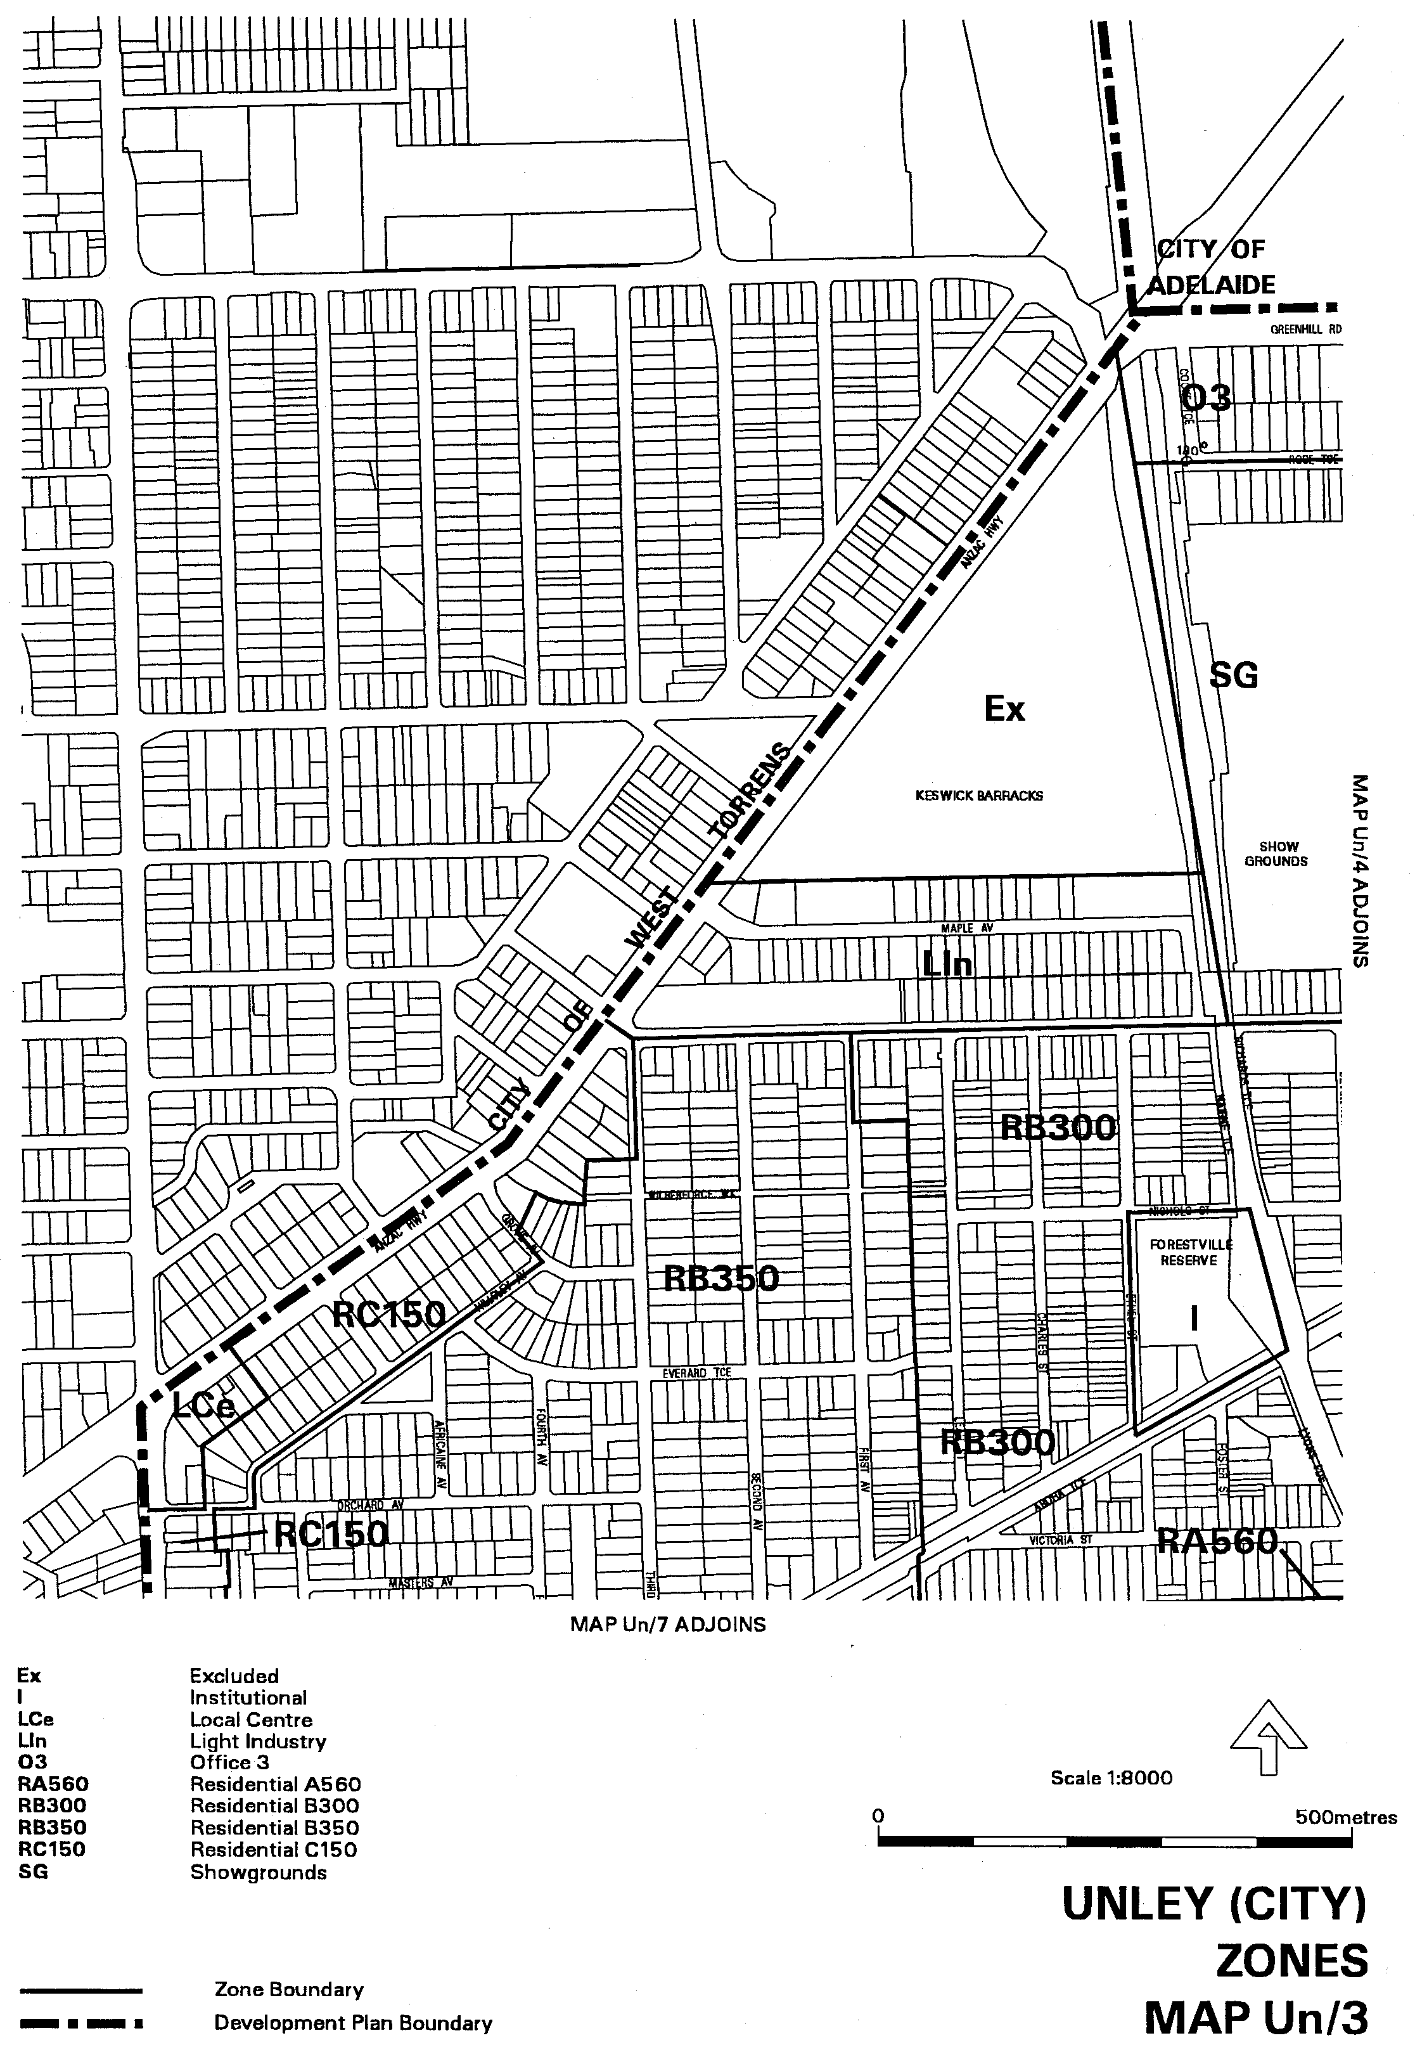
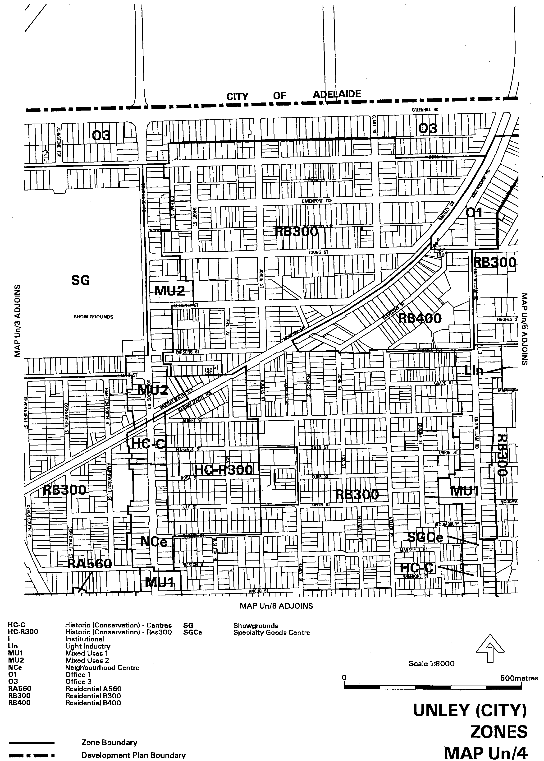
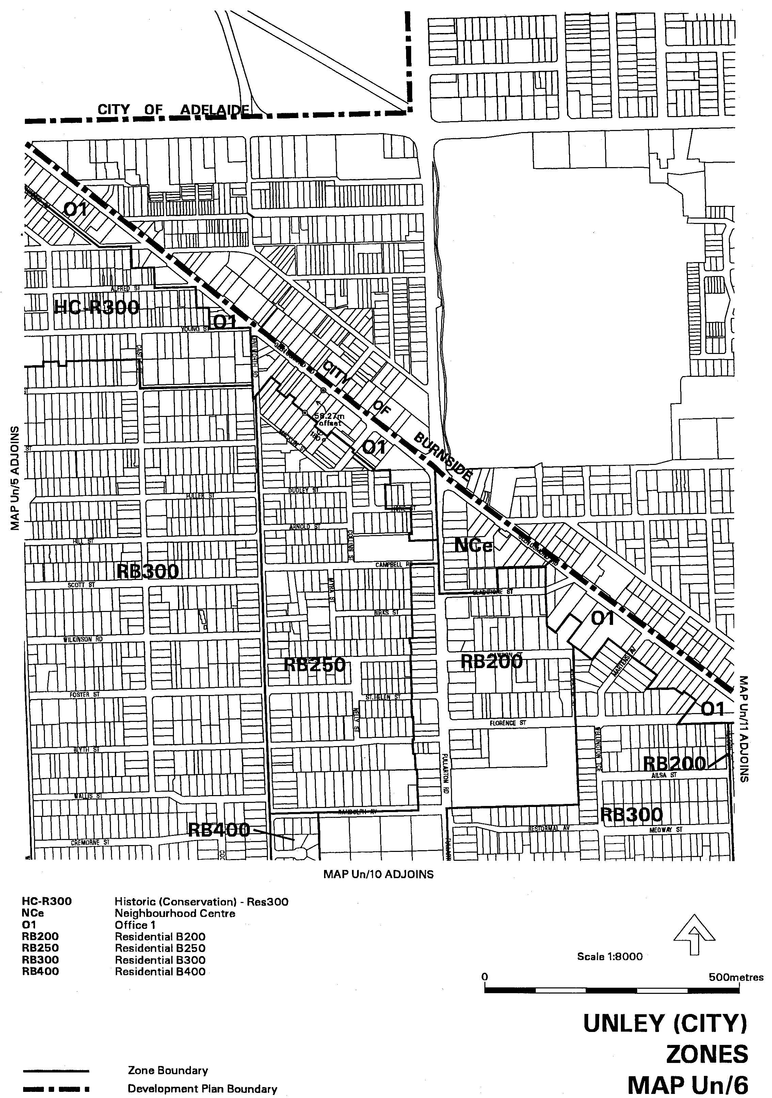
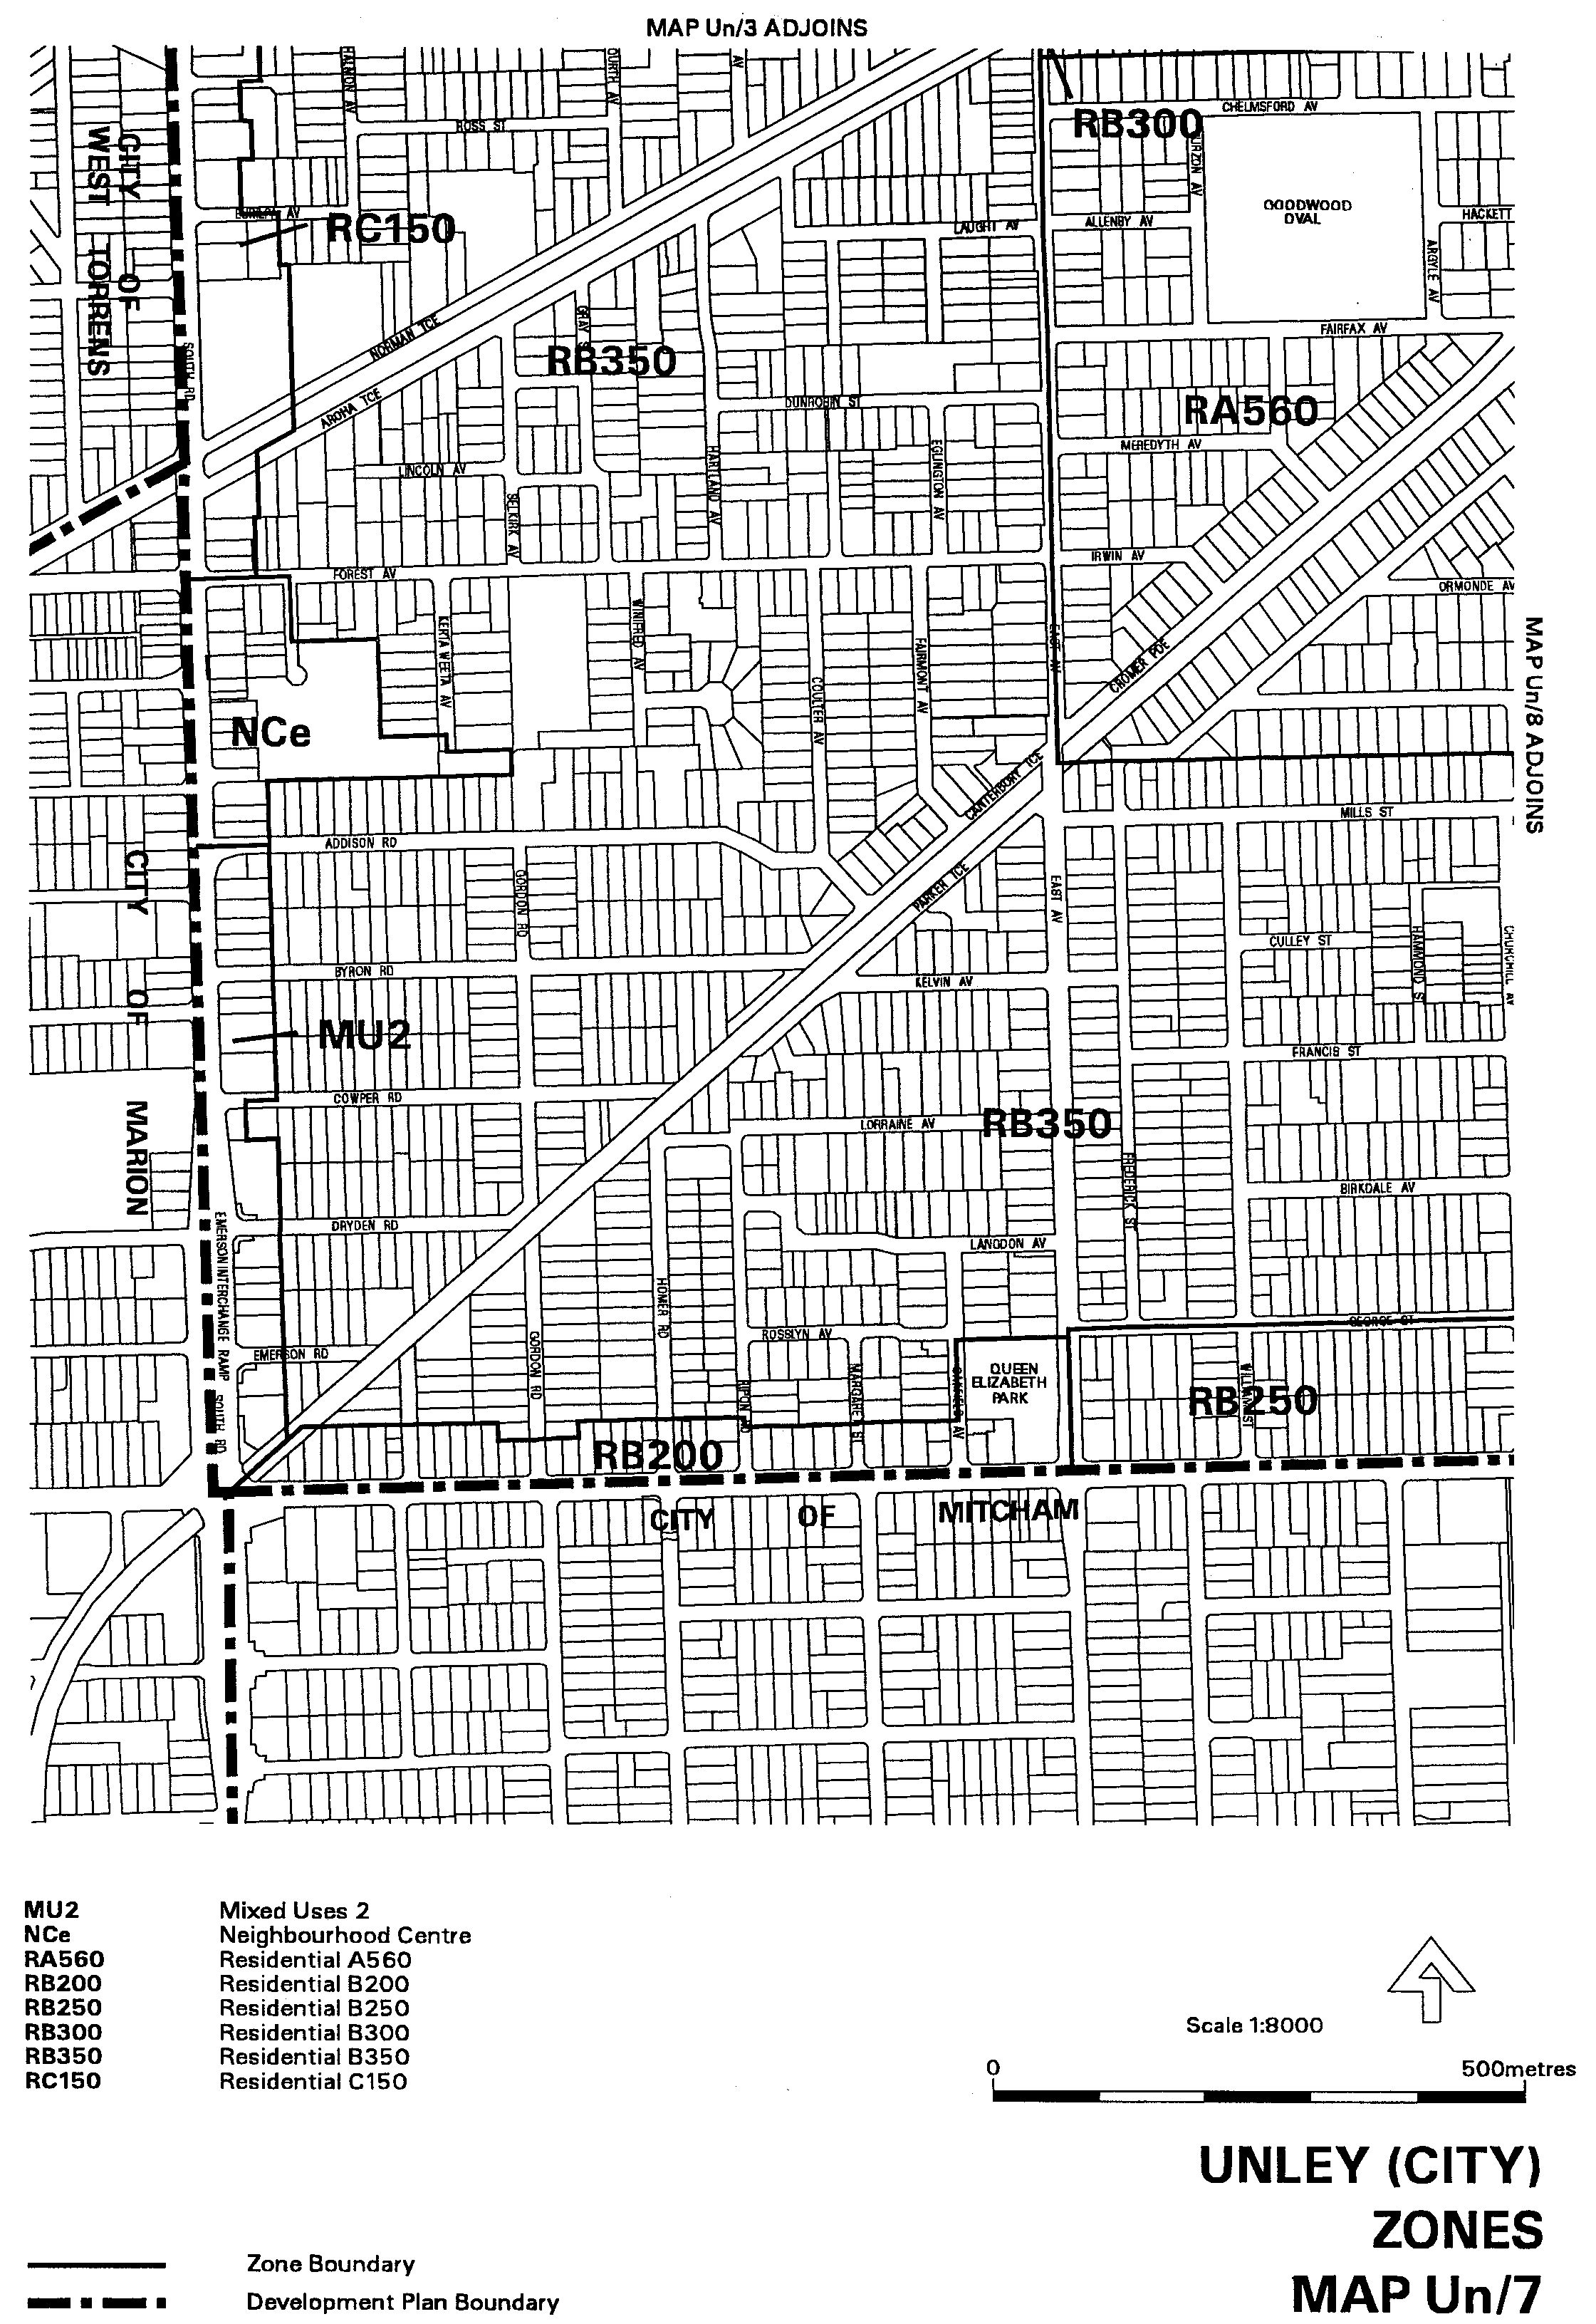
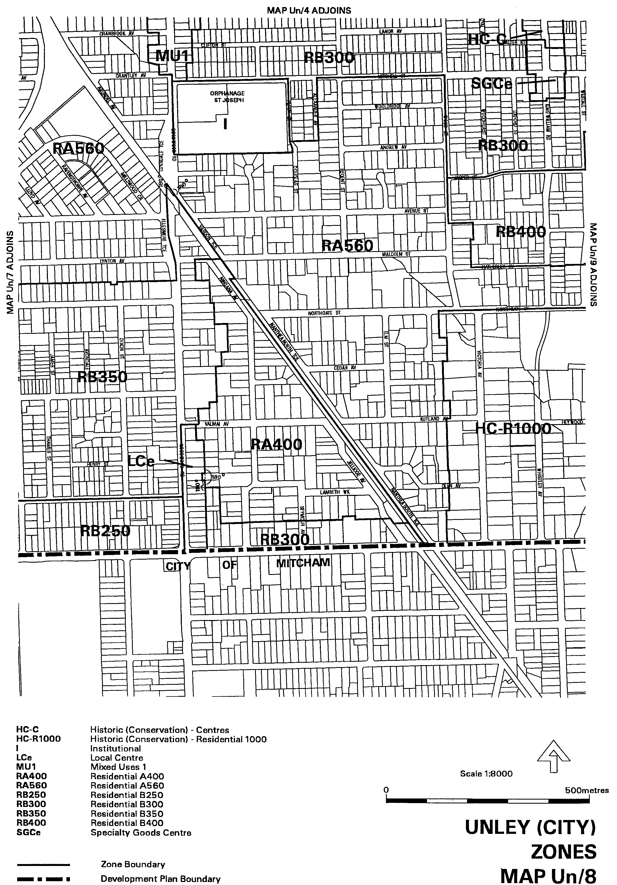
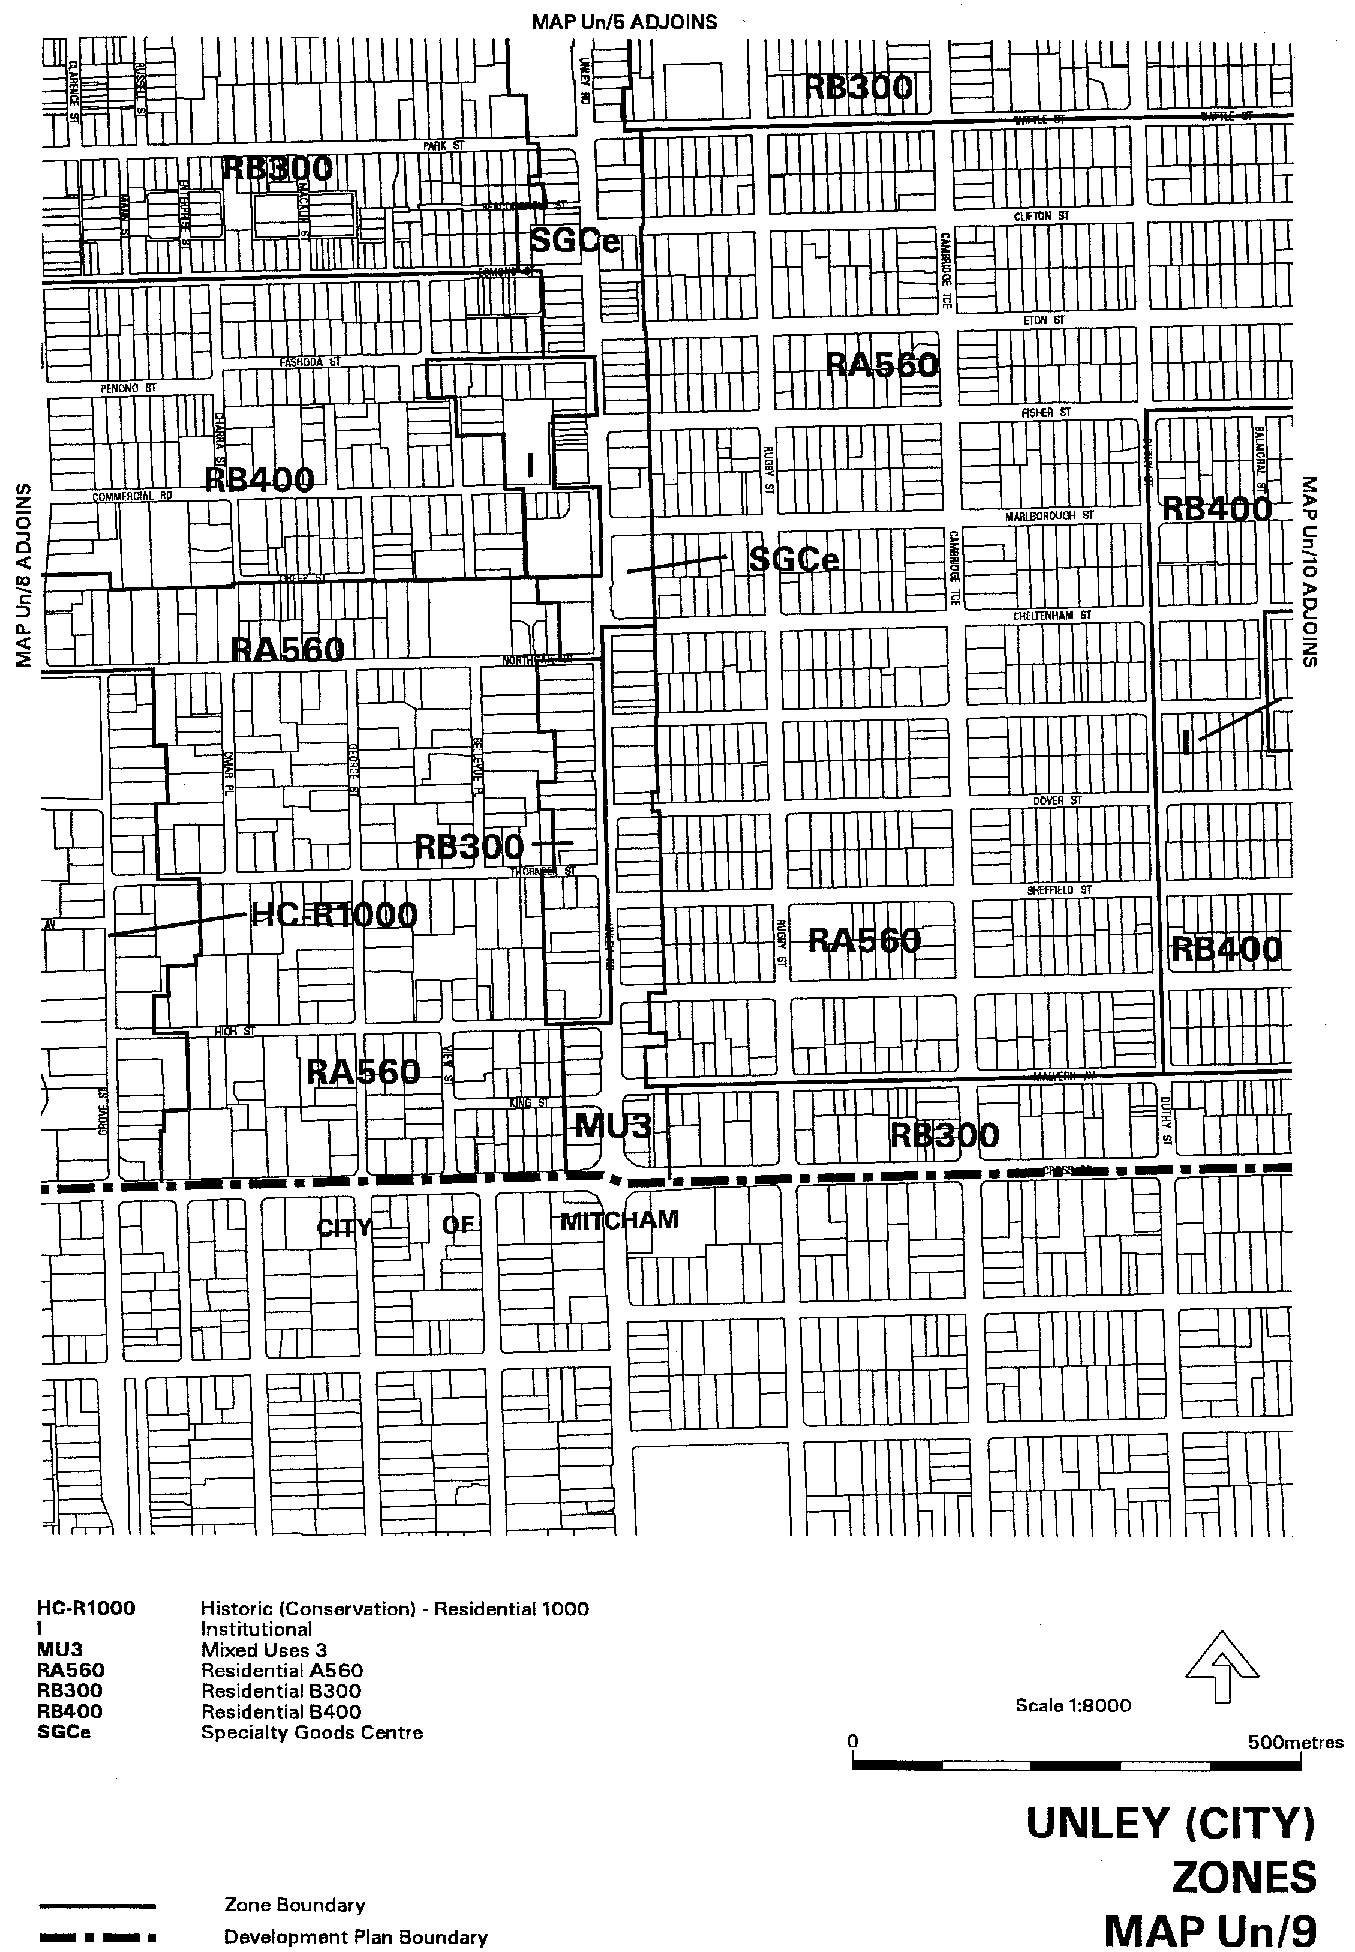
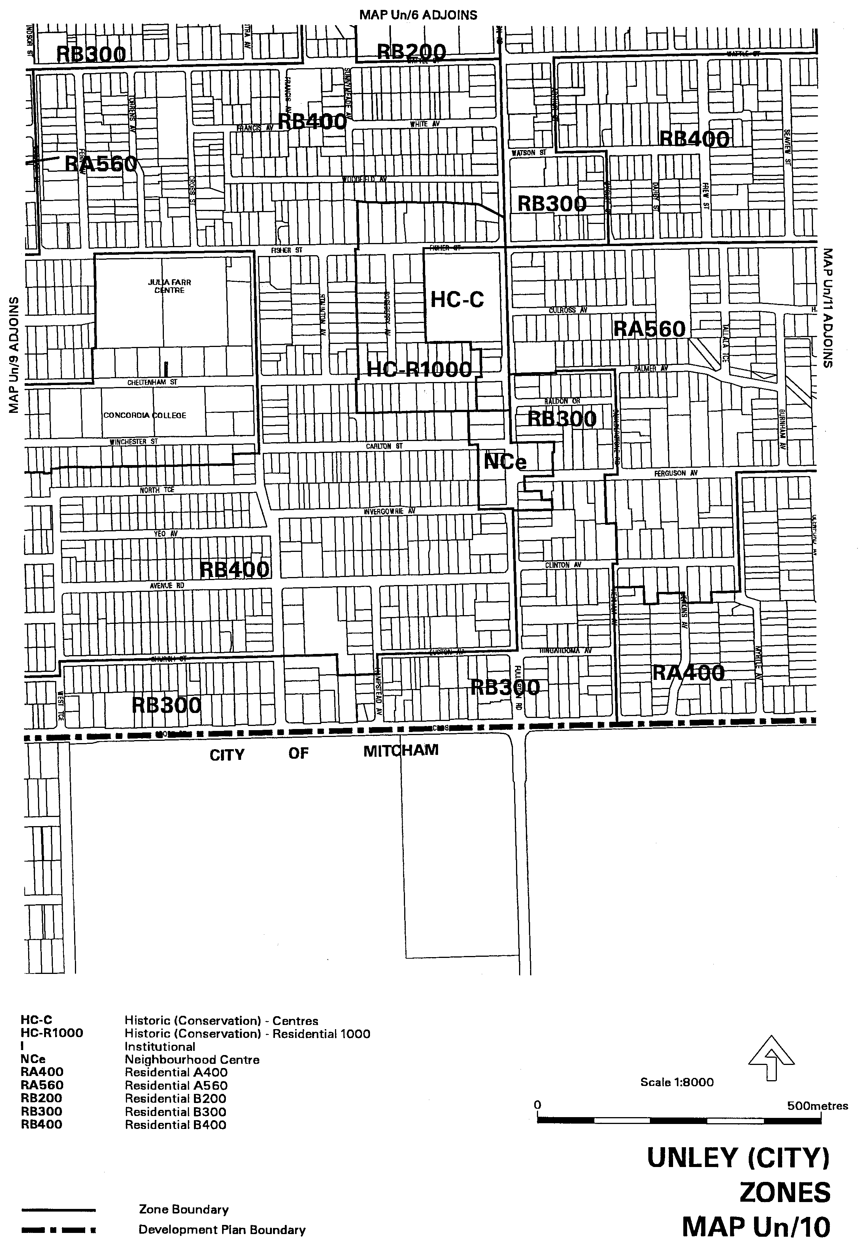
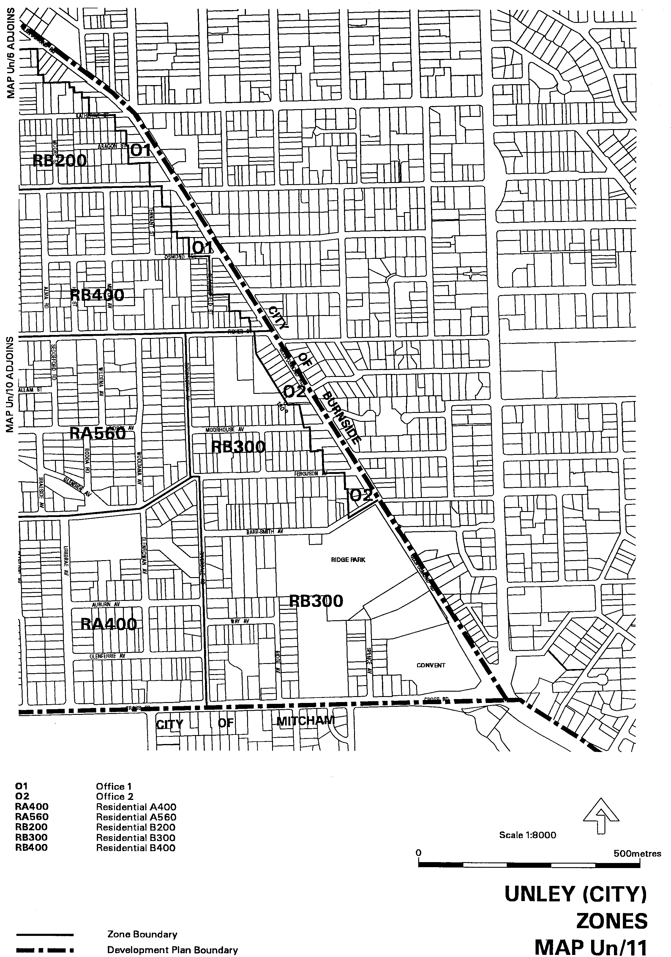
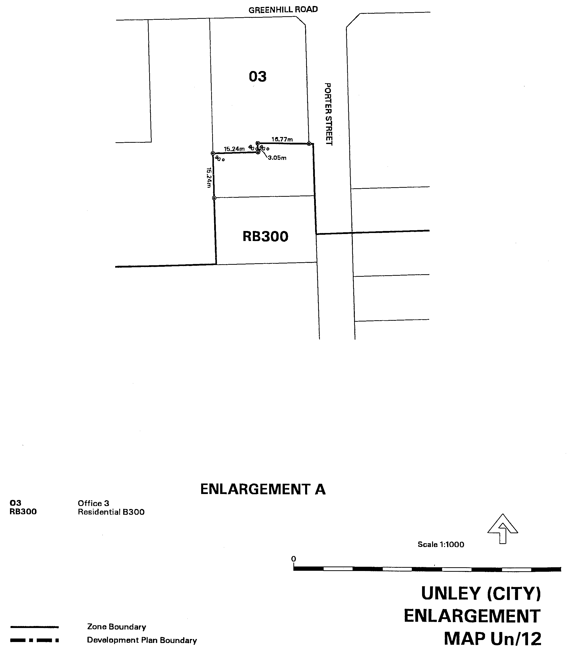

Dated 8 June 2000.
Diana Laidlaw, Minister for Transport and Urban Planning

GOLDEN GROVE (INDENTURE RATIFICATION) ACT 1984: SECTION 4A.3(a), GOLDEN GROVE—ZONING VARIATION VIII PLAN AMENDMENT
Preamble
The Minister for Government Enterprises, pursuant to section 16 (15) of the Statutes Repeal and Amendment (Development) Act 1993 and the Minister for Transport and Urban Planning, pursuant to the Development Act 1993 have approved the amendment entitled ‘Golden Grove—Zoning Variation VIII Plan Amendment’.
Notice
PURSUANT to section 27 (1) of the Development Act 1993, I, the Governor with the advice and consent of the Executive Council, declare the Plan Amendment to be an authorised Plan Amendment and fix 8 June 2000 as the day on which it will come into operation.
Dated 8 June 2000.
E. J. Neal Governor
MTUP-PL 27/00CS

FISHERIES ACT 1982
Marine Mollusc Farming Licence FM00070
(Previous Licence No. F731)
Licence to Farm Fish under section 53 of the Fisheries
Act 1982
WHEREAS the Director of Fisheries has, pursuant to section 50 (2) of the Fisheries Act 1982 (‘the Act’), issued a permit to the undermentioned licensee to release the fish specified in Item 1 of Schedule 2 of this licence (‘the permitted species’), the Minister for Primary Industries, (‘the Minister’) hereby grants to:
John Patrick and Wendy Joy Pedler
Section 120,
Hundred of Wallanippie,
Smoky Bay, S.A. 5680,
a non-exclusive licence to occupy and use the waters specified in Item 1 of Schedule 1 of this licence (‘the site’) for the purpose of farming and taking the permitted species (‘the permitted use’) for the period commencing on 1 April 2000 and ending, subject to any earlier termination under this licence, on 30 June 2000 (‘the term’) subject to the following terms and conditions:
Conditions of This Licence
1. Licence
The parties acknowledge and agree that:
1.1 the rights, powers and privileges granted to or vested in the licensee under this licence are contractual only and shall not create or vest in the licensee any estate, interest or right of a proprietary nature in the site; and
1.2 that, subject to section 53A of the Fisheries Act 1982, this licence does not entitle the licensee to exclusive rights of entry to and occupation of the site and that the rights granted by this licence are exercisable by the licensee in common with any other occupiers of the site from time to time.
2. Marked-off Areas
For the purposes of section 53A of the Fisheries Act 1982, the marked-off areas within the site is that area or those areas marked-off or indicated in the manner set out in Item 2 of Schedule 1 of this licence.
3. Permitted Species
The licensee:
3.1 must not farm or introduce any species at the site other than the permitted species; and
3.2 must not take any wild fish from the site except for recreational purposes.
4. Permitted Use
The licensee must not use the site for any purpose other than the permitted use.
5. Permitted Methods
The licensee:
5.1 must not stock the permitted species at a rate greater than that specified in Schedule 2 of this licence;
5.2 must not use the anti-fouling chemical tributyltin (TBT) on any equipment used at the site;
5.3 must not use any chemical or drug for either therapeutic or prophylactic purpose except with the prior approval of the Minister;
5.4 must apply the permitted farming methods set out in Item 2 of Schedule 2 of this licence.
6. Marking and Maintaining the Site
The licensee:
6.1 must ensure that the site is maintained in a good, tidy and safe condition to the satisfaction of the Minister;
6.2 must remove and lawfully dispose of any waste or debris on the site as soon as is reasonably practicable and in particular must comply with any guidelines issued from time to time by the Minister in relation to the removal from the site of any unhealthy or dead fish;
6.3 must maintain all buoys, crosses, and markers on the site in good condition and in accordance with the colours specified in Schedule 1 of this licence; and
6.4 must mark the site boundary in accordance with the specifications in Schedule 1 of this licence.
7. Site Inspection and Supervision
The licensee:
7.1 must at all times permit the Minister, his employees, agents or contractors or any employees, agents or contractors of the Crown to enter the site for the purposes of inspecting the site, the sea floor and the flora and fauna on or in the vicinity of the site; and
7.2 must comply with all reasonable directions of any such person authorised by the Director of Fisheries to inspect the conduct of the licensee’s activities at the site.
8. Fees and Returns
The licensee:
8.1 must pay to the Minister the licence fee in accordance with Item l of Schedule 3 of this licence;
8.2 must on or before 31 January and 31 July during the term, submit to the Minister a return supplying all of the information described in Schedule 4 of this licence.
9. Compliance With Relevant Laws
9.1 the licensee must at all times comply with all laws, by-laws or regulations in force which relate to the site or the activities conducted in the site and with all notices, orders or requirements lawfully given or made by any authority or authorities in respect of the site;
9.2 in particular, without derogating from the general requirement under condition 9 of this licence:
9.2.1 the licensee must not do or permit to be done in upon or about the site anything which in the opinion of the Minister would cause or contribute to the degradation or pollution of any coastal land or the surrounding marine environment; and
9.2.2 in the event that the Minister is satisfied, on reasonable grounds, that the fish taken from the waters are not fit for human consumption or that consumption of fish taken from the waters could present a danger to the health of the consumer, the licensee must, in accordance with a written notice from the Minister, cease or suspend the conduct of the permitted use or else conduct the permitted use as directed within the notice.
10. Public Risk Liability
The licensee must at all times indemnify the Minister, his officers, employees, contractors and agents from and against all claims, demands, actions, judgments, proceedings, damages, losses, costs, charges and expenses in respect of any loss of life, personal injury and/or damage to property caused or suffered in any manner in or about the site.
11. Release
The licensee must use and keep the site at the risk in all things of the licensee and the licensee must release to the full extent permitted by law the Minister, his agents, contractors and servants in the absence of any wilful act, omission, default or neglect on their part from all claims and demands of every kind resulting from any accident damage or injury to persons or property occurring at the site, including loss or damage to the licensee’s fixtures or personal property of the licensee.
12. Public Risk Insurance
The licensee shall at its own cost and expense during the term effect and keep in full force and effect in respect of the site and the permitted use a policy of public risk insurance in the joint names of the licensee and the Minister in which the limits of public risk shall not be less than the amount specified in Item 2 of Schedule 3 of this licence, or such further amount as the Minister may from time to time reasonably require, as the amount which may be paid out in respect of any one single claim and a policy of insurance or copy thereof or a certificate of insurance shall be produced by the licensee to the Minister on request in writing being made by the Minister for its production.
13. Guarantee or Indemnity Scheme
The licensee must either:
13.1 provide a guarantee from its bankers; or
13.2 contribute to an indemnity scheme established for the aquaculture and fisheries industry and approved by the Minister,
to and in favour of and for the benefit of the Minister by way of security for the due and punctual performance by the licensee of the terms and conditions of this licence and in particular the obligations of the licensee to rehabilitate the site immediately prior to the expiration or sooner determination of the term of this licence. Such guarantee or indemnity scheme must have effect from the date of commencement of the term.
14. No Assignment
The licensee acknowledges that this licence is personal and it must not assign or sublet or deal in any other way with any interest in this licence.
15. Default by Licensee and Termination
The Minister may terminate this licence immediately by notice in writing served on the licensee if:
15.1 the licensee commits or permits any breach or default of the obligations imposed on the licensee by this licence, and following the giving by the Minister of written notice of such breach or default, the licensee either fails to rectify such breach or default within one calendar month of the date of such notice (or earlier if the circumstances require) or fails to make diligent progress towards rectifying any such breach which is incapable of rectification within the time so limited; or
15.2 the licensee commits or permits any further breach or default of the obligations imposed on the licensee by this licence for which the Minister has previously given notice in writing of such breach or default pursuant to paragraph 1 of condition 15.1 notwith-standing rectification of the previous breach or default; or
15.3 the licence fee referred to in condition 8 is unpaid for a period of 14 days after notice has been given to the licensee that it is outstanding; or
15.4 if the licensee is a body corporate, any of the following occur:
15.4.1 the licensee is unable to pay its debts as and when they fall due or is otherwise insolvent;
15.4.2 an order is made for the winding up or liquidation of the licensee;
15.4.3 the licensee enters into a scheme of arrangement, compromise, moratorium or other form of composition with its creditors or any class of its creditors;
15.4.4 a receiver, a manager or a receiver and manager, a company administrator or other insolvency administrator is appointed to the licensee; or
15.4.5 a mortgagee, chargee or other encum-brancee is appointed over or takes possession of or appoints an agent to take possession of all or any of the licensee’s assets; or
15.5 if the licensee is an individual, the licensee:
15.5.1 becomes bankrupt or assigns its estate or enters into a deed of arrangement or other form of composition for the benefit of the licensee’s creditors; or
15.5.2 is convicted of an indictable offence.
Termination of this licence by the Minister shall be without prejudice to any rights, remedies or actions that the Minister may have against the licensee in respect of any antecedent breach by the licensee of the terms and conditions contained in this licence.
16. Interpretation
Subject to any inconsistency of subject or context, the following rules of construction shall be used in the interpretation of this licence:
16.1 any word importing the plural includes the singular and vice versa;
16.2 any wording importing a gender shall include all other genders;
16.3 a reference to a body corporate shall include a natural person and vice versa;
16.4 a reference to a recital, party, clause, Schedule or Annexure is a reference to a recital, party, clause, Schedule or Annexure of this licence;
16.5 the captions, headings, section numbers and clause numbers appearing in this licence are inserted only as a matter of convenience and in no way affect the construction of this licence;
16.6 a reference to a statute shall include all statutes amending, consolidating or replacing the statutes referred to;
16.7 where two or more persons are named as licensees, this licence shall bind the licensees jointly and each of them severally; and
16.8 time is of the essence in respect of any obligation relating to time in this licence.
17. Delegation
Any consent, notice, any consultation or any other thing which is pursuant to the terms of this licence either required to be given, done or performed or which may be given, done or performed by the Minister may for the purposes of this licence be properly given, done or performed by any duly authorised agent or employee of the Minister.
18. Severance
If any term or condition of this licence should be for any reason unlawful, void, invalid or unenforceable then the offending term or condition shall be severed from this licence without affecting the validity or enforceability of the remainder of this licence.
19. Modification
No variation of or addition to any provision of this licence shall be binding upon the Minister and the licensee unless such variation or addition is made in writing, signed by both the Minister and the licensee and expressed to be either supplemental to or in substitution for the whole or a part of this licence.
20. Waiver
20.1 A waiver of any provision of this licence by the Minister must both be in writing and be signed by the Minister or by persons duly authorised to execute such a document on the Minister’s part.
20.2 No waiver by the Minister of a breach of a term or condition contained in this licence shall operate as a waiver of any breach of the same or any other term or condition contained in this licence.
20.3 No forbearance, delay or indulgence by the Minister in enforcing the provisions of this licence shall prejudice or restrict the rights of the Minister.
21. Notices
21.1 Notices may be served by delivering the same personally, by mail or facsimile transmission and shall be:
21.1.1 in writing addressed to the Director of Fisheries, PIRSA, 16th Floor, 25 Grenfell Street, Adelaide, S.A. 5000 (in the case of the Minister) and to the address of the licensee set out above (in the case of the licensee);
21.1.2 signed by or on behalf of the sender or by a person duly authorised in that regard by the sender;
21.1.3 deemed to be duly served or made in the following circumstances:
(a) if delivered, upon delivery;
(b) if sending by mail, upon posting;
(c) if sent by facsimile transmission, upon the sender’s facsimile producing a transmission report that the facsimile was satisfactorily sent in its entirety to the addressee’s facsimile number,
but if delivery is not made before 5 p.m. on any day it shall be deemed to be received at 9 a.m. on the next day in that place.
21.2 The Minister and the licensee may each vary their address or facsimile number at any time by written notice.
Granted by the General Manager Aquaculture, delegate of the Minister, on 25 May 2000.
I. Nightingale, General Manager Aquaculture
The licensee hereby acknowledges and agrees to the terms and conditions of this licence.
Signed by the said John P. Pedler
Wendy J. Pedler
In the presence of: Graham John Milton, Witness
Schedule 1
Item 1—The Site
Area applicable to this licence:
Licensed Area Licensed
Hectares
AGD 66—Zone 53
394677E 6417060N 7
394647E 6416637N
394811E 6416625N
394842E 6417049N
All structures, equipment, buoys and flotations (except for that required by the Department for Transport, Urban Planning and the Arts) must be black, dark grey, dark blue, dark brown, or dark green coloured materials.
The boundary of the site to be marked either with:
(a) (1) At the corners with posts extending 900 mm above mean high water springs. Such posts to be marked with a St Andrews cross, each cross arm measuring 900 mm from tip to tip, minimum width 75 mm.
(2) Posts to be not less than 125 mm in diameter.
(3) Posts and crosses to be painted yellow.
(4) The ends of each cross to be marked with a 200 mm strip of yellow retro-reflective tape.
(5) Between the corner posts at intervals not exceeding 50 m, buoys not less than 300 mm in diameter.
(6) All buoys, posts, crosses and markers must be maintained in good condition.
or
(b) (1) At each corner, yellow spar buoys with a St Andrews cross as a top mark placed at least 900 mm above the buoy, cross arms 900 mm long x 75 mm wide.
(2) The buoys and topmarks must all be coloured yellow and marked with a yellow retro-reflective as in (a) (4).
(3) All buoys, posts, crosses and markers must be maintained in good condition.
When the site is in navigable water and possible danger to navigation, lights must be placed on the top of each St Andrews cross that is located at each corner of the site and these lights must be yellow in colour and flashing once every 4 seconds and visible over an arc of 360 degrees for a distance of at least one mile.
Item 2—Marked-Off Areas
[Co-ordinates of developed areas within the site to be provided by the licensee.]
White buoys of at least 12 inches in diameter must be placed around the whole of the perimeter of the developed areas within the site at a distance of no less than 50 m from one another.
Schedule 2
Item 1—Permitted Species
The Director of Fisheries has, pursuant to section 50 (2) of the Act, issued a permit for the release of the fish specified in this Schedule.
Pacific Oysters (Crassostrea gigas)
Item 2—Permitted Farming Methods
Longlines
Each unit must not exceed 100 m in length and 2 m in width, and each unit must be at least 6 m from any other unit.
Item 3—Stocking Rates
Oysters
Size (mm) Number per Hectare
3 2 500 000
10 1 600 000
20 1 100 000
30 750 000
40 500 000
50 350 000
60 200 000
70 150 000
80 100 000
Schedule 3
Item 1—Fees
Annual licence fees are:
$
FRDC levy per hectare, (9 months at 9 ha and 3
months at 7 ha) at $12.50 each 106.24
EMP fee per hectare (9 months at 9 ha and 3 months
at 7 ha) at $22.96 each 195.16
Base Licence Fee per hectare, (9 months at 9 ha and
3 months at 7 ha) at $57 each 484.52
SASQAP (Classified Area) per hectare, (9 months
at 9 ha and 3 months at 7 ha) at $60 each 510.00
Total Annual Licence Fee 1 295.92
Quarterly instalments 323.98
Item 2—Public Risk Insurance
Five million dollars ($5 000 000).
Schedule 4
Returns
The licensee must submit the following information to the Minister, c/o Director of Fisheries, PIRSA, 16th Floor, 25 Grenfell Street, Adelaide, S.A. 5000 on or before 31 January and 31 July during the term of this licence:
1. Name of licensee.
2. Address of licensee.
3. Species of fish farmed and held on the site.
4. Location of aquaculture operation.
5. Period covered by return.
6. Number of life stage of each species of fish held.
7. Number, weight and value of each species of fish held.
8. Details of any disease detected in any fish kept.
9. Source (whether interstate or intrastate) of any stock acquired and date of acquisition (if relevant, include name of authority that provided certification that stock was free from disease).
10. If any fish were brought into the state, the number of fish and the life stage of the fish.
11. If fish were brought into the state, the purpose for which they were brought in.
12. Method of disposal of water and packaging use for transporting the fish.
13. If any disease or symptom of disease occurred in the acquired fish.
14. Method of disposal of diseased or dead fish and the number disposed of.
15. Signature, date and telephone number.
16. Use of any chemicals for fish husbandry—type of chemical and quantity used, purpose and date of use.

FISHERIES ACT 1982: SECTION 50 (2)
TAKE notice that pursuant to section 50 (2) of the Fisheries Act 1982, I hereby authorise John Patrick and Wendy Joy Pedler, Section 120, Hundred of Wallanippie, Smoky Bay, S.A. 5680 (hereinafter referred to as ‘the permit holder’) to engage in the activities and to do the acts specified in Schedule 1, subject to the conditions specified in Schedule 2 from the date of this permit and ending upon the expiration or earlier termination of Licence No. FM00070.
Schedule 1
The importation and release of Pacific Oysters, (Crassostrea gigas), within the water defined by the following co-ordinates:
Licensed Area Licensed
Hectares
AGD 66—Zone 53
394677E 6417060N 7
394647E 6416637N
394811E 6416625N
394842E 6417049N
Schedule 2
1. Fish obtained within South Australia for use in the fish farm shall only be obtained from registered fish farmers, licensed fishers or other persons approved by the Director of Fisheries.
2. The permit holder shall not import any live fish (ova, fry or adult) into South Australia unless the shipment has certification from an appropriate authority in the State from which they are obtained that they are free from all relevant notifiable diseases listed in Schedule 4 of the Fisheries (Exotic Fish, Fish Farming and Fish Diseases) Regulations 1984.
3. Any oysters brought into South Australia must undergo a soakage process whereby they are completely submerged in fresh water for a period of not less than two hours before being placed in the approved structures. Fresh water is deemed to be water suitable for human consumption or horticultural and agricultural use.
4. The permit holder shall not contravene or fail to comply with the Fisheries Act 1982, or any regulations made under the Act, except where specifically permitted by this notice.
5. The permit holder must retain the copy of this permit which has been supplied by the Director of Fisheries, and if requested by a Fisheries and Aquaculture Officer, produce that permit for inspection.
Dated 8 May 2000.
I. Nightingale, General Manager Aquaculture, as the delegate of the Director of Fisheries

FISHERIES ACT 1982
Marine Mollusc Farming Licence FM00101
(Previous Licence No. F777)
Licence to Farm Fish under section 53 of the Fisheries
Act 1982
WHEREAS the Director of Fisheries has, pursuant to section 50 (2) of the Fisheries Act 1982 (‘the Act’), issued a permit to the undermentioned licensee to release the fish specified in Item 1 of Schedule 2 of this licence (‘the permitted species’), the Minister for Primary Industries, (‘the Minister’) hereby grants to:
Marco S. Breede (18380)
Leanne J. Breede (19807)
3 Crocker Court,
Smoky Bay, S.A. 5680,
a non-exclusive licence to occupy and use the waters specified in Item 1 of Schedule 1 of this licence (‘the site’) for the purpose of farming and taking the permitted species (‘the permitted use’) for the period commencing on 1 April 2000 and ending, subject to any earlier termination under this licence, on 30 June 2000 (‘the term’) subject to the following terms and conditions:
Conditions of This Licence
1. Licence
The parties acknowledge and agree that:
1.1 the rights, powers and privileges granted to or vested in the licensee under this licence are contractual only and shall not create or vest in the licensee any estate, interest or right of a proprietary nature in the site; and
1.2 that, subject to section 53A of the Fisheries Act 1982, this licence does not entitle the licensee to exclusive rights of entry to and occupation of the site and that the rights granted by this licence are exercisable by the licensee in common with any other occupiers of the site from time to time.
2. Marked-off Areas
For the purposes of section 53A of the Fisheries Act 1982, the marked-off areas within the site is that area or those areas marked-off or indicated in the manner set out in Item 2 of Schedule 1 of this licence.
3. Permitted Species
The licensee:
3.1 must not farm or introduce any species at the site other than the permitted species; and
3.2 must not take any wild fish from the site except for recreational purposes.
4. Permitted Use
The licensee must not use the site for any purpose other than the permitted use.
5. Permitted Methods
The licensee:
5.1 must not stock the permitted species at a rate greater than that specified in Schedule 2 of this licence;
5.2 must not use the anti-fouling chemical tributyltin (TBT) on any equipment used at the site;
5.3 must not use any chemical or drug for either therapeutic or prophylactic purpose except with the prior approval of the Minister;
5.4 must apply the permitted farming methods set out in Item 2 of Schedule 2 of this licence.
6. Marking and Maintaining the Site
The licensee:
6.1 must ensure that the site is maintained in a good, tidy and safe condition to the satisfaction of the Minister;
6.2 must remove and lawfully dispose of any waste or debris on the site as soon as is reasonably practicable and in particular must comply with any guidelines issued from time to time by the Minister in relation to the removal from the site of any unhealthy or dead fish;
6.3 must maintain all buoys, crosses, and markers on the site in good condition and in accordance with the colours specified in Schedule 1 of this licence; and
6.4 must mark the site boundary in accordance with the specifications in Schedule 1 of this licence.
7. Site Inspection and Supervision
The licensee:
7.1 must at all times permit the Minister, his employees, agents or contractors or any employees, agents or contractors of the Crown to enter the site for the purposes of inspecting the site, the sea floor and the flora and fauna on or in the vicinity of the site; and
7.2 must comply with all reasonable directions of any such person authorised by the Director of Fisheries to inspect the conduct of the licensee’s activities at the site.
8. Fees and Returns
The licensee:
8.1 must pay to the Minister the licence fee in accordance with Item l of Schedule 3 of this licence;
8.2 must on or before 31 January and 31 July during the term, submit to the Minister a return supplying all of the information described in Schedule 4 of this licence.
9. Compliance With Relevant Laws
9.1 the licensee must at all times comply with all laws, by-laws or regulations in force which relate to the site or the activities conducted in the site and with all notices, orders or requirements lawfully given or made by any authority or authorities in respect of the site;
9.2 in particular, without derogating from the general requirement under condition 9 of this licence:
9.2.1 the licensee must not do or permit to be done in upon or about the site anything which in the opinion of the Minister would cause or contribute to the degradation or pollution of any coastal land or the surrounding marine environment; and
9.2.2 in the event that the Minister is satisfied, on reasonable grounds, that the fish taken from the waters are not fit for human consumption or that consumption of fish taken from the waters could present a danger to the health of the consumer, the licensee must, in accordance with a written notice from the Minister, cease or suspend the conduct of the permitted use or else conduct the permitted use as directed within the notice.
10. Public Risk Liability
The licensee must at all times indemnify the Minister, his officers, employees, contractors and agents from and against all claims, demands, actions, judgments, proceedings, damages, losses, costs, charges and expenses in respect of any loss of life, personal injury and/or damage to property caused or suffered in any manner in or about the site.
11. Release
The licensee must use and keep the site at the risk in all things of the licensee and the licensee must release to the full extent permitted by law the Minister, his agents, contractors and servants in the absence of any wilful act, omission, default or neglect on their part from all claims and demands of every kind resulting from any accident damage or injury to persons or property occurring at the site, including loss or damage to the licensee’s fixtures or personal property of the licensee.
12. Public Risk Insurance
The licensee shall at its own cost and expense during the term effect and keep in full force and effect in respect of the site and the permitted use a policy of public risk insurance in the joint names of the licensee and the Minister in which the limits of public risk shall not be less than the amount specified in Item 2 of Schedule 3 of this licence, or such further amount as the Minister may from time to time reasonably require, as the amount which may be paid out in respect of any one single claim and a policy of insurance or copy thereof or a certificate of insurance shall be produced by the licensee to the Minister on request in writing being made by the Minister for its production.
13. Guarantee or Indemnity Scheme
The licensee must either:
13.1 provide a guarantee from its bankers; or
13.2 contribute to an indemnity scheme established for the aquaculture and fisheries industry and approved by the Minister,
to and in favour of and for the benefit of the Minister by way of security for the due and punctual performance by the licensee of the terms and conditions of this licence and in particular the obligations of the licensee to rehabilitate the site immediately prior to the expiration or sooner determination of the term of this licence. Such guarantee or indemnity scheme must have effect from the date of commencement of the term.
14. No Assignment
The licensee acknowledges that this licence is personal and it must not assign or sublet or deal in any other way with any interest in this licence.
15. Default by Licensee and Termination
The Minister may terminate this licence immediately by notice in writing served on the licensee if:
15.1 the licensee commits or permits any breach or default of the obligations imposed on the licensee by this licence, and following the giving by the Minister of written notice of such breach or default, the licensee either fails to rectify such breach or default within one calendar month of the date of such notice (or earlier if the circumstances require) or fails to make diligent progress towards rectifying any such breach which is incapable of rectification within the time so limited; or
15.2 the licensee commits or permits any further breach or default of the obligations imposed on the licensee by this licence for which the Minister has previously given notice in writing of such breach or default pursuant to paragraph 1 of condition 15.1 notwith-standing rectification of the previous breach or default; or
15.3 the licence fee referred to in condition 8 is unpaid for a period of 14 days after notice has been given to the licensee that it is outstanding; or
15.4 if the licensee is a body corporate, any of the following occur:
15.4.1 the licensee is unable to pay its debts as and when they fall due or is otherwise insolvent;
15.4.2 an order is made for the winding up or liquidation of the licensee;
15.4.3 the licensee enters into a scheme of arrangement, compromise, moratorium or other form of composition with its creditors or any class of its creditors;
15.4.4 a receiver, a manager or a receiver and manager, a company administrator or other insolvency administrator is appointed to the licensee; or
15.4.5 a mortgagee, chargee or other encum-brancee is appointed over or takes possession of or appoints an agent to take possession of all or any of the licensee’s assets; or
15.5 if the licensee is an individual, the licensee:
15.5.1 becomes bankrupt or assigns its estate or enters into a deed of arrangement or other form of composition for the benefit of the licensee’s creditors; or
15.5.2 is convicted of an indictable offence.
Termination of this licence by the Minister shall be without prejudice to any rights, remedies or actions that the Minister may have against the licensee in respect of any antecedent breach by the licensee of the terms and conditions contained in this licence.
16. Interpretation
Subject to any inconsistency of subject or context, the following rules of construction shall be used in the interpretation of this licence:
16.1 any word importing the plural includes the singular and vice versa;
16.2 any wording importing a gender shall include all other genders;
16.3 a reference to a body corporate shall include a natural person and vice versa;
16.4 a reference to a recital, party, clause, Schedule or Annexure is a reference to a recital, party, clause, Schedule or Annexure of this licence;
16.5 the captions, headings, section numbers and clause numbers appearing in this licence are inserted only as a matter of convenience and in no way affect the construction of this licence;
16.6 a reference to a statute shall include all statutes amending, consolidating or replacing the statutes referred to;
16.7 where two or more persons are named as licensees, this licence shall bind the licensees jointly and each of them severally; and
16.8 time is of the essence in respect of any obligation relating to time in this licence.
17. Delegation
Any consent, notice, any consultation or any other thing which is pursuant to the terms of this licence either required to be given, done or performed or which may be given, done or performed by the Minister may for the purposes of this licence be properly given, done or performed by any duly authorised agent or employee of the Minister.
18. Severance
If any term or condition of this licence should be for any reason unlawful, void, invalid or unenforceable then the offending term or condition shall be severed from this licence without affecting the validity or enforceability of the remainder of this licence.
19. Modification
No variation of or addition to any provision of this licence shall be binding upon the Minister and the licensee unless such variation or addition is made in writing, signed by both the Minister and the licensee and expressed to be either supplemental to or in substitution for the whole or a part of this licence.
20. Waiver
20.1 A waiver of any provision of this licence by the Minister must both be in writing and be signed by the Minister or by persons duly authorised to execute such a document on the Minister’s part.
20.2 No waiver by the Minister of a breach of a term or condition contained in this licence shall operate as a waiver of any breach of the same or any other term or condition contained in this licence.
20.3 No forbearance, delay or indulgence by the Minister in enforcing the provisions of this licence shall prejudice or restrict the rights of the Minister.
21. Notices
21.1 Notices may be served by delivering the same personally, by mail or facsimile transmission and shall be:
21.1.1 in writing addressed to the Director of Fisheries, PIRSA, 16th Floor, 25 Grenfell Street, Adelaide, S.A. 5000 (in the case of the Minister) and to the address of the licensee set out above (in the case of the licensee);
21.1.2 signed by or on behalf of the sender or by a person duly authorised in that regard by the sender;
21.1.3 deemed to be duly served or made in the following circumstances:
(a) if delivered, upon delivery;
(b) if sending by mail, upon posting;
(c) if sent by facsimile transmission, upon the sender’s facsimile producing a transmission report that the facsimile was satisfactorily sent in its entirety to the addressee’s facsimile number,
but if delivery is not made before 5 p.m. on any day it shall be deemed to be received at 9 a.m. on the next day in that place.
21.2 The Minister and the licensee may each vary their address or facsimile number at any time by written notice.
Granted by the General Manager Aquaculture, delegate of the Minister, on 25 May 2000.
I. Nightingale, General Manager Aquaculture
The licensee hereby acknowledges and agrees to the terms and conditions of this licence.
Signed by the said Marco Breede
In the presence of: Malcolm K. Ettridge, Witness
Schedule 1
Item 1—The Site
Area applicable to this licence:
Licensed Area Licensed
Hectare
AGD 66—Zone 53
395045E 6416951N 1
395092E 6416947N
395076E 6416734N
395029E 6416738N
All structures, equipment, buoys and flotations (except for that required by the Department for Transport, Urban Planning and the Arts) must be black, dark grey, dark blue, dark brown, or dark green coloured materials.
The boundary of the site to be marked either with:
(a) (1) At the corners with posts extending 900 mm above mean high water springs. Such posts to be marked with a St Andrews cross, each cross arm measuring 900 mm from tip to tip, minimum width 75 mm.
(2) Posts to be not less than 125 mm in diameter.
(3) Posts and crosses to be painted yellow.
(4) The ends of each cross to be marked with a 200 mm strip of yellow retro-reflective tape.
(5) Between the corner posts at intervals not exceeding 50 m, buoys not less than 300 mm in diameter.
(6) All buoys, posts, crosses and markers must be maintained in good condition.
or
(b) (1) At each corner, yellow spar buoys with a St Andrews cross as a top mark placed at least 900 mm above the buoy, cross arms 900 mm long x 75 mm wide.
(2) The buoys and topmarks must all be coloured yellow and marked with a yellow retro-reflective as in (a) (4).
(3) All buoys, posts, crosses and markers must be maintained in good condition.
When the site is in navigable water and possible danger to navigation, lights must be placed on the top of each St Andrews cross that is located at each corner of the site and these lights must be yellow in colour and flashing once every 4 seconds and visible over an arc of 360 degrees for a distance of at least one mile.
Item 2—Marked-Off Areas
[Co-ordinates of developed areas within the site to be provided by the licensee.]
White buoys of at least 12 inches in diameter must be placed around the whole of the perimeter of the developed areas within the site at a distance of no less than 50 m from one another.
Schedule 2
Item 1—Permitted Species
The Director of Fisheries has, pursuant to section 50 (2) of the Act, issued a permit for the release of the fish specified in this Schedule.
Pacific Oysters (Crassostrea gigas)
Item 2—Permitted Farming Methods
Longlines
Each unit must not exceed 100 m in length and 2 m in width, and each unit must be at least 6 m from any other unit.
Item 3—Stocking Rates
Oysters
Size (mm) Number per Hectare
3 2 500 000
10 1 600 000
20 1 100 000
30 750 000
40 500 000
50 350 000
60 200 000
70 150 000
80 100 000
Schedule 3
Item 1—Fees]
Annual licence fees are:
$
FRDC levy per hectare, 1 at $12.50 each 12.50
EMP fee per hectare 1 at $22.96 each 22.96
Base Licence Fee per hectare 1 at $57 each 57.00
SASQAP (Classified Area) per hectare 1 at $60 each 60.00
Total Annual Licence Fee 152.46
Quarterly instalments 38.12
Item 2—Public Risk Insurance
Five million dollars ($5 000 000).
Schedule 4
Returns
The licensee must submit the following information to the Minister, c/o Director of Fisheries, PIRSA, 16th Floor, 25 Grenfell Street, Adelaide, S.A. 5000 on or before 31 January and 31 July during the term of this licence:
1. Name of licensee.
2. Address of licensee.
3. Species of fish farmed and held on the site.
4. Location of aquaculture operation.
5. Period covered by return.
6. Number of life stage of each species of fish held.
7. Number, weight and value of each species of fish held.
8. Details of any disease detected in any fish kept.
9. Source (whether interstate or intrastate) of any stock acquired and date of acquisition (if relevant, include name of authority that provided certification that stock was free from disease).
10. If any fish were brought into the state, the number of fish and the life stage of the fish.
11. If fish were brought into the state, the purpose for which they were brought in.
12. Method of disposal of water and packaging use for transporting the fish.
13. If any disease or symptom of disease occurred in the acquired fish.
14. Method of disposal of diseased or dead fish and the number disposed of.
15. Signature, date and telephone number.
16. Use of any chemicals for fish husbandry—type of chemical and quantity used, purpose and date of use.

FISHERIES ACT 1982: SECTION 50 (2)
TAKE notice that pursuant to section 50 (2) of the Fisheries Act 1982, I hereby authorise Marco S. Breede and Leanne J. Breede, 3 Crocker Court, Smoky Bay, S.A. 5680 (hereinafter referred to as ‘the permit holder’) to engage in the activities and to do the acts specified in Schedule 1, subject to the conditions specified in Schedule 2 from the date of this permit and ending upon the expiration or earlier termination of Licence No. FM00101.
Schedule 1
The importation and release of Pacific Oysters, (Crassostrea gigas), within the water defined by the following co-ordinates:
Licensed Area Licensed
Hectare
AGD 66—Zone 53
395045E 6416951N 1
395092E 6416947N
395076E 6416734N
395029E 6416738N
Schedule 2
1. Fish obtained within South Australia for use in the fish farm shall only be obtained from registered fish farmers, licensed fishers or other persons approved by the Director of Fisheries.
2. The permit holder shall not import any live fish (ova, fry or adult) into South Australia unless the shipment has certification from an appropriate authority in the State from which they are obtained that they are free from all relevant notifiable diseases listed in Schedule 4 of the Fisheries (Exotic Fish, Fish Farming and Fish Diseases) Regulations 1984.
3. Any oysters brought into South Australia must undergo a soakage process whereby they are completely submerged in fresh water for a period of not less than two hours before being placed in the approved structures. Fresh water is deemed to be water suitable for human consumption or horticultural and agricultural use.
4. The permit holder shall not contravene or fail to comply with the Fisheries Act 1982, or any regulations made under the Act, except where specifically permitted by this notice.
5. The permit holder must retain the copy of this permit which has been supplied by the Director of Fisheries, and if requested by a Fisheries and Aquaculture Officer, produce that permit for inspection.
Dated 8 May 2000.
I. Nightingale, General Manager Aquaculture, as the delegate of the Director of Fisheries

FISHERIES ACT 1982
Marine Mollusc Farming Licence FM00168
(Previous Licence No. F845)
Licence to Farm Fish under section 53 of the Fisheries
Act 1982
WHEREAS the Director of Fisheries has, pursuant to section 50 (2) of the Fisheries Act 1982 (‘the Act’), issued a permit to the undermentioned licensee to release the fish specified in Item 1 of Schedule 2 of this licence (‘the permitted species’), the Minister for Primary Industries, (‘the Minister’) hereby grants to:
Russell MacKenzie (12393)
Karen MacKenzie (19821)
6 Beattie Court,
Smoky Bay, S.A. 5680,
a non-exclusive licence to occupy and use the waters specified in Item 1 of Schedule 1 of this licence (‘the site’) for the purpose of farming and taking the permitted species (‘the permitted use’) for the period commencing on 1 April 2000 and ending, subject to any earlier termination under this licence, on 30 June 2000 (‘the term’) subject to the following terms and conditions:
Conditions of This Licence
1. Licence
The parties acknowledge and agree that:
1.1 the rights, powers and privileges granted to or vested in the licensee under this licence are contractual only and shall not create or vest in the licensee any estate, interest or right of a proprietary nature in the site; and
1.2 that, subject to section 53A of the Fisheries Act 1982, this licence does not entitle the licensee to exclusive rights of entry to and occupation of the site and that the rights granted by this licence are exercisable by the licensee in common with any other occupiers of the site from time to time.
2. Marked-off Areas
For the purposes of section 53A of the Fisheries Act 1982, the marked-off areas within the site is that area or those areas marked-off or indicated in the manner set out in Item 2 of Schedule 1 of this licence.
3. Permitted Species
The licensee:
3.1 must not farm or introduce any species at the site other than the permitted species; and
3.2 must not take any wild fish from the site except for recreational purposes.
4. Permitted Use
The licensee must not use the site for any purpose other than the permitted use.
5. Permitted Methods
The licensee:
5.1 must not stock the permitted species at a rate greater than that specified in Schedule 2 of this licence;
5.2 must not use the anti-fouling chemical tributyltin (TBT) on any equipment used at the site;
5.3 must not use any chemical or drug for either therapeutic or prophylactic purpose except with the prior approval of the Minister;
5.4 must apply the permitted farming methods set out in Item 2 of Schedule 2 of this licence.
6. Marking and Maintaining the Site
The licensee:
6.1 must ensure that the site is maintained in a good, tidy and safe condition to the satisfaction of the Minister;
6.2 must remove and lawfully dispose of any waste or debris on the site as soon as is reasonably practicable and in particular must comply with any guidelines issued from time to time by the Minister in relation to the removal from the site of any unhealthy or dead fish;
6.3 must maintain all buoys, crosses, and markers on the site in good condition and in accordance with the colours specified in Schedule 1 of this licence; and
6.4 must mark the site boundary in accordance with the specifications in Schedule 1 of this licence.
7. Site Inspection and Supervision
The licensee:
7.1 must at all times permit the Minister, his employees, agents or contractors or any employees, agents or contractors of the Crown to enter the site for the purposes of inspecting the site, the sea floor and the flora and fauna on or in the vicinity of the site; and
7.2 must comply with all reasonable directions of any such person authorised by the Director of Fisheries to inspect the conduct of the licensee’s activities at the site.
8. Fees and Returns
The licensee:
8.1 must pay to the Minister the licence fee in accordance with Item l of Schedule 3 of this licence;
8.2 must on or before 31 January and 31 July during the term, submit to the Minister a return supplying all of the information described in Schedule 4 of this licence.
9. Compliance With Relevant Laws
9.1 the licensee must at all times comply with all laws, by-laws or regulations in force which relate to the site or the activities conducted in the site and with all notices, orders or requirements lawfully given or made by any authority or authorities in respect of the site;
9.2 in particular, without derogating from the general requirement under condition 9 of this licence:
9.2.1 the licensee must not do or permit to be done in upon or about the site anything which in the opinion of the Minister would cause or contribute to the degradation or pollution of any coastal land or the surrounding marine environment; and
9.2.2 in the event that the Minister is satisfied, on reasonable grounds, that the fish taken from the waters are not fit for human consumption or that consumption of fish taken from the waters could present a danger to the health of the consumer, the licensee must, in accordance with a written notice from the Minister, cease or suspend the conduct of the permitted use or else conduct the permitted use as directed within the notice.
10. Public Risk Liability
The licensee must at all times indemnify the Minister, his officers, employees, contractors and agents from and against all claims, demands, actions, judgments, proceedings, damages, losses, costs, charges and expenses in respect of any loss of life, personal injury and/or damage to property caused or suffered in any manner in or about the site.
11. Release
The licensee must use and keep the site at the risk in all things of the licensee and the licensee must release to the full extent permitted by law the Minister, his agents, contractors and servants in the absence of any wilful act, omission, default or neglect on their part from all claims and demands of every kind resulting from any accident damage or injury to persons or property occurring at the site, including loss or damage to the licensee’s fixtures or personal property of the licensee.
12. Public Risk Insurance
The licensee shall at its own cost and expense during the term effect and keep in full force and effect in respect of the site and the permitted use a policy of public risk insurance in the joint names of the licensee and the Minister in which the limits of public risk shall not be less than the amount specified in Item 2 of Schedule 3 of this licence, or such further amount as the Minister may from time to time reasonably require, as the amount which may be paid out in respect of any one single claim and a policy of insurance or copy thereof or a certificate of insurance shall be produced by the licensee to the Minister on request in writing being made by the Minister for its production.
13. Guarantee or Indemnity Scheme
The licensee must either:
13.1 provide a guarantee from its bankers; or
13.2 contribute to an indemnity scheme established for the aquaculture and fisheries industry and approved by the Minister,
to and in favour of and for the benefit of the Minister by way of security for the due and punctual performance by the licensee of the terms and conditions of this licence and in particular the obligations of the licensee to rehabilitate the site immediately prior to the expiration or sooner determination of the term of this licence. Such guarantee or indemnity scheme must have effect from the date of commencement of the term.
14. No Assignment
The licensee acknowledges that this licence is personal and it must not assign or sublet or deal in any other way with any interest in this licence.
15. Default by Licensee and Termination
The Minister may terminate this licence immediately by notice in writing served on the licensee if:
15.1 the licensee commits or permits any breach or default of the obligations imposed on the licensee by this licence, and following the giving by the Minister of written notice of such breach or default, the licensee either fails to rectify such breach or default within one calendar month of the date of such notice (or earlier if the circumstances require) or fails to make diligent progress towards rectifying any such breach which is incapable of rectification within the time so limited; or
15.2 the licensee commits or permits any further breach or default of the obligations imposed on the licensee by this licence for which the Minister has previously given notice in writing of such breach or default pursuant to paragraph 1 of condition 15.1 notwith-standing rectification of the previous breach or default; or
15.3 the licence fee referred to in condition 8 is unpaid for a period of 14 days after notice has been given to the licensee that it is outstanding; or
15.4 if the licensee is a body corporate, any of the following occur:
15.4.1 the licensee is unable to pay its debts as and when they fall due or is otherwise insolvent;
15.4.2 an order is made for the winding up or liquidation of the licensee;
15.4.3 the licensee enters into a scheme of arrangement, compromise, moratorium or other form of composition with its creditors or any class of its creditors;
15.4.4 a receiver, a manager or a receiver and manager, a company administrator or other insolvency administrator is appointed to the licensee; or
15.4.5 a mortgagee, chargee or other encum-brancee is appointed over or takes possession of or appoints an agent to take possession of all or any of the licensee’s assets; or
15.5 if the licensee is an individual, the licensee:
15.5.1 becomes bankrupt or assigns its estate or enters into a deed of arrangement or other form of composition for the benefit of the licensee’s creditors; or
15.5.2 is convicted of an indictable offence.
Termination of this licence by the Minister shall be without prejudice to any rights, remedies or actions that the Minister may have against the licensee in respect of any antecedent breach by the licensee of the terms and conditions contained in this licence.
16. Interpretation
Subject to any inconsistency of subject or context, the following rules of construction shall be used in the interpretation of this licence:
16.1 any word importing the plural includes the singular and vice versa;
16.2 any wording importing a gender shall include all other genders;
16.3 a reference to a body corporate shall include a natural person and vice versa;
16.4 a reference to a recital, party, clause, Schedule or Annexure is a reference to a recital, party, clause, Schedule or Annexure of this licence;
16.5 the captions, headings, section numbers and clause numbers appearing in this licence are inserted only as a matter of convenience and in no way affect the construction of this licence;
16.6 a reference to a statute shall include all statutes amending, consolidating or replacing the statutes referred to;
16.7 where two or more persons are named as licensees, this licence shall bind the licensees jointly and each of them severally; and
16.8 time is of the essence in respect of any obligation relating to time in this licence.
17. Delegation
Any consent, notice, any consultation or any other thing which is pursuant to the terms of this licence either required to be given, done or performed or which may be given, done or performed by the Minister may for the purposes of this licence be properly given, done or performed by any duly authorised agent or employee of the Minister.
18. Severance
If any term or condition of this licence should be for any reason unlawful, void, invalid or unenforceable then the offending term or condition shall be severed from this licence without affecting the validity or enforceability of the remainder of this licence.
19. Modification
No variation of or addition to any provision of this licence shall be binding upon the Minister and the licensee unless such variation or addition is made in writing, signed by both the Minister and the licensee and expressed to be either supplemental to or in substitution for the whole or a part of this licence.
20. Waiver
20.1 A waiver of any provision of this licence by the Minister must both be in writing and be signed by the Minister or by persons duly authorised to execute such a document on the Minister’s part.
20.2 No waiver by the Minister of a breach of a term or condition contained in this licence shall operate as a waiver of any breach of the same or any other term or condition contained in this licence.
20.3 No forbearance, delay or indulgence by the Minister in enforcing the provisions of this licence shall prejudice or restrict the rights of the Minister.
21. Notices
21.1 Notices may be served by delivering the same personally, by mail or facsimile transmission and shall be:
21.1.1 in writing addressed to the Director of Fisheries, PIRSA, 16th Floor, 25 Grenfell Street, Adelaide, S.A. 5000 (in the case of the Minister) and to the address of the licensee set out above (in the case of the licensee);
21.1.2 signed by or on behalf of the sender or by a person duly authorised in that regard by the sender;
21.1.3 deemed to be duly served or made in the following circumstances:
(a) if delivered, upon delivery;
(b) if sending by mail, upon posting;
(c) if sent by facsimile transmission, upon the sender’s facsimile producing a transmission report that the facsimile was satisfactorily sent in its entirety to the addressee’s facsimile number,
but if delivery is not made before 5 p.m. on any day it shall be deemed to be received at 9 a.m. on the next day in that place.
21.2 The Minister and the licensee may each vary their address or facsimile number at any time by written notice.
Granted by the General Manager Aquaculture, delegate of the Minister, on 25 May 2000.
I. Nightingale, General Manager Aquaculture
The licensee hereby acknowledges and agrees to the terms and conditions of this licence.
Signed by the said Karen MacKenzie
In the presence of: Marco Breede, Witness
Schedule 1
Item 1—The Site
Area applicable to this licence:
Licensed Area Licensed
Hectare
AGD 66—(Zone 53)
395029E 6416738N 1
395076E 6416734N
395061E 6416523N
395014E 6416527N
All structures, equipment, buoys and flotations (except for that required by the Department for Transport, Urban Planning and the Arts) must be black, dark grey, dark blue, dark brown, or dark green coloured materials.
The boundary of the site to be marked either with:
(a) (1) At the corners with posts extending 900 mm above mean high water springs. Such posts to be marked with a St Andrews cross, each cross arm measuring 900 mm from tip to tip, minimum width 75 mm.
(2) Posts to be not less than 125 mm in diameter.
(3) Posts and crosses to be painted yellow.
(4) The ends of each cross to be marked with a 200 mm strip of yellow retro-reflective tape.
(5) Between the corner posts at intervals not exceeding 50 m, buoys not less than 300 mm in diameter.
(6) All buoys, posts, crosses and markers must be maintained in good condition.
or
(b) (1) At each corner, yellow spar buoys with a St Andrews cross as a top mark placed at least 900 mm above the buoy, cross arms 900 mm long x 75 mm wide.
(2) The buoys and topmarks must all be coloured yellow and marked with a yellow retro-reflective as in (a) (4).
(3) All buoys, posts, crosses and markers must be maintained in good condition.
When the site is in navigable water and possible danger to navigation, lights must be placed on the top of each St Andrews cross that is located at each corner of the site and these lights must be yellow in colour and flashing once every 4 seconds and visible over an arc of 360 degrees for a distance of at least one mile.
Item 2—Marked-Off Areas
[Co-ordinates of developed areas within the site to be provided by the licensee.]
White buoys of at least 12 inches in diameter must be placed around the whole of the perimeter of the developed areas within the site at a distance of no less than 50 m from one another.
Schedule 2
Item 1—Permitted Species
The Director of Fisheries has, pursuant to section 50 (2) of the Act, issued a permit for the release of the fish specified in this Schedule.
Pacific Oysters (Crassostrea gigas)
Item 2—Permitted Farming Methods
Longlines
Each unit must not exceed 100 m in length and 2 m in width, and each unit must be at least 6 m from any other unit.
Item 3—Stocking Rates
Oysters
Size (mm) Number per Hectare
3 2 500 000
10 1 600 000
20 1 100 000
30 750 000
40 500 000
50 350 000
60 200 000
70 150 000
80 100 000
Schedule 3
Item 1—Fees
Annual licence fees are:
$
FRDC Levy per hectare 1 at $12.50 each 12.50
EMP Fee per hectare 1 at $22.96 each 22.96
Base Licence Fee per hectare 1 at $57 each 57.00
SASQAP (Classified Area) per hectare 1 at $60 each 60.00
Total Annual Licence Fee 152.46
Quarterly instalments 38.12
Item 2—Public Risk Insurance
Five million dollars ($5 000 000).
Schedule 4
Returns
The licensee must submit the following information to the Minister, c/o Director of Fisheries, PIRSA, 16th Floor, 25 Grenfell Street, Adelaide, S.A. 5000 on or before 31 January and 31 July during the term of this licence:
1. Name of licensee.
2. Address of licensee.
3. Species of fish farmed and held on the site.
4. Location of aquaculture operation.
5. Period covered by return.
6. Number of life stage of each species of fish held.
7. Number, weight and value of each species of fish held.
8. Details of any disease detected in any fish kept.
9. Source (whether interstate or intrastate) of any stock acquired and date of acquisition (if relevant, include name of authority that provided certification that stock was free from disease).
10. If any fish were brought into the state, the number of fish and the life stage of the fish.
11. If fish were brought into the state, the purpose for which they were brought in.
12. Method of disposal of water and packaging use for transporting the fish.
13. If any disease or symptom of disease occurred in the acquired fish.
14. Method of disposal of diseased or dead fish and the number disposed of.
15. Signature, date and telephone number.
16. Use of any chemicals for fish husbandry—type of chemical and quantity used, purpose and date of use.

FISHERIES ACT 1982: SECTION 50 (2)
TAKE notice that pursuant to section 50 (2) of the Fisheries Act 1982, I hereby authorise Russell Mackenzie and Karen Mackenzie, 6 Beattie Court, Smoky Bay, S.A. 5680 (hereinafter referred to as ‘the permit holder’) to engage in the activities and to do the acts specified in Schedule 1, subject to the conditions specified in Schedule 2 from the date of this permit and ending upon the expiration or earlier termination of Licence No. FM00168.
Schedule 1
The importation and release of Pacific Oysters, (Crassostrea gigas), within the water defined by the following co-ordinates:
Licensed Area Licensed
Hectare
AGD 66—Zone 53
395029E 6416738N 1
395076E 6416734N
395061E 6416523N
395014E 6416527N
Schedule 2
1. Fish obtained within South Australia for use in the fish farm shall only be obtained from registered fish farmers, licensed fishers or other persons approved by the Director of Fisheries.
2. The permit holder shall not import any live fish (ova, fry or adult) into South Australia unless the shipment has certification from an appropriate authority in the State from which they are obtained that they are free from all relevant notifiable diseases listed in Schedule 4 of the Fisheries (Exotic Fish, Fish Farming and Fish Diseases) Regulations 1984.
3. Any oysters brought into South Australia must undergo a soakage process whereby they are completely submerged in fresh water for a period of not less than two hours before being placed in the approved structures. Fresh water is deemed to be water suitable for human consumption or horticultural and agricultural use.
4. The permit holder shall not contravene or fail to comply with the Fisheries Act 1982, or any regulations made under the Act, except where specifically permitted by this notice.
5. The permit holder must retain the copy of this permit which has been supplied by the Director of Fisheries, and if requested by a Fisheries and Aquaculture Officer, produce that permit for inspection.
Dated 8 May 2000.
I. Nightingale, General Manager Aquaculture, as the delegate of the Director of Fisheries

FISHERIES ACT 1982: SECTION 53
TAKE note that the licence to farm fish made under section 53 of the Fisheries Act 1982, and published in the South Australian Government Gazette, dated 11 November 1999, on page 2273, being the third notice on that page, through to page 2277 and referring to John Patrick Pedler and Wendy Joy Pedler is hereby revoked.
Dated 6 June 2000.
I. Nightingale, General Manager Aquaculture, as the delegate of the Director of Fisheries

GAMING MACHINES ACT 1992
Notice of Application for an Increase in Number of Gaming Machines
NOTICE is hereby given, pursuant to section 29 (1) (d) of the Gaming Machines Act 1992, that S.A. & H.T. Raphael Investments Pty Ltd, c/o the Australian Hotels Association (S.A. Branch), 4th Floor, 60 Hindmarsh Square, Adelaide, the licensee of Marrakesh Hotel, 21 James Place, Adelaide, S.A. 5000 has applied to the Liquor Licensing Commissioner for an increase in the number of approved gaming machines from 19 to 33, and for a redefinition of the gaming area.
The application has been set down for hearing on Friday, 30 June 2000 at 9 a.m.
Any person may object to the application by lodging a notice of objection in the prescribed form with the Liquor Licensing Commissioner, and serving a copy of the notice on the applicant at the applicant’s address given above, at least seven days before the hearing date.
Plans in respect of the premises the subject of the application are open to public inspection without fee at the Office of the Liquor Licensing Commissioner, 9th Floor, East Wing, G.R.E. Building, 50 Grenfell Street, Adelaide 5000.
Dated 30 May 2000.
Applicant

GAMING MACHINES ACT 1992
Notice of Application for Grant of Gaming Machine Licence
NOTICE is hereby given, pursuant to section 29 of the Gaming Machines Act 1992, that Noid Investments Pty Ltd, 23 Beeston Way, West Lakes, S.A. 5021 has applied to the Liquor Licensing Commissioner for the grant of a Gaming Machine Licence in respect of premises situated at 144 St Vincent Street, Port Adelaidce, S.A. 5015 and known as Golden Port Tavern.
The application has been set down for hearing on 7 July 2000.
Any person may object to the application by lodging a notice of objection in the prescribed form with the Liquor Licensing Commissioner, and serving a copy of the notice on the applicant at the applicant’s address given above, at least seven days before the hearing date.
Plans in respect of the premises the subject of the application are open to public inspection without fee at the Office of the Liquor Licensing Commissioner, 9th Floor, East Wing, G.R.E. Building, 50 Grenfell Street, Adelaide 5000.
Dated 23 May 2000.
Applicant

GAMING MACHINES ACT 1992
Notice of Application for Increase in Gaming Machines
NOTICE is hereby given, pursuant to section 29 of the Gaming Machines Act 1992, that Adelaide Greyhound Raceway of Greyhound Park, 55 Cardigan Street, Angle Park, S.A. 5010 has applied to the Liquor Licensing Commissioner for the increase in the number of gaming machines from 25 to 40 in respect of premises situated at Greyhound Park, 55 Cardigan Street, Angle Park, S.A. 5010 and known as Adelaide Greyhound Raceway.
The application has been set down for hearing on 14 July 2000 at 9 a.m.
Any person may object to the application by lodging a notice of objection in the prescribed form with the Liquor Licensing Commissioner, and serving a copy of the notice on the applicant at the applicant’s address given above, at least seven days before the hearing date.
Plans in respect of the premises the subject of the application are open to public inspection without fee at the Office of the Liquor Licensing Commissioner, 9th Floor, East Wing, G.R.E. Building, 50 Grenfell Street, Adelaide 5000.
Applicant

GAMING MACHINES ACT 1992
Notice of Application for Grant of Gaming Machine Dealer’s Licence
NOTICE is hereby given, pursuant to section 29 of the Gaming Machines Act 1992, that Poker Gaming Pty Ltd, 384 Unley Road, Unley Park, S.A. 5061 has applied to the Liquor Licensing Commissioner for the grant of a Gaming Machine Dealer’s Licence.
The application has been set down for hearing on 7 July 2000.
Any person may object to the application by lodging a notice of objection in the prescribed form with the Liquor Licensing Commissioner, and serving a copy of the notice on the applicant at the applicant’s address given above, at least seven days before the hearing date.
Plans in respect of the premises the subject of the application are open to public inspection without fee at the Office of the Liquor Licensing Commissioner, 9th Floor, East Wing, G.R.E. Building, 50 Grenfell Street, Adelaide 5000.
Dated 30 May 2000.
Applicant

GEOGRAPHICAL NAMES ACT 1991
Notice to Assign Names and Boundaries to Places
NOTICE is hereby given pursuant to the provisions of the above Act that I, Robert David Lawson, Minister for Administrative and Information Services, Minister of the Crown to whom the administration of the Geographical Names Act 1991, is committed, DO HEREBY add to the suburb of WEST BEACH the area marked (A) and add to the suburb of GLENELG NORTH the area marked (B) as shown on the plan below.
The Plan
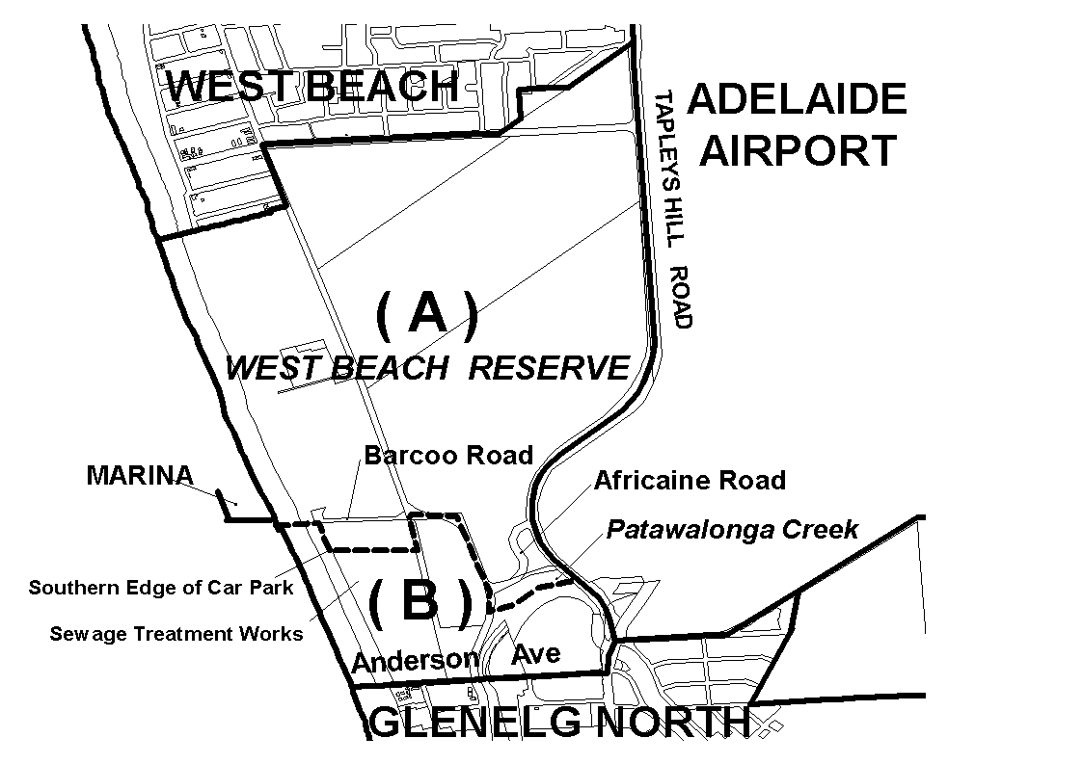
Dated 8 June 2000.
Robert Lawson, Minister for Administrative and Information Services.
DEHAA.04/0136

GEOGRAPHICAL NAMES ACT 1991
For Public Consultation
Notice of Intention to Assign Boundaries and Names to Places
NOTICE is hereby given pursuant to the provisions of the above Act, that the Minister for Administrative and Information Services seeks public comment on a proposal to assign the names MOUNT TORRENS, HARROGATE, WOODSIDE, OAKBANK, HAY VALLEY, BRUKUNGA, KANMANTOO, DAWESLEY, NAIRNE, BLAKISTON, MOUNT BARKER JUNCTION, LITTLEHAMPTON, TOTNESS, HAHNDORF, VERDUN, BRIDGEWATER, MYLOR, BRADBURY, CHAPEL HILL, BIGGS FLAT, PAECHTOWN, ECHUNGA, MOUNT BARKER, MOUNT BARKER SUMMIT, MOUNT BARKER SPRINGS, PETWOOD, CALLINGTON, SAINT IVES, WIS-TOW, SCRUBBY HILL, PHILCOX HILL, BUGLE RANGES, MACCLESFIELD, FLAXLEY, HACK RANGE, BULL KNOB, PARIS CREEK, BULL CREEK, PROSPECT HILL, KUITPO, MEADOWS, KANGARILLA, JUPITER CREEK and DORSET VALE to those areas within the District Council of Mount Barker and shown numbered 1 to 44 respectively on Rack Plan 799.
Copies of Rack Plan 799 can be viewed in the Office of the Surveyor-General, 101 Grenfell Street, Adelaide and the offices of the District Council of Mount Barker.
Submissions in writing regarding this proposal may be lodged with the Secretary, Geographical Names Advisory Committee, 300 Richmond Road, Netley, S.A. 5037 (P.O. Box 550, Marleston, S.A. 5033) within one month of the publication of this notice.
Dated 11 January 2000.
P. M. Kentish, Surveyor-General, Department for Administrative and Information Services
DEHAA 04/0159

GEOGRAPHICAL NAMES ACT 1991
For Public Consultation
Notice of Intention to Assign Boundaries and Names to Places
NOTICE is hereby given pursuant to the provisions of the above Act, that the Minister for Administrative and Information Services seeks public comment on a proposal to assign boundaries to LYNDHURST, LEIGH CREEK, COPLEY, PARACHILNA, MARLA, NEPABUNNA, OODNADATTA, ANDAMOOKA, PENONG, COORABIE and FOWLERS BAY to those areas within the Out of Councils Area and shown numbered 1 to 11 respectively on Rack Plan 857.
Copies of Rack Plan 857 can be viewed in the Office of the Surveyor-General, 101 Grenfell Street, Adelaide and the offices of the various Progress Associations.
Submissions in writing regarding this proposal may be lodged with the Secretary, Geographical Names Advisory Committee, 300 Richmond Road, Netley, S.A. 5037 (P.O. Box 550, Marleston, S.A. 5033) within one month of the publication of this notice.
Dated 29 February 2000.
P. M. Kentish, Surveyor-General, Department for Administrative and Information Services
DEHAA 04/0221

GEOGRAPHICAL NAMES ACT 1991
For Public Consultation
Notice of Intention to Assign Boundaries and Names to Places
NOTICE is hereby given pursuant to the provisions of the above Act, that the Minister for Administrative and Information Services seeks public comment on a proposal to assign the names CAVENAGH, PARATOO, NACKARA, DAWSON, MININVALARA, PETERBOROUGH, SUNNYBRAE, YONGALA, UCOLTA, OODLA WIRRA, PARNAROO, and HARDY to those areas within the District Council of Peterborough and shown numbered 1 to 12 respectively on Rack Plan 860.
Copies of Rack Plan 860 can be viewed at the Office of the Surveyor-General, 101 Grenfell Street, Adelaide or at the offices of the Peterborough Council.
Submissions in writing regarding this proposal may be lodged with the Secretary, Geographical Names Advisory Committee, Building 2, 300 Richmond Road, Netley, S.A. 5037 (P.O. Box 550, Marleston, S.A. 5033) within one month of the publication of this notice.
Dated 22 May 2000.
P. M. Kentish, Surveyor-General, Department for Administrative and Information Services
DEHAA 04/0218

GEOGRAPHICAL NAMES ACT 1991
For Public Consultation
Notice of Intention to Assign Boundaries and Names to Places
NOTICE is hereby given pursuant to the provisions of the above Act, that the Minister for Administrative and Information Services seeks public comment on a proposal to:
1. Extend the boundaries of WEPAR and TRIHI.
2. Assign the names BOOL LAGOON, GLENROY, COMAUM, MAAOUPE, COONAWARRA, WATTLE RANGE EAST, MONBULLA, PENOLA, MOERLONG, KRONGART, NANGWARRY and KALANGADOO to those areas within the Wattle Range Council and shown numbered 1 to 14 respectively on Rack Plan 853.
Copies of Rack Plan 853 can be viewed at the Office of the Surveyor-General, 101 Grenfell Street, Adelaide or at the offices of the Wattle Range Council.
Submissions in writing regarding this proposal may be lodged with the Secretary, Geographical Names Advisory Committee, Building 2, 300 Richmond Road, Netley, S.A. 5037 (P.O. Box 550, Marleston, S.A. 5033) within one month of the publication of this notice.
Dated 1 March 2000.
P. M. Kentish, Surveyor-General, Department for Administrative and Information Services
DEHAA 04/0177

HARBORS AND NAVIGATION ACT 1993
Determination of State Crewing Committee
THE following determination made on 25 May 2000 by the State Crewing Committee is published pursuant to part 6, section 45 of the Harbors and Navigation Act 1993.
Diana Laidlaw, Minister for Transport and Urban Planning.
TSA 2000/03534

HARBORS AND NAVIGATION ACT 1993
Determination of State Crewing Committee in respect of the
M.V. ‘Columbia’
THE following determination is made by the State Crewing Committee pursuant to part 6, section 45 of the Harbors and Navigation Act 1993, in respect of the Columbia whilst operating within the following limits:
Operational limits
1. Within 15 nautical miles of the coast of South Australia.
2. Within 30 nautical miles of the coast of South Australia.
Minimum complement
1. One person⎯Master
2. Two persons⎯Master and GP (General Purpose Person)
Minimum Qualifications of Crew
1. and 2. Master⎯Certificate of Competency as Master Class 5.
GP⎯General purpose person, an able bodied person not less than 16 years of age with not less than 3 months sea experience and has successfully completed an approved Elements of Shipboard Safety Course.
Note: In 2. above, either the Master or GP must possess a Certificate of Competency as Marine Engine Driver Grade III.
Capt. W. J. Stuart, Presiding Member, State Crewing Committee.

HARBORS AND NAVIGATION ACT 1993
Determination of State Crewing Committee
THE following determination made on 27 April 2000 by the State Crewing Committee is published pursuant to part 6, section 45 of the Harbors and Navigation Act 1993.
Diana Laidlaw, Minister for Transport and Urban Planning.
TSA 2000/02701

HARBORS AND NAVIGATION ACT 1993
Determination of State Crewing Committee in respect of the
M.V. ‘Alley Cat’
THE following determination is made by the State Crewing Committee pursuant to part 6, section 45 of the Harbors and Navigation Act 1993, in respect of the Alley Cat whilst operating within 15 nautical miles of the coast of South Australia.
Minimum complement
One person⎯Master
Minimum Qualifications of Crew
Master⎯Certificate of Competency as Coxswain and has successfully completed an approved Elements of Shipboard Safety and Restricted Radiotelephony courses.
Capt. W. J. Stuart, Presiding Member, State Crewing Committee.

HARBORS AND NAVIGATION ACT 1993
Determination of State Crewing Committee
THE following determination made on 27 April 2000 by the State Crewing Committee is published pursuant to part 6, section 45 of the Harbors and Navigation Act 1993.
Diana Laidlaw, Minister for Transport and Urban Planning.
TSA 2000/03410

HARBORS AND NAVIGATION ACT 1993
Determination of State Crewing Committee in respect of the
M.V. ‘Yvette’
THE following determination is made by the State Crewing Committee pursuant to part 6, section 45 of the Harbors and Navigation Act 1993, in respect of the Yvette whilst operating within the Goolwa Channel not more than 0.5 nautical miles either side of the Goolwa Wharf.
Minimum complement
One person⎯Master
Minimum Qualification of Crew
Master⎯Certificate of Competency as Coxswain River Murray and Inland Waters and has successfully completed an approved Elements of Shipboard Safety Course.
Capt. W. J. Stuart, Presiding Member, State Crewing Committee.

HARBORS AND NAVIGATION ACT 1993
Determination of State Crewing Committee
THE following determination made on 27 April 2000 by the State Crewing Committee is published pursuant to part 6, section 45 of the Harbors and Navigation Act 1993.
Diana Laidlaw, Minister for Transport and Urban Planning.
TSA 2000/02700

HARBORS AND NAVIGATION ACT 1993
Determination of State Crewing Committee in respect of the
M.V. ‘Nautilust’
THE following determination is made by the State Crewing Committee pursuant to part 6, section 45 of the Harbors and Navigation Act 1993, in respect of the Nautilust whilst operating within the following limits:
Operational limits
1. Within 15 nautical miles of the coast of South Australia.
2. Within 30 nautical miles of the coast of South Australia.
Minimum complement
1. One person⎯Master
2. Two persons⎯Master and GP (General Purpose Person)
Minimum Qualifications of Crew
1. Master⎯Certificate of Competency as Coxswain and has successfully completed approved Elements of Shipboard Safety and Restricted Radiotelephony courses.
2. Master—Certificate of Competency as Master Class 5.
GP⎯General purpose person, an able bodied person not less than 16 years of age with not less than 3 months experience and has successfully completed an approved Elements of Shipboard Safety Course.
Note: In 2. above either the Master or GP must possess a Certificate of Competency as Marine Engine Driver Grade III.
Capt. W. J. Stuart, Presiding Member, State Crewing Committee.

HARBORS AND NAVIGATION ACT 1993
Determination of State Crewing Committee
THE following determination made on 30 March 2000 by the State Crewing Committee is published pursuant to part 6, section 45 of the Harbors and Navigation Act 1993.
Diana Laidlaw, Minister for Transport and Urban Planning.
TSA 2000/02550

HARBORS AND NAVIGATION ACT 1993
Determination of State Crewing Committee in respect of the
M.V. ‘Aladin’
THE following determination is made by the State Crewing Committee pursuant to part 6, section 45 of the Harbors and Navigation Act 1993, in respect of the Aladin whilst operating within 15 nautical miles of the coast of South Australia.
Minimum complement
Nine passengers:
One person⎯Master
Twelve passengers:
Two persons⎯Master and GP (General Purpose Person)
Minimum Qualifications of Crew
Master⎯Certificate of Competency as Coxswain and has successfully completed approved Elements of Shipboard Safety and Restricted Radiotelephony courses.
GP⎯General purpose person, an able bodied person not less than 16 years of age with not less than 3 months experience and has successfully completed an approved Elements of Shipboard Safety Course.
Capt. W. J. Stuart, Presiding Member, State Crewing Committee.

HARBORS AND NAVIGATION ACT 1993
Determination of State Crewing Committee
THE following determination made on 25 May 2000 by the State Crewing Committee is published pursuant to part 6, section 45 of the Harbors and Navigation Act 1993.
Diana Laidlaw, Minister for Transport and Urban Planning.
TSA 2000/03391

HARBORS AND NAVIGATION ACT 1993
Determination of State Crewing Committee in respect of the
M.V. ‘Copper Triangle Charters’
THE following determination is made by the State Crewing Committee pursuant to part 6, section 45 of the Harbors and Navigation Act 1993, in respect of the Copper Triangle Charters whilst operating within 15 nautical miles of the coast of South Australia.
Minimum complement
One person⎯Master
Minimum Qualifications of Crew
Master⎯Certificate of Competency as Coxswain and has successfully completed an approved Elements of Shipboard Safety and Restricted Radiotelephony courses.
Capt. W. J. Stuart, Presiding Member, State Crewing Committee.

HARBORS AND NAVIGATION ACT 1993
Determination of State Crewing Committee
THE following determination made on 25 May 2000 by the State Crewing Committee is published pursuant to part 6, section 45 of the Harbors and Navigation Act 1993.
Diana Laidlaw, Minister for Transport and Urban Planning.
TSA 2000/27043

HARBORS AND NAVIGATION ACT 1993
Determination of State Crewing Committee in respect of the
M.T. ‘Nalta Yuki’
THE following determination is made by the State Crewing Committee pursuant to part 6, section 45 of the Harbors and Navigation Act 1993, in respect of the Nalta Yuki whilst operating within the River Murray, Lakes and Coorong of South Australia.
Minimum complement
Two persons⎯Master and GP (General Purpose Person)
Minimum Qualifications of Crew
Master⎯Certificate of Competency as Master Class 5 RMIW.
GP⎯General purpose person, an able bodied person not less than 16 years of age with not less than 3 months experience and has successfully completed an approved Elements of Shipboard Safety Course.
Note: Either the Master or GP must possess a Marine Engine Driver Grade III Certificate of Competency.
Capt. W. J. Stuart, Presiding Member, State Crewing Committee.

LAND AND BUSINESS (SALE AND CONVEYANCING) ACT 1994
Exemption
TAKE notice that, pursuant to section 32 (1) of the Land and Business (Sale and Conveyancing) Act 1994, I, Kenneth Trevor Griffin, Minister for Consumer Affairs, do hereby exempt the person named in Schedule 1 from the application of section 23 of the Act in relation to the purchase of the land specified in Schedule 2.
Schedule 1
Frances Neil Sloan, an officer/employee of Weeks & Macklin, Semaphore-Largs.
Schedule 2
The whole of the land described in certificate of title register book volume 1010, folio 94, situated at Lots 17 and 18 Arnold Street, Ottoway, S.A. 5013.
Dated 8 June 2000.
Signed for and on behalf of the Minister for Consumer Affairs by the Commissioner for Consumer Affairs:
M. Bodycoat, Commissioner

LAND AND BUSINESS (SALE AND CONVEYANCING) ACT 1994
Exemption
TAKE notice that, pursuant to section 23 (3) of the Land and Business (Sale and Conveyancing) Act 1994, I, Kenneth Trevor Griffin, Minister for Consumer Affairs, do hereby exempt the person named in Schedule 1 from the application of section 23 (2) of the Act in relation to the purchase of the land specified in Schedule 2.
Schedule 1
Sonia Cannell, an officer/employee of JD Real Estate Investments Pty Ltd.
Schedule 2
The whole of the land described in Certificate of Title Register Book Volume 5128, folio 151, situated at 8 Oxford Street, Reynella, S.A. 5161.
Dated 8 June 2000.
Signed for and on behalf of the Minister for Consumer Affairs by the Commissioner for Consumer Affairs:
M. Bodycoat, Commissioner

LIQUOR LICENSING ACT 1997
Notice of Application
NOTICE is hereby given, pursuant to section 52 (2) (b) of the Liquor Licensing Act 1997, that David Jones Limited (ACN 000 074 573), 86-108 Castlereagh Street, Sydney, N.S.W. 2000 has applied to the Licensing Authority for the removal of the special circumstances licence held at 44-58 Rundle Mall, Adelaide and known as David Jones to the premises to be situated at 100 Rundle Mall, Adelaide and to be known as David Jones.
The application has been set down for hearing on 7 July 2000.
Conditions
The following licence conditions are sought:
Approval is sought for a variation to the current licence conditions so that the licence authorises the licensee to do the following:
1. At the following times other than when those times fall on Good Friday or Christmas Day—Monday to Friday, 8 a.m. to 9 p.m.; Saturday, 8 a.m. to 5 p.m.; Sunday, 11 a.m. to 5 p.m., and such further or other times as the licensee may legally be permitted to trade pursuant to the Shop Trading Hours Act 1977 and proclamations made thereunder.
The licensee is authorised to do the following:
• Sell liquor as a part of a hamper/gift basket from time to time from anywhere on the licensed premises;
• supply liquor to persons attending an event, function or performance anywhere on the licensed premises from time to time where the event is for the promotion of goods or service sold by the licensee and the consumption of liquor is ancillary to the event, function or performance;
• sell liquor from the lower ground floor for consumption off the licensed premises;
• supply liquor by way of sample for consumption in the lower ground floor of the licensed premises;
• sell liquor from the lower ground floor Food Hall, second floor Expresso Coffee Bar and third floor Antipasta Bar for consumption on the licensed premises.
2. Sell liquor from the ground floor restaurant being the area outlined in orange for consumption on the licensed premises at the following times, which include extended trading authorisation:
• Monday to Saturday, 8 a.m. to 2 a.m. the following morning;
• Sunday, 10 a.m. to midnight, with the exception of the following times:
• Good Friday, all day;
• Christmas Day, between midnight and 2 a.m.
• The day after Good Friday, between midnight and 2 a.m.
• the day after Christmas Day, between midnight and 2 a.m.; and
• if the day after Christmas Day is a Sunday, between 10 a.m. and 11 a.m. and between 8 p.m. and midnight on that day.
3. To provide entertainment in the areas outlined in brown. Entertainment is to be limited to events, functions or performances for the promotion of goods and services sold by the licensee.
Any person may object to the application by lodging a notice of objection in the prescribed form with the Licensing Authority, and serving a copy of the notice on the applicant at the applicant’s address given above, at least seven days before the hearing date.
Plans in respect of the premises the subject of the application are open to public inspection without fee at the Office of the Liquor and Gaming Commissioner, 9th Floor, East Wing, 50 Grenfell Street, Adelaide, S.A. 5000.
Dated 24 May 2000.
Applicant

LIQUOR LICENSING ACT 1997
Notice of Application
NOTICE is hereby given, pursuant to section 52 (2) (b) of the Liquor Licensing Act 1997, that John and Carol Rosewell, 85 Main Street, Woodside, S.A. 5244 have applied to the Licensing Authority for a Restaurant Licence with section 34 (1)(c) in respect of premises situated at 85 Main Street, Woodside, S.A. 5244 and to be known as Rosies Barn.
The application has been set down for hearing on 14 July 2000 at 9 a.m.
Condition
The following licence condition is sought:
Section 34 (1) (c) authorises the licensee to sell liquor on any day except Good Friday and Christmas Day for consumption on the licensed premises by persons:
seated at a table; or
attending a function at which food is provided.
Any person may object to the application by lodging a notice of objection in the prescribed form with the Licensing Authority, and serving a copy of the notice on the applicants at the applicants’ address given above, at least seven days before the hearing date.
Plans in respect of the premises the subject of the application are open to public inspection without fee at the Office of the Liquor and Gaming Commissioner, 9th Floor, East Wing, 50 Grenfell Street, Adelaide, S.A. 5000.
Dated 6 June 2000.
Applicants

LIQUOR LICENSING ACT 1997
Notice of Application
NOTICE is hereby given, pursuant to section 52 (2) (b) of the Liquor Licensing Act 1997, that Giuseppe Fiala, 292 Findon Road, Findon, S.A. 5023 has applied to the Licensing Authority for the transfer of a Restaurant Licence in respect of premises situated at Shops 10 and 11, Henley Square, 334/346 Seaview Road, Henley Beach, S.A. 5022 and known as Cafe Sul Mare and to be known as Cafe Pacific.
The application has been set down for hearing on 17 July 2000 at 9 a.m.
Any person may object to the application by lodging a notice of objection in the prescribed form with the Licensing Authority, and serving a copy of the notice on the applicant at the applicant’s address given above, at least seven days before the hearing date.
Plans in respect of the premises the subject of the application are open to public inspection without fee at the Office of the Liquor and Gaming Commissioner, 9th Floor, East Wing, 50 Grenfell Street, Adelaide, S.A. 5000.
Dated 5 June 2000.
Applicant

LIQUOR LICENSING ACT 1997
Notice of Application
NOTICE is hereby given, pursuant to section 52 (2) (b) of the Liquor Licensing Act 1997, that Thomas William Harold Murdoch, 1 Main Road, Marrabel, S.A. 5413 has applied to the Licensing Authority for the transfer of a Hotel Licence in respect of premises situated at 1 Main Road, Marrabel, S.A. 5413 and known as Marrabel Hotel.
The application has been set down for hearing on 10 July 2000 at 10 a.m.
Any person may object to the application by lodging a notice of objection in the prescribed form with the Licensing Authority, and serving a copy of the notice on the applicant at the applicant’s address given above, at least seven days before the hearing date.
Plans in respect of the premises the subject of the application are open to public inspection without fee at the Office of the Liquor and Gaming Commissioner, 9th Floor, East Wing, 50 Grenfell Street, Adelaide, S.A. 5000.
Dated 2 June 2000.
Applicant

LIQUOR LICENSING ACT 1997
Notice of Application
NOTICE is hereby given, pursuant to section 52 (2) (b) of the Liquor Licensing Act 1997, that David Graham Phillips and Lidwina Gijsbertha Antonia Phillips, P.O. Box 959, Renmark, S.A. 5341 have applied to the Licensing Authority for a Producer’s Licence in respect of premises situated at 25th Street, Renmark South, S.A. 5341 and to be known as Charnwood Vineyard.
The application has been set down for hearing on 7 July 2000 at 9 a.m.
Any person may object to the application by lodging a notice of objection in the prescribed form with the Licensing Authority, and serving a copy of the notice on the applicants at the applicants’ address given above, at least seven days before the hearing date.
Plans in respect of the premises the subject of the application are open to public inspection without fee at the Office of the Liquor and Gaming Commissioner, 9th Floor, East Wing, 50 Grenfell Street, Adelaide, S.A. 5000.
Dated 2 June 2000.
Applicants

LIQUOR LICENSING ACT 1997
Notice of Application
NOTICE is hereby given, pursuant to section 52 (2) (b) of the Liquor Licensing Act 1997, that Australian Wine & Liquor Wholesalers Pty Ltd (ACN 089 451 472), c/o Wallmans Solicitors, 173 Wakefield Street, Adelaide, S.A. 5000 has applied to the Licensing Authority for the transfer of a Special Circumstances Licence in respect of premises situated at 578 The Parade, Auldana, S.A. 5072 and known as Skye Cellar.
The application has been set down for hearing on 30 June 2000 at 11.30 a.m.
Any person may object to the application by lodging a notice of objection in the prescribed form with the Licensing Authority, and serving a copy of the notice on the applicant at the applicant’s address given above, at least seven days before the hearing date.
Plans in respect of the premises the subject of the application are open to public inspection without fee at the Office of the Liquor and Gaming Commissioner, 9th Floor, East Wing, 50 Grenfell Street, Adelaide, S.A. 5000.
Dated 1 June 2000.
Applicant

LIQUOR LICENSING ACT 1997
Notice of Application
NOTICE is hereby given, pursuant to section 52 (2) (b) of the Liquor Licensing Act 1997, that Coriole Pty Ltd has applied to the Licensing Authority for a Special Circumstances Licence in respect of premises situated at Chaffey Road, McLaren Vale, S.A. 5171 and known as Coriole.
The application has been set down for hearing on 7 July 2000.
Conditions
The following licence conditions are sought:
1. To sell and supply liquor for consumption on the licensed premises at any time with or ancillary to a meal provided by the licensee.
2. To sell and supply liquor for consumption on the licensed premises at any time to a person seated at a table.
3. To sell and supply liquor for consumption on the licensed premises at any time to a person attending a pre-booked function or reception.
4. Entertainment consent is sought for the whole of the premises.
Any person may object to the application by lodging a notice of objection in the prescribed form with the Licensing Authority, and serving a copy of the notice on the applicant at the applicant’s address given above, at least seven days before the hearing date.
Plans in respect of the premises the subject of the application are open to public inspection without fee at the Office of the Liquor and Gaming Commissioner, 9th Floor, East Wing, 50 Grenfell Street, Adelaide, S.A. 5000.
Dated 31 May 2000.
Applicant

LIQUOR LICENSING ACT 1997
Notice of Application
NOTICE is hereby given, pursuant to section 52 (2) (b) of the Liquor Licensing Act 1997, that The Grand Hotel (SA) Pty Ltd, Moseley Square, Glenelg, S.A. 5045 has applied to the Licensing Authority for a variation to an extended trading authorisation in areas 4 and 6 in respect of premises situated at 2 Jetty Road, Glenelg, S.A. 5045 and known as Stamford Grand.
The application has been set down for hearing on 7 July 2000 at 9 a.m.
Conditions
The following licence conditions are sought:
Hours of Operation, Current Area 4:
Monday, 8 a.m. to 1.30 a.m. the following day; Tuesday to Friday 8 a.m. to 2 a.m. the following day; Saturday, 8 a.m. to 2.30 a.m. the following day and Sunday, 8 a.m. to 3 a.m. the following day.
Current Area 6:
Monday, 8 a.m. to midnight; Tuesday to Friday, 8 a.m. to midnight; Saturday, 8 a.m. to midnight and Sunday, 8 a.m. to midnight.
Proposed Area 4:
Monday, 8 a.m. to 2.30 a.m. the following day; Tuesday to Thursday, 8 a.m. to 2 a.m. the following day; Friday, 8 a.m. to 3 a.m. the following day; Saturday, 8 a.m. to 3 a.m. the following day and Sunday, 8 a.m. to 3 a.m. the following day.
Proposed Area 6:
Monday, 8 a.m. to 2.30 a.m. the following day; Tuesday to Thursday, 8 a.m. to 2 a.m. the following day; Friday, 8 a.m. to 3 a.m. the following day; Saturday, 8 a.m. to 3 a.m. the following day and Sunday, 8 a.m. to 3 a.m. the following day.
Any person may object to the application by lodging a notice of objection in the prescribed form with the Licensing Authority, and serving a copy of the notice on the applicant at the applicant’s address given above, at least seven days before the hearing date.
Plans in respect of the premises the subject of the application are open to public inspection without fee at the Office of the Liquor and Gaming Commissioner, 9th Floor, East Wing, 50 Grenfell Street, Adelaide, S.A. 5000.
Dated 1 June 2000.
Applicant

LIQUOR LICENSING ACT 1997
Notice of Application
NOTICE is hereby given, pursuant to section 52 (2) (b) of the Liquor Licensing Act 1997, that B.L.W. Corporation Pty Ltd has applied to the Licensing Authority for a Special Circumstances Licence in respect of premises to be situated at Lower Hermitage Road, Houghton, S.A. 5131 and known as Glen Ewin Cellars.
The application has been set down for hearing on 7 July 2000.
Conditions
The following licence conditions are sought:
1. To sell and supply liquor for consumption on the licensed premises at any time with or ancillary to a meal provided by the licensee.
2. To sell and supply liquor for consumption on the licensed premises at any time to a person seated at a table.
3. To sell and supply liquor for consumption on the licensed premises at any time to a person attending a pre-booked function or reception.
4. Entertainment consent is sought for the whole of the premises.
Any person may object to the application by lodging a notice of objection in the prescribed form with the Licensing Authority, and serving a copy of the notice on the applicant at the applicant’s address given above, at least seven days before the hearing date.
Plans in respect of the premises the subject of the application are open to public inspection without fee at the Office of the Liquor and Gaming Commissioner, 9th Floor, East Wing, 50 Grenfell Street, Adelaide, S.A. 5000.
Dated 31 May 2000.
Applicant

LIQUOR LICENSING ACT 1997
Notice of Application
NOTICE is hereby given, pursuant to section 52 (2) (b) of the Liquor Licensing Act 1997, that Ritta Moubayed and Najib Moubayed, 55 Norrie Avenue, Clovelly Park have applied to the Licensing Authority for the transfer of a Restaurant Licence in respect of premises situated at 904 South Road, Edwardstown, S.A. 5039 and known as Portofino Pizza Restaurant.
The application has been set down for hearing on 30 June 2000.
Any person may object to the application by lodging a notice of objection in the prescribed form with the Licensing Authority, and serving a copy of the notice on the applicants at the applicants’ address given above, at least seven days before the hearing date.
Plans in respect of the premises the subject of the application are open to public inspection without fee at the Office of the Liquor and Gaming Commissioner, 9th Floor, East Wing, 50 Grenfell Street, Adelaide, S.A. 5000.
Dated 26 May 2000.
Applicants

MINING ACT 1971
NOTICE is hereby given in accordance with section 28 (5) of the Mining Act 1971, that the Minister for Minerals and Energy proposes to grant an Exploration Licence over the undermentioned area.
Applicant: Anglogold Australasia Limited and Helix Resources NL
Location: Mount Christie Siding Area—Approximately 180 km north-west of Ceduna, bounded as follows: commencing at a point being the intersection of latitude 30°34′S and longitude 133°07′E, thence east to longitude 133°09′E, north to the northern boundary of Yellabinna Regional Reserve, thence generally easterly along the boundary of the said Regional Reserve to longitude 133°25′E, south to latitude 30°35′S, west to longitude 133°22′E, south to latitude 30°37′S, west to longitude 133°20′E, south to latitude 30°39′S, west to longitude 133°14′E, south to latitude 30°41′S, west to longitude 133°10′E, south to latitude 30°43′S, west to longitude 133°07′E, south to latitude 30°44′S, west to longitude 133°05′E, north to latitude 30°36′S, east to longitude 133°07′E, and north to the point of commencement, all the within latitudes and longitudes being geodetic and expressed in terms of the Australian Geodetic Datum as defined on p. 4984 of Commonwealth Gazette number 84 dated October 6, 1966.
Term: 2 years
Area in km²: 371
Ref: 169/1999
L. Johnston, Mining Registrar, Department of Primary Industries and Resources

MINING ACT 1971
NOTICE is hereby given in accordance with section 28 (5) of the Mining Act 1971, that the Minister for Minerals and Energy proposes to grant an Exploration Licence over the undermentioned area.
Applicant: Helix Resources NL
Location: Corunna Area—Approximately 50 km west-south-west of Port Augusta, bounded as follows: commencing at a point being the intersection of latitude 137°10′S and longitude 32°31′E, thence east to longitude 137°18′E, south to latitude 32°45′S, west to longitude 137°10′E, and north to the point of commencement, all the within latitudes and longitudes being geodetic and expressed in terms of the Australian Geodetic Datum as defined on p. 4984 of Commonwealth Gazette number 84 dated October 6, 1966 (AGD66).
Term: 1 year
Area in km²: 324
Ref: 35/2000
L. Johnston, Mining Registrar, Department of Primary Industries and Resources

MINING ACT 1971
NOTICE is hereby given in accordance with section 53 (2) of the Mining Act 1971, that an application for a miscellaneous purposes licence has been received. Details of the proposal may be inspected at the Department of Primary Industries and Resources, Mineral Resources Group, Level 5, 101 Grenfell Street, Adelaide S.A. 5000:
Applicant: District Council of Mount Barker
Claim No: 3169
Location: Section 297, Hundred of Freeling
Purpose: For recovery of Sand
Reference: T2194
A copy of the proposal has been provided to the Alexandrina Council.
Written submissions in relation to the granting of the miscellaneous purposes licence are invited to be received at the Department of Primary Industries and Resources, Mineral Resources Group, Level 5, 101 Grenfell Street, Adelaide, S.A. 5000 or G.P.O. Box 1671, Adelaide, S.A. 5001 no later than 26 June 2000.
L. Johnston, Mining Registrar

MINING ACT 1971
Native Title (South Australia) Act 1994
NOTICE is hereby given in accordance with section 35A (1) of the Mining Act 1971 and Part 5 of the Native Title (South Australia) Act 1994 and the Regulations thereunder that an application for a mining lease has been received. Details of the proposal may be inspected at the Department of Primary Industries and Resources, Mineral Resources Group, Level 5, 101 Grenfell Street, Adelaide, S.A. 5000:
Applicant: Minerals Corporation Ltd
Location: In Pastoral Block 1114, Out of Hundreds, (Curnamona)
Bimbowrie Station, 40 km north of Olary
Size: 71.5 ha
Purpose: For the recovery of feldspar
Ref: T2164
The Minister for Minerals and Energy is required to have regard to any representations received from owners of the land (including native title holders) to which the application relates and/or any interested members of the public in determining the application or in fixing the conditions to be attached to the lease if granted.
Written submissions in relation to the granting of the mining lease are invited to be received at the Department of Primary Industries and Resources, Mineral Resources Group, Level 5, 101 Grenfell Street, Adelaide, S.A. 5000 or G.P.O. Box 1671, Adelaide, S.A. 5001 no later than 13 July 2000.
L. Johnston, Mining Registrar

MINING ACT 1971
Native Title (South Australia) Act 1994
NOTICE is hereby given in accordance with section 35A (1) of the Mining Act 1971 and Part 5 of the Native Title (South Australia) Act 1994 and the Regulations thereunder that an application for a mining lease has been received. Details of the proposal may be inspected at the Department of Primary Industries and Resources, Mineral Resources Group, Level 5, 101 Grenfell Street, Adelaide, S.A. 5000:
Applicant: Neil Johansen
Location: Block 998, Out of Hundreds Renmark, 18 km north-north-west of Renmark (Bookmark Biosphere)
Size: 36.8 ha
Purpose: For the recovery of Gypsum
Ref.: T2182
The Minister for Minerals and Energy is required to have regard to any representations received from owners of the land (including native title holders) to which the application relates and/or any interested members of the public in determining the application or in fixing the conditions to be attached to the lease if granted.
Written submissions in relation to the granting of the mining lease are invited to be received at the Department of Primary Industries and Resources, Mineral Resources Group, Level 5, 101 Grenfell Street, Adelaide, S.A. 5000 or G.P.O. Box 1671, Adelaide, S.A. 5001 no later than 13 July 2000.
L. Johnston, Mining Registrar

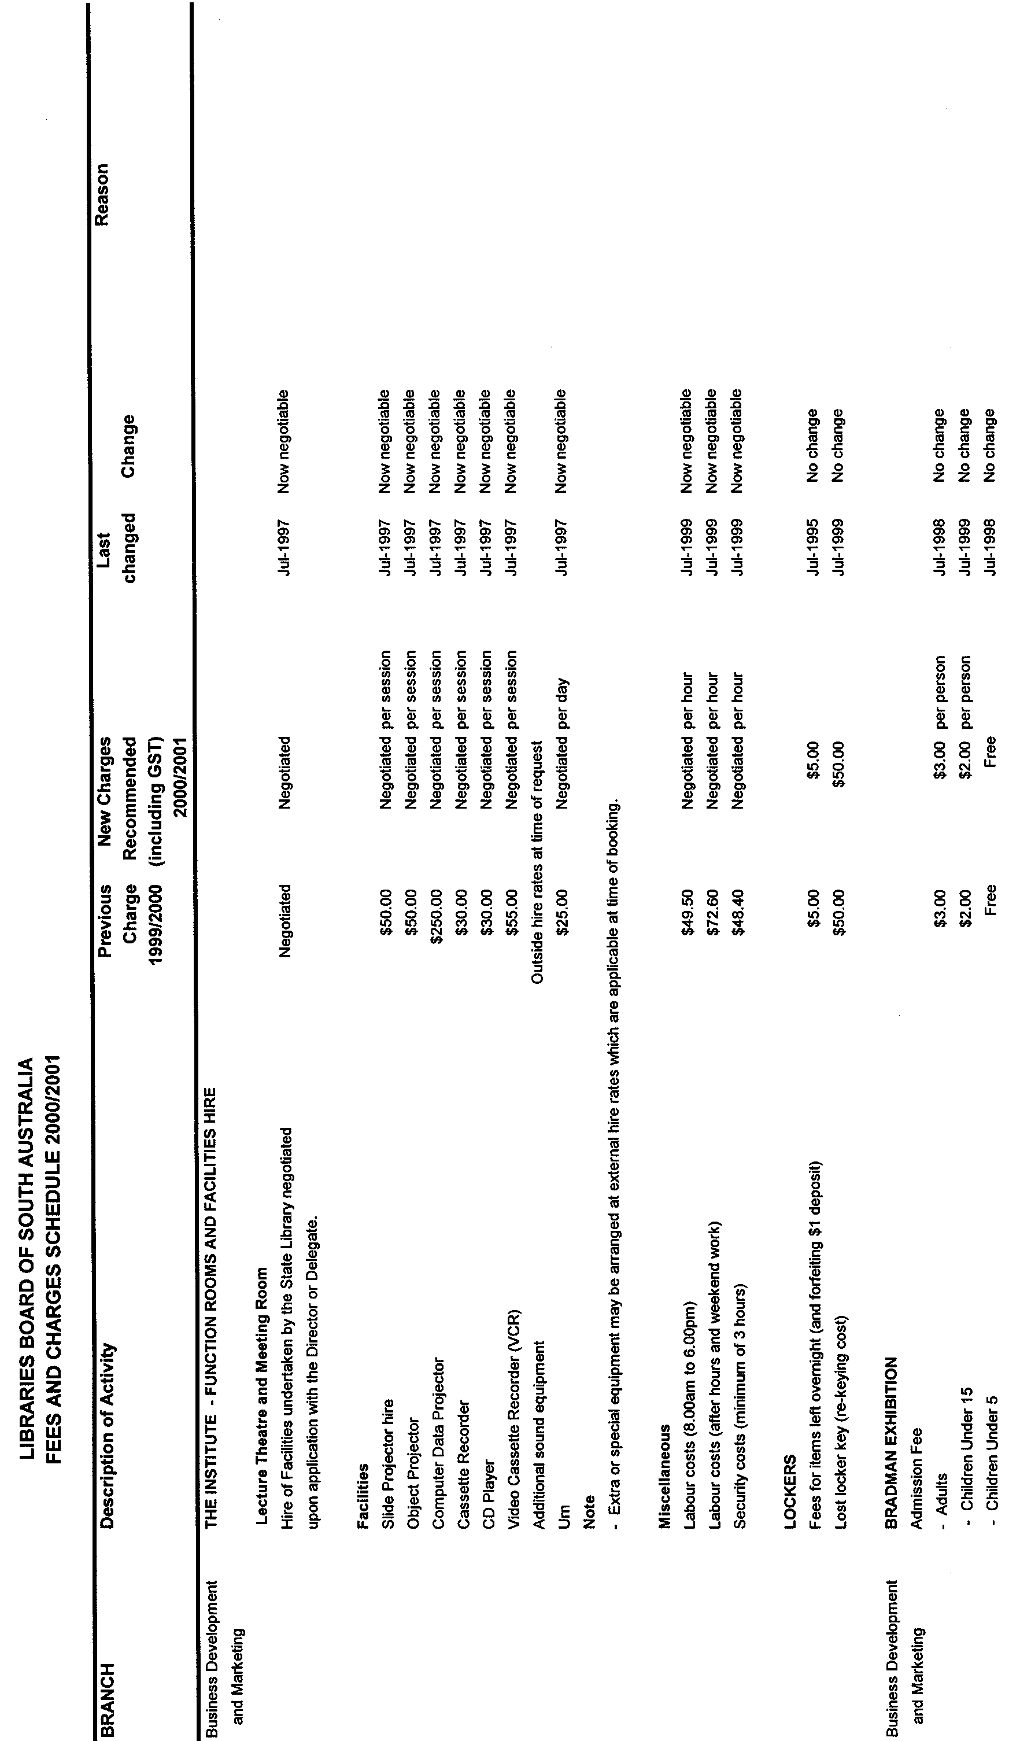
LIBRARIES BOARD OF SOUTH AUSTRALIA
FEES AND CHARGES SCHEDULE 2000/2001
Proposed Fees and Charges as at 1 July 2000

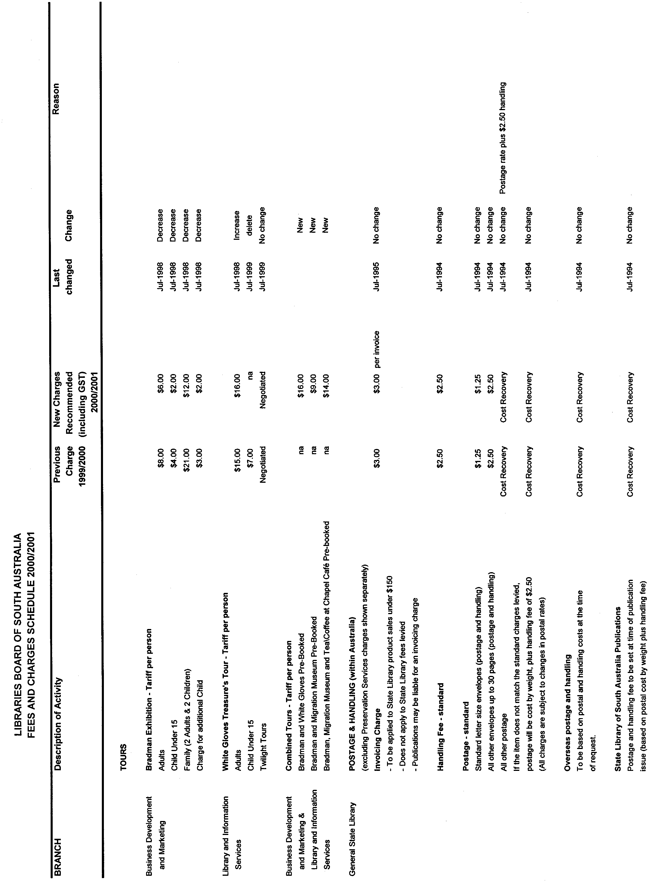
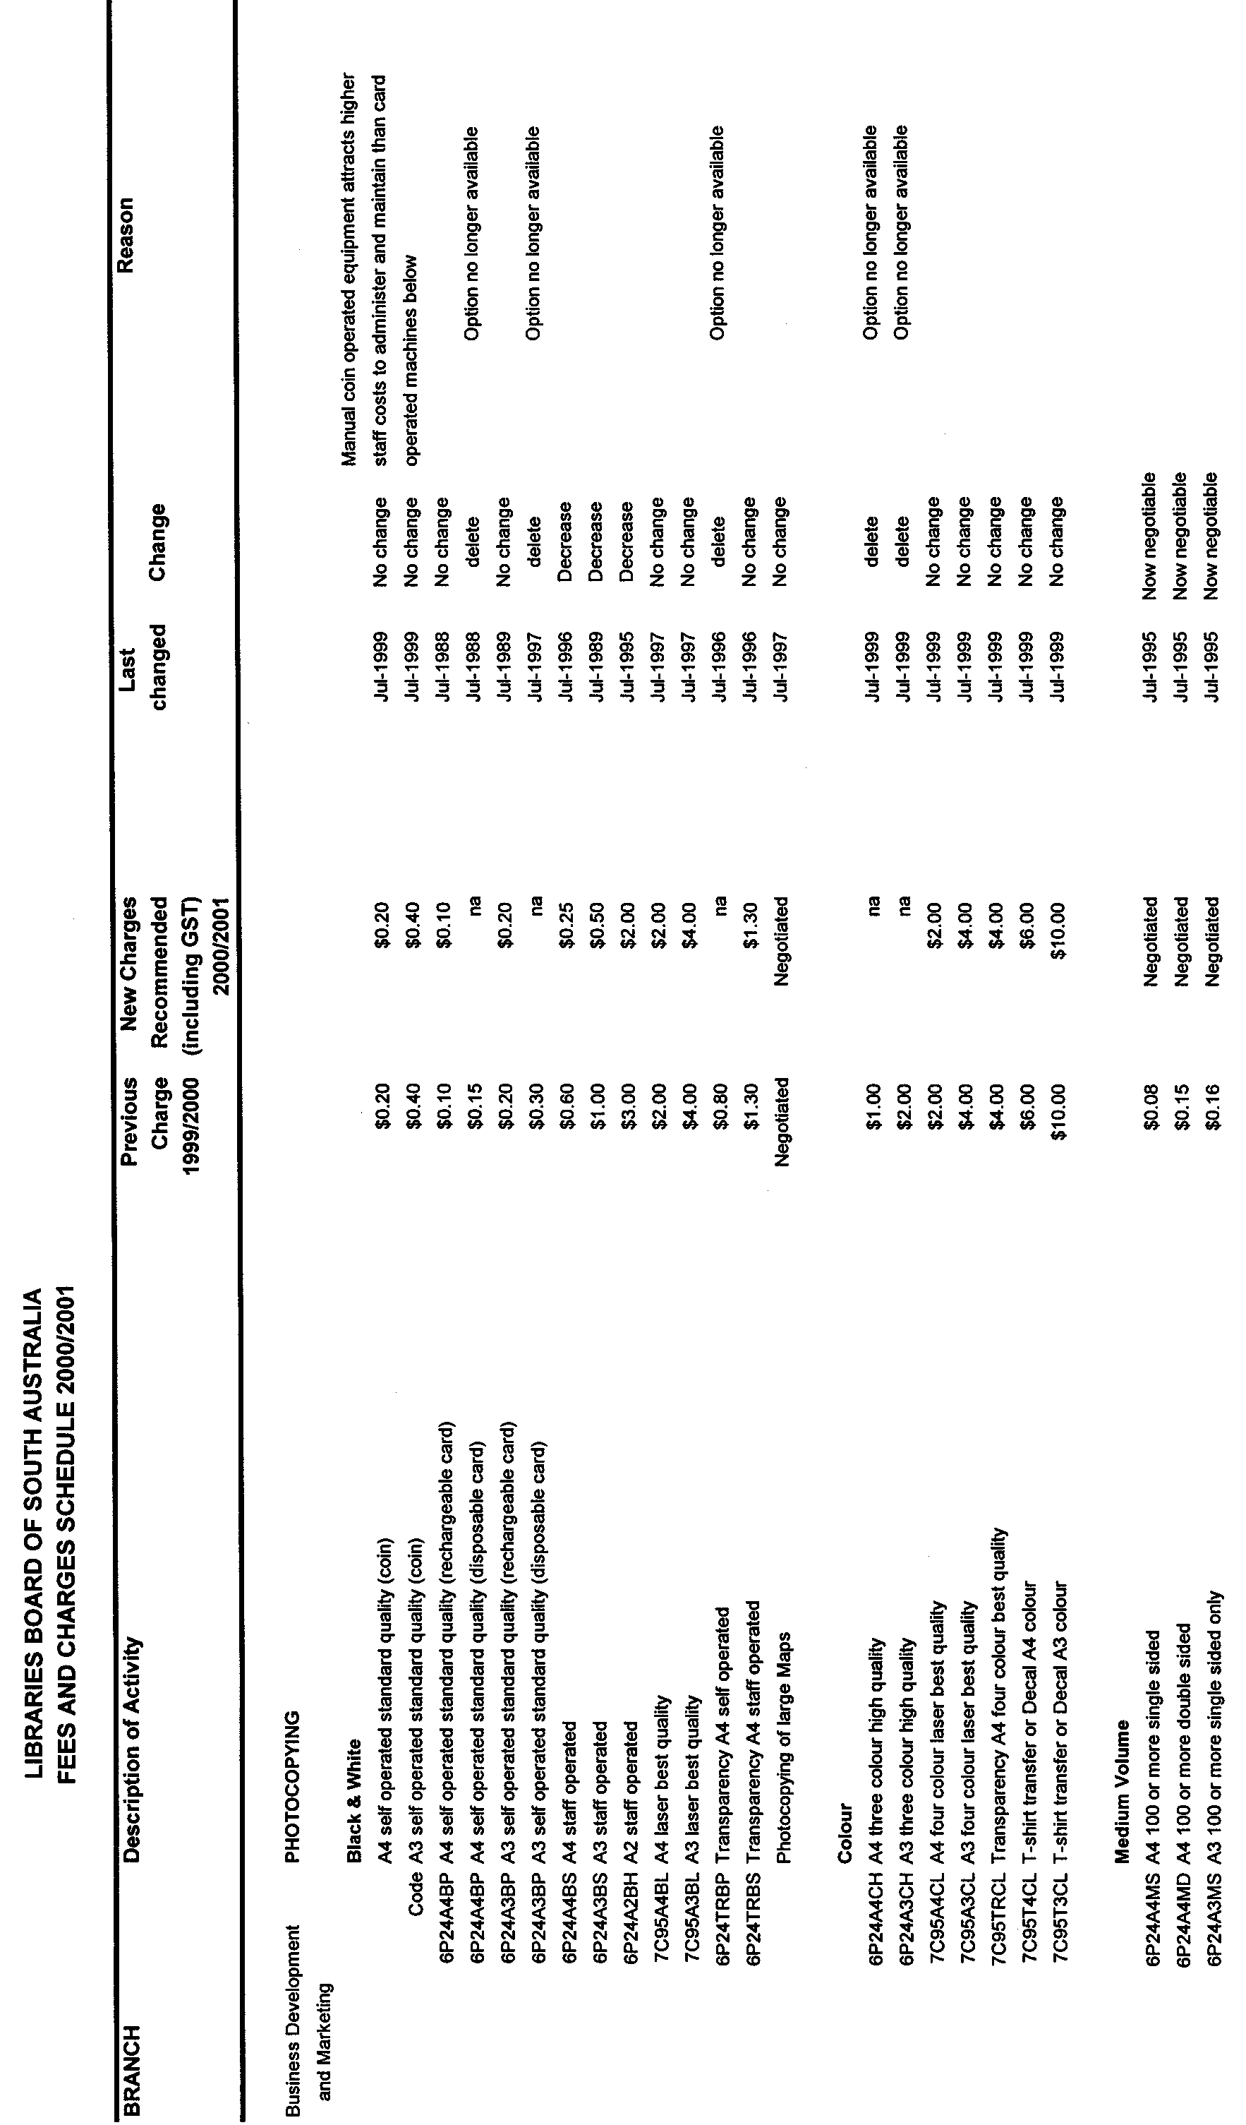
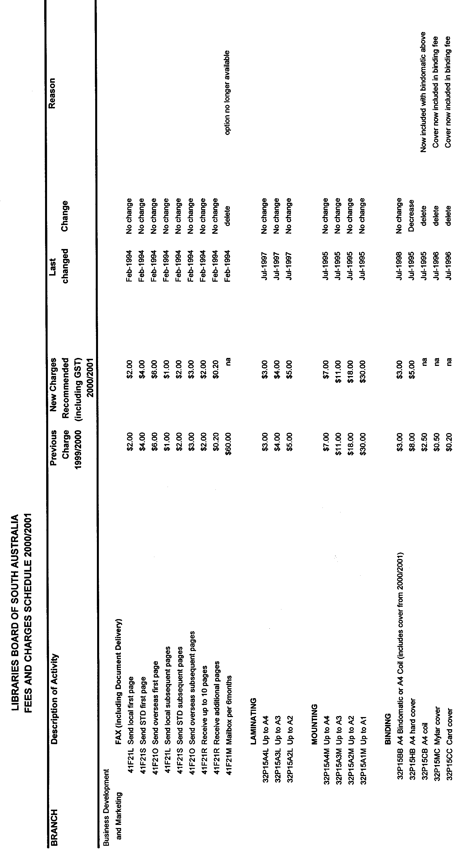
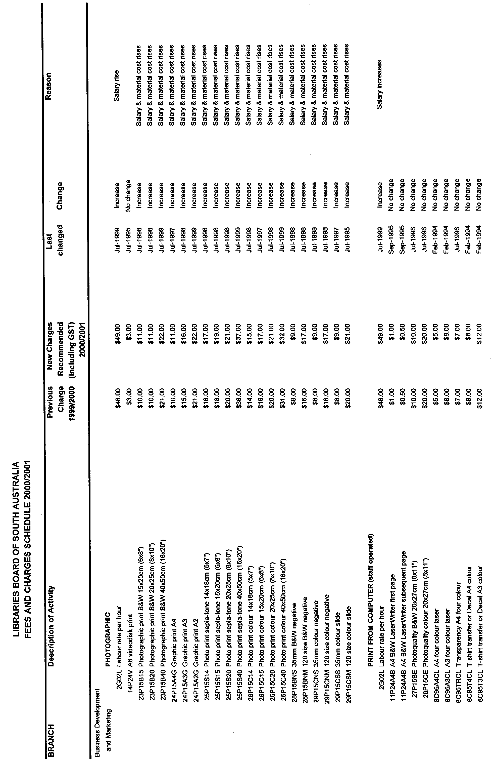
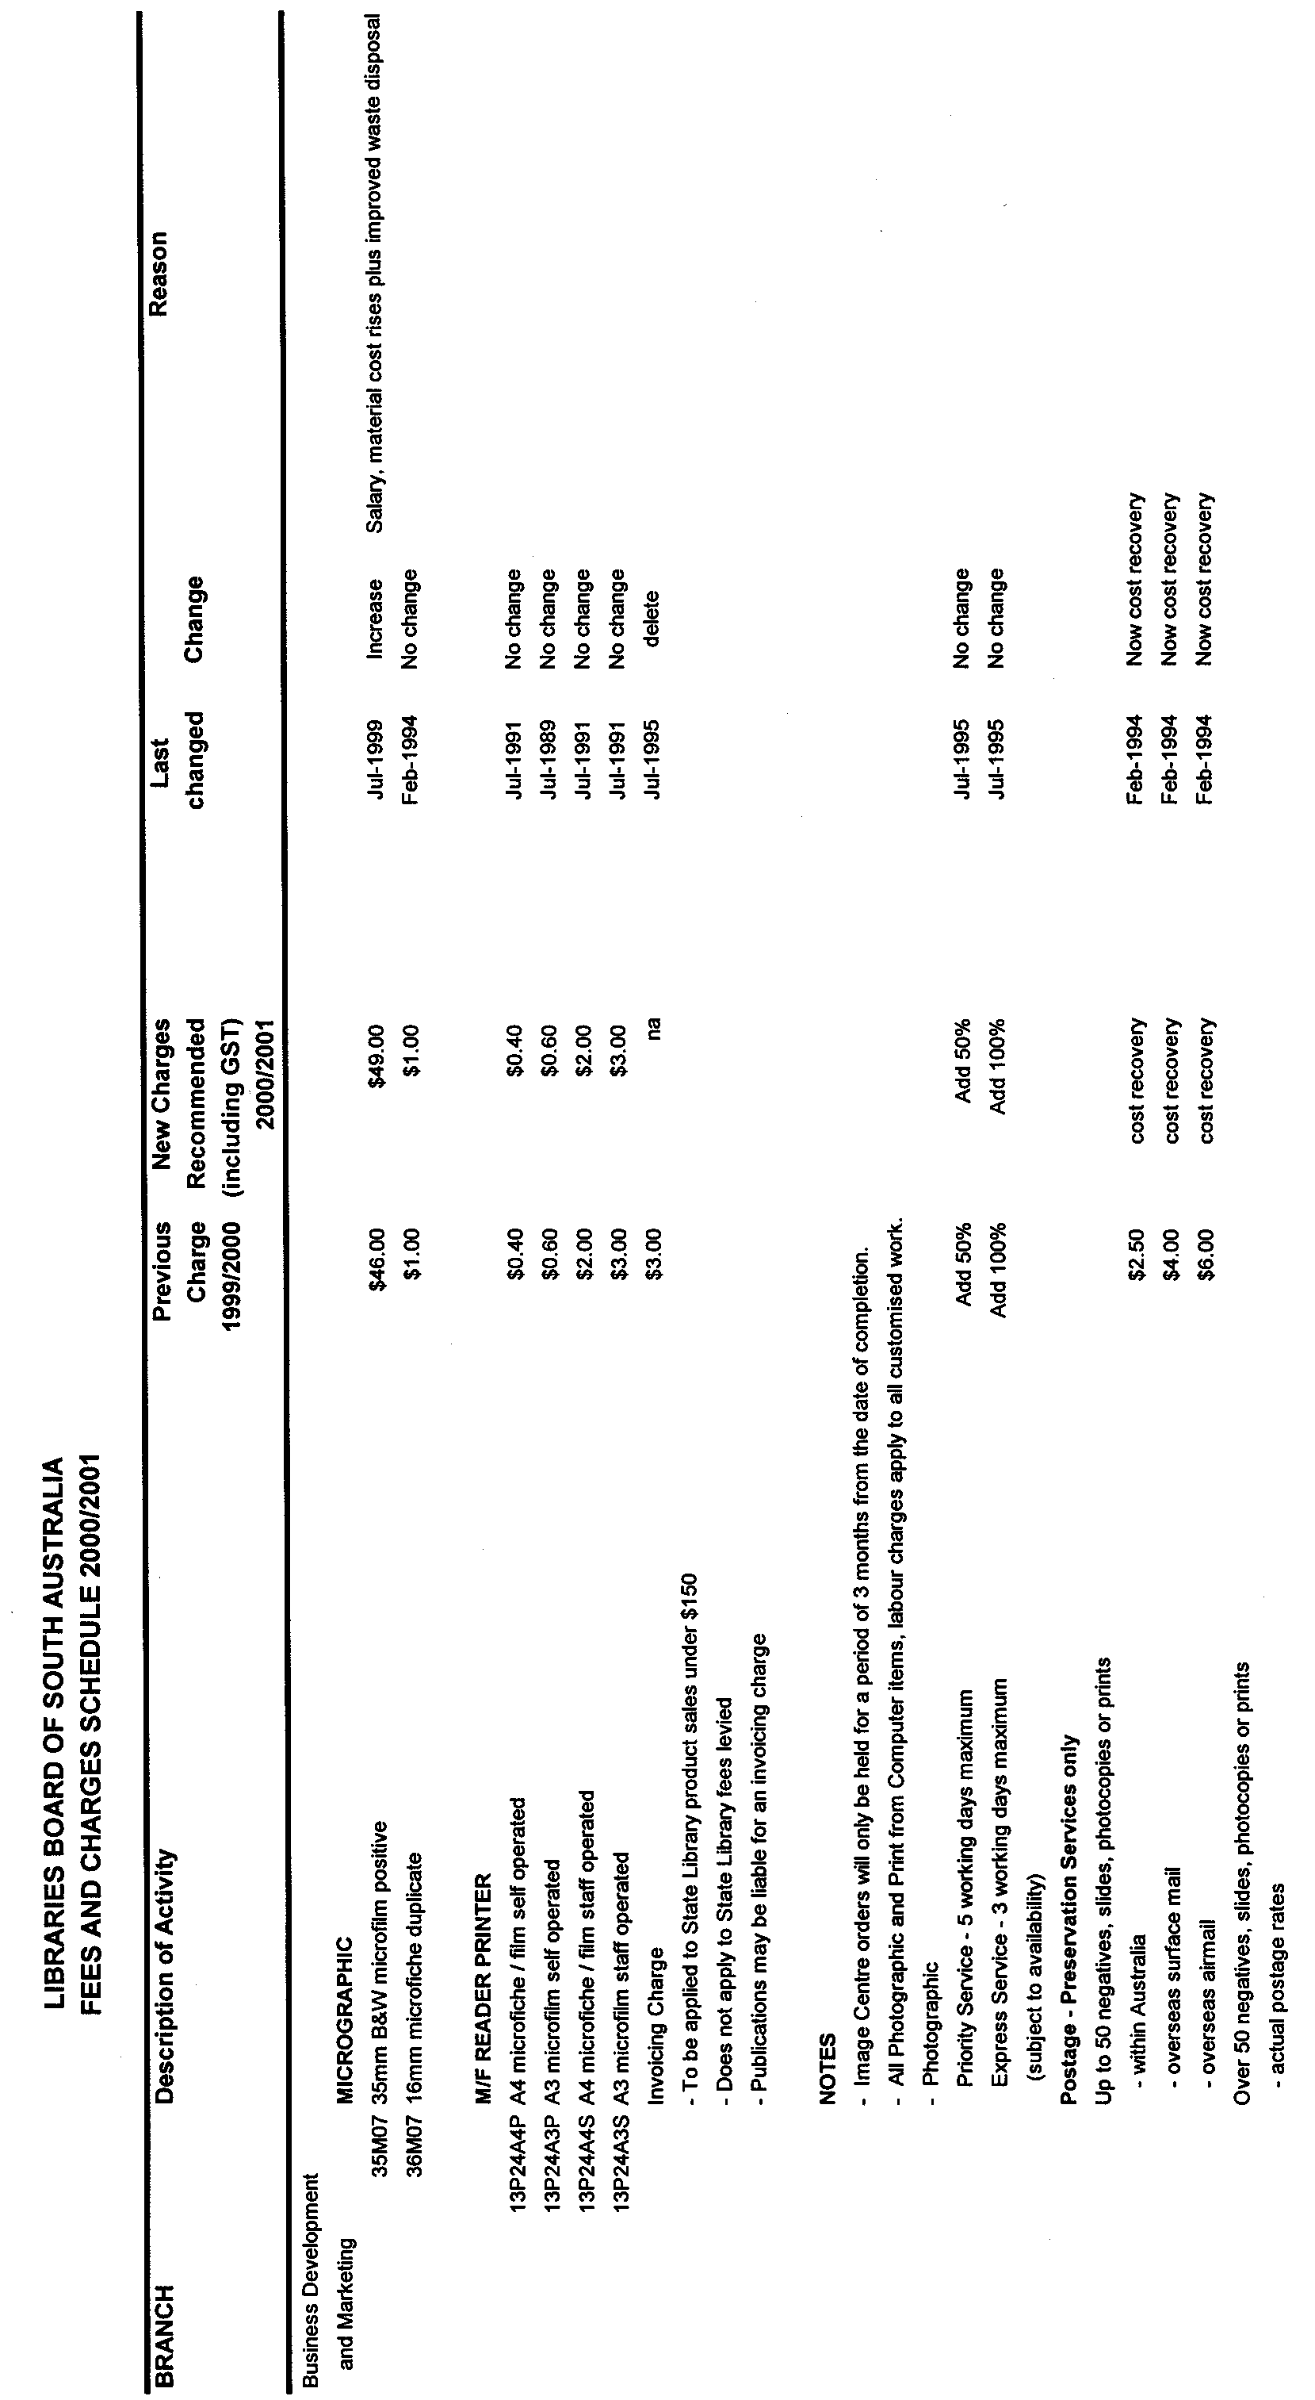
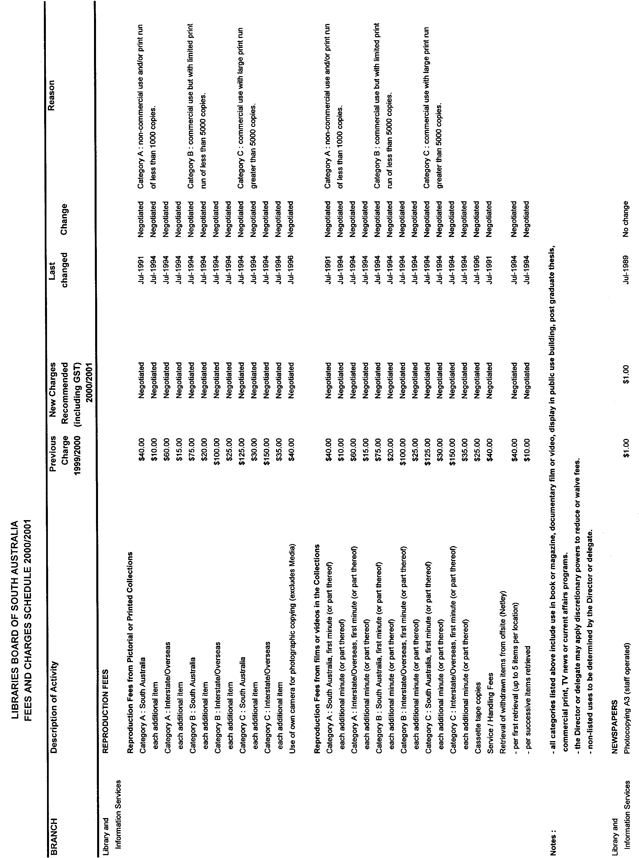
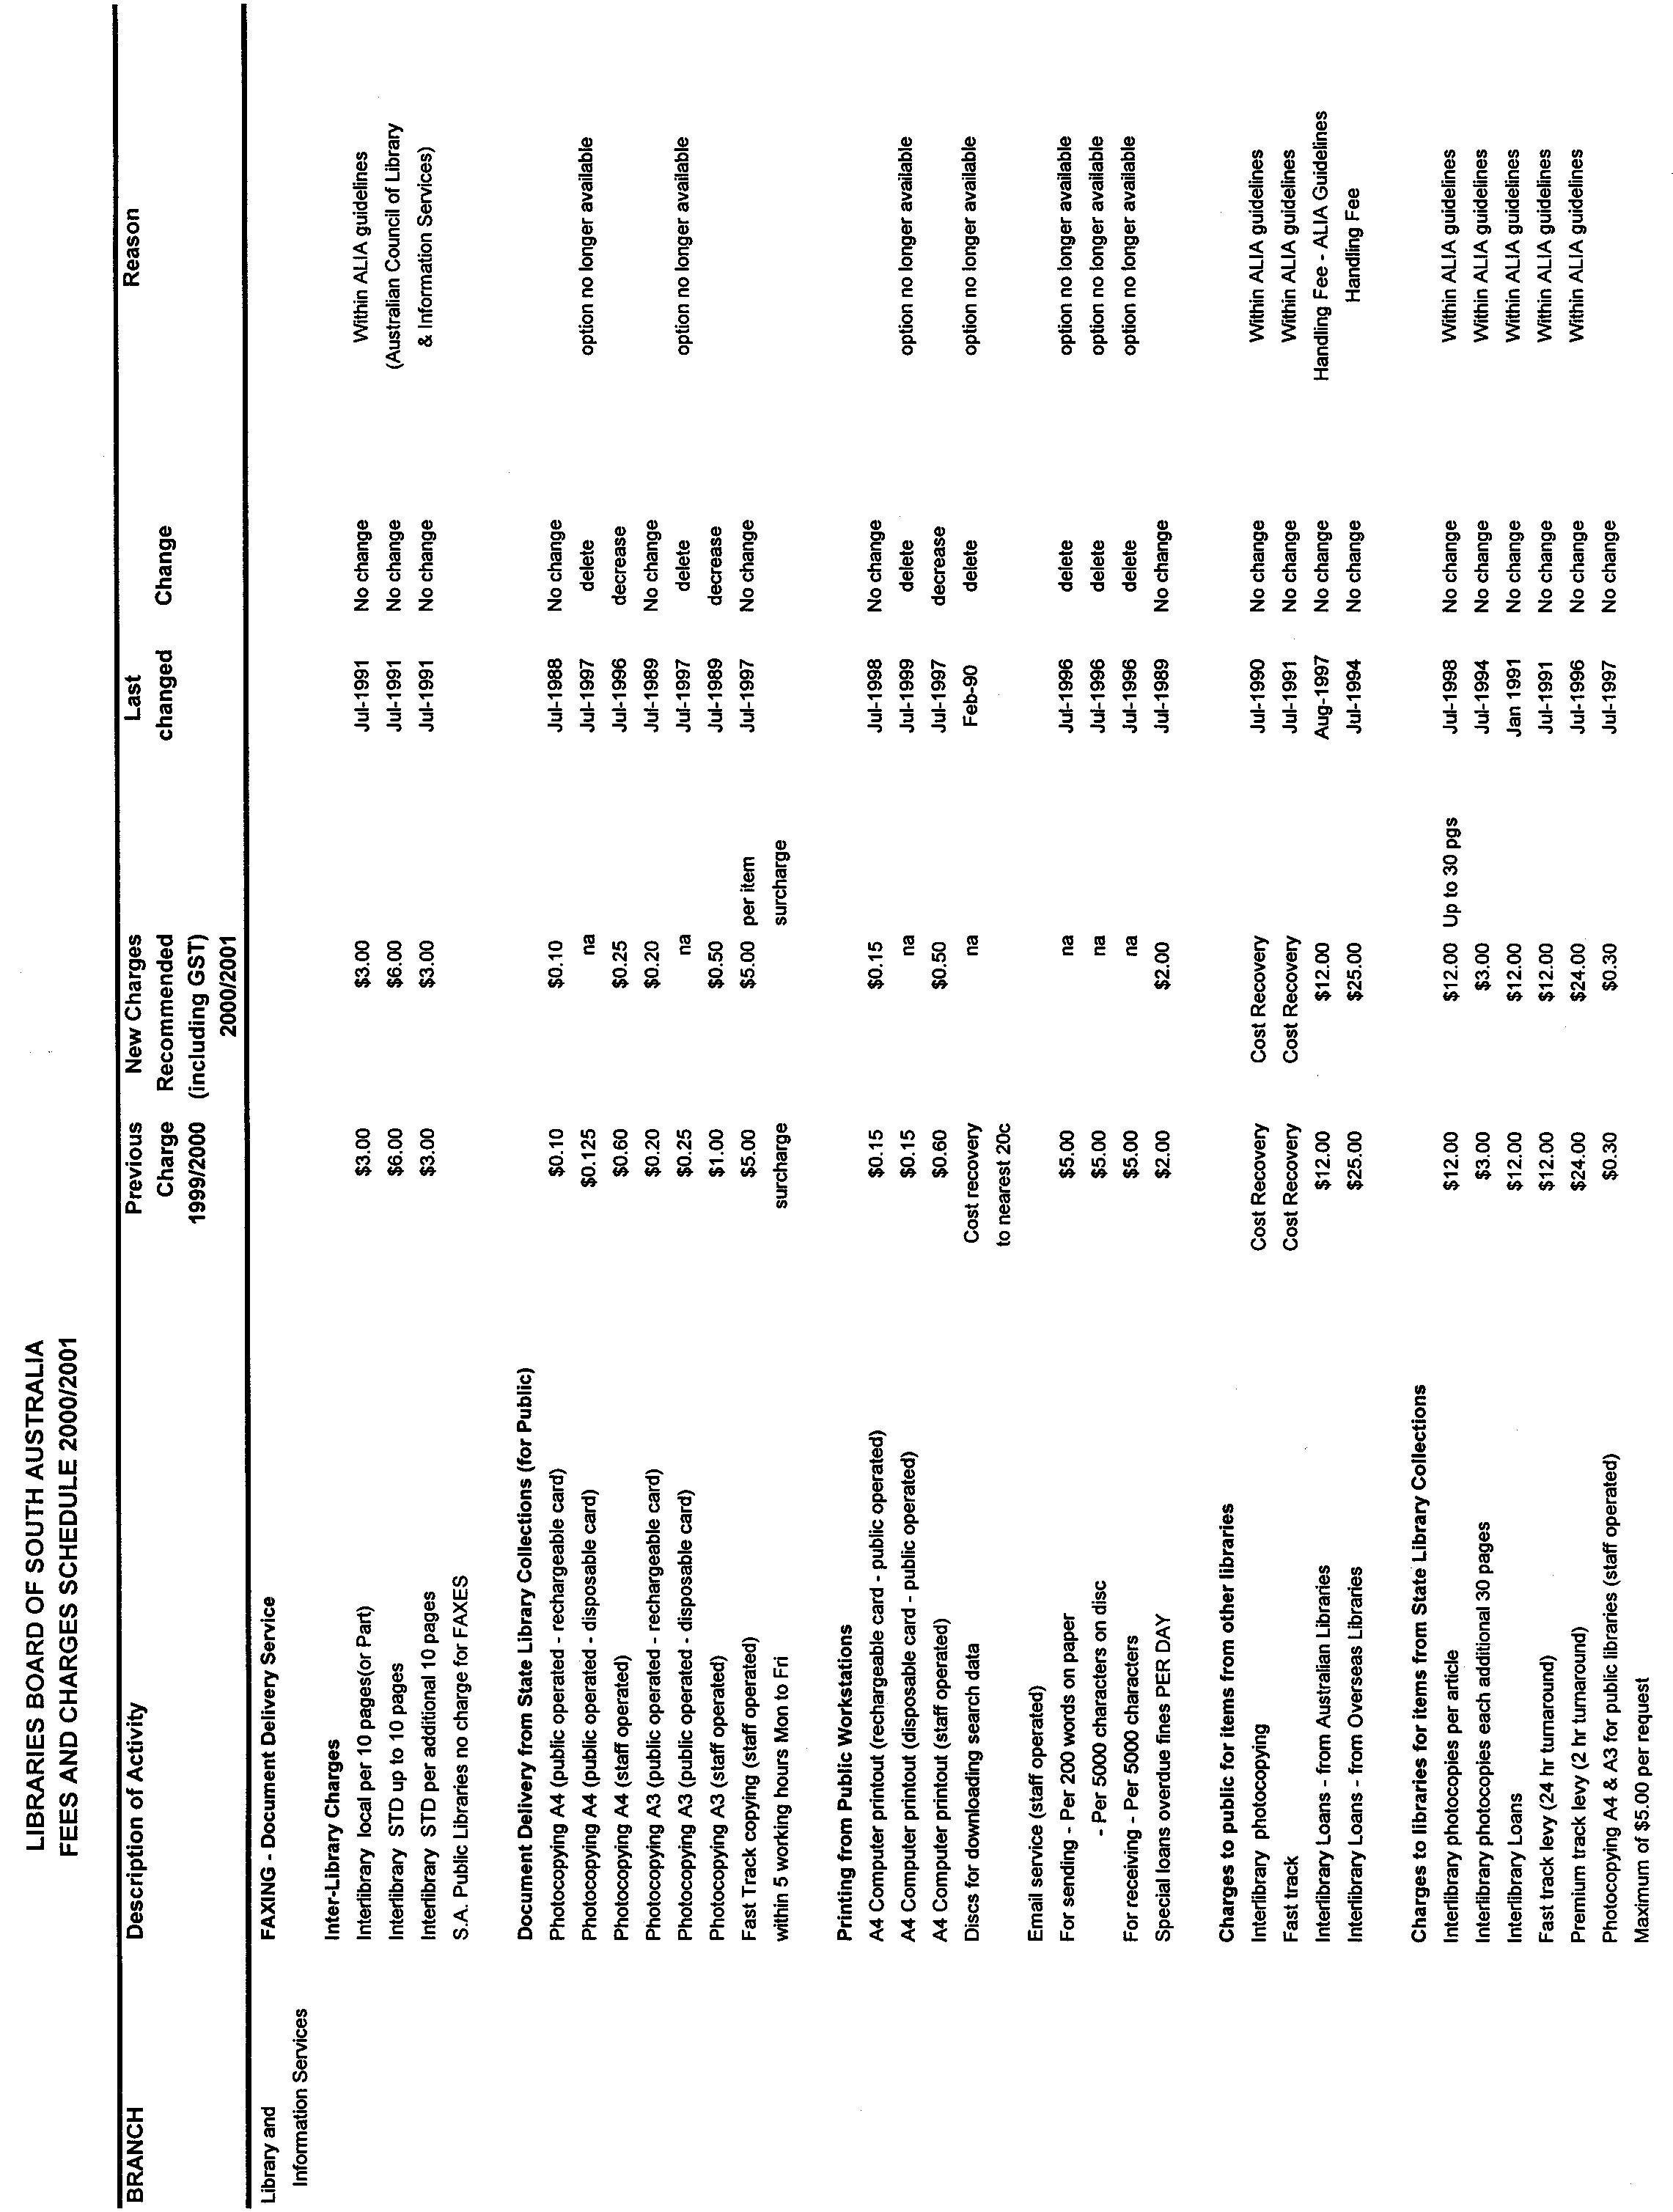
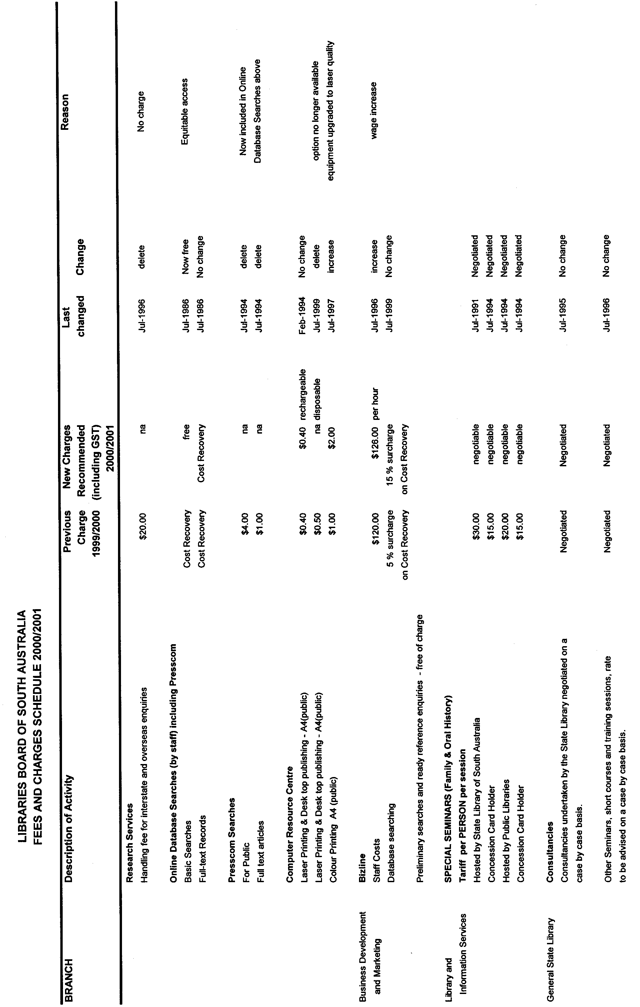
Dated 30 May 2000.B. Halliday, Director State Library of South Australia
GRANT OF FIRST RENEWAL OF PETROLEUM EXPLORATION LICENCE
Department of Primary Industries and Resources, Adelaide 22 May 2000
NOTICE is hereby given that pursuant to delegated powers, dated 20 November 1997, Gazetted 4 December 1997, page 1526, the undermentioned Petroleum Exploration Licence has been renewed under the provisions of the Petroleum Act 1940.
D. Mutton, Chief Executive, Delegate of the Minister for Primary Industries and Resources
No. of  Licence | Licensee | Locality | Date of  Expiry | Area in  km² | Reference

49 | Felstea Pty Ltd |  | Eromanga Basin area of South Australia | 30 June 2001 | 2 064 | SR.27.2.111  vol. 3

Description of Area
All that part of the State of South Australia, bounded as follows: commencing at a point being the intersection of latitude 26°30′S and longitude 137°20′E, thence east to longitude 137°45′E, south to latitude 26°45′S, west to longitude 137°25′E, south to latitude 26°55′S, east to longitude 137°30′E, south to latitude 27°00′S, east to longitude 137°35′E, south to latitude 27°15′S, west to longitude 137°25′E, north to latitude 27°10′S, west to longitude 137°20′E, and north to the point of commencement, all the within latitudes and longitudes being geodetic and expressed in terms of the Australian Geodetic Datum as defined on p. 4984 of Commonwealth Gazette number 84 dated 6 October 1966.
Area: 2 064 km² approximately.

CANCELLATION OF PETROLEUM EXPLORATION LICENCE
Department of Primary Industries and Resources, Adelaide 23 May 2000
NOTICE is hereby given that the undermentioned Petroleum Exploration Licence has been cancelled, pursuant to the provisions of the Petroleum Act 1940.
W. Matthew, Minister for Minerals and Energy
No. of  Licence | Licensee | Locality | Effective  Date of  Cancellation | Area in  km² | Reference

34 | Nerdlihc Company Inc. |  | Spencer Gulf area of South Australia | 23 May 2000 | 5 597 | SR.27.2.79  vol. 4

Description of Area
All that part of the State of South Australia, bounded as follows: commencing at a point being the intersection of latitude 34°10′S and longitude 136°30′E, thence east to longitude 137°15′E, south to latitude 34°54′S, west to longitude 136°30′E, and north to the point of commencement, all the within latitudes and longitudes being geodetic and expressed in terms of the Australian Geodetic Datum as defined on p. 4984 of Commonwealth Gazette number 84 dated 6 October 1966.

GRANT OF THIRD RENEWAL OF PETROLEUM EXPLORATION LICENCE
Department of Primary Industries and Resources, Adelaide 26 May 2000
NOTICE is hereby given that pursuant to delegated powers, dated 20 November 1997, Gazetted 4 December 1997, page 1526, the undermentioned Petroleum Exploration Licence has been renewed under the provisions of the Petroleum Act 1940.
D. Mutton, Chief Executive, Delegate of the Minister for Primary Industries and Resources
No. of  Licence | Licensees | Locality | Date of  Expiry | Area in  km² | Reference

32 | Origin Energy Resources NL  Sagasco South East Inc.  Omega Oil NL |  | Otway Basin area of South Australia | 18 February 2005 | 530.2 | SR.27.2.73  vol. 7

Description of Area
All that part of the State of South Australia, bounded as follows: commencing at a point being the intersection of latitude 37°15′00″S and longitude 140°32′30″E, thence east to longitude 140°40′00″E, south to latitude 37°17′30″S, east to longitude 140°45′00″E, south to latitude 37°20′00″S, east to longitude 140°50′00″E, south to latitude 37°22′30″S, east to longitude 140°55′00″E, south to latitude 37°28′50″S, west to longitude 140°51′00″E, south to latitude 37°29′10″S, west to longitude 140°50′00″E, south to latitude 37°33′00″S, west to longitude 140°44′30″E, north to latitude 37°32′20″S, west to longitude 140°43′10″E, north to latitude 37°32′00″S, west to longitude 140°42′40″E, north to latitude 37°30′20″S, west to longitude 140°41′00″E, north to latitude 37°29′50″S, west to longitude 140°38′40″E, north to latitude 37°29′00″S, west to longitude 140°37′30″E, north to latitude 37°28′10″S, west to longitude 140°36′50″E, north to latitude 37°27′30″S, west to longitude 140°36′10″E, north to latitude 37°26′40″S, west to longitude 140°35′10″E, north to latitude 37°25′20″S, east to longitude 140°40′40″E, north to latitude 37°24′50″S, east to longitude 140°45′00″E, north to latitude 37°22′20″S, west to longitude 140°41′40″E, north to latitude 37°21′20″S, west to longitude 140°40′00″E, north to latitude 37°19′50″S, west to longitude 140°37′50″E, south to latitude 37°21′40″S, west to longitude 140°34′50″E, north to latitude 37°19′50″S, west to longitude 140°33′40″E, north to latitude 37°19′00″S, west to longitude 140°32′30″E, north to latitude 37°15′00″S, and east to the point of commencement, but excluding the areas of Petroleum Production Licences numbered 62 and 168. All the within latitudes and longitudes are expressed in terms of the Geocentric Datum of Australia (GDA 94) except those latitudes and longitudes underlined which are expressed in terms of the Australian Geodetic Datum as defined on p. 4984 of Commonwealth Gazette number 84 dated 6 October 1966.
Area: No greater than 530.2 km² approximately.

RACING ACT 1976
Amendments to Rules
AT a meeting of the South Australian Greyhound Racing Authority on 27 January 2000 the following amendments were made to the National Rules of Greyhound Racing.
‘PARADE STEWARD’ definition.
Add the words ‘or Club’ immediately after Board/Commission.
Rule 6 (4)
Delete the words ‘Notwithstanding this Rule 6 (4)’ and add the words ‘Subject to Rule 6 (5),’.
Delete 6 (4) (a) and 6 (4) (b).
Rule 6 (5)
Delete the rule as it reads and replace with ‘The period of prohibition referred to in Rule 6 (4) shall not be varied or revoked unless a veterinary certificate is produced to the satisfaction of the Chief Steward or his Deputy stating that at the time of examination the greyhound is fit to start.’.
Rule 6 (7)
Delete the rule as it reads and replace with ‘Any injury or illness or seasonal condition which will prevent a greyhound from competing at that meeting shall be notified by the owner or trainer to the Board or Commission by the appointed scratching time on the day of the meeting’.
Rule 18 (5)
Delete ‘,’ between the words Chief Steward, Board/Commission and add the word ‘or’.
Rule 65 (2)
Delete the rule as it reads and replace with ‘The Board, Commission or Stewards may authorise the use, and the acceptance of any results, of any method or device (including, without limitation, photography, video and other image recording devices) to assist the determination of placings of greyhounds in an event.’
Rule 71
Delete the word ‘timekeeper’, and add the words ‘Judge or Assistant Judge or any other person authorised by the Board, Commission or Stewards for that purpose’.
Rule 105
Add the word ‘and’ between the words ‘Owner Trainer’.
Rule 119 (15)
Delete the words ‘Race photography’, and add the words ‘the results of, any device or method approved by the Board, Commission or Stewards (including, without limitation, photography, video and other image recording devices)’.
These rules shall come into operation on 28 June 2000.
The Common Seal of the South Australian Greyhound Racing Authority was hereto affixed in the presence of:
(l.s.) G. J. Inns, Chairman
S. McQueen, Chief Executive Officer

MISCELLANEOUS LEGISLATION AND GOVERNMENT PUBLICATIONS PRICES AS FROM 1 JULY 1999

Acts, Bills, Rules, Parliamentary Papers and Regulations
Pages | Main | Amends | Pages | Main | Amends

1-16 | 1.60 | 0.75 | 497-512 | 23.30 | 22.40
17-32 | 2.30 | 1.45 | 513-528 | 23.90 | 23.00
33-48 | 2.90 | 2.10 | 529-544 | 24.70 | 23.80
49-64 | 3.70 | 2.75 | 545-560 | 25.30 | 24.50
65-80 | 4.35 | 3.55 | 561-576 | 26.00 | 25.20
81-96 | 5.00 | 4.20 | 577-592 | 26.75 | 25.75
97-112 | 5.75 | 4.85 | 593-608 | 27.50 | 26.50
113-128 | 6.40 | 5.60 | 609-624 | 28.25 | 27.50
129-144 | 7.20 | 6.30 | 625-640 | 28.75 | 28.00
145-160 | 7.90 | 6.95 | 641-656 | 29.50 | 28.50
161-176 | 8.60 | 7.70 | 657-672 | 30.00 | 29.25
177-192 | 9.25 | 8.40 | 673-688 | 31.00 | 30.00
193-208 | 9.95 | 9.10 | 689-704 | 31.75 | 30.75
209-224 | 10.60 | 9.75 | 705-720 | 32.25 | 31.50
225-240 | 11.25 | 10.50 | 721-736 | 33.25 | 32.00
241-257 | 12.05 | 11.10 | 737-752 | 33.75 | 32.75
258-272 | 12.80 | 11.80 | 753-768 | 34.50 | 33.25
273-288 | 13.45 | 12.60 | 769-784 | 35.00 | 34.25
289-304 | 14.10 | 13.20 | 785-800 | 35.75 | 35.00
305-320 | 14.80 | 13.90 | 801-816 | 36.25 | 35.50
321-336 | 15.55 | 14.60 | 817-832 | 37.25 | 36.25
337-352 | 16.20 | 15.40 | 833-848 | 38.00 | 37.00
353-368 | 16.90 | 16.05 | 849-864 | 38.50 | 37.75
369-384 | 17.60 | 16.80 | 865-880 | 39.25 | 38.50
385-400 | 18.30 | 17.50 | 881-896 | 39.75 | 39.00
401-416 | 19.00 | 18.10 | 897-912 | 40.75 | 39.75
417-432 | 19.75 | 18.90 | 913-928 | 41.25 | 40.75
433-448 | 20.40 | 19.50 | 929-944 | 42.00 | 41.25
449-464 | 21.15 | 20.20 | 945-960 | 43.00 | 41.75
465-480 | 21.75 | 20.90 | 961-976 | 43.50 | 42.50
481-496 | 22.40 | 21.50 | 977-992 | 44.25 | 43.00

Legislation—Acts, Regulations, etc: $
Subscriptions:
Acts 144.00
All Bills as Laid 344.00
Rules and Regulations 344.00
Parliamentary Papers 344.00
Bound Acts 159.00
Index 77.00
Government Gazette
Copy 3.85
Subscription 190.00
Hansard
Copy 10.30
Subscription—per session (issued weekly) 298.00
Cloth bound—per volume 128.00
Subscription—per session (issued daily) 298.00
Legislation on Disk
Whole Database 2 201.00
Annual Subscription for fortnightly updates 677.00
Individual Act(s) including updates POA

Postage Extra on Individual Copies

All Legislation, Government Gazette, Hansard and Legislation on disk are available from:
Counter Sales Information SA (State Government Bookshop)
and Mail Orders: Australis Centre, Ground Floor, 77 Grenfell Street, Adelaide, S.A. 5000.
Phone: (08) 8204 1900. Fax: (08) 8204 1909
S.A. Country Customer Free Call: 1800 182 234
TTY (Hearing Impaired): (08) 8204 1923
Subscriptions and Standing Orders:
Phone: (08) 8204 9447, (08) 8204 9448. Fax: (08) 8204 1898
P.O. Box 1, Rundle Mall, Adelaide, S.A. 5000.

GOVERNMENT GAZETTE ADVERTISEMENT RATES

To apply from 1 July 1999

$  Agents, Ceasing to Act as 28.50  Associations:  Incorporation 14.50  Intention of Incorporation 35.75  Transfer of Properties 35.75  Attorney, Appointment of 28.50  Bailiff’s Sale 35.75  Cemetery Curator Appointed 21.20  Companies:  Alteration to Constitution 28.50  Capital, Increase or Decrease of 35.75  Ceasing to Carry on Business 21.20  Declaration of Dividend 21.20  Incorporation 28.50  Lost Share Certificates:  First Name 21.20  Each Subsequent Name 7.30  Meeting Final 23.80  Meeting Final Regarding Liquidator’s Report on  Conduct of Winding Up (equivalent to ‘Final  Meeting’)  First Name 28.50  Each Subsequent Name 7.30  Notices:  Call 35.75  Change of Name 14.50  Creditors 28.50  Creditors Compromise of Arrangement 28.50  Creditors (extraordinary resolution that ‘the Com-pany be wound up voluntarily and that a liquidator be appointed’) 35.75  Release of Liquidator⎯Application⎯Large Ad. 57.00  ⎯Release Granted 35.75  Receiver and Manager Appointed 33.25  Receiver and Manager Ceasing to Act 28.50  Restored Name 27.00  Petition to Supreme Court for Winding Up 49.50  Summons in Action 42.25  Order of Supreme Court for Winding Up Action 28.50  Register of Interests⎯Section 84 (1) Exempt 64.00  Removal of Office 14.50  Proof of Debts 28.50  Sales of Shares and Forfeiture 28.50  Estates:  Assigned 21.20  Deceased Persons⎯Notice to Creditors, etc. 35.75  Each Subsequent Name 7.30  Deceased Persons⎯Closed Estates 21.20  Each Subsequent Estate 0.90  Probate, Selling of 28.50  Public Trustee, each Estate 7.30 |  | $  Firms:  Ceasing to Carry on Business (each insertion) 21.20  Discontinuance Place of Business 21.20  Land⎯Real Property Act:  Intention to Sell, Notice of 35.75  Lost Certificate of Title Notices 35.75  Cancellation, Notice of (Strata Plan) 35.75  Mortgages:  Caveat Lodgment 14.50  Discharge of 15.30  Foreclosures 14.50  Transfer of 14.50  Sublet 7.30  Leases⎯Application for Transfer (2 insertions) each 7.30  Lost Treasury Receipts (3 insertions) each 21.20  Licensing 42.25  Municipal or District Councils:  Annual Financial Statement⎯Forms 1 and 2 400.00  Electricity Supply⎯Forms 19 and 20 283.00  Default in Payment of Rates:  First Name 57.00  Each Subsequent Name 7.30  Noxious Trade 21.20  Partnership, Dissolution of 21.20  Petitions (small) 14.50  Registered Building Societies (from Registrar-  General) 14.50  Register of Unclaimed Moneys⎯First Name 21.20  Each Subsequent Name 7.30  Registers of Members⎯Three pages and over:  Rate per page (in 8pt) 181.00  Rate per page (in 6pt) 239.00  Sale of Land by Public Auction 36.25  Advertisements 2.00  Advertisements, other than those listed are charged at $2.00 per column line, tabular one-third extra.  Notices by Colleges, Universities, Corporations and District Councils to be charged at $2.00 per line.  Where the notice inserted varies significantly in length from that which is usually published a charge of $2.00 per column line will be applied in lieu of advertisement rates listed.  South Australian Government publications are sold on the condition that they will not be reproduced without prior permission from the Government Printer.

GOVERNMENT GAZETTE NOTICES
ALL private advertisements forwarded for publication in the South Australian Government Gazette must be PAID FOR PRIOR TO INSERTION; and all notices, from whatever source, should be legibly written on one side of the paper only and sent to Riverside 2000 so as to be received no later than 4 p.m. Tuesday preceding the day of publication. Phone 8207 1045 or Fax 8207 1040. E-mail: Riv2000@saugov.sa.gov.au. Send as attachments in Word format and please confirm your transmission with a faxed copy of your document, including the date the notice is to be published and to whom the notice will be charged.

ROAD TRAFFIC ACT 1961

Operation of Road Train Vehicles in South Australia

PURSUANT to the provisions of Section 161A of the Road Traffic Act 1961 and Regulation 35 of the Road Traffic (Miscellaneous) Regulations 1999, I, T. N. Argent, Executive Director, Transport SA, as an authorised delegate of the Minister for Transport and Urban Planning, hereby approve road trains to operate on routes specified in the Gazette Notice titled ‘Operation of Road Train Vehicles in South Australia’ dated 1 June 2000, subject to the following amendments and conditions:

1. Road Trains operating under this approval operate in accordance with all the requirements of the Gazette Notice ‘Operation of Road Train Vehicles in South Australia’ that appeared in the South Australian Government Gazette, dated 1 June 2000 except for the requirement of the Note to Clause 11 which states ‘Routes specified in this Notice are only available for road trains carrying general freight. This approval does not include the cartage of dangerous goods (in bulk) on these specified routes’.

2. Routes which are under the care and control of the City of Port Adelaide Enfield are only available for road trains carrying general freight. This approval does not include the cartage of dangerous goods (in bulk) on these routes. These routes are:

Mildred Terrace, Elder Road (Victoria Road to Willochra Street), Bedford Street (Eastern Parade to Kennedy’s Depot access), Wing Street, South Terrace (South Road to Wing Street), Francis Road (South Road to Davis Street), Davis Street (Francis Road to Goodfellow’s Depot access), Johansson Road, Senna Road, Lafitte Road, Rosberg Road, Dunstan Road, Streiff Road, Grand Junction Service Road, Duncan Road, Acorn Road, Indama Street, Opala Street, Birralee Road, Naweena Road, Wirriga Road, Kateena Street, Myuna Street, Pumbala Street, Taminga Street, Aruma Street, Camira Street, Tikalara Street, Peekarra Street.

3. The carriage of dangerous goods by road trains on the routes listed above in clause 2 shall only be allowed by the issue of an individual permit from Transport SA.

4. This Notice or a legible copy shall be carried by the driver of the vehicle at all times when operating under this approval and be produced when requested by an Inspector appointed under the Road Traffic Act, 1961 or a Police Officer. This requirement is in addition to the documentation required to be carried by the driver under the Gazette Notice ‘Operation of Road Train Vehicles in South Australia’ that appeared in the South Australian Government Gazette, dated 1 June 2000.

T. N. Argent, Executive Director, Transport SA

ROAD TRAFFIC ACT 1961
Driving Hours and Records for Heavy Vehicles Carrying Live Bees as their Primary Load
PURSUANT to Regulation 5 (4) of the Road Traffic (Driving Hours) Regulations 1999 (‘the Regulations’) I, Diana Vivienne Laidlaw, MLC, Minister for Transport and Urban Planning, hereby declare that the following specified regulations:
• Part 2, Division 2 (driving, work and rest times of regulated hours drivers) Regulations 19, 20 and 21;
• Part 4, Division 2 (driving records for non-local area work);
• Part 4, Division 3 (driving records for local area work);
• Regulation 61 (driving records for non-local area work to be kept); and
• Regulation 62 (local area management records to be kept),
do not apply to drivers of heavy trucks, as defined in Regulation 8, only when the heavy trucks are being used to transport live bees, and subject to the conditions below:
Conditions
1. This notice applies only if a driver is on a journey not exceeding a 200 km limit which is the circumference of a notional circle of which—
(a) the centre is the driver’s base; and
(b) the radius is 200 km.
2. This notice does not exempt employers, employed drivers and self-employed drivers from their obligations under sections 19, 20, 21 and 22 of the Occupational Health, Safety and Welfare Act 1986 and Division 1.2 of the Occupational Health, Safety and Welfare Regulations 1995.
3. This notice has effect only for travel entirely within South Australia.
4. If these conditions are not complied with, the driver becomes ineligible to operate under the exemption and the normal regulation requirements apply.
This notice expires on 1 December 2000 and may be varied or revoked by further notice published in the Gazette.
Dated 1 June 2000.
Diana Laidlaw, Minister for Transport and Urban Planning

ROADS (OPENING AND CLOSING) ACT 1991:
SECTION 24
NOTICE OF CONFIRMATION OF ROAD
PROCESS ORDER
Chapel Street, Hindmarsh
Deposited Plan 53994
BY Road Process Order made on 2 December 1999, the City of Charles Sturt ordered that:
1. Portion of the public road (Chapel Street) adjoining the western boundary of allotment 67 in Filed Plan 120086 more particularly lettered ‘A’ in Preliminary Plan No. PP32/0442 be closed.
2. The whole of the land subject to closure be transferred to DAVID DAVIS GUERIN and MICHAEL DAVIS GUERIN in accordance with agreement for transfer dated 22 November 1999 entered into between the City of Charles Sturt and D. D. Guerin and M. D. Guerin.
3. The following easements are granted over the whole of the land subject to that closure.
Grant to the South Australian Water Corporation easements for water supply and sewerage purposes.
On 10 January 2000 that order was confirmed by the Minister for Administrative Services conditionally on approval and deposit of the survey plan by the Registrar-General. The condition has now been fulfilled.
Pursuant to section 24(5) of the Roads (Opening and Closing) Act 1991, NOTICE of the order referred to above and its confirmation is hereby given.
Dated 8 June 2000.
P. M. Kentish, Surveyor-General

ROADS (OPENING AND CLOSING) ACT 1991:
SECTION 24
NOTICE OF CONFIRMATION OF ROAD
PROCESS ORDER
Ann Street, Findon
Deposited Plan 54849
BY Road Process Order made on 19 April 2000, the City of Charles Sturt ordered that:
1. The whole of the public road (Ann Street) south of Winona Street dividing allotments 140 and 141 in Deposited Plan 4974 more particularly lettered ‘A’ in Preliminary Plan No. PP32/0388 be closed.
2. The whole of the land subject to closure be transferred to FINDON SHOPPING CENTRE PTY LTD in accordance with agreement for transfer dated 19 April 2000 entered into between the City of Charles Sturt and Findon Shopping Centre Pty Ltd.
3. The following easements are granted over portion of the land subject to that closure.
Grant to the ETSA Utilities Pty Ltd an easement for overhead electricity supply purposes.
Grant to Envestra (SA) Limited an easement for gas supply purposes.
On 26 May 2000 that order was confirmed by the Minister for Administrative and Information Services conditionally on approval and deposit of the survey plan by the Registrar-General. The condition has now been fulfilled.
Pursuant to section 24(5) of the Roads (Opening and Closing) Act 1991, NOTICE of the order referred to above and its confirmation is hereby given.
Dated 8 June 2000.
P. M. Kentish, Surveyor-General

CITY OF ONKAPARINGA
NOTICE OF EXCHANGE OF RESERVE
Deposited Plan 55084
Flagstaff Hill
IN PURSUANCE of the LOCAL GOVERNMENT ACT 1934 as amended, I hereby give notice that the City of Onkaparinga of P.O. Box 1, Noarlunga Centre, S.A. 5168, proposes at a meeting to be held at Ramsay Place, Noarlunga Centre, S.A. 5168 on Tuesday, 15 August 2000 at 7.00 p.m., to make an order to exchange a piece of land being a northern portion of allotment 2042 (Reserve) in Deposited Plan 51867 (near Sturt Approach) containing an area of 682m² or thereabouts as delineated, and marked Allotment 1000 on Deposited Plan 55084 (hereinafter referred to as the Map), for allotment 149 in Deposited Plan 42706 adjoining Ironbark Avenue in the said council area, containing an area of 1 123m² or thereabouts as delineated, and marked allotment 1002 in the said Map, with the owner and occupier of the last-mentioned piece of land being CRAIGBURN PROPERTIES PTY LTD. A Survey Map, Plan and Agreement has been deposited in the office of the Surveyor-General, at Adelaide, S.A. 5000 and a copy thereof deposited in the office of the above mentioned Council at Ramsay Place, Noarlunga Centre, S.A. 5168, where the same are open for public inspection, containing the several requirements of the said Act. And I hereby require all persons interested within 40 days
after 8 June 2000, being the date of the first publication of this notice, to deliver to the said Council or its Clerk, in writing, any objection to such exchange. Copy of such objection shall be forwarded to the Surveyor-General’s Office.
Dated 8 June 2000.
P. M. Kentish, Surveyor
DAIS 32/0575

Schedule of Owners and Occupiers, so far as known

No. of Section Owners Occupiers
and Hundred

Hundred of Noarlunga City of Onkaparinga The public
Deposited Plan 51867 P.O. Box 1,
Allotment 2042 Noarlunga Centre,
(Reserve) S.A. 5168
Deposited Plan 53550 City of Onkaparinga The public
(Reserve) P.O. Box 1,
Allotment 505 Noarlunga Centre
S.A. 5168
Allotment 421 J.F. Krijgsman and Owners
J.A. McShane
18 Noll Street
Port Pirie, S.A. 5540
Allotment 500 Craigburn Property Owners
Pty Ltd
c/o Lensworth Group
Pty Ltd
Floor 34, 385 Bourke
Street, Melbourne,
Vic. 3000
Deposited Plan 42706 Craigburn Property Owners
Allotment 149 Pty Ltd
c/o Lensworth Group
Pty Ltd,
Floor 34, 385 Bourke
Street, Melbourne,
Vic. 3000
Allotment 54 P. R. & P. L. Owners
Hemmings
4 Ironbark Avenue,
Flagstaff Hill, S.A. 5033
1/2

ROADS (OPENING AND CLOSING) ACT 1991
Road Closure—Johnston Terrace, Wayville
NOTICE is hereby given, pursuant to section 10 of the Roads (Opening and Closing) Act 1991, that the THE CORPORATION OF THE CITY OF UNLEY proposes to make a Road Process Order to close and transfer to the MINISTER FOR ENVIRONMENT AND HERITAGE portion of the public road (Johnston Terrace) south of Rose Terrace adjoining the northern entrance to the Wayville Showgrounds and allotment 121 in Filed Plan 9795 as more particularly delineated and lettered ‘A’ on Preliminary Plan No. PP32/0573.
A copy of the plan and a statement of persons affected are available for public inspection at the office of the Council, 181 Unley Road, Unley and the Adelaide office of the Surveyor-General during normal office hours.
Any application for easement or objection must set out the full name, address and details of the submission and must be fully supported by reasons.
The application for easement or objection must be made in writing to the Council, P.O. Box 1, Unley, S.A. 5061 WITHIN 28 DAYS OF THIS NOTICE and a copy must be forwarded to the Surveyor-General, G.P.O. Box 1354, Adelaide, S.A. 5001. Where a submission is made, the Council will give notification of a meeting at which the matter will be considered.
Dated 8 June 2000.
P. M. Kentish, Surveyor-General

ROADS (OPENING AND CLOSING) ACT 1991
Corrigendum
NOTICE OF CONFIRMATION OF ROAD
PROCESS ORDER
First Avenue, Glossop
Deposited Plan 52772
IN NOTICE appearing in Government Gazette dated 1 June 2000 on page 2899, pursuant to section 24(5) of the Roads (Opening and Closing) Act 1991 for the Berri Barmera Council should read as follows:
the heading Deposited Plan 52772 to read as follows:
Deposited Plan 54772
the notice is appearing for the Berri Barmera Council not the Alexandrina Council.
Dated 8 June 2000.
P. M.Kentish, Surveyor-General

SOUTH EASTERN WATER CONSERVATION AND DRAINAGE ACT 1992
Contribution Levy
NOTICE is hereby given that I, Mark Brindal, Minister for Water Resources, after consulting with the South Eastern Water Conservation and Drainage Board and pursuant to section 34A of the South Eastern Water Conservation and Drainage Act 1992, give notice that:
1. The South Eastern Water Conservation and Drainage Board may, in respect of the 2000-2001 financial year, levy a contribution from all landholders who own or occupy more than 10 ha of private land in that area of the South East as designated in the attached schedule.
2. Contributions will not be levied in respect of private land that:
(a) is subject to a heritage agreement under the Native Vegetation Act 1992; or
(b) is an area of native vegetation in a single block greater than 40 ha per individual property.
3. The money received by the Board will be applied for the local funding component of the Upper South East Project.
4. The levy will be applied to landholders at differing rates according to where land is situated as designated in the attached schedule with more than one payment option being available.
5. The levy will be applied as follows:
Zone A⎯$2.24/ha/year;
Zone B⎯$1.07/ha/year;
Zone C⎯$0.54/ha/year;
Zone D⎯$0.11/ha/year.
In addition to those levy payments indicated, landholders in Zone A who did in November 1997 elect to make payment over 8 years, the levy will be applied as follows:
$2.29 for 5 years.
Dated 6 June 2000.
Mark Brindal, Minister for Water Resources

VALUATION OF LAND ACT 1971
Notice of General Valuation
PURSUANT to the Valuation of Land Act 1971, notice is hereby given that within the following Local Government Areas I have made a general valuation of all land subject to the general valuation. The values are assigned as at 1 January 2000.
L.G.A. No. Local Government Area
0200 Adelaide
6801 Northern UIA
6803 Riverland UIA
9340 Port Lincoln
9350 Lower Eyre Peninsula
These values will come into force from 1 July 2000.
Dated 5 June 2000.
N. A. Bray, Valuer-General
CL 110/93

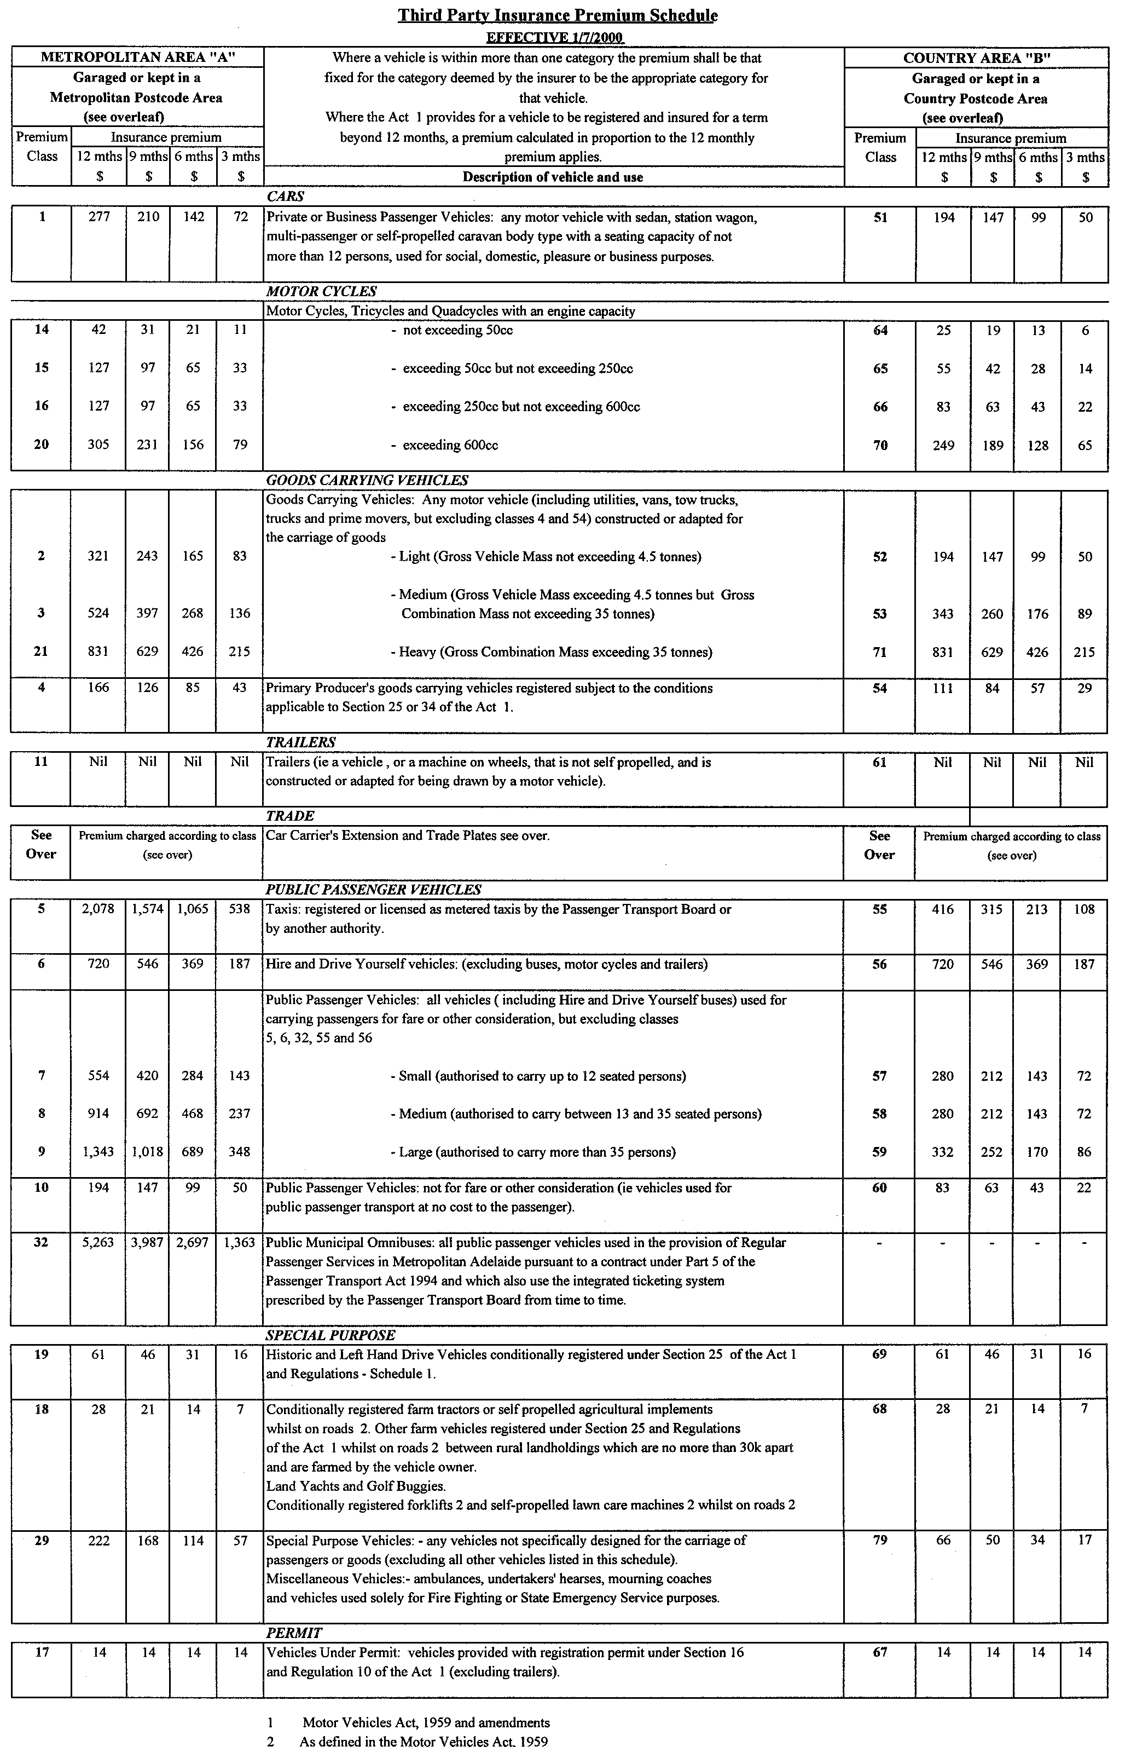
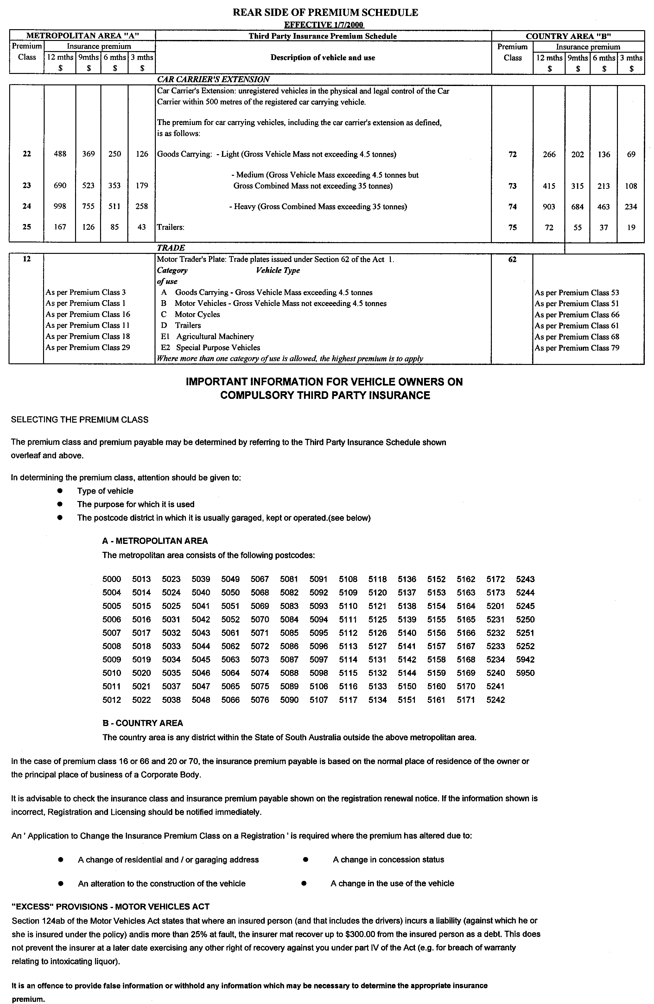
WATER MAINS AND SEWERS

Office of the South Australian Water Corporation
Adelaide, 8 June 2000.

WATER MAINS LAID

Notice is hereby given that the following main pipes or parts of main pipes have been laid down by the South Australian Water Corporation in or near the undermentioned water districts and are now available for a constant supply of water to adjacent land.

ADELAIDE WATER DISTRICT

CITY OF HOLDFAST BAY
Peterson Street, Somerton Park. p14

CITY OF MARION
Frederick Avenue, Seacombe Heights. p15

CITY OF ONKAPARINGA
Knox Drive, Woodcroft and Onkaparinga Hills. p17
Fleet Street, Seaford. p18

CITY OF PORT ADELAIDE ENFIELD
Somerset Avenue, Clearview. p1

CITY OF SALISBURY
Linford Close, Salisbury Downs. p3

CITY OF TEA TREE GULLY
Chapel Hill Road, Greenwith. p4
Lilford Court, Greenwith. p4
Coulson Court, Greenwith. p4

BEACHPORT WATER DISTRICT

DISTRICT OF WATTLE RANGE COUNCIL
Foster Street, Beachport. p12

BEETALOO COUNTRY LANDS WATER DISTRICT

PORT PIRIE REGIONAL COUNCIL
Finnegan Road, Wandearah East. p6

KADINA WATER DISTRICT

DISTRICT OF THE COPPER COAST
Olive Parade, New Town. p9

PENOLA WATER DISTRICT

DISTRICT OF WATTLE RANGE COUNCIL
Roden Lane, Penola. p19

PORT AUGUSTA WATER DISTRICT

CITY OF PORT AUGUSTA
Hannagan Street, Willsden. p8

PORT MACDONNELL WATER DISTRICT

DISTRICT OF GRANT
Pascoe Road, Port MacDonnell. p10
Rossell Street, Port MacDonnell – This main is available on application only. p11
Elizabeth Street, Port MacDonnell – This main is available on application only. p11
French Street, Port MacDonnell. p20

WHYALLA WATER DISTRICT

CITY OF WHYALLA
Noble Street, Whyalla Stuart. p5
Dennis Street, Whyalla Stuart. p5

WILLIAMSTOWN WATER DISTRICT

DISTRICT OF THE BAROSSA COUNCIL
William Dyer Drive, Williamstown. p2

WATER MAINS ABANDONED

Notice is hereby given that the undermentioned water mains have been abandoned by the South Australian Water Corporation.

BEETALOO COUNTRY LANDS WATER DISTRICT

PORT PIRIE REGIONAL COUNCIL
Finnegan Road, Wandearah East. p6

KADINA WATER DISTRICT

DISTRICT OF THE COPPER COAST
Olive Parade, New Town. p9

WHYALLA WATER DISTRICT

CITY OF WHYALLA
Noble Street, Whyalla Stuart. p5
Dennis Street, Whyalla Stuart. p5

SEWERS LAID

Notice is hereby given that the following sewers have been laid down by the South Australian Water Corporation in the undermentioned drainage areas and are now available for house connections.

ADELAIDE DRAINAGE AREA

CITY OF CHARLES STURT
Easements in lots 202 and 201, Sussex Street, Henley Beach. FB 1087 p60

CITY OF HOLDFAST BAY
Peterson Street, Somerton Park. FB 1088 p1

CITY OF MITCHAM
Easement in LTRO Strata Plan 7874, Blythewood Road, Torrens Park. FB 2/27 p49

CITY OF ONKAPARINGA
Carlisle Circuit, Seaford. FB 1087 p55-57
Cardiff Walk, Seaford. FB 1087 p55 and 56
Cleamont Court, Seaford. FB 1087 p55 and 58
Cambourne Crescent, Seaford. FB 1087 p55 and 58
Easement in lot 11, Brabham Grove and lot 2, Black Road, Aberfoyle Park. FB 1087 p59
Across Black Road, Aberfoyle Park. FB 1087 p59

CITY OF SALISBURY
Linford Close, Salisbury Downs. FB 1087 p51

CITY OF TEA TREE GULLY
Sewerage land (lot 474), Maxlay Road, Modbury Heights. FB 431 p3
Across Maxlay Road, Modbury Heights. FB 431 p3
Chapel Hill Road, Greenwith. FB 1087 p52 and 53
Coulson Court, Greenwith. FB 1087 p52 and 53
Easement in lot 82, Lilford Court, Greenwith. FB 1087 p52 and 53
Lilford Court, Greenwith. FB 1087 p52 and 53
Easement in Linear Park (lot 400), Historic Drive, Highbury. FB 1088 p3 and 4

CITY OF WEST TORRENS
Susan Street, Fulham. FB 1087 p54
Selby Street, Kurralta Park. FB 1088 p2

MOUNT GAMBIER COUNTRY DRAINAGE AREA

CITY OF MOUNT GAMBIER
Easement in lots 137 and 118, Sunnyside Drive, Mount Gambier. FB 1066 p50
Kookaburra Court, Mount Gambier. FB 1066 p52
Fairlie Street, Mount Gambier. FB 1066 p51
Heriot Street, Mount Gambier. FB 1066 p47

PORT PIRIE COUNTRY DRAINAGE AREA

PORT PIRIE REGIONAL COUNCIL
Luscombe Street, Risdon Park South. FB 1086 p9

WHYALLA COUNTRY DRAINAGE AREA

CITY OF WHYALLA
Reid Street, Whyalla Norrie. FB 1087 p50
Geddes Street, Whyalla Stuart. FB 1087 p49

SEWERS ABANDONED

Notice is hereby given that the undermentioned sewer has been abandoned by the South Australian Water Corporation.

ADELAIDE DRAINAGE AREA

CITY OF MITCHAM
Easement in LTRO Strata Plan 7874, Blythewood Road, Torrens Park. FB 2/27 p49

SEWERS LAID

Notice is hereby given that the undermentioned sewer has been laid down by the South Australian Water Corporation and is not available for house connections.

ADELAIDE DRAINAGE AREA

CITIES OF TEA TREE GULLY AND CAMPBELLTOWN

Easements in Linear Park (lot 400, Historic Drive and lots 51 and 256, Coventry Drive), Highbury and Athelstone – 80 mm PVC pumping main. FB 1088 p3 and 4

S. Sullivan, Chief Executive Officer, South Australian Water Corporation

WATER RESOURCES ACT 1997
Notice of Prohibition of Water Use in the Baroota Area
PURSUANT to section 16 of the Water Resources Act 1997, I, Mark Brindal, Minister for Water Resources, am of the opinion that the rate at which water is being taken from wells that source water from the Quaternary sands and gravels that are recharged mainly from streamflow events in the Baroota Creek, in the area bounded by the bold line in GRO Plan No. 213/00 (the ‘defined area’), is:
• such that there is a risk that the available water will not be sufficient to meet future demand; and
• likely to affect the quality of water in those underground aquifers.
Accordingly, pursuant to section 16 (1) of the Water Resources Act 1997, I HEREBY PROHIBIT the taking of water from wells in the defined area subject to the exceptions specified in Schedule 1.
Schedule 1
1. A person may take water in accordance with the terms of a written authorisation granted by me or my delegate in accordance with the Guidelines for Authorisation in the Baroota Area dated 3 June 2000 and signed by me (‘the Guidelines’).
2. Any authorisation to take water from wells in the defined area may be varied by further written authorisation issued by me or my delegate in accordance with the Guidelines.
3. This prohibition does not apply to the taking of water pursuant to section 7 (5) of the Act for domestic purposes or watering stock (other than stock subject to intensive farming) or to the taking of water for firefighting or reticulating supplies of potable water for townships in the defined area.
This notice will remain in force for two years unless earlier varied or revoked.
Dated 3 June 2000.
Mark Brindal, Minister for Water Resources

WATER RESOURCES ACT 1997
Notice of Authorisation to Take Water
PURSUANT to section 11 of the Water Resources Act 1997, I Mark Brindal, MP, Minister for Water Resources, do hereby authorise the taking of water from the North Para Prescribed Watercourse between Nuriootpa and Rowland Flat for the purpose of recovering polluted water.
All water taken pursuant to this authorisation must only be taken for the purposes described above, unless otherwise authorised.
This authorisation applies from 12 May 2000 to 26 May 2000.
Dated 2 June 2000.
Mark Brindal, Minister for Water Resources

WATER RESOURCES ACT 1997
Notice on Basis of Levy for 2000-2001 in The Torrens Catchment Water Management Board’s Catchment Area
I, MARK BRINDAL, Minister for Water Resources, have determined pursuant to section 138 (3) of the Water Resources Act 1997, that the basis for the levy in the catchment area of the Torrens Catchment Water Management Board for the 2000-2001 financial year will be the capital value of rateable land.
His Excellency the Governor gave his approval of the method referred to in the above paragraph on 8 June 2000.
Dated 8 June 2000.
Mark Brindal, Minister for Water Resources

WATER RESOURCES ACT 1997
Notice of Contributions in 2000-2001 by Constituent Councils of the Torrens Catchment Water Management Board’s Catchment Area
I, MARK BRINDAL, Minister for Water Resources, have determined pursuant to section 135 of the Water Resources Act 1997 that:
(a) the total amount to be contributed by constituent councils of the catchment area of the Torrens Catchment Water Management Board in respect of the 2000-2001 financial year is to be the sum of three million eight hundred and twenty-one thousand nine hundred dollars; and
(b) constituent councils of the Board’s area will share the liability for the payment of that amount as follows:
Constituent Council Amount
$

Adelaide 450 800
Adelaide Hills 88 400
Barossa 7 100
Burnside 395 400
Campbelltown 353 000
Charles Sturt 905 300
Norwood, Payneham and St Peters 416 800
Prospect 200 400
Port Adelaide/Enfield 724 300
Walkerville 105 500
West Torrens 101 200
Tea Tree Gully 73 700
Total 3 821 900

His Excellency the Governor gave his approval of the amounts referred to in paragraph (a) on 8 June 2000.
Dated 8 June 2000.
Mark Brindal, Minister for Water Resources

WATER RESOURCES ACT 1997
Notice on Basis of Levy for 2000-2001 in The Northern Adelaide and Barossa Catchment Water Management Board’s Catchment Area
I, MARK BRINDAL, Minister for Water Resources, have determined pursuant to section 138 (3) of the Water Resources Act 1997 that the basis for the levy in the catchment area of the Northern Adelaide and Barossa Catchment Water Management Board for the 2000-2001 financial year will be the capital value of rateable land.
His Excellency the Governor gave his approval of the method referred to in the above paragraph on 8 June 2000.
Dated 8 June 2000.
Mark Brindal, Minister for Water Resources

WATER RESOURCES ACT 1997
Notice of Contributions in 2000-2001 by Constituent Councils of the Northern Adelaide and Barossa Catchment Water Management Board’s Catchment Area
I, MARK BRINDAL, Minister for Water Resources, have determined pursuant to section 135 of the Water Resources Act 1997 that:
(a) the total amount to be contributed by constituent councils of the catchment area of the Northern Adelaide and Barossa Catchment Water Management Board in respect of the 2000-2001 financial year is to be the sum of two million fifty thousand and two hundred dollars; and
(b) constituent councils of the Board’s area will share the liability for the payment of that amount as follows:

Constituent Council Amount
$

Adelaide Hills 24 900
Barossa 207 700
Gawler 125 300
Kapunda Light 59 300
Mallala 33 000
Playford 338 500
Port Adelaide/Enfield 17 100
Salisbury 619 700
Tea Tree Gully 624 700
Total 2 050 200

His Excellency the Governor gave his approval of the amounts referred to in paragraph (a) on 8 June 2000.
Dated 8 June 2000.
Mark Brindal, Minister for Water Resources

WATER RESOURCES ACT 1997
Notice on Basis of Levy for 2000-2001 in The Patawalonga Catchment Water Management Board’s Catchment Area
I, MARK BRINDAL, Minister for Water Resources, have determined pursuant to section 138 (3) of the Water Resources Act 1997 that the basis for the levy in the catchment area of the Patawalonga Catchment Water Management Board for the 2000-2001 financial year will be the capital value of rateable land.
His Excellency the Governor gave his approval of the method referred to in the above paragraph on 8 June 2000.
Dated 8 June 2000.
Mark Brindal, Minister for Water Resources

WATER RESOURCES ACT 1997
Notice of Contributions in 2000-2001 by Constituent Councils of the Patawalonga Catchment Water Management Board’s Catchment Area
I, MARK BRINDAL, Minister for Water Resources, have determined pursuant to section 135 of the Water Resources Act 1997 that:
(a) the total amount to be contributed by constituent councils of the catchment area of the Patawalonga Catchment Water Management Board in respect of the 2000-2001 financial year is to be the sum of two million two hundred and forty-eight thousand five hundred dollars; and
(b) constituent councils of the Board’s area will share the liability for the payment of that amount as follows:

Constituent Council Amount
$

Adelaide 90 500
Adelaide Hills 21 000
Burnside 157 200
Charles Sturt 13 100
Holdfast Bay 331 100
Marion 390 300
Mitcham 478 600
Onkaparinga 70 500
Unley 373 900
West Torrens 322 300
Total 2 248 500

His Excellency the Governor gave his approval of the amounts referred to in paragraph (a) on 8 June 2000.
Dated 8 June 2000.
Mark Brindal, Minister for Water Resources

WINGFIELD WASTE DEPOT CLOSURE ACT 1999
Closure of Waste Depot
NOTICE is hereby given pursuant to section 12 (2)(d) of the Wingfield Waste Depot Closure Act 1999 that I, Iain Frederick Evans, Minister for Environment and Heritage, Minister of the Crown to whom the administration of the Wingfield Waste Depot Closure Act 1999 is committed, advise that on 5 May 2000, I adopted the Landfill Environmental Management Plan for closure of the Wingfield waste depot. The Landfill Environmental Management Plan may be inspected or purchased at the Environment Shop, 77 Grenfell Street, Adelaide.
Iain Evans, Minister for Environment and Heritage

REGULATIONS UNDER THE EMERGENCY SERVICES FUNDING ACT 1998
────
No. 125 of 2000
────
At the Executive Council Office at Adelaide 8 June 2000

PURSUANT to the Emergency Services Funding Act 1998, on the recommendation of the Minister for Justice and with the advice and consent of the Executive Council, I make the following regulations.
E. J. NEAL Governor

PURSUANT to section 10AA(2) of the Subordinate Legislation Act 1978, I certify that, in my opinion, it is necessary or appropriate that the following regulations come into operation as set out below.

K. T. GRIFFIN Minister for Justice
───────────────────
SUMMARY OF PROVISIONS

1. Citation
2. Commencement
3. Interpretation
4. Remission of levy on cars and motorcycles
5. Remission of levy on metropolitan primary production goods vehicles
6. Remission of levy on trailers
7. Remission of levy on historic and left hand drive vehicles
8. Remission of levy on recreational vessels
9. Proportionate reduction of remission
───────────────────

Citation
1. These regulations may be cited as the Emergency Services Funding (Remissions—Motor Vehicles and Vessels) Regulations 2000.

Commencement
2. These regulations will come into operation on 1 July 2000.

Interpretation
3. In these regulations, unless the contrary intention appears—

"the Act" means the Emergency Services Funding Act 1998;

"levy" means the levy under Part 3 Division 2 of the Act.

Remission of levy on cars and motorcycles
4. A person who is liable to pay a levy in relation to the 2000/2001 financial year or a subsequent financial year on the registration, or the renewal of the registration, of a motor vehicle in Premium Class Code 1, 15, 16, 20, 51, 66 or 70 (car or motorcycle) is entitled to a remission of $8.00.

Remission of levy on metropolitan primary production goods vehicles
5. A person who is liable to pay a levy in relation to the 2000/2001 financial year or a subsequent financial year on the registration, or the renewal of the registration, of a vehicle in Premium Class Code PCC4 (primary production—goods) is entitled to a remission of $20.00.

Remission of levy on trailers
6. A person who is liable to pay a levy in relation to the 2000/2001 financial year or a subsequent financial year on the registration, or the renewal of the registration, of a motor vehicle in Premium Class Code 11 or 61 (trailer) is entitled to a remission of the whole of the levy.

Remission of levy on historic and left hand drive vehicles
7. (1) A person who is liable to pay a levy in relation to one or more of the financial years referred to in subregulation (2) on the registration, or the renewal of the registration, of a motor vehicle as a historic vehicle or a left hand drive vehicle under section 25 of the Motor Vehicles Act 1959 is entitled to a remission of part of the levy in respect of the vehicle.

(2) The financial years to which subregulation (1) relates are the 2000/2001, 2001/2002, 2002/2003 and 2003/2004 financial years.

(3) The amount of the remission is such amount as is required to reduce the levy in respect of the vehicle to $6.00.

Remission of levy on recreational vessels
8. (1) A person who is liable to pay a levy in relation to the 2000/2001 financial year or a subsequent financial year on the registration, or the renewal of the registration, of a recreational vessel fitted with an engine is entitled to a remission of the whole of the levy.

(2) In subregulation (1), "recreational vessel" has the same meaning as in the Harbors and Navigation Act 1993.

Proportionate reduction of remission
9. (1) The amount of a remission prescribed by these regulations is in respect of the levy paid, or payable, for the whole of a financial year in relation to which the remission applies.

(2) If a proportion of a levy is paid, or payable, in respect of part of a financial year, the person liable to pay the levy is entitled to the same proportion of the remission prescribed by these regulations for that year.

AG 41/2000 CS R. DENNIS Clerk of the Council

REGULATIONS UNDER THE CONTROLLED SUBSTANCES ACT 1984
────
No. 126 of 2000
────
At the Executive Council Office at Adelaide 8 June 2000

PURSUANT to the Controlled Substances Act 1984 and with the advice and consent of the Executive Council, I make the following regulations.
E. J. NEAL Governor

PURSUANT to section 10AA(2) of the Subordinate Legislation Act 1978, I certify that, in my opinion, it is necessary or appropriate that the following regulations come into operation as set out below.

DEAN BROWN Minister for Human Services
───────────────────
SUMMARY OF PROVISIONS

1. Citation
2. Commencement
3. Variation of reg. 4—Interpretation
4. Variation of Sched. E—Schedule 2 Poisons Authorised to be Sold by Holder of Medicine Sellers Licence (Regulation 11(2))
───────────────────

Citation
1. The Controlled Substances (Poisons) Regulations 1996 (see Gazette 4 January 1996 p. 36), as varied, are referred to in these regulations as "the principal regulations".

Commencement
2. (1) Subject to subregulation (2), these regulations will come into operation four months after the day on which they are made (see Subordinate Legislation Act 1978 section 10AA).

(2) Regulation 3 will come into operation on 1 July 2000.

Variation of reg. 4—Interpretation
3. Regulation 4 of the principal regulations is varied—

(a) by inserting after the definition of "health service" in subregulation (1) the following definition:

"National Drugs and Poisons Schedule Committee" means the National Drugs and Poisons Schedule Committee established by the Therapeutic Goods Act 1989 of the Commonwealth;;

(b) by striking out the definition of "Uniform Poisons Standard" in subregulation (1) and substituting the following definition:

"Uniform Poisons Standard" means the Standard for the Uniform Scheduling of Drugs and Poisons published by the National Drugs and Poisons Schedule Committee.

Variation of Sched. E—Schedule 2 Poisons Authorised to be Sold by Holder of Medicine Sellers Licence (Regulation 11(2))
4. Schedule E of the principal regulations is varied—

(a) by striking out "Buclizine" and "Carbaryl";
(b) by inserting in alphabetical order the following items:

Aciclovir Ketoprofen
Bifonazole Levocabastine
Cetirizine Lodoxamide
Diclofenac Loperamide
Econazole Loratadine
Fexofenadine Nystatin
Ibuprofen Penciclovir
Indomethacin Piroxicam
Ipratropium Sodium cromoglycate
Ketoconazole Terbinafine.

DHS 003/00/0090 CS R. DENNIS Clerk of the Council
DHS 003/99/0249 CS

REGULATIONS UNDER THE DEVELOPMENT ACT 1993
────
No. 127 of 2000
────
At the Executive Council Office at Adelaide 8 June 2000

PURSUANT to the Development Act 1993 and with the advice and consent of the Executive Council, I make the following regulations.
E. J. NEAL Governor

PURSUANT to section 10AA(2) of the Subordinate Legislation Act 1978, I certify that, in my opinion, it is necessary or appropriate that the following regulations come into operation as set out below.

DIANA LAIDLAW Minister for Transport and Urban Planning
───────────────────
SUMMARY OF PROVISIONS

1. Citation
2. Commencement
3. Variation of schedule 10
───────────────────

Citation
1. The Development Regulations 1993 (see Gazette 27 October 1993 p. 1954), as varied, are referred to in these regulations as "the principal regulations".

Commencement
2. These regulations will come into operation on the day on which they are made.

Variation of schedule 10
3. Schedule 10 of the principal regulations is varied—

(a) by striking out from clause 4 "All classes of development" and substituting "Development that involves the erection of a new building";

(b) by striking out clause 17.

MFTUP 9/2000 CS R. DENNIS Clerk of the Council

REGULATIONS UNDER THE STOCK FOODS ACT 1941
────
No. 128 of 2000
────
At the Executive Council Office at Adelaide 8 June 2000

PURSUANT to the Stock Foods Act 1941 and with the advice and consent of the Executive Council, I make the following regulations.
E. J. NEAL Governor

───────────────────
SUMMARY OF PROVISIONS

1. Citation
2. Commencement
3. Variation of reg. 4—Interpretation
4. Variation of reg. 10A—Application of Part
5. Variation of reg. 10B—Label or invoice on sale of stock food
6. Transitional provision
───────────────────

Citation
1. The Stock Foods Regulations 1996 (see Gazette 29 August 1996 p. 992), as varied, are referred to in these regulations as "the principal regulations".

Commencement
2. These regulations will come into operation four months after the day on which they are made (see Subordinate Legislation Act 1978 section 10AA).

Variation of reg. 4—Interpretation
3. Regulation 4 of the principal regulations is varied by striking out the definition of "ruminant material" and substituting the following definition:

"mammalian material" means any material derived from a mammal but does not include—

(a) milk or products derived from milk; or

(b) tallow; or

(c) gelatine; or

(d) blood or any extract or derivative of blood; or

(e) meat, or a meat product, that was originally sold for human consumption in accordance with the Meat Hygiene Act 1994 and, after being cooked for the purpose of human consumption, was found not to be needed for that purpose and has subsequently undergone further heat treatment in the process of being produced as food for livestock; or

(f) porcine, equine or macropod material;.

Variation of reg. 10A—Application of Part
4. Regulation 10A of the principal regulations is varied by striking out paragraph (b) and substituting the following paragraph:

(b) that is not supplied as food for dogs or pigeons.

Variation of reg. 10B—Label or invoice on sale of stock food
5. Regulation 10B of the principal regulations is varied by striking out from subregulation (1)(a) "material from a ruminant" and substituting "mammalian material".

Transitional provision
6. (1) Part 3 of the principal regulations, as amended by these regulations, only applies in relation to stock food manufactured after the commencement of these regulations.

(2) Part 3 of the principal regulations, as in force immediately before the commencement of these regulations, continues to apply to stock food manufactured prior to the commencement of these regulations.

MPNR 76/99 CS R. DENNIS Clerk of the Council

FAXING COPY?

IF you fax copy to Riverside 2000, for inclusion in the Government Gazette, there is no need to send a Confirmation Copy to us as well.

This creates confusion and may well result in your notice being printed twice.

Please use the following fax number:

Fax transmission: (08) 8207 1040
Phone Inquiries: (08) 8207 1045

Please include a contact person, phone number and order number so that we can phone back with any queries we may have regarding the fax copy.

NOTE: Closing time for lodging new copy (either fax or hard copy) is 4 p.m. on Tuesday preceding the day of publication.

Government Gazette notices can be E-mailed.

The address is:

Riv2000@saugov.sa.gov.au

Documents should be sent as attachments in Word format.

When sending a document via E-mail, please confirm your transmission with a faxed copy of your document, including the date the notice is to be published.

Fax transmission: (08) 8207 1040
Enquiries: (08) 8207 1045

CITY OF BURNSIDE
Results of Periodical Election
OFFICE of Mayor (one vacancy—quota 6 635 first preference votes):
Votes
Jacobsen, Jim 4 255
Greiner, Wendy 4 312 elected
Taylor, Alan 4 702
Informal 69
⎯⎯⎯
Total 13 338
Office of Councillor for Beaumont Ward (two vacancies—quota 722 first preference votes):
Votes
Hillier, Andrew 931 elected (1)
Ward, Allan Albert 817 elected (2)
Disney, Rosalie 417
Informal 90
⎯⎯⎯
Total 2 255
Office of Councillor for BurnsideWard (two vacancies—quota 753 first preference votes):
Votes
Kershaw, Hollie 509
McGovern, Bill 370
Gilbert, Rob 665 elected (2)
Bills, Graham 714 elected (1)
Informal 70
⎯⎯⎯
Total 2 328
Office of Councillor for Eastwood and Glenunga Ward (two vacancies—quota 729 first preference votes):
Votes
O’Kelly, Michael 568
Palk, Leni 979 elected (1)
Melick, Jenni 637 elected (2)
Informal 99
⎯⎯⎯
Total 2 283
Office of Councillor for Kensington Gardens and Magill Ward (two vacancies—quota 719 first preference votes):
Votes
Walker, Andrea 226
Byrne, Irene 118
Waller, Gregory John 570 elected (2)
Collins, Christopher 565 elected (1)
Caruso, Mario 163
Pitman, Colin 427
Foster-Jones, Rod 87
Informal 62
⎯⎯⎯
Total 2 218
Office of Councillor for Kensington Park Ward (two vacancies—quota 710 first preference votes):
Votes
Bren, Maria 157
Crompton, Barbara 718 elected (1)
Gerrard, Paul 557
Harris, Peter 695 elected (2)
Informal 57
⎯⎯⎯
Total 2 184
Office of Councillor for Rose Park and Toorak Gardens Ward (two vacancies—quota 684 first preference votes):
Votes
O’Brien, Joy L. 283 elected (2)
Shepherd, George 308
Wickham, Jean 698 elected (1)
Williams, Wally 164
Holman, John 273
Read 325
Informal 49
⎯⎯⎯
Total 2 100
S. H. Tully, Returning Officer

CITY OF CAMPBELLTOWN
Results of Periodical Election
OFFICE of Mayor (one vacancy):
Woodcock, Steve (elected unopposed)
Office of Area Councillors (four vacancies):
Amber, Max (elected unopposed)
Durden, Jim (elected unopposed)
Hallwood, George (elected unopposed)
Kennedy, John (elected unopposed)
Office of Councillor for Hectorville Ward (two vacancies⎯ quota 866 votes) after distribution of preferences:
Votes
Black, Judy 1 413 elected
McIlwraith, Ross 344 elected
Scherer, George 348
Scalzi, Peter 492
Informal 84
⎯⎯⎯
Total 2 681
Office of Councillor for Gorge Ward (two vacancies⎯quota 829 votes) after distribution of preferences:
Votes
Preece, Bruce 192
Aldenhoven, Lee 500 elected
Centofanti, Tony 498
Goldstone, Fred 399
Koch, Denis John 412
Nicol, Margaret 484 elected
Informal 67
⎯⎯⎯
Total 2 552
Office of Councillor for Newton Ward (two vacancies):
Decorso, Pio (elected unopposed)
Di Fede, Giovanni (John) (elected unopposed)
Office of Councillor for River Ward (two vacancies⎯quota 830 votes) after distribution of preferences:
Votes
Matzick, Jeanne 1 113 elected
Pucek, Darko 543
Liapis, Steve Soteres 833 elected
Informal 101
⎯⎯⎯
Total 2 590
Office of Councillor for Woodforde Ward (two vacancies⎯ quota 836 votes) after distribution of preferences:
Votes
Jennings, Graham 1 006 elected
Beck, Karen 747 elected
Klaebe-Ly, Cathryn (Gabriella) 165
Drewett, Jennifer Anne. 587
Informal 64
⎯⎯⎯
Total 2 569
S. H. Tully, Returning Officer

CITY OF CHARLES STURT
Results of Periodical Election
OFFICE of Mayor (one vacancy—quota 14 808 first preference votes):
Votes
Anderson, Harold 13 506 elected
Taylor, Chris 10 570
Meschino, Carlo 3 359
Lewis, Don 2 179
Informal 272
⎯⎯⎯
Total 29 886
Office of Councillor for Semaphore Park Ward (two vacancies—quota 857 first preference votes):
Votes
Ferrao, Gerard 1 341 elected (1)
Buesnel, Graham R. 561
Rau, Anna 667 elected (2)
Informal 141
⎯⎯⎯
Total 2 710
Office of Councillor for West Lakes Ward (two vacancies):
Ghent, Stuart Wilson (elected unopposed)
Miller, Allison (elected unopposed)
Office of Councillor for Grange Ward (two vacancies—quota 1 009 first preference votes):
Votes
Sykes, Paul 991 elected (1)
Cashel, Deb 788
Esposito, Neil 402
Howland, John H 843 elected (2)
Informal 144
⎯⎯⎯
Total 3 168
Office of Councillor for Henley Ward (two vacancies—quota 1 168 first preference votes):
Votes
Barratt, Kate 488
Dodds, Tim 1 066 elected (1)
Lawrence, Julie 257
Fitzpatrick, Jim 399
Taylor, Rob 336
Phillips, Bernie 956 elected (2)
Informal 91
⎯⎯⎯
Total 3 593
Office of Councillor for Royal Park Ward (two vacancies—quota 857 first preference votes):
Votes
Wasylenko, Tolley 1 305 elected (1)
Grant, Robert Hugh 963 elected (2)
Ormond, Bruce 302
Informal 213
⎯⎯⎯
Total 2 783
Office of Councillor for Findon Ward (two vacancies—quota 1 084 first preference votes):
Votes
Harvie, Don 124
Cotton, Bernhard 376
Olsen, Richard (Dick) Thomas 1 082 elected (1)
Ienco, Joe 661
Duncan, Julie 1 007 elected (2)
Informal 169
⎯⎯⎯
Total 3 419
Office of Councillor for Kidman Ward (two vacancies—quota 929 first preference votes):
Votes
Pinto, John 893 elected (2)
Curtis, Marni 1 244 elected (1)
Horobin, Andrew Stuart 648
Informal 129
⎯⎯⎯
Total 2 914
Office of Councillor for Woodville Ward (two vacancies—quota 917 first preference votes):
Votes
Freak, Brian Noel 962 elected (1)
Barrowman, Fiona 454
Blaikie, Jonothan Grant 427
Evans, Haydn 633 elected (2)
Galanti, Max 274
Informal 197
⎯⎯⎯
Total 2 947
Office of Councillor for Beverley Ward (two vacancies—quota 858 first preference votes):
Votes
Agius, Edgar 522
Ramage, Nic 341
Hall, Phillip 434 elected (2)
Odgers, Lee-Anne 917 elected (1)
Liang, Larry 358
Informal 174
⎯⎯⎯
Total 2 746
Office of Councillor for Hindmarsh Ward (two vacancies—quota 933 first preference votes):
Votes
Bowey, Candice 855 elected (2)
Rankine, Brett W. 433
Tsavaridis, John 1 025 elected (2)
O’Mahoney, Damien 483
Informal 167
⎯⎯⎯
Total 2 963
S. H. Tully, Returning Officer

CITY OF HOLDFAST BAY
Periodical Election Results
OFFICE of Mayor (one vacancy—quota 5 815 first preference votes):
Votes
Nadilo, Brian 8 587 elected
Ferdinands, Kingsley 3 042
Informal 95
⎯⎯⎯
Total 11 724
Office of Councillor for Glenelg Ward (three vacancies first preference votes):
Votes
MacCaskill, Pat 1 019 elected (1)
McDermott, Heather 455
Deakin, Sandra 505 elected (3)
Dixon, Peter William 924 elected (2)
Informal 84
⎯⎯⎯
Total 2 987
Office of Councillor for Somerton Ward (three vacancies—quota 718 first preference votes):
Votes
Lush, Cheryl 794 elected (1)
Telfer, Raelene June 538 elected (2)
Rollond, Ken 545 elected (3)
Bouchee, Mikki 318
Tate, Petrina 314
Clayton, Barry 359
Informal 65
⎯⎯⎯
Total 2 933
Office of Councillor for Brighton Ward (three vacancies—quota 760 first preference votes):
Votes
Howieson, Benjamin James 317
Norton, Alan C. 1 591 elected (1)
Deakin, Jon 488 elected (3)
Hounslow, Ralph 208
Swiderczuk, Dariusz J. 434 elected (2)
Informal 60
⎯⎯⎯
Total 3 098
Office of Councillor for Seacliff Ward (three vacancies—quota 677 first preference votes):
Votes
Rampling, Paul Thomas 291
Holt, Peter 569 elected (3)
Edwards, Rod 887 elected (1)
Needham, Peter E. 348
Mathwin, John 611 elected (2)
Informal 58
⎯⎯⎯
Total 2 764
S. H. Tully, Returning Officer

CITY OF MARION
Results of Periodical Election
OFFICE of Mayor—(one vacancy—quota 10 623) after distribution of preferences:
Votes
Hull, Bruce W. 8 009
Lewis, Felicity-Ann 7 435 elected
Bierbaum, Wolf 5 800
Informal 122
⎯⎯⎯
Total 21 366
Office of Councillor for East Ward (three vacancies—quota 1 318) after distribution of preferences:
Votes
Watts, Graham K. 1 430 elected
Herraman, Joan 1 790 elected
Zimmermann, Alex 1 284 elected
McLeod, Donald 767
Informal 232
⎯⎯⎯
Total 5 503
Office of Councillor for West Ward (three vacancies⎯quota 1 320 votes) after distribution of preferences:
Votes
Woolley, Ray 1 693 elected
Veliskou, Vicky 931
Brown, Vincent Neil 1 581 elected
Whennan, Irene. 1 072 elected
Informal 154
⎯⎯⎯
Total 5 431
Office of Councillor for Central Ward (three vacancies⎯quota 1 323 votes) after distribution of preferences:
Votes
Senior, Clem 1 299 elected
Donley, Bob 2 153 elected
Kulshrestha, Devendra 289
Staker, Clarke. 337
Bouwens, Carol 1 211 elected
Informal 141
⎯⎯⎯
Total 5 430
Office of Councillor for South Ward (three vacancies⎯quota 1 168 votes) after distribution of preferences:
Votes
Borst, Rene 531
Moorman, Keith T. 585 elected
Durward, Rob 1 296 elected
Connor, Cheryl. 2 258 elected
Informal 190
⎯⎯⎯
Total 4 860
S. H. Tully, Returning Officer

CITY OF MITCHAM
Periodical Election Results
OFFICE of Mayor (one vacancy) Brooks, Ivan (elected unopposed):
Office of Councillor for Boorman Ward (two vacancies—quota 918 first preference votes):
Votes
Hart, Cathryn 1 404 elected (1)
Pritchard, Michael 435
Rowe, David 471 elected (2)
Jarell, Derron J. 134
Blanks, Lori 308
Informal 38
⎯⎯⎯
Total 2 790
Office of Councillor for Gault Ward (two vacancies—quota 964 first preference votes):
Votes
Fisher, Stephen Edward 1 101 elected (1)
Adcock, Chris 862 elected (2)
MacDonald, Peter 503
Clark, Grant 424
Informal 41
⎯⎯⎯
Total 2 931
Office of Councillor for Overton Ward (two vacancies):
Lawson, Nanette (elected unopposed).
Sanderson, John (elected unopposed).
Office of Councillor for Babbage Ward (two vacancies—quota 878 first preference votes):
Votes
Gellie, Christopher 1 351 elected (1)
Warren, Richard 719 elected (2)
Hoebee, Eldert 563
Informal 67
⎯⎯⎯
Total 2 700
Office of Councillor for Craigburn Ward (two vacancies):
Chennell, Heather (elected unopposed).
Grimm, Elaine (elected unopposed).
Office of Councillor for The Park Ward (two vacancies—quota 1 045 first preference votes):
Votes
Humphries, Moira P. Clare 530
Marshall, Bob 1 551 elected (1)
Twelftree, Bruce Charles 300
Campbell, Colin 753 elected (2)
Informal 36
⎯⎯⎯
Total 3 170
S. H. Tully, Returning Officer

CITY OF MOUNT GAMBIER
Results of Periodical Election
OFFICE of Mayor (one vacancy):
McDonnell, Don (elected unopposed)
Office of Area Councillors (three vacancies—quota 1 756 votes) after distribution of preferences:
Votes
Pearson, Hugh 2 039 elected
Perryman, Steve 2 302 elected
Allen, John 1 624 elected
White, Mervyn 1 055
Informal 173
⎯⎯⎯
Total 7 193
Office of Councillor for North East Ward (two vacancies):
Hudson, Barrie (elected unopposed)
Jenner, Paul (elected unopposed)
Office of Councillor for North West Ward (two vacancies⎯ quota 602 votes) after distribution of preferences:
Votes
Smolders, Theo 264
Drinkell, Owen 221
Teske, Paul 865 elected
Persello, Jan 454 elected
Informal 39
⎯⎯⎯
Total 1 843
Office of Councillor for South East Ward (two vacancies⎯ quota 550 votes) after distribution of preferences:
Votes
Jeffree, David 518 elected
Dowdell, Allan 477
Tregoweth, Jan 653 elected
Informal 28
⎯⎯⎯
Total 1 676
Office of Councillor for South West Ward (two vacancies):
Jordan, Ted (elected unopposed)
Lane, Pat (elected unopposed)
S. H. Tully, Returning Officer

THE RURAL CITY OF MURRAY BRIDGE
Results of Periodical Election
OFFICE of Mayor (one vacancy—quota 3 059 first preference votes):
Votes
Arbon, Allan 2 567 elected
Johnson, Brian 881
Haig, Tom 1 428
Clothier, Geoff 941
Informal 27
⎯⎯⎯
Total 6 144
Office of Councillor for Mobilong Ward (three vacancies—quota 524 first preference votes):
Votes
Leyland, Kath 270 elected (3)
Schubert, Clem. 556 elected (2)
Stegmeyer, Dirk 228
Weinmann, Theo 752 elected (1)
Sert, Adnan 75
Moritz, Steve 212
Informal 50
⎯⎯⎯
Total 2 143
Office of Councillor for Brinkley Ward (three vacancies—quota 503 first preference votes):
Steinborner, Keith 173
Fegan, Terry 190
Clark, Brian 157
Whittaker, Trevor 207 elected (3)
Sanders, Fred 106
Pearson, Bruce 706 elected (1)
Blucher, Errol (Bluch) 107
England, Bob 364 elected (2)
Informal 66
⎯⎯⎯
Total 2 076
Office of Councillor for Monarto Ward (three vacancies—quota 502 first preference votes):
Votes
Weinert, Milton 642 elected (1)
Wilhelm, Maurice John 261
Simmons, Keith 308 elected (3)
Fabbian, Lui 318 elected (2)
Williams, Mike 264
Tyerman, Andrew 211
Informal 38
⎯⎯⎯
Total 2 042
S. H. Tully, Returning Officer

CITY OF NORWOOD, PAYNEHAM AND ST PETERS
Periodical Election Results
Office of Mayor (one vacancy):
Fioravanti, Laurie (elected unopposed).
Office of Councillor for East Adelaide/Hackney Ward (two vacancies—quota 541) after distribution of preferences:
Votes
Pasalidis, Isaac 628 elected
Cree, David 490
Balan, Elizabeth 502 elected
Informal 26
⎯⎯⎯
Total 1 646
Office of Councillor for Stepney/Maylands Ward (two vacancies⎯quota 401 votes) after distribution of preferences:
Votes
Shorne, Dorothy 187 elected
Hoseason-Smith, Maxwell 170
Smernos, Peter 111
Kleanthi, Effy. 306 elected
Bibbo, Salvatore 191
Moore, Evonne 237
Informal 22
⎯⎯⎯
Total 1 224
Office of Councillor for Torrens Ward (three vacancies⎯quota 514 votes) after distribution of preferences:
Votes
Andrews, Darren 255
Lovett, Judith 765 elected
Bria, Robert 628 elected
Granozio, Connie. 405 elected
Informal 54
⎯⎯⎯
Total 2 107
Office of Councillor for Payneham Ward (two vacancies⎯
quota 463 votes) after distribution of preferences:
Votes
Malabello, Joe 153
Dottore, Carlo 706 elected
Scalzi, Jack 527 elected
Informal 66
⎯⎯⎯
Total 1 452
Office of Councillor for Trinity Ward (two vacancies⎯quota 483 votes) after distribution of preferences:
Votes
Boult, Peter 657 elected
Winckel, Sue 421 elected
Mansel, Lance 370
Informal 32
⎯⎯⎯
Total 1 480
Office of Councillor for Norwood/Kent Town Ward (two vacancies⎯quota 502 votes) after distribution of preferences:
Votes
Whitington, Sue 497 elected
Wormald, Paul 611 elected
Sava, Charles 126
Oehme, Keith. 270
Informal 26
⎯⎯⎯
Total 1 530
Office of Councillor for Kensington Ward (two vacancies⎯
quota 454 votes) after distribution of preferences:
Votes
Pierson, Christine 342 elected
Davis, Kitty 93
De Fazio, Reno 503 elected
Rundle, Geoff. 225
Austin, Peter 198
Informal 23
⎯⎯⎯
Total 1 384
S. H. Tully, Returning Officer

CITY OF ONKAPARINGA
Periodical Election Results
OFFICE of Mayor (one vacancy—quota 17 988 first preference votes):
Votes
Chappell, Jo 12 178
Gilbert, Ray 21 467 elected
Oxer, Barry 2 330
Informal 232
⎯⎯⎯
Total 36 207
Office of Councillor for McLaren Ward (two vacancies—quota 1 076 first preference votes):
Votes
Simes, Grant M. 781
Bayliss, Brett Darren 390
Sharp, Sandra 901 elected (1)
Summers, Carol 600 elected (2)
Hunt, Leath. 554
Informal 124
⎯⎯⎯
Total 3 350
Office of Councillor for South Coast Ward (three vacancies—quota 1 587 first preference votes):
Votes
Apap, George 946
Parker, John 311
Dunnett, Colin 968 elected (3)
Rosenberg, Lorraine F. 2 054 elected (1)
Peat, Richard 1 523 elected (2)
Whicker, Leslie E. (Tex) 207
Roberts, Paul F. 338
Informal 203
⎯⎯⎯
Total 6 550
Office of Councillor for Hunt Ward (two vacancies—quota 871 first preference votes):
Votes
Allen, Brian John 1 226 elected (1)
Flaherty, Tim 863 elected (2)
McInnes, John 521
Informal 235
⎯⎯⎯
Total 2 845
Office of Councillor for Noarlunga Ward (two vacancies—quota 898 first preference votes):
Votes
Ferguson, Arthur (Artie) 814
Rowland, Bill 832 elected (2)
Jamieson, William 1 047 elected (1)
Informal 181
⎯⎯⎯
Total 2 874
Office of Councillor for O’Sullivan Ward (two vacancies—quota 1 034 first preference votes):
Votes
Oakes, Alan 1 711 elected (1)
Manson, Rex 460
Amezdroz, Alan 929 elected (2)
Informal 241
⎯⎯⎯
Total 3 341
Office of Councillor for Pimpala Ward:
Brown, Rod (elected unopposed).
Whellum, Ray (elected unopposed).
Office of Councillor for Reservoir Ward:
Nash, Sharon V. (elected unopposed).
Van Brussel, Leon (elected unopposed).
Office of Councillor for Thalassa Ward (three vacancies—quota 1 494 first preference votes):
Votes
Fletcher, Trevor 2 375 elected (1)
Pine, Graham 621
Cunningham, Col 1 543 elected (2)
Parslow, Darryl 1 435 elected (3)
Informal 231
⎯⎯⎯
Total 6 205
Office of Councillor for Knox Ward (two vacancies—quota 1 141 first preference votes):
Votes
Bowen, Gerry 841
Brown, Sandra 1 370 elected (1)
Erwin, Doreen Ann 1 211 elected (2)
Informal 239
⎯⎯⎯
Total 3 661
S. H. Tully, Returning Officer

CITY OF PLAYFORD
Results of Periodical Election
OFFICE of the Mayor—(quota 8 311) after distribution of preferences:
Votes
Baker, Marilyn. 8 833 elected
Lindsell, Martin 7 788
Informal 142
⎯⎯⎯
Total 16 763
Office of Councillor for Ward 1 (three vacancies—quota 775 votes) after distribution of preferences:
Votes
Norris, Julie Ann 554 elected
Henschke, Brenton Leslie 391
Jeisman, Cheryl 148
Eyndhoven, John 203
Boundy, Geoff 357
Ackland, Neal 252
Morris, Mick 421 elected
Musolino, Dino 773 elected
Informal 138
⎯⎯⎯
Total 3 237
Office of Councillor for Ward 2 (three vacancies⎯quota 850 votes) after distribution of preferences:
Votes
Snewin, David 595 elected
Tuncks, Cathryn 280
Wissell, Shirley 750 elected
Gill, Pauline 476
Strauss, Rachel 340
Cava, Nick. 510 elected
Webb, Jack 46
Informal 138
⎯⎯⎯
Total 3 535
Office of Councillor for Ward 3 (two vacancies⎯quota 770 votes) after distribution of preferences:
Votes
Frederico, Joe 215
Clarke, Kestie 182
Stevens, Mike 395
Rogers, Barry. 228
Hayden, Matthew 729 elected
Craig, Andrew 558 elected
Informal 84
⎯⎯⎯
Total 2 391
Office of Councillor for Ward 4 (three vacancies⎯quota 737 votes) after distribution of preferences:
Votes
Levitt, Don 834 elected
Gooley, Coral. 706 elected
Heley, Shane 354
Watts, Ron. 397
O’Rielly, Max 655 elected
Informal 129
⎯⎯⎯
Total 3 075
Office of Councillor for Ward 5 (two vacancies⎯quota 680 votes) after distribution of preferences:
Votes
Ryan, Dennis 939 elected
Shaw, Iris. 721 elected
Salamon, Peter 377
Informal 129
⎯⎯⎯
Total 2 161
Office of Councillor for Ward 6 (two vacancies⎯quota 741 votes) after distribution of preferences:
Votes
Bebbington, Julie 1 347 elected
MacMillan, Duncan. 636 elected
Stokes-Thompson, Frederick 238
Informal 146
⎯⎯⎯
Total 2 367
S. H. Tully, Returning Officer

CITY OF PORT ADELAIDE ENFIELD
Periodical Election Results
Office of Mayor (one vacancy⎯quota 14 324 first preference votes) after distribution of preferences:
Votes
McLuskey, Johanna 20 931 elected
Johnstone, Rodney 4 118
Wilson, Kate 3 597
Informal 221
⎯⎯⎯
Total 28 867
Office of Councillor for Outer Harbour Ward (two vacancies—quota 1 267 first preference votes) after distribution of preferences:
Votes
Sutton, Phil 1 116
Hansen, Patrick 1 308 elected
Johansen, Bruce 1 376 elected
Informal 218
⎯⎯⎯
Total 4 018
Office of Councillor for Semaphore Ward (two vacancies⎯ quota 1 164 first preference votes) after distribution of preferences:
Votes
Nicholls, Peter 1 011 elected
Telford, Anni 665
Case, David 819 elected
Moffatt, Sheila. 450
Gray, Cecil 169
Moran, Mark 180
Webb, Debbie M. 196
Informal 113
⎯⎯⎯
Total 3 603
Office of Councillor for Port Adelaide Ward (two vacancies⎯quota 1 134 first preference votes) after distribution of preferences:
Votes
McGowan, John 691
Allen, Deidree 863 elected
Guscott, Ray 815
Snadden, Joyce. 1 032 elected
Informal 184
⎯⎯⎯
Total 3 585
Office of Councillor for Parks Ward (three vacancies):
Amer, Roy (elected unopposed)
Croci, John Alexander (elected unopposed)
Ngo, Tung (elected unopposed)
Office of Councillor for Enfield Ward (three vacancies⎯quota 1 256 first preference votes) after distribution of preferences:
Votes
King, Trevor Allan 737
McKay, Peter Robert 1 160 elected
Martin, Carol 1 440 elected
Stock, Mike 1 686 elected
Informal 269
⎯⎯⎯
Total 5 292
Office of Councillor for Klemzig Ward (two vacancies⎯quota 1 187 first preference votes) after distribution of preferences:
Votes
Bonner, Ron 961
Bradbrook, Jenny 1 203 elected
Richardson, Daniel 146
Barca, Tony 991 elected
Fisher, Robert John 258
Informal 154
⎯⎯⎯
Total 3 713
Office of Councillor for Northfield Ward (two vacancies⎯
quota 1 242 first preference votes) after distribution of preferences:
Votes
McBride, Gregory (Greg) 387
McCarthy, Kevin 991 elected
Basham, Mark 1 722 elected
Jones, Allan. 425
Wilson, Gordon 199
Informal 194
⎯⎯⎯
Total 3 918
S. H. Tully, Returning Officer

CITY OF PORT AUGUSTA
Authorised Officers
NOTICE is hereby given that at its meeting held on 29 May 2000, the City of Port Augusta passed the following resolution in relation to the appointment of Authorised Officers:
(a) revokes all previous appointments in relation to ‘Authorised Officers’;
(b) approves the following Officers as Authorised Officers for the Corporation of the City of Port Augusta, to carry out the powers or functions vested or conferred under the said Acts:
Local Government Act 1999:
Ian Donald McSporran, Geoffrey Ernest Francis Botten, Robert Wayne Rutter, Graham John Woodforde, Nicholas John Heron, Anthony Douglas McCoy, John David Hogg, Gregory Steven Walter Press, Glendon Press and Deon Rodney Schumann.
Development Act 1993:
Ian Donald McSporran, Graham John Woodforde, Nicholas John Heron, John David Hogg and Robert Wayne Rutter.
Dog and Cat Management Act 1995:
Ian Donald McSporran, Geoffrey Ernest Francis Botton, Robert Wayne Rutter, Graham John Woodforde, Nicholas John Heron, Anthony Douglas McCoy, John David Hogg, Gregory Steven Walter Press and Glendon Press.
Environment Protection Act 1993:
Ian Donald McSporran, Geoffrey Ernest Francis Botten, Robert Wayne Rutter, Graham John Woodforde, Nicholas John Heron, Anthony Douglas McCoy, John David Hogg, Gregory Steven Walter Press and Glendon Press.
Country Fires Act 1989:
Ian Donald McSporran, Geoffrey Ernest Francis Botten and Anthony Douglas McCoy.
Public and Environmental Health Act 1987:
Ian Donald McSporran, Robert Wayne Rutter, Graham John Woodforde and Nicholas John Heron.
Impounding Act 1920:
Anthony Douglas McCoy, Gregory Steven Walter Press, Glendon Press and John William Hobbs.
Food Act 1985:
Robert Wayne Rutter.
I. D. McSporran, City Manager

CITY OF PORT AUGUSTA
Results of Periodical Election
Office of Mayor—(one vacancy⎯quota 315) after distribution of preferences:
Baluch, Joy (elected unopposed)
Office of Councillor for Copley Ward (one vacancy⎯quota 315 first preference votes) after distribution of preferences:
Votes
Coulthard, Gordon 83
Clark, Geoffrey 545 elected
Informal 1
⎯⎯⎯
Total 629
Office of Councillor for Tassie Ward (one vacancy⎯quota 225 first preference votes) after distribution of preferences:
Votes
Bohlin, Gordon 213
Williams, Rob 236 elected
Informal 7
⎯⎯⎯
Total 456
Office of Councillor for Willsden Ward (one vacancy):
Morgan, Allan (elected unopposed).
Office of Councillor for Stirling Ward (one vacancy⎯quota 331 first preference votes) after distribution of preferences:
Votes
Solomon, Peter 416 elected
Mafrici, Frank 245
Informal 3
⎯⎯⎯
Total 664
Office of Councillor for Carlton Ward (one vacancy):
Hutchison, Colleen (elected unopposed).
Office of Councillor for West Ward (one vacancy):
Bailey, Dennis (elected unopposed).
Office of Councillor for Whiting Ward (one vacancy):
Greagen, Phil (elected unopposed).
Office of Councillor for Conwaytown Ward (one vacancy):
Dalla Santa, Sue (elected unopposed).
Office of Councillor for Flinders Ward (one vacancy):
Pycroft, Chris (elected unopposed).
S. H. Tully, Returning Officer

PORT PIRIE REGIONAL COUNCIL
Results of Periodical Election
OFFICE of Mayor (one vacancy):
Madigan, Ken (elected unopposed)
Office of Area Councillor (quota 483 votes) after distribution of preferences:
Votes
Wilson, Neville 700 elected
Bone, Ellei 180 elected
Vanstone, Brenton I. 501 elected
Carwana, David 196 elected
Beard, Henry 170
Sullivan, Craig Vincent 160
MacDonald, Jamie John 206 elected
Longmire, Christine 110
Hards, Colin Alexander 57
Brock, Geoff 1 595 elected
Blieschke, Rita 593 elected
Smart, Russell Clyma 153
Legg, John 279 elected
Gadaleta, Dino 286 elected
Haldane, David 252 elected
Stanley, Ann 206 elected
Magor, John 566 elected
Goodenough, Tom 56
Informal 383
⎯⎯⎯
Total 6 659
S. H. Tully, Returning Officer

CITY OF PROSPECT
Results of Periodical Election
OFFICE of Mayor (one vacancy—quota 2 492 first preference votes):
Votes
Barnett, Kristina 3 736 elected
Dedes, John 1 246
Informal 40
⎯⎯⎯
Total 5 022
Office of Area Councillor (three vacancies—quota 1 198 first preference votes):
Votes
Newall, Jim 897
Mitchell, Matthew 1 892 elected (1)
Blaikie, David 997 elected (2)
Stock, Frank 1 004 elected (3)
Informal 172
⎯⎯⎯
Total 4 962
Office of Councillor for Nailsworth Ward (two vacancies—quota 380 first preference votes):
Votes
Ward, David 352 elected (2)
Harris, Allen 613 elected (1)
Wasley, Lan Hoang 172
Informal 27
⎯⎯⎯
Total 1 164
Office of Councillor for Kingston Ward (two vacancies—quota 345 first preference votes):
Votes
Dixon, Ashley 532 elected (1)
Van Velsen, Margaret Ruth 321 elected (2)
Chirmuley, Dilip 180
Informal 38
⎯⎯⎯
Total 1 071
Office of Councillor for Fitzroy Ward (two vacancies—quota 339 first preference votes):
Votes
Magers, Andrew Steven 442 elected (1)
Raptis, Stavroula 203
Mitchell, Kate 220 elected (2)
Maio, Nicholas 149
Informal 24
⎯⎯⎯
Total 1 038
Office of Councillor for St Johns Wood Ward (two vacancies):
Bray, Rhonda (elected unopposed)
Newall, Timothy (elected unopposed)
Office of Councillor for Highbury Ward (two vacancies):
Mussared, Fran (elected unopposed)
Wellby, Brian (elected unopposed)
S. H. Tully, Returning Officer

CITY OF SALISBURY
Results of Periodical Election
OFFICE of Mayor (one vacancy⎯quota 14 314 first preference votes) after distribution of preferences:
Votes
Zappia, Tony 17 497 elected
Hicks, Daryl 11 129
Informal 178
⎯⎯⎯
Total 28 804
Office of Councillor for Central Ward (two vacancies⎯quota 1 152 first preference votes) after distribution of preferences:
Votes
LePoidevin, Leslie V. 764 elected
Carter, David 622
Pinnegar, Matt 456
Gill, Betty 1 074 elected
Dockerty, Michael 135
Wauer, Harry F. C. 403
Informal 218
⎯⎯⎯
Total 3 672
Office of Councillor for East Ward (two vacancies⎯quota 1 130 first preference votes) after distribution of preferences:
Votes
Welsh, George 532
Pilkington, Damien 797 elected
Burgess, Steve 654
Caruso, Joe 1 406 elected
Informal 233
⎯⎯⎯
Total 3 622
Office of Councillor for South Ward (two vacancies):
Cotton, John (elected unopposed)
Sickerdick, Andrew (elected unopposed)
Office of Councillor for Hills Ward (two vacancies⎯quota 1 127 first preference votes) after distribution of preferences:
Votes
Reardon, Shiralee 1 337 elected
Irving, Ann 1 330 elected
Nettleton, Daryl 713
Informal 195
⎯⎯⎯
Total 3 575
Office of Councillor for Para Ward (two vacancies⎯quota 1 181 first preference votes) after distribution of preferences:
Votes
Edwards, Patricia Ann 705 elected
Dicker, Ray 438
Bailey, David J. 418
Aldridge, Gillian 1 979 elected
Informal 313
⎯⎯⎯
Total 3 853
Office of Councillor for North Ward (two vacancies⎯quota 897 first preference votes) after distribution of preferences:
Votes
Collins, Peter 437
Curtis, Stephen 467
Caruso, Linda 603 elected
Kirkhope, Lynne Yvonne 1 183 elected
Informal 229
⎯⎯⎯
Total 2 919
Office of Councillor for Levels Ward (two vacancies⎯quota 1 225 first preference votes) after distribution of preferences:
Votes
Atkinson, Reg 1 284 elected
Goodall, Brian 2 096 elected
Volbrecht, Robert John 292
Informal 231
⎯⎯⎯
Total 3 903
Office of Councillor for West Ward (two vacancies):
Hockley, Rodney M. (elected unopposed)
Bennie, Donna (elected unopposed)
S. H. Tully, Returning Officer

CITY OF TEA TREE GULLY
Results of Periodical Elections
Office of Mayor (one vacancy—quota 12 016 first preference votes):
Votes
Panagaris, Peter 10 612
Purdom, Lesley 13 419 elected
Informal 133
⎯⎯⎯
Total 24 164
Office of Councillor for Pedare Ward (two vacancies—quota 1 064 first preference votes):
Votes
Langer, Josef 754 elected (2)
Young, Michael 1 138 elected (1)
Wilkinson, Christine 314
Milton, Tom 338
Winter, Barry J. 646
Informal 115
⎯⎯⎯
Total 3 305
Office of Councillor for Hillcott Ward (two vacancies—quota 1 208 first preference votes):
Votes
Hatchard, Micah S. 100
Burge, Geoff 517
Osterstock, Mark 1 544 elected (1)
Barbaro, Paul A. 333
Hudson, Vicki 985 elected (2)
Sankey, Brian 143
Informal 104
⎯⎯⎯
Total 3 726
Office of Councillor for Steventon Ward (two vacancies—quota 1 328 first preference votes):
Votes
Loader, Matthew 1 446 elected (2)
Siemers, Sioux 732
Lees, Brian 1 804 elected (1)
Informal 143
⎯⎯⎯
Total 4 125
Office of Councillor for Drumminor Ward (two vacancies—quota 1 301 first preference votes):
Votes
Russell, Ruth 1 295 elected (2)
Gallasch, Gordon 1 493 elected (1)
Johnson, Trevor 1 112
Informal 161
⎯⎯⎯
Total 4 061
Office of Councillor for Balmoral Ward (two vacancies):
Denholm, Graeme, elected unopposed.
Knight, Kevin J. (elected unopposed).
Office of Councillor for Water Gully Ward (two vacancies—quota 1 383 first preference votes):
Votes
Romano, Maddalena 1 035
Nassig, Marino 978 elected (2)
Leue, Peter Kym 2 135 elected (1)
Informal 208
⎯⎯⎯
Total 4 356
S. H. Tully, Returning Officer

CITY OF UNLEY
Results of Periodical Election
OFFICE of Mayor (one vacancy⎯quota 5 664 first preference votes) after distribution of preferences:
Votes
Keenan, Michael 5 628 elected
Koumi, John 2 986
Psevdos, Spiros (Pip) 2 713
Informal 42
⎯⎯⎯
Total 11 369
Office of Councillor for Unley Ward (two vacancies⎯quota 584 first preference votes) after distribution of preferences:
Votes
Tyler, Susan 786 elected
Constantine, Dale 145
Bowen, Mike 272
Salaman, Rufus 548 elected
Informal 68
⎯⎯⎯
Total 1 819
Office of Councillor for Parkside Ward (two vacancies):
Hudson, Mike (elected unopposed)
Tipper, Denise (elected unopposed)
Office of Councillor for Fullarton Ward (two vacancies⎯quota 556 first preference votes) after distribution of preferences:
Votes
Peters, A. Boyd 339
McGowan, James 437 elected
Lapidge, Anthony John 890 elected
Informal 103
⎯⎯⎯
Total 1 769
Office of Councillor for Goodwood Ward (two vacancies⎯
quota 600 first preference votes) after distribution of preferences:
Votes
Brown, Heather A. 587 elected
Tsirbas, Angelo 429 elected
Shipp, Ron 95
Schnell, Bob 418
Bridge, Ken 269
Informal 58
⎯⎯⎯
Total 1 856
Office of Councillor for Goodwood South Ward (two vacancies⎯quota 652 first preference votes) after distribution of preferences:
Votes
Boisvert, Jennie 532
Birch, Les 738 elected
Zschorn, Darryl 685 elected
Informal 78
⎯⎯⎯
Total 2 033
Office of Councillor for Unley Park Ward (two vacancies⎯
quota 666 first preference votes) after distribution of preferences:
Votes
Thorne, Richard 1 055 elected
Watson, Bernard 60
Birnie, Robert Burns 375 elected
Smith, Kym 244
Sangster, Rob 263
Informal 45
⎯⎯⎯
Total 2 042
S. H. Tully, Returning Officer

CITY OF VICTOR HARBOR
Results of Periodical Election
OFFICE of Mayor (one vacancy):
Crompton, John (elected unopposed)
Office of Area Councillor (ten vacancies—quota 468 first preference votes):
Votes
Riggs, Neville 339 elected (9)
Parker, Rae 355 elected (8)
Sutton, Enid 333 elected (10)
English, Teri 86
Bryant, Leith 205
Couzens, Ashley 148
Hill, Gwyn Paul 125
Ewens, Kay Lorraine 323 elected (5)
White, Rod 368 elected (4)
Heyes, Brian 17
Schubert, Scott 322 elected (3)
Michelmore, Deane H. 417 elected (2)
Naumann, Joe A. 80
Porter, Darren G. 46
Gelling, Tony 176
Dickson, Lachlan 212
Loeser, Keith 187
Hutton, Leon (deceased)
Whittle, Alan 228
Chismon, Graham George 115
Cooper, Liz 335 elected (7)
Bond, Barbara. 301 elected (6)
Allison, Mary 423 elected (1)
Informal 331
⎯⎯⎯
Total 5 472
S. H. Tully, Returning Officer

CITY OF WEST TORRENS
Results of Periodical Election
OFFICE of Mayor (one vacancy—quota 9 396 first preference votes):
Votes
Trainer, John 10 455 elected
Jennings, Reece 4 047
Demetriou, Paul 4 289
Informal 107
⎯⎯⎯
Total 18 898
Office of Councillor for Keswick Ward (two vacancies⎯quota 744 first preference votes):
Votes
Glazbrook, Mark 261
Blackwell, Barry 681 elected (1)
Pilkington, John 479 elected (2)
Fantasia, Amerigo (Curley) 311
Richards, Ken 497
Informal 79
⎯⎯⎯
Total 2 308
Office of Councillor for Hilton Ward (two vacancies—quota 832 first preference votes):
Votes
Vlahos, George 759 elected (2)
Martin, Pauline Amie 575
Crossing, David 333
Cassidy, Tom 828 elected (1)
Informal 153
⎯⎯⎯
Total 2 648
Office of Councillor for Plympton Ward (two vacancies—quota 882 first preference votes):
Votes
Mangos, Arthur C. 1 004 elected (1)
Owen, Trevor Neil 833 elected (2)
Woltynski, Edmund 807
Informal 152
⎯⎯⎯
Total 2 796
Office of Councillor for Lockleys Ward (two vacancies—quota 890 first preference votes):
Votes
O’Rielley, Annette 882 elected (1)
Matthews, David 856 elected (2)
McKay, Kym 495
Antoniou, Dimitrious (Jim) 436
Informal 101
⎯⎯⎯
Total 2 770
Office of Councillor for Airport Ward (two vacancies—quota 880 first preference votes):
Votes
Palmer, Garth Robert 1 071 elected (1)
Haese, Rosalie 810 elected (2)
Kaeding, Kevin 513
Crowe, Greg 243
Informal 90
⎯⎯⎯
Total 2 727
Office of Councillor for Morphett Ward (two vacancies—quota 845 first preference votes):
Votes
Demetriou, George 824 elected (1)
Boyce, Harry William 690 elected (2)
Frances, Ian 314
Costanzo, Emilio 705
Informal 104
⎯⎯⎯
Total 2 637
Office of Councillor for Thebarton Ward (two vacancies—quota 992 first preference votes):
Votes
Lieschke, Andrew 288
Dantalis, Nicki 710 elected (1)
Lindner, John 595
Mittiga, Domenico 99
Curnow, Les 164
Flabouris, Nick 358
Polito, Antonio 761 elected (2)
Informal 70
⎯⎯⎯
Total 3 045
S. H. Tully, Returning Officer

TOWN OF GAWLER
Periodical Election Results
Office of Mayor (one vacancy⎯quota 2 976 first preference votes) after distribution of preferences:
Votes
Piccolo, Tony 3 204 elected
Eastick, Bruce Charles 2 746
Informal 32
⎯⎯⎯
Total 5 982
Office of Area Councillor (ten vacancies—quota 510 first preference votes) after distribution of preferences:
Votes
Dawkins, Helena 724 elected
Gillett-Ferguson, Judy 379 elected
Pastok, Julie 144
Kellett, Patsy 225
Thom, Brian 401 elected
Baxendale, Bill 79
Richter, Rob 456 elected
Bartlett, Lillian 434 elected
Graham, Peter 303 elected
Murray, Pauline Ruth 187
Dibben, Warren Frederick 267
Field, Dianne Patricia 416 elected
Ragless, John 320 elected
Chatterton, Roland 248
Davison, Yvonne 66
Skewes, Ian D. 465 elected
Davies, Sandy 380 elected
Hill, Mary 107
Informal 283
⎯⎯⎯
Total 5 884
S. H. Tully, Returning Officer

ADELAIDE HILLS COUNCIL
Results of Periodical Election
OFFICE of Mayor (one vacancy⎯quota 5 865 first preference votes) after distribution of preferences:
Votes
Gibbings, Wayne 1 735
Gale, Bill 2 933
Bonython, Valerie 1 912
Cooksley, Bill 3 069 elected
Taylor, Leone 2 080
Informal 59
⎯⎯⎯
Total 11 788
Office of Councillor for Manoah Ward (two vacancies⎯quota 571 first preference votes) after distribution of preferences:
Votes
Murray, Andrew 590 elected
Williams, Wayne 241
Nelson, Ron 879 elected
Informal 98
⎯⎯⎯
Total 1 808
Office of Councillor for Mount Lofty Ward (three vacancies⎯ quota 790 first preference votes) after distribution of preferences:
Votes
Kemp, John 935 elected
Evans, Stan 527 elected
Healey, George 1 493 elected
Coombe, Howie 203
Informal 118
⎯⎯⎯
Total 3 276
Office of Councillor for Marble Hill Ward (two vacancies⎯ quota 637 first preference votes) after distribution of preferences:
Votes
Bailey, Ian 645 elected
Loveday, Jan 446
Spragg, Bill 561 elected
Wilkins, Craig 258
Informal 69
⎯⎯⎯
Total 1 979
Office of Councillor for Torrens Valley Ward (two vacancies⎯quota 614 first preference votes) after distribution of preferences:
Votes
Williams, Eileen 336
Hall, Val 627 elected
Potter, Tim 524 elected
Linkevics, Ray 354
Informal 89
⎯⎯⎯
Total 1 930
Office of Councillor for Onkaparinga Valley Ward (three vacancies):
Camac, Stan (elected unopposed)
Paschke, David Charles Henry (elected unopposed)
Joyce, William James (elected unopposed)
S. H. Tully, Returning Officer

ALEXANDRINA COUNCIL
Results of Periodical Election
OFFICE of Mayor (one vacancy⎯quota 3 884 votes):
Votes
Siemers, John 2 957
Barry Kym McHugh 4 809 elected
Informal 38
⎯⎯⎯
Total 7 804
Office of Councillor for Nangkita-Ashbourne Ward (one vacancy⎯quota 436 first preference votes):
Votes
Creek, Robert 142
Connor, Glenda 729 elected
Informal 4
⎯⎯⎯
Total 875
Office of Councillor for Strathalbyn Ward (two vacancies):
Jarrett, Geoffrey (elected unopposed)
As there were insufficient nominations to fill the required vacancies, a Supplementary Election will be conducted on 17 July 2000.
Office of Councillor for Angas-Bremer Ward (two vacancies):
McAnaney, Terry (elected unopposed)
Potter, Rod (elected unopposed)
Office of Councillor for Port Elliot-Middleton Ward (two vacancies):
Beckett, Mary (elected unopposed)
Martin, Geoffrey (elected unopposed)
Office of Councillor for Currency Creek-Hindmarsh Island Ward (one vacancy):
Griffin, Barry (elected unopposed)
Office of Councillor for Goolwa Ward (one vacancy):
Tuckwell, Leon (elected unopposed)
Office of Councillor for Sturt Ward (one vacancy⎯quota 487 first preference votes):
Votes
Presgrave, Anthony Deane 480
Reedman, Peter 492 elected
Informal 11
⎯⎯⎯
Total 983
S. H. Tully, Returning Officer

THE BAROSSA COUNCIL
Results of Periodical Election
OFFICE of Mayor (one vacancy):
Hurn, Brian (elected unopposed)
Office of Area Councillor (two vacancies—quota 394 first preference votes):
Votes
Lykke, David 819 elected (2)
Angas, John 821 elected (1)
Shemmeld, Mick 185 elected (6)
McMahon, John 90 elected (12)
Wright, Garth Wayne 341 elected (9)
Hoopmann, Elizabeth (Libby) 729 elected (3)
Humphrey, Shirley 83
Furnell, Jim 269 elected (8)
Pullen, Leon 197 elected (10)
Ross, Ian 388 elected (5)
Hannagan, Patrick James 76
Stewart, Barrie James 236 elected (11)
Pollitt, Robert Ian 75
Seager, Michael 359 elected (7)
Duffield, Chris 85
Withers, Bruce 84 elected (13)
Kelly, Grant 77
Lehmann, Margaret 592 elected (4)
Informal 406
⎯⎯⎯
Total 5 912
S. H. Tully, Returning Officer

THE BERRI BARMERA COUNCIL
Results of Periodical Election
OFFICE of Mayor (one vacancy⎯quota 2 225 votes) after distribution of preferences:
Votes
Evans, Margaret McLean 2 902 elected
Chase, John 1 547
⎯⎯⎯
Total 4 449
Office of Area Councillor (10 vacancies⎯quota 394 votes) after distribution of preferences:
Votes
Noonan, Sondra 730 elected
Kanakaris, Bill 432 elected
Gower, Rosemary 416 elected
Manser, Arthur 400 elected
Hill, Les 379 elected
Marks, Stephen 170
Nelsson, Josie 434 elected
Centofanti, Rhonda 398 elected
Gardner, Malcolm 339
Stivahtaris, Micheal 112
Hunt, Peter 399 elected
Fletcher, Barry 429 elected
Cole, Mike 52
Millington, Pat 813 elected
⎯⎯⎯
Total 4 323
M. J. Hurley, Deputy Returning Officer

CLARE AND GILBERT VALLEYS COUNCIL
Meeting Time and Dates
NOTICE is hereby given that meetings of council will be held on the third Monday of each month, commencing at 8 p.m. or the Tuesday following if the Monday is a Public Holiday.
M. J. Anderson, Chief Executive Officer

DISTRICT COUNCIL OF COOBER PEDY
Results of Periodical Election
OFFICE of Mayor (one vacancy⎯quota 502 votes first preference votes):
Votes
James, Jonathan 325
Tsamtsikas, Anita 223
Malliotis, Eric 455 elected
Informal 4
⎯⎯⎯
Total 1 007
Office of area Councillor (eight vacancies⎯quota 107 votes first preference votes):
Votes
Luff, Isvari. 70 elected (7)
Zelenko, Mark 49
Rapaic, Boro 123 elected (2)
Hanley, Raelene 49
Blobel, Harry 55 elected (8)
Baines, Steve 126 elected (1)
Price, Dale 50
Shelton, Stan 104 elected (4)
Scott, Rod 12
Athanasiadis, Yanni 121 elected (3)
Vanajek, Ivan 85 elected (5)
Maylin, Mike 59 elected (6)
Bonaros, Steve 57
Informal 44
⎯⎯⎯
Total 1 004
S. H. Tully, Returning Officer

DISTRICT COUNCIL OF THE COPPER COAST
Roads (Opening and Closing) Act 1991
NOTICE is hereby given, pursuant to section 10 of the Roads (Opening and Closing) Act 1991, that the District Council of The Copper Coast proposes to make a Road Process Order to close that portion of land adjacent to allotments 213 and 214, Town of Kadina (portion of Frances Terrace, Kadina) more particularly delineated and marked ‘A’ and ‘B’ in Preliminary Plan No. PP32/0574. The portion marked ‘A’ is to be transferred to the adjacent owner and merged with Allotment 214 (certificate of title 5350-830) and portion marked ‘B’ is to be transferred to the adjacent owner and merged with allotment 213 (certificate of title 5350-830).
A copy of the Preliminary Plan and statement of persons affected is available for public inspection at the Council Office, 51 Taylor Street, Kadina, or at the Adelaide office of the Surveyor-General, during normal office hours.
Any person affected may object to the proposed road process, or apply for an easement to be granted in that person’s favour over land subject to the proposed road closure. Such objection, or application for an easement, must set out the full name and address of the person, and reason for making the objection or application. Any applicaton for an easement must give full particulars of the nature and location of the easement and, where made by a person as the owner of adjoining or nearby land, specify the land to which the easement is to be annexed.
An objection, or application for an easement, must be lodged in writing to the District Council of The Copper Coast, 51 Taylor Street, Kadina, S.A. 5554, and a copy lodged with the Surveyor-General, P.O. Box 1354, Adelaide, S.A. 5001, within 28 days of this notice.
Where an objection, or application for an easement is made, the council will give notification of a meeting at which the matter will be considered, so that the person making the objection or application may attend, if desired, personally or by a representative.
Dated 24 May 2000.
J. Shane, Chief Executive Officer

DISTRICT COUNCIL OF THE COPPER COAST
Development Act 1993
Harrys Point Plan Amendment Report Prepared by the Council—Draft for Public Consultation
NOTICE is hereby given that the District Council of the Copper Coast has prepared a draft Plan Amendment Report affecting land at Harrys Point, between the settlements of Moonta Bay and Port Hughes.
The draft Plan Amendment Report proposes the re-zoning of the subject land from its current designation as Urban Coastal to a specific zone to be designated as Tourist Accommodation (Harrys Point).
Matters addressed in the draft Plan Amendment Report include:
• the development of the land for a range of land uses including tourist accommodation, convention and enter-tainment facilities and medium and low density residential use;
• the provision of open space buffers to separate development on the land from existing residential land uses at Moonta Bay and Port Hughes;
• on-site effluent treatment and disposal and on-site retention of storm water;
• the provision of an erosion buffer to the coast, to be used as public reserve to maintain pedestrian links along the coast;
• the introduction of a list of land uses specifying those developments that will be the subject of category 1 and 2 public notification;
• new mapping to reflect the proposed zone boundary.
The draft Plan Amendment Report and Statement of Investigations will be available for public inspection during normal working hours, at the Council Offices, 51 Taylor Street, Kadina; 71 George Street, Moonta or 5 John Terrace, Wallaroo.
The Plan will be on display from 7 June 2000 to 10 August 2000.
Written submissions regarding the draft amendment should be lodged no later than 5 p.m. on 10 August 2000. All submissions should be addressed to The Chief Executive Officer, District Council of the Copper Coast, 51 Taylor Street, Kadina, S.A. 5554 and should clearly indicate whether you wish to be heard in support of your submission.
Copies of all submissions will be available for inspection by interested persons at the Council Offices from 7 June 2000 until the public hearing.
A public hearing will be held on Wednesday, 23 August 2000 at 5 p.m. in the Council Chambers, 51 Taylor Street, Kadina. The public hearing will not be held if no submissions are received or if no submission has a request to be heard.
Dated 2 June 2000.
J. W. Shane, Chief Executive Officer

FLINDERS RANGES COUNCIL
Results of Periodical Election
OFFICE of Mayor (one vacancy):
McHugh, Max (elected unopposed)
Office of Area Councillor (eight vacancies⎯quota 97 first preference votes) after distribution of preferences:
Votes
Shute, John 201 elected
Kaesler, Troy 179 elected
Daniel, R. K. (Mopsy) 28 elected
Ozolins, Modris 83 elected
Smith, Robert 79 elected
Schuttloffel, Wayne 128 elected
Donnellan, Kath 45 elected
McColl, Maureen 31
Deer, Margaret 95 elected
Informal 12
⎯⎯⎯
Total 881
S. H. Tully, Returning Officer

REGIONAL COUNCIL OF GOYDER
Results of Periodical Election
OFFICE of Councillor for Hallett Ward (two vacancies—quota 114 first preference votes):
Votes
Duncan-Tiver, Paula 89
Mattey, S. Peter 140 elected (1)
Sullivan, Laurie 111 elected (2)
Informal 8
⎯⎯⎯
Total 348
Office of Councillor for Burra Ward (five vacancies—quota 161 first preference votes):
Votes
Quinn, Jim 130 elected (2)
Kellock, Graham M. 313 elected (1)
Bradley, Robert Wayne 144 elected (3)
Woodgate, Colleen 87 elected (5)
Gill, Adrian (Gilly) 143 elected (4)
Wallis, Kevin 65
Underwood, Trevor John 81
Informal 23
⎯⎯⎯
Total 986
Office of Councillor for Robertstown Ward (two vacancies):
Keller, Denis (elected unopposed)
Mosey, Warren S. (elected unopposed)
Office of Councillor for Eudunda Ward (four vacancies):
Pfitzner, Donald Bruce (elected unopposed)
Reese, Jim (elected unopposed)
Schiller, Paul A. (elected unopposed)
Simper, Stan (elected unopposed)
S. H. Tully, Returning Officer

DISTRICT COUNCIL OF GRANT
Results of Periodical Election
OFFICE of Councillor for North East Ward (two vacancies⎯ quota 140 first preference votes) after distribution of preferences:
Votes
Urquhart, Malcolm 188 elected
Megaw, Tom 175 elected
Hay, Albert 56
Informal 14
⎯⎯⎯
Total 433
Office of Councillor for Tarpeena Ward (one vacancy):
Little, Shirley (elected unopposed)
Office of Councillor for North West Ward (two vacancies⎯ quota 166 first preference votes) after distribution of preferences:
Votes
Pittard, Mary-Ann 69
Giles, Ian 210 elected
Gilbertson, Tanya 218 elected
Informal 16
⎯⎯⎯
Total 513
Office of Councillor for South East Ward (two vacancies⎯ quota 216 first preference votes) after distribution of preferences:
Votes
Lamond, Peter 290 elected
Laslett, Len 260 elected
Spehr, Alan 97
Informal 13
⎯⎯⎯
Total 660
Office of Councillor for Port MacDonnell Ward (two vacancies):
Carrison, Chris (elected unopposed)
Woodland, John (elected unopposed)
Office of Councillor for West Ward (two vacancies⎯quota 219 first preference votes) after distribution of preferences:
Votes
Collins, Brian 194 elected
Wells, Peter 99
Pegler, Don 363 elected
Informal 12
⎯⎯⎯
Total 668
S. H. Tully, Returning Officer

KANGAROO ISLAND C0UNCIL
Results of Periodical Election
OFFICE of Mayor (one vacancy⎯quota 1 218 first preference votes):
Votes
Kelly, Janice 1 358 elected
Willson, Beth 1 076
Informal 12
⎯⎯⎯
Total 2 446
Office of Area Councillor (nine vacancies⎯quota 236 votes):
Votes
DeRohan, Susan 213 elected (5)
Sheridan, Helen 105
Matheson, Charles 75
Hobbs, Mike 185 elected (6)
Turner, Milton 151 elected (8)
Pengilly, Michael Redding 380 elected (1)
Bates, Jayne 251 elected (3)
Boxall, Malcolm Robert 224 elected (4)
Lovis, Steve 48
Sabel, John 114
Smith, Graham Neil 185 elected (7)
Hein, Liz 127 elected (9)
Wickham, Craig 300 elected (2)
Informal 104
⎯⎯⎯
Total 2 462
S. H. Tully, Returning Officer

DISTRICT COUNCIL OF KAPUNDA AND LIGHT
Results of Periodical Election
OFFICE of Mayor (one vacancy—quota 1 849 first preference votes):
Votes
Shanahan, Des 1 812 elected
Klemm, R. S. 905
Tuckwell, Ron 979
Informal 8
⎯⎯⎯
Total 3 704
Office of Councillor for Dutton Ward (two vacancies—quota 285 first preference votes):
Votes
Janson, Peter 339 elected (1)
Carrick, Bill 88
Jones, Joyce Mary 144
Hornsey, Robert 281 elected (2)
Informal 25
⎯⎯⎯
Total 877
Office of Councillor for Light Ward (three vacancies—quota 274 first preference votes):
Votes
Reichstein, Lynette 520 elected (1)
Scott, Dave 169
Johnson, Cobbie 55
Ryan, Terry 199 elected (2)
Howard, Rob 149 elected (3)
Informal 15
⎯⎯⎯
Total 1 107
Office of Councillor for Western Barossa Ward (three vacancies—quota 268 first preference votes):
Votes
Moody, Michael 108
Skevington, Mike 214 elected (2)
Schmaal, Natalie 366 elected (1)
Rogers, Jim 195
Reardon, Wayne 188 elected (3)
Informal 21
⎯⎯⎯
Total 1 092
Office of Councillor for Mudla Wirra Ward (two vacancies):
Dawkins, Ross (elected unopposed)
Fyfe, Natalie (elected unopposed)
S. H. Tully, Returning Officer

DISTRICT COUNCIL OF LOWER EYRE PENINSULA
Results of Periodical Election
OFFICE of Area Councillor (seven vacancies⎯quota 246 first preference votes):
Votes
Bobrige, Gaile 106 elected (7)
Treloar, Brian 436 elected (2)
Thyer, Peter 66 elected (6)
Robertson, Janet F. 98
Watkins, W. R. 632 elected (1)
Thomas, Sharon 68
de la Perrelle, Bett 68
Low, Julie 280 elected (3)
Rogers, John R. 112 elected (4)
Ford, Bill 100 elected (5)
Informal 50
⎯⎯⎯
Total 2 016
S. H. Tully, Returning Officer

DISTRICT COUNCIL OF MALLALA
Results of Periodical Election
OFFICE of Councillor for Dublin Ward (two vacancies):
Jones, Stephen Edward (elected unopposed)
Keen, Terry-Anne (elected unopposed)
Office of Councillor for Mallala Ward (two vacancies⎯quota 165 first preference votes) after distribution of preferences:
Votes
Parsons, David L. 95 elected
Strudwicke, Marcus 328 elected
Picard, Michael Anthony 71
Informal 18
⎯⎯⎯
Total 512
Office of Councillor for Two Wells Ward (three vacancies⎯ quota 177 first preference votes) after distribution of preferences:
Votes
Gameau, Margaret 205 elected
Stojanovski, Rose 109
Daniele, Joe 254 elected
Magro, Suzanne 139 elected
Informal 23
⎯⎯⎯
Total 730
Office of Councillor for Lewiston Ward (four vacancies—quota 153 first preference votes) after distribution of preferences:
Votes
Godfrey, Dean Herbert 69 elected
Goulter, Gerry T. 120 elected
Summerton, B. J. (Tom) 186 elected
Rammell, Sheila 80
Rammell, Chris 45
Fabrici, Rudi 263 elected
Informal 12
⎯⎯⎯
Total 775
S. H. Tully, Returning Officer

MID-MURRAY COUNCIL
Results of Periodical Election
OFFICE of Mayor (one vacancy):
Mann, Ian R. (elected unopposed).
Office of councillor for Randell Ward (three vacancies):
Hammond, Wally (elected unopposed)
Smith, Peter R. (elected unopposed)
Taylor, Brian (elected unopposed)
Office of councillor for River South Ward (two vacancies—quota 355 first preference votes):
Votes
Kluge, Mike 469 elected (1)
Burgess, Dave 243
Bond, Ian 350 elected (2)
Informal 18
⎯⎯⎯
Total 1 080
Office of Councillor for Sturt Ward (two vacancies⎯quota 234 first preference votes):
Votes
Peterson, Norman 209 elected (2)
Smith, Les 124
Lillecrapp, Roger Malcolm 366 elected (1)
Informal 12
⎯⎯⎯
Total 711
Office of Councillor for River North Ward (three vacancies—quota 343 first preference votes):
Votes
Nickolls, Allen 379 elected (2)
Knipe, Heather 343 elected (3)
Lindner, John 415 elected (1)
Sayers, Ken 130
Mustard, Ross 102
Informal 26
⎯⎯⎯
Total 1 395
Office of Councillor for Reedy Creek Ward (one vacancy):
Townsend, David (elected unopposed).
S. H. Tully, Returning Officer

MID MURRAY COUNCIL
Temporary Road Closure
NOTICE is hereby given that at a meeting of council held on 5 June 2000, it was resolved that pursuant to section 359 of the Local Government Act 1934, as amended, for the purpose of conducting Round 2 of the National Motorcycle Thumper Series, the entire length of Faehrmann Road, Hundred of Finniss, be closed to all vehicular traffic other than vehicles associated with the event, from 4 p.m. on Saturday, 17 June 2000, until 4 p.m. on Sunday, 18 June 2000.
G. R. Brus, Chief Executive Officer

DISTRICT COUNCIL OF MOUNT BARKER
Results of Periodical Election
OFFICE of Mayor (one vacancy⎯quota 3 300 first preference votes) after distribution of preferences:
Votes
Vincent, Carol 3 091
Eglinton, Bernie 3 507 elected
Informal 20
⎯⎯⎯
Total 6 618
Office of Councillor for North Ward (four vacancies⎯quota 519 first preference votes) after distribution of preferences:
Votes
Tsigros, Nick 725 elected
Palesy, Ralph 536 elected
Stokes, Lyn 447 elected
West, Ron 268
Allen, Jeannette 618 elected
Informal 72
⎯⎯⎯
Total 2 666
Office of Councillor for Central Ward (four vacancies⎯quota 534 first preference votes) after distribution of preferences:
Votes
Lindsay, Tex 342 elected
Gamble, Bruce 312 elected
Rogers, Nathan 121
Chester, Peter 210
Haddy, Brian 259
Zanker, Joan 468 elected
Ferguson, Ann 571 elected
Bails, Michael 212
Cooper, Jack 173
Informal 70
⎯⎯⎯
Total 2 738
Office of Councillor for South Ward (two vacancies⎯quota 414 first preference votes) after distribution of preferences:
Votes
Irvine, Roger 312 elected
McCarty, Douglas 82
Fraser, Stewart 272
Schmidt, Ivar 186
Rothe, Allen 387 elected
Informal 46
⎯⎯⎯
Total 1 285
S. H. Tully, Returning Officer

DISTRICT COUNCIL OF MOUNT REMARKABLE
Results of Periodical Election
Office of Councillor for Baroota Ward (two vacancies):
Leue, Gordon (elected unopposed)
Wauchope, Sandra (elected unopposed)
Office of Councillor for Appila Ward (two vacancies⎯quota 121 first preference votes) after distribution of preferences:
Votes
McKerlie, Trevor D. 79 elected
Vogelsang, Leon Neil 215 elected
Ellis, Robert F. 66
Informal 3
⎯⎯⎯
Total 363
Office of Councillor for Willochra Ward (two vacancies):
Frick, Kelvin H. (elected unopposed)
Hitch, Neville (elected unopposed)
Office of Councillor for Mount Remarkable Ward (three vacancies):
Blieschke, Peter (elected unopposed)
Freer, Shirley (elected unopposed)
Roocke, Trevor Clarence (elected unopposed)
S. H. Tully, Returning Officer

NORTHERN AREAS COUNCIL
Results of Periodical Election
OFFICE of Councillor for Jamestown Ward (four vacancies⎯ quota 240 first preference votes) after distribution of preferences:
Votes
Sparks, Frederick Charles 264 elected
Robinson, Merv 321 elected
Catford, Malcolm 223 elected
Sims, Garry 45
Clarke, Denis Vincent 109 elected
Prior, Max 95
Thomas, Malcolm Dean Garfield 139
Informal 10
⎯⎯⎯
Total 1 206
Office of Councillor for Spalding Ward (one vacancy):
Longmire, Lyndon (elected unopposed)
Office of Councillor for Rocky River Ward (three vacancies⎯ quota 226 first preference votes) after distribution of preferences:
Votes
Woolford, Allan 239 elected
Williams, Davydd 176
Chapman, June 247 elected
McPherson, Donald F. 241 elected
Informal 6
⎯⎯⎯
Total 909
Office of Councillor for Georgetown Ward (one vacancy):
Burgess, Jeff (elected unopposed)
S. H. Tully, Returning Officer

DISTRICT COUNCIL OF RENMARK PARINGA
Temporary Street Closure
NOTICE is hereby given that, pursuant to the provisions of Section 59 of the Summary Offences Act 1953, I, Clarence Rodney Thomas, Mayor of the District Council of Renmark Paringa, have formed the opinion that Paringa Street between Hale Street and Fifteenth Street will become unusually crowded, between the hours of 9 a.m. and 4 p.m. on Saturday, 10 June 2000 and between 9 a.m. and 2 p.m. on Sunday, 11 June 2000, due to the State Junior Soccer Championships and hereby direct that traffic will be regulated as necessary along the above route.
R. Thomas, Mayor

WAKEFIELD REGIONAL COUNCIL
Results of Periodical Election
Office of Mayor⎯(one vacancy):
Maitland, James (elected unopposed)
Office of Councillor for Northern Ward (two vacancies):
Ottens, Darryl (elected unopposed)
Turner, Barbara Kay (elected unopposed)
Office of Councillor for Western Ward (two vacancies):
Nottle, Barry John (elected unopposed)
Parrish, K. J. (elected unopposed)
Office of Councillor for Central Ward (three vacancies):
Hill, Dean (elected unopposed)
Hudson, Avon (elected unopposed)
Tiller, Maurice G. (elected unopposed)
Office of Councillor for Southern Ward (two vacancies):
Beaumont-Clark, Lyn (elected unopposed)
Dale, Don (elected unopposed)
Office of Councillor for Eastern Ward (two vacancies):
Kennett, Joan (elected unopposed)
Lamond, David John (elected unopposed)
S. H. Tully, Returning Officer

WATTLE RANGE COUNCIL
Erratum
Results of Periodical Election
Office of Councillor for Kintore Ward (two vacancies—quota 362 first preference votes and after distribution of preferences):
Votes
Kain, Rosemary June 601 elected
Cameron, Barbara Mary 275 elected
Osborne, Michael Wayne 209
⎯⎯⎯
Total 1 085
F. N. Brennan, Deputy Returning Officer

IN the matter of the estates of the undermentioned deceased persons:
Angus, Ronda Lillian, late of 51 Eve Road, Bellevue Heights, widow, who died on 7 April 2000.
Delaney, John, late of 17 Boorman Avenue, Pasadena, retired french polisher, who died on 26 April 2000.
Green, Annie Violet, late of Petersen Street, Somerton Park, of no occupation, who died on 28 April 2000.
Henderson, Murray Keith, late of 29 Austral Terrace, Morphettville, retired carpenter, who died on 6 April 2000.
Redding, Robert Henry, late of 77 Seaview Road, Port Augusta, retired grazier, who died on 3 April 2000.
Ronchetti, Kevin Leonard, late of 7 Franklin Street, Sturt, retired mechanical engineer, who died on 15 April 2000.
Smith, Arnold, late of 105 Woolnough Road, Largs Bay, retired station hand, who died on 13 July 1999.
Temby, Darren Jamie, late of 29 North West Terrace, Owen, mechanic, who died on 24 December 1999.
Toman, Adolf Alois Josef, late of 25 Newton Street, Whyalla, retired accounts clerk, who died on 17 April 2000.
Notice is hereby given pursuant to the Trustee Act 1936, as amended, the Inheritance (Family Provision) Act 1972, and the Family Relationships Act 1975, that all creditors, beneficiaries, and other persons having claims against the said estates are required to send, in writing, to the Public Trustee, 25 Franklin Street, Adelaide, S.A. 5000, full particulars and proof of such claims, on or before 7 July 2000, otherwise they will be excluded from the distribution of the said estate; and notice is also hereby given that all persons who are indebted to the said estates are required to pay the amount of their debts to the Public Trustee or proceedings will be taken for the recovery thereof; and all persons having any property belonging to the said estates are forthwith to deliver the same to the Public Trustee.
Dated 8 June 2000.
J. H. Worrall, Public Trustee

ATTENTION

CUSTOMERS requiring a proof of their notice for inclusion in the Government Gazette, please note that the onus is on you to inform Riverside 2000 of any subsequent corrections by 10 a.m. on Thursday, which is our publication deadline.

For any corrections to your notice please phone 8207 1045 or Fax 8207 1040 before 10 a.m. on Thursday.

If we do not receive any communication by 10 a.m. on Thursday (day of publication) we will presume the notice is correct and will print it as it is.

Remember—the onus is on you to inform us of any corrections necessary to your notice.

NOTE: Closing time for lodging new copy (either fax or hard copy) is 4 p.m. on Tuesday preceding the day of publication. Ph. 8207 1045—Fax 8207 1040.

Printed and published by authority every Thursday by M. G. O’CALLAGHAN, Government Printer, South Australia
Price: $3.85, plus postage; to subscribers, $190 per annum.

