No. 35 1247

THE SOUTH AUSTRALIAN

GOVERNMENT GAZETTE

PUBLISHED BY AUTHORITY

ALL PUBLIC ACTS appearing in this GAZETTE are to be considered official, and obeyed as such

ADELAIDE, THURSDAY, 2 MARCH 2000

CONTENTS

Page
Accident Towing Roster Scheme Regulations 1984—Notice 1249
Animal and Plant Control (Agricultural Protection and
Other Purposes) Act 1986—Notice 1253
Appointments, Resignations, Etc. 1248
Building Work Contractors Act 1995—Notice 1248
Corporations and District Councils—Notices 1312
Development Act 1993—Notice 1248
Fisheries Act 1982—Notices 1253
Geographical Names Act 1991—Notices 1272
Land and Business (Sale and Conveyancing) Act 1994—
Notice 1248
Liquor Licensing Act 1997—Notices 1272
Mining Act 1971—Notices 1274
National Electricity (South Australia) Act 1996—Notice 1275

Page
Optometrists Act 1920—Register 1275
Private Advertisement 1327
Public Trustee Office—Administration of Estates 1326

REGULATIONS
Criminal Law (Sentencing) Act 1988 (No. 16 of 2000) 1293
South Australian Housing Trust Act 1995—
(No. 17 of 2000) 1310
Roads (Opening and Closing) Act 1991—Notices 1278
Road Traffic Act 1961—Notice 1282
Road Traffic (Road Rules—Ancillary and Miscellaneous
Provisions) Regulations 1999—Notice 1292
Survey Act 1992—Notice 1292
Water Mains and Sewers—Mains Laid, Replaced, Etc. 1279

GOVERNMENT GAZETTE NOTICES
ALL poundkeepers' and private advertisements forwarded for publication in the South Australian Government Gazette must be PAID FOR PRIOR TO INSERTION; and all notices, from whatever source, should be legibly written on one side of the paper only and sent to Riverside 2000 so as to be received no later than 4 p.m. Tuesday preceding the day of publication. Phone 8207 1045 or Fax 8207 1040. E-mail: Riv2000@saugov.sa.gov.au. Send as attachments in Word format and please confirm your transmission with a faxed copy of your document, including the date the notice is to be published and to whom the notice will be charged.

Department of the Premier and Cabinet
Adelaide, 2 March 2000
HIS Excellency the Governor in Executive Council has been pleased to appoint the undermentioned to the Workers Compensation Tribunal, pursuant to the provisions of the Workers Rehabilitation and Compensation Act 1986:
Acting Deputy President: (from 6 March 2000 until 8 September 2000)
Garth Michael Massey Thompson
By command,
Mark Brindal, for Premier
MGE 005/00CS

Department of the Premier and Cabinet
Adelaide, 2 March 2000
HIS Excellency the Governor in Executive Council has accepted the resignation of His Honour Judge Ian Brandwood Burnett, effective from 26 February 2000, pursuant to the provisions of the District Court Act 1991.
By command,
Mark Brindal, for Premier
ATTG 84/94TC1CS

Department of the Premier and Cabinet
Adelaide, 2 March 2000
HIS Excellency the Governor in Executive Council has been pleased to appoint as officers of the Crown for the purpose of providing the range of custodial services for Prisoner Movement and In-Court Management services, in accordance with the contract, without pay or any other industrial entitlement, staff of Group 4 Correction Services Pty Ltd, pursuant to section 68 of the Constitution Act 1934:
Clive Clark
Andrew Cotton
Kevin Cronin
Anthony Ellis
Anita Fryer
Matthew Green
Sylvia Harvey
Janet Howard
Allan Lambe
Julia Lycett
Sally-Ann Pitts
Noel Saxby
Brenton Shipp
Emma Thring
Graham Tolland
Henri Van Praet
Michael Walker
Ryan Williams
The specific duties as summarised are governed by a variety of documentation identified in and arising out of the contract for Prisoner Movement and In-Court Management services, including:
• The Correctional Services Act 1982, the Young Offenders Act 1993 and the Youth Courts Act 1993;
• the operational specifications, which comprise all those services described in Schedule 1 of the contact;
• the Agencies’ Policy and Procedure Statements;
• the Manager’s Rules created in accordance with the Correctional Services Act 1982;
• the Emergency Orders which describe the procedures to be followed by all staff in particular emergency situations; and
• the Operational Instructions which describe the procedures to be used by all staff in the day to day management of the Prisoner Movement and In-Court Management services.
By command,
Mark Brindal, for Premier
MCS 2/98CS

BUILDING WORK CONTRACTORS ACT 1995
Exemption
TAKE notice that, pursuant to section 45 of the Building Work Contractors Act 1995, I, Kenneth Trevor Griffin, Minister for Consumer Affairs, do hereby exempt the person named in Schedule 1 from the application of section 6 of the Act, on condition that the person named therein only contract for the scope of work outlined in Schedule 2. This exemption is effective only until 16 July 2000.
Schedule 1
Michael Francis Loader.
Schedule 2
Commercial/industrial and residential building work limited to: commercial and domestic alterations, repairs and renovations, speculative residential building work not exceeding two storeys, brick paving, fencing, carports and pergolas, demolition, concrete floor and path paving, total value of any contract not to exceed $150 000.
Dated 1 March 2000.
K. T. Griffin, Minister for Consumer Affairs

DEVELOPMENT ACT 1993, SECTION 27 (1): CLARE AND GILBERT VALLEYS COUNCIL—CONSOLIDATION OF THE CLARE (DC), SADDLEWORTH AND AUBURN (DC) AND RIVERTON (DC) DEVELOPMENT PLANS—CONSOLIDATION PLAN AMENDMENT
Preamble
The Minister for Transport and Urban Planning has approved the amendment entitled ‘Clare and Gilbert Valleys Council—Consolidation of the Clare (DC), Saddleworth and Auburn (DC) and Riverton (DC) Development Plans—Consolidation Plan Amendment’ (the Plan Amendment) and has referred it to the Governor.
Notice
PURSUANT to section 27 (1) of the Development Act 1993, I, the Governor with the advice and consent of the Executive Council, declare the Plan Amendment to be an authorised Plan Amendment and fix 2 March 2000 as the day on which it will come into operation.
Dated 2 March 2000.
E. J. Neal Governor
MTUP-PL 39/99CS

LAND AND BUSINESS (SALE AND CONVEYANCING) ACT 1994
Exemption
TAKE notice that, pursuant to section 23 (3) of the Land and Business (Sale and Conveyancing) Act 1994, I, Kenneth Trevor Griffin, Minister for Consumer Affairs, do hereby exempt the person named in Schedule 1 from the application of section 23 (2) of the Act in relation to the purchase of the land specified in Schedule 2.
Schedule 1
Ronald Norman Fuller and Daniel Treurnicht DeJager, officers/employees of Elders Ltd.
Schedule 2
The whole of the land described in Certificate of Title Register Book Volume 1150, folio 32 situated at section 137 of the Hundred of Spence, County of Robe.
Dated 2 March 2000.
Signed for and on behalf of the Minister for Consumer Affairs by the Commissioner for Consumer Affairs:
M. Bodycoat, Commissioner

ACCIDENT TOWING ROSTER SCHEME REGULATIONS 1984
TAKE notice that I, Diana Vivienne Laidlaw, the responsible Minister of the Crown for the Transport and Urban Planning portfolio, acting in accordance with regulation 16 of the Accident Towing Roster Scheme Regulations 1984 (regulations under the Motor Vehicles Act 1959), do hereby alter the boundaries of zones 13, 14 and 15 used in conjunction with the operation of the Accident Towing Roster Scheme and as described hereunder.
My approval in this regard shall take effect immediately upon the opening of the Adelaide to Crafers Highway project to general traffic.

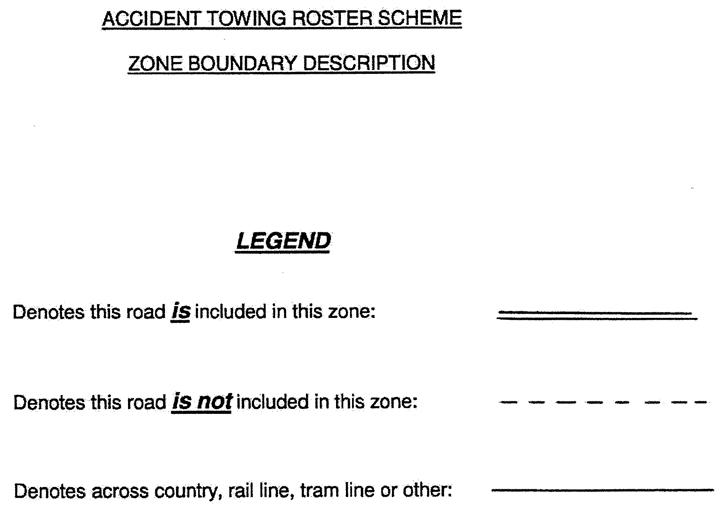

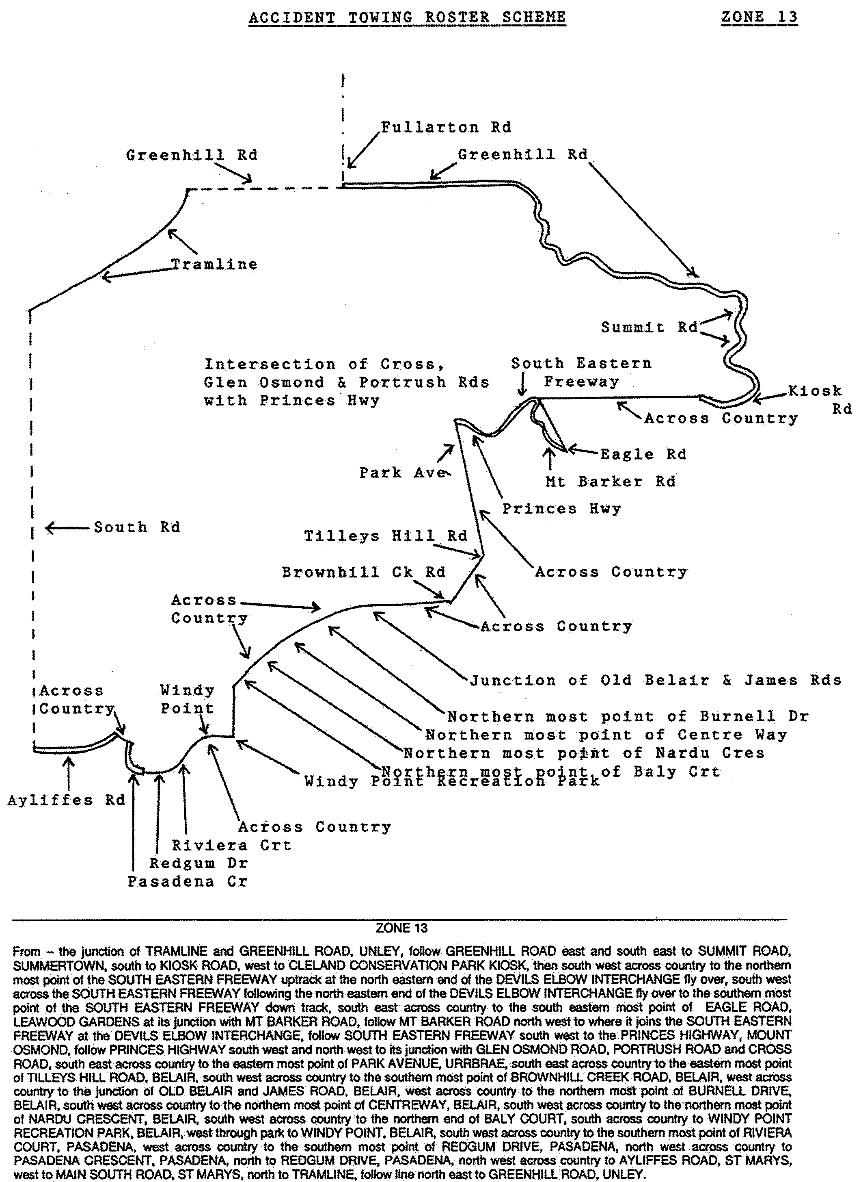
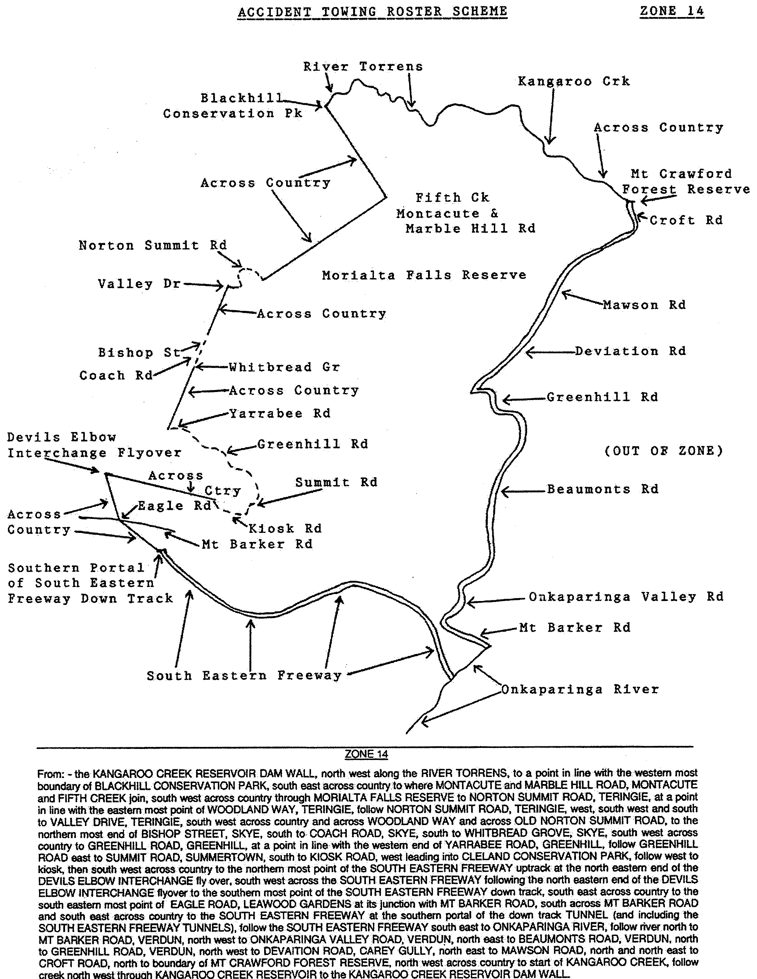
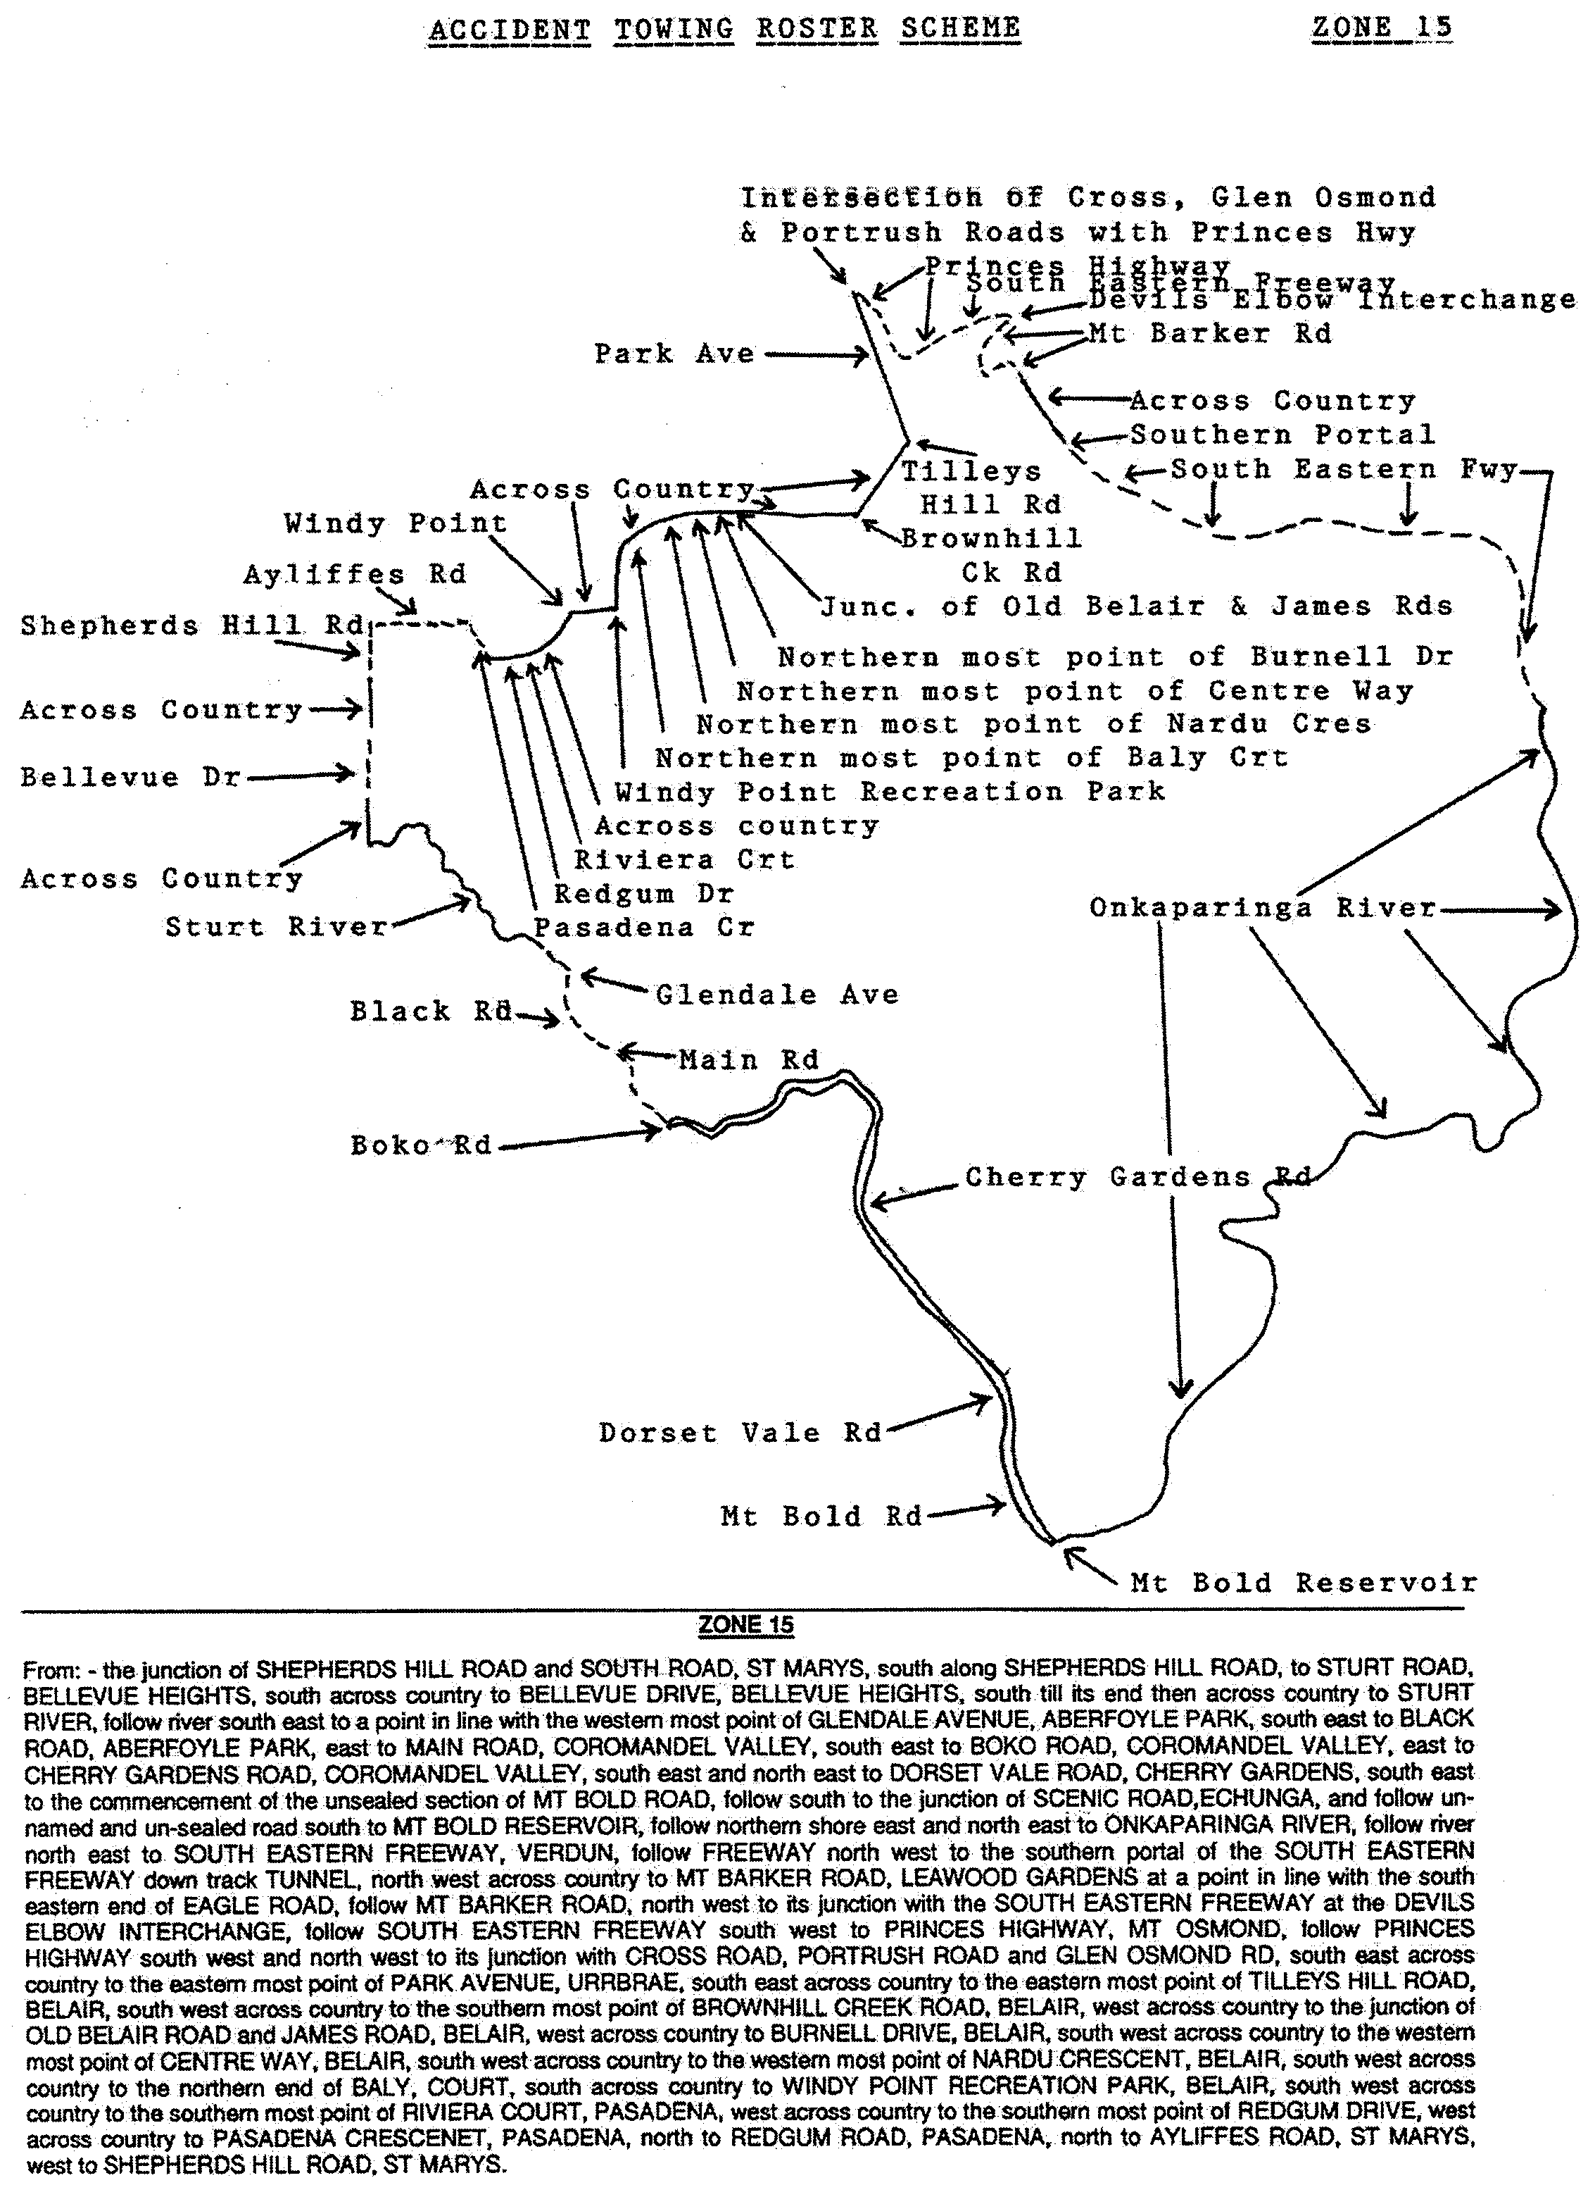

Dated at Adelaide, 18 February 2000.
Diana Laidlaw, Minister for Transport and Urban Planning

ANIMAL AND PLANT CONTROL (AGRICULTURAL PROTECTION AND OTHER PURPOSES) ACT 1986
Amended Contribution
NOTICE is hereby given that the Animal and Plant Control Commission has determined pursuant to section 36 (2) of the Animal and Plant Control (Agricultural Protection and Other Purposes) Act 1986, that the amended contribution by constituent council to animal and plant control boards for the 2000 board year shall be as follows:
Animal and Plant Control Board | Council | $
Adelaide Plains | Corporation of the Town of Gawler | 14 400

FISHERIES ACT 1982
Marine Mollusc Farming Licence FM00173
(Previous Licence No. F545)
Licence to Farm Fish under section 53 of the Fisheries
Act 1982
WHEREAS the Director of Fisheries has, pursuant to section 50 (2) of the Fisheries Act 1982 (‘the Act’), issued a permit to the undermentioned licensee to release the fish specified in Item 1 of Schedule 2 of this licence (‘the permitted species’) the Minister for Primary Industries, Natural Resources and Regional Development (‘the Minister’) hereby grants to:
R. A. & M. F. Sullivan
c/o Post Office,
Smoky Bay, S.A. 5680
a non-exclusive licence to occupy and use the waters specified in Item 1 of Schedule 1 of this licence (‘the site’) for the purpose of farming and taking the permitted species (‘the permitted use’) for the period commencing on 1 July 1999 and ending, subject to any earlier termination under this licence, on 30 June 2000 (‘the term’) subject to the following terms and conditions:
Conditions of This Licence
1. Licence
The parties acknowledge and agree that:
1.1 the rights, powers and privileges granted to or vested in the licensee under this licence are contractual only and shall not create or vest in the licensee any estate, interest or right of a proprietary nature in the site; and
1.2 that, subject to section 53A of the Fisheries Act 1982, this licence does not entitle the licensee to exclusive rights of entry to and occupation of the site and that the rights granted by this licence are exercisable by the licensee in common with any other occupiers of the site from time to time.
2. Marked-off Areas
For the purposes of section 53A of the Fisheries Act 1982, the marked-off areas within the site is that area or those areas marked-off or indicated in the manner set out in Item 2 of Schedule 1 of this licence.
3. Permitted Species
The licensee:
3.1 must not farm or introduce any species at the site other than the permitted species; and
3.2 must not take any wild fish from the site except for recreational purposes.
4. Permitted Use
The licensee must not use the site for any purpose other than the permitted use.
5. Permitted Methods
The licensee:
5.1 must not stock the permitted species at a rate greater than that specified in Schedule 2 of this licence;
5.2 must not use the anti-fouling chemical tributyltin (TBT) on any equipment used at the site;
5.3 must not use any chemical or drug for either therapeutic or prophylactic purpose except with the prior approval of the Minister;
5.4 must apply the permitted farming methods set out in Item 2 of Schedule 2 of this licence.
6. Marking and Maintaining the Site
The licensee:
6.1 must ensure that the site is maintained in a good, tidy and safe condition to the satisfaction of the Minister;
6.2 must remove and lawfully dispose of any waste or debris on the site as soon as is reasonably practicable and in particular must comply with any guidelines issued from time to time by the Minister in relation to the removal from the site of any unhealthy or dead fish;
6.3 must maintain all buoys, crosses, and markers on the site in good condition and in accordance with the colours specified in Schedule 1 of this licence; and
6.4 must mark the site boundary in accordance with the specifications in Schedule 1 of this licence.
7. Site Inspection and Supervision
The licensee:
7.1 must at all times permit the Minister, his employees, agents or contractors or any employees, agents or contractors of the Crown to enter the site for the purposes of inspecting the site, the sea floor and the flora and fauna on or in the vicinity of the site; and
7.2 must comply with all reasonable directions of any such person authorised by the Director of Fisheries to inspect the conduct of the licensee’s activities at the site.
8. Fees and Returns
The licensee:
8.1 must pay to the Minister the licence fee in accordance with Item l of Schedule 3 of this licence;
8.2 must on or before 31 January and 31 July during the term, submit to the Minister a return supplying all of the information described in Schedule 4 of this licence.
9. Compliance With Relevant Laws
9.1 the licensee must at all times comply with all laws, by-laws or regulations in force which relate to the site or the activities conducted in the site and with all notices, orders or requirements lawfully given or made by any authority or authorities in respect of the site;
9.2 in particular, without derogating from the general requirement under condition 9 of this licence:
9.2.1 the licensee must not do or permit to be done in upon or about the site anything which in the opinion of the Minister would cause or contribute to the degradation or pollution of any coastal land or the surrounding marine environment; and
9.2.2 in the event that the Minister is satisfied, on reasonable grounds, that the fish taken from the waters are not fit for human consumption or that consumption of fish taken from the waters could present a danger to the health of the consumer, the licensee must, in accordance with a written notice from the Minister, cease or suspend the conduct of the permitted use or else conduct the permitted use as directed within the notice.
10. Public Risk Liability
The licensee must at all times indemnify the Minister, his officers, employees, contractors and agents from and against all claims, demands, actions, judgments, proceedings, damages, losses, costs, charges and expenses in respect of any loss of life, personal injury and/or damage to property caused or suffered in any manner in or about the site.
11. Release
The licensee must use and keep the site at the risk in all things of the licensee and the licensee must release to the full extent permitted by law the Minister, his agents, contractors and servants in the absence of any wilful act, omission, default or neglect on their part from all claims and demands of every kind resulting from any accident damage or injury to persons or property occurring at the site, including loss or damage to the licensee’s fixtures or personal property of the licensee.
12. Public Risk Insurance
The licensee shall at its own cost and expense during the term effect and keep in full force and effect in respect of the site and the permitted use a policy of public risk insurance in the joint names of the licensee and the Minister in which the limits of public risk shall not be less than the amount specified in Item 2 of Schedule 3 of this licence, or such further amount as the Minister may from time to time reasonably require, as the amount which may be paid out in respect of any one single claim and a policy of insurance or copy thereof or a certificate of insurance shall be produced by the licensee to the Minister on request in writing being made by the Minister for its production.
13. Guarantee or Indemnity Scheme
The licensee must either:
13.1 provide a guarantee from its bankers; or
13.2 contribute to an indemnity scheme established for the aquaculture and fisheries industry and approved by the Minister,
to and in favour of and for the benefit of the Minister by way of security for the due and punctual performance by the licensee of the terms and conditions of this licence and in particular the obligations of the licensee to rehabilitate the site immediately prior to the expiration or sooner determination of the term of this licence. Such guarantee or indemnity scheme must have effect from the date of commencement of the term.
14. No Assignment
The licensee acknowledges that this licence is personal and it must not assign or sublet or deal in any other way with any interest in this licence.
15. Default by Licensee and Termination
The Minister may terminate this licence immediately by notice in writing served on the licensee if:
15.1 the licensee commits or permits any breach or default of the obligations imposed on the licensee by this licence, and following the giving by the Minister of written notice of such breach or default, the licensee either fails to rectify such breach or default within one calendar month of the date of such notice (or earlier if the circumstances require) or fails to make diligent progress towards rectifying any such breach which is incapable of rectification within the time so limited; or
15.2 the licensee commits or permits any further breach or default of the obligations imposed on the licensee by this licence for which the Minister has previously given notice in writing of such breach or default pursuant to paragraph 1 of condition 15.1 notwith-standing rectification of the previous breach or default; or
15.3 the licence fee referred to in condition 8 is unpaid for a period of 14 days after notice has been given to the licensee that it is outstanding; or
15.4 if the licensee is a body corporate, any of the following occur:
15.4.1 the licensee is unable to pay its debts as and when they fall due or is otherwise insolvent;
15.4.2 an order is made for the winding up or liquidation of the licensee;
15.4.3 the licensee enters into a scheme of arrangement, compromise, moratorium or other form of composition with its creditors or any class of its creditors;
15.4.4 a receiver, a manager or a receiver and manager, a company administrator or other insolvency administrator is appointed to the licensee; or
15.4.5 a mortgagee, chargee or other encum-brancee is appointed over or takes possession of or appoints an agent to take possession of all or any of the licensee’s assets; or
15.5 if the licensee is an individual, the licensee:
15.5.1 becomes bankrupt or assigns its estate or enters into a deed of arrangement or other form of composition for the benefit of the licensee’s creditors; or
15.5.2 is convicted of an indictable offence.
Termination of this licence by the Minister shall be without prejudice to any rights, remedies or actions that the Minister may have against the licensee in respect of any antecedent breach by the licensee of the terms and conditions contained in this licence.
16. Interpretation
Subject to any inconsistency of subject or context, the following rules of construction shall be used in the interpretation of this licence:
16.1 any word importing the plural includes the singular and vice versa;
16.2 any wording importing a gender shall include all other genders;
16.3 a reference to a body corporate shall include a natural person and vice versa;
16.4 a reference to a recital, party, clause, Schedule or Annexure is a reference to a recital, party, clause, Schedule or Annexure of this licence;
16.5 the captions, headings, section numbers and clause numbers appearing in this licence are inserted only as a matter of convenience and in no way affect the construction of this licence;
16.6 a reference to a statute shall include all statutes amending, consolidating or replacing the statutes referred to;
16.7 where two or more persons are named as licensees, this licence shall bind the licensees jointly and each of them severally; and
16.8 time is of the essence in respect of any obligation relating to time in this licence.
17. Delegation
Any consent, notice, any consultation or any other thing which is pursuant to the terms of this licence either required to be given, done or performed or which may be given, done or performed by the Minister may for the purposes of this licence be properly given, done or performed by any duly authorised agent or employee of the Minister.
18. Severance
If any term or condition of this licence should be for any reason unlawful, void, invalid or unenforceable then the offending term or condition shall be severed from this licence without affecting the validity or enforceability of the remainder of this licence.
19. Modification
No variation of or addition to any provision of this licence shall be binding upon the Minister and the licensee unless such variation or addition is made in writing, signed by both the Minister and the licensee and expressed to be either supplemental to or in substitution for the whole or a part of this licence.
20. Waiver
20.1 A waiver of any provision of this licence by the Minister must both be in writing and be signed by the Minister or by persons duly authorised to execute such a document on the Minister’s part.
20.2 No waiver by the Minister of a breach of a term or condition contained in this licence shall operate as a waiver of any breach of the same or any other term or condition contained in this licence.
20.3 No forbearance, delay or indulgence by the Minister in enforcing the provisions of this licence shall prejudice or restrict the rights of the Minister.
21. Notices
21.1 Notices may be served by delivering the same personally, by mail or facsimile transmission and shall be:
21.1.1 in writing addressed to the Director of Fisheries, PIRSA, 16th Floor, 25 Grenfell Street, Adelaide, S.A. 5000 (in the case of the Minister) and to the address of the licensee set out above (in the case of the licensee);
21.1.2 signed by or on behalf of the sender or by a person duly authorised in that regard by the sender;
21.1.3 deemed to be duly served or made in the following circumstances:
(a) if delivered, upon delivery;
(b) if sending by mail, upon posting;
(c) if sent by facsimile transmission, upon the sender’s facsimile producing a transmission report that the facsimile was satisfactorily sent in its entirety to the addressee’s facsimile number,
but if delivery is not made before 5 p.m. on any day it shall be deemed to be received at 9 a.m. on the next day in that place.
21.2 The Minister and the licensee may each vary their address or facsimile number at any time by written notice.
Granted by the General Manager of Aquaculture, delegate of the Minister, on 28 February 2000.
I. Nightingale, General Manager, Aquaculture
The licensee hereby acknowledges and agrees to the terms and conditions of this licence.
Signed by the said M. F. Sullivan
and R. A. Sullivan
In the presence of: J. E. Schulze, Witness
Schedule 1
Item 1—The Site
Area applicable to this licence:
Licensed Area Licensed
Hectares
AGD 66—Zone 53
395549E 6416844N 6
395761E 6416828N
395740E 6416545N
395529E 6416561N
All structures, equipment, buoys and flotations (except for that required by the Department for Transport, Urban Planning and the Arts) must be black, dark grey, dark blue, dark brown, or dark green coloured materials.
The boundary of the site to be marked either with:
(a) (1) At the corners with posts extending 900 mm above mean high water springs. Such posts to be marked with a St Andrews cross, each cross arm measuring 900 mm from tip to tip, minimum width 75 mm.
(2) Posts to be not less than 125 mm in diameter.
(3) Posts and crosses to be painted yellow.
(4) The ends of each cross to be marked with a 200 mm strip of yellow retro-reflective tape.
(5) Between the corner posts at intervals not exceeding 50 m, buoys not less than 300 mm in diameter.
(6) All buoys, posts, crosses and markers must be maintained in good condition.
or
(b) (1) At each corner, yellow spar buoys with a St Andrews cross as a top mark placed at least 900 mm above the buoy, cross arms 900 mm long x 75 mm wide.
(2) The buoys and topmarks must all be coloured yellow and marked with a yellow retro-reflective as in (a) (4).
(3) All buoys, posts, crosses and markers must be maintained in good condition.
When the site is in navigable water and possible danger to navigation, lights must be placed on the top of each St Andrews cross that is located at each corner of the site and these lights must be yellow in colour and flashing once every 4 seconds and visible over an arc of 360 degrees for a distance of at least one mile.
Item 2—Marked-Off Areas
[Co-ordinates of developed areas within the site to be provided by the licensee.]
White buoys of at least 12 inches in diameter must be placed around the whole of the perimeter of the developed areas within the site at a distance of no less than 50 m from one another.
Schedule 2
Item 1⎯Permitted Species
The Director of Fisheries has, pursuant to section 50 (2) of the Act, issued a permit for the release of the fish specified in this Schedule.
Pacific Oysters (Crassostrea gigas)
Item 2⎯Permitted Farming Methods
Racks
Each unit must not exceed 100 m in length and 2 m in width, and each unit must be at least 6 m from any other unit.
Item 3⎯Stocking Rates
Oysters
Size (mm) Number per Hectare
3 2 500 000
10 1 600 000
20 1 100 000
30 750 000
40 500 000
50 350 000
60 200 000
70 150 000
80 100 000
Schedule 3
Item 1—Fees
Annual licence fees are:
$
FRDC Levy per hectare 6 at $12.50 each 75.00
EMP fee per hectare 6 at $22.96 each 137.76
Base Licence Fee per hectare 6 at $57 each 342.00
SASQAP (Classified Area) per hectare 6 at $60 each 360.00
Total Annual Licence Fee 914.76
Quarterly Instalments 228.69
Item 2—Public Risk Insurance
Five million dollars ($5 000 000).
Schedule 4
Returns
The licensee must submit the following information to the Minister, c/o Director of Fisheries, PIRSA, 16th Floor, 25 Grenfell Street, Adelaide, S.A. 5000 on or before 31 January and 31 July during the term of this licence:
1. Name of licensee.
2. Address of licensee.
3. Species of fish farmed and held on the site.
4. Location of aquaculture operation.
5. Period covered by return.
6. Number of life stage of each species of fish held.
7. Number, weight and value of each species of fish held.
8. Details of any disease detected in any fish kept.
9. Source (whether interstate or intrastate) of any stock acquired and date of acquisition (if relevant, include name of authority that provided certification that stock was free from disease).
10. If any fish were brought into the state, the number of fish and the life stage of the fish.
11. If fish were brought into the state, the purpose for which they were brought in.
12. Method of disposal of water and packaging use for transporting the fish.
13. If any disease or symptom of disease occurred in the acquired fish.
14. Method of disposal of diseased or dead fish and the number disposed of.
15. Signature, date and telephone number.
16. Use of any chemicals for fish husbandry—type of chemical and quantity used, purpose and date of use.

FISHERIES ACT 1982: SECTION 48G (2)
TAKE notice that pursuant to section 48G (2) of the Fisheries Act 1982, I hereby authorise R. A and M. F. Sullivan, c/o P.O., Smoky Bay, S.A. 5602 (hereinafter referred to as the ‘permit holder’) to engage in the activities and to do the acts specified in Schedule 1, subject to the conditions specified in Schedule 2 from the date of this permit ending upon the expiration or earlier termination of Licence Number FM00173.
Schedule 1
The importation and release of Pacific Oysters (Crassostrea gigas) within the waters defined by the following co-ordinates:
Licensed Area Licensed
Hectares
AGD 66—Zone 53
395549E 6416844N 6
395761E 6416828N
395740E 6416545N
395529E 6416561N
Schedule 2
1. Fish obtained within South Australia for use in the fish farm shall only be obtained from registered fish farmers, licensed fishers or other persons approved by the Director of Fisheries.
2. The permit holder shall not import any live fish (ova, fry or adult) into South Australia unless the shipment has certification from an appropriate authority in the State from which they are obtained that they are free from all relevant notifiable diseases listed in Schedule 4 of the Fisheries (Exotic Fish, Fish Farming and Fish Diseases) Regulations 1984.
3. Any oysters brought into South Australia must undergo a soakage process whereby they are completely submerged in fresh water for a period of not less than 2 hours before being placed in the approved structures. Fresh water is deemed to be water suitable for human consumption or horticultural or agricultural use.
4. The permit holder shall not contravene or fail to comply with the Fisheries Act 1982, or any regulations made under the Act, except where specifically permitted by this notice.
5. The permit holder must retain the copy of this permit which has been supplied by the Director of Fisheries, and if requested by a PIRSA Fisheries and Aquaculture Officer, produce that permit for inspection.
Dated 28 February 2000.
I. Nightingale, General Manager Aquaculture as the delegate of the Director of Fisheries.

FISHERIES ACT 1982
Marine Mollusc Farming Licence FM00332
Licence to Farm Fish under section 53 of the Fisheries
Act 1982
WHEREAS the Director of Fisheries has, pursuant to section 50 (2) of the Fisheries Act 1982 (‘the Act’), issued a permit to the undermentioned licensee to release the fish specified in Item 1 of Schedule 2 of this licence (‘the permitted species’), the Minister for Primary Industries (‘the Minister’) hereby grants to:
Gary Seidl (13008)
59 Bergmann Drive
Ceduna, S.A. 5690
a non-exclusive licence to occupy and use the waters specified in Item 1 of Schedule 1 of this licence (‘the site’) for the purpose of farming and taking the permitted species (‘the permitted use’) for the period commencing on 1 July 1999 and ending, subject to any earlier termination under this licence, on 30 June 2000 (‘the term’) subject to the following terms and conditions:
Conditions of This Licence
1. Licence
The parties acknowledge and agree that:
1.1 the rights, powers and privileges granted to or vested in the licensee under this licence are contractual only and shall not create or vest in the licensee any estate, interest or right of a proprietary nature in the site; and
1.2 that, subject to section 53A of the Fisheries Act 1982, this licence does not entitle the licensee to exclusive rights of entry to and occupation of the site and that the rights granted by this licence are exercisable by the licensee in common with any other occupiers of the site from time to time.
2. Marked-off Areas
For the purposes of section 53A of the Fisheries Act 1982, the marked-off areas within the site is that area or those areas marked-off or indicated in the manner set out in Item 2 of Schedule 1 of this licence.
3. Permitted Species
The licensee:
3.1 must not farm or introduce any species at the site other than the permitted species; and
3.2 must not take any wild fish from the site except for recreational purposes.
4. Permitted Use
The licensee must not use the site for any purpose other than the permitted use.
5. Permitted Methods
The licensee:
5.1 must not stock the permitted species at a rate greater than that specified in Schedule 2 of this licence;
5.2 must not use the anti-fouling chemical tributyltin (TBT) on any equipment used at the site;
5.3 must not use any chemical or drug for either therapeutic or prophylactic purpose except with the prior approval of the Minister;
5.4 must apply the permitted farming methods set out in Item 2 of Schedule 2 of this licence.
6. Marking and Maintaining the Site
The licensee:
6.1 must ensure that the site is maintained in a good, tidy and safe condition to the satisfaction of the Minister;
6.2 must remove and lawfully dispose of any waste or debris on the site as soon as is reasonably practicable and in particular must comply with any guidelines issued from time to time by the Minister in relation to the removal from the site of any unhealthy or dead fish;
6.3 must maintain all buoys, crosses, and markers on the site in good condition and in accordance with the colours specified in Schedule 1 of this licence; and
6.4 must mark the site boundary in accordance with the specifications in Schedule 1 of this licence.
7. Site Inspection and Supervision
The licensee:
7.1 must at all times permit the Minister, his employees, agents or contractors or any employees, agents or contractors of the Crown to enter the site for the purposes of inspecting the site, the sea floor and the flora and fauna on or in the vicinity of the site; and
7.2 must comply with all reasonable directions of any such person authorised by the Director of Fisheries to inspect the conduct of the licensee’s activities at the site.
8. Fees and Returns
The licensee:
8.1 must pay to the Minister the licence fee in accordance with Item l of Schedule 3 of this licence;
8.2 must on or before 31 January and 31 July during the term, submit to the Minister a return supplying all of the information described in Schedule 4 of this licence.
9. Compliance With Relevant Laws
9.1 the licensee must at all times comply with all laws, by-laws or regulations in force which relate to the site or the activities conducted in the site and with all notices, orders or requirements lawfully given or made by any authority or authorities in respect of the site;
9.2 in particular, without derogating from the general requirement under condition 9 of this licence:
9.2.1 the licensee must not do or permit to be done in upon or about the site anything which in the opinion of the Minister would cause or contribute to the degradation or pollution of any coastal land or the surrounding marine environment; and
9.2.2 in the event that the Minister is satisfied, on reasonable grounds, that the fish taken from the waters are not fit for human consumption or that consumption of fish taken from the waters could present a danger to the health of the consumer, the licensee must, in accordance with a written notice from the Minister, cease or suspend the conduct of the permitted use or else conduct the permitted use as directed within the notice.
10. Public Risk Liability
The licensee must at all times indemnify the Minister, his officers, employees, contractors and agents from and against all claims, demands, actions, judgments, proceedings, damages, losses, costs, charges and expenses in respect of any loss of life, personal injury and/or damage to property caused or suffered in any manner in or about the site.
11. Release
The licensee must use and keep the site at the risk in all things of the licensee and the licensee must release to the full extent permitted by law the Minister, his agents, contractors and servants in the absence of any wilful act, omission, default or neglect on their part from all claims and demands of every kind resulting from any accident damage or injury to persons or property occurring at the site, including loss or damage to the licensee’s fixtures or personal property of the licensee.
12. Public Risk Insurance
The licensee shall at its own cost and expense during the term effect and keep in full force and effect in respect of the site and the permitted use a policy of public risk insurance in the joint names of the licensee and the Minister in which the limits of public risk shall not be less than the amount specified in Item 2 of Schedule 3 of this licence, or such further amount as the Minister may from time to time reasonably require, as the amount which may be paid out in respect of any one single claim and a policy of insurance or copy thereof or a certificate of insurance shall be produced by the licensee to the Minister on request in writing being made by the Minister for its production.
13. Guarantee or Indemnity Scheme
The licensee must either:
13.1 provide a guarantee from its bankers; or
13.2 contribute to an indemnity scheme established for the aquaculture and fisheries industry and approved by the Minister,
to and in favour of and for the benefit of the Minister by way of security for the due and punctual performance by the licensee of the terms and conditions of this licence and in particular the obligations of the licensee to rehabilitate the site immediately prior to the expiration or sooner determination of the term of this licence. Such guarantee or indemnity scheme must have effect from the date of commencement of the term.
14. No Assignment
The licensee acknowledges that this licence is personal and it must not assign or sublet or deal in any other way with any interest in this licence.
15. Default by Licensee and Termination
The Minister may terminate this licence immediately by notice in writing served on the licensee if:
15.1 the licensee commits or permits any breach or default of the obligations imposed on the licensee by this licence, and following the giving by the Minister of written notice of such breach or default, the licensee either fails to rectify such breach or default within one calendar month of the date of such notice (or earlier if the circumstances require) or fails to make diligent progress towards rectifying any such breach which is incapable of rectification within the time so limited; or
15.2 the licensee commits or permits any further breach or default of the obligations imposed on the licensee by this licence for which the Minister has previously given notice in writing of such breach or default pursuant to paragraph 1 of condition 15.1 notwith-standing rectification of the previous breach or default; or
15.3 the licence fee referred to in condition 8 is unpaid for a period of 14 days after notice has been given to the licensee that it is outstanding; or
15.4 if the licensee is a body corporate, any of the following occur:
15.4.1 the licensee is unable to pay its debts as and when they fall due or is otherwise insolvent;
15.4.2 an order is made for the winding up or liquidation of the licensee;
15.4.3 the licensee enters into a scheme of arrangement, compromise, moratorium or other form of composition with its creditors or any class of its creditors;
15.4.4 a receiver, a manager or a receiver and manager, a company administrator or other insolvency administrator is appointed to the licensee; or
15.4.5 a mortgagee, chargee or other encum-brancee is appointed over or takes possession of or appoints an agent to take possession of all or any of the licensee’s assets; or
15.5 if the licensee is an individual, the licensee:
15.5.1 becomes bankrupt or assigns its estate or enters into a deed of arrangement or other form of composition for the benefit of the licensee’s creditors; or
15.5.2 is convicted of an indictable offence.
Termination of this licence by the Minister shall be without prejudice to any rights, remedies or actions that the Minister may have against the licensee in respect of any antecedent breach by the licensee of the terms and conditions contained in this licence.
16. Interpretation
Subject to any inconsistency of subject or context, the following rules of construction shall be used in the interpretation of this licence:
16.1 any word importing the plural includes the singular and vice versa;
16.2 any wording importing a gender shall include all other genders;
16.3 a reference to a body corporate shall include a natural person and vice versa;
16.4 a reference to a recital, party, clause, Schedule or Annexure is a reference to a recital, party, clause, Schedule or Annexure of this licence;
16.5 the captions, headings, section numbers and clause numbers appearing in this licence are inserted only as a matter of convenience and in no way affect the construction of this licence;
16.6 a reference to a statute shall include all statutes amending, consolidating or replacing the statutes referred to;
16.7 where two or more persons are named as licensees, this licence shall bind the licensees jointly and each of them severally; and
16.8 time is of the essence in respect of any obligation relating to time in this licence.
17. Delegation
Any consent, notice, any consultation or any other thing which is pursuant to the terms of this licence either required to be given, done or performed or which may be given, done or performed by the Minister may for the purposes of this licence be properly given, done or performed by any duly authorised agent or employee of the Minister.
18. Severance
If any term or condition of this licence should be for any reason unlawful, void, invalid or unenforceable then the offending term or condition shall be severed from this licence without affecting the validity or enforceability of the remainder of this licence.
19. Modification
No variation of or addition to any provision of this licence shall be binding upon the Minister and the licensee unless such variation or addition is made in writing, signed by both the Minister and the licensee and expressed to be either supplemental to or in substitution for the whole or a part of this licence.
20. Waiver
20.1 A waiver of any provision of this licence by the Minister must both be in writing and be signed by the Minister or by persons duly authorised to execute such a document on the Minister’s part.
20.2 No waiver by the Minister of a breach of a term or condition contained in this licence shall operate as a waiver of any breach of the same or any other term or condition contained in this licence.
20.3 No forbearance, delay or indulgence by the Minister in enforcing the provisions of this licence shall prejudice or restrict the rights of the Minister.
21. Notices
21.1 Notices may be served by delivering the same personally, by mail or facsimile transmission and shall be:
21.1.1 in writing addressed to the Director of Fisheries, PIRSA, 16th Floor, 25 Grenfell Street, Adelaide, S.A. 5000 (in the case of the Minister) and to the address of the licensee set out above (in the case of the licensee);
21.1.2 signed by or on behalf of the sender or by a person duly authorised in that regard by the sender;
21.1.3 deemed to be duly served or made in the following circumstances:
(a) if delivered, upon delivery;
(b) if sending by mail, upon posting;
(c) if sent by facsimile transmission, upon the sender’s facsimile producing a transmission report that the facsimile was satisfactorily sent in its entirety to the addressee’s facsimile number,
but if delivery is not made before 5 p.m. on any day it shall be deemed to be received at 9 a.m. on the next day in that place.
21.2 The Minister and the licensee may each vary their address or facsimile number at any time by written notice.
Granted by the General Manager Aquaculture, delegate of the Minister, on 28 February 2000.
I. Nightingale, General Manager Aquaculture
The licensee hereby acknowledges and agrees to the terms and conditions of this licence.
Signed by the said G. Seidl
In the presence of: A. Seidl, Witness
Schedule 1
Item 1—The Site
Area applicable to this licence:
Licensed Area Licensed
Hectares
AGD 66—Zone 53
366068E 6445881N 5
366359E 6445752N
366358E 6445580N
366067E 6445709N
All structures, equipment, buoys and flotations (except for that required by the Department for Transport, Urban Planning and the Arts) must be black, dark grey, dark blue, dark brown, or dark green coloured materials.
The boundary of the site to be marked either with:
(a) (1) At the corners with posts extending 900 mm above mean high water springs. Such posts to be marked with a St Andrews cross, each cross arm measuring 900 mm from tip to tip, minimum width 75 mm.
(2) Posts to be not less than 125 mm in diameter.
(3) Posts and crosses to be painted yellow.
(4) The ends of each cross to be marked with a 200 mm strip of yellow retro-reflective tape.
(5) Between the corner posts at intervals not exceeding 50 m, buoys not less than 300 mm in diameter.
(6) All buoys, posts, crosses and markers must be maintained in good condition.
or
(b) (1) At each corner, yellow spar buoys with a St Andrews cross as a top mark placed at least 900 mm above the buoy, cross arms 900 mm long x 75 mm wide.
(2) The buoys and topmarks must all be coloured yellow and marked with a yellow retro-reflective as in (a) (4).
(3) All buoys, posts, crosses and markers must be maintained in good condition.
When the site is in navigable water and possible danger to navigation, lights must be placed on the top of each St Andrews cross that is located at each corner of the site and these lights must be yellow in colour and flashing once every 4 seconds and visible over an arc of 360 degrees for a distance of at least one mile.
Item 2—Marked-Off Areas
[Co-ordinates of developed areas within the site to be provided by the licensee.]
White buoys of at least 12 inches in diameter must be placed around the whole of the perimeter of the developed areas within the site at a distance of no less than 50 m from one another.
Schedule 2
Item 1⎯Permitted Species
The Director of Fisheries has, pursuant to section 50 (2) of the Act, issued a permit for the release of the fish specified in this Schedule.
Pacific Oysters (Crassostrea gigas)
Item 2⎯Permitted Farming Methods
Racks
Item 3⎯Stocking Rates
Oysters
Size (mm) Number per Hectare
3 2 500 000
10 1 600 000
20 1 100 000
30 750 000
40 500 000
50 350 000
60 200 000
70 150 000
80 100 000
Schedule 3
Item 1—Fees
Annual licence fees are:
$
FRDC Levy per hectare 5 at $12.50 each 31.25
EMP fee per hectare 5 at $22.96 each 57.40
Base Licence Fee per hectare 5 at $57 each 142.50
SASQAP (Classified Area) per hectare 5 at $60 each 150.00
Total Annual Licence Fee 381.15
Quarterly Instalments 95.29
Item 2—Public Risk Insurance
Five million dollars ($5 000 000).
Schedule 4
Returns
The licensee must submit the following information to the Minister, c/o Director of Fisheries, PIRSA, 16th Floor, 25 Grenfell Street, Adelaide, S.A. 5000 on or before 31 January and 31 July during the term of this licence:
1. Name of licensee.
2. Address of licensee.
3. Species of fish farmed and held on the site.
4. Location of aquaculture operation.
5. Period covered by return.
6. Number of life stage of each species of fish held.
7. Number, weight and value of each species of fish held.
8. Details of any disease detected in any fish kept.
9. Source (whether interstate or intrastate) of any stock acquired and date of acquisition (if relevant, include name of authority that provided certification that stock was free from disease).
10. If any fish were brought into the state, the number of fish and the life stage of the fish.
11. If fish were brought into the state, the purpose for which they were brought in.
12. Method of disposal of water and packaging use for transporting the fish.
13. If any disease or symptom of disease occurred in the acquired fish.
14. Method of disposal of diseased or dead fish and the number disposed of.
15. Signature, date and telephone number.
16. Use of any chemicals for fish husbandry—type of chemical and quantity used, purpose and date of use.

FISHERIES ACT 1982: SECTION 50 (2)
TAKE notice that pursuant to section 50 (2) of the Fisheries Act 1982, I hereby authorise Gary Seidl, 59 Bergmann Drive, Ceduna, S.A. 5690 (hereinafter referred to as the ‘permit holder’) to engage in the activities and to do the acts specified in Schedule 1, subject to the conditions specified in Schedule 2 from the date of this permit and ending upon the expiration or earlier termination of Licence Number FM00332.
Schedule 1
The importation and release of Pacific Oysters (Crassostrea gigas) within the water defined by the following co-ordinates:
Licensed Area Licensed
Hectares
AGD 66—Zone 53
366068E 6445881N 5
366359E 6445752N
366358E 6445580N
366067E 6445709N
Schedule 2
1. Fish obtained within South Australia for use in the fish farm shall only be obtained from registered fish farmers, licensed fishers or other persons approved by the Director of Fisheries.
2. The permit holder shall not import any live fish (ova, fry or adult) into South Australia unless the shipment has certification from an appropriate authority in the State from which they are obtained that they are free from all relevant notifiable diseases listed in Schedule 4 of the Fisheries (Exotic Fish, Fish Farming and Fish Diseases) Regulations 1984.
3. Any oysters brought into South Australia must undergo a soakage process whereby they are completely submerged in fresh water for a period of not less than 2 hours before being placed in the approved structures. Fresh water is deemed to be water suitable for human consumption or horticultural or agricultural use.
4. The permit holder shall not contravene or fail to comply with the Fisheries Act 1982, or any regulations made under the Act, except where specifically permitted by this notice.
5. The permit holder must retain the copy of this permit which has been supplied by the Director of Fisheries, and if requested by a Fisheries and Aquaculture Officer, produce that permit for inspection.
Dated 28 February 2000.
I. Nightingale, General Manager, Aquaculture, as the delegate of the Director of Fisheries

FISHERIES ACT 1982
Marine Mollusc Farming Licence FM00335
Licence to Farm Fish under section 53 of the Fisheries
Act 1982
WHEREAS the Director of Fisheries has, pursuant to section 50 (2) of the Fisheries Act 1982 (‘the Act’), issued a permit to the undermentioned licensee to release the fish specified in Item 1 of Schedule 2 of this licence (‘the permitted species’), the Minister for Primary Industries, (‘the Minister’) hereby grants to:
Colmion Pty Ltd (12214)
1 Brentwood Street
Stansbury, S.A. 5582
a non-exclusive licence to occupy and use the waters specified in Item 1 of Schedule 1 of this licence (‘the site’) for the purpose of farming and taking the permitted species (‘the permitted use’) for the period commencing on 1 February 2000 and ending, subject to any earlier termination under this licence, on 30 June 2000 (‘the term’) subject to the following terms and conditions:
Conditions of This Licence
1. Licence
The parties acknowledge and agree that:
1.1 the rights, powers and privileges granted to or vested in the licensee under this licence are contractual only and shall not create or vest in the licensee any estate, interest or right of a proprietary nature in the site; and
1.2 that, subject to section 53A of the Fisheries Act 1982, this licence does not entitle the licensee to exclusive rights of entry to and occupation of the site and that the rights granted by this licence are exercisable by the licensee in common with any other occupiers of the site from time to time.
2. Marked-off Areas
For the purposes of section 53A of the Fisheries Act 1982, the marked-off areas within the site is that area or those areas marked-off or indicated in the manner set out in Item 2 of Schedule 1 of this licence.
3. Permitted Species
The licensee:
3.1 must not farm or introduce any species at the site other than the permitted species; and
3.2 must not take any wild fish from the site except for recreational purposes.
4. Permitted Use
The licensee must not use the site for any purpose other than the permitted use.
5. Permitted Methods
The licensee:
5.1 must not stock the permitted species at a rate greater than that specified in Schedule 2 of this licence;
5.2 must not use the anti-fouling chemical tributyltin (TBT) on any equipment used at the site;
5.3 must not use any chemical or drug for either therapeutic or prophylactic purpose except with the prior approval of the Minister;
5.4 must apply the permitted farming methods set out in Item 2 of Schedule 2 of this licence.
6. Marking and Maintaining the Site
The licensee:
6.1 must ensure that the site is maintained in a good, tidy and safe condition to the satisfaction of the Minister;
6.2 must remove and lawfully dispose of any waste or debris on the site as soon as is reasonably practicable and in particular must comply with any guidelines issued from time to time by the Minister in relation to the removal from the site of any unhealthy or dead fish;
6.3 must maintain all buoys, crosses, and markers on the site in good condition and in accordance with the colours specified in Schedule 1 of this licence; and
6.4 must mark the site boundary in accordance with the specifications in Schedule 1 of this licence.
7. Site Inspection and Supervision
The licensee:
7.1 must at all times permit the Minister, his employees, agents or contractors or any employees, agents or contractors of the Crown to enter the site for the purposes of inspecting the site, the sea floor and the flora and fauna on or in the vicinity of the site; and
7.2 must comply with all reasonable directions of any such person authorised by the Director of Fisheries to inspect the conduct of the licensee’s activities at the site.
8. Fees and Returns
The licensee:
8.1 must pay to the Minister the licence fee in accordance with Item l of Schedule 3 of this licence;
8.2 must on or before 31 January and 31 July during the term, submit to the Minister a return supplying all of the information described in Schedule 4 of this licence.
9. Compliance With Relevant Laws
9.1 the licensee must at all times comply with all laws, by-laws or regulations in force which relate to the site or the activities conducted in the site and with all notices, orders or requirements lawfully given or made by any authority or authorities in respect of the site;
9.2 in particular, without derogating from the general requirement under condition 9 of this licence:
9.2.1 the licensee must not do or permit to be done in upon or about the site anything which in the opinion of the Minister would cause or contribute to the degradation or pollution of any coastal land or the surrounding marine environment; and
9.2.2 in the event that the Minister is satisfied, on reasonable grounds, that the fish taken from the waters are not fit for human consumption or that consumption of fish taken from the waters could present a danger to the health of the consumer, the licensee must, in accordance with a written notice from the Minister, cease or suspend the conduct of the permitted use or else conduct the permitted use as directed within the notice.
10. Public Risk Liability
The licensee must at all times indemnify the Minister, his officers, employees, contractors and agents from and against all claims, demands, actions, judgments, proceedings, damages, losses, costs, charges and expenses in respect of any loss of life, personal injury and/or damage to property caused or suffered in any manner in or about the site.
11. Release
The licensee must use and keep the site at the risk in all things of the licensee and the licensee must release to the full extent permitted by law the Minister, his agents, contractors and servants in the absence of any wilful act, omission, default or neglect on their part from all claims and demands of every kind resulting from any accident damage or injury to persons or property occurring at the site, including loss or damage to the licensee’s fixtures or personal property of the licensee.
12. Public Risk Insurance
The licensee shall at its own cost and expense during the term effect and keep in full force and effect in respect of the site and the permitted use a policy of public risk insurance in the joint names of the licensee and the Minister in which the limits of public risk shall not be less than the amount specified in Item 2 of Schedule 3 of this licence, or such further amount as the Minister may from time to time reasonably require, as the amount which may be paid out in respect of any one single claim and a policy of insurance or copy thereof or a certificate of insurance shall be produced by the licensee to the Minister on request in writing being made by the Minister for its production.
13. Guarantee or Indemnity Scheme
The licensee must either:
13.1 provide a guarantee from its bankers; or
13.2 contribute to an indemnity scheme established for the aquaculture and fisheries industry and approved by the Minister,
to and in favour of and for the benefit of the Minister by way of security for the due and punctual performance by the licensee of the terms and conditions of this licence and in particular the obligations of the licensee to rehabilitate the site immediately prior to the expiration or sooner determination of the term of this licence. Such guarantee or indemnity scheme must have effect from the date of commencement of the term.
14. No Assignment
The licensee acknowledges that this licence is personal and it must not assign or sublet or deal in any other way with any interest in this licence.
15. Default by Licensee and Termination
The Minister may terminate this licence immediately by notice in writing served on the licensee if:
15.1 the licensee commits or permits any breach or default of the obligations imposed on the licensee by this licence, and following the giving by the Minister of written notice of such breach or default, the licensee either fails to rectify such breach or default within one calendar month of the date of such notice (or earlier if the circumstances require) or fails to make diligent progress towards rectifying any such breach which is incapable of rectification within the time so limited; or
15.2 the licensee commits or permits any further breach or default of the obligations imposed on the licensee by this licence for which the Minister has previously given notice in writing of such breach or default pursuant to paragraph 1 of condition 15.1 notwith-standing rectification of the previous breach or default; or
15.3 the licence fee referred to in condition 8 is unpaid for a period of 14 days after notice has been given to the licensee that it is outstanding; or
15.4 if the licensee is a body corporate, any of the following occur:
15.4.1 the licensee is unable to pay its debts as and when they fall due or is otherwise insolvent;
15.4.2 an order is made for the winding up or liquidation of the licensee;
15.4.3 the licensee enters into a scheme of arrangement, compromise, moratorium or other form of composition with its creditors or any class of its creditors;
15.4.4 a receiver, a manager or a receiver and manager, a company administrator or other insolvency administrator is appointed to the licensee; or
15.4.5 a mortgagee, chargee or other encum-brancee is appointed over or takes possession of or appoints an agent to take possession of all or any of the licensee’s assets; or
15.5 if the licensee is an individual, the licensee:
15.5.1 becomes bankrupt or assigns its estate or enters into a deed of arrangement or other form of composition for the benefit of the licensee’s creditors; or
15.5.2 is convicted of an indictable offence.
Termination of this licence by the Minister shall be without prejudice to any rights, remedies or actions that the Minister may have against the licensee in respect of any antecedent breach by the licensee of the terms and conditions contained in this licence.
16. Interpretation
Subject to any inconsistency of subject or context, the following rules of construction shall be used in the interpretation of this licence:
16.1 any word importing the plural includes the singular and vice versa;
16.2 any wording importing a gender shall include all other genders;
16.3 a reference to a body corporate shall include a natural person and vice versa;
16.4 a reference to a recital, party, clause, Schedule or Annexure is a reference to a recital, party, clause, Schedule or Annexure of this licence;
16.5 the captions, headings, section numbers and clause numbers appearing in this licence are inserted only as a matter of convenience and in no way affect the construction of this licence;
16.6 a reference to a statute shall include all statutes amending, consolidating or replacing the statutes referred to;
16.7 where two or more persons are named as licensees, this licence shall bind the licensees jointly and each of them severally; and
16.8 time is of the essence in respect of any obligation relating to time in this licence.
17. Delegation
Any consent, notice, any consultation or any other thing which is pursuant to the terms of this licence either required to be given, done or performed or which may be given, done or performed by the Minister may for the purposes of this licence be properly given, done or performed by any duly authorised agent or employee of the Minister.
18. Severance
If any term or condition of this licence should be for any reason unlawful, void, invalid or unenforceable then the offending term or condition shall be severed from this licence without affecting the validity or enforceability of the remainder of this licence.
19. Modification
No variation of or addition to any provision of this licence shall be binding upon the Minister and the licensee unless such variation or addition is made in writing, signed by both the Minister and the licensee and expressed to be either supplemental to or in substitution for the whole or a part of this licence.
20. Waiver
20.1 A waiver of any provision of this licence by the Minister must both be in writing and be signed by the Minister or by persons duly authorised to execute such a document on the Minister’s part.
20.2 No waiver by the Minister of a breach of a term or condition contained in this licence shall operate as a waiver of any breach of the same or any other term or condition contained in this licence.
20.3 No forbearance, delay or indulgence by the Minister in enforcing the provisions of this licence shall prejudice or restrict the rights of the Minister.
21. Notices
21.1 Notices may be served by delivering the same personally, by mail or facsimile transmission and shall be:
21.1.1 in writing addressed to the Director of Fisheries, PIRSA, 16th Floor, 25 Grenfell Street, Adelaide, S.A. 5000 (in the case of the Minister) and to the address of the licensee set out above (in the case of the licensee);
21.1.2 signed by or on behalf of the sender or by a person duly authorised in that regard by the sender;
21.1.3 deemed to be duly served or made in the following circumstances:
(a) if delivered, upon delivery;
(b) if sending by mail, upon posting;
(c) if sent by facsimile transmission, upon the sender’s facsimile producing a transmission report that the facsimile was satisfactorily sent in its entirety to the addressee’s facsimile number,
but if delivery is not made before 5 p.m. on any day it shall be deemed to be received at 9 a.m. on the next day in that place.
21.2 The Minister and the licensee may each vary their address or facsimile number at any time by written notice.
22. SASQAP
22.1 The licensee:
22.1.1 must submit to the Manager, South Australian Shellfish Quality Assurance Program (‘SASQAP’) for testing such sample as the Manager, SASQAP requires of the fish farmed at the site and specified in Item 1.1 of Schedule 2;
22.1.2 must comply with all reasonable require-ments of the Manager, SASQAP in relation to such testing; and
22.1.3 must obtain the written consent of the Manager, SASQAP, prior to making any of the fish farmed at the site and specified in Item 1.1 of Schedule 2, available for human consumption.
Granted by the General Manager Aquaculture, delegate of the Minister, on 28 February 2000.
I. Nightingale, General Manager Aquaculture
The licensee hereby acknowledges and agrees to the terms and conditions of this licence.
The Common Seal of Colmion Pty Ltd was hereunto affixed in the presence of:
(l.s.) M. Dee, Director
Schedule 1
Item 1—The Site
Area applicable to this licence:
Licensed Area Licensed
Hectares
AGD 66—Zone 53
764812E 6148862N 10
765069E 6149168N
765260E 6149007N
765003E 6148701N
All structures, equipment, buoys and flotations (except for that required by the Department for Transport, Urban Planning and the Arts) must be black, dark grey, dark blue, dark brown, or dark green coloured materials.
The boundary of the site to be marked either with:
(a) (1) At the corners with posts extending 900 mm above mean high water springs. Such posts to be marked with a St Andrews cross, each cross arm measuring 900 mm from tip to tip, minimum width 75 mm.
(2) Posts to be not less than 125 mm in diameter.
(3) Posts and crosses to be painted yellow.
(4) The ends of each cross to be marked with a 200 mm strip of yellow retro-reflective tape.
(5) Between the corner posts at intervals not exceeding 50 m, buoys not less than 300 mm in diameter.
(6) All buoys, posts, crosses and markers must be maintained in good condition.
or
(b) (1) At each corner, yellow spar buoys with a St Andrews cross as a top mark placed at least 900 mm above the buoy, cross arms 900 mm long x 75 mm wide.
(2) The buoys and topmarks must all be coloured yellow and marked with a yellow retro-reflective as in (a) (4).
(3) All buoys, posts, crosses and markers must be maintained in good condition.
When the site is in navigable water and possible danger to navigation, lights must be placed on the top of each St Andrews cross that is located at each corner of the site and these lights must be yellow in colour and flashing once every 4 seconds and visible over an arc of 360 degrees for a distance of at least one mile.
Item 2—Marked-Off Areas
[Co-ordinates of developed areas within the site to be provided by the licensee.]
White buoys of at least 12 inches in diameter must be placed around the whole of the perimeter of the developed areas within the site at a distance of no less than 50 m from one another.
Schedule 2
Item 1⎯Permitted Species
The Director of Fisheries has, pursuant to section 50 (2) of the Act, issued a permit for the release of the fish specified in this Schedule.
Pacific Oysters (Crassostrea gigas)
Item 1.1—Fish subject to SASQAP testing
Pacific Oysters (Crassostrea gigas)
Item 2⎯Permitted Farming Methods
BST Longlines
Each structure must comply with the construction requirements specified in the Decision Notification Form issued for the site under Regulation 42 of the Development Regulation Act 1993.
Item 3⎯Stocking Rates
Oysters
Size (mm) Number per Hectare
3 2 500 000
10 1 600 000
20 1 100 000
30 750 000
40 500 000
50 350 000
60 200 000
70 150 000
80 100 000
Scallops
Size (mm) Number per Hectare
3 30 000 000
10 20 000 000
20 16 000 000
30 13 000 000
40 6 000 000
50 4 000 000
60 2 000 000
70 1 500 000
80 1 000 000
90 750 000
100 500 000
Schedule 3
Item 1—Fees
Annual licence fees are: Pro-rata to 5 months
$
FRDC Levy per hectare 10 at $12.50 each 52.50
EMP fee per hectare 10 at $22.96 each 96.43
Base Licence Fee per hectare 10 at $57 each 239.40
Total Annual Licence Fee 388.33
Quarterly Instalments 97.08
Item 2—Public Risk Insurance
Five million dollars ($5 000 000).
Schedule 4
Returns
The licensee must submit the following information to the Minister, c/o Director of Fisheries, PIRSA, 16th Floor, 25 Grenfell Street, Adelaide, S.A. 5000 on or before 31 January and 31 July during the term of this licence:
1. Name of licensee.
2. Address of licensee.
3. Species of fish farmed and held on the site.
4. Location of aquaculture operation.
5. Period covered by return.
6. Number of life stage of each species of fish held.
7. Number, weight and value of each species of fish held.
8. Details of any disease detected in any fish kept.
9. Source (whether interstate or intrastate) of any stock acquired and date of acquisition (if relevant, include name of authority that provided certification that stock was free from disease).
10. If any fish were brought into the state, the number of fish and the life stage of the fish.
11. If fish were brought into the state, the purpose for which they were brought in.
12. Method of disposal of water and packaging use for transporting the fish.
13. If any disease or symptom of disease occurred in the acquired fish.
14. Method of disposal of diseased or dead fish and the number disposed of.
15. Signature, date and telephone number.
16. Use of any chemicals for fish husbandry—type of chemical and quantity used, purpose and date of use.

FISHERIES ACT 1982: SECTION 50 (2)
TAKE notice that pursuant to section 50 (2) of the Fisheries Act 1982, as the delegate of the Director of Fisheries, I hereby authorise Colmion Pty Ltd, 1 Brentwood Street, Stansbury, S.A. 5582 (hereinafter referred to as the ‘permit holder’) to engage in the activities and to do the acts specified in Schedule 1, subject to the conditions specified in Schedule 2 from the date of this permit ending upon the expiration or earlier termination of Licence Number FM00335.
Schedule 1
The importation and release of Pacific Oysters (Crassostrea gigas) within the waters defined by the following co-ordinates:
Licensed Area Licensed
Hectares
AGD 66—Zone 53
764812E 6148862N 10
765069E 6149168N
765260E 6149007N
765003E 6148701N
Schedule 2
1. Fish obtained within South Australia for use in the fish farm shall only be obtained from registered fish farmers, licensed fishers or other persons approved by the Director of Fisheries.
2. The permit holder shall not import any live fish (ova, fry or adult) into South Australia unless the shipment has certification from an appropriate authority in the State from which they are obtained that they are free from all relevant notifiable diseases listed in Schedule 4 of the Fisheries (Exotic Fish, Fish Farming and Fish Diseases) Regulations 1984.
3. Any oysters brought into South Australia must undergo a soakage process whereby they are completely submerged in fresh water for a period of not less than 2 hours before being placed in the approved structures. Fresh water is deemed to be water suitable for human consumption or horticultural or agricultural use.
4. The permit holder shall not contravene or fail to comply with the Fisheries Act 1982, or any regulations made under the Act, except where specifically permitted by this notice.
5. The permit holder must retain the supplied copy of this permit, and if requested by a PIRSA Fisheries and Aquaculture Compliance Officer, produce that permit for inspection.
Dated 28 February 2000.
I. Nightingale, General Manager Aquaculture, as the Delegate of the Director of Fisheries

FISHERIES ACT 1982
Marine Mollusc Farming Licence FM00336
Licence to Farm Fish under section 53 of the Fisheries
Act 1982
WHEREAS the Director of Fisheries has, pursuant to section 50 (2) of the Fisheries Act 1982 (‘the Act’), issued a permit to the undermentioned licensee to release the fish specified in Item 1 of Schedule 2 of this licence (‘the permitted species’) the Minister for Primary Industries (‘the Minister’) hereby grants to:
Colmion Pty Ltd (12214)
1 Brentwood Street
Stansbury, S.A. 5582
a non-exclusive licence to occupy and use the waters specified in Item 1 of Schedule 1 of this licence (‘the site’) for the purpose of farming and taking the permitted species (‘the permitted use’) for the period commencing on 1 February 2000 and ending, subject to any earlier termination under this licence, on 30 June 2000 (‘the term’) subject to the following terms and conditions:
Conditions of This Licence
1. Licence
The parties acknowledge and agree that:
1.1 the rights, powers and privileges granted to or vested in the licensee under this licence are contractual only and shall not create or vest in the licensee any estate, interest or right of a proprietary nature in the site; and
1.2 that, subject to section 53A of the Fisheries Act 1982, this licence does not entitle the licensee to exclusive rights of entry to and occupation of the site and that the rights granted by this licence are exercisable by the licensee in common with any other occupiers of the site from time to time.
2. Marked-off Areas
For the purposes of section 53A of the Fisheries Act 1982, the marked-off areas within the site is that area or those areas marked-off or indicated in the manner set out in Item 2 of Schedule 1 of this licence.
3. Permitted Species
The licensee:
3.1 must not farm or introduce any species at the site other than the permitted species; and
3.2 must not take any wild fish from the site except for recreational purposes.
4. Permitted Use
The licensee must not use the site for any purpose other than the permitted use.
5. Permitted Methods
The licensee:
5.1 must not stock the permitted species at a rate greater than that specified in Schedule 2 of this licence;
5.2 must not use the anti-fouling chemical tributyltin (TBT) on any equipment used at the site;
5.3 must not use any chemical or drug for either therapeutic or prophylactic purpose except with the prior approval of the Minister;
5.4 must apply the permitted farming methods set out in Item 2 of Schedule 2 of this licence.
6. Marking and Maintaining the Site
The licensee:
6.1 must ensure that the site is maintained in a good, tidy and safe condition to the satisfaction of the Minister;
6.2 must remove and lawfully dispose of any waste or debris on the site as soon as is reasonably practicable and in particular must comply with any guidelines issued from time to time by the Minister in relation to the removal from the site of any unhealthy or dead fish;
6.3 must maintain all buoys, crosses, and markers on the site in good condition and in accordance with the colours specified in Schedule 1 of this licence; and
6.4 must mark the site boundary in accordance with the specifications in Schedule 1 of this licence.
7. Site Inspection and Supervision
The licensee:
7.1 must at all times permit the Minister, his employees, agents or contractors or any employees, agents or contractors of the Crown to enter the site for the purposes of inspecting the site, the sea floor and the flora and fauna on or in the vicinity of the site; and
7.2 must comply with all reasonable directions of any such person authorised by the Director of Fisheries to inspect the conduct of the licensee’s activities at the site.
8. Fees and Returns
The licensee:
8.1 must pay to the Minister the licence fee in accordance with Item l of Schedule 3 of this licence;
8.2 must on or before 31 January and 31 July during the term, submit to the Minister a return supplying all of the information described in Schedule 4 of this licence.
9. Compliance With Relevant Laws
9.1 the licensee must at all times comply with all laws, by-laws or regulations in force which relate to the site or the activities conducted in the site and with all notices, orders or requirements lawfully given or made by any authority or authorities in respect of the site;
9.2 in particular, without derogating from the general requirement under condition 9 of this licence:
9.2.1 the licensee must not do or permit to be done in upon or about the site anything which in the opinion of the Minister would cause or contribute to the degradation or pollution of any coastal land or the surrounding marine environment; and
9.2.2 in the event that the Minister is satisfied, on reasonable grounds, that the fish taken from the waters are not fit for human consumption or that consumption of fish taken from the waters could present a danger to the health of the consumer, the licensee must, in accordance with a written notice from the Minister, cease or suspend the conduct of the permitted use or else conduct the permitted use as directed within the notice.
10. Public Risk Liability
The licensee must at all times indemnify the Minister, his officers, employees, contractors and agents from and against all claims, demands, actions, judgments, proceedings, damages, losses, costs, charges and expenses in respect of any loss of life, personal injury and/or damage to property caused or suffered in any manner in or about the site.
11. Release
The licensee must use and keep the site at the risk in all things of the licensee and the licensee must release to the full extent permitted by law the Minister, his agents, contractors and servants in the absence of any wilful act, omission, default or neglect on their part from all claims and demands of every kind resulting from any accident damage or injury to persons or property occurring at the site, including loss or damage to the licensee’s fixtures or personal property of the licensee.
12. Public Risk Insurance
The licensee shall at its own cost and expense during the term effect and keep in full force and effect in respect of the site and the permitted use a policy of public risk insurance in the joint names of the licensee and the Minister in which the limits of public risk shall not be less than the amount specified in Item 2 of Schedule 3 of this licence, or such further amount as the Minister may from time to time reasonably require, as the amount which may be paid out in respect of any one single claim and a policy of insurance or copy thereof or a certificate of insurance shall be produced by the licensee to the Minister on request in writing being made by the Minister for its production.
13. Guarantee or Indemnity Scheme
The licensee must either:
13.1 provide a guarantee from its bankers; or
13.2 contribute to an indemnity scheme established for the aquaculture and fisheries industry and approved by the Minister,
to and in favour of and for the benefit of the Minister by way of security for the due and punctual performance by the licensee of the terms and conditions of this licence and in particular the obligations of the licensee to rehabilitate the site immediately prior to the expiration or sooner determination of the term of this licence. Such guarantee or indemnity scheme must have effect from the date of commencement of the term.
14. No Assignment
The licensee acknowledges that this licence is personal and it must not assign or sublet or deal in any other way with any interest in this licence.
15. Default by Licensee and Termination
The Minister may terminate this licence immediately by notice in writing served on the licensee if:
15.1 the licensee commits or permits any breach or default of the obligations imposed on the licensee by this licence, and following the giving by the Minister of written notice of such breach or default, the licensee either fails to rectify such breach or default within one calendar month of the date of such notice (or earlier if the circumstances require) or fails to make diligent progress towards rectifying any such breach which is incapable of rectification within the time so limited; or
15.2 the licensee commits or permits any further breach or default of the obligations imposed on the licensee by this licence for which the Minister has previously given notice in writing of such breach or default pursuant to paragraph 1 of condition 15.1 notwith-standing rectification of the previous breach or default; or
15.3 the licence fee referred to in condition 8 is unpaid for a period of 14 days after notice has been given to the licensee that it is outstanding; or
15.4 if the licensee is a body corporate, any of the following occur:
15.4.1 the licensee is unable to pay its debts as and when they fall due or is otherwise insolvent;
15.4.2 an order is made for the winding up or liquidation of the licensee;
15.4.3 the licensee enters into a scheme of arrangement, compromise, moratorium or other form of composition with its creditors or any class of its creditors;
15.4.4 a receiver, a manager or a receiver and manager, a company administrator or other insolvency administrator is appointed to the licensee; or
15.4.5 a mortgagee, chargee or other encum-brancee is appointed over or takes possession of or appoints an agent to take possession of all or any of the licensee’s assets; or
15.5 if the licensee is an individual, the licensee:
15.5.1 becomes bankrupt or assigns its estate or enters into a deed of arrangement or other form of composition for the benefit of the licensee’s creditors; or
15.5.2 is convicted of an indictable offence.
Termination of this licence by the Minister shall be without prejudice to any rights, remedies or actions that the Minister may have against the licensee in respect of any antecedent breach by the licensee of the terms and conditions contained in this licence.
16. Interpretation
Subject to any inconsistency of subject or context, the following rules of construction shall be used in the interpretation of this licence:
16.1 any word importing the plural includes the singular and vice versa;
16.2 any wording importing a gender shall include all other genders;
16.3 a reference to a body corporate shall include a natural person and vice versa;
16.4 a reference to a recital, party, clause, Schedule or Annexure is a reference to a recital, party, clause, Schedule or Annexure of this licence;
16.5 the captions, headings, section numbers and clause numbers appearing in this licence are inserted only as a matter of convenience and in no way affect the construction of this licence;
16.6 a reference to a statute shall include all statutes amending, consolidating or replacing the statutes referred to;
16.7 where two or more persons are named as licensees, this licence shall bind the licensees jointly and each of them severally; and
16.8 time is of the essence in respect of any obligation relating to time in this licence.
17. Delegation
Any consent, notice, any consultation or any other thing which is pursuant to the terms of this licence either required to be given, done or performed or which may be given, done or performed by the Minister may for the purposes of this licence be properly given, done or performed by any duly authorised agent or employee of the Minister.
18. Severance
If any term or condition of this licence should be for any reason unlawful, void, invalid or unenforceable then the offending term or condition shall be severed from this licence without affecting the validity or enforceability of the remainder of this licence.
19. Modification
No variation of or addition to any provision of this licence shall be binding upon the Minister and the licensee unless such variation or addition is made in writing, signed by both the Minister and the licensee and expressed to be either supplemental to or in substitution for the whole or a part of this licence.
20. Waiver
20.1 A waiver of any provision of this licence by the Minister must both be in writing and be signed by the Minister or by persons duly authorised to execute such a document on the Minister’s part.
20.2 No waiver by the Minister of a breach of a term or condition contained in this licence shall operate as a waiver of any breach of the same or any other term or condition contained in this licence.
20.3 No forbearance, delay or indulgence by the Minister in enforcing the provisions of this licence shall prejudice or restrict the rights of the Minister.
21. Notices
21.1 Notices may be served by delivering the same personally, by mail or facsimile transmission and shall be:
21.1.1 in writing addressed to the Director of Fisheries, PIRSA, 16th Floor, 25 Grenfell Street, Adelaide, S.A. 5000 (in the case of the Minister) and to the address of the licensee set out above (in the case of the licensee);
21.1.2 signed by or on behalf of the sender or by a person duly authorised in that regard by the sender;
21.1.3 deemed to be duly served or made in the following circumstances:
(a) if delivered, upon delivery;
(b) if sending by mail, upon posting;
(c) if sent by facsimile transmission, upon the sender’s facsimile producing a transmission report that the facsimile was satisfactorily sent in its entirety to the addressee’s facsimile number,
but if delivery is not made before 5 p.m. on any day it shall be deemed to be received at 9 a.m. on the next day in that place.
21.2 The Minister and the licensee may each vary their address or facsimile number at any time by written notice.
22. SASQAP
22.1 The licensee:
22.1.1 must submit to the Manager, South Australian Shellfish Quality Assurance Program (‘SASQAP’) for testing such sample as the Manager, SASQAP requires of the fish farmed at the site and specified in Item 1.1 of Schedule 2;
22.1.2 must comply with all reasonable require-ments of the Manager, SASQAP in relation to such testing; and
22.1.3 must obtain the written consent of the Manager, SASQAP, prior to making any of the fish farmed at the site and specified in Item 1.1 of Schedule 2, available for human consumption.
Granted by General Manager Aquaculture, delegate of the Minister, on 28 February 2000.
I. Nightingale, General Manager Aquaculture
The licensee hereby acknowledges and agrees to the terms and conditions of this licence.
The Common Seal of Colmion Pty Ltd was hereunto affixed in the presence of:
(l.s.) M. Dee, Director
Schedule 1
Item 1—The Site
Area applicable to this licence:
Licensed Area Licensed
Hectares
AGD 66—Zone 53
764357E 6148517N 10
764803E 6148744N
764894E 6148566N
764448E 6148339N
All structures, equipment, buoys and flotations (except for that required by the Department for Transport, Urban Planning and the Arts) must be black, dark grey, dark blue, dark brown, or dark green coloured materials.
The boundary of the site to be marked either with:
(a) (1) At the corners with posts extending 900 mm above mean high water springs. Such posts to be marked with a St Andrews cross, each cross arm measuring 900 mm from tip to tip, minimum width 75 mm.
(2) Posts to be not less than 125 mm in diameter.
(3) Posts and crosses to be painted yellow.
(4) The ends of each cross to be marked with a 200 mm strip of yellow retro-reflective tape.
(5) Between the corner posts at intervals not exceeding 50 m, buoys not less than 300 mm in diameter.
(6) All buoys, posts, crosses and markers must be maintained in good condition.
or
(b) (1) At each corner, yellow spar buoys with a St Andrews cross as a top mark placed at least 900 mm above the buoy, cross arms 900 mm long x 75 mm wide.
(2) The buoys and topmarks must all be coloured yellow and marked with a yellow retro-reflective as in (a) (4).
(3) All buoys, posts, crosses and markers must be maintained in good condition.
When the site is in navigable water and possible danger to navigation, lights must be placed on the top of each St Andrews cross that is located at each corner of the site and these lights must be yellow in colour and flashing once every 4 seconds and visible over an arc of 360 degrees for a distance of at least one mile.
Item 2—Marked-Off Areas
[Co-ordinates of developed areas within the site to be provided by the licensee.]
White buoys of at least 12 inches in diameter must be placed around the whole of the perimeter of the developed areas within the site at a distance of no less than 50 m from one another.
Schedule 2
Item 1⎯Permitted Species
The Director of Fisheries has, pursuant to section 50 (2) of the Act, issued a permit for the release of the fish specified in this Schedule.
Pacific Oysters (Crassostrea gigas)
Item 1.1—Fish subject to SASQAP testing
Pacific Oysters (Crassostrea gigas)
Item 2⎯Permitted Farming Methods
BST Longlines
Each structure must comply with the construction requirements specified in the Decision Notification Form issued for the site under Regulation 42 of the Development Regulation Act 1993.
Item 3⎯Stocking Rates
Oysters
Size (mm) Number per Hectare
3 2 500 000
10 1 600 000
20 1 100 000
30 750 000
40 500 000
50 350 000
60 200 000
70 150 000
80 100 000
Scallops
Size (mm) Number per Hectare
3 30 000 000
10 20 000 000
20 16 000 000
30 13 000 000
40 6 000 000
50 4 000 000
60 2 000 000
70 1 500 000
80 1 000 000
90 750 000
100 500 000
Schedule 3
Item 1—Fees
Annual licence fees are: Pro rata to five months
$
FRDC Levy per hectare 10 at $12.50 each 52.50
EMP fee per hectare 10 at $22.96 each 96.43
Base Licence Fee per hectare 10 at $57 each 239.40
Total Annual Licence Fee 388.33
Quarterly Instalments 97.08
Item 2—Public Risk Insurance
Five million dollars ($5 000 000).
Schedule 4
Returns
The licensee must submit the following information to the Minister, c/o Director of Fisheries, PIRSA, 16th Floor, 25 Grenfell Street, Adelaide, S.A. 5000 on or before 31 January and 31 July during the term of this licence:
1. Name of licensee.
2. Address of licensee.
3. Species of fish farmed and held on the site.
4. Location of aquaculture operation.
5. Period covered by return.
6. Number of life stage of each species of fish held.
7. Number, weight and value of each species of fish held.
8. Details of any disease detected in any fish kept.
9. Source (whether interstate or intrastate) of any stock acquired and date of acquisition (if relevant, include name of authority that provided certification that stock was free from disease).
10. If any fish were brought into the state, the number of fish and the life stage of the fish.
11. If fish were brought into the state, the purpose for which they were brought in.
12. Method of disposal of water and packaging use for transporting the fish.
13. If any disease or symptom of disease occurred in the acquired fish.
14. Method of disposal of diseased or dead fish and the number disposed of.
15. Signature, date and telephone number.
16. Use of any chemicals for fish husbandry—type of chemical and quantity used, purpose and date of use.

FISHERIES ACT 1982: SECTION 50 (2)
TAKE notice that pursuant to section 50 (2) of the Fisheries Act 1982, I hereby authorise Colmion Pty Ltd, 1 Brentwood Street, Stansbury, S.A. 5582 (hereinafter referred to as the ‘permit holder’) to engage in the activities and to do the acts specified in Schedule 1, subject to the conditions specified in Schedule 2 from the date of this permit ending upon the expiration or earlier termination of Licence Number FM00336.
Schedule 1
The importation and release of Pacific Oysters (Crassostrea gigas) within the water defined by the following co-ordinates:
Licensed Area Licensed
Hectares
AGD 66—Zone 53
764357E 6148517N 10
764803E 6148744N
764894E 6148566N
764448E 6148339N
Schedule 2
1. Fish obtained within South Australia for use in the fish farm shall only be obtained from registered fish farmers, licensed fishers or other persons approved by the Director of Fisheries.
2. The permit holder shall not import any live fish (ova, fry or adult) into South Australia unless the shipment has certification from an appropriate authority in the State from which they are obtained that they are free from all relevant notifiable diseases listed in Schedule 4 of the Fisheries (Exotic Fish, Fish Farming and Fish Diseases) Regulations 1984.
3. Any oysters brought into South Australia must undergo a soakage process whereby they are completely submerged in fresh water for a period of not less than 2 hours before being placed in the approved structures. Fresh water is deemed to be water suitable for human consumption or horticultural or agricultural use.
4. The permit holder shall not contravene or fail to comply with the Fisheries Act 1982, or any regulations made under the Act, except where specifically permitted by this notice.
5. The permit holder must retain the copy of this permit which has been supplied by the Director of Fisheries, and if requested by a Fisheries and Aquaculture Officer, produce that permit for inspection.
Dated 28 February 2000.
I. Nightingale, General Manager, Aquaculture, as the delegate of the Director of Fisheries

FISHERIES ACT 1982
Marine Mollusc Farming Licence FM00343
Licence to Farm Fish under section 53 of the Fisheries
Act 1982
WHEREAS the Director of Fisheries has, pursuant to section 50 (2) of the Fisheries Act 1982 (‘the Act’), issued a permit to the undermentioned licensee to release the fish specified in Item 1 of Schedule 2 of this licence (‘the permitted species’) the Minister for Primary Industries, (‘the Minister’) hereby grants to:
Christy White (14948)
Section 186 in the Hundred of Mundoora
Port Broughton, S.A. 5522
a non-exclusive licence to occupy and use the waters specified in Item 1 of Schedule 1 of this licence (‘the site’) for the purpose of farming and taking the permitted species (‘the permitted use’) for the period commencing on 22 February 2000 and ending, subject to any earlier termination under this licence, on 30 June 2000 (‘the term’) subject to the following terms and conditions:
Conditions of This Licence
1. Licence
The parties acknowledge and agree that:
1.1 the rights, powers and privileges granted to or vested in the licensee under this licence are contractual only and shall not create or vest in the licensee any estate, interest or right of a proprietary nature in the site; and
1.2 that, subject to section 53A of the Fisheries Act 1982, this licence does not entitle the licensee to exclusive rights of entry to and occupation of the site and that the rights granted by this licence are exercisable by the licensee in common with any other occupiers of the site from time to time.
2. Marked-off Areas
For the purposes of section 53A of the Fisheries Act 1982, the marked-off areas within the site is that area or those areas marked-off or indicated in the manner set out in Item 2 of Schedule 1 of this licence.
3. Permitted Species
The licensee:
3.1 must not farm or introduce any species at the site other than the permitted species; and
3.2 must not take any wild fish from the site except for recreational purposes.
4. Permitted Use
The licensee must not use the site for any purpose other than the permitted use.
5. Permitted Methods
The licensee:
5.1 must not stock the permitted species at a rate greater than that specified in Schedule 2 of this licence;
5.2 must not use the anti-fouling chemical tributyltin (TBT) on any equipment used at the site;
5.3 must not use any chemical or drug for either therapeutic or prophylactic purpose except with the prior approval of the Minister;
5.4 must apply the permitted farming methods set out in Item 2 of Schedule 2 of this licence.
5.5 must conduct an environmental monitoring program as set out in Schedule 5 of this licence.
6. Marking and Maintaining the Site
The licensee:
6.1 must ensure that the site is maintained in a good, tidy and safe condition to the satisfaction of the Minister;
6.2 must remove and lawfully dispose of any waste or debris on the site as soon as is reasonably practicable and in particular must comply with any guidelines issued from time to time by the Minister in relation to the removal from the site of any unhealthy or dead fish;
6.3 must maintain all buoys, crosses, and markers on the site in good condition and in accordance with the colours specified in Schedule 1 of this licence; and
6.4 must mark the site boundary in accordance with the specifications in Schedule 1 of this licence.
7. Site Inspection and Supervision
The licensee:
7.1 must at all times permit the Minister, his employees, agents or contractors or any employees, agents or contractors of the Crown to enter the site for the purposes of inspecting the site, the sea floor and the flora and fauna on or in the vicinity of the site; and
7.2 must comply with all reasonable directions of any such person authorised by the Director of Fisheries to inspect the conduct of the licensee’s activities at the site.
8. Fees and Returns
The licensee:
8.1 must pay to the Minister the licence fee in accordance with Item l of Schedule 3 of this licence;
8.2 must on or before 31 January and 31 July during the term, submit to the Minister a return supplying all of the information described in Schedule 4 of this licence.
9. Compliance With Relevant Laws
9.1 the licensee must at all times comply with all laws, by-laws or regulations in force which relate to the site or the activities conducted in the site and with all notices, orders or requirements lawfully given or made by any authority or authorities in respect of the site;
9.2 in particular, without derogating from the general requirement under condition 9 of this licence:
9.2.1 the licensee must not do or permit to be done in upon or about the site anything which in the opinion of the Minister would cause or contribute to the degradation or pollution of any coastal land or the surrounding marine environment; and
9.2.2 in the event that the Minister is satisfied, on reasonable grounds, that the fish taken from the waters are not fit for human consumption or that consumption of fish taken from the waters could present a danger to the health of the consumer, the licensee must, in accordance with a written notice from the Minister, cease or suspend the conduct of the permitted use or else conduct the permitted use as directed within the notice.
10. Public Risk Liability
The licensee must at all times indemnify the Minister, his officers, employees, contractors and agents from and against all claims, demands, actions, judgments, proceedings, damages, losses, costs, charges and expenses in respect of any loss of life, personal injury and/or damage to property caused or suffered in any manner in or about the site.
11. Release
The licensee must use and keep the site at the risk in all things of the licensee and the licensee must release to the full extent permitted by law the Minister, his agents, contractors and servants in the absence of any wilful act, omission, default or neglect on their part from all claims and demands of every kind resulting from any accident damage or injury to persons or property occurring at the site, including loss or damage to the licensee’s fixtures or personal property of the licensee.
12. Public Risk Insurance
The licensee shall at its own cost and expense during the term effect and keep in full force and effect in respect of the site and the permitted use a policy of public risk insurance in the joint names of the licensee and the Minister in which the limits of public risk shall not be less than the amount specified in Item 2 of Schedule 3 of this licence, or such further amount as the Minister may from time to time reasonably require, as the amount which may be paid out in respect of any one single claim and a policy of insurance or copy thereof or a certificate of insurance shall be produced by the licensee to the Minister on request in writing being made by the Minister for its production.
13. Guarantee or Indemnity Scheme
The licensee must either:
13.1 provide a guarantee from its bankers; or
13.2 contribute to an indemnity scheme established for the aquaculture and fisheries industry and approved by the Minister,
to and in favour of and for the benefit of the Minister by way of security for the due and punctual performance by the licensee of the terms and conditions of this licence and in particular the obligations of the licensee to rehabilitate the site immediately prior to the expiration or sooner determination of the term of this licence. Such guarantee or indemnity scheme must have effect from the date of commencement of the term.
14. No Assignment
The licensee acknowledges that this licence is personal and it must not assign or sublet or deal in any other way with any interest in this licence.
15. Default by Licensee and Termination
The Minister may terminate this licence immediately by notice in writing served on the licensee if:
15.1 the licensee commits or permits any breach or default of the obligations imposed on the licensee by this licence, and following the giving by the Minister of written notice of such breach or default, the licensee either fails to rectify such breach or default within one calendar month of the date of such notice (or earlier if the circumstances require) or fails to make diligent progress towards rectifying any such breach which is incapable of rectification within the time so limited; or
15.2 the licensee commits or permits any further breach or default of the obligations imposed on the licensee by this licence for which the Minister has previously given notice in writing of such breach or default pursuant to paragraph 1 of condition 15.1 notwith-standing rectification of the previous breach or default; or
15.3 the licence fee referred to in condition 8 is unpaid for a period of 14 days after notice has been given to the licensee that it is outstanding; or
15.4 if the licensee is a body corporate, any of the following occur:
15.4.1 the licensee is unable to pay its debts as and when they fall due or is otherwise insolvent;
15.4.2 an order is made for the winding up or liquidation of the licensee;
15.4.3 the licensee enters into a scheme of arrangement, compromise, moratorium or other form of composition with its creditors or any class of its creditors;
15.4.4 a receiver, a manager or a receiver and manager, a company administrator or other insolvency administrator is appointed to the licensee; or
15.4.5 a mortgagee, chargee or other encum-brancee is appointed over or takes possession of or appoints an agent to take possession of all or any of the licensee’s assets; or
15.5 if the licensee is an individual, the licensee:
15.5.1 becomes bankrupt or assigns its estate or enters into a deed of arrangement or other form of composition for the benefit of the licensee’s creditors; or
15.5.2 is convicted of an indictable offence.
Termination of this licence by the Minister shall be without prejudice to any rights, remedies or actions that the Minister may have against the licensee in respect of any antecedent breach by the licensee of the terms and conditions contained in this licence.
16. Interpretation
Subject to any inconsistency of subject or context, the following rules of construction shall be used in the interpretation of this licence:
16.1 any word importing the plural includes the singular and vice versa;
16.2 any wording importing a gender shall include all other genders;
16.3 a reference to a body corporate shall include a natural person and vice versa;
16.4 a reference to a recital, party, clause, Schedule or Annexure is a reference to a recital, party, clause, Schedule or Annexure of this licence;
16.5 the captions, headings, section numbers and clause numbers appearing in this licence are inserted only as a matter of convenience and in no way affect the construction of this licence;
16.6 a reference to a statute shall include all statutes amending, consolidating or replacing the statutes referred to;
16.7 where two or more persons are named as licensees, this licence shall bind the licensees jointly and each of them severally; and
16.8 time is of the essence in respect of any obligation relating to time in this licence.
17. Delegation
Any consent, notice, any consultation or any other thing which is pursuant to the terms of this licence either required to be given, done or performed or which may be given, done or performed by the Minister may for the purposes of this licence be properly given, done or performed by any duly authorised agent or employee of the Minister.
18. Severance
If any term or condition of this licence should be for any reason unlawful, void, invalid or unenforceable then the offending term or condition shall be severed from this licence without affecting the validity or enforceability of the remainder of this licence.
19. Modification
No variation of or addition to any provision of this licence shall be binding upon the Minister and the licensee unless such variation or addition is made in writing, signed by both the Minister and the licensee and expressed to be either supplemental to or in substitution for the whole or a part of this licence.
20. Waiver
20.1 A waiver of any provision of this licence by the Minister must both be in writing and be signed by the Minister or by persons duly authorised to execute such a document on the Minister’s part.
20.2 No waiver by the Minister of a breach of a term or condition contained in this licence shall operate as a waiver of any breach of the same or any other term or condition contained in this licence.
20.3 No forbearance, delay or indulgence by the Minister in enforcing the provisions of this licence shall prejudice or restrict the rights of the Minister.
21. Notices
21.1 Notices may be served by delivering the same personally, by mail or facsimile transmission and shall be:
21.1.1 in writing addressed to the Director of Fisheries, PIRSA, 16th Floor, 25 Grenfell Street, Adelaide, S.A. 5000 (in the case of the Minister) and to the address of the licensee set out above (in the case of the licensee);
21.1.2 signed by or on behalf of the sender or by a person duly authorised in that regard by the sender;
21.1.3 deemed to be duly served or made in the following circumstances:
(a) if delivered, upon delivery;
(b) if sending by mail, upon posting;
(c) if sent by facsimile transmission, upon the sender’s facsimile producing a transmission report that the facsimile was satisfactorily sent in its entirety to the addressee’s facsimile number,
but if delivery is not made before 5 p.m. on any day it shall be deemed to be received at 9 a.m. on the next day in that place.
21.2 The Minister and the licensee may each vary their address or facsimile number at any time by written notice.
22. SASQAP
22.1 The licensee:
22.1.1 must submit to the Manager, South Australian Shellfish Quality Assurance Program (‘SASQAP’) for testing such sample as the Manager, SASQAP requires of the fish farmed at the site and specified in Item 1.1 of Schedule 2;
22.1.2 must comply with all reasonable require-ments of the Manager, SASQAP in relation to such testing; and
22.1.3 must obtain the written consent of the Manager, SASQAP, prior to making any of the fish farmed at the site and specified in Item 1.1 of Schedule 2, available for human consumption.
Granted by the General Manager Aquaculture, delegate of the Minister, on 28 February 2000.
I. Nightingale, General Manager Aquaculture
The licensee hereby acknowledges and agrees to the terms and conditions of this licence.
Signed by the said C. L. White
In the presence of: E. K. Mann, Witness
Schedule 1
Item 1—The Site
Area applicable to this licence:
Licensed Area Licensed
Hectares
AGD 66—Zone 53
765804E 6291599N 10
765603E 6291525N
765402E 6291994N
765603E 6292068N
All structures, equipment, buoys and flotations (except for that required by the Department for Transport, Urban Planning and the Arts) must be black, dark grey, dark blue, dark brown, or dark green coloured materials.
The boundary of the site to be marked either with:
(a) (1) At the corners with posts extending 900 mm above mean high water springs. Such posts to be marked with a St Andrews cross, each cross arm measuring 900 mm from tip to tip, minimum width 75 mm.
(2) Posts to be not less than 125 mm in diameter.
(3) Posts and crosses to be painted yellow.
(4) The ends of each cross to be marked with a 200 mm strip of yellow retro-reflective tape.
(5) Between the corner posts at intervals not exceeding 50 m, buoys not less than 300 mm in diameter.
(6) All buoys, posts, crosses and markers must be maintained in good condition.
or
(b) (1) At each corner, yellow spar buoys with a St Andrews cross as a top mark placed at least 900 mm above the buoy, cross arms 900 mm long x 75 mm wide.
(2) The buoys and topmarks must all be coloured yellow and marked with a yellow retro-reflective as in (a) (4).
(3) All buoys, posts, crosses and markers must be maintained in good condition.
When the site is in navigable water and possible danger to navigation, lights must be placed on the top of each St Andrews cross that is located at each corner of the site and these lights must be yellow in colour and flashing once every 4 seconds and visible over an arc of 360 degrees for a distance of at least one mile.
Item 2—Marked-Off Areas
[Co-ordinates of developed areas within the site to be provided by the licensee.]
White buoys of at least 12 inches in diameter must be placed around the whole of the perimeter of the developed areas within the site at a distance of no less than 50 m from one another.
Schedule 2
Item 1⎯Permitted Species
The Director of Fisheries has, pursuant to section 50 (2) of the Act, issued a permit for the release of the fish specified in this Schedule.
Blue Mussels (Mytilus edulis)
Native Oysters (Ostrea angasi)
Pacific Oysters (Crassostrea gigas)
Commercial (King) Scallops (Pecten fumatus)
Scallops (Queen) (Equichlamys bifrons)
Scallops (Dough Boy) (Mimachlamys asperrimus)
Item 1.1—Fish subject to SASQAP testing
All permitted species⎯Item 1 of Schedule 2.
Item 2⎯Permitted Farming Methods
BST Longlines
Each structure must comply with the construction requirements specified in the Decision Notification Form issued for the site under Regulation 42 of the Development Regulation Act 1993.
Item 3⎯Stocking Rates
Oysters
Size (mm) Number per Hectare
3 2 500 000
10 1 600 000
20 1 100 000
30 750 000
40 500 000
50 350 000
60 200 000
70 150 000
80 100 000
Mussels and Scallops
Size (mm) Number per Hectare
3 30 000 000
10 20 000 000
20 16 000 000
30 13 000 000
40 6 000 000
50 4 000 000
60 2 000 000
70 1 500 000
80 1 000 000
90 750 000
100 500 000
Schedule 3
Item 1—Fees
Annual licence fees are: Pro-rata for 4 months
$
FRDC Levy per hectare 10 at $12.50 each 41.25
Base Licence Fee per hectare 10 at $57 each 188.10
Total Annual Licence Fee 229.35
Quarterly Instalments 57.34
Item 2—Public Risk Insurance
Five million dollars ($5 000 000).
Schedule 4
Returns
The licensee must submit the following information to the Minister, c/o Director of Fisheries, PIRSA, 16th Floor, 25 Grenfell Street, Adelaide, S.A. 5000 on or before 31 January and 31 July during the term of this licence:
1. Name of licensee.
2. Address of licensee.
3. Species of fish farmed and held on the site.
4. Location of aquaculture operation.
5. Period covered by return.
6. Number of life stage of each species of fish held.
7. Number, weight and value of each species of fish held.
8. Details of any disease detected in any fish kept.
9. Source (whether interstate or intrastate) of any stock acquired and date of acquisition (if relevant, include name of authority that provided certification that stock was free from disease).
10. If any fish were brought into the state, the number of fish and the life stage of the fish.
11. If fish were brought into the state, the purpose for which they were brought in.
12. Method of disposal of water and packaging use for transporting the fish.
13. If any disease or symptom of disease occurred in the acquired fish.
14. Method of disposal of diseased or dead fish and the number disposed of.
15. Signature, date and telephone number.
16. Use of any chemicals for fish husbandry—type of chemical and quantity used, purpose and date of use.
Schedule 5
Approved Environmental Monitoring Program
An Environmental Monitoring Program for the Site must comply with the general requirements for environmental monitoring specified in the Decision Notification Form issued for the Site under Regulation 42 of the Development Regulations 1993.
An Environmental Monitoring Program for the Site must comply with Schedule 10 of the Environment Protection (Marine) Policy 1994.
The Licensee must submit a draft Environmental Monitoring Program in writing to the General Manager Aquaculture within 60 days after the grant of the Licence by the Minister

FISHERIES ACT 1982: SECTION 50 (2)
TAKE notice that pursuant to section 50 (2) of the Fisheries Act 1982, as the delegate of the Director of Fisheries, I hereby authorise Christy White, Section 186, Hundred Mundoora, Port Broughton, S.A. 5522 (hereinafter referred to as the ‘permit holder’) to engage in the activities and to do the acts specified in Schedule 1, subject to the conditions specified in Schedule 2 from the date of this permit and ending upon the expiration or earlier termination of Licence Number FM00343.
Schedule 1
The importation and release of Blue Mussels (Mytilus edulis); Native Oysters (Ostrea angasi); Pacific Oysters (Crassostrea gigas); Commercial Scallops (King) (Pecten fumatus); Scallops (Queen) (Equichlamys bifrons) and Scallops (Dough Boy) (Mimachlamys asperrimus) within the waters defined by the following co-ordinates:
Licensed Area Licensed
Hectares
AGD 66—Zone 53
765804E 6291599N 10
765603E 6291525N
765402E 6291994N
765603E 6292068N
Schedule 2
1. Fish obtained within South Australia for use in the fish farm shall only be obtained from registered fish farmers, licensed fishers or other persons approved by the Director of Fisheries.
2. The permit holder shall not import any live fish (ova, fry or adult) into South Australia unless the shipment has certification from an appropriate authority in the State from which they are obtained that they are free from all relevant notifiable diseases listed in Schedule 4 of the Fisheries (Exotic Fish, Fish Farming and Fish Diseases) Regulations 1984.
3. Any oysters brought into South Australia must undergo a soakage process whereby they are completely submerged in fresh water for a period of not less than 2 hours before being placed in the approved structures. Fresh water is deemed to be water suitable for human consumption or horticultural or agricultural use.
4. The permit holder shall not contravene or fail to comply with the Fisheries Act 1982, or any regulations made under the Act, except where specifically permitted by this notice.
5. The permit holder must retain the copy of this permit which has been supplied by the Director of Fisheries, and if requested by a Fisheries and Aquaculture Officer, produce that permit for inspection.
Dated 28 February 2000.
I. Nightingale, General Manager Aquaculture as the delegate of the Director of Fisheries.

FISHERIES ACT 1982: SECTION 59
TAKE notice that pursuant to section 59 of the Fisheries Act 1982, Jim Puckridge, The University of Adelaide Department of Environmental Biology, Adelaide, S.A. 5005 or persons acting as his agents (hereinafter referred to as the ‘permit holder’) is exempt from the provisions of the Fisheries Act 1982, but only insofar as the permit holder may engage in the activities specified in Schedule 1 (hereinafter referred to as the ‘permitted activity’), using the gear specified in Schedule 2, subject to the conditions specified in Schedule 3 from 1 January 2000 until 1 April 2002.
Schedule 1
The collection of native and introduced fish, including those species protected pursuant to section 42 of the Fisheries Act 1982 from the waters of the Diamantina Creek, Cooper Creek, the Stevenson River, and the Neales River.
Schedule 2
6 seine nets⎯maximum length 20 m, minimum mesh size 2 mm
4 fyke nets⎯maximum dimension 15 m, minimum mesh size 30 mm
6 gill nets⎯maximum length 36 m, minimum mesh size 30 mm
3 larval trawls⎯maximum length 2 m, minimum mesh size 500 µm
1 electro fishing set.
Schedule 3
1. All native fish collected pursuant to this notice not required for scientific evaluation must be returned to the water on completion of the study.
2. The fisher shall not contravene or fail to comply with the Fisheries Act 1982 or any regulations made under that Act, except where specifically exempted by this notice.
3. While engaging in the permitted activity, the permit holder must be in possession of a copy of this notice. Such notice must be produced to a PIRSA Fisheries and Aquaculture Compliance Officer if such an officer requests that it be produced.
4. Before collecting any specimens pursuant to this notice, the permit holder must advise the PIRSA Fisheries and Aquaculture Compliance Unit on 1800 065 522 with details of the proposed locations and the dates on which the collections are to be made.
Dated 29 February 2000.
W. Zacharin, Principal Fisheries Manager

FISHERIES ACT 1982: SECTION 59
TAKE note that the notice made under section 59 of the Fisheries Act 1982, and published in the South Australian Government Gazette on page number 1065, dated 21 February 2000, being the second notice on that page, referring to the collection of native and introduced fish from the waters of the Diamantina Creek, Dawsley Creek and the Bremer River, is hereby revoked.
Dated 29 February 2000.
W. Zacharin, Principal Fisheries Manager

FISHERIES ACT 1982: SECTION 43
TAKE notice that it is hereby declared that it shall be unlawful for any person to engage in the class of fishing activity specified in Schedule 1 during the periods specified in Schedule 2.
Schedule 1
The act of taking or the act preparatory to or involved in the taking of western king prawn (Penaeus latisulcatus) in all waters of Gulf St Vincent between 0700 hours and 2030 hours.
Schedule 2
27 February 2000 to 13 March 2000.
Dated 29 February 2000.
W. Zacharin, Principal Fisheries Manager
V0015/00

GEOGRAPHICAL NAMES ACT 1991
For Public Consultation
Notice of Intention to Assign a Boundary to a Place
NOTICE is hereby given pursuant to the provisions of the above Act, that the Minister for Administrative Services seeks public comment on a proposal to assign the names CAREY GULLY, PICCADILLY, SUMMERTOWN, URAIDLA, BASKET RANGE, FOREST RANGE, MARBLE HILL, ASHTON, HORSNELL GULLY, CHERRYVILLE, NORTON SUMMIT, BLACK HILL, MONTACUTE, CASTAMBUL, CUDLEE CREEK, MILLBROOK, PARACOMBE, INGLEWOOD, HOUGHTON, LOWER HERMITAGE, UPPER HERMITAGE, CHAIN OF PONDS, KERSBROOK, CROMER, WARREN, GUMERACHA, MOUNT TORRENS, BIRDWOOD and FORRESTON to those areas within the Adelaide Hills Council and shown numbered 1 to 29 on Rack Plan 818.
Copies of Rack Plan 818 can be viewed at the office of the Surveyor-General, 101 Grenfell Street, Adelaide, or at the offices of the Adelaide Hills Council.
Submissions in writing regarding this proposal may be lodged with the Secretary, Geographical Names Advisory Committee, Building 2, 300 Richmond Road, Netley (P.O. Box 550, Marleston, S.A. 5033) within one month of the publication of this notice.
Dated 17 January 2000.
P. M. Kentish, Surveyor-General, Department for Administrative and Information Services.
DEHAA 04/0149

GEOGRAPHICAL NAMES ACT 1991
For Public Consultation
Notice of Intention to Assign Boundaries and Names to Places
NOTICE is hereby given pursuant to the provisions of the above Act, that the Minister for Administrative Services seeks public comment on a proposal to assign the names NATURI, TAILEM BEND, MOORLANDS, SHERLOCK, PEAKE, JABUK, NETHERTON, KI KI, YUMALI, COOMANDOOK, COOKE PLAINS, WELLINGTON EAST, POLTALLOCH, NAR-RUNG, MENINGIE WEST, MENINGIE, WALTOWA, ASHVILLE, MALINONG, MENINGIE EAST, COONALPYN, CARCUMA, CULBURRA, FIELD, COORONG, COLE-BATCH, TINTINARA, BUNBURY, DEEPWATER, SALT CREEK, COOMBE, ELWOMPLE, MAKIN and NGARKAT. to those areas within the Coorong District Council and shown numbered 1 to 34 respectively on Rack Plan 832.
Copies of Rack Plan 832 can be viewed at the office of the Surveyor-General, 101 Grenfell Street, Adelaide or at the office of the Coorong District Council.
Submissions in writing regarding this proposal may be lodged with the Secretary, Geographical Names Advisory Committee, Building 2, 300 Richmond Road, Netley, S.A. 5037 (P.O. Box 550, Marleston, S.A. 5033) within one month of the publication of this notice.
Dated 2 February 2000.
P. M. Kentish, Surveyor-General, Department for Administrative and Information Services.
DEHAA 04/0187

GEOGRAPHICAL NAMES ACT 1991
For Public Consultation
Second Notice of Intention to Assign Names and
Boundaries to Places
NOTICE is hereby given pursuant to the provisions of the above Act, that the Minister for Administrative Services seeks public comment on a proposal to assign the names CANOWIE BELT, TEROWIE, WHYTE YARCOWIE, ULOOLOO, WONNA, FRANKLYN, PINE CREEK, CANOWIE, HALLETT, MOUNT BRYAN EAST, COLLINSVILLE, WILLALO, NORTH BOOBOROWIE, BOOBOROWIE, MOUNT BRYAN,
LEIGHTON, GUM CREEK, HANSON, FARRELL FLAT, PORTER LAGOON, KOONOONA, BURRA, MONGOLATA, BALDINA, WORLDS END, BURRA EASTERN DISTRICTS, APOINGA, EMU DOWNS, HALLELUJAH HILLS, BRADY CREEK, ROBERTSTOWN, ROCKY PLAIN, GERANIUM PLAINS, BUNDEY, NGAPALA, JULIA, HAMPDEN, POINT PASS, EUDUNDA, AUSTRALIA PLAINS, PEEP HILL, SUTHERLANDS, BOWER, BUCHANAN, HANSBOROUGH, NEALES FLAT, DUTTON, FRANKTON, BROWNLOW and STEINFELD to those areas within the Regional Council of Goyder and shown numbered 1 to 50 respectively on Rack Plan 858.
Copies of Rack Plan 858 can be viewed at the office of the Surveyor-General, 101 Grenfell Street, Adelaide or at the offices of the Regional Council of Goyder.
Submissions in writing regarding this proposal may be lodged with the Secretary, Geographical Names Advisory Committee, Building 2, 300 Richmond Road, Netley (P.O. Box 550, Marleston, S.A. 5033) within one month of the publication of this notice.
Dated 28 January 2000.
P. M. Kentish, Surveyor-General, Department for Administrative and Information Services.
DEHAA 04/0213

LIQUOR LICENSING ACT 1997 AND GAMING MACHINES ACT 1992
Notice of Application for Transfer of a Hotel Licence and Gaming Machine Licence
NOTICE is hereby given pursuant to section 52 of the Liquor Licensing Act 1997 and section 29 of the Gaming Machines Act 1992 that Grange Hotel Trading Pty Ltd (ACN 091 436 207) has applied to the Liquor and Gaming Commissioner for the transfer of a Hotel Licence and Gaming Machine Licence in respect of premises situated at 489 Esplanade, Grange and known as Grange Hotel.
The application has been set down for hearing on 31 March 2000.
Any person may object to the application by lodging a notice of objection in the prescribed form with the Licensing Authority, and serving a copy of the notice on the applicant at the applicant’s address given above, at least seven days before the hearing date.
Plans in respect of the premises the subject of the application are open to public inspection without fee at the Office of the Liquor and Gaming Commissioner, 9th Floor, East Wing, 50 Grenfell Street, Adelaide, S.A. 5000.
Applicant

LIQUOR LICENSING ACT 1997
Notice of Application
NOTICE is hereby given, pursuant to section 52 (2) (b) of the Liquor Licensing Act 1997, that S. & S. Marquis Pty Ltd, 2 Riviera Court, Pasadena has applied to the Licensing Authority for a Producer’s Licence in respect of premises to be situated at 2 Riviera Court, Pasadena, S.A. 5042 and to be known as S. & S. Marquis Pty Ltd.
The application has been set down for hearing on 31 March 2000.
Any person may object to the application by lodging a notice of objection in the prescribed form with the Licensing Authority, and serving a copy of the notice on the applicant at the applicant’s address given above, at least seven days before the hearing date.
Plans in respect of the premises the subject of the application are open to public inspection without fee at the Office of the Liquor and Gaming Commissioner, 9th Floor, East Wing, 50 Grenfell Street, Adelaide, S.A. 5000.
Dated 6 February 2000.
Applicant

LIQUOR LICENSING ACT 1997
Notice of Application
NOTICE is hereby given, pursuant to section 52 (2) (b) of the Liquor Licensing Act 1997, that Frank Pinneri, as trustee for F. P. Investment Trust, 443 Pulteney Street, Adelaide, S.A. 5000 has applied to the Licensing Authority for a Restaurant Licence with Extended Trading Authorisation and section 34 (1) (c) to serve liquor without meals in respect of premises situated at 443 Pulteney Street, Adelaide, S.A. 5000 and known as Pulteney Pizza Bar & Restaurant.
The application has been set down for hearing on 31 March 2000 at 9 a.m.
Conditions
The following licence conditions are sought:
Hours of Operation
That the licensee be permitted to sell liquor on the licensed premises for consumption on the licensed premises on:
(a) Monday to Saturday from midnight to 2 a.m. the following day;
(b) Sunday from 8 a.m. to 11 a.m. and 8 p.m. to 2 a.m. the following day;
(c) Section 34 (1) (c) to serve liquor without a meal.
Any person may object to the application by lodging a notice of objection in the prescribed form with the Licensing Authority, and serving a copy of the notice on the applicant at the applicant’s address given above, at least seven days before the hearing date.
Plans in respect of the premises the subject of the application are open to public inspection without fee at the Office of the Liquor and Gaming Commissioner, 9th Floor, East Wing, 50 Grenfell Street, Adelaide, S.A. 5000.
Dated 25 February 2000.
Applicant

LIQUOR LICENSING ACT 1997
Notice of Application
NOTICE is hereby given, pursuant to section 52 (2) (b) of the Liquor Licensing Act 1997, that Binmede Pty Ltd (ACN 091 706 786), c/o Bonnins, Level 14, 100 King William Street, Adelaide, S.A. 5000 has applied to the Licensing Authority for the transfer of the Special Circumstances Licence in respect of premises situated at 273 Rundle Street, Adelaide, S.A. 5000 and known as Bin 273.
The application has been set down for hearing on 31 March 2000 at 10 a.m.
Any person may object to the application by lodging a notice of objection in the prescribed form with the Licensing Authority, and serving a copy of the notice on the applicant at the applicant’s address given above, at least seven days before the hearing date.
Plans in respect of the premises the subject of the application are open to public inspection without fee at the Office of the Liquor and Gaming Commissioner, 9th Floor, East Wing, 50 Grenfell Street, Adelaide, S.A. 5000.
Dated 24 February 2000.
Applicant

LIQUOR LICENSING ACT 1997
Notice of Application
NOTICE is hereby given, pursuant to section 52 (2) (b) of the Liquor Licensing Act 1997, that Rivervale Waters Pty Ltd (ACN 091 520 615), 269 Wakefield Street, Adelaide, S.A. 5000 has applied to the Licensing Authority for the transfer of a Restaurant Licence in respect of premises situated at 126 King William Road, Hyde Park, S.A. 5061 and known as Cafe Piccante.
The application has been set down for hearing on 31 March 2000.
Any person may object to the application by lodging a notice of objection in the prescribed form with the Licensing Authority, and serving a copy of the notice on the applicant at the applicant’s address given above, at least seven days before the hearing date.
Plans in respect of the premises the subject of the application are open to public inspection without fee at the Office of the Liquor and Gaming Commissioner, 9th Floor, East Wing, 50 Grenfell Street, Adelaide, S.A. 5000.
Dated 21 February 2000.
Applicant

LIQUOR LICENSING ACT 1997
Notice of Application
NOTICE is hereby given, pursuant to section 52 (2) (b) of the Liquor Licensing Act 1997, that Cybersurfer Pty Ltd, 9 Keroma Drive, Aldgate, S.A. 5154 has applied to the Licensing Authority for a Special Circumstances Licence in respect of premises situated at Shop R7, Marina Pier, Holdfast Shores, Glenelg, S.A. 5045 and to be known as Cybersurfer Internet Cafe.
The application has been set down for hearing on 31 March 2000.
Conditions
The following licence conditions are sought:
Hours of Operation
That the licensee be permitted to sell liquor on the licensed premises for consumption on the licensed premises on:
(a) Sunday to Thursday from 8 a.m. to 11.30 p.m.;
(b) Friday and Saturday from 8 a.m. to 12.30 p.m. the following morning.
Any person may object to the application by lodging a notice of objection in the prescribed form with the Licensing Authority, and serving a copy of the notice on the applicant at the applicant’s address given above, at least seven days before the hearing date.
Plans in respect of the premises the subject of the application are open to public inspection without fee at the Office of the Liquor and Gaming Commissioner, 9th Floor, East Wing, 50 Grenfell Street, Adelaide, S.A. 5000.
Dated 23 February 2000.
Applicant

LIQUOR LICENSING ACT 1997
Notice of Application
NOTICE is hereby given, pursuant to section 52 (2) (b) of the Liquor Licensing Act 1997, that Glen Devlin Pty Ltd (ACN 085 179 451), c/o 135 South Terrace, Adelaide, S.A. 5000 has applied to the Licensing Authority for the transfer of a Retail Liquor Merchant’s Licence in respect of premises situated at 170 Commercial Road, Salisbury, S.A. 5108 and known as Barossa Liquor Store.
The application has been set down for hearing on 31 March 2000.
Any person may object to the application by lodging a notice of objection in the prescribed form with the Licensing Authority, and serving a copy of the notice on the applicant at the applicant’s address given above, at least seven days before the hearing date.
Plans in respect of the premises the subject of the application are open to public inspection without fee at the Office of the Liquor and Gaming Commissioner, 9th Floor, East Wing, 50 Grenfell Street, Adelaide, S.A. 5000.
Dated 22 February 2000.
Applicant

LIQUOR LICENSING ACT 1997
Notice of Application
NOTICE is hereby given, pursuant to section 52 (2) (b) of the Liquor Licensing Act 1997, that Eden Springs Enterprises Pty Ltd, Boehm Springs Road, Springton, S.A. 5235 has applied to the Licensing Authority for a Producer’s Licence in respect of premises situated at Boehm Springs Road, Springton, S.A. 5235 and to be known as Eden Springs Vineyards.
The application has been set down for hearing on 31 March 2000.
Any person may object to the application by lodging a notice of objection in the prescribed form with the Licensing Authority, and serving a copy of the notice on the applicant at the applicant’s address given above, at least seven days before the hearing date.
Plans in respect of the premises the subject of the application are open to public inspection without fee at the Office of the Liquor and Gaming Commissioner, 9th Floor, East Wing, 50 Grenfell Street, Adelaide, S.A. 5000.
Dated 18 February 2000.
Applicant

LIQUOR LICENSING ACT 1997
Notice of Application
NOTICE is hereby given, pursuant to section 52 (2) (b) of the Liquor Licensing Act 1997, that Littleyoung Pty Ltd has applied to the Licensing Authority for the transfer of a Restaurant Licence in respect of premises situated at 218 Port Road, Hindmarsh and known as Toffeez The Boardroom.
The application has been set down for hearing on 31 March 2000.
Any person may object to the application by lodging a notice of objection in the prescribed form with the Licensing Authority, and serving a copy of the notice on the applicant at the applicant’s address given above, at least seven days before the hearing date.
Plans in respect of the premises the subject of the application are open to public inspection without fee at the Office of the Liquor and Gaming Commissioner, 9th Floor, East Wing, 50 Grenfell Street, Adelaide, S.A. 5000.
Dated 21 February 2000.
Applicant

LIQUOR LICENSING ACT 1997
Notice of Application
NOTICE is hereby given, pursuant to section 52 (2) (b) of the Liquor Licensing Act 1997, that Coverdoor Pty Ltd of Nuske Vourmard, 1 Second Street, Murray Bridge, S.A. 5253 has applied to the Licensing Authority for the transfer of a Retail Liquor Merchant’s Licence in respect of premises situated at 51 Main Road, Myponga and known as Myponga General Store.
The application has been set down for hearing on 3 April 2000 at 9 a.m.
Any person may object to the application by lodging a notice of objection in the prescribed form with the Licensing Authority, and serving a copy of the notice on the applicant at the applicant’s address given above, at least seven days before the hearing date.
Plans in respect of the premises the subject of the application are open to public inspection without fee at the Office of the Liquor and Gaming Commissioner, 9th Floor, East Wing, 50 Grenfell Street, Adelaide, S.A. 5000.
Dated 22 February 2000.
Applicant

LIQUOR LICENSING ACT 1997
Notice of Application
NOTICE is hereby given, pursuant to section 52 (2) (b) of the Liquor Licensing Act 1997, that Shane Seyair and Kenny Hsieh, 33 Kirra Avenue, Mitchell Park, S.A. 5043 have applied to the Licensing Authority for a Restaurant Licence in respect of premises situated at 590C Lower North East Road, Campbelltown, S.A. 5074 known as Four Seasons Restaurant and to be known as Ginger Lime Chinese Restaurant.
The application has been set down for hearing on 3 April 2000.
Any person may object to the application by lodging a notice of objection in the prescribed form with the Licensing Authority, and serving a copy of the notice on the applicants at the applicants’ address given above, at least seven days before the hearing date.
Plans in respect of the premises the subject of the application are open to public inspection without fee at the Office of the Liquor and Gaming Commissioner, 9th Floor, East Wing, 50 Grenfell Street, Adelaide, S.A. 5000.
Dated 22 February 2000.
Applicants

MINING ACT 1971
NOTICE is hereby given in accordance with section 28 (5) of the Mining Act 1971, that the Minister for Primary Industries, Natural Resources and Regional Development proposes to grant an Exploration Licence over the undermentioned area:
Applicant: Alphadale Pty Ltd.
Location: Lock area—Approximately 110 km north of Port Lincoln, bounded as follows: Commencing at a point being the intersection of latitude 33°43′S and longitude 135°53′E, thence west to longitude 135°50′E, south to latitude 33°45′S, east to longitude 135°51′E, south to latitude 33°46′S, east to longitude 135°52′E, south to latitude 33°49′S, east to longitude 135°53′E, south to a northern boundary of Hincks Conservation Park, thence generally westerly and southerly along the boundary of the said Conservation Park to latitude 33°55′S, west to longitude 135°45′E, north to latitude 33°45′S, west to an eastern boundary of Bascombe Well Conservation Park, thence generally north-westerly along the boundary of the said Conservation Park to latitude 33°35′S, east to longitude 135°53′E, and south to the point of commencement, all the within latitudes and longitudes being geodetic and expressed in terms of the Australian Geodetic Datum as defined on p. 4984 of Commonwealth Gazette number 84 dated 6 October 1966.
Term: 1 year
Area in km²: 658
Ref. D.M.E. No.: 144/1999
Dated 2 March 2000.
L. Johnston, Mining Registrar

MINING ACT 1971
NOTICE is hereby given in accordance with section 28 (5) of the Mining Act 1971, that the Minister for Primary Industries, Natural Resources and Regional Development proposes to grant an Exploration Licence over the undermentioned area:
Applicant: Cosmo Developments Pty Ltd (50%) and Outback Mining and Oil Company Pty Ltd (50%).
Location: Ooldea area—Nullarbor Plain, bounded as follows: Commencing at a point being the intersection of latitude 30°30′S and longitude 131°52′E, thence east to longitude 131°55′E, south to latitude 30°35′S, east to longitude 131°59′E, south to latitude 30°45′S, west to longitude 131°45′E, north to latitude 30°37′S, west to longitude 131°42′E, north to latitude 30°33′S, east to
longitude 131°52′E, and north to the point of commencement, all the within latitudes and longitudes being geodetic and expressed in terms of the Australian Geodetic Datum as defined on p. 4984 of Commonwealth Gazette number 84 dated 6 October 1966.
Term: 1 year
Area in km²: 534
Ref. D.M.E. No.: 147/1999
Dated 2 March 2000.
L. Johnston, Mining Registrar

NATIONAL ELECTRICITY (SOUTH AUSTRALIA)
ACT 1996
Notice Under Section 6 (2) of the National Electricity Law And National Electricity Code
NOTICE is hereby given pursuant to section 6 (2) of the National Electricity Law, which forms the Schedule to the National Electricity (South Australia) Act 1996 and clause 8.3.9 (d) of the National Electricity Code approved under section 6 of the National Electricity Law, that clauses 3.3.3 (a), 4.8.9 (a), (c), 8.7.4, 8.9 (c) and Schedule 3.2 of the National Electricity Codes are amended.
These amendments to the National Electricity Code commence on 2 March 2000.
As required by clause 8.3.9 (d) of the National Electricity Code, a copy of the ACCC’s letter dated 21 February 2000 is set out below.
The amendments referred to above and copies of the ACCC’s letter dated 21 February 2000, providing authorisation for these amendments can be viewed on the Internet website of National Electricity Code Administrator Limited (ACN 073 942 775) (‘NECA’) at www.neca.com.au under ‘The Code’ section of that website.
The National Electricity Code can be viewed on the NECA Internet website at www.neca.com.au and at the offices of NECA and National Electricity Market Management Company Limited (ACN 072 010 327). A list of addresses where the Code can be viewed is available on the NECA website.
Dated 2 March 2000.
National Electricity Code Administrator

NATIONAL ELECTRICITY (SOUTH AUSTRALIA)
ACT 1996
Notice Under Section 6 (2) of the National Electricity Law And National Electricity Code
NOTICE is hereby given pursuant to section 6 (2) of the National Electricity Law, which forms the Schedule to the National Electricity (South Australia) Act 1996 and clause 9.1.1 (h) of the National Electricity Code approved under section 6 of the National Electricity Law, that clauses 9.27A.1, 9.28.3 and 9.29.5 (South Australian derogations) of the National Electricity Code are amended.
These amendments to the National Electricity Code commence on 2 March 2000.
As required by clause 9.1.1 (h) of the National Electricity Code, copies of the notice from the Treasurer notifying the amendments to the National Electricity Code to NECA and the ACCC’s letter dated 21 February 2000 are set out below.
The amendments referred to above and copies of the ACCC’s letter dated 21 February 2000, providing authorisation for these amendments can be viewed on the Internet website of National Electricity Code Administrator Limited (ACN 073 942 775) (‘NECA’) at www.neca.com.au under ‘The Code’ section of that website.
The National Electricity Code can be viewed on the NECA Internet website at www.neca.com.au and at the offices of NECA and National Electricity Market Management Company Limited (ACN 072 010 327). A list of addresses where the Code can be viewed is available on the NECA website.
Dated 2 March 2000.
National Electricity Code Administrator

NATIONAL ELECTRICITY CODE
Amendments to Chapter 9
South Australia
With effect from 2 March 2000, I make the changes set out in Attachment A to the National Electricity Code as it applies to South Australia.
Dated 29 February 2000.
Rob Lucas, Treasurer
Note: Attachment A can be viewed on the Internet website of National Electricity Code Administrator Limited (ACN 073 942 775) (‘NECA’) at www.neca.com.au under ‘The Code’ section of that website.

ACCC Letter of Authorisation
21 February 2000
Stephen Kelly
Managing Director
NECA
Level 4, 41 Currie Street
ADELAIDE, S.A. 5000
Dear Mr Kelly
Authorisation of the Amended National Electricity Code Nos. A90671, A90672 and A90673
I refer to your letter of 28 January 2000 in which you enclose draft changes to meet conditions of authorisation imposed in the Commission’s determination of 22 December 1999.
The Commission accepts that on the basis of draft Code changes, written commitments to undertake the reviews required in conditions C3.2, C6.2 and C6.3, and the South Australian amendments to its Electricity Pricing Order and transmission code that the conditions of authorisation outlined in the determination of 22 December 1999 have been satisfied.
Therefore, the authorisation of the amended National Electricity Code, as documented in the Commission’s determination, will take effect from today, 21 February 2000.
Yours sincerely,
M. Rawstron, General Manager, Regulatory Affairs—Electricity.

OPTOMETRISTS ACT 1920
Registered Optometrists
as at 1 February 2000
ADAMS REA
AITCHISON STUART WILLIAM
AMES ROBERT LIONEL
BAILEY NEVILLE
BARNETT DUNCAN LINDSAY
BARRY JOHN PETER
BARTON DANIEL
BEAL MARTIN RUPERT STEPHEN
BELL PAUL CLAYTON
BENNETT REGINALD FREDERICK
BERRY CAROLINE ISABEL
BERRY MARK BOYD
BIAN STEVEN
BLUNTISH IAN STANFORD
BOLTON ANTONY LAURENCE
BOTTRILL ANTOINETTE DIANE LOUISE
BOTTRILL DAVID JAMES
BROADHEAD ANN
BROOK IAN OLLIVER
BROWN PAUL ANTHONY
BULL BENJAMIN ANTHONY
BURNSIDE MICHAEL EDWARD
BUTLER GRAEME ANDREW
CANT DONALD PERCIVAL
CAPPER ELIZABETH JANE
CARLISLE (nee OGDEN) KAREN JANE
CARPENTER PAUL ANTHONY
CHENERY KENNETH DESMOND
CHEUNG CHING PUI
CHIN WILLIAM
CLEM PHILIP MARTIN
COOREY DAVID MICHAEL
COTTER SUSAN
COTTON KELLY MARIE
CUNNINGHAM MICHAEL GERARD
DAVIS SAMANTHA JANE
DeBOCK JELLE
DELANEY PETER JOHN
DICKENSON JENNIFER
DICKENSON WILLIAM ARTHUR
DINH STEVE NHU
DINI KATHERINE ANNE
DINI AUL JAMES
DIXON PETER JAMES
DONOVAN REBECCA M
DRABSCH CAROLYNNE JANE
DUNSFORD NIGEL EMERY
EDWARDS CATHERINE PATRICE
EMSLEY JOHN GORDON
EVANS COLIN GLYN
FIELDHOUSE RONALD HORACE
FOTKU PAUL
FOUNTAIN PAUL NICHOLAS
FREWIN JOSLYN WESTCOTT
GATERELL LORI LEANNE
GILLIES DIANA BERYL
GONSALVES JOSE ANTHONY
GRACE ASHLEY ANTHONY
GRACE RUTH MARGARET
GRIFFITHS ANDREW CHARLE
GROTH MELANIE KATE
GUNAWAN BEE BUAN
GUNAWAN HANDANI
HALL LYNDA ANN
HANCOCK MITCHELL JOHN
HEANEY LESLEY ANNE
HOLDING LEIGH JAMES
HOLLAND JASON JOHN
HOOK MARK JOHN
HORNE CHAU HAN
HOWE WILLIAM
HUME JOHN BRYCE
HUNT PHILIP ANDREW
IMISON ANTHONY KENNETH
JACKSON ELIZABETH KATHLEEN
JENKINS GRAEME SKENE
JESSOP DONALD SCOTT
JOHNSTON KIRSTY LEE
JONES MICHAEL LANDON
KAKULAS ANTHONY BARTLEY
KAVANAGH ROSEMARIE
KAWECKI CHRISTOPHER
KEARY PETER MICHAEL
KEHDI ELIAS ELIE
KEIPERT LEWIS DOUGLAS
KELLER INGRID SUZETTE
KENEFICK JAMES DAVID
KENG WEN LI
KINCHINGTON DAVID PATRICK
KIRKMAN MARGARET ANNE
KRUSZEWSKI HENRY JOHN
LAI EE-LYNN
LAKE DONALD DEREK
LAM LEE CHOON
LANHAM JENNIFER ANNE
LARSEN KURT CHRISTOPHER
LAVERTY EMMA
LEHMANN ANDREW MARK
LEHMANN JULIANNE MARGARET
LEWRY ALLAN JOHN
LI COLIN RUN TANG
LIM MONPREE JU TECK
LONG KENNETH ROBERT
LYGO DAVID JAMES
MACBETH MICHAEL ROBERT
MALINGRE RENE MARCEL PIERRE
MANN STANLEY BRADSHAW
MANN VERONICA LOUISE
MARTIN FREDERICK WAYNE
MARTIN JANN ELIZABETH
McCREERY GRANT BRUCE
McGREGOR ROBERT BRUCE
McLARTY ANTHONY MATTHEW
McMAHON ERIN BLEAKLEY
MERRINGTON JOHN COSSAR
MERRINGTON PETER JOHN
MILDENHALL PAULA JANE
MILFORD PHILIP KENDALL
MILHINCH PETER HADFIELD
MORRIS PHILIP ANDREW
MOUSER CHRISTOPHER JOHN
MURPHY SIOBHAN GRAINNE
MURRAY ANDREA DORNE
MURRAY NEIL BRUCE
NG CHOW ENG
NGUYEN HOANG-TU
NGUYEN MARILYN HONG HANH
NGUYEN-DUC ANNIE TU-AN
NORTON ROBERT DENNIS
OAKEY GEOFFREY GORDON
O’BRIEN DAVID ANTHONY
O’CALLAGHAN GAVIN JOSEPH
O’CONNOR DAVID CHRISTOPHER
O’CONNOR MARK JOHN
O’NEILL ANDREW PAUL
OSWALD PETER JAMES
PARSONS MARK PHILIP WILLIAM
PEAKE SELWYN HUGH
PESUDOVS KONRAD
PHILLIPS ANTHONY JOHN
PHUAH SELINA
POCKNEE ELISE
PRESTON SUZANNE MARIE
PRITCHARD ROBERT
RIVETT ASHLEY GORDON
ROBOTHAM JAYNE
ROONEY KEVIN FRANCIS
ROYLE LISA MARIE
SANUN BHUPINDER SINGH
SARA DONALD EDWARD
SCHONEVELD PAUL GREGORY
SCHULTZ GLEN PHILLIP
SCOTT-HOY STEPHEN
SEILER ROBERT ARTHUR
SELBY NIGEL
SIBBIN DEREK RICHARD
SIMPSON MICHAEL CRAWFORD
SLATER BRIAN GERARD
SMITH LEANNE
SOLLEVELD TERESA ANN
SOO BOBBY TONG
SOTIROPOULOS ORIANA
STANBURY DION NEVILLE
STANLEY MURRAY DAVID
STOKES CLIVE ROBERT
TARGETT ALLAN PETER
TAYLER BRIAN OSWALD
THOMAS ANDREW ROY SCOTT
THOMSON CHRISTOPHER WYVILLE
THOMSON PETER WYVILLE
THORNTON PENELOPE RAE
TRIMPER MERVYN STANLEY
TRUONG JOHN
UPTON GEORGE MOSTYN
VANSTONE JOHN ALLEN
VERNEY STEPHEN JOHN
WALLIS ANNETTE
WALLIS ERIC ROBERT
WALLIS KAY LOUISE
WALLIS REX BURTON
WATERMAN BRIAN KEITH
WATKINS RODNEY DENNIS
WATLING MARK EDWARD AUSTIN
WELCH DAVID JOHN
WELLS JANE MARGARET
WHEELER IAN ROBERT
WHITNEY KRISTIN LEIGH
WILDEN STEFANIE
WILKINSON HARTLEY LANCE
WILLMORE MELVIN ROBERT
WILSON MANDY
WOJT JACINTA
WOJT MARK
WOODCOCK JENNIFER MARGARET
WYATT SIMONE LYNETTE
WYNN IAN LESLIE
YEE BASIL
YEE MARIE
Optometrists Removed from the Register
as at 1 January 2000
ABBOTT MEREDITH LOUISE
APRO JANE
BARRALL KATHRYN EMMA
BEHARRY-LALL INDRANI
BIGAULT OLIVIA JANE
BOWEN KIRILY
BRISBANE KAMLA SUZANNE
CASSIDY TROY
CONDON WILFRED
COOKE LOIS ANNE
DALGLEISH NOEL LESLIE
DINGLE CAROLYN EMMA
GIANNIS JENNY DIMITRA
GREEN EDWARD CHARLES
GRIBBIN JUSTIN MATTHEW
HO WENDY
HOLDSWORTH SHARON CATHERINE
HUMPHREYS MICHELLE
KAYROOZ LISA DIANE
KENNY BRYAN MICHAEL
KENNY SONIA JOANN
KILLALEA ROBERT STEPHEN
LISKA ANTHONY
LOWE SHIU-FONG
McGIVERN STEPHANIE BRIDGET
MILLER CARLIEN CLARICE
MILLER MALCOLM HAYWARD
MOHSENI ABDUL-AZIM
ROKIC NATALIE MARICA
SEETO ASHLEY JOHN
SPRUMONT KYLIE
TANZER MICHAEL JOHN
TRACTON DANIEL
VANDERBURG KELLIE LEIGH-ANNE
WEISINGER HARRISON SCOTT
WHITEHEAD GAYNOR
WILLIAMS ROSANNE LADE
YEH EVE SZE-YI
Registered Optical Dispensers
as at 1 February 2000
ACHESON JANETTE ELLEN
ADAMS RONALD MAURICE
ALLEN DAVID JEFFREY
ANDERSON KEVIN FRANCIS
ARNST FREDERIC DONALD
ASHFORD IAN PATRICK
BAILEY BARBARA FRANCES
BALALES HAZEL
BALAZA STEPHEN
BLAIN MICHELLE
BOYS BETH IRENE
BOYS PHILIP JOHN
BREUKER LINDA JOAN
BRIGGS BRIAN CHARLES
BROUGHAM JOHN MATTHEW
BROWN (nee WHITE) KYLIE LYN
BROWNE ROBERT GEOFFREY
BULLEN GILLIAN PATRICIA
BUSHELL KEITH NEVILLE
BUTCHER ROBERT RICHARD
BUTCHER SCOTT KENDALL
BUTCHER WENDY LILLIAN
CALLEJA DARREN JOHN
CARR REGINA BARBARA
CATTERELL JULIE ELIZABETH
CHAMPION KEITH THOMAS
CHEESMAN GRAHAM ATHELSTAN
CLARKE SANDRA JAYNE
CLARKE WENDY EVELYN
COLE MARY EDITH
CONROY VINCENT ROBIN
COOPE PAUL
COOPER JULIE MICHELE
COTTLE DENNIS LINDSAY
CROOK LANCE OWEN
CROSBY EVELYN JOAN
CROSSLEY CHARLES ERIC
CRUICKSHANK ANNE
CUMMINGS GRAHAM MALCOLM
DARTNALL SHIRLEY
DATSON DAVID LESLIE
DEACON RICHARD JOHN
DICKINS (nee BROCK) KARREN JANE
DIGLIO VINCE JOHN
DINOS ELIZABETH
DOMINGO (nee BROWN) LEAH SUSANNE
DORMAN JOHN FRANCIS
DORZ STEVEN PETER
DUNGEY LEIGH ANTHONY
ECKERMANN GREGORY JOHN
ECKERT PETER JOHN
ECKSTEIN SILVIA
ESHMAN BARRIE FREDERICK
ESHMAN JULIE LOUISE
EWER TREVOR MAX
FISK DENIS ANDREW
FLETCHER JULIE MARGARET
FREEMAN ROYCE ANNETTE
FROMM DAVID JOHN
FURY DIANNE LESLEY
GALLAGHER PETER EMMETT
GARDNER PATRICIA STEPHANIE
GASKIN SHARYN ELIZABETH
GAUCI VINCENT
GEORGOPOULOS NICHOLAS
GEORGONICAS STEPHEN
GEPP STEPHEN WAYNE
GODDEN DEBORAH ANNE
GOLDSWORTHY KAREN ANNE
GOODWIN MERILYN JEAN
GRACE JENNIFER ANNE
GRAY ANTHONY KEITH
GUEST JILLIAN ADA
GUY ANDREW JAMES
HALLINAN HELENA
HAMILTON LINDA
HANISCH DAVID PAUL
HARRIOTT TONI ANNE
HARTSHORNE DAVID RALPH
HAWKE CAMERON STUART
HEFFERNAN CRAIG PHILLIP
HENLEY BEVERLEY ANNE
HILDER EUNICE MARIE
HOGAN MARTIN XAVIER
HOLDEN NATALIE JANE
HOLMES MARTIN SCOTT
HONEY KERRY BENTLEY
HOSKING JILLIAN PATRICIA
HULL TRACEY MAREE
HUTTON MARGARET RUTH
HUTTON STEVEN ANDREW
INGLIS TREVOR
ISAACS WARREN
JACOBS DAVID GEORGE
JOHNSTON DENISE JUNE
JONES ANDREW LUCAS
JONES DENISE EILEEN
JOSHI SANGEETA
KEHOE JANE
KELLY GAIL
KEOGH KYM HAROLD
KUBLER SASCHA
LACZINA MICHELLE KIM
LANGFORD DONNA-MAREE
LAUSBERG WERNER HUBERT
LEE DONALD GEORGE
LEWRY TONIA ANN
LIDDIARD SALLY ELIZABETH
LO OI KING
LONGBOTTOM WENDY JEAN
MACBETH TANIA DENISE
MACKENZIE BRIAN BERRY
MACOLINO MARIA
MANGELSDORF REBECCA ELIZABETH
MARTIN MURRAY CHARLES
MARTIN PENELOPE JANE
MATE MICHAEL JOHN
MATULICK KATHRYN LEANNE
McFALL JACQUELINE CLAIRE
McGIBBON VANESSA LEE
McINERNEY MICHAEL BRIAN
McINERNEY PAUL KEVIN
McNAMARA BERNADETTE LOUISE
McPHEE MICHELLE KAREN
MEDCALF JENNIFER MERLE
MILLER CHRISTOPHER JOHN
MONKSFIELD MICHELLE LEE
MORAN TIMOTHY JAMES
MUNYARD WENDY MARIE
MURCHISON MICHELLE
NICIAUSKAS DANIEL PATRICK
NOLAN LAWRENCE MICHAEL
ODGERS MARY ROSE
O’NEILL ROBERT ANTHONY
OUZMAN MICHELE
PAECH JANINE MARY
PARKER KAREN JANE
PARRY JULIE FAY
PEARSON CRAIG ANDREW
PETHICK PRUDENCE ROSALIND
PHILLIPS BRETT DON
POPE MICHAEL JOHN
PRITCHARD TASLIM
PRZIBILLA HEATHER JEAN
PRZIBILLA TIMOTHY CLARENCE
PULLEN JOHN RUSSELL
PURLING JOANNE
RAKE MEREDITH PHYLLIS MAY
REID SHARON KAYE
RICHARDS MARK JASON
RICHTER SHELLEY ANN
ROE ROSEMARIE
ROGERS JOHN ALLAN
SCHROEDER SHARON ANN
SENECA CAROLINA
SIMON MARK ALLEN
SIMS KERRIE ANNE
SMITH AMANDA GAYE
SMITH BRIAN NORMAN
SMITH RODNEY DONALD
SMITH SHEILA
SMITHSON LOUISE MAY
SPENCER TODD STUART
STANES CYNTHIA LOIS
STANYER ELINOR MAY
STEVENS ROSEMARY ANN
TAINTEY ROBERT JAMES
TEN VOORDE LUCI JOHANNA
THOMPSON (nee HILHORST) SHILO ARLENE
TILKE GLENN LAWRENCE
TILKE LEANNE DOROTHY
TIMMINS PERRY JOHN
TIMMINS SUSAN ANN
TSOUTSOURAS SUSAN JANE
TUCKER PAUL LESLIE
VAN BALEN AUGUSTINUS
VAN SPRANG JAN CORNELIS
VIANT BRENDAN THOMAS
VIRGO LEIGHTON DAVID
WALTER CHERYL KAYE
WAUGH DEBRA VALERIE
WEBBER MARIE ANNE
WESTALL MARGARET CHRISTINA
WHIBLEY JOHN MARK
WHITE JEFFREY DEAN
WHITTAKER KAREN MICHELLE
WHITTALL MICHAEL JOHN
WILLIAMSON CLARE LOUISE
WILLINGTON GRANT SCOTT
WOJT JACINTA CLARE
WOOLNOUGH MICHELLE KYLIE
Optical Dispensers Struck Off The Register
as at 1 January 2000
BASFORD IRIS WINIFRED
DORMAN MARK JOHN
DUGAIN VALERY PASCAL
GRAHAM RAELENE GAYE
HARRIS TRAFFORD JOHN
HARRISON-BARKER VALERIE IRENE
LE GASSICK CAROLINE
STANSBOROUGH JASON GLENN
STREET ROBYN LEE
THYER ANTHONY DAVID
VEARS TERESA VICKI
WHITE CHRISTINE ISABELL

ROADS (OPENING AND CLOSING) ACT 1991:
SECTION 24
NOTICE OF CONFIRMATION OF ROAD
PROCESS ORDER
River Lane, Mannum
Deposited Plan 54266
BY Road Process Order made on 10 January 2000, the Mid Murray Council ordered that:
1. Portion of the public road (River Lane) adjoining the north-eastern boundary of allotment 1 in Deposited Plan 35473 more particularly lettered ‘A’ in Preliminary Plan No. PP32/0325 be closed.
2. The whole of the land subject to closure be transferred to HALLAM BAGSHAW GRAY and IDA DORIS GRAY in accordance with agreement for transfer dated 10 December 1999 entered into between the Mid Murray Council and H. B. Gray and I. D. Gray.
On 18 February 2000 that order was confirmed by the Minister for Administrative Services conditionally on approval and deposit of the survey plan by the Registrar-General. The condition has now been fulfilled.
Pursuant to section 24(5) of the Roads (Opening and Closing) Act 1991, NOTICE of the order referred to above and its confirmation is hereby given.
Dated 2 March 2000.
P. M. Kentish, Surveyor-General

ROADS (OPENING AND CLOSING) ACT 1991:
SECTION 24
NOTICE OF CONFIRMATION OF ROAD
PROCESS ORDER
Public Road adjacent Middle Row, Salisbury
Deposited Plan 52889
BY Road Process Order made on 7 July 1999, the City of Salisbury ordered that:
1. Portions of the public road adjoining allotments 5 and 11 in Filed Plan 14183 more particularly lettered ‘J’, ‘D’ and ‘F’ (respectively) in Preliminary Plan No. PP32/0371 be closed.
2. Portion of the land subject to closure lettered ‘J’ be transferred to the AUSTRALIAN NATIONAL RAILWAYS COMMISSION in accordance with agreement for transfer dated 12 January 1999 entered into between the City of Salisbury and Australian National Railways Commission.
3. Portion of the land subject to closure lettered ‘D’ and ‘F’ be transferred to TRANSADELAIDE in accordance with agreement for transfer dated 12 January 1999 entered into between the City of Salisbury and TransAdelaide.
On 11 August 1999 that order was confirmed by the Minister for Administrative Services conditionally on approval and deposit of the survey plan by the Registrar-General. The condition has now been fulfilled.
Pursuant to section 24(5) of the Roads (Opening and Closing) Act 1991, NOTICE of the order referred to above and its confirmation is hereby given.
Dated 2 March 2000.
P. M. Kentish, Surveyor-General

WATER MAINS AND SEWERS

Office of the South Australian Water Corporation
Adelaide, 2 March 2000.

WATER MAINS LAID

Notice is hereby given that the following main pipes or parts of main pipes have been laid down by the South Australian Water Corporation in or near the undermentioned water districts and are now available for a constant supply of water to adjacent land.

ADELAIDE WATER DISTRICT

CITY OF CHARLES STURT
Fifth Street, Brompton. p6

CITY OF MARION
Woodend Road, Sheidow Road. p20
Kandra Road, Sheidow Park. p20 and 21

CITY OF MITCHAM
Bain Street, Pasadena. p5

CITY OF PORT ADELAIDE ENFIELD
Sandville Avenue, Broadview. p1

CITY OF SALISBURY
Bolivar Road, Burton. p18 and 19
Easement in lot 30, Bolivar Road, Burton. p18 and 19

CITY OF TEA TREE GULLY
Hillcott Avenue, Wynn Vale. p17
Phyllis Court, Wynn Vale. p17

BRINKLEY COUNTRY LANDS WATER DISTRICT

RURAL CITY OF MURRAY BRIDGE
Park Way, Murray Bridge. p7-9
Bluebush Court, Murray Bridge. p9 and 10
Easements in lot 24, Bluebush Court, Murray Bridge. p10 and 11
In and across South Eastern Freeway, Murray Bridge. p11-13

NURIOOTPA WATER DISTRICT

DISTRICT OF THE BAROSSA COUNCIL
Traminer Way, Nuriootpa. p16
Hermitage Court, Nuriootpa. p16
Riesling Court, Nuriootpa. p16

TANUNDA WATER DISTRICT

DISTRICT OF THE BAROSSA COUNCIL
Across Murray Street, Tanunda. p22
Easement in reserve (lot 102), Murray Street, Tanunda. p22
Aughey Street, Tanunda. p22
Pannach Court, Tanunda. p22

ADDENDUM

Addendum to notice in “Government Gazette” of 28 January 1999.

“WATER MAINS LAID”

“ADELAIDE WATER DISTRICT”

“CITY OF PLAYFORD”
“Beatrix Drive, Craigmore. p4-7”

To this notice add “This main is not available for constant rateable supply to lots 7-13 and 20 in LTRO DP 50237. p3”
SEWERS LAID

Notice is hereby given that the following sewers have been laid down by the South Australian Water Corporation in the undermentioned drainage area and are now available for house connections.

ADELAIDE DRAINAGE AREA

CITY OF BURNSIDE
Beulah Road, Kensington Park. FB 1085 p30
Wyatt Road, Burnside. FB 1085 p35

CITY OF CAMPBELLTOWN
Nilginee Street, Rostrevor. FB 1085 p31

CITY OF HOLDFAST BAY
Grosvenor Street, Somerton Park. FB 1085 p55

CITY OF MARION
Vardon Street, Seacombe Gardens. FB 1085 p53
Kandra Road, Sheidow Park. FB 1085 p45 and 46
Woodend Road, Sheidow Park. FB 1085 p45 and 46

CITY OF MITCHAM
Easement in lot 5 and in waterworks land (lot 1), Toohey Crescent, Pasadena. FB 1085 p36

Easements in lots 1 and 2, Sturt Avenue, Hawthorndene. FB 1085 p47

CITY OF NORWOOD, PAYNEHAM AND ST. PETERS
Kapunda Terrace, Payneham. FB 1085 p29
Fisher Street, Felixstow. FB 1085 p32

CITY OF PLAYFORD
Charlson Street, Davoren Park. FB 1085 p27

CITY OF SALISBURY
Fowlers Road, Salisbury North. FB 1085 p28

CITY OF TEA TREE GULLY
Hillcott Avenue, Wynn Vale. FB 1085 p37 and 38
Phyllis Court, Wynn Vale. FB 1085 p37 and 38

CITY OF UNLEY
Tondie Avenue, Parkside. FB 1085 p34

CORRECTION

Correction to notice in “Government Gazette” of 7 April 1988 later corrected by addendum to notice in “Government Gazette” of 17 February 2000.

“SEWERS LAID”

“ADELAIDE DRAINAGE AREA”

“CITY OF (HAPPY VALLEY) ONKAPARINGA”
“Homestead Drive, Aberfoyle Park—250.1 m of 150 mm PVC sewer from 225 mm sewer easement in lot 1 running easterly to lot 229. This sewer is available for house connections on the southern side only for the first 43.0 m and the last 28.7 m. FB 1085 p12”

For “28.7 m” read “23.7 m”

S. Sullivan, Chief Executive Officer, South Australian Water Corporation

MISCELLANEOUS LEGISLATION AND GOVERNMENT PUBLICATIONS PRICES AS FROM 1 JULY 1999

Acts, Bills, Rules, Parliamentary Papers and Regulations
Pages | Main | Amends | Pages | Main | Amends

1-16 | 1.60 | 0.75 | 497-512 | 23.30 | 22.40
17-32 | 2.30 | 1.45 | 513-528 | 23.90 | 23.00
33-48 | 2.90 | 2.10 | 529-544 | 24.70 | 23.80
49-64 | 3.70 | 2.75 | 545-560 | 25.30 | 24.50
65-80 | 4.35 | 3.55 | 561-576 | 26.00 | 25.20
81-96 | 5.00 | 4.20 | 577-592 | 26.75 | 25.75
97-112 | 5.75 | 4.85 | 593-608 | 27.50 | 26.50
113-128 | 6.40 | 5.60 | 609-624 | 28.25 | 27.50
129-144 | 7.20 | 6.30 | 625-640 | 28.75 | 28.00
145-160 | 7.90 | 6.95 | 641-656 | 29.50 | 28.50
161-176 | 8.60 | 7.70 | 657-672 | 30.00 | 29.25
177-192 | 9.25 | 8.40 | 673-688 | 31.00 | 30.00
193-208 | 9.95 | 9.10 | 689-704 | 31.75 | 30.75
209-224 | 10.60 | 9.75 | 705-720 | 32.25 | 31.50
225-240 | 11.25 | 10.50 | 721-736 | 33.25 | 32.00
241-257 | 12.05 | 11.10 | 737-752 | 33.75 | 32.75
258-272 | 12.80 | 11.80 | 753-768 | 34.50 | 33.25
273-288 | 13.45 | 12.60 | 769-784 | 35.00 | 34.25
289-304 | 14.10 | 13.20 | 785-800 | 35.75 | 35.00
305-320 | 14.80 | 13.90 | 801-816 | 36.25 | 35.50
321-336 | 15.55 | 14.60 | 817-832 | 37.25 | 36.25
337-352 | 16.20 | 15.40 | 833-848 | 38.00 | 37.00
353-368 | 16.90 | 16.05 | 849-864 | 38.50 | 37.75
369-384 | 17.60 | 16.80 | 865-880 | 39.25 | 38.50
385-400 | 18.30 | 17.50 | 881-896 | 39.75 | 39.00
401-416 | 19.00 | 18.10 | 897-912 | 40.75 | 39.75
417-432 | 19.75 | 18.90 | 913-928 | 41.25 | 40.75
433-448 | 20.40 | 19.50 | 929-944 | 42.00 | 41.25
449-464 | 21.15 | 20.20 | 945-960 | 43.00 | 41.75
465-480 | 21.75 | 20.90 | 961-976 | 43.50 | 42.50
481-496 | 22.40 | 21.50 | 977-992 | 44.25 | 43.00

Legislation—Acts, Regulations, etc: $
Subscriptions:
Acts 144.00
All Bills as Laid 344.00
Rules and Regulations 344.00
Parliamentary Papers 344.00
Bound Acts 159.00
Index 77.00
Government Gazette
Copy 3.85
Subscription 190.00
Hansard
Copy 10.30
Subscription—per session (issued weekly) 298.00
Cloth bound—per volume 128.00
Subscription—per session (issued daily) 298.00
Legislation on Disk
Whole Database 2 201.00
Annual Subscription for fortnightly updates 677.00
Individual Act(s) including updates POA

Postage Extra on Individual Copies

All Legislation, Government Gazette, Hansard and Legislation on disk are available from:
Counter Sales Information SA (State Government Bookshop)
and Mail Orders: Australis Centre, Ground Floor, 77 Grenfell Street, Adelaide, S.A. 5000.
Phone: (08) 8204 1900. Fax: (08) 8204 1909
S.A. Country Customer Free Call: 1800 182 234
TTY (Hearing Impaired): (08) 8204 1923
Subscriptions and Standing Orders:
Phone: (08) 8204 9447, (08) 8204 9448. Fax: (08) 8204 1898
P.O. Box 1, Rundle Mall, Adelaide, S.A. 5000.

GOVERNMENT GAZETTE ADVERTISEMENT RATES

To apply from 1 July 1999

$  Agents, Ceasing to Act as 28.50  Associations:  Incorporation 14.50  Intention of Incorporation 35.75  Transfer of Properties 35.75  Attorney, Appointment of 28.50  Bailiff’s Sale 35.75  Cemetery Curator Appointed 21.20  Companies:  Alteration to Constitution 28.50  Capital, Increase or Decrease of 35.75  Ceasing to Carry on Business 21.20  Declaration of Dividend 21.20  Incorporation 28.50  Lost Share Certificates:  First Name 21.20  Each Subsequent Name 7.30  Meeting Final 23.80  Meeting Final Regarding Liquidator’s Report on  Conduct of Winding Up (equivalent to ‘Final  Meeting’)  First Name 28.50  Each Subsequent Name 7.30  Notices:  Call 35.75  Change of Name 14.50  Creditors 28.50  Creditors Compromise of Arrangement 28.50  Creditors (extraordinary resolution that ‘the Com-pany be wound up voluntarily and that a liquidator be appointed’) 35.75  Release of Liquidator⎯Application⎯Large Ad. 57.00  ⎯Release Granted 35.75  Receiver and Manager Appointed 33.25  Receiver and Manager Ceasing to Act 28.50  Restored Name 27.00  Petition to Supreme Court for Winding Up 49.50  Summons in Action 42.25  Order of Supreme Court for Winding Up Action 28.50  Register of Interests⎯Section 84 (1) Exempt 64.00  Removal of Office 14.50  Proof of Debts 28.50  Sales of Shares and Forfeiture 28.50  Estates:  Assigned 21.20  Deceased Persons⎯Notice to Creditors, etc. 35.75  Each Subsequent Name 7.30  Deceased Persons⎯Closed Estates 21.20  Each Subsequent Estate 0.90  Probate, Selling of 28.50  Public Trustee, each Estate 7.30 |  | $  Firms:  Ceasing to Carry on Business (each insertion) 21.20  Discontinuance Place of Business 21.20  Land⎯Real Property Act:  Intention to Sell, Notice of 35.75  Lost Certificate of Title Notices 35.75  Cancellation, Notice of (Strata Plan) 35.75  Mortgages:  Caveat Lodgment 14.50  Discharge of 15.30  Foreclosures 14.50  Transfer of 14.50  Sublet 7.30  Leases⎯Application for Transfer (2 insertions) each 7.30  Lost Treasury Receipts (3 insertions) each 21.20  Licensing 42.25  Municipal or District Councils:  Annual Financial Statement⎯Forms 1 and 2 400.00  Electricity Supply⎯Forms 19 and 20 283.00  Default in Payment of Rates:  First Name 57.00  Each Subsequent Name 7.30  Noxious Trade 21.20  Partnership, Dissolution of 21.20  Petitions (small) 14.50  Registered Building Societies (from Registrar-  General) 14.50  Register of Unclaimed Moneys⎯First Name 21.20  Each Subsequent Name 7.30  Registers of Members⎯Three pages and over:  Rate per page (in 8pt) 181.00  Rate per page (in 6pt) 239.00  Sale of Land by Public Auction 36.25  Advertisements 2.00  Advertisements, other than those listed are charged at $2.00 per column line, tabular one-third extra.  Notices by Colleges, Universities, Corporations and District Councils to be charged at $2.00 per line.  Where the notice inserted varies significantly in length from that which is usually published a charge of $2.00 per column line will be applied in lieu of advertisement rates listed.  South Australian Government publications are sold on the condition that they will not be reproduced without prior permission from the Government Printer.

GOVERNMENT GAZETTE NOTICES
ALL private advertisements forwarded for publication in the South Australian Government Gazette must be PAID FOR PRIOR TO INSERTION; and all notices, from whatever source, should be legibly written on one side of the paper only and sent to Riverside 2000 so as to be received no later than 4 p.m. Tuesday preceding the day of publication. Phone 8207 1045 or Fax 8207 1040. E-mail: Riv2000@saugov.sa.gov.au. Send as attachments in Word format and please confirm your transmission with a faxed copy of your document, including the date the notice is to be published and to whom the notice will be charged.

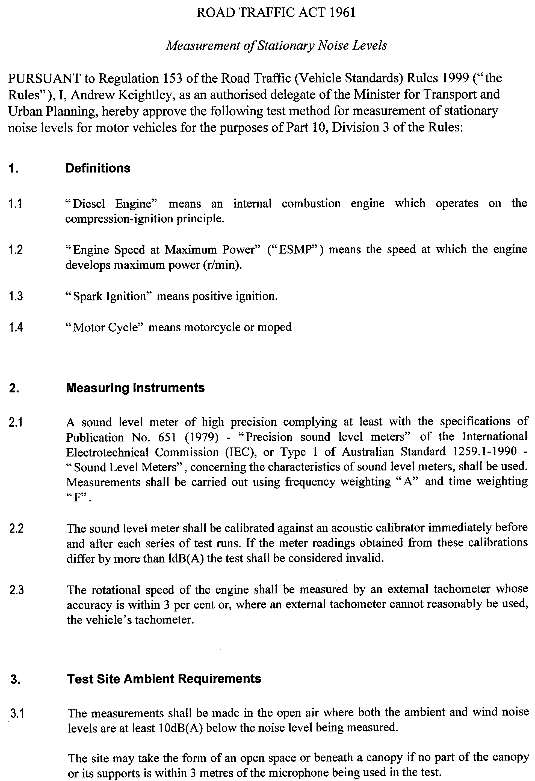
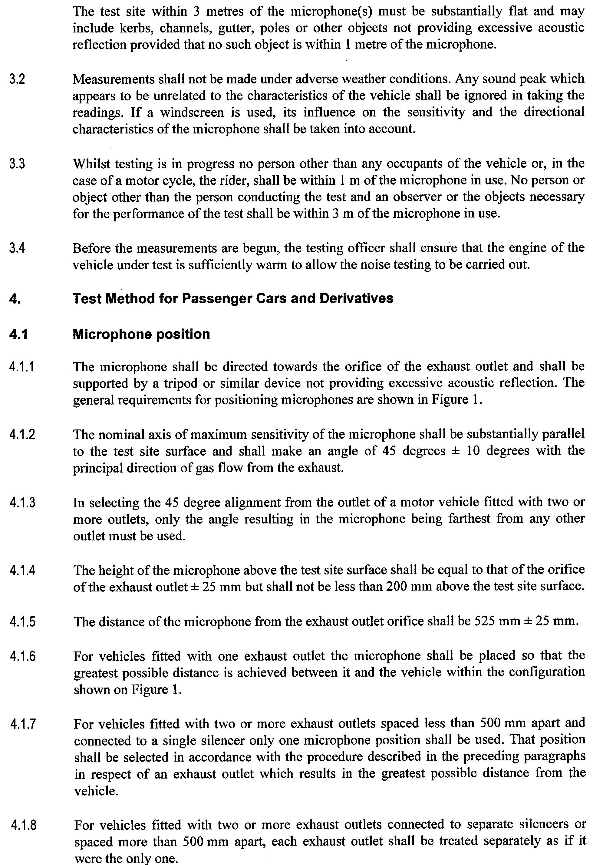
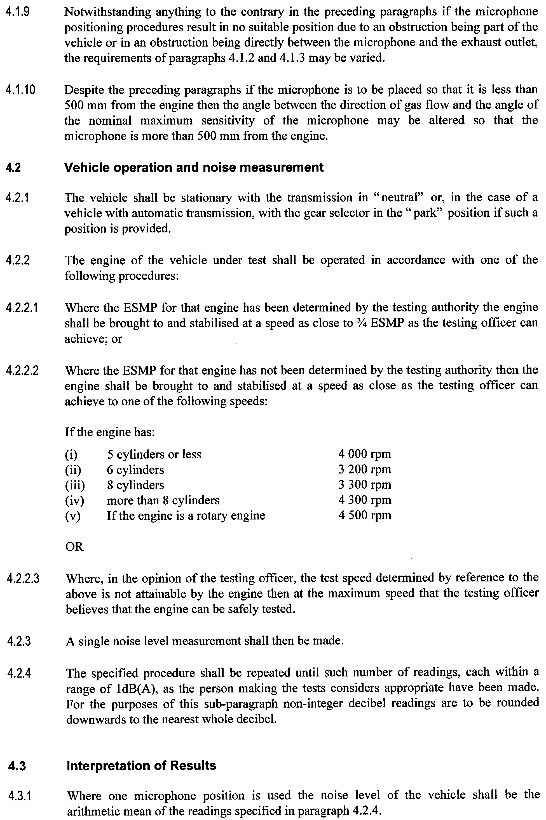
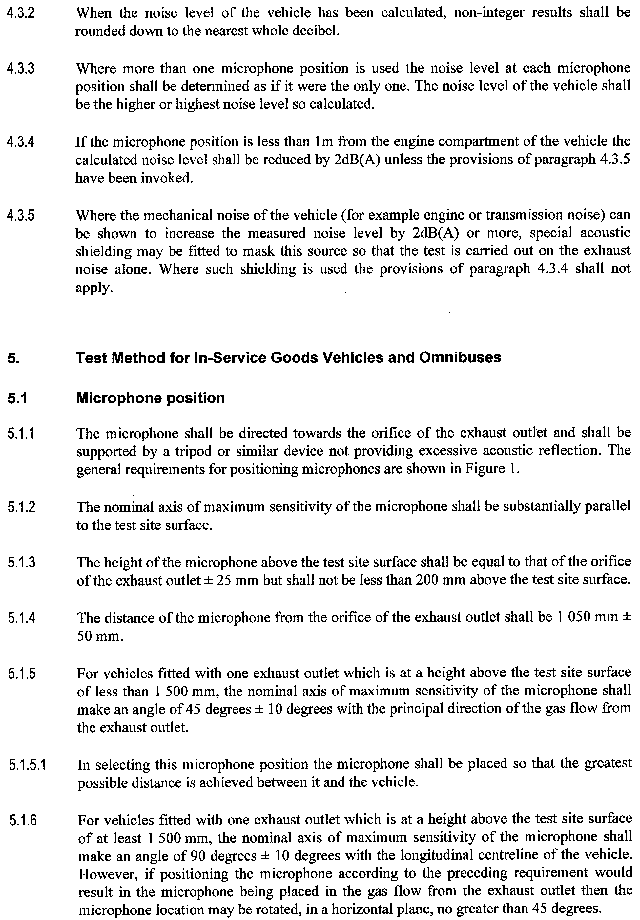
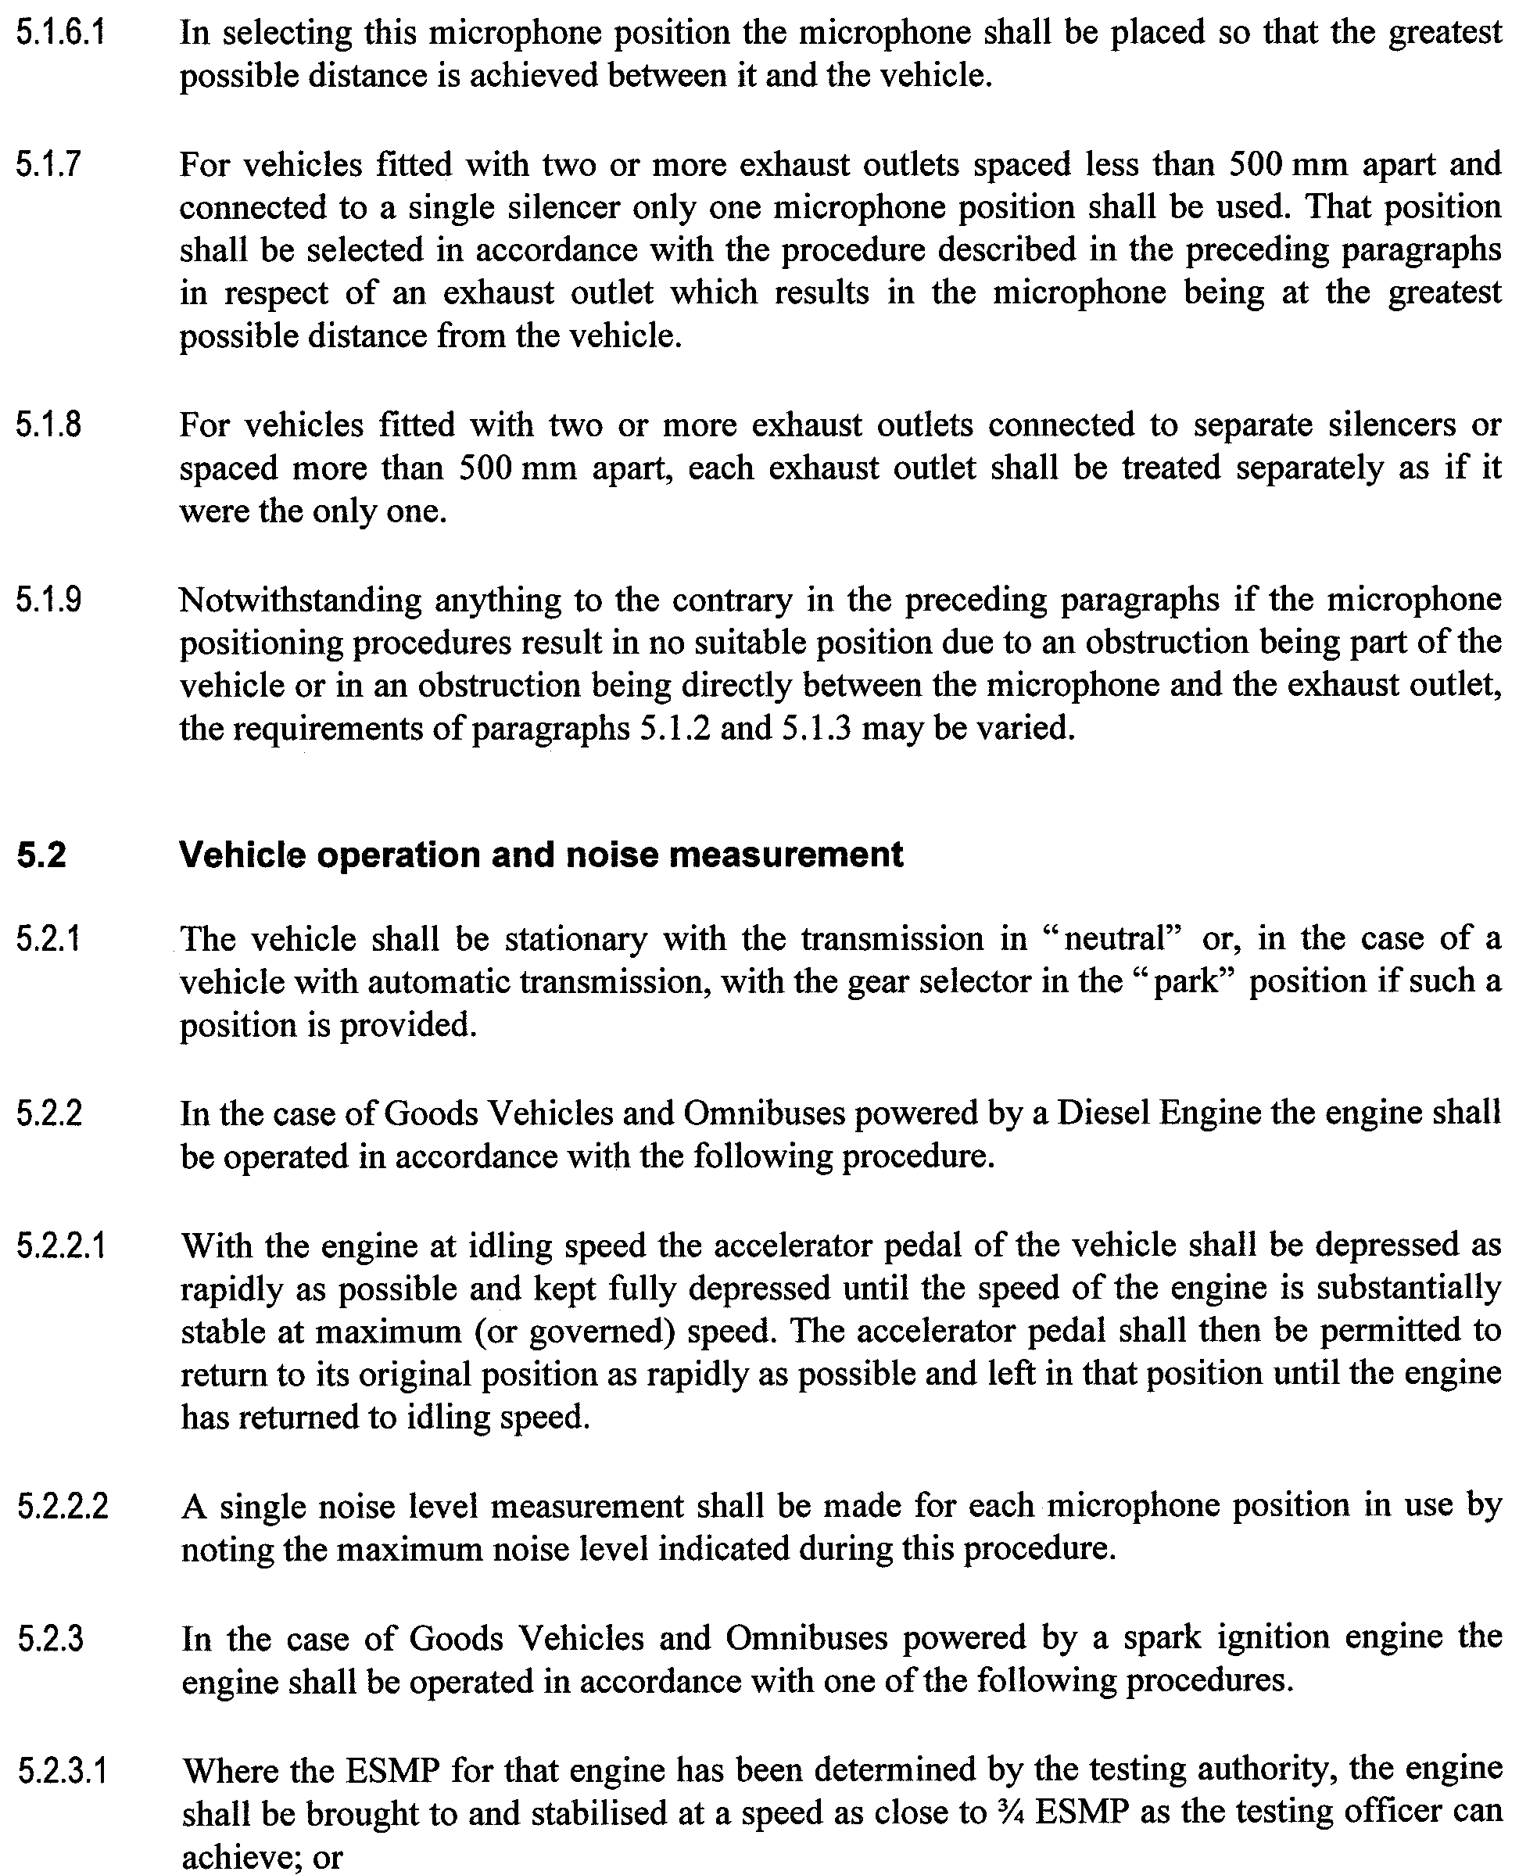
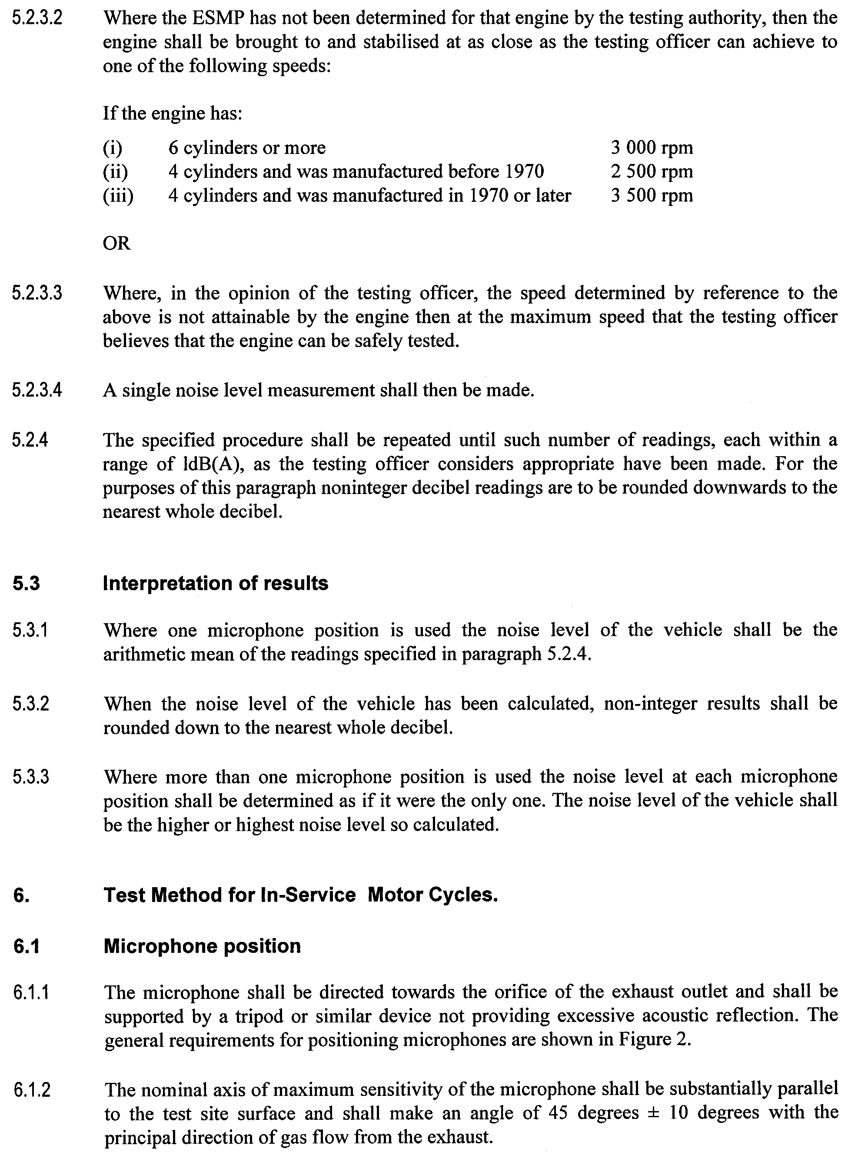
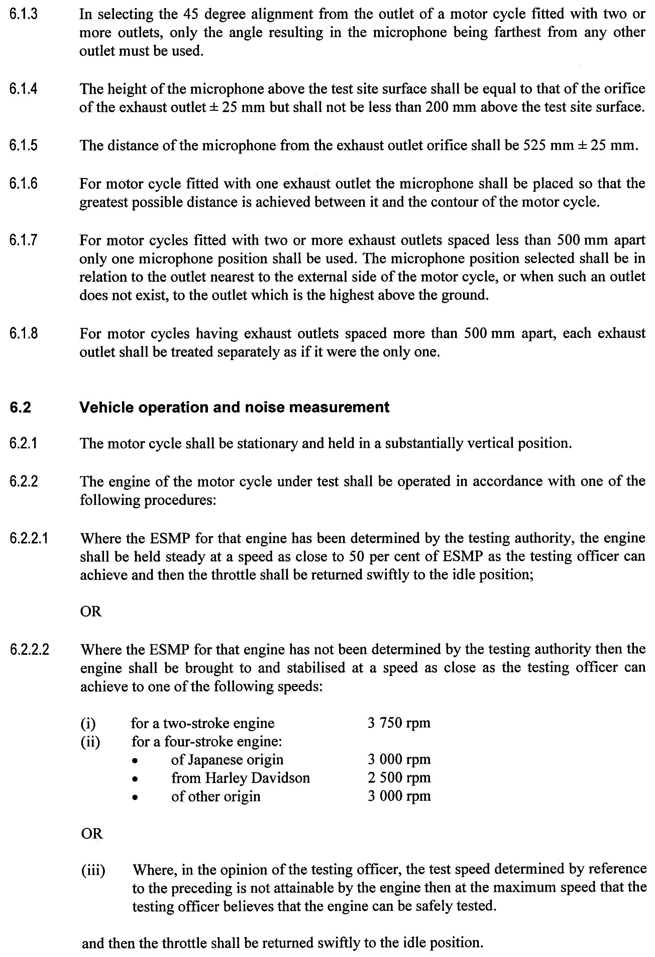
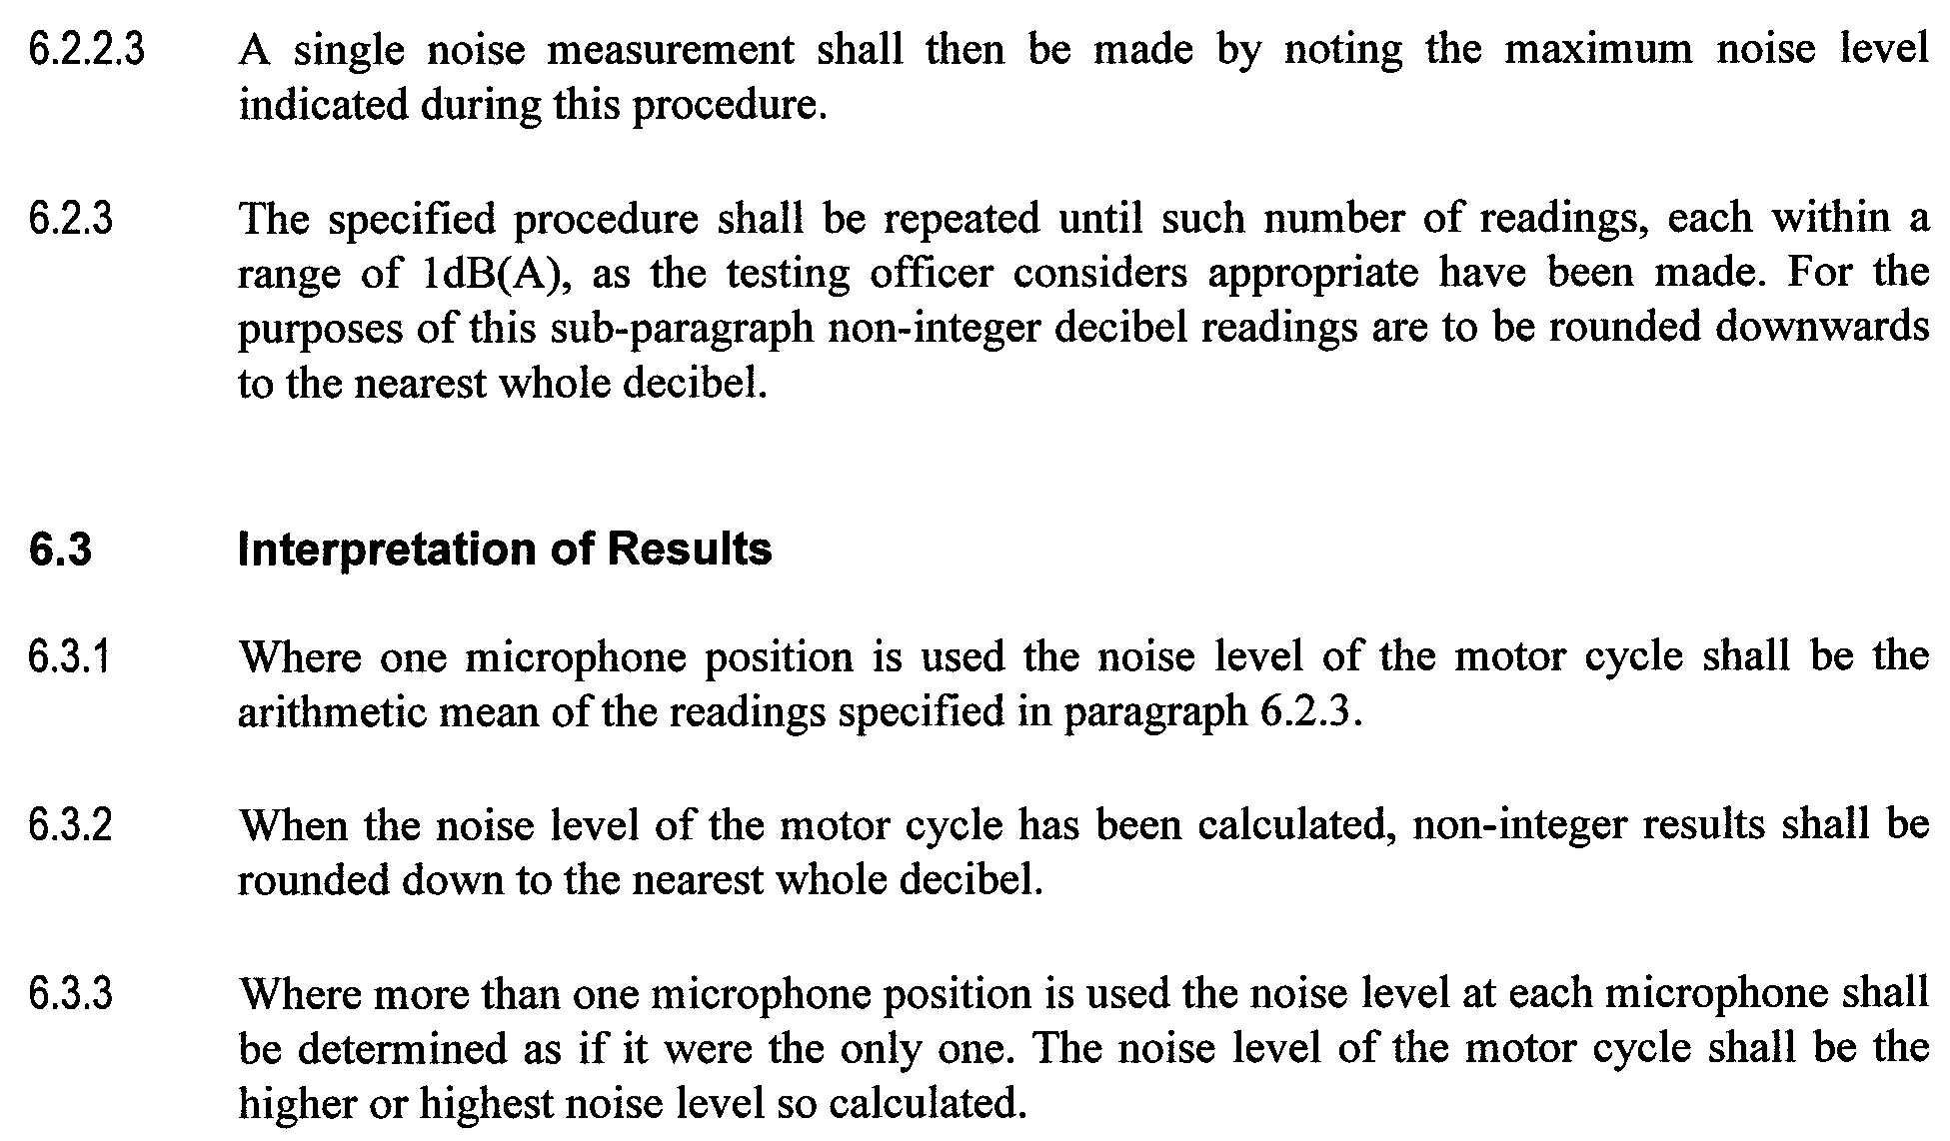
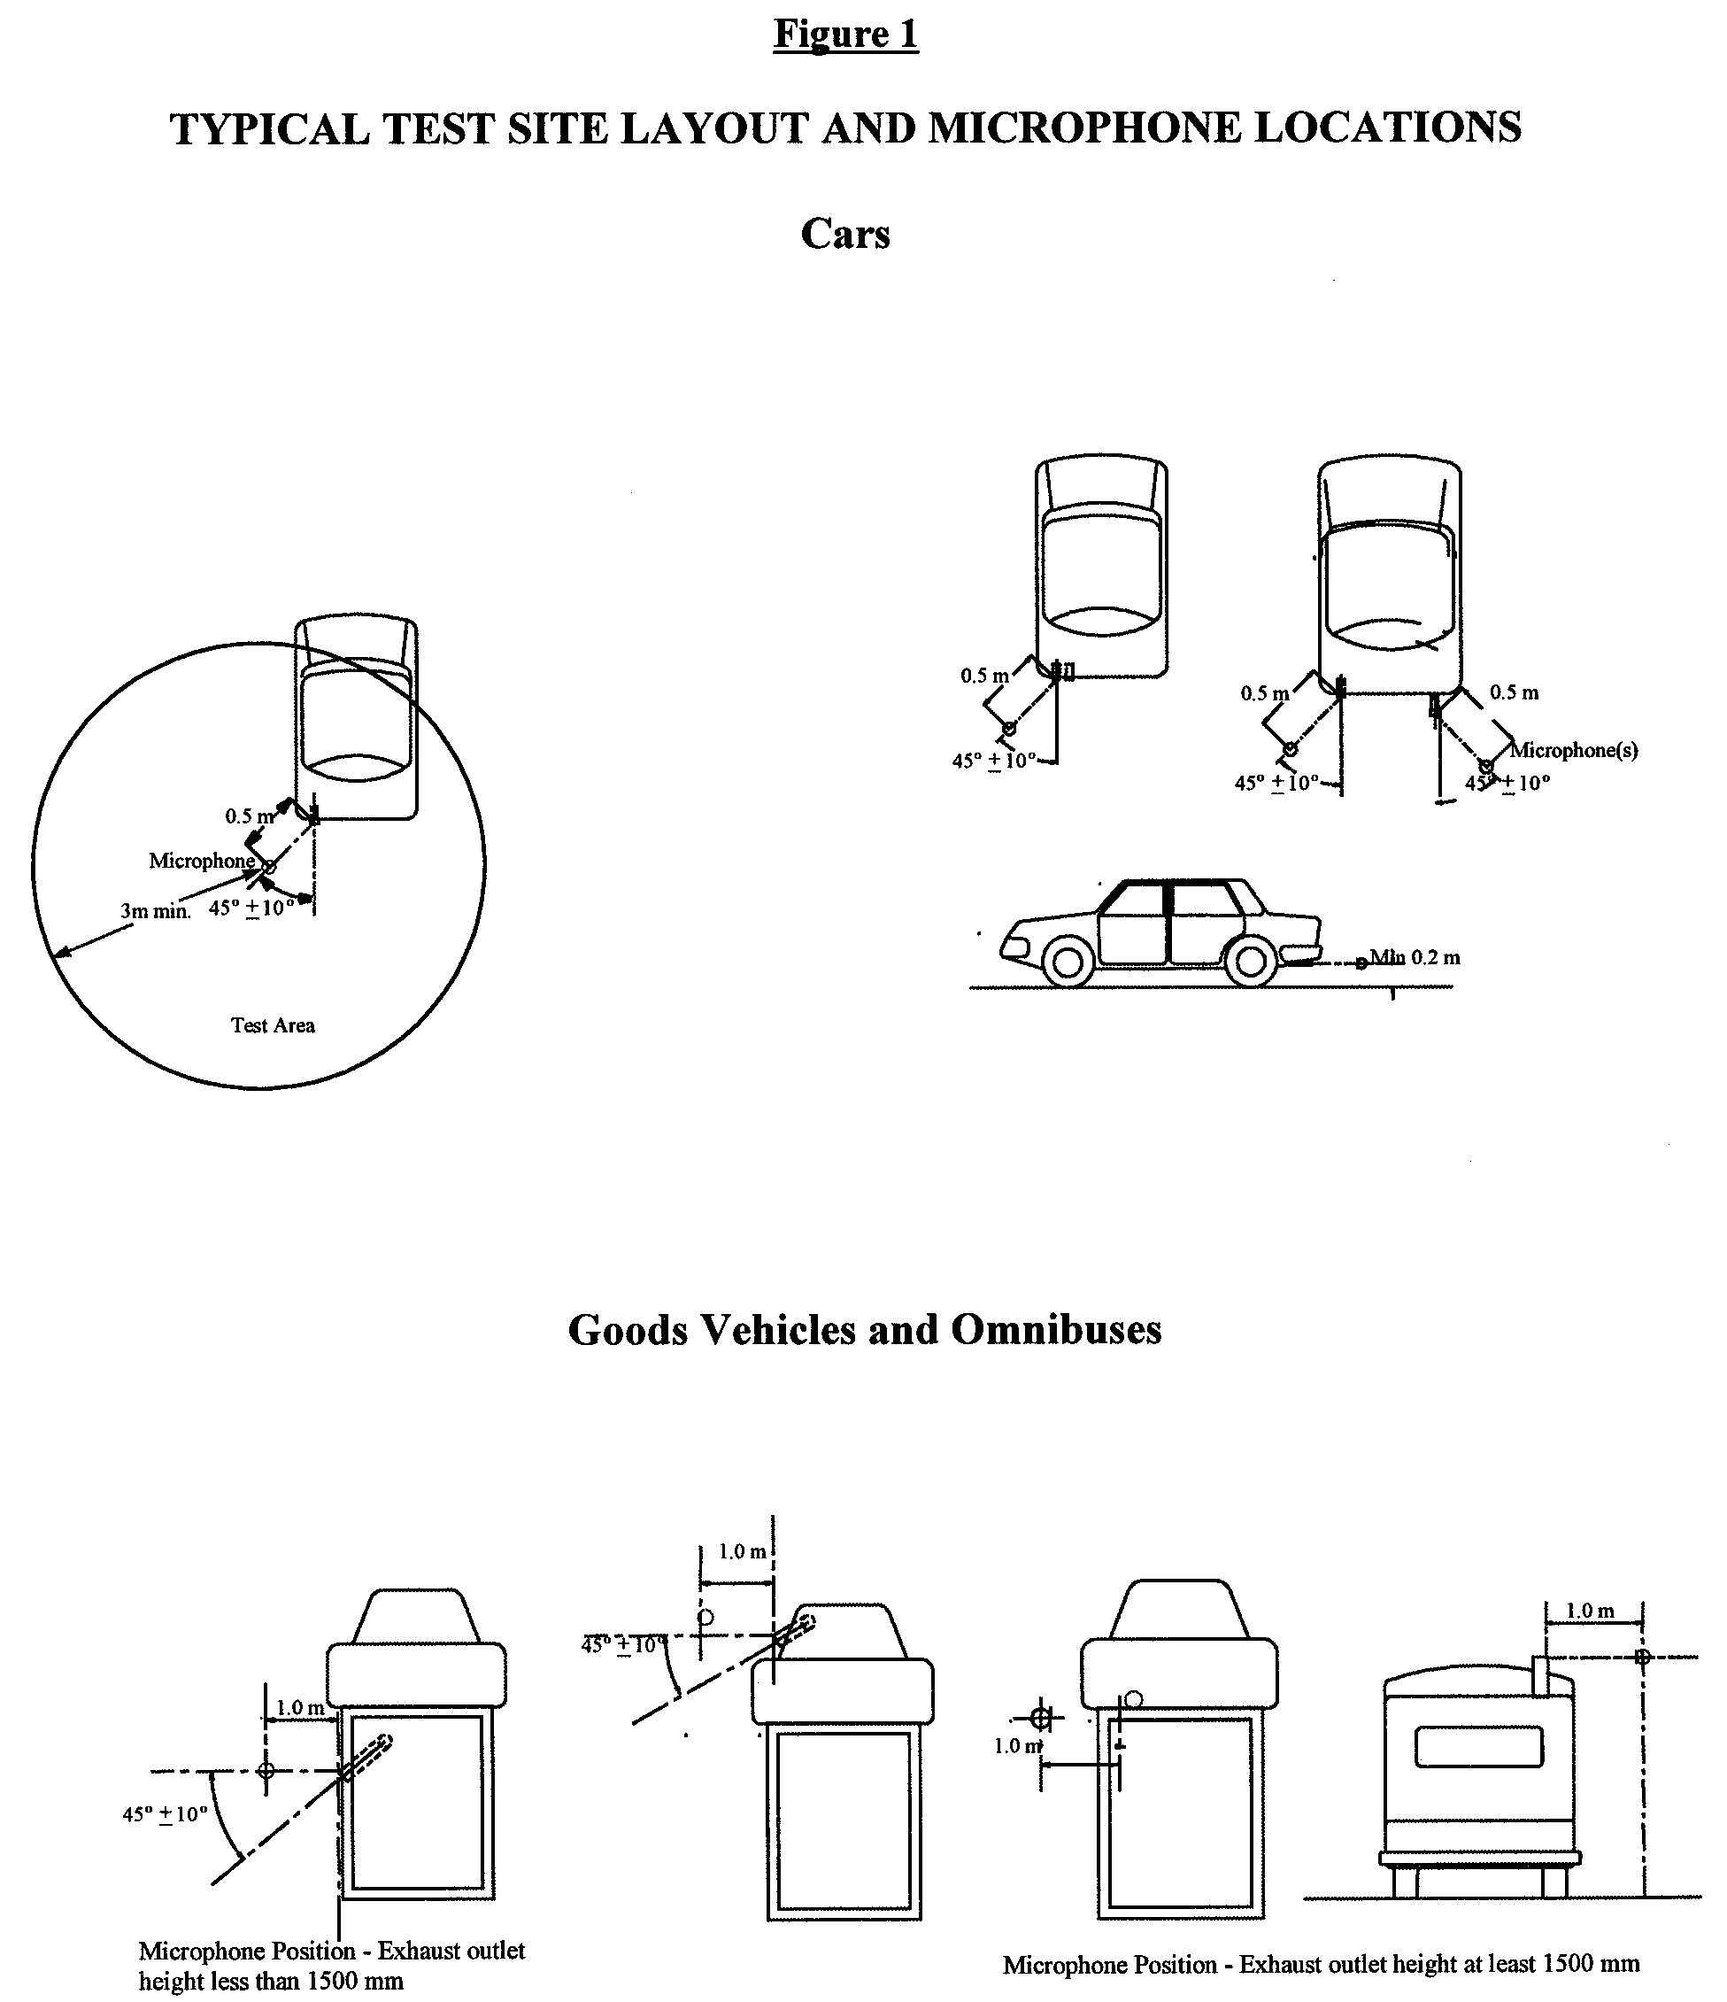
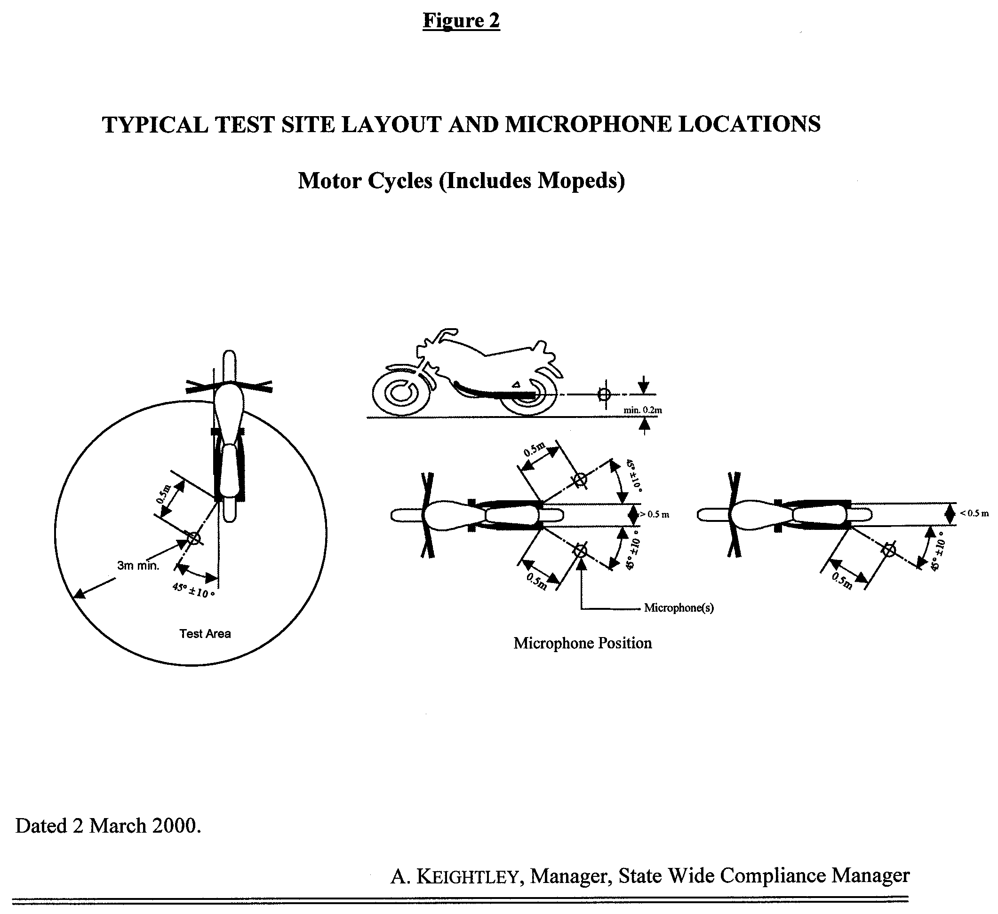

ROAD TRAFFIC (ROAD RULES—ANCILLARY AND
MISCELLANEOUS PROVISIONS) REGULATIONS 1999
Notice of Exemption
I, DIANA LAIDLAW, Minister for Transport and Urban Planning, grant the following exemption pursuant to Regulation 7 of the Road Traffic (Road Rules—Ancillary and Miscellaneous Provisions) Regulations 1999.
The drivers of vehicles manufactured before 1 July 1976, that are not of the following class of vehicles, are exempt from the operation of subrule 266 (2) (wearing of seatbelt by passenger under 1 year of age):
(a) passenger cars; or
(b) passenger car derivatives; or
(c) forward-control passenger vehicles; or
(d) multi-purpose passenger cars; or
as defined in the Australian Design Rules.
This exemption is subject to the following condition:
Where the motor vehicle has two or more rows of seats, the child passenger must not sit or be carried in the front row of seats.
This exemption is effective immediately.
This exemption does not affect any other rule contained in the Rules under the Road Traffic Act 1961.
Dated 22 February 2000.
Diana Laidlaw, Minister for Transport and Urban Planning.

SURVEY ACT 1992
Register of Surveyors
IT is hereby notified for general information that the name of the undermentioned person has been restored to the Register and such person is duly registered under the above Act.
List of Registered Surveyors

Name |  | Address | Date of  Registration
Larden, Douglas Roy |  | 8 Strathspey Avenue, Hazelwood Park, S.A. 5066 | 12.5.83

D. N. Brook, Registrar

REGULATIONS UNDER THE CRIMINAL LAW (SENTENCING) ACT 1988
────
No. 16 of 2000
────
At the Executive Council Office at Adelaide 2 March 2000

PURSUANT to the Criminal Law (Sentencing) Act 1988 and with the advice and consent of the Executive Council, I make the following regulations.
E. J. NEAL Governor

PURSUANT to section 10AA(2) of the Subordinate Legislation Act 1978, I certify that, in my opinion, it is necessary or appropriate that the following regulations come into operation as set out below.

K. T. GRIFFIN Attorney-General
───────────────────
SUMMARY OF PROVISIONS

1. Citation
2. Commencement
3. Revocation
4. Interpretation
5. Forms
6. Fees
7. Enforcement of bonds and guarantees (s. 57)
8. Review of written payment arrangements (s. 64)
9. Applications relating to registration of court order for pecuniary sums (s. 68)
10. Modification of bankruptcy laws (seizure of personal property)(s. 70G)
11. Enforcement of community service orders
12. Enforcement of non-pecuniary orders

SCHEDULE
───────────────────

Citation
1. These regulations may be cited as the Criminal Law (Sentencing) Regulations 2000.

Commencement
2. These regulations will come into operation on 6 March 2000.

Revocation
3. The Criminal Law (Sentencing) Regulations 1988, as varied, are revoked.

Interpretation
4. In these regulations—

"the Act" means the Criminal Law (Sentencing) Act 1988.

Forms
5. (1) The forms set out in the schedule to these regulations are prescribed, and must be used, for the purposes of the Act.

(2) If any enforcement proceedings are to be taken against a guarantor of a bond, the relevant forms in the schedule must be modified accordingly.

(3) If any document the form of which is prescribed by the schedule is to be served on a company, the relevant form must be modified accordingly.

Fees
6. The following fees are prescribed for the purposes of the Act:

1. | Reminder notice fee (s. 65(3)) | $13.00
2. | Issuance of penalty enforcement order:
 | (a) suspension of driver's licence (s. 70E) | $20.00
 | (b) restriction on transacting business with Registrar of Motor Vehicles (s. 70F) | $20.00
 | (c) order for sale of property (s. 70G) | $55.00
 | (d) garnishee order (s. 70H) | $55.00
3. | Service and execution of penalty enforcement order—a fee comprised of the costs reasonably incurred in the service or execution, including—
 | ⋅ postage and telephone calls;
 | ⋅ travelling, accommodation and necessary meals;
 | ⋅ labour in seizing and removing seized property;
 | ⋅ cartage, storage and insurance of seized property;
 | ⋅ maintenance of seized animals;
 | ⋅ engaging assistants, appraisers, auctioneers or agents;
 | ⋅ advertisements;
 | ⋅ conducting sales of seized property.

Enforcement of bonds and guarantees (s. 57)
7. (1) If, pursuant to section 57(1) of the Act, a probative court decides to issue a summons or a warrant of arrest to bring a probationer before the court on a written application made by the Crown alleging breach of bond, the court must endorse the application accordingly.

(2) The court should first issue a summons to a probationer alleged to have breached a bond unless the court has reasonable grounds to believe—

(a) that service of a summons is not likely to be effected; or

(b) that the probationer is not likely to comply with a summons.

(3) A summons must be served on the probationer—

(a) personally; or

(b) if personal service is not practicable or the probationer cannot, after reasonable enquiries, be found, in such other manner as the court may direct,

not later than 2 clear working days before the date specified in the summons for the hearing of the matter.
(4) If a probationer fails to appear before the probative court in compliance with a summons and the court is satisfied that the summons was duly served on the probationer, the court may, instead of issuing a warrant, deal with the application in the absence of the probationer.

(5) If a guarantor fails to appear before the probative court in compliance with a summons and the court is satisfied that the summons was duly served on the guarantor, the court may make orders in relation to enforcing the guarantee in the absence of the guarantor.

(6) If a probationer is found guilty of an offence committed during the term of a bond by a court that has jurisdiction to deal with proceedings for breach of the bond, the court may, on an oral application by the Crown, proceed to hear and determine the application forthwith if it is satisfied that the probationer has had adequate notice of the intention of the Crown to make such an application.

Review of written payment arrangements (s. 64)
8. The Manager of the Penalty Management Unit must cause each written arrangement entered into under section 64 of the Act to be reviewed on a regular basis, at intervals not exceeding 6 months.

Applications relating to registration of court order for pecuniary sums (s. 68)
9. (1) An application made by an authorised officer under section 68 of the Act—

(a) for registration as a charge over land of an order of a court imposing a pecuniary sum; or

(b) for cancellation of the registration of such an order,

must be made using Form A3 of the forms approved by the Registrar-General under the Real Property Act 1886.

(2) An application referred to in subregulation (1) need not be accompanied by a duplicate certificate of title for the land.

(3) No fee is payable in respect of lodging an application referred to in subregulation (1).

Modification of bankruptcy laws (seizure of personal property)(s. 70G)
10. For the purposes of section 70G(3) of the Act, the laws of bankruptcy are modified to the extent that the following personal property of a debtor, although not divisible amongst creditors in a bankruptcy, is available for seizure and sale pursuant to an order for sale under section 70G:

(a) any motor vehicle, of whatever value; and

(b) property—

(i) that was purchased or acquired with exempt money (being exempt money within the meaning of section 116 of the Bankruptcy Act 1966 of the Commonwealth); and

(ii) that is not otherwise excluded from seizure and sale by virtue of the application of the laws of bankruptcy.

Enforcement of community service orders
11. (1) A notice issued under section 71(3)(a) of the Act must be served on the defendant—

(a) personally; or

(b) if personal service is not practicable or the defendant cannot, after reasonable enquiries, be found, in such other manner as the court may direct,

not later than 2 clear working days before the date specified in the notice for the hearing of the matter.

(2) If the defendant fails to attend before the court in compliance with the notice and the court is satisfied that the notice was duly served on the defendant, the court may deal with the matter in the absence of the defendant.

Enforcement of non-pecuniary orders
12. (1) A notice under section 71A(1)(a) of the Act must be served on the defendant—

(a) personally; or

(b) if personal service is not practicable or the defendant cannot, after reasonable enquiries, be found, in such other manner as the court may direct,

not later than 2 clear working days before the date specified in the notice for the hearing of the matter.

(2) If the defendant fails to attend before the court in compliance with the notice and the court is satisfied that the notice was duly served on the defendant, the court may deal with the matter in the absence of the defendant.

SCHEDULE

CRIMINAL LAW (SENTENCING) ACT 1988

FORM 1

Warrant of Commitment (Imprisonment on Conviction)

COURT PARTICULARS
Court of origin

DEFENDANT'S PARTICULARS
Name |  | Date of birth
Address

DETAILS OF THE OFFENCE(S) AND THE TERM(S) OF IMPRISONMENT ORDERED FOR THE OFFENCE(S)
File No. | Count No. | Offence (and offence date) | Sentence imposed | CIC Levy
Total sentence of imprisonment to be served |  |  | Total CIC Levy | $
Imprisonment commencement date |  |  | Amount paid | $
Non-parole period set (or minimum term) |  |  | Amount outstanding | $
Non-parole period commencement date
Name of person who imposed penalty
Date order made by court
Date warrant issued

To the Commissioner of Police for the State of South Australia and each police officer, and to the Executive Director of the Department of Correctional Services.

The defendant named in this warrant has been dealt with by a court and sentenced to a term of imprisonment. Particulars of the court that imposed the penalty, the charge(s) against the defendant and the sentence(s) imposed appear on this warrant.

You, the Commissioner of Police and police officers, are directed to convey the defendant to a correctional institution and you, the Executive Director, are directed to detain the defendant for such period of time as this warrant directs.

Judge/Magistrate

CRIMINAL LAW (SENTENCING) ACT 1988 (s.38)

FORM 2

Suspended Sentence Bond

DETAILS OF THE COURT THAT IMPOSED THE SENTENCE(S)
Name of court

DETAILS OF THE PROBATIONER
Name |  | Date of Birth
Address

DETAILS OF THE OFFENCE(S) TO WHICH THE BOND RELATES AND OF THE SENTENCE(S) THAT THE COURT HAS IMPOSED FOR THOSE OFFENCES

File No. | Count No. | Offence | Sentence Imposed

Total sentence of imprisonment to be served
Non-parole period fixed (if the sentence to be served is 12 months or more)

The court has recorded a conviction against you for the offence(s) listed above and has imposed the sentence(s) shown for each matter. It has, however, ordered that the sentence(s) be suspended if you enter into a bond.

DETAILS OF YOUR BOND ARE:

Length of bond term |  | (starting from *when you sign this bond/when you are released from prison)
Amount of bond

CONDITIONS OF YOUR BOND ARE:

1. That you be of good behaviour, and comply with all of the conditions of this bond.

2. That you be under the supervision of a community corrections officer for a period of ........................ and obey the lawful directions given to you by the community corrections officer to whom you are assigned for the purposes of supervision.

* 3. That you perform ......................... hours of community service within ................... months from the date of this bond, and obey the lawful directions of the community corrections officer to whom you are assigned for the purposes of the community service.

* 4. That you report, within 2 working days of having signed this bond, at the offices of the Department of Correctional Services at

(NOTE: You need not report if within that 2 day period you receive notice from the Department that it is not necessary to do so).

5. Other conditions:

*Delete if inapplicable.
WHAT WILL HAPPEN IF YOU COMPLY WITH THE CONDITIONS OF THIS BOND:

If, at the end of the term of this bond, you have complied with all of the conditions mentioned above, the sentence(s) of imprisonment ordered by the court will not have to be served, nor will you have to come back to court.

WHAT WILL HAPPEN IF YOU FAIL TO COMPLY WITH THE CONDITIONS OF THIS BOND:

If you fail to comply with any of the conditions of your bond, the following things may happen:

1. You may be brought back to court, and the court may cancel the order of suspension of the prison sentence(s) imposed on you. You would then have to serve that sentence, or such lesser term of imprisonment as may be fixed by the court.

2. You may be ordered to pay the amount of the bond (as set out above), or any lesser amount fixed by the court.

3. Any person who has agreed to act as a guarantor to this bond may be ordered to pay the amount of money for which they have signed, or any lesser amount fixed by the court.

ACKNOWLEDGMENT BY PROBATIONER
I agree to enter into this bond. I acknowledge that I fully understand its conditions, and I undertake to comply with those conditions. I also understand what will happen to me if I fail to do so. | Probationer

Bond taken before me and duplicate served this ...................... day of ............................. 20 ...........................

Judge
Magistrate
Justice of the Peace

CRIMINAL LAW (SENTENCING) ACT 1988 (s.39)

FORM 3

Good Behaviour Bond

DETAILS OF THE COURT THAT IMPOSED THE SENTENCE(S)
Name of court

DETAILS OF THE PROBATIONER
Name |  | Date of Birth
Address

DETAILS OF THE OFFENCE(S) THAT THE BOND RELATES TO

File No. | Count No. | Offence

You, the probationer, have been found guilty of the offence(s) listed above. The court this day ordered that you be discharged on a bond *with/without conviction and without a penalty having been imposed on you.

*Delete whichever is inapplicable.

DETAILS OF YOUR BOND ARE:

Length of bond term |  | (starting from when you sign this bond)
Amount of bond

THE CONDITION OF YOUR BOND IS THAT YOU BE OF GOOD BEHAVIOUR.

WHAT WILL HAPPEN IF YOU COMPLY WITH THE CONDITION OF THIS BOND:

If, at the end of the term of this bond you have complied with the condition to be of good behaviour, the bond will lapse automatically. You will not be required to come back to court and you cannot be punished further for the offence(s) listed above.

WHAT WILL HAPPEN IF YOU FAIL TO COMPLY WITH THE CONDITION OF THIS BOND:

If you fail to comply with the condition to be of good behaviour, the following things may happen:

1. You may be ordered to pay the above amount of the bond, or any lesser amount fixed by the court.

2. Any person who has agreed to act as a guarantor to this bond may be ordered to pay the amount of money for which they have signed, or any lesser amount fixed by the court.

ACKNOWLEDGMENT BY PROBATIONER

I agree to enter into this bond. I acknowledge that I fully understand the condition to be of good behaviour, and I undertake to comply with that condition. I also understand what will happen to me if I fail to do so. | Probationer

Bond taken before me and duplicate served this ....................... day of ............................. 20................

Judge
Magistrate
Justice of the Peace

CRIMINAL LAW (SENTENCING) ACT 1988 (s.39)

FORM 4

Good Behaviour Bond (with conditions)

DETAILS OF THE COURT THAT IMPOSED THE SENTENCE(S)
Name of court

DETAILS OF THE PROBATIONER
Name |  | Date of Birth
Address

DETAILS OF THE OFFENCE(S) THAT THE BOND RELATES TO

File No. | Count No. | Offence

You, the probationer, have been found guilty of the offence(s) listed above. The court this day ordered that you be discharged on a bond *with/without conviction and without a penalty having been imposed on you.

DETAILS OF YOUR BOND ARE:

Length of bond term |  | (starting from when you sign this bond)
Amount of bond

CONDITIONS OF YOUR BOND ARE:

1. That you be of good behaviour, and comply with all the other conditions of this bond.

2. That you appear before a court for *conviction and/sentence for the above offence(s) if you disobey any of the conditions of this bond.

3. That you be under the supervision of a community corrections officer for a period of ........................ and obey the lawful directions given to you by the community corrections officer to whom you are assigned for the purposes of supervision.

4. That you report, within 2 working days of having signed this bond, at the offices of the Department of Correctional Services at

(NOTE: You need not report if within that 2 day period you receive notice from the Department that it is not necessary to do so).

5. Other conditions:

WHAT WILL HAPPEN IF YOU COMPLY WITH THE CONDITIONS OF THIS BOND:

If, at the end of the term of this bond you have complied with all of the above conditions,the bond will lapse automatically. You will not be required to come back to court and you cannot be punished further for the offence(s) listed above.

WHAT WILL HAPPEN IF YOU FAIL TO COMPLY WITH THE CONDITIONS OF THIS BOND:

If you fail to comply with the conditions of your bond, the following things may happen:

1. You may be brought back to court, and the court may *convict and/sentence you for the offence(s).

2. You may be ordered to pay the above amount of the bond, or any lesser amount fixed by the court.

3. Any person who has agreed to act as a guarantor to this bond may be ordered to pay the amount of money for which they have signed, or any lesser amount fixed by the court.

*Delete whichever is inapplicable.

ACKNOWLEDGMENT BY PROBATIONER

I agree to enter into this bond. I acknowledge that I fully understand its conditions and I undertake to comply with those conditions. I also understand what will happen to me if I fail to do so. | Probationer

Bond taken before me and duplicate served this ....................... day of ............................. 20................

Judge
Magistrate
Justice of the Peace

CRIMINAL LAW (SENTENCING) ACT 1988 (s.41)

FORM 5

Guarantee of Bond

I, (D/B / / )

of

and I, (D/B / / )

of

guarantee that

("the probationer") will comply with all of the terms and conditions of the bond (a copy of which is attached) that he or she has entered into this day.

I understand that I am liable to pay the sum of $ if the probationer breaches any of the conditions of the attached bond.

...........................................................................
(Guarantor)

...........................................................................
(Guarantor)

Taken before me this day of 20 .

Duplicates served on the guarantor(s) and the probationer.

...........................................................................

CRIMINAL LAW (SENTENCING) ACT 1988

FORM 6

Notice of a Community Service Order made by a Court

DETAILS OF THE COURT THAT MADE THE ORDER

Name of court

DETAILS OF THE PERSON AGAINST WHOM THE ORDER HAS BEEN MADE

Name |  | Date of Birth
Address

DETAILS OF THE OFFENCE(S) TO WHICH THE ORDER RELATES
File No. | Count No. | Offence

*The court has *found you guilty/convicted you of the offence(s) listed above and has sentenced you this day as follows:

*The court has reconsidered your sentence under section 70I of the Act and has revoked the order(s) for the pecuniary sum(s) listed in the attached copy of Referral Notice and made a community service order against you instead, the details of which are as follows:

1. You are to perform .................... hours of community service within ................... months from the date of this order, and you must, until such time as you have finished working the required number of hours, obey the lawful directions of the community corrections officer to whom you are assigned for the purposes of the community service.

*2. You are to be under the supervision of a community corrections officer for a period of .................... from the date of this order and during that period must obey the lawful directions that are given to you by the community corrections officer to whom you are assigned for the purposes of supervision.

3. You are to report, within 2 working days of having signed this notice, at the offices of the Department of......................
.................................... at..............................................

(NOTE: You need not report if, within that 2 day period, you receive notice from the Department advising that you do not have to comply with this requirement.)

* Delete if inapplicable

Date of Order ............... / ........ / 20...........

WHAT CAN HAPPEN IF YOU FAIL TO COMPLY WITH THIS ORDER

If you fail to comply with any part of the order set out above, you can be sentenced to imprisonment (detention or home detention if you are a youth) for a period not exceeding 6 months, calculated, in the case of a breach of clause 1, on the basis of 1 day for each 8 hours of community service not performed.

Duplicate notice handed to the abovenamed person this  ....................................... day of  ...................................... 20........... | ........................................................................  (Server)

Receipt acknowledged ....................................................
CRIMINAL LAW (SENTENCING) ACT 1988 (s. 57)

FORM 7

Summons to a Person Charged with Breaching a Conditional Bond

On the day of 20 , you entered into a bond, a copy of which is attached.

It is alleged by

of

that you have failed to comply with a condition of your bond, in that you—

* failed to be of good behaviour by committing a further offence, particulars of which are detailed in the attached certified copy.

* failed, in the manner described in the attached affidavit, to comply with the condition that you be under the supervision of a community corrections officer and obey the lawful directions of the officer to whom you are assigned.

* failed, in the manner described in the attached affidavit, to comply with the condition that you perform community service.

* failed, in the manner described in the attached affidavit, to comply with the condition that

*Delete whichever is inapplicable.

TAKE NOTICE that you are required to answer the allegation that you have failed to comply with a condition of your bond, and for that purpose you are hereby ordered to appear on the day of

20 , at o'clock in the noon at the

in the State of South Australia, to answer the allegation and to show cause why you should not be dealt with according to law. If you fail to attend as required by this summons, the court may order that a warrant be issued for your arrest, or make such order against you in your absence as it sees fit, including (except where imprisonment is not available for the offence(s) to which the bond relates) an order for your imprisonment.

Dated the day of 20 , at

in the State of South Australia

...........................................................................

Judge/Magistrate

PROOF OF SERVICE

I, of

make oath and say that I did on the day of
20 , between the hours of
and in the noon duly serve
at
with this summons by delivering a duplicate first to him/her personally.

Sworn before me at
(Server)
on the day of
20 .
(Justice of the Peace)

CRIMINAL LAW (SENTENCING) ACT 1988 (s. 57)

FORM 8

Warrant to Apprehend a Person Charged with Breach of a Bond

To the Commissioner of Police for the State of South Australia, and to each police officer.
This warrant is for the apprehension of
of ("the probationer").
Evidence on oath was given on the day of 20 ,
by of
that the probationer has failed to comply with the conditions of a bond entered into at the
Court on the day of 20 ,
in relation to an offence of

Conditions of the bond are that the probationer—
1. Be of good behaviour.
* 2. Be under the supervision of a community corrections officer and obey the lawful directions given by that officer.
* 3. Perform hours of community service within , and obey the lawful directions given by the community corrections officer to whom the probationer is assigned for the purposes of the community service.
* 4. Report within 2 working days of having signed the bond at the office of the Correctional Services Department.
* 5. Other conditions:

*Delete whichever is inapplicable.

And it is alleged that the probationer has failed to comply with the conditions of the bond in that

And I, , sitting as a probative court at the , being satisfied by evidence on oath that the probationer may have failed to comply with the conditions of the bond, direct you to apprehend the probationer and to bring that person before the Court (or the Magistrates Court) not later than the next working day after the day of the probationer's arrest, to be dealt with according to law.

Dated the day of 20 , at in the
State of South Australia.

...........................................................................

Judge/Magistrate

CRIMINAL LAW (SENTENCING) ACT 1988

FORM 9

Warrant of Commitment

(Imprisonment for non-compliance with an order of a non-pecuniary nature)

DETAILS OF COURT/AUTHORISED OFFICER THAT MADE ORDER
Name of court/title of officer
File no. |  | Count no.

DETAILS OF DEFENDANT
Name
Date of birth
Address

DETAILS OF OFFENCES(S) THAT ORDER AROSE FROM
Date of offence(s)
Offence location
Offence(s)

DETAILS OF ORDER
Terms of order | 1. To perform community service of hours
 | 2. Other (give brief particulars)

DETAILS OF IMPRISONMENT IMPOSED ON DEFAULT
Term of imprisonment ordered
Imprisonment commencement date
Name of court or title of officer who imposed sentence
Date warrant issued

To the Commissioner of Police for the State of South Australia and police officers, and to the Executive Director of the Department of Correctional Services.

The defendant named in this warrant has refused or neglected to comply with an order of a court/authorised officer of a non-pecuniary nature, and has been sentenced to a term of imprisonment, details of which appear above.

You, the Commissioner of Police and police officers are directed to convey the defendant to a correctional institution, and you, the Executive Director, are directed to detain the defendant for such period of time as this warrant directs.

...........................................................................
Judge/ Magistrate

AG 9/98 CS R. DENNIS Clerk of the Council
REGULATIONS UNDER THE SOUTH AUSTRALIAN HOUSING TRUST ACT 1995
────
No. 17 of 2000
────
At the Executive Council Office at Adelaide 2 March 2000

PURSUANT to the South Australian Housing Trust Act 1995 and with the advice and consent of the Executive Council, I make the following regulations.
E. J. NEAL Governor

PURSUANT to section 10AA(2) of the Subordinate Legislation Act 1978, I certify that, in my opinion, it is necessary or appropriate that the following regulations come into operation as set out below.

DEAN BROWN Minister for Human Services
───────────────────
SUMMARY OF PROVISIONS

1. Citation
2. Commencement
3. Variation of reg. 1—Citation
4. Insertion of reg. 7
7. Mandatory provision in conditions of tenancy
───────────────────

Citation
1. The South Australian Housing Trust (Administrative Arrangements) Regulations 1995 (see Gazette 21 December 1995 p. 1808) are referred to in these regulations as "the principal regulations".

Commencement
2. These regulations will come into operation on 6 March 2000.

Variation of reg. 1—Citation
3. Regulation 1 of the principal regulations is varied by striking out "(Administrative Arrangements)" and substituting "(General)".

Insertion of reg. 7
4. The following regulation is inserted after regulation 6 of the principal regulations:

Mandatory provision in conditions of tenancy
7. Pursuant to section 44(2)(a) of the Act, an agreement between SAHT and a tenant setting out the conditions of the tenancy must contain a provision in a form approved from time to time by the Minister that allows SAHT to charge, as a component of the rent payable under the agreement, a premium if the income of the tenant exceeds an amount determined by SAHT from time to time and the tenant does not meet eligibility criteria determined by SAHT (from time to time)¹.

1. A provision inserted in an agreement under this regulation will not apply to a tenant who last applied for SAHT housing before 25 February 1998.

DHS 29/99 CS R. DENNIS Clerk of the Council

FAXING COPY?

IF you fax copy to Riverside 2000, for inclusion in the Government Gazette, there is no need to send a Confirmation Copy to us as well.

This creates confusion and may well result in your notice being printed twice.

Please use the following fax number:

Fax transmission: (08) 8207 1040
Phone Inquiries: (08) 8207 1045

Please include a contact person, phone number and order number so that we can phone back with any queries we may have regarding the fax copy.

NOTE: Closing time for lodging new copy (either fax or hard copy) is 4 p.m. on Tuesday preceding the day of publication.

Government Gazette notices can be E-mailed.

The address is:

Riv2000@saugov.sa.gov.au

Documents should be sent as attachments in Word format.

When sending a document via E-mail, please confirm your transmission with a faxed copy of your document, including the date the notice is to be published.

Fax transmission: (08) 8207 1040
Enquiries: (08) 8207 1045

CITY OF ADELAIDE
Periodical Election
NOMINATIONS are hereby invited and will be received at the Customer Centre, City of Adelaide, Ground Floor, 25 Pirie Street, Adelaide, from Thursday, 9 March 2000 until noon on Thursday, 30 March 2000 from any person eligible to be a candidate for election to either the vacancy of Lord Mayor or one of the eight vacancies of Councillor.
Nomination forms and candidate’s handbooks are available from the Customer Centre, City of Adelaide between 8.30 a.m. and 5.30 p.m., Monday to Friday or requested by telephone on (08) 8203 7337.
A candidate must submit a profile of not more than 150 words with the nomination form.
A candidate photograph of predominantly the head and shoulders, taken within the preceding 12 months, may also be submitted.
A briefing for prospective candidates will be conducted at the State Electoral Office, 134 Fullarton Road, Rose Park, on Wednesday, 29 March 2000, commencing at 6 p.m.
If more than the required number of nominations are received for any vacancy, an election will be conducted entirely by postal ballot with the return of the completed ballot papers to reach the Returning Officer no later than noon on Tuesday, 16 May 2000.
S. H. Tully, Returning Officer

CITY OF ADELAIDE
Exemption
NOTICE is hereby given that the Council of the Corporation of the City of Adelaide, at its meeting held on 6 December 1999, passed, inter alia, the following resolution:
Pursuant to section 174C of the Road Traffic Act 1961 and Regulation 6 (2) (c) of the Road Traffic (Road Rules—Ancillary and Miscellaneous Provisions) Regulations 1999, an exemption be granted from compliance with all traffic control devices designated as a ‘loading zone’ to any commercial vehicle on the condition that such vehicle is being used for a loading activity and remains within any area or length of road to which such traffic control devices apply for a continuous period no greater than 30 minutes and that for the purposes of this exemption, ‘commercial vehicle’ that is being used for a loading activity means:
(a) A motor vehicle constructed solely or mainly for the carriage of goods (including a vehicle of the kind commonly called a utility, but excluding a vehicle of the kind commonly called a station wagon or station sedan) that is dropping off, or picking up, goods; or
(b) A truck that is dropping off, or picking up, goods; or
(c) A public bus that is dropping off, or picking up, passengers.
Jude Munro, Chief Executive Officer

CITY OF BURNSIDE
Periodical Election
NOMINATIONS are hereby invited and will be received at the Council Office, City of Burnside, 401 Greenhill Road, Tusmore from Thursday, 9 March 2000 until noon on Thursday, 30 March 2000, from any person eligible to be a candidate for election to the vacancy of Mayor or one of the 12 vacancies of Councillor.
Nomination forms and candidate’s handbooks are available at the above address between 8.30 a.m. and 5 p.m., Monday to Friday, or requested by telephone on (08) 8366 4210.
The vacancies for which nominations are sought are as follows:
Mayor (one vacancy)
Councillors:
Beaumont Ward (two vacancies)
Burnside Ward (two vacancies)
Eastwood/Glenunga Ward (two vacancies)
Kensington Gardens/Magill Ward (two vacancies)
Kensington Park Ward (two vacancies)
Rose Park/Toorak Gardens Ward (two vacancies)
A candidate must submit a profile of not more than 150 words with the nomination form.
A candidate photograph of predominantly the head and shoulders, taken within the preceding 12 months, may also be submitted.
A briefing for prospective candidates will be conducted at the offices of the City of Burnside, 401 Greenhill Road, Tusmore on Monday, 27 March 2000, commencing at 6 p.m.
If more than the required number of nominations are received for any vacancy, an election will be conducted entirely by postal ballot with the return of the completed ballot papers to reach the Deputy Returning Officer no later than noon on Tuesday, 16 May 2000.
S. H. Tully, Returning Officer

CITY OF CAMPBELLTOWN
Periodical Election
NOMINATIONS are hereby invited and will be received at the Australian Electoral Commission Office, 9th Floor, AMP Building, 1 King William Street, Adelaide, S.A. 5000 or at the Council Offices, City of Campbelltown, 172 Montacute Road, Rostrevor, S.A. 5073, from Thursday, 9 March 2000 until noon on Thursday, 30 March 2000, from any person eligible to be a candidate for election to the vacancies of:
Mayor (one vacancy)
Area Councillors (four vacancies)
Councillors:
Hectorville Ward (two vacancies)
Gorge Ward (two vacancies)
Newton Ward (two vacancies)
River Ward (two vacancies)
Woodforde Ward (two vacancies)
Nomination forms and candidate’s handbooks are available from either of the above addresses between 9 a.m. and 5 p.m., Monday to Friday, or requested by telephone on (08) 8237 6560.
A candidate must submit a profile of not more than 150 words with the nomination form.
A candidate photograph of predominantly the head and shoulders, taken within the preceding 12 months, may also be submitted.
A briefing for prospective candidates will be conducted at the Council Committee Room, 172 Montacute Road, Rostrevor, S.A. 5073, on Monday, 27 March 2000, commencing at 6.30 p.m.
If more than the required number of nominations are received for any vacancy, an election will be conducted entirely by postal ballot with the return of the completed ballot papers to reach the Deputy Returning Officer no later than noon on Tuesday, 16 May 2000.
S. H. Tully, Returning Officer

CITY OF CHARLES STURT
Periodical Election
NOMINATIONS are hereby invited and will be received at the Charles Sturt Civic Centre, 72 Woodville Road, Woodville from Thursday, 9 March 2000 until noon on Thursday, 30 March 2000, from any person eligible to be a candidate for election to either the vacancy of Mayor or one of the 20 vacancies of Councillor.
Nomination forms and candidate’s handbooks are available from the above address or the West Lakes Library, corner West Lakes Boulevard and Brebner Drive, West Lakes or Henley Beach Library, 378 Seaview Road, Henley Beach, between 9 a.m. and 5 p.m., Monday to Friday, or requested by telephone on (08) 8408 1120.
The vacancies for which nominations are sought are as follows:
Mayor (one vacancy)
Councillors:
Semaphore Park Ward (two vacancies)
West Lakes Ward (two vacancies)
Grange Ward (two vacancies)
Henley Ward (two vacancies)
Royal Park Ward (two vacancies)
Findon Ward (two vacancies)
Kidman Ward (two vacancies)
Woodville Ward (two vacancies)
Beverley Ward (two vacancies)
Hindmarsh Ward (two vacancies)
A candidate must submit a profile of not more than 150 words with the nomination form.
A candidate photograph of predominantly the head and shoulders, taken within the preceding 12 months, may also be submitted.
A briefing for prospective candidates will be conducted at the Charles Sturt Civic Centre, 72 Woodville Road, Woodville on Tuesday, 21 March 2000 commencing at 6 p.m.
If more than the required number of nominations are received for any vacancy, an election will be conducted entirely by postal ballot with the return of the completed ballot papers to reach the Deputy Returning Officer no later than noon on Tuesday, 16 May 2000.
S. H. Tully, Returning Officer

CITY OF HOLDFAST BAY
Periodical Election
NOMINATIONS are hereby invited and will be received at the offices of the City of Holdfast Bay, 24 Jetty Road, Brighton from Thursday, 9 March 2000 until noon on Thursday, 30 March 2000, from any person eligible to be a candidate for election to either the vacancy of Mayor or one of the 12 vacancies of Councillor.
Nomination forms and candidate’s handbooks are available at the above address between 9 a.m. and 5 p.m., Monday to Friday, or requested by telephone on (08) 8229 9999.
The vacancies for which nominations are sought are as follows:
Mayor (one vacancy)
Councillors:
Glenelg Ward (three vacancies)
Somerton Ward (three vacancies)
Brighton Ward (three vacancies)
Seacliff Ward (three vacancies)
A candidate must submit a profile of not more than 150 words with the nomination form.
A candidate photograph of predominantly the head and shoulders, taken within the preceding 12 months, may also be submitted.
A briefing for prospective candidates will be conducted at the offices of the City of Holdfast Bay, 24 Jetty Road, Brighton on Monday, 27 March 2000, commencing at 6 p.m.
If more than the required number of nominations are received for any vacancy, an election will be conducted entirely by postal ballot with the return of the completed ballot papers to reach the Deputy Returning Officer no later than noon on Tuesday, 16 May 2000.
S. H. Tully, Returning Officer

CITY OF HOLDFAST BAY
Roads (Opening and Closing) Act 1991
NOTICE is hereby given that the City of Holdfast Bay in accordance with section 10 of the Roads (Opening and Closing) Act 1991, proposes to make a Road Process Order to close the following road in the Hundred of Noarlunga, being a strip of public road off Cliff Street, Glenelg East situate dividing allotment 38 in Deposited Plan 1008 from allotment 39 in Deposited Plan 1008 and marked ‘A’ and ‘B’ respectively on Preliminary Plan No. PP32/0546.
It is proposed that the portion of road to be closed marked ‘A’ be transferred to W. and S. Lynott and merged with said allotment 38 in Deposited Plan 1008 and that the portion marked ‘B’ be transferred to J. and A. Russo and merged with said allotment 39 in Deposited Plan 1008.
A preliminary plan of the proposal, and a statement, are available for public inspection at the Holdfast Bay Council Office, 24 Jetty Road, Brighton between the hours of 9 a.m. and 4.45 p.m., Monday to Friday and at the Adelaide office of the Surveyor-General during normal office hours.
Any person may object to the proposal (and any adjoining landowner or other person substantially affected by the proposed road closure may apply for an easement relative to the closure).
Such objection (or application for an easement) must be made in writing to the City of Holdfast Bay within 28 days of the date of this notice.
If a submission is made, the City of Holdfast Bay is required to give notice of the time and place at which a meeting will be held to consider the matter, so that the person making the submission (or a representative) may attend to support the submission, if desired.
Any submission must set out the full name and address of the person making the submission, and must be fully supported by reasons (and any application for the grant of an easement must give full particulars of the nature and location of the easement and, where made by a person as the owner of adjoining or nearby land, specify the land to which the easement is to be annexed). A copy of the submission must be forwarded to the Surveyor-General at Adelaide.
Dated 2 March 2000.
D. Aylen, Chief Executive Officer

CITY OF MARION
Periodical Election
NOMINATIONS are hereby invited and will be received at the Australian Electoral Commission Office, 5th Floor, Marion Tower, 297 Diagonal Road, Oaklands Park and also at the City of Marion Office, 245 Sturt Road, Oaklands Park, from Thursday, 9 March 2000 until noon on Thursday, 30 March 2000, from any person eligible to be a candidate for election to the vacancies of:
Mayor (one vacancy)
Councillors:
Central Ward (three vacancies)
East Ward (three vacancies)
South Ward (three vacancies)
West Ward (three vacancies)
Nomination forms and candidate’s handbooks are available from either of the above addresses between 9 a.m. and 5 p.m., Monday to Friday, or requested by telephone on (08) 8296 2136.
A candidate must submit a profile of not more than 150 words with the nomination form.
A candidate photograph of predominantly the head and shoulders, taken within the preceding 12 months, may also be submitted.
A briefing for prospective candidates will be conducted at the City of Marion Office, 245 Sturt Road, Oaklands Park, on Monday, 27 March 2000, commencing at 7.30 p.m.
If more than the required number of nominations are received for any vacancy, an election will be conducted entirely by postal ballot with the return of the completed ballot papers to reach the Deputy Returning Officer no later than noon on Tuesday, 16 May 2000.
S. H. Tully, Returning Officer

CITY OF MITCHAM
Periodical Election
NOMINATIONS are hereby invited and will be received at the Council Office, City of Mitcham, 131 Belair Road, Torrens Park from Thursday, 9 March 2000 until noon on Thursday, 30 March 2000, from any person eligible to be a candidate for election to either the vacancy of Mayor or one of the 12 vacancies of Councillor.
Nomination forms and candidate’s handbooks are available at the above address between 9 a.m. and 5 p.m., Monday to Friday, or requested by telephone on (08) 8272 8888.
The vacancies for which nominations are sought are as follows:
Mayor (one vacancy)
Councillors:
Babbage Ward (two vacancies)
Boorman Ward (two vacancies)
Craigburn Ward (two vacancies)
Gault Ward (two vacancies)
Overton Ward (two vacancies)
The Park Ward (two vacancies)
A candidate must submit a profile of not more than 150 words with the nomination form.
A candidate photograph of predominantly the head and shoulders, taken within the preceding 12 months, may also be submitted.
A briefing for prospective candidates will be conducted at the offices of the City of Mitcham, 131 Belair Road, Torrens Park on Monday, 27 March 2000, commencing at 6 p.m.
If more than the required number of nominations are received for any vacancy, an election will be conducted entirely by postal ballot with the return of the completed ballot papers to reach the Deputy Returning Officer no later than noon on Tuesday, 16 May 2000.
S. H. Tully, Returning Officer

CITY OF MOUNT GAMBIER
Periodical Election
NOMINATIONS are hereby invited and will be received at the Australian Electoral Commission Office, 2 Mitchell Street, Mount Gambier, and also at the Council Offices, Civic Centre, 10 Watson Terrace, Mount Gambier, from Thursday, 9 March 2000 until noon on Thursday, 30 March 2000, from any person eligible to be a candidate for election to the vacancies of:
Mayor (one vacancy)
Area Councillors (three vacancies)
Councillors:
North West Ward (two vacancies)
North East Ward (two vacancies)
South West Ward (two vacancies)
South East Ward (two vacancies)
Nomination forms and candidate’s handbooks are available from either of the above addresses between 9 a.m. and 5 p.m., Monday to Friday, or requested by telephone on (08) 8723 1366.
A candidate must submit a profile of not more than 150 words with the nomination form.
A candidate photograph of predominantly the head and shoulders, taken within the preceding 12 months, may also be submitted.
A briefing for prospective candidates will be conducted at the Council Offices, Civic Centre, 10 Watson Terrace, Mount Gambier, on Monday, 27 March 2000, commencing at 7.30 p.m.
If more than the required number of nominations are received for any vacancy, an election will be conducted entirely by postal ballot with the return of the completed ballot papers to reach the Deputy Returning Officer no later than noon on Tuesday, 16 May 2000.
S. H. Tully, Returning Officer

THE RURAL CITY OF MURRAY BRIDGE
Periodical Election
NOMINATIONS are hereby invited and will be received at the Council Office, The Rural City of Murray Bridge, 2 Seventh Street, Murray Bridge from Thursday, 9 March 2000 until noon on Thursday, 30 March 2000, from any person eligible to be a candidate for election to either the vacancy of Mayor or one of the nine vacancies of Councillor.
Nomination forms and candidate’s handbooks are available at the above address between 9 a.m. and 5 p.m., Monday to Friday, or requested by telephone on (08) 8532 1288.
The vacancies for which nominations are sought are as follows:
Mayor (one vacancy)
Councillors:
Mobilong Ward (three vacancies)
Brinkley Ward (three vacancies)
Monarto Ward (three vacancies)
A candidate must submit a profile of not more than 150 words with the nomination form.
A candidate photograph of predominantly the head and shoulders, taken within the preceding 12 months, may also be submitted.
A briefing for prospective candidates will be conducted at the offices of The Rural City of Murray Bridge, 2 Seventh Street, Murray Bridge on Tuesday, 28 March 2000, commencing at 6 p.m.
If more than the required number of nominations are received for any vacancy, an election will be conducted entirely by postal ballot with the return of the completed ballot papers to reach the Deputy Returning Officer no later than noon on Tuesday, 16 May 2000.
S. H. Tully, Returning Officer

CITY OF NORWOOD, PAYNEHAM & ST PETERS
Periodical Election
NOMINATIONS are hereby invited and will be received at the Australian Electoral Commission Office, 134 The Parade, Norwood, S.A. 5067 and also at the Council Office, 175 The Parade, Norwood, S.A. 5067 from Thursday, 9 March 2000 until noon on Thursday, 30 March 2000, from any person eligible to be a candidate for election to the vacancies of:
Mayor (one vacancy)
Councillors:
East Adelaide/Hackney Ward (two vacancies)
Stepney/Maylands Ward (two vacancies)
Torrens Ward (three vacancies)
Payneham Ward (two vacancies)
Trinity Ward (two vacancies)
Norwood/Kent Town Ward (two vacancies)
Kensington Ward (two vacancies)
Nomination forms and candidate’s handbooks are available from either of the above addresses between 9 a.m. and 5 p.m., Monday to Friday, or requested by telephone on (08) 8364 5062.
A candidate must submit a profile of not more than 150 words with the nomination form.
A candidate photograph of predominantly the head and shoulders, taken within the preceding 12 months, may also be submitted.
A briefing for prospective candidates will be conducted at the Norwood Town Hall, Don Pyatt Hall, 175 The Parade, Norwood (entrance off George Street), on Monday, 27 March 2000, commencing at 6 p.m.
If more than the required number of nominations are received for any vacancy, an election will be conducted entirely by postal ballot with the return of the completed ballot papers to reach the Deputy Returning Officer no later than noon on Tuesday, 16 May 2000.
S. H. Tully, Returning Officer

CITY OF ONKAPARINGA
Periodical Election
NOMINATIONS are hereby invited and will be received at the Council Offices, Ramsay Place, Noarlunga Centre, from Thursday, 9 March 2000 until noon on Thursday, 30 March 2000, from any person eligible to be a candidate for election to either the vacancy of Mayor or one of the 20 vacancies of Councillor.
Nomination forms and candidate’s handbooks are available at the above address between 9 a.m. and 5 p.m., Monday to Friday, or requested by telephone on (08) 8384 0666.
The vacancies for which nominations are sought are as follows:
Mayor (one vacancy)
Councillors:
McLaren Ward (two vacancies)
South Coast Ward (three vacancies)
Hunt Ward (two vacancies)
Noarlunga Ward (two vacancies)
O’Sullivan Ward (two vacancies)
Pimpala Ward (two vacancies)
Reservoir Ward (two vacancies)
Thalassa Ward (three vacancies)
Knox Ward (two vacancies)
A candidate must submit a profile of not more than 150 words with the nomination form.
A candidate photograph of predominantly the head and shoulders, taken within the preceding 12 months, may also be submitted.
A briefing for prospective candidates will be conducted at the office of the City of Onkaparinga, Ramsay Place, Noarlunga Centre on Monday, 27 March 2000, commencing at 6 p.m.
If more than the required number of nominations are received for any vacancy, an election will be conducted entirely by postal ballot with the return of the completed ballot papers to reach the Deputy Returning Officer no later than noon on Tuesday, 16 May 2000.
S. H. Tully, Returning Officer

CITY OF PLAYFORD
Periodical Election
NOMINATIONS are hereby invited and will be received at the Australian Electoral Commission Office, Suite 1, Elizabeth House, Oxenham Drive, Elizabeth, and also at the City of Playford Civic Centre, Warooka Drive, Smithfield, from Thursday, 9 March 2000 until noon on Thursday, 30 March 2000, from any person eligible to be a candidate for election to the vacancies of:
Mayor (one vacancy)
Councillors:
Ward 1 (three vacancies)
Ward 2 (three vacancies)
Ward 3 (two vacancies)
Ward 4 (three vacancies)
Ward 5 (two vacancies)
Ward 6 (two vacancies)
Nomination forms and candidate’s handbooks are available from either of the above addresses between 9 a.m. and 5 p.m., Monday to Friday, or requested by telephone on (08) 8287 2188.
A candidate must submit a profile of not more than 150 words with the nomination form.
A candidate photograph of predominantly the head and shoulders, taken within the preceding 12 months, may also be submitted.
A briefing for prospective candidates will be conducted at 1st Floor, Elizabeth House, Oxenham Drive, Elizabeth, commencing at 6.30 p.m. on Monday, 27 March 2000.
If more than the required number of nominations are received for any vacancy, an election will be conducted entirely by postal ballot with the return of the completed ballot papers to reach the Deputy Returning Officer no later than noon on Tuesday, 16 May 2000.
S. H. Tully, Returning Officer

CITY OF PORT ADELAIDE ENFIELD
Development Act 1993
Telecommunication Facilities and Minor Amendments Plan Amendment Report
THE CITY OF PORT ADELAIDE ENFIELD has prepared a draft Plan Amendment Report to amend the Development Plan as it affects land within the council area.
The Plan Amendment Report will amend the Development Plan by introducing new policies to ensure the effective management and development of telecommunication facilities within the City of Port Adelaide Enfield.
A draft Plan Amendment Report and Statement is available for public inspection during normal office hours at Planning SA, Level 5, 136 North Terrace, Adelaide; Enfield Library⎯Council Office, Kensington Crescent, Enfield; Geenacres Library⎯ Council Office, 2 Fosters Road, Greenacres; Parks Library⎯ Council Office, Cowan Street, Angle Park; Port Adelaide Library, Church Street, Port Adelaide or Semaphore Library, Semaphore Road, Semaphore.
Plans can also be viewed or purchased from the City of Port Adelaide Enfield during normal business hours at 163 St Vincent Street, Port Adelaide. The Plan will be on display from Wednesday, 1 March 2000 until Monday, 1 May 2000 and can be purchased for $20 a copy.
Council will also be holding two community information sessions regarding the Plan Amendment at the following times and locations:
Thursday, 6 April, 2000 at Kilburn Community Centre, 59 Gladstone Avenue, Kilburn at 7 p.m.
Thursday, 13 April, 2000 at Port Adelaide Enfield Town Hall, 34 Nile Street, Port Adelaide at 7 p.m.
Persons interested in making submissions regarding the draft amendment for consideration by council should do so by 5 p.m. on Monday, 1 May 2000. All submissions should be addressed to the Chief Executive Officer, City of Port Adelaide Enfield, P.O. Box 110, Port Adelaide, S.A. 5015 and should clearly indicate whether you wish to be heard in support of your submission.
Submissions received will be available for inspection at the Council Offices, 163 St Vincent Street, Port Adelaide from Tuesday, 2 May 2000 to Wednesday, 3 May 2000.
A public hearing will commence at the City of Port Adelaide Enfield Council Chamber, 62 Commercial Road, Port Adelaide at 7 p.m. on Wednesday, 3 May 2000 provided that at least one submission indicates an interest in being heard by council. All interested persons are welcome to attend and give their opinion on the Plan Amendment Report and their submissions.
Dated 2 March 2000.
Harry Wierda, Chief Executive Officer

CITY OF PORT ADELAIDE ENFIELD
Periodical Election
NOMINATIONS are hereby invited and will be received at the Australian Electoral Commission Office, 220 Commercial Road, Port Adelaide, and also at the Council Office, City of Port Adelaide Enfield, 163 St Vincent Street, Port Adelaide, S.A. 5015, from Thursday, 9 March 2000 until noon on Thursday, 30 March 2000, from any person eligible to be a candidate for election to the vacancies of:
Mayor (one vacancy)
Councillors:
Outer Harbour Ward (two vacancies)
Semaphore Ward (two vacancies)
Port Adelaide Ward (two vacancies)
Parks Ward (three vacancies)
Enfield Ward (three vacancies)
Klemzig Ward (two vacancies)
Northfield Ward (two vacancies)
Nomination forms and candidate’s handbooks are available from either of the above addresses between 9 a.m. and 5 p.m., Monday to Friday, or requested by telephone on (08) 8341 0931.
A candidate must submit a profile of not more than 150 words with the nomination form.
A candidate photograph of predominantly the head and shoulders, taken within the preceding 12 months, may also be submitted.
A briefing for prospective candidates will be conducted at the Port Adelaide Town Hall, 34 Nile Street, Port Adelaide, S.A. 5015, on Monday, 27 March 2000, commencing at 7 p.m.
If more than the required number of nominations are received for any vacancy, an election will be conducted entirely by postal ballot with the return of the completed ballot papers to reach the Deputy Returning Officer no later than noon on Tuesday, 16 May 2000.
S. H. Tully, Returning Officer

CITY OF PORT AUGUSTA
Periodical Election
NOMINATIONS are hereby invited and will be received at the Australian Electoral Commission Office, Gateway Shopping Centre, Marryatt Street, Port Augusta, S.A. 5700 or at the Council Offices, City of Port Augusta, 4 Mackay Street, Port Augusta, S.A. 5700, from Thursday, 9 March 2000 until noon on Thursday, 30 March 2000, from any person eligible to be a candidate for election to the vacancies of:
Mayor (one vacancy)
Councillors:
Copley Ward (one vacancy)
Tassie Ward (one vacancy)
Willsden Ward (one vacancy)
Stirling Ward (one vacancy)
Carlton Ward (one vacancy)
West Ward (one vacancy)
Whiting Ward (one vacancy)
Conwaytown Ward (one vacancy)
Flinders View Ward (one vacancy)
Nomination forms and candidate’s handbooks are available from either of the above addresses between 9 a.m. and 5 p.m., Monday to Friday, or requested by telephone on (08) 8641 2072.
A candidate must submit a profile of not more than 150 words with the nomination form.
A candidate photograph of predominantly the head and shoulders, taken within the preceding 12 months, may also be submitted.
A briefing for prospective candidates will be conducted at the Council Chamber, City of Port Augusta, 4 Mackay Street, Port Augusta, S.A. 5700, on Tuesday, 28 March 2000, commencing at 7.30 p.m.
If more than the required number of nominations are received for any vacancy, an election will be conducted entirely by postal ballot with the return of the completed ballot papers to reach the Deputy Returning Officer no later than noon on Tuesday, 16 May 2000.
S. H. Tully, Returning Officer

PORT PIRIE REGIONAL COUNCIL
Periodical Election
NOMINATIONS are hereby invited and will be received at the Australian Electoral Commission Divisional Office, corner of Digby and Forster Streets, Kadina, S.A. 5554 and also at the Council Offices, Port Pirie Regional Council, 115 Ellen Street, Port Pirie, S.A. 5540 and Bowmans Street, Crystal Brook, S.A. 5523, from Thursday, 9 March 2000 until noon on Thursday, 30 March 2000, from any person eligible to be a candidate for election to the vacancies of:
Mayor (one vacancy)
Councillors (12 vacancies)
Nomination forms and candidate’s handbooks are available from any of the above addresses between 9 a.m. and 5 p.m., Monday to Friday, or requested by telephone on (08) 8821 3253.
A candidate must submit a profile of not more than 150 words with the nomination form.
A candidate photograph (predominantly the head and shoulders, taken within the preceding 12 months), may also be submitted.
A briefing for prospective candidates will be conducted at the Council Offices, Port Pirie Regional Council, 115 Ellen Street, Port Pirie, S.A. 5540, on Monday, 27 March 2000, commencing at 7.30 p.m.
If more than the required number of nominations are received for any vacancy, an election will be conducted entirely by postal ballot with the return of the completed ballot papers to reach the Deputy Returning Officer no later than noon on Tuesday, 16 May 2000.
S. H. Tully, Returning Officer

CITY OF PROSPECT
Periodical Election
NOMINATIONS are hereby invited and will be received at the Council Offices, City of Prospect, 128 Prospect Road, Prospect, S.A. 5082, from Thursday, 9 March 2000 until noon on Thursday, 30 March 2000, from any person eligible to be a candidate for election to the vacancies of:
Mayor (one vacancy)
Area Councillors (three vacancies)
Councillors:
Nailsworth Ward (two vacancies)
Kingston Ward (two vacancies)
Fitzroy Ward (two vacancies)
St Johns Wood Ward (two vacancies)
Highbury Ward (two vacancies)
Nomination forms and candidate’s handbooks are available from the above address between 8.45 a.m. and 5.15 p.m., Monday to Friday, or requested by telephone on (08) 8269 5355.
A candidate must submit a profile of not more than 150 words with the nomination form.
A candidate photograph of predominantly the head and shoulders, taken within the preceding 12 months, may also be submitted.
A briefing for prospective candidates will be conducted at the Council Offices, City of Prospect, 128 Prospect Road, Prospect, S.A. 5082, on Monday, 27 March 2000, commencing at 6 p.m.
If more than the required number of nominations are received for any vacancy, an election will be conducted entirely by postal ballot with the return of the completed ballot papers to reach the Deputy Returning Officer no later than noon on Tuesday, 16 May 2000.
S. H. Tully, Returning Officer

CITY OF SALISBURY
Periodical Election
NOMINATIONS are hereby invited and will be received at the Australian Electoral Commission Office, 959 North East Road, Modbury, S.A. 5092 or at the Council Offices, 12 James Street, Salisbury, S.A. 5108, from Thursday, 9 March 2000 until noon on Thursday, 30 March 2000, from any person eligible to be a candidate for election to the vacancies of:
Mayor (one vacancy)
Councillors:
Central Ward (two vacancies)
East Ward (two vacancies)
South Ward (two vacancies)
Hills Ward (two vacancies)
Para Ward (two vacancies)
North Ward (two vacancies)
Levels Ward (two vacancies)
West Ward (two vacancies)
Nomination forms and candidate’s handbooks are available from the AEC Office, 959 North East Road, Modbury, S.A. 5092 between 9 a.m. and 5 p.m., and the Council Office, 12 James Street, Salisbury, S.A. 5108, between 8.30 a.m. and 5 p.m., Monday to Friday, or requested by telephone on (08) 8396 4712.
A candidate must submit a profile of not more than 150 words with the nomination form.
A candidate photograph of predominantly the head and shoulders, taken within the preceding 12 months, may also be submitted.
A briefing for prospective candidates will be conducted at the Council Office, City of Salisbury, 12 James Street, Salisbury, S.A. 5108, on Tuesday, 28 March 2000, commencing at 7 p.m.
If more than the required number of nominations are received for any vacancy, an election will be conducted entirely by postal ballot with the return of the completed ballot papers to reach the Deputy Returning Officer no later than noon on Tuesday, 16 May 2000.
S. H. Tully, Returning Officer

CITY OF TEA TREE GULLY
Periodical Election
NOMINATIONS are hereby invited and will be received at the Civic Centre, 571 Montague Road, Modbury, S.A. 5092, from Thursday, 9 March 2000 until noon on Thursday, 30 March 2000, from any person eligible to be a candidate for election to the vacancies of:
Mayor (one vacancy)
Councillors:
Pedare Ward (two vacancies)
Hillcott Ward (two vacancies)
Steventon Ward (two vacancies)
Drumminor Ward (two vacancies)
Balmoral Ward (two vacancies)
Water Gully Ward (two vacancies)
Nomination forms and candidate’s handbooks are available from the above address between 9 a.m. and 5 p.m., Monday to Friday, or requested by telephone on (08) 8397 7444.
A candidate must submit a profile of not more than 150 words with the nomination form.
A candidate photograph of predominantly the head and shoulders, taken within the preceding 12 months, may also be submitted.
A briefing for prospective candidates will be conducted at the Council Offices, City of Tea Tree Gully, 571 Montague Road, Modbury, S.A. 5092, on Monday, 27 March 2000, commencing at 6 p.m.
If more than the required number of nominations are received for any vacancy, an election will be conducted entirely by postal ballot with the return of the completed ballot papers to reach the Deputy Returning Officer no later than noon on Tuesday, 16 May 2000.
S. H. Tully, Returning Officer

CITY OF UNLEY
Temporary Road Closure
NOTICE is hereby given that the council of the Corporation of the City of Unley at its meeting held on 28 February 2000, passed the following resolution:
That pursuant to the powers contained in section 359 of the Local Government Act 1934, as amended, vehicles generally be excluded from Milton Avenue, Fullarton (between Fisher Street and Osmond Terrace) on Sunday, 5 March 2000 between the hours of 5 p.m. and midnight.
R. J. Green, City Manager

CITY OF UNLEY
Periodical Election
NOMINATIONS are hereby invited and will be received at the Australian Electoral Commission Office, 5th Floor, Marion Tower, 297 Diagonal Road, Oaklands Park, S.A. 5046 or at the Council Offices, City of Unley, 181 Unley Road, Unley, S.A. 5061, from Thursday, 9 March 2000 until noon on Thursday, 30 March 2000, from any person eligible to be a candidate for election to the vacancies of:
Mayor (one vacancy)
Councillors:
Unley Ward (two vacancies)
Parkside Ward (two vacancies)
Fullarton Ward (two vacancies)
Goodwood Ward (two vacancies)
Goodwood South Ward (two vacancies)
Unley Park Ward (two vacancies)
Nomination forms and candidate’s handbooks are available from either of the above addresses between 9 a.m. and 5 p.m., Monday to Friday, or requested by telephone on (08) 8358 3284.
A candidate must submit a profile of not more than 150 words with the nomination form.
A candidate photograph of predominantly the head and shoulders, taken within the preceding 12 months, may also be submitted.
A briefing for prospective candidates will be conducted at the Fullarton Park Community Centre, Park View Room, 411 Fullarton Road, Fullarton, S.A. 5063, on Monday, 28 March 2000, commencing at 7 p.m.
If more than the required number of nominations are received for any vacancy, an election will be conducted entirely by postal ballot with the return of the completed ballot papers to reach the Deputy Returning Officer no later than noon on Tuesday, 16 May 2000.
S. H. Tully, Returning Officer

CITY OF VICTOR HARBOR
Periodical Election
NOMINATIONS are hereby invited and will be received at the Council Offices, City of Victor Harbor, Bay Road, Victor Harbor, S.A. 5211 until noon on Thursday, 30 March 2000, from any person eligible to be a candidate for election to the vacancies of:
Mayor (one vacancy)
Councillors (ten vacancies)
Nomination forms and candidate’s handbooks are available from the above address between 9 a.m. and 4.45 p.m., Monday to Friday, or requested by telephone on (08) 8552 1777.
A candidate must submit a profile of not more than 150 words with the nomination form.
A candidate photograph of predominantly the head and shoulders, taken within the preceding 12 months, may also be submitted.
A briefing for prospective candidates will be conducted at the Town Hall, Coral Street, Victor Harbor, S.A. 5211, on Monday, 20 March 2000, commencing at 6.30 p.m.
If more than the required number of nominations are received for any vacancy, an election will be conducted entirely by postal ballot with the return of the completed ballot papers to reach the Deputy Returning Officer no later than noon on Tuesday, 16 May 2000.
S. H. Tully, Returning Officer

CITY OF WEST TORRENS
Periodical Election
NOMINATIONS are hereby invited and will be received at the Council Office, City of West Torrens, 165 Burbridge Road, Hilton, S.A. 5033, from Thursday, 9 March 2000 until noon on Thursday, 30 March 2000, from any person eligible to be a candidate for election to the vacancies of:
Mayor (one vacancy)
Councillors:
Keswick Ward (two vacancies)
Hilton Ward (two vacancies)
Plympton Ward (two vacancies)
Lockleys Ward (two vacancies)
Airport Ward (two vacancies)
Morphett Ward (two vacancies)
Thebarton Ward (two vacancies)
Nomination forms and candidate’s handbooks are available from the above address between 9 a.m. and 5 p.m., Monday to Friday, or requested by telephone on (08) 8416 6333.
A candidate must submit a profile of not more than 150 words with the nomination form.
A candidate photograph of predominantly the head and shoulders, taken within the preceding 12 months, may also be submitted.
A briefing for prospective candidates will be conducted at the Council Offices, City of West Torrens, 165 Burbridge Road, Hilton, S.A. 5033, on Monday, 27 March 2000, commencing at 6 p.m.
If more than the required number of nominations are received for any vacancy, an election will be conducted entirely by postal ballot with the return of the completed ballot papers to reach the Deputy Returning Officer no later than noon on Tuesday, 16 May 2000.
S. H. Tully, Returning Officer

TOWN OF GAWLER
Periodical Election
NOMINATIONS are hereby invited and will be received at the Australian Electoral Commission Office, Suite 1, Elizabeth House, Oxenham Drive, Elizabeth, S.A. 5112 or at the Gawler Council Offices, 89 Murray Street, Gawler, S.A. 5118, from Thursday, 9 March 2000 until noon on Thursday, 30 March 2000, from any person eligible to be a candidate for election to the vacancies of:
Mayor (one vacancy)
Area Councillors (ten vacancies)
Nomination forms and candidate’s handbooks are available from either of the above addresses between 9 a.m. and 5 p.m., Monday to Friday, or requested by telephone on (08) 8287 2148.
A candidate must submit a profile of not more than 150 words with the nomination form.
A candidate photograph of predominantly the head and shoulders, taken within the preceding 12 months, may also be submitted.
A briefing for prospective candidates will be conducted at the High Street Hall (rear of Gawler Institute), High Street, Gawler, S.A. 5118, on Monday, 27 March 2000, commencing at 7 p.m.
If more than the required number of nominations are received for any vacancy, an election will be conducted entirely by postal ballot with the return of the completed ballot papers to reach the Deputy Returning Officer no later than noon on Tuesday, 16 May 2000.
S. H. Tully, Returning Officer

ADELAIDE HILLS COUNCIL
Periodical Election
NOMINATIONS are hereby invited and will be received at the Australian Electoral Commission Office, 28 Main Street, Woodside, S.A. 5244 and at 63 Mount Barker Road, Stirling, S.A. 5152, from Thursday, 9 March 2000 until noon on Thursday, 30 March 2000, from any person eligible to be a candidate for election to the vacancies of:
Mayor (one vacancy)
Councillors:
Manoah Ward (two vacancies)
Mount Lofty Ward (three vacancies)
Marble Hill Ward (two vacancies)
Torrens Valley Ward (two vacancies)
Onkaparinga Valley Ward (three vacancies)
Nomination forms and candidate’s handbooks are available from the above addresses between 9 a.m. and 5 p.m., Monday to Friday, or requested by telephone on (08) 8131 0127.
A candidate must submit a profile of not more than 150 words with the nomination form.
A candidate photograph of predominantly the head and shoulders, taken within the preceding 12 months, may also be submitted.
A briefing for prospective candidates will be conducted at the Woodside Day Care Centre, 36 Nairne Road, Woodside, S.A. 5244, on Monday, 27 March 2000, commencing at 7.30 p.m.
If more than the required number of nominations are received for any vacancy, an election will be conducted entirely by postal ballot with the return of the completed ballot papers to reach the Deputy Returning Officer no later than noon on Tuesday, 16 May 2000.
S. H. Tully, Returning Officer

ALEXANDRINA COUNCIL
Periodical Election
NOMINATIONS are hereby invited and will be received at the Alexandrina Council Offices, Dawson Street, Goolwa, S.A. 5214, or at 1 Colman Terrace, Strathalbyn, S.A. 5255, from Thursday, 9 March 2000 until noon on Thursday, 30 March 2000, from any person eligible to be a candidate for election to the vacancies of:
Mayor (one vacancy)
Councillors:
Nangkita-Ashbourne Ward (one vacancy)
Strathalbyn Ward (two vacancies)
Angas-Bremer Ward (two vacancies)
Port Elliot-Middleton Ward (two vacancies)
Currency Creek-Hindmarsh Island Ward (one vacancy)
Goolwa Ward (one vacancy)
Sturt Ward (one vacancy)
Nomination forms and candidate’s handbooks are available from either of the above addresses between 9 a.m. and 5 p.m., Monday to Friday, or requested by telephone on (08) 8555 7000.
A candidate must submit a profile of not more than 150 words with the nomination form.
A candidate photograph of predominantly the head and shoulders, taken within the preceding 12 months, may also be submitted.
A briefing for prospective candidates will be conducted at the Council Offices, Dawson Street, Goolwa, S.A. 5214, on Tuesday, 16 March 2000, commencing at 6 p.m.
If more than the required number of nominations are received for any vacancy, an election will be conducted entirely by postal ballot with the return of the completed ballot papers to reach the Deputy Returning Officer no later than noon on Tuesday, 16 May 2000.
S. H. Tully, Returning Officer

THE BAROSSA COUNCIL
Periodical Election
NOMINATIONS are hereby invited and will be received at the Barossa Council Principal Office, 1 Washington Street, Angaston, S.A. 5353, from Thursday, 9 March 2000 until noon on Thursday, 30 March 2000, from any person eligible to be a candidate for election to the vacancies of:
Mayor (one vacancy)
Councillors (13 vacancies)
Nomination forms and candidate’s handbooks are available from the above address between 9 a.m. and 5 p.m., Monday to Friday, or requested by telephone on (08) 8563 8444.
A candidate must submit a profile of not more than 150 words with the nomination form.
A candidate photograph of predominantly the head and shoulders, taken within the preceding 12 months, may also be submitted.
A briefing for prospective candidates will be conducted at the Council Office, 1 Washington Street, Angaston, S.A. 5353, on Monday, 27 March 2000, commencing at 6 p.m.
If more than the required number of nominations are received for any vacancy, an election will be conducted entirely by postal ballot with the return of the completed ballot papers to reach the Deputy Returning Officer no later than noon on Tuesday, 16 May 2000.
S. H. Tully, Returning Officer

DISTRICT COUNCIL OF BARUNGA WEST
Periodical Election
NOMINATIONS are hereby invited and will be received at the District Council of Barunga West Offices, Bay Street, Port Broughton, S.A. 5522 or at the Council Offices, Railway Terrace, Bute, S.A. 5560, from Thursday, 9 March 2000 until noon on Thursday, 30 March 2000, from any person eligible to be a candidate for election to the vacancies of:
Councillors:
Bute Ward (four vacancies)
Broughton Ward (six vacancies)
Nomination forms and candidate’s handbooks are available from the Barunga West Offices, Bay Street, Port Broughton, S.A. 5522.
A candidate must submit a profile of not more than 150 words with the nomination form.
A candidate photograph of predominantly the head and shoulders, taken within the preceding 12 months, may also be submitted.
A briefing for prospective candidates will be conducted at the Council Chambers, Railway Terrace, Bute, S.A. 5560, on Monday, 27 March 2000, commencing at 7 p.m.
If more than the required number of nominations are received for any vacancy, an election will be conducted entirely by postal ballot with the return of the completed ballot papers to reach the Deputy Returning Officer no later than noon on Tuesday, 16 May 2000.
G. O’Connor, Deputy Returning Officer

BERRI BARMERA COUNCIL
Periodical Election
NOTICE is hereby given that nominations are hereby invited and will be received at the Berri Barmera Council Office, 19 Wilson Street, Berri, from Thursday, 9 March 2000 until noon on Thursday, 30 March 2000, from any person eligible to be a candidate for election to the vacancies of:
Mayor (one vacancy)
Councillors (10 vacancies)
Nomination forms and candidate’s handbooks are available from the Berri Barmera Council Office.
A candidate must submit a profile of not more than 150 words with the nomination form. A recent candidate photograph (predominantly head and shoulders) may also be submitted.
A briefing for prospective candidates will be conducted in the Council Chambers, 19 Wilson Street, Berri on Monday, 27 March 2000 at 6 p.m.
If more than the required number of nominations are received for any vacancy, an election will be conducted entirely by postal ballot with the return of the completed ballot papers to reach the Deputy Returning Officer no later than noon on Tuesday, 16 May 2000.
M. J. Hurley, Deputy Returning Officer

DISTRICT COUNCIL OF CEDUNA
Periodical Election
NOTICE is hereby given that nominations are hereby invited and will be received at the District Council of Ceduna, 44 O’Loughlin Terrace, Ceduna from Thursday, 9 March 2000 until noon on Thursday, 30 March 2000, from any person eligible to be a candidate for election to the vacancies of:
Mayor (one vacancy)
Councillor (eight vacancies)
Nomination forms and candidate’s handbooks are available from the District Council of Ceduna.
A candidate must submit a profile of not more than 150 words with the nomination form. A recent candidate photograph (predominantly head and shoulders) may also be submitted.
A briefing for prospective candidates will be conducted in the Council Chambers, District Council of Ceduna on Monday, 27 March 2000 at 6 p.m.
If more than the required number of nominations are received for any vacancy, an election will be conducted entirely by postal ballot with the return of the completed ballot papers to reach the Deputy Returning Officer no later than noon on Tuesday, 16 May 2000.
T. Smart, Deputy Returning Officer

DISTRICT COUNCIL OF CLEVE
Periodical Election
NOMINATIONS are hereby invited and will be received at the District Council of Cleve, 10 Main Street, Cleve, S.A. 5640, from Thursday, 9 March 2000 until noon on Thursday, 30 March 2000, from any person eligible to be a candidate for election to the vacancies of:
Councillors (eight vacancies)
Nomination forms and candidate’s handbooks are available from the above address.
A candidate must submit a profile of not more than 150 words with the nomination form.
A candidate photograph of predominantly the head and shoulders, taken within the preceding 12 months, may also be submitted.
A briefing for prospective candidates will be conducted at the Council Chamber, 10 Main Street, Cleve, S.A. 5640, on Monday, 27 March 2000, commencing at 6 p.m.
If more than the required number of nominations are received for any vacancy, an election will be conducted entirely by postal ballot with the return of the completed ballot papers to reach the Deputy Returning Officer no later than noon on Tuesday, 16 May 2000.
F. L. Gillings, Deputy Returning Officer

DISTRICT COUNCIL OF COOBER PEDY
Periodical Election
NOMINATIONS are hereby invited and will be received at the District Council of Coober Pedy, Hutchison Street, Coober Pedy, S.A. 5723, from Thursday, 9 March 2000 until noon on Thursday, 30 March 2000, from any person eligible to be a candidate for election to the vacancies of:
Mayor (one vacancy)
Councillors (eight vacancies)
Nomination forms and candidate’s handbooks are available from the above address between 9 a.m. and 5 p.m., Monday to Friday, or requested by telephone on (08) 8672 5298.
A candidate must submit a profile of not more than 150 words with the nomination form.
A candidate photograph of predominantly the head and shoulders, taken within the preceding 12 months, may also be submitted.
A briefing for prospective candidates will be conducted at the Council Office, Hutchison Street, Coober Pedy, S.A. 5723, on Monday, 27 March 2000, commencing at 6 p.m.
If more than the required number of nominations are received for any vacancy, an election will be conducted entirely by postal ballot with the return of the completed ballot papers to reach the Deputy Returning Officer no later than noon on Tuesday, 16 May 2000.
S. H. Tully, Returning Officer

COORONG DISTRICT COUNCIL
Periodical Election
NOMINATIONS are hereby invited and will be received at the Coorong District Council, 49 Princes Highway, Meningie, S.A. 5264; 95 Railway Terrace, Tailem Bend, S.A. 5260 or at Becker Terrace, Tintinara, S.A. 5266, from Thursday, 9 March 2000 until noon on Thursday, 30 March 2000, from any person eligible to be a candidate for election to the vacancies of:
Councillors:
Mallee Ward (five vacancies)
Lakes Ward (four vacancies)
Parks Ward (three vacancies)
Nomination forms and candidate’s handbooks are available from either of the above addresses.
A candidate must submit a profile of not more than 150 words with the nomination form.
A candidate photograph of predominantly the head and shoulders, taken within the preceding 12 months, may also be submitted.
A briefing for prospective candidates will be conducted at the Council Chambers, 95 Railway Terrace, Tailem Bend, on Monday, 27 March 2000, commencing at 7 p.m.
If more than the required number of nominations are received for any vacancy, an election will be conducted entirely by postal ballot with the return of the completed ballot papers to reach the Deputy Returning Officer no later than noon on Tuesday, 16 May 2000.
T. J. Gordon, Deputy Returning Officer

DISTRICT COUNCIL OF THE COPPER COAST
Periodical Election
NOMINATIONS are hereby invited and will be received at the Council Office of the District Council of the Copper Coast, 51 Taylor Street, Kadina, S.A. 5554, from Thursday, 9 March 2000 until noon on Thursday, 30 March 2000, from any person eligible to be a candidate for election to the vacancies of:
Mayor (one vacancy)
Councillors:
Kadina Ward (three vacancies)
Paskeville Ward (one vacancy)
Moonta Ward (three vacancies)
Wallaroo Ward (three vacancies)
Nomination forms and candidate’s handbooks are available from Council Offices, District Council of the Copper Coast, 51 Taylor Street, Kadina, S.A. 5554, 71 George Street, Moonta, S.A. 5558 and 5 John Terrace, Wallaroo, S.A. 5556.
A candidate must submit a profile of not more than 150 words with the nomination form.
A candidate photograph of predominantly the head and shoulders, taken within the preceding 12 months, may also be submitted.
A briefing for prospective candidates will be conducted at the Council Function Room, District Council of the Copper Coast, 51 Taylor Street, Kadina, S.A. 5554, on Monday, 27 March 2000, commencing at 6 p.m.
If more than the required number of nominations are received for any vacancy, an election will be conducted entirely by postal ballot with the return of the completed ballot papers to reach the Deputy Returning Officer no later than noon on Tuesday, 16 May 2000.
P. J. Brand, Deputy Returning Officer

DISTRICT COUNCIL OF ELLISTON
Periodical Election
NOMINATIONS are hereby invited and will be received at the District Council of Elliston, Beach Terrace, Elliston, S.A. 5670, from Thursday, 9 March 2000 until noon on Thursday, 30 March 2000, from any person eligible to be a candidate for election to the vacancies of:
Councillors:
Anxious Bay Ward (four vacancies)
Terre Ward (four vacancies)
Nomination forms and candidate’s handbooks are available from the above address.
A candidate must submit a profile of not more than 150 words with the nomination form.
A candidate photograph of predominantly the head and shoulders, taken within the preceding 12 months, may also be submitted.
A briefing for prospective candidates will be conducted at the Council Office, Beach Terrace, Elliston, S.A. 5670 and the Lock Heritage Building, Lock, S.A. 5633, on Wednesday, 29 March 2000, commencing at 8 p.m.
If more than the required number of nominations are received for any vacancy, an election will be conducted entirely by postal ballot with the return of the completed ballot papers to reach the Deputy Returning Officer no later than noon on Tuesday, 16 May 2000.
D. E. Hitchcock, Deputy Returning Officer

FLINDERS RANGES COUNCIL
Periodical Election
NOMINATIONS are hereby invited and will be received at the Australian Electoral Commission Office, Gateway Shopping Centre, Marryat Street, Port Augusta, S.A. 5700 or at the Flinders Ranges Council Offices, 1 Seventh Street, Quorn, S.A. 5433, from Thursday, 9 March 2000 until noon on Thursday, 30 March 2000, from any person eligible to be a candidate for election to the vacancies of:
Mayor (one vacancy)
Area Councillors (eight vacancies)
Nomination forms and candidate’s handbooks are available from either of the above addresses between 9 a.m. and 5 p.m., Monday to Friday, or requested by telephone on (08) 8641 2072.
A candidate must submit a profile of not more than 150 words with the nomination form.
A candidate photograph of predominantly the head and shoulders, taken within the preceding 12 months, may also be submitted.
A briefing for prospective candidates will be conducted at the Flinders Ranges Council Chamber, 1 Seventh Street, Quorn, S.A. 5433, on Monday, 27 March 2000, commencing at 7.30 p.m.
If more than the required number of nominations are received for any vacancy, an election will be conducted entirely by postal ballot with the return of the completed ballot papers to reach the Deputy Returning Officer no later than noon on Tuesday, 16 May 2000.
S. H. Tully, Returning Officer

DISTRICT COUNCIL OF FRANKLIN HARBOUR
Periodical Election
NOMINATIONS are hereby invited and will be received at the District Council of Franklin Harbour, 6 Main Street, Cowell from Thursday, 9 March 2000 until noon on Thursday, 30 March 2000, from any person eligible to be a candidate for election to the vacancies of:
Councillor (six vacancies)
Nomination forms and candidate’s handbooks are available from the District Council of Franklin Harbour office.
A candidate must submit a profile of not more than 150 words with the nomination form. A recent candidate photograph (predominantly head and shoulders) may also be submitted.
A briefing for prospective candidates will be conducted at the Council Chamber, District Council of Franklin Harbour, on Monday, 27 March 2000, commencing at 8 p.m.
If more than the required number of nominations are received for any vacancy, an election will be conducted entirely by postal ballot with the return of the completed ballot papers to reach the Deputy Returning Officer no later than noon on Tuesday, 16 May 2000.
B. A. Francis, Deputy Returning Officer

REGIONAL COUNCIL OF GOYDER
Periodical Election
NOMINATIONS are hereby invited and will be received at the Regional Council of Goyder, 1 Market Square, Burra, S.A. 5417, from Thursday, 9 March 2000 until noon on Thursday, 30 March 2000, from any person eligible to be a candidate for election to the vacancies of:
Councillors:
Hallett Ward (two vacancies)
Burra Ward (five vacancies)
Robertstown Ward (two vacancies)
Eudunda Ward (four vacancies)
Nomination forms and candidate’s handbooks are available from the above address between 9 a.m. and 5 p.m., Monday to Friday, or requested by telephone on (08) 8892 2100.
A candidate must submit a profile of not more than 150 words with the nomination form.
A candidate photograph of predominantly the head and shoulders, taken within the preceding 12 months, may also be submitted.
A briefing for prospective candidates will be conducted at the Civic Centre, 1 Market Square, Burra, S.A. 5417, on Monday, 27 March 2000, commencing at 6 p.m.
If more than the required number of nominations are received for any vacancy, an election will be conducted entirely by postal ballot with the return of the completed ballot papers to reach the Deputy Returning Officer no later than noon on Tuesday, 16 May 2000.
S. H. Tully, Returning Officer

REGIONAL COUNCIL OF GOYDER
Temporary Road Closure
NOTICE is hereby given that in accordance with section 359 of the Local Government Act 1934, as amended, the Regional Council of Goyder has resolved to exclude all vehicles (except authorised vehicles and emergency service vehicles) from that part of Smelts Road, Burra between Ludgvan Street (Burra- Morgan Road) and Paxton Terrace from 6.30 p.m. until 11 p.m. on Sunday, 12 March 2000, for the purpose of a street procession and pedestrian access to and from the Telstra Adelaide Festival 2000 Regional Event—Plenty.
S. Kerrigan, Chief Executive Officer

DISTRICT COUNCIL OF GRANT
Periodical Election
NOMINATIONS are hereby invited and will be received at the Australian Electoral Commission Office, 2 Mitchell Street, Mount Gambier, S.A. 5290 or at District Council of Grant Offices, 324 Commercial Street West, Mount Gambier, S.A. 5290, from Thursday, 9 March 2000 until noon on Thursday, 30 March 2000, from any person eligible to be a candidate for election to the vacancies of:
Councillors:
North East Ward (two vacancies)
North West Ward (two vacancies)
Port MacDonnell Ward (two vacancies)
South East Ward (two vacancies)
Tarpeena Ward (one vacancy)
West Ward (two vacancies)
Nomination forms and candidate’s handbooks are available from either of the above addresses between 9 a.m. and 5 p.m., Monday to Friday, or requested by telephone on (08) 8723 1197.
A candidate must submit a profile of not more than 150 words with the nomination form.
A candidate photograph of predominantly the head and shoulders, taken within the preceding 12 months, may also be submitted.
A briefing for prospective candidates will be conducted at the Council Chambers, 324 Commercial Street West, Mount Gambier, S.A. 5290, on Monday, 27 March 2000, commencing at 6.30 p.m.
If more than the required number of nominations are received for any vacancy, an election will be conducted entirely by postal ballot with the return of the completed ballot papers to reach the Deputy Returning Officer no later than noon on Tuesday, 16 May 2000.
S. H. Tully, Returning Officer

KANGAROO ISLAND COUNCIL
Periodical Election
NOMINATIONS are hereby invited and will be received at the Kangaroo Island Council Office, 43 Dauncey Street, Kingscote, S.A. 5223, from Thursday, 9 March 2000 until noon on Thursday, 30 March 2000, from any person eligible to be a candidate for election to the vacancies of:
Mayor (one vacancy)
Councillors (nine vacancies)
Nomination forms and candidate’s handbooks are available from the above address between 9 a.m. and 5 p.m., Monday to Friday, or requested by telephone on (08) 8553 2015.
A candidate must submit a profile of not more than 150 words with the nomination form.
A candidate photograph of predominantly the head and shoulders, taken within the preceding 12 months, may also be submitted.
A briefing for prospective candidates will be conducted at the Office of the Kangaroo Island Council, 43 Dauncey Street, Kingscote, S.A. 5223, on Monday, 27 March 2000, commencing at 6 p.m.
If more than the required number of nominations are received for any vacancy, an election will be conducted entirely by postal ballot with the return of the completed ballot papers to reach the Deputy Returning Officer no later than noon on Tuesday, 16 May 2000.
S. H. Tully, Returning Officer

DISTRICT COUNCIL OF KAPUNDA AND LIGHT
Periodical Election
NOMINATIONS are hereby invited and will be received at the Council Office of the District Council of Kapunda and Light, 93 Main Street, Kapunda, S.A. 5373, from Thursday, 9 March 2000 until noon on Thursday, 30 March 2000, from any person eligible to be a candidate for election to the vacancies of:
Mayor (one vacancy)
Councillors:
Dutton Ward (two vacancies)
Light Ward (three vacancies)
Western Barossa Ward (three vacancies)
Mudla Wirra Ward (two vacancies)
Nomination forms and candidate’s handbooks are available from the above address between 9 a.m. and 5 p.m., Monday to Friday, or requested by telephone on (08) 8566 2101.
A candidate must submit a profile of not more than 150 words with the nomination form.
A candidate photograph of predominantly the head and shoulders, taken within the preceding 12 months, may also be submitted.
A briefing for prospective candidates will be conducted at the Freeling Council Chambers, District Council of Kapunda and Light, 12 Hanson Street, Freeling, S.A. 5372, on Tuesday, 28 March 2000, commencing at 6 p.m.
If more than the required number of nominations are received for any vacancy, an election will be conducted entirely by postal ballot with the return of the completed ballot papers to reach the Deputy Returning Officer no later than noon on Tuesday, 16 May 2000.
S. H. Tully, Returning Officer

DISTRICT COUNCIL OF KAROONDA EAST MURRAY
Periodical Election
NOMINATIONS are hereby invited and will be received at the District Council of Karoonda East Murray, Railway Terrace, Karoonda, S.A. 5307, from Thursday, 9 March 2000 until noon on Thursday, 30 March 2000, from any person eligible to be a candidate for election to the vacancies of:
Mayor (one vacancy)
Councillors:
East Murray Ward (one vacancy)
Hooper Ward (two vacancies)
Karoonda Ward (two vacancies)
Molineux Ward (two vacancies)
Nomination forms and candidate’s handbooks are available from the above address.
A candidate must submit a profile of not more than 150 words with the nomination form.
A candidate photograph of predominantly the head and shoulders, taken within the preceding 12 months, may also be submitted.
A briefing for prospective candidates will be conducted at the Council Chambers, District Council of Karoonda East Murray, Railway Terrace, Karoonda, S.A. 5307, on Monday, 27 March 2000, commencing at 7.30 p.m.
If more than the required number of nominations are received for any vacancy, an election will be conducted entirely by postal ballot with the return of the completed ballot papers to reach the Deputy Returning Officer no later than noon on Tuesday, 16 May 2000.
If further information is required please phone (08) 8578 1004.
J. Schultz, Deputy Returning Officer

DISTRICT COUNCIL OF KIMBA
Periodical Election
NOMINATIONS are hereby invited and will be received at the Council Office of the District Council of Kimba, Cross Street, Kimba, S.A. 5641, from Thursday, 9 March 2000 until noon on Thursday, 30 March 2000, from any person eligible to be a candidate for election to the vacancies of:
Area Councillors (seven vacancies)
Nomination forms and candidate’s handbooks are available from the above address.
A candidate must submit a profile of not more than 150 words with the nomination form.
A candidate photograph of predominantly the head and shoulders, taken within the preceding 12 months, may also be submitted.
A briefing for prospective candidates will be conducted at the Conference Room, District Council of Kimba, Cross Street, Kimba, S.A. 5641, on Monday, 27 March 2000, commencing at 6 p.m.
If more than the required number of nominations are received for any vacancy, an election will be conducted entirely by postal ballot with the return of the completed ballot papers to reach the Deputy Returning Officer no later than noon on Tuesday, 16 May 2000.
M. D. Cant, Deputy Returning Officer

DISTRICT COUNCIL OF KIMBA
Periodical Election
NOTICE is hereby given inviting nominations for candidates as councillor for the District Council of Kimba, from Thursday, 9 March 2000 until noon on Thursday, 30 March 2000, from any person eligible to be a candidate for election to the vacancies of councillors, Kimba (7 vacancies).
Nomination forms and candidate’s handbooks are available at the Council office, District Council of Kimba, Cross Street, Kimba.
A candidate must submit a profile of not more than 150 words with the nomination form. A recent candidate photograph (predominantly head and shoulders), may also be submitted.
A briefing for prospective candidates will be conducted in the Conference Room, District Council of Kimba on Monday, 27 March 2000 at 6 p.m.
If more than the required numbers of nominations are received for any vacancy, an election will be conducted entirely by postal ballot with the return of the completed ballot papers to reach the Deputy Returning Officer no later than noon on Tuesday, 16 May 2000.
M. D. Cant, Deputy Returning Officer

DISTRICT COUNCIL OF LACEPEDE
Periodical Election
NOMINATIONS are hereby invited and will be received at the District Council of Lacepede, 29 Holland Street, Kingston (S.E.), S.A. 5275, from Thursday, 9 March 2000 until noon on Thursday, 30 March 2000, from any person eligible to be a candidate for election to the vacancies of:
Councillors:
Coorong Ward (one vacancy)
Blackford Ward (two vacancies)
Woolmit Ward (three vacancies)
Marcollat Ward (one vacancy)
Kingston Ward (four vacancies)
Nomination forms and candidate’s handbooks are available from the above address.
A candidate must submit a profile of not more than 150 words with the nomination form.
A candidate photograph of predominantly the head and shoulders, taken within the preceding 12 months, may also be submitted.
A briefing for prospective candidates will be conducted at the Council Chambers, District Council of Lacepede, 29 Holland Street, Kingston (S.E.), S.A. 5275, on Monday, 27 March 2000, commencing at 7.30 p.m.
If more than the required number of nominations are received for any vacancy, an election will be conducted entirely by postal ballot with the return of the completed ballot papers to reach the Deputy Returning Officer no later than noon on Tuesday, 16 May 2000.
S. J. Rufus, Deputy Returning Officer

DISTRICT COUNCIL OF LOWER EYRE PENINSULA
Periodical Election
NOMINATIONS are hereby invited and will be received at the Council Office of the District Council of Lower Eyre Peninsula, Railway Terrace, Cummins, S.A. 5631, from Thursday, 9 March 2000 until noon on Thursday, 30 March 2000, from any person eligible to be a candidate for election to the vacancies of:
Councillors (seven vacancies)
Nomination forms and candidate’s handbooks are available from the above address between 9 a.m. and 5 p.m., Monday to Friday, or requested by telephone on (08) 8676 2106.
A candidate must submit a profile of not more than 150 words with the nomination form.
A candidate photograph of predominantly the head and shoulders, taken within the preceding 12 months, may also be submitted.
A briefing for prospective candidates will be conducted at the Council Chambers, District Council of Lower Eyre Peninsula, Railway Terrace, Cummins, S.A. 5631, on Friday, 17 March 2000, commencing at 6 p.m.
If more than the required number of nominations are received for any vacancy, an election will be conducted entirely by postal ballot with the return of the completed ballot papers to reach the Deputy Returning Officer no later than noon on Tuesday, 16 May 2000.
S. H. Tully, Returning Officer

DISTRICT COUNCIL OF LOXTON WAIKERIE
Periodical Election
NOMINATIONS are hereby invited and will be received at the District Council of Loxton Waikerie, East Terrace, Loxton and Strangman Road, Waikerie, S.A. 5330, from Thursday, 9 March 2000 until noon on Thursday, 30 March 2000, from any person eligible to be a candidate for election to the vacancies of:
Mayor (one vacancy)
Councillors (12 vacancies)
Nomination forms and candidate’s handbooks are available from the above addresses.
A candidate must submit a profile of not more than 150 words with the nomination form.
A candidate photograph of predominantly the head and shoulders, taken within the preceding 12 months, may also be submitted.
A briefing for prospective candidates will be conducted at the Committee Room, District Council of Loxton Waikerie, Strangman Road, Waikerie, S.A. 5330, on Tuesday, 28 March 2000, commencing at 6 p.m. and also in the Committee Room, East Terrace, Loxton, S.A. 5333, on Wednesday, 29 March 2000, commencing at 6 p.m.
If more than the required number of nominations are received for any vacancy, an election will be conducted entirely by postal ballot with the return of the completed ballot papers to reach the Deputy Returning Officer no later than noon on Tuesday, 16 May 2000.
B. P. Rogers, Deputy Returning Officer

DISTRICT COUNCIL OF MALLALA
Periodical Election
NOMINATIONS are hereby invited and will be received at the Australian Electoral Commission Office, cnr Digby and Forster Streets, Kadina, S.A. 5554, or at the Council Office of the District Council of Mallala, 2A Wasleys Road, Mallala, S.A. 5502, and also at the Australian Electoral Commission Office, 9th Floor, AMP Building, 1 King William Street, Adelaide, S.A. 5000, from Thursday, 9 March 2000 until noon on Thursday, 30 March 2000, from any person eligible to be a candidate for election to the vacancies of:
Councillors:
Dublin Ward (two vacancies)
Mallala Ward (two vacancies)
Two Wells Ward (three vacancies)
Lewiston Ward (four vacancies)
Nomination forms and candidate’s handbooks are available from any of the above addresses between 9 a.m. and 5 p.m., Monday to Friday, or requested by telephone on (08) 8237 6559.
A candidate must submit a profile of not more than 150 words with the nomination form.
A candidate photograph of predominantly the head and shoulders, taken within the preceding 12 months, may also be submitted.
A briefing for prospective candidates will be conducted at the Council Office, District Council of Mallala, 2A Wasleys Road, Mallala, S.A. 5502, on Tuesday, 28 March 2000, commencing at 6.30 p.m.
If more than the required number of nominations are received for any vacancy, an election will be conducted entirely by postal ballot with the return of the completed ballot papers to reach the Deputy Returning Officer no later than noon on Tuesday, 16 May 2000.
S. H. Tully, Returning Officer

MID MURRAY COUNCIL
Periodical Election
NOMINATIONS are hereby invited and will be received at the Council Offices of the Mid Murray Council, Mannum, S.A. 5238, Main Street, Cambrai, S.A. 5353 and Morgan, S.A. 5320, from Thursday, 9 March 2000 until noon on Thursday, 30 March 2000, from any person eligible to be a candidate for election to the vacancies of:
Mayor (one vacancy)
Councillors:
Randell Ward (three vacancies)
River South Ward (two vacancies)
Sturt Ward (two vacancies)
River North Ward (three vacancies)
Reedy Creek Ward (one vacancy)
Nomination forms and candidate’s handbooks are available from any of the above addresses between 9 a.m. and 5 p.m., Monday to Friday, or requested by telephone on (08) 8569 1600.
A candidate must submit a profile of not more than 150 words with the nomination form.
A candidate photograph of predominantly the head and shoulders, taken within the preceding 12 months, may also be submitted.
A briefing for prospective candidates will be conducted at the Council Chambers, Mid Murray Council, Main Street, Cambrai, S.A. 5353, on Monday, 27 March 2000, commencing at 6 p.m.
If more than the required number of nominations are received for any vacancy, an election will be conducted entirely by postal ballot with the return of the completed ballot papers to reach the Deputy Returning Officer no later than noon on Tuesday, 16 May 2000.
S. H. Tully, Returning Officer

DISTRICT COUNCIL OF MOUNT BARKER
Periodical Election
NOMINATIONS are hereby invited and will be received at the Australian Electoral Commission Office, 5th Floor, Marion Tower, 297 Diagonal Road, Oaklands Park, S.A. 5046 and also at the Local Government Centre, 23 Mann Street, Mount Barker, S.A. 5251, from Thursday, 9 March 2000 until noon on Thursday, 30 March 2000, from any person eligible to be a candidate for election to the vacancies of:
Mayor (one vacancy)
Councillors:
North Ward (four vacancies)
Central Ward (four vacancies)
South Ward (two vacancies)
Nomination forms and candidate’s handbooks are available from either of the above addresses between 9 a.m. and 5 p.m., Monday to Friday, or requested by telephone on (08) 8377 1079.
A candidate must submit a profile of not more than 150 words with the nomination form.
A candidate photograph (predominantly the head and shoulders, taken within the preceding 12 months) may also be submitted.
A briefing for prospective candidates will be conducted at the Council Chambers, District Council of Mount Barker, Local Government Centre, 23 Mann Street, Mount Barker, S.A. 5251, on Monday, 27 March 2000, commencing at 7.30 p.m.
If more than the required number of nominations are received for any vacancy, an election will be conducted entirely by postal ballot with the return of the completed ballot papers to reach the Deputy Returning Officer no later than noon on Tuesday, 16 May 2000.
S. H. Tully, Returning Officer

DISTRICT COUNCIL OF MOUNT REMARKABLE
Periodical Election
NOMINATIONS are hereby invited and will be received at the Australian Electoral Commission Office, 5th Floor, Marion Tower, 297 Diagonal Road, Oaklands Park, S.A. 5046 and also at the Council Office, District Council of Mount Remarkable, Stuart Street, Melrose, S.A. 5483, from Thursday, 9 March 2000 until noon on Thursday, 30 March 2000, from any person eligible to be a candidate for election to the vacancies of:
Councillors:
Mount Remarkable Ward (three vacancies)
Baroota Ward (two vacancies)
Appila Ward (two vacancies)
Willochra Ward (two vacancies)
Nomination forms and candidate’s handbooks are available from either of the above addresses between 9 a.m. and 5 p.m., Monday to Friday, or requested by telephone on (08) 8296 1799.
A candidate must submit a profile of not more than 150 words with the nomination form.
A candidate photograph (predominantly the head and shoulders, taken within the preceding 12 months) may also be submitted.
A briefing for prospective candidates will be conducted at the Council Office, District Council of Mount Remarkable, Stuart Street, Melrose, S.A. 5483, on Wednesday, 29 March 2000, commencing at 7.30 p.m.
If more than the required number of nominations are received for any vacancy, an election will be conducted entirely by postal ballot with the return of the completed ballot papers to reach the Deputy Returning Officer no later than noon on Tuesday, 16 May 2000.
S. H. Tully, Returning Officer

NARACOORTE LUCINDALE COUNCIL
Temporary Road Closure
NOTICE is hereby given that at the Works Committee meeting held on 22 February 2000, council, pursuant to section 359 of the Local Government Act 1934, as amended, prohibit vehicular traffic, for the purpose of special activities on the following streets, between 9.30 a.m. and 4.30 p.m. on 12 March 2000:
Smith street between McRae and Rolland Street;
Ormerod Street between McRae and Riverside Drive;
Bank Place;
DeGaris Place,
and between 6 a.m. and 4.30 p.m.
Jones Street between Smith and Ormerod Streets.
D. L. Beaton, Chief Executive Officer

Temporary Road Closure
NOTICE is hereby given that at the Works Committee meeting held on 22 February 2000, council, pursuant to section 359 of the Local Government Act 1934, as amended, prohibit vehicular traffic on West Terrace, Lucindale, portion north of Musgrave Avenue, from 13 March 2000 to 19 March 2000, for the purpose of traffic control.
D. L. Beaton, Chief Executive Officer

NORTHERN AREAS COUNCIL
Periodical Election
NOMINATIONS are hereby invited and will be received at the Australian Electoral Commission Office, corner of Digby and Forster Streets, Kadina, S.A. 5554 and also at the Council Offices, 94 Ayr Street, Jamestown, S.A. 5491; 14 Fifth Street, Gladstone, S.A. 5473 and Main Street, Spalding, S.A. 5454, from Thursday, 9 March 2000 until noon on Thursday, 30 March 2000, from any person eligible to be a candidate for election to the vacancies of:
Councillors:
Georgetown Ward (one vacancy)
Spalding Ward (one vacancy)
Jamestown Ward (four vacancies)
Rocky River Ward (three vacancies)
Nomination forms and candidate’s handbooks are available from any of the above addresses between 9 a.m. and 5 p.m., Monday to Friday, or requested by telephone on (08) 8821 3435.
A candidate must submit a profile of not more than 150 words with the nomination form.
A candidate photograph (predominantly the head and shoulders, taken within the preceding 12 months), may also be submitted.
A briefing for prospective candidates will be conducted at the Council Offices, Northern Areas Council, 94 Ayr Street, Jamestown, S.A. 5491 on Monday, 27 March 2000, commencing at 7 p.m. and also at 14 Fifth Street, Gladstone, S.A. 5473, on Tuesday, 28 March 2000, commencing at 7 p.m.
If more than the required number of nominations are received for any vacancy, an election will be conducted entirely by postal ballot with the return of the completed ballot papers to reach the Deputy Returning Officer no later than noon on Tuesday, 16 May 2000.
S. H. Tully, Returning Officer

DISTRICT COUNCIL OF PETERBOROUGH
Periodical Election
NOMINATIONS are hereby invited and will be received at the District Council of Peterborough Office, 108 Main Street, Peterborough, S.A. 5422, from Thursday, 9 March 2000 until noon on Thursday, 30 March 2000, from any person eligible to be a candidate for election to the vacancies of:
Mayor (one vacancy)
Councillor (eight vacancies)
Nomination forms and candidate’s handbooks are available from the District Council of Peterborough Office.
A candidate must submit a profile of not more than 150 words with the nomination form. A recent candidate photograph (predominantly head and shoulders) may also be submitted.
A briefing for prospective candidates will be conducted in the Meeting Room, upstairs in the Town Hall Building, 108 Main Street, Peterborough, S.A. 5422, on Tuesday, 28 March 2000, commencing at 7.30 p.m.
If more than the required number of nominations are received, an election will be conducted entirely by postal ballot with the return of the completed ballot papers to reach the Deputy Returning Officer no later than noon on Tuesday, 16 May 2000.
C. K. Willmott, Deputy Returning Officer

DISTRICT COUNCIL OF RENMARK PARINGA
Periodical Election
NOMINATIONS are hereby invited and will be received at the District Council of Renmark Paringa Offices, 8 Ral Ral Avenue, Renmark, S.A. 5341, from Thursday, 9 March 2000 until noon on Thursday, 30 March 2000, from any person eligible to be a candidate for election to the vacancies of:
Mayor (one vacancy)
Councillors (10 vacancies)
Nomination forms and candidate’s handbooks are available from the District Council of Renmark Paringa Office.
A candidate must submit a profile of not more than 150 words with the nomination form. A recent candidate photograph (predominantly head and shoulders) may also be submitted.
A briefing for prospective candidates will be conducted in the Council Chambers, District Council of Renmark Paringa, on Monday, 27 March 2000, commencing at 7.30 p.m.
If more than the required number of nominations are received for any vacancy, an election will be conducted entirely by postal ballot with the return of the completed ballot papers to reach the Deputy Returning Officer no later than noon on Tuesday, 16 May 2000.
R. J. Waples, Deputy Returning Officer

DISTRICT COUNCIL OF STREAKY BAY
Temporary Road Closures
NOTICE is hereby given that pursuant to section 359 of the Local Government Act 1934, as amended, the District Council of Streaky Bay at a meeting held on 17 February 2000, approved the following temporary road closures and resolved to exclude all vehicles, with the exceptions shown below, during the holding of the Streaky Bay Plenty Festival:
• from 10 a.m. on Friday, 3 March 2000 to 8 a.m. on Sunday, 5 March 2000, (Alfred Terrace/Bay Road Junction, adjacent to the Community Hotel to Trezona’s House to all vehicles except festival, council and emergency services vehicles).
• from 10 a.m. on Friday, 3 March 2000, to 8 a.m. on Sunday, 5 March 2000, (Slidy Beach access road to all vehicles except local traffic, festival, emergency services vehicles and disabled audience members).
• from 10 a.m. on Saturday, 4 March 2000, to 1.30 a.m. on Sunday, 5 March 2000, (Alfred Terrace from Bay Road to the council car park).
• from 11.30 a.m. to 1.30 p.m. on Saturday, 4 March 2000, (Bay Road from Wells Street to Alfred Terrace).
D. J. Lane, Chief Executive Officer

DISTRICT COUNCIL OF STREAKY BAY
Periodical Election
NOMINATIONS are hereby invited and will be received at the District Council of Streaky Bay, 29 Alfred Terrace, Streaky Bay, S.A. 5680, from Thursday, 9 March 2000 until noon on Thursday, 30 March 2000, from any person eligible to be a candidate for election to the vacancies of:
Councillors:
Flinders Ward (four vacancies)
Eyre Ward (four vacancies)
Nomination forms and candidate’s handbooks are available from the District Council of Streaky Bay office.
A candidate must submit a profile of not more than 150 words with the nomination form. A recent candidate photograph (predominantly head and shoulders, passport size) may also be submitted.
A briefing for prospective candidates will be conducted in the Council Chamber, District Council of Streaky Bay, on Monday, 27 March 2000, commencing at 6 p.m.
If more than the required number of nominations are received for any vacancy, an election will be conducted entirely by postal ballot with the return of the completed ballot papers to reach the Deputy Returning Officer no later than noon on Tuesday, 16 May 2000.
J. Rumbelow, Deputy Returning Officer

DISTRICT COUNCIL OF TATIARA
Appointment
NOTICE is hereby given that Geoffrey W. Piesse, has been appointed Chief Executive Officer, from 21 February 2000.
G. W. Piesse, Chief Executive Officer

WAKEFIELD REGIONAL COUNCIL
Periodical Election
NOMINATIONS are hereby invited and will be received at the Wakefield Regional Council, 10 Edith Terrace, Balaklava, S.A. 5461, from Thursday, 9 March 2000 until noon on Thursday, 30 March 2000, from any person eligible to be a candidate for election to the vacancies of:
Mayor (one vacancy)
Councillors:
Northern Ward (two vacancies)
Western Ward (two vacancies)
Central Ward (three vacancies)
Southern Ward (two vacancies)
Eastern Ward (two vacancies)
Nomination forms and candidate’s handbooks are available from the above address between 9 a.m. and 5 p.m., Monday to Friday, or can be requested by telephone on (08) 8237 6554.
A candidate must submit a profile of not more than 150 words with the nomination form.
A candidate photograph of predominantly the head and shoulders, taken within the preceding 12 months, may also be submitted.
A briefing for prospective candidates will be conducted at the Wakefield Regional Council, 10 Edith Terrace, Balaklava, S.A. 5461, on Monday, 27 March 2000, commencing at 7.30 p.m.
If more than the required number of nominations are received for any vacancy, an election will be conducted entirely by postal ballot with the return of the completed ballot papers to reach the Deputy Returning Officer no later than noon on Tuesday, 16 May 2000.
S. H. Tully, Returning Officer

WATTLE RANGE COUNCIL
Periodical Election
NOMINATIONS are hereby invited and will be received at the Wattle Range Council Office, Civic Centre, George Street, Millicent, S.A. 5280, from Thursday, 9 March 2000 until noon on Thursday, 30 March 2000, from any person eligible to be a candidate for election to the vacancies of:
Mayor (one vacancy)
Councillors:
Corcoran Ward (five vacancies)
Kintore Ward (two vacancies)
Riddoch Ward (two vacancies)
Sorby Adams Ward (two vacancies)
Nomination forms and candidate’s handbooks are available from the Wattle Range Council Offices.
A candidate must submit a profile of not more than 150 words with the nomination form. A recent photograph (predominantly head and shoulders) may also be submitted.
A briefing for prospective candidates will be conducted in the Council Chambers, Civic Centre, George Street, Millicent, S.A. 5280, on Monday, 27 March 2000, commencing at 6 p.m.
If more than the required number of nominations are received for any vacancy, an election will be conducted entirely by postal ballot with the return of the completed ballot papers to reach the Deputy Returning Officer no later than noon on Tuesday, 16 May 2000.
F. N. Brennan, Deputy Returning Officer

DISTRICT COUNCIL OF YANKALILLA
Periodical Election
NOMINATIONS are hereby invited and will be received at the District Council of Yankalilla Office, Main Road, Yankalilla, S.A. 5203, from Thursday, 9 March 2000 until noon on Thursday, 30 March 2000, from any person eligible to be a candidate for election to the vacancies of:
Councillors:
Cape Jervis Ward (one vacancy)
Second Valley/Rapid Bay/Parawa Ward (one vacancy)
Normanville Ward (two vacancies)
Yankalilla/Inman Valley Ward (two vacancies)
Carrickalinga Ward (two vacancies)
Myponga Ward (one vacancy)
Nomination forms and candidate’s handbooks are available from the District Council of Yankalilla office.
A candidate must submit a profile of not more than 150 words with the nomination form. A recent candidate photograph (predominantly head and shoulders, passport size) may also be submitted.
A briefing for prospective candidates will be conducted in the Council Chamber, District Council of Yankalilla, on Monday, 27 March 2000, commencing at 7.30 p.m.
If more than the required number of nominations are received for any vacancy, an election will be conducted entirely by postal ballot with the return of the completed ballot papers to reach the Deputy Returning Officer no later than noon on Tuesday, 16 May 2000.
M. Davis, Deputy Returning Officer

IN the matter of the estates of the undermentioned deceased persons:
Broadbent, Walter Brocklesby, late of 54 Woodcroft Drive, Morphett Vale, retired staff supervisor, who died on 15 January 2000.
Bryson, Allan John, late of 19 John Renwick Place, Modbury Heights, retired printer, who died on 19 January 2000.
Dassiras, Matheos, late of 489 Kensington Road, Wattle Park, retired insurance officer, who died on 27 November 1999.
Garie, Jean Isobel, late of 159 Kensington Road, Kensington, widow, who died on 3 January 2000.
Hammond, Doreen St Clair, late of 57 Main Street, Pine Point, home duties, who died on 8 January 2000.
Hehir, Dorothy Venus, late of 6 Ellis Street, Enfield, retired salesperson, who died on 18 November 1999.
Hellyer, Pauline Maria, late of 38 Laird Street, Mount Gambier, home duties, who died on 14 November 1994.
Henderson, Alexander Watson, late of 3 McMillan Street, Loxton, retired fruit grower, who died on 16 November 1999.
James, June, late of 12 Cross Street, Lockleys, home duties, who died on 15 January 2000.
Kennedy, Elizabeth Little, late of 61 Silkes Road, Paradise, widow, who died on 16 January 2000.
Lawler, Thelma Mavis, late of 114 Goodman Road, Elizabeth South, widow, who died on 11 January 2000.
Lynch, Daphne Audrey, late of 18 Edgar Street, Bedford Park, home duties, who died on 11 December 1999.
Lynch, Leonard William, late of 8 Augusta Street, Glenelg, retired cook, who died on 16 January 2000.
Nagel, Mary Patricia Jessica, late of 18 Fleet Street, Salisbury, widow, who died on 26 August 1993.
Quinn, John Robert William, late of 535 Victoria Road, Osborne, retired timber mill foreman, who died on 8 January 2000.
Raymond, Dorothy Jean, late of 7 Lancelot Drive, Daw Park, of no occupation, who died on 23 November 1999.
Scott, George Harry Ferguson, late of 103 Fisher Street, Fullarton, retired telecommunications employee, who died on 17 December 1999.
Stephens, Hilda May, late of Poplar Crescent, Campbelltown, of no occupation, who died on 18 January 2000.

Tyler, Pearl Gladys, late of 9 Brenchley Grove, Kingswood, of no occupation, who died on 21 January 2000.
Weston, Kathleen Kezia, late of 164 O.G. Road, Felixstow, of no occupation, who died on 3 January 2000.
Notice is hereby given pursuant to the Trustee Act 1936, as amended, the Inheritance (Family Provision) Act 1972, and the Family Relationships Act 1975, that all creditors, beneficiaries, and other persons having claims against the said estates are required to send, in writing, to the Public Trustee, 25 Franklin Street, Adelaide, S.A. 5000, full particulars and proof of such claims, on or before 31 March 2000, otherwise they will be excluded from the distribution of the said estate; and notice is also hereby given that all persons who are indebted to the said estates are required to pay the amount of their debts to the Public Trustee or proceedings will be taken for the recovery thereof; and all persons having any property belonging to the said estates are forthwith to deliver the same to the Public Trustee.
Dated 2 March 2000.
J. H. Worrall, Public Trustee

SOUTH AUSTRALIA—In the Supreme Court No. 1240 of 1997. In the matter of R J C Electrical Pty Ltd (ACN 054 481 202) and in the matter of the Corporations Law.
Notice of Release of Liquidator
Take notice that by order of the Supreme Court of South Australia, dated 22 February 2000, I, Russell H. Heywood-Smith, 248 Flinders Street, Adelaide, S.A. 5000, the liquidator of the abovenamed company was granted my release as liquidator.
Dated 25 February 2000.
R. H. Heywood-Smith, Liquidator

ATTENTION

CUSTOMERS requiring a proof of their notice for inclusion in the Government Gazette, please note that the onus is on you to inform Riverside 2000 of any subsequent corrections by 10 a.m. on Thursday, which is our publication deadline.

For any corrections to your notice please phone 8207 1045 or Fax 8207 1040 before 10 a.m. on Thursday.

If we do not receive any communication by 10 a.m. on Thursday (day of publication) we will presume the notice is correct and will print it as it is.

Remember—the onus is on you to inform us of any corrections necessary to your notice.

NOTE: Closing time for lodging new copy (either fax or hard copy) is 4 p.m. on Tuesday preceding the day of publication. Ph. 8207 1045—Fax 8207 1040.

Printed and published by authority every Thursday by M. G. O’CALLAGHAN, Government Printer, South Australia
Price: $3.85, plus postage; to subscribers, $190 per annum.

