SUPPLEMENTARY GAZETTE



THE SOUTH AUSTRALIAN

GOVERNMENT GAZETTE

PUBLISHED BY AUTHORITY

ALL PUBLIC ACTS appearing in this GAZETTE are to be considered official, and obeyed as such

ADELAIDE, THURSDAY, 9 MARCH 2000

CONTENTS
Page
Development Act 1993—Notices 1410
Fisheries Act 1982—Notices 1410

DEVELOPMENT ACT 1993 CORPORATION OF THE TOWN OF GAWLER HERITAGE (CONSERVATION) POLICY AREAS PLAN AMENDMENT REPORT
Draft For Public Consultation
NOTICE is hereby given that the Corporation of the Town of Gawler has prepared a draft Plan Amendment Report to amend the Gawler (CT) Development Plan as it affects the following zones: Residential 1A; Residential 2; Residential 2G; Residential 3; Special Uses; Town Centre (Fringe); Town Centre (Retail Core); Historic (Conservation) Town Centre; District Shopping.
The draft Plan Amendment Report will amend the Develop-ment Plan by introducing:
• Five Historic (Conservation) Policy Areas with accompanying policies;
• Additional and/or amended Council-wide Objectives and Principles of Development Control relating to heritage conservation.
This draft Plan Amendment Report is available for inspection during normal office hours at the Gawler Council Offices, Library or Information Centre from 9 March 2000 to 18 May 2000. A copy of the draft Plan Amendment Report can be purchased from those locations for $5 each.
Persons interested in making written submissions regarding the draft Plan Amendment Report must do so by 18 May 2000. The written submission should also clearly indicate whether you wish to speak at the public hearing on your submission. All submissions should be addressed to the Town Manager, Corporation of the Town of Gawler, Box 130, Gawler, S.A. 5118.
Copies of all submissions will be available for inspection by interested persons at the Council Offices, 89 Murray Street, Gawler from 22 May 2000 to 4 July 2000.
A public hearing will commence at the Gawler Arms Hotel Function Room at 7.30 p.m. on 4 July 2000, at which time persons may appear and be heard by Council in relation to the draft Plan Amendment Report and submissions.
The public hearing may not be held if no submission indicates an interest in speaking at the public hearing.
Jeff McEachen, Town Manager

DEVELOPMENT ACT 1993 CORPORATION OF THE TOWN OF GAWLER LOCAL HERITAGE PLACES PLAN AMENDMENT REPORT
Draft For Public Consultation
NOTICE is hereby given that the Corporation of the Town of Gawler has prepared a draft Plan Amendment Report to amend the Gawler (CT) Development Plan as it affects land throughout the area of the town of Gawler.
The draft Plan Amendment Report will amend the Develop-ment Plan by introducing:
• Register of Local Heritage Places and Contributory Heritage Places;
• New policies and amendment of existing policies within the Council-wide section of the Development Plan intended to ensure the protection and enhancement of Local Heritage Places and Contributory Heritage Places.
This draft Plan Amendment Report is available for inspection during normal office hours at the Gawler Council Offices, Library or Information Centre from 9 March 2000 to 18 May 2000. A copy of the draft Plan Amendment Report can be purchased from those locations for $5 each.
Persons interested in making written submissions regarding the draft Plan Amendment Report must do so by 18 May 2000. The written submission should also clearly indicate whether you wish to speak at the public hearing on your submission. All submissions should be addressed to the Town Manager, Corporation of the Town of Gawler, Box 130, Gawler, S.A. 5118.
Copies of all submissions will be available for inspection by interested persons at the Council Offices, 89 Murray Street, Gawler from 22 May 2000 to 4 July 2000.
A public hearing will commence at the Gawler Arms Hotel Function Room at 7.30 p.m. on 4 July 2000, at which time persons may appear and be heard by Council in relation to the draft Plan Amendment Report and submissions.
The public hearing may not be held if no submission indicates an interest in speaking at the public hearing.
Jeff McEachen, Town Manager

DEVELOPMENT ACT 1993 CORPORATION OF THE TOWN OF GAWLER RURAL LIVING IN GAWLER PLAN AMENDMENT REPORT
Draft for Public Consultation
NOTICE is hereby given that the Corporation of the Town of Gawler has prepared a draft Plan Amendment Report to amend the Gawler (CT) Development Plan as it affects rural living land throughout the area of the town of Gawler.
The draft Plan Amendment Report will amend the Develop-ment Plan by introducing new land division policies and amendment of existing land division policies relating to the Rural Living Zone section of the Development Plan intended to ensure the protection and enhancement of rural land.
This draft Plan Amendment Report is available for inspection during normal office hours at the Gawler Council Offices, Library or Information Centre from 9 March 2000 to 18 May 2000. A copy of the draft Plan Amendment Report can be purchased from those locations for $5 each.
Persons interested in making written submissions regarding the draft Plan Amendment Report must do so by 18 May 2000. The written submission should also clearly indicate whether you wish to speak at the public hearing on your submission. All submissions should be addressed to the Town Manager, Corporation of the Town of Gawler, Box 130, Gawler, S.A. 5118.
Copies of all submissions will be available for inspection by interested persons at the Council Offices, 89 Murray Street, Gawler from 22 May 2000 to 4 July 2000.
A public hearing will commence at the Gawler Arms Hotel Function Room at 7.30 p.m. on 4 July 2000, at which time persons may appear and be heard by Council in relation to the draft Plan Amendment Report and submissions.
The public hearing may not be held if no submission indicates an interest in speaking at the public hearing.
Jeff McEachen, Town Manager

FISHERIES ACT 1982: SECTION 59
TAKE notice that pursuant to section 59 of the Fisheries Act 1982, Mark J. Whillas (hereinafter referred to as the ‘exemption holder’), 10 Telford Avenue, Port Lincoln, S.A. 5606 is exempt from section 41 of the Fisheries Act 1982, subject to the conditions specified in Schedule 1, in that the exemption holder shall not be guilty of an offence when taking native oysters (Ostrea angasi) for the purpose of trade or business (hereinafter referred to as the ‘permitted activity’).
Schedule 1
1. The exemption is valid until 30 September 2000.
2. The fish may only be taken by diving and collection by hand.
3. The exemption holder must notify the Fisheries Compliance Unit on 1800 065 522 at least two hours prior to conducting the permitted activity.
4. A maximum of one thousand (1 000) dozen native oysters may be taken pursuant to this exemption.
5. The first batch (100 kg) of oysters taken must be tested after a two week minimum delay period and before sale by SASQAP or other registered testing authority, and have less than 2.3 E. coli per gram.
6. Fish taken inside waters of Boston and Proper Bays must be taken from those waters outside the exclusion zone as detailed in the map in Schedule 2.
7. When conducting the permitted activity the exemption holder must be carrying the GPS readings of the exclusion zone in Boston and Proper Bays.
8. Fish taken outside waters of Boston and Proper Bays but within 5 km of a sewage outfall must immediately be taken to and remain at a registered aquaculture site for a period of 3 months and be batch tested prior to sale.
9. The exemption holder must provide the Director of Fisheries with details of catches, dive times, harvest locations and aquaculture sites used on a monthly basis. This report must be forwarded to the Director of Fisheries within 7 days of the completion of each calendar month.
10. Primary Industries and Resources, South Australia Fisheries and Aquaculture retains the right for a departmental officer to observe the permitted activity at any time.
11. Whilst engaged in the permitted activity the exemption holder must have in his possession a copy of this notice and produce a copy of the notice if required by a PIRSA Fisheries and Aquaculture Officer.
12. The exemption holder shall not contravene or fail to comply with the Fisheries Act 1982, or any regulations made under the Act, except where specifically exempted by this notice.
Schedule 2
NATIVE OYSTER COLLECTION
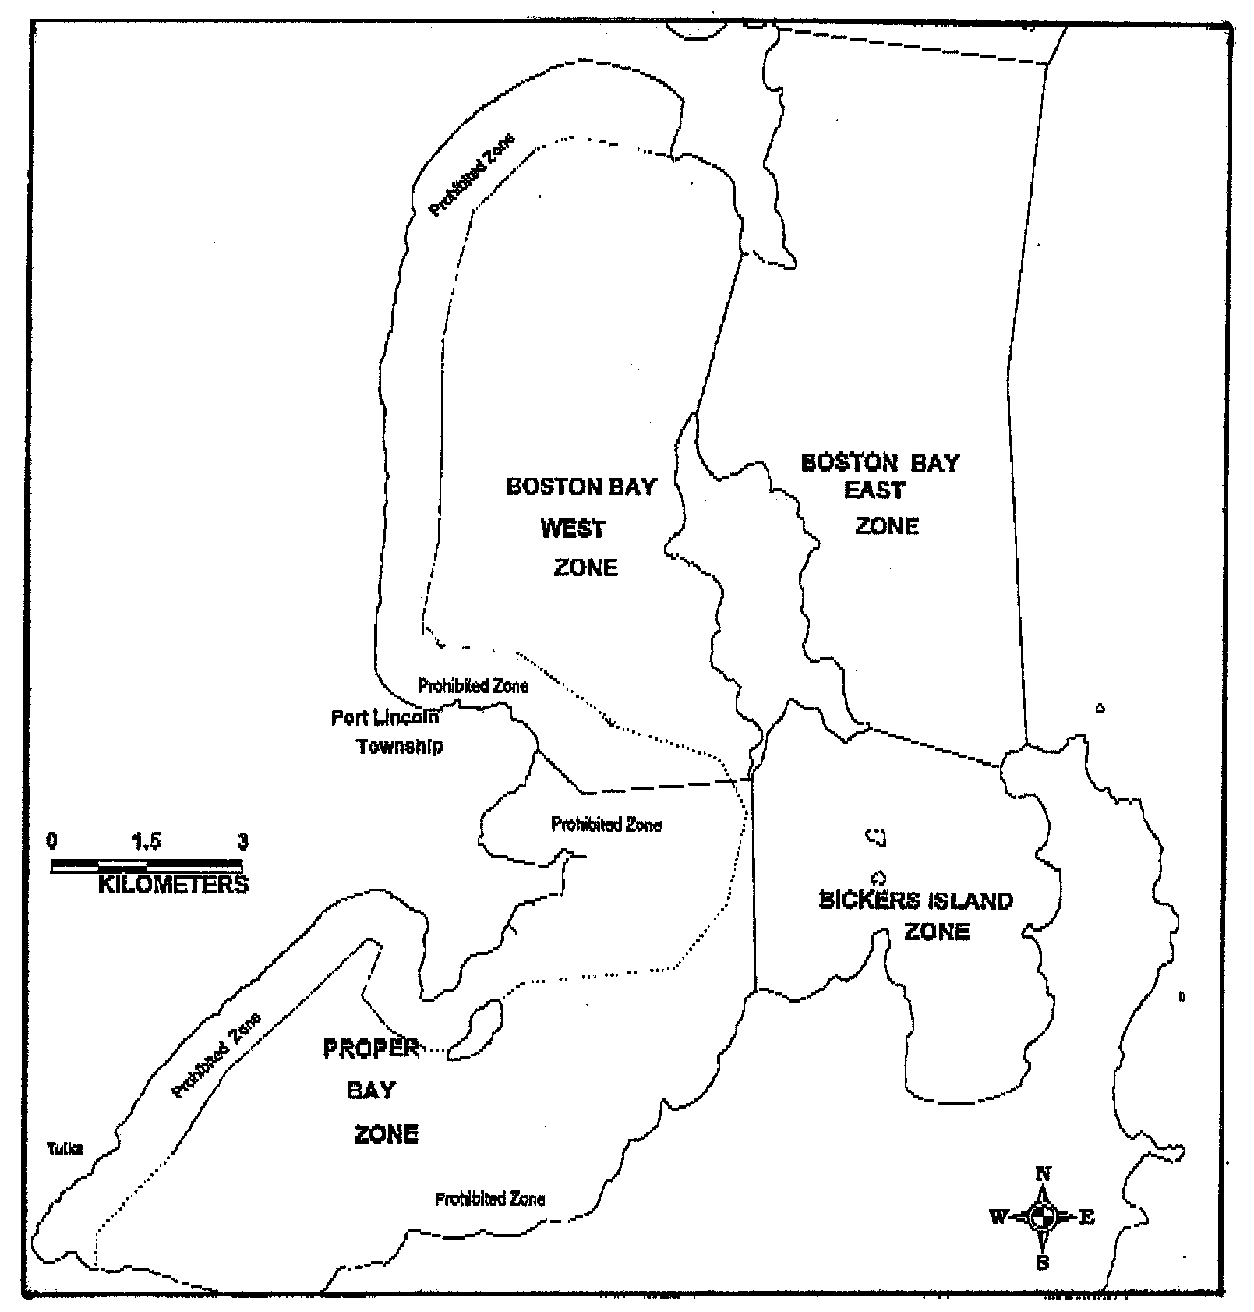
Dated 9 March 2000.
W. Zacharin, Principal Fisheries Manager

FISHERIES ACT 1982: SECTION 59
TAKE notice that pursuant to section 59 of the Fisheries Act 1982, Nicholas Pluker (hereinafter referred to as the ‘exemption holder’), 19 Tobruk Terrace, Port Lincoln, S.A. 5606 is exempt from section 41 of the Fisheries Act 1982, subject to the conditions specified in Schedule 1, in that the exemption holder shall not be guilty of an offence when taking native oysters (Ostrea angasi) for the purpose of trade or business (hereinafter referred to as the ‘permitted activity’).
Schedule 1
1. The exemption is valid until 30 September 2000.
2. The fish may only be taken by diving and collection by hand.
3. The exemption holder must notify the Fisheries Compliance Unit on 1800 065 522 at least two hours prior to conducting the permitted activity.
4. A maximum of one thousand (1 000) dozen native oysters may be taken pursuant to this exemption.
5. The first batch (100 kg) of oysters taken must be tested after a two week minimum delay period and before sale by SASQAP or other registered testing authority, and have less than 2.3 E. coli per gram.
6. Fish taken inside waters of Boston and Proper Bays must be taken from those waters outside the exclusion zone as detailed in the map in Schedule 2.
7. When conducting the permitted activity the exemption holder must be carrying the GPS readings of the exclusion zone in Boston and Proper Bays.
8. Fish taken outside waters of Boston and Proper Bays but within 5 km of a sewage outfall must immediately be taken to and remain at a registered aquaculture site for a period of 3 months and be batch tested prior to sale.
9. The exemption holder must provide the Director of Fisheries with details of catches, dive times, harvest locations and aquaculture sites used on a monthly basis. This report must be forwarded to the Director of Fisheries within 7 days of the completion of each calendar month.
10. Primary Industries and Resources, South Australia Fisheries and Aquaculture retains the right for a departmental officer to observe the permitted activity at any time.
11. Whilst engaged in the permitted activity the exemption holder must have in his possession a copy of this notice and produce a copy of the notice if required by a PIRSA Fisheries and Aquaculture Officer.
12. The exemption holder shall not contravene or fail to comply with the Fisheries Act 1982, or any regulations made under the Act, except where specifically exempted by this notice.
Schedule 2
NATIVE OYSTER COLLECTION
Dated 9 March 2000.
W. Zacharin, Principal Fisheries Manager

FISHERIES ACT 1982: SECTION 59
TAKE notice that pursuant to section 59 of the Fisheries Act 1982, Roger Cutting (hereinafter referred to as the ‘exemption holder’) is exempt from the individual catch quota system imposed by the Director of Fisheries under Regulation 14 (a) of the Scheme of Management (Rock Lobster Fisheries) Regulations 1991, subject to the conditions specified in Schedule 1, in that the permit holder shall not be guilty of an offence when taking southern rock lobster (Jasus edwardsii), outside of the quota fixed on the exemption holder’s southern zone rock lobster licence (S027) (hereinafter referred to as the ‘exempted activity’).
Schedule 1
1. This exemption is valid from the date of gazettal of this notice to 30 March 2000.
2. All southern rock lobster (Jasus edwardsii) are to be taken for Fishery Management Committee promotional purposes.
3. No more than a total of 150 kg of southern rock lobster (Jasus edwardsii) may be taken pursuant to this notice.
4. The exemption holder must notify a PIRSA Fisheries and Aquaculture Compliance Officer on 1800 065 522 at least two hours prior to landing southern rock lobster (Jasus edwardsii).
5. All southern rock lobster (Jasus edwardsii) taken pursuant to this notice are to be weighed off at the nearest weigh station, recorded in a catch and disposal record and marked ‘Promotion Fish’ and immediately delivered to the registered fish processor Joe’s Live Lobster at Port MacDonnell (hereinafter referred to as the ‘approved fish processor’). Immediately upon delivery of rock lobster to the approved fish processor, the exemption holder must record the accurate weight of rock lobster delivered and retain a record showing the date and weight of all southern rock lobster landed pursuant to this notice.
6. The exempted activity may only be conducted from the boat Hannah Ann G.
7. A maximum of 52 rock lobster pots may be used to conduct the exempted activity.
8. The exempted activity may only be conducted in those waters of the Southern Zone Rock Lobster fishery.
9. PIRSA Fisheries and Aquaculture retains the right for a departmental officer to observe the exempted activity at any time.
10. Whilst engaged in the exempted activity the exemption holder must have in his possession a copy of this notice and produce a copy of this notice if required by a PIRSA Fisheries and Aquaculture Compliance Officer.
11. The exemption holder shall not contravene or fail to comply with the Fisheries Act 1982, or any regulations made under the Act, except where specifically exempted by this notice.
Dated 9 March 2000.
W. Zacharin, Principal Fisheries Manager
FF 98/0527

M. G. O’CALLAGHAN, Government Printer, South Australia

