No. 45 1419

THE SOUTH AUSTRALIAN

GOVERNMENT GAZETTE

PUBLISHED BY AUTHORITY

ALL PUBLIC ACTS appearing in this GAZETTE are to be considered official, and obeyed as such

ADELAIDE, THURSDAY, 16 MARCH 2000

CONTENTS

Page
Appointment, Resignation, Etc. 1420
Associations Incorporation Act 1985—Notice 1420
Corporations and District Councils—Notices 1476
Crown Lands Act 1929—Notice 1420
Development Act 1993—Notices 1433
Environment Protection Authority—Notice 1433
Geographical Names Act 1991—Notices 1433
Government of South Australia—Mid-year Budget Review 1421
Land and Business (Sale and Conveyancing) Act 1994—
Notices 1434
Liquor Licensing Act 1997—Notices 1434
National Electricity (South Australia) Act 1996—Notice 1438
Private Advertisements 1477
Proclamations 1420

Page
Public Trustee Office—Administration of Estates 1476
Public Sector Management Act 1995—Notice 1441
Radiation Protection and Control Act 1982—Notice 1446
Real Property Act 1886—Notice 1448

REGULATION
Workers Rehabilitation and Compensation Act 1986—
(No. 20 of 2000) 1474
Roads (Opening and Closing) Act 1991—Notices 1446
Road Traffic Act 1961—Notices 1447
Road Traffic (Road Rules—Ancillary and Miscellaneous
Provisions) Regulations 1999—Exemption 1446
Veterinary Surgeons Board of South Australia—Registers 1449
Water Mains and Sewers—Mains Laid, Replaced, Etc. 1472

GOVERNMENT GAZETTE NOTICES
ALL poundkeepers' and private advertisements forwarded for publication in the South Australian Government Gazette must be PAID FOR PRIOR TO INSERTION; and all notices, from whatever source, should be legibly written on one side of the paper only and sent to Riverside 2000 so as to be received no later than 4 p.m. Tuesday preceding the day of publication. Phone 8207 1045 or Fax 8207 1040. E-mail: Riv2000@saugov.sa.gov.au. Send as attachments in Word format and please confirm your transmission with a faxed copy of your document, including the date the notice is to be published and to whom the notice will be charged.

MOTOR VEHICLES (MISCELLANEOUS) AMENDMENT ACT 1999 (Act No. 52 of 1999): DAY OF COMMENCEMENT
Proclamation By The Governor
(l.s.) E. J. Neal
WITH the advice and consent of the Executive Council, I fix 23 March 2000 as the day on which sections 44(d), 44(g) and 50(f) of the Motor Vehicles (Miscellaneous) Amendment Act 1999 will come into operation.
Given under my hand and the Public Seal of South Australia at Adelaide, 16 March 2000.
By command,
Mark Brindal, for Premier
TSA 10640/97 CS

SHOP TRADING HOURS ACT 1977 SECTION 13: ALTERATION OF SHOP TRADING HOURS—BERRI SHOPPING DISTRICT
Proclamation By The Governor
(l.s.) E. J. Neal
PURSUANT to section 13 of the Shop Trading Hours Act 1977 and with the advice and consent of the Executive Council, I authorise the opening of all shops in the Berri Shopping District from 5 p.m. until 9 p.m. on Saturday, 18 March 2000, subject to the conditions specified in the schedule.
Schedule
This proclamation only authorises the opening of a shop if—
(a) all relevant industrial awards, workplace agreements and enterprise agreements are observed by the shopkeeper and persons employed in the business of the shop during and in relation to the hours specified in this proclamation during which the shop is open; and
(b) subject to an industrial award, workplace agreement or enterprise agreement to the contrary—a person who is employed in the business of the shop is entitled to refuse to work at the shop during the hours specified in this proclamation unless he or she has agreed with the shopkeeper to work during those hours.
Given under my hand and the Public Seal of South Australia at Adelaide 16 March 2000.
By command,
Mark Brindal, for Premier
MWPR 18/2000 CS

Department of the Premier and Cabinet
Adelaide, 16 March 2000
HIS Excellency the Governor in Executive Council has been pleased to appoint the undermentioned to the Physiotherapists Board of South Australia, pursuant to the provisions of the Physiotherapists Act 1991:
Member: (from 20 March 2000 until 19 March 2003)
David Ash Black
Dr Michael George Hayes
Professor Ruth Grant
Elizabeth Anne Ganley
By command,
Mark Brindal, for Premier
MHS 004/00CS

ASSOCIATIONS INCORPORATION ACT 1985
Deregistration of Associations
NOTICE is hereby given that the Corporate Affairs Commission approves the applications for deregistration received from the associations named below pursuant to section 43A of the Associations Incorporation Act 1985. Deregistration takes effect on the date of publication of this notice.
Independent Jewellers Association Inc.
Professional Florists Association of South Australia & Northern Territory Inc.
Size Acceptance Network Inc.
South Central Acc Inc.
Given at Adelaide 14 March 2000.
A. J. Griffiths, a delegate of the Corporate Affairs Commission

CROWN LANDS ACT 1929: SECTION 5
TAKE NOTICE that pursuant to the Crown Lands Act 1929, I, IAIN EVANS, Minister for Environment and Heritage, Minister of the Crown to whom the administration of the Crown Lands Act 1929 is committed DO HEREBY dedicate the Crown Land defined in The Schedule as a Public Road.
The Schedule
Allotment 3 of DP 53950, Hundred of Goolwa, County of Hindmarsh, being within the Alexandrina district.
Dated 13 March 2000.
Iain Evans, Minister for Environment and Heritage
DEHAA 12/0502

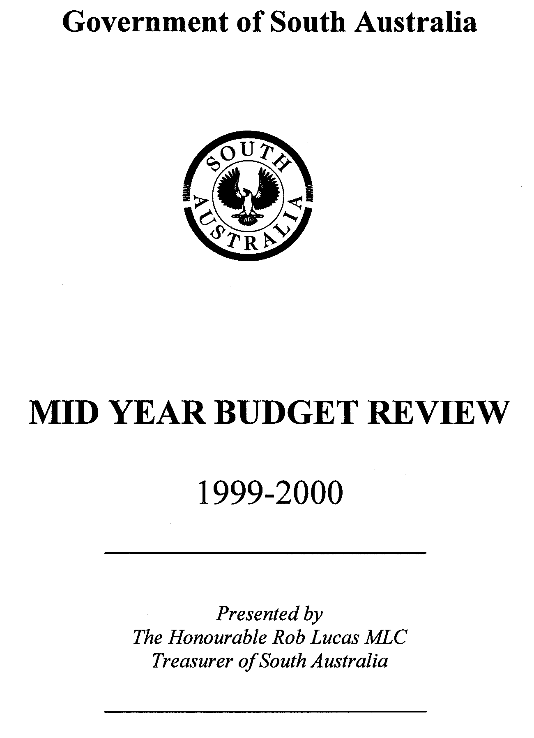


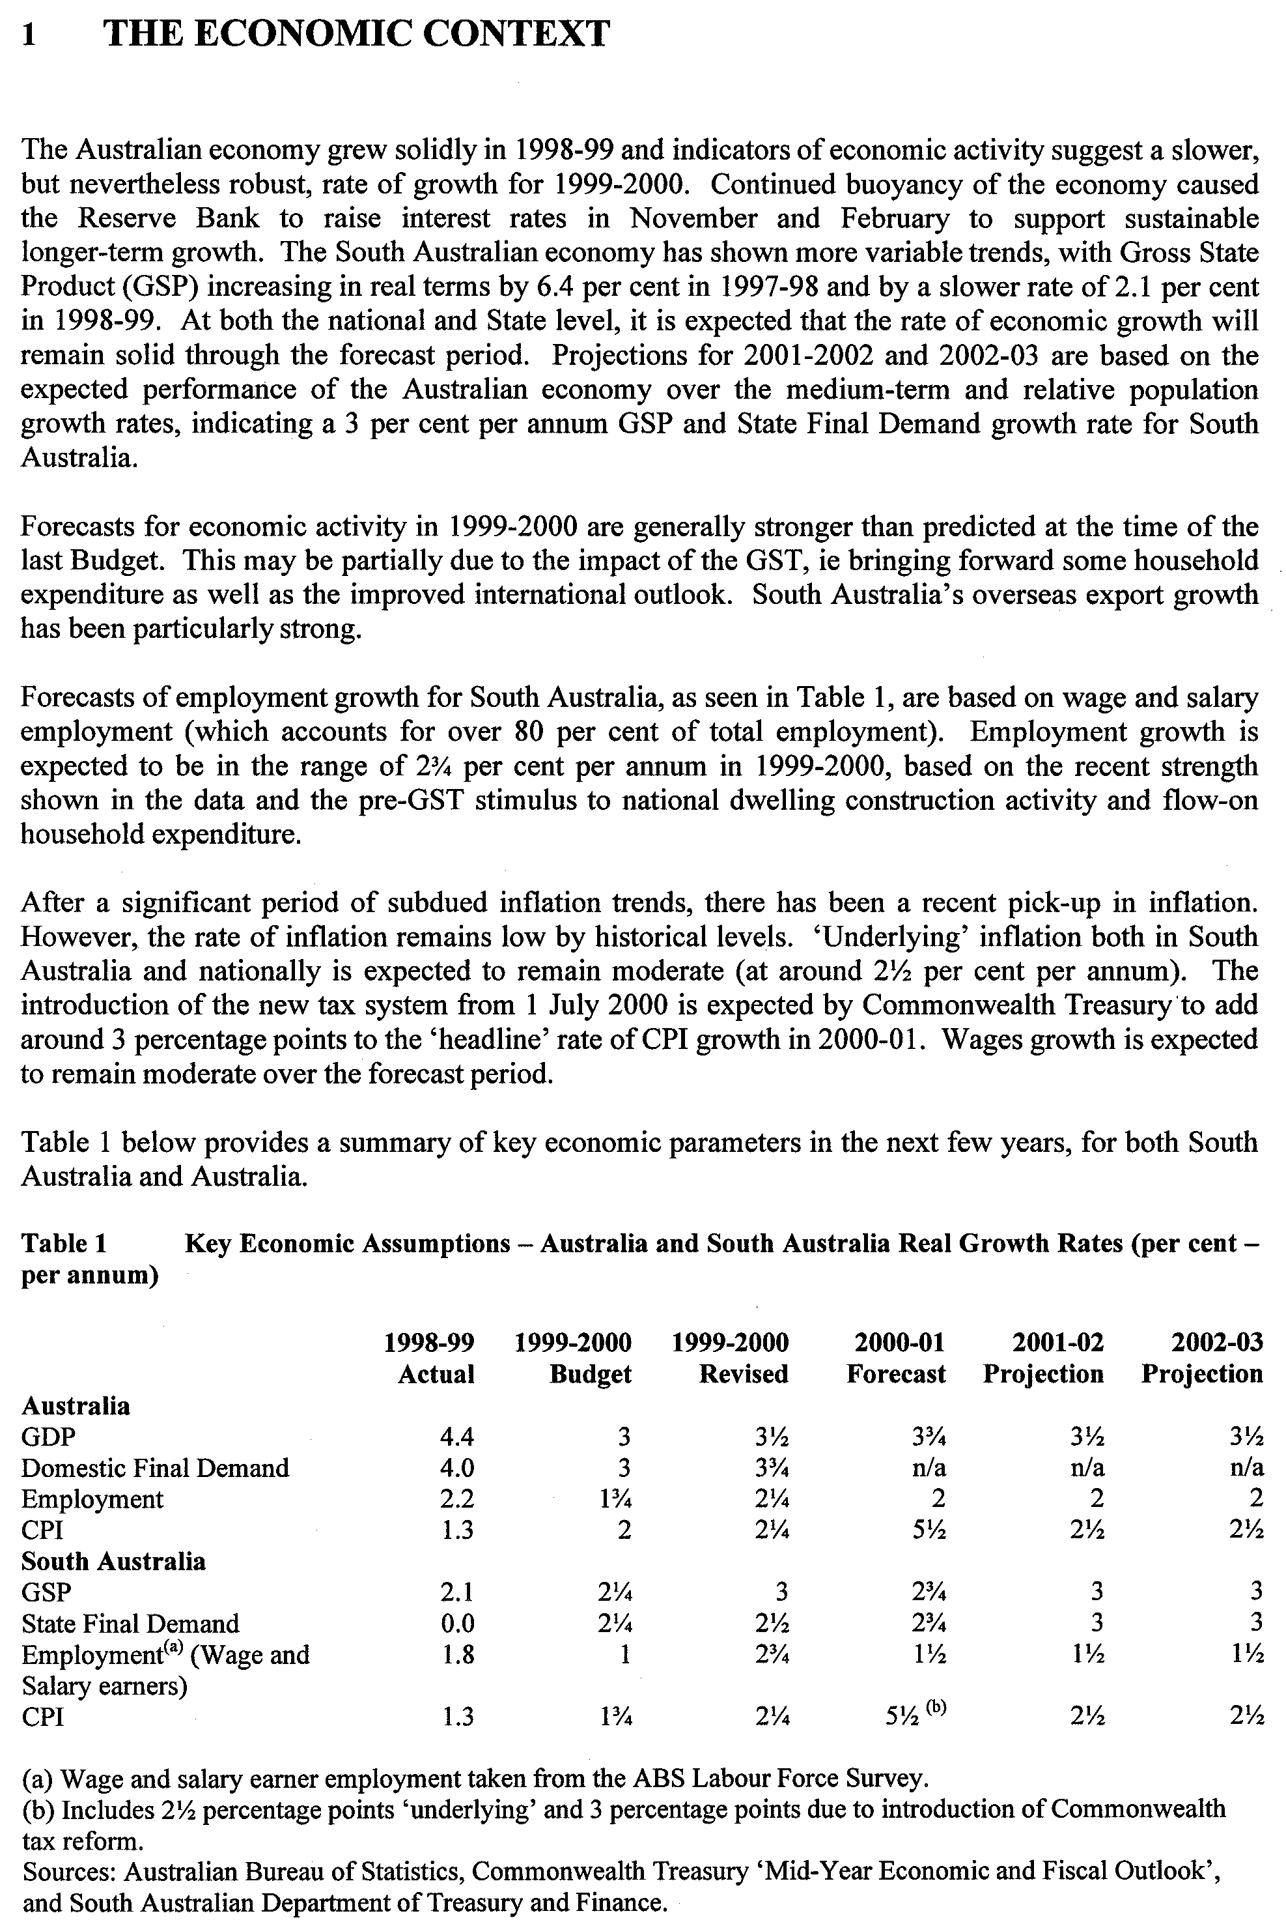
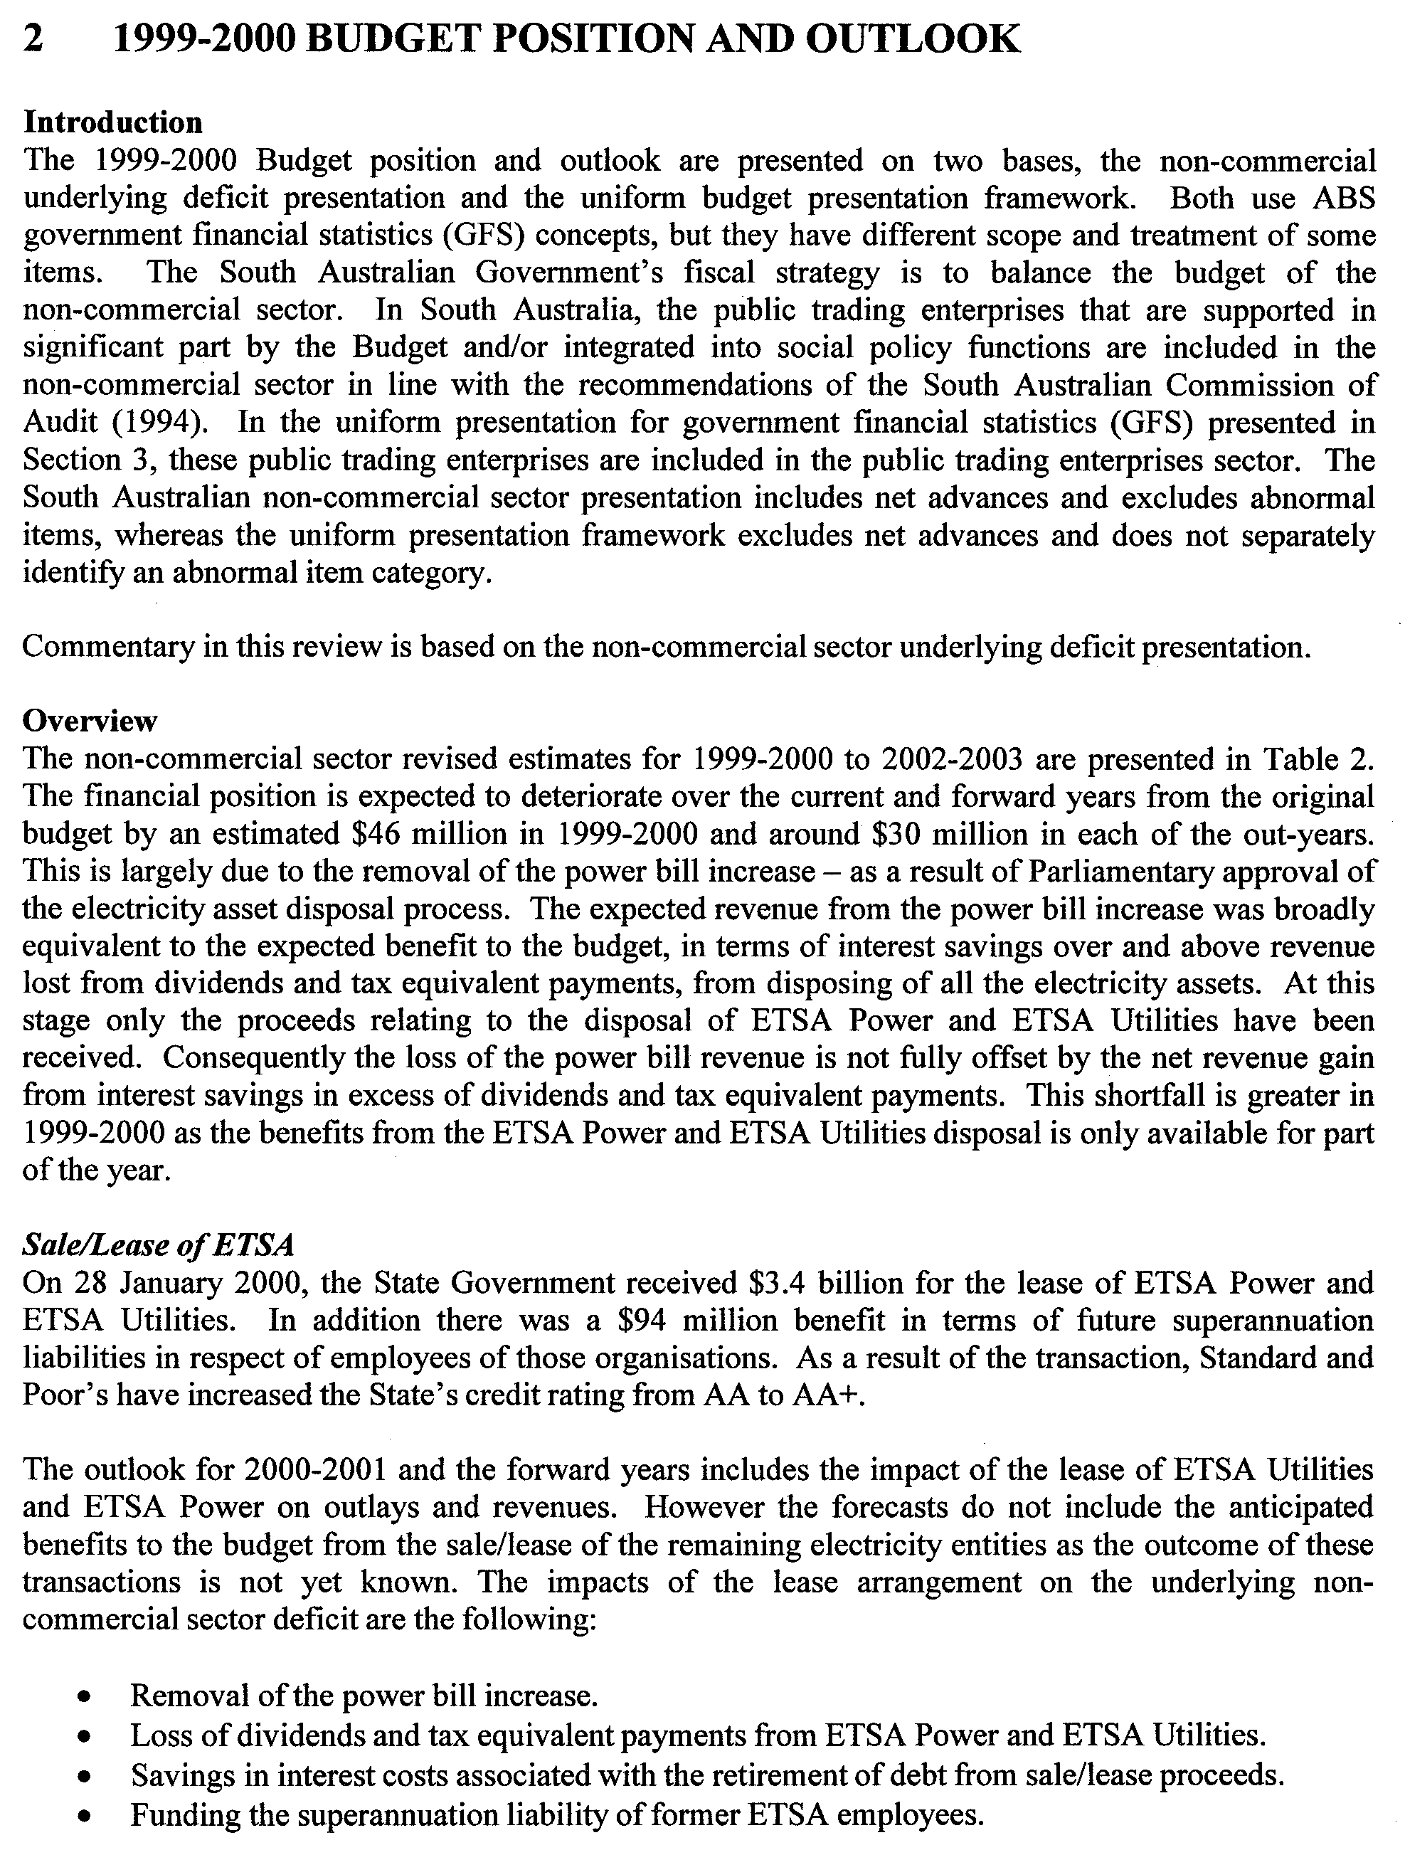
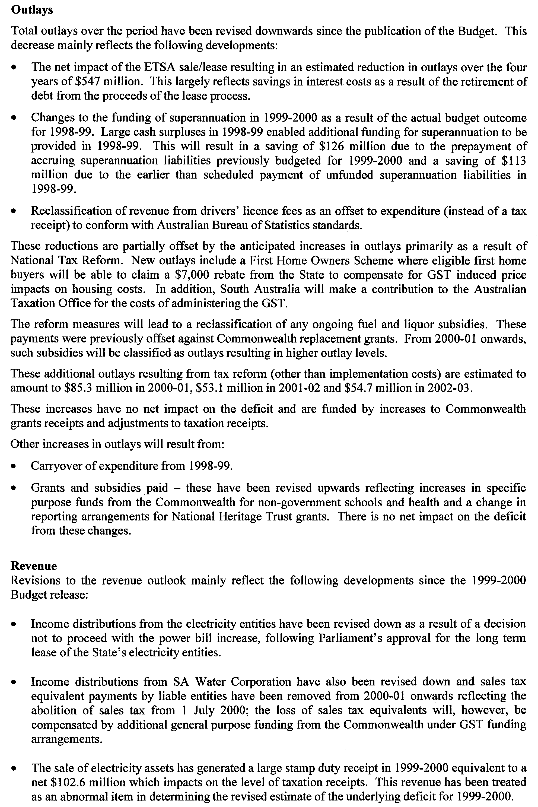
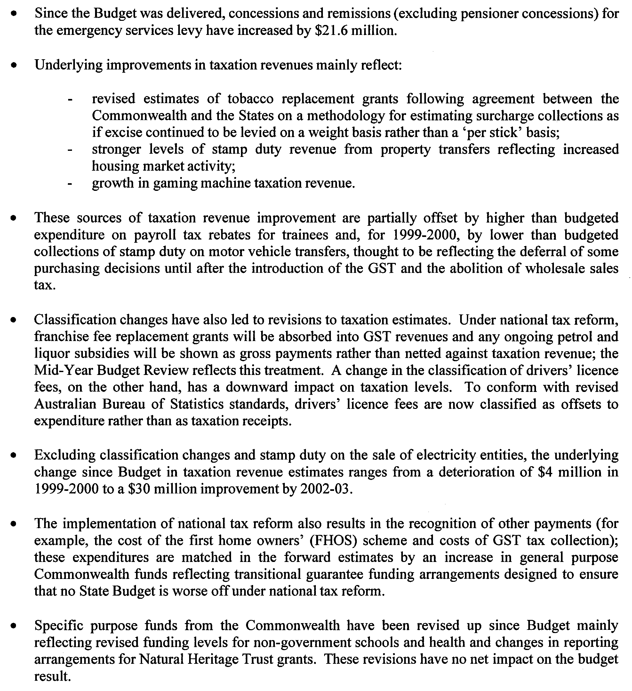
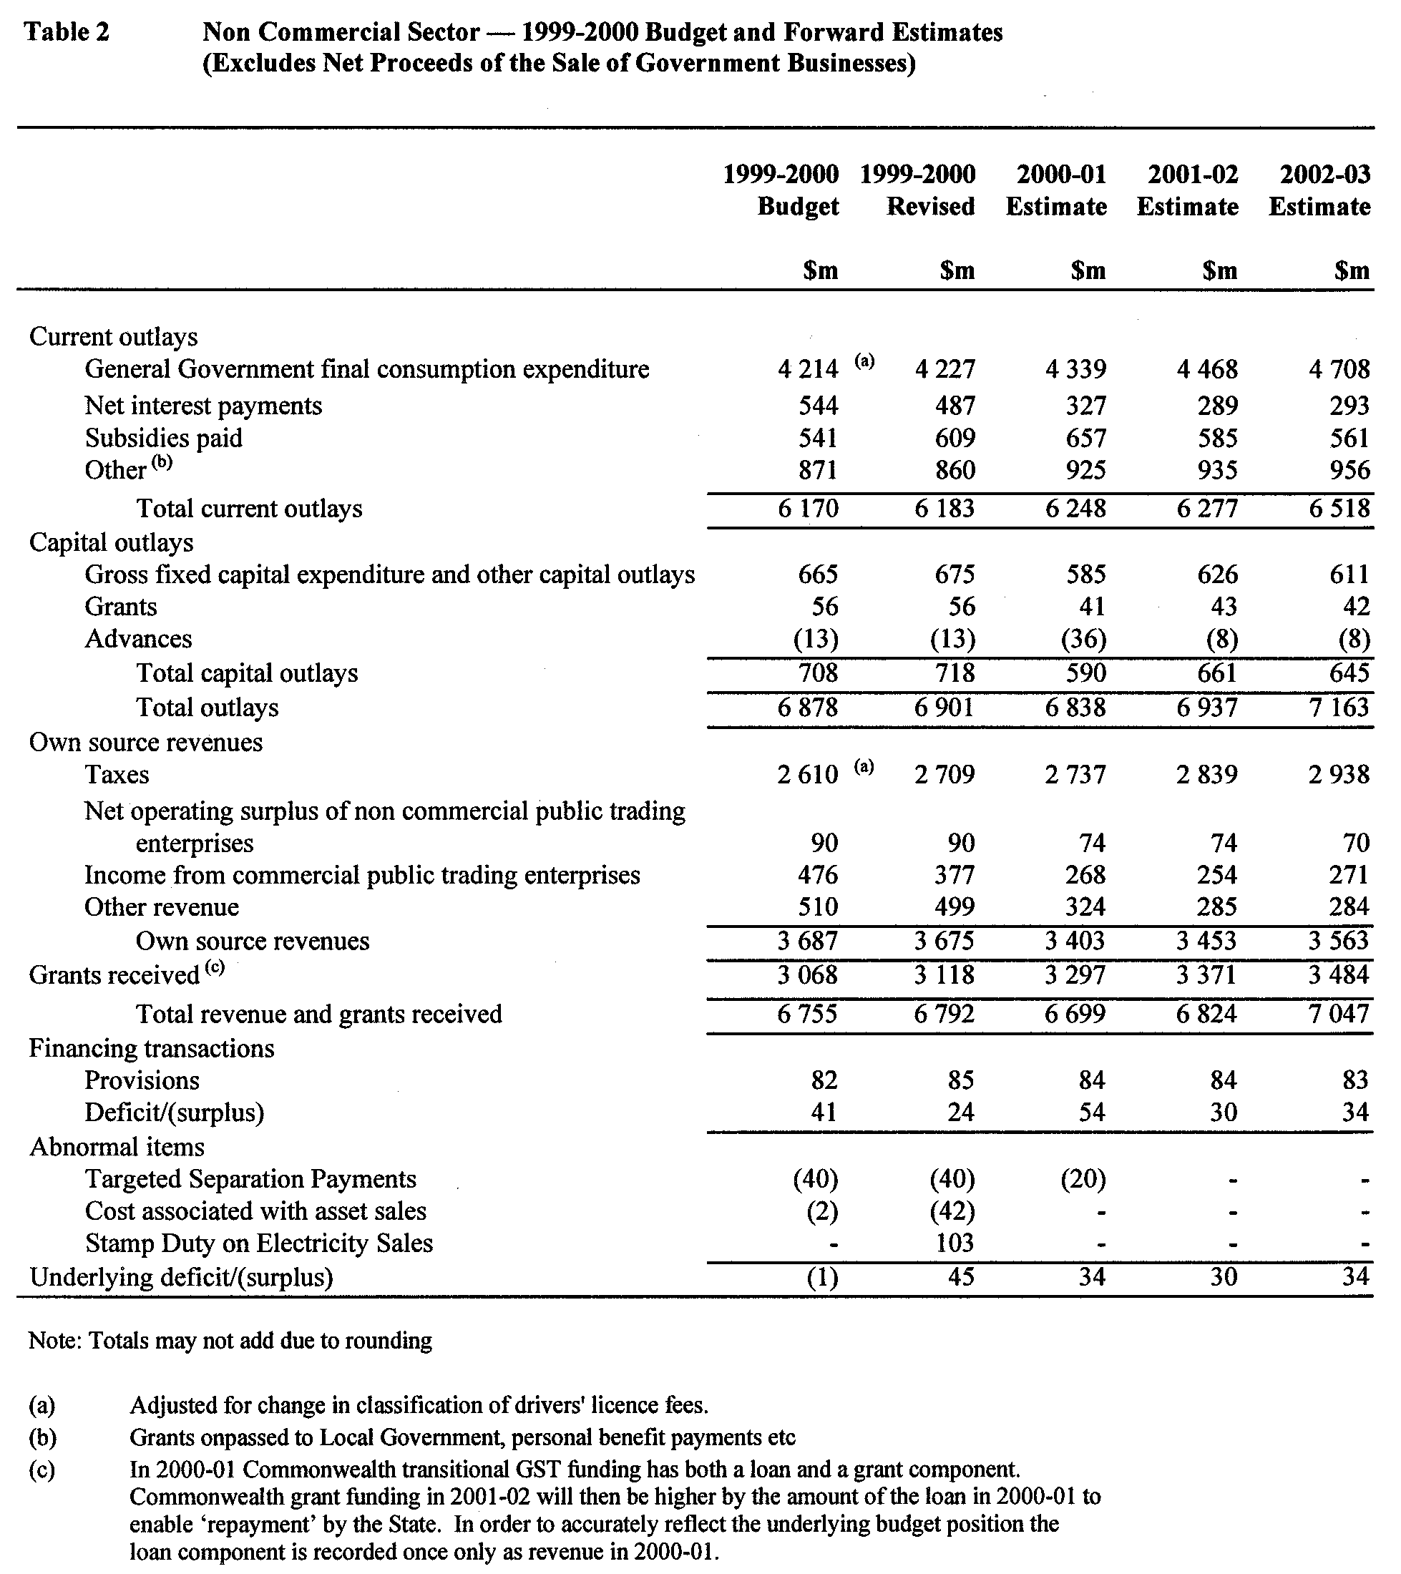
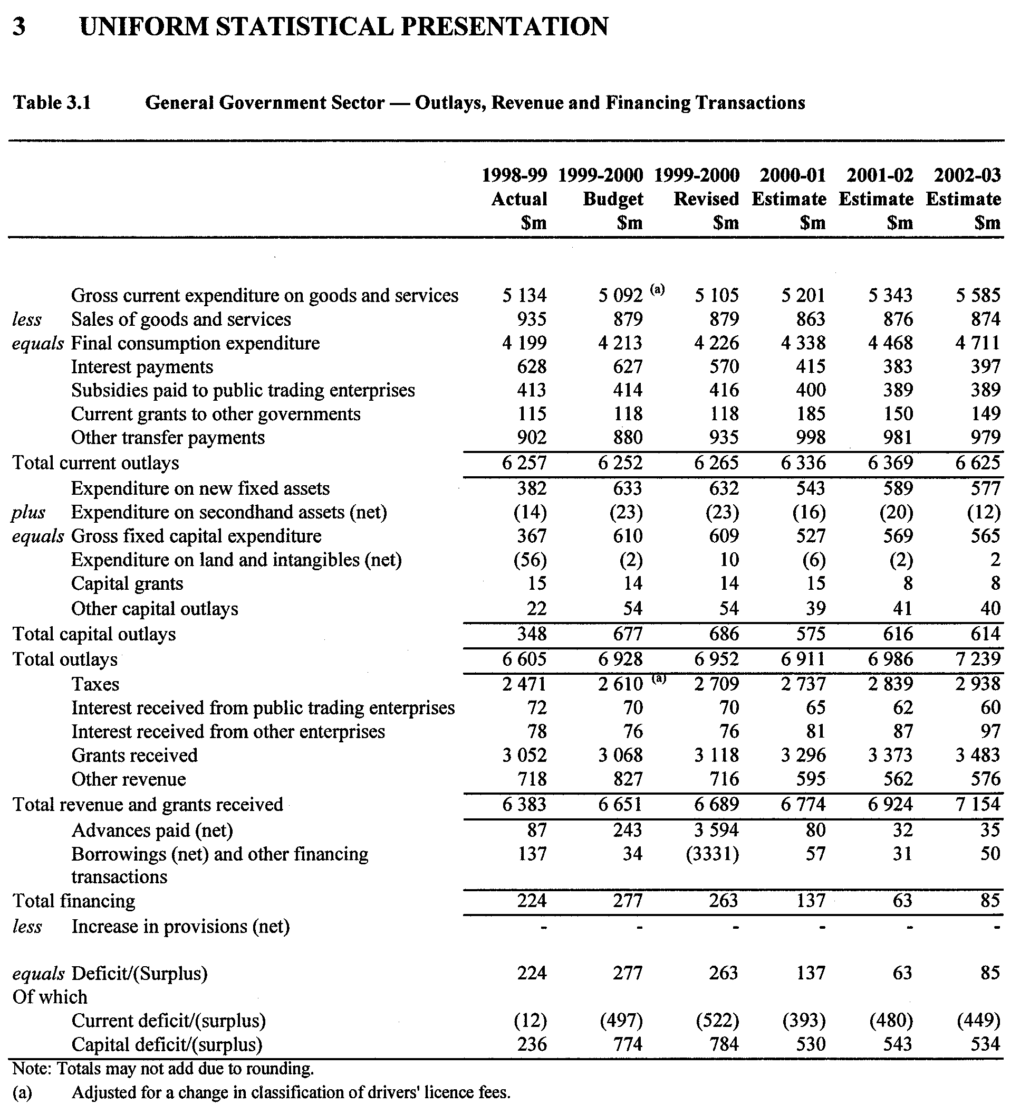
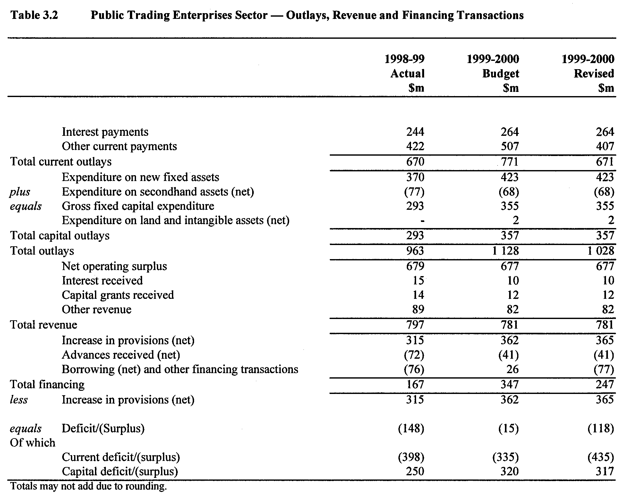
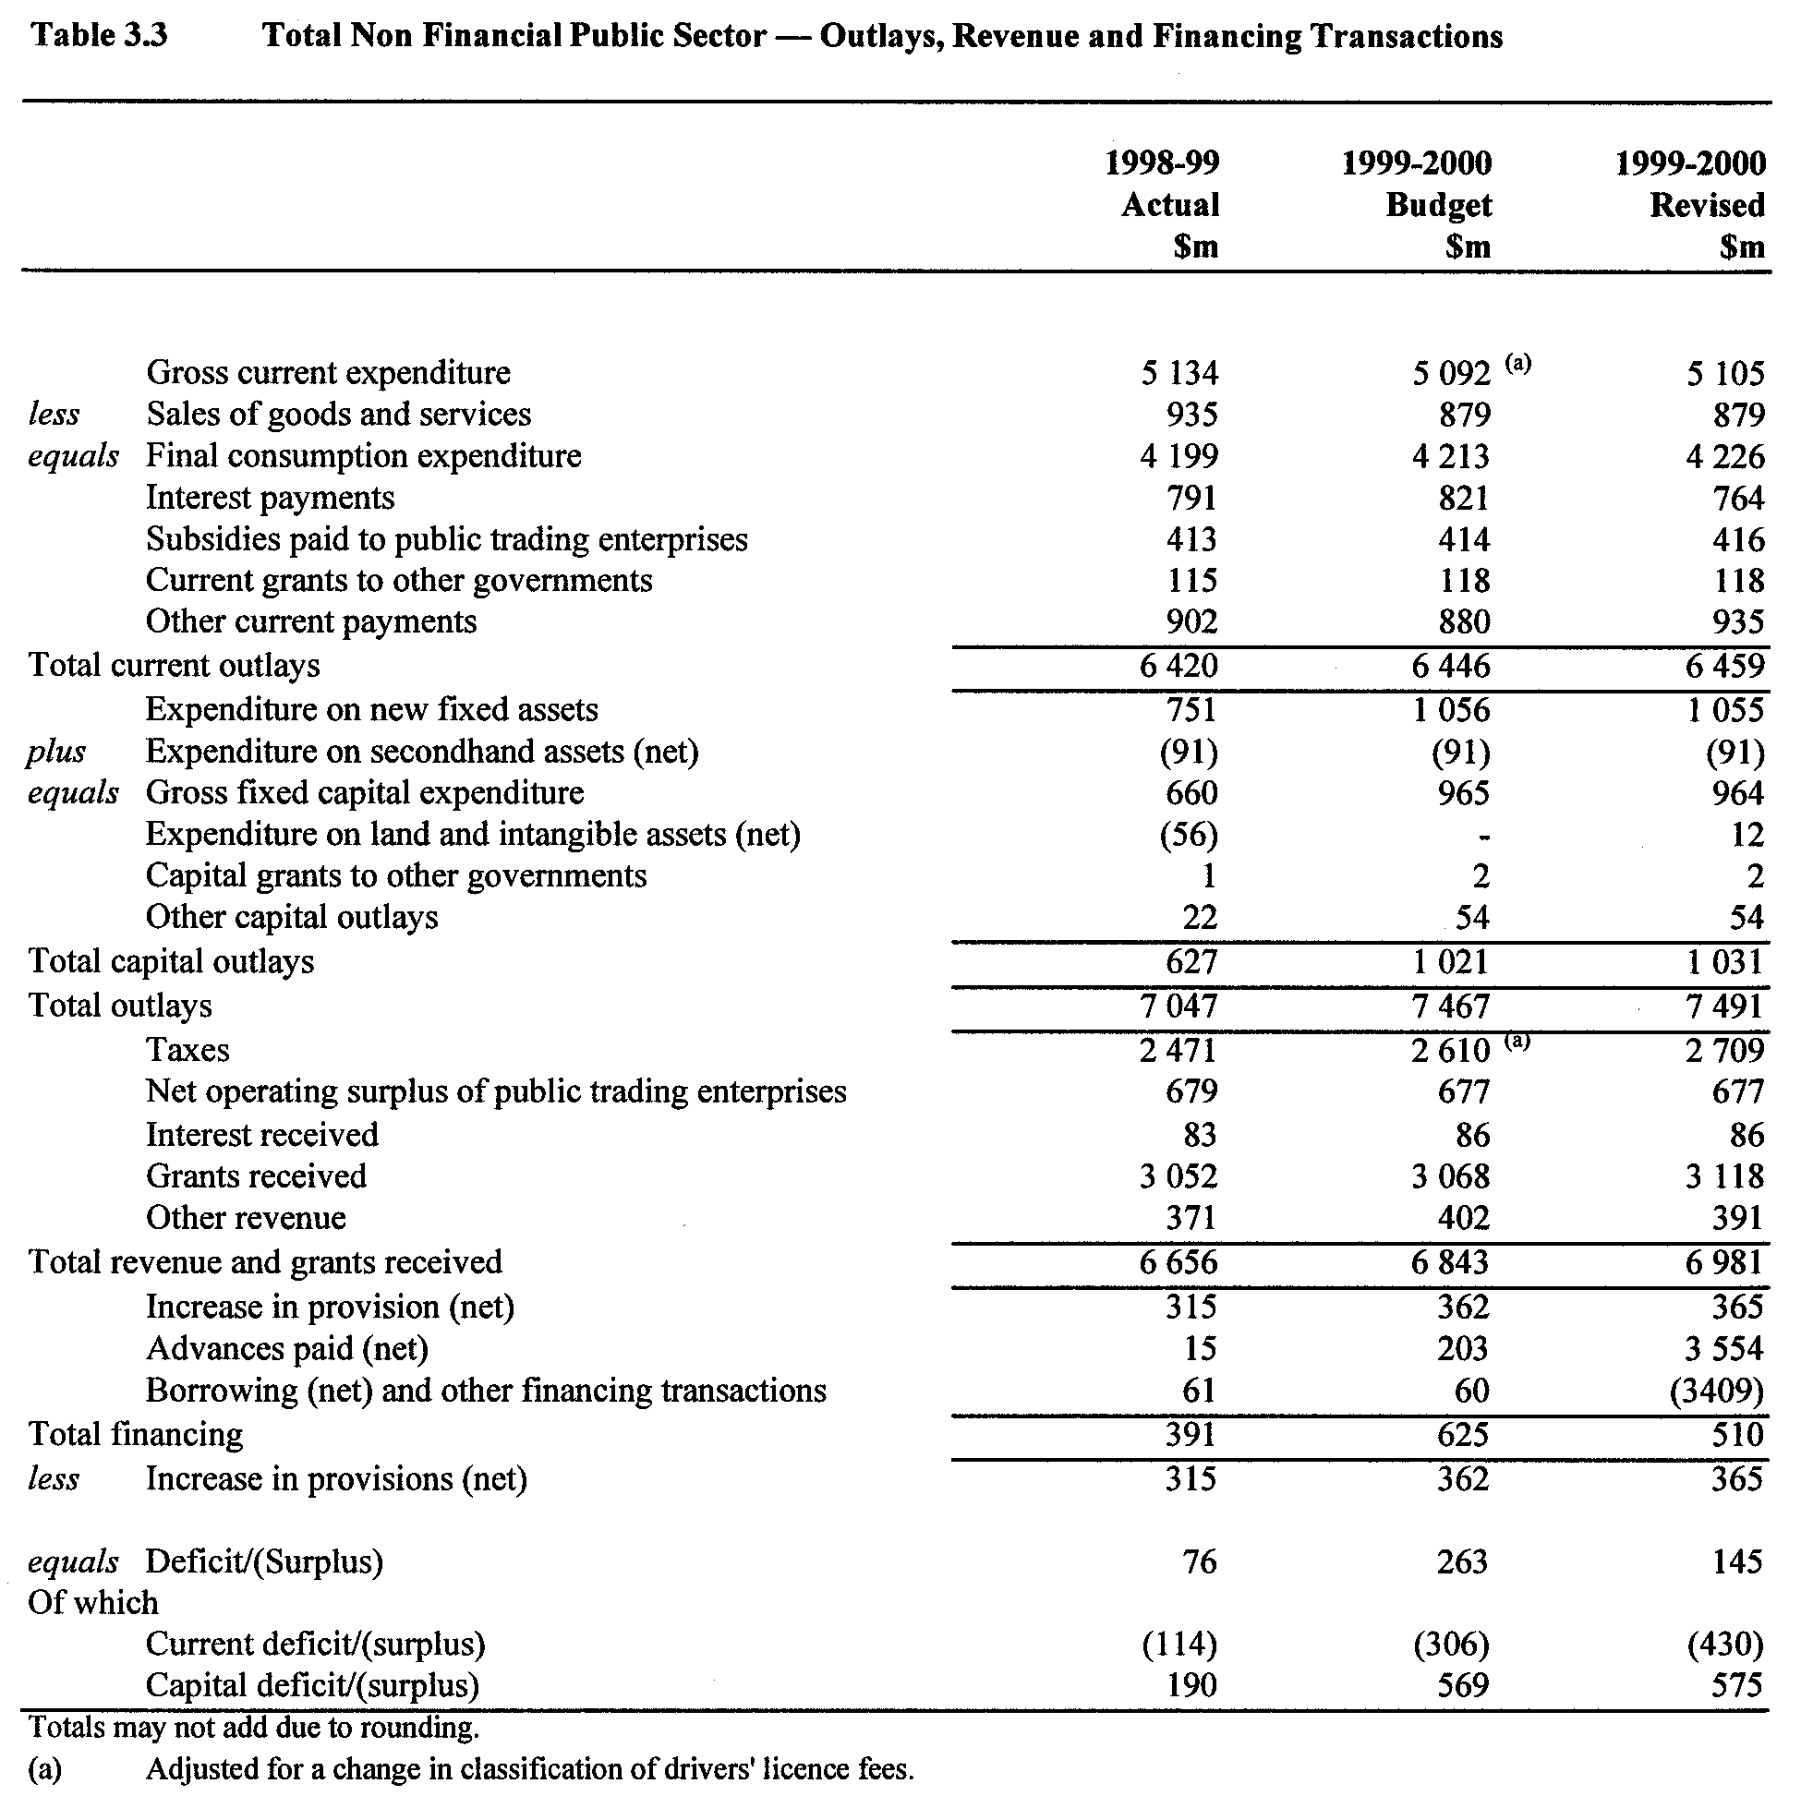
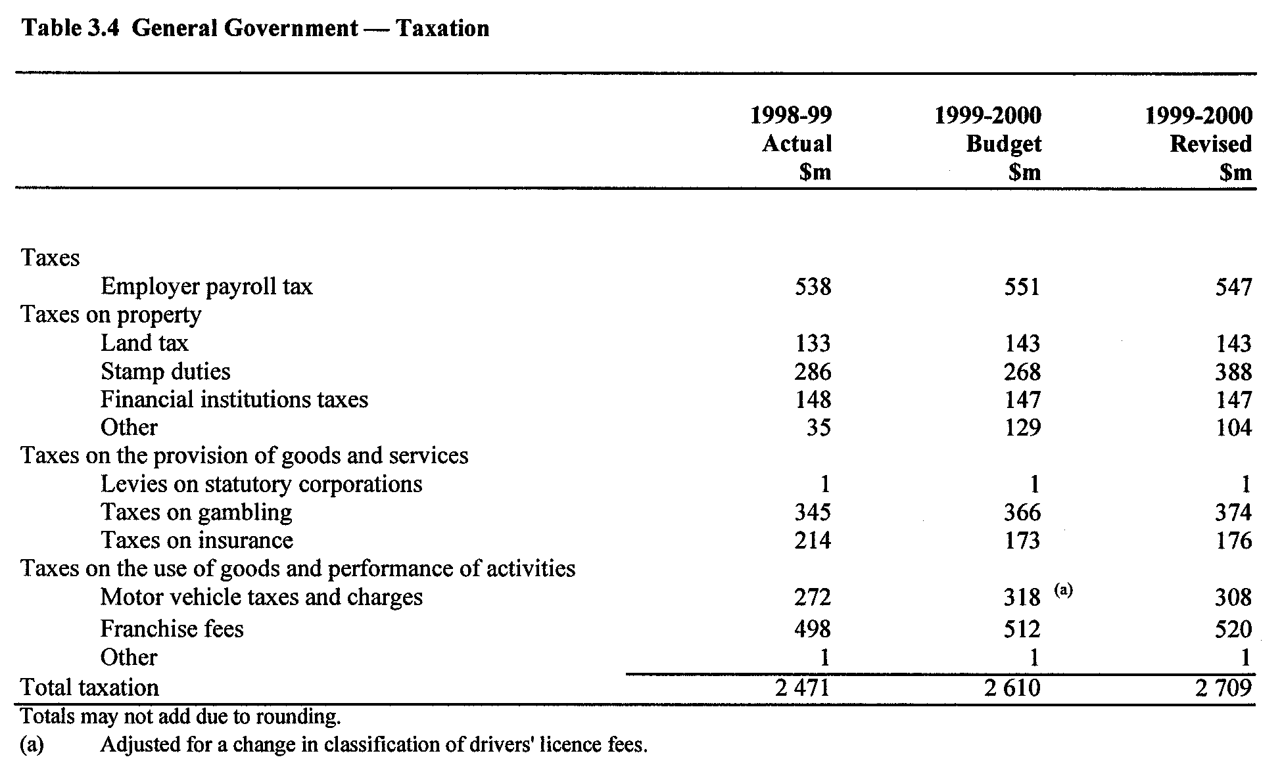

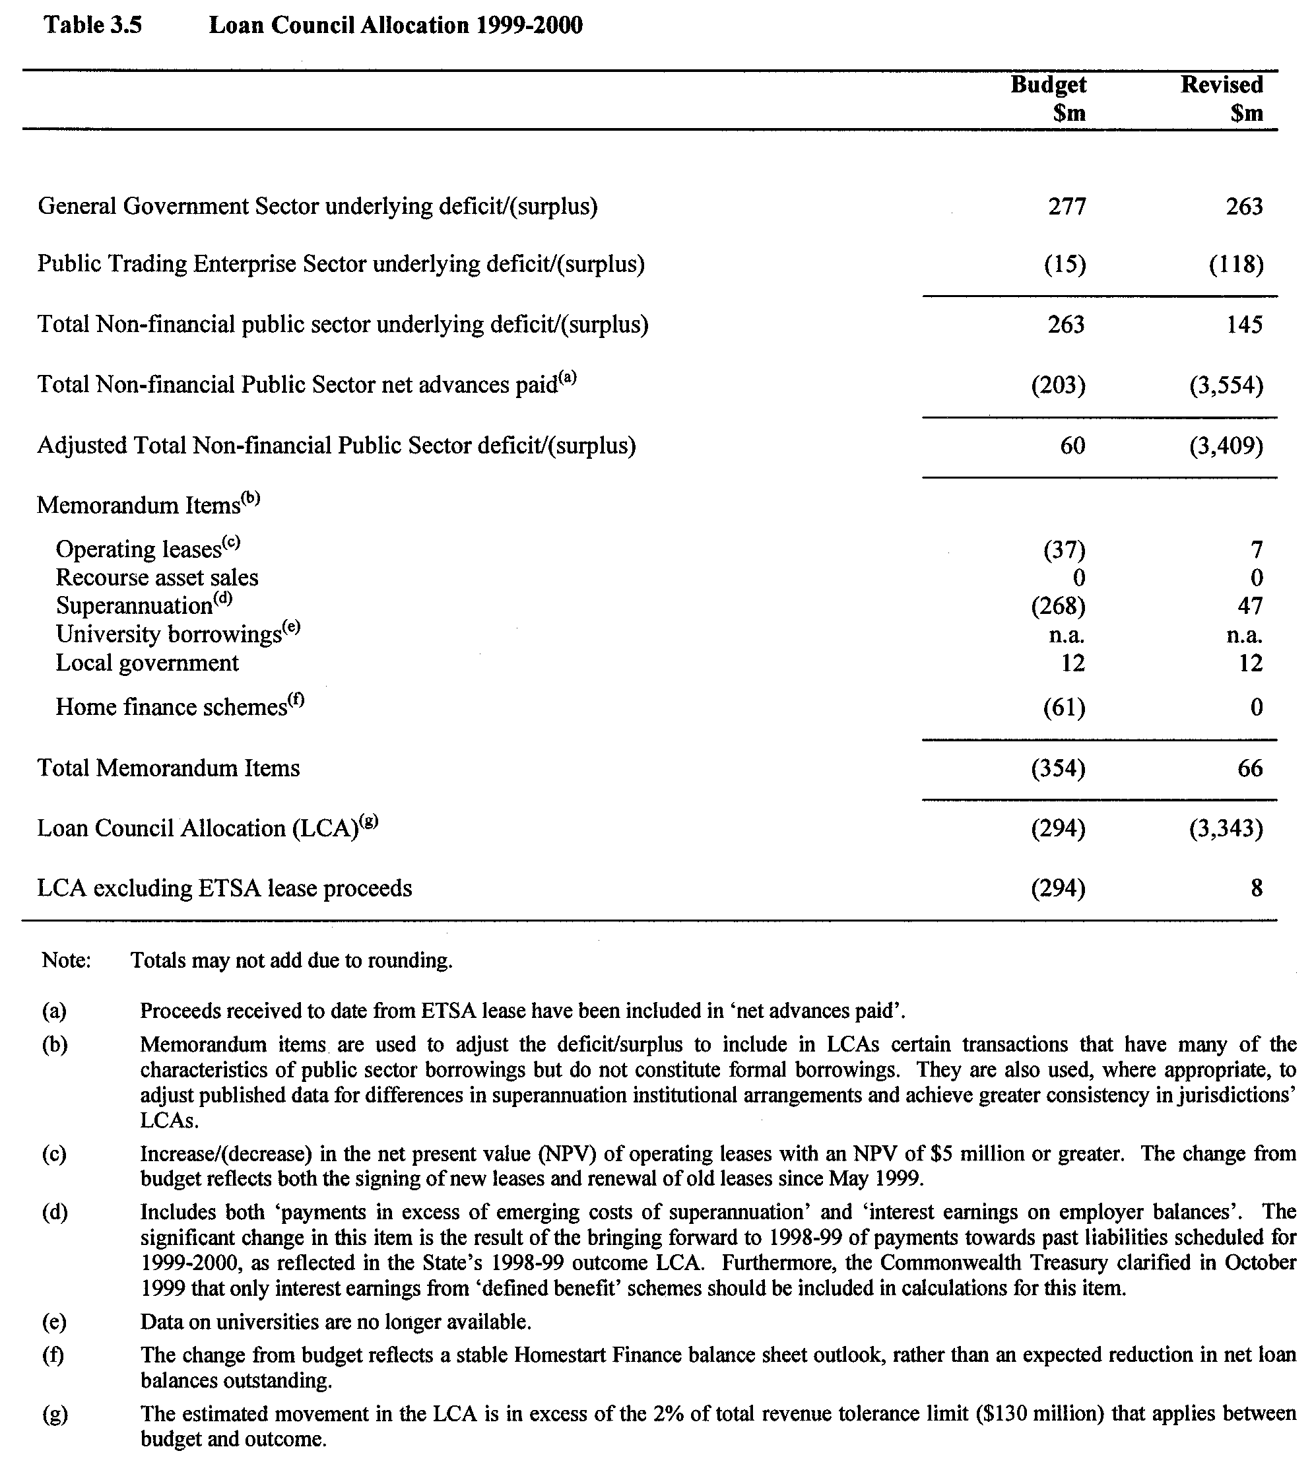

DEVELOPMENT ACT 1993, SECTION 28 (5): DECLARA-TION OF CESSATION OF INTERIM OPERATION OF THE CITY OF TEA TREE GULLY—RURAL LIVING ZONE AND INCLUSION OF LAND INTO THE HILLS FACE ZONE PLAN AMENDMENT REPORT
Preamble
On 11 March 1999 the Governor, under section 28 (1), declared the City of Tea Tree Gully—Rural Living Zone and inclusion of land into the Hills Face Zone Plan Amendment Report as an amendment to come into interim operation without delay on that day. The Tea Tree Gully (City) Development Plan, consolidated on 11 March 1999, incorporated the provisions of the ‘Rural Living Zone and inclusion of land into the Hills Face Zone Plan Amendment Report’.
The City of Tea Tree Gully—Rural Living Zone and inclusion of land into the Hills Face Zone Plan Amendment Report has not been authorised by the Governor under section 27 (1) within the required 12 months period.
Notice
Pursuant to section 28 (4) (c) of the Development Act 1993, the City of Tea Tree Gully—Rural Living Zone and inclusion of land into the Hills Face Zone Plan Amendment Report ceases to operate under the Interim Operation Order proclaimed by the Governor on 11 March 1999.
Dated 16 March 2000.
Diana Laidlaw, Minister for Transport and Urban Planning

DEVELOPMENT ACT 1993, SECTION 27 (1): CITY OF PORT ADELAIDE ENFIELD—OPEN SPACE STRATEGY PLAN AMENDMENT
Preamble
The Minister for Transport and Urban Planning has approved the amendment entitled ‘City of Port Adelaide Enfield—Open space Strategy Plan Amendment’ (the Plan Amendment) and has referred it to the Governor.
Notice
PURSUANT to section 27 (1) of the Development Act 1993, I, the Governor with the advice and consent of the Executive Council, declare the Plan Amendment to be an authorised Plan Amendment and fix 16 March 2000 as the day on which it will come into operation.
Dated 16 March 2000.
E. J. Neal, Governor
MTUP 61/99CS

ENVIRONMENT PROTECTION AUTHORITY
Public Consultation
IN accordance with the requirements of the Wingfield Waste Depot Closure Act 1999, the City of Adelaide has prepared a Landfill Environment Management Plan for the Wingfield Waste Management Centre.
The Environment Protection Authority invites interested persons to make written submissions, in relation to the plan, to the Authority by the close of business on 26 April 2000.
The Environment Management Plan can be inspected or purchased at the City of Adelaide Customer Centre, 25 Pirie Street, Adelaide.
A public meeting will be held at 2 p.m. on 27 March 2000 at Australia Asia Water Centre, 4th Floor, 77 Grenfell Street, Adelaide.
G. Hocking, Senior Licensing Officer

GEOGRAPHICAL NAMES ACT 1991
Notice to Assign Names and Boundaries to Places
NOTICE is hereby given pursuant to the provisions of the above Act that I, Robert David Lawson, Minister for Administrative and Information Services, Minister of the Crown to whom the administration of the Geographical Names Act 1991 is committed DO HEREBY assign the names HAMILTON, ALLENDALE NORTH, HANSBOROUGH, BAGOT WELL, KAPUNDA, KOONUNGA, ST. KITTS, TRURO, STOCKWELL, BETHEL, FORDS, ST. JOHNS, MOPPA, GREENOCK, NURIOOTPA and EBENEZER to those areas within the District Council of Kapunda and Light and shown numbered 1 to 16 respectively on Rack Plan 855.
Dated 10 March 2000.
Robert Lawson, Minister for Administrative and Information Services
DEHAA 04/0186

GEOGRAPHICAL NAMES ACT 1991
Notice to Assign Names and Boundaries to Places
NOTICE is hereby given pursuant to the provisions of the above Act that I, Robert David Lawson, Minister for Administrative and Information Services, Minister of the Crown to whom the administration of the Geographical Names Act 1991 is committed DO HEARBY assign the names ROCKLEIGH, TEPKO, CALOOTE, WALL, WOOLANE, ETTRICK, PALLAMANA, MYPOLONGA, SUNNYSIDE, BURDETT, MONARTO, CALLINGTON, MURRAY BRIDGE NORTH, TOORA, MURRAWONG, CHAPMAN BORE, ROCKY GULLY, NORTHERN HEIGHTS, MOBILONG, AVOCA DELL, RIVERGLADES, MURRAY BRIDGE EAST, MONARTO SOUTH, WHITE HILL, MURRAY BRIDGE, LONG FLAT, GIFFORD HILL, MURRAY BRIDGE SOUTH, SWANPORT, RIVERGLEN, MONTEITH, KEPA, NATURI, BRINKLEY, WHITE SANDS, WOODS POINT, JERVOIS, MULGUNDAWA, NALPA, TODEROL, WILLOW BANKS, and GREENBANKS to those areas within the Rural City of Murray Bridge and shown numbered 1 to 43 respectively on Rack Plan 833.
Dated 10 March 2000.
Robert Lawson, Minister for Administrative and Information Services
DEHAA 04/0185

GEOGRAPHICAL NAMES ACT 1991
Notice to Assign Names and Boundaries to Places
NOTICE is hereby given pursuant to the provisions of the above Act that I, Robert David Lawson, Minister for Administrative and Information Services, Minister of the Crown to whom the administration of the Geographical Names Act 1991 is committed DO HEARBY assign the names MURTHO, PARINGA, MUNDIC CREEK, WONUARRA, PIKE RIVER, YAMBA, LYRUP, GURRA GURRA, CHAFFEY, RENMARK NORTH, RENMARK WEST, RENMARK, CRESCENT, OLD CALPERUM, COOLTONG and RENMARK SOUTH to those areas within the District Council of Renmark Paringa and shown numbered 1 to 16 respectively on Rack Plan 840.
Dated 10 March 2000.
Robert Lawson, Minister for Administrative and Information Services
DEHAA 04/0094

GEOGRAPHICAL NAMES ACT 1991
Notice to Assign Names and Boundaries to Places
NOTICE is hereby given pursuant to the provisions of the above Act that I, Robert David Lawson, Minister for Administrative and Information Services, Minister of the Crown to whom the administration of the Geographical Names Act 1991 is committed DO HEREBY assign the names MAKIN, McCALLUM, SHAUGH, MOUNT CHARLES, LAFFER, KEITH, SHERWOOD, BRIMBAGO, WIRREGA, LOWAN VALE, CANNAWIGARA, SENIOR, PETHERICK, WILLALOOKA, CAREW, KONGAL, BUCKINGHAM, MUNDULLA, BORDERTOWN, PINE HILL, WOLSELEY, SWEDE FLAT, BORDERTOWN SOUTH, POOGINAGORIC, CUSTON, PADTHAWAY, WESTERN FLAT, BANGHAM, NGARKAT and MUNDULLA WEST to those areas within the District Council of Tatiara and shown numbered 1 to 30 respectively on Rack Plan 848.
Dated 10 March 2000.
Robert Lawson, Minister for Administrative and Information Services.
DEHAA 04/0203

GEOGRAPHICAL NAMES ACT 1991
Notice to Assign a Name to a Place
NOTICE is hereby given pursuant to the provisions of the above Act that I, Robert David Lawson, Minister for Administrative and Information Services, Minister of the Crown to whom the administration of the Geographical Names Act 1991 is committed DO HEREBY alter the name of the suburb of Landcross Farm, as shown on the plan below, to McLaren Vale.
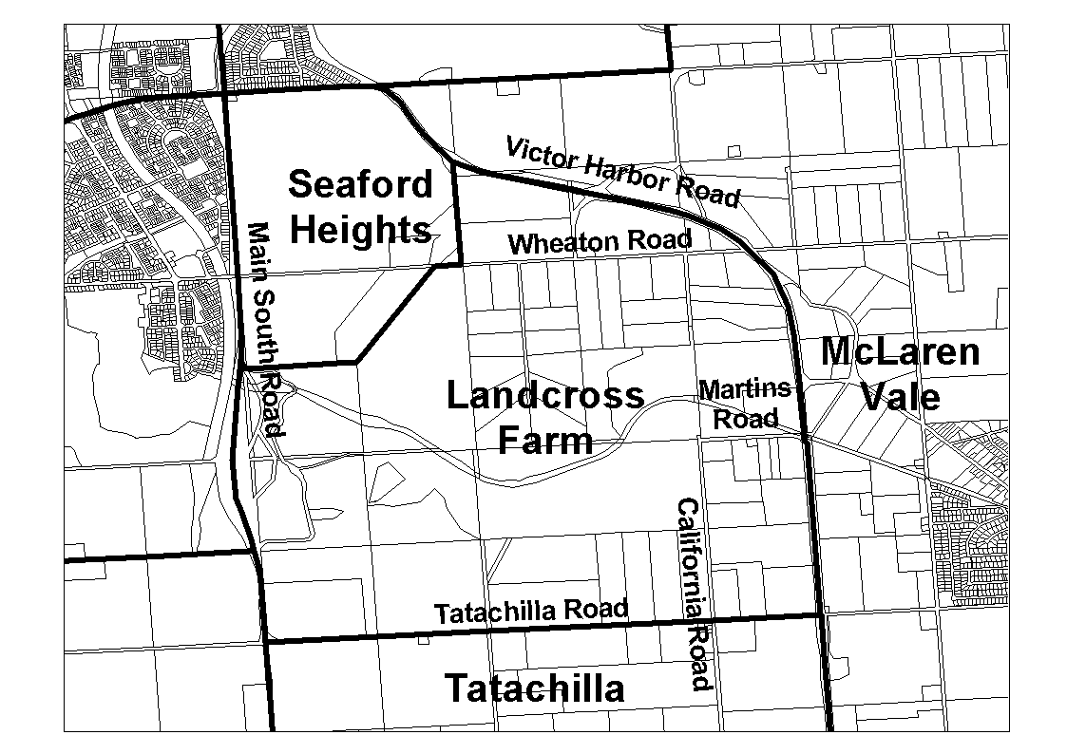
The Plan
Dated 10 March 2000.
Robert Lawson, Minister for Administrative and Information Services.
DEHAA 04/0182

LAND AND BUSINESS (SALE AND CONVEYANCING) ACT 1994
Exemption
TAKE notice that, pursuant to section 23 (3) of the Land and Business (Sale and Conveyancing) Act 1994, I, Kenneth Trevor Griffin, Minister for Consumer Affairs, do hereby exempt the person named in Schedule 1 from the application of section 23 (2) of the Act in relation to the purchase of the land specified in Schedule 2.
Schedule 1
Richard Francis Riddell and Claire Marie Riddell, officers/ employees of Melnata Pty Ltd.
Schedule 2
The whole of the land described in certificate of title register book volume 5355, folio 772 situated at 7 Norman Street, Normanville, S.A. 5204.
Signed for and on behalf of the Minister for Consumer Affairs by the Commissioner for Consumer Affairs.
M. Bodycoat, Commissioner

LAND AND BUSINESS (SALE AND CONVEYANCING) ACT 1994
Exemption
TAKE notice that, pursuant to section 23 (3) of the Land and Business (Sale and Conveyancing) Act 1994, I, Kenneth Trevor Griffin, Minister for Consumer Affairs, do hereby exempt the person named in Schedule 1 from the application of section 23 (2) of the Act in relation to the purchase of the land specified in Schedule 2.
Schedule 1
Linda Marie D’Amato, officer/employee of Golden Way Realty (S.A.) Pty Ltd.
Schedule 2
The whole of the land described in certificate of title register book volume 5213, folio 967 situated at 44 Perseverance Road, Tea Tree Gully, S.A. 5091.
Signed for and on behalf of the Minister for Consumer Affairs by the Commissioner for Consumer Affairs.
M. Bodycoat, Commissioner

LIQUOR LICENSING ACT 1997
Notice of Application for Transfer of Liquor Licence and Gaming Machine Licence
NOTICE is hereby given, pursuant to section 52 of the Liquor Licensing Act 1997 and section 29 of the Gaming Machines Act 1992, that Rred Pty Ltd, c/o Kelly & Co. Solicitors has applied to the Liquor and Gaming Commissioner for the transfer of a Hotel Licence and Gaming Machine Licence in respect of premises situated at Harley Street, Blyth, S.A. 5462 and known as Blyth Hotel.
The applications have been set down for hearing on 14 April 2000.
Any person may object to the application by lodging a notice of objection in the prescribed form with the Licensing Authority, and serving a copy of the notice on the applicant at the applicant’s address given above, at least seven days before the hearing date.
Plans in respect of the premises the subject of the application are open to public inspection without fee at the Office of the Liquor and Gaming Commissioner, 9th Floor, East Wing, 50 Grenfell Street, Adelaide, S.A. 5000.
Dated 9 March 2000.
Applicant

LIQUOR LICENSING ACT 1997
Notice of Application for Transfer of Liquor Licence and Gaming Machine Licence
NOTICE is hereby given, pursuant to section 52 of the Liquor Licensing Act 1997 and section 29 of the Gaming Machines Act 1992, that Lincoln Cove Investments Pty Ltd (ACN 091 607 840) has applied to the Liquor and Gaming Commissioner for the transfer of a Special Circumstances Licence and Gaming Machine Licence in respect of premises situated at section 938 Jubilee Drive, Lincoln Cove, Port Lincoln, S.A. 5606 and known as Dockside Tavern.
The applications have been set down for hearing on 7 April 2000.
Any person may object to the application by lodging a notice of objection in the prescribed form with the Licensing Authority, and serving a copy of the notice on the applicant at the applicant’s address given above, at least seven days before the hearing date.
Plans in respect of the premises the subject of the application are open to public inspection without fee at the Office of the Liquor and Gaming Commissioner, 9th Floor, East Wing, 50 Grenfell Street, Adelaide, S.A. 5000.
Applicant

LIQUOR LICENSING ACT 1997
Notice of Application
NOTICE is hereby given, pursuant to section 52 (2) (b) of the Liquor Licensing Act 1997, that S. & A. D. Basheer Nominees Pty Ltd has applied to the Licensing Authority for a Redefinition of Licensed Area in respect of premises situated at 129 North Terrace, Adelaide, S.A. 5000 and known as Strathmore Hotel.
The application has been set down for hearing on 31 March 2000.
Any person may object to the application by lodging a notice of objection in the prescribed form with the Licensing Authority, and serving a copy of the notice on the applicant at the applicant’s address given above, at least seven days before the hearing date.
Plans in respect of the premises the subject of the application are open to public inspection without fee at the Office of the Liquor and Gaming Commissioner, 9th Floor, East Wing, 50 Grenfell Street, Adelaide, S.A. 5000.
Dated 9 March 2000.
Applicant

LIQUOR LICENSING ACT 1997
Notice of Application
NOTICE is hereby given, pursuant to section 52 (2) (b) of the Liquor Licensing Act 1997, that BAE Systems Flight Training (Australia) Pty Ltd (ACN 003 877 138) has applied to the Licensing Authority for a Special Circumstances Licence with Entertainment Consent in respect of premises situated at Hangar 54, Kitty Hawk Lane, Parafield Airport, S.A. 5107 and to be known as BAE Systems.
The application has been set down for hearing on 7 April 2000.
Conditions
The following licence conditions are sought:
Authorisation to sell liquor for consumption on the licensed premises:
To staff and students of the licensee between the following hours: Wednesday, Thursday and Friday, 5 p.m. to 11 p.m.
At any time to any persons attending a pre-booked function.
Any person may object to the application by lodging a notice of objection in the prescribed form with the Licensing Authority, and serving a copy of the notice on the applicant at the applicant’s address given above, at least seven days before the hearing date.
Plans in respect of the premises the subject of the application are open to public inspection without fee at the Office of the Liquor and Gaming Commissioner, 9th Floor, East Wing, 50 Grenfell Street, Adelaide, S.A. 5000.
Dated 10 March 2000.
Applicant

LIQUOR LICENSING ACT 1997
Notice of Application
NOTICE is hereby given, pursuant to section 52 (2) (b) of the Liquor Licensing Act 1997, that Gulf Investments Pty Ltd has applied to the Licensing Authority for an Extended Trading Authorisation in respect of premises situated at Stirling North, S.A. 5710 and known as Travellers Rest Hotel.
The application has been set down for hearing on 14 April 2000.
Conditions
The following licence conditions are sought:
Friday and Saturday, midnight to 2 a.m. the following morning.
Sunday, 8 a.m. to 11 a.m. and 8 p.m. to midnight, for consumption on the licensed premises.
Sunday, 8 a.m. to 11 a.m. and 8 p.m. to 9 p.m., for consumption off the licensed premises.
Any person may object to the application by lodging a notice of objection in the prescribed form with the Licensing Authority, and serving a copy of the notice on the applicant at the applicant’s address given above, at least seven days before the hearing date.
Plans in respect of the premises the subject of the application are open to public inspection without fee at the Office of the Liquor and Gaming Commissioner, 9th Floor, East Wing, 50 Grenfell Street, Adelaide, S.A. 5000.
Dated 7 March 2000.
Applicant

LIQUOR LICENSING ACT 1997
Notice of Application
NOTICE is hereby given, pursuant to section 52 (2) (b) of the Liquor Licensing Act 1997, that Mitolo Wines Pty Ltd, c/o Donaldson Walsh Lawyers, Kings Chambers, 320 King William Street, Adelaide, S.A. 5000 has applied to the Licensing Authority for a Producer’s Licence in respect of premises situated at corner Angle Vale and Johns Road, Virginia, S.A. 5120 and to be known as Mitolo Wines Pty Ltd.
The application has been set down for hearing on 14 April 2000 at 9 a.m.
Any person may object to the application by lodging a notice of objection in the prescribed form with the Licensing Authority, and serving a copy of the notice on the applicant at the applicant’s address given above, at least seven days before the hearing date.
Plans in respect of the premises the subject of the application are open to public inspection without fee at the Office of the Liquor and Gaming Commissioner, 9th Floor, East Wing, 50 Grenfell Street, Adelaide, S.A. 5000.
Dated 7 March 2000.
Applicant

LIQUOR LICENSING ACT 1997
Notice of Application
NOTICE is hereby given, pursuant to section 52 (2) (b) of the Liquor Licensing Act 1997, that Gomersal Wines Pty Ltd (ACN 055 758 382), c/o Fisher Jeffries, SGIC Building, 211 Victoria Square, Adelaide, S.A. 5000 has applied to the Licensing Authority for a Producer’s Licence in respect of the premises situated at 137 Lyndoch Road, Gomersal, S.A. 5352 and to be known as Gomersal Wines.
The application has been set down for hearing on 14 April 2000.
Any person may object to the application by lodging a notice of objection in the prescribed form with the Licensing Authority, and serving a copy of the notice on the applicant at the applicant’s address given above, at least seven days before the hearing date.
Plans in respect of the premises the subject of the application are open to public inspection without fee at the Office of the Liquor and Gaming Commissioner, 9th Floor, East Wing, 50 Grenfell Street, Adelaide, S.A. 5000.
Dated 7 March 2000.
Applicant

LIQUOR LICENSING ACT 1997
Notice of Application
NOTICE is hereby given, pursuant to section 52 (2) (b) of the Liquor Licensing Act 1997, that Joanne Rae Spurling and Kerrilee Jane Spurling, Shops 5 and 7, 40 Murray Street, Gawler, S.A. 5118 have applied to the Licensing Authority for a Restaurant Licence with Extended Trading Authorisation and Section 34 (1) (c) in respect of premises situated at Shops 5 and 7, 40 Murray Street, Gawler, S.A. 5118 and known as Conversations Cafe.
The application has been set down for hearing on 14 April 2000 at 9 a.m.
Conditions
The following licence conditions are sought:
1. Extended Trading Authorisation: Sunday 8 a.m. to 11 a.m.
2. Section 34 (1) (c) authorises the licensee to sell liquor on any day except Good Friday and Christmas Day for consumption on the licensed premises by persons:
(a) seated at a table; or
(b) attending a function at which food is provided.
Any person may object to the application by lodging a notice of objection in the prescribed form with the Licensing Authority, and serving a copy of the notice on the applicants at the applicants’ address given above, at least seven days before the hearing date.
Plans in respect of the premises the subject of the application are open to public inspection without fee at the Office of the Liquor and Gaming Commissioner, 9th Floor, East Wing, 50 Grenfell Street, Adelaide, S.A. 5000.
Dated 8 March 2000.
Applicants

LIQUOR LICENSING ACT 1997
Notice of Application
NOTICE is hereby given, pursuant to section 52 (2) (b) of the Liquor Licensing Act 1997, that K. E. and S. M. Burgess and M. R. and M. A. Pounsett, 77 Liberator Drive, Paralowie, S.A. 5108 has applied to the licensing authority for a Special Circumstances Licence in respect of premises situated at 77 Liberator Drive, Paralowie, S.A. 5108 and known as Red Rose Limousines.
The application has been set down for hearing on 14 April 2000.
Conditions
The following licence conditions are sought:
1. The licensee authorises the sale, supply and consumption of all types of liquor to and by passengers on any day and at any time in the vehicle and areas adjacent thereto, provided such sales and consumption is always under the supervision and control of the driver of the subject vehicle.
2. No driver of the vehicle is permitted to drink alcohol during the hours aforementioned and is to be totally alcohol free whilst in charge of that vehicle.
3. There shall be no liquor in the vehicle except in the boot storage area whilst a minor is in the vehicle, unless that minor is in the company of an adult guardian or adult spouse of the minor. A guardian in relation to a minor means a parent, including a step-parent or legal guardian of the minor.
Any person may object to the application by lodging a notice of objection in the prescribed form with the Licensing Authority, and serving a copy of the notice on the applicants at the applicants’ address given above, at least seven days before the hearing date.
Plans in respect of the premises the subject of the application are open to public inspection without fee at the Office of the Liquor and Gaming Commissioner, 9th Floor, East Wing, 50 Grenfell Street, Adelaide, S.A. 5000.
Dated 8 March 2000.
Applicants

LIQUOR LICENSING ACT 1997
Notice of Application
NOTICE is hereby given, pursuant to section 52 (2) (b) of the Liquor Licensing Act 1997, that Davidco Trading Pty Ltd as Trustee of David Wood Family Trust, 261 Pirie Street, Adelaide, S.A. 5000 has applied to the Licensing Authority for a Variation to an Extended Trading Authorisation in respect of premises situated at 261 Pirie Street, Adelaide and known as Tivoli Hotel.
The application has been set down for hearing on 14 April 2000.
Conditions
The following licence conditions are sought:
Hours of Operation:
Friday, midnight to 5 a.m. the following morning.
Saturday, midnight to 5 a.m. the following morning.
Sunday, 8 a.m. to 11 a.m. and 8 p.m. to 2 a.m. the following morning for consumption on the licensed premises.
Sunday, 8 a.m. to 11 a.m. and 8 p.m. to 9 p.m. for consumption off the licensed premises.
Any person may object to the application by lodging a notice of objection in the prescribed form with the Licensing Authority, and serving a copy of the notice on the applicant at the applicant’s address given above, at least seven days before the hearing date.
Plans in respect of the premises the subject of the application are open to public inspection without fee at the Office of the Liquor and Gaming Commissioner, 9th Floor, East Wing, 50 Grenfell Street, Adelaide, S.A. 5000.
Dated 8 March 2000.
Applicant

LIQUOR LICENSING ACT 1997
Notice of Application
NOTICE is hereby given, pursuant to section 52 (2) (b) of the Liquor Licensing Act 1997, that Agpro Operations Pty Ltd, 710 Main North Road, Gepps Cross S.A. 5094 has applied to the Licensing Authority for a Wholesale Liquor Merchant’s Licence in respect of premises to be situated at 710 Main North Road, Gepps Cross and to be known as Gepps Cross Wine Centre.
The application has been set down for hearing on 14 April 2000.
Any person may object to the application by lodging a notice of objection in the prescribed form with the Licensing Authority, and serving a copy of the notice on the applicant at the applicant’s address given above, at least seven days before the hearing date.
Plans in respect of the premises the subject of the application are open to public inspection without fee at the Office of the Liquor and Gaming Commissioner, 9th Floor, East Wing, 50 Grenfell Street, Adelaide, S.A. 5000.
Dated 8 March 2000.
Applicant

LIQUOR LICENSING ACT 1997
Notice of Application
NOTICE is hereby given, pursuant to section 52 (2) (b) of the Liquor Licensing Act 1997, that Denial Bay Aquaculture Pty Ltd has applied to the Licensing Authority for a Special Circumstances Licence in respect of premises to be situated at Eyre Highway, Ceduna, S.A. 5690 and to be known as Ceduna Oyster Bar.
The application has been set down for hearing on 14 April 2000.
Condition
The following licence condition is sought:
Authorisation to sell liquor for consumption on the licensed premises between the following hours:
Monday to Friday, 10.30 a.m. to 6 p.m.
Saturday, 10.30 a.m. to 1 p.m.
Any person may object to the application by lodging a notice of objection in the prescribed form with the Licensing Authority, and serving a copy of the notice on the applicant at the applicant’s address given above, at least seven days before the hearing date.
Plans in respect of the premises the subject of the application are open to public inspection without fee at the Office of the Liquor and Gaming Commissioner, 9th Floor, East Wing, 50 Grenfell Street, Adelaide, S.A. 5000.
Dated 9 March 2000.
Applicant

LIQUOR LICENSING ACT 1997
Notice of Application
NOTICE is hereby given, pursuant to section 52 (2) (b) of the Liquor Licensing Act 1997, that Bruce Business Pty Ltd (ACN 086 148 665), c/o Fisher Jeffries, SGIC Building, 211 Victoria Square, Adelaide, S.A. 5000 has applied to the Licensing Authority for a Wholesale Liquor Merchant’s Licence in respect of the premises situated at Krondorf Road, Tanunda, S.A. 5352.
The application has been set down for hearing on 14 April 2000 at 9 a.m.
Any person may object to the application by lodging a notice of objection in the prescribed form with the Licensing Authority, and serving a copy of the notice on the applicant at the applicant’s address given above, at least seven days before the hearing date.
Plans in respect of the premises the subject of the application are open to public inspection without fee at the Office of the Liquor and Gaming Commissioner, 9th Floor, East Wing, 50 Grenfell Street, Adelaide, S.A. 5000.
Dated 8 March 2000.
Applicant

LIQUOR LICENSING ACT 1997
Notice of Application
NOTICE is hereby given, pursuant to section 52 (2) (b) of the Liquor Licensing Act 1997, that L. E. Sat. Nominees Pty Ltd (ACN 088 235 867) and A. J. Sat. Nominees Pty Ltd (ACN 088 235 769), 97 The Parade, Norwood, S.A. 5067 have applied to the Liquor Licensing Authority for a Hotel Licence in respect of premises to be situated at 130 Martins Road, Parafield Gardens, S.A. 5107 and to be known as Slug ‘N’ Lettuce Tavern.
The application has been set down for hearing on 14 April 2000.
Any person may object to the application by lodging a notice of objection in the prescribed form with the Licensing Authority, and serving a copy of the notice on the applicants at the applicants’ address given above, at least seven days before the hearing date.
Plans in respect of the premises the subject of the application are open to public inspection without fee at the Office of the Liquor and Gaming Commissioner, 9th Floor, East Wing, 50 Grenfell Street, Adelaide, S.A. 5000.
Dated 8 March 2000.
Applicants

LIQUOR LICENSING ACT 1997
Notice of Application
NOTICE is hereby given, pursuant to section 52 (2) (b) of the Liquor Licensing Act 1997, that Mick and Catherine Morrissey, c/o Griffins Lawyers, Level 14, 26 Flinders Street, Adelaide, S.A. 5000 have applied to the Licensing Authority for a Restaurant Licence with Section 34 (1) (c) in respect of premises situated at Tenancy 2, Bi-Lo Shopping Centre, McLaren Street, Mount Barker, S.A. 5251 and to be known as McLarens in the Mall Snack Bar & Coffee Lounge.
The application has been set down for hearing on 14 April 2000 at 9 a.m.
Conditions
The following licence conditions are sought:
1. Section 34 (1) (c) authorises the licensee to sell liquor on any day except Good Friday and Christmas Day for consumption on the licensed premises by persons:
(a) seated at a table; or
(b) attending a function at which food is provided.
Any person may object to the application by lodging a notice of objection in the prescribed form with the Licensing Authority, and serving a copy of the notice on the applicants at the applicants’ address given above, at least seven days before the hearing date.
Plans in respect of the premises the subject of the application are open to public inspection without fee at the Office of the Liquor and Gaming Commissioner, 9th Floor, East Wing, 50 Grenfell Street, Adelaide, S.A. 5000.
Dated 13 March 2000.
Applicants

LIQUOR LICENSING ACT 1997
Notice of Application
NOTICE is hereby given, pursuant to section 52 (2) (b) of the Liquor Licensing Act 1997, that Panorama Park Stud Pty Ltd has applied to the Licensing Authority for a Restaurant Licence with Entertainment Consent in respect of premises to be situated at Lot 946, Sturt Highway, Berri, S.A. 5343 to be known as Hamley House Restaurant.
The application has been set down for hearing on 14 April 2000.
Conditions
The following licence conditions are sought:
The licensee is authorised to sell liquor on any day except Good Friday and Christmas Day for consumption on the licensed premises by persons:
(a) seated at a table; or
(b) attending a function at which food is provided.
Extended Trading Authorisation hours of operation:
Monday to Thursday, midnight to 1 a.m. the following morning.
Friday and Saturday, midnight to 2 a.m. the following morning.
Sunday, 8 a.m. to 11 a.m. and 8 p.m. to midnight.
Any person may object to the application by lodging a notice of objection in the prescribed form with the Licensing Authority, and serving a copy of the notice on the applicant at the applicant’s address given above, at least seven days before the hearing date.
Plans in respect of the premises the subject of the application are open to public inspection without fee at the Office of the Liquor and Gaming Commissioner, 9th Floor, East Wing, 50 Grenfell Street, Adelaide, S.A. 5000.
Dated 13 March 2000.
Applicant

LIQUOR LICENSING ACT 1997
Notice of Application
NOTICE is hereby given, pursuant to section 52 (2) (b) of the Liquor Licensing Act 1997, that Three Victories Pty Ltd, corner of Commercial Road and Griffiths Drive, Seaford Rise, S.A. 5169 has applied to the Licensing Authority for a Variation to Extended Trading Authorisation in respect of premises situated at corner Commercial Road and Griffiths Drive, Seaford Rise and known as Seaford Rise Tavern.
The application has been set down for hearing on 14 April 2000 at 9 a.m.
Condition
The following licence condition is sought:
Extended trading authorisation: Sunday, 8 a.m. to 11 a.m. and 8 p.m. to midnight.
Any person may object to the application by lodging a notice of objection in the prescribed form with the Licensing Authority, and serving a copy of the notice on the applicant at the applicant’s address given above, at least seven days before the hearing date.
Plans in respect of the premises the subject of the application are open to public inspection without fee at the Office of the Liquor and Gaming Commissioner, 9th Floor, East Wing, 50 Grenfell Street, Adelaide, S.A. 5000.
Dated 13 March 2000.
Applicant

LIQUOR LICENSING ACT 1997
Notice of Application
NOTICE is hereby given, pursuant to section 52 (2) (b) of the Liquor Licensing Act 1997, that D’Alioa Nominees Pty Ltd (ACN 071 551 285), c/o Gibson & Partners, 246 Brighton Road, Somerton Park, S.A. 5044 has applied to the Licensing Authority for the transfer of a Residential Licence in respect of premises situated at Bordertown Road, Naracoorte, S.A. 5271 and known as William MacIntosh Motor Inn.
The application has been set down for hearing on 17 April 2000.
Any person may object to the application by lodging a notice of objection in the prescribed form with the Licensing Authority, and serving a copy of the notice on the applicant at the applicant’s address given above, at least seven days before the hearing date.
Plans in respect of the premises the subject of the application are open to public inspection without fee at the Office of the Liquor and Gaming Commissioner, 9th Floor, East Wing, 50 Grenfell Street, Adelaide, S.A. 5000.
Dated 10 March 2000.
Applicant

LIQUOR LICENSING ACT 1997
Notice of Application
NOTICE is hereby given, pursuant to section 52 (2) (b) of the Liquor Licensing Act 1997, that Paul Leslie Spooner and Bronwen Johnson Burnett-Spooner, 69 Hereford Avenue, Payneham, S.A. 5070 have applied to the Licensing Authority for the transfer of a Restaurant Licence in respect of premises situated at 199 Port Road, Hindmarsh, S.A. 5007 and known as Antonella’s Mediterranean Restaurant.
The application has been set down for hearing on 17 April 2000.
Any person may object to the application by lodging a notice of objection in the prescribed form with the Licensing Authority, and serving a copy of the notice on the applicants at the applicants’ address given above, at least seven days before the hearing date.
Plans in respect of the premises the subject of the application are open to public inspection without fee at the Office of the Liquor and Gaming Commissioner, 9th Floor, East Wing, 50 Grenfell Street, Adelaide, S.A. 5000.
Dated 9 March 2000.
Applicants

LIQUOR LICENSING ACT 1997
Notice of Application
NOTICE is hereby given, pursuant to section 52 (2) (b) of the Liquor Licensing Act 1997, that T., T. & B. Soekinto, c/o Gordon Cheng Solicitors, Level 7, 32 Grenfell Street, Adelaide, S.A. 5000 have applied to the Licensing Authority for the transfer of a Restaurant Licence in respect of premises situated at 26 John Street, Salisbury, S.A. 5108 and known as Emperors Crown Chinese Restaurant.
The application has been set down for hearing on 17 April 2000.
Any person may object to the application by lodging a notice of objection in the prescribed form with the Licensing Authority, and serving a copy of the notice on the applicants at the applicants’ address given above, at least seven days before the hearing date.
Plans in respect of the premises the subject of the application are open to public inspection without fee at the Office of the Liquor and Gaming Commissioner, 9th Floor, East Wing, 50 Grenfell Street, Adelaide, S.A. 5000.
Dated 7 March 2000.
Applicants

NATIONAL ELECTRICITY (SOUTH AUSTRALIA)
ACT 1996
Notice Under Section 6 (2) of the National Electricity Law and National Electricity Code
NOTICE is hereby given pursuant to section 6 (2) of the National Electricity Law, which forms the Schedule to the National Electricity (South Australia) Act 1996 and clause 8.3.9 (d) of the National Electricity Code approved under section 6 of the National Electricity Law, that clauses 5.2.3 (except for (h) and (i)), 5.3.6, 5.5 (e) (2), 5.5A, 5.6.2 (a1), 5.6.3, 5.6.6, Schedules to Chapter 5, 6.1.4 (a), 6.19 (d) to (f), and definitions to Chapter 10 relevant to entrepreneurial interconnectors of the National Electricity Code are amended or inserted as applicable.
These amendments to the National Electricity Code commence on 16 March 2000.
As required by clause 8.3.9 (d) of the National Electricity Code, a copy of the ACCC’s letters dated 31 January 2000, 29 February 2000 and 14 March 2000 are set out below.
The amendments referred to above and copies of the ACCC’s letter dated 31 January 2000, providing interim authorisation, further letter of 29 February 2000, varying the conditions of interim authorisation and further letter of 14 March 2000 confirming that the conditions of interim authorisation have been met for these amendments can be viewed on the Internet website of National Electricity Code Administrator Limited (ACN 073 942 775) (‘NECA’) at www.neca.com.au under ‘The Code’ section of that website.
The National Electricity Code can be viewed on the NECA Internet website at www.neca.com.au and at the offices of NECA and National Electricity Market Management Company Limited (ACN 072 010 327). A list of addresses where the Code can be viewed is available on the NECA website.
Dated 16 March 2000.
National Electricity Code Administrator

ACCC Letter of Authorisation
31 January 2000
Stephen Kelly
Managing Director
NECA
Level 5, 41 Currie Street
ADELAIDE, S.A. 5000
Dear Stephen
National Electricity Code—Applications for Authorisation Nos: A90704, A90705 and A90706
I refer to applications for authorisation of the National Electricity Code submitted to the Commission on 26 July 1999 and amended on 18 August 1999, and your letter dated 17 January 2000, which requested that the Commission grant interim authorisation to the following clauses, relating to entrepreneurial interconnectors:
5.2.3 (not (h) and (i))
5.3.6
5.5 (e) (2)
5.5A
5.6.2 (a1)
5.6.3
5.6.6
Schedules to chapter 5
6.1.4 (a)
6.19 (d) to (f)
Pursuant to subsection 91 (2) of the Act, the Commission hereby grants interim authorisation for the above Code changes, with the exception that the interim authorisation does not apply to clause 5.5A (g) (2) (A).
The interim authorisation is granted subject to the following conditions:
C1 Clause 5.5A (g) (1A) be amended to provide that:
‘Service level standards to which the MNSP requires the NSP to adhere in providing it services to the extent that the MNSP is seeking a service level higher than that in this Code or set by the relevant regulator.’
C2 Clause 6.1.4A be amended to provide that:
‘Chapter 6 does not govern the principles or rules for the calculation of prices which a Market Network Service Provider may charge for its services. However, a Market Network Service Provider is obliged to pay any applicable charges determined in accordance with Chapter 6.’
The Commission has received submissions from interested parties, expressing some concerns with the safe harbour provisions for entrepreneurial interconnectors. The Commission will conduct a full assessment of the Code changes and submissions in its draft determination and may, if it considers necessary, impose conditions that are additional to those imposed in this interim authorisation. Please note that the interim authorisation will lapse when the Commission reaches a final determination in regard to the applications and that, under subsection 91 (2) of the Trade Practices Act, the Commission may revoke an interim authorisation at any time.
If you have any queries about any issue raised in this letter, please contact either myself on (02) 6243 1249 or Tanya Barden on (02) 6243 1248.
Yours sincerely,
M. Rawstron, General Manager, Regulatory Affairs Division—Electricity.

ACCC Letter of Authorisation
29 February 2000
Stephen Kelly
Managing Director
NECA
Level 5, 41 Currie Street
ADELAIDE, S.A. 5000
Dear Stephen
National Electricity Code—Applications for Authorisation Nos: A90704, A90705 and A90706
I refer to my letter of 31 January 2000, advising you of the Commission’s decision to grant interim authorisation to a set of Code changes related to entrepreneurial interconnectors as per your request of 17 January 2000. The interim authorisation did not cover clause 5.5A (g) (2) (A) and was subject to two conditions.
Condition C2: Clause 6.1.4A
Condition 2 of the interim authorisation required clause 6.1.4A of the proposed Code changes to be amended to provide that:
Chapter 6 does not govern the principles or rules for the calculation of prices which a Market Network Service Provider may charge for its services. However, a Market Network Service Provider is obliged to pay any applicable charges determined in accordance with Chapter 6.
The intention of Condition 2 was to amend clause 6.1.4A so that if, in the future, Chapter 6 determined prices that a Market Network Service Provider (MNSP) must pay for use of the transmission or distribution network, the interim authorisation would cover that arrangement.
The Commission has since been informed that Condition 2 may be misinterpreted as meaning that MNSP’s must pay the usage component of Customer Transmission Use of System (TUOS) charges.
Consequently, the Commission has decided to amend Condition 2 so that interim authorisation is subject to the condition that Chapter 6 not apply to charges paid by a MNSP for transmission or distribution services. Charges for network services provided to a MNSP must be determined in accordance with Clause 5.5A of the Code.
Condition 2 of the interim authorisation now reads:
C2 Clause 6.1.4A must be amended to provide that:
Chapter 6 does not govern the principles or rules for the calculation of prices a Market Network Service Provider may charge for its services, nor the charges for transmission or distribution services provided by a Network Service Provider to a Market Network Service Provider. Charges for network services provided to a Market Network Service Provider are governed by the provisions of clause 5.5A.
It is important to note that the Commission is still in the process of assessing the complete package of Code changes arising from the Transmission and Distribution Pricing Review and has not yet formed a view on issues such as who should pay TUOS charges.
Operation of Interim Authorisation
I am concerned that some parties may have misinterpreted the status of an interim authorisation. Parties should be aware that:
• the Commission may revoke or vary the imterim authorisation (including conditions to which the interim authorisation is subject) at any time and the interim authorisation terminates when the Commission makes a final determination on the application; and

• the interim authorisation has been granted pending a full review of the Code changes and submissions. The Commission may reach a different conclusion on the appropriate charging arrangements for network services provided to an MNSP that are currently granted interim authorisation.
Clause 5.5A (g) (2) (A)
The Commission did not grant interim authorisation in respect of clause 5.5A (g) (2) (A), which provides for the Network Service Provider and the MNSP to negotiate in good faith on the ‘use of system service charges to be paid to the MNSP in respect of any reduction in the long run marginal cost of augmenting the network as a result of it being connected to the network’. The Commission is aware that there is a potential inconsistency in the treatment of generators and MNSP’s with respect to such payments.
As indicated above, it should be noted that the Commission has not reached a view on the charging arrangements for network services provided to MNSP’s. The Commission will consider this issue in the draft determination on the Transmission and Distribution Pricing Review Code changes.
Chapter 10 Definitions
I wish to clarify that the interim authorisation referred to in my letter of 31 January 2000, covers the definitions in Chapter 10 that are relevant to entrepreneurial interconnectors. The relevant definitions are listed in Attachment 1 to this letter.
If you have any queries about any issue raised in this letter, please contact either myself on (02) 6243 1249 or Tanya Barden on (02) 6243 1248.
Yours sincerely,
M. Rawstron, General Manager, Regulatory Affairs Division—Electricity.

Attachment 1
The relevant definitions from Chapter 10 are as follows:
annual revenue requirement
black start capability
central dispatch
dispatch
dispatch instruction
dispatch offer
dispatch offer price
financially responsible
generation dispatch offer
independently controllable two-terminal link
inflexible
loading level
market connection point
Market Network Service Provider
market network service provider access
market network service
Market Participant
negotiated use of system charges
network dispatch offer
network element
network loop
profile
ramp rate
registered bid and offer data
reserve contract
scheduled network service
Scheduled Network Service Provider
two-terminal link

ACCC Letter of Authorisation
14 March 2000
Stephen Kelly
Managing Director
NECA
Level 5, 41 Currie Street
ADELAIDE, S.A. 5000
Dear Stephen
National Electricity Code—Applications for Authorisation Nos: A90704, A90705 and A90706
I advise that, on the basis of the material you have put forward, the Commission is presently of the view that the conditions subject to which it granted interim authorisation A90704, A90705 and A90706, namely:
C1 Clause 5.5A (g) (1A) be amended to provide that:
Service level standards to which the MNSP requires the NSP to adhere in providing it services to the extent that the MNSP is seeking a service level higher than that in this Code or set by the relevant regulator.
C2 Clause 6.1.4A must be amended to provide that:
Chapter 6 does not govern the principles or rules for the calculation of prices a Market Network Service Provider may charge for its services, nor the charges for transmission or distribution services provided by a Network Service Provider to a Market Network Service Provider. Charges for network services provided to a Market Network Service Provider are governed by the provisions of clause 5.5A,
have been complied with.
However, please note that the Commission may, at any time, on the basis of material subsequently coming to the Commission’s attention (perhaps from interested third parties), or for any other reason, revoke an interim authorisation.
If you have any queries about any issue raised in this letter, please contact Paul Bilyk on (02) 6243 1254.
Yours sincerely,
A. Asher, Deputy Chairman

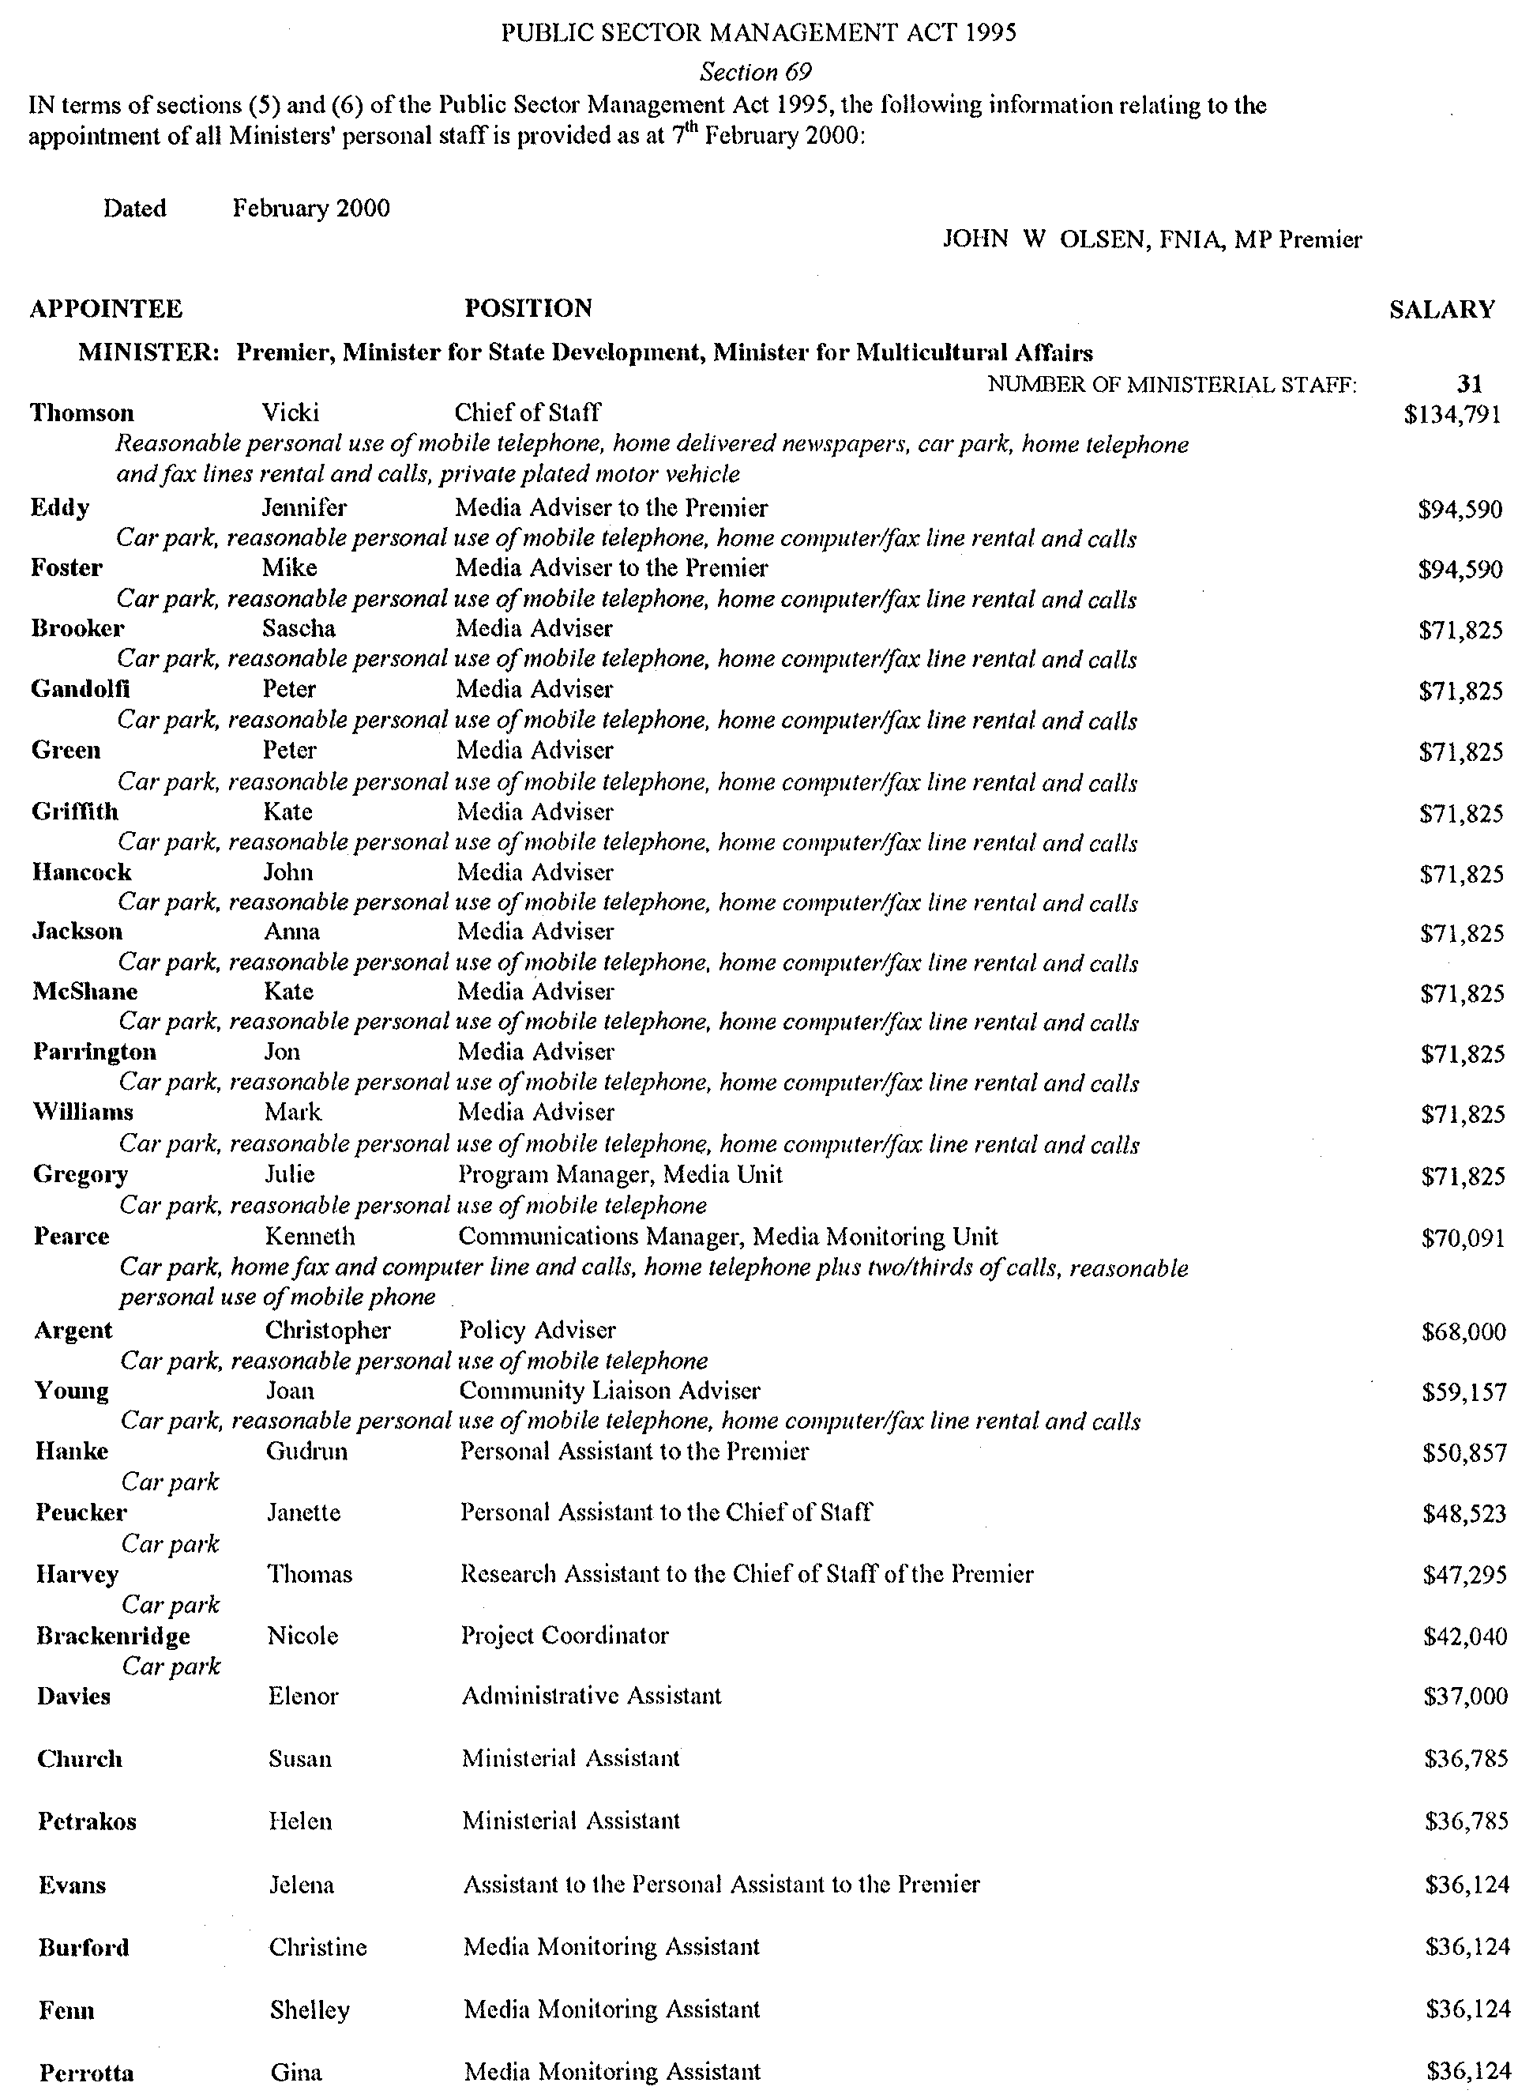
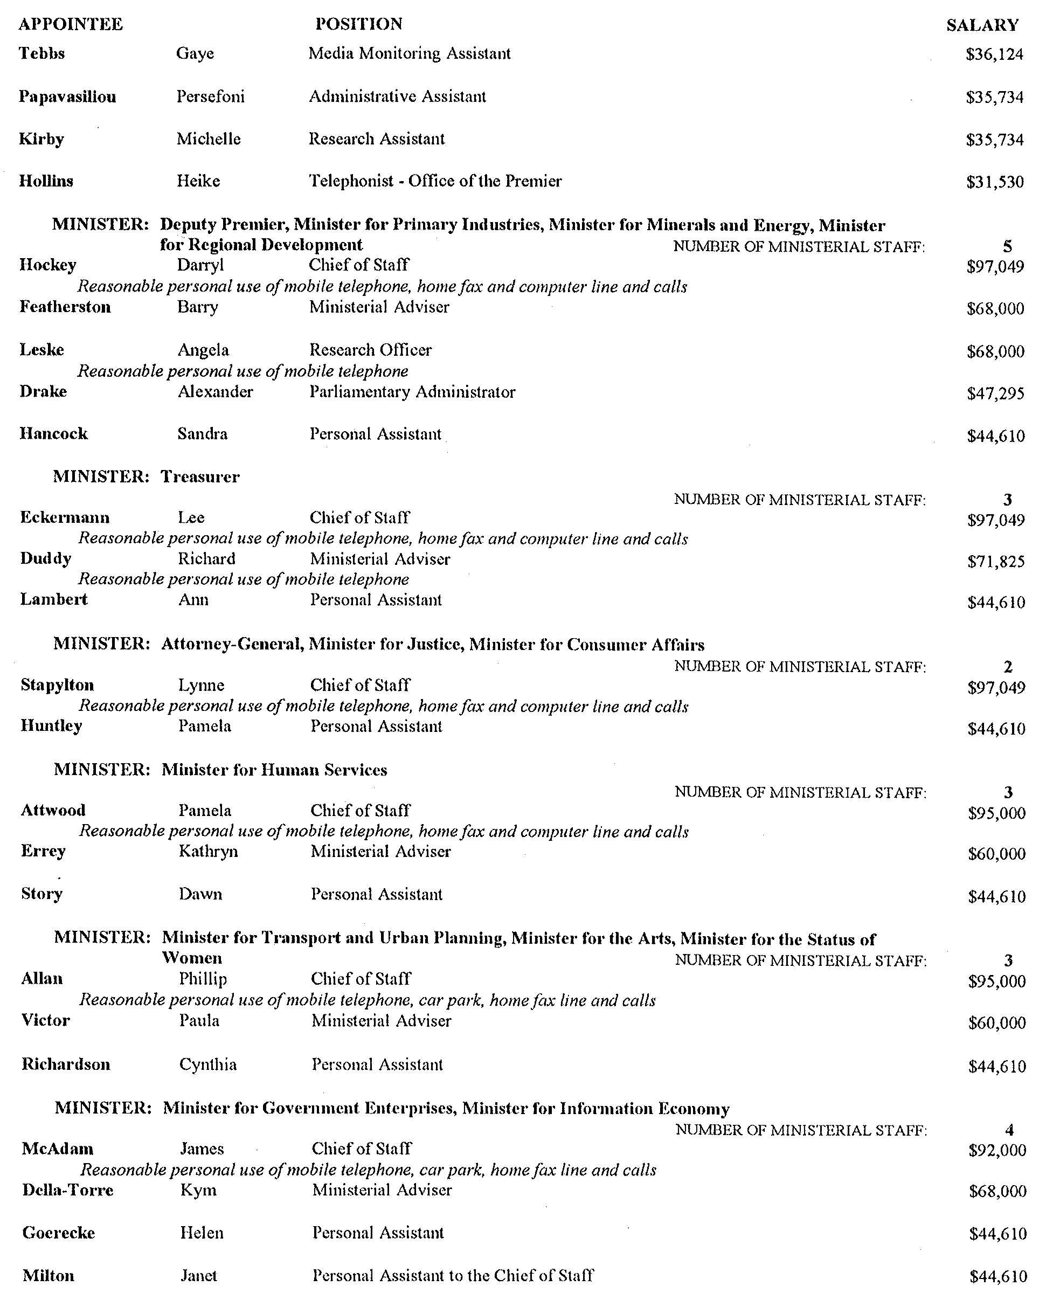
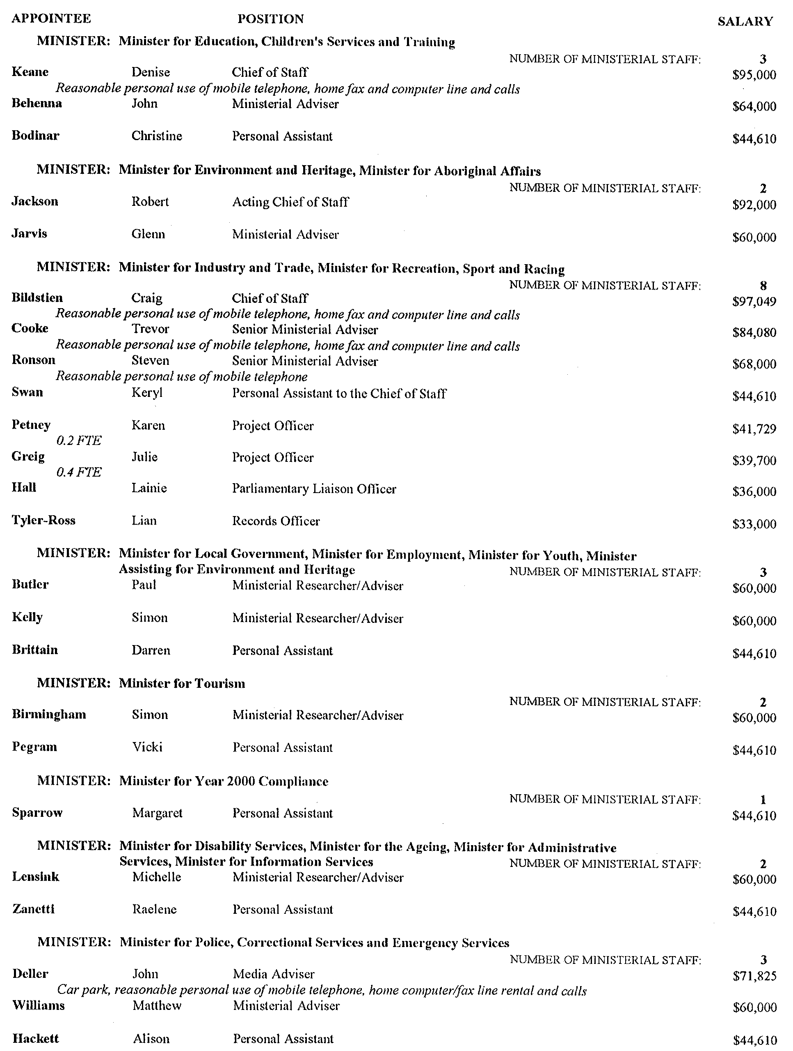

MISCELLANEOUS LEGISLATION AND GOVERNMENT PUBLICATIONS PRICES AS FROM 1 JULY 1999

Acts, Bills, Rules, Parliamentary Papers and Regulations
Pages | Main | Amends | Pages | Main | Amends

1-16 | 1.60 | 0.75 | 497-512 | 23.30 | 22.40
17-32 | 2.30 | 1.45 | 513-528 | 23.90 | 23.00
33-48 | 2.90 | 2.10 | 529-544 | 24.70 | 23.80
49-64 | 3.70 | 2.75 | 545-560 | 25.30 | 24.50
65-80 | 4.35 | 3.55 | 561-576 | 26.00 | 25.20
81-96 | 5.00 | 4.20 | 577-592 | 26.75 | 25.75
97-112 | 5.75 | 4.85 | 593-608 | 27.50 | 26.50
113-128 | 6.40 | 5.60 | 609-624 | 28.25 | 27.50
129-144 | 7.20 | 6.30 | 625-640 | 28.75 | 28.00
145-160 | 7.90 | 6.95 | 641-656 | 29.50 | 28.50
161-176 | 8.60 | 7.70 | 657-672 | 30.00 | 29.25
177-192 | 9.25 | 8.40 | 673-688 | 31.00 | 30.00
193-208 | 9.95 | 9.10 | 689-704 | 31.75 | 30.75
209-224 | 10.60 | 9.75 | 705-720 | 32.25 | 31.50
225-240 | 11.25 | 10.50 | 721-736 | 33.25 | 32.00
241-257 | 12.05 | 11.10 | 737-752 | 33.75 | 32.75
258-272 | 12.80 | 11.80 | 753-768 | 34.50 | 33.25
273-288 | 13.45 | 12.60 | 769-784 | 35.00 | 34.25
289-304 | 14.10 | 13.20 | 785-800 | 35.75 | 35.00
305-320 | 14.80 | 13.90 | 801-816 | 36.25 | 35.50
321-336 | 15.55 | 14.60 | 817-832 | 37.25 | 36.25
337-352 | 16.20 | 15.40 | 833-848 | 38.00 | 37.00
353-368 | 16.90 | 16.05 | 849-864 | 38.50 | 37.75
369-384 | 17.60 | 16.80 | 865-880 | 39.25 | 38.50
385-400 | 18.30 | 17.50 | 881-896 | 39.75 | 39.00
401-416 | 19.00 | 18.10 | 897-912 | 40.75 | 39.75
417-432 | 19.75 | 18.90 | 913-928 | 41.25 | 40.75
433-448 | 20.40 | 19.50 | 929-944 | 42.00 | 41.25
449-464 | 21.15 | 20.20 | 945-960 | 43.00 | 41.75
465-480 | 21.75 | 20.90 | 961-976 | 43.50 | 42.50
481-496 | 22.40 | 21.50 | 977-992 | 44.25 | 43.00

Legislation—Acts, Regulations, etc: $
Subscriptions:
Acts 144.00
All Bills as Laid 344.00
Rules and Regulations 344.00
Parliamentary Papers 344.00
Bound Acts 159.00
Index 77.00
Government Gazette
Copy 3.85
Subscription 190.00
Hansard
Copy 10.30
Subscription—per session (issued weekly) 298.00
Cloth bound—per volume 128.00
Subscription—per session (issued daily) 298.00
Legislation on Disk
Whole Database 2 201.00
Annual Subscription for fortnightly updates 677.00
Individual Act(s) including updates POA

Postage Extra on Individual Copies

All Legislation, Government Gazette, Hansard and Legislation on disk are available from:
Counter Sales Information SA (State Government Bookshop)
and Mail Orders: Australis Centre, Ground Floor, 77 Grenfell Street, Adelaide, S.A. 5000.
Phone: (08) 8204 1900. Fax: (08) 8204 1909
S.A. Country Customer Free Call: 1800 182 234
TTY (Hearing Impaired): (08) 8204 1923
Subscriptions and Standing Orders:
Phone: (08) 8204 9447, (08) 8204 9448. Fax: (08) 8204 1898
P.O. Box 1, Rundle Mall, Adelaide, S.A. 5000.

GOVERNMENT GAZETTE ADVERTISEMENT RATES

To apply from 1 July 1999

$  Agents, Ceasing to Act as 28.50  Associations:  Incorporation 14.50  Intention of Incorporation 35.75  Transfer of Properties 35.75  Attorney, Appointment of 28.50  Bailiff’s Sale 35.75  Cemetery Curator Appointed 21.20  Companies:  Alteration to Constitution 28.50  Capital, Increase or Decrease of 35.75  Ceasing to Carry on Business 21.20  Declaration of Dividend 21.20  Incorporation 28.50  Lost Share Certificates:  First Name 21.20  Each Subsequent Name 7.30  Meeting Final 23.80  Meeting Final Regarding Liquidator’s Report on  Conduct of Winding Up (equivalent to ‘Final  Meeting’)  First Name 28.50  Each Subsequent Name 7.30  Notices:  Call 35.75  Change of Name 14.50  Creditors 28.50  Creditors Compromise of Arrangement 28.50  Creditors (extraordinary resolution that ‘the Com-pany be wound up voluntarily and that a liquidator be appointed’) 35.75  Release of Liquidator⎯Application⎯Large Ad. 57.00  ⎯Release Granted 35.75  Receiver and Manager Appointed 33.25  Receiver and Manager Ceasing to Act 28.50  Restored Name 27.00  Petition to Supreme Court for Winding Up 49.50  Summons in Action 42.25  Order of Supreme Court for Winding Up Action 28.50  Register of Interests⎯Section 84 (1) Exempt 64.00  Removal of Office 14.50  Proof of Debts 28.50  Sales of Shares and Forfeiture 28.50  Estates:  Assigned 21.20  Deceased Persons⎯Notice to Creditors, etc. 35.75  Each Subsequent Name 7.30  Deceased Persons⎯Closed Estates 21.20  Each Subsequent Estate 0.90  Probate, Selling of 28.50  Public Trustee, each Estate 7.30 |  | $  Firms:  Ceasing to Carry on Business (each insertion) 21.20  Discontinuance Place of Business 21.20  Land⎯Real Property Act:  Intention to Sell, Notice of 35.75  Lost Certificate of Title Notices 35.75  Cancellation, Notice of (Strata Plan) 35.75  Mortgages:  Caveat Lodgment 14.50  Discharge of 15.30  Foreclosures 14.50  Transfer of 14.50  Sublet 7.30  Leases⎯Application for Transfer (2 insertions) each 7.30  Lost Treasury Receipts (3 insertions) each 21.20  Licensing 42.25  Municipal or District Councils:  Annual Financial Statement⎯Forms 1 and 2 400.00  Electricity Supply⎯Forms 19 and 20 283.00  Default in Payment of Rates:  First Name 57.00  Each Subsequent Name 7.30  Noxious Trade 21.20  Partnership, Dissolution of 21.20  Petitions (small) 14.50  Registered Building Societies (from Registrar-  General) 14.50  Register of Unclaimed Moneys⎯First Name 21.20  Each Subsequent Name 7.30  Registers of Members⎯Three pages and over:  Rate per page (in 8pt) 181.00  Rate per page (in 6pt) 239.00  Sale of Land by Public Auction 36.25  Advertisements 2.00  Advertisements, other than those listed are charged at $2.00 per column line, tabular one-third extra.  Notices by Colleges, Universities, Corporations and District Councils to be charged at $2.00 per line.  Where the notice inserted varies significantly in length from that which is usually published a charge of $2.00 per column line will be applied in lieu of advertisement rates listed.  South Australian Government publications are sold on the condition that they will not be reproduced without prior permission from the Government Printer.

GOVERNMENT GAZETTE NOTICES
ALL private advertisements forwarded for publication in the South Australian Government Gazette must be PAID FOR PRIOR TO INSERTION; and all notices, from whatever source, should be legibly written on one side of the paper only and sent to Riverside 2000 so as to be received no later than 4 p.m. Tuesday preceding the day of publication. Phone 8207 1045 or Fax 8207 1040. E-mail: Riv2000@saugov.sa.gov.au. Send as attachments in Word format and please confirm your transmission with a faxed copy of your document, including the date the notice is to be published and to whom the notice will be charged.

RADIATION PROTECTION AND CONTROL ACT 1982
Exemption
TAKE notice that the specified employer, the Office of the Sheriff of South Australia, Court Administration Authority, is exempt from the requirements of Regulation 25 of the Ionizing Radiation Regulations 1985, only in so far as that regulation applies to persons working with a Fiscan LS-V5030 portable cabinet X-ray unit, provided that:
1. the X-ray unit is maintained in good working order and condition; and
2. the specified employer issues a personal monitoring device to a radiation worker if directed in writing by the Health Commission to do so.
Prof. B. Kearney, Executive Director, Statewide Division, Department of Human Services

ROADS (OPENING AND CLOSING) ACT 1991:
SECTION 24
NOTICE OF CONFIRMATION OF ROAD
PROCESS ORDER
Public Road adj Gundagai Street, Goolwa
Deposited Plan 52509
BY Road Process Order made on 6 April 1999, The Alexandrina Council ordered that:
1. The whole of the public road (un-named) dividing allotments 58 and 60 in Deposited plan 14 shown delineated and lettered ‘A’ on the Preliminary Plan No. PP 32/0383 be closed.
2. The whole of the closed road be transferred to JOHN ERNEST MODRA and JOYCE EDITH MODRA in accordance with agreement for transfer dated 5 November 1998 entered into between the Alexandrina Council and J. E. and J. E. Modra.
On 21 June 1999 that order was confirmed by the Minister for Administrative Services, conditionally on approval and deposit of the survey plan by the Registrar-General. The condition has now been fulfilled.
Pursuant to section 24 (5) of the Roads (Opening and Closing) Act 1991, NOTICE of the order referred to above and its confirmation is hereby given.
Dated 16 March 2000.
P. M. Kentish, Surveyor-General

ROADS (OPENING AND CLOSING) ACT 1991:
SECTION 24
NOTICE OF CONFIRMATION OF ROAD
PROCESS ORDER
North Bokara Road, Mypolonga Irrigation Area
Deposited Plan 54265
BY Road Process Order made on 1 February 2000, the Rural City of Murray Bridge ordered that:
1. Portion of the public road (North Bokara Road) adjoining section 1226 adjacent to section 686 Hundred of Mobilong, more particularly lettered ‘A’ in Preliminary Plan No. PP32/0510 be closed.
2. Vest in the Crown the whole of the land subject to closure.
On 18 February 2000 that order was confirmed by the Minister for Administrative Services conditionally on approval and deposit of the survey plan by the Registrar-General. The condition has now been fulfilled.
Pursuant to section 24 (5) of the Roads (Opening and Closing) Act 1991, NOTICE of the order referred to above and its confirmation is hereby given.
Dated 16 March 2000.
P. M. Kentish, Surveyor-General

ROAD TRAFFIC (ROAD RULES⎯ANCILLARY AND MISCELLANEOUS PROVISIONS) REGULATIONS 1999
Notice of Exemption
I, DIANA LAIDLAW, Minister for Transport and Urban Planning, grant the following exemption pursuant to Regulation 7 of the Road Traffic (Road Rules⎯Ancillary and Miscellaneous Provisions) Regulations 1999:
I exempt drivers of public buses travelling on the South Eastern Freeway from the provisions of Rule 177 (Stopping on Freeway) provided:
(a) The bus has stopped solely for the purpose of picking up or setting down passengers; and
(b) The bus stops only at bus zones on the Freeway specifically set aside and designated by sign for that purpose.
This exemption is effective immediately.
All other provisions contained in the Road Traffic Act 1961 and the Australian Road Rules continue to have full force and effect.
I exempt pedestians boarding or alighting from, or waiting to board a public bus on the South Eastern Freeway from the provisions of Rule 229 (Pedestrians on a road with a road access sign) provided the pedestrians:
(a) are in a bus zone specifically set aside and designated by sign for that purpose; and
(b) do not move beyond the kerbing which separates the road related area and road of that zone.
In this notice, ‘public bus’ and ‘bus zone’ have the same meaning as defined for the purposes of the Australian Road Rules.
Dated 10 March 2000.
Diana Laidlaw, Minister for Transport and Planning

ROAD TRAFFIC ACT 1961
Exemption for Semi-Trailers to Exceed 12.3 m in Length Between the Point of Articulation and the Rear of the Trailer
PURSUANT to Section 163AA of the Road Traffic Act 1961, I, T. N. Argent, Executive Director, Transport SA, authorised delegate of the Minister for Transport and Urban Planning, hereby exempt semi-trailers from the requirements of Rule 68(1)(b) Length of single trailers, of the Road Traffic (Vehicle Standards) Rules 1999.
This exemption is subject to the following conditions:
1. This Notice or a legible copy shall be carried by the driver of the vehicle at all times when operating under this exemption and be produced when requested by an Inspector appointed under the Road Traffic Act 1961, or a Police Officer.
2. A semi-trailer manufactured on or after 1 July 1991 must be certified by the Australian Motor Vehicle Certification Board as an over dimension vehicle.
Note that the following dimensional requirements are extant:
1. The distance between the point of articulation at the front of the trailer and the rear of the trailer must not exceed 13.2 m.
2. The distance between the point of articulation at the front of the trailer and the rear overhang line must not exceed 9.5 m.
3. The projection forward of the point of articulation at the front of the semi-trailer must be contained within a radius of 1.9 m from the point of articulation.
4. The maximum overall length of the prime mover semi-trailer combination must not exceed 19 m.
T. N. Argent, Executive Director, Transport SA

ROAD TRAFFIC ACT 1961
Exemption for Single Axle Pig Trailers to Exceed the Maximum Mass Limit of 8.5 tonnes
PURSUANT to section 163AA of the Road Traffic Act 1961, I, T. N. Argent, Executive Director Transport SA, as an authorised delegate of the Minister for Transport and Urban Planning, hereby exempt pig trailers fitted with a single axle, from the maximum mass limit requirement of 8.5 tonnes specified in Schedule 1, Table 1 Mass limits for Single Axles and Axle Groups, of the Road Traffic (Mass and Loading Requirements) Regulations 1999.
This exemption is subject to the following conditions:
1. That all axles are fitted with dual tyres.
2. That the wheels and tyres fitted to an axle of the vehicle must be of sufficient size and capacity to carry the part of the vehicle’s gross mass transmitted to the ground through the axle.
3. That the mass carried on the pig trailer does not exceed the lesser of:
3.1. The manufacturer’s specified Aggregate Trailer Mass; or
3.2. The manufacturer’s specified Gross Trailer Mass; or
3.3. The Gross Vehicle Mass Limit specified by the Registering Authority; or
3.4. 9.0 tonnes.
This exemption expires at midnight on 31 May 2000.
T. N. Argent, Executive Director, Transport SA

ROAD TRAFFIC ACT 1961
Exemption for Tandem Axle Pig Trailers to Exceed the Maximum Mass Limit of 15 tonnes
PURSUANT to section 163AA of the Road Traffic Act 1961, I, T. N. Argent, Executive Director Transport SA, as an authorised delegate of the Minister for Transport and Urban Planning, hereby exempt pig trailers fitted with a tandem axle group, from the maximum mass limit requirement of 15 tonnes specified in Schedule 1, Table 1 Mass limits for single axles and axle groups, of the Road Traffic (Mass and Loading Requirements) Regulations 1999.
This exemption is subject to the following conditions:
1. The pig trailer is fitted with a load sharing tandem axle group.
2. Both axles are fitted with dual tyres.
3. The wheels and tyres fitted to an axle of the vehicle must be of sufficient size and capacity to carry the part of the vehicle’s gross mass transmitted to the ground through the axle.
4. The mass carried on the pig trailer does not exceed the lesser of:
4.1 The manufacturer’s specified Aggregate Trailer Mass; or
4.2 The manufacturer’s specified Gross Trailer Mass; or
4.3 The Gross Vehicle Mass Limit specified by the Registering Authority; or
4.4 16.5 tonnes.
This exemption expires at midnight on 31 May 2000.
T. N. Argent, Executive Director, Transport SA

ROAD TRAFFIC ACT 1961
Exemption from the Fitting of an Anti-Lock Braking System to Prime Movers and/or Semi-Trailers Forming
Part of B-Double Combinations
PURSUANT to Section 163AA of the Road Traffic Act 1961, I, T. N. Argent, Executive Director, Transport SA, as an authorised delegate of the Minister for Transport and Urban Planning, hereby exempt prime movers manufactured prior to 1 July 1991 and semi-trailers manufactured prior to 1 July 1995, which form part of a B-Double combination, from the requirements of Rule 136(2)(a), (b) and (c), Braking system design for a prime mover in a B-double and from the requirements of Rule 138(3) (a) and (b), Braking system design for trailers in B-doubles or road trains, of the Road Traffic (Vehicle Standards) Rules 1999.
This exemption is subject to the following condition:
This exemption is not valid while either the prime mover and/or semi-trailer are operated as part of a B-double combination which includes a road tank vehicle and is used for carrying dangerous goods in bulk on the sections of road from the intersection of Portrush Road, Glen Osmond Road and Cross Road to Crafers either via the Mount Barker Road through Eagle on the Hill or via the Princes Highway, National Highway M1.
This exemption expires at midnight on 31 May 2000.
T. N. Argent, Executive Director, Transport SA

ROAD TRAFFIC ACT 1961
Exemption for Vehicle Combinations to Exceed the Overall Maximum Length Requirements
PURSUANT to section 163AA of the Road Traffic Act 1961, I, T. N. Argent, Executive Director, Transport SA, as an authorised delegate of the Minister for Transport and Urban Planning, hereby exempt rigid vehicles, truck trailer combinations and prime mover semi-trailer combinations from the requirements of Rule 69 (1) (d), Length of combinations, of the Road Traffic (Vehicle Standards) Rules 1999.
This exemption is subject to the following condition:
The maximum length of the combination is not to exceed 20.117 m.
This exemption expires at midnight on 31 May 2000.
T. N. Argent, Executive Director, Transport SA

ROAD TRAFFIC ACT 1961
Exemption for Semi-Trailers Manufactured Prior to 1 July 1988 to Exceed Dimensions for the Length of Single Trailers
PURSUANT to section 163AA of the Road Traffic Act 1961, I, T. N. Argent, Executive Director, Transport SA, as an authorised delegate of the Minister for Transport and Urban Planning, hereby exempt semi-trailers manufactured prior to 1 July 1988, from the requirements of Rule 68(1) and (2), Length of single trailers, of the Road Traffic (Vehicle Standards) Rules 1999.
This exemption is subject to the following condition:
The overall length of the semi-trailer, when coupled to a prime mover does not exceed 20.117 m.
This exemption expires at midnight on 31 May 2000.
T. N. Argent, Executive Director, Transport SA

REAL PROPERTY ACT NOTICE
WHEREAS the persons named at the foot hereof have each respectively for himself made application to have the land set forth and described before his name at the foot hereof brought under the operation of the Real Property Act: Notice is hereby given that unless caveat be lodged with the Registrar-General by some person having estate or interest in the said lands on or before the expiration of the period herein below for each case specified, the said several pieces of land will be brought under the operation of the said Act as by law directed. Diagrams delineating these parcels of land may be inspected at the Lands Titles Registration Office, Adelaide, and in the offices of the several corporations or district councils in which the lands are situated.

The Schedule
No. of  Applica-  tion | Description of Property |  | Name |  | Residence | Date up to and  inclusive of which  caveat may be  lodged

30607 | Allotments 266, 270 and 272, Township of Currency Creek (Government Town) |  | Paulham Distributors Pty Ltd |  | P.O. Box 283, Goolwa, S.A. 5214 | 16 May 2000

Dated 15 March 2000, at the Lands Titles Registration Office, Adelaide. J. Zaccaria, Deputy Registrar-General

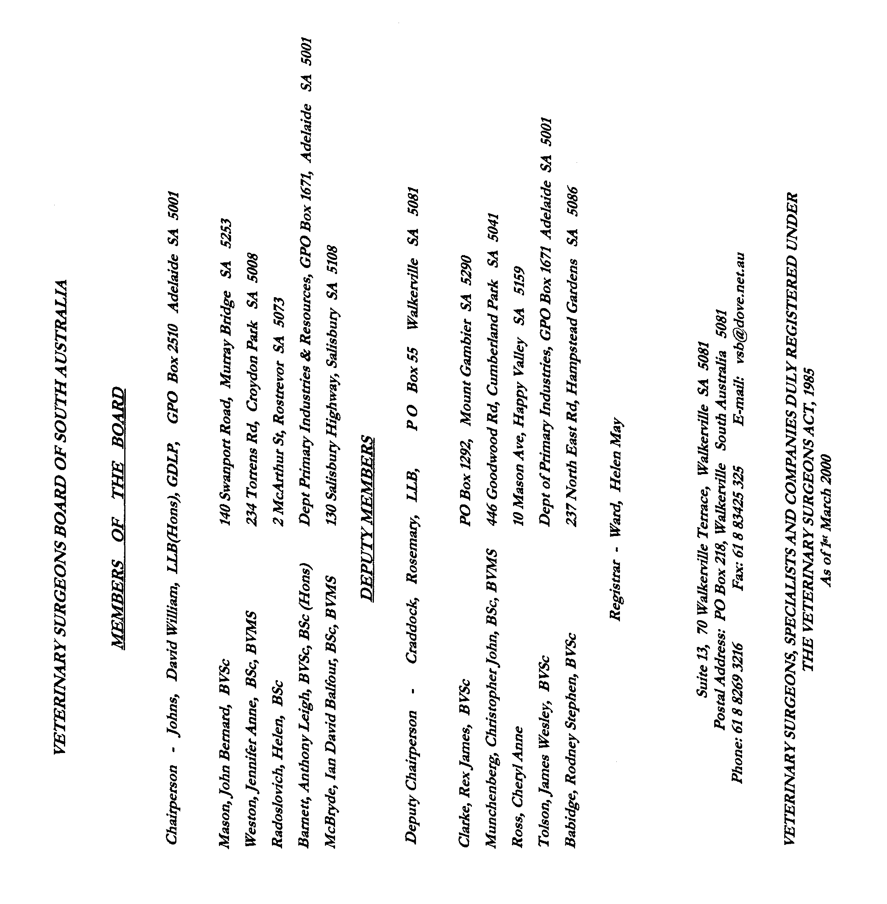
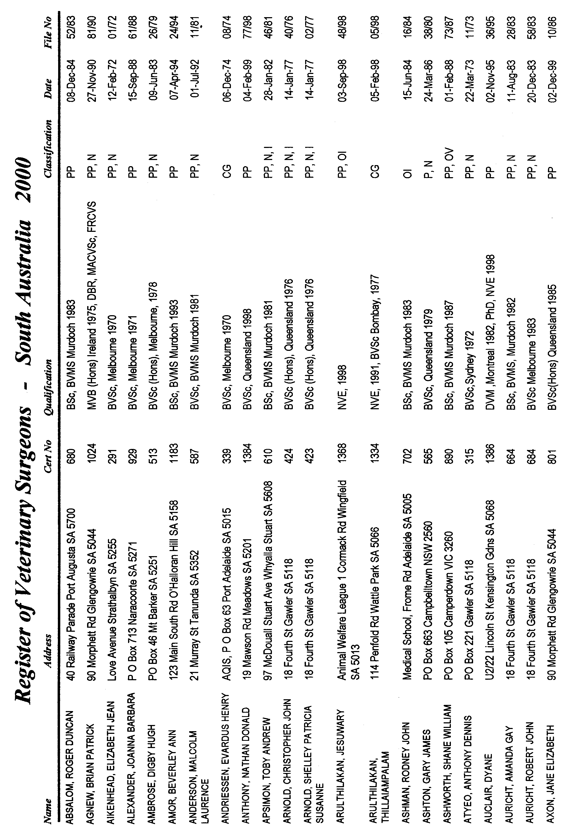
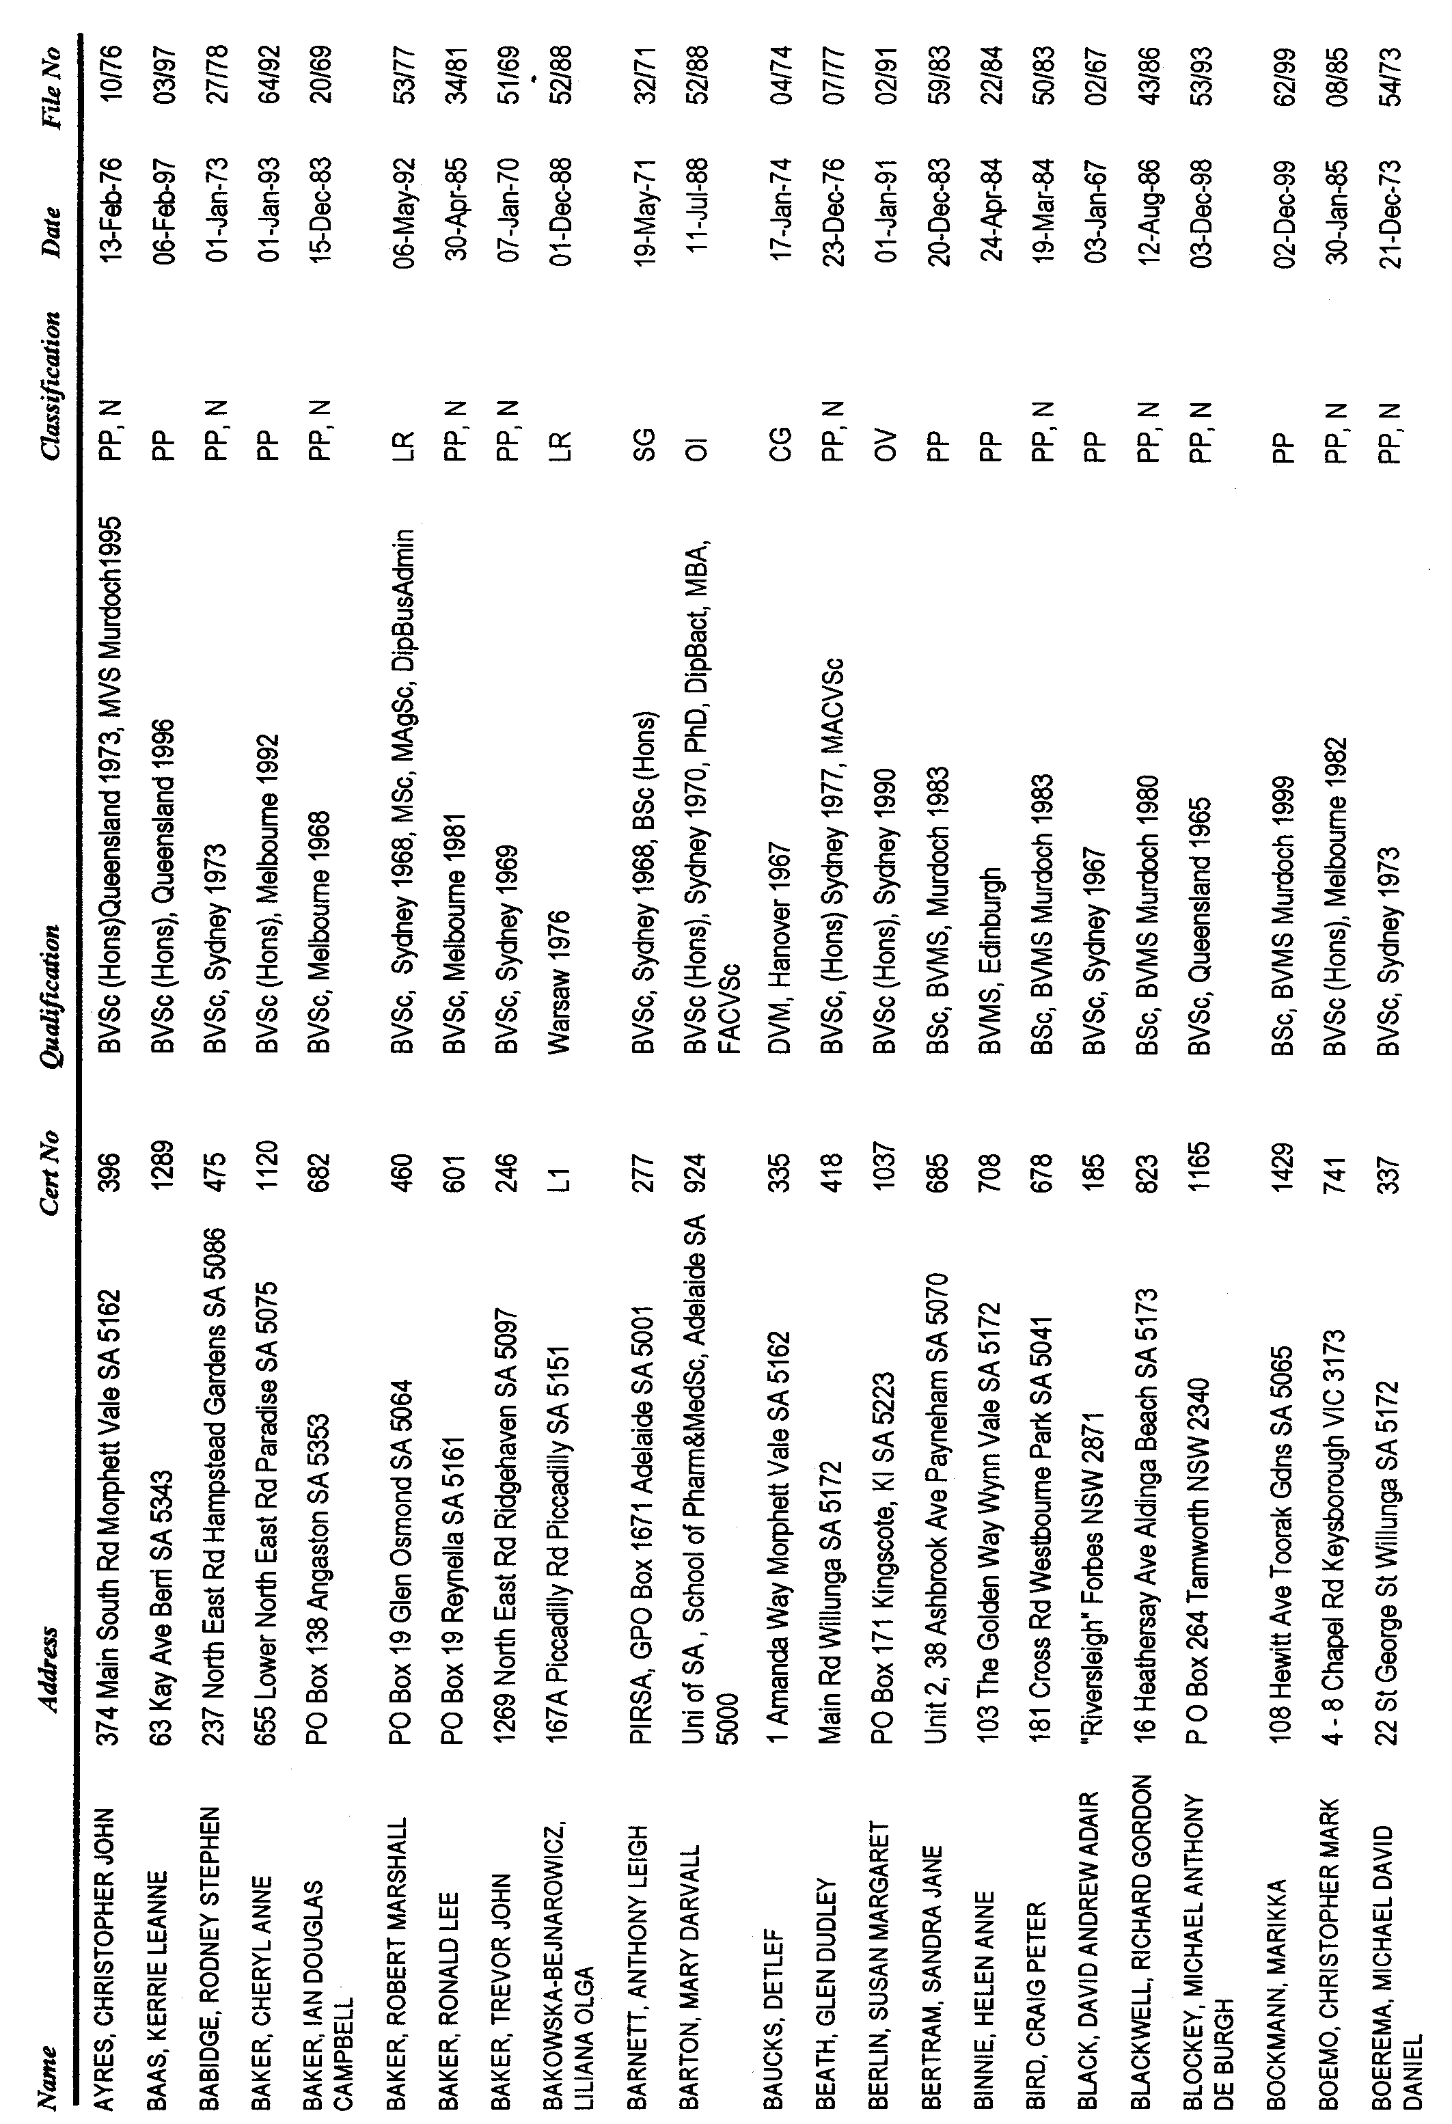
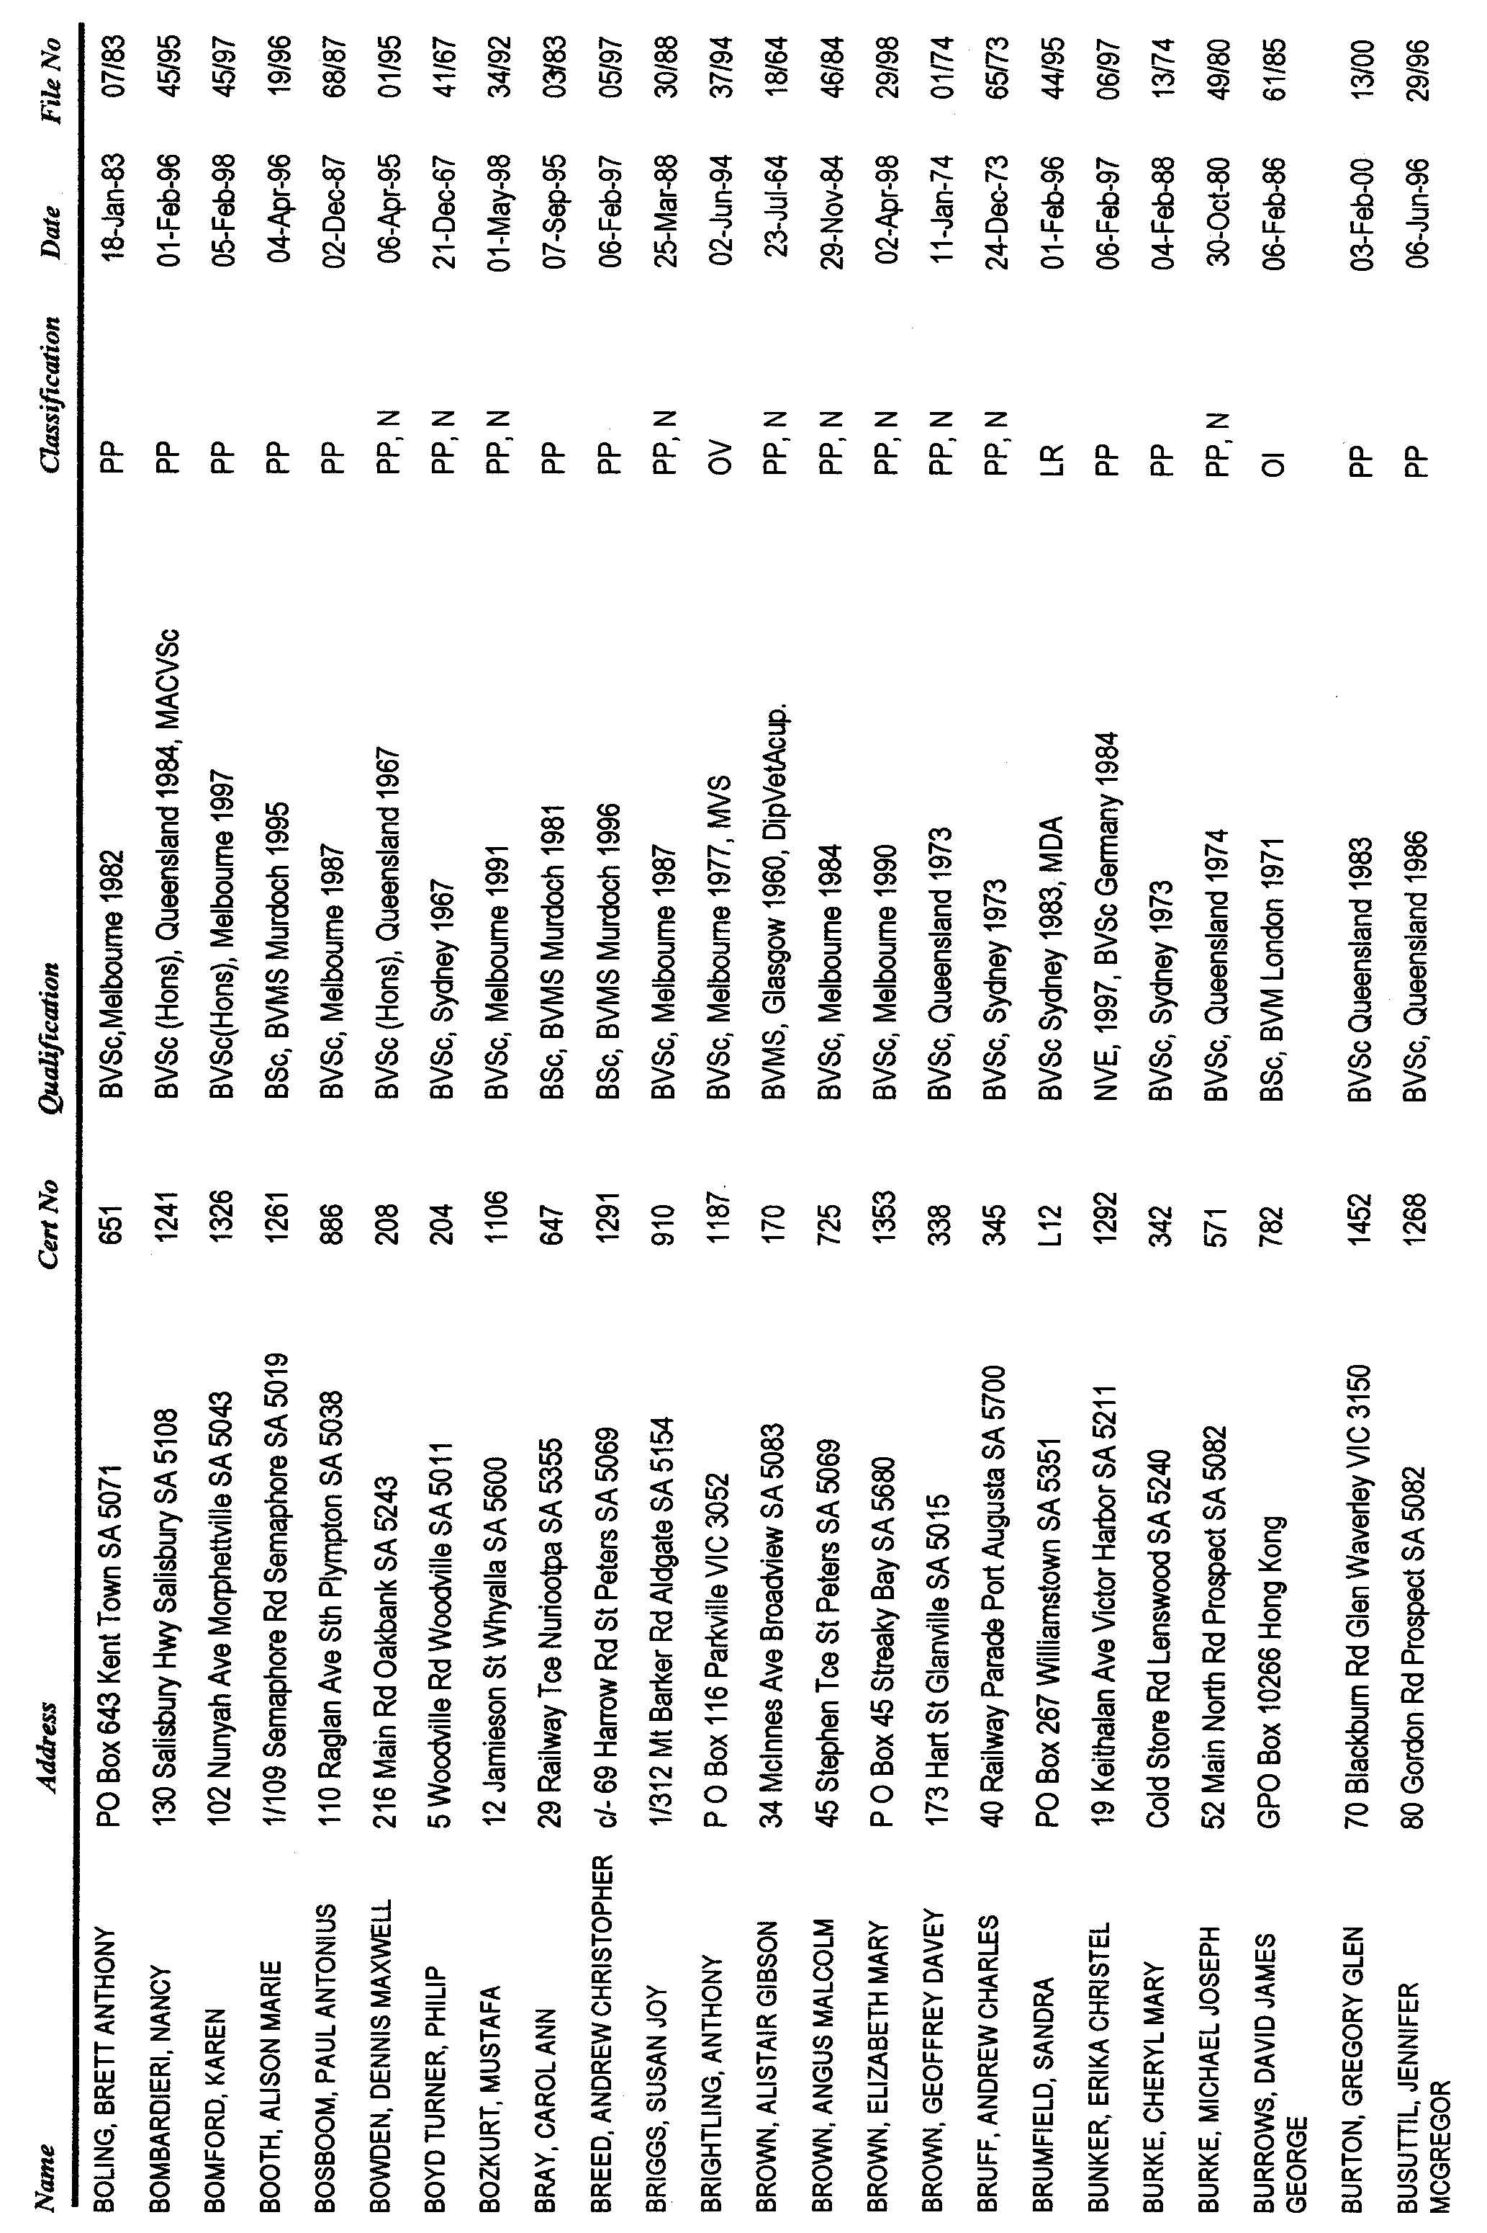
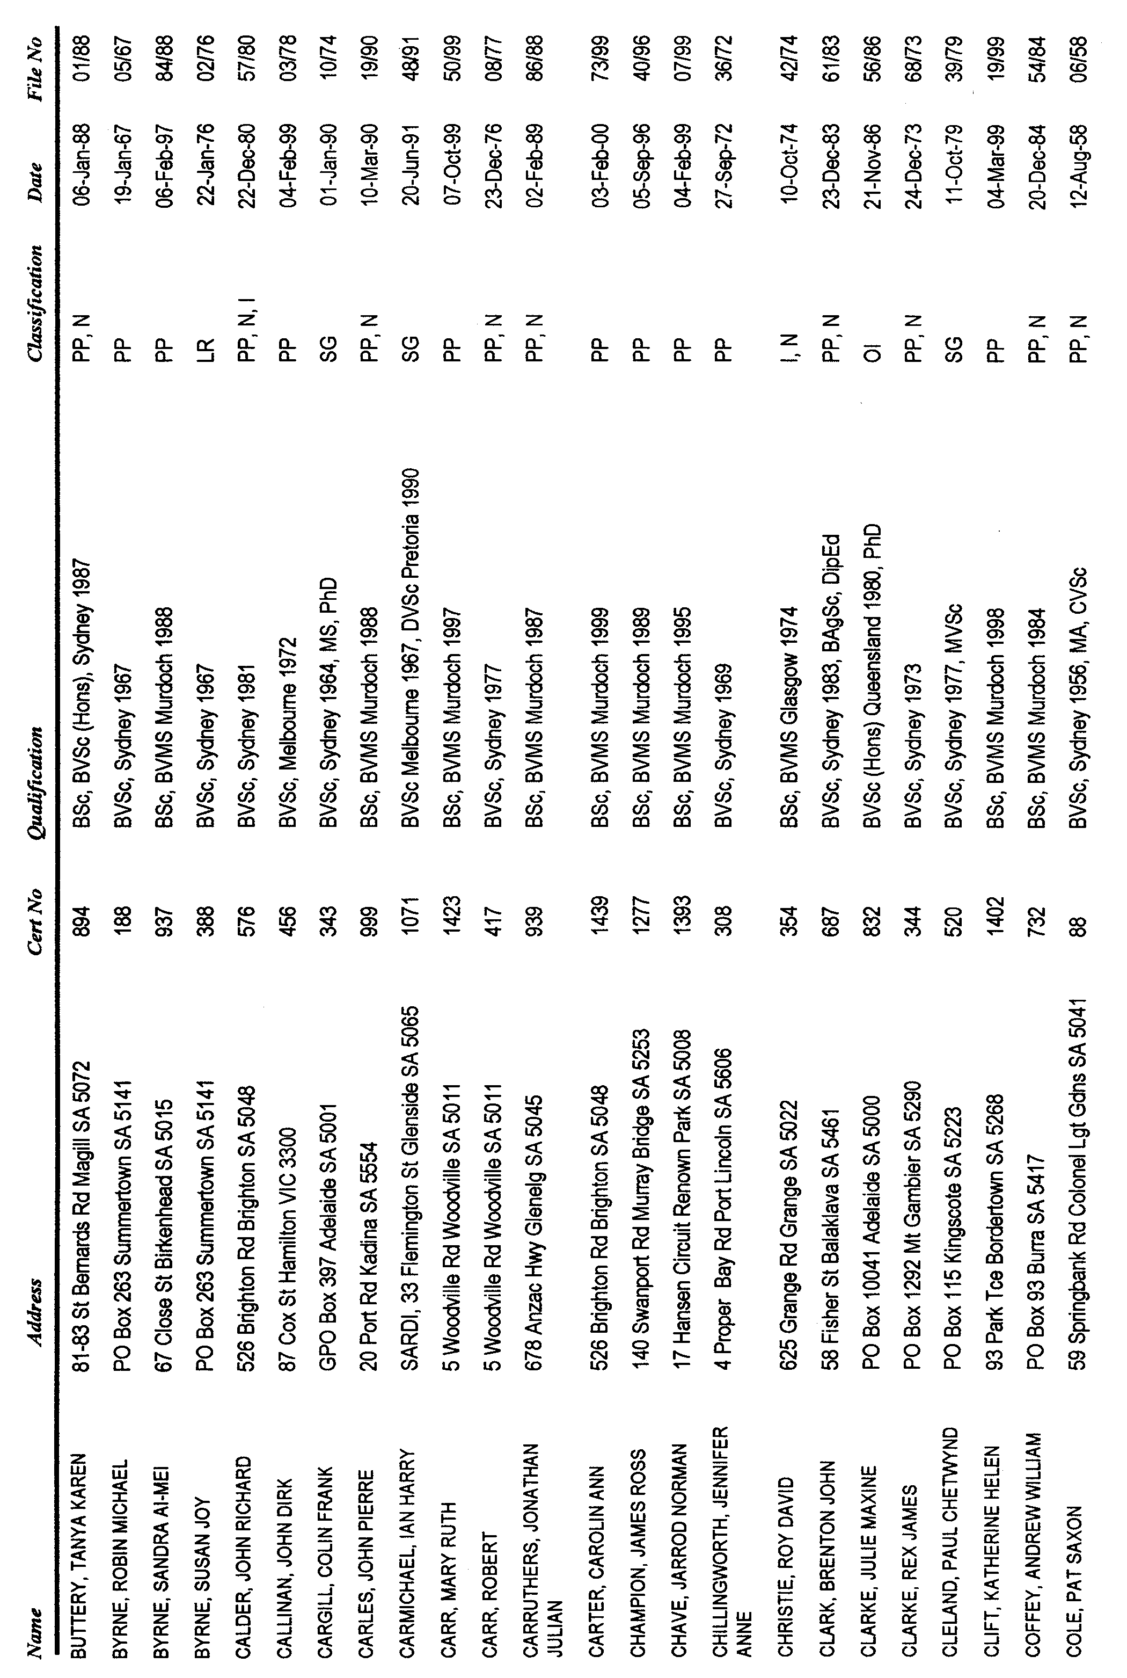
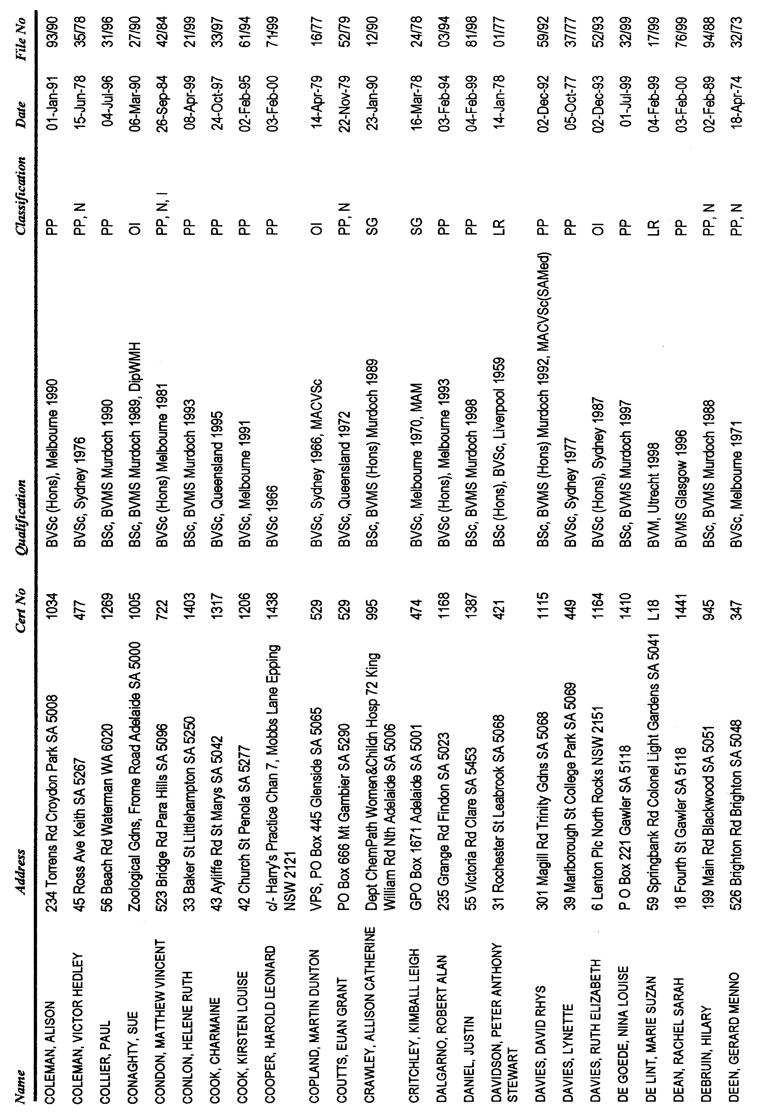
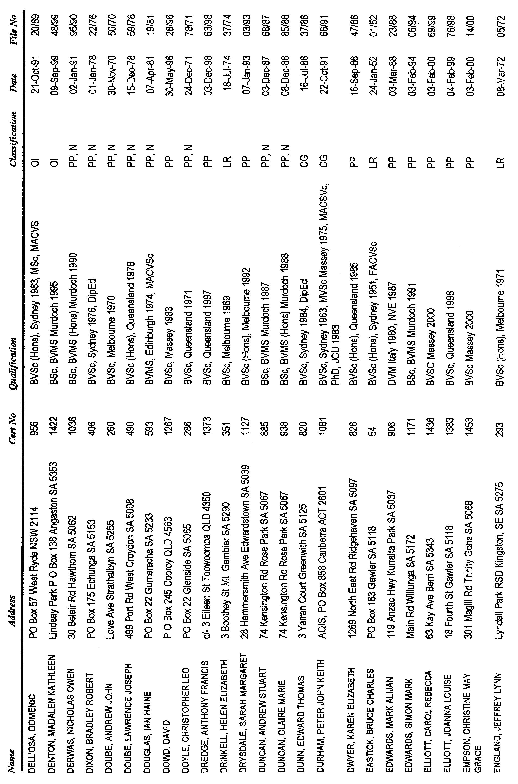
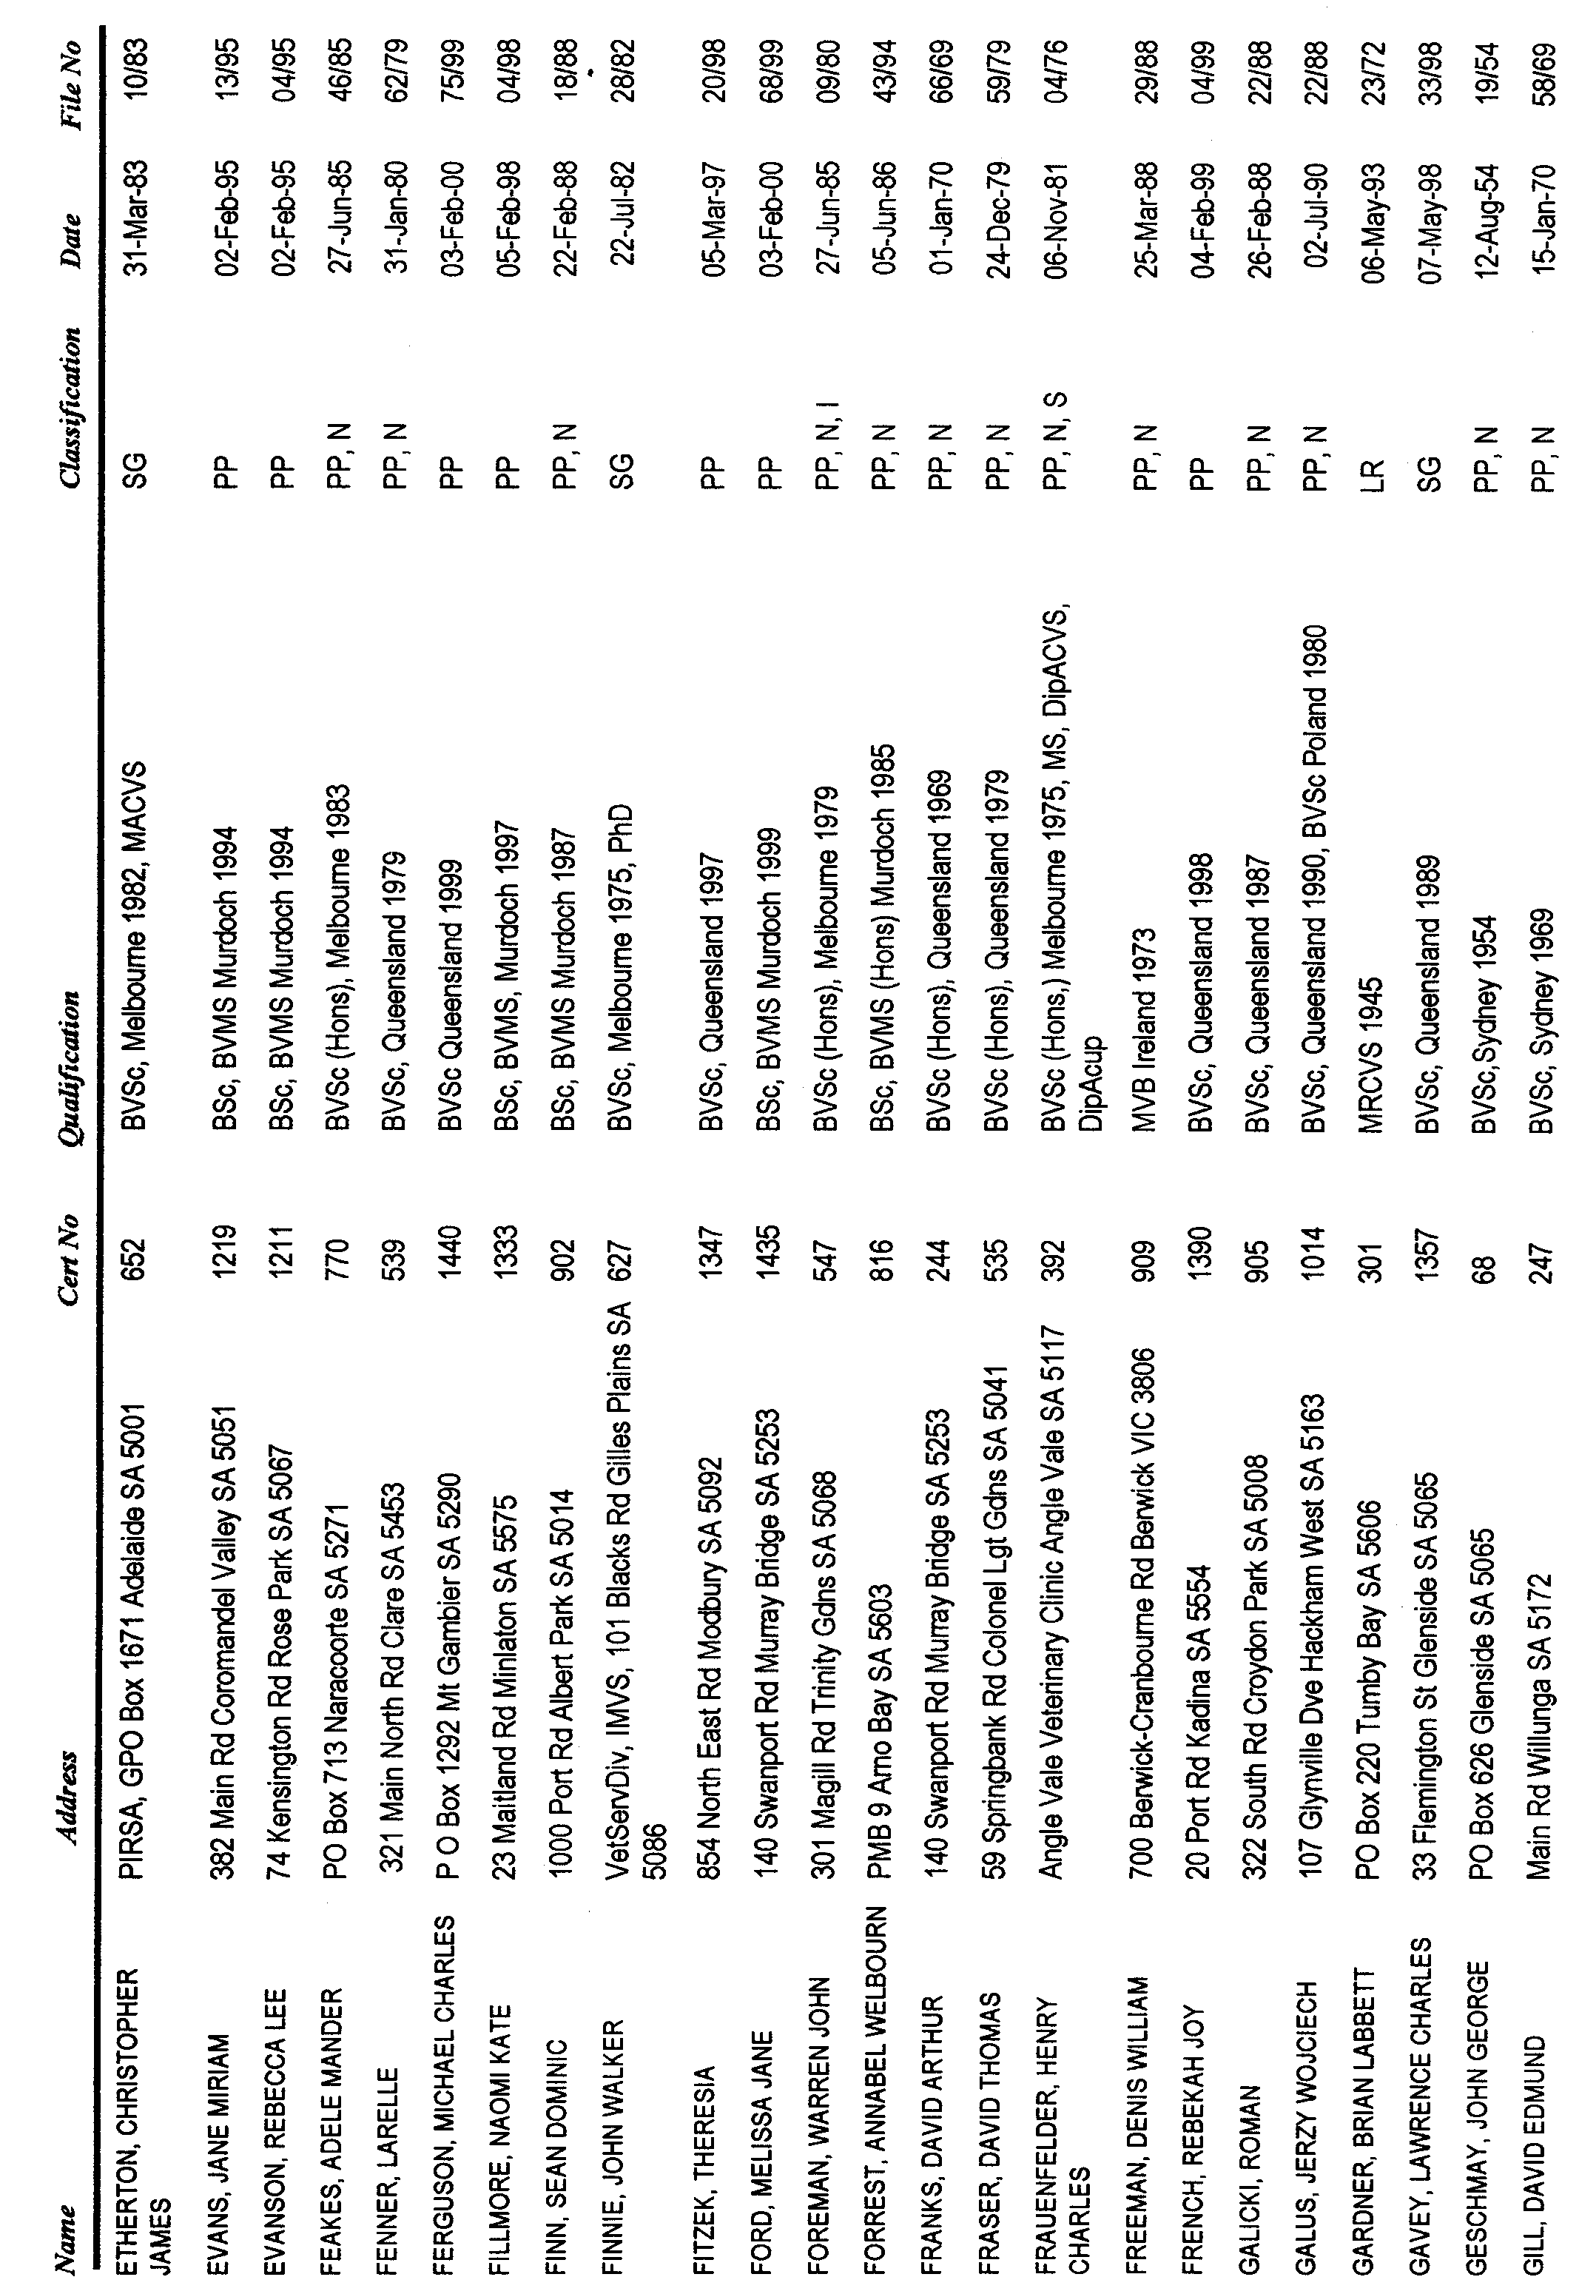
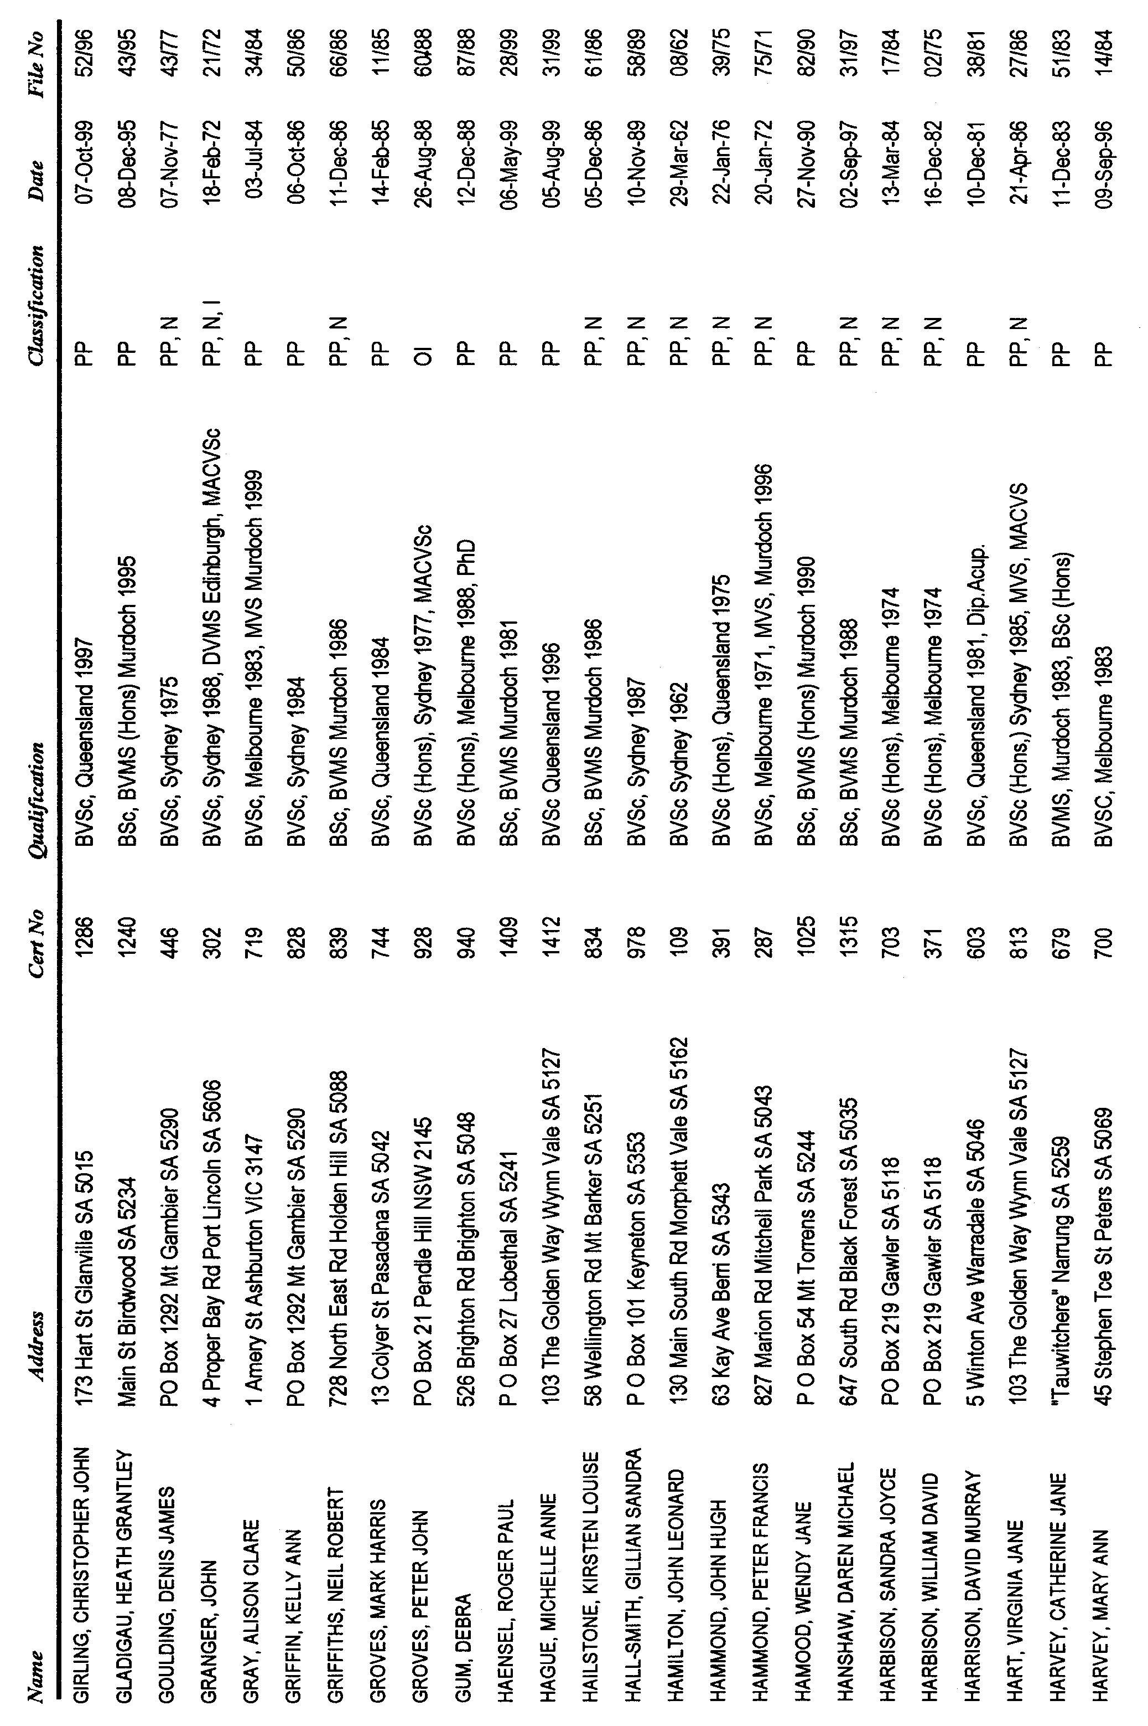
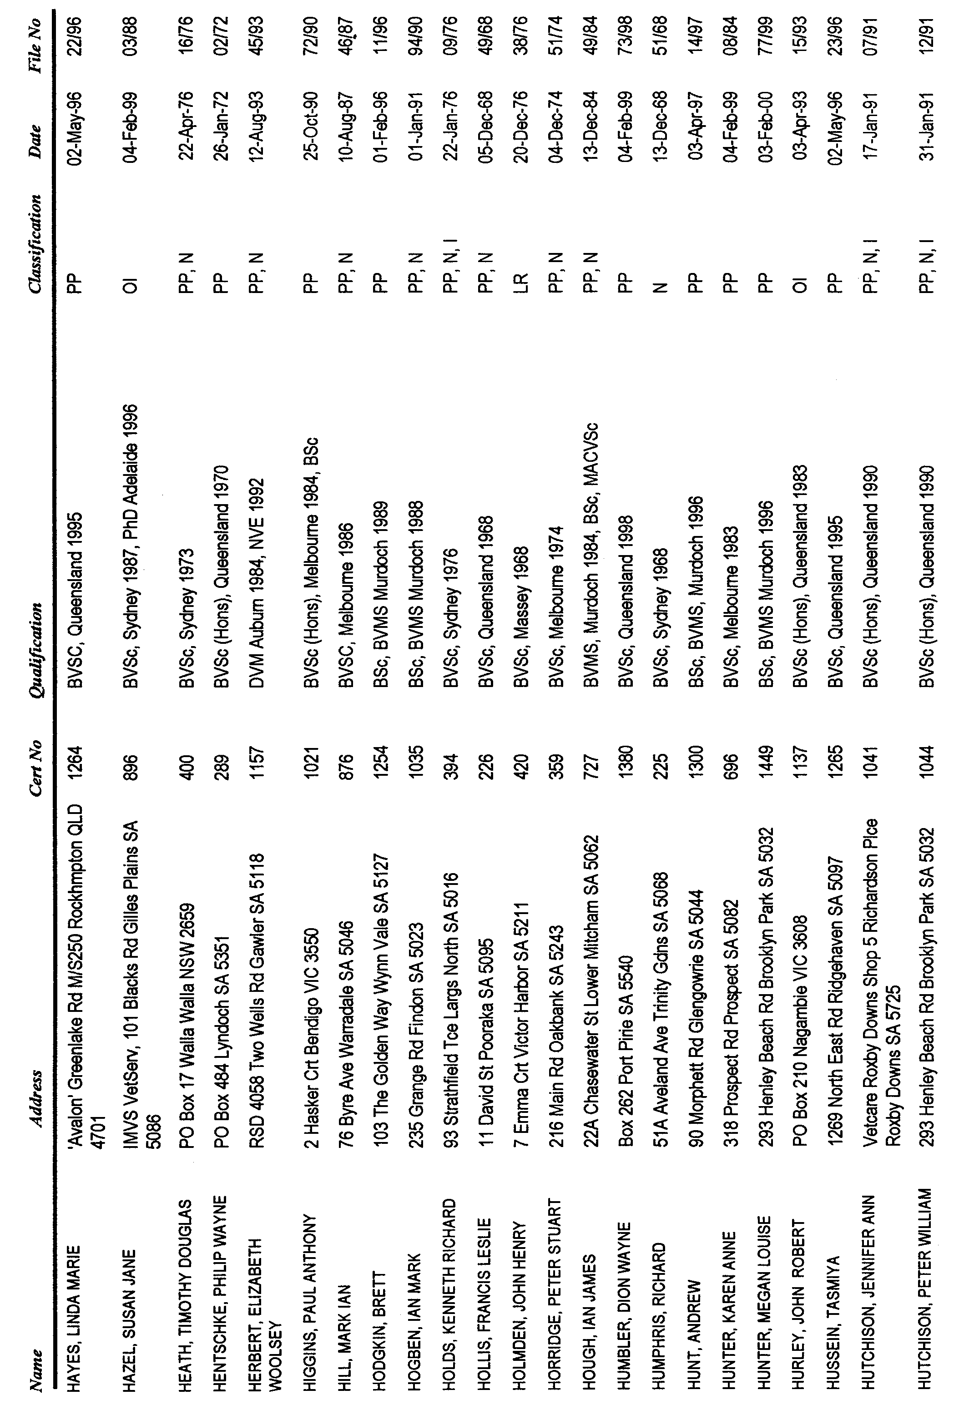
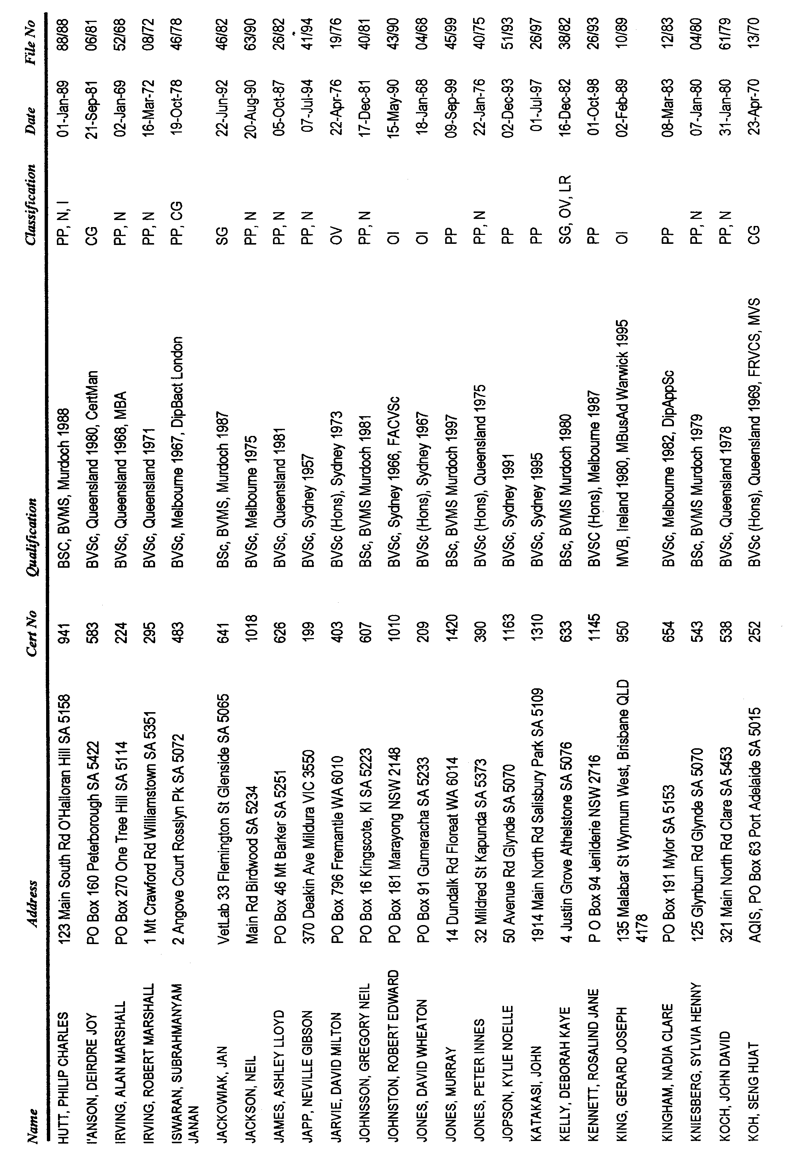
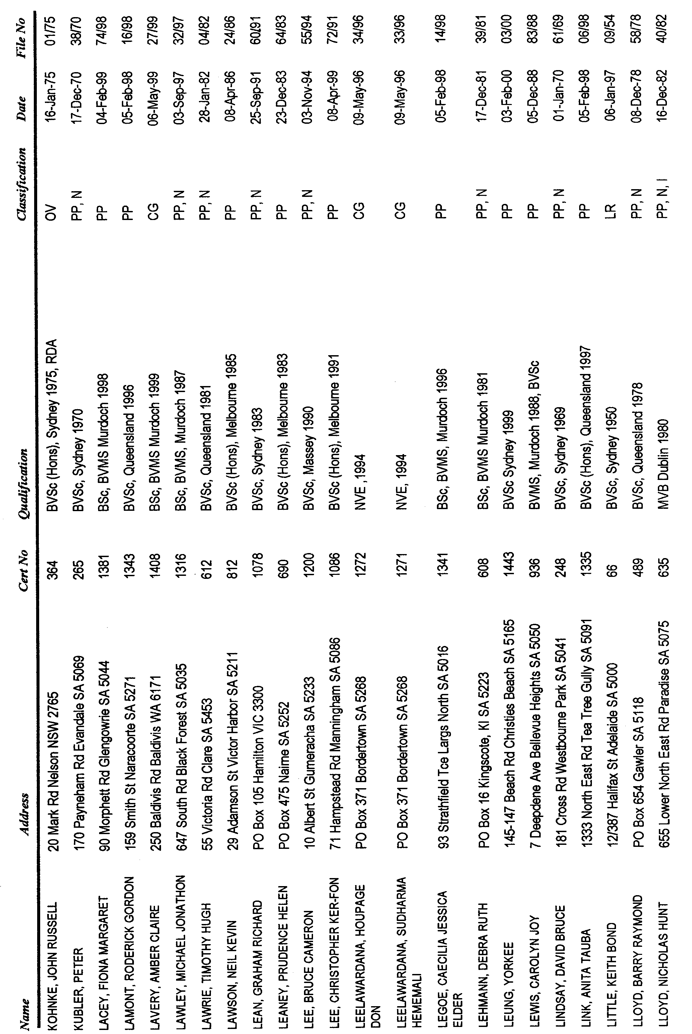
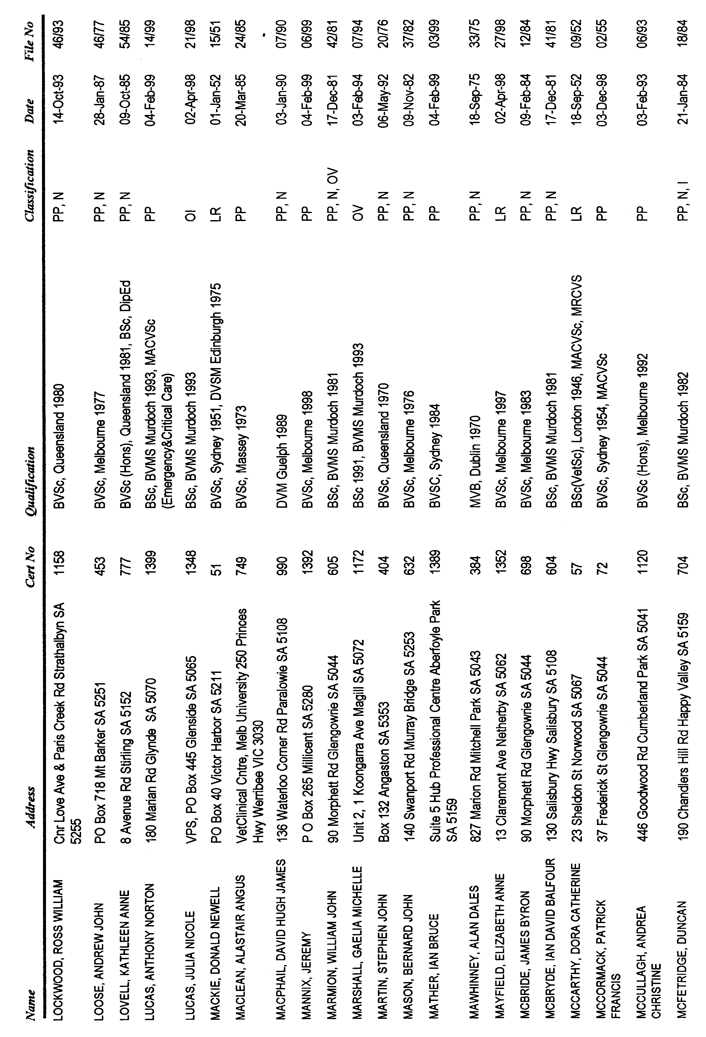
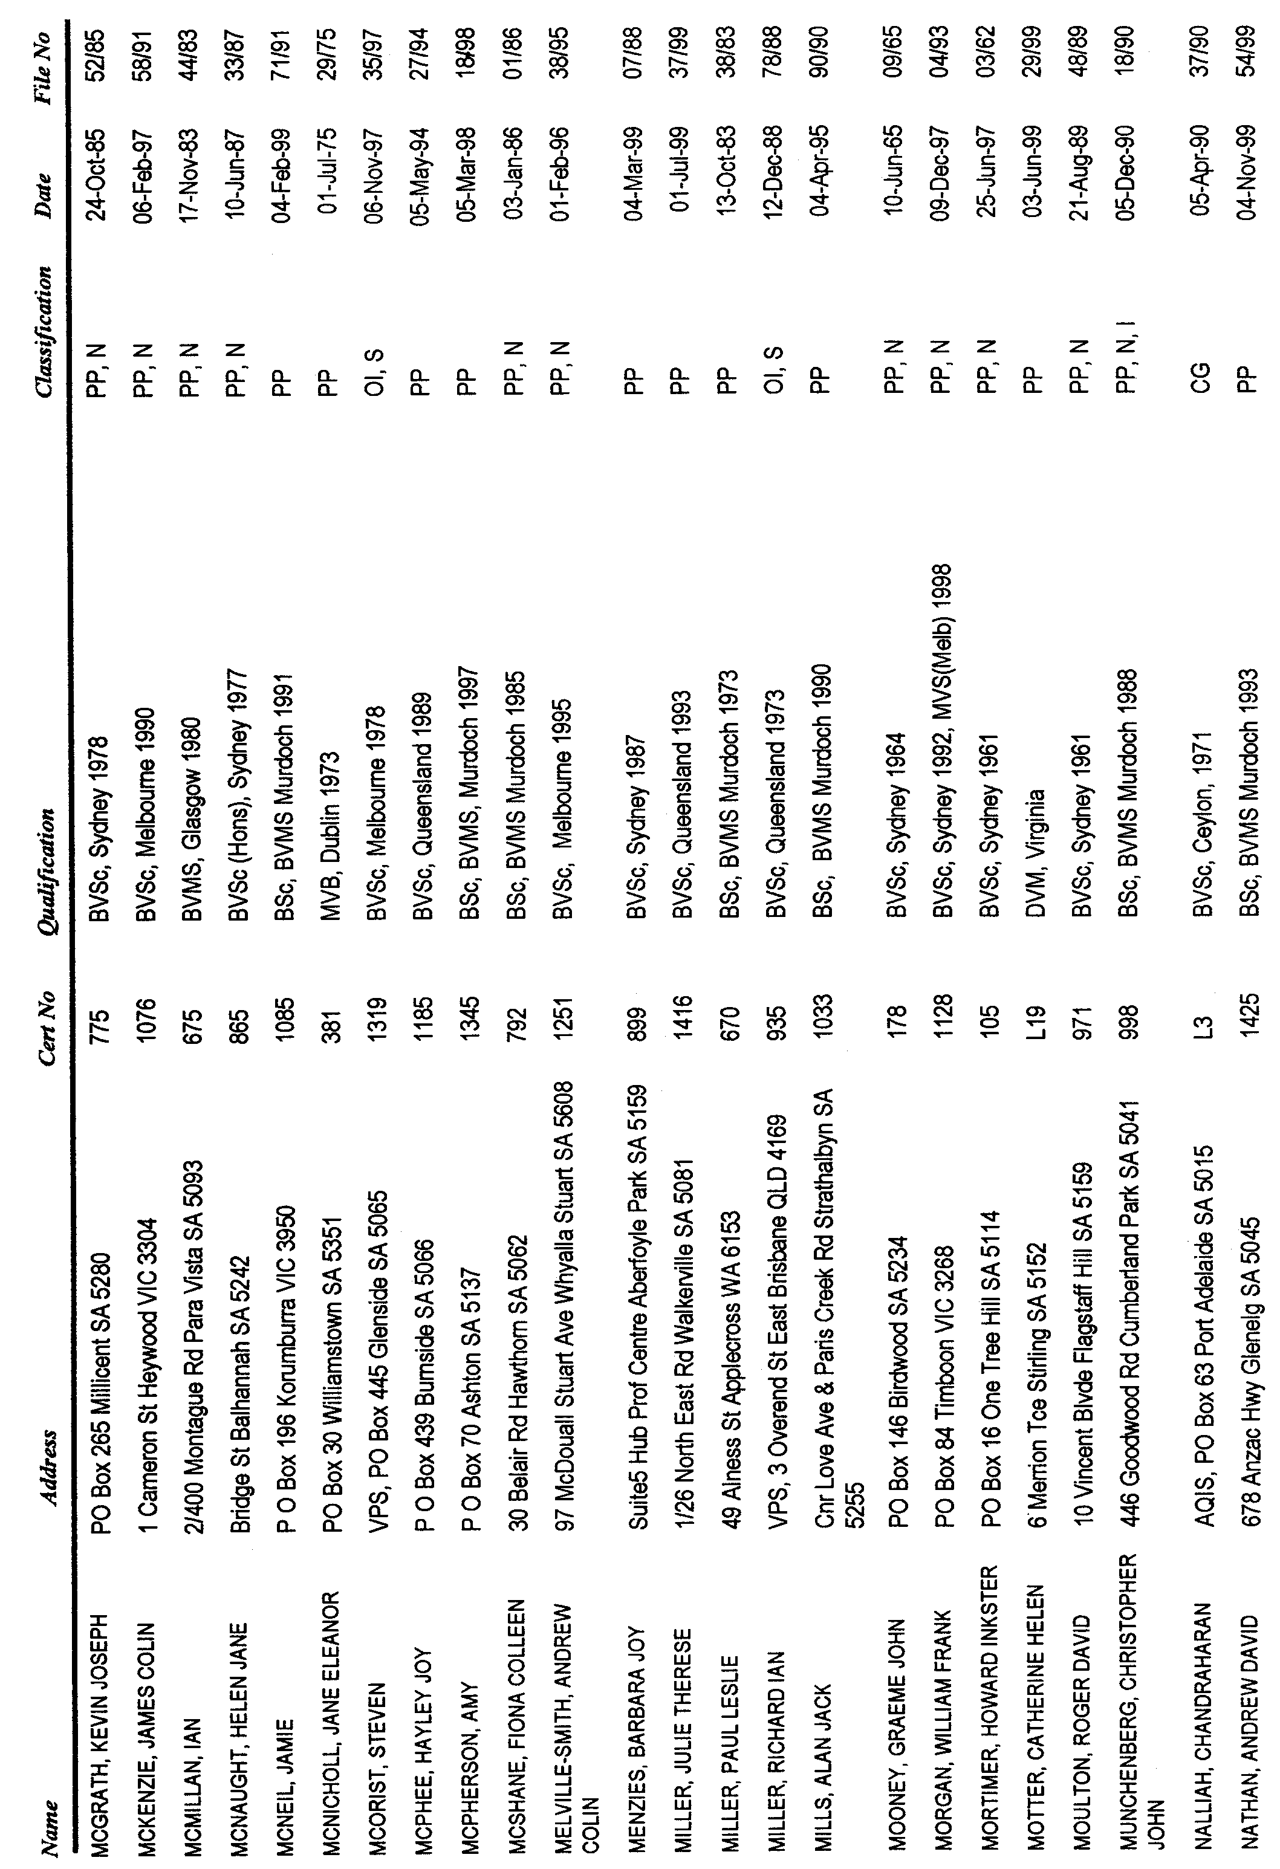
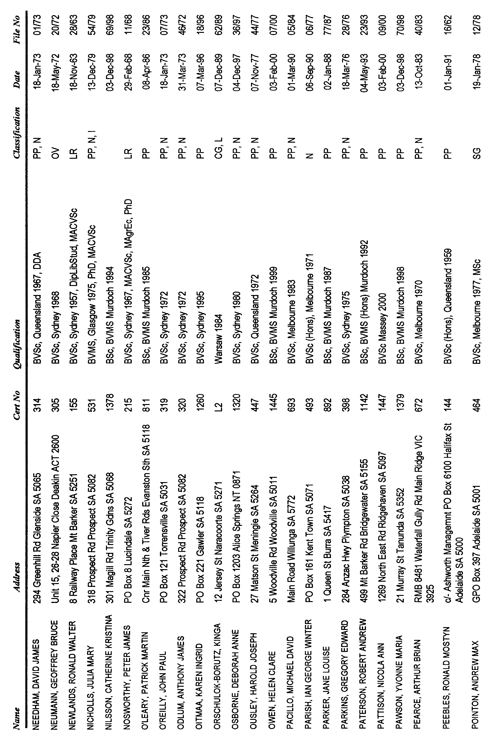
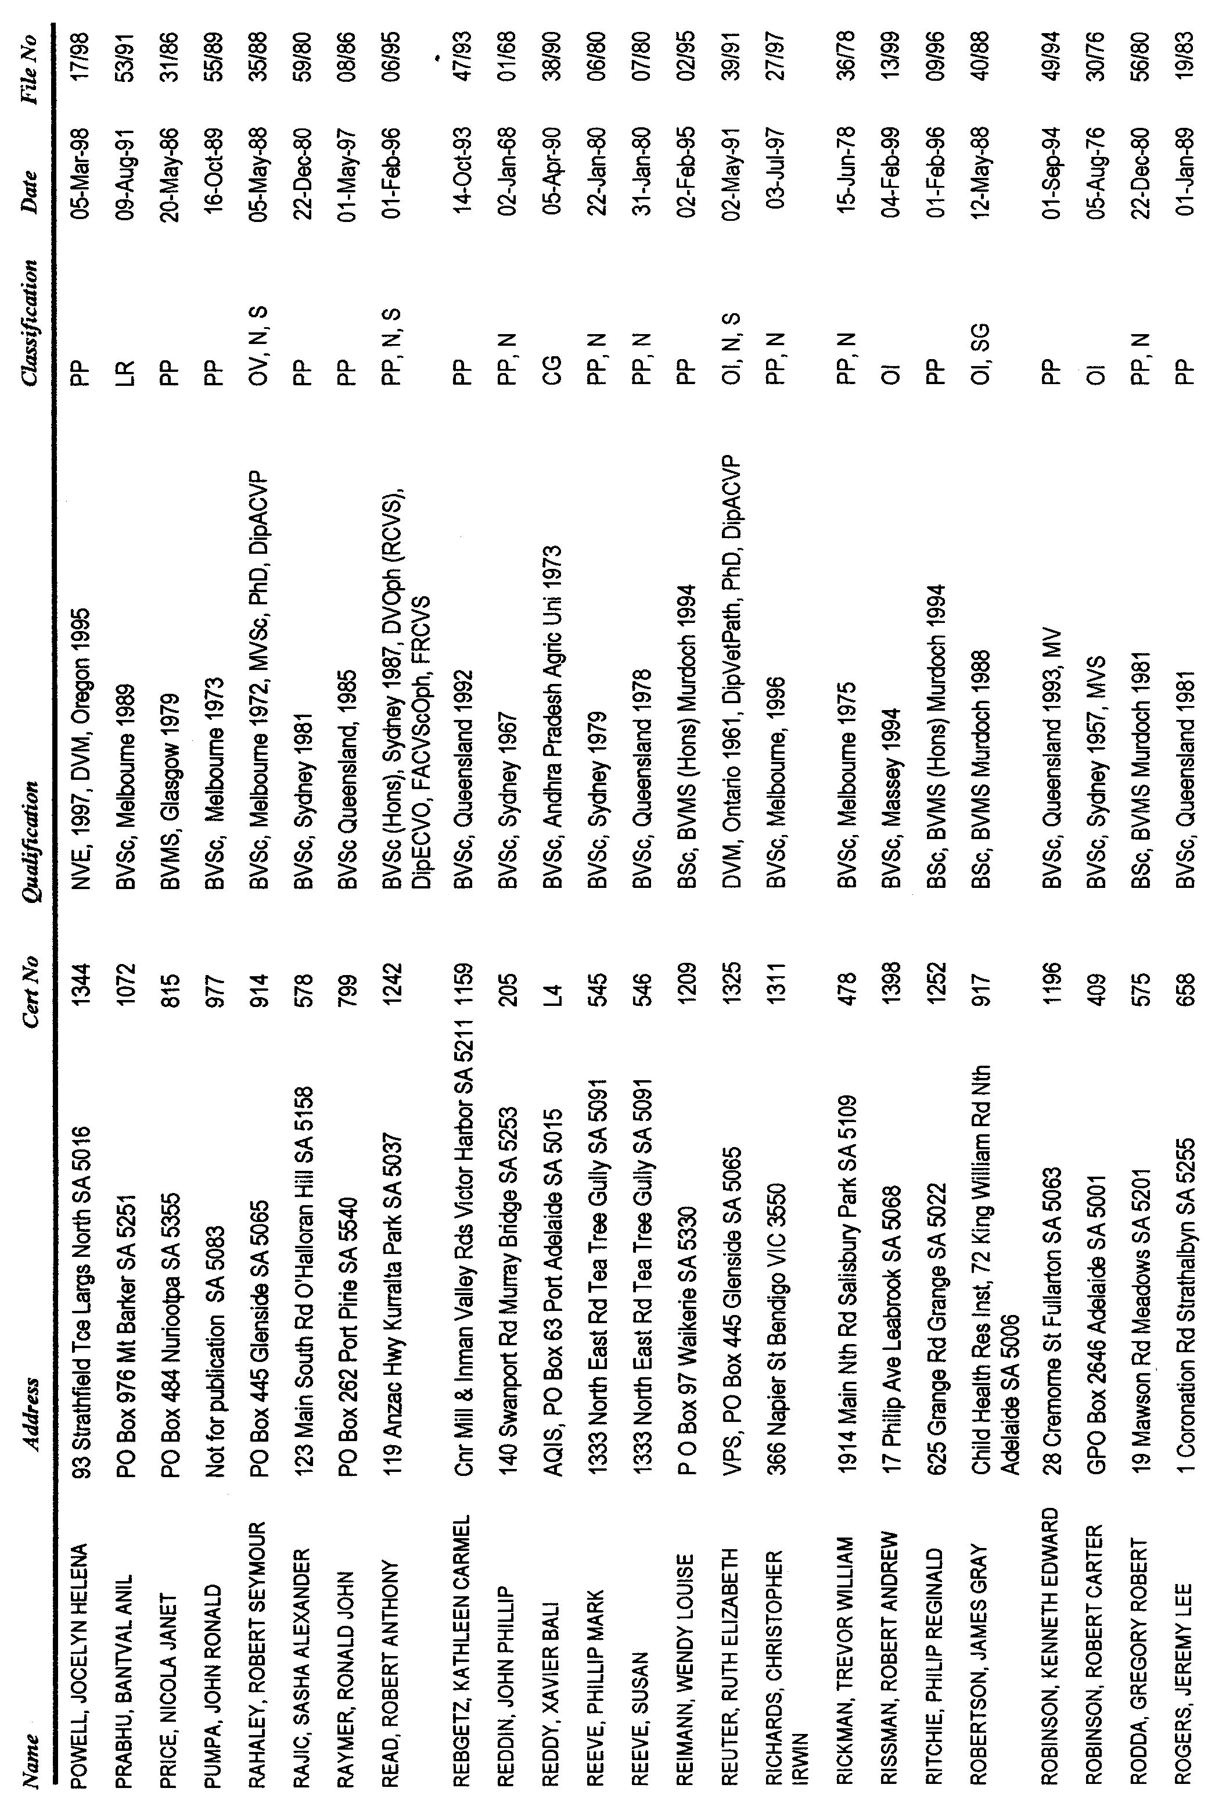
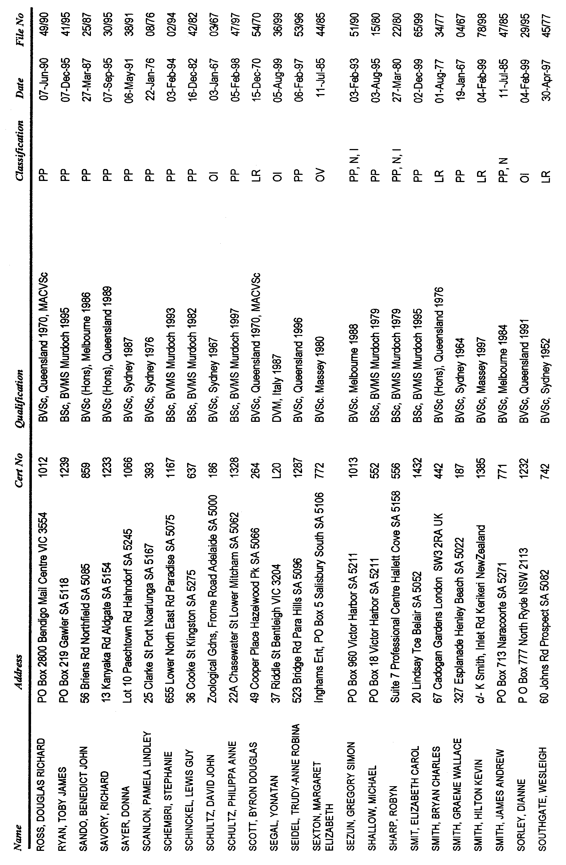
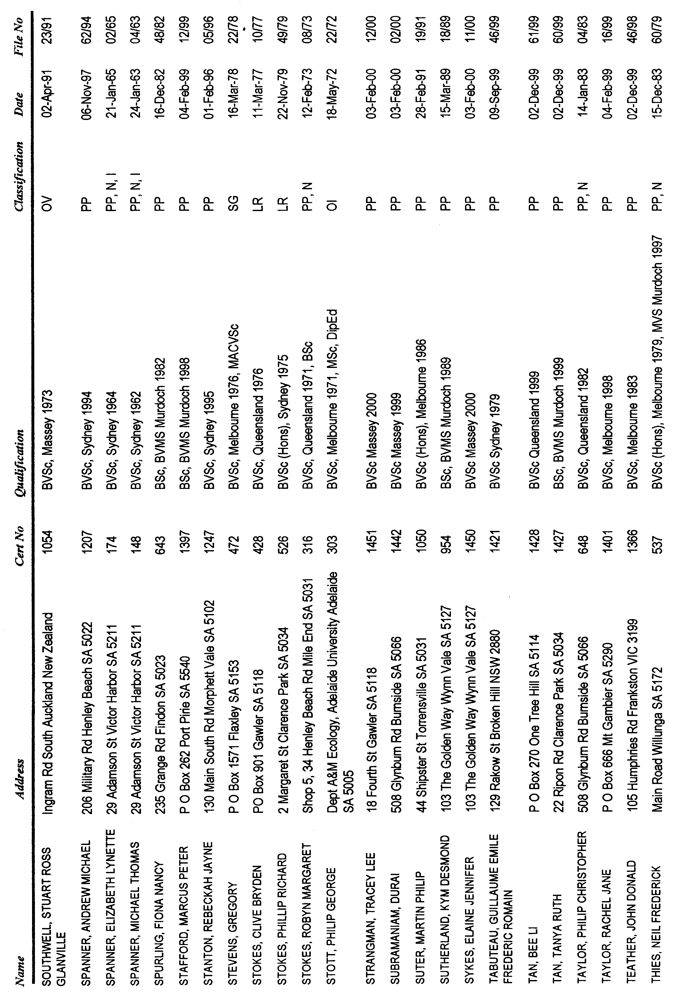
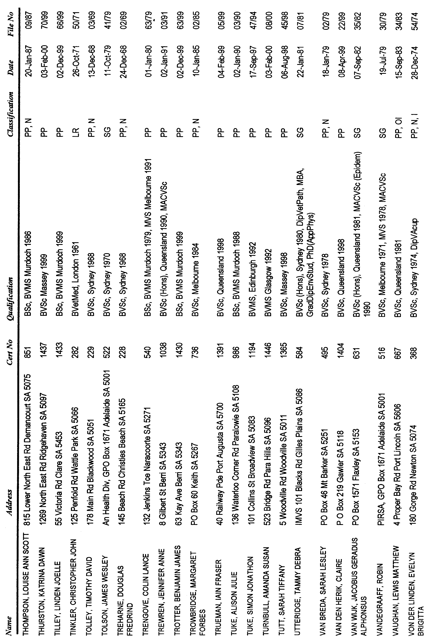
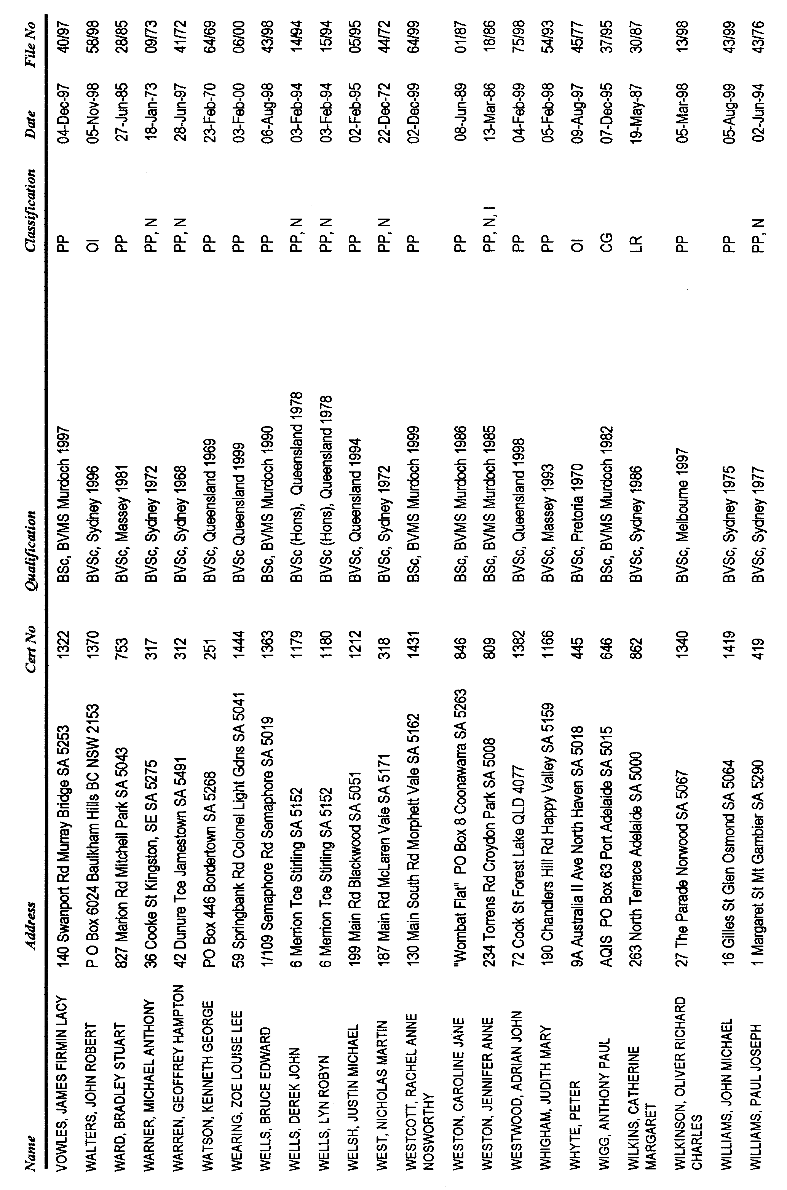
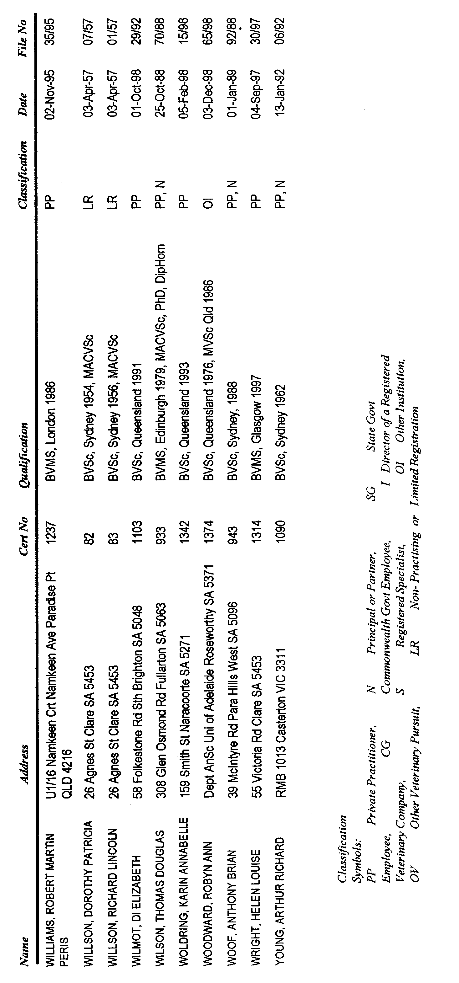
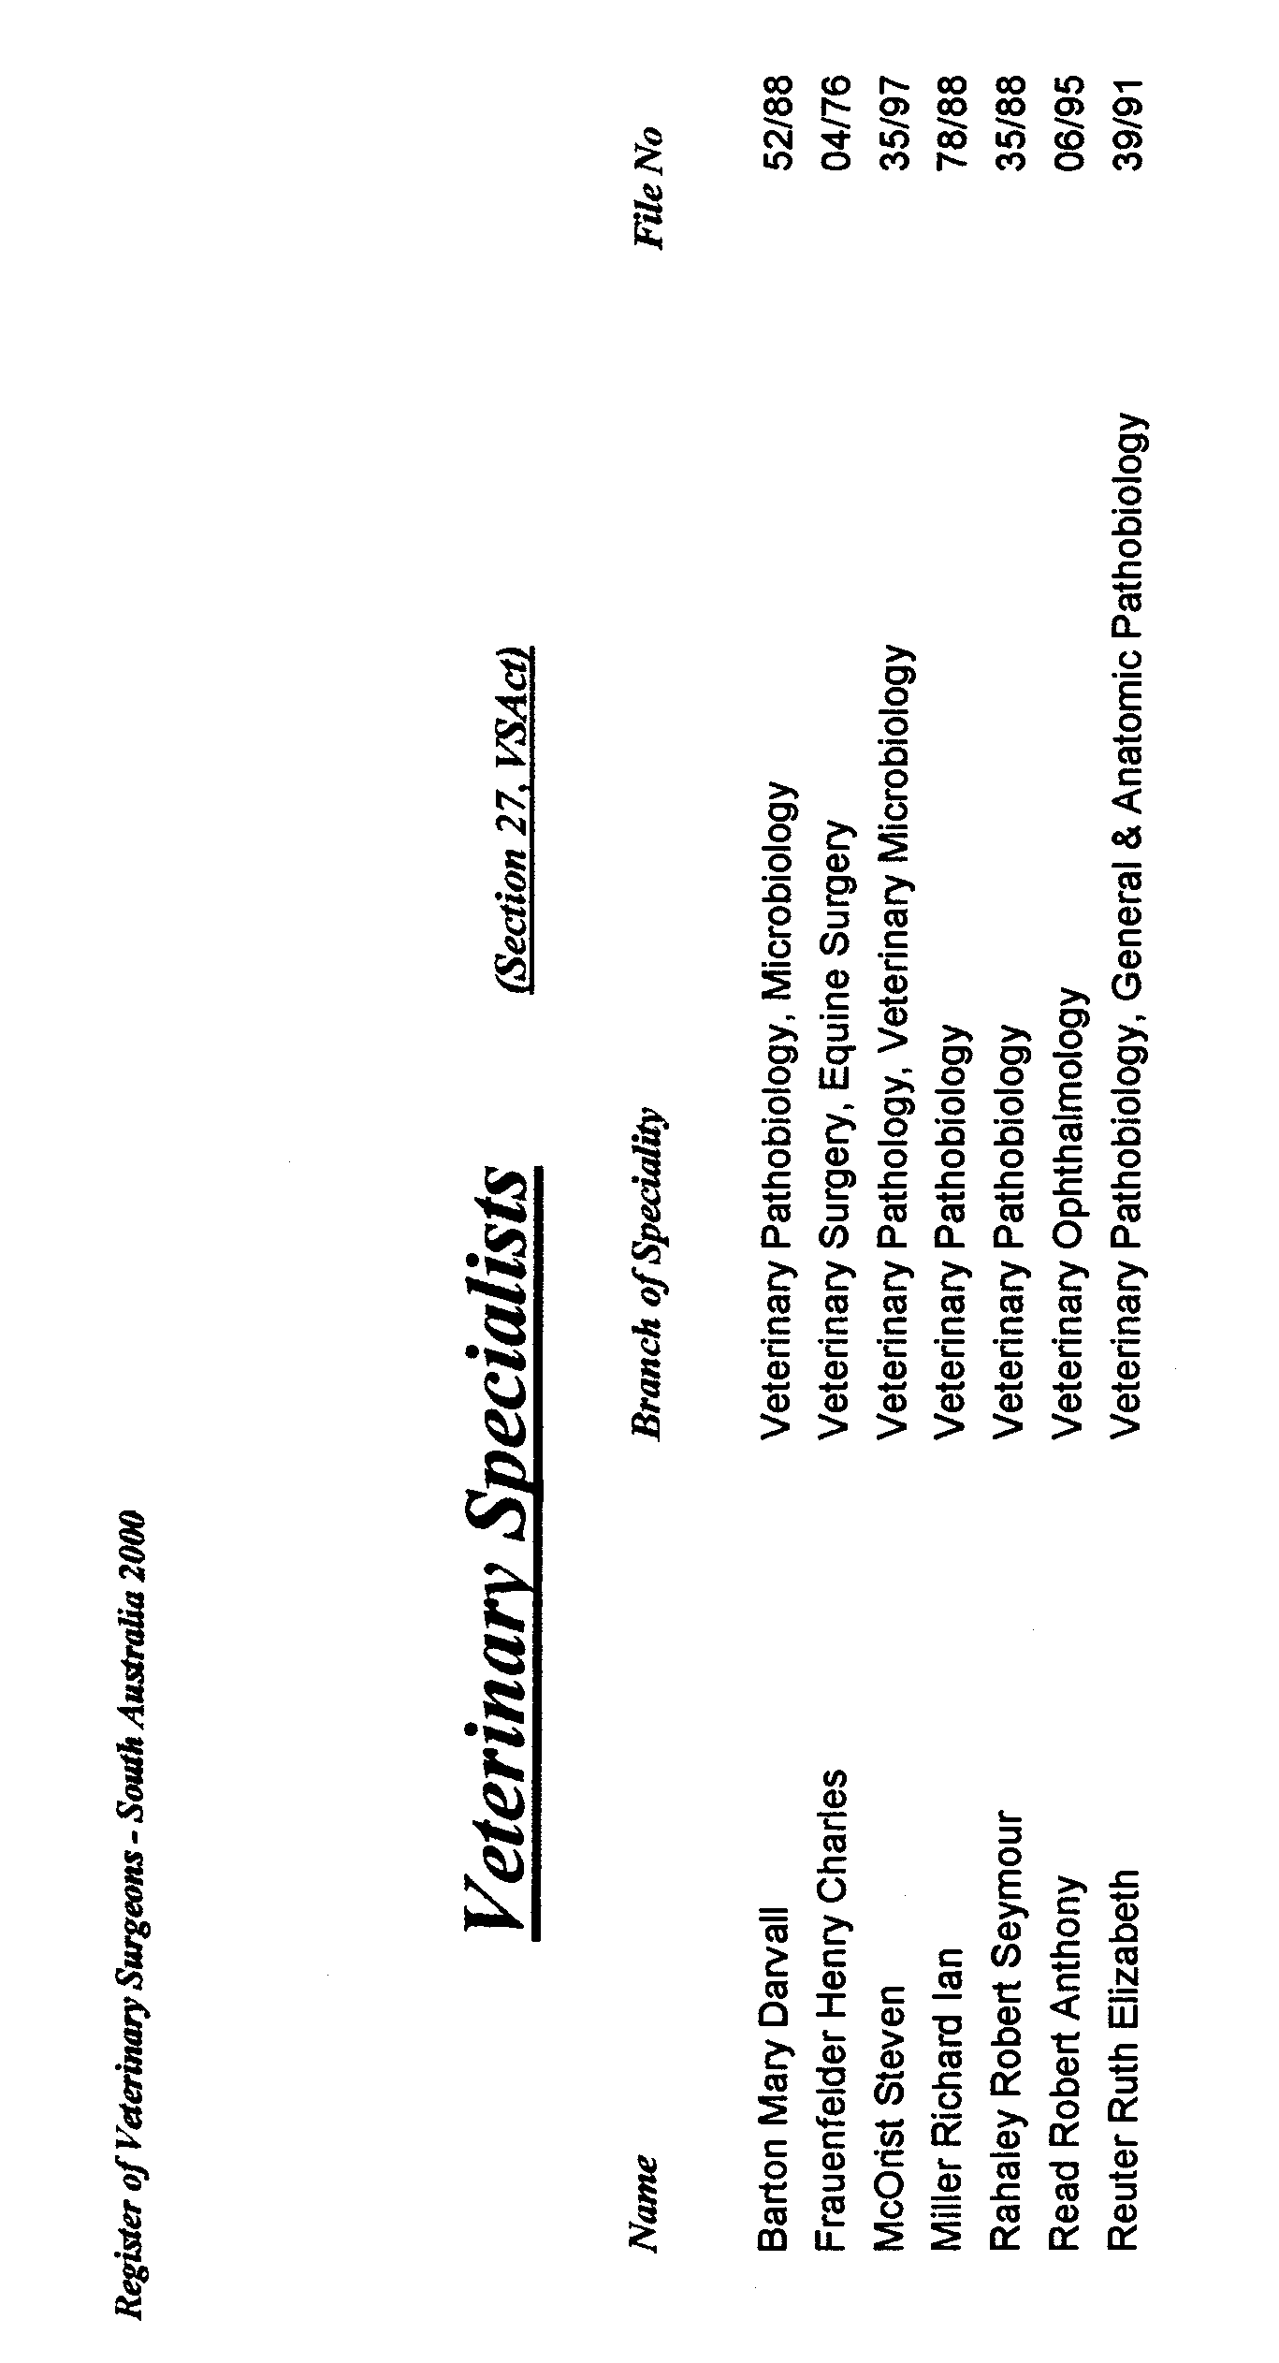
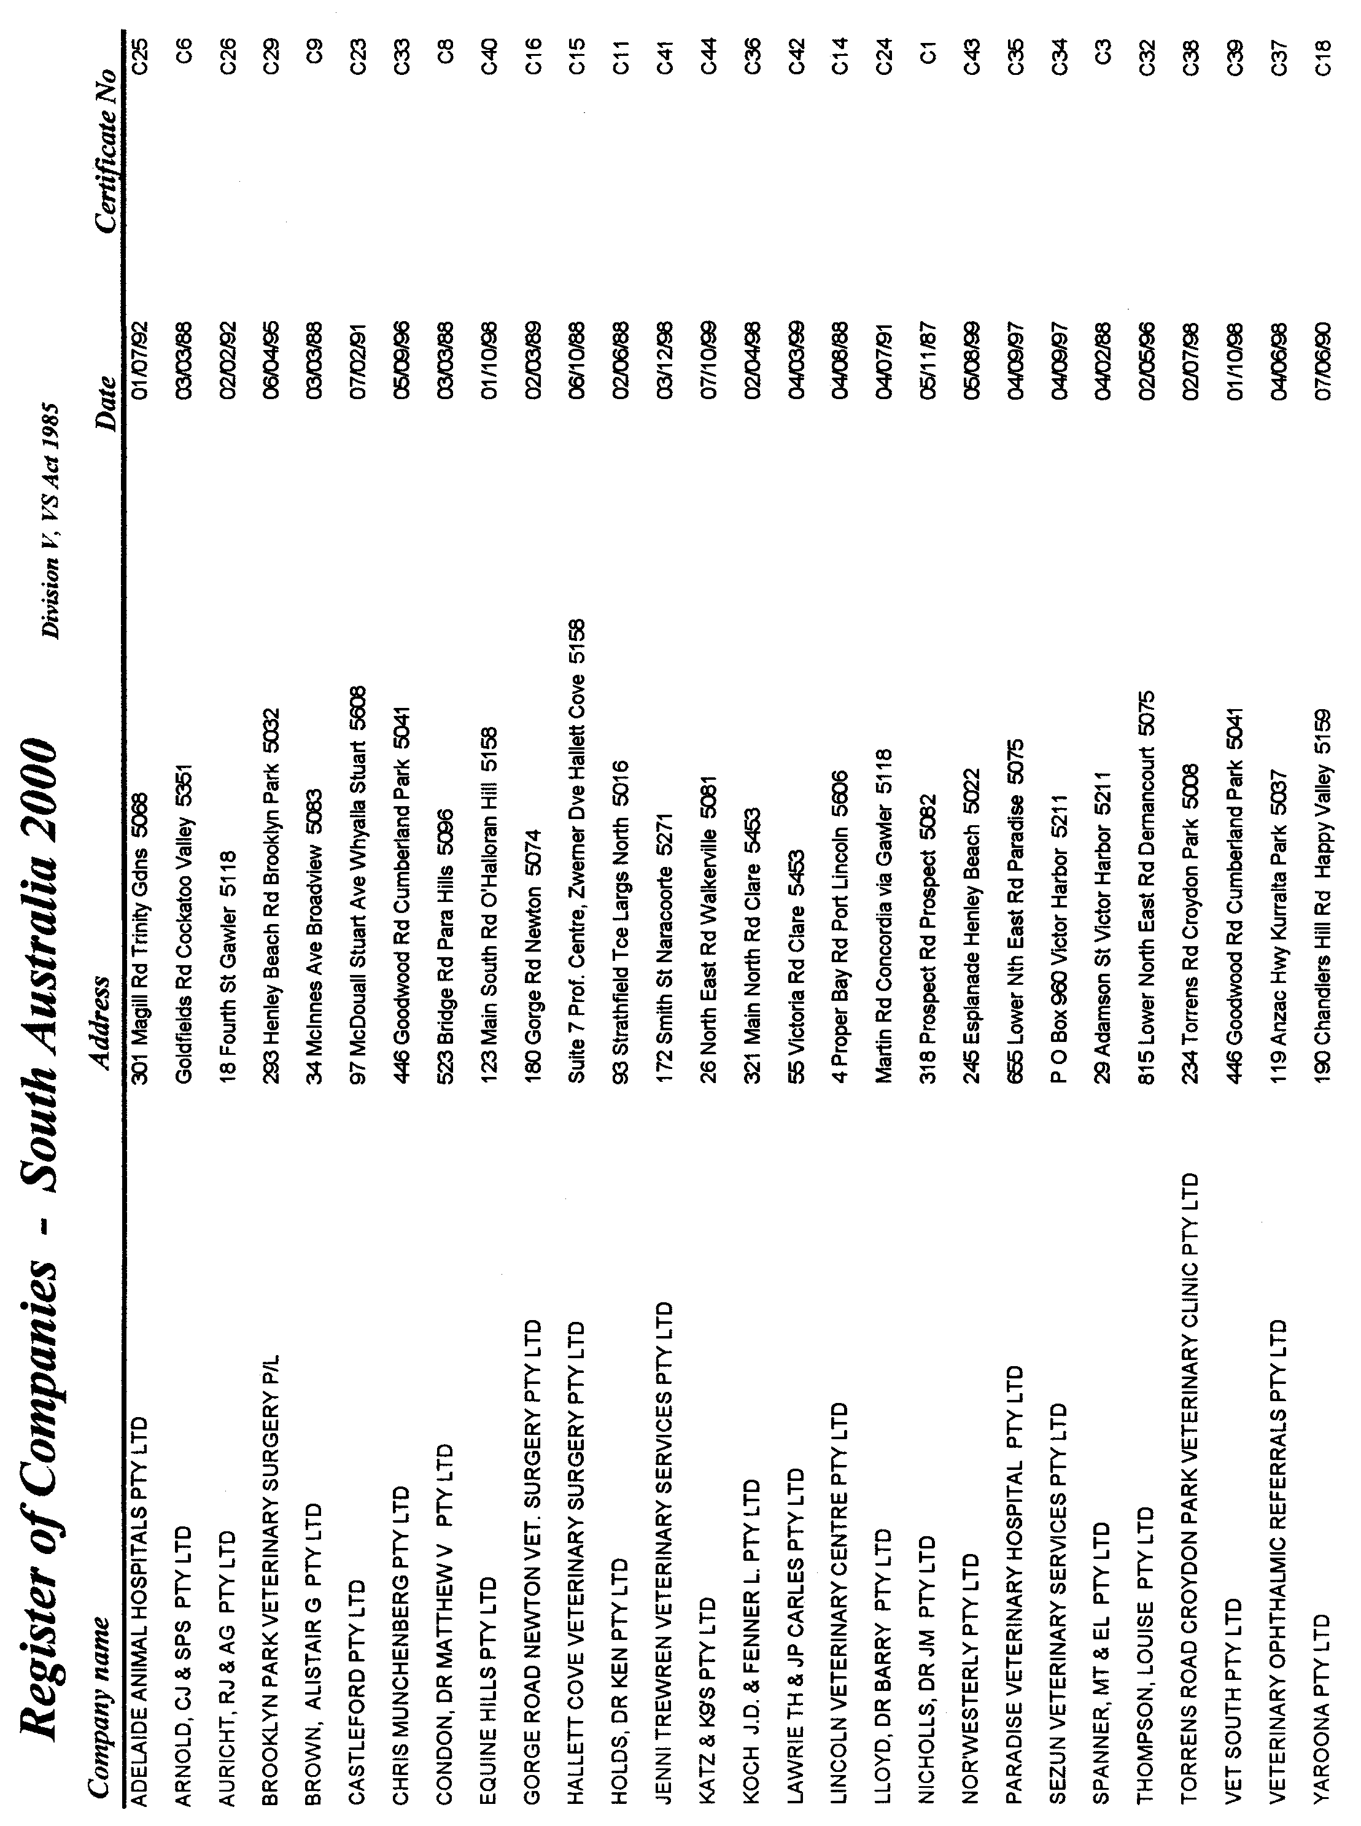
WATER MAINS AND SEWERS

Office of the South Australian Water Corporation
Adelaide, 16 March 2000.

WATER MAINS LAID

Notice is hereby given that the following main pipes or parts of main pipes have been laid down by the South Australian Water Corporation in or near the undermentioned water districts and are now available for a constant supply of water to adjacent land.

ADELAIDE WATER DISTRICT

CITY OF CHARLES STURT
Banks Avenue, Flinders Park. p20

CITY OF MITCHAM
Kiley Court, St. Marys. p9

CITY OF ONKAPARINGA
Candy Road, Happy Valley. p27
Tandana Court, Happy Valley. p27

CITY OF PORT ADELAIDE ENFIELD
Folland Avenue, Northfield. p2
Vine Terrace, Klemzig. p3

CITY OF SALISBURY
Sheaoak Drive, Mawson Lakes. p28
Elder Circuit, Mawson Lakes. p28
Easement in lot 532, Elder Circuit, Mawson Lakes. p28
Maple Court, Mawson Lakes. p28
The Walk, Mawson Lakes. p29
Victoria Court, Mawson Lakes. p29
Lakewood Court, Mawson Lakes. p29

CITY OF TEA TREE GULLY
The Parkway, Holden Hill. p19

CORPORATE TOWN OF WALKERVILLE
Edmund Street, Vale Park. p21

ENCOUNTER BAY COUNTRY LANDS WATER
DISTRICT

DISTRICT OF ALEXANDRINA COUNCIL

In and across Strathalbyn-Goolwa Road, Goolwa. This main is available on application only. p7

Easement in railway land (part section 2377, hundred of Goolwa), Goolwa. This main is available on application only. p7

Corio Terrace, Goolwa. This main is available on application only. p8

GOOLWA WATER DISTRICT

DISTRICT OF ALEXANDRINA COUNCIL
Strathalbyn-Goolwa Road, Goolwa. This main is available on application only. p7
Corio Terrace, Goolwa. This main is available on application only. p7 and 8

TOWNSHIP OF LOXTON WATER DISTRICT

DISTRICT OF LOXTON WAIKERIE
Barker Street, Loxton. p26

MANNUM WATER DISTRICT

RURAL CITY OF MURRAY BRIDGE
Across and in Berryman Avenue, Mannum. p4 and 6
Queen Mary Street, Mannum. p4 and 5
Waterworks land (lot 1), Queen Mary Street, Mannum. p5

MOONTA WATER DISTRICT

DISTRICT OF THE COPPER COAST
Clayton Street, Moonta Bay. p12
Harbison Street, Moonta Bay. p12

OUTSIDE HAWKER WATER DISTRICT

DISTRICT OF THE FLINDERS RANGES COUNCIL
Easement in section 76, hundred of Arkaba. p22

ROBE WATER DISTRICT

DISTRICT OF ROBE
Domaschenz Street, Robe. p10
Joy Terrace, Robe. p11
Obelisk Road, Robe. p11

WATER MAINS ABANDONED

Notice is hereby given that the undermentioned water mains have been abandoned by the South Australian Water Corporation.

ADELAIDE WATER DISTRICT

CITY OF MITCHAM
Adare Walk, Bellevue Heights. p18

CITY OF PORT ADELAIDE ENFIELD
Folland Avenue, Northfield. p2
Vine Terrace, Klemzig. p3

MANNUM WATER DISTRICT

RURAL CITY OF MURRAY BRIDGE
Berryman Avenue, Mannum. p6
Elizabeth Street, Mannum. p6

OUTSIDE HAWKER WATER DISTRICT

DISTRICT OF THE FLINDERS RANGES COUNCIL
Easement in section 76, hundred of Arkaba. p22

ROBE WATER DISTRICT

DISTRICT OF ROBE
Joy Terrace, Robe. p11

WATER MAINS LAID

Notice is hereby given that the undermentioned water mains have been laid down by the South Australian Water Corporation and are not available for a constant supply of water to adjacent land.

BEETALOO COUNTRY LANDS WATER DISTRICT

DISTRICT OF NORTHERN AREAS COUNCIL
Waterworks land (lot 531), hundred of Howe. p15, 13 and 14
Government road west of lot 92, hundred of Howe. p13 and 14
Easement in lot 92, hundred of Howe. p13 and 14
Across government road north of lot 92, hundred of Howe. p13 and 14

OUTSIDE HAWKER WATER DISTRICT

DISTRICT OF THE FLINDERS RANGES COUNCIL
Easement in section 76, hundred of Arkaba. p22

PORT AUGUSTA WATER DISTRICT

CITY OF PORT AUGUSTA
Trent Road, Port Augusta. p23
Waterworks reserve (section 1187, hundred of Davenport), Trent Road, Port Augusta. p23 and 24

SEWERS LAID

Notice is hereby given that the following sewers have been laid down by the South Australian Water Corporation in the undermentioned drainage areas and are now available for house connections.

ADELAIDE DRAINAGE AREA

CITY OF CHARLES STURT
Drake Avenue, Flinders Park. FB 1086 p6
Banks Avenue, Flinders Park. FB 1086 p5

CITY OF HOLDFAST BAY
Verginia Street, Hove. FB 1085 p54

CITY OF MITCHAM
Easement in lot 70, Main Road, Belair. FB 615 p25
Easement in reserve (lot 32), Ragless Street, St. Marys. FB 1085 p58 and 59
Kiley Court, St. Marys. FB 1085 p58 and 59

CITY OF ONKAPARINGA
Easements in reserve (lot 196) and lots 101-109, Tandana Court, Happy Valley. FB 1086 p7

CITY OF PLAYFORD
Easements in lots 102-110 and lot 101, Stanley Street, and lot 100, Main North Road, Hillbank. FB 1086 p8

CITY OF SALISBURY
Easements in lot 528, Mawson Lakes Boulevard, Mawson Lakes. FB 1085 p48, 50 and 52
Mawson Lakes Boulevard, Mawson Lakes. FB 1085 p48 and 50
Brookside Drive, Mawson Lakes. FB 1085 p49, 51 and 52
Brownhill Lane, Mawson Lakes. FB 1085 p49 and 51
Cobblers Court, Mawson Lakes. FB 1085 p49, 51 and 52
Hamilton Place, Mawson Lakes. FB 1085 p49 and 52
The Walk, Mawson Lakes. FB 1085 p39, 40 and 41
Easement in lot 527, The Walk, Mawson Lakes. FB 1085 p39 and 41
Lakewood Court, Mawson Lakes. FB 1085 p39 and 40
Easements in lot 1, The Walk, reserve (lot 618), Parkview Drive and lot 12, Victoria Court, Mawson Lakes. FB 1085 p39 and 41
Victoria Court, Mawson Lakes. FB 1085 p39 and 41
Elder Circuit, Mawson Lakes. FB 1085 p 42 and 44
Sheoak Drive, Mawson Lakes. FB 1085 p42, 43 and 44
Maple Court, Mawson Lakes. FB 1085 p 42 and 43

CORPORATE TOWN OF WALKERVILLE
Edmund Street, Vale Park. FB 1085 p60

PORT PIRIE COUNTRY DRAINAGE AREA

PORT PIRIE REGIONAL COUNCIL
Wanderah Road, Port Pirie South. FB 1085 p56
Easement in reserve (lot 62), Senate Road and lot 102, Ferme Street, Risdon Park. FB 1085 p57

STIRLING COUNTRY DRAINAGE AREA

DISTRICT OF ADELAIDE HILLS COUNCIL
Wilpena Terrace, Aldgate. FB 1086 p1 and 4
Easements in lots12, 23, 9, 11, 12 and 15, Arkaba Road, lots 28, 27, 21, 22, 14, 113, 59-57, 52 and 53, Wilpena Terrace and lots 2 and 3 Penola Road, Aldgate. FB 1086 p1-4

WHYALLA COUNTRY DRAINAGE AREA

CITY OF WHYALLA
Public utility reserve (lot 6948), south of lots 5 and 6, Loveday Street, Whyalla Norrie. FB 1023 p22
Public utility reserve (lot 6926) north of lot 3, Choat Street, Whyalla Norrie. FB 1023 p14
Loring Street, Whyalla Stewart. FB 1023 p19

SEWERS ABANDONED

Notice is hereby given that the undermentioned sewer/s has/have been abandoned by the South Australian Water Corporation.

ADELAIDE DRAINAGE AREA

CITY OF SALISBURY
The Walk, Mawson Lakes. FB 1085 p39

S. Sullivan, Chief Executive Officer, South Australian Water Corporation

REGULATIONS UNDER THE WORKERS REHABILITATION AND COMPENSATION ACT 1986
────
No. 20 of 2000
────
At the Executive Council Office at Adelaide 16 March 2000

PURSUANT to the Workers Rehabilitation and Compensation Act 1986 and with the advice and consent of the Executive Council, I make the following regulations.
E. J. NEAL Governor

PURSUANT to section 10AA(2) of the Subordinate Legislation Act 1978, I certify that, in my opinion, it is necessary or appropriate that the following regulations come into operation as set out below.

MICHAEL ARMITAGE Minister for Government Enterprises
───────────────────
SUMMARY OF PROVISIONS

1. Citation
2. Commencement
3. Variation of reg. 12—Special provisions relating to exempt employers
───────────────────

Citation
1. The Workers Rehabilitation and Compensation (Claims and Registration) Regulations 1999 (see Gazette 25 November 1999 p. 2764), as varied, are referred to in these regulations as "the principal regulations".

Commencement
2. These regulations will come into operation on the day on which they are made.

Variation of reg. 12—Special provisions relating to exempt employers
3. Regulation 12 of the principal regulations is varied by inserting after its present contents (now to be designated as subregulation (1)) the following subregulation:

(2) For the purposes of subsection (4) of section 50 of the Act—

(a) the actuarial guidelines approved by the Corporation from time to time for the purposes of the calculation of financial guarantees under clause 10 of schedule 4; and

(b) the principle that a scaling factor equal to the scaling factor that applies under clause 10(2)(a) of schedule 4 should be applied to any actuarial determination of the value of liabilities,

are prescribed for estimating and capitalising liabilities under that section.

MGE 100/99 CS R. DENNIS Clerk of the Council

FAXING COPY?

IF you fax copy to Riverside 2000, for inclusion in the Government Gazette, there is no need to send a Confirmation Copy to us as well.

This creates confusion and may well result in your notice being printed twice.

Please use the following fax number:

Fax transmission: (08) 8207 1040
Phone Inquiries: (08) 8207 1045

Please include a contact person, phone number and order number so that we can phone back with any queries we may have regarding the fax copy.

NOTE: Closing time for lodging new copy (either fax or hard copy) is 4 p.m. on Tuesday preceding the day of publication.

Government Gazette notices can be E-mailed.

The address is:

Riv2000@saugov.sa.gov.au

Documents should be sent as attachments in Word format.

When sending a document via E-mail, please confirm your transmission with a faxed copy of your document, including the date the notice is to be published.

Fax transmission: (08) 8207 1040
Enquiries: (08) 8207 1045

CITY OF PORT AUGUSTA
Development Plan Review⎯Draft for Public Consultation
NOTICE is hereby given that pursuant to section 30 of the Development Act 1993, the City of Port Augusta is reviewing its Development Plan to determine the appropriateness of the Development Plan to the council area and its consistency with the Country Planning Strategy.
An Issues Paper is available for viewing at the City of Port Augusta Council office. The Issues Paper highlights the main planning issues in Port Augusta, including economic development, Aquaculture, Shacks, Tidal Flooding, Tourism and sites of significance.
The Issues Paper will be available for comment for an approximate two month period, from Thursday, 16 March 2000 until Tuesday, 23 May 2000. A copy of the Issues Paper can be obtained at the council.
Written submissions regarding the Development Plan Review should be forwarded to the City of Port Augusta by no later than Tuesday, 23 May 2000. All submissions should be addressed to:
Ian McSporran, Chief Executive Officer,
City of Port Augusta,
4 Mackay Street,
Port Augusta, S.A. 5700.
Persons making written submissions should also clearly indicate whether they wish to speak at a subsequent public hearing.
Copies of all submissions received will be available for inspection for all interested persons at the offices of the City of Port Augusta from Thursday, 16 March 2000 until the date of the public hearing.
A public hearing will be held on Tuesday, 30 May 2000 commencing at 7 p.m. at the Offices of the City of Port Augusta, at which time interested persons are welcome to attend and comment on the Development Plan and the submissions. The public hearing may not be held if no submission indicates an interest in speaking at the public hearing.
I. McSporran, Chief Executive Officer

BERRI BARMERA COUNCIL
Temporary Road Closure
NOTICE is hereby given that the Berri Barmera Council, pursuant to section 359 of the Local Government Act 1934, as amended, hereby resolved to exclude all vehicles, with the exception of emergency vehicles, from Riverview Drive between Crawford Terrace and Clark Road and Crawford Terrace from its intersection with Riverview Drive and Denny Street, on Saturday, 18 March 2000 from 8 a.m. to 5.30 p.m. and on Sunday, 19 March 2000 from 7 a.m. to 5 p.m., for the purpose of holding the Berri Speed Boat Spectacular.
M. J. Hurley, Chief Executive Officer

KANGAROO ISLAND COUNCIL
Temporary Road Closure
NOTICE is hereby given that pursuant to section 359 of the Local Government Act 1934, as amended, council at its meeting held on 8 March 2000 resolved to exclude all vehicles generally from Dauncey Street, Kingscote between its intersections with Murray and Commercial Streets, Commercial Street between its intersections with Dauncey Street and Chapman/Kingscote Terraces, Kingscote Terrace between its intersections with Chapman Terrace/Commercial Street and Anzac Drive and Anzac Drive in its entirety from 10 a.m. until noon on Tuesday, 25 April 2000 for the purposes of Anzac Day commemorations.
B. C. Hurst, Chief Executive Officer

NARACOORTE LUCINDALE COUNCIL
Declaration of Public Road
NOTICE is hereby given that the Naracoorte Lucindale Council hereby declares that portion of land known as Lot 294 in file plan 199188 of part section 738, Hundred of Naracoorte, as public road, to be known as Pallant Close.
D. L. Beaton, Chief Executive Officer

DISTRICT COUNCIL OF RENMARK PARINGA
Assignment of Name to Public Road
NOTICE is hereby given that pursuant to section 219 of the Local Government Act 1999, at a meeting of the council held on 22 February 2000 the name Scarborough Court was assigned to the public road detailed within allotment 10 in deposited plan 52246 Renmark Irrigation District, certificate of title volume 5692, folio 405, fronting Dridan Avenue, Renmark.
Dr Ali Khan, Chief Executive Officer

IN the matter of the estates of the undermentioned deceased persons:
Basford, Hilda Clarice, late of 98 Military Road, Semaphore South, widow, who died on 4 November 1999.
Biggs, Keith Charles, late of Cox Road, Aldinga Beach, retired taxi truck operator, who died on 24 December 1999.
Clode, Myrtle Gwen, late of O’Halloran Parade, Edithburgh, home duties, who died on 11 February 2000.
Donoughue, Amy Mary, late of 18 Cross Road, Myrtle Bank, widow, who died on 22 January 2000.
Karsten, Harry, late of 8 Mine Street, Kadina, of no occupation, who died on 17 January 2000.
Keogh, John Thomas, late of 29 Clifford Way, Valley View, retired weather observer, who died on 11 January 2000.
Looker, Pamela Bertha, late of 82 Ninth Avenue, Royston Park, of no occupation, who died on 22 February 2000.
McAlister, Walter, late of 50 Gulfview Road, Christies Beach, retired security officer, who died on 1 December 1999.
Matthews, Kathleen Helen, late of 66 Nelson Road, Valley View, of no occupation, who died on 6 February 2000.
Mortlock-Verne, Bernard Michael, late of 20 Long Island Road, Murray Bridge, retired funeral director, who died on 22 December 1999.
Searle, Margaret Elizabeth, late of 2 Jean Street, Oaklands Park, of no occupation, who died on 18 January 2000.
Skipper, Brian George Dolling, late of 8 Kearnes Road, Oaklands Park, retired maintenance fitter, who died on 26 January 2000.
Smith, Carmen, Lo Moro, late of 177 Longwood Road, Heathfield, of no occupation, who died on 7 January 2000.
Stiggants, Rose Catherine, late of 324 Military Road, Semaphore Park, of no occupation, who died on 14 February 2000.
Thomas, Muriel Collier, late of 631 South Road, Everard Park, home duties, who died on 22 January 2000.
Waters, Reginald Gordon, late of 55 Wood Street, South Plympton, retired cabinetmaker, who died on 25 January 2000.
Winning, Raymond Lawrence, late of 52 Dunrobin Road, Hove, retired packer, who died on 1 July 1999.
Notice is hereby given pursuant to the Trustee Act 1936, as amended, the Inheritance (Family Provision) Act 1972, and the Family Relationships Act 1975, that all creditors, beneficiaries, and other persons having claims against the said estates are required to send, in writing, to the Public Trustee, 25 Franklin Street, Adelaide 5000, full particulars and proof of such claims, on or before 14 April 2000, otherwise they will be excluded from the distribution of the said estate; and notice is also hereby given that all persons who are indebted to the said estates are required to pay the amount of their debts to the Public Trustee or proceedings will be taken for the recovery thereof; and all persons having any property belonging to the said estates are forthwith to deliver the same to the Public Trustee.
Dated 16 March 2000.
J. H. Worrall, Public Trustee

IN the matter of the estates of the undermentioned deceased persons:
Crozier, Madeleine Roma, late of 166 Sixteenth Avenue, Renmark, home duties, who died on 2 February 2000.
Daniels, Eileen Mary, late of Unit 161, 30 Sussex Terrace, Westbourne Park, widow, who died on 15 February 2000.
Hayter, Brian Nelson, late of 64A Tusmore Avenue, Tusmore, retired public servant, who died on 10 February 2000.
Le Poidevin, Raymond Richard, late of Park View Aged Hostel, 10 Majors Road, Moonta, retired cleaner, who died on 20 February 2000.
Wyten, Francisca Johanna Julia Maria, late of Southern Cross Care, 345 Fullarton Road, Fullarton, divorced woman, who died on 8 January 2000.
Notice is hereby given pursuant to the Trustee Act 1936, as amended, the Inheritance (Family Provision) Act 1972-1975, and the Family Relationships Act 1975, that all creditors, beneficiaries, and other persons having claims against the abovenamed estates are directed to send full particulars of such claims to the undersigned on or before 13 April 2000, otherwise they will be excluded from the distribution of the said estates.
Dated 16 March 2000.
IOOF Australia Trustees Limited (ACN 007 870 644) and Bagot’s Executor and Trustee Company Limited (ACN 007 869 829), 212 Pirie Street, Adelaide, S.A. 5000.

[Republished]
SOUTH AUSTRALIA—In the Supreme Court. No. 2086 of 1992. In the matter of ACN 050 167 176 (in liquidation) and in the matter of the Corporations Law.
Notice of Release of Liquidator and Dissolution of the Company
Take notice that by order of the Supreme Court of South Australia, dated 11 February 2000, I, Ronald Ernest Craddock, the liquidator of the abovenamed company, was granted my release as liquidator and the company was dissolved as at the date of this order.
Dated 3 March 2000.
R. E. Craddock, Liquidator
[*]

SOUTH AUSTRALIA⎯In the Supreme Court No. 598 of 1998. In the matter of Affordable Lifestyle Homes Pty Limited (in liquidation) (ACN 075 925 174) and in the matter of the Corporations Law.
Notice of Release of Liquidator and Dissolution of the Company
Take notice that by an order of the Supreme Court of South Australia, dated 9 March 2000, I, David John Olifent, PricewaterhouseCoopers, 91 King William Street, Adelaide, S.A. 5000 the liquidator of the abovenamed company, was granted my release as liquidator and the company was dissolved as at the date of this order.
Dated 13 March 2000.
D. J. Olifent, Liquidator

[Republished]
SOUTH AUSTRALIA—In the Supreme Court. No. 1131 of 1992. In the matter of Divalen Pty Ltd (in liquidation) and in the matter of the Corporations Law.
Notice of Release of Liquidator and Dissolution of the Company
Take notice that by order of the Supreme Court of South Australia, dated 21 February 2000, I, Ronald Ernest Craddock, the liquidator of the abovenamed company, was granted my release as liquidator and the company was dissolved as at the date of this order.
Dated 3 March 2000.
R. E. Craddock, Liquidator
[*]

SOUTH AUSTRALIA—In the Supreme Court. No. 1315 of 1992. In the matter of Presu Pty Ltd (ACN 003 436 191) and in the matter of the Corporations Law.
Notice by a Liquidator of His Intention to Seek His Release
Take notice that I, Austin Robert Meerten Taylor, of Horwath Adelaide Partnership, 99 Frome Street, Adelaide, S.A. 5000, the liquidator of the abovenamed company, intend to make application to the Supreme Court of South Australia for my release as the liquidator of the abovenamed company and for the company to be dissolved.
And take further notice that if you have any objection to the granting of my release you must file at the Supreme Court and also forward to me, within 21 days of the publication in the Gazette of the notice of my intention to apply for a release a notice of objection in the form laid down by the Corporations (South Australia) Rules 1993. A summary of my receipts and payments as liquidator is available from my office.
Dated 7 March 2000.
A. R. M. Taylor, Liquidator
Note: Section 481 of the Corporations Law enacts that an order of the Court releasing a liquidator shall discharge him/her in the administration of the affairs of the company, or otherwise in relation to his or her conduct as liquidator, but any such order may be revoked on proof that it was obtained by fraud or by suppression or by concealment of any material fact.

ATTENTION

CUSTOMERS requiring a proof of their notice for inclusion in the Government Gazette, please note that the onus is on you to inform Riverside 2000 of any subsequent corrections by 10 a.m. on Thursday, which is our publication deadline.

For any corrections to your notice please phone 8207 1045 or Fax 8207 1040 before 10 a.m. on Thursday.

If we do not receive any communication by 10 a.m. on Thursday (day of publication) we will presume the notice is correct and will print it as it is.

Remember—the onus is on you to inform us of any corrections necessary to your notice.

NOTE: Closing time for lodging new copy (either fax or hard copy) is 4 p.m. on Tuesday preceding the day of publication. Ph. 8207 1045—Fax 8207 1040.

Printed and published by authority every Thursday by M. G. O’CALLAGHAN, Government Printer, South Australia
Price: $3.85, plus postage; to subscribers, $190 per annum.

