SUPPLEMENTARY GAZETTE



THE SOUTH AUSTRALIAN

GOVERNMENT GAZETTE

PUBLISHED BY AUTHORITY

ALL PUBLIC ACTS appearing in this GAZETTE are to be considered official, and obeyed as such

ADELAIDE, THURSDAY, 16 MARCH 2000

CONTENTS
Page
Fisheries Act 1982—Notices 1480
REGULATION
Workers Rehabilitation and Compensation Act 1986
(No. 20 of 2000)—Republished 1481

FISHERIES ACT 1982: SECTION 59
TAKE notice that, pursuant to section 59 of the Fisheries Act 1982, Cowell Area School, 42 Story Road, Cowell, S.A. 5602 (hereinafter referred to as the ‘fish farmer’) is exempt from the provisions of section 50 of the Fisheries Act 1982, in that they shall not be guilty of an offence when importing and releasing Pacific Oysters (Crassostrea gigas) and Native Oysters (Ostrea angasi) (hereinafter referred to as the ‘permitted activity’) subject to the conditions set out in Schedule 1 from the date of gazettal of this notice until 30 June 2000.
Schedule 1
1. The fish farmer may only engage in the permitted activity on the premises situated in Franklin Harbour (hereinafter referred to as the ‘premises’).
2. The fish farmer must ensure that no live fish leave the premises for sale without the clearance by Manager SASQAP.
3. The fish farmer shall not contravene or fail to comply with the Fisheries Act 1982, or any regulations made under that Act, except where specifically exempted by this notice.
4. The fish farmer must retain a copy of this notice and produce that notice for inspection if requested by a PIRSA Fisheries and Aquaculture Compliance Officer.
Dated 16 March 2000.
Ian Nightingale, General Manager Aquaculture, as the delegate of the Director of Fisheries
FT00594

FISHERIES ACT 1982: SECTION 59
TAKE notice that pursuant to section 59 of the Fisheries Act 1982, Mardi van der Wielen, The University of Adelaide Department of Soil and Water, Waite Campus PMB1, Glen Osmond, S.A. 5064 (hereinafter referred to as the ‘exemption holder’) is exempt from the provisions of the Fisheries Act 1982, but only insofar as the exemption holder may engage in the activities specified in Schedule 1 (hereinafter referred to as the ‘permitted activity’), using the gear specified in Schedule 2, subject to the conditions specified in Schedule 3 from 1 March 2000 until 30 April 2000.
Schedule 1
The collection of carp (family cyprinidae), and subsequent release into up to a maximum of 6 metal rings with a maximum diameter of 4.5 m and a maximum height of 0.9 m placed within the waters of the River Murray (including anabranches and tributaries).
Schedule 2
1 seine net
Schedule 3
1. All native fish collected pursuant to this exemption must be returned to the water on completion of scientific evaluation.
2. The exemption holder shall not contravene or fail to comply with the Fisheries Act 1982 or any regulations made under that Act, except where specifically exempted by this notice.
3. While engaging in the permitted activity, the exemption holder must be in possession of a copy of this notice. Such notice must be produced to a PIRSA Fisheries and Aquaculture Compliance Officer if such an officer requests that it be produced.
4. Before collecting any specimens pursuant to this notice, the permit holder must advise the PIRSA Fisheries and Aquaculture Compliance Unit on 1800 065 522 with details of the proposed locations and the dates on which the collections are to be made.
Dated 15 March 2000.
W. Zacharin, Principal Fisheries Manager

[Republished]

IN Government Gazette of 16 March 2000 at page 1474 the date at the top of the page should read 16 March 2000, not 16 April 2000.

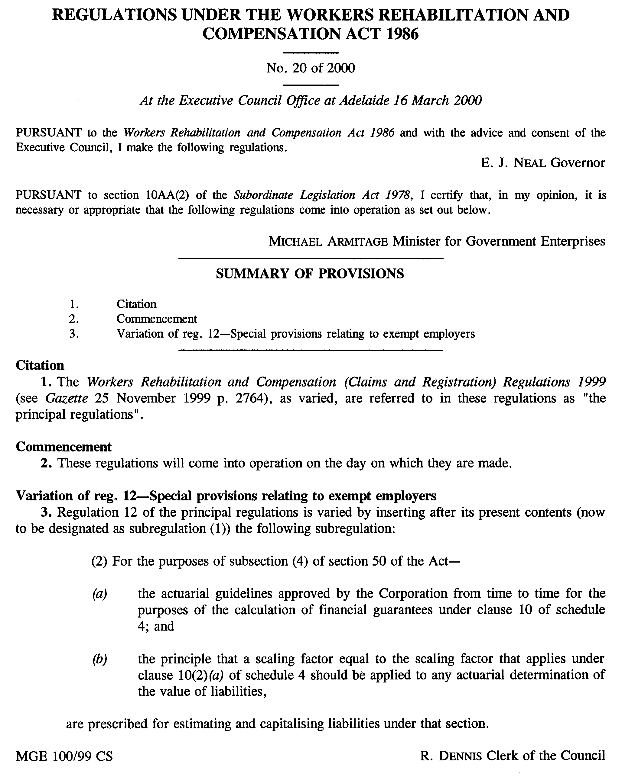

M. G. O’CALLAGHAN, Government Printer, South Australia

