No. 57 1897

THE SOUTH AUSTRALIAN

GOVERNMENT GAZETTE

PUBLISHED BY AUTHORITY

ALL PUBLIC ACTS appearing in this GAZETTE are to be considered official, and obeyed as such

ADELAIDE, THURSDAY, 30 MARCH 2000

CONTENTS

Page
Administrative Arrangements Act 1994—Notice 1899
Appointments Resignation, Etc. 1899
Corporations and District Councils—Notices 1941
Crown Lands Act 1929—Notices 1899
Dangerous Substances Act 1979—Notice 1900
Environment Protection Authority—Notice 1900
Equal Opportunity Tribunal—Exemption 1900
Fisheries Act 1982—Notices 1900
Geographical Names Act 1991—Corrigendum 1900
Harbors and Navigation Act 1993—Notice 1907
Housing Improvement Act 1940—Notices 1908
Industrial and Employee Relations Act 1994—
Appointment 1907
Liquor Licensing Act 1997—Notices 1915
Livestock Act 1997—Notice 1912
Local Government Act 1934—Notice 1915
Lottery and Gaming Act 1936—Notice 1916
Mining Act 1971—Notices 1916
Occupational Health, Safety and Welfare Act 1986—
Notice 1917

Page
Petroleum Products Regulation Act 1995—Appointment 1917
Private Advertisements 1942
Proclamations 1898
Public Trustee Office—Administration of Estates 1942
Real Property Act 1886—Notice 1917
REGULATIONS
Superannuation Act 1988 (No. 23 of 2000) 1930
Liquor Licensing Act 1997 (No. 24 of 2000) 1932
Workers Rehabilitation and Compensation Act 1986—
(No. 25 of 2000) 1933
Remuneration Tribunal—Determination 1918
Roads (Opening and Closing) Act 1991—Notices 1918
Road Traffic Act 1961—Notice 1919
Soil Conservation and Land Care Act 1989—Notice 1919
Trans-Tasman Mutual Recognition Act 1997—
Endorsement of Regulations 1923
Unclaimed Moneys Act 1891—Notice 1943
Vocational Education, Employment and Training Act
1994—Contracts of Training 1921
Water Mains and Sewers—Mains Laid, Replaced, Etc. 1919

GOVERNMENT GAZETTE NOTICES
ALL poundkeepers' and private advertisements forwarded for publication in the South Australian Government Gazette must be PAID FOR PRIOR TO INSERTION; and all notices, from whatever source, should be legibly written on one side of the paper only and sent to Riverside 2000 so as to be received no later than 4 p.m. Tuesday preceding the day of publication. Phone 8207 1045 or Fax 8207 1040. E-mail: Riv2000@saugov.sa.gov.au. Send as attachments in Word format and please confirm your transmission with a faxed copy of your document, including the date the notice is to be published and to whom the notice will be charged.

CROWN LANDS ACT 1929 SECTION 5AA(1)(c): OUT OF HUNDREDS (PORT AUGUSTA)—DEDICATED LAND RESUMED
Proclamation By The Governor
(l.s.) E. J. Neal
Preamble
1. The following land is dedicated as a reserve for school purposes, not being intended for ecclesiastical or denominational purposes (see Gazette 31 May 1917, p. 886):
Section 21, Out of Hundreds (Port Augusta), being the whole of the land contained in Land Grant Register Book Volume 1090, Folio 135.
The registered proprietor of the land has requested the resumption of the land.
2. The following land is dedicated for school purposes, not intended for ecclesiastical or denominational purposes (see Gazette 24 November 1921, p. 1210):
Section 22, out of Hundreds (Port Augusta), being the whole of the land contained in Land Grant Register Book Volume 1252, Folio 20.
The registered proprietor of the land has requested the resumption of the land.
3. The following land is dedicated as a reserve for school purposes, not intended for ecclesiastical or denominational purposes (see Gazette 11 January 1962, p. 46):
Section 396, North Out of Hundreds, County of Manchester (now Out of Hundreds (Port Augusta)), being the whole of the land contained in Certificate of Title Register Book Volume 5605, Folio 431.
The registered proprietor of the land has requested the resumption of the land.
Proclamation
PURSUANT to section 5AA (1) (c) of the Crown Lands Act 1929 and with the advice and consent of the Executive Council, I resume the land defined in clauses 1, 2 and 3 of the preamble to this proclamation.
Given under my hand and the Public Seal of South Australia, at Adelaide, 30 March 2000.
By command,
Iain Evans, for Premier
MEH 3/2000 CS

ELECTRICITY CORPORATIONS (RESTRUCTURING AND DISPOSAL) ACT 1999 SECTION 11 AND SCHEDULE 2: CONVERSION OF ELECTRICITY CORPORATION TO STATE-OWNED COMPANY
Proclamation By The Governor
(l.s.) E. J. Neal
PURSUANT to section 11 and Schedule 2 of the Electricity Corporations (Restructuring and Disposal) Act 1999 and with the advice and consent of the Executive Council, I—
(a) declare that Schedule 2 of the Act applies to SA Generation Corporation (see section 11); and
(b) specify the date on which this proclamation is made as the date from which SA Generation Corporation is to have a share capital (see clause 1(1) of Schedule 2); and
(c) require SA Generation Corporation to issue one fully paid ordinary share to the Treasurer at an issue price of $1.00 to be paid in full by the Treasurer (see clause 1(2) of Schedule 2); and
(d) require SA Generation Corporation to take such action as is necessary or desirable to be taken, and as is approved by the Minister, for the purpose of its being registered as a proprietary company limited by shares under Part 5B.1 of the Corporations Law, including (without limitation) action to adopt a constitution approved by the Minister (see clause 1(5) of Schedule 2).
Given under my hand and the Public Seal of South Australia, at Adelaide, 30 March 2000.
By command,
Iain Evans, for Premier
T&F 28/2000 CS

SHOP TRADING HOURS ACT 1977 SECTION 13: ALTERATION OF SHOP TRADING HOURS—EASTER 2000
Proclamation By The Governor
(l.s.) E. J. Neal
PURSUANT to section 13 of the Shop Trading Hours Act 1977 and with the advice and consent of the Executive Council, I authorise, subject to the conditions set out in the schedule, the opening of all shops—
(a) in the Balaklava Shopping District as follows:
from 9 a.m. until 5 p.m. on Saturday, 22 April 2000
from 9 a.m. until 5 p.m. on Monday, 24 April 2000;
(b) in the Berri Shopping District as follows:
from 9 a.m. until 5 p.m. on Saturday, 22 April 2000
from 10 a.m. until 5 p.m. on Sunday, 23 April 2000
from 10 a.m. until 5 p.m. on Monday, 24 April 2000;
(c) in the Clare Shopping District as follows:
from 8 a.m. until 6 p.m. on Saturday, 22 April 2000
from 8 a.m. until 6 p.m. on Sunday, 23 April 2000
from 8 a.m. until 6 p.m. on Monday, 24 April 2000;
(d) in the Cobdogla Shopping District as follows:
from 8 a.m. until 5 p.m. on Saturday, 22 April 2000
from 8 a.m. until 5 p.m. on Monday, 24 April 2000;
(e) in the Jamestown Shopping District as follows:
from 7 a.m. until 5 p.m. on Saturday, 22 April 2000
from 8 a.m. until 5 p.m. on Monday, 24 April 2000;
(f) in the Loxton Shopping District as follows:
from 8 a.m. until 12.30 p.m. on Saturday, 22 April 2000;
(g) in the Millicent Shopping District as follows:
from 7 a.m. until 5 p.m. on Saturday, 22 April 2000;
(h) in the Minlaton Shopping District as follows:
from 8.30 a.m. until 12 noon on Saturday, 22 April 2000
from 8.30 a.m. until 5.30 p.m. on Monday, 24 April 2000;
(i) in the Mount Barker Shopping District as follows:
from 7 a.m. until 7 p.m. on Monday, 24 April 2000;
(j) in the Mount Gambier Shopping District as follows:
from 6 a.m. until 5 p.m. on Saturday, 22 April 2000
from 6 a.m. until 5 p.m. on Monday, 24 April 2000;
(k) in the Streaky Bay Shopping District as follows:
from 9 a.m. until 4.30 p.m. on Saturday, 22 April 2000
from 9 a.m. until 1 p.m. on Monday, 24 April 2000.
Schedule
This proclamation only authorises the opening of a shop if—
(a) all relevant industrial awards, workplace agreements and enterprise agreements are observed by the shopkeeper and persons employed in the business of the shop during and in relation to the hours specified in this proclamation during which the shop is open; and
(b) subject to an industrial award, workplace agreement or enterprise agreement to the contrary—a person who is employed in the business of the shop is entitled to refuse to work at the shop during the hours specified in this proclamation unless he or she has agreed with the shopkeeper to work during those hours.
Given under my hand and the Public Seal of South Australia, at Adelaide, 30 March 2000.
By command,
Iain Evans, for Premier
MGE 17/99 CS

STATUTES AMENDMENT (ELECTRICITY) ACT 1999 (Act No. 74 of 1999): DAY OF COMMENCEMENT
Proclamation By The Governor
(l.s.) E. J. Neal
WITH the advice and consent of the Executive Council, I—
(a) bring sections 5(b) and (d), 6, 10, 12(2), 14(b) and 20 of the Statutes Amendment (Electricity) Act 1999 into operation at the time at which SA Generation Corporation is converted into a company under the Corporations Law;
(b) fix 30 March 2000 as the day on which section 7 of the Statutes Amendment (Electricity) Act 1999 will come into operation.
Given under my hand and the Public Seal of South Australia, at Adelaide, 30 March 2000.
By command,
Iain Evans, for Premier
T&F 27/2000 CS

Department of the Premier and Cabinet
Adelaide, 30 March 2000
HIS Excellency the Governor in Executive Council has been pleased to appoint the undermentioned to the Third Party Premiums Committee, pursuant to the provisions of the Motor Vehicles Act 1959:
Presiding Officer: (from 30 March 2000)
Suzanne Corcoran
By command,
Iain Evans, for Premier
MAC 0002/00CS

Department of the Premier and Cabinet
Adelaide, 30 March 2000
HIS Excellency the Governor in Executive Council has been pleased to appoint Sean Sullivan as a Commissioner representing South Australia on the Murray-Darling Basin Commission for a period of five years from 30 March 2000, pursuant to Section 6 (1) of the Murray-Darling Basin Act 1993.
By command,
Iain Evans, for Premier
MWR 0008/00CS

ADMINISTRATIVE ARRANGEMENTS ACT 1994
Delegation
I, JOHN WAYNE OLSEN, Premier of South Australia, hereby delegate, pursuant to Section 9 of the Administrative Arrangements Act 1994, all of my powers and functions under the Year 2000 Information Disclosure Act 1999, to the Minister Assisting the Deputy Premier.
Dated 23 March 2000.
John Olsen, Premier

CROWN LANDS ACT 1929: SECTION 5
TAKE NOTICE that pursuant to the Crown Lands Act 1929, I PETER MACLAREN KENTISH, Surveyor-General and Delegate appointed by IAIN EVANS, Minister for Environment and Heritage, Minister of the Crown to whom the administration of the Crown Lands Act 1929 is committed DO HEREBY:
1. Resume the land defined in The First Schedule.
2. Dedicate the Crown Land defined in The Second Schedule as a Camping Reserve and declare that such land shall be under the care, control and management of The District Council of Tatiara.
The First Schedule
Camping Reserve, section 962, Hundred of Tatiara, County of Buckingham, the proclamation of which was published in the Government Gazette of 12 January 1984 at page 49, The Fourth Schedule, being the whole of the land comprised in Crown Record Volume 5648 Folio 20.
The Second Schedule
Allotment 1 of DP 53930 and section 962, Hundred of Tatiara, County of Buckingham, exclusive of all necessary roads.
Dated 27 March 2000.
P. M. Kentish, Surveyor-General
DEHAA 09/1414

CROWN LANDS ACT 1929: SECTION 5
TAKE NOTICE that pursuant to the Crown Lands Act 1929, I PETER MACLAREN KENTISH, Surveyor-General and Delegate appointed by IAIN EVANS, Minister for Environment and Heritage, Minister of the Crown to whom the administration of the Crown Lands Act 1929 is committed DO HEREBY dedicate the Crown Land defined in The Schedule as a Travelling Stock Reserve and declare that such land shall be under the care, control and management of the Regional Council of Goyder.
The Schedule
Allotment 316 of DP 46685, Hundred of Kooringa, County of Burra, exclusive of all necessary roads, being the whole of the land comprised in Crown Record Volume 5429 Folio 570.
Dated 27 March 2000.
P. M. Kentish, Surveyor-General
DL 1466/1989

CROWN LANDS ACT 1929: SECTION 5
TAKE NOTICE that pursuant to the Crown Lands Act 1929, I PETER MACLAREN KENTISH, Surveyor-General and Delegate appointed by IAIN EVANS, Minister for Environment and Heritage, Minister of the Crown to whom the administration of the Crown Lands Act 1929 is committed DO HEREBY vary the notice as described in The Schedule by declaring that Highway Reserve as defined in The Schedule shall cease to be under the care, control and management of the Commissioner of Highways and by further declaring that the said Highway Reserve shall be under the care, control and management of the Wakefield Regional Council.
The Schedule
Highway Reserve, allotment 501 of DP 43321, Hundred of Cameron, County of Daly, the notice of which was published in the Government Gazette of 21 March 1996 page 1675, The Third Schedule, being the whole of the land contained in Crown Record Volume 5345 Folio 487.
Dated 27 March 2000.
P. M. Kentish, Surveyor-General
DENR 4201/1994

CROWN LANDS ACT 1929: SECTION 5
TAKE NOTICE that pursuant to the Crown Lands Act 1929, I PETER MACLAREN KENTISH, Surveyor-General and Delegate appointed by IAIN EVANS, Minister for Environment and Heritage, Minister of the Crown to whom the administration of the Crown Lands Act 1929 is committed DO HEREBY resume the land defined in The Schedule.
The Schedule
Reserves for Government Purposes, sections 997 and 998, Hundred of Yatala, County of Adelaide, the proclamation of which was published in the Government Gazette of 15 April 1976 at page 1978, being the whole of the land comprised in Crown Record Volume 5292 Folio 248.
Dated 27 March 2000.
P. M. Kentish, Surveyor-General
DENR 9952/1995

DANGEROUS SUBSTANCES ACT 1979
Appointment
I, ROBERT DAVID LAWSON, Minister for Workplace Relations, in and for the State of South Australia, hereby appoint the undermentioned Officer as an Authorised Officer, pursuant to the Dangerous Substances Act 1979:
Christopher Ginever
Dated 28 March 2000.
Robert Lawson, Minister for Workplace Relations

ENVIRONMENT PROTECTION AUTHORITY
Notice of Amendment of Public Notice—Dated 13 March 2000
THE Environment Protection Authority notifies of the following amendment to the notice for Public Consultation relating to the Landfill Environmental Management Plan for the Wingfield Waste Management Centre:
Interested persons may make written submissions in relation to the plan by close of business 27 April 2000.
G. Hocking, Senior Environmental Licensing Officer

EQUAL OPPORTUNITY TRIBUNAL
No. 2 of 2000
Notice of Exemption
Before Deputy Presiding Officer Vanstone
Members Altman and Heylen
I HEREBY certify that on 20 March 2000, the Equal Opportunity Tribunal of South Australia, on the application of The United Trades and Labour Council of South Australia, and others made the following orders for exemption:
1. The United Trades and Labour Council of South Australia, and others are granted exemption from compliance with Section 35 (1) (b) (i) of the Equal Opportunity Act 1984, in relation to the provision of the Anna Stewart Memorial Project only for women.
2. The United Trades and Labour Council of South Australia, and others are granted exemption from compliance with Section 103 (1) of the Equal Opportunity Act 1984, in relation to the advertising of the Anna Stewart Memorial Project as a programme available only to women.
3. That the above exemptions are to apply for a period of 3 years commencing this day.
4. Notice of the grant of exemptions is to be published in the Government Gazette forthwith.
Dated 22 March 2000.
D. Hoban for M. Moore, Registrar, Equal Opportunity Tribunal.

GEOGRAPHICAL NAMES ACT 1991
Corrigendum
Notice to Assign Names and Boundaries to Places
IN the notice appearing in Government Gazette of 16 March 2000 at page 1433, fifth notice published on that page, for WOOLANE read WOODLANE.
Dated 23 March 2000.
P. M. Kentish, Surveyor-General, Department for Administrative and Information Services.
DEHAA 04/0185

FISHERIES ACT 1982
Marine Mollusc Farming Licence FM00057
(Previous Licence No. F713)
Licence to Farm Fish under section 53 of the Fisheries
Act 1982
WHEREAS the Director of Fisheries has, pursuant to section 50 (2) of the Fisheries Act 1982 (‘the Act’), issued a permit to the undermentioned licensee to release the fish specified in Item 1 of Schedule 2 of this licence (‘the permitted species’), the Minister for Primary Industries, (‘the Minister’) hereby grants to:
J. H. Ettridge (19771)
N. M. Dodd (13072)
T. L. Dodd (19772)
Denton Street
Smoky Bay, S.A. 5680
a non-exclusive licence to occupy and use the waters specified in Item 1 of Schedule 1 of this licence (‘the site’) for the purpose of farming and taking the permitted species (‘the permitted use’) for the period commencing on 1 July 1999 and ending, subject to any earlier termination under this licence, on 30 June 2000 (‘the term’) subject to the following terms and conditions:
Conditions of This Licence
1. Licence
The parties acknowledge and agree that:
1.1 the rights, powers and privileges granted to or vested in the licensee under this licence are contractual only and shall not create or vest in the licensee any estate, interest or right of a proprietary nature in the site; and
1.2 that, subject to section 53A of the Fisheries Act 1982, this licence does not entitle the licensee to exclusive rights of entry to and occupation of the site and that the rights granted by this licence are exercisable by the licensee in common with any other occupiers of the site from time to time.
2. Marked-off Areas
For the purposes of section 53A of the Fisheries Act 1982, the marked-off areas within the site is that area or those areas marked-off or indicated in the manner set out in Item 2 of Schedule 1 of this licence.
3. Permitted Species
The licensee:
3.1 must not farm or introduce any species at the site other than the permitted species; and
3.2 must not take any wild fish from the site except for recreational purposes.
4. Permitted Use
The licensee must not use the site for any purpose other than the permitted use.
5. Permitted Methods
The licensee:
5.1 must not stock the permitted species at a rate greater than that specified in Schedule 2 of this licence;
5.2 must not use the anti-fouling chemical tributyltin (TBT) on any equipment used at the site;
5.3 must not use any chemical or drug for either therapeutic or prophylactic purpose except with the prior approval of the Minister;
5.4 must apply the permitted farming methods set out in Item 2 of Schedule 2 of this licence.
6. Marking and Maintaining the Site
The licensee:
6.1 must ensure that the site is maintained in a good, tidy and safe condition to the satisfaction of the Minister;
6.2 must remove and lawfully dispose of any waste or debris on the site as soon as is reasonably practicable and in particular must comply with any guidelines issued from time to time by the Minister in relation to the removal from the site of any unhealthy or dead fish;
6.3 must maintain all buoys, crosses, and markers on the site in good condition and in accordance with the colours specified in Schedule 1 of this licence; and
6.4 must mark the site boundary in accordance with the specifications in Schedule 1 of this licence.
7. Site Inspection and Supervision
The licensee:
7.1 must at all times permit the Minister, his employees, agents or contractors or any employees, agents or contractors of the Crown to enter the site for the purposes of inspecting the site, the sea floor and the flora and fauna on or in the vicinity of the site; and
7.2 must comply with all reasonable directions of any such person authorised by the Director of Fisheries to inspect the conduct of the licensee’s activities at the site.
8. Fees and Returns
The licensee:
8.1 must pay to the Minister the licence fee in accordance with Item l of Schedule 3 of this licence;
8.2 must on or before 31 January and 31 July during the term, submit to the Minister a return supplying all of the information described in Schedule 4 of this licence.
9. Compliance With Relevant Laws
9.1 the licensee must at all times comply with all laws, by-laws or regulations in force which relate to the site or the activities conducted in the site and with all notices, orders or requirements lawfully given or made by any authority or authorities in respect of the site;
9.2 in particular, without derogating from the general requirement under condition 9 of this licence:
9.2.1 the licensee must not do or permit to be done in upon or about the site anything which in the opinion of the Minister would cause or contribute to the degradation or pollution of any coastal land or the surrounding marine environment; and
9.2.2 in the event that the Minister is satisfied, on reasonable grounds, that the fish taken from the waters are not fit for human consumption or that consumption of fish taken from the waters could present a danger to the health of the consumer, the licensee must, in accordance with a written notice from the Minister, cease or suspend the conduct of the permitted use or else conduct the permitted use as directed within the notice.
10. Public Risk Liability
The licensee must at all times indemnify the Minister, his officers, employees, contractors and agents from and against all claims, demands, actions, judgments, proceedings, damages, losses, costs, charges and expenses in respect of any loss of life, personal injury and/or damage to property caused or suffered in any manner in or about the site.
11. Release
The licensee must use and keep the site at the risk in all things of the licensee and the licensee must release to the full extent permitted by law the Minister, his agents, contractors and servants in the absence of any wilful act, omission, default or neglect on their part from all claims and demands of every kind resulting from any accident damage or injury to persons or property occurring at the site, including loss or damage to the licensee’s fixtures or personal property of the licensee.
12. Public Risk Insurance
The licensee shall at its own cost and expense during the term effect and keep in full force and effect in respect of the site and the permitted use a policy of public risk insurance in the joint names of the licensee and the Minister in which the limits of public risk shall not be less than the amount specified in Item 2 of Schedule 3 of this licence, or such further amount as the Minister may from time to time reasonably require, as the amount which may be paid out in respect of any one single claim and a policy of insurance or copy thereof or a certificate of insurance shall be produced by the licensee to the Minister on request in writing being made by the Minister for its production.
13. Guarantee or Indemnity Scheme
The licensee must either:
13.1 provide a guarantee from its bankers; or
13.2 contribute to an indemnity scheme established for the aquaculture and fisheries industry and approved by the Minister,
to and in favour of and for the benefit of the Minister by way of security for the due and punctual performance by the licensee of the terms and conditions of this licence and in particular the obligations of the licensee to rehabilitate the site immediately prior to the expiration or sooner determination of the term of this licence. Such guarantee or indemnity scheme must have effect from the date of commencement of the term.
14. No Assignment
The licensee acknowledges that this licence is personal and it must not assign or sublet or deal in any other way with any interest in this licence.
15. Default by Licensee and Termination
The Minister may terminate this licence immediately by notice in writing served on the licensee if:
15.1 the licensee commits or permits any breach or default of the obligations imposed on the licensee by this licence, and following the giving by the Minister of written notice of such breach or default, the licensee either fails to rectify such breach or default within one calendar month of the date of such notice (or earlier if the circumstances require) or fails to make diligent progress towards rectifying any such breach which is incapable of rectification within the time so limited; or
15.2 the licensee commits or permits any further breach or default of the obligations imposed on the licensee by this licence for which the Minister has previously given notice in writing of such breach or default pursuant to paragraph 1 of condition 15.1 notwith-standing rectification of the previous breach or default; or
15.3 the licence fee referred to in condition 8 is unpaid for a period of 14 days after notice has been given to the licensee that it is outstanding; or
15.4 if the licensee is a body corporate, any of the following occur:
15.4.1 the licensee is unable to pay its debts as and when they fall due or is otherwise insolvent;
15.4.2 an order is made for the winding up or liquidation of the licensee;
15.4.3 the licensee enters into a scheme of arrangement, compromise, moratorium or other form of composition with its creditors or any class of its creditors;
15.4.4 a receiver, a manager or a receiver and manager, a company administrator or other insolvency administrator is appointed to the licensee; or
15.4.5 a mortgagee, chargee or other encum-brancee is appointed over or takes possession of or appoints an agent to take possession of all or any of the licensee’s assets; or
15.5 if the licensee is an individual, the licensee:
15.5.1 becomes bankrupt or assigns its estate or enters into a deed of arrangement or other form of composition for the benefit of the licensee’s creditors; or
15.5.2 is convicted of an indictable offence.
Termination of this licence by the Minister shall be without prejudice to any rights, remedies or actions that the Minister may have against the licensee in respect of any antecedent breach by the licensee of the terms and conditions contained in this licence.
16. Interpretation
Subject to any inconsistency of subject or context, the following rules of construction shall be used in the interpretation of this licence:
16.1 any word importing the plural includes the singular and vice versa;
16.2 any wording importing a gender shall include all other genders;
16.3 a reference to a body corporate shall include a natural person and vice versa;
16.4 a reference to a recital, party, clause, Schedule or Annexure is a reference to a recital, party, clause, Schedule or Annexure of this licence;
16.5 the captions, headings, section numbers and clause numbers appearing in this licence are inserted only as a matter of convenience and in no way affect the construction of this licence;
16.6 a reference to a statute shall include all statutes amending, consolidating or replacing the statutes referred to;
16.7 where two or more persons are named as licensees, this licence shall bind the licensees jointly and each of them severally; and
16.8 time is of the essence in respect of any obligation relating to time in this licence.
17. Delegation
Any consent, notice, any consultation or any other thing which is pursuant to the terms of this licence either required to be given, done or performed or which may be given, done or performed by the Minister may for the purposes of this licence be properly given, done or performed by any duly authorised agent or employee of the Minister.
18. Severance
If any term or condition of this licence should be for any reason unlawful, void, invalid or unenforceable then the offending term or condition shall be severed from this licence without affecting the validity or enforceability of the remainder of this licence.
19. Modification
No variation of or addition to any provision of this licence shall be binding upon the Minister and the licensee unless such variation or addition is made in writing, signed by both the Minister and the licensee and expressed to be either supplemental to or in substitution for the whole or a part of this licence.
20. Waiver
20.1 A waiver of any provision of this licence by the Minister must both be in writing and be signed by the Minister or by persons duly authorised to execute such a document on the Minister’s part.
20.2 No waiver by the Minister of a breach of a term or condition contained in this licence shall operate as a waiver of any breach of the same or any other term or condition contained in this licence.
20.3 No forbearance, delay or indulgence by the Minister in enforcing the provisions of this licence shall prejudice or restrict the rights of the Minister.
21. Notices
21.1 Notices may be served by delivering the same personally, by mail or facsimile transmission and shall be:
21.1.1 in writing addressed to the Director of Fisheries, PIRSA, 16th Floor, 25 Grenfell Street, Adelaide, S.A. 5000 (in the case of the Minister) and to the address of the licensee set out above (in the case of the licensee);
21.1.2 signed by or on behalf of the sender or by a person duly authorised in that regard by the sender;
21.1.3 deemed to be duly served or made in the following circumstances:
(a) if delivered, upon delivery;
(b) if sending by mail, upon posting;
(c) if sent by facsimile transmission, upon the sender’s facsimile producing a transmission report that the facsimile was satisfactorily sent in its entirety to the addressee’s facsimile number,
but if delivery is not made before 5 p.m. on any day it shall be deemed to be received at 9 a.m. on the next day in that place.
21.2 The Minister and the licensee may each vary their address or facsimile number at any time by written notice.
Granted by the General Manager Aquaculture, delegate of the Minister on 24 March 2000.
I. Nightingale, General Manager Aquaculture
The licensee hereby acknowledges and agrees to the terms and conditions of this licence.
The Common Seal of T. J. N. Oysters was hereunto affixed in the presence of:
(l.s.) J. Ettridge, Director
H. V. Dodd, Witness
Schedule 1
Item 1—The Site
Area applicable to this licence:
Licensed Area Licensed
Hectares
AGD 66—Zone 53
395236E 6416873N 4.5
395342E 6416865N
395312E 6416441N
395206E 6416449N
All structures, equipment, buoys and flotations (except for that required by the Department for Transport, Urban Planning and the Arts) must be black, dark grey, dark blue, dark brown, or dark green coloured materials.
The boundary of the site to be marked either with:
(a) (1) At the corners with posts extending 900 mm above mean high water springs. Such posts to be marked with a St Andrews cross, each cross arm measuring 900 mm from tip to tip, minimum width 75 mm.
(2) Posts to be not less than 125 mm in diameter.
(3) Posts and crosses to be painted yellow.
(4) The ends of each cross to be marked with a 200 mm strip of yellow retro-reflective tape.
(5) Between the corner posts at intervals not exceeding 50 m, buoys not less than 300 mm in diameter.
(6) All buoys, posts, crosses and markers must be maintained in good condition.
or
(b) (1) At each corner, yellow spar buoys with a St Andrews cross as a top mark placed at least 900 mm above the buoy, cross arms 900 mm long x 75 mm wide.
(2) The buoys and topmarks must all be coloured yellow and marked with a yellow retro-reflective as in (a) (4).
(3) All buoys, posts, crosses and markers must be maintained in good condition.
When the site is in navigable water and possible danger to navigation, lights must be placed on the top of each St Andrews cross that is located at each corner of the site and these lights must be yellow in colour and flashing once every 4 seconds and visible over an arc of 360 degrees for a distance of at least one mile.
Item 2—Marked-Off Areas
[Co-ordinates of developed areas within the site to be provided by the licensee.]
White buoys of at least 12 inches in diameter must be placed around the whole of the perimeter of the developed areas within the site at a distance of no less than 50 m from one another.
Schedule 2
Item 1⎯Permitted Species
The Director of Fisheries has, pursuant to section 50 (2) of the Act, issued a permit for the release of the fish specified in this Schedule.
Pacific Oysters (Crassostrea gigas)
Item 2⎯Permitted Farming Methods
Longlines
Each unit must not exceed 100 m in length and 2 m in width, and each unit must be at least 6 m from any other unit.
Item 3⎯Stocking Rates
Oysters
Size (mm) Number per Hectare
3 2 500 000
10 1 600 000
20 1 100 000
30 750 000
40 500 000
50 350 000
60 200 000
70 150 000
80 100 000
Schedule 3
Item 1—Fees
Annual licence fees are:
$
FRDC Levy per hectare 4.50 at $12.50 each 56.25
EMP fee per hectare 4.50 at $22.96 each 103.32
Base Licence Fee per hectare 4.50 at $57 each 256.50
SASQAP (Classified Area) per hectare 4.50 at
$60 each 270.00
Total Annual Licence Fee 686.07
Quarterly Instalments 171.52
Item 2—Public Risk Insurance
Five million dollars ($5 000 000).
Schedule 4
Returns
The licensee must submit the following information to the Minister, c/o Director of Fisheries, PIRSA, 16th Floor, 25 Grenfell Street, Adelaide, S.A. 5000 on or before 31 January and 31 July during the term of this licence:
1. Name of licensee.
2. Address of licensee.
3. Species of fish farmed and held on the site.
4. Location of aquaculture operation.
5. Period covered by return.
6. Number of life stage of each species of fish held.
7. Number, weight and value of each species of fish held.
8. Details of any disease detected in any fish kept.
9. Source (whether interstate or intrastate) of any stock acquired and date of acquisition (if relevant, include name of authority that provided certification that stock was free from disease).
10. If any fish were brought into the state, the number of fish and the life stage of the fish.
11. If fish were brought into the state, the purpose for which they were brought in.
12. Method of disposal of water and packaging use for transporting the fish.
13. If any disease or symptom of disease occurred in the acquired fish.
14. Method of disposal of diseased or dead fish and the number disposed of.
15. Signature, date and telephone number.
16. Use of any chemicals for fish husbandry—type of chemical and quantity used, purpose and date of use.

FISHERIES ACT 1982: SECTION 50 (2)
TAKE notice that pursuant to section 50 (2) of the Fisheries Act 1982, as the delegate of the Director of Fisheries, I hereby authorise John H. Ettridge, Neil M. Dodd and Thomas L. Dodd, Denton Street, Smoky Bay, S.A. 5680 (hereinafter referred to as the ‘permit holder’) to engage in the activities and to do the acts specified in Schedule 1, subject to the conditions specified in Schedule 2 from the date of this permit and ending upon the expiration or earlier termination of Licence No. FM00057.
Schedule 1
The importation and release of Pacific Oysters (Crassostrea gigas) within the water defined by the following co-ordinates:
Licensed Area Licensed
Hectares
AGD 66—Zone 53
395236E 6416873N 4.5
395342E 6416865N
395312E 6416441N
395206E 6416449N
Schedule 2
1. Fish obtained within South Australia for use in the fish farm shall only be obtained from registered fish farmers, licensed fishers or other persons approved by the Director of Fisheries.
2. The permit holder shall not import any live fish (ova, fry or adult) into South Australia unless the shipment has certification from an appropriate authority in the State from which they are obtained that they are free from all relevant notifiable diseases listed in Schedule 4 of the Fisheries (Exotic Fish, Fish Farming and Fish Diseases) Regulations 1984.
3. Any oysters brought into South Australia must undergo a soakage process whereby they are completely submerged in fresh water for a period of not less than 2 hours before being placed in the approved structures. Fresh water is deemed to be water suitable for human consumption or horticultural or agricultural use.
4. The permit holder shall not contravene or fail to comply with the Fisheries Act 1982, or any regulations made under the Act, except where specifically permitted by this notice.
5. The permit holder must retain the supplied copy of this permit, and if requested by a PIRSA Fisheries and Aquaculture Compliance Officer, produce that permit for inspection.
Dated 24 March 2000.
I. Nightingale, General Manager, Aquaculture, as the delegate of the Director of Fisheries

FISHERIES ACT 1982
Marine Mollusc Farming Licence FM00058
(Previous Licence No. F714)
Licence to Farm Fish under section 53 of the Fisheries
Act 1982
WHEREAS the Director of Fisheries has, pursuant to section 50 (2) of the Fisheries Act 1982 (‘the Act’), issued a permit to the undermentioned licensee to release the fish specified in Item 1 of Schedule 2 of this licence (‘the permitted species’), the Minister for Primary Industries (‘the Minister’) hereby grants to:
Alton M. Dorward (7651)
Mark A. Retsas (1110)
13 Hillside Grove
Port Lincoln, S.A. 5606
a non-exclusive licence to occupy and use the waters specified in Item 1 of Schedule 1 of this licence (‘the site’) for the purpose of farming and taking the permitted species (‘the permitted use’) for the period commencing on 1 July 1999 and ending, subject to any earlier termination under this licence, on 30 June 2000 (‘the term’) subject to the following terms and conditions:
Conditions of This Licence
1. Licence
The parties acknowledge and agree that:
1.1 the rights, powers and privileges granted to or vested in the licensee under this licence are contractual only and shall not create or vest in the licensee any estate, interest or right of a proprietary nature in the site; and
1.2 that, subject to section 53A of the Fisheries Act 1982, this licence does not entitle the licensee to exclusive rights of entry to and occupation of the site and that the rights granted by this licence are exercisable by the licensee in common with any other occupiers of the site from time to time.
2. Marked-off Areas
For the purposes of section 53A of the Fisheries Act 1982, the marked-off areas within the site is that area or those areas marked-off or indicated in the manner set out in Item 2 of Schedule 1 of this licence.
3. Permitted Species
The licensee:
3.1 must not farm or introduce any species at the site other than the permitted species; and
3.2 must not take any wild fish from the site except for recreational purposes.
4. Permitted Use
The licensee must not use the site for any purpose other than the permitted use.
5. Permitted Methods
The licensee:
5.1 must not stock the permitted species at a rate greater than that specified in Schedule 2 of this licence;
5.2 must not use the anti-fouling chemical tributyltin (TBT) on any equipment used at the site;
5.3 must not use any chemical or drug for either therapeutic or prophylactic purpose except with the prior approval of the Minister;
5.4 must apply the permitted farming methods set out in Item 2 of Schedule 2 of this licence.
6. Marking and Maintaining the Site
The licensee:
6.1 must ensure that the site is maintained in a good, tidy and safe condition to the satisfaction of the Minister;
6.2 must remove and lawfully dispose of any waste or debris on the site as soon as is reasonably practicable and in particular must comply with any guidelines issued from time to time by the Minister in relation to the removal from the site of any unhealthy or dead fish;
6.3 must maintain all buoys, crosses, and markers on the site in good condition and in accordance with the colours specified in Schedule 1 of this licence; and
6.4 must mark the site boundary in accordance with the specifications in Schedule 1 of this licence.
7. Site Inspection and Supervision
The licensee:
7.1 must at all times permit the Minister, his employees, agents or contractors or any employees, agents or contractors of the Crown to enter the site for the purposes of inspecting the site, the sea floor and the flora and fauna on or in the vicinity of the site; and
7.2 must comply with all reasonable directions of any such person authorised by the Director of Fisheries to inspect the conduct of the licensee’s activities at the site.
8. Fees and Returns
The licensee:
8.1 must pay to the Minister the licence fee in accordance with Item l of Schedule 3 of this licence;
8.2 must on or before 31 January and 31 July during the term, submit to the Minister a return supplying all of the information described in Schedule 4 of this licence.
9. Compliance With Relevant Laws
9.1 the licensee must at all times comply with all laws, by-laws or regulations in force which relate to the site or the activities conducted in the site and with all notices, orders or requirements lawfully given or made by any authority or authorities in respect of the site;
9.2 in particular, without derogating from the general requirement under condition 9 of this licence:
9.2.1 the licensee must not do or permit to be done in upon or about the site anything which in the opinion of the Minister would cause or contribute to the degradation or pollution of any coastal land or the surrounding marine environment; and
9.2.2 in the event that the Minister is satisfied, on reasonable grounds, that the fish taken from the waters are not fit for human consumption or that consumption of fish taken from the waters could present a danger to the health of the consumer, the licensee must, in accordance with a written notice from the Minister, cease or suspend the conduct of the permitted use or else conduct the permitted use as directed within the notice.
10. Public Risk Liability
The licensee must at all times indemnify the Minister, his officers, employees, contractors and agents from and against all claims, demands, actions, judgments, proceedings, damages, losses, costs, charges and expenses in respect of any loss of life, personal injury and/or damage to property caused or suffered in any manner in or about the site.
11. Release
The licensee must use and keep the site at the risk in all things of the licensee and the licensee must release to the full extent permitted by law the Minister, his agents, contractors and servants in the absence of any wilful act, omission, default or neglect on their part from all claims and demands of every kind resulting from any accident damage or injury to persons or property occurring at the site, including loss or damage to the licensee’s fixtures or personal property of the licensee.
12. Public Risk Insurance
The licensee shall at its own cost and expense during the term effect and keep in full force and effect in respect of the site and the permitted use a policy of public risk insurance in the joint names of the licensee and the Minister in which the limits of public risk shall not be less than the amount specified in Item 2 of Schedule 3 of this licence, or such further amount as the Minister may from time to time reasonably require, as the amount which may be paid out in respect of any one single claim and a policy of insurance or copy thereof or a certificate of insurance shall be produced by the licensee to the Minister on request in writing being made by the Minister for its production.
13. Guarantee or Indemnity Scheme
The licensee must either:
13.1 provide a guarantee from its bankers; or
13.2 contribute to an indemnity scheme established for the aquaculture and fisheries industry and approved by the Minister,
to and in favour of and for the benefit of the Minister by way of security for the due and punctual performance by the licensee of the terms and conditions of this licence and in particular the obligations of the licensee to rehabilitate the site immediately prior to the expiration or sooner determination of the term of this licence. Such guarantee or indemnity scheme must have effect from the date of commencement of the term.
14. No Assignment
The licensee acknowledges that this licence is personal and it must not assign or sublet or deal in any other way with any interest in this licence.
15. Default by Licensee and Termination
The Minister may terminate this licence immediately by notice in writing served on the licensee if:
15.1 the licensee commits or permits any breach or default of the obligations imposed on the licensee by this licence, and following the giving by the Minister of written notice of such breach or default, the licensee either fails to rectify such breach or default within one calendar month of the date of such notice (or earlier if the circumstances require) or fails to make diligent progress towards rectifying any such breach which is incapable of rectification within the time so limited; or
15.2 the licensee commits or permits any further breach or default of the obligations imposed on the licensee by this licence for which the Minister has previously given notice in writing of such breach or default pursuant to paragraph 1 of condition 15.1 notwith-standing rectification of the previous breach or default; or
15.3 the licence fee referred to in condition 8 is unpaid for a period of 14 days after notice has been given to the licensee that it is outstanding; or
15.4 if the licensee is a body corporate, any of the following occur:
15.4.1 the licensee is unable to pay its debts as and when they fall due or is otherwise insolvent;
15.4.2 an order is made for the winding up or liquidation of the licensee;
15.4.3 the licensee enters into a scheme of arrangement, compromise, moratorium or other form of composition with its creditors or any class of its creditors;
15.4.4 a receiver, a manager or a receiver and manager, a company administrator or other insolvency administrator is appointed to the licensee; or
15.4.5 a mortgagee, chargee or other encum-brancee is appointed over or takes possession of or appoints an agent to take possession of all or any of the licensee’s assets; or
15.5 if the licensee is an individual, the licensee:
15.5.1 becomes bankrupt or assigns its estate or enters into a deed of arrangement or other form of composition for the benefit of the licensee’s creditors; or
15.5.2 is convicted of an indictable offence.
Termination of this licence by the Minister shall be without prejudice to any rights, remedies or actions that the Minister may have against the licensee in respect of any antecedent breach by the licensee of the terms and conditions contained in this licence.
16. Interpretation
Subject to any inconsistency of subject or context, the following rules of construction shall be used in the interpretation of this licence:
16.1 any word importing the plural includes the singular and vice versa;
16.2 any wording importing a gender shall include all other genders;
16.3 a reference to a body corporate shall include a natural person and vice versa;
16.4 a reference to a recital, party, clause, Schedule or Annexure is a reference to a recital, party, clause, Schedule or Annexure of this licence;
16.5 the captions, headings, section numbers and clause numbers appearing in this licence are inserted only as a matter of convenience and in no way affect the construction of this licence;
16.6 a reference to a statute shall include all statutes amending, consolidating or replacing the statutes referred to;
16.7 where two or more persons are named as licensees, this licence shall bind the licensees jointly and each of them severally; and
16.8 time is of the essence in respect of any obligation relating to time in this licence.
17. Delegation
Any consent, notice, any consultation or any other thing which is pursuant to the terms of this licence either required to be given, done or performed or which may be given, done or performed by the Minister may for the purposes of this licence be properly given, done or performed by any duly authorised agent or employee of the Minister.
18. Severance
If any term or condition of this licence should be for any reason unlawful, void, invalid or unenforceable then the offending term or condition shall be severed from this licence without affecting the validity or enforceability of the remainder of this licence.
19. Modification
No variation of or addition to any provision of this licence shall be binding upon the Minister and the licensee unless such variation or addition is made in writing, signed by both the Minister and the licensee and expressed to be either supplemental to or in substitution for the whole or a part of this licence.
20. Waiver
20.1 A waiver of any provision of this licence by the Minister must both be in writing and be signed by the Minister or by persons duly authorised to execute such a document on the Minister’s part.
20.2 No waiver by the Minister of a breach of a term or condition contained in this licence shall operate as a waiver of any breach of the same or any other term or condition contained in this licence.
20.3 No forbearance, delay or indulgence by the Minister in enforcing the provisions of this licence shall prejudice or restrict the rights of the Minister.
21. Notices
21.1 Notices may be served by delivering the same personally, by mail or facsimile transmission and shall be:
21.1.1 in writing addressed to the Director of Fisheries, PIRSA, 16th Floor, 25 Grenfell Street, Adelaide, S.A. 5000 (in the case of the Minister) and to the address of the licensee set out above (in the case of the licensee);
21.1.2 signed by or on behalf of the sender or by a person duly authorised in that regard by the sender;
21.1.3 deemed to be duly served or made in the following circumstances:
(a) if delivered, upon delivery;
(b) if sending by mail, upon posting;
(c) if sent by facsimile transmission, upon the sender’s facsimile producing a transmission report that the facsimile was satisfactorily sent in its entirety to the addressee’s facsimile number,
but if delivery is not made before 5 p.m. on any day it shall be deemed to be received at 9 a.m. on the next day in that place.
21.2 The Minister and the licensee may each vary their address or facsimile number at any time by written notice.
Granted by the General Manager Aquaculture, delegate of the Minister on 24 March 2000.
I. Nightingale, General Manager Aquaculture
The licensee hereby acknowledges and agrees to the terms and conditions of this licence.
Signed by the said M. A. Retsas
and A. M. Dorward
In the presence of: C. Van Doorn, Witness
Schedule 1
Item 1—The Site
Area applicable to this licence:
Licensed Area Licensed
Hectares
AGD 66—Zone 53
583804E 6170300N 10
583938E 6170150N
583566E 6169817N
583432E 6169966N
All structures, equipment, buoys and flotations (except for that required by the Department for Transport, Urban Planning and the Arts) must be black, dark grey, dark blue, dark brown, or dark green coloured materials.
The boundary of the site to be marked either with:
(a) (1) At the corners with posts extending 900 mm above mean high water springs. Such posts to be marked with a St Andrews cross, each cross arm measuring 900 mm from tip to tip, minimum width 75 mm.
(2) Posts to be not less than 125 mm in diameter.
(3) Posts and crosses to be painted yellow.
(4) The ends of each cross to be marked with a 200 mm strip of yellow retro-reflective tape.
(5) Between the corner posts at intervals not exceeding 50 m, buoys not less than 300 mm in diameter.
(6) All buoys, posts, crosses and markers must be maintained in good condition.
or
(b) (1) At each corner, yellow spar buoys with a St Andrews cross as a top mark placed at least 900 mm above the buoy, cross arms 900 mm long x 75 mm wide.
(2) The buoys and topmarks must all be coloured yellow and marked with a yellow retro-reflective as in (a) (4).
(3) All buoys, posts, crosses and markers must be maintained in good condition.
When the site is in navigable water and possible danger to navigation, lights must be placed on the top of each St Andrews cross that is located at each corner of the site and these lights must be yellow in colour and flashing once every 4 seconds and visible over an arc of 360 degrees for a distance of at least one mile.
Item 2—Marked-Off Areas
[Co-ordinates of developed areas within the site to be provided by the licensee.]
White buoys of at least 12 inches in diameter must be placed around the whole of the perimeter of the developed areas within the site at a distance of no less than 50 m from one another.
Schedule 2
Item 1⎯Permitted Species
The Director of Fisheries has, pursuant to section 50 (2) of the Act, issued a permit for the release of the fish specified in this Schedule.
Pacific Oysters (Crassostrea gigas)
Item 2⎯Permitted Farming Methods
Longlines
Each unit must not exceed 100 m in length and 2 m in width, and each unit must be at least 6 m from any other unit.
Item 3⎯Stocking Rates
Oysters
Size (mm) Number per Hectare
3 2 500 000
10 1 600 000
20 1 100 000
30 750 000
40 500 000
50 350 000
60 200 000
70 150 000
80 100 000
Schedule 3
Item 1—Fees
Annual licence fees are:
$
FRDC Levy per hectare 10 at $12.50 each 125.00
EMP fee per hectare 10 at $22.96 each 229.60
Base Licence Fee per hectare 10 at $57 each 570.00
SASQAP (Classified Area) per hectare 10 at $60 each 600.00
Total Annual Licence Fee 1 524.60
Quarterly Instalments 381.15
Item 2—Public Risk Insurance
Five million dollars ($5 000 000).
Schedule 4
Returns
The licensee must submit the following information to the Minister, c/o Director of Fisheries, PIRSA, 16th Floor, 25 Grenfell Street, Adelaide, S.A. 5000 on or before 31 January and 31 July during the term of this licence:
1. Name of licensee.
2. Address of licensee.
3. Species of fish farmed and held on the site.
4. Location of aquaculture operation.
5. Period covered by return.
6. Number of life stage of each species of fish held.
7. Number, weight and value of each species of fish held.
8. Details of any disease detected in any fish kept.
9. Source (whether interstate or intrastate) of any stock acquired and date of acquisition (if relevant, include name of authority that provided certification that stock was free from disease).
10. If any fish were brought into the state, the number of fish and the life stage of the fish.
11. If fish were brought into the state, the purpose for which they were brought in.
12. Method of disposal of water and packaging use for transporting the fish.
13. If any disease or symptom of disease occurred in the acquired fish.
14. Method of disposal of diseased or dead fish and the number disposed of.
15. Signature, date and telephone number.
16. Use of any chemicals for fish husbandry—type of chemical and quantity used, purpose and date of use.

FISHERIES ACT 1982: SECTION 50 (2)
TAKE notice that pursuant to section 50 (2) of the Fisheries Act 1982, as the delegate of the Director of Fisheries, I hereby authorise A. M. Dorward and M. A. Retsas, 13 Hillside Grove, Port Lincoln, S.A. 5606 (hereinafter referred to as the ‘permit holder’) to engage in the activities and to do the acts specified in Schedule 1, subject to the conditions specified in Schedule 2 from the date of this permit ending upon the expiration or earlier termination of Licence Number FM00058.
Schedule 1
The importation and release of Pacific Oysters (Crassostrea gigas) within the waters defined by the following co-ordinates:
Licensed Area Licensed
Hectares
AGD 66—Zone 53
583804E 6170300N 10
583938E 6170150N
583566E 6169817N
583432E 6169966N
Schedule 2
1. Fish obtained within South Australia for use in the fish farm shall only be obtained from registered fish farmers, licensed fishers or other persons approved by the Director of Fisheries.
2. The permit holder shall not import any live fish (ova, fry or adult) into South Australia unless the shipment has certification from an appropriate authority in the State from which they are obtained that they are free from all relevant notifiable diseases listed in Schedule 4 of the Fisheries (Exotic Fish, Fish Farming and Fish Diseases) Regulations 1984.
3. Any oysters brought into South Australia must undergo a soakage process whereby they are completely submerged in fresh water for a period of not less than 2 hours before being placed in the approved structures. Fresh water is deemed to be water suitable for human consumption or horticultural or agricultural use.
4. The permit holder shall not contravene or fail to comply with the Fisheries Act 1982, or any regulations made under the Act, except where specifically permitted by this notice.
5. The permit holder must retain the copy of this permit, and if requested by a PIRSA Fisheries and Aquaculture Compliance Officer, produce that permit for inspection.
Dated 24 March 2000.
I. Nightingale, General Manager Aquaculture, as the delegate of the Director of Fisheries

INDUSTRIAL AND EMPLOYEE RELATIONS ACT 1994
Appointment
I, ROBERT DAVID LAWSON, Minister for Workplace Relations, in and for the State of South Australia, hereby appoint the undermentioned Officer as an Inspector, pursuant to the Industrial and Employee Relations Act 1994:
Christopher Ginever
Dated 28 March 2000.
Robert Lawson, Minister for Workplace Relations

HARBORS AND NAVIGATION ACT 1993
Section 11 (1)
TAKE notice that pursuant to section 11 of the Harbors and Navigation Act 1993, the Minister for Transport and Urban Planning being the Minister to whom the administration of the Harbors and Navigation Act 1993, is committed does hereby:
1. Revoke the delegation made on 27 December 1999, to the person for the time being holding or acting in the position of Deputy Chief Executive, Department of Primary Industries and Resources of the functions and powers under section 19 of the Harbors and Navigation Act 1993.
2. Delegate to the person for the time being holding or acting in the position of General Manager, Aquaculture of the Department of Primary Industries and Resources the functions and powers under section 19 of the Harbors and Navigation Act 1993 to lease land vested in the said Minister for Transport and Urban Planning by section 15 of that Act, provided such powers shall be limited to the granting of such leases for the sole purpose of aquaculture. Without limiting the generality of the foregoing, this delegation includes all functions and powers incidental to the said power to lease including the incidental functions and powers referred to in a Minute dated 8 July 1998, from the Minister for Transport and Urban Planning to the Minister for Primary Industries, Natural Resources and Regional Development.
Dated 13 March 2000.
Diana Laidlaw, Minister for Transport and Urban Planning

HOUSING IMPROVEMENT ACT 1940
NOTICE is hereby given that the South Australian Housing Trust in the exercise of the powers conferred by the Housing Improvement Act 1940, does hereby declare the houses described in the table hereunder to be substandard for the purposes of Part VII of the Housing Improvement Act 1940.
No. of House and Street | Locality | Allotment, Section, etc. | Certificate of Title  Volume Folio

23 Fletcher Road |  | Elizabeth East | Allotment 520 of Deposited Plan 6433, Hundred of Munno Para | 5279 | 721
28 Queen Street |  | Glenunga | Allotment 106 in Filed Plan 16172, Hundred of Adelaide | 5182 | 399
7 Lauretta Street |  | Newton | Allotment 1 of Deposited Plan 6833, Hundred of Adelaide | 5628 | 408
Lot C Womma Road |  | Penfield | Allotment 318 in Filed Plan 162667 in the area named Penfield, Hundred of Munno Para | 5648 | 540
13 Tilbrook Crescent |  | South Brighton | Allotment 172 of Deposited Plan 2932, Hundred of Noarlunga | 5133 | 796
35 Harris Street |  | Stirling North | Allotment 20 in Filed Plan 17364, Hundred of Davenport | 5311 | 975
Lot 47 Port Wakefield Road |  | Waterloo Corner | Allotment 47 in Filed Plan 114708, Hundred of Port Adelaide | 5544 | 626
Lot 24 First Street |  | Wild Horse Plains | Allotment 24 of Deposited Plan 1096, Hundred of Dublin | 5527 | 249

Dated at Adelaide, 30 March 2000. G. Black, General Manager, Housing Trust

HOUSING IMPROVEMENT ACT 1940
WHEREAS by notice published in the Government Gazette on the dates mentioned in the following table the South Australian Housing Trust did declare the houses described in the said table to be substandard for the purposes of Part VII of the Housing Improvement Act 1940, and whereas the South Australian Housing Trust is satisfied that each of the houses described hereunder has ceased to be substandard, notice is hereby given that, in exercise of the powers conferred by the said Part, the South Australian Housing Trust does hereby revoke the said declaration in respect of each house.
Address of House | Allotment, Section, etc. | Certificate of Title  Volume Folio | Date and page of Government Gazette in which notice declaring house to be substandard published

15 Lowe Street, Adelaide |  | Portion of Town Acre 396 | 1807 | 79 |  | 14.5.81, page 1486
10 Union Street, Beulah Park |  | Allotment 71 in Filed Plan 141232, Hundred of Adelaide | 5735 | 629 |  | 29.5.97, page 2697
275 Esplanade, Henley Beach |  | Allotment 16 of Section 310, Hundred of Yatala | 4084 | 941 |  | 21.3.74, page 1034
42 Valiant Road, Holden Hill |  | Allotment 45 of subdivision of portion of section 312 | 5360 | 940 |  | 12.10.89, page 1177
1 Chivell Street, Mallala |  | Allotment 46 of portion of Section 60, Hundred of Grace | 5201 | 857 |  | 12.2.81, page 439
1 Mawson Road, Meadows |  | Allotment 533 in Filed Plan 5444 | 5130 | 512 |  | 26.8.93, page 989
5 King Street, Norwood |  | Allotment 11 in Filed Plan 4 in the area named Norwood, Hundred of Adelaide | 5282 | 988 |  | 18.10.73, page 2471
3 Stamford Street, Parkside |  | Allotment 139 in Filed Plan 14659 of portion of Section 240, Hundred of Adelaide | 1322 | 106 |  | 22.7.71, page 22
7 Ann Street, Rosewater |  | Allotments 38 and 39 of Section 1188 | 5296 | 541 |  | 24.6.93, page 2153
17 Seventh Avenue, St Morris |  | Allotment 67 of portion of Section 302 | 5253 | 875 |  | 2.2.00, page 207
44 Cudmore Terrace, Whyalla |  | Allotment 327, Hundred of Randell | 5730 | 37 |  | 16.8.90, page 636

Dated at Adelaide, 30 March 2000. G. Black, General Manager, Housing Trust

HOUSING IMPROVEMENT ACT 1940
WHEREAS by notice published in the Government Gazette on the dates mentioned in the following table the South Australian Housing Trust did declare the houses described in the said table to be substandard for the purposes of Part VII of the Housing Improvement Act 1940, the South Australian Housing Trust in the exercise of the powers conferred by the said Part, does hereby fix as the maximum rental per week which shall be payable subject to section 55 of the Residential Tenancies Act 1995, in respect of each house described in the following table the amount shown in the said table opposite the description of such house and this notice shall come into force on the date of this publication in the Gazette.
Address of House | Allotment, Section, etc. | Certificate of Title  Volume Folio | Date and page of Government Gazette in which notice declaring house to be substandard published | Maximum rental per week payable in respect of each house  $

37 Port Road, Auburn |  | Allotment 793 in Filed Plan 168992, Hundred of Upper Wakefield | 5424 | 559 |  | 3.2.00, page 714 | 85
41A Shannon Street, Birdwood |  | Allotment 100 of Deposited Plan 22246, Hundred of Talunga | 5157 | 93 |  | 27.8.98, page 640 | 100
20A Cleland Avenue, Dulwich |  | Allotment 99 in Filed Plan 140460, Hundred of Adelaide | 5439 | 586 |  | 6.1.00, page 4 | 130
11 Blanche Street, Edithburgh |  | Allotment 230 in Filed Plan 195652 in the area named Edithburgh, Hundred of Melville | 5429 | 793 |  | 28.10.99, page 2107 | 80
15 George Street, Marleston |  | Allotment 14 of Deposited Plan 2556, Hundred of Adelaide | 5306 | 99 |  | 30.1.86, page 231 | 125
Unit 2, 13 Gulf Street, Moonta Bay |  | Allotment 141 of Deposited Plan 6064, Hundred of Wallaroo | 5134 | 745 |  | 3.2.00, page 714 | 60
Unit 3, 13 Gulf Street, Moonta Bay |  | Allotment 141 of Deposited Plan 6064, Hundred of Wallaroo | 5134 | 745 |  | 3.2.00, page 714 | 60
2 Edward Street, Old Noarlunga |  | Allotment 2 of portion of Section 61 | 4271 | 471 |  | 21.3.74, page 1034 | 100
86 Porter Street, Parkside |  | Allotment 243 in Filed Plan 22220, Hundred of Adelaide | 5216 | 599 |  | 11.4.74, page 1231 | 130
Unit 4, 50 Portrush Road, Payneham |  | Allotment 1 of Deposited Plan 27984, Hundred of Adelaide | 5411 | 385 |  | 2.9.76, page 799 | 80
House at Section 123 Day Road, Redbanks |  | Section 123, Hundred of Grace | 5351 | 529 |  | 3.2.00, page 714 | 85
58 Emilie Street, Sefton Park |  | Allotment 33 in Filed Plan 18675, Hundred of Yatala | 5727 | 294 |  | 28.10.93, page 2119 | 130
44 Charles Street, Wallaroo |  | Allotment 6 in Filed Plan 13091, Hundred of Wallaroo | 5233 | 352 |  | 3.2.00, page 714 | 82

Dated at Adelaide, 30 March 2000. G. Black, General Manager, Housing Trust

MISCELLANEOUS LEGISLATION AND GOVERNMENT PUBLICATIONS PRICES AS FROM 1 JULY 1999

Acts, Bills, Rules, Parliamentary Papers and Regulations
Pages | Main | Amends | Pages | Main | Amends

1-16 | 1.60 | 0.75 | 497-512 | 23.30 | 22.40
17-32 | 2.30 | 1.45 | 513-528 | 23.90 | 23.00
33-48 | 2.90 | 2.10 | 529-544 | 24.70 | 23.80
49-64 | 3.70 | 2.75 | 545-560 | 25.30 | 24.50
65-80 | 4.35 | 3.55 | 561-576 | 26.00 | 25.20
81-96 | 5.00 | 4.20 | 577-592 | 26.75 | 25.75
97-112 | 5.75 | 4.85 | 593-608 | 27.50 | 26.50
113-128 | 6.40 | 5.60 | 609-624 | 28.25 | 27.50
129-144 | 7.20 | 6.30 | 625-640 | 28.75 | 28.00
145-160 | 7.90 | 6.95 | 641-656 | 29.50 | 28.50
161-176 | 8.60 | 7.70 | 657-672 | 30.00 | 29.25
177-192 | 9.25 | 8.40 | 673-688 | 31.00 | 30.00
193-208 | 9.95 | 9.10 | 689-704 | 31.75 | 30.75
209-224 | 10.60 | 9.75 | 705-720 | 32.25 | 31.50
225-240 | 11.25 | 10.50 | 721-736 | 33.25 | 32.00
241-257 | 12.05 | 11.10 | 737-752 | 33.75 | 32.75
258-272 | 12.80 | 11.80 | 753-768 | 34.50 | 33.25
273-288 | 13.45 | 12.60 | 769-784 | 35.00 | 34.25
289-304 | 14.10 | 13.20 | 785-800 | 35.75 | 35.00
305-320 | 14.80 | 13.90 | 801-816 | 36.25 | 35.50
321-336 | 15.55 | 14.60 | 817-832 | 37.25 | 36.25
337-352 | 16.20 | 15.40 | 833-848 | 38.00 | 37.00
353-368 | 16.90 | 16.05 | 849-864 | 38.50 | 37.75
369-384 | 17.60 | 16.80 | 865-880 | 39.25 | 38.50
385-400 | 18.30 | 17.50 | 881-896 | 39.75 | 39.00
401-416 | 19.00 | 18.10 | 897-912 | 40.75 | 39.75
417-432 | 19.75 | 18.90 | 913-928 | 41.25 | 40.75
433-448 | 20.40 | 19.50 | 929-944 | 42.00 | 41.25
449-464 | 21.15 | 20.20 | 945-960 | 43.00 | 41.75
465-480 | 21.75 | 20.90 | 961-976 | 43.50 | 42.50
481-496 | 22.40 | 21.50 | 977-992 | 44.25 | 43.00

Legislation—Acts, Regulations, etc: $
Subscriptions:
Acts 144.00
All Bills as Laid 344.00
Rules and Regulations 344.00
Parliamentary Papers 344.00
Bound Acts 159.00
Index 77.00
Government Gazette
Copy 3.85
Subscription 190.00
Hansard
Copy 10.30
Subscription—per session (issued weekly) 298.00
Cloth bound—per volume 128.00
Subscription—per session (issued daily) 298.00
Legislation on Disk
Whole Database 2 201.00
Annual Subscription for fortnightly updates 677.00
Individual Act(s) including updates POA

Postage Extra on Individual Copies

All Legislation, Government Gazette, Hansard and Legislation on disk are available from:
Counter Sales Information SA (State Government Bookshop)
and Mail Orders: Australis Centre, Ground Floor, 77 Grenfell Street, Adelaide, S.A. 5000.
Phone: (08) 8204 1900. Fax: (08) 8204 1909
S.A. Country Customer Free Call: 1800 182 234
TTY (Hearing Impaired): (08) 8204 1923
Subscriptions and Standing Orders:
Phone: (08) 8204 9447, (08) 8204 9448. Fax: (08) 8204 1898
P.O. Box 1, Rundle Mall, Adelaide, S.A. 5000.

GOVERNMENT GAZETTE ADVERTISEMENT RATES

To apply from 1 July 1999

$  Agents, Ceasing to Act as 28.50  Associations:  Incorporation 14.50  Intention of Incorporation 35.75  Transfer of Properties 35.75  Attorney, Appointment of 28.50  Bailiff’s Sale 35.75  Cemetery Curator Appointed 21.20  Companies:  Alteration to Constitution 28.50  Capital, Increase or Decrease of 35.75  Ceasing to Carry on Business 21.20  Declaration of Dividend 21.20  Incorporation 28.50  Lost Share Certificates:  First Name 21.20  Each Subsequent Name 7.30  Meeting Final 23.80  Meeting Final Regarding Liquidator’s Report on  Conduct of Winding Up (equivalent to ‘Final  Meeting’)  First Name 28.50  Each Subsequent Name 7.30  Notices:  Call 35.75  Change of Name 14.50  Creditors 28.50  Creditors Compromise of Arrangement 28.50  Creditors (extraordinary resolution that ‘the Com-pany be wound up voluntarily and that a liquidator be appointed’) 35.75  Release of Liquidator⎯Application⎯Large Ad. 57.00  ⎯Release Granted 35.75  Receiver and Manager Appointed 33.25  Receiver and Manager Ceasing to Act 28.50  Restored Name 27.00  Petition to Supreme Court for Winding Up 49.50  Summons in Action 42.25  Order of Supreme Court for Winding Up Action 28.50  Register of Interests⎯Section 84 (1) Exempt 64.00  Removal of Office 14.50  Proof of Debts 28.50  Sales of Shares and Forfeiture 28.50  Estates:  Assigned 21.20  Deceased Persons⎯Notice to Creditors, etc. 35.75  Each Subsequent Name 7.30  Deceased Persons⎯Closed Estates 21.20  Each Subsequent Estate 0.90  Probate, Selling of 28.50  Public Trustee, each Estate 7.30 |  | $  Firms:  Ceasing to Carry on Business (each insertion) 21.20  Discontinuance Place of Business 21.20  Land⎯Real Property Act:  Intention to Sell, Notice of 35.75  Lost Certificate of Title Notices 35.75  Cancellation, Notice of (Strata Plan) 35.75  Mortgages:  Caveat Lodgment 14.50  Discharge of 15.30  Foreclosures 14.50  Transfer of 14.50  Sublet 7.30  Leases⎯Application for Transfer (2 insertions) each 7.30  Lost Treasury Receipts (3 insertions) each 21.20  Licensing 42.25  Municipal or District Councils:  Annual Financial Statement⎯Forms 1 and 2 400.00  Electricity Supply⎯Forms 19 and 20 283.00  Default in Payment of Rates:  First Name 57.00  Each Subsequent Name 7.30  Noxious Trade 21.20  Partnership, Dissolution of 21.20  Petitions (small) 14.50  Registered Building Societies (from Registrar-  General) 14.50  Register of Unclaimed Moneys⎯First Name 21.20  Each Subsequent Name 7.30  Registers of Members⎯Three pages and over:  Rate per page (in 8pt) 181.00  Rate per page (in 6pt) 239.00  Sale of Land by Public Auction 36.25  Advertisements 2.00  Advertisements, other than those listed are charged at $2.00 per column line, tabular one-third extra.  Notices by Colleges, Universities, Corporations and District Councils to be charged at $2.00 per line.  Where the notice inserted varies significantly in length from that which is usually published a charge of $2.00 per column line will be applied in lieu of advertisement rates listed.  South Australian Government publications are sold on the condition that they will not be reproduced without prior permission from the Government Printer.

GOVERNMENT GAZETTE NOTICES
ALL private advertisements forwarded for publication in the South Australian Government Gazette must be PAID FOR PRIOR TO INSERTION; and all notices, from whatever source, should be legibly written on one side of the paper only and sent to Riverside 2000 so as to be received no later than 4 p.m. Tuesday preceding the day of publication. Phone 8207 1045 or Fax 8207 1040. E-mail: Riv2000@saugov.sa.gov.au. Send as attachments in Word format and please confirm your transmission with a faxed copy of your document, including the date the notice is to be published and to whom the notice will be charged.

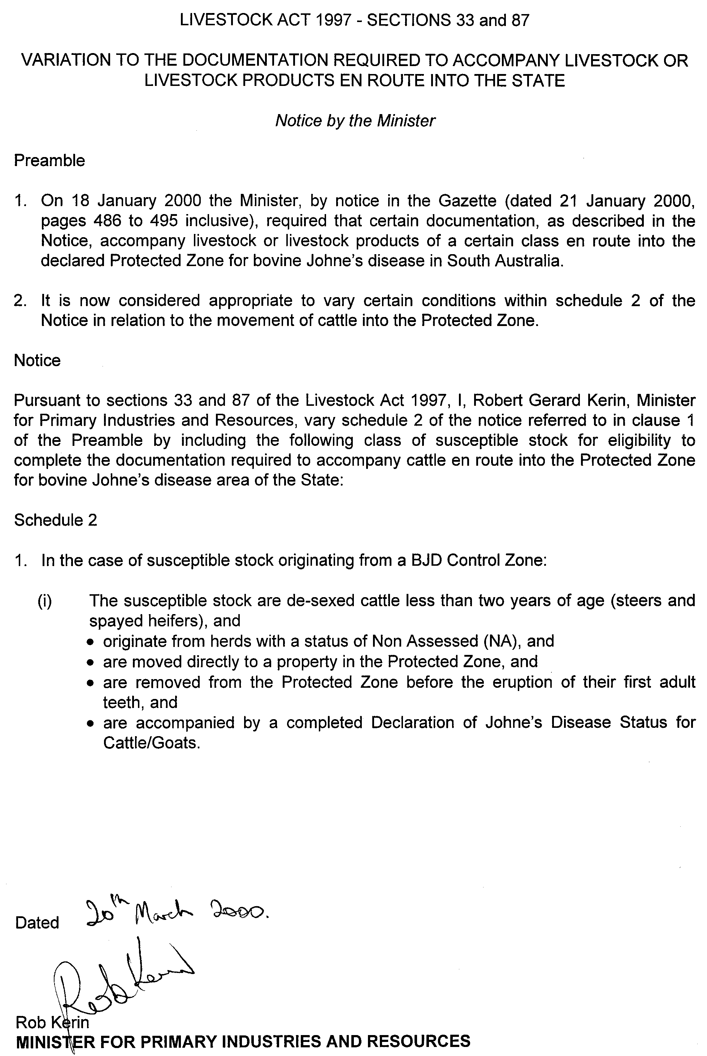
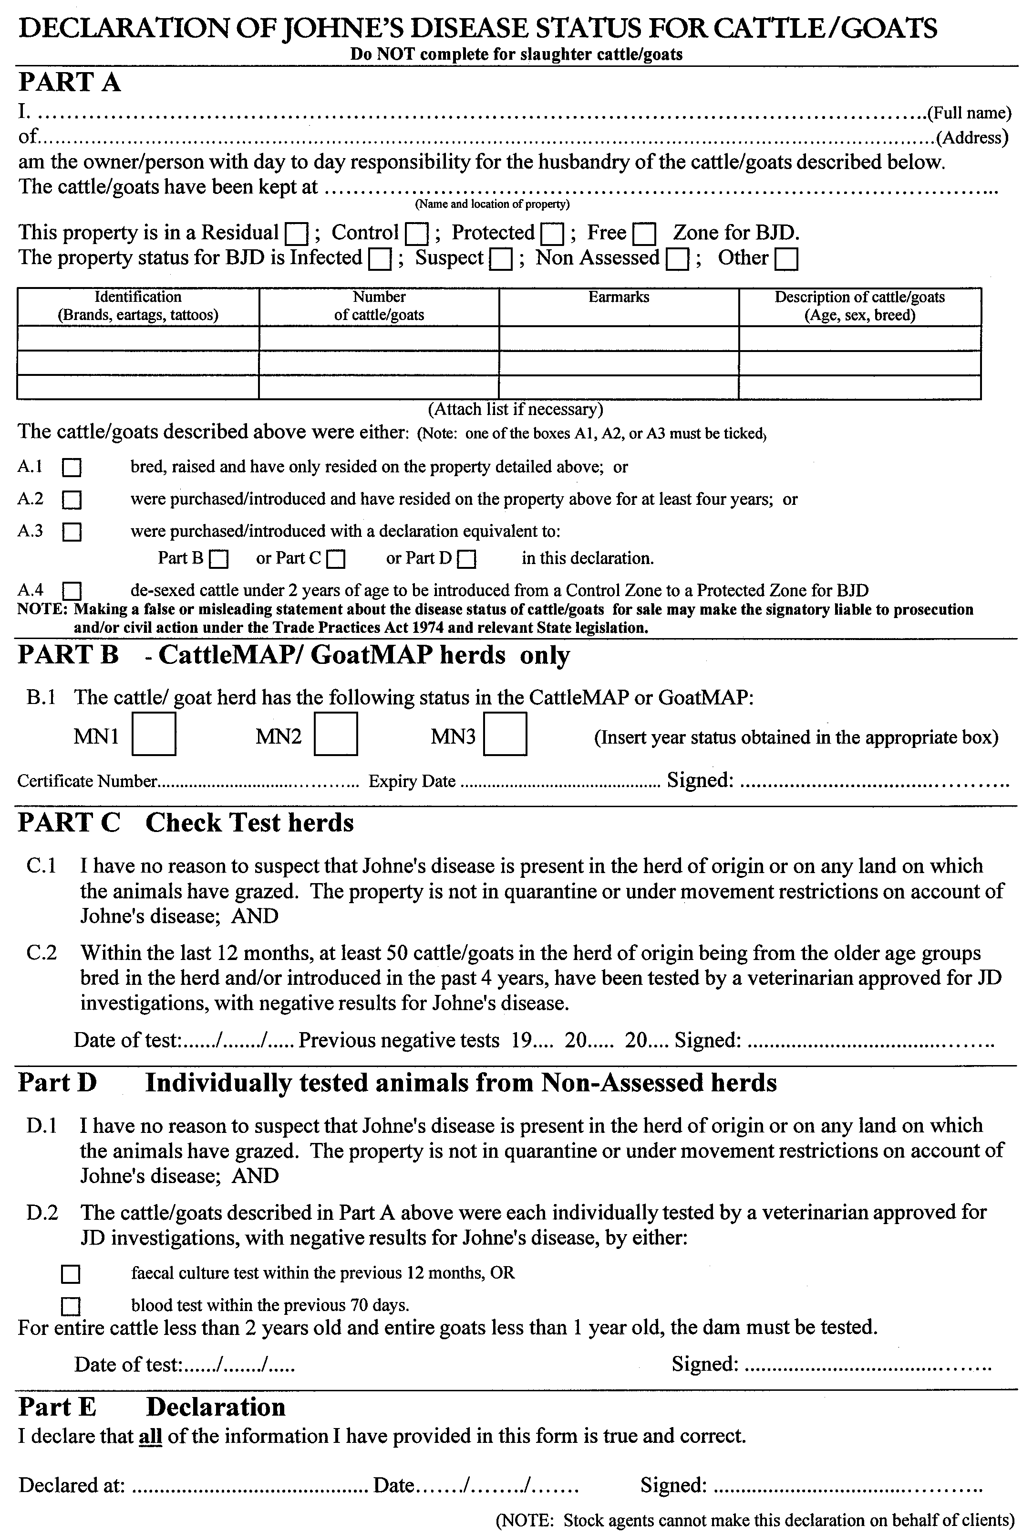
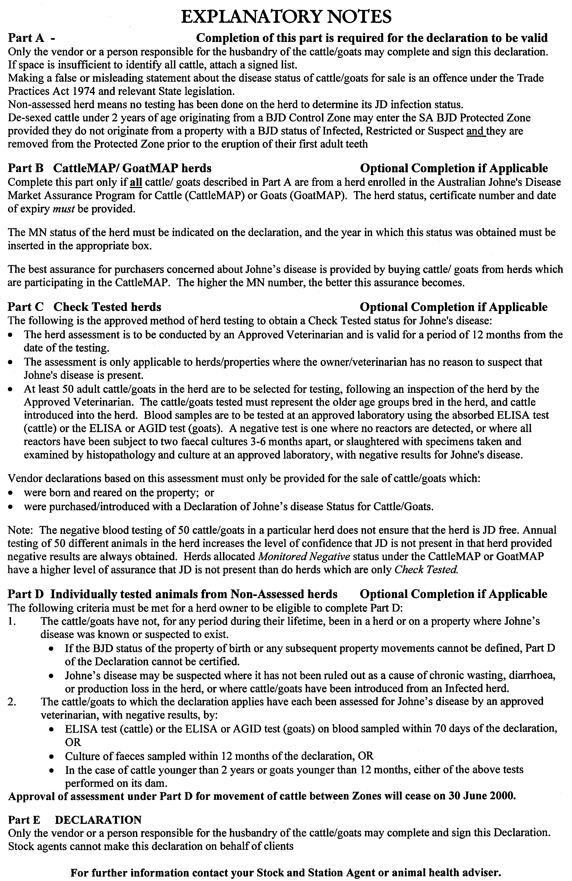

LIQUOR LICENSING ACT 1997
Notice of Application
NOTICE is hereby given, pursuant to section 52 (2) (b) of the Liquor Licensing Act 1997, that Woolies Liquor Stores Pty Ltd (ACN 007 939 531), 599 Main North Road, Gepps Cross, S.A. has applied to the Licensing Authority for the removal of the Retail Liquor Merchant’s Licence from premises the subject of the Certificate for Removal to Ground Floor, Woolworths Variety Store, 80 Rundle Mall, Adelaide to premises situated in the basement at the Woolworths Variety Store, 80 Rundle Mall, Adelaide.
The application has been set down for hearing on 28 April 2000.
Any person may object to the application by lodging a notice of objection in the prescribed form with the Licensing Authority, and serving a copy of the notice on the applicant at the applicant’s address given above, at least seven days before the hearing date.
Plans in respect of the premises the subject of the application are open to public inspection without fee at the Office of the Liquor and Gaming Commissioner, 9th Floor, East Wing, 50 Grenfell Street, Adelaide, S.A. 5000.
Applicant

LIQUOR LICENSING ACT 1997
Notice of Application
NOTICE is hereby given, pursuant to section 52 (2) (b) of the Liquor Licensing Act 1997, that Diana Joy Radford, 7 Sharon Place, Grange, S.A. 5022 has applied to the Licensing Authority for the transfer of a Restaurant Licence in respect of premises situated at 202-204 Hutt Street, Adelaide, S.A. 5000 and known as Cafe Isabella.
The application has been set down for hearing on 5 May 2000.
Any person may object to the application by lodging a notice of objection in the prescribed form with the Licensing Authority, and serving a copy of the notice on the applicant at the applicant’s address given above, at least seven days before the hearing date.
Plans in respect of the premises the subject of the application are open to public inspection without fee at the Office of the Liquor and Gaming Commissioner, 9th Floor, East Wing, 50 Grenfell Street, Adelaide, S.A. 5000.
Dated 24 March 2000.
Applicant

LIQUOR LICENSING ACT 1997
Notice of Application
NOTICE is hereby given, pursuant to section 52 (2) (b) of the Liquor Licensing Act 1997, that Vale Host Pty Ltd and Topanisa No. 2 Pty Ltd have applied to the Licensing Authority for the transfer of a Restaurant Licence in respect of premises situated at 173 Hutt Street, Adelaide, S.A. 5000 and known as Tantino.
The application has been set down for hearing on 17 April 2000.
Any person may object to the application by lodging a notice of objection in the prescribed form with the Licensing Authority, and serving a copy of the notice on the applicants at the applicants’ address.
Plans in respect of the premises the subject of the application are open to public inspection without fee at the Office of the Liquor and Gaming Commissioner, 9th Floor, East Wing, 50 Grenfell Street, Adelaide, S.A. 5000.
Applicants

LIQUOR LICENSING ACT 1997
Notice of Application
NOTICE is hereby given, pursuant to section 52 (2) (b) of the Liquor Licensing Act 1997, that Glenhurst Wines Pty Ltd has applied to the Licensing Authority for a Producer’s Licence in respect of premises to be situated at Jones Road, Hahndorf, S.A 5245 and to be known as Glenhurst Wines.
The application has been set down for hearing on 28 April 2000.
Any person may object to the application by lodging a notice of objection in the prescribed form with the Licensing Authority, and serving a copy of the notice on the applicant at the applicant’s address given above, at least seven days before the hearing date.
Plans in respect of the premises the subject of the application are open to public inspection without fee at the Office of the Liquor and Gaming Commissioner, 9th Floor, East Wing, 50 Grenfell Street, Adelaide, S.A. 5000.
Dated 20 March 2000.
Applicant

LIQUOR LICENSING ACT 1997
Notice of Application
NOTICE is hereby given, pursuant to section 52 (2) (b) of the Liquor Licensing Act 1997, that Miby Pty Ltd has applied to the Licensing Authority for a Variation of Conditions of Licence in respect of premises situated at 2 North Terrace, Kent Town, S.A. 5067 and known as Royal Hotel.
The application has been set down for hearing on 28 April 2000 at 9 a.m.
Condition
The following licence condition is sought:
Variation of conditions 4 and 7 of the licence in regard to security, so that one security officer only is required in the undercroft carpark and on the street during live entertainment on Thursday, Friday and Saturday nights at the hotel.
Any person may object to the application by lodging a notice of objection in the prescribed form with the Licensing Authority, and serving a copy of the notice on the applicant at the applicant’s address given above, at least seven days before the hearing date.
Plans in respect of the premises the subject of the application are open to public inspection without fee at the Office of the Liquor and Gaming Commissioner, 9th Floor, East Wing, 50 Grenfell Street, Adelaide, S.A. 5000.
Dated 21 March 2000.
Applicant

LOCAL GOVERNMENT ACT 1934
Mid North Regional Development Board
Notice of Winding Up of a Controlling Authority
TAKE notice that pursuant to section 200 of the Local Government Act 1934, as amended, Dorothy Kotz, Minister for Local Government and delegate Minister of the Minister for Transport and Urban Planning, to whom the administration of the Local Government Act 1934, is committed, has approved the winding up of the Mid North Regional Development Board by the Clare and Gilbert Valleys Council, the Northern Areas Council and the Regional Council of Goyder effective midnight, 30 June 2000.
Dated 27 March 2000.
Dorothy Kotz, Minister for Local Government, Minister for Aboriginal Affairs

LOTTERY AND GAMING ACT 1936
Notice by the Treasurer
Exemption
PURSUANT to section 57 (2) of the Lottery and Gaming Act 1936, I exempt the following club:
Streaky Bay Racing Club
for the 1999-2000 racing season from the operation of section 57 (1) of that Act subject to the conditions set out in the Schedule attached to this notice.
Dated 19 March 2000.
Rob Lucas, Treasurer

Schedule
1. The exemption only relates to, and is in relation to, a punters’ club conducted on behalf of the racing club by a person appointed by the club for that purpose.
2. A punters’ club can only be conducted on behalf of a racing club in a racecourse during the holding of a race meeting by that racing club.
3. The person conducting the club must not receive any valuable thing, except money, for investment by the club.
4. A punters’ club referred to in this Schedule has the following characteristics:
(a) a club is made up of persons who purchase tickets issued by the person conducting the club;
(b) a ticket entitles the holder to membership of a club in respect of the race meeting in relation to which the ticket is issued;
(c) the money paid for tickets plus any moneys received in the form of sponsorship, forms a fund which may be invested by the club on races;
(d) any winnings are paid into the fund and the members of the club are entitled to share the fund in proportion to the number of tickets held by each member.
5. Tickets printed and issued shall be consecutively numbered and shall show the date designated for such meeting.
6. Tickets cannot be sold by a club after it has invested money on a race.
7. The following information must be announced and displayed at the place at which the operations of the punters’ club are conducted:
(a) the opening balance of the fund to be invested by the club; and
(b) the number of tickets issued to members of the punters’ club; and
(c) the bets and the races on which they are placed; and
(d) the winnings and losses resulting from those bets.
8. The information:
(a) referred to in clause 7 must be announced on course and displayed in legible letters and numerals that are of sufficient size to be understood easily by members of the public;
(b) referred to in clause 7 (c) must be announced on course and displayed before the race to which it relates is run.
9. The amount to be shared between the members of the punters’ club is the amount paid by members for tickets issued by the club plus any moneys received in the form of sponsorship plus the amount of any winnings less the amount invested in bets on races. The dividend declared shall be rounded up to the nearest 5 cents.
10. Within 21 days after the holding of a race meeting, the club that has conducted a punters’ club must lodge with the Racing Industry Development Authority a return in the attached form.
11. If at the expiration of two months after a race meeting a punters’ club holds unclaimed money on behalf of a member, the club must on the appropriate form provide details of all punters’ club tickets that are unclaimed and must pay the money to the Racing Industry Development Authority.
Punters’ Club—Details of Investments
Name of Club:
Date of Race Meeting:
No. of tickets sold . . . . . . . @ $ . . . . . . . $
Sponsorship . . . . . . . . . . . . . . . . . . . . . $
Total $
Plus
Winnings: Bookmakers
On-Course Totalizator $
⎯⎯⎯⎯⎯
Sub Total $
Less
Amount Invested: Bookmakers
On-Course
Totalizator $
⎯⎯⎯⎯⎯
Balance $
⎯⎯⎯⎯⎯
⎯⎯⎯⎯⎯
Amount to be Distributed to Each Ticket Holder= $
Race Day Transaction Summary—Totalizator Investments
Code | Race No. | Bet Details | Amount  Invested | Winnings

Race Day Transaction Summary—Bookmaker Investments
State | Race No. | Bet Details | Amount  Invested | Winnings

Club Nominee

MINING ACT 1971
NOTICE is hereby given in accordance with Section 28 (5) of the Mining Act 1971, that the Minister for Minerals and Energy proposes to grant an Exploration Licence over the under-mentioned area.
Applicant: Helix Resources NL
Location: Lock area—Approximately 120 km north of Port Lincoln, bounded as follows: Commencing at a point being the intersection of latitude 33°30′S and longitude 135°30′E, thence east to longitude 136°11′E, south to latitude 33°32′S, west to longitude 136°10′E, south to latitude 33°44′S, west to longitude 135°56′E, north to latitude 33°42′S, west to longitude 135°53′E, north to latitude 33°36′S, east to longitude 135°54′E, north to latitude 33°35′S, east to longitude 135°57′E, south to latitude 33°36′S, east to longitude 135°58′E, north to latitude 33°33′S, west to longitude 135°57′E, north to latitude 33°32′S, west to longitude 135°55′E, south to latitude 33°34′S, west to longitude 135°53′E, south to latitude 33°35′S, west to longitude 135°40′E, north to latitude 33°32′S, west to longitude 135°30′E and north to the point of commencement, but excluding Hincks Conservation Park. All the within latitudes and longitudes are geodetic and expressed in terms of the Australian Geodetic Datum as defined on p. 4984 of Commonwealth Gazette number 84 dated 6 October 1966.
Term: 1 year
Area in km²: 872
Ref. D.M.E. No.: 157/1999
Dated 28 March 2000.
L. Johnston, Mining Registrar

MINING ACT 1971
NOTICE is hereby given in accordance with Section 28 (5) of the Mining Act 1971, that the Minister for Minerals and Energy proposes to grant an Exploration Licence over the under-mentioned area.
Applicant: Helix Resources NL
Location: Iron Baron area—Approximately 50 km south-west of Whyalla, bounded as follows: Commencing at a point being the intersection of latitude 33°10′S and longitude 137°01′E, thence east to longitude 137°05′E, south to latitude 33°16′S, west to longitude 137°01′E, and north to the point of commencement, all the within latitudes and longitudes being geodetic and expressed in terms of the Australian Geodetic Datum as defined on p. 4984 of Commonwealth Gazette number 84 dated 6 October 1966.
Term: 1 year
Area in km²: 69
Ref. D.M.E. No.: 163/1999
Dated 28 March 2000.
L. Johnston, Mining Registrar

OCCUPATIONAL HEALTH, SAFETY AND WELFARE
ACT 1986
Appointment
I, ROBERT DAVID LAWSON, Minister for Workplace Relations, in and for the State of South Australia, hereby appoint the undermentioned Officer as an Inspector, pursuant to the Occupational Health, Safety and Welfare Act 1986:
Christopher Ginever
Dated 28 March 2000.
Robert Lawson, Minister for Workplace Relations

PETROLEM PRODUCTS REGULATION ACT 1995
Appointment
I, ROBERT DAVID LAWSON, Minister for Workplace Relations, in and for the State of South Australia, hereby appoint the undermentioned Officer as an Authorised Officer under the Petroleum Products Regulation Act 1995, in accordance with my delegated authority under section 49 of the Petroleum Products Regulation Act 1995:
Christopher Ginever
Dated 28 March 2000.
Robert Lawson, Minister for Workplace Relations

REAL PROPERTY ACT NOTICE
WHEREAS the persons named at the foot hereof have each respectively for himself made application to have the land set forth and described before his name at the foot hereof brought under the operation of the Real Property Act: Notice is hereby given that unless caveat be lodged with the Registrar-General by some person having estate or interest in the said lands on or before the expiration of the period herein below for each case specified, the said several pieces of land will be brought under the operation of the said Act as by law directed. Diagrams delineating these parcels of land may be inspected at the Lands Titles Registration Office, Adelaide, and in the offices of the several corporations or district councils in which the lands are situated.

The Schedule
No. of  Applica-  tion | Description of Property |  | Name |  | Residence | Date up to and  inclusive of which  caveat may be  lodged

30920 | A free and unrestricted right of way over portion of Town Acre 754, Hundred of Yatala being marked ‘A’ on Filed Plan No. 41413 and being appurtenant to the whole of the land comprised in Certificate of Title Volume 5190, Folio 758 |  | Brian Patrick Brophy and Mary Alice Brophy |  | 267 Ward Street, North Adelaide, S.A. 5006 | 1 May 2000

Dated 29 March 2000, at the Lands Titles Registration Office, Adelaide. J. Zaccaria, Deputy Registrar-General

REMUNERATION TRIBUNAL
Supplementary Report to Determination No. 9 of 1999
1. Clarification has recently been sought from the Remuneration Tribunal in respect to Clause 4. ‘Telephone Rental and Calls Allowance’ of Determination No. 9 of 1999 which states:
When a person to whom this Determination applies is required to have a telephone at home for official purposes, that person shall be paid the whole of the telephone rental for a single point connection without extra services and one third of the cost of metered calls.
2. The Tribunal confirms that one third of the cost of metered calls refers to the cost of locally metered calls made from the telephone at home.
3. The Tribunal understands that persons covered by the Tribunal’s determination can seek reimbursement of International and STD business calls on the basis of actual costs incurred.
Dated 27 March 2000.
R. L. Dahlenburg, A.M. President

ROADS (OPENING AND CLOSING) ACT 1991
Road closure portion of Burton Road
Salisbury Downs
NOTICE is hereby given, pursuant to section 10 of the Roads (Opening and Closing) Act 1991, that the City of Salisbury proposes to make a Road Process Order to close and transfer to Sandhurst Trustees Ltd the portion of Burton Road between piece 20 in Deposited Plan 44809 and allotment 200 in Filed Plan 11847. The road is no longer required due to the re-alignment of the Burton Road/Spains Road intersection, shown delineated and lettered ‘A’ on Preliminary Plan No. PP32/0551.
A copy of the plan and a statement of persons affected are available for public inspection at the offices of the Council, 8 James Street, Salisbury, S.A. 5108 and the Adelaide office of the Surveyor-General during normal office hours.
Any application for easement or objection must set out the full name, address and details of the submission and must be fully supported by reasons.
The application for easement or objection must be made in writing to the Council, P.O. Box 8, Salisbury, S.A. 5108 WITHIN 28 DAYS OF THE DATE OF THIS NOTICE and a copy must be forwarded to the Surveyor-General, G.P.O. Box 1354, Adelaide, S.A. 5001. Where a submission is made, the Council will give notification of a meeting at which the matter will be considered.
Dated 30 March 2000.
P. M. Kentish Surveyor-General

ROADS (OPENING AND CLOSING) ACT 1991
Road Closure— Walkway, Butterworth and Blacker Roads,
Aldinga Beach
NOTICE is hereby given, pursuant to section 10 of the Roads (Opening and Closing) Act 1991, that the CITY OF ONKAPARINGA proposes to make a Road Process Order to close the whole of the public road (walkway) between Butterworth Road and Blacker Road adjoining allotments 701 and 712 in Deposited Plan 6722 as more particularly delineated and lettered ‘A’ and ‘B’ (respectively) on Preliminary Plan No. PP32/0554. Closed road ‘A’ to be transferred to A. and Z. ATHANASOPOULOS and closed road ‘B’ to be transferred to R. J. and K. L. FERBER.
A copy of the plan and a statement of persons affected are available for public inspection at the office of the Council, Ramsay Place, Noarlunga Centre, S.A. 5168 and the Adelaide Office of the Surveyor-General during normal office hours.
Any application for easement or objection must set out the full name, address and details of the submission and must be fully supported by reasons.
The application for easement or objection must be made in writing to the Council, P.O. Box 1, Noarlunga Centre, S.A. 5168 WITHIN 28 DAYS OF THIS NOTICE and a copy must be forwarded to the Surveyor-General, G.P.O. Box 1354, Adelaide, S.A. 5001. Where a submission is made, the Council will give notification of a meeting at which the matter will be considered.
Dated 30 March 2000.
P. M. Kentish, Surveyor-General

ROADS (OPENING AND CLOSING) ACT 1991
Portions Pelican Point Road
Pelican Point
NOTICE is hereby given, pursuant to section 10 of the Roads (Opening and Closing) Act 1991, that the DISTRICT COUNCIL OF GRANT proposes to make a Road Process Order to close and transfer to the adjoining owners portions of public road (Pelican Point Road) adjoining sections 656 to 667 (inclusive) Hundred of Kongorong shown delineated and lettered ‘A’ to ‘H’ and ‘J’ to ‘M’ respectively on Preliminary Plan No. PP32/0555.
A copy of the plan and a statement of persons affected are available for public inspection at the offices of the Council, 324 Commercial Street West, Mount Gambier, S.A. 5290 and the Adelaide office of the Surveyor-General during normal office hours.
Any application for easement or objection must set out the full name, address and details of the submission and must be fully supported by reasons.
The application for easement or objection must be made in writing to the Council, P.O. Box 724, Mount Gambier, S.A. 5290 WITHIN 28 DAYS OF THE DATE OF THIS NOTICE and a copy must be forwarded to the Surveyor-General, G.P.O. Box 1354, Adelaide, S.A. 5001. Where a submission is made, the Council will give notification of a meeting at which the matter will be considered.
Dated 30 March 2000.
P. M. Kentish, Surveyor-General

ROADS (OPENING AND CLOSING) ACT 1991:
SECTION 24
NOTICE OF CONFIRMATION OF ROAD
PROCESS ORDER
Heritage Court, Oakden
Deposited Plan 54424
BY Road Process Order made on 2 March 2000, The City of Port Adelaide Enfield ordered that:
1. Portion of the public road (Heritage Court) south of Hilltop Drive between allotments 351 and 352 in Deposited Plan 48652 more particularly lettered ‘A’ in Preliminary Plan No. PP32/0374 be closed.
2. The whole of the land subject to closure be transferred to G. Y. LAND DEVELOPERS PTY LTD in accordance with agreement for transfer dated 6 April 1999 entered into between The City of Port Adelaide Enfield to G. Y. Land Developers Pty Ltd.
3. The following easements are granted over portion of the land subject to that closure:
Grant to the South Australian Water Corporation easements for water supply and sewerage purposes.
Grant to The City of Port Adelaide Enfield an easement for drainage purposes.
Grant to ETSA Utilities Pty Ltd an easement for underground electricity supply purposes.
On 20 March 2000 that order was confirmed by the Minister for Administrative Services conditionally on approval and deposit of the survey plan by the Registrar-General. The condition has now been fulfilled.
Pursuant to section 24(5) of the Roads (Opening and Closing) Act 1991, NOTICE of the order referred to above and its confirmation is hereby given.
Dated 30 March 2000.
P. M. Kentish, Surveyor-General

ROAD TRAFFIC ACT 1961
Appointment of Inspectors
NOTICE is hereby given that on 18 March 2000 I appointed the following persons as Inspectors for the purposes of Section 160 and Part 4A of the Road Traffic Act 1961:
Robert Maxwell Faulkner
Yolande Louis Gower
Daniel Joseph Lee
Diana Laidlaw, Minister for Transport and Urban Planning

ROAD TRAFFIC ACT 1961
Appointment of Inspectors
NOTICE is hereby given that on 18 March 2000 I appointed the following persons as Inspectors pursuant to Section 35 (1) of the Road Traffic Act 1961:
Robert Maxwell Faulkner
Daniel Joseph Lee
Diana Laidlaw, Minister for Transport and Urban Planning

SOIL CONSERVATION AND LAND CARE ACT 1989
Appointments
I, ROBERT GERARD KERIN, Minister for Primary Industries and Resources in the State of South Australia to whom the administration of the Soil Conservation and Land Care Act 1989 has been committed, do hereby appoint the following people as members of the Kangaroo Island Soil Conservation Board, pursuant to Section 24 of the Act until 13 July 2001:
Kylie Moritz
Charles Matheson
William John Roper
Dated 20 March 2000.
Rob Kerin, Minister for Primary Industries and Resources

WATER MAINS AND SEWERS

Office of the South Australian Water Corporation
Adelaide, 30 March 2000.

WATER MAINS LAID

Notice is hereby given that the following main pipes or parts of main pipes have been laid down by the South Australian Water Corporation in or near the undermentioned water districts and are now available for a constant supply of water to adjacent land.

ADELAIDE WATER DISTRICT

CITY OF HOLDFAST BAY
Hulbert Street, Hove. p12

DISTRICT OF KAPUNDA AND LIGHT
Across Gawler Bypass, Gawler West. p19

CITY OF PORT ADELAIDE ENFIELD
Tudor Street, Blair Athol. p16

BEETALOO COUNTRY LANDS WATER DISTRICT

DISTRICT OF THE COPPER COAST
Coast Road, Warburto. p10

MOONTA WATER DISTRICT

DISTRICT OF THE COPPER COAST
Moonta Road, Moonta Bay. p8

PORT PIRIE WATER DISTRICT

PORT PIRIE REGIONAL COUNCIL
Wandearah Road, Port Pirie South. p1

WALLAROO WATER DISTRICT

DISTRICT OF THE COPPER COAST
Burra Street, Wallaroo. p9

YORKE PENINSULA COUNTRY LANDS WATER DISTRICT

DISTRICT OF YORKE PENINSULA
Government road south of section 26 (hundred of Kilkerran), Maitland. p3
Government road west of sections 80 and 79 (hundred of Maitland), Maitland. p3 and 4
Government road south of sections 80 and 81 (hundred of Maitland), Maitland. p4
Government road south of section 55 (hundred of Maitland), Yorke Valley. p11

WATER MAINS ABANDONED

Notice is hereby given that the undermentioned water mains have been abandoned by the South Australian Water Corporation.

ADELAIDE WATER DISTRICT

DISTRICT OF KAPUNDA AND LIGHT
Across Gawler Bypass, Gawler West. p19

BEETALOO COUNTRY LANDS WATER DISTRICT

DISTRICT OF THE COPPER COAST
Easements in lots 105 and 104, Federal Avenue, lot 101, Davidson Road and lot 102, Devon Road, Wallaroo Mines. p5

YORKE PENINSULA COUNTRY LANDS WATER DISTRICT

DISTRICT OF YORKE PENINSULA
Government road south of section 26 (hundred of Kilkerran), Maitland. p3
Government road west of sections 80 and 79 (hundred of Maitland), Maitland. p3 and 4
Government road south of sections 80 and 81 (hundred of Maitland), Maitland. p4
Government road south of section 55 (hundred of Maitland), Yorke Valley. p11

SEWERS LAID

Notice is hereby given that the following sewers have been laid down by the South Australian Water Corporation in the undermentioned drainage area and are now available for house connections.

ADELAIDE DRAINAGE AREA

CITY OF HOLDFAST BAY
Hulbert Street, Hove. FB 1086 p11
Easement in lot 201, Hulbert Street, Hove. FB 1086 p11

CITY OF MITCHAM
Easement in lot 703, Brook Street, Torrens Park. FB 1086 p10

CITY OF PLAYFORD
Halsey Road, Elizabeth East. FB 1086 p12
Easements in lot 2, Keysley Street and lot 25, Goodman Road, Elizabeth South. FB 1086 p16
Leslie Street, Elizabeth East. FB 1086 p17

CITY OF PORT ADELAIDE ENFIELD
Lawson Avenue, Clearview. FB 1086 p14

CITY OF PROSPECT
Elderslie Avenue, Fitzroy. FB 1086 p13

CITY OF SALISBURY
Parkway Circuit, Parafield Gardens. FB 1086 p20 and 21
Woodside Court, Parafield Gardens. FB 1086 p20 and 21
Hillsview Place, Parafield Gardens. FB 1086 p20 and 21

CITY OF TEA TREE GULLY
Bloomfield Avenue, Greenwith. FB 1086 p18 and 19
Easements in reserve (lot 522) and lots 70 and 69, Bloomfield Avenue, Greenwith. FB 1086 p18 and 19
Reuben Richardson Road, Greenwith. FB 1086 p22-25 and p27-29
Easement in lot 77, Lake Gairdner Parade, Greenwith. FB 1086 p22 and 25
Lake Gairdner Parade, Greenwith. FB 1086 p22 and 25
Chapel Hill Road, Greenwith. FB 1086 p22 and 25
Olde Coach Road, Greenwith. FB 1086 p22 and 27
Easements in lot 100, Olde Coach Road and lot 101 and reserve (lot 102), Millswood Place, Greenwith. FB 1086 p 22 and 27
Waterfield Lane, Greenwith. FB 1086 p22 and 27
Lakeridge Court, Greenwith. FB 1086 p23 and 26
Lakeside Court, Greenwith. FB 1086 p23 and 28
Easements in lots 94-92, Mirage Court and lot 87, Reuben Richardson Road, Greenwith. FB 1086 p23 and 26
Mirage Court, Greenwith. FB 1086 p23 and 26
Easements in lot 552, Reuben Richardson Road, Greenwith. FB 1086 p23, 24 and 26
Easements in lots 522 and 96, Reuben Richardson Road, Greenwith. FB 1086 p24, 23 and 29

CORPORATE TOWN OF WALKERVILLE
James Street, Gilberton. FB 1086 p15

OUTSIDE ADELAIDE DRAINAGE AREA

CITY OF TEA TREE GULLY
Easement in lot 11, Lakeridge Court, Greenwith. FB 1086 p23 and 29

SEWERS ABANDONED

Notice is hereby given that the undermentioned sewer has been abandoned by the South Australian Water Corporation.

ADELAIDE DRAINAGE AREA

CITY OF TEA TREE GULLY
Lake Gairdner Avenue, Greenwith. FB 1086 p22
S. Sullivan, Chief Executive Officer, South Australian Water Corporation

VOCATIONAL EDUCATION, EMPLOYMENT AND TRAINING ACT 1994

PART 4 - CONTRACTS OF TRAINING

Pursuant to the provisions of the Vocational Education, Employment and Training Act (VEET Act) the Accreditation and Registration Council (ARC) gives notice that it has determined the following:

Occupations that Constitute Trades and Other Declared Vocations
The following schedule is additional to:

1. the gazettal of 24 April 1996 (page 2045) | 2. the gazettal of 31 October 1996 (page 1544)
3. the gazettal of 5 December 1996 (page 1818) | 4. the gazettal of 6 February 1997 (page 830)
5. the gazettal of 17 April 1997 (page 1571) | 6. the gazettal of 29 May 1997 (page 2758)
7. the gazettal of 12 June 1997 (page 2984) | 8. the gazettal of 3 July 1997 (page 33)
9. the gazettal of 7 August 1997 (page 311) | 10. the gazettal of 18 December 1997 (page 1677)
11. the gazettal of 22 December 1997 (page 1776) | 12. the gazettal of 23 April 1998 (page 1959)
13. the gazettal of 18 June 1998 (page 2594) | 14. the gazettal of 6 August 1998 (page 339)
15. the gazettal of 24 September (page 990) | 16. the gazettal of 1 October 1998 (page 1038)
17. the gazettal of 15 October 1998 (page 1150) | 18. the gazettal of 12 November 1998 (page 1389)
19. the gazettal of 19 November 1998 (page 1583) | 20. the gazettal of 3 December 1998 (page 1742)
21. the gazettal of 10 December 1998 (page 1870) | 22. the gazettal of 17 December 1998 (page 1954)
23. the gazettal of 23 December 1998 (page 2039) | 24. the gazette of 11 March 1999 (page 1359)
25. the gazette of 25 March 1999 (page 1480) | 26. the gazette of 1 April 1999 (page 1605) (Errata)
27. the gazette of 22 April 1999 (page 2219) | 28. the gazettal of 29 April 1999 (page 2381) (Errata)
29. the gazettal of 6 May 1999 (page 2482) | 30. the gazettal of 13 May 1999 (page 2595)
31. the gazettal of 27 May 1999 (Errata) (page 2723) | 32. the gazettal of 17 June 1999 (page 3123)
33. the gazettal of 24 June 1999 (page 3261) | 34. the gazettal of 1 July 1999 (page 22)
35. the gazettal of 29 July 1999 (page 602) | 36. the gazettal of 30 September 1999 (page 1364)
37. the gazettal of 14 October 1999 (page 1973) | 38. the gazettal of 11 November 1999 (page 2327)

which set out the occupations that constitute trades and other declared vocations and the terms and conditions applicable to such declared vocations.

SCHEDULE - DECLARED VOCATIONS, REQUIRED COURSES OF INSTRUCTION AND ASSOCIATED CONDITIONS

Entries recorded in italics denote previous courses and conditions determined by ARC for existing Declared Vocations. Variations appear in bold.

Occupation/Occupation Levels  Declared Vocation  * Trade  # Other than trade | Course code  National / State  and expiry date | Approved Course of Instruction and Stream | Nominal Term of  Contract of  Training | Nominal hours of  attendance at  approved course | Probationary Period
# Health Ancillary Worker (Dental Assistant)  Declared ICTC  February 1996 | 12805SA  SALPR  December 2000 | Certificate III in Health Ancillary Worker Dental Assistant | 12 months | Max. hrs for this qualification.  410 hours | 1 month
# Clerical Processing (Office Administration) | Endorsed to  23/9/00 | Administration Training Package
ARC June 1998 | BSZ10197 | Certificate I in Business (Office Skills) | exit point
ARC November 98 - | BSZ20197 | Certificate II in Business (Office Administration) (Level 2) | 12 months | 390 hours | 1 month
change in hours | BSZ30197 | Certificate III in Business (Office Administration) (Level 3) | 12 months | 265 - 345 hrs | 1 month

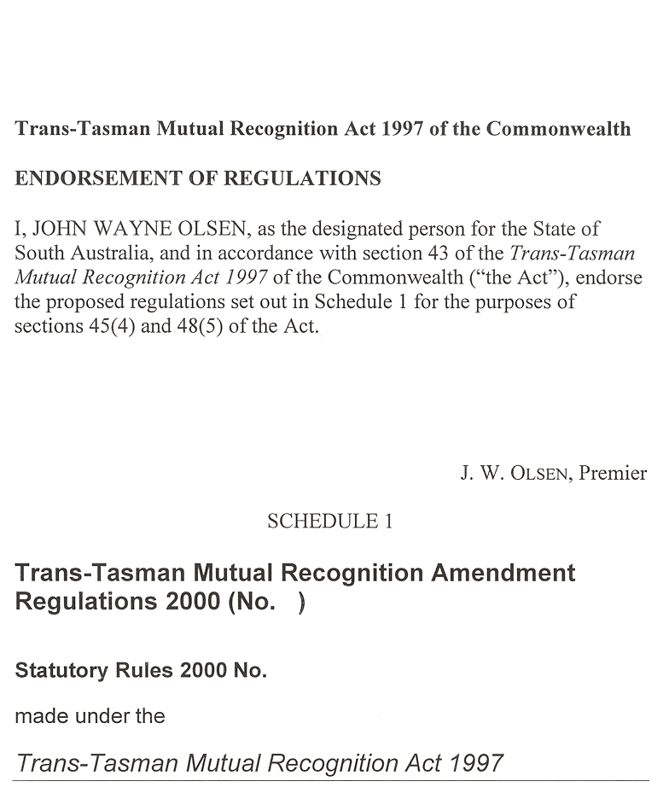
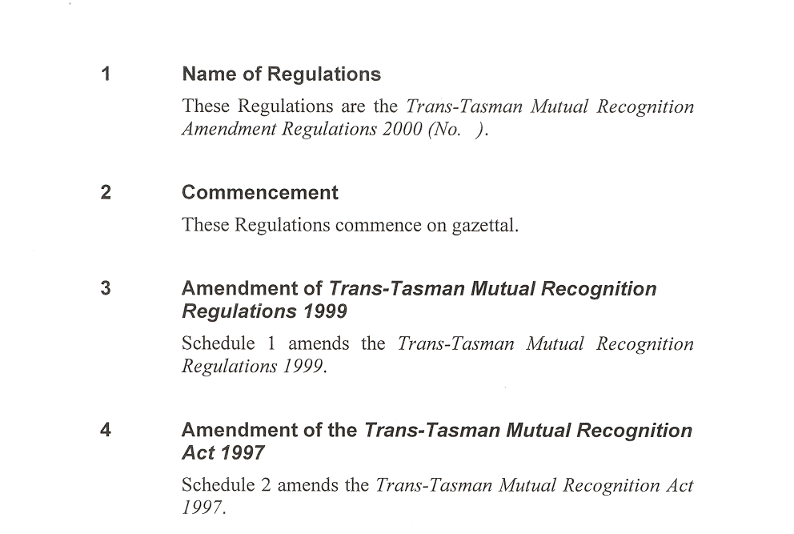
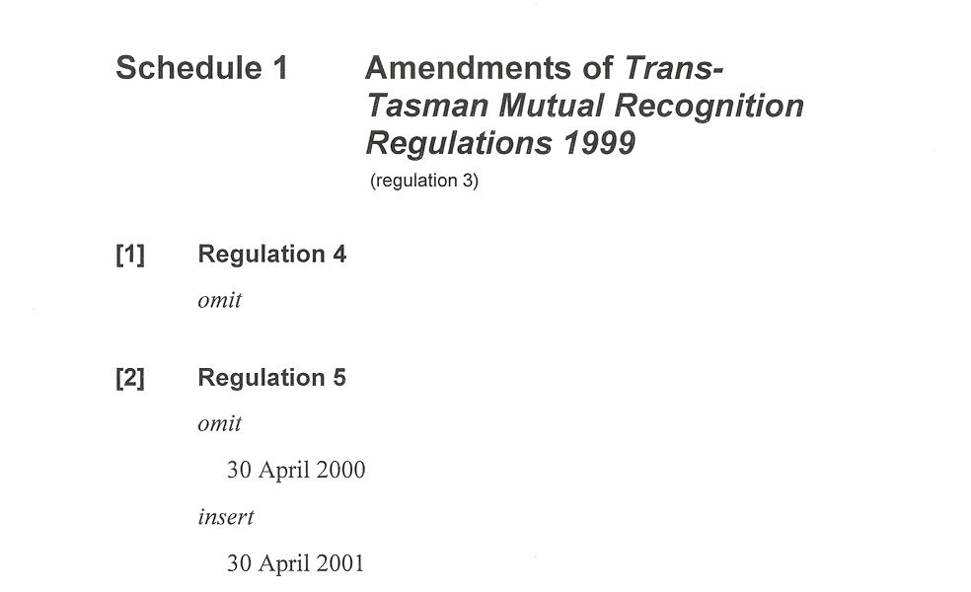
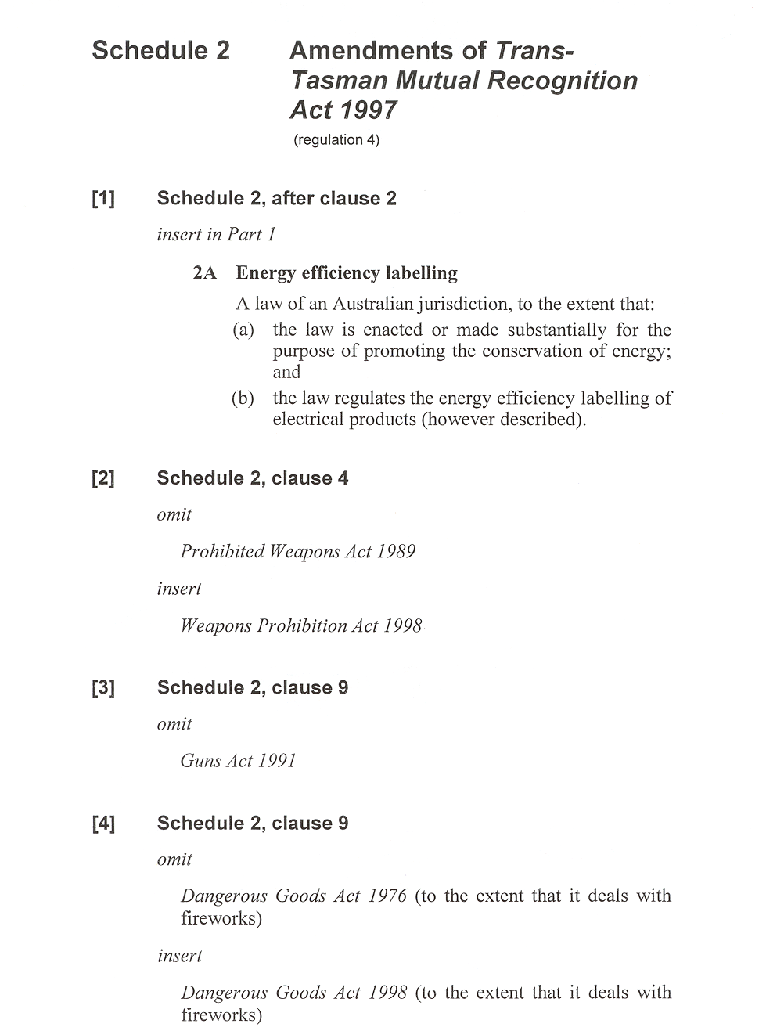
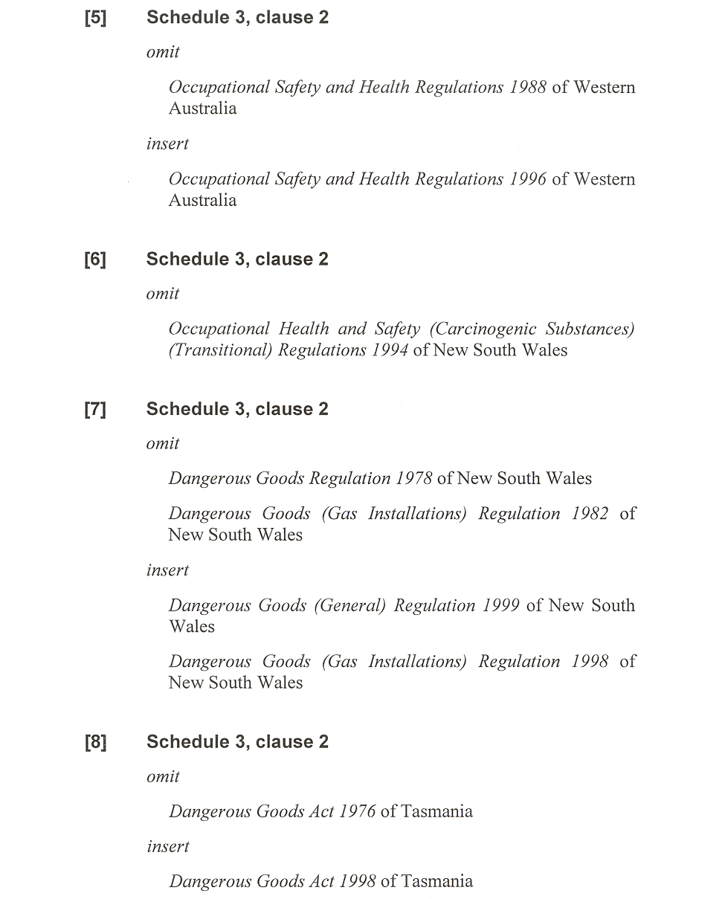
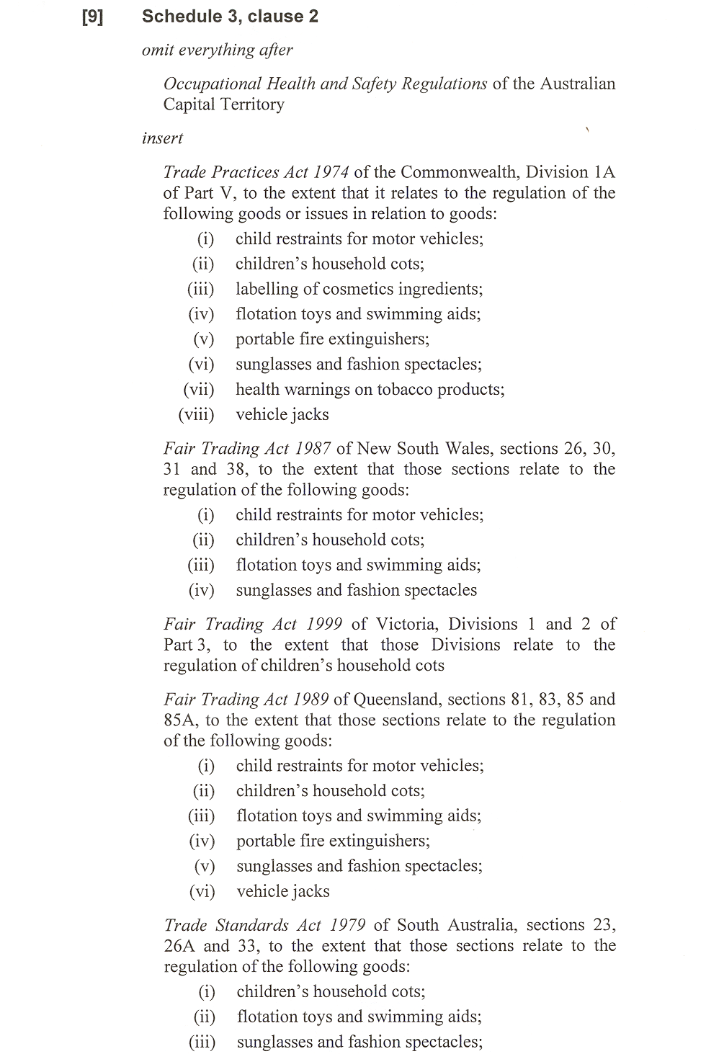
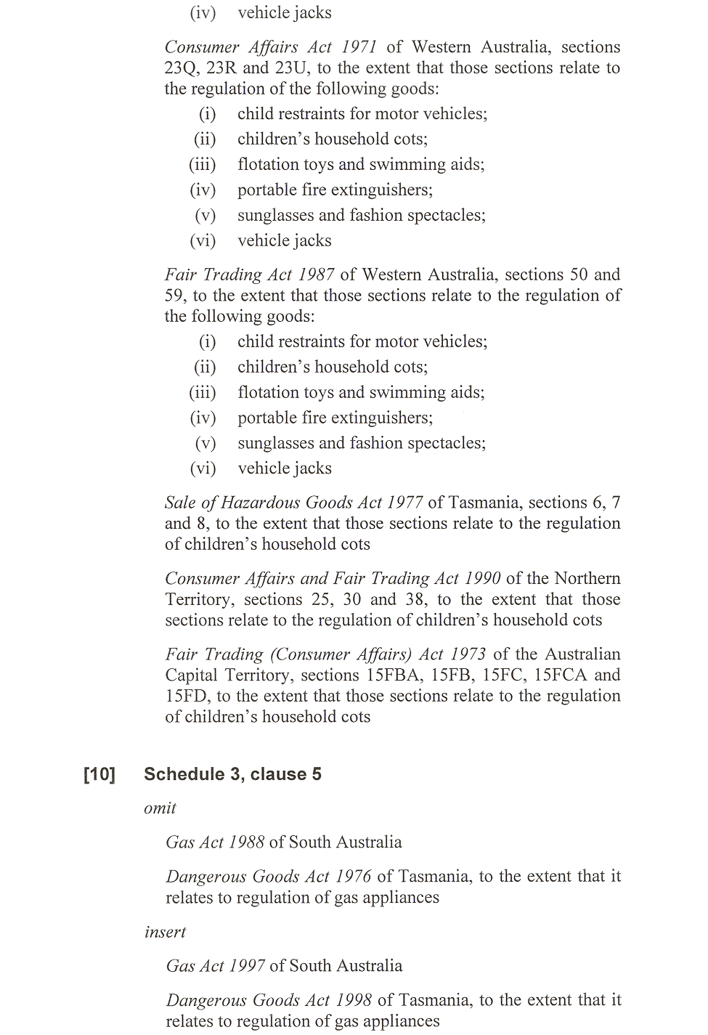
REGULATIONS UNDER THE SUPERANNUATION ACT 1988
────
No. 23 of 2000
────
At the Executive Council Office at Adelaide 30 March 2000

PURSUANT to the Superannuation Act 1988 and with the advice and consent of the Executive Council, I make the following regulations.
E. J. NEAL Governor

PURSUANT to section 10AA(2) of the Subordinate Legislation Act 1978, I certify that, in my opinion, it is necessary or appropriate that the following regulations come into operation as set out below.

ROB LUCAS Treasurer
───────────────────
SUMMARY OF PROVISIONS

1. Citation
2. Commencement
3. Variation of reg. 5—Replacement of Part 4 of the Act
───────────────────

Citation
1. The Superannuation (STA Employees) Regulations 1991 (see Gazette 20 June 1991 p.1935), as varied, are referred to in these regulations as "the principal regulations".

Commencement
2. These regulations come into operation on the day on which they are made.

Variation of reg. 5—Replacement of Part 4 of the Act
3. Regulation 5 of the principal regulations is varied—

(a) by striking out subsection (3d) of section 28 (being a section of Part 4 which is applied by regulation 5 to, and in relation to, the STA group to the exclusion of Part 4 of the Superannuation Act 1988) and substituting the following subsection:

(3d) The rate of interest will be determined by the Board in respect of each financial year in accordance with section 20A.;

(b) by striking out subsections (3) and (4) of section 28A (being a section of Part 4 which is applied by regulation 5 to, and in relation to, the STA group to the exclusion of Part 4 of the Superannuation Act 1988) and substituting the following subsections:

(3) On resignation, a contributor to whom this section applies is entitled to a lump sum but may elect to convert 50 per cent or more of the lump sum to a pension.

(4) The lump sum is made up of—

(a) an employee component (to be charged against the contributor's contribution account) equivalent to the amount standing to the credit of that account; and

(b) an employer component that is equal to twice the amount of the employee component.

(5) A contributor who elects to convert part of the lump sum to a pension is entitled to—

(a) the balance (if any) of the lump sum not converted to a pension; and

(b) a pension in an amount determined by the Board on the advice of an actuary.

(6) The pension payable under subsection 5(b) will be indexed.

(7) A part of the lump sum referred to in subsection (4), being an amount equivalent to the minimum contribution required to avoid payment of the superannuation guarantee charge in respect of the contributor under the Commonwealth Act, is preserved.

(8) A part of the balance of the lump sum referred to in subsection (5)(a), being an amount equivalent to the minimum contribution required to avoid payment of the superannuation guarantee charge in respect of the contributor under the Commonwealth Act, is preserved but if that amount is equal to or greater than the balance of the lump sum, the whole of the balance of the lump sum is preserved.

(9) The amount preserved by subsection (7) or (8) together with interest is payable in accordance with the following provisions:

(a) the contributor may at any time after reaching 55 years of age require the Board to pay the amount and, if no such requirement has been made on or before the date on which the contributor reaches 65 years of age, the Board will pay the amount to the contributor;

(b) if the contributor satisfies the Board that he or she has become totally and permanently incapacitated for work, the Board will pay the amount to the contributor;

(c) if the contributor dies, the amount will be paid to the spouse of the deceased contributor or, if he or she left no surviving spouse, to the contributor's estate,

(and a payment under any of the above paragraphs excludes further rights so that a claim cannot be subsequently made under some other paragraph).

(10) The amount of interest will be calculated and credited to the contributor at the end of each financial year and will be calculated at the end of the first financial year on the amount preserved and on the aggregate of that amount and the interest previously credited at the end of each subsequent financial year.

(11) The rate of interest will be determined by the Board in respect of each financial year in accordance with section 20A.

(12) In this section—

"voluntary separation package" means an agreement between a contributor and his or her employer pursuant to which the contributor resigns from employment.

T&F 11/2000 CS R. DENNIS Clerk of the Council

REGULATIONS UNDER THE LIQUOR LICENSING ACT 1997
────
No. 24 of 2000
────
At the Executive Council Office at Adelaide 30 March 2000

PURSUANT to the Liquor Licensing Act 1997 and with the advice and consent of the Executive Council, I make the following regulations.
E. J. NEAL Governor

PURSUANT to section 10AA(2) of the Subordinate Legislation Act 1978, I certify that, in my opinion, it is necessary or appropriate that the following regulations come into operation as set out below.

K. T. GRIFFIN Minister for Consumer Affairs
───────────────────
SUMMARY OF PROVISIONS

1. Citation
2. Commencement
3. Variation of Sched. 1—Long Term Dry Areas
───────────────────

Citation
1. The Liquor Licensing (Dry Areas—Long Term) Regulations 1997 (see Gazette 6 November 1997 p. 1217), as varied, are referred to in these regulations as "the principal regulations".

Commencement
2. These regulations come into operation on the day on which they are made.

Variation of Sched. 1—Long Term Dry Areas
3. Schedule 1 of the principal regulations is varied—

(a) by striking out from the column headed "Period" in the item headed "Hallett Cove—Area 1" "26 March 2000" and substituting "30 March 2002";

(b) by striking out from the column headed "Period" in the item headed "Hallett Cove—Area 2" "27 May 2000" and substituting "30 March 2002".

LL 9/99 CS R. DENNIS Clerk of the Council

REGULATIONS UNDER THE WORKERS REHABILITATION AND COMPENSATION ACT 1986
────
No. 25 of 2000
────
At the Executive Council Office at Adelaide 30 March 2000

PURSUANT to the Workers Rehabilitation and Compensation Act 1986 and with the advice and consent of the Executive Council, I make the following regulations.
E. J. NEAL Governor

PURSUANT to section 10AA(2) of the Subordinate Legislation Act 1978, I certify that, in my opinion, it is necessary or appropriate that the following regulations come into operation as set out below.

MICHAEL ARMITAGE Minister for Government Enterprises
───────────────────
SUMMARY OF PROVISIONS

1. Citation
2. Commencement
3. Insertion of reg. 8
8. Scales of charges—Registered occupational therapists
4. Insertion of schedule 5
SCHEDULE 5
Scales of charges—Registered occupational therapists
───────────────────
Citation
1. The Workers Rehabilitation and Compensation (Scales of Medical and Other Charges) Regulations 1995 (see Gazette 16 November 1995 p. 1370), as varied, are referred to in these regulations as "the principal regulations".

Commencement
2. These regulations will come into operation on 31 March 2000.

Insertion of reg. 8
3. The following regulation is inserted after regulation 7 of the principal regulations:

Scales of charges—Registered occupational therapists
8. Pursuant to subsection (11) of section 32 of the Act, the scales of charges set out in schedule 5 are prescribed as scales of charges for the purposes of that section for the provision of services by registered occupational therapists.

Insertion of schedule 5
4. The following schedule is inserted after schedule 4 of the principal regulations:

SCHEDULE 5
Scales of charges—Registered occupational therapists

Item No. | Service Description | Charge
 | OCCUPATIONAL THERAPY CORE SCHEDULE SERVICES
 | Refer to the Occupational Therapy Schedule Guidelines for requirements regarding the delivery of core schedule services.
 | INITIAL AND SUBSEQUENT CONSULTATIONS (Individual client)
The following services may be delivered as a component of an initial and subsequent consultation:
⋅ Clinical assessment
⋅ Clinical treatment
⋅ Graded activity/exercise
⋅ Pain management
⋅ Stress management
⋅ Relaxation training
⋅ Biomechanical education
⋅ Independent living skills training
Refer to Section 1 of the Occupational Therapy Schedule Guidelines for further details regarding the provision of initial and subsequent consultations.
 | INITIAL CONSULTATION (Individual client)
OT 105 | INITIAL CONSULTATION, history, examination and treatment of not more than 15 minutes duration. | $24.00
OT 110 | INITIAL CONSULTATION, history, examination and treatment of more than 15 minutes duration but not more than 30 minutes duration. | $36.00
OT 115 | INITIAL CONSULTATION, history, examination and treatment of more than 30 minutes duration but not more than 45 minutes duration. | $60.00
OT 120 | INITIAL CONSULTATION, history, examination and treatment of more than 45 minutes but not more than 60 minutes duration. | $84.00
OT 125 | INITIAL CONSULTATION, history, examination and treatment of more than 60 minutes duration but not more than 75 minutes duration. | $108.00
OT 130 | INITIAL CONSULTATION, history, examination and treatment of more than 75 minutes duration but not more than 90 minutes duration. | $132.00
 | SUBSEQUENT CONSULTATIONS (Individual client)
OT 205 | SUBSEQUENT CONSULTATION and treatment of not more than 15 minutes duration. | $24.00
OT 210 | SUBSEQUENT CONSULTATION and treatment of more than 15 minutes duration but not more than 30 minutes duration. | $36.00
OT 215 | SUBSEQUENT CONSULTATION and treatment of more than 30 minutes duration but not more than 45 minutes duration. | $60.00
OT 220 | SUBSEQUENT CONSULTATION and treatment of more than 45 minutes duration but not more than 60 minutes duration. | $84.00
OT 225 | SUBSEQUENT CONSULTATION and treatment of more than 60 minutes duration but not more than 75 minutes duration. | $108.00
OT 230 | SUBSEQUENT CONSULTATION and treatment of more than 75 minutes duration but not more than 90 minutes duration. | $132.00

 | CORRECTIVE/SERIAL SPLINTING
 | Refer to Section 2 of the Occupational Therapy Schedule Guidelines for the types of splints available to the occupational therapist and the conditions associated with the provision of these splints.
OT 300 | Fabrication/Fitting/Adjustment of splint | $96.00 per hour
OT 390 | Materials used to construct or modify a splint | Derived Fee
 | TREATMENT REVIEW
OT 780 | INDEPENDENT CLINICAL ASSESSMENT | $96.00 per hour
 | Includes a review of medical history, functional capacity and a clinical examination to provide a differential diagnosis and/or make recommendations regarding ongoing treatment goals or return to work.
 | The Self-Managed, Exempt Employer or Claims Agent must provide approval prior to the provision of this service.
 | This service will NOT be performed by the treating occupational therapist.
 | Refer to the Occupational Therapy Schedule Guidelines, Section 3, for service standards and indicators for use regarding Independent Clinical Assessment.
OT 785 | OCCUPATIONAL THERAPY FUNCTIONAL ESTIMATION FORM | $15.00
 | The Functional Estimation Form (FEF) will be initiated by the treating occupational therapist when information is identified from a clinical consultation which impacts upon the worker's capacity to return to work. This form must be forwarded directly to the certifying medical practitioner.
 | This form must only be completed when it complies with the criteria specified within the Occupational Therapy Schedule Guidelines, Section 4.
 | PAIN MANAGEMENT (GROUP PROGRAM)
 | Occupational therapists should refer to the Occupational Therapy Schedule Guidelines, Section 5, for further detail regarding the delivery of Pain Management services.
OT 602 | PAIN MANAGEMENT, group program, minimum of 2 clients, maximum of 5 clients, of not more than 30 minutes duration.  - each client. | $13.70
OT 604 | PAIN MANAGEMENT, group program, minimum of 2 clients, maximum of 5 clients, of more than 30 minutes duration but not more than 60 minutes duration.  - each client. | $20.50
OT 608 | PAIN MANAGEMENT, group program, minimum of 2 clients, maximum of 5 clients, of more than 60 minutes duration but not more than 120 minutes duration.  - each client. | $41.15
OT 612 | PAIN MANAGEMENT, group program, minimum of 2 clients, maximum of 5 clients, of more than 120 minutes duration but not more than 180 minutes duration.  - each client. | $68.50

 | ACTIVITIES OF DAILY LIVING ASSESSMENT
OT 760 | ACTIVITIES OF DAILY LIVING ASSESSMENT | $96.00 per hour
 | An Activities of Daily Living Assessment is an assessment of the worker’s level of functioning in regard to personal care, household tasks, and recreational and social activities. Generally conducted in the worker’s home environment, an Activities of Daily Living Assessment is utilised to reduce the impact of the injury, and facilitate early return to normal activity. Assessed levels of performance in daily activities can be used as an indicator of functional tolerances for determining work capacity.
 | Refer to Section 6 of the Occupational Therapy Schedule Guidelines for further details regarding the provision of an Activities of Daily Living Assessment.
 | REPORTS
OT 810 | COMPREHENSIVE REPORT | $96.00 per hour
 | A Self Managed, Exempt Employer or Claims Agent case manager may request a comprehensive report in response to a series of specific questions. A report will be taken to be comprehensive when requested by a Self Managed, Exempt Employer or Claims Agent, and re-examination of the patient is a pre-requisite for the preparation of the report.
 | All reports referred to under this item are chargeable on an hourly basis with a maximum time chargeable of 1.5 hours.
 | Refer to Section 7 of the Occupational Therapy Schedule Guidelines, for further detail regarding Comprehensive Reports.
OT 820 | STANDARD REPORT | $96.00 per hour
A Self Managed, Exempt Employer or Claims Agent case manager may request a standard report in response to a series of specific questions.
A report will be taken to be standard when re-examination of the worker is not required and the report is based on a transcription of existing clinical records.
 | All reports referred to under this item are chargeable on an hourly basis with a maximum time chargeable of 1 hour.
Refer to Section 8 of the Occupational Therapy Schedule Guidelines, for
further detail regarding standards required for report writing.
 | TRAVEL
 | Refer to Section 9 of the Occupational Therapy Schedule Guidelines, for further details regarding travel.
 | All travel items refer to an approved return trip from the treating occupational therapist's rooms to a worker's home for the purpose of a home visit, hospital, worksite or case conference.
OT 910 | Travel time, not more than 15 minutes. | $24.00
OT 920 | Travel time, of more than 15 minutes duration but less than 30 minutes duration. | $36.00
OT 930 | Travel time, of more than 30 minutes duration but not more than 60 minutes duration. | $72.00
OT 940 | Travel time, of more than 60 minutes duration but not more than 90 minutes duration. | $120.00
OT 950 | Travel time, of more than 90 minutes duration but not more than 120 minutes duration. | $168.00
OT 960 | Travel time, of more than 120 minutes duration but not more than 150 minutes duration. | $216.00
OT 970 | Travel time, of more than 150 minutes duration but not more than 180 minutes duration. | $264.00

CURAP | THERAPEUTIC AIDS AND APPLIANCES | Derived Fee
 | Includes, an appliance or aid for reducing the extent of a compensable disability or enabling a patient to overcome in whole or in part the effects of a compensable disability.
 | Refer to Section 10 of the Occupational Therapy Schedule Guidelines for details regarding therapeutic appliances.
 | OCCUPATIONAL THERAPY SUPPLEMENTARY SCHEDULE SERVICES
 | REHABILITATION AND RETURN TO WORK SERVICES
 | Refer to Section 11 of the Occupational Therapy Schedule Guidelines for service requirements and indicators for use of each rehabilitation and return to work service listed within the supplementary schedule.
 | WORK SIMULATION - OFF SITE (GROUP PROGRAM)
 | A graduated program of supervised activities used to simulate work conditions and the physical demands of duties. It is highly structured, goal-orientated and individualised and is designed to maximise the worker's ability to return to work. The program is usually contracted with the worker so that attendance patterns and work behaviours are normalised.
OT 502 | WORK SIMULATION, at rooms, group program, minimum of 2 clients maximum of 5 clients of not more than 30 minutes duration.  - each client | $13.70
OT 504 | WORK SIMULATION, at rooms, group program, minimum of 2 clients maximum of 5 clients of more than 30 minutes duration but not more than 60 minutes duration.  - each client | $20.50
OT 506 | WORK SIMULATION, at rooms, group program, minimum of 2 clients maximum of 5 clients of more than 60 minutes duration but not more than 90 minutes duration.  - each client | $34.30
OT 508 | WORK SIMULATION, at rooms, group program, minimum of 2 clients maximum of 5 clients of more than 90 minutes duration but not more than 120 minutes duration.  - each client | $48.00
OT 510 | WORK SIMULATION, at rooms, group program, minimum of 2 clients maximum of 5 clients of more than 120 minutes duration but not more than 150 minutes duration.  - each client | $61.70
OT 512 | WORK SIMULATION, at rooms, group program, minimum of 2 clients maximum of 5 clients of more than 150 minutes duration but not more than 180 minutes duration.  - each client | $75.40
OT 519 | WORK SIMULATION, materials | Derived Fee
OT 700 | FUNCTIONAL CAPACITY EVALUATION (FCE) | $96.00 per hour
 | Maximum time - 7 hours including report preparation with an Executive Summary form outlining the major components of the service and relevant findings.

 | Functional Capacity Evaluation is an assessment of an employee’s physical capabilities. The evaluation consists of a series of standardised tests focussed on selected work tolerances. Work tolerances are the observed and measured physical capabilities that affect the individual’s ability to perform the physical demands of specified work tasks. They are assessed as the ability to sustain a given work effort, i.e. work capacity at a prescribed frequency over a given period of time, and ability to maintain a specified rate of production at a pace compatible with the specified job. Work capacity is inferred based upon the work tolerance data gathered.
OT 730 | WORKSITE ASSESSMENT | $96.00 per hour
 | A visit to the workplace to determine the availability of duties for an injured worker and/or comment on the suitability of workplace layout/design for that worker.
OT 740 | JOB ANALYSIS | $96.00 per hour
 | The service includes the preparation of a report with an Executive Summary form outlining the major components of the service and relevant findings.
 | A Job Analysis involves analysis of the critical physical demands of a task, tasks or occupations to ascertain if they are within the worker’s capacity. The Job Analysis is undertaken based on available medical guidelines or given the medical expert's knowledge of the worker's diagnosis, pathology and prognosis. The Occupational Therapist will also provide recommendations regarding modifications to elements of the job to enable the worker to safely and effectively perform the task, the provision of aids or equipment which will assist the worker to perform the task and work practice guidelines to ensure that appropriate body mechanics are utilised by the worker in the performance of the task.
OT 750 | WORK HARDENING ON SITE | $96.00 per hour
 | Work Hardening (On-Site) is the process of increasing on a graduated basis the physical tolerances of a worker through the use of actual and productive work duties. This process is essential in assisting the worker to maintain his/her employment through the period of rehabilitation, by ensuring that identified duties are within the worker's capacity and guidelines relevant to the nature of the injury.
OT 870 | CASE CONFERENCE | $96.00 per hour
Case conferences are used for the purpose of determining:
⋅ details of limitations/recommendations relating to a sustainable return to work;
⋅ options for management of a worker's recovery;
⋅ other related information.
A Case conference may be requested by:
⋅ a treating medical expert;
⋅ an employer;
⋅ a worker or worker advocate;
⋅ a Self-Managed Employer, Exempt Employer, Claims Agent or appointed Rehabilitation Coordinator.
 | The holding of a case conference must be authorised by the Self Managed, Exempt Employer or Claims Agent case manager, before the case conference is convened.
 | Refer to Section 12 of the Occupational Therapy Schedule Guidelines for further details regarding case conferences.

 | NON SCHEDULED ITEMS
OT 999 | NON SCHEDULED SERVICES | $96.00 per hour
 | The use of this item number requires the approval of the Self Managed, Exempt Employer or Claims Agent prior to the delivery of the service.
 | This item is used when the provision of services not listed on the Core or Supplementary Fee Schedule is necessary, appropriate and reasonably required.
 | Refer to Section 13 of the Occupational Therapy Schedule Guidelines for further details regarding non scheduled services.
INTERPRETATION
In this Schedule "Derived Fee" means that each claim under that item will be considered on its merits.

MGE 8/2000 CS R. DENNIS Clerk of the Council

FAXING COPY?

IF you fax copy to Riverside 2000, for inclusion in the Government Gazette, there is no need to send a Confirmation Copy to us as well.

This creates confusion and may well result in your notice being printed twice.

Please use the following fax number:

Fax transmission: (08) 8207 1040
Phone Inquiries: (08) 8207 1045

Please include a contact person, phone number and order number so that we can phone back with any queries we may have regarding the fax copy.

NOTE: Closing time for lodging new copy (either fax or hard copy) is 4 p.m. on Tuesday preceding the day of publication.

Government Gazette notices can be E-mailed.

The address is:

Riv2000@saugov.sa.gov.au

Documents should be sent as attachments in Word format.

When sending a document via E-mail, please confirm your transmission with a faxed copy of your document, including the date the notice is to be published.

Fax transmission: (08) 8207 1040
Enquiries: (08) 8207 1045

CITY OF MARION AND CITY OF MITCHAM
Development Act 1993
Industry/Commerce Zone Plan Amendment Report—Draft for Public Consultation
NOTICE is hereby given that the Cities of Marion and Mitcham have prepared a draft Plan Amendment Report to amend both the City of Marion and City of Mitcham Development Plan as it affects part of the areas situated in Edwardstown, Clarence Gardens and Melrose Park.
The Plan Amendment Report will amend both the City of Marion and City of Mitcham Development Plan by refining the zone boundaries and introducing interface policy areas which recognise the close proximity of business and residential development. It is also proposed to replace the General Industry and Light Industry zones and part of the Commercial (South Road) zone with an Industry/Commerce zone and to introduce locational impact criteria to help determine where different types of industrial development can locate.
The draft Plan Amendment Report and statement will be available for public inspection and purchase ($5) during normal office hours at the councils’ offices:
City of Marion—245 Sturt Road, Sturt
City of Mitcham—131 Belair Road, Torrens Park
and for public inspection at the City of Marion Parkholme Library, Duncan Avenue, Parkholme or the City of Mitcham Library, 154 Belair Road, Hawthorn from Thursday, 30 March 2000 to Friday, 23 June 2000.
Written submissions regarding the draft amendment will be accepted by the councils until Friday, 23 June 2000. The written submission should also clearly indicate whether you will wish to speak at the public hearing on your submission. All submissions should be addressed to the Chief Executive Officer of either the City of Marion or the City of Mitcham.
Copies of all submissions received will be available for inspection by interested persons at the councils from Monday, 26 June 2000 until the date of the public hearing.
A public hearing will be held at 7.30 p.m. in the Clarence Gardens Bowling Club Rooms, Winona Avenue, Clarence Gardens on Wednesday, 12 July 2000. The public hearing may not be held if no submission indicates an interest in speaking at the public hearing.
Dated 30 March 2000.
T. Bruun, Acting Chief Executive Officer, City of Marion
R. Malcolm, Chief Executive Officer, City of Mitcham

CITY OF WEST TORRENS
Intention to Declare Land a Public Road
NOTICE is hereby given, pursuant to section 210 (2) (b) of the Local Government Act 1999 that the council intends to declare the land contained in allotments 1 and 3 in file plan 41602 to be public roads, if, at the expiration of three months from the date of this notice, no owner of the land has been identified.
Any person who may have an interest in the described land should in the first instance contact the council (telephone
(08) 8416 6362 during normal office hours) and may also make application to the valuation court for compensation for the said land.
T. Starr, City Manager

ADELAIDE HILLS COUNCIL
Temporary Road Closure
NOTICE is hereby given that, Mayor Anita Aspinall has approved, pursuant to section 59 of the Summary Offences Act 1953, the temporary closure of the Gumeracha-Lobethal Road, Gumeracha between John Fisher Avenue and Retreat Valley Road/Kenton Terrace, on Sunday, 9 April 2000 between the hours of 9.45 a.m. and 3 p.m.
This temporary closure is to allow the Salem Baptist Church to hold an Open Day and associated activities.
Further enquiries can be directed to Pastor Tom Playford on 8389 6362.
R. D. Blight, Chief Executive Officer

ADELAIDE HILLS COUNCIL
Roads (Opening and Closing) Act 1991
Mount Barker Road, Aldgate
PURSUANT to section 10 of the Roads (Opening and Closing) Act 1991, the Adelaide Hills Council hereby gives notice of its intent to implement a Road Process Order to close and sell to Marrick Enterprises Pty Ltd (certificate of title volume 5569, folio 533) the portion marked A on Preliminary Plan No. PP32/0556 in the Hundred of Noarlunga being portion of public road, Mount Barker Road, generally situated at Aldgate.
A statement of persons affected by the road process together with a copy of the preliminary plan are available for public inspection at the Council Offices, Mount Barker Road, Stirling, between the hours of 9 a.m. and 5 p.m. weekdays only. Copies may also be inspected at the Adelaide office of the Surveyor-General during normal working hours.
Any person who may wish to object to the proposed road process must lodge with the said council a Notice of Objection within 28 days of the date of this notice.
All objections shall be in writing giving the objector’s full name and address, reasons for the objection and whether the objector wishes to appear in person or be represented at the subsequent meeting when the objection will be determined by council.
An application for an easement shall be in writing giving the full name and address of the person applying for the grant, full details of the nature and location of the requested easement whether it will be in favour of the owner of adjoining or nearby land and if so specify the land to which the easement will be annexed and reasons for the grant of easement.
A copy of any submission must be forwarded to the Surveyor- General in Adelaide.
Dated 28 March 2000.
R. D. Blight, Chief Executive Officer

THE BAROSSA COUNCIL
Temporary Street Closure
NOTICE is hereby given that pursuant to the provisions of section 359 of the Local Government Act 1934, as amended, the Barossa Council resolves that the following public roads will be closed to all vehicles, except emergency vehicles and authorised service vehicles, between 8.45 a.m. and 10.30 a.m. on Saturday, 1 April 2000, for the Ulysses Club National Annual General Meeting:
Barossa Valley Way from Old Kapunda Road, Nuriootpa to Elizabeth Street, Tanunda.
Penrice Road from Murray Street to Research Road, Nuriootpa.
J. G. Jones, Chief Executive Officer

DISTRICT COUNCIL OF BARUNGA WEST
Temporary Road Closure
NOTICE is hereby given that, pursuant to Section 33 (1) of the Road Traffic Act 1961, High Street, Bute between Railway Terrace and Third Street will be closed to all vehicular traffic between 6.15 a.m. and 7.15 a.m. on Wednesday, 25 April 2000 to facilitate the Anzac Day Dawn Service.
G. O’Connor, Deputy District Manager

NARACOORTE LUCINDALE COUNCIL
Temporary Road Closure
NOTICE is hereby given that pursuant to section 359 of the Local Government Act 1934, as amended, council hereby directs that Peake Road, Hynam, be closed to vehicular traffic from 27 March 2000 until 2 April 2000, for the purposes of orderly traffic control.
D. E. Beaton, Chief Executive Officer

ROXBY DOWNS COUNCIL
Temporary Road Closure
NOTICE is hereby given that pursuant to the powers vested in the Administrator under the provisions of the Roxby Downs (Indenture Ratification) Act 1982, and in accordance with the provisions of the Local Government Act 1934, as amended, I hereby resolve that the portions of the northern and southern sections of Richardson Place, between Arcoona Street and Burgoyne Street, will be closed to vehicular traffic for the purposes of the Anzac Day March and Remembrance Day, between the hours of 10 a.m. and 11.30 a.m. on Tuesday, 25 April 2000.
The closure will apply to vehicular traffic with the exception of police, emergency, or those vehicles involved in the activities.
Dated 23 March 2000.
W. J. Boehm, Administrator

IN the matter of the estates of the undermentioned deceased persons:
Beskeen, Iris Ethel, late of 1 Kent Street, Hawthorn, widow, who died on 13 February 2000.
Boundey, Johanna Maria, late of 12 Cherington Street, Mount Barker, domiciliary carer, who died on 22 January 2000.
Butler, Irene Jolie, late of 28 Evan Avenue, Salisbury, home duties, who died on 28 February 2000.
Friskus, Arend, late of 5 Northfield Road, Northfield, retired postal services officer, who died on 28 January 2000.
Hanna, Susie Ellen, late of 251 Payneham Road, Joslin, widow, who died on 6 January 2000.
McKay, Florence Jean, late of Ruwoldt Road, Yahl, of no occupation, who died on 21 December 1999.
Rankine, Florence Margaret, late of 63 Hackney Road, Hackney, home duties, who died on 8 February 2000.
Stephens, Jean, late of 3 Grant Avenue, Gilles Plains, of no occupation, who died on 28 February 2000.
Von Stanke, James George, late of Carpenter Rocks, retired fisherman, who died on 19 December 1995.
Wake, Florence Evaline, late of 3 Jeffries Street, Whyalla Playford, widow, who died on 30 January 2000.
Williams, Marjorie Elizabeth, late of 5 Stroud Street, Clearview, home duties, who died on 29 January 2000.
Notice is hereby given pursuant to the Trustee Act 1936, as amended, the Inheritance (Family Provision) Act 1972, and the Family Relationships Act 1975, that all creditors, beneficiaries, and other persons having claims against the said estates are required to send, in writing, to the Public Trustee, 25 Franklin Street, Adelaide, S.A. 5000, full particulars and proof of such claims, on or before 28 April 2000, otherwise they will be excluded from the distribution of the said estate; and notice is also hereby given that all persons who are indebted to the said estates are required to pay the amount of their debts to the Public Trustee or proceedings will be taken for the recovery thereof; and all persons having any property belonging to the said estates are forthwith to deliver the same to the Public Trustee.
Dated 30 March 2000.
J. H. Worrall, Public Trustee

IN the matter of the estates of the undermentioned deceased persons:
Carr, Leo Abram, late of 14 Hall Street, Cummins, retired seed agent, who died on 15 February 2000.
Collins, Maude Irene, late of Victor Harbor Nursing Home, 20 Coral Street, Victor Harbor, widow, who died on 10 January 2000.
Dent, Edgar, late of Lutheran Homes The Vines Nursing Home, 1217 Grand Junction Road, Hope Valley, retired transport driver, who died on 8 February 2000.
Haddock, Winifred, late of 13 Grandview Avenue, Maslin Beach, home duties, who died on 26 February 2000.
Kimber, Simon John, late of 7 Fonda Court, Paralowie, storeman, who died on 12 March 2000.
Lockyer, Dawn, late of 235 Lower Athelstone Road, Athelstone, home duties, who died on 12 March 2000.
Notice is hereby given pursuant to the Trustee Act 1936, as amended, the Inheritance (Family Provision) Act 1972-1975 and the Family Relationships Act 1975, that all creditors, beneficiaries, and other persons having claims against any of the abovenamed estates are directed to send full particulars of such claims to the undersigned on or before 27 April 2000, otherwise they will be excluded from the distribution of the said estate.
Dated 30 March 2000.
IOOF Australia Trustees Limited (acn 007 870 644) and Bagot’s Executor & Trustee Company Limited (acn 007 869 829), 212 Pirie Street, Adelaide, S.A. 5000.

A. E. GREGORY PTY LTD
(ACN 007 630 248)
Voluntary Winding Up of Company
NOTICE is hereby given that at a general meeting of the company duly convened and held on 6 March 2000, the following special resolution was duly passed:
That the company be wound up voluntarily and that Anthony James Vanstone, 208 Carrington Street, Adelaide, S.A. 5000 be appointed liquidator.
Dated 28 March 2000.
L. P. McEvoy, Secretary

FP BRIGHTON PTY LTD
(ACN 051 788 562)
Notice of Appointment of Receiver and Manager
NOTICE is hereby given that on 4 March 2000, Peter Ivan Macks of Prentice Parbery Barilla, Level 10, 26 Flinders Street, Adelaide, S.A. 5000, was appointed receiver and manager of the assets of FP Brighton Pty Ltd, by FP Glenelg Pty Ltd, in exercise of its powers contained in Deed of Debenture Registered No. 684544.
Wallmans, 173 Wakefield Street, Adelaide, S.A. 5000, solicitors for the appointer.

J. & A. TRANSPORT PTY LTD
(ACN 008 190 609)
ON 17 March 2000 the Supreme Court of South Australia in Action No. 254 of 2000 made an order for the winding up of
J. & A. Transport Pty Ltd which was commenced by the plaintiff, Peter John Jolly and will be heard at the Supreme Courthouse, Victoria Square, Adelaide at 2.15 p.m. on 18 April 2000. Copies of the documents filed may be obtained from Armour & Allen, 69A Grote Street, Adelaide, S.A. 5000.

Any person intending to appear at the hearing must file a notice of appearance, in accordance with the prescribed form, together with any affidavit on which the person intends to rely, and serve a copy of the notice and any affidavit on the plaintiff at the plaintiff’s address for service at least three days before the date fixed for the hearing.
Dated 30 March 2000.
Armour & Allen, 69A Grote Street, Adelaide, S.A. 5000, solicitors for the plaintiff.

SOUTH AUSTRALIA—In the Supreme Court. No. 3995 of 1985. In the matter of Mikform Pty Limited (in liquidation) (ACN 007 969 431) and in the matter of the Corporations Law.
Notice of Release of Liquidator and Dissolution of the Company
Take notice that by order of the Supreme Court of South Australia dated 20 March 2000, I, Barrie Malcolm Mansom, 1st Floor, 17 Bagot Street, North Adelaide, S.A. 5006, the liquidator of the abovenamed company, was granted my release as the liquidator and the company was dissolved as at the date of this order.
Dated 24 March 2000.
B. M. Mansom, Liquidator

UNCLAIMED MONEYS ACT 1891
Register of Unclaimed Moneys held by ETSA Utilities for year ended 31 December 1999

Name of owner on books | Total amount due to owner  $ |  |  | Cheque Number |  | Cheque  Date | Description of Unclaimed Money
A. B. Stanley |  | 19.29 | 874792-06 |  | 2/2/93 |  |  | Unpresented Cheque
A. J. and J. A. Roberts |  | 11.35 | 859354-09 |  | 16/11/92 |  |  | Unpresented Cheque
A. J. Wilson |  | 20.54 | 870863-01 |  | 11/1/93 |  |  | Unpresented Cheque
A. L. Haines |  | 18.67 | 877075-00 |  | 22/2/93 |  |  | Unpresented Cheque
A. L. Thomas |  | 250.00 | 862695-18 |  | 2/12/92 |  |  | Unpresented Cheque
A. Minnucci |  | 222.80 | 867320-05 |  | 24/12/92 |  |  | Unpresented Cheque
A. Nagel |  | 13.17 | 883289-02 |  | 18/3/93 |  |  | Unpresented Cheque
A. P. Gameau |  | 15.55 | 885792-04 |  | 5/4/93 |  |  | Unpresented Cheque
A. Priest |  | 27.53 | 881603 |  | 5/3/93 |  |  | Unpresented Cheque
A. T. Kerr |  | 31.55 | 869938-01 |  | 4/1/93 |  |  | Unpresented Cheque
A. W. Muenchow |  | 69.93 | 868820-07 |  | 4/1/93 |  |  | Unpresented Cheque
All Type Security |  | 22.63 | 870677-06 |  | 11/1/93 |  |  | Unpresented Cheque
Ampol Roadhouse |  | 145.89 | 881861 |  | 8/3/93 |  |  | Unpresented Cheque
B. C. Cook |  | 23.99 | 870327-08 |  | 8/1/93 |  |  | Unpresented Cheque
B. R. and J. K. Beggs |  | 26.48 | 855398 |  | 26/10/92 |  |  | Unpresented Cheque
B. T. E. Stradling |  | 29.53 | 864617-02 |  | 4/12/92 |  |  | Unpresented Cheque
C. Darzanos |  | 338.80 | 846665 |  | 7/9/92 |  |  | Unpresented Cheque
C. Longstaff |  | 29.80 | 845031 |  | 31/8/92 |  |  | Unpresented Cheque
D. A. Roosi |  | 19.41 | 885823-02 |  | 5/4/93 |  |  | Unpresented Cheque
D. B. Dadleh |  | 30.00 | 884343-03 |  | 19/3/93 |  |  | Unpresented Cheque
D. Warnock |  | 15.61 | 867292-09 |  | 24/12/92 |  |  | Unpresented Cheque
Dept Industrial Relations |  | 12.00 | 875735-04 |  | 9/2/93 |  |  | Unpresented Cheque
Dunlop Industries |  | 118.82 | 887855 |  | 14/4/93 |  |  | Unpresented Cheque
E. E. San Tan |  | 56.41 | 888833 |  | 22/4/93 |  |  | Unpresented Cheque
Epsom Australia |  | 241.00 | 835129 |  | 20/7/92 |  |  | Unpresented Cheque
F. North |  | 14.19 | 865220-00 |  | 7/12/92 |  |  | Unpresented Cheque
Fairview Fitness |  | 112.00 | 841773 |  | 25/8/92 |  |  | Unpresented Cheque
Fiegt Frech Prestige |  | 37.24 | 845535 |  | 01/9/92 |  |  | Unpresented Cheque
Finlaysons |  | 115.00 | 859742-18 |  | 17/11/92 |  |  | Unpresented Cheque
G. B. Nguyen |  | 37.10 | 837725 |  | 31/7/92 |  |  | Unpresented Cheque
G. Windsor |  | 13.28 | 833872 |  | 13/7/92 |  |  | Unpresented Cheque
Hewlett Packard |  | 480.00 | 841148 |  | 25/8/92 |  |  | Unpresented Cheque
Huei-Jong Liy |  | 40.96 | 841718 |  | 25/8/92 |  |  | Unpresented Cheque
I. Chang |  | 25.54 | 862192-00 |  | 2/12/92 |  |  | Unpresented Cheque
I. Valentina |  | 59.00 | 877813-01 |  | 26/2/93 |  |  | Unpresented Cheque
J. Bell |  | 67.87 | 871343-06 |  | 18/1/93 |  |  | Unpresented Cheque
J. C. Gallagher |  | 172.54 | 840914 |  | 18/8/92 |  |  | Unpresented Cheque
J. Daniels |  | 23.49 | 853144 |  | 12/10/92 |  |  | Unpresented Cheque
J. Janai |  | 26.26 | 884471-03 |  | 22/3/93 |  |  | Unpresented Cheque
J. Li |  | 67.09 | 840920 |  | 18/8/92 |  |  | Unpresented Cheque
J. S. and S. K. Hatwell |  | 15.00 | 877411-05 |  | 22/2/93 |  |  | Unpresented Cheque
Jack Horner Paint |  | 94.02 | 833428 |  | 9/7/92 |  |  | Unpresented Cheque
K. Frindstran |  | 16.31 | 832279 |  | 10/7/92 |  |  | Unpresented Cheque
K. J. Thomas |  | 250.00 | 862696-07 |  | 2/12/92 |  |  | Unpresented Cheque
K. L. Draper |  | 17.28 | 871234-01 |  | 18/1/93 |  |  | Unpresented Cheque
K. Minchin |  | 62.00 | 866170-01 |  | 14/12/92 |  |  | Unpresented Cheque
K. R. Hornung |  | 40.00 | 886458-00 |  | 08/4/93 |  |  | Unpresented Cheque
L. J. Ward |  | 34.00 | 838166 |  | 3/8/92 |  |  | Unpresented Cheque
L. J. Ward |  | 1 000.00 | 862724-03 |  | 2/12/92 |  |  | Unpresented Cheque
L. S. Hollard |  | 25.94 | 851156 |  | 29/9/92 |  |  | Unpresented Cheque
Lawstaff |  | 2 846.73 | 887279 |  | 13/4/93 |  |  | Unpresented Cheque
M. and C. L. Schischov |  | 10.01 | 888162 |  | 19/4/93 |  |  | Unpresented Cheque
M. and R. B. Alexander |  | 20.05 | 883007 |  | 17/3/93 |  |  | Unpresented Cheque
M. Kaur |  | 10.45 | 885801-05 |  | 5/4/93 |  |  | Unpresented Cheque
Mac-Pac |  | 118.02 | 837920 |  | 3/8/92 |  |  | Unpresented Cheque
O'Connors Air Services |  | 258.00 | 871593-09 |  | 18/1/93 |  |  | Unpresented Cheque
P. Botwratht |  | 15.61 | 875808-02 |  | 12/2/93 |  |  | Unpresented Cheque
P. I. Bates |  | 95.00 | 863604-18 |  | 30/11/92 |  |  | Unpresented Cheque
P. J. Phillips |  | 31.53 | 865113-00 |  | 21/12/92 |  |  | Unpresented Cheque
P. J. Woodward |  | 50.00 | 870591-18 |  | 11/1/93 |  |  | Unpresented Cheque
P. M. Bowyer |  | 10.24 | 837004 |  | 27/7/92 |  |  | Unpresented Cheque
Pal Barindra Hal |  | 14.00 | 872312-04 |  | 2/2/93 |  |  | Unpresented Cheque
Polytek Food |  | 4 867.50 | 847856 |  | 28/9/92 |  |  | Unpresented Cheque
Public Corporation 3721 |  | 113.94 | 871560-08 |  | 25/1/93 |  |  | Unpresented Cheque
R. A. Borg |  | 60.00 | 838548 |  | 4/8/92 |  |  | Unpresented Cheque
R. A. Rieger |  | 11.40 | 879940 |  | 3/3/93 |  |  | Unpresented Cheque
R. Fisher |  | 18.68 | 860823-02 |  | 24/11/92 |  |  | Unpresented Cheque
R. M. Dawes |  | 28.56 | 855317 |  | 26/10/92 |  |  | Unpresented Cheque
R. M. Kirchman |  | 13.29 | 835170 |  | 20/7/92 |  |  | Unpresented Cheque
R. Ridnell |  | 28.75 | 848689 |  | 21/9/92 |  |  | Unpresented Cheque
S. A. Rota |  | 36.40 | 888159 |  | 19/4/93 |  |  | Unpresented Cheque
S. A. Wheeler |  | 15.04 | 871821-06 |  | 19/1/93 |  |  | Unpresented Cheque
S. Folland |  | 150.00 | 841428 |  | 25/8/92 |  |  | Unpresented Cheque
S. J. Power |  | 25.52 | 824283 |  | 3/7/92 |  |  | Unpresented Cheque
S. L. Perrot |  | 16.13 | 858213-06 |  | 3/11/92 |  |  | Unpresented Cheque
S. Taylor |  | 21.07 | 886740 |  | 13/4/93 |  |  | Unpresented Cheque
S.A.H.T. Proj |  | 13.39 | 837993 |  | 3/8/92 |  |  | Unpresented Cheque
S.A.H.T. Proj 2 |  | 10.75 | 852633-03 |  | 9/10/92 |  |  | Unpresented Cheque
Stihl Chain Saw |  | 2 759.50 | 865624-01 |  | 11/12/92 |  |  | Unpresented Cheque
T. Koumi and K Talciz |  | 14.13 | 870341-07 |  | 8/1/93 |  |  | Unpresented Cheque
T. Wahib |  | 58.77 | 846827 |  | 8/9/92 |  |  | Unpresented Cheque
T. Yamada |  | 35.70 | 871250-05 |  | 18/1/93 |  |  | Unpresented Cheque
Tunarama Inc |  | 245.00 | 888172 |  | 19/4/93 |  |  | Unpresented Cheque
V. A. G. De Boo |  | 100.00 | 853588 |  | 13/10/92 |  |  | Unpresented Cheque
V. C. Coulson |  | 52.70 | 839575 |  | 11/8/92 |  |  | Unpresented Cheque
Z. S. J. Viscione |  | 11.47 | 876601-05 |  | 15/2/93 |  |  | Unpresented Cheque

ATTENTION

CUSTOMERS requiring a proof of their notice for inclusion in the Government Gazette, please note that the onus is on you to inform Riverside 2000 of any subsequent corrections by 10 a.m. on Thursday, which is our publication deadline.

For any corrections to your notice please phone 8207 1045 or Fax 8207 1040 before 10 a.m. on Thursday.

If we do not receive any communication by 10 a.m. on Thursday (day of publication) we will presume the notice is correct and will print it as it is.

Remember—the onus is on you to inform us of any corrections necessary to your notice.

NOTE: Closing time for lodging new copy (either fax or hard copy) is 4 p.m. on Tuesday preceding the day of publication. Ph. 8207 1045—Fax 8207 1040.

Printed and published by authority every Thursday by M. G. O’CALLAGHAN, Government Printer, South Australia
Price: $3.85, plus postage; to subscribers, $190 per annum.

