No. 83 2625

THE SOUTH AUSTRALIAN

GOVERNMENT GAZETTE

PUBLISHED BY AUTHORITY

ALL PUBLIC ACTS appearing in this GAZETTE are to be considered official, and obeyed as such

ADELAIDE, THURSDAY, 25 MAY 2000

CONTENTS

Page
Appointments, Resignations, Etc. 2628
Associations Incorporation Act 1985—Notice 2629
Corporations and District Councils—Notices 2836
Dangerous Substances Act 1979—Notice 2629
Development Act 1993—Notices 2629
Electoral Act 1985—Notice 2645
Explosives Act 1936—Notice 2645
Gaming Machines Act 1992—Notices 2645
Government Business Enterprises (Competition) Act 1996—
Notices 2645
Housing Improvement Act 1940—Notices 2647
Industrial and Employee Relations Act 1994—Notice 2648
Land and Business (Sale and Conveyancing) Act 1994—
Notices 2648
Liquor Licensing Act 1997—Notices 2649
Local Government Act 1934—Notice 2656
Mining Act 1971—Notices 2650

Page
Motor Vehicles Act 1959—Notice 2650
National Parks and Wildlife Act 1972—Notices 2651
Occupational Health, Safety and Welfare Act 1986—
Notice 2656
Opal Mining Act 1995—Erratum 2653
Petroleum Products Regulation Act 1995—Notice 2656
Private Advertisements 2841
Proclamations 2627
Public Trustee Office—Administration of Estates 2840
REGULATIONS
Local Government Act 1999 (No. 41 of 2000) 2673
Local Government (Implementation) Act 1999—
(No. 42 of 2000) 2675
Mines and Works Inspection Act 1920—
(No. 43 of 2000) 2677
Mining Act 1971 (No. 44 of 2000) 2678
Opal Mining Act 1995 (No. 45 of 2000) 2681

GOVERNMENT GAZETTE NOTICES
ALL poundkeepers' and private advertisements forwarded for publication in the South Australian Government Gazette must be PAID FOR PRIOR TO INSERTION; and all notices, from whatever source, should be legibly written on one side of the paper only and sent to Riverside 2000 so as to be received no later than 4 p.m. Tuesday preceding the day of publication. Phone 8207 1045 or Fax 8207 1040. E-mail: Riv2000@saugov.sa.gov.au. Send as attachments in Word format and please confirm your transmission with a faxed copy of your document, including the date the notice is to be published and to whom the notice will be charged.

REGULATIONS—continued
Page
Petroleum Act 1940 (No. 46 of 2000) 2683
Seeds Act 1979 (No. 47 of 2000) 2685
Meat Hygiene Act 1994 (No. 48 of 2000) 2687
Land Tax Act 1936 (No. 49 of 2000) 2690
Lottery and Gaming Act 1936 (No. 50 of 2000) 2691
Petroleum Products Regulation Act 1995—
(No. 51 of 2000) 2694
Tobacco Products Regulation Act 1997—
(No. 52 of 2000) 2695
Road Traffic Act 1961 (No. 53 of 2000) 2696
Firearms Act 1977 (No. 54 of 2000) 2707
Criminal Law (Sentencing) Act 1988 (No. 55 of 2000) 2709
District Court Act 1991 (No. 56 of 2000) 2710
Environment, Resources and Development Court
Act 1993—
(No. 57 of 2000) 2712
(No. 58 of 2000) 2713
Magistrates Court Act 1991 (No. 59 of 2000) 2714
Sheriff’s Act 1978 (No. 60 of 2000) 2716
Supreme Court Act 1935—
(No. 61 of 2000) 2717
(No. 62 of 2000) 2719
Youth Court Act 1993 (No. 63 of 2000) 2721
Bills of Sale Act 1886 (No. 64 of 2000) 2722
Community Titles Act 1996 (No. 65 of 2000) 2723
Real Property Act 1886—
(No. 66 of 2000) 2726
(No. 67 of 2000) 2729
Registration of Deeds Act 1935 (No. 68 of 2000) 2730
Strata Titles Act 1988 (No. 69 of 2000) 2731
Worker’s Liens Act 1893 (No. 70 of 2000) 2733
Public Trustee Act 1995 (No. 71 of 2000) 2734
Associations Incorporation Act 1985 (No. 72 of 2000) 2736
Business Names Act 1996 (No. 73 of 2000) 2738
Co-operatives Act 1997 (No. 74 of 2000) 2740
Gaming Machines Act 1992 (No. 75 of 2000) 2744
Liquor Licensing Act 1997 (No. 76 of 2000) 2746
Births, Deaths and Marriages Registration Act 1996—
(No. 77 of 2000) 2748
Building Work Contractors Act 1995 (No. 78 of 2000) 2750
Conveyancers Act 1994 (No. 79 of 2000) 2752
Cremation Act 1891 (No. 80 of 2000) 2753
Land Agents Act 1994 (No. 81 of 2000) 2754 Plumbers, Gas Fitters and Electricians Act 1995—
(No. 82 of 2000) 2755
Second-Hand Vehicle Dealers Act 1995—
(No. 83 of 2000) 2757
Security and Investigation Agents Act 1995—
(No. 84 of 2000) 2759
Sexual Reassignment Act 1988 (No. 85 of 2000) 2761
Trade Measurement Administration Act 1993—
(No. 86 of 2000) 2762

Page
Travel Agents Act 1986 (No. 87 of 2000) 2768
Adoption Act 1988 (No. 88 of 2000) 2769
Controlled Substances Act 1984—
(No. 89 of 2000) 2771
(No. 90 of 2000) 2772
(No. 91 of 2000) 2774
Housing Improvement Act 1940 (No. 92 of 2000) 2776
Public and Environmental Health Act 1987—
(No. 93 of 2000) 2777
Radiation Protection and Control Act 1982—
(No. 94 of 2000) 2780
South Australian Health Commission Act 1976—
(No. 95 of 2000) 2782
(No. 96 of 2000) 2783
Development Act 1993 (No. 97 of 2000) 2785
Harbors and Navigation Act 1993 (No. 98 of 2000) 2787
Motor Vehicles Act 1959—
(No. 99 of 2000) 2793
(No. 100 of 2000) 2795
Passenger Transport Act 1994—
(No. 101 of 2000) 2798
(No. 102 of 2000) 2799
Road Traffic Act 1961 (No. 103 of 2000) 2802
Local Government Act 1999 (No. 104 of 2000) 2804
Private Parking Areas Act 1986 (No. 105 of 2000) 2805
Roads (Opening and Closing) Act 1991—
(No. 106 of 2000) 2806
Valuation of Land Act 1971 (No. 107 of 2000) 2808
State Records Act 1997 (No. 108 of 2000) 2810
Dangerous Substances Act 1979 (No. 109 of 2000) 2813
Explosives Act 1936 (No. 110 of 2000) 2816
Occupational Health, Safety and Welfare Act 1986—
(No. 111 of 2000) 2818
Environment Protection Act 1993—
(No. 112 of 2000) 2820
(No. 114 of 2000) 2823
Crown Lands Act 1929 (No. 113 of 2000) 2821
Botanic Gardens and State Herbarium Act 1978—
(No. 115 of 2000) 2825
Historic Shipwrecks Act 1981 (No. 116 of 2000) 2827
National Parks and Wildlife Act 1972 (No. 117 of 2000) 2828
Pastoral Land Management and Conservation Act 1989—
(No. 118 of 2000) 2830
Water Resources Act 1997 (No. 119 of 2000) 2832
Roads (Opening and Closing) Act 1991—Notice 2656
Valuation of Land Act 1971—Notice 2656
Water Mains and Sewers—Mains Laid, Replaced, Etc. 2657
Workers Rehabilitation and Compensation Act 1986—
Notices 2660

GOVERNMENT BUSINESS ENTERPRISES (COMPETITION) ACT 1996 SECTION 16: REVOCATION OF PRINCIPLES OF COMPETITIVE NEUTRALITY
Proclamation By The Governor
(l.s.) E. J. Neal
PURSUANT to section 16 of the Government Business Enterprises (Competition) Act 1996 and with the advice and consent of the Executive Council, I revoke all principles of competitive neutrality previously established under that section.
Given under my hand and the Public Seal of South Australia, at Adelaide, 25 May 2000.
By command,
Mark Brindal, for Premier
DPC 16/97 CS

GOVERNMENT BUSINESS ENTERPRISES (COMPETITION) (MISCELLANEOUS) AMENDMENT ACT 2000 (Act No. 2 of 2000): DAY OF COMMENCEMENT
Proclamation By The Governor
(l.s.) E. J. Neal
WITH the advice and consent of the Executive Council, I fix 25 May 2000 as the day on which the Government Business Enterprises (Competition) (Miscellaneous) Amendment Act 2000 will come into operation.
Given under my hand and the Public Seal of South Australia, at Adelaide, 25 May 2000.
By command,
Mark Brindal, for Premier
DPC 16/97 CS

HARBORS AND NAVIGATION ACT 1993 SECTION 18: CARE, CONTROL AND MANAGEMENT OF PROPERTY—FORESHORE AT WEST BEACH
Proclamation By The Governor
(l.s.) E. J. Neal
Preamble
1. The area of the foreshore at West Beach delineated by hatching on the plan in the Schedule is within the area of the City of West Torrens but not within a harbor.
2. By virtue of section 18 (4) of the Act, the adjacent land and any structures on the adjacent land within the area (except land and structures in private ownership) would, apart from this proclamation, be under the care, control and management of the City of West Torrens.
3. In order to further the development of the area, it is proposed by this proclamation to place the adjacent land belonging to the Minister, and any structure belonging to the Minister on the adjacent land within the area under the care, control and management of the Minister.
4. As required by section 18 (3) of the Act, the City of West Torrens has been consulted and given an opportunity to make representations on the matter.
Proclamation
PURSUANT to section 18 of the Harbors and Navigation Act 1993 and with the advice and consent of the Executive Council, I place adjacent land belonging to the Minister, and any structure belonging to the Minister on adjacent land, within the area of the foreshore at West Beach delineated by hatching on the plan in the Schedule under the care, control and management of the Minister.
Schedule

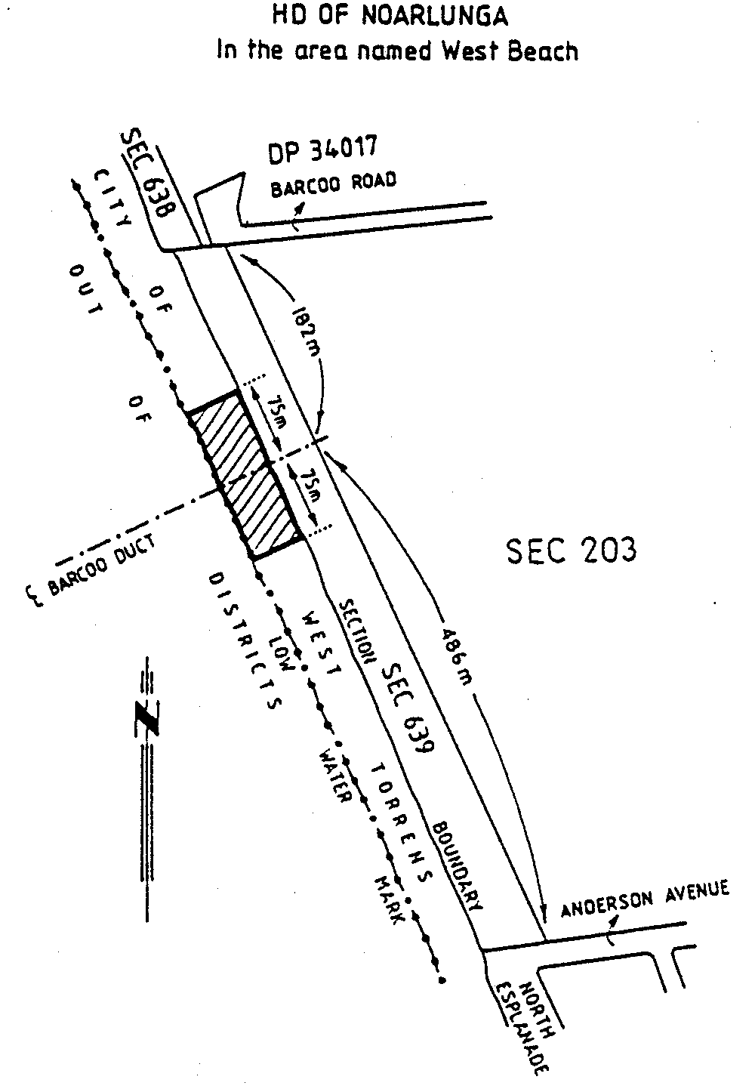
Given under my hand and the Public Seal of South Australia, at Adelaide, 25 May 2000.
By command,
Mark Brindal, for Premier
TSA 9766/99 CS

PRIVACY COMMITTEE OF SOUTH AUSTRALIA: VARIATION OF PROCLAMATION
Proclamation By The Governor
(l.s.) E. J. Neal
WITH the advice and consent of the Executive Council, I vary the proclamation made on 6 July 1989 (see Gazette 6 July 1989 p. 6), as varied—
(a) by striking out subclauses (2) and (2a) of clause 1 and substituting the following subclauses:
(2) The Committee will consist of six members appointed by the Governor as follows:
(a) three will be appointed on the nomination of the Minister, of whom one must be a person who is not a public sector employee (within the meaning of the Public Sector Management Act 1995) and one must be a person with expertise in information and records management;
(b) one will be appointed on the nomination of the Attorney-General;
(c) one will be appointed on the nomination of the Minister for Human Services;
(d) one will be appointed on the nomination of the Commissioner for Public Employment.
(2a) One of the persons appointed under subclause (2)(a) will be appointed (on the nomination of the Minister) to be the presiding member.;
(b) by striking out from clause 1(5)(c) ‘Three’ and substituting ‘Four’;
(c) by striking out from clause 3(1) ‘section 8 of the Government Management and Employment Act 1985’ and substituting ‘section 66 of the Public Sector Management Act 1995’;
(d) by striking out from clause 5 the definition of ‘public employee’.
Given under my hand and the Public Seal of South Australia, at Adelaide, 25 May 2000.
By command,
Mark Brindal, for Premier
MAIS 21/99 CS

Department of the Premier and Cabinet
Adelaide, 25 May 2000
HIS Excellency the Governor in Executive Council has been pleased to appoint the undermentioned to the Guardianship Board, pursuant to the provisions of the Guardianship and Administration Act 1993:
Panel Member: (from 25 May 2000 until 24 May 2003)
Leslie Frank Koopowitz
By command,
Mark Brindal, for Premier
MH030/004/008CS

Department of the Premier and Cabinet
Adelaide, 25 May 2000
HIS Excellency the Governor in Executive Council has been pleased to appoint the undermentioned to the Equal Opportunity Tribunal, pursuant to the provisions of the Equal Opportunity Act 1984:
Deputy Presiding Officer: (from 10 July 2000 until 9 July 2003)
Peter Thomas Allan
Jeffrey Philip Anderson
Michael Lester Wheatley Bowering
David Flaxman Bright
Michael David
Peter Anthony John Herriman
Neal Jeremy Hume
Barrie Kitchen
Christopher Robert Lee
Neil William Lowrie
Geoffrey Louis Muecke
Michael Anthony Noblet
Malcolm Lindsay Robertson
John Robert Sulan
Christine Louise Trenorden
By command,
Mark Brindal, for Premier
ATTG42/95CS

Department of the Premier and Cabinet
Adelaide, 25 May 2000
HIS Excellency the Governor in Executive Council has been pleased to appoint the undermentioned to the Legal Practitioners Conduct Board, pursuant to the provisions of the Legal Practitioners Act 1981:
Member: (from 25 May 2000 until 24 May 2003)
Patricia Merilyn Mudge
By command,
Mark Brindal, for Premier
ATTG38/94TC1CS

Department of the Premier and Cabinet
Adelaide, 25 May 2000
HIS Excellency the Governor in Executive Council has been pleased to appoint the undermentioned to the South-East Catchment Water Management Board, pursuant to the provisions of the Water Resources Act 1997:
Member: (from 25 May 2000 until 24 May 2004)
Phillip Nicholas McBride
Robert England
Robert Cowan
Peter Robert Altschwager
By command,
Mark Brindal, for Premier
MWR0012/00CS

Department of the Premier and Cabinet
Adelaide, 25 May 2000
HIS Excellency the Governor in Executive Council has been pleased to proclaim the undermentioned to the Privacy Committee of South Australia:
Member: (from 25 May 2000 until 30 June 2001)
Michael David Walters Hodder
Gabriele Fabio Jaksa
Milton Bernard Spurling
Maria Panagiotidis
James Davidson
Anne Lynette French
Presiding Member: (from 25 May 2000 until 30 June 2001)
Michael David Walters Hodder
By command,
Mark Brindal, for Premier
MAS021/99CS

ASSOCIATIONS INCORPORATION ACT 1985
Deregulation of Associations
NOTICE is hereby given that the Corporate Affairs Commission approves the applications for deregistration received from the associations named below pursuant to section 43A of the Associations Incorporation Act 1985. Deregistration takes effect on the date of publication of this notice:
Bethesda Movement Inc.
Harmer Memorial Homes Inc.
Insurance Brokers Network (S.A.) Inc.
Kindergym Cleve Inc.
Mission Ministries Inc.
Russian Club Inc.
St Thomas’ School Inc.
Tatiara Polo Cross Club Inc.
Tea Tree Gully College of TAFE Student Association Inc.
Westside Squares Social Club Inc.
Woodville Enfield Community Organising Against Poverty Inc.
Dated 17 May 2000.
A. J. Griffiths, A delegate of the Corporate Affairs Commission

DANGEROUS SUBSTANCES ACT 1979
Appointment
NOTICE is hereby given that I, Robert David Lawson, Minister for Workplace Relations in and for the State of South Australia, hereby appoint the undermentioned officer as an Authorised Officer, pursuant to the Dangerous Substances Act 1979:
Hillman, Roger Lyall
Dated 23 May 2000.
R. Lawson, Minister for Workplace Relations

DEVELOPMENT ACT 1993, SECTION 27 (1): THE BAROSSA COUNCIL—ANGASTON (DC)—ANGASTON TOWN CENTRE AND ENVIRONS HISTORIC (CONSERVATION) ZONES PLAN AMENDMENT
Preamble
The Minister for Transport and Urban Planning has approved the amendment entitled ‘The Barossa Council—Angaston (DC)— Angaston Town Centre and Environs Historic (Conservation) Zones Plan Amendment’ (the Plan Amendment) and has referred it to the Governor.
Notice
PURSUANT to section 27 (1) of the Development Act 1993, I, the Governor with the advice and consent of the Executive Council, declare the Plan Amendment to be an authorised Plan Amendment and fix 25 May 2000 as the day on which it will come into operation.
Dated 25 May 2000.
E. J. Neal, Governor
MTUP-PL 59/99CS

DEVELOPMENT ACT 1993: SECTION 48
Decision by the Development Assessment Commission
as Delegate of the Governor
Preamble
1. A land division application to create allotments for residential and public uses has been under consideration under Division 2 of Part 4 of the Development Act 1993 as part of the Tumby Bay Marina Proposal that was approved by the Governor on 29 October 1998 and 8 July 1999 as a Major Development under section 48 of the Development Act 1993.
2. The proposed use of the land for such purposes has been the subject of an amended Environmental Impact Statement and an amended Assessment Report under section 47 of the Development Act 1993.
3. Application has now been made to the Development Assessment Commission as the Delegated Authority under section 48 (8) of the Development Act 1993 for the approval of the land division.
4. The Development Assessment Commission is satisfied that an appropriate Environmental Impact Statement, and an Assessment Report, have been prepared in relation to the development in accordance with the requirements of Division 2 of Part 4 of the Development Act 1993.
5. The Development Assessment Commission has, in considering the application, had regard to all relevant matters under section 48 (5) of the Development Act 1993.
Decision
PURSUANT to section 48 of the Development Act 1993 the Development Assessment Commission grants development approval for the land division as described in the following application:
• Application dated 14 September 1999, letter from the District Council of Tumby Bay dated 15 March 2000 and plan number 996335-17C—Plan of Division for Development Approval.
Subject to conditions and notes attached entitled “Conditions (1-5) for Development Approval—Tumby Bay Marina Land Division”
Dated 18 May 2000
Gloria Holland-Booker, Secretary, Development Assessment Commission

CONDITIONS [1-5] FOR DEVELOPMENT APPROVAL
Tumby Bay Marina Land Division
(1) Council must ensure the necessary infrastructure is constructed in accordance with the application.
(2) The applicant must satisfy the construction and financial requirements of SA Water.
(3) A common building scheme encumbrance or equivalent device for the purpose of ensuring compliance with design standards for residential and other buildings must be made to the reasonable satisfaction of the Development Assessment Commission.
(4) A protection strategy must be prepared, in consultation with the Coast Protection Board, to address the coastal flooding risk from long-term sea level rise (ie. provision for a further 0.7 metre rise in accordance with the Board’s flooding policy).
(5) A set back distance of two metres from the top of the waterway edge treatments (for the construction of coastal protection works if required in the future) must be provided, with respect to any building or other structures (except those for coastal protection) for residential or public allotments.
Notes to the Applicant
1. All construction works must be undertaken in accordance with the EPA approved Environmental Management Implementation Plan (dated 10 December 1999) and Soil Erosion and Drainage Management Plan (dated February 2000).
2. The Council must prepare a Management Plan for the Open Space Reserve (ie. for the use of the reserve and for the protection and enhancement of environmental and recreational values) in accordance with the Local Government Act 1999.
3. Two copies of certified survey plans, as required under the Real Property Act 1886, must be lodged with the Development Assessment Commission for the issue of certificate of title, prior to titles for allotments being granted. The plans must show all easements and reserves.
DEVELOPMENT ACT 1993: SECTION 48
Decision by the Development Assessment Commission
as Delegate of the Governor
Preamble
1 A proposal for the development of a marina facility, the creation of housing blocks and upgrading of public boating facilities, immediately south of the township of Tumby Bay on the Eyre Peninsula has been under consideration under Division 2 of Part 4 of the Development Act 1993.
2. The development has been the subject of an environmental impact statement (being an environmental impact statement officially recognised under the Planning Act 1982) and amended under section 47 of the Development Act 1993.
3. On 29 October 1998 (and amended on 8 July 1999) the Governor granted development approval for the proposal as a Major Development under section 48 of the Development Act 1993.
4. Application has now been made to the Development Assessment Commission as the Delegated Authority under section 48(8) of the Development Act 1993 to vary the conditions of Governor’s approval.
5. The Development Assessment Commission is satisfied that an appropriate Environmental Impact Statement, and an Assessment Report, have been prepared in relation to the development in accordance with the requirements of Division 2 of Part 4 of the Development Act 1993.
6. The Development Assessment Commission has, in considering the application, had regard to all relevant matters under section 48 (5) of the Development Act 1993.
Decision
PURSUANT to section 48 of the Development Act 1993 the Development Assessment Commission grants approval to vary the Governor’s approval as described in the following:
• Application dated 29 November 1999 requesting a variation to condition 1 (6) of the Governor’s approval dated 29 October 1998, by striking out the words “and the incorporation of floating booms and trash racks for pollution control into the culvert design.” and substituting with the words “A strategy for achieving suitable environmental flows and pollution control for First Creek must be prepared, to the satisfaction of the Development Assessment Commission, and implemented within 5 years of the date of this approval.”.
• Application dated 5 May 2000 requesting a variation to condition 1 (10) of the Governor’s approval dated 29 October 1998, by adding the words “for the construction stage” and by adding condition 1 (14).
1. Development Approval for the excavation/formation of land for the entrance channel, marina basin and waterways (including the installation of edge treatments and culverts) and for the public boat ramp facility, boat repair yard facility and residential lots subject to the following conditions:

Conditions for Development Authorisation
(1) The works must be carried out as shown on plans in the application (Drawings Numbered 996335-3B dated January 1998, 996335-14 dated 7 April 1999 and 996335-4C dated 7 May 1998), except where varied by conditions described below.
(2) Construction activities must be suitably managed to minimise and/or mitigate impacts on the community (especially noise and dust) and the natural environment as outlined in the 1990 Environment Impact Statement, especially the scheduling of major works during times when impacts on tourism can be minimised.
(3) During construction, the temporary boat ramp and stockpiles of earth must be located to avoid damage or disturbance to native vegetation (including mangroves and seagrasses) and sand dunes.
(4) The land to be used for land-based allotments must be formed to prevent stormwater flows entering into the waterways. To the extent that this is not practicable, stormwater must not be released into the waterways unless treated in accordance with the EPA Stormwater Pollution Prevention Codes of Practice.
(5) Signs indicating the depth of the channel and other appropriate navigational aids must be erected in prominent locations to advise users of the marina facility of the navigational hazards associated with the limited channel depth, prior to use of the facility for boating purposes. Contingency plans must be prepared, in consultation with Transport SA, for minimising navigational risks, especially for visiting craft, prior to use of the facility for boating purposes. Council must monitor the extent of any hazard to navigation to determine whether it needs to increase the depth of the channel in the future to address any unacceptable risk.
(6) The final design of modifications to the existing culvert on the Graham Smelt Causeway must allow for the reinstatement of the natural flow capacity of First Creek (at high tide). This may necessitate at least a three-fold increase in the cross-sectoral area of the existing culvert. A strategy for achieving suitable environmental flows and pollution control for First Creek must be prepared, to the satisfaction of the Development Assessment Commission, and implemented within 5 years of the date of this approval. The final design must be independently certified by a registered engineer to the satisfaction of Planning SA, prior to the commencement of construction of the modifications.
(7) The final design of the northern culvert must allow water flow into the basin only.
(8) Any proposed culvert under the Graham Smelt Causeway must be designed to pass beneath the existing 200 mm water main.
(9) The Council (as proponent), or the developer, and all subsequent agents, such as construction crews, must be conversant with the provisions of the Aboriginal Heritage Act 1988, particularly the requirement to immediately contact the Division of Aboriginal Affairs in the event archaeological items (especially skeletal material) are uncovered during earthmoving. The Biringa Inc. Aboriginal group must be consulted in regard to any known sites of significance in the area.
(10) A monitoring program for the construction stage must be prepared and implemented, in accordance with the requirements of the EPA and the Amendment to the Assessment Report (section 6), to the satisfaction of Planning SA, prior to construction works commencing.
(11) Edge treatments and other waterway related structures must be independently certified by a registered engineer to the satisfaction of Transport SA, prior to the commencement of construction.
(12) If any work constitutes building work under the Development Act 1993, the work must be certified by a private certifier, or where relevant by a registered engineer, as complying with the Building Rules prior to any building work commencing.
(13) If a private developer undertakes the construction of the development, a legal agreement delineating the management and monitoring responsibilities of each party must be prepared to the satisfaction of Planning SA, prior to the commencement of construction.
(14) A monitoring program for the operational stage must be prepared and implemented, in accordance with the requirements of the EPA and the Amendment to the Assessment Report (Section 6), to the satisfaction of Planning SA, prior to the commencement of operation of the marina.
Notes to the Applicant
1. The Environment Protection Authority will require approved monitoring programs to satisfy the Authority’s licensing requirements for earthworks drainage. As part of licensing the proponent may need to prepare a Soil Erosion & Drainage Management Plan (prior to works commencing) to address the control of run-off to ensure water quality is not detrimentally affected. In addition the proponent would need to adopt or comply with the following:
• Environment Protection (Marine) Policy 1994;
• Draft Environment Protection (Water Quality) Policy; and
• Stormwater Pollution Prevention Codes of Practice.
2. The proponent must comply with the Public and Environmental Health Act 1987 in regard to the maintenance of suitable water quality within the marina basin to protect public health and amenity.
3. If gravel traps on stormwater outlets are to be installed the layout design must be refined to indicate the area of land to be provided for such works.
2. Provisional Development Plan Consent for the future use of the subject land, formed up in accordance with the approval referred to in the preceding paragraph 1, for the marina facility, a boat ramp and refuelling facility, marine toilet pump-out and treatment facility, hardstand and parking areas on proposed allotments, a boat repair yard, slip-way and dry storage area, residential allotments on proposed allotments 1-22, 24-30 and 32-65 and medium density allotments for aged care or tourist accommodation facilities on proposed allotments 23 and 31, generally in accordance with the plans comprising the application.
Condition for Development Authorisation
1. The final location and design of the boat repair yard must be determined taking into account the impact of air emissions on adjoining residents.
Notes to the applicant
1. Development authorisation (for buildings) is required for structures associated with the marina facility, public boat ramp (including the refuelling facility and marine toilet pump-out/treatment facility) and boat repair yard (including the slip-way and dry storage area). Detailed design plans and cross-sections need to be provided for consent.
2. Development authorisation (for the division of land) is required for the division of land into the proposed allotments. A detailed description of service infrastructure, easement and open space reserve requirements needs to be provided as part of a subsequent land-division application. It is intended that any land-division approvals be conditional on no Certificates of Title being issued until management, maintenance and monitoring responsibilities are appropriately identified and allocated to the satisfaction of the Minister for Transport and Urban Planning.
3. The Environment Protection Authority will require approved monitoring programs to satisfy the Authority’s licensing requirements for the operation of the marina facility (for 50 or more berths). As part of licensing the proponent may need to prepare a Waste Management Plan, which should encompass both the marina facilities and residential component. In addition the proponent would need to adopt or comply with the following:
• Environment Protection (Marine) Policy 1994 (by following the Best Practice Guidelines for Waste Reception Facilities at Ports, Marinas and Boat Harbours in Australia and New Zealand);
• Draft Environment Protection (Water Quality) Policy; and
• Stormwater Pollution Prevention Codes of Practice.
4. The marina mooring structures must be designed in accordance with the Australian Standard AS3962—1991 Guidelines for Design of Marinas and be independently certified by a registered engineer, to the satisfaction of Transport SA.
5. The public boat ramp facility must be generally designed in accordance with the South Australian Boating Advisory Committee’s Guidelines for Planning, Design and Construction of Boat Launching Facilities and be independently certified by a registered engineer, to the satisfaction of Transport SA (Marine Facilities), prior to construction commencing. Final design and construction of the boat ramp facility shall ensure any run-off or accidental spills are prevented from entering the basin without suitable prior treatment to reduce pollutants.
6. The boat refuelling dock and marine toilet pump-out/treatment facility must be designed and constructed in accordance with the requirements of the EPA and Transport SA and be located within allotments 57 and 58 to minimise impacts on adjacent land. For effluent disposal the marine toilet pump-out/treatment facility must be designed and constructed in accordance with the requirements of the South Australian Health Commission.
7. If foreign vessels are allowed to berth in the marina the proponent would need to consult with Transport SA (Marine Safety Section) to address any requirements of the Australian Quarantine Inspection Service (AQIS) and Australian Customs Service.
PURSUANT to section 48 (7) of the Development Act 1993, I specify that the matters of protection of water quality and the natural environment relevant to these authorisations are matters in relation to which the Governor may vary or revoke conditions of these authorisations or attach new conditions to them.

DEVELOPMENT ACT 1993: SECTION 46 (1)
Notice
Preamble
Subsection (1) of section 46 of the Development Act 1993 allows the Minister for Transport and Urban Planning to apply that section to a specified kind of development or project if the Minister is of the opinion that a declaration under that section is appropriate or necessary for the proper assessment of development or a project of major environmental, social or economic importance.
PURSUANT to subsection (1) of section 46 of the Development Act 1993, being of the opinion that a declaration under Section 46 of that Act is appropriate for the proper assessment of development of major environmental, social and economic importance, I declare that Section 46 of that Act applies to any development of a kind specified in Schedule 1.
Diana Laidlaw, Minister for Transport and Urban Planning
Schedule 1
1. Development directly associated with the establishment and operation of a magnesium production plant, within the areas specified in Schedule 2, including development of a gas fired electric power station, buildings, plant or structures for, or associated with, the handling, stockpiling or processing of magnesite ore, and (without limiting the generality of the foregoing) including some or all of the following elements:
(a) the generation of electric power from natural gas for use in the smelting process and for sale to customers off site, and including the use of seawater for cooling in the power station;
(b) the processing of ore to remove impurities and render it suitable for electrolytic smelting to magnesium metal;
(c) the production, casting and storage of magnesium alloys;
(d) the storage and handling of materials used in the magnesium alloy production process including a storage facility for hazardous materials with associated safety zones;
(e) any development for the purposes of, or otherwise related to, stormwater, waste water or solid or liquid effluent management, treatment, storage or disposal, including the on-site disposal of solid wastes arising from an activity referred to in a preceding paragraph, and which are part of the development;
(f) buildings used for administration, laboratories or other related activities or amenities within the area specified in Schedule 2, and which are part of the development;
(g) any development for the purpose of, or otherwise related to, the transmission or conveyance of electricity, gas, water in connection with the development of a magnesium production plant referred to above, whether undertaken within the site specified in Schedule 2 or on other land;
(h) the construction of road and rail infrastructure in connection with the development of a magnesium production plant referred to above, whether undertaken within the site specified in Schedule 2 or other land.
2. Ancillary development associated with the proposed development and located within any of the areas specified in Schedule 2.
Schedule 2
1. An area adjacent to Port Germein, being the area shown as Area 1 in Schedule 3.
2. An area in, or adjacent to, Port Pirie, being the area shown as Area 2 in Schedule 3.
Schedule 3
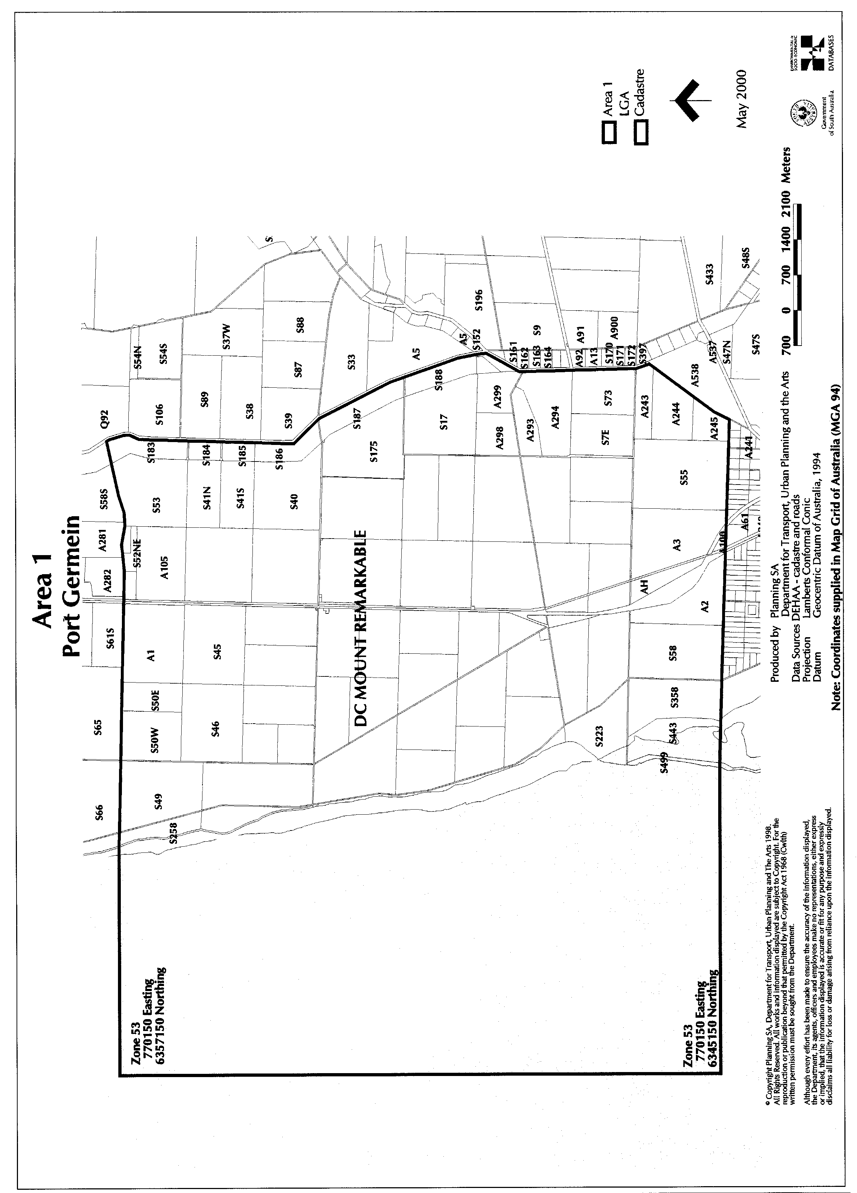
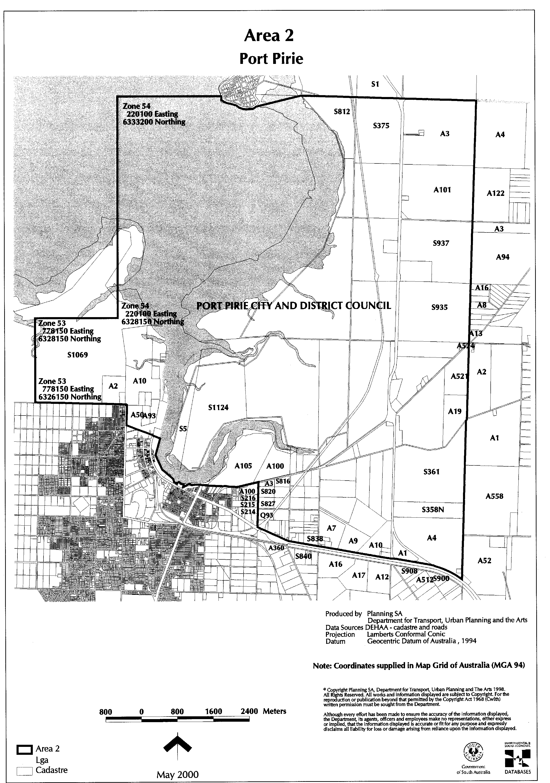
DEVELOPMENT ACT 1993: SECTION 29 (2) (a)
Amendment to the Clare and Gilbert Valleys Council Development Plan
Preamble
It is necessary to amend the Clare and Gilbert Valleys Council Development Plan dated 20 April 2000.
Notice
PURSUANT to Section 29 (2) (a) of the Development Act 1993, I, Diana Laidlaw, being the Minister administering the Act, amend:
The Clare and Gilbert Valleys Council Development Plan dated 20 April 2000 as follows:
Delete Map CGV/8 dated 20 April 2000 and insert the contents of attachment ‘A’.
ATTACHMENT ‘A’
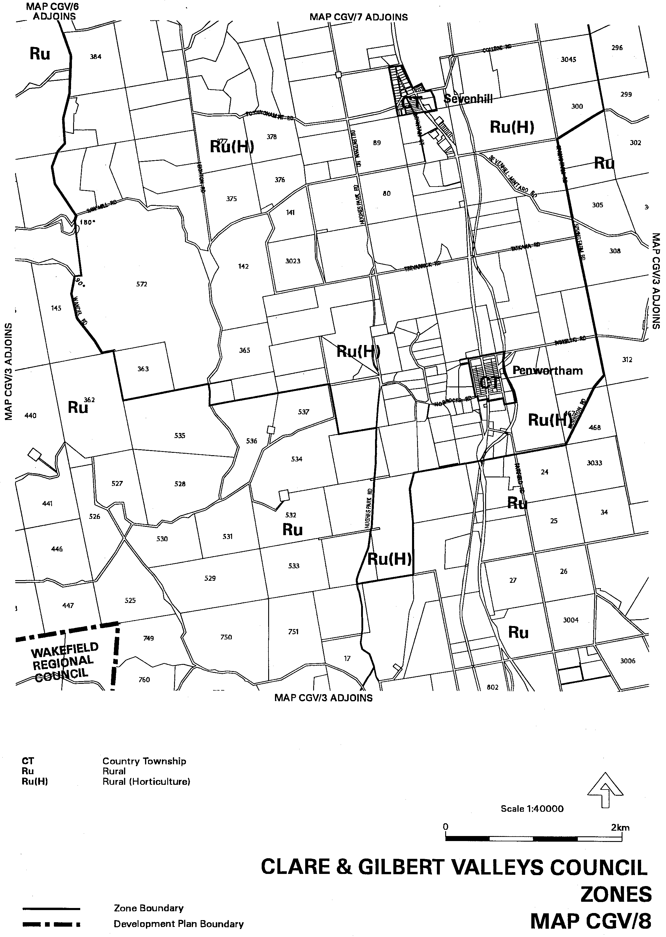
Dated 25 May 2000.
Diana Laidlaw, Minister for Transport and Urban Planning

DEVELOPMENT ACT 1993: SECTION 29 (2) (a)
Amendment to the Mount Pleasant (DC) Development Plan
Preamble
It is necessary to amend the Mount Pleasant (DC) Development Plan dated 20 April 2000.
Notice
PURSUANT to Section 29 (2) (a) of the Development Act 1993, I, Diana Laidlaw, being the Minister administering the Act, amend:
The Mount Pleasant (DC) Development Plan, as dated 20 April 2000, as follows:
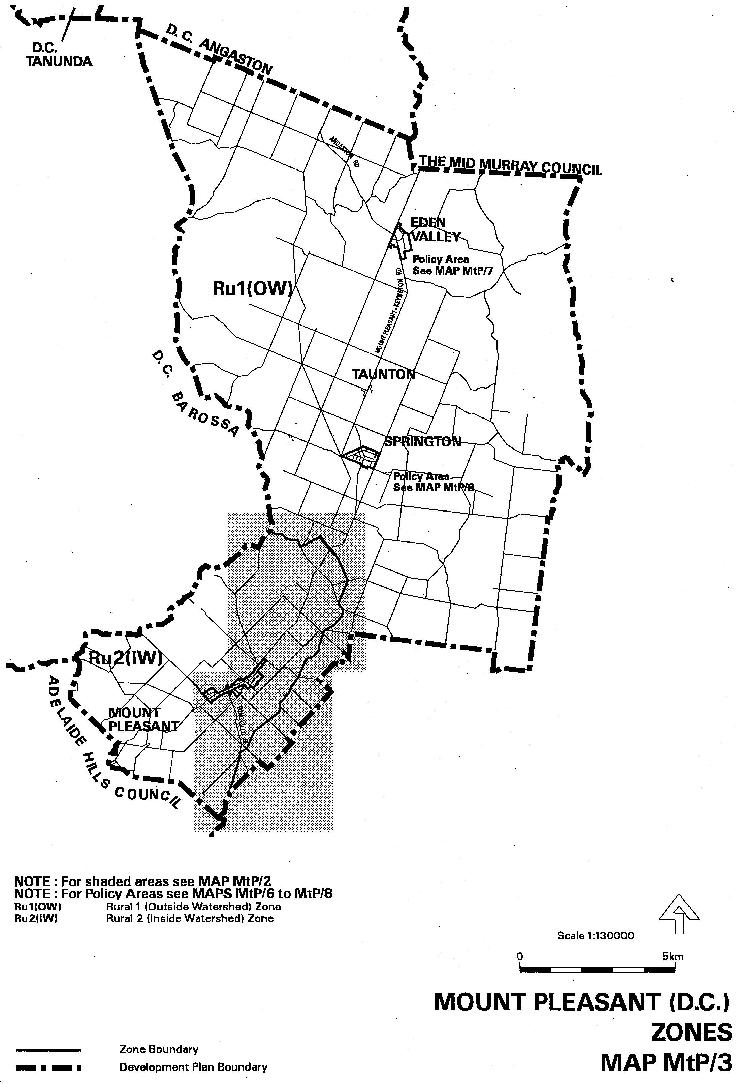
1. Replace Zone Maps MtP/3 and MtP/4, dated 20 April 2000, with the contents of Attachment A.
ATTACHMENT ‘A’

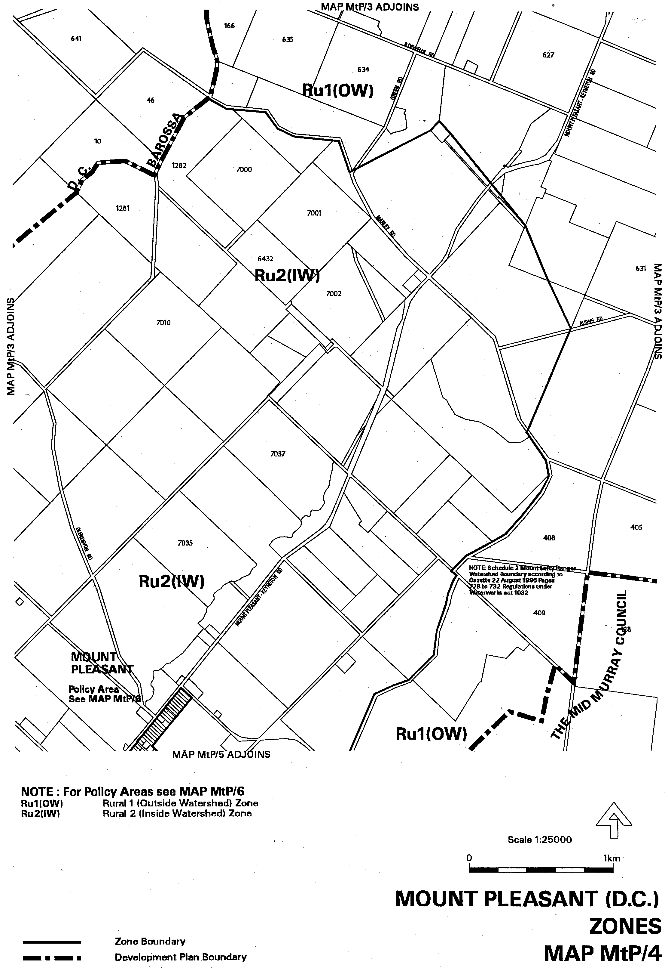
Dated 25 May 2000.
Diana Laidlaw, Minister for Transport and Urban Planning

DEVELOPMENT ACT 1993: SECTION 29 (2) (a)
Amendment to the Barossa (DC) Development Plan
Preamble
It is necessary to amend the Barossa (DC) Development Plan dated 20 April 2000.
Notice
PURSUANT to Section 29 (2) (a) of the Development Act 1993, I, Diana Laidlaw, being the Minister administering the Act, amend:
The Barossa (DC) Development Plan, as dated 20 April 2000, as follows:
1. Replace Zone Maps Baro/4, Baro/8, Baro/13 and Baro/14, dated 20 April 2000, with the contents of Attachment A.
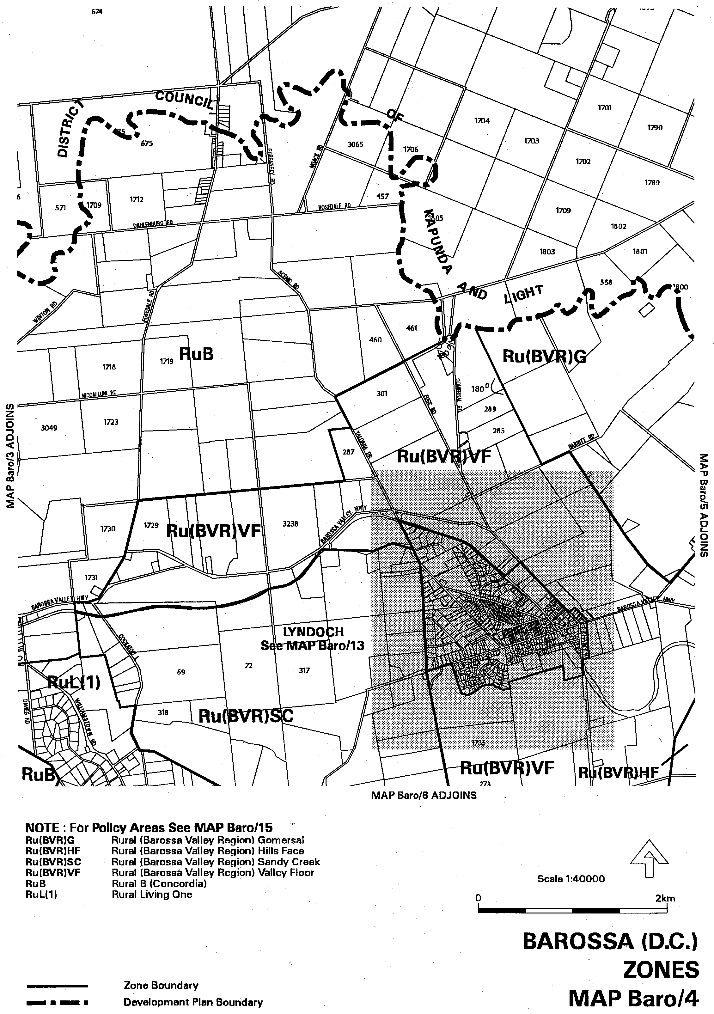
ATTACHMENT ‘A’

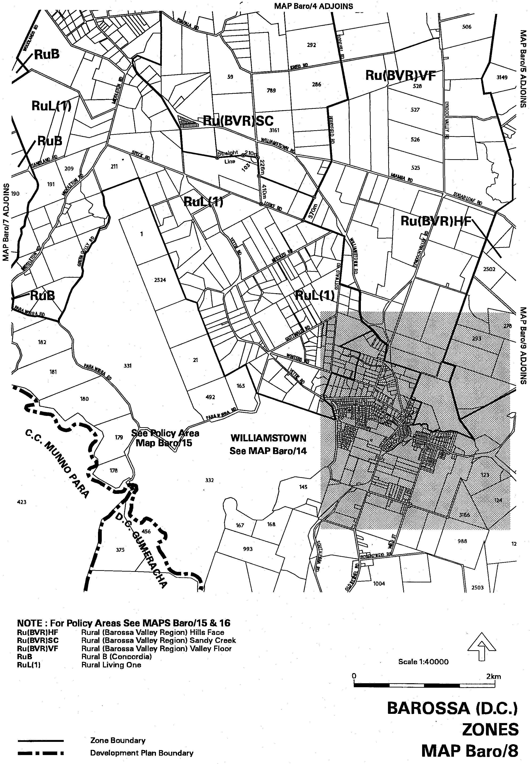
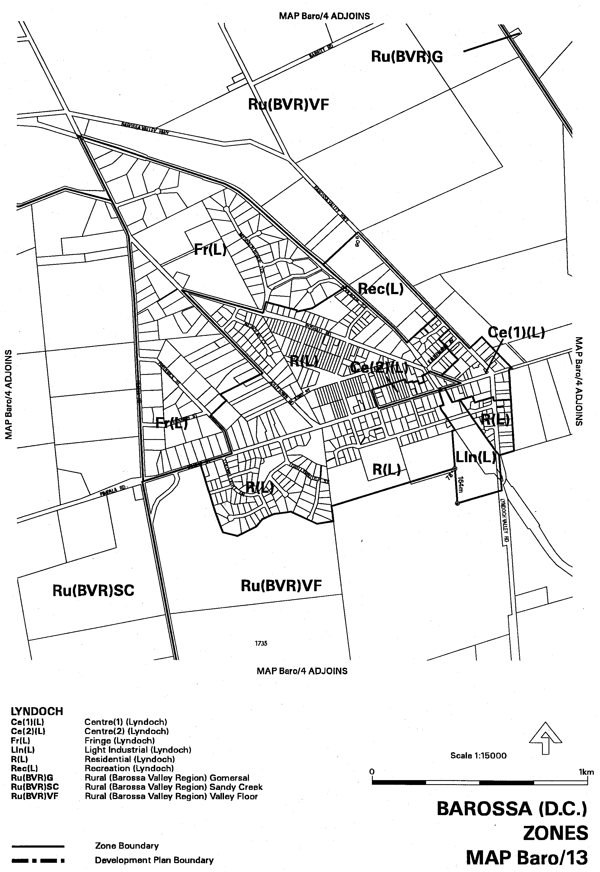
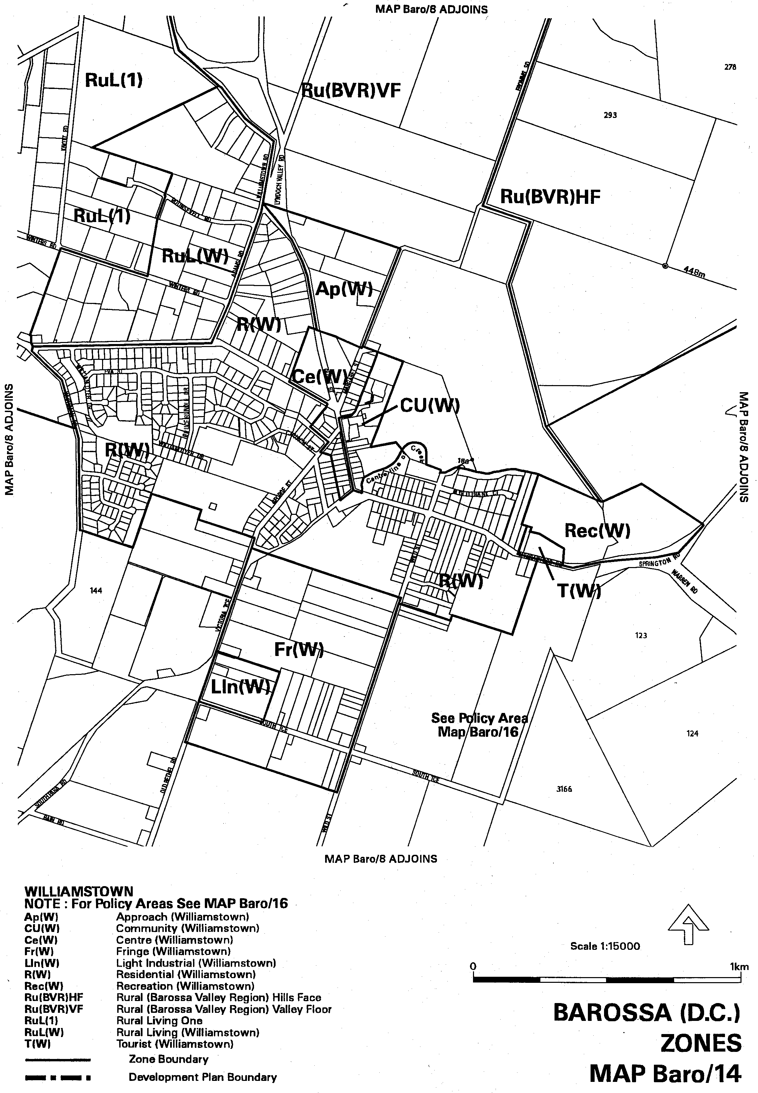
Dated 25 May 2000.
Diana Laidlaw, Minister for Transport and Urban Planning

DEVELOPMENT ACT 1993: SECTION 29 (2) (a)
Amendment to the Angaston (DC) Development Plan
Preamble
It is necessary to amend the Angaston (DC) Development Plan dated 13 January 2000.
Notice
PURSUANT to Section 29 (2) (a) of the Development Act 1993, I, Diana Laidlaw, being the Minister administering the Act, amend:
The Angaston (DC) Development Plan, as dated 13 January 2000, as follows:
(a) Replace Maps An/6 and An/7 dated 13 January 2000 with the contents of Attachment A; and
(b) Amend the associated text references accordingly.
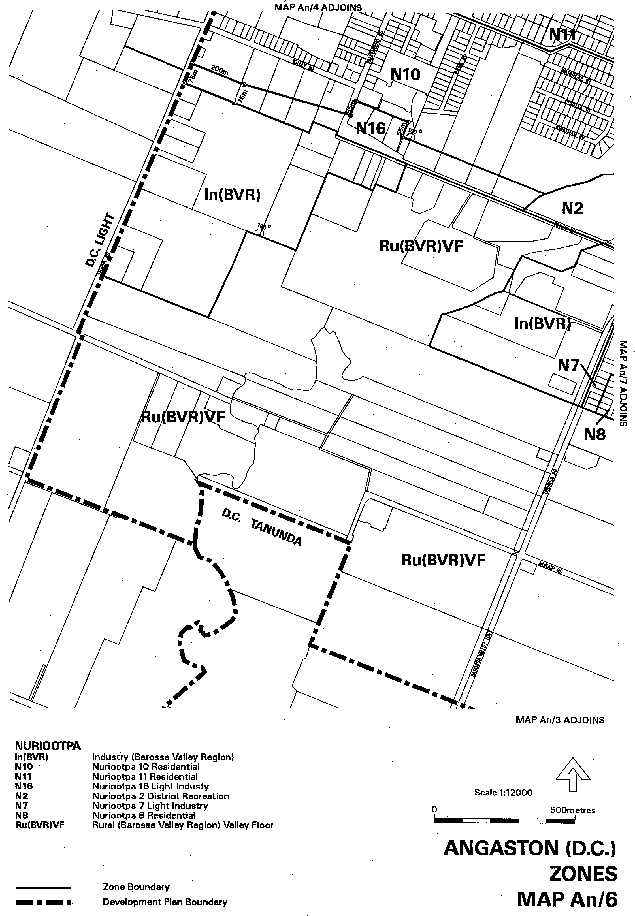
ATTACHMENT ‘A’

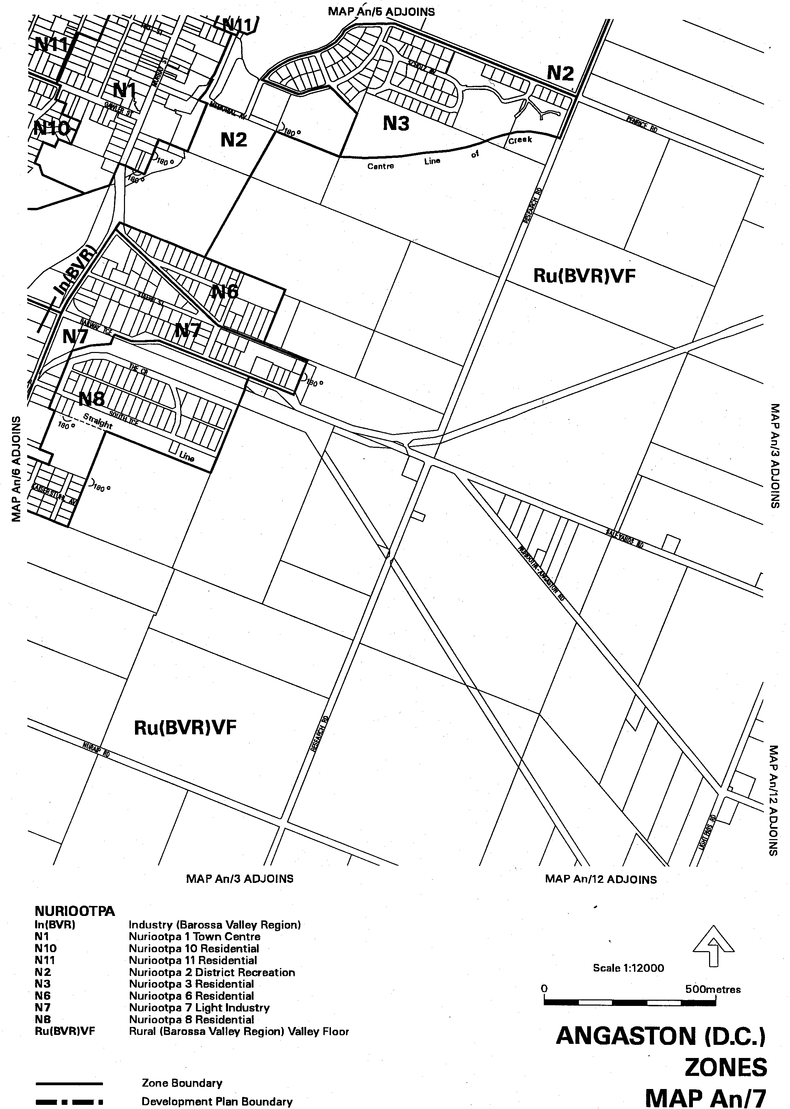
Dated 25 May 2000.
Diana Laidlaw, Minister for Transport and Urban Planning

ELECTORAL ACT 1985
Registration of Political Parties
NOTICE is hereby given, pursuant to section 42 of the Electoral Act 1985, that I have this day registered the following political party:
Name of Party: Australian Federal Republican Party (SA).
Abbreviation of Name of Party: The Republican Party.
Dated 25 May 2000.
S. H. Tully, Electoral Commissioner
SEO 101/00

EXPLOSIVES ACT 1936
Appointments
NOTICE is hereby given that I, Robert David Lawson, Minister for Administrative and Information Services and Minister for Workplace Relations in and for the State of South Australia, hereby appoint the undermentioned persons as inspectors, pursuant to the Explosives Act 1936:
Adams, Peter Raymond
Daly, Colin Vincent
Schiller, Brian John
Murray, Rodney John
Dated 23 May 2000.
R. Lawson, Minister for Workplace Relations

GAMING MACHINES ACT 1992
Notice of Application
NOTICE is hereby given, pursuant to section 29 of the Gaming Machines Act 1992, that Kadina Football Club Inc, has applied to the Liquor Licensing Commissioner for the grant of a Gaming Machine Licence in respect of premises situated at 1 Doswell Terrace, Kadina, S.A. 5554 and known as Kadina Football Club Inc.
The application has been set down for hearing on 23 June 2000.
Any person may object to the application by lodging a notice of objection in the prescribed form with the Liquor Licensing Commissioner, and serving a copy of the notice on the applicant at the applicant’s address given above, at least seven days before the hearing date.
Plans in respect of the premises the subject of the application are open to public inspection without fee at the Office of the Liquor Licensing Commissioner, 9th Floor, East Wing, G.R.E. Building, 50 Grenfell Street, Adelaide 5000.
Dated 5 May 2000.
Applicant

GAMING MACHINES ACT 1992
Notice of Application
NOTICE is hereby given, pursuant to section 29 of the Gaming Machines Act 1992, that Lincoln Cove Investments Pty Ltd has applied to the Liquor Licensing Commissioner for an increase in the number of gaming machines from 21 to 40 in respect of premises situated at Lincoln Cove, Port Lincoln, S.A. 5606 and known as Marina Hotel.
The application has been set down for hearing on 23 June 2000.
Any person may object to the application by lodging a notice of objection in the prescribed form with the Liquor Licensing Commissioner, and serving a copy of the notice on the applicant at the applicant’s address given above, at least seven days before the hearing date.
Plans in respect of the premises the subject of the application are open to public inspection without fee at the Office of the Liquor Licensing Commissioner, 9th Floor, East Wing, G.R.E. Building, 50 Grenfell Street, Adelaide 5000.
Dated 17 May 2000.
Applicant

GOVERNMENT BUSINESS ENTERPRISES (COMPETITION) ACT 1996
Significant Business Activities
Preamble
1. Revised principles of competitive neutrality have been prepared and published by the Premier in a Policy Statement under section 16 of the Government Business Enterprises (Competition) Act 1996.
2. The principles include a scheme for the identification of significant Government business activities.
3. Significant Government business activities are divided into two categories:
(a) Category 1: Business activities with an annual revenue in excess of $2 million, or employing assets with a value in excess of $20 million;
(b) Category 2: All other significant business activities.
4. Category 1 and Category 2 business activities have been identified, and are listed below.
Significant business activities
1. Category 1
Adelaide Convention Centre*
Adelaide Entertainment Centre*
Adelaide Festival Centre Trust*
- Bass ticketing service
- Set building workshops
- Theatre hire services
Attorney-General’s Department
- Contestable legal services
Department for Administrative and Information Services
- Forestry SA
- Supply SA (distribution services)
Department of Education, Training and Employment
- General vocational education and training services
- General tender program
- Fee for service courses (not required by the Government)
ETSA Corporation and subsidiaries*
Enfield General Cemetery Trust*
Fire Equipment Services
Homestart Finance
Lotteries Commission of South Australia*
- Conduct of lotteries
The Public Trustee*
- Personal trusteeship services
SA Generation Corporation and subsidiaries*
SA Ports Corporation*
SA Water Corporation*
South Australian Health Commission
- Medvet Science Pty Ltd
- IMVS Research and Diagnostic Pathology Services
South Australian Police Department
- Security Services Division
South Australian Totalizator Agency Board*
- The conduct of totalizator betting
South Australian Tourism Commission
- Travel Centre bookings and sales services
TransAdelaide (including Austrics and Hills Transit)*
West Beach Trust*
*Falls within the ABS’s classification of PTE or PFE.

2. Category 2
Department of the Premier and Cabinet
- Interpreting and translating services
- Tourism Commission wholesale programs - SA Shorts and SA Getaway
Department of Industry and Trade
- SA Centre for Manufacturing - Advanced Manufacturing Facility
Department for Transport, Urban Planning and the Arts
- Artlab
Department of Human Services
- Modbury Hospital rental accommodation
- RAH rental accommodation
- North Western Adelaide Health Service equipment hire (outside customers)
- Flinders Medical Centre
- Commercial car park
- Rental of flats
- Southpath SA pathology services
Department for Administrative and Information Services
- Building maintenance services
- Contract services
Department for Environment and Heritage
- Cleland Wildlife Park
Department of Primary Industries and Resources
- Seed certification and testing
- Scientific diagnostic services
Department of Education, Training and Employment
- Learning materials sales (e.g., Curriculum Resource Unit)
- International Program
- Student recruitment
- International business
John Olsen, Premier

GOVERNMENT BUSINESS ENTERPRISES (COMPETITION) ACT 1996
Revocation of Previous Notices
Preamble
1. Significant Government business activities have been previously identified for the purposes of principles of competitive neutrality under the Government Business Enterprises (Competition) Act 1996.
2. Revised principles of competitive neutrality have been prepared and published by the Premier in a Policy Statement under section 16 of the Government Business Enterprises (Competition) Act 1996.
3. It is now appropriate to revoke previous declarations of Category 1 and Category 2 business activities.
Revocation
FOR the purposes of section 16 of the Government Business Enterprises (Competition) Act 1996, I revoke all previous notices identifying significant Government business activities of the Government of the State for the purposes of principles of competitive neutrality.
John Olsen, Premier

HOUSING IMPROVEMENT ACT 1940
WHEREAS by notice published in the Government Gazette on the dates mentioned in the following table the South Australian Housing Trust did declare the houses described in the said table to be substandard for the purposes of Part VII of the Housing Improvement Act 1940, the South Australian Housing Trust in the exercise of the powers conferred by the said Part, does hereby fix as the maximum rental per week which shall be payable subject to section 55 of the Residential Tenancies Act 1995, in respect of each house described in the following table the amount shown in the said table opposite the description of such house and this notice shall come into force on the date of this publication in the Gazette.
Address of House | Allotment, Section, etc. | Certificate of Title  Volume Folio | Date and page of Government Gazette in which notice declaring house to be substandard published | Maximum rental per week payable in respect of each house  $

62 Corryton Street, Adelaide |  | Allotment 617 in Filed Plan 182269, Hundred of Adelaide | 5609 | 542 |  | 29.6.67, page 1966 | 110.00
11 Hurtle Square, Adelaide |  | Allotment 669 in Filed Plan 182321, Hundred of Adelaide | 5730 | 279 |  | 4.11.65, page 1566 | 60.00 per room
44 Higgins Road, Buchfelde (also known as Gawler River) |  | Allotment 3 in Filed Plan 138700, Hundred of Mudla Wirra | 5258 | 35 |  | 28.11.96, page 1755 | 95.00
Lot 8 Hawthorn Street, Dawesley (also known as Lot 662) |  | Allotment 8 in section 4414, Hundred of Kanmantoo | 257 | 17 |  | 29.6.78, page 2246 | 60.00
39 Minchington Road, Elizabeth North |  | Allotment 731 in Deposited Plan 6448, Hundred of Munno Para | 5260 | 339 |  | 26.2.98, page 1010 | 68.00
22 Newton Terrace, Enfield |  | Allotment 200 in Deposited Plan 4451, Hundred of Yatala | 5225 | 928 |  | 24.6.99, page 3212 | 75.00
Detached stone house at section 462 Sand Road, Kangarilla |  | Section 462, Hundred of Kuitpo | 5584 | 541 |  | 24.12.92, page 2295 | 85.00
Unit 1/322 Esplanade, Moana |  | Allotment 500 in Deposited Plan 38580, Hundred of Willunga | 5175 | 14 |  | 29.7.99, page 587 | 45.00
5 Birks, Street, Parkside |  | Allotment 3 in Filed Plan 7972, Hundred of Adelaide | 1689 | 35 |  | 25.9.97, page 886 | 165.00
27 Clyde Street, Parkside |  | Allotment 128 in Filed Plan 14380, Hundred of Adelaide | 5485 | 324 |  | 21.9.78, page 1004 | 95.00
58 Emilie Street, Sefton Park |  | Allotment 33 in Filed Plan 18675, Hundred of Yatala | 5727 | 294 |  | 28.10.93, page 2119 | 145.00
19 Beaufort Street, Woodville |  | Allotment 101 in Deposited Plan 20115, Hundred of Yatala | 5088 | 112 |  | 6.1.00, page 4 | 95.00
150 Waterfall Gully Road, Waterfall Gully |  | Allotment 8 in Deposited Plan 4777, Hundred of Adelaide  Allotment 9 in Deposited Plan 4777, Hundred of Adelaide | 5449  5236 | 268  514 |  | 30.3.95, page 1142  30.3.95, page 1142 | 90.00  90.00

Dated at Adelaide, 25 May 2000. G. Black, Chief General Manager, Housing Trust

HOUSING IMPROVEMENT ACT 1940
NOTICE is hereby given that the South Australian Housing Trust in the exercise of the powers conferred by the Housing Improvement Act 1940, does hereby declare the houses described in the table hereunder to be substandard for the purposes of Part VII of the Housing Improvement Act 1940.
No. of House and Street | Locality | Allotment, Section, etc. | Certificate of Title  Volume Folio

34 Wallace Street |  | Balaklava | Allotment 19 in Deposited Plan 1052 in the area named Balaklava, Hundred of Balaklava | 5360 | 914
Lot 17 Bowhill Road |  | Burdett | Allotment 17 in Filed Plan 3571, Hundred of Burdett | 5163 | 252
30 Olympia Crescent |  | Hackham West | Allotment 541 in Deposited Plan 10678, Hundred of Noarlunga | 5107 | 168

Dated at Adelaide, 25 May 2000. G. Black, Chief General Manager, Housing Trust

HOUSING IMPROVEMENT ACT 1940
WHEREAS by notice published in the Government Gazette on the dates mentioned in the following table the South Australian Housing Trust did declare the houses described in the said table to be substandard for the purposes of Part VII of the Housing Improvement Act 1940, and whereas the South Australian Housing Trust is satisfied that each of the houses described hereunder has ceased to be substandard, notice is hereby given that, in exercise of the powers conferred by the said Part, the South Australian Housing Trust does hereby revoke the said declaration in respect of each house.
Address of House | Allotment, Section, etc. | Certificate of Title  Volume Folio | Date and page of Government Gazette in which notice declaring house to be substandard published

151 Park Terrace, Brahma Lodge |  | Allotment 9 in subdivision of portion of section 2201, Hundred of Yatala | 2958 | 73 |  | 7.1.99, page 7
2 Martens Avenue, Fullarton |  | Allotment 26 in Deposited Plan 2548, Hundred of Adelaide | 5325 | 870 |  | 11.1.96, page 110
52 Shipsters Road, Kensington |  | Allotment 101 in Filed Plan 27994, Hundred of Adelaide | 5425 | 169 |  | 3.6.65, page 1400
86 Porter Street, Parkside |  | Allotment 243 of portion of section 240 | 5216 | 599 |  | 11.4.74, page 1231
41 Unley Road, Parkside |  | Allotment 151 in Filed Plan 14380, Hundred of Adelaide | 5730 | 981 |  | 17.1.74, page 177
Dwelling at rear of 117 Grand Junction Road, Rosewater |  | Unit 1 Strata Plan 13455, Hundred of Port Adelaide | 5269 | 969 |  | 24.10.96, page 1421
81 Railway Terrace West, Snowtown |  | Allotment 22 in Deposited Plan 26890, Hundred of Barunga | 5088 | 204 |  | 29.10.92, page 1439
2 Glenrowan Road, Woodville South |  | Allotment 93 in Deposited Plan 3362, Hundred of Yatala | 5747 | 472 |  | 22.7.86, page 386

Dated at Adelaide, 25 May 2000. G. Black, Chief General Manager, Housing Trust

INDUSTRIAL AND EMPLOYEE RELATIONS ACT 1994
Appointment
NOTICE is hereby given that I, Robert David Lawson, Minister for Workplace Relations in and for the State of South Australia, hereby appoint the undermentioned officer as an Inspector, pursuant to the Industrial and Employee Relations Act 1994:
Hillman, Roger Lyall
Dated 23 May 2000.
R. Lawson, Minister for Workplace Relations

LAND AND BUSINESS (SALE AND CONVEYANCING) ACT 1994
Exemption
TAKE notice that, pursuant to section 23 (3) of the Land and Business (Sale and Conveyancing) Act 1994, I, Kenneth Trevor Griffin, Minister for Consumer Affairs, do hereby exempt the person named in Schedule 1 from the application of section 23 (2) of the Act in relation to the purchase of the land specified in Schedule 2.
Schedule 1
Sheena Marie Buscumb, officer/employee of W. B. Real Estate Pty Ltd.
Schedule 2
The whole of the land described in certificate of title register book volume 5068, folio 612 situated at 1 Coolibah Avenue, Craigmore, S.A. 5114.
Dated 25 May 2000.
Signed for and on behalf of the Minister for Consumer Affairs by the Commissioner for Consumer Affairs:
M. Bodycoat, Commissioner

LAND AND BUSINESS (SALE AND CONVEYANCING) ACT 1994
Exemption
TAKE notice that, pursuant to section 23 (3) of the Land and Business (Sale and Conveyancing) Act 1994, I, Kenneth Trevor Griffin, Minister for Consumer Affairs, do hereby exempt the person named in Schedule 1 from the application of section 23 (2) of the Act in relation to the purchase of the land specified in Schedule 2.
Schedule 1
Michael Laurence Quilliam, an officer/employee of Southern Vales Real Estate Pty Ltd.
Schedule 2
The whole of the land described in Certificate of Title Register Book Volume 5019, folio 537, situated at Unit 2/297 Main South Road, Morphett Vale, S.A. 5162.
Dated 25 May 2000.
Signed for and on behalf of the Minister for Consumer Affairs by the Commissioner for Consumer Affairs:
M. Bodycoat, Commissioner

LAND AND BUSINESS (SALE AND CONVEYANCING) ACT 1994
Exemption
TAKE notice that, pursuant to section 23 (3) of the Land and Business (Sale and Conveyancing) Act 1994, I, Kenneth Trevor Griffin, Minister for Consumer Affairs, do hereby exempt the person named in Schedule 1 from the application of section 23 (2) of the Act in relation to the purchase of the land specified in Schedule 2.
Schedule 1
Andrew James Whan, an officer/employee of Miller Whan & John Pty Ltd.
Schedule 2
The whole of the land described in Certificate of Title Register Book Volume 5664, folio 765, situated at the corner of Newbold and Collins Roads, Benara (allotment 360, Hundred of Blanche).
Dated 25 May 2000.
Signed for and on behalf of the Minister for Consumer Affairs by the Commissioner for Consumer Affairs:
M. Bodycoat, Commissioner

LIQUOR LICENSING ACT 1997 AND GAMING MACHINES ACT 1992
Notice of Application
NOTICE is hereby given, pursuant to section 52 of the Liquor Licensing Act 1997 and section 29 of the Gaming Machines Act 1992, that Evian Management (Aust) No. 3 Pty Ltd (ACN 092 374 340), Level 1, 133 Archer Street, North Adelaide, S.A. 5006 has applied to the Liquor and Gaming Commissioner for the transfer of a Hotel Licence and Gaming Machine Licence in respect of premises situated at corner of Commercial Road and Griffith Drive, Seaford Rise and known as the Seaford Rise Tavern.
The applications have been set down for hearing on 23 June 2000.
Any person may object to the application by lodging a notice of objection in the prescribed form with the Licensing Authority, and serving a copy of the notice on the applicant at the applicant’s address given above, at least seven days before the hearing date.
Plans in respect of the premises the subject of the application are open to public inspection without fee at the Office of the Liquor and Gaming Commissioner, 9th Floor, East Wing, 50 Grenfell Street, Adelaide, S.A. 5000.
Dated 16 May 2000.
Applicant

LIQUOR LICENSING ACT 1997
Notice of Application
NOTICE is hereby given, pursuant to section 52 (2) (b) of the Liquor Licensing Act 1997, that Pembroke Old Scholars’ Football Club at Parkinson Oval, Kensington Gardens Reserve, off West Terrace, Kensington Gardens, S.A. 5068 has applied to the Licensing Authority for a Limited Club Licence with Extended Trading Authorisation and Entertainment Consent in respect of premises situated at Parkinson Oval, Kensington Gardens Reserve, off West Terrace, Kensington Gardens, S.A. 5068 and to be known as Pembroke Old Scholars’ Football Club.
The application has been set down for hearing on 23 June 2000 at 9 a.m.
Conditions
The following licence conditions are sought:
1. Extended Trading Authorisation, Saturday, midnight to 1 a.m. the following day.
2. Entertainment consent.
Any person may object to the application by lodging a notice of objection in the prescribed form with the Licensing Authority, and serving a copy of the notice on the applicant at the applicant’s address given above, at least seven days before the hearing date.
Plans in respect of the premises the subject of the application are open to public inspection without fee at the Office of the Liquor and Gaming Commissioner, 9th Floor, East Wing, 50 Grenfell Street, Adelaide, S.A. 5000.
Dated 18 May 2000.
Applicant

LIQUOR LICENSING ACT 1997
Notice of Application
NOTICE is hereby given, pursuant to section 52 (2) (b) of the Liquor Licensing Act 1997, that Tyncu Pty Ltd (ACN 008 190 403) has applied to the Licensing Authority for an Extended Trading Authorisation in respect of premises situated at 4 Main Street, Crafers and known as Crafers Inn Hotel.
The application has been set down for hearing on Friday, 23 June 2000 at 9 a.m.
Conditions
The following licence conditions are sought:
1. That the licensee be permitted to sell liquor for consumption on the licensed premises from 9 a.m. to 11 a.m. and 8 p.m. to midnight each Sunday, and on Christmas Day from midnight to 2 a.m.
2. That the licensee be permitted to sell liquor for consumption off the licensed premises from 9 a.m. to 11 a.m. and from 8 p.m. to 9 p.m. each Sunday.
3. That the extended trading authorisation shall apply to the areas referred to on the deposited plan as Area 2, Area 3 and Area 4.
Any person may object to the application by lodging a notice of objection in the prescribed form with the Licensing Authority, and serving a copy of the notice on the applicant at the applicant’s address given above, at least seven days before the hearing date.
Plans in respect of the premises the subject of the application are open to public inspection without fee at the Office of the Liquor and Gaming Commissioner, 9th Floor, East Wing, 50 Grenfell Street, Adelaide, S.A. 5000.
Dated 16 May 2000.
Applicant

LIQUOR LICENSING ACT 1997
Notice of Application
NOTICE is hereby given, pursuant to section 52 (2) (b) of the Liquor Licensing Act 1997, that Ian Ech Ngang Lim, 28/2 Ayliffes Road, St Marys, S.A. 5042 has applied to the Licensing Authority for the transfer of a Restaurant Licence in respect of premises situated at 150A Goodwood Road, Goodwood, S.A. 5034 and known as Manee Siam Thai Restaurant.
The application has been set down for hearing on 26 June 2000.
Any person may object to the application by lodging a notice of objection in the prescribed form with the Licensing Authority, and serving a copy of the notice on the applicant at the applicant’s address given above, at least seven days before the hearing date.
Plans in respect of the premises the subject of the application are open to public inspection without fee at the Office of the Liquor and Gaming Commissioner, 9th Floor, East Wing, 50 Grenfell Street, Adelaide, S.A. 5000.
Dated 11 May 2000.
Applicant

LIQUOR LICENSING ACT 1997
Notice of Application
NOTICE is hereby given, pursuant to section 52 (2) (b) of the Liquor Licensing Act 1997, that Cogno Bros. Cobbity Wines Pty Ltd has applied to the Licensing Authority for the transfer of a Special Circumstances Licence in respect of premises situated at Sand Road, McLaren Vale, S.A. 5171 and known as Middlebrook Winery.
The application has been set down for hearing on 26 June 2000.
Any person may object to the application by lodging a notice of objection in the prescribed form with the Licensing Authority, and serving a copy of the notice on the applicant at the applicant’s address given above, at least seven days before the hearing date.
Plans in respect of the premises the subject of the application are open to public inspection without fee at the Office of the Liquor and Gaming Commissioner, 9th Floor, East Wing, 50 Grenfell Street, Adelaide, S.A. 5000.
Applicant

LIQUOR LICENSING ACT 1997
Notice of Application
NOTICE is hereby given, pursuant to section 52 (2) (b) of the Liquor Licensing Act 1997, that Ian Burrows has applied to the Licensing Authority for the transfer of a Restaurant Licence in respect of premises situated at 2/2 Durham Street, Glenelg, S.A. 5045 and known as Durham’s Restaurant.
The application has been set down for hearing on 26 June 2000.
Any person may object to the application by lodging a notice of objection in the prescribed form with the Licensing Authority, and serving a copy of the notice on the applicant at the applicant’s address given above, at least seven days before the hearing date.
Plans in respect of the premises the subject of the application are open to public inspection without fee at the Office of the Liquor and Gaming Commissioner, 9th Floor, East Wing, 50 Grenfell Street, Adelaide, S.A. 5000.
Dated 17 May 2000.
Applicant

LIQUOR LICENSING ACT 1997
Notice of Application
NOTICE is hereby given, pursuant to section 52 (2) (b) of the Liquor Licensing Act 1997, that Evan Charles Kosch and Leanne Maree Kosch, c/o Duncan Basheer Hannon, 66 Wright Street, Adelaide S.A. 5000 have applied to the Licensing Authority for the transfer of a Residential Licence in respect of premises situated at corner Penola Road and Jubilee Highway, Mount Gambier, S.A. 5290 and known as Commodore Motel Mount Gambier.
The application has been set down for hearing on 26 June 2000 at 11 a.m.
Any person may object to the application by lodging a notice of objection in the prescribed form with the Licensing Authority, and serving a copy of the notice on the applicants at the applicants’ address given above, at least seven days before the hearing date.
Plans in respect of the premises the subject of the application are open to public inspection without fee at the Office of the Liquor and Gaming Commissioner, 9th Floor, East Wing, 50 Grenfell Street, Adelaide, S.A. 5000.
Dated 18 May 2000.
Applicants

LIQUOR LICENSING ACT 1997
Notice of Application
NOTICE is hereby given, pursuant to section 52 (2) (b) of the Liquor Licensing Act 1997, that CKC Distributors Pty Ltd has applied to the Licensing Authority for the transfer of a Residential Licence in respect of premises situated at 74A Main North Road, Clare and known as Clare Valley Motel.
The application has been set down for hearing on 23 June 2000.
Any person may object to the application by lodging a notice of objection in the prescribed form with the Licensing Authority, and serving a copy of the notice on the applicant at the applicant’s address given above, at least seven days before the hearing date.
Plans in respect of the premises the subject of the application are open to public inspection without fee at the Office of the Liquor and Gaming Commissioner, 9th Floor, East Wing, 50 Grenfell Street, Adelaide, S.A. 5000.
Dated 18 May 2000.
Applicant

MINING ACT 1971
NOTICE is hereby given in accordance with section 28 (5) of the Mining Act 1971, that the Minister for Minerals and Energy proposes to grant an Exploration Licence over the undermentioned area:
Applicant: Taipan Resources NL
Location: Glyde Hill area⎯Approximately 150 km north-east of Ceduna, bounded as follows:
Area ‘A’⎯Commencing at a point being the inter-section of latitude 31°28′S and longitude 135°09′E, thence east to longitude 135°21′E, south to latitude 31°36′S, west to longitude 135°09′E, and north to the point of commencement.
Area ‘B’⎯Commencing at a point being the inter-section of latitude 31°41′S and longitude 135°17′E, thence east to longitude 135°21′E, south to latitude 31°45′S, west to longitude 135°17′E, and north to the point of commencement.
All the within latitudes and longitudes are geodetic and expressed in terms of the Australian Geodetic Datum as defined on p. 4984 of Commonwealth Gazette number 84 dated 6 October 1966.
Term: 1 year
Area in km²: 327
Ref. 172/1999
Dated 25 May 2000.
L. Johnston, Mining Registrar

MINING ACT 1971
NOTICE is hereby given in accordance with section 28 (5) of the Mining Act 1971, that the Minister for Minerals and Energy proposes to grant an Exploration Licence over the undermentioned area:
Applicant: Pasminco Australia Limited
Location: Mulyungarie area⎯Approximately 100 km north-east of Olary, bounded as follows: Commencing at a point being the intersection of latitude 31°21′S and longitude 140°40′E, thence east to the eastern border of the State of South Australia, thence southerly along the border of the said State to latitude 31°36′S, west to longitude 140°40′E north to latitude 31°35′S, west to longitude 140°30′E, north to latitude 31°24′S, east to longitude 140°40′E, and north to the point of commencement, all the within latitudes and longitudes being geodetic and expressed in terms of the Australian Geodetic Datum as defined on p. 4984 of Commonwealth Gazette number 84 dated 6 October 1966 (AGD66).
Term: 1 year
Area in km²: 1 139
Ref. 18/2000
Dated 25 May 2000.
L. Johnston, Mining Registrar

MOTOR VEHICLES ACT 1959
Accident Towing Roster Scheme
NOTICE is hereby given that I, Diana Vivienne Laidlaw, the responsible Minister of the Crown for the Transport portfolio, do hereby rescind the appointment of Jeffrey Parsons as a member of the Accident Towing Roster Review Committee.
Pursuant to Regulations 8 (1) (b) and 8a of the Accident Towing Roster Scheme Regulations 1984, I hereby appoint Wendy Bevan as a member of the Accident Towing Roster Review Committee and confirm the appointment of Robin Thorpe as her deputy.
Dated 15 May 2000.
Diana laidlaw, Minister for Transport and Urban Planning

NATIONAL PARKS AND WILDLIFE ACT 1972
Declaration of Little Kaiserstuhl Sanctuary
I, IAIN EVANS, Minister for Environment and Heritage and Minister of the Crown for the time being administering the National Parks and Wildlife Act 1972, being of the opinion that it is desirable to conserve the animals and plants for which the land depicted as a sanctuary in the schedule hereto is a natural habitat or environment and having received all necessary consents, do hereby declare the said land to be a sanctuary for the purposes of the said Act.
Dated 30 April 2000.
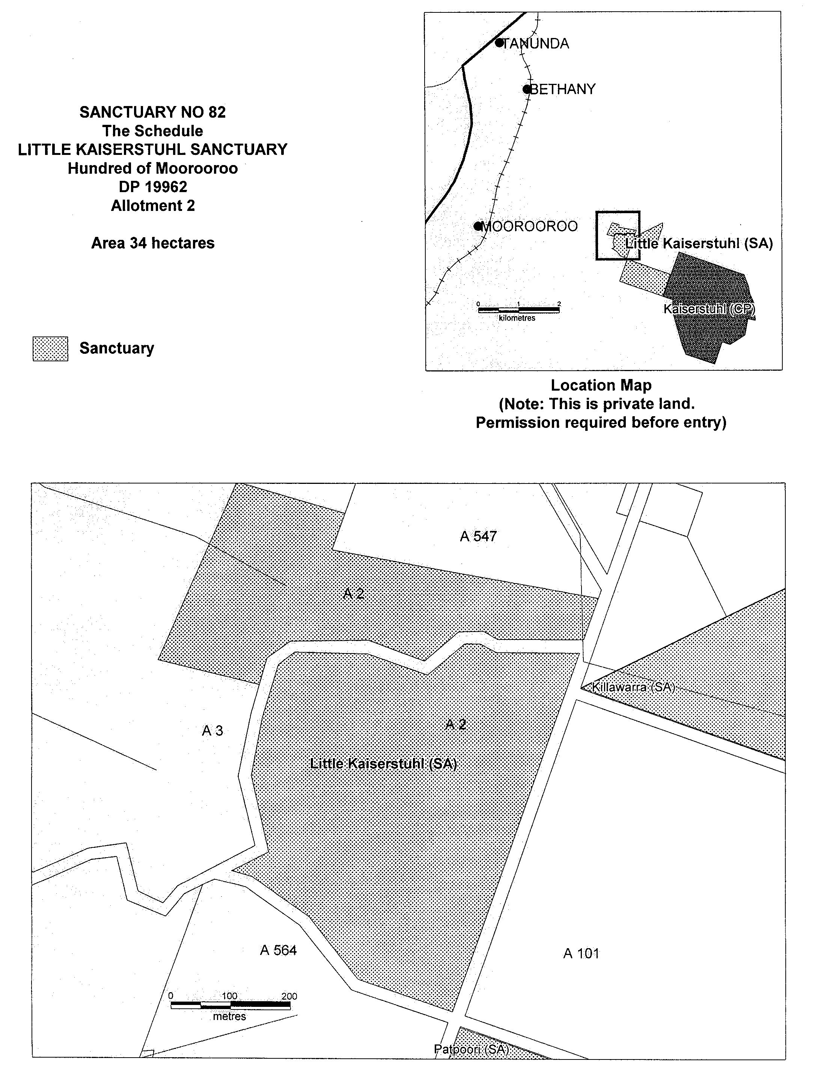
Iain Evans, Minister for Environment and Heritage

NATIONAL PARKS AND WILDLIFE ACT 1972
Declaration of Meadow Lea Sanctuary
I, IAIN EVANS, Minister for Environment and Heritage and Minister of the Crown for the time being administering the National Parks and Wildlife Act 1972, being of the opinion that it is desirable to conserve the animals and plants for which the land depicted as a sanctuary in the schedule hereto is a natural habitat or environment and having received all necessary consents, do hereby declare the said land to be a sanctuary for the purposes of the said Act.
Dated 20 April 2000.
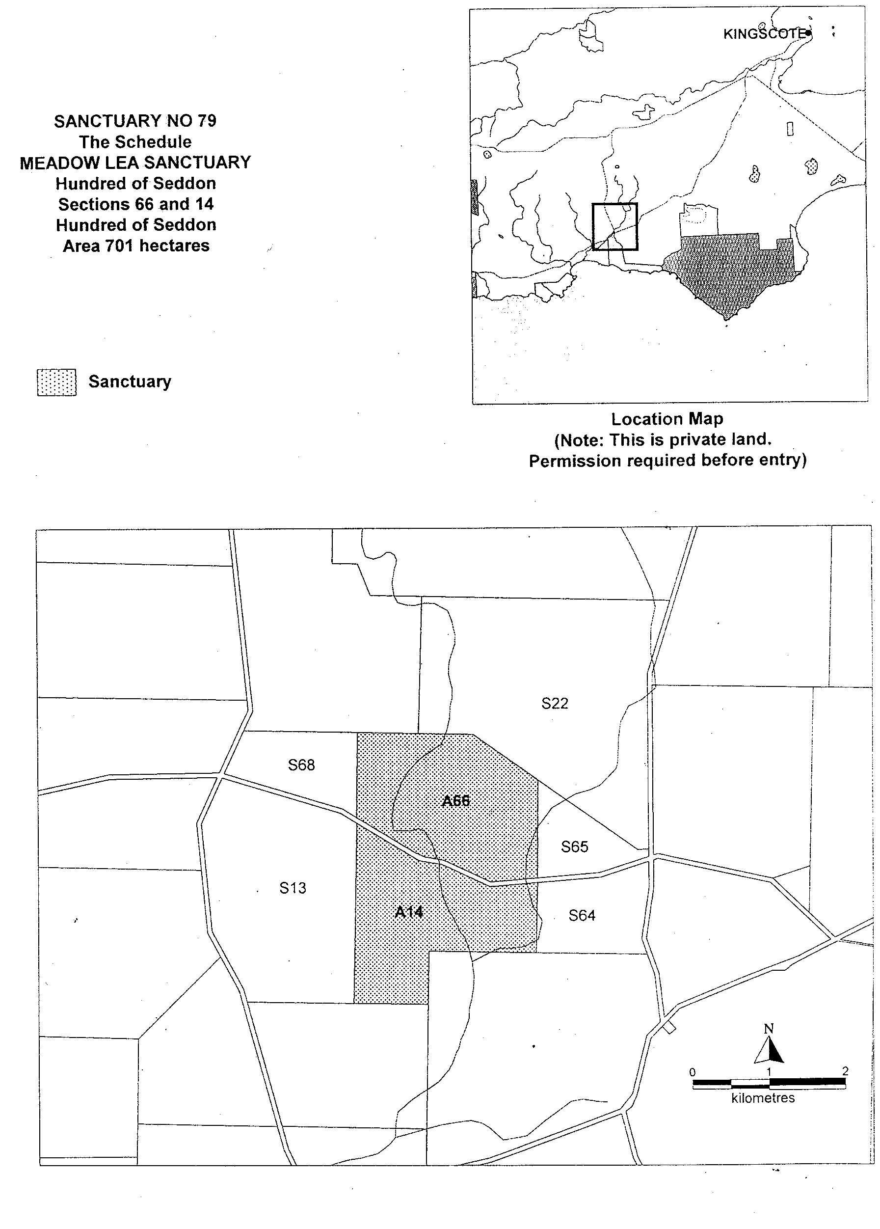
Iain Evans, Minister for Environment and Heritage

OPAL MINING ACT 1995
Erratum
WITH reference to the Declaration of Exclusion Zone which appeared on page 442 of the Government Gazette dated 20 January 2000, I advise that the description and accompanying plan of the said Exclusion Zone should have appeared as follows:
Description of Area
Commencing at a point being the intersection of latitude 26°57′S and longitude 134°01′E, thence east to longitude 134°10′E, south to latitude 26°58′S, east to longitude 134°17′E, south to latitude 27°24′S, east to longitude 134°21′E, south to latitude 27°27′S, west to longitude 133°52′E, north to latitude 27°13′S, west to longitude 133°46′E, north to latitude 26°58′S, east to longitude 134°01′E, and north to the point of commencement, all the within latitudes and longitudes being geodetic and expressed in terms of the Australian Geodetic Datum as defined on p. 4984 of Commonwealth Gazette number 84 dated 6 October 1966 (AGD66).
Area: 2 549 km² approximately.

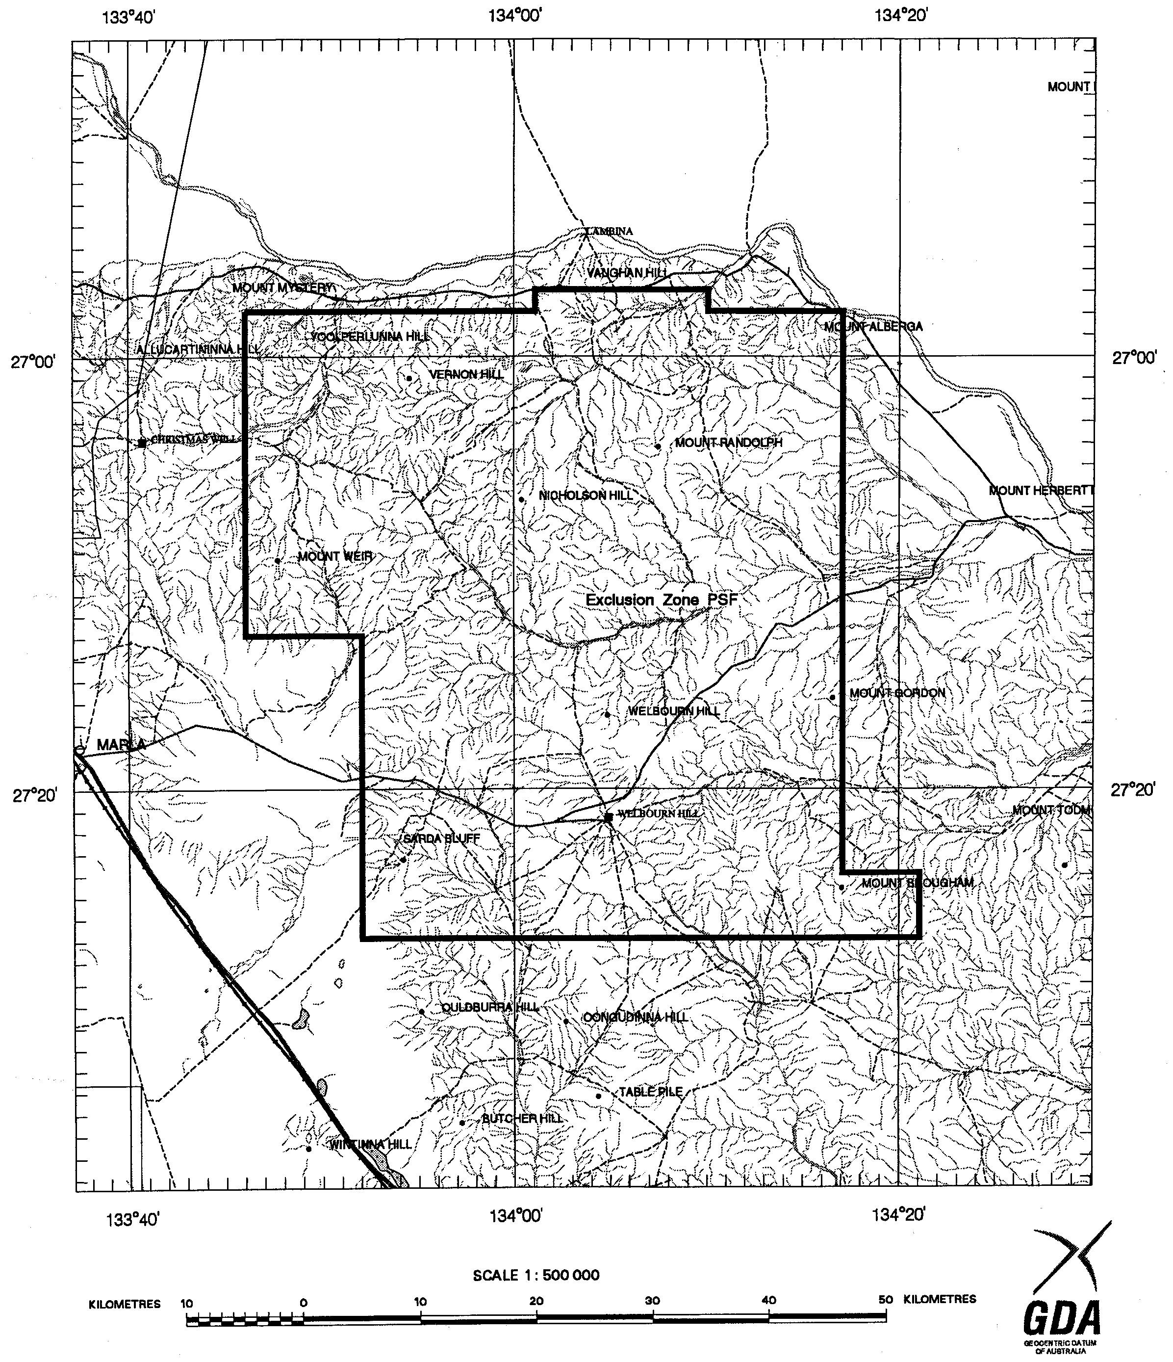
W. Matthew, Minister for Minerals and Energy

MISCELLANEOUS LEGISLATION AND GOVERNMENT PUBLICATIONS PRICES AS FROM 1 JULY 1999

Acts, Bills, Rules, Parliamentary Papers and Regulations
Pages | Main | Amends | Pages | Main | Amends

1-16 | 1.60 | 0.75 | 497-512 | 23.30 | 22.40
17-32 | 2.30 | 1.45 | 513-528 | 23.90 | 23.00
33-48 | 2.90 | 2.10 | 529-544 | 24.70 | 23.80
49-64 | 3.70 | 2.75 | 545-560 | 25.30 | 24.50
65-80 | 4.35 | 3.55 | 561-576 | 26.00 | 25.20
81-96 | 5.00 | 4.20 | 577-592 | 26.75 | 25.75
97-112 | 5.75 | 4.85 | 593-608 | 27.50 | 26.50
113-128 | 6.40 | 5.60 | 609-624 | 28.25 | 27.50
129-144 | 7.20 | 6.30 | 625-640 | 28.75 | 28.00
145-160 | 7.90 | 6.95 | 641-656 | 29.50 | 28.50
161-176 | 8.60 | 7.70 | 657-672 | 30.00 | 29.25
177-192 | 9.25 | 8.40 | 673-688 | 31.00 | 30.00
193-208 | 9.95 | 9.10 | 689-704 | 31.75 | 30.75
209-224 | 10.60 | 9.75 | 705-720 | 32.25 | 31.50
225-240 | 11.25 | 10.50 | 721-736 | 33.25 | 32.00
241-257 | 12.05 | 11.10 | 737-752 | 33.75 | 32.75
258-272 | 12.80 | 11.80 | 753-768 | 34.50 | 33.25
273-288 | 13.45 | 12.60 | 769-784 | 35.00 | 34.25
289-304 | 14.10 | 13.20 | 785-800 | 35.75 | 35.00
305-320 | 14.80 | 13.90 | 801-816 | 36.25 | 35.50
321-336 | 15.55 | 14.60 | 817-832 | 37.25 | 36.25
337-352 | 16.20 | 15.40 | 833-848 | 38.00 | 37.00
353-368 | 16.90 | 16.05 | 849-864 | 38.50 | 37.75
369-384 | 17.60 | 16.80 | 865-880 | 39.25 | 38.50
385-400 | 18.30 | 17.50 | 881-896 | 39.75 | 39.00
401-416 | 19.00 | 18.10 | 897-912 | 40.75 | 39.75
417-432 | 19.75 | 18.90 | 913-928 | 41.25 | 40.75
433-448 | 20.40 | 19.50 | 929-944 | 42.00 | 41.25
449-464 | 21.15 | 20.20 | 945-960 | 43.00 | 41.75
465-480 | 21.75 | 20.90 | 961-976 | 43.50 | 42.50
481-496 | 22.40 | 21.50 | 977-992 | 44.25 | 43.00

Legislation—Acts, Regulations, etc: $
Subscriptions:
Acts 144.00
All Bills as Laid 344.00
Rules and Regulations 344.00
Parliamentary Papers 344.00
Bound Acts 159.00
Index 77.00
Government Gazette
Copy 3.85
Subscription 190.00
Hansard
Copy 10.30
Subscription—per session (issued weekly) 298.00
Cloth bound—per volume 128.00
Subscription—per session (issued daily) 298.00
Legislation on Disk
Whole Database 2 201.00
Annual Subscription for fortnightly updates 677.00
Individual Act(s) including updates POA

Postage Extra on Individual Copies

All Legislation, Government Gazette, Hansard and Legislation on disk are available from:
Counter Sales Information SA (State Government Bookshop)
and Mail Orders: Australis Centre, Ground Floor, 77 Grenfell Street, Adelaide, S.A. 5000.
Phone: (08) 8204 1900. Fax: (08) 8204 1909
S.A. Country Customer Free Call: 1800 182 234
TTY (Hearing Impaired): (08) 8204 1923
Subscriptions and Standing Orders:
Phone: (08) 8204 9447, (08) 8204 9448. Fax: (08) 8204 1898
P.O. Box 1, Rundle Mall, Adelaide, S.A. 5000.

GOVERNMENT GAZETTE ADVERTISEMENT RATES

To apply from 1 July 1999

$  Agents, Ceasing to Act as 28.50  Associations:  Incorporation 14.50  Intention of Incorporation 35.75  Transfer of Properties 35.75  Attorney, Appointment of 28.50  Bailiff’s Sale 35.75  Cemetery Curator Appointed 21.20  Companies:  Alteration to Constitution 28.50  Capital, Increase or Decrease of 35.75  Ceasing to Carry on Business 21.20  Declaration of Dividend 21.20  Incorporation 28.50  Lost Share Certificates:  First Name 21.20  Each Subsequent Name 7.30  Meeting Final 23.80  Meeting Final Regarding Liquidator’s Report on  Conduct of Winding Up (equivalent to ‘Final  Meeting’)  First Name 28.50  Each Subsequent Name 7.30  Notices:  Call 35.75  Change of Name 14.50  Creditors 28.50  Creditors Compromise of Arrangement 28.50  Creditors (extraordinary resolution that ‘the Com-pany be wound up voluntarily and that a liquidator be appointed’) 35.75  Release of Liquidator⎯Application⎯Large Ad. 57.00  ⎯Release Granted 35.75  Receiver and Manager Appointed 33.25  Receiver and Manager Ceasing to Act 28.50  Restored Name 27.00  Petition to Supreme Court for Winding Up 49.50  Summons in Action 42.25  Order of Supreme Court for Winding Up Action 28.50  Register of Interests⎯Section 84 (1) Exempt 64.00  Removal of Office 14.50  Proof of Debts 28.50  Sales of Shares and Forfeiture 28.50  Estates:  Assigned 21.20  Deceased Persons⎯Notice to Creditors, etc. 35.75  Each Subsequent Name 7.30  Deceased Persons⎯Closed Estates 21.20  Each Subsequent Estate 0.90  Probate, Selling of 28.50  Public Trustee, each Estate 7.30 |  | $  Firms:  Ceasing to Carry on Business (each insertion) 21.20  Discontinuance Place of Business 21.20  Land⎯Real Property Act:  Intention to Sell, Notice of 35.75  Lost Certificate of Title Notices 35.75  Cancellation, Notice of (Strata Plan) 35.75  Mortgages:  Caveat Lodgment 14.50  Discharge of 15.30  Foreclosures 14.50  Transfer of 14.50  Sublet 7.30  Leases⎯Application for Transfer (2 insertions) each 7.30  Lost Treasury Receipts (3 insertions) each 21.20  Licensing 42.25  Municipal or District Councils:  Annual Financial Statement⎯Forms 1 and 2 400.00  Electricity Supply⎯Forms 19 and 20 283.00  Default in Payment of Rates:  First Name 57.00  Each Subsequent Name 7.30  Noxious Trade 21.20  Partnership, Dissolution of 21.20  Petitions (small) 14.50  Registered Building Societies (from Registrar-  General) 14.50  Register of Unclaimed Moneys⎯First Name 21.20  Each Subsequent Name 7.30  Registers of Members⎯Three pages and over:  Rate per page (in 8pt) 181.00  Rate per page (in 6pt) 239.00  Sale of Land by Public Auction 36.25  Advertisements 2.00  Advertisements, other than those listed are charged at $2.00 per column line, tabular one-third extra.  Notices by Colleges, Universities, Corporations and District Councils to be charged at $2.00 per line.  Where the notice inserted varies significantly in length from that which is usually published a charge of $2.00 per column line will be applied in lieu of advertisement rates listed.  South Australian Government publications are sold on the condition that they will not be reproduced without prior permission from the Government Printer.

GOVERNMENT GAZETTE NOTICES
ALL private advertisements forwarded for publication in the South Australian Government Gazette must be PAID FOR PRIOR TO INSERTION; and all notices, from whatever source, should be legibly written on one side of the paper only and sent to Riverside 2000 so as to be received no later than 4 p.m. Tuesday preceding the day of publication. Phone 8207 1045 or Fax 8207 1040. E-mail: Riv2000@saugov.sa.gov.au. Send as attachments in Word format and please confirm your transmission with a faxed copy of your document, including the date the notice is to be published and to whom the notice will be charged.

OCCUPATIONAL HEALTH, SAFETY & WELFARE
ACT 1986
Appointment
NOTICE is hereby given that I, Robert David Lawson, Minister for Workplace Relations in and for the State of South Australia, hereby appoint the undermentioned officer as an Inspector, pursuant to the Occupational Health, Safety and Welfare Act 1986:
Hillman, Roger Lyall
Dated 23 May 2000.
R. Lawson, Minister for Workplace Relations

PETROLEUM PRODUCTS REGULATION ACT 1995
Appointment
NOTICE is hereby given, that I, Robert David Lawson, Minister for Workplace Relations, in and for the State of South Australia, hereby appoint the following officer as an Authorised Officer under the Petroleum Products Regulation Act 1995, in accordance with my delegated authority under section 49 of the Petroleum Products Regulation Act 1995:
Hillman, Roger Lyall
Dated 23 May 2000.
R. Lawson, Minister for Workplace Relations

ROADS (OPENING AND CLOSING) ACT 1991:
SECTION 37
NOTICE is hereby given pursuant to section 37(1) of the Roads (Opening and Closing) Act 1991 that:
Whereas it is considered that EDWARD JAMES REYNOLDS of Sevenhills was entitled to a Certificate of Title over closed road ‘A’ on Road Plan 1213, District of Clare, deposited in the Office of the Surveyor-General at Adelaide, vide notice of confirmation of road order published in the Government Gazette of 6 April 1922 at page 1022:
And whereas no Certificate of Title was issued in respect of the said closed road and the said EDWARD JAMES REYNOLDS is believed to be dead or unknown:
And whereas application is made by BARRY PAUL MARSSON, P.O. Box 90, Watervale, S.A. 5452 for the issue of a Certificate of Title over the said closed road by virtue of possession:
And whereas I am satisfied that the applicants are in possession of the said closed road and that there is apparently no other known person entitled to possession thereof:
Take notice that unless objection by any person claiming any interest in the said land is made in writing to me within one month from the date of this notice, I propose to issue a Certificate of Title for the said land to the said applicant.
Objections should be addressed to the Surveyor-General, Department for Administrative and Information Services, G.P.O. Box 1354, Adelaide, S.A. 5001.
Dated 25 May 2000.
P. M. Kentish, Surveyor-General
DAIS 32/0571

LOCAL GOVERNMENT ACT
PURSUANT to Section 309 of the Local Government Act 1934, as amended, notice is hereby given that it is proposed to determine the alignment of the following roads, and the boundaries of any or all or any part of any allotments or sections and the like which abut thereto, in the area of Brighton, being subdivisions of Part Sections 240 and 241, Hundred of Noarlunga laid out in L.T.R.O. Filed Plan No 41503, and being firstly, the southern boundary of Marlborough Street between Seaview Terrace and Cedar Avenue; secondly, the western boundary of Cedar Avenue between Marlborough Street and Edwards Street; thirdly, the northern boundary of Edwards Street
between Seaview Terrace and Cedar Avenue; and fourthly, the eastern boundary of Seaview Terrace between Marlborough Street and Edwards Street.
A plan showing the said alignment may be inspected at the office of the Surveyor General, Department for Administrative and Information Services, Land Boundaries Branch, 1st floor, 101 Grenfell Street, Adelaide, S.A. 5000 or at the office of the City of Holdfast Bay.
Notice is further given that any person who so desires may within one month of the date hereof make representation to me that the said plan does not give effect to the provisions of Division iii of Part XVII of the said Act.
Dated 25 May 2000.
P. M. Kentish Surveyor-General
DAIS 30/0282

VALUATION OF LAND ACT 1971
Notice of General Valuation
PURSUANT to the Valuation of Land Act 1971, notice is hereby given that within the following Local Government Areas I have made a general valuation of all land subject to the general valuation. The values are assigned as at 1 January 2000.

L.G.A.No. | Local Government Areas
0300 | Adelaide Hills 1
0400 | Port Adelaide Enfield 1
0500 | Prospect
0600 | Port Adelaide Enfield 2
0710 | Metropolitan UIA
0800 | Mitcham
0900 | Unley
1000 | Marion
1200 | Holdfast Bay
1300 | Onkaparinga 1
1400 | Onkaparinga 2
1500 | Norwood Payneham St Peters 1
1600 | Norwood Payneham St Peters 2
1700 | Campbelltown
1800 | Burnside
1900 | Norwood Payneham St Peters 3
2000 | Walkerville
2200 | West Torrens
2500 | Charles Sturt
2600 | Yankalilla
2800 | Tea Tree Gully
2910 | Playford 1
3030 | Wakefield 1
3050 | Copper Coast 1
3120 | Mallala
3130 | Kapunda Light
3200 | Playford 2
3300 | Adelaide Hills 2
3410 | Copper Coast 2
3430 | Barunga West 1
3530 | Port Pirie 3
3540 | Port Pirie 1
3550 | Port Pirie 2
3720 | Wakefield 2
3820 | Grant 1
3840 | Mount Gambier City
4000 | Tatiara
4150 | Murray Bridge
4230 | Goyder 1
4240 | Goyder 2
4310 | Clare & Gilbert Valleys 1
4320 | Clare & Gilbert Valleys 2
4400 | Salisbury
4530 | Victor Harbor
4540 | Alexandrina 1
4610 | Yorke Peninsula 1
4710 | Adelaide Hills 3
4820 | Orroroo Carrieton 1
4830 | Flinders Ranges 1
4900 | Gawler
5010 | Peterborough 1
5020 | Orroroo Carrieton 2
5030 | Peterborough 2
5120 | Coorong 1
5130 | Karoonda East Murray
5210 | Kangaroo Island 1
5230 | Kangaroo Island 2
5410 | Yorke Peninsula 2
5420 | Yorke Peninsula 3
5430 | Yorke Peninsula 4
5500 | Loxton Waikerie 1
5630 | Adelaide Hills 4
5700 | Coorong 2
5800 | Mount Barker
5910 | Loxton Waikerie 2
6400 | Lacepede
6600 | Port Augusta
6710 | Naracoorte Lucindale 1
6720 | Naracoorte Lucindale 2
6802 | Eyre UIA
6804 | Yorke UIA
6805 | Lower North UIA
6806 | Southern UIA
6910 | Coober Pedy
6920 | Roxby Downs
7100 | Mid Murray
7210 | Southern Mallee 1
7220 | Southern Mallee 2
7310 | Grant 2
7400 | Flinders Ranges 2
7530 | Renmark Paringa
7550 | Loxton Waikerie 3
7560 | Berri Barmera
7610 | Northern Areas 1
7630 | Northern Areas 2
7710 | Alexandrina 2
7830 | Streaky Bay
7840 | Ceduna
8000 | Coorong 3
8210 | Naracoorte Lucindale 3
8220 | Robe
8300 | Mount Remarkable
8400 | Wattle Range 1
8500 | Whyalla
8600 | Onkaparinga 3
8710 | Northern Areas 3
8920 | Wattle Range 2
8930 | Wattle Range 3
9000 | Kimba
9250 | Tumby Bay
9260 | Cleve
9270 | Le Hunte
9280 | Franklin Harbour
9360 | Elliston
9420 | Barunga West 2
9680 | Clare & Gilbert Valleys 3
9690 | Barossa
9810 | Goyder 3
9820 | Goyder 4

These values will come into force from 1 July 2000.
Dated 23 May 2000.
N. A. Bray, Valuer-General
CL 110/93

WATER MAINS AND SEWERS

Office of the South Australian Water Corporation
Adelaide, 25 May 2000.

WATER MAINS LAID

Notice is hereby given that the following main pipes or parts of main pipes have been laid down by the South Australian Water Corporation in or near the undermentioned water districts and are now available for a constant supply of water to adjacent land.

ADELAIDE WATER DISTRICT

CITY OF CHARLES STURT
Hayman Street, Brompton. p6
Harvey Street West, Woodville. p10 and 11
Estcourt Road, Tennyson. p16
Bucknall Court, Tennyson. p16

CITY OF PLAYFORD
Easement in lot 3, Davoren Road, Davoren Park. p20
Peachey Road, Davoren Park. p20
Landseer Place, Hillbank. p22
Coach House Drive, Hillbank. p24

CITY OF PORT ADELAIDE ENFIELD
Wolseley Road, Croydon Park. p12

CITY OF SALISBURY
Duchess Walk, Para Hills. p13
Brion Drive, Paralowie. p14
Tarqui Drive, Paralowie. p15
Regal Court, Para Hills. p21

CITY OF TEA TREE GULLY
Naughton Court, Greenwith. p23
Tahlia Road, Greenwith. p23
Panama Grove, Greenwith. p23

GOOLWA WATER DISTRICT

DISTRICT OF ALEXANDRINA COUNCIL
Gordon Street, Goolwa Beach. p18
Clark Street, Goolwa. p19
Across Lindsay Parade, Goolwa. p19
Across and in Byrnes Road, Goolwa. p19
Goode Street, Goolwa. p19

MOUNT GAMBIER WATER DISTRICT

CITY OF MOUNT GAMBIER
Matthew Flinders Way, Mount Gambier. p1
Easement in lot 201, Matthew Flinders Way, Mount Gambier. p1
Wentworth Court, Mount Gambier. p1
King Grove, Mount Gambier. p2

PORT VICTOR WATER DISTRICT

DISTRICT OF VICTOR HARBOR
Smith Street, Encounter Bay. p17

TUMBY BAY WATER DISTRICT

DISTRICT OF TUMBY BAY
Butterfield Street, Tumby Bay. p3

WATER MAINS ABANDONED

Notice is hereby given that the undermentioned water mains have been abandoned by the South Australian Water Corporation.

ADELAIDE WATER DISTRICT

CITY OF CHARLES STURT
Harvey Street West, Woodville. p10 and 11

CITY OF PLAYFORD
Easement in lot 3, Davoren Road, Davoren Park. p20
Peachey Road, Davoren Park. p20

WATER MAINS LAID

Notice is hereby given that the undermentioned water mains have been laid down by the South Australian Water Corporation and are not available for a constant supply of water to adjacent land.

BERRI WATERWORKS

OUTSIDE BERRI WATER DISTRICT

DISTRICT OF BERRI BARMERA COUNCIL
Huckstepp Court, Berri. p5
Halliday Court, Berri. p5

SEWERS LAID

Notice is hereby given that the following sewers have been laid down by the South Australian Water Corporation in the undermentioned drainage areas and are now available for house connections.

ADELAIDE DRAINAGE AREA

CITY OF CHARLES STURT
Hayman Street, Brompton. FB 1087 p27
Estcourt Road, Tennyson. FB 1087 p34 and 35
Easements in lot 602, Estcourt Road and lots 26-22, Bucknall Court, Tennyson. FB 1087 p34 and 35
Bucknall Court, Tennyson. FB 1087 p34 and 35

CORPORATE TOWN OF GAWLER
Barker Street, Willaston. FB 1087 p26

CITY OF PLAYFORD
Easement in lot 232, Landseer Place, Hillbank. FB 1087 p42 and 43
Landseer Place, Hillbank. FB 1087 p42 and 43
Easements in reserve (lot 233), Landseer Place and reserve (lot 101) and lots 102-104, Coach House Drive, Hillbank. FB 1087 p46 and 47
Coach House Drive, Hillbank. FB 1087 p46 and 47

CITY OF PORT ADELAIDE ENFIELD
Wolseley Road, Croydon Park. FB 1087 p29

CITY OF SALISBURY
Shepherdson Road, Parafield Gardens. FB 1087 p28
Tarqui Drive, Paralowie. FB 1087 p32 and 33
Brion Drive, Paralowie. FB 1087 p32 and 33
Duchess Walk, Para Hills. FB 1087 p30 and 31
Duke Avenue, Para Hills. FB 1087 p40 and 41
Walkway south-west of lot 19, Duke Avenue, Para Hills. FB 1087 p40 and 41
Easement in lot 102, Duchess Walk, Para Hills. FB 1087 p40 and 41
Easements in lot 7, Duke Avenue and lots 10 and 11, Regal Court, Para Hills. FB 1087 p40 and 41
Regal Court, Para Hills. FB 1087 p40 and 41

CITY OF TEA TREE GULLY
Naughton Court, Greenwith. FB 1087 p44 and 45
Panama Grove, Greenwith. FB 1087 p44 and 45
Tahlia Road, Greenwith. FB 1087 p44 and 45

MOUNT GAMBIER COUNTRY DRAINAGE AREA

CITY OF MOUNT GAMBIER
Easement in lots 124-120, Wireless Road West, Mount Gambier. FB 1066 p19 and 20
King Grove, Mount Gambier. FB 1066 p19 and 20
Conroe Drive, Mount Gambier. FB 1066 p33 and 34
Easement in reserve (lot 1005), Conroe Drive, Mount Gambier. FB 1066 p33 and 34
Braxton Close, Mount Gambier. FB 1066 p33 and 34
Arlington Terrace, Mount Gambier. FB 1066 p33 and 34
Easement in lot 614, Arlington Terrace, Mount Gambier. FB 1066 p33 and 34

PORT LINCOLN COUNTRY DRAINAGE AREA

CITY OF PORT LINCOLN
Flinders Avenue, Port Lincoln. FB 1087 p25
Easement in lot 127, Flinders Avenue, Port Lincoln. FB 1087 p25

VICTOR HARBOR COUNTRY DRAINAGE AREA

DISTRICT OF VICTOR HARBOR
Wandeen Street, Hayborough. FB 1087 p39
Easements in lot 116, Cudmore Road and lot 117, Honeyman Grove, McCracken. FB 1087 p38

SEWERS LAID

Notice is hereby given that the undermentioned sewers have been laid down by the South Australian Water Corporation and are not available for house connections.

ADELAIDE DRAINAGE AREA

CITY OF CHARLES STURT
Sewerage land (lot 2), Davidson Avenue, Hendon – 2 x 300 mm and 1 x 525 mm CI pumping mains. FB 665 p1 and 2
Davidson Avenue, Hendon – 2 x 300 mm and 1 x 525 mm CI pumping mains. FB 665 p1 and 2
Tapleys Hill Road, Hendon and Royal Park – 2 x 300 mm and 1 x 525 mm CI pumping mains. FB 665 p1 and 2
Pine Street, Royal Park – 2 x 300 mm and 1 x 525 mm CI pumping mains. FB 665 p1 and 2
Wattle Avenue, Royal Park – 2 x 300 mm CI pumping mains. FB 665 p1
Clovelly Avenue, Royal Park – 2 x 300 mm CI pumping mains. FB 665 p1
Easements in lots 58 and 4, Clovelly Avenue, Royal Park – 2 x 300 mm and 1 x 525 mm CI pumping mains. FB 665 p1 and 2
Brandwood Street, Royal Park – 2 x 300 mm and 1 x 525 mm CI pumping mains. FB 665 p1 and 2
Sewerage land (section 934, hundred of Yatala), West Lakes - 2 x 300 mm CI pumping mains. FB 665 p1
Crow Terrace, Royal Park – 525 mm CI pumping main. FB 665 p2

CITY OF HOLDFAST BAY
Sewerage land (lot 147), Anderson Avenue, Glenelg North – 2 x 675 mm and 1 x 825 mm MSCL pumping mains. FB 665 p23

CITIES OF HOLDFAST BAY AND WEST TORRENS
Across Anderson Avenue, Glenelg North and West Beach – 2 x 675 mm and 1 x 825 mm MSCL pumping mains. FB 665 p23
Easement in lot B in LTRO Road Plan 7126, Anderson Avenue, West Beach – 2 x 675 mm and 1 x 825 mm MSCL pumping mains. FB 665 p23

CITY OF WEST TORRENS
Sewerage land (section 1514, hundred of Noarlunga),West Beach – 2 x 675 mm and 1 x 825 mm MSCL pumping mains. FB 665 p23
Easement in closed road in LTRO Road Plan 2186 and drainage reserves (section 1572, hundred of Noarlunga and section 677, hundred of Adelaide and lot 18), Military Road, West Beach – 2 x 675 mm and 1 x 825 mm MSCL pumping mains. FB 665 p23
Sewerage land (lot 7), Military Road, West Beach – 2 x 675 mm and 1 x 825 mm MSCL pumping mains. FB 665 p23

OUTSIDE ANGASTON COUNTRY DRAINAGE AREA

DISTRICT OF THE BAROSSA COUNCIL
Across Stockwell Road, Angaston. FB 188 p22
Sewerage land (lot 364), Stockwell Road, Angaston. FB 188 p22

OUTSIDE MURRAY BRIDGE COUNTRY DRAINAGE AREA

RURAL CITY OF MURRAY BRIDGE
Sewerage land (lot 57) off Tumbella Drive, Murray Bridge – 150 mm PVC pumping main. FB 312 p47
Easements in lot 55, Tumbella Drive, Murray Bridge – 150 mm PVC pumping main. FB 312 p47

PRIVATE SEWERS LAID

Notice is hereby given that the undermentioned private sewer has been laid down and is not available for house connections.

ADELAIDE DRAINAGE AREA

CITY OF CHARLES STURT
In lots 101 and 72, Frederick Road, Seaton – 125 mm CI pumping main. FB 1087 p48

CORRECTIONS

Correction to notice in “Government Gazette” of 18 October 1962 later corrected by addendum to notice in “Government Gazette” of 5 June 1975 later corrected by amendment to notices in “Government Gazettes” of 23 November 1978 and 18 January 1979.

“SEWERS LAID”

“Notice is hereby given that the following sewers have been laid down by the South Australian Water Corporation in the undermentioned drainage areas and are now available for house connections.”

“OUTSIDE DRAINAGE AREAS”

“DISTRICT OF THE BAROSSA COUNCIL”

“Easement through section 129 and government roads (now Murray Street) south-west of section 129 and through section 678, hundred of Moorooroo (Angaston) – south-easterly for 1503.6 m from treatment works in section 130 to boundary of Angaston Country Drainage Area. This sewer is not available for house connections for the first 518.8 m and for 822.8 m from a point 576.2 m from point of commencement. The remaining 122.9 m is available for house connections on the south-western side only.”

For “This sewer is not available, etc.” read “This sewer is not available for house connections for the first 500.5 m and for 822.8 m from a point 557.9 m from point of commencement and is available by agreement to lot 2 in LTRO Filed Plan 107621. The remaining 122.9 m is available for house connections on the south-western side only. FB 1087 p36 and 37”

S. Sullivan, Chief Executive Officer, South Australian Water Corporation

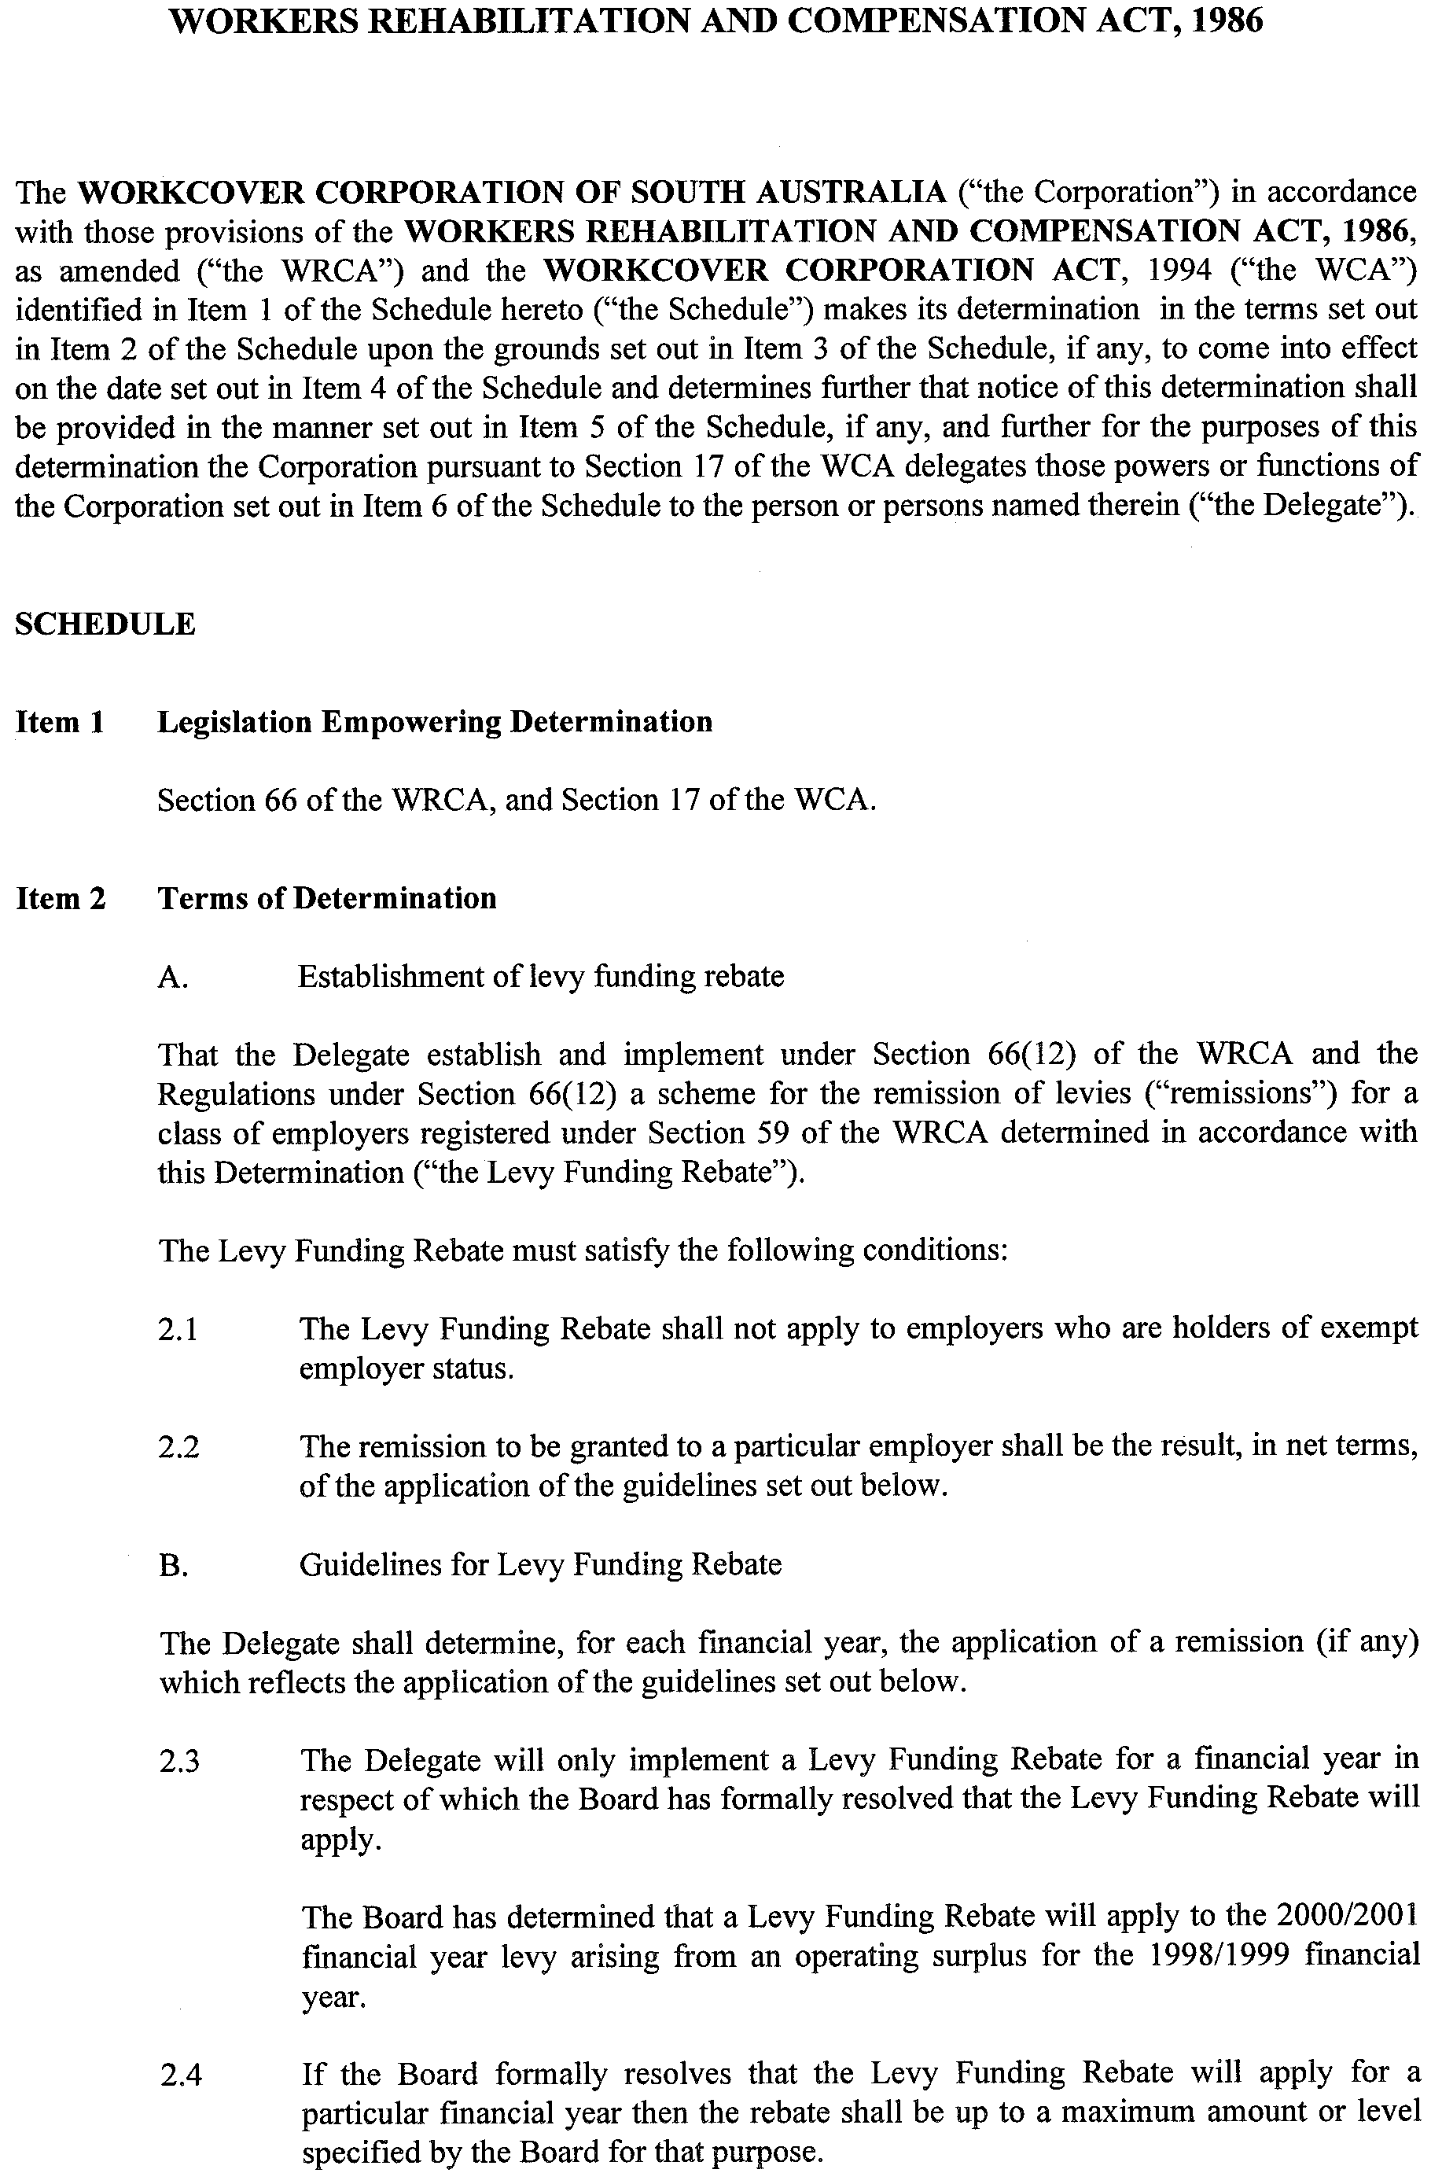
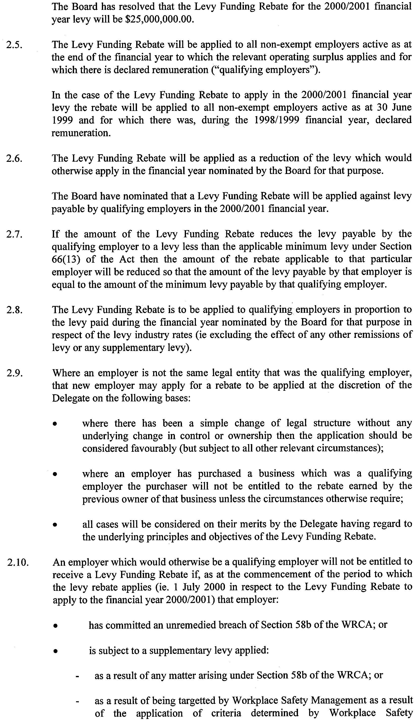
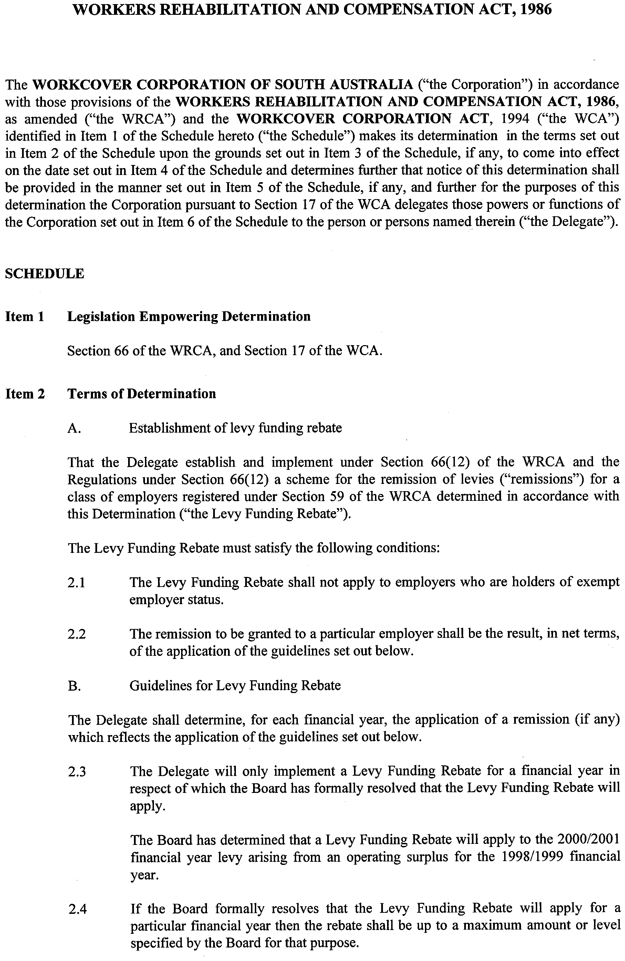
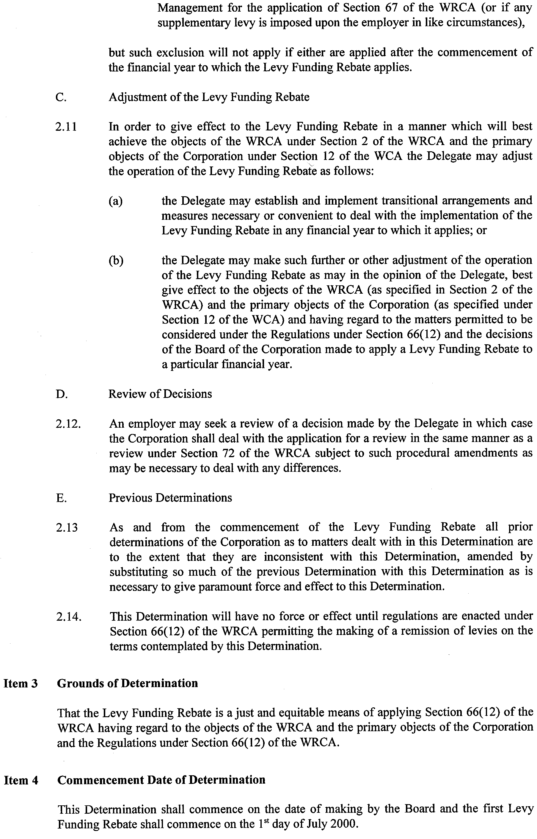
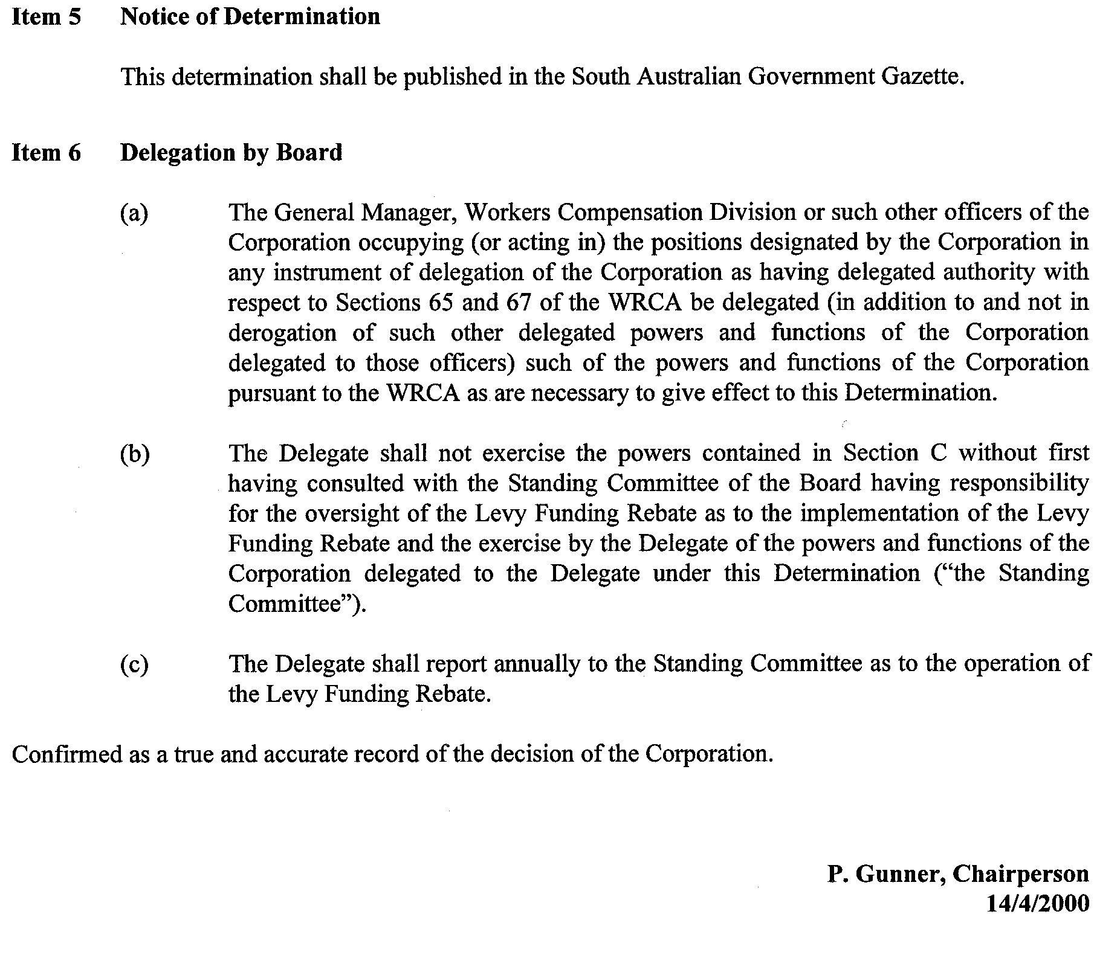
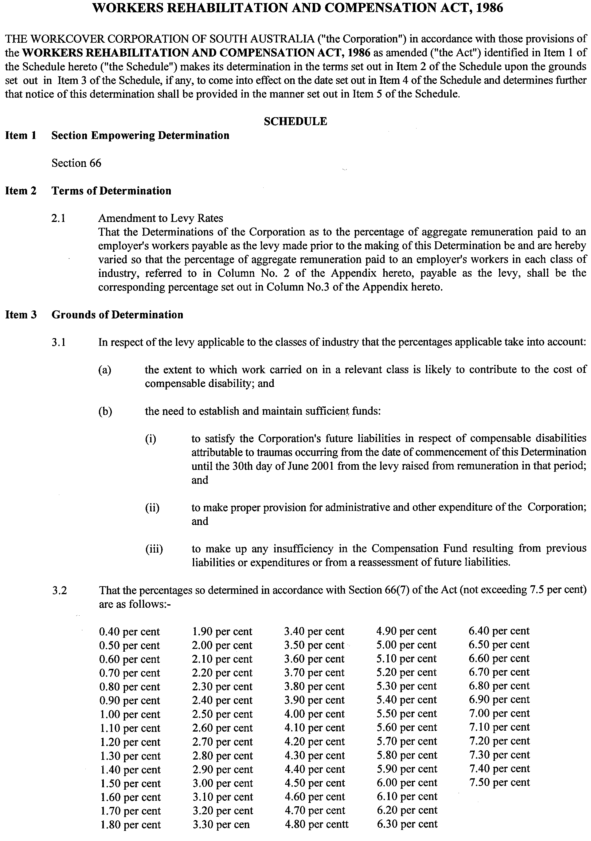
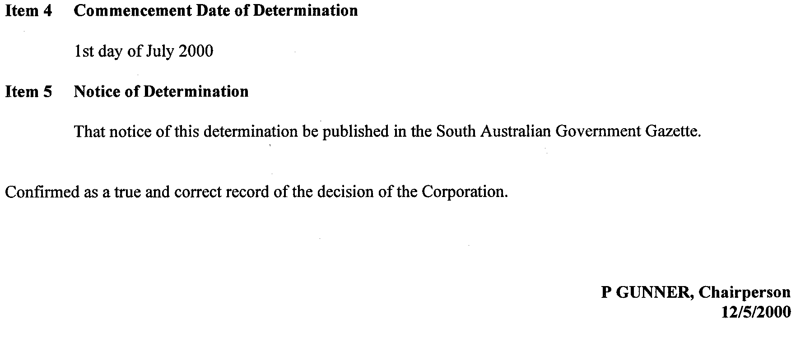
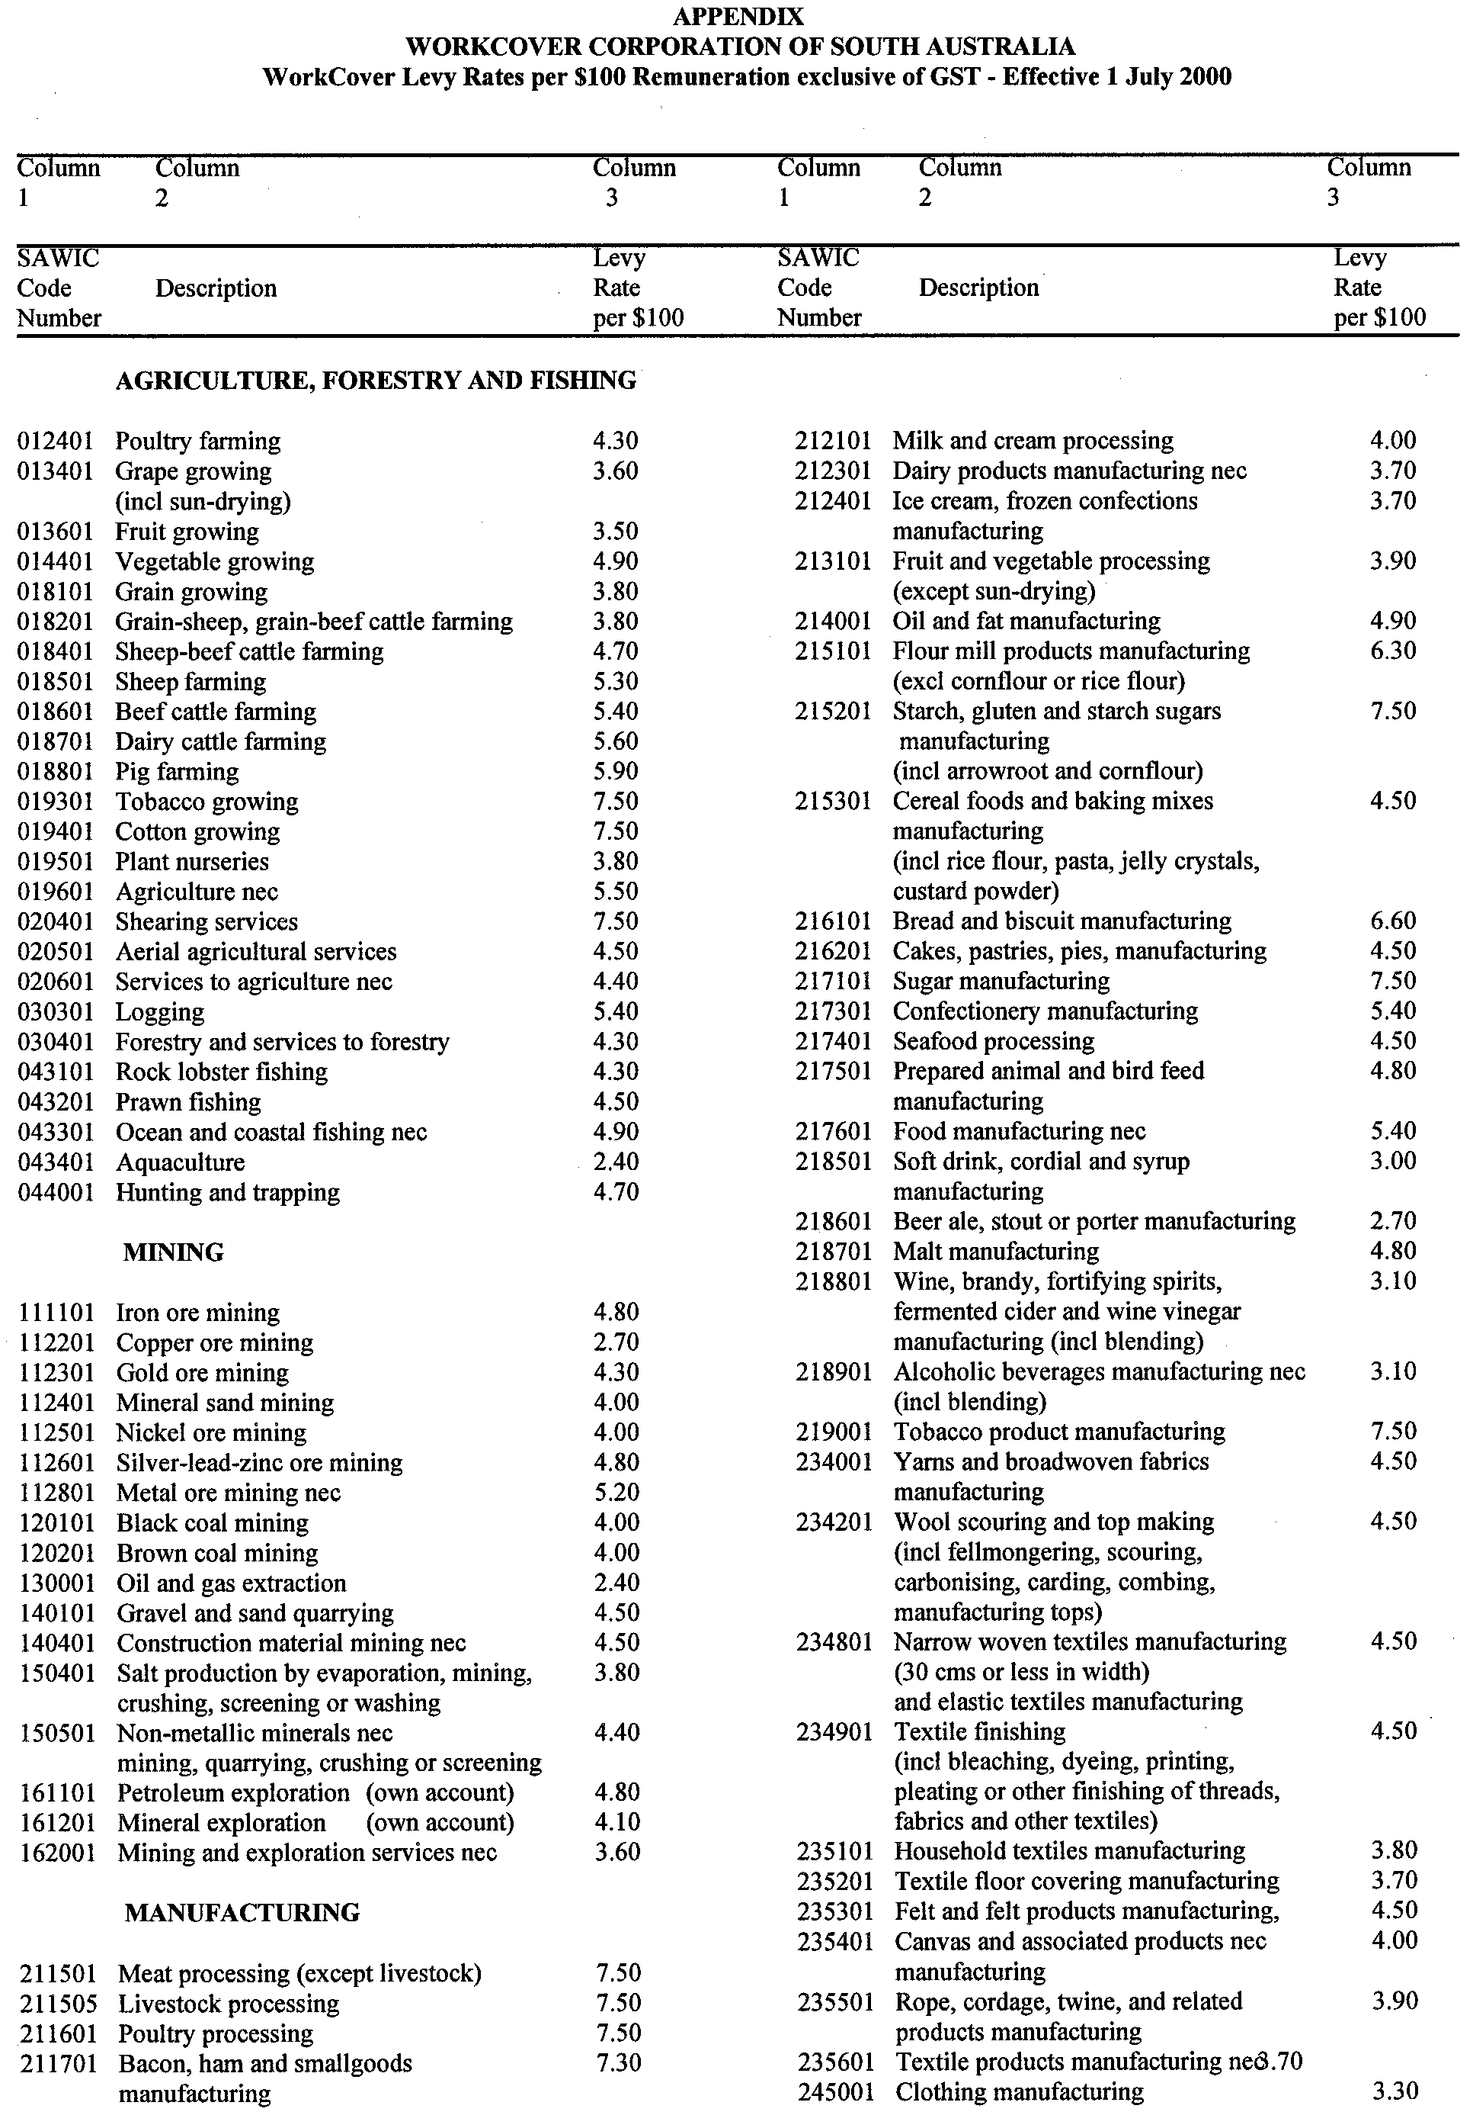
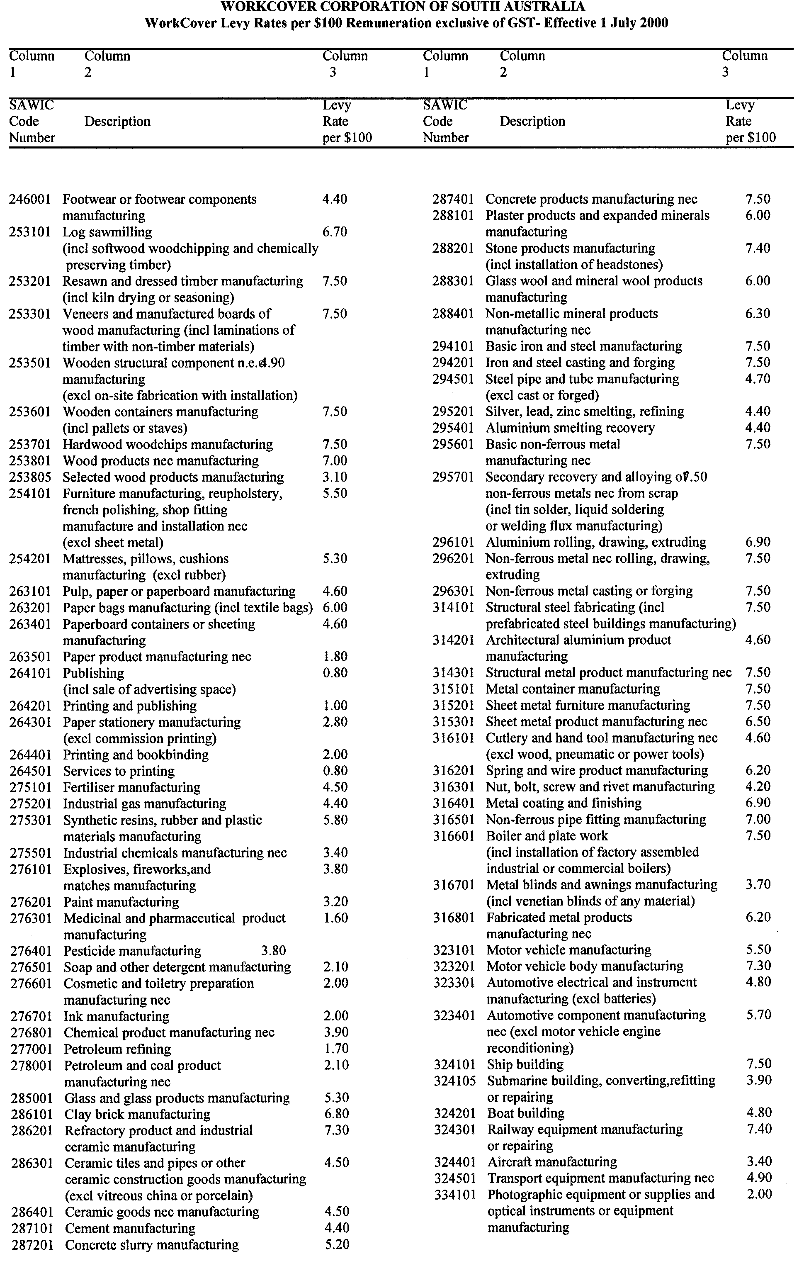
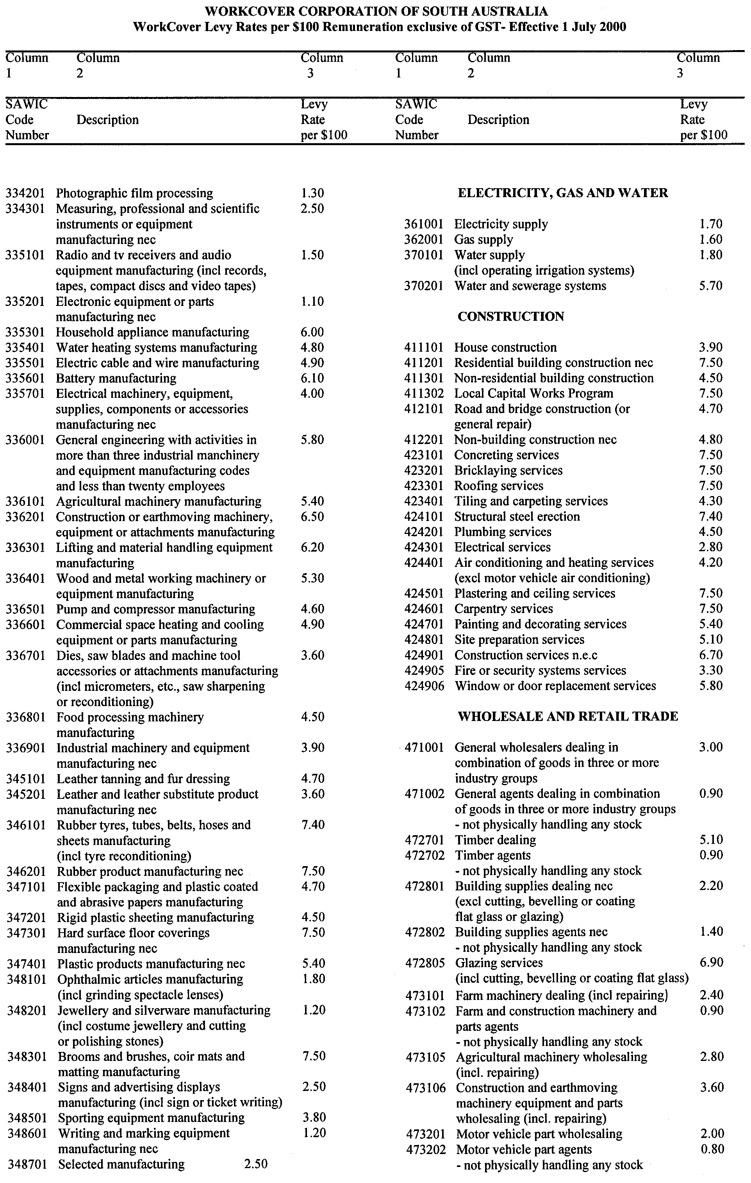
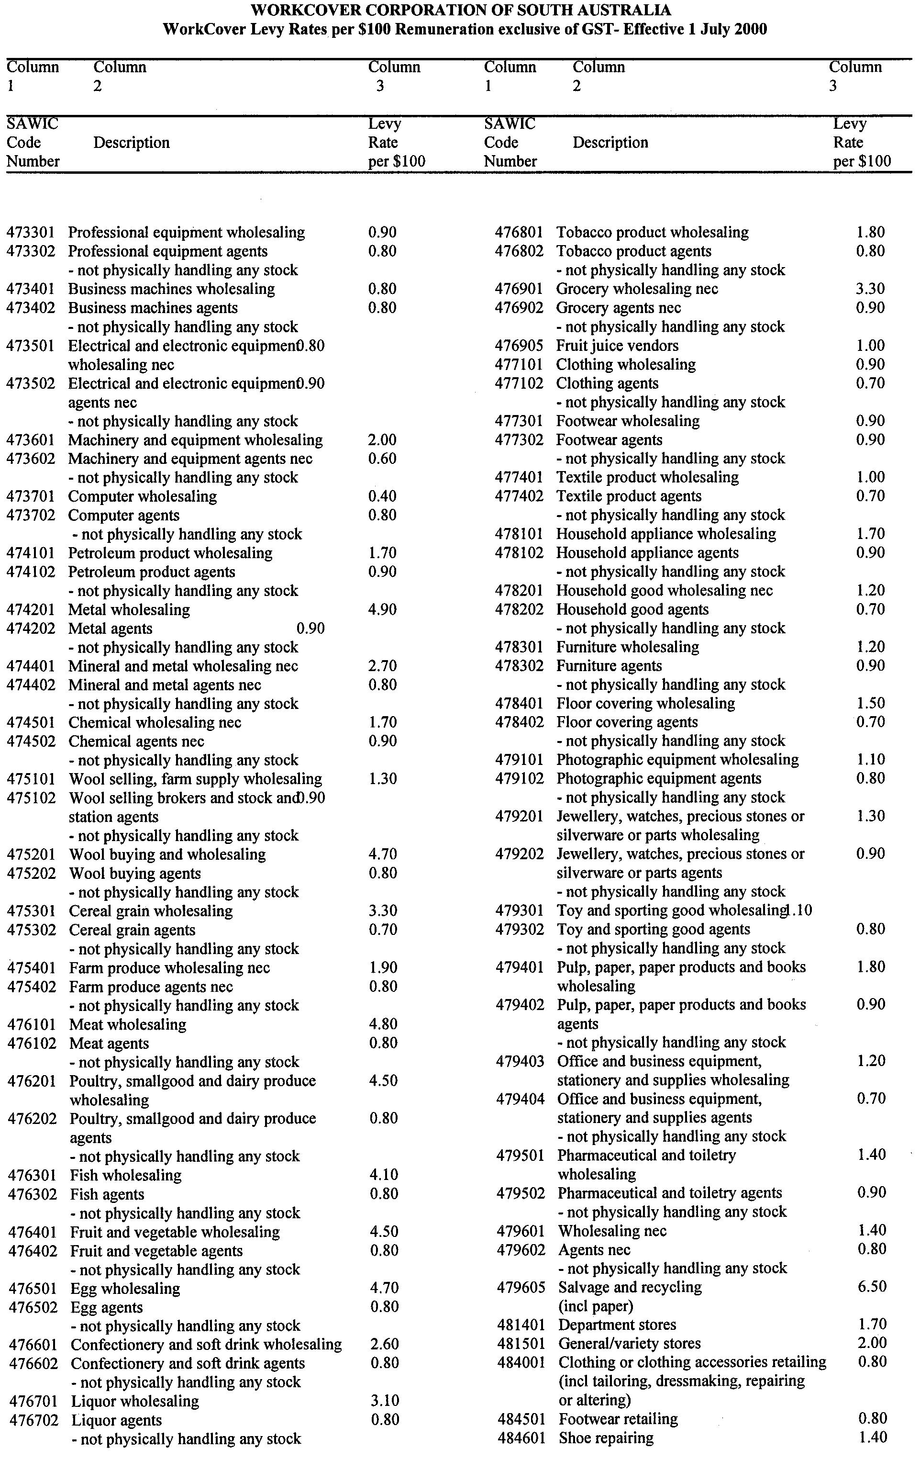
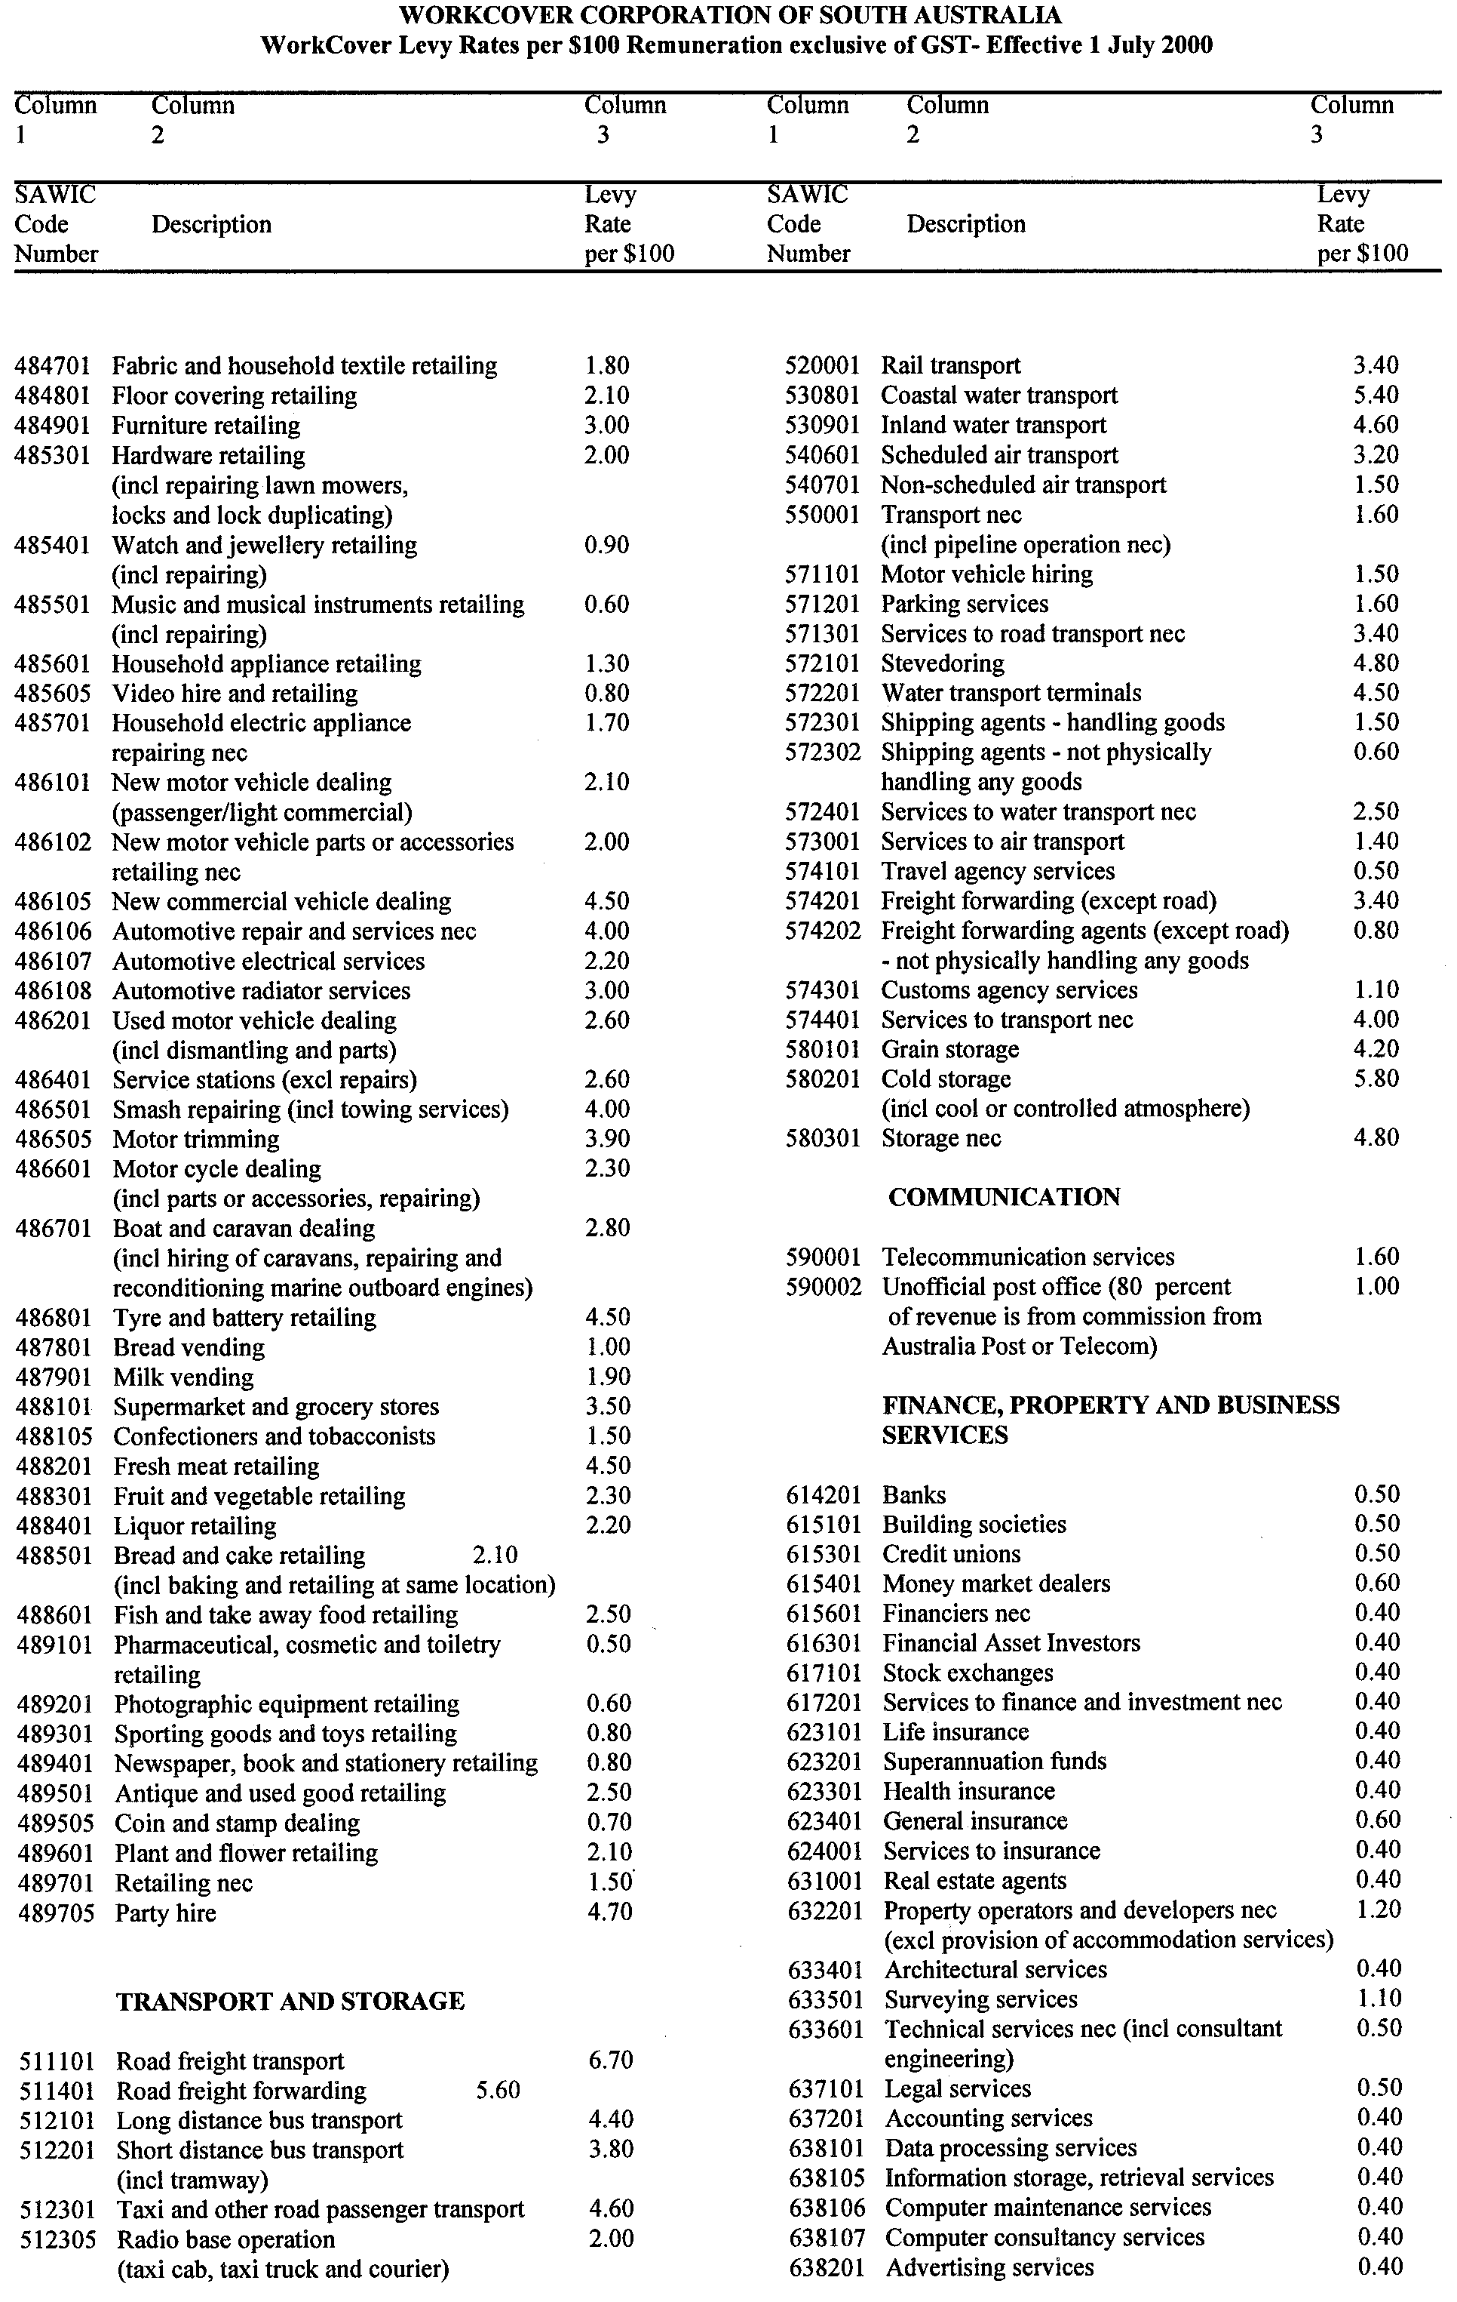
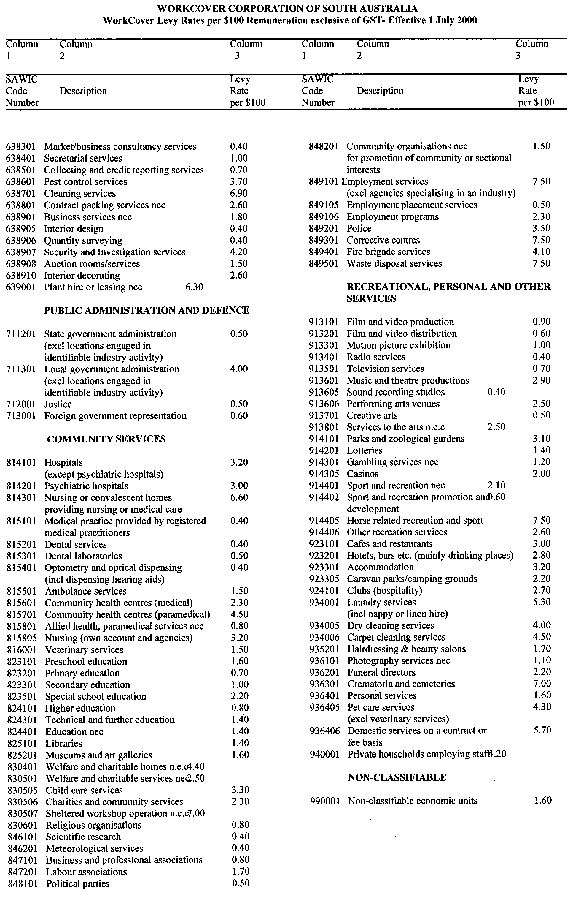
REGULATIONS UNDER THE LOCAL GOVERNMENT ACT 1999
────
No. 41 of 2000
────
At the Executive Council Office at Adelaide 25 May 2000

PURSUANT to the Local Government Act 1999 and with the advice and consent of the Executive Council, I make the following regulations.
E. J. NEAL Governor
PURSUANT to section 10AA(2) of the Subordinate Legislation Act 1978, I certify that, in my opinion, it is necessary or appropriate that the following regulations come into operation as set out below.

DIANA LAIDLAW Minister for Transport and Urban Planning
───────────────────
SUMMARY OF PROVISIONS

1. Citation
2. Commencement
3. Insertion of reg. 9A
9A. Prescribed service—s. 155
4. Insertion of reg. 15A
15A. Exemption of certain leases or licences over community land from consultation requirements
5. Variation of schedule 1
───────────────────

Citation
1. The Local Government (General) Regulations 1999 (see Gazette 25 November 1999 p. 2855) are referred to in these regulations as "the principal regulations".

Commencement
2. These regulations will come into operation on the day on which they are made.

Insertion of reg. 9A
3. The following regulation is inserted after regulation 9 of the principal regulations:

Prescribed service—s. 155
9A. A television retransmission service is prescribed as a service for the purposes of the definition of "prescribed service" under section 155 of the Act.

Insertion of reg. 15A
4. The following regulation is inserted after regulation 15 of the principal regulations:

Exemption of certain leases or licences over community land from consultation requirements
15A. Pursuant to section 202(3)(b) of the Act, a council is not required to comply with its public consultation policy with respect to a lease or licence over community land if—

(a) the lease or licence is being granted to the Crown, or to a Minister or other agency or instrumentality of the Crown; and

(b) it is a term of the lease or licence that there is to be no substantial change in the use of the land (disregarding trifling, insignificant or subsidiary uses).

Variation of schedule 1
5. Schedule 1 of the principal regulations is varied—

(a) by striking out from Note 3 of Form 8 "The description must include the number of the by-law, the full name of the council which made it, and the date on which it was made.";

(b) by striking out from Note 4 of Form 8 "which made" and substituting "proposing to make".

MLG 1/2000 CS R. DENNIS Clerk of the Council

REGULATIONS UNDER THE LOCAL GOVERNMENT (IMPLEMENTATION) ACT 1999
────
No. 42 of 2000
────
At the Executive Council Office at Adelaide 25 May 2000

PURSUANT to the Local Government Act 1999 and with the advice and consent of the Executive Council, I make the following regulations.
E. J. NEAL Governor

PURSUANT to section 10AA(2) of the Subordinate Legislation Act 1978, I certify that, in my opinion, it is necessary or appropriate that the following regulations come into operation as set out below.

DIANA LAIDLAW Minister for Transport and Urban Planning
───────────────────
SUMMARY OF PROVISIONS

1. Citation
2. Commencement
3. Variation of reg. 11—Local government land
───────────────────

Citation
1. The Local Government (Implementation) Regulations 1999 (see Gazette 9 December 1999 p. 3297) are referred to in these regulations as "the principal regulations".

Commencement
2. These regulations will take effect from the commencement of the Local Government (Implementation) Act 1999 (as provided by proclamation made under section 2(1) of that Act)¹.

^{1.} See section 45(3) of that Act.

Variation of reg. 11—Local government land
3. Regulation 11 of the principal regulations is varied—

(a) by striking out from subregulation (1) "the repealed Act" and substituting "the 1934 Act";

(b) by inserting after paragraph (d) of subregulation (2) the following word and paragraph:

or

(e) land which is to be transferred or conveyed to another party pursuant to an arrangement the essential terms and conditions of which were approved by the relevant council before 1 January 2000 (and, for the purposes of this paragraph, disregarding any subsequent variation that may be made to those terms or conditions unless the variation is substantial).;

(c) by inserting after paragraph (c) of subregulation (3) the following word and paragraph:

or

(d) an arrangement to which subregulation (2)(e) applies is cancelled, or an essential term or condition of any such arrangement is not met or is substantially varied,;
(d) by inserting after paragraph (d) of subregulation (4) the following word and paragraph:

or

(e) —

(i) the lease or licence is for the purposes of a short-term event; and

(ii) the term of the lease or licence is limited to the duration of the event and any period required before the event for setting up or preparing for the event or after the event for dismantling the event or taking action to address the impact of the event; and

(iii) the council has not adopted a management plan on account of the operation of section 196(7) of the Act.;

(e) by inserting after subregulation (5) the following subregulation:

(6) In this regulation—

"short-term event" means an event to be held over or during a period not exceeding three consecutive days.

MLG 1/2000 CS R. DENNIS Clerk of the Council

REGULATIONS UNDER THE MINES AND WORKS INSPECTION ACT 1920
────
No. 43 of 2000
────
At the Executive Council Office at Adelaide 25 May 2000

PURSUANT to the Mines and Works Inspection Act 1920 and with the advice and consent of the Executive Council, I make the following regulations.
E. J. NEAL Governor

PURSUANT to section 10AA(2) of the Subordinate Legislation Act 1978, I certify that, in my opinion, it is necessary or appropriate that the following regulations come into operation as set out below.

ROB KERIN Minister for Primary Industries and Resources
───────────────────
SUMMARY OF PROVISIONS

1. Citation
2. Commencement
3. Substitution of Sched. 3
SCHEDULE 3
Fees
───────────────────

Citation
1. The Mines and Works Inspection Regulations 1998 (see Gazette 21 August 1998 p. 579), as varied, are referred to in these regulations as "the principal regulations".

Commencement
2. These regulations will come into operation on 1 July 2000.

Substitution of Sched. 3
3. Schedule 3 of the principal regulations is revoked and the following Schedule is substituted:

SCHEDULE 3
Fees

1. | Application for a certificate under schedule 1 | $17.50
2. | Each subject for examination for a second-class quarry manager's certificate under schedule 1 | $11.00
3. | Examination in mining law, environment and occupational health and safety law under schedule 1 | $11.00
4. | Issue of a certificate under schedule 1 | $27.00
5. | Issue of a replacement certificate | $17.50.

MME 10/2000 CS R. DENNIS Clerk of the Council

REGULATIONS UNDER THE MINING ACT 1971
────
No. 44 of 2000
────
At the Executive Council Office at Adelaide 25 May 2000

PURSUANT to the Mining Act 1971 and with the advice and consent of the Executive Council, I make the following regulations.
E. J. NEAL Governor

PURSUANT to section 10AA(2) of the Subordinate Legislation Act 1978, I certify that, in my opinion, it is necessary or appropriate that the following regulations come into operation as set out below.

ROB KERIN Minister for Primary Industries and Resources
───────────────────
SUMMARY OF PROVISIONS

1. Citation
2. Commencement
3. Substitution of Scheds. 2 and 3
SCHEDULE 2
Fees
SCHEDULE 3
Rents and other annual fees
───────────────────

Citation
1. The Mining Regulations 1998 (see Gazette 21 August 1998 p. 476), as varied, are referred to in these regulations as "the principal regulations".

Commencement
2. These regulations will come into operation on 1 July 2000.

Substitution of Scheds. 2 and 3
3. Schedules 2 and 3 of the principal regulations are revoked and the following Schedules are substituted:

SCHEDULE 2
Fees

1. Application for issue or renewal of miner's right $ 42.00

2. Declaration of loss $ 9.50

3. Application for registration of mineral claim $ 24.00

4. Application for registration or renewal of access claim $ 42.00

5. Mining Lease—
(a) Application fee (per lease) $ 63.00
(b) Preparation fee (per lease) $ 63.00
(c) Renewal fee (per lease) $ 63.00

6. Miscellaneous Purposes Licence—
(a) Application fee (per licence) $ 63.00
(b) Preparation fee (per licence) $ 63.00
(c) Renewal fee (per licence) $ 63.00

7. Retention Lease—
(a) Application fee (per lease) $ 63.00
(b) Preparation fee (per lease) $ 63.00
(c) Renewal fee (per lease) $ 63.00

8. Exploration Licence—
(a) Application fee (per licence) $181.50

PLUS, in respect of the cost of advertising the application under section 28(5) of the Act—

(i) if the proposed area of the licence is not more than 1 000 square kilometres $308.00

(ii) if the proposed area of the licence is more than 1 000 square kilometres but
not more than 2 000 square kilometres $411.00

(iii) if the proposed area of the licence is more than 2 000 square kilometres $514.00

(b) Renewal fee (per licence) $ 61.50

9. Application for variation of condition of a tenement, working conditions
or special approval to undertake a particular work program $102.50

10. Inspection of register $ 26.00
(a) Extract of lease or licence $ 6.50
(b) Extract of claim $ 4.00

11. Search of tenement database—
(a) Standard report $ 25.50
plus 25 cents per page
(b) Non-standard report $ 51.00
plus 25 cents per page

12. Application for Ministerial consent to dealing with the following—
(a) Exploration licence $264.00
(b) Mining Lease $ 52.50
(c) Retention lease $ 52.50
(d) Miscellaneous purposes licence $ 52.50

13. Registration of Ministerial consent (in respect of each tenement
affected by the instrument) $ 9.50

14. Application for issue of duplicate lease $ 64.00

15. Application for issue of duplicate licence $ 64.00

16. Late lodgment of transfer $ 24.00

17. Further fee for late lodgment of transfer, if lodged more than 90 days late $ 6.50

18. Lodgment of an agreement or determination with the Mining Registrar under Part 9B of Act $102.50

19. Lodgment of caveat $ 42.00

20. Withdrawal of caveat $ 42.00

21. Registration of any other document $ 9.50

22. Application for a safety net agreement under section 84A of Act $ 51.00

23. Exemption from removing posts $ 6.50

SCHEDULE 3
Rents and other annual fees

Rental (per annum)—
(a) Mining lease (per hectare) $ 26.50
(b) Retention lease (per hectare) $ 13.40
(c) Minimum rental in respect of any lease $ 69.00
(d) Miscellaneous purposes licence (per hectare) $ 13.40
Minimum rental $ 64.50
(e) Exploration licence (per square kilometre) $ 3.70
Minimum annual fee $271.50

MME 10/2000 CS R. DENNIS Clerk of the Council

REGULATIONS UNDER THE OPAL MINING ACT 1995
────
No. 45 of 2000
────
At the Executive Council Office at Adelaide 25 May 2000

PURSUANT to the Opal Mining Act 1995 and with the advice and consent of the Executive Council, I make the following regulations.
E. J. NEAL Governor

PURSUANT to section 10AA(2) of the Subordinate Legislation Act 1978, I certify that, in my opinion, it is necessary or appropriate that the following regulations come into operation as set out below.

ROB KERIN Minister for Primary Industries and Resources
───────────────────
SUMMARY OF PROVISIONS

1. Citation
2. Commencement
3. Substitution of Sched. 2
SCHEDULE 2
Fees
───────────────────

Citation
1. The Opal Mining Regulations 1997 (see Gazette 3 April 1997 p. 1410), as varied, are referred to in these regulations as "the principal regulations".

Commencement
2. These regulations will come into operation on 1 July 2000.

Substitution of Sched. 2
3. Schedule 2 of the principal regulations is revoked and the following Schedule is substituted:

SCHEDULE 2
Fees
The following fees are payable:
1. | Application for a permit under section 7 of the Act | $ 42.00
2. | Application for renewal of a permit under section 9 of the Act | $ 42.00
3. | Application for a set of identification plates (other than the first set of plates) | $ 5.00
4. | Application for issue of a replacement identification plate | $ 4.00
5. | Application for issue of a duplicate permit | $ 9.50
6. | Application for registration of a tenement under section 19 of the Act:
 | small precious stones claim | $ 17.50
 | large precious stones claim | $ 35.50
 | extra large precious stones claim | $ 50.50
 | opal development lease | $ 56.00

7. | Application for renewal of a tenement under section 22 of the Act:
 | small precious stones claim | $ 65.00
 | large precious stones claim | $130.50
 | extra large precious stones claim | $177.50
8. | Lodging a caveat under section 26 of the Act | $ 42.00
9. | Withdrawal of a caveat | $ 42.00
10. | Application for an authorisation under the Act | $ 9.50
11. | Lodging a bond under section 36 of the Act | $ 9.50
12. | Registration of an agreement under Part 6 of the Act | $ 52.50
13. | Lodging for registration of mining native title agreement under section 59 of the Act or mining native title determination under section 64 of the Act | $111.00
14. | Inspection fee under section 76 of the Act | $ 26.00
15. | Extraction of claim | $ 4.00
16. | Application for an exemption under section 79 of the Act | $ 56.00
17. | Recovering a post stored at an office of the Mining Registrar | $ 13.50
18. | Exemption from removing posts | $ 6.50
19. | Registration of any other document | $ 9.50

MME 10/2000 CS R. DENNIS Clerk of the Council

REGULATIONS UNDER THE PETROLEUM ACT 1940
────
No. 46 of 2000
────
At the Executive Council Office at Adelaide 25 May 2000

PURSUANT to the Petroleum Act 1940 and with the advice and consent of the Executive Council, I make the following regulations.
E. J. NEAL Governor

PURSUANT to section 10AA(2) of the Subordinate Legislation Act 1978, I certify that, in my opinion, it is necessary or appropriate that the following regulations come into operation as set out below.

ROB KERIN Minister for Primary Industries and Resources
───────────────────
SUMMARY OF PROVISIONS

1. Citation
2. Commencement
3. Variation of reg. 13—Register of licences
4. Substitution of Sched.
SCHEDULE
Fees and amounts (reg.254)
───────────────────

Citation
1. The Petroleum Regulations 1989 (see Gazette 5 October 1989 p. 1053), as varied, are referred to in these regulations as "the principal regulations".

Commencement
2. These regulations will come into operation on 1 July 2000.

Variation of reg. 13—Register of licences
3. Regulation 13 of the principal regulations is varied—

(a) by striking out from subregulation (2) "$115" and substituting "$118";

(b) by striking out from subregulation (4) "$1.15" and substituting "$1.18".

Substitution of Sched.
4. The Schedule of the principal regulations is revoked and the following Schedule is substituted:

SCHEDULE
Fees and amounts (reg.254)

Fees — various
1. On application for the grant of a petroleum exploration licence or
petroleum production licence (s. 7(2)) $2 362.00
2. On application for the renewal of a petroleum production licence
(s. 32(2)(c)) $1 181.00
3. Annual fee for a petroleum production licence (per square
kilometre of the area comprised in the licence) (s. 34) $174.00
4. On application for the Minister's approval to deal with a licence or
an interest in a licence, etc. (s. 42(6)) $1 181.00
5. Annual fee for a pipeline licence (per kilometre of the pipeline or
proposed pipeline) (s. 80o) $94.00

Scale of licence fees — petroleum exploration licence (s. 18c)
6. Annual fee for a petroleum exploration licence (per square kilometre
of the area comprised in the licence)—
(a) in respect of the initial term of the licence $0.28
(b) in respect of the first renewal of the licence $0.42
(c) in respect of the second renewal of the licence $0.56
(d) in respect of any subsequent renewal of the licence $0.70

Bond
7. Bond to be lodged before grant of a petroleum exploration licence
or petroleum production licence (s. 13(1)) $15 000.00

MME 10/2000 CS R. DENNIS Clerk of the Council

REGULATIONS UNDER THE SEEDS ACT 1979
────
No. 47 of 2000
────
At the Executive Council Office at Adelaide 25 May 2000

PURSUANT to the Seeds Act 1979 and with the advice and consent of the Executive Council, I make the following regulations.
E. J. NEAL Governor

PURSUANT to section 10AA(2) of the Subordinate Legislation Act 1978, I certify that, in my opinion, it is necessary or appropriate that the following regulations come into operation as set out below.

ROB KERIN Minister for Primary Industries and Resources
───────────────────
SUMMARY OF PROVISIONS

1. Citation
2. Commencement
3. Variation of Sched. 5—Fees for Seed Analysis Service (Regulation 12)
───────────────────

Citation
1. The Seeds Regulations 1986 (see Gazette 14 August 1986 p. 522), as varied, are referred to in these regulations as "the principal regulations".

Commencement
2. These regulations will come into operation on 1 July 2000.

Variation of Sched. 5—Fees for Seed Analysis Service (Regulation 12)
3. Schedule 5 of the principal regulations is varied by striking out the table of fees in clause 2 and substituting the following table:

 | Service | Fee
1. | Purity analysis of seeds of—  (a) Group 1 species  (b) Group 2 species  (c) Group 3 species  (d) Group 4 species | $33.20$43.40  $53.30  $60.90
2. | Germination analysis of seeds of—  (a) Group 1 species  (b) Group 2 species  (c) Group 3 species  (d) Group 4 species | $34.90  $38.00  $41.70  $48.20
3. | Determination of moisture content—  (a) ISTA test (oven method)  (b) meter tests | $25.30  $12.40
4. | Weed seed count—  (a) including count of prohibited seeds  (b) including count of all species | $33.20  $41.70
5. | Tetrazolium test for whether seed is alive or dead—  (a) for cereals and grain legumes  (b) for grasses and other species | $67.60  $72.10
6. | Analysis of seed mixture—  (a) purity analysis of seeds included in mixture—  ⋅ if the mixture comprises 2 species  ⋅ if the mixture comprises 3 species  ⋅ if the mixture comprises at least 4 species  (b) germination analysis of seeds included in mixture—  ⋅ analysis of combined species in mixture  ⋅ in addition, for each species analysed | $45.90  $51.00  $58.60  $34.90  $34.90
7. | Number of seeds per unit mass—  (a) field crops/cereal species  (b) all other species | $17.30  $33.20
8. | Seed identification for each species identified | $7.30
9. | Seed identification by chemical means | $12.10
10. | Cultivar determination—  (a) by grow-on test  (b) by visual assessment | $96.40  $18.10
11. | Fluorescence test | $33.20
12. | Sprouting test (not to ISTA rules)—  (a) without purity analysis  (b) including purity analysis | $41.70  $66.50
13. | Purity analysis of seeds (not to ISTA rules) for quality assurance purposes—  (a) for samples provided by Freepost (Australia wide)  (b) for all other samples | $44.20  $33.20
14. | Issue of International Certificate—  (a) if analysis is not required  (b) if purity analysis is required of—  ⋅ Group 1 species  ⋅ Group 2 species  ⋅ Group 3 species  ⋅ Group 4 species  (c) if germination analysis is required of—  ⋅ Group 1 species  ⋅ Group 2 species  ⋅ Group 3 species  ⋅ Group 4 species | $13.55  $41.10  $48.20  $55.50  $63.10  $43.40  $46.20  $48.75  $63.10
15. | Emergence test | $33.20
16. | For issuing—  (a) an interim certificate of analysis  (b) a duplicate certificate of analysis | $2.70  $2.70
17. | A 15 per cent surcharge is payable for each test or analysis required to be carried out on dirty samples.

MME 10/2000 CS R. DENNIS Clerk of the Council

REGULATIONS UNDER THE MEAT HYGIENE ACT 1994
────
No. 48 of 2000
────
At the Executive Council Office at Adelaide 25 May 2000

PURSUANT to the Meat Hygiene Act 1994 and with the advice and consent of the Executive Council, I make the following regulations.
E. J. NEAL Governor

PURSUANT to section 10AA(2) of the Subordinate Legislation Act 1978, I certify that, in my opinion, it is necessary or appropriate that the following regulations come into operation as set out below.

ROB KERIN Minister for Primary Industries and Resources
───────────────────
SUMMARY OF PROVISIONS

1. Citation
2. Commencement
3. Variation of Sched. 1—Fees
4. Transitional provision
───────────────────

Citation
1. The Meat Hygiene Regulations 1994 (see Gazette 1 December 1994 p. 1894), as varied, are referred to in these regulations as "the principal regulations".

Commencement
2. These regulations come into operation on the day on which they are made.

Variation of Sched. 1—Fees
3. Schedule 1 of the principal regulations is varied—

(a) by striking out clauses (4) and (5) and substituting the following clauses:

(4) The Minister may, by notice in writing to the holder of an accreditation at any time preceding the date for payment of the annual fee under section 17 of the Act, specify a forthcoming month as the relevant month and require the holder to provide the Minister with—

(a) sufficient information about the amount (by mass) of meat sold in the course of the holder's business during that month to enable the Minister to determine whether the holder is a retail butcher;

(b) sufficient information about the number of positions held by persons engaged in processing meat under the accreditation during that month to enable the component of the annual fee that is referable to that number to be determined.

(5) If a notice is given under clause (4), the holder of the accreditation must, within 14 days after the end of the relevant month, provide the Minister with the required information verified by statutory declaration.;

(b) by striking out from clause (6)(b) "$130" and substituting "$140";

(c) by inserting after paragraph (c) of clause (6) the following paragraph:

(ca) further wholesale processing means further processing, for sale by wholesale for human consumption, meat that has been processed by the holder of an accreditation (or has been processed in another State or a Territory of the Commonwealth by a person authorised to do so in accordance with the law relating to the processing of meat in force in that place or has been processed outside Australia and lawfully imported into Australia);;

(d) by inserting after paragraph (g) of clause (6) the following paragraph:

(gaa) retail/wholesale butcher means a person who operates a business involving the sale of meat for human consumption by both retail and wholesale where—

(i) 50% or more (by mass) of the meat sold in the course of that business during the relevant month is sold by retail; and

(ii) not more than 4 tonnes of meat sold in the course of that business during the relevant month is sold by wholesale;

(e) by inserting after subitem (2a) of item 2 of the table of fees the following subitem:

(2b) in the case of an accreditation that authorises a retail/wholesale butcher to undertake further wholesale processing—

(a) administration fee
plus
(b) the aggregate of the fee units applicable to the types of further wholesale processing carried out by the holder of the accreditation as follows:
type of processing fee units
(i) production of smallgoods by a process involving fermentation 1
(ii) production of smallgoods by a process involving cooking or curing 1
(iii) production of any other product within the ambit of the definition of "meat" (see section 3 of the Act) 1;

(f) by striking out paragraph (c) of item 2(3) of the table of fees and substituting the following paragraph:

(c) the fee units applicable to the highest number of full-time equivalent positions held by persons engaged in processing meat under the accreditation during the relevant month as follows:
full-time equivalent positions fee units
(i) not more than 6 2
(ii) more than 6 but not more than 11 6
(iii) more than 11 but not more than 26 12
(iv) more than 26 but not more than 40 20
(v) more than 40 but not more than 60 30
(vi) more than 60 40.

Transitional provision
4. If an accreditation is granted, varied or transferred on or before 30 June 2000, the fees payable in respect of the grant, variation or transfer are to be determined in accordance with Schedule 1 of the principal regulations as in force immediately before the commencement of these regulations.

MPIR 16/2000 CS R. DENNIS Clerk of the Council

REGULATIONS UNDER THE LAND TAX ACT 1936
────
No. 49 of 2000
────
At the Executive Council Office at Adelaide 25 May 2000

PURSUANT to the Land Tax Act 1936 and with the advice and consent of the Executive Council, I make the following regulations.
E. J. NEAL Governor

PURSUANT to section 10AA(2) of the Subordinate Legislation Act 1978, I certify that, in my opinion, it is necessary or appropriate that the following regulations come into operation as set out below.

ROB LUCAS Treasurer
───────────────────
SUMMARY OF PROVISIONS

1. Citation
2. Commencement
3. Variation of reg. 11—Certificates in respect of liability to land tax
───────────────────

Citation
1. The Land Tax Regulations 1999 (see Gazette 12 August 1999 p. 779) are referred to in these regulations as "the principal regulations".

Commencement
2. These regulations will come into operation on 1 July 2000.

Variation of reg. 11—Certificates in respect of liability to land tax
3. Regulation 11 of the principal regulations is varied by striking out from subregulation (1) "$18.70" and substituting "$19.20".

T&F 24/2000 CS R. DENNIS Clerk of the Council

REGULATIONS UNDER THE LOTTERY AND GAMING ACT 1936
────
No. 50 of 2000
────
At the Executive Council Office at Adelaide 25 May 2000

PURSUANT to the Lottery and Gaming Act 1936 and with the advice and consent of the Executive Council, I make the following regulations.
E. J. NEAL Governor

PURSUANT to section 10AA(2) of the Subordinate Legislation Act 1978, I certify that, in my opinion, it is necessary or appropriate that the following regulations come into operation as set out below.

ROB LUCAS Treasurer
───────────────────
SUMMARY OF PROVISIONS

1. Citation
2. Commencement
3. Variation of reg. 13—Applications for lottery licence
4. Variation of reg. 16—Licence fees
5. Variation of reg. 17—Licence conditions
6. Variation of reg. 17CA—Variation of licence
7. Variation of reg. 28—Fees
8. Variation of reg. 29—Licence conditions
9. Variation of Sched. 1—Application for a Major Lottery Licence
10. Variation of Sched. 2—Application for a Bingo Licence
11. Variation of Sched. 3—Application for an Instant Lottery Licence
12. Variation of Sched. 5—Financial Statement—Major Lottery Licence
13. Variation of Sched. 6—Quarterly Financial Statement—Bingo Licence
14. Variation of Sched. 9—Monthly Financial Statement—Instant Lottery Ticket Supplier's Licence
───────────────────

Citation
1. The Lottery and Gaming Regulations 1993 (see Gazette 27 October 1993 p. 1901), as varied, are referred to in these regulations as "the principal regulations".

Commencement
2. (1) Subject to subregulation (2), these regulations will come into operation on 1 July 2000.

(2) Regulations 4, 5, 8 and 14 of these regulations will come into operation on 1 June 2000.

Variation of reg. 13—Applications for lottery licence
3. Regulation 13 of the principal regulations is varied by striking out from subregulation (1)(c) "$5" and substituting "$5.10".

Variation of reg. 16—Licence fees
4. Regulation 16 of the principal regulations is varied—

(a) by striking out from subregulation (1)(a) "major lottery licence" and substituting "major lottery licence for a lottery drawn before 1 July 2000";

(b) by inserting in subregulation (1)(b) "before 1 July 2000" after "bingo sessions conducted";

(c) by inserting in subregulation (1)(c) "before 1 June 2000" after "tickets purchased".

Variation of reg. 17—Licence conditions
5. Regulation 17 of the principal regulations is varied—

(a) by inserting in subregulations (1)(a) and (2)(a) "in the case of a licence granted before 1 July 2000," before "a condition";

(b) by inserting in subregulations (1)(b) and (2)(b) "in the case of any licence," before "a condition";

(c) by inserting in subregulation (3)(a) "in the case of a licence granted before 1 June 2000," before "a condition";

(d) by inserting in subregulation (3)(b) "in the case of any licence," before "a condition".

Variation of reg. 17CA—Variation of licence
6. Regulation 17CA of the principal regulations is varied by striking out "$30" and substituting "$30.75".

Variation of reg. 28—Fees
7. Regulation 28 of the principal regulations is varied—

(a) by striking out from paragraph (a) "$1 000" and substituting "$1 028";

(b) by striking out from paragraph (b) "$100" and substituting "$102".

Variation of reg. 29—Licence conditions
8. Regulation 29 of the principal regulations is varied by striking out from subregulation (1)(f) "14 days of the end of each month" and substituting "one month of the end of each quarter".

Variation of Sched. 1—Application for a Major Lottery Licence
9. Schedule 1 of the principal regulations is varied by striking out from the boxed note on the front of the form contained in that Schedule "$5.00" and substituting "$5.10".

Variation of Sched. 2—Application for a Bingo Licence
10. Schedule 2 of the principal regulations is varied by striking out from the boxed note on the front of the form contained in that Schedule "$5.00" and substituting "$5.10".

Variation of Sched. 3—Application for an Instant Lottery Licence
11. Schedule 3 of the principal regulations is varied by striking out from the boxed note on the front of the form contained in that Schedule "$5.00" and substituting "$5.10".

Variation of Sched. 5—Financial Statement—Major Lottery Licence
12. Schedule 5 of the principal regulations is varied by—

(a) by striking out from the front of the form contained in that Schedule the whole of the box containing the statement "NOTE:⋅ The licence fee (4 percent of gross proceeds) must accompany this statement";

(b) by striking out from clause 1 of the SECRETARY/TREASURER'S REPORT in that form "4% Licence fee payable on Gross Proceeds........$ ".

Variation of Sched. 6—Quarterly Financial Statement—Bingo Licence
13. Schedule 6 of the principal regulations is varied by striking out from clause 1 of the form contained in that Schedule the whole of the item commencing "LICENCE FEE".

Variation of Sched. 9—Monthly Financial Statement—Instant Lottery Ticket Supplier's Licence
14. Schedule 9 of the principal regulations is varied—

(a) by striking out from the heading to the form contained in that Schedule "MONTHLY" and substituting "QUARTERLY";

(b) by striking out from the sentence immediately below that heading "14 days of the end of each month" and substituting "one month of the end of each quarter".

T&F 114/99 CS
T&F 31/2000 CS R. DENNIS Clerk of the Council

REGULATIONS UNDER THE PETROLEUM PRODUCTS REGULATION ACT 1995
────
No. 51 of 2000
────
At the Executive Council Office at Adelaide 25 May 2000

PURSUANT to the Petroleum Products Regulation Act 1995 and with the advice and consent of the Executive Council, I make the following regulations.
E. J. NEAL Governor

PURSUANT to section 10AA(2) of the Subordinate Legislation Act 1978, I certify that, in my opinion, it is necessary or appropriate that the following regulations come into operation as set out below.

ROB LUCAS Treasurer
───────────────────
SUMMARY OF PROVISIONS

1. Citation
2. Commencement
3. Variation of Sched.—Fees
───────────────────

Citation
1. The Petroleum Products Regulations 1995 (see Gazette 1 June 1995 p. 2574), as varied, are referred to in these regulations as "the principal regulations".

Commencement
2. These regulations will come into operation on 1 July 2000.

Variation of Sched.—Fees
3. The Schedule of the principal regulations is varied—

(a) by striking out from item 1(1)(a) "143.00" and substituting "147.00";

(b) by striking out from item 1(1)(b) "143.00" and substituting "147.00";

(c) by striking out from item 2(1)(a) "106.00" and substituting "108.90";

(d) by striking out from item 2(1)(b) "304.00" and substituting "312.00";

(e) by striking out from item 2(1)(c) "490.00" and substituting "503.00";

(f) by striking out from item 2(2)(a) "56.50" and substituting "58.00";

(g) by striking out from item 2(2)(b) "106.00" and substituting "108.90";

(h) by striking out from item 2(2)(c) "266.00" and substituting "273.00";

(i) by striking out from item 2(2)(d) "899.00" and substituting "924.00";

(j) by striking out from item 2(2)(e) "3 024.00" and substituting "3 108.00";

(k) by striking out from item 2(2)(f) "4 973.00" and substituting "5 112.00".

T&F 25/2000 CS R. DENNIS Clerk of the Council

REGULATIONS UNDER THE TOBACCO PRODUCTS REGULATION ACT 1997
────
No. 52 of 2000
────
At the Executive Council Office at Adelaide 25 May 2000

PURSUANT to the Tobacco Products Regulation Act 1997 and with the advice and consent of the Executive Council, I make the following regulations.
E. J. NEAL Governor

PURSUANT to section 10AA(2) of the Subordinate Legislation Act 1978, I certify that, in my opinion, it is necessary or appropriate that the following regulations come into operation as set out below.

ROB LUCAS Treasurer
───────────────────
SUMMARY OF PROVISIONS

1. Citation
2. Commencement
3. Variation of reg. 3—Licence fee
───────────────────

Citation
1. The Tobacco Products Regulations 1997 (see Gazette 5 June 1997 p. 2925), as varied, are referred to in these regulations as "the principal regulations".

Commencement
2. These regulations will come into operation on 1 July 2000.

Variation of reg. 3—Licence fee
3. Regulation 3 of the principal regulations is varied—

(a) by striking out "$2.15" and substituting "$2.20";

(b) by striking out "$10.80" and substituting "$11.10".

T&F 26/2000 CS R. DENNIS Clerk of the Council

REGULATIONS UNDER THE ROAD TRAFFIC ACT 1961
────
No. 53 of 2000
────
At the Executive Council Office at Adelaide 25 May 2000

PURSUANT to the Road Traffic Act 1961 and with the advice and consent of the Executive Council, I make the following regulations.
E. J. NEAL Governor

PURSUANT to section 10AA(2) of the Subordinate Legislation Act 1978, I certify that, in my opinion, it is necessary or appropriate that the following regulations come into operation as set out below.

DIANA LAIDLAW Minister for Transport and Urban Planning
───────────────────
SUMMARY OF PROVISIONS

1. Citation
2. Commencement
3. Substitution of Sched. 9
───────────────────

Citation
1. The Road Traffic (Miscellaneous) Regulations 1999 (see Gazette 25 November 1999 p. 2690), as varied, are referred to in these regulations as "the principal regulations".

Commencement
2. These regulations will come into operation on 1 July 2000.

Substitution of Sched. 9
3. Schedule 9 of the principal regulations is revoked and the following Schedule is substituted:

SCHEDULE 9
Expiation Fees (Reg. 45)

PART 1
OFFENCES AGAINST THE ROAD TRAFFIC ACT 1961

Section | Description of offence against Road Traffic Act 1961 | Fee  ($)
47B(1) | Driving whilst having prescribed concentration of alcohol in blood
 | Contravention involving less than 0.08 grams of alcohol in  100 millilitres of blood | 125
79B(2) | See end of Schedule
91(3) | Failing to comply with direction of ferry operator | 44
112(2) | Driving or towing on road vehicle not complying with vehicle standards or requirements relating to safety maintenance or emission control systems
 | Non-compliance with rule 155 of the vehicle standards | 125
 | Non-compliance with rule 158 of the vehicle standards | 64
 | Any other contravention of section 112(1) | 134

114(2) | Driving or towing on road vehicle not complying with mass and loading requirements  Exceeding mass limits of vehicle—
 | by not more than 500 kg over permitted mass | 166
 | by more than 500 kg but not more than 1 000 over permitted mass | 212
 | by more than 1 000 kg but not more than 1 500 kg over permitted mass | 272
 | by more than 1 500 kg but not more than 2 000 kg over permitted mass | 286
 | Any non-compliance other than exceeding a mass limit | 134
164A(1) | Contravening or failing to comply with provision of Act  Contravention of or failure to comply with—
 | s. 33(9) Failing to comply with direction of member of police force | 120
 | s. 41(2) Failing to comply with direction of member of police force | 120
 | s. 53B(1) Selling radar detector or jammer or storing or offering radar detector or jammer for sale | 205
s. 82(1) Speeding while passing school bus
Exceeding the speed-limit while passing a school bus—
 | by less than 15 kph | 122
 | by 15 kph or more but less than 30 kph | 194
 | by 30 kph or more | 308
 | s. 83A(1) Standing, etc. or placing goods or sign on carriageway, dividing strip or traffic island for purpose of soliciting business, etc. | 44
 | s. 83A(2) Buying or offering to buy goods from person standing, etc. on carriageway, etc. in contravention of rule 83A(1) | 44
 | s. 85(2) Leaving stationary vehicle in prohibited area near Parliament House, etc. without authority | 56
 | s. 87 Walking without due care or attention etc. | 10
 | s. 95 Riding on vehicle without consent of driver | 44
 | s. 99A Bicycle rider riding on footpath or other road-related area failing to give warning to pedestrians etc. | 17
 | s. 99B(1) Riding wheeled recreational device or wheeled toy without due care or attention etc.. | 17
 | s. 99B(2) Riding wheeled recreational device or wheeled toy on footpath or other road-related area abreast of another vehicle etc. | 17
 | s. 99B(3) Riding wheeled recreational device or wheeled toy on footpath or other road-related area without giving warning to pedestrians etc | 17
 | s. 106(1) Damaging road, bridge, etc. otherwise than by reasonable use or removing, damaging or interfering with fence, post, etc.. | 104
 | s. 107 Driving, drawing, hauling, dragging over road any implement, sledge, etc. | 104
 | s. 108(1) Depositing certain articles or materials on road | 98
 | s. 110 Failing to keep whole of vehicle on sealed surface when driving on sealed road | 44
 | s. 161A(1) Driving of certain vehicles subject to Ministerial approval | 134
 | s. 162A(2) Driving motor vehicle not equipped with seat belts, etc. as required by regulations | 180
 | s. 162C(1) Riding wheeled recreational device or wheeled toy without wearing safety helmet complying with regulations and properly adjusted and securely fastened | 44
 | s. 162C(2) Riding wheeled recreational device or wheeled toy on which is carried child under 16 years not wearing safety helmet complying with regulations and properly adjusted and securely fastened | 44
 | s. 162C(2a) Parent or other person having custody or care of child under 16 years causing or permitting child to ride or be carried on wheeled recreational device or wheeled toy without wearing safety helmet complying with regulations and properly adjusted and securely fastened | 43
167(1) | Causing or permitting the commission of an expiable offence against the Road Traffic  Act 1961 or these regulations | 39
174B | Further offence for continued parking contravention | 13

PART 2
OFFENCES AGAINST THE AUSTRALIAN ROAD RULES

Rule | Description of offence against Australian Road Rules | Fee  ($)
20 | Speeding  Exceeding applicable speed-limit on length of road—
 | by less than 15 kph | 122
 | by 15 kph or more but less than 30 kph | 194
 | by 30 kph or more | 308
27(1) | Failing to keep left when starting left turn (from other than multi-lane road) | 148
28(1) | Failing to keep within left lane when starting left turn on multi-lane road | 148
29 | Failing to make left turn as indicated by road marking | 148
31(1) | Starting right turn incorrectly (from other than multi-lane road) | 148
32(1) | Failing to keep within right lane when starting right turn (on multi-lane road) | 148
33(1) | Making right turn at intersection incorrectly (other than at T-intersection) | 148
34(1) | Making hook turn at "hook turn only" sign incorrectly | 129
35(2) | Bicycle rider making hook turn at intersection with "no hook turn only" sign,  etc. incorrectly | 17
36 | Bicycle rider making hook turn contrary to "no hook turn by bicycles sign" | 17
37 | Starting U-turn without clear view, etc. | 182
38 | Failing to give way when making U-turn | 182
39(1) | Making U-turn contrary to "no U-turn sign" at break in dividing strip | 170
39(2) | Making U-turn contrary to "no U-turn sign" on length of road | 170
40 | Making U-turn at intersection with traffic lights and "no U-turn permitted" sign | 145
41 | Making U-turn at intersection without traffic lights and without "U-turn permitted"  sign | 170
42 | Starting U-turn at intersection from incorrect position | 182
43(1) | Starting and making left turn incorrectly | 148
43(2) | Starting and making right turn incorrectly | 148
46(1) | Failing to give left change of direction signal before turning left | 143
46(4) | Failing to stop giving left change of direction signal after turning left | 83
48(1) | Failing to give right change of direction signal before turning right | 143
48(4) | Failing to stop giving right change of direction signal after turning right | 83
51 | Using direction indicator lights when not permitted | 83
53(1) | Failing to give stop signal before stopping or suddenly slowing | 143
53(2) | Failing to give sufficient warning of stopping | 143
53(3) | Failing to give stop signal while slowing | 143
56(1) | Failing to stop for red traffic light | 205
56(2) | Failing to stop for red traffic arrow | 205
57(2) | Failing to stop for yellow traffic light or arrow | 205
57(3) | Failing to leave intersection showing yellow traffic light or arrow | 205
59(1) | Proceeding through red traffic light | 205
60 | Proceeding through red traffic arrow | 205
61(2) | Failing to stop at intersection when traffic lights or arrows change to yellow or red | 205
61(5) | Failing to leave intersection when traffic lights or arrows change to yellow or red | 205
62 | Failing to give way when turning at intersection with traffic lights | 205
63(2) | Failing to give way at intersection with traffic lights not operating or only partly operating—where traffic light-stop sign | 205
63(3) | Failing to give way at intersection with traffic lights not operating or only partly operating—where no traffic light-stop sign | 205
64 | Failing to give way at flashing yellow traffic arrow at intersection | 205
65(2) | Failing to give way at marked foot crossing (except at intersection) with flashing  yellow traffic light | 195
66(1) | Failing to stop for twin red lights (except at level crossing) | 44
66(4) | Proceeding after stopping for twin red lights (except at level crossing) | 44
67(1) | Failing to stop and give way at stop sign or stop line at intersection without traffic lights | 205
68(1) | Failing to stop and give way at stop sign or stop line at other place | 170
69(1) | Failing to give way at give way sign or give way line at intersection | 205
70 | Failing to give way at give way sign at bridge or length of narrow road | 205
71(1) | Failing to give way at give way sign or give way line at other place | 170
72(1) | Failing to give way at intersection (except T-intersection or roundabout) | 205
73(1) | Failing to give way at T-intersection | 205
74(1) | Failing to give way when entering road from road-related area or adjacent land | 182
75(1) | Failing to give way when entering road-related area or adjacent land from road | 182
76(1) | Moving into path of tram travelling in tram lane, etc. | 83
76(2) | Failing to move out of path of tram travelling in tram lane, etc. | 83
77(1) | Failing to give way to bus | 83
78(1) | Moving into path of police or emergency vehicle | 205
78(2) | Failing to move out of path of police or emergency vehicle | 205
79(1) | Failing to give way to police or emergency vehicle | 205
80(2) | Failing to stop at children's crossing | 205
80(3) | Failing to obey hand-held stop sign at children's crossing | 170
80(4) | Proceeding while pedestrian on children's crossing | 205
81(2) | Failing to give way at pedestrian crossing | 195
82 | Overtaking or passing vehicle at children's crossing or pedestrian crossing | 195
83 | Failing to give way to pedestrian in shared zone | 156
84(1) | Failing to give way when driving through break in dividing strip | 182
85 | Failing to give way on painted island | 170
86(1) | Failing to give way in median turning bays | 182
87(1) | Failing to give way when moving from side or shoulder of road | 160
87(3) | Failing to give way when moving from median strip parking area | 160
88(1) | Failing to turn left at intersection with "left turn only" sign | 170
88(2) | Failing to turn left when in left lane at intersection with "left lane must turn  left" sign | 170
89(1) | Failing to turn right at intersection with "right turn only" sign | 170
89(2) | Failing to turn right when in right lane at intersection with "right lane must turn  right" sign | 170
90 | Turning at intersection with "no turn" sign | 170
91(1) | Turning left at intersection with "no left turn" sign | 170
91(2) | Turning at intersection with "no right turn" sign | 170
92(1) | Failing to drive in direction indicated by traffic lane arrows | 170
93(1) | Driving or overtaking on bridge or length of road where "no overtaking or passing" sign applies | 170
94 | Overtaking on bridge with "no overtaking on bridge" sign | 170
95(1) | Driving in emergency stopping lane | 170
96(1) | Stopping on area of road marked with keep clear marking | 170
97(1) | Driving on length of road where "road access" sign applies | 170
98(1) | Driving in wrong direction on length of road where "one-way" sign applies | 205
99(1) | Failing to drive to left of "keep left" sign | 170
99(2) | Failing to drive to right of "keep right" sign | 170
100 | Driving past "no entry" sign | 170
101(1) | Failing to stop before hand-held stop sign | 170
101(2) | Proceeding after stopping for hand-held stop sign | 170
102(1) | Driving past "clearance" or "low clearance" sign | 170
103(1) | Driving past "bridge load limit (gross mass)" or "gross load limit" sign—vehicle exceeding gross mass indicated by sign | 170
103(2) | Driving past "bridge load limit (mass per axle group)" sign—vehicle axle group carrying mass exceeding mass indicated by sign | 170
104(1) | Driving past "no trucks" sign - vehicle GMV exceeding permitted mass | 170
104(2) | Driving truck past "no trucks" sign—vehicle or combination exceeding permitted  length | 170
104(3) | Driving truck past "no trucks" sign where no mass or length indicated | 170
105 | Failing to enter area indicated by "trucks must enter" sign | 170
106(1) | Driving bus past "no buses" sign—bus exceeding mass indicated by sign | 170
106(2) | Driving bus past "no buses" sign—bus exceeding length indicated by sign | 170
106(3) | Driving bus past "no buses sign" where no mass or length indicated | 170
107 | Failing to enter area indicated by "buses must enter" sign | 170
108(1) | Failing to drive truck or bus in low gear on length of road where "trucks and buses low gear" sign applies | 170
111(1) | Failing to enter roundabout from multi-lane road or road with 2 or more lines of  traffic travelling in same direction correctly | 170
112(2) | Failing to give left change of direction signal when entering roundabout | 143
112(3) | Failing to continue left change of direction signal while on roundabout | 143
113(2) | Failing to give right change of direction signal when entering roundabout | 143
113(3) | Failing to continue right change of direction signal while in roundabout | 143
114(1) | Failing to give way when entering roundabout | 205
114(2) | Failing to give way to tram when driving in roundabout | 205
115(1) | Failing to drive in roundabout to left of central traffic island | 205
116 | Failing to obey traffic lane arrows when driving in or leaving roundabout | 170
117(1) | Failing to give left change of direction signal when changing marked lanes or  lines of traffic in roundabout | 143
117(2) | Failing to give right change of direction signal when changing marked lanes or  lines of traffic in roundabout | 143
118(1) | Failing to give left change of direction signal when leaving roundabout | 143
118(2) | Failing to stop left change of direction signal after leaving roundabout | 143
119 | Failing to give way by rider of bicycle or animal to vehicle leaving roundabout | 17
121 | Failing to stop and give way at stop sign at level crossing | 170
122 | Failing to give way at give way sign or give way line at level crossing | 170
123 | Entering level crossing when train or tram is approaching, etc. | 168
124 | Failing to leave level crossing as soon as safe to do so | 140
125(1) | Unreasonably obstructing path of other driver or pedestrian | 53
126 | Failing to keep safe distance behind other vehicles | 154
127(1) | Failing to keep required minimum distance behind long vehicle | 104
128 | Entering blocked intersection | 105
129(1) | Failing to keep to far left side of road | 138
130(2) | Driving in right lane on certain multi-lane roads | 111
131 | Failing to keep to left of oncoming vehicles | 156
132(1) | Failing to keep to left of centre of road | 182
132(2) | Failing to keep to left of dividing line | 182
135(1) | Failing to keep to left of median strip | 147
136 | Driving in wrong direction on one-way service road | 147
137(1) | Failing to keep off dividing strip | 104
138(1) | Failing to keep off painted island | 111
140 | Overtaking when not safe to do so | 138
141(1) | Driver overtaking to left of other vehicle | 154
141(2) | Bicycle rider overtaking to left of vehicle turning left | 17
142(1) | Overtaking to right of vehicle turning right | 160
143(1) | Passing or overtaking to left of turning left vehicle displaying "do not overtake  turning vehicle" sign | 83
143(2) | Passing or overtaking to right of turning right vehicle displaying "do not overtake turning vehicle" sign | 83
144 | Failing to keep safe distance when overtaking | 138
145 | Increasing speed while being overtaken | 136
146(1) | Failing to drive within single marked lane | 111
146(2) | Failing to drive within single line of traffic | 111
147 | Moving from one marked lane to another marked lane across continuous line | 111
148(1) | Failing to give way when moving from one marked lane to another marked lane | 154
148(2) | Failing to give way when moving from one line of traffic to another line of traffic | 154
149 | Failing to give way when lines of traffic merge into single line of traffic | 154
150(1) | Driving on or across continuous white edge line | 44
151(1) | Riding motor bike or bicycle alongside more than 1 other rider on non  multi-lane road | 44
151(2) | Riding motor bike or bicycle alongside more than 1 other rider in marked lane | 44
151(4) | Riding motor bike or bicycle more than 1.5 metres from another rider | 44
152(1) | Driving in marked lane to which overhead lane control device applies—failing to comply with rule | 170
153(1) | Driving in bicycle lane | 116
154(1) | Driving in bus lane | 116
155(1) | Driving in tram lane | 116
156(1) | Driving in transit lane | 116
157(1) | Driving in truck lane | 116
159(1) | Driving in marked lane required to be used by particular kinds of vehicles | 116
160(2) | Passing or overtaking to right of tram not at or near far left side of road | 154
160(3) | Passing or overtaking left turning, etc. tram not at or near far left side of road | 154
161(2) | Passing or overtaking to left of tram at or near the left side of road | 154
161(3) | Passing or overtaking tram turning right or giving right change of direction  signal | 154
162(1) | Driving past safety zone | 205
163(1) | Driving past rear of stopped tram | 205
164(1) | Failing to give way to pedestrians crossing road near stopped tram | 205
167 | Stopping where "no stopping" sign applies | 39
168(1) | Stopping where "no parking" sign applies | 30
169 | Stopping on road with continuous yellow edge line | 39
170(1) | Stopping in intersection | 39
170(2) | Stopping within 20 metres of intersection with traffic lights | 39
170(3) | Stopping within 10 metres of intersection without traffic lights | 39
171(1) | Stopping on or near children's crossing | 39
172(1) | Stopping on or near pedestrian crossing (except at intersection) | 39
173(1) | Stopping on or near marked foot crossing (except at intersection) | 39
174(2) | Stopping at or near bicycle crossing lights (except at intersection) | 39
175(1) | Stopping on or near level crossing | 39
176(1) | Stopping on clearway | 116
177(1) | Stopping on freeway | 116
178 | Stopping in emergency stopping lane | 116
179(1) | Stopping in loading zone | 24
179(2) | Stopping in loading zone—exceeding time in loading zone | 24
180(1) | Stopping in truck zone | 24
181(1) | Stopping in works zone | 24
182(1) | Stopping in taxi zone | 24
183(1) | Stopping in bus zone | 39
184(1) | Stopping in minibus zone | 39
185(1) | Stopping in permit zone | 24
186(1) | Stopping in mail zone | 24
187(1) | Stopping in bus lane, transit lane or truck lane | 116
187(2) | Stopping in bicycle lane | 116
187(3) | Stopping in tram lane or on tram tracks | 116
188 | Stopping in shared zone | 24
189(1) | Double parking | 39
190(1) | Stopping in or near safety zone | 24
191 | Stopping near obstruction | 53
192(1) | Stopping on bridge, causeway, ramp or similar structure | 39
192(2) | Stopping in tunnel or underpass | 53
193(1) | Stopping on crest or curve outside built-up area | 53
194(1) | Stopping near fire hydrant, etc. | 30
195(1) | Stopping at or near bus stop | 39
196(1) | Stopping at or near tram stop | 39
197(1) | Stopping on path, dividing strip or nature strip | 39
198(1) | Obstructing access to and from footpath ramp, etc. | 30
198(2) | Obstructing access to and from driveway, etc. | 30
199(1) | Stopping near postbox | 39
200(1) | Stopping heavy or long vehicle on road outside built-up area except on shoulder  of road | 53
200(2) | Stopping heavy or long vehicle on road in built-up area for longer than permitted  time | 53
201 | Stopping on road with "bicycle parking" sign | 24
202 | Stopping on road with "motor bike parking" sign | 24
203(1) | Stopping in parking area for people with disabilities | 59
205 | Parking for longer than indicated where "permissive parking" sign applies | 13
207(2) | Failing to pay fee, etc. for parking where fees payable | 13
208(1) | Failing to park on road (except in median strip parking area) in accordance with  rule—parallel parking | 24
209(2) | Failing to park in median strip parking area in accordance with rule  —parallel parking | 24
210(1) | Failing to park in accordance with rule—angle parking | 24
211(1) | Parking on road, etc. where "park in bays only" sign applies | 13
211(2) | Parking in parking bays—failing to park vehicle wholly within parking bay | 13
211(3) | Parking in parking bays—failing to park long or wide vehicle in  minimum number of parking bays needed to park vehicle | 13
212(1) | Entering or leaving median strip parking area—contrary to sign | 53
212(2) | Entering or leaving median strip parking area—failing to drive forward | 53
215(1) | Failing to use lights when driving at night or in hazardous weather conditions | 104
216(1) | Failing to use lights when towing vehicle at night or in hazardous weather  conditions | 64
217(1) | Using rear fog light when not driving in fog or other hazardous weather  conditions | 104
218(1) | Using headlights on high-beam | 104
219 | Using lights to dazzle other road users | 104
220(1) | Stopping vehicle on road at night—failing to operate lights | 104
221 | Using hazard warning lights | 58
223 | Riding animal-drawn vehicle at night or in hazardous weather conditions  —failing to operate lights | 17
224 | Using horn or similar warning device | 70
225(1) | Using radar detector or similar device | 205
226(1) | Driving heavy vehicle not equipped with portable warning triangles | 44
226(2) | Failing to produce warning triangles on demand | 44
227(2) | Failing to use portable warning triangles—vehicle stopped on road | 44
227(3) | Failing to use portable warning triangles—fallen load | 44
228 | Pedestrian passing "no pedestrians" sign | 10
229 | Pedestrian on road to which "road access" sign applies | 10
230(1) | Failing to cross road in accordance with rule | 10
231(1) | Failing to cross road with pedestrian lights in accordance with rule | 10
232(1) | Failing to cross road at traffic lights without pedestrian lights in accordance  with rule | 10
232(3) | Failing to cross road at traffic lights while light turning yellow or red in accordance with rule | 10
232(4) | Crossing road at traffic lights—failing to remain in safety area | 10
233(1) | Crossing road to get on tram—crossing before tram stops at tram stop | 10
233(2) | Crossing road from tram—failing to comply with rule | 10
234(1) | Crossing road near crossing for pedestrians | 10
234(2) | Pedestrian staying on road longer than necessary to cross road | 10
235(1) | Crossing level crossing | 10
235(2) | Crossing level crossing while warning lights flashing, etc | 10
236(1) | Pedestrian causing traffic hazard | 10
236(2) | Pedestrian causing obstruction | 10
237(1) | Getting on or into moving vehicle | 69
238(1) | Pedestrian travelling along road—failing to use footpath | 10
238(2) | Pedestrian travelling along road—failing to keep left or walking abreast | 10
239(1) | Pedestrian on bicycle path or separated footpath | 10
239(3) | Pedestrian on bicycle path or separated footpath—failing to keep out of path  of bicycle, etc. | 10
240(1) | Travelling in or on wheeled recreational device or wheeled toy on road with  dividing line, median strip, one-way road or road with more than 1 marked lane | 17
240(2) | Travelling in or on wheeled recreational device on certain roads or during certain times | 17
240(3) | Travelling in or on wheeled toy on certain road or during certain times | 17
241(1) | Travelling in or on wheeled recreational device or toy on road—failing to keep  to left or travelling abreast | 17
242(1) | Travelling in or on wheeled recreational device or toy on footpath or shared path—failing to keep left or give way | 17
243(1) | Travelling on rollerblades, etc. on bicycle path or separated footpath | 17
243(2) | Travelling on rollerblades, etc. on bicycle path etc.—failing to keep out of path of bicycle | 17
244 | Travelling in or on wheeled recreational device or wheeled toy—holding onto  moving vehicle | 58
245 | Riding bicycle not in accordance with rule | 69
246 | Carrying on bicycle more persons than bicycle designed to carry | 17
247(1) | Failing to ride in bicycle lane on road | 17
248 | Riding bicycle across road on crossing | 17
249 | Riding bicycle on separated footpath | 105
250(1) | Riding bicycle on footpath or shared path if prohibited by another law | 10
250(2) | Riding bicycle on footpath or shared path—failing to keep to left or give way | 17
251 | Riding bicycle on bicycle path, etc.—failing to keep to left of oncoming bicycle riders on path | 17
252(1) | Riding bicycle where "no bicycles" sign or no bicycle road markings applies | 17
253 | Bicycle rider causing traffic hazard | 17
254(1) | Bicycle being towed—riding towed bicycle | 17
254(2) | Bicycle rider holding onto moving vehicle | 17
255 | Riding bicycle too close to rear of motor vehicle | 17
256(1) | Riding bicycle—rider failing to wear bicycle helmet | 44
256(2) | Riding bicycle—rider carrying passenger not wearing bicycle helmet | 43
257(1) | Riding with person on bicycle trailer | 17
258 | Riding bicycle not equipped with brake or warning device | 17
259 | Riding bicycle at night or in hazardous weather conditions without displaying  lights, etc. | 17
260(1) | Failing to stop bicycle for red bicycle crossing light | 17
260(2) | Proceeding after stopping for red bicycle crossing light—proceeding before light changes, etc. | 17
261(1) | Failing to stop bicycle for yellow bicycle crossing light | 17
262(1) | Proceeding at intersection when bicycle crossing lights change to yellow  from red—failing to finish crossing | 17
262(2) | Proceeding on road when bicycle crossing lights change to yellow  from red—failing to cross road | 17
264(1) | Failing to wear seatbelt—driver | 149
265(1) | Failing to wear seatbelt—passenger 16 years old, or older | 149
266(1) | Failing to ensure passenger under 16 years old is wearing seatbelt | 149
268(1) | Travelling in or on part of motor vehicle not designed primarily for carriage of passengers or goods | 70
268(2) | Travelling in or on part of motor vehicle designed primarily for carriage of goods | 103
268(3) | Travelling in or on motor vehicle with part of body outside window or door | 70
268(4) | Driving motor vehicle with part of passenger's body outside window or door | 70
269(1) | Getting off or out of moving vehicle | 69
269(3) | Creating hazard by opening door of vehicle, leaving door open, etc. | 70
269(4) | Driving bus while doors not closed | 154
270(1) | Riding motor bike without wearing helmet or with passenger not wearing helmet | 44
270(2) | Passenger on motor bike failing to wear helmet | 44
271(1) | Riding on motor bike—rider failing to ride in correct position | 60
271(2) | Riding on motor bike—passenger failing to ride in correct position | 60
271(3) | Riding on motor bike—rider riding with passenger not riding correctly | 60
271(4) | Riding on motor bike (without sidecar)—riding with more than permitted  number of passengers | 60
271(5) | Riding on motor bike (with sidecar)—riding with more than permitted  number of passengers | 60
272 | Passenger interfering with driver's control of vehicle, etc. | 154
274 | Failing to stop for red T light—tram driver | 205
275 | Failing to stop for yellow T light—tram driver | 205
277 | Proceeding after stopping for a red or yellow T light—tram driver | 205
279(2) | Proceeding when white T light or white traffic arrow no longer showing  —tram driver proceeding before entering intersection | 205
279(3) | Proceeding when white T light or white traffic arrow no longer showing  —tram driver failing to leave intersection | 205
281 | Failing to stop for red B light—bus driver | 205
282 | Failing to stop for yellow B light—bus driver | 205
284 | Proceeding after stopping for red or yellow B light—bus driver | 205
286(2) | Proceeding when white B light or white traffic arrow no longer showing  —bus driver proceeding before entering intersection | 205
286(3) | Proceeding when white B light or white traffic arrow no longer showing  —bus driver failing to leave intersection | 205
288(1) | Driving on path | 105
288(4) | Driving on path—failing to give way | 104
289(1) | Driving on nature strip | 104
289(2) | Driving on nature strip—failing to give way | 104
290 | Driving on traffic island | 104
291 | Making unnecessary noise or smoke while starting or driving vehicle | 81
292 | Driving or towing vehicle carrying insecure or overhanging load | 50
293(2) | Failing to remove from road things fallen from vehicle while driving | 98
294(1) | Towing vehicle without keeping control of vehicle being towed | 64
294(2) | Towing trailer without keeping control of trailer | 64
295(1) | Motor vehicle towing another vehicle with towline not in accordance with rule | 64
296(1) | Reversing vehicle when not safe to do so | 205
296(2) | Reversing vehicle further than reasonably necessary | 111
297(1) | Driving motor vehicle without having proper control of vehicle | 70
297(2) | Driving motor vehicle without clear view of road, etc. | 70
298 | Driving motor vehicle towing trailer with person in trailer | 103
299(1) | Driving motor vehicle with TV or VDU in operation in vehicle | 44
300(1) | Using hand-held mobile phone while driving vehicle | 154
301 | Leading animal while driving motor vehicle | 44
301 | Leading animal while riding bicycle | 17
302 | Rider of animal on footpath or nature strip failing to give way to pedestrian | 17
303(1) | Riding animal alongside more than 1 other rider on non multi-lane road | 17
303(2) | Riding animal alongside another rider in marked lane | 17
303(4) | Riding animal alongside another rider more than 1.5 metres from other rider | 17
304(1) | Failing to obey direction of police officer or authorised person | 130

PART 3
OFFENCES AGAINST THE ROAD TRAFFIC (DRIVING HOURS)
REGULATIONS 1999

Reg. | Description of offence against Road Traffic  (Driving Hours) Regulations 1999 | Fee  ($)
19(2) | Exceeding driver's maximum driving time for relevant period 1, 2 or 3  (heavy truck or commercial bus) | 160
20(2) | Exceeding driver's maximum work time for relevant period 1, 2 or 3  (heavy truck or commercial bus) | 160
21(2) | Failing to comply with driver's required minimum rest time for relevant period 1, 2 or 3 (heavy truck) | 160
21(3) | Failing to comply with driver's required minimum rest time for relevant period 1, 2 or 4 (commercial bus) | 160
28(3) | Exceeding driver's maximum driving time for relevant period (heavy truck) | 160
29(2) | Exceeding driver's maximum work time for relevant period (heavy truck) | 160
30(3) | Failing to comply with driver's required minimum rest time for relevant period  (heavy truck) | 160
39 | Employer registered as employer participant in TFMS failing to comply with  requirement of reg. 39 | 160
129(1) | Contravention or failure to comply with provision for which no penalty is specifically provided | 160

PART 4
OFFENCES AGAINST THE ROAD TRAFFIC (MISCELLANEOUS)
REGULATIONS 1999

Reg. | Description of offence against Road Traffic  (Miscellaneous) Regulations 1999 | Fee  ($)
20(3) | Driving or towing vehicle on certain roads while transporting dangerous substance | 134
21(1) | Parking in certain public places
 | Parking in City of Adelaide Park Lands | 65
 | Parking in other public place | 24
22(3) | Contravening notice prohibiting fishing or other specified activities from specified bridge or causeway | 44
23(1) | Failing to ensure dog does not enter or remain on certain bicycle paths | 88
25(2) | Driving or towing on road vehicle not complying with requirements of regulation—vehicle altered from original specifications | 43
44(1) | Contravening or failing to comply with provision of regulations  Contravention of or failure to comply with—
 | reg. 28 Riding bicycle not complying with requirements of regulation | 17
 | reg. 29(1) Bicycle rider towing vehicle other than bicycle trailer complying with regulation or towing more than one vehicle | 17
 | reg. 33(4) Removing, altering or defacing defect label lawfully affixed to vehicle | 53
 | reg. 36(7) Selling, or offering for sale, for use in motor vehicle seat belt or part  of seat belt not complying with requirements of regulation or removed  from vehicle in which previously used | 180
 | reg. 37(3) Selling, or offering for sale, for use in motor vehicle child restraint or part of child restraint not approved | 180
 | reg. 38(3) Selling, or offering for sale, for use by motor bike rider or passenger helmet not complying with standard | 180
 | reg. 38(5) Selling, or offering for sale, for use by bicycle rider or rider of wheeled recreational device or wheeled toy helmet not meeting requirement | 180

Photographic detection devices
1. The expiation fee for an alleged offence against s. 79B(2) of the Act constituted of being the owner of a vehicle that appears from evidence obtained through the operation of a photographic detection device to have been involved in the commission of an expiable offence is the same as the expiation fee payable for that expiable offence.

Lesser expiation fee if motor vehicle not involved
2. Despite the fees fixed in the tables above, the expiation fee is $17 for an alleged offence (other than an offence constituted of failing to comply with the lawful directions of a person or an offence against s. 162C(1), (2) or (2a) of the Act) constituted of—

(a) driving, towing, stopping or parking a vehicle other than a motor vehicle; or

(b) travelling in or on a wheeled recreational device or wheeled toy.

AG 20/2000 CS R. DENNIS Clerk of the Council

REGULATIONS UNDER THE FIREARMS ACT 1977
────
No. 54 of 2000
────
At the Executive Council Office at Adelaide 25 May 2000

PURSUANT to the Firearms Act 1977 and with the advice and consent of the Executive Council, I make the following regulations.
E. J. NEAL Governor

PURSUANT to section 10AA(2) of the Subordinate Legislation Act 1978, I certify that, in my opinion, it is necessary or appropriate that the following regulations come into operation as set out below.

K. T. GRIFFIN Minister for Justice
────────────────────
SUMMARY OF PROVISIONS

1. Citation
2. Commencement
3. Substitution of Schedule 1
SCHEDULE 1
Fees
────────────────────

Citation
1. The Firearms Regulations 1993 (see Gazette 29 April 1993 p. 1482), as varied, are referred to in these regulations as "the principal regulations".

Commencement
2. These regulations come into operation on 1 July 2000.

Substitution of Schedule 1
3. Schedule 1 of the principal regulations is revoked and the following schedule is substituted:

SCHEDULE 1
Fees

Application for grant or renewal of firearms licence
Term of the licence is one year $ 46.25
Term of the licence is three years $ 117.00
Term of the licence is five years $ 186.00

Where the licence authorises the possession and use
of a prescribed firearm $ 35.50

Application for grant or renewal of dealer's licence
authorising dealing in firearms or firearms and
ammunition
Term of the licence is one year $ 248.00
Term of the licence is three years $ 721.00
Term of the licence is five years $ 1195.00

Application for grant or renewal of dealer's licence
that only authorises dealing in ammunition
Term of the licence is one year $ 72.00
Term of the licence is three years $ 193.00
Term of the licence is five years $ 314.00

Application for variation of licence $ 27.75

Application for registration of firearm in the name
of the owner of the firearm or for issue of duplicate
certificate of registration $ 16.50

Application for a licence to replace licence lost, stolen
or destroyed $ 27.75

Application for a permit to acquire ammunition $ 16.50

Fee to witness the transfer of a firearm under Part 3
Division 2A of the Act $ 11.30
[Note: If a firearm is registered in the name of the owner
immediately after transfer of the firearm is witnessed by a
member of the police force, the witnessing fee is not payable]

Administrative fee on late renewal of a licence $ 18.50

AG 19/2000 CS R. DENNIS Clerk of the Council

REGULATIONS UNDER THE CRIMINAL LAW (SENTENCING) ACT 1988
────
No. 55 of 2000
────
At the Executive Council Office at Adelaide 25 May 2000

PURSUANT to the Criminal Law (Sentencing) Act 1988 and with the advice and consent of the Executive Council, I make the following regulations.
E. J. NEAL Governor

PURSUANT to section 10AA(2) of the Subordinate Legislation Act 1978, I certify that, in my opinion, it is necessary or appropriate that the following regulations come into operation as set out below.

K. T. GRIFFIN Attorney-General
───────────────────
SUMMARY OF PROVISIONS

1. Citation
2. Commencement
3. Variation of reg. 6—Fees
───────────────────

Citation
1. The Criminal Law (Sentencing) Regulations 2000 (see Gazette 2 March 2000 p. 1293) are referred to in these regulations as "the principal regulations".

Commencement
2. These regulations will come into operation on 1 July 2000.

Variation of reg. 6—Fees
3. Regulation 6 of the principal regulations is varied—

(a) by striking out from item 2 (c) "$55.00" and substituting "$56.00";

(b) by striking out from item 2 (d) "$55.00" and substituting "$56.00".

AG 18/2000 CS R. DENNIS Clerk of the Council

REGULATIONS UNDER THE DISTRICT COURT ACT 1991
────
No. 56 of 2000
────
At the Executive Council Office at Adelaide 25 May 2000

PURSUANT to the District Court Act 1991 and with the advice and consent of the Executive Council, I make the following regulations.
E. J. NEAL Governor

PURSUANT to section 10AA(2) of the Subordinate Legislation Act 1978, I certify that, in my opinion, it is necessary or appropriate that the following regulations come into operation as set out below.

K. T. GRIFFIN Attorney-General
───────────────────
SUMMARY OF PROVISIONS

1. Citation
2. Commencement
3. Variation of Sched. 1—Fees in Civil Division
4. Variation of Sched. 2—Fees in Criminal Division
5. Variation of Sched. 3—Fees in Criminal Injuries Division
───────────────────

Citation
1. The District Court (Fees) Regulations 1992 (see Gazette 2 July 1992 p. 226), as varied, are referred to in these regulations as "the principal regulations".

Commencement
2. These regulations will come into operation on 1 July 2000.

Variation of Sched. 1—Fees in Civil Division
3. Schedule 1 of the principal regulations is varied—

(a) by striking out from clause 1 "$240" and substituting "$246";

(b) by striking out from clause 1A "$55" and substituting "$56";

(c) by striking out from clause 1B "$240" and substituting "$246";

(d) by striking out from clause 2 "$55" and substituting "$56";

(e) by striking out from clause 4 "$8" and substituting "$8.20";

(f) by striking out from clause 8 "$50" and substituting "$51";

(g) by striking out from clause 10 "$150" and substituting "$154";

(h) by striking out from clause 14 "$150" and substituting "$154";

(i) by striking out from clause 15 "$450" and substituting "$462".

Variation of Sched. 2—Fees in Criminal Division
4. Schedule 2 of the principal regulations is varied—

(a) by striking out from clause 1 "$8" and substituting "$8.20";

(b) by striking out from clause 6 "$50" and substituting "$51".

Variation of Sched. 3—Fees in Criminal Injuries Division
5. Schedule 3 of the principal regulations is varied—

(a) by striking out from clause 1 "$55" and substituting "$56";

(b) by striking out from clause 2 "$8" and substituting "$8.20";

(c) by striking out from clause 6 "$50" and substituting "$51";

(d) by striking out from clause 10 "$150" and substituting "$154";

(e) by striking out from clause 11 "$450" and substituting "$462".

AG 18/2000 CS R. DENNIS Clerk of the Council

REGULATIONS UNDER THE ENVIRONMENT, RESOURCES AND DEVELOPMENT COURT ACT 1993
────
No. 57 of 2000
────
At the Executive Council Office at Adelaide 25 May 2000

PURSUANT to the Environment, Resources and Development Court Act 1993 and with the advice and consent of the Executive Council, I make the following regulations.
E. J. NEAL Governor

PURSUANT to section 10AA(2) of the Subordinate Legislation Act 1978, I certify that, in my opinion, it is necessary or appropriate that the following regulations come into operation as set out below.

K. T. GRIFFIN Attorney-General
───────────────────
SUMMARY OF PROVISIONS

1. Citation
2. Commencement
3. Variation of Sched.—Fees in General Jurisdiction
───────────────────

Citation
1. The Environment, Resources and Development Court Regulations 1993 (see Gazette 27 October 1993 p. 2094), as varied, are referred to in these regulations as "the principal regulations".

Commencement
2. These regulations will come into operation on 1 July 2000.

Variation of Sched.—Fees in General Jurisdiction
3. The Schedule of the principal regulations is varied—

(a) by striking out from clause 1 "$60" and substituting "$61";

(b) by striking out from clause 2 "$23" and substituting "$23.50";

(c) by striking out from clause 3 "$180" and substituting "$185";

(d) by striking out from clause 4 "$120" and substituting "$123";

(e) by striking out from clause 5 "$8" and substituting "$8.20";

(f) by striking out from clause 10 "$60" and substituting "$61".

AG 18/2000 CS R. DENNIS Clerk of the Council

REGULATIONS UNDER THE ENVIRONMENT, RESOURCES AND DEVELOPMENT COURT ACT 1993
────
No. 58 of 2000
────
At the Executive Council Office at Adelaide 25 May 2000

PURSUANT to the Environment, Resources and Development Court Act 1993 and with the advice and consent of the Executive Council, I make the following regulations.
E. J. NEAL Governor

PURSUANT to section 10AA(2) of the Subordinate Legislation Act 1978, I certify that, in my opinion, it is necessary or appropriate that the following regulations come into operation as set out below.

K. T. GRIFFIN Attorney-General
───────────────────
SUMMARY OF PROVISIONS

1. Citation
2. Commencement
3. Variation of Sched.—Fees
───────────────────

Citation
1. The Environment, Resources and Development Court (Native Title) Regulations 1995 (see Gazette 12 October 1995 p. 1098), as varied, are referred to in these regulations as "the principal regulations".

Commencement
2. These regulations will come into operation on 1 July 2000.

Variation of Sched.—Fees
3. The Schedule of the principal regulations is varied—

(a) by striking out from clause 1 "$330" and substituting "$339";

(b) by striking out from clause 2 "$23" and substituting "$23.50";

(c) by striking out from clause 3(a) "$8" and substituting "$8.20";

(d) by striking out from clause 4 "$60" and substituting "$61".

AG 18/2000 CS R. DENNIS Clerk of the Council

REGULATIONS UNDER THE MAGISTRATES COURT ACT 1991
────
No. 59 of 2000
────
At the Executive Council Office at Adelaide 25 May 2000

PURSUANT to the Magistrates court Act 1991 and with the advice and consent of the Executive Council, I make the following regulations.
E. J. NEAL Governor

PURSUANT to section 10AA(2) of the Subordinate Legislation Act 1978, I certify that, in my opinion, it is necessary or appropriate that the following regulations come into operation as set out below.

K. T. GRIFFIN Attorney-General
───────────────────
SUMMARY OF PROVISIONS

1. Citation
2. Commencement
3. Variation of Sched. 1—Fees in Civil (General Claims) Division and Civil (Minor Claims) Division
4. Variation of Sched. 2—Fees in Criminal Division
───────────────────

Citation
1. The Magistrates Court (Fees) Regulations 1992 (see Gazette 2 July 1992 p. 232), as varied, are referred to in these regulations as "the principal regulations".

Commencement
2. These regulations will come into operation on 1 July 2000.

Variation of Sched. 1—Fees in Civil (General Claims) Division and Civil (Minor Claims) Division
3. Schedule 1 of the principal regulations is varied—

(a) by striking out from clause 1 "$55" and substituting "$56";

(b) by striking out from clause 2 "$55" and substituting "$56";

(c) by striking out from clause 3 "$105" and substituting "$107";

(d) by striking out from clause 4 "$105" and substituting "$107";

(e) by striking out from clause 6 "$55" and substituting "$56";

(f) by striking out from clause 7 "$55" and substituting "$56";

(g) by striking out from clause 9 "$8" and substituting "$8.20";

(h) by striking out from clause 13 "$50" and substituting "$51";

(i) by striking out from clause 16 "$150" and substituting "$154";

(j) by striking out from clause 17 "$450" and substituting "$462".

Variation of Sched. 2—Fees in Criminal Division
4. Schedule 2 of the principal regulations is varied—

(a) by striking out from clause 1 "$80" and "$23" and substituting, respectively, "$82" and "$23.50";

(b) by striking out from clause 1A "$80" and substituting "$82";

(c) by striking out from clause 2 "$25" and substituting "$25.50";

(d) by striking out from clause 6 "$50" and substituting "$51".

AG 18/2000 CS R. DENNIS Clerk of the Council

REGULATIONS UNDER THE SHERIFF’S ACT 1978
────
No. 60 of 2000
────
At the Executive Council Office at Adelaide 25 May 2000

PURSUANT to the Sheriff's Act 1978 and with the advice and consent of the Executive Council, I make the following regulations.
E. J. NEAL Governor
PURSUANT to section 10AA(2) of the Subordinate Legislation Act 1978, I certify that, in my opinion, it is necessary or appropriate that the following regulations come into operation as set out below.

K. T. GRIFFIN Attorney-General
───────────────────
SUMMARY OF PROVISIONS

1. Citation
2. Commencement
3. Variation of Sched.—Fees
───────────────────

Citation
1. The Sheriff's Regulations 1992 (see Gazette 2 July 1992 p. 236), as varied, are referred to in these regulations as "the principal regulations".

Commencement
2. These regulations will come into operation on 1 July 2000.

Variation of Sched.—Fees
3. The Schedule of the principal regulations is varied—

(a) by striking out from clause 1 "$20" and substituting "$20.50";

(b) by striking out from clause 2 "$27" and substituting "$27.50";

(c) by striking out from clause 3 "$23" and substituting "$23.50";

(d) by striking out from clause 4 "$18" and substituting "$18.50";

(e) by striking out from clause 5 "$45" and substituting "$46";

(f) by striking out from clause 6 "$23" and substituting "$23.50";

(g) by striking out from clause 10 "$27" and substituting "$27.50";

(h) by striking out from clause 11 "$150" and substituting "$154".

AG 18/2000 CS R. DENNIS Clerk of the Council

REGULATIONS UNDER THE SUPREME COURT ACT 1935
────
No. 61 of 2000
────
At the Executive Council Office at Adelaide 25 May 2000

PURSUANT to the Supreme Court Act 1935 and with the advice and consent of the Executive Council, I make the following regulations.
E. J. NEAL Governor

PURSUANT to section 10AA(2) of the Subordinate Legislation Act 1978, I certify that, in my opinion, it is necessary or appropriate that the following regulations come into operation as set out below.

K. T. GRIFFIN Attorney-General
───────────────────
SUMMARY OF PROVISIONS

1. Citation
2. Commencement
3. Variation of Sched.—Fees
───────────────────

Citation
1. The Supreme Court (Probate Fees) Regulations 1999 (see Gazette 27 May 1999 p. 2825) are referred to in these regulations as "the principal regulations".

Commencement
2. These regulations will come into operation on 1 July 2000.

Variation of Sched.—Fees
3. The Schedule of the principal regulations is varied—

(a) by striking out from clause 1(a) "$475" and substituting "$488";

(b) by striking out from clause 1(b) "$475" and substituting "$488";

(c) by striking out from clause 1(c) "$475" and substituting "$488";

(d) by striking out from clause 2 "$40" and substituting "$41";

(e) by striking out from clause 3 "$40" and substituting "$41";

(f) by striking out from clause 4 "$40" and substituting "$41";

(g) by striking out from clause 6 "$18" and substituting "$18.50";

(h) by striking out from clause 7 "$18" and substituting "$18.50";

(i) by striking out from clause 8 "$40" and substituting "$41";

(j) by striking out from clause 10 "$29" and substituting "$29.50";

(k) by striking out from clause 14 "$55" and substituting "$56";

(l) by striking out from clause 15 "$27" and substituting "$27.50";
(m) by striking out from clause 16 "$70" and substituting "$71";

(n) by striking out from clause 17 "$21" and substituting "$21.50";

(o) by striking out from clause 18 "$140" and substituting "$143";

(p) by striking out from clause 19 "$27" and substituting "$27.50";

(q) by striking out from clause 20 "$140" and substituting "$143";

(r) by striking out from clause 21 "$70" and substituting "$71";

(s) by striking out clause 22 (and anything relating to that clause);

(t) by striking out from clause 23 "$27" and substituting "$27.50";

(u) by striking out from clause 24(b) "$5" and substituting "$5.10";

(v) by striking out from clause 24(c) "$27" and substituting "$27.50".

AG 18/2000 CS R. DENNIS Clerk of the Council

REGULATIONS UNDER THE SUPREME COURT ACT 1935
────
No. 62 of 2000
────
At the Executive Council Office at Adelaide 25 May 2000

PURSUANT to the Supreme Court Act 1935 and with the advice and consent of the Executive Council, I make the following regulations.
E. J. NEAL Governor

PURSUANT to section 10AA(2) of the Subordinate Legislation Act 1978, I certify that, in my opinion, it is necessary or appropriate that the following regulations come into operation as set out below.

K. T. GRIFFIN Attorney-General
───────────────────
SUMMARY OF PROVISIONS

1. Citation
2. Commencement
3. Variation of Sched.—Fees
───────────────────

Citation
1. The Supreme Court (Fees) Regulations 1999 (see Gazette 27 May 1999 p. 2821), as varied, are referred to in these regulations as "the principal regulations".

Commencement
2. These regulations will come into operation on 1 July 2000.

Variation of Sched.—Fees
3. The Schedule of the principal regulations is varied—

(a) by striking out from clause 1(a) "$475.00" and substituting "$488.00";

(b) by striking out from clause 1(b) "$475.00" and substituting "$488.00";

(c) by striking out from clause 1(c) "$80.00" and substituting "$82.00";

(d) by striking out from clause 1(d) "$395.00" and "$475.00" and substituting, respectively, "$406.00" and "$488.00";

(e) by striking out from clause 3 "$8.00" and substituting "$8.20";

(f) by striking out from clause 7 "$50.00" and substituting "$51.00";

(g) by striking out from clause 9 "$225.00" and substituting "$231.00";

(h) by striking out from clause 13 "$80.00" and substituting "$82.00";

(i) by striking out from clause 14 "$150.00" and substituting "$154.00";

(j) by striking out from clause 15 "$450.00" and substituting "$462.00";

(k) by striking out from clause 16 "$230.00" and substituting "$236.00";

(l) by striking out from clause 17(a) "$5.00" and substituting "$5.10";

(m) by striking out from clause 19 "$8.00" and substituting "$8.20";

(n) by striking out from clause 20 "$29.00" and substituting "$29.50";

(o) by striking out from clause 21(a) "$24.00" and substituting "$24.50";

(p) by striking out from clause 21(b) "$50.00" and substituting "$51.00";

(q) by striking out from clause 21 "$65.00" and substituting "$66.00";

(r) by striking out from clause 22 "$50.00" and substituting "$51.00";

(s) by striking out from clause 23 "$24.00" and substituting "$24.50";

(t) by striking out from clause 24 "$50.00" and substituting "$51.00";

(u) by striking out from clause 25 "$50.00" and substituting "$51.00";

(v) by striking out from clause 26 "$50.00" and substituting "$51.00";

(w) by striking out from clause 27 "$50.00" and substituting "$51.00";

(x) by striking out from clause 28 "$150.00" and substituting "$154.00";

(y) by striking out from clause 29(b) "$6.00" and substituting "$6.10";

(z) by striking out from clause 30 "$29.00" and substituting "$29.50".

AG 18/2000 CS R. DENNIS Clerk of the Council

REGULATIONS UNDER THE YOUTH COURT ACT 1993
────
No. 63 of 2000
────
At the Executive Council Office at Adelaide 25 May 2000

PURSUANT to the Youth Court Act 1993 and with the advice and consent of the Executive Council, I make the following regulations.
E. J. NEAL Governor

PURSUANT to section 10AA(2) of the Subordinate Legislation Act 1978, I certify that, in my opinion, it is necessary or appropriate that the following regulations come into operation as set out below.

K. T. GRIFFIN Attorney-General
───────────────────
SUMMARY OF PROVISIONS

1. Citation
2. Commencement
3. Variation of Sched.—Fees
───────────────────

Citation
1. The Youth Court (Fees) Regulations 1996 (see Gazette 30 May 1996 p. 2695), as varied, are referred to in these regulations as "the principal regulations".

Commencement
2. These regulations will come into operation on 1 July 2000.

Variation of Sched.—Fees
3. The Schedule of the principal regulations is varied—

(a) by striking out from clause 1 "$80" and "$23" and substituting, respectively, "$82" and "$23.50";

(b) by striking out from clause 1AA "$73" and substituting "$82";

(c) by striking out from clause 1A "$80" and substituting "$82";

(d) by striking out from clause 2 "$25" and substituting "$25.50";

(e) by striking out from clause 6 "$50" and substituting "$51".

AG 18/2000 CS R. DENNIS Clerk of the Council

REGULATIONS UNDER THE BILLS OF SALE ACT 1886
────
No. 64 of 2000
────
At the Executive Council Office at Adelaide 25 May 2000

PURSUANT to the Bills of Sale Act 1886 and with the advice and consent of the Executive Council, I make the following regulations.
E. J. NEAL Governor

PURSUANT to section 10AA(2) of the Subordinate Legislation Act 1978, I certify that, in my opinion, it is necessary or appropriate that the following regulations come into operation as set out below.

K. T. GRIFFIN Attorney-General
───────────────────
SUMMARY OF PROVISIONS
1. Citation
2. Commencement
3. Variation of Sched.—Fees
───────────────────

Citation
1. The Bills of Sale (Fees) Regulations 1995 (see Gazette 10 May 1995 p. 2080), as varied, are referred to in these regulations as "the principal regulations".

Commencement
2. These regulations will come into operation on 1 July 2000.

Variation of Sched.—Fees
3. The Schedule of the principal Regulations is varied—

(a) by striking out from item 1 "43", wherever occurring, and substituting (in each case) "44";

(b) by striking out from item 2 "35" and substituting "36".

AG 16/2000 CS R. DENNIS Clerk of the Council

REGULATIONS UNDER THE COMMUNITY TITLES ACT 1996
────
No. 65 of 2000
────
At the Executive Council Office at Adelaide 25 May 2000

PURSUANT to the Community Titles Act 1996 and with the advice and consent of the Executive Council, I make the following regulations.
E. J. NEAL Governor

PURSUANT to section 10AA(2) of the Subordinate Legislation Act 1978, I certify that, in my opinion, it is necessary or appropriate that the following regulations come into operation as set out below.

K. T. GRIFFIN Attorney-General
───────────────────
SUMMARY OF PROVISIONS

1. Citation
2. Commencement
3. Substitution of Sched. 2
SCHEDULE 2
Fees
───────────────────

Citation
1. The Community Titles Regulations 1996 (see Gazette 31 October 1996 p. 1559), as varied, are referred to in these regulations as "the principal regulations".

Commencement
2. These regulations will come into operation on 1 July 2000.

Substitution of Sched. 2
3. Schedule 2 of the principal regulations is revoked and the following Schedule is substituted:

SCHEDULE 2
Fees

1. Application to deposit plan of community division (excluding the fee for
issue of certificates of title) (s. 14) $222.00

2. Fee for the issue of a certificate of title for each lot generated (including
a development lot but not including a certificate of title generated for any
road, street, reserve vesting in a council or other authority) by the deposit
of a community plan or the amalgamation of two or more adjacent community plans
or the cancellation of a community plan $ 50.00

3. Fee for the issue of each certificate of title for each lot (including
a development lot) on amendment of a community plan $ 50.00

4. Fee for the examination of a plan of community division or amendment
of a community plan pursuant to s. 58 (unless paid on pre-examination)—

(a) where there are 5 lots or less $274.00

(b) where there are more than 5 lots $549.00

5. Fee for the deposit of a plan of community division $ 84.00

6. Fee for the examination of an outer boundary survey plan $549.00

7. Fee for filing an outer boundary survey plan $ 84.00

8. Fee for the Registrar-General to examine a plan to be lodged with an application
under this Act before the application is lodged, to determine whether the plan is
in an appropriate form (s. 143)—

(a) where there are 5 lots or less $274.00

(b) where there are more than 5 lots $549.00

9. Fee for re-examination of plan when amended after approval for deposit is given $ 84.00

10. Fee for the examination of a plan to amend a plan of community division (s. 52) $274.00

11. Fee for the examination of a filed plan delineating the outer boundaries of a
primary parcel for cancellation of a plan (s. 65) $274.00

12. Fee for filing plan for the cancellation of a community plan $ 84.00

13. Fee for the examination of a plan of amalgamation $274.00

14. Fee for the deposit of a plan of amalgamation $ 84.00

15. Lodgement of Scheme Description $ 84.00

16. Lodgement of By-Laws $ 84.00

17. Lodgement of Development Contract $ 84.00

18. Lodgement of resolution to elect to use the Community Titles Act 1996 $ 84.00

19. Lodgement of application to amend schedule of lot entitlements (s. 21) $ 84.00

20. Lodgement to amend a scheme description (s. 30) $ 84.00

21. Lodgement to vary by-laws (s. 39) $ 84.00

22. Lodgement of agreement to vary or terminate a development contract (s. 50) $ 84.00

23. Maximum Fee for the purchase from a corporation of Scheme Description $ 28.00

24. Fee to be charged by Registrar-General for the purchase of Scheme Description
by the public from the Lands Titles Office $ 5.60

25. Maximum Fee for the purchase from a corporation of by-laws
(The inspection of by-laws must be free of charge) (s. 44) $ 28.00

26. Fee to be charged by Registrar-General for the purchase by the
public of by-laws (s. 44) $ 5.60

27. Maximum Fee charged by corporation for the purchase of a development contract
that is in force (inspection must be free of charge) (s. 51) $ 28.00

28. Fee charged by the Registrar-General for the purchase by the public of a
copy of a development contract (s. 51) $ 5.60

29. Fee for an application for the amendment of a community plan (excluding issue
of certificates of title) (s. 52) $167.00

30. Fee for an application for the amendment of a plan pursuant to a development
contract (excluding issue of certificates of title) (s. 58) $167.00

31. Fee for an application for amalgamation of community plans
(excluding fee for the issue of certificates of title) (s. 60) $167.00

32. Fee for Application to the Registrar-General for the cancellation of a
community plan (excluding fee for issue of certificate of title) (s. 65) $167.00

33. Fee for Application to the Registrar-General for the cancellation of a community
plan pursuant to order of court (excluding fee for issue of certificate of title) (s. 67) $167.00

34. Notice of appointment of administrator $ 84.00

35. Notice of removal or replacement of administrator $ 84.00

36. Lodgement of any other document required by the Act $ 84.00

AG 16/2000 CS R. DENNIS Clerk of the Council

REGULATIONS UNDER THE REAL PROPERTY ACT 1886
────
No. 66 of 2000
────
At the Executive Council Office at Adelaide 25 May 2000

PURSUANT to the Real Property Act 1886 and with the advice and consent of the Executive Council, I make the following regulations.
E. J. NEAL Governor

PURSUANT to section 10AA(2) of the Subordinate Legislation Act 1978, I certify that, in my opinion, it is necessary or appropriate that the following regulations come into operation as set out below.

K. T. GRIFFIN Attorney-General
───────────────────
SUMMARY OF PROVISIONS

1. Citation
2. Commencement
3. Substitution of Sched.
SCHEDULE
Fees
───────────────────

Citation
1. The Real Property (Fees) Regulations 1991 (see Gazette 27 June 1991 p. 2219), as varied, are referred to in these regulations as "the principal regulations".

Commencement
2. These regulations will come into operation on 1 July 2000.

Substitution of Sched.
3. The Schedule of the principal regulations is revoked and the following Schedule is substituted:

SCHEDULE
Fees
$

1. For the registration or entry of each instrument (irrespective of the number
of folios to be endorsed)—other than any registration or entry specifically provided for 84

2. For registering a transfer—

(a) where the consideration, or the value as assessed under the Stamp Duties Act 1923—

(i) does not exceed $5 000 84

(ii) does not exceed $20 000 94

(iii) does not exceed $40 000 105

(iv) exceeds $40 000 150
plus $47 for every $10 000 (or part of $10 000) above $50 000.

(b) where the Commissioner of Stamps has adjudged the transfer to be
exempt from stamp duty or where no ad valorem stamp duty is payable
(except for those transfers assessed pursuant to s. 71C of the Stamp Duties Act 1923) 84

(c) that has been assessed pursuant to s. 71CA, 71CB or 71CC of the Stamp Duties Act 1923 84

3. On lodgment of a caveat under s. 39, 80F or 223D of the Act 84

4. For the deposit, or noting the revocation, of a duplicate or attested copy of a power of attorney 84

5. For an application for the issue of a substituted lessee's copy of a Crown lease
or duplicate certificate of title (exclusive of the cost of advertising in the Gazette) 84

6. For the registration of an application to note a change of address no fee

7. For entry of a foreclosure order (exclusive of the cost of advertising in the Gazette) 146

8. For a certified copy 15

9. Unless otherwise specified—

(a) (except where paragraph (b) applies) for the issue of a new certificate of title
or a substituted lessee's copy of a Crown lease or duplicate certificate of title 50

(b) for the issue of a new certificate of title on the amalgamation of allotments
wholly within the Mount Lofty Catchment Area no fee

10. For the issue of a certificate of title—

(a) (limited or ordinary) upon the land first being brought under the Act no fee

(b) to a corporation or district council for a road, street or reserve no fee

(c) to effect correction or amendment of title or for the convenience of the
Lands Titles Registration Office in effecting registration or redesignation no fee

(d) under Division 2 of Part 5 of the Act (but only if the volume and
folio numbers remain the same and the title is not issued to replace
one that has been lost or destroyed) no fee

11. For a new certificate of title issued as a result of the existing title being
full of endorsements no fee

12. For the deposit or acceptance for filing by the Registrar-General—

(a) of a plan of amalgamation of allotments wholly within the Mount Lofty Catchment Area no fee

(b) of any other plan 84

13. Unless otherwise specified, for the examination—

(a) of a plan of survey certified correct by a licensed surveyor and lodged
with or submitted to the Registrar-General (for freehold or Crown land)— 549

plus a further $274, payable by the surveyor, if the plan is relodged or
resubmitted following rejection by the Registrar-General (However, the
Registrar-General may waive or reduce the further fee if he or she considers
that appropriate in a particular case having regard to the work involved
in examining the relodged or resubmitted plan.)

(b) of an uncertified data plan (except a plan of a kind referred to in paragraph (c))
lodged with or submitted to the Registrar-General (for freehold or Crown land) 274

(c) of an uncertified data plan lodged with or submitted to the Registrar-General
for the amalgamation of allotments wholly within the Mount Lofty Catchment Area no fee

(d) of a plan lodged with or submitted to the Registrar-General for the purposes of a lease
of part of an allotment 111

14. For the examination—

(a) of a plan of survey certified correct by a licensed surveyor and lodged
with the Registrar-General for information purposes only no fee

(b) of an uncertified data plan lodged with the Registrar-General for
information purposes only no fee

(c) of a plan of survey certified by a licensed surveyor and lodged with
the Registrar-General by the Surveyor-General no fee

(d) of plans submitted under the Roads (Opening and Closing) Act 1991 no fee

15. Unless otherwise specified, for the deposit or acceptance for filing of any
plan (for freehold or Crown land) 84

16. For the deposit or acceptance for filing of a plan prepared by the
Registrar-General or under the Registrar-General's authorisation no fee

17. For the withdrawal of any instrument, application or plan submitted for
registration, deposit or acceptance for filing 36

18. For the withdrawal of any plan of survey certified correct by a licensed surveyor
and lodged with or submitted to the Registrar-General for examination 74

19. For an application to the Registrar-General to issue a summons pursuant
to s. 220(3) of the Act 121

20. For an application pursuant to s. 146 of the Act (exclusive of the cost of
registration of the instrument of discharge) 121

AG 16/2000 CS R. DENNIS Clerk of the Council

REGULATIONS UNDER THE REAL PROPERTY ACT 1886
────
No. 67 of 2000
────
At the Executive Council Office at Adelaide 25 May 2000

PURSUANT to the Real Property Act 1886 and with the advice and consent of the Executive Council, I make the following regulations.
E. J. NEAL Governor

PURSUANT to section 10AA(2) of the Subordinate Legislation Act 1978, I certify that, in my opinion, it is necessary or appropriate that the following regulations come into operation as set out below.

K. T. GRIFFIN Attorney-General
───────────────────
SUMMARY OF PROVISIONS

1. Citation
2. Commencement
3. Variation of Sched. 1—Fees
───────────────────

Citation
1. The Real Property (Land Division) Regulations 1995 (see Gazette 31 August 1995 p. 616), as varied, are referred to in these regulations as "the principal regulations".

Commencement
2. These regulations will come into operation on 1 July 2000.

Variation of Sched. 1—Fees
3. Schedule 1 of the principal regulations is varied—

(a) by striking out from items 1(a) and 2 "$82" and substituting, in each case, "$84";

(b) by striking out from item 1(b) "$216" and substituting "$222".

AG 16/2000 CS R. DENNIS Clerk of the Council

REGULATIONS UNDER THE REGISTRATION OF DEEDS ACT 1935
────
No. 68 of 2000
────
At the Executive Council Office at Adelaide 25 May 2000

PURSUANT to the Registration of Deeds Act 1935 and with the advice and consent of the Executive Council, I make the following regulations.
E. J. NEAL Governor

PURSUANT to section 10AA(2) of the Subordinate Legislation Act 1978, I certify that, in my opinion, it is necessary or appropriate that the following regulations come into operation as set out below.

K. T. GRIFFIN Attorney-General
───────────────────
SUMMARY OF PROVISIONS

1. Citation
2. Commencement
3. Variation of Sched.—Fees
───────────────────

Citation
1. The Registration of Deeds (Fees) Regulations 1992 (see Gazette 18 June 1992 p. 1804)), as varied, are referred to in these regulations as "the principal regulations".

Commencement
2. These regulations will come into operation on 1 July 2000.

Variation of Sched.—Fees
3. The Schedule of the principal regulations is varied—

(a) by striking out from item 1(a) "82" and substituting "84";

(b) by striking out from item 4 "5.50" and substituting "5.60";

(c) by striking out from item 5 "23" and substituting "24".

AG 16/2000 CS R. DENNIS Clerk of the Council

REGULATIONS UNDER THE STRATA TITLES ACT 1988
────
No. 69 of 2000
────
At the Executive Council Office at Adelaide 25 May 2000

PURSUANT to the Strata Titles Act 1988 and with the advice and consent of the Executive Council, I make the following regulations.
E. J. NEAL Governor

PURSUANT to section 10AA(2) of the Subordinate Legislation Act 1978, I certify that, in my opinion, it is necessary or appropriate that the following regulations come into operation as set out below.

K. T. GRIFFIN Attorney-General
───────────────────
SUMMARY OF PROVISIONS

1. Citation
2. Commencement
3. Substitution of Sched.
SCHEDULE
Fees Payable to Registrar-General
───────────────────

Citation
1. The Strata Titles (Fees) Regulations 1988 (see Gazette 21 July 1988 p. 468), as varied, are referred to in these regulations as "the principal regulations".

Commencement
2. These regulations will come into operation on 1 July 2000.

Substitution of Sched.
3. The Schedule of the principal regulations is revoked and the following schedule is substituted:

SCHEDULE
Fees Payable to Registrar-General

1. For lodgement of an application for—

(a) the deposit of a strata plan $ 84

(b) amendment of a strata plan $ 84

(c) amalgamation of two or more strata plans $ 84

2. For the examination of—

(a) a strata plan $274

(b) an amendment to a strata plan $274

(c) an amalgamation of two or more strata plans $274

3. For the deposit of a strata plan $ 84

4. For the issue of a certificate of title—

(a) for each unit comprised in a strata plan $ 50

(b) for each unit added to a strata plan or amended by a strata plan $ 50

(c) for each unit comprised in an amalgamated plan $ 50

5. For the amendment of a schedule of unit entitlements $ 84

6. For the cancellation of a strata plan (including fees for entering necessary memorials
in the Register Book) $246
plus $50 for each
certificate of
title issued.

7. On lodging a certified copy of a special resolution of a strata corporation amending the
articles of the corporation $ 84

8. On lodging any other document with the Registrar-General under the Act $ 84

9. On giving written notice—

(a) of the appointment of an administrator of a strata corporation $ 84

(b) of the removal or replacement of an administrator of a strata corporation $ 84

AG 16/2000 CS R. DENNIS Clerk of the Council

REGULATIONS UNDER THE WORKER’S LIENS ACT 1893
────
No. 70 of 2000
────
At the Executive Council Office at Adelaide 25 May 2000

PURSUANT to the Worker's Liens Act 1893 and with the advice and consent of the Executive Council, I make the following regulations.
E. J. NEAL Governor

PURSUANT to section 10AA(2) of the Subordinate Legislation Act 1978, I certify that, in my opinion, it is necessary or appropriate that the following regulations come into operation as set out below.

K. T. GRIFFIN Attorney-General
───────────────────
SUMMARY OF PROVISIONS

1. Citation
2. Commencement
3. Variation of Sched. 1—Fees
───────────────────

Citation
1. The Worker's Liens Regulations 1999 (see Gazette 26 August 1999 p. 982) are referred to in these regulations as "the principal regulations".

Commencement
2. These regulations will come into operation on 1 July 2000.

Variation of Sched. 1—Fees
3. Schedule 1 of the principal regulations is varied—

(a) by striking out from items 1 and 2 "82" and substituting, in each case, "84";

(b) by striking out from item 3 "35" and substituting "36".

AG 16/2000 CS R. DENNIS Clerk of the Council

REGULATIONS UNDER THE PUBLIC TRUSTEE ACT 1995
────
No. 71 of 2000
────
At the Executive Council Office at Adelaide 25 May 2000

PURSUANT to the Public Trustee Act 1995 and with the advice and consent of the Executive Council, I make the following regulations.
E. J. NEAL Governor

PURSUANT to section 10AA(2) of the Subordinate Legislation Act 1978, I certify that, in my opinion, it is necessary or appropriate that the following regulations come into operation as set out below.

K. T. GRIFFIN Attorney-General
───────────────────
SUMMARY OF PROVISIONS
1. Citation
2. Commencement
3. Variation of Sched. 2—Commission and Fees
4. Variation of Sched. 3—Fees for Examination of Accounts, etc.
───────────────────

Citation
1. The Public Trustee Regulations 1995 (see Gazette 3 August 1995 p. 368), as varied, are referred to in these regulations as "the principal regulations".

Commencement
2. (1) Subject to this regulation, these regulations will come into operation on 1 July 2000.

(2) Regulation 4 comes into operation in accordance with section 5 of the Fees Regulation Act 1927.

Variation of Sched. 2—Commission and Fees
3. Part 2 of Schedule 2 of the principal regulations is varied—

(a) by striking out from item 1 "$135", wherever occurring, and substituting (in each case) "$138";

(b) by striking out from item 2 "$115" and substituting "$118";

(c) by striking out from item 5 "$115" and substituting "$118";

(d) by striking out from item 6 "$85" and substituting "$90";

(e) by striking out from item 7 "$135" and substituting "$138";

(f) by striking out from item 8 "$135" and substituting "$138";

(g) by striking out from item 10 "$85", twice occurring, and substituting (in each case) "$90".

Variation of Sched. 3—Fees for Examination of Accounts, etc.
4. Schedule 3 of the principal regulations is varied—

(a) by striking out from item 1 "$85" and substituting "$87";

(b) by striking out from item 2 "$85" and substituting "$87".

AG 22/2000 CS R. DENNIS Clerk of the Council

REGULATIONS UNDER THE ASSOCIATIONS INCORPORATION ACT 1985
────
No. 72 of 2000
────
At the Executive Council Office at Adelaide 25 May 2000

PURSUANT to the Associations Incorporation Act 1985 and with the advice and consent of the Executive Council, I make the following regulations.
E. J. NEAL Governor

PURSUANT to section 10AA(2) of the Subordinate Legislation Act 1978, I certify that, in my opinion, it is necessary or appropriate that the following regulations come into operation as set out below.
K. T. GRIFFIN Attorney-General
───────────────────
SUMMARY OF PROVISIONS

1. Citation
2. Commencement
3. Substitution of Sched. 2
SCHEDULE 2
Fees
───────────────────

Citation
1. The Associations Incorporation Regulations 1993 (see Gazette 20 May 1993 p.1709), as varied, are referred to in these regulations as "the principal regulations".

Commencement
2. These regulations will come into operation on 1 July 2000.

Substitution of Sched. 2
3. Schedule 2 of the principal regulations is revoked and the following Schedule is substituted:

SCHEDULE 2
Fees

Clause | Matter | Amount  $
1. | For inspection under section 6(2) of the Act of documents lodged by or in relation to an association | 15
2. | For the supply of an uncertified copy, or the supply of a copy of an extract from, a document held by the Commission in relation to an association (in addition to the fee payable under clause 1)—  (a) for one page  (b) for each additional page or part of a page | 4  1
3. | For the supply of a certified copy of, or the supply of a certified copy of an extract from, a document held by the Commission in relation to an association (in addition to the fee payable under clause 1)—  (a) for one page  (b) for each additional page or part of a page | 15  1
4. | On lodging an application to the Commission (not being an application for which a fee is specified elsewhere in the schedule) to exercise any of the powers conferred on the Commission by the Act, or by those provisions of the Corporations Law applied by the Act to an association | 37
5. | On lodging an application to the Minister to exercise any powers conferred on the Minister by the Act | 37
6. | On lodging an application for incorporation under section 19 of the Act | 111
7. | On lodging an application for amalgamation under section 22 of the Act | 111
8. | On lodging an application to register an alteration to rules under section 24 of the Act (including an application to alter the name of an association) | 37
9. | For the approval of the Commission of an auditor under section 35(2)(b) of the Act | 52
10. | On lodging a periodic return under section 36 of the Act | 52
11. | On submitting to the Commission for examination a draft explanatory statement prior to its registration under the provisions of the Corporations Law applied under section 40A of the Act | 111
12. | On lodging an application for the approval of the Commission for extension of period under section 41C(4)(a) of the Act | 39
13. | For consent of the Commission under section 43(1a) of the Act to distribute surplus assets of an association on winding up among members of the association | 52
14. | On lodging an application to deregister an association under section 43A(1) of the Act  and, in addition, on making a request of the Commission under section 43A(5) of the Act | 79  52
15. | On lodging an application to the Commission to exercise the powers conferred by section 44A or 46 of the Act | 52
16. | For an act done by the Commission—  (a) representing a defunct association or its liquidator under section 44A of the Act  (b) under section 46 of the Act | 52  52
17. | On lodging an application to the Commission to exercise the power conferred by section 53 of the Act | 52
18. | On lodging an application to reserve a name under section 53A(1) of the Act | 79
19. | On the late lodgment of a document (in addition to any lodgment fee provided by any other clause for the lodging of that document)—  (a) if lodged within one month after the prescribed time  (b) if lodged more than one month but within three months after the prescribed time  (c) if lodged more than three months after the prescribed time | 20  42  89
20. | For the production by the Commission, pursuant to a subpoena, of a document held by it in relation to an association  and, in addition, for each two pages or less of the document produced | 30  1
21. | For any act that the Commission is required or authorised to do on the request of a person and for which a fee is not prescribed by any other clause | 20

AG 25/2000 CS R. DENNIS Clerk of the Council

REGULATIONS UNDER THE BUSINESS NAMES ACT 1996
────
No. 73 of 2000
────
At the Executive Council Office at Adelaide 25 May 2000

PURSUANT to the Business Names Act 1996 and with the advice and consent of the Executive Council, I make the following regulations.
E. J. NEAL Governor

PURSUANT to section 10AA(2) of the Subordinate Legislation Act 1978, I certify that, in my opinion, it is necessary or appropriate that the following regulations come into operation as set out below.

K. T. GRIFFIN Attorney-General
───────────────────
SUMMARY OF PROVISIONS

1. Citation
2. Commencement
3. Substitution of Sched.
SCHEDULE
Fees
───────────────────

Citation
1. The Business Names Regulations 1996 (see Gazette 18 July 1996 p. 151), as varied, are referred to in these regulations as "the principal regulations".

Commencement
2. These regulations will come into operation on 1 July 2000.

Substitution of Sched.
3. The Schedule of the principal regulations is revoked and the following Schedule is substituted:

SCHEDULE
Fees

1. | Section 8(1) of the Act—
 | (a) application fee for registration of business name | $106
 | (b) application fee for renewal of registration of business name | $ 84
 | (c) late application fee (in addition to fee payable under paragraph (a) or (b) | $ 24
2. | Fee for replacement of certificate of registration | $ 15
3. | Section 8(4) of the Act—application for consent of Minister | $185
4. | Section 11(4) of the Act—
 | (a) inspection of a document lodged with the Commission under this Act or the repealed Act | $ 15
 | (b) obtaining a copy of part of the register or of a document lodged with the Commission under the Act or the repealed Act—
 | ⋅ for first sheet copied | $ 15
 | ⋅ for each additional sheet copied | $ 1
 | (c) obtaining a certified copy of part of the register or of a document lodged with the Commission under the Act or the repealed Act—
 | ⋅ for first sheet copied | $ 15
 | ⋅ for each additional sheet copied | $ 1
 | (d) obtaining a copy of information contained in ASCOT | $ 15
5. | Section 12(1) of the Act—
 | (a) notification of change of proprietor of business name | $ 22
 | (b) late lodgment of a notice (other than a notice of cessation of business under a business name | $ 24
6. | For any act that the Commission is required or authorised to do on the request of a person and for which a fee is not otherwise prescribed | $ 15.

AG 25/2000 CS R. DENNIS Clerk of the Council

REGULATIONS UNDER THE CO-OPERATIVES ACT 1997
────
No. 74 of 2000
────
At the Executive Council Office at Adelaide 25 May 2000

PURSUANT to the Co-operatives Act 1997 and with the advice and consent of the Executive Council, I make the following regulations.
E. J. NEAL Governor

PURSUANT to section 10AA(2) of the Subordinate Legislation Act 1978, I certify that, in my opinion, it is necessary or appropriate that the following regulations come into operation as set out below.

K. T. GRIFFIN Attorney-General
───────────────────
SUMMARY OF PROVISIONS

1. Citation
2. Commencement
3. Substitution of Sched. 5
SCHEDULE 5
Fees
───────────────────

Citation
1. The Co-operatives Regulations 1997 (see Gazette 20 November 1997 p. 1365), as varied, are referred to in these regulations as "the principal regulations".

Commencement
2. These regulations will come into operation on 1 July 2000.

Substitution of Sched. 5
3. Schedule 5 of the principal regulations is revoked and the following schedule is substituted:

SCHEDULE 5
Fees

$

1. Application to Commission for approval of proposed disclosure statement (s. 17) 211

2. Application to Commission for approval of proposed rules (s. 18) 106

3. Application to Commission for registration of proposed co-operative (s. 19) 106

4. Application to Commission for registration—existing body corporate (s. 24) 106

5. Issue of duplicate certificate (s. 35) 27

6. Application for Commission's certificate (s. 61(2)) 27

7. Application for Commission's consent (s. 72(2)) 52

8. Application to Commission for approval of alteration to rules (s. 107)—$10 per rule to a maximum
of $100

9. Registration of rule alteration (s. 110(2)) 27

10. Issue of certificate of registration of rule alteration (s. 110(4)) 27

11. Application to the Commission for determination of a member's eligibility to vote (s. 122(3)) 106

12. Application to Commission for exemption (s. 142) 211

13. Application to Commission for approval of proposed disclosure statement (s. 150) 211

14. Application to Commission for review (s. 181) 211

15. Lodgment of special resolution (s. 192) 27

16. Application to Commission for approval of proposed disclosure statement (s. 195) 211

17. Application to Commission for exemption (s. 234) 211

18. Approval of office where register to be kept (s. 240(1)(d)) 27

19. Lodgment of annual report (s. 244) 52

20. Application to Commission for approval of abbreviation or elaboration of name (s. 248(e)) 27

21. Application to Commission for approval of name change (s. 250(1)) 27

22. Application to Commission for approval of proposed disclosure statement (s. 253) 211

23. Filing a prospectus under s. 1018 of the Corporations Law as applied by s. 258 of the Act 1 542

24. Filing a notice under s. 1043B of the Corporation Law relating to the sale of debentures
under s. 1043D as applied by s. 258 of the Act 30

25. Application to Commission for exemption (s. 258(6)) 211

26. Approval to Commission of proposed disclosure statement (s. 259) 211

27. Application to Commission for approval of proposed disclosure statement (s. 262) 211

28. Application to Commission for exemption (s. 270) 211

29. Application to Commission for approval of maximum share interest (s. 275(5)) 211

30. Inspection of register of notifiable interests—fee payable to the co-operative (s. 280(3)(b)) 27

31. Application to Commission for exemption (s. 284) 211

32. Application to Commission for approval of share offer (s. 286) 211

33. Application to Commission for extension of period of offer (s. 288(5)) 52

34. Application to Commission for exemption (s. 292) 211

35. Application for Commission's consent (s. 295(2)) 52

36. Application to Commission for approval of proposed disclosure statement (s. 296(2)) 211

37. Application to Commission for exemption (s. 296(4)) 211

38. Application to Commission for approval of merger or transfer of engagements (s. 297) 211

39. Application to Commission for exemption (s. 302(3)) 211

40. Filing an application for the Commission to exercise powers conferred by s. 575 or 577 (now
ss. 601AE and 601AF) of the Corporations Law as applied by s. 311 of the Act 206

41. Application to Commission for exemption (s. 312(2)) 211

42. Application for Commission's permission (s. 336(1)) 52

43. Application to Commission for direction (s. 338(1)(f)) 211

44. Application to Commission for approval of explanatory statement (s. 345(1)) 527

45. Application to Commission for registration (s. 364) 106

46. Application to Commission for registration (s. 365) 527

47. Application to Commission for certificate of compliance (s. 373) 633

48. Application for South Australian Registrar's consent (s. 376) 52

49. Application to South Australian Registrar for approval of proposed disclosure
statement (s. 377(2)) 211

50. Application to South Australian Registrar for exemption (s. 377(4)) 211

51. Application to South Australian Registrar for approval of merger or transfer of
engagements (s. 378) 211

52. Application to Commission for special meeting (s. 415(1)(a)) 211

53. Application to Commission for inquiry (s. 415(1)(b)) 527

54. Application to Commission for extension or abridgment of time (s. 421) 52

55. Inspection of a register or document (s. 427(1)(a) and (b)) 15

56. Copy of, or copy of an extract from, an entry in a register, a certificate of incorporation, an
acknowledgement of registration or a document held or registered by the Commission
(s. 427(1)(c)) (in addition to the fee payable under clause 55)—

(a) for a certified copy—

(i) for one page 15

(ii) for each additional page or part of a page 1

(b) for an uncertified copy—

(i) for one page 4

(ii) for each additional page or part of a page 1

57. Application to Commission for permission to give notice by newspaper (s. 451(2)(c)(iii)) 52

58. Lodgment of notice of charge (sched. 3, cl. 13(1)) 74

59. Lodgment of notice of acquisition of property subject to charge (sched. 3, cl. 17(1)) 74

60. Application to Commission for extension of time (sched. 3, cl. 20(3)(c)) 52

61. Lodgment of notice of assignment of charge (sched. 3, cl. 36(1)) 37

62. Lodgment of notice of variation of charge (sched. 3, cl. 36(2)) 37

63. Lodgment of memorandum of discharge (sched. 3, cl. 37(2)) 37

64. Request for certificate (sched. 3, cl. 42) 27

65. Application to Commission for exemption (sched. 3, cl. 44) 211

66. Application to Commission for direction (sched. 4, cl. 3(1)(f)) 211

67. Inspection of managing controller's report (sched. 4, cl. 12(3)(b)) 15

68. Late lodgment of a document (in addition to any lodgment fee provided by any other item for the
lodging of that document)—

(c) if lodged within one month after the prescribed time 32

(d) if lodged more than one month but within three months after the prescribed time 96

(e) if lodged more than three months after the prescribed time 160

AG 25/2000 CS R. DENNIS Clerk of the Council

REGULATIONS UNDER THE GAMING MACHINES ACT 1992
────
No. 75 of 2000
────
At the Executive Council Office at Adelaide 25 May 2000

PURSUANT to the Gaming Machines Act 1992 and with the advice and consent of the Executive Council, I make the following regulations.
E. J. NEAL Governor

PURSUANT to section 10AA(2) of the Subordinate Legislation Act 1978, I certify that, in my opinion, it is necessary or appropriate that the following regulations come into operation as set out below.

ROB LUCAS Treasurer
───────────────────
SUMMARY OF PROVISIONS

1. Citation
2. Commencement
3. Substitution of schedule 8
SCHEDULE 8
Fees
───────────────────

Citation
1. The Gaming Machines Regulations 1993 (see Gazette 11 March 1993 p. 861), as varied, are referred to in these regulations as "the principal regulations".

Commencement
2. These regulations will come into operation on 1 July 2000.

Substitution of schedule 8
3. Schedule 8 of the principal regulations is revoked and the following schedule is substituted:

SCHEDULE 8
Fees

 | Matter | Fee  $
1. | Application for a gaming machine licence | 319
2. | Application for a gaming machine dealer's licence | 319
3. | Application for the gaming machine monitor licence | 319
4. | Application for consent to the transfer of a gaming machine licence | 319
5. | Application for approval of a gaming machine manager | 68.50
6. | Application for approval of a gaming machine employee | 68.50
7. | Application for approval to assume position of authority in body corporate | 68.50
8. | Application for approval of an employee of monitor licence holder | 68.50
9. | Application for approval of subcontractor of approved service agent | 319
10. | Application for approval of employee of approved service agent | 68.50
11. | Application for approval of an employee of an approved subcontractor | 68.50
12. | Application for approval of a gaming machine | 319
13. | Application for approval of a game | 319
14. | Application for approval of gaming tokens | 319
15. | Application for approval to manufacture gaming tokens | 319
16. | Application for approval under s. 68(2) of the Act | 319
17. | Application by holder of gaming machine licence for approval to sell or dispose of any  number of gaming machines or prescribed gaming machine components | 68.50
18. | Application to vary licence conditions (other than condition relating to number of gaming  machines on licensed premises) | 68.50
19. | Application to vary licence condition relating to number of gaming machines on  licensed premises | No fee
20. | Fee for issue of identification badge | 11

AG 25/2000 CS R. DENNIS Clerk of the Council

REGULATIONS UNDER THE LIQUOR LICENSING ACT 1997
────
No. 76 of 2000
────
At the Executive Council Office at Adelaide 25 May 2000

PURSUANT to the Liquor Licensing Act 1997 and with the advice and consent of the Executive Council, I make the following regulations.
E. J. NEAL Governor

PURSUANT to section 10AA(2) of the Subordinate Legislation Act 1978, I certify that, in my opinion, it is necessary or appropriate that the following regulations come into operation as set out below.

K. T. GRIFFIN Minister for Consumer Affairs
───────────────────
SUMMARY OF PROVISIONS

1. Citation
2. Commencement
3. Substitution of Sched. 1—Fees
SCHEDULE 1
Fees
───────────────────

Citation
1. The Liquor Licensing (General) Regulations 1997 (see Gazette 25 September 1997 p. 913), as varied, are referred to in these regulations as "the principal regulations".

Commencement
2. These regulations will come into operation on 1 July 2000.

Substitution of Sched. 1—Fees
3. Schedule 1 of the principal regulations is revoked and the following schedule is substituted:

SCHEDULE 1
Fees

1. | Application for grant of licence other than limited licence | $319
2. | Application for grant of limited licence—
 | (a) if the licence is sought for one function lasting 1 day or less | $26
 | (b) if the licence is sought for one function lasting more than 1 day | $26 for each day or part  of a day up to a  maximum of $500
 | (c) if the licence is sought for more than one function, whether or not the functions are held on the same day | $26 for each function up to a maximum of $500
 | However, no fee is payable for an application for a limited licence if the licence is granted for a function or functions that, in the opinion of the licensing authority, are to be held for charitable or other community purposes.
3. | Application for extended trading authorisation | $319
4. | Application for removal of licence | $319
5. | Application for transfer of licence | $319
6. | Application for—
 | ⋅ approval of alteration or proposed alteration to licensed premises; or
 | ⋅ redefinition of licensed premises as defined in licence; or
 | ⋅ designation of part of licensed premises as dining area or reception area | $68.50
7. | Application for authorisation to sell liquor in area adjacent to licensed premises | $68.50
8. | Application for variation of trading hours or for imposition, variation or revocation of condition of licence | $319
9. | Application for approval of—  ⋅ natural person or persons as manager or managers of business conducted under licence; or  ⋅ approval of assumption by person of position of authority in trust or corporate entity that holds licence,  per person in respect of whom Commissioner of Police investigates and reports | $68.50
10. | Application for conversion of temporary licence into ordinary licence | $319
11. | Application for consent of licensing authority to use part of licensed premises or area adjacent to licensed premises for the purpose of providing entertainment | $319
12. | Additional fee on an application where identification badge is issued | $11

AG 25/2000 CS R. DENNIS Clerk of the Council

REGULATIONS UNDER THE BIRTHS, DEATHS AND MARRIAGES REGISTRATION ACT 1996
────
No. 77 of 2000
────
At the Executive Council Office at Adelaide 25 May 2000

PURSUANT to the Births, Deaths and Marriages Registration Act 1996 and with the advice and consent of the Executive Council, I make the following regulations.
E. J. NEAL Governor

PURSUANT to section 10AA(2) of the Subordinate Legislation Act 1978, I certify that, in my opinion, it is necessary or appropriate that the following regulations come into operation as set out below.

K. T. GRIFFIN Minister for Consumer Affairs
───────────────────
SUMMARY OF PROVISIONS

1. Citation
2. Commencement
3. Substitution of schedule

SCHEDULE
Fees
───────────────────

Citation
1. The Births, Deaths and Marriages Registration Regulations 1996 (see Gazette 30 May 1996 p. 2675), as varied, are referred to in these regulations as "the principal regulations".

Commencement
2. These regulations will come into operation on 1 July 2000.

Substitution of schedule
3. The schedule of the principal regulations is revoked and the following schedule is substituted:
SCHEDULE
Fees

Item | Circumstances in which fee is payable | Fee
1. | Application to register change of adult's or child's name (s. 24 or 25 of Act) | $100
2. | Application to register change of name under law of another State or by order of a court (s. 27(2) of Act) | $30
3. | Application for correction of entry in Register (s. 42 of Act) | $30
4. | Application for access to Register or provision of information extracted from Register (s. 43 of Act) | *By negotiation
5. | Application for search of entries made in Register about a particular registrable event within a 10 year period or part of a 10 year period (ss. 44 & 46 of Act)—  (a) inclusive of issue of standard certificate on completion of search  (b) inclusive of issue of commemorative certificate package on completion of search | $30  $40
6. | Additional fee for giving priority to an application under item 5(a) | $22
* The fee for an application under item 4 is to be fixed by negotiation between the Registrar and the person seeking the service.

AG 24/2000 CS R. DENNIS Clerk of the Council

REGULATIONS UNDER THE BUILDING WORK CONTRACTORS ACT 1995
────
No. 78 of 2000
────
At the Executive Council Office at Adelaide 25 May 2000

PURSUANT to the Building Work Contractors Act 1995 and with the advice and consent of the Executive Council, I make the following regulations.
E. J. NEAL Governor

PURSUANT to section 10AA(2) of the Subordinate Legislation Act 1978, I certify that, in my opinion, it is necessary or appropriate that the following regulations come into operation as set out below.

K. T. GRIFFIN Minister for Consumer Affairs
───────────────────
SUMMARY OF PROVISIONS

1. Citation
2. Commencement
3. Substitution of Sched. 1
SCHEDULE 1
Fees
───────────────────

Citation
1. The Building Work Contractors Regulations 1996 (see Gazette 23 May 1996 p. 2547), as varied, are referred to in these regulations as "the principal regulations".

Commencement
2. These regulations will come into operation on 1 July 2000.

Substitution of Sched. 1
3. Schedule 1 of the principal regulations is revoked and the following Schedule is substituted:

SCHEDULE 1
Fees

1. Application fee for licence (s. 8(1)(b) of the Act) $ 116

2. Licence fee—payable before the granting of a licence under Part 2 of the Act—
(a) for a natural person for the following kinds of building work (as described in Schedule 2 Part C)—
(i) any building work $ 243
(ii) light commercial/industrial and residential building work $ 243
(iii) residential building work $ 243
(iv) other specified building work $ 121

(b) for a body corporate for the following kinds of building work (as described in Schedule 2 Part C)—
(i) any building work $ 543
(ii) light commercial/industrial and residential building work $ 543
(iii) residential building work $ 543
(iv) other specified building work $ 274

3. Periodic fee for licence (s. 11(2)(a) of the Act):
(a) for a natural person for the following kinds of building work (as described in Schedule 2 Part C)—
(i) any building work $ 243
(ii) light commercial/industrial and residential building work $ 243
(iii) residential building work $ 243
(iv) other specified building work $ 121
(b) for a body corporate for the following kinds of building work (as described in Schedule 2 Part C)—
(i) any building work $ 543
(ii) light commercial/industrial and residential building work $ 543
(iii) residential building work $ 543
(iv) other specified building work $ 274

4. Default penalty fee (s. 11(3) of the Act) $ 100

5. Application fee to vary or revoke a licence condition (s. 7(2)(b) of the Act) $ 89

6. Application fee for registration (s. 15(b) of the Act) $ 116

7. Registration fee—payable before registration under Part 3 of the Act $ 111

8. Periodic fee for registration (s. 18(2)(a) of the Act) $ 111

9. Application fee to vary or revoke a condition of registration (s. 13(2)(b) of the Act) $ 89

10. Application fee for approval as a building work supervisor in relation to a building work contractor's business (s. 19(3)(b) of the Act) $ 69

11. Application fee for exemption (s. 45(1) of the Act) $ 58

12. Fee for replacement of licence or certificate of registration $ 15

AG 24/2000 CS R. DENNIS Clerk of the Council

REGULATIONS UNDER THE CONVEYANCERS ACT 1994
────
No. 79 of 2000
────
At the Executive Council Office at Adelaide 25 May 2000

PURSUANT to the Conveyancers Act 1994 and with the advice and consent of the Executive Council, I make the following regulations.
E. J. NEAL Governor

PURSUANT to section 10AA(2) of the Subordinate Legislation Act 1978, I certify that, in my opinion, it is necessary or appropriate that the following regulations come into operation as set out below.

K. T. GRIFFIN Minister for Consumer Affairs
───────────────────
SUMMARY OF PROVISIONS

1. Citation
2. Commencement
3. Substitution of Sched.
SCHEDULE
Fees
───────────────────

Citation
1. The Conveyancers Regulations 1995 (see Gazette 25 May 1995 p. 2479), as varied, are referred to in these regulations as "the principal regulations".

Commencement
2. These regulations will come into operation on 1 July 2000.

Substitution of Sched.
3. The Schedule of the principal regulations is revoked and the following Schedule is substituted:

SCHEDULE
Fees

1. Application fee for registration (s. 6(b) of the Act) $ 163

2. Registration fee—payable before registration under Part 2 of the Act—
(a) for a natural person $ 200
(b) for a body corporate $ 300

3. Annual fee (s. 8(2)(a) of the Act)—
(a) for a natural person $ 200
(b) for a body corporate $ 300

4. Default penalty fee (s. 8(3) of the Act) $ 106

5. Civil penalty for default (s. 24(4) of the Act) $ 332

6. Fee for replacement of certificate of registration $ 15

AG 24/2000 CS R. DENNIS Clerk of the Council

REGULATIONS UNDER THE CREMATION ACT 1891
────
No. 80 of 2000
────
At the Executive Council Office at Adelaide 25 May 2000

PURSUANT to the Cremation Act 1891 and with the advice and consent of the Executive Council, I make the following regulations.
E. J. NEAL Governor

PURSUANT to section 10AA(2) of the Subordinate Legislation Act 1978, I certify that, in my opinion, it is necessary or appropriate that the following regulations come into operation as set out below.
K. T. GRIFFIN Attorney-General
───────────────────
SUMMARY OF PROVISIONS
1. Citation
2. Commencement
3. Variation of reg. 5—Cremation permit
───────────────────

Citation
1. The Cremation Regulations 1994 (see Gazette 25 August 1994 p. 564), as varied, are referred to in these regulations as "the principal regulations".

Commencement
2. These regulations will come into operation on 1 July 2000.

Variation of reg. 5—Cremation permit
3. Regulation 5 of the principal regulations is varied by striking out from subregulation (1)(c) "$29" and substituting "$30".

AG 24/2000 CS R. DENNIS Clerk of the Council

REGULATIONS UNDER THE LAND AGENTS ACT 1994
────
No. 81 of 2000
────
At the Executive Council Office at Adelaide 25 May 2000

PURSUANT to the Land Agents Act 1994 and with the advice and consent of the Executive Council, I make the following regulations.
E. J. NEAL Governor

PURSUANT to section 10AA(2) of the Subordinate Legislation Act 1978, I certify that, in my opinion, it is necessary or appropriate that the following regulations come into operation as set out below.

K. T. GRIFFIN Minister for Consumer Affairs
───────────────────
SUMMARY OF PROVISIONS

1. Citation
2. Commencement
3. Substitution of Sched. 1
SCHEDULE 1
Fees
───────────────────

Citation
1. The Land Agents Regulations 1995 (see Gazette 25 May 1995 p. 2464), as varied, are referred to in these regulations as "the principal regulations".

Commencement
2. These regulations will come into operation on 1 July 2000.

Substitution of Sched. 1
3. Schedule 1 of the principal regulations is revoked and the following schedule is substituted:

SCHEDULE 1
Fees

1. Application fee for registration (s. 7(b) of the Act) $ 163

2. Registration fee—payable before registration under Part 2 of the Act—

(a) for a natural person $ 200

(b) for a body corporate $ 300

3. Annual fee (s. 9(2)(a) of the Act)—

(a) for a natural person $ 200

(b) for a body corporate $ 300

4. Default penalty fee (s. 9(3) of the Act) $ 106

5. Civil penalty for default (s. 22(4) of the Act) $ 332

6. Fee for replacement of certificate of registration $ 15

AG 24/2000 CS R. DENNIS Clerk of the Council

REGULATIONS UNDER THE PLUMBERS, GAS FITTERS AND ELECTRICIANS ACT 1995
────
No. 82 of 2000
────
At the Executive Council Office at Adelaide 25 May 2000

PURSUANT to the Plumbers, Gas Fitters and Electricians Act 1995 and with the advice and consent of the Executive Council, I make the following regulations.
E. J. NEAL Governor

PURSUANT to section 10AA(2) of the Subordinate Legislation Act 1978, I certify that, in my opinion, it is necessary or appropriate that the following regulations come into operation as set out below.

K. T. GRIFFIN Minister for Consumer Affairs
───────────────────
SUMMARY OF PROVISIONS

1. Citation
2. Commencement
3. Variation of Sched.—Fees
───────────────────

Citation
1. The Plumbers, Gas Fitters and Electricians Regulations 1995 (see Gazette 29 June 1995 p. 3085), as varied, are referred to in these regulations as "the principal regulations".

Commencement
2. These regulations will come into operation on 1 July 2000.

Variation of Sched.—Fees
3. Part A of the Schedule of the principal regulations is revoked and the following Part is substituted:

A. FEE AMOUNTS

1. Application fee for licence (s. 8(1)(b) of the Act) $ 116

2. Licence fee—payable before the grant of a licence under Part 2 of the Act—

(a) for a natural person $ 206

(b) for a body corporate $ 306

3. Periodic fee for licence (s. 11(2)(a) of the Act)—

(a) for a natural person $ 206

(b) for a body corporate $ 306

4. Default penalty fee (s. 11(3) of the Act) $ 106

5. Application fee to vary or revoke a licence condition (s. 7(2)(b) of the Act) $ 163

6. Application fee for registration (s. 15(b) of the Act) $ 116

7. Registration fee—payable before the grant of registration under Part 3 of the Act) $ 84

8. Periodic fee for registration (s. 18(2)(a) of the Act) $ 84

9. Default penalty fee (s. 18(3) of the Act) $ 37

10. Application fee to vary or revoke a condition of registration (s. 14(2)(b) of the Act) $ 69

11. Fee for replacement of licence or certificate of registration $ 15

AG 24/2000 CS R. DENNIS Clerk of the Council

REGULATIONS UNDER THE SECOND-HAND VEHICLE DEALERS ACT 1995
────
No. 83 of 2000
────
At the Executive Council Office at Adelaide 25 May 2000

PURSUANT to the Second-hand Vehicle Dealers Act 1995 and with the advice and consent of the Executive Council, I make the following regulations.
E. J. NEAL Governor

PURSUANT to section 10AA(2) of the Subordinate Legislation Act 1978, I certify that, in my opinion, it is necessary or appropriate that the following regulations come into operation as set out below.

K. T. GRIFFIN Minister for Consumer Affairs
───────────────────
SUMMARY OF PROVISIONS

1. Citation
2. Commencement
3. Substitution of Sched. 1
SCHEDULE 1
Fees
───────────────────

Citation
1. The Second-hand Vehicle Dealers Regulations 1995 (see Gazette 2 November 1995 p. 1258), as varied, are referred to in these regulations as "the principal regulations".

Commencement
2. These regulations will come into operation on 1 July 2000.

Substitution of Sched. 1
3. Schedule 1 of the principal regulations is revoked and the following Schedule is substituted:

SCHEDULE 1
Fees

The following fees are payable as specified:

1. Application fee for licence (s. 8(1) of the Act) $ 158

2. Licence fee—payable before the granting of a licence under Part 2 Division 1 of the Act—

(a) for a natural person—

(i) for carrying on the business of selling second-hand vehicles consisting only of motorcycles $ 116

(ii) in any other case $ 243

(b) for a body corporate—

(i) for carrying on the business of selling second-hand vehicles consisting only of motorcycles $ 169

(ii) in any other case $ 364

Where the date for payment of the first annual licence fee is less than 12 months after the grant of the licence, the licence fee is a proportion of the above fee, being the proportion that the number of whole months in the period between the grant of the licence and the date for payment of the first annual licence fee bears to 12.

3. Annual fee (s. 11(2) of the Act)—

(a) for a natural person—

(i) for carrying on the business of selling second-hand vehicles consisting only of motorcycles $ 116

(ii) in any other case $ 243

(b) for a body corporate—

(i) for carrying on the business of selling second-hand vehicles consisting only of motorcycles $ 169

(ii) in any other case $ 364

4. Default penalty fee (s. 11(3) of the Act) $ 216

5. Application fee for separate application to register premises (s. 14(2) of the Act) $ 31

6. Application fee for permission to carry on business as a dealer at a place other than the registered premises of the licensee (s. 14(4) of the Act) $ 31

7. Application fee with respect to a duty to repair a vehicle (s. 24(3) of the Act) $ 31

8. Fee for replacement of licence or certificate of registration $ 15

AG 24/2000 CS R. DENNIS Clerk of the Council

REGULATIONS UNDER THE SECURITY AND INVESTIGATION AGENTS ACT 1995
────
No. 84 of 2000
────
At the Executive Council Office at Adelaide 25 May 2000

PURSUANT to the Security and Investigation Agents Act 1995 and with the advice and consent of the Executive Council, I make the following regulations.
E. J. NEAL Governor

PURSUANT to section 10AA(2) of the Subordinate Legislation Act 1978, I certify that, in my opinion, it is necessary or appropriate that the following regulations come into operation as set out below.

K. T. GRIFFIN Minister for Consumer Affairs
───────────────────
SUMMARY OF PROVISIONS

1. Citation
2. Commencement
3. Variation of reg. 21—Requirement to submit audit statement or declaration if no trust account kept
4. Substitution of Sched. 2
SCHEDULE 2
Fees
───────────────────

Citation
1. The Security and Investigation Agents Regulations 1996 (see Gazette 28 March 1996 p. 1857), as varied, are referred to in these regulations as "the principal regulations".

Commencement
2. These regulations will come into operation on 1 July 2000.

Variation of reg. 21—Requirement to submit audit statement or declaration if no trust account kept
3. Regulation 21 of the principal regulations is varied by striking out from subregulation (4) "$300" and substituting "$308".

Substitution of Sched. 2
4. Schedule 2 of the principal regulations is revoked and the following Schedule is substituted:
SCHEDULE 2
Fees

1. Application fee for licence (s. 8(1)(b) of the Act) $ 163

2. Licence fee—payable before the granting of a licence under Part 2 of the Act—

(a) for a natural person—

(i) if licence subject to employee condition or employee (supervision condition) $ 111

(ii) in any other case $ 274

(b) for a body corporate $ 411

If the period between the grant of the licence and the next date for payment of a fee under section 12 of the Act is less than or more than 12 months, a pro rata adjustment is to be made to the amount of the additional fee by applying the proportion that the length of that period bears to 12 months.

3. Annual fee (s. 12(2)(a) of the Act)-

(a) for a natural person—

(i) if licence subject to employee condition or employee (supervision condition) $ 111

(ii) in any other case $ 274

(b) for a body corporate $ 411

If the period between the first date for payment of a fee under section 12 of the Act after the commencement of these regulations and the next date for payment of a fee under that section (as nominated by the Commissioner) is more than 12 months, a pro rata adjustment is to be made to the amount of the fee by applying the proportion that the length of that period bears to 12 months.

4. Default penalty fee (s. 12(3) of the Act) $ 200

5. Application fee for alteration to conditions of licence (s. 10 of the Act) $ 163

6. Fee for replacement of licence $ 15

AG 24/2000 CS R. DENNIS Clerk of the Council

REGULATIONS UNDER THE SEXUAL REASSIGNMENT ACT 1988
────
No. 85 of 2000
────
At the Executive Council Office at Adelaide 25 May 2000

PURSUANT to the Sexual Reassignment Act 1988 and with the advice and consent of the Executive Council, I make the following regulations.
E. J. NEAL Governor

PURSUANT to section 10AA(2) of the Subordinate Legislation Act 1978, I certify that, in my opinion, it is necessary or appropriate that the following regulations come into operation as set out below.

K. T. GRIFFIN Attorney-General
───────────────────
SUMMARY OF PROVISIONS

1. Citation
2. Commencement
3. Variation of reg. 4—Applications for recognition certificates
4. Variation of reg. 5—Registration of certificates
───────────────────

Citation
1. The Sexual Reassignment Regulations 1988 (see Gazette 10 November 1988 p. 1723), as varied, are referred to in these regulations as "the principal regulations".

Commencement
2. These regulations will come into operation on 1 July 2000.

Variation of reg. 4—Applications for recognition certificates
3. Regulation 4 of the principal regulations is varied by striking out from subregulation (3) "$49" and substituting "$50".

Variation of reg. 5—Registration of certificates
4. Regulation 5 of the principal regulations is varied by striking out "$30" and substituting "$31".

AG 24/2000 CS R. DENNIS Clerk of the Council

REGULATIONS UNDER THE TRADE MEASUREMENT ADMINISTRATION ACT 1993
────
No. 86 of 2000
────
At the Executive Council Office at Adelaide 25 May 2000

PURSUANT to the Trade Measurement Administration Act 1993 and with the advice and consent of the Executive Council, I make the following regulations.
E. J. NEAL Governor

PURSUANT to section 10AA(2) of the Subordinate Legislation Act 1978, I certify that, in my opinion, it is necessary or appropriate that the following regulations come into operation as set out below.

K. T. GRIFFIN Minister for Consumer Affairs
───────────────────
SUMMARY OF PROVISIONS

1. Citation
2. Commencement
3. Substitution of Scheds. 1 to 4
SCHEDULE 1
Application and Licence Fees
SCHEDULE 2
Trade Measuring Instruments—Verification, Re-Verification
and Testing Charges
SCHEDULE 3
Verification and Testing Charges for Reference Standards
of Measurement and Measuring Instruments Tested to Special Accuracy
SCHEDULE 4
Charges Payable where Inspector Keeps Appointment but Measuring Instrument
Unavailable for Examination or Testing
───────────────────

Citation
1. The Trade Measurement (Administration) Regulations 1993 (see Gazette 30 September 1993 p. 1445), as varied, are referred to in these regulations as "the principal regulations".

Commencement
2. These regulations will come into operation on 1 July 2000.

Substitution of Scheds. 1 to 4
3. Schedules 1 to 4 of the principal regulations are revoked and the following schedules are substituted:

SCHEDULE 1
Application and Licence Fees

1. | On lodging an application for a servicing licence or a public weighbridge licence (section 44 of the principal Act)—application fee | $64
2. | Licence fee payable under section 52(1) of the principal Act—
 | (a) in the case of a servicing licence | $153
 | and for each person employed by the licensee to certify measuring instruments—  an additional | $42
 | (b) in the case of a public weighbridge licence—for each weighbridge | $153
3. | On lodging an application to the administering authority for the issue of a duplicate servicing licence or public weighbridge licence | $30
4. | On lodging an application to the administering authority for the issue of a certificate of suitability for a weighbridge | $64
5. | On lodging an application to the administering authority for the issue of a duplicate certificate of suitability for a weighbridge | $30

SCHEDULE 2
Trade Measuring Instruments—Verification, Re-Verification
and Testing Charges

The charges set out in this Schedule are payable to the administering authority by the person who uses the relevant instrument for trade when an inspector verifies, re-verifies or tests a measuring instrument pursuant to the principal Act.

PART 1—MASSES

1. Masses used for trade—
each mass not exceeding 5 kg $3.30
each mass exceeding 5 kg $5.60

2. Other masses—
each mass not exceeding 5 kg $3.30
each mass exceeding 5 kg but not exceeding 25 kg $5.60
each mass exceeding 25 kg but not exceeding 100 kg $15.70
each mass exceeding 100 kg but not exceeding 1.5 t $27.00
each mass exceeding 1.5 t $40.60

PART 2—MEASURES OF LENGTH

1. For each graduated edge tested—
each measure not exceeding 1 m $3.30
each measure exceeding 1 m but not exceeding 3 m $9.00
each measure exceeding 3 m but not exceeding 20 m $32.70
each measure exceeding 20 m $69.90

PART 3—LENGTH MEASURING INSTRUMENTS

1. Each measure not exceeding 12 m $11.20

2. Each measure exceeding 12 m $24.80

PART 4—AREA MEASURING INSTRUMENTS

1. Each instrument $63.10

PART 5—MEASURES OF VOLUME

1. Each lubricating oil measure, alcoholic measure or beverage measure $2.20

2. Each dispensing measure or graduated measuring cylinder $11.20

3. Each un-subdivided measure not previously specified—
each measure not exceeding 2 L $4.50
each measure exceeding 2 L but not exceeding 20 L $9.00
each measure exceeding 20 L $19.10

4. Each subdivided measure not previously specified—
each measure not exceeding 2 L $24.80
each measure exceeding 2 L but not exceeding 20 L $46.20
each measure exceeding 20 L $69.90

PART 6—LIQUID MEASURING INSTRUMENTS

1. Alcoholic liquor measuring instruments—
(a) single product instruments with one delivery outlet—each instrument $4.50
(b) single product or multi-product instruments with more than one delivery outlet—
each instrument $29.30

2. Liquid fuel and oil measuring instruments—
(a) driveway flow meters (each dual or multi user instrument will be taken as two
or more separate measuring instruments)—
each measuring unit designed for a flow rate not exceeding 60 L/min $63.10
each measuring unit designed for a flow rate exceeding 60 L/min $81.20
(b) measuring instruments designed to deliver blended fuels—each instrument $81.20
(c) control console or note, coin, card or other payment system interfaced with a
measuring instrument—each console or system $32.70
(d) volumetric drum filling instruments—
each instrument $75.50
when an instrument is tested with more than one product—for each
additional product $32.70
(e) drum filling flow meters, vehicle mounted flow meters, gantry flow meters
and other flow meters—
each flow meter tested at a flow rate not exceeding 1000 L/min $97.90
each flow meter tested at a flow rate exceeding 1000 L/min $162.40
when a flow meter is tested with more than one product—for each
additional product $32.70
(f) LPG driveway flow meters (each dual or multi user instrument will be taken as two
or more separate measuring instruments)—each measuring unit $144.40
(g) LPG vehicle mounted flow meters—each flow meter $208.70

3. Milk flow meters—
each flow meter $162.40

4. Mass flow meters—
each mass meter $162.40
when a flow meter is tested with more than one product—for each additional product $32.70

5. Vehicle tanks—
for each compartment tested per 1000 L or part of 1000 L $16.90
for each dipstick tested against the calibration chart $29.30

6. Other measuring instruments—
each instrument per 15 minutes or part of 15 minutes for the time taken to test the
instrument $27.10

PART 7—WEIGHING INSTRUMENTS

1. Class 1 instruments (including balances)—
each instrument $51.90

2. Class 2, Class 3, Class 4 instruments (including automatic weighing instruments and
unclassified instruments, but not including instruments otherwise specified)—
each instrument not exceeding 15 kg capacity $28.20
each instrument exceeding 15 kg but not exceeding 100 kg capacity $46.20
each instrument exceeding 100 kg but not exceeding 500 kg capacity $51.90
each instrument exceeding 500 kg but not exceeding 1 t capacity $98.10
each instrument exceeding 1 t but not exceeding 3 t capacity $173.70

3. Weighbridges—
each instrument with a minimum of 3 t but not exceeding 20 t capacity $236.90
each instrument exceeding 20 t but not exceeding 40 t capacity $329.40
each instrument exceeding 40 t but not exceeding 60 t capacity $456.90
each instrument exceeding 60 t but not exceeding 100 t capacity $573.00
each instrument exceeding 100 t capacity $861.80

4. Hopper weighers—
each instrument not exceeding 10 t capacity $225.60
each instrument exceeding 10 t but not exceeding 200 t capacity $370.00
each instrument exceeding 200 t capacity $861.80

5. Wheel load weighers—
each instrument $75.60

6. Additional mass indicator or ticket printer interfaced with a weighing instrument—
each indicator or printer not exceeding 1 t capacity $5.60
each indicator or printer exceeding 1 t capacity $40.60

7. Other weighing instruments not specified—
each instrument per 15 minutes or part of 15 minutes for the time taken to test the
instrument $27.00

SCHEDULE 3
Verification and Testing Charges for Reference Standards
of Measurement and Measuring Instruments Tested to Special Accuracy

The charges set out in this Schedule are payable to the administering authority by the person who requests the verification or testing.

PART 1—MASSES

1. Masses verified to the requirements of State Secondary Standards—
each mass of a denomination not exceeding 200 g $28.20
each mass of a denomination exceeding 200 g but not exceeding 25 kg $51.90

2. Masses verified to the requirements of State Tertiary Standards—
each mass of a denomination not exceeding 200 g $16.90
each mass of a denomination exceeding 200 g but not exceeding 25 kg $32.70

3. Masses verified to the requirements of Inspectors' Class 1, Inspectors' Class 2 Standards—
each mass of a denomination not exceeding 200 g $11.20
each mass of a denomination exceeding 200 g but not exceeding 25 kg $24.80

4. Masses verified to the requirements of Inspectors' Class 3 Standards—
each mass of a denomination not exceeding 5 kg $5.60
each mass of a denomination exceeding 5 kg but not exceeding 30 kg $10.10
each mass of a denomination exceeding 30 kg but not exceeding 1 t $51.90
each mass of a denomination exceeding 1 t $98.10

PART 2—VOLUMETRIC MEASURES

1. Volumetric measures verified to the requirements of State Secondary Standards—
each measure with a capacity not exceeding 25 L $138.70
each measure with a capacity exceeding 25 L but not exceeding 200 L $214.40
each measure with a capacity exceeding 200 L $555.00

2. Volumetric measures verified to the requirements of State Tertiary, Inspectors' Class 1
Standards—
each measure with a capacity not exceeding 25 L $46.20
each measure with a capacity exceeding 25 L but not exceeding 200 L $103.80
each measure with a capacity exceeding 200 L but not exceeding 2000 L $364.40
each measure with a capacity exceeding 2000 L $688.10

PART 3—MEASURES OF LENGTH

1. Rigid line measures verified to the requirements of State Secondary or Inspectors' Class 1
Standards—
(a) measures not exceeding 1000 mm—each graduated edge $260.60
(b) measures exceeding 1000 mm but not exceeding 3000 mm—each graduated edge $375.70

2. Rigid line measures verified to lesser accuracies than those required for State Secondary or
Inspectors' Class 1 Standards—
(a) measures not exceeding 1000 mm—each graduated edge $81.20
(b) measures exceeding 1000 mm but not exceeding 3000 mm—each graduated edge $116.20

3. Flexible line measures verified to the requirements of State Secondary or Inspectors'
Class 1 Standards—
each measure not exceeding 10 m $127.50
each measure exceeding 10 m but not exceeding 50 m $277.50
each measure exceeding 50 m $421.90

4. Flexible line measures verified to lesser accuracies than those required for State Secondary or
Inspectors' Class 1 Standards—
each measure not exceeding 10 m $63.10
each measure exceeding 10 m but not exceeding 50 m $208.70
each measure exceeding 50 m $266.20

PART 4—OTHER MEASURES AND MEASURING INSTRUMENTS

1. Vernier Callipers—each instrument tested $81.20

2. Micrometers—each instrument tested $109.40

3. Orifice Plates—each plate tested $127.50

4. Weighing instruments Class 1 (including Class A balances)—each instrument $127.50

5. Liquid measuring instruments—
master flow meters—each petroleum product tested $641.80
LPG master flow meters—each instrument $989.30

6. Area templates—each template tested $421.90

7. Other instruments not specified—
each instrument per 15 minutes or part of 15 minutes for the time taken to test the
instrument $31.50

PART 5—CERTIFICATES AND MEASUREMENT REPORTS

1. On the issue of each certificate of verification or each duplicate certificate of verification $19.10

2. On the issue of each measurement report or each duplicate measurement report $12.40

SCHEDULE 4
Charges Payable where Inspector Keeps Appointment but Measuring Instrument
Unavailable for Examination or Testing

The charges set out in this schedule are payable to the administering authority by the owner of an instrument when an inspector keeps an appointment to examine or test the instrument but the instrument is unavailable for examination or testing.

1. Where a test on a measuring instrument involves the use of the weighbridge testing unit—
for each 15 minutes or part of 15 minutes that the inspector is kept waiting $63.10

2. Where a test on a measuring instrument does not involve the use of the weighbridge testing unit—
for each 15 minutes or part of 15 minutes that the inspector is kept waiting $29.30

AG 24/2000 CS R. DENNIS Clerk of the Council

REGULATIONS UNDER THE TRAVEL AGENTS ACT 1986
────
No. 87 of 2000
────
At the Executive Council Office at Adelaide 25 May 2000

PURSUANT to the Travel Agents Act 1986 and with the advice and consent of the Executive Council, I make the following regulations.
E. J. NEAL Governor

PURSUANT to section 10AA(2) of the Subordinate Legislation Act 1978, I certify that, in my opinion, it is necessary or appropriate that the following regulations come into operation as set out below.

K. T. GRIFFIN Minister for Consumer Affairs
───────────────────
SUMMARY OF PROVISIONS

1. Citation
2. Commencement
3. Substitution of Sched. 1
SCHEDULE 1
Fees
───────────────────

Citation
1. The Travel Agents Regulations 1996 (see Gazette 27 June 1996 p. 3140), as varied, are referred to in these regulations as "the principal regulations".

Commencement
2. These regulations will come into operation on 1 July 2000.

Substitution of Sched. 1
3. Schedule 1 of the principal regulations is revoked and the following Schedule is substituted:

SCHEDULE 1
Fees

1. Application fee for licence (s. 8(1) of the Act) $ 158

2. Licence fee—payable before the granting of a licence under s. 9 of the Act—

(a) in the case of a natural person $ 243

(b) in the case of a body corporate $ 580

3. Annual fee (s. 12(2) of the Act):

(a) in the case of a natural person $ 243

(b) in the case of a body corporate $ 580

plus for each office from which the licensee carries on business up to a maximum of 10 offices $ 100

4. Default penalty fee (s. 12(3) of the Act) $ 216

5. Replacement fee for licence $ 15

AG 24/2000 CS R. DENNIS Clerk of the Council

REGULATIONS UNDER THE ADOPTION ACT 1988
────
No. 88 of 2000
────
At the Executive Council Office at Adelaide 25 May 2000

PURSUANT to the Adoption Act 1988 and with the advice and consent of the Executive Council, I make the following regulations.
E. J. NEAL Governor

PURSUANT to section 10AA(2) of the Subordinate Legislation Act 1978, I certify that, in my opinion, it is necessary or appropriate that the following regulations come into operation as set out below.

DEAN BROWN Minister for Human Services
───────────────────
SUMMARY OF PROVISIONS

1. Citation
2. Commencement
3. Substitution of Sched.
SCHEDULE
Fees
───────────────────

Citation
1. The Adoption Regulations 1989 (see Gazette 17 August 1989 p. 571), as varied, are referred to in these regulations as "the principal regulations".

Commencement
2. These regulations will come into operation on 1 July 2000.

Substitution of Sched.
3. The Schedule of the principal regulations is revoked and the following Schedule is substituted:

SCHEDULE
Fees

Fees payable to the Chief Executive in respect of applications for adoption through the Prospective Adoptive Parents Register

1. On lodgement of an expression of interest under regulation 7(1)—
(a) standard fee $170.00
(b) fee for person whose previous registration has lapsed or who has adopted a child under
the Act $110.00

2. On lodgement of an application for registration as a prospective adoptive parent—
(a) for new applicants $500
(b) for applicants who have applied previously $275

3. For the preparation of an assessment report by the Chief Executive—
(a) for new applicants $500
(b) for applicants who have previously been the subject of an assessment report $250

4. On lodgement of an application for transfer of registration under regulation 11 $178

5. On lodgement of an application for conversion of registration under regulation 12 $284

6. For preparation of an assessment report by the Chief Executive following
an application for conversion of registration under regulation 12 $284

7. On placement of a child under regulation 20 $250

Fees payable to the Chief Executive in respect of other adoptions

8. For all functions associated with consent to adoption and, where necessary, the preparation of a report under section 22(1) of the Act prior to an application to the Court for an order for adoption of a child by a relative of the child, a person who has been appointed a guardian of the child by a court or a person who is cohabiting with a parent of the child in a marriage relationship—
(a) if the application for an adoption order is to relate to only one child $232
(b) if the application for an adoption order is to relate to more than one child $232 for the
first child and
$63.00 for each
additional child
named in the
application

Other fees payable to the Chief Executive

9. For obtaining information under section 27 or 27A of the Act $50

DHS 13/2000 CS R. DENNIS Clerk of the Council

REGULATIONS UNDER THE CONTROLLED SUBSTANCES ACT 1984
────
No. 89 of 2000
────
At the Executive Council Office at Adelaide 25 May 2000

PURSUANT to the Controlled Substances Act 1984 and with the advice and consent of the Executive Council, I make the following regulations.
E. J. NEAL Governor

PURSUANT to section 10AA(2) of the Subordinate Legislation Act 1978, I certify that, in my opinion, it is necessary or appropriate that the following regulations come into operation as set out below.

DEAN BROWN Minister for Human Services
───────────────────
SUMMARY OF PROVISIONS

1. Citation
2. Commencement
3. Variation of reg. 76—Fees
───────────────────

Citation
1. The Drugs of Dependence (General) Regulations 1985 (see Gazette 9 May 1985 p. 1498), as varied, are referred to in these regulations as "the principal regulations".

Commencement
2. These regulations will come into operation on 1 July 2000.

Variation of reg. 76—Fees
3. Regulation 76 of the principal regulations is varied—

(a) by striking out from clause 1(a) of the table in that regulation "215.00" and substituting "221.00";

(b) by striking out from clause 2(a) of the table in that regulation "215.00" and substituting "221.00".

DHS 13/2000 CS R. DENNIS Clerk of the Council

REGULATIONS UNDER THE CONTROLLED SUBSTANCES ACT 1984
────
No. 90 of 2000
────
At the Executive Council Office at Adelaide 25 May 2000

PURSUANT to the Controlled Substances Act 1984 and with the advice and consent of the Executive Council, I make the following regulations.
E. J. NEAL Governor

PURSUANT to section 10AA(2) of the Subordinate Legislation Act 1978, I certify that, in my opinion, it is necessary or appropriate that the following regulations come into operation as set out below.

DEAN BROWN Minister for Human Services
───────────────────
SUMMARY OF PROVISIONS

1. Citation
2. Commencement
3. Substitution of Sched. 2
───────────────────

Citation
1. The Controlled Substances (Pesticide) Regulations 1988 (see Gazette 19 May 1988 p. 1267), as varied, are referred to in these regulations as "the principal regulations".

Commencement
2. These regulations will come into operation on 1 July 2000.

Substitution of Sched. 2
3. Schedule 2 of the principal regulations is revoked and the following Schedule is substituted:

SCHEDULE 2
General Fees

1. Fee on Application for Licence

The fee payable on application for a licence is as follows:

Type of  licence |  | Fee payable (according to the month in which the licence is granted) ($)
 | Jul |  | Aug | Sep | Oct | Nov | Dec | Jan | Feb | Mar | Apr | May | Jun
Pest Control  Operator | 46 |  | 43 | 40 | 37 | 34 | 31 | 28 | 25 | 22 | 18 | 15 | 12
Pest Controller | 187 |  | 172 | 159 | 146 | 132 | 119 | 106 | 92 | 79 | 66 | 52 | 39

2. Fee on Application for Renewal of Licence

The fee payable on application for renewal of a licence is as follows:

Type of Licence Fee payable (per annum)

Renewal of Pest Control Operator's Licence $ 46
Renewal of Pest Controller's Licence $187

DHS 13/2000 CS R. DENNIS Clerk of the Council

REGULATIONS UNDER THE CONTROLLED SUBSTANCES ACT 1984
────
No. 91 of 2000
────
At the Executive Council Office at Adelaide 25 May 2000

PURSUANT to the Controlled Substances Act 1984 and with the advice and consent of the Executive Council, I make the following regulations.
E. J. NEAL Governor

PURSUANT to section 10AA(2) of the Subordinate Legislation Act 1978, I certify that, in my opinion, it is necessary or appropriate that the following regulations come into operation as set out below.

DEAN BROWN Minister for Human Services
───────────────────
SUMMARY OF PROVISIONS

1. Citation
2. Commencement
3. Substitution of Sched. D
SCHEDULE D
Fees
(Regulations 10 and 41)
───────────────────

Citation
1. The Controlled Substances (Poisons) Regulations 1996 (see Gazette 4 January 1996 p. 36), as varied, are referred to in these regulations as "the principal regulations".

Commencement
2. These regulations will come into operation on 1 July 2000.

Substitution of Sched. D
3. Schedule D of the principal regulations is revoked and the following Schedule is substituted:

SCHEDULE D
Fees
(Regulations 10 and 41)
$

1. Annual fee for manufacturers licence—
(a) for a manufacturer who manufactures only schedule 1 poisons 0
(b) for a manufacturer who manufactures schedule 2 poisons 167
(c) for a manufacturer who manufactures schedule 3 poisons 167
(d) for a manufacturer who manufactures schedule 4 poisons 167
(e) for a manufacturer who manufactures schedule 5 poisons 112
(f) for a manufacturer who manufactures schedule 6 poisons 167
(g) for a manufacturer who manufactures schedule 7 poisons 167

(NB The maximum cumulative annual fee for a manufacturer is $558)

2. Annual fee for wholesale dealers licence—
(a) for a wholesaler who sells only schedule 1 poisons 0
(b) for a wholesaler who sells schedule 2 poisons 55
(c) for a wholesaler who sells schedule 3 poisons 55
(d) for a wholesaler who sells schedule 4 poisons 112
(e) for a wholesaler who sells schedule 5 poisons 55
(f) for a wholesaler who sells schedule 6 poisons 55
(g) for a wholesaler who sells schedule 7 poisons 112

(NB The maximum cumulative annual fee for a wholesaler is $278)

3. Annual fee for retail sellers licence 112

4. Annual fee for medicine sellers licence 27

5. Annual fee for a licence to supply or administer an S4 drug 55

6. Annual fee for licence to possess schedule F poisons 83

7. Application fee for analysis of substance 167

DHS 13/2000 CS R. DENNIS Clerk of the Council

REGULATIONS UNDER THE HOUSING IMPROVEMENT ACT 1940
────
No. 92 of 2000
────
At the Executive Council Office at Adelaide 25 May 2000

PURSUANT to the Housing Improvement Act 1940, on the recommendation of the South Australian Housing Trust and with the advice and consent of the Executive Council, I make the following regulations.

E. J. NEAL Governor

PURSUANT to section 10AA(2) of the Subordinate Legislation Act 1978, I certify that, in my opinion, it is necessary or appropriate that the following regulations come into operation as set out below.

DEAN BROWN Minister for Human Services
───────────────────
SUMMARY OF PROVISIONS

1. Citation
2. Commencement
3. Variation of reg. 5
───────────────────

Citation
1. The Housing Improvement (Statements under section 60) Regulations 1986 (see Gazette 27 March 1986 p. 748), as varied, are referred to in these regulations as "the principal regulations".

Commencement
2. These regulations will come into operation on 1 July 2000.

Variation of reg. 5
3. Regulation 5 of the principal regulations is varied by striking out "$20.00" and substituting "$20.50".

DHS 13/2000 CS R. DENNIS Clerk of the Council

REGULATIONS UNDER THE PUBLIC AND ENVIRONMENTAL HEALTH ACT 1987
────
No. 93 of 2000
────
At the Executive Council Office at Adelaide 25 May 2000

PURSUANT to the Public and Environmental Health Act 1987 and with the advice and consent of the Executive Council, I make the following regulations.
E. J. NEAL Governor

PURSUANT to section 10AA(2) of the Subordinate Legislation Act 1978, I certify that, in my opinion, it is necessary or appropriate that the following regulations come into operation as set out below.

DEAN BROWN Minister for Human Services
───────────────────
SUMMARY OF PROVISIONS

1. Citation
2. Commencement
3. Substitution of Sched. 2
SCHEDULE 2
Fees
───────────────────

Citation
1. The Public and Environmental Health (Waste Control) Regulations 1995 (see Gazette 10 May 1995 p. 1802), as varied, are referred to in these regulations as "the principal regulations".

Commencement
2. These regulations will come into operation on 1 July 2000.

Substitution of Sched. 2
3. Schedule 2 of the principal regulations is revoked and the following Schedule is substituted:

SCHEDULE 2
Fees

PART A
This Part applies if the authority is a council

1. Installation or alteration of a waste control system—Other than a temporary facility

(1) For the purposes of this item, the capacity of a waste control system will be taken to include (if relevant) the combined sludge scum and hydraulic loadings for both sewage and sullage waste material.

(2) Fees payable in relation to an application for approval to install or alter a waste control system—

(a) if the system's capacity does not exceed 5 000 litres $64.50

(b) if the system's capacity exceeds 5 000 litres $64.50 plus $14.00 for
each 1 000 litres
(or part thereof)
in capacity in excess
of 5 000 litres,
plus $70.00 for each inspection required by the council.

2. Installation or alteration of a temporary waste control system

Fees payable in relation to an application for approval to install or alter a temporary waste control system—

(a) if the system will service not more than 10 persons $28.50

(b) if the system will service more than 10 persons, but
not more than 100 persons $57.50 plus $14.00
for each 1 000 litres
(or part thereof) in
capacity in excess of
5 000 litres (if any)

(c) if the system will service more than 100 persons $64.50 plus $14.00 for
each 1 000 litres
(or part thereof) in
capacity in excess of
5 000 litres (if any),
plus $70.00 for each inspection required by the council.

3. Fee payable in relation to the connection of a waste control system to a STED scheme or sewer—

(a) existing system $64.50

(b) new system—

(i) if the system's capacity does not exceed 5 000 litres $64.50

(ii) if the system's capacity exceed 5 000 litres $64.50 plus $14.00 for each
1 000 litres (or part
thereof) in capacity in excess
of 5 000 litres,
plus $70.00 for each inspection required by the council.

4. Fee payable if a matter must be referred to the Commission—referral fee $28.50
plus $70.00 for each inspection (if any) carried out by the Commission.

(A fee payable under this item is payable to the Commission but may be collected by the council on behalf of the Commission (and then forwarded to the Commission)).

PART B
This Part applies if the authority is the Commission

1. In relation to a matter of a kind referred to in Part A—the same fee that would be payable under that Part is payable to the Commission (as if it were a council) (including a case where the waste control system is not the same as, but is similar to, a system that conforms with a prescribed code).

2. In any other case $291.00
plus, if more than one inspection is required, $116.00 for each additional inspection required by the Commission.

DHS 13/2000 CS R. DENNIS Clerk of the Council

REGULATIONS UNDER THE RADIATION PROTECTION AND CONTROL ACT 1982
────
No. 94 of 2000
────
At the Executive Council Office at Adelaide 25 May 2000

PURSUANT to the Radiation Protection and Control Act 1982 and with the advice and consent of the Executive Council, I make the following regulations.
E. J. NEAL Governor

PURSUANT to section 10AA(2) of the Subordinate Legislation Act 1978, I certify that, in my opinion, it is necessary or appropriate that the following regulations come into operation as set out below.

DEAN BROWN Minister for Human Services
───────────────────
SUMMARY OF PROVISIONS

1. Citation
2. Commencement
3. Variation of reg. 75
4. Variation of reg. 80
5. Variation of reg. 146
6. Variation of reg. 164
7. Variation of reg. 194
8. Variation of reg. 209
───────────────────

Citation
1. The Ionizing Radiation Regulations 1985 (see Gazette 4 April 1985 p. 993), as varied, are referred to in these regulations as "the principal regulations".

Commencement
2. These regulations will come into operation on 1 July 2000.

Variation of reg. 75
3. Regulation 75 of the principal regulations is varied by striking out from subregulation (1) "$46.00" (twice occurring) and substituting, in each case, "$47.00".

Variation of reg. 80
4. Regulation 80 of the principal regulations is varied—

(a) by striking out from subregulation (1)(a) "$79.00" and substituting "$81.00";

(b) by striking out from subregulation (1)(b) "$237.00" and substituting "$243.00";

(c) by striking out from subregulation (2) "$46.00" and substituting "$47.00".

Variation of reg. 146
5. Regulation 146 of the principal regulations is varied by striking out from subregulation (2) "$46.00" (twice occurring) and substituting, in each case, "$47.00".

Variation of reg. 164
6. Regulation 164 of the principal regulations is varied—

(a) by striking out from subregulation (1)(a) "$17.00" and substituting "$17.50";
(b) by striking out from subregulation (1)(b) "$52.00" and substituting "$52.50";

(c) by striking out from subregulation (2)(a) "$46.00" and substituting "$47.00";

(d) by striking out from subregulation (2)(b) "$17.00" and substituting "$17.50".

Variation of reg. 194
7. Regulation 194 of the principal regulations is varied—

(a) by striking out from subregulation (3)(a) "$79.00" and substituting "$81.00";

(b) by striking out from subregulation (3)(b) "$237.00" and substituting "$243.00";

(c) by striking out from subregulation (4) "$46.00" and substituting "$47.00".

Variation of reg. 209
8. Regulation 209 of the principal regulations is varied—

(a) by striking out from subregulation (3)(b) "$46.00" and substituting "$47.00";

(b) by striking out from subregulation (3)(c)(i) "$79.00" and substituting "$81.00";

(c) by striking out from subregulation (3)(c)(ii) "$237.00" and substituting "$243.00";

(d) by striking out from subregulation (3)(d)(i) "$17.00" and substituting "$17.50";

(e) by striking out from subregulation (3)(d)(ii) "$52.00" and substituting "$52.50";

(f) by striking out from subregulation (3)(e) "$46.00" and substituting "$47.00";

(g) by striking out from subregulation (3)(f)(i) "$79.00" and substituting "$81.00";

(h) by striking out from subregulation (3)(f)(ii) "$237.00" and substituting "$243.00".

DHS 13/2000 CS R. DENNIS Clerk of the Council

REGULATIONS UNDER THE SOUTH AUSTRALIAN HEALTH COMMISSION ACT 1976
────
No. 95 of 2000
────
At the Executive Council Office at Adelaide 25 May 2000

PURSUANT to the South Australian Health Commission Act 1976 and with the advice and consent of the Executive Council, I make the following regulations.
E. J. NEAL Governor

PURSUANT to section 10AA(2) of the Subordinate Legislation Act 1978, I certify that, in my opinion, it is necessary or appropriate that the following regulations come into operation as set out below.

DEAN BROWN Minister for Human Services
───────────────────
SUMMARY OF PROVISIONS

1. Citation
2. Commencement
3. Variation of reg. 8
───────────────────

Citation
1. The South Australian Health Commission (Private Hospitals) Regulations 1985 (see Gazette 14 March 1985 p. 851), as varied, are referred to in these regulations as "the principal regulations".

Commencement
2. These regulations will come into operation on 1 July 2000.

Variation of reg. 8
3. Regulation 8 of the principal regulations is varied by striking out from subregulation (1) paragraphs (a), (b) and (c) and substituting the following paragraphs:

(a) licence application fee (s. 57C(2)) $133.50;

(b) fee for grant of licence (s. 57D(2)) $133.50;

(c) annual licence fee (s. 57G(2)) $133.50;

(d) application fee for transfer of licence (s. 57H(2)) $20.00.

DHS 13/2000 CS R. DENNIS Clerk of the Council

REGULATIONS UNDER THE SOUTH AUSTRALIAN HEALTH COMMISSION ACT 1976
────
No. 96 of 2000
────
At the Executive Council Office at Adelaide 25 May 2000

PURSUANT to the South Australian Health Commission Act 1976, on the recommendation of the South Australian Health Commission and with the advice and consent of the Executive Council, I make the following regulations.
E. J. NEAL Governor

PURSUANT to section 10AA(2) of the Subordinate Legislation Act 1978, I certify that, in my opinion, it is necessary or appropriate that the following regulations come into operation as set out below.

DEAN BROWN Minister for Human Services
────────────────────
SUMMARY OF PROVISIONS

1. Citation
2. Commencement
3. Variation of Sched. 3
───────────────────

Citation
1. The South Australian Health Commission (Recognised Hospital and Incorporated Health Centre—Compensable and Non-Medicare Patients Fees) Regulations 1995 (see Gazette 13 April 1995 p. 1442), as varied, are referred to in these regulations as "the principal regulations".

Commencement
2. These regulations will come into operation on 1 July 2000.

Variation of Sched. 3
3. Schedule 3 of the principal regulations is varied—

(a) by striking out from clause 1 "$322.00" and substituting "$331.00";

(b) by striking out from clause 2 "$279.00" and substituting "$286.00";

(c) by striking out from clause 3(a) "$194.00" and substituting "$199.00";

(d) by striking out from clause 3(b) "$279.00" and substituting "$286.00";

(e) by striking out from clause 3(c) "$23.00" and substituting "$23.50";

(f) by striking out from clause 3(d) "$205.00" and substituting "$231.00";

(g) by striking out from clause 4(a)(i)(A) "$279.00" and substituting "$286.00";

(h) by striking out from clause 4(a)(i)(B) "$353.00" and substituting "$362.50";

(i) by striking out from clause 4(a)(i)(C) "$91.00" and substituting "$93.50";

(j) by striking out from clause 4(a)(ii)(A) "$132.00" and substituting "$135.50";

(k) by striking out from clause 4(a)(ii)(B) "$101.00" and substituting "$103.50";

(l) by striking out from clause 4(a)(ii)(C) "$42.00" and substituting "$43.00";

(m) by striking out from clause 4(b) "$279.00" and substituting "$286.00".

DHS 13/2000 CS R. DENNIS Clerk of the Council

REGULATIONS UNDER THE DEVELOPMENT ACT 1993
────
No. 97 of 2000
────
At the Executive Council Office at Adelaide 25 May 2000

PURSUANT to the Development Act 1993 and with the advice and consent of the Executive Council, I make the following regulations.
E. J. NEAL Governor

PURSUANT to section 10AA(2) of the Subordinate Legislation Act 1978, I certify that, in my opinion, it is necessary or appropriate that the following regulations come into operation as set out below.

DIANA LAIDLAW Minister for Transport and Urban Planning
───────────────────
SUMMARY OF PROVISIONS

1. Citation
2. Commencement
3. Variation of reg. 63B—Prescribed fee
4. Variation of reg. 93A—Register of private certifiers
5. Variation of schedule 6
6. Variation of schedule 7
───────────────────

Citation
1. The Development Regulations 1993 (see Gazette 27 October 1993 p. 1954), as varied, are referred to in these regulations as "the principal regulations".

Commencement
2. These regulations will come into operation on 1 July 2000.

Variation of reg. 63B—Prescribed fee
3. Regulation 63B of the principal regulations is varied by striking out from subregulation (1)(a) "$1 072" and substituting "$1 102".

Variation of reg. 93A—Register of private certifiers
4. Regulation 93A of the principal regulations is varied—

(a) by striking out from subregulation (2)(b) "$54" and substituting "$55.50";

(b) by striking out from subregulation (5)(a) "$32" and substituting "$33".

Variation of schedule 6
5. Schedule 6 of the principal regulations is varied—

(a) by striking out from item 1(1) "$28" and substituting "$28.50";

(b) by striking out from item 1(2)(c) "$17" and substituting "$17.50";

(c) by striking out from item 1(2)(d) "$56" and substituting "$57.50";

(d) by striking out from item 1(3)(a)(i) "$17" and substituting "$17.50";

(e) by striking out from item 1(3)(a)(ii) "$56 plus $5.50 for each allotment up to a maximum of $1 072" and substituting "$57.50 plus $5.60 for each allotment up to a maximum of $1 102";

(f) by striking out from item 1(3)(b) "$146" and substituting "$150";

(g) by striking out from item 1(3)(c) "$56" and substituting "$57.50";

(h) by striking out from item 1(4) "$56" and substituting "$57.50";

(i) by striking out from item 1(5) "$56" and substituting "$57.50";

(j) by striking out from item 1(6) "$56" and substituting "$57.50";

(k) by striking out from item 1(8)(a) "$28" and substituting "$31";

(l) by striking out from item 1(8)(b) "$28" and substituting "$31";

(m) by striking out from item 1(8) "(unless the $28 minimum applies)" and substituting "(unless the $31 minimum applies)";

(n) by striking out from item 1(9) "$79" and substituting "$87.50";

(o) by striking out from item 1(10) "$173" and substituting "$177.50";

(p) by striking out from item 2(a) "$28" and substituting "$31";

(q) by striking out from item 2(b) "$28" and substituting "$31";

(r) by striking out from item 2 "(unless the $28 minimum applies)" and substituting "(unless the $31 minimum applies)";

(s) by striking out from item 3 "$5.50" and substituting "$6;

(t) by striking out from item 4 "$28" and substituting "$31";

(u) by striking out from item 6(a) "$268" and substituting "$275";

(v) by striking out from item 6(b) "$590" and substituting "$606".

Variation of schedule 7
6. Schedule 7 of the principal regulations is varied—

(a) by striking out from item 2(a)(iii) "$50.40" and substituting "$51.50";

(b) by striking out from item 3(a)(iii) "$95.60" and substituting "$98.50".

MFTUP 14/2000 CS R. DENNIS Clerk of the Council

REGULATIONS UNDER THE HARBORS AND NAVIGATION ACT 1993
────
No. 98 of 2000
────
At the Executive Council Office at Adelaide 25 May 2000

PURSUANT to the Harbors and Navigation Act 1993 and with the advice and consent of the Executive Council, I make the following regulations.
E. J. NEAL Governor

PURSUANT to section 10AA(2) of the Subordinate Legislation Act 1978, I certify that, in my opinion, it is necessary or appropriate that the following regulations come into operation as set out below.

DIANA LAIDLAW Minister for Transport and Urban Planning
───────────────────
SUMMARY OF PROVISIONS
1. Citation
2. Commencement
3. Substitution of Sched. 14
SCHEDULE 14
Fees
───────────────────

Citation
1. The Harbors and Navigation Regulations 1994 (see Gazette 20 October 1994 p. 987), as varied, are referred to in these regulations as "the principal regulations".

Commencement
2. These regulations will come into operation on 1 July 2000.

Substitution of Sched. 14
3. Schedule 14 of the principal Regulations is revoked and the following Schedule is substituted:

SCHEDULE 14
Fees

Waiver of fees and payment in instalments
1. (1) The CEO may waive or reduce the fee payable under these regulations if he or she considers the circumstances of the particular case justify the waiver or reduction.

(2) The CEO may allow a person to pay a fee in instalments.

Interpretation of table of fees
2. (1) In the table below, where a fee is expressed as an amount per metre, the fee is to be calculated for each metre or part of a metre in the length of the vessel.

(2) For the purposes of this schedule, an observation vessel is to be regarded as a Class 3 vessel.

Fees payable
3. The following fees are payable to the CEO for the purposes of the Act and these regulations:

Item Fee

Fees relating to Part 5

1. Pilotage exemption certificate $361.00

2. Renewal of pilotage exemption certificate $179.00

3. Replacement pilotage exemption certificate $34.75

Fees relating to Part 6

4. Exemption from crewing requirements $82.00

Fees relating to Part 7

5. Certificate of competency—

(a) for recreational vessels—
⋅ Boat Operator's Licence $22.60
⋅ special permit $22.60
⋅ plus for a written examination (whether a first or subsequent attempt) $23.60

(b) for trading vessels operating solely on the River Murray or inland waters—

(i) Master Class 4 River Murray and Inland Waters $531.00
⋅ plus for a second or subsequent attempt at a written examination $30.25
⋅ plus for a second or subsequent attempt at an oral examination $197.00

(ii) Master Class 5 River Murray and Inland Waters (including Houseboat) $439.00
⋅ plus for a second or subsequent attempt at a written examination $30.25
⋅ plus for a second or subsequent attempt at an oral examination $107.00

(iii) Coxswain River Murray and Inland Waters $335.00
⋅ plus for a second or subsequent attempt at a written examination $30.25
⋅ plus for a second or subsequent attempt at an oral examination $90.00

(c) for other trading vessels and fishing vessels—

(i) Master Class 3 or Skipper Grade 1 $849.00
⋅ plus for a second or subsequent attempt at a written examination $59.50
⋅ plus for a second or subsequent attempt at an oral examination $212.00

(ii) Master Class 4, Mate Class 4 or Skipper Grade 2 $701.00
⋅ plus for a second or subsequent attempt at a written examination $46.00
⋅ plus for a second or subsequent attempt at an oral examination $197.00

(iii) Master Class 5 or Skipper Grade 3 $576.00
⋅ plus for a second or subsequent attempt at a written examination $30.25
⋅ plus for a second or subsequent attempt at an oral examination $151.00

(iv) Coxswain $335.00
⋅ plus for a second or subsequent attempt at a written examination $30.25
⋅ plus for a second or subsequent attempt at an oral examination $90.00

(v) Marine Engineer Class 3 $700.00
⋅ plus for a second or subsequent attempt at a written examination $77.50
⋅ plus for a second or subsequent attempt at an oral examination $197.00

(vi) Marine Engine Driver Grade 1 $531.00
⋅ plus for a second or subsequent attempt at a written examination $69.50
⋅ plus for a second or subsequent attempt at an oral examination $121.00

(vii) Marine Engine Driver Grade 2 $397.00
⋅ plus for a second or subsequent attempt at a written examination $46.00
⋅ plus for a second or subsequent attempt at an oral examination $77.50

(viii) Marine Engine Driver Grade 3 $242.00
⋅ plus for a second or subsequent attempt at a written examination $30.25

6. Exemption from requirement to hold certificate of competency $82.00

7. Endorsement of certificate of competency $82.00

8. Recognition of certificate of competency—

(a) if applicant not required to sit examination $82.00

(b) if applicant required to sit examination $289.00

9. Re-validation of certificate of competency $20.50

10. Replacement certificate of competency—

(a) Boat Operator's Licence or special permit $10.20

(b) Other $82.00

Fees relating to Part 8
Hire and Drive Houseboats

11. For inspection of a hire and drive houseboat in relation to initial grant of
licence under Part 8 of the Act or in relation to adding a houseboat to the fleet
operated pursuant to such a licence $39.25 per metre

12. For inspection of a hire and drive houseboat pursuant to a condition of a licence under
Part 8 of the Act—

(a) where the inspection is required as a result of damage or
alteration to the houseboat $16.00 per metre

(b) in any other case $25.75 per metre

13. For examination of houseboat building plans—

(a) for construction of a houseboat $26.75 per metre

(b) for alterations to a houseboat $14.50 per metre

14. For non-attendance by owner or agent at an appointed inspection $197.00

15. For issue of a replacement or additional certificate of inspection $39.00

Fees relating to Part 9
Registration

16. Registration of vessel—

(a) Recreational vessel—

(i) vessel that is not more than 3.1 metres in length and is powered by an engine capable of developing not more than five horsepower—

(A) initial registration $21.50

(B) subsequent registration in same name nil

(C) subsequent registration in different name $10.20

(ii) any other vessel—

(A) initial registration $47.25

(B) subsequent registration in same name $31.75

(C) subsequent registration in different name $42.00

(b) Restricted vessel—

(i) initial registration $192.00

(ii) subsequent registration $120.00

17. Exemption from requirement for vessel to be registered nil

18. Issue of trade plates—

(i) initial issue $47.25

(ii) subsequent issue $31.75

19. Substitution of identification mark at request of owner $10.20

20. Transfer of registration of vessel $10.20

21. Replacement certificate of registration $10.20

22. Replacement registration label $10.20

23. Cancellation of registration $10.20

Certificates of Survey

24. Certificate of survey or application for consent to structural
alteration to hull or material alteration to equipment the sum of the applicable fees
fixed by clauses 25 to 29

25. Survey—

(a) Survey for initial issue of certificate of survey $98.00 per metre

(b) Survey for subsequent issue of certificate of survey—

(i) if the vessel has been surveyed by a classification society $45.25 per metre

(ii) in any other case—

(A) Class 1 and 2 vessels: first visit $48.75 per metre

(B) Class 1 and 2 vessels: subsequent visit $25.75 per metre

(C) Class 3 vessels: first visit $53.50 per metre

(D) Class 3 vessels: subsequent visit $26.75 per metre
(c) Survey of alterations or repairs to vessel—

(i) Class 1 and 2 vessels $25.75 per metre

(ii) Class 3 vessels $26.75 per metre

(iii) Minimum fee $161.00

26. Examination and approval of plans—

(a) construction of vessel or major hull modifications $68.00 per metre

(b) major alterations $44.50 per metre

(c) other alterations $23.50 per metre

27. Attendance of surveyor at an inclining experiment $161.00

28. Examination and approval of vessel's stability information—

(a) if the information is based on a metacentric height (G.M.) criteria $147.00

(b) in any other case $96.50 per hour
minimum fee: $437.00

29. For non-attendance of owner of vessel or representative at an appointed
survey $25.75 per metre

30. Alteration to certificate of survey following consent to alteration of
vessel or its equipment $39.00

31. Exemption from requirement for vessel to be surveyed nil

32. Extension of period for which certificate of survey remains in force—

(a) Class 1 and 2 vessels $25.75 per metre

(b) Class 3 vessels $26.75 per metre

33. Recognition as equivalent to certificate of survey nil

34. Replacement certificate of survey $39.00

Loadline Certificates

35. Loadline certificate—

(a) Initial issue $44.50 per metre

(b) Subsequent issue $23.50 per metre

36. Exemption from requirement for loadline certificate to be issued in respect of vessel nil

37. Recognition as equivalent to loadline certificate nil

38. Replacement loadline certificate $23.50 per metre
Fees relating to Part 14
Boat Havens

39. Permit to moor vessel in boat haven—

(a) North Arm Boat Haven

(i) Annual permit—

(A) Fishing vessel 9 metres and over in length $47.00 per metre

(B) Fishing vessel less than 9 metres in length $63.00 per metre

(C) Tender vessel $47.00 per metre

(D) The above is subject to the following maximum fees:
⋅ Fishing vessel and 2 tender vessels $302.00
⋅ Fishing vessel and 3 tender vessels $342.00
⋅ Other vessels 12 metres or more in length $118.00 per metre
⋅ Other vessels less than 12 metres in length $1 404.00

(ii) Temporary permit (1 week or part of a week) $41.00

(b) Port MacDonnell Boat Haven and Robe Boat Haven

(i) Annual permit $63.00 per metre

(ii) Temporary permit (24 hours) $4.00 per day

(c) Port Pirie Boat Haven

(i) Annual permit—

(A) Vessels 9 metres and over in length $105.00 per metre

(B) Vessels less than 9 metres in length $53.00 per metre

(ii) Temporary permit (24 hours) $1.00 per metre

Levies

40. Facilities levy—

Recreational vessel—

(a) recreational vessel that is not more than 3.1 metres in length and is powered
by an engine capable of developing not more than 5 horsepower nil

(b) any other recreational vessel $25.00

TSA 4701/97 CS R. DENNIS Clerk of the Council

REGULATIONS UNDER THE MOTOR VEHICLES ACT 1959
────
No. 99 of 2000
────
At the Executive Council Office at Adelaide 25 May 2000

PURSUANT to the Motor Vehicles Act 1959 and with the advice and consent of the Executive Council, I make the following regulations.
E. J. NEAL Governor

PURSUANT to section 10AA(2) of the Subordinate Legislation Act 1978, I certify that, in my opinion, it is necessary or appropriate that the following regulations come into operation as set out below.

DIANA LAIDLAW Minister for Transport and Urban Planning
───────────────────
SUMMARY OF PROVISIONS

1. Citation
2. Commencement
3. Variation of reg. 67—Prescribed Fees
───────────────────

Citation
1. The Accident Towing Roster Scheme Regulations 1984 (see Gazette 30 August 1984 p. 707), as varied, are referred to in these regulations as "the principal regulations".

Commencement
2. (1) Subject to subregulation (2), these regulations will come into operation on 1 July 2000.

(2) Regulation 3(g) and (i) come into operation on the day on which these regulations are made.

Variation of reg. 67—Prescribed Fees
3. 4. Regulation 67 of the principal regulations is varied—

(a) by striking out from item 1 of the table "50.00" and substituting "53.00";

(b) by striking out from item 2 of the table "50.00" and substituting "56.00";

(c) by striking out from item 3(a) of the table "125.00" and substituting "150.00";

(d) by striking out from item 3(b) of the table "50.00" and substituting "75.00";

(e) by striking out from items 4 and 5 of the table "50.00" and substituting, in each case, "53.00";

(f) by striking out from item 6 of the table "400.00" and substituting "424.00";

(g) by striking out item 7 of the table and substituting the following item:

7. On application for renewal of each position on a roster—

(a) if the renewal is to take effect before 1 July 2000 200.00

(b) if the renewal is to take effect on or after 1 July 2000 250.00;

(h) by striking out from item 8 of the table "400.00" and substituting "424.00";
(i) by striking out item 9 of the table and substituting the following item:

9. On late application for renewal under regulation 42(2)—

(a) if the renewal is to take effect before 1 July 2000 200.00

(b) if the renewal is to take effect on or after 1 July 2000 212.00;

(j) by striking out from item 10 of the table "130.00" and substituting "198.00";

(k) by striking out from items 11, 12 and 13 of the table "$10.00" and substituting, in each case, "$11.00".

TSA 1695/2000 CS R. DENNIS Clerk of the Council

REGULATIONS UNDER THE MOTOR VEHICLES ACT 1959
────
No. 100 of 2000
────
At the Executive Council Office at Adelaide 25 May 2000

PURSUANT to the Motor Vehicles Act 1959 and with the advice and consent of the Executive Council, I make the following regulations.
E. J. NEAL Governor

PURSUANT to section 10AA(2) of the Subordinate Legislation Act 1978, I certify that, in my opinion, it is necessary or appropriate that the following regulations come into operation as set out below.

DIANA LAIDLAW Minister for Transport and Urban Planning
────────────────────
SUMMARY OF PROVISIONS

1. Citation
2. Commencement
3. Variation of Sched. 5—Fees
4. Transitional provision
────────────────────

Citation
1. The Motor Vehicles Regulations 1996 (see Gazette 30 May 1996 p. 2751), as varied, are referred to in these regulations as "the principal regulations".

Commencement
2. These regulations will come into operation on the day on which they are made.

Variation of Sched. 5—Fees
3. Schedule 5 of the principal regulations is varied—

(a) by striking out paragraph (b) of clause 2(1) and substituting the following paragraph:

(b) a vehicle that is not a heavy vehicle—

(i) a motor cycle $25.00

(ii) a trailer $43.00

(iii) a motor vehicle propelled other than by an internal combustion engine $72.00

(iv) a commercial motor vehicle—

(A) if the unladen mass of the vehicle does not exceed 1 000 kg and
the vehicle is propelled by an internal combustion engine—

⋅ having 4 cylinders or less $72.00

⋅ having 5 or 6 cylinders $146.00

⋅ having 7 or more cylinders $212.00

(B) if the unladen mass of the vehicle exceeds 1 000 kg but does not
exceed 1 500 kg $160.00

(C) if the unladen mass of the vehicle exceeds 1 500 kg $271.00

(v) any motor vehicle (other than a vehicle referred to in subparagraphs (i) to (iv),
propelled by an internal combustion engine—

(A) having 4 cylinders or less $72.00

(B) having 5 or 6 cylinders $146.00

(C) having 7 or more cylinders $212.00;

(b) by striking out from clause 4(2) "$45.00" and substituting "$50.00";

(c) by striking out from clause 18(1)(a) "$10.50" and substituting "$11.00";

(d) by striking out from clause 18(1)(b) "$10.50" and substituting "$11.00";

(e) by striking out from clause 18(1)(c) "$21.00" and substituting "$22.00";

(f) by striking out paragraphs (a) and (b) of clause 24 and substituting the following paragraphs:

(a) training course fee—

(i) for basic motor cycle training preparatory to obtaining a motor cycle
learner's permit $73.00

(ii) for advanced motor cycle training preparatory to obtaining a motor cycle
driver's licence $64.00

(b) administration fee (payable in addition to the training course fee) $11.00;

(g) by striking out from clause 25(a)(i) "$38.00" and substituting "$42.00";

(h) by striking out from clause 25(b)(i) "$3 285" and substituting "$3 613.00";

(i) by striking out clause 26 and substituting the following clause:

Motor driving instructor's licence
26. For the issue of a motor driving instructor's licence $278.00;

(j) by striking out from clause 28(a)(i) "$277.00" and substituting "$310.00";

(k) by striking out from clause 28(a)(ii) "level 2 fee" and substituting "$11.00";

(l) by striking out from clause 28(b)(i) "$410.00" and substituting "$460.00";

(m) by striking out from clause 28(b)(ii) "level 2 fee" and substituting "$11.00";

(n) by striking out from clause 29 "$26.00" and substituting "$29.00".

Transitional provision
4. (1) The fees prescribed in respect of the issue or renewal of a driver's licence or registration of a motor vehicle by Schedule 5 of the principal regulations, as varied by these regulations, apply where the issue or renewal is to take effect on or after 1 July 2000.

(2) All other fees prescribed by Schedule 5 of the principal regulations, as varied by these regulations, apply from 1 July 2000.

(3) Despite regulation 3—

(a) the fees prescribed in relation to the issue or renewal of a driver's licence or registration of a motor vehicle by Schedule 5 of the principal regulations, as in force immediately before the commencement of these regulations, continue to apply where the issue or renewal is to take effect before 1 July 2000; and

(b) all other fees prescribed by Schedule 5 of the principal regulations, as in force immediately before the commencement of these regulations, continue to apply until 1 July 2000.

TSA 1695/2000 CS R. DENNIS Clerk of the Council

REGULATIONS UNDER THE PASSENGER TRANSPORT ACT 1994
────
No. 101 of 2000
────
At the Executive Council Office at Adelaide 25 May 2000

PURSUANT to the Passenger Transport Act 1994 and with the advice and consent of the Executive Council, I make the following regulations.
E. J. NEAL Governor

PURSUANT to section 10AA(2) of the Subordinate Legislation Act 1978, I certify that, in my opinion, it is necessary or appropriate that the following regulations come into operation as set out below.

DIANA LAIDLAW Minister for Transport and Urban Planning
───────────────────
SUMMARY OF PROVISIONS

1. Citation
2. Commencement
3. Variation of schedule 2
───────────────────

Citation
1. The Passenger Transport (General) Regulations 1994 (see Gazette 28 July 1994 p. 254), as varied, are referred to in these regulations as "the principal regulations".

Commencement
2. These regulations will come into operation on 12.01 a.m. on 1 July 2000.

Variation of schedule 2
3. Schedule 2 of the principal regulations is varied—

(a) by striking out from clause 1(1)(a)(i) "$2.10" and substituting "$2.30";

(b) by striking out from clause 1(1)(a)(ii) "$4.00" and substituting "$4.40";

(c) by striking out from clause 1(1)(b)(i) "102.8 metres" and substituting "92.24 metres";

(d) by striking out from clause 1(1)(b)(ii) "96 metres" and substituting "86.14 metres";

(e) by striking out from clause 1(1)(c)(i) "17.14 seconds" and substituting "15.38 seconds";

(f) by striking out from clause 1(1)(c)(ii) "16.74 seconds" and substituting "15.02 seconds";

(g) by striking out from clause 2(1) "$0.65" and substituting "$0.72";

(h) by striking out from clause 2(1) "17.14 seconds" and substituting "15.38 seconds";

(i) by striking out from clause 2(3) "17.14 seconds" and substituting "15.38 seconds".

PTB 932/2000 CS R. DENNIS Clerk of the Council

REGULATIONS UNDER THE PASSENGER TRANSPORT ACT 1994
────
No. 102 of 2000
────
At the Executive Council Office at Adelaide 25 May 2000

PURSUANT to the Passenger Transport Act 1994 and with the advice and consent of the Executive Council, I make the following regulations.
E. J. NEAL Governor

PURSUANT to section 10AA(2) of the Subordinate Legislation Act 1978, I certify that, in my opinion, it is necessary or appropriate that the following regulations come into operation as set out below.

DIANA LAIDLAW Minister for Transport and Urban Planning
───────────────────
SUMMARY OF PROVISIONS

1. Citation
2. Commencement
3. Substitution of schedule 4
───────────────────

Citation
1. The Passenger Transport (General) Regulations 1994 (see Gazette 28 July 1994 p. 254), as varied, are referred to in these regulations as "the principal regulations".

Commencement
2. These regulations will come into operation on 1 July 2000.

Substitution of schedule 4
3. Schedule 4 of the principal regulations is revoked and the following schedule is substituted:

SCHEDULE 4
Fees

1. Application fee for an accreditation under the Act—
(a) in respect of an accreditation under Division 1 of Part 4—
(i) unless (ii) or (iii) applies | $233
(ii) in the case of a Small Passenger Vehicle (Traditional) Accreditation, a Small Passenger Vehicle (Special Purpose) Accreditation or a Small Passenger Vehicle (Non-Metropolitan) Accreditation | $233 plus $52 for each vehicle  that will initially be used for  the purposes of a service operated  under the accreditation
(iii) in the case of a Small Passenger Vehicle (Metropolitan) Accreditation | $233 plus $1 055 for each vehicle  that will initially be used for the  purposes of a service operated  under the accreditation
(b) in respect of an accreditation under Division 2 of Part 4 $70
(c) in respect of an accreditation under Division 3 of Part 4 $582
2. Periodical fee payable under section 33(1)(b) of the Act—for each prescribed period (see regulation 8(1))—
(a) in respect of an accreditation under Division 1 of Part 4—
(i) unless (ii) or (iii) applies $233
(ii) in the case of a Small Passenger Vehicle (Traditional)  Accreditation, a Small Passenger Vehicle (Special Purpose)  Accreditation or a Small Passenger Vehicle (Non-Metropolitan) Accreditation | $233 plus $52 for each vehicle  used (or available for use) for the  purposes of a service operated  under the accreditation (as at the  end of the relevant period
(iii) in the case of a Small Passenger Vehicle (Metropolitan) Accreditation | $233 plus $1 055 for each vehicle  used (or available for use) for the  purposes of a service operated  under the accreditation (as at the  end of the relevant period
(b) in respect of an accreditation under Division 3 of Part 4 $582
3. Penalty for a default under section 33(2) of the Act $34
4. Renewal fee under section 34 of the Act—
(a) in respect of an accreditation under Division 1 of Part 4—
(i) unless (ii) or (iii) applies $233
(ii) in the case of a Small Passenger Vehicle (Traditional) Accreditation, a Small Passenger Vehicle (Special  Purpose) Accreditation or a Small Passenger Vehicle (Non-Metropolitan) Accreditation | $233 plus $52 for each vehicle  used (or available for use) for the  purposes of a service operated  under the accreditation at the time  of renewal
(iii) in the case of a Small Passenger Vehicle (Metropolitan) Accreditation | $233 plus $1 055 for each vehicle  used (or available for use) for the  purposes of service operated  under the accreditation at the time  of renewal
(b) in respect of an accreditation under Division 2 of Part 4 $70
(c) in respect of an accreditation under Division 3 of Part 4 $582
5. Application to vary an accreditation under Division 2 of Part 4 $70

6. Notification to the Board of—
(a) the introduction of a vehicle to a service—
(i) unless (ii) or (iii) applies $11
(ii) in the case of a vehicle used for the purposes of a service operated under a Small Passenger Vehicle (Traditional) Accreditation, a Small Passenger Vehicle (Special Purpose) Accreditation or a Small Passenger Vehicle (Non-Metropolitan) Accreditation | $52 per vehicle
(iii) in the case of a vehicle used for the purposes of a service operated under a Small Passenger Vehicle (Metropolitan) Accreditation | $1 055 per vehicle
However, if a vehicle is introduced to a service operated under an accreditation referred to in subparagraph (ii) or (iii) during a prescribed period for that accreditation under regulation 8(1), the fee payable under subparagraph (ii) or (iii) may be adjusted on a pro rata basis by applying the proportion that the number of months that are left to run to the end of that prescribed period bears to 12 months (on the basis that parts of a month count as a full month)
(b) the withdrawal of a vehicle from a service | $11
7. Application fee for a licence under Part 6 of the Act—
(a) in respect of a special vehicle licence | $87
(b) in respect of any other kind of licence | $174
8. Renewal fee under Part 6 of the Act—
(a) in respect of a special vehicle licence | $87
(b) in respect of any other kind of licence | $174
9. Application fee for the consent of the Board under section 49 of the Act | $57
10. Application fee for consent to the substitution of another vehicle for a licensed taxi | $22
11. Fee for issue of a duplicate of an accreditation or licence that has been lost, etc. | $34
12. Prescribed fee under section 54 of the Act—
(a) for a first inspection | $58
(b) for a subsequent inspection (if necessary) | $42
13. Tender fee for the purposes of schedule 1 | $23

PTB 930/2000 CS R. DENNIS Clerk of the Council

REGULATIONS UNDER THE ROAD TRAFFIC ACT 1961
────
No. 103 of 2000
────
At the Executive Council Office at Adelaide 25 May 2000

PURSUANT to the Road Traffic Act 1961 and with the advice and consent of the Executive Council, I make the following regulations.
E. J. NEAL Governor

PURSUANT to section 10AA(2) of the Subordinate Legislation Act 1978, I certify that, in my opinion, it is necessary or appropriate that the following regulations come into operation as set out below.

DIANA LAIDLAW Minister for Transport and Urban Planning
───────────────────
SUMMARY OF PROVISIONS

1. Citation
2. Commencement
3. Variation of reg. 43—Fees for inspections
───────────────────

Citation
1. The Road Traffic (Miscellaneous) Regulations 1999 (see Gazette 25 November 1999 p. 2690), as varied, are referred to in these regulations as "the principal regulations".

Commencement
2. These regulations will come into operation on 1 July 2000.

Variation of reg. 43—Fees for inspections
3. Regulation 43 of the principal regulations is varied—

(a) by striking out the table in subregulation (2) and substituting the following table:

Type of vehicle | Fee payable for first inspection | Fee payable for further inspection
B-double | $325.50 | $107.00
Where the exemption is sought in relation to the use of the vehicle as part of a road train or B-double—
Prime mover | $179.00 | $60.50
Semi-trailer | $74.00 | $34.75
Converter dolly | $34.75 | $34.75
Trailer | $74.00 | $34.75
Any other vehicle | $179.00 | $60.50
Where the exemption is sought in relation to the use of the vehicle otherwise than as part of a road train or B-double—
Commercial motor vehicle with a GVM over 4.5 tonnes | $94.50 | $60.50
Prime mover with a GVM over 4.5 tonnes | $94.50 | $60.50
One-off motor vehicle | $94.50 | $60.50
Any other vehicle | $60.50 | $44.00

(b) by striking out from subregulation (3) "$5" and substituting "$5.60";

(c) by striking out from subregulation (4) "$16" and substituting "$18";

(d) by striking out from subregulation (5) "$16" and substituting "$18";

(e) by striking out from subregulation (6) "$16" and substituting "$18";

(f) by striking out from subregulation (7) "$10" and substituting "$11.25";

(g) by striking out from subregulation (8) "$10" and substituting "$11.25".

TSA 4296/97 CS R. DENNIS Clerk of the Council

REGULATIONS UNDER THE LOCAL GOVERNMENT ACT 1999
────
No. 104 of 2000
────
At the Executive Council Office at Adelaide 25 May 2000

PURSUANT to the Local Government Act 1999 and with the advice and consent of the Executive Council, I make the following regulations.
E. J. NEAL Governor

PURSUANT to section 10AA(2) of the Subordinate Legislation Act 1978, I certify that, in my opinion, it is necessary or appropriate that the following regulations come into operation as set out below.

DIANA LAIDLAW Minister for Transport and Urban Planning
───────────────────
SUMMARY OF PROVISIONS

1. Citation
2. Commencement
3. Substitution of schedule 2
SCHEDULE 2
Prescribed fees
───────────────────

Citation
1. The Local Government (General) Regulations 1999 (see Gazette 25 November 1999 p. 2855) are referred to in these regulations as "the principal regulations".

Commencement
2. These regulations will come into operation on 1 July 2000.

Substitution of schedule 2
3. Schedule 2 of the principal regulations is revoked and the following schedule is substituted:

SCHEDULE 2
Prescribed fees
 |  | $
1. | For the purposes of s. 169(9)(c) of the Act, where the valuation is—
 | (a) of land used by the objector solely as his or her principal place of residence, the prescribed fee is | 61
 | (b) of any other land, the prescribed fee is | 151
2. | For the purposes of s. 169(16) of the Act, where the valuation is—
 | (a) of land used by the objector solely as his or her principal place of residence, the prescribed fee is | 135
 | (b) of any other land, the prescribed fee is | 165
3. | For the purposes of s. 187(3)(e) of the Act | 10.

MLG 4/2000 CS R. DENNIS Clerk of the Council

REGULATIONS UNDER THE PRIVATE PARKING AREAS ACT 1986
────
No. 105 of 2000
────
At the Executive Council Office at Adelaide 25 May 2000

PURSUANT to the Private Parking Areas Act 1986 and with the advice and consent of the Executive Council, I make the following regulations.
E. J. NEAL Governor

PURSUANT to section 10AA(2) of the Subordinate Legislation Act 1978, I certify that, in my opinion, it is necessary or appropriate that the following regulations come into operation as set out below.

DIANA LAIDLAW Minister for Transport and Urban Planning
───────────────────
SUMMARY OF PROVISIONS

1. Citation
2. Commencement
3. Substitution of reg. 11
───────────────────

Citation
1. The Private Parking Areas Regulations 1987 (see Gazette 17 December 1987 p. 1894), as varied, are referred to in these regulations as "the principal regulations".

Commencement
2. These regulations will come into operation on 1 July 2000.

Substitution of reg. 11
3. Regulation 11 of the principal regulations is revoked and the following regulation is substituted:

Expiation of offences

11. The following expiation fees are fixed for alleged offences against the Act or these regulations:
Offence Fee
section 8(1) $39
section 8(2) $59
section 8(3), (4) or (5) $24
section 8(6) $13
regulation 3(1)(a) $13
regulation 3(1)(b) $24
regulation 4 $30
regulation 5 $30
regulation 6 $15
regulation 7(a) or (b) $39

MLG 4/2000 CS R. DENNIS Clerk of the Council

REGULATIONS UNDER THE ROADS (OPENING AND CLOSING) ACT 1991
────
No. 106 of 2000
────
At the Executive Council Office at Adelaide 25 May 2000

PURSUANT to the Roads (Opening and Closing) Act 1991 and with the advice and consent of the Executive Council, I make the following regulations.
E. J. NEAL Governor

PURSUANT to section 10AA(2) of the Subordinate Legislation Act 1978, I certify that, in my opinion, it is necessary or appropriate that the following regulations come into operation as set out below.

MICHAEL ARMITAGE Minister for Government Enterprises
───────────────────
SUMMARY OF PROVISIONS

1. Citation
2. Commencement
3. Substitution of Sched.
SCHEDULE
Fees
───────────────────

Citation
1. The Roads (Opening and Closing) Fees Regulations 1991 (see Gazette 31 October 1991 p. 1216), as varied, are referred to in these regulations as "the principal regulations".

Commencement
2. These regulations will come into operation on 1 July 2000.

Substitution of Sched.
3. The schedule of the principal regulations is revoked and the following schedule is substituted:

SCHEDULE
Fees

1. | On deposit with the Surveyor-General of preliminary plan and statement for processing under the Act | $146
2. | For notification of a proposed road process by the Surveyor-General pursuant to s. 10 of the Act (payable, on deposit of the preliminary plan and statement, by the council commencing the road process) | $413
3. | On deposit with the Surveyor-General of an agreement for transfer or exchange (on which is denoted all stamp duty payable in respect of that agreement) for processing under the Act | $100
4. | On deposit with the Surveyor-General of a survey plan for processing under the Act—
 | (a) examination fee—
 | (i) where the plan is an uncertified data plan | $274
 | (ii) where the plan is a survey plan certified by a licensed surveyor | $549
 | plus a further $274, payable by the surveyor, if the plan is resubmitted following rejection by the Registrar-General (However, the Registrar-General may waive or reduce the further fee if he or she considers that appropriate in a particular case having regard to the work involved in examining the resubmitted plan.)
 | (b) administration fee (payable in addition to examination fee) | $135
5. | On deposit with the Surveyor-General of an application under the Act (on which is denoted all stamp duty payable in respect of that application) for a document of title, or for the alteration of a document of title, where there is no agreement for transfer or exchange | $100
6. | For notification of an order or a notice by the Surveyor-General pursuant to s. 34 or s. 37 of the Act (payable prior to notification) | $100
7. | On deposit of a document with the Surveyor-General for processing under the Act for which a fee is not otherwise provided in this schedule | $100
8. | For the withdrawal of a document (other than a survey plan) submitted to the Surveyor-General for processing under the Act | $36
9. | On application for a road width declaration by the Surveyor-General | $39.

MAIS 5/2000 CS R. DENNIS Clerk of the Council

REGULATIONS UNDER THE VALUATION OF LAND ACT 1971
────
No. 107 of 2000
────
At the Executive Council Office at Adelaide 25 May 2000

PURSUANT to the Valuation of Land Act 1971 and with the advice and consent of the Executive Council, I make the following regulations.
E. J. NEAL Governor

PURSUANT to section 10AA(2) of the Subordinate Legislation Act 1978, I certify that, in my opinion, it is necessary or appropriate that the following regulations come into operation as set out below.

MICHAEL ARMITAGE Minister for Government Enterprises
───────────────────
SUMMARY OF PROVISIONS

1. Citation
2. Commencement
3. Substitution of Sched. 2
SCHEDULE 2
Fees and allowances
───────────────────

Citation
1. The Valuation of Land Regulations 1991 (see Gazette 27 June 1991 p. 2206), as varied, are referred to in these regulations as "the principal regulations".

Commencement
2. These regulations will come into operation on 1 July 2000.

Substitution of Sched. 2
3. Schedule 2 of the principal regulations is revoked and the following schedule is substituted:

SCHEDULE 2
Fees and allowances
Fees
1. (1) For a copy of the valuation roll containing valuations to be adopted for rating or taxing purposes (section 21 of the Act)—

per $10 000 of site value 44 cents

per $10 000 of capital value 19 cents

Minimum fee $2 528.00.

(2) For a copy of the valuation roll containing valuations not to be adopted for rating or taxing purposes an additional fee equal to 20% of the applicable fee is also payable.

(3) On an application for review of a valuation (section 25B(2)(c) of the Act)—

of land used by the applicant solely as his or her principal place of residence $61.00

of any other land $151.00.

(4) For a certified copy of, or extract from, any entry in a valuation roll $23.00.

Allowances under section 25A(8) of the Act
2. (1) For a review of a valuation of land used by the applicant solely as his or her
principal place of residence $135.00.

(2) For a review of a valuation of any other land $165.00.

MAIS 5/2000 CS R. DENNIS Clerk of the Council

REGULATIONS UNDER THE STATE RECORDS ACT 1997
────
No. 108 of 2000
────
At the Executive Council Office at Adelaide 25 May 2000

PURSUANT to the State Records Act 1997 and with the advice and consent of the Executive Council, I make the following regulations.
E. J. NEAL Governor

PURSUANT to section 10AA(2) of the Subordinate Legislation Act 1978, I certify that, in my opinion, it is necessary or appropriate that the following regulations come into operation as set out below.

MICHAEL ARMITAGE Minister for Government Enterprises
───────────────────
SUMMARY OF PROVISIONS

1. Citation
2. Commencement
3. Substitution of Sched.—Fees

SCHEDULE
Fees
───────────────────

Citation
1. The State Records Regulations 1998 (see Gazette 28 May 1998 p. 2387), as varied, are referred to in these regulations as "the principal regulations".

Commencement
2. These regulations will come into operation on 1 July 2000.

Substitution of Sched.—Fees
3. The Schedule of the principal regulations is revoked and the following Schedule is substituted:

SCHEDULE
Fees

1. MINIMUM FEE (for a service which is paid in advance or not paid immediately) $5.25

2. COPIES OF DOCUMENTS

(1) Photographs (per print)

• black and white 5" x 3.5" $8.90
7" x 5" $9.40
10" x 8" $10.10
16" x 12" $12.00
20" x 16" $16.20

• sepia toning 5" x 3.5" $11.90
7" x 5" $12.50
10" x 8" $13.60
16" x 12" $16.50
20" x 16" $22.80

• colour 5" x 3.5" $3.80
7" x 5" $6.30
10" x 8" $11.10
14" x 11" $17.60
20" x 16" $26.20

(2) Negatives (per negative)

• black and white (image only) 35 mm $5.25
6 cm x 7 cm (120 neg) $12.50
10 cm x 13 cm $22.80

• colour (image only) 35 mm $5.25

• black and white (text only) 35 mm $4.20

(3) Slides (per slide)

• duplicate of slide (black and white or colour) $4.20

(4) Microforms

• 35 mm microfilm - 1 reel of positive microfilm (30 metres)
if master negative is available $45.25

• 35 mm microfilm - 1 reel of positive microfilm (30 metres)
if master negative is not available $425.00

• 16 mm microfilm - 1 reel of positive microfilm (30 metres)
if master negative is available $40.00

• 16 mm microfilm - 1 reel of positive microfilm (30 metres)
if master negative is not available $265.00

• 16 mm microfiche duplicate if master negative is
available $1.10 per sheet

• 16 mm microfiche duplicate if master negative is not
available $28.25 per sheet

(5) Photocopies (per page)

• A4 (297 mm x 210 mm) $0.50

• A3 (420 mm x 297 mm) $1.00

• A2 (594 mm x 420 mm) $4.40

• A1 (841 mm x 594 mm) $5.60

• A0 (1189 mm x 841 mm) $7.80

• B2 (707 mm x 500 mm) $4.40

• B1 (1000 mm x 707 mm) $5.40

(6) Requests by correspondence

• copies of records requested by correspondence where specific and
accurate archive reference numbers are supplied $5.25*

* Fee is in addition to cost of copies, research and postage (if any).

3. RESEARCH SERVICE (research by archivist)

• per 30 minutes or part thereof (minimum fee) $19.00**

• per hour (includes 5 photocopies - additional
photocopies at prescribed rates) $37.00**

** (i) Payment of quoted figure is required in advance.

(ii) No fee is incurred by persons carrying out their own research or
for advice or guidance to users of, or visitors to, the reading room.

4. POSTAGE AND HANDLING

• interstate and intrastate $1.00

• international $2.10

5. STORAGE OF RECORDS (for agency purposes only)

• storage of permanent value records no charge

• storage of temporary value records (high access
retrieval) $13.60 per shelf metre

• storage of temporary value records (low access
retrieval) $11.00 per shelf metre

• transfer fee (pallet storage only) $2.10 per pallet

6. RETRIEVAL OF RECORDS (for agency purposes only)

• retrieval or refiling (includes scheduled courier) $7.05 per item

• interfiling (new files into boxes already held) $6.55 per item

• destruction (secure shredding of documents) $6.30 per shelf metre

7. CONSULTANCY (for agency purposes only)

• preparation of disposal schedules from $52.50 per hour

• culling and sentencing of records from $44.25 per hour

• other advisory or processing services from $26.25 per hour

MAIS 6/2000 CS R. DENNIS Clerk of the Council

REGULATIONS UNDER THE DANGEROUS SUBSTANCES ACT 1979
────
No. 109 of 2000
────
At the Executive Council Office at Adelaide 25 May 2000

PURSUANT to the Dangerous Substances Act 1979 and with the advice and consent of the Executive Council, I make the following regulations.
E. J. NEAL Governor

PURSUANT to section 10AA(2) of the Subordinate Legislation Act 1978, I certify that, in my opinion, it is necessary or appropriate that the following regulations come into operation as set out below.

MICHAEL ARMITAGE Minister for Government Enterprises
───────────────────
SUMMARY OF PROVISIONS

1. Citation
2. Commencement
3. Variation of reg. 10—Application of Commonwealth regulations
4. Substitution of Sched. 2

SCHEDULE 2
Fees
───────────────────

Citation
1. The Dangerous Substances Regulations 1998 (see Gazette 27 August 1998 p. 703), as varied, are referred to in these regulations as "the principal regulations".

Commencement
2. These regulations will come into operation on 1 July 2000.

Variation of reg. 10—Application of Commonwealth regulations
3. Regulation 10 of the principal regulations is varied by striking out the table in subregulation (3)(w) and substituting the following table:

Column 1  Item | Column 2  Provision for which fee  prescribed | Column 3  Fee  $
1 | Regulation 4.24(c) | 154.00
2 | Regulation 18.10(2)(e) | 30.75
3 | Regulation 18.12(2)(e) | 30.75
4 | Regulation 18.19(3) | 82.00 per vehicle
5 | Regulation 18.22(3) | 82.00 per vehicle

Substitution of Sched. 2
4. Schedule 2 of the principal regulations is revoked and the following Schedule is substituted:

SCHEDULE 2
Fees

1. Subject to clause 2 of this schedule, the following fees are payable to the Director:

(1) Annual fee for a licence or renewal of a licence to keep—

(a) liquefied petroleum gas (class 2)*—

For each licensed premises in which the aggregate capacity of tanks, packaging
and cylinders—

(i) exceeds 560 litres (water capacity) but does not exceed 20 kilolitres $108.90

(ii) exceeds 20 kilolitres (water capacity) but does not exceed 100 kilolitres $312.00

(iii) exceeds 100 kilolitres (water capacity) $503.00

*For the purposes of calculating fees, the water capacity of a 45 kilogram liquefied petroleum gas cylinder must be taken to be 109 litres.

(b) flammable liquids (class 3)—

For each licensed premises in which the aggregate capacity of tanks,
packaging and cylinders—

(i) exceeds 120 litres but does not exceed 1 kilolitre $58.00

(ii) exceeds 1 kilolitre but does not exceed 25 kilolitres $108.90

(iii) exceeds 25 kilolitres but does not exceed 250 kilolitres $273.00

(iv) exceeds 250 kilolitres but does not exceed 2 500 kilolitres $924.00

(v) exceeds 2 500 kilolitres but does not exceed 10 000 kilolitres $3 108.00

(vi) exceeds 10 000 kilolitres $5 112.00

(c) class 6 or 8 substances—

For each licensed premises, where the sum of the maximum volume in litres
and mass in kilograms of class 6 or 8 substances that may be kept in the
premises pursuant to the licence—

(i) does not exceed 1 000 $58.00

(ii) exceeds 1 000 but does not exceed 25 000 $108.90

(iii) exceeds 25 000 but does not exceed 250 000 $273.00

(iv) exceeds 250 000 but does not exceed 2 500 000 $924.00

(v) exceeds 2 500 000 $3 108.00

(2) Fees for an autogas permit, renewal of an autogas permit or the issue of a duplicate
autogas permit $63.50

(3) Fee for the issue of a compliance plate to the holder of an autogas permit $6.35

(4) Fee for the issue of a blank certificate of compliance to the holder of an autogas permit $2.55

(5) In respect of an application lodged by or on behalf of a Minister of the Crown No fee

2. (1) If a licence is to be issued or renewed for a term of more than one year, the fee prescribed by clause 1 must be multiplied by the number of whole years in the term of the licence.

(2) If a licence is to be issued or renewed for a term of less than one year, the fee is a proportion of the fee prescribed by clause 1, being the proportion that the number of whole months in the term of the licence bears to 12.

MWPR 1/2000 CS R. DENNIS Clerk of the Council

REGULATIONS UNDER THE EXPLOSIVES ACT 1936
────
No. 110 of 2000
────
At the Executive Council Office at Adelaide 25 May 2000

PURSUANT to the Explosives Act 1936 and with the advice and consent of the Executive Council, I make the following regulations.
E. J. NEAL Governor

PURSUANT to section 10AA(2) of the Subordinate Legislation Act 1978, I certify that, in my opinion, it is necessary or appropriate that the following regulations come into operation as set out below.

MICHAEL ARMITAGE Minister for Government Enterprises
───────────────────
SUMMARY OF PROVISIONS

1. Citation
2. Commencement
3. Substitution of Sched. V
───────────────────

Citation
1. The Explosives Regulations 1996 (see Gazette 15 August 1996 p. 578), as varied, are referred to in these regulations as "the principal regulations".

Commencement
2. These regulations will come into operation on 1 July 2000.

Substitution of Sched. V
3. Schedule V of the principal regulations is revoked and the following Schedule is substituted:

SCHEDULE V
Fees
(Section 52, regulation 15.09)

Classification of explosives (Part 2)
1. Fee for—

(a) application for classification of explosive $103.80

(b) amendment of classification of explosive $58.50

Licensing of factories (Part 3)
2. Licence fee for a factory to manufacture explosives $188.00

Licence to mix and use Ammonium Nitrate mixture (Part 4)
3. Licence to mix and use Ammonium Nitrate mixture of Classification Code 1.1D—

(a) for one place only $34.95

(b) for more than one place $88.40

Licence to carry explosives (Part 7)
4. Licence fee for a carrier to carry—

(a) up to 60 kg of explosives $22.00

(b) up to 265 kg of explosives $34.95

(c) up to 1 000 kg of explosives $38.25

(d) over 1 000 kg of explosives $110.00

Licence to store on premises (Part 10)
5. Licence fee for storing explosives on premises in which the quantity of explosives to be stored—

(a) does not exceed 30 kg $34.95

(b) exceeds 30 kg but does not exceed 60 kg $63.50

Licensing of magazines (Part 11)
6. (1) Licence fee for portable magazine in which the quantity of explosive to be stored—

(a) does not exceed 60 kg $76.50

(b) exceeds 60 kg but does not exceed 1 000 kg $220.00

(c) exceeds 1 000 kg $386.00

(2) Licence fee for any other magazine in which the quantity of explosive to be stored—

(a) does not exceed 1 000 kg $110.00

(b) exceeds 1 000 kg $193.00

Licence to import explosives (Part 13)
7. Licence fee to import explosives—

(a) of classification code 1.2G, 1.3G, 1.4G or 1.4S $38.25

(b) of another classification code $63.50

Licence to keep and sell fireworks (Part 14, Division 3)
8. Licence fee to keep and sell Shop Goods Fireworks $17.35

Inspection or testing of explosives
9. Fee for—

(a) examination of fuse $23.00

(b) examination of detonator $23.00

(c) physical examination of firework or firework composition $23.00

(d) liquefaction test $23.00

(e) exudation test $23.00

(f) heat test $23.00

MWPR 1/2000 CS R. DENNIS Clerk of the Council

REGULATIONS UNDER THE OCCUPATIONAL HEALTH, SAFETY AND WELFARE ACT 1986
────
No. 111 of 2000
────
At the Executive Council Office at Adelaide 25 May 2000

PURSUANT to the Occupational Health, Safety and Welfare Act 1986 and with the advice and consent of the Executive Council, I make the following regulations.
E. J. NEAL Governor

PURSUANT to section 10AA(2) of the Subordinate Legislation Act 1978, I certify that, in my opinion, it is necessary or appropriate that the following regulations come into operation as set out below.

MICHAEL ARMITAGE Minister for Government Enterprises
───────────────────
SUMMARY OF PROVISIONS

1. Citation
2. Commencement
3. Variation of reg. 6.8.2—Prescription of fee
4. Substitution of Sched. 8
SCHEDULE 8
Fees
───────────────────

Citation
1. The Occupational Health, Safety and Welfare Regulations 1995 (see Gazette 23 February 1995 p. 423), as varied, are referred to in these regulations as "the principal regulations".

Commencement
2. These regulations will come into operation on 1 July 2000.

Variation of reg. 6.8.2—Prescription of fee
3. Regulation 6.8.2 of the principal regulations is varied by striking out from subregulation (1) "$4 612 000" and substituting "$4 741 000".

Substitution of Sched. 8
4. Schedule 8 of the principal regulations is revoked and the following Schedule is substituted:

SCHEDULE 8
Fees

1. Inspection fees under Part 3 (reg. 3.1.6)—

(a) inspection fee payable when an inspector carries out
an inspection under regulation 3.2.6 $123.00 per hour

(b) inspection fee payable when an inspector carries out
an inspection under regulation 3.2.24 $123.00 per hour

(c) inspection fee payable when an inspector carries out
an inspection of plant in connection with an
application to register, or to renew the registration
of, an item of plant (regs. 3.4.3 and 3.4.4) $123.00 per hour

2. Application fee for the registration of a plant design under Part 3,
or for the re-registration of a plant design (reg. 3.4.2)—

(a) general application fee $70.40

PLUS

(b) if the Director is to undertake the verification
of the plant design under an agreement with the
applicant—a fee determined by the Director.

3. Application fee for the registration of an item of plant under Part 3 (reg. 3.4.3) $40.25

4. Annual fee payable by the owner of registered plant under Part 3 (reg. 3.4.6) $40.25

5. Application for an asbestos removal licence under Division 4.2 of Part 4—

(a) in the case of a licence limited to the removal of
asbestos-cement (fibro) products or other non-friable
asbestos containing material $835.00

(b) in any other case $5 484.00

6. Application fee for a blaster's licence under Division 5.12 or 5.13 of Part 5 (for 3 years) $42.40

7. Renewal of a blaster's licence under Division 5.12 or 5.13 of Part 5 (for 3 years) $42.40

8. Application fee for a certificate of competency under Division 6.4 of Part 6 $70.40

9. Application fee for registration as an assessor under Division 6.4 of Part 6 $234.00

10. Annual fee for registration as an assessor under Division 6.4 of Part 6 $234.00

11. Fee payable for a copy of a certificate or other document
under these regulations $44.45

MWPR 1/2000 CS R. DENNIS Clerk of the Council

REGULATIONS UNDER THE ENVIRONMENT PROTECTION ACT 1993
────
No. 112 of 2000
────
At the Executive Council Office at Adelaide 25 May 2000

PURSUANT to the Environment Protection Act 1993 and with the advice and consent of the Executive Council, I make the following regulations.
E. J. NEAL Governor

PURSUANT to section 10AA(2) of the Subordinate Legislation Act 1978, I certify that, in my opinion, it is necessary or appropriate that the following regulations come into operation as set out below.

IAIN EVANS Minister for Environment and Heritage
───────────────────
SUMMARY OF PROVISIONS

1. Citation
2. Commencement
3. Variation of Sched. 3—Fees
───────────────────

Citation
1. The Environment Protection (Beverage Container) Regulations 1995 (see Gazette 27 April 1995 p. 1658), as varied, are referred to in these regulations as "the principal regulations".

Commencement
2. These regulations will come into operation on 1 July 2000.

Variation of Sched. 3—Fees
3. Schedule 3 of the principal regulations is varied by striking out from clause 2 "$54.50" and substituting "$56.00".

MEH 4/2000 CS R. DENNIS Clerk of the Council

REGULATIONS UNDER THE CROWN LANDS ACT 1929
────
No. 113 of 2000
────
At the Executive Council Office at Adelaide 25 May 2000

PURSUANT to the Crown Lands Act 1929 and with the advice and consent of the Executive Council, I make the following regulations.
E. J. NEAL Governor

PURSUANT to section 10AA(2) of the Subordinate Legislation Act 1978, I certify that, in my opinion, it is necessary or appropriate that the following regulations come into operation as set out below.

IAIN EVANS Minister for Environment and Heritage
───────────────────
SUMMARY OF PROVISIONS

1. Citation
2. Commencement
3. Substitution of Sched. 2

SCHEDULE 2
Fees
───────────────────

Citation
1. The Crown Lands Regulations 1996 (see Gazette 29 August 1996 p. 1007), as varied, are referred to in these regulations as "the principal regulations".

Commencement
2. These regulations will come into operation on 1 July 2000.

Substitution of Sched. 2
3. Schedule 2 of the principal regulations is revoked and the following schedule is substituted:

SCHEDULE 2
Fees

Application fees
1. Application for consent—

(a) to transfer, assign, mortgage, encumber or sublet a lease, agreement or land
grant (or part of a lease) $242.00

(b) to transfer, assign or sublet a licence $242.00

(c) to transfer, assign or sublet a licence where the licence is held inseparable with other Crown
leasehold land being transferred $120.00

2. Application to surrender a lease for other tenure $257.00

3. Application to surrender absolutely a miscellaneous lease endorsed "non-acceptable"
and for the issue of a new miscellaneous lease to a nominated party $242.00

4. Application to convert a licence to other tenure $257.00

5. Application for a duplicate or amended consent to transfer, assign, mortgage, encumber or
sublet a lease, agreement or land grant $17.40

(N.B. The cost of publishing a notice in the Gazette where required under s. 222 of the Act is payable in addition to the above fees.)

Document fees
6. For preparing—

(a) a land grant $163.00

(b) a lease or agreement $319.00

(c) a surrender of a lease or agreement $192.00

(d) a surrender of part of a lease or agreement $319.00

(e) a certificate under s. 66A or 66B of the Act $163.00

(f) a certificate where a lease or agreement is altered, renewed or revived $163.00

(g) a determination of a lease or agreement on completion of purchase $192.00

(h) a resumption of a lease or agreement $192.00

(i) a resumption of part of a lease or agreement $319.00

(j) a request by the Minister to alter or cancel a land grant or certificate of title
on behalf of another party $163.00

(k) a grant of easement or an extinguishment of a grant of easement $163.00

(l) a mortgage or discharge of mortgage $163.00

7. For correcting by registration an error in the name or other particulars supplied by or on
behalf of a lessee, purchaser or other party $163.00

Miscellaneous fees
8. For processing a transaction (other than a transaction in respect of which an
application fee has been paid) under the Act at the request of any person for the benefit
of that person or some other person nominated by that person $242.00

(N.B. Documentary fees are payable in addition to the above fee.)

9. For production in the Lands Titles Office of land grants, certificates of title, leases
and agreements held as security irrespective of the number of documents involved in the
one transaction $97.00

10. For preparing or checking definitions for proclamations or notices under the Act—

(a) where the time spent in preparing or checking definitions exceeds two and a half
hours (per hour) $66.50

(b) minimum fee $167.00

N.B. Lands Titles Office fees and stamp duty are not included in the fees in this schedule but will, in appropriate circumstances, be payable.

MEH 4/2000 CS R. DENNIS Clerk of the Council

REGULATIONS UNDER THE ENVIRONMENT PROTECTION ACT 1993
────
No. 114 of 2000
────
At the Executive Council Office at Adelaide 25 May 2000

PURSUANT to the Environment Protection Act 1993 and with the advice and consent of the Executive Council, I make the following regulations.
E. J. NEAL Governor

PURSUANT to section 10AA(2) of the Subordinate Legislation Act 1978, I certify that, in my opinion, it is necessary or appropriate that the following regulations come into operation as set out below.

IAIN EVANS Minister for Environment and Heritage
───────────────────
SUMMARY OF PROVISIONS

1. Citation
2. Commencement
3. Substitution of reg. 4
4. Monetary value of fee unit
4. Variation of Sched. 5—Miscellaneous Fees
───────────────────

Citation
1. The Environment Protection (Fees and Levy) Regulations 1994 (see Gazette 15 December 1994 p. 2202), as varied, are referred to in these regulations as "the principal regulations".

Commencement
2. These regulations will come into operation on 1 July 2000.

Substitution of reg. 4
3. Regulation 4 of the principal regulations is revoked and the following regulation is substituted:

Monetary value of fee unit
4. In these regulations, the monetary value of a fee unit on or after 1 July 2000 is—

(a) for the purposes of clause 3(5) and (6) of Part A of Schedule 3—$9.60;

(b) for the purposes of the remainder of Part A of Schedule 3—$10.00;

(c) for all other purposes—$11.70.

Variation of Sched. 5—Miscellaneous Fees
4. Schedule 5 of the principal regulations is varied—

(a) by striking out from clause 2 "5.65" (wherever occurring) and substituting, in each case, "6.00";

(b) by striking out from clause 3(a) "2.30" and substituting "3.00";

(c) by striking out paragraphs (b) and (c) of clause 3 and substituting the following paragraph:

(b) for each additional page 1.00.

MEH 4/2000 CS R. DENNIS Clerk of the Council

REGULATIONS UNDER THE BOTANIC GARDENS AND STATE HERBARIUM ACT 1978
────
No. 115 of 2000
────
At the Executive Council Office at Adelaide 25 May 2000

PURSUANT to the Botanic Gardens and State Herbarium Act 1978, on the recommendation of the Board of the Botanic Gardens and State Herbarium and with the advice and consent of the Executive Council, I make the following regulations.
E. J. NEAL Governor

PURSUANT to section 10AA(2) of the Subordinate Legislation Act 1978, I certify that, in my opinion, it is necessary or appropriate that the following regulations come into operation as set out below.

IAIN EVANS Minister for Environment and Heritage
───────────────────
SUMMARY OF PROVISIONS

1. Citation
2. Commencement
3. Variation of Sched.
───────────────────

Citation
1. The Botanic Gardens and State Herbarium (General) Regulations 1993 (see Gazette 15 July 1993 p. 569), as varied, are referred to in these regulations as "the principal regulations".

Commencement
2. These regulations will come into operation on 1 July 2000.

Variation of Sched.
3. The Schedule of the principal regulations is varied by striking out clause 2 and substituting the following clause:

2. SERVICES

(1) Tree Advisory Service

(a) Tree inspection (including $98.50 for the first hour
travelling time and time spent (or part of an hour)
researching and writing report) plus $50.00 for each
subsequent half hour
(or part of a half hour)

(b) Expert advice or court appearance $98.50 for each hour (or
as expert witness (including part of an hour)
travelling time)

(2) Plant Sciences Services

For acting as consultant or court appearance as expert witness:

(a) where the service is provided $106.50 for each hour
by an officer classified at a (or part of an hour)
level of or equivalent to Professional
Service Officer 4 or below

(b) where the service is provided $141.00 for each hour
by an officer classified at a (or part of an hour)
level of or equivalent to Professional
Services Officer 5 or above

(3) Identification of Plant Specimens and other Plant Material for Commonwealth Agency or Instrumentality

(a) per specimen, for a signed $58.50 for the first 15 minutes
written identification (or part of 15 minutes)
plus $45.00 for each subsequent
30 minutes (or part of 30 minutes)

(b) per specimen, for an oral $35.50 for the first 15 minutes
or unsigned identification (or part of 15 minutes)
plus $45.00 for each subsequent
30 minutes (or part of 30 minutes)

(4) Identification of Plant Specimens by the State Herbarium

(a) where the service is provided to $18.00 per specimen
a person for commercial purposes identified

(b) in any other case No charge

MEH 4/2000 CS R. DENNIS Clerk of the Council

REGULATIONS UNDER THE HISTORIC SHIPWRECKS ACT 1981
────
No. 116 of 2000
────
At the Executive Council Office at Adelaide 25 May 2000

PURSUANT to the Historic Shipwrecks Act 1981 and with the advice and consent of the Executive Council, I make the following regulations.
E. J. NEAL Governor

PURSUANT to section 10AA(2) of the Subordinate Legislation Act 1978, I certify that, in my opinion, it is necessary or appropriate that the following regulations come into operation as set out below.

IAIN EVANS Minister for Environment and Heritage
───────────────────
SUMMARY OF PROVISIONS

1. Citation
2. Commencement
3. Variation of reg. 5—Fee for copy of Register
───────────────────

Citation
1. The Historic Shipwrecks Regulations 1999 (see Gazette 26 August 1999 p. 1022) are referred to in these regulations as "the principal regulations".

Commencement
2. These regulations will come into operation on 1 July 2000.

Variation of reg. 5—Fee for copy of Register
3. Regulation 5 of the principal regulations is varied by striking out "20 cents" and substituting "one dollar".

MEH 4/2000 CS R. DENNIS Clerk of the Council

REGULATIONS UNDER THE NATIONAL PARKS AND WILDLIFE ACT 1972
────
No. 117 of 2000
────
At the Executive Council Office at Adelaide 25 May 2000

PURSUANT to the National Parks and Wildlife Act 1972 and with the advice and consent of the Executive Council, I make the following regulations.
E. J. NEAL Governor

PURSUANT to section 10AA(2) of the Subordinate Legislation Act 1978, I certify that, in my opinion, it is necessary or appropriate that the following regulations come into operation as set out below.

IAIN EVANS Minister for Environment and Heritage
───────────────────
SUMMARY OF PROVISIONS

1. Citation
2. Commencement
3. Variation of sched.—Fees
───────────────────

Citation
1. The National Parks and Wildlife (Hunting) Regulations 1996 (see Gazette 29 August 1996 p. 984), as varied, are referred to in these regulations as "the principal regulations".

Commencement
2. These regulations will come into operation on 1 July 2000.

Variation of Sched.—Fees
3. The Schedule of the principal regulations is varied by striking out clause 2 and substituting the following clause:

Fees
2. The following fees are payable:

(a) basic hunting permit $12.80

(b) basic hunting permit (concession cardholder and junior concession rate) $6.40

(c) hunting permit with open season endorsement for quail only $35.75

(d) hunting permit with open season endorsement for quail only
(concession cardholder and junior concession rate) $17.90

(e) hunting permit with open season endorsement (duck or quail) $35.75

(f) hunting permit with open season endorsement (duck or quail)
(concession cardholder and junior concession rate) $18.00

(g) hunting permit (subjunior concession rate) $4.10

(h) transfer to endorsed permit $23.10

(i) transfer to endorsed permit (concession cardholder and junior concession rate) $11.50

(j) permit to take galahs or corellas other than by shooting $51.40

MEH 4/2000 CS R. DENNIS Clerk of the Council

REGULATIONS UNDER THE PASTORAL LAND MANAGEMENT AND CONSERVATION ACT 1989
────
No. 118 of 2000
────
At the Executive Council Office at Adelaide 25 May 2000

PURSUANT to the Pastoral Land Management and Conservation Act 1989 and with the advice and consent of the Executive Council, I make the following regulations.
E. J. NEAL Governor

PURSUANT to section 10AA(2) of the Subordinate Legislation Act 1978, I certify that, in my opinion, it is necessary or appropriate that the following regulations come into operation as set out below.

ROB KERIN Minister for Primary Industries and Resources
───────────────────
SUMMARY OF PROVISIONS

1. Citation
2. Commencement
3. Substitution of Sched.

SCHEDULE
Fees
───────────────────

Citation
1. The Pastoral Land Management and Conservation Regulations 1991 (see Gazette 18 April 1991 p. 1351), as varied, are referred to in these regulations as "the principal regulations".

Commencement
2. These regulations will come into operation on 1 July 2000.

Substitution of Sched.
3. The Schedule of the principal regulations is revoked and the following Schedule is substituted:

SCHEDULE
Fees

Application fees
1. Dealing with an application—

(a) under s. 28(1) of the Act for consent to transfer, etc. a lease or part of a lease—

(i) for one lease or part of one lease $242.00

(ii) for each additional lease or part of each additional lease $120.00

(b) for a duplicate or amended consent under s. 28(1) of the Act $17.40

Document fees
2. Preparing—

(a) a lease $319.00

(b) a surrender or resumption of a lease $192.00

(c) a surrender or resumption of part of a lease $319.00

(d) on the request of a lessee, a notice of alteration of boundaries under s. 31 of the Act $163.00

(e) an agreement between a lessee and any other person or body for the acquisition or
extinguishment of easement rights by that other person or body $163.00

3. Correcting on the register any error in particulars supplied by or on behalf of a lessee,
purchaser or other party to a transaction $163.00

Miscellaneous fees
4. Producing a lease at the Lands Titles Office on the request of a lessee as security where
the lease is in possession of the Department of Environment and Heritage for other purposes $97.00

5. Preparing or checking a definition for a notice to be published in the Gazette under s. 44
or 45 of the Act by the Board on the request of some other person $167.00

6. Processing on the request of some person any other transaction under the Act (not being
one in respect of which an application fee has been paid under these regulations) $242.00

(N.B. The fees in this schedule do not include L.T.O. fees or stamp duty that may be payable.)

MEH 4/2000 CS R. DENNIS Clerk of the Council

REGULATIONS UNDER THE WATER RESOURCES ACT 1997
────
No. 119 of 2000
────
At the Executive Council Office at Adelaide 25 May 2000

PURSUANT to the Water Resources Act 1997 and with the advice and consent of the Executive Council, I make the following regulations.
E. J. NEAL Governor

PURSUANT to section 10AA(2) of the Subordinate Legislation Act 1978, I certify that, in my opinion, it is necessary or appropriate that the following regulations come into operation as set out below.

MARK BRINDAL Minister for Water Resources
───────────────────
SUMMARY OF PROVISIONS

1. Citation
2. Commencement
3. Substitution of Schedule 2
SCHEDULE 2
Fees
───────────────────

Citation
1. The Water Resources Regulations 1997 (see Gazette 26 June 1997 p. 3221), as varied, are referred to in these regulations as "the principal regulations".

Commencement
2. These regulations come into operation on 1 July 2000.

Substitution of Schedule 2
3. Schedule 2 of the principal regulations is revoked and the following schedule is substituted:

SCHEDULE 2
Fees

Application for a permit $ 32.50

Maximum fee for copies of documents under section 21 of the Act $1.00 per page

Application for well drillers' licence
For a new licence $150.00
For the renewal of a licence $ 74.00

Application for the variation of a well drillers' licence $114.00

Application for a water licence—

(a) where the licence is to replace a water recovery
licence that is taken to be a water licence under
the Act but has expired (see regulation 25) or to replace
any other water recovery licence that was in force at any time
within a period of three months immediately preceding
the commencement of the Act; $32.50

(b) in any other case $133.50

Maximum fee for copies of water licences $1.00 per page

Application to transfer water licence $220.00

Application to vary water licence on transfer of allocation $220.00

Additional fee payable on application for transfer of water
licence or variation of licence on transfer of allocation
where Minister had directed an assessment of the effect of
granting the application (see section 39(2) of the Act)
(the expenses of the assessment are to be paid by the
applicant in addition to this fee.) $110.00

Application to vary licence for any other reason $220.00

Application for notation on the register of water licences under
section 47(5) and application for removal of notation under section 47(7) $ 5.25

Maximum fee for copies of submissions for financial assistance $1.00 per page

Maximum fee for a copy of the annual report of a board $1.10 per page

Maximum fee for a copy of the State Water Plan or any
amendments to the State Water Plan $1.10 per page

Maximum fee for copies of documents under section 100 of the Act $1.00 per page

Maximum fee for copies of documents under section 107 of the Act $1.00 per page

Maximum fee for copies of documents under section 115 of the Act $1.00 per page

Maximum fee for copies of agenda or minutes of a meeting of the
Council, a board or committee $1.10 per page

Fee for providing information required under the Land and Business
(Sale and Conveyancing) Act 1994 $ 15.00

Rent for meter Rent for a period of
12 months or less
ending on 30 June

Nominal size of meter
less than 50mm $122.00
50 to 100mm $177.50
150 to 175mm $263.00
200 to 380mm $300.00
407 to 610mm $361.00

Fee for testing meter under section 126(4) of the Act Estimated cost
quoted by Minister

Fee for reading meter at request of licensee Estimated cost
quoted by Minister

MWR 7/2000 CS R. DENNIS Clerk of the Council

FAXING COPY?

IF you fax copy to Riverside 2000, for inclusion in the Government Gazette, there is no need to send a Confirmation Copy to us as well.

This creates confusion and may well result in your notice being printed twice.

Please use the following fax number:

Fax transmission: (08) 8207 1040
Phone Inquiries: (08) 8207 1045

Please include a contact person, phone number and order number so that we can phone back with any queries we may have regarding the fax copy.

NOTE: Closing time for lodging new copy (either fax or hard copy) is 4 p.m. on Tuesday preceding the day of publication.

Government Gazette notices can be E-mailed.

The address is:

Riv2000@saugov.sa.gov.au

Documents should be sent as attachments in Word format.

When sending a document via E-mail, please confirm your transmission with a faxed copy of your document, including the date the notice is to be published.

Fax transmission: (08) 8207 1040
Enquiries: (08) 8207 1045

CITY OF PORT LINCOLN
Results of Periodical Election
OFFICE of the Mayor (one vacancy⎯quota 2 705 votes):
Votes
Davis, Peter 3 480 elected
Bassham, John. 1 929
Informal 27
⎯⎯⎯
Total 5 436
Office of Councillor for Boston Ward (two vacancies):
Parker, Jillian elected
Richardson, Robert elected
Office of Councillor for Flinders Ward (two vacancies):
Cibich, Geoffrey elected
Robin, Heather elected
Office of Councillor for Kirton Ward (two vacancies—quota 408 votes) after distribution of preferences:
Votes
Tilsner, Margaret 732 elected
Russell, Eric 337 elected
Mulvihill, Tom 153
Informal 80
⎯⎯⎯
Total 1 302
Office of Councillor for Tod Ward (two vacancies⎯quota 360 votes):
Votes
Bascombe, Michael 502 elected
Heath, Christine. 309 elected
Hollands, Gary 266
Informal 51
⎯⎯⎯
Total 1 128
Office of Councillor for Bishop Ward (two vacancies—quota 381 votes):
Votes
Reynolds, Alan 469 elected
Dry, Stephen 278 elected
Davis, Faye 216
Hockaday, Mary 179
Informal 34
⎯⎯⎯
Total 1 176
I. L. Burfitt, Deputy Returning Officer

WHYALLA CITY COUNCIL
Results of Periodical Election
OFFICE of Mayor for the City of Whyalla (one vacancy⎯quota 3 734 votes):
Votes
Smith, John Donald 4 977 elected
Wilson, Keith 2 490
Informal 27
⎯⎯⎯
Total 7 494
Office of Area Councillor (three vacancies⎯quota 1 825 votes) after distribution of preferences:
Votes
Warner, John 563
Ledo, Bruce 338
Hornhardt, Kim 788 elected
Richards, Mark 591
Hughes, Eddie 1 948 elected
Scriven, James John 288
Garrett, Clint 1 635 elected
Jordan, Rex 550
Papps. Graham 597
Informal 162
⎯⎯⎯
Total 7 460
Office of Councillor for East Ward (two vacancies⎯quota 662 votes):
Votes
Hodge, Merton 963 elected
Stovell, Susan 697 elected
Schaffarz, Doris 323
Informal 36
⎯⎯⎯
Total 2 019
Office of Councillor for North Ward (two vacancies):
Scheide, Gunter (elected)
Pollock, Jim (elected)
Office of Councillor for South Ward (two vacancies⎯quota 696 votes):
Votes
Pickert, Geoff 723 elected
Oates, Jean 738 elected
Plew, Sandra 324
Springbett, Heather 300
Informal 41
⎯⎯⎯
Total 2 126
Office of Councillor for West Ward (two vacancies⎯quota 567 votes) after distribution of preferences:
Votes
Velthuizen, Jack 479 elected
Waters, Jo-anne 372 elected
Lawrence, Graham 173
Santucci, Rick 384
Merritt, Bob 290
Informal 38
⎯⎯⎯
Total 1 736

P. Cameron, Deputy Returning Officer

ADELAIDE HILLS COUNCIL
Roads (Opening and Closing) Act 1991
NOTICE is hereby given pursuant to section 10 of the Roads (Opening and Closing) Act 1991, that the Adelaide Hills Council proposes to make a Road Process Order to:
1. Close that portion of the public road (Woods Hills Road) dividing allotment 1 in Lands Titles Registration Office Deposited Plan No. 8541 and allotment 68 in Lands Titles Registration Office Filed Plan No. 130022 from sections 710 and 1118 in the Hundred of Adelaide as more particularly delineated and lettered ‘A’ on Preliminary Plan No. PP32/0569. The closed road is to be transferred to Ralph Christopher Bleechmore, 13 Cambridge Street, Hackney, S.A. 5069.
2. Open as public road that portion of allotment 1 in Lands Titles Registration Office Deposited Plan No. 8541 as more particularly delineated and numbered ‘1’ on Preliminary Plan No. PP32/0569.
A copy of the plan and statement of persons affected are available for public inspection at the office of the Adelaide Hills Council, 28 Main Street, Woodside, S.A. 5244 and the Adelaide office of the Surveyor-General during normal office hours.
Any person is entitled to object to the proposed road process, or any person affected by the proposed closure is entitled to apply for an easement to be granted in that person’s favour over the land subject to the proposed closure. Such objection or application for an easement must set out the full name and address of the person making the objection or application and must be fully supported by reasons. Any application for an easement must give full particulars of the nature and location of the easement and where made by a person as the owner of adjoining or nearby land, specify the land to which the easement is to be annexed.
The objection or application for an easement must be made in writing to the Adelaide Hills Council, P.O. Box 44, Woodside, S.A. 5244, within twenty-eight days of this notice and a copy shall be forwarded to the Surveyor-General at Adelaide. Where a submission is made, the council will give notification of a meeting at which the matter will be considered, so that the person making the submission, or a representative may attend, if so desired.
Dated 24 May 2000.
R. D. Blight, Chief Executive Officer

ALEXANDRINA COUNCIL
Council Meeting Following Election
NOTICE is hereby given that the public are advised that the first council meeting following the May elections will be held on Monday, 5 June 2000, commencing at 10 a.m. in the Council Chambers, Cadell Street, Goolwa.
J. L. Coombe, Chief Executive Officer

DISTRICT COUNCIL OF BARUNGA WEST
Results of Periodical Election
OFFICE of Councillor for Bute Ward (four vacancies⎯quota 122 votes) after distribution of preferences:
Votes
Rooney, Brian 113 elected
Burgess, Ian 75 elected
Daniel, Howard 257 elected
Manners, Chris 46
Herbert, Glenn 33
Simmons, Georgie 82 elected
Office of Councillor for Broughton Ward (six vacancies—quota 146 votes) after distribution of preferences:
Votes
Dolling, Dean 299 elected
Kerley, Leonie 121 elected
Smith, Russel 62 elected
Kerley, Jeff 64
Aitchison, Peter 140 elected
Simounds, Michael 204 elected
Schkabaryn, Tony 128 elected
G. O’Connor, Deputy Returning Officer

BERRI BARMERA COUNCIL
Temporary Road Closure
NOTICE is hereby given that at a meeting held on 9 May 2000, the Berri Barmera Council, pursuant to section 359 of the Local Government Act 1934, as amended, resolved to exclude all vehicles other than the classes of vehicles specified hereunder from Riverview Drive, from Crawford Terrace to Clarke Road, and Crawford Terrace from Riverview Drive to the Berri Bridge intersection on Saturday, 27 May 2000 from 1 p.m. to 4.30 p.m. and Sunday, 28 May 2000 from 8 a.m. to 12.30 p.m. and Vaughan Terrace (eastern and western carriageways) from Riverview Drive to the intersection of Coneybeer Street and Merritt Avenue on Sunday, 28 May 2000 from 10.15 a.m. to 12.30 p.m. for the purpose of conducting the 26th Riverland Cycling Weekend.
Exempted vehicles:
(1) All competitor and official vehicles participating in the event;
(2) Emergency vehicles.
M. J. Hurley, Chief Executive Officer

DISTRICT COUNCIL OF CEDUNA
Results of Periodical Election
OFFICE of the Mayor (one vacancy):
Duffy, Peter James, elected unopposed.
Area councillor (eight vacancies⎯quota 143 votes) after distribution of preferences:
Votes
Comas, Mark 269 elected
Hoffrichter, Jon 150 elected
Mastrosavas, Bevin 128 elected
Slattery, Vincent M. 123 elected
Michell, Rosslyn P. 81 elected
Workman, Brian 113 elected
Burge, Eddie 97 elected
Limbert, Greg 80 elected
Dodd, Sandra 98
Watson, Ben 75
Lange, Mark John 70
⎯⎯⎯
Total 2 684
T. Smart, Deputy Returning Officer

CLARE AND GILBERT VALLEYS COUNCIL
Supplementary Election for South Ward—Nominations
NOTICE is hereby given that nominations are hereby invited and will be received at the offices of the Clare and Gilbert Valleys Council, 4 Gleeson Street, Clare, from Thursday, 1 June 2000 until 12 noon on Thursday, 22 June 2000, from any person eligible to be a candidate for election to the vacancy of councillor for South Ward.
Nomination forms and candidate’s handbooks may be obtained from the above address between 9 a.m. and 5 p.m., Monday to Friday, or requested by telephone on (08) 8842 2700.
A candidate must submit a profile of not more than 150 words within the nomination form.
A candidate photograph of predominantly the head and shoulders, taken within the preceding 12 months, may also be submitted.
Notice is also given that a briefing session for intending candidates will be conducted at the Clare and Gilbert Valleys Council Office, 4 Gleeson Street, Clare, on Tuesday, 20 June 2000 commencing at 6 p.m.
If more than the required number of nominations are received for the vacancy, an election will be conducted entirely by postal ballot with the return of the completed ballot papers to reach the Deputy Returning Officer no later than noon on Monday, 17 July 2000.
M. J. Anderson, Deputy Returning Officer

CLARE AND GILBERT VALLEYS COUNCIL
Results of Periodical Election
OFFICE of Councillor for North Ward (six vacancies⎯quota 297 votes) after distribution of preferences:
Votes
Ackland, T. B. 421 elected
Pynor, M. J. 329 elected
Hannagan, S. G. 267 elected
Benger, D. F. 215 elected
Koch, J. D. 360 elected
Ward, K. M. 172
Chapman, T. L. 188 elected
Alderson, K. F. 123
M. J. Anderson, Deputy Returning Officer

THE COORONG DISTRICT COUNCIL
Results of Periodical Election
OFFICE of Councillor for Parks Ward after distribution of preferences:
Votes
Mattner, Peter Kevin 107 elected
Moore, Heather Lillian 158 elected
Fairbairn James Cooke 400 elected
Jacobs, Harold Rex 130
Informal 4
⎯⎯⎯
Total 799
Office of Councillor for Mallee Ward after distribution of preferences:
Votes
Marshall, Steven Edward 61
Woidt, Dianne Jean 133 elected
Jaensch, Neville Ross 217 elected
Simmons, Paul Edward 240 elected
Squires, Bettina Nicole 63
Whibley, Evonne Kathleen 80 elected
Cheeseman, Wayne Dean 28
Forrest, Michael Thomas 27
Qualmann, Brenton David 191 elected
Informal 19
⎯⎯⎯
Total 1 059
Office of Councillor for Lakes Ward after distribution of preferences:
Votes
Scobie, Keith Locke 175 elected
King, Judith Esther Mary 141 elected
Bagshaw, Kenneth Glen 186 elected
Angas, Mary Michel 80
Tanner, Bobbie Graham 174 elected
Strother, Roger John 87
Informal 11
⎯⎯⎯
Total 854
T. J. Gordon, Deputy Returning Officer

DISTRICT COUNCIL OF THE COPPER COAST
Results of Periodical Election
OFFICE of Councillor for Kadina Ward (three vacancies⎯quota 393 votes) after distribution of preferences:
Votes
Talbot, Roslyn 415 elected
Stevens, Maureen Harman 410 elected
Price, Dene 485 elected
Frost, Ian (Fred) 258
Office of Councillor for Moonta Ward (three vacancies—quota 444 votes) after distribution of preferences:
Votes
Frost, Margaret 215
Tonkin, Tommy 449 elected
Davis, Richard 214 elected
Schmidt, H. Bruce 896 elected
Office of Councillor for Wallaroo Ward (three vacancies)—quota 411 votes) after distribution of preferences:
Votes
Brand, Albert L. 352 elected
Niotis, Judi 403 elected
Hicks, John B. 281
Pope, Margaret 607 elected
P. J. Brand, Deputy Returning Officer

DISTRICT COUNCIL OF ELLISTON
Supplementary Election for Anxious Bay Ward—Nominations
NOTICE is hereby given that nominations are invited and will be received at the office of the District Council of Elliston, Beach Terrace, Elliston, from Thursday, 1 June 2000 until 12 noon on Thursday, 22 June 2000 from any person eligible to be a candidate for election to the vacancy of one Councillor for Anxious Bay Ward.
Nomination forms and candidate’s handbooks may be obtained at the above address between 9 a.m. and 5 p.m. Monday to Friday or requested by telephone on (08) 8687 9177.
A candidate must submit a profile of not more than 150 words with the nomination form.
A candidate photograph of predominantly the head and shoulders, taken within the preceding 12 months, may also be submitted.
Notice is hereby given that a briefing session for intending candidates will be conducted at the Elliston Council Office, Beach Terrace, Elliston on Monday, 19 June 2000 commencing at 6 p.m.
If more than the required number of nominations are received for the vacancy, an election will be conducted entirely by postal ballot with the return of the completed ballot papers to reach the Deputy Returning Officer no later than 12 noon on Monday, 17 July 2000.
D. E. Hitchcock, Deputy Returning Officer

DISTRICT COUNCIL OF GRANT
Roads (Opening and Closing) Act 1991
Duckshooters Road and Perrymans Lane, Hundred of Kongorong
NOTICE is hereby given pursuant to section 10 of the Roads (Opening and Closing) Act 1991, that the District Council of Grant hereby gives notice of its intent to implement a Road Process Order to:
(i) Open as road, portions of section 418, Hundred of Kongorong, shown delineated as ‘1’, ‘2’ and ‘3’ on Preliminary Plan No. PP32/0564.
(ii) Open as road, portion of section 547, Hundred of Kongorong, shown delineated as ‘4’ on Preliminary Plan No. PP32/0564.
(iii) Open as road, portion of section 331, Hundred of Kongorong, shown delineated as ‘5’ on Preliminary Plan No. PP32/0564.
(iv) Open as road, portion of section 419, Hundred of Kongorong, shown delineated as ‘6’ on Preliminary Plan No. PP32/0564.
(v) Open as road, portion of section 718, Hundred of MacDonnell, shown delineated as ‘7’ on Preliminary Plan No. PP32/0564.
(vi) Close and transfer portion of Public Road (Perrymans Lane), and merge with section 331 in the name of John Robert Jenkin, shown delineated as ‘A’ on Preliminary Plan No. PP32/0564, in exchange for land taken for new road (iii) above.
(vii) Close and transfer portion of Public Road (Perrymans Lane), and merge with section 419 in the name of Tyngara Pty Ltd, shown delineated as ‘B’ on Preliminary Plan No. PP32/0564, in exchange for land taken for new road (iv) above.
A copy of the plan and a statement of persons affected are available for public inspection at the office of the council, Commercial Street West, Mount Gambier and the Adelaide office of the Surveyor-General during normal office hours.
Any application for easement or objection must set out the full name, address and details of the submission and must be fully supported by reasons.
The application for easement or objection must be made in writing to the council, P.O. Box 724, Mount Gambier, S.A. 5290 within 28 days of this notice and a copy must be forwarded to the Surveyor-General, G.P.O. Box 1354, Adelaide, S.A. 5001. Where a submission is made, the council will give notification of a meeting at which the matter will be considered.
Dated 25 May 2000.
R. Peake, District Manager
PP32/0564

DISTRICT COUNCIL OF KIMBA
Appointment of Chief Executive Officer
NOTICE is hereby given that at a meeting of council held on Thursday, 20 April 2000, the District Council of Kimba appointed Sean Richard Cheriton as Chief Executive Officer of the council. This appointment takes effect from Monday, 22 May 2000, and is for a period of five years from that date.
N. P. Huppatz, Acting Chief Executive Officer

DISTRICT COUNCIL OF LACEPEDE
Results of Periodical Election
OFFICE of Councillor for Kingston Ward (four vacancies—quota 129 votes) after distribution of preferences:
Votes
Stratton, Ken 24
Gribble, Graham E. 76 elected
Peters, Gary 176 elected
McBride, Keith 76 elected
Randall, Tom 56
Usher, Graham 84
Beames, Geoff 148 elected
Informal 6
⎯⎯⎯
Total 646
Office of Councillor for Woolmit Ward (three vacancies⎯ quota 103 votes):
Votes
Flint, Evan Roy 180 elected
Obst, Julie. 112 elected
Nulty, Bruce 76 elected
Barton, Pat 40
Informal 2
⎯⎯⎯
Total 410
S. Rufus, Deputy Returning Officer

DISTRICT COUNCIL OF LE HUNTE
Supplementary Election—Nominations
NOTICE is hereby given that nominations are invited and will be received at the offices of the District Council of Le Hunte, Burton Terrace, Wudinna from Thursday, 1 June 2000 until 12 noon on Thursday, 22 June 2000, from any person eligible to be a candidate for election to the vacancy of councillor.
Nomination forms and candidate’s handbooks may be obtained at the above address between 9 a.m. and 5 p.m. Monday to Friday or requested by telephone on (08) 8680 2002.
A candidate must submit a profile of not more than 150 words with the nomination form.
A candidate photograph of predominantly head and shoulders, taken within the preceding 12 months, may also be submitted.
Notice is also given that a briefing session for intending candidates will be conducted at the office of the District Council of Le Hunte, Burton Terrace, Wudinna on Monday, 19 June 2000 commencing at 8 p.m.
If more than the required number of nominations are received for the vacancy, an election will be conducted entirely by postal ballot with the return of the completed ballot papers to reach the Returning Officer no later than 12 noon on Monday, 17 July 2000.
A. F. McGuire, Deputy Returning Officer

DISTRICT COUNCIL OF LOXTON WAIKERIE
Results of Periodical Election
NOTICE is hereby given that the following candidates were elected to fill the respective vacancies at the periodical election held on 16 May 2000.
Office of Mayor: Cass, Jan (elected unopposed)
Office of Area Councillor (12 vacancies⎯quota 363 votes) after distribution of preferences:
Votes
Flavel, Jody 427 elected
Copeland, Ross 990 elected
Woosnam, Mike 232 elected
Petch, John 288 elected
Stasinowsky, Leon 546 elected
Hartwig, Merv 240 elected
Kerley, Dean 149
Ziegler, Christina 123 elected
Simes, Frances 223 elected
Clark, George 249 elected
Maple, Carole 163
Maywald, Dean 396 elected
Centofanti, Sarah 324 elected
Ward, Mark 273 elected
Pfeiffer, Rodney 83
Informal 257
⎯⎯⎯
Total 4 963
B. P. Rogers, Deputy Returning Officer

DISTRICT COUNCIL OF RENMARK PARINGA
Results of Periodical Election
Mayor: (one vacancy)
Thomas, Clarence Rodney (elected)
Office of Area Councillor (10 vacancies⎯quota 303 votes):
Votes
Papageorgiou, Jack 609 elected
Forbes, Greg 94
Ter Bogt, Harry 347 elected
Daniel, Graeme Rex 329 elected
Taylor, Darnley H. G. 300 elected
Schmidt, Max 176 elected
Howie, Margaret 145 elected
Doecke, Colin 107
Stewart, Richard 146
Nattrass, Neville G. 312 elected
Mc Auliffe, Trish 297 elected
Curtis, Milton 136 elected
Turton, Frank 332 elected
B. Waples, Deputy Returning Officer

SOUTHERN MALLEE DISTRICT COUNCIL
Results of Periodical Election
OFFICE of Bews Ward (three vacancies⎯quota 98 votes) after distribution of preferences:
Votes
Ramke, John 202 elected
Kelly, Glen 106 elected
Maynard, Leslie John 49 elected
Walker, Alf 34
Informal 8
⎯⎯⎯
Total 399
A. A. McCabe, Deputy Returning Officer

DISTRICT COUNCIL OF TATIARA
Results of Periodical Election
OFFICE of Councillor for West Ward (three vacancies⎯quota 268 votes) after distribution of preferences:
Votes
Klemich, Helena 68
Malthouse, Margaret 115 elected
Bailey, Don 67
Stanbury, Richard (Chard) 657 elected
Walladge, Keith 164 elected
⎯⎯⎯
Total 1 071
K. J. Conlon, Deputy Returning Officer

DISTRICT COUNCIL OF TUMBY BAY
Results of Periodical Election
OFFICE of Area Councillors (nine vacancies⎯quota 157 votes):
Votes
Pearson, Ian J. W. 690 elected
Dunn, Dean A. 84 elected
Hibble, Ross E. 93 elected
Davies, Douglas 58 excluded
Haese, Kevin 116 elected
Brougham, Pam 129 elected
Giles, Geoff 53 elected
Jurgs, Desiree 103 elected
Lawrie, Bob 152 elected
Jenkins, Jack 88 elected
⎯⎯⎯
Total 1 566
D. C. Watson, Deputy Returning Officer

WATTLE RANGE COUNCIL
Results of Periodical Election
OFFICE of Mayor (one vacancy⎯quota 2 757 votes):
Votes
Sinclair, John Crichton 763
Ferguson, Donald MacFarlane 4 749 elected
⎯⎯⎯
Total 5 512
Office of Councillor for Kintore Ward (two vacancies⎯quota 362 votes):
Votes
Kain, Rosemary June 601 elected
Cameron, Barbara Mary 275 elected
Osborne, Michael Wayne 209 elected
⎯⎯⎯
Total 1 085
Office of Councillor for Riddoch Ward (two vacancies⎯ quota 385 votes):
Votes
Yates, James Watkin 209
Murray, William James 390 elected
Cox, Simon Andrew 555 elected
⎯⎯⎯
Total 1 154
Office of Councillor for Corcoran Ward (five vacancies⎯quota 407 votes):
Votes
Trafford, John 666 elected
Rae, Anthony Robert 201
Clarke, John Douglas 458 elected
Osis, Zigurds Peter 246 elected
Gritton, Maurice William David 263 elected
Braes, Mark Edward 607 elected
⎯⎯⎯
Total 2 441
F. N. Brennan, Deputy Returning Officer

DISTRICT COUNCIL OF YANKALILLA
Results of Periodical Election
OFFICE of Councillor for Yankalilla/Inman Valley Ward (two vacancies⎯quota 174 votes):
Votes
Richter, Marion 221 elected
Taggart, Rodger 105
Hunt, Wendy 193 elected
Informal 9
⎯⎯⎯
Total 528
Office of Councillor for Carrickalinga Ward (two vacancies⎯ quota 194 votes) after distribution of preferences:
Votes
Schlein, Malcolm 134 elected
Steinwedel, Trevor 191 elected
Johnston, Lillian 166
Hancock, Margaret 90
Informal 8
⎯⎯⎯
Total 589
Office of Councillor for Normanville Ward (two vacancies⎯ quota 169 votes) after distribution of preferences:
Votes
Byers, Vanessa 157 elected
Nicholson, Jack 62
Martin, Jim 241 elected
Carli, Dominic 45
Informal 8
⎯⎯⎯
Total 513
M. Davis, Deputy Returning Officer

DISTRICT COUNCIL OF YORKE PENINSULA
Result of Periodical Election
OFFICE of the Mayor (one vacancy⎯quota 3 344 votes):
Votes
Thomson, Thomas Malcolm 2 671
Schulze, Robert Lloyd. 4 015 elected
Informal 19
⎯⎯⎯
Total 6 705
M. J. Catford, Deputy Returning Officer

IN the matter of the estates of the undermentioned deceased persons:
Apsimon, Toby Andrew, late of 83 Lacey Street, Whyalla, veterinarian, who died on 12 March 2000.
Bishop, Pearl Florence, late of 81 Tapleys Hill Road, Hendon, of no occupation, who died on 12 March 2000.
Brendel, Helena Alida, late of 13 Fitzroy Terrace, Fitzroy, of no occupation, who died on 12 April 2000.
Elder, Elva Dorothy, late of 8 Simpson Road, Wattle Park, retired typist, who died on 5 April 2000.
Glabai Anna, late of 160 Walkerville Terrace, Walkerville, retired draftswoman, who died on 4 April 2000.
Goodall, Frank Edgar, late of 44 Catherine Street, Lower Mitcham, retired cleaner, who died on 24 March 2000.
Harrop, Ross Clinton James, late of 56 Wallis Street, Port Neill, retired farmer, who died on 9 January 2000.
Hickey, Margaret Irene, late of 342 Marion Road, North Plympton, widow, who died on 1 April 2000.
Johnson, Phyllis May, late of Grainger Road, Somerton Park, retired secretary, who died on 18 April 2000.
Maley, Doris, late of 32 Cross Road, Myrtle Bank, widow, who died on 15 April 2000.
Maloney, Myrtle Ada, late of 9 William Street, Clarence Park, widow, who died on 28 February 2000.
Owen, Violet Agnes, late of 56 High Street, Grange, of no occupation, who died on 25 March 2000.
Piskovsky, Leopold Kurt, late of 13 Davis Avenue, Christies Beach, retired fitter and turner, who died on 26 March 2000.
Ross, Gwendoline Stella, late of Port Wakefield Road, Wild Horse Plains, home duties, who died on 26 April 2000.
Singh, Harjinder, late of 8 Roberts Street, Berri, fruit picker, who died on 26 November 1997.
Notice is hereby given pursuant to the Trustee Act 1936, as amended, the Inheritance (Family Provision) Act 1972, and the Family Relationships Act 1975, that all creditors, beneficiaries, and other persons having claims against the said estates are required to send, in writing, to the Public Trustee, 25 Franklin Street, Adelaide, S.A. 5000, full particulars and proof of such claims, on or before 23 June 2000, otherwise they will be excluded from the distribution of the said estate; and notice is also hereby given that all persons who are indebted to the said estates are required to pay the amount of their debts to the Public Trustee or proceedings will be taken for the recovery thereof; and all persons having any property belonging to the said estates are forthwith to deliver the same to the Public Trustee.
Dated 25 May 2000.
J. H. Worrall, Public Trustee

SOUTH AUSTRALIA—In the Supreme Court. No. 1333 of 1997. In the matter of Australian Knitwear Pty Limited (ACN 073 738 468) and in the matter of the Corporations Law.
Notice by a Liquidator of His Intention to Seek His Release
Take notice that I, Peter Ivan Macks, 26 Flinders Street, Adelaide, S.A. 5000, the liquidator of the abovenamed company, intend to make application to the Supreme Court of South Australia for my release as the liquidator of the abovenamed company. And take further notice that if you have any objection to the granting of my release you must file at the Supreme Court and also forward to me within 21 days of the publication in the Gazette of the notice of my intention to apply for a release a notice of objection in the form laid down by the Corporations (South Australia) Rules 1993.
Dated 19 May 2000.
P. I. Macks, Liquidator

SOUTH AUSTRALIA—In the Supreme Court. No. 592 of 1999. In the matter of Civelec Pty Limited (ACN 068 717 108) and in the matter of the Corporations Law.
Notice by a Liquidator of His Intention to Seek His Release
Take notice that I, Mark Christopher Hall, 26 Flinders Street, Adelaide, S.A. 5000, the liquidator of the abovenamed company, intend to make application to the Supreme Court of South Australia for my release as the liquidator of the abovenamed company. And take further notice that if you have any objection to the granting of my release you must file at the Supreme Court and also forward to me within 21 days of the publication in the Gazette of the notice of my intention to apply for a release a notice of objection in the form laid down by the Corporations (South Australia) Rules 1993.
Dated 18 May 2000.
M. C. Hall, Liquidator

SOUTH AUSTRALIA—In the Supreme Court. No. 993 of 1998. In the matter of Kolev Nominees Pty Limited (ACN 006 358 167) and in the matter of the Corporations Law.
Notice by a Liquidator of His Intention to Seek his Release
Take notice that I, Mark Christopher Hall, 26 Flinders Street, Adelaide, S.A. 5000, the liquidator of the abovenamed company, intend to make application to the Supreme Court of South Australia for my release as the liquidator of the abovenamed company.
And take further notice that if you have any objection to the granting of my release you must file at the Supreme Court and also forward to me within 21 days of the publication in the Gazette of the notice of my intention to apply for a release a notice of objection in the form laid down by the Corporations (South Australia) Rules 1993.
Dated 17 May 2000.
M. C. Hall, Liquidator

ATTENTION

CUSTOMERS requiring a proof of their notice for inclusion in the Government Gazette, please note that the onus is on you to inform Riverside 2000 of any subsequent corrections by 10 a.m. on Thursday, which is our publication deadline.

For any corrections to your notice please phone 8207 1045 or Fax 8207 1040 before 10 a.m. on Thursday.

If we do not receive any communication by 10 a.m. on Thursday (day of publication) we will presume the notice is correct and will print it as it is.

Remember—the onus is on you to inform us of any corrections necessary to your notice.

NOTE: Closing time for lodging new copy (either fax or hard copy) is 4 p.m. on Tuesday preceding the day of publication. Ph. 8207 1045—Fax 8207 1040.

Printed and published by authority every Thursday by M. G. O’CALLAGHAN, Government Printer, South Australia
Price: $3.85, plus postage; to subscribers, $190 per annum.

