No. 176 2877

THE SOUTH AUSTRALIAN

GOVERNMENT GAZETTE

PUBLISHED BY AUTHORITY

ALL PUBLIC ACTS appearing in this GAZETTE are to be considered official, and obeyed as such

ADELAIDE, THURSDAY, 2 NOVEMBER 2000

CONTENTS

Page
Appointments, Resignations, Etc. 2878
Corporations and District Councils—Notices 2936
Crown Lands Act 1929—Notices 2880
Development Act 1993—Notices 2880
Electricity Act 1996—Terms and Conditions 2881
Environment Protection Act 1993—Notice 2884
Fisheries Act 1982—Notice 2884
Geographical Names Act 1991—Notices 2884
Land and Business (Sale and Conveyancing) Act 1994—
Notices 2885
Liquor Licensing Act 1997—Notices 2885
Motor Vehicles Act 1959—Notice 2894
National Parks and Wildlife Act 1972—Notices 2892
Petroleum Act 2000—Notices 2889
Page
Private Advertisements 2939
Proclamations 2878
Public Trustee Office—Administration of Estates 2938
REGULATIONS
Firearms Act 1977 (No. 257 of 2000) 2926
Optometrists Act 1920 (No. 258 of 2000) 2929
Development Act 1993 (No. 259 of 2000) 2930
Water Resources Act 1997 (No. 260 of 2000) 2933
Construction Industry Long Service Leave Act 1987—
(No. 261 of 2000) 2934
Roads (Opening and Closing) Act 1991—Notice 2925
Starr-Bowkett Societies Act 1975—Notice 2888
Survey Act 1992—Notice 2917
Transport, Department of—Notices to Mariners 2924

GOVERNMENT GAZETTE NOTICES
ALL poundkeepers’ and private advertisements forwarded for publication in the South Australian Government Gazette must be PAID FOR PRIOR TO INSERTION; and all notices, from whatever source, should be legibly written on one side of the paper only and sent to Riverside 2000 so as to be received no later than 4 p.m. Tuesday preceding the day of publication. Phone 8207 1045 or Fax 8207 1040. E-mail: Riv2000@saugov.sa.gov.au. Send as attachments in Word format and please confirm your transmission with a faxed copy of your document, including the date the notice is to be published and to whom the notice will be charged.

Department of the Premier and Cabinet
Adelaide, 2 November 2000
HIS Excellency the Governor in Executive Council has been pleased to appoint the undermentioned to the Firearms Consultative Committee, pursuant to the provisions of the Firearms Act 1977:
Member: (from 2 November 2000 until 31 December 2000)
Robert Wilfred Hamdorf
Chairperson: (from 2 November 2000 until 31 December 2000)
Robert Wilfred Hamdorf
Deputy Member: (from 2 November 2000 until 31 December 2000)
Owen Llewelyn Willet Bevan
By command,
Mark Brindal, for Premier
PCO21/98CS

Department of the Premier and Cabinet
Adelaide, 2 November 2000
HIS Excellency the Governor in Executive Council has been pleased to appoint the undermentioned to the Residential Tenancies Tribunal, pursuant to the provisions of the Residential Tenancies Act 1995:
Member: (from 1 December 2000 until 5 November 2005)
Patricia Mary Patrick
Presiding Member: (from 6 November 2000 until 5 November 2005)
Patricia Mary Patrick
By command,
Mark Brindal, for Premier
CSA03/00CS

Department of the Premier and Cabinet
Adelaide, 2 November 2000
HIS Excellency the Governor in Executive Council has removed Sean Sullivan, former Chief Executive SA Water, from the office of Commissioner representing South Australia on the Murray-Darling Basin Commission, pursuant to section 11 of the Murray-Darling Basin Act 1993.
By command,
Mark Brindal, for Premier
MWR0042/00CS

Department of the Premier and Cabinet
Adelaide, 2 November 2000
HIS Excellency the Governor in Executive Council has been pleased to appoint Robert Ian Thomas, Chief Executive of the Department for Water Resources, as a Commissioner representing South Australia on the Murray-Darling Basin Commission for a period of five years from 2 November 2000, pursuant to section 6 (1) of the Murray-Darling Basin Act 1993.
By command,
Mark Brindal, for Premier
MWR0042/00CS

Department of the Premier and Cabinet
Adelaide, 2 November 2000
HIS Excellency the Governor in Executive Council has been pleased to declare the ‘City of Onkaparinga—Willunga (DC) (Metropolitan) Rural Lands Plan Amendment’ to be an authorised amendment and fix 2 November 2000 as the day on which it will come into operation, pursuant to section 27 (1) of the Development Act 1993.
By command,
Mark Brindal, for Premier
MTUP-PL48/99CS

Department of the Premier and Cabinet
Adelaide, 2 November 2000
HIS Excellency the Governor in Executive Council has been pleased to declare the ‘City of West Torrens—Thebarton (CT) and West Torrens (City) Development Plans—Consolidation Plan Amendment’ to be an authorised amendment and fix 2 November 2000 as the day on which it will come into operation, pursuant to section 27 (1) of the Development Act 1993.
By command,
Mark Brindal, for Premier
MTUP-PL22/00CS

SHOP TRADING HOURS ACT 1977 SECTION 13: ALTERATION OF SHOP TRADING HOURS—NOVEMBER 2000
Proclamation By The Governor
(l.s.) E. J. Neal
PURSUANT to section 13 of the Shop Trading Hours Act 1977 and with the advice and consent of the Executive Council—
1. I authorise the opening of all shops (other than shops the business of which is solely or predominantly the retail sale of boats or motor vehicles) in the Mount Barker Shopping District from 11 a.m. until 5 p.m. on the following days, subject to the condition set out in the Schedule:
Sunday, 19 November 2000
Sunday, 26 November 2000.
2. I authorise the opening of all shops in the Renmark Shopping District from 11 a.m. until 5 p.m. on the following days, subject to the condition set out in the Schedule:
Sunday, 19 November 2000
Sunday, 26 November 2000.
Schedule
This proclamation only authorises the opening of a shop if a person who is employed in the business of the shop is entitled to refuse to work at the shop during the hours specified in this proclamation, unless the person is subject to an industrial award, workplace agreement or enterprise agreement to the contrary or has otherwise agreed with the shopkeeper to work during those hours.
Given under my hand and the Public Seal of South Australia at Adelaide, 2 November 2000.
By command,
Mark Brindal, for Premier
MWR00/035CS

SHOP TRADING HOURS ACT 1977 SECTION 13: ALTERATION OF SHOP TRADING HOURS—JANUARY 2001
Proclamation By The Governor
(l.s.) E. J. Neal
PURSUANT to section 13 of the Shop Trading Hours Act 1977 and with the advice and consent of the Executive Council, I authorise, subject to the condition specified in the Schedule, the opening of all shops—
(a) in the Mount Gambier Shopping District from 11 a.m. until 5 p.m. on the following days:
Sunday, 7 January 2001
Sunday, 14 January 2001
Sunday, 21 January 2001
Sunday, 28 January 2001;
(b) in the Port Lincoln Shopping District from 11 a.m. until 5 p.m. on the following days:
Sunday, 7 January 2001
Sunday, 14 January 2001
Sunday, 21 January 2001
Sunday, 28 January 2001;
(c) in the Renmark Shopping District from 11 a.m. until 5 p.m. on the following days:
Sunday, 7 January 2001
Sunday, 14 January 2001
Sunday, 21 January 2001
Sunday, 28 January 2001;
(d) in the Waikerie Shopping District from 9 a.m. until 5 p.m. on the following days:
Sunday, 7 January 2001
Sunday, 14 January 2001
Sunday, 21 January 2001
Sunday, 28 January 2001.
Schedule
This proclamation only authorises the opening of a shop if a person who is employed in the business of the shop is entitled to refuse to work at the shop during the hours specified in this proclamation, unless the person is subject to an industrial award, workplace agreement or enterprise agreement to the contrary, or has otherwise agreed with the shopkeeper to work during those hours.
Given under my hand and the Public Seal of South Australia at Adelaide, 2 November 2000.
By command,
Mark Brindal, for Preemier
MWR00/035CS

SHOP TRADING HOURS ACT 1977 SECTION 13: ALTERATION OF SHOP TRADING HOURS—DECEMBER 2000
Proclamation By The Governor
(l.s.) E. J. Neal
PURSUANT to section 13 of the Shop Trading Hours Act 1977 and with the advice and consent of the Executive Council, I authorise, subject to the condition specified in the Schedule, the opening of all shops—
(a) in the Balaklava Shopping District from 6 p.m. until 9 p.m. on Friday, 22 December 2000;
(b) in the Millicent Shopping District as follows:
from 7 a.m. until 5 p.m. on Sunday, 3 December 2000
from 7 a.m. until 5 p.m. on Sunday, 10 December 2000
from 7 a.m. until 5 p.m. on Sunday, 17 December 2000
from 5 p.m. until 6 p.m. on Saturday, 23 December 2000
from 7 a.m. until 5 p.m. on Sunday, 24 December 2000;
(c) in the Minlaton Shopping District, from 6 p.m. until 9 p.m. on the following days:
Monday, 18 December 2000
Tuesday, 19 December 2000
Wednesday, 20 December 2000
Friday, 22 December 2000;
(d) in the Mount Barker Shopping District (other than shops the business of which is solely or predominantly the retail sale of boats or motor vehicles) as follows:
from 11 a.m. until 5 p.m. on Sunday, 3 December 2000
from 11 a.m. until 5 p.m. on Sunday, 10 December 2000
from 11 a.m. until 5 p.m. on Sunday, 17 December 2000
from 6 p.m. until 9 p.m. on Monday, 18 December 2000
from 6 p.m. until 9 p.m. on Tuesday, 19 December 2000
from 6 p.m. until 9 p.m. on Wednesday, 20 December 2000
from 11 a.m. until 5 p.m. on Sunday, 24 December 2000
from 6 p.m. until 9 p.m. on Wednesday, 27 December 2000;
(e) in the Mount Barker Shopping District from 6 p.m. until 9 p.m. on Friday, 22 December 2000;
(f) in the Mount Gambier Shopping District as follows:
from 11 a.m. until 5 p.m. on Sunday, 3 December 2000
from 11 a.m. until 5 p.m. on Sunday, 10 December 2000
from 11 a.m. until 5 p.m. on Sunday, 17 December 2000
from 6 p.m. until 9 p.m. on Monday, 18 December 2000
from 6 p.m. until 9 p.m. on Tuesday, 19 December 2000
from 6 p.m. until 9 p.m. on Wednesday, 20 December 2000
from 6 p.m. until 9 p.m. on Friday, 22 December 2000
from 11 a.m. until 5 p.m. on Sunday, 24 December 2000
from 6 p.m. until 9 p.m. on Wednesday, 27 December 2000
from 11 a.m. until 5 p.m. on Sunday, 31 December 2000;
(g) in the Port Lincoln Shopping District as follows:
from 11 a.m. until 5 p.m. on Sunday, 10 December 2000
from 11 a.m. until 5 p.m. on Sunday, 17 December 2000
from 6 p.m. until 9 p.m. on Monday, 18 December 2000
from 6 p.m. until 9 p.m. on Tuesday, 19 December 2000
from 6 p.m. until 9 p.m. on Wednesday, 20 December 2000
from 6 p.m. until 9 p.m. on Friday, 22 December 2000
from 11 a.m. until 5 p.m. on Sunday, 24 December 2000
from 11 a.m. until 5 p.m. on Sunday, 31 December 2000;
(h) in the Renmark Shopping District as follows:
from 11 a.m. until 5 p.m. on Sunday, 3 December 2000
from 11 a.m. until 5 p.m. on Sunday, 10 December 2000
from 11 a.m. until 5 p.m. on Sunday, 17 December 2000
from 6 p.m. until 9 p.m. on Thursday, 21 December 2000
from 11 a.m. until 5 p.m. on Sunday, 24 December 2000
from 6 p.m. until 9 p.m. on Thursday, 28 December 2000
from 11 a.m. until 5 p.m. on Sunday, 31 December 2000;
(i) in the Tailem Bend Shopping District from 6 p.m. until 9 p.m. on Friday, 22 December 2000;
(j) in the Waikerie Shopping District as follows:
from 9 a.m. until 5 p.m. on Sunday, 3 December 2000
from 9 a.m. until 5 p.m. on Sunday, 10 December 2000
from 9 a.m. until 5 p.m. on Sunday, 17 December 2000
from 5 p.m. until 8 p.m. on Saturday, 23 December 2000
from 9 a.m. until 8 p.m. on Sunday, 24 December 2000
from 9 a.m. until 5 p.m. on Sunday, 31 December 2000.
Schedule
This proclamation only authorises the opening of a shop if a person who is employed in the business of the shop is entitled to refuse to work at the shop during the hours specified in this proclamation, unless the person is subject to an industrial award, workplace agreement or enterprise agreement to the contrary or has otherwise agreed with the shopkeeper to work during those hours.
Given under my hand and the Public Seal of South Australia at Adelaide, 2 November 2000.
By command,
Mark Brindal, for Premier
MWR00/035CS

DEVELOPMENT ACT 1993, SECTION 27 (1): CITY OF ONKAPARINGA—WILLUNGA (DC) (METROPOLITAN) RURAL LANDS PLAN AMENDMENT
Preamble
The Minister for Transport and Urban Planning has approved the amendment entitled ‘City of Onkaparinga—Willunga (DC) (Metropolitan)—Rural Lands Plan Amendment’ (the Plan Amendment) and has referred it to the Governor.
Notice
PURSUANT to section 27 (1) of the Development Act 1993, I, the Governor with the advice and consent of the Executive Council, declare the Plan Amendment to be an authorised Plan Amendment and fix 2 November 2000 as the day on which it will come into operation.
Dated 2 November 2000.
E. J. Neal Governor
MTUP CAB 48/99CS

DEVELOPMENT ACT 1993, SECTION 27 (1): CITY OF WEST TORRENS—THEBARTON (CT) AND WEST TORRENS (CITY) DEVELOPMENT PLANS—CONSOLI-DATION PLAN AMENDMENT
Preamble
The Minister for Transport and Urban Planning has approved the amendment entitled ‘City of West Torrens—Thebarton (CT) and West Torrens (City) Development Plans—Consolidation Plan Amendment’ (the Plan Amendment) and has referred it to the Governor.
Notice
PURSUANT to section 27 (1) of the Development Act 1993, I, the Governor with the advice and consent of the Executive Council, declare the Plan Amendment to be an authorised Plan Amendment and fix 2 November 2000 as the day on which it will come into operation.
Dated 2 November 2000.
E. J. Neal Governor
MTUP CAB 22/00CS

CROWN LANDS ACT 1929: SECTION 5
TAKE NOTICE that pursuant to the Crown Lands Act, 1929, I KOSTAS SARNECKIS, Acting Surveyor-General and Delegate appointed by IAIN EVANS, Minister for Environment and Heritage, Minister of the Crown to whom the administration of the Crown Lands Act 1929 is committed DO HEREBY:
1. Resume the land defined in The First Schedule.
2. Dedicate the Crown Land defined in The Second Schedule as a Community and Conservation Purposes Reserve and declare that such land shall be under the care, control and management of The Berri Barmera Council.
The First Schedule
Community Purposes Reserve, allotment 100 of DP 51673, McIntosh and Nookamka Divisions, Cobdogla Irrigation Area, County of Hamley, the notice of which was published in the Government Gazette of 8 April 1999 at page 1634, being the whole of the land comprised in Crown Record Volume 5661 Folio 7.
The Second Schedule
Allotment 200 of DP 54475, McIntosh and Nookamka Divisions, Cobdogla Irrigation Area, County of Hamley, exclusive of all necessary roads.
Dated 31 October 2000.
K. Sarneckis, Acting Surveyor-General
DENR 11/0857

CROWN LANDS ACT 1929: SECTION 5
TAKE NOTICE that pursuant to the Crown Lands Act 1929, I KOSTAS SARNECKIS, Acting Surveyor-General and Delegate appointed by IAIN EVANS, Minister for Environment and Heritage, Minister of the Crown to whom the administration of the Crown Lands Act 1929 is committed DO HEREBY:
1. Resume the land defined in The First Schedule.
2. Dedicate the Crown Land defined in The Second Schedule as Park Lands and declare that such land shall be under the care, control and management of The Corporation of the City of Port Augusta.
The First Schedule
Portion of Park Lands, section 1169, Hundred of Davenport, County of Frome, the notice of which, together with other land was published in the Government Gazette of 29 August 1985 at page 672, The Second Schedule, being the whole of the land comprised in Crown Record Volume 5550 Folio 686.
The Second Schedule
Allotment 7 of DP 50346, Hundred of Davenport, County of Frome, exclusive of all necessary roads.
Dated 31 October 2000.
K. Sarneckis, Acting Surveyor-General
DL 4692/1986

CROWN LANDS ACT 1929: SECTION 5
TAKE NOTICE that pursuant to the Crown Lands Act 1929, I KOSTAS SARNECKIS, Acting Surveyor-General and Delegate appointed by IAIN EVANS, Minister for Environment and Heritage, Minister of the Crown to whom the administration of the Crown Lands Act 1929 is committed DO HEREBY resume the land defined in The Schedule.
The Schedule
Reserve for Caravan Park Purposes, allotment 3 of Deposited Plan No.38058, Hundred of Dixson, County of Jervois, the notice of which was published in the Government Gazette of 16 December 1993 at page 3000, The Fourth Schedule, being the whole of the land comprised in Crown Record Volume 5753 Folio 676.
Dated 31 October 2000.
K. Sarneckis, Acting Surveyor-General
DL 1982/1987

ELECTRICITY ACT 1996
ElectraNet SA the trading name of Bluemint Pty Ltd
(ACN 094 482 416)
Terms and Conditions of Supply
NOTICE is hereby given that these standard terms and conditions governing the supply of electricity (including the service of maintaining the connection between your premises and the transmission network) by Bluemint Pty Ltd trading as ‘ElectraNet SA’ are published in accordance with section 36 (2) of the South Australian Electricity Act 1996.
These standard terms and conditions will come into force on the issue to Bluemint Pty Ltd, on 31 October 2000, of a licence under the Electricity Act 1996 which authorises the operation of a transmission network.When in force, these standard terms and conditions will be contractually binding on Bluemint Pty Ltd and the class of customers to whom these terms and conditions are expressed to apply.
ElectraNet SA, the trading name of Bluemint Pty Ltd, Standard Terms and Conditions of Supply
1. Does This Document Apply To You?
1.1 Does this document apply to you?
This document applies to each customer who:
(a) occupies a premises which is connected to our equipment via a connection point as at the date this contract starts; and
(b) has not already negotiated, or does not in the future negotiate, a different agreement with us for the provision of prescribed transmission services in relation to the connection point for that premises.
1.2 What documents make up our contract with you?
Our contract with you is made up of these standard terms and conditions and the other documents referred to below. This contract when published will set out our entire agreement with you in relation to the provision of prescribed transmission services and override any of our previous arrangements with you.
1.3 What does our contract cover?
This contract sets out the terms on which we provide you with prescribed transmission services in relation to each connection point for your premises.
This contract does not deal with the sale of electricity to you at your premises. You have a separate contract with your retailer for the sale of electricity to you at your premises.
2. These Words and Expressions Have Special Meanings
In this document the following words and expressions have the meanings set out next to them:
Word or Expression | Meaning
Applicable laws | The NEC, the Electricity Act, the Electricity Pricing Order and any other legislation, rules, regulations, codes, electricity pricing orders or conditions which are binding on us or you (and includes in your case any obligations which would be imposed on you by the NEC if you were registered as a customer under the NEC);
Billing period | If you are a grace period customer, the period covered by your retailer’s bill.  If you are not a grace period customer, the billing period as defined in the NEC;
Connection point | Each point at which your equipment is connected to our equipment;
Contract | Your contract with us for the connection of your equipment to our equipment and the provision of prescribed transmission services by us in relation to each connection point for your premises;
Customer sale contract | The contract you have with your retailer for the sale of electricity to you at your premises;
Electricity Act | The Electricity Act 1996 and all regulations, orders and notices made under that Act;
Electricity Pricing Order | The electricity pricing order dated 11 October 1999 and published pursuant to Section 35B of the Electricity Act;
NEC | The ‘National Electricity Code’ as defined in the National Electricity Law set out in the schedule to the National Electricity (South Australia) Act 1996;
Premises | A site which is supplied with electricity from a connection point;
Price list | Our list of current tariffs and charges applying to you from time to time;
Retailer | The person who sells electricity to you at your premises;
Our equipment | Our transmission network and the existing meters and connection assets for each connection point;
We, our or us | Bluemint Pty Ltd (ACN 094 482 416) trading as ‘ElectraNet SA’ and its authorised officers and contractors;
Your equipment | Any equipment at your premises (or connected to your side of a connection point) for the distribution and use of electricity which is not our equipment;
You or your | the person recorded in our records and on accounts issued by us or a retailer as the customer for a premises.
Any term used in this document which is not otherwise defined in this clause 2 will have the same meaning as is given to that term in the Electricity Pricing Order.
In this document, unless the context otherwise requires:
(a) the singular include the plural and vice versa;
(b) mentioning anything after include, includes or including does not limit what else might be included; and
(c) a reference to any Act of Parliament or to any section or provision in any Act of Parliament extends to and includes any regulations, codes, orders or other instruments made under that Act and any modifications to any of the above things.
3. Term of This Contract
3.1 When does this contract start?
This contract will start on the date set out in the Gazette in which this document was published.
3.2 When does this contract end?
This contract will end in relation to a connection point for a premises on the day that you (or another person) enters into a different agreement with us for the provision of transmission services in relation to that connection point.
4. Our Equipment
To provide transmission services in the most effective manner to you and/or to our other customers, it may be necessary for us to place our equipment on your premises.
Our equipment may be place above ground or underground and may be attached to any building or structure at your premises. Our equipment and the connection point will be placed at a location determined by us.
You must allow us safe and unobstructed access to our equipment at all times. You may be required to provide us with an easement before our equipment can be installed.
You must provide and maintain an approved weatherproof container for our meters, time switches and other equipment. If you want to lock the container or any gate or door that prevents access to our equipment, you will need to contact us to make appropriate arrangements.
5. Ownership, Interference With and Removal of Our Equipment
Our equipment placed on your premises will always remain our property even if you contribute to its cost. Despite anything else in this contract, you must not damage or otherwise interfere with our equipment or any rights that we have, or any other party may have, to use or access our equipment or any place where our equipment is situated. You must also ensure that no-one else does any of these things.
We may modify, remove or replace our equipment at any time.
6. Your Equipment
You must install, maintain and operate your equipment in accordance with the requirements of all applicable laws. To ensure that you are doing this, we may inspect and test your equipment. Any tests and inspections that we carry out are for our information only and not to check the overall state of your equipment. You must allow us access to your equipment and premises to carry out these inspections.
We may charge you a fee for carrying out such inspections and testing. We will not be liable to you or to anyone else if your equipment fails or is defective.
We have developed operating procedures in relation to the interaction between our equipment and your equipment in order to regulate switching, load shedding, monitoring, information exchange and to ensure that the requirements imposed upon both parties under the applicable laws are satisfied. Both parties must comply with these operating procedures.
7. Making Changes To Your Equipment
If you wish to change your supply requirements, or modify or upgrade your connection point or your equipment at any time (including by varying the agreed maximum demand for your connection point), you must first apply to us for our consent. We will deal with that application in accordance with the procedures set out in Chapter 5 of the NEC.
You must not make that change, modification or upgrade until our consent has been given.
If a change, modification or upgrade is made without our consent you will be responsible to pay for any damage to our equipment and will indemnify us for any claims by any third parties.
8. Supply Specifications and Interruptions
8.1 Specifications of electricity and services
The specifications of the electricity we deliver and the prescribed transmission services we provide may vary from area to area and from time to time.
Accordingly we may impose conditions on your use of electrical appliances or your equipment at a premises. In particular, you must not take electricity from a connection point in excess of the agreed maximum demand notified to you by us for that connection point without our consent. We may take such steps as we consider are reasonably necessary to prevent this occurring or continuing.
You should therefore check with us to find out the specifications of the electricity we deliver and the prescribed transmission services we provide in the area in which your premises is situated.
8.2 Interruption to supply
We will endeavour to provide you with the ability to receive a continuous supply of electricity via the provision of prescribed transmission services to each connection point. However, circumstances may arise that require us to disconnect, interrupt or ration the provision of prescribed transmission services to you at your premises (such as where we are required to do so under an applicable law, in order to maintain our equipment or your equipment, or for any of the reasons set out in clause 13).
Wherever possible, early notice of the interruption will be given, and we will try to coordinate any interruptions with you so as to minimise any inconvenience. However, if an emergency arises we are not obliged to give any notice.
We may be obliged to place restrictions on your consumption of electricity at your premises.
We may need to enter your premises unannounced in order to interrupt or reinstate the provision of prescribed transmission services to your premises.
The supply of electricity or prescribed transmission services to your premises may also be interrupted or reduced due to circumstances beyond our control. We will endeavour to overcome these circumstances as soon as possible, but in the meantime, our obligations under this contract will be suspended to the extent to which these circumstances prevent us from complying.
9. Meter Testing
If you believe that our meter is inaccurate, we will check its accuracy in accordance with any relevant applicable law or standard.
We may ask you to pay our fees in advance for checking the meter. However, if the meter is found not to comply with the relevant applicable laws and standards, we will arrange for that fee to be reimbursed to you.
If the meter is found to be inaccurate, the amount payable to us will be based on our best estimate of the amount of electricity that you would have used at your premises. We will arrange for any over charges you have paid to be reimbursed to you through your next account from your retailer.
10. Charges
10.1 You must pay our tariffs and charges
You must pay all charges for prescribed transmission services supplied by us in relation to each connection point in accordance with the terms of this contract.
10.2 Which tariff applies to you?
The transmission tariff and other charges applying to you in relation to the provision of prescribed transmission services for each connection point immediately prior to the start of this contract will continue to apply until we inform you otherwise in accordance with clause 10.3.
10.3 Variations to your tariffs and charges
We can vary our transmission tariffs and charges in accordance with the Electricity Pricing Order, and we will notify you of these variations. Where the Electricity Pricing Order does not apply we may vary our transmission tariffs and charges by giving you at least 30 days prior notice.
10.4 Changes to the tariff rates and charges during a billing cycle
If a transmission tariff or charge applying to you changes during a billing cycle, your bill for that billing cycle will be calculated on a pro-rata basis using:
(a) the old tariff or charge up to and including the date of the change; and
(b) the new tariff or charge from that date to the end of the billing cycle.
10.5 Pass through of taxes and other charges
We can pass through to you those taxes, charges and rebates which we are entitled or required to pass through under the Electricity Pricing Order. We can do this by either changing our transmission tariffs and charges, or including the amount as a separate item in your bill.
10.6 GST
Our transmission tariffs and charges are inclusive of GST.
However, there may be other amounts payable by you or by us under this contract that are payments for ‘taxable supplies’ as defined for GST purposes. To the extent permitted by law, these other payments will be increased so that the GST payable on the taxable supply is passed on to the recipient of the taxable supply.
10.7 Security for payment
At any time we may require you (as a condition of our agreement to supply or continue to supply you with prescribed transmission services) to lodge a deposit with us or your retailer as security for payment of our tariffs and charges.
We will determine the amount of the deposit and may, at our discretion, apply it in satisfaction of any amount you owe us. You also agree that any deposit you paid to us or your retailer under your previous electricity sale or supply arrangement will now be held by your retailer as security for payment of any amounts you owe us and your retailer.
11. Billing
11.1 Grace Period Customer
If you are a grace period customer, the following billing procedures will apply:
(a) we will arrange with your retailer for one bill to be sent to you, covering what you owe under this contract and under your customer sale contract with your retailer. Your customer sale contract sets out how often these accounts will be sent;
(b) the amount you must pay, the due date and the method of payment for the prescribed transmission services we provide under this contract will be set out in the bill sent to you by your retailer;
(c) when you have paid you retailer the amounts due under this contract, you are deemed to have discharged your obligations to us to pay that amount.
11.2 Non-grace period customers
If you are not, or cease to be, a grace period customer the following billing procedures will apply.
(a) we will issue a draft bill to you for the prescribed transmission services supplied by us to you during each billing period within 5 business days of the end of that billing period;
(b) no later than 18 business days after the end of each billing period we will issue a final bill in respect of all charges incurred by you in that billing period;
(c) our bill may include charges in respect of one or more billing periods and be in respect of a charge that has previously been made in order to reflect revised or substituted metering data, information or other adjustments; and
(d) you must pay our bill no later than noon on the business day being 10 business days after receipt by you of the final bill under clause 11.2 (b).
11.3 Late payments
If you do not pay your accounts on time, you may be required to pay our reasonable costs of recovering that amount from you. You may also be required to pay interest on the outstanding amounts at the rate specified in our price list from time to time.
11.4 Calculating the bill
The amounts you owe under this contract at the end of each billing period will be calculated based on information from reading you meter.
11.5 Estimating the electricity usage
If we or your retailer are unable to read your meter for any reason, we can estimate how much electricity was supplied to your premises by using other information (such as your previous bills or your electricity usage history).
The bill will be adjusted for the difference between our estimate and the actual amount of electricity used, based on a subsequent reading of the meter.
11.6 Variations to agreed maximum demand
You may request us to increase the agreed maximum demand for a connection point. If we do not need to modify or upgrade your connection point, your equipment or our equipment, we will agree to the increase. If the increase requires us to modify or upgrade your connection point or your equipment, you must apply to us under clause 7.
If you wish to reduce the agreed maximum demand for a connection point, you must make a request to us by 31 March in any year. We will agree to the reduction if the measured demand for that connection point for the 12 month period before your request has not exceeded the agreed maximum demand for that connection point, and we are satisfied that the reduction is due to a reduction in the expected load at that connection point which you could not originally have foreseen.
11.7 Excess demand charge
If at any time during a financial year, the actual maximum demand for a connection point exceeds the agreed maximum demand for that connection point at that time:
(a) for the purposes of calculating the charges payable by you during that financial year, the actual maximum demand will become the agreed maximum demand;
(b) you will be deemed to have requested an increased in agreed maximum demand under clause 11.6 and the requirements of clauses 7 and 11.6 must be satisfied before the actual maximum demand will become the agreed maximum demand for the purposes of clause 8.1; and
(c) we may recover from you the excess demand charge referred to in our price list and the difference between the charges you would have paid to us during that financial year if your agreed maximum demand had been the actual maximum demand.
12. Discontinuance of supply by us
We may disconnect or interrupt the provision of prescribed transmission services to your connection point for any one or more of the following reasons:
(a) if any of the events set out in clause 8.2 occur;
(b) if we are requested by you or your retailer to do so;
(c) if you fail to pay us or your retailer any amount owed to us by the due date;
(d) if you otherwise do not comply with your obligations under this contract;
(e) if you prevent the exercise by us of any of our rights under this contract or at law;
(f) if you make or have made any false statement to us in relation to the supply of electricity to you;
(g) if you deal with the electricity we supply to you in a manner that interferes with the supply of electricity to other people;
(h) if in our opinion your equipment is in a dangerous condition;
(i) if in our opinion it is unsafe to continue to supply you with transmission services;
(j) if we are entitled to do so under any applicable law;
(k) if we are directed to do so by any person, including the System Controller or NEMMCO, exercising an authority granted to it under any applicable law; or
(l) if you fraudulently obtain or use electricity we supply to your premises.
If we disconnect a connection point for your premises for any of the above reasons, we may refuse to reconnect that connection point until the reason for the disconnection has been remedied and all of our charges have been paid.
13. Limitation of liability
13.1 Warranties
Unless required by an applicable law, we give no warranties or undertakings and make no representations to you about the condition, suitability, quality, fitness or safety of the transmission services we provide, other than those expressly set out in this contract.
Any liability we have for breach of any condition, warranty or term which is implied into this contract by the Trade Practices Act 1974(Cth) or any other law and cannot be excluded, is limited to the maximum extent permitted by that Act or law.
13.2 Limit of our liability to you
Subject to clause 13.1, our liability to you for any loss, damage, costs or expenses (including pure economic losses, loss of profits, business or anticipated savings, claims by third parties and any other indirect or consequential losses) suffered or incurred by you as a result of any of our acts or omissions relating to the provision of transmission services or the operation of the transmission system generally (including breach of contract, tort (including negligence) or otherwise) will not exceed $1 000 000 for any financial year.
13.3 National electricity law immunity
This clause 13 will apply in addition to any exclusion from, or limitation on, liability that we or you may be entitled to claim the benefit of under an applicable law (including without limitation sections 77A or 78 of the National Electricity Law).
14. Assignment
We may assign any of our rights under this contract at any time. We do not require your consent to do this.
15. Notices
All notices that we give to you, or you give to us, under this contract must be sent by prepaid post or by facsimile to the most recent facsimile number provided by the recipient.
However, we may agree with you that some notices will be communicated by other means (for example telephone, email or internet).
16. Information
16.1 Provision of information
You must provide to us on request such information concerning your equipment as is reasonably necessary to enable us to comply with our obligations under any applicable law and to operate, develop, design and plan our transmission system in accordance with the requirements of all applicable laws.
16.2 Confidentiality
We must keep information about you confidential.
We may, however, disclose information about you:
(a) if required or permitted by law to do so;
(b) where you give us written consent; or
(c) to your retailer to the extent that the information is for the purposes of arranging and coordinating disconnection, reconnection and billing.
17. Compliance with applicable laws
Both parties must comply with all applicable laws. In particular, you must comply with any obligations which would be imposed on you by the NEC if you were registered as a customer.
We will give you, and you must give us, reasonable assistance in complying with the requirement of any applicable law.
18. Alterations to this contract
We reserve the right to alter this contract from time to time. All alterations will be published in the South Australian Government Gazette. They will be effective from the date specified in the Gazette or, if there is none, from the date of publication.
Dated 31 October 2000.
K. Tothill, Chief Executive Officer

ENVIRONMENT PROTECTION ACT 1993
Exemption
THE Environment Protection Authority has issued to Adelaide Commercial Theatres Pty Ltd an exemption from the Environment Protection (Industrial Noise) Policy 1994 with respect to a music concert at Adelaide Oval, North Adelaide, on 8 or 9 November 2000.
All entertainment including encores shall cease by 11 p.m.
At all other times, noise emissions from the concert site must comply with the Environment Protection Act 1993 and the Environment Protection (Industrial Noise) Policy 1994.
G. Hill, Acting Manager Northern Operations, Environment Protection Agency

DEPARTMENT OF PRIMARY INDUSTRIES—
FISHERIES DIVISION
NOTICE is hereby given pursuant to section 28 (10) (b) of the Fisheries Act 1982, that the following items have been seized by officers of the Department of Primary Industries and Resources, Fisheries Division.
2 green plastic shrimp traps set from the waters edge with no tags attached, each shrimp trap had a length of white and blue rope attached to it.
The items were seized at Pike River (River Murray).
The above items were suspected to have been used or intended to be used, in contravention of the Fisheries Act 1982, and were taken into possession at Loxton.
After the expiration of one month from the date of this notice the items listed above shall, on the order of the Minister of Primary Industries and Resources, Fisheries, be forfeited to the Crown and shall be either disposed of by sale or destruction.
The above items may be viewed at the Loxton office of the Department of Primary Industries and Resources, Fisheries Division.
Dated 1 November 2000.
B. E. Hemming, Manager Fisheries Compliance Unit

GEOGRAPHICAL NAMES ACT 1991
For Public Consultation
Notice of Intention to Assign Boundaries and Names to Places
NOTICE is hereby given pursuant to the provisions of the above Act, that the Minister for Administrative and Information Services seeks public comment on a proposal to assign the names KEPPOCH, THE GAP, FRANCES, CADGEE, BINNUM, LOCHABER, WILD DOG VALLEY, KYBYBOLITE, STEWART RANGE, NARACOORTE, HYNAM, MOUNT LIGHT, LAURIE PARK, MOYHALL, KOPPAMURRA, BOOL LAGOON, STRUAN, JOANNA and, WRATTONBULLY to those areas within the Naracoorte Lucindale Council shown numbered 1 to 19 respectively on Rack Plan 830.
Copies of Rack Plan 830 can be viewed at the Office of the Surveyor-General, 101 Grenfell Street, Adelaide or at the offices of the Naracoorte and Lucindale Council.
Submissions in writing regarding this proposal may be lodged with the Secretary, Geographical Names Advisory Committee, Building 2, 300 Richmond Road, Netley S.A. 5037 (P.O. Box 550, Marleston, S.A. 5033) within one month of the publication of this notice.
Dated 10 October 2000.
P. M. Kentish, Surveyor-General, Department for Administrative and Information Services
DEHAA 04/0103

GEOGRAPHICAL NAMES ACT 1991
For Public Consultation
Notice of Intention to Assign a Name to a Place
NOTICE is hereby given pursuant to the provisions of the above Act, that the Minister for Administrative and Information Services seeks public comment on a proposal to assign the name ROMA MITCHELL BAY to that bay located between Carrickalinga Head and Haycock Point, as shown on the plan below.
The Plan
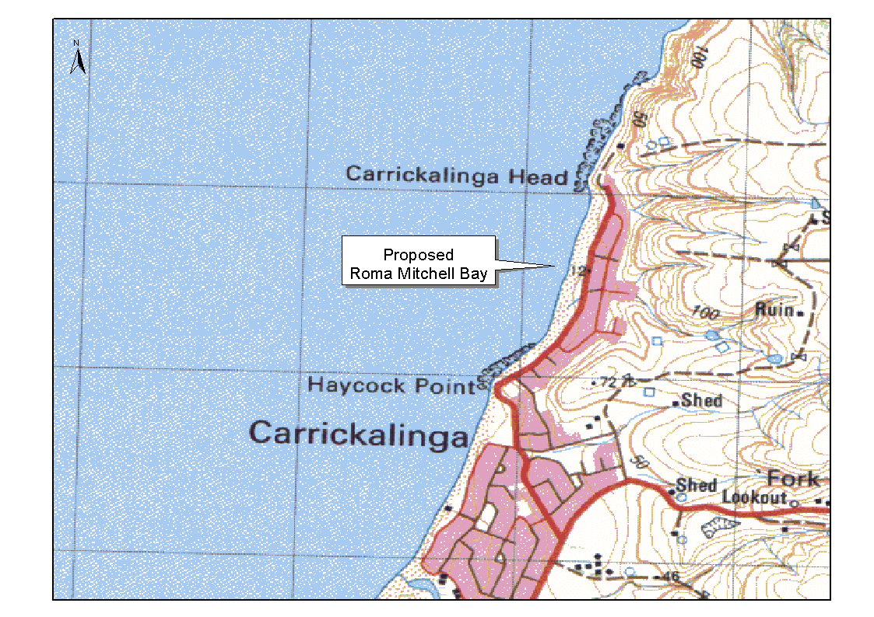
Submissions in writing regarding this proposal may be lodged with the Secretary, Geographical Names Advisory Committee, Building 2, 300 Richmond Road, Netley (P.O. Box 550, Marleston, S.A. 5033) within one month of the publication of this notice.
Dated 11 October 2000.
P. M. Kentish, Surveyor-General, Department for Administrative and Information Services
DAIS 04/0403

LAND AND BUSINESS (SALE AND CONVEYANCING) ACT 1994
Exemption
TAKE notice that, pursuant to section 23 (3) of the Land and Business (Sale and Conveyancing) Act 1994, I, Kenneth Trevor Griffin, Minister for Consumer Affairs, do hereby exempt the person named in Schedule 1 from the application of section 23 (2) of the Act in relation to the purchase of the land specified in Schedule 2.
Schedule 1
Alison Jane Thrift, an officer/employee of Charles Sturt Real Estate Pty Ltd.
Schedule 2
The whole of the land described in certificate of title register book volume 5736, folio 550, situated at 7 Coach House Drive, Novar Gardens, S.A. 5040.
Dated 27 October 2000.
K. T. Griffin, Minister for Consumer Affairs

LAND AND BUSINESS (SALE AND CONVEYANCING) ACT 1994
Exemption
TAKE notice that, pursuant to section 23 (3) of the Land and Business (Sale and Conveyancing) Act 1994, I, Kenneth Trevor Griffin, Minister for Consumer Affairs, do hereby exempt the persons named in Schedule 1 from the application of section 23 (2) of the Act in relation to the purchase of the land specified in Schedule 2.
Schedule 1
Albert John Lindop and Christiane Lindop, officers/employees of Bert Lindop Real Estate Pty Ltd.
Schedule 2
The whole of the land described in certificate of title register book volume 5623, folio 89, situated at 16 Fourth Avenue, Semaphore Park, S.A. 5019.
Dated 2 November 2000.
M. Bodycoat, Commissioner

LAND AND BUSINESS (SALE AND CONVEYANCING) ACT 1994
Exemption
TAKE notice that, pursuant to section 23 (3) of the Land and Business (Sale and Conveyancing) Act 1994, I, Kenneth Trevor Griffin, Minister for Consumer Affairs, do hereby exempt the person named in Schedule 1 from the application of section 23 (2) of the Act in relation to the purchase of the land specified in Schedule 2.
Schedule 1
Geoffrey David Muir, an officer/employee of John DeMichele Real Estate Pty Ltd.
Schedule 2
The whole of the land described in certificate of title register book volume 5364, folio 670, situated at 162 Sturt Reserve, Murray Bridge, S.A. 5253.
Dated 2 November 2000.
M. Bodycoat, Commissioner

LAND AND BUSINESS (SALE AND CONVEYANCING) ACT 1994
Exemption
TAKE notice that, pursuant to section 23 (3) of the Land and Business (Sale and Conveyancing) Act 1994, I, Kenneth Trevor Griffin, Minister for Consumer Affairs, do hereby exempt the person named in Schedule 1 from the application of section 23 (2) of the Act in relation to the purchase of the land specified in Schedule 2.
Schedule 1
Harold Joseph Wood, an officer/employee of Local Real Estate Pty Ltd.
Schedule 2
The whole of the land described in certificate of title register book volume 5512, folio 645, situated at 58 Tintara Road, Paralowie, S.A. 5108.
Dated 2 November 2000.
M. Bodycoat, Commissioner

LIQUOR LICENSING ACT 1997
Notice of Application
NOTICE is hereby given, pursuant to section 52 (2) (b) of the Liquor Licensing Act 1997, that Akino Pty Ltd (ACN 077 654 114), c/o 3 Grigg Street Marden, S.A. 5070 has applied to the Licensing Authority for the transfer of a Restaurant Licence in respect of premises situated at 79 Gouger Street, Adelaide, S.A. 5000 and known as Paul’s Restaurant.
The application has been set down for hearing on 27 November 2000 at 10 a.m.
Any person may object to the application by lodging a notice of objection in the prescribed form with the Licensing Authority, and serving a copy of the notice on the applicant at the applicant’s address given above, at least seven days before the hearing date.
Plans in respect of the premises the subject of the application are open to public inspection without fee at the Office of the Liquor and Gaming Commissioner, 9th Floor, East Wing, 50 Grenfell Street, Adelaide, S.A. 5000.
Dated 20 October 2000.
Applicant

LIQUOR LICENSING ACT 1997 AND GAMING MACHINES ACT 1992
Notice of Application
NOTICE is hereby given, pursuant to section 52 (2) (b) of the Liquor Licensing Act 1997 and section 29 of the Gaming Machines Act 1992 that Damir Arneric has applied to the Liquor and Gaming Commissioner for the transfer of a Hotel Licence, and extended Trading Authorisation and Grant of a Gaming Machine Licence in respect of premises situated at 9 Darling Terrace, Whyalla, S.A. 5600 and known as Whyalla Hotel.
The application has been set down for hearing on 1 December 2000.
Conditions
The following licence conditions are sought:
An extended trading authorisation to authorise the sale of liquor for consumption on the licensed premises between the following hours:
Monday to Saturday—midnight to 3 a.m. the following morning.
Sunday—8 p.m. to 3 a.m. the following morning.
Monday being a public holiday 9 a.m. to 11 a.m.
Any person may object to the application by lodging a notice of objection in the prescribed form with the Licensing Authority, and serving a copy of the notice on the applicant at the applicant’s address given above, at least seven days before the hearing date.
Plans in respect of the premises the subject of the application are open to public inspection without fee at the Office of the Liquor and Gaming Commissioner, 9th Floor, East Wing, 50 Grenfell Street, Adelaide, S.A. 5000.
Dated 25 October 2000.
Applicant

LIQUOR LICENSING ACT 1997
Notice of Application
NOTICE is hereby given, pursuant to section 52 (2) (b) of the Liquor Licensing Act 1997 that Kenan Becirovic has applied to the Licence Authority for a Restaurant Licence with an extended Trading Authorisation in respect of premises situated at 46B King William Street, Adelaide, S.A. 5000 and known as Yiros Bar 777.
The application has been set down for hearing on 1 December 2000.
Conditions
The following licence conditions are sought:
• An extended trading authorisation to authorise the licensee to sell liquor on any day except Good Friday and Christmas Day for consumption on the licensed premises by persons:
(i) seated at a table; or
(ii) attending a function at which food is provided between the following hours:
Monday to Saturday—midnight to 3 a.m. the following morning.
Sunday: 8 p.m. to 3 p.m. the following morning.
Any person may object to the application by lodging a notice of objection in the prescribed form with the Licensing Authority, and serving a copy of the notice on the applicant at the applicant’s address given above, at least seven days before the hearing date.
Plans in respect of the premises the subject of the application are open to public inspection without fee at the Office of the Liquor and Gaming Commissioner, 9th Floor, East Wing, 50 Grenfell Street, Adelaide, S.A. 5000.
Dated 27 October 2000.
Applicant

LIQUOR LICENSING ACT 1997
Notice of Application
NOTICE is hereby given, pursuant to section 52 (2) (b) of the Liquor Licensing Act 1997, that Possums McLaren Vineyards Pty Ltd (ACN 093 953 416), 1/345 King William Street, Adelaide, S.A. 5000 has applied to the Licensing Authority for a Producer’s Licence in respect of premises to be situated at 31 Thornber Street, Unley Park and to be known as Possum’s Vineyards.
The application has been set down for hearing on 1 December 2000 at 9 a.m.
Any person may object to the application by lodging a notice of objection in the prescribed form with the Licensing Authority, and serving a copy of the notice on the applicant at the applicant’s address given above, at least seven days before the hearing date.
Plans in respect of the premises the subject of the application are open to public inspection without fee at the Office of the Liquor and Gaming Commissioner, 9th Floor, East Wing, 50 Grenfell Street, Adelaide, S.A. 5000.
Dated 20 October 2000.
Applicant

LIQUOR LICENSING ACT 1997
Notice of Application
NOTICE is hereby given, pursuant to section 52 (2) (b) of the Liquor Licensing Act 1997, that Indochina Restaurant Pty Ltd, c/o Scammell & Co. Barristers and Solicitors, 86 Franklin Street, Adelaide, S.A. 5000 has applied to the Licensing Authority for a Restaurant Licence in respect of premises situated at 153 Unley Road, Unley, S.A. 5061 and known as Indochina Restaurant.
The application has been set down for hearing on 1 December 2000 at 9 a.m.
Any person may object to the application by lodging a notice of objection in the prescribed form with the Licensing Authority, and serving a copy of the notice on the applicant at the applicant’s address given above, at least seven days before the hearing date.
Plans in respect of the premises the subject of the application are open to public inspection without fee at the Office of the Liquor and Gaming Commissioner, 9th Floor, East Wing, 50 Grenfell Street, Adelaide, S.A. 5000.
Dated 24 October 2000.
Applicant

LIQUOR LICENSING ACT 1997
Notice of Application
NOTICE is hereby given, pursuant to section 52 (2) (b) of the Liquor Licensing Act 1997, that Steven Darryl Moffatt and Dianne Margaret Moffatt, 29 Commercial Road, Port Adelaide, S.A. 5015, the holder of a Hotel Licence in respect of premises known as the First Commercial Inn apply for a Variation to Extended Trading Authorisation to authorise the sale of liquor for consumption on the licensed premises during the following hours.
The application has been set down for hearing on 1 December 2000.
Condition
The following licence condition is sought:
Hours of Operation
Sunday—8 a.m. to 11 a.m. and 8 p.m. to midnight.
Any person may object to the application by lodging a notice of objection in the prescribed form with the Licensing Authority, and serving a copy of the notice on the applicants at the applicants’ address given above, at least seven days before the hearing date.
Plans in respect of the premises the subject of the application are open to public inspection without fee at the Office of the Liquor and Gaming Commissioner, 9th Floor, East Wing, 50 Grenfell Street, Adelaide, S.A. 5000.
Dated 11 October 2000.
Applicants

LIQUOR LICENSING ACT 1997
Notice of Application
NOTICE is hereby given, pursuant to section 52 (2) (b) of the Liquor Licensing Act 1997, that CMS-Crows Minlaton Sporting Club Inc. has applied to the Licensing Authority for an Extended Trading Authorisation in respect of premises situated at 33 Main Street, Minlaton, S.A. 5575 and known as CMS-Crows Minlaton Sporting Club.
The application has been set down for hearing on 1 December 2000.
Condition
The following licence condition is sought:
Hours sought for the Extended Trading Authorisation:
Thursday to Saturday—midnight to 2 a.m.
Any person may object to the application by lodging a notice of objection in the prescribed form with the Licensing Authority, and serving a copy of the notice on the applicant at the applicant’s address given above, at least seven days before the hearing date.
Plans in respect of the premises the subject of the application are open to public inspection without fee at the Office of the Liquor and Gaming Commissioner, 9th Floor, East Wing, 50 Grenfell Street, Adelaide, S.A. 5000.
Applicant

LIQUOR LICENSING ACT 1997
Notice of Application
NOTICE is hereby given, pursuant to section 52 (2) (b) of the Liquor Licensing Act 1997, that Domaine Wine Shippers Pty Ltd, c/o David Watts & Associates, Liquor Licensing Consultants, 1 Cator Street, Glenside has applied to the Licensing Authority for a Wholesale Liquor Merchant’s Licence in respect of premises situated at 22 Honeysuckle Grove, Bridgewater, S.A. 5155 and to be known as Domaine Wine Shippers.
The application has been set down for hearing on 1 December 2000 at 9 a.m.
Any person may object to the application by lodging a notice of objection in the prescribed form with the Licensing Authority, and serving a copy of the notice on the applicant at the applicant’s address given above, at least seven days before the hearing date.
Plans in respect of the premises the subject of the application are open to public inspection without fee at the Office of the Liquor and Gaming Commissioner, 9th Floor, East Wing, 50 Grenfell Street, Adelaide, S.A. 5000.
Dated 26 October 2000.
Applicant

LIQUOR LICENSING ACT 1997
Notice of Application
NOTICE is hereby given, pursuant to section 52 (2) (b) of the Liquor Licensing Act 1997, that Burton Premium Wines Pty Ltd, (ACN 094 416 412) c/o Wallmans Lawyers, 173 Wakefield Street, Adelaide, S.A. 5000 has applied to the Licensing Authority for a Producer’s Licence in respect of premises situated at 246 Flinders Street, Adelaide, S.A. 5000.
The application has been set down for hearing on 1 December 2000.
Any person may object to the application by lodging a notice of objection in the prescribed form with the Licensing Authority, and serving a copy of the notice on the applicant at the applicant’s address given above, at least seven days before the hearing date.
Plans in respect of the premises the subject of the application are open to public inspection without fee at the Office of the Liquor and Gaming Commissioner, 9th Floor, East Wing, 50 Grenfell Street, Adelaide, S.A. 5000.
Dated 26 October 2000.
Applicant

LIQUOR LICENSING ACT 1997
Notice of Application
NOTICE is hereby given, pursuant to section 52 (2) (b) of the Liquor Licensing Act 1997, that Andrew Lee Murray and Justin Scott McDonald have applied the Licensing Authority for a Direct Sales Licence in respect of premises situated at 42 Richmond Avenue, Colonel Light Gardens, S.A. 5041 and to be known as Beer King.
The application has been set down for hearing on 1 December 2000.
Any person may object to the application by lodging a notice of objection in the prescribed form with the Licensing Authority, and serving a copy of the notice on the applicants at the applicants’ address given above, at least seven days before the hearing date.
Plans in respect of the premises the subject of the application are open to public inspection without fee at the Office of the Liquor and Gaming Commissioner, 9th Floor, East Wing, 50 Grenfell Street, Adelaide, S.A. 5000.
Dated 26 October 2000.
Applicants

LIQUOR LICENSING ACT 1997
Notice of Application
NOTICE is hereby given, pursuant to section 52 (2) (b) of the Liquor Licensing Act 1997, that Hackham West Community Centre Inc., corner Glynville and Warsaw Court, Hackham West, S.A. 5163 has applied the Licensing Authority for a Club Licence with Entertainment Consent in respect of premises situated at corner Glynville and Warsaw Courts, Hackham West, S.A. 5163 and known as Hackham West Community Centre.
The application has been set down for hearing on 1 December 2000.
Any person may object to the application by lodging a notice of objection in the prescribed form with the Licensing Authority, and serving a copy of the notice on the applicant at the applicant’s address given above, at least seven days before the hearing date.
Plans in respect of the premises the subject of the application are open to public inspection without fee at the Office of the Liquor and Gaming Commissioner, 9th Floor, East Wing, 50 Grenfell Street, Adelaide, S.A. 5000.
Dated 3 October 2000.
Applicant

LIQUOR LICENSING ACT 1997
Notice of Application
NOTICE is hereby given, pursuant to section 52 (2) (b) of the Liquor Licensing Act 1997, that Anthony Ernest Parish, 18 Ada Street, Goodwood, S.A. 5034 has applied to the Licensing Authority for a Restaurant Licence in respect of premises situated at 143 Goodwood Road, Goodwood, S.A. 5034 and to be known as Cafe Deco.
The application has been set down for hearing on 1 December 2000 at 9 a.m.
Any person may object to the application by lodging a notice of objection in the prescribed form with the Licensing Authority, and serving a copy of the notice on the applicant at the applicant’s address given above, at least seven days before the hearing date.
Plans in respect of the premises the subject of the application are open to public inspection without fee at the Office of the Liquor and Gaming Commissioner, 9th Floor, East Wing, 50 Grenfell Street, Adelaide, S.A. 5000.
Dated 27 October 2000.
Applicant

LIQUOR LICENSING ACT 1997
Notice of Application
NOTICE is hereby given, pursuant to section 52 (2) (b) of the Liquor Licensing Act 1997, that Stavroula Forsyth, c/o Fisher Jeffries, SGIC Building, 211 Victoria Square, Adelaide, S.A. 5000 has applied to the Licensing Authority for a Direct Sales Licence in respect of premises situated at 26 Balfour Road, Springfield, S.A. 5062 and to be known as Forsyth Wine Marketing.
The application has been set down for hearing on 1 December 2000 at 9 a.m.
Any person may object to the application by lodging a notice of objection in the prescribed form with the Licensing Authority, and serving a copy of the notice on the applicant at the applicant’s address given above, at least seven days before the hearing date.
Plans in respect of the premises the subject of the application are open to public inspection without fee at the Office of the Liquor and Gaming Commissioner, 9th Floor, East Wing, 50 Grenfell Street, Adelaide, S.A. 5000.
Dated 26 October 2000.
Applicant

LIQUOR LICENSING ACT 1997
Notice of Application
NOTICE is hereby given, pursuant to section 52 (2) (b) of the Liquor Licensing Act 1997, that Houlton Investments Pty Ltd (ACN 094 878 823), c/o Bonnins, Level 14, 100 King William Street, Adelaide, S.A. 5000 has applied to the Licensing Authority for the transfer of a Hotel Licence in respect of premises situated at Dickenson Street, Iron Knob, S.A. 5601 and known as Iron Knob Hotel and removal of that Hotel Licence to premises situated at section 21 Lewis Terrace, Iron Knob, S.A. 5061.
The application has been set down for hearing on 1 December 2000.
Condition
The following licence condition is sought:
The existing entertainment consent is to apply to the bar area and the designated dining areas in the new premises.
Any person may object to the application by lodging a notice of objection in the prescribed form with the Licensing Authority, and serving a copy of the notice on the applicant at the applicant’s address given above, at least seven days before the hearing date.
Plans in respect of the premises the subject of the application are open to public inspection without fee at the Office of the Liquor and Gaming Commissioner, 9th Floor, East Wing, 50 Grenfell Street, Adelaide, S.A. 5000.
Dated 26 October 2000.
Applicant

LIQUOR LICENSING ACT 1997
Notice of Application
NOTICE is hereby given, pursuant to section 52 (2) (b) of the Liquor Licensing Act 1997, that Vijay Prakash Singh, 13/23 Unley Towers, Shop 12, Unley Road, Parkside, S.A. 5061 has applied to the Licensing Authority for the transfer of a Restaurant Licence in respect of premises situated at Shop 12, 13/23 Unley Road, Parkside, S.A. 5061 and known as Quality Indian Kitchen and to be known as Raj on Taj.
The application has been set down for hearing on 4 December 2000 at 9 a.m.
Any person may object to the application by lodging a notice of objection in the prescribed form with the Licensing Authority, and serving a copy of the notice on the applicant at the applicant’s address given above, at least seven days before the hearing date.
Plans in respect of the premises the subject of the application are open to public inspection without fee at the Office of the Liquor and Gaming Commissioner, 9th Floor, East Wing, 50 Grenfell Street, Adelaide, S.A. 5000.
Dated 26 October 2000.
Applicant

LIQUOR LICENSING ACT 1997
Notice of Application
NOTICE is hereby given, pursuant to section 52 (2) (b) of the Liquor Licensing Act 1997, that Rewind Enterprises Pty Ltd (ACN 089 266 400) c/o Griffins Lawyers, Level 14, 26 Flinders Street, Adelaide, S.A. 5000 has applied to the Licensing Authority for the transfer of a Special Circumstances Licence and the grant of a variation to a condition of the Special Circumstances Licence in respect of premises situated at 10 Vaughan Place, Adelaide, S.A. 5000 and to be known as the Blue Room.
The application has been set down for hearing on Friday, 1 December 2000.
Condition
The following licence condition is sought:
That the condition on the special circumstances licence requiring food to be available at all times when the restaurant section is open to the public be deleted.
Any person may object to the application by lodging a notice of objection in the prescribed form with the Licensing Authority, and serving a copy of the notice on the applicant at the applicant’s address given above, at least seven days before the hearing date.
Plans in respect of the premises the subject of the application are open to public inspection without fee at the Office of the Liquor and Gaming Commissioner, 9th Floor, East Wing, 50 Grenfell Street, Adelaide, S.A. 5000.
Dated 27 October 2000.
Applicant

STARR-BOWKETT SOCIETIES ACT 1975
Cancellation of Registration
PURSUANT to subsection 459 (2) of the Companies (South Australia) Code as applied by subsection 67 (2) of the Starr-Bowkett Societies Act 1975, the Corporate Affairs Commission in the State of South Australia gives notice that at the expiration of three months from the date of this notice, the registration of the society referred to in the Schedule will, unless cause is shown to the contrary, be cancelled and the society will be dissolved.
Schedule
Black Diamond Starr-Bowkett Building Society No. 54.
Dated at Adelaide, 31 October 2000.
A. J. Griffiths, a delegate of the Corporate Affairs Commission

PETROLEUM ACT 2000
Statement of Environmental Objectives for Existing Regulated Activities
PURSUANT to section 6 (1) of the Schedule to the Petroleum Act 2000 (the Act), I, Robert Antohny Laws, Director Petroleum, Office of Minerals and Energy Resources, Department of Primary Industries and Resources SA, Delegate of the Minister for Minerals and Energy Resources, pursuant to Delegation dated 25 September 2000, Gazetted 28 September 2000, do hereby publish the following documents as having fulfilled a purpose corresponding to the purpose of a statement of environmental objectives under the Act.
These documents are available for public inspection on the Environmental Register section of the Petroleum Group’s web site (www.petroleum.pir.sa.gov.au) or at the Public Office determined pursuant to section 107 (1) of the Act to be at:
Minerals and Petroleum Centre
Office of Minerals and Energy Resources
Ground Floor
101 Grenfell Street
Adelaide, S.A. 5000.
Documents:
1. Santos alternative arrangements approved on 8 June 2000 under regulation 16 (2) of the Petroleum Regulations 1989. Subject to review and assessment in accordance with the requirements of Part 12 of the Petroleum Act 2000 prior to 30 June 2001.
2. The statement of environmental objectives for drilling and well operations in the Cooper/Eromanga Basin of South Australia, approved on 17 August 2000. Subject to review and assessment in accordance with the requirements of Part 12 of the Petroleum Act 2000 within 12 months of this Gazettal.
3. Statement of Environmental Objectives for Seismic Operations in the Cooper and Eromanga Basins of South Australia, May 1998, Report Book: 98/16 as approved in May 1998.
4. Origin Energy alternative arrangements approved on 22 September 2000 under regulation 16 (2) of the Petroleum Regulations 1989 for Production and Processing of Petroleum and Associated Activities in the Otway Basin of South Australia. This is subject to review and assessment in accordance with the requirements of Part 12 of the Petroleum Act 2000 by 25 September 2001.
5. Origin Energy alternative arrangements approved on 22 September 2000 under regulation 16 (2) of the Petroleum Regulations 1989 for seismic operations in the Otway Basin of South Australia. This is subject to review and assessment in accordance with the requirements of Part 12 of the Petroleum Act 2000 by 25 September 2001.
Dated 31 October 2000.
R. A. Laws, Delegate of the Minister for Minerals and Energy Resources

SURRENDER OF PORTION OF EXPLORATION LICENCE
Department of Primary Industries and Resources SA, 31 October 2000
NOTICE is hereby given that portion of the undermentioned Exploration Licence has been surrendered in accordance with the provisions of the Petroleum Act 2000, pursuant to delegated powers dated 25 September 2000, Gazetted 28 September 2000, page 2289.
R. A. Laws, Director Petroleum Group, Primary Industries and Resources SA, Delegate of the Minister for Minerals and Energy Resources
No. of  Licence | Licensees | Locality | Date of  Surrender | Surrender  Area in  km² | Reference

66 | • Origin Energy Resources Ltd  • Beach Petroleum NL |  | Otway Basin of South Australia | 31 October 2000 | 559 | SR.27.2.138

Description of the Area EL 66
The land retained comprised in the licence is all that part of the State of South Australia, bounded as follows: commencing at a point being the intersection of latitude 37°10′S AGD66 and longitude 140°15′E AGD66, thence east to longitude 140°20′E AGD66, south to latitude 37°15′S AGD66, east to longitude 140°30′E AGD66, south to latitude 37°20′S AGD66, east to longitude 140°32′30″E AGD66, south to latitude 37°25′S AGD66, west to longitude 140°30′E AGD66, south to latitude 37°27′30″S AGD66, east to longitude 140°32′30″E AGD66, south to latitude 37°30′S AGD66, east to longitude 140°37′30″E AGD66, south to latitude 37°30′30″S AGD66, east to longitude 140°40′E AGD66, south to latitude 37°32′30″S AGD66, east to longitude 140°42′30″E AGD66, south to latitude 37°35′S GDA94, west to longitude 140°42′E GDA94, south to latitude 37°37′S GDA94, west to longitude 140°40′E GDA94, south to latitude 37°40′S GDA94, west to longitude 140°32′E GDA94, north to latitude 37°32′S GDA94, west to longitude 140°22′30″E AGD66, north to latitude 37°25′S AGD66, east to longitude 140°27′30″E AGD66, north to latitude 37°17′30″S AGD66, west to longitude 140°15′E AGD66 and north to the point of commencement.
Area: 675 km² approximately.

MISCELLANEOUS LEGISLATION AND GOVERNMENT PUBLICATIONS PRICES AS FROM 1 JULY 2000

Acts, Bills, Rules, Parliamentary Papers and Regulations
Pages | Main | Amends | Pages | Main | Amends

1-16 | 1.80 | 0.80 | 497-512 | 26.25 | 25.25
17-32 | 2.55 | 1.60 | 513-528 | 27.00 | 26.00
33-48 | 3.25 | 2.35 | 529-544 | 27.75 | 26.75
49-64 | 4.15 | 3.10 | 545-560 | 28.50 | 27.75
65-80 | 4.90 | 4.00 | 561-576 | 29.25 | 28.50
81-96 | 5.60 | 4.70 | 577-592 | 30.25 | 29.00
97-112 | 6.45 | 5.45 | 593-608 | 31.00 | 30.00
113-128 | 7.20 | 6.30 | 609-624 | 31.75 | 31.00
129-144 | 8.10 | 7.10 | 625-640 | 32.50 | 31.50
145-160 | 8.90 | 7.85 | 641-656 | 33.25 | 32.25
161-176 | 9.70 | 8.70 | 657-672 | 33.75 | 33.00
177-192 | 10.40 | 9.50 | 673-688 | 35.00 | 33.75
193-208 | 11.20 | 10.30 | 689-704 | 35.75 | 34.75
209-224 | 12.00 | 11.00 | 705-720 | 36.25 | 35.50
225-240 | 12.70 | 11.80 | 721-736 | 37.50 | 36.00
241-257 | 13.60 | 12.50 | 737-752 | 38.00 | 37.00
258-272 | 14.40 | 13.30 | 753-768 | 39.00 | 37.50
273-288 | 15.20 | 14.20 | 769-784 | 39.50 | 38.75
289-304 | 15.90 | 14.90 | 785-800 | 40.25 | 39.50
305-320 | 16.70 | 15.70 | 801-816 | 41.00 | 40.00
321-336 | 17.50 | 16.50 | 817-832 | 42.00 | 41.00
337-352 | 18.30 | 17.40 | 833-848 | 42.75 | 41.75
353-368 | 19.10 | 18.10 | 849-864 | 43.50 | 42.50
369-384 | 19.90 | 19.00 | 865-880 | 44.25 | 43.50
385-400 | 20.60 | 19.70 | 881-896 | 44.75 | 44.00
401-416 | 21.40 | 20.40 | 897-912 | 46.00 | 44.75
417-432 | 22.30 | 21.30 | 913-928 | 46.50 | 46.00
433-448 | 23.00 | 22.00 | 929-944 | 47.50 | 46.50
449-464 | 23.90 | 22.80 | 945-960 | 48.50 | 47.00
465-480 | 24.50 | 23.60 | 961-976 | 49.00 | 48.00
481-496 | 25.25 | 24.30 | 977-992 | 50.00 | 48.50

Legislation—Acts, Regulations, etc: $
Subscriptions:
Acts 162.85
All Bills as Laid 388.90
Rules and Regulations 388.90
Parliamentary Papers 388.90
Bound Acts 179.75
Index 87.05
Government Gazette
Copy 4.30
Subscription 214.85
Hansard
Copy 11.60
Subscription—per session (issued weekly) 336.95
Cloth bound—per volume 144.70
Subscription—per session (issued daily) 336.95
Legislation on Disk
Whole Database 2 488.80
Annual Subscription for fortnightly updates 765.20
Individual Act(s) including updates POA
Compendium
Subscriptions:
New Subs 1 476.60
Updates 527.10

(All the above prices include GST)

All Legislation, Government Gazette, Hansard and Legislation on disk are available from:
Counter Sales Information SA (State Government Bookshop)
and Mail Orders: Australis Centre, Ground Floor, 77 Grenfell Street, Adelaide, S.A. 5000.
Phone: (08) 8204 1900. Fax: (08) 8204 1909
S.A. Country Customer Free Call: 1800 182 234
TTY (Hearing Impaired): (08) 8204 1923
Subscriptions and Standing Orders:
Phone: (08) 8204 9447, (08) 8204 9448. Fax: (08) 8204 1898
P.O. Box 1, Rundle Mall, Adelaide, S.A. 5000.

GOVERNMENT GAZETTE ADVERTISEMENT RATES

To apply from 1 July 2000

$  Agents, Ceasing to Act as 32.00  Associations:  Incorporation 16.30  Intention of Incorporation 40.25  Transfer of Properties 40.25  Attorney, Appointment of 32.00  Bailiff’s Sale 40.25  Cemetery Curator Appointed 23.90  Companies:  Alteration to Constitution 32.00  Capital, Increase or Decrease of 40.25  Ceasing to Carry on Business 23.90  Declaration of Dividend 23.90  Incorporation 32.00  Lost Share Certificates:  First Name 23.90  Each Subsequent Name 8.20  Meeting Final 26.75  Meeting Final Regarding Liquidator’s Report on  Conduct of Winding Up (equivalent to ‘Final  Meeting’)  First Name 32.00  Each Subsequent Name 8.20  Notices:  Call 40.25  Change of Name 16.30  Creditors 32.00  Creditors Compromise of Arrangement 32.00  Creditors (extraordinary resolution that ‘the Com-pany be wound up voluntarily and that a liquidator be appointed’) 40.25  Release of Liquidator⎯Application⎯Large Ad. 64.00  ⎯Release Granted 40.25  Receiver and Manager Appointed 37.25  Receiver and Manager Ceasing to Act 32.00  Restored Name 30.25  Petition to Supreme Court for Winding Up 55.50  Summons in Action 47.50  Order of Supreme Court for Winding Up Action 32.00  Register of Interests⎯Section 84 (1) Exempt 72.00  Removal of Office 16.30  Proof of Debts 32.00  Sales of Shares and Forfeiture 32.00  Estates:  Assigned 23.90  Deceased Persons⎯Notice to Creditors, etc. 40.25  Each Subsequent Name 8.20  Deceased Persons⎯Closed Estates 23.90  Each Subsequent Estate 1.00  Probate, Selling of 32.00  Public Trustee, each Estate 8.20 |  | $  Firms:  Ceasing to Carry on Business (each insertion) 21.30  Discontinuance Place of Business 21.30  Land⎯Real Property Act:  Intention to Sell, Notice of 40.25  Lost Certificate of Title Notices 40.25  Cancellation, Notice of (Strata Plan) 40.25  Mortgages:  Caveat Lodgment 16.30  Discharge of 17.20  Foreclosures 16.30  Transfer of 16.30  Sublet 8.20  Leases⎯Application for Transfer (2 insertions) each 8.20  Lost Treasury Receipts (3 insertions) each 23.90  Licensing 47.50  Municipal or District Councils:  Annual Financial Statement⎯Forms 1 and 2 451.00  Electricity Supply⎯Forms 19 and 20 319.00  Default in Payment of Rates:  First Name 64.00  Each Subsequent Name 8.20  Noxious Trade 23.90  Partnership, Dissolution of 23.90  Petitions (small) 16.30  Registered Building Societies (from Registrar-  General) 16.30  Register of Unclaimed Moneys⎯First Name 23.90  Each Subsequent Name 8.20  Registers of Members⎯Three pages and over:  Rate per page (in 8pt) 204.00  Rate per page (in 6pt) 269.00  Sale of Land by Public Auction 40.75  Advertisements 2.25  Advertisements, other than those listed are charged at $2.25 per column line, tabular one-third extra.  Notices by Colleges, Universities, Corporations and District Councils to be charged at $2.25 per line.  Where the notice inserted varies significantly in length from that which is usually published a charge of $2.25 per column line will be applied in lieu of advertisement rates listed.  South Australian Government publications are sold on the condition that they will not be reproduced without prior permission from the Government Printer.
All the above prices include GST

GOVERNMENT GAZETTE NOTICES
ALL private advertisements forwarded for publication in the South Australian Government Gazette must be PAID FOR PRIOR TO INSERTION; and all notices, from whatever source, should be legibly written on one side of the paper only and sent to Riverside 2000 so as to be received no later than 4 p.m. Tuesday preceding the day of publication. Phone 8207 1045 or Fax 8207 1040. E-mail: Riv2000@saugov.sa.gov.au. Send as attachments in Word format and please confirm your transmission with a faxed copy of your document, including the date the notice is to be published and to whom the notice will be charged.

NATIONAL PARKS AND WILDLIFE ACT 1972
Declaration of Diprose Sanctuary
I, IAIN EVANS, Minister for Environment and Heritage and Minister of the Crown for the time being administering the National Parks and Wildlife Act 1972, being of the opinion that it is desirable to conserve the animals and plants for which the land depicted as a sanctuary in the schedule hereto is a natural habitat or environment and having received all necessary consents, hereby declare the said land to be a sanctuary for the purposes of the said Act.
Dated 24 September 2000.
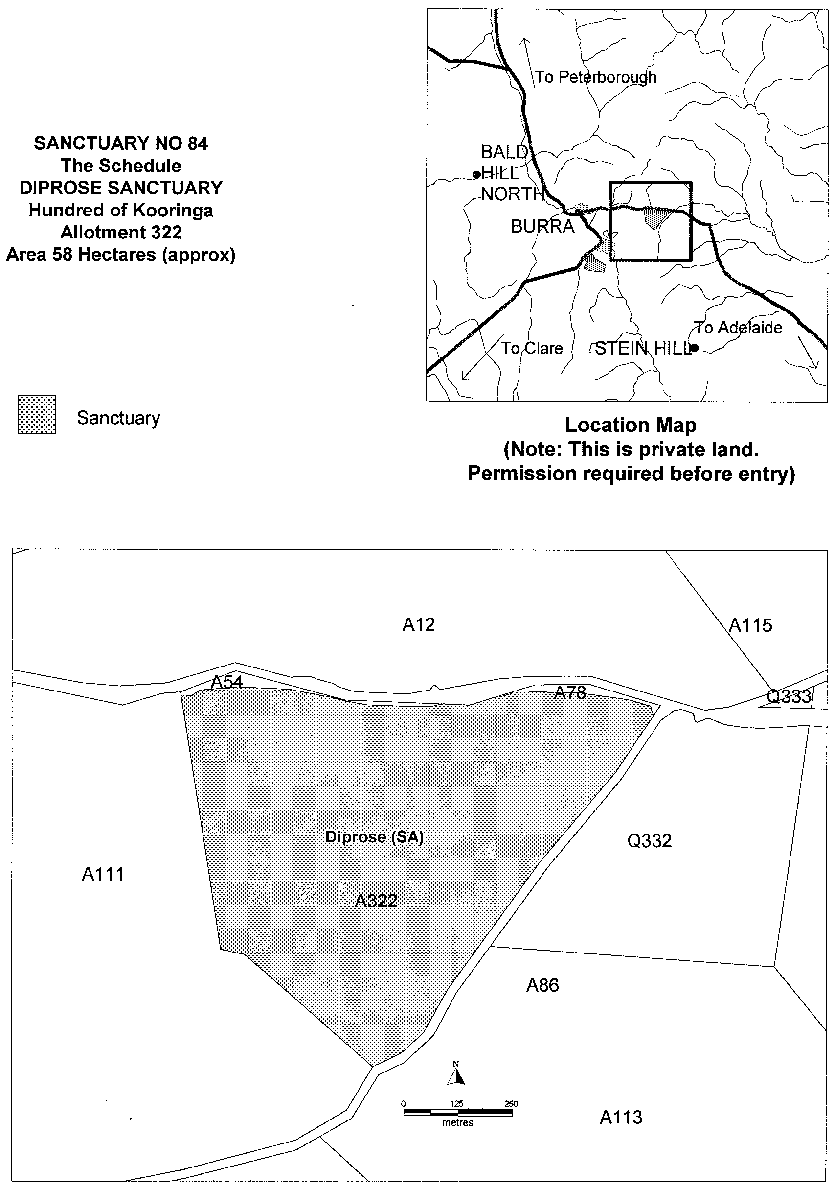
Iain Evans, Minister for Environment and Heritage

NATIONAL PARKS AND WILDLIFE ACT 1972
Declaration of Sida Sanctuary
I, IAIN EVANS, Minister for Environment and Heritage and Minister of the Crown for the time being administering the National Parks and Wildlife Act 1972, being of the opinion that it is desirable to conserve the animals and plants for which the land depicted as a sanctuary in the schedule hereto is a natural habitat or environment and having received all necessary consents, hereby declare the said land to be a sanctuary for the purposes of the said Act.
Dated 24 September 2000.
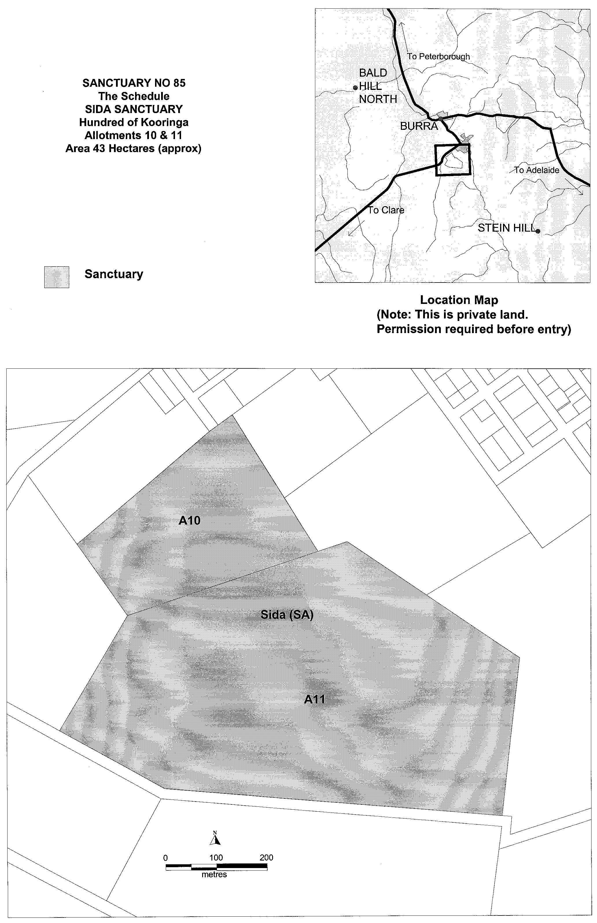
Iain Evans, Minister for Environment and Heritage

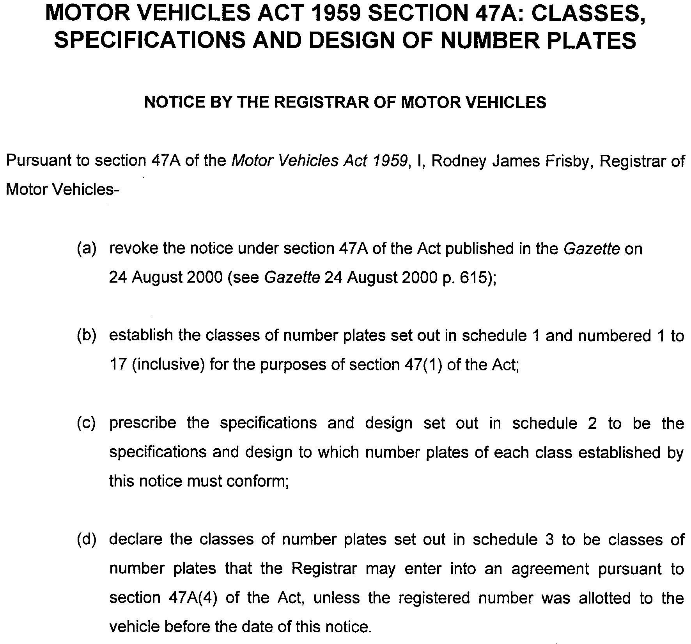
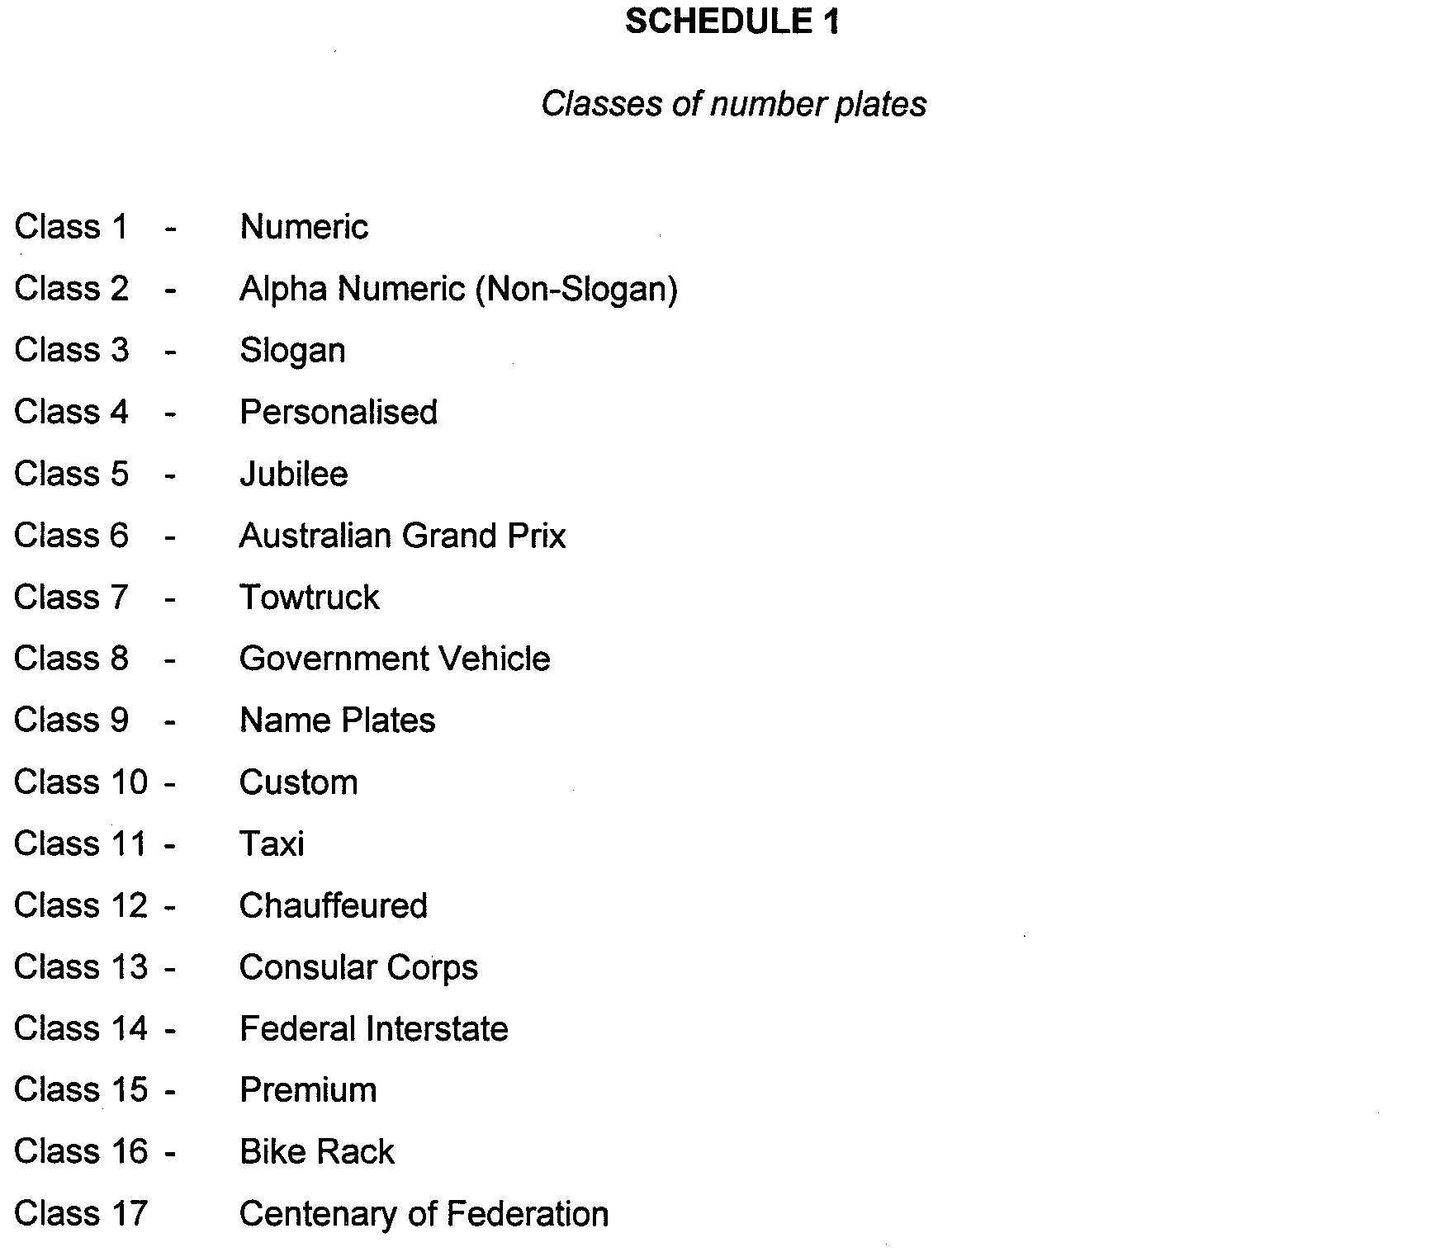




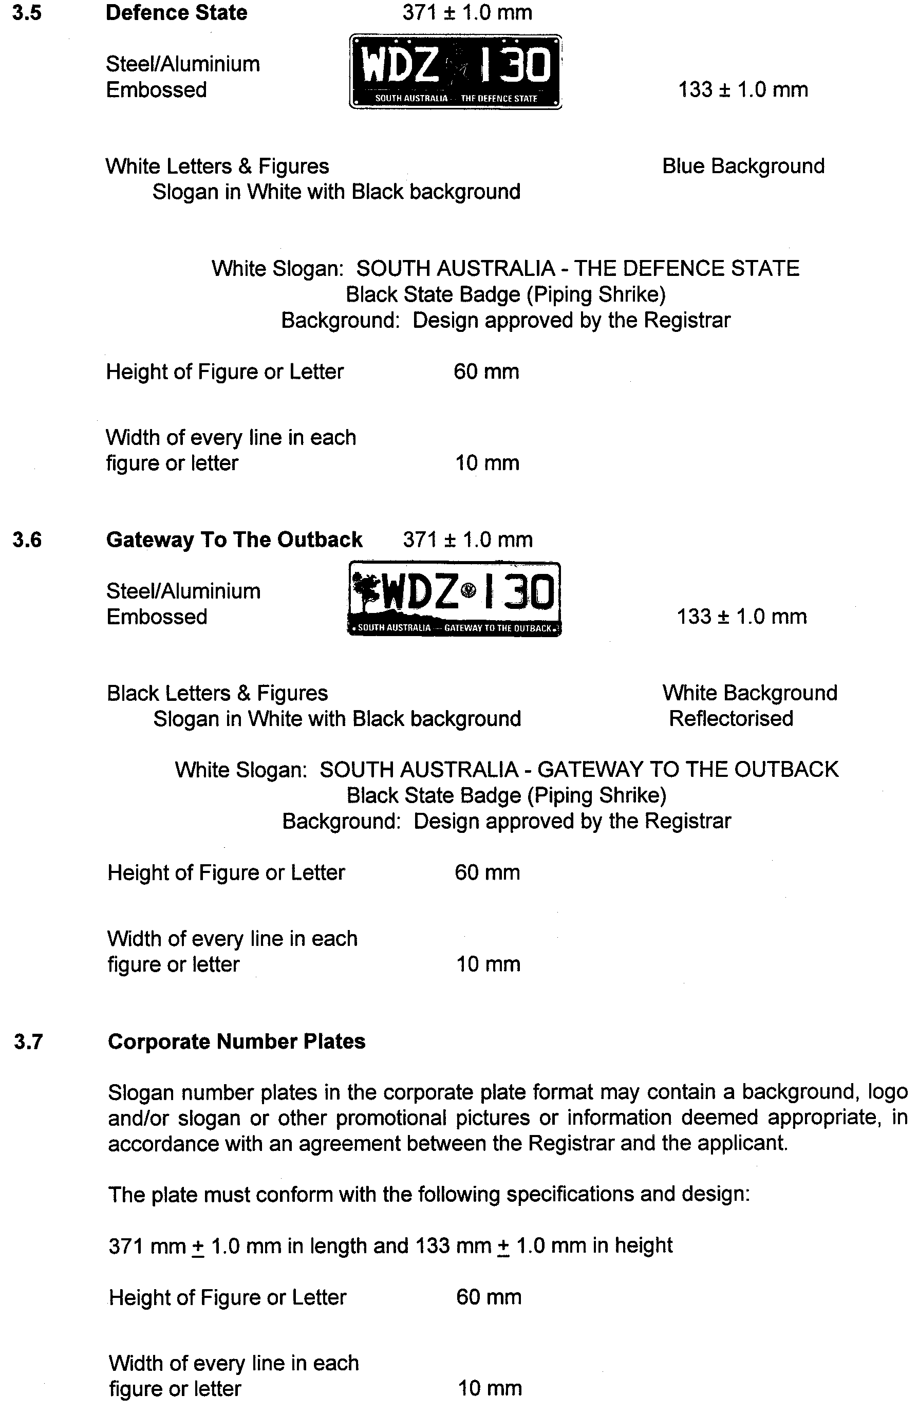





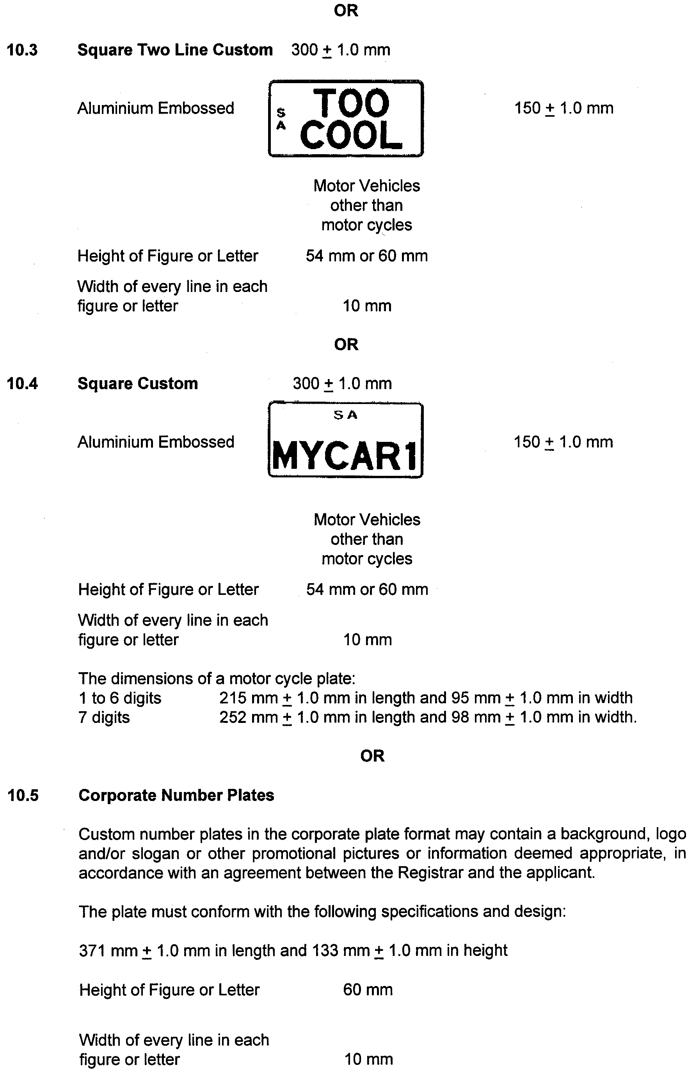

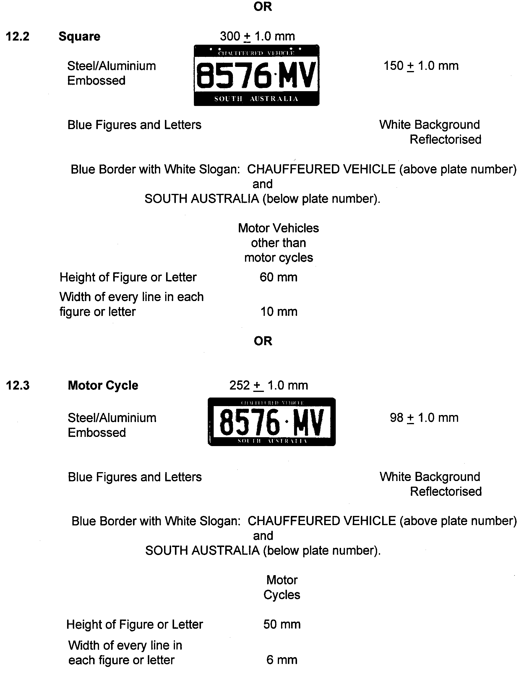


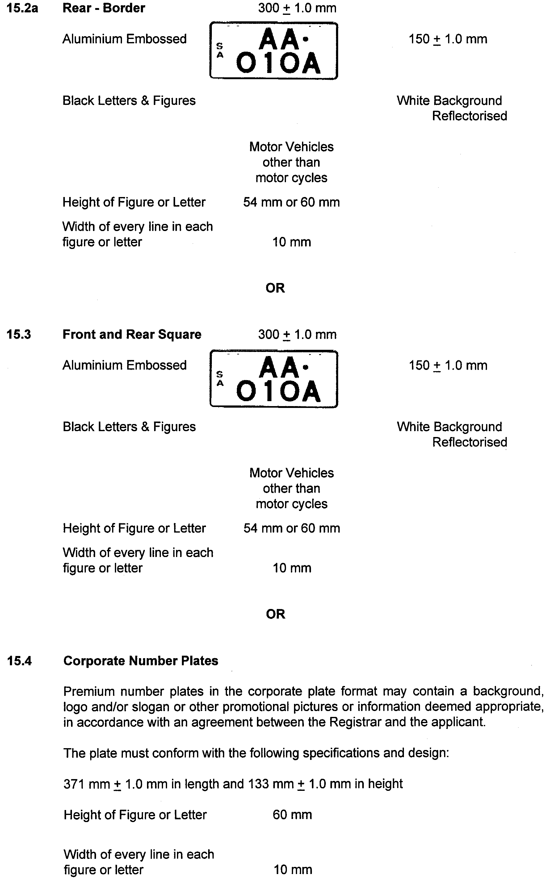



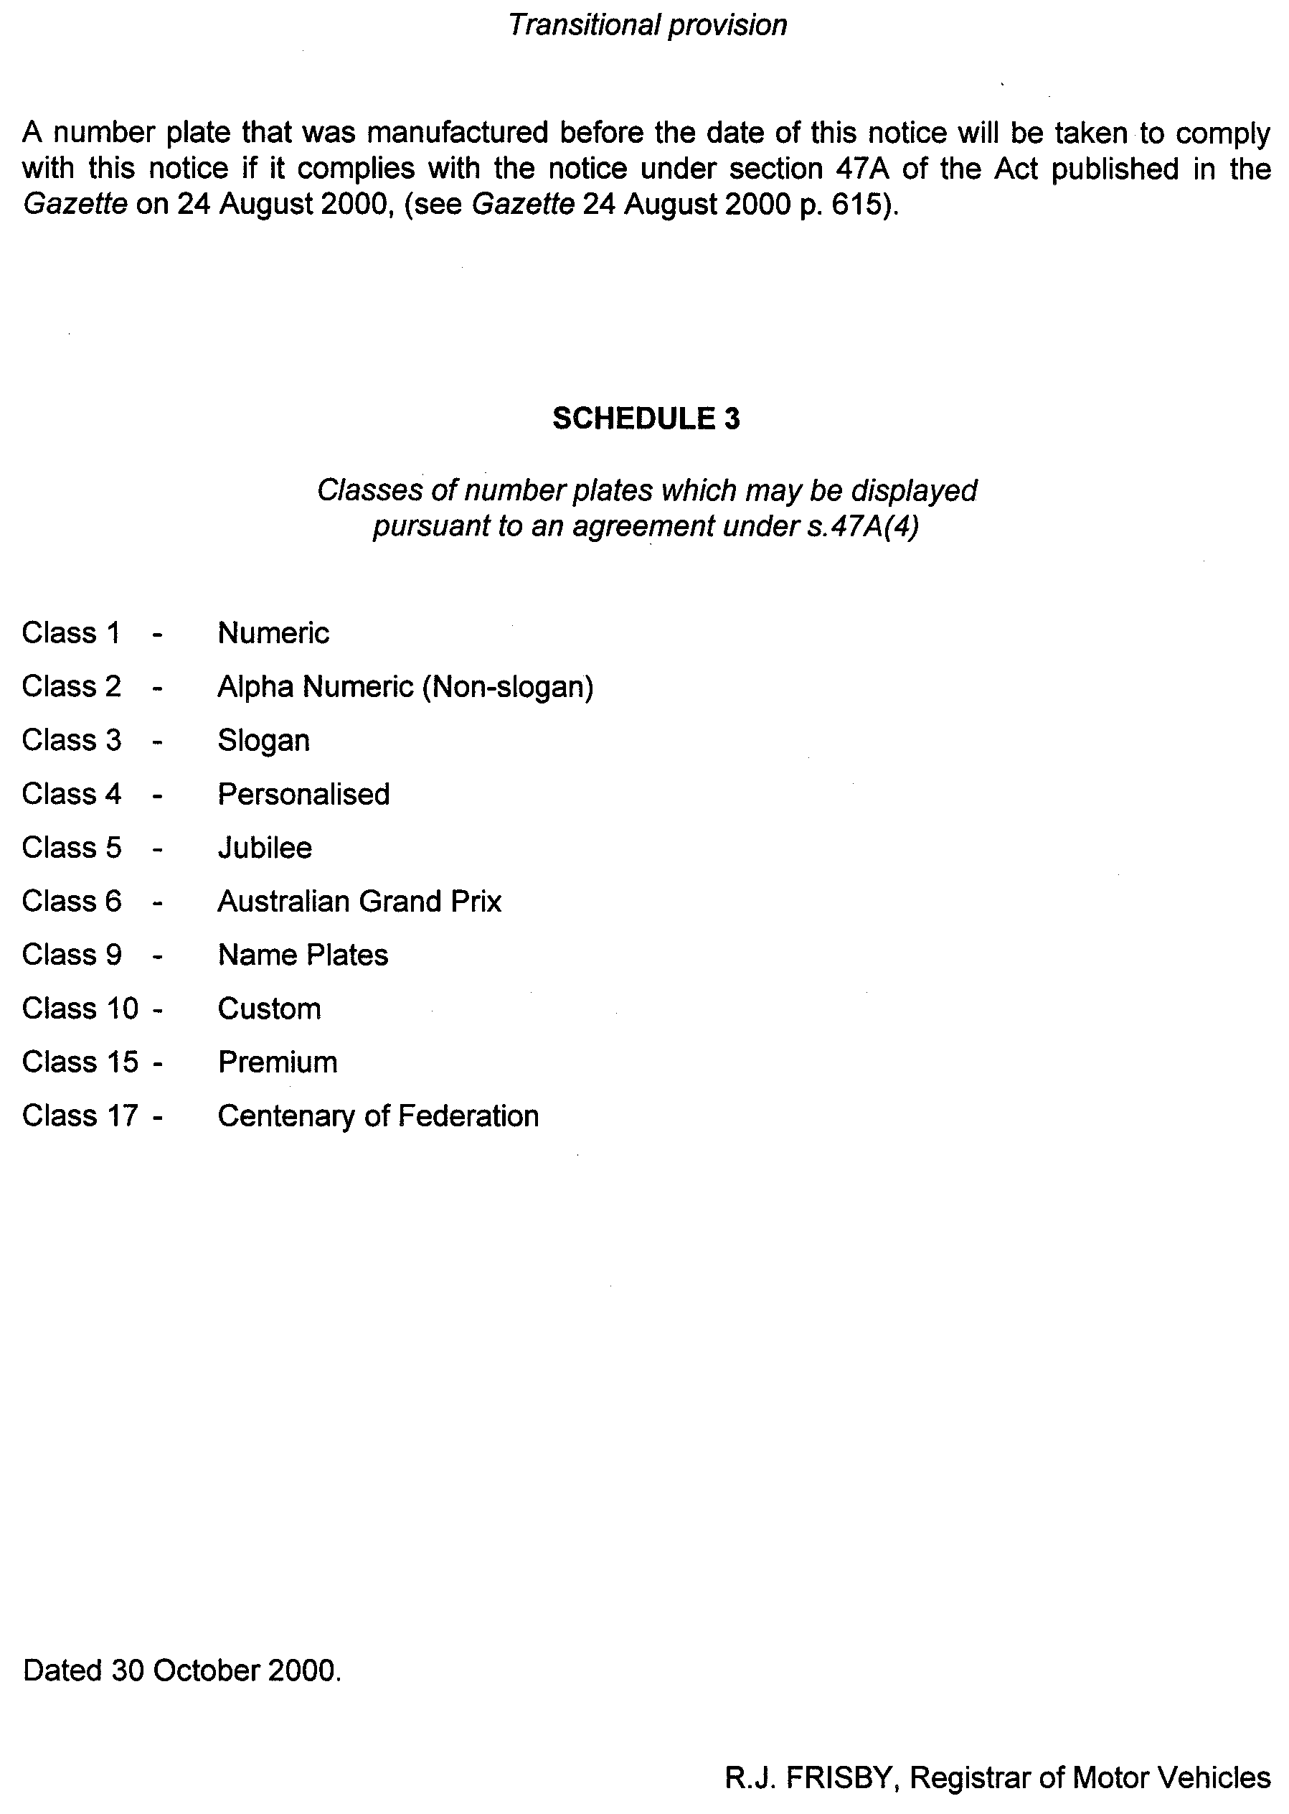

SURVEY ACT 1992
Designated Survey Areas
PURSUANT to section 49 (1) (b) of the Survey Act 1992, I declare that from 1 February 2001:
• designated survey area number 88 is revoked, and
• the following areas of the State, numbered 88, 104, 112, 113, 114, 115 and 116 outlined in black on the following plans, to be designated survey areas.

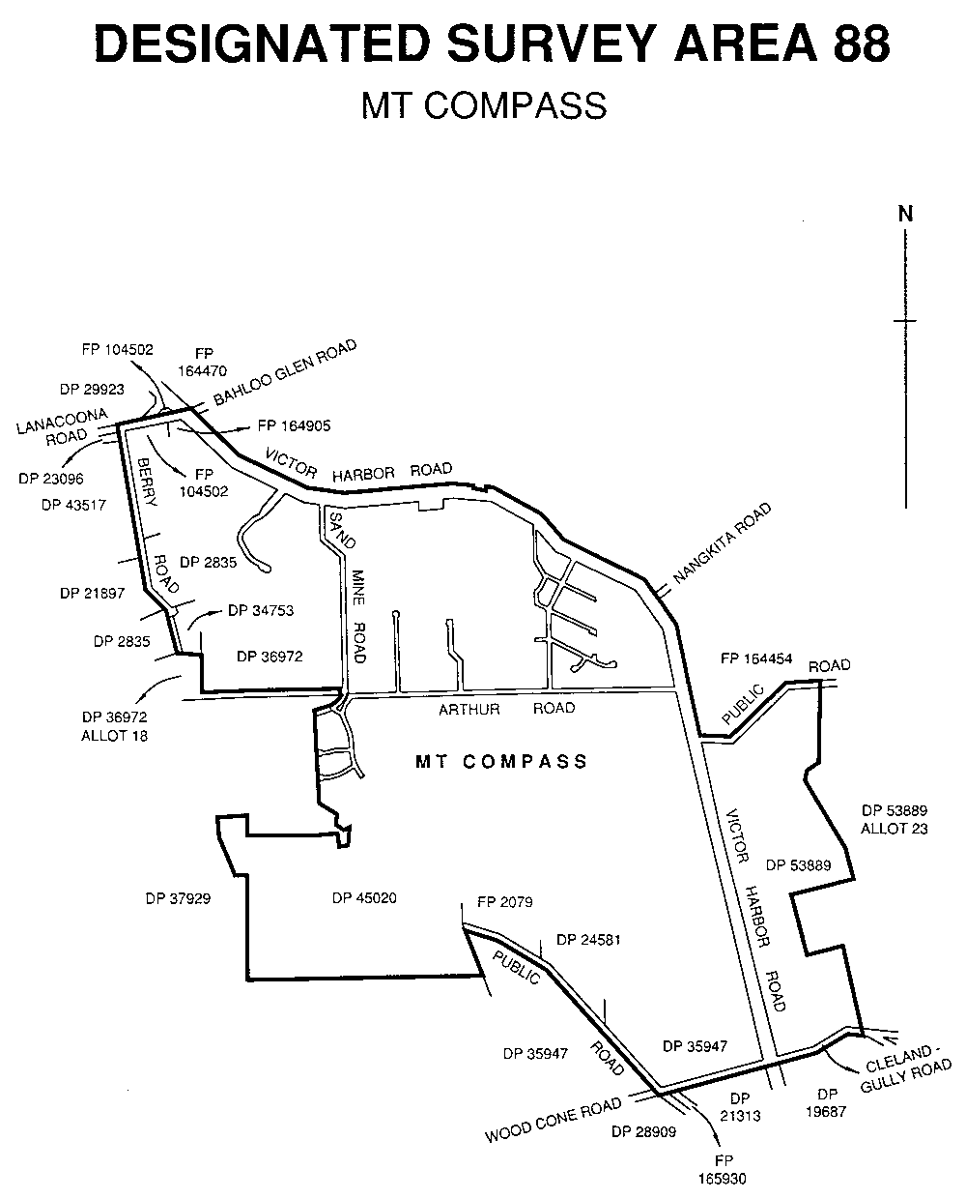

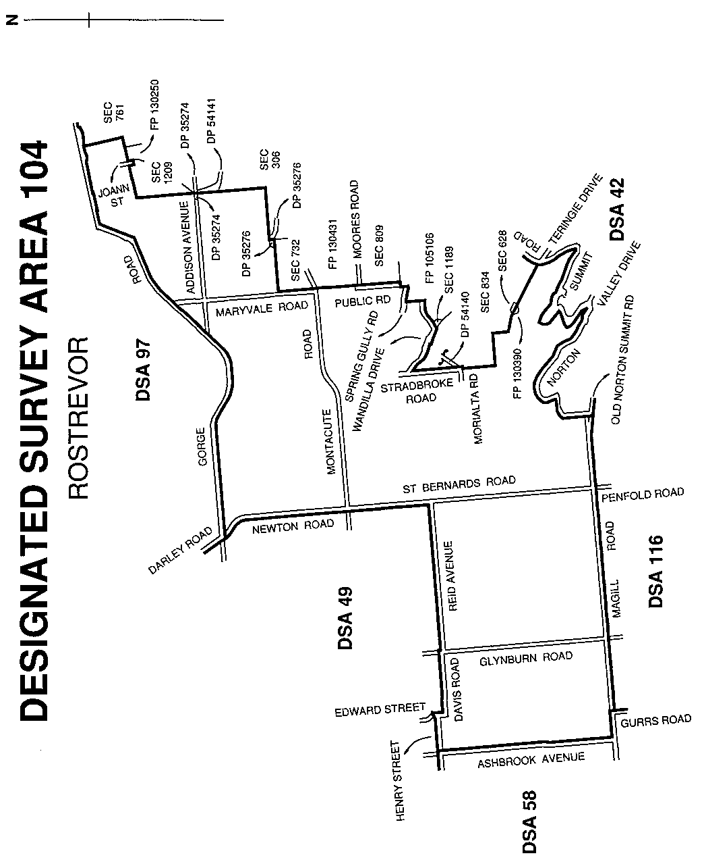

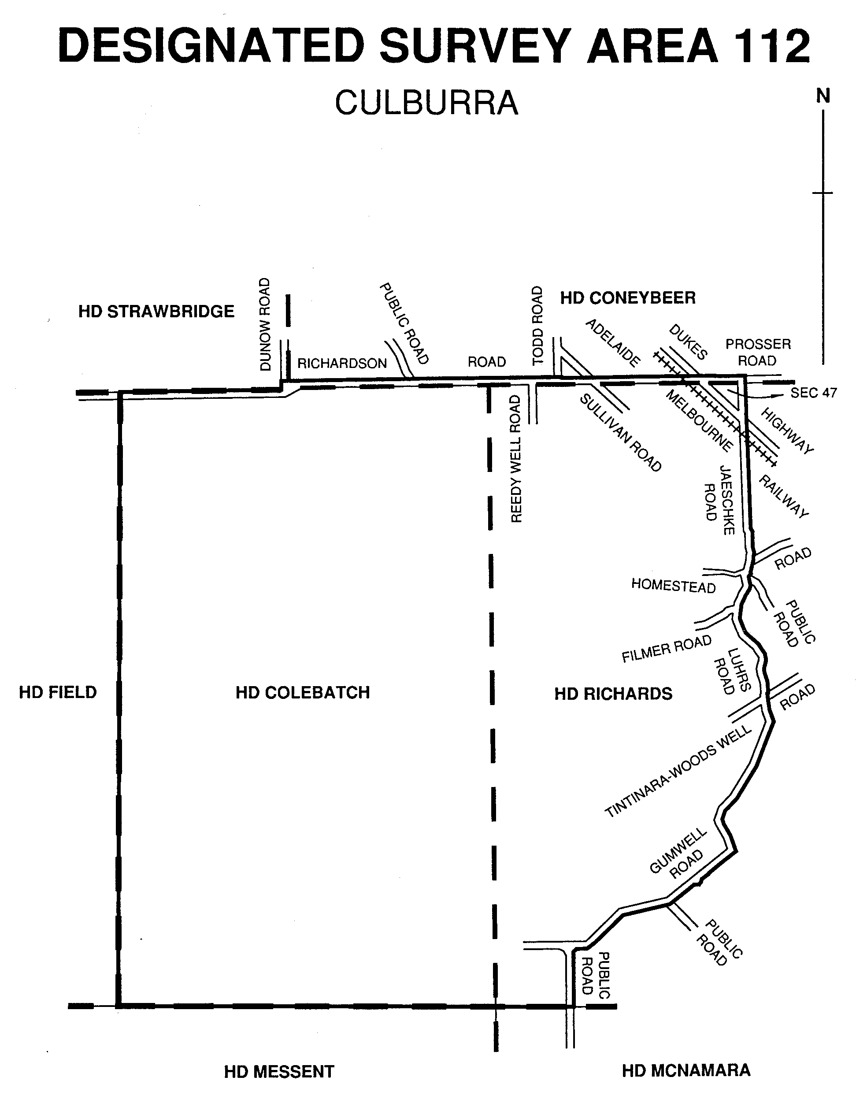

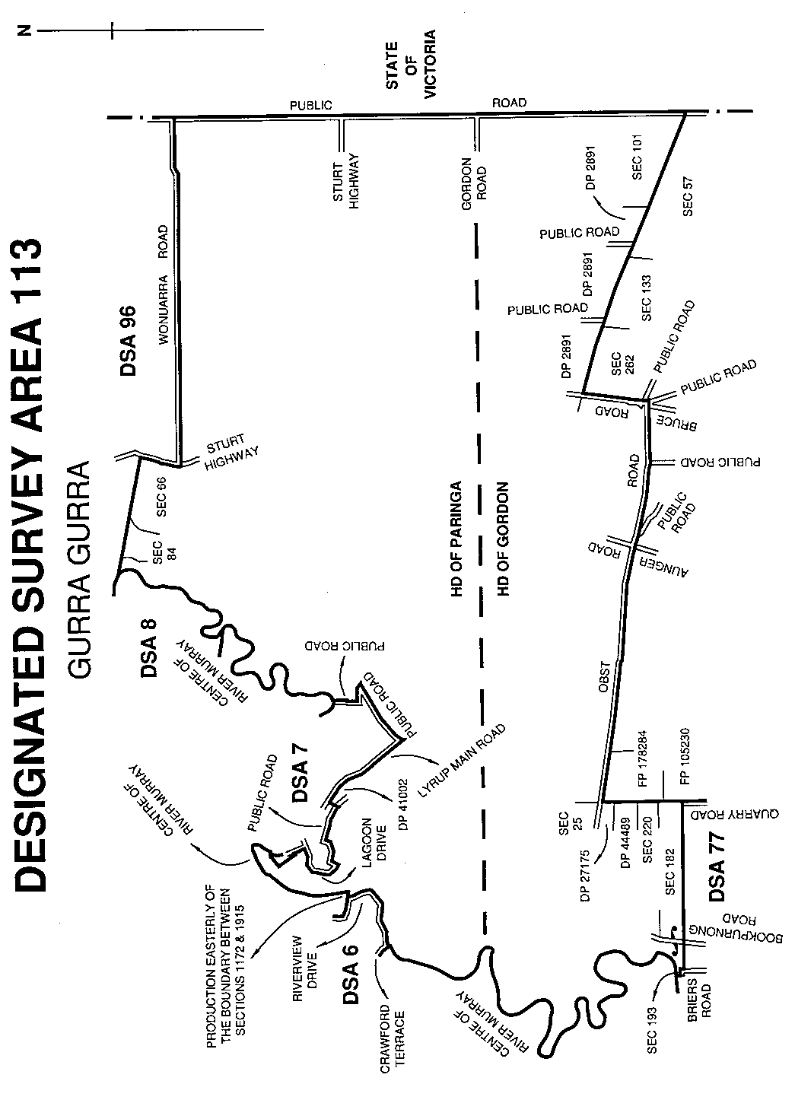

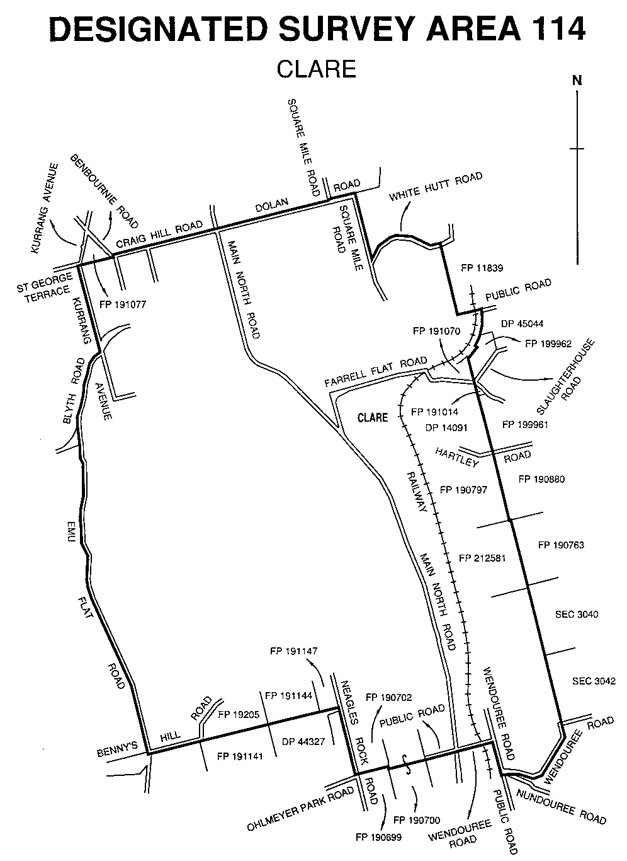

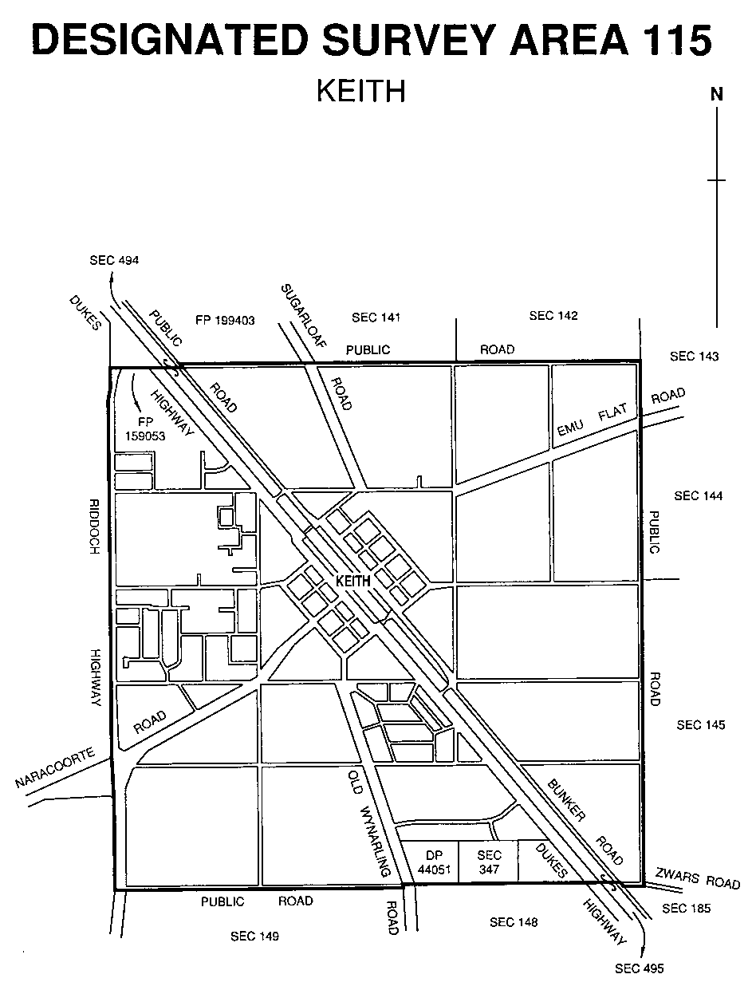
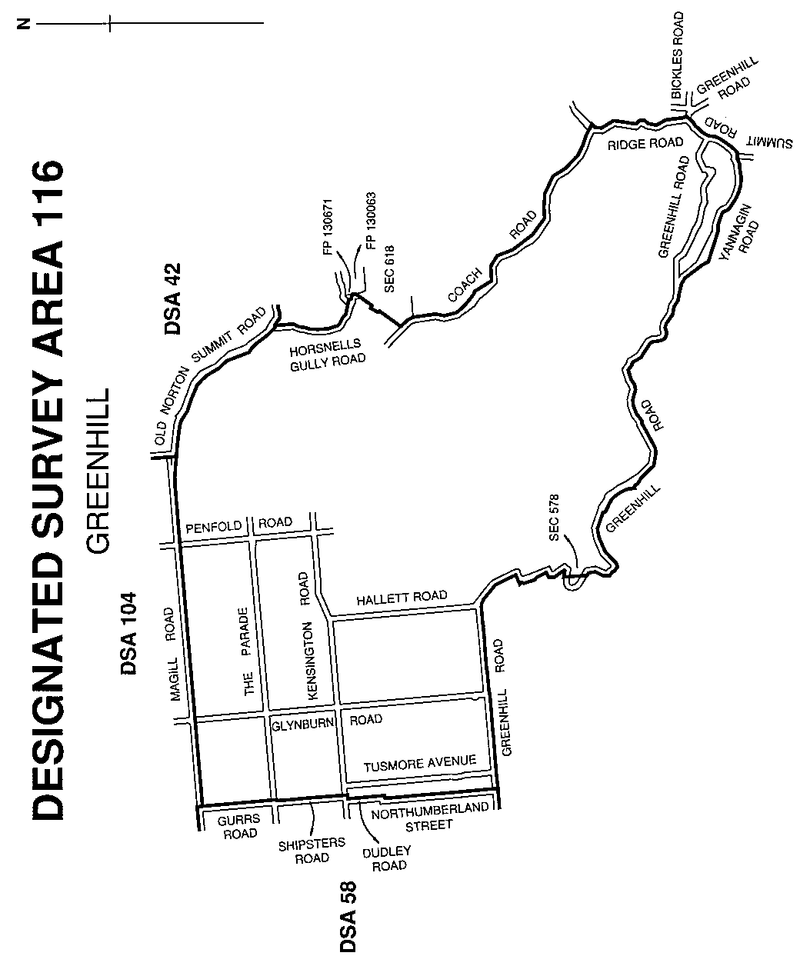

Dated 2 November 2000.
K. Sarneckis, Acting Surveyor-General

NOTICE TO MARINERS
No. 23 of 2000
South Australia—Spencer Gulf—Port Bonython—Buoy Off Station
MARINERS are advised that the No.5 starboard hand channel marker in approximate position Latitude 33°02.8′S, Longitude 137°45.5′E has been reported off station.
The buoy will be returned to station in approximately three weeks.
Mariners are advised to proceed with caution in the vicinity.
Navy Charts affected: Aus 136, 344, 444 and 778.
Publication affected: Australia Pilot Vol.1 (Seventh Edition 1992) pages 102 and 103.
Adelaide, 5 September 2000.
Diana Laidlaw, Minister for Transport and Urban Planning
TSA 2000/02079

NOTICE TO MARINERS
No. 24 of 2000
South Australia—Spencer Gulf—Port Pirie—Dredging Operations
MARINERS are advised that a suction cutter dredge will be conducting Dredging Operations in the Inner Harbor of Port Pirie commencing Monday, 18 September 2000 and continuing for approximately one month.
The dredging, which will take place at various berths, will alternate in response to shipping movements. The dredger will either be on the far west or far east of the channel and small vessels should pass via the displayed dredging signals.
During operations, a submerged pipeline will extend in a straight line from the berth being dredged to the eastern shore. Depths of water over the pipeline should be considered one metre shallower than expected.
Whilst in position, the dredger will exhibit the appropriate lights and shapes required by the international regulations for the prevention of collisions at sea.
Notice to traverse the river will be given by the Port Pirie pilot.
Navy Chart affected: Aus 136
Publication affected: Australian Pilot, Volume 1 (Seventh Edition, 1992) pages 105 and 106.
Adelaide, 7 September 2000.
Diana Laidlaw, Minister for Transport and Urban Planning
PCSA 99/0002

NOTICE TO MARINERS
No. 25 of 2000
South Australia—Gulf St Vincent—Port Adelaide River—Birkenhead Bridge Routine Maintenance
TRANSPORT SA advises that the Birkenhead Bridge will be temporarily closed to marine traffic from 0900 hrs to 1600 hrs from Wednesday, 13 September 2000 until Friday, 15 September 2000 and from Monday, 18 September 2000 until Thursday, 21 September 2000 to allow for routine maintenance to be carried out.
This restriction may need to be extended depending on the speed of repairs and/or inclement weather.
Mariners are advised that any river traffic relying on the opening of the bridge will be unable to pass during the time of closure. The exception to this will apply to emergency watercraft, which will be granted access if necessary.
Navy Chart affected: Aus 137.
Local Chart affected: Port Adelaide and Approaches.
Adelaide, 7 September 2000
Diana Laidlaw, Minister for Transport and Urban Planning
TSA 99/01794

NOTICE TO MARINERS
No. 26 of 2000
South Australia—Gulf St Vincent—North Haven—Flare Demonstration
MARINERS are advised that between 1200 hrs and 1330 hrs on Sunday, 24 September 2000, the Cruising Yacht Club of South Australia Inc. will be conducting flare demonstrations on the lawn to the east of their clubhouse on Lady Gowrie Drive, North Haven. The flares being demonstrated will be the hand-held orange smoke signal type.
Navy Charts affected: Aus 137, 780 and 781.
Local Charts affected: Port Adelaide and Approaches, Gulf St Vincent and Torrens Island & Environs.
Adelaide, 12 September 2000.
Diana Laidlaw, Minister for Transport and Urban Planning
TSA 98/07633

NOTICE TO MARINERS
No. 27 of 2000
South Australia—Thevenard—Yatala Channel—New Channel Beacons Established
Former Notices Nos. 17 and 19 of 2000
MARINERS are advised that the No. 6 and No. 8 Channel Beacons on the approaches to Thevenard, which were referred to in previous notices, have been re-established in the following AGD 84 coordinate positions:
No. 6 Beacon—Latitude 32°11′06.6612″S, Longitude 133° 36′ 05.7885″E.
No. 8 Beacon—Latitude 32°11′09.3996″S, Longitude 133° 36′ 22.8692″E.
All other characteristics remain the same.
Navy Chart affected: Aus 120.
Publications affected: Australian Pilot, Volume 1 (7th Edition, 1992) pages 72-74.
Admiralty List of Lights and Fog Signals, Volume K Nos. 1826.5 and 1827.5
Adelaide, 3 October 2000.
Diana Laidlaw, Minister for Transport and Urban Planning
PCSA 2000/0158

NOTICE TO MARINERS
No. 28 of 2000
South Australia—Spencer Gulf—Whyalla—Outer Harbour—Channel Beacon Non-operational
MARINERS are advised that the No. 3 Beacon in the Outer Harbour Channel of the Port of Whyalla has been reported non-operational. Repairs should be completed within three weeks.
Mariners are advised to proceed with caution in the vicinity.
Navy Chart affected: Aus 136, 344, 444 and 778.
Publications affected: Australian Pilot, Volume 1 (7th Edition, 1992) pages 100–103.
Admiralty List of Lights and Fog Signals, Volume K No. 1935.4.
Adelaide, 4 October 2000.
Diana Laidlaw, Minister for Transport and Urban Planning
TSA-2000/02079

NOTICE TO MARINERS
No. 29 of 2000
South Australia—Thevenard—Yatala Channel—Temporary Buoy Placed
Former Notice No. 27 of 2000
MARINERS are advised that a temporary buoy (R Fl 4s) without a day mark has been placed in the approximate location of the original No. 6 Channel Beacon (AGD 84 coordinates Latitude 32° 11′07.172″ S, Longitude 133°36′06.875″E) marking the edge of the channel. This buoy will be in place until further notice.
The No. 6 Port Hand Beacon referred to in the previous notice, which is 32 m to the west of this temporary buoy, is to be ignored as a channel marker. The red light on this beacon has been changed to white. All other characteristics remain the same.
Mariners are advised to proceed with caution in the vicinity of these marks.
Navy Chart affected: Aus 120.
Publications affected: Australian Pilot, Volume 1 (7th Edition, 1992) pages 72-74.
Adelaide, 17 October 2000.
Diana Laidlaw, Minister for Transport and Urban Planning
PCSA 2000/0158

NOTICE TO MARINERS
No. 30 of 2000
South Australia—Gulf St Vincent—Port Vincent—Yachting Buoys Laid
MARINERS are advised that the Port Vincent Sailing Club have set unlit marker buoys off Port Vincent from 8 October 2000 until 16 April 2001.
The colour and approximate locations of these buoys in WGS84 coordinates are:
2 vertical black buoys Latitude 34°46.39'S, Longitude 137°52.33′E Latitude 34°46.28′S, Longitude 137°52.98′E.
1 vertical black buoy Latitude 34°45.62'S, Longitude 137°51.80′E.
2 vertical black buoys Latitude 34°46.10'S, Longitude 137°51.80′E.
1 vertical black buoy Latitude 34°46.61'S, Longitude 137°51.80′E.
2 horizontal black and yellow check buoys Latitude 34°46.61'S, Longitude 137°51.80′E.
Navy Charts affected: Aus 345, 444, 780 and 781.
Local Charts affected: Port Vincent and Gulf St Vincent.
Publication affected: Australia Pilot, Vol.1 (Seventh Edition, 1992), page 133.
Adelaide, 18 October 2000.
Diana Laidlaw, Minister for Transport and Urban Planning
TSA 99/08816

NOTICE TO MARINERS
No. 31 of 2000
South Australia—River Murray—Goolwa—Hindmarsh Island Bridge—Construction Operations
Former Notice No. 26 of 1999
DURING the month of November 2000, the clearance to the pool level of the River Murray under the Hindmarsh Island Bridge at Goolwa of the navigable channel will be limited to 11.8 m due to a deck form walkway being suspended beneath the bridge. The walkway will be marked by a white strobe light at each end.
Mariners are advised to proceed with caution in the vicinity of the bridge during this phase of the construction.
Local Charts affected: Lower Murray and Lakes and Lower Murray.
Adelaide, 25 October 2000.
Diana Laidlaw, Minister for Transport and Urban Planning
TSA 97/14877

ROADS (OPENING AND CLOSING) ACT 1991:
SECTION 24
NOTICE OF CONFIRMATION OF ROAD
PROCESS ORDER
Decaux Road, Hope Forest
Deposited Plan 55696
BY Road Process Order made on 8 August 2000, the Alexandrina Council ordered that:
1. The whole of the public road (Decaux Road) extending westerly from Francis Road to the eastern boundary of allotment 1 in Deposited Plan 26239, more particularly delineated and lettered ‘A’ in Preliminary Plan No. PP32/0577 be closed.
2. Vest in the Crown the whole of the closed road and add that land to section 927 Hundred of Kuitpo which land is dedicated under the Crown Lands Act 1929 for Water Reserve purposes.
On 12 September 2000 that order was confirmed by the Minister for Administrative and Information Services, conditionally on approval and deposit of the survey plan by the Registrar-General. The condition has now been fulfilled.
Pursuant to section 24(5) of the Roads (Opening and Closing) Act 1991, NOTICE of the order referred to above and its confirmation is hereby given.
Dated 2 November 2000.
P. M. Kentish, Surveyor-General

REGULATIONS UNDER THE FIREARMS ACT 1977
────
No. 257 of 2000
────
At the Executive Council Office at Adelaide 2 November 2000

PURSUANT to the Firearms Act 1977 and with the advice and consent of the Executive Council, I make the following regulations.
E. J. NEAL Governor

PURSUANT to section 10AA(2) of the Subordinate Legislation Act 1978, I certify that, in my opinion, it is necessary or appropriate that the following regulations come into operation as set out below.

K. T. GRIFFIN Minister for Justice
───────────────────
SUMMARY OF PROVISIONS

1. Citation
2. Commencement
3. Insertion of reg. 12A
12A. Checks to be made by the Registrar
4. Insertion of reg. 24A
24A. Checks to be made by the Registrar
5. Insertion of reg. 49
49. International visitor firearms permits
6. Variation of reg. 50—Exemption of persons from outside the State
───────────────────

Citation
1. The Firearms Regulations 1993 (see Gazette 29 April 1993 p. 1482), as varied, are referred to in these regulations as "the principal regulations".

Commencement
2. These regulations come into operation on the day on which they are made.

Insertion of reg. 12A
3. The following regulation is inserted in Part 3 Division 1 after regulation 12 of the principal regulations:

Checks to be made by the Registrar
12A. Before granting an application for a firearms licence or to renew or vary a firearms licence, the Registrar must check the application against the checklist adopted for that purpose by the Australasian Police Minister's Council.

Insertion of reg. 24A
4. The following regulation is inserted after regulation 24 of the principal regulations:

Checks to be made by the Registrar
24A. Before granting an application for a permit to acquire a firearm, the Registrar must check the application against the checklist adopted for that purpose by the Australasian Police Minister's Council.

Insertion of reg. 49
5. The following regulation is inserted after regulation 48 of the principal regulations:

International visitor firearms permits
49. (1) The Registrar may, on the application of a visiting shooter, issue an international visitor firearms permit to the shooter.

(2) The application—

(a) must be in a form approved by the Registrar; and

(b) must include, or be accompanied by, such information as the Registrar requires.

(3) The applicant must—

(a) provide such further information as the Registrar requires in order to determine the application; and

(b) provide all information in connection with the application in the form required by the Registrar; and

(c) provide such proof of the information supplied as the Registrar requires.

(4) A permit—

(a) may be issued for such term and subject to such conditions as the Registrar thinks fit; and

(b) may be varied or revoked by the Registrar at any time.

(5) A permit issued under this regulation—

(a) must identify the firearm or firearms to which it applies;

(b) must not be issued in relation to a class D firearm or a prescribed firearm.

(6) A visiting shooter may possess and use a firearm in South Australia for the purpose of, or for a purpose related to, competitive shooting in accordance with an international visitor firearms permit issued to the shooter under this regulation or in accordance with a permit issued to the shooter under a law of another State or a Territory of the Commonwealth corresponding with this regulation.

(7) A visiting shooter referred to in subregulation (6) is exempt from each of the provisions of the Act and these regulations that he or she would otherwise be required to comply with in relation to activities authorised by the permit.

(8) In this regulation—

"visiting shooter" means a person who is visiting, or who intends visiting, Australia to participate in competitive shooting.

Variation of reg. 50—Exemption of persons from outside the State
6. Regulation 50 of the principal regulations is varied—

(a) by striking out "Subject to subregulation (1a)" from subregulation (1) and substituting "Subject to this regulation";

(b) by inserting the following subregulation after subregulation (1a):

(1b) A person who is entitled to apply for a permit under regulation 49 is not entitled under this regulation to possess or use a firearm in South Australia for the purpose of, or for a purpose related to, competitive shooting.

P 9/99 TC1 CS R. DENNIS Clerk of the Council

REGULATIONS UNDER THE OPTOMETRISTS ACT 1920
────
No. 258 of 2000
────
At the Executive Council Office at Adelaide 2 November 2000

PURSUANT to the Optometrists Act 1920 and with the advice and consent of the Executive Council, I make the following regulations.
E. J. NEAL Governor

PURSUANT to section 10AA(2) of the Subordinate Legislation Act 1978, I certify that, in my opinion, it is necessary or appropriate that the following regulations come into operation as set out below.

DEAN BROWN Minister for Human Services
───────────────────
SUMMARY OF PROVISIONS

1. Citation
2. Commencement
3. Variation of Sched. 5—Fees
───────────────────

Citation
1. The Optometrists Regulations 1996 (see Gazette 29 August 1996 p. 864) are referred to in these regulations as "the principal regulations".

Commencement
2. These regulations come into operation on 1 January 2001.

Variation of Sched. 5—Fees
3. Schedule 5 of the principal regulations is varied—

(a) by striking out from clause 1 "220.00" and substituting "240.00";

(b) by striking out from clause 3(a) "220.00" and substituting "240.00".

MH 030/001/008 CS R. DENNIS Clerk of the Council

REGULATIONS UNDER THE DEVELOPMENT ACT 1993
────
No. 259 of 2000
────
At the Executive Council Office at Adelaide 2 November 2000

PURSUANT to the Development Act 1993 and with the advice and consent of the Executive Council, I make the following regulations.
E. J. NEAL Governor

PURSUANT to section 10AA(2) of the Subordinate Legislation Act 1978, I certify that, in my opinion, it is necessary or appropriate that the following regulations come into operation as set out below.

DIANA LAIDLAW Minister for Transport and Urban Planning
───────────────────
SUMMARY OF PROVISIONS

1. Citation
2. Commencement
3. Variation of reg. 28—Special provision relating to fire authorities
4. Variation of reg. 78—Building Code: bushfire prone areas
5. Variation of reg. 83B—Swimming pools
6. Variation of reg. 88—Certificate of independent technical expert in respect of certain matters
7. Variation of Sched. 8
8. Variation of Sched. 9
───────────────────

Citation
1. The Development Regulations 1993 (see Gazette 27 October 1993 p. 1954), as varied, are referred to in these regulations as "the principal regulations".

Commencement
2. These regulations will come into operation on 2 November 2000.

Variation of reg. 28—Special provision relating to fire authorities
3. Regulation 28 of the principal regulations is varied by inserting after paragraph (c) of subregulation (1) the following word and paragraph:

or

(d) an extreme bushfire risk, as assessed in accordance with the provisions of Australian Standard 3959 Construction of Buildings in Bushfire Prone Areas, exists with respect to the site of the development and there are no relevant requirements in the Building Rules for a site that has been so assessed,.

Variation of reg. 78—Building Code: bushfire prone areas
4. Regulation 78 of the principal regulations is varied—

(a) by striking out "Part G5" and substituting "Performance Requirement GP5.1—Volume 1, and P2.3.4—Housing Provisions—Volume 2,";

(b) by inserting after its present contents (as varied by paragraph (a) and now to be designated as subregulation (1)) the following subregulation:

(2) If—

(a) application is made for provisional building rules consent for building work in the nature of an alteration to a Class 1, 2 or 3 building under the Building Code; and

(b) the building is in a bushfire prone area (as determined under subregulation (1)); and

(c) the total floor area of the building would, after the completion of the proposed building work, have increased by at least 50% when compared to the total floor area of the building as it existed 3 years before the date of the application (or, in the case of a building constructed since that time, as it existed at the date of completion of original construction),

then the relevant authority may require, as a condition of consent, that the entire building be brought into conformity with the relevant requirements of the Building Rules for bushfire protection.

Variation of reg. 83B—Swimming pools
5. Regulation 83B of the principal regulations is varied by inserting "—Volume 1, and P.2.5.3—Housing Provisions—Volume 2," after "GP1.2".

Variation of reg. 88—Certificate of independent technical expert in respect of certain matters
6. Regulation 88 of the principal regulations is varied—

(a) by inserting in paragraph (a) "—Volume 1" after "Part B1";

(b) by inserting in paragraph (b) "—Volume 1" after "Section E".

Variation of Sched. 8
7. Schedule 8 of the principal regulations is varied by inserting after item 13 the following items:

14. Crematoria

A. Development that involves the construction of a crematorium.

B. The Minister for the time being administering the Public and Environmental Health Act 1987.

C. Six weeks.

D. Direction.

15. Aquaculture development

A. Aquaculture development within a prescribed area, other than development which, in the opinion of the relevant authority, involves a minor alteration to an existing or approved development.

In this item—

"prescribed area" means any part of the coast within the meaning of the Coast Protection Act 1972, or any other waters of the sea within the State.

B. The Minister for the time being administering the Fisheries Act 1982.

C. Six weeks.

D. Direction.

Variation of Sched. 9
8. Schedule 9 of the principal regulations is varied by inserting after the present contents of clause 9 of Part 1 (now to be designated as subclause (1)) the following subclause:

(2) However, subclause (1)(c) does not apply if aquaculture development has been previously conducted on the same site, or on a site which, in the opinion of the relevant authority, is substantially the same, within the period of 2 years immediately preceding the date of the application.

MTUP-PL 46/00 CS R. DENNIS Clerk of the Council

REGULATIONS UNDER THE WATER RESOURCES ACT 1997
────
No. 260 of 2000
────
At the Executive Council Office at Adelaide 2 November 2000

PURSUANT to the Water Resources Act 1997, on the recommendation of the Minister for Water Resources and with the advice and consent of the Executive Council, I make the following regulations.
E. J. NEAL Governor

PURSUANT to section 10AA(2) of the Subordinate Legislation Act 1978, I certify that, in my opinion, it is necessary or appropriate that the following regulations come into operation as set out below.

MARK BRINDAL Minister for Water Resources
───────────────────
SUMMARY OF PROVISIONS

1. Citation
2. Commencement
3. Interpretation
4. Declaration of wells
5. The establishment and prescribed periods
6. Operation of s. 7(5) of the Act not excluded
───────────────────

Citation
1. These regulations may be cited as the Water Resources (Tintinara Coonalpyn Prescribed Wells Area) Regulations 2000.

Commencement
2. These regulations come into operation on the day on which they are made.

Interpretation
3. In these regulations—

"the Act" means the Water Resources Act 1997;

"the Tintinara Coonalpyn Prescribed Wells Area" means the area comprising the Hundreds of Archibald, Carcuma, Coneybeer, Coombe, Lewis, Livingston, McCallum, Makin and Richards.

Declaration of wells
4. Existing wells in the Tintinara Coonalpyn Prescribed Wells Area and wells drilled in that Area in the future are declared to be prescribed wells.

The establishment and prescribed periods
5. (1) The establishment period in relation to the Tintinara Coonalpyn Prescribed Wells Area commenced on 30 June 1995 and ended at the commencement of the prescribed period (11 May 2000).

(2) The prescribed period in relation to the Tintinara Coonalpyn Prescribed Wells Area commenced on 11 May 2000 and will end on 31 October 2002.

Operation of s. 7(5) of the Act not excluded
6. These regulations do not exclude the operation of section 7(5) of the Act.

WR00/0038CS R. DENNIS Clerk of the Council

REGULATIONS UNDER THE CONSTRUCTION INDUSTRY LONG SERVICE LEAVE ACT 1987
────
No. 261 of 2000
────
At the Executive Council Office at Adelaide 2 November 2000

PURSUANT to the Construction Industry Long Service Leave Act 1987 and with the advice and consent of the Executive Council, I make the following regulations.
E. J. NEAL Governor

PURSUANT to section 10AA(2) of the Subordinate Legislation Act 1978, I certify that, in my opinion, it is necessary or appropriate that the following regulations come into operation as set out below.

MICHAEL ARMITAGE Minister for Government Enterprises
───────────────────
SUMMARY OF PROVISIONS

1. Citation
2. Commencement
3. Variation of reg. 11—Services
───────────────────

Citation
1. The Construction Industry Long Service Leave Regulations 1988 (see Gazette 24 March 1988 p. 712), as varied, are referred to in these regulations as "the principal regulations".

Commencement
2. These regulations come into operation on the day on which they are made.

Variation of reg. 11—Services
3. Regulation 11 of the principal regulations is varied by striking out "1% is prescribed" from subregulation (1) and substituting "1.6 per cent is prescribed".

MWR 27/00 CS R. DENNIS Clerk of the Council

FAXING COPY?

IF you fax copy to Riverside 2000, for inclusion in the Government Gazette, there is no need to send a Confirmation Copy to us as well.

This creates confusion and may well result in your notice being printed twice.

Please use the following fax number:

Fax transmission: (08) 8207 1040
Phone Inquiries: (08) 8207 1045

Please include a contact person, phone number and order number so that we can phone back with any queries we may have regarding the fax copy.

NOTE: Closing time for lodging new copy (either fax or hard copy) is 4 p.m. on Tuesday preceding the day of publication.

Government Gazette notices can be E-mailed.

The address is:

Riv2000@saugov.sa.gov.au

Documents should be sent as attachments in Word format.

When sending a document via E-mail, please confirm your transmission with a faxed copy of your document, including the date the notice is to be published.

Fax transmission: (08) 8207 1040
Enquiries: (08) 8207 1045

CITY OF MOUNT GAMBIER
Development Act 1993
Central State Heritage Area—Draft for Public Consultation
NOTICE is hereby given that the City of Mount Gambier has prepared a draft Plan Amendment Report to amend the development plan as it affects the areas situated in the Mount Gambier (City) Development Plan.
The Plan Amendment Report will amend the Development Plan by the creation of a new heritage policy area within the City Centre Zone to incorporate the designated Area of State Heritage. The new Central State Heritage Area Policy Area brings together planning policies in relation to the conservation of the Cave Gardens and Environs area and the significant built elements of the State Heritage Area to reinforce the strong historic character of the locality. The introduction of the Central State Heritage Area Policy Area into the Development Plan gives status to the recommendations of the City of Mount Gambier Heritage Survey (1994). The Development Plan is amended by the following policy changes:
• designation of the Central State Heritage Area Policy Area;
• establish objectives and principles of development control applicable to the Central State Heritage Area Policy Area.
The draft Plan Amendment Report and statement will be available for public inspection and purchase during normal office hours at the City of Mount Gambier Council Office, 10 Watson Terrace, Mount Gambier, S.A. 5290, from Thursday, 2 November 2000 to Thursday, 11 January 2001. A copy of the Plan Amendment Report can be purchased from the Council for $10 each.
Written submissions regarding the draft amendment will be accepted by the City of Mount Gambier until Thursday, 11 January 2001. The written submission should also clearly indicate whether you wish to speak at the public hearing on your submission. All submissions should be addressed to the Chief Executive Officer, City of Mount Gambier, P.O. Box 56, Mount Gambier, S.A. 5290.
Copies of all submissions received will be available for inspection by interested persons at the City of Mount Gambier Council Office, 10 Watson Terrace, Mount Gambier, from Friday, 12 January 2001 until the date of the public hearing.
A public hearing will be held in the Reception Area, Civic Centre, 10 Watson Terrace, Mount Gambier on Tuesday, 23 January 2001 commencing at 7.30 p.m. The public hearing may not be held if no submission indicates an interest by its author to speak at the public hearing.
Dated 23 October 2000.
G. Muller, Chief Executive Officer

THE RURAL CITY OF MURRAY BRIDGE
Change of Meeting Dates
NOTICE is hereby given that the Rural City of Murray Bridge at its meeting held on Monday, 23 October 2000, resolved to hold only one meeting per month in December 2000 and January 2001. The dates for the these meetings are as follows:
Monday, 11 December 2000 commencing at 7 p.m.
Monday, 22 January 2001 commencing at 7 p.m.
R. J. Foster, Chief Executive Officer

CITY OF WHYALLA
Periodical Review of Elector Representation
NOTICE is hereby given that pursuant to the provisions of section 12 (5) of the Local Government Act 1999, the Corporation of the City of Whyalla is to carry out a review to determine whether a change of arrangements in respect to elector representation, including ward boundaries and the composition of council. This will result in the election of the council being more adequately and fairly represented.
Information regarding the nature of the periodical review is available from Darling Terrace, Whyalla, S.A. 5600, during opening hours or by contacting Phil Cameron on telephone 8640 3444.
Written submissions are invited from interested persons from 6 November 2000 and should be directed to the City Manager, P.O. Box 126, Whyalla, S.A. 5600, to be received by 5 p.m. on 22 December 2000.
Any person making a written submission will be also invited to appear before a meeting of council, or a council committee, to be heard in respect of their submission.
D. Knox, City Manager

THE BAROSSA COUNCIL
Temporary Street Closure
NOTICE is hereby given that pursuant to the provisions of section 359 of the Local Government Act 1934, as amended, The Barossa Council resolves that the following public road will be closed to all vehicles, except emergency vehicles and authorised service vehicles, between 11.15 a.m. and 12.15 p.m. on Thursday, 9 November 2000, for the staging of the Mock Motor Vehicle Accident:
Penrice Road, Nuriootpa—from Kokoda Road to Murray Street.
J. G. Jones, Chief Executive Officer

THE COORONG DISTRICT COUNCIL
Roads (Opening and Closing) Act 1991
Road Opening—Tailem Bend
NOTICE is hereby given, pursuant to section 10 of the Roads (Opening and Closing) Act 1991, that the Coorong District Council proposes to make a Road Process Order to open as road an irregularly shaped strip of piece 104 in Deposited Plan 28144 adjoining Allotment 102 in Deposited Plan 28144, more particularly delineated and numbered ‘106’ in Preliminary Plan No. PP32/0617.
A copy of the plan and a statement of persons affected are available for public inspection at the offices of the Council, 49 Princes Highway, Meningie and the Adelaide office of the Surveyor-General at Adelaide during normal office hours.
Any person is entitled to object to the proposed road process, or any person affected by the proposed opening is entitled to apply for an easement to be granted in that person’s favour over the land subject to the proposed opening. Such objection or application for an easement must set out the full name and address of the person making the objection or application and must be fully supported by reasons. Any application for an easement must give full particulars of the nature and location of the easement and where made by a person as the owner of adjoining or nearby land, specify the land to which the easement is to be annexed.
The objection or application for an easement must be made in writing to the Council, P.O. Box 28, Meningie, S.A. 5264 within 28 days of this notice and a copy shall be forwarded to the Surveyor-General, G.P.O. Box 1354, Adelaide, S.A. 5001. Where a submission is made, the council will give notification of a meeting at which the matter will be considered, so that the person making the submission or a representative may attend, if so desired.
Dated 2 November 2000.
W. R. Paterson, Chief Executive Officer

DISTRICT COUNCIL OF GRANT
Results of Supplementary Election
AT the conclusion of the scrutiny and count for a vacancy of Councillor for North East Ward, the following is the result of the Supplementary Election, after distribution of preferences:
Votes
Spehr, Alan 129
Hay, Albert 64
Wells, Peter 162 elected
Informal 0
⎯⎯⎯
Total 355
S. H. Tully, Returning Officer

KINGSTON DISTRICT COUNCIL
Results of Supplementary Election
NOTICE is hereby given of the results of the Supplementary Election for Woolmit Ward (one vacancy)—Quota 160.
Votes
Higgins, John 126 elected
Broadby, Michael H. 91
Mackereth, Michelle 91
Informal 3
⎯⎯⎯
Total 321
S. Rufus, Deputy Returning Officer

DISTRICT COUNCIL OF LOWER EYRE PENINSULA
Readvertised
Roads (Opening and Closing) Act 1991
NOTICE is hereby given, pursuant to section 10 of the Roads (Opening and Closing) Act 1991, that the District Council of Lower Eyre Peninsula proposes to make a Road Process Order to close and transfer to Eurasia Industries Pty Ltd the public road situated in section 111, Hundred of Louth and a northern portion of the public road situated in section 110, Hundred of Louth more particularly delineated and marked ‘A’ on Preliminary Plan No. PP 32/0184 and to open a new road through section 111 more particularly delineated and marked ‘1’ on Preliminary Plan No. PP 32/0184.
A copy of the plan and a statement of persons affected are available for public inspection at the offices of the District Council of Lower Eyre Peninsula, 32 Railway Terrace, Cummins, S.A. 5631, 38 Washington Street, Port Lincoln, S.A. 5606 and the Adelaide office of the Surveyor-General, 25 Pirie Street, Adelaide during normal office hours.
Any person is entitled to object to the proposed road process, or any person affected by the proposed closure is entitled to apply for an easement to be granted in that person’s favour over the land subject to the proposed closure. Such objection or application for an easement must set out the full name and address of the person making the objection or application and must be fully supported by reasons. Any application for an easement must give full particulars of the nature and location of the easement and where made by a person as the owner of adjoining or nearby land, specify the land to which the easement is to be annexed.
The objection or application for an easement must be made in writing to the District Council of Lower Eyre Peninsula, P.O. Box 41, Cummins, S.A. 5631 within 28 days of this notice and a copy shall be forwarded to the Surveyor-General, G.P.O. Box 1354, Adelaide, S.A. 5001. Where a submission is made, the council will give notification of a meeting at which the matter will be considered, so that the person making the submission or a representative may attend, if so desired.
Dated 2 November 2000.
P. W. Aird, District Clerk

DISTRICT COUNCIL OF LOXTON WAIKERIE
Temporary Street Closure
NOTICE is hereby given that at a meeting of council held on 20 October 2000, the following motion was passed:
The District Council of Loxton Waikerie, pursuant to section 359 of the Local Government Act 1934, as amended, hereby resolved that all vehicles with the exception of emergency vehicles are excluded from those roads listed in Column A during those times and dates listed in Column B, for the purpose of controlling traffic movements during the Christmas Lights Festival.
Column A | Column B
Hillbig Street: the western half of the carriageway from First Street in the north and Second Street in the south | 10 a.m. on Sunday, 26 Nov-ember 2000 to 10 a.m. on Tuesday, 2 January 2001
Drabsch Street: East Terrace crossover | 1 p.m. to 10 p.m. on Sunday, 26 November 2000  2 p.m. to 10 p.m. on Sunday, 10 December 2000  2 p.m. to 10 p.m. on Sunday, 17 December 2000
East Terrace: between Book-purnong Terrace and Scenic Drive | 3 p.m. to 10 p.m. on Sunday, 26 November 2000
East Terrace: eastern carriage-way between Drabsch Street crossover and Edward Street | 2 p.m. to 10 p.m. on Sunday, 10 December 2000
William Street and its con-tinuation, Scenic Drive between Henry Street and East Terrace | 2 p.m. to 10 p.m. on Sunday, 26 November 2000
East Terrace: Murray Street crossover | 3.30 p.m. to 6.30 p.m. on Sunday, 3, 10, 17 December 2000  4 p.m. to 6 p.m. on Thursday, 21 December 2000  2 p.m. to 4 p.m. on Sunday, 24 December 2000
Exemptions from the following Australian Road Rules is hereby granted by Council—Rule 230: Crossing a Road—General.
T. L. Burgemeister, District Manager

MID MURRAY COUNCIL
Roads (Opening and Closing) Act 1991
NOTICE is hereby given, pursuant to section 10 of the Roads (Opening and Closing) Act 1991, that the Mid Murray Council proposes to make a Road Process Order to close those portions of public road marked A and B on Preliminary Plan No. PP 32/0618. The closed road marked A is to be merged with allotment 4 in Deposited Plan 51827, Hundred of Ridley. The closed road marked B is to be merged with allotments 5 and 6 in Deposited Plan 51827, Hundred of Ridley.
The closed road is to be transferred to the Minister of Environment and Heritage and Peter Copley.
The preliminary plan and associated statements prepared pursuant to section 9 of the Roads (Opening and Closing) Act 1991 are available for examination to the public at the office of the Mid Murray Council, 49 Adelaide Road, Mannum and at the Adelaide office of the Surveyor-General, 101 Grenfell Street, Adelaide during normal office hours.
Any person who wishes to object to this proposal may lodge a written objection to the Mid Murray Council, P.O. Box 28, Mannum, S.A. 5238 and a copy forwarded to the Surveyor-General, 101 Grenfell Street, Adelaide, S.A. 5000 within 28 days of the date of this notice. Any objectors must include their full name and address, stating their reasons for objecting and stating whether or not they wish to make submissions to the Mid Murray Council at a meeting convened to consider such objections.
Any land owner adjoining or other person substantially affected by the closure may apply for an easement over all or part of the proposed road closure. Such application shall be in writing to the Mid Murray Council, P.O. Box 28, Mannum, S.A. 5238 and a copy must be forwarded to the office of the Surveyor-General, 101 Grenfell Street, Adelaide, S.A. 5000 within 28 days of the date of this notice. The applicants must include their full name and address giving particulars of the nature and location of the easement being applied for, specifying the land to which the easement is to be annexed and stating the reasons for the application for easement.
G. R. Brus, Chief Executive Officer

NARACOORTE LUCINDALE COUNCIL
Temporary Road Closure
NOTICE is hereby given that pursuant to section 33 of the Road Traffic Act 1961, council under its delegated authority declares the temporary road closures of the following streets from 10.30 a.m. until the completion of a street parade, on Saturday, 2 December 2000.
Ormerod Street—Railway Yard to DeGaris Place
McRae Street—Ormerod Street to Smith Street
Smith Street—McRae Street to DeGaris Place
DeGaris Place—Smith Street to Ormerod Street
and including:
Bank Place—Smith Street to Ormerod Street
Jones Street—Smith Street to Ormerod Street
D. L. Beaton, Chief Executive Officer

DISTRICT COUNCIL OF STREAKY BAY
Change of Meeting Date
NOTICE is hereby given that the ordinary council meeting for December will be held on Wednesday, 13 December 2000 in lieu of Wednesday, 20 December 2000, in the Council Chambers, 29 Alfred Terrace, Streaky Bay.
J. Rumbelow, General Manager

DISTRICT COUNCIL OF STREAKY BAY
Periodical Review
NOTICE is hereby given that pursuant to the provisions of section 12 (5) of the Local Government Act 1999, the District Council of Streaky Bay is to carry out a review to determine whether a change of arrangements in respect to elector representation would result in electors being more adequately and fairly represented.
The review will include whether the composition of council should be altered (number of Councillors) and if the two ward system should remain, although boundary adjustments may be required. Consideration will also be given to increasing the number of wards or to discarding the ward system.
Information regarding this review is available from the council office during normal office hours, telephone 8626 1001.
Written submissions are invited from interested persons and should be directed to the General Manager, District Council of Streaky Bay, 29 Alfred Terrace, or P.O. Box 179, Streaky Bay, S.A. 5680, and be received by 5 p.m. on Friday, 8 December 2000.
Any person providing a written submission will be given the opportunity to address council on their submission
J. Rumbelow, General Manager

DISTRICT COUNCIL OF STREAKY BAY
Readvertised
Roads (Opening and Closing) Act 1991
NOTICE is hereby given, pursuant to section 10 of the Roads (Opening and Closing) Act 1991, that the District Council of Streaky Bay proposes to make a Road Process Order to close and transfer to the Minister for Environment and Heritage public roads and portions of public roads situated adjacent to sections 89, 115 and 117, Hundred of Rounsevell more particularly delineated and marked ‘A’, ‘B’, ‘C’, ‘D’, ‘E’, ‘F’ and ‘G’ on Preliminary Plan No. PP 32/0423.
A copy of the plan and a statement of persons affected are available for public inspection at the offices of the District Council of Streaky Bay, 29 Alfred Terrace, Streaky Bay, S.A. 5680, and the Adelaide office of the Surveyor-General during normal office hours.
Any application for easement or objection must set out the full name, address and details of the submission and must be fully supported by reasons.
The application for easement or objection must be made in writing to the council, P.O. Box 179, Streaky Bay, S.A. 5680 within 28 days of the date of this notice and a copy must be forwarded to the Surveyor-General, G.P.O. Box 1354, Adelaide, S.A. 5001. Where a submission is made, the council will give notification of a meeting at which the matter will be considered.
Dated 2 November 2000.
P. M. Kentish, Surveyor-General

IN the matter of the estates of the undermentioned deceased persons:
Anderson, Royston Allan, late of 338 Railway Terrace, Osborne, retired plant attendant, who died on 29 September 2000.
Bradford, Colin Walter, late of North Terrace, Orroroo, retired revenue teller, who died on 17 June 2000.
Cook, Glenys Saxon, late of 404 Payneham Road, Glynde, widow, who died on 19 July 2000.
Davison, Vera Ivy, late of 26 River Road, Port Noarlunga, of no occupation, who died on 2 September 2000.
Draysey, Timothy Lloyd, late of 410 Kensington Road, Wattle Park, business consultant, who died on 3 July 2000.
Hamilton, Lionel Charles, late of 6 Booth Avenue, Linden Park, retired bank officer, who died on 20 September 2000.
Hansen, Helmet, late of Bean Street, Coober Pedy, of no occupation, who died on 5 March 2000.
Hector, Clara Anna Ottilie, late of 58 Fisher Street, Fullarton, of no occupation, who died on 10 May 1984.
Jones, Helen, late of 2 Belinda Crescent, Salisbury North, of no occupation, who died on 17 September 2000.
McDonald, Bertha Grace, late of Leighton Avenue, Klemzig, married woman, who died on 17 July 2000.
McLean, David Ross, late of 22 Le Hunte Avenue, Prospect, retired public servant, who died on 30 June 2000.
Meakins, Valda, late of 150 Adams Road, Craigmore, of no occupation, who died on 9 June 2000.
Megaw, Ruth Phyllis Ophelia, late of 17 Burton Avenue, Park Holme, home duties, who died on 19 September 2000.
Newton, Winifred Clarissa, late of 5 Maturin Road, Glenelg, widow, who died on 9 September 2000.
Ormsby, Marjorie, late of 437 Salisbury Highway, Parafield Gardens, of no occupation, who died on 1 June 2000.

Peake, William James, late of Ruwoldt Road, Yahl, retired mill hand, who died on 20 August 2000.
Powell, Arthur James Denville, late of Maude Street, Encounter Bay, retired technician, who died on 29 August 2000.
Reeves, Olive Gwendoline, late of 8 Brenchley Grove, Kingswood, retired secretary, who died on 15 September 2000.
West, Lily, late of 83 Edward Street, Ottoway, retired chef manageress, who died on 8 September 2000.
Notice is hereby given pursuant to the Trustee Act 1936, as amended, the Inheritance (Family Provision) Act 1972, and the Family Relationships Act 1975, that all creditors, beneficiaries, and other persons having claims against the said estates are required to send, in writing, to the Public Trustee, 25 Franklin Street, Adelaide, S.A. 5000, full particulars and proof of such claims, on or before 1 December 2000, otherwise they will be excluded from the distribution of the said estate; and notice is also hereby given that all persons who are indebted to the said estates are required to pay the amount of their debts to the Public Trustee or proceedings will be taken for the recovery thereof; and all persons having any property belonging to the said estates are forthwith to deliver the same to the Public Trustee.
Dated 2 November 2000.
J. H. Worrall, Public Trustee

IN the matter of the estate of the undermentioned deceased person:
Tolman, Anthea Lyle, late of 9 Clarence Avenue, Klemzig, S.A. 5087, who died on 6 April 2000.
Notice is hereby given pursuant to the Trustee Act 1936, as amended, the Inheritance (Family Provision) Act 1972-1975 and the Family Relationships Act 1975, that all creditors, beneficiaries and other persons having claims against the abovenamed estate are directed to send full particulars of such claims to the undermentioned on or before 25 November 2000, otherwise they will be excluded from the distribution of the said estate.
Perpetual Trustees S.A. Limited (ACN 008 273 916), c/o 5th Floor, 39 Hunter Street, Sydney, N.S.W. 2000.

SOUTH AUSTRALIA—In the Supreme Court No. 1764 of 1998. In the matter of Casual Living Products Pty Limited (in liquidation) (ACN 008 287 698) and in the matter of the Corporations Law.
Notice by a Liquidator of His Intention to Seek His Release
Take notice that I, David John Olifent, Pricewaterhouse-Coopers, Level 14, 91 King William Street, Adelaide, S.A. 5000, the liquidator of the abovenamed company, intend to make application to the Supreme Court of South Australia for my release as the liquidator of the abovenamed company.
And further take notice that if you have any objection to the granting of my release you must file at the Supreme Court and also forward to me within 21 days of the publication in the Gazette of the notice of my intention to apply for a release, a notice of objection in the form laid down by the Corporations (South Australia) Rules 1993. A summary of my receipts and payments as liquidator is available for inspection at my office.
Dated 27 October 2000.
D. J. Olifent, Liquidator
Note: Section 481 (3) of the Corporations Law enacts that an order of the court releasing the liquidator discharges him or her from all liability in respect of any act done or default made by him or her in the administration of the affairs of the company, or otherwise in relation to his or her conduct as liquidator, but any such order may be revoked on proof that it was obtained by fraud or by suppression or concealment of any material fact.

ATTENTION

CUSTOMERS requiring a proof of their notice for inclusion in the Government Gazette, please note that the onus is on you to inform Riverside 2000 of any subsequent corrections by 10 a.m. on Thursday, which is our publication deadline.

For any corrections to your notice please phone 8207 1045 or Fax 8207 1040 before 10 a.m. on Thursday.

If we do not receive any communication by 10 a.m. on Thursday (day of publication) we will presume the notice is correct and will print it as it is.

Remember—the onus is on you to inform us of any corrections necessary to your notice.

NOTE: Closing time for lodging new copy (either fax or hard copy) is 4 p.m. on Tuesday preceding the day of publication. Ph. 8207 1045—Fax 8207 1040.

Printed and published by authority every Thursday by M. G. O’CALLAGHAN, Government Printer, South Australia
Price: $4.30, plus postage; to subscribers, $214.85 per annum.
(The above prices are inclusive of GST)

