No. 182 3195

THE SOUTH AUSTRALIAN

GOVERNMENT GAZETTE

PUBLISHED BY AUTHORITY

ALL PUBLIC ACTS appearing in this GAZETTE are to be considered official, and obeyed as such

ADELAIDE, THURSDAY, 16 NOVEMBER 2000

CONTENTS

Page
Acts Assented To 3196
Animal and Plant Control (Agricultural and Other Purposes)
Act 1986—Notice 3197
Appointments, Resignations, Etc. 3196
Associations Incorporation Act 1985—Notice 3197
Corporations and District Councils—Notices 3221
Crown Lands Act 1929—Notice 3197
Development Act 1993—Notices 3198
Fisheries Act 1982—Notices 3198
Gaming Machines Act 1992—Notice 3207
Land and Business (Sale and Conveyancing) Act 1994—
Notices 3200
Liquor Licensing Act 1997—Notices 3200
Local Government Act 1999—Notice 3203
Mining Act 1971—Notices 3203
Mutual Recognition Act 1992—Notice 3203

Page
Private Advertisements 3223
Proclamations 3196
Public Trustee Office—Administration of Estates 3222
Radiation Protection and Control Act 1982—Notice 3206
REGULATIONS
Environment Protection Act 1993 (No. 262 of 2000) 3216
Forestry Act 1950 (No. 263 of 2000) 3218
Roads (Opening and Closing) Act 1991—Notices 3206
Road Traffic Act 1961—Notice 3207
Sale of Property 3223
Trans-Tasman Mutual Recognition Act 1997—Endorsement
of Regulations 3213
Vocational Education, Employment and Training Act
1994—
Contracts of Training 3208
Errata 3211

GOVERNMENT GAZETTE NOTICES
ALL poundkeepers’ and private advertisements forwarded for publication in the South Australian Government Gazette must be PAID FOR PRIOR TO INSERTION; and all notices, from whatever source, should be legibly written on one side of the paper only and sent to Riverside 2000 so as to be received no later than 4 p.m. Tuesday preceding the day of publication. Phone 8207 1045 or Fax 8207 1040. E-mail: Riv2000@saugov.sa.gov.au. Send as attachments in Word format and please confirm your transmission with a faxed copy of your document, including the date the notice is to be published and to whom the notice will be charged.

Department of the Premier and Cabinet
Adelaide, 9 November 2000
HIS Excellency the Governor directs it to be notified for general information that he has in the name and on behalf of Her Majesty The Queen, this day assented to the undermentioned Act passed by the Legislative Council and House of Assembly in Parliament assembled, viz.:
No. 64 of 2000: First Home Owner Grant (New Zealand Citizens) Amendment Act 2000.
By command,
Mark Brindal, for Premier
DPC 97/0415

Department of the Premier and Cabinet
Adelaide, 16 November 2000
HIS Excellency the Governor directs it to be notified for general information that he has in the name and on behalf of Her Majesty The Queen, this day assented to the undermentioned Act passed by the Legislative Council and House of Assembly in Parliament assembled, viz.:
No. 65 of 2000—Associations Incorporation (Oppressive or Unreasonable Acts) Amendment Act 2000.
By command,
Mark Brindal, for Premier
DPC 97/0415

ADMINISTRATIVE ARRANGEMENTS ACT 1994 SECTION 5: ADMINISTRATION OF SOUTH AUSTRALIAN FORESTRY CORPORATION ACT 2000 COMMITTED TO THE MINISTER FOR GOVERNMENT ENTER-PRISES
Proclamation By The Governor
(l.s.) E. J. Neal
PURSUANT to section 5 of the Administrative Arrangements Act 1994 and with the advice and consent of the Executive Council, I commit the administration of the South Australian Forestry Corporation Act 2000 to the Minister for Government Enterprises.
Given under my hand and the Public Seal of South Australia, at Adelaide, 16 November 2000.
By command,
Mark Brindal, for Premier
MGE 99/089 CS

ADMINISTRATIVE ARRANGEMENTS ACT 1994 SECTION 5: ADMINISTRATION OF STATE DISASTER ACT 1980 COMMITTED TO THE MINISTER FOR JUSTICE
Proclamation By The Governor
(l.s.) E. J. Neal
PURSUANT to section 5 of the Administrative Arrangements Act 1994 and with the advice and consent of the Executive Council, I commit the administration of the State Disaster Act 1980 to the Minister for Justice.
Given under my hand and the Public Seal of South Australia, at Adelaide, 16 November 2000.
By command,
Mark Brindal, for Premier
DPC 038/97 CS

ADMINISTRATIVE ARRANGEMENTS ACT 1994 SECTION 5: ADMINISTRATION OF RECREATIONAL GREEN-WAYS ACT 2000 COMMITTED TO THE MINISTER FOR RECREATION, SPORT AND RACING
Proclamation By The Governor
(l.s.) E. J. Neal
PURSUANT to section 5 of the Administrative Arrangements Act 1994 and with the advice and consent of the Executive Council, I commit the administration of the Recreational Greenways Act 2000 to the Minister for Recreation, Sport and Racing.
Given under my hand and the Public Seal of South Australia, at Adelaide, 16 November 2000.
By command,
Mark Brindal, for Premier
RS 99/0008CS

RECREATIONAL GREENWAYS ACT 2000 (Act No. 61 of 2000): DAY OF COMMENCEMENT
Proclamation By The Governor
(l.s.) E. J. Neal
WITH the advice and consent of the Executive Council, I fix 16 November 2000 as the day on which the Recreational Greenways Act 2000 will come into operation.
Given under my hand and the Public Seal of South Australia, at Adelaide, 16 November 2000.
By command,
Mark Brindal, for Premier
RS 99/0008CS

SOUTH AUSTRALIAN FORESTRY CORPORATION ACT 2000 (Act No. 58 of 2000): DAY OF COMMENCEMENT
Proclamation By The Governor
(l.s.) E. J. Neal
WITH the advice and consent of the Executive Council, I fix 1 January 2001 as the day on which the South Australian Forestry Corporation Act 2000 will come into operation.
Given under my hand and the Public Seal of South Australia, at Adelaide, 16 November 2000.
By command,
Mark Brindal, for Premier
MGE 99/089 CS

Department of the Premier and Cabinet
Adelaide, 16 November 2000
HIS Excellency the Governor in Executive Council has been pleased to appoint the undermentioned to the Legal Services Commission of South Australia, pursuant to the provisions of the Legal Services Commission Act 1977:
Member: (from 20 November 2000 until 19 November 2003)
Michael Carlisle Howard Burgess
By command,
Mark Brindal, for Premier
ATTG 51/00CS

Department of the Premier and Cabinet
Adelaide, 16 November 2000
HIS Excellency the Governor in Executive Council has been pleased to appoint the undermentioned to the Residential Tenancies Tribunal, pursuant to the provisions of the Residential Tenancies Act 1995:
Member: (from 1 December 2000 until 30 November 2002)
Harrison Juliet Anderson
Stuart Webb Andrew
Adrian John Bradbrook
Clive William Kitchin
Anthony Peter Moore
Thomas Mark Rymill
Roger Thomas Vincent
Douglas Wallace Stott
Andrew Henry Lenthal Swifte
Jane Caroline Welch
Pamela Wilkinson
By command,
Mark Brindal, for Premier
ATTG 7/99CS

Department of the Premier and Cabinet
Adelaide, 16 November 2000
HIS Excellency the Governor in Executive Council has been pleased to appoint the undermentioned to the South Australian Forestry Corporation, pursuant to the provisions of the South Australian Forestry Corporation Act 2000:
Member: (from 1 January 2001 until 31 December 2003)
Julie Ann Meeking
Sybella Blencowe
Warren Victor Wilson
David McLeod
Stephen James Duncan
By command,
Mark Brindal, for Premier
MGE 089/99CS

Department of the Premier and Cabinet
Adelaide, 16 November 2000
HIS Excellency the Governor in Executive Council has been pleased to appoint the undermentioned to the South Australian Forestry Corporation, pursuant to the provisions of the South Australian Forestry Corporation Act 2000:
Chairperson: (from 1 January 2001 until 31 December 2003)
Sybella Blencowe
By command,
Mark Brindal, for Premier
MGE 097/00CS

Department of the Premier and Cabinet
Adelaide, 16 November 2000
HIS Excellency the Governor in Executive Council has been pleased to declare ‘The District Council of the Cooper Coast
—Northern Yorke Peninsula (DC) Development Plan—Port Hughes Plan Amendment’ to be an authorised amendment and fix 16 November 2000, as the day on which it will come into operation, pursuant to section 27 (1) of the Development Act 1993.
By command,
Mark Brindal, for Premier
MTUP-PL 43/00CS

ANIMAL AND PLANT CONTROL (AGRICULTURAL AND OTHER PURPOSES) ACT 1986
Declaration of Rate
PURSUANT to the provisions of sections 31 (2) and 31 (4) of the Animal and Plant Control (Agricultural Protection and Other Purposes) Act 1986, the Animal and Plant Control Commission hereby declares, for the purposes of the said section concerning the Dingo Control Fund for the financial year ended 30 June 2000, the amount payable upon every square kilometre of rateable land to be three cents with a minimum amount payable by any person to be $25.
Dated 2 November 2000.
R. B. Wickes, Presiding Officer, Animal and Plant Control Commission

ASSOCIATIONS INCORPORATION ACT 1985
Deregistration of Associations
NOTICE is hereby given that the Corporate Affairs Commission approves the applications for deregistration received from the associations named below pursuant to section 43A of the Associations Incorporation Act 1985. Deregistration takes effect on the date of publication of this notice:
Archway Rehabilitation and Community Services Incor-porated
Hahndorf Commerce and Tourism Association Incorporated
The Harmony School of Music Incorporated
Julia Farr Community Services Incorporated
Dated 9 November 2000.
R. D. Burnell, A Delegate of the Corporate Affairs Commission

CROWN LANDS ACT 1929: SECTION 5
TAKE NOTICE that pursuant to the Crown Lands Act 1929, I KOSTAS SARNECKIS, Acting Surveyor-General and Delegate appointed by IAIN EVANS, Minister for Environment and Heritage, Minister of the Crown to whom the administration of the Crown Lands Act 1929 is committed DO HEREBY:
1. Resume the land defined in The First Schedule.
2. Dedicate the Crown Land defined in The Second Schedule as a Reserve for Community and Drainage Purposes and declare that such land shall be under the care, control and management of the City of Port Lincoln.
The First Schedule
Reserve for Community and Drainage Purposes, sections 675 and 688, Hundred of Lincoln, County of Flinders, the notice of which was published in the Government Gazette of 24 April 1991 at page 1409, The Second Schedule, being the whole of the land comprised in Crown Record Volume 5753 Folio 939.
The Second Schedule
Allotments 101 and 102 of DP 55761, Hundred of Lincoln, County of Flinders, exclusive of all necessary roads, subject nevertheless to an existing easement more particularly described in Certificate of Title Volume 5673 Folio 336 over those portions of allotments 101 and 102 marked A on DP 55761, and appurtenant to section 1231, Hundred of Lincoln.
Dated 14 November 2000.
K. Sarneckis, Acting Surveyor-General
DENR 08/0392

DEVELOPMENT ACT 1993, SECTION 28 (5): DECLARA-TION OF CESSATION OF INTERIM OPERATION OF THE CITY OF TEA TREE GULLY—HERITAGE PLAN AMENDMENT REPORT
Preamble
On 11 November 1999 the Governor, under Section 28 (1), declared the City of Tea Tree Gully—Heritage Plan Amendment Report as an amendment to come into interim operation without delay on that day. The Tea Tree Gully (City) Development Plan, consolidated on 11 November 1999, incorporated the provisions of the ‘Heritage Plan Amendment Report’.
The City of Tea Tree Gully—Heritage Plan Amendment Report has not been authorised by the Governor under Section 27 (1) within the required 12 month period.
Notice
PURSUANT to Section 28 (4) (c) of the Development Act 1993, the City of Tea Tree Gully—Heritage Plan Amendment Report ceases to operate under the Interim Operation Order proclaimed by the Governor on 11 November 1999.
Dated 16 November 2000.
Diana Laidlaw, Minister for Transport and Urban Planning
MFTUP CAB 32/99

DEVELOPMENT ACT 1993, SECTION 27 (1): THE DISTRICT COUNCIL OF THE COPPER COAST—NORTHERN YORKE PENINSULA (DC) DEVELOP-MENT PLAN—PORT HUGHES PLAN AMENDMENT
Preamble
The Minister for Transport and Urban Planning has approved the amendment entitled ‘The District Council of the Copper Coast—Northern Yorke Peninsula (DC) Development Plan—Port Hughes Plan Amendment’ (the Plan Amendment) and has referred it to the Governor.
Notice
PURSUANT to Section 27 (1) of the Development Act 1993, I, the Governor with the advice and consent of the Executive Council, declare the Plan Amendment to be an authorised Plan Amendment and fix 16 November 2000, as the day on which it will come into operation.
Dated 16 November 2000.
E. J. Neal, Governor
MTUP CAB 43/00CS

FISHERIES ACT 1982: SECTION 59
TAKE notice that pursuant to section 59 of the Fisheries Act 1982, Professor H. B. S. Womersley or his agents of the State Herbarium, P.O. Box 2732, Kent Town, S.A. 5069 and Department of Environmental Biology, University of Adelaide, North Terrace, Adelaide, S.A. 5000 (hereinafter referred to as the ‘exemption holder’), shall not be guilty of an offence when collecting marine algal (phycological) specimens in the waters specified in Schedule 1, subject to the conditions specified in Schedule 2 from the date of gazettal of this notice to 31 October 2001.
Schedule 1
Coastal marine waters of South Australia including aquatic reserves.
Schedule 2
1. Marine algal (phycological) specimens may be collected by the exemption holder for scientific purposes only.
2. Collections undertaken in aquatic reserves must be of a limited nature only and undertaken with due consideration of the concerns of other members of the public already in the aquatic reserves.
3. The exemption holder shall notify the PIRSA Fisheries and Aquaculture Compliance Unit on 1800 065 522 at least 24 hours prior to conducting the permitted activity in any aquatic reserve with the following information:
(a) the name of the person who will be conducting the permitted activity; and
(b) the intended area where the permitted activity will be undertaken.
4. The fisher shall not contravene or fail to comply with the Fisheries Act 1982 or any regulations made under the Act, except where specifically exempted by this exemption.
5. While engaging in the activities, the fisher shall have in his possession the copy of this notice. Such notice must be produced to a PIRSA Fisheries and Aquaculture Compliance Officer if such an officer requests that it be so produced.
Dated 13 November 2000.
W. Zacharin, Director of Fisheries

FISHERIES ACT 1982: SECTION 59
TAKE note that the notice made under section 59 of the Fisheries Act 1982, and published in the South Australian Government Gazette on page 2217, dated 26 September 2000, being the first notice on the page, referring to the use of an endorsed boat for recreational fishing, is hereby revoked.
Dated 13 November 2000.
W. Zacharin, Director of Fisheries

FISHERIES ACT 1982: SECTION 59
TAKE notice that pursuant to section 59 of the Fisheries Act 1982, Terry Scott (hereinafter referred to as the ‘exemption holder’), c/o Post Office, Coffin Bay, S.A. 5607 is exempt from sections 34 and 41 of the Fisheries Act 1982, but only insofar as the exemption holder may take Turbo (Turbo undulatis) (hereinafter referred to as the ‘exempted activity’) subject to the conditions in Schedule 1 for the purposes of trade or business.
Schedule 1
1. The exemption holder may engage in the exempted activity from the date of gazettal of this notice until 30 June 2001.
2. Fish may only be taken from South Australian coastal waters south of 36.6247°S and east of 136.5°E, other than the waters within 3 nautical miles of Kangaroo Island.
3. The exemption holder may take Turbo (Turbo undulatis) by diving and collection by hand.
4. The exemption holder may take no more than 200 kg of Turbo (Turbo undulatis) in any one calendar week.
5. The exemption holder must provide the Director of Fisheries statistical catch and effort information, (including zero returns if no fish have been collected) in the form of a written report, within 15 days of the completion of each calendar month. This report is to include the following information:
(i) the dates of fishing activity;
(ii) the exact locations of fishing activity;
(iii) the total weight of fish collected;
(iv) the mean average size of fish collected; and
(v) the weight and use of any fish sold.
6. The exemption holder shall notify the PIRSA Fisheries Compliance Unit on 1800 065 522 prior to conducting the exempted activity with the following information:
(i) details of the boat that will be used to engage in the exempted activity;
(ii) the intended area of conducting the exempted activity; and
(iii) the intended place and time of launching and retrieval of the nominated boat for that day.
7. PIRSA Fisheries retains the right for a departmental officer to accompany the exemption holder at any time during fishing operations.
8. While engaged in the exempted activity the exemption holder shall carry or have about or near his person a copy of this notice. Such notice must be produced to a PIRSA Fisheries Compliance Officer upon request.
9. The exemption holder shall not contravene or fail to comply with the Fisheries Act 1982, or any regulations made under that Act, except where specifically exempted by this notice.
Dated 14 November 2000.
W. Zacharin, Director of Fisheries


LAND AND BUSINESS (SALE AND CONVEYANCING) ACT 1994
Exemption
TAKE notice that, pursuant to section 23 (3) of the Land and Business (Sale and Conveyancing) Act 1994, I, Kenneth Trevor Griffin, Minister for Consumer Affairs, do hereby exempt the person named in Schedule 1 from the application of section 23 (2) of the Act in relation to the purchase of the land specified in Schedule 2.
Schedule 1
Ralph Adamo, an officer/employee of Neil Ottoson Real Estate Pty Ltd.
Schedule 2
The whole of the land described in certificate of title register book volume 5276, folio 925 situated at Allotment 8, Railway Terrace, Beachport, S.A. 5280.
Dated 16 November 2000.
Signed for and on behalf of the Minister for Consumer Affairs by the Commissioner for Consumer Affairs:
M. Bodycoat, Commissioner

LAND AND BUSINESS (SALE AND CONVEYANCING) ACT 1994
Exemption
TAKE notice that, pursuant to section 23 (3) of the Land and Business (Sale and Conveyancing) Act 1994, I, Kenneth Trevor Griffin, Minister for Consumer Affairs, do hereby exempt the person named in Schedule 1 from the application of section 23 (2) of the Act in relation to the purchase of the land specified in Schedule 2.
Schedule 1
Karen Ann Lombe, an officer/employee of Toop Real Estate Group Pty Ltd.
Schedule 2
The whole of the land described in certificate of title register book volume 5173, folio 122 situated at 17 Gray Street, Norwood, S.A. 5067.
Dated 16 November 2000.
Signed for and on behalf of the Minister for Consumer Affairs by the Commissioner for Consumer Affairs:
M. Bodycoat, Commissioner

LAND AND BUSINESS (SALE AND CONVEYANCING) ACT 1994
Exemption
TAKE notice that, pursuant to section 23 (3) of the Land and Business (Sale and Conveyancing) Act 1994, I, Kenneth Trevor Griffin, Minister for Consumer Affairs, do hereby exempt the person named in Schedule 1 from the application of section 23 (2) of the Act in relation to the purchase of the land specified in Schedule 2.
Schedule 1
Graham Clem Raven, an officer/employee of Carol Clark & E. Marcel Estates Pty Ltd.
Schedule 2
The whole of the land described in certificate of title register book volume 5244, folio 699 situated at 1 Alexander Avenue, Grange, S.A. 5022.
Dated 16 November 2000.
Signed for and on behalf of the Minister for Consumer Affairs by the Commissioner for Consumer Affairs:
M. Bodycoat, Commissioner

LIQUOR LICENSING ACT 1997 AND GAMING MACHINES ACT 1992
Notice of Application
NOTICE is hereby given, pursuant to section 52 of the Liquor Licensing Act 1997 and section 29 of the Gaming Machines Act 1992, that Gilmorgan Pty Ltd (ACN 008 229 031), c/o Wallmans Lawyers, 173 Wakefield Street, Adelaide, S.A. 5000 has applied to the Liquor and Gaming Commissioner for the transfer of a Hotel Licence and Gaming Machine Licence in respect of premises situated at Makin Street, Keith, S.A. 5267 and known as Keith Hotel.
The applications have been set down for hearing on 15 December 2000.
Any person may object to the application by lodging a notice of objection in the prescribed form with the Licensing Authority, and serving a copy of the notice on the applicant at the applicant’s address given above, at least seven days before the hearing date.
Plans in respect of the premises the subject of the application are open to public inspection without fee at the Office of the Liquor and Gaming Commissioner, 9th Floor, East Wing, 50 Grenfell Street, Adelaide, S.A. 5000.
Dated 9 November 2000.
Applicant

LIQUOR LICENSING ACT 1997 AND GAMING MACHINES ACT 1992
Notice of Application
NOTICE is hereby given, pursuant to section 52 of the Liquor Licensing Act 1997 and section 29 of the Gaming Machines Act 1992, that NLSR Pty Ltd (ACN 006 601 609), c/o Wallmans Lawyers, 173 Wakefield Street, Adelaide, S.A. 5000 has applied to the Liquor and Gaming Commissioner for the transfer of a Hotel Licence and Gaming Machine Licence in respect of premises situated at King Street, Port Lincoln, S.A. 5606 and known as Hotel Boston.
The applications have been set down for hearing on 15 December 2000.
Any person may object to the application by lodging a notice of objection in the prescribed form with the Licensing Authority, and serving a copy of the notice on the applicant at the applicant’s address given above, at least seven days before the hearing date.
Plans in respect of the premises the subject of the application are open to public inspection without fee at the Office of the Liquor and Gaming Commissioner, 9th Floor, East Wing, 50 Grenfell Street, Adelaide, S.A. 5000.
Dated 9 November 2000.
Applicant

LIQUOR LICENSING ACT 1997 AND GAMING MACHINES ACT 1992
Notice of Application
NOTICE is hereby given, pursuant to section 52 of the Liquor Licensing Act 1997 and section 29 of the Gaming Machines Act 1992, that Lambert Corporation Pty Ltd and K. & B. Lambert Corporation Pty Ltd, c/o 66 Wright Street, Adelaide, S.A. 5000 have applied to the Liquor and Gaming Commissioner for the transfer of a Hotel Licence and Gaming machine Licence in respect of premises situated at 2 Ryan Street, Moonta, S.A. 5558 and known as Royal Hotel.
The applications have been set down for hearing on 8 December 2000.
Any person may object to the application by lodging a notice of objection in the prescribed form with the Licensing Authority, and serving a copy of the notice on the applicants at the applicants’ address given above, at least seven days before the hearing date.
Plans in respect of the premises the subject of the application are open to public inspection without fee at the Office of the Liquor and Gaming Commissioner, 9th Floor, East Wing, 50 Grenfell Street, Adelaide, S.A. 5000.
Applicants

LIQUOR LICENSING ACT 1997
Notice of Application
NOTICE is hereby given, pursuant to section 52 (2) (b) of the Liquor Licensing Act 1997, that Stephanie Jane McLeod and Sean Patrick Kenny have applied to the Licensing Authority for the transfer of a Restaurant Licence and Entertainment Consent in respect of premises situated at 27 High Street, Willunga, S.A. 5172, currently known as Vanessa’s and to be known as Willy Hill Cafe.
The application has been set down for hearing on 8 December 2000.
Condition
The following licence condition is sought:
Entertainment consent is sought for the area outlined in blue on the deposited plan.
Any person may object to the application by lodging a notice of objection in the prescribed form with the Licensing Authority, and serving a copy of the notice on the applicants at the applicants’ address given above, at least seven days before the hearing date.
Plans in respect of the premises the subject of the application are open to public inspection without fee at the Office of the Liquor and Gaming Commissioner, 9th Floor, East Wing, 50 Grenfell Street, Adelaide, S.A. 5000.
Dated 8 November 2000.
Applicants

LIQUOR LICENSING ACT 1997
Notice of Application
NOTICE is hereby given, pursuant to section 52 (2) (b) of the Liquor Licensing Act 1997, that Evian Management No. 3 Pty Ltd, c/o Duncan Basheer Hannon has applied to the Licensing Authority for a Redefinition of Licensed Premises to include additional areas and drive through bottle shop in respect of premises situated at Lot 18, Griffiths Drive, Seaford, S.A. 5169 and known as Seaford Rise Tavern.
The application has been set down for hearing on 15 December 2000.
Any person may object to the application by lodging a notice of objection in the prescribed form with the Licensing Authority, and serving a copy of the notice on the applicant at the applicant’s address given above, at least seven days before the hearing date.
Plans in respect of the premises the subject of the application are open to public inspection without fee at the Office of the Liquor and Gaming Commissioner, 9th Floor, East Wing, 50 Grenfell Street, Adelaide, S.A. 5000.
Dated 7 November 2000.
Applicant

LIQUOR LICENSING ACT 1997
Notice of Application
NOTICE is hereby given, pursuant to section 52 (2) (b) of the Liquor Licensing Act 1997, that The Royal Zoological Society of South Australia Incorporated, Frome Road, Adelaide, S.A. 5000 has applied to the Licensing Authority for the grant of a Restaurant Licence in respect of premises situated at Monarto Zoological Park, Princes Highway, Monarto, S.A. 5254.
The application has been set down for hearing on 15 December 2000.
Any person may object to the application by lodging a notice of objection in the prescribed form with the Licensing Authority, and serving a copy of the notice on the applicant at the applicant’s address given above, at least seven days before the hearing date.
Plans in respect of the premises the subject of the application are open to public inspection without fee at the Office of the Liquor and Gaming Commissioner, 9th Floor, East Wing, 50 Grenfell Street, Adelaide, S.A. 5000.
Dated 7 November 2000.
Applicant

LIQUOR LICENSING ACT 1997
Notice of Application
NOTICE is hereby given, pursuant to section 52 (2) (b) of the Liquor Licensing Act 1997, that Caersbrook Vineyards Pty Ltd has applied to the Licensing Authority for a Producer’s Licence in respect of premises situated at Kookaburra Estate, Wellington Road, Langhorne Creek, S.A. 5255 and known as Tessamere Wines.
The application has been set down for hearing on 15 December 2000.
Any person may object to the application by lodging a notice of objection in the prescribed form with the Licensing Authority, and serving a copy of the notice on the applicant at the applicant’s address given above, at least seven days before the hearing date.
Plans in respect of the premises the subject of the application are open to public inspection without fee at the Office of the Liquor and Gaming Commissioner, 9th Floor, East Wing, 50 Grenfell Street, Adelaide, S.A. 5000.
Dated 2 November 2000.
Applicant

LIQUOR LICENSING ACT 1997
Notice of Application
NOTICE is hereby given, pursuant to section 52 (2) (b) of the Liquor Licensing Act 1997, that Croatian Sports Centre (SA) Inc., 15 Birralee Road, Regency Park, S.A. 5010 has applied to the Licensing Authority for a Club Licence with an Extended Trading Authorisation and Entertainment Consent in respect of premises situated at Lot 12, Main North Road Sports Park, Gepps Cross, S.A. 5094 and to be known as Croatian Sports Centre (SA) Inc.
The application has been set down for hearing on 15 December 2000.
Conditions
The following licence conditions are sought:
An Extended Trading Authorisation to authorise the sale of liquor for consumption on the licensed premises between the following hours:
Friday: midnight to 1.30 a.m. the following morning.
Saturday: midnight to 2 a.m. the following morning.
Sunday: 8 a.m. to 11 a.m. and 8 p.m. to 10 p.m.
Entertainment consent is sought for the licensed premises.
Any person may object to the application by lodging a notice of objection in the prescribed form with the Licensing Authority, and serving a copy of the notice on the applicant at the applicant’s address given above, at least seven days before the hearing date.
Plans in respect of the premises the subject of the application are open to public inspection without fee at the Office of the Liquor and Gaming Commissioner, 9th Floor, East Wing, 50 Grenfell Street, Adelaide, S.A. 5000.
Dated 9 December 2000.
Applicant

LIQUOR LICENSING ACT 1997
Notice of Application
NOTICE is hereby given, pursuant to section 52 (2) (b) of the Liquor Licensing Act 1997, that Maid For Us Pty Ltd (ACN 094 226 794), c/o Griffins Lawyers, Level 14, 26 Flinders Street, Adelaide, S.A. 5000 has applied to the Licensing Authority for an Extended Trading Authorisation in respect of premises situated at 1 Magill Road, Stepney, S.A. 5069 and known as the Maid and Magpie Hotel.
The application has been set down for hearing on 15 December 2000 at 9 a.m.
Conditions
The following licence conditions are sought:
Monday to Saturday: midnight to 3 a.m. the following day.
Sunday: 8 a.m. to 11 a.m. and 8 p.m. to midnight (excluding Christmas Day).
Any person may object to the application by lodging a notice of objection in the prescribed form with the Licensing Authority, and serving a copy of the notice on the applicant at the applicant’s address given above, at least seven days before the hearing date.
Plans in respect of the premises the subject of the application are open to public inspection without fee at the Office of the Liquor and Gaming Commissioner, 9th Floor, East Wing, 50 Grenfell Street, Adelaide, S.A. 5000.
Dated 10 November 2000.
Applicant

LIQUOR LICENSING ACT 1997
Notice of Application
NOTICE is hereby given, pursuant to section 52 (2) (b) of the Liquor Licensing Act 1997, that Yorke Peninsula Harness Racing Club has applied to the Licensing Authority for a Club Licence with an Extending Authorisation and Entertainment Consent in respect of premises situated at Agery Road, Kadina, S.A. 5554 and to be known as Yorke Peninsula Harness Racing Club.
The application has been set down for hearing on 15 December 2000 at 9 a.m.
Conditions
The following licence conditions are sought:
1. An extended trading authorisation, Monday, Friday and Saturday, midnight to 2 a.m. the following day.
2. Entertainment Consent.
Any person may object to the application by lodging a notice of objection in the prescribed form with the Licensing Authority, and serving a copy of the notice on the applicant at the applicant’s address given above, at least seven days before the hearing date.
Plans in respect of the premises the subject of the application are open to public inspection without fee at the Office of the Liquor and Gaming Commissioner, 9th Floor, East Wing, 50 Grenfell Street, Adelaide, S.A. 5000.
Dated 9 November 2000.
Applicant

LIQUOR LICENSING ACT 1997
Notice of Application
NOTICE is hereby given, pursuant to section 52 (2) (b) of the Liquor Licensing Act 1997, that Trevor John Spurr and William Thomas Spurr, 7 Olive Close, Glenside, S.A. 5121 have applied to the Licensing Authority for the transfer of a Producer’s Licence in respect of premises situated at Lot 1, Heaslip Road, Penfield, S.A. 5121 and known as Wilkie Estate Wines.
The application has been set down for hearing on 18 December 2000 at 10.30 a.m.
Any person may object to the application by lodging a notice of objection in the prescribed form with the Licensing Authority, and serving a copy of the notice on the applicants at the applicants’ address given above, at least seven days before the hearing date.
Plans in respect of the premises the subject of the application are open to public inspection without fee at the Office of the Liquor and Gaming Commissioner, 9th Floor, East Wing, 50 Grenfell Street, Adelaide, S.A. 5000.
Dated 9 November 2000.
Applicants

LIQUOR LICENSING ACT 1997
Notice of Application
NOTICE is hereby given, pursuant to section 52 (2) (b) of the Liquor Licensing Act 1997, that Red Company Pty Ltd (ACN 078 134 479), c/o Lee Green, First Floor, 133 Archer Street, North Adelaide, S.A. 5006 has applied to the Licensing Authority for the transfer of a Entertainment Venue Licence in respect of premises situated at 153 Melbourne Street, North Adelaide and known as Stellini Ristorante.
The application has been set down for hearing on 18 December 2000.
Any person may object to the application by lodging a notice of objection in the prescribed form with the Licensing Authority, and serving a copy of the notice on the applicant at the applicant’s address given above, at least seven days before the hearing date.
Plans in respect of the premises the subject of the application are open to public inspection without fee at the Office of the Liquor and Gaming Commissioner, 9th Floor, East Wing, 50 Grenfell Street, Adelaide, S.A. 5000.
Dated 3 November 2000.
Applicant

LIQUOR LICENSING ACT 1997
Notice of Application
NOTICE is hereby given, pursuant to section 52 (2) (b) of the Liquor Licensing Act 1997, that Dulcify (SA) Pty Ltd (ACN 090 467 539) c/o Knox & Hargrave Lawyers, Level 21, 25 Grenfell Street, Adelaide, S.A. 5000 has applied to the Licensing Authority for the transfer of a Restaurant Licence in respect of premises situated at 76 Gouger Street, Adelaide, S.A. 5000 and known as Stanley’s Seafood Restaurant.
The application has been set down for hearing on 18 December 2000 at 9.30 a.m.
Any person may object to the application by lodging a notice of objection in the prescribed form with the Licensing Authority, and serving a copy of the notice on the applicant at the applicant’s address given above, at least seven days before the hearing date.
Plans in respect of the premises the subject of the application are open to public inspection without fee at the Office of the Liquor and Gaming Commissioner, 9th Floor, East Wing, 50 Grenfell Street, Adelaide, S.A. 5000.
Dated 6 November 2000.
Applicant

LIQUOR LICENSING ACT 1997
Notice of Application
NOTICE is hereby given, pursuant to section 52 (2) (b) of the Liquor Licensing Act 1997, that Allister Graham Parker and Tenney Jean Parker have applied to the Licensing Authority for the transfer of a Restaurant Licence in respect of premises situated at Shop 1, 3 Esplanade, Victor Harbor, S.A. 5211 and known as Watermark Cafe and to be known as Blues.
The application has been set down for hearing on 19 December 2000.
Any person may object to the application by lodging a notice of objection in the prescribed form with the Licensing Authority, and serving a copy of the notice on the applicants at the applicants’ address given above, at least seven days before the hearing date.
Plans in respect of the premises the subject of the application are open to public inspection without fee at the Office of the Liquor and Gaming Commissioner, 9th Floor, East Wing, 50 Grenfell Street, Adelaide, S.A. 5000.
Dated 8 November 2000. Applicants

LIQUOR LICENSING ACT 1997
Notice of Application
NOTICE is hereby given, pursuant to section 52 (2) (b) of the Liquor Licensing Act 1997, that Robert Allan Parsons, c/o David Watts & Associates, Liquor Licensing Consultants, 1 Cator Street, Glenside, S.A. 5065 has applied to the Licensing Authority for the transfer of licence in respect of premises situated at 310 North Terrace, Adelaide and known as the Botanic Bar.
The application has been set down for hearing on 19 December 2000.
Any person may object to the application by lodging a notice of objection in the prescribed form with the Licensing Authority, and serving a copy of the notice on the applicant at the applicant’s address given above, at least seven days before the hearing date.
Plans in respect of the premises the subject of the application are open to public inspection without fee at the Office of the Liquor and Gaming Commissioner, 9th Floor, East Wing, 50 Grenfell Street, Adelaide, S.A. 5000.
Dated 10 November 2000. Applicant

LIQUOR LICENSING ACT 1997
Notice of Application
NOTICE is hereby given, pursuant to section 52 (2) (b) of the Liquor Licensing Act 1997, that Wilcadene Pty Ltd, P.O. Box 174, McLaren Vale, S.A. 5171 has applied to the Licensing Authority for the transfer of a Producer’s Licence in respect of premises situated at Lot 4, Foggo Road, McLaren Vale and known as Curts Wines and to be known as Foggo Wines.
The application has been set down for hearing on 19 December 2000.
Any person may object to the application by lodging a notice of objection in the prescribed form with the Licensing Authority, and serving a copy of the notice on the applicant at the applicant’s address given above, at least seven days before the hearing date.
Plans in respect of the premises the subject of the application are open to public inspection without fee at the Office of the Liquor and Gaming Commissioner, 9th Floor, East Wing, 50 Grenfell Street, Adelaide, S.A. 5000.
Dated 30 October 2000. Applicant

LOCAL GOVERNMENT ACT 1999
Adelaide Hills Regional Development Board
Notice of Winding Up of a Regional Subsidiary
Preamble
1. The Adelaide Hills Regional Development Board was established as a controlling authority pursuant to section 200 of the Local Government Act 1934, as amended. Pursuant to section 25 of the Local Government (Implementation) Act 1999, it was continued as a subsidiary under Part 2 of Schedule 2 of the Local Government Act 1999.
2. The constituent councils for this subsidiary are the Adelaide Hills Council and the District Council of Mount Barker. These councils have requested that the subsidiary be wound up.
Notice
PURSUANT to clause 33 (1) (a) of Part 2 of Schedule 2 of the Local Government Act 1999, I, Dorothy Kotz, Minister for Local Government, wind up the Adelaide Hills Regional Development Board.
Dated 7 November 2000.
D. C. Kotz, Minister for Local Government

MINING ACT 1971
NOTICE is hereby given in accordance with section 28 (5) of the Mining Act 1971, that the Minister for Minerals and Energy proposes to grant an Exploration Licence over the under-mentioned area:
Applicant: NRG Flinders Operating Services Pty Ltd
Location: Lake Bumbunga Area—Immediately north-east of Lochiel, described as follows: The subsurface stratum, as proclaimed in the Government Gazette of 14 March 1985, immediately below sections 545, 646, 647, 648, 649, 650, 651, 652 and 659, Hundred of Cameron.
Term: 2 years
Area in km²: 15
Ref: 82/00
H. Tyrteos, Acting Mining Registrar, Department of Primary Industries and Resources

MINING ACT 1971
NOTICE is hereby given in accordance with section 28 (5) of the Mining Act 1971, that the Minister for Minerals and Energy proposes to grant an Exploration Licence over the under-mentioned area.
Applicant: Goldrap Pty Ltd
Location: Anabama Area—Approximately 130 km east of Peterborough, bounded as follows: Commencing at a point being the intersection of latitude 32°45′S and longitude 140°17′E, thence east to longitude 140°20′E, south to latitude 32°47′S, east to longitude 140°23′E, south to latitude 32°50′S, west to longitude 140°14′E, north to latitude 32°46′S, east to longitude 140°17′E, and north to the point of commencement, all the within latitudes and longitudes being geodetic and expressed in terms of the Australian Geodetic Datum as defined on p. 4984 of Commonwealth Gazette number 84 dated 6 October 1966 (AGD66).
Term: 1 year
Area in km²: 104
Ref: 79/00
H. Tyrteos, Acting Mining Registrar, Department of Primary Industries and Resources

MUTUAL RECOGNITION ACT 1992
Ministerial Declaration made under s32
WHEREAS no underground coal mines exist in South Australia, we jointly declare that:
(a) the occupation which may be carried on only by a person granted a Restricted First Class Mine Manager’s Certificate of Competency pursuant to the Mines and Works Inspection Act 1920 (South Australia) (as amended) and the Mines and Works Inspection Regulations 1966 (South Australia) (as amended), being a certificate restricted to coal mines; and
(b) the occupation which may be carried on by a person granted a Limited Mine Manager’s Certificate of Competency pursuant to s57 (1) (c) of the Coal Mining Act 1925 (Queensland) (as amended), being a certificate in respect of open-cut coal mines,
are equivalent.
The Honourable Wayne Matthew MP
South Australian Minister for Minerals and Energy and
Minister Assisting the Deputy Premier
The Honourable Tony McGrady MP
Queensland Minister for Mines and Energy and
Minister Assisting the Deputy Premier on Regional Develop-ment
Dated 25 August 2000.

MISCELLANEOUS LEGISLATION AND GOVERNMENT PUBLICATIONS PRICES AS FROM 1 JULY 2000

Acts, Bills, Rules, Parliamentary Papers and Regulations
Pages | Main | Amends | Pages | Main | Amends

1-16 | 1.80 | 0.80 | 497-512 | 26.25 | 25.25
17-32 | 2.55 | 1.60 | 513-528 | 27.00 | 26.00
33-48 | 3.25 | 2.35 | 529-544 | 27.75 | 26.75
49-64 | 4.15 | 3.10 | 545-560 | 28.50 | 27.75
65-80 | 4.90 | 4.00 | 561-576 | 29.25 | 28.50
81-96 | 5.60 | 4.70 | 577-592 | 30.25 | 29.00
97-112 | 6.45 | 5.45 | 593-608 | 31.00 | 30.00
113-128 | 7.20 | 6.30 | 609-624 | 31.75 | 31.00
129-144 | 8.10 | 7.10 | 625-640 | 32.50 | 31.50
145-160 | 8.90 | 7.85 | 641-656 | 33.25 | 32.25
161-176 | 9.70 | 8.70 | 657-672 | 33.75 | 33.00
177-192 | 10.40 | 9.50 | 673-688 | 35.00 | 33.75
193-208 | 11.20 | 10.30 | 689-704 | 35.75 | 34.75
209-224 | 12.00 | 11.00 | 705-720 | 36.25 | 35.50
225-240 | 12.70 | 11.80 | 721-736 | 37.50 | 36.00
241-257 | 13.60 | 12.50 | 737-752 | 38.00 | 37.00
258-272 | 14.40 | 13.30 | 753-768 | 39.00 | 37.50
273-288 | 15.20 | 14.20 | 769-784 | 39.50 | 38.75
289-304 | 15.90 | 14.90 | 785-800 | 40.25 | 39.50
305-320 | 16.70 | 15.70 | 801-816 | 41.00 | 40.00
321-336 | 17.50 | 16.50 | 817-832 | 42.00 | 41.00
337-352 | 18.30 | 17.40 | 833-848 | 42.75 | 41.75
353-368 | 19.10 | 18.10 | 849-864 | 43.50 | 42.50
369-384 | 19.90 | 19.00 | 865-880 | 44.25 | 43.50
385-400 | 20.60 | 19.70 | 881-896 | 44.75 | 44.00
401-416 | 21.40 | 20.40 | 897-912 | 46.00 | 44.75
417-432 | 22.30 | 21.30 | 913-928 | 46.50 | 46.00
433-448 | 23.00 | 22.00 | 929-944 | 47.50 | 46.50
449-464 | 23.90 | 22.80 | 945-960 | 48.50 | 47.00
465-480 | 24.50 | 23.60 | 961-976 | 49.00 | 48.00
481-496 | 25.25 | 24.30 | 977-992 | 50.00 | 48.50

Legislation—Acts, Regulations, etc: $
Subscriptions:
Acts 162.85
All Bills as Laid 388.90
Rules and Regulations 388.90
Parliamentary Papers 388.90
Bound Acts 179.75
Index 87.05
Government Gazette
Copy 4.30
Subscription 214.85
Hansard
Copy 11.60
Subscription—per session (issued weekly) 336.95
Cloth bound—per volume 144.70
Subscription—per session (issued daily) 336.95
Legislation on Disk
Whole Database 2 488.80
Annual Subscription for fortnightly updates 765.20
Individual Act(s) including updates POA
Compendium
Subscriptions:
New Subs 1 476.60
Updates 527.10

(All the above prices include GST)

All Legislation, Government Gazette, Hansard and Legislation on disk are available from:
Counter Sales Information SA (State Government Bookshop)
and Mail Orders: Australis Centre, Ground Floor, 77 Grenfell Street, Adelaide, S.A. 5000.
Phone: (08) 8204 1900. Fax: (08) 8204 1909
S.A. Country Customer Free Call: 1800 182 234
TTY (Hearing Impaired): (08) 8204 1923
Subscriptions and Standing Orders:
Phone: (08) 8204 9447, (08) 8204 9448. Fax: (08) 8204 1898
P.O. Box 1, Rundle Mall, Adelaide, S.A. 5000.

GOVERNMENT GAZETTE ADVERTISEMENT RATES

To apply from 1 July 2000

$  Agents, Ceasing to Act as 32.00  Associations:  Incorporation 16.30  Intention of Incorporation 40.25  Transfer of Properties 40.25  Attorney, Appointment of 32.00  Bailiff’s Sale 40.25  Cemetery Curator Appointed 23.90  Companies:  Alteration to Constitution 32.00  Capital, Increase or Decrease of 40.25  Ceasing to Carry on Business 23.90  Declaration of Dividend 23.90  Incorporation 32.00  Lost Share Certificates:  First Name 23.90  Each Subsequent Name 8.20  Meeting Final 26.75  Meeting Final Regarding Liquidator’s Report on  Conduct of Winding Up (equivalent to ‘Final  Meeting’)  First Name 32.00  Each Subsequent Name 8.20  Notices:  Call 40.25  Change of Name 16.30  Creditors 32.00  Creditors Compromise of Arrangement 32.00  Creditors (extraordinary resolution that ‘the Com-pany be wound up voluntarily and that a liquidator be appointed’) 40.25  Release of Liquidator⎯Application⎯Large Ad. 64.00  ⎯Release Granted 40.25  Receiver and Manager Appointed 37.25  Receiver and Manager Ceasing to Act 32.00  Restored Name 30.25  Petition to Supreme Court for Winding Up 55.50  Summons in Action 47.50  Order of Supreme Court for Winding Up Action 32.00  Register of Interests⎯Section 84 (1) Exempt 72.00  Removal of Office 16.30  Proof of Debts 32.00  Sales of Shares and Forfeiture 32.00  Estates:  Assigned 23.90  Deceased Persons⎯Notice to Creditors, etc. 40.25  Each Subsequent Name 8.20  Deceased Persons⎯Closed Estates 23.90  Each Subsequent Estate 1.00  Probate, Selling of 32.00  Public Trustee, each Estate 8.20 |  | $  Firms:  Ceasing to Carry on Business (each insertion) 21.30  Discontinuance Place of Business 21.30  Land⎯Real Property Act:  Intention to Sell, Notice of 40.25  Lost Certificate of Title Notices 40.25  Cancellation, Notice of (Strata Plan) 40.25  Mortgages:  Caveat Lodgment 16.30  Discharge of 17.20  Foreclosures 16.30  Transfer of 16.30  Sublet 8.20  Leases⎯Application for Transfer (2 insertions) each 8.20  Lost Treasury Receipts (3 insertions) each 23.90  Licensing 47.50  Municipal or District Councils:  Annual Financial Statement⎯Forms 1 and 2 451.00  Electricity Supply⎯Forms 19 and 20 319.00  Default in Payment of Rates:  First Name 64.00  Each Subsequent Name 8.20  Noxious Trade 23.90  Partnership, Dissolution of 23.90  Petitions (small) 16.30  Registered Building Societies (from Registrar-  General) 16.30  Register of Unclaimed Moneys⎯First Name 23.90  Each Subsequent Name 8.20  Registers of Members⎯Three pages and over:  Rate per page (in 8pt) 204.00  Rate per page (in 6pt) 269.00  Sale of Land by Public Auction 40.75  Advertisements 2.25  Advertisements, other than those listed are charged at $2.25 per column line, tabular one-third extra.  Notices by Colleges, Universities, Corporations and District Councils to be charged at $2.25 per line.  Where the notice inserted varies significantly in length from that which is usually published a charge of $2.25 per column line will be applied in lieu of advertisement rates listed.  South Australian Government publications are sold on the condition that they will not be reproduced without prior permission from the Government Printer.
All the above prices include GST

GOVERNMENT GAZETTE NOTICES
ALL private advertisements forwarded for publication in the South Australian Government Gazette must be PAID FOR PRIOR TO INSERTION; and all notices, from whatever source, should be legibly written on one side of the paper only and sent to Riverside 2000 so as to be received no later than 4 p.m. Tuesday preceding the day of publication. Phone 8207 1045 or Fax 8207 1040. E-mail: Riv2000@saugov.sa.gov.au. Send as attachments in Word format and please confirm your transmission with a faxed copy of your document, including the date the notice is to be published and to whom the notice will be charged.

RADIATION PROTECTION AND CONTROL ACT 1982
Exemption
TAKE notice that Dr Michael Innes Kitchener, MBBS, FRACP, is exempt from the requirements of Regulation 41 of the Ionizing Radiation Regulations 2000, to the extent that he may authorise the treatment with radionuclides of patients suffering from the disorders listed in column 1 of the Schedule provided that:
1. The type and maximum activity of the radionuclides to be used in the treatment shall conform to those listed in column 2 of the Schedule.
2. Authorisation for treatment of malignant disorders shall only be given following consultation with a radiation oncologist.
3. The treatments shall only be carried out at premises registered under section 29 of the Radiation Protection and Control Act 1982.
4. The treatment of malignant disorders using I-131 shall only be carried out at the following hospitals: Royal Adelaide Hospital, North Western Adelaide Health Service (TQEH), Women’s and Children’s Hospital and Flinders Medical Centre.
5. The treatment of metastatic breast and small cell lung cancer using Y-90 shall only be carried out at the North Western Adelaide Health Service (TQEH).
The Schedule
Column 1 |  | Column 2
Non-Hodgkins Lymphoma |  | I-131 | 6 GBq
Advanced malignant phaeochromocytoma, neuroblastoma or other endocrine tumours with active uptake |  | I-131 | 5 GBq
Thyroid malignancy |  | I-131 | 5 GBq
Thyrotoxicosis |  | I-131 | 600 MBq
Painful bone metastases |  | Sr-89 | 150 MBq
Painful bone metastases |  | Sm-153 | 5 GBq
Polycythaemia rubra vera |  | P-32 | 200 MBq
Thrombocytosis |  | P-32 | 200 MBq
Rheumatoid arthritis and related diseases |  | Y-90 | 500 MBq
Haemophiliac arthropathy |  | Y-90 | 500 MBq
Metastatic breast and small cell lung  cancer |  | Y-90 | 14 GBq
The exemption from the requirement of Regulation 55 of the Ionizing Radiation Regulations 1985, granted to Dr Michael Innes Kitchener on 13 July 2000 is hereby revoked.
Prof. B. J. Kearney, Executive Director, Statewide Division, Department of Human Services.

ROADS (OPENING AND CLOSING) ACT 1991:
SECTION 24
NOTICE OF CONFIRMATION OF ROAD
PROCESS ORDER
Shrewton Court, Salisbury North
Deposited Plan 55489
BY Road Process Order made on 27 June 2000, the City of Salisbury ordered that:
1. Portion of the public road (Shrewton Court) adjoining Bagster Road dividing allotments 9 and 10 in Deposited Plan 4494 from allotment 30 in Filed Plan 36414, more particularly delineated and lettered ‘A’ in Preliminary Plan No. PP32/0552 be closed.
2. Issue a Certificate of Title to the CITY OF SALISBURY for the whole of the land subject to closure which land is being retained by Council for Public Purposes.
3. The following easements are granted over the land subject to that closure:
Grant to the Distribution Lessor Corporation an easement for underground electricity supply purposes over portion of the land.
Grant to the South Australian Water Corporation easements for water supply and sewerage purposes over the whole of the land.
Grant to the Envestra (SA) Limited an easement for gas supply purposes over the whole of the land.
On 1 September 2000 that order was confirmed by the Minister for Administrative and Information Services, conditionally on approval and deposit of the survey plan by the Registrar-General. The condition has now been fulfilled.
Pursuant to section 24(5) of the Roads (Opening and Closing) Act 1991, NOTICE of the order referred to above and its confirmation is hereby given.
Dated 16 November 2000.
K. Sarneckis, Acting Surveyor-General

ROADS (OPENING AND CLOSING) ACT 1991:
SECTION 24
NOTICE OF CONFIRMATION OF ROAD
PROCESS ORDER
Union Street/Pioneer Place, Gawler
Deposited Plan 54834
BY Road Process Order made on 6 April 2000, The Corporation of the Town of Gawler ordered that:
1. Two triangular portions of allotment 92 in Filed Plan 210026 more particularly delineated and numbered ‘1’ and ‘2’ in Preliminary Plan No. PP32/0491 be opened as road, forming a widening of Pioneer Place.
2. Portion of allotment 92 in Filed Plan 210026, closed road ‘A’ in Road Plan 4636 and portion of allotment 91 in Filed Plan 212654 more particularly delineated and numbered ‘3’, ‘4’ and ‘5’ (respectively) in Preliminary Plan No. PP32/0491 be opened as road, forming a widening of Union Street.
3. An irregular portion of the public road (Pioneer Place) adjoining Horrocks Place and allotment 91 in Filed Plan 210026, more particularly delineated and lettered ‘A’ in Preliminary Plan No. PP32/0491 be closed.
4. Issue a Certificate of Title to THE CORPORATION OF THE TOWN OF GAWLER for the whole of the land subject to closure which land is being retained by Council for Public Purposes.
On 10 July 2000 that order was confirmed by the Minister for Administrative and Information Services, conditionally on approval and deposit of the survey plan by the Registrar-General. The condition has now been fulfilled.
Pursuant to section 24(5) of the Roads (Opening and Closing) Act 1991, NOTICE of the order referred to above and its confirmation is hereby given.
Dated 16 November 2000.
K. Sarneckis, Acting Surveyor-General

GAMING MACHINES ACT 1992
Notice of Application for Increase in Number of Machines
NOTICE is hereby given, pursuant to section 29 (1) (d) of the Gaming Machines Act 1992, that J. W. and M. E. Heyward, c/o The Australian Hotels Association (SA Branch), 4th Floor, 60 Hindmarsh Square, Adelaide, the licensees of Heyward’s Royal Oak Hotel situated at 31 Church Street, Penola have applied to the Liquor and Gaming Commission for an increase in the number of approved gaming machines from 8 to 16.
The application has been set down for hearing on Friday, 15 December 2000 at 9 a.m.
Any person may object to the application by lodging a notice of objection in the prescribed form with the Liquor Licensing Commissioner, and serving a copy of the notice on the applicants at the applicants’ address given above, at least seven days before the hearing date.
Plans in respect of the premises the subject of the application are open to public inspection without fee at the Office of the Liquor Licensing Commissioner, 9th Floor, East Wing, G.R.E. Building, 50 Grenfell Street, Adelaide 5000.
Dated 8 November 2000.
Applicants

ROAD TRAFFIC ACT 1961
Exemption for the Fitting of Brakes to Boat Trailers Built Prior to July 1990 which have a Laden mass not Exceeding 2 tonnes
PURSUANT to the provisions of section 163AA of the Road Traffic Act 1961, I, T. N. Argent, Executive Director, Transport SA, as an authorised delegate of the Minister for Transport and Urban Planning, hereby exempt boat trailers built prior to July 1990 which have a laden mass not exceeding 2 tonnes from the following provisions of the Road Traffic (Vehicle Standards) Rules 1999:
• Rule 132 (1)—Trailer braking requirements;
• Rule 133—Operation of brakes on trailers;
• Rule 20, but only insofar as it requires compliance with Australian Design Rule (‘ADR’) 38—all other require-ments under Rule 20 must be complied with.
Subject to the following conditions:
(1) That the unladen mass of the towing vehicle is at least 1.2 times greater than the total laden mass of the boat trailer, boat and other equipment carried thereon.
(2) The speed of the vehicle combination does not exceed 90 km/h.
(3) That the trailer complies with all other requirements of the Road Traffic Act 1961, and associated Regulations and Rules.
(4) In spite of this exemption the towing capacity specified by the manufacturer of the towing vehicle must not be exceeded.
Note: For the purposes of this notice ‘Laden Mass’ means the mass of the boat trailer, boat and any other equipment carried thereon that is borne on the surfaces on which the trailer is standing or stationary when disconnected from the towing vehicle.
This exemption expires at midnight on the 30 September 2003.
T. N. Argent, Executive Director, Transport SA

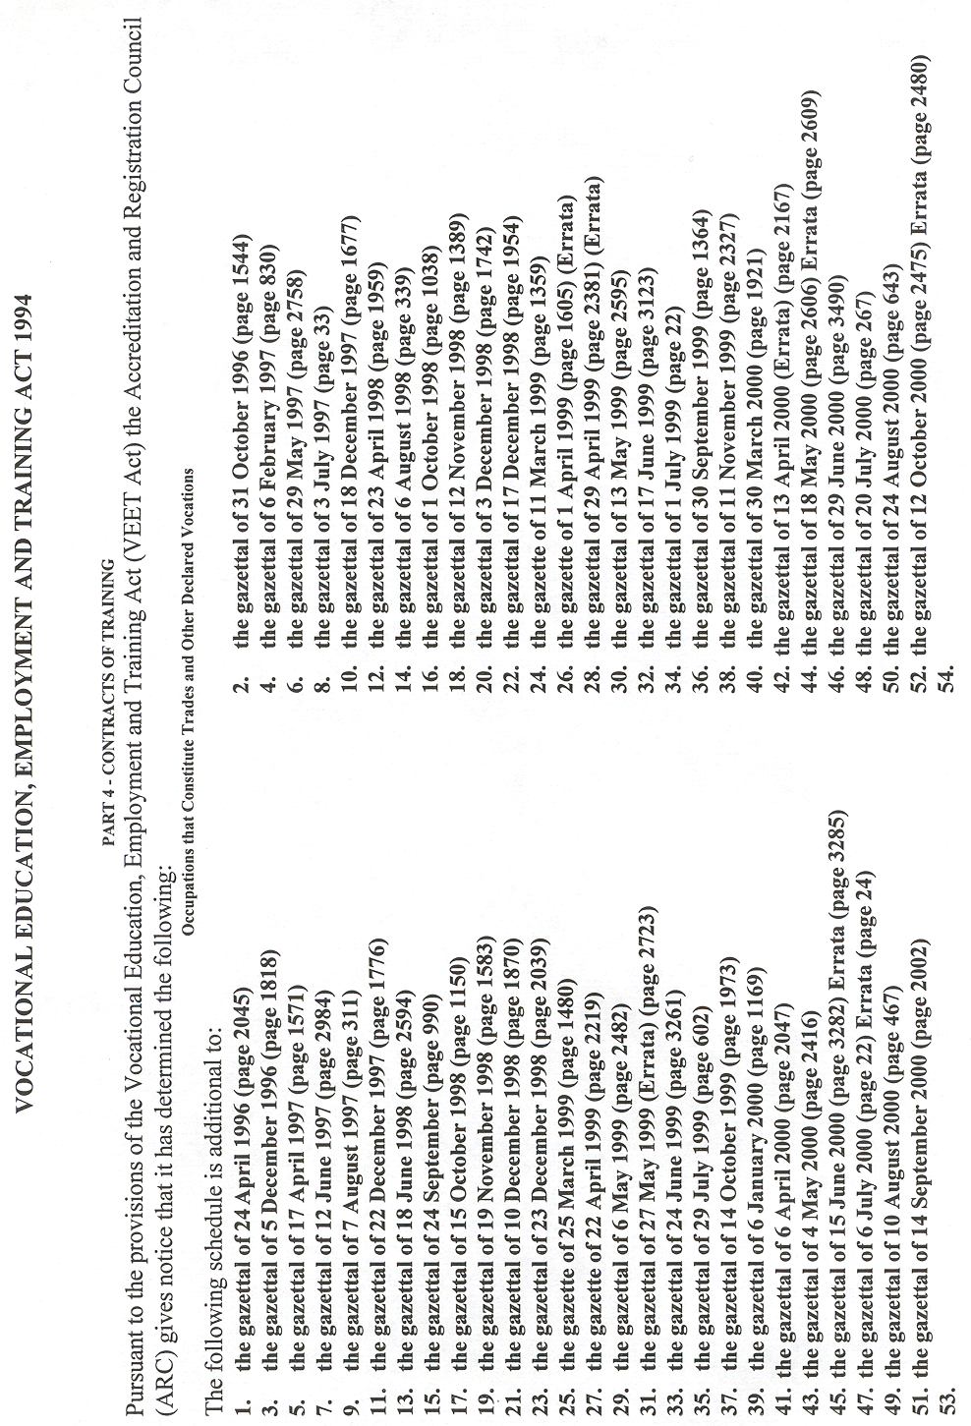
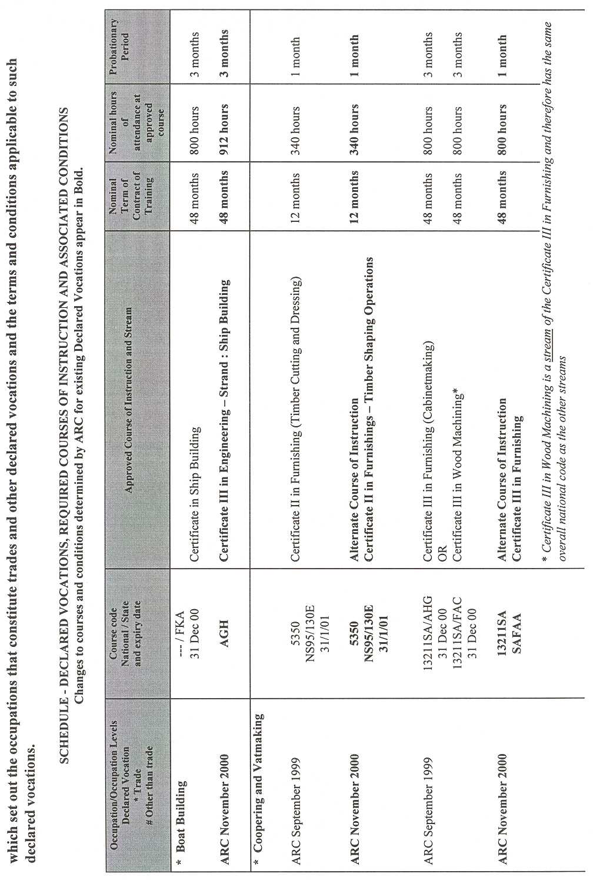
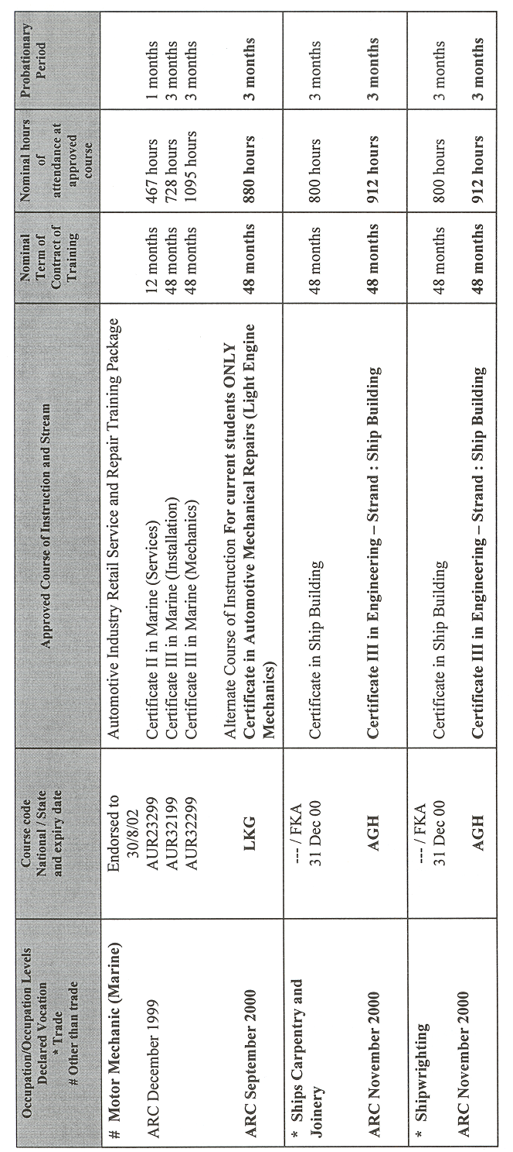
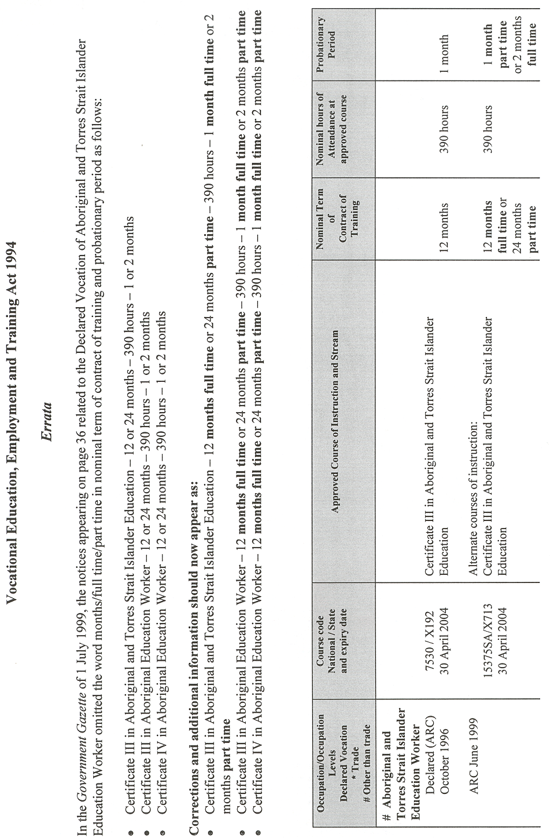
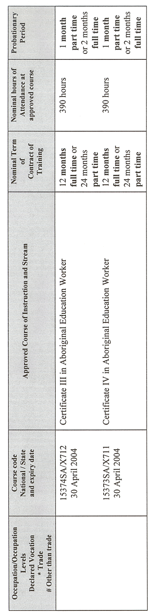
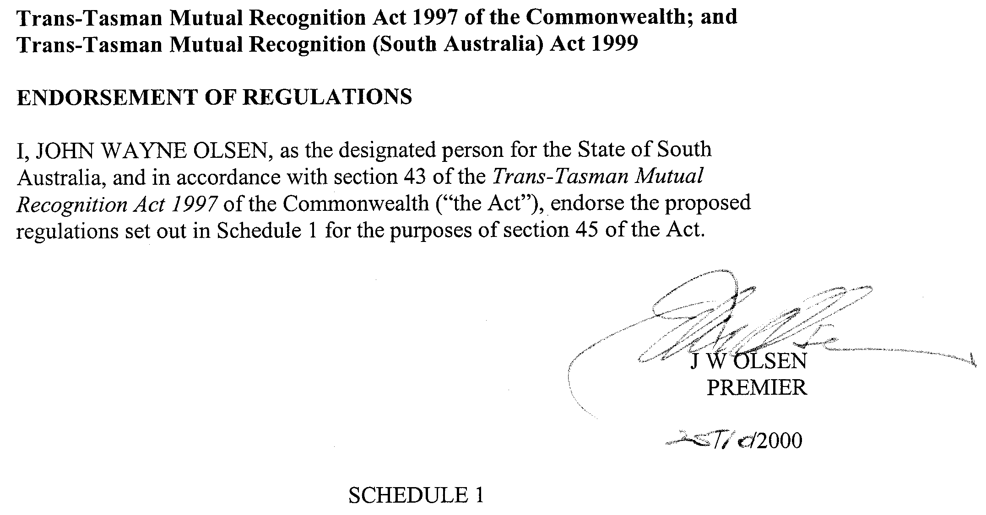
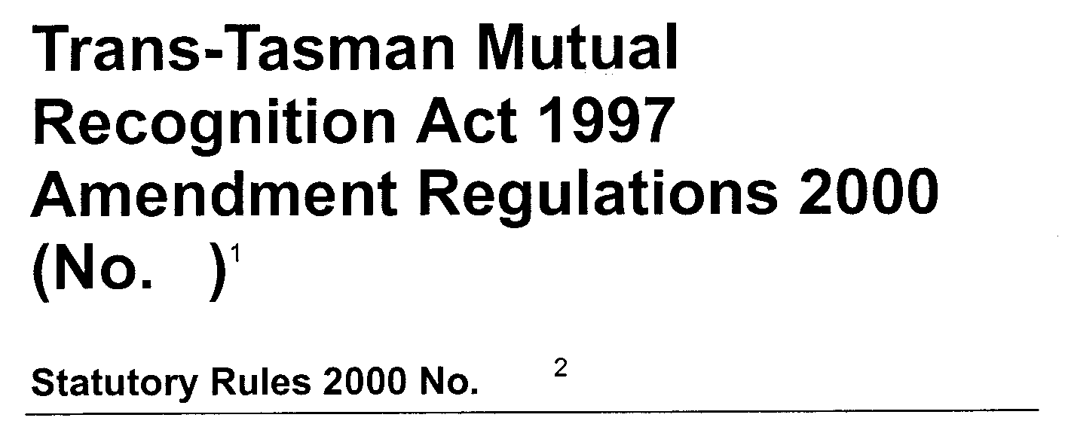

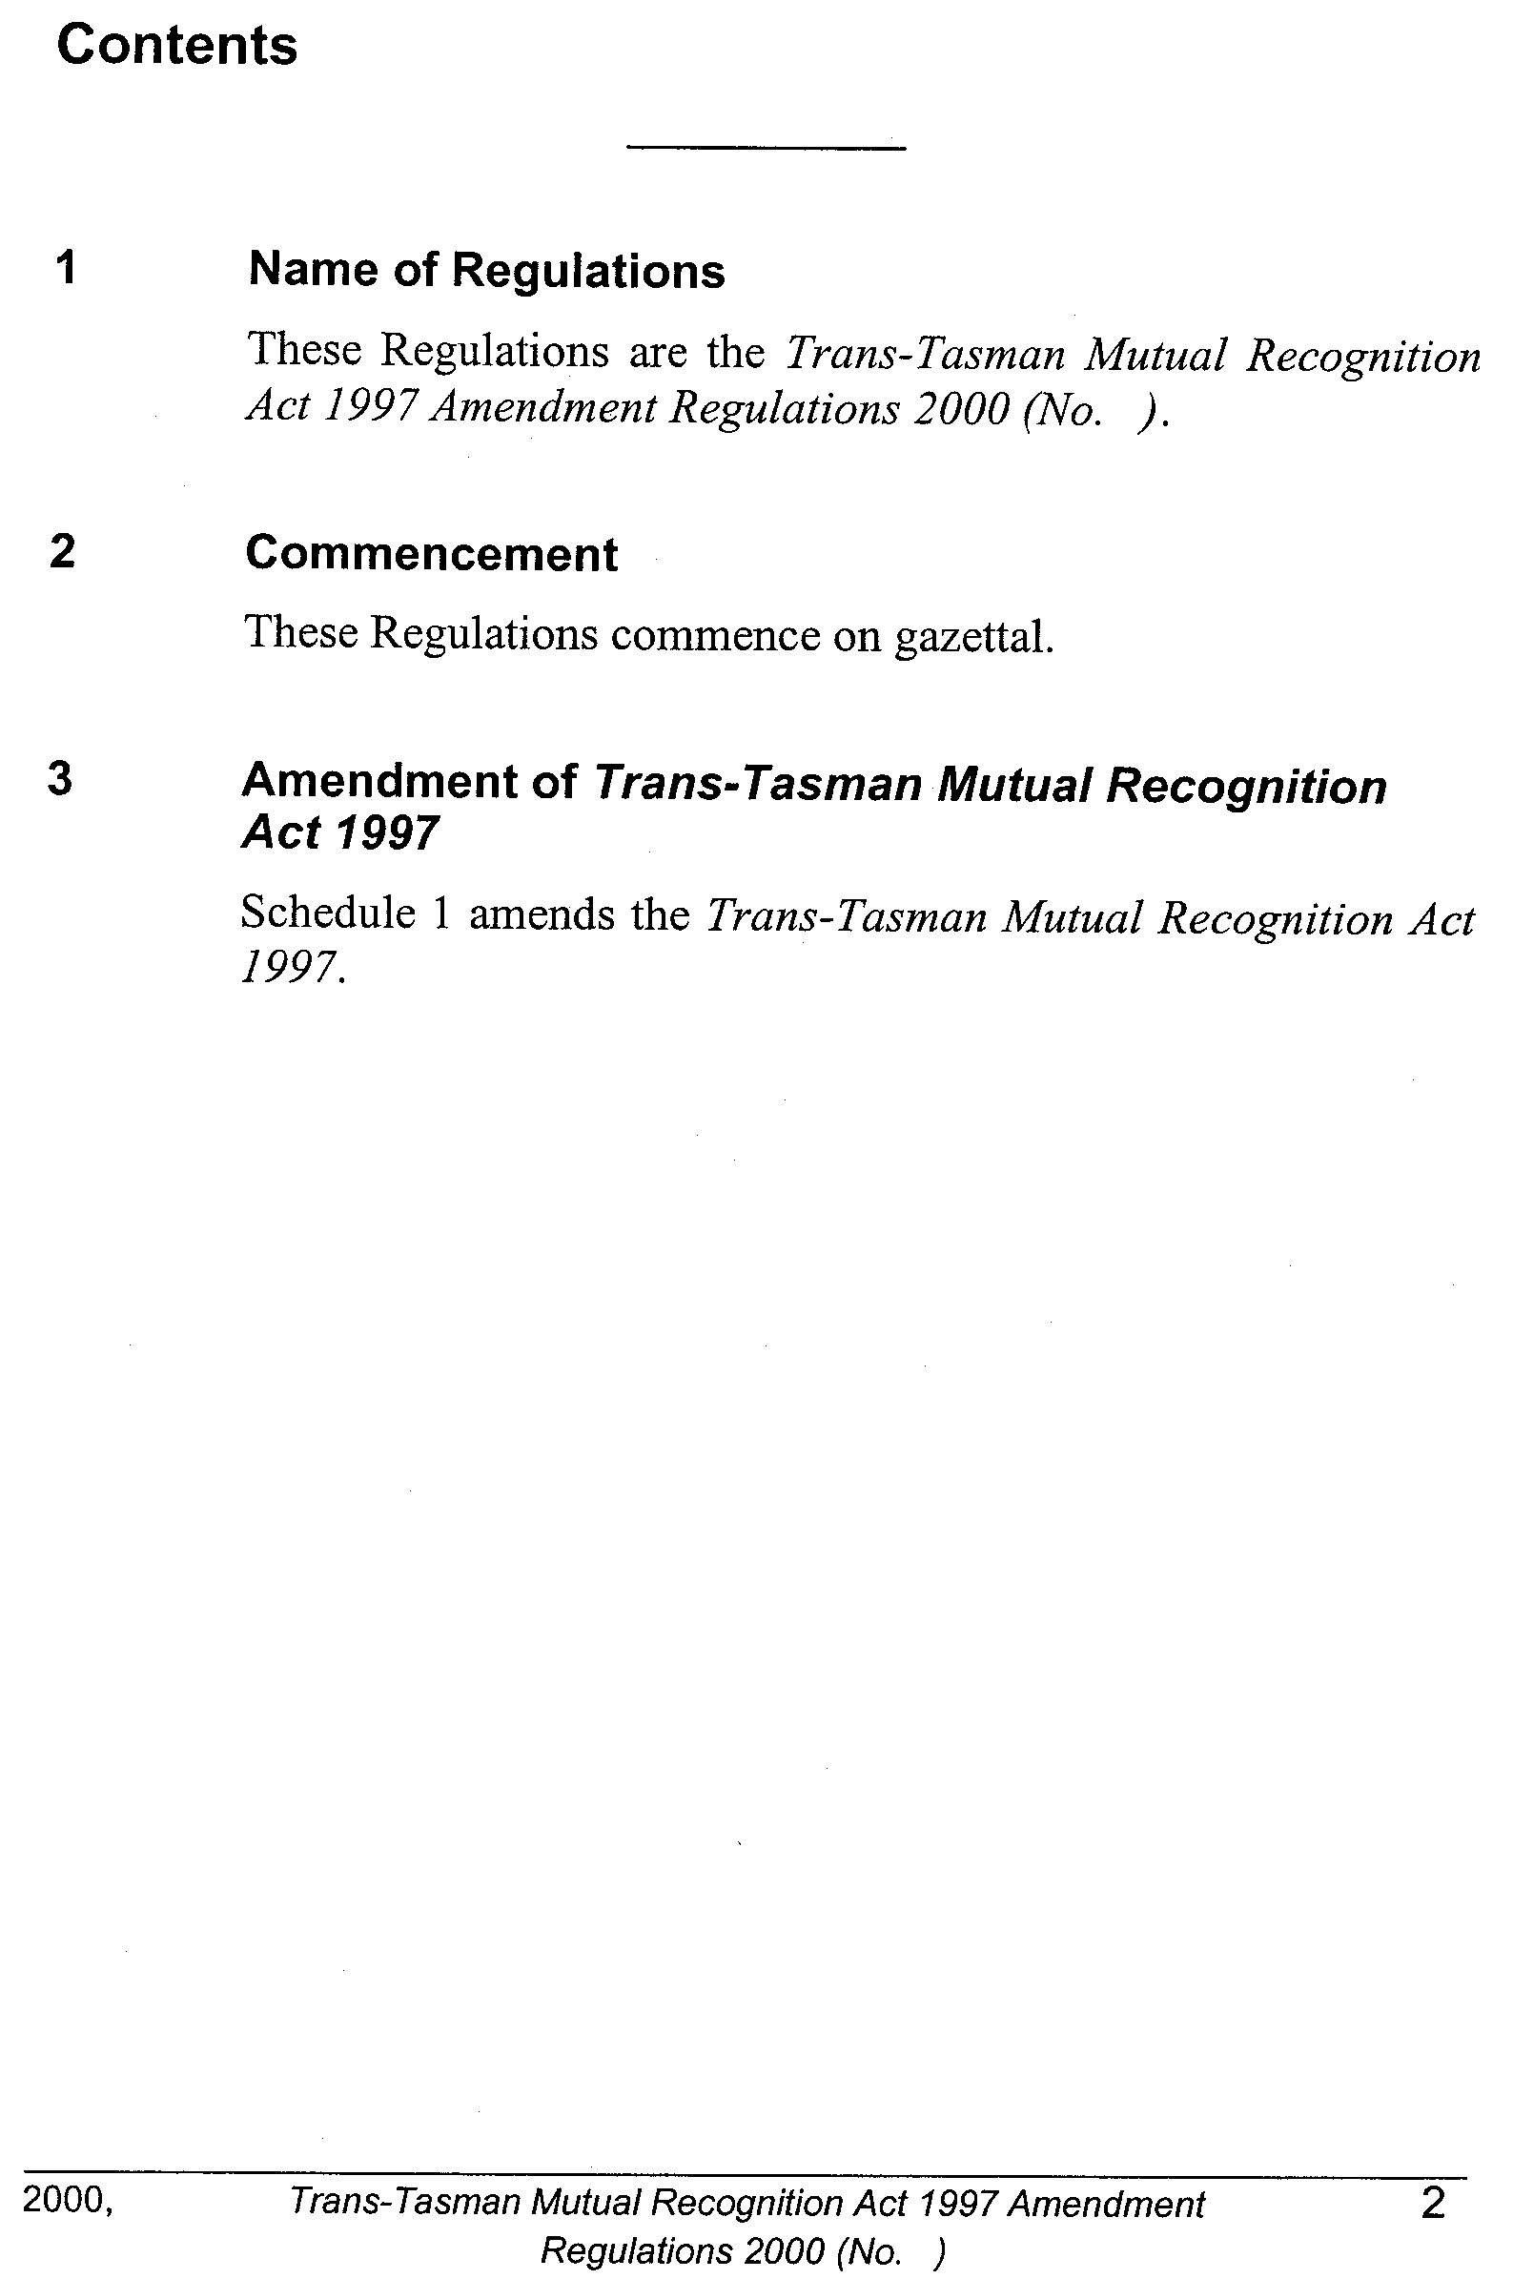

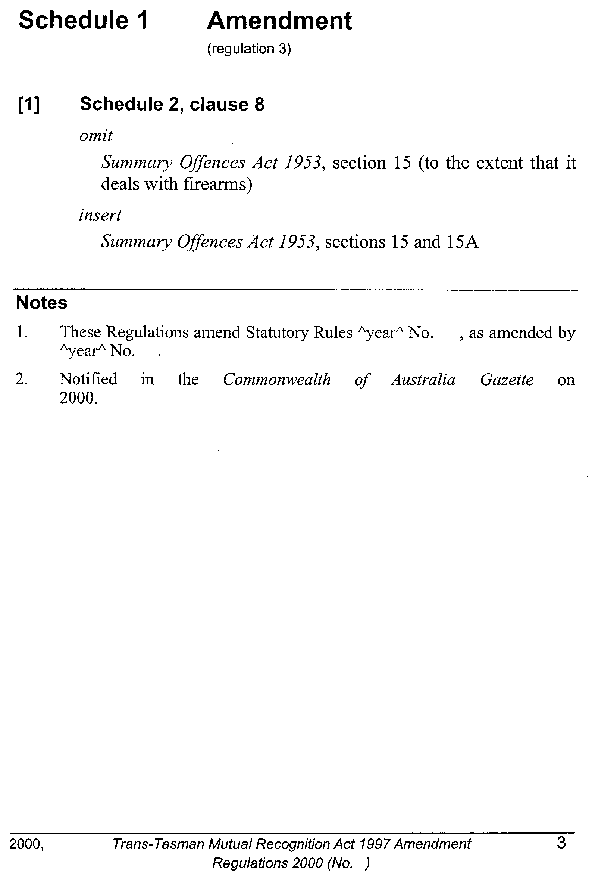

REGULATIONS UNDER THE ENVIRONMENT PROTECTION ACT 1993
────
No. 262 of 2000
────
At the Executive Council Office at Adelaide 16 November 2000

PURSUANT to the Environment Protection Act 1993 and with the advice and consent of the Executive Council, I make the following regulations.
E. J. NEAL Governor

PURSUANT to section 10AA(2) of the Subordinate Legislation Act 1978, I certify that, in my opinion, it is necessary or appropriate that the following regulations come into operation as set out below.

IAIN EVANS Minister for Environment and Heritage
───────────────────
SUMMARY OF PROVISIONS

1. Citation
2. Commencement
3. Substitution of reg. 4A
4A. Amendments to environment protection policies (section 32)
───────────────────

Citation
1. The Environment Protection (General) Regulations 1994 (see Gazette 27 October 1994 p. 1346), as varied, are referred to in these regulations as "the principal regulations".

Commencement
2. These regulations come into operation on the day on which they are made.

Substitution of reg. 4A
3. Regulation 4A of the principal regulations is revoked and the following regulation is substituted:

Amendments to environment protection policies (section 32)
4A. (1) For the purposes of section 32(1)(c) of the Act, the Minister may make changes of the following kinds by notice in the Gazette under that section:

(a) clause 4(2)(c) of the Environment Protection (Burning) Policy 1994 may be amended so that—

(i) an additional council area or portion of a council area is referred to in the provision if the council for the area has applied to the Minister for that change to be made;

(ii) a reference to a council, council area or portion of a council area is changed to reflect a change in an official name;

(iii) a reference to a council, council area or portion of a council area is removed if the council or council area has ceased to exist or the portion has ceased to exist or ceased to be within a specified council area;

(b) Schedule 1 of the Environment Protection (Burning) Policy 1994 may be amended so that—

(i) an additional council area or portion of a council area is referred to in the Schedule if the council for the area has applied to the Minister for that change to be made;

(ii) a reference to a council, council area or portion of a council area is changed to reflect a change in an official name;

(iii) a reference to a council, council area or portion of a council area is removed if the council or council area has ceased to exist or the portion has ceased to exist or ceased to be within a specified council area.

EH 00/0024 CS R. DENNIS Clerk of the Council

REGULATIONS UNDER THE FORESTRY ACT 1950
────
No. 263 of 2000
────
At the Executive Council Office at Adelaide 16 November 2000

PURSUANT to the Forestry Act 1950 and with the advice and consent of the Executive Council, I make the following regulations.
E. J. NEAL Governor

PURSUANT to section 10AA(2) of the Subordinate Legislation Act 1978, I certify that, in my opinion, it is necessary or appropriate that the following regulations come into operation as set out below.

MICHAEL ARMITAGE Minister for Government Enterprises
───────────────────
SUMMARY OF PROVISIONS

1. Citation
2. Commencement
3. Variation of reg. 3—Interpretation
4. Variation of reg. 4—Non-derogation from Corporation's powers
5. Variation of reg. 6—Prohibition of entrance by notice
6. Variation of reg. 10—Driving vehicles in reserves
7. Variation of reg. 20—Permits
8. Variation of reg. 21—False or misleading statements
9. Variation of reg. 22—General offence
10. Transitional provision
───────────────────

Citation
1. The Forestry (Recreational Access and Use of Reserves) Regulations 1989 (see Gazette 11 January 1990 p. 58), as varied, are referred to in these regulations as "the principal regulations".

Commencement
2. These regulations will come into operation on the day on which the South Australian Forestry Corporation Act 2000 comes into operation.

Variation of reg. 3—Interpretation
3. Regulation 3 of the principal regulations is varied by striking out the definition of "issuing officer".

Variation of reg. 4—Non-derogation from Corporation's powers
4. Regulation 4 of the principal regulations is varied by striking out "Minister" (twice occurring) and substituting, in each case, "Corporation".

Variation of reg. 6—Prohibition of entrance by notice
5. Regulation 6(1) of the principal regulations is varied by striking out "Minister" and substituting "Corporation".

Variation of reg. 10—Driving vehicles in reserves
6. Regulation 10 of the principal regulations is varied by striking out from subregulation (2)(b) "Minister" and substituting "Corporation".

Variation of reg. 20—Permits
7. Regulation 20 of the principal regulations is varied—

(a) by striking out from subregulation (1) "an issuing officer" and substituting "the Corporation";

(b) by striking out paragraph (a) of subregulation (2) and substituting the following paragraph:

(a) must be made in the manner and form determined by the Corporation; and;

(c) by striking out subregulation (7);

(d) by striking out from subregulation (8)(a) "an issuing officer" and substituting "the Corporation";

(e) by striking out from subregulation (8)(b) "Minister" (twice occurring) and substituting, in each case, "Corporation";

(f) by striking out subregulation (9) and substituting the following subregulation:

(9) If the Corporation is satisfied that a permit has been lost or destroyed, the Corporation may, on payment of the appropriate fee specified in the schedule, issue a replacement permit.;

(g) by striking out from subregulation (11) "issuing officer" and substituting "Corporation".

Variation of reg. 21—False or misleading statements
8. Regulation 21 of the principal regulations is varied by striking out the penalty provision at the foot of subregulation (1) and substituting the following penalty provision:

Maximum penalty: $750.

Variation of reg. 22—General offence
9. Regulation 22 of the principal regulations is varied by striking out the penalty provision at the foot of that regulation and substituting the following penalty provision:

Maximum penalty: $750.
Expiation fee: $105.

Transitional provision
10. A permit in force under the principal regulations immediately before the commencement of these regulations continues as if it were a permit issued by the Corporation under the principal regulations as varied by these regulations.

MGE 00/077 CS R. DENNIS Clerk of the Council

FAXING COPY?

IF you fax copy to Riverside 2000, for inclusion in the Government Gazette, there is no need to send a Confirmation Copy to us as well.

This creates confusion and may well result in your notice being printed twice.

Please use the following fax number:

Fax transmission: (08) 8207 1040
Phone Inquiries: (08) 8207 1045

Please include a contact person, phone number and order number so that we can phone back with any queries we may have regarding the fax copy.

NOTE: Closing time for lodging new copy (either fax or hard copy) is 4 p.m. on Tuesday preceding the day of publication.

Government Gazette notices can be E-mailed.

The address is:

Riv2000@saugov.sa.gov.au

Documents should be sent as attachments in Word format.

When sending a document via E-mail, please confirm your transmission with a faxed copy of your document, including the date the notice is to be published.

Fax transmission: (08) 8207 1040
Enquiries: (08) 8207 1045

CITY OF ADELAIDE
Declaration as Public Road
NOTICE is hereby given that pursuant to section 210 of the Local Government Act 1999 the council intends to declare, as public road, the roads known as Red Lane and Willcox Street in Town Acres 626 and 697.
Dated 9 November 2000.
J. Harry, Acting Chief Executive Officer

CITY OF MOUNT GAMBIER
Supplementary Election for South East Ward
NOTICE is hereby given that nominations are hereby invited and will be received at the Australian Electoral Commission Office, 2 Mitchell Street, Mount Gambier, from Thursday, 23 November 2000 until 12 noon on Thursday, 14 December 2000, from any person eligible to be a candidate for election to the vacancy of Councillor for South East Ward.
Nomination forms and candidate’s handbooks may be obtained from the above address between 9 a.m. and 5 p.m., Monday to Friday, or requested by telephone on (08) 8723 1366.
A candidate must submit a profile of not more than 150 words with the nomination form.
A candidate photograph of predominantly the head and shoulders, taken within the preceding 12 months, may also be submitted.
A briefing session for intending candidates will be conducted at the Council Offices, Civic Centre, 10 Watson Terrace, Mount Gambier on Tuesday, 5 December 2000 commencing at 5.30 p.m.
If more than one nomination is received for the vacancy, an election will be conducted entirely by postal ballot with voting closing at 12 noon on Monday, 12 February 2001.
S. H. Tully, Returning Officer

CITY OF ONKAPARINGA
Supplementary Election for Thalassa Ward
NOTICE is hereby given that nominations are invited and will be received at the Noarlunga Office of the City of Onkaparinga, Ramsay Place, Noarlunga Centre or at the State Electoral Office, 134 Fullarton Road, Rose Park, from Thursday, 23 November 2000 until 12 noon on Thursday, 14 December 2000, from any person eligible to be a candidate for election to the vacancy of Councillor for Thalassa Ward.
Nomination forms and candidate’s handbooks may be obtained at the Aberfoyle Park, Noarlunga and Willunga offices of the council between 8.30 a.m. and 5 p.m., Monday to Friday, or requested by telephone on (08) 8384 0734.
A candidate must submit a profile of not more than 150 words with the nomination form.
A candidate photograph of predominantly the head and shoulders, taken within the preceding 12 months, may also be submitted.
A briefing session for intending candidates will be conducted in the Community Meeting Room, The Hub Library, Hub Drive, Aberfoyle Park on 6 December 2000, commencing at 6.30 p.m.
If more than one nomination is received for the vacancy, an election will be conducted entirely by postal ballot with voting closing at 12 noon on Monday, 12 February 2001.
S. H. Tully, Returning Officer

CITY OF PORT ADELAIDE ENFIELD
Conversion of Private Roads to Public Roads and the Assignment of a Name
NOTICE is hereby given that at its meeting held on 8 November 2000, pursuant to the provisions contained in sections 210 and 219 of the Local Government Act 1999, the City of Port Adelaide Enfield declared allotment 213 in Deposited Plan 1966, situated between Addison Road and Eastbourne Terrace and allotment 14 in Filed Plan 42325, situated between Military Road and Vassall Street to be public roads.
The name Hennessey Terrace was also assigned to allotment 213 in Deposited Plan 1966.
H. J. Wierda, City Manager

CITY OF PROSPECT
Periodical Review
NOTICE is hereby given that pursuant to Chapter 3, Sections 12, 13, 26 and 33 of the Local Government Act 1999, council is undertaking a review of its composition, wards and elector representation.
The council of the City of Prospect is presently comprised of:
• A Mayor—elected at large.
• Three area Councillors—elected at large.
• Ten Ward Councillors—two Councillors elected from each of five wards.
These fourteen elected members represent a total elector population of 16 020.
In undertaking this review the council must consider a range of principles set out in section 26 of the Act, and also the matters contained within section 33 of the Act.
At the meeting of council held on 24 October 2000 the council resolved:
That the following options be adopted for the purposes of the community consultation process for Prospect’s Elector Representation Review:
(a) A council consisting of the Mayor, three area councillors, and ten councillors, two for each of five wards, (a total of fourteen elected members).
(b) A council consisting of the Mayor and twelve councillors, four from each of three wards, (a total of thirteen elected members).
(c) A council consisting of the Mayor and ten councillors, two from each of five wards, (a total of eleven elected members).
(d) A council consisting of the Mayor and nine councillors, three from each of three wards, (a total of ten elected members).
Interested persons are invited to comment on these or other options.
A copy of the discussion paper and plans attached to the various options is available at the Civic Centre, 128 Prospect Road and at the Prospect Library, 1 Thomas Street, Nails-
worth. It is also available on council’s web site— www.prospect.sa.gov.au.
The council is actively seeking submissions. Any interested person who wishes to make a submission on the four options outlined or any other option, should do so in writing to the City Manager, P.O. Box 171, Prospect, S.A. 5082, by no later than 5 p.m. on Friday, 26 January 2001. Those who make a submission will be provided with an opportunity, either personally or through a nominated representative, to address the council about their submission at a Committee meeting during February.
M. Llewellyn-Smith City Manager

ADELAIDE HILLS COUNCIL
Exclusion from Classification as Community Land
NOTICE is hereby given that the council of the Adelaide Hills Council at a meeting held on 7 November 2000, resolved pursuant to section 193 of the Local Government Act 1999, to exclude the following land from classification as community land:
Vacant land situated at 90A Onkaparinga Valley Road, Balhannah, being land comprised in certificate of title volume 5757, folio 73, allotment 101 in Deposited Plan 52972.
R. D. Blight, Chief Executive Officer

MID MURRAY COUNCIL
Declaration of Public Road
NOTICE is hereby given that the Mid Murray Council at its meeting held on 13 November 2000, resolved that pursuant to section 208 (4) of the Local Government Act 1999, Allotment 1 in Lands Titles Office Deposited Plan 54647 be declared a public road.
G. R. Brus, Chief Executive Officer

DISTRICT COUNCIL OF MOUNT BARKER
Development Act 1993
Mount Barker and Littlehampton Townships Centres Plan Amendment Report—Draft for Public Consultation
NOTICE is hereby given that the District Council of Mount Barker has prepared a Mount Barker and Littlehampton Townships Centres Plan Amendment Report for the purpose of addressing the hierarchy of the centres within the townships of Mount Barker and Littlehampton.
The Mount Lofty Ranges Regional Strategy Plan (1993) identified the Mount Barker Township as a regional service centre for the Mount Lofty Ranges. A key purpose of this Plan Amendment Report is to reflect that significance by rezoning the existing Mount Barker District Centre to a Regional Town Centre.
The Plan Amendment Report also examines the role and relationship of a number of smaller commercial centres within the Mount Barker and Littlehampton Townships.
The major policy changes that will result from the Mount Barker and Littlehampton Townships Centres Plan Amendment Report include:
• the rezoning of the Mount Barker District Centre to a Regional Town Centre;
• the inclusion of additional land within the proposed Regional Town Centre Zone;
• the introduction of eight new Policy Areas within the proposed Regional Town Centre Zone;
• the inclusion of three additional allotments within the Wellington Road, Mount Barker Local Centre Zone;
• amending the Littlehampton Neighbourhood Centre Zone to create two smaller zones (a Neighbourhood Centre Zone focussed around the intersection of North Terrace (Main Road) and Junction Road and a Local Centre Zone at the western end of the existing Neighbourhood Centre Zone. Eleven allotments will be rezoned to residential to reflect their existing use and six allotments will be rezoned to Neighbourhood Centre;
• amending the Industrial/Commercial Zone to accom-modate bulky goods retail and inclusion of additional allotments within the Industrial/Commercial Zone; and
• a review of the complying conditions for certain advertise-ments, the public notification categories and general advertisement standards.
The Plan Amendment Report and Statement of Investigation will be available for public inspection during normal office hours at the District Council of Mount Barker Local Government Centre, 23 Mann Street, Mount Barker, and at the Mount Barker Community Library, Dumas Street, Mount Barker from Thursday, 16 November 2000 until Thursday, 25 January 2001. Copies of the Plan Amendment Report can be purchased from the Local Government Centre at a cost of $15 each or borrowed on a weekly basis from the Mount Barker Community Library.
An informal community information evening will be held on Tuesday, 12 December 2000 at 7 p.m. at the Mount Barker Bowling Club. No formal verbal submissions will be accepted at this time.
Written submissions regarding the Plan Amendment Report will be accepted by the District Council of Mount Barker until 5 p.m. on Thursday, 25 January 2001. All written submissions should be addressed to the Chief Executive Officer, District Council of Mount Barker, P.O. Box 54, Mount Barker, S.A., 5251.
Copies of all written submissions received will be available for inspection by all interested persons at the Council Office from 25 January 2001, until the date of the public hearing.
A public hearing will be held commencing at 7 p.m. on Wednesday, 7 February 2001, at the Council Chambers, Local Government Centre, 23 Mann Street, Mount Barker, at which time interested parties may appear and be heard in relation to the Plan Amendment Report and submissions.
D. Gollan, Chief Executive Officer

NARACOORTE LUCINDALE COUNCIL
Declaration of Public Road
NOTICE is hereby given that the Naracoorte Lucindale Council hereby declares that portion of road reserve adjacent sections 200, 202, 207, 126, 127, 92, 91, 90, 86, 93, 94, 219, 208, 201, 315, Hundred of Townsend be known as Minnie Crowe Road.
D. L. Beaton, Chief Executive Officer

NARACOORTE LUCINDALE COUNCIL
Declaration of Public Road
NOTICE is hereby given that the Naracoorte Lucindale Council hereby declares that portion of road reserve adjacent sections 287 and 290, Hundred of Glenroy be known as Johnston’s Road.
D. L. Beaton, Chief Executive Officer

DISTRICT COUNCIL OF STREAKY BAY
Roads (Opening and Closing) Act 1991
Erratum
NOTICE OF CONFIRMATION OF ROAD
PROCESS ORDER
Preliminary Plan No. PP32/0423
IN notice appearing in Government Gazette dated 2 November 2000 on page 2938, pursuant to section 24 (5) of the Roads (Opening and Closing) Act 1991, the relevant authority for this process is the council and the notice date and authority should read:
Dated 2 November 2000.
D. J. Lane, District Clerk

IN the matter of the estates of the undermentioned deceased persons:
Appleby, Mary Elizabeth, late of 147 St Bernard’s Road, Rostrevor, of no occupation who died on 20 September 2000.
Baker, Nellie, late of 124 March Street, Orange, New South Wales, widow, who died on 17 August 2000.
Barty, Mervyn Frederick, late of 17 Ripon Road, Clarence Park, retired compositor, who died on 28 August 2000.
Braham, Raymond Leslie, late of 17 Albert Place, Mount Barker, retired technical officer, who died on 28 August 2000.
Chant, Nancy Alice, late of 26 Flinders Highway, Port Lincoln, of no occupation, who died on 28 September 2000.
Fyrer, Bertram, late of 23 Shakespeare Avenue, Tranmere, retired head superintendent, who died on 19 September 2000.
Hall, Georgina Margaret McNally, late of 656 Anzac Highway, Glenelg East, widow, who died on 17 September 2000.
Howard, Denzil Arthur, late of 5 Redsails Court, West Lakes Shore, retired company director, who died on 16 September 2000.
King, Kenneth William, late of 47 Eve Road, Bellevue Heights, retired fitter, who died on 7 September 2000.
Klingberg, Rhoda Clara, late of 366 The Parade, Kensington Park, of no occupation, who died on 22 September 2000.
Koch, Othal Ludwig, late of 50 Gulfview Road, Christies Beach, retired schoolteacher, who died on 16 September 2000.
Leimann, Karl, late of 3 Emperor Avenue, Golden Grove, retired painter and decorator, who died on 4 October 2000.
McColl, Mary Josephine, late of 43 Alexander Street, Largs Bay, widow, who died on 20 August 2000.
Maltby, Lavinia Mary, late of 7 Railway Terrace, Old Reynella, of no occupation, who died on 22 September 2000.
Mitchell, Ruby Gertrude, late of 360 Senate Road, Risdon Park, Port Pirie, of no occupation, who died on 25 August 2000.
Morton, Thomas, late of 2 White Street, Whyalla Stuart, retired engineering manager, who died on 10 August 2000.
Nelson, Alan, late of 34 De Haviland Avenue, Hendon, retired canister maker, who died on 6 September 2000.
Osborne, Esther Lucy, late of 6 Sullivan Terrace, O’Sullivan Beach, of no occupation, who died on 3 October 2000.
Pryor, Jean Elizabeth Christabel, late of 26 River Road, Port Noarlunga, widow who died on 22 August 2000.
Ridge, Howard Reginald Richard, late of 4 White Street, Kapunda, retired surveyor, who died on 1 September 2000.
Roberts, Leonora, late of 10 Laught Street, Whyalla Stuart, of no occupation, who died on 20 August 2000.
Schubert, Edwin Walter, late of 1215 Grand Junction Road, Hope Valley, retired storeman, who died on 12 October 2000.
Stevens, Jean Gwendoline, late of 13 Verdale Avenue, Linden Park, home duties, who died on 14 September 2000.
Thorne, Brian Malcolm, late of 10 Watson Street, Risdon Park, Port Pirie, retired storeman, who died on 2 September 2000.
Walker, Winifred May, late of 13 Sabina Crescent, Christie Downs, home duties, who died on 8 September 2000.
Wallman, Beatrice Myrtle, late of 45 Denning Street, Hawthorn, of no occupation, who died on 15 October 2000.
Watton, Mabel Joan, late of 19 Aldersey Street, McLaren Vale, widow, who died on 4 September 2000.
Weir, William McMoran, late of 3 Burgate Street, Elizabeth Grove, retired refrigeration mechanic, who died on 17 August 2000.
Wells, Freda May, late of Grainger Road, Somerton Park, home duties, who died on 21 September 2000.
Notice is hereby given pursuant to the Trustee Act 1936, as amended, the Inheritance (Family Provision) Act 1972, and the Family Relationships Act 1975, that all creditors, beneficiaries, and other persons having claims against the said estates are required to send, in writing, to the Public Trustee, 25 Franklin Street, Adelaide, S.A. 5000, full particulars and proof of such
claims, on or before 15 December 2000, otherwise they will be
excluded from the distribution of the said estate; and notice is also hereby given that all persons who are indebted to the said estates are required to pay the amount of their debts to the Public Trustee or proceedings will be taken for the recovery thereof; and all persons having any property belonging to the said estates are forthwith to deliver the same to the Public Trustee.
Dated 16 November 2000.
J. H. Worrall, Public Trustee

TOWER TRUST LIMITED
Missing Will
IF anyone is aware of a will for Keith Eric Sharp, late of The Vales Aged Care Facility, 60 States Road, Morphett Vale, S.A. 5162, which is dated later than 19 August 1986, please contact Stephen Molloy, TOWER Trust Limited, 44 Pirie Street, Adelaide, S.A. 5000.
S. Molloy, Client Service Adviser

SOUTH AUSTRALIA—In the Supreme Court of South Australia. No. 162 of 1999. In the matter of Japling Pty Limited and in the matter of the Corporations Law.
Notice of Release of Liquidator and Dissolution of the Company
Take notice that by order of the Supreme Court of South Australia dated 31 October 2000, I, John Sheahan, Level 8, 26 Flinders Street, Adelaide, S.A. 5000, the liquidator of the abovenamed company was granted my release as liquidator and the company was dissolved as at the date of this order.
Dated 7 November 2000.
J. Sheahan, Liquidator

SALE OF PROPERTY
Auction Date: Thursday, 30 November 2000 at 11 a.m.
Location: 4/534 Brighton Road, South Brighton
NOTICE is hereby given that on the above date at the time and place stated, by virtue of the Warrant of Sale issued out of the Magistrates Court of South Australia, Adelaide Registry, Action No. 13656 of 1999, directed to the Sheriff of South Australia in an action wherein Strata Corporation 3674 Inc, is Plaintiff and Scott Grindle is Defendant, I, Tim Goodes, Sheriff, of the State of South Australia, will by my auctioneers, Griffin Real Estate, make sale of the estate, right, title or interest whatsoever it may be of the defendant Scott Grindle as the registered proprietor of an estate in fee simple in the following:
That piece of land situated in the area named South Brighton, being 4/534 Brighton Road, being the property comprised in certificate of title register book volume 5033, folio 934.
Further particulars from the auctioneers:
Griffin Real Estate
179 King William Road
Hyde Park, S.A. 5061
Telephone 8373 5145

ATTENTION

CUSTOMERS requiring a proof of their notice for inclusion in the Government Gazette, please note that the onus is on you to inform Riverside 2000 of any subsequent corrections by 10 a.m. on Thursday, which is our publication deadline.

For any corrections to your notice please phone 8207 1045 or Fax 8207 1040 before 10 a.m. on Thursday.

If we do not receive any communication by 10 a.m. on Thursday (day of publication) we will presume the notice is correct and will print it as it is.

Remember—the onus is on you to inform us of any corrections necessary to your notice.

NOTE: Closing time for lodging new copy (either fax or hard copy) is 4 p.m. on Tuesday preceding the day of publication. Ph. 8207 1045—Fax 8207 1040.

Printed and published by authority every Thursday by M. G. O’CALLAGHAN, Government Printer, South Australia
Price: $4.30, plus postage; to subscribers, $214.85 per annum.
(The above prices are inclusive of GST)

