No. 187 3355

THE SOUTH AUSTRALIAN

GOVERNMENT GAZETTE

PUBLISHED BY AUTHORITY

ALL PUBLIC ACTS appearing in this GAZETTE are to be considered official, and obeyed as such

ADELAIDE, THURSDAY, 30 NOVEMBER 2000

CONTENTS

Page
Acts Assented To 3356
Appointments, Resignations, Etc. 3356
Corporations and District Councils—Notices 3403
Crown Lands Act 1929—Notices 3358
Development Act 1993—Notice 3358
Firearms Act 1977—Notices 3358
Fisheries Act 1982—Notice 3371
Gaming Machines Act 1992—Notice 3358
Housing Improvement Act 1940—Notices 3362
Land and Business (Sale and Conveyancing) Act 1994—
Notices 3364
Liquor Licensing Act 1997—Notices 3364
Mining Act 1971—Notice 3368
Motor Vehicles Act 1959—Notice 3368
National Parks and Wildlife Act 1972—Notice 3370
National Parks Regulations 1990—Notice 3371

Page
Private Advertisements 3407
Proclamations 3356
Public Trustee Office—Administration of Estates 3406
REGULATIONS
Senior Secondary Assessment Board of South Australia
Act 1983 (No. 271 of 2000) 3372
Harbors and Navigation Act 1993 (No. 272 of 2000) 3381
South Australian Motor Sport Act 1984
(No. 273 of 2000) 3389
Housing and Urban Development (Administrative
Arrangements) Act 1995 (No. 274 of 2000) 3394
Police Act 1998 (No. 275 of 2000) 3396
National Electricity (South Australia) Act 1996
(No. 276 of 2000) 3397
Environment Protection Act 1993 (No. 277 of 2000) 3400
Roads (Opening and Closing) Act 1991—Notice 3371

GOVERNMENT GAZETTE NOTICES
ALL poundkeepers’ and private advertisements forwarded for publication in the South Australian Government Gazette must be PAID FOR PRIOR TO INSERTION; and all notices, from whatever source, should be legibly written on one side of the paper only and sent to Government Publishing SA (formerly Riverside 2000) so as to be received no later than 4 p.m. on the Tuesday preceding the day of publication. Phone 8207 1045 or Fax 8207 1040. E-mail: governmentgazette@saugov.sa.gov.au. Send as attachments in Word format and please confirm your transmission with a faxed copy of your document, including the date the notice is to be published and to whom the notice will be charged.

Department of the Premier and Cabinet
Adelaide, 30 November 2000
HIS Excellency the Governor directs it to be notified for general information that he has in the name and on behalf of Her Majesty The Queen, this day assented to the undermentioned Acts passed by the Legislative Council and House of Assembly in Parliament assembled, viz.:
No. 66 of 2000—An Act to amend the Racing (Controlling Authorities) Amendment Act 2000.
No. 67 of 2000—An Act to amend the Barley Marketing Act 1993.
No. 68 of 2000—An Act to prohibit the establishment of certain nuclear waste storage facilities in South Australia; and for other purposes.
By command,
Mark Brindal, for Premier
DPC 97/0415

CORRECTIONAL SERVICES ACT 1982 SECTION 17: VISITING TRIBUNALS
Proclamation By The Governor
(l.s.) E. J. Neal
PURSUANT to section 17 of the Correctional Services Act 1982 and with the advice and consent of the Executive Council—
1. I revoke all proclamations previously made under that section.
2. I appoint each of the following Justices of the Peace to be a Visiting Tribunal for each of the correctional institutions appearing in the Schedule:
Ernest John Davis
Heather Lorraine Ellis
William Howard Gill
Schedule
Adelaide Remand Centre
Cadell Training Centre
Mobilong Prison
Mount Gambier Prison
Northfield Prison Complex (now known as the Adelaide Women’s Prison and the Adelaide Pre-Release Centre)
Port Augusta Gaol (now known as the Port Augusta Prison)
Port Lincoln Prison
Yatala Labour Prison.
Given under my hand and the Public Seal of South Australia, at Adelaide, 30 November 2000.
By command,
Mark Brindal, for Premier
CSC 0010/00

HIGHWAYS ACT 1926 SECTION 27AA: CLOSURE OF PORTION OF DYSON ROAD, NOARLUNGA DOWNS, ABUTTING ALLOTMENT 100 IN DP 23897, HUNDRED OF NOARLUNGA
Proclamation By The Governor
(l.s.) E. J. Neal
PURSUANT to section 27AA of the Highways Act 1926, on the recommendation of the Commissioner of Highways made pursuant to that section and with the advice and consent of the Executive Council, I close that portion of public road (Dyson Road) delineated as allotment 80 in Lands Titles Registration Office File Plan No. 42040, subject to an easement to ETSA Utilities Pty Ltd (registered as instrument TG 8146534 in the Lands Titles Registration Office).
Given under my hand and the Public Seal of South Australia, at Adelaide, 30 November 2000.
By command,
Mark Brindal, for Premier
TSA 01322/2000 CS

Department of the Premier and Cabinet
Adelaide, 30 November 2000
HIS Excellency the Governor in Executive Council has revoked the appointment of Helen Marion Nugent as a Director of the Superannuation Funds Management Corporation of South Australia Board, pursuant to the Superannuation Funds Management Corporation of South Australia Act 1995 and the Acts Interpretation Act 1915.
By command,
Mark Brindal, for Premier

Department of the Premier and Cabinet
Adelaide, 30 November 2000
HIS Excellency the Governor in Executive Council has been pleased to appoint the undermentioned to the Superannuation Funds Management Corporation of South Australia Board, pursuant to the provisions of the Superannuation Funds Management Corporation of South Australia:
Director: (from 1 December 2000 until 30 November 2003)
Helen Marion Nugent
By command,
Mark Brindal, for Premier
TFD 102/98CS

Department of the Premier and Cabinet
Adelaide, 30 November 2000
HIS Excellency the Governor in Executive Council has been pleased to designate Mark Rice and Peter John Norman, Masters of the District Court of South Australia, as officers of the Environment, Resources and Development Court from 30 November 2000, pursuant to section 11 of the Environment, Resources and Development Court Act 1993.
By command,
Mark Brindal, for Premier
ATTG 53/93CS

Department of the Premier and Cabinet
Adelaide, 30 November 2000
HIS Excellency the Governor in Executive Council has removed the undermentioned from the office of Justices of the Peace, pursuant to section 6 of the Justices of the Peace Act 1991:
Laurie William George Collins
Wallace Fraser
Gavan Edward Kennare
Jack Alfred Mann
Tania Louise Milsom
Leslie Robert Payne
Reginald Harry Priestley
Mervyn Leonard Richards
Alfred Norman Sandercock
John Allen Wilson
By command,
Mark Brindal, for Premier
ATTG 54/99CS

Department of the Premier and Cabinet
Adelaide, 30 November 2000
HIS Excellency the Governor in Executive Council has been pleased to appoint the undermentioned as Justices of the Peace for South Australia, pursuant to section 4 of the Justices of the Peace Act 1991:
Josephine Erica Chesson
Bjorn De Jager
David Anthony Edwards
Diane Elizabeth Evans
Sharyn Renee Faulkner
Anthony James Fawcett
Ronald Jeffrey Herman
Julie Ho
Helen Mary Houghton
David Anthony Humphries
Heather Valmai Humphries
Tanya Marie Keays
Karen Jane Loechel
Alexander David MacLeod
Rodney George Nancarrow
Alison Mary Penny
Glenys Rose Petagna
Fevronia Plomaritis
Judith Anne-Marie Presgrave
Janice Rose Shepherd
Glen Gary Joseph Smith
Angela Tortella
Matthew Daniel Woods
Christine Wyman
By command,
Mark Brindal, for Premier
ATTG 43/99CS

Department of the Premier and Cabinet
Adelaide, 30 November 2000
HIS Excellency the Governor in Executive Council has been pleased to appoint as Officers of the Crown for the purpose of providing the range of custodial services for Prisoner Movement and In-Court Management Services, in accordance with the contract, without pay or any other industrial entitlement, staff of Group 4 Correction Services Pty Ltd as listed, pursuant to section 68 of the Constitution Act 1934:
Simon James Baker
Craig Edward Burrow
Colin John Edson
Noel Elliott
Raymond Peter Hendry
Haymish Jonathon Hickman
Theresa Nicole Marechal
David Thomas Moore
Bayden James Sinclair
Richard Wayne Smith
Sharon Lee Smith
David Michael Wellings
Ryan Paul Williams
By command,
Mark Brindal, for Premier
MCS 0011/00CS

Department of the Premier and Cabinet
Adelaide, 30 November 2000
HIS Excellency the Governor in Executive Council has revoked the appointment of the Inspectors listed, pursuant to the provisions of the Correctional Services Act 1982 and the Acts Interpretation Act 1915:
Metropolitan Prisons
Brian Milton Annells
Elizabeth Anne Bachmann
Patrick John Forster
Arthur Bealby Helyard
James Henry Hugo
Kathleen Theresa Johnston
Branka King
David Douglas Lee
James Olds
Donald Charles Spackman
Morton John Menz
Mount Gambier Prison
Alexander Robert Haig
John Henry Monger
Mary Elizabeth Walker
Cadell Training Centre
Ross Copeland
Jack Campbell Norman
Port Augusta Prison
Judith Anne Bury
Jillian Kay Carter
Peter Kenny
Ernest Colin Orr
George Henry Parker
Mobilong Prison
Brian John Alan Eves
Russell John Stuart Nuske
Harry Vernon Stephen
Port Lincoln Prison
Warren John Ord Dickie
William John Kenny
Graham Peter Shepherd
By command,
Mark Brindal, for Premier
MCS 0010/00CS

Department of the Premier and Cabinet
Adelaide, 30 November 2000
HIS Excellency the Governor in Executive Council has been pleased to appoint the Inspectors listed, pursuant to the provisions of the Correctional Services Act 1982:
Alexander Robert Haig
Arthur Bealby Helyard
Branka King
Brian John Alan Eves
Brian Milton Annells
Ernest Colin Orr
George Henry Parker
Graham Peter Sheperd
Harry Vernon Stephen
Morton John Menz
Jack Campbell Norman
James Henry Hugo
James Olds
Jillian Kay Carter
John Henry Monger
Judith Anne Bury
Kathleen Therese Johnston
Mary Elizabeth Walker
Patrick John Forster
Ross Copeland
Warren John Ord Dickie
William John Kenny
Russell John Nuske
Valda May Stevens
Vanessa Florence Boully
Arthur Lawrie Anson
Barry James La Vanda
By command,
Mark Brindal, for Premier
MCS 0010/00CS

CROWN LANDS ACT 1929: SECTION 5
TAKE NOTICE that pursuant to the Crown Lands Act 1929, I KOSTAS SARNECKIS, Acting Surveyor-General and Delegate appointed by IAIN EVANS, Minister for Environment and Heritage, Minister of the Crown to whom the administration of the Crown Lands Act 1929 is committed DO HEREBY dedicate the Crown Land defined in The Schedule as a Conservation Recreation and Effluent Treatment Reserve and declare that such land shall be under the care, control and management of the Mid Murray Council.
The Schedule
1. Allotment 6 of DP 51325, Hundred of Finniss, County of Sturt, exclusive of all necessary roads, being the whole of the land comprised in Crown Record Volume 5777, Folio 486.
2. Allotments 51, 52 and 53 of DP 52017, Hundred of Finniss, County of Sturt, exclusive of all necessary roads, being the whole of the land comprised in Crown Records Volume 5777, Folio 492, Volume 5777, Folio 493 and Volume 5777, Folio 494, respectively.
3. Allotment 100 of DP 55162, Hundred of Finniss, County of Sturt, exclusive of all necessary roads, being the whole of the land comprised in Crown Record Volume 5801, Folio 622.
4. Section 915, Hundred of Finniss, County of Sturt, exclusive of all necessary roads, being the whole of the land comprised in Crown Record Volume 5761, Folio 328.
Dated 27 November 2000.
K. Sarneckis, Acting Surveyor-General
DL 3619/1992

CROWN LANDS ACT 1929: SECTION 5
TAKE NOTICE that pursuant to the Crown Lands Act 1929, I KOSTAS SARNECKIS, Acting Surveyor-General and Delegate appointed by IAIN EVANS, Minister for Environment and Heritage, Minister of the Crown to whom the administration of the Crown Lands Act 1929 is committed DO HEREBY dedicate the Crown Land defined in The Schedule as a Flora Reserve and declare that such land shall be under the care, control and management of the City of Victor Harbor.
The Schedule
Section 299, Hundred of Goolwa, County of Hindmarsh being the whole of the land comprised in Crown Record Volume 5737 Folio 428.
Dated 27 November 2000.
K. Sarneckis, Acting Surveyor-General
DENR 12/0529

DEVELOPMENT ACT 1993, SECTION 46 (4)
Preamble
1. On 15 July 1999, the Minister for Transport and Urban Planning, by notice in the Gazette (see Gazette 15 July 1999 pp. 240 and 241), declared that section 46 of the Development Act 1993, applied to any development of a kind specified in Schedule 1 of that notice.
2. The declaration was then varied by notice in the Gazette on 22 July 1999 (see Gazette 22 July 1999 p. 433).
3. It has been decided to make a further variation.
Notice
PURSUANT to section 46 (4) of the Development Act 1993, I vary the declaration referred to in clause 1 of the preamble (as varied by the notice referred to in clause 2 of the preamble) by inserting after paragraph (k) the following paragraph:
(l) development within the ambit of paragraph (a) or (b) that is proposed to be in place for a period not exceeding 18 months subject to the qualification that this paragraph will not apply if the development, or development of the same kind, or substantially the same kind, has been previously conducted on the same site, or on substantially the same site, within the preceding period of two years.
Dated 30 November 2000.
Diana Laidlaw, Minister for Transport and Urban Planning

FIREARMS ACT 1977
Recognised Paintball Operators
I DECLARE Paintball Skirmish S.A. to be a recognised paintball operation, pursuant to section 26B of the Firearms Act 1977.
Dated 24 November 2000.
R. Brokenshire, Minister for Police, Correctional Services and Emergency Services

FIREARMS ACT 1977
Recognised Paintball Operators
I DECLARE Tactical Advantage, Arid Lands Paintball to be a recognised paintball operation, pursuant to section 26B of the Firearms Act 1977.
Dated 24 November 2000.
R. Brokenshire, Minister for Police, Correctional Services and Emergency Services

GAMING MACHINES ACT 1992
Notice of Application for Grant of Gaming Machine Licence
NOTICE is hereby given, pursuant to section 29 of the Gaming Machines Act 1992, that Spalding Community Hotel Incorporated, c/o P.O. Box 23, Spalding, S.A. 5454 has applied to the Liquor Licensing Commissioner for the grant of a Gaming Machine Licence in respect of premises situated at Main Street, Spalding, S.A. 5454.
The application has been set down for hearing on 5 January 2001 at 9 a.m.
Any person may object to the application by lodging a notice of objection in the prescribed form with the Liquor Licensing Commissioner, and serving a copy of the notice on the applicant at the applicant’s address given above, at least seven days before the hearing date.
Plans in respect of the premises the subject of the application are open to public inspection without fee at the Office of the Liquor Licensing Commissioner, 9th Floor, East Wing, G.R.E. Building, 50 Grenfell Street, Adelaide 5000.
Dated 22 November 2000.
Applicant

   

Please Note: The South Australian Government Gazette will be available on the Internet from Thursday, 14th December 2000.
The web address will be:

www.governmentgazette.sa.gov.au

Any relevant queries, should be directed to Richard Hood on 8207 1045.

  

Notices for inclusion in the Gazette, should be sent to the new e-mail address, which is:

governmentgazette@saugov.sa.gov.au

   

MISCELLANEOUS LEGISLATION AND GOVERNMENT PUBLICATIONS PRICES AS FROM 1 JULY 2000

Acts, Bills, Rules, Parliamentary Papers and Regulations
Pages | Main | Amends | Pages | Main | Amends

1-16 | 1.80 | 0.80 | 497-512 | 26.25 | 25.25
17-32 | 2.55 | 1.60 | 513-528 | 27.00 | 26.00
33-48 | 3.25 | 2.35 | 529-544 | 27.75 | 26.75
49-64 | 4.15 | 3.10 | 545-560 | 28.50 | 27.75
65-80 | 4.90 | 4.00 | 561-576 | 29.25 | 28.50
81-96 | 5.60 | 4.70 | 577-592 | 30.25 | 29.00
97-112 | 6.45 | 5.45 | 593-608 | 31.00 | 30.00
113-128 | 7.20 | 6.30 | 609-624 | 31.75 | 31.00
129-144 | 8.10 | 7.10 | 625-640 | 32.50 | 31.50
145-160 | 8.90 | 7.85 | 641-656 | 33.25 | 32.25
161-176 | 9.70 | 8.70 | 657-672 | 33.75 | 33.00
177-192 | 10.40 | 9.50 | 673-688 | 35.00 | 33.75
193-208 | 11.20 | 10.30 | 689-704 | 35.75 | 34.75
209-224 | 12.00 | 11.00 | 705-720 | 36.25 | 35.50
225-240 | 12.70 | 11.80 | 721-736 | 37.50 | 36.00
241-257 | 13.60 | 12.50 | 737-752 | 38.00 | 37.00
258-272 | 14.40 | 13.30 | 753-768 | 39.00 | 37.50
273-288 | 15.20 | 14.20 | 769-784 | 39.50 | 38.75
289-304 | 15.90 | 14.90 | 785-800 | 40.25 | 39.50
305-320 | 16.70 | 15.70 | 801-816 | 41.00 | 40.00
321-336 | 17.50 | 16.50 | 817-832 | 42.00 | 41.00
337-352 | 18.30 | 17.40 | 833-848 | 42.75 | 41.75
353-368 | 19.10 | 18.10 | 849-864 | 43.50 | 42.50
369-384 | 19.90 | 19.00 | 865-880 | 44.25 | 43.50
385-400 | 20.60 | 19.70 | 881-896 | 44.75 | 44.00
401-416 | 21.40 | 20.40 | 897-912 | 46.00 | 44.75
417-432 | 22.30 | 21.30 | 913-928 | 46.50 | 46.00
433-448 | 23.00 | 22.00 | 929-944 | 47.50 | 46.50
449-464 | 23.90 | 22.80 | 945-960 | 48.50 | 47.00
465-480 | 24.50 | 23.60 | 961-976 | 49.00 | 48.00
481-496 | 25.25 | 24.30 | 977-992 | 50.00 | 48.50

Legislation—Acts, Regulations, etc: $
Subscriptions:
Acts 162.85
All Bills as Laid 388.90
Rules and Regulations 388.90
Parliamentary Papers 388.90
Bound Acts 179.75
Index 87.05
Government Gazette
Copy 4.30
Subscription 214.85
Hansard
Copy 11.60
Subscription—per session (issued weekly) 336.95
Cloth bound—per volume 144.70
Subscription—per session (issued daily) 336.95
Legislation on Disk
Whole Database 2 488.80
Annual Subscription for fortnightly updates 765.20
Individual Act(s) including updates POA
Compendium
Subscriptions:
New Subs 1 476.60
Updates 527.10

(All the above prices include GST)

All Legislation, Government Gazette, Hansard and Legislation on disk are available from:
Counter Sales Information SA (State Government Bookshop)
and Mail Orders: Australis Centre, Ground Floor, 77 Grenfell Street, Adelaide, S.A. 5000.
Phone: (08) 8204 1900. Fax: (08) 8204 1909
S.A. Country Customer Free Call: 1800 182 234
TTY (Hearing Impaired): (08) 8204 1923
Subscriptions and Standing Orders:
Phone: (08) 8204 9447, (08) 8204 9448. Fax: (08) 8204 1898
P.O. Box 1, Rundle Mall, Adelaide, S.A. 5000.

GOVERNMENT GAZETTE ADVERTISEMENT RATES

To apply from 1 July 2000

$  Agents, Ceasing to Act as 32.00  Associations:  Incorporation 16.30  Intention of Incorporation 40.25  Transfer of Properties 40.25  Attorney, Appointment of 32.00  Bailiff’s Sale 40.25  Cemetery Curator Appointed 23.90  Companies:  Alteration to Constitution 32.00  Capital, Increase or Decrease of 40.25  Ceasing to Carry on Business 23.90  Declaration of Dividend 23.90  Incorporation 32.00  Lost Share Certificates:  First Name 23.90  Each Subsequent Name 8.20  Meeting Final 26.75  Meeting Final Regarding Liquidator’s Report on  Conduct of Winding Up (equivalent to ‘Final  Meeting’)  First Name 32.00  Each Subsequent Name 8.20  Notices:  Call 40.25  Change of Name 16.30  Creditors 32.00  Creditors Compromise of Arrangement 32.00  Creditors (extraordinary resolution that ‘the Com-pany be wound up voluntarily and that a liquidator be appointed’) 40.25  Release of Liquidator⎯Application⎯Large Ad. 64.00  ⎯Release Granted 40.25  Receiver and Manager Appointed 37.25  Receiver and Manager Ceasing to Act 32.00  Restored Name 30.25  Petition to Supreme Court for Winding Up 55.50  Summons in Action 47.50  Order of Supreme Court for Winding Up Action 32.00  Register of Interests⎯Section 84 (1) Exempt 72.00  Removal of Office 16.30  Proof of Debts 32.00  Sales of Shares and Forfeiture 32.00  Estates:  Assigned 23.90  Deceased Persons⎯Notice to Creditors, etc. 40.25  Each Subsequent Name 8.20  Deceased Persons⎯Closed Estates 23.90  Each Subsequent Estate 1.00  Probate, Selling of 32.00  Public Trustee, each Estate 8.20 |  | $  Firms:  Ceasing to Carry on Business (each insertion) 21.30  Discontinuance Place of Business 21.30  Land⎯Real Property Act:  Intention to Sell, Notice of 40.25  Lost Certificate of Title Notices 40.25  Cancellation, Notice of (Strata Plan) 40.25  Mortgages:  Caveat Lodgment 16.30  Discharge of 17.20  Foreclosures 16.30  Transfer of 16.30  Sublet 8.20  Leases⎯Application for Transfer (2 insertions) each 8.20  Lost Treasury Receipts (3 insertions) each 23.90  Licensing 47.50  Municipal or District Councils:  Annual Financial Statement⎯Forms 1 and 2 451.00  Electricity Supply⎯Forms 19 and 20 319.00  Default in Payment of Rates:  First Name 64.00  Each Subsequent Name 8.20  Noxious Trade 23.90  Partnership, Dissolution of 23.90  Petitions (small) 16.30  Registered Building Societies (from Registrar-  General) 16.30  Register of Unclaimed Moneys⎯First Name 23.90  Each Subsequent Name 8.20  Registers of Members⎯Three pages and over:  Rate per page (in 8pt) 204.00  Rate per page (in 6pt) 269.00  Sale of Land by Public Auction 40.75  Advertisements 2.25  Advertisements, other than those listed are charged at $2.25 per column line, tabular one-third extra.  Notices by Colleges, Universities, Corporations and District Councils to be charged at $2.25 per line.  Where the notice inserted varies significantly in length from that which is usually published a charge of $2.25 per column line will be applied in lieu of advertisement rates listed.  South Australian Government publications are sold on the condition that they will not be reproduced without prior permission from the Government Printer.
All the above prices include GST

GOVERNMENT GAZETTE NOTICES
ALL private advertisements forwarded for publication in the South Australian Government Gazette must be PAID FOR PRIOR TO INSERTION; and all notices, from whatever source, should be legibly written on one side of
the paper only and sent to Government Publishing SA (formerly Riverside 2000) so as to be received no later than 4 p.m. Tuesday preceding the day of publication. Phone 8207 1045 or Fax 8207 1040. E-mail: governmentgazette@saugov.sa.gov.au. Send as attachments in Word format and please confirm your transmission with a faxed copy of your document, including the date the notice is to be published and to whom the notice will be charged.

HOUSING IMPROVEMENT ACT 1940
NOTICE is hereby given that the South Australian Housing Trust in the exercise of the powers conferred by the Housing Improvement Act 1940, does hereby declare the houses described in the table hereunder to be substandard for the purposes of Part VII of the Housing Improvement Act 1940.
No. of House and Street | Locality | Allotment, Section, etc. | Certificate of Title  Volume Folio

Part Sections 91 and 92, Riverbanks Road |  | Angle Vale | Section 92, Hundred of Munno Para | Crow  5744 | n Record  241
Lot 95, Swamp Road |  | Balhannah | Allotment 95 in Filed Plan 156930, Hundred of Onkaparinga | 5395 | 418
21 Addison Road |  | Black Forest | Allotment 89 of subdivision of portion of section 49, Hundred of Adelaide | 931 | 130
9 Marker Street |  | Enfield | Allotment 58 in Deposited Plan 4685, Hundred of Yatala | 5593 | 261
398 Saddlebags Road |  | Kangarilla | Section 998, Hundred of Kuitpo in the area named Kangarilla | 5522 | 94
Section 82, Krieg Road |  | Roseworthy | Allotment 473 in Filed Plan 174374, Hundred of Mudla Wirra | 5647 | 593
Lot 53, Annie Terrace |  | Wasleys | Allotment 53 in Deposited Plan 352, Hundred of Mudla Wirra | 5306 | 394
Lot 300, Port Parham Road |  | Windsor | Allotment 300 in Filed Plan 18216, Hundred of Dublin | 5496 | 45

Dated at Adelaide, 30 November 2000. G. Black, General Manager, Housing Trust

HOUSING IMPROVEMENT ACT 1940
WHEREAS by notice published in the Government Gazette on the dates mentioned in the following table the South Australian Housing Trust did declare the houses described in the said table to be substandard for the purposes of Part VII of the Housing Improvement Act 1940, the South Australian Housing Trust in the exercise of the powers conferred by the said Part, does hereby fix as the maximum rental per week which shall be payable subject to section 55 of the Residential Tenancies Act 1995, in respect of each house described in the following table the amount shown in the said table opposite the description of such house and this notice shall come into force on the date of this publication in the Gazette.
Address of House | Allotment, Section, etc. | Certificate of Title  Volume Folio | Date and page of Government Gazette in which notice declaring house to be substandard published | Maximum rental per week payable in respect of each house  $

623 Main North Road, Elizabeth North |  | Allotment 697 in Deposited Plan 6448, Hundred of Munno Para | 5260 | 345 |  | 27.2.97, page 1054 | 82.00
45 Mellor Road, Glanville |  | Portion of allotment 17 of subdivision of section 908, Hundred of Port Adelaide | 2097 | 40 |  | 21.9.67, page 1424 | 100.00
67 Kyle Street, Glenside |  | Allotment 76 in Deposited Plan 2091, Hundred of Adelaide | 5418 | 93 |  | 21.9.00, page 2147 | 125.00
Flat 1/472 Seaview Road, Henley Beach |  | Allotment 203 in Filed Plan 13, Hundred of Yatala | 5506 | 932 |  | 11.3.76, page 1143 | 97.00
Flat 2/472 Seaview Road, Henley Beach |  | Allotment 203 in Filed Plan 13, Hundred of Yatala | 5506 | 932 |  | 11.3.76, page 1143 | 50.00
Flat 1/474 Seaview Road Henley Beach |  | Allotment 203 in Filed Plan 13, Hundred of Yatala | 5506 | 932 |  | 25.3.76, page 1636 | 90.00
160 Strathalbyn Road, Mylor |  | Section 926, Hundred of Noarlunga | 5221 | 505 |  | 29.6.00, page 3453 | 150.00
39 Lewis Street, South Brighton |  | Allotment 16 in Deposited Plan 3250, Hundred of Noarlunga | 5254 | 919 |  | 30.3.95, page 1142 | 120.00
144 Graeber Road, Smithfield |  | Allotment 4 in Deposited Plan 17830, Hundred of Munno Para | 5459 | 662 |  | 29.4.93, page 1556 | 77.00

Dated at Adelaide, 30 November 2000. G. Black, General Manager, Housing Trust

HOUSING IMPROVEMENT ACT 1940
WHEREAS by notice published in the Government Gazette on the dates mentioned in the following table the South Australian Housing Trust did declare the houses described in the said table to be substandard for the purposes of Part VII of the Housing Improvement Act 1940, and whereas the South Australian Housing Trust is satisfied that each of the houses described hereunder has ceased to be substandard, notice is hereby given that, in exercise of the powers conferred by the said Part, the South Australian Housing Trust does hereby revoke the said declaration in respect of each house.
Address of House | Allotment, Section, etc. | Certificate of Title  Volume Folio | Date and page of Government Gazette in which notice declaring house to be substandard published

Lot 7, Redbanks Road, American River |  | Allotment 7 in Deposited Plan 4281, Hundred of Haines | 5699 | 965 |  | 28.11.96, page 1755
42 Ferris Street, Christies Beach |  | Allotment 385 in Deposited Plan 4516, Hundred of Noarlunga | 5125 | 886 |  | 30.9.93, page 1370
Converted garage at rear of 18 Vincent Street, Christies Beach |  | Allotment 561 in Deposited Plan 7562, Hundred of Noarlunga | 5595 | 56 |  | 25.1.96, page 828
69 Morgan Avenue, Daw Park |  | Allotment 360 in Deposited Plan 746, Hundred of Adelaide | 5465 | 24 |  | 27.6.96, page 3120
Flat 1/23, Montepelier Street, Exeter |  | Allotment 299 in Filed Plan 17705, Hundred of Port Adelaide | 5366 | 834 |  | 18.10.84, page 1279
Flat 2/23, Montpelier Street, Exeter |  | Allotment 299 in Filed Plan 17705, Hundred of Port Adelaide | 5366 | 834 |  | 6.12.84, page 1791
Flat 3/23, Montpelier Street, Exeter |  | Allotment 299 in Filed Plan 17705, Hundred of Port Adelaide | 5366 | 834 |  | 6.12.84, page 1791
25 Lyndoch Road, Gawler |  | Allotment 50 in Filed Plan 154251, Hundred of Nuriootpa | 5410 | 56 |  | 10.11.88, page 1729
78 Shipsters Road, Kensington Park |  | Allotment 19 in Filed Plan 141080, Hundred of Adelaide | 5271 | 357 |  | 30.3.95, page 1141
37 Raggatt Crescent, Mitchell Park |  | Allotment 159 in Deposited Plan 7249, Hundred of Adelaide | 5257 | 983 |  | 29.6.95, page 3061
6 Norman Avenue, Normanville |  | Allotment 26 in Deposited Plan 3480, Hundred of Yankalilla | 5194 | 446 |  | 25.3.93, page 1081
18 Stamford Street, Parkside |  | Allotment 1296 in Filed Plan 14654, Hundred of Adelaide | 348 | 69 |  | 30.5.96, page 2605
73 Percy Street, Prospect |  | Allotment 47 in Filed Plan 109912, Hundred of Yatala | 5624 | 536 |  | 13.9.90, page 860
3 Montrose Street, Stirling |  | Allotment 25 of portion of section 94, Hundred of Noarlunga | 458 | 53 |  | 10.3.88, page 611

Dated at Adelaide, 30 November 2000. G. Black, General Manager, Housing Trust

LAND AND BUSINESS (SALE AND CONVEYANCING) ACT 1994
Exemption
TAKE notice that, pursuant to section 23 (3) of the Land and Business (Sale and Conveyancing) Act 1994, I, Kenneth Trevor Griffin, Minister for Consumer Affairs, do hereby exempt the person named in Schedule 1 from the application of section 23 (2) of the Act in relation to the purchase of the land specified in Schedule 2.
Schedule 1
John Roger Wilson, an officer/employee of Smallacombe Stark Pty Ltd.
Schedule 2
The whole of the land described in certificate of title register book volume 5348, folio 795 situated at 3 Manse Road, Strathalbyn, S.A. 5255.
Dated 30 November 2000.
Signed for and on behalf of the Minister for Consumer Affairs by the Commissioner for Consumer Affairs:
M. Bodycoat, Commissioner

LAND AND BUSINESS (SALE AND CONVEYANCING) ACT 1994
Exemption
TAKE notice that, pursuant to section 23 (3) of the Land and Business (Sale and Conveyancing) Act 1994, I, Kenneth Trevor Griffin, Minister for Consumer Affairs, do hereby exempt the person named in Schedule 1 from the application of section 23 (2) of the Act in relation to the purchase of the land specified in Schedule 2.
Schedule 1
Colin Albert Martin, an officer/employee of John Martin Land Agents Pty Ltd.
Schedule 2
The whole of the land described in certificate of title register book volume 5622, folio 528 situated at 88 Clayson Road, Salisbury East, S.A. 5109.
Dated 30 November 2000.
Signed for and on behalf of the Minister for Consumer Affairs by the Commissioner for Consumer Affairs:
M. Bodycoat, Commissioner

LIQUOR LICENSING ACT 1997 AND GAMING MACHINES ACT 1992
Notice of Application
NOTICE is hereby given, pursuant to section 52 of the Liquor Licensing Act 1997 and section 29 of the Gaming Machines Act 1992 that Jewel River Pty Ltd (ACN 069 189 699), c/o Bonnins Lawyers, Level 14, 100 King William Street, Adelaide, S.A. 5000 has applied to the Liquor and Gaming Commissioner for the transfer of a Hotel Licence and Gaming Machine Licence in respect of premises situated at 175 North Terrace, Adelaide, S.A. 5000 and known as the London Tavern.
The applications have been set down for hearing on 5 January 2001.
Any person may object to the application by lodging a notice of objection in the prescribed form with the Licensing Authority, and serving a copy of the notice on the applicant at the applicant’s address given above, at least seven days before the hearing date.
Plans in respect of the premises the subject of the application are open to public inspection without fee at the Office of the Liquor and Gaming Commissioner, 9th Floor, East Wing, 50 Grenfell Street, Adelaide, S.A. 5000.
Dated 15 November 2000.
Applicant

LIQUOR LICENSING ACT 1997 AND GAMING MACHINES ACT 1992
Notice of Application
NOTICE is hereby given, pursuant to section 52 of the Liquor Licensing Act 1997 and section 29 of the Gaming Machines Act 1992 that Mandamo Pty Ltd (ACN 095 031 682), c/o Bonnins Lawyers, Level 14, 100 King William Street, Adelaide, S.A. 5000 has applied to the Liquor and Gaming Commissioner for the transfer of a Hotel Licence and Gaming Machine Licence in respect of premises situated at 9 Bagot Road, Wallaroo, S.A. 5556 and known as Angler’s Inn Hotel Motel.
The applications have been set down for hearing on 5 January 2001.
Any person may object to the application by lodging a notice of objection in the prescribed form with the Licensing Authority, and serving a copy of the notice on the applicant at the applicant’s address given above, at least seven days before the hearing date.
Plans in respect of the premises the subject of the application are open to public inspection without fee at the Office of the Liquor and Gaming Commissioner, 9th Floor, East Wing, 50 Grenfell Street, Adelaide, S.A. 5000.
Dated 23 November 2000.
Applicant

LIQUOR LICENSING ACT 1997
Notice of Application
NOTICE is hereby given, pursuant to section 52 (2) (b) of the Liquor Licensing Act 1997, that Seafood Concepts Pty Ltd (ACN 082 952 378) has applied to the Licensing Authority for the transfer of a Restaurant Licence in respect of premises known as Barnacle Bill Fish and Chippery—Glenelg, situated at Shop 4/116 Jetty Road, Glenelg, S.A. 5045 and to be known as Jack’s Fish Shack.
The application has been set down for hearing on 14 December 2000 at 9 a.m.
Any person may object to the application by lodging a notice of objection in the prescribed form with the Licensing Authority, and serving a copy of the notice on the applicant at the applicant’s address given above, at least seven days before the hearing date.
Plans in respect of the premises the subject of the application are open to public inspection without fee at the Office of the Liquor and Gaming Commissioner, 9th Floor, East Wing, 50 Grenfell Street, Adelaide, S.A. 5000.
Dated 21 November 2000.
Applicant

LIQUOR LICENSING ACT 1997
Notice of Application
NOTICE is hereby given, pursuant to section 52 (2) (b) of the Liquor Licensing Act 1997, that Balaklava Sports Club Inc. has applied to the Licensing Authority for Alterations and Redefinition of the licensed premises situated at Werocata Road, Balaklava, S.A. 5461 and known as Balaklava Sports Club.
The application has been set down for hearing on 15 December 2000.
Condition
The following licence condition is sought:
To redefine the licensed premises in accordance with the plans lodged with the office of the Liquor and Gaming Commissioner.
Any person may object to the application by lodging a notice of objection in the prescribed form with the Licensing Authority, and serving a copy of the notice on the applicant at the applicant’s address given above, at least seven days before the hearing date.
Plans in respect of the premises the subject of the application are open to public inspection without fee at the Office of the Liquor and Gaming Commissioner, 9th Floor, East Wing, 50 Grenfell Street, Adelaide, S.A. 5000.
Applicant

LIQUOR LICENSING ACT 1997
Notice of Application
NOTICE is hereby given, pursuant to section 52 of the Liquor Licensing Act 1997, that Marcol Bay Pty Ltd (ACN 094 964 815) has applied to the Liquor and Gaming Commissioner for the transfer of a Restaurant Licence in respect of premises situated at 20 Ocean Street, Victor Harbor and known as The Original Victor Harbor Fish Shop.
The application has been set down for hearing on 15 December 2000.
Any person may object to the application by lodging a notice of objection in the prescribed form with the Licensing Authority, and serving a copy of the notice on the applicant at the applicant’s address given above, at least seven days before the hearing date.
Plans in respect of the premises the subject of the application are open to public inspection without fee at the Office of the Liquor and Gaming Commissioner, 9th Floor, East Wing, 50 Grenfell Street, Adelaide, S.A. 5000.
Dated 22 November 2000.
Applicant

LIQUOR LICENSING ACT 1997
Notice of Application
NOTICE is hereby given, pursuant to section 52 (2) (b) of the Liquor Licensing Act 1997, that EV’s DB Pty Ltd, Unit 1, 245 Milne Road, Modbury North, S.A. 5092 has applied to the Licensing Authority for the transfer of a Restaurant Licence in respect of premises situated at 539 Greenhill Road, Hazelwood Park, S.A. 5066 and known as Fasta Pasta Roundabout.
The application has been set down for hearing on 18 December 2000 at 11 a.m.
Any person may object to the application by lodging a notice of objection in the prescribed form with the Licensing Authority, and serving a copy of the notice on the applicant at the applicant’s address given above, at least seven days before the hearing date.
Plans in respect of the premises the subject of the application are open to public inspection without fee at the Office of the Liquor and Gaming Commissioner, 9th Floor, East Wing, 50 Grenfell Street, Adelaide, S.A. 5000.
Dated 13 November 2000.
Applicant

LIQUOR LICENSING ACT 1997
Notice of Application
NOTICE is hereby given, pursuant to section 52 (2) (b) of the Liquor Licensing Act 1997, that Novini Nominees Pty Ltd has applied to the Licensing Authority for the transfer of a Restaurant Licence in respect of premises situated at Shop 3, 1 Griffiths Drive, Moana, S.A. 5169 and known as Pat’s Bistro Takeaway and Restaurant.
The application has been set down for hearing on 20 December 2000 at 10.30 a.m.
Any person may object to the application by lodging a notice of objection in the prescribed form with the Licensing Authority, and serving a copy of the notice on the applicant at the applicant’s address given above, at least seven days before the hearing date.
Plans in respect of the premises the subject of the application are open to public inspection without fee at the Office of the Liquor and Gaming Commissioner, 9th Floor, East Wing, 50 Grenfell Street, Adelaide, S.A. 5000.
Dated 20 November 2000.
Applicant

LIQUOR LICENSING ACT 1997
Notice of Application
NOTICE is hereby given, pursuant to section 52 (2) (b) of the Liquor Licensing Act 1997, that Rowley Industries (Sales) Pty Ltd, 86 Jay Drive, Willunga, S.A. 5172 has applied to the Licensing Authority for a Redefinition of Licensed Area and to include the existing Extended Trading Authorisation and Entertainment Consent in that area in respect of premises situated at 51 High Street, Willunga, S.A. 5172 and known as Old Bush Inn.
The application has been set down for hearing on 22 December 2000.
Any person may object to the application by lodging a notice of objection in the prescribed form with the Licensing Authority, and serving a copy of the notice on the applicant at the applicant’s address given above, at least seven days before the hearing date.
Plans in respect of the premises the subject of the application are open to public inspection without fee at the Office of the Liquor and Gaming Commissioner, 9th Floor, East Wing, 50 Grenfell Street, Adelaide, S.A. 5000.
Dated 24 November 2000.
Applicant

LIQUOR LICENSING ACT 1997
Notice of Application
NOTICE is hereby given, pursuant to section 52 (2) (b) of the Liquor Licensing Act 1997, that Cantrian Pty Ltd has applied to the Licensing Authority for a variation to Extended Trading Authorisation and Entertainment Consent in respect of premises situated at 2-4 George Street, Millicent, S.A. 5280 and known as Somerset Hotel.
The application has been set down for hearing on 22 December 2000.
Conditions
The following licence conditions are sought:
Extended Trading Authorisation:
Sunday—8 p.m. to midnight in areas 1, 2 and 3.
Entertainment consent is sought for these hours.
Any person may object to the application by lodging a notice of objection in the prescribed form with the Licensing Authority, and serving a copy of the notice on the applicant at the applicant’s address given above, at least seven days before the hearing date.
Plans in respect of the premises the subject of the application are open to public inspection without fee at the Office of the Liquor and Gaming Commissioner, 9th Floor, East Wing, 50 Grenfell Street, Adelaide, S.A. 5000.
Dated 23 November 2000.
Applicant

LIQUOR LICENSING ACT 1997
Notice of Application
NOTICE is hereby given, pursuant to section 52 (2) (b) of the Liquor Licensing Act 1997, that Zero In Pty Ltd has applied to the Licensing Authority for an Extended Trading Authorisation and variation to Entertainment Consent in respect of premises situated at 55 George Street, Millicent, S.A. 5280 and known as Grand Hotel.
The application has been set down for hearing on 22 December 2000.
Conditions
The following licence conditions are sought:
Extended Trading Authorisation:
Monday to Saturday: midnight to 2 a.m. the following morning.
Sunday: 8 p.m. to 9 p.m.
Seeking to have the Entertainment Consent transferred from Area 1 to Area 3.
Any person may object to the application by lodging a notice of objection in the prescribed form with the Licensing Authority, and serving a copy of the notice on the applicant at the applicant’s address given above, at least seven days before the hearing date.
Plans in respect of the premises the subject of the application are open to public inspection without fee at the Office of the Liquor and Gaming Commissioner, 9th Floor, East Wing, 50 Grenfell Street, Adelaide, S.A. 5000.
Dated 15 November 2000.
Applicant

LIQUOR LICENSING ACT 1997
Notice of Application
NOTICE is hereby given, pursuant to section 52 (2) (b) of the Liquor Licensing Act 1997, that Andrew Robert Duncan, P.O. Box 393, Berri, S.A. 5342 has applied to the Licensing Authority for a Producer’s Licence in respect of premises situated at section 268, Lobban Road, Monash via Berri, S.A. 5342 and to be known as Back Verandah Wines.
The application has been set down for hearing on 5 January 2001 at 9 a.m.
Any person may object to the application by lodging a notice of objection in the prescribed form with the Licensing Authority, and serving a copy of the notice on the applicant at the applicant’s address given above, at least seven days before the hearing date.
Plans in respect of the premises the subject of the application are open to public inspection without fee at the Office of the Liquor and Gaming Commissioner, 9th Floor, East Wing, 50 Grenfell Street, Adelaide, S.A. 5000.
Dated 27 November 2000.
Applicant

LIQUOR LICENSING ACT 1997
Notice of Application
NOTICE is hereby given, pursuant to section 52 (2) (b) of the Liquor Licensing Act 1997, that Manh-Hung Nguyen and Uyen-Khanh Le have applied to the Licensing Authority for a Restaurant Licence with Extended Trading Authorisation in respect of premises situated at 320 South Road, Croydon Park, S.A. 5008 and known as Lucky Chef.
The application has been set down for hearing on 5 January 2001.
Condition
The following licence condition is sought:
Extended Trading Authorisation:
Sunday: 8 p.m. to 10 p.m.
Public holidays: 8 p.m. to 10 p.m.
Any person may object to the application by lodging a notice of objection in the prescribed form with the Licensing Authority, and serving a copy of the notice on the applicants at the applicants’ address given above, at least seven days before the hearing date.
Plans in respect of the premises the subject of the application are open to public inspection without fee at the Office of the Liquor and Gaming Commissioner, 9th Floor, East Wing, 50 Grenfell Street, Adelaide, S.A. 5000.
Dated 20 November 2000.
Applicants

LIQUOR LICENSING ACT 1997
Notice of Application
NOTICE is hereby given, pursuant to section 52 (2) (b) of the Liquor Licensing Act 1997, that Jayment Pty Ltd has applied to the Licensing Authority for a Special Circumstances Licence in respect of premises situated at 155 Railway Terrace, Mile End, S.A. 5031 and to be known as Jaymet.
The application has been set down for hearing on 5 January 2001.
Conditions
The following licence conditions are sought:
For consumption/sale on the licensed premises:
Monday to Friday—10 a.m. to 10 p.m.
Saturday and Sunday—9 a.m. to 10 p.m.
On match days when games conclude after 8 p.m. trading hours will be extended to 11.30 p.m.
The licence will authorise the sale and supply of liquor on the licensed premises on any day and at any time for the consumption at a place other than the licensed premises provided that such consumption is by a persons attending a pre-booked function and/or a bar or cocktail function.
Any person may object to the application by lodging a notice of objection in the prescribed form with the Licensing Authority, and serving a copy of the notice on the applicant at the applicant’s address given above, at least seven days before the hearing date.
Plans in respect of the premises the subject of the application are open to public inspection without fee at the Office of the Liquor and Gaming Commissioner, 9th Floor, East Wing, 50 Grenfell Street, Adelaide, S.A. 5000.
Dated 22 November 2000.
Applicant

LIQUOR LICENSING ACT 1997
Notice of Application
NOTICE is hereby given, pursuant to section 52 (2) (b) of the Liquor Licensing Act 1997, that Frederick John Hemmett, c/o David Watts & Associates, Liquor Licensing Consultants, 1 Cator Street, Glenside, S.A. 5065, has applied to the Licensing Authority for a Direct Sales Licence in respect of premises situated at 326-328 The Parade, Kensington, S.A. 5068 and known as Frederick John Hemmett.
The application has been set down for hearing on 5 January 2001 at 9 a.m.
Any person may object to the application by lodging a notice of objection in the prescribed form with the Licensing Authority, and serving a copy of the notice on the applicant at the applicant’s address given above, at least seven days before the hearing date.
Plans in respect of the premises the subject of the application are open to public inspection without fee at the Office of the Liquor and Gaming Commissioner, 9th Floor, East Wing, 50 Grenfell Street, Adelaide, S.A. 5000.
Dated 23 November 2000.
Applicant

LIQUOR LICENSING ACT 1997
Notice of Application
NOTICE is hereby given, pursuant to section 52 (2) (b) of the Liquor Licensing Act 1997, that Jocelyn Rae Loft, 15 Memorial Drive, Padthaway, S.A. 5271 has applied to the Licensing Authority for a Special Circumstances Licence in respect of premises situated at Lot 8, Hundred of Glenroy, Padthaway and to be known as Loft Charters.
The application has been set down for hearing on 5 January 2001 at 9 a.m.
Conditions
The following licence conditions are sought:
• The licence shall authorise the consumption of liquor only to persons travelling on the bus for consumption on the bus and areas adjacent on any day and at any time.
• No sale of liquor to or consumption of liquor by an employee of the licensee whilst in the course of his employment on the bus is permitted.
• The licensee shall ensure that no public nuisance, disturbance or disorder is caused by the passengers whilst on the buses whilst embarking or disembarking.
Any person may object to the application by lodging a notice of objection in the prescribed form with the Licensing Authority, and serving a copy of the notice on the applicant at the applicant’s address given above, at least seven days before the hearing date.
Plans in respect of the premises the subject of the application are open to public inspection without fee at the Office of the Liquor and Gaming Commissioner, 9th Floor, East Wing, 50 Grenfell Street, Adelaide, S.A. 5000.
Dated 24 November 2000.
Applicant

LIQUOR LICENSING ACT 1997
Notice of Application
NOTICE is hereby given, pursuant to section 52 (2) (b) of the Liquor Licensing Act 1997, that Queen Elizabeth Park Trust, Grant Avenue, Mount Gambier, S.A. 5290 has applied to the Licensing Authority for a variation to Conditions of Licence in respect of premises situated at Grant Avenue, Mount Gambier, S.A. 5290 and known as Blue Lake City Golf Links.
The application has been set down for hearing on 5 January 2001 at 9 a.m.
Condition
The following licence condition is sought:
To delete the paragraph:
‘To those persons who play or intend to play golf with companions.’
from the licence conditions.
Any person may object to the application by lodging a notice of objection in the prescribed form with the Licensing Authority, and serving a copy of the notice on the applicant at the applicant’s address given above, at least seven days before the hearing date.
Plans in respect of the premises the subject of the application are open to public inspection without fee at the Office of the Liquor and Gaming Commissioner, 9th Floor, East Wing, 50 Grenfell Street, Adelaide, S.A. 5000.
Dated 22 November 2000.
Applicant

LIQUOR LICENSING ACT 1997
Notice of Application
NOTICE is hereby given, pursuant to section 52 (2) (b) of the Liquor Licensing Act 1997, that Andrew Peter Schultz and David Andrew Stewart, 2/312 Mount Barker Road, Aldgate, S.A. 5154 have applied to the Licensing Authority for the removal of a Producer’s Licence in respect of premises situated at Units 2, 3 and 4, 312 Mount Barker Road, Aldgate, S.A. 5154 and to be situated at Lot 4, Princes Highway, Hahndorf and known as Grumpy’s Brewhaus.
The application has been set down for hearing on 5 January 2001 at 9 a.m.
Any person may object to the application by lodging a notice of objection in the prescribed form with the Licensing Authority, and serving a copy of the notice on the applicants at the applicants’ address given above, at least seven days before the hearing date.
Plans in respect of the premises the subject of the application are open to public inspection without fee at the Office of the Liquor and Gaming Commissioner, 9th Floor, East Wing, 50 Grenfell Street, Adelaide, S.A. 5000.
Dated 22 November 2000.
Applicants

LIQUOR LICENSING ACT 1997
Notice of Application
NOTICE is hereby given, pursuant to section 52 (2) (b) of the Liquor Licensing Act 1997, that Barossa Grapepress Pty Ltd, P.O Box 199, Nuriootpa, S.A. 5355 has applied to the Licensing Authority for a Producer’s Licence in respect of premises situated at Lot 188, Vine Vale Road, Tanunda, S.A. 5352 and to be known as Barossa Grapepress Pty Ltd.
The application has been set down for hearing on 5 January 2001 at 9 a.m.
Any person may object to the application by lodging a notice of objection in the prescribed form with the Licensing Authority, and serving a copy of the notice on the applicant at the applicant’s address given above, at least seven days before the hearing date.
Plans in respect of the premises the subject of the application are open to public inspection without fee at the Office of the Liquor and Gaming Commissioner, 9th Floor, East Wing, 50 Grenfell Street, Adelaide, S.A. 5000.
Dated 21 November 2000.
Applicant

LIQUOR LICENSING ACT 1997
Notice of Application
NOTICE is hereby given, pursuant to section 52 (2) (b) of the Liquor Licensing Act 1997, that Heysen Wines Pty Ltd (ACN 094 672 714), 34 Hastings Street, Glenelg South, S.A. 5045 has applied to the Licensing Authority for the grant of a Producer’s Licence in respect of premises situated at 34 Hastings Street, Glenelg South, S.A. 5045 and to be known as Heysen Wines.
The application has been set down for hearing on 5 January 2001.
Any person may object to the application by lodging a notice of objection in the prescribed form with the Licensing Authority, and serving a copy of the notice on the applicant at the applicant’s address given above, at least seven days before the hearing date.
Plans in respect of the premises the subject of the application are open to public inspection without fee at the Office of the Liquor and Gaming Commissioner, 9th Floor, East Wing, 50 Grenfell Street, Adelaide, S.A. 5000.
Dated 20 November 2000.
Applicant

LIQUOR LICENSING ACT 1997
Notice of Application
NOTICE is hereby given, pursuant to section 52 (2) (b) of the Liquor Licensing Act 1997, that Kyriakos Ken and Despina Carypidis, Old Port Wakefield Road, Virginia, S.A. 5120 have applied to the Licensing Authority for a Producer’s Licence in respect of premises situated at Lot Q, Section 7557 Old Port Wakefield Road, Virginia, S.A. 5120 and to be known as Home.
The application has been set down for hearing on 5 January 2001.
Any person may object to the application by lodging a notice of objection in the prescribed form with the Licensing Authority, and serving a copy of the notice on the applicants at the applicants’ address given above, at least seven days before the hearing date.
Plans in respect of the premises the subject of the application are open to public inspection without fee at the Office of the Liquor and Gaming Commissioner, 9th Floor, East Wing, 50 Grenfell Street, Adelaide, S.A. 5000.
Dated 8 November 2000.
Applicants

LIQUOR LICENSING ACT 1997
Notice of Application
NOTICE is hereby given, pursuant to section 52 (2) (b) of the Liquor Licensing Act 1997, that Bottega Rotolo, 7 Osmond Terrace, Norwood has applied to the Licensing Authority for a Retail Liquor Merchant’s Licence in respect of premises situated at 7 Osmond Terrace, Norwood and to be known as Bottega Rotolo.
The application has been set down for hearing on 5 January 2001 at 9 a.m.
Condition
The following licence condition is sought:
Italian and French Wine and Spirits only.
Any person may object to the application by lodging a notice of objection in the prescribed form with the Licensing Authority, and serving a copy of the notice on the applicant at the applicant’s address given above, at least seven days before the hearing date.
Plans in respect of the premises the subject of the application are open to public inspection without fee at the Office of the Liquor and Gaming Commissioner, 9th Floor, East Wing, 50 Grenfell Street, Adelaide, S.A. 5000.
Dated 27 November 2000.
Applicant

MINING ACT 1971
NOTICE is hereby given in accordance with section 35A (1) of the Mining Act 1971, that an application for a mining lease over the undermentioned mineral claim has been received. Details of the proposal may be inspected at the Department of Primary Industries and Resources, Mineral Resources Group, Level 5, 101 Grenfell Street, Adelaide, S.A. 5000:
Applicant: McArdle Pty Ltd
Claim Number: 3118
Location: Approximately 30 km south-west of Clare, in section 398, Hundred of Everard.
Purpose: For the recovery of Gypsum for Agricultural purposes.
Reference: T2158
A copy of the proposal has been provided to the Wakefield Regional Council.
Written submissions in relation to the granting of the mining lease are invited to be received at the Department of Primary Industries and Resources, Mineral Resources Group, Level 5, 101 Grenfell Street, Adelaide, S.A. 5000 or G.P.O. Box 1671, Adelaide, S.A. 5001 no later than 15 December 2000.
H. Tyrteos, Acting Mining Registrar

MOTOR VEHICLES ACT 1959
Recognised Historic Motor Vehicle Club
NOTICE is hereby given that the undermentioned club is recognised as an historic motor vehicle club in accordance with Schedule 1, Clause 3 (3) (a) of the Motor Vehicles Regulations, for the purposes of section 25 of the Motor Vehicles Act 1959:
Southern Early’s FX-FJ Car Club Incorporated.
Dated 23 November 2000.
R. J. Frisby, Registrar of Motor Vehicles


NATIONAL PARKS AND WILDLIFE ACT 1972
Declaration of Kelly Sanctuary
I, IAIN EVANS, Minister for Environment and Heritage and Minister of the Crown for the time being administering the National Parks and Wildlife Act 1972, being of the opinion that it is desirable to conserve the animals and plants for which the land depicted as a sanctuary in the schedule hereto is a natural habitat or environment and having received all necessary consents, do hereby declare the said land to be a sanctuary for the purposes of the said Act.
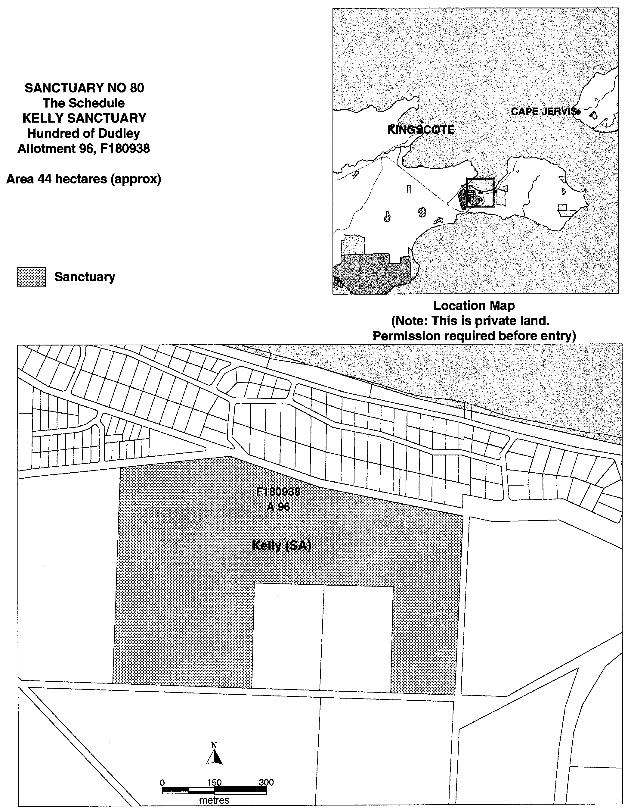
Dated 15 November 2000.

Iain Evans, Minister for Environment and Heritage

NATIONAL PARKS REGULATIONS 1990
Closure of Granite Island Recreation Park
PURSUANT to Regulations 7 (3) (b) and 7 (3) (c) of the National Parks Regulations 1990, I, Lindsay Wilfred Best, the Acting Director of National Park and Wildlife, close to the public the whole of Granite Island Recreation Park during the following times:
From 00.01 hours on Saturday, 25 November 2000 until 05.30 hours on Saturday, 25 November 2000.
From 00.01 hours on Sunday, 26 November 2000 until 05.30 hours on Sunday, 26 November 2000.
From 00.01 hours on Monday, 27 November 2000 until 05.30 hours on Monday, 27 November 2000.
From 00.01 hours on Tuesday, 28 November 2000 until 05.30 hours on Tuesday, 28 November 2000.
From 00.01 hours on Wednesday, 29 November 2000 until 05.30 hours on Wednesday, 29 November 2000.
From 00.01 hours on Thursday, 30 November 2000 until 05.30 hours on Thursday, 30 November 2000.
From 00.01 hours on Friday, 1 December 2000 until 05.30 hours on Friday, 1 December 2000.
From 00.01 hours on Saturday, 2 December 2000 until 05.30 hours on Saturday, 2 December 2000.
From 00.01 hours on Sunday, 3 December 2000 until 05.30 hours on Sunday, 3 December 2000.
From 00.01 hours on Monday, 4 December 2000 until 05.30 hours on Monday, 4 December 2000.
The purpose of the abovementioned closures is, that in my opinion, during Schoolies Week 2000, the number of staff necessary to patrol the reserve is unavailable, and it is in the interest of public safety to close the reserve during the abovementioned times.
Permission to Enter and Remain in the Reserve
Pursuant to Regulations 7 (4) and 37 of the National Parks Regulations 1990, I, Lindsay Wilfred Best, the Acting Director of National Parks and Wildlife, grant permission to persons undertaking legitimate recreational and commercial fishing activities to enter and remain in the area between the causeway and the screw pile jetty on Granite Island Recreation Park during the abovementioned times.
Pursuant to Regulations 7 (4) and 37 of the National Parks Regulations 1990, I, Lindsay Wilfred Best, the Acting Director of National Parks and Wildlife, grant permission to the lessee and employees of the Granite Island Nature Park, whilst undertaking duties of his or her employment, to enter and remain in the Granite Island Recreation Park from 00.01 hours on Saturday, 25 November 2000 until 05.30 hours on Monday, 4 December 2000.
This permission is conditional upon the observance by each of those persons of the requirements of the National Parks and Wildlife Act 1972 and the National Parks Regulations 1990, including those requiring compliance with the directions, requests, requirements and orders of a warden.
Dated 22 November 2000.
L. Best, Acting Director of National Parks and Wildlife

DEPARTMENT OF PRIMARY INDUSTRIES—
FISHERIES DIVISION
NOTICE is hereby given pursuant to section 28 (10) (b) of the South Australian Fisheries Act 1982, that the following items have been seized by officers of the Department of Primary Industries, Fisheries Division at 3 Mile Rocks Area at Beachport on 16 November 2000:
Fisheries Compliance Officers Marshall and Grant detected a rock lobster pot with no identification as required or red float as required. The rock lobster pot had a white float, a small wood tag, no name or number on tag, red neck with S160 on the neck.
The above items were suspected to have been used or intended to be used, in contravention of the Fisheries Act 1982, and were taken into possession at Kingston Fisheries Office, 17 James Street, Kingston.
After the expiration of one month from the date of this notice the items listed above shall, on my order as the Minister of Fisheries, be forfeited to the Crown and shall be either disposed of by sale or destruction.
The above items may be viewed at the Kingston Office, 17 James Street, Kingston an office of the Department of Primary Industries, Fisheries Division.
Dated 27 November 2000.
B. E. Hemming, Manager, Fisheries Compliance

ROADS (OPENING AND CLOSING) ACT 1991
Road Closure—Portion of Harcourt Terrace, Salisbury North
NOTICE is hereby given, pursuant to section 10 of the Roads (Opening and Closing) Act 1991, that the City of Salisbury proposes to make a Road Process Order to close and transfer to the South Australian Housing Trust portion of the public road (Harcourt Terrace) adjoining allotment 10 in Filed Plan 111906 (Harcourt Terrace/Milford Avenue) shown delineated and lettered ‘A’ in Preliminary Plan No. PP32/0623.
A copy of the plan and a statement of persons affected are available for public inspection at the office of Council, 8 James Street, Salisbury, S.A. 5108 and the Adelaide office of the Surveyor-General during normal office hours.
Any application for easement or objection must set out the full name, address and details of the submission and must be fully supported by reasons.
The application for easement or objection must be made in writing to the Council, P.O. Box 8, Salisbury, S.A. 5108 within 28 days of this notice and a copy must be forwarded to the Surveyor-General, G.P.O. Box 1354, Adelaide, S.A. 5001. Where a submission is made, the council will give notification of a meeting at which the matter will be considered.
Dated 28 November 2000.
K. Sarneckis, Acting Surveyor-General

REGULATIONS UNDER THE SENIOR SECONDARY ASSESSMENT BOARD OF SOUTH AUSTRALIA ACT 1983
────
No. 271 of 2000
────
At the Executive Council Office at Adelaide 30 November 2000

PURSUANT to the Senior Secondary Assessment Board of South Australia Act 1983, on the recommendation of the Senior Secondary Assessment Board of South Australia and with the advice and consent of the Executive Council, I make the following regulations.
E. J. NEAL Governor

PURSUANT to section 10AA(2) of the Subordinate Legislation Act 1978, I certify that, in my opinion, it is necessary or appropriate that the following regulations come into operation as set out below.

MALCOLM BUCKBY Minister for Education and Children's Services
───────────────────
SUMMARY OF PROVISIONS

1. Citation
2. Commencement
3. Revocation
4. Interpretation
5. Prescribed certification requirements
6. Fees

SCHEDULE 1
Year 11 Subjects

SCHEDULE 2

Year 12 Subjects

SCHEDULE 3

Fees
───────────────────

Citation
1. These regulations may be cited as the Senior Secondary Assessment Board of South Australia Regulations 2000.

Commencement
2. These regulations will come into operation on 1 January 2001.

Revocation
3. The Senior Secondary Assessment Board of South Australia Regulations 1991 (see Gazette 27 June 1991 p. 2258), as varied, are revoked.

Interpretation
4. In these regulations—

"Act" means the Senior Secondary Assessment Board of South Australia Act 1983;

"recorded achievement" in relation to a unit of study means completion of the unit at a level assessed by the Board to be not less than the minimum level required;

"satisfactory achievement" in relation to a unit of study means completion of the unit at a level assessed by the Board to be satisfactory;

"two-unit sequence" means—

(a) a program of study designed to be studied over a minimum of 100 hours, achievement in which is assessed as a whole; or

(b) any 2 units of study designated by the Board as a two-unit sequence;

"unit" of study means a program of study designed to be studied over a minimum of 50 hours.

Prescribed certification requirements
5. For the purposes of the Act, the following requirements are the certification requirements of senior secondary education:

(a) a student must enrol in at least 22 units of study that must include—

(i) at Year 11 level—

(A) 2 units in English or English as a Second Language; and

(B) 1 unit in Australian Studies; and

(C) 1 unit in Mathematics; and

(D) 2 units in any one or more of the subjects listed in Group 1 of Schedule 1; and

(E) 2 units in any one or more of the subjects listed in Group 2 of Schedule 1; and

(ii) at Year 12 level—

(A) 3 two-unit sequences in subjects listed in Schedule 2 that include at least—

(·) 2 units in a subject listed in Group 1 of Schedule 2; and

(·) 2 units in a subject listed in Group 2 of Schedule 2; or

(B) 3 two-unit sequences in subjects listed in Schedule 2 and—

(·) if all those subjects are listed in Group 1 of Schedule 2—at least 2 units in any one or more of the subjects listed in Group 2 of Schedule 2;

(·) if all those subjects are listed in Group 2 of Schedule 2—at least 2 units in any one or more of the subjects listed in Group 1 of Schedule 2; and

(iii) such number of other units in subjects listed in Schedule 1 or 2 as will make up the required minimum number of 22 units; and

(b) the student must achieve in the units of study in which he or she is enrolled the following levels of achievement:

(i) for 16 of the units (which must include 3 two-unit sequences of study at Year 12 level)—satisfactory achievement; and

(ii) for the other units—satisfactory achievement or recorded achievement; and

(c) the student must achieve the literacy standard set by the Board.

Fees
6. (1) The fees set out in Schedule 3 are payable to the Board.

(2) The Board may, in appropriate cases, waive or reduce fees that would otherwise be payable under these regulations.

SCHEDULE 1
Year 11 Subjects

Group 1
Humanities, arts or social and cultural studies
Aboriginal Studies | Languages other than English:
Ancient Studies | 42 languages are offered
Art | Legal Studies
Australian Indigenous Languages | Media Studies
Australian Studies | Modern History
Business Studies | Multi Arts
Communication for the Hearing-Impaired | Music
Community Services (VET) | Outdoor Education
Community Studies: | Personal Development Studies
The Arts and the Community | Politics
Business and the Community | Social Studies
The Community and the Environment | Studies in Religion
Design, Construction and the Community | Technical Drawing
Foods and the Community | Technology Studies:
Health, Recreation and the Community | Technology and Society
Language and the Community | Theory of Knowledge
Lifestyles and the Community | Tourism
Work and the Community | Women's Studies
Craft | Work Education
Dance
Design
Drama
Economics
English
English as a Second Language
Environmental Studies
Geography
Health Education
Home Economics
Integrated Studies:
programs of study in Integrated Studies classified by the Board as being in the field of humanities, arts or social and cultural studies

Group 2
Mathematics, science or technology
Accounting | Laboratory Operations (VET)
Agriculture | Mathematics
Biology | Physical Education
Chemistry | Physics
Community Studies: | Practical Information Processing
Business and the Community | Technology Studies:
The Community and the Environment | Construction Technology
Design, Construction and the Community | Electronics
Foods and the Community | Energy Technology
Health, Recreation and the Community | Photography
Mathematics and the Community | Technical Graphics
Science and the Community
Technology and the Community
Work and the Community
Computing
Geology
Information Technology (VET)
Integrated Science
Integrated Studies:
programs of study in Integrated Studies classified by the Board as being in the field of mathematics, science or technology
SCHEDULE 2
Year 12 Subjects

Group 1
Humanities, arts or social and cultural studies
Aboriginal Studies | Geography Studies
Ancient History | Health Education
Art Practical | Historical Studies: Ancient
Australian History | Historical Studies: Australian
Australian Indigenous Languages | Historical Studies: Contemporary World
The Australian Legal System | Home Economics
Business Studies | Languages other than English:
Classical Studies | 42 languages are offered
Communication for the Hearing-Impaired | Legal Studies
Community Services (VET) | Media Production and Analysis
Community Studies: | Medieval History
The Arts and the Community | Modern History: Asia
Business and the Community | Modern History: Europe
The Community and the Environment | Modern History: United States of America
Design, Construction and the Community | Modern History: World
Foods and the Community | Music
Health, Recreation and the Community | Natural Resources Management
Language and the Community | Outdoor Education
Lifestyles and the Community | Politics
Work and the Community | Religions in Australia
Craft Practical | Small Business Enterprise
Dance | Social Studies
Dance Performance and Theory | Studies of Religion
Design Practical | Tourism
Drama | Visual Arts Studies
Drama Studies | Women's Studies
Economics | Work Education:
English | Vocational Studies A
English as a Second Language | Vocational Studies B
English as Second Language Studies | Work Studies A
English Studies | Work Studies B
Geography

Group 2
Mathematics, science or technology
Accounting | Laboratory Operations (VET)
Accounting Studies | Maritime Studies
Agricultural and Horticultural Science | Mathematics 1, 2
Agriculture and Horticulture | Nutrition
Applied Mathematics | Physical Education
Biology | Physics
Business Mathematics | Quantitative Methods
Chemistry | Science
Community Studies: | Technology
Business and the Community | Technology Studies
The Community and the Environment | Work Education:
Design, Construction and the Community | Vocational Studies A
Foods and the Community | Vocational Studies B
Health, Recreation and the Community
Mathematics and the Community
Science and the Community
Technology and the Community
Work and the Community
Geology
Information Processing and Publishing
Information Technology
Information Technology Studies
Information Technology (VET)
SCHEDULE 3
Fees

1. | REGISTRATION FEE  For registration as an assessment centre of an educational institution not in receipt of financial assistance from the State | $1 220.65 per year
 | (Registration entitles the institution to services similar to that extended by the Board to educational institutions in receipt of financial assistance from the State.)
2. | STUDENT FEE  For enrolment for assessment and certification of completion of prescribed certification requirements by—
 | (a) a student of an educational institution not in receipt of financial assistance from the State; or
 | (b) a full fee paying overseas student (within the meaning of the Education Act 1972)
 | For a student at Year 11 level | $132 per student
 | For a student at Year 12 level | $137.50 per student plus $29.70 per subject per student
3. | LATE ENROLMENT FEE  For enrolment of a student for assessment of completion of prescribed certification requirements after the closing date for receipt of enrolments set by the Board in any year | $63.25 per student
4. | CLERICAL CHECK FEE  For checking, at the request of a student, the clerical processes and procedures involved in determining a result in a subject | $7.40 per subject
5. | CANDIDATE RECORD FEE  For access to information about the contribution of examination marks and moderated school assessment marks to the final result of a Year 12 level subject | $6.30 per subject
6. | SCRIPT ACCESS FEE  For access of students to their assessment materials | $12.65 per subject
7. | STATEMENT FEE  For a statement or certified record replacing—
 | (a) a statement of results awarded in a specified year; or
 | (b) a certified record of studies undertaken towards completion of the prescribed certification requirements (SACE Record of Achievement); or
 | (c) a certified record of results in individual subjects or requirements comprised in the prescribed certification requirements (SACE Statement of Results) issued | $14.85 per record or statement
8. | REPLACEMENT FEE FOR SACE CERTIFICATE  For a replacement copy of a South Australian Certificate of Education | $25.30

9. | PUBLICATIONS FEES  For a copy of—
 | (a) a curriculum statement | $6.00 if 80 pages or less  $9.70 if more than 80 pages
 | (b) a SSABSA handbook | $14.60

MECS 26/00 CS R. DENNIS Clerk of the Council

REGULATIONS UNDER THE HARBORS AND NAVIGATION ACT 1993
────
No. 272 of 2000
────
At the Executive Council Office at Adelaide 30 November 2000

PURSUANT to the Harbors and Navigation Act 1993 and with the advice and consent of the Executive Council, I make the following regulations.
E. J. NEAL Governor

PURSUANT to section 10AA(2) of the Subordinate Legislation Act 1978, I certify that, in my opinion, it is necessary or appropriate that the following regulations come into operation as set out below.

DIANA LAIDLAW Minister for Transport and Urban Planning
───────────────────
SUMMARY OF PROVISIONS
1. Citation
2. Commencement
3. Variation of reg. 132B—Personal watercraft only to be used during certain hours
4. Variation of Sched. 4—Restricted Areas—Controls
5. Variation of Sched. 5—Restricted Areas—Delineation
6. Substitution of Sched. 10
SCHEDULE 10
Speed Restrictions in Certain Waters
(Part 10 Division 2)
───────────────────

Citation
1. The Harbors and Navigation Regulations 1994 (see Gazette 20 October 1994 p. 987), as varied, are referred to in these regulations as "the principal regulations".

Commencement
2. These regulations will come into operation on 7 December 2000.

Variation of reg. 132B—Personal watercraft only to be used during certain hours
3. Regulation 132B of the principal regulations is varied—

(a) by striking out from subregulation (1) "A person" and substituting "Subject to this regulation, a person";

(b) by inserting after subregulation (1) the following subregulation:

(1a) However, a person may operate a personal watercraft on the River Murray for the purpose of towing another person at any time between sunrise and sunset on any day.

Variation of Sched. 4—Restricted Areas—Controls
4. Schedule 4 of the principal regulations is varied—

(a) by striking out from the table in clause 2 the entry relating to Lake Bonney (Barmera) and substituting the following entries:
Lake Bonney (Barmera Area 1) | Controls 1 and 4
Lake Bonney (Barmera Area 2) | Controls 2 and 5

Variation of Sched. 5—Restricted Areas—Delineation
5. Schedule 5 of the principal regulations is varied by striking out the entry relating to Lake Bonney (Barmera) and substituting the following entries:

Lake Bonney (Barmera Area 1)
The portion of Lake Bonney marked out by flame orange spherical buoys and yellow marker posts.

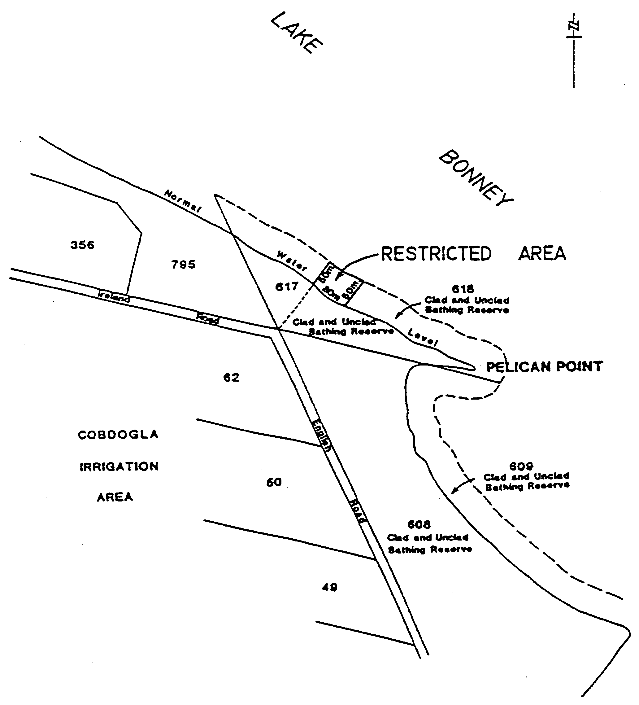

Lake Bonney (Barmera Area 2)
The portion of Lake Bonney bounded as follows:

⋅ on the north by a line 100 metres from, and parallel to, the edge of the water;

⋅ on the east by the prolongation, north-westerly, of the boundary between Section 150 and Section 151 in the Cobdogla Irrigation Area;

⋅ on the south by the edge of the water;

⋅ on the west by a straight line from the eastern end of the concrete wharf (approximately 20 metres west of the prolongation, northerly, of the western boundary of James Terrace) and at right angles to the edge of the water.

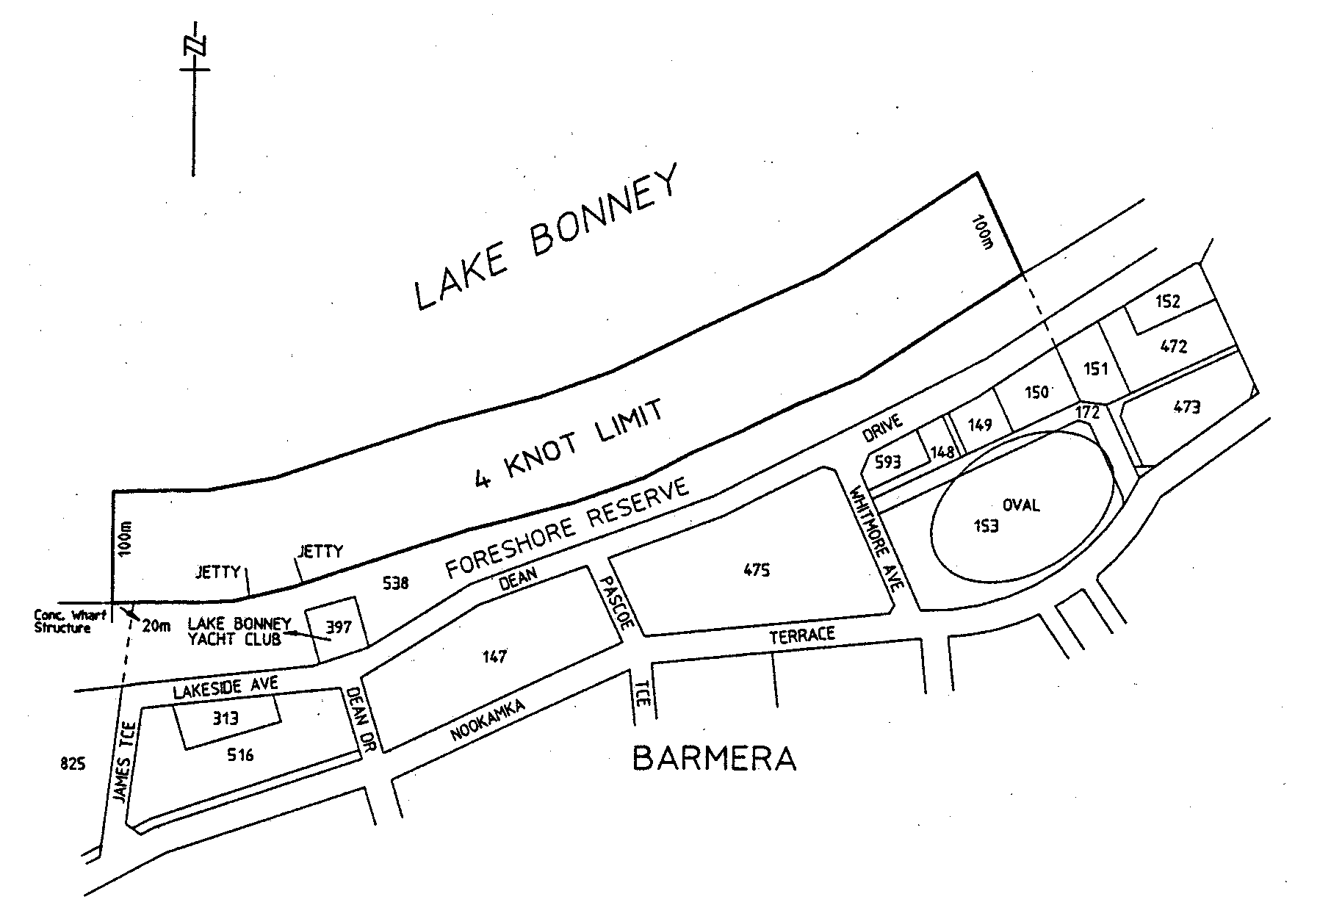

Substitution of Sched. 10
6. Schedule 10 of the principal regulations is revoked and the following Schedule is substituted:

SCHEDULE 10
Speed Restrictions in Certain Waters
(Part 10 Division 2)

Unless the contrary intention appears, the maps in this Schedule are provided for convenience of reference only.

7 knot limit—all vessels
1. The speed limit in the following waters is seven knots:

(a) Kangaroo Island
The area, known as the American River Aquatic Reserve, comprising all the waters of American River upstream of the geodesic commencing at high water mark on the western shore of American River at position latitude 35°47.5'S, longitude 137°45.5'E, then in a south easterly direction to high water mark on the eastern shore of American River, position latitude 35°48'S, longitude 137°45.8'E, together with the waters of Pelican Lagoon and all adjoining creeks and inlets of Pelican Lagoon;

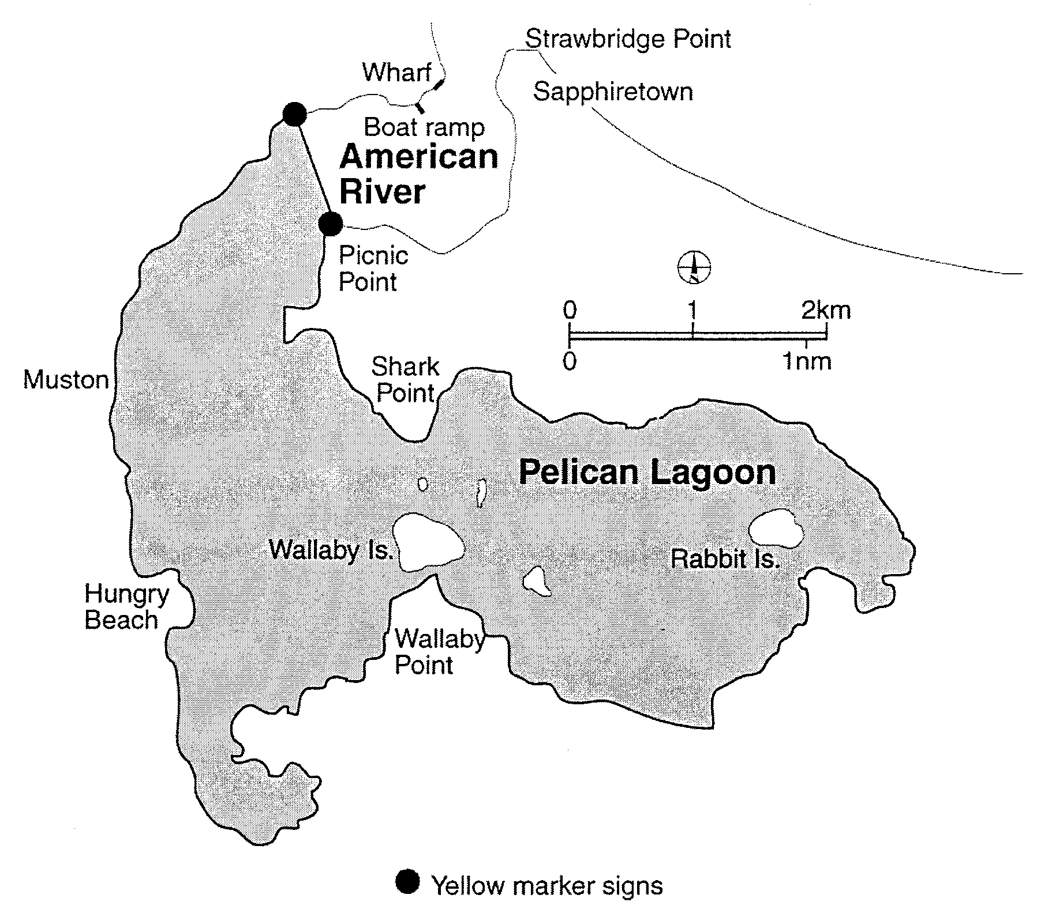

(b) Port Adelaide

(i) That portion of the marked channel in Barker Inlet, Port Adelaide between the middle ground beacon and Angas Inlet, Port Adelaide entrance beacon; and

(ii) Angas Inlet, Port Adelaide;

(c) Port Augusta
The area bounded as follows: Commencing at the intersection of the south-eastern end of Great Western Bridge and approaches with high water mark, then south-westerly along high water mark to its intersection with the production shorewards of the north-eastern end of Port Augusta wharf, then seawards along that production and the northern end of Port Augusta wharf to the north-eastern corner of the wharf, then along the face of that wharf and its production south-westerly to its intersection with high water mark on the north-western side of Port Augusta channel, then generally north-east along high water mark to its intersection with the north-western end of the Great Western Bridge and approaches, then south-easterly along the Great Western Bridge to the point of commencement;

(d) Port Broughton
The area bounded as follows: Commencing at the stick beacon without a top-mark situated approximately 655 metres north-north-west of the centre of sea-end of the Port Broughton jetty and between stick beacons Nos. 34 and 35 which are both surmounted by black triangles (the three beacons are on the western side of the Port Broughton channel) then due east to high water mark on the eastern side of Mundoora Arm, then generally southerly along the high water mark to its intersection with the production westerly of the southern side of Edmund Street, then west-north-westerly on a line parallel to the jetty to intersect high water mark on the western side of the Mundoora Arm, then generally north-easterly, easterly, south-easterly, north-easterly and north-westerly along high water mark to a point due west of the point of commencement then due east to the point of commencement;

(e) Whyalla
The area bounded as follows: Commencing at the intersection of high water mark and the production westerly of the face of the wharf on the north side of the Inner Harbor, then along the face of that wharf to its seaward end, then approximately south-easterly to the entrance beacon, then approximately southerly to a light beacon being the central of three beacons marking the northern side of the No. 2 Ore Channel, then approximately south-easterly to the light beacon marking the northern side of the seaward end of that channel, then at an angle of 90° bearing approximately south-westerly for 140 metres then bearing approximately north-westerly to the light beacon marking the inner end of the southern side of the channel, then approximately south-westerly to a point on the production of the line of dolphins at No. 1 Ore Jetty and 120 metres distant from the south-westerly face of the most south- westerly dolphin, then approximately north-westerly and parallel to the centre line of the latter jetty, to high water mark, then along high water mark to the point of commencement.

4 knot limit—all vessels
2. The speed limit in the following waters is four knots:

(a) Cowell
That portion of the waters of Cowell (Franklin Harbor) bounded by and to the west of a line commencing at the seaward end of the jetty and extending in a south-westerly direction to the seaward end of the southern breakwater;

(b) Lincoln Cove Marina
That portion of the waters within Lincoln Cove Marina bounded by a line commencing at the eastern extremity of the northern breakwater and extending to the starboard land entrance beacon (F1.G), then to the port land entrance beacon (F1.R), and then to the eastern extremity of the southern breakwater;

(c) North Arm
That portion of the North arm bounded by a line extending generally north and south along the western face of the Wave Screen at the western end and the Grand Trunkway Bridge at the eastern end;

(d) Victor Harbor
That portion of the waters of Encounter Bay commencing at the intersection of high water mark and the base of the north-western edge of the jetty adjacent to the boat ramp at Rosetta Head, then generally easterly along the north-western edge of the jetty, then generally north-easterly and easterly along the starboard hand channel markers of the navigation channel to the solar light navigation aid at the eastern entrance to the navigation channel, then generally westerly and south-westerly along the port hand channel markers of the navigation channel to the southern-most port hand channel marker, then to a point, on high water mark, 40 metres south-east of the point of commencement, then generally north-westerly along high water mark to the point of commencement;

(e) West Beach
That portion of the sea along the metropolitan foreshore within the Adelaide Shores boat ramp facility at West Beach bounded as follows:

⋅ on the south and west by the Adelaide Shores boat ramp and rigging area and the adjoining breakwater;

⋅ on the north by the northern breakwater;

⋅ on the east by the high water mark;

⋅ on the north-west by a straight line across the entrance to the Adelaide Shores boat ramp facility joining the northern end of the western breakwater and the western end of the northern breakwater.

4 knot limit—personal watercraft
3. The speed limit applicable to personal watercraft in the following waters is four knots:

(a) Beachport
That portion of the waters of Rivoli Bay, Beachport, between a straight line extending easterly from the eastern extremity of Section 467, Hundred of Rivoli Bay, and the prolongation, south-easterly, of the western boundary of Section 465, Hundred of Rivoli Bay, and within 100 metres seaward of high water mark;

(b) Kangaroo Island
That portion of the waters of Eastern Cove, Kangaroo Island, between a straight line extending northerly from the northern extremity of Strawbridge Point and the prolongation, westerly, of the northern boundary of Section 514, Hundred of Dudley, and within 200 metres seaward of high water mark;

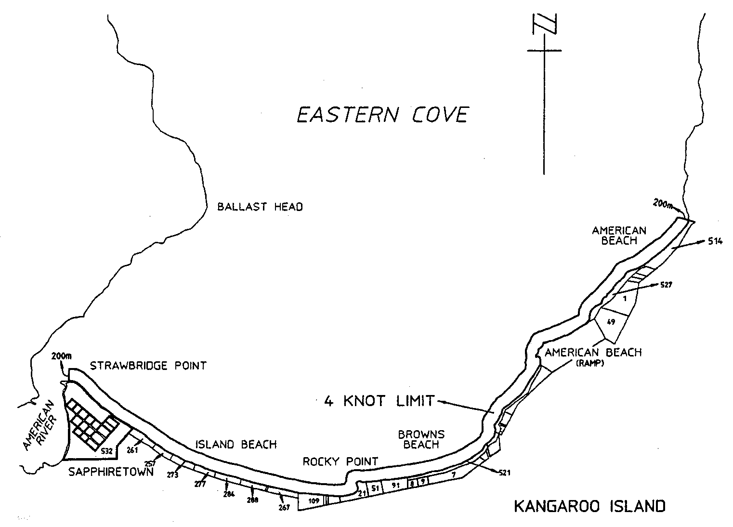

(c) Meningie
That portion of the waters of Lake Albert, Meningie, between the prolongation, northerly, of the far western boundary of Allotment 2 in Filed Plan 149606 and the prolongation, westerly, of the northern boundary of Section 235, Hundred of Bonney, and within 200 metres of the shoreline;

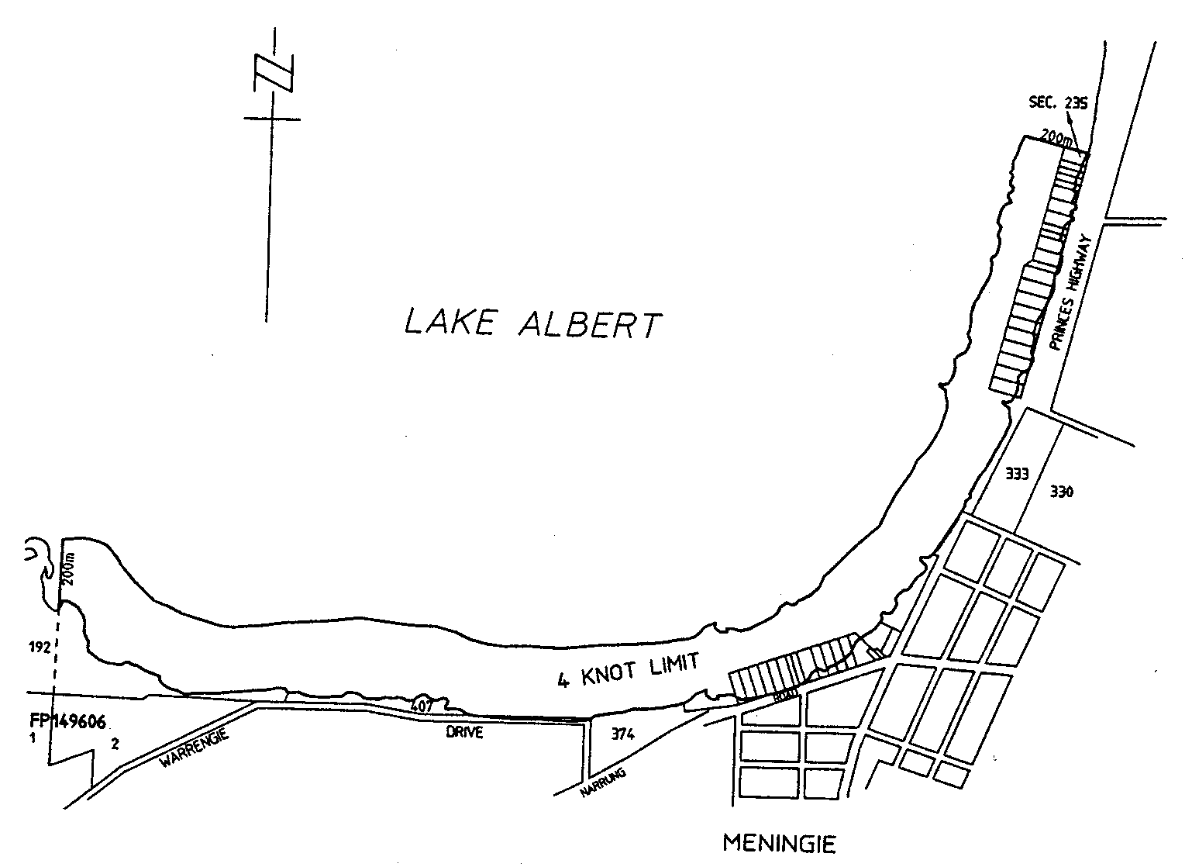

(d) Metropolitan Foreshore
That portion of the sea along the metropolitan foreshore from the landward end of the southern breakwater of the Outer Harbor to the southern end of Sellicks Beach and 200 metres seaward of the shoreline;

(e) River Murray
All creeks, tributaries, lakes, lagoons and other bodies of water connected to the River Murray between the border of South Australia and a line joining the upstream sides of the landings used by the ferry at Wellington, except a body of water that has been exempted by the CEO by notice published in the Gazette;

(f) Southend
That portion of the waters of Rivoli Bay, Southend, between the prolongation, north-easterly, of the northern boundary of Section 372, Hundred of Rivoli Bay, and the prolongation, north-westerly, of the north-east boundary of Section 108, Hundred of Rivoli Bay, and within 100 metres seaward of high water mark.

C 99/1019 R. DENNIS Clerk of the Council
REGULATIONS UNDER THE SOUTH AUSTRALIAN MOTOR SPORT ACT 1984
────
No. 273 of 2000
────
At the Executive Council Office at Adelaide 30 November 2000

PURSUANT to the South Australian Motor Sport Act 1984 and with the advice and consent of the Executive Council, I make the following regulations.
E. J. NEAL Governor

PURSUANT to section 10AA(2) of the Subordinate Legislation Act 1978, I certify that, in my opinion, it is necessary or appropriate that the following regulations come into operation as set out below.

JOHN OLSEN Minister for State Development
───────────────────
SUMMARY OF PROVISIONS

1. Citation
2. Commencement
3. Variation of reg. 4—Interpretation
4. Variation of reg. 6—Access to declared area by permitted entrants
5. Variation of reg. 8—Restriction on vehicles in declared area
6. Variation of reg. 9—Restriction on access to motor racing circuit
7. Substitution of reg. 10
10. Restricted areas
8. Variation of reg. 12—Permits, etc., may be subject to conditions
9. Variation of reg. 13—Reserved areas
10. Variation of reg. 15—Offences relating to tickets
11. Variation of reg. 17—Regulation of conduct in declared area
12. Variation of reg. 18—Refreshment areas
13. Variation of reg. 19—No smoking areas
14. Variation of reg. 20—Entertainment licences in declared areas
15. Variation of reg. 21—Authorised persons
16. Variation of reg. 25—Authorised persons—other powers
17. Variation of reg. 29—Disposal of confiscated property
───────────────────

Citation
1. The South Australian Motor Sport Regulations 1999 (see Gazette 11 March 1999 p. 1381) are referred to in these regulations as "the principal regulations".

Commencement
2. These regulations come into operation on the day on which they are made.

Variation of reg. 4—Interpretation
3. Regulation 4 of the principal regulations is varied—

(a) by striking out the definition of permitted entrant and substituting the following definition:

"permitted entrant", in respect of a motor sport event, means—

(a) a person who is entitled to be in a declared area for the event pursuant to a ticket or permit issued by or under the authority of the Board; or

(b) a person who is admitted by or under the authority of the Board to a declared area for the event on payment of an admission fee; or

(c) an agent or employee of the Board; or

(d) a resident or an invitee of a resident; or

(e) any other person who is, pursuant to a general or specific permit or authorisation granted by or under the authority of the Board, entitled to be in a declared area for the event;;

(b) by striking out from the definition of racing car "promoted by the Board";

(c) by striking out from the definition of ticket "on behalf" and substituting "under the authority".

Variation of reg. 6—Access to declared area by permitted entrants
4. Regulation 6 of the principal regulations is varied by striking out from subregulation (3) "by the Board" and substituting "by or under the authority of the Board".

Variation of reg. 8—Restriction on vehicles in declared area
5. Regulation 8 of the principal regulations is varied by inserting "or under the authority of" after "issued by".

Variation of reg. 9—Restriction on access to motor racing circuit
6. Regulation 9 of the principal regulations is varied—

(a) by striking out subparagraph (iv) of paragraph (a) and substituting the following subparagraph:

(iv) a vehicle that may be driven on the circuit under a specific permit or authorisation issued by or under the authority of the Board; or;

(b) by striking out paragraph (c) and substituting the following paragraph:

(c) entering the circuit under a specific permit or authorisation issued by or under the authority of the Board.

Substitution of reg. 10
7. Regulation 10 of the principal regulations is revoked and the following regulation is substituted:

Restricted areas
10. (1) A particular part of a declared area may be designated as a restricted area if, in the opinion of the Board or a person authorised by the Board, it would be unsafe to allow persons generally to enter or remain in that part of the declared area.

(2) A restricted area must be—

(a) designated as such by appropriate markings; and

(b) identified by notices bearing the words "RESTRICTED AREA: ACCESS TO PERMITTED PERSONS ONLY" posted at or near each entrance to the area.

(3) A person must not enter or remain in a restricted area except in accordance with a permit or authorisation issued by or under the authority of the Board.

Maximum penalty: $1 250.
Expiation fee: $55.

Variation of reg. 12—Permits, etc., may be subject to conditions
8. Regulation 12 of the principal regulations is varied by striking out subregulation (1) and substituting the following subregulations:

(1) Conditions may be imposed in respect of rights conferred by a permit, authorisation or ticket—

(a) in respect of a motor sport event promoted by the Board—by the Board;

(b) in respect of a motor sport event promoted by some other person—by the Minister.

(1a) Conditions imposed under subregulation (1) must be—

(a) stated or referred to in the permit, authorisation or ticket; or

(b) published in the Gazette.

Variation of reg. 13—Reserved areas
9. Regulation 13 of the principal regulations is varied—

(a) by inserting in subregulation (1) "or a person authorised by the Board" after "The Board";

(b) by inserting in subregulation (2) "or a person authorised by the Board" after "The Board";

(c) by striking out subregulations (3) and (4) and substituting the following subregulation:

(3) Reserved areas, reserved blocks of seats and reserved seats must be clearly differentiated by signs or markings.

Variation of reg. 15—Offences relating to tickets
10. Regulation 15 of the principal regulations is varied by striking out from subregulation (1) "by the Board" and substituting "by or under the authority of the Board".

Variation of reg. 17—Regulation of conduct in declared area
11. Regulation 17 of the principal regulations is varied—

(a) by inserting in subregulation (1)(a) "or under the authority of" after "issued by";

(b) by inserting in subregulation (1)(b)(iv) "or under the authority of" after "issued by".

Variation of reg. 18—Refreshment areas
12. Regulation 18 of the principal regulations is varied by striking out subregulations (1) and (2) and substituting the following subregulations:

(1) A particular part of a declared area for a motor sport event may be designated as a refreshment area.
(2) A refreshment area must be—

(a) designated as such by appropriate markings; and

(b) identified by notices bearing the words "REFRESHMENT AREA: NO BOTTLE, CAN OR GLASS MAY BE REMOVED FROM THIS AREA" posted at or near each exit to the area.

Variation of reg. 19—No smoking areas
13. Regulation 19 of the principal regulations is varied by striking out subregulations (1) and (2) and substituting the following subregulations:

(1) A part of a declared area for a motor sport event may be designated as a no smoking area if, in the opinion of the Board or a person authorised by the Board, it would be unsafe to permit smoking in that part of the declared area.

(2) A no smoking area must be—

(a) designated as such by appropriate markings; and

(b) identified by notices bearing the words "NO SMOKING" posted at or near each entrance to the area.

Variation of reg. 20—Entertainment licences in declared areas
14. Regulation 20 of the principal regulations is varied—

(a) by striking out subregulations (1) and (2) and substituting the following subregulations:

(1) The Board or a person authorised by the Board may grant a licence to a person to conduct an entertainment for members of the public in a declared area for a motor sport event.

(2) A licence to conduct an entertainment may be subject to conditions.

(2a) Conditions to be observed by members of the public entering a declared area for the purposes of attending an entertainment conducted under a licence may be imposed—

(a) if the declared area is for a motor sport event promoted by the Board—by the Board;

(b) if the declared area is for a motor sport event promoted by some other person—by the Minister.;

(b) by striking out from subregulation (3)(c) "(2)" and substituting "(2a)".

Variation of reg. 21—Authorised persons
15. Regulation 21 of the principal regulations is varied by striking out subregulations (1) to (3) (inclusive) and substituting the following subregulations:

(1) For the purposes of these regulations, a person may be appointed as an authorised person by the Board or the Minister.

(2) An appointment may be—

(a) subject to conditions specified in the instrument of appointment; and

(b) varied or revoked at any time.

Variation of reg. 25—Authorised persons—other powers
16. Regulation 25 of the principal regulations is varied by striking out paragraph (f) and substituting the following paragraph:

(f) if the authorised person has reasonable cause to believe that a person is in a restricted area in contravention of Part 2, remove the person from the restricted area;.

Variation of reg. 29—Disposal of confiscated property
17. Regulation 29 of the principal regulations is varied—

(a) by striking out from subregulation (1) "the Board must return it" and substituting "it must be returned";

(b) by striking out from subregulation (2) "Board" and substituting "Minister".

CST000/0012 R. DENNIS Clerk of the Council

REGULATIONS UNDER THE HOUSING AND URBAN DEVELOPMENT (ADMINISTRATIVE ARRANGEMENTS) ACT 1995
────
No. 274 of 2000
────
At the Executive Council Office at Adelaide 30 November 2000

PURSUANT to the Housing and Urban Development (Administrative Arrangements) Act 1995 and with the advice and consent of the Executive Council, I make the following regulations.
E. J. NEAL Governor

PURSUANT to section 10AA(2) of the Subordinate Legislation Act 1978, I certify that, in my opinion, it is necessary or appropriate that the following regulations come into operation as set out below.

DEAN BROWN Minister for Human Services
───────────────────
SUMMARY OF PROVISIONS

1. Citation
2. Commencement
3. Variation of reg. 5—Board of management
───────────────────

Citation
1. The Housing and Urban Development (Administrative Arrangements) (South Australian Aboriginal Housing Authority) Regulations 1998 (see Gazette 22 October 1998 p. 1238) are referred to in these regulations as "the principal regulations".

Commencement
2. These regulations come into operation on the day on which they are made.

Variation of reg. 5—Board of management
3. Regulation 5 of the principal regulations is varied—

(a) by striking out paragraph (a) of subregulation (1) and substituting the following paragraph:

(a) five will be appointed by the Governor, on the nomination of the Minister, of whom at least two must be persons who, in the opinion of the Minister, are appropriate representatives of Anangu Pitjantjatjara, Maralinga Tjarutja or the Aboriginal Lands Trust; and;

(b) by inserting after subregulation (1) the following subregulations:

(1a) One of the members appointed to the board on the nomination of the Minister will be appointed as the presiding member.

(1b) If—

(a) a member of ATSIC is appointed to the board on the nomination of ATSIC; and

(b) the person subsequently ceases to be a member of ATSIC,

the office of that member is automatically vacated.;

(c) by inserting in subregulation (4) "and it will be a condition of appointment that the member or deputy provide, within 3 months of his or her appointment, such evidence to the board as the board thinks necessary to establish that the member or deputy is an Aboriginal person" after "Aboriginal persons".

DHSCS 00/45 R. DENNIS Clerk of the Council

REGULATIONS UNDER THE POLICE ACT 1998
────
No. 275 of 2000
────
At the Executive Council Office at Adelaide 30 November 2000

PURSUANT to the Police Act 1998 and with the advice and consent of the Executive Council, I make the following regulations.
E. J. NEAL Governor

PURSUANT to section 10AA(2) of the Subordinate Legislation Act 1978, I certify that, in my opinion, it is necessary or appropriate that the following regulations come into operation as set out below.

K. T. GRIFFIN Minister for Justice
───────────────────
SUMMARY OF PROVISIONS

1. Citation
2. Commencement
3. Variation of reg. 54—Custody of property
───────────────────

Citation
1. The Police Regulations 1999 (see Gazette 5 August 1999 p. 684), as varied, are referred to in these regulations as "the principal regulations".

Commencement
2. These regulations will come into operation on 3 December 2000.

Variation of reg. 54—Custody of property
3. Regulation 54 of the principal regulations is varied by striking out paragraph (c) of subregulation (2) and substituting the following paragraph:

(c) a receipt to be issued, as soon as is reasonably practicable and in the manner approved by the Commissioner, to the person from whom the property was received, seized or otherwise obtained.

CSP0009/00 R. DENNIS Clerk of the Council

REGULATIONS UNDER THE NATIONAL ELECTRICITY (SOUTH AUSTRALIA) ACT 1996
────
No. 276 of 2000
────
At the Executive Council Office at Adelaide 30 November 2000

PURSUANT to the National Electricity (South Australia) Act 1996, on the unanimous recommendation of the Ministers of the participating jurisdictions and with the advice and consent of the Executive Council, I make the following regulations.

E. J. NEAL Governor
───────────────────
SUMMARY OF PROVISIONS

1. Citation
2. Commencement
3. Variation of reg. 14—Maximum civil monetary liabilities of NEMMCO or network service providers
4. Variation of Sched.—Classification of Provisions of Code and Class A Civil Penalties
───────────────────

Citation
1. The National Electricity (South Australia) Regulations (see Gazette 8 December 1998 p. 1820), as varied, are referred to in these regulations as "the principal regulations".

Commencement
2. These regulations come into operation on the day on which they are made.

Variation of reg. 14—Maximum civil monetary liabilities of NEMMCO or network service providers
3. Regulation 14 of the principal regulations is varied—

(a) by inserting in subregulation (1)(b) "in respect of the relevant event" after "exceeds the prescribed amount";

(b) by striking out from subregulation (1)(b) "is the prescribed" and substituting "is that prescribed";

(c) by inserting in subregulation (1)(d) "in respect of the relevant event" after "exceeds the prescribed amount";

(d) by striking out from subregulation (1)(d) "is the prescribed" and substituting "is that prescribed";

(e) by inserting in subregulation (2)(c) "separate" before "running totals";

(f) by inserting in subregulation (2)(c)(i) "in relation to relevant events alleged to have occurred during the same prescribed 12 month period" after "claimants)";

(g) by inserting in subregulation (2)(c)(ii) "in relation to relevant events alleged to have occurred during the same prescribed 12 month period" after "claims";

(h) by inserting in the definition of "prescribed amount" in subregulation (3) "in respect of a relevant event" before "means";

(i) by inserting in paragraph (a) of the definition of "prescribed amount" in subregulation (3) "occurring during the same prescribed 12 month period as that in which the relevant event occurred" after "relevant events";

(j) by inserting in paragraph (b) of the definition of "prescribed amount" in subregulation (3) "occurring during the same prescribed 12 month period as that in which the relevant event occurred" after "relevant events";

(k) by inserting after the definition of "prescribed amount" in subregulation (3) the following definition:

"prescribed 12 month period" means—

(a) the period of 12 months from the prescribed day; or

(b) the period of 12 months from the end of the period referred to in paragraph (a);;

(l) by striking out from paragraph (a) of the definition of "relevant event" in subregulation (3) "12" and substituting "24";

(m) by striking out from paragraph (b) of the definition of "relevant event" in subregulation (3) "12" and substituting "24".

Variation of Sched.—Classification of Provisions of Code and Class A Civil Penalties
4. The Schedule of the principal regulations is varied—

(a) by inserting in the table after the entry relating to 2.3.4(h) the following entry:

2.5.3(e)(1)-(4) | C

(b) by inserting in the table after the entry relating to 3.8.2(a)-(b) the following entry:

3.8.2(b1) | A | $20 000

(c) by inserting in the table after the entry relating to 3.8.4(a)-(d) the following entry:

3.8.4(e) | C

(d) by striking out from the table the entry relating to 3.9.6(b);

(e) by striking out from the table the entry relating to 3.15.7;

(f) by inserting in the table after the entry relating to 3.15.25(a) the following entry:

3.18.4(e) | C

(g) by inserting in the table after the entry relating to 4.9.2(c) the following entry:

4.9.2a(c) | C
(h) by inserting in the table after the entry relating to 4.9.4(a)-(f) the following entry:

4.9.4a(a)-(b) | C

(i) by inserting in the table after the entry relating to 4.9.9 the following entry:

4.9.9a | A | $10 000

(j) by inserting in the table after the entry relating to 5.2.3(e) the following entry:

5.2.3(e1), (f), (g) | B

(k) by inserting in the table after the entry relating to SCHEDULE 9G, 6.2 the following entry:

6.2A(b)-(c) | C

T&F 00/113 CS R. DENNIS Clerk of the Council

REGULATIONS UNDER THE ENVIRONMENT PROTECTION ACT 1993
────
No. 277 of 2000
────
At the Executive Council Office at Adelaide 30 November 2000

PURSUANT to the Environment Protection Act 1993 and with the advice and consent of the Executive Council, I make the following regulations.
E. J. NEAL Governor
───────────────────
SUMMARY OF PROVISIONS

1. Citation
2. Commencement
3. Variation of reg.3—Interpretation
4. Substitution of reg. 4
4. Beverages
5. Variation of Sched. 2—Exempt containers
───────────────────

Citation
1. The Environment Protection (Beverage Container) Regulations 1995 (see Gazette 27 April 1996 p. 1658), as varied, are referred to in these regulations as "the principal regulations".

Commencement
2. These regulations will come into operation on 1 January 2003.

Variation of reg.3—Interpretation
3. Regulation 3 of the principal regulations is varied by inserting after the definition of "the Act" the following definitions:

"flavoured milk" means milk to which flavouring has been added;

"milk" means cow's milk or the milk of any other animal, soy milk, rice milk or coconut milk and, without limiting that meaning, includes milk that is one or more of the following:

(a) ultra heat treated or reconstituted milk;

(b) reduced fat milk;

(c) milk with added protein, milk fat, calcium, vitamins, minerals or other supplements;

"soft drink" means all kinds of drinks that do not include alcohol except—

(a) water; and

(b) milk; and

(c) pure fruit juice;

"pure fruit juice" means a liquid at least 90 per cent of which is fruit juice or vegetable juice or a mixture of fruit and vegetable juices;.

Substitution of reg. 4
4. Regulation 4 of the principal regulations is revoked and the following regulation is substituted:

Beverages
4. Pursuant to section 65 of the Act, the following liquids intended for human consumption by drinking are declared to be beverages for the purposes of Division 2 Part 8 of the Act:

(a) water;

(b) flavoured milk;

(c) pure fruit juice; and

(d) non-carbonated soft drinks.

Variation of Sched. 2—Exempt containers
5. Schedule 2 of the principal regulations is varied—

(a) by striking out clause 1 and substituting the following clause:

1. Any containers used for the purpose of containing 1 litre or more of flavoured milk.;

(b) by striking out clause 2 and substituting the following clause:

2. Any containers used for the purpose of containing 1 litre or more of pure fruit juice.;

(c) by inserting in clause 3 "used for the purpose of" after "(commonly known as casks or aseptic packs)";

(d) by inserting in clause 4 "used for the purpose of" after "(commonly known as sachets)";

(e) by inserting in clause 5 "used for the purpose of" after "containers";

(f) by striking out clause 6.

EH00/0020CS R. DENNIS Clerk of the Council

FAXING COPY?

IF you fax copy to Government Publishing SA (formerly Riverside 2000), for inclusion in the Government Gazette, there is no need to send a Confirmation Copy to us as well.

This creates confusion and may well result in your notice being printed twice.

Please use the following fax number:

Fax transmission: (08) 8207 1040
Phone Inquiries: (08) 8207 1045

Please include a contact person, phone number and order number so that we can phone back with any queries we may have regarding the fax copy.

NOTE: Closing time for lodging new copy (either fax or hard copy) is 4 p.m. on Tuesday preceding the day of publication.

Government Gazette notices can be E-mailed.

The address is:

governmentgazette@saugov.sa.gov.au

Documents should be sent as attachments in Word format.

When sending a document via E-mail, please confirm your transmission with a faxed copy of your document, including the date the notice is to be published.

Fax transmission: (08) 8207 1040
Enquiries: (08) 8207 1045

CITY OF PROSPECT
Exclusion of Community Land
NOTICE is hereby given pursuant to section 34 of the Local Government (Implementation) Act 1999, that council at its meeting held on 21 November 2000, resolved to exclude from classification as community land the property located at 33 Harvey Street, Nailsworth, S.A. 5083 and contained within allot-ment 3, section 347, file plan 110811, certificate of title volume 5688, folio 823; allotment 1, section 347, file plan 110809, certificate of title volume 5688, folio 688 and allotment 100, section 347, filed plan 110808, certificate of title volume 5787, folio 710.
M. Llewellyn-Smith, City Manager

CITY OF PROSPECT
Exclusion of Community Land
NOTICE is hereby given pursuant to section 34 of the Local Government (Implementation) Act 1999, that council at its meeting held on 21 November 2000, resolved to exclude from classification as community land the property located at 18 and 24 Wilson Street, Prospect, S.A. 5082, known as Little Adelaide Village and contained within allotment 13, section 348, deposited plan 14978, certificate of title volume 5357, folio 605; allotment 11, section 348, deposited plan 13903, certificate of title volume 5740, folio 395; allotment 50, section 348, deposited plan 17078, certificate of title volume 4265, folio 676 and allotment 20, section 348, deposited plan 207878, certificate of title volume 5606, folio 221.
M. Llewellyn-Smith, City Manager

CITY OF TEA TREE GULLY
Declaration of Public Road
NOTICE is hereby given that Council, at its’ meeting held on 14 November 2000, exercised its’ powers under Section 210 of the Local Government Act 1999, and declared that Allotment 55 in Deposited Plan 3688, being the whole of the land comprised in Certificate of Title Register Book Volume 5715, Folio 673, be declared as a public road and to be known as Orkney Lane.
G. J. Perkin, Chief Executive Officer

CITY OF WEST TORRENS
Erection of Barricades in Street
NOTICE is hereby given that due to drainage construction works an officer of council, authorised for the purpose, has directed that barriers be erected on and across Military Road, West Beach to prevent the passing of traffic along a section of that road.
Pursuant to section 323 of the Local Government Act 1934, as amended, I hereby determine that, between 1 December 2000 and 1 April 2001 all traffic shall proceed on and along Military Road using that portion of the road as described on the Barcoo Outlet Road Deviation Plan number 2000—0731 Revision A, except vehicles owned or operated by or on behalf of Stockport Civil in connection with the Barcoo Outlet construction works.
Dated 22 November 2000.
J. P. Trainer, Mayor

DISTRICT COUNCIL OF GRANT
By-laws
Part A: Definitions and Construction
1. In these by-laws, unless the context otherwise indicates:
‘camp’ includes setting up a camp, or allowing a caravan or tent or motor home to remain on land whether or not any person is in attendance or sleeps on the land;
‘camping reserve’ means land vested in or under the control of the council which the council has set aside as a camping reserve and which is identified by one or more signs bearing the words “camping reserve” with or without other words;
‘council land’ means any land vested in or under the care, control or management of the council, (but does not include a road unless specifically mentioned), and for the purposes of this by-law includes the Port MacDonnell Harbour (as described in Schedule 3 to the Harbors and Navigation Regulations 1994), and the adjacent or subjacent land to that harbor under the control of the Minister;
‘foreshore’ means the beach next to the ocean and sandhills adjacent thereto that are under the care, control and management of the council;
‘Minister’ means the Minister of the Crown for the time being responsible for the administration of the Harbors and Navigation Act 1993;
‘permission’ means permission of the council given in writing;
‘small dwelling’ means the premises of a self-contained dwelling which is either commonly known as a flat, service flat, home unit or the like, or which is contained in a separate strata title.
2. These by-laws are subject to any Act of Parliament and the general law of the State.
Part B: Council Land
General provisions
1. No person shall on any council land:
Improper use of things
(1) improperly remove or improperly interfere with or use or wilfully damage any chattel or thing the property of the council;
Organised or dangerous sports
(2) (a) promote or conduct any organised athletic sport;
(b) to which this by-law 1 (2) (b) applies, play or practise any game which involves kicking, hitting or throwing a ball or other object;
Removal of soil, plants etc.
(3) remove therefrom any mineral or vegetable matter that is part of the land (unless the land is a reserve and the taking of that item is permitted by the purpose for which that land has been reserved);
Attaching objects
(4) attach, hang or fix any rug, blanket, sheet, rope or other material to any tree, shrub, plant, tree guard, tree stake, notice board, seat, fence, post, wall or other item or structure the property of the council;
Tents and structures
(5) erect or construct any tent, building or other structure thereon, unless in the case of a tent, the land is a camping reserve and the tent is for the purpose of camping overnight;
Camping
(6) camp or stay overnight thereon (but this by-law 1 (6) does not apply to a camping reserve);
Lighting fires
(7) light or maintain a fire except in places set aside by the council for that purpose, (but a gas fire or gas barbeque may be used for cooking purposes);
Use of rubbish bins
(8) (a) place any rubbish of a certain kind in a rubbish bin where a sign or signs indicate that rubbish of another kind only is permitted to be placed in that bin; or
(b) place any rubbish in a rubbish bin otherwise than in accordance with a sign or signs which give directions in relation to the placement of rubbish in that bin;
Alcohol beverages
(9) constituting a park or reserve to which this by-law 1 (9) applies, consume or possess or be in charge of any alcoholic beverage;
Smoking
(10) smoke tobacco or any other substance in any building or part thereof to which this by-law 1 (10) applies;
Levying charges
(11) levy or collect a charge for admission to any part thereof;
Interference with use
(12) (a) annoy or unreasonably interfere with any other persons’ normal use of the land by making a noise or creating a disturbance;
(b) interrupt or disrupt or interfere with any person’s use of the land for which permission has been granted;
Firearms etc.
(13) shoot or discharge a firearm, or ignite any firework thereon;
Directions
(14) fail to comply with any reasonable direction or request from an authorised officer of the council relating to:
(a) that person’s use of the land;
(b) that person’s conduct and behaviour on the land;
(c) that person’s safety on the land; or
(d) the safety and enjoyment of the land by other persons.
Vehicles on council land
2. No person shall on any council land:
Speed of vehicles
(1) to which this by-law 2 (1) applies, drive or propel a vehicle at a greater speed than 25 km/h;
Exclusion of vehicles
(2) to which this by-law 2 (2) applies, drive or propel a vehicle on such land; or
Vehicles on parklands and cemeteries
(3) comprising a cemetery or parklands or a reserve:
(a) drive or propel a vehicle thereon, (except a wheelchair), unless for the purpose of attending to stock (depasturing thereon with permission), or unless on an area, path, or road constructed or set aside by the council for the parking or travelling of that kind of vehicle; or
(b) promote, organise or take part in any race, test or trial of any kind in which motor vehicles, motor cycles, motor scooters or bicycles take part (except in parklands or a reserve on a properly constructed area for the purpose).
Animals on council land
3. No person shall on any council land:
Animals causing pollution or damage
(1) being the person responsible for an animal, fail to ensure that the animal does not pollute any lake, dam, channel or other body of water, or does not cause any damage to council property;
Depasturing
(2) cause, suffer or allow any animal under his or her control to depasture thereon;
Dog free areas
(3) to which this by-law 3 (3) applies cause, suffer or permit any dog under that person’s control, charge or authority to be or remain in that place;
Dog on leash areas
(4) to which this by-law 3 (4) applies, cause, suffer or permit any dog under that person’s control, charge or authority to be or remain in that place unless such dog is restrained by a strong leash not exceeding 2 m in length and either tethered securely to a fixed object or held by a person capable of controlling the dog and preventing it from being a nuisance or a danger to other persons; or
Horse free areas
(5) to which this by-law 3 (5) applies, cause, suffer or permit any horse under that person’s control, charge or authority to be or remain in that place.
The foreshore
4. No person shall:
Vehicle access
(1) drive or propel a vehicle onto or from the foreshore other than by a ramp or thoroughfare constructed or provided by the council or the Government for that purpose; or
Cattle, goats and sheep on foreshore
(2) cause, suffer or permit any cattle, goats or sheep under that person’s control, charge or authority to be or remain on the foreshore.
Camping reserves
5. No person shall:
(1) camp on a camping reserve for a period in excess of six consecutive weeks;
(2) having camped on a camping reserve for six consecutive weeks, camp on any camping reserve until a further period of four consecutive weeks has expired.
Rubbish dumps
6. No person shall interfere with, remove or take away any rubbish that has been discarded at any rubbish dump on council land.
Restricted lands
7. (1) No person shall enter or remain on any part of council land:
(a) at any time during which the council has by resolution declared that part to be closed to the public, and which is indicated by a sign adjacent to the entrance to that part; or
(b) where the land is enclosed with fences and/or walls, and gates, at any time when the gates have been closed and locked; or
(c) at any time when the council has fixed a fee for entry to or use of that part, without payment of the fee, or, otherwise without permission; or
(d) where that person has been requested by an officer, employee or agent of the council or a council subsidiary to leave that land.
(2) The council may only declare land in the Port MacDonnell Harbour to be closed to the public in a situation of emergency, or otherwise with the consent of the Minister.
Movement of animals on roads
8. (1) The owner or person in charge of any cattle or horses that are driven over, across or along any road shall forthwith after such animals have completed their passage remove any dung left by those animals during their passage.
(2) The person responsible for looking after any cattle, sheep, goats, horses or other farm animals (but not dogs or cats) shall ensure that any of those animals do not move across, along or on any road unattended.
Removal of unauthorised things
9. If a person has placed or erected a substance, object or structure on council land without lawful authority or without permission, or has apparently abandoned the same thereon, the council may remove and dispose of it, and recover the cost of so doing from the person who placed or erected it thereon.
Part C: Use of Tents and Certain Buildings for Human
Habitation
1. No person shall erect any tent or building constructed of other than brick, stone, concrete or similar material, which is used or adapted for the purpose of human habitation, on any land abutting or within view of any public road or of any reserve or foreshore.
Part D: Restriction on Dog Numbers
1. The limit on the number of dogs kept:
(1) in a township:
(a) in a small dwelling, shall be one dog;
(b) on premises other than a small dwelling, shall be two dogs;
(2) outside of a township, shall be three dogs (other than working dogs).
2. No person shall keep any dog on any premises where the number of dogs being kept on those premises exceeds the limit.
Part E: Exemptions
1. A person may perform an act prohibited in these by-laws:
(1) with permission; or
(2) if the act is performed during the course of and as part of their official duties as a public official or an officer, employee, agent or contractor of the council; and
(3) it is otherwise lawful to do so.
2. A person granted permission under these by-laws shall comply with any conditions imposed thereon.
3. In addition to the foregoing exemptions, the council may exempt persons generally, or classes of persons from compliance with any by-law or by-laws from time to time or on or during times days or occasions, and subject to conditions.
Part F: Application
1. Any of by-laws 1 (2) (b), 1 (9), 1 (10), 2 (1), 2 (2), 3 (3),
3 (4) and 3 (5) shall apply only within such part or parts of the area as the council may determine from time to time.
Part G: Penalties
1. A person who breaches any of these by-laws is guilty of an offence and is liable to a penalty being the maximum amount that generally can be prescribed by by-law for any breach of a by-law.
[currently this amount is $750]
2. Unless otherwise decided by resolution of the council, the expiation fee for an alleged offence against these by-laws is 25% of the maximum penalty.
Schedule: Repeal of By-laws
All by-laws of the council made prior to the date this by-law is made are hereby repealed.
This schedule is hereby repealed to take effect four weeks after this by-law comes into effect.
The Minister for Transport and Urban Planning, being the Minister responsible for the administration of the Harbors and Navigation Act 1993, hereby consents to the making of the above by-laws.
The foregoing by-laws were duly made and passed at a meeting of the District Council of Grant held on 23 November 2000, by an absolute majority of the members for the time being constituting the council, there being at least two-thirds of the members present.
Dated 30 November 2000.
R. J. Peate, District Manager

LIGHT REGIONAL COUNCIL
Amendment to Change of Meeting Date and Venue
REFERENCE is made to the Government Gazette of 9 November 2000, page 3105, giving notice of the change of council’s December ordinary meeting date. The following notice is an amendment to that change of date:
Notice is hereby given that at the ordinary meeting of council held on 21 November 2000, it was resolved that the ordinary council meeting for December will be held on Wednesday, 13 December 2000, commencing at 5.30 p.m., in the Community House, Kingfisher Drive, Hewett.
P. J. Beare, Chief Executive Officer

LIGHT REGIONAL COUNCIL
Temporary Road Closure
NOTICE is hereby given that pursuant to section 359 of the Local Government Act 1934, as amended, all vehicles except emergency vehicles and authorised service vehicles are excluded from Main Street, Kapunda between Ford Street and the
Clare Road/South Terrace intersection; Smedley Street, Kapunda from Main Street to Whittaker Street; Crase Street, Kapunda from Main Street to Whittaker Street; Lucas Street, Kapunda from Main Street to Whittaker Street; Beck Street, Kapunda from Main Street to Church Street; Hill Street, Kapunda from Main Street to Blyth Street; Brown Street, Kapunda from Main Street to Stock Street, that heavy vehicles be re-routed via Hancock Road, Kapunda and local traffic detoured down Ford Street, Kapunda between the hours of 5 p.m. and 9.30 p.m. on Friday, 22 December 2000.
P. J. Beare, Chief Executive Officer

LIGHT REGIONAL COUNCIL
Temporary Road Closure
NOTICE is hereby given that pursuant to section 359 of the Local Government Act 1934, as amended, all vehicles except emergency vehicles and authorised service vehicles are excluded from Gray Street between Neldner Street and Borrow Street; Hanson Street between the Post Office and Gray Street and Stevenson Street between Coulls Street and Gray Street in Freeling between the hours of 4 p.m. and midnight on Saturday, 2 December 2000.
P. J. Beare, Chief Executive Officer

DISTRICT COUNCIL OF LOXTON WAIKERIE
Temporary Road Closure
NOTICE is hereby given that at a meeting of council held on 17 December 2000, the District Council of Loxton Waikerie, pursuant to section 359 of the Local Government Act 1934, as amended, resolved to exclude all vehicles, with the exception of emergency vehicles and vehicles associated with the Waikerie Pageant, from McCoy Street and the southern carriageway of White Street from noon to 5 p.m.; Civic Avenue between Crush Terrace and Dowling Street and Crush Terrace from Civic Avenue to White Street and the roundabout intersection of McCoy Street, Strangman Road, Crush Terrace and Lawrie Terrace from 12.30 p.m. to 2 p.m. on Sunday, 10 December 2000.
Pursuant to section 33 (1) (b) of the Road Traffic Act 1961, Council made an order directing that persons taking part in the Waikerie Pageant be exempted, in relation to the roads named herein, from the duty to observe the Australian Road Rules specified below subject to any conditions described below and attaching to the exemption.
Australian Road Rules Exemptions and Conditions
1. Rule 221: Using hazardous warning lights.
2. Rule 230: Crossing a road—general.
3. Rule 237: Getting on or into a moving vehicle—provided the speed of the vehicle does not exceed 5 km/h.
4. Rule 238: Pedestrians travelling along a road (except in or on a wheeled recreation device or toy).
5. Rule 264: Wearing of seat belts by drivers—provided the speed of the vehicle does not exceed 25 km/h.
6. Rule 264: Wearing of seat belts by passengers 16 years old, or older—provided the speed of the vehicle does not exceed 25 km/h.
7. Rule 265: Wearing of seat belts by passengers under 16 years old—provided the speed of the vehicle does not exceed 25 km/h.
8. Rule 268: How persons must travel in or on a motor vehicle—provided the speed of the vehicle does not exceed 25 km/h.
9. Rule 298: Driving with a person in a trailer—provided the speed of the vehicle does not exceed 25 km/h.
T. L. Burgemeister, District Manager

MID MURRAY COUNCIL
Roads (Opening and Closing) Act 1991
NOTICE is hereby given that in accordance with section 10 of the Roads (Opening and Closing) Act 1991, that the Mid Murray Council proposes to make a Road Process Order to close the following road, in the Hundred of Forster, being a strip of public road situate dividing sections 100, 101 and 102 from section 128 and marked ‘A’ and ‘B’ on Preliminary Plan No. PP32/0624.
It is proposed that the portion of road to be closed marked ‘A’ be transferred to Oakville Potatoes Pty Ltd and merged with said section 102 and the piece marked ‘B’ be transferred to Oakville Potatoes Pty Ltd and merged with said section 101.
A preliminary plan of the proposal and a statement, are available for public inspection at the Mid Murray Council Office, 49 Adelaide Road, Mannum, S.A. 5238 between the hours of 9 a.m. and 5 p.m., Monday to Friday or at the Adelaide office of the Surveyor-General, during normal office hours.
Any person may object to the proposal and any adjoining landowner or other person substantially affected by the proposed road closure may apply for an easement relative to the closure. Such objection (or application for an easement) must be made in writing to the Mid Murray Council within 28 days of the date of this notice.
If a submission is made, the Mid Murray Council is required to give notice of the time and place at which a meeting will be held to consider the matter, so that the person making the submission (or a representative) may attend to support the submission, if desired.
Any submission must set out the full name and address of the person making the submission, and must be fully supported by reasons and any application for the grant of an easement must give full particulars of the nature and location of the easement and, where made by a person as the owner of adjoining or nearby land, specify the land to which the easement is to be annexed. A copy of the submission must be forwarded to the Surveyor-General at Adelaide.
Dated 30 November 2000.
G. Brus, Chief Executive Officer

MID MURRAY COUNCIL
Temporary Road Closure
NOTICE is hereby given that at a meeting of council held on 13 November 2000, it was resolved that pursuant to section 359 of the Local Government Act 1934, as amended, the following roads in the Morgan Township will be closed to all but procession traffic and emergency vehicles on Saturday, 16 December 2000:
• First Street, between Third Street and Eighth Street, from 5.30 p.m. to 7.30 p.m.;
• Eighth Street, between First Street and Railway Terrace, from 5.30 p.m. to 7.30 p.m.;
• Railway Terrace, between Eighth Street and High Street, from 5.30 p.m. to 7.30 p.m.;
• High Street, between Railway Terrace and Oval Road, from 5.30 p.m. to 7.30 p.m.,
for the purpose of conducting the annual Christmas Parade.
G. R. Brus, Chief Executive Officer

Temporary Road Closure
NOTICE is hereby given that at a meeting of council held on 13 November 2000, it was resolved that pursuant to section 359 of the Local Government Act 1934, as amended, all vehicles with the exception of any vehicles authorised by the Mannum Progress Association Inc., be excluded from the following section of Randell Street, Mannum:
(1) Randell Street, from the William Street intersection to the McLaren Street intersection between the hours of 5.30 p.m. and 6.30 p.m. on Friday, 22 December 2000, for the purpose of conducting the Christmas Pageant and Street Party.
(2) Randell Street, from the Wattle Street intersection to the Shearer Car Park entrance between the hours of 6.30 p.m. and 9 p.m. on Friday, 22 December 2000, for the purpose of conducting the Christmas Street Party.
G. R. Brus, Chief Executive Officer

DISTRICT COUNCIL OF STREAKY BAY
Change of Meeting Date
NOTICE is hereby given that the ordinary council meeting for December 2000 will be held on Wednesday, 13 December 2000 in lieu of Wednesday, 20 December 2000, in the Council Chambers, 29 Alfred Terrace, Streak Bay, S.A. 5680.
Temporary Road Closures
Notice is hereby given that the District Council of Streaky Bay at a meeting held on 15 November 2000, resolved that pursuant to section 359 of the Local Government Act 1934, as amended, approved the following temporary road closures:
(1) Alfred Terrace, Streaky Bay from Bay Road to Linklater Street from 10 a.m. on Sunday, 31 December 2000 to 9 a.m. on Monday, 1 January 2001 for the Annual Christmas Celebration.
(2) Southern portion of Campbell Street on Friday, 15 December 2000 from 7 p.m. to 2 a.m. for a Street Party.
(3) Hay Terrace, Wirrulla, adjacent Hotel, on Saturday, 16 December 2000 from 6 p.m. to midnight for Christmas Celebrations.
J. Rumbelow, General Manager

DISTRICT COUNCIL OF YANKALILLA
Alteration of Council Meeting Dates
NOTICE is hereby given that the District Council of Yankalilla at its meeting held on 20 November 2000, resolved to change its ordinary meeting dates as follows:
Monday, 18 December 2000, commencing at 12.30 p.m. No meeting will be held on Thursday, 21 December 2000.
Monday, 15 January 2001, commencing at 9 a.m. No meeting will be held on Thursday, 18 January 2001.
R. D. Sweetman, Chief Executive Officer

IN the matter of the estates of the undermentioned deceased persons:
Begg, Edith Walker, late of 14 Frew Street, Fullarton, widow, who died on 29 September 2000.
Brooks, Gordon Edward, late of 22 Tuscanny Way, Woodcroft, retired factory supervisor, who died on 22 September 2000.
Costello, Anne May, late of 276 Portrush Road, Beulah Park, of no occupation, who died on 21 October 2000.
Craig, Frances Kathleen, late of 81 Tapleys Hill Road, Hendon, of no occupation, who died on 30 September 2000.
Cunningham, Clarence Leslie, late of corner Bay Road and Tabernacle Road, Encounter Bay, retired chef, who died on 1 October 2000.
Darroch, Phillip James, late of 4 Holden Avenue, Woodville West, retired plasterer, who died on 19 October 2000.
Davis, Mavis Doris, late of 17 Oswald Crescent, Para Hills, home duties, who died on 10 October 2000.
Harvey, Trevor Melvin, late of 39 Redward Avenue, Greenacres, retired technical officer, who died on 22 August 2000.
Hatswell, Annie, late of 34 Molesworth Street, North Adelaide, of no occupation, who died on 3 October 2000.
Hobbs, Sandra Kay, late of 29 Harvey Avenue, Salisbury, married woman, who died on 2 August 2000.
Horton, Mark Samuel, late of 11 Nunyah Avenue, Park Holme, computer support officer, who died on 5 August 1999.
Kugena, Marlene, late of Yalata, of no occupation, who died on 6 February 1994.
McBain, Evelyn Mary, late of Pridham Boulevard, Aldinga Beach, of no occupation, who died on 15 September 2000.
McBride, Edna Joyce, late of Ruwoldt Road, Yahl, of no occupation, who died on 2 October 2000.
Martin, Cecelia, late of 342 Marion Road, North Plympton, of no occupation, who died on 14 October 2000.
Matthews, Felicity, late of 3 Codd Street, Para Hills West, home duties, who died on 11 October 2000.
Mills, Robert Richmond, late of 33 South Street, Allora, Queensland, retired rigger, who died on 21 September 2000.
Moffatt, Ronald James, late of 39 Myall Avenue, Kensington Gardens, of no occupation, who died on 18 July 2000.
Morris, Emily Jane, late of 13 Cedar Avenue, Campbelltown, retired accounts clerk, who died on 16 October 2000.
Mulraney, Jean Noreen, late of Blamey Road, Elizabeth East, of no occupation, who died on 16 October 2000.
Newton, Hilda Florence, late of 26 Batley Avenue, Hawthorndene, retired psychiatric nurse, who died on 31 August 2000.
Quinnell, Nellie Kathleen, late of 66 Nelson Road, Valley View, of no occupation, who died on 29 July 2000.
Raymond, Vera Eileen, late of 103 Fisher Street, Fullarton, of no occupation, who died on 4 October 2000.
Reed, Reginald Walter, late of 12 Melville Road, Salisbury East, retired district clerk, who died on 19 September 2000.
Smith, Ellen Dorothy, late of Fotheringham Terrace, Gawler, home duties, who died on 11 September 2000.
Walker, Mabel Violet, late of 20 Ashfield Road, Elizabeth, home duties, who died on 26 February 2000.
Wiren, Meeri Marietta, late of 135 Hancock Road, Tea Tree Gully, widow, who died on 17 October 2000.
Wood, Edna May, late of 39 Finniss Street, Marion, widow, who died on 5 September 2000.
Notice is hereby given pursuant to the Trustee Act 1936, as amended, the Inheritance (Family Provision) Act 1972, and the Family Relationships Act 1975, that all creditors, beneficiaries, and other persons having claims against the said estates are required to send, in writing, to the Public Trustee, 25 Franklin Street, Adelaide, S.A. 5000, full particulars and proof of such claims, on or before 15 January 2001, otherwise they will be excluded from the distribution of the said estate; and notice is also hereby given that all persons who are indebted to the said estates are required to pay the amount of their debts to the Public Trustee or proceedings will be taken for the recovery thereof; and all persons having any property belonging to the said estates are forthwith to deliver the same to the Public Trustee.
Dated 30 November 2000.
J. H. Worrall, Public Trustee

IN the matter of the estate of the undermentioned deceased person:
Smith, Grace Ellen, late of Bartonvale Gardens Nursing Home, 6 Ellis Street, Enfield, S.A. 5085, who died on 23 October 2000.
Notice is hereby given pursuant to the Trustee Act 1936, as amended, the Inheritance (Family Provision) Act 1972-1975
and the Family Relationships Act 1975, that all creditors, beneficiaries, and other persons having claims against the above-named estate are directed to send full particulars of such claims to the undersigned on or before 28 December 2000, otherwise they will be excluded from the distribution of the estate.
Perpetual Trustees SA Limited, (ACN 008 273 916), c/o 5th Floor, 39 Hunter Street, Sydney, NSW 2000.

ACKMAR HOLDINGS PTY LIMITED (IN LIQUIDATION)
(ACN 009 215 190)
Notice of Final Meeting
NOTICE is hereby given that a final meeting of the members and creditors of the company will be held at the offices of MC Chartered Accountants, 1st Floor, Menai House, 17 Bagot Street, North Adelaide on 20 December 2000 at 10 a.m.
Agenda
1. To receive a final report from the liquidator showing how the winding up has been conducted and the property of the company has been disposed of and giving any necessary explanation of the account.
2. Any other business.
Dated 20 November 2000.
B. M. Mansom, Liquidator

ATTENTION

CUSTOMERS requiring a proof of their notice for inclusion in the Government Gazette, please note that the onus is on you to inform Government Publishing SA (formerly Riverside 2000) of any subsequent corrections by 10 a.m. on Thursday, which is our publication deadline.

For any corrections to your notice please phone 8207 1045 or Fax 8207 1040 before 10 a.m. on Thursday.

If we do not receive any communication by 10 a.m. on Thursday (day of publication) we will presume the notice is correct and will print it as it is.

Remember—the onus is on you to inform us of any corrections necessary to your notice.

NOTE: Closing time for lodging new copy (either fax or hard copy) is 4 p.m. on Tuesday preceding the day of publication. Ph. 8207 1045—Fax 8207 1040.

Printed and published by authority every Thursday by M. G. O’CALLAGHAN, Government Printer, South Australia
Price: $4.30, plus postage; to subscribers, $214.85 per annum.
(The above prices are inclusive of GST)

