No. 164 2383

THE SOUTH AUSTRALIAN

GOVERNMENT GAZETTE

PUBLISHED BY AUTHORITY

ALL PUBLIC ACTS appearing in this GAZETTE are to be considered official, and obeyed as such

ADELAIDE, THURSDAY, 12 OCTOBER 2000

CONTENTS

Page
Appointments, Resignations, Etc. 2384
Associations Incorporation Act 1985—Notice 2384
Corporations and District Councils—Notices 2497
Crown Lands Act 1929—Notices 2385
Development Act 1993—Notices 2386
Fisheries Act 1982—Notices 2427
Gaming Machines Act 1992—Notice 2443
Groundwater (Border Agreement) Act 1985—Notice 2443
Liquor Licensing Act 1997—Notices 2443
Local Government Act 1999—Notice 2446
Mining Act 1971—Notices 2446
Motor Vehicles Act 1959—Notices 2447
National Electricity (South Australia) Act 1996—Notice 2447
National Parks and Wildlife Act 1972—Notice 2448
Passenger Transport Act 1994—Notice 2448

Page
Private Advertisements 2508
Proclamations 2384
Public Trustee Office—Administration of Estates 2508
Real Property Act 1886—Corrigendum 2448
REGULATIONS
Fees Regulation Act 1927 (No. 241 of 2000) 2483
Waterworks Act 1932 (No. 242 of 2000) 2485
Sewerage Act 1929 (No. 243 of 2000) 2487
Liquor Licensing Act 1997 (No. 244 of 2000) 2489
Electricity Act 1996 (No. 245 of 2000) 2490
Roads (Opening and Closing) Act 1991—Notice 2448
Road Traffic Act 1961—Notices 2451
Vocational Education, Employment and Training Act
1994—Contracts of Training 2475
Water Mains and Sewers—Mains Laid, Replaced, Etc. 2449

GOVERNMENT GAZETTE NOTICES
ALL poundkeepers' and private advertisements forwarded for publication in the South Australian Government Gazette must be PAID FOR PRIOR TO INSERTION; and all notices, from whatever source, should be legibly written on one side of the paper only and sent to Riverside 2000 so as to be received no later than 4 p.m. Tuesday preceding the day of publication. Phone 8207 1045 or Fax 8207 1040. E-mail: Riv2000@saugov.sa.gov.au. Send as attachments in Word format and please confirm your transmission with a faxed copy of your document, including the date the notice is to be published and to whom the notice will be charged.

LOCAL GOVERNMENT (IMPLEMENTATION) ACT 1999 SECTION 46(b): REPEAL OF CERTAIN PROVISIONS OF THE LOCAL GOVERNMENT ACT 1934
Proclamation By The Governor
(l.s.) E. J. Neal
PURSUANT to section 46(b) of the Local Government (Implementation) Act 1999 and with the advice and consent of the Executive Council, I repeal the following provisions of the Local Government Act 1934:
(a) the whole of Part 26;
(b) section 883(2);
(c) section 886ba.
Given under my hand and the Public Seal of South Australia at Adelaide, 12 October 2000.
By command,
Mark Brindal, for Premier
MLG 16/2000 CS
OLG 41/00 TC1

LOCAL GOVERNMENT ACT 1999
SECTION 250: REVOCATION OF MODEL BY-LAWS
Proclamation By The Governor
(l.s.) E. J. Neal
PURSUANT to section 250 of the Local Government Act 1999 and with the advice and consent of the Executive Council, I revoke all model by-laws in force under that section (including any model by-laws previously in force under the Local Government Act 1934^{1.}).
^{1.} See section 11 of the Acts Interpretation Act 1915.
Given under my hand and the Public Seal of South Australia at Adelaide, 12 October 2000.
By command,
Mark Brindal, for Premier
MLG 16/2000 CS
OLG 41/00 TC1

Department of the Premier and Cabinet
Adelaide, 12 October 2000
HIS Excellency the Governor in Executive Council has been pleased to appoint the undermentioned to the Guardianship Board, pursuant to the provisions of the Guardianship and Administration Act 1993:
Panel Member: (from 12 October 2000 until 11 October 2003)
Christopher Paul Alderman
Lee-Anne Clark
Leon Douglas Earle
Jan Harry
Karen Ada McAuley
Robert Winston Arbon
Jeanette Nita Curtis
Audrey Edwards
Helene Candace Hyde
Sally Langton
Katrina Sylvia Power
Eileen Cecilia Quinn
Alice Dorothy Rigney
Patricia Sutton
By command,
Mark Brindal, for Premier
MH 030/004/008 CS

Department of the Premier and Cabinet
Adelaide, 12 October 2000
HIS Excellency the Governor in Executive Council has been pleased to appoint the undermentioned to the Environment Protection Authority, pursuant to the provisions of the Environment Protection Act 1993:
Member: (from 12 October 2000 until 11 October 2002)
David Cruickshanks-Boyd
John David Phillips
By command,
Mark Brindal, for Premier
MEH 0052/00 CS

Department of the Premier and Cabinet
Adelaide, 12 October 2000
HIS Excellency the Governor in Executive Council has revoked the appointment of Steven Millsteed, as Crown Counsel, Director of Public Prosecutions Office in the Attorney-General’s Department, pursuant to section 36 of the Acts Interpretation Act 1915 and section 68 of the Constitution Act 1934.
By command,
Mark Brindal, for Premier
ATTG 66/00 CS

Department of the Premier and Cabinet
Adelaide, 12 October 2000
HIS Excellency the Governor directs it to be notified that he has been pleased to approve retention of the title Honourable by George Weatherill following his retirement from the Legislative Council on Friday, 1 September 2000.
Dated 1 October 2000.
By command,
John Olsen, Premier
DPC 427/75 PTA PT2

ASSOCIATIONS INCORPORATION ACT 1985
Deregistration of Associations
NOTICE is hereby given that the Corporate Affairs Commission approves the applications for deregistration received from the associations named below pursuant to section 43A of the Associations Incorporation Act 1985. Deregistration takes effect on the date of publication of this notice:
International Wagner Symposium Organising Committee Incorporated
Karnavals Club The Jolly Jokers Adelaide Incorporated
Kumarangk Legal Defence Fund Incorporated
Miller School Irish Dancing Association Incorporated
Pulteney Grammar School Staff Association Incorporated
Ransom Christian Centre Incorporated
Returned Services’ League (Uraidla Sub Branch) Incor-porated
South Australian Amateur Television Group Incorporated
The Passionist Fathers South Australia Incorporated
Dated 9 October 2000.
A. J. Griffiths, a delegate of the Corporate Affairs Commission

CROWN LANDS ACT 1929: SECTION 5
TAKE NOTICE that pursuant to the Crown Lands Act 1929, I PETER MACLAREN KENTISH, Surveyor-General and Delegate appointed by IAIN EVANS, Minister for Environment and Heritage, Minister of the Crown to whom the administration of the Crown Lands Act 1929 is committed DO HEREBY:
1. Resume the Land defined in The First Schedule.
2. Dedicate the Crown defined in The Second Schedule as a Public Road.
3. Dedicate the Crown Land defined in The Third Schedule as a Recreation Reserve and declare that such land shall be under the care, control and management of The District Council of Ceduna.
The First Schedule
Reserve for Recreation Purposes, section 194, Hundred of Bonython, County of Way, the proclamation of which was published in the Government Gazette of 16 October 1969 at page 1268, The Third Schedule, being the whole of the land comprised in Crown Record Volume 5737 Folio 432.
The Second Schedule
Allotment 22 of DP 55491, Hundred of Bonython, County of Way, being within the district of Ceduna.
The Third Schedule
Allotment 21 of DP 55491, Hundred of Bonython, County of Way, exclusive of all necessary roads.
Dated 10 October 2000.
P. M. Kentish, Surveyor-General
DEHAA 08/0431

CROWN LANDS ACT 1929: SECTION 5
TAKE NOTICE that pursuant to the Crown Lands Act 1929, I PETER MACLAREN KENTISH, Surveyor-General and Delegate appointed by IAIN EVANS, Minister for Environment and Heritage, Minister of the Crown to whom the administration of the Crown Lands Act 1929 is committed DO HEREBY dedicate the Crown Land defined in The Schedule as a Public Road.
The Schedule
Allotment 72 of DP 55643, Hundred of Wirreanda, County of Granville, being within the Flinders Ranges district.
Dated 10 October 2000.
P. M. Kentish, Surveyor-General
DEHAA 13/0648 Pt 1

DEVELOPMENT ACT 1993, SECTION 29 (2) (b): AMENDMENT TO THE WALLAROO (CT) DEVELOPMENT PLAN
Preamble
It is necessary to amend the Wallaroo (CT) Development Plan dated 23 March 2000.
Notice
PURSUANT to section 29 (2) (b) of the Development Act 1993, I, Diana Laidlaw, being the Minister administering the Act, amend The Wallaroo (CT) Development Plan, dated 23 March 2000 as follows:
1. (a) Delete Maps Wal/1 to Wal/3;
(b) insert the contents of Attachment A; and
(c) adjust the mapping references in the Wallaroo (CT) Development Plan text accordingly.
2. (a) Insert the contents of Attachment B in the Council wide section, immediately following the page where the heading ‘OBJECTIVES’ appears;
(b) renumber the subsequent pages; and
(c) adjust the mapping references in the Wallaroo (CT) Development Plan text accordingly.
Attachment A
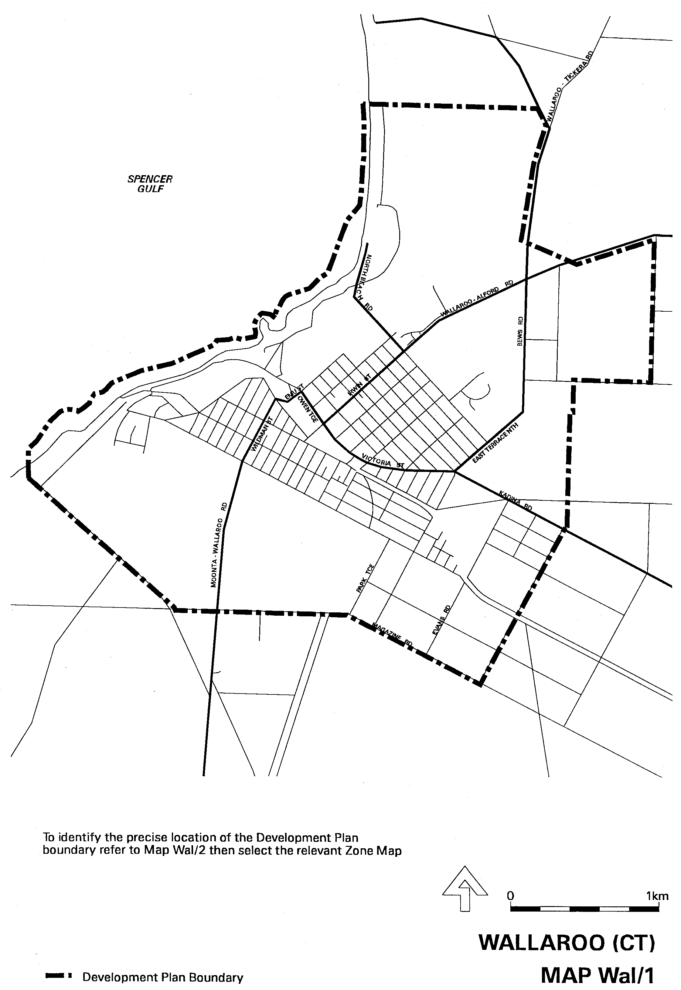
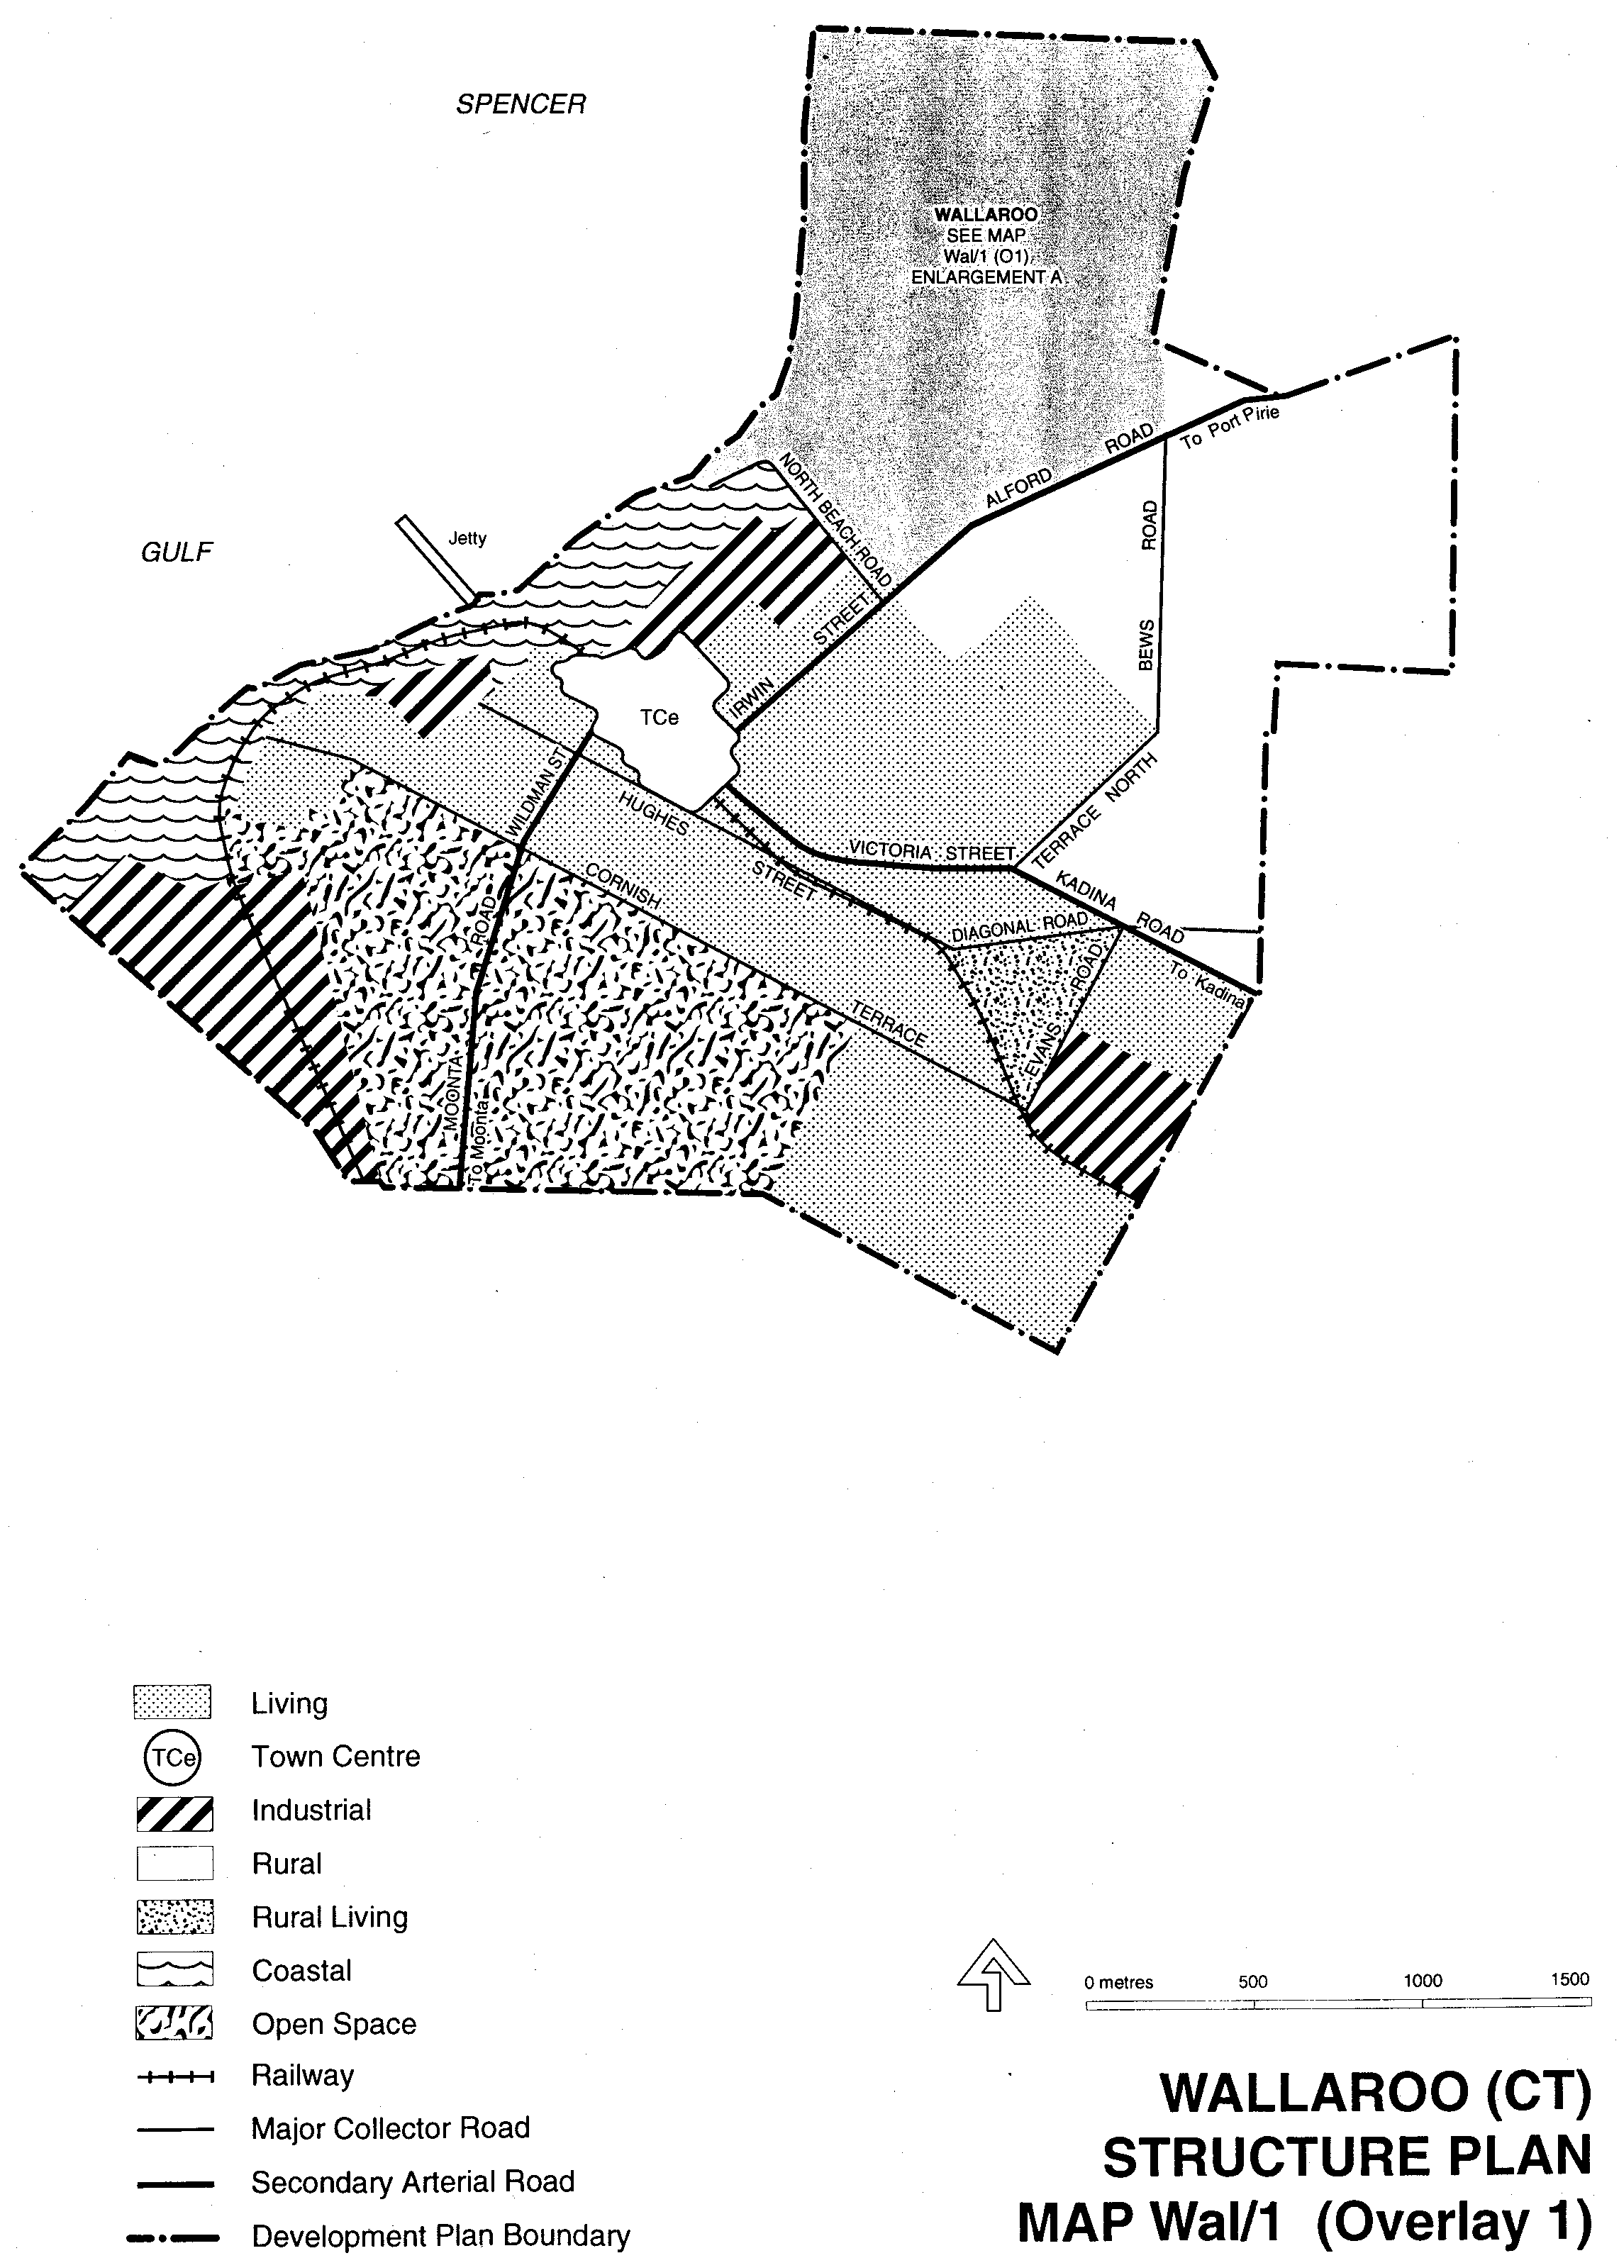
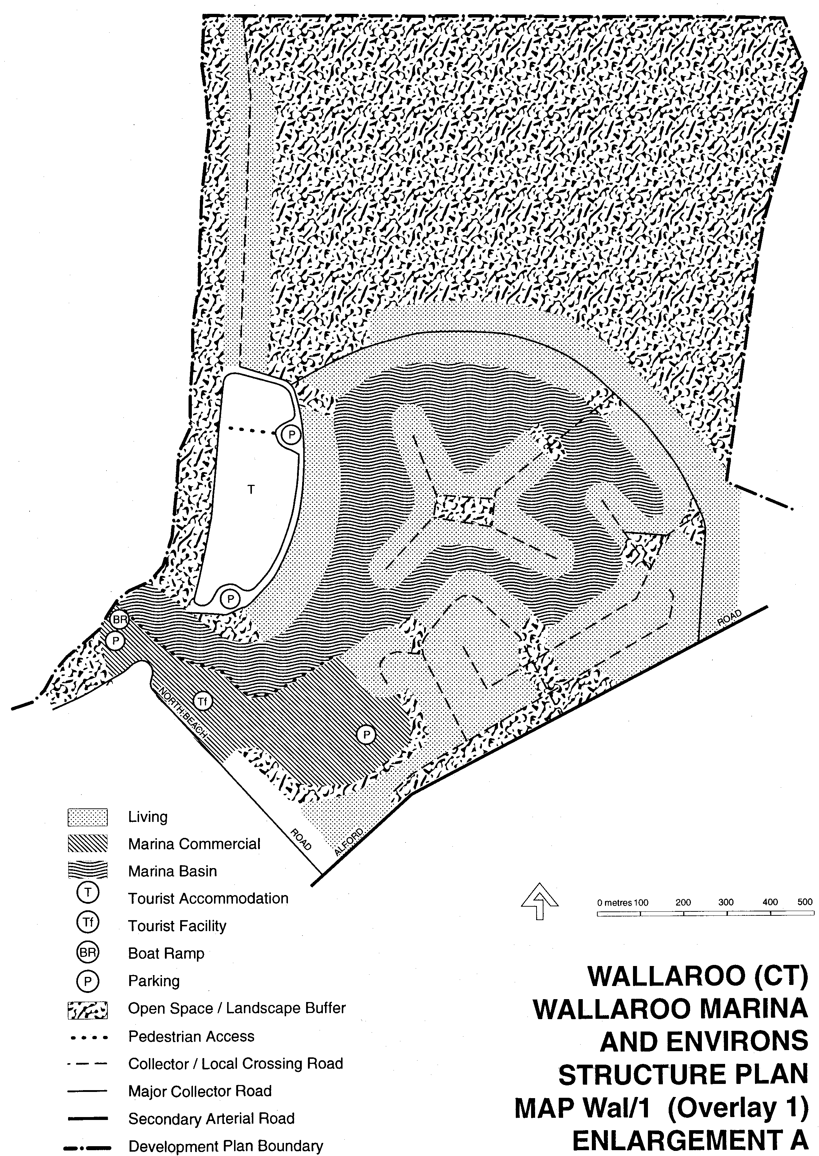
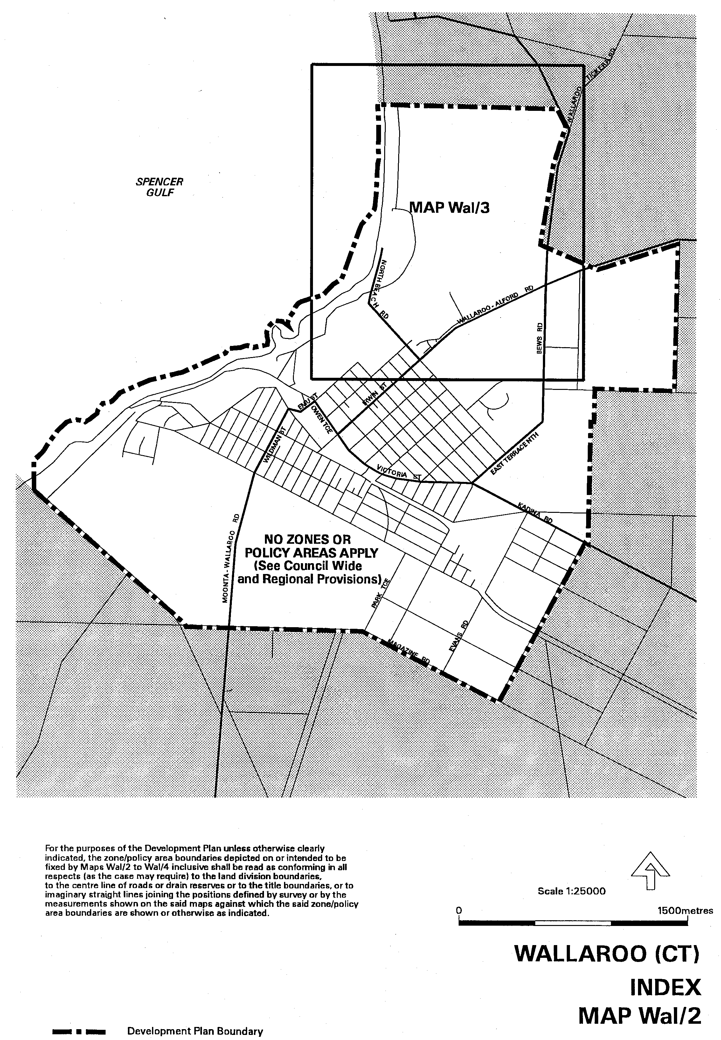
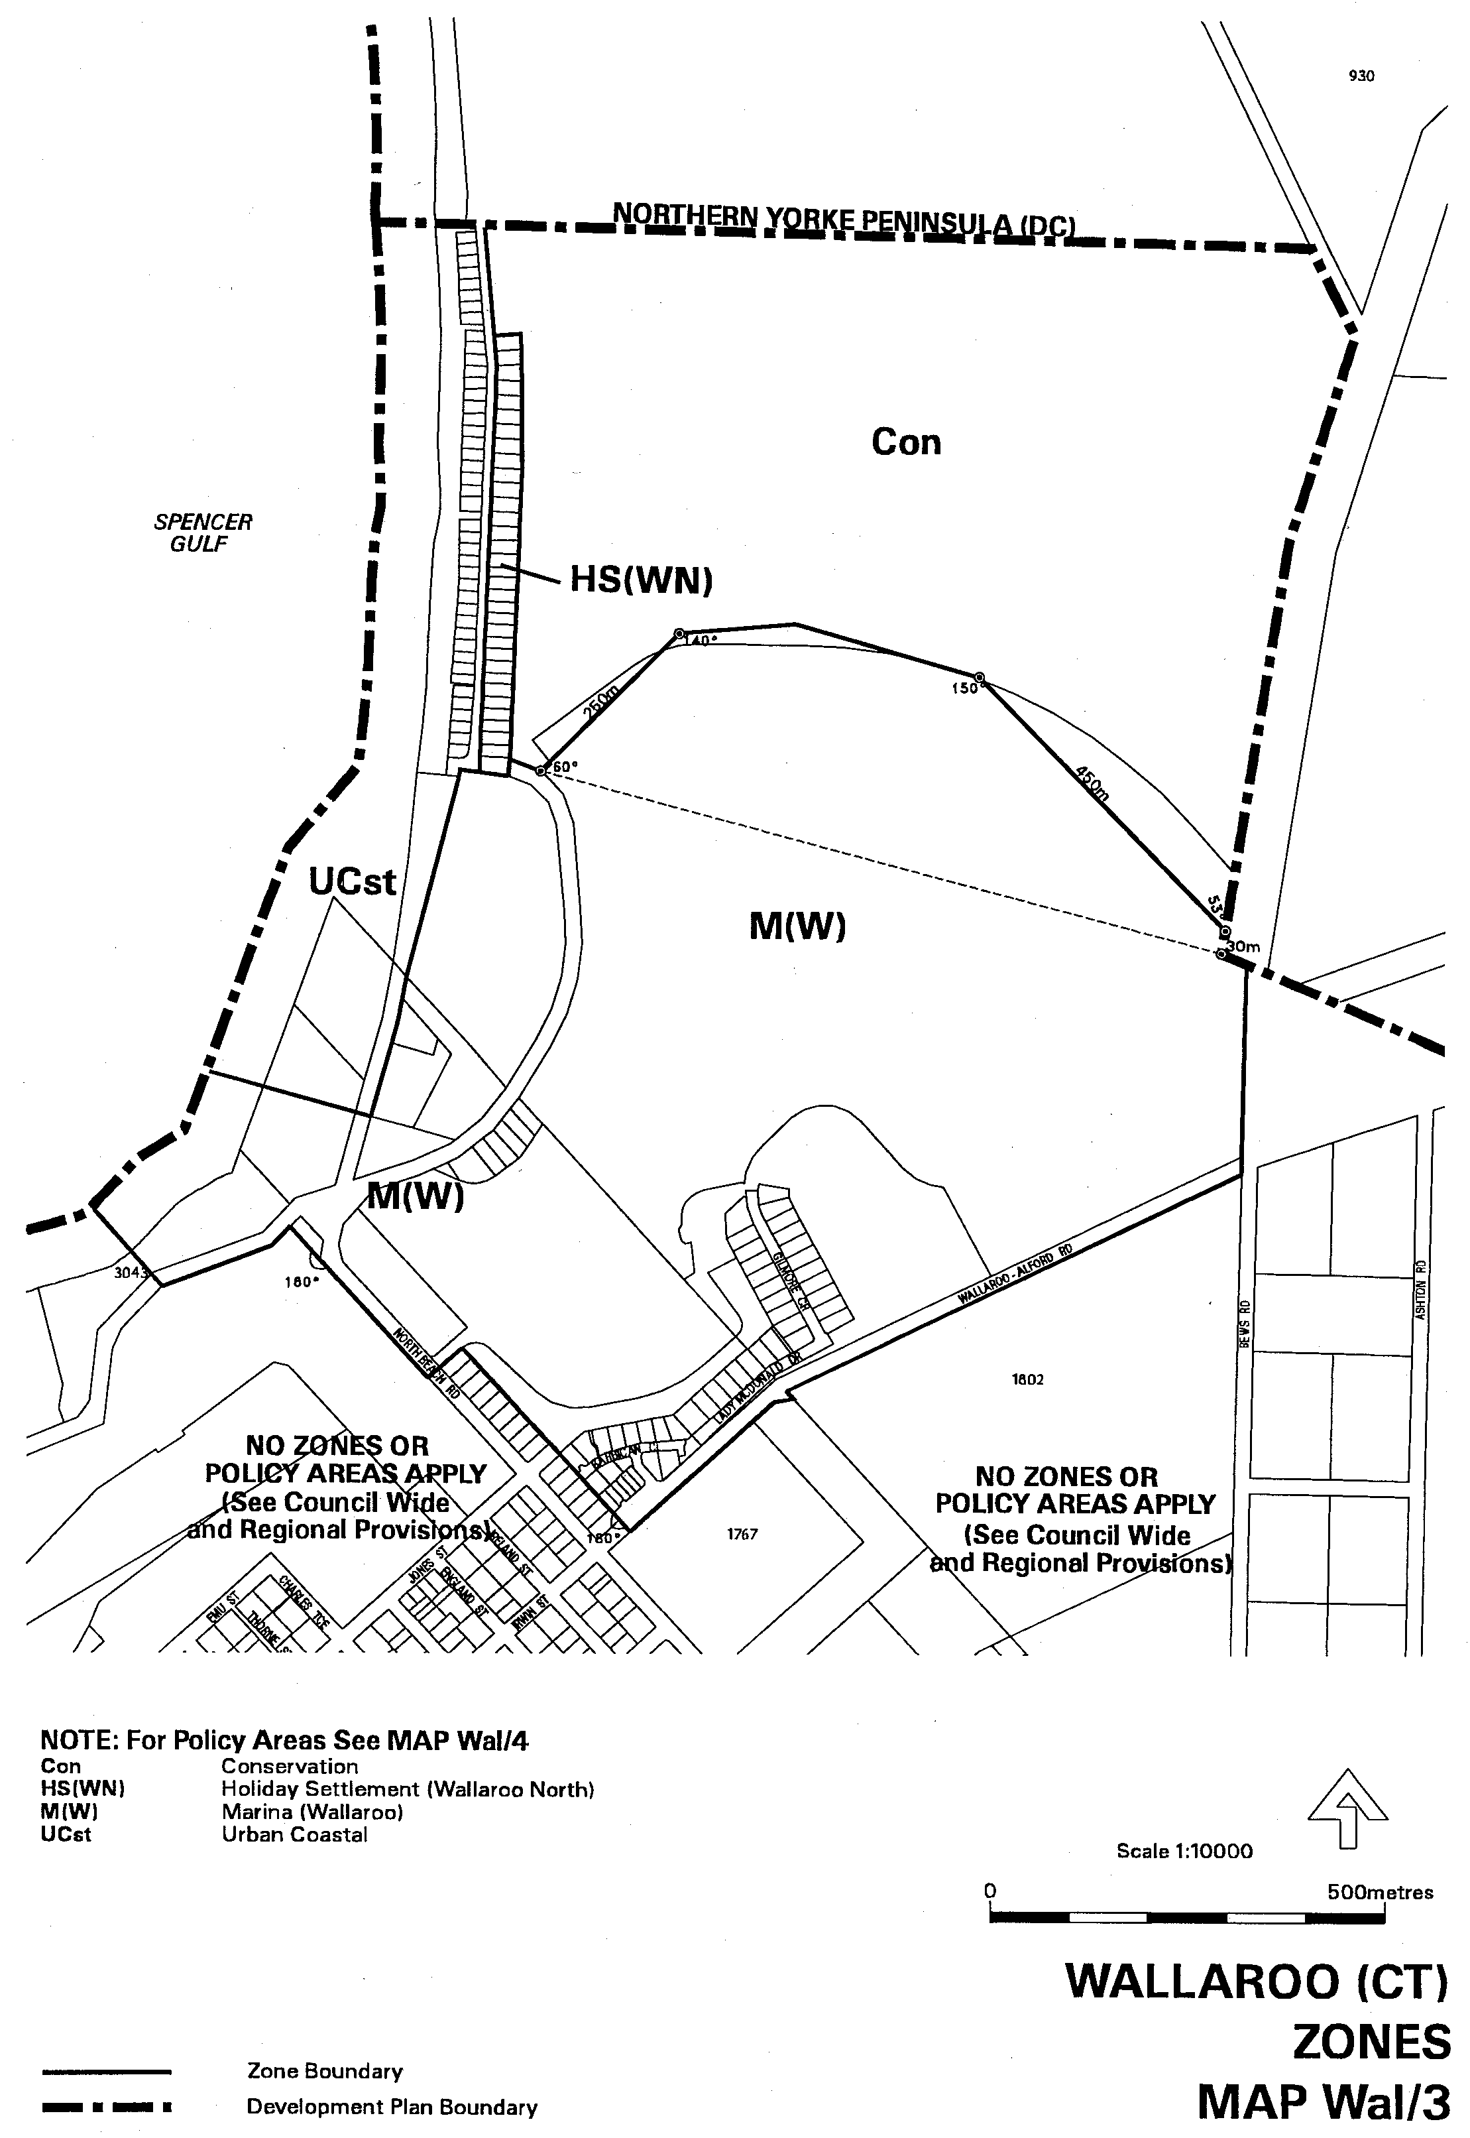
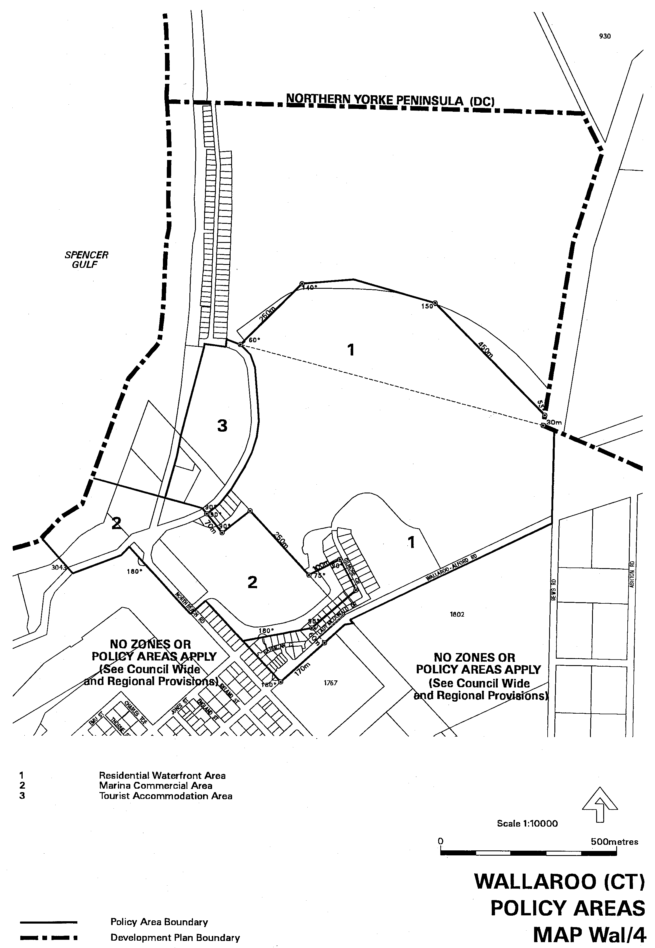
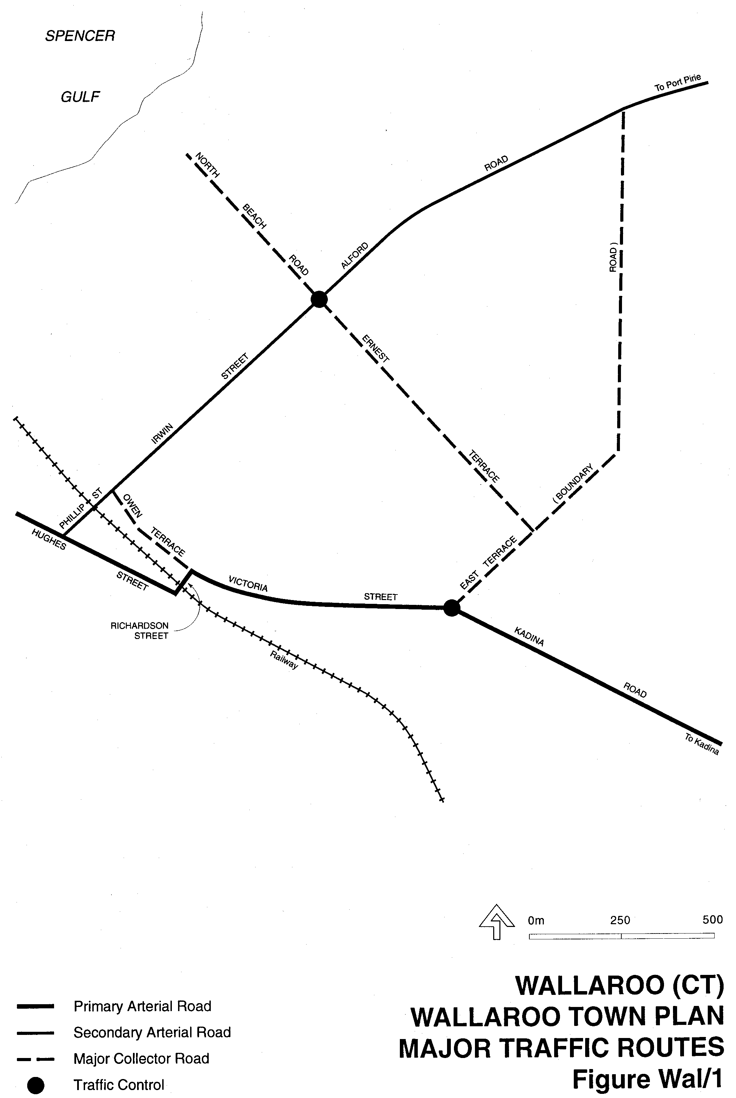
Attachment B

Dated 12 October 2000.
Diana Laidlaw, Minister for Transport, Urban Planning and the Arts

DEVELOPMENT ACT 1993, SECTION 29 (2) (b): AMENDMENT TO THE NORTHERN AREAS COUNCIL
DEVELOPMENT PLAN
Preamble
It is necessary to amend the Northern Areas Council Development Plan dated 13 April 2000.
Notice
PURSUANT to section 29 (2) (b) of the Development Act 1993, I, Diana Laidlaw, being the Minister administering the Act, amend The Northern Areas Council Development Plan, dated 13 April 2000 as follows:
1. (a) Delete Maps NtA/1 to NtA/18 dated 13 April 2000;
(b) insert the contents of Attachment A; and
(c) adjust the mapping references in the Northern Areas Council Development Plan text accordingly.
2. Replace Fig 1A(Ja)/1 within the Residential Zone with the contents of Attachment B.
Attachment A
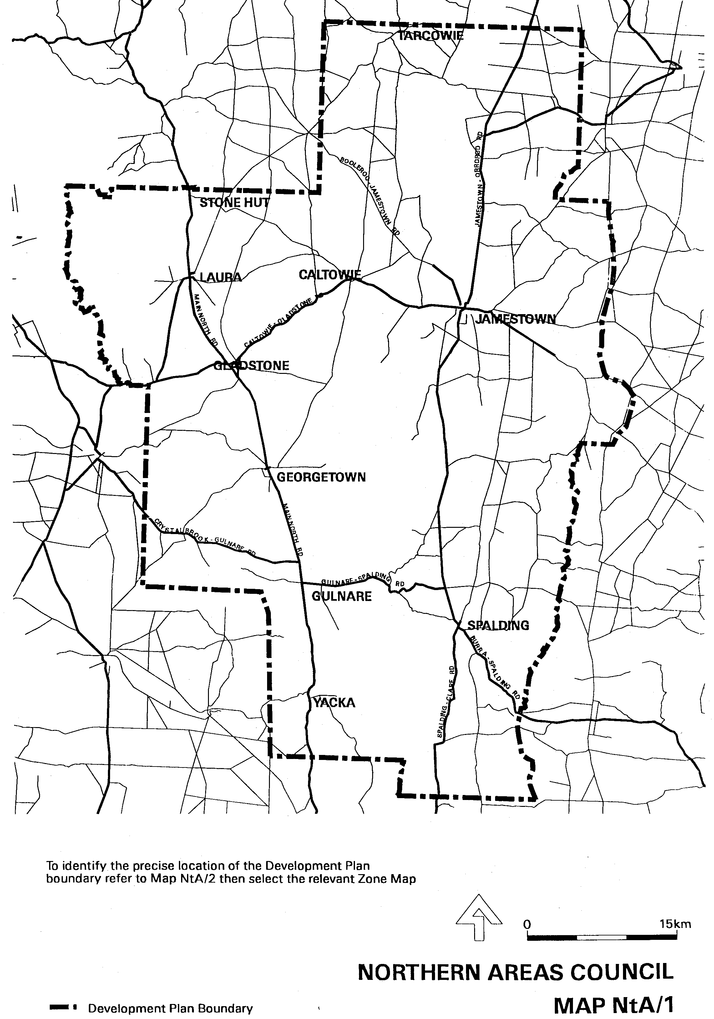
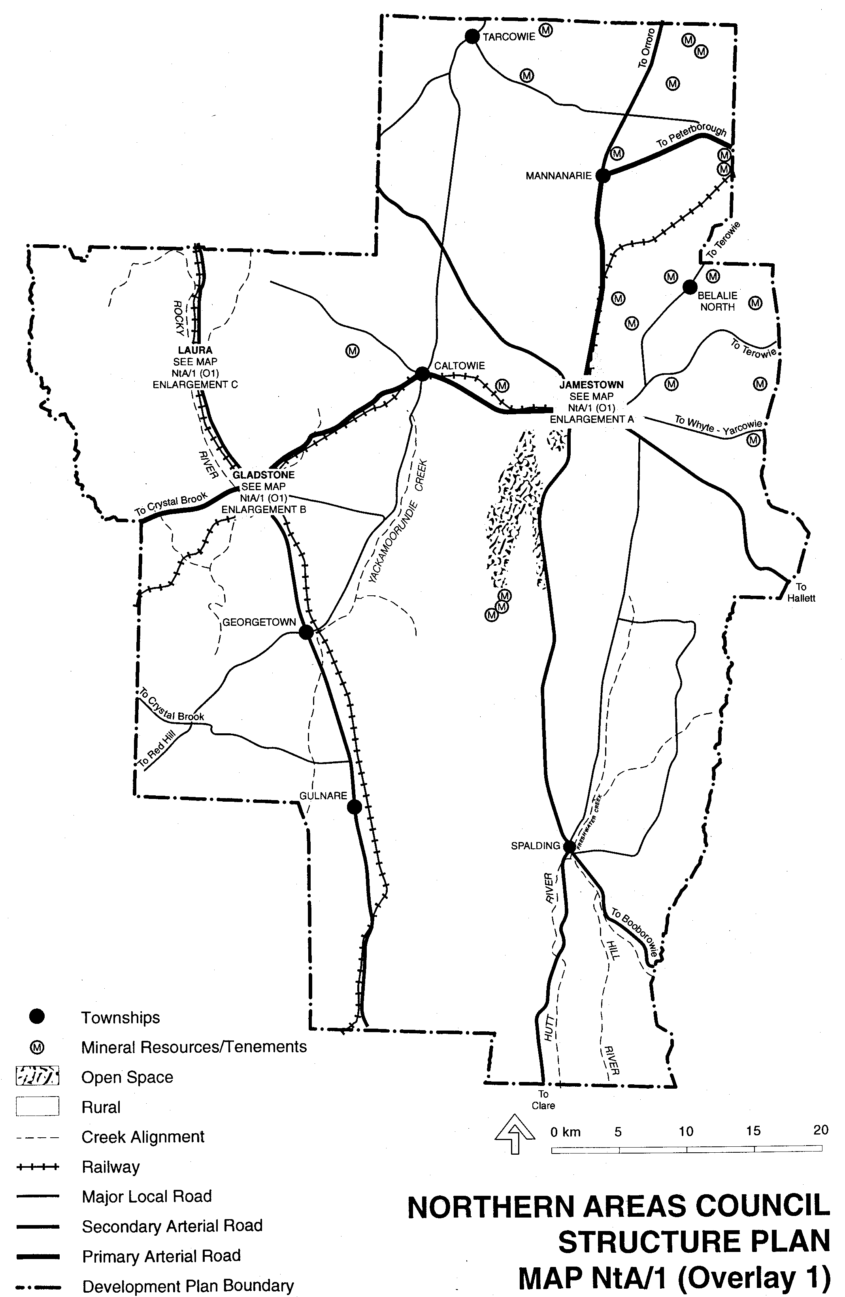
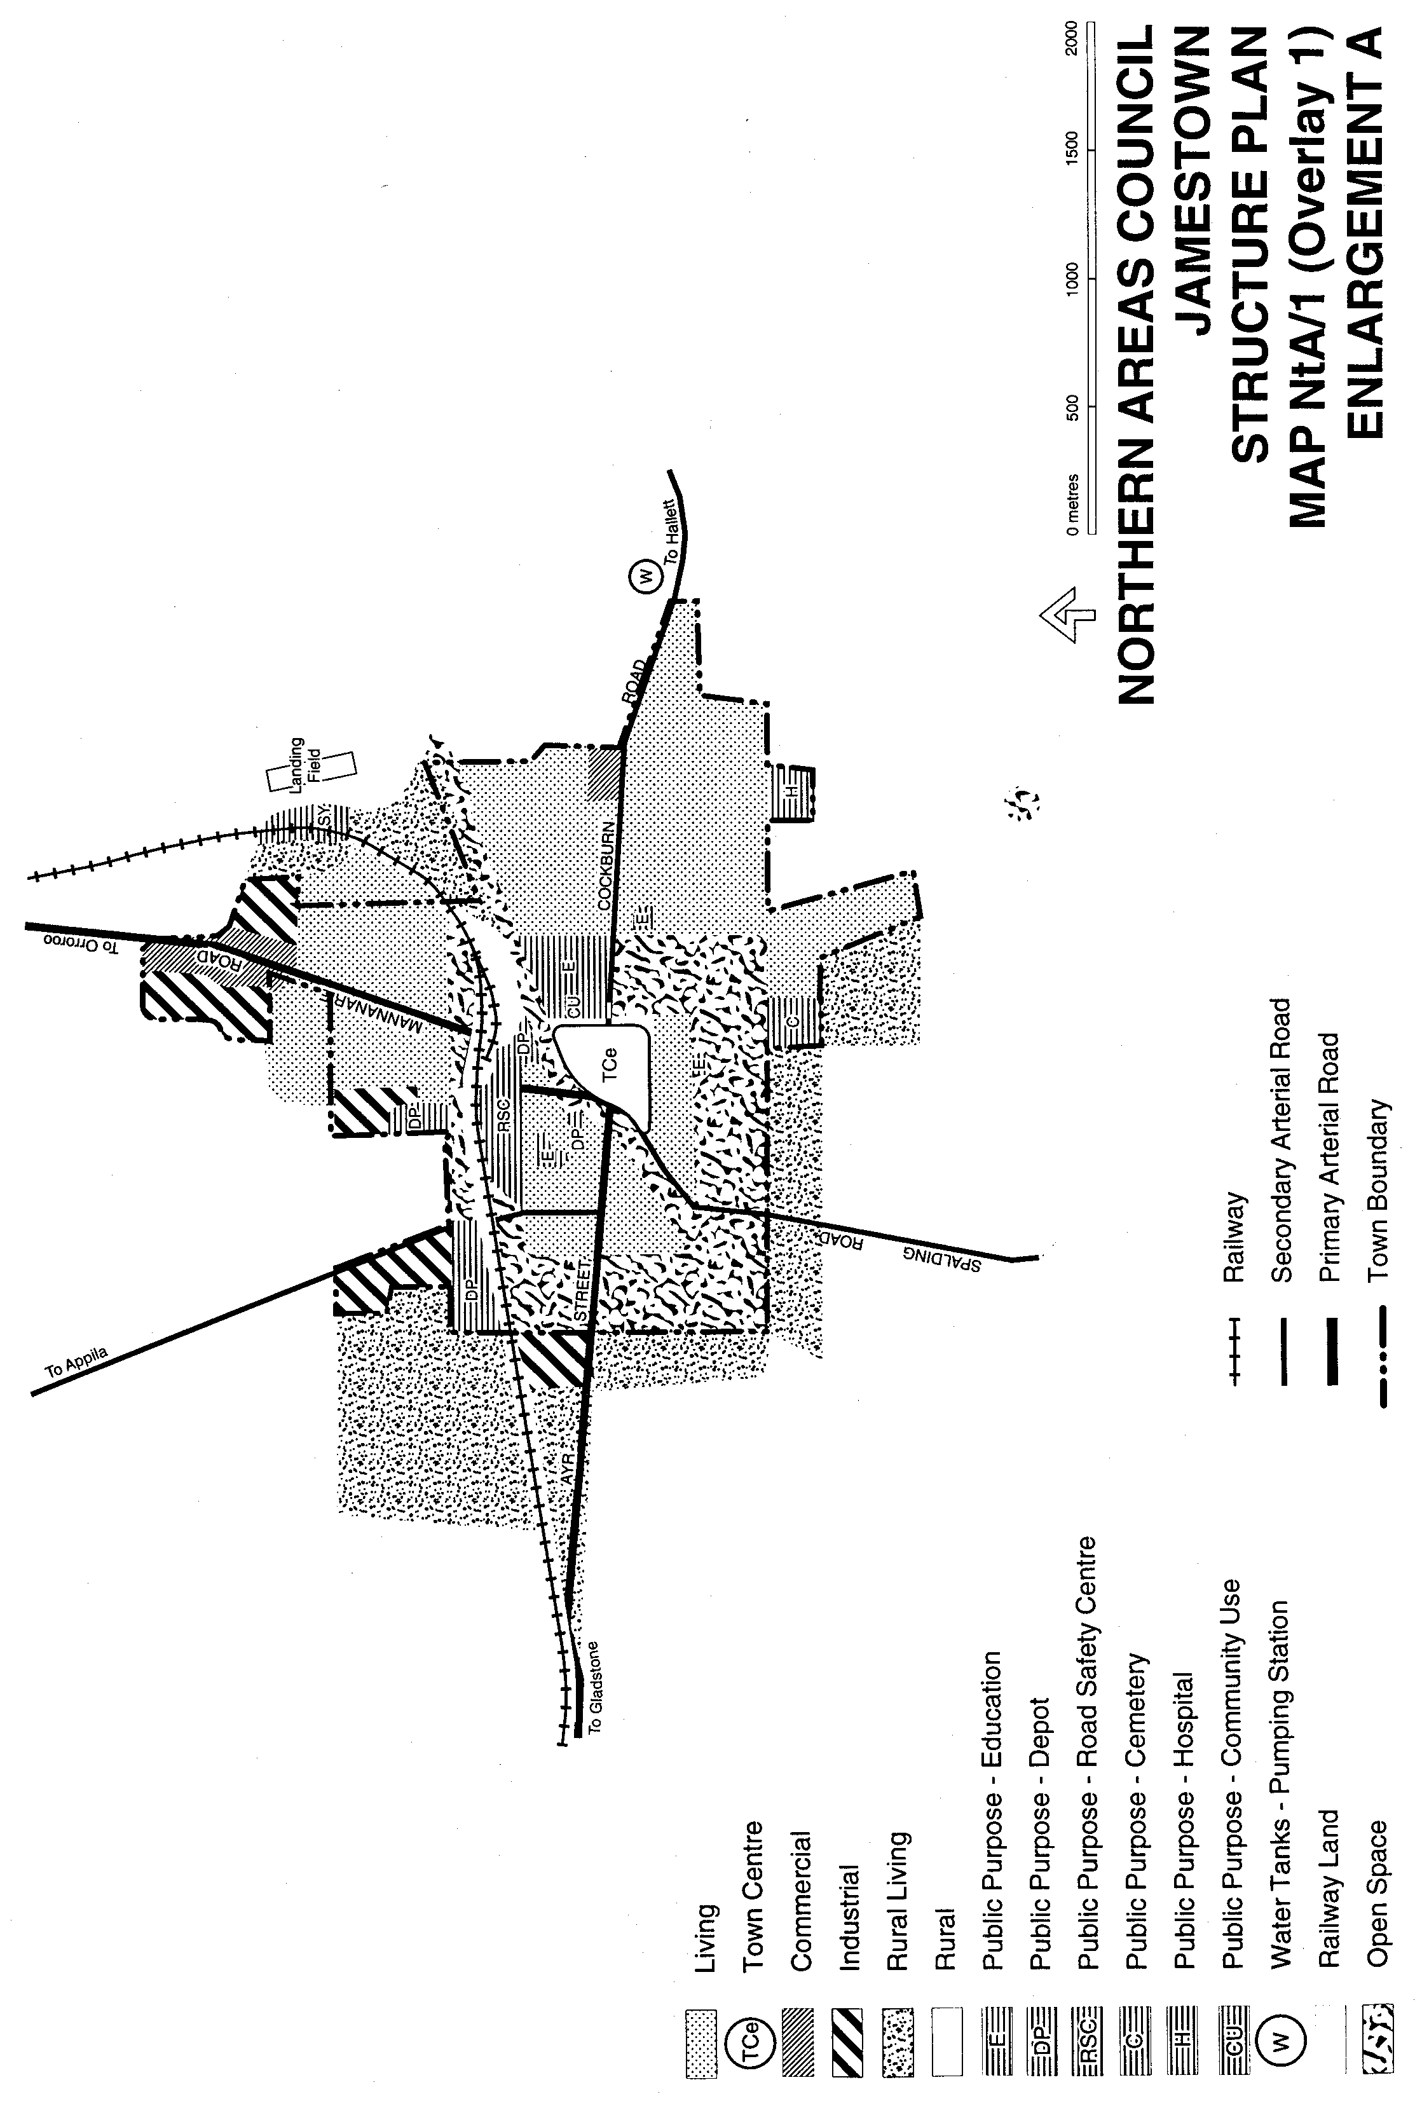
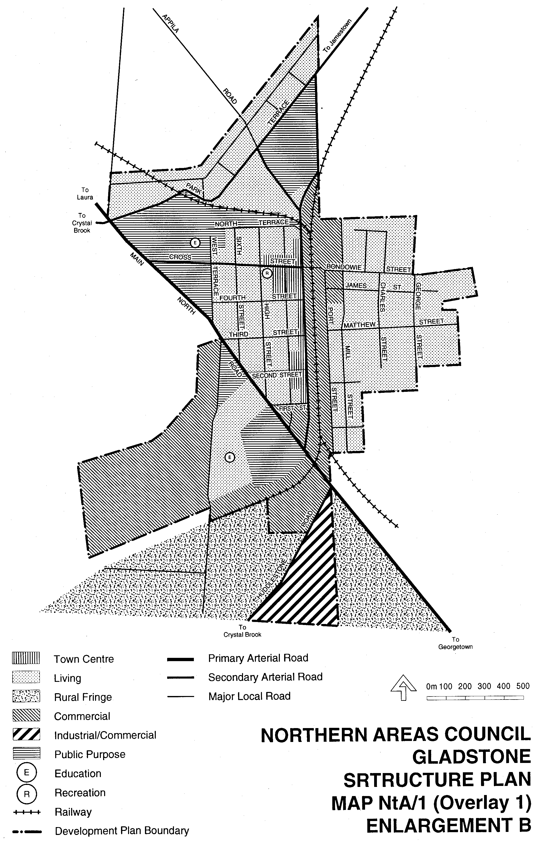
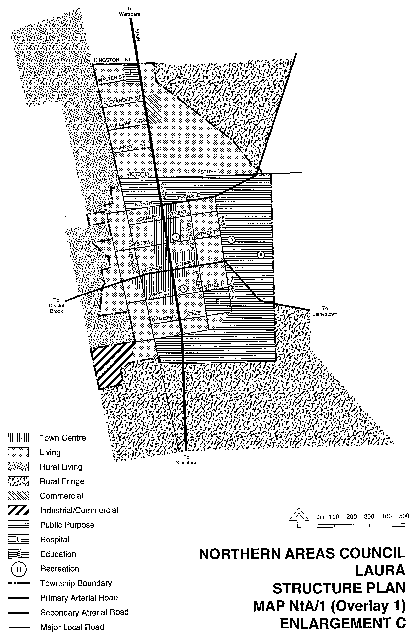
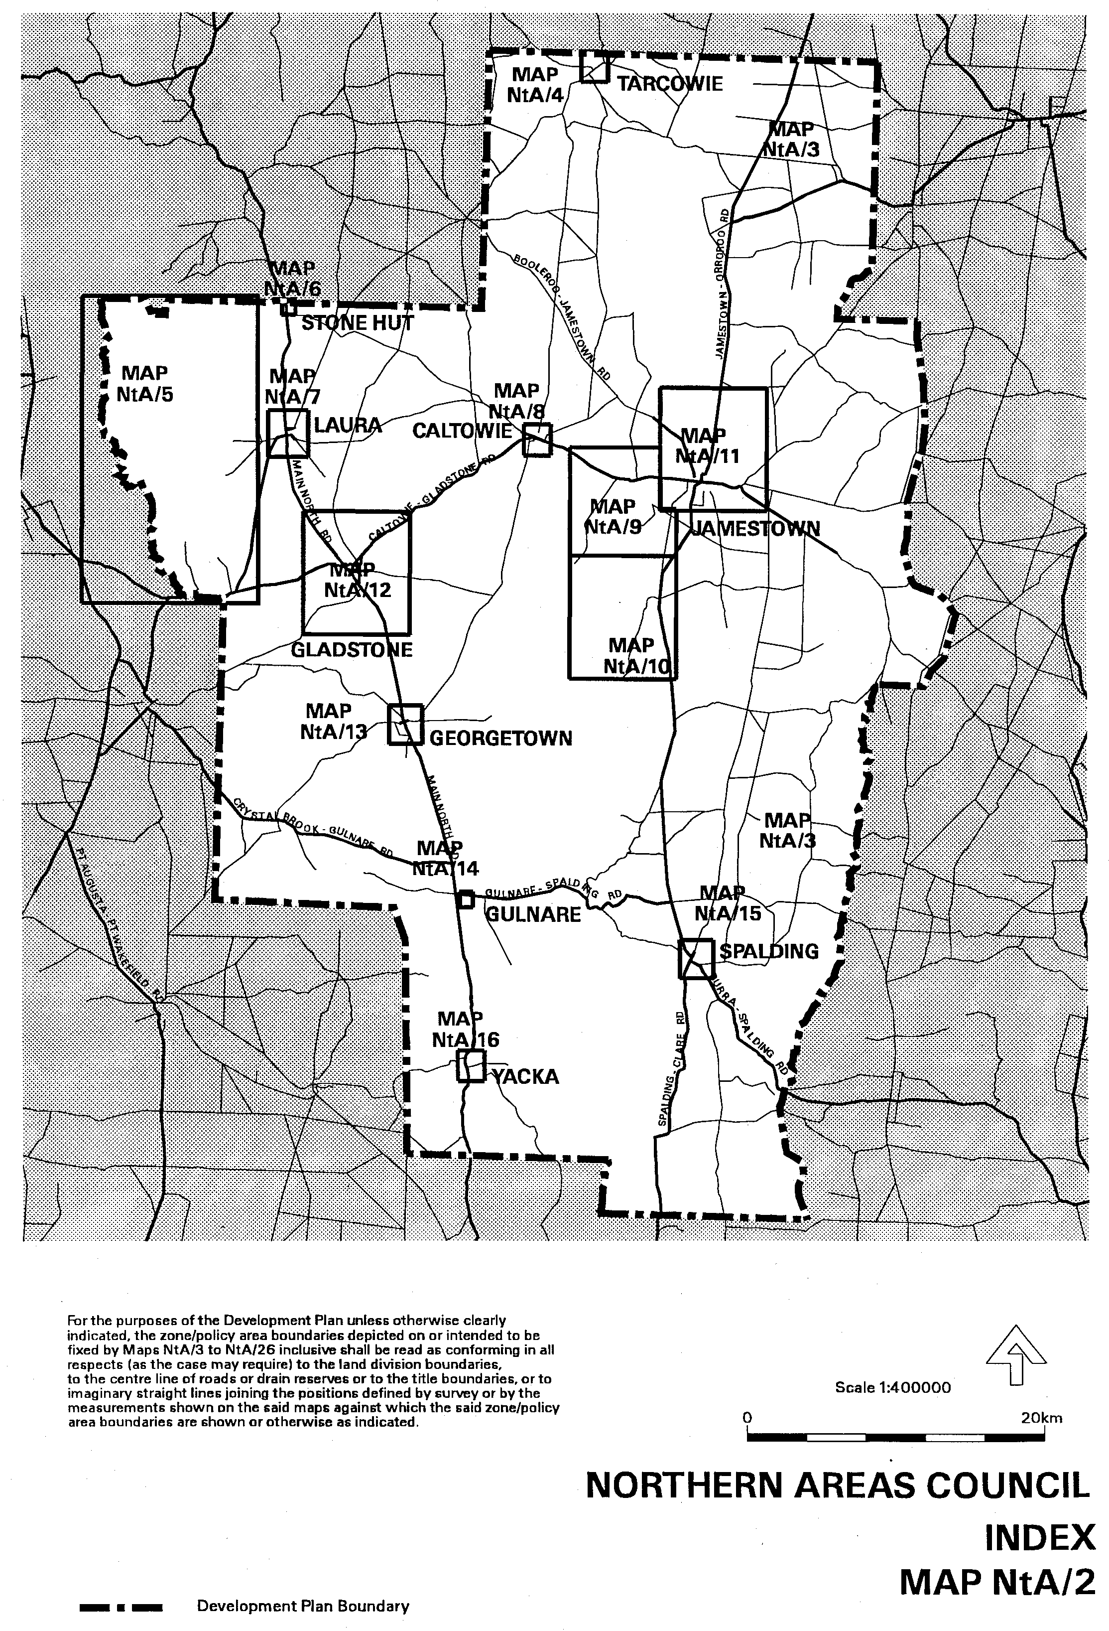
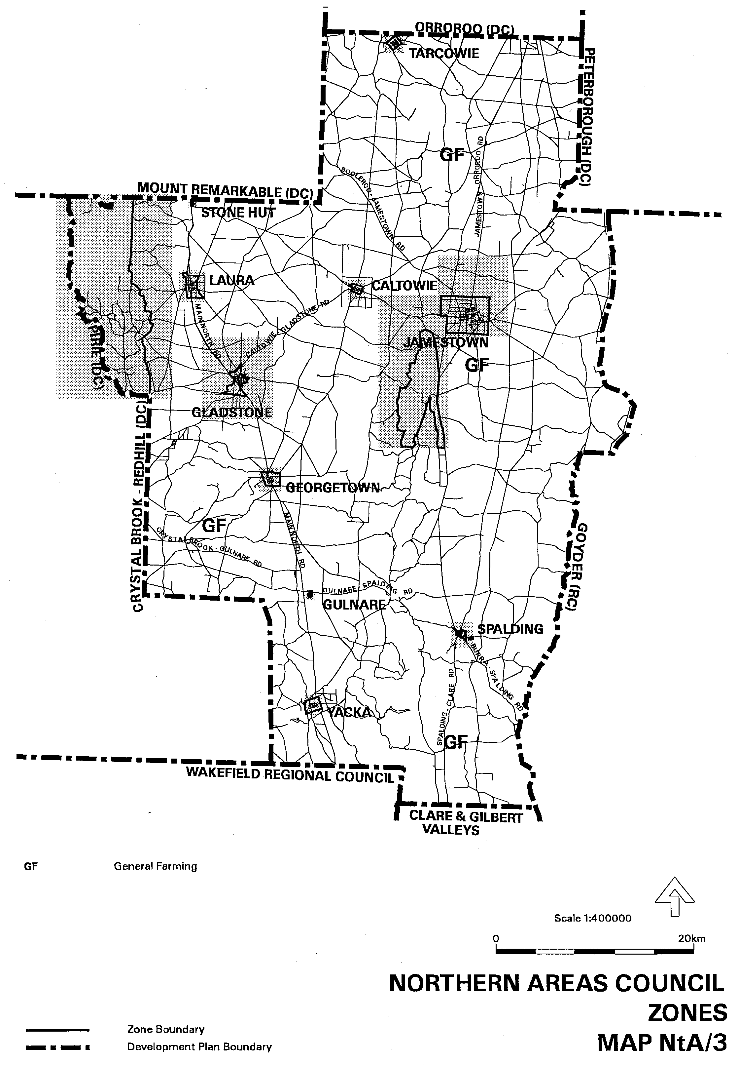
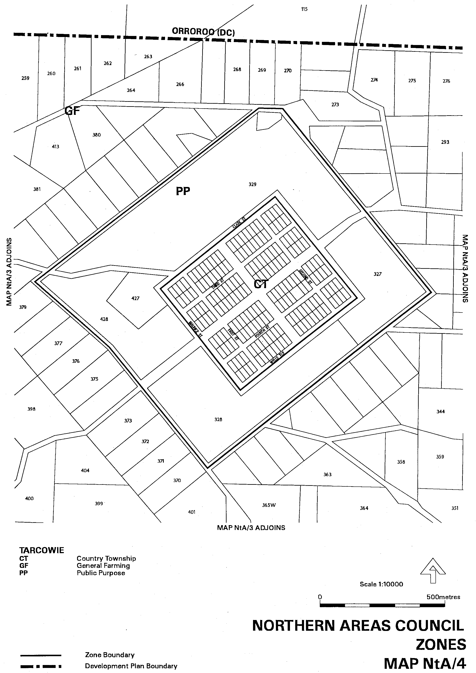
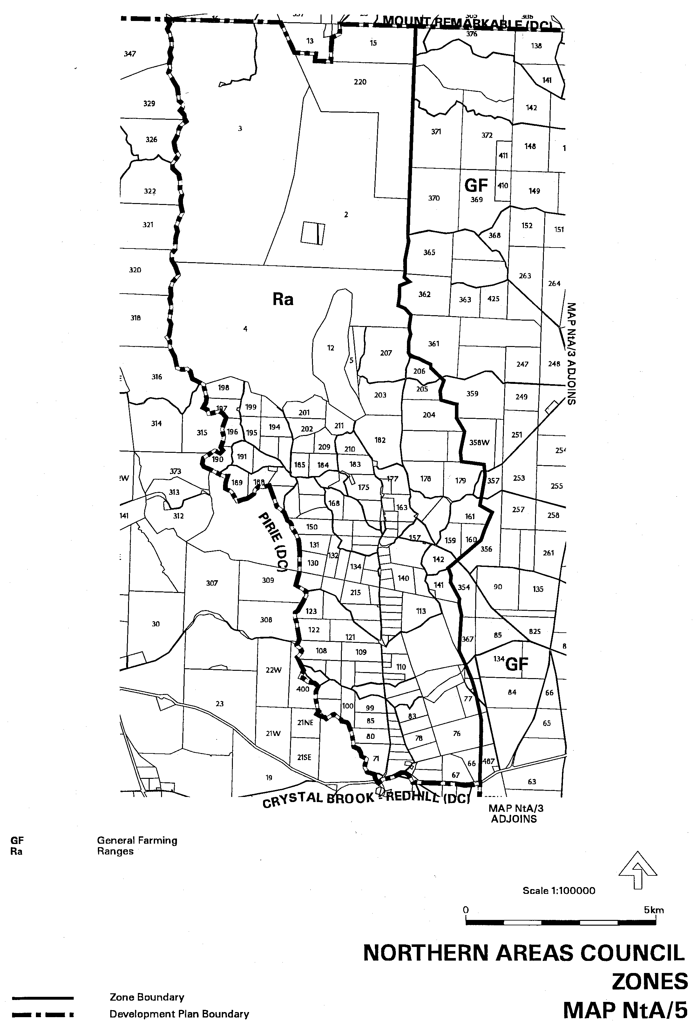
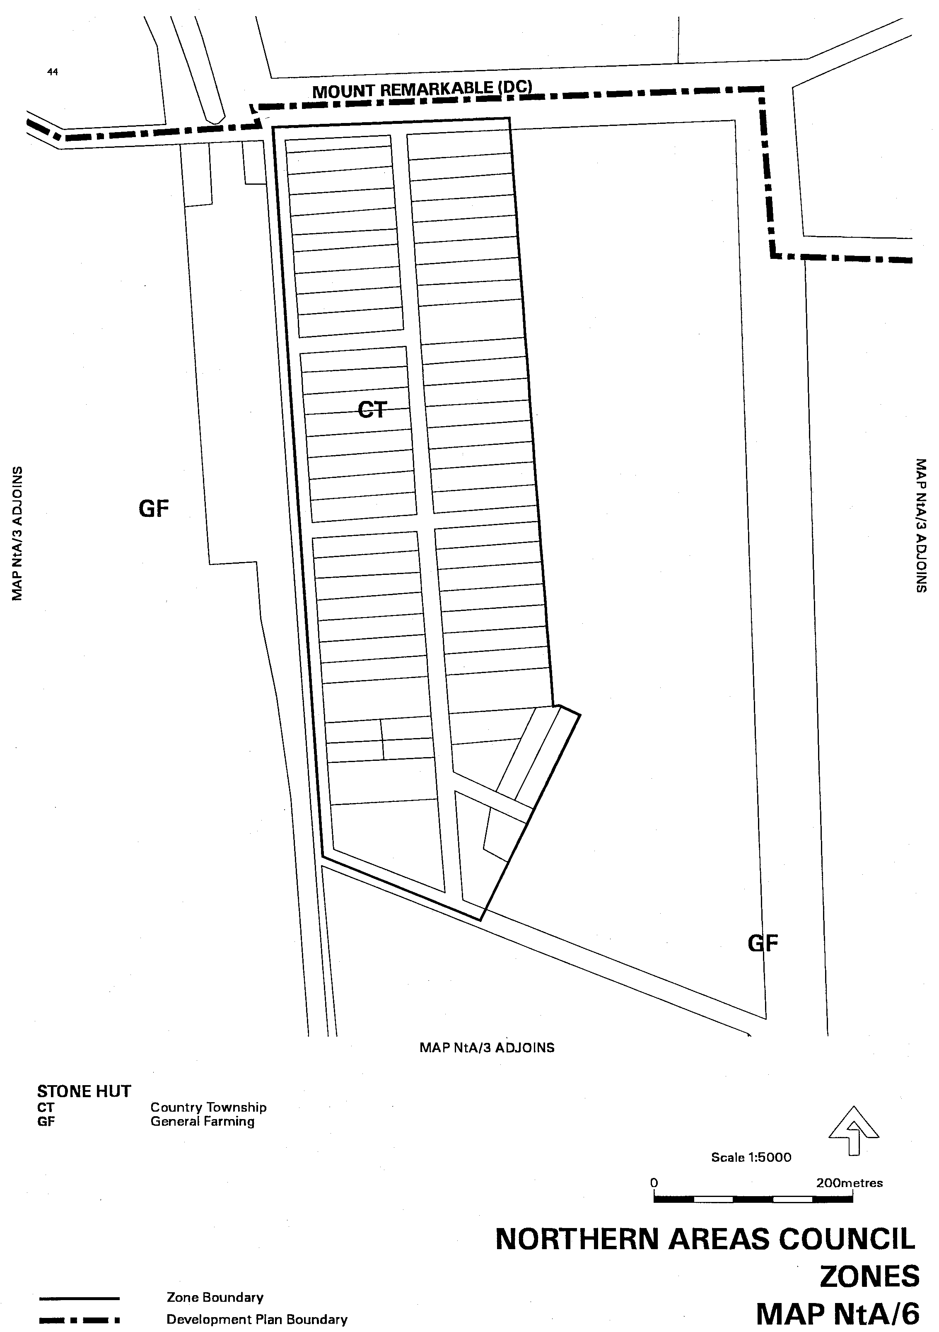
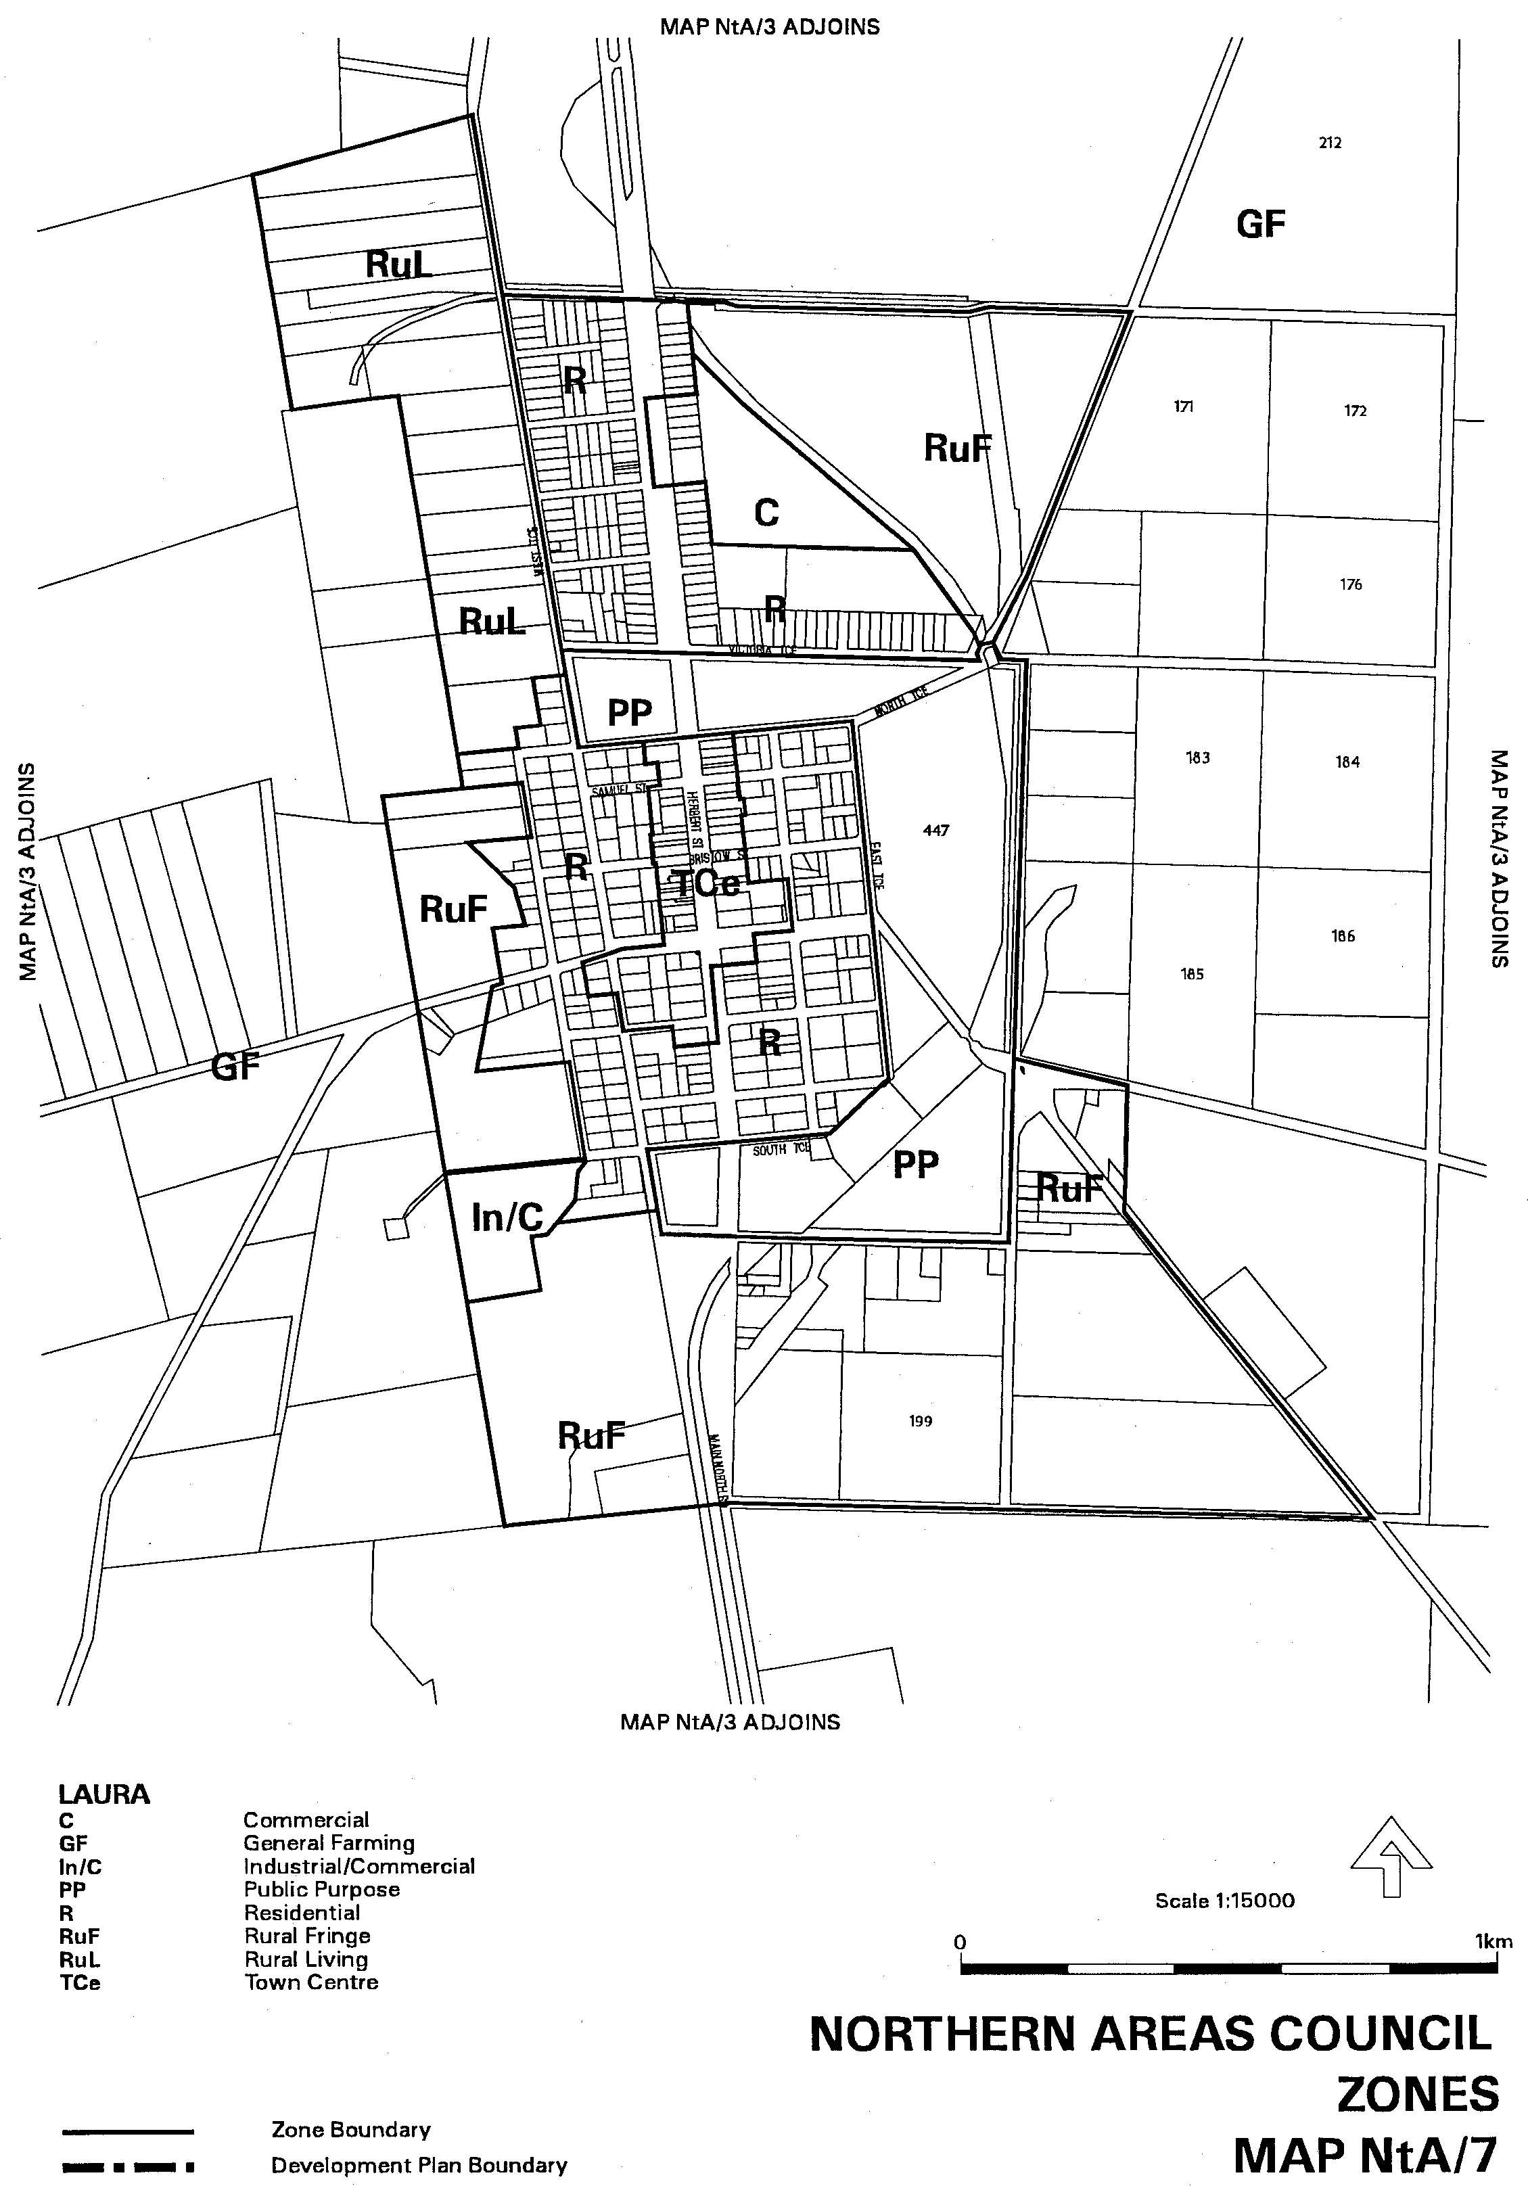
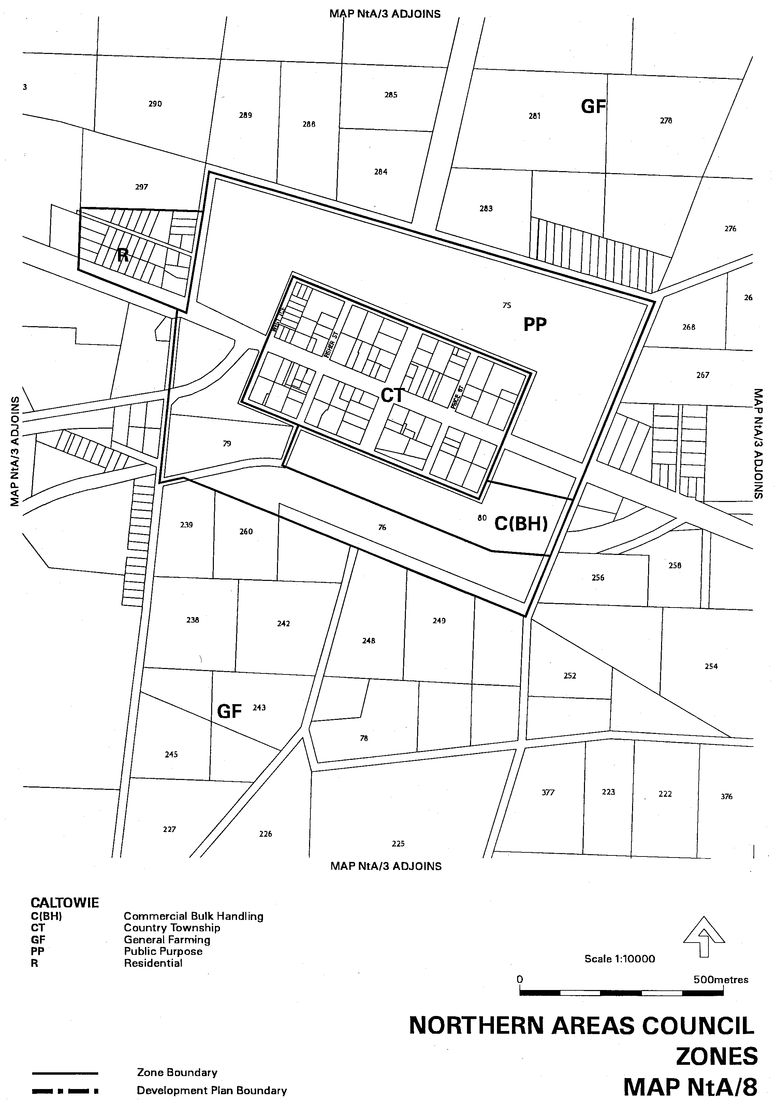
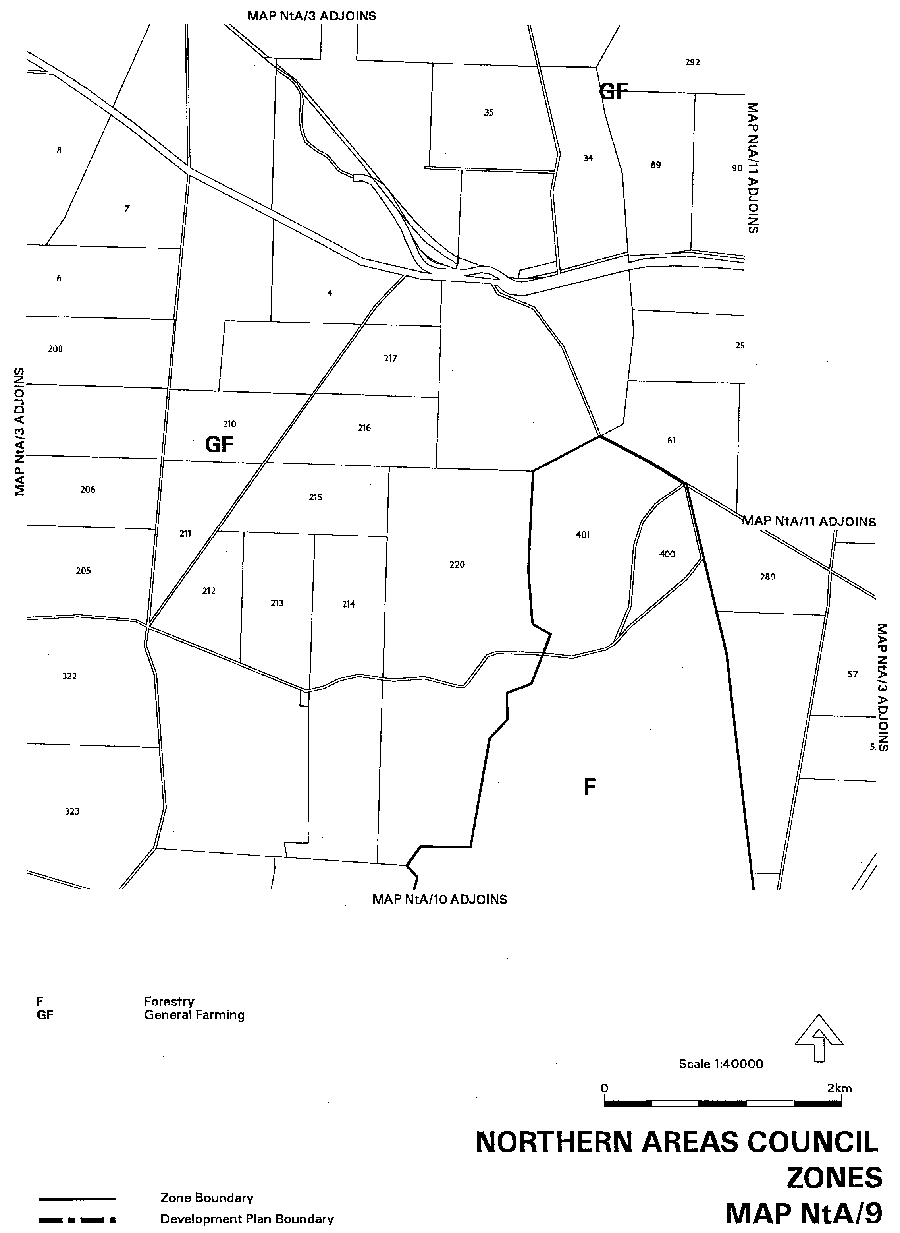
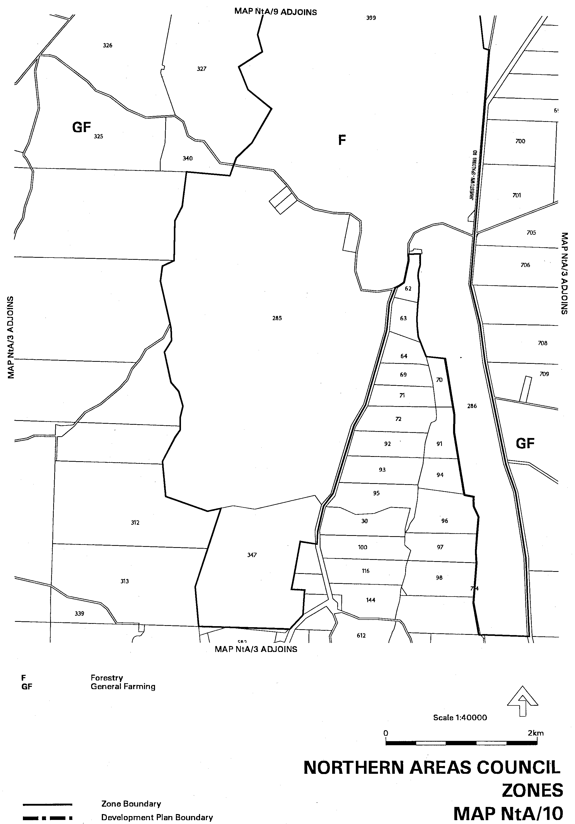
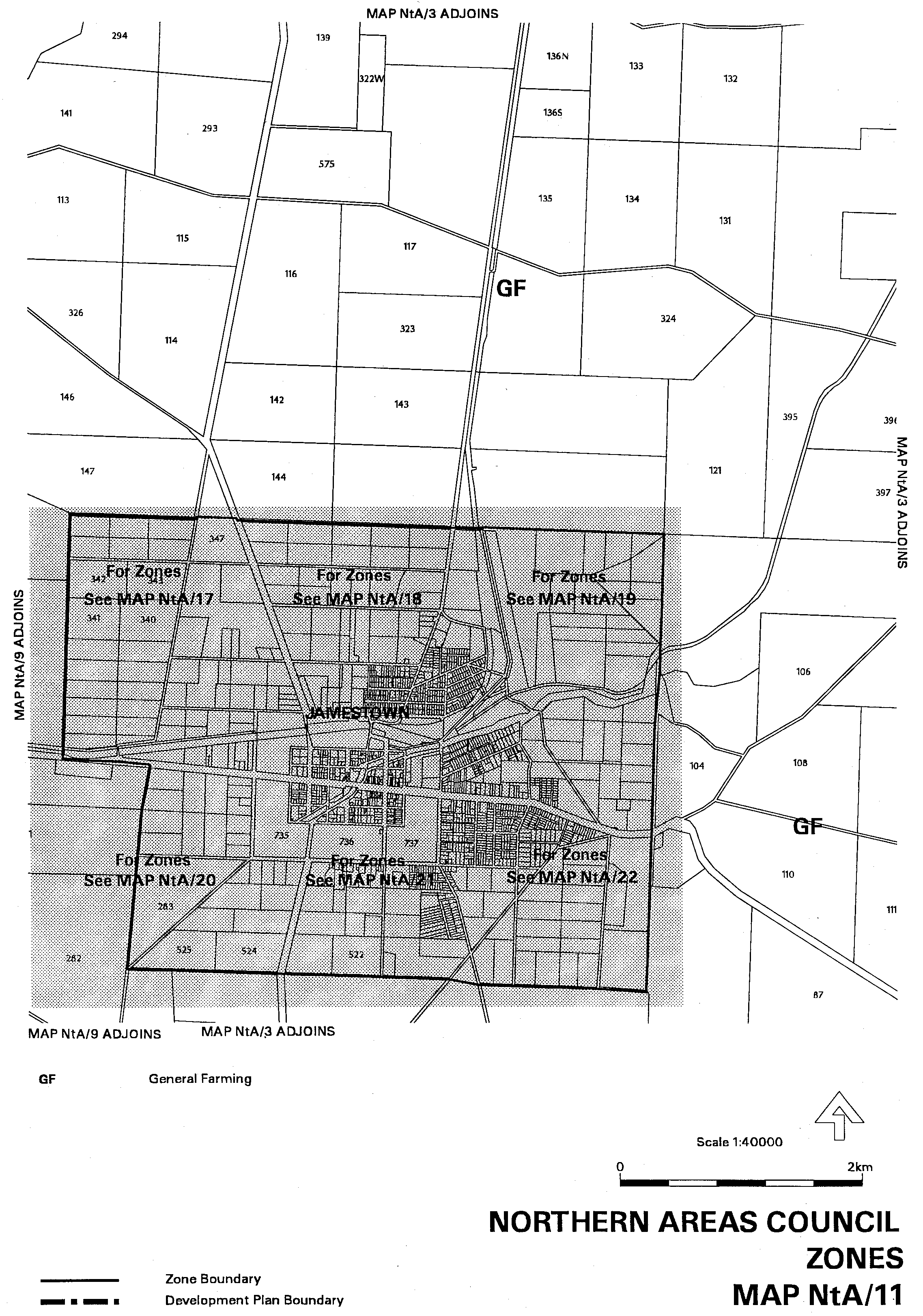
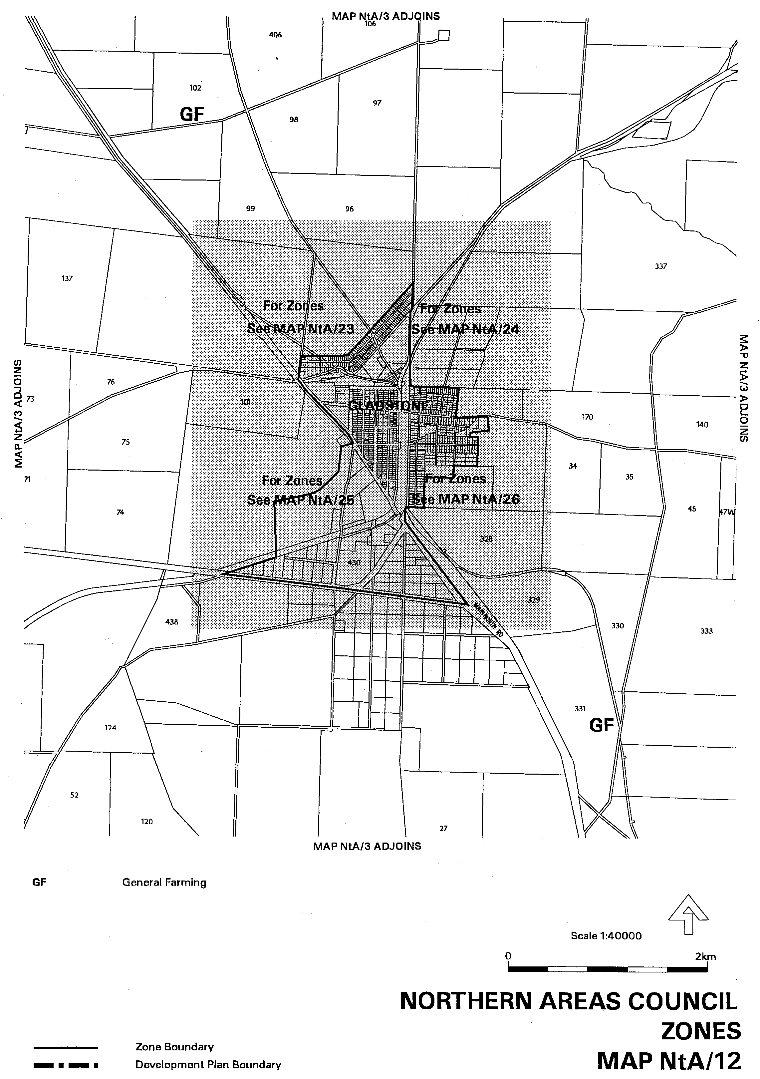
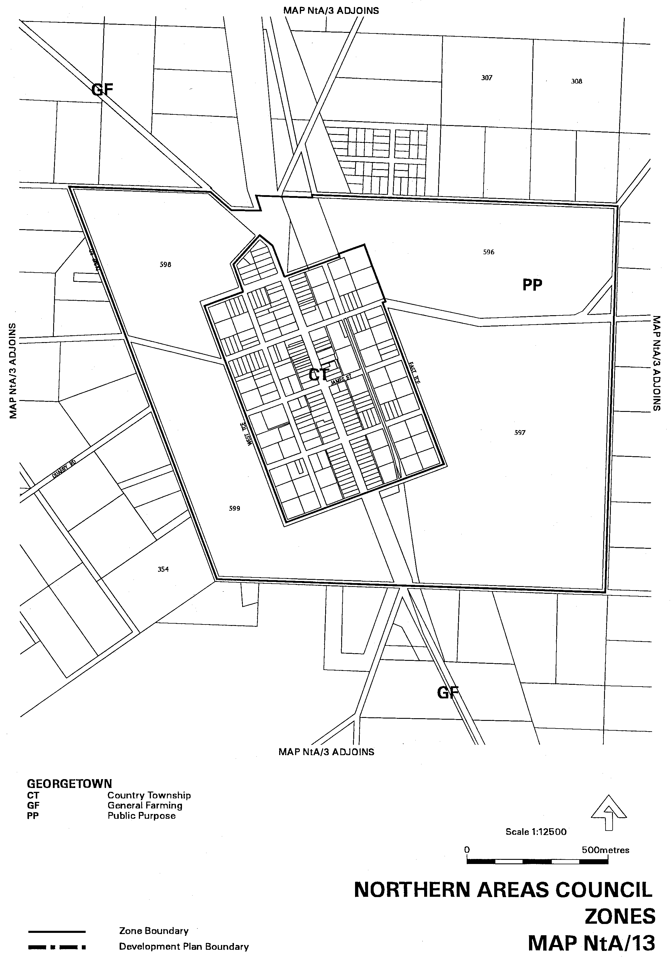
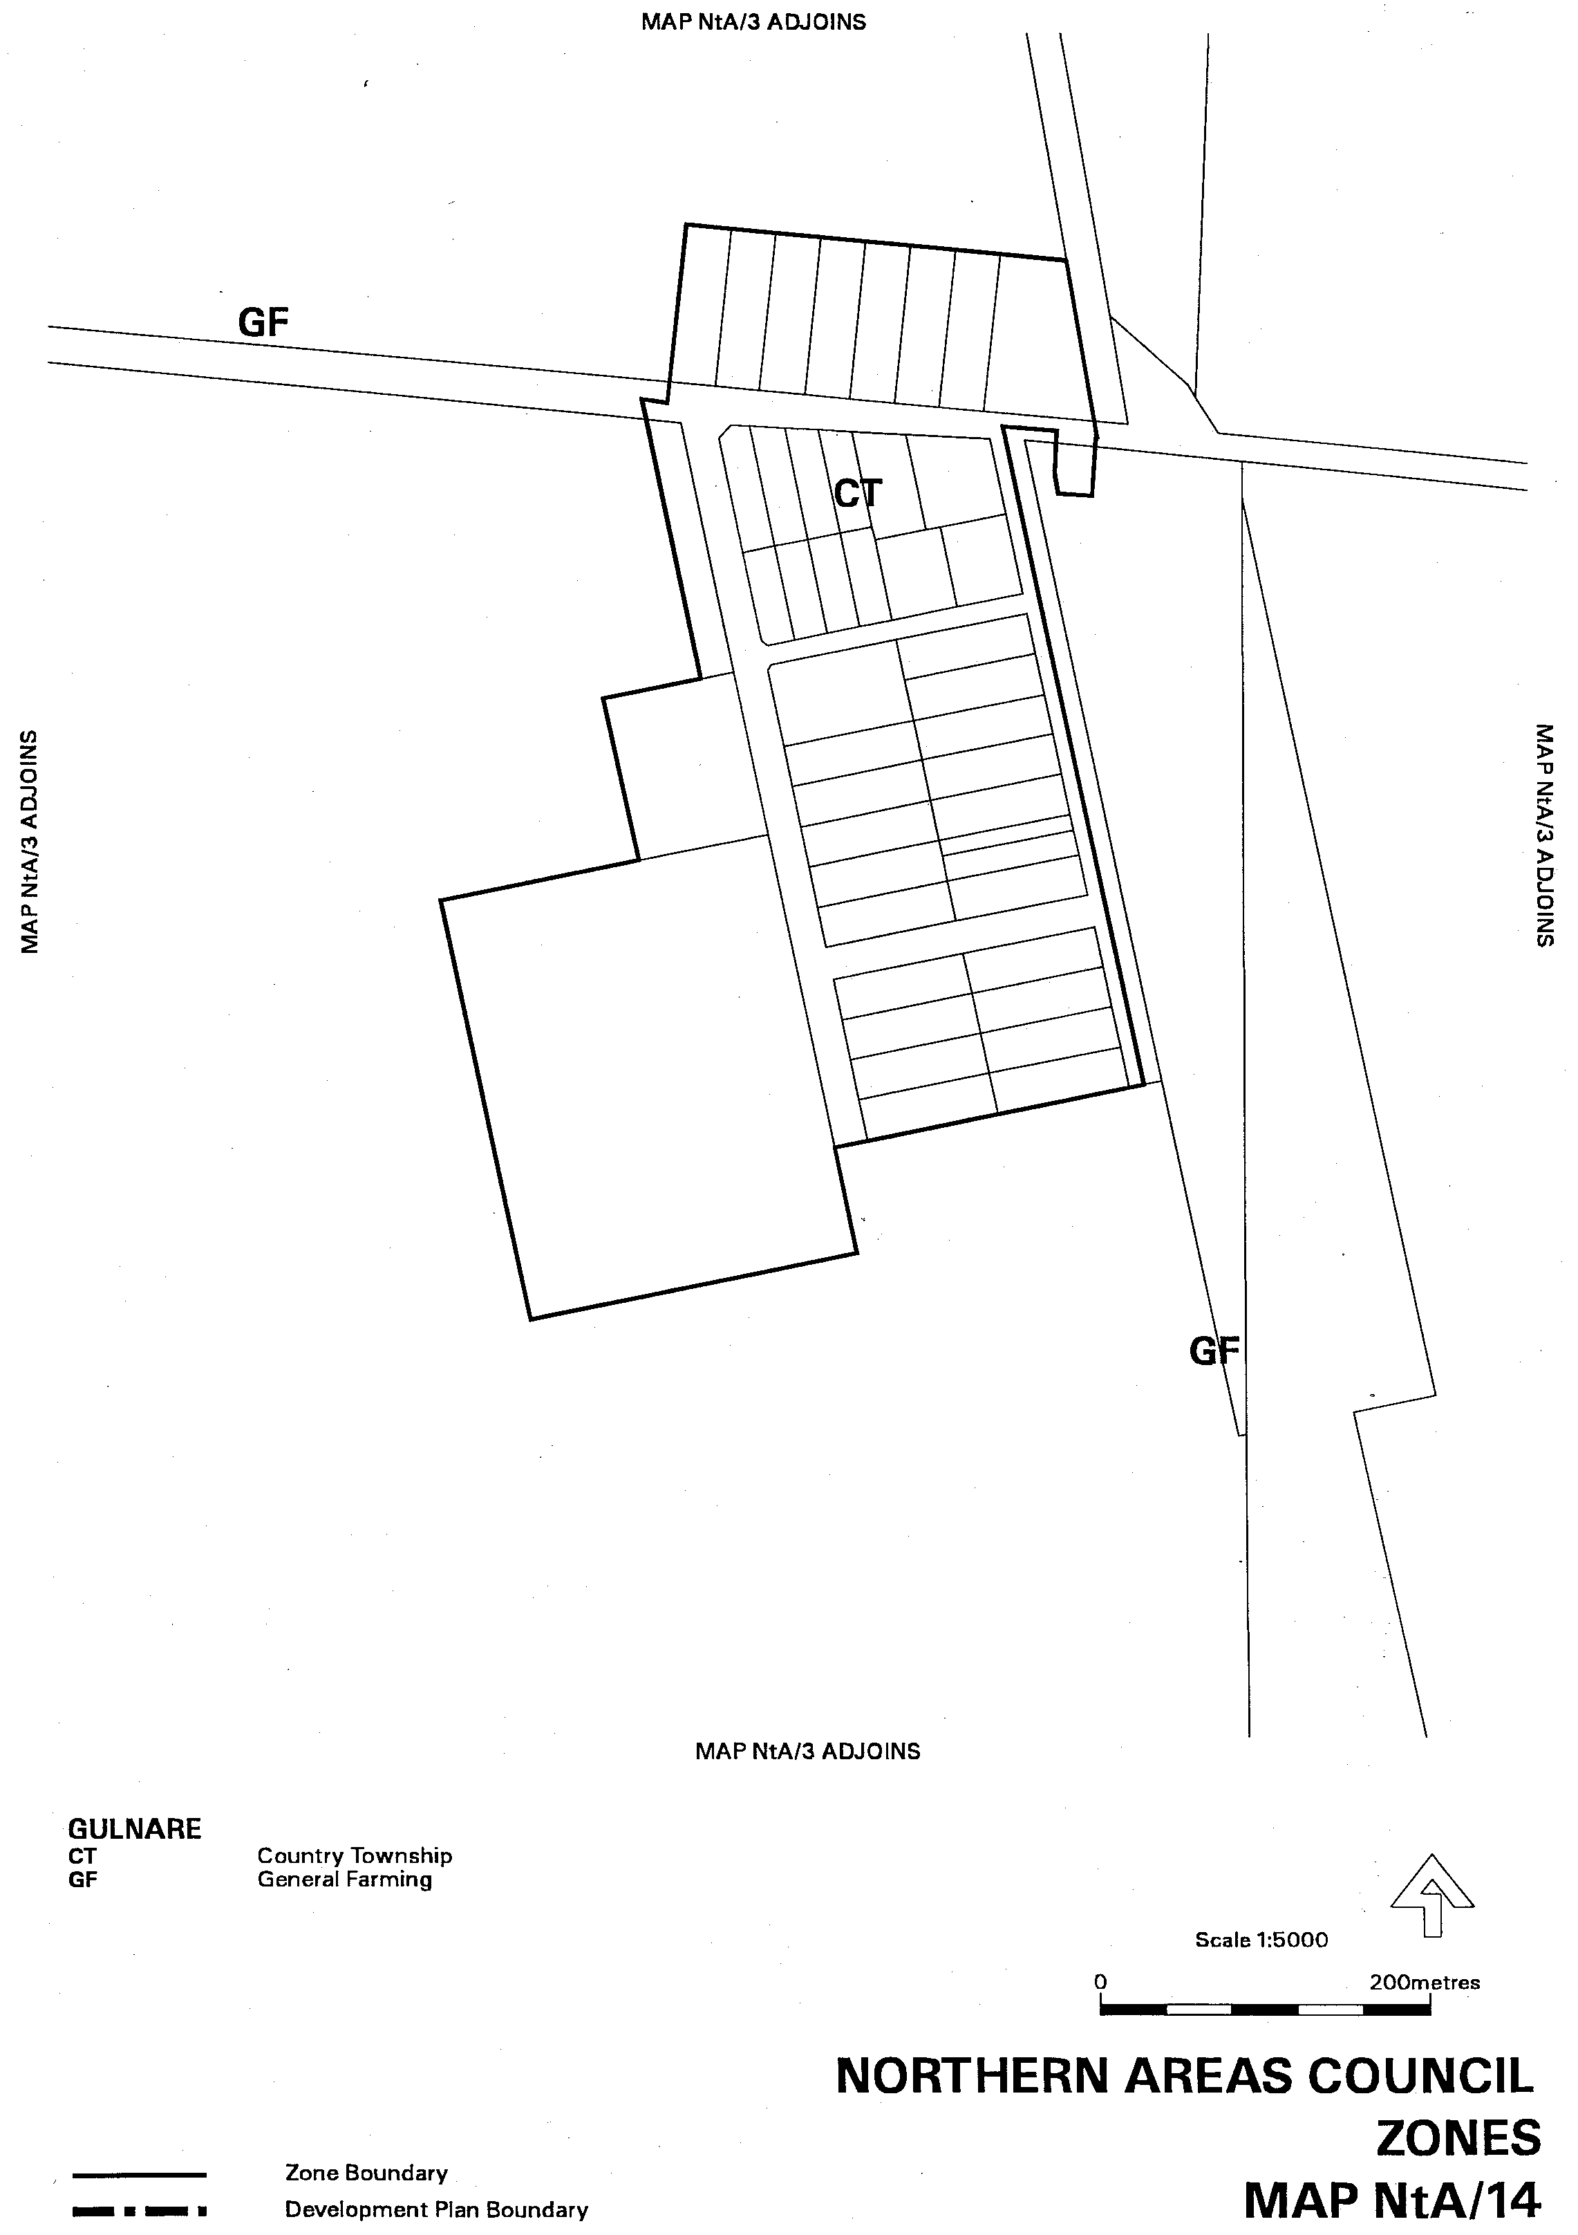
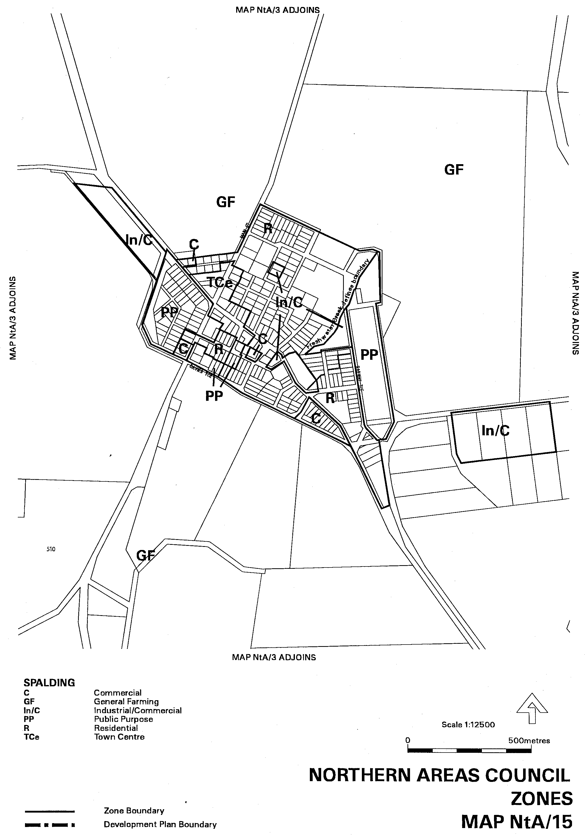
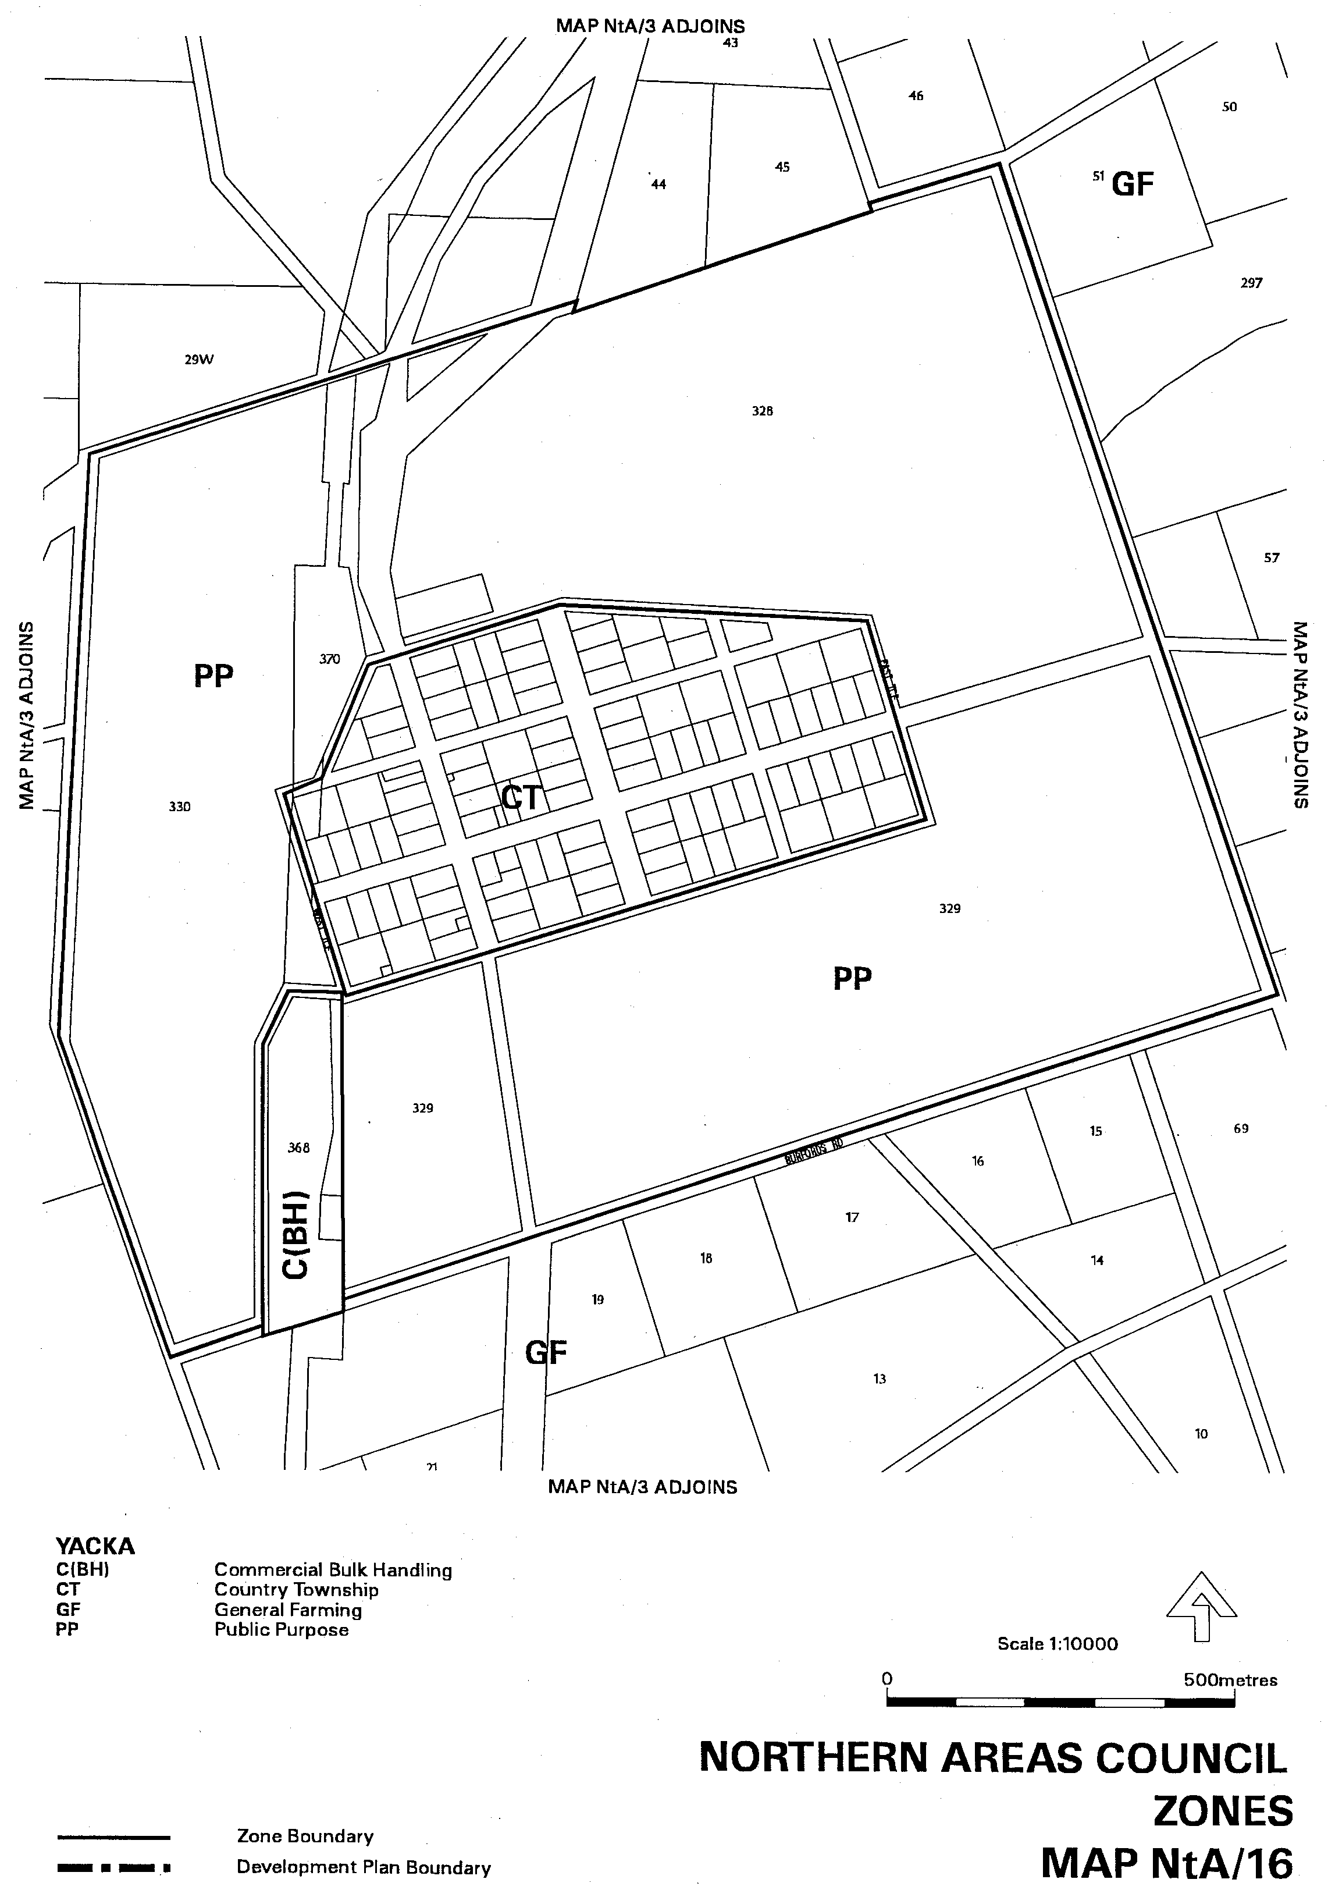
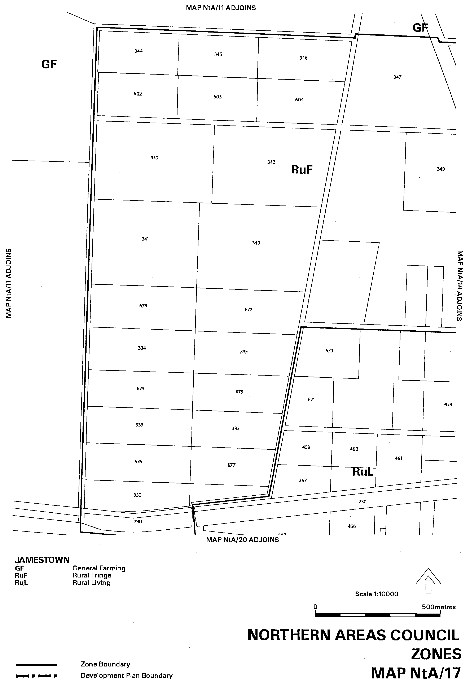
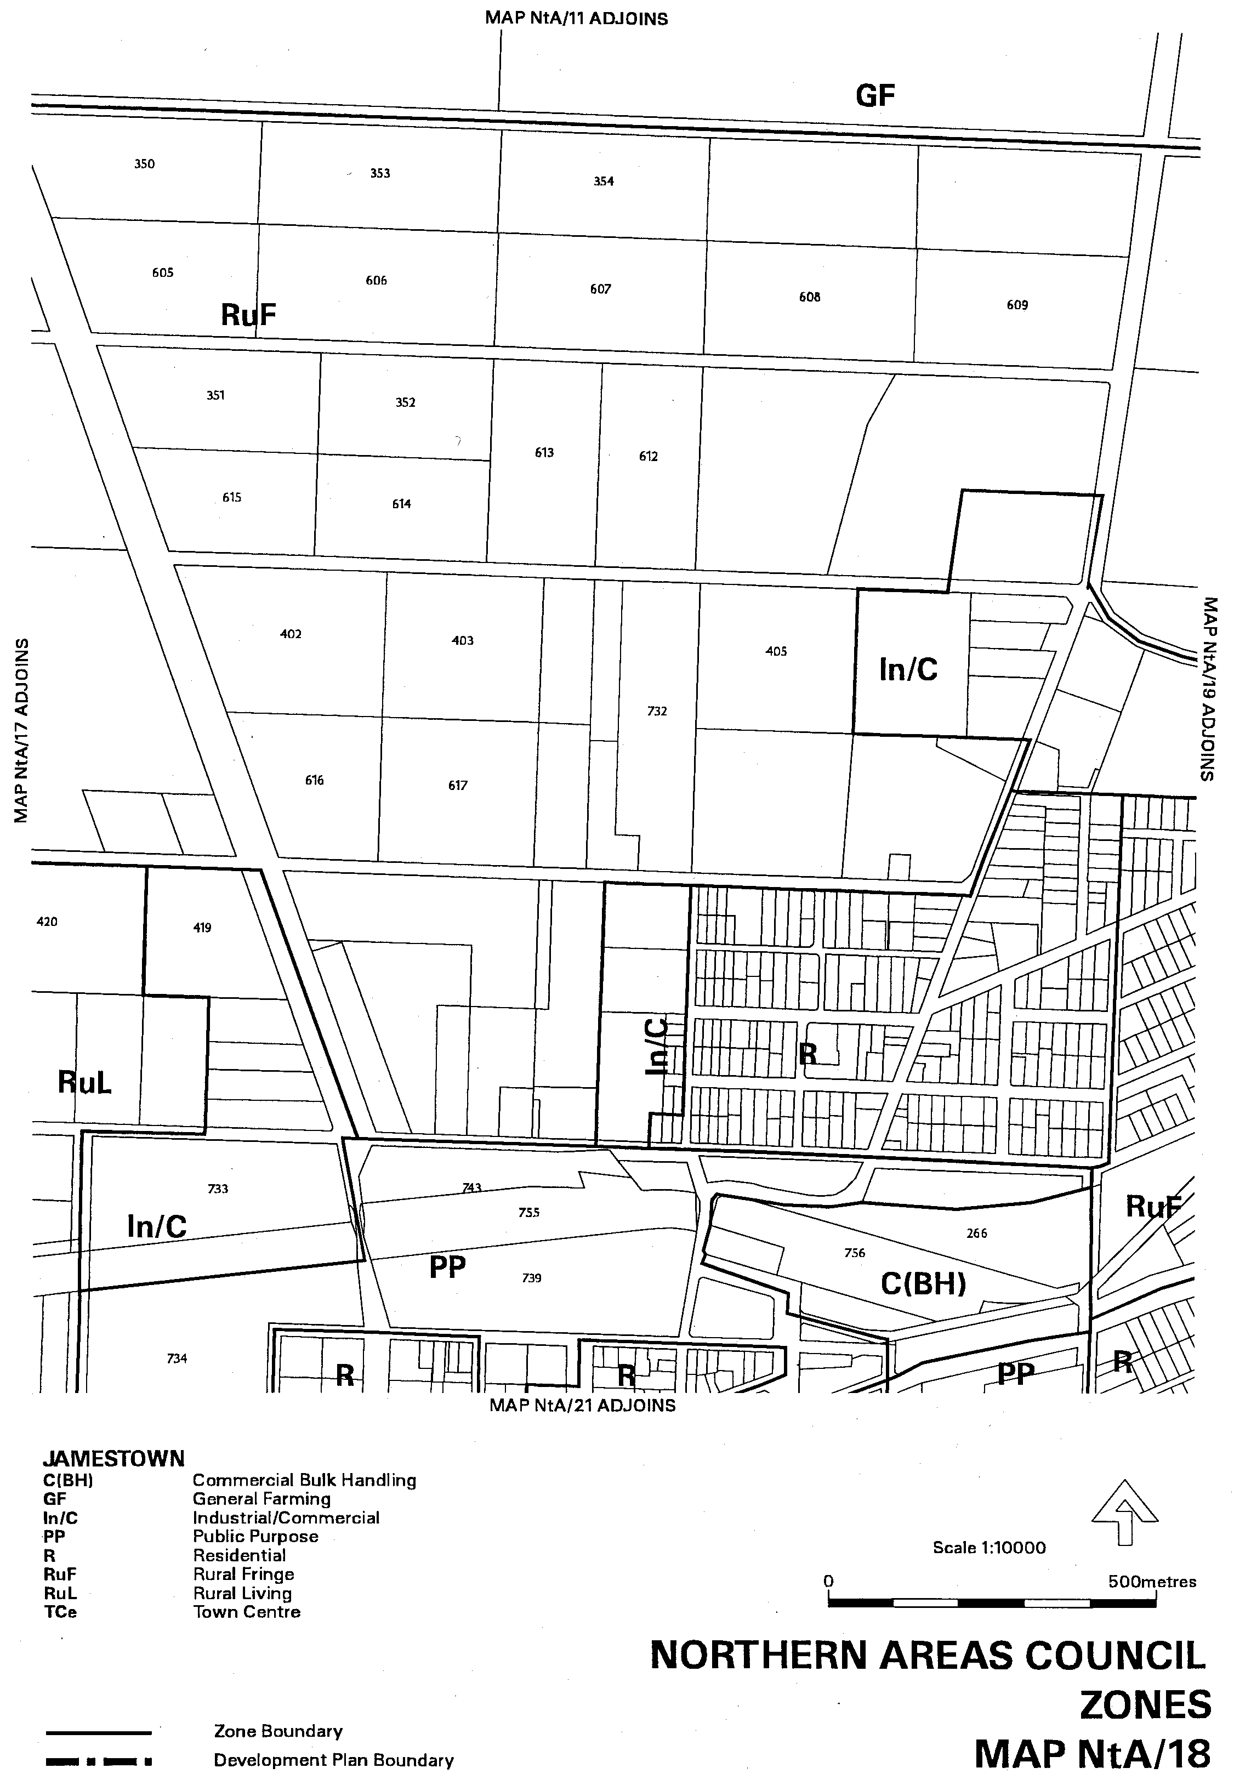
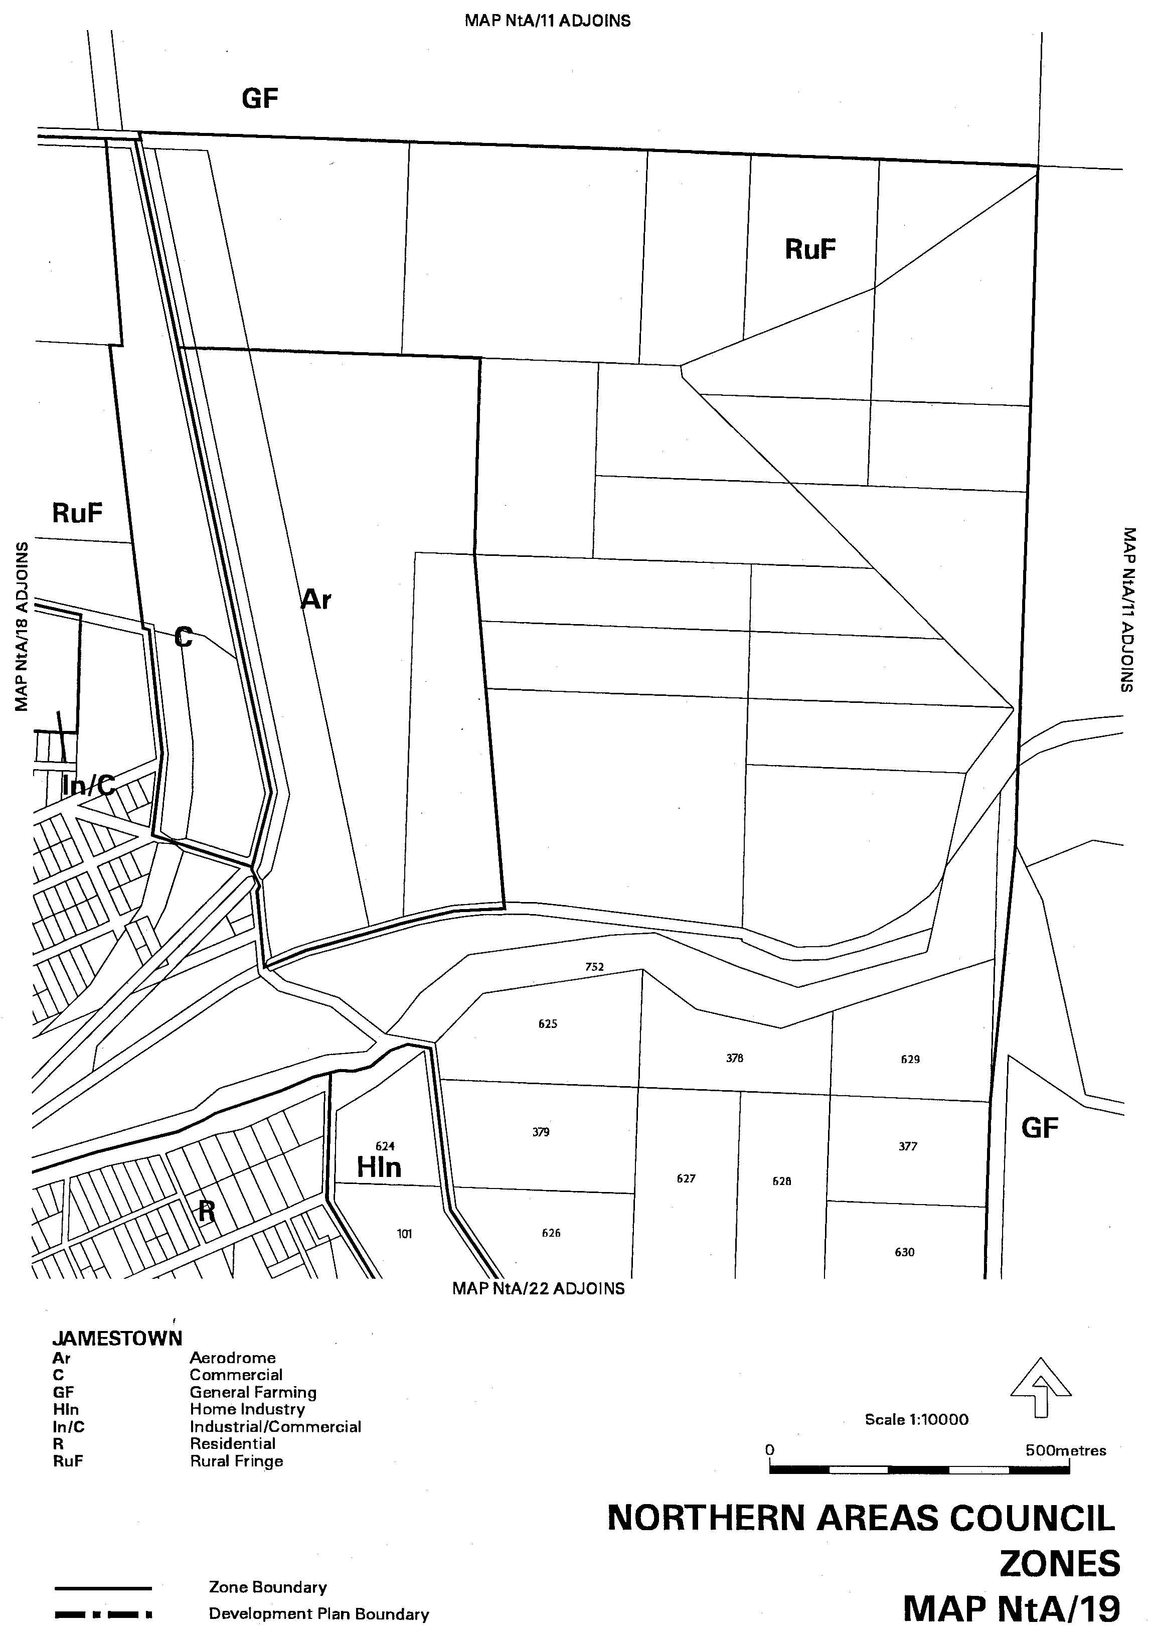
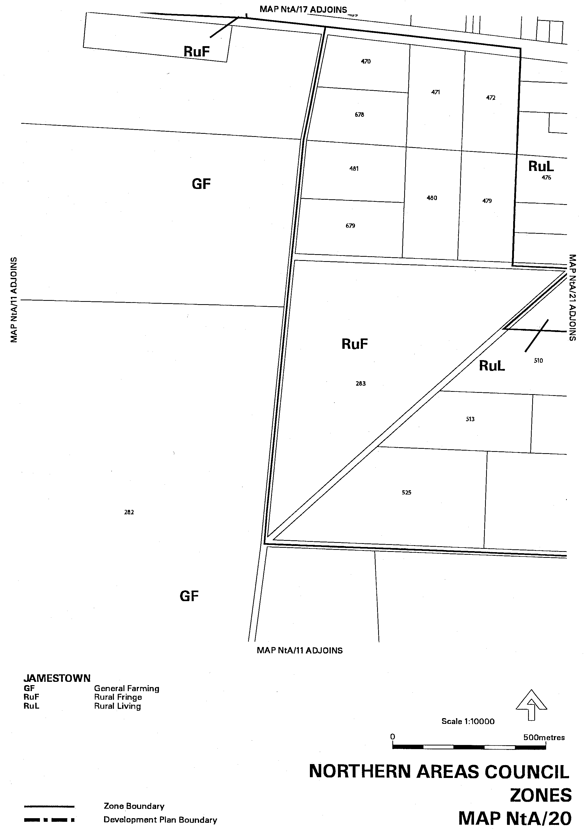
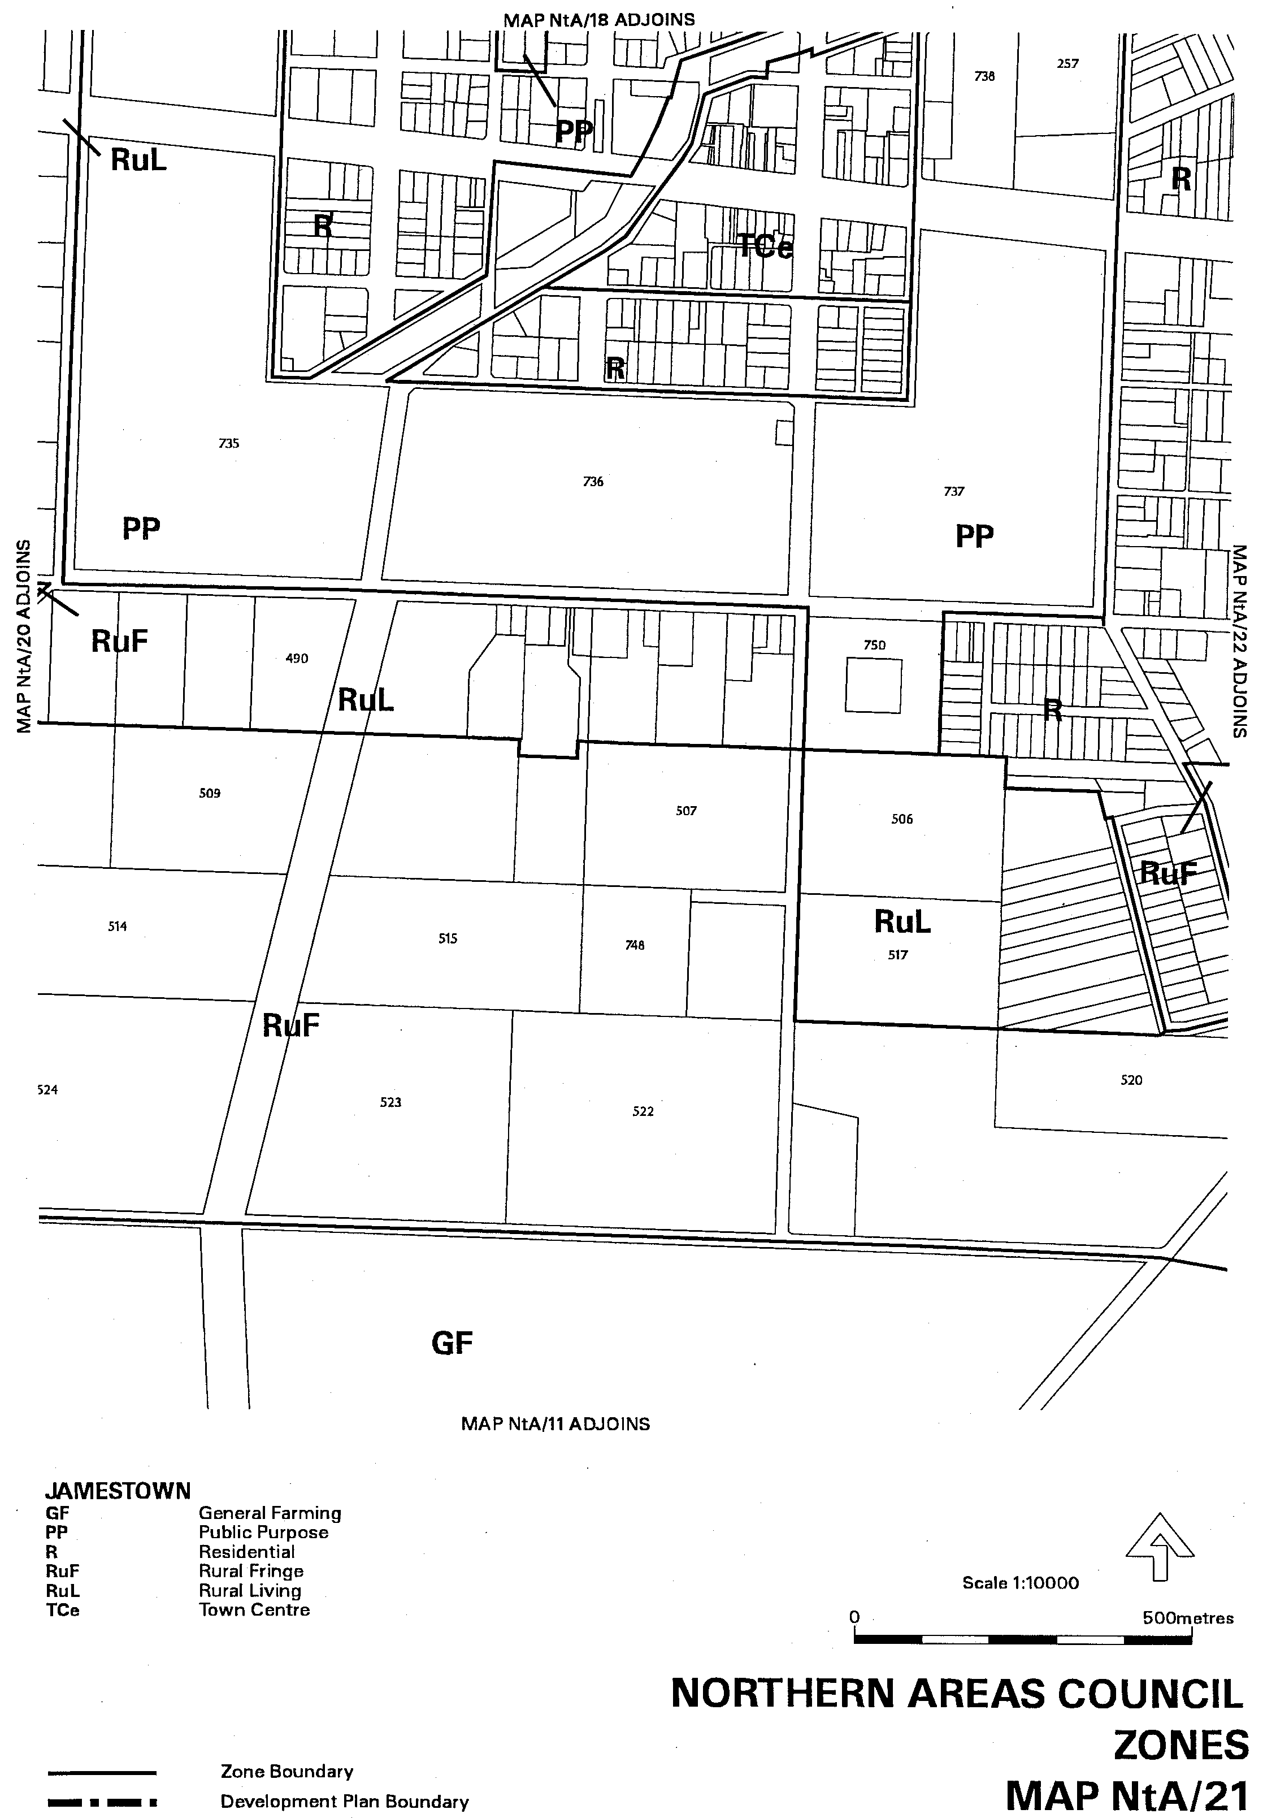
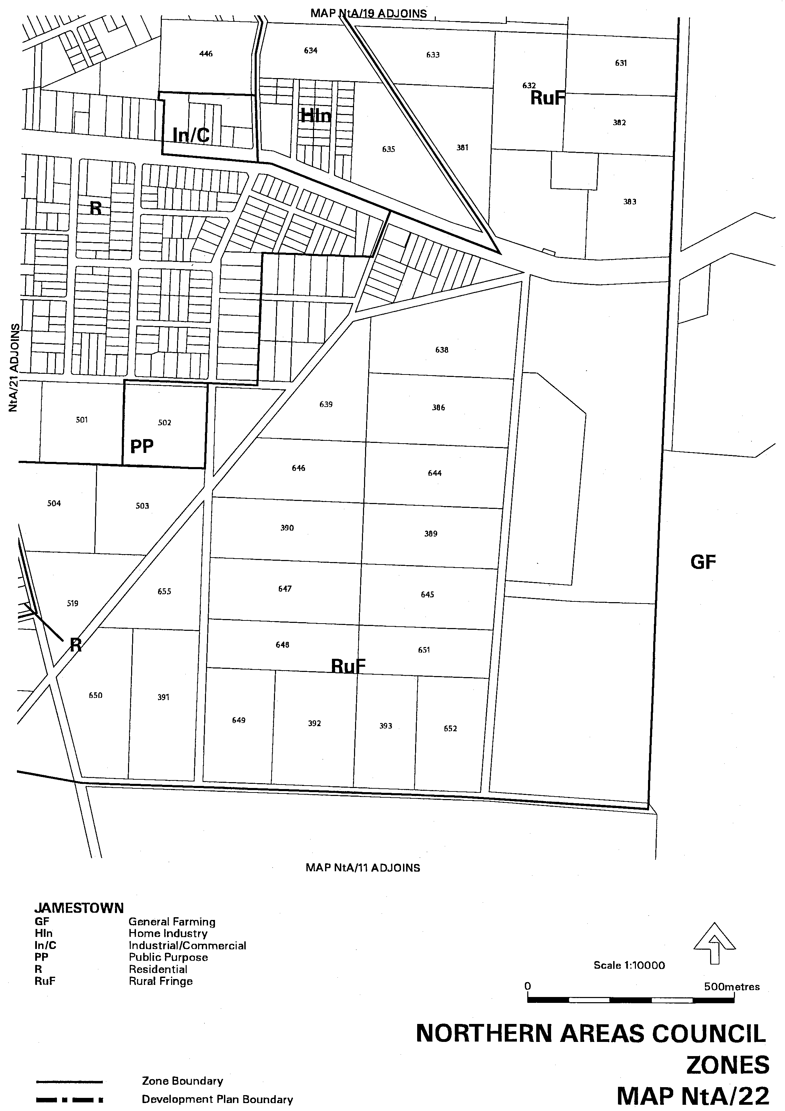
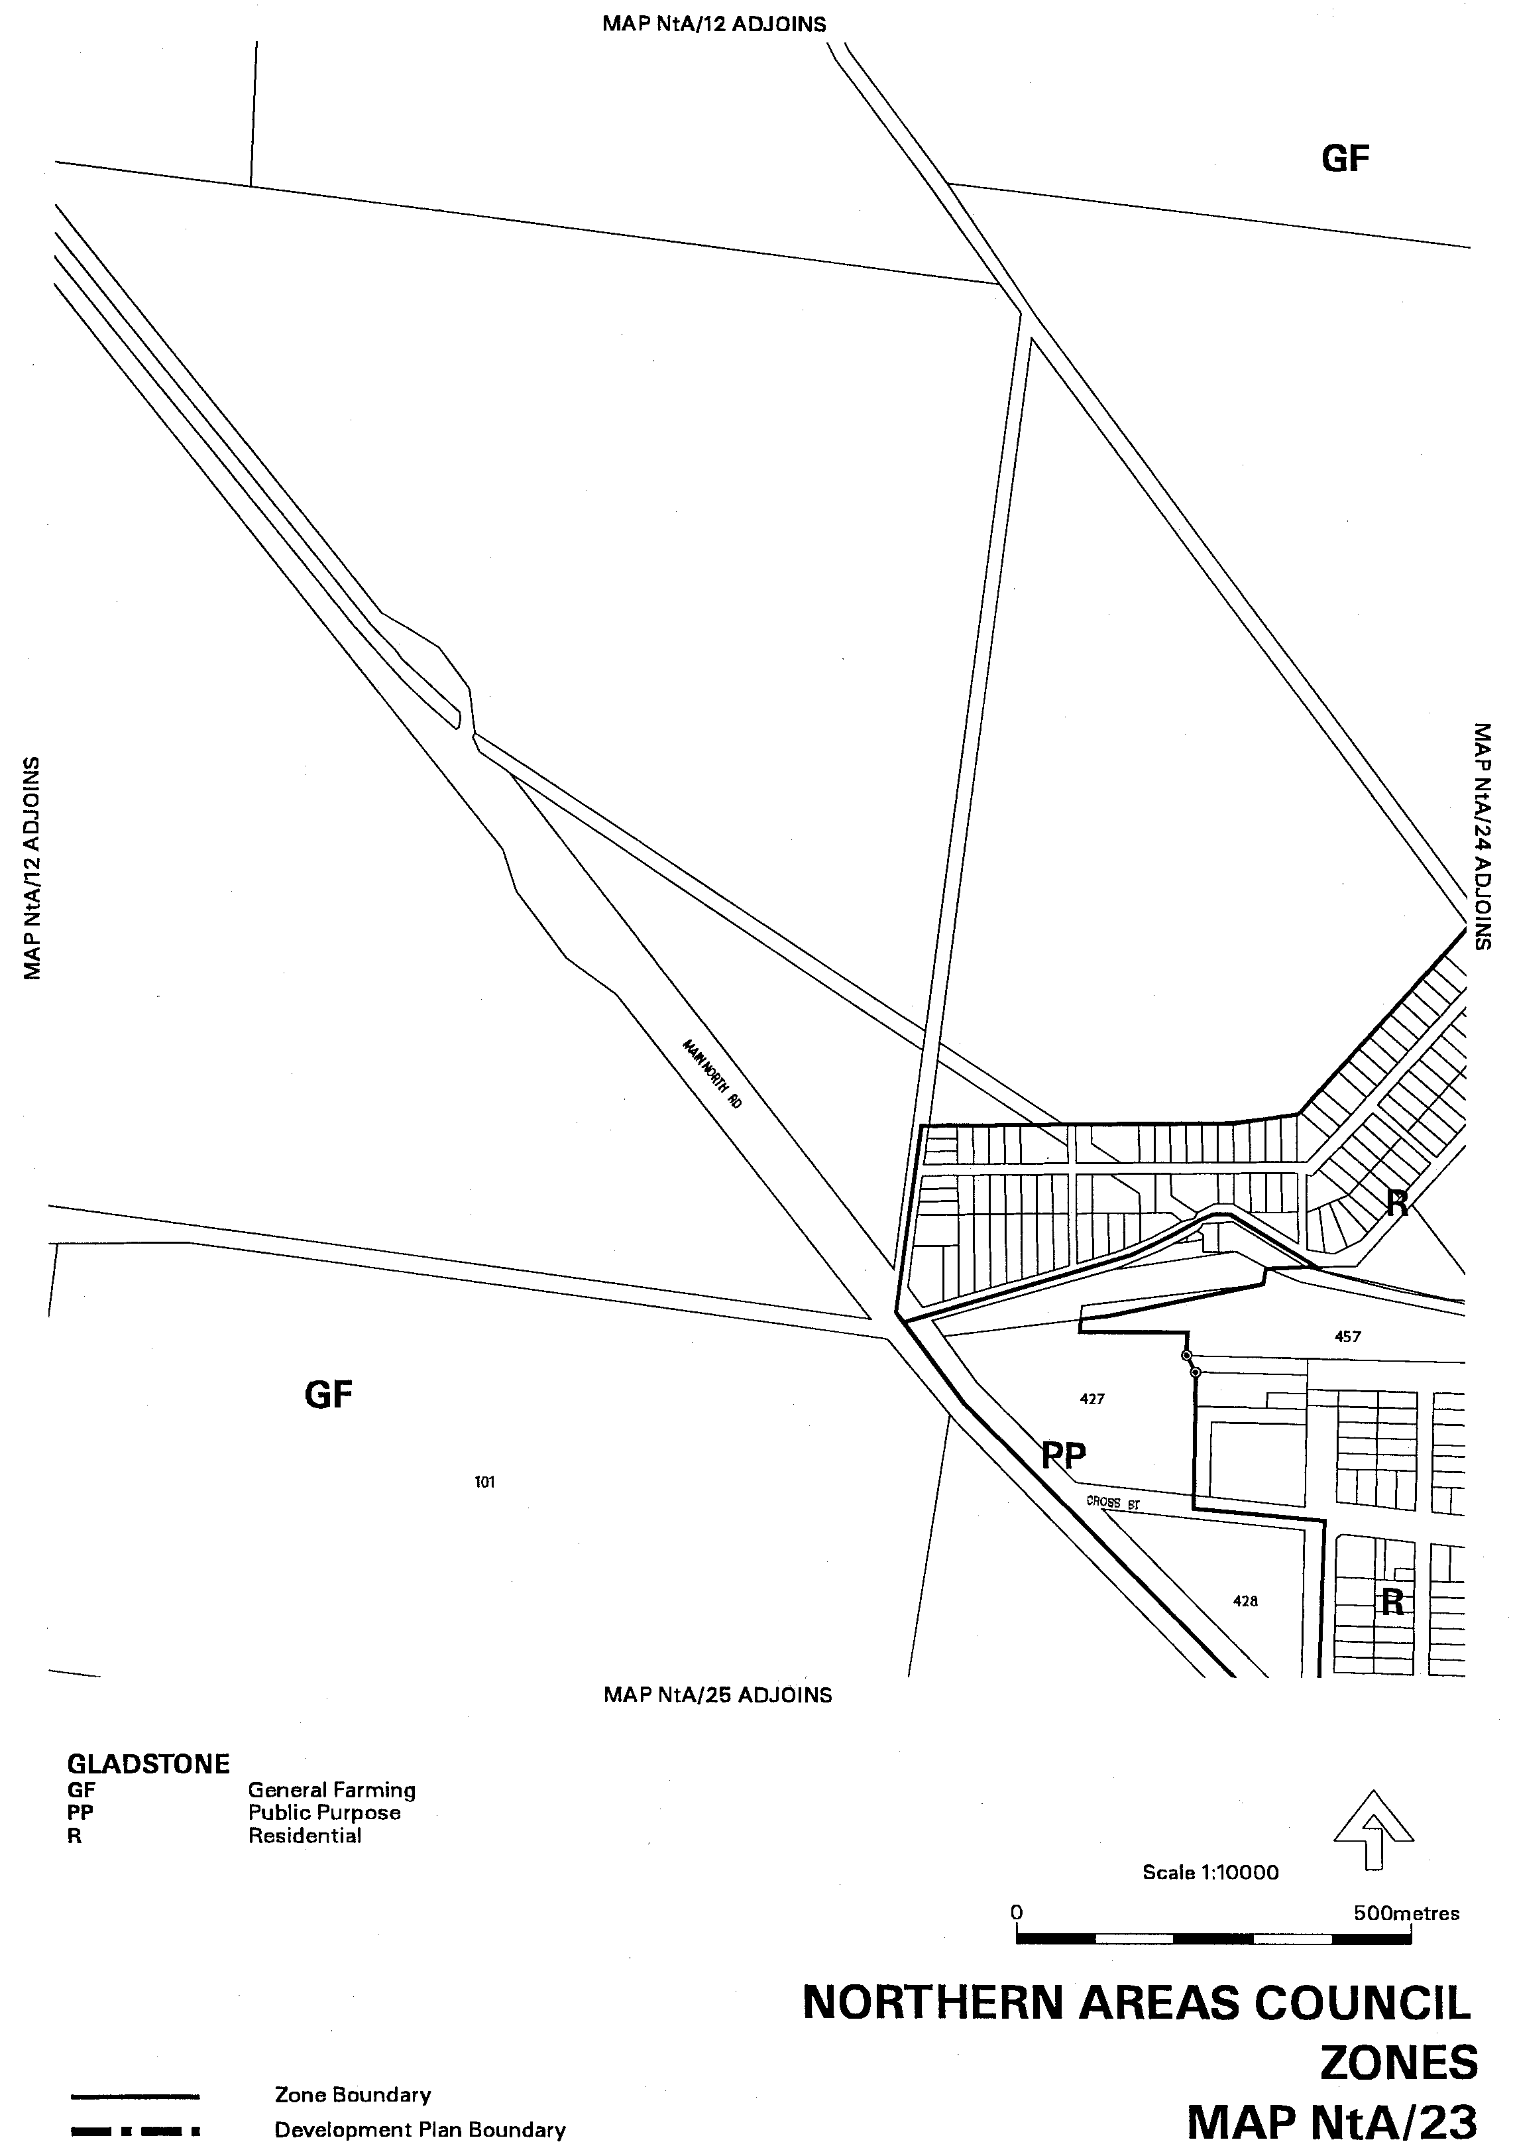
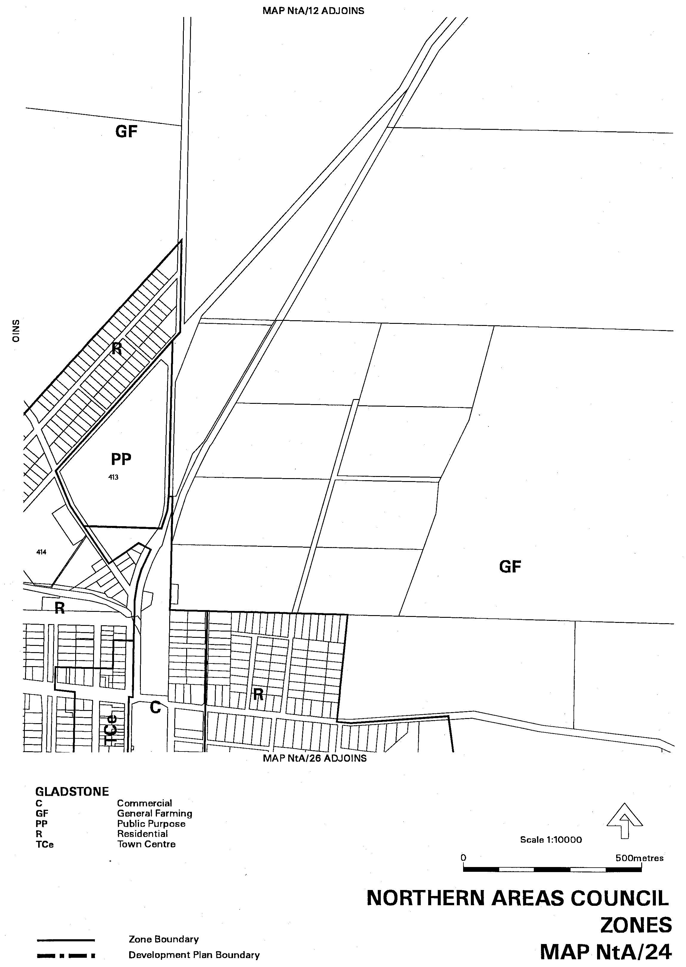
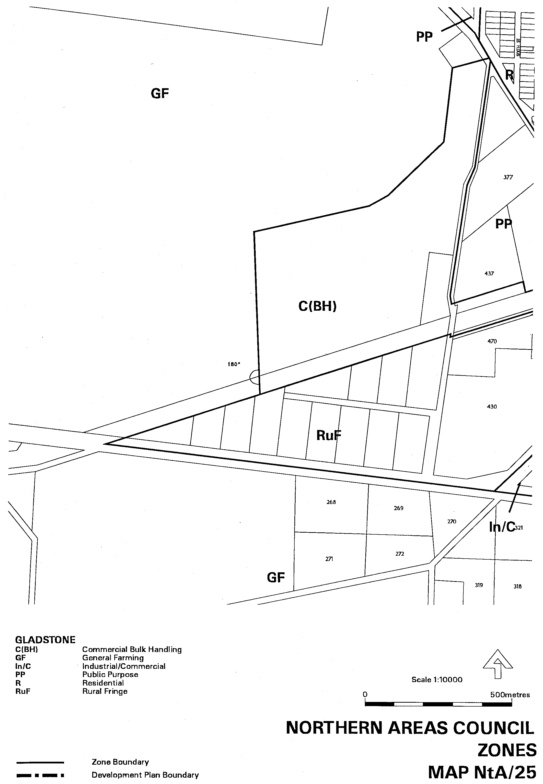
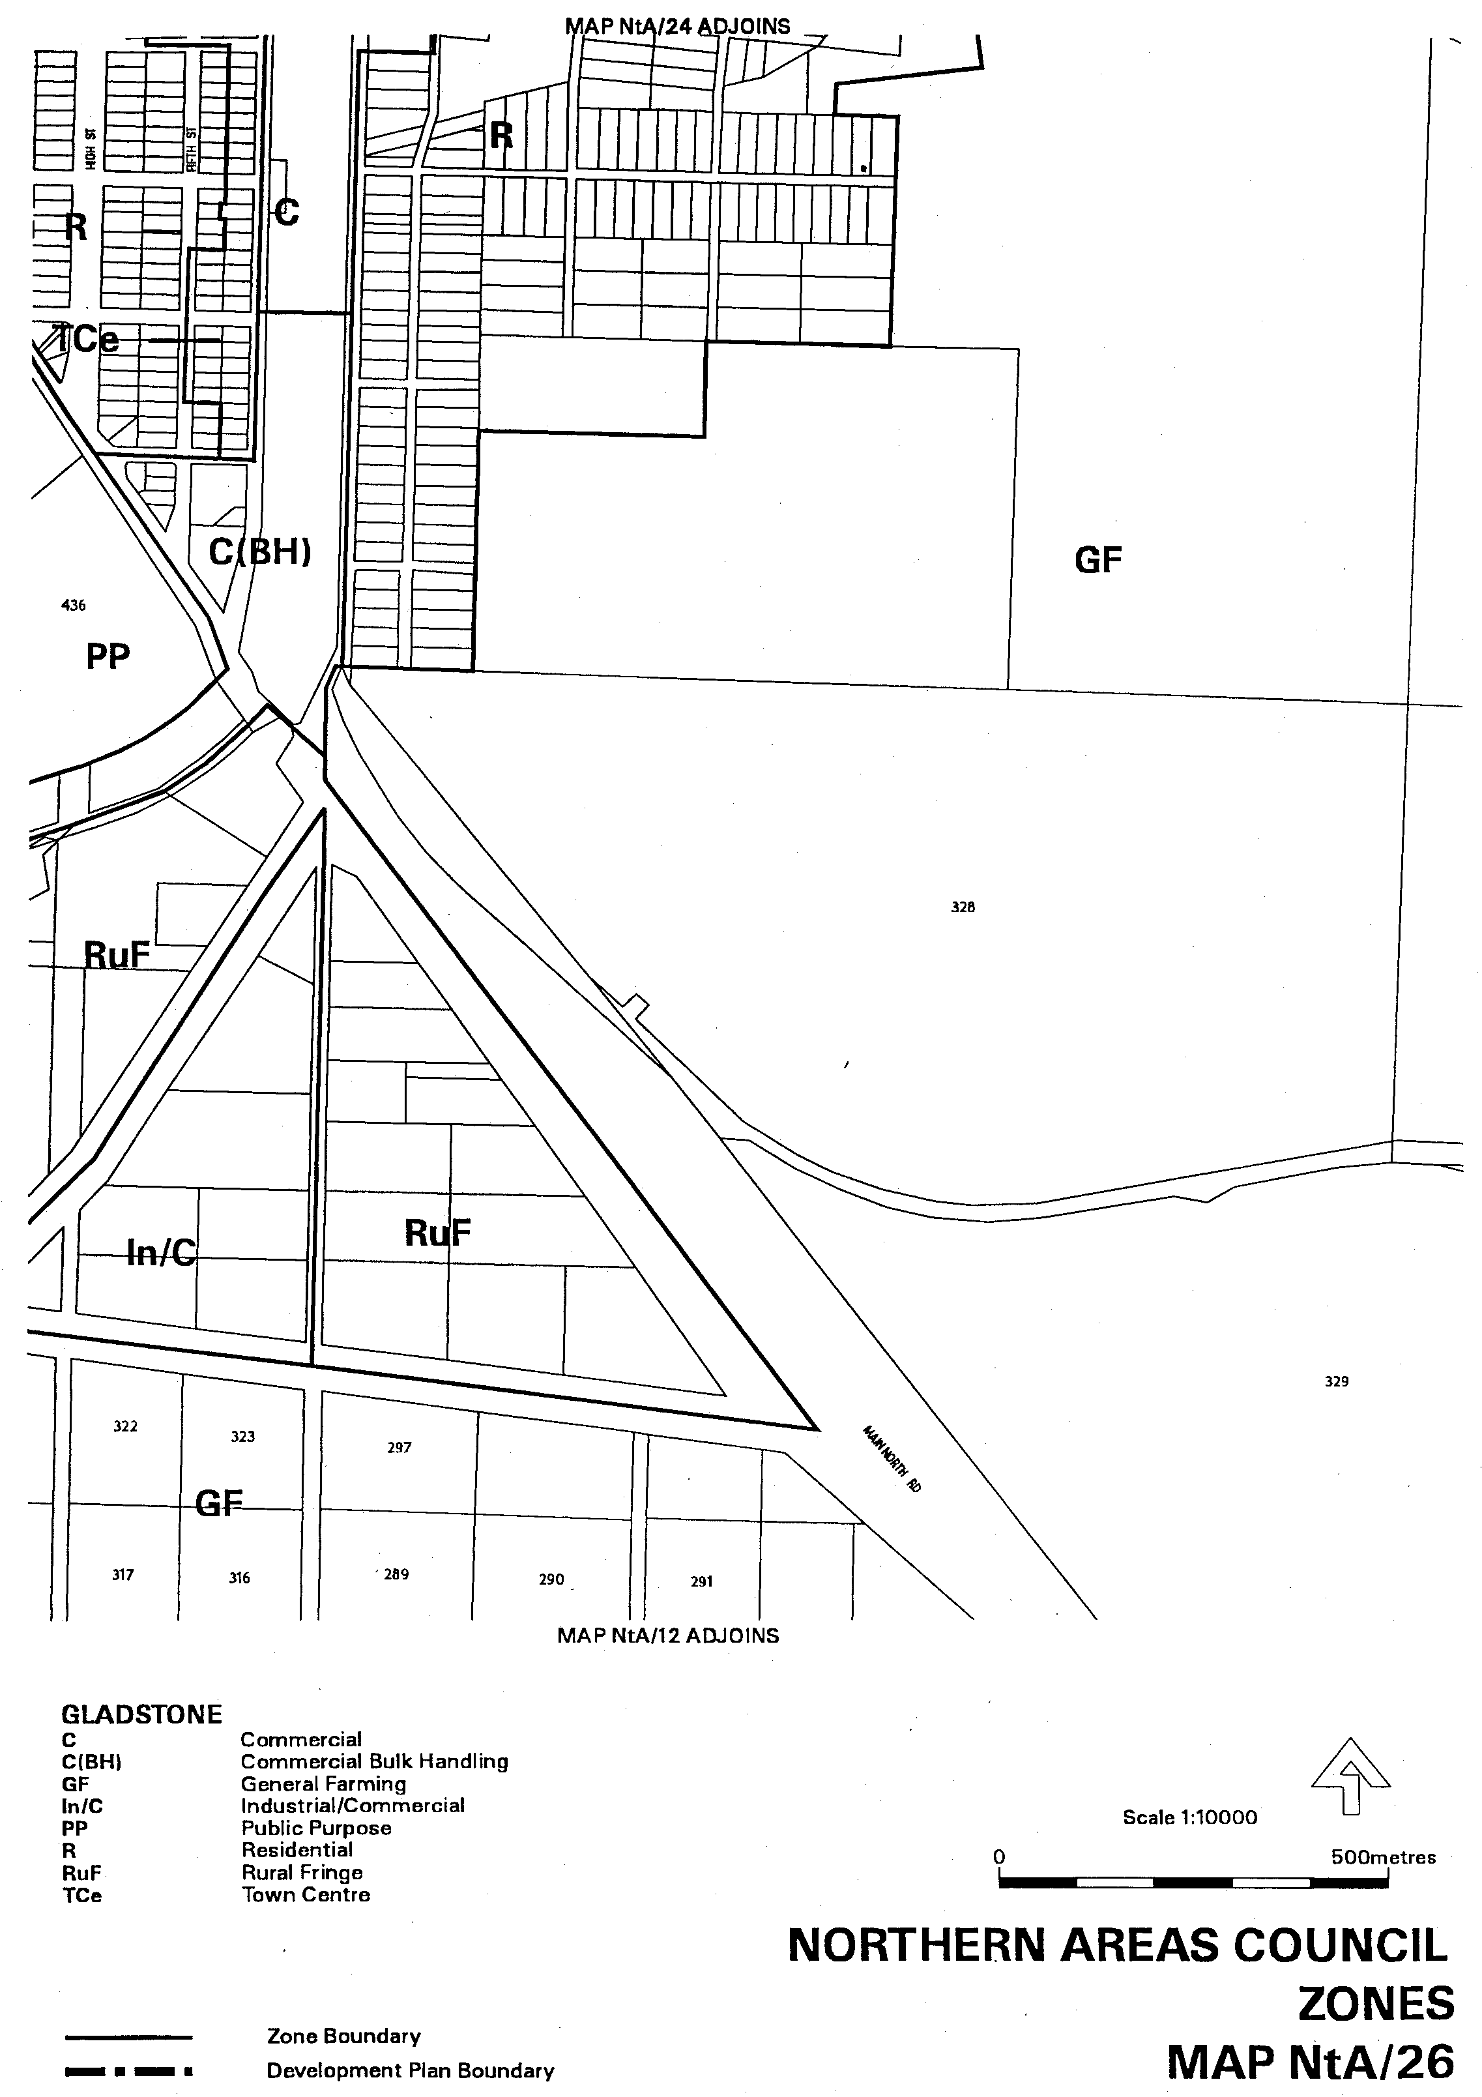
Attachment B
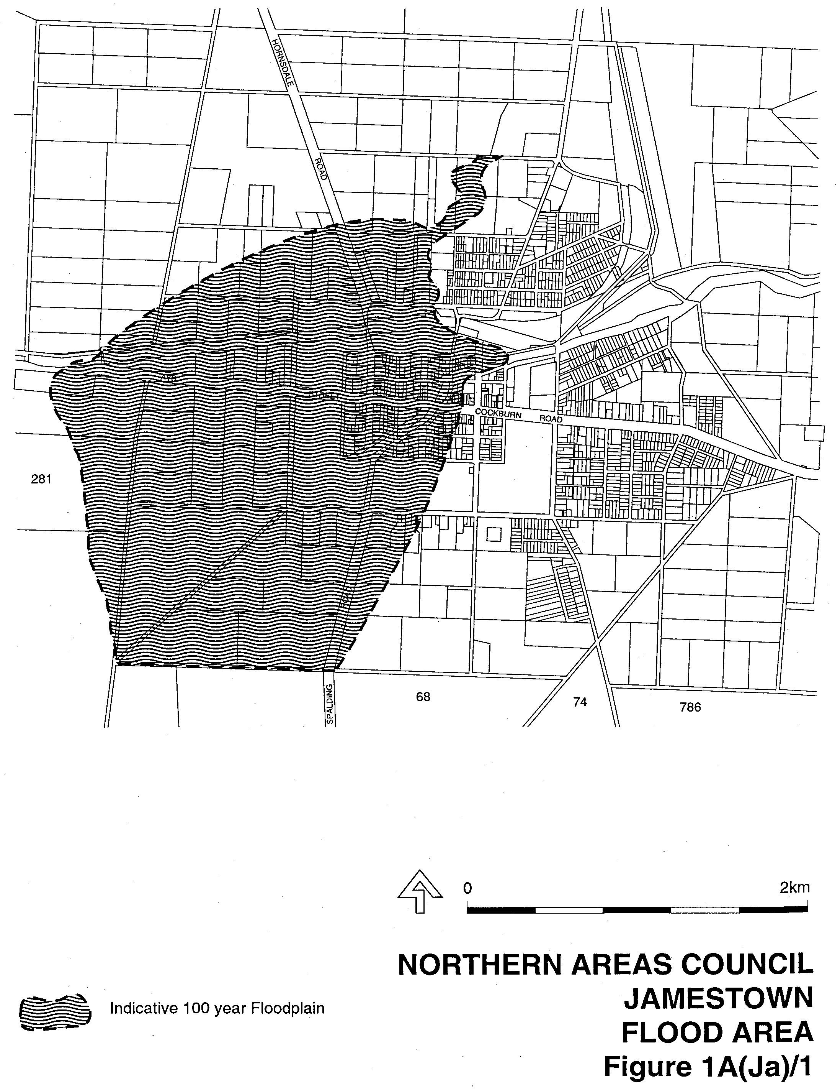

Dated 12 October 2000.
Diana Laidlaw, Minister for Transport, Urban Planning and the Arts

MISCELLANEOUS LEGISLATION AND GOVERNMENT PUBLICATIONS PRICES AS FROM 1 JULY 2000

Acts, Bills, Rules, Parliamentary Papers and Regulations
Pages | Main | Amends | Pages | Main | Amends

1-16 | 1.80 | 0.80 | 497-512 | 26.25 | 25.25
17-32 | 2.55 | 1.60 | 513-528 | 27.00 | 26.00
33-48 | 3.25 | 2.35 | 529-544 | 27.75 | 26.75
49-64 | 4.15 | 3.10 | 545-560 | 28.50 | 27.75
65-80 | 4.90 | 4.00 | 561-576 | 29.25 | 28.50
81-96 | 5.60 | 4.70 | 577-592 | 30.25 | 29.00
97-112 | 6.45 | 5.45 | 593-608 | 31.00 | 30.00
113-128 | 7.20 | 6.30 | 609-624 | 31.75 | 31.00
129-144 | 8.10 | 7.10 | 625-640 | 32.50 | 31.50
145-160 | 8.90 | 7.85 | 641-656 | 33.25 | 32.25
161-176 | 9.70 | 8.70 | 657-672 | 33.75 | 33.00
177-192 | 10.40 | 9.50 | 673-688 | 35.00 | 33.75
193-208 | 11.20 | 10.30 | 689-704 | 35.75 | 34.75
209-224 | 12.00 | 11.00 | 705-720 | 36.25 | 35.50
225-240 | 12.70 | 11.80 | 721-736 | 37.50 | 36.00
241-257 | 13.60 | 12.50 | 737-752 | 38.00 | 37.00
258-272 | 14.40 | 13.30 | 753-768 | 39.00 | 37.50
273-288 | 15.20 | 14.20 | 769-784 | 39.50 | 38.75
289-304 | 15.90 | 14.90 | 785-800 | 40.25 | 39.50
305-320 | 16.70 | 15.70 | 801-816 | 41.00 | 40.00
321-336 | 17.50 | 16.50 | 817-832 | 42.00 | 41.00
337-352 | 18.30 | 17.40 | 833-848 | 42.75 | 41.75
353-368 | 19.10 | 18.10 | 849-864 | 43.50 | 42.50
369-384 | 19.90 | 19.00 | 865-880 | 44.25 | 43.50
385-400 | 20.60 | 19.70 | 881-896 | 44.75 | 44.00
401-416 | 21.40 | 20.40 | 897-912 | 46.00 | 44.75
417-432 | 22.30 | 21.30 | 913-928 | 46.50 | 46.00
433-448 | 23.00 | 22.00 | 929-944 | 47.50 | 46.50
449-464 | 23.90 | 22.80 | 945-960 | 48.50 | 47.00
465-480 | 24.50 | 23.60 | 961-976 | 49.00 | 48.00
481-496 | 25.25 | 24.30 | 977-992 | 50.00 | 48.50

Legislation—Acts, Regulations, etc: $
Subscriptions:
Acts 162.85
All Bills as Laid 388.90
Rules and Regulations 388.90
Parliamentary Papers 388.90
Bound Acts 179.75
Index 87.05
Government Gazette
Copy 4.30
Subscription 214.85
Hansard
Copy 11.60
Subscription—per session (issued weekly) 336.95
Cloth bound—per volume 144.70
Subscription—per session (issued daily) 336.95
Legislation on Disk
Whole Database 2 488.80
Annual Subscription for fortnightly updates 765.20
Individual Act(s) including updates POA
Compendium
Subscriptions:
New Subs 1 476.60
Updates 527.10

(All the above prices include GST)

All Legislation, Government Gazette, Hansard and Legislation on disk are available from:
Counter Sales Information SA (State Government Bookshop)
and Mail Orders: Australis Centre, Ground Floor, 77 Grenfell Street, Adelaide, S.A. 5000.
Phone: (08) 8204 1900. Fax: (08) 8204 1909
S.A. Country Customer Free Call: 1800 182 234
TTY (Hearing Impaired): (08) 8204 1923
Subscriptions and Standing Orders:
Phone: (08) 8204 9447, (08) 8204 9448. Fax: (08) 8204 1898
P.O. Box 1, Rundle Mall, Adelaide, S.A. 5000.

GOVERNMENT GAZETTE ADVERTISEMENT RATES

To apply from 1 July 2000

$  Agents, Ceasing to Act as 32.00  Associations:  Incorporation 16.30  Intention of Incorporation 40.25  Transfer of Properties 40.25  Attorney, Appointment of 32.00  Bailiff’s Sale 40.25  Cemetery Curator Appointed 23.90  Companies:  Alteration to Constitution 32.00  Capital, Increase or Decrease of 40.25  Ceasing to Carry on Business 23.90  Declaration of Dividend 23.90  Incorporation 32.00  Lost Share Certificates:  First Name 23.90  Each Subsequent Name 8.20  Meeting Final 26.75  Meeting Final Regarding Liquidator’s Report on  Conduct of Winding Up (equivalent to ‘Final  Meeting’)  First Name 32.00  Each Subsequent Name 8.20  Notices:  Call 40.25  Change of Name 16.30  Creditors 32.00  Creditors Compromise of Arrangement 32.00  Creditors (extraordinary resolution that ‘the Com-pany be wound up voluntarily and that a liquidator be appointed’) 40.25  Release of Liquidator⎯Application⎯Large Ad. 64.00  ⎯Release Granted 40.25  Receiver and Manager Appointed 37.25  Receiver and Manager Ceasing to Act 32.00  Restored Name 30.25  Petition to Supreme Court for Winding Up 55.50  Summons in Action 47.50  Order of Supreme Court for Winding Up Action 32.00  Register of Interests⎯Section 84 (1) Exempt 72.00  Removal of Office 16.30  Proof of Debts 32.00  Sales of Shares and Forfeiture 32.00  Estates:  Assigned 23.90  Deceased Persons⎯Notice to Creditors, etc. 40.25  Each Subsequent Name 8.20  Deceased Persons⎯Closed Estates 23.90  Each Subsequent Estate 1.00  Probate, Selling of 32.00  Public Trustee, each Estate 8.20 |  | $  Firms:  Ceasing to Carry on Business (each insertion) 21.30  Discontinuance Place of Business 21.30  Land⎯Real Property Act:  Intention to Sell, Notice of 40.25  Lost Certificate of Title Notices 40.25  Cancellation, Notice of (Strata Plan) 40.25  Mortgages:  Caveat Lodgment 16.30  Discharge of 17.20  Foreclosures 16.30  Transfer of 16.30  Sublet 8.20  Leases⎯Application for Transfer (2 insertions) each 8.20  Lost Treasury Receipts (3 insertions) each 23.90  Licensing 47.50  Municipal or District Councils:  Annual Financial Statement⎯Forms 1 and 2 451.00  Electricity Supply⎯Forms 19 and 20 319.00  Default in Payment of Rates:  First Name 64.00  Each Subsequent Name 8.20  Noxious Trade 23.90  Partnership, Dissolution of 23.90  Petitions (small) 16.30  Registered Building Societies (from Registrar-  General) 16.30  Register of Unclaimed Moneys⎯First Name 23.90  Each Subsequent Name 8.20  Registers of Members⎯Three pages and over:  Rate per page (in 8pt) 204.00  Rate per page (in 6pt) 269.00  Sale of Land by Public Auction 40.75  Advertisements 2.25  Advertisements, other than those listed are charged at $2.25 per column line, tabular one-third extra.  Notices by Colleges, Universities, Corporations and District Councils to be charged at $2.25 per line.  Where the notice inserted varies significantly in length from that which is usually published a charge of $2.25 per column line will be applied in lieu of advertisement rates listed.  South Australian Government publications are sold on the condition that they will not be reproduced without prior permission from the Government Printer.
All the above prices include GST

GOVERNMENT GAZETTE NOTICES
ALL private advertisements forwarded for publication in the South Australian Government Gazette must be PAID FOR PRIOR TO INSERTION; and all notices, from whatever source, should be legibly written on one side of the paper only and sent to Riverside 2000 so as to be received no later than 4 p.m. Tuesday preceding the day of publication. Phone 8207 1045 or Fax 8207 1040. E-mail: Riv2000@saugov.sa.gov.au. Send as attachments in Word format and please confirm your transmission with a faxed copy of your document, including the date the notice is to be published and to whom the notice will be charged.


FISHERIES ACT 1982
Marine Tuna Farming Licence FB00005
(Previous Licence No. F607)
Licence to Farm Fish under section 53 of the Fisheries
Act 1982
WHEREAS the Director of Fisheries has, pursuant to section 50 (2) of the Fisheries Act 1982 (‘the Act’), issued a permit to the undermentioned licensee to release the fish specified in Schedule 2 of this licence (‘the permitted species’), the Minister for Primary Industries (‘the Minister’) hereby grants to:
Novajo Pty Ltd (13006)
2/11 Flinders Highway
Port Lincoln, S.A. 5606,
a non-exclusive licence to occupy and use the waters specified in Item 1 of Schedule 1 of this licence (‘the site’) for the purpose of farming and taking the permitted species (‘the permitted use’) for the period commencing on 1 July 2000 and ending, subject to any earlier termination under this licence, on 30 June 2001 (‘the term’) subject to the following terms and conditions:
Conditions of This Licence
1. Licence
The parties acknowledge and agree that:
1.1 the rights, powers and privileges granted to or vested in the licensee under this licence are contractual only and shall not create or vest in the licensee any estate, interest or right of a proprietary nature in the site; and
1.2 that, subject to section 53A of the Fisheries Act 1982, this licence does not entitle the licensee to exclusive rights of entry to and occupation of the site and that the rights granted by this licence are exercisable by the licensee in common with any other occupiers of the site from time to time.
2. Marked-off Areas
For the purposes of section 53A of the Fisheries Act 1982, the marked-off areas within the site is that area or those areas marked-off or indicated in the manner set out in Item 2 of Schedule 1 of this licence.
3. Permitted Species
The licensee:
3.1 must not farm or introduce any species at the site other than the permitted species; and
3.2 must not take any wild fish from the site except for recreational purposes.
4. Permitted Use
The licensee must not use the site for any purpose other than the permitted use.
5. Permitted Methods
The licensee:
5.1 must not stock the permitted species at a rate greater than that specified in Schedule 2 of this licence;
5.2 must not use the anti-fouling chemical tributyltin (TBT) on any equipment used at the site;
5.3 must not use any chemical or drug for either therapeutic or prophylactic purpose except with the prior approval of the Minister;
5.4 must apply the permitted farming methods set out in Schedule 2 of this licence.
6. Sea Cages
The licensee:
6.1 must ensure that all sea cages on the site have anti-predator protection satisfactory to the Minister at all times during the term; and
6.2 must immediately inform an officer of PIRSA (Fisheries) on 1800 065 522 or such other officer as the Minister from time to time notifies to the licensee in writing if any marine animal, other than the permitted species, is caught in any sea cage or other farm structure used by the licensee on the site.
7. Location of Sea Cages
The licensee must not erect or use any sea cages in any location on the site where stocked sea cages have been used in the immediately preceding two year period.
8. Marking and Maintaining the Site
The licensee:
8.1 must ensure that the site is maintained in a good, tidy and safe condition to the satisfaction of the Minister;
8.2 must remove and lawfully dispose of any waste or debris on the site as soon as is reasonably practicable and in particular must comply with any guidelines issued from time to time by the Minister in relation to the removal from the site of any unhealthy or dead fish;
8.3 must maintain all buoys, crosses, and markers on the site in good condition and in accordance with the colours specified in Schedule 1 of this licence; and
8.4 must mark the site boundary in accordance with the specifications in Schedule 1 of this licence.
9. Site Inspection and Supervision
The licensee:
9.1 must at all times permit the Minister, his employees, agents or contractors or any employees, agents or contractors of the Crown to enter the site for the purposes of inspecting the site, the sea floor and the flora and fauna on or in the vicinity of the site; and
9.2 must comply with all reasonable directions of any such person authorised by the Director of Fisheries to inspect the conduct of the licensee’s activities at the site.
10. Fees and Returns
The licensee:
10.1 must pay to the Minister the licence fee in accordance with Item l of Schedule 3 of this licence;
10.2 must on or before 31 January and 31 July during the term, submit to the Minister a return supplying all of the information described in Schedule 4 of this licence.
11. Compliance With Relevant Laws
11.1 the licensee must at all times comply with all laws, by-laws or regulations in force which relate to the site or the activities conducted in the site and with all notices, orders or requirements lawfully given or made by any authority or authorities in respect of the site;
11.2 in particular, without derogating from the general requirement under condition 11 of this licence:
11.2.1 the licensee must not do or permit to be done in upon or about the site anything which in the opinion of the Minister would cause or contribute to the degradation or pollution of any coastal land or the surrounding marine environment; and
11.2.2 in the event that the Minister is satisfied, on reasonable grounds, that the fish taken from the waters are not fit for human consumption or that consumption of fish taken from the waters could present a danger to the health of the consumer, the licensee must, in accordance with a written notice from the Minister, cease or suspend the conduct of the permitted use or else conduct the permitted use as directed within the notice.
12. Public Risk Indemnity
The licensee must at all times indemnify the Minister, his officers, employees, contractors and agents from and against all claims, demands, actions, judgments, proceedings, damages, losses, costs, charges and expenses in respect of any loss of life, personal injury and/or damage to property caused or suffered in any manner in or about the site.
13. Release
The licensee must use and keep the site at the risk in all things of the licensee and the licensee must release to the full extent permitted by law the Minister, his agents, contractors and servants in the absence of any wilful act, omission, default or neglect on their part from all claims and demands of every kind resulting from any accident damage or injury to persons or property occurring at the site, including loss or damage to the licensee’s fixtures or personal property of the licensee.
14. Public Risk Insurance
The licensee shall at its own cost and expense during the term effect and keep in full force and effect in respect of the site and the permitted use a policy of public risk insurance in the joint names of the licensee and the Minister in which the limits of public risk shall not be less than the amount specified in Item 2 of Schedule 3 of this licence, or such further amount as the Minister may from time to time reasonably require, as the amount which may be paid out in respect of any one single claim and a policy of insurance or copy thereof or a certificate of insurance shall be produced by the licensee to the Minister on request in writing being made by the Minister for its production.
15. Guarantee or Indemnity Scheme
The licensee must either:
15.1 provide a guarantee from its bankers; or
15.2 contribute to an indemnity scheme established for the aquaculture and fisheries industry and approved by the Minister,
to and in favour of and for the benefit of the Minister by way of security for the due and punctual performance by the licensee of the terms and conditions of this licence and in particular the obligations of the licensee to rehabilitate the site immediately prior to the expiration or sooner determination of the term of this licence. Such guarantee or indemnity scheme must have effect from the date of commencement of the term.
16. No Assignment
The licensee acknowledges that this licence is personal and it must not assign or sublet or deal in any other way with any interest in this licence.
17. Default by Licensee and Termination
The Minister may terminate this licence immediately by notice in writing served on the licensee if:
17.1 the licensee commits or permits any breach or default of the obligations imposed on the licensee by this licence, and following the giving by the Minister of written notice of such breach or default, the licensee either fails to rectify such breach or default within one calendar month of the date of such notice (or earlier if the circumstances require) or fails to make diligent progress towards rectifying any such breach which is incapable of rectification within the time so limited; or
17.2 the licensee commits or permits any further breach or default of the obligations imposed on the licensee by this licence for which the Minister has previously given notice in writing of such breach or default pursuant to paragraph 1 of condition 17.1 notwith-standing rectification of the previous breach or default; or
17.3 the licence fee referred to in condition 10 is unpaid for a period of 14 days after notice has been given to the licensee that it is outstanding; or
17.4 if the licensee is a body corporate, any of the following occur:
17.4.1 the licensee is unable to pay its debts as and when they fall due or is otherwise insolvent;
17.4.2 an order is made for the winding up or liquidation of the licensee;
17.4.3 the licensee enters into a scheme of arrangement, compromise, moratorium or other form of composition with its creditors or any class of its creditors;
17.4.4 a receiver, a manager or a receiver and manager, a company administrator or other insolvency administrator is appointed to the licensee; or
17.4.5 a mortgagee, chargee or other encum-brancee is appointed over or takes possession of or appoints an agent to take possession of all or any of the licensee’s assets; or
17.5 if the licensee is an individual, the licensee:
17.5.1 becomes bankrupt or assigns its estate or enters into a deed of arrangement or other form of composition for the benefit of the licensee’s creditors; or
17.5.2 is convicted of an indictable offence.
Termination of this licence by the Minister shall be without prejudice to any rights, remedies or actions that the Minister may have against the licensee in respect of any antecedent breach by the licensee of the terms and conditions contained in this licence.
18. Interpretation
Subject to any inconsistency of subject or context, the following rules of construction shall be used in the interpretation of this licence:
18.1 any word importing the plural includes the singular and vice versa;
18.2 any wording importing a gender shall include all other genders;
18.3 a reference to a body corporate shall include a natural person and vice versa;
18.4 a reference to a recital, party, clause, Schedule or Annexure is a reference to a recital, party, clause, Schedule or Annexure of this licence;
18.5 the captions, headings, section numbers and clause numbers appearing in this licence are inserted only as a matter of convenience and in no way affect the construction of this licence;
18.6 a reference to a statute shall include all statutes amending, consolidating or replacing the statutes referred to;
18.7 where two or more persons are named as licensees, this licence shall bind the licensees jointly and each of them severally; and
18.8 time is of the essence in respect of any obligation relating to time in this licence.
19. Delegation
Any consent, notice, any consultation or any other thing which is pursuant to the terms of this licence either required to be given, done or performed or which may be given, done or performed by the Minister may for the purposes of this licence be properly given, done or performed by any duly authorised agent or employee of the Minister.
20. Severance
If any term or condition of this licence should be for any reason unlawful, void, invalid or unenforceable then the offending term or condition shall be severed from this licence without affecting the validity or enforceability of the remainder of this licence.
21. Modification
No variation of or addition to any provision of this licence shall be binding upon the Minister and the licensee unless such variation or addition is made in writing, signed by both the Minister and the licensee and expressed to be either supplemental to or in substitution for the whole or a part of this licence.
22. Waiver
22.1 A waiver of any provision of this licence by the Minister must both be in writing and be signed by the Minister or by persons duly authorised to execute such a document on the Minister’s part.
22.2 No waiver by the Minister of a breach of a term or condition contained in this licence shall operate as a waiver of any breach of the same or any other term or condition contained in this licence.
22.3 No forbearance, delay or indulgence by the Minister in enforcing the provisions of this licence shall prejudice or restrict the rights of the Minister.
23. Notices
23.1 Notices may be served by delivering the same personally, by mail or facsimile transmission and shall be:
23.1.1 in writing addressed to the Director of Fisheries, PIRSA, 16th Floor, 25 Grenfell Street, Adelaide, S.A. 5000 (in the case of the Minister) and to the address of the licensee set out above (in the case of the licensee);
23.1.2 signed by or on behalf of the sender or by a person duly authorised in that regard by the sender;
23.1.3 deemed to be duly served or made in the following circumstances:
(a) if delivered, upon delivery;
(b) if sending by mail, upon posting;
(c) if sent by facsimile transmission, upon the sender’s facsimile producing a transmission report that the facsimile was satisfactorily sent in its entirety to the addressee’s facsimile number,
but if delivery is not made before 5 p.m. on any day it shall be deemed to be received at 9 a.m. on the next day in that place.
23.2 The Minister and the licensee may each vary their address or facsimile number at any time by written notice.
Granted by the General Manager Aquaculture, delegate of the Minister, on 29 September 2000.
I. Nightingale, General Manager Aquaculture
The licensee hereby acknowledges and agrees to the terms and conditions of this licence.
The Common Seal of Navajo Pty Ltd (ACN 077 840 325) was hereunto affixed in the presence of:
(l.s.) T. Bryant, Director
L. Bryant, Secretary
Schedule 1
Item 1—The Site
Area applicable to this licence:
Licensed Area Licensed
Hectares
AGD 66—Zone 53
587797E 6155738N 20
587445E 6155547N
587697E 6155116N
588045E 6155308N
All structures, equipment, buoys and flotations (except for that required by the Department for Transport, Urban Planning and the Arts) must be black, dark grey, dark blue, dark brown, or dark green coloured materials.
The boundary of the site to be marked either with:
(a) (1) At the corners with posts extending 900 mm above mean high water springs. Such posts to be marked with a St Andrews cross, each cross arm measuring 900 mm from tip to tip, minimum width 75 mm.
(2) Posts to be not less than 125 mm in diameter.
(3) Posts and crosses to be painted yellow.
(4) The ends of each cross to be marked with a 200 mm strip of yellow retro-reflective tape.
(5) Between the corner posts at intervals not exceeding 50 m, buoys not less than 300 mm in diameter.
(6) All buoys, posts, crosses and markers must be maintained in good condition.
or
(b) (1) At each corner, yellow spar buoys with a St Andrews cross as a top mark placed at least 900 mm above the buoy, cross arms 900 mm long x 75 mm wide.
(2) The buoys and topmarks must all be coloured yellow and marked with a yellow retro-reflective as in (a) (4).
(3) All buoys, posts, crosses and markers must be maintained in good condition.
When the site is in navigable water and a possible danger to navigation, lights must be yellow in colour and flashing once every 4 seconds and visible over an arc of 360 degrees for a distance of at least one mile.
All sea cages on the site must be marked with a unique sea cage number and the site’s unique ‘FB number’; that is, the licence number. All St Andrew’s crosses must be marked with the site’s unique ‘FB number’; that is the licence number.
Item 2—Marked-Off Areas
Marked-off areas must be marked with no less the 8 equally spaced white buoys, each of at least 12 inches in diameter, each positioned no more than 70 m from each relevant sea cage situated on the site.
Schedule 2
Permitted Species
The Director of Fisheries has, pursuant to section 50 (2) of the Act, issued a permit for the release of the fish specified in this Schedule.
Snapper (Pagrus auratus)
Southern Bluefin Tuna (Thunnus maccoyii)
Australian Herring (Tommy Ruff) (Arripis georgianus)
Yellowtail King Fish (Seriola lalandi)
Silver Trevally (Pseudocaranx dentex)
Permitted Farming Methods
Sea Cages
Stocking Rates
The maximum standing stock on the site must not exceed 250 tonnes.
12 seacages each with a maximum diameter of 20 m. The maximum stocking density of Southern Bluefin Tuna (Thunnus maccoyii) must not exceed 4 kg/m³.
The maximum weight of Southern Bluefin Tuna (Thunnus maccoyii) must not exceed 162 tonnes in total during the term of the licence.
The maximum stocking density of fish other than Southern Bluefin Tuna (Thunnus maccoyii) on the site must not exceed 10 kg/m³.
Schedule 3
Item 1—Fees
Annual licence fees are:
$
ESD Study (Seafood Council) per hectare 20 at
$49 each 980.00
TEMP Environmental Monitoring Fee (per hectare)
20 at $164 each 3 280.00
Base Licence Fee (per hectare) 20 at $228 each 4 560.00
Fisheries Research and Development Corporation
(per hectare) 20 at $364 each 7 280.00
Total Annual Licence Fee 16 100.00
Quarterly Installments 4 025.00
Item 2—Public Risk Insurance
Five million dollars ($5 000 000).
Schedule 4
Returns
The licensee must submit the following information to the Minister, c/o Director of Fisheries, PIRSA, 16th Floor, 25 Grenfell Street, Adelaide, S.A. 5000 on or before 31 January and 31 July during the term of this licence:
1. Name of licensee.
2. Address of licensee.
3. Species of fish farmed and held on the site.
4. Location of aquaculture operation.
5. Period covered by return.
6. Number of life stage of each species of fish held.
7. Number, weight and value of each species of fish held.
8. Details of any disease detected in any fish kept.
9. Source (whether interstate or intrastate) of any stock acquired and date of acquisition (if relevant, include name of authority that provided certification that stock was free from disease).
10. If any fish were brought into the state, the number of fish and the life stage of the fish.
11. If fish were brought into the state, the purpose for which they were brought in.
12. Method of disposal of water and packaging use for transporting the fish.
13. If any disease or symptom of disease occurred in the acquired fish.
14. Method of disposal of diseased or dead fish and the number disposed of.
15. Signature, date and telephone number.
16. Use of any chemicals for fish husbandry—type of chemical and quantity used, purpose and date of use

FISHERIES ACT 1982
Marine Tuna Farming Licence FB00011
Licence to Farm Fish under section 53 of the Fisheries
Act 1982
WHEREAS the Director of Fisheries has, pursuant to section 50 (2) of the Fisheries Act 1982 (‘the Act’), issued a permit to the undermentioned licensee to release the fish specified in Schedule 2 of this licence (‘the permitted species’), the Minister for Primary Industries (‘the Minister’) hereby grants to:
Ajka Pty Ltd (1673)
Marnikol Fisheries Pty Ltd (13228)
P.O. Box 10
Port Lincoln, S.A. 5606,
a non-exclusive licence to occupy and use the waters specified in Item 1 of Schedule 1 of this licence (‘the site’) for the purpose of farming and taking the permitted species (‘the permitted use’) for the period commencing on 1 July 2000 and ending, subject to any earlier termination under this licence, on 30 June 2001 (‘the term’) subject to the following terms and conditions:
Conditions of This Licence
1. Licence
The parties acknowledge and agree that:
1.1 the rights, powers and privileges granted to or vested in the licensee under this licence are contractual only and shall not create or vest in the licensee any estate, interest or right of a proprietary nature in the site; and
1.2 that, subject to section 53A of the Fisheries Act 1982, this licence does not entitle the licensee to exclusive rights of entry to and occupation of the site and that the rights granted by this licence are exercisable by the licensee in common with any other occupiers of the site from time to time.
2. Marked-off Areas
For the purposes of section 53A of the Fisheries Act 1982, the marked-off areas within the site is that area or those areas marked-off or indicated in the manner set out in Item 2 of Schedule 1 of this licence.
3. Permitted Species
The licensee:
3.1 must not farm or introduce any species at the site other than the permitted species; and
3.2 must not take any wild fish from the site except for recreational purposes.
4. Permitted Use
The licensee must not use the site for any purpose other than the permitted use.
5. Permitted Methods
The licensee:
5.1 must not stock the permitted species at a rate greater than that specified in Schedule 2 of this licence;
5.2 must not use the anti-fouling chemical tributyltin (TBT) on any equipment used at the site;
5.3 must not use any chemical or drug for either therapeutic or prophylactic purpose except with the prior approval of the Minister;
5.4 must apply the permitted farming methods set out in Schedule 2 of this licence.
6. Sea Cages
The licensee:
6.1 must ensure that all sea cages on the site have anti-predator protection satisfactory to the Minister at all times during the term; and
6.2 must immediately inform an officer of PIRSA (Fisheries) on 1800 065 522 or such other officer as the Minister from time to time notifies to the licensee in writing if any marine animal, other than the permitted species, is caught in any sea cage or other farm structure used by the licensee on the site.
7. Location of Sea Cages
The licensee must not erect or use any sea cages in any location on the site where stocked sea cages have been used in the immediately preceding two year period.
8. Marking and Maintaining the Site
The licensee:
8.1 must ensure that the site is maintained in a good, tidy and safe condition to the satisfaction of the Minister;
8.2 must remove and lawfully dispose of any waste or debris on the site as soon as is reasonably practicable and in particular must comply with any guidelines issued from time to time by the Minister in relation to the removal from the site of any unhealthy or dead fish;
8.3 must maintain all buoys, crosses, and markers on the site in good condition and in accordance with the colours specified in Schedule 1 of this licence; and
8.4 must mark the site boundary in accordance with the specifications in Schedule 1 of this licence.
9. Site Inspection and Supervision
The licensee:
9.1 must at all times permit the Minister, his employees, agents or contractors or any employees, agents or contractors of the Crown to enter the site for the purposes of inspecting the site, the sea floor and the flora and fauna on or in the vicinity of the site; and
9.2 must comply with all reasonable directions of any such person authorised by the Director of Fisheries to inspect the conduct of the licensee’s activities at the site.
10. Fees and Returns
The licensee:
10.1 must pay to the Minister the licence fee in accordance with Item l of Schedule 3 of this licence;
10.2 must on or before 31 January and 31 July during the term, submit to the Minister a return supplying all of the information described in Schedule 4 of this licence.
11. Compliance With Relevant Laws
11.1 the licensee must at all times comply with all laws, by-laws or regulations in force which relate to the site or the activities conducted in the site and with all notices, orders or requirements lawfully given or made by any authority or authorities in respect of the site;
11.2 in particular, without derogating from the general requirement under condition 11 of this licence:
11.2.1 the licensee must not do or permit to be done in upon or about the site anything which in the opinion of the Minister would cause or contribute to the degradation or pollution of any coastal land or the surrounding marine environment; and
11.2.2 in the event that the Minister is satisfied, on reasonable grounds, that the fish taken from the waters are not fit for human consumption or that consumption of fish taken from the waters could present a danger to the health of the consumer, the licensee must, in accordance with a written notice from the Minister, cease or suspend the conduct of the permitted use or else conduct the permitted use as directed within the notice.
12. Public Risk Indemnity
The licensee must at all times indemnify the Minister, his officers, employees, contractors and agents from and against all claims, demands, actions, judgments, proceedings, damages, losses, costs, charges and expenses in respect of any loss of life, personal injury and/or damage to property caused or suffered in any manner in or about the site.
13. Release
The licensee must use and keep the site at the risk in all things of the licensee and the licensee must release to the full extent permitted by law the Minister, his agents, contractors and servants in the absence of any wilful act, omission, default or neglect on their part from all claims and demands of every kind resulting from any accident damage or injury to persons or property occurring at the site, including loss or damage to the licensee’s fixtures or personal property of the licensee.
14. Public Risk Insurance
The licensee shall at its own cost and expense during the term effect and keep in full force and effect in respect of the site and the permitted use a policy of public risk insurance in the joint names of the licensee and the Minister in which the limits of public risk shall not be less than the amount specified in Item 2 of Schedule 3 of this licence, or such further amount as the Minister may from time to time reasonably require, as the amount which may be paid out in respect of any one single claim and a policy of insurance or copy thereof or a certificate of insurance shall be produced by the licensee to the Minister on request in writing being made by the Minister for its production.
15. Guarantee or Indemnity Scheme
The licensee must either:
15.1 provide a guarantee from its bankers; or
15.2 contribute to an indemnity scheme established for the aquaculture and fisheries industry and approved by the Minister,
to and in favour of and for the benefit of the Minister by way of security for the due and punctual performance by the licensee of the terms and conditions of this licence and in particular the obligations of the licensee to rehabilitate the site immediately prior to the expiration or sooner determination of the term of this licence. Such guarantee or indemnity scheme must have effect from the date of commencement of the term.
16. No Assignment
The licensee acknowledges that this licence is personal and it must not assign or sublet or deal in any other way with any interest in this licence.
17. Default by Licensee and Termination
The Minister may terminate this licence immediately by notice in writing served on the licensee if:
17.1 the licensee commits or permits any breach or default of the obligations imposed on the licensee by this licence, and following the giving by the Minister of written notice of such breach or default, the licensee either fails to rectify such breach or default within one calendar month of the date of such notice (or earlier if the circumstances require) or fails to make diligent progress towards rectifying any such breach which is incapable of rectification within the time so limited; or
17.2 the licensee commits or permits any further breach or default of the obligations imposed on the licensee by this licence for which the Minister has previously given notice in writing of such breach or default pursuant to paragraph 1 of condition 17.1 notwith-standing rectification of the previous breach or default; or
17.3 the licence fee referred to in condition 10 is unpaid for a period of 14 days after notice has been given to the licensee that it is outstanding; or
17.4 if the licensee is a body corporate, any of the following occur:
17.4.1 the licensee is unable to pay its debts as and when they fall due or is otherwise insolvent;
17.4.2 an order is made for the winding up or liquidation of the licensee;
17.4.3 the licensee enters into a scheme of arrangement, compromise, moratorium or other form of composition with its creditors or any class of its creditors;
17.4.4 a receiver, a manager or a receiver and manager, a company administrator or other insolvency administrator is appointed to the licensee; or
17.4.5 a mortgagee, chargee or other encum-brancee is appointed over or takes possession of or appoints an agent to take possession of all or any of the licensee’s assets; or
17.5 if the licensee is an individual, the licensee:
17.5.1 becomes bankrupt or assigns its estate or enters into a deed of arrangement or other form of composition for the benefit of the licensee’s creditors; or
17.5.2 is convicted of an indictable offence.
Termination of this licence by the Minister shall be without prejudice to any rights, remedies or actions that the Minister may have against the licensee in respect of any antecedent breach by the licensee of the terms and conditions contained in this licence.
18. Interpretation
Subject to any inconsistency of subject or context, the following rules of construction shall be used in the interpretation of this licence:
18.1 any word importing the plural includes the singular and vice versa;
18.2 any wording importing a gender shall include all other genders;
18.3 a reference to a body corporate shall include a natural person and vice versa;
18.4 a reference to a recital, party, clause, Schedule or Annexure is a reference to a recital, party, clause, Schedule or Annexure of this licence;
18.5 the captions, headings, section numbers and clause numbers appearing in this licence are inserted only as a matter of convenience and in no way affect the construction of this licence;
18.6 a reference to a statute shall include all statutes amending, consolidating or replacing the statutes referred to;
18.7 where two or more persons are named as licensees, this licence shall bind the licensees jointly and each of them severally; and
18.8 time is of the essence in respect of any obligation relating to time in this licence.
19. Delegation
Any consent, notice, any consultation or any other thing which is pursuant to the terms of this licence either required to be given, done or performed or which may be given, done or performed by the Minister may for the purposes of this licence be properly given, done or performed by any duly authorised agent or employee of the Minister.
20. Severance
If any term or condition of this licence should be for any reason unlawful, void, invalid or unenforceable then the offending term or condition shall be severed from this licence without affecting the validity or enforceability of the remainder of this licence.
21. Modification
No variation of or addition to any provision of this licence shall be binding upon the Minister and the licensee unless such variation or addition is made in writing, signed by both the Minister and the licensee and expressed to be either supplemental to or in substitution for the whole or a part of this licence.
22. Waiver
22.1 A waiver of any provision of this licence by the Minister must both be in writing and be signed by the Minister or by persons duly authorised to execute such a document on the Minister’s part.
22.2 No waiver by the Minister of a breach of a term or condition contained in this licence shall operate as a waiver of any breach of the same or any other term or condition contained in this licence.
22.3 No forbearance, delay or indulgence by the Minister in enforcing the provisions of this licence shall prejudice or restrict the rights of the Minister.
23. Notices
23.1 Notices may be served by delivering the same personally, by mail or facsimile transmission and shall be:
23.1.1 in writing addressed to the Director of Fisheries, PIRSA, 16th Floor, 25 Grenfell Street, Adelaide, S.A. 5000 (in the case of the Minister) and to the address of the licensee set out above (in the case of the licensee);
23.1.2 signed by or on behalf of the sender or by a person duly authorised in that regard by the sender;
23.1.3 deemed to be duly served or made in the following circumstances:
(a) if delivered, upon delivery;
(b) if sending by mail, upon posting;
(c) if sent by facsimile transmission, upon the sender’s facsimile producing a transmission report that the facsimile was satisfactorily sent in its entirety to the addressee’s facsimile number,
but if delivery is not made before 5 p.m. on any day it shall be deemed to be received at 9 a.m. on the next day in that place.
23.2 The Minister and the licensee may each vary their address or facsimile number at any time by written notice.
Granted by the General Manager Aquaculture, delegate of the Minister, on 29 September 2000.
I. Nightingale, General Manager Aquaculture
The licensee hereby acknowledges and agrees to the terms and conditions of this licence.
The Common Seal of Marnikol Fisheries Pty Ltd (ACN 050 949 730) was hereunto affixed in the presence of:
(l.s.) M. Valcic, Director
The Common Seal of Ajka Pty Ltd (ACN 007 912 861) was hereunto affixed in the presence of:
(l.s.) J. Gobin, Director
Schedule 1
Item 1—The Site
Area applicable to this licence:
Licensed Area Licensed
Hectares
AGD 66—Zone 53
587548E 6159578N 30
588196E 6159954N
588397E 6159608N
587748E 6159232N
All structures, equipment, buoys and flotations (except for that required by the Department for Transport, Urban Planning and the Arts) must be black, dark grey, dark blue, dark brown, or dark green coloured materials.
The boundary of the site to be marked either with:
(a) (1) At the corners with posts extending 900 mm above mean high water springs. Such posts to be marked with a St Andrews cross, each cross arm measuring 900 mm from tip to tip, minimum width 75 mm.
(2) Posts to be not less than 125 mm in diameter.
(3) Posts and crosses to be painted yellow.
(4) The ends of each cross to be marked with a 200 mm strip of yellow retro-reflective tape.
(5) Between the corner posts at intervals not exceeding 50 m, buoys not less than 300 mm in diameter.
(6) All buoys, posts, crosses and markers must be maintained in good condition.
or
(b) (1) At each corner, yellow spar buoys with a St Andrews cross as a top mark placed at least 900 mm above the buoy, cross arms 900 mm long x 75 mm wide.
(2) The buoys and topmarks must all be coloured yellow and marked with a yellow retro-reflective as in (a) (4).
(3) All buoys, posts, crosses and markers must be maintained in good condition.
When the site is in navigable water and a possible danger to navigation, lights must be yellow in colour and flashing once every 4 seconds and visible over an arc of 360 degrees for a distance of at least one mile.
All sea cages on the site must be marked with a unique sea cage number and the site’s unique ‘FB number’; that is, the licence number. All St Andrew’s crosses must be marked with the site’s unique ‘FB number’; that is the licence number.
Item 2—Marked-Off Areas
Marked-off areas must be marked with no less the 8 equally spaced white buoys, each of at least 12 inches in diameter, each positioned no more than 70 m from each relevant sea cage situated on the site.
Schedule 2
Permitted Species
The Director of Fisheries has, pursuant to section 50 (2) of the Act, issued a permit for the release of the fish specified in this Schedule.
Southern Bluefin Tuna (Thunnus maccoyii)
Permitted Farming Methods
Sea Cages
Stocking Rates
The maximum weight of fish introduced into the site must not exceed 400 tonnes in total during the term of the licence.
The maximum stocking density of fish introduced into the site must not exceed 4 kg/m³.
Schedule 3
Item 1—Fees
Annual licence fees are:
$
ESD Study (Seafood Council) per hectare 30 at
$49 each 1 470.00
TEMP Environmental Monitoring Fee (per hectare)
30 at $164 each 4 920.00
Base Licence Fee (per hectare) 30 at $228 each 6 840.00
Fisheries Research and Development Corporation
(per hectare) 30 at $364 each 10 920.00
Total Annual Licence Fee 24 150.00
Quarterly Installments 6 037.50
Item 2—Public Risk Insurance
Five million dollars ($5 000 000).
Schedule 4
Returns
The licensee must submit the following information to the Minister, c/o Director of Fisheries, PIRSA, 16th Floor, 25 Grenfell Street, Adelaide, S.A. 5000 on or before 31 January and 31 July during the term of this licence:
1. Name of licensee.
2. Address of licensee.
3. Species of fish farmed and held on the site.
4. Location of aquaculture operation.
5. Period covered by return.
6. Number of life stage of each species of fish held.
7. Number, weight and value of each species of fish held.
8. Details of any disease detected in any fish kept.
9. Source (whether interstate or intrastate) of any stock acquired and date of acquisition (if relevant, include name of authority that provided certification that stock was free from disease).
10. If any fish were brought into the state, the number of fish and the life stage of the fish.
11. If fish were brought into the state, the purpose for which they were brought in.
12. Method of disposal of water and packaging use for transporting the fish.
13. If any disease or symptom of disease occurred in the acquired fish.
14. Method of disposal of diseased or dead fish and the number disposed of.
15. Signature, date and telephone number.
16. Use of any chemicals for fish husbandry—type of chemical and quantity used, purpose and date of use

FISHERIES ACT 1982
Marine Mollusc Farming Licence FM00013
(Previous Licence No. F502)
Licence to Farm Fish under section 53 of the Fisheries
Act 1982
WHEREAS the Director of Fisheries has, pursuant to section 50 (2) of the Fisheries Act 1982 (‘the Act’), issued a permit to the undermentioned licensee to release the fish specified in Item 1 of Schedule 2 of this licence (‘the permitted species’), the Minister for Primary Industries (‘the Minister’) hereby grants to:
R. Brown Enterprises Pty Ltd (12135)
101 Wells Street
Streaky Bay, S.A. 5680
a non-exclusive licence to occupy and use the waters specified in Item 1 of Schedule 1 of this licence (‘the site’) for the purpose of farming and taking the permitted species (‘the permitted use’) for the period commencing on 1 July 2000 and ending, subject to any earlier termination under this licence, on 30 June 2001 (‘the term’) subject to the following terms and conditions:
Conditions of This Licence
1. Licence
The parties acknowledge and agree that:
1.1 the rights, powers and privileges granted to or vested in the licensee under this licence are contractual only and shall not create or vest in the licensee any estate, interest or right of a proprietary nature in the site; and
1.2 that, subject to section 53A of the Fisheries Act 1982, this licence does not entitle the licensee to exclusive rights of entry to and occupation of the site and that the rights granted by this licence are exercisable by the licensee in common with any other occupiers of the site from time to time.
2. Marked-off Areas
For the purposes of section 53A of the Fisheries Act 1982, the marked-off areas within the site is that area or those areas marked-off or indicated in the manner set out in Item 2 of Schedule 1 of this licence.
3. Permitted Species
The licensee:
3.1 must not farm or introduce any species at the site other than the permitted species; and
3.2 must not take any wild fish from the site except for recreational purposes.
4. Permitted Use
The licensee must not use the site for any purpose other than the permitted use.
5. Permitted Methods
The licensee:
5.1 must not stock the permitted species at a rate greater than that specified in Schedule 2 of this licence;
5.2 must not use the anti-fouling chemical tributyltin (TBT) on any equipment used at the site;
5.3 must not use any chemical or drug for either therapeutic or prophylactic purpose except with the prior approval of the Minister;
5.4 must apply the permitted farming methods set out in Item 2 of Schedule 2 of this licence.
6. Marking and Maintaining the Site
The licensee:
6.1 must ensure that the site is maintained in a good, tidy and safe condition to the satisfaction of the Minister;
6.2 must remove and lawfully dispose of any waste or debris on the site as soon as is reasonably practicable and in particular must comply with any guidelines issued from time to time by the Minister in relation to the removal from the site of any unhealthy or dead fish;
6.3 must maintain all buoys, crosses, and markers on the site in good condition and in accordance with the colours specified in Schedule 1 of this licence; and
6.4 must mark the site boundary in accordance with the specifications in Schedule 1 of this licence.
7. Site Inspection and Supervision
The licensee:
7.1 must at all times permit the Minister, his employees, agents or contractors or any employees, agents or contractors of the Crown to enter the site for the purposes of inspecting the site, the sea floor and the flora and fauna on or in the vicinity of the site; and
7.2 must comply with all reasonable directions of any such person authorised by the Director of Fisheries to inspect the conduct of the licensee’s activities at the site.
8. Fees and Returns
The licensee:
8.1 must pay to the Minister the licence fee in accordance with Item l of Schedule 3 of this licence;
8.2 must on or before 31 January and 31 July during the term, submit to the Minister a return supplying all of the information described in Schedule 4 of this licence.
9. Compliance With Relevant Laws
9.1 the licensee must at all times comply with all laws, by-laws or regulations in force which relate to the site or the activities conducted in the site and with all notices, orders or requirements lawfully given or made by any authority or authorities in respect of the site;
9.2 in particular, without derogating from the general requirement under condition 9 of this licence:
9.2.1 the licensee must not do or permit to be done in upon or about the site anything which in the opinion of the Minister would cause or contribute to the degradation or pollution of any coastal land or the surrounding marine environment; and
9.2.2 in the event that the Minister is satisfied, on reasonable grounds, that the fish taken from the waters are not fit for human consumption or that consumption of fish taken from the waters could present a danger to the health of the consumer, the licensee must, in accordance with a written notice from the Minister, cease or suspend the conduct of the permitted use or else conduct the permitted use as directed within the notice.
10. Public Risk Liability
The licensee must at all times indemnify the Minister, his officers, employees, contractors and agents from and against all claims, demands, actions, judgments, proceedings, damages, losses, costs, charges and expenses in respect of any loss of life, personal injury and/or damage to property caused or suffered in any manner in or about the site.
11. Release
The licensee must use and keep the site at the risk in all things of the licensee and the licensee must release to the full extent permitted by law the Minister, his agents, contractors and servants in the absence of any wilful act, omission, default or neglect on their part from all claims and demands of every kind resulting from any accident damage or injury to persons or property occurring at the site, including loss or damage to the licensee’s fixtures or personal property of the licensee.
12. Public Risk Insurance
The licensee shall at its own cost and expense during the term effect and keep in full force and effect in respect of the site and the permitted use a policy of public risk insurance in the joint names of the licensee and the Minister in which the limits of public risk shall not be less than the amount specified in Item 2 of Schedule 3 of this licence, or such further amount as the Minister may from time to time reasonably require, as the amount which may be paid out in respect of any one single claim and a policy of insurance or copy thereof or a certificate of insurance shall be produced by the licensee to the Minister on request in writing being made by the Minister for its production.
13. Guarantee or Indemnity Scheme
The licensee must either:
13.1 provide a guarantee from its bankers; or
13.2 contribute to an indemnity scheme established for the aquaculture and fisheries industry and approved by the Minister,
to and in favour of and for the benefit of the Minister by way of security for the due and punctual performance by the licensee of the terms and conditions of this licence and in particular the obligations of the licensee to rehabilitate the site immediately prior to the expiration or sooner determination of the term of this licence. Such guarantee or indemnity scheme must have effect from the date of commencement of the term.
14. No Assignment
The licensee acknowledges that this licence is personal and it must not assign or sublet or deal in any other way with any interest in this licence.
15. Default by Licensee and Termination
The Minister may terminate this licence immediately by notice in writing served on the licensee if:
15.1 the licensee commits or permits any breach or default of the obligations imposed on the licensee by this licence, and following the giving by the Minister of written notice of such breach or default, the licensee either fails to rectify such breach or default within one calendar month of the date of such notice (or earlier if the circumstances require) or fails to make diligent progress towards rectifying any such breach which is incapable of rectification within the time so limited; or
15.2 the licensee commits or permits any further breach or default of the obligations imposed on the licensee by this licence for which the Minister has previously given notice in writing of such breach or default pursuant to paragraph 1 of condition 15.1 notwith-standing rectification of the previous breach or default; or
15.3 the licence fee referred to in condition 8 is unpaid for a period of 14 days after notice has been given to the licensee that it is outstanding; or
15.4 if the licensee is a body corporate, any of the following occur:
15.4.1 the licensee is unable to pay its debts as and when they fall due or is otherwise insolvent;
15.4.2 an order is made for the winding up or liquidation of the licensee;
15.4.3 the licensee enters into a scheme of arrangement, compromise, moratorium or other form of composition with its creditors or any class of its creditors;
15.4.4 a receiver, a manager or a receiver and manager, a company administrator or other insolvency administrator is appointed to the licensee; or
15.4.5 a mortgagee, chargee or other encum-brancee is appointed over or takes possession of or appoints an agent to take possession of all or any of the licensee’s assets; or
15.5 if the licensee is an individual, the licensee:
15.5.1 becomes bankrupt or assigns its estate or enters into a deed of arrangement or other form of composition for the benefit of the licensee’s creditors; or
15.5.2 is convicted of an indictable offence.
Termination of this licence by the Minister shall be without prejudice to any rights, remedies or actions that the Minister may have against the licensee in respect of any antecedent breach by the licensee of the terms and conditions contained in this licence.
16. Interpretation
Subject to any inconsistency of subject or context, the following rules of construction shall be used in the interpretation of this licence:
16.1 any word importing the plural includes the singular and vice versa;
16.2 any wording importing a gender shall include all other genders;
16.3 a reference to a body corporate shall include a natural person and vice versa;
16.4 a reference to a recital, party, clause, Schedule or Annexure is a reference to a recital, party, clause, Schedule or Annexure of this licence;
16.5 the captions, headings, section numbers and clause numbers appearing in this licence are inserted only as a matter of convenience and in no way affect the construction of this licence;
16.6 a reference to a statute shall include all statutes amending, consolidating or replacing the statutes referred to;
16.7 where two or more persons are named as licensees, this licence shall bind the licensees jointly and each of them severally; and
16.8 time is of the essence in respect of any obligation relating to time in this licence.
17. Delegation
Any consent, notice, any consultation or any other thing which is pursuant to the terms of this licence either required to be given, done or performed or which may be given, done or performed by the Minister may for the purposes of this licence be properly given, done or performed by any duly authorised agent or employee of the Minister.
18. Severance
If any term or condition of this licence should be for any reason unlawful, void, invalid or unenforceable then the offending term or condition shall be severed from this licence without affecting the validity or enforceability of the remainder of this licence.
19. Modification
No variation of or addition to any provision of this licence shall be binding upon the Minister and the licensee unless such variation or addition is made in writing, signed by both the Minister and the licensee and expressed to be either supplemental to or in substitution for the whole or a part of this licence.
20. Waiver
20.1 A waiver of any provision of this licence by the Minister must both be in writing and be signed by the Minister or by persons duly authorised to execute such a document on the Minister’s part.
20.2 No waiver by the Minister of a breach of a term or condition contained in this licence shall operate as a waiver of any breach of the same or any other term or condition contained in this licence.
20.3 No forbearance, delay or indulgence by the Minister in enforcing the provisions of this licence shall prejudice or restrict the rights of the Minister.
21. Notices
21.1 Notices may be served by delivering the same personally, by mail or facsimile transmission and shall be:
21.1.1 in writing addressed to the Director of Fisheries, PIRSA, 16th Floor, 25 Grenfell Street, Adelaide, S.A. 5000 (in the case of the Minister) and to the address of the licensee set out above (in the case of the licensee);
21.1.2 signed by or on behalf of the sender or by a person duly authorised in that regard by the sender;
21.1.3 deemed to be duly served or made in the following circumstances:
(a) if delivered, upon delivery;
(b) if sending by mail, upon posting;
(c) if sent by facsimile transmission, upon the sender’s facsimile producing a transmission report that the facsimile was satisfactorily sent in its entirety to the addressee’s facsimile number,
but if delivery is not made before 5 p.m. on any day it shall be deemed to be received at 9 a.m. on the next day in that place.
21.2 The Minister and the licensee may each vary their address or facsimile number at any time by written notice.
Granted by the General Manager Aquaculture, delegate of the Minister, on 29 September 2000.
I. Nightingale, General Manager Aquaculture
The licensee hereby acknowledges and agrees to the terms and conditions of this licence.
The Common Seal of R. Brown Enterprises Pty Ltd (ACN 011 006 518) was hereunto affixed in the presence of:
(l.s.) R. W. Brown, Director
Schedule 1
Item 1—The Site
Area applicable to this licence:
Licensed Area Licensed
Hectares
AGD 66—Zone 53
424047E 6374260N 10
424416E 6374240N
424416E 6374050N
424179E 6374060N
424179E 6373894N
424001E 6373862N
All structures, equipment, buoys and flotations (except for that required by the Department for Transport, Urban Planning and the Arts) must be black, dark grey, dark blue, dark brown, or dark green coloured materials.
The boundary of the site to be marked either with:
(a) (1) At the corners with posts extending 900 mm above mean high water springs. Such posts to be marked with a St Andrews cross, each cross arm measuring 900 mm from tip to tip, minimum width 75 mm.
(2) Posts to be not less than 125 mm in diameter.
(3) Posts and crosses to be painted yellow.
(4) The ends of each cross to be marked with a 200 mm strip of yellow retro-reflective tape.
(5) Between the corner posts at intervals not exceeding 50 m, buoys not less than 300 mm in diameter.
(6) All buoys, posts, crosses and markers must be maintained in good condition.
or
(b) (1) At each corner, yellow spar buoys with a St Andrews cross as a top mark placed at least 900 mm above the buoy, cross arms 900 mm long x 75 mm wide.
(2) The buoys and topmarks must all be coloured yellow and marked with a yellow retro-reflective as in (a) (4).
(3) All buoys, posts, crosses and markers must be maintained in good condition.
When the site is in navigable water and a possible danger to navigation, lights must be placed on the top of each St Andrews cross that is located at each corner of the site and these lights must be yellow in colour and flashing once every 4 seconds and visible over an arc of 360 degrees for a distance of at least one mile.
Item 2—Marked-Off Areas
[Co-ordinates of developed areas within the site to be provided by the licensee.]
White buoys of at least 12 inches in diameter must be placed around the whole of the perimeter of the developed areas within the site at a distance of no less than 50 m from one another.
Schedule 2
Item 1⎯Permitted Species
The Director of Fisheries has, pursuant to section 50 (2) of the Act, issued a permit for the release of the fish specified in this Schedule.
Pacific Oysters (Crassostrea gigas)
Item 2⎯Permitted Farming Methods
Longlines
Each unit must not exceed 100 m in length and 2 m in width, and each unit must be at least 6 m from any other unit.
Item 3⎯Stocking Rates
Oysters
Size (mm) Number per Hectare
3 2 500 000
10 1 600 000
20 1 100 000
30 750 000
40 500 000
50 350 000
60 200 000
70 150 000
80 100 000
Schedule 3
Item 1—Fees
Annual licence fees are:
$
FRDC Levy per hectare 10 at $9.50 each 95.00
EMP Fee per hectare 10 at $17.70 each 177.00
Base Licence Fee per hectare 10 at $66 each 660.00
SASQAP (Classified Area) per hectare 10
at $80 each 800.00
Total Annual Licence Fee 1 732.00
Quarterly Instalments 433.00
Item 2—Public Risk Insurance
Five million dollars ($5 000 000).
Schedule 4
Returns
The licensee must submit the following information to the Minister, c/o Director of Fisheries, PIRSA, 16th Floor, 25 Grenfell Street, Adelaide, S.A. 5000 on or before 31 January and 31 July during the term of this licence:
1. Name of licensee.
2. Address of licensee.
3. Species of fish farmed and held on the site.
4. Location of aquaculture operation.
5. Period covered by return.
6. Number of life stage of each species of fish held.
7. Number, weight and value of each species of fish held.
8. Details of any disease detected in any fish kept.
9. Source (whether interstate or intrastate) of any stock acquired and date of acquisition (if relevant, include name of authority that provided certification that stock was free from disease).
10. If any fish were brought into the state, the number of fish and the life stage of the fish.
11. If fish were brought into the state, the purpose for which they were brought in.
12. Method of disposal of water and packaging use for transporting the fish.
13. If any disease or symptom of disease occurred in the acquired fish.
14. Method of disposal of diseased or dead fish and the number disposed of.
15. Signature, date and telephone number.
16. Use of any chemicals for fish husbandry—type of chemical and quantity used, purpose and date of use.

FISHERIES ACT 1982
Marine Mollusc Farming Licence FM00178
(Previous Licence No. F742)
Licence to Farm Fish under section 53 of the Fisheries
Act 1982
WHEREAS the Director of Fisheries has, pursuant to section 50 (2) of the Fisheries Act 1982 (‘the Act’), issued a permit to the undermentioned licensee to release the fish specified in Item 1 of Schedule 2 of this licence (‘the permitted species’), the Minister for Primary Industries (‘the Minister’) hereby grants to:
J. B. & C. J. Holmes Pty Ltd (12976)
25 Denton Street
Smoky Bay, S.A. 5680
a non-exclusive licence to occupy and use the waters specified in Item 1 of Schedule 1 of this licence (‘the site’) for the purpose of farming and taking the permitted species (‘the permitted use’) for the period commencing on 1 July 2000 and ending, subject to any earlier termination under this licence, on 30 June 2001 (‘the term’) subject to the following terms and conditions:
Conditions of This Licence
1. Licence
The parties acknowledge and agree that:
1.1 the rights, powers and privileges granted to or vested in the licensee under this licence are contractual only and shall not create or vest in the licensee any estate, interest or right of a proprietary nature in the site; and
1.2 that, subject to section 53A of the Fisheries Act 1982, this licence does not entitle the licensee to exclusive rights of entry to and occupation of the site and that the rights granted by this licence are exercisable by the licensee in common with any other occupiers of the site from time to time.
2. Marked-off Areas
For the purposes of section 53A of the Fisheries Act 1982, the marked-off areas within the site is that area or those areas marked-off or indicated in the manner set out in Item 2 of Schedule 1 of this licence.
3. Permitted Species
The licensee:
3.1 must not farm or introduce any species at the site other than the permitted species; and
3.2 must not take any wild fish from the site except for recreational purposes.
4. Permitted Use
The licensee must not use the site for any purpose other than the permitted use.
5. Permitted Methods
The licensee:
5.1 must not stock the permitted species at a rate greater than that specified in Schedule 2 of this licence;
5.2 must not use the anti-fouling chemical tributyltin (TBT) on any equipment used at the site;
5.3 must not use any chemical or drug for either therapeutic or prophylactic purpose except with the prior approval of the Minister;
5.4 must apply the permitted farming methods set out in Item 2 of Schedule 2 of this licence.
6. Marking and Maintaining the Site
The licensee:
6.1 must ensure that the site is maintained in a good, tidy and safe condition to the satisfaction of the Minister;
6.2 must remove and lawfully dispose of any waste or debris on the site as soon as is reasonably practicable and in particular must comply with any guidelines issued from time to time by the Minister in relation to the removal from the site of any unhealthy or dead fish;
6.3 must maintain all buoys, crosses, and markers on the site in good condition and in accordance with the colours specified in Schedule 1 of this licence; and
6.4 must mark the site boundary in accordance with the specifications in Schedule 1 of this licence.
7. Site Inspection and Supervision
The licensee:
7.1 must at all times permit the Minister, his employees, agents or contractors or any employees, agents or contractors of the Crown to enter the site for the purposes of inspecting the site, the sea floor and the flora and fauna on or in the vicinity of the site; and
7.2 must comply with all reasonable directions of any such person authorised by the Director of Fisheries to inspect the conduct of the licensee’s activities at the site.
8. Fees and Returns
The licensee:
8.1 must pay to the Minister the licence fee in accordance with Item l of Schedule 3 of this licence;
8.2 must on or before 31 January and 31 July during the term, submit to the Minister a return supplying all of the information described in Schedule 4 of this licence.
9. Compliance With Relevant Laws
9.1 the licensee must at all times comply with all laws, by-laws or regulations in force which relate to the site or the activities conducted in the site and with all notices, orders or requirements lawfully given or made by any authority or authorities in respect of the site;
9.2 in particular, without derogating from the general requirement under condition 9 of this licence:
9.2.1 the licensee must not do or permit to be done in upon or about the site anything which in the opinion of the Minister would cause or contribute to the degradation or pollution of any coastal land or the surrounding marine environment; and
9.2.2 in the event that the Minister is satisfied, on reasonable grounds, that the fish taken from the waters are not fit for human consumption or that consumption of fish taken from the waters could present a danger to the health of the consumer, the licensee must, in accordance with a written notice from the Minister, cease or suspend the conduct of the permitted use or else conduct the permitted use as directed within the notice.
10. Public Risk Liability
The licensee must at all times indemnify the Minister, his officers, employees, contractors and agents from and against all claims, demands, actions, judgments, proceedings, damages, losses, costs, charges and expenses in respect of any loss of life, personal injury and/or damage to property caused or suffered in any manner in or about the site.
11. Release
The licensee must use and keep the site at the risk in all things of the licensee and the licensee must release to the full extent permitted by law the Minister, his agents, contractors and servants in the absence of any wilful act, omission, default or neglect on their part from all claims and demands of every kind resulting from any accident damage or injury to persons or property occurring at the site, including loss or damage to the licensee’s fixtures or personal property of the licensee.
12. Public Risk Insurance
The licensee shall at its own cost and expense during the term effect and keep in full force and effect in respect of the site and the permitted use a policy of public risk insurance in the joint names of the licensee and the Minister in which the limits of public risk shall not be less than the amount specified in Item 2 of Schedule 3 of this licence, or such further amount as the Minister may from time to time reasonably require, as the amount which may be paid out in respect of any one single claim and a policy of insurance or copy thereof or a certificate of insurance shall be produced by the licensee to the Minister on request in writing being made by the Minister for its production.
13. Guarantee or Indemnity Scheme
The licensee must either:
13.1 provide a guarantee from its bankers; or
13.2 contribute to an indemnity scheme established for the aquaculture and fisheries industry and approved by the Minister,
to and in favour of and for the benefit of the Minister by way of security for the due and punctual performance by the licensee of the terms and conditions of this licence and in particular the obligations of the licensee to rehabilitate the site immediately prior to the expiration or sooner determination of the term of this licence. Such guarantee or indemnity scheme must have effect from the date of commencement of the term.
14. No Assignment
The licensee acknowledges that this licence is personal and it must not assign or sublet or deal in any other way with any interest in this licence.
15. Default by Licensee and Termination
The Minister may terminate this licence immediately by notice in writing served on the licensee if:
15.1 the licensee commits or permits any breach or default of the obligations imposed on the licensee by this licence, and following the giving by the Minister of written notice of such breach or default, the licensee either fails to rectify such breach or default within one calendar month of the date of such notice (or earlier if the circumstances require) or fails to make diligent progress towards rectifying any such breach which is incapable of rectification within the time so limited; or
15.2 the licensee commits or permits any further breach or default of the obligations imposed on the licensee by this licence for which the Minister has previously given notice in writing of such breach or default pursuant to paragraph 1 of condition 15.1 notwith-standing rectification of the previous breach or default; or
15.3 the licence fee referred to in condition 8 is unpaid for a period of 14 days after notice has been given to the licensee that it is outstanding; or
15.4 if the licensee is a body corporate, any of the following occur:
15.4.1 the licensee is unable to pay its debts as and when they fall due or is otherwise insolvent;
15.4.2 an order is made for the winding up or liquidation of the licensee;
15.4.3 the licensee enters into a scheme of arrangement, compromise, moratorium or other form of composition with its creditors or any class of its creditors;
15.4.4 a receiver, a manager or a receiver and manager, a company administrator or other insolvency administrator is appointed to the licensee; or
15.4.5 a mortgagee, chargee or other encum-brancee is appointed over or takes possession of or appoints an agent to take possession of all or any of the licensee’s assets; or
15.5 if the licensee is an individual, the licensee:
15.5.1 becomes bankrupt or assigns its estate or enters into a deed of arrangement or other form of composition for the benefit of the licensee’s creditors; or
15.5.2 is convicted of an indictable offence.
Termination of this licence by the Minister shall be without prejudice to any rights, remedies or actions that the Minister may have against the licensee in respect of any antecedent breach by the licensee of the terms and conditions contained in this licence.
16. Interpretation
Subject to any inconsistency of subject or context, the following rules of construction shall be used in the interpretation of this licence:
16.1 any word importing the plural includes the singular and vice versa;
16.2 any wording importing a gender shall include all other genders;
16.3 a reference to a body corporate shall include a natural person and vice versa;
16.4 a reference to a recital, party, clause, Schedule or Annexure is a reference to a recital, party, clause, Schedule or Annexure of this licence;
16.5 the captions, headings, section numbers and clause numbers appearing in this licence are inserted only as a matter of convenience and in no way affect the construction of this licence;
16.6 a reference to a statute shall include all statutes amending, consolidating or replacing the statutes referred to;
16.7 where two or more persons are named as licensees, this licence shall bind the licensees jointly and each of them severally; and
16.8 time is of the essence in respect of any obligation relating to time in this licence.
17. Delegation
Any consent, notice, any consultation or any other thing which is pursuant to the terms of this licence either required to be given, done or performed or which may be given, done or performed by the Minister may for the purposes of this licence be properly given, done or performed by any duly authorised agent or employee of the Minister.
18. Severance
If any term or condition of this licence should be for any reason unlawful, void, invalid or unenforceable then the offending term or condition shall be severed from this licence without affecting the validity or enforceability of the remainder of this licence.
19. Modification
No variation of or addition to any provision of this licence shall be binding upon the Minister and the licensee unless such variation or addition is made in writing, signed by both the Minister and the licensee and expressed to be either supplemental to or in substitution for the whole or a part of this licence.
20. Waiver
20.1 A waiver of any provision of this licence by the Minister must both be in writing and be signed by the Minister or by persons duly authorised to execute such a document on the Minister’s part.
20.2 No waiver by the Minister of a breach of a term or condition contained in this licence shall operate as a waiver of any breach of the same or any other term or condition contained in this licence.
20.3 No forbearance, delay or indulgence by the Minister in enforcing the provisions of this licence shall prejudice or restrict the rights of the Minister.
21. Notices
21.1 Notices may be served by delivering the same personally, by mail or facsimile transmission and shall be:
21.1.1 in writing addressed to the Director of Fisheries, PIRSA, 16th Floor, 25 Grenfell Street, Adelaide, S.A. 5000 (in the case of the Minister) and to the address of the licensee set out above (in the case of the licensee);
21.1.2 signed by or on behalf of the sender or by a person duly authorised in that regard by the sender;
21.1.3 deemed to be duly served or made in the following circumstances:
(a) if delivered, upon delivery;
(b) if sending by mail, upon posting;
(c) if sent by facsimile transmission, upon the sender’s facsimile producing a transmission report that the facsimile was satisfactorily sent in its entirety to the addressee’s facsimile number,
but if delivery is not made before 5 p.m. on any day it shall be deemed to be received at 9 a.m. on the next day in that place.
21.2 The Minister and the licensee may each vary their address or facsimile number at any time by written notice.
Granted by the General Manager Aquaculture, delegate of the Minister, on 29 September 2000.
I. Nightingale, General Manager Aquaculture
The licensee hereby acknowledges and agrees to the terms and conditions of this licence.
The Common Seal of J. B. & C. J. Holmes Pty Ltd (ACN 071 077 391) was hereunto affixed in the presence of:
(l.s.) J. B. Holmes, Director
and C. J. Holmes, Secretary
Schedule 1
Item 1—The Site
Area applicable to this licence:
Licensed Area Licensed
Hectares
AGD 66—Zone 53
395530E 6416562N 3
395741E 6416546N
395731E 6416405N
395519E 6416420N
All structures, equipment, buoys and flotations (except for that required by the Department for Transport, Urban Planning and the Arts) must be black, dark grey, dark blue, dark brown, or dark green coloured materials.
The boundary of the site to be marked either with:
(a) (1) At the corners with posts extending 900 mm above mean high water springs. Such posts to be marked with a St Andrews cross, each cross arm measuring 900 mm from tip to tip, minimum width 75 mm.
(2) Posts to be not less than 125 mm in diameter.
(3) Posts and crosses to be painted yellow.
(4) The ends of each cross to be marked with a 200 mm strip of yellow retro-reflective tape.
(5) Between the corner posts at intervals not exceeding 50 m, buoys not less than 300 mm in diameter.
(6) All buoys, posts, crosses and markers must be maintained in good condition.
or
(b) (1) At each corner, yellow spar buoys with a St Andrews cross as a top mark placed at least 900 mm above the buoy, cross arms 900 mm long x 75 mm wide.
(2) The buoys and topmarks must all be coloured yellow and marked with a yellow retro-reflective as in (a) (4).
(3) All buoys, posts, crosses and markers must be maintained in good condition.
When the site is in navigable water and a possible danger to navigation, lights must be placed on the top of each St Andrews cross that is located at each corner of the site and these lights must be yellow in colour and flashing once every 4 seconds and visible over an arc of 360 degrees for a distance of at least one mile.
Item 2—Marked-Off Areas
[Co-ordinates of developed areas within the site to be provided by the licensee.]
White buoys of at least 12 inches in diameter must be placed around the whole of the perimeter of the developed areas within the site at a distance of no less than 50 m from one another.
Schedule 2
Item 1⎯Permitted Species
The Director of Fisheries has, pursuant to section 50 (2) of the Act, issued a permit for the release of the fish specified in this Schedule.
Pacific Oysters (Crassostrea gigas)
Item 2⎯Permitted Farming Methods
Racks
Each unit must not exceed 100 m in length and 2 m in width, and each unit must be at least 6 m from any other unit.
Item 3⎯Stocking Rates
Oysters
Size (mm) Number per Hectare
3 2 500 000
10 1 600 000
20 1 100 000
30 750 000
40 500 000
50 350 000
60 200 000
70 150 000
80 100 000
Schedule 3
Item 1—Fees
Annual licence fees are:
$
FRDC Levy per hectare 3 at $9.50 each 28.50
EMP Fee per hectare 3 at $17.70 each 53.10
Base Licence Fee per hectare 3 at $66 each 198.00
SASQAP (Classified Area) per hectare 3 at $80 each 240.00
Total Annual Licence Fee 519.60
Quarterly Instalments 129.90
Item 2—Public Risk Insurance
Five million dollars ($5 000 000).
Schedule 4
Returns
The licensee must submit the following information to the Minister, c/o Director of Fisheries, PIRSA, 16th Floor, 25 Grenfell Street, Adelaide, S.A. 5000 on or before 31 January and 31 July during the term of this licence:
1. Name of licensee.
2. Address of licensee.
3. Species of fish farmed and held on the site.
4. Location of aquaculture operation.
5. Period covered by return.
6. Number of life stage of each species of fish held.
7. Number, weight and value of each species of fish held.
8. Details of any disease detected in any fish kept.
9. Source (whether interstate or intrastate) of any stock acquired and date of acquisition (if relevant, include name of authority that provided certification that stock was free from disease).
10. If any fish were brought into the state, the number of fish and the life stage of the fish.
11. If fish were brought into the state, the purpose for which they were brought in.
12. Method of disposal of water and packaging use for transporting the fish.
13. If any disease or symptom of disease occurred in the acquired fish.
14. Method of disposal of diseased or dead fish and the number disposed of.
15. Signature, date and telephone number.
16. Use of any chemicals for fish husbandry—type of chemical and quantity used, purpose and date of use.

FISHERIES ACT 1982
Marine Mollusc Farming Licence FM00212
(Previous Licence No. F1580A)
Licence to Farm Fish under section 53 of the Fisheries
Act 1982
WHEREAS the Director of Fisheries has, pursuant to section 50 (2) of the Fisheries Act 1982 (‘the Act’), issued a permit to the undermentioned licensee to release the fish specified in Item 1 of Schedule 2 of this licence (‘the permitted species’), the Minister for Primary Industries (‘the Minister’) hereby grants to:
R. Brown Enterprises Pty Ltd
101 Wells Street
Streaky Bay, S.A. 5680
a non-exclusive licence to occupy and use the waters specified in Item 1 of Schedule 1 of this licence (‘the site’) for the purpose of farming and taking the permitted species (‘the permitted use’) for the period commencing on 1 July 2000 and ending, subject to any earlier termination under this licence, on 30 June 2001 (‘the term’) subject to the following terms and conditions:
Conditions of This Licence
1. Licence
The parties acknowledge and agree that:
1.1 the rights, powers and privileges granted to or vested in the licensee under this licence are contractual only and shall not create or vest in the licensee any estate, interest or right of a proprietary nature in the site; and
1.2 that, subject to section 53A of the Fisheries Act 1982, this licence does not entitle the licensee to exclusive rights of entry to and occupation of the site and that the rights granted by this licence are exercisable by the licensee in common with any other occupiers of the site from time to time.
2. Marked-off Areas
For the purposes of section 53A of the Fisheries Act 1982, the marked-off areas within the site is that area or those areas marked-off or indicated in the manner set out in Item 2 of Schedule 1 of this licence.
3. Permitted Species
The licensee:
3.1 must not farm or introduce any species at the site other than the permitted species; and
3.2 must not take any wild fish from the site except for recreational purposes.
4. Permitted Use
The licensee must not use the site for any purpose other than the permitted use.
5. Permitted Methods
The licensee:
5.1 must not stock the permitted species at a rate greater than that specified in Schedule 2 of this licence;
5.2 must not use the anti-fouling chemical tributyltin (TBT) on any equipment used at the site;
5.3 must not use any chemical or drug for either therapeutic or prophylactic purpose except with the prior approval of the Minister;
5.4 must apply the permitted farming methods set out in Item 2 of Schedule 2 of this licence.
6. Marking and Maintaining the Site
The licensee:
6.1 must ensure that the site is maintained in a good, tidy and safe condition to the satisfaction of the Minister;
6.2 must remove and lawfully dispose of any waste or debris on the site as soon as is reasonably practicable and in particular must comply with any guidelines issued from time to time by the Minister in relation to the removal from the site of any unhealthy or dead fish;
6.3 must maintain all buoys, crosses, and markers on the site in good condition and in accordance with the colours specified in Schedule 1 of this licence; and
6.4 must mark the site boundary in accordance with the specifications in Schedule 1 of this licence.
7. Site Inspection and Supervision
The licensee:
7.1 must at all times permit the Minister, his employees, agents or contractors or any employees, agents or contractors of the Crown to enter the site for the purposes of inspecting the site, the sea floor and the flora and fauna on or in the vicinity of the site; and
7.2 must comply with all reasonable directions of any such person authorised by the Director of Fisheries to inspect the conduct of the licensee’s activities at the site.
8. Fees and Returns
The licensee:
8.1 must pay to the Minister the licence fee in accordance with Item l of Schedule 3 of this licence;
8.2 must on or before 31 January and 31 July during the term, submit to the Minister a return supplying all of the information described in Schedule 4 of this licence.
9. Compliance With Relevant Laws
9.1 the licensee must at all times comply with all laws, by-laws or regulations in force which relate to the site or the activities conducted in the site and with all notices, orders or requirements lawfully given or made by any authority or authorities in respect of the site;
9.2 in particular, without derogating from the general requirement under condition 9 of this licence:
9.2.1 the licensee must not do or permit to be done in upon or about the site anything which in the opinion of the Minister would cause or contribute to the degradation or pollution of any coastal land or the surrounding marine environment; and
9.2.2 in the event that the Minister is satisfied, on reasonable grounds, that the fish taken from the waters are not fit for human consumption or that consumption of fish taken from the waters could present a danger to the health of the consumer, the licensee must, in accordance with a written notice from the Minister, cease or suspend the conduct of the permitted use or else conduct the permitted use as directed within the notice.
10. Public Risk Liability
The licensee must at all times indemnify the Minister, his officers, employees, contractors and agents from and against all claims, demands, actions, judgments, proceedings, damages, losses, costs, charges and expenses in respect of any loss of life, personal injury and/or damage to property caused or suffered in any manner in or about the site.
11. Release
The licensee must use and keep the site at the risk in all things of the licensee and the licensee must release to the full extent permitted by law the Minister, his agents, contractors and servants in the absence of any wilful act, omission, default or neglect on their part from all claims and demands of every kind resulting from any accident damage or injury to persons or property occurring at the site, including loss or damage to the licensee’s fixtures or personal property of the licensee.
12. Public Risk Insurance
The licensee shall at its own cost and expense during the term effect and keep in full force and effect in respect of the site and the permitted use a policy of public risk insurance in the joint names of the licensee and the Minister in which the limits of public risk shall not be less than the amount specified in Item 2 of Schedule 3 of this licence, or such further amount as the Minister may from time to time reasonably require, as the amount which may be paid out in respect of any one single claim and a policy of insurance or copy thereof or a certificate of insurance shall be produced by the licensee to the Minister on request in writing being made by the Minister for its production.
13. Guarantee or Indemnity Scheme
The licensee must either:
13.1 provide a guarantee from its bankers; or
13.2 contribute to an indemnity scheme established for the aquaculture and fisheries industry and approved by the Minister,
to and in favour of and for the benefit of the Minister by way of security for the due and punctual performance by the licensee of the terms and conditions of this licence and in particular the obligations of the licensee to rehabilitate the site immediately prior to the expiration or sooner determination of the term of this licence. Such guarantee or indemnity scheme must have effect from the date of commencement of the term.
14. No Assignment
The licensee acknowledges that this licence is personal and it must not assign or sublet or deal in any other way with any interest in this licence.
15. Default by Licensee and Termination
The Minister may terminate this licence immediately by notice in writing served on the licensee if:
15.1 the licensee commits or permits any breach or default of the obligations imposed on the licensee by this licence, and following the giving by the Minister of written notice of such breach or default, the licensee either fails to rectify such breach or default within one calendar month of the date of such notice (or earlier if the circumstances require) or fails to make diligent progress towards rectifying any such breach which is incapable of rectification within the time so limited; or
15.2 the licensee commits or permits any further breach or default of the obligations imposed on the licensee by this licence for which the Minister has previously given notice in writing of such breach or default pursuant to paragraph 1 of condition 15.1 notwith-standing rectification of the previous breach or default; or
15.3 the licence fee referred to in condition 8 is unpaid for a period of 14 days after notice has been given to the licensee that it is outstanding; or
15.4 if the licensee is a body corporate, any of the following occur:
15.4.1 the licensee is unable to pay its debts as and when they fall due or is otherwise insolvent;
15.4.2 an order is made for the winding up or liquidation of the licensee;
15.4.3 the licensee enters into a scheme of arrangement, compromise, moratorium or other form of composition with its creditors or any class of its creditors;
15.4.4 a receiver, a manager or a receiver and manager, a company administrator or other insolvency administrator is appointed to the licensee; or
15.4.5 a mortgagee, chargee or other encum-brancee is appointed over or takes possession of or appoints an agent to take possession of all or any of the licensee’s assets; or
15.5 if the licensee is an individual, the licensee:
15.5.1 becomes bankrupt or assigns its estate or enters into a deed of arrangement or other form of composition for the benefit of the licensee’s creditors; or
15.5.2 is convicted of an indictable offence.
Termination of this licence by the Minister shall be without prejudice to any rights, remedies or actions that the Minister may have against the licensee in respect of any antecedent breach by the licensee of the terms and conditions contained in this licence.
16. Interpretation
Subject to any inconsistency of subject or context, the following rules of construction shall be used in the interpretation of this licence:
16.1 any word importing the plural includes the singular and vice versa;
16.2 any wording importing a gender shall include all other genders;
16.3 a reference to a body corporate shall include a natural person and vice versa;
16.4 a reference to a recital, party, clause, Schedule or Annexure is a reference to a recital, party, clause, Schedule or Annexure of this licence;
16.5 the captions, headings, section numbers and clause numbers appearing in this licence are inserted only as a matter of convenience and in no way affect the construction of this licence;
16.6 a reference to a statute shall include all statutes amending, consolidating or replacing the statutes referred to;
16.7 where two or more persons are named as licensees, this licence shall bind the licensees jointly and each of them severally; and
16.8 time is of the essence in respect of any obligation relating to time in this licence.
17. Delegation
Any consent, notice, any consultation or any other thing which is pursuant to the terms of this licence either required to be given, done or performed or which may be given, done or performed by the Minister may for the purposes of this licence be properly given, done or performed by any duly authorised agent or employee of the Minister.
18. Severance
If any term or condition of this licence should be for any reason unlawful, void, invalid or unenforceable then the offending term or condition shall be severed from this licence without affecting the validity or enforceability of the remainder of this licence.
19. Modification
No variation of or addition to any provision of this licence shall be binding upon the Minister and the licensee unless such variation or addition is made in writing, signed by both the Minister and the licensee and expressed to be either supplemental to or in substitution for the whole or a part of this licence.
20. Waiver
20.1 A waiver of any provision of this licence by the Minister must both be in writing and be signed by the Minister or by persons duly authorised to execute such a document on the Minister’s part.
20.2 No waiver by the Minister of a breach of a term or condition contained in this licence shall operate as a waiver of any breach of the same or any other term or condition contained in this licence.
20.3 No forbearance, delay or indulgence by the Minister in enforcing the provisions of this licence shall prejudice or restrict the rights of the Minister.
21. Notices
21.1 Notices may be served by delivering the same personally, by mail or facsimile transmission and shall be:
21.1.1 in writing addressed to the Director of Fisheries, PIRSA, 16th Floor, 25 Grenfell Street, Adelaide, S.A. 5000 (in the case of the Minister) and to the address of the licensee set out above (in the case of the licensee);
21.1.2 signed by or on behalf of the sender or by a person duly authorised in that regard by the sender;
21.1.3 deemed to be duly served or made in the following circumstances:
(a) if delivered, upon delivery;
(b) if sending by mail, upon posting;
(c) if sent by facsimile transmission, upon the sender’s facsimile producing a transmission report that the facsimile was satisfactorily sent in its entirety to the addressee’s facsimile number,
but if delivery is not made before 5 p.m. on any day it shall be deemed to be received at 9 a.m. on the next day in that place.
21.2 The Minister and the licensee may each vary their address or facsimile number at any time by written notice.
Granted by the General Manager Aquaculture, delegate of the Minister, on 29 September 2000.
I. Nightingale, General Manager Aquaculture
The licensee hereby acknowledges and agrees to the terms and conditions of this licence.
The Common Seal of R. Brown Enterprises Pty Ltd (ACN 011 006 518) was hereunto affixed in the presence of:
(l.s.) R. W. Brown, Director
Schedule 1
Item 1—The Site
Area applicable to this licence:
Licensed Area Licensed
Hectares
AGD 66—Zone 53
424800E 6379520N 10
425254E 6379320N
425254E 6379100N
424800E 6379300N
All structures, equipment, buoys and flotations (except for that required by the Department for Transport, Urban Planning and the Arts) must be black, dark grey, dark blue, dark brown, or dark green coloured materials.
The boundary of the site to be marked either with:
(a) (1) At the corners with posts extending 900 mm above mean high water springs. Such posts to be marked with a St Andrews cross, each cross arm measuring 900 mm from tip to tip, minimum width 75 mm.
(2) Posts to be not less than 125 mm in diameter.
(3) Posts and crosses to be painted yellow.
(4) The ends of each cross to be marked with a 200 mm strip of yellow retro-reflective tape.
(5) Between the corner posts at intervals not exceeding 50 m, buoys not less than 300 mm in diameter.
(6) All buoys, posts, crosses and markers must be maintained in good condition.
or
(b) (1) At each corner, yellow spar buoys with a St Andrews cross as a top mark placed at least 900 mm above the buoy, cross arms 900 mm long x 75 mm wide.
(2) The buoys and topmarks must all be coloured yellow and marked with a yellow retro-reflective as in (a) (4).
(3) All buoys, posts, crosses and markers must be maintained in good condition.
When the site is in navigable water and a possible danger to navigation, lights must be placed on the top of each St Andrews cross that is located at each corner of the site and these lights must be yellow in colour and flashing once every 4 seconds and visible over an arc of 360 degrees for a distance of at least one mile.
Item 2—Marked-Off Areas
[Co-ordinates of developed areas within the site to be provided by the licensee.]
White buoys of at least 12 inches in diameter must be placed around the whole of the perimeter of the developed areas within the site at a distance of no less than 50 m from one another.
Schedule 2
Item 1⎯Permitted Species
The Director of Fisheries has, pursuant to section 50 (2) of the Act, issued a permit for the release of the fish specified in this Schedule.
Pacific Oysters (Crassostrea gigas)
Item 2⎯Permitted Farming Methods
BST Longlines
Each structure must comply with the construction requirements specified in the Decision Notification Form issued for the site under Regulation 42 of the Development Regulation Act 1993.
Item 3⎯Stocking Rates
Oysters
Size (mm) Number per Hectare
3 2 500 000
10 1 600 000
20 1 100 000
30 750 000
40 500 000
50 350 000
60 200 000
70 150 000
80 100 000
Schedule 3
Item 1—Fees
Annual licence fees are:
$
FRDC Levy per hectare 10 at $9.50 each 95.00
EMP Fee per hectare 10 at $17.70 each 177.00
Base Licence Fee per hectare 10 at $66 each 660.00
SASQAP (Classified Area) per hectare 10
at $80 each 800.00
Total Annual Licence Fee 1 732.00
Quarterly Instalments 433.00
Item 2—Public Risk Insurance
Five million dollars ($5 000 000).
Schedule 4
Returns
The licensee must submit the following information to the Minister, c/o Director of Fisheries, PIRSA, 16th Floor, 25 Grenfell Street, Adelaide, S.A. 5000 on or before 31 January and 31 July during the term of this licence:
1. Name of licensee.
2. Address of licensee.
3. Species of fish farmed and held on the site.
4. Location of aquaculture operation.
5. Period covered by return.
6. Number of life stage of each species of fish held.
7. Number, weight and value of each species of fish held.
8. Details of any disease detected in any fish kept.
9. Source (whether interstate or intrastate) of any stock acquired and date of acquisition (if relevant, include name of authority that provided certification that stock was free from disease).
10. If any fish were brought into the state, the number of fish and the life stage of the fish.
11. If fish were brought into the state, the purpose for which they were brought in.
12. Method of disposal of water and packaging use for transporting the fish.
13. If any disease or symptom of disease occurred in the acquired fish.
14. Method of disposal of diseased or dead fish and the number disposed of.
15. Signature, date and telephone number.
16. Use of any chemicals for fish husbandry—type of chemical and quantity used, purpose and date of use.

GROUNDWATER (BORDER AGREEMENT) ACT 1985
Alteration under Subclause 28 (2) of The Border Groundwaters Agreement of Permissible Annual Volumes of Extractions
NOTICE is hereby given, as required by clause 31 of the Border Groundwaters Agreement, that the Border Groundwaters Agreement Review Committee by virtue of its powers under subclause 28 (2) of the Agreement, alters the permissible annual volumes of extraction set out in the Second Schedule to the said Agreement, to the extent set out in the Schedule hereto, with effect from the date of publication of this notice in the Government Gazette.
The Schedule
Permissible Annual Volume
(Megalitres)
alter
Zone from to
1A 71 000 30 900
For and on behalf of the Border Groundwaters Agreement Review Committee.
Dated 1 October 2000.
K. O. Collett, President, Border Groundwaters Agreement Review Committee

GAMING MACHINES ACT 1992
Notice of Application for Gaming Machine Licence
NOTICE is hereby given, pursuant to section 29 of the Gaming Machines Act 1992, that J.T.W.U. Pty Ltd (as trustee for the J.T.W. Uther Family Trust), c/o Kelly & Co., Solicitors, Level 17, 91 King William Street, Adelaide, S.A. 5000, has applied to the Liquor and Gaming Commissioner for a Gaming Machine Licence in respect of premises situated at 437 Pulteney Street, Adelaide, S.A. 5000 and known as Astor Restaurant and Bar.
The application has been set down for hearing on 10 November 2000.
Any person may object to the application by lodging a notice of objection in the prescribed form with the Liquor Licensing Commissioner, and serving a copy of the notice on the applicant at the applicant’s address given above, at least seven days before the hearing date.
Plans in respect of the premises the subject of the application are open to public inspection without fee at the Office of the Liquor Licensing Commissioner, 9th Floor, East Wing, G.R.E. Building, 50 Grenfell Street, Adelaide 5000.
Dated 28 September 2000.
Applicant

LIQUOR LICENSING ACT 1997 AND GAMING MACHINES ACT 1992
Notice of Application
NOTICE is hereby given, pursuant to section 52 of the Liquor Licensing Act 1997 and section 29 of the Gaming Machines Act 1992, that Vincenzo Vallelonga, Teresa Vallelonga, Ilario Chiera and Ginetta Chiera, c/o Kelly & Co., Solicitors, Level 17, 91 King William Street, Adelaide, S.A. 5000, have applied to the Liquor and Gaming Commissioner for a Hotel Licence, Extended Trading Authorisation, Entertainment Consent and a grant of a Gaming Machine Licence in respect of premises situated at 19 Murray Street, Gawler, S.A. 5118 and known as Murrays.
The applications have been set down for hearing on 10 November 2000.
Conditions
The following licence conditions are sought:
Extended Trading Authorisation for the whole of the licensed premises to enable the premises to trade on Friday and Saturday from midnight to 2 a.m. the following day.
Sunday from 8 a.m. to 11 a.m. and 8 p.m. to 2 a.m. the following day.
For consumption off the licensed premises on Sunday between the hours of 8 a.m. to 11 a.m. and 8 p.m. and 9 p.m.
Public Holidays from midnight to 2 a.m. the following day.
Entertainment Consent for the whole of the licensed premises to enable amplified live music to be played in gaming lounge, lounge, cafe, restaurant and reception hall.
Any person may object to the application by lodging a notice of objection in the prescribed form with the Liquor Licensing Commissioner, and serving a copy of the notice on the applicants at the applicants’ address given above, at least seven days before the hearing date.
Plans in respect of the premises the subject of the application are open to public inspection without fee at the Office of the Liquor Licensing Commissioner, 9th Floor, East Wing, G.R.E. Building, 50 Grenfell Street, Adelaide 5000.
Dated 28 September 2000.
Applicants

LIQUOR LICENSING ACT 1997 AND GAMING MACHINES ACT 1992
Notice of Application
NOTICE is hereby given, pursuant to section 52 of the Liquor Licensing Act 1997 and section 29 of the Gaming Machines Act 1992, that Crystalcorp Developments Pty Ltd, c/o Kelly & Co., Solicitors, Level 17, 91 King William Street, Adelaide, S.A. 5000, has applied to the Liquor and Gaming Commissioner for a Hotel Licence with Entertainment Consent, and an Extended Trading Authorisation and a Gaming Machine License in respect of premises to be situated at Copper Cove Marina, Wallaroo, S.A. 5556 and to be known as Copper Cove Marina Resort.
The applications have been set down for hearing on 10 November 2000.
Conditions
The following licence conditions are sought:
Extended Trading Authorisation to sell liquor for consumption on the licensed premises Friday and Saturday nights from midnight to 2 a.m. the next day and Sunday from 8 a.m. to 11 a.m. and 8 p.m. to midnight.
Extended Trading Authorisation to sell liquor for consumption off the licensed premises on Sunday from 8 p.m. to 9 p.m.
Entertainment Consent to enable amplified live music to be played on the licensed premises during both normal hotel trading hours and during the periods of extended trading.
Any person may object to the application by lodging a notice of objection in the prescribed form with the Liquor Licensing Commissioner, and serving a copy of the notice on the applicant at the applicant’s address given above, at least seven days before the hearing date.
Plans in respect of the premises the subject of the application are open to public inspection without fee at the Office of the Liquor Licensing Commissioner, 9th Floor, East Wing, G.R.E. Building, 50 Grenfell Street, Adelaide 5000.
Dated 28 September 2000.
Applicant

LIQUOR LICENSING ACT 1997 AND GAMING MACHINES ACT 1992
Notice of Application
NOTICE is hereby given, pursuant to section 52 of the Liquor Licensing Act 1997 and section 29 of the Gaming Machines Act 1992, that A. G. Bennetts Nominees Pty Ltd, c/o Kelly & Co., Solicitors, Level 17, 91 King William Street, Adelaide, S.A. 5000, has applied to the Liquor and Gaming Commissioner for a Hotel Licence with Entertainment Consent, and an Extended Trading Authorisation and a Gaming Machine License in respect of premises to be situated at Lot 600, Arthur Road, Mount Compass, S.A. 5210 and to be known as Fleurieu Resort Hotel.
The applications have been set down for hearing on 10 November 2000.
Conditions
The following licence conditions are sought:
Extended Trading Authorisation to sell liquor for consumption on the licensed premises Friday and Saturday nights from midnight to 2 a.m. the next day and Sunday from 8 a.m. to 11 a.m. and 8 p.m. to midnight and Sunday before a public holiday midnight to 2 a.m. the next day.
Extended Trading Authorisation to sell liquor for consumption off the licensed premises on Sunday from 8 p.m. to 9 p.m.
Entertainment Consent to enable amplified live music to be played on the licensed premises during both normal hotel trading hours and during the periods of extended trading.
Any person may object to the application by lodging a notice of objection in the prescribed form with the Liquor Licensing Commissioner, and serving a copy of the notice on the applicant at the applicant’s address given above, at least seven days before the hearing date.
Plans in respect of the premises the subject of the application are open to public inspection without fee at the Office of the Liquor Licensing Commissioner, 9th Floor, East Wing, G.R.E. Building, 50 Grenfell Street, Adelaide 5000.
Dated 28 September 2000.
Applicant

LIQUOR LICENSING ACT 1997
Notice of Application
NOTICE is hereby given, pursuant to section 52 (2) (b) of the Liquor Licensing Act 1997, that Hedley Mervyn Habermann, Denise Ann Habermann and Daniel Paul Habermann, Light Pass Road, Tanunda, S.A. 5352, have applied to the Licensing Authority for a Producer’s Licence in respect of premises situated at Piece 3 in Deposited Plan No. 44446, Hundred of Moorooroo being all the land comprised in certificate of title register book volume 5335, folio 401, situated at Light Pass Road, Tanunda, S.A. 5352 to be known as Habermanns Hotel.
The application has been set down for hearing on 10 November 2000.
Any person may object to the application by lodging a notice of objection in the prescribed form with the Licensing Authority, and serving a copy of the notice on the applicants at the applicants’ address given above, at least seven days before the hearing date.
Plans in respect of the premises the subject of the application are open to public inspection without fee at the Office of the Liquor and Gaming Commissioner, 9th Floor, East Wing, 50 Grenfell Street, Adelaide, S.A. 5000.
Dated 1 August 2000.
Applicants

LIQUOR LICENSING ACT 1997
Notice of Application
NOTICE is hereby given, pursuant to section 52 (2) (b) of the Liquor Licensing Act 1997, that David Thomas Hockey and Radoslava Kolouchova, 230 Coromandel Parade, Coromandel Valley, S.A. 5051, have applied to the Licensing Authority for a Wholesale Liquor Merchant’s Licence in respect of premises situated at 230 Coromandel Parade, Coromandel Valley and to be known as Siuya Importers.
The application has been set down for hearing on 10 November 2000.
Any person may object to the application by lodging a notice of objection in the prescribed form with the Licensing Authority, and serving a copy of the notice on the applicants at the applicants’ address given above, at least seven days before the hearing date.
Plans in respect of the premises the subject of the application are open to public inspection without fee at the Office of the Liquor and Gaming Commissioner, 9th Floor, East Wing, 50 Grenfell Street, Adelaide, S.A. 5000.
Dated 27 September 2000.
Applicants

LIQUOR LICENSING ACT 1997
Notice of Application
NOTICE is hereby given, pursuant to section 52 (2) (b) of the Liquor Licensing Act 1997, that Silvi Marina Pty Ltd (ACN 007 956 354), has applied to the Licensing Authority for an Extended Trading Authorisation in respect of premises situated at 540 Port Road, Allenby Gardens and known as Marinelli’s Tavern
The application has been set down for hearing on Friday, 10 November 2000 at 9 a.m.
Conditions
The following licence conditions are sought:
That the licensee be permitted to sell liquor for consumption on the licensed premises Monday to Saturday inclusive from midnight to 3 a.m. the following morning, Sunday from 9 a.m. to 11 a.m. and 8 p.m. to 3 a.m. the following morning, and on Christmas Day from midnight to 2 a.m.
That the licensee be permitted to sell liquor for consumption off the licensed premises from 9 a.m. to 11 a.m. and from 8 p.m. to 9 p.m. each Sunday.
That the Extended Trading Authorisation shall apply to the whole of the licensed premises.
There will be no live entertainment on the premises.
Any person may object to the application by lodging a notice of objection in the prescribed form with the Licensing Authority, and serving a copy of the notice on the applicant at the applicant’s address given above, at least seven days before the hearing date.
Plans in respect of the premises the subject of the application are open to public inspection without fee at the Office of the Liquor and Gaming Commissioner, 9th Floor, East Wing, 50 Grenfell Street, Adelaide, S.A. 5000.
Dated 4 October 2000.
Applicant

LIQUOR LICENSING ACT 1997
Notice of Application
NOTICE is hereby given, pursuant to section 52 (2) (b) of the Liquor Licensing Act 1997, that Kopurlo Pty Ltd, c/o David Watts & Associates, Liquor Licensing Consultants, 1 Cator Street, Glenside, S.A. 5065, has applied to the Licensing Authority for the removal of a Wholesale Liquor Merchant’s Licence from premises situated at 18 Dune Court, West Lakes Shore, S.A. 5020 to premises situated at Unit 1, 10 Endeavour Drive, Port Adelaide, S.A. 5015.
The application has been set down for hearing on 10 November 2000.
Any person may object to the application by lodging a notice of objection in the prescribed form with the Licensing Authority, and serving a copy of the notice on the applicant at the applicant’s address given above, at least seven days before the hearing date.
Plans in respect of the premises the subject of the application are open to public inspection without fee at the Office of the Liquor and Gaming Commissioner, 9th Floor, East Wing, 50 Grenfell Street, Adelaide, S.A. 5000.
Dated 4 October 2000.
Applicant

LIQUOR LICENSING ACT 1997
Notice of Application
NOTICE is hereby given, pursuant to section 52 (2) (b) of the Liquor Licensing Act 1997, that Harvey Holland Cheatle, c/o David Watts & Associates, Liquor Licensing Consultants, 1 Cator Street, Glenside, S.A. 5065, has applied to the Licensing Authority for a Wholesale Liquor Merchant’s Licence in respect of premises situated at 18 Dune Court, West Lakes Shore, S.A. 5020 and to be known as West Lakes Wines and Spirits Wholesalers.
The application has been set down for hearing on 10 November 2000.
Conditions
The following licence conditions is sought:
Exemption form section 42 (2) (b) of the Act.
Any person may object to the application by lodging a notice of objection in the prescribed form with the Licensing Authority, and serving a copy of the notice on the applicant at the applicant’s address given above, at least seven days before the hearing date.
Plans in respect of the premises the subject of the application are open to public inspection without fee at the Office of the Liquor and Gaming Commissioner, 9th Floor, East Wing, 50 Grenfell Street, Adelaide, S.A. 5000.
Applicant

LIQUOR LICENSING ACT 1997
Notice of Application
NOTICE is hereby given, pursuant to section 52 (2) (b) of the Liquor Licensing Act 1997, that Blanco Catering Pty Ltd, c/o David Watts & Associates, Liquor Licensing Consultants, 1 Cator Street, Glenside, S.A. 5065, has applied to the Licensing Authority for a Special Circumstances Licence in respect of premises situated at 37 Amherst Avenue, Trinity Gardens, S.A. 5068 and to be known as Blanco Catering.
The application has been set down for hearing on 10 November 2000.
Conditions
The following licence conditions are sought:
To sell liquor on the licensed premises for consumption at places other than the licensed premises but only at pre-booked functions and with or ancillary to food provided by the licensee (outside catering).
Any person may object to the application by lodging a notice of objection in the prescribed form with the Licensing Authority, and serving a copy of the notice on the applicant at the applicant’s address given above, at least seven days before the hearing date.
Plans in respect of the premises the subject of the application are open to public inspection without fee at the Office of the Liquor and Gaming Commissioner, 9th Floor, East Wing, 50 Grenfell Street, Adelaide, S.A. 5000.
Dated 5 October 2000.
Applicant

LIQUOR LICENSING ACT 1997
Notice of Application
NOTICE is hereby given, pursuant to section 52 (2) (b) of the Liquor Licensing Act 1997, that Ross Matthew Stanley, c/o David Watts & Associates, Liquor Licensing Consultants, 1 Cator Street, Glenside, S.A. 5065, has applied to the Licensing Authority for an Entertainment Venue Licence in respect of premises situated at 142 Hindley Street, Adelaide, S.A. 5000 and to be known as Odyssey.
The application has been set down for hearing on 10 November 2000.
Any person may object to the application by lodging a notice of objection in the prescribed form with the Licensing Authority, and serving a copy of the notice on the applicant at the applicant’s address given above, at least seven days before the hearing date.
Plans in respect of the premises the subject of the application are open to public inspection without fee at the Office of the Liquor and Gaming Commissioner, 9th Floor, East Wing, 50 Grenfell Street, Adelaide, S.A. 5000.
Dated 5 October 2000.
Applicant

LIQUOR LICENSING ACT 1997
Notice of Application
NOTICE is hereby given, pursuant to section 52 (2) (b) of the Liquor Licensing Act 1997, that MLE Products Pty Ltd, has applied to the Licensing Authority for a Direct Sales Licence in respect of premises situated at 15 Peony Court, Morphett Vale, S.A. 5162 and to be known as Vines Premium Wine Auctioneers.
The application has been set down for hearing on 10 November 2000.
Any person may object to the application by lodging a notice of objection in the prescribed form with the Licensing Authority, and serving a copy of the notice on the applicant at the applicant’s address given above, at least seven days before the hearing date.
Plans in respect of the premises the subject of the application are open to public inspection without fee at the Office of the Liquor and Gaming Commissioner, 9th Floor, East Wing, 50 Grenfell Street, Adelaide, S.A. 5000.
Dated 3 October 2000.
Applicant

LIQUOR LICENSING ACT 1997
Notice of Application
NOTICE is hereby given, pursuant to section 52 (2) (b) of the Liquor Licensing Act 1997, that Edney Pty Ltd, c/o Kelly & Co., Lawyers, Level 17, 91 King William Street, Adelaide, S.A. 5000, has applied to the Liquor and Gaming Commissioner for the grant of an Extended Trading Authorisation and Entertainment Consent in respect of premises situated at 235 Grenfell Street, Adelaide, S.A. 5000 and known as The East End Exchange Hotel.
The application has been set down for hearing on 10 November 2000.
Conditions
The following licence conditions are sought:
Extended Trading Authorisation for areas 4 and 5 of the licensed premises to enable the premises to trade on each day from midnight to 3 a.m. the following day including Public Holidays.
Entertainment Consent for areas 4 and 5 of the licensed premises to enable amplified live music to be played.
Any person may object to the application by lodging a notice of objection in the prescribed form with the Licensing Authority, and serving a copy of the notice on the applicant at the applicant’s address given above, at least seven days before the hearing date.
Plans in respect of the premises the subject of the application are open to public inspection without fee at the Office of the Liquor and Gaming Commissioner, 9th Floor, East Wing, 50 Grenfell Street, Adelaide, S.A. 5000.
Dated 5 October 2000.
Applicant

LIQUOR LICENSING ACT 1997
Notice of Application
NOTICE is hereby given, pursuant to section 52 (2) (b) of the Liquor Licensing Act 1997, that Nhat Gieng Long and Simone Michelle Long, 7 St Georges Court, Morphett Vale, S.A. 5162, have applied to the Licensing Authority for a Restaurant Licence in respect of premises situated at Shop 6, McLaren Vale Shopping Centre, Main Road, McLaren Vale, S.A. 5171 and to be known as McLaren Vale Chinese Restaurant.
The application has been set down for hearing on 10 November 2000.
Any person may object to the application by lodging a notice of objection in the prescribed form with the Licensing Authority, and serving a copy of the notice on the applicants at the applicants’ address given above, at least seven days before the hearing date.
Plans in respect of the premises the subject of the application are open to public inspection without fee at the Office of the Liquor and Gaming Commissioner, 9th Floor, East Wing, 50 Grenfell Street, Adelaide, S.A. 5000.
Dated 29 September 2000.
Applicants

LIQUOR LICENSING ACT 1997
Notice of Application
NOTICE is hereby given, pursuant to section 52 (2) (b) of the Liquor Licensing Act 1997, that Clark Edward Ingham and Beverley Joy Ingham, Hope Street, Clare, S.A. 5453, have applied to the Licensing Authority for a Producer’s Licence in respect of premises situated at Section 65, Hundred of Clare being all the land comprised in certificate of title register book volume 5278, folio 72, situated at the corner of Gillentown Road and McCord Land, Sevenhill via Clare, S.A. 5453 and to be known as Inghams Skilly Ridge.
The application has been set down for hearing on 10 November 2000.
Any person may object to the application by lodging a notice of objection in the prescribed form with the Licensing Authority, and serving a copy of the notice on the applicants at the applicants’ address given above, at least seven days before the hearing date.
Plans in respect of the premises the subject of the application are open to public inspection without fee at the Office of the Liquor and Gaming Commissioner, 9th Floor, East Wing, 50 Grenfell Street, Adelaide, S.A. 5000.
Dated 13 September 2000.
Applicants

LIQUOR LICENSING ACT 1997
Notice of Application
NOTICE is hereby given, pursuant to section 52 (2) (b) of the Liquor Licensing Act 1997, that Australian Holiday Management Services Pty Ltd (ACN 092 733 723), 17 Hindmarsh Road, Victor Harbor, S.A. 5211, has applied to the Licensing Authority for the transfer of a Residential Licence in respect of premises situated at 17 Hindmarsh Road, Victor Harbor, S.A. 5211 and known as Bay View Victor Motel.
The application has been set down for hearing on 13 November 2000.
Any person may object to the application by lodging a notice of objection in the prescribed form with the Licensing Authority, and serving a copy of the notice on the applicant at the applicant’s address given above, at least seven days before the hearing date.
Plans in respect of the premises the subject of the application are open to public inspection without fee at the Office of the Liquor and Gaming Commissioner, 9th Floor, East Wing, 50 Grenfell Street, Adelaide, S.A. 5000.
Dated 21 September 2000.
Applicant

LIQUOR LICENSING ACT 1997
Notice of Application
NOTICE is hereby given, pursuant to section 52 (2) (b) of the Liquor Licensing Act 1997, that Thomas Haering (as trustee for Petrus Trust), has applied to the Licensing Authority for the transfer of a Restaurant Licence in respect of premises situated at 87 Kensington Road, Norwood, S.A. 5067 and known as The Table Restaurant and Function Centre.
The application has been set down for hearing on 13 November 2000.
Any person may object to the application by lodging a notice of objection in the prescribed form with the Licensing Authority, and serving a copy of the notice on the applicant at the applicant’s address given above, at least seven days before the hearing date.
Plans in respect of the premises the subject of the application are open to public inspection without fee at the Office of the Liquor and Gaming Commissioner, 9th Floor, East Wing, 50 Grenfell Street, Adelaide, S.A. 5000.
Dated 3 October 2000.
Applicant

LOCAL GOVERNMENT ACT 1999
Regulations by the Local Government Superannuation Board
THE Local Government Superannuation Board makes the following regulations pursuant to Part 2 of Schedule 1 of the Local Government Act 1999.
The Rules constituting the Local Super Scheme are amended as follows:
1. Rule 48 is amended by inserting new paragraphs (d), (e) and (f) immediately after paragraph (c) as follows:
‘(d) Any contributions (including any interest imposed under Rule 48 (c)) which become due and payable shall be a debt due to the Board and payable to the Board in accordance with Rule 48 (b).
(e) The Board may sue for and recover the debt from a council in any court of competent jurisdiction.
(f) Rules 48 (d) and (e) only apply in respect of contributions which become due and payable after the date on which this rule was first inserted.’
Dated 14 August 2000.
B. Ryland, Executive Officer

MINING ACT 1971
NOTICE is hereby given in accordance with section 28 (5) of the Mining Act 1971, that the Minister for Minerals and Energy proposes to grant an Exploration Licence over the under-mentioned area:
Applicant: Tasman Resources NL
Location: Bopeechee area—Approximately 60 km west of Marree, bounded as follows: Commencing at a point being the intersection of latitude 29°28′S and longitude 137°02′E, thence east to longitude 137°30′E, south to latitude 29°37′S, east to longitude 137°32′E, south to latitude 29°45′S, west to longitude 137°30′E, north to latitude 29°42′S, west to longitude 137°16′E, south to latitude 29°44′S, west to longitude 137°04′E, north to latitude 29°41′S, west to longitude 137°03′E, north to latitude 29°37′S, west to longitude 137°02′E, and north to the point of commencement but excluding Lake Eyre National Park, all the within latitudes and longitudes being geodetic and expressed in terms of the Australian Geodetic Datum as defined on p. 4984 of Commonwealth Gazette number 84 dated 6 October 1966 (AGD66).
Term: 6 months
Area in km²: 1 234
Ref: 058/00
L. Johnston, Mining Registrar Department of Primary Industries and Resources

MINING ACT 1971
NOTICE is hereby given in accordance with section 28 (5) of the Mining Act 1971, that the Minister for Minerals and Energy proposes to grant an Exploration Licence over the under-mentioned area:
Applicant: Olliver Geological Services Pty Ltd
Location: Waltowa area—Approximately 110 km south-east of Adelaide, bounded as follows: Commencing at a point being the intersection of latitude 35°35′S and longitude 139°21′E, thence east to longitude 139°25′E, south to latitude 35°39′S, west to longitude 139°21′E, and north to the point of commencement, all the within latitudes and longitudes being geodetic and expressed in terms of the Australian Geodetic Datum as defined on p. 4984 of Commonwealth Gazette number 84 dated 6 October 1966 (AGD66).
Term: 1 year
Area in km²: 45
Ref: 047/00
L. Johnston, Mining Registrar Department of Primary Industries and Resources

MINING ACT 1971
NOTICE is hereby given in accordance with section 28 (5) of the Mining Act 1971, that the Minister for Minerals and Energy proposes to grant an Exploration Licence over the under-mentioned area:
Applicant: Western Metals Resources Ltd
Location: Crozier Hill area—Approximately 70 km south of Adelaide, bounded as follows:
Area A: Commencing at a point being the intersection of latitude 35°30′S and longitude 138°34′E, thence east to longitude 138°36′E, south to a line parallel to and 800 m inland from high water mark, Encounter Bay, thence generally south-westerly along the said parallel line to longitude 138°25′E, north to latitude 35°35′S, west to longitude 138°17′E, north to latitude 35°34′S, east to longitude 138°18′E, north to latitude 35°33′S, east to longitude 138°23′E, north to latitude 35°32′S, east to longitude 138°26′E, south to latitude 35°36′S, east to longitude 138°27′E, north to latitude 35°35′S, east to longitude 138°28′E, north to latitude 35°34′S, east to longitude 138°29′E, north to latitude 35°33′S, east to longitude 138°30′E, north to latitude 35°32′S, east to longitude 138°32′E, north to latitude 35°31′S, east to longitude 138°34′E, and north to the point of commencement, but excluding Newland Head Con-servation Park.
Area B: Commencing at a point being the intersection of latitude 35°35′S and longitude 138°09′E, thence east to longitude 138°11′E, south to latitude 35°38′S, west to longitude 138°08′E, north to latitude 35°37′S, east to longitude 138°09′E, and north to the point of commencement.
All the within latitudes and longitudes are geodetic and expressed in terms of the Australian Geodetic Datum as defined on p. 4984 of Commonwealth Gazette number 84 dated 6 October 1966 (AGD66).
Term: 1 year
Area in km²: 199
Ref: 041/00
L. Johnston, Mining Registrar Department of Primary Industries and Resources

MOTOR VEHICLES ACT 1959
Accident Towing Roster Scheme
NOTICE is hereby given that I, Diana Vivienne Laidlaw, the responsible Minister of the Crown for the Transport portfolio, do hereby rescind the appointment of Chief Inspector Bronwyn Killmier as a member of the Accident Towing Roster Review Committee.
Pursuant to Regulations 7 (1) (b) and 8 of the Motor Vehicles (Accident Towing Roster Scheme) Regulations 2000, I hereby appoint Sergeant Linda Williams as a member of the Accident Towing Roster Review Committee and confirm the appointment of Senior Sergeant John Murray as a Deputy Member.
Dated at Adelaide, 28 September 2000.
Diana Laidlaw, Minister for Transport and Urban Planning.

MOTOR VEHICLES ACT 1959
Recognised Historic Motor Vehicle Club
NOTICE is hereby given that the undermentioned club is recognised as an historic motor vehicle club in accordance with Schedule 1, Clause 3 (3) (a) of the Motor Vehicles Regulations, for the purposes of section 25 of the Motor Vehicles Act 1959:
AMC Rambler Club Incorporated.
Dated 6 October 2000.
R. J. Frisby, Registrar of Motor Vehicles

NATIONAL ELECTRICITY (SOUTH AUSTRALIA)
ACT 1996
Notice Under National Electricity Law and National
Electricity Code
NOTICE is hereby given pursuant to section 6 (2) of the National Electricity Law which forms the Schedule to the National Electricity (South Australia) Act 1996 that clauses 9.16.2 (d) (1) (ii), (d) (1) (iii), (d) (2), (d) (4), (d) (5), (d) (5A) and 9.16.3 (a) (4) (NSW Derogations for interim transmission network service pricing) of the National Electricity Code are amended.
These amendments to the National Electricity Code commence on 13 October 2000.
The amendments referred to above and copies of the ACCC’s letter of 6 October 2000, providing interim authorisation for these amendments can be viewed on the Internet website of National Electricity Code Administrator Limited (ACN 073 942 775) (‘NECA’) at www.neca.com.au under ‘The Code’ section of that website.
The National Electricity Code can be viewed on the NECA Internet website at www.neca.com.au and at the offices of NECA and National Electricity Market Management Company Limited (ACN 072 010 327). A list of addresses where the Code can be viewed is available on the NECA website.
Dated 12 October 2000.
National Electricity Code Administrator

ACCC Letter of Authorisation
6 October 2000
Stephen Kelly
Managing Director
National Electricity Code Administrator Limited
Level 5, 41 Currie Street
ADELAIDE, S.A. 5000
Dear Stephen
Thank you for your letter of 22 September 2000, regarding the Commission’s authorisation of amendments to NSW’s deroga-tions to the National Electricity Code.
I advise that, on the basis of the material you have put forward, the Commission is presently of the view that the conditions subject to which it granted authorisation (application numbers A90684, A90685 and A90686) namely:
C5.1 Clause 9.16.2 (d) (1) (ii) must be amended:
(a) to require the amount AC to be paid by no later than 1 October in the relevant year; and
(b) to insert ‘1.06225 x’ prior to UOA in the definition of AC.
C5.2 Clause 9.16.2 (d) (4) must be amended to clarify that the pricing arrangements refer to Energy Australia’s transmission network and not to all NSW trans-mission networks that are not operated by TransGrid.
C5.3 Clause 9.16.2 must be amended to clarify that any revenues collected by TransGrid on behalf of Energy Australia, in accordance with clauses 9.16.2 (d) (1) (iii) and 9.16.2 (d) (4), are in addition to any revenues that TransGrid collects as part of its revenue cap as determined by the Commission.
C5.4 Clause 9.16.2 (d) (5) must be amended:
(a) to require the transmission networks to provide the Commission with a written notice of any proposed transition prices, varied in accordance with clause 9.16.2 (d) (5). The notice must include a detailed explanation of the price modelling techniques used, the prices that would have otherwise applied and an explanation for any differences; and
(b) to provide the Commission with at least three months to assess the transmission network’s proposed transition prices.
C5.5 Clause 9.16.2 (d) (1) (iii) must be amended by replacing the words ‘in accordance with clause 9.16.2 (d) (3)’ with the words ‘in accordance with clause 9.16.2 (d) (4)’.
C5.6 Clause 9.16.2 (d) (2) must be amended by replacing the words ‘notwithstanding clause 9.15.2 (d) (1)’ with the words ‘notwithstanding clause 9.16.2 (d) (1)’.
C5.7 Clause 9.16.2 must be amended to include a definition of the term ‘Previous Year’.
C5.8 Clause 9.16.3 (a) (4) must be amended by replacing the date ‘22 August 19997’ with the date ‘22 August 1997’,
have been complied with.
However, would you please note that the view expressed above is an informal view in the sense that the Commission’s formal functions in relation to compliance with conditions attached to authorisations is provided for in sections 91B and 91C of the Trade Practices Act. As a result, the view expressed above is not expressed as part of any consideration by the Commission of matters required to be considered by those sections.
Accordingly, notwithstanding the view expressed above, it is possible that material may subsequently come to the Commis-sion’s attention (perhaps from interested third parties) which requires the Commission to initiate the processes referred to in sections 91B or 91C. In that event, the Commission would be required to form its views on the relevant issues on the basis of the material available and its market enquiries at that time and the Commission may not necessarily reach the same view as that expressed above.
Please do not hesitate to contact me on (02) 6243 1254 if you wish to discuss these matters further.
Yours sincerely,
P. Bilyk, Acting General Manager, Regulatory Affairs Division—Electricity.

NATIONAL PARKS AND WILDLIFE ACT 1972
Douglas Point Conservation Park Draft Management Plan
I, IAIN EVANS, Minister for Environment and Heritage, hereby give notice under the provisions of section 38 of the National Parks and Wildlife Act 1972, that a draft management plan has been proposed for Douglas Point Conservation Park.
Copies of the draft plan may be inspected at or obtained at no cost ($2 postage within South Australia) from The Environment Shop, Ground Floor, Australis Building, 77 Grenfell Street, Adelaide, S.A. 5000 (G.P.O. Box 1047, Adelaide, S.A. 5001) telephone (08) 8204 1910 or, the Department for Environment and Heritage, 11 Helen Street, Mount Gambier, S.A. 5290 (P.O. Box 1046, Mount Gambier, S.A. 5290) telephone (08) 8735 1177.
Any person may make representations in connection with the draft management plan during the period up to and including Friday, 12 January 2001.
Written comments should be forwarded to the Manager, Parks and Wildlife, South East Region, Department for Environment and Heritage, P.O. Box 1046, Mount Gambier, S.A. 5290.
Iain Evans, Minister for Environment and Heritage

PASSENGER TRANSPORT ACT 1994
Appointments
PURSUANT to section 57 of the Passenger Transport Act 1994, the following persons have been authorised by the Passenger Transport Board to act as prescribed officers:
Timothy Holtham
Derrek Kay
Jim Mitchell
Shaun Payne
Mario Ranieri
Domenic Troia
Rodney Verrall
H. Webster, Executive Director, Passenger Transport Board

Real Property Act 1886
Corrigendum
Notice of Proposed Extinguishment of Rights of Way
In notice appearing in Government Gazette dated 31 August 2000 on page 958, pursuant to section 90b of the Real Property Act 1886 for the Application 8798219 the second paragraph should read as follows:
‘John Baker, or any person claiming through or under his or any other person to be entitled to the benefit of a right of way over the land above described are invited to make represen-tations to me in relation to the proposed extinguishment within 21 days from the date of publication of this notice.’
Dated 12 October 2000.
A. J. Sharman, Registrar-General

ROADS (OPENING AND CLOSING) ACT 1991
Beach Road, Goolwa Beach
NOTICE is hereby given, pursuant to section 10 of the Roads (Opening and Closing) Act 1991, that the ALEXANDRINA COUNCIL proposes to make a Road Process Order to close and transfer to JOHN GRAHAM DILLON the triangular portion of the public road (Beach Road) adjoining the north-eastern boundary of allotment 131 in Deposited Plan 6114, shown more particularly delineated and lettered ‘Z’ on the Preliminary Plan No. PP32/00606.
A copy of the plan and a statement of persons affected are available for public inspection at the offices of the Council, 16 Dawson Street, Goolwa, S.A. 5214 and the Adelaide office of the Surveyor-General during normal office hours.
Any application for easement or objection must set out the full name, address and details of the submission and must be fully supported by reasons.
The application for easement or objection must be made in writing to the Council, P.O. Box 21, Goolwa, S.A. 5214 WITHIN 28 DAYS OF THIS NOTICE and a copy must be forwarded to the Surveyor-General, G.P.O. Box 1354, Adelaide, S.A. 5001. Where a submission is made, the Council will give notification of a meeting at which the matter will be considered.
Dated 12 October 2000.
P. M. Kentish, Surveyor-General

WATER MAINS AND SEWERS

Office of the South Australian Water Corporation
Adelaide, 12 October 2000.

WATER MAINS LAID

Notice is hereby given that the following main pipes or parts of main pipes have been laid down by the South Australian Water Corporation in or near the undermentioned water districts and are now available for a constant supply of water to adjacent land.

ADELAIDE WATER DISTRICT

CITY OF ONKAPARINGA
Plains Road, Sellicks Hill. This main is available on application only. p4

OUT OF DISTRICT COUNCILS
Easements in section 463 hundred of Port Adelaide, Garden Island. p24-26

CITY OF PORT ADELAIDE ENFIELD
Montrose Street, Ferryden Park. p29
Strathmore Street, Ferryden Park. p29
Sutherland Road, Ferryden Park. p29
MacKenzie Court, Ferryden Park. p29

CITY OF PROSPECT
Pulsford Road, Prospect. p2
Milner Street, Prospect. p3
Gloucester Street, Prospect. p3
Ballville Street, Prospect. p3

MORGAN-WHYALLA COUNTRY LANDS WATER
DISTRICT

DISTRICT OF CLARE AND GILBERT VALLEYS COUNCIL
Easement in lot 3, Farrell Flat Road, hundred of Clare. p30

MOUNT GAMBIER WATER DISTRICT

CITY OF MOUNT GAMBIER
Parkway Avenue, Mount Gambier. p5
Easement in lot 615, Parkway Avenue, Mount Gambier. p5
Savannah Court, Mount Gambier. p5
Holly Place, Mount Gambier. p5
Hulon Place, Mount Gambier. p6
Conroe Drive, Mount Gambier. p7
Honnington Boulevard, Mount Gambier. p7 and 8
Arlington Terrace, Mount Gambier. p7
Braxton Close, Mount Gambier. p7
Navajo Drive, Mount Gambier. p8
Raleigh Terrace, Mount Gambier. p8
Easement in reserve (lot 1004), Raleigh Terrace, Mount Gambier. p8
Wentworth Court, Mount Gambier. p9
Blaxland Court, Mount Gambier. p9
Saint Martins Drive, Mount Gambier. p10
Max Young Drive, Mount Gambier. p10
Warrick Close, Mount Gambier. p10

SMOKY BAY WATER DISTRICT

DISTRICT OF CEDUNA
Lloyd Street, Ceduna. p28
Denton Street, Ceduna. p28
Lovelock Street, Ceduna. p28

TOWNSHIP OF AUBURN WATER DISTRICT

DISTRICT OF CLARE AND GILBERT VALLEYS COUNCIL
Kingston Terrace, Auburn. p22

WATER MAINS ABANDONED

Notice is hereby given that the undermentioned water mains have been abandoned by the South Australian Water Corporation.

ADELAIDE WATER DISTRICT

OUT OF DISTRICT COUNCILS
Easements in section 463 hundred of Port Adelaide, Garden Island. p24

CITY OF PORT ADELAIDE ENFIELD
Montrose Street, Ferryden Park. p29
Strathmore Street, Ferryden Park. p29
Sutherland Road (formerly cul-de-sac), Ferryden Park. p29

CITY OF PROSPECT
Pulsford Road, Prospect. p2
Milner Street, Prospect. p3
Gloucester Street, Prospect. p3
Ballville Street, Prospect. p3

MORGAN-WHYALLA COUNTRY LANDS WATER
DISTRICT

DISTRICT OF CLARE AND GILBERT VALLEYS COUNCIL
Easement in lot 3, Farrell Flat Road, hundred of Clare. p30

WATER MAINS LAID

Notice is hereby given that the undermentioned water mains have been laid down by the South Australian Water Corporation and are not available for a constant supply of water to adjacent land.

BAROSSA COUNTRY LANDS WATER DISTRICT

REGIONAL COUNCIL OF LIGHT
Waterworks land (lot 3), Roenfeldt Road, Magdalla. p17
Waterworks land (lot 629), Coleman Road, Pinkerton Plains. p23

SEWERS LAID

Notice is hereby given that the following sewers have been laid down by the South Australian Water Corporation in the undermentioned drainage areas and are now available for house connections.

ADELAIDE DRAINAGE AREA

CITY OF ADELAIDE
Walter Street, North Adelaide. FB 1091 p7

CITY OF ONKAPARINGA
Easements in lots 1-7, Pimpala Road, Woodcroft. FB 1091 p9

CITY OF PORT ADELAIDE ENFIELD
Montrose Street, Ferryden Park. FB 1091 p10 and 11
Strathmore Street, Ferryden Park. FB 1091 p10 and 11
Sutherland Road, Ferryden Park. FB 1091 p10 and 11
MacKenzie Court, Ferryden Park. FB 1091 p10 and 11

CITY OF PROSPECT
Prospect Road, Prospect. FB 1091 p5
Kintore Avenue, Prospect. FB 1091 p5
Labrina Avenue, Prospect. FB 1091 p6
Pulsford Road, Prospect. FB 1091 p6
Milner Street, Prospect. FB 1091 p6
Gloucester Street, Prospect. FB 1091 p6
Ballville Street, Prospect. FB 1091 p6

MOUNT GAMBIER COUNTRY DRAINAGE AREA

CITY OF MOUNT GAMBIER
Easement in lot 24, Gebhardt Close, Mount Gambier. FB 1090 p1
Easement in lot 1, Downer Street, Mount Gambier. FB 1090 p3

NARACOORTE COUNTRY DRAINAGE AREA

DISTRICT OF NARACOORTE LUCINDALE COUNCIL
Magarey Crescent, Naracoorte. FB 1090 p2

SEWERS ABANDONED

Notice is hereby given that the undermentioned sewers have been abandoned by the South Australian Water Corporation.

ADELAIDE DRAINAGE AREA

CITY OF CHARLES STURT
Easement in lot 102 (formerly right-of-way), Winston Crescent, West Beach. FB 1091 p8

CITY OF PORT ADELAIDE ENFIELD
Montrose Street, Ferryden Park. FB 1091 p10
Easements in lot 215, Montrose Street, Ferryden Park. FB 1091 p10
Strathmore Street, Ferryden Park. FB 1091 p10
Sutherland Road (formerly cul-de-sac), Ferryden Park. FB 1091 p10

CITY OF PROSPECT
Prospect Road, Prospect. FB 1091 p5
Kintore Avenue, Prospect. FB 1091 p5
Labrina Avenue, Prospect. FB 1091 p6
Pulsford Road, Prospect. FB 1091 p6
Milner Street, Prospect. FB 1091 p6
Gloucester Street, Prospect. FB 1091 p6
Ballville Street, Prospect. FB 1091 p6

S. Sullivan, Chief Executive Officer, South Australian Water Corporation

ROAD TRAFFIC ACT 1961
Exemption for a Motor Vehicle with a Gross Vehicle Mass of 4.5 tonnes or less to Tow a Combination Consisting of a “Kar-Kaddy”,
Car Towing Trailer and Another Motor Vehicle
PURSUANT to the provisions of section 163AA of the Road Traffic Act 1961, I, T. N. Argent, Executive Director, Transport SA, as an authorised delegate of the Minister for Transport and Urban Planning, hereby exempt, a motor vehicle with a Gross Vehicle Mass of 4.5 tonnes or less to tow a trailer identified as “Kar Kaddy” upon which may be superimposed another motor vehicle, from Regulation 20A of the Road Traffic (Miscellaneous) Regulations 1999:
Subject to the following conditions:
1. That all towing is performed in accordance with Kar Kaddy operating instructions issued in 1987.
2. That the total mass of the combination of the vehicles being towed does not exceed the lesser of 1.5 times the unladen mass of the towing vehicle or the towing vehicle’s towing capacity as specified by the vehicle manufacturer.
3. That while the combination of vehicles is being towed, a speed of 80 km/h shall not be exceeded.
4. That all vehicles being part of the combination are appropriately registered and meet all other requirements of the Road Traffic (Vehicle Standards) Rules 1999.
This exemption expires at midnight on 30 September 2003.
The notice titled ‘Notice of Dispensation from Regulation 7.02 – Towing of Vehicles “Kar-Kaddy” Trailer’ appearing in the South Australian Government Gazette, dated 18 November 1993, is hereby revoked.
T. N. Argent, Executive Director, Transport SA

ROAD TRAFFIC ACT 1961
Exemption for a Motor Vehicle with a Gross Vehicle Mass of 4.5 tonnes or less to Tow a Combination Consisting of a “Claire’s Quick Tow”, Car Towing Trailer and Another Motor Vehicle
PURSUANT to the provisions of section 163AA of the Road Traffic Act 1961, I, T. N. Argent, Executive Director, Transport SA, as an authorised delegate of the Minister for Transport and Urban Planning, hereby exempt, a motor vehicle with a Gross Vehicle Mass of 4.5 tonnes or less to tow a trailer identified as “Claire’s Quick Tow” upon which may be superimposed another motor vehicle, from Regulation 20A of the Road Traffic (Miscellaneous) Regulations 1999:
Subject to the following conditions:
1. That all towing is performed in accordance with Claire’s Quick Tow operating instructions issued in February 1996.
2. That the total mass of the combination of the vehicles being towed does not exceed the lesser of 1.5 times the unladen mass of the towing vehicle or the towing vehicle’s towing capacity as specified by the vehicle manufacturer.
3. That while the combination of vehicles is being towed, a speed of 80 km/h shall not be exceeded.
4. That all vehicles being part of the combination are appropriately registered and meet all other requirements of the Road Traffic (Vehicle Standards) Rules 1999.
This exemption expires at midnight on 30 September 2003.
The notice titled ‘Notice of Dispensation from Regulation 7.02 – Towing of Vehicles – Claires Quick Tow – Car Towing Trailer’ appearing in the South Australian Government Gazette, dated 7 March 1996, is hereby revoked.
T. N. Argent, Executive Director, Transport SA

ROAD TRAFFIC ACT 1961
Exemption for a Motor Vehicle with a Gross Vehicle Mass of 4.5 tonnes or less to Tow a Combination Consisting of a “Mobi-Jack”,
Car Towing Trailer and Another Motor Vehicle
PURSUANT to the provisions of section 163AA of the Road Traffic Act 1961, I, T. N. Argent, Executive Director, Transport SA, as an authorised delegate of the Minister for Transport and Urban Planning, hereby exempt, a motor vehicle with a Gross Vehicle Mass of 4.5 tonnes or less to tow a trailer identified as “Mobi-Jack” upon which may be superimposed another motor vehicle, from Regulation 20A of the Road Traffic (Miscellaneous) Regulations 1999:
Subject to the following conditions:
1. That all towing is performed in accordance with Mobi-Jack operating instructions issued in 1987.
2. That the total mass of the combination of the vehicles being towed does not exceed the lesser of 1.5 times the unladen mass of the towing vehicle or the towing vehicle’s towing capacity as specified by the vehicle manufacturer.
3. That while the combination of vehicles is being towed, a speed of 80 km/h shall not be exceeded.
4. That all vehicles being part of the combination are appropriately registered and meet all other requirements of the Road Traffic (Vehicle Standards) Rules 1999.
This exemption expires at midnight on 30 September 2003.
The notice titled ‘Towing of Vehicles “Mobi-Jack” Trailer’ appearing in the South Australian Government Gazette, dated 11 June 1987, is hereby revoked.
T. N. Argent, Executive Director, Transport SA

ROAD TRAFFIC ACT 1961
Exemption for a Motor Vehicle with a Gross Vehicle Mass of 4.5 tonnes or less to Tow a Combination Consisting of a “Eezy Tow”,
Car Towing Trailer and Another Motor Vehicle
PURSUANT to the provisions of section 163AA of the Road Traffic Act 1961, I, T. N. Argent, Executive Director, Transport SA, as an authorised delegate of the Minister for Transport and Urban Planning, hereby exempt, a motor vehicle with a Gross Vehicle Mass of 4.5 tonnes or less to tow a trailer identified as “Eezy Tow” upon which may be superimposed another motor vehicle, from Regulation 20A of the Road Traffic (Miscellaneous) Regulations 1999:
Subject to the following conditions:
1. That all towing is performed in accordance with P.M.R. Products operating procedures for the “Eezy Tow” Car Trailer Mk1 Volume 1 issued 1986.
2. That the total mass of the combination of the vehicles being towed does not exceed the lesser of 1.5 times the unladen mass of the towing vehicle or the towing vehicle’s towing capacity as specified by the vehicle manufacturer.
3. That while the combination of vehicles is being towed, a speed of 80 km/h shall not be exceeded.
4. That all vehicles being part of the combination are appropriately registered and meet all other requirements of the Road Traffic (Vehicle Standards) Rules 1999.
This exemption expires at midnight on 30 September 2003.
The notice titled ‘Towing of Vehicles ‘Eezy-Tow’ Car Trailer’ appearing in the South Australian Government Gazette, dated 11 June 1987, is hereby revoked.
T. N. Argent, Executive Director, Transport SA

ROAD TRAFFIC ACT 1961
Exemption for Motor Vehicles Towing Trailers Transporting Citrus Fruit from Towing Two Trailers and the Towing Requirements and
the Trailers Used for Transporting the Citrus Fruit from the fitting of Lighting Equipment, Brakes and Mudguards
PURSUANT to the provisions of section 163AA of the Road Traffic Act 1961, I, T. N. Argent, Executive Director, Transport SA, as an authorised delegate of the Minister for Transport and Urban Planning, hereby exempt trailers transporting citrus fruit from Rule 33 Mudguards, Part 9 – Braking Systems and Part 8 – Lights and Reflectors of the Road Traffic (Vehicle Standards) Rules 1999 and motor vehicles towing trailers transporting citrus fruit from Regulation 20A of the Road Traffic (Miscellaneous) Regulations 1999 for the towing of two trailers and Schedule 2, Regulation 2 of the Road Traffic (Mass and Loading Requirements) Regulations 1999 for the mass of vehicles towed by a light vehicle:
Subject to the following conditions:
1. The towing vehicle shall have an unladen mass of not less than 1.75 tonnes.
2. The towing vehicle shall have a manufacturer’s recommended gross combination mass of not less than 5.0 tonnes.
3. The direction indicator lights and brake lights fitted to the towing vehicle shall be clearly visible to following vehicles at all times when the trailer is being towed.
Note: If the direction indicator lights and brake lights fitted to the towing vehicle are in any way obscured by the trailer(s) or the load being carried on the trailer(s) then direction indicator lights and brake lights complying with the requirements of the Part 8 – Lights and Reflectors of the Road Traffic (Vehicle Standards) Rules 1999 shall be fitted to the trailer(s).
4. The trailer(s) shall be fitted with at least one red reflector at the rear.
5. The laden mass of each trailer shall not exceed 1.9 tonnes.
6. The trailer(s) shall not be towed between the hours of sunset and sunrise or during periods of low visibility:
6.1 For the purposes of this notice ‘a period of low visibility’ means any time, when, owing to insufficient daylight or unfavourable conditions, persons or vehicles on a road are not clearly visible at a distance of 250 m to a person of normal vision.
7. That the towing vehicle, when towing a trailer or trailers exempted under this notice, shall not travel at a speed greater than 25 km/h.
8. The towing vehicle and trailer shall comply with all other requirements of the Road Traffic Act and Regulations.
9. This notice only applies while the trailer(s) are transporting citrus fruit in a laden condition from a place of production to a place of processing and return in an unladen condition to the place of production via the same route.
The notice titled ‘Towing of Two Citrus Trailers’ appearing in the South Australian Government Gazette, dated 15 June 1989, is hereby revoked.
This exemption expires at midnight on 30 September 2001.
T. N. Argent, Executive Director, Transport SA

ROAD TRAFFIC ACT 1961
Exemption for Motor Vehicles Towing Trailers Transporting Citrus Fruit from the Towing Requirements and Trailers Used for
Transporting Citrus Fruit from the Fitting of Lighting Equipment, Brakes and Mudguards
PURSUANT to the provisions of section 163AA of the Road Traffic Act 1961, I, T. N. Argent, Executive Director, Transport SA, as an authorised delegate of the Minister for Transport and Urban Planning, hereby exempt trailers transporting citrus fruit from Rule 33 Mudguards, Part 9 – Braking Systems and Part 8 – Lights and Reflectors of the Road Traffic (Vehicle Standards) Rules 1999 and motor vehicles towing trailers transporting citrus fruit from Schedule 2, Regulation 2 of the Road Traffic (Mass and Loading Requirements) Regulations 1999 for the mass of vehicles towed by a light vehicle:
Subject to the following conditions:
1. The towing vehicle shall have a manufacturer’s recommended towing capacity of not less than 1.2 tonnes.
The direction indicator lights and brake lights fitted to the towing vehicle shall be clearly visible to following vehicles at all times when the trailer is being towed.
Note: If the direction indicator lights and brake lights fitted to the towing vehicle are in any way obscured by the trailer(s) or the load being carried on the trailer(s) then direction indicator lights and brake lights complying with the requirements of Part 8 – Lights and Reflectors of the Road Traffic (Vehicle Standards) Rules 1999 shall be fitted to the trailer(s).
2. The trailer shall be fitted with at least one red reflector at the rear.
3. The laden mass of the trailer shall not exceed 1.9 tonnes.
4. The trailer shall not be towed between the hours of sunset and sunrise or during periods of low visibility:
4.1. For the purposes of this notice ‘a period of low visibility’ means any time, when, owing to insufficient daylight or unfavourable conditions, persons or vehicles on a road are not clearly visible at a distance of 250 m to a person of normal vision.
5. That the towing vehicle, when towing a trailer exempted under this notice, shall not travel at a speed greater than 25 km/h.
6. The towing vehicle and trailer shall comply with all other requirements of the Road Traffic Act and Regulations.
7. That this notice only applies while the trailer is transporting citrus fruit in a laden condition from a place of production to a place of processing and return in an unladen condition via the same route to the place of production.
The notice titled ‘Towing of One Citrus Trailer’ appearing in the South Australian Government Gazette, dated 8 March 1990, is hereby revoked.
This exemption expires at midnight on 30 September 2001.
T. N. Argent, Executive Director, Transport SA

ROAD TRAFFIC ACT 1961
Exemption for Engine Changes to Cars, Car Type Utilities and Car Type Panel Vans
PURSUANT to the provisions of section 163AA of the Road Traffic Act 1961, I, T. N. Argent, Executive Director, Transport SA, as authorised delegate of the Minister for Transport and Urban Planning, hereby exempt cars, car type utilities and car type panel vans:
From the following provisions of the Road Traffic (Vehicle Standards) Rules 1999:
• Rule 19 – Compliance with second edition Australian Design Rules;
• Rule 20 – Compliance with third edition Australian Design Rules; and
From the following provisions of the Road Traffic (Miscellaneous) Regulations 1999:
• Regulation 25 (3) (b) – Modification of motor vehicles:
For:
1. The fitting of a replacement petrol engine to vehicles manufactured to comply with Australian Design Rules 26, 27, 27A, 27B and 27C – Vehicle Emission Control, subject to the following conditions:
1.1. That the engine does not have a greater displacement volume than an engine available as an option for the vehicle and that the braking system is the same as that fitted by the vehicle manufacturer for the engine concerned.
1.2. That the engines fitted to vehicles manufactured on or after 1 January 1972, incorporate a positive crankcase ventilation system.
1.3. That the engine fitted to passenger cars manufactured on or after 1 January 1972, but prior to 1 January 1974, does not have a carbon monoxide exhaust emission output which exceeds 4.5 percent, at the vehicle manufacturer’s recommended engine idle speed.
1.4. That the engine fitted to passenger cars manufactured on or after 1 January 1974 but prior to 1 July 1976 does not have a carbon monoxide emission output which exceeds 4.5 percent and a hydrocarbon exhaust emission output which exceeds 250 parts per million at the vehicle manufacturer’s recommended engine idle speed.
1.5. That the engine fitted to vehicles manufactured on or after 1 July 1976, incorporates a system which does not permit crankcase gases to escape directly into the atmosphere.
1.6. That the engine fitted to vehicles manufactured on or after 1 July 1976, but prior to 1 January 1986, does not have a carbon monoxide exhaust emission output which exceeds 2.5 percent and a hydrocarbon exhaust emission output which exceeds 250 parts per million, at vehicle manufacturer’s recommended engine idle speed.
1.7. That the engine fitted to cars manufactured on or after 1 January 1974, car type utilities manufactured on or after 1 July 1976 and car type panel vans manufactured on or after 1 July 1976, the engine camshaft, inlet manifold, air cleaner, air intake system or internal engine components (apart from the normal reconditioning process) are not altered from the original manufacturer’s specifications. A carburettor which was not supplied as original equipment by the vehicle manufacturer may be fitted provided that the carburettor is equipped with the same number of venturis, it has an air flow rating that is within 5 percent of the manufacturer’s original carburettor specifications and all emission control features fitted to the original carburettor are able to be reconnected and operate effectively.
1.8. That all original equipment emission control features applicable to the engine are fitted and operate effectively.
1.9. That if the engine has been reconditioned to a later Australian Design Rule specification all emission control features applicable to the later Australian Design Rule engine are fitted and operate effectively.
1.10. That vehicles manufactured on or after 1 July 1976 are fitted with an effective evaporative emission control system.
2. Notwithstanding Clause 1, the fitting of a larger capacity engine to vehicles tabled in the Category 1 Approved Engine Change List issued by Transport SA, varied or substituted from time to time is permitted and subject to the following:
2.1. That the engine fitted meets the requirements of Clause 1, Conditions 1.2, 1.3, 1.4, 1.5, 1.6, 1.7, 1.8 and 1.9.
2.2. That vehicles manufactured on or after 1 July 1976, are fitted with an effective evaporative emission control system.
2.3. That any requirements or conditions specified in the Category 1 Approved Engine Change List issued by Transport SA, are met.
3. That the vehicle complies with all other requirements of the Road Traffic Act and Regulations and Australian Design Rules as apply to the vehicle.
The notice titled ‘Notice of Dispensation from Regulations 7.00A and 7.01 Concerning Engine Changes to Passenger Cars and Passenger Car Derivatives’ appearing in the South Australian Government Gazette, dated 29 September 1994, is hereby revoked.
T. N. Argent, Executive Director, Transport SA

ROAD TRAFFIC ACT 1961
Exemption for Engine Changes to Vehicles with a Gross Vehicle Mass of 4.5 Tonnes or Less
(Excluding Motor Bikes, Cars, Car Type Utilities and Car Type Panel Vans)
PURSUANT to the provisions of section 163AA of the Road Traffic Act 1961, and Regulation 46 of the Road Traffic (Miscellaneous) Regulations 1999, I, T. N. Argent, Executive Director, Transport SA, as an authorised delegate of the Minister for Transport and Urban Planning, hereby exempt motor vehicles with a Gross Vehicle Mass of 4.5 tonnes or less excluding motor bikes, cars, car type utilities and car type panel vans:
From the following provisions of the Road Traffic (Vehicle Standards) Rules 1999:
• Rule 19 – Compliance with second edition Australian Design Rules;
• Rule 20 – Compliance with third edition Australian Design Rules; and
From the following provisions of the Road Traffic (Miscellaneous) Regulations 1999:
• Regulation 25 (4) (a) – Modification of motor vehicles:
For:
1. The fitting of a replacement petrol or diesel engine to vehicles manufactured to comply with the Australian Design Rule 30 – Diesel Engine Exhaust Smoke Emissions and Australian Design Rule 36 – Exhaust Emission for Heavy Duty Vehicles, subject to the following conditions:
1.1. That the engine does not have a greater displacement volume than an engine available as an option for the vehicle and that the braking system is the same as that fitted by the vehicle manufacturer for the engine concerned.
1.2. That petrol engines fitted to vehicles manufactured on or after 1 January 1972 incorporate a positive crankcase ventilation system.
1.3. That for vehicles manufactured on or after 1 July 1978, but prior to 1 July 1988, fitted with a petrol engine, the carbon monoxide exhaust emission output does not exceed 2.5 per cent and the hydrocarbon exhaust emission output does not exceed 250 parts per million at the vehicle manufacturer’s recommended engine idle speed.
1.4. That for petrol engines fitted to vehicles manufactured on or after 1 July 1978, the engine camshaft, inlet manifold, air cleaner, air intake system or internal engine components (apart from the normal reconditioning process) are not altered from the original manufacturer’s specifications. A carburettor which was not supplied as original equipment by that vehicle manufacturer may be fitted provided that the carburettor is equipped with the same number of venturis, it has an air flow rating which is within 5 percent of the manufacturer’s original carburettor specifications and all emission control features fitted to the original carburettor are able to be reconnected and operate effectively.
1.5. That for diesel engines fitted to vehicles manufactured on or after 1 July 1976, the engine camshaft, inlet manifold, fuel pump, fuel injectors, air cleaner, air intake system or internal engine components are not altered (apart form the normal reconditioning process) to increase the engine’s power and or torque by more than 5 percent above the vehicle manufacturer’s original power and torque specifications.
1.6. That all original equipment emission control features applicable to the engine are fitted and operate effectively.
1.7. That if the engine has been reconditioned to a later Australian Design Rule specification all emission control features applicable to the later Australian Design Rule engine are fitted and operate effectively.
1.8. That vehicles which are fitted with a petrol engine and manufactured on or after 1 July 1978, are fitted with an effective evaporation emission control system.
2. Notwithstanding Clause 1, the fitting of larger capacity engines to vehicles with a Gross Vehicle Mass of 4.5 tonnes or less (other than motor bikes, cars, car type utilities or car type panel vans) as tabled in the Category 1 Approved Engine Change List issued by Transport SA, varied or substituted from time to time, is permitted subject to the following:
2.1. That petrol engines fitted meet the requirements of Clause 1, Conditions 1.2, 1.3, 1.4, 1.6 and 1.7.
2.2. That diesel engines fitted meet the requirements of Clause 1, Conditions 1.5, 1.6 and 1.7.
2.3. That vehicles fitted with a petrol engine and manufactured on or after 1 July 1978, be fitted with an effective evaporative emission control system.
2.4. That any requirements or conditions specified in the Category 1 Approved Engine Change List issued by Transport SA, are met.
3. That the vehicle complies with all other requirements of the Road Traffic Act and Regulations and Australian Design Rules as apply to the vehicle.
The notice titled ‘Notice of Dispensation from Regulations 7.00A and 7.01 Concerning Engine Changes to Vehicles with a Gross Vehicle Mass of 4.5 Tonnes or Less (Excluding Motorcycles, Passenger Cars, Passenger Car Derivatives)’ appearing in the South Australian Government Gazette, dated 29 September 1994, is hereby revoked.
T. N. Argent, Executive Director, Transport SA

ROAD TRAFFIC ACT 1961
Exemption to Modify Vehicles in Accordance with Specified Type Approvals
PURSUANT to the provisions of section 163AA of the Road Traffic Act 1961, I, T. N. Argent, Executive Director, Transport SA, as an authorised delegate of the Minister for Transport and Urban Planning, hereby exempt vehicles modified in accordance with Type Approvals issued by the Transport Department:
From the following provisions of the Road Traffic (Vehicle Standards) Rules 1999:
• Rule 19 – Compliance with second edition Australian Design Rules; and
• Rule 20 – Compliance with third edition Australian Design Rules:
Subject to the following conditions:
1. All components fitted in accordance with a Type Approval shall be retained in the form and position in the vehicle described in the drawings and engineering submissions approved by Transport SA.
2. All modifications for which a Type Approval has been granted, shall be carried out strictly in accordance with the drawings and engineering submissions approved by Transport SA.
3. A ‘Type Approval Plate’ shall be affixed to the vehicle adjacent to the Australian Design Rule compliance plate or in a position approved by Transport SA.
4. The ‘Type Approval Plate’ shall not be removed, relocated, modified or defaced in any way unless authorisation to do so has been granted by Transport SA.
5. The ‘Type Approval Plate’ is only a valid plate if it is in the form prescribed by Transport SA and all information inscribed on the plate is correct.
6. This notice only applies to the alterations undertaken in accordance with the Type Approval issued by Transport SA.
7. The notice titled ‘Modified Vehicles Type Approvals’ appearing in the South Australian Government Gazette, dated 27 November 1986, is hereby revoked.
T. N. Argent, Executive Director, Transport SA

ROAD TRAFFIC ACT 1961
Exemption for Modified Vehicles (not being a bus) Certified as Complying with the National Code of Practice for Heavy Vehicle
Modifications and Fitted with a Transport SA Modification Plate by a Recognised Engineering Signatory
PURSUANT to the provisions of section 163AA of the Road Traffic Act 1961, and Regulation 46 of the Road Traffic (Miscellaneous) Regulations 1999, I, T. N. Argent, Executive Director, Transport SA, as an authorised delegate of the Minister for Transport and Urban Planning, hereby exempt motor vehicles with a Manufacturer’s Gross Vehicle Mass greater than 4.5 tonnes (not being a bus) and trailers with a Manufacturer’s Aggregate Trailer Mass greater than 4.5 tonnes:
From the following provisions of the Road Traffic (Vehicle Standards) Rules 1999:
• Rule 19 – Compliance with second edition Australian Design Rules;
• Rule 20 – Compliance with third edition Australian Design Rules; and
From the following provisions of the Road Traffic (Miscellaneous) Regulations 1999:
• Regulation 25 (5) – Modification of motor vehicles:
Subject to the following conditions:
1. The vehicle and any modifications shall, subject to condition 2, comply with the requirements of the National Code of Practice, Heavy Vehicle Modifications published as Vehicle Standards Bulletin Number 6, issued by the Department of Transport and Communications, Federal Office of Road Safety.
2. In the event that the vehicle does not, in the opinion of Transport SA, comply with the requirements of condition 1, the vehicle must meet standards in accordance with the following:
2.1. A Recognised Engineering Signatory must lodge a submission with Transport SA in a manner and a form acceptable to Transport SA.
2.2. The submission referred to above must demonstrate to the satisfaction of Transport SA that any modifications to the vehicle are equivalent to and meet the intent of Vehicle Standards Bulletin Number 6.
3. Upon acceptance by Transport SA of the submission referred to in condition 2, the vehicle shall be deemed to comply with condition 1.
4. On completion of the modification, a certificate certifying that the modified vehicle complies with all the requirements contained in this notice shall be completed by a Recognised Engineering Signatory.
5. Following certification, as described in condition 4 of this notice, a Transport SA Modification Plate, inscribed with the applicable Modification Codes in accordance with Table 1 of this notice as they relate to the modifications to the vehicle, shall be permanently affixed to the vehicle by or on behalf of a Recognised Engineering Signatory.
6. The Transport SA Modification Plate shall not be removed, relocated, defaced and the information originally inscribed thereon shall not be altered in any way, unless authorisation to do so has been granted by Transport SA.
7. The Transport SA Modification Plate is only a valid plate if it is in the form prescribed by Transport SA and all information inscribed on the plate is legible and correct.
8. Modification Codes that identify vehicle modifications for the purposes of this notice shall be in accordance with the Modification Codes listed in Table 1.
Table 1

A1 | Engine Substitution
A2 | Air Cleaner Substitution
A3 | Turbocharger Installation
A4 | Exhaust System Alteration
A5 | Road Speed Limiter
B1 | Transmission Substitution or Additional Fitting
C1 | Tailshaft Alterations
D1 | Rear Axle(s) Installation
D2 | Differential Substitution
E1 | Front Axle(s) Installation
E2 | Steering System Alteration
F1 | Suspension Substitution
G1 | Air Brakes System – Relocation of Air Brake Components
G2 | Installation of Trailer Braking Controls – Air Brakes
G3 | Trailer Brake System Upgrading
G4 | Brake System Certification
G5 | Auxiliary Brakes – Engine, Exhaust or Retarder Type
G6 | Air Operated Accessories
G7 | Brake System Substitution or Wheelbase Extension – Powered Vehicles
H1 | Wheelbase Extension Outside the First Manufacturer’s Option
H2 | Wheelbase Reduction Less Than First Manufacturer’s Option
H3 | Wheelbase Alteration Within First Manufacturer’s Option
H4 | Chassis Frame Alteration
J1 | Body Mounting
K1 | Seating Capacity Alteration and Seat Belt Installation
K2 | Seat Belt Anchorage Certification and Seat Belt Anchorage Certification
K3 | Cabin Conversion
K5 | Wheelchair Occupant Restraint System Installation
M1 | Fuel System Alteration
P1 | Tow Coupling Installation Vehicles Greater Than 4.5 Tonne GVM
P2 | Fifth Wheel and King Pin Installation
Q1 | Installation of Truck Mounted Lifting System – Slewing
R1 | Goods Loading Devices - Non-Slewing
R2 | Wheelchair Loading Devices
S1 | Gross Vehicle Mass Rating Within Manufacturer’s Specifications
S2 | Gross Vehicle Mass Rating for Non-Standard Vehicles
S3 | Gross Combination Mass Rating
S7 | Trailer Rating
S8 | Road Train Prime Mover Rating
S9 | B-Double Prime Mover Rating
T1 | Construction of Tow Trucks
T2 | Design of Tow Trucks
Y1 | Non-standard Wheel and Non-standard Wheel Track
Z1 | No AMVCB or Motor Vehicles Standards Act Compliance Plate
Z2 | No AMVCB or Motor Vehicles Standards Act Compliance Plate Approval

Note: For the purposes of this notice a Recognised Engineering Signatory is a person who has been approved by the Minister to certify vehicle modifications under this notice.
Note: A list of Recognised Engineering Signatories and the fields of work for which they are accredited are contained in the publication identified as Automotive Circular Number 24 – Recognised Engineering Signatories for Heavy Vehicles, as amended from time to time, issued by Transport SA.
This Exemption only applies to vehicles bearing a Transport SA Modification Plate issued on or after 12 October 2000.
T. N. Argent, Executive Director, Transport SA

ROAD TRAFFIC ACT 1961
Exemption for Modified Vehicles (not being a bus) Certified and Fitted with a Transport SA Modification Plate by Transport SA
PURSUANT to the provisions of section 163AA under the Road Traffic Act 1961, as amended, and Regulation 46 of the Road Traffic (Miscellaneous) Regulations 1999, I, T. N. Argent, Executive Director, Transport SA, as an authorised delegate of the Minister for Transport and Urban Planning, hereby exempt, motor vehicles with a Manufacturer’s Gross Vehicle Mass greater than 4.5 tonnes (not being a bus) and trailers with a Manufacturer’s Aggregate Trailer Mass greater than 4.5 tonnes:
From the following provisions of the Road Traffic (Vehicle Standards) Rules 1999:
• Rule 19 – Compliance with second edition Australian Design Rules;
• Rule 20 – Compliance with third edition Australian Design Rules; and
From the following provisions of the Road Traffic (Miscellaneous) Regulations 1999:
• Regulation 25 (5) – Modification of motor vehicles:
Subject to the following conditions:
1. The vehicle and any alterations to the vehicle shall comply with the document titled Statement of Requirements, which has been issued by Transport SA in relation to the vehicle and specified vehicle modifications.
2. A Transport SA Modification Plate shall be permanently affixed to the vehicle and inscribed with the applicable Modification Codes in accordance with Table 1 of this notice as they relate to the modifications to the vehicle.
3. The Transport SA Modification Plate shall not be removed, relocated, defaced and the information originally inscribed thereon shall not be altered in any way, unless authorisation to do so has been granted by Transport SA.
4. The Transport SA Modification Plate is only a valid plate if it is in the form prescribed by Transport SA and all information inscribed on the plate is legible and correct.
Table 1

A1 | Engine Substitution
A2 | Air Cleaner Substitution
A3 | Turbocharger Installation
A4 | Exhaust System Alteration
A5 | Road Speed Limiter
B1 | Transmission Substitution or Additional Fitting
C1 | Tailshaft Alterations
D1 | Rear Axle(s) Installation
D2 | Differential Substitution
E1 | Front Axle(s) Installation
E2 | Steering System Alteration
F1 | Suspension Substitution
G1 | Air Brakes System – Relocation of Air Brake Components
G2 | Installation of Trailer Braking Controls – Air Brakes
G3 | Trailer Brake System Upgrading
G4 | Brake System Certification
G5 | Auxiliary Brakes – Engine, Exhaust or Retarder Type
G6 | Air Operated Accessories
G7 | Brake System Substitution or Wheelbase Extension – Powered Vehicles
H1 | Wheelbase Extension Outside the First Manufacturer’s Option
H2 | Wheelbase Reduction Less Than First Manufacturer’s Option
H3 | Wheelbase Alteration Within First Manufacturer’s Option
H4 | Chassis Frame Alteration
J1 | Body Mounting
K1 | Seating Capacity Alteration and Seat Belt Installation
K2 | Seat Belt Anchorage Certification and Seat Belt Anchorage Certification
K3 | Cabin Conversion
K5 | Wheelchair Occupant Restraint System Installation
M1 | Fuel System Alteration
P1 | Tow Coupling Installation Vehicles Greater Than 4.5 Tonne GVM
P2 | Fifth Wheel and King Pin Installation
Q1 | Installation of Truck Mounted Lifting System – Slewing
R1 | Goods Loading Devices - Non-Slewing
R2 | Wheelchair Loading Devices
S1 | Gross Vehicle Mass Rating Within Manufacturer’s Specifications
S2 | Gross Vehicle Mass Rating for Non-Standard Vehicles
S3 | Gross Combination Mass Rating
S7 | Trailer Rating
S8 | Road Train Prime Mover Rating
S9 | B-Double Prime Mover Rating
T1 | Construction of Tow Trucks
T2 | Design of Tow Trucks
Y1 | Non-standard Wheel and Non-standard Wheel Track
Z1 | No AMVCB or Motor Vehicles Standards Act Compliance Plate
Z2 | No AMVCB or Motor Vehicles Standards Act Compliance Plate Approval

This Exemption only applies to vehicles bearing a Transport SA Modification Plate issued on or after 12 October 2000.
T. N. Argent, Executive Director, Transport SA

ROAD TRAFFIC ACT 1961
Exemption for Modified Buses Certified as Complying with the National Code of Practice for Heavy Vehicle Modifications and
Fitted with a Transport SA Modification Plate by a Recognised Engineering Signatory
PURSUANT to the provisions of section 163AA of the Road Traffic Act 1961, I, T. N. Argent, Executive Director, Transport SA, as an authorised delegate of the Minister for Transport and Urban Planning, hereby exempt buses with a Manufacturer’s Gross Vehicle Mass greater than 4.5 tonnes:
From the following provisions of the Road Traffic (Vehicle Standards) Rules 1999:
• Rule 19 – Compliance with second edition Australian Design Rules;
• Rule 20 – Compliance with third edition Australian Design Rules; and
From the following provisions of the Road Traffic (Miscellaneous) Regulations 1999:
• Regulation 42 (1) as it relates to Clause 4 – Modifications, of the Code of Practice for Buses:
Subject to the following conditions:
1. The vehicle and any modifications shall, subject to condition 2, comply with the requirements of the National Code of Practice, Heavy Vehicle Modifications published as Vehicle Standards Bulletin Number 6, issued by the Department of Transport and Communications, Federal Office of Road Safety.
2. In the event that the vehicle does not, in the opinion of Transport SA, comply with the requirements of condition 1, the vehicle must meet standards in accordance with the following:
2.1. A Recognised Engineering Signatory must lodge a submission with Transport SA in a manner and a form acceptable to Transport SA.
2.2. The submission referred to above must demonstrate to the satisfaction of Transport SA that any modifications to the vehicle are equivalent to and meet the intent of Vehicle Standards Bulletin Number 6.
3. Upon acceptance by Transport SA of the submission referred to in condition 2, the vehicle shall be deemed to comply with condition 1.
4. On completion of the modification, a certificate certifying that the modified vehicle complies with all the requirements contained in this notice shall be completed by a Recognised Engineering Signatory.
5. Following certification, as described in condition 4 of this notice, a Transport SA Modification Plate, inscribed with the applicable Modification Codes in accordance with Table 1 of this notice as they relate to the modifications to the vehicle, shall be permanently affixed to the vehicle by or on behalf of a Recognised Engineering Signatory.
6. The Transport SA Modification Plate shall not be removed, relocated, defaced and the information originally inscribed thereon shall not be altered in any way, unless authorisation to do so has been granted by Transport SA.
7. The Transport SA Modification Plate is only a valid plate if it is in the form prescribed by Transport SA and all information inscribed on the plate is legible and correct.
8. Modification Codes that identify vehicle modifications for the purposes of this notice shall be in accordance with the Modification Codes listed in Table 1.
Table 1

A1 | Engine Substitution
A2 | Air Cleaner Substitution
A3 | Turbocharger Installation
A4 | Exhaust System Alteration
A5 | Road Speed Limiter
B1 | Transmission Substitution or Additional Fitting
C1 | Tailshaft Alterations
D1 | Rear Axle(s) Installation
D2 | Differential Substitution
E1 | Front Axle(s) Installation
E2 | Steering System Alteration
F1 | Suspension Substitution
G1 | Air Brakes System – Relocation of Air Brake Components
G2 | Installation of Trailer Braking Controls – Air Brakes
G3 | Trailer Brake System Upgrading
G4 | Brake System Certification
G5 | Auxiliary Brakes – Engine, Exhaust or Retarder Type
G6 | Air Operated Accessories
G7 | Brake System Substitution or Wheelbase Extension – Powered Vehicles
H1 | Wheelbase Extension Outside the First Manufacturer’s Option
H2 | Wheelbase Reduction Less Than First Manufacturer’s Option
H3 | Wheelbase Alteration Within First Manufacturer’s Option
H4 | Chassis Frame Alteration
J1 | Body Mounting
K1 | Seating Capacity Alteration and Seat Belt Installation
K2 | Seat Belt Anchorage Certification and Seat Belt Anchorage Certification
K3 | Cabin Conversion
K5 | Wheelchair Occupant Restraint System Installation
M1 | Fuel System Alteration
P1 | Tow Coupling Installation Vehicles Greater Than 4.5 Tonne GVM
P2 | Fifth Wheel and King Pin Installation
Q1 | Installation of Truck Mounted Lifting System – Slewing
R1 | Goods Loading Devices - Non-Slewing
R2 | Wheelchair Loading Devices
S1 | Gross Vehicle Mass Rating Within Manufacturer’s Specifications
S2 | Gross Vehicle Mass Rating for Non-Standard Vehicles
S3 | Gross Combination Mass Rating
S7 | Trailer Rating
S8 | Road Train Prime Mover Rating
S9 | B-Double Prime Mover Rating
T1 | Construction of Tow Trucks
T2 | Design of Tow Trucks
Y1 | Non-standard Wheel and Non-standard Wheel Track
Z1 | No AMVCB or Motor Vehicles Standards Act Compliance Plate
Z2 | No AMVCB or Motor Vehicles Standards Act Compliance Plate Approval

Note: For the purposes of this notice a Recognised Engineering Signatory is a person who has been approved by the Minister to certify vehicle modifications under this notice.
Note: A list of Recognised Engineering Signatories and the fields of work for which they are accredited are contained in the publication identified as Automotive Circular Number 24 – Recognised Engineering Signatories for Heavy Vehicles, as amended from time to time, issued by Transport SA.
This Exemption only applies to vehicles bearing a Transport SA Modification Plate issued on or after 12 October 2000.
T. N. Argent, Executive Director, Transport SA

ROAD TRAFFIC ACT 1961
Exemption for Modified Buses Certified and Fitted with a Transport SA Modification Plate by Transport SA
PURSUANT to the provisions of section 163AA of the Road Traffic Act 1961, I, T. N. Argent, Executive Director, Transport SA, as an authorised delegate of the Minister for Transport and Urban Planning, hereby exempt buses with a Manufacturer’s Gross Vehicle Mass greater than 4.5 tonnes:
From the following provisions of the Road Traffic (Vehicle Standards) Rules 1999:
• Rule 19 – Compliance with second edition Australian Design Rules;
• Rule 20 – Compliance with third edition Australian Design Rules; and
From the following provisions of the Road Traffic (Miscellaneous) Regulations 1999:
• Regulation 42 (1) as it relates to Clause 4 – Modifications, of the Code of Practice for Buses:
Subject to the following conditions:
1. The vehicle and any alterations to the vehicle shall comply with the document titled Statement of Requirements, which has been issued by Transport SA in relation to the vehicle and specified vehicle modifications.
2. A Transport SA Modification Plate shall be permanently affixed to the vehicle and inscribed with the applicable Modification Codes in accordance with Table 1 of this notice as they relate to the modifications to the vehicle.
3. The Transport SA Modification Plate shall not be removed, relocated, defaced and the information originally inscribed thereon shall not be altered in any way, unless authorisation to do so has been granted by Transport SA.
4. The Transport SA Modification Plate is only a valid plate if it is in the form prescribed by Transport SA and all information inscribed on the plate is legible and correct.
Table 1

A1 | Engine Substitution
A2 | Air Cleaner Substitution
A3 | Turbocharger Installation
A4 | Exhaust System Alteration
A5 | Road Speed Limiter
B1 | Transmission Substitution or Additional Fitting
C1 | Tailshaft Alterations
D1 | Rear Axle(s) Installation
D2 | Differential Substitution
E1 | Front Axle(s) Installation
E2 | Steering System Alteration
F1 | Suspension Substitution
G1 | Air Brakes System – Relocation of Air Brake Components
G2 | Installation of Trailer Braking Controls – Air Brakes
G3 | Trailer Brake System Upgrading
G4 | Brake System Certification
G5 | Auxiliary Brakes – Engine, Exhaust or Retarder Type
G6 | Air Operated Accessories
G7 | Brake System Substitution or Wheelbase Extension – Powered Vehicles
H1 | Wheelbase Extension Outside the First Manufacturer’s Option
H2 | Wheelbase Reduction Less Than First Manufacturer’s Option
H3 | Wheelbase Alteration Within First Manufacturer’s Option
H4 | Chassis Frame Alteration
J1 | Body Mounting
K1 | Seating Capacity Alteration and Seat Belt Installation
K2 | Seat Belt Anchorage Certification and Seat Belt Anchorage Certification
K3 | Cabin Conversion
K5 | Wheelchair Occupant Restraint System Installation
M1 | Fuel System Alteration
P1 | Tow Coupling Installation Vehicles Greater Than 4.5 Tonne GVM
P2 | Fifth Wheel and King Pin Installation
Q1 | Installation of Truck Mounted Lifting System – Slewing
R1 | Goods Loading Devices - Non-Slewing
R2 | Wheelchair Loading Devices
S1 | Gross Vehicle Mass Rating Within Manufacturer’s Specifications
S2 | Gross Vehicle Mass Rating for Non-Standard Vehicles
S3 | Gross Combination Mass Rating
S7 | Trailer Rating
S8 | Road Train Prime Mover Rating
S9 | B-Double Prime Mover Rating
T1 | Construction of Tow Trucks
T2 | Design of Tow Trucks
Y1 | Non-standard Wheel and Non-standard Wheel Track
Z1 | No AMVCB or Motor Vehicles Standards Act Compliance Plate
Z2 | No AMVCB or Motor Vehicles Standards Act Compliance Plate Approval

This Exemption only applies to vehicles bearing a Transport SA Modification Plate issued on or after 12 October 2000.
T. N. Argent, Executive Director, Transport SA

ROAD TRAFFIC ACT 1961
Exemption for Motor Bikes manufactured prior to 1950 from the Fitting of Brake Lights
Pursuant to the provisions of section 163AA of the Road Traffic Act 1961, I, T. N. Argent, Executive Director, Transport SA, as an authorised delegate of the Minister for Transport and Urban Planning, hereby exempt motor bikes manufactured prior to 1950:
From the following provision of the Road Traffic (Vehicle Standards) Rules 1999:
• Rule 98 – Fitting brake lights:
Subject to the following condition:
1. That the vehicle complies with all other requirements of the Road Traffic Act and Regulations 1961.
The notice titled ‘Road Traffic Act 1961, Dispensation From Brake Lamp Requirements’ appearing in the South Australian Government Gazette, dated 13 June 1985, is hereby revoked.
T. N. Argent, Executive Director, Transport SA

ROAD TRAFFIC ACT 1961
Exemption for the fitting of Additional Direction Indicator Lights
Pursuant to the provisions of section 163AA of the Road Traffic Act 1961, I, T. N. Argent, Executive Director, Transport SA, as an authorised delegate of the Minister for Transport and Urban Planning, hereby exempt motor vehicles fitted with additional pairs of direction indicator lights:
From the following provision of the Road Traffic (Vehicle Standards) Rules 1999:
• Rule 101 – Direction indicator lights on motor vehicles:
Subject to the following condition:
1. That the lights meet all other requirements of Division 11 – Direction Indicator Lights of the Road Traffic (Vehicle Standards) Rules 1999.
T. N. Argent, Executive Director, Transport SA

ROAD TRAFFIC ACT 1961
Exemption for the Fitting of Magenta Flashing Lights to Vehicles Used by Inspectors
Appointed Under the Dangerous Substances Act
PURSUANT to the provisions of section 163AA of the Road Traffic Act 1961, I, T. N. Argent, Executive Director, Transport SA, as authorised delegate of the Minister for Transport and Urban Planning, hereby exempt vehicles used by inspectors appointed under the Dangerous Substances Act 1979, fitted with magenta flashing lights:
From the following provision of the Road Traffic (Vehicle Standards) Rules 1999:
• Rule 118 (1) – Other lights and reflectors:
Subject to the following condition:
1. That the light or lights are only operated by an inspector, in the exercise or performance of the powers, functions or duties of an inspector appointed under the Dangerous Substances Act 1979.
T. N. Argent, Executive Director, Transport SA

ROAD TRAFFIC ACT 1961
Exemption for the Fitting of Lighting Equipment, Rear Vision Mirrors, Horn and Other Equipment to Agricultural Vehicles
which are Not More than 3 m in Width
PURSUANT to the provisions of section 163AA of the Road Traffic Act 1961, I, T. N. Argent, Executive Director, Transport SA, as an authorised delegate of the Minister for Transport and Urban Planning, hereby exempt:
Tractors used for agricultural purposes, self propelled agricultural machines and agricultural implements with an overall width of not more than 3 m:
From the following provisions of the Road Traffic (Vehicle Standards) Rules 1999:
• Part 8, Division 2 – Headlamps;
• Part 8, Division 3 – Parking Lights;
• Part 8, Division 5 – Tail Lights;
• Part 8, Division 6 – Number Plate Lights;
• Part 8, Division 7 – Clearance Lights;
• Part 8, Division 8 – Side Marker Lights;
• Part 8, Division 14 – Reflectors Generally;
• Part 8, Division 15 – Rear Reflectors;
• Part 8, Division 17 – Front Reflectors;
• Part 8, Division 19 – Other Lights, Reflectors, Rear Marking Plates or Signals;
• Rule 34 – Horns, alarms etc;
• Rule 35 – Rear vision mirrors;
• Rule 129 – Motor vehicle braking system requirements;
• Rule 146 – Crank case gases;
• Rule 148 – Exhaust systems; and
From the following provision of the Road Traffic Act 1961:
• Section 110B – Motor vehicle or trailer shall bear a vehicle identification plate:
Subject to the following conditions:
1. The vehicle is only permitted to travel on a road or road related area for the purpose of:
1.1. undertaking activities involved directly with primary production; or
1.2. transport to or from a farm machinery dealership to place of agricultural operation, display or repair and return; or
1.3. transport to or from a place of an agricultural operation to another place of agricultural operation.
2. The vehicle is not operated at a speed exceeding 40 km/h.
3. The vehicle shall not be driven or used on a road or road related area between sunset and sunrise or during periods of low visibility unless all lighting equipment in accordance with Part 8 – Lights and Reflectors of the Road Traffic (Vehicle Standards) Rules 1999, are fitted:
3.1. For the purpose of this notice ‘a period of low visibility’ means any time when, owing to insufficient daylight or unfavourable conditions, persons or vehicles on a road are not clearly visible at a distance of 250 m to a person of normal vision.
4. If the vehicle is a tractor or machine which has its own motive power, it shall be fitted with:
4.1. A horn complying with Rule 34 of the Road Traffic (Vehicle Standards) Rules 1999, if the vehicle was manufactured on or after 1 July 1996.
4.2. A rear vision mirror or mirrors complying with the requirements of Rule 35 and 36 of the Road Traffic (Vehicle Standards) Rules 1999, if the vehicle was manufactured on or after 1 July 1996, unless the primary use of the tractor or machine is under or in or about trees or vines, or any other place which is too low, or too narrow, for a tractor to work when the vehicle is fitted with mirrors.
4.3. Parking lights, complying with Part 8 Division 3 of the Road Traffic (Vehicle Standards) Rules 1999, if the vehicle is left standing on a road or road related area between sunset and sunrise or during periods of low visibility.
4.4. Brakes to two or more wheels complying with the requirements of Rule 128 of the Road Traffic (Vehicles Standards) Rules 1999.
4.5. A parking brake that operates on at least two wheels and that is capable of holding the vehicle stationary on a 12 percent gradient.
4.6. An actuating mechanism for the parking brake that incorporates a device that prevents accidental release of that mechanism and holds the brake in the applied position unless intentionally released by the driver.
5. If the vehicle is an agricultural implement it shall be fitted with parking lights if the vehicle is left standing on a road or road related area between sunset and sunrise or during periods of low visibility.
6. That the vehicle is conditionally registered pursuant to the requirements of Section 25 of the Motor Vehicle Act 1959.
The notice titled ‘Exemption from the fitting of lights, mudguards, rear vision mirrors and a warning device to agricultural vehicles’ appearing in the South Australian Government Gazette, dated 9 September 1999, is hereby revoked.
T. N. Argent, Executive Director, Transport SA

ROAD TRAFFIC ACT 1961
Exemption for the Fitting of Lighting Equipment, Rear Vision Mirrors, Horn and Other Equipment to Agricultural Vehicles
which are More than 3 m in Width
PURSUANT to the provisions of section 163AA of the Road Traffic Act 1961, I, T. N. Argent, Executive Director, Transport SA, as an authorised delegate of the Minister for Transport and Urban Planning, hereby exempt:
Tractors used for agricultural purposes, self propelled agricultural machines and agricultural implements with an overall width of more than 3 m:
From the following provisions of the Road Traffic (Vehicle Standards) Rules 1999:
• Part 8, Division 2 – Headlamps;
• Part 8, Division 3 – Parking Lights;
• Part 8, Division 5 – Tail Lights;
• Part 8, Division 6 – Number Plate Lights;
• Part 8, Division 7 – Clearance Lights;
• Part 8, Division 8 – Side Marker Lights;
• Part 8, Division 9 – Brake Lights;
• Part 8, Division 14 – Reflectors Generally;
• Part 8, Division 15 – Rear Reflectors;
• Part 8, Division 17 – Front Reflectors;
• Part 8, Division 19 – Other Lights, Reflectors, Rear Marking Plates or Signals;
• Rule 34 – Horns, alarms etc;
• Rule 35 – Rear vision mirrors;
• Rule 129 – Motor vehicle braking system requirements;
• Rule 146 – Crank case gases;
• Rule 148 – Exhaust systems; and
From the following provision of the Road Traffic Act 1961:
• Section 110B – Motor vehicle or trailer shall bear a vehicle identification plate:
Subject to the following conditions:
1. The vehicle is only permitted to travel on a road or road related area for the purpose of:
1.1. undertaking activities involved directly with primary production; or
1.2. transport to or from a farm machinery dealership to place of agricultural operation, display or repair and return; or
1.3. transport to or from a place of an agricultural operation to another place of agricultural operation.
2. The vehicle is not operated at a speed exceeding 40 km/h.
3. The vehicle shall not be driven or used on a road or road related area between sunset and sunrise or during periods of low visibility:
3.1. For the purpose of this notice ‘a period of low visibility’ means any time when, owing to insufficient daylight or unfavourable conditions, persons or vehicles on a road are not clearly visible at a distance of 250 m to a person of normal vision.
4. Agricultural vehicles built prior to 1 July 2001 which are more than 3 m in width are exempt from the fitting of brake lights. If brake lights are not fitted to an agricultural vehicle it is subject to the additional conditions contained in Clause 5 of this notice.
5. Agricultural vehicles not fitted with brake lights shall comply with the following additional conditions:
5.1. The agricultural vehicle shall not travel within the Adelaide Area (Metropolitan) and the Adelaide Hills Area.
5.2. For the purposes of this notice, the ‘Adelaide Area (Metropolitan)’ is defined as the area described in Map 1 ‘Adelaide Area (Metropolitan) – Overwidth Agricultural Vehicles’ of this notice.
5.3. For the purposes of this notice the ‘Adelaide Hills Area’ is defined as the shaded areas shown in ‘Map 2, Adelaide Hills Area – Overwidth Agricultural Vehicles’ of this notice.
5.4. The agricultural vehicle shall not be operated at a speed exceeding 25 km/h within townships.
5.5. The agricultural vehicle shall display a warning light(s) (revolving yellow flashing light) that are visible from all sides, fixed to the highest practicable point on the vehicle and which meet the following specifications:
5.5.1. emit a rotating, flashing, yellow coloured light; and
5.5.2. flash at a rate between 120 and 200 times per minute; and
5.5.3. have a power of at least 55 watts; and
5.5.4. be clearly visible to other road users at a distance of 500 m; and
5.5.5. not be a strobe light.
5.6. Warning light(s) shall be either permanently connected into the electrical system of the vehicle or use standard automotive connectors to allow easy electrical disconnection and removal of the light(s) when not required.
5.7. Warning light(s) shall have incorporated into their electrical system an on/off switch control which is located within easy reach of the driver.
Note: The warning light may be fitted to a mast of sufficient height to meet the requirements of the conditions contained in Clause 5.5.4. of this notice.
6. If the vehicle is a tractor or machine which has its own motive power it shall be fitted with:
6.1. A horn complying with Rule 34 of the Road Traffic (Vehicle Standards) Rules 1999, if the vehicle was manufactured on or after 1 July 1996.
6.2. A rear vision mirror or mirrors complying with the requirements of Rule 35 and 36 of the Road Traffic (Vehicle Standards) Rules 1999, if the vehicle was manufactured on or after 1 July 1996, unless the primary use of the tractor or machine is under or in or about trees or vines, or any other place which is too low, or too narrow, for a tractor to work when the vehicle is fitted with mirrors.
6.3. Parking lights, if the vehicle is left standing on a road or road related area between sunset and sunrise or during periods of low visibility.
6.4. Brakes to two or more wheels complying with the requirements of Rule 128 of the Road Traffic (Vehicles Standards) Rules 1999.
6.5. A parking brake that operates on at least two wheels and that is capable of holding the vehicle stationary on a 12 percent gradient.
6.6. An actuating mechanism for the parking brake that incorporates a device that prevents accidental release of that mechanism and holds the brake in the applied position unless intentionally released by the driver.
7. If the vehicle is an agricultural implement it shall be fitted with parking lights if the vehicle is left standing on a road or road related area between sunset and sunrise or during periods of low visibility.
8. That the vehicle is conditionally registered pursuant to the requirements of Section 25 of the Motor Vehicle Act 1959.
This notice will expire at midnight on 30 June 2001.
The notice titled ‘Exemption from the fitting of lights, mudguards, rear vision mirrors and a warning device to agricultural vehicles’ appearing in the South Australian Government Gazette, dated 9 September 1999, is hereby revoked.
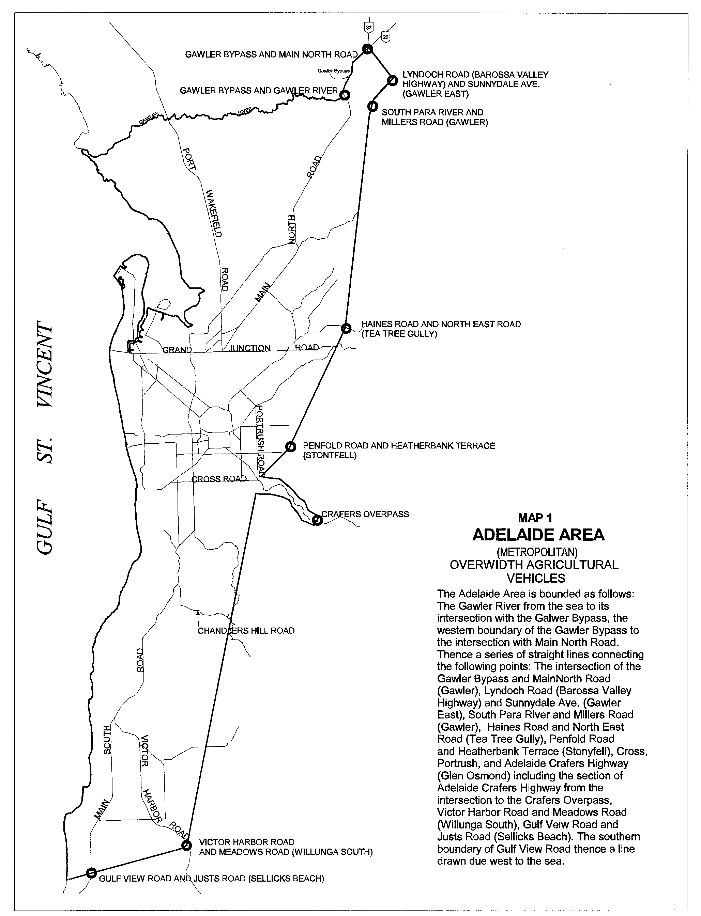

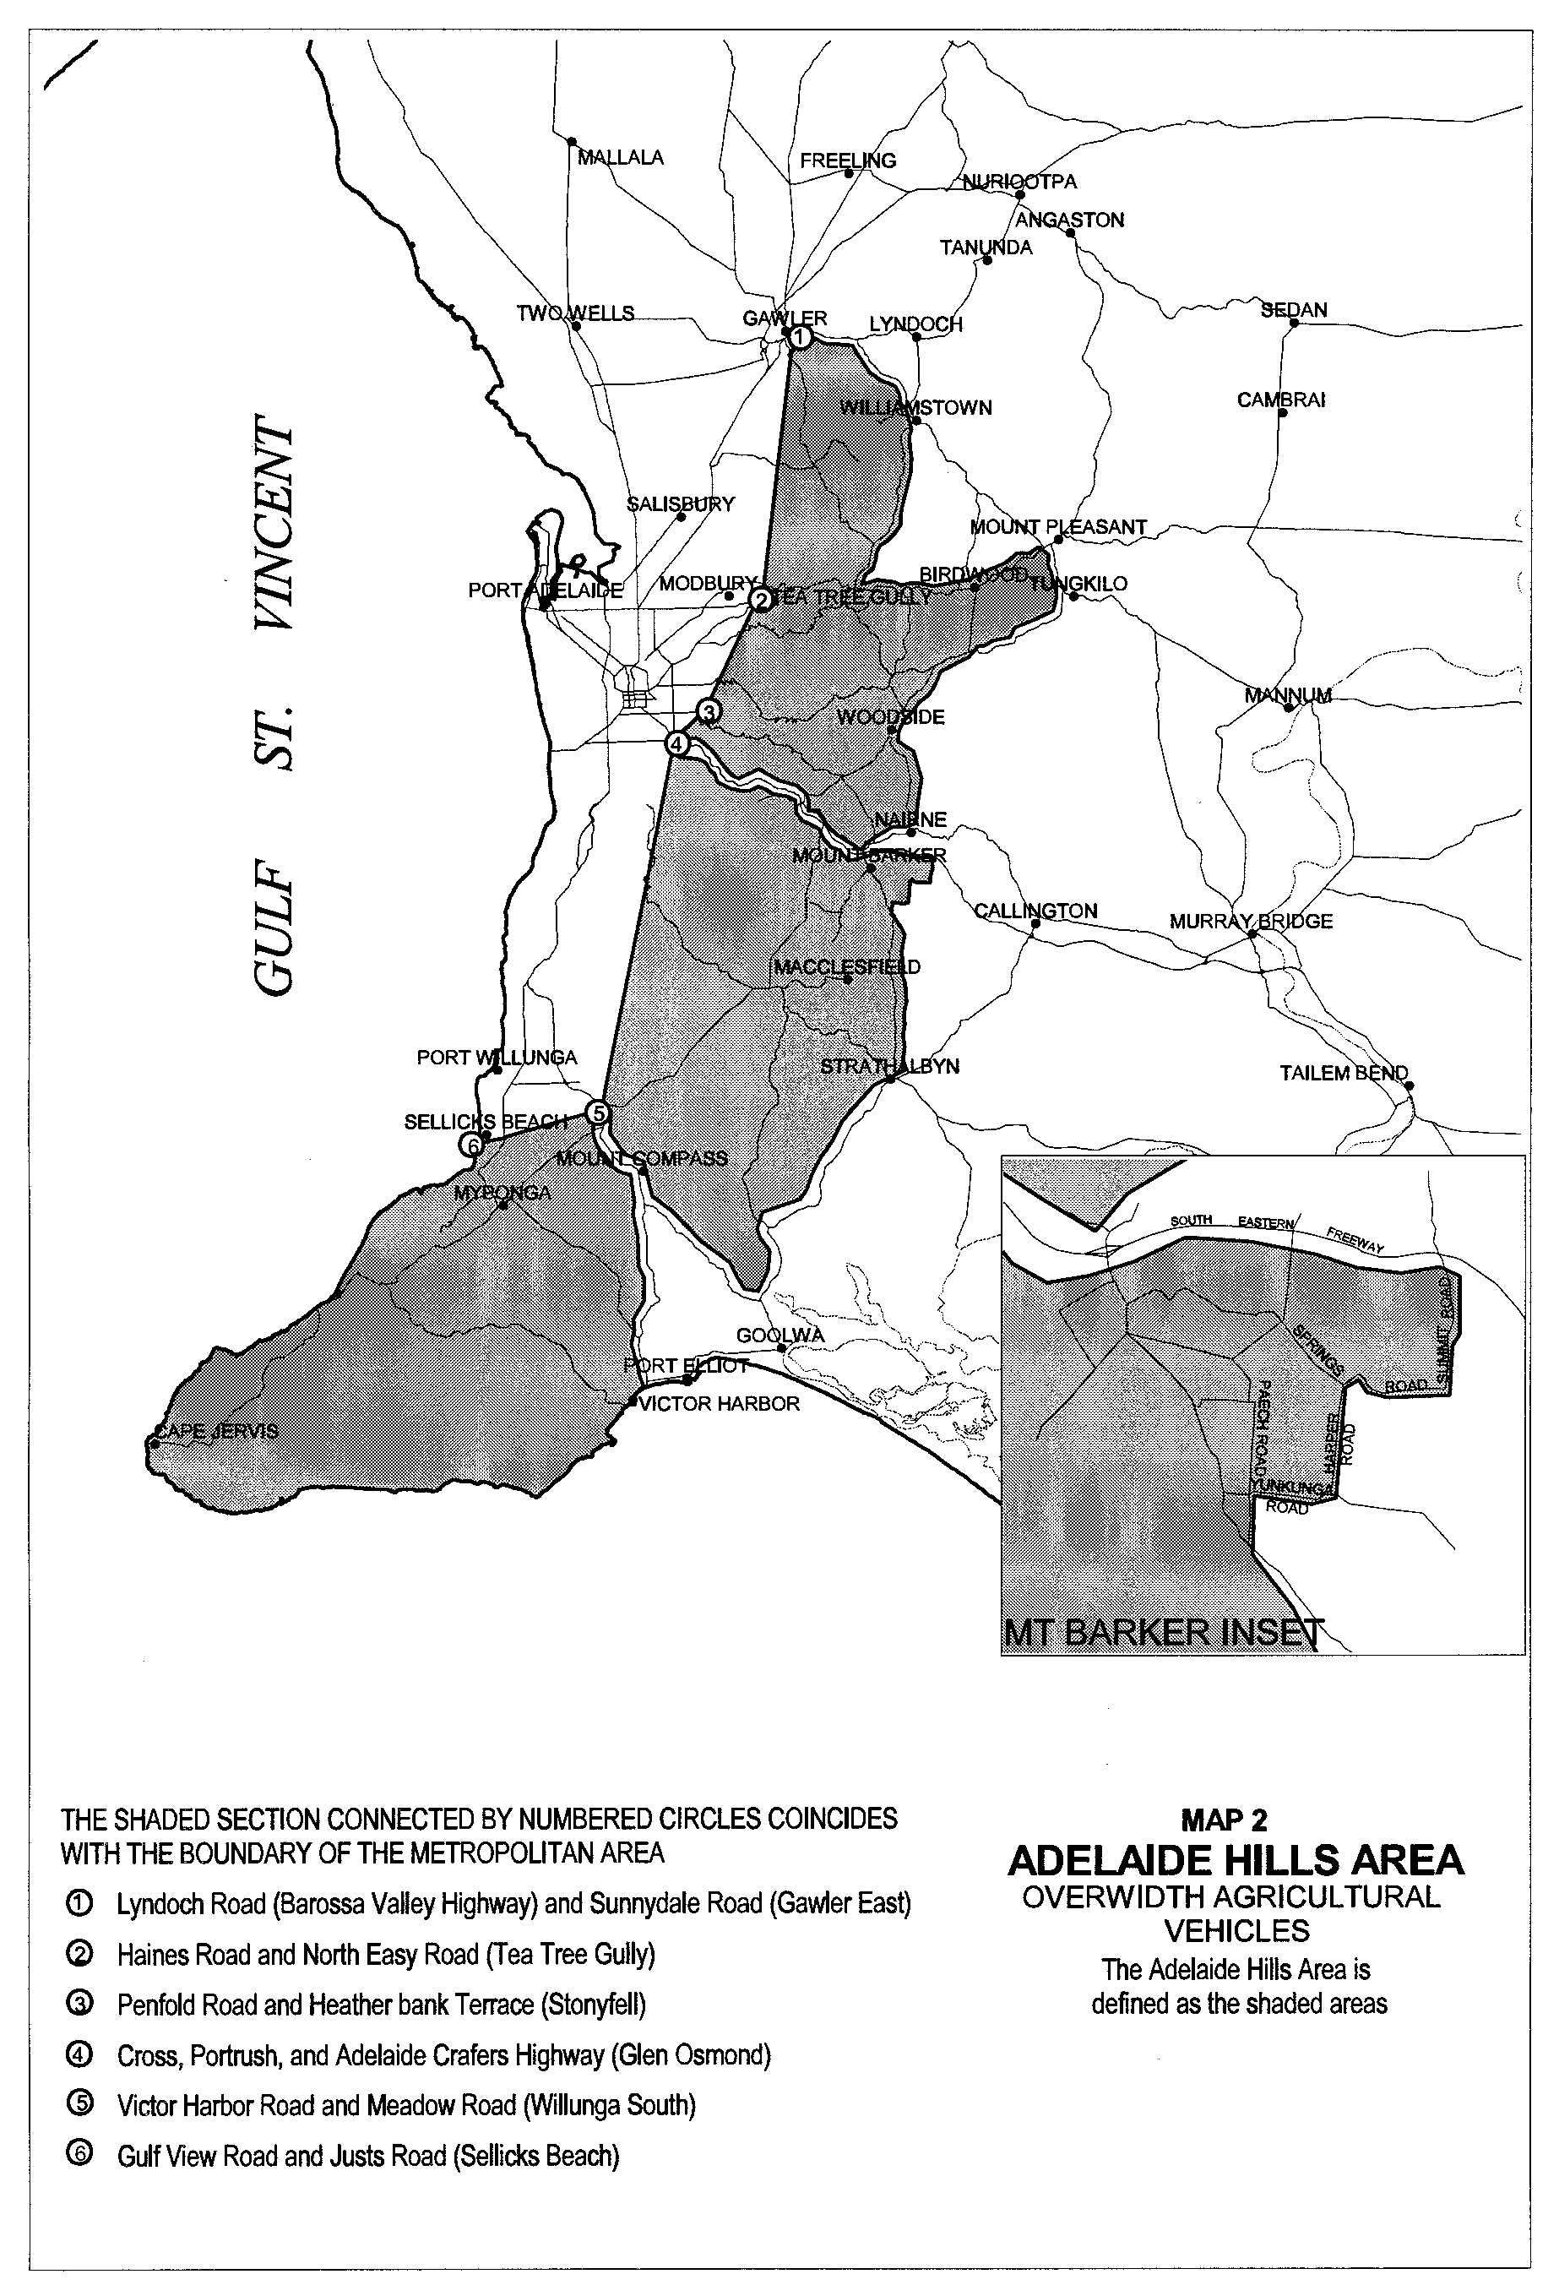
T. N. Argent, Executive Director, Transport SA

ROAD TRAFFIC ACT 1961
Exemption for the Fitting of Lighting Equipment, Rear Vision Mirrors, Horn and Other Equipment to Tractors, Road Construction
Equipment and Forklifts Operating within a Designated Worksite
PURSUANT to the provisions of section 163AA of the Road Traffic Act 1961, I, T. N. Argent, Executive Director, Transport SA, as an authorised delegate of the Minister for Transport and Urban Planning, hereby exempt tractors, road construction equipment, and forklifts:
From the following provisions of the Road Traffic (Vehicle Standards) Rules 1999:
• Part 8, Division 2 – Headlamps;
• Part 8, Division 3 – Parking Lights;
• Part 8, Division 5 – Tail Lights;
• Part 8, Division 6 – Number Plate Lights;
• Part 8, Division 7 – Clearance Lights;
• Part 8, Division 8 – Side Marker Lights;
• Part 8, Division 9 – Brake Lights;
• Part 8, Division 11 – Direction Indicator Lights;
• Part 8, Division 14 – Reflectors Generally;
• Part 8, Division 15 – Rear Reflectors;
• Part 8, Division 17 – Front Reflectors;
• Part 8, Division 19 – Other Lights, Reflectors, Rear Marking Plates or Signals;
• Rule 28 – Turning ability;
• Rule 30 – Protrusions;
• Rule 34 – Horns, alarms etc;
• Rule 35 – Rear vision mirrors;
• Rule 129 – Motor vehicle braking system requirements;
• Rule 146 – Crank case gases;
• Rule 147 – Visible emissions;
• Rule 148 – Exhaust systems; and
From the following provision of the Road Traffic Act 1961:
• Section 110B – Motor vehicle or trailer shall bear a vehicle identification plate:
Subject to the following conditions:
1. The vehicle is only permitted to be operated on a road or road related area for the purpose of undertaking activities involved directly with road construction and/or maintenance.
2. The vehicle is only permitted to be operated or to be left standing on a road or road related area within a designated worksite.
3. The worksite is signed in accordance with Australian Standard 1742.3-1996, Part 3 ‘Traffic Control Devices for Works on Roads’.
4. The vehicle is transported by float (not driven) to and/or between worksites.
5. The vehicle is only used for the maintenance and/or construction of roads, road related areas, bridges or culverts.
6. Travel is not permitted on a road or road related area within the designated worksite between sunset and sunrise or during periods of low visibility unless the designated worksite is floodlit or the vehicle is fitted with all lighting equipment in accordance with Part 8 – Lights and Reflectors of the Road Traffic (Vehicle Standards) Rules 1999:
6.1. For the purpose of this notice ‘a period of low visibility’ means any time when, owing to insufficient daylight or unfavourable conditions, persons or vehicles on a road are not clearly visible at a distance of 250 m to a person of normal vision.
7. The vehicle is not operated at a speed exceeding 40 km/h.
8. If the vehicle is a tractor or machine which has its own motive power, it shall be fitted with:
8.1. Brakes to two or more wheels complying with the requirements of Rule 128 of the Road Traffic (Vehicles Standards) Rules 1999.
8.2. A parking brake that operates on at least two wheels and that is capable of holding the vehicle stationary on a 12 percent gradient.
8.3. An actuating mechanism for the parking brake that incorporates a device that prevents accidental release of that mechanism and holds the brake in the applied position unless intentionally released by the driver.
9. That the vehicle is conditionally registered pursuant to the requirements of Section 25 of the Motor Vehicle Act 1959.
The notice titled ‘Notice of Dispensation from the Regulations under the Road Traffic Act for the Fitting of Lighting Equipment to Tractors, Road Construction Equipment, Earth Moving Equipment and Forklift Trucks’ appearing in the South Australian Government Gazette, dated 22 October 1996, is hereby revoked.
T. N. Argent, Executive Director, Transport SA

ROAD TRAFFIC ACT 1961
Exemption for the Fitting of Lighting and Other Equipment to Tractors, Graders, Road Rollers and Other Machines used for Road
Construction and/or Maintenance Operating on Roads and Road Related Areas
PURSUANT to the provisions of section 163AA of the Road Traffic Act 1961, I, T. N. Argent, Executive Director, Transport SA, as an authorised delegate of the Minister for Transport and Urban Planning, hereby exempt tractors, graders, road rollers and other machines used for road construction and/or maintenance:
From the following provisions of the Road Traffic (Vehicle Standards) Rules 1999:
• Part 8, Division 2 – Headlamps;
• Part 8, Division 3 – Parking Lights;
• Part 8, Division 5 – Tail Lights;
• Part 8, Division 6 – Number Plate Lights;
• Part 8, Division 7 – Clearance Lights;
• Part 8, Division 8 – Side Marker Lights;
• Part 8, Division 14 – Reflectors Generally;
• Part 8, Division 17 – Front Reflectors;
• Part 8, Division 19 – Other Lights, Reflectors, Rear Marking Plates or Signals;
• Rule 28 – Turning ability;
• Rule 30 – Protrusions;
• Rule 129 – Motor vehicle braking system requirements;
• Rule 146 – Crank case gases;
• Rule 147 – Visible emissions;
• Rule 148 – Exhaust systems; and
From:
From the following provision of the Road Traffic Act 1961:
• Section 110B – Motor vehicle or trailer shall bear a vehicle identification plate:
Subject to the following conditions:
1. The vehicle is only permitted to be operated on a road or road related area for the purpose of undertaking activities involved directly with road construction and/or maintenance.
2. The vehicle is not designed primarily for road use and is not constructed on a conventional truck chassis.
3. The vehicle is only used for the maintenance and/or construction of roads, road related areas, bridges or culverts.
4. Travel is not permitted on a road or road related area between sunset and sunrise or during periods of low visibility unless the vehicle is fitted with all lighting equipment in accordance with Part 8 – Lights and Reflectors of the Road Traffic (Vehicle Standards) Rules 1999:
4.1. For the purpose of this notice ‘a period of low visibility’ means any time when, owing to insufficient daylight or unfavourable conditions, persons or vehicles on a road are not clearly visible at a distance of 250 m to a person of normal vision.
5. The vehicle is not operated at a speed exceeding 40 km/h.
6. If the vehicle is a tractor, grader or machine which has its own motive power, it shall be fitted with:
6.1. Brakes to two or more wheels complying with the requirements of Rule 128 of the Road Traffic (Vehicles Standards) Rules 1999.
6.2. A parking brake that operates on at least two wheels and that is capable of holding the vehicle stationary on a 12 per cent gradient.
6.3. An actuating mechanism for the parking brake that incorporates a device that prevents accidental release of that mechanism and holds the brake in the applied position unless intentionally released by the driver.
7. If the vehicle is a construction road roller which does not have its own motive power and it has a laden mass not exceeding 12 tonnes it is exempt from the fitting of brakes while being drawn behind another vehicle at a speed not exceeding 10 km/h and the towing vehicle is fitted with brakes.
8. If the vehicle is a machine which does not have its own motive power and it has a laden mass not exceeding 6 tonnes it is exempt from the fitting of brakes while being drawn behind another vehicle at a speed not exceeding 25 km/h and the towing vehicle is fitted with brakes.
9. All vehicles operating under this notice, except for construction road rollers which do not have their own motive power, shall be fitted with:
9.1. Direction indicator lights complying with Part 8, Division 11 of the Road Traffic (Vehicle Standards) Rules 1999.
9.2. Brake lights complying with Part 8, Division 9 of the Road Traffic (Vehicle Standards) Rules 1999.
9.3. Rear reflectors complying with Part 8, Division 15 of the Road Traffic (Vehicle Standards) Rules 1999.
9.4. Parking lights, if the vehicle is left standing on a road or road related area between sunset and sunrise or during periods of low visibility.
10. All construction road rollers which do not have their own motive power and which are operating under this notice, shall be fitted with rear reflectors complying with Part 8, Division 15 of the Road Traffic (Vehicle Standards) Rules 1999.
Note: For the purposes of this notice construction road rollers are steel smooth drum rollers, steel grid rollers, steel sheeps-foot rollers and combination steel smooth drum/pneumatic tyred multi wheel rollers which do not have their own motive power and which are designed and constructed to only be drawn by a towing vehicle.
11. That the vehicle is conditionally registered pursuant to the requirements of Section 25 of the Motor Vehicle Act 1959.
The notice titled ‘Dispensation from Lighting Requirements’ appearing in the South Australian Government Gazette, dated 17 September 1992, is hereby revoked.
T. N. Argent, Executive Director, Transport SA

ROAD TRAFFIC ACT 1961
Exemption from the Road Traffic (Vehicle Standards) Rules 1999, for Three and Four Wheel Motor Bikes which are being used for
Work Related Activities by Primary Producers and Nominated Government Departments and Authorities
PURSUANT to the provisions of section 163AA of the Road Traffic Act 1961, I, T. N. Argent, Executive Director, Transport SA, as an authorised delegate of the Minister for Transport and Urban Planning, hereby exempt vehicles of a specified class which can be identified as follows:
1. A vehicle which has 4 wheels or a vehicle which has 3 wheels where one wheel is at the front and two wheels are at the rear and the wheels are symmetrically placed about the longitudinal axis of the vehicle;
2. A vehicle designed and constructed for the driver to sit astride; and
3. A vehicle for which the design of the engine, transmission and steering is common with those components used in the manufacture of motor bikes; and
4. A vehicle which is manufactured by a company who manufactures motor bikes approved by the Administrator, Vehicle Safety Standards Safety Branch, for compliance with Australian Design Rules and road use in Australia.
From the following provisions of the Road Traffic (Vehicle Standards) Rules 1999:
• Part 8 – Lights and reflectors;
• Rule 19 – Compliance with second edition Australian Design Rules;
• Rule 20 – Compliance with third edition Australian Design Rules;
• Rule 34 – Horns, alarms etc;
• Rule 35 – Rear vision mirrors;
• Rule 129 – Motor vehicle braking system requirements; and
From the following provision of the Road Traffic (Miscellaneous) Regulations 1999:
• Regulation 36 – Seat belts and seat belt anchorages; and
From the following provision of the Road Traffic Act 1961:
• Section 110B – Motor vehicle or trailer shall bear a vehicle identification plate:
Subject to the following conditions:
1. The vehicle is either:
1.1. owned by a person who qualifies as a primary producer for the purposes of the Motor Vehicles Act 1959, and the motor bike is only used in connection with the working of one or more separate parcels of land that are worked in conjunction with each other; or
1.2. owned by Department for Environment and Heritage, Primary Industries and Resources SA, Utilities Management Pty Ltd, or Local Government Authorities and the motor bike is only used on a road or road related area for the purposes of undertaking duties directly associated with the functions of that Government Department or authority.
2. The vehicle complies with all other requirements of the Road Traffic (Vehicle Standards) Rules 1999, applicable to motor bikes.
3. The vehicle does not tow a trailer that has a laden mass which exceeds the unladen mass of the towing vehicle.
4. The vehicle is only permitted to be operated on a road or road related area for the purpose of undertaking activities involved directly with primary production or for the purpose of undertaking duties directly involved with those Government Departments or authorities identified in Clause 1.2.
5. The vehicle is not operated at a speed exceeding 40 km/h.
6. The vehicle is fitted with:
6.1. Headlight(s), tail light, brake light and rear reflector(s).
6.2. Parking lights, if the vehicle is left standing on a road or road related area between sunset and sunrise or during periods of low visibility.
6.3. For the purpose of this notice ‘a period of low visibility’ means any time when, owing to insufficient daylight or unfavourable conditions, persons or vehicles on a road are not clearly visible at a distance of 250 m to a person of normal vision.
6.4. Brakes to two or more wheels complying with the requirements of Rule 128 of the Road Traffic (Vehicles Standards) Rules 1999.
6.5. A parking brake that operates on at least two wheels and that is capable of holding the vehicle stationary on a 12 per cent gradient.
6.6. An actuating mechanism for the parking brake that incorporates a device that prevents accidental release of that mechanism and holds the brake in the applied position unless intentionally released by the driver.
6.7. A rear vision mirror or mirrors complying with the requirements of Rule 35 and 36 of the Road Traffic (Vehicle Standards) Rules 1999.
6.8. Footrests for the driver and if a seating position for a passenger is provided, footrests for the passenger, complying with the requirements of Rule 56 of the Road Traffic (Vehicle Standards) Rules 1999.
7. That if the vehicle was manufactured on or after 1 July 1996 it is fitted with:
7.1. Two rear vision mirrors, complying with the requirements of Rule 35 and 36 of the Road Traffic (Vehicle Standards) Rules 1999.
7.2. A horn complying with the requirements of Rule 34 of the Road Traffic (Vehicle Standards) Rules 1999.
7.3. A headlight which remains illuminated while the vehicle is being operated on roads and road related areas.
8. All lights and reflectors required by this notice shall meet the location and performance requirements of Part 8 – Lights and Reflectors, of the Road Traffic (Vehicle Standards) Rules 1999.
9. That the vehicle is conditionally registered pursuant to the requirements of Section 25 of the Motor Vehicle Act 1959.
The notice titled ‘Notice of Exemption from the Regulations under the Road Traffic Act for Three and Four Wheel Motor Bikes used for Agricultural Purposes’ appearing in the South Australian Government Gazette, dated 23 March 2000, is hereby revoked.
T. N. Argent, Executive Director, Transport SA

ROAD TRAFFIC ACT 1961
Exemption to operate Special Purpose “Jinker Type” vehicles, within the Adelaide Produce Market
PURSUANT to the provisions of section 163AA of the Road Traffic Act 1961, I, T. N. Argent, Executive Director, Transport SA, as an authorised delegate of the Minister for Transport and Urban Planning, hereby exempt vehicles of a specified class which can be identified as follows:
1. A vehicle which has 4 wheels or a vehicle which has three wheels where one wheel is at the front and two wheels are at the rear and the wheels are symmetrically placed about the longitudinal axis of the vehicle; and
2. A vehicle which is fitted with a motor which provides motive power for the vehicle; and
3. A vehicle which is designed solely for the carriage of primary produce:
From the following provisions of the Road Traffic (Vehicle Standards) Rules 1999:
• Part 8 – Lights and Reflectors;
• Rule 19 – Compliance with second edition Australian Design Rules;
• Rule 20 – Compliance with third edition Australian Design Rules;
• Rule 33 – Mudguards and spray suppression;
• Rule 129 – Motor vehicle braking system requirements; and
From the following provision of the Road Traffic (Miscellaneous) Regulations 1999:
• Regulation 36 – Seat belts and seat belt anchorages; and
From the following provision of the Road Traffic Act 1961:
• Section 110B – Motor vehicle or trailer shall bear a vehicle identification plate:
Subject to the following conditions:
1. The vehicle is:
1.1. Only used in conjunction with the transport of produce within the boundaries of the Adelaide Produce Market. The Adelaide Produce Market is defined as Lot 23, Section 97 of DP 27232, Volume 5237, Folio 317, bordering Diagonal Road and Burma road, Pooraka, within the City of Salisbury.
1.2. Only operated between the hours of midnight and 10 a.m., Monday to Friday.
1.3. Travel is not permitted outside the Adelaide Produce Market as described in 1 (a) (i) of this notice.
2. The vehicle does not tow a trailer that has a laden mass which exceeds the unladen mass of the towing vehicle.
3. The vehicle is fitted with headlight(s) and tail lights.
4. The vehicle is fitted with brakes to at least one wheel, on three-wheeled vehicles, and to at least two or more wheels on four-wheeled vehicles.
5. The vehicle is not operated at a speed exceeding 40 km/h.
6. The vehicle is fitted with a horn.
7. That the vehicle is conditionally registered pursuant to the requirements of Section 25 of the Motor Vehicle Act 1959.
The notice titled ‘Notice of Dispensation from the Regulations under the Road Traffic Act to operate Special Purpose “Jinker Type” vehicles, within the Adelaide Produce Market’ appearing in the South Australian Government Gazette, dated 5 July 1996, is hereby revoked.
T. N. Argent, Executive Director, Transport SA

ROAD TRAFFIC ACT 1961
Exemption for Land Yachts
PURSUANT to the provisions of section 163AA of the Road Traffic Act 1961, I, T. N. Argent, Executive Director, Transport SA, as authorised delegate of the Minister for Transport and Urban Planning, hereby exempt vehicles known as Land Yachts which can be identified as follows:
1. A vehicle which has 3 wheels.
2. A vehicle designed and constructed to be propelled by wind only:
From the following provisions of the Road Traffic (Vehicle Standards) Rules 1999:
• Part 8 – Lights and reflectors;
• Part 9 – Braking systems;
• Rule – Mudguards and spray suppression;
• Rule 34 – Horns, alarms etc;
• Rules 35 – Rear vision mirrors;
• Rule 46 – Wheels and tyres; and
From the following provisions of the Road Traffic (Miscellaneous) Regulations 1999:
• Regulation 36 – Seat belts and seat belt anchorages;
• Regulation 37 – Child restraints:
Subject to the following conditions:
1. That the vehicle is conditionally registered pursuant to the requirements of Section 25 of the Motor Vehicle Act 1959.
2. This exemption, if required, is produced to the appropriate authority on request.
3. The person operating the land yacht is a financial member of Adelaide Land Yacht Club.
4. The vehicle is only operated:
4.1. Within the area defined as the Port Gawler Foreshore which abuts Sections 708 and 709, Hundred of Port Gawler and is limited to the frontage of the above sections which is abutting the Off-Road Vehicle Park.
4.2. Between the hours of sunrise and sunset.
4.3. In accordance with the conditions and/or by-laws imposed by the District Council of Mallala.
4.4. In a manner which will not endanger the safety of any other person or in a manner which may cause damage to property.
The notice titled ‘Notice of Dispensation from the Regulations under the Road Traffic Act for “Land Yachts”’ appearing in the South Australian Government Gazette, dated 5 July 1996, is hereby revoked.
T. N. Argent, Executive Director, Transport SA

ROAD TRAFFIC ACT
Exemption for Golf Cars Operating on Golf Courses
PURSUANT to the provisions of section 163AA of the Road Traffic Act 1961, and Regulation 46 of the Road Traffic (Miscellaneous) Regulations 1999, I, T. N. Argent, Executive Director, Transpoert SA, as an authorised delegate of the Minister for Transport and Urban Planning, hereby exempt vehicles known as Golf Cars, which can be identified as follows:
1. A vehicle which has 3 or 4 wheels; and
2. A vehicle designed and constructed or specially adapted to be used for transport of persons participating in the game of golf on golf courses:
From the following provisions of the Road Traffic (Vehicle Standards) Rules 1999:
• Part 8 – Lighting equipment;
• Rule 19 – Compliance with second edition Australian Design Rules;
• Rule 20 – Compliance with third edition Australian Design Rules;
• Rule 27 (2) – Steering;
• Rule 28 – Turning ability;
• Rule 33 – Mudguards;
• Rule 35 – Rear Vision Mirrors;
• Rule 40 (2) – Bonnet securing devices;
• Rule 45 – Windscreen wipers and washers;
• Rules 128 – Performance of braking systems;
• Rule129 – Motor vehicle braking system requirements;
• Rule 146 – Crank case gases;
• Rule 147 – Visible emissions;
• Rule 148 – Exhaust systems; and
From the following provisions of the Road Traffic (Miscellaneous) Regulations 1999:
• Regulation 36 – Seat belt and seat belt anchorages;
• Regulation 37 – Child restraints; and
From the following provision of the Road Traffic Act 1961:
• Section 110B – Motor vehicle or trailer shall bear a vehicle identification plate:
Subject to the following conditions:
1. The vehicle is only driven within golf course car parks or golf course boundaries; or directly across a road between sections of the same golf course when safe to do so.
2. The vehicle may only be driven between the hours of sunset and sunrise or during periods of low visibility, if it is fitted with headlights, tail lights, brake lights and rear reflectors in accordance with the Road Traffic (Vehicle Standards) Rules 1999:
2.1. For the purposes of this notice ‘a period of low visibility’ means any time, when, owing to insufficient daylight or unfavourable conditions, persons or vehicles on a road are not clearly visible at a distance of 250 m to a person of normal vision.
3. The vehicle may not tow a trailer that has a laden mass that exceeds the unladen mass of the towing vehicle.
4. In the case of a four wheeled vehicle that brakes are fitted to at least two road wheels.
5. In the case of a three wheeled vehicle that brakes are fitted to either the front wheel, the two rear wheels or all wheels.
6. The vehicle shall be fitted with a parking brake that operates on at least two wheels and that is capable of holding the vehicle stationary on a 12 percent gradient.
7. The actuating mechanism for the parking brake shall have a device that prevents accidental release of that mechanism and holds the brake in the applied position unless intentionally released by the driver.
8. That the vehicle is conditionally registered pursuant to the requirements of Section 25 of the Motor Vehicle Act 1959.
The notice titled ‘Notice of dispensation from the Regulations under the Road Traffic Act for Golf Cars’ appearing in the South Australian Government Gazette, dated 10 July 1996, is hereby revoked.
T. N. Argent, Executive Director, Transport SA

ROAD TRAFFIC ACT 1961
Exemption for Golfers from the Wearing of a Safety Helmet when Riding a Motor Bike on a Golf Course
PURSUANT to the provisions of Regulation 7 of the Road Traffic (Road Rules – Ancillary and Miscellaneous Provisions) Regulations 1999, of the Road Traffic Act 1961, I, T. N. Argent, Executive Director, Transport SA, as an authorised delegate of the Minister for Transport and Urban Planning hereby exempt a person playing golf from wearing a safety helmet while riding a motor bike on a golf course:
From the following provision of the Australian Road Rules:
• Rule 270:
Subject to the following conditions:
1. That the motor bike has an engine capacity not exceeding 50 cubic centimetres; and
2. That the motor bike is not ridden at a speed exceeding 10 km/h.
The notice titled ‘Exemption – Golfers on Golf Courses’ appearing in the South Australian Government Gazette, dated 9 January 1992, is hereby revoked.
T. N. Argent, Executive Director, Transport SA

ROAD TRAFFIC ACT 1961
Exemption from Australian Design Rule Requirements for Motor Bikes and Motor Bikes fitted with a Side Car which are being used
for Work Related Activities by Primary Producers and Nominated Government Departments and Authorities
PURSUANT to the provisions of section 163AA of the Road Traffic Act 1961, I, T. N. Argent, Executive Director, Transport SA, as an authorised delegate of the Minister for Transport and Urban Planning, hereby exempt motor bikes and motor bikes fitted with a side car:
From the following provisions of the Road Traffic (Vehicle Standards) Rules 1999:
• Rule 19 – Compliance with second edition Australian Design Rules;
• Rule 20 – Compliance with third edition Australian Design Rules; and
From the following provision of the Road Traffic Act 1961:
• Section 110B – Motor vehicle or trailer shall bear a vehicle identification plate:
Subject to the following conditions:
1. The motor bike is either:
1.1. Owned by a person who qualifies as a primary producer for the purposes of the Motor Vehicles Act 1959, and the motor bike is only used in connection with the working of one or more separate parcels of land that are worked in conjunction with each other; or
1.2. Owned by Department for Environment and Heritage, Primary Industries and Resources SA, Utilities Management Pty Ltd, or Local Government Authorities and the motor bike is only used on a road or road related area for the purposes of undertaking duties directly associated with the functions of that Government Department or authority.
2. While operating the motor bike on a road or road related area, the rider of the motor bike and any passenger shall wear an ‘approved motor bike helmet’ as approved for motor bike riders under the Road Traffic (Miscellaneous) Regulations 1999.
3. The motor bike shall not tow a trailer which has a laden mass that exceeds the unladen mass of the motor bike.
4. The motor bike is only permitted to be operated on a road or road related area for the purpose of undertaking activities involved directly with primary production or for the purpose of undertaking duties directly involved with those Government Departments or authorities identified in Clause 1.2.
5. The motor bike shall be fitted with:
5.1. A headlight, tail light, brake light and rear reflector.
5.2. Direction indicator lights, if the motor bike was manufactured on or after 1 October 1991.
5.3. Brakes complying with the requirements of Part 9 – Braking Systems of the Road Traffic (Vehicle Standards) Rules 1999.
5.4. Mudguards complying with the requirements of Rule 33 of the Road Traffic (Vehicle Standards) Rules 1999.
5.5. One or two rear vision mirrors if manufactured prior to July 1975 and two rear vision mirrors if manufactured on or after 1 July 1975, complying with the requirements of Rule 35 and 36 of the Road Traffic (Vehicle Standards) Rules 1999.
5.6. A horn complying with the requirements of Rule 34 of the Road Traffic (Vehicle Standards) Rules 1999.
5.7. The motor bike shall be fitted with, footrests for the rider and if a seating position for a pillion passenger to be seated behind the rider is provided, footrests for the pillion passenger, complying with the requirements of Rule 56 of the Road Traffic (Vehicle Standards) Rules 1999.
5.8. A chain guard, complying with the requirements of Rule 57 of the Road Traffic (Vehicle Standards) Rules 1999, where a chain is fitted to transmit engine power to the rear wheel.
6. All lights required by this notice shall be fitted in accordance with the location and performance requirements of Part 8 – Lights and Reflectors, of the Road Traffic (Vehicle Standards) Rules 1999.
7. Motor bikes manufactured on or after 1 July 1988 which are not supported by the wheel of a side car shall be fitted with a side stand which will comply with the following:
7.1. Automatically fold back into the closed or riding position, when the vehicle is returned to the normal vertical position for riding, or as a result of the vehicle being moved forward by a deliberate action of the rider, or without disturbing the equilibrium of the vehicle, if the side stand comes into contact with the road while the vehicle is moving; or
7.2. Be connected to the ignition system in such a manner that the ignition system can only be activated when the side stand is in the closed or riding position; or
7.3. Be connected to an audible signal and warning lamp, visible to the rider in the normal riding position which are activated if the ignition is switched on and the side stand is not in the closed or riding position; or
7.4. Be connected in such a manner so that the vehicle cannot be operated under its own power unless it is retracted.
8. That the vehicle complies with all other requirements of the Road traffic Act and Regulations.
9. That the vehicle is conditionally registered pursuant to the requirements of Section 25 of the Motor Vehicles Act 1959.
The notice titled ‘Notice of Dispensation from the Regulations under the Road Traffic Act for Two Wheel Motorcycles used for Agricultural Purposes’ appearing in the South Australian Government Gazette, dated 24 October 1996, is hereby revoked.
T. N. Argent, Executive Director, Transport SA

ROAD TRAFFIC ACT 1961
Exemption from Compliance with Australian Design Rules and Right Hand Drive Configuration for Vehicles Owned and Operated
in South Australia by United States of America Forces Personnel
PURSUANT to the provisions of section 163AA of the Road Traffic Act 1961, I, T. N. Argent, Executive Director, Transport SA, as authorised delegate of the Minister for Transport and Urban Planning, hereby exempt left hand drive motor vehicles owned and operated by United States of America Forces Personnel, where such vehicles have been imported into Australia under the Status of Forces Agreement:
From the following provisions of the Road Traffic (Vehicle Standards) Rules 1999:
• Rule 19 – Compliance with second edition Australian Design Rules;
• Rule 20 – Compliance with third edition Australian Design Rules;
• Rule 27 (1) – Steering; and
From the following provision of the Road Traffic Act 1961:
• Section 110B – Motor vehicle or trailer shall bear a vehicle identification plate:
Subject to the following conditions:
1. The vehicle remains the property of personnel currently serving with the United States of America Forces in Australia.
2. The vehicle has been granted a Vehicle Import Approval issued by the Commonwealth Department of Transport and Regional Services, pursuant to the Motor Vehicle Standards Act 1989.
3. The vehicle shall be re-exported out of Australia by the date of expiration of the Vehicle Import Approval.
4. A copy of this notice and a copy of the Vehicle Import Approval shall be carried with the vehicle at all times and be presented on request, to a member of the South Australian Police Department or an Inspector appointed or holding office as an Inspector under the Road Traffic Act 1961.
5. The vehicle is fitted with:
5.1. Headlights that dip downwards or downwards and to the left and which are adjusted to provide the necessary amount of light, without dazzling the driver of another vehicle.
5.2. Tail lights, and brake lights which when illuminated display a red light.
5.3. Front and rear parking lights which when illuminated display red light to the rear and white or amber light to the front.
5.4. Rear reflectors.
5.5. Front and rear direction indicator lights which when illuminated display amber light.
5.6. A horn complying with Rule 34 of the Road Traffic (Vehicle Standards) Rules 1999.
5.7. Seatbelts to all seating positions complying with the intent of Australian Design Rules (ADRs) applicable to seat belts and seat belt anchorages and which are equivalent in specification for the type and year of vehicle that would be required for ADR compliance.
5.8. External rear vision mirrors to both the left and right hand sides of the vehicle complying with Rule 35 and 36 of the Road Traffic (Vehicle Standards) Rules 1999.
6. All lights and reflectors required by this notice shall meet the location and performance requirements of Part 8 – Lights and Reflectors, of the Road Traffic (Vehicle Standards) Rules 1999.
The notice titled ‘Notice Concerning Dispensation from Regulation 7.00A and Prohibition of Left Hand Drive Vehicles Owned and Operated in South Australia by United States of America Forces Personnel’ appearing in the South Australian Government Gazette, dated 7 January 1997, is hereby revoked.
T. N. Argent, Executive Director, Transport SA

ROAD TRAFFIC ACT 1961
Exemption from the ‘Code of Practice for Buses’ for three children to occupy a double seat 860 mm or more in width
PURSUANT to the provisions of section 163C (1a) of the Road Traffic Act 1961, I, T. N. Argent, Executive Director, Transport SA, as an authorised delegate of the Minister for Transport and Urban Planning, hereby exempt any vehicle within the prescribed class for the purposes of Part 4A of the Act from sections 163D and 163F of the Act as they relate to the provisions of the Road Traffic (Miscellaneous) Regulations 1999, Regulation 42(1) with respect to Clause 7.2 (3) (a) of the Code of Practice for Buses, for a seating position intended for a use by a child to be less than 300 mm in width:
Subject to the following conditions:
1. That no more than three children occupy the seat.
2. That the seat is a double seat designed for use by two adult passengers, that has a width of not less than 860 mm when measured along the front of the seat cushion.
3. That the gap between the seat backs is no greater than 100 mm.
4. That the gap between the seat cushions is no greater than 50 mm.
5. That the seat backs remain in the upright position when three children occupy the seat.
Note: For the purposes of this notice a ‘child’ means a person up to and including the age of fourteen.
The notice titled ‘Notice of Dispensation from Regulation 8.03 Code of Practice for Buses’ appearing in the South Australian Government Gazette, dated 25 November 1993, is hereby revoked.
T. N. Argent, Executive Director, Transport SA

ROAD TRAFFIC ACT 1961
Exemption for Multi-Tyred Road Rollers to be Fitted with Tyres which do not have a Tread Pattern
PURSUANT to the provisions of section 163AA of the Road Traffic Act 1961, I, T. N. Argent, Executive Director, Transpoert SA, as an authorised delegate of the Minister for Transport and Urban Planning, hereby exempt vehicles known as multi-tyred road rollers:
From the following provision of the Road Traffic (Vehicle Standards) Rules 1999:
• Rule 54 (2) – Tyre tread:
Subject to the following condition:
1. That the vehicle is fittted with pneumatic tyres.
The notice titled ‘Tread Pattern on Tyres’ appearing in the South Australian Government Gazette, dated 11 November 1986, is hereby revoked.
T. N. Argent, Executive Director, Transport SA

VOCATIONAL EDUCATION, EMPLOYMENT AND TRAINING ACT 1994

PART 4 - CONTRACTS OF TRAINING
Pursuant to the provisions of the Vocational Education, Employment and Training Act (VEET Act) the Accreditation and Registration Council (ARC) gives notice that it has determined the following:

Occupations that Constitute Trades and Other Declared Vocations
The following schedule is additional to:
1. the gazettal of 24 April 1996 (page 2045) | 2. the gazettal of 31 October 1996 (page 1544)
3. the gazettal of 5 December 1996 (page 1818) | 4. the gazettal of 6 February 1997 (page 830)
5. the gazettal of 17 April 1997 (page 1571) | 6. the gazettal of 29 May 1997 (page 2758)
7. the gazettal of 12 June 1997 (page 2984) | 8. the gazettal of 3 July 1997 (page 33)
9. the gazettal of 7 August 1997 (page 311) | 10. the gazettal of 18 December 1997 (page 1677)
11. the gazettal of 22 December 1997 (page 1776) | 12. the gazettal of 23 April 1998 (page 1959)
13. the gazettal of 18 June 1998 (page 2594) | 14. the gazettal of 6 August 1998 (page 339)
15. the gazettal of 24 September (page 990) | 16. the gazettal of 1 October 1998 (page 1038)
17. the gazettal of 15 October 1998 (page 1150) | 18. the gazettal of 12 November 1998 (page 1389)
19. the gazettal of 19 November 1998 (page 1583) | 20. the gazettal of 3 December 1998 (page 1742)
21. the gazettal of 10 December 1998 (page 1870) | 22. the gazettal of 17 December 1998 (page 1954)
23. the gazettal of 23 December 1998 (page 2039) | 24. the gazette of 11 March 1999 (page 1359)
25. the gazette of 25 March 1999 (page 1480) | 26. the gazette of 1 April 1999 (page 1605) (Errata)
27. the gazette of 22 April 1999 (page 2219) | 28. the gazettal of 29 April 1999 (page 2381) (Errata)
29. the gazettal of 6 May 1999 (page 2482) | 30. the gazettal of 13 May 1999 (page 2595)
31. the gazettal of 27 May 1999 (Errata) (page 2723) | 32. the gazettal of 17 June 1999 (page 3123)
33. the gazettal of 24 June 1999 (page 3261) | 34. the gazettal of 1 July 1999 (page 22)
35. the gazettal of 29 July 1999 (page 602) | 36. the gazettal of 30 September 1999 (page 1364)
37. the gazettal of 14 October 1999 (page 1973) | 38. the gazettal of 11 November 1999 (page 2327)
39. the gazettal of 6 January 2000 (page 1169) | 40. the gazettal of 30 March 2000 (page 1921)
the gazettal of 6 April 2000 (page 2047) | the gazettal of 13 April 2000 (Errata) (page 2167)
the gazettal of 4 May 2000 (page 2416) | the gazettal of 18 May 2000 (page 2606) Errata (page 2609)
the gazettal of 15 June 2000 (page 3282) Errata (page 3285) | the gazettal of 29 June 2000 (page 3490)
the gazettal of 6 July 2000 (page 22) Errata (page 24) | the gazettal of 20 July 2000 (page 267)
the gazettal of 10 August 2000 (page 467) | the gazettal of 24 August 2000 (page 643)
the gazettal of 14 September 2000 (page 2002)

which set out the occupations that constitute trades and other declared vocations and the terms and conditions applicable to such declared vocations.

SCHEDULE - DECLARED VOCATIONS, REQUIRED COURSES OF INSTRUCTION AND ASSOCIATED CONDITIONS

Changes to courses and conditions determined by ARC for existing Declared Vocations appear in Bold.

Occupation/Occupation Levels  Declared Vocation  * Trade  # Other than trade | Course code  National / State  and expiry date | Approved Course of Instruction and Stream | Nominal Term of  Contract of  Training | Nominal hours of  attendance at  approved course | Probationary Period
# Clerical Processing (Office Administration) | Endorsed to  31/01/01 | Administration Training Package
ARC September 2000 | BSA10197 | Certificate I in Business (Office Administration) | Exit point
ARC September 2000 | BSA20197 | Certificate II in Business (Office Administration) | 12 months | *390 hours | 1 month
ARC September 2000 | BSA30197 | Certificate III in Business (Office Administration) | 12 months | *265-345 hours | 1 month
ARC September 2000 | BSA40197 | Certificate IV in Business (Administration) | 12 months | *345-360 hours | 1 month
Note: People entering at Level 3 may be required to undertake some training in order to gain Level 2 competencies where skill gaps are identified

*Up to 140 hours of pre requisite competencies may be added, if required, to the nominal hours for each qualification level

ARC October 2000 | BSA30200 | Certificate III in Business (Legal Administration) | 12 months | 300-385 hours | 1 month
ARC October 2000 | BSA40200 | Certificate IV in Business (Legal Services) | 24 months | 590-740 hours* | 2 months
 |  | *6 Units of Competency (totalling 225 hours) from the Certificate III underpin all units of competency in the Legal Services Stream of the Administration Training Package
 |  | Alternate courses of instruction:
ARC June 1997 | 3947  NS95/525LFX  November 2000 | Certificate II in Arts Administration (Level 2) | 12 months | 328 hours | 1 month
ARC June 1998 | 12319SA  CFF  December 2001 | Certificate III in Business (Real Estate Corporate Support)  (Level 3) | 12 month | 580 hours | 1 month
 | Endorsed to 9/4/01 | Correctional Services Training Package Qualification
 | CSC30398 | Certificate III in Correctional Practice (Administration/Ancillary) | 12 or 24 months | 385 hours | 1 or 2 months
 | Endorsed to  30/8/02 | Automotive Industry Retail Service and Repair Training Package
 |  | Alternative Courses of Instruction:
ARC June 2000 | AUR10199 | Certificate II in Automotive | Exit Point
ARC December 1999 | AUR20199 | Certificate II in Automotive (Administration – Clerical) | 18 months | 501 hours | 6 weeks
 | AUR20299 | Certificate II in Automotive (Administration – Service Reception) | 18 months | 551 hours | 6 weeks
 | AUR20399 | Certificate II in Automotive (Administration – Vehicle Financing and Insuring) | 12 months | 351 hours | 1 month
 | AUR 20499 | Certificate II in Automotive (Administration – Vehicle Financing and Insuring – Loss Assessing) | 12 months | 286 hours | 1 month
 | AUR 20599 | Certificate II in Automotive (Administration – Vehicle Valuating/Purchasing) | 12 months | 291 hours | 1 month
ARC September 2000 | Endorsed to 30/11/02 | Public Services Training Package
ARC September 2000 | PSP20199 | *Certificate II in Government | 12 months | 160-200 hours | 1 month
ARC September 2000 | PSP30199 | *Certificate III in Government | 12 months | 255-350 hours | 1 month
ARC September 2000 | PSP40199 | Certificate IV in Government | 24 months | 300-650 hours | 2 months
ARC September 2000 | PSP50199 | Diploma of Government | 36 months | 385-705 hours | 3 months
ARC September 2000 | PSP60199 | Advanced Diploma of Government | 48 months | 590-1030 hours | 3 months
ARC September 2000 | PSP50299 | Diploma of Government (Policy Development) | 36 months | 365-505 hours | 3 months
ARC September 2000 | PSP40399 | Certificate IV in Government (Procurement and Contracting) | 24 months | 445-565 hours | 2 months
 |  | *An industrial agreement for a training wage has been negotiated for Certificates II and III only.
# Management | Endorsed to 30/11/2002 | Woolworths Supermarket Enterprise Training Package
ARC December 1999 | ZWA40199 | Certificate IV in Woolworths Management | 36 months (72 months part time) | 349 hours | 3 months
 | ZWA50199 | Diploma of Woolworths Management | 48 months (72 months part time) | 366 hours | 3 months
Declared (ARC)  August 1998 | 5437  VI2311AEB  Dec 2000 | Certificate III in Small Business Franchising (Bakers Delight) | 12 months | 550 hours | 1 month
 |  | Alternate course of instruction:
ARC June 1999 | 1968  BFX  31 Dec 2002 | Certificate IV in First Line Management | 24 months | 260 hours | 2 months
ARC December 1999 | AUR40199  30 Aug 02 | Certificate IV in Automotive  (Business Management Stream) | 48 months | 1320 hours | 3 months
ARC June 2000 | 7040  QLFM1003  15/07/01 | Certificate III in Frontline Management | 12 months | 240 hours | 1 month
ARC June 2000 | 7041  QLFM1004  15/07/01 | Certificate IV in Frontline Management | 24 months | 400 hours | 2 months
ARC September 2000 | Endorsed to  30/11/02 | Public Services Training Package
ARC September 2000 | PSP60299 | Advanced Diploma of Government (Compliance Management) | 48 months | 605-1010 hours | 3 months
ARC September 2000 | PSP60399 | Advanced Diploma of Government (Contract Management) | 48 months | 630-970 hours | 3 months
ARC September 2000 | PSP60499 | Advanced Diploma of Government (Human Resources) | 48 months | 535-700 hours | 3 months
ARC September 2000 | PSP50399 | Diploma of Government (Management) | 36 months | 495 hours | 3 months
ARC September 2000 | PSP60599 | Advanced Diploma of Government (Management) | 48 months | 630-690 hours | 3 months
ARC September 2000 | PSP60699 | Certificate IV in Government (Project Management) | 24 months | 480-640 hours | 2 months
ARC September 2000 | PSP50699 | Diploma of Government (Project Management) | 36 months | 505-646 hours | 3 months
ARC September 2000 | PSP50799 | Diploma of Government (Financial Management) | 36 months | 425-665 hours | 3 months
 | Endorsed to 31/1/01 | Administration Training Package
ARC October 2000 | BSA50200 | Diploma of Business (Legal Services) | 36 months | 685-965 hours* | 3 months
 |  | *6 Units of Competency (totalling 225 hours) from the Certificate III underpin all units of competency in the Legal Services Stream of the Administration Training Package.
*Signwriting | Endorsed to 10/7/03 | Off Site Construction (Sign Writing/Computer Operation) Training Package
ARC October 2000 | BCF30700 | Certificate III in Off Site Construction (Sign Writing/Computer Operation) | 48 months | 920 hours | 3 months
# Customer Servicing (Financial Institutions) | Endorsed to  30/6/02 | Financial Services Training Package
ARC December 1999 | FNB20199 | Certificate II in Financial Services | 12 months | 230 hours | 1 month
ARC October 2000 | FNB30199 | Certificate III in Financial Services  replaces | 24 months | 680 hours | 2 months
 | FNB30199 | Certificate III in Financial Services | 18 months | 680 hours | 6 weeks
ARC June 2000 | FNB40199 | Certificate IV in Financial Services | 24 months | 1080 hours | 3 months
ARC June 2000 | FNB40299 | Certificate IV in Financial Services (Personal Trust Administration) | 24 months | 965 hours | 2 hours
ARC June 2000 | FNB40399 | Certificate IV in Financial Services (Credit Management & Mercantile Agents) | 24 months | 895 hours | 2 months
ARC June 2000 | FNB50199 | Diploma of Financial Services | 36 months | 1245 hours | 3 months
ARC June 2000 | FNB50299 | Diploma of Accounting | 36 months | 1200 hours | 3 months
ARC June 2000 | FNB50399 | Diploma of Financial Services (Insurance Broking) | 36 months | 820 hours | 3 months
ARC June 2000 | FNB50499 | Diploma of Financial Services (Distribution) | 36 months | 1005 hours | 3 months
ARC June 2000 | FNB50599 | Diploma of Financial Services (Loss Adjusting) | 36 months | 865 hours | 3 months
ARC June 2000 | FNB60199 | Advanced Diploma of Financial Services | 48 months | 1305 hours | 3 months
ARC June 2000 | FNB60299 | Advanced Diploma of Accounting | 48 months | 1500 hours | 3 months

Vocational Education, Employment and Training Act 1994

Errata

In the Government Gazette of 10 August 2000, the notices appearing on page 469 related to the Declared Vocation of Recreation Industry Worker showed incorrect course code as follows:
- Certificate II Sport (Officiating) – SRS20300
In the Government Gazette of July 1986, the notices relating to the Declared Vocation of Sprinkler Fitting showed as follows:
- Sprinkler Fitting – Course conducted at the Royal Melbourne Institute of Technology, 960 nominal hours of attendance at approved course, 1 month probationary period

Corrections and additional information should now appear as:
- Certificate II Sport (Officiating) – SRS20399
- Sprinkler Fitting – Course Code 13190VIC, Certificate III in Sprinkler Fitting, 1040 nominal hours of attendance at approved course, 3 months probationary period

Occupational/Occupation Levels Declared Vocation  - Trade  # Other than trade | Course code  National/ State and expiry date |  | Approved Course of Instruction and Stream | Nominal Term of Contract of Training |  |  | Nominal hours of attendance at approved course |  |  | Probationary Period

# Recreation Industry Worker
ARC July 1998 | 12280ACT  AC97/2360  January 2003 | Certificate II in Sport and Recreation Traineeship  (Fitness Instruction stream) |  |  | 12 months | 390 hours |  |  | 1 month
ARC March 1999 | 14962ACT  31 Jan 04 | Certificate III in Sport and Recreation Traineeship  (Fitness Trainer stream) Full time employment  Part time employment |  |  | 12 months  24 months | 390 hours  390 hours |  |  | 1 month  2 months
 |  | Note: Successful completion of Certificate II in Sport and Recreation (Traineeship) is a prerequisite for entry into Certificate III
ARC December 1998 | 12280ACT  AC97/2360  January 2003 | Certificate II in Sport and Recreation Traineeship (Community Recreation) Full time employment  Part time employment |  |  | 12 months  24 months |  |  | 390 hours  390 hours | 1 month  2 months
ARC March 1999 | 14962ACT  31 Jan 04 | Certificate III in Sport and Recreation Traineeship (Community Recreation) Full time employment  Part time employment |  |  | 12 months  24 months |  |  | 390 hours  390 hours | 1 month  2 months
ARC March 1999 | 12280ACT  AC97/2360  January 2003 | Certificate II in Sport and Recreation Traineeship (Aquatics stream) Full time employment  Part time employment |  |  | 12 months  24 months |  |  | 390 hours  390 hours | 1 month  2 months
ARC March 1999 | 14962ACT  31 Jan 04 | Certificate III in Sport and Recreation Traineeship (Aquatics stream) Full time employment  Part time employment |  |  | 12 months  24 months |  |  | 390 hours  390 hours | 1 month  2 months
 |  | Note: Successful completion of Certificate II in Sport and Recreation (Traineeship) is a prerequisite for entry into Certificate III
ARC March 1999 | Endorsed to  30/4/02 | National Outdoor Recreation Industry Training Package
ARC December 1999 | SRO20299 | Certificate II in Outdoor Recreation |  |  | 12 months | 480 hours |  |  | 2 months
 | SRO30299 | Certificate III in Outdoor Recreation |  |  | 24 months | 730 hours |  |  | 2 months
 | SRO40299 | Certificate IV in Outdoor Recreation |  |  | 24 months | 1150 hours |  |  | 2 months
 | SRO50299 | Diploma of Outdoor Recreation |  |  | 36 months | 1100 hours |  |  | 3 months
ARC December 1999 | SRO10199 | Certificate I in Sport and Recreation |  |  | -- | 170 hours |  |  | --
 | SRO20199 | Certificate II in Sport and Recreation |  |  | 12 months | 380 hours |  |  | 1 month
 | SRO30199 | Certificate III in Sport and Recreation |  |  | 12 months | 460 hours |  |  | 1 month
 | SRO40199 | Certificate IV in Sport and Recreation |  |  | 24 months | 690 hours |  |  | 2 months
 | SRO50199 | Diploma of Sport and Recreation |  |  | 36 months | 890 hours |  |  | 3 months
 | SRO60199 | Advanced Diploma of Sport and Recreation |  |  | 48 months | 1340 hours |  |  | 3 months
ARC July 2000 | SRO20199 | Certificate II in Sport and Recreation |  |  | 12 months | 380 hours |  |  | 4 weeks
ARC July 2000 | SRS20299 | Certificate II in Sport (Career Oriented Participation) |  |  | 12 months | 455 hours |  |  | 4 weeks
ARC July 2000 | SRS20399 | Certificate II in Sport (Officiating) |  |  | 12 months | 312 hours |  |  | 4 weeks
ARC July 2000 | SRO30199 | Certificate III in Sport and Recreation |  |  | 12 months | 460 hours |  |  | 4 weeks
ARC July 2000 | SRS30299 | Certificate III in Sport (Career Oriented Participation) |  |  | 12 months | 359 hours |  |  | 4 weeks
ARC July 2000 | SRS30399 | Certificate III in Sport (Coaching) |  |  | 24 months | 795 hours |  |  | 8 weeks
ARC July 2000 | SRS30499 | Certificate III in Sport (Officiating) |  |  | 12 months | 453 hours |  |  | 4 weeks
ARC July 2000 | SRS30599 | Certificate III in Sport (Trainer) |  |  | 12 months | 450 hours |  |  | 4 weeks
ARC July 2000 | SRO40199 | Certificate IV in Sport and Recreation |  |  | 24 months | 690 hours |  |  | 8 weeks
ARC July 2000 | SRS40299 | Certificate IV in Sport (Coaching) |  |  | 24 months | 746 hours |  |  | 8 weeks
ARC July 2000 | SRS40399 | Certificate IV in Sport (Development) |  |  | 24 months | 958 hours |  |  | 8 weeks
ARC July 2000 | SRS40499 | Certificate IV in Sport (Officiating) |  |  | 12 months | 396 hours |  |  | 4 weeks
ARC July 2000 | SRS40599 | Certificate IV in Sport (Trainer) |  |  | 24 months | 552 hours |  |  | 8 weeks
ARC July 2000 | SRO50199 | Diploma of Sport and Recreation |  |  | 36 months | 890 hours |  |  | 12 weeks
ARC July 2000 | SRS50299 | Diploma of Sport (Coaching) |  |  | 36 months | 1327 hours |  |  | 12 weeks
ARC July 2000 | SRS50399 | Diploma of Sport (Development) |  |  | 36 months | 1207 hours |  |  | 12 weeks
ARC July 2000 | SRO60199 | Advanced Diploma of Sport and Recreation |  |  | 48 months | 1340 hours |  |  | 16 weeks
Sprinkler Fitting  ARC October 2000 | 13190VIC | Certificate III in Sprinkler Fitting |  |  | 48 months | 1040 hours |  |  | 3 months

REGULATIONS UNDER THE FEES REGULATION ACT 1927
────
No. 241 of 2000
────
At the Executive Council Office at Adelaide 12 October 2000

PURSUANT to the Fees Regulation Act 1927 and with the advice and consent of the Executive Council, I make the following regulations.
E. J. NEAL Governor

PURSUANT to section 10AA(2) of the Subordinate Legislation Act 1978, I certify that, in my opinion, it is necessary or appropriate that the following regulations come into operation as set out below.

JOHN OLSEN Premier
───────────────────
SUMMARY OF PROVISIONS

1. Citation
2. Commencement
3. Substitution of Sched.

SCHEDULE
Fees
───────────────────

Citation
1. The Fees Regulation (Assessment of Requirements—Water and Sewerage) Regulations 1997 (see Gazette 13 May 1997 p. 1820), as varied, are referred to in these regulations as "the principal regulations".

Commencement
2. These regulations will come into operation in accordance with section 5 of the Fees Regulation Act 1927.

Substitution of Sched.
3. The Schedule of the principal regulations is revoked and the following Schedule is substituted:

SCHEDULE
Fees

On the original assessment of the requirements of South Australian Water Corporation where the requirements relate only to the provision of water supply or sewerage services | $219.00
On the original assessment of the requirements of South Australian Water Corporation where the requirements relate to the provision of both water supply and sewerage services | $438.00
On updating the original or a subsequent assessment where the requirements relate only to the provision of water supply or sewerage services | $64.50

On updating the original or a subsequent assessment where the requirements relate to the provision of both water supply and sewerage services | $129.00

MGE00/064/CS SUZANNE M. CARMAN Clerk of the Council

REGULATIONS UNDER THE WATERWORKS ACT 1932
────
No. 242 of 2000
────
At the Executive Council Office at Adelaide 12 October 2000

PURSUANT to the Waterworks Act 1932 and with the advice and consent of the Executive Council, I make the following regulations.
E. J. NEAL Governor

PURSUANT to section 10AA(2) of the Subordinate Legislation Act 1978, I certify that, in my opinion, it is necessary or appropriate that the following regulations come into operation as set out below.

MICHAEL ARMITAGE Minister for Government Enterprises
───────────────────
SUMMARY OF PROVISIONS

1. Citation
2. Commencement
3. Variation of reg. 29—Other charges
───────────────────

Citation
1. The Waterworks Regulations 1996 (see Gazette 22 August 1996 p. 702), as varied, are referred to in these regulations as "the principal regulations".

Commencement
2. These regulations come into operation on the day on which they are made.

Variation of reg. 29—Other charges
3. Regulation 29 of the principal regulations is varied—

(a) by striking out from subregulation (1) the following entries:

Charge to provide certificate of rates or charges unpaid for the purposes of settlement of land transactions | $7.70
Charge for statement of existence or non-existence of encumbrances in favour of the Corporation or back flow prevention devices | $6.05

and substituting the following entries:

Charge to provide certificate of rates or charges unpaid for the purposes of settlement of land transactions | $7.00
Charge for statement of existence or non-existence of encumbrances in favour of the Corporation or back flow prevention devices | $5.50;

(b) by striking out from subregulation (1) the following entries:
Charge for additional administrative cost in relation to a dishonoured cheque used to pay a charge or other amount under these regulations | $11.00
Charge for additional administrative cost in relation to a charge or other amount due under these regulations but not paid by the date for payment in the notice served on the person liable | $5.50
Charge for visit in relation to the non-payment of a charge or other amount to the land in relation to which the charge or amount is payable | $22.00

and substituting the following entries:
Charge for additional administrative cost in relation to a dishonoured cheque used to pay a charge or other amount under these regulations | $10.00
Charge for additional administrative cost in relation to a charge or other amount due under these regulations but not paid by the date for payment in the notice served on the person liable | $5.00
Charge for visit in relation to the non-payment of a charge or other amount to the land in relation to which the charge or amount is payable | $20.00.

MGE00/064/CS SUZANNE M. CARMAN Clerk of the Council

REGULATIONS UNDER THE SEWERAGE ACT 1929
────
No. 243 of 2000
────
At the Executive Council Office at Adelaide 12 October 2000

PURSUANT to the Sewerage Act 1929 and with the advice and consent of the Executive Council, I make the following regulations.
E. J. NEAL Governor

PURSUANT to section 10AA(2) of the Subordinate Legislation Act 1978, I certify that, in my opinion, it is necessary or appropriate that the following regulations come into operation as set out below.

MICHAEL ARMITAGE Minister for Government Enterprises
───────────────────
SUMMARY OF PROVISIONS

1. Citation
2. Commencement
3. Variation of reg. 36—Other charges
───────────────────

Citation
1. The Sewerage Regulations 1996 (see Gazette 22 August 1996 p. 733), as varied, are referred to in these regulations as "the principal regulations".

Commencement
2. These regulations come into operation on the day on which they are made.

Variation of reg. 36—Other charges
3. Regulation 36 of the principal regulations is varied—

(a) by striking out from subregulation (1) the following entry:

Disconnection charge:  Nominal diameter  150 mm or less  greater than 150 mm | $  271.70  estimated cost quoted by Corporation

and substituting the following entry:

Disconnection charge:  Nominal diameter  150 mm or less  greater than 150mm | $  247.00  estimated cost quoted by Corporation;

(b) by striking out from subregulation (1) the following entries:
Charge to provide certificate of rates or charges unpaid for the purposes of settlement of land transactions | $7.70
Charge for statement of existence or non-existence of easements or other encumbrances in favour of the Corporation | $6.05

and substituting the following entries:

Charge to provide certificate of rates or charges unpaid for the purposes of settlement of land transactions | $7.00
Charge for statement of existence or non-existence of easements or other encumbrances in favour of the Corporation | $5.50;

(c) by striking out from subregulation (1) the following entries:

Charge for additional administrative cost in relation to a dishonoured cheque used to pay a charge or other amount under these regulations | $11.00
Charge for additional administrative cost in relation to a charge or other amount due under these regulations but not paid by the date for payment in the notice served on the person liable | $5.50
Charge for visit in relation to the non-payment of a charge or other amount to the land in relation to which the charge or amount is payable | $22.00

and substituting the following entries:

Charge for additional administrative cost in relation to a dishonoured cheque used to pay a charge or other amount under these regulations | $10.00
Charge for additional administrative cost in relation to a charge or other amount due under these regulations but not paid by the date for payment in the notice served on the person liable | $5.00
Charge for visit in relation to the non-payment of a charge or other amount to the land in relation to which the charge or amount is payable | $20.00.

MGE00/064/CS SUZANNE M. CARMAN Clerk of the Council

REGULATIONS UNDER THE LIQUOR LICENSING ACT 1997
────
No. 244 of 2000
────
At the Executive Council Office at Adelaide 12 October 2000

PURSUANT to the Liquor Licensing Act 1997 and with the advice and consent of the Executive Council, I make the following regulations.
E. J. NEAL Governor

PURSUANT to section 10AA(2) of the Subordinate Legislation Act 1978, I certify that, in my opinion, it is necessary or appropriate that the following regulations come into operation as set out below.

K. T. GRIFFIN Minister for Consumer Affairs
───────────────────
SUMMARY OF PROVISIONS

1. Citation
2. Commencement
3. Variation of Sched. 1—Short Term Dry Areas
───────────────────

Citation
1. The Liquor Licensing (Dry Areas—Short Term) Regulations 1997 (see Gazette 2 October 1997 p. 965), as varied, are referred to in these regulations as "the principal regulations".

Commencement
2. These regulations will come into operation on 12 October 2000.

Variation of Sched. 1—Short Term Dry Areas
3. Schedule 1 of the principal regulations is varied by inserting after the item headed "Robe—Area 3" the following item:

Roxby Downs—Area 1
(there is no plan for this area)

Area | Period | Extent of prohibition
Richardson Place between Arcoona Street and Burgoyne Street. | 6.00 p.m. on 14 October 2000 to 2.00 a.m. on 15 October 2000. | The consumption of liquor is prohibited and the possession of liquor is prohibited.

LLCS 3/2000 SUZANNE M. CARMAN Clerk of the Council

REGULATIONS UNDER THE ELECTRICITY ACT 1996
────
No. 245 of 2000
────
At the Executive Council Office at Adelaide 12 October 2000

PURSUANT to the Electricity Act 1996 and with the advice and consent of the Executive Council, I make the following regulations.
E. J. NEAL Governor

PURSUANT to section 10AA(2) of the Subordinate Legislation Act 1978, I certify that, in my opinion, it is necessary or appropriate that the following regulations come into operation as set out below.

ROB LUCAS Treasurer
───────────────────
SUMMARY OF PROVISIONS

1. Citation
2. Commencement
3. Variation of reg. 5—Interpretation—definition of retailing
4. Substitution of reg. 6
6. Exemptions from requirement to be licensed
───────────────────

Citation
1. The Electricity (General) Regulations 1997 (see Gazette 26 June 1997 p. 3144), as varied, are referred to in these regulations as "the principal regulations".

Commencement
2. These regulations come into operation on the day on which they are made.

Variation of reg. 5—Interpretation—definition of retailing
3. Regulation 5 of the principal regulations is varied by striking out paragraph (a).

Substitution of reg. 6
4. Regulation 6 of the principal regulations is revoked and the following regulation is substituted:

Exemptions from requirement to be licensed
6. (1) A person who carries on operations in the electricity supply industry (the operator) is exempt from the requirement to hold a licence under the Act authorising the operations if the electricity in relation to which the operations are carried on is only for the consumption of one or more of the following:

(a) the operator;

(b) a designated body;

(c) a person at premises occupied or used by the person as a tenant or licensee (whether directly or indirectly) of the operator or a designated body where that person is not charged for the supply of electricity except by an electricity entity or as an unspecified part of rent or charges for the occupation or use of the premises.

(2) A person who carries on the generation of electricity is exempt from the requirement to hold a licence under the Act authorising the operations if—

(a) the generating plant has a rated nameplate output of 100 kVA or less; or

(b) the person does not supply electricity for reward to or by means of a transmission or distribution network.

(3) A person who carries on operations as an inset network operator or inset network retailer is exempt from the requirement to hold a licence under the Act authorising the operations subject to the following conditions:

(a) a transitional inset customer who is a non-contestable customer may only be charged for—

(i) electricity supplied through the inset network before 1 January 2003; or

(ii) services or things provided before that date in connection with that supply of electricity,

an amount not exceeding an amount that would be chargeable in accordance with the franchise terms and conditions if the electricity were supplied, or the services or things provided, by the franchise retailer to a non-contestable customer;

(b) a transitional inset customer who is a contestable customer may only be charged for—

(i) electricity supplied through the inset network before 1 July 2001; or

(ii) services or things provided before that date in connection with that supply of electricity,

an amount not exceeding an amount that would be chargeable in accordance with the franchise terms and conditions if the electricity were supplied, or the services or things provided, by the franchise retailer to a contestable customer during the customer's contestability transition period;

(c) a transitional inset customer who is a contestable customer may only be charged for—

(i) electricity supplied through the inset network on or after 1 July 2001 and before 1 July 2002; or

(ii) services or things provided during that period in connection with that supply of electricity,

an amount not exceeding an amount that would have been chargeable under paragraph (b) if the electricity had been supplied, or the services or things provided, before 1 July 2001, adjusted for changes in the Consumer Price Index as follows:

$A_{1} = B_{} x \left(\frac{{\text{CPI}}_{x}}{{\text{CPI}}_{b}} −0\text{.}\text{03}\right)$

where—

A₁ is the amount chargeable for electricity supplied, or services or things provided, on or after 1 July 2001 and before 1 July 2002;

B is the amount that would have been chargeable under paragraph (b) if the electricity had been supplied, or the services or things provided, before 1 July 2001;

CPI_{x} is the Consumer Price Index, All Groups Index Number (All Cities) published by the Australian Bureau of Statistics, for the quarter ending 31 March 2001;

CPI_{b} is the Consumer Price Index, All Groups Index Number (All Cities) published by the Australian Bureau of Statistics, for the quarter ending 31 March 2000;

(d) a transitional inset customer who is a contestable customer may only be charged for—

(i) electricity supplied through the inset network on or after 1 July 2002 and before 1 January 2003; or

(ii) services or things provided during that period in connection with that supply of electricity,

an amount not exceeding an amount that would have been chargeable under paragraph (b) if the electricity had been supplied, or the services or things provided, before 1 July 2001, adjusted for changes in the Consumer Price Index as follows:

$A_{2}\text{ = }B_{}x\left(\frac{{\text{CPI}}_{y}}{{\text{CPI}}_{b}}\text{ -0}\text{.}\text{03}\right)$

where—

A₂ is the amount chargeable for electricity supplied, or services or things provided, on or after 1 July 2002 and before 1 January 2003;

B is the amount that would have been chargeable under paragraph (b) if the electricity had been supplied, or the services or things provided, before 1 July 2001;

CPI_{y} is the Consumer Price Index, All Groups Index Number (All Cities) published by the Australian Bureau of Statistics, for the quarter ending 31 March 2002;

CPI_{b} is the Consumer Price Index, All Groups Index Number (All Cities) published by the Australian Bureau of Statistics, for the quarter ending 31 March 2000;

(e) a transitional inset customer may only be charged for—

(i) electricity supplied through the inset network on or after 1 January 2003; or

(ii) services or things provided on or after that date in connection with that supply of electricity,

an amount not exceeding the applicable amount (if any) according to the scale of charges fixed by the Industry Regulator under subregulation (4);

(f) an inset customer must be kept informed of—

(i) the nature of any arrangements for the purchase of electricity for the inset network made between the inset network operator or retailer and a licensed retailer for any period for which the customer purchases electricity from the inset network retailer; and

(ii) if the customer is to make a payment for or contribution towards the cost of electricity consumed in common areas, or for shared facilities, at the premises served by the inset network—

(A) the total amount of electricity so consumed; and

(B) the amount paid by the inset network operator or retailer for that electricity;

(g) an inset customer (other than a transitional inset customer) must have an effective right of access to a licensed retailer of the customer's choice;

(h) the inset network operator or retailer must follow processes of a kind approved by the Industry Regulator to resolve disputes with inset customers about the sale or supply of electricity.

(4) The Industry Regulator must fix a scale of charges for classes of inset customers for the purposes of subregulation (3)(e) that the Regulator considers fair and reasonable having regard to the prices that such classes of customers could obtain from licensed retailers.

(5) An exemption under this regulation is (in addition to any other condition to which it is expressed to be subject under this regulation) subject to the condition that the person comply with any requirement imposed by or under the Act, these regulations, the National Electricity Code or a code made by the Industry Regulator under the Independent Industry Regulator Act 1999 as if the person were an electricity entity authorised by a licence to carry on the operations to which the exemption relates.

(6) The Technical Regulator may grant an exemption from subregulation (5), or from specified requirements referred to in that subregulation, on terms and conditions the Technical Regulator considers appropriate.

(7) For the purposes of determining whether an inset customer is a contestable customer or non-contestable customer, the customer's actual or estimated electricity consumption level is to be determined by reference to the customer's metered connection points to the inset network.

(8) For the purposes of this regulation, an inset customer has an effective right of access to a licensed retailer of the customer's choice only if the customer may—

(a) have access to and use the inset network for the purpose of consuming electricity purchased by the customer from a licensed retailer of the customer's choice; and

(b) install, maintain and use meters and other equipment necessary for that purpose,

without any charge being payable by the customer (other than to the licensed retailer) or by the licensed retailer.

(9) In this regulation—

"community or strata title premises" means premises the subject of the same community plan under the Community Titles Act 1996 or the same strata plan under the Strata Titles Act 1988;

"contestability transition period", in relation to a customer of a franchise retailer, means the period specified in the franchise terms and conditions as the period for which at least the same level of tariffs and charges applicable to customers as non-contestable customers apply to the customer after the customer becomes a contestable customer;

"designated body" means a body or group of persons designated by the Minister by notice in the Gazette;

"franchise retailer", in relation to premises, means the electricity entity that has an exclusive right under its licence to sell electricity to non-contestable customers in an area in which the premises are situated;

"franchise terms and conditions", in relation to a franchise retailer, means the standard terms and conditions for the time being fixed by the franchise retailer under section 36 of the Act;

"inset customer", in relation to an inset network, means a person (other than the inset network operator or the inset network retailer) who has or seeks a supply of electricity from the inset network;

"inset network" means a transmission or distribution network that serves only a group of premises in the same ownership or community or strata title premises;

"inset network operator" means a person who operates an inset network;

"inset network retailer" means a person (other than an electricity entity) who retails electricity supplied through an inset network;

"licensed retailer" means an electricity entity licensed to retail electricity;

"premises" includes part of premises;

"transitional inset customer" means—

(a) an inset customer who occupies or uses part of a group of premises in the same ownership under a lease or licence granted before 1 January 2003;

(b) until 31 December 2002—an inset customer who owns, occupies or uses part of community or strata title premises,

but does not include an inset customer if—

(c) the premises served by the inset network resulted from or were affected by building work commenced on or after the commencement of this regulation; and

(d) there were no inset customers residing or carrying on business at the premises served by the network during all or part of the period over which the building work was carried out.

(10) The Minister may—

(a) by notice in the Gazette, designate a body or group of persons for the purposes of the definition of "designated body"; and

(b) by subsequent notice in the Gazette, vary or revoke a notice under this subregulation.

T&F00/017CS SUZANNE M. CARMAN Clerk of the Council

FAXING COPY?

IF you fax copy to Riverside 2000, for inclusion in the Government Gazette, there is no need to send a Confirmation Copy to us as well.

This creates confusion and may well result in your notice being printed twice.

Please use the following fax number:

Fax transmission: (08) 8207 1040
Phone Inquiries: (08) 8207 1045

Please include a contact person, phone number and order number so that we can phone back with any queries we may have regarding the fax copy.

NOTE: Closing time for lodging new copy (either fax or hard copy) is 4 p.m. on Tuesday preceding the day of publication.

Government Gazette notices can be E-mailed.

The address is:

Riv2000@saugov.sa.gov.au

Documents should be sent as attachments in Word format.

When sending a document via E-mail, please confirm your transmission with a faxed copy of your document, including the date the notice is to be published.

Fax transmission: (08) 8207 1040
Enquiries: (08) 8207 1045

CITY OF ADELAIDE
Declaration of Public Road
NOTICE is hereby given that pursuant to section 210 (2) (b) of the Local Government Act 1999, council at its meeting held on 18 September 2000, declared that part of Corryton Street contained within town acres 577 and 590 and named Corryton Street on Lands Title Plan C-2359, to be a public road.
J. Harry, Acting Chief Executive Officer

CITY OF ADELAIDE
Declaration of Public Road
NOTICE is hereby given pursuant to section 210 (2) (b) of the Local Government Act 1999, that at its meeting held on 18 September 2000, council declared that part of John Street contained within Town Acres 484 and 529 and named John Street on Lands Title Plan C-220 and the land marked B and K on the aforementioned plan and contained in certificate of title volume 3680, folio 137 and volume 3485, folio 118, to be a public road.
J. Harry, Acting Chief Executive Officer

CITY OF CHARLES STURT
By-law Made Under the Local Government Act 1999
By-law No. 1—Permits and Penalties
TO provide for a permit system and continuing penalties in council by-laws, to clarify the construction of such by-laws, and to repeal by-laws.
A. All previous by-laws made or adopted by the council, prior to the date this by-law is made, are hereby repealed.
Permits
1. (1) In any by-law of the council unless the contrary intention is clearly indicated the word ‘Permission’ means the permission of the council given in writing.
(2) The council may attach such conditions to a grant of permission as it thinks fit, and may vary or revoke such conditions or impose new conditions by notice in writing to the permit holder.
(3) Any permit holder shall comply with every such condition.
(4) The council may revoke such grant of permission at any time by notice in writing to the permit holder.
Penalties
2. Any person who commits a breach of any by-law of the council of a continuing nature shall be guilty of an offence and, in addition to any other penalty that may be imposed, shall be liable to a further penalty for every day on which the offence is continued, such penalty being the maximum amount referred to in the Local Government Act 1934, as amended, and/or the Local Government Act 1999, which may be prescribed by by-law for offences of a continuing nature.
Construction
3. Every by-law of the council shall be subject to any Act of Parliament and Regulations made thereunder.
The foregoing by-law was duly made and passed at a meeting of the Council of the City of Charles Sturt held on 4 October 2000 by an absolute majority of the members for the time being constituting the council, there being at least two-thirds of the members present.
S. Law, Chief Executive Officer

CITY OF CHARLES STURT
By-law Made Under the Local Government Act 1999
By-law No. 2—Moveable Signs
TO set standards for moveable signs on streets and roads and to provide conditions for and the placement of such signs.
Definitions
1. In this by-law:
(1) ‘footpath’ means:
(a) a footway, lane or other place made or constructed for the use of pedestrians and not for the use of vehicles;
(b) that part of a street or road between the edge of the carriageway and the boundary between the street or road and the adjoining land on the same side of the carriageway as that edge;
(2) ‘approved construction’ means a moveable sign which:
(a) is not more than 1 m high, 600 mm in length and 600 mm in width; and
(b) when placed on a footpath in a display position is not more than 600 mm in length; and
(c) is constructed so as not to be (or be likely to be) a hazard to a member of the public using the footpath upon which the moveable sign has been placed; and
(d) is constructed so as to be (and to be likely to be) stable when displayed upon a footpath including being stable during adverse weather conditions; and
(e) does not rotate, contain flashing lights or is illuminated internally or externally; and
(f) does not have balloons, flags, streamers or other things attached to it;
(3) ‘authorised person’ means a person appointed an authorised person pursuant to section 260 of the Local Government Act 1999;
(4) ‘business premises’ means the premises from which a business, trade or calling is conducted;
(5) ‘moveable sign’ has the same meaning as in the Local Government Act 1999;
(6) ‘the Council’ means the City of Charles Sturt.
Placement
2. A moveable sign displayed on a public street or road:
(1) must not be placed anywhere except on the footpath; and
(2) must not be placed on a footpath that is less than 2.5 m wide; and
(3) must not be placed on the sealed part of a footpath unless the sealed part is wide enough to contain the moveable sign and still leave a clear thoroughfare of at least 1.2 m wide; and
(4) must not be placed on a landscaped area (other than when landscaping comprises only lawn); and
(5) must not be placed on a designated parking area or within 1 m of an entrance to or exit from premises; and
(6) must not, without the council’s permission, be fixed, tied or chained to, or leaned against any bus shelter; and
(7) must not be placed within 6 m of an intersection; and
(8) must not, without the council’s permission, be fixed, tied or chained to, leaned against or placed closer than 2 m to any other structure, object or plant (including another moveable sign); and
(9) must not unreasonably restrict the use of the footpath or road or endanger the safety of members of the public.
Restrictions
3. A moveable sign displayed on a public street or road is subject to the following restrictions:
(1) the moveable sign must only contain material which advertises a business being conducted on premises adjacent to the sign;
(2) only one moveable sign is to be displayed in relation to a business premises;
(3) the movable sign must not be displayed unless the business to which it relates is open to the public;
(4) the moveable sign must be clearly visible during the hours of darkness;
(5) the moveable sign must be of an approved construction.
Exemptions
4. This by-law does not apply to a moveable sign which:
(1) directs people to premises that are open for inspection, for sale or lease;
(2) directs people to a charitable function;
(3) advertises a garage sale taking place from residential premises;
(4) is a flat sign containing only the banner or headlines of a newspaper or magazine;
(5) is a movable sign in a location for which the written permission of the council has first been obtained.
Removal of unauthorised moveable signs
5. (1) If a moveable sign has been placed on any public street, road or footpath in contravention of this by-law or of section 226 of the Local Government Act 1999, an authorised person may order the owner of the sign to remove the moveable sign from the street, road or footpath.
(2) If the authorised person can not find the owner, or the owner fails to comply immediately with the order, the authorised person may remove the sign.
(3) If a moveable sign is removed under subparagraph (2) of this by-law and is not claimed within 30 days of such removal the authorised person may sell, destroy or otherwise dispose of the moveable sign as the authorised person thinks fit.
(4) Any person who displays an unauthorised moveable sign or who is the owner of an unauthorised moveable sign which has been removed under subparagraph (2) of this by-law must pay the council any reasonable costs incurred in removing, storing or attempting to dispose of the moveable sign before being entitled to recover the moveable sign.
Removal of authorised moveable sign
6. (1) A moveable sign must be removed or relocated by the person who placed the moveable sign on a street, road or footpath or the owner of the moveable sign, at the request of an authorised officer if, in the opinion of the authorised person, and notwithstanding compliance with this by-law, there is any hazard or obstruction or there is likely to be a hazard or obstruction arising out of the location of the moveable sign.
(2) A moveable sign must be removed or relocated by the person who placed the movable sign on a street, road or public place or the owner of the sign, at the request of an authorised person if so required by the authorised person for the purpose of special events, parades, road or footpath works or any other circumstances which, in the opinion of the authorised person, requires relocation or removal of the moveable sign.
The foregoing by-law was duly made and passed at a meeting of the Council of the City of Charles Sturt held on 4 October 2000 by an absolute majority of the members for the time being constituting the council, there being at least two-thirds of the members present.
S. Law, Chief Executive Officer

CITY OF CHARLES STURT
By-law made under the Local Government Act 1999
By-law No. 3—Local Government Land
FOR the management and regulation of the use of and access to local government land (other than streets and roads) vested in or under the control of the council, including the prohibition and regulation of particular activities on local government land.
Definitions
1. In this by-law:
(1) ‘local government land’ means land owned by the council or under the council’s care, control and management (except streets and roads);
(2) ‘liquor’ has the same meaning as defined in the Liquor Licensing Act 1997;
(3) ‘open container’ means a container which:
(a) after the contents thereof have been sealed at the time of manufacture and:
(i) being a bottle, has had its cap, cork or top removed (whether or not it has since been replaced);
(ii) being a can, it has been opened or punctured;
(iii) being a cask, has had its tap placed in a position to allow it to be used;
(iv) being any form of container, it has been opened, broken, punctured or manipulated in such a way as to allow access to the contents thereof; or
(b) is a flask, glass or mug or other container used for drinking purposes;
(4) ‘the Council’ means the City of Charles Sturt;
(5) ‘authorised person’ means a person appointed an authorised person pursuant to section 260 of the Local Government Act 1999;
(6) ‘public place’ means a place (including a place on private land) to which the public has access (except a street or road) but does not include any part of a community parcel divided by a plan of community division under the Community Titles Act 1996.
Activities requiring permission
2. No person shall without permission on any local government land:
Vehicles Generally
(1) (a) being the driver of a vehicle, fail to obey the indications given by any traffic control device (as defined in the Road Traffic Act 1961) or any sign erected by or with the authority of the council, for regulating traffic or indicating the direction or route to be followed by traffic on that land;
(b) drive or propel a vehicle where the council has excluded vehicles generally or of that class, pursuant to section 32 and/or section 33 of the Road Traffic Act 1961;
Vehicles on Parklands, etc.
(2) comprising parklands or reserves or the foreshore:
(a) drive, park or propel a motor vehicle unless on an area or road constructed or set aside by the council for the parking or travelling of motor vehicles;
(b) except on a properly constructed area for the purpose, promote, organise or take part in any race, test or trial of any kind in which motor vehicles, motor cycles, motor scooters or bicycles take part;
Vehicles on Foreshore
(3) comprising the foreshore:
(a) drive, park or propel a vehicle onto or from the foreshore other than by a ramp or thoroughfare constructed or provided by the council for that purpose;
(b) launch or retrieve a boat other than from a boat ramp constructed for that purpose;
(c) allow any vehicle to remain stationary on any boat ramp longer than is necessary to launch or retrieve a boat;
(d) drive or propel any vehicle on such a ramp or thoroughfare or elsewhere on the foreshore at a speed greater than 25 km/h;
Working on Vehicles
(4) perform the work of repairing, washing, painting, panel beating or other work of any nature on or to any vehicle, except for running repairs in the case of breakdown;
Busking
(5) sing, busk or play a musical instrument for the purpose of, or so as to appear to be for the purpose of entertaining others or receiving money;
Preaching
(6) preach or harangue;
Horses, Cattle, etc.
(7) ride, lead or drive any horse, cattle or sheep, except on any street, road or car park or where the council has set aside a track or other area for use by or in connection with the animal of that kind;
Donations
(8) ask for or receive or indicate that he or she desires a donation of money or any other thing;
Amplification
(9) use an amplifier or other device whether mechanical or electrical for the purpose of amplifying sound;
Distribution
(10) distribute anything to any bystander, passer by or other person;
Canvassing
(11) convey any advertising, religious or other message to any bystander, passer by or other person;
Advertising
(12) display any sign for the purpose of commercial advertising, other than a moveable sign which is displayed on a public street or road in accordance with the council’s moveable signs by-law;
Oil Fires
(13) light any fire except:
(a) in a place provided by the council for that purpose; or
(b) in a portable barbeque, as long as the barbeque is used in an area that is clear of flammable material;
Animals in Ponds
(14) comprising a pond or lake, to which this subparagraph applies, allow or suffer any animal to enter or remain therein;
Animals on Foreshore
(15) (a) allow or suffer any animal under his or her control to swim or bathe in the sea or any other open public water to the inconvenience, annoyance, or danger of any other person bathing or swimming;
(b) comprising the foreshore, drive, lead or ride any horse;
(c) comprising the foreshore, and where permission has been given by the council pursuant to paragraph 15 (b) ride, drive or exercise any horse in such manner as to endanger the safety of any other person;
Attachments to Trees
(16) attach, hang or fix any rug, blanket, sheet, rope or other material to any tree, shrub, plant, tree guard, tree stake, notice board, seat, fence, post or other item or structure which is the property of the council;
Removing Soil etc.
(17) carry away or remove any soil, sand, seaweed, timber, stones, pebbles, other organic or inorganic materials or any part of the land;
Picking Fruit, etc.
(18) pick fruit, nuts or berries from any trees or bushes;
Digging Soil, etc.
(19) to which this subparagraph applies, dig the soil for or collect worms, shellfish, grubs or insects;
Flora and Fauna
(20) subject to the Native Vegetation Act 1991 and the National Parks and Wildlife Act 1972:
(a) damage, pick, or interfere with any plant or flower thereon; or
(b) tease, or cause harm to any animal, bird or marine creature;
Athletic and Ball Sports
(21) (a) promote, organise or take part in any organised athletic sport;
(b) to which this subparagraph applies, play or practice the game of golf;
Swimming
(22) swim or bathe in any pond or lake to which this subparagraph applies;
Bridge Jumping
(23) jump or dive from any bridge;
Boat Ramps
(24) launch or retrieve a boat to or from any pond or lake to which this subparagraph applies;
Use of Boats
(25) use a boat in any pond or lake to which this subparagraph applies;
Hiring Boats
(26) (a) hire out a boat or otherwise use it for commercial purposes in any pond or lake; or
(b) hire out a boat on or from any part of the foreshore;
Buoys, etc.
(27) place a buoy, cable, chain, hawser, rope or net in, on or across any pond or lake;
Pontoons
(28) install or maintain a pontoon, fixed floating jetty, or other jetty on any pond or lake;
Fishing
(29) (a) fish in any pond or lake to which this subparagraph applies;
(b) fish from any bridge or structure;
No Liquor
(30) (a) consume, carry or be in possession or charge of any liquor on any local government land to which this subparagraph applies (provided the land constitutes parklands or reserves);
(b) excepting sealed containers, consume, carry, be in possession or charge of any liquor in an open container on any local government land to which this subparagraph applies (provided the land constitutes parklands or reserves);
Weddings
(31) conduct or participate in a marriage ceremony on any parkland or reserve;
Closed Lands
(32) enter or remain on any part of local government land:
(a) at any time during which the council has declared that it shall be closed to the public and which is indicated by a sign to that effect;
(b) where the land is enclosed with fences and/or walls, and gates, at any time when the gates have been closed and locked; or
(c) where admission charges are payable, to enter without paying those charges;
Cemeteries
(33) comprising a cemetery:
(a) bury or inter any human or animal remains;
(b) erect any memorial;
(c) drive or propel any vehicle except on paths or roads constructed and set aside for that purpose and in compliance with any signs that have been erected;
Camping
(34) camp or stay overnight;
Toilets
(35) in any public convenience on local government land:
(1) urinate other than in a urinal or pan or defecate other than in a pan set apart for that purpose;
(2) smoke tobacco or any other substance;
(3) deposit anything in a pan, urinal or drain which is likely to cause a blockage;
(4) use it for a purpose for which it was not designed or constructed;
(5) enter any toilet that is set aside for use of the opposite sex except where:
(a) a child under the age of five years accompanied by an adult person of that other sex; and/or
(b) to provide assistance to a disabled person.
Posting of Bills etc.
3. No person shall without the council’s permission post any bills, advertisements or other papers or items on a building, or structure on local government land or other public place.
Prohibited Activities
4. No person shall on local government land:
Smoking
(1) smoke tobacco or any other substance in any building or part of any building to which this subparagraph applies;
Use of Equipment
(2) use any item of equipment and/or facilities or other council property other than in the manner and for the purpose for which it was designed or set aside;
Annoyances
(3) annoy or unreasonably interfere with any other person’s use of the land by making a noise or by creating a disturbance that has not been authorised by the council;
Interference with Permitted Use
(4) interrupt or disrupt or interfere with any person’s use of parklands, reserves or the foreshore for which permission has been granted;
Encroachment
(5) erect or place any fencing, posts or other structures or any other items or substances such as to encroach onto the land;
Interference with Land
(6) interfere with the land such as levelling or flattening sand hills, planting grass, lawn or other vegetation, paving the land, or otherwise use the land in a manner contrary to the purpose for which the land was designed to be used;
Removal of Encroachment or Interference
(7) any person who encroaches onto or interferes with local government land contrary to this by-law must at the request in writing of an authorised person, cease the encroachment or interference and remove the source of the encroachment or interference, and reinstate the land to the same standard as the state of the land prior to the encroachment of interference;
Council may do work
(8) if a person fails to remove an encroachment or interference on local government land in accordance with a request of an authorised officer pursuant to sub-paragraph 4 (7) of this by-law, then the council may:
(a) undertake the work itself; and
(b) recover the cost of doing so from that person.
Directions
5. Any person on local government land must comply with any reasonable direction or request from an authorised person relating to:
(a) that person’s use of the land;
(b) that person’s conduct and behaviour on the land;
(c) that person’s safety on the land;
(d) the safety and enjoyment of the land by other persons.
Removal of Animals and Persons
6. (1) If any animal is found on local government land in breach of a by-law:
(a) any person in charge of the animal shall remove it on the request of an authorised person; and
(b) an authorised person may remove the animal if a person fails to comply with the request, or if no person is in charge of the animal.
(2) Any authorised person may remove any person from local government land who is found committing a breach of a by-law.
Application
7. The restrictions in this by-law do not apply to any Police Officer, Council Officer or employee acting in the course and within the scope of that person’s normal duties, or to a contractor while performing work for the council and while acting under the supervision of a Council Officer, or to the driver of an exempt vehicle (within the meaning of section 40 of the Road Traffic Act 1961) while driving that vehicle in relation to an emergency.
Application of Paragraphs
8. Any of paragraphs 2 (14), 2 (21) (b), 2 (22), 2 (24), 2 (25), 2 (29), 2 (30) and 4 (1) of this by-law shall apply only in such portion or portions of the area as the council may by resolution direct (in accordance with section 246 (3) (e) of the Local Government Act 1999).
The foregoing by-law was duly made and passed at a meeting of the Council of the City of Charles Sturt held on the 4 October 2000 by an absolute majority of the members for the time being constituting the council, there being at least two-thirds of the members present.
S. Law, Chief Executive Officer

CITY OF CHARLES STURT
By-law Made Under the Local Government Act 1999
By-law No. 4—Streets and Roads
FOR the management, control and regulation of activities on streets and roads.
Definitions
1. In this by-law:
(1) ‘authorised person’ means a person appointed an authorised person pursuant to section 260 of the Local Government Act 1999.
Activities requiring permission
2. No person shall without permission on any street or road:
Vehicles generally
(1) (a) being the driver of a vehicle, fail to obey the indications given by any traffic control device (as defined in the Road Traffic Act 1961) or any sign erected by or with the authority of the council, for regulating traffic or indicating the direction or route to be followed by traffic on that land;
(b) drive or propel a vehicle where the council has excluded vehicles generally or of that class, pursuant to section 32 or section 33 of the Road Traffic Act 1961 or section 359 of the Local Government Act 1934;
Working on vehicles
(3) perform the work of repairing, washing, painting, panel beating or other work of any nature on or to any vehicle, except for running repairs in the case of breakdown;
Preaching
(3) preach or harangue;
Horses, cattle, etc.
(4) ride, lead or drive any horse, cattle or sheep, except on any street, road or carpark or where the council has set aside a track or other area for use by or in connection with the animal of that kind;
Donations
(5) ask for or receive or indicate that he or she desires a donation of money or any other thing;
Amplification
(6) use an amplifier or other device whether mechanical or electrical for the purpose of amplifying sound or broadcasting announcements or advertisements;
Canvassing
(7) convey any advertising, religious or other message to any bystander, passer by or other person;
Advertising
(8) display any sign for the purpose of commercial advertising, other than a moveable sign which is displayed on a public street or road in accordance with the council’s moveable signs by-law.
Posting of bills etc.
3. No person shall, without the council’s permission, post any, bills, advertisements or other papers or items on a building or structure on a street or road.
Removal of animals and persons
4. (1) If any animal is found on a street or road in breach of a by-law:
(a) any person in charge of the animal shall remove it on the request of an authorised person; and
(b) an authorised person may remove the animal if a person fails to comply with the request, or if no person is in charge of the animal.
(2) Any authorised person may remove any person from street or road land who is found committing a breach of a by-law.
Application
(3) The restrictions in this by-law do not apply to any Police Officer, Council Officer or employee acting in the course and within the scope of that person’s normal duties, or to a contractor while performing work for the council and while acting under the supervision of a Council Officer, or to the driver of an exempt vehicle (within the meaning of section 40 of the Road Traffic Act 1961) while driving that vehicle in relation to an emergency.
The foregoing by-law was duly made and passed at a meeting of the Council of the City of Charles Sturt held on 4 October 2000 by an absolute majority of the members for the time being constituting the council, there being at least two-thirds of the members present.
S. Law Chief Executive

CITY OF CHARLES STURT
By-law Made Under the Local Government Act 1999
By-law No. 5—Lodging Houses
FOR controlling, licensing, inspecting, and regulating lodging houses.
Definitions
1. In this by-law:
‘lodging house’ means any building or part of any building where three persons or more not being members of the occupier’s family are allowed to stay overnight for reward, the building not being self contained flats, a motel, school, maternity, home, hospital or a building either licensed under the Liquor Licensing Act 1997, or which is a supported residential facility within the meaning of the Supported Residential Facilities Act 1992.
Permits for lodging houses
2. No person shall without permission:
(1) use or let any building or part thereof as a lodging house; or
(2) add to or alter any lodging house or use any compartment therein for other than the purpose which has been specified by the council.
Offences
3. No person in a lodging house shall:
(1) fix or change any lock or fastener to the door of any room without the approval of the proprietor or the person in charge of the lodging house;
(2) place or keep therein any luggage, clothing, bedding, furniture or other thing if any such article is harbouring vermin;
(3) place or keep therein any goods or material which are flammable, obnoxious or offensive;
(4) foul or commit any nuisance in any bath, hand basin or laundry trough;
(5) use any bath or hand basin for other than ablutionary purposes;
(6) use any bathroom for laundry purposes;
(7) use any laundry trough for other than the washing of clothes or ablutionary purposes;
(8) use any sink installed in any kitchen for other than the purpose of the washing and cleansing of food utensils or vessels or kitchenware or for culinary purposes; or
(9) deposit any rubbish or waste food other than into receptacles provided for that purpose.
Inspections
4. (1) No person shall hinder or obstruct any officer of the council in the inspection of or enforcement of the law relating to a lodging house, whether by refusing to allow inspection of a room or by failing to be truthful about matters relating to the lodging house or otherwise.
(2) The proprietor or the person in charge of every lodging house shall retain a duplicate key to the door of every room for the purposes of inspection.
The foregoing by-law was duly made and passed at a meeting of the Council of the City of Charles Sturt held on 4 October 2000 by an absolute majority of the members for the time being constituting the council, there being at least two-thirds of the members present.
S. Law, Chief Executive Officer

CITY OF CHARLES STURT
By-law Made Under the Dog and Cat Management Act 1995 and the Local Government Act 1999
By-law No. 6—Dogs
FOR the control of dogs within the area, to limit the number of dogs kept in premises and to require dogs to be effectively secured.
Definitions
1. In this by-law:
(1) ‘dog’ means a dog of the age of three months or older;
(2) ‘small dwelling’ means a flat, a service flat, home unit, or a suite of rooms which is wholly occupied, or designed or intended or adapted to be occupied, as a separate dwelling, but does not include a detached, semi-detached or row dwelling house;
(3) ‘approved kennel establishment’ means a building, structure or area approved by the relevant authority, pursuant to the Development Act 1993, for the keeping of dogs on a temporary or permanent basis;
(4) ‘public place’ means all streets, roads, parklands, reserves, open space and all other land in the ownership of the council or under the care, control and management of the council;
(5) ‘the council’ means the City of Charles Sturt.
Limit on dog numbers
2. (1) The limit on the number of dogs kept shall be:
(a) in a small dwelling, one dog; and
(b) in premises other than a small dwelling, two dogs.
(2) No person shall, without obtaining the written permission of the council, keep any dog on any premises where the number of dogs on those premises exceeds the limit unless the premises are an approved kennel establishment.
Dog free areas
3. No person shall in a public place to which this paragraph applies cause, suffer or permit any dog under that person’s control, charge or authority to be in, or remain in that place.
Dogs on leash areas
4. No person shall in a public place to which this paragraph applies, cause, suffer or permit any dog under that person’s control, charge or authority to be or remain in that public place unless such dog is secured by a strong leash not exceeding 2 m in length and either tethered securely to a fixed object or held by a person capable of controlling the dog and preventing it from being a nuisance or a danger to other persons.
Dog exercise areas
5. (1) Any person may enter upon any public place to which this paragraph applies for the purpose of exercising a dog under his or her control.
(2) Where a person enters upon such public place for that purpose, he or she shall ensure that the dog or dogs under his or her control remain under effective control (within the meaning of the Dog and Cat Management Act 1995) while on the land.
(3) Signs shall be erected to denote the public places to which this paragraph applies, and information shall be provided in a manner determined by the Chief Executive Officer of the council to inform the public about such public places.
Dog faeces
6. No person shall cause, suffer or permit a dog under that person’s control, charge or authority to be on or to remain in a public place unless that person has in their possession a bag or other suitable container on their person for the collection of any faeces from that dog for the purpose of complying with the obligation in Offence No. 12 of section 43 of the Dog and Cat Management Act 1995.
Application of paragraphs
7. Any of paragraphs 3, 4, and 5 (1) of this by-law shall apply only in such portion or portions of a public place as the council may by resolution direct (in accordance with section 246 (3) (e) of the Local Government Act 1999).
The foregoing by-law was duly made and passed at a meeting of the Council of the City of Charles Sturt held on 4 October 2000 by an absolute majority of the members for the time being constituting the council, there being at least two-thirds of the members present.
S. Law, Chief Executive Officer

CITY OF WEST TORRENS
By-law Made Under the Local Government Act 1999
By-law No. 1—Permits and Penalties
TO provide for a permit system and penalties in council by-laws, to clarify the construction of such by-laws, and to repeal by-laws.
A. All previous by-laws made or adopted by the council, prior to the date this by-law is made, are hereby repealed.
Permits
1. (1) In any by-law of the council unless the contrary intention is clearly indicated the word ‘Permission’ means the permission of the council given in writing.
(2) The council may attach such conditions to a grant of permission as it thinks fit, and may vary or revoke such conditions or impose new conditions by notice in writing to the permit holder.
(3) Any permit holder shall comply with every such condition.
(4) The council may revoke such grant of permission at any time by notice in writing to the permit holder.
Penalties
2. Any person who commits a breach of any by-law of the council shall be guilty of an offence and liable to a penalty being the maximum amount referred to in the Local Government Act 1999, and in addition shall be liable to a further penalty for each day that the offence continues being the maximum amount referred to in the Local Government Act 1934.
Construction
3. Every by-law of the council shall be subject to any Act of Parliament and Regulations made thereunder.
The foregoing by-law was duly made and passed at a meeting of the Council of the City of West Torrens held on 3 October 2000 by an absolute majority of the members for the time being constituting the council, there being at least two-thirds of the members present.
T. Starr, City Manager

CITY OF WEST TORRENS
By-law Made Under the Local Government Act 1999
By-law No. 2—Moveable Signs
TO set standards for moveable signs on streets and roads and to provide conditions for the placement of such signs.
Definitions
1. In this by-law:
(1) ‘footpath area’ means that part of a street or road between the boundary of the street or road and the edge of the carriageway on the same side as that boundary; and
(2) ‘moveable signs’ has the same meaning as in the Local Government Act 1999;
(3) ‘authorised person’ means a person appointed an authorised person pursuant to section 260 of the Local Government Act 1999.
Construction
2. A moveable sign displayed on a road:
(1) shall be a kind known as an ‘A’ Frame or Sandwich Board sign, an ‘inverted “T”’ sign, or a flat sign;
(2) (a) shall be constructed and maintained in good quality and condition;
(b) shall be of strong construction with no sharp or jagged edges or corners;
(c) shall not be unsightly or offensive in appearance;
(3) shall:
(a) be constructed of timber, metal or plastic coated cardboard, or a mixture of such materials;
(b) not exceed 1 000 mm in height, 600 mm in width or 600 mm in depth;
(4) shall not be likely to fall over or collapse;
(5) in the case of an ‘A’ Frame or Sandwich Board sign:
(a) shall be hinged or joined at the top;
(b) shall be of such construction that its sides shall be securely fixed or locked in position when erected;
(6) in the case of an ‘inverted “T”’ sign, shall contain no struts or members that run between the display area and the base of the sign; and
(7) shall not rotate, contain flashing lights or be illuminated internally.
Position
3. A moveable sign shall not be positioned on a public street or road:
(1) unless it rests on the surface of the footpath area but no closer to the carriageway than 400 mm;
(2) on a footpath area that is of less width than 2.5 m;
(3) on a footpath area attached to or within 2 m of any other structure, fixed object, tree, bush or plant (excepting a building adjacent to the footpath area); or
(4) within 1 m of an entrance to premises adjacent thereto;
(5) on the sealed part of any footpath area, if there is any unsealed part of that area on which the sign can be placed in accordance with this by-law;
(6) within 1 m of a building line or fence line adjacent thereto; or
(7) on a median strip, traffic island or carriageway.
Restrictions
4. A moveable sign shall not be placed on a public street or road:
(1) (a) unless it only displays material which advertises a business being conducted on premises which are not used in whole for residential or primary production purposes and which are adjacent to the sign, or the products available from that business;
(b) if another moveable sign which relates to the same business is already displayed on the street or road;
(c) unless the business to which it relates is open;
(2) in a wind if it is likely to be blown over or swept away;
(3) in such a position or in such circumstances that the safety of any user of the street or road is at risk;
(4) during the hours of darkness unless it is clearly visible.
Appearance
5. A moveable sign displayed on a public street or road shall:
(1) be painted or otherwise detailed in a competent and professional manner;
(2) be attractive, legible and simply worded to convey a precise message;
(3) be of such design and contain such colours which are compatible with the architectural design of the premises adjacent to the sign, and which relate well to the townscape and overall amenity of the locality in which it is situated;
(4) contain combinations of colour and typographical styles which blend in with and reinforce the heritage qualities of the locality and the buildings where it is situated;
(5) not have balloons, flags, streamers or other things attached to it.
Banners
6. No person shall without permission place, erect or display a banner on any council property.
Signs on vehicles
7. No person shall without permission on any local government land display a sign on a parked vehicle:
(1) indicating that the vehicle is for sale; or
(2) which rests on or which is attached to the vehicle and which advertises a product or business excepting:
(a) a licensed taxi, a vehicle belonging to any council or controlling authority, a bus greater than 6 m in length, and a vehicle which only has a sign or signs painted on or glued to it for the main purpose of which is to identify it as belonging to a business; and
(b) a sign comprising a sunscreen on a vehicle, where any message or trades name or mark on the sunscreen does not advertise a business being carried on in the vicinity of the place the vehicle is parked, or the products available from that business.
Removal of signs
8. Where an authorised person has removed a sign placed on a public street, road or local government land in contravention of this by-law or a provision of the Local Government Act 1999, the owner of the sign shall not be entitled to reclaim the sign until they have paid council the reasonable costs of removal and storage of the sign.
Exemptions
9. (1) Subparagraphs 3 (1), (2), (4), (5), (7) and 4 (1) and paragraph 5 do not apply to a moveable sign which is used:
(a) by a Land Agent to indicate only that a residential premises is open for inspection for sale;
(b) to advertise a garage sale taking place from residential premises; or
(c) as a directional sign to an event run by a charitable body,
and which is not placed on the carriageway of a street or road.
(2) Subparagraph 4 (1) does not apply to a flat sign the message of which only contains newspaper headlines and the name of a newspaper.
(3) Paragraphs 2 (3), 3, 4 (1) and 4 (4) do not apply to a banner.
(4) A requirement of this by-law will not apply where permission has been granted for the sign to be displayed contrary to that requirement.
The foregoing by-law was duly made and passed at a meeting of the Council of the City of West Torrens held on 3 October 2000 by an absolute majority of the members for the time being constituting the council, there being at least two-thirds of the members present.
T. Starr, City Manager

CITY OF WEST TORRENS
By-law Made Under the Local Government Act 1999
By-law No. 3—Local Government Land
FOR the management of parklands, reserves, public places, the foreshore, and other land vested in or under the control of the council.
1. In this by-law:
(1) ‘Local Government land’ means all parklands, reserves, ornamental grounds, jetties, bridges, public places, and other land, vested in or under the control of the council (except street and roads);
(2) ‘Disability’ means a disability as defined in the Disability Discrimination Act 1992, with the exception of a disability that previously existed but no longer exists, may exist in the future or is imputed to a person;
(3) ‘Guide Dog’ means a guide dog as defined in the Dog and Cat Management Act 1995;
(4) ‘liquor’ has the same meaning as defined in the Liquor Licensing Act 1995;
(5) ‘open container’ means a container which:
(a) after the contents thereof have been sealed at the time of manufacture and:
(i) being a bottle it has had its cap or cork or top removed (whether it has since been replaced or not);
(ii) being a can it has been opened or punctured;
(iii) being a cask it has had its tap placed in a position to allow it to be used;
(iv) being any form or container it has been opened, broken, punctured or manipulated in such a way as to allow access to the contents thereof; or
(b) is a flask, glass or mug or other container used for drinking purposes;
(c) ‘authorised person’ means a person appointed an authorised person pursuant to section 260 of the Local Government Act 1999.
Activities requiring permission
2. No person shall without permission on any local government land:
Vehicles generally
(1) (a) being the driver of a vehicle, fail to obey the indications given by any traffic control device (within the meaning of the Road Traffic Act 1961), or any sign erected by or with the authority to the council, for regulating traffic or indicating the direction of route to be followed by traffic on that land;
(b) drive or propel a vehicle on any part thereof where the council has excluded vehicles generally pursuant to section 32 of the Road Traffic Act 1961;
(c) drive or propel a vehicle of a class on any part thereof where the council has excluded vehicles of that class pursuant to section 32 of the Road Traffic Act 1961;
Vehicles on parklands etc.
(2) comprising parklands or reserves:
(a) drive or propel a motor vehicle thereon, unless on an area or road constructed or set aside by the council for the parking or travelling of motor vehicles;
(b) except on a properly constructed area for the purpose, promote, organise or take part in any race, test or trial of any kind in which motor vehicles, motor cycles, motor scooters or bicycles take part;
Vehicles on foreshore
(3) (a) drive or propel a vehicle onto or from the foreshore other than by a ramp or thoroughfare constructed or provided by the council for that purpose;
(b) launch or retrieve a boat other than from a boat ramp constructed for that purpose;
(c) allow any vehicle to remain stationary on any boat ramp longer than is necessary to launch or retrieve a boat;
(d) drive or propel any vehicle on such a ramp or thoroughfare or elsewhere on the foreshore at a speed greater than 25 km/h;
Repairs to vehicles
(4) perform the work of repairing, washing, painting, panel-beating or other work of any nature on or to any vehicle, provided that this paragraph shall not extend to running repairs in the case of breakdown;
Busking
(5) sing, busk or play any recording or upon any musical instrument so as to appear to be for the purpose of entertaining other persons or receiving money;
Amplification
(6) use an amplifier or other device whether mechanical or electrical for the purpose of amplifying sound or broadcasting announcements;
Donations
(7) ask for or receive or indicate that he or she desires a donation of money or any other thing;
Preaching
(8) preach or harangue;
Distribution of printed material
(9) place on any vehicle (without the owner’s consent) or give out or distribute to any bystander or passer-by any handbill, book, notice, or other printed matter, provided that this restriction shall not apply to any handbill or leaflet given out or distributed by or with the authority of a candidate during the course of a Federal, State or Local Government Election or to a handbill or leaflet given out or distributed during the course and for the purposes of a Referendum;
Removing soil etc.
(10) carry away or remove any soil, sand, timber, stones, pebbles or any part of the land;
Picking fruit etc.
(11) pick fruit, nuts or berries from any trees or bushes thereon;
Digging soil
(12) to which this subparagraph applies, dig the soil for or to collect worms, grubs or insects;
Games
(13) (a) to which this subparagraph applies, participate in any game recreation or amusement which involves the use of a ball missile or other object which by the use thereof may cause or be likely to cause injury or discomfort to any person being on or in the vicinity of that land; or
(b) play any organised competition sport;
No liquor
(14) to which this subparagraph applies (except local government land which is not part of parklands or reserves) consume carry or be in possession or charge of any liquor;
No liquor except sealed containers
(15) to which this subparagraph applies (except local government land which is not part of parklands or reserves):
(a) consume any liquor; or
(b) carry or be in possession or charge of any liquor in an open container;
Smoking
(16) smoke tobacco or any other substance in any building or part thereof to which this paragraph applies;
Animals on foreshore
(17) (a) allow or suffer any animal under his or her control to swim or bathe in the sea or any other open public water to the inconvenience, annoyance or danger of any other person bathing or swimming;
(b) comprising the foreshore, drive, lead or ride any horse thereon from midnight to 5 a.m. and 8 a.m. to midnight;
(c) comprising the foreshore, ride, drive or exercise any horse in such a manner as to endanger the safety of any person thereon;
Closed lands
(18) enter or remain on any part of local government land:
(a) at any time during which the council has declared that the part shall be closed to the public, and which is indicated by a sign adjacent to the entrance to that part;
(b) where the land is enclosed with fences and/or walls, and gates have been closed and locked; or
(c) where admission charges are payable for that person to enter that part, without paying those charges;
Tents
(19) (except the council or other Government authority) erect any tent or other structure of calico, canvass, plastic or similar material as a place of habitation;
Camping
(20) camp or remain overnight on any parklands, reserves or other local government land;
Suspending articles
(21) hang or suspend any article or thing from any building, verandah, pergola or other structure under the control of the council;
Use of toilets
(22) enter any toilet that is set aside for use of the opposite sex; provided however that:
(a) a child under the age of five years may enter a public convenience set apart for the use of the other sex if the child is accompanied by an adult person of that other sex; and
(b) a person, using discretion, may enter a public convenience for the purpose of providing assistance to a person with a disability;
Fauna
(23) (a) take, interfere with or disturb any animal or bird or the eggs or young of any animal or bird;
(b) disturb, interfere with or damage any burrow, nest or habitat of any animal or bird; or
(c) use, possess or have control of any device for the purpose of killing or capturing any animal or bird;
Flora
(24) (a) take, uproot or damage any plant;
(b) remove, take or disturb any soil, stone, wood, tender or bark;
(c) collect or take any dead wood or timber for the purpose of using the same to make or maintain a fire; or
(d) ride or drive any vehicle or animal or run, stand or walk on any flower bed or garden plot;
Horses, cattle etc.
(25) ride, lead or drive any horse, cattle or sheep, except on any street, road or car park or where the council has set aside a track or other area for use by or in connection with the animal of that kind;
Animals
(26) (a) allow any stock to stray into or depasture therein;
(b) allow any animal to damage any flower bed, garden plot, tree, lawn or other item or place;
(c) take any animal into any area to which this sub-paragraph applies;
Boats
(27) propel or float any boat, raft, pontoon or water craft on any pond or lake or reservoir or part thereof to which this subparagraph applies;
Fireworks
(28) use, discharge or explode any fireworks;
Footway
(29) comprising parklands or reserve, obstruct any footway road or path.
Prohibited activities
3. No person shall on any local government land:
Use of equipment
(1) use any form of equipment or property belonging to the council other than in the manner and for the purpose for which it was designed or set aside;
Annoyances
(2) annoy or unreasonably interfere with any other person’s use of the land by making a noise or creating a disturbance that has not been authorised by the council;
Directions
(3) fail to comply with any reasonable direction or request from an authorised person of the council relating to:
(a) that person’s use of the land;
(b) that person’s conduct and behaviour on the land;
(c) that person’s safety on the land; or
(d) the safety and enjoyment of the land by other persons;
Missiles
(4) throw, roll or discharge any stone, substance or missile to the danger of any person or animal therein;
Glass
(5) wilfully break any glass, china or other brittle material;
Defacing property
(6) deface, paint, write, cut names or make marks on or fix bills or advertisements to any tree, rock, gate, fence, building, sign or other property of the council therein.
Removal of animals and persons
5. (1) If any animal is found on any part of local government land in breach of a by-law:
(a) any person in charge of the animal shall forthwith remove it from that part on the request of an authorised person; and
(b) any authorised person may remove it therefrom if the person fails to comply with the request, or if no person is in charge of the animal.
(2) Any authorised person may remove any person from a part of local government land who is found committing a breach of a by-law in that part.
Exemptions
6. The restrictions in this by-law do not apply to any council officer or employee acting in the course and within the scope of that person’s normal duties, or to a contractor while performing work for the council and while acting under the supervision of a council officer, or to the driver of an exempt vehicle (within the meaning of section 40 of the Road Traffic Act 1961) while driving that vehicle in relation to an emergency.
Application of paragraphs
7. Any subparagraphs of 2 (12), 2 (13) (a), 2 (14), 2 (15), 2 (16), or 2 (26) (c) of this by-law shall apply only in such portion or portions of the area as the council may by resolution direct (in accordance with section 246 of the Local Government Act 1999).
The foregoing by-law was duly made and passed at a meeting of the Council of the City of West Torrens held on 3 October 2000 by an absolute majority of the members for the time being constituting the council, there being at least two-thirds of the members present.
T. Starr, City Manager

CITY OF WEST TORRENS
By-law Made Under the Local Government Act 1999
By-law No. 4—Roads
FOR the management of streets, roads and public places vested in or under the control of the council.
1. In this by-law:
(1) ‘road’ has the same meaning as in the Local Government Act 1999;
(2) ‘Disability’ means a disability as defined in the Disability Discrimination Act 1992, with the exception of a disability that previously existed but no longer exists, may exist in the future or is imputed to a person;
(3) ‘Guide Dog’ means a guide dog as defined in the Dog and Cat Management Act 1995;
(4) ‘authorised person’ means a person appointed an authorised person pursuant to section 260 of the Local Government Act 1999.
Activities requiring permission
2. No person shall without permission on any street or road:
Repairs to vehicles
(4) perform the work of repairing, washing, painting, panel-beating or other work of any nature on or to any vehicle, provided that this paragraph shall not extend to running repairs in the case of breakdown;
Amplification
(5) use an amplifier or other device whether mechanical or electrical for the purpose of amplifying sound or broadcasting announcements or advertisements;
Donations
(6) ask for or receive or indicate that he or she desires a donation of money or any other thing;
Preaching
(7) preach or harangue;
Suspending articles
(8) hang or suspend any article or thing from any building, verandah, pergola or other structure on a road or other public place;
Defacing property
(9) fix bills, advertisements or papers, deface, paint, write, cut names or make marks on or to any tree, rock, gate, fence, building, sign or structure on a road or other public place;
Horses, cattle etc.
(10) ride, lead or drive any horse, cattle or sheep, except on any street, road or carpark where the council has set aside a track or other area for use by or in connection with the animal of that kind;
Animals
(11) (a) allow any stock to stray into or depasture therein;
(b) allow any animal to damage any flower bed, garden plot, tree, lawn or other item or place;
(c) take any animal into any area to which this paragraph applies.
Prohibited activities
3. No person shall on any street or road:
Directions
(1) fail to comply with any reasonable direction or request from an authorised person of the council relating to:
(a) that person’s use of the land;
(b) that person’s conduct and behaviour on the land;
(c) that person’s safety on the land; or
(d) the safety and enjoyment of the land by other persons.
Exemptions
4. The restrictions in this by-law do not apply to any council officer or employee acting in the course and within the scope of that person’s normal duties, or to a contractor while performing work for the council and while acting under the supervision of a council officer, or to the driver of an exempt vehicle (within the meaning of section 40 of the Road Traffic Act 1961) while driving that vehicle in relation to an emergency.
Application of paragraphs
5. Subparagraph 2 (9) (c) of this by-law shall apply only in such portion or portions of the area as the council may by resolution direct (in accordance with section 246 of the Local Government Act 1999).
The foregoing by-law was duly made and passed at a meeting of the Council of the City of West Torrens held on 3 October 2000 by an absolute majority of the members for the time being constituting the council, there being at least two-thirds of the members present.
T. Starr, City Manager

CITY OF WEST TORRENS
By-law Made Under the Dog and Cat Management
Act 1995
By-Law No. 5—Dogs
TO limit the number of dogs kept in premises, to set specifications for kennel establishments and to provide for control of dogs on local government land.
Definitions
1. In this by-law:
(1) ‘small dwelling’ means the premises of a self contained dwelling either:
(a) commonly known as a flat, serviced flat, home unit or the like; or
(b) which is contained in a separate strata title or community title;
(2) ‘kennel establishment’ means a building, structure, premises or area approved by the relevant authority pursuant to the Development Act 1993, for the keeping of dogs on a temporary or permanent basis.
Limit on dog numbers
2. The limit on the number of dogs kept shall be:
(1) in a small dwelling, one dog; and
(2) on premises other than a small dwelling shall be two dogs.
Kennel establishments
3. (1) No person shall, without the council’s written permission, keep any dog on any premises where the number of dogs on those premises exceeds the limit specified in paragraph 2 of this by-law unless:
(a) the council is satisfied that approval under the Development Act 1993 is not required; or
(b) a kennel establishment is able to operate lawfully under the Development Act 1993; and
(c) the kennel complies with any specifications set by the council for kennel establishments in the area generally.
Dog free areas
4. No person shall, in a place to which this paragraph applies cause, suffer or permit any dog (except guide dogs guiding a person who is wholly or partially blind; or wholly or partially deaf), under that persons control or authority to be or remain in that place.
Dogs on leashes
5. No person shall, in a place to which this paragraph applies, cause, suffer or permit any dog (except guide dogs guiding a person who is wholly or partially blind; or wholly or partially deaf), under that person’s control charge or authority to be or remain in that place unless such dog is restrained by a strong leash not exceeding 2 m in length and either tethered securely to a fixed object or held by a person capable of controlling the dog and preventing it from being a nuisance or danger to other persons.
Dog exercise areas
6. (1) Any person may enter upon any part of local government land to which this paragraph applies for the purpose of exercising a dog under his or her control.
(2) Where a person enters upon such part of local government land for that purpose, he or she shall ensure that the dog or dogs under his or her control remain under effective control (within the meaning of the Dog and Cat Management Act 1995) while on that land.
(3) Signs shall be erected to denote land to which this paragraph applies, and information shall be provided to the public in a manner determined by the Council's City Manager to inform the public about such land.
Application of paragraphs
7. Paragraphs 4, 5 and 6 of this by-law shall apply only in such portion or portions of the area as the council may by resolution direct (in accordance with section 246 of the Local Government Act 1999).
The foregoing by-law was duly made and passed at a meeting of the Council of the City of West Torrens held on 3 October 2000 by an absolute majority of the members for the time being constituting the council, there being at least two-thirds of the members present.
T. Starr, City Manager

ADELAIDE HILLS COUNCIL
Roads (Opening and Closing) Act 1991
Gum Tree Glade, Norton Summit
NOTICE is hereby given that pursuant to section 10 of the Roads (Opening and Closing) Act 1991, the Adelaide Hills Council hereby gives notice of its intent to implement a Road Process to close and sell to Juliana Niemeier and Rory Dene Williams (Certificate of Title Volume 5402, Folio 637) the portions marked ‘A’ and ‘B’, on Preliminary Plan No. PP32/0607 in the Hundred of Adelaide being portion of public road, Gum Tree Glade, generally situated at Norton Summit.
The closed road is to be exchanged for portion of allotment piece 92 in Filed Plan 171080 marked ‘1’ and portion of allotment piece 94 in Filed Plan 171080 marked ‘2’ as shown on Preliminary Plan No. PP32/0607.
A statement of persons affected by the road process together with a copy of the Preliminary Plan are available for public inspection at the Council Offices, Mount Barker Road, Stirling, between the hours of 9 a.m. and 5 p.m. week days only. Copies may also be inspected at the Adelaide Office of the Surveyor-General during normal office hours.
Any person who may wish to object to the proposed road process must lodge with the said council a Notice of Objection within 28 days of the date of this notice.
All objections shall be in writing giving the objector’s full name and address, reasons for the objection and whether the objector wishes to appear in person or be represented at the subsequent meeting when the objection will be determined by council.
An application for an easement shall be in writing giving the full name and address of the person applying for the grant, full details of the nature and location of the requested easement, whether it will be in favour of the owner of adjoining or nearby land and if so specify the land to which the easement will be annexed and reasons for the grant of easement.
A copy of any submission must be forwarded to the Surveyor-General in Adelaide.
Dated 25 September 2000.
R. D. Blight, Chief Executive Officer

ALEXANDRINA COUNCIL
Change of Council Meeting Dates
NOTICE is hereby given that council at its meeting held on Tuesday, 3 October 2000, resolved to change the council meeting dates to the first and third Tuesdays of every month with the Environmental Services and Corporate Services and council meetings being held on the first Tuesday of the month commencing at 9.30 a.m. and the Technical Services, Finance and Information Technology and council meeting being held on the third Tuesday of the month commencing at 4.30 p.m. This is in lieu of the council meetings being held on the first and third Mondays of every month.
The above changes will apply as from January 2001.
J. L. Coombe, Chief Executive Officer

DISTRICT COUNCIL OF THE COPPER COAST
Temporary Road Closure
NOTICE is hereby given that the council, pursuant to section 359 of the Local Government Act 1934, as amended, resolved to exclude vehicles generally, except council vehicles from that portion of Hallett Street, Kadina, between Lindsay Street and Christie Street, from 10 a.m. to 4 p.m. on Sunday, 29 October 2000, for the purpose of the Kadina Kindy Carnival.
J. W. Shane, Chief Executive Officer

KINGSTON DISTRICT COUNCIL
Appointment
NOTICE is hereby given that pursuant to section 102 of the Local Government Act 1999, Peter W. Wegener has been appointed Acting Chief Executive Officer for the period Monday, 27 November 2000 to Friday, 22 December 2000, being a four week period, vide Chief Executive Officer on annual leave.
S. J. Rufus, Chief Executive Officer

KINGSTON DISTRICT COUNCIL
Appointment
NOTICE is hereby given that pursuant to section 38 of the Country Fires Act 1989, the Kingston District Council appointed Stuart James Levick of the Marcollat CFS Brigade as an authorised officer for the issuing of fire permits. The appointment of Bruce Gardner as an authorised officer, for the issuing of fire permits has been revoked.
S. J. Rufus, Chief Executive Officer

NARACOORTE LUCINDALE COUNCIL
Temporary Road Closure
NOTICE is hereby given that pursuant to section 33 of the Road Traffic Act 1961, council under its delegated authority, declares the temporary road closure on 3 November 2000, of Jones Street between Ormerod Street and Smith Street from 2.30 p.m. until 4.30 p.m., and Jones Street between Robertson Street and Smith Street from 3.30 p.m. until 4.30 p.m. for special activities.
That bollards be placed along the full length of the Macintosh Square side of Jones Street between Smith Street and Ormerod Street, to restrict parking from 8.30 a.m. until 4.30 p.m.
That bollards be placed to restrict parking for three car spaces on the western side of Jones Street between Robertson Street and Smith Street, from 8.30 a.m. until 4.30 p.m.
D. L. Beaton, Chief Executive Officer

NARACOORTE LUCINDALE COUNCIL
Temporary Road Closure
NOTICE is hereby given that pursuant to section 33 of the Road Traffic Act 1961, council under its delegated authority, declares the temporary road closure on 10 November 2000, of Jones Street from Smith Street to Ormerod Street, from noon until 5.30 p.m., for special activities.
D. L. Beaton, Chief Executive Officer

DISTRICT COUNCIL OF RENMARK PARINGA
Amendment—Renaming of Road
NOTICE is hereby given that the advertisement shown in the edition of the Government Gazette of Thursday, 28 September 2000, should read The Matulick Riverfront Walk, not The Matulick Riverfront Walkway.
Dr. A. Khan, Chief Executive Officer

DISTRICT COUNCIL OF YORKE PENINSULA
Periodical Review
NOTICE is hereby given that pursuant to the provisions of section 12 of the Local Government Act 1999, the District Council of Yorke Peninsula is to carry out a review to determine whether a change of arrangements in respect to elector representation, including ward boundaries and the composition of council, will result in the electors of the area being more adequately and fairly represented.
Information pertaining to the periodical review can be obtained from the council offices at:
• 8 Elizabeth Street, Maitland;
• 18 Main Street, Minlaton;
• 15 Edithburgh Road, Yorketown; and
• Player Street, Warooka
or by contacting Peter Ackland on telephone 8853 2102.
Interested persons are invited to make a written submission to the Chief Executive Officer, 8 Elizabeth Street, Maitland, S.A. 5573 by the close of business on 24 November 2000.
Any person who makes a written submission will be afforded an opportunity to appear before council, or a committee thereof, to be heard in respect to their submission.
S. P. Griffiths, Chief Executive Officer

DISTRICT COUNCIL OF YORKE PENINSULA
Appointment
NOTICE is hereby given that at the meeting held on 3 October 2000, council resolved to appoint David Anthony Cowell as its Environmental Health Officer until revoked:
(1) Authorised to carry out the powers and functions of Division II of Part III of the Public and Environmental Health Act 1987.
(2) Authorised to carry out the powers contained in section 9 of the Supported Residential Facilities Act 1992.
S. Griffiths, Chief Executive Officer

IN the matter of the estates of the undermentioned deceased persons:
Blackman, Edward Albert, late of 158 Diagonal Road, Warradale, retired accountant, who died on 12 August 2000.
Callahan, Alma Joan, late of 77 Seaview Road, Port Augusta, of no occupation, who died on 22 July 2000.
Coxell, Phyllis Ruth, late of 157 Beulah Road, Norwood, widow, who died on 3 August 2000.
Fry, Robert Grist, late of 29 Austral Terrace, Morphettville, retired labourer, who died on 17 August 2000.
Herbert, Ethel Irene, late of 1 Myzantha Street, Lockleys, of no occupation, who died on 2 July 2000.
Jozus, Janis, late of 22 Second Avenue, Seaton, retired security guard, who died on 18 August 2000.
Lean, Maude Alexandra Ethel, late of 342 Marion Road, North Plympton, of no occupation, who died on 15 August 2000.
Peek, Valentine Edward, late of 99 Tapleys Hill Road, Hendon, retired toolmaker, who died on 7 April 2000.
Taylor, Leonard John, late of 19 Jenkins Street, Risdon Park, Port Pirie, retired trades assistant, who died on 30 June 2000.
Walsh, Gladys Jean, late of 88-94 Robert Street, West Croydon, widow, who died on 2 August 2000.
Woolman, Muriel Joyce, late of 50 Cheltenham Street, Highgate, retired jury assistant, who died on 26 August 2000.
Notice is hereby given pursuant to the Trustee Act 1936, as amended, the Inheritance (Family Provision) Act 1972, and the Family Relationships Act 1975, that all creditors, beneficiaries, and other persons having claims against the said estates are required to send, in writing, to the Public Trustee, 25 Franklin Street, Adelaide, S.A. 5000, full particulars and proof of such claims, on or before 10 November 2000, otherwise they will be excluded from the distribution of the said estate; and notice is also hereby given that all persons who are indebted to the said estates are required to pay the amount of their debts to the Public Trustee or proceedings will be taken for the recovery thereof; and all persons having any property belonging to the said estates are forthwith to deliver the same to the Public Trustee.
Dated 12 October 2000.
J. H. Worrall, Public Trustee

SOUTH AUSTRALIA—In the Supreme Court. No. 770 of 1999. In the matter of B. & S. Painters Pty Limited (ACN 070 792 906) and in the matter of the Corporations Law.
Notice of Release of Liquidator
Take notice that by an order of the Supreme Court of South Australia dated 14 September 2000, I, Mark Christopher Hall, 10th Floor, 26 Flinders Street, Adelaide, S.A. 5000, the liquidator of the abovenamed company was granted my release as liquidator.
Dated 3 October 2000.
M. C. Hall, Liquidator

SOUTH AUSTRALIA—In the Supreme Court. No. 707 of 1997. In the matter of Oscom International Pty Limited (ACN 052 168 564) and in the matter of the Corporations Law.
Notice of Release of Liquidator
Take notice that by order of the Supreme Court of South Australia, dated 14 September 2000, I, Peter Ivan Macks, 10th Floor, 26 Flinders Street, Adelaide, S.A. 5000, the liquidator of the abovenamed company, was granted my release as liquidator.
Dated 9 October 2000.
P. I. Macks, Liquidator

SOUTH AUSTRALIA—In the Supreme Court. No. 2537 of 1992. In the matter of Williams Brothers (Concrete) Pty Ltd (ACN 007 690 888) and in the matter of the Corporations Law.
Notice by a Liquidator of His Intention to Seek His Release
Take notice that I, Austin Robert Meerten Taylor of Horwath Adelaide Partnership, 99 Frome Street, Adelaide, S.A. 5000, the liquidator of the abovenamed company, intend to make applica-tion to the Supreme Court of South Australia for my release as the liquidator of the abovenamed company and for the company to be dissolved.
And further take notice that if you have any objection to the granting of my release and dissolution of the company you must file at the Supreme Court and also forward to me, within 21 days of the publication in the Gazette of the notice of my intention to apply for a release a notice of objection in the form laid down by the Corporations (South Australia) Rules 1993. A summary of my receipts and payments as liquidator is available from my office.
Dated 2 October 2000.
A. R. M. Taylor, Liquidator
Note: Section 481 of the Corporations Law enacts that an order of the Court releasing a liquidator shall discharge him/her in the administration of the affairs of the company, or otherwise in relation to his or her conduct as liquidator, but any such order may be revoked on proof that it was obtained by fraud or by suppression or by concealment of any material fact.

ATTENTION

CUSTOMERS requiring a proof of their notice for inclusion in the Government Gazette, please note that the onus is on you to inform Riverside 2000 of any subsequent corrections by 10 a.m. on Thursday, which is our publication deadline.

For any corrections to your notice please phone 8207 1045 or Fax 8207 1040 before 10 a.m. on Thursday.

If we do not receive any communication by 10 a.m. on Thursday (day of publication) we will presume the notice is correct and will print it as it is.

Remember—the onus is on you to inform us of any corrections necessary to your notice.

NOTE: Closing time for lodging new copy (either fax or hard copy) is 4 p.m. on Tuesday preceding the day of publication. Ph. 8207 1045—Fax 8207 1040.

Printed and published by authority every Thursday by M. G. O’CALLAGHAN, Government Printer, South Australia
Price: $4.30, plus postage; to subscribers, $214.85 per annum.
(The above prices are inclusive of GST)

