SUPPLEMENTARY GAZETTE



THE SOUTH AUSTRALIAN

GOVERNMENT GAZETTE

PUBLISHED BY AUTHORITY

ALL PUBLIC ACTS appearing in this GAZETTE are to be considered official, and obeyed as such

ADELAIDE, WEDNESDAY, 6 SEPTEMBER 2000

PUBLIC FINANCE AND AUDIT ACT 1987
THE guarantee set out below has been given by the Treasurer pursuant to section 19 of the Public Finance and Audit Act 1987, Flinders Power Pty Ltd having been declared to be a ‘semi-government authority’ within the meaning of that Act by virtue of a proclamation made on 5 September 2000.

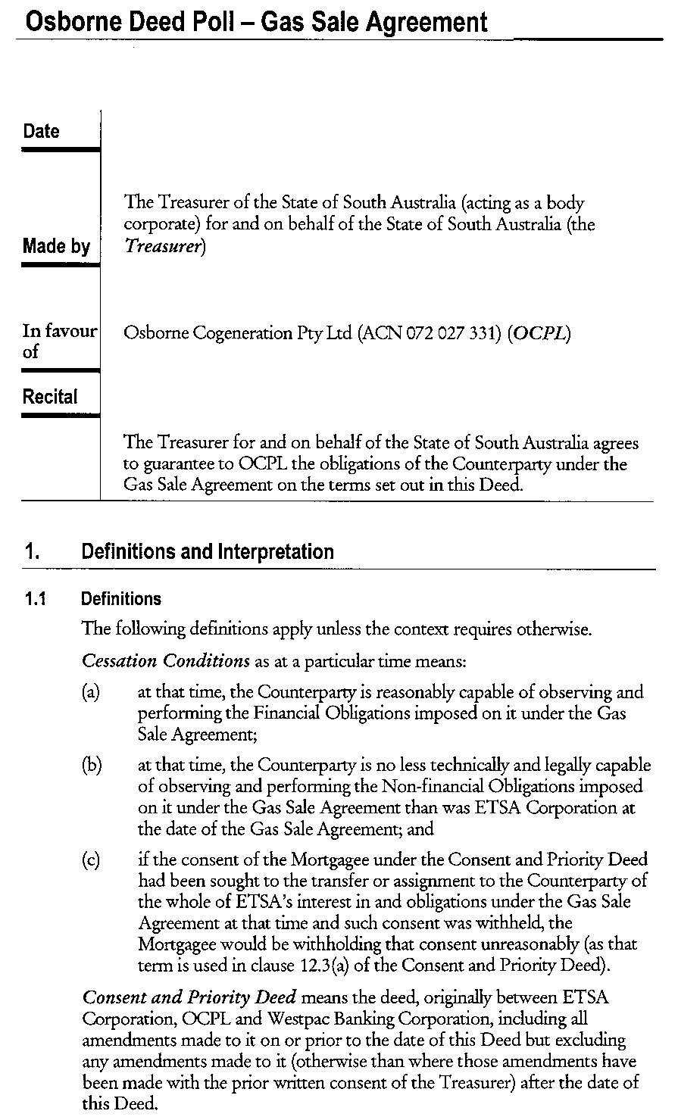
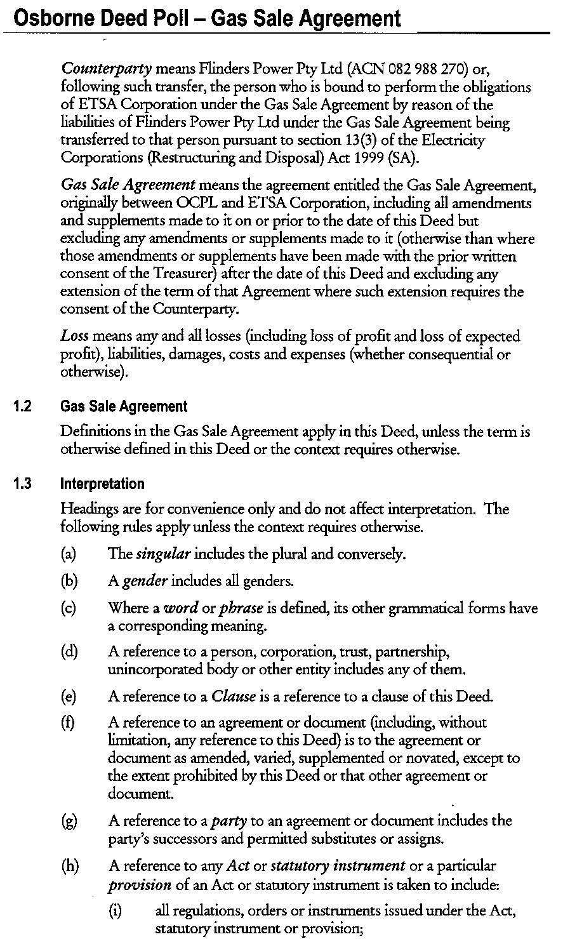
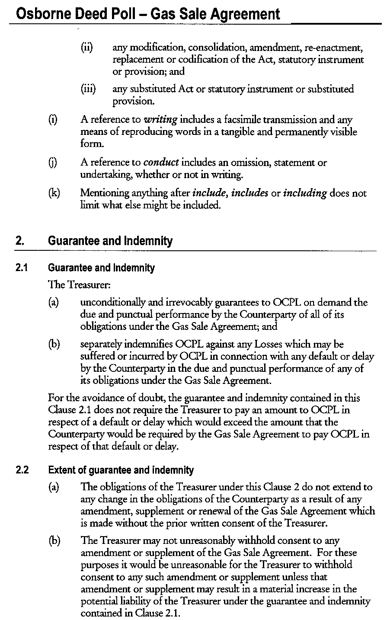
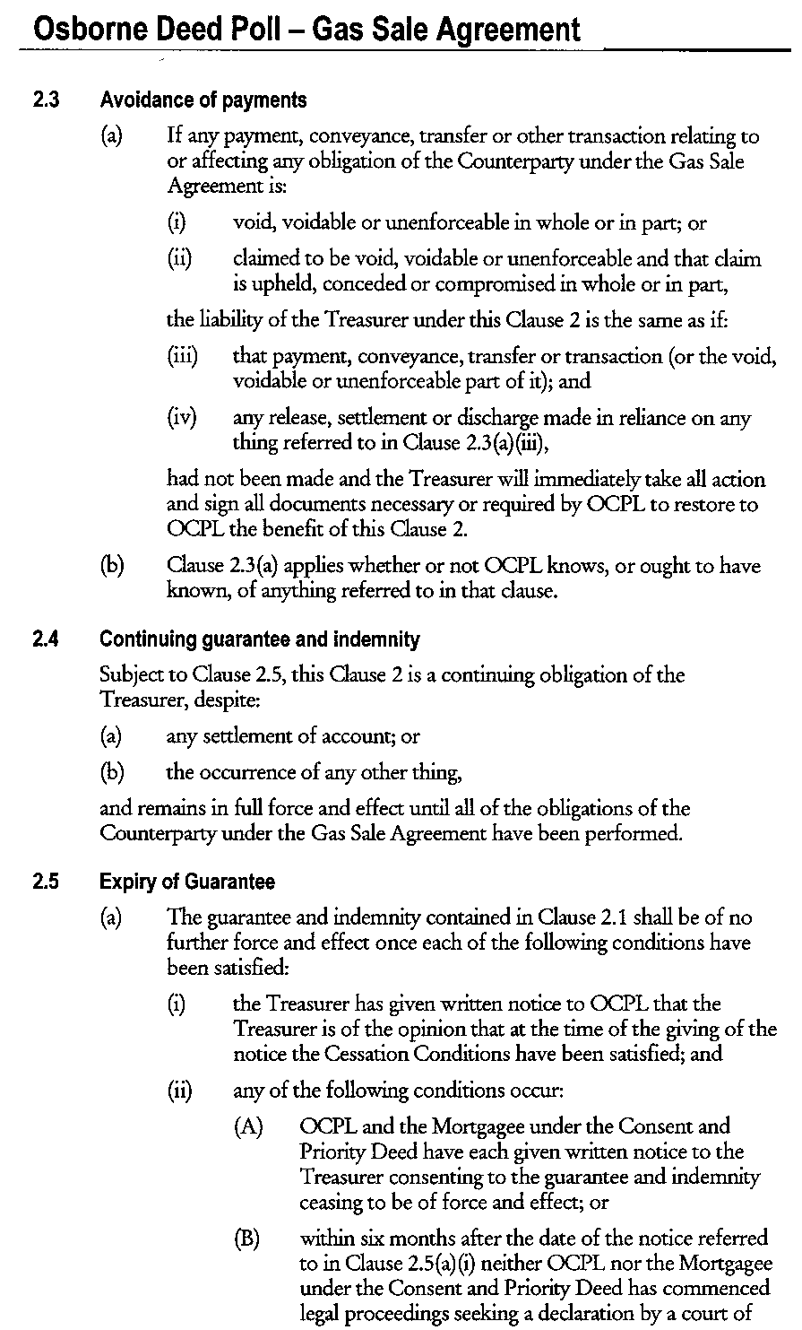
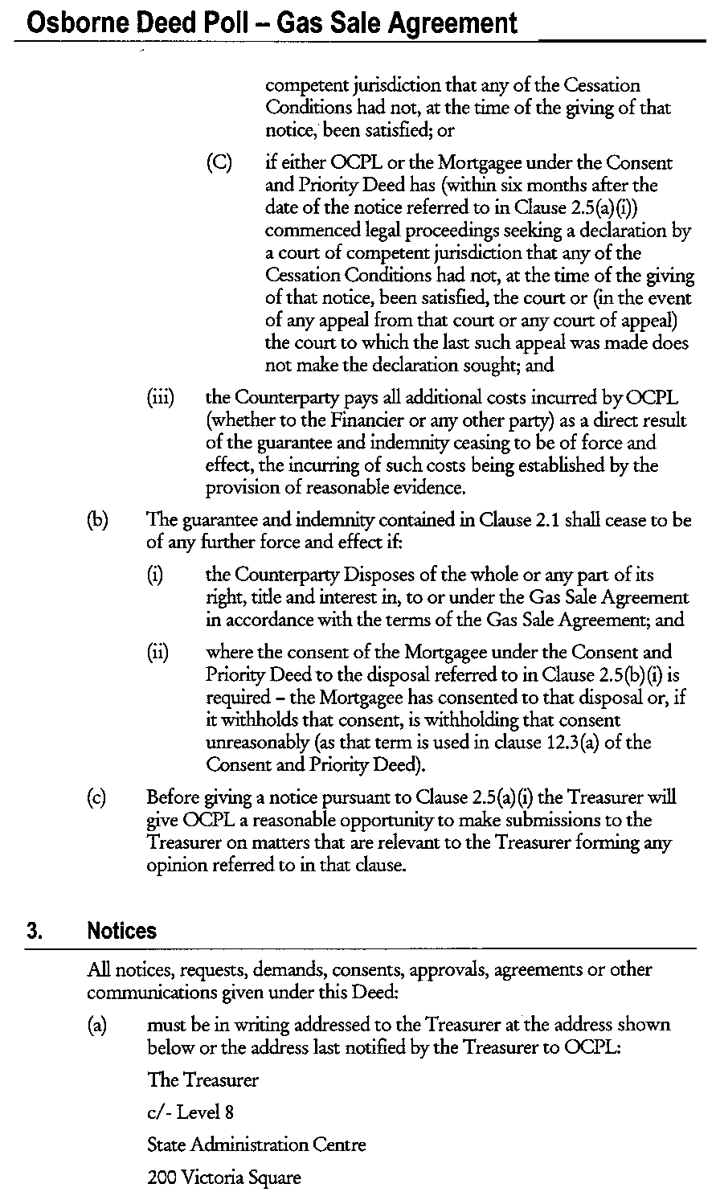

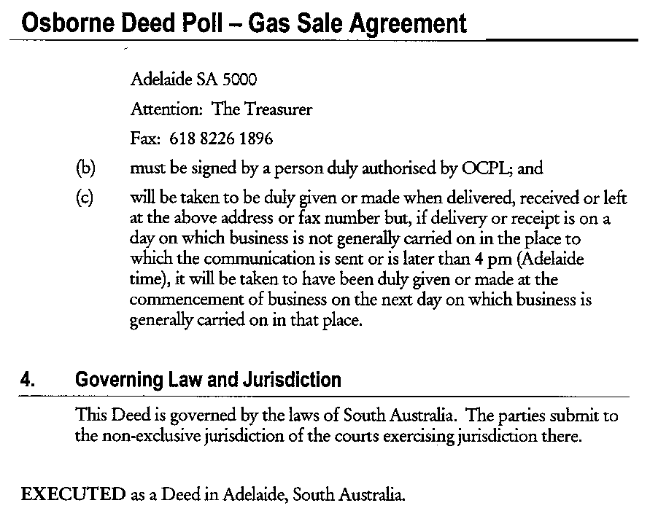

Dated 6 September 2000.

THE COMMON SEAL of THE TREASURER acting for and on behalf of the State of South Australia was duly affixed in the presence of:
(l.s.) Rob Lucas, Treasurer
Kirsty Haylock, Witness

PUBLIC FINANCE AND AUDIT ACT 1987
THE guarantee set out below has been given by the Treasurer pursuant to section 19 of the Public Finance and Audit Act 1987, Flinders Power Pty Ltd having been declared to be a ‘semi-government authority’ within the meaning of that Act by virtue of a proclamation made on 5 September 2000.

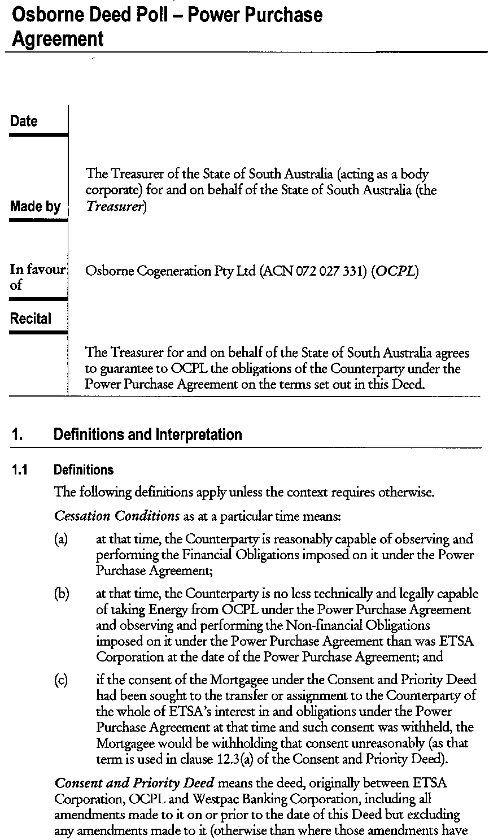

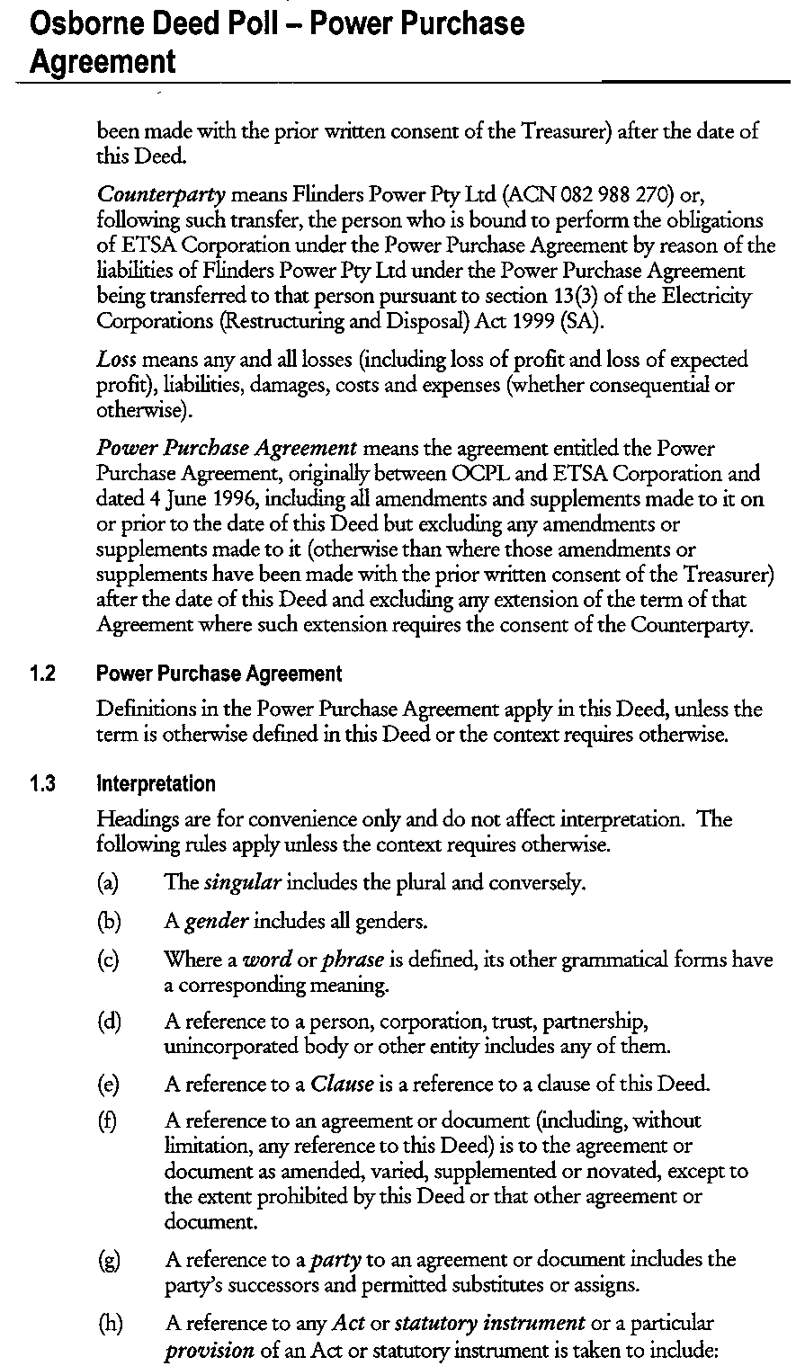
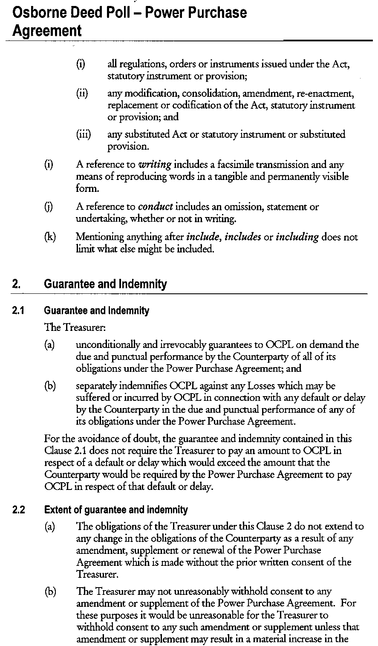
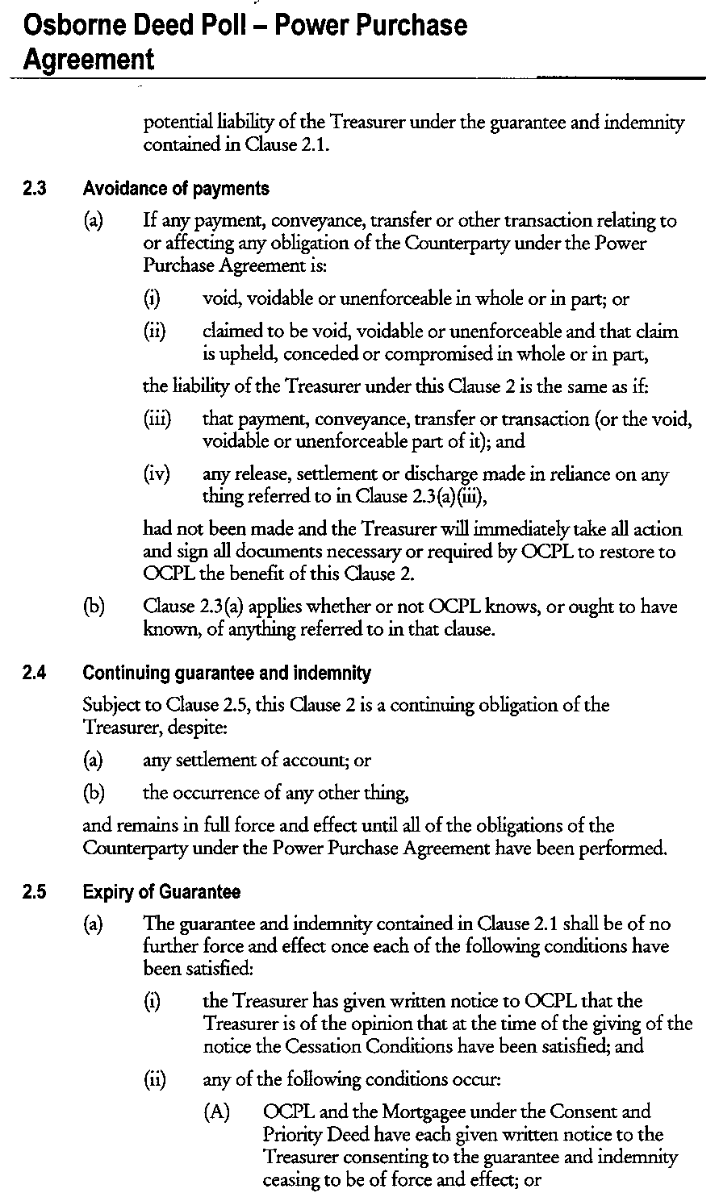
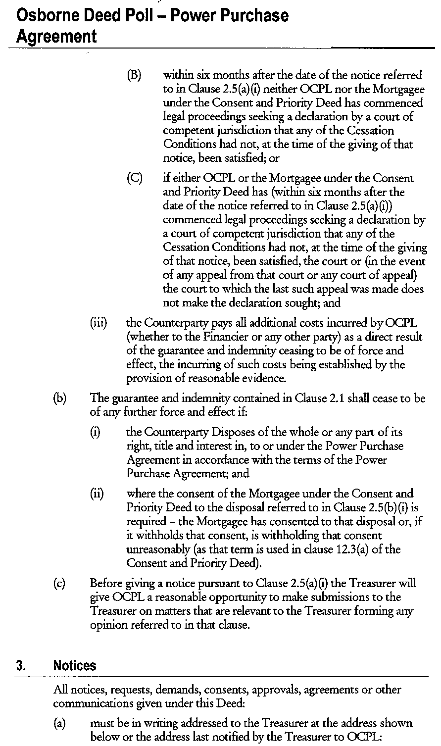

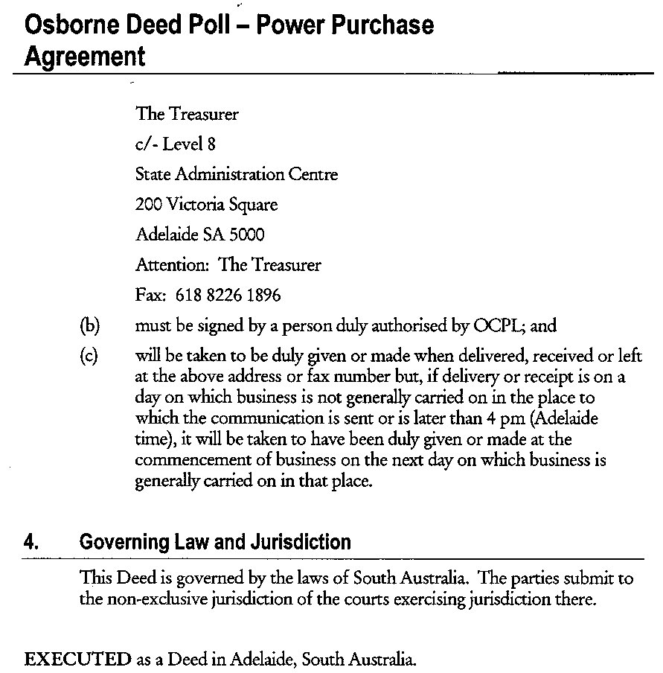

Dated 6 September 2000.

THE COMMON SEAL of THE TREASURER acting for and on behalf of the State of South Australia was duly affixed in the presence of:
(l.s.) Rob Lucas, Treasurer
Kirsty Haylock, Witness

M. G. O’CALLAGHAN, Government Printer, South Australia

