No. 155 2041

THE SOUTH AUSTRALIAN

GOVERNMENT GAZETTE

PUBLISHED BY AUTHORITY

ALL PUBLIC ACTS appearing in this GAZETTE are to be considered official, and obeyed as such

ADELAIDE, THURSDAY, 21 SEPTEMBER 2000

CONTENTS

Page
Appointments, Resignations, Etc. 2042
Associations Incorporation Act 1985—Notice 2043
Corporations and District Councils—Notices 2207
Crown Lands Act 1929—Notices 2043
Development Act 1993—Notices 2044
Electricity Act 1996—Terms and Conditions of Supply 2111
Electoral Act 1985—Notice 2114
Fisheries Act 1982—Notices 2114
Geographical Names Act 1991—Corrigendum 2147
Housing Improvement Act 1940—Notices 2145
Land and Business (Sale and Conveyancing) Act 1994—
Notices 2147
Liquor Licensing Act 1997—Notices 2147
Livestock Act 1997—Notice 2150

Page
Local Government Act 1934—Notice 2153
Mining Act 1971—Notices 2150
Partnership Act 1891—Notice 2209
Police Act 1998—Notices 2156
Private Advertisements 2209
Proclamations 2042
Public Corporations Act 1993—Notice 2152
Public Trustee Office—Administration of Estates 2208

REGULATIONS
Petroleum Products Subsidy Act 1965 (No. 234 of 2000) 2157
Petroleum Act 2000 (No. 235 of 2000) 2158
Water Resources Act 1997 (No. 236 of 2000) 2203
Roads (Opening and Closing) Act 1991—Notices 2152

GOVERNMENT GAZETTE NOTICES
ALL poundkeepers' and private advertisements forwarded for publication in the South Australian Government Gazette must be PAID FOR PRIOR TO INSERTION; and all notices, from whatever source, should be legibly written on one side of the paper only and sent to Riverside 2000 so as to be received no later than 4 p.m. Tuesday preceding the day of publication. Phone 8207 1045 or Fax 8207 1040. E-mail: Riv2000@saugov.sa.gov.au. Send as attachments in Word format and please confirm your transmission with a faxed copy of your document, including the date the notice is to be published and to whom the notice will be charged.

ADMINISTRATIVE ARRANGEMENTS ACT 1994 SECTION 5: ADMINISTRATION OF PETROLEUM ACT 2000 COMMITTED TO THE MINISTER FOR PRIMARY INDUSTRIES AND RESOURCES
Proclamation By The Governor
(l.s.) E. J. Neal
PURSUANT to section 5 of the Administrative Arrangements Act 1994 and with the advice and consent of the Executive Council, I commit the administration of the Petroleum Act 2000 to the Minister for Primary Industries and Resources.
Given under my hand and the Public Seal of South Australia, at Adelaide, 21 September 2000.
By command,
Diana Laidlaw, for Premier
MME 053/2000 CS

CROWN LANDS ACT 1929 SECTION 5AA(1)(c): HUNDRED OF TATIARA—DEDICATED LAND RESUMED AND GRANT CANCELLED
Proclamation By The Governor
(l.s.) E. J. Neal
Preamble
1. The following land is dedicated for the purposes of a show reserve (see Gazette 1 December 1960 p. 1526):
Section 868, Hundred of Tatiara, being the whole of the land contained in Certificate of Title Register Book Volume 5726 Folio 208.
2. The registered proprietor of the land has requested the resumption of the land.
Proclamation
PURSUANT to section 5AA(1)(c) of the Crown Lands Act 1929 and with the advice and consent of the Executive Council, I resume the land defined in the preamble and cancel the grant of that land.
Given under my hand and the Public Seal of South Australia, at Adelaide, 21 September 2000.
By command,
Diana Laidlaw, for Premier
EH 00/0035 CS

FORESTRY ACT 1950 SECTION 3(3): NORTHERN FOREST DISTRICT—LAND CEASING TO BE FOREST RESERVE
Proclamation By The Governor
(l.s.) E. J. Neal
Preamble
1. The following land is forest reserve under the Forestry Act 1950 (see proclamation, Gazette 19 March 1992 p. 877, as varied) and forms part of the Northern Forest District:
Portion of Sections 400, 401 and 759, Hundred of Belalie, now numbered as allotment 1 of Plan No. DP 52649, Hundred of Belalie, accepted for deposit in the Lands Titles Registration Office at Adelaide.
2. It is intended that this land cease to be forest reserve.
Proclamation
PURSUANT to section 3(3) of the Forestry Act 1950 and with the advice and consent of the Executive Council, I vary the proclamation referred to in the preamble by striking out from clause 2(d) of the schedule of that proclamation ‘398-401, 759’ and substituting ‘398, 399, Lot 2 of Plan No. DP 52649 accepted for deposit in the Lands Titles Registration Office at Adelaide’.
Given under my hand and the Public Seal of South Australia, at Adelaide, 21 September 2000.
By command,
Diana Laidlaw, for Premier
MGE 00/072 CS

PETROLEUM ACT 2000 (Act No. 60 of 2000): DAY OF COMMENCEMENT
Proclamation By The Governor
(l.s.) E. J. Neal
WITH the advice and consent of the Executive Council, I fix 25 September 2000 as the day on which the Petroleum Act 2000 will come into operation.
Given under my hand and the Public Seal of South Australia, at Adelaide, 21 September 2000.
By command,
Diana Laidlaw, for Premier
MME 053/2000 CS

Department of the Premier and Cabinet
Adelaide, 17 September 2000
HIS Excellency the Governor in Executive Council was pleased to appoint the Honourable Robert Gerard Kerin, MP, Deputy Premier, Minister for Primary Industries and Resources and Minister for Regional Development to be also Acting Premier, Acting Minister for State Development and Acting Minister for Multicultural Affairs for the period from 1 p.m. on 27 September 2000 to 30 September 2000 inclusive, during the absence of the Honourable John Wayne Olsen, MP.
By command,
Diana Laidlaw, for Premier
DIT 385/001/030 CS

Department of the Premier and Cabinet
Adelaide, 17 September 2000
HIS Excellency the Governor in Executive Council has been pleased to appoint the undermentioned to the South Eastern Water Conservation and Drainage Board, pursuant to the South Eastern Water Conservation and Drainage Act 1992:
Member: (from 21 September 2000 until 13 August 2004)
Thomas Anthony Speakman Hanson
By command,
Diana Laidlaw, for Premier
MWR 0037/00 CS

Department of the Premier and Cabinet
Adelaide, 17 September 2000
HIS Excellency the Governor in Executive Council has been pleased to appoint the undermentioned to the History Trust of South Australia, pursuant to the History Trust of South Australia Act 1981:
Member: (from 1 October 2000 until 30 September 2003)
Marie Danvers
By command,
Diana Laidlaw, for Premier
ACD 010/94 CS

Department of the Premier and Cabinet
Adelaide, 17 December 1999
HIS Excellency the Governor in Executive Council has been pleased to appoint the undermentioned to the TransAdelaide Board, pursuant to the provisions of the TransAdelaide (Corporate Structure) Act 1998:
Director: (from 12 January 2001 until 14 September 2003)
Susan Law
Chair: (from 21 September 2000 until 14 September 2003)
Susan Law
By command,
Diana Laidlaw, for Premier
TA-GOR 000001 CS

ASSOCIATIONS INCORPORATION ACT 1985
Transfer of Undertaking
WHEREAS the Corporate Affairs Commission (‘the Commission’), pursuant to subsection 42 (1) of the Associations Incorporation Act 1985 (‘the Act’), is of the opinion that the undertaking of National Family Day Care Council (Aus.) Incorporated (‘the association’), being an incorporated association under the Act would more appropriately be carried on by a body corporate incorporated under the Corporations Law of South Australia and whereas the Commission was on 7 September 2000, requested by the association to transfer its undertaking to National Family Day Care Council of Australia Limited (ACN 094 436 021) the Commission pursuant to subsection 42 (2) of the Act doth hereby order that on 21 September 2000, the undertaking of National Family Day Care Council (Aus.) Incorporated, be transferred to National Family Day Care Council of Australia Limited.
Given at Adelaide, 15 September 2000.
A. J. Griffiths, Delegate of the Corporate Affairs Commission

CROWN LANDS ACT 1929: SECTION 5
TAKE NOTICE that pursuant to the Crown Lands Act 1929, I PETER MACLAREN KENTISH, Surveyor-General and Delegate appointed by IAIN EVANS, Minister for Environment and Heritage, Minister of the Crown to whom the administration of the Crown Lands Act 1929 is committed DO HEREBY dedicate the Crown Land defined in The Schedule as a Public Road.
The Schedule
Allotments 16, 17, 18 and 19 of DP 54184, Hundred of Cultana, County of York, being within the municipality of the City of Whyalla.
Dated 18 September 2000.
P. M. Kentish, Surveyor-General
DENR 13/0617

CROWN LANDS ACT 1929: SECTION 5
TAKE NOTICE that pursuant to the Crown Lands Act 1929, I PETER MACLAREN KENTISH, Surveyor-General and Delegate appointed by IAIN EVANS, Minister for Environment and Heritage, Minister of the Crown to whom the administration of the Crown Lands Act 1929 is committed DO HEREBY:
1. Dedicate the Crown Land defined in The First Schedule as a Public Road.
2. Dedicate the Crown Land defined in The Second Schedule as a Recreation Reserve and declare that such land shall be under the care, control and management of the District Council of Loxton Waikerie.
The First Schedule
Allotment 2 of DP 55233, Hundred of Pyap, County of Alfred, being within the district of Loxton Waikerie.
The Second Schedule
Allotments 21 to 28 inclusive, Town of Pata, Hundred of Pyap, County of Alfred, exclusive of all necessary roads, being the whole of the land comprised in Crown Record Volume 5737 Folio 437.
Dated 18 September 2000.
P. M. Kentish, Surveyor-General
DL 3683/1982

DEVELOPMENT ACT 1993, SECTION 29(2) (b): AMENDMENT TO THE DUDLEY (DC) DEVELOPMENT PLAN
Preamble
It is necessary to amend the Dudley (DC) Development Plan dated 18 November 1999.
Notice
PURSUANT to Section 29(2) (b) of the Development Act 1993, I, Diana Laidlaw, being the Minister administering the Act, amend
The Dudley (DC) Development Plan, dated 18 November 1999 as follows:
1.(a) Delete Maps Du/1 to Du/12;
1.(b) insert the contents of Attachment A; and
1.(c) adjust the mapping references in the Dudley (DC) Development Plan text accordingly.
Attachment A
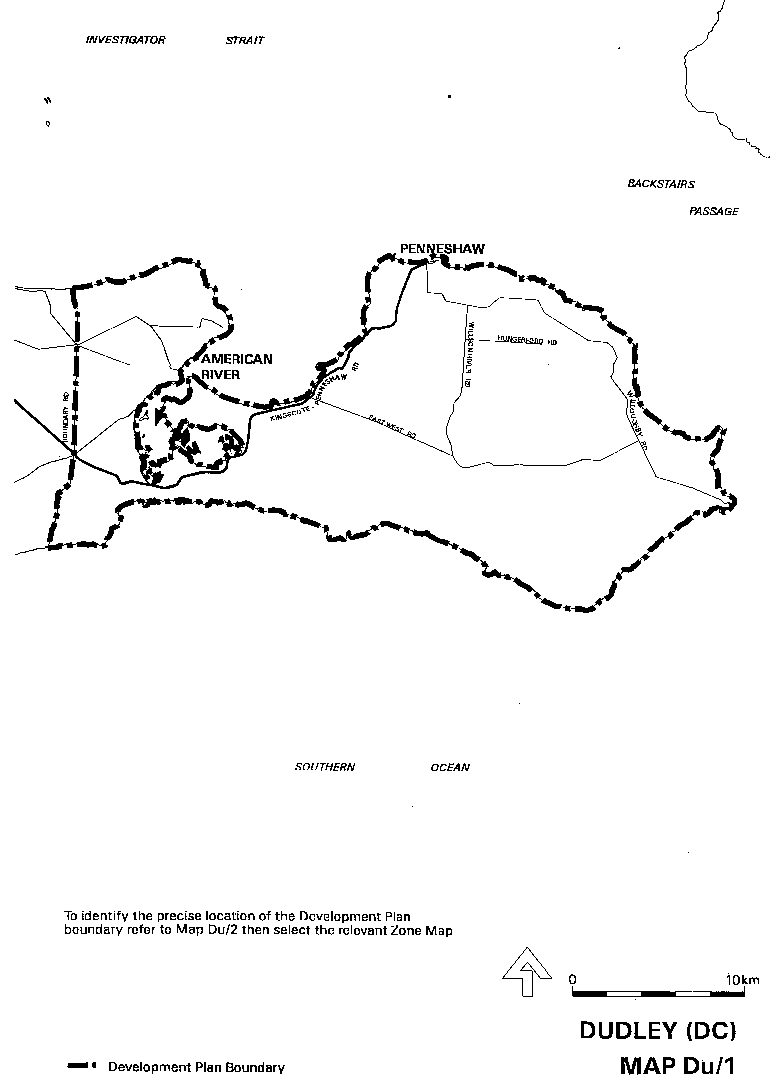
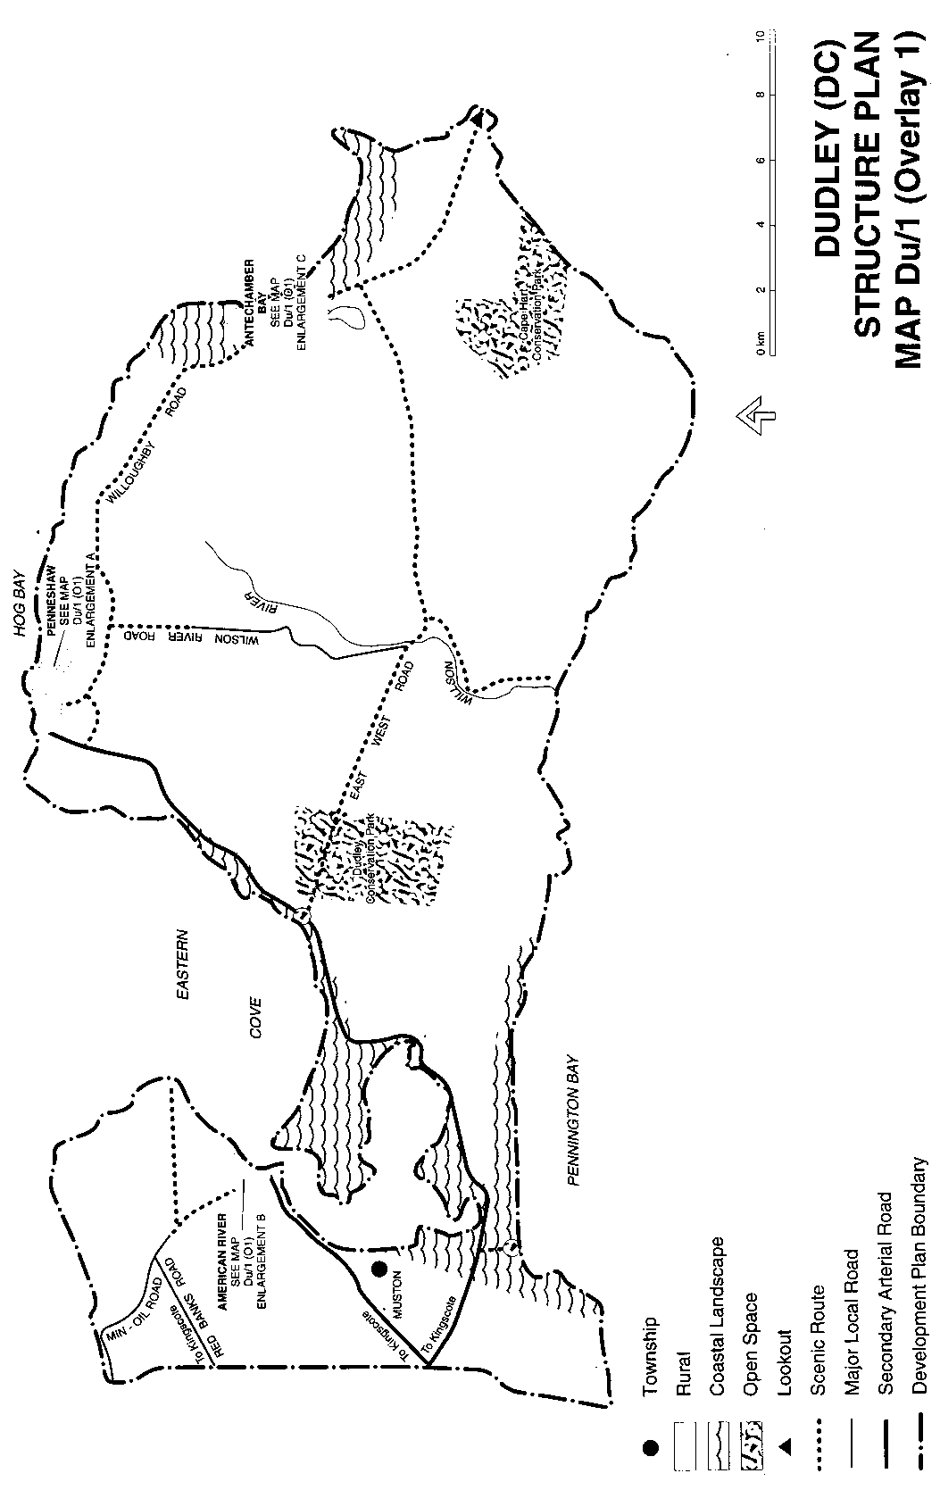
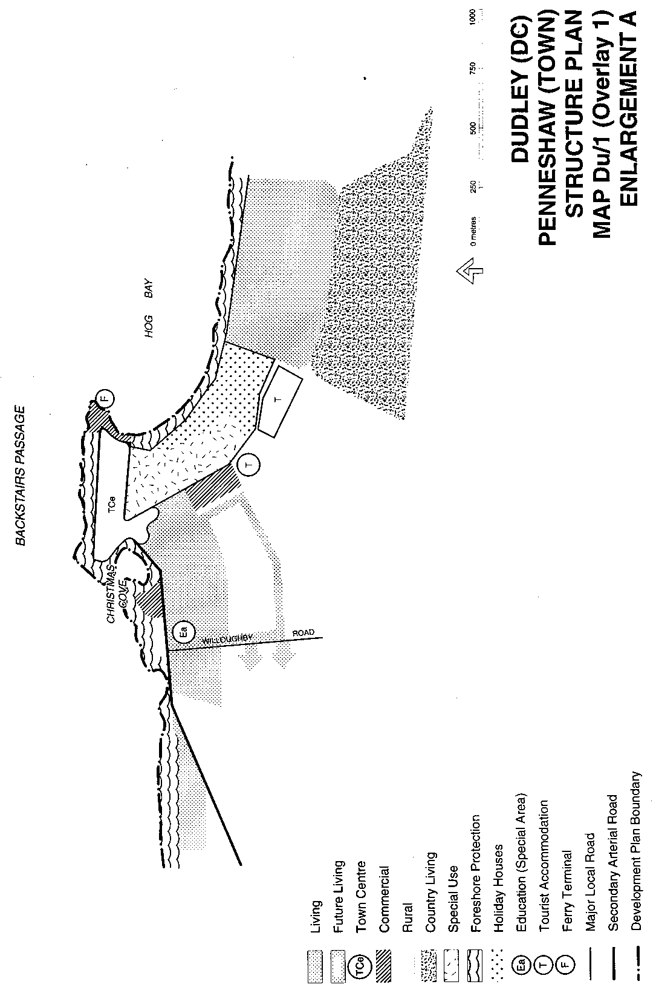
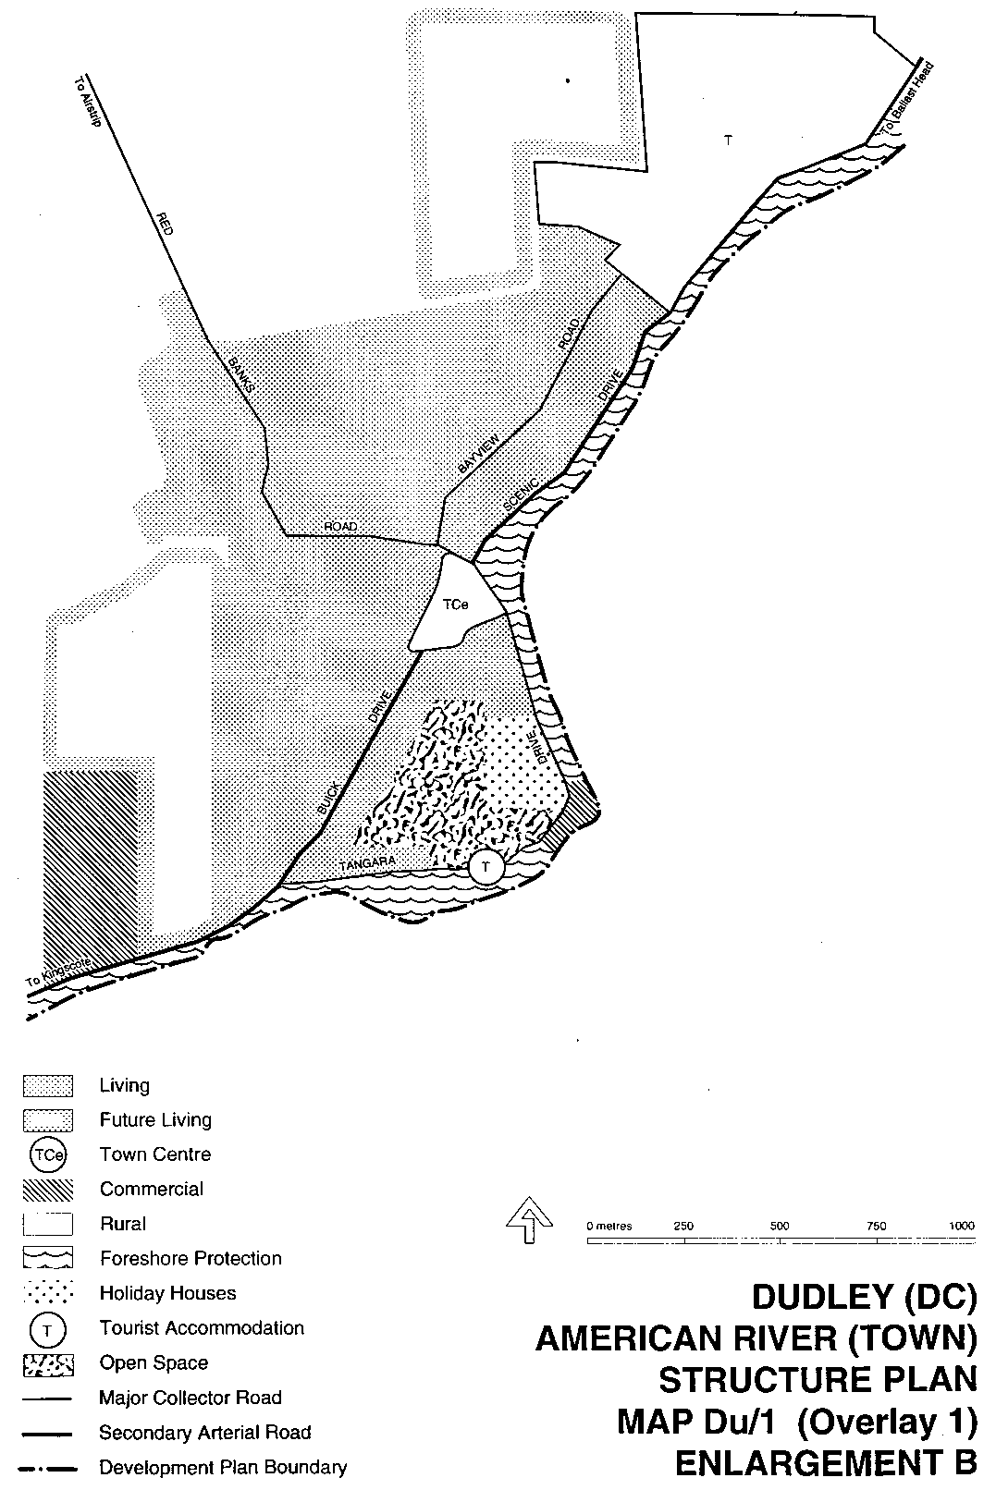
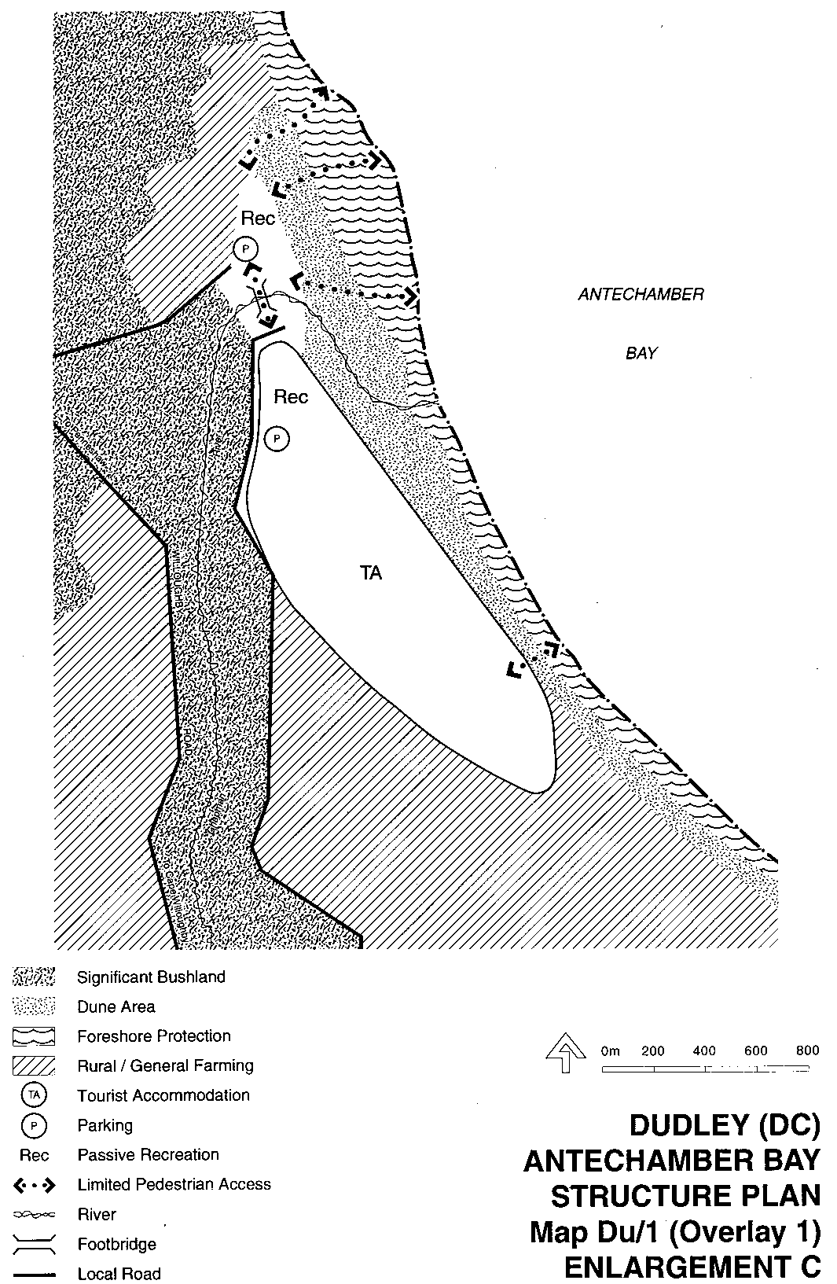
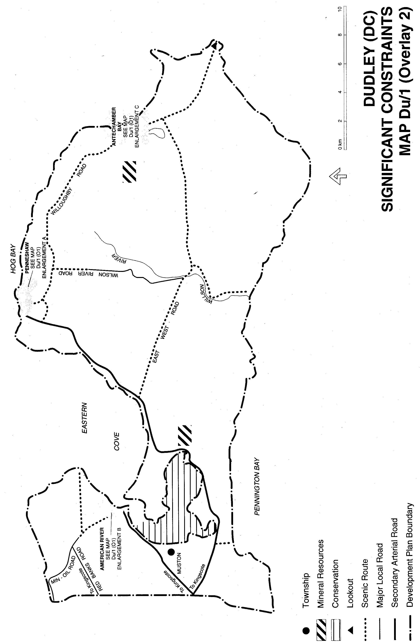
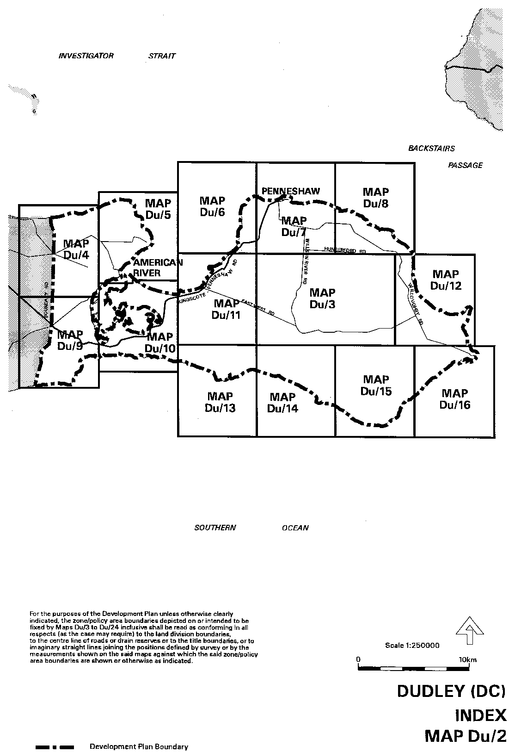
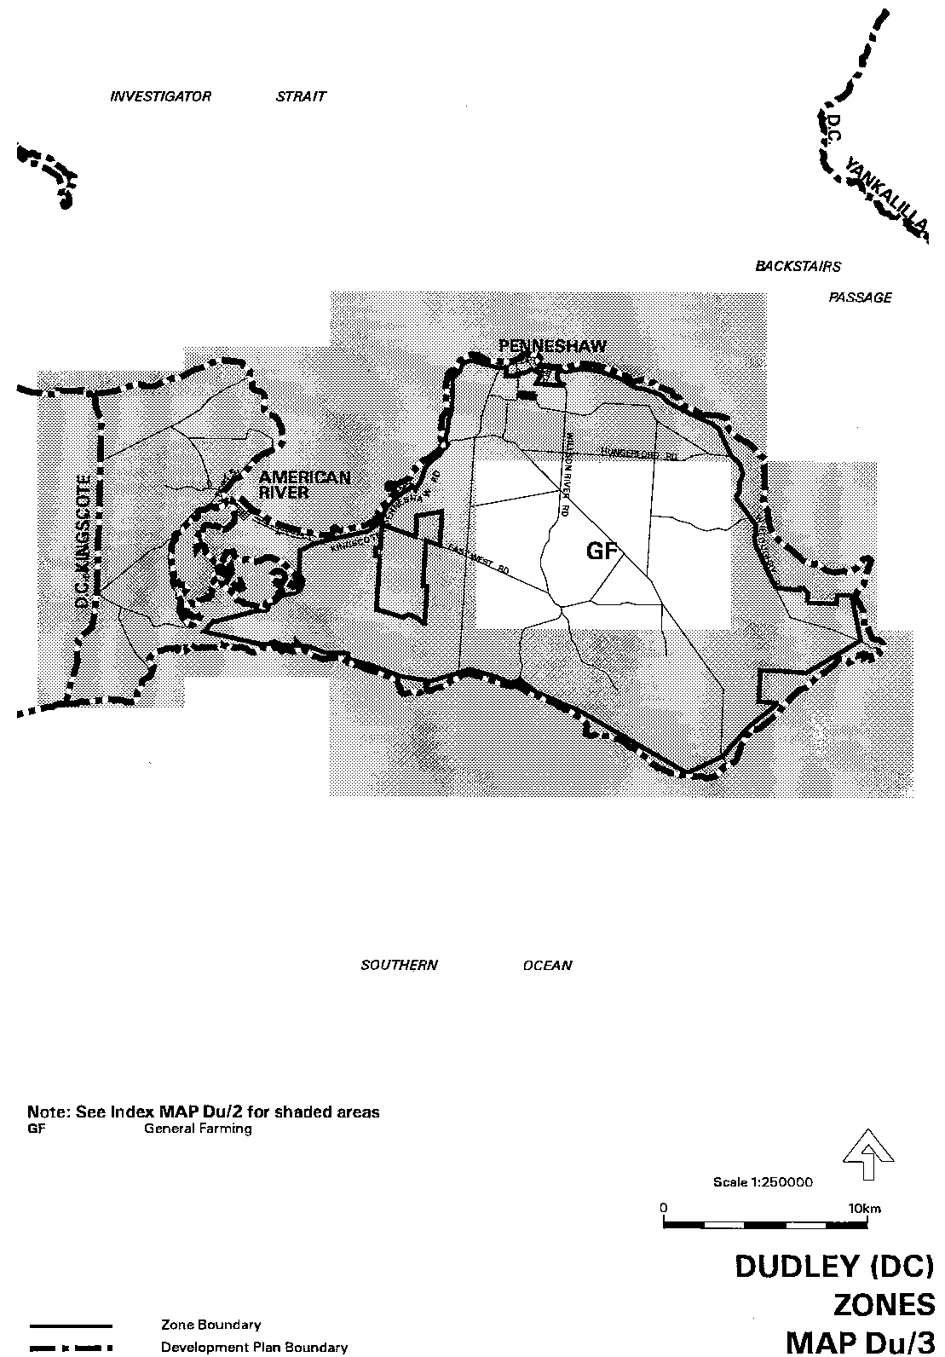
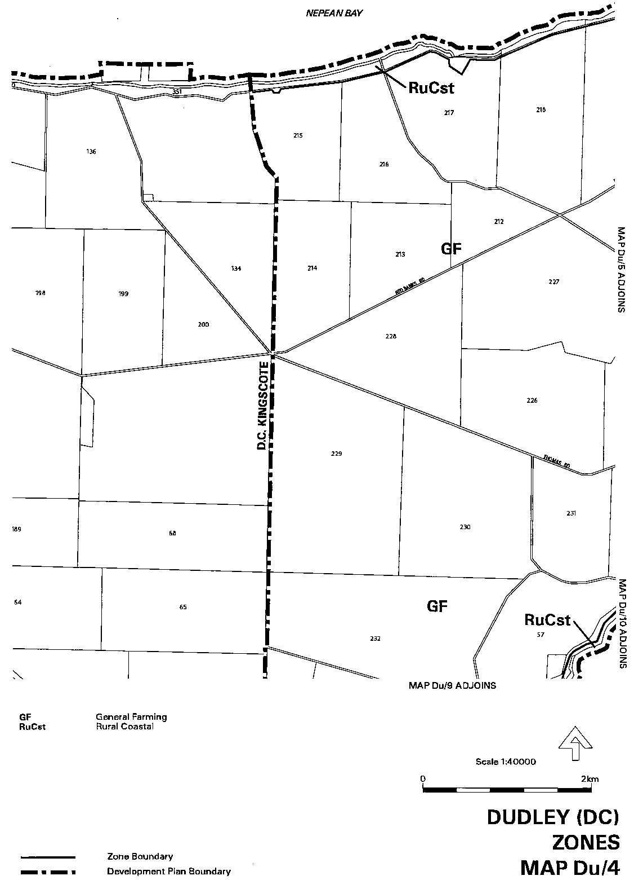
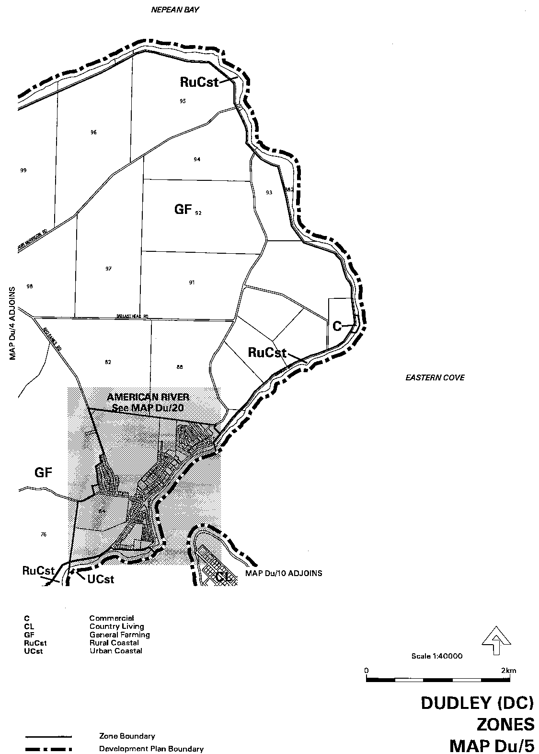
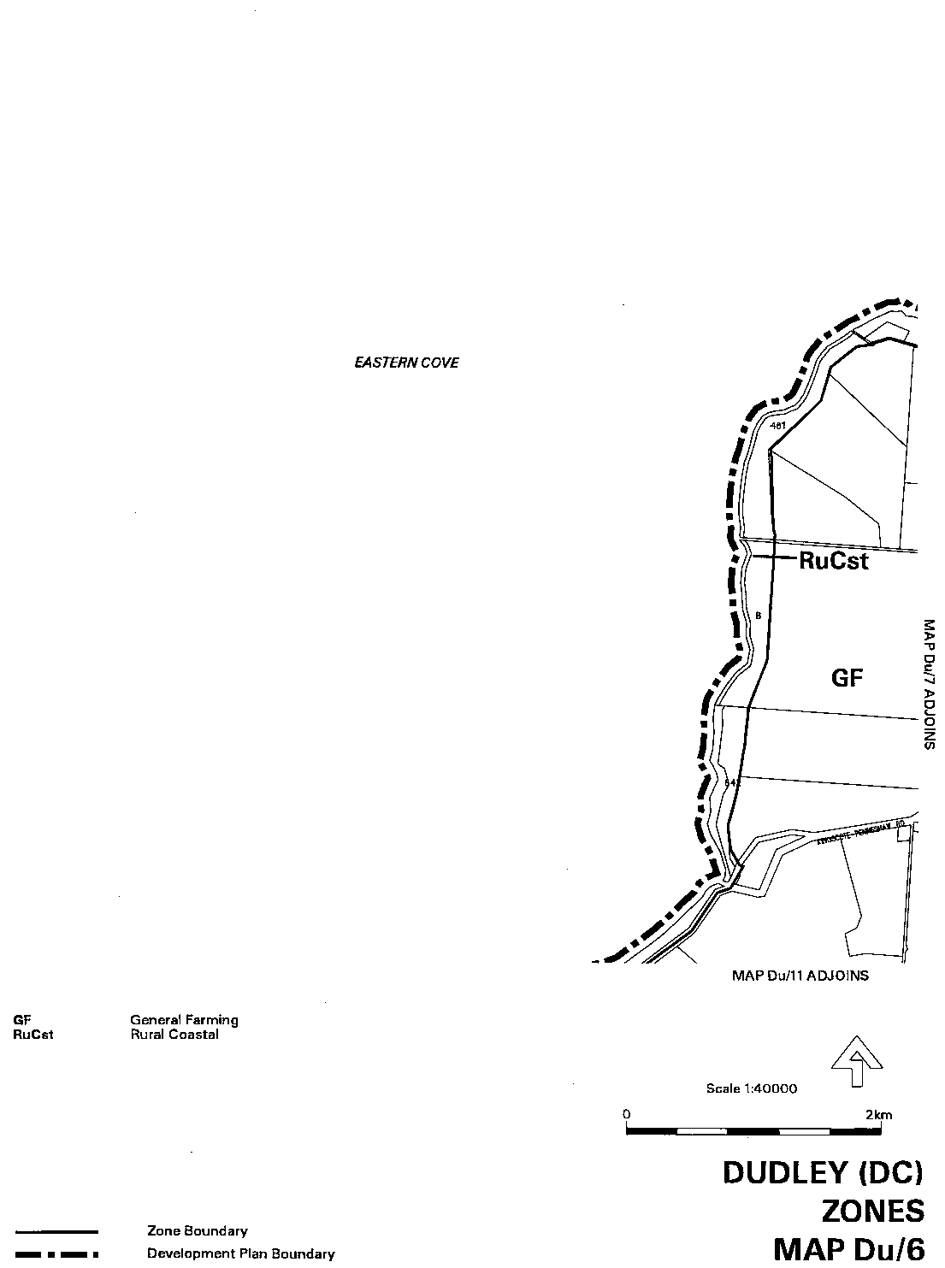
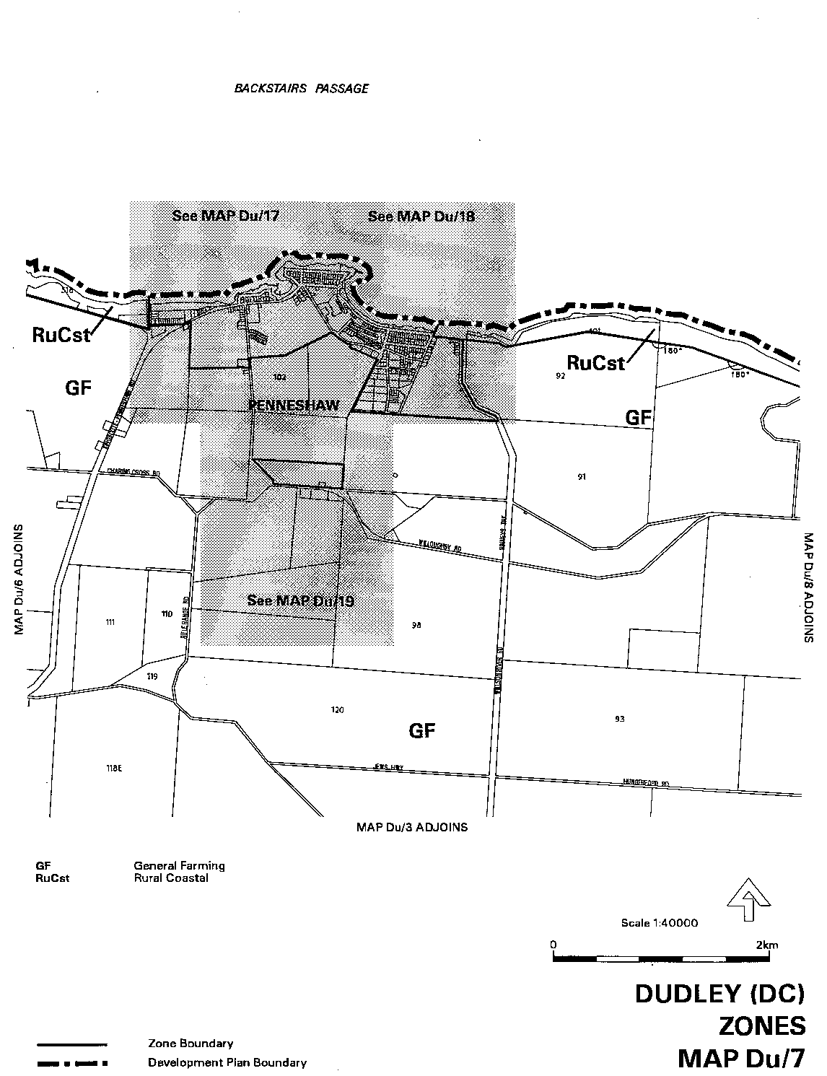
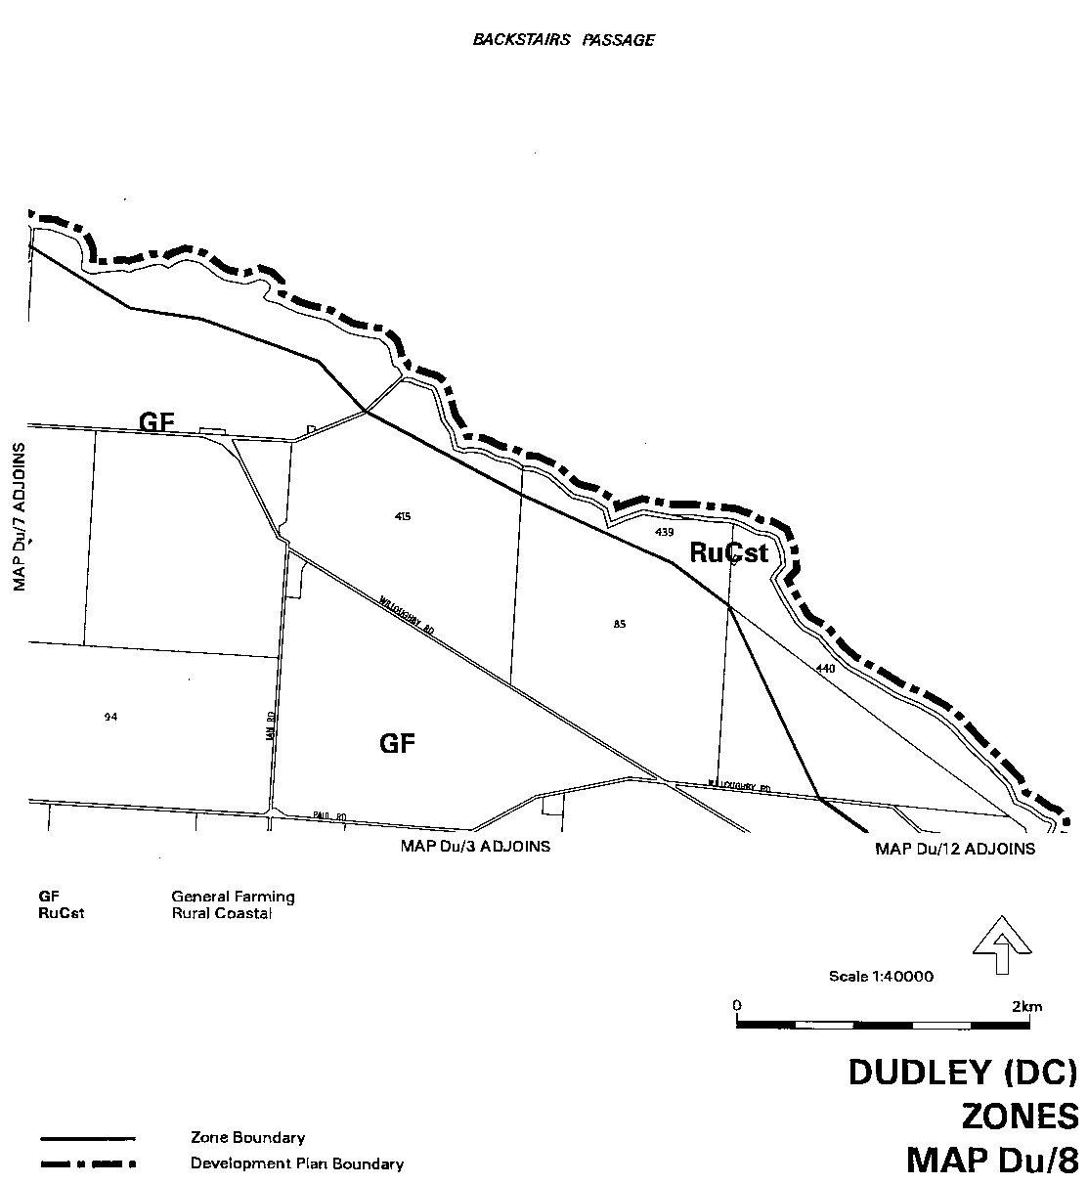
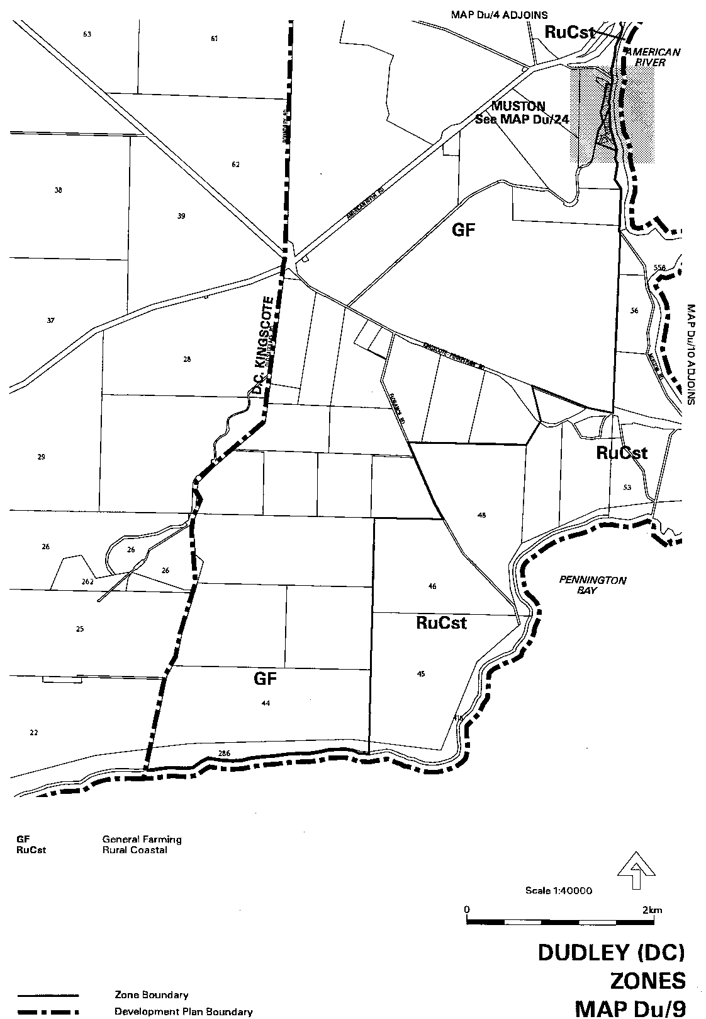
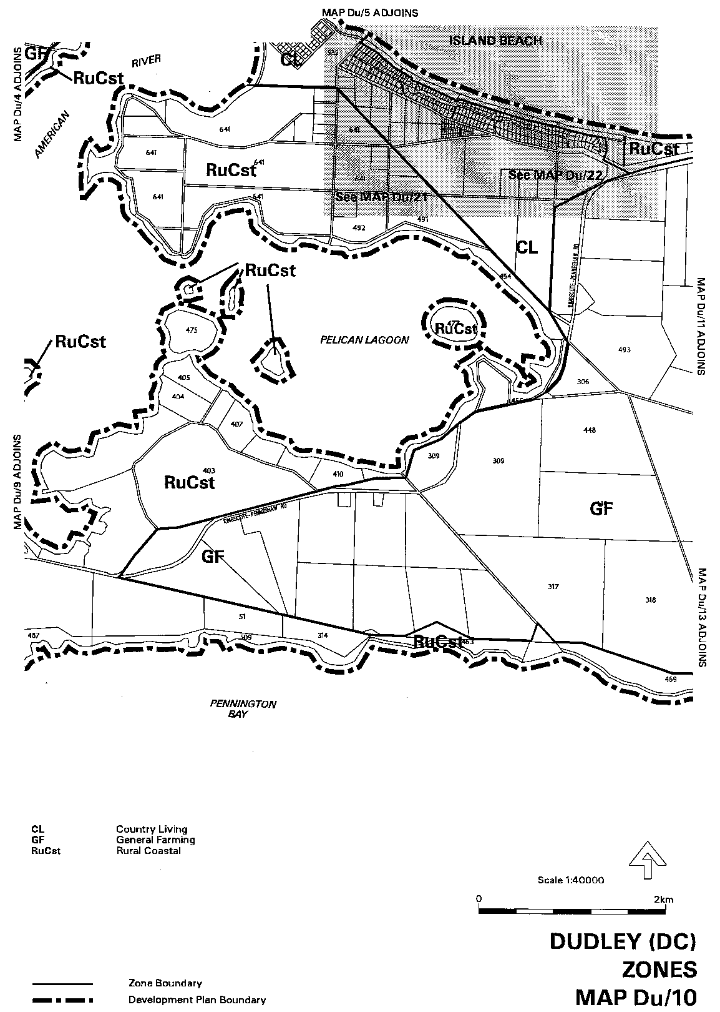
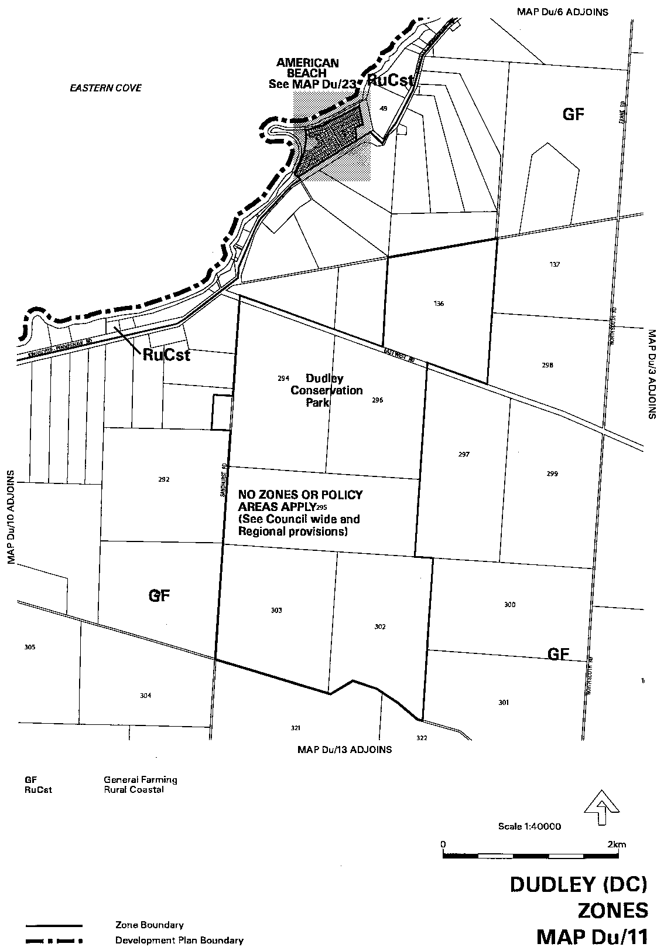
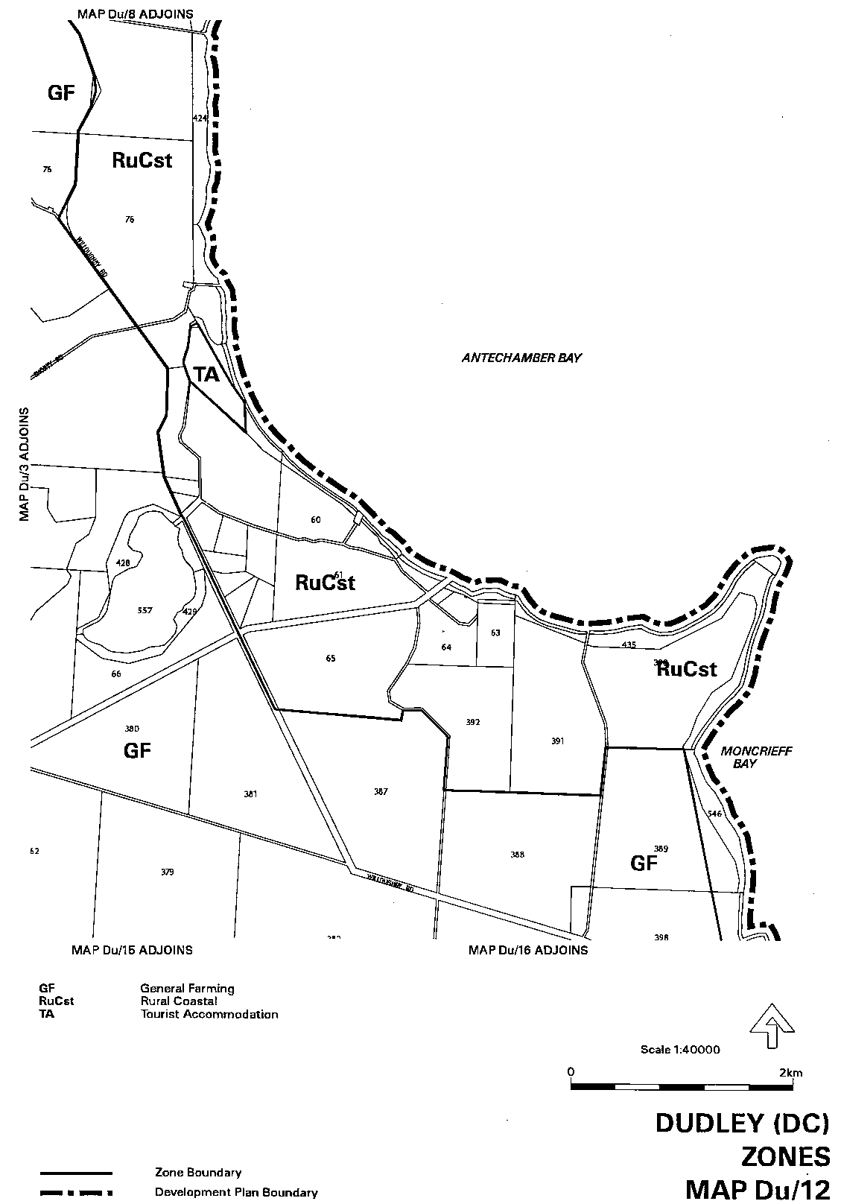
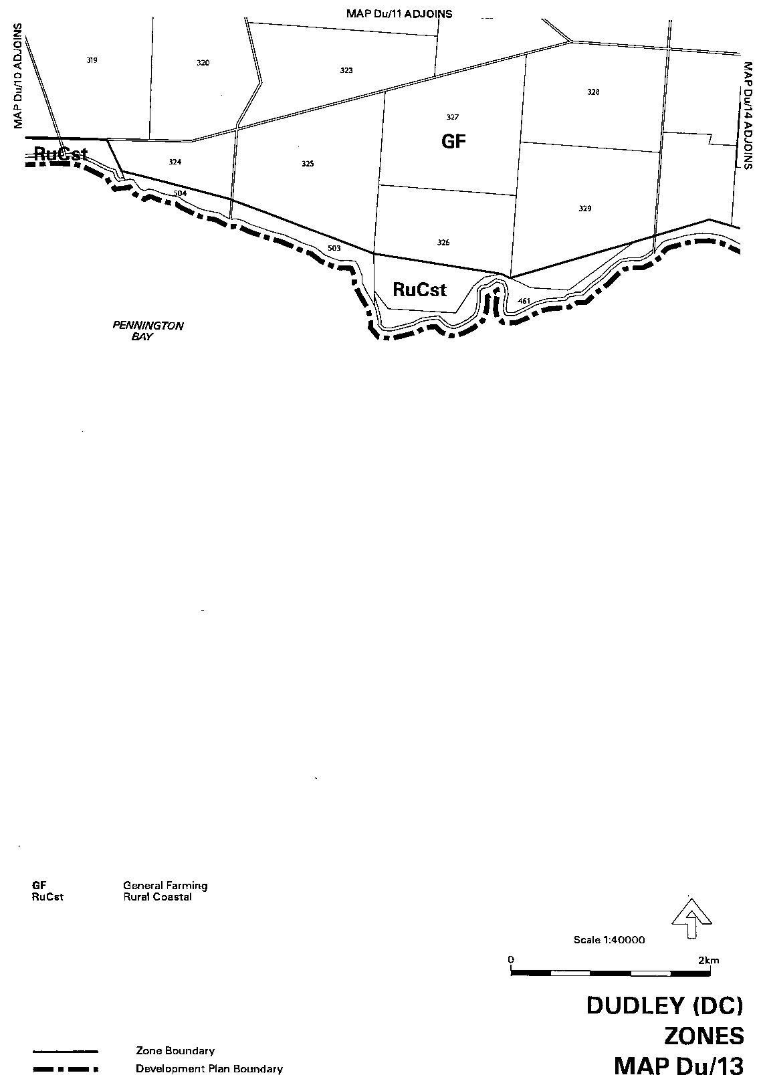
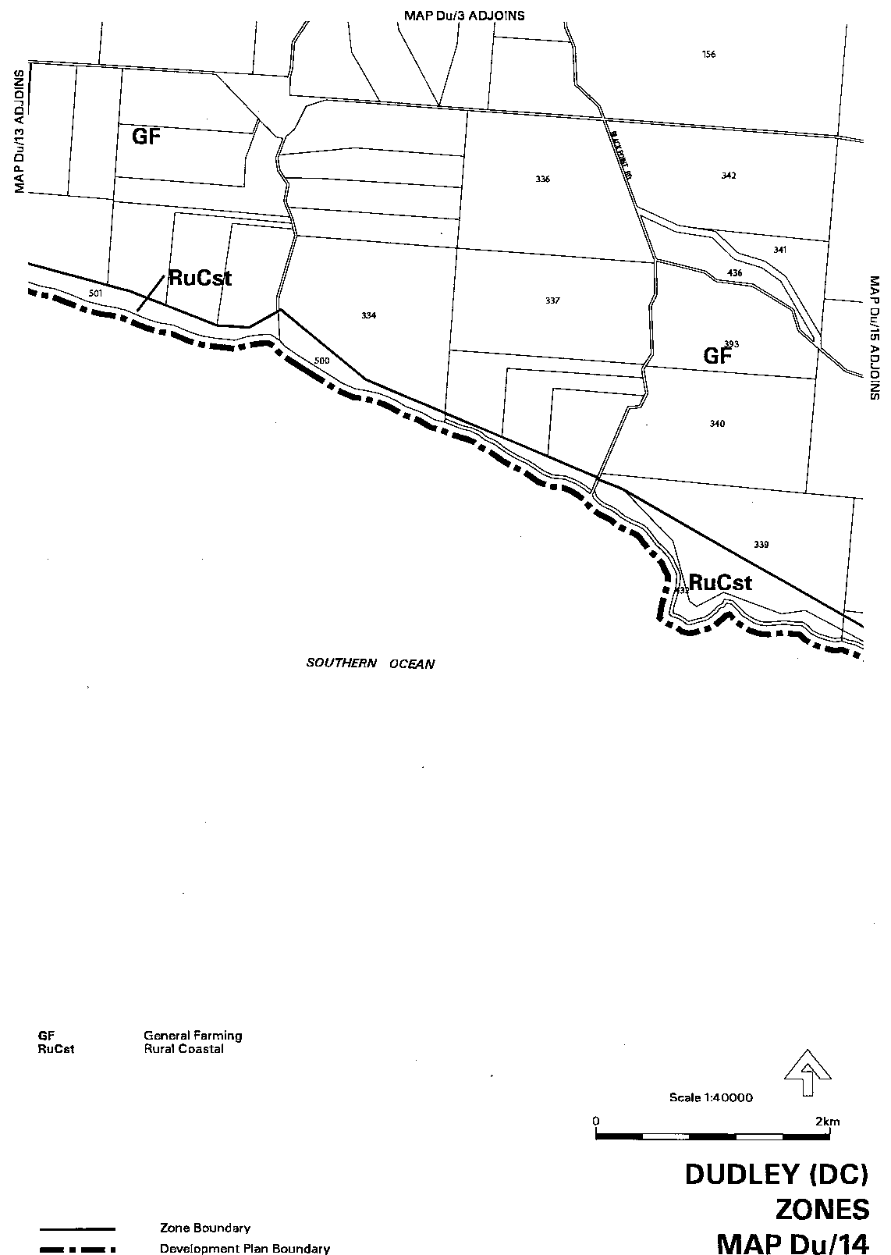
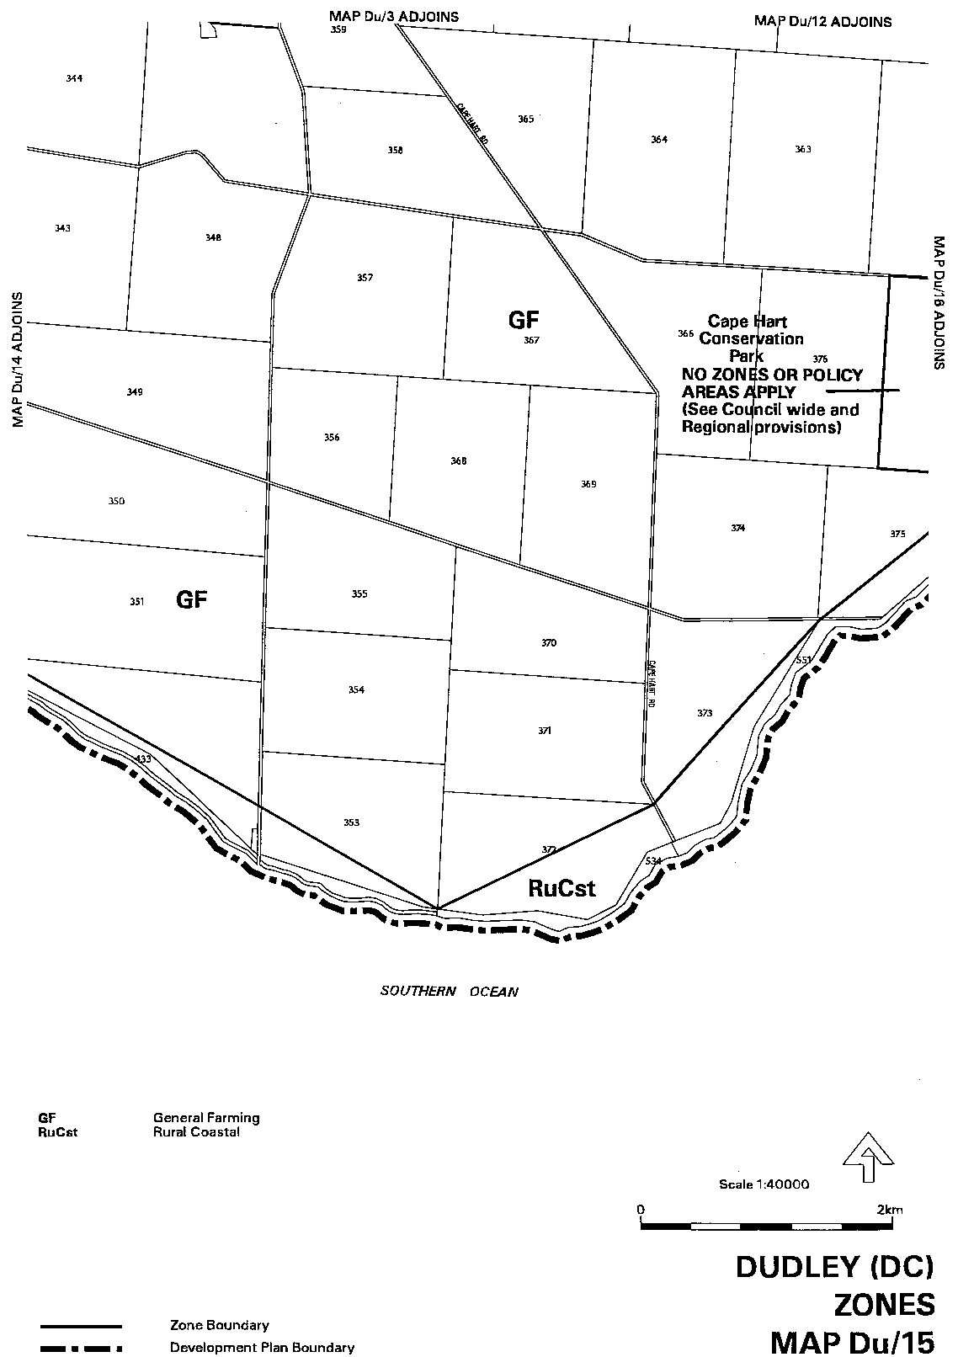
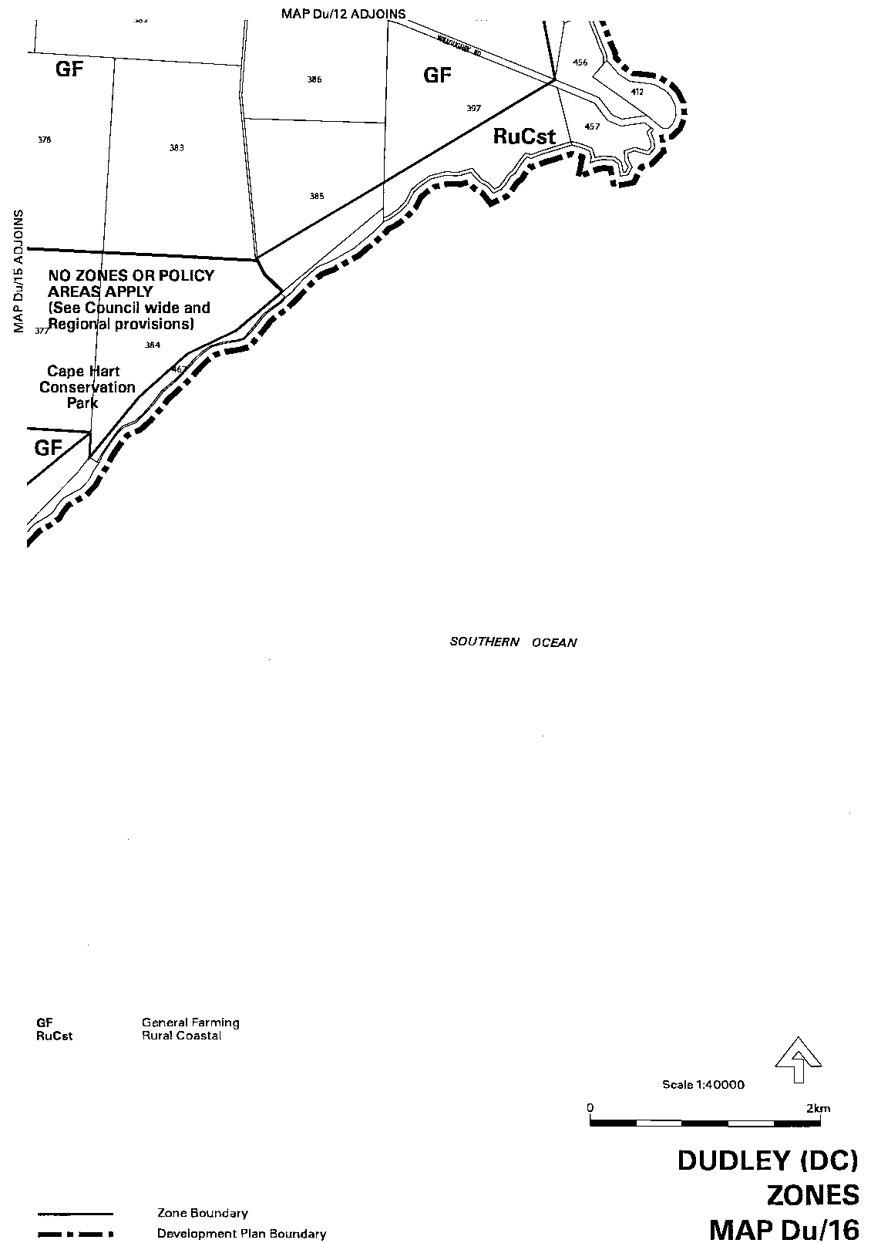
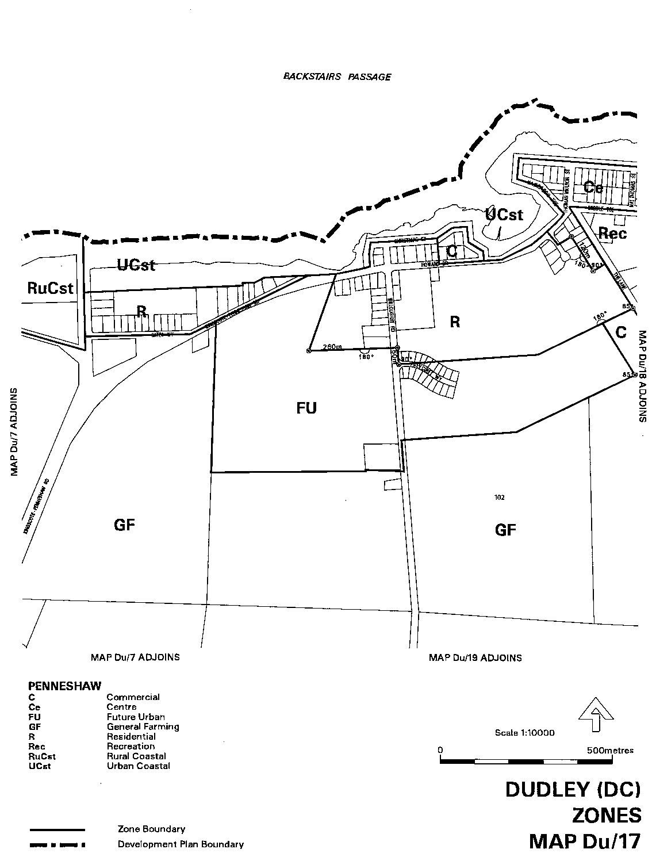
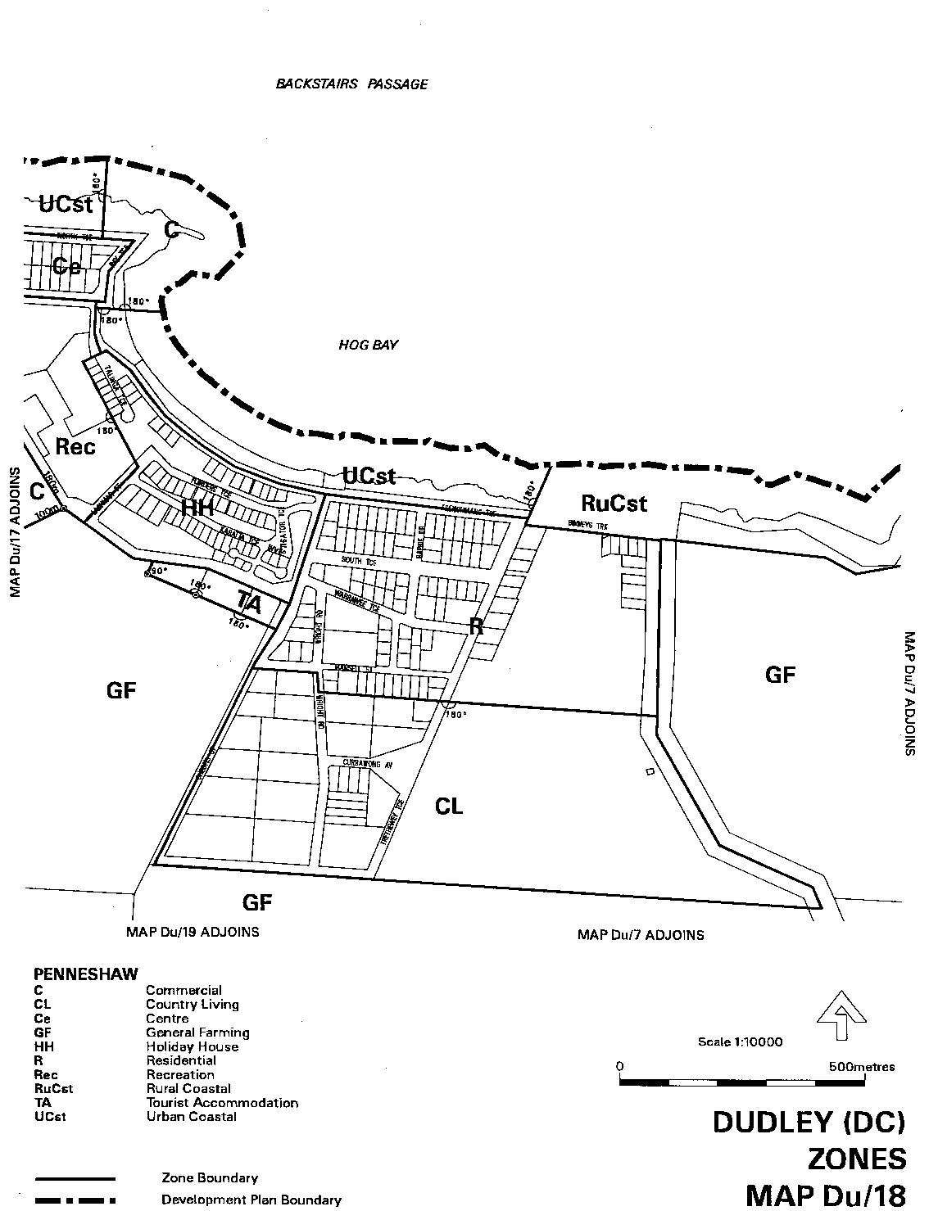
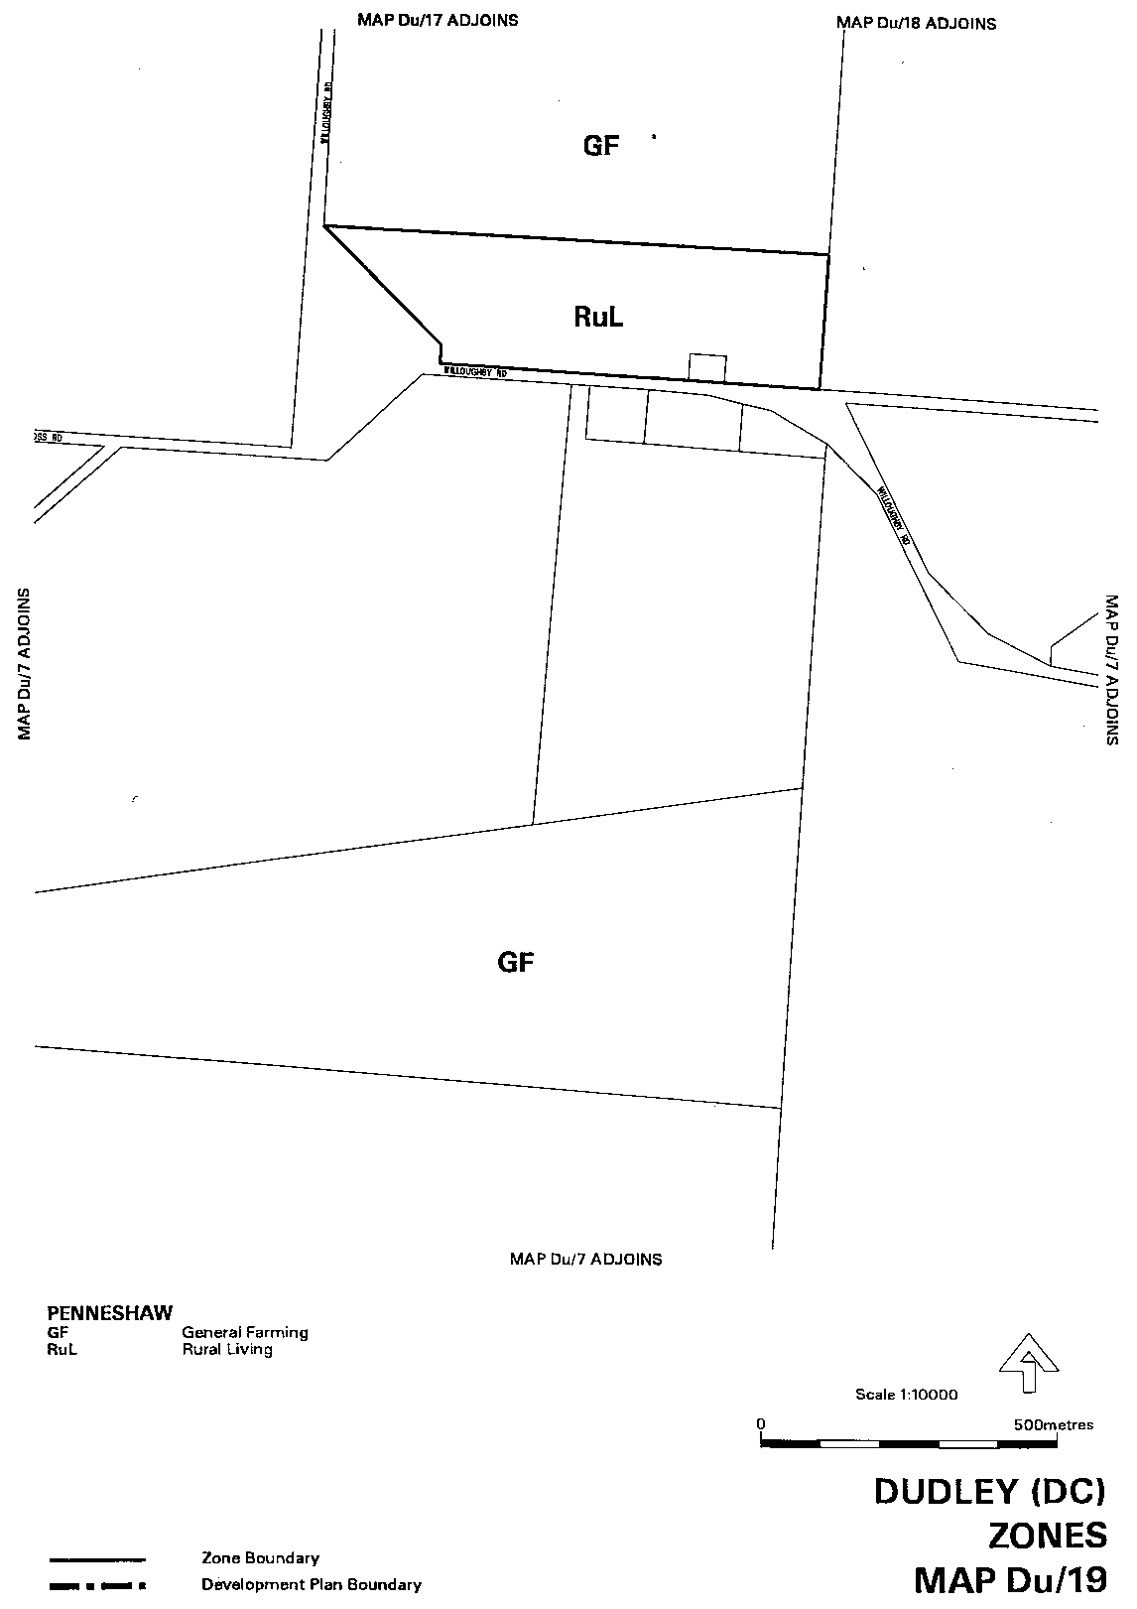
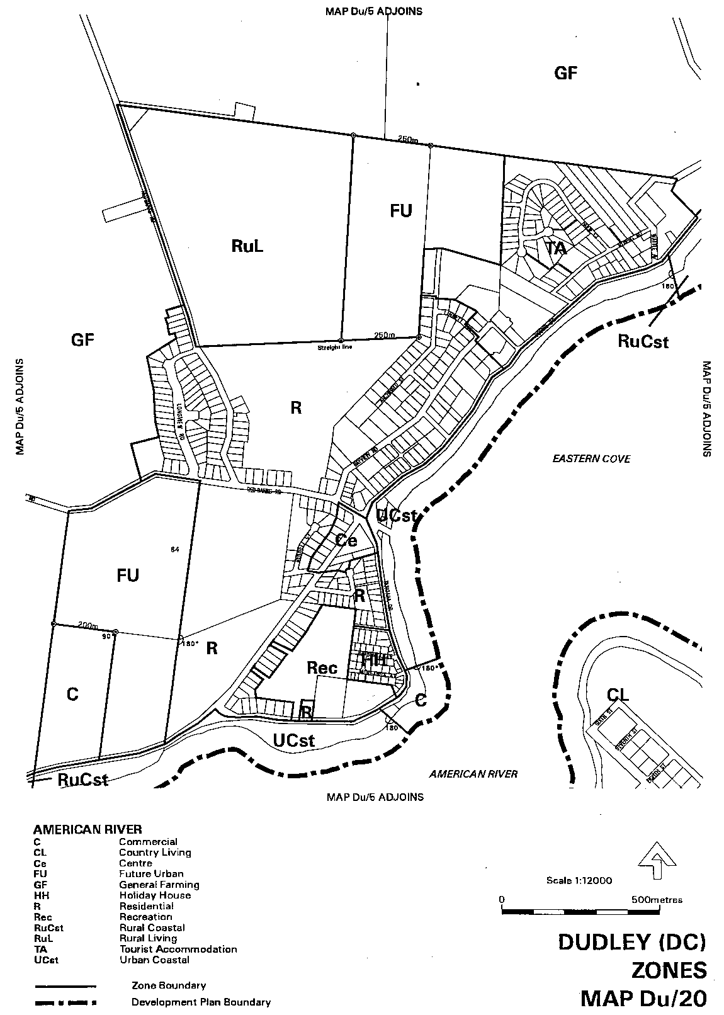
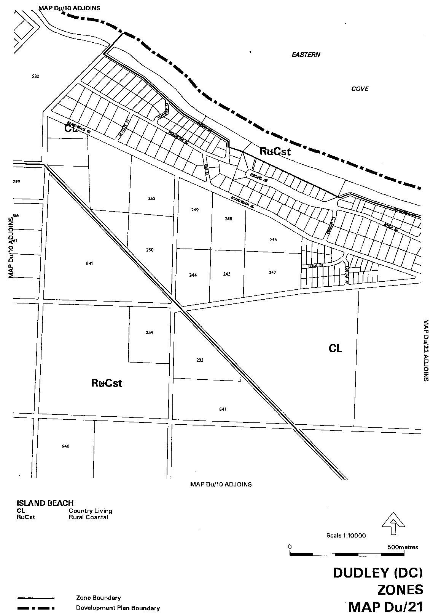
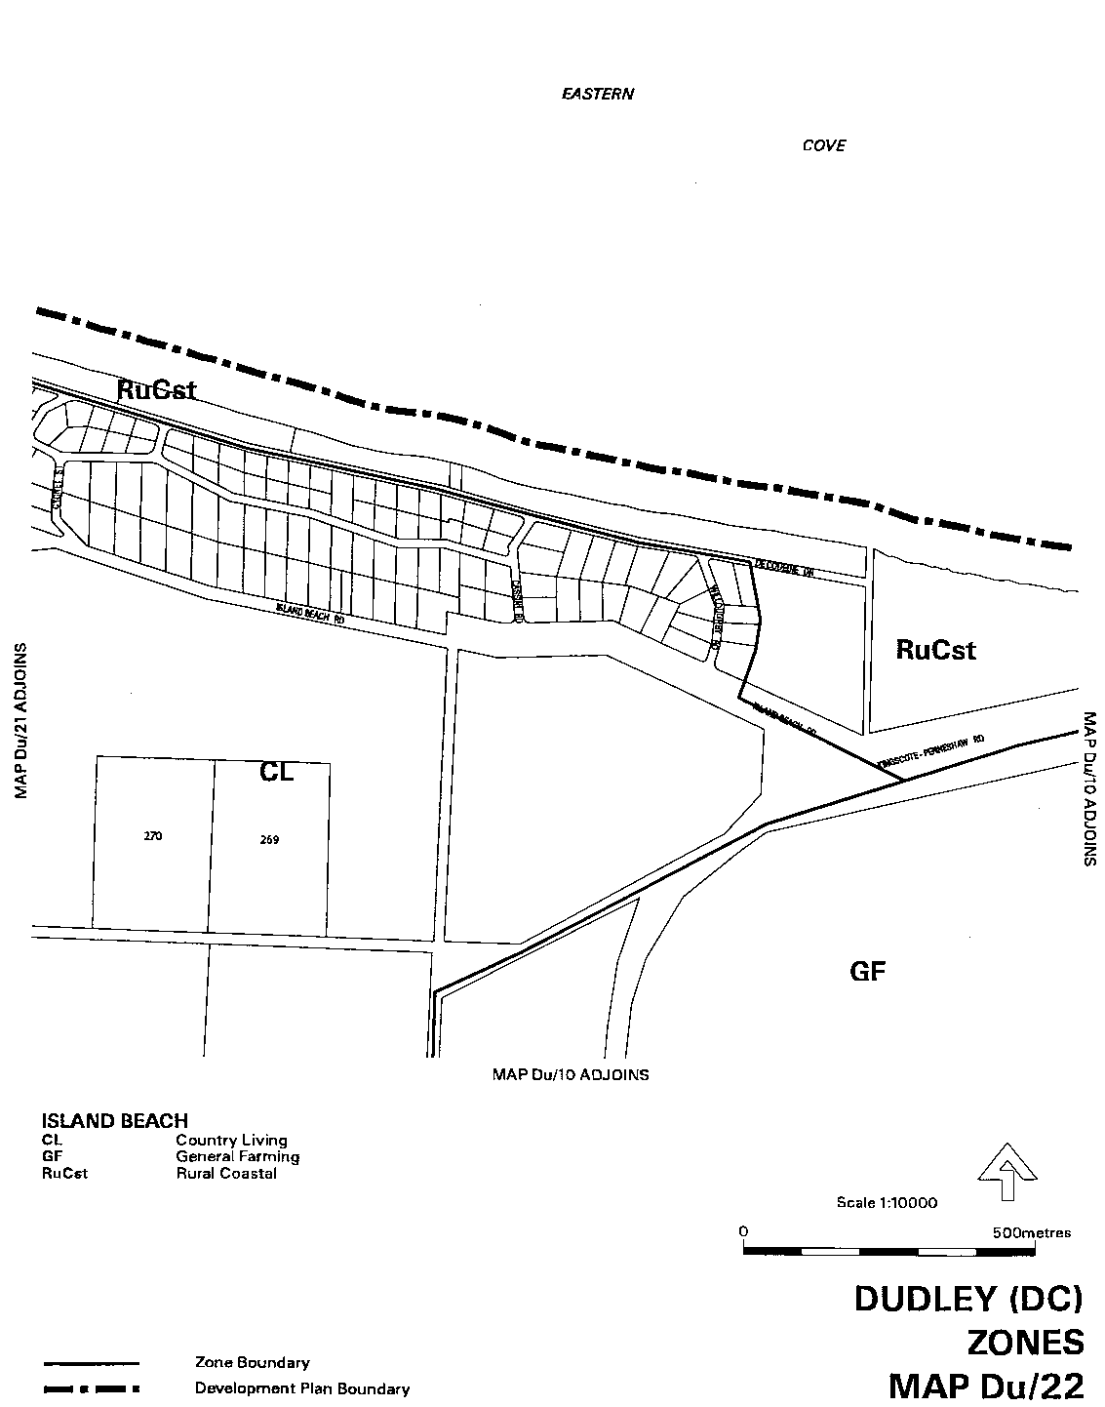
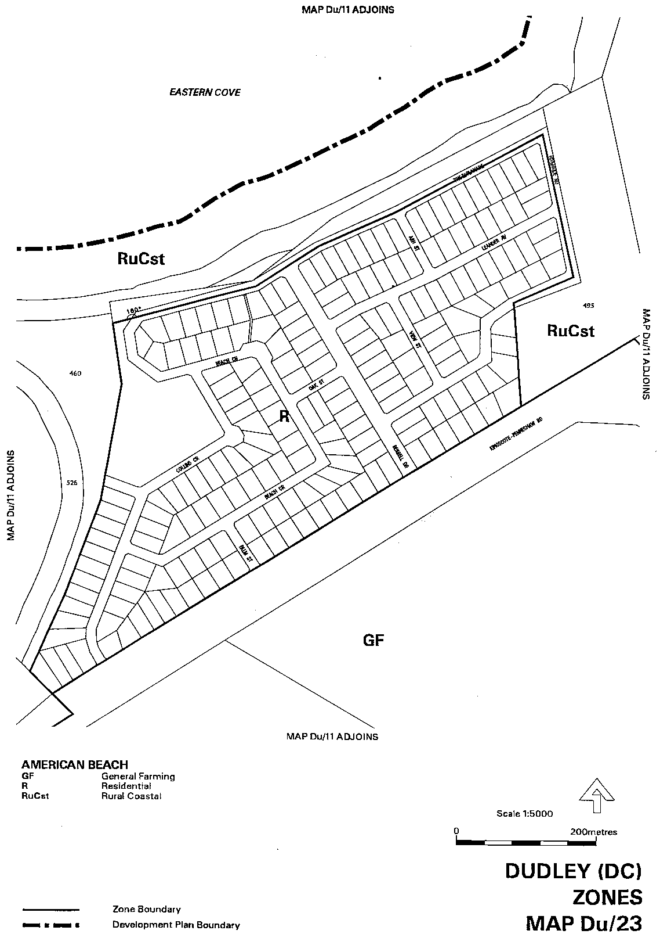
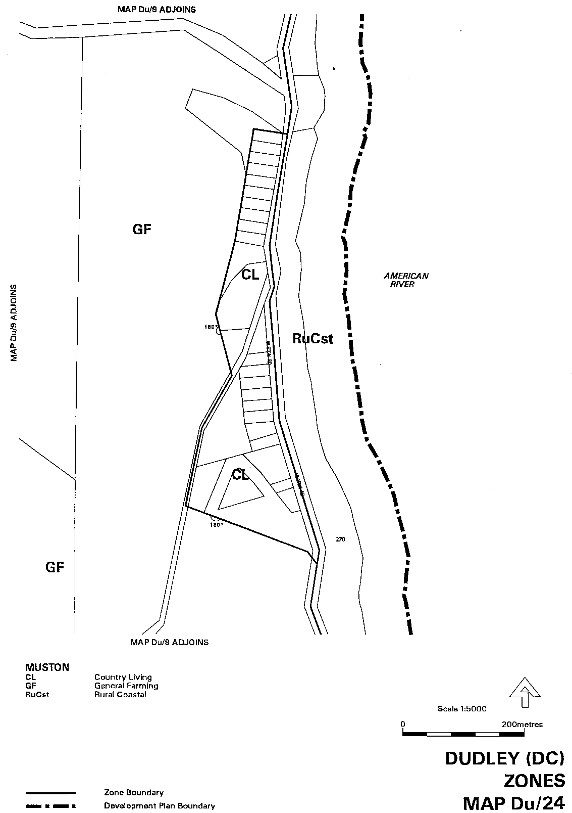
Dated 21 September 2000.
Diana Laidlaw, Minister for Transport, Urban Planning and the Arts

DEVELOPMENT ACT 1993, SECTION 29(2) (b): AMENDMENT TO THE KINGSCOTE (DC) DEVELOPMENT PLAN
Preamble
It is necessary to amend the Kingscote (DC) Development Plan dated 18 November 1999.
NOTICE
PURSUANT to Section 29(2) (b) of the Development Act 1993, I, Diana Laidlaw, being the Minister administering the Act, amend
The Kingscote (DC) Development Plan, dated 18 November 1999 as follows:
1.(a) Delete Maps KI/1 to KI/25;
1.(b) insert the contents of Attachment A; and
1.(c) adjust the mapping references in the Kingscote (DC) Development Plan text accordingly.
2.(a) Insert the contents of Attachment B in the Tourist Accommodation (Tandanya) Zone, immediately following the page where principle of development control number 1 appears; and
2.(b) renumber the subsequent pages.
Attachment A
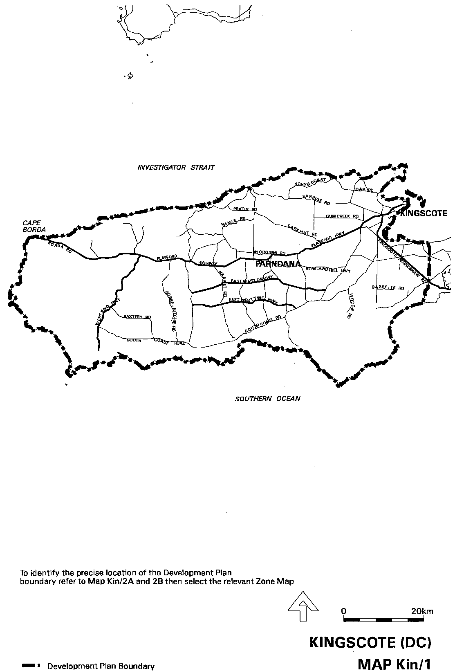
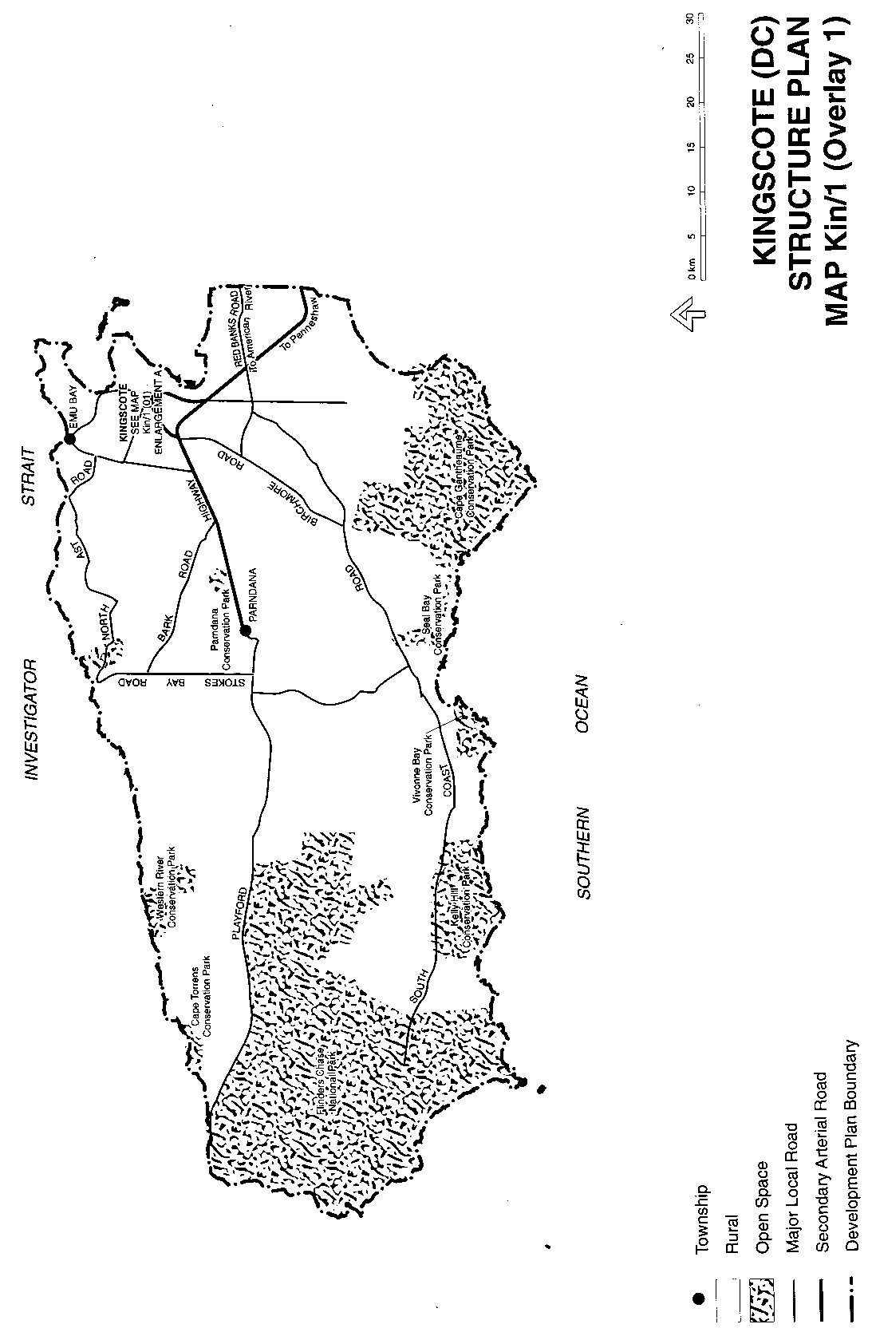
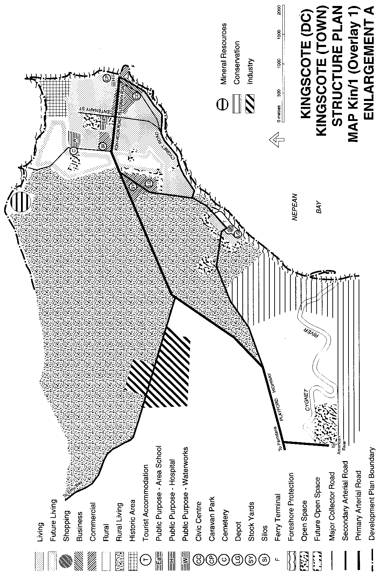
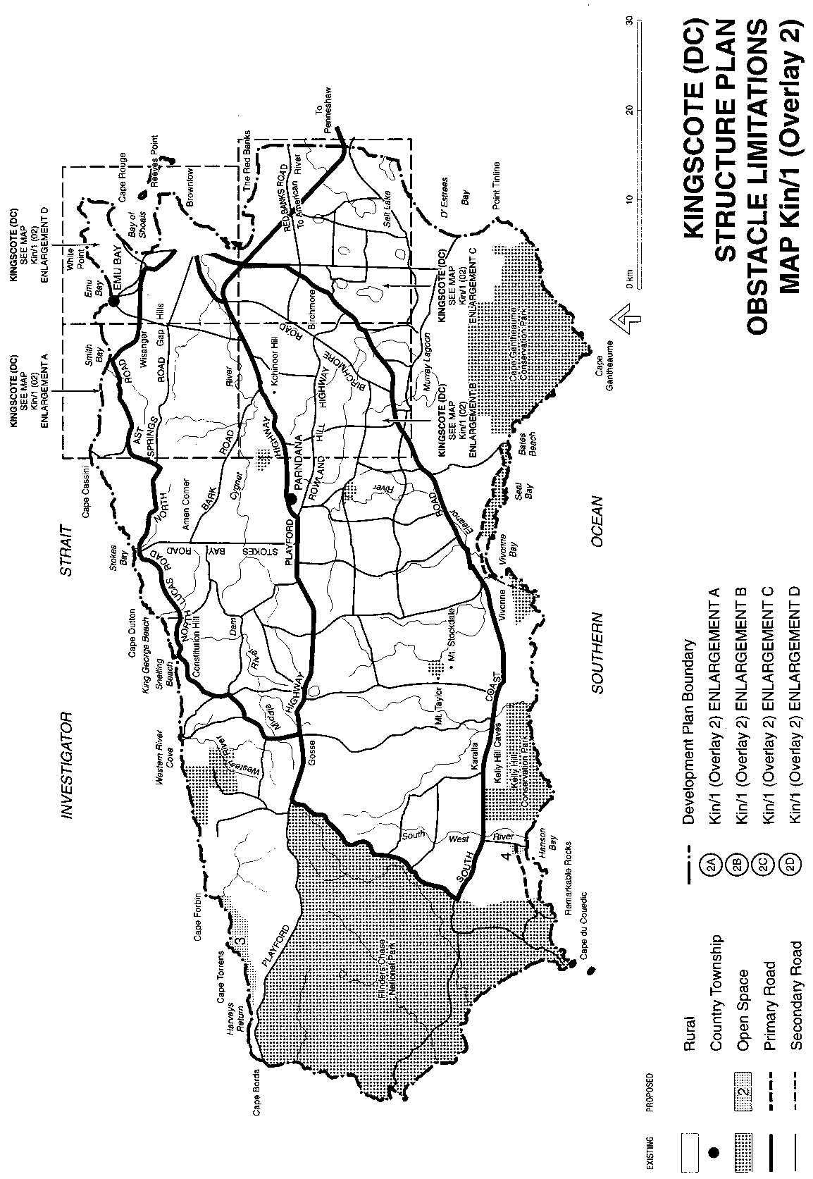
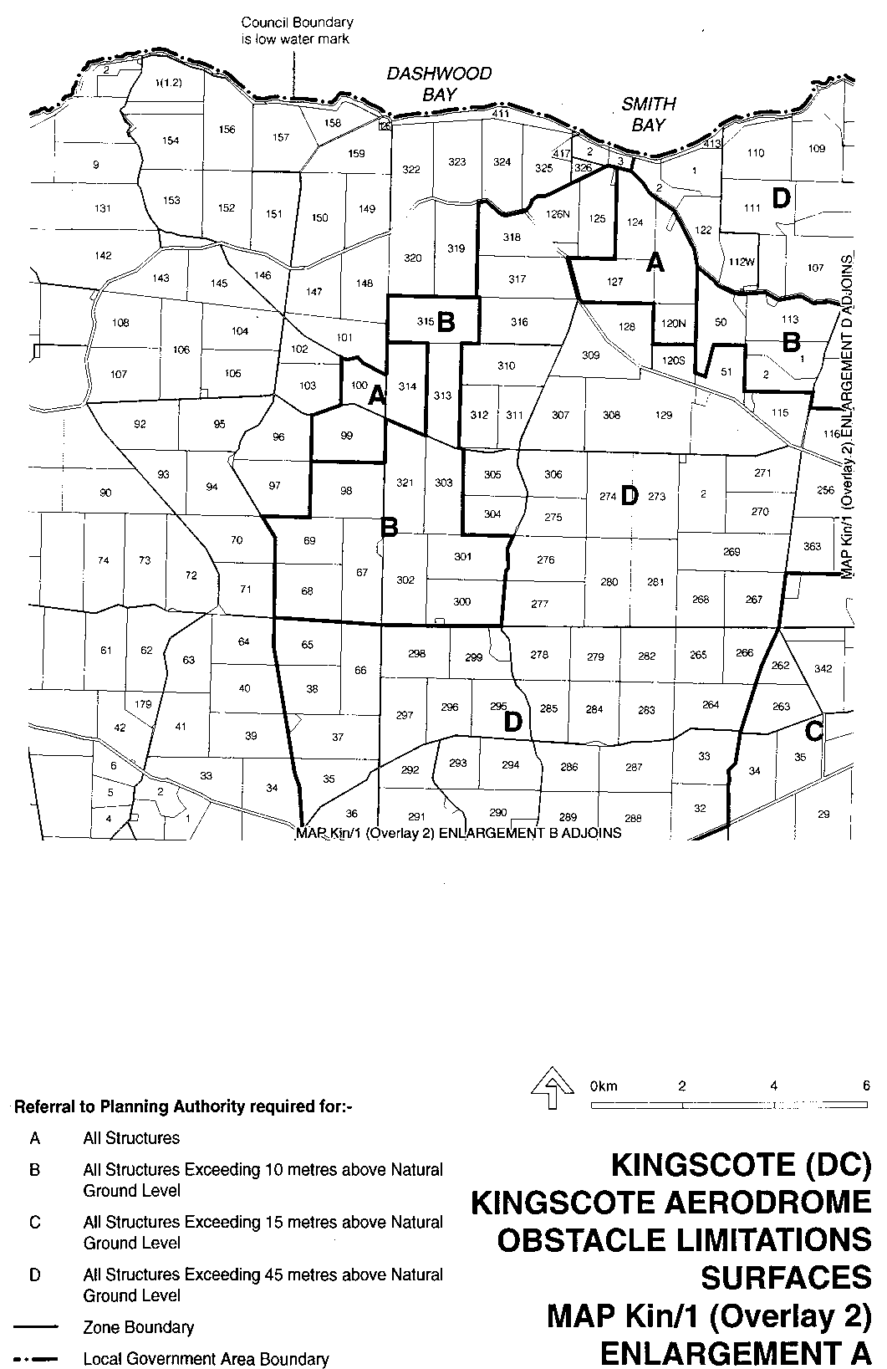
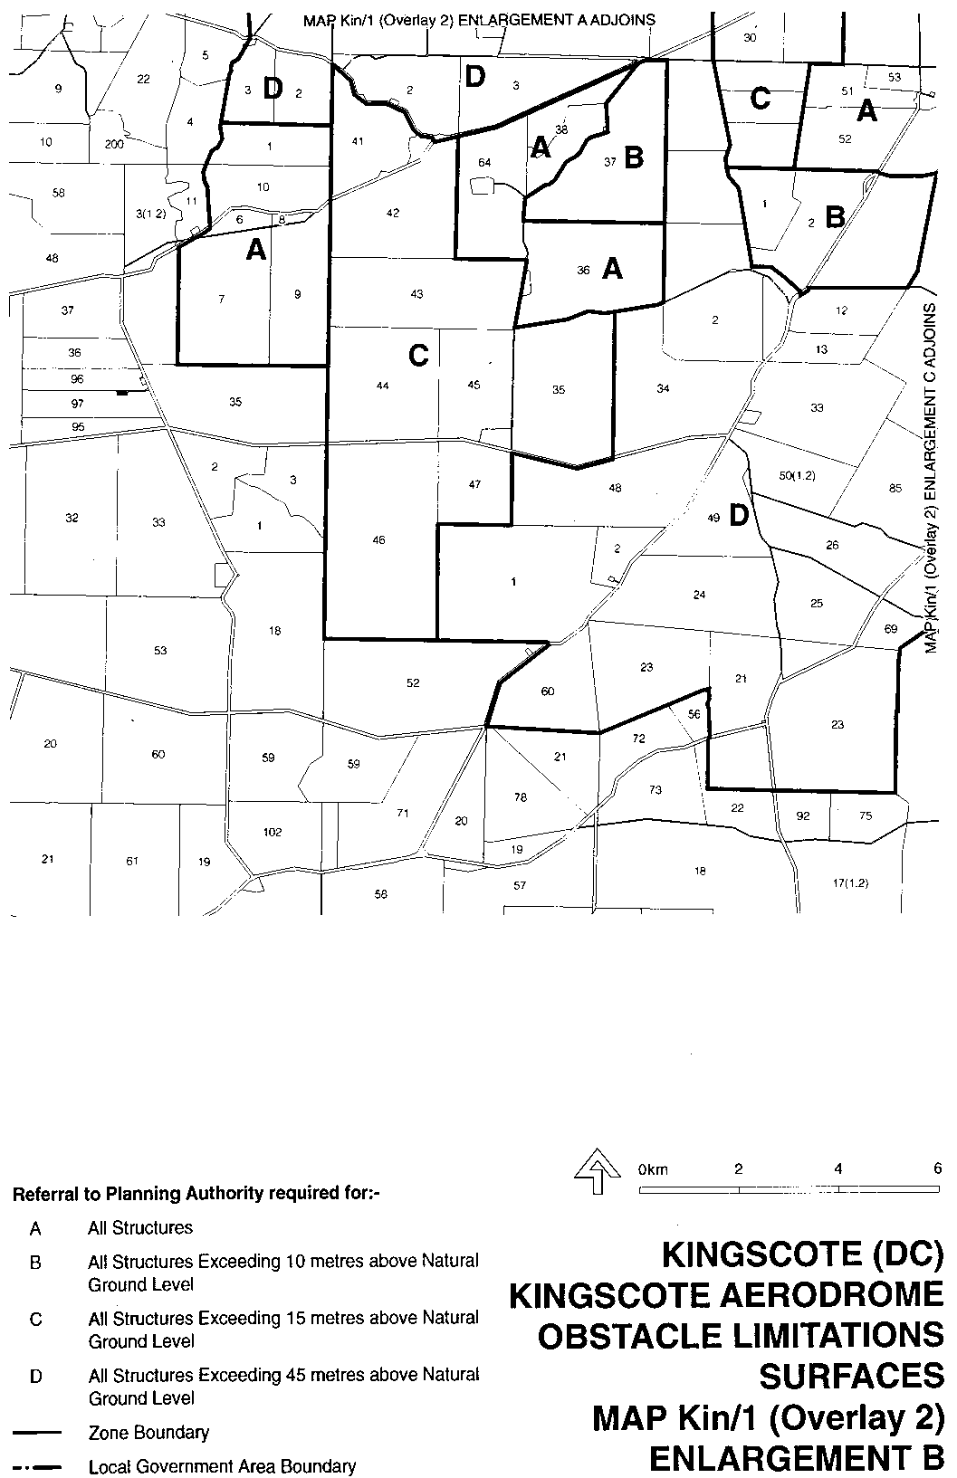
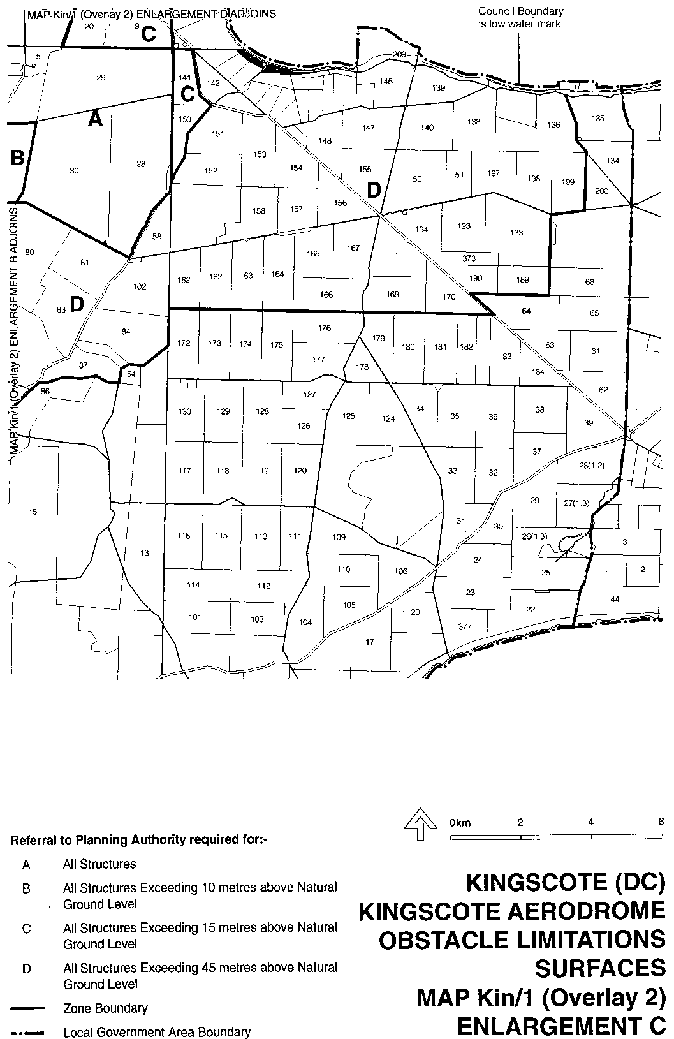
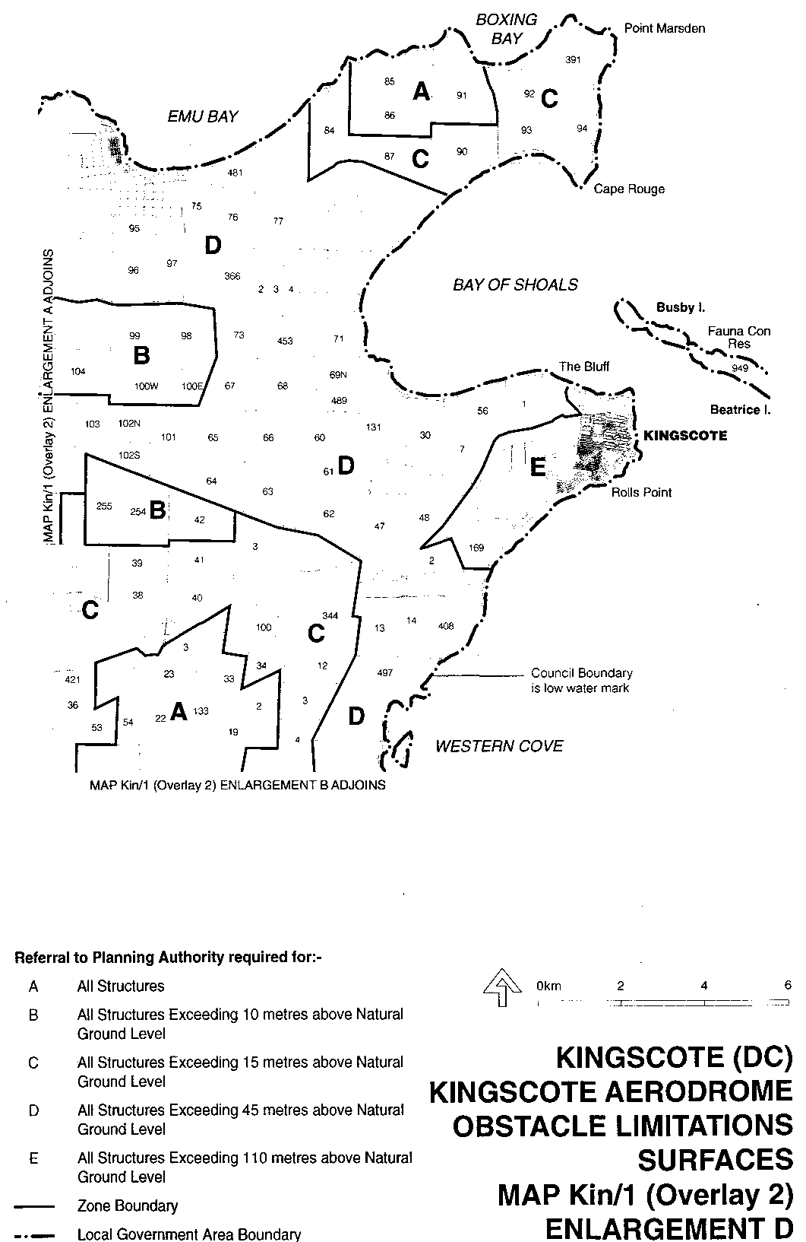
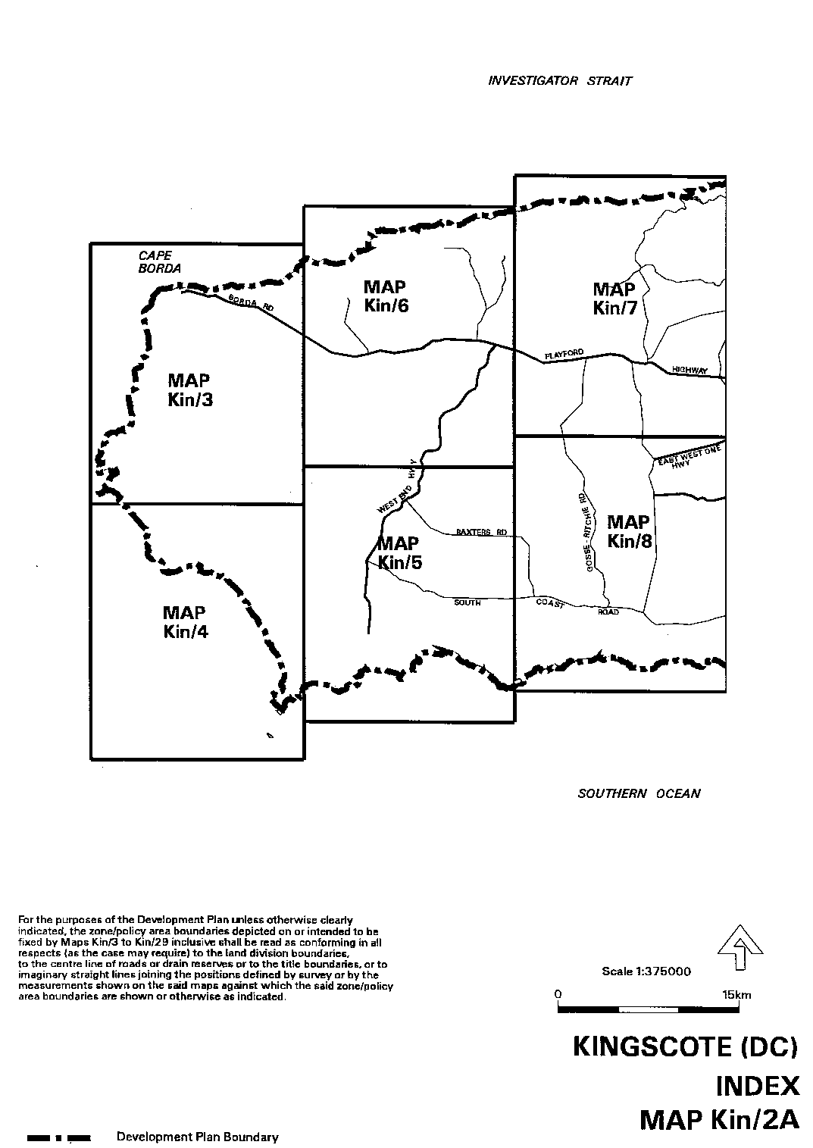
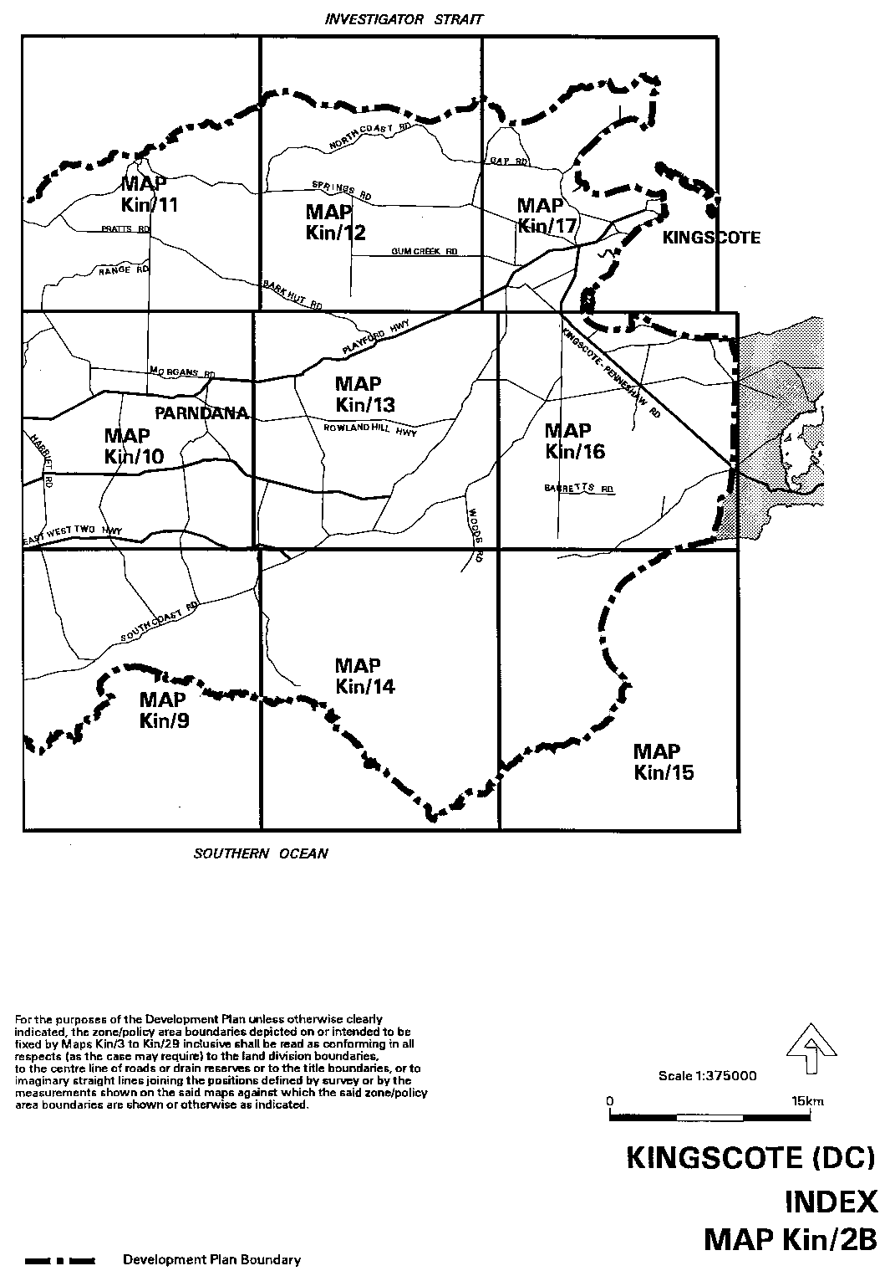
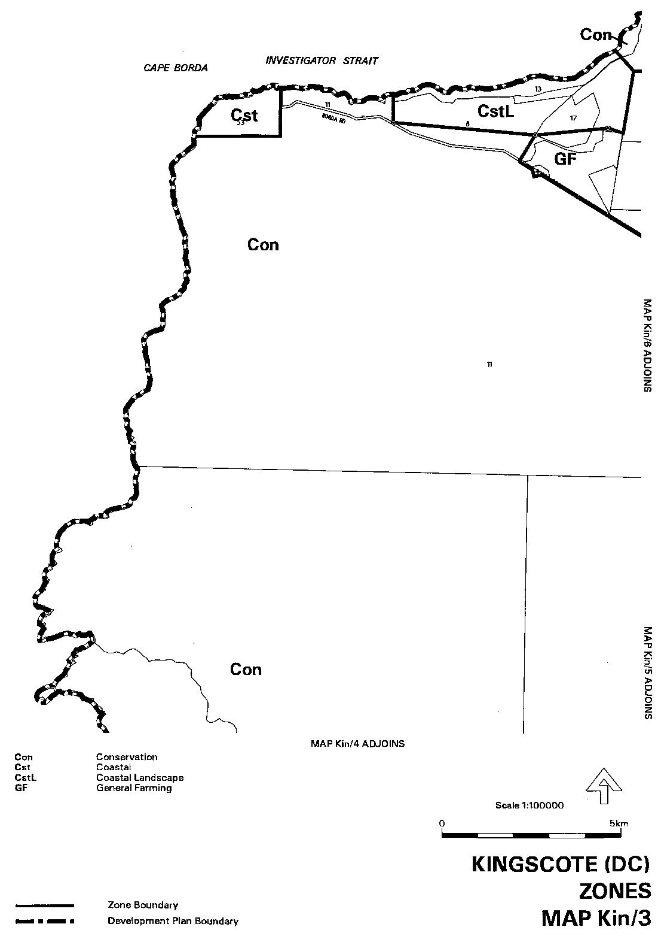
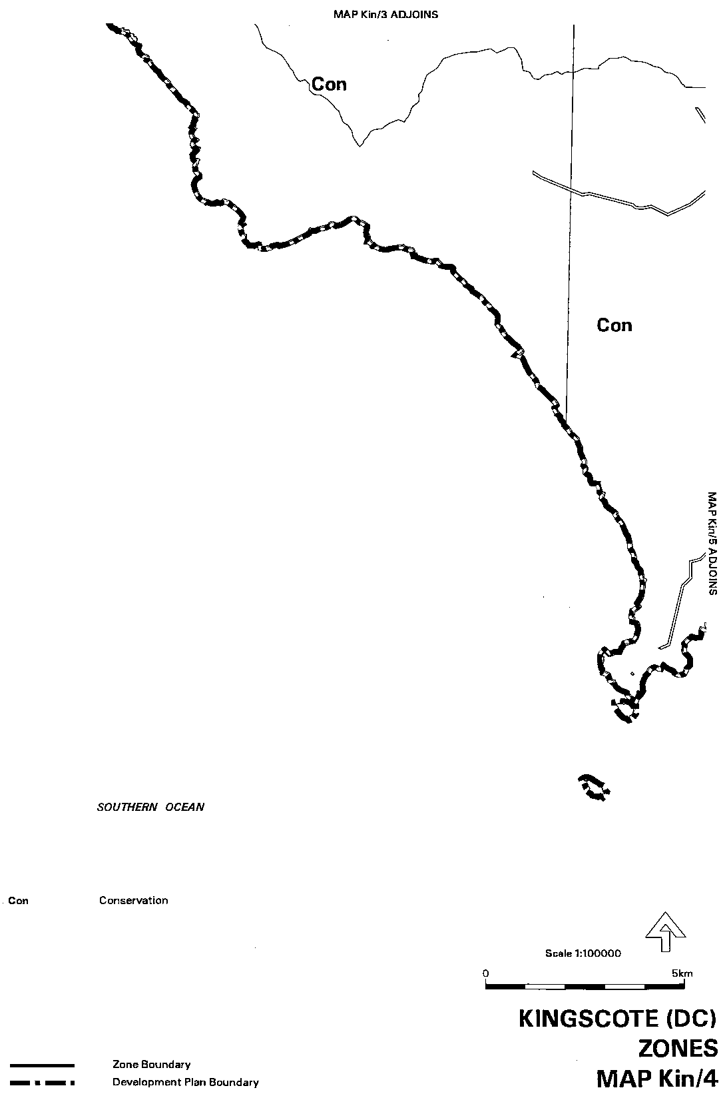
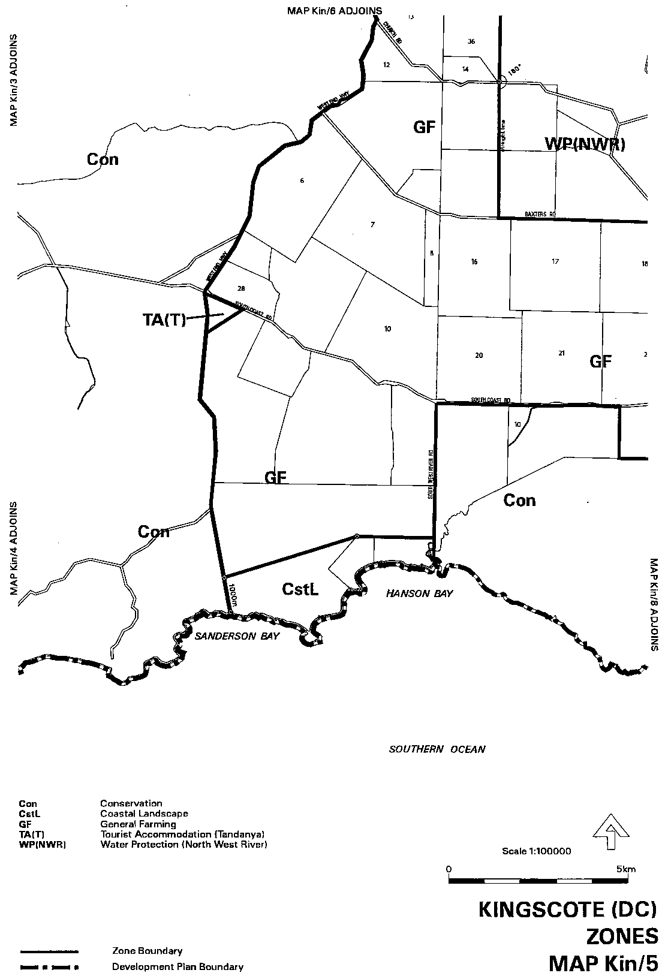
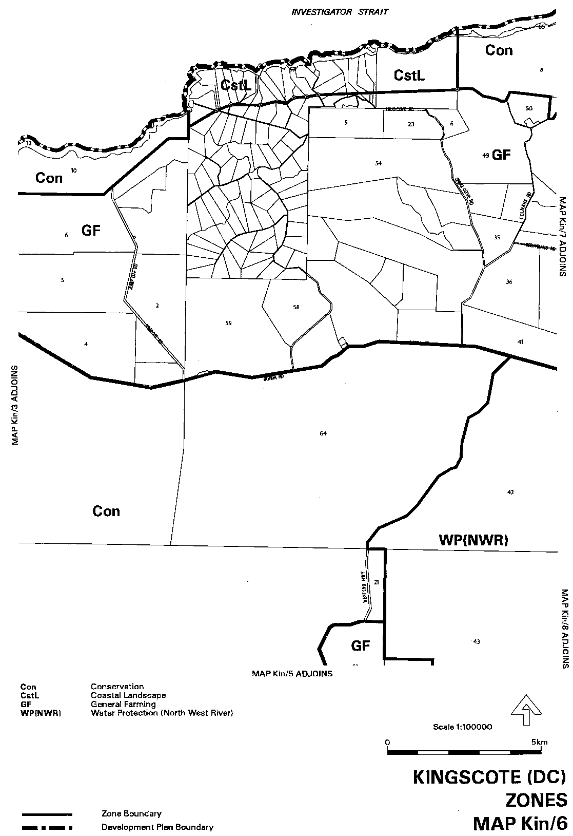
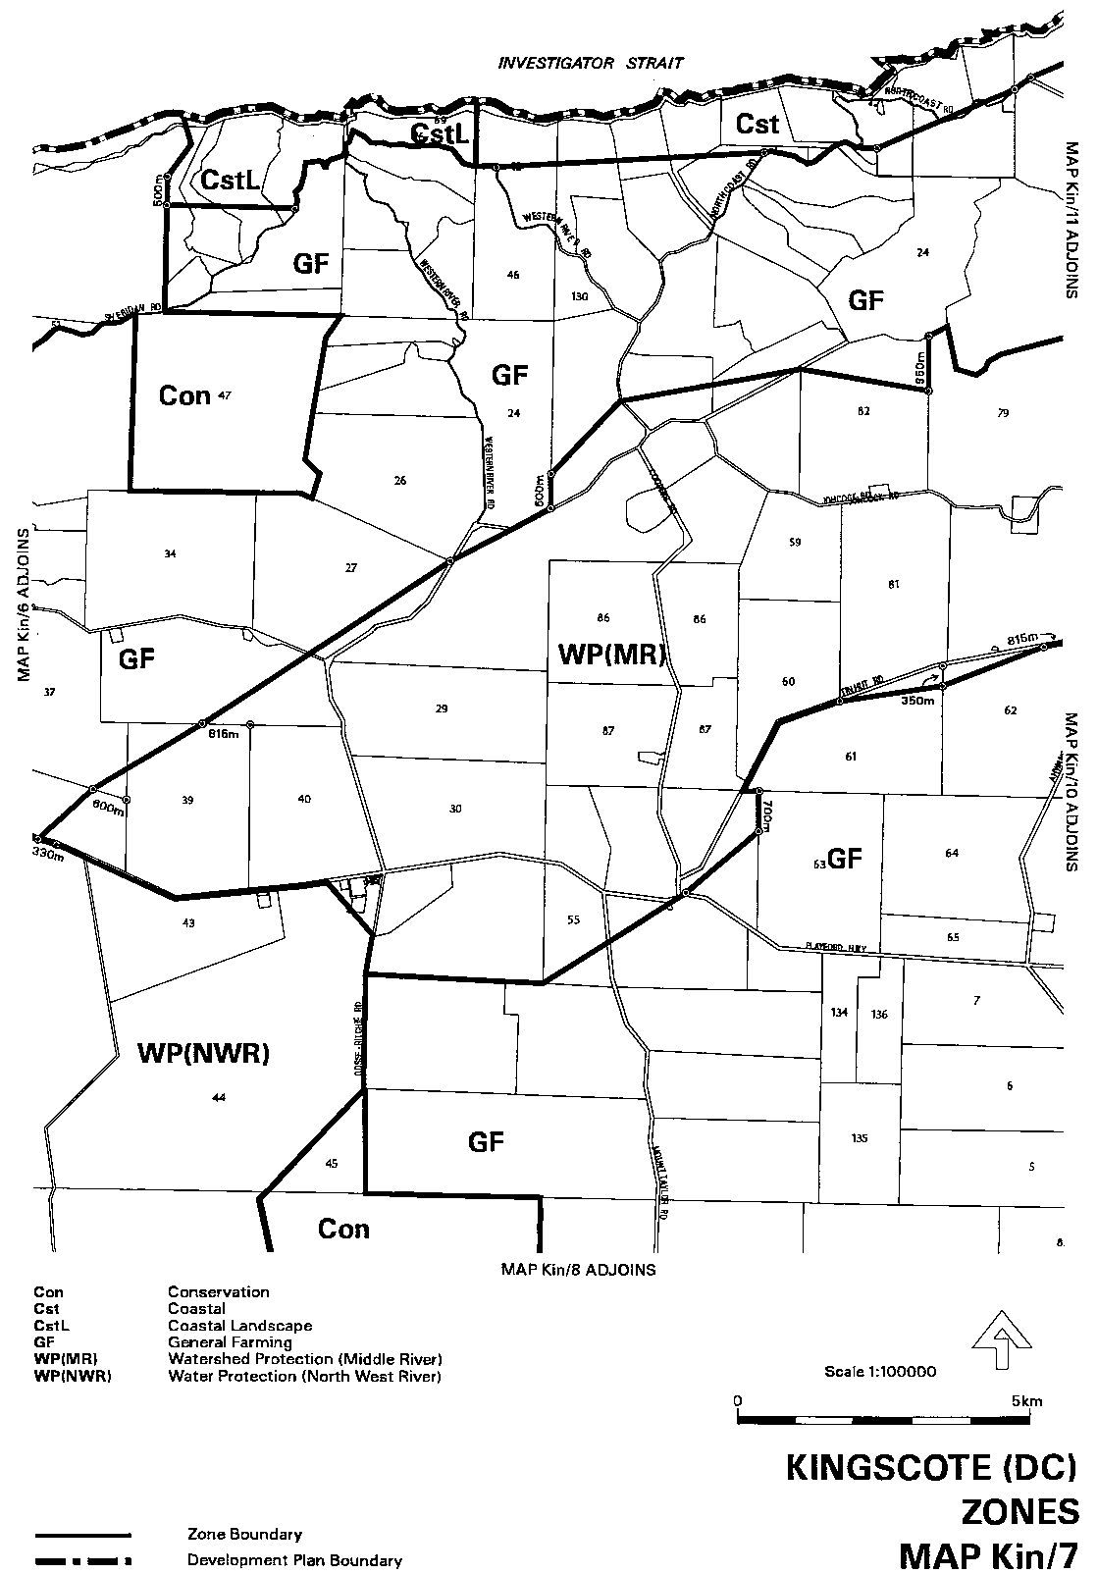
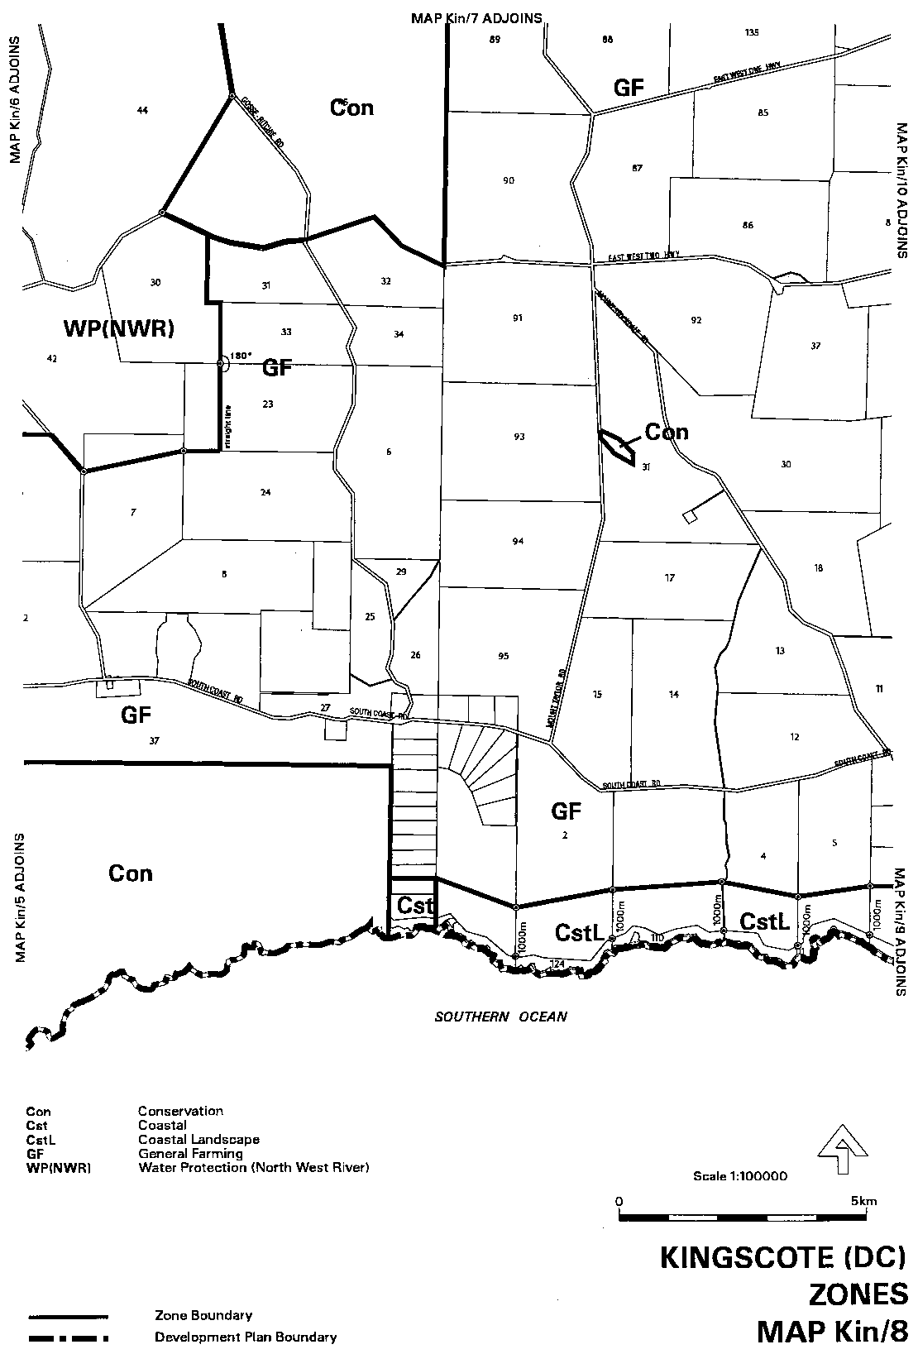
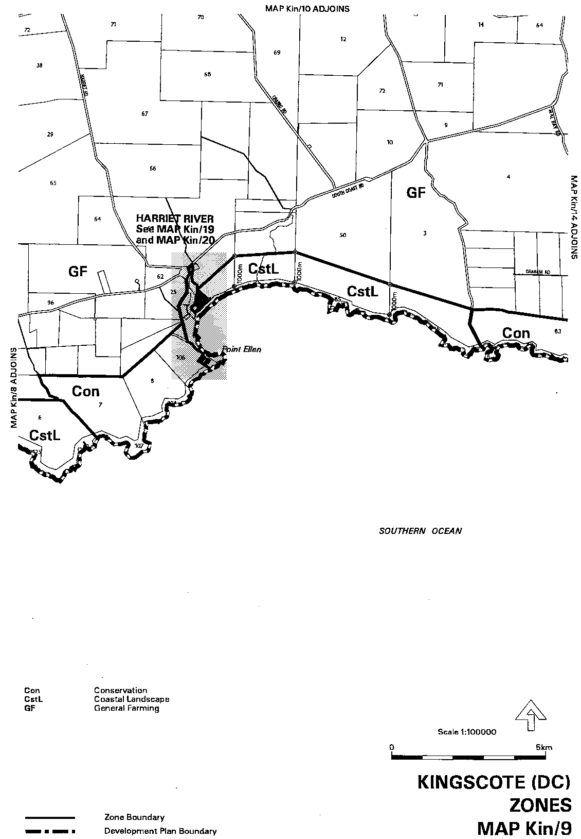
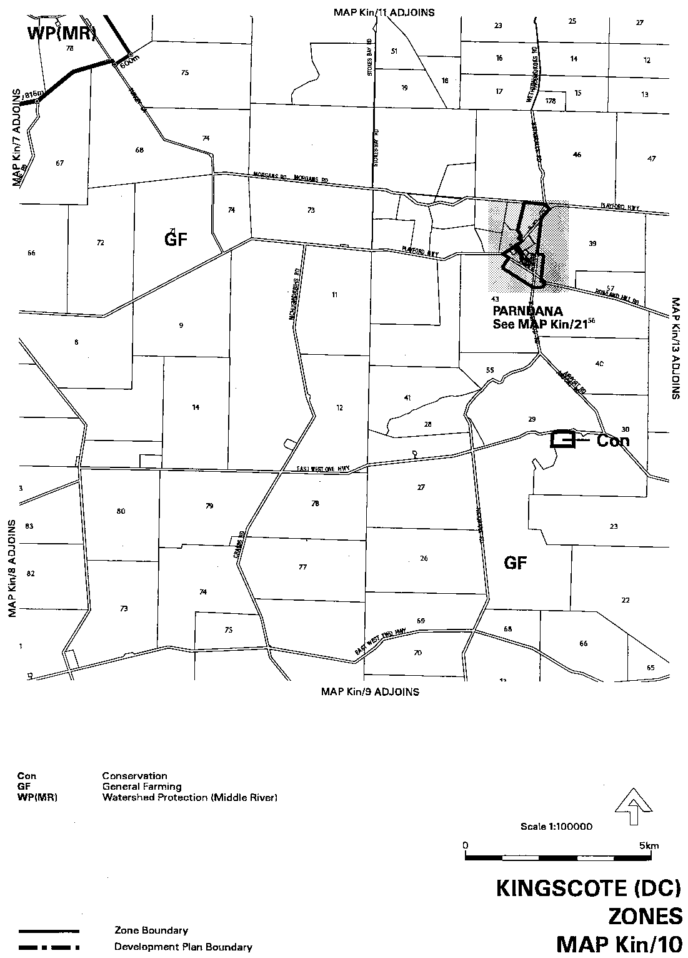
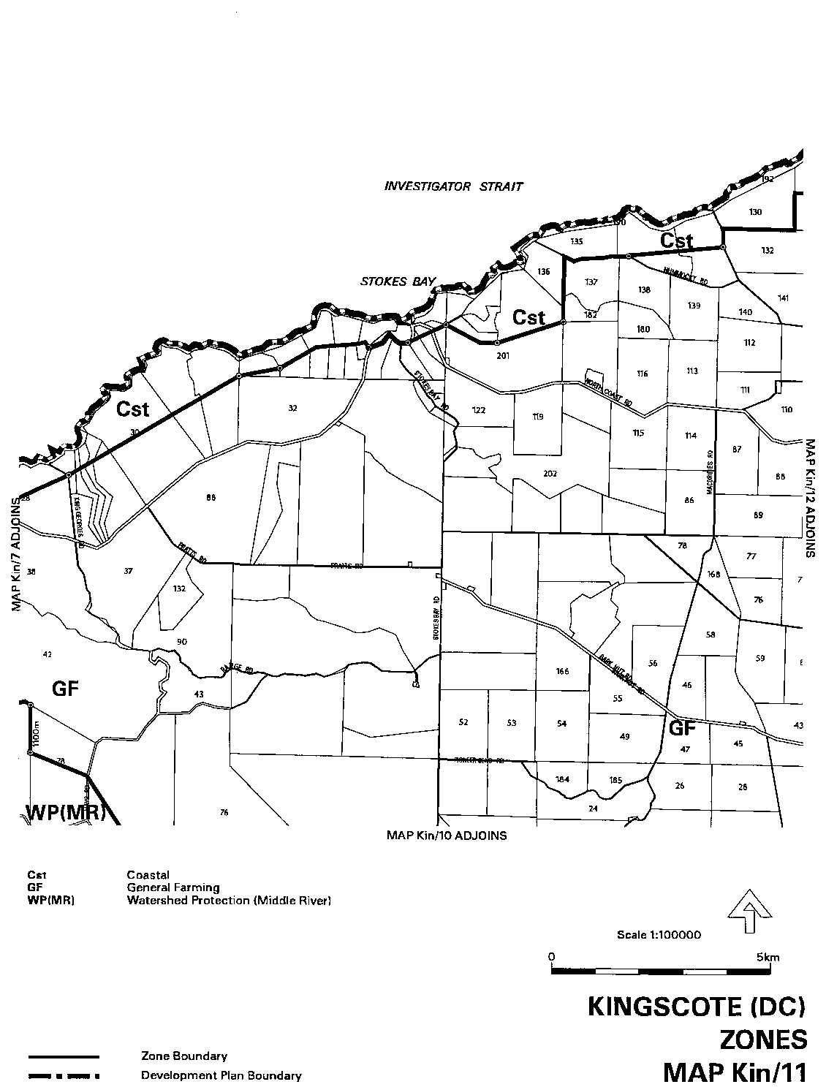
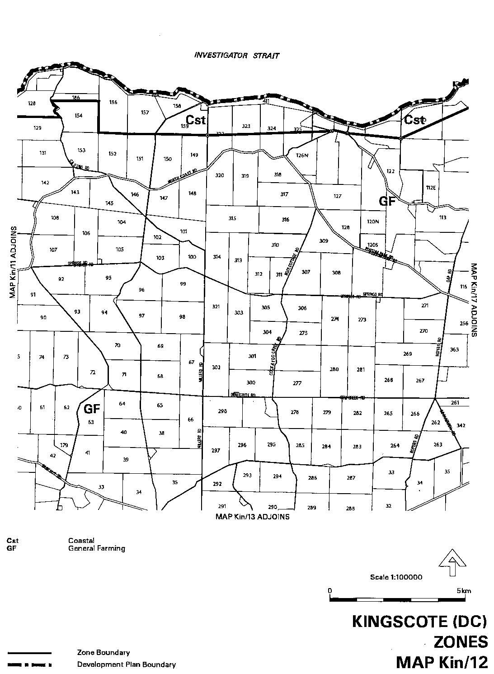
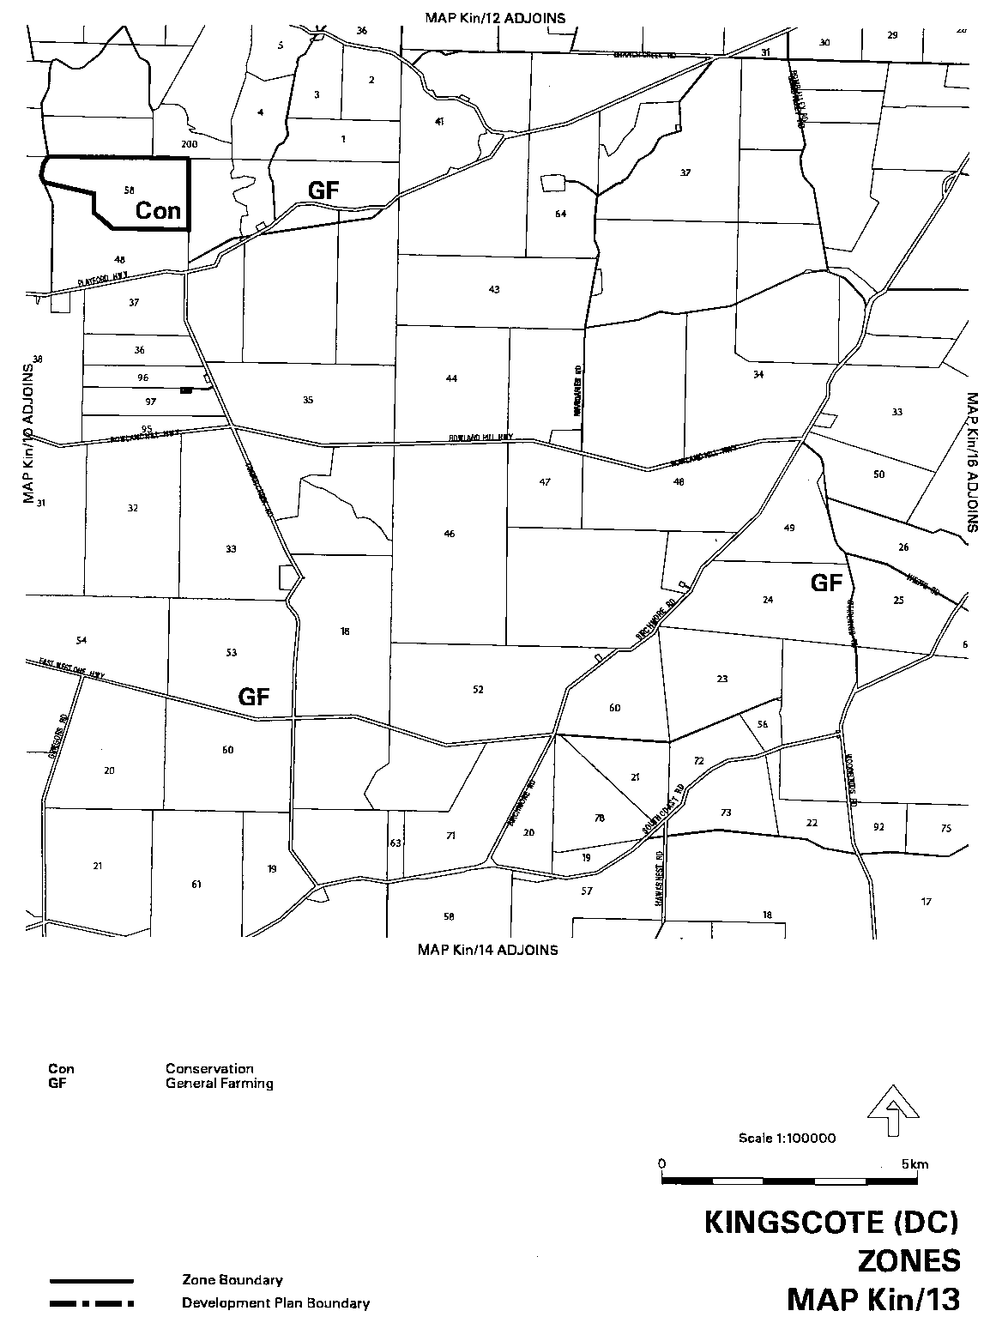
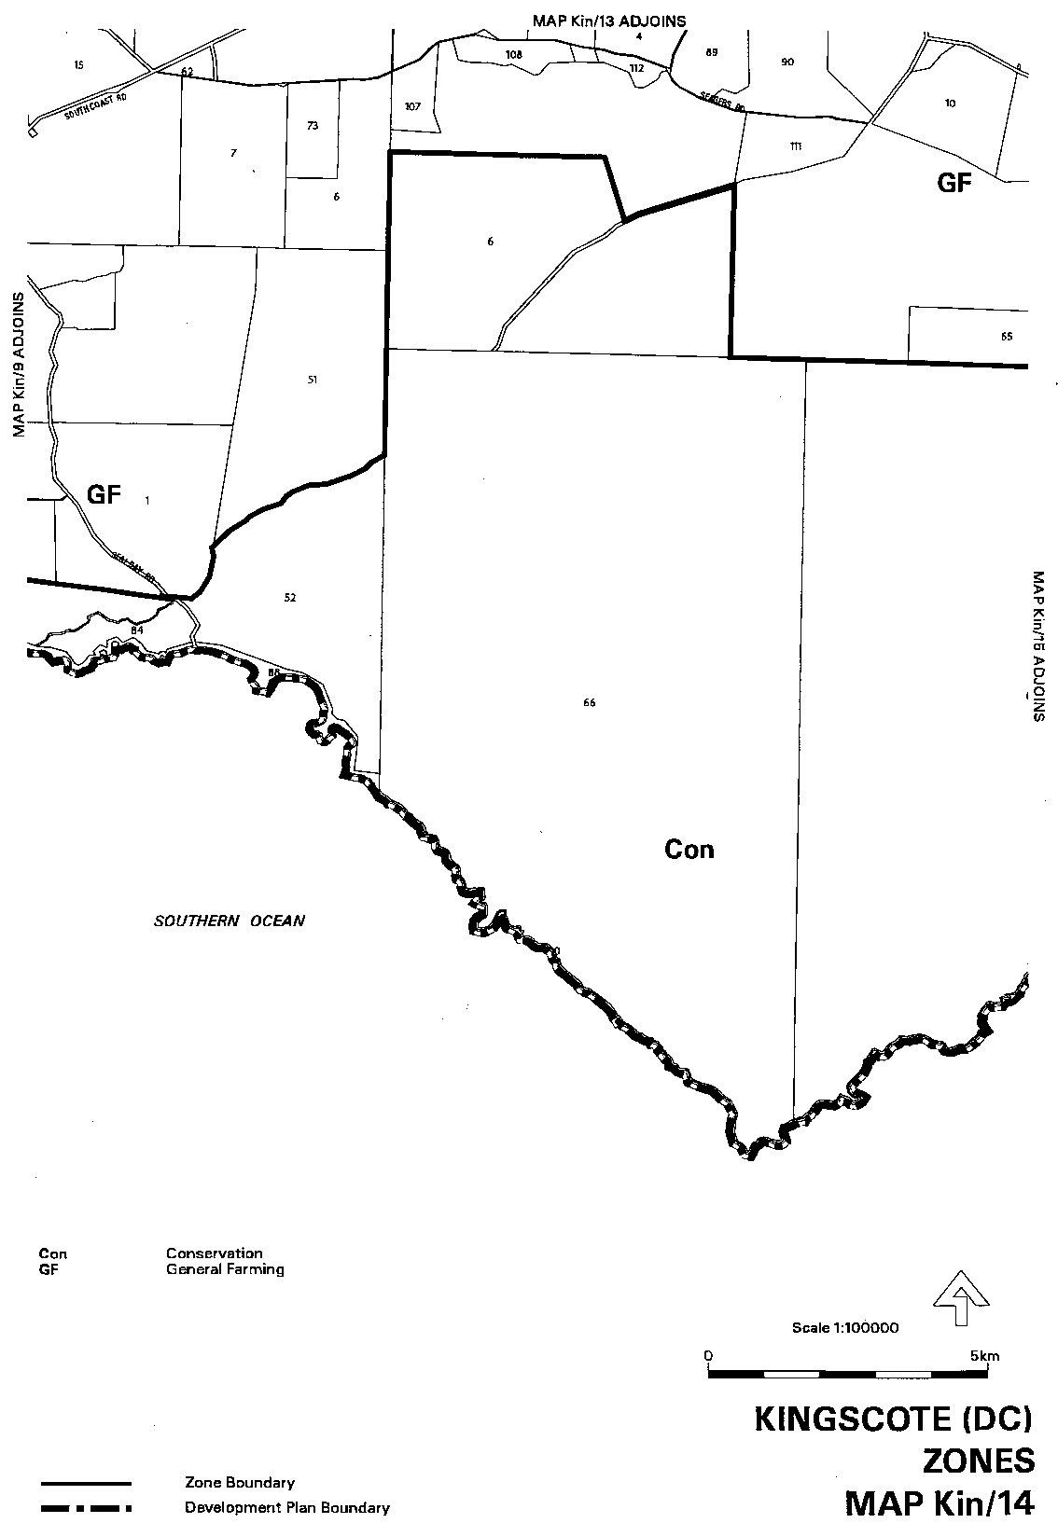
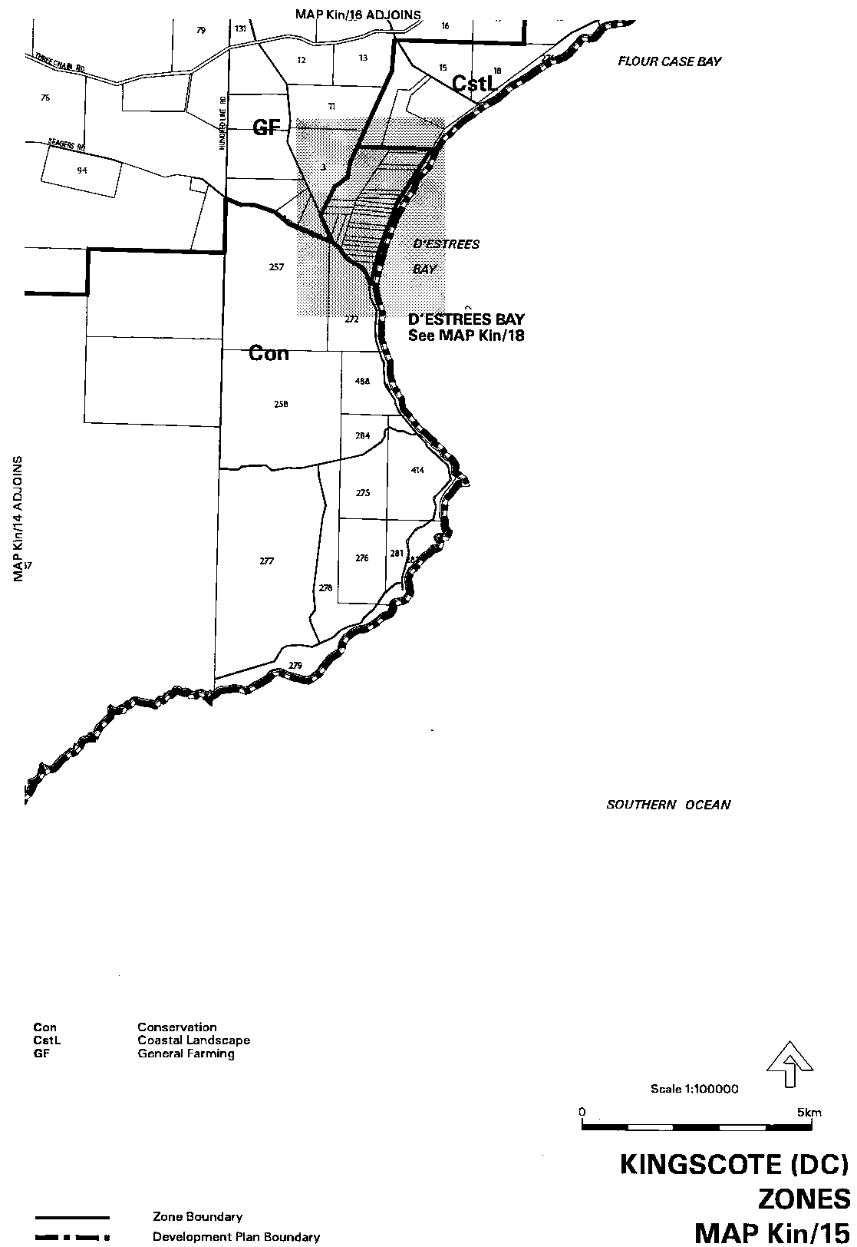
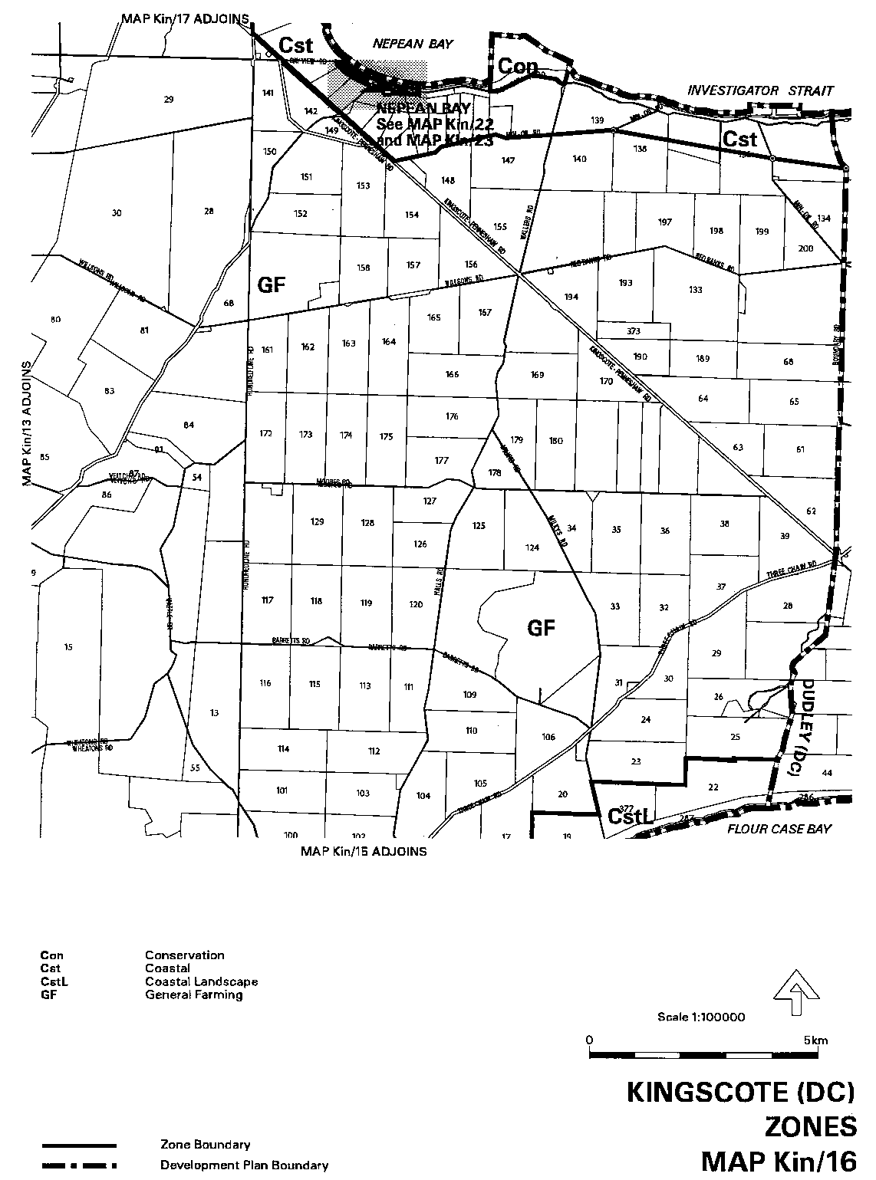
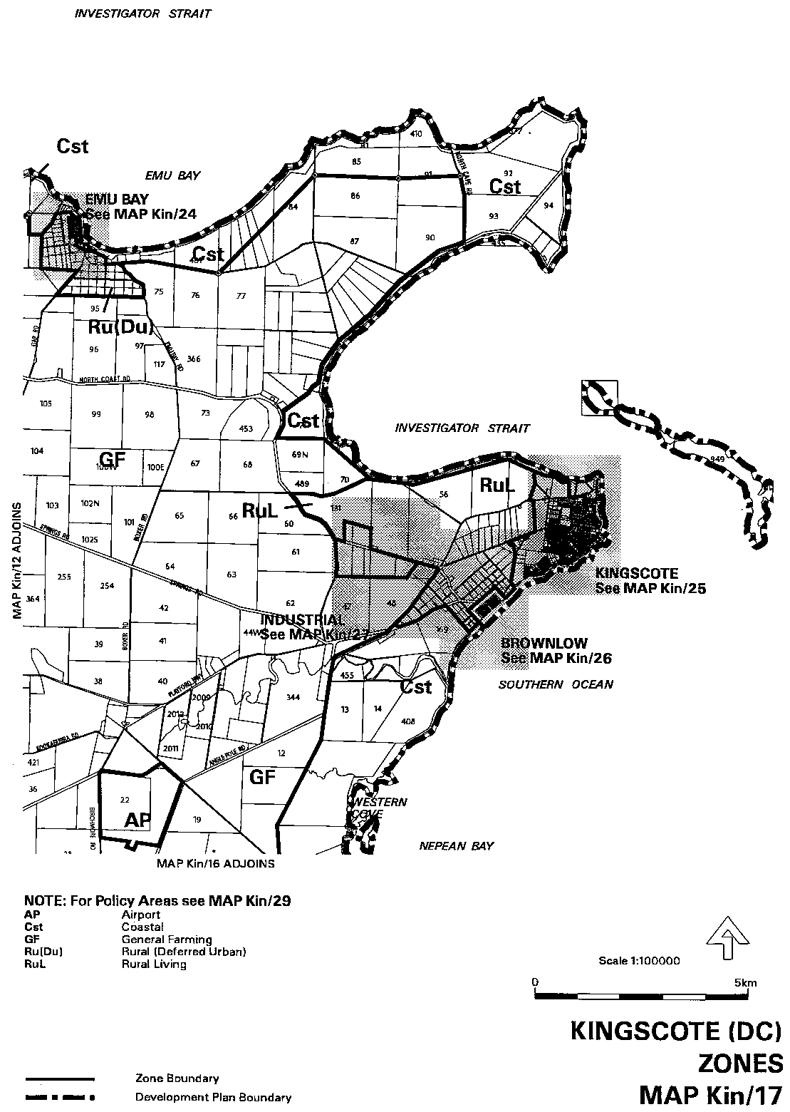
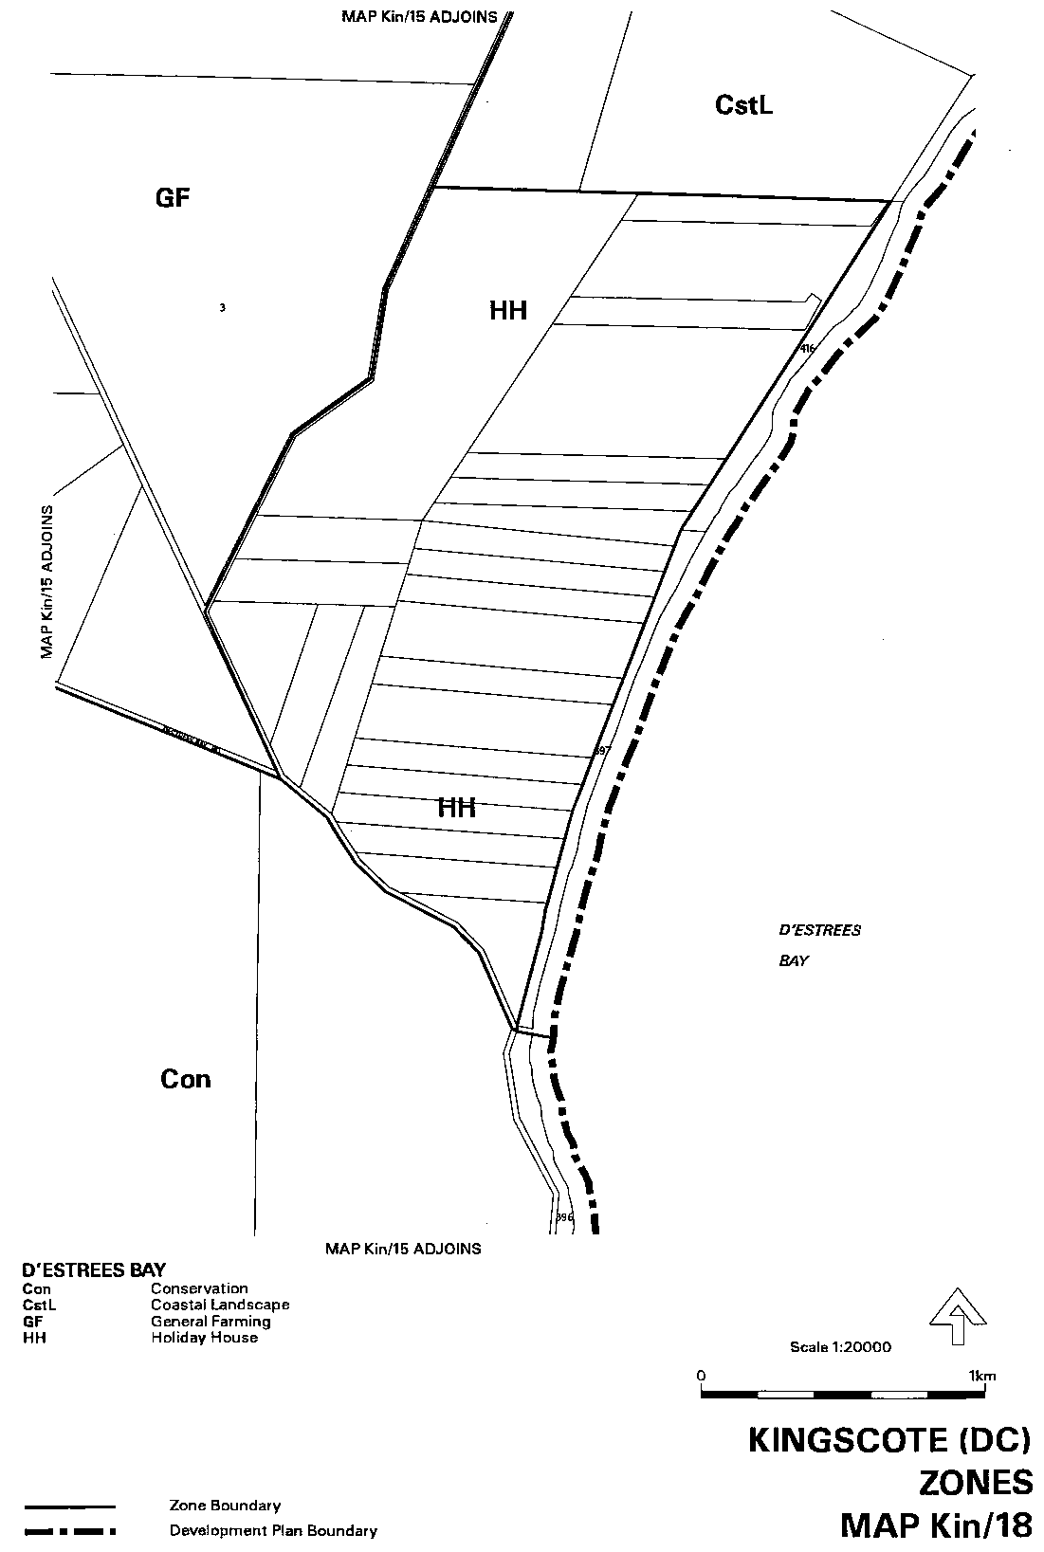
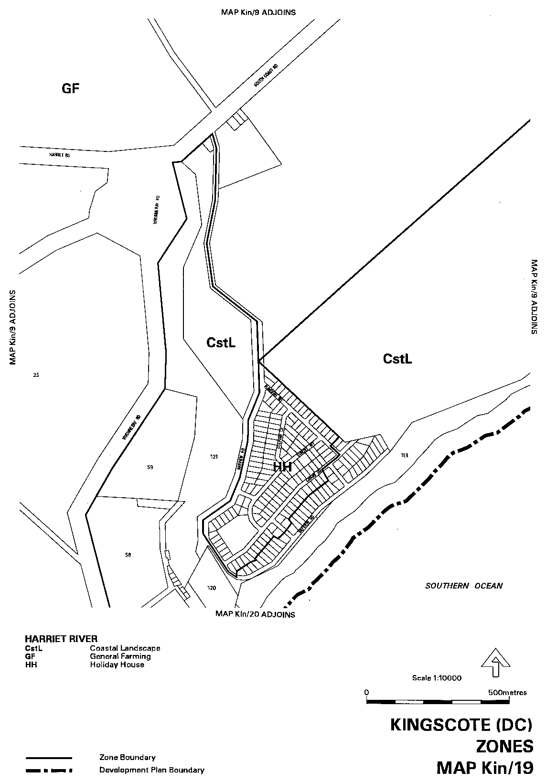
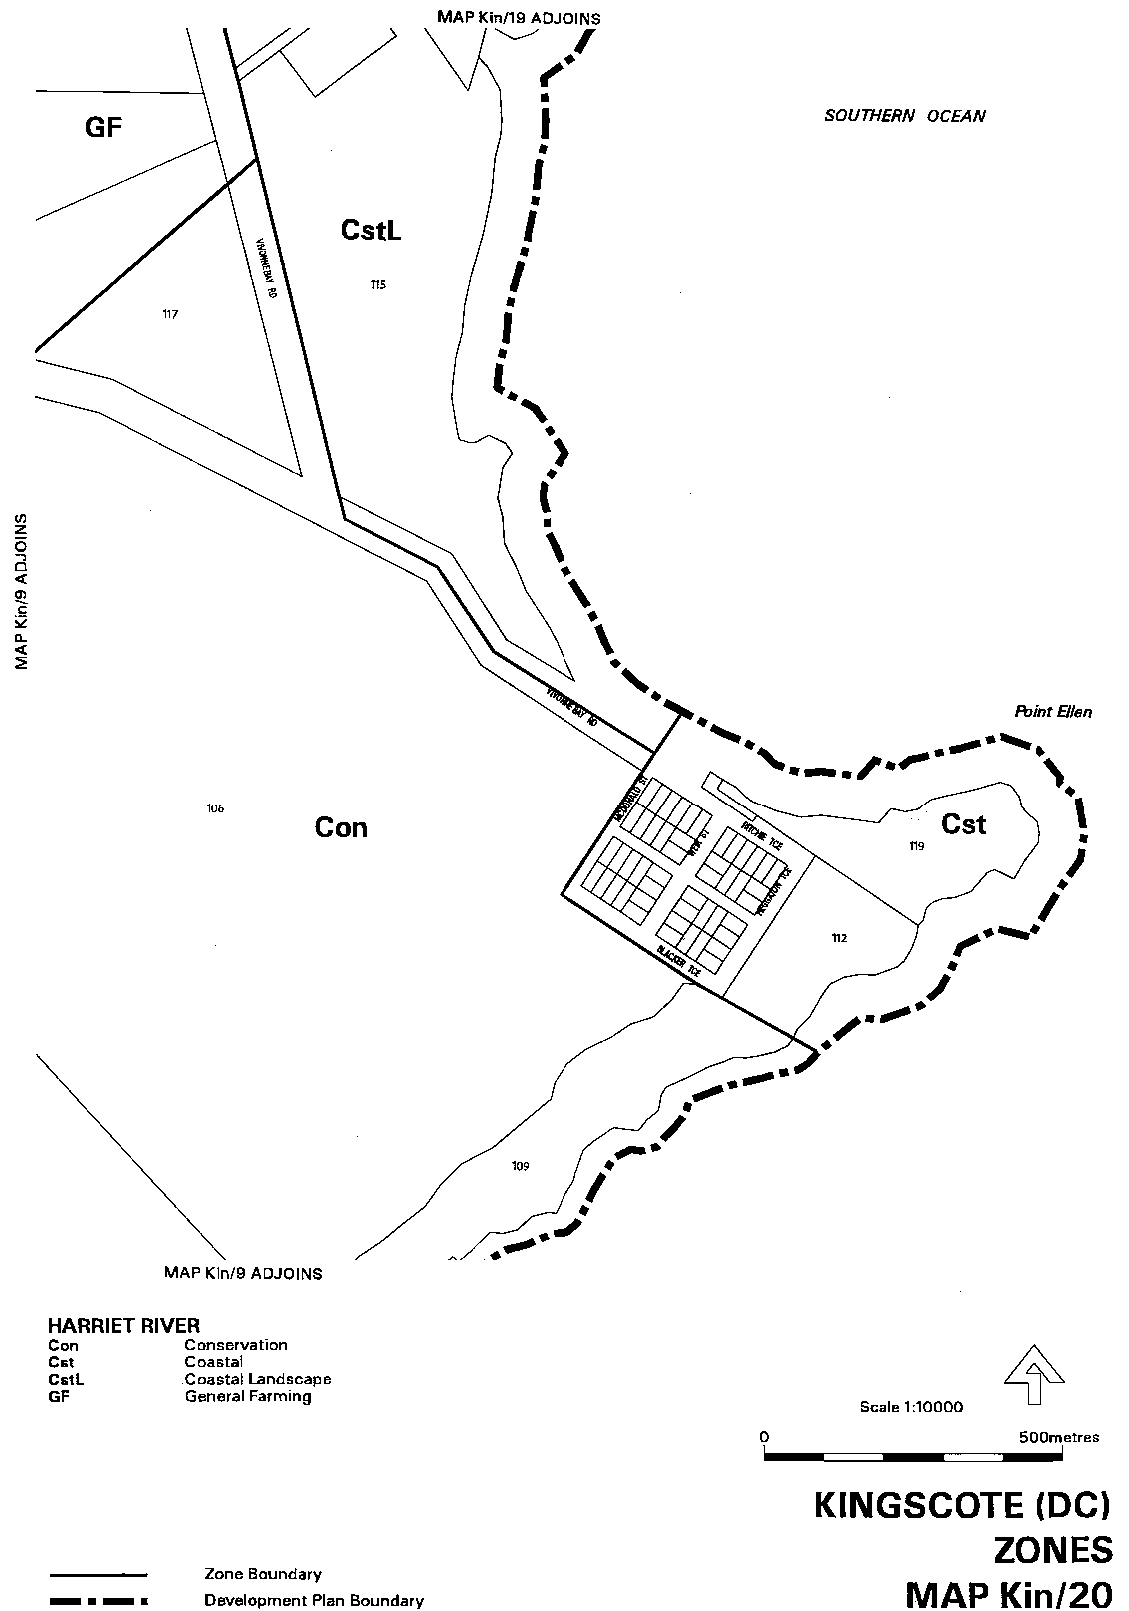
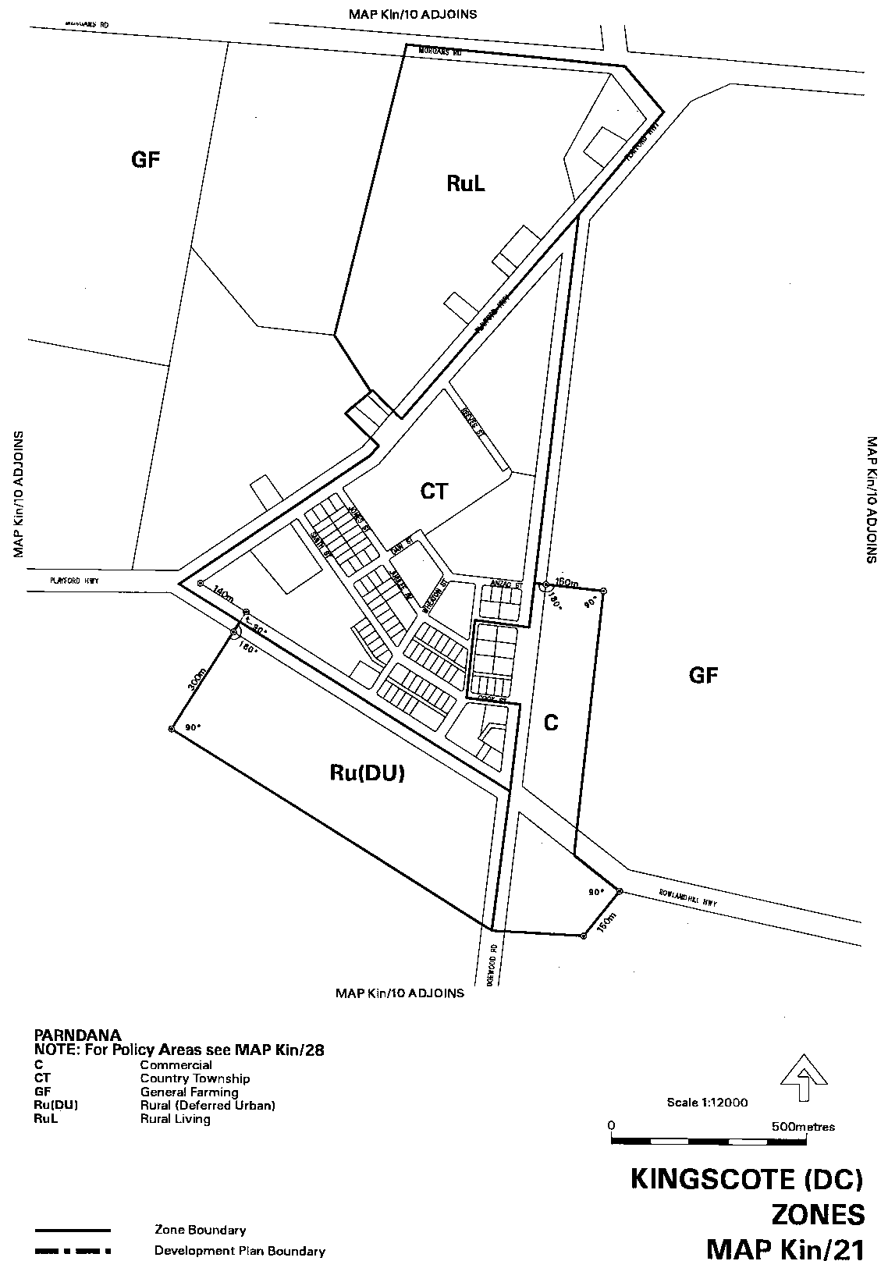
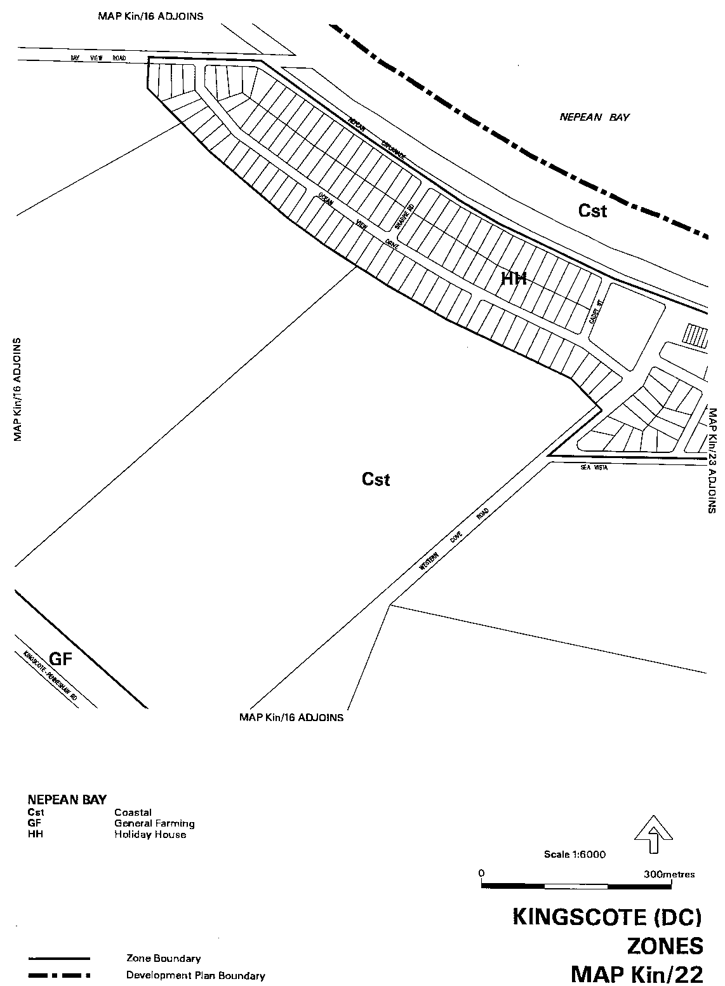
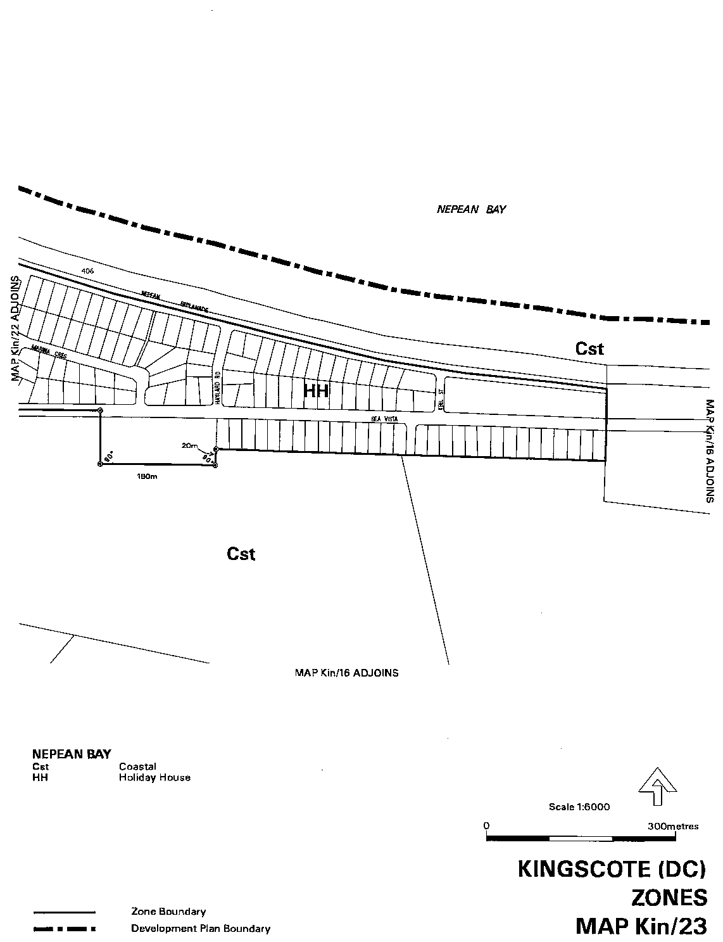
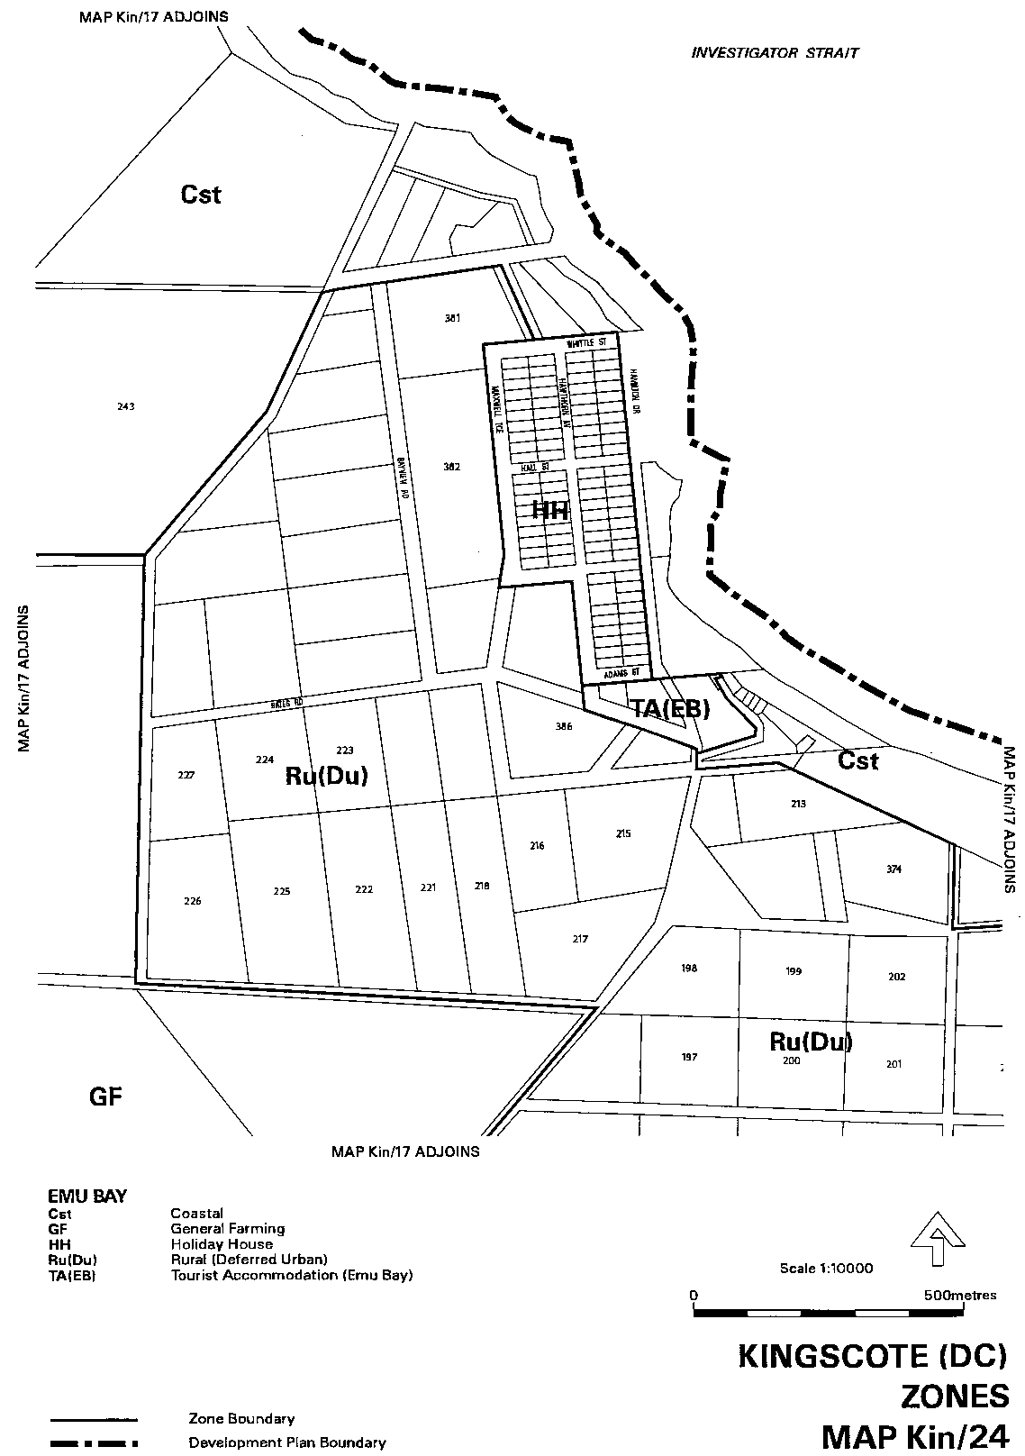
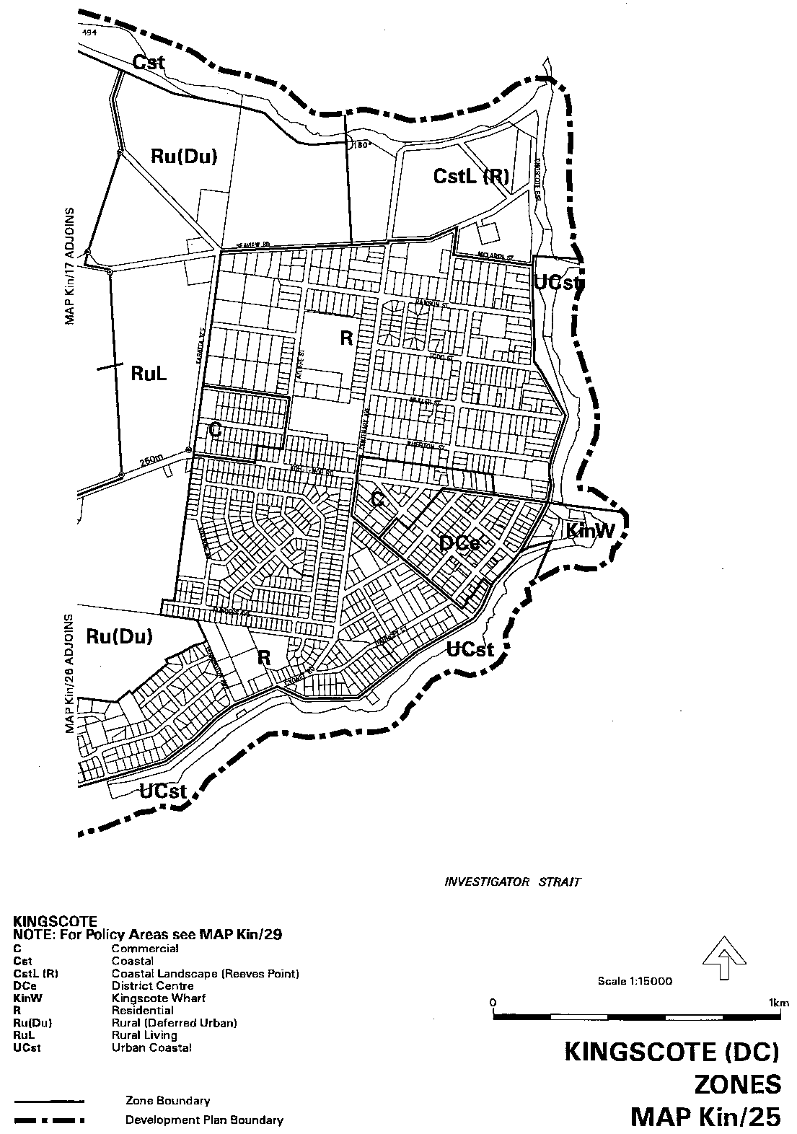
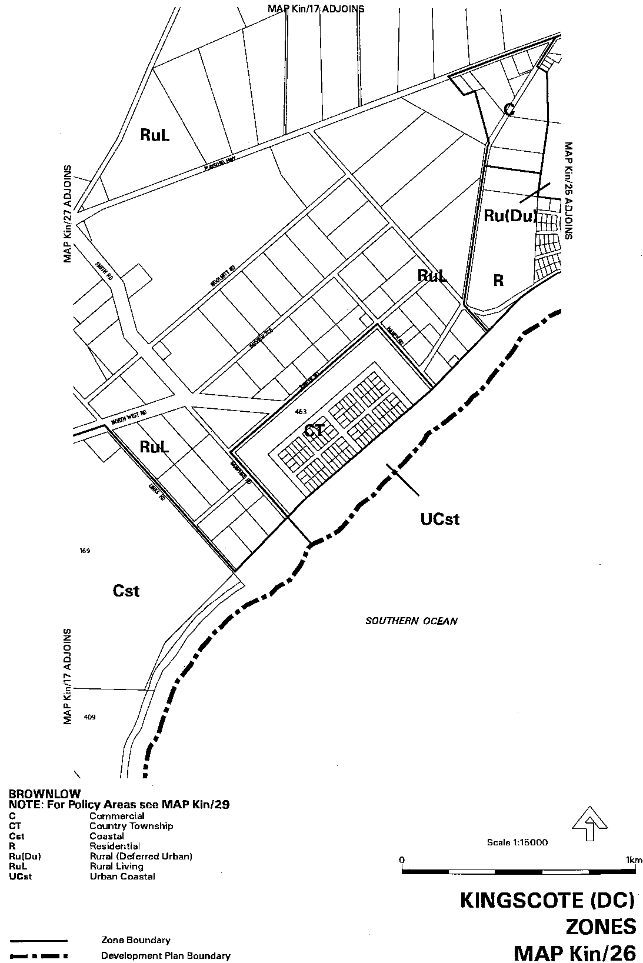
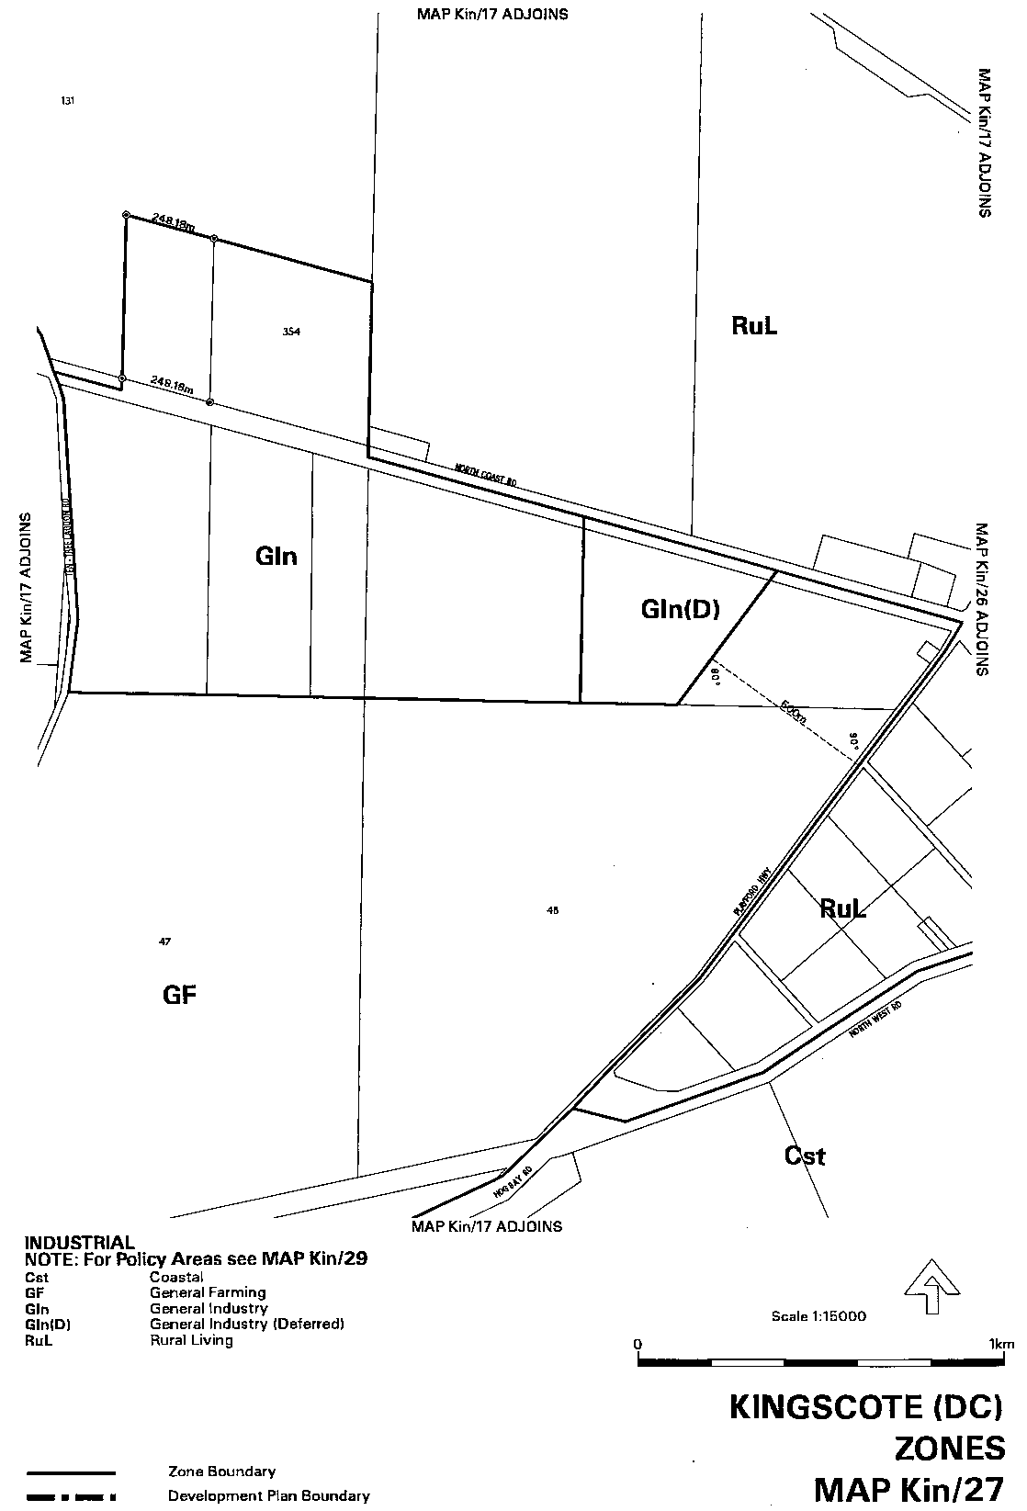
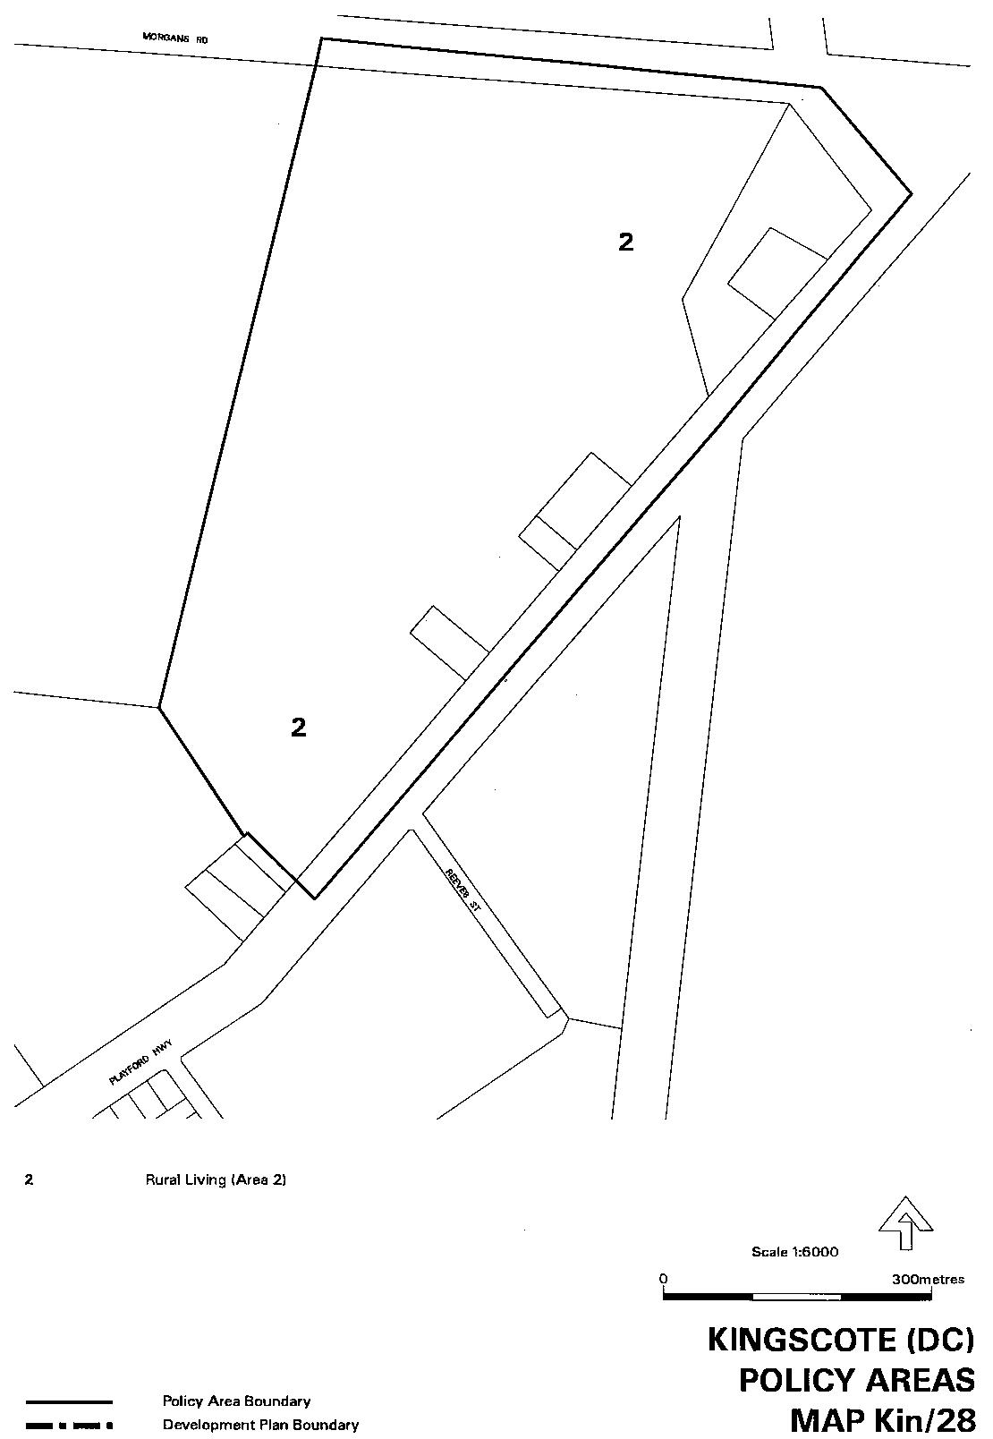

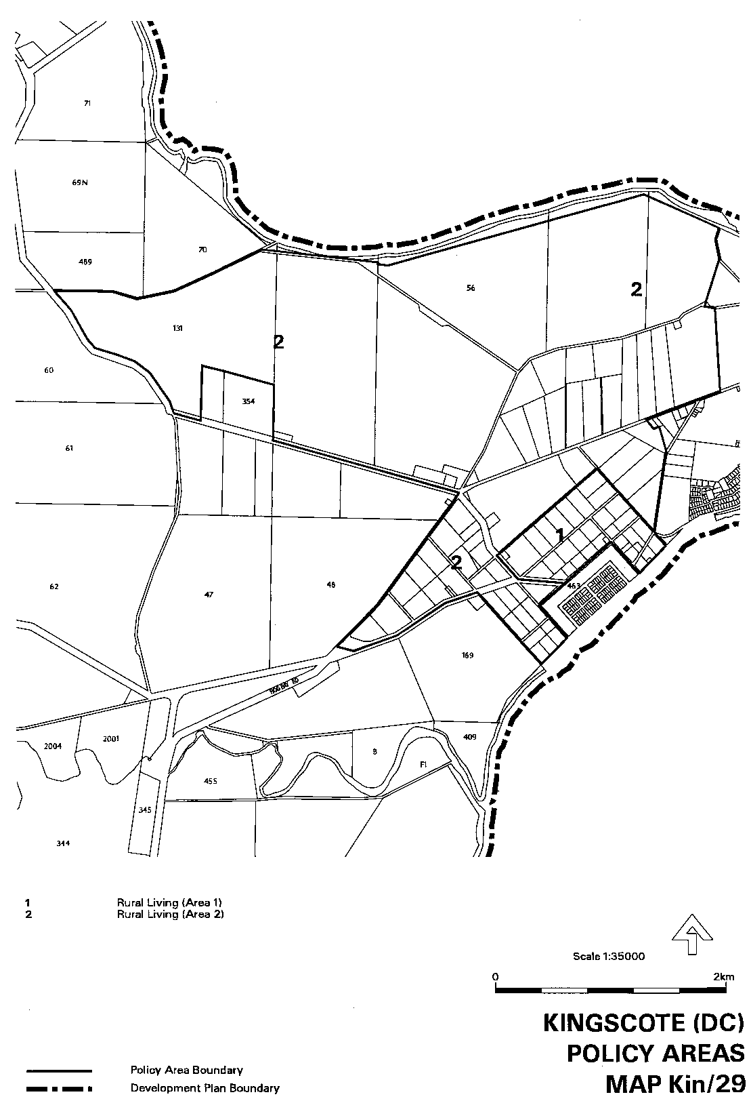
Dated 21 September 2000.
Diana Laidlaw, Minister for Transport, Urban Planning and The Arts

DEVELOPMENT ACT 1993
City of Norwood, Payneham and St Peters
Kensington and Norwood (City)—Local Heritage Places (Built Heritage) Review Plan Amendment Report—Draft for Public Consultation
NOTICE is hereby given that the City of Norwood, Payneham & St Peters has prepared a draft Local Heritage Places (Built Heritage) Review Plan Amendment Report for the purposes of identifying Local Heritage Places.
The draft Local Heritage Places (Built Heritage) Review Plan Amendment Report seeks to ensure that the future development which affects a Local Heritage Place or a State Heritage Item, proceeds in a manner which is sympathetic to the identified heritage values.
The primary policy changes proposed as part of the draft Local Heritage Places (Built Heritage) Review Plan Amendment Report include:
• an amendment to Table KeN/1 to add 106 Local Heritage Places; and
• an amendment to eleven advisory Council-wide Principles of Development Control to make them applicable to existing State Heritage Items; and
• the introduction of a new Schedule containing the list of existing State Heritage Items.
With regard to the introduction of Local Heritage Places, the extent of the heritage significance of each place has been specified. In most cases the extent of the significance includes the external form, materials and detailing associated with the proposed Local Heritage Place.
The draft Kensington and Norwood (City)—Local Heritage Places (Built Heritage) Review Plan Amendment Report and Statement of Investigations will be available for public inspection during normal office hours at the City of Norwood, Payneham and St Peters Head Office, Norwood Town Hall, 175 The Parade, Norwood, the Payneham Customer Service Centre, 196 O.G. Road, Felixstow, and the St Peters Customer Service Centre, 101 Payneham Road, St Peters, from 21 September 2000 until 22 November 2000.
Copies of the draft Local Heritage Places (Built Heritage) Review Plan Amendment Report can be obtained free of charge from:
• Norwood Town Hall, 175 The Parade, Norwood
• St Peters Library, 101 Payneham Road, St Peters
• Norwood Library, 110 The Parade, Norwood
• Payneham Library, 196 O.G. Road, Felixstow
Written submissions regarding the draft Local Heritage Places (Built Heritage) Review Plan Amendment Report will be accepted until 5 p.m., on 22 November 2000. The written submissions should also clearly indicate whether you wish to speak at the public hearing.
If a submission was made as part of the previous Kensington and Norwood (City)—Local Heritage Places (Built Heritage) Plan Amendment Report and you wish for that submission to be considered as a submission in respect to the Kensington and Norwood (City)—Local Heritage Places (Built Heritage) Review Plan Amendment Report please indicate accordingly in writing.
All submissions should be addressed to the Chief Executive Officer, City of Norwood, Payneham and St Peters, P.O. Box 204, Kent Town, S.A. 5071.
Copies of all submissions received will be available for inspection by all interested person at the Norwood Town Hall, 175 The Parade, Norwood from 22 November 2000 until the date of the public hearing.
A public hearing will be held, commencing at 7 p.m., on 14 December 2000 at the Don Pyatt Hall, Norwood Town Hall, 175 The Parade (entrance off George Street), Norwood, at which time interested parties may appear and be heard in relation to the draft Kensington and Norwood (City)—Local Heritage Places (Built Heritage) Review Plan Amendment Report and submissions.
Dated 21 September 2000.
M. Barone, Chief Executive Officer

DEVELOPMENT ACT 1993, SECTION 28 (1): DECLARA-TION OF INTERIM OPERATION OF CITY OF NORWOOD, PAYNEHAM AND ST PETERS—KENSINGTON AND NORWOOD (CITY) DEVELOP-MENT PLAN—LOCAL HERITAGE PLACES (BUILT HERITAGE) REVIEW PLAN AMENDMENT
Notice
PURSUANT to section 28 (1) of the Development Act 1993, I, the Governor, with the advice and consent of the Executive Council, being of the opinion that it is necessary in the interest of the orderly and proper development of the area affected by the ‘City of Norwood, Payneham and St Peters—Kensington and Norwood (City) Development Plan—Local Heritage Places (Built Heritage) Review Plan Amendment’ that the Plan Amendment should come into operation without delay, declare that the Plan Amendment will come into operation on an interim basis on 21 September 2000.
Given under my hand at Adelaide, 14 September 2000.
E. J. Neal, Governor
MTUP 41/00CS

DEVELOPMENT ACT 1993, SECTION 27 (1): TEA TREE GULLY (CITY) DEVELOPMENT PLAN, RURAL LIVING ZONE AND INCLUSION OF LAND INTO THE HILLS FACE ZONE PLAN AMENDMENT
Preamble
The Minister for Transport and Urban Planning has approved the amendment entitled ‘Tea Tree Gully (City) Development Plan, Rural Living Zone and inclusion of land into the Hills Face Zone Plan Amendment’ (the Plan Amendment) and has referred it to the Governor.
Notice
PURSUANT to section 27 (1) of the Development Act 1993, I, the Governor with the advice and consent of the Executive Council, declare the Plan Amendment to be an authorised Plan Amendment and fix 21 September 2000, as the day on which it will come into operation.
Dated 21 September 2000.
E. J. Neal, Governor
MTUP 73/98CS

DEVELOPMENT ACT 1993, SECTION 27 (1): SMALL SCALE RURAL/AGRICULTURAL AND HOME BASED INDUSTRIES PLAN AMENDMENT
Preamble
The Minister for Transport and Urban Planning has approved the amendment entitled ‘Small Scale Rural/Agricultural and Home Based Industries Plan Amendment’ (the Plan Amendment) and has referred it to the Governor.
Notice
PURSUANT to section 27 (1) of the Development Act 1993, I, the Governor with the advice and consent of the Executive Council, declare the Plan Amendment to be an authorised Plan Amendment and fix 21 September 2000, as the day on which it will come into operation.
Dated 21 September 2000.
E. J. Neal, Governor
MTUP 42/00CS

DEVELOPMENT ACT 1993, SECTION 27 (1): SMALL SCALE TOURIST ACCOMMODATION IN RURAL AREAS OF THE MOUNT LOFTY RANGES PLAN AMENDMENT
Preamble
The Minister for Transport and Urban Planning has approved the amendment entitled ‘Small Scale Tourist Accommodation in Rural Areas of the Mount Lofty Ranges Plan Amendment’ (the Plan Amendment) and has referred it to the Governor.
Notice
PURSUANT to section 27 (1) of the Development Act 1993, I, the Governor with the advice and consent of the Executive Council, declare the Plan Amendment to be an authorised Plan Amendment and fix 21 September 2000, as the day on which it will come into operation.
Dated 21 September 2000.
E. J. Neal, Governor
MTUP 15/99CS

ELECTRICITY ACT 1996
Transmission Lessor Corporation
Terms and Conditions of Supply
NOTICE is hereby given that these standard terms and conditions governing the supply of electricity (including the service of maintaining the connection between your premises and the transmission network) by Transmission Lessor Corporation trading as ‘ElectraNet SA’ are published in accordance with section 36(2) of the South Australian Electricity Act 1996.
These standard terms and conditions will come into force on 21 September 2000, and when in force will be contractually binding on Transmission Lessor Corporation and the class of customers to whom these terms and conditions are expressed to apply.
Transmission Lessor Corporation Trading As ElectraNet SA—Standard Terms and Conditions of Supply
1. Does This Document Apply to You?
1.1 Does this document apply to you?
This document applies to each customer who:
(a) occupies a premises which is connected to our equipment via a connection point as at the date this contract starts; and
(b) has not already negotiated, or does not in the future negotiate, a different agreement with us for the provision of prescribed transmission services in relation to the connection point for that premises.
1.2 What documents make up our contract with you?
Our contract with you is made up of these standard terms and conditions and the other documents referred to below. This contract when published will set out our entire agreement with you in relation to the provision of prescribed transmission services and override any of our previous arrangements with you.
1.3 What does our contract cover?
This contract sets out the terms on which we provide you with prescribed transmission services in relation to each connection point for your premises.
This contract does not deal with the sale of electricity to you at your premises. You have a separate contract with your retailer for the sale of electricity to you at your premises.
2. These Words and Expressions Have Special Meanings
In this document the following words and expressions have the meanings set out next to them:
Word or Expression | Meaning
applicable laws | The NEC, the Electricity Act, the Electricity Pricing Order and any other legislation, rules, regulations, codes, electricity pricing orders or conditions which are binding on us or you (and includes in your case any obligations which would be imposed on you by the NEC if you were registered as a customer under the NEC).
billing period | If you are a grace period customer, the period covered by your retailer’s bill.
 | If you are not a grace period customer, the billing period as defined in the NEC;
Word or Expression | Meaning
Connection point | Each point at which your equipment is con-nected to our equipment;
contract | Your contract with us for the connection of your equipment to our equipment and the provision of prescribed transmission services by us in relation to each connection point for your premises;
customer sale | The contract you have with your retailer for the
contract | sale of electricity to you at your premises;
Electricity Act | The Electricity Act 1996 and all regulations, orders and notices made under that Act;
Electricity Pricing Order | The electricity pricing order dated 11 October 1999 and published pursuant to section 35B of the Electricity Act;
NEC | The ‘National Electricity Code’ as defined in the National Electricity Law set out in the schedule to the National Electricity (South Australia) Act 1996;
premises | A site which is supplied with electricity from a connection point;
price list | Our list of current tariffs and charges applying to you from time to time;
retailer | The person who sells electricity to you at your premises;
our equipment | Our transmission network and the existing meters and connection assets for each con-nection point;
we, our or us | Transmission Lessor Corporation trading as ‘ElectraNet SA’ and its authorised officers and contractors;
your equipment | Any equipment at your premises (or connected to your side of a connection point) for the distribution and use of electricity which is not our equipment;
you or your | the person recorded in our records and on accounts issued by us or a retailer as the customer for a premises.
Any term used in this document which is not otherwise defined in this clause 2 will have the same meaning as is given to that term in the Electricity Pricing Order.
In this document, unless the context otherwise requires:
(a) the singular shall include the plural and vice versa;
(b) mentioning anything after include, includes or including does not limit what else might be included; and
(c) a reference to any Act of Parliament or to any section or provision in any Act of Parliament extends to and includes any regulations, codes, orders or other instruments made under that Act and any modifications to any of the above things.
3. Term of this Contract
3.1 When does this contract start?
This contract will start on the date set out in the Gazette in which this document was published.
3.2 When does this contract end?
This contract will end in relation to a connection point for a premises on the day that you (or another person) enters into a different agreement with us for the provision of transmission services in relation to that connection point.
4. Our Equipment
To provide transmission services in the most effective manner to you and/or to our other customers, it may be necessary for us to place our equipment on your premises.
Our equipment may be placed above ground or underground and may be attached to any building or structure at your premises. Our equipment and the connection point will be placed at a location determined by us.
You must allow us safe and unobstructed access to our equipment at all times. You may be required to provide us with an easement before our equipment can be installed.
You must provide and maintain an approved weatherproof container for our meters, time switches and other equipment. If you want to lock the container or any gate or door that prevents access to our equipment, you will need to contact us to make appropriate arrangements.
5. Ownership, Interference with and Removal of Our Equipment
Our equipment placed on your premises will always remain our property even if you contribute to its cost. Despite anything else in this contract, you must not damage or otherwise interfere with our equipment or any rights that we have, or any other party may have, to use or access our equipment or any place where our equipment is situated. You must also ensure that no-one else does any of these things.
We may modify, remove or replace our equipment at any time.
6. Your Equipment
You must install, maintain and operate your equipment in accordance with the requirements of all applicable laws. To ensure that you are doing this, we may inspect and test your equipment. Any tests and inspections that we carry out are for our information only and not to check the overall state of your equipment. You must allow us access to your equipment and premises to carry out these inspections.
We may charge you a fee for carrying out such inspections and testing. We will not be liable to you or to anyone else if your equipment fails or is defective.
We have developed operating procedures in relation to the interaction between our equipment and your equipment in order to regulate switching, load shedding, monitoring, information exchange and to ensure that the requirements imposed upon both parties under the applicable laws are satisfied. Both parties must comply with these operating procedures.
7. Making Changes to Your Equipment
If you wish to change your supply requirements, or modify or upgrade your connection point or your equipment at any time (including by varying the agreed maximum demand for your connection point), you must first apply to us for our consent. We will deal with that application in accordance with the procedures set out in Chapter 5 of the NEC.
You must not make that change, modification or upgrade until our consent has been given.
If a change, modification or upgrade is made without our consent you will be responsible to pay for any damage to our equipment and will indemnify us for any claims by any third parties.
8. Supply Specifications and Interruptions
8.1 Specifications of Electricity and Services
The specifications of the electricity we deliver and the prescribed transmission services we provide may vary from area to area and from time to time.
Accordingly we may impose conditions on your use of electrical appliances or your equipment at a premises. In particular, you must not take electricity from a connection point in excess of the agreed maximum demand notified to you by us for that connection point without our consent. We may take such steps as we consider are reasonably necessary to prevent this occurring or continuing.
You should therefore check with us to find out the specifications of the electricity we deliver and the prescribed transmission services we provide in the area in which your premises is situated.
8.2 Interruption to Supply
We will endeavour to provide you with the ability to receive a continuous supply of electricity via the provision of prescribed transmission services to each connection point. However, circumstances may arise that require us to disconnect, interrupt or ration the provision of prescribed transmission services to you at
your premises (such as where we are required to do so under an applicable law, in order to maintain our equipment or your equipment, or for any of the reasons set out in clause 13).
Wherever possible, early notice of the interruption will be given, and we will try to coordinate any interruptions with you so as to minimise any inconvenience. However, if an emergency arises we are not obliged to give any notice.
We may be obliged to place restrictions on your consumption of electricity at your premises.
We may need to enter your premises unannounced in order to interrupt or reinstate the provision of prescribed transmission services to your premises.
The supply of electricity or prescribed transmission services to your premises may also be interrupted or reduced due to circumstances beyond our control. We will endeavour to overcome these circumstances as soon as possible, but in the meantime, our obligations under this contract will be suspended to the extent to which these circumstances prevent us from complying.
9. Meter Testing
If you believe that our meter is inaccurate, we will check its accuracy in accordance with any relevant applicable law or standard.
We may ask you to pay our fees in advance for checking the meter. However, if the meter is found not to comply with the relevant applicable laws and standards, we will arrange for that fee to be reimbursed to you.
If the meter is found to be inaccurate, the amount payable to us will be based on our best estimate of the amount of electricity that you would have used at your premises. We will arrange for any over charges you have paid to be reimbursed to you through your next account from your retailer.
10. Charges
10.1 You must pay our tariffs and charges.
You must pay all charges for prescribed transmission services supplied by us in relation to each connection point in accordance with the terms of this contract.
10.2 Which tariff applies to you?
The transmission tariff and other charges applying to you in relation to the provision of prescribed transmission services for each connection point immediately prior to the start of this contract will continue to apply until we inform you otherwise in accordance with clause 10.3.
10.3 Variations to your tariffs and charges.
We can vary our transmission tariffs and charges in accordance with the Electricity Pricing Order, and we will notify you of these variations. Where the Electricity Pricing Order does not apply we may vary our transmission tariffs and charges by giving you at least 30 days prior notice.
10.4 Changes to the tariff rates and charges during a billing cycle.
If a transmission tariff or charge applying to you changes during a billing cycle, your bill for that billing cycle will be calculated on a pro-rata basis using:
(a) the old tariff or charge up to and including the date of the change; and
(b) the new tariff or charge from that date to the end of the billing cycle.
10.5 Pass through of taxes and other charges.
We can pass through to you those taxes, charges and rebates which we are entitled or required to pass through under the Electricity Pricing Order. We can do this by either changing our transmission tariffs and charges, or including the amount as a separate item in your bill.
10.6 GST.
Our transmission tariffs and charges are inclusive of GST.
However, there may be other amounts payable by you or by us under this contract that are payments for ‘taxable supplies’ as defined for GST purposes. To the extent permitted by law, these other payments will be increased so that the GST payable on the taxable supply is passed on to the recipient of the taxable supply.
10.7 Security for payment.
At any time we may require you (as a condition of our agreement to supply or continue to supply you with prescribed transmission services) to lodge a deposit with us or your retailer as security for payment of our tariffs and charges.
We will determine the amount of the deposit and may, at our discretion, apply it in satisfaction of any amount you owe us. You also agree that any deposit you paid to us or your retailer under your previous electricity sale or supply arrangement will now be held by your retailer as security for payment of any amounts you owe us and your retailer.
11. Billing
11.1 Grace Period Customer.
If you are a grace period customer, the following billing procedures will apply:
(a) we will arrange with your retailer for one bill to be sent to you, covering what you owe under this contract and under your customer sale contract with your retailer. Your customer sale contract sets out how often these accounts will be sent;
(b) the amount you must pay, the due date and the method of payment for the prescribed transmission services we provide under this contract will be set out in the bill sent to you by your retailer;
(c) when you have paid your retailer the amounts due under this contract, you are deemed to have discharged your obligations to us to pay that amount.
11.2 Non-grace period customers.
If you are not, or cease to be, a grace period customer the following billing procedures will apply:
(a) we will issue a draft bill to you for the prescribed transmission services supplied by us to you during each billing period within 5 business days of the end of that billing period;
(b) no later than 18 business days after the end of each billing period we will issue a final bill in respect of all charges incurred by you in that billing period;
(c) our bill may include charges in respect of one or more billing periods and be in respect of a charge that has previously been made in order to reflect revised or substituted metering data, information or other adjustments; and
(d) you must pay our bill no later than noon on the business day being 10 business days after receipt by you of the final bill under clause 11.2 (b).
11.3 Late payments.
If you do not pay your accounts on time, you may be required to pay our reasonable costs of recovering that amount from you. You may also be required to pay interest on the outstanding amounts at the rate specified in our price list from time to time.
11.4 Calculating the bill.
The amounts you owe under this contract at the end of each billing period will be calculated based on information from reading you meter.
11.5 Estimating the electricity usage.
If we or your retailer are unable to read your meter for any reason, we can estimate how much electricity was supplied to your premises by using other information (such as your previous bills or your electricity usage history).
The bill will be adjusted for the difference between our estimate and the actual amount of electricity used, based on a subsequent reading of the meter.
11.6 Variations to agreed maximum demand.
You may request us to increase the agreed maximum demand for a connection point. If we do not need to modify or upgrade your connection point, your equipment or our equipment, we will agree to the increase. If the increase requires us to modify or upgrade your connection point or your equipment, you must apply to us under clause 7.
If you wish to reduce the agreed maximum demand for a connection point, you must make a request to us by 31 March in any year. We will agree to the reduction if the measured demand for that connection point for the 12 month period before your request has not exceeded the agreed maximum demand for that connection point, and we are satisfied that the reduction is due to a reduction in the expected load at that connection point which you could not originally have foreseen.
11.7 Excess demand charge.
If at any time during a financial year, the actual maximum demand for a connection point exceeds the agreed maximum demand for that connection point at that time:
(a) for the purposes of calculating the charges payable by you during that financial year, the actual maximum demand will become the agreed maximum demand;
(b) you will be deemed to have requested an increase in agreed maximum demand under clause 11.6 and the requirements of clauses 7 and 11.6 must be satisfied before the actual maximum demand will become the agreed maximum demand for the purposes of clause 8.1; and
(c) we may recover from you the excess demand charge referred to in our price list and the difference between the charges you would have paid to us during that financial year if your agreed maximum demand had been the actual maximum demand.
12. Discontinuance of Supply By Us
We may disconnect or interrupt the provision of prescribed transmission services to your connection point for any one or more of the following reasons:
(a) if any of the events set out in clause 8.2 occur;
(b) if we are requested by you or your retailer to do so;
(c) if you fail to pay us or your retailer any amount owed to us by the due date;
(d) if you otherwise do not comply with your obligations under this contract;
(e) if you prevent the exercise by us of any of our rights under this contract or at law;
(f) if you make or have made any false statement to us in relation to the supply of electricity to you;
(g) if you deal with the electricity we supply to you in a manner that interferes with the supply of electricity to other people;
(h) if in our opinion your equipment is in a dangerous condition;
(i) if in our opinion it is unsafe to continue to supply you with transmission services;
(j) if we are entitled to do so under any applicable law;
(k) if we are directed to do so by any person, including the System Controller or NEMMCO, exercising an authority granted to it under any applicable law; or
(l) if you fraudulently obtain or use electricity we supply to your premises.
If we disconnect a connection point for your premises for any of the above reasons, we may refuse to reconnect that connection point until the reason for the disconnection has been remedied and all of our charges have been paid.
13. Limitation of Liability
13.1 Warranties.
Unless required by an applicable law, we give no warranties or undertakings and make no representations to you about the condition, suitability, quality, fitness or safety of the transmission services we provide, other than those expressly set out in this contract.
Any liability we have for breach of any condition, warranty or term which is implied into this contract by the Trade Practices Act 1974(Cth) or any other law and cannot be excluded, is limited to the maximum extent permitted by that Act or law.
13.2 Limit of our liability to you.
Subject to clause 13.1, our liability to you for any loss, damage, costs or expenses (including pure economic losses, loss of profits, business or anticipated savings, claims by third parties and any other indirect or consequential losses) suffered or incurred by you as a result of any of our acts or omissions relating to the provision of transmission services or the operation of the transmission system generally (including breach of contract, tort [including negligence] or otherwise) will not exceed $1 000 000 for any financial year.
13.3 National Electricity Law Immunity.
This clause 13 will apply in addition to any exclusion from, or limitation on, liability that we or you may be entitled to claim the benefit of under an applicable law (including without limitation sections 77A or 78 of the National Electricity Law).
14. Assignment
We may assign any of our rights under this contract at any time. We do not require your consent to do this.
15. Notices
All notices that we give to you, or you give to us, under this contract must be sent by prepaid post or by facsimile to the most recent facsimile number provided by the recipient.
However, we may agree with you that some notices will be communicated by other means (for example telephone, email or internet).
16. Information
16.1 Provision of information
You must provide to us on request such information concerning your equipment as is reasonably necessary to enable us to comply with our obligations under any applicable law and to operate, develop, design and plan our transmission system in accordance with the requirements of all applicable laws.
16.2 Confidentiality.
We must keep information about you confidential.
We may, however, disclose information about you:
(a) if required or permitted by law to do so;
(b) where you give us written consent; or
(c) to your retailer to the extent that the information is for the purposes of arranging and coordinating disconnection, reconnection and billing.
17. Compliance with Applicable Laws?
Both parties must comply with all applicable laws. In particular, you must comply with any obligations which would be imposed on you by the NEC if you were registered as a customer.
We will give you, and you must give us, reasonable assistance in complying with the requirement of any applicable law.
18. Alterations to This Contract
We reserve the right to alter this contract from time to time. All alterations will be published in the South Australian Government Gazette. They will be effective from the date specified in the Gazette or, if there is none, from the date of publication.
Dated 21 September 2000.
K. Tothill, Chief Executive Officer

ELECTORAL ACT 1985
Part 6—Registration of Political Parties
NOTICE is hereby given that the following application for registration as a registered political party under the provisions of Part 6 of the Electoral Act 1985, has been received.
Name of Party: No Nuclear Dump in S.A. Party
Name of Applicant: Leonard Andrew Spencer
Any elector who believes that the party should not be registered:
• because the party does not have as a purpose, the promotion of the election to the State Parliament of its endorsed candidate(s); or
• because the application does not fulfil the technical requirements specified in the Act; or
• because the party’s name is likely to be confused with that of another registered party, parliamentary party or prominent public body,
can formally object in writing to the Electoral Commissioner by close of business on 23 October 2000. Objections must contain the postal address and signature of the objector.
Dated 21 September 2000.
S. H. Tully, Electoral Commissioner
SEO 155/00

FISHERIES ACT 1982: SECTION 59
TAKE notice that pursuant to section 59 of the Fisheries Act 1982, Southern Lobster Farmers Pty Ltd, P.O. Box 267, Port Lincoln, S.A. 5606, or persons acting as their agents (hereinafter referred to as the ‘exemption holder’) are exempt from the provisions of sections 50 and 53 of the Fisheries Act 1982 insofar as they may engage in the activities and do the acts specified in Schedule 1 (hereinafter referred to as the ‘permitted use’) during the times specified in Schedule 2 subject to the conditions specified in Schedule 3 from the waters specified in Schedule 4 (hereinafter referred to as the ‘site’).
Schedule 1
The deposit and subsequent removal and sale of Southern rock lobster (Jasus edwardsii) (hereinafter referred to as the ‘permitted species’), into cages located in the area of water specified in Schedule 4, for the purpose of conducting research and development into their farming.
Schedule 2
This exemption is valid from date of gazettal to 2400 hours on 30 June 2001.
Schedule 3
1. The exemption holder must not farm or introduce any species at the site other than the permitted species.
2. The exemption holder must not use the site for any purpose other than the permitted use.
3. The exemption holder must ensure that the site is maintained in a good, tidy and safe condition to the satisfaction of the Minister for Primary Industries Natural Resources and Regional Development (hereinafter referred to as the ‘Minister’).
4. The exemption holder must remove and lawfully dispose of any waste or debris on the site as soon as is reasonably practicable and in particular must comply with any instructions issued from time to time by the Minister or an officer acting on his behalf in relation to the removal from the site of any unhealthy or dead fish.
5. The exemption holder must mark the site boundary in accordance with any requirements of the Harbors and Navigation Act 1993 or other applicable Acts.
6. The exemption holder must at all times permit the Minister, his employees, agents or contractors or any employees, agents or contractors of the Crown to enter the site for the purposes of inspecting the site, the sea floor and the flora and fauna on or in the vicinity of the site.
7. The exemption holder must comply with all reasonable directions of any such person authorised by the Minister to inspect the conduct of the exemption holder’s activities at the site.
8. The exemption holder must at all times comply with all laws, by-laws or regulations in force which relate to the site or the activities conducted in the site and with all notices, orders or requirements lawfully given or made by any authority or authorities in respect of the site.
9. The exemption holder must not do or permit to be done in, upon or about the site, anything which in the opinion of the Minister would cause or contribute to the degradation or pollution of any coastal land or the surrounding marine environment.
10. The exemption holder must maintain a Stock Movement Register for all of the permitted species introduced onto the site. The information must be recorded in sufficient detail so as to identify:
• the provider of each batch of stock, including the name and signature of the exemption holder or the exemption holder’s delegate;
• all movements of stock onto and removed from the site;
• the date on which the stock was placed on or removed from the site;
• the numbers of stock moved on each occasion;
• mortalities of stock;
• the number of stock held on site at the first day of every month.
11. The exemption holder must ensure the Stock Movement Register is written in ink in a bound book with consecutively numbered pages, each entry must be made immediately below the previous entry and each page must be filled before commencing the next page.
12. The exemption holder must keep the Stock Movements Register for 12 months from the date of last entry. A photocopy of the Register must be forwarded to PIRSA Fisheries Aquaculture Compliance on or before 30 June 2001.
13. The exemption holder must not use chemical or drug for therapeutic or prophylactic purpose except with the prior approval of the Minister.
14. In the event that the Minister is satisfied, on reasonable grounds, that the fish taken from the waters are not fit for human consumption or that consumption of fish taken from the waters could present a danger to the health of the consumer, the exemption holder must, in accordance with a written notice from the Minister, cease or suspend the conduct of the permitted use or else conduct the permitted use as directed within the notice.
15. The exemption holder must at all times indemnify the Minister, his officers, employees, contractors and agents from and against all claims, demands, actions, judgements, proceedings, damages, losses, costs, charges and expenses in respect of any loss of life, personal injury and/or damage to property caused or suffered in any manner in or about the site.
16. The Minister may terminate this exemption immediately by notice in writing served on the exemption holder.
17. The exemption holder shall not contravene or fail to comply with the Fisheries Act 1982, or any regulations made under the Act, except where specifically permitted by this notice.
18. The exemption holder must retain a copy of this exemption which has been supplied by the Minister, and if requested by a PIRSA Fisheries and Aquaculture Officer, produce that exemption for inspection.
Schedule 4
Licensed Area Licensed
Hectare
AGD-66⎯(Zone 53)
579480E 6160580N 1
579580E 6160580N
579580E 6160480N
579480E 6160480N
Dated 13 September 2000.
I. Nightingale, General Manager Aquaculture, as the delegate of the Minister for Primary Industries
FC00005

FISHERIES ACT 1982: SECTION 59
TAKE notice that, pursuant to section 59 of the Fisheries Act 1982, Andrew W. Arbon (or his agent) (hereinafter referred to as the ‘exemption holder’), 134 Fishermans Bay Road, Port Broughton, S.A. 5522 shall not be guilty of an offence when engaging in the activities and to do the acts specified in Schedule 1 subject to the conditions specified in Schedule 2 from the date of gazettal of this exemption until revoked by the Director of Fisheries.
Schedule 1
The importation and release of black bream, (Acanthopagrus butcheri) into dams located at section 499 in the Hundred of Mundoora.
Schedule 2
1. The exemption holder must maintain adequate security arrangements to prevent escapement of fish (ova, fry, or adult) into any South Australian waters.
2. Fish obtained within South Australia for use on the registered fish farm must be obtained from registered fish farmers, licensed fishers or other persons approved by the Director of Fisheries.
3. Fish must not be collected from rivers, streams, lakes or other inland waters of this State unless prior approval for this collection is granted by the Director of Fisheries.
4. The exemption holder must not import any live fish (ova, fry, or adult) into South Australia unless the shipment has certification from an appropriate authority in the State from which they are obtained that they are free from all relevant notifiable diseases listed in Schedule 4 of the Fisheries (Exotic Fish, Fish Farming and Fish Diseases) Regulations 1984.
5. The exemption holder must not contravene or fail to comply with the Fisheries Act 1982 or any regulations made under the Act, except where specifically permitted by this notice.
6. The exemption holder must retain the copy of this permit which has been supplied by the Director of Fisheries, and if requested by a PIRSA Fisheries and Aquaculture Compliance Officer, produce that permit for inspection.
Dated 13 September 2000.
I. Nightingale, General Manager Aquaculture, as the delegate of the Minister for Primary Industries
FT00639

FISHERIES ACT 1982: SECTION 53
TAKE notice that the licence to farm fish made under section 53 of the Fisheries Act 1982, and published in the South Australian Government Gazette, dated 1 September 2000, on page 1510 being the second notice on that page, through to page 1513 and referring to The South Australian Oyster Hatchery Pty Ltd is hereby revoked.
Dated 19 September 2000.
I. Nightingale, General Manager Aquaculture, as the delegate of the Minister for Primary Industries

FISHERIES ACT 1982
Marine Finfish Farming Licence FF00031
Licence to Farm Fish under section 53 of the Fisheries
Act 1982
WHEREAS the Director of Fisheries has, pursuant to section 50 (2) of the Fisheries Act 1982 (‘the Act’), issued a permit to the undermentioned licensee to release the fish specified in Schedule 2 of this licence (‘the permitted species’), the Minister for Primary Industries, Natural Resources and Regional Development (‘the Minister’) hereby grants to:
Douglas R. Peel (13005)
Garry L. Peel (14650)
Jason A. Peel (13094)
Nola M. Peel (19778)
Bagdad Road
Mount Benson, S.A. 5276
a non-exclusive licence to occupy and use the waters specified in Item 1 of Schedule 1 of this licence (‘the site’) for the purpose of farming and taking the permitted species (‘the permitted use’) for the period commencing on 1 July 2000 and ending, subject to any earlier termination under this licence, on 30 June 2001 (‘the term’) subject to the following terms and conditions:
Conditions of This Licence
1. Licence
The parties acknowledge and agree that:
1.1 the rights, powers and privileges granted to or vested in the licensee under this licence are contractual only and shall not create or vest in the licensee any estate, interest or right of a proprietary nature in the site; and
1.2 that, subject to section 53A of the Fisheries Act 1982, this licence does not entitle the licensee to exclusive rights of entry to and occupation of the site and that the rights granted by this licence are exercisable by the licensee in common with any other occupiers of the site from time to time.
2. Marked-off Areas
For the purposes of section 53A of the Fisheries Act 1982, the marked-off areas within the site is that area or those areas marked-off or indicated in the manner set out in Item 2 of Schedule 1 of this licence.
3. Permitted Species
The licensee:
3.1 must not farm or introduce any species at the site other than the permitted species; and
3.2 must not take any wild fish from the site except for recreational purposes.
4. Permitted Use
The licensee must not use the site for any purpose other than the permitted use.
5. Permitted Methods
The licensee:
5.1 must not stock the permitted species at a rate greater than that specified in Schedule 2 of this licence;
5.2 must not use the anti-fouling chemical tributyltin (TBT) on any equipment used at the site;
5.3 must not use any chemical or drug for either therapeutic or prophylactic purpose except with the prior approval of the Minister;
5.4 must apply the permitted farming methods set out in Item 2 of Schedule 2 of this licence.
5.5 must conduct an environmental monitoring program as set out in Schedule 5 of this licence.
6. Sea Cages
The licensee:
6.1 must ensure that all sea cages on the site have anti-predator protection satisfactory to the Minister at all times during the Term; and
6.2 must immediately inform an officer of PIRSA (Fisheries) on 1800 065 522 or such other officer as the Minister from time to time notifies to the Licensee in writing if any marine animal, other than the Permitted Species, is caught in any seacage or other farm structure used by the Licensee on the site.
7. Local of Sea Cages
The Licensee must not erect or use any sea cages in any location on the site where stocked sea cages have been used in the immediately preceding two year period.
8. Marking and Maintaining the Site
The licensee:
8.1 must ensure that the site is maintained in a good, tidy and safe condition to the satisfaction of the Minister;
8.2 must remove and lawfully dispose of any waste or debris on the site as soon as is reasonably practicable and in particular must comply with any guidelines issued from time to time by the Minister in relation to the removal from the site of any unhealthy or dead fish;
8.3 must maintain all buoys, crosses, and markers on the site in good condition and in accordance with the colours specified in Schedule 1 of this licence; and
8.4 must mark the site boundary in accordance with the specifications in Schedule 1 of this licence.
9. Site Inspection and Supervision
The licensee:
9.1 must at all times permit the Minister, his employees, agents or contractors or any employees, agents or contractors of the Crown to enter the site for the purposes of inspecting the site, the sea floor and the flora and fauna on or in the vicinity of the site; and
9.2 must comply with all reasonable directions of any such person authorised by the Director of Fisheries to inspect the conduct of the licensee’s activities at the site.
10. Fees and Returns
The licensee:
10.1 must pay to the Minister the licence fee in accordance with Item l of Schedule 3 of this licence;
10.2 must on or before 31 January and 31 July during the term, submit to the Minister a return supplying all of the information described in Schedule 4 of this licence.
11. Compliance With Relevant Laws
11.1 the licensee must at all times comply with all laws, by-laws or regulations in force which relate to the site or the activities conducted in the site and with all notices, orders or requirements lawfully given or made by any authority or authorities in respect of the site;
11.2 in particular, without derogating from the general requirement under condition 9 of this licence:
11.2.1 the licensee must not do or permit to be done in upon or about the site anything which in the opinion of the Minister would cause or contribute to the degradation or pollution of any coastal land or the surrounding marine environment; and
11.2.2 in the event that the Minister is satisfied, on reasonable grounds, that the fish taken from the waters are not fit for human consumption or that consumption of fish taken from the waters could present a danger to the health of the consumer, the licensee must, in accordance with a written notice from the Minister, cease or suspend the conduct of the permitted use or else conduct the permitted use as directed within the notice.
12. Public Risk Liability
The licensee must at all times indemnify the Minister, his officers, employees, contractors and agents from and against all claims, demands, actions, judgments, proceedings, damages, losses, costs, charges and expenses in respect of any loss of life, personal injury and/or damage to property caused or suffered in any manner in or about the site.
13. Release
The licensee must use and keep the site at the risk in all things of the licensee and the licensee must release to the full extent permitted by law the Minister, his agents, contractors and servants in the absence of any wilful act, omission, default or neglect on their part from all claims and demands of every kind resulting from any accident damage or injury to persons or property occurring at the site, including loss or damage to the licensee’s fixtures or personal property of the licensee.
14. Public Risk Insurance
The licensee shall at its own cost and expense during the term effect and keep in full force and effect in respect of the site and the permitted use a policy of public risk insurance in the joint names of the licensee and the Minister in which the limits of public risk shall not be less than the amount specified in Item 2 of Schedule 3 of this licence, or such further amount as the Minister may from time to time reasonably require, as the amount which may be paid out in respect of any one single claim and a policy of insurance or copy thereof or a certificate of insurance shall be produced by the licensee to the Minister on request in writing being made by the Minister for its production.
15. Guarantee or Indemnity Scheme
The licensee must either:
15.1 provide a guarantee from its bankers; or
15.2 contribute to an indemnity scheme established for the aquaculture and fisheries industry and approved by the Minister,
to and in favour of and for the benefit of the Minister by way of security for the due and punctual performance by the licensee of the terms and conditions of this licence and in particular the obligations of the licensee to rehabilitate the site immediately prior to the expiration or sooner determination of the term of this licence. Such guarantee or indemnity scheme must have effect from the date of commencement of the term.
16. No Assignment
The licensee acknowledges that this licence is personal and it must not assign or sublet or deal in any other way with any interest in this licence.
17. Default by Licensee and Termination
The Minister may terminate this licence immediately by notice in writing served on the licensee if:
17.1 the licensee commits or permits any breach or default of the obligations imposed on the licensee by this licence, and following the giving by the Minister of written notice of such breach or default, the licensee either fails to rectify such breach or default within one calendar month of the date of such notice (or earlier if the circumstances require) or fails to make diligent progress towards rectifying any such breach which is incapable of rectification within the time so limited; or
17.2 the licensee commits or permits any further breach or default of the obligations imposed on the licensee by this licence for which the Minister has previously given notice in writing of such breach or default pursuant to paragraph 1 of condition 17.1 notwith-standing rectification of the previous breach or default; or
17.3 the licence fee referred to in condition 10 is unpaid for a period of 14 days after notice has been given to the licensee that it is outstanding; or
17.4 if the licensee is a body corporate, any of the following occur:
17.4.1 the licensee is unable to pay its debts as and when they fall due or is otherwise insolvent;
17.4.2 an order is made for the winding up or liquidation of the licensee;
17.4.3 the licensee enters into a scheme of arrangement, compromise, moratorium or other form of composition with its creditors or any class of its creditors;
17.4.4 a receiver, a manager or a receiver and manager, a company administrator or other insolvency administrator is appointed to the licensee; or
17.4.5 a mortgagee, chargee or other encum-brancee is appointed over or takes possession of or appoints an agent to take possession of all or any of the licensee’s assets; or
17.5 if the licensee is an individual, the licensee:
17.5.1 becomes bankrupt or assigns its estate or enters into a deed of arrangement or other form of composition for the benefit of the licensee’s creditors; or
17.5.2 is convicted of an indictable offence.
Termination of this licence by the Minister shall be without prejudice to any rights, remedies or actions that the Minister may have against the licensee in respect of any antecedent breach by the licensee of the terms and conditions contained in this licence.
18. Interpretation
Subject to any inconsistency of subject or context, the following rules of construction shall be used in the interpretation of this licence:
18.1 any word importing the plural includes the singular and vice versa;
18.2 any wording importing a gender shall include all other genders;
18.3 a reference to a body corporate shall include a natural person and vice versa;
18.4 a reference to a recital, party, clause, Schedule or Annexure is a reference to a recital, party, clause, Schedule or Annexure of this licence;
18.5 the captions, headings, section numbers and clause numbers appearing in this licence are inserted only as a matter of convenience and in no way affect the construction of this licence;
18.6 a reference to a statute shall include all statutes amending, consolidating or replacing the statutes referred to;
18.7 where two or more persons are named as licensees, this licence shall bind the licensees jointly and each of them severally; and
18.8 time is of the essence in respect of any obligation relating to time in this licence.
19. Delegation
Any consent, notice, any consultation or any other thing which is pursuant to the terms of this licence either required to be given, done or performed or which may be given, done or performed by the Minister may for the purposes of this licence be properly given, done or performed by any duly authorised agent or employee of the Minister.
20. Severance
If any term or condition of this licence should be for any reason unlawful, void, invalid or unenforceable then the offending term or condition shall be severed from this licence without affecting the validity or enforceability of the remainder of this licence.
21. Modification
No variation of or addition to any provision of this licence shall be binding upon the Minister and the licensee unless such variation or addition is made in writing, signed by both the Minister and the licensee and expressed to be either supplemental to or in substitution for the whole or a part of this licence.
22. Waiver
22.1 A waiver of any provision of this licence by the Minister must both be in writing and be signed by the Minister or by persons duly authorised to execute such a document on the Minister’s part.
22.2 No waiver by the Minister of a breach of a term or condition contained in this licence shall operate as a waiver of any breach of the same or any other term or condition contained in this licence.
22.3 No forbearance, delay or indulgence by the Minister in enforcing the provisions of this licence shall prejudice or restrict the rights of the Minister.
23. Notices
23.1 Notices may be served by delivering the same personally, by mail or facsimile transmission and shall be:
23.1.1 in writing addressed to the Director of Fisheries, PIRSA, 16th Floor, 25 Grenfell Street, Adelaide, S.A. 5000 (in the case of the Minister) and to the address of the licensee set out above (in the case of the licensee);
23.1.2 signed by or on behalf of the sender or by a person duly authorised in that regard by the sender;
23.1.3 deemed to be duly served or made in the following circumstances:
(a) if delivered, upon delivery;
(b) if sending by mail, upon posting;
(c) if sent by facsimile transmission, upon the sender’s facsimile producing a transmission report that the facsimile was satisfactorily sent in its entirety to the addressee’s facsimile number,
but if delivery is not made before 5 p.m. on any day it shall be deemed to be received at 9 a.m. on the next day in that place.
23.2 The Minister and the licensee may each vary their address or facsimile number at any time by written notice.
Granted by the General Manager Aquaculture, delegate of the Minister, on 13 September 2000.
I. Nightingale, General Manager Aquaculture
The licensee hereby acknowledges and agrees to the terms and conditions of this licence.
Signed by the said D. R. Peel, N. M. Peel,
G. L. Peel and J. A. Peel
In the presence of: M. R. Peel, Witness
Schedule 1
Item 1—The Site
Area applicable to this licence:
Licensed Area Licensed
Hectares
AGD 66—Zone 54
382466E 5912386N 20
382233E 5912711N
382639E 5913003N
382873E 5912678N
All structures, equipment, buoys and flotations (except for that required by the Department for Transport, Urban Planning and the Arts) must be black, dark grey, dark blue, dark brown, or dark green coloured materials.
The boundary of the site to be marked either with:
(a) (1) At the corners with posts extending 900 mm above mean high water springs. Such posts to be marked with a St Andrews cross, each cross arm measuring 900 mm from tip to tip, minimum width 75 mm.
(2) Posts to be not less than 125 mm in diameter.
(3) Posts and crosses to be painted yellow.
(4) The ends of each cross to be marked with a 200 mm strip of yellow retro-reflective tape.
(5) Between the corner posts at intervals not exceeding 50 m, buoys not less than 300 mm in diameter.
(6) All buoys, posts, crosses and markers must be maintained in good condition.
or
(b) (1) At each corner, yellow spar buoys with a St Andrews cross as a top mark placed at least 900 mm above the buoy, cross arms 900 mm long x 75 mm wide.
(2) The buoys and topmarks must all be coloured yellow and marked with a yellow retro-reflective as in (a) (4).
(3) All buoys, posts, crosses and markers must be maintained in good condition.
When the site is in navigable water and a possible danger to navigation, lights must be yellow in colour and flashing once every 4 seconds and visible over an arc of 360 degrees for a distance of at least one mile.
All sea cages on the site must be marked with a unique sea cage number and the site’s unique ‘F number’; that is, the licence number. All St Andrew’s crosses must be marked with the site’s unique ‘F number’; that is the licence number.
Item 2—Marked-Off Areas
Marked off areas must be marked with no less than 8 equally spaced white buoys, each of at least 12 inches in diameter, each positioned no more than 70 m from each relevant seacage situated on the site.
Schedule 2
Item 1⎯Permitted Species
The Director of Fisheries has, pursuant to section 50 (2) of the Act, issued a permit for the release of the fish specified in this Schedule.
Atlantic Salmon (Salmo salar)
Trout Rainbow (Oncorhynchus mykiss)
Yellowtail King Fish (Seriola lalandi)
Permitted Farming Methods
Seacages 12
Stocking Rates
The maximum stocking density of all fish on the site must not exceed 10 kg/m³. Twelve sea cages each with a maximum diameter of 20 m.
There must be a distance of no less than 3 m between the bottom of each sea cage and the highest point of the sea grass. Where there is no seagrass, there must be a distance of no less than 3 m between the bottom of each seacage and the seabed.
Schedule 3
Item 1—Fees
Annual licence fees are:
$
Base Licence Fee 876.00
Total Annual Licence Fee 876.00
Quarterly Instalments 219.00
Item 2—Public Risk Insurance
Five million dollars ($5 000 000).
Schedule 4
Returns
The licensee must submit the following information to the Minister, c/o Director of Fisheries, PIRSA, 16th Floor, 25 Grenfell Street, Adelaide, S.A. 5000 on or before 31 January and 31 July during the term of this licence:
1. Name of licensee.
2. Address of licensee.
3. Species of fish farmed and held on the site.
4. Location of aquaculture operation.
5. Period covered by return.
6. Number of life stage of each species of fish held.
7. Number, weight and value of each species of fish held.
8. Details of any disease detected in any fish kept.
9. Source (whether interstate or intrastate) of any stock acquired and date of acquisition (if relevant, include name of authority that provided certification that stock was free from disease).
10. If any fish were brought into the state, the number of fish and the life stage of the fish.
11. If fish were brought into the state, the purpose for which they were brought in.
12. Method of disposal of water and packaging use for transporting the fish.
13. If any disease or symptom of disease occurred in the acquired fish.
14. Method of disposal of diseased or dead fish and the number disposed of.
15. Signature, date and telephone number.
16. Use of any chemicals for fish husbandry—type of chemical and quantity used, purpose and date of use.
Schedule 5
Approved Environmental Monitoring Program
An Environmental Monitoring Program for the site must comply with the general requirements for environmental monitoring specified in the Decision Notification Form issued for the site under Regulation 42 of the Development Regulations 1993.
An Environmental Monitoring Program for the site must comply with Schedule 10 of the Environment Protection (Marine) Policy 1994.
The licensee must submit a draft Environmental Monitoring Program in writing to the General Manager Aquaculture within 60 days after the grant of the licence by the Minister.

FISHERIES ACT 1982
Marine Mollusc Farming Licence FM00066
(Previous Licence No. F727)
Licence to Farm Fish under section 53 of the Fisheries
Act 1982
WHEREAS the Director of Fisheries has, pursuant to section 50 (2) of the Fisheries Act 1982 (‘the Act’), issued a permit to the undermentioned licensee to release the fish specified in Item 1 of Schedule 2 of this licence (‘the permitted species’), the Minister for Primary Industries (‘the Minister’) hereby grants to:
David J. Mitchell (12189)
Debra A. Mitchell (18629)
1-3 Barlow Court
Smoky Bay, S.A. 5680
a non-exclusive licence to occupy and use the waters specified in Item 1 of Schedule 1 of this licence (‘the site’) for the purpose of farming and taking the permitted species (‘the permitted use’) for the period commencing on 1 July 2000 and ending, subject to any earlier termination under this licence, on 30 June 2001 (‘the term’) subject to the following terms and conditions:
Conditions of This Licence
1. Licence
The parties acknowledge and agree that:
1.1 the rights, powers and privileges granted to or vested in the licensee under this licence are contractual only and shall not create or vest in the licensee any estate, interest or right of a proprietary nature in the site; and
1.2 that, subject to section 53A of the Fisheries Act 1982, this licence does not entitle the licensee to exclusive rights of entry to and occupation of the site and that the rights granted by this licence are exercisable by the licensee in common with any other occupiers of the site from time to time.
2. Marked-off Areas
For the purposes of section 53A of the Fisheries Act 1982, the marked-off areas within the site is that area or those areas marked-off or indicated in the manner set out in Item 2 of Schedule 1 of this licence.
3. Permitted Species
The licensee:
3.1 must not farm or introduce any species at the site other than the permitted species; and
3.2 must not take any wild fish from the site except for recreational purposes.
4. Permitted Use
The licensee must not use the site for any purpose other than the permitted use.
5. Permitted Methods
The licensee:
5.1 must not stock the permitted species at a rate greater than that specified in Schedule 2 of this licence;
5.2 must not use the anti-fouling chemical tributyltin (TBT) on any equipment used at the site;
5.3 must not use any chemical or drug for either therapeutic or prophylactic purpose except with the prior approval of the Minister;
5.4 must apply the permitted farming methods set out in Item 2 of Schedule 2 of this licence.
6. Marking and Maintaining the Site
The licensee:
6.1 must ensure that the site is maintained in a good, tidy and safe condition to the satisfaction of the Minister;
6.2 must remove and lawfully dispose of any waste or debris on the site as soon as is reasonably practicable and in particular must comply with any guidelines issued from time to time by the Minister in relation to the removal from the site of any unhealthy or dead fish;
6.3 must maintain all buoys, crosses, and markers on the site in good condition and in accordance with the colours specified in Schedule 1 of this licence; and
6.4 must mark the site boundary in accordance with the specifications in Schedule 1 of this licence.
7. Site Inspection and Supervision
The licensee:
7.1 must at all times permit the Minister, his employees, agents or contractors or any employees, agents or contractors of the Crown to enter the site for the purposes of inspecting the site, the sea floor and the flora and fauna on or in the vicinity of the site; and
7.2 must comply with all reasonable directions of any such person authorised by the Director of Fisheries to inspect the conduct of the licensee’s activities at the site.
8. Fees and Returns
The licensee:
8.1 must pay to the Minister the licence fee in accordance with Item l of Schedule 3 of this licence;
8.2 must on or before 31 January and 31 July during the term, submit to the Minister a return supplying all of the information described in Schedule 4 of this licence.
9. Compliance With Relevant Laws
9.1 the licensee must at all times comply with all laws, by-laws or regulations in force which relate to the site or the activities conducted in the site and with all notices, orders or requirements lawfully given or made by any authority or authorities in respect of the site;
9.2 in particular, without derogating from the general requirement under condition 9 of this licence:
9.2.1 the licensee must not do or permit to be done in upon or about the site anything which in the opinion of the Minister would cause or contribute to the degradation or pollution of any coastal land or the surrounding marine environment; and
9.2.2 in the event that the Minister is satisfied, on reasonable grounds, that the fish taken from the waters are not fit for human consumption or that consumption of fish taken from the waters could present a danger to the health of the consumer, the licensee must, in accordance with a written notice from the Minister, cease or suspend the conduct of the permitted use or else conduct the permitted use as directed within the notice.
10. Public Risk Liability
The licensee must at all times indemnify the Minister, his officers, employees, contractors and agents from and against all claims, demands, actions, judgments, proceedings, damages, losses, costs, charges and expenses in respect of any loss of life, personal injury and/or damage to property caused or suffered in any manner in or about the site.
11. Release
The licensee must use and keep the site at the risk in all things of the licensee and the licensee must release to the full extent permitted by law the Minister, his agents, contractors and servants in the absence of any wilful act, omission, default or neglect on their part from all claims and demands of every kind resulting from any accident damage or injury to persons or property occurring at the site, including loss or damage to the licensee’s fixtures or personal property of the licensee.
12. Public Risk Insurance
The licensee shall at its own cost and expense during the term effect and keep in full force and effect in respect of the site and the permitted use a policy of public risk insurance in the joint names of the licensee and the Minister in which the limits of public risk shall not be less than the amount specified in Item 2 of Schedule 3 of this licence, or such further amount as the Minister may from time to time reasonably require, as the amount which may be paid out in respect of any one single claim and a policy of insurance or copy thereof or a certificate of insurance shall be produced by the licensee to the Minister on request in writing being made by the Minister for its production.
13. Guarantee or Indemnity Scheme
The licensee must either:
13.1 provide a guarantee from its bankers; or
13.2 contribute to an indemnity scheme established for the aquaculture and fisheries industry and approved by the Minister,
to and in favour of and for the benefit of the Minister by way of security for the due and punctual performance by the licensee of the terms and conditions of this licence and in particular the obligations of the licensee to rehabilitate the site immediately prior to the expiration or sooner determination of the term of this licence. Such guarantee or indemnity scheme must have effect from the date of commencement of the term.
14. No Assignment
The licensee acknowledges that this licence is personal and it must not assign or sublet or deal in any other way with any interest in this licence.
15. Default by Licensee and Termination
The Minister may terminate this licence immediately by notice in writing served on the licensee if:
15.1 the licensee commits or permits any breach or default of the obligations imposed on the licensee by this licence, and following the giving by the Minister of written notice of such breach or default, the licensee either fails to rectify such breach or default within one calendar month of the date of such notice (or earlier if the circumstances require) or fails to make diligent progress towards rectifying any such breach which is incapable of rectification within the time so limited; or
15.2 the licensee commits or permits any further breach or default of the obligations imposed on the licensee by this licence for which the Minister has previously given notice in writing of such breach or default pursuant to paragraph 1 of condition 15.1 notwith-standing rectification of the previous breach or default; or
15.3 the licence fee referred to in condition 8 is unpaid for a period of 14 days after notice has been given to the licensee that it is outstanding; or
15.4 if the licensee is a body corporate, any of the following occur:
15.4.1 the licensee is unable to pay its debts as and when they fall due or is otherwise insolvent;
15.4.2 an order is made for the winding up or liquidation of the licensee;
15.4.3 the licensee enters into a scheme of arrangement, compromise, moratorium or other form of composition with its creditors or any class of its creditors;
15.4.4 a receiver, a manager or a receiver and manager, a company administrator or other insolvency administrator is appointed to the licensee; or
15.4.5 a mortgagee, chargee or other encum-brancee is appointed over or takes possession of or appoints an agent to take possession of all or any of the licensee’s assets; or
15.5 if the licensee is an individual, the licensee:
15.5.1 becomes bankrupt or assigns its estate or enters into a deed of arrangement or other form of composition for the benefit of the licensee’s creditors; or
15.5.2 is convicted of an indictable offence.
Termination of this licence by the Minister shall be without prejudice to any rights, remedies or actions that the Minister may have against the licensee in respect of any antecedent breach by the licensee of the terms and conditions contained in this licence.
16. Interpretation
Subject to any inconsistency of subject or context, the following rules of construction shall be used in the interpretation of this licence:
16.1 any word importing the plural includes the singular and vice versa;
16.2 any wording importing a gender shall include all other genders;
16.3 a reference to a body corporate shall include a natural person and vice versa;
16.4 a reference to a recital, party, clause, Schedule or Annexure is a reference to a recital, party, clause, Schedule or Annexure of this licence;
16.5 the captions, headings, section numbers and clause numbers appearing in this licence are inserted only as a matter of convenience and in no way affect the construction of this licence;
16.6 a reference to a statute shall include all statutes amending, consolidating or replacing the statutes referred to;
16.7 where two or more persons are named as licensees, this licence shall bind the licensees jointly and each of them severally; and
16.8 time is of the essence in respect of any obligation relating to time in this licence.
17. Delegation
Any consent, notice, any consultation or any other thing which is pursuant to the terms of this licence either required to be given, done or performed or which may be given, done or performed by the Minister may for the purposes of this licence be properly given, done or performed by any duly authorised agent or employee of the Minister.
18. Severance
If any term or condition of this licence should be for any reason unlawful, void, invalid or unenforceable then the offending term or condition shall be severed from this licence without affecting the validity or enforceability of the remainder of this licence.
19. Modification
No variation of or addition to any provision of this licence shall be binding upon the Minister and the licensee unless such variation or addition is made in writing, signed by both the Minister and the licensee and expressed to be either supplemental to or in substitution for the whole or a part of this licence.
20. Waiver
20.1 A waiver of any provision of this licence by the Minister must both be in writing and be signed by the Minister or by persons duly authorised to execute such a document on the Minister’s part.
20.2 No waiver by the Minister of a breach of a term or condition contained in this licence shall operate as a waiver of any breach of the same or any other term or condition contained in this licence.
20.3 No forbearance, delay or indulgence by the Minister in enforcing the provisions of this licence shall prejudice or restrict the rights of the Minister.
21. Notices
21.1 Notices may be served by delivering the same personally, by mail or facsimile transmission and shall be:
21.1.1 in writing addressed to the Director of Fisheries, PIRSA, 16th Floor, 25 Grenfell Street, Adelaide, S.A. 5000 (in the case of the Minister) and to the address of the licensee set out above (in the case of the licensee);
21.1.2 signed by or on behalf of the sender or by a person duly authorised in that regard by the sender;
21.1.3 deemed to be duly served or made in the following circumstances:
(a) if delivered, upon delivery;
(b) if sending by mail, upon posting;
(c) if sent by facsimile transmission, upon the sender’s facsimile producing a transmission report that the facsimile was satisfactorily sent in its entirety to the addressee’s facsimile number,
but if delivery is not made before 5 p.m. on any day it shall be deemed to be received at 9 a.m. on the next day in that place.
21.2 The Minister and the licensee may each vary their address or facsimile number at any time by written notice.
Granted by the General Manager Aquaculture, delegate of the Minister, on 13 September 2000.
I. Nightingale, General Manager Aquaculture
The licensee hereby acknowledges and agrees to the terms and conditions of this licence.
Signed by the said D. A. Mitchell
and D. J. Mitchell
In the presence of: H. Ettridge, Witness
Schedule 1
Item 1—The Site
Area applicable to this licence:
Licensed Area Licensed
Hectares
AGD 66—Zone 53
394109E 6417108N 4.5
394215E 6417100N
394184E 6416676N
394079E 6416684N
All structures, equipment, buoys and flotations (except for that required by the Department for Transport, Urban Planning and the Arts) must be black, dark grey, dark blue, dark brown, or dark green coloured materials.
The boundary of the site to be marked either with:
(a) (1) At the corners with posts extending 900 mm above mean high water springs. Such posts to be marked with a St Andrews cross, each cross arm measuring 900 mm from tip to tip, minimum width 75 mm.
(2) Posts to be not less than 125 mm in diameter.
(3) Posts and crosses to be painted yellow.
(4) The ends of each cross to be marked with a 200 mm strip of yellow retro-reflective tape.
(5) Between the corner posts at intervals not exceeding 50 m, buoys not less than 300 mm in diameter.
(6) All buoys, posts, crosses and markers must be maintained in good condition.
or
(b) (1) At each corner, yellow spar buoys with a St Andrews cross as a top mark placed at least 900 mm above the buoy, cross arms 900 mm long x 75 mm wide.
(2) The buoys and topmarks must all be coloured yellow and marked with a yellow retro-reflective as in (a) (4).
(3) All buoys, posts, crosses and markers must be maintained in good condition.
When the site is in navigable water and a possible danger to navigation, lights must be placed on the top of each St Andrews cross that is located at each corner of the site and these lights must be yellow in colour and flashing once every 4 seconds and visible over an arc of 360 degrees for a distance of at least one mile.
Item 2—Marked-Off Areas
[Co-ordinates of developed areas within the site to be provided by the licensee.]
White buoys of at least 12 inches in diameter must be placed around the whole of the perimeter of the developed areas within the site at a distance of no less than 50 m from one another.
Schedule 2
Item 1⎯Permitted Species
The Director of Fisheries has, pursuant to section 50 (2) of the Act, issued a permit for the release of the fish specified in this Schedule.
Pacific Oysters (Crassostrea gigas)
Item 2⎯Permitted Farming Methods
Racks
Longlines
Each unit must not exceed 100 m in length and 2 m in width, and each unit must be at least 6 m from any other unit.
Item 3⎯Stocking Rates
Oysters
Size (mm) Number per Hectare
3 2 500 000
10 1 600 000
20 1 100 000
30 750 000
40 500 000
50 350 000
60 200 000
70 150 000
80 100 000
Schedule 3
Item 1—Fees
Annual licence fees are:
$
FRDC Levy per hectare 4.5 at $9.50 each 42.75
EMP Fee per hectare 4.5 at $17.70 each 79.65
Base Licence Fee per hectare 4.5 at $66 each 297.00
SASQAP (Classified Area) per hectare 4.5 at $80 each 360.00
Total Annual Licence Fee 779.40
Quarterly Instalments 194.85
Item 2—Public Risk Insurance
Five million dollars ($5 000 000).
Schedule 4
Returns
The licensee must submit the following information to the Minister, c/o Director of Fisheries, PIRSA, 16th Floor, 25 Grenfell Street, Adelaide, S.A. 5000 on or before 31 January and 31 July during the term of this licence:
1. Name of licensee.
2. Address of licensee.
3. Species of fish farmed and held on the site.
4. Location of aquaculture operation.
5. Period covered by return.
6. Number of life stage of each species of fish held.
7. Number, weight and value of each species of fish held.
8. Details of any disease detected in any fish kept.
9. Source (whether interstate or intrastate) of any stock acquired and date of acquisition (if relevant, include name of authority that provided certification that stock was free from disease).
10. If any fish were brought into the state, the number of fish and the life stage of the fish.
11. If fish were brought into the state, the purpose for which they were brought in.
12. Method of disposal of water and packaging use for transporting the fish.
13. If any disease or symptom of disease occurred in the acquired fish.
14. Method of disposal of diseased or dead fish and the number disposed of.
15. Signature, date and telephone number.
16. Use of any chemicals for fish husbandry—type of chemical and quantity used, purpose and date of use.

FISHERIES ACT 1982
Marine Mollusc Farming Licence FM00088
(Previous Licence No. F758)
Licence to Farm Fish under section 53 of the Fisheries
Act 1982
WHEREAS the Director of Fisheries has, pursuant to section 50 (2) of the Fisheries Act 1982 (‘the Act’), issued a permit to the undermentioned licensee to release the fish specified in Item 1 of Schedule 2 of this licence (‘the permitted species’), the Minister for Primary Industries (‘the Minister’) hereby grants to:
The South Australian Oyster Hatchery Pty Ltd (12206)
Section 227 in the Hundred of Louth
Louth Bay, S.A. 5607
a non-exclusive licence to occupy and use the waters specified in Item 1 of Schedule 1 of this licence (‘the site’) for the purpose of farming and taking the permitted species (‘the permitted use’) for the period commencing on 1 July 2000 and ending, subject to any earlier termination under this licence, on 30 June 2001 (‘the term’) subject to the following terms and conditions:
Conditions of This Licence
1. Licence
The parties acknowledge and agree that:
1.1 the rights, powers and privileges granted to or vested in the licensee under this licence are contractual only and shall not create or vest in the licensee any estate, interest or right of a proprietary nature in the site; and
1.2 that, subject to section 53A of the Fisheries Act 1982, this licence does not entitle the licensee to exclusive rights of entry to and occupation of the site and that the rights granted by this licence are exercisable by the licensee in common with any other occupiers of the site from time to time.
2. Marked-off Areas
For the purposes of section 53A of the Fisheries Act 1982, the marked-off areas within the site is that area or those areas marked-off or indicated in the manner set out in Item 2 of Schedule 1 of this licence.
3. Permitted Species
The licensee:
3.1 must not farm or introduce any species at the site other than the permitted species; and
3.2 must not take any wild fish from the site except for recreational purposes.
4. Permitted Use
The licensee must not use the site for any purpose other than the permitted use.
5. Permitted Methods
The licensee:
5.1 must not stock the permitted species at a rate greater than that specified in Schedule 2 of this licence;
5.2 must not use the anti-fouling chemical tributyltin (TBT) on any equipment used at the site;
5.3 must not use any chemical or drug for either therapeutic or prophylactic purpose except with the prior approval of the Minister;
5.4 must apply the permitted farming methods set out in Item 2 of Schedule 2 of this licence.
6. Marking and Maintaining the Site
The licensee:
6.1 must ensure that the site is maintained in a good, tidy and safe condition to the satisfaction of the Minister;
6.2 must remove and lawfully dispose of any waste or debris on the site as soon as is reasonably practicable and in particular must comply with any guidelines issued from time to time by the Minister in relation to the removal from the site of any unhealthy or dead fish;
6.3 must maintain all buoys, crosses, and markers on the site in good condition and in accordance with the colours specified in Schedule 1 of this licence; and
6.4 must mark the site boundary in accordance with the specifications in Schedule 1 of this licence.
7. Site Inspection and Supervision
The licensee:
7.1 must at all times permit the Minister, his employees, agents or contractors or any employees, agents or contractors of the Crown to enter the site for the purposes of inspecting the site, the sea floor and the flora and fauna on or in the vicinity of the site; and
7.2 must comply with all reasonable directions of any such person authorised by the Director of Fisheries to inspect the conduct of the licensee’s activities at the site.
8. Fees and Returns
The licensee:
8.1 must pay to the Minister the licence fee in accordance with Item l of Schedule 3 of this licence;
8.2 must on or before 31 January and 31 July during the term, submit to the Minister a return supplying all of the information described in Schedule 4 of this licence.
9. Compliance With Relevant Laws
9.1 the licensee must at all times comply with all laws, by-laws or regulations in force which relate to the site or the activities conducted in the site and with all notices, orders or requirements lawfully given or made by any authority or authorities in respect of the site;
9.2 in particular, without derogating from the general requirement under condition 9 of this licence:
9.2.1 the licensee must not do or permit to be done in upon or about the site anything which in the opinion of the Minister would cause or contribute to the degradation or pollution of any coastal land or the surrounding marine environment; and
9.2.2 in the event that the Minister is satisfied, on reasonable grounds, that the fish taken from the waters are not fit for human consumption or that consumption of fish taken from the waters could present a danger to the health of the consumer, the licensee must, in accordance with a written notice from the Minister, cease or suspend the conduct of the permitted use or else conduct the permitted use as directed within the notice.
10. Public Risk Liability
The licensee must at all times indemnify the Minister, his officers, employees, contractors and agents from and against all claims, demands, actions, judgments, proceedings, damages, losses, costs, charges and expenses in respect of any loss of life, personal injury and/or damage to property caused or suffered in any manner in or about the site.
11. Release
The licensee must use and keep the site at the risk in all things of the licensee and the licensee must release to the full extent permitted by law the Minister, his agents, contractors and servants in the absence of any wilful act, omission, default or neglect on their part from all claims and demands of every kind resulting from any accident damage or injury to persons or property occurring at the site, including loss or damage to the licensee’s fixtures or personal property of the licensee.
12. Public Risk Insurance
The licensee shall at its own cost and expense during the term effect and keep in full force and effect in respect of the site and the permitted use a policy of public risk insurance in the joint names of the licensee and the Minister in which the limits of public risk shall not be less than the amount specified in Item 2 of Schedule 3 of this licence, or such further amount as the Minister may from time to time reasonably require, as the amount which may be paid out in respect of any one single claim and a policy of insurance or copy thereof or a certificate of insurance shall be produced by the licensee to the Minister on request in writing being made by the Minister for its production.
13. Guarantee or Indemnity Scheme
The licensee must either:
13.1 provide a guarantee from its bankers; or
13.2 contribute to an indemnity scheme established for the aquaculture and fisheries industry and approved by the Minister,
to and in favour of and for the benefit of the Minister by way of security for the due and punctual performance by the licensee of the terms and conditions of this licence and in particular the obligations of the licensee to rehabilitate the site immediately prior to the expiration or sooner determination of the term of this licence. Such guarantee or indemnity scheme must have effect from the date of commencement of the term.
14. No Assignment
The licensee acknowledges that this licence is personal and it must not assign or sublet or deal in any other way with any interest in this licence.
15. Default by Licensee and Termination
The Minister may terminate this licence immediately by notice in writing served on the licensee if:
15.1 the licensee commits or permits any breach or default of the obligations imposed on the licensee by this licence, and following the giving by the Minister of written notice of such breach or default, the licensee either fails to rectify such breach or default within one calendar month of the date of such notice (or earlier if the circumstances require) or fails to make diligent progress towards rectifying any such breach which is incapable of rectification within the time so limited; or
15.2 the licensee commits or permits any further breach or default of the obligations imposed on the licensee by this licence for which the Minister has previously given notice in writing of such breach or default pursuant to paragraph 1 of condition 15.1 notwith-standing rectification of the previous breach or default; or
15.3 the licence fee referred to in condition 8 is unpaid for a period of 14 days after notice has been given to the licensee that it is outstanding; or
15.4 if the licensee is a body corporate, any of the following occur:
15.4.1 the licensee is unable to pay its debts as and when they fall due or is otherwise insolvent;
15.4.2 an order is made for the winding up or liquidation of the licensee;
15.4.3 the licensee enters into a scheme of arrangement, compromise, moratorium or other form of composition with its creditors or any class of its creditors;
15.4.4 a receiver, a manager or a receiver and manager, a company administrator or other insolvency administrator is appointed to the licensee; or
15.4.5 a mortgagee, chargee or other encum-brancee is appointed over or takes possession of or appoints an agent to take possession of all or any of the licensee’s assets; or
15.5 if the licensee is an individual, the licensee:
15.5.1 becomes bankrupt or assigns its estate or enters into a deed of arrangement or other form of composition for the benefit of the licensee’s creditors; or
15.5.2 is convicted of an indictable offence.
Termination of this licence by the Minister shall be without prejudice to any rights, remedies or actions that the Minister may have against the licensee in respect of any antecedent breach by the licensee of the terms and conditions contained in this licence.
16. Interpretation
Subject to any inconsistency of subject or context, the following rules of construction shall be used in the interpretation of this licence:
16.1 any word importing the plural includes the singular and vice versa;
16.2 any wording importing a gender shall include all other genders;
16.3 a reference to a body corporate shall include a natural person and vice versa;
16.4 a reference to a recital, party, clause, Schedule or Annexure is a reference to a recital, party, clause, Schedule or Annexure of this licence;
16.5 the captions, headings, section numbers and clause numbers appearing in this licence are inserted only as a matter of convenience and in no way affect the construction of this licence;
16.6 a reference to a statute shall include all statutes amending, consolidating or replacing the statutes referred to;
16.7 where two or more persons are named as licensees, this licence shall bind the licensees jointly and each of them severally; and
16.8 time is of the essence in respect of any obligation relating to time in this licence.
17. Delegation
Any consent, notice, any consultation or any other thing which is pursuant to the terms of this licence either required to be given, done or performed or which may be given, done or performed by the Minister may for the purposes of this licence be properly given, done or performed by any duly authorised agent or employee of the Minister.
18. Severance
If any term or condition of this licence should be for any reason unlawful, void, invalid or unenforceable then the offending term or condition shall be severed from this licence without affecting the validity or enforceability of the remainder of this licence.
19. Modification
No variation of or addition to any provision of this licence shall be binding upon the Minister and the licensee unless such variation or addition is made in writing, signed by both the Minister and the licensee and expressed to be either supplemental to or in substitution for the whole or a part of this licence.
20. Waiver
20.1 A waiver of any provision of this licence by the Minister must both be in writing and be signed by the Minister or by persons duly authorised to execute such a document on the Minister’s part.
20.2 No waiver by the Minister of a breach of a term or condition contained in this licence shall operate as a waiver of any breach of the same or any other term or condition contained in this licence.
20.3 No forbearance, delay or indulgence by the Minister in enforcing the provisions of this licence shall prejudice or restrict the rights of the Minister.
21. Notices
21.1 Notices may be served by delivering the same personally, by mail or facsimile transmission and shall be:
21.1.1 in writing addressed to the Director of Fisheries, PIRSA, 16th Floor, 25 Grenfell Street, Adelaide, S.A. 5000 (in the case of the Minister) and to the address of the licensee set out above (in the case of the licensee);
21.1.2 signed by or on behalf of the sender or by a person duly authorised in that regard by the sender;
21.1.3 deemed to be duly served or made in the following circumstances:
(a) if delivered, upon delivery;
(b) if sending by mail, upon posting;
(c) if sent by facsimile transmission, upon the sender’s facsimile producing a transmission report that the facsimile was satisfactorily sent in its entirety to the addressee’s facsimile number,
but if delivery is not made before 5 p.m. on any day it shall be deemed to be received at 9 a.m. on the next day in that place.
21.2 The Minister and the licensee may each vary their address or facsimile number at any time by written notice.
Granted by the General Manager Aquaculture, delegate of the Minister, on 19 August 2000.
I. Nightingale, General Manager Aquaculture
The licensee hereby acknowledges and agrees to the terms and conditions of this licence.
The Common Seal of South Australian Oyster Hatchery Pty Ltd (ACN 060 490 511) was hereunto affixed in the presence of:
(l.s.) W. B. Mattner, Director
Schedule 1
Item 1—The Site
Area applicable to this licence:
Licensed Area Licensed
Hectare
AGD 66—Zone 53
536858E 6177626N 1
536935E 6177655N
536977E 6177544N
536900E 6177510N
All structures, equipment, buoys and flotations (except for that required by the Department for Transport, Urban Planning and the Arts) must be black, dark grey, dark blue, dark brown, or dark green coloured materials.
The boundary of the site to be marked either with:
(a) (1) At the corners with posts extending 900 mm above mean high water springs. Such posts to be marked with a St Andrews cross, each cross arm measuring 900 mm from tip to tip, minimum width 75 mm.
(2) Posts to be not less than 125 mm in diameter.
(3) Posts and crosses to be painted yellow.
(4) The ends of each cross to be marked with a 200 mm strip of yellow retro-reflective tape.
(5) Between the corner posts at intervals not exceeding 50 m, buoys not less than 300 mm in diameter.
(6) All buoys, posts, crosses and markers must be maintained in good condition.
or
(b) (1) At each corner, yellow spar buoys with a St Andrews cross as a top mark placed at least 900 mm above the buoy, cross arms 900 mm long x 75 mm wide.
(2) The buoys and topmarks must all be coloured yellow and marked with a yellow retro-reflective as in (a) (4).
(3) All buoys, posts, crosses and markers must be maintained in good condition.
When the site is in navigable water and a possible danger to navigation, lights must be placed on the top of each St Andrews cross that is located at each corner of the site and these lights must be yellow in colour and flashing once every 4 seconds and visible over an arc of 360 degrees for a distance of at least one mile.
Item 2—Marked-Off Areas
[Co-ordinates of developed areas within the site to be provided by the licensee.]
White buoys of at least 12 inches in diameter must be placed around the whole of the perimeter of the developed areas within the site at a distance of no less than 50 m from one another.
Schedule 2
Item 1⎯Permitted Species
The Director of Fisheries has, pursuant to section 50 (2) of the Act, issued a permit for the release of the fish specified in this Schedule.
Pacific Oysters (Crassostrea gigas)
Item 2⎯Permitted Farming Methods
Longlines
Each unit must not exceed 100 m in length and 2 m in width, and each unit must be at least 6 m from any other unit.
Item 3⎯Stocking Rates
Oysters
Size (mm) Number per Hectare
3 2 500 000
10 1 600 000
20 1 100 000
30 750 000
40 500 000
50 350 000
60 200 000
70 150 000
80 100 000
Schedule 3
Item 1—Fees
Annual licence fees are:
$
FRDC Levy per hectare 1 at $9.50 each 9.50
EMP Fee per hectare 1 at $17.70 each 17.70
Base Licence Fee per hectare 1 at $66 each 66.00
SASQAP (Classified Area) per hectare 1 at $80 each 80.00
Total Annual Licence Fee 173.20
Quarterly Instalments 43.30
Item 2—Public Risk Insurance
Five million dollars ($5 000 000).
Schedule 4
Returns
The licensee must submit the following information to the Minister, c/o Director of Fisheries, PIRSA, 16th Floor, 25 Grenfell Street, Adelaide, S.A. 5000 on or before 31 January and 31 July during the term of this licence:
1. Name of licensee.
2. Address of licensee.
3. Species of fish farmed and held on the site.
4. Location of aquaculture operation.
5. Period covered by return.
6. Number of life stage of each species of fish held.
7. Number, weight and value of each species of fish held.
8. Details of any disease detected in any fish kept.
9. Source (whether interstate or intrastate) of any stock acquired and date of acquisition (if relevant, include name of authority that provided certification that stock was free from disease).
10. If any fish were brought into the state, the number of fish and the life stage of the fish.
11. If fish were brought into the state, the purpose for which they were brought in.
12. Method of disposal of water and packaging use for transporting the fish.
13. If any disease or symptom of disease occurred in the acquired fish.
14. Method of disposal of diseased or dead fish and the number disposed of.
15. Signature, date and telephone number.
16. Use of any chemicals for fish husbandry—type of chemical and quantity used, purpose and date of use.

FISHERIES ACT 1982
Marine Mollusc Farming Licence FM00162
(Previous Licence No. F822)
Licence to Farm Fish under section 53 of the Fisheries
Act 1982
WHEREAS the Director of Fisheries has, pursuant to section 50 (2) of the Fisheries Act 1982 (‘the Act’), issued a permit to the undermentioned licensee to release the fish specified in Item 1 of Schedule 2 of this licence (‘the permitted species’), the Minister for Primary Industries (‘the Minister’) hereby grants to:
Ronald E. Connell (6835)
Beverley A. Connell (12288)
8 Wheelton Street
Kingscote, KI 5223
a non-exclusive licence to occupy and use the waters specified in Item 1 of Schedule 1 of this licence (‘the site’) for the purpose of farming and taking the permitted species (‘the permitted use’) for the period commencing on 1 July 2000 and ending, subject to any earlier termination under this licence, on 30 June 2001 (‘the term’) subject to the following terms and conditions:
Conditions of This Licence
1. Licence
The parties acknowledge and agree that:
1.1 the rights, powers and privileges granted to or vested in the licensee under this licence are contractual only and shall not create or vest in the licensee any estate, interest or right of a proprietary nature in the site; and
1.2 that, subject to section 53A of the Fisheries Act 1982, this licence does not entitle the licensee to exclusive rights of entry to and occupation of the site and that the rights granted by this licence are exercisable by the licensee in common with any other occupiers of the site from time to time.
2. Marked-off Areas
For the purposes of section 53A of the Fisheries Act 1982, the marked-off areas within the site is that area or those areas marked-off or indicated in the manner set out in Item 2 of Schedule 1 of this licence.
3. Permitted Species
The licensee:
3.1 must not farm or introduce any species at the site other than the permitted species; and
3.2 must not take any wild fish from the site except for recreational purposes.
4. Permitted Use
The licensee must not use the site for any purpose other than the permitted use.
5. Permitted Methods
The licensee:
5.1 must not stock the permitted species at a rate greater than that specified in Schedule 2 of this licence;
5.2 must not use the anti-fouling chemical tributyltin (TBT) on any equipment used at the site;
5.3 must not use any chemical or drug for either therapeutic or prophylactic purpose except with the prior approval of the Minister;
5.4 must apply the permitted farming methods set out in Item 2 of Schedule 2 of this licence.
6. Marking and Maintaining the Site
The licensee:
6.1 must ensure that the site is maintained in a good, tidy and safe condition to the satisfaction of the Minister;
6.2 must remove and lawfully dispose of any waste or debris on the site as soon as is reasonably practicable and in particular must comply with any guidelines issued from time to time by the Minister in relation to the removal from the site of any unhealthy or dead fish;
6.3 must maintain all buoys, crosses, and markers on the site in good condition and in accordance with the colours specified in Schedule 1 of this licence; and
6.4 must mark the site boundary in accordance with the specifications in Schedule 1 of this licence.
7. Site Inspection and Supervision
The licensee:
7.1 must at all times permit the Minister, his employees, agents or contractors or any employees, agents or contractors of the Crown to enter the site for the purposes of inspecting the site, the sea floor and the flora and fauna on or in the vicinity of the site; and
7.2 must comply with all reasonable directions of any such person authorised by the Director of Fisheries to inspect the conduct of the licensee’s activities at the site.
8. Fees and Returns
The licensee:
8.1 must pay to the Minister the licence fee in accordance with Item l of Schedule 3 of this licence;
8.2 must on or before 31 January and 31 July during the term, submit to the Minister a return supplying all of the information described in Schedule 4 of this licence.
9. Compliance With Relevant Laws
9.1 the licensee must at all times comply with all laws, by-laws or regulations in force which relate to the site or the activities conducted in the site and with all notices, orders or requirements lawfully given or made by any authority or authorities in respect of the site;
9.2 in particular, without derogating from the general requirement under condition 9 of this licence:
9.2.1 the licensee must not do or permit to be done in upon or about the site anything which in the opinion of the Minister would cause or contribute to the degradation or pollution of any coastal land or the surrounding marine environment; and
9.2.2 in the event that the Minister is satisfied, on reasonable grounds, that the fish taken from the waters are not fit for human consumption or that consumption of fish taken from the waters could present a danger to the health of the consumer, the licensee must, in accordance with a written notice from the Minister, cease or suspend the conduct of the permitted use or else conduct the permitted use as directed within the notice.
10. Public Risk Liability
The licensee must at all times indemnify the Minister, his officers, employees, contractors and agents from and against all claims, demands, actions, judgments, proceedings, damages, losses, costs, charges and expenses in respect of any loss of life, personal injury and/or damage to property caused or suffered in any manner in or about the site.
11. Release
The licensee must use and keep the site at the risk in all things of the licensee and the licensee must release to the full extent permitted by law the Minister, his agents, contractors and servants in the absence of any wilful act, omission, default or neglect on their part from all claims and demands of every kind resulting from any accident damage or injury to persons or property occurring at the site, including loss or damage to the licensee’s fixtures or personal property of the licensee.
12. Public Risk Insurance
The licensee shall at its own cost and expense during the term effect and keep in full force and effect in respect of the site and the permitted use a policy of public risk insurance in the joint names of the licensee and the Minister in which the limits of public risk shall not be less than the amount specified in Item 2 of Schedule 3 of this licence, or such further amount as the Minister may from time to time reasonably require, as the amount which may be paid out in respect of any one single claim and a policy of insurance or copy thereof or a certificate of insurance shall be produced by the licensee to the Minister on request in writing being made by the Minister for its production.
13. Guarantee or Indemnity Scheme
The licensee must either:
13.1 provide a guarantee from its bankers; or
13.2 contribute to an indemnity scheme established for the aquaculture and fisheries industry and approved by the Minister,
to and in favour of and for the benefit of the Minister by way of security for the due and punctual performance by the licensee of the terms and conditions of this licence and in particular the obligations of the licensee to rehabilitate the site immediately prior to the expiration or sooner determination of the term of this licence. Such guarantee or indemnity scheme must have effect from the date of commencement of the term.
14. No Assignment
The licensee acknowledges that this licence is personal and it must not assign or sublet or deal in any other way with any interest in this licence.
15. Default by Licensee and Termination
The Minister may terminate this licence immediately by notice in writing served on the licensee if:
15.1 the licensee commits or permits any breach or default of the obligations imposed on the licensee by this licence, and following the giving by the Minister of written notice of such breach or default, the licensee either fails to rectify such breach or default within one calendar month of the date of such notice (or earlier if the circumstances require) or fails to make diligent progress towards rectifying any such breach which is incapable of rectification within the time so limited; or
15.2 the licensee commits or permits any further breach or default of the obligations imposed on the licensee by this licence for which the Minister has previously given notice in writing of such breach or default pursuant to paragraph 1 of condition 15.1 notwith-standing rectification of the previous breach or default; or
15.3 the licence fee referred to in condition 8 is unpaid for a period of 14 days after notice has been given to the licensee that it is outstanding; or
15.4 if the licensee is a body corporate, any of the following occur:
15.4.1 the licensee is unable to pay its debts as and when they fall due or is otherwise insolvent;
15.4.2 an order is made for the winding up or liquidation of the licensee;
15.4.3 the licensee enters into a scheme of arrangement, compromise, moratorium or other form of composition with its creditors or any class of its creditors;
15.4.4 a receiver, a manager or a receiver and manager, a company administrator or other insolvency administrator is appointed to the licensee; or
15.4.5 a mortgagee, chargee or other encum-brancee is appointed over or takes possession of or appoints an agent to take possession of all or any of the licensee’s assets; or
15.5 if the licensee is an individual, the licensee:
15.5.1 becomes bankrupt or assigns its estate or enters into a deed of arrangement or other form of composition for the benefit of the licensee’s creditors; or
15.5.2 is convicted of an indictable offence.
Termination of this licence by the Minister shall be without prejudice to any rights, remedies or actions that the Minister may have against the licensee in respect of any antecedent breach by the licensee of the terms and conditions contained in this licence.
16. Interpretation
Subject to any inconsistency of subject or context, the following rules of construction shall be used in the interpretation of this licence:
16.1 any word importing the plural includes the singular and vice versa;
16.2 any wording importing a gender shall include all other genders;
16.3 a reference to a body corporate shall include a natural person and vice versa;
16.4 a reference to a recital, party, clause, Schedule or Annexure is a reference to a recital, party, clause, Schedule or Annexure of this licence;
16.5 the captions, headings, section numbers and clause numbers appearing in this licence are inserted only as a matter of convenience and in no way affect the construction of this licence;
16.6 a reference to a statute shall include all statutes amending, consolidating or replacing the statutes referred to;
16.7 where two or more persons are named as licensees, this licence shall bind the licensees jointly and each of them severally; and
16.8 time is of the essence in respect of any obligation relating to time in this licence.
17. Delegation
Any consent, notice, any consultation or any other thing which is pursuant to the terms of this licence either required to be given, done or performed or which may be given, done or performed by the Minister may for the purposes of this licence be properly given, done or performed by any duly authorised agent or employee of the Minister.
18. Severance
If any term or condition of this licence should be for any reason unlawful, void, invalid or unenforceable then the offending term or condition shall be severed from this licence without affecting the validity or enforceability of the remainder of this licence.
19. Modification
No variation of or addition to any provision of this licence shall be binding upon the Minister and the licensee unless such variation or addition is made in writing, signed by both the Minister and the licensee and expressed to be either supplemental to or in substitution for the whole or a part of this licence.
20. Waiver
20.1 A waiver of any provision of this licence by the Minister must both be in writing and be signed by the Minister or by persons duly authorised to execute such a document on the Minister’s part.
20.2 No waiver by the Minister of a breach of a term or condition contained in this licence shall operate as a waiver of any breach of the same or any other term or condition contained in this licence.
20.3 No forbearance, delay or indulgence by the Minister in enforcing the provisions of this licence shall prejudice or restrict the rights of the Minister.
21. Notices
21.1 Notices may be served by delivering the same personally, by mail or facsimile transmission and shall be:
21.1.1 in writing addressed to the Director of Fisheries, PIRSA, 16th Floor, 25 Grenfell Street, Adelaide, S.A. 5000 (in the case of the Minister) and to the address of the licensee set out above (in the case of the licensee);
21.1.2 signed by or on behalf of the sender or by a person duly authorised in that regard by the sender;
21.1.3 deemed to be duly served or made in the following circumstances:
(a) if delivered, upon delivery;
(b) if sending by mail, upon posting;
(c) if sent by facsimile transmission, upon the sender’s facsimile producing a transmission report that the facsimile was satisfactorily sent in its entirety to the addressee’s facsimile number,
but if delivery is not made before 5 p.m. on any day it shall be deemed to be received at 9 a.m. on the next day in that place.
21.2 The Minister and the licensee may each vary their address or facsimile number at any time by written notice.
Granted by the General Manager Aquaculture, delegate of the Minister, on 19 September 2000.
I. Nightingale, General Manager Aquaculture
The licensee hereby acknowledges and agrees to the terms and conditions of this licence.
Signed by the said R. E. Connell
and B. A. Connell
In the presence of: P. Oak, Witness
Schedule 1
Item 1—The Site
Area applicable to this licence:
Licensed Area Licensed
Hectares
AGD 66—Zone 53
742799E 6041700N 5
743050E 6041700N
743050E 6041500N
742800E 6041500N
All structures, equipment, buoys and flotations (except for that required by the Department for Transport, Urban Planning and the Arts) must be black, dark grey, dark blue, dark brown, or dark green coloured materials.
The boundary of the site to be marked either with:
(a) (1) At the corners with posts extending 900 mm above mean high water springs. Such posts to be marked with a St Andrews cross, each cross arm measuring 900 mm from tip to tip, minimum width 75 mm.
(2) Posts to be not less than 125 mm in diameter.
(3) Posts and crosses to be painted yellow.
(4) The ends of each cross to be marked with a 200 mm strip of yellow retro-reflective tape.
(5) Between the corner posts at intervals not exceeding 50 m, buoys not less than 300 mm in diameter.
(6) All buoys, posts, crosses and markers must be maintained in good condition.
or
(b) (1) At each corner, yellow spar buoys with a St Andrews cross as a top mark placed at least 900 mm above the buoy, cross arms 900 mm long x 75 mm wide.
(2) The buoys and topmarks must all be coloured yellow and marked with a yellow retro-reflective as in (a) (4).
(3) All buoys, posts, crosses and markers must be maintained in good condition.
When the site is in navigable water and a possible danger to navigation, lights must be placed on the top of each St Andrews cross that is located at each corner of the site and these lights must be yellow in colour and flashing once every 4 seconds and visible over an arc of 360 degrees for a distance of at least one mile.
Item 2—Marked-Off Areas
[Co-ordinates of developed areas within the site to be provided by the licensee.]
White buoys of at least 12 inches in diameter must be placed around the whole of the perimeter of the developed areas within the site at a distance of no less than 50 m from one another.
Schedule 2
Item 1⎯Permitted Species
The Director of Fisheries has, pursuant to section 50 (2) of the Act, issued a permit for the release of the fish specified in this Schedule.
Pacific Oysters (Crassostrea gigas)
Item 2⎯Permitted Farming Methods
Longlines
Each unit must not exceed 100 m in length and 2 m in width, and each unit must be at least 6 m from any other unit.
Item 3⎯Stocking Rates
Oysters
Size (mm) Number per Hectare
3 2 500 000
10 1 600 000
20 1 100 000
30 750 000
40 500 000
50 350 000
60 200 000
70 150 000
80 100 000
Schedule 3
Item 1—Fees
Annual licence fees are:
$
FRDC Levy per hectare 5 at $9.50 each 47.50
EMP Fee per hectare 5 at $17.70 each 88.50
Base Licence Fee per hectare 5 at $66 each 330.00
SASQAP (Classified Area) per hectare 5 at $80 each 400.00
Total Annual Licence Fee 866.00
Quarterly Instalments 216.50
Item 2—Public Risk Insurance
Five million dollars ($5 000 000).
Schedule 4
Returns
The licensee must submit the following information to the Minister, c/o Director of Fisheries, PIRSA, 16th Floor, 25 Grenfell Street, Adelaide, S.A. 5000 on or before 31 January and 31 July during the term of this licence:
1. Name of licensee.
2. Address of licensee.
3. Species of fish farmed and held on the site.
4. Location of aquaculture operation.
5. Period covered by return.
6. Number of life stage of each species of fish held.
7. Number, weight and value of each species of fish held.
8. Details of any disease detected in any fish kept.
9. Source (whether interstate or intrastate) of any stock acquired and date of acquisition (if relevant, include name of authority that provided certification that stock was free from disease).
10. If any fish were brought into the state, the number of fish and the life stage of the fish.
11. If fish were brought into the state, the purpose for which they were brought in.
12. Method of disposal of water and packaging use for transporting the fish.
13. If any disease or symptom of disease occurred in the acquired fish.
14. Method of disposal of diseased or dead fish and the number disposed of.
15. Signature, date and telephone number.
16. Use of any chemicals for fish husbandry—type of chemical and quantity used, purpose and date of use.

FISHERIES ACT 1982
Marine Mollusc Farming Licence FM00177
(Previous Licence No. F836)
Licence to Farm Fish under section 53 of the Fisheries
Act 1982
WHEREAS the Director of Fisheries has, pursuant to section 50 (2) of the Fisheries Act 1982 (‘the Act’), issued a permit to the undermentioned licensee to release the fish specified in Item 1 of Schedule 2 of this licence (‘the permitted species’), the Minister for Primary Industries (‘the Minister’) hereby grants to:
Michael Whillas (8926)
Anne Whillas (13022)
7 Blacker Court
Port Lincoln S.A. 5606
a non-exclusive licence to occupy and use the waters specified in Item 1 of Schedule 1 of this licence (‘the site’) for the purpose of farming and taking the permitted species (‘the permitted use’) for the period commencing on 1 July 2000 and ending, subject to any earlier termination under this licence, on 30 June 2001 (‘the term’) subject to the following terms and conditions:
Conditions of This Licence
1. Licence
The parties acknowledge and agree that:
1.1 the rights, powers and privileges granted to or vested in the licensee under this licence are contractual only and shall not create or vest in the licensee any estate, interest or right of a proprietary nature in the site; and
1.2 that, subject to section 53A of the Fisheries Act 1982, this licence does not entitle the licensee to exclusive rights of entry to and occupation of the site and that the rights granted by this licence are exercisable by the licensee in common with any other occupiers of the site from time to time.
2. Marked-off Areas
For the purposes of section 53A of the Fisheries Act 1982, the marked-off areas within the site is that area or those areas marked-off or indicated in the manner set out in Item 2 of Schedule 1 of this licence.
3. Permitted Species
The licensee:
3.1 must not farm or introduce any species at the site other than the permitted species; and
3.2 must not take any wild fish from the site except for recreational purposes.
4. Permitted Use
The licensee must not use the site for any purpose other than the permitted use.
5. Permitted Methods
The licensee:
5.1 must not stock the permitted species at a rate greater than that specified in Schedule 2 of this licence;
5.2 must not use the anti-fouling chemical tributyltin (TBT) on any equipment used at the site;
5.3 must not use any chemical or drug for either therapeutic or prophylactic purpose except with the prior approval of the Minister;
5.4 must apply the permitted farming methods set out in Item 2 of Schedule 2 of this licence.
6. Marking and Maintaining the Site
The licensee:
6.1 must ensure that the site is maintained in a good, tidy and safe condition to the satisfaction of the Minister;
6.2 must remove and lawfully dispose of any waste or debris on the site as soon as is reasonably practicable and in particular must comply with any guidelines issued from time to time by the Minister in relation to the removal from the site of any unhealthy or dead fish;
6.3 must maintain all buoys, crosses, and markers on the site in good condition and in accordance with the colours specified in Schedule 1 of this licence; and
6.4 must mark the site boundary in accordance with the specifications in Schedule 1 of this licence.
7. Site Inspection and Supervision
The licensee:
7.1 must at all times permit the Minister, his employees, agents or contractors or any employees, agents or contractors of the Crown to enter the site for the purposes of inspecting the site, the sea floor and the flora and fauna on or in the vicinity of the site; and
7.2 must comply with all reasonable directions of any such person authorised by the Director of Fisheries to inspect the conduct of the licensee’s activities at the site.
8. Fees and Returns
The licensee:
8.1 must pay to the Minister the licence fee in accordance with Item l of Schedule 3 of this licence;
8.2 must on or before 31 January and 31 July during the term, submit to the Minister a return supplying all of the information described in Schedule 4 of this licence.
9. Compliance With Relevant Laws
9.1 the licensee must at all times comply with all laws, by-laws or regulations in force which relate to the site or the activities conducted in the site and with all notices, orders or requirements lawfully given or made by any authority or authorities in respect of the site;
9.2 in particular, without derogating from the general requirement under condition 9 of this licence:
9.2.1 the licensee must not do or permit to be done in upon or about the site anything which in the opinion of the Minister would cause or contribute to the degradation or pollution of any coastal land or the surrounding marine environment; and
9.2.2 in the event that the Minister is satisfied, on reasonable grounds, that the fish taken from the waters are not fit for human consumption or that consumption of fish taken from the waters could present a danger to the health of the consumer, the licensee must, in accordance with a written notice from the Minister, cease or suspend the conduct of the permitted use or else conduct the permitted use as directed within the notice.
10. Public Risk Liability
The licensee must at all times indemnify the Minister, his officers, employees, contractors and agents from and against all claims, demands, actions, judgments, proceedings, damages, losses, costs, charges and expenses in respect of any loss of life, personal injury and/or damage to property caused or suffered in any manner in or about the site.
11. Release
The licensee must use and keep the site at the risk in all things of the licensee and the licensee must release to the full extent permitted by law the Minister, his agents, contractors and servants in the absence of any wilful act, omission, default or neglect on their part from all claims and demands of every kind resulting from any accident damage or injury to persons or property occurring at the site, including loss or damage to the licensee’s fixtures or personal property of the licensee.
12. Public Risk Insurance
The licensee shall at its own cost and expense during the term effect and keep in full force and effect in respect of the site and the permitted use a policy of public risk insurance in the joint names of the licensee and the Minister in which the limits of public risk shall not be less than the amount specified in Item 2 of Schedule 3 of this licence, or such further amount as the Minister may from time to time reasonably require, as the amount which may be paid out in respect of any one single claim and a policy of insurance or copy thereof or a certificate of insurance shall be produced by the licensee to the Minister on request in writing being made by the Minister for its production.
13. Guarantee or Indemnity Scheme
The licensee must either:
13.1 provide a guarantee from its bankers; or
13.2 contribute to an indemnity scheme established for the aquaculture and fisheries industry and approved by the Minister,
to and in favour of and for the benefit of the Minister by way of security for the due and punctual performance by the licensee of the terms and conditions of this licence and in particular the obligations of the licensee to rehabilitate the site immediately prior to the expiration or sooner determination of the term of this licence. Such guarantee or indemnity scheme must have effect from the date of commencement of the term.
14. No Assignment
The licensee acknowledges that this licence is personal and it must not assign or sublet or deal in any other way with any interest in this licence.
15. Default by Licensee and Termination
The Minister may terminate this licence immediately by notice in writing served on the licensee if:
15.1 the licensee commits or permits any breach or default of the obligations imposed on the licensee by this licence, and following the giving by the Minister of written notice of such breach or default, the licensee either fails to rectify such breach or default within one calendar month of the date of such notice (or earlier if the circumstances require) or fails to make diligent progress towards rectifying any such breach which is incapable of rectification within the time so limited; or
15.2 the licensee commits or permits any further breach or default of the obligations imposed on the licensee by this licence for which the Minister has previously given notice in writing of such breach or default pursuant to paragraph 1 of condition 15.1 notwith-standing rectification of the previous breach or default; or
15.3 the licence fee referred to in condition 8 is unpaid for a period of 14 days after notice has been given to the licensee that it is outstanding; or
15.4 if the licensee is a body corporate, any of the following occur:
15.4.1 the licensee is unable to pay its debts as and when they fall due or is otherwise insolvent;
15.4.2 an order is made for the winding up or liquidation of the licensee;
15.4.3 the licensee enters into a scheme of arrangement, compromise, moratorium or other form of composition with its creditors or any class of its creditors;
15.4.4 a receiver, a manager or a receiver and manager, a company administrator or other insolvency administrator is appointed to the licensee; or
15.4.5 a mortgagee, chargee or other encum-brancee is appointed over or takes possession of or appoints an agent to take possession of all or any of the licensee’s assets; or
15.5 if the licensee is an individual, the licensee:
15.5.1 becomes bankrupt or assigns its estate or enters into a deed of arrangement or other form of composition for the benefit of the licensee’s creditors; or
15.5.2 is convicted of an indictable offence.
Termination of this licence by the Minister shall be without prejudice to any rights, remedies or actions that the Minister may have against the licensee in respect of any antecedent breach by the licensee of the terms and conditions contained in this licence.
16. Interpretation
Subject to any inconsistency of subject or context, the following rules of construction shall be used in the interpretation of this licence:
16.1 any word importing the plural includes the singular and vice versa;
16.2 any wording importing a gender shall include all other genders;
16.3 a reference to a body corporate shall include a natural person and vice versa;
16.4 a reference to a recital, party, clause, Schedule or Annexure is a reference to a recital, party, clause, Schedule or Annexure of this licence;
16.5 the captions, headings, section numbers and clause numbers appearing in this licence are inserted only as a matter of convenience and in no way affect the construction of this licence;
16.6 a reference to a statute shall include all statutes amending, consolidating or replacing the statutes referred to;
16.7 where two or more persons are named as licensees, this licence shall bind the licensees jointly and each of them severally; and
16.8 time is of the essence in respect of any obligation relating to time in this licence.
17. Delegation
Any consent, notice, any consultation or any other thing which is pursuant to the terms of this licence either required to be given, done or performed or which may be given, done or performed by the Minister may for the purposes of this licence be properly given, done or performed by any duly authorised agent or employee of the Minister.
18. Severance
If any term or condition of this licence should be for any reason unlawful, void, invalid or unenforceable then the offending term or condition shall be severed from this licence without affecting the validity or enforceability of the remainder of this licence.
19. Modification
No variation of or addition to any provision of this licence shall be binding upon the Minister and the licensee unless such variation or addition is made in writing, signed by both the Minister and the licensee and expressed to be either supplemental to or in substitution for the whole or a part of this licence.
20. Waiver
20.1 A waiver of any provision of this licence by the Minister must both be in writing and be signed by the Minister or by persons duly authorised to execute such a document on the Minister’s part.
20.2 No waiver by the Minister of a breach of a term or condition contained in this licence shall operate as a waiver of any breach of the same or any other term or condition contained in this licence.
20.3 No forbearance, delay or indulgence by the Minister in enforcing the provisions of this licence shall prejudice or restrict the rights of the Minister.
21. Notices
21.1 Notices may be served by delivering the same personally, by mail or facsimile transmission and shall be:
21.1.1 in writing addressed to the Director of Fisheries, PIRSA, 16th Floor, 25 Grenfell Street, Adelaide, S.A. 5000 (in the case of the Minister) and to the address of the licensee set out above (in the case of the licensee);
21.1.2 signed by or on behalf of the sender or by a person duly authorised in that regard by the sender;
21.1.3 deemed to be duly served or made in the following circumstances:
(a) if delivered, upon delivery;
(b) if sending by mail, upon posting;
(c) if sent by facsimile transmission, upon the sender’s facsimile producing a transmission report that the facsimile was satisfactorily sent in its entirety to the addressee’s facsimile number,
but if delivery is not made before 5 p.m. on any day it shall be deemed to be received at 9 a.m. on the next day in that place.
21.2 The Minister and the licensee may each vary their address or facsimile number at any time by written notice.
Granted by the General Manager Aquaculture, delegate of the Minister, on 13 September 2000.
I. Nightingale, General Manager Aquaculture
The licensee hereby acknowledges and agrees to the terms and conditions of this licence.
Signed by the said M. C. Whillas
In the presence of: A. M. Whillas, Witness
Schedule 1
Item 1—The Site
Area applicable to this licence:
Licensed Area Licensed
Hectares
AGD 66—Zone 53
530412E 6177235N 2
530512E 6177257N
530512E 6177457N
530412E 6177435N
All structures, equipment, buoys and flotations (except for that required by the Department for Transport, Urban Planning and the Arts) must be black, dark grey, dark blue, dark brown, or dark green coloured materials.
The boundary of the site to be marked either with:
(a) (1) At the corners with posts extending 900 mm above mean high water springs. Such posts to be marked with a St Andrews cross, each cross arm measuring 900 mm from tip to tip, minimum width 75 mm.
(2) Posts to be not less than 125 mm in diameter.
(3) Posts and crosses to be painted yellow.
(4) The ends of each cross to be marked with a 200 mm strip of yellow retro-reflective tape.
(5) Between the corner posts at intervals not exceeding 50 m, buoys not less than 300 mm in diameter.
(6) All buoys, posts, crosses and markers must be maintained in good condition.
or
(b) (1) At each corner, yellow spar buoys with a St Andrews cross as a top mark placed at least 900 mm above the buoy, cross arms 900 mm long x 75 mm wide.
(2) The buoys and topmarks must all be coloured yellow and marked with a yellow retro-reflective as in (a) (4).
(3) All buoys, posts, crosses and markers must be maintained in good condition.
When the site is in navigable water and a possible danger to navigation, lights must be placed on the top of each St Andrews cross that is located at each corner of the site and these lights must be yellow in colour and flashing once every 4 seconds and visible over an arc of 360 degrees for a distance of at least one mile.
Item 2—Marked-Off Areas
[Co-ordinates of developed areas within the site to be provided by the licensee.]
White buoys of at least 12 inches in diameter must be placed around the whole of the perimeter of the developed areas within the site at a distance of no less than 50 m from one another.
Schedule 2
Item 1⎯Permitted Species
The Director of Fisheries has, pursuant to section 50 (2) of the Act, issued a permit for the release of the fish specified in this Schedule.
Pacific Oysters (Crassostrea gigas)
Item 2⎯Permitted Farming Methods
BST Longlines
Racks
Each unit must not exceed 100 m in length and 2 m in width, and each unit must be at least 6 m from any other unit.
Item 3⎯Stocking Rates
Oysters
Size (mm) Number per Hectare
3 2 500 000
10 1 600 000
20 1 100 000
30 750 000
40 500 000
50 350 000
60 200 000
70 150 000
80 100 000
Schedule 3
Item 1—Fees
Annual licence fees are:
$
FRDC Levy per hectare 2 at $9.50 each 19.00
EMP Fee per hectare 2 at $17.70 each 35.40
Base Licence Fee per hectare 2 at $66 each 132.00
SASQAP (Classified Area) per hectare 2 at $80 each 160.00
Total Annual Licence Fee 346.40
Quarterly Instalments 86.60
Item 2—Public Risk Insurance
Five million dollars ($5 000 000).
Schedule 4
Returns
The licensee must submit the following information to the Minister, c/o Director of Fisheries, PIRSA, 16th Floor, 25 Grenfell Street, Adelaide, S.A. 5000 on or before 31 January and 31 July during the term of this licence:
1. Name of licensee.
2. Address of licensee.
3. Species of fish farmed and held on the site.
4. Location of aquaculture operation.
5. Period covered by return.
6. Number of life stage of each species of fish held.
7. Number, weight and value of each species of fish held.
8. Details of any disease detected in any fish kept.
9. Source (whether interstate or intrastate) of any stock acquired and date of acquisition (if relevant, include name of authority that provided certification that stock was free from disease).
10. If any fish were brought into the state, the number of fish and the life stage of the fish.
11. If fish were brought into the state, the purpose for which they were brought in.
12. Method of disposal of water and packaging use for transporting the fish.
13. If any disease or symptom of disease occurred in the acquired fish.
14. Method of disposal of diseased or dead fish and the number disposed of.
15. Signature, date and telephone number.
16. Use of any chemicals for fish husbandry—type of chemical and quantity used, purpose and date of use.

FISHERIES ACT 1982
Marine Mollusc Farming Licence FM00217
Licence to Farm Fish under section 53 of the Fisheries
Act 1982
WHEREAS the Director of Fisheries has, pursuant to section 50 (2) of the Fisheries Act 1982 (‘the Act’), issued a permit to the undermentioned licensee to release the fish specified in Item 1 of Schedule 2 of this licence (‘the permitted species’), the Minister for Primary Industries (‘the Minister’) hereby grants to:
Michael Whillas (8926)
Anne Whillas (13022)
7 Blacker Court
Port Lincoln, S.A. 5606
a non-exclusive licence to occupy and use the waters specified in Item 1 of Schedule 1 of this licence (‘the site’) for the purpose of farming and taking the permitted species (‘the permitted use’) for the period commencing on 1 July 2000 and ending, subject to any earlier termination under this licence, on 30 June 2001 (‘the term’) subject to the following terms and conditions:
Conditions of This Licence
1. Licence
The parties acknowledge and agree that:
1.1 the rights, powers and privileges granted to or vested in the licensee under this licence are contractual only and shall not create or vest in the licensee any estate, interest or right of a proprietary nature in the site; and
1.2 that, subject to section 53A of the Fisheries Act 1982, this licence does not entitle the licensee to exclusive rights of entry to and occupation of the site and that the rights granted by this licence are exercisable by the licensee in common with any other occupiers of the site from time to time.
2. Marked-off Areas
For the purposes of section 53A of the Fisheries Act 1982, the marked-off areas within the site is that area or those areas marked-off or indicated in the manner set out in Item 2 of Schedule 1 of this licence.
3. Permitted Species
The licensee:
3.1 must not farm or introduce any species at the site other than the permitted species; and
3.2 must not take any wild fish from the site except for recreational purposes.
4. Permitted Use
The licensee must not use the site for any purpose other than the permitted use.
5. Permitted Methods
The licensee:
5.1 must not stock the permitted species at a rate greater than that specified in Schedule 2 of this licence;
5.2 must not use the anti-fouling chemical tributyltin (TBT) on any equipment used at the site;
5.3 must not use any chemical or drug for either therapeutic or prophylactic purpose except with the prior approval of the Minister;
5.4 must apply the permitted farming methods set out in Item 2 of Schedule 2 of this licence.
6. Marking and Maintaining the Site
The licensee:
6.1 must ensure that the site is maintained in a good, tidy and safe condition to the satisfaction of the Minister;
6.2 must remove and lawfully dispose of any waste or debris on the site as soon as is reasonably practicable and in particular must comply with any guidelines issued from time to time by the Minister in relation to the removal from the site of any unhealthy or dead fish;
6.3 must maintain all buoys, crosses, and markers on the site in good condition and in accordance with the colours specified in Schedule 1 of this licence; and
6.4 must mark the site boundary in accordance with the specifications in Schedule 1 of this licence.
7. Site Inspection and Supervision
The licensee:
7.1 must at all times permit the Minister, his employees, agents or contractors or any employees, agents or contractors of the Crown to enter the site for the purposes of inspecting the site, the sea floor and the flora and fauna on or in the vicinity of the site; and
7.2 must comply with all reasonable directions of any such person authorised by the Director of Fisheries to inspect the conduct of the licensee’s activities at the site.
8. Fees and Returns
The licensee:
8.1 must pay to the Minister the licence fee in accordance with Item l of Schedule 3 of this licence;
8.2 must on or before 31 January and 31 July during the term, submit to the Minister a return supplying all of the information described in Schedule 4 of this licence.
9. Compliance With Relevant Laws
9.1 the licensee must at all times comply with all laws, by-laws or regulations in force which relate to the site or the activities conducted in the site and with all notices, orders or requirements lawfully given or made by any authority or authorities in respect of the site;
9.2 in particular, without derogating from the general requirement under condition 9 of this licence:
9.2.1 the licensee must not do or permit to be done in upon or about the site anything which in the opinion of the Minister would cause or contribute to the degradation or pollution of any coastal land or the surrounding marine environment; and
9.2.2 in the event that the Minister is satisfied, on reasonable grounds, that the fish taken from the waters are not fit for human consumption or that consumption of fish taken from the waters could present a danger to the health of the consumer, the licensee must, in accordance with a written notice from the Minister, cease or suspend the conduct of the permitted use or else conduct the permitted use as directed within the notice.
10. Public Risk Liability
The licensee must at all times indemnify the Minister, his officers, employees, contractors and agents from and against all claims, demands, actions, judgments, proceedings, damages, losses, costs, charges and expenses in respect of any loss of life, personal injury and/or damage to property caused or suffered in any manner in or about the site.
11. Release
The licensee must use and keep the site at the risk in all things of the licensee and the licensee must release to the full extent permitted by law the Minister, his agents, contractors and servants in the absence of any wilful act, omission, default or neglect on their part from all claims and demands of every kind resulting from any accident damage or injury to persons or property occurring at the site, including loss or damage to the licensee’s fixtures or personal property of the licensee.
12. Public Risk Insurance
The licensee shall at its own cost and expense during the term effect and keep in full force and effect in respect of the site and the permitted use a policy of public risk insurance in the joint names of the licensee and the Minister in which the limits of public risk shall not be less than the amount specified in Item 2 of Schedule 3 of this licence, or such further amount as the Minister may from time to time reasonably require, as the amount which may be paid out in respect of any one single claim and a policy of insurance or copy thereof or a certificate of insurance shall be produced by the licensee to the Minister on request in writing being made by the Minister for its production.
13. Guarantee or Indemnity Scheme
The licensee must either:
13.1 provide a guarantee from its bankers; or
13.2 contribute to an indemnity scheme established for the aquaculture and fisheries industry and approved by the Minister,
to and in favour of and for the benefit of the Minister by way of security for the due and punctual performance by the licensee of the terms and conditions of this licence and in particular the obligations of the licensee to rehabilitate the site immediately prior to the expiration or sooner determination of the term of this licence. Such guarantee or indemnity scheme must have effect from the date of commencement of the term.
14. No Assignment
The licensee acknowledges that this licence is personal and it must not assign or sublet or deal in any other way with any interest in this licence.
15. Default by Licensee and Termination
The Minister may terminate this licence immediately by notice in writing served on the licensee if:
15.1 the licensee commits or permits any breach or default of the obligations imposed on the licensee by this licence, and following the giving by the Minister of written notice of such breach or default, the licensee either fails to rectify such breach or default within one calendar month of the date of such notice (or earlier if the circumstances require) or fails to make diligent progress towards rectifying any such breach which is incapable of rectification within the time so limited; or
15.2 the licensee commits or permits any further breach or default of the obligations imposed on the licensee by this licence for which the Minister has previously given notice in writing of such breach or default pursuant to paragraph 1 of condition 15.1 notwith-standing rectification of the previous breach or default; or
15.3 the licence fee referred to in condition 8 is unpaid for a period of 14 days after notice has been given to the licensee that it is outstanding; or
15.4 if the licensee is a body corporate, any of the following occur:
15.4.1 the licensee is unable to pay its debts as and when they fall due or is otherwise insolvent;
15.4.2 an order is made for the winding up or liquidation of the licensee;
15.4.3 the licensee enters into a scheme of arrangement, compromise, moratorium or other form of composition with its creditors or any class of its creditors;
15.4.4 a receiver, a manager or a receiver and manager, a company administrator or other insolvency administrator is appointed to the licensee; or
15.4.5 a mortgagee, chargee or other encum-brancee is appointed over or takes possession of or appoints an agent to take possession of all or any of the licensee’s assets; or
15.5 if the licensee is an individual, the licensee:
15.5.1 becomes bankrupt or assigns its estate or enters into a deed of arrangement or other form of composition for the benefit of the licensee’s creditors; or
15.5.2 is convicted of an indictable offence.
Termination of this licence by the Minister shall be without prejudice to any rights, remedies or actions that the Minister may have against the licensee in respect of any antecedent breach by the licensee of the terms and conditions contained in this licence.
16. Interpretation
Subject to any inconsistency of subject or context, the following rules of construction shall be used in the interpretation of this licence:
16.1 any word importing the plural includes the singular and vice versa;
16.2 any wording importing a gender shall include all other genders;
16.3 a reference to a body corporate shall include a natural person and vice versa;
16.4 a reference to a recital, party, clause, Schedule or Annexure is a reference to a recital, party, clause, Schedule or Annexure of this licence;
16.5 the captions, headings, section numbers and clause numbers appearing in this licence are inserted only as a matter of convenience and in no way affect the construction of this licence;
16.6 a reference to a statute shall include all statutes amending, consolidating or replacing the statutes referred to;
16.7 where two or more persons are named as licensees, this licence shall bind the licensees jointly and each of them severally; and
16.8 time is of the essence in respect of any obligation relating to time in this licence.
17. Delegation
Any consent, notice, any consultation or any other thing which is pursuant to the terms of this licence either required to be given, done or performed or which may be given, done or performed by the Minister may for the purposes of this licence be properly given, done or performed by any duly authorised agent or employee of the Minister.
18. Severance
If any term or condition of this licence should be for any reason unlawful, void, invalid or unenforceable then the offending term or condition shall be severed from this licence without affecting the validity or enforceability of the remainder of this licence.
19. Modification
No variation of or addition to any provision of this licence shall be binding upon the Minister and the licensee unless such variation or addition is made in writing, signed by both the Minister and the licensee and expressed to be either supplemental to or in substitution for the whole or a part of this licence.
20. Waiver
20.1 A waiver of any provision of this licence by the Minister must both be in writing and be signed by the Minister or by persons duly authorised to execute such a document on the Minister’s part.
20.2 No waiver by the Minister of a breach of a term or condition contained in this licence shall operate as a waiver of any breach of the same or any other term or condition contained in this licence.
20.3 No forbearance, delay or indulgence by the Minister in enforcing the provisions of this licence shall prejudice or restrict the rights of the Minister.
21. Notices
21.1 Notices may be served by delivering the same personally, by mail or facsimile transmission and shall be:
21.1.1 in writing addressed to the Director of Fisheries, PIRSA, 16th Floor, 25 Grenfell Street, Adelaide, S.A. 5000 (in the case of the Minister) and to the address of the licensee set out above (in the case of the licensee);
21.1.2 signed by or on behalf of the sender or by a person duly authorised in that regard by the sender;
21.1.3 deemed to be duly served or made in the following circumstances:
(a) if delivered, upon delivery;
(b) if sending by mail, upon posting;
(c) if sent by facsimile transmission, upon the sender’s facsimile producing a transmission report that the facsimile was satisfactorily sent in its entirety to the addressee’s facsimile number,
but if delivery is not made before 5 p.m. on any day it shall be deemed to be received at 9 a.m. on the next day in that place.
21.2 The Minister and the licensee may each vary their address or facsimile number at any time by written notice.
22. SASQAP
22.1 The licensee:
22.1.1 must submit to the Manager, South Australian Shellfish Quality Assurance Program (‘SASQAP’) for testing such sample as the Manager, SASQAP requires of the fish farmed at the site and specified in Item 1.1 of Schedule 2;
22.1.2 must comply with all reasonable require-ments of the Manager, SASQAP in relation to such testing; and
22.1.3 must obtain the written consent of the Manager, SASQAP, prior to making any of the fish farmed at the site and specified in Item 1.1 of Schedule 2, available for human consumption.
Granted by the General Manager Aquaculture, delegate of the Minister, on 13 September 2000.
I. Nightingale, General Manager Aquaculture
The licensee hereby acknowledges and agrees to the terms and conditions of this licence.
Signed by the said M. C. Whillas
In the presence of: A. M. Whillas, Witness
Schedule 1
Item 1—The Site
Area applicable to this licence:
Licensed Area Licensed
Hectares
AGD 66—Zone 53
425259E 6398851N 10
425050E 6398901N
425380E 6399338N
425563E 6399318N
All structures, equipment, buoys and flotations (except for that required by the Department for Transport, Urban Planning and the Arts) must be black, dark grey, dark blue, dark brown, or dark green coloured materials.
The boundary of the site to be marked either with:
(a) (1) At the corners with posts extending 900 mm above mean high water springs. Such posts to be marked with a St Andrews cross, each cross arm measuring 900 mm from tip to tip, minimum width 75 mm.
(2) Posts to be not less than 125 mm in diameter.
(3) Posts and crosses to be painted yellow.
(4) The ends of each cross to be marked with a 200 mm strip of yellow retro-reflective tape.
(5) Between the corner posts at intervals not exceeding 50 m, buoys not less than 300 mm in diameter.
(6) All buoys, posts, crosses and markers must be maintained in good condition.
or
(b) (1) At each corner, yellow spar buoys with a St Andrews cross as a top mark placed at least 900 mm above the buoy, cross arms 900 mm long x 75 mm wide.
(2) The buoys and topmarks must all be coloured yellow and marked with a yellow retro-reflective as in (a) (4).
(3) All buoys, posts, crosses and markers must be maintained in good condition.
When the site is in navigable water and a possible danger to navigation, lights must be placed on the top of each St Andrews cross that is located at each corner of the site and these lights must be yellow in colour and flashing once every 4 seconds and visible over an arc of 360 degrees for a distance of at least one mile.
Item 2—Marked-Off Areas
[Co-ordinates of developed areas within the site to be provided by the licensee.]
White buoys of at least 12 inches in diameter must be placed around the whole of the perimeter of the developed areas within the site at a distance of no less than 50 m from one another.
Schedule 2
Item 1⎯Permitted Species
The Director of Fisheries has, pursuant to section 50 (2) of the Act, issued a permit for the release of the fish specified in this Schedule.
Pacific Oysters (Crassostrea gigas)
Item 1.1—Fish subject to SASQAP testing
Pacific Oysters (Crassostrea gigas)
Item 2⎯Permitted Farming Methods
Racks
Longlines
Each unit must not exceed 100 m in length and 2 m in width, and each unit must be at least 6 m from any other unit.
Item 3⎯Stocking Rates
Oysters
Size (mm) Number per Hectare
3 2 500 000
10 1 600 000
20 1 100 000
30 750 000
40 500 000
50 350 000
60 200 000
70 150 000
80 100 000
Schedule 3
Item 1—Fees
Annual licence fees are:
$
FRDC Levy per hectare 10 at $9.50 each 95.00
EMP Fee per hectare 10 at $17.70 each 177.00
Base Licence Fee per hectare 10 at $66 each 660.00
Total Annual Licence Fee 932.00
Quarterly Instalments 233.00
Item 2—Public Risk Insurance
Five million dollars ($5 000 000).
Schedule 4
Returns
The licensee must submit the following information to the Minister, c/o Director of Fisheries, PIRSA, 16th Floor, 25 Grenfell Street, Adelaide, S.A. 5000 on or before 31 January and 31 July during the term of this licence:
1. Name of licensee.
2. Address of licensee.
3. Species of fish farmed and held on the site.
4. Location of aquaculture operation.
5. Period covered by return.
6. Number of life stage of each species of fish held.
7. Number, weight and value of each species of fish held.
8. Details of any disease detected in any fish kept.
9. Source (whether interstate or intrastate) of any stock acquired and date of acquisition (if relevant, include name of authority that provided certification that stock was free from disease).
10. If any fish were brought into the state, the number of fish and the life stage of the fish.
11. If fish were brought into the state, the purpose for which they were brought in.
12. Method of disposal of water and packaging use for transporting the fish.
13. If any disease or symptom of disease occurred in the acquired fish.
14. Method of disposal of diseased or dead fish and the number disposed of.
15. Signature, date and telephone number.
16. Use of any chemicals for fish husbandry—type of chemical and quantity used, purpose and date of use.

FISHERIES ACT 1982
Marine Mollusc Farming Licence FM00317
Licence to Farm Fish under section 53 of the Fisheries
Act 1982
WHEREAS the Director of Fisheries has, pursuant to section 50 (2) of the Fisheries Act 1982 (‘the Act’), issued a permit to the undermentioned licensee to release the fish specified in Item 1 of Schedule 2 of this licence (‘the permitted species’), the Minister for Primary Industries (‘the Minister’) hereby grants to:
Mark J. Whillas (17144)
Michael Whillas (8926)
Anne Whillas (13022)
7 Blacker Court
Port Lincoln, S.A. 5606
a non-exclusive licence to occupy and use the waters specified in Item 1 of Schedule 1 of this licence (‘the site’) for the purpose of farming and taking the permitted species (‘the permitted use’) for the period commencing on 1 July 2000 and ending, subject to any earlier termination under this licence, on 30 June 2001 (‘the term’) subject to the following terms and conditions:
Conditions of This Licence
1. Licence
The parties acknowledge and agree that:
1.1 the rights, powers and privileges granted to or vested in the licensee under this licence are contractual only and shall not create or vest in the licensee any estate, interest or right of a proprietary nature in the site; and
1.2 that, subject to section 53A of the Fisheries Act 1982, this licence does not entitle the licensee to exclusive rights of entry to and occupation of the site and that the rights granted by this licence are exercisable by the licensee in common with any other occupiers of the site from time to time.
2. Marked-off Areas
For the purposes of section 53A of the Fisheries Act 1982, the marked-off areas within the site is that area or those areas marked-off or indicated in the manner set out in Item 2 of Schedule 1 of this licence.
3. Permitted Species
The licensee:
3.1 must not farm or introduce any species at the site other than the permitted species; and
3.2 must not take any wild fish from the site except for recreational purposes.
4. Permitted Use
The licensee must not use the site for any purpose other than the permitted use.
5. Permitted Methods
The licensee:
5.1 must not stock the permitted species at a rate greater than that specified in Schedule 2 of this licence;
5.2 must not use the anti-fouling chemical tributyltin (TBT) on any equipment used at the site;
5.3 must not use any chemical or drug for either therapeutic or prophylactic purpose except with the prior approval of the Minister;
5.4 must apply the permitted farming methods set out in Item 2 of Schedule 2 of this licence.
6. Marking and Maintaining the Site
The licensee:
6.1 must ensure that the site is maintained in a good, tidy and safe condition to the satisfaction of the Minister;
6.2 must remove and lawfully dispose of any waste or debris on the site as soon as is reasonably practicable and in particular must comply with any guidelines issued from time to time by the Minister in relation to the removal from the site of any unhealthy or dead fish;
6.3 must maintain all buoys, crosses, and markers on the site in good condition and in accordance with the colours specified in Schedule 1 of this licence; and
6.4 must mark the site boundary in accordance with the specifications in Schedule 1 of this licence.
7. Site Inspection and Supervision
The licensee:
7.1 must at all times permit the Minister, his employees, agents or contractors or any employees, agents or contractors of the Crown to enter the site for the purposes of inspecting the site, the sea floor and the flora and fauna on or in the vicinity of the site; and
7.2 must comply with all reasonable directions of any such person authorised by the Director of Fisheries to inspect the conduct of the licensee’s activities at the site.
8. Fees and Returns
The licensee:
8.1 must pay to the Minister the licence fee in accordance with Item l of Schedule 3 of this licence;
8.2 must on or before 31 January and 31 July during the term, submit to the Minister a return supplying all of the information described in Schedule 4 of this licence.
9. Compliance With Relevant Laws
9.1 the licensee must at all times comply with all laws, by-laws or regulations in force which relate to the site or the activities conducted in the site and with all notices, orders or requirements lawfully given or made by any authority or authorities in respect of the site;
9.2 in particular, without derogating from the general requirement under condition 9 of this licence:
9.2.1 the licensee must not do or permit to be done in upon or about the site anything which in the opinion of the Minister would cause or contribute to the degradation or pollution of any coastal land or the surrounding marine environment; and
9.2.2 in the event that the Minister is satisfied, on reasonable grounds, that the fish taken from the waters are not fit for human consumption or that consumption of fish taken from the waters could present a danger to the health of the consumer, the licensee must, in accordance with a written notice from the Minister, cease or suspend the conduct of the permitted use or else conduct the permitted use as directed within the notice.
10. Public Risk Liability
The licensee must at all times indemnify the Minister, his officers, employees, contractors and agents from and against all claims, demands, actions, judgments, proceedings, damages, losses, costs, charges and expenses in respect of any loss of life, personal injury and/or damage to property caused or suffered in any manner in or about the site.
11. Release
The licensee must use and keep the site at the risk in all things of the licensee and the licensee must release to the full extent permitted by law the Minister, his agents, contractors and servants in the absence of any wilful act, omission, default or neglect on their part from all claims and demands of every kind resulting from any accident damage or injury to persons or property occurring at the site, including loss or damage to the licensee’s fixtures or personal property of the licensee.
12. Public Risk Insurance
The licensee shall at its own cost and expense during the term effect and keep in full force and effect in respect of the site and the permitted use a policy of public risk insurance in the joint names of the licensee and the Minister in which the limits of public risk shall not be less than the amount specified in Item 2 of Schedule 3 of this licence, or such further amount as the Minister may from time to time reasonably require, as the amount which may be paid out in respect of any one single claim and a policy of insurance or copy thereof or a certificate of insurance shall be produced by the licensee to the Minister on request in writing being made by the Minister for its production.
13. Guarantee or Indemnity Scheme
The licensee must either:
13.1 provide a guarantee from its bankers; or
13.2 contribute to an indemnity scheme established for the aquaculture and fisheries industry and approved by the Minister,
to and in favour of and for the benefit of the Minister by way of security for the due and punctual performance by the licensee of the terms and conditions of this licence and in particular the obligations of the licensee to rehabilitate the site immediately prior to the expiration or sooner determination of the term of this licence. Such guarantee or indemnity scheme must have effect from the date of commencement of the term.
14. No Assignment
The licensee acknowledges that this licence is personal and it must not assign or sublet or deal in any other way with any interest in this licence.
15. Default by Licensee and Termination
The Minister may terminate this licence immediately by notice in writing served on the licensee if:
15.1 the licensee commits or permits any breach or default of the obligations imposed on the licensee by this licence, and following the giving by the Minister of written notice of such breach or default, the licensee either fails to rectify such breach or default within one calendar month of the date of such notice (or earlier if the circumstances require) or fails to make diligent progress towards rectifying any such breach which is incapable of rectification within the time so limited; or
15.2 the licensee commits or permits any further breach or default of the obligations imposed on the licensee by this licence for which the Minister has previously given notice in writing of such breach or default pursuant to paragraph 1 of condition 15.1 notwith-standing rectification of the previous breach or default; or
15.3 the licence fee referred to in condition 8 is unpaid for a period of 14 days after notice has been given to the licensee that it is outstanding; or
15.4 if the licensee is a body corporate, any of the following occur:
15.4.1 the licensee is unable to pay its debts as and when they fall due or is otherwise insolvent;
15.4.2 an order is made for the winding up or liquidation of the licensee;
15.4.3 the licensee enters into a scheme of arrangement, compromise, moratorium or other form of composition with its creditors or any class of its creditors;
15.4.4 a receiver, a manager or a receiver and manager, a company administrator or other insolvency administrator is appointed to the licensee; or
15.4.5 a mortgagee, chargee or other encum-brancee is appointed over or takes possession of or appoints an agent to take possession of all or any of the licensee’s assets; or
15.5 if the licensee is an individual, the licensee:
15.5.1 becomes bankrupt or assigns its estate or enters into a deed of arrangement or other form of composition for the benefit of the licensee’s creditors; or
15.5.2 is convicted of an indictable offence.
Termination of this licence by the Minister shall be without prejudice to any rights, remedies or actions that the Minister may have against the licensee in respect of any antecedent breach by the licensee of the terms and conditions contained in this licence.
16. Interpretation
Subject to any inconsistency of subject or context, the following rules of construction shall be used in the interpretation of this licence:
16.1 any word importing the plural includes the singular and vice versa;
16.2 any wording importing a gender shall include all other genders;
16.3 a reference to a body corporate shall include a natural person and vice versa;
16.4 a reference to a recital, party, clause, Schedule or Annexure is a reference to a recital, party, clause, Schedule or Annexure of this licence;
16.5 the captions, headings, section numbers and clause numbers appearing in this licence are inserted only as a matter of convenience and in no way affect the construction of this licence;
16.6 a reference to a statute shall include all statutes amending, consolidating or replacing the statutes referred to;
16.7 where two or more persons are named as licensees, this licence shall bind the licensees jointly and each of them severally; and
16.8 time is of the essence in respect of any obligation relating to time in this licence.
17. Delegation
Any consent, notice, any consultation or any other thing which is pursuant to the terms of this licence either required to be given, done or performed or which may be given, done or performed by the Minister may for the purposes of this licence be properly given, done or performed by any duly authorised agent or employee of the Minister.
18. Severance
If any term or condition of this licence should be for any reason unlawful, void, invalid or unenforceable then the offending term or condition shall be severed from this licence without affecting the validity or enforceability of the remainder of this licence.
19. Modification
No variation of or addition to any provision of this licence shall be binding upon the Minister and the licensee unless such variation or addition is made in writing, signed by both the Minister and the licensee and expressed to be either supplemental to or in substitution for the whole or a part of this licence.
20. Waiver
20.1 A waiver of any provision of this licence by the Minister must both be in writing and be signed by the Minister or by persons duly authorised to execute such a document on the Minister’s part.
20.2 No waiver by the Minister of a breach of a term or condition contained in this licence shall operate as a waiver of any breach of the same or any other term or condition contained in this licence.
20.3 No forbearance, delay or indulgence by the Minister in enforcing the provisions of this licence shall prejudice or restrict the rights of the Minister.
21. Notices
21.1 Notices may be served by delivering the same personally, by mail or facsimile transmission and shall be:
21.1.1 in writing addressed to the Director of Fisheries, PIRSA, 16th Floor, 25 Grenfell Street, Adelaide, S.A. 5000 (in the case of the Minister) and to the address of the licensee set out above (in the case of the licensee);
21.1.2 signed by or on behalf of the sender or by a person duly authorised in that regard by the sender;
21.1.3 deemed to be duly served or made in the following circumstances:
(a) if delivered, upon delivery;
(b) if sending by mail, upon posting;
(c) if sent by facsimile transmission, upon the sender’s facsimile producing a transmission report that the facsimile was satisfactorily sent in its entirety to the addressee’s facsimile number,
but if delivery is not made before 5 p.m. on any day it shall be deemed to be received at 9 a.m. on the next day in that place.
21.2 The Minister and the licensee may each vary their address or facsimile number at any time by written notice.
Granted by the General Manager Aquaculture, delegate of the Minister, on 13 September 2000.
I. Nightingale, General Manager Aquaculture
The licensee hereby acknowledges and agrees to the terms and conditions of this licence.
Signed by the said M. C. Whillas
In the presence of: A. M. Whillas, Witness
Schedule 1
Item 1—The Site
Area applicable to this licence:
Licensed Area Licensed
Hectares
AGD 66—Zone 53
543804E 6169737N 2
543704E 6169737N
543704E 6169937N
543804E 6169937N
All structures, equipment, buoys and flotations (except for that required by the Department for Transport, Urban Planning and the Arts) must be black, dark grey, dark blue, dark brown, or dark green coloured materials.
The boundary of the site to be marked either with:
(a) (1) At the corners with posts extending 900 mm above mean high water springs. Such posts to be marked with a St Andrews cross, each cross arm measuring 900 mm from tip to tip, minimum width 75 mm.
(2) Posts to be not less than 125 mm in diameter.
(3) Posts and crosses to be painted yellow.
(4) The ends of each cross to be marked with a 200 mm strip of yellow retro-reflective tape.
(5) Between the corner posts at intervals not exceeding 50 m, buoys not less than 300 mm in diameter.
(6) All buoys, posts, crosses and markers must be maintained in good condition.
or
(b) (1) At each corner, yellow spar buoys with a St Andrews cross as a top mark placed at least 900 mm above the buoy, cross arms 900 mm long x 75 mm wide.
(2) The buoys and topmarks must all be coloured yellow and marked with a yellow retro-reflective as in (a) (4).
(3) All buoys, posts, crosses and markers must be maintained in good condition.
When the site is in navigable water and a possible danger to navigation, lights must be placed on the top of each St Andrews cross that is located at each corner of the site and these lights must be yellow in colour and flashing once every 4 seconds and visible over an arc of 360 degrees for a distance of at least one mile.
Item 2—Marked-Off Areas
[Co-ordinates of developed areas within the site to be provided by the licensee.]
White buoys of at least 12 inches in diameter must be placed around the whole of the perimeter of the developed areas within the site at a distance of no less than 50 m from one another.
Schedule 2
Item 1⎯Permitted Species
The Director of Fisheries has, pursuant to section 50 (2) of the Act, issued a permit for the release of the fish specified in this Schedule.
Pacific Oysters (Crassostrea gigas)
Item 2⎯Permitted Farming Methods
Racks
Each unit must not exceed 100 m in length and 2 m in width, and each unit must be at least 6 m from any other unit.
Item 3⎯Stocking Rates
Oysters
Size (mm) Number per Hectare
3 2 500 000
10 1 600 000
20 1 100 000
30 750 000
40 500 000
50 350 000
60 200 000
70 150 000
80 100 000
Schedule 3
Item 1—Fees
Annual licence fees are:
$
FRDC Levy per hectare 2 at $9.50 each 19.00
EMP Fee per hectare 2 at $17.70 each 35.40
Base Licence Fee per hectare 2 at $66 each 132.00
SASQAP (Classified Area) per hectare 2 at $80 each 160.00
Total Annual Licence Fee 346.40
Quarterly Instalments 86.60
Item 2—Public Risk Insurance
Five million dollars ($5 000 000).
Schedule 4
Returns
The licensee must submit the following information to the Minister, c/o Director of Fisheries, PIRSA, 16th Floor, 25 Grenfell Street, Adelaide, S.A. 5000 on or before 31 January and 31 July during the term of this licence:
1. Name of licensee.
2. Address of licensee.
3. Species of fish farmed and held on the site.
4. Location of aquaculture operation.
5. Period covered by return.
6. Number of life stage of each species of fish held.
7. Number, weight and value of each species of fish held.
8. Details of any disease detected in any fish kept.
9. Source (whether interstate or intrastate) of any stock acquired and date of acquisition (if relevant, include name of authority that provided certification that stock was free from disease).
10. If any fish were brought into the state, the number of fish and the life stage of the fish.
11. If fish were brought into the state, the purpose for which they were brought in.
12. Method of disposal of water and packaging use for transporting the fish.
13. If any disease or symptom of disease occurred in the acquired fish.
14. Method of disposal of diseased or dead fish and the number disposed of.
15. Signature, date and telephone number.
16. Use of any chemicals for fish husbandry—type of chemical and quantity used, purpose and date of use.

FISHERIES ACT 1982
Marine Mollusc Farming Licence FM00345
Licence to Farm Fish under section 53 of the Fisheries
Act 1982
WHEREAS the Director of Fisheries has, pursuant to section 50 (2) of the Fisheries Act 1982 (‘the Act’), issued a permit to the undermentioned licensee to release the fish specified in Item 1 of Schedule 2 of this licence (‘the permitted species’), the Minister for Primary Industries (‘the Minister’) hereby grants to:
David J. Mitchell (12189)
Debra A. Mitchell (18629)
1-3 Barlow Court
Smoky Bay, S.A. 5680
a non-exclusive licence to occupy and use the waters specified in Item 1 of Schedule 1 of this licence (‘the site’) for the purpose of farming and taking the permitted species (‘the permitted use’) for the period commencing on 1 July 2000 and ending, subject to any earlier termination under this licence, on 30 June 2001 (‘the term’) subject to the following terms and conditions:
Conditions of This Licence
1. Licence
The parties acknowledge and agree that:
1.1 the rights, powers and privileges granted to or vested in the licensee under this licence are contractual only and shall not create or vest in the licensee any estate, interest or right of a proprietary nature in the site; and
1.2 that, subject to section 53A of the Fisheries Act 1982, this licence does not entitle the licensee to exclusive rights of entry to and occupation of the site and that the rights granted by this licence are exercisable by the licensee in common with any other occupiers of the site from time to time.
2. Marked-off Areas
For the purposes of section 53A of the Fisheries Act 1982, the marked-off areas within the site is that area or those areas marked-off or indicated in the manner set out in Item 2 of Schedule 1 of this licence.
3. Permitted Species
The licensee:
3.1 must not farm or introduce any species at the site other than the permitted species; and
3.2 must not take any wild fish from the site except for recreational purposes.
4. Permitted Use
The licensee must not use the site for any purpose other than the permitted use.
5. Permitted Methods
The licensee:
5.1 must not stock the permitted species at a rate greater than that specified in Schedule 2 of this licence;
5.2 must not use the anti-fouling chemical tributyltin (TBT) on any equipment used at the site;
5.3 must not use any chemical or drug for either therapeutic or prophylactic purpose except with the prior approval of the Minister;
5.4 must apply the permitted farming methods set out in Item 2 of Schedule 2 of this licence.
6. Marking and Maintaining the Site
The licensee:
6.1 must ensure that the site is maintained in a good, tidy and safe condition to the satisfaction of the Minister;
6.2 must remove and lawfully dispose of any waste or debris on the site as soon as is reasonably practicable and in particular must comply with any guidelines issued from time to time by the Minister in relation to the removal from the site of any unhealthy or dead fish;
6.3 must maintain all buoys, crosses, and markers on the site in good condition and in accordance with the colours specified in Schedule 1 of this licence; and
6.4 must mark the site boundary in accordance with the specifications in Schedule 1 of this licence.
7. Site Inspection and Supervision
The licensee:
7.1 must at all times permit the Minister, his employees, agents or contractors or any employees, agents or contractors of the Crown to enter the site for the purposes of inspecting the site, the sea floor and the flora and fauna on or in the vicinity of the site; and
7.2 must comply with all reasonable directions of any such person authorised by the Director of Fisheries to inspect the conduct of the licensee’s activities at the site.
8. Fees and Returns
The licensee:
8.1 must pay to the Minister the licence fee in accordance with Item l of Schedule 3 of this licence;
8.2 must on or before 31 January and 31 July during the term, submit to the Minister a return supplying all of the information described in Schedule 4 of this licence.
9. Compliance With Relevant Laws
9.1 the licensee must at all times comply with all laws, by-laws or regulations in force which relate to the site or the activities conducted in the site and with all notices, orders or requirements lawfully given or made by any authority or authorities in respect of the site;
9.2 in particular, without derogating from the general requirement under condition 9 of this licence:
9.2.1 the licensee must not do or permit to be done in upon or about the site anything which in the opinion of the Minister would cause or contribute to the degradation or pollution of any coastal land or the surrounding marine environment; and
9.2.2 in the event that the Minister is satisfied, on reasonable grounds, that the fish taken from the waters are not fit for human consumption or that consumption of fish taken from the waters could present a danger to the health of the consumer, the licensee must, in accordance with a written notice from the Minister, cease or suspend the conduct of the permitted use or else conduct the permitted use as directed within the notice.
10. Public Risk Liability
The licensee must at all times indemnify the Minister, his officers, employees, contractors and agents from and against all claims, demands, actions, judgments, proceedings, damages, losses, costs, charges and expenses in respect of any loss of life, personal injury and/or damage to property caused or suffered in any manner in or about the site.
11. Release
The licensee must use and keep the site at the risk in all things of the licensee and the licensee must release to the full extent permitted by law the Minister, his agents, contractors and servants in the absence of any wilful act, omission, default or neglect on their part from all claims and demands of every kind resulting from any accident damage or injury to persons or property occurring at the site, including loss or damage to the licensee’s fixtures or personal property of the licensee.
12. Public Risk Insurance
The licensee shall at its own cost and expense during the term effect and keep in full force and effect in respect of the site and the permitted use a policy of public risk insurance in the joint names of the licensee and the Minister in which the limits of public risk shall not be less than the amount specified in Item 2 of Schedule 3 of this licence, or such further amount as the Minister may from time to time reasonably require, as the amount which may be paid out in respect of any one single claim and a policy of insurance or copy thereof or a certificate of insurance shall be produced by the licensee to the Minister on request in writing being made by the Minister for its production.
13. Guarantee or Indemnity Scheme
The licensee must either:
13.1 provide a guarantee from its bankers; or
13.2 contribute to an indemnity scheme established for the aquaculture and fisheries industry and approved by the Minister,
to and in favour of and for the benefit of the Minister by way of security for the due and punctual performance by the licensee of the terms and conditions of this licence and in particular the obligations of the licensee to rehabilitate the site immediately prior to the expiration or sooner determination of the term of this licence. Such guarantee or indemnity scheme must have effect from the date of commencement of the term.
14. No Assignment
The licensee acknowledges that this licence is personal and it must not assign or sublet or deal in any other way with any interest in this licence.
15. Default by Licensee and Termination
The Minister may terminate this licence immediately by notice in writing served on the licensee if:
15.1 the licensee commits or permits any breach or default of the obligations imposed on the licensee by this licence, and following the giving by the Minister of written notice of such breach or default, the licensee either fails to rectify such breach or default within one calendar month of the date of such notice (or earlier if the circumstances require) or fails to make diligent progress towards rectifying any such breach which is incapable of rectification within the time so limited; or
15.2 the licensee commits or permits any further breach or default of the obligations imposed on the licensee by this licence for which the Minister has previously given notice in writing of such breach or default pursuant to paragraph 1 of condition 15.1 notwith-standing rectification of the previous breach or default; or
15.3 the licence fee referred to in condition 8 is unpaid for a period of 14 days after notice has been given to the licensee that it is outstanding; or
15.4 if the licensee is a body corporate, any of the following occur:
15.4.1 the licensee is unable to pay its debts as and when they fall due or is otherwise insolvent;
15.4.2 an order is made for the winding up or liquidation of the licensee;
15.4.3 the licensee enters into a scheme of arrangement, compromise, moratorium or other form of composition with its creditors or any class of its creditors;
15.4.4 a receiver, a manager or a receiver and manager, a company administrator or other insolvency administrator is appointed to the licensee; or
15.4.5 a mortgagee, chargee or other encum-brancee is appointed over or takes possession of or appoints an agent to take possession of all or any of the licensee’s assets; or
15.5 if the licensee is an individual, the licensee:
15.5.1 becomes bankrupt or assigns its estate or enters into a deed of arrangement or other form of composition for the benefit of the licensee’s creditors; or
15.5.2 is convicted of an indictable offence.
Termination of this licence by the Minister shall be without prejudice to any rights, remedies or actions that the Minister may have against the licensee in respect of any antecedent breach by the licensee of the terms and conditions contained in this licence.
16. Interpretation
Subject to any inconsistency of subject or context, the following rules of construction shall be used in the interpretation of this licence:
16.1 any word importing the plural includes the singular and vice versa;
16.2 any wording importing a gender shall include all other genders;
16.3 a reference to a body corporate shall include a natural person and vice versa;
16.4 a reference to a recital, party, clause, Schedule or Annexure is a reference to a recital, party, clause, Schedule or Annexure of this licence;
16.5 the captions, headings, section numbers and clause numbers appearing in this licence are inserted only as a matter of convenience and in no way affect the construction of this licence;
16.6 a reference to a statute shall include all statutes amending, consolidating or replacing the statutes referred to;
16.7 where two or more persons are named as licensees, this licence shall bind the licensees jointly and each of them severally; and
16.8 time is of the essence in respect of any obligation relating to time in this licence.
17. Delegation
Any consent, notice, any consultation or any other thing which is pursuant to the terms of this licence either required to be given, done or performed or which may be given, done or performed by the Minister may for the purposes of this licence be properly given, done or performed by any duly authorised agent or employee of the Minister.
18. Severance
If any term or condition of this licence should be for any reason unlawful, void, invalid or unenforceable then the offending term or condition shall be severed from this licence without affecting the validity or enforceability of the remainder of this licence.
19. Modification
No variation of or addition to any provision of this licence shall be binding upon the Minister and the licensee unless such variation or addition is made in writing, signed by both the Minister and the licensee and expressed to be either supplemental to or in substitution for the whole or a part of this licence.
20. Waiver
20.1 A waiver of any provision of this licence by the Minister must both be in writing and be signed by the Minister or by persons duly authorised to execute such a document on the Minister’s part.
20.2 No waiver by the Minister of a breach of a term or condition contained in this licence shall operate as a waiver of any breach of the same or any other term or condition contained in this licence.
20.3 No forbearance, delay or indulgence by the Minister in enforcing the provisions of this licence shall prejudice or restrict the rights of the Minister.
21. Notices
21.1 Notices may be served by delivering the same personally, by mail or facsimile transmission and shall be:
21.1.1 in writing addressed to the Director of Fisheries, PIRSA, 16th Floor, 25 Grenfell Street, Adelaide, S.A. 5000 (in the case of the Minister) and to the address of the licensee set out above (in the case of the licensee);
21.1.2 signed by or on behalf of the sender or by a person duly authorised in that regard by the sender;
21.1.3 deemed to be duly served or made in the following circumstances:
(a) if delivered, upon delivery;
(b) if sending by mail, upon posting;
(c) if sent by facsimile transmission, upon the sender’s facsimile producing a transmission report that the facsimile was satisfactorily sent in its entirety to the addressee’s facsimile number,
but if delivery is not made before 5 p.m. on any day it shall be deemed to be received at 9 a.m. on the next day in that place.
21.2 The Minister and the licensee may each vary their address or facsimile number at any time by written notice.
22. SASQAP
22.1 The licensee:
22.1.1 must submit to the Manager, South Australian Shellfish Quality Assurance Program (‘SASQAP’) for testing such sample as the Manager, SASQAP requires of the fish farmed at the site and specified in Item 1.1 of Schedule 2;
22.1.2 must comply with all reasonable require-ments of the Manager, SASQAP in relation to such testing; and
22.1.3 must obtain the written consent of the Manager, SASQAP, prior to making any of the fish farmed at the site and specified in Item 1.1 of Schedule 2, available for human consumption.
Granted by the General Manager Aquaculture, delegate of the Minister, on 13 September 2000.
I. Nightingale, General Manager Aquaculture
The licensee hereby acknowledges and agrees to the terms and conditions of this licence.
Signed by the said D. A. Mitchell
and D. J. Mitchell
In the presence of: H. Ettridge, Witness
Schedule 1
Item 1—The Site
Area applicable to this licence:
Licensed Area Licensed
Hectares
AGD 66—Zone 53
397215E 6421313N 10
397307E 6421042N
397530E 6420787N
397742E 6420787N
397494E 6421042N
397390E 6421313N
All structures, equipment, buoys and flotations (except for that required by the Department for Transport, Urban Planning and the Arts) must be black, dark grey, dark blue, dark brown, or dark green coloured materials.
The boundary of the site to be marked either with:
(a) (1) At the corners with posts extending 900 mm above mean high water springs. Such posts to be marked with a St Andrews cross, each cross arm measuring 900 mm from tip to tip, minimum width 75 mm.
(2) Posts to be not less than 125 mm in diameter.
(3) Posts and crosses to be painted yellow.
(4) The ends of each cross to be marked with a 200 mm strip of yellow retro-reflective tape.
(5) Between the corner posts at intervals not exceeding 50 m, buoys not less than 300 mm in diameter.
(6) All buoys, posts, crosses and markers must be maintained in good condition.
or
(b) (1) At each corner, yellow spar buoys with a St Andrews cross as a top mark placed at least 900 mm above the buoy, cross arms 900 mm long x 75 mm wide.
(2) The buoys and topmarks must all be coloured yellow and marked with a yellow retro-reflective as in (a) (4).
(3) All buoys, posts, crosses and markers must be maintained in good condition.
When the site is in navigable water and a possible danger to navigation, lights must be placed on the top of each St Andrews cross that is located at each corner of the site and these lights must be yellow in colour and flashing once every 4 seconds and visible over an arc of 360 degrees for a distance of at least one mile.
Item 2—Marked-Off Areas
[Co-ordinates of developed areas within the site to be provided by the licensee.]
White buoys of at least 12 inches in diameter must be placed around the whole of the perimeter of the developed areas within the site at a distance of no less than 50 m from one another.
Schedule 2
Item 1⎯Permitted Species
The Director of Fisheries has, pursuant to section 50 (2) of the Act, issued a permit for the release of the fish specified in this Schedule.
Pacific Oysters (Crassostrea gigas)
Item 1.1—Fish subject to SASQAP testing
Pacific Oysters (Crassostrea gigas)
Item 2⎯Permitted Farming Methods
Racks
Each structure must comply with the construction requirements specified in the Decision Notification Form issued for the site under Regulation 42 of the Development Regulation Act 1993.
Item 3⎯Stocking Rates
Oysters
Size (mm) Number per Hectare
3 2 500 000
10 1 600 000
20 1 100 000
30 750 000
40 500 000
50 350 000
60 200 000
70 150 000
80 100 000
Schedule 3
Item 1—Fees
Annual licence fees are:
$
FRDC Levy per hectare 10 at $9.50 each 95.00
EMP Fee per hectare 10 at $17.70 each 177.00
Base Licence Fee per hectare 10 at $66 each 660.00
Total Annual Licence Fee 932.00
Quarterly Instalments 233.00
Item 2—Public Risk Insurance
Five million dollars ($5 000 000).
Schedule 4
Returns
The licensee must submit the following information to the Minister, c/o Director of Fisheries, PIRSA, 16th Floor, 25 Grenfell Street, Adelaide, S.A. 5000 on or before 31 January and 31 July during the term of this licence:
1. Name of licensee.
2. Address of licensee.
3. Species of fish farmed and held on the site.
4. Location of aquaculture operation.
5. Period covered by return.
6. Number of life stage of each species of fish held.
7. Number, weight and value of each species of fish held.
8. Details of any disease detected in any fish kept.
9. Source (whether interstate or intrastate) of any stock acquired and date of acquisition (if relevant, include name of authority that provided certification that stock was free from disease).
10. If any fish were brought into the state, the number of fish and the life stage of the fish.
11. If fish were brought into the state, the purpose for which they were brought in.
12. Method of disposal of water and packaging use for transporting the fish.
13. If any disease or symptom of disease occurred in the acquired fish.
14. Method of disposal of diseased or dead fish and the number disposed of.
15. Signature, date and telephone number.
16. Use of any chemicals for fish husbandry—type of chemical and quantity used, purpose and date of use.

FISHERIES ACT 1982
Marine Mollusc Farming Licence FM00358
Licence to Farm Fish under section 53 of the Fisheries
Act 1982
WHEREAS the Director of Fisheries has, pursuant to section 50 (2) of the Fisheries Act 1982 (‘the Act’), issued a permit to the undermentioned licensee to release the fish specified in Item 1 of Schedule 2 of this licence (‘the permitted species’), the Minister for Primary Industries (‘the Minister’) hereby grants to:
Benjamin J. Morcom (19891)
Bradley M. Stringer (19894)
Robert J. Morcom (19890)
Helen B. Morcom (19892)
Lucy B. Morcom (19893)
7 Cottesloe Street
West Beach, S.A. 5024
a non-exclusive licence to occupy and use the waters specified in Item 1 of Schedule 1 of this licence (‘the site’) for the purpose of farming and taking the permitted species (‘the permitted use’) for the period commencing on 1 July 2000 and ending, subject to any earlier termination under this licence, on 30 June 2001 (‘the term’) subject to the following terms and conditions:
Conditions of This Licence
1. Licence
The parties acknowledge and agree that:
1.1 the rights, powers and privileges granted to or vested in the licensee under this licence are contractual only and shall not create or vest in the licensee any estate, interest or right of a proprietary nature in the site; and
1.2 that, subject to section 53A of the Fisheries Act 1982, this licence does not entitle the licensee to exclusive rights of entry to and occupation of the site and that the rights granted by this licence are exercisable by the licensee in common with any other occupiers of the site from time to time.
2. Marked-off Areas
For the purposes of section 53A of the Fisheries Act 1982, the marked-off areas within the site is that area or those areas marked-off or indicated in the manner set out in Item 2 of Schedule 1 of this licence.
3. Permitted Species
The licensee:
3.1 must not farm or introduce any species at the site other than the permitted species; and
3.2 must not take any wild fish from the site except for recreational purposes.
4. Permitted Use
The licensee must not use the site for any purpose other than the permitted use.
5. Permitted Methods
The licensee:
5.1 must not stock the permitted species at a rate greater than that specified in Schedule 2 of this licence;
5.2 must not use the anti-fouling chemical tributyltin (TBT) on any equipment used at the site;
5.3 must not use any chemical or drug for either therapeutic or prophylactic purpose except with the prior approval of the Minister;
5.4 must apply the permitted farming methods set out in Item 2 of Schedule 2 of this licence.
6. Marking and Maintaining the Site
The licensee:
6.1 must ensure that the site is maintained in a good, tidy and safe condition to the satisfaction of the Minister;
6.2 must remove and lawfully dispose of any waste or debris on the site as soon as is reasonably practicable and in particular must comply with any guidelines issued from time to time by the Minister in relation to the removal from the site of any unhealthy or dead fish;
6.3 must maintain all buoys, crosses, and markers on the site in good condition and in accordance with the colours specified in Schedule 1 of this licence; and
6.4 must mark the site boundary in accordance with the specifications in Schedule 1 of this licence.
7. Site Inspection and Supervision
The licensee:
7.1 must at all times permit the Minister, his employees, agents or contractors or any employees, agents or contractors of the Crown to enter the site for the purposes of inspecting the site, the sea floor and the flora and fauna on or in the vicinity of the site; and
7.2 must comply with all reasonable directions of any such person authorised by the Director of Fisheries to inspect the conduct of the licensee’s activities at the site.
8. Fees and Returns
The licensee:
8.1 must pay to the Minister the licence fee in accordance with Item l of Schedule 3 of this licence;
8.2 must on or before 31 January and 31 July during the term, submit to the Minister a return supplying all of the information described in Schedule 4 of this licence.
9. Compliance With Relevant Laws
9.1 the licensee must at all times comply with all laws, by-laws or regulations in force which relate to the site or the activities conducted in the site and with all notices, orders or requirements lawfully given or made by any authority or authorities in respect of the site;
9.2 in particular, without derogating from the general requirement under condition 9 of this licence:
9.2.1 the licensee must not do or permit to be done in upon or about the site anything which in the opinion of the Minister would cause or contribute to the degradation or pollution of any coastal land or the surrounding marine environment; and
9.2.2 in the event that the Minister is satisfied, on reasonable grounds, that the fish taken from the waters are not fit for human consumption or that consumption of fish taken from the waters could present a danger to the health of the consumer, the licensee must, in accordance with a written notice from the Minister, cease or suspend the conduct of the permitted use or else conduct the permitted use as directed within the notice.
10. Public Risk Liability
The licensee must at all times indemnify the Minister, his officers, employees, contractors and agents from and against all claims, demands, actions, judgments, proceedings, damages, losses, costs, charges and expenses in respect of any loss of life, personal injury and/or damage to property caused or suffered in any manner in or about the site.
11. Release
The licensee must use and keep the site at the risk in all things of the licensee and the licensee must release to the full extent permitted by law the Minister, his agents, contractors and servants in the absence of any wilful act, omission, default or neglect on their part from all claims and demands of every kind resulting from any accident damage or injury to persons or property occurring at the site, including loss or damage to the licensee’s fixtures or personal property of the licensee.
12. Public Risk Insurance
The licensee shall at its own cost and expense during the term effect and keep in full force and effect in respect of the site and the permitted use a policy of public risk insurance in the joint names of the licensee and the Minister in which the limits of public risk shall not be less than the amount specified in Item 2 of Schedule 3 of this licence, or such further amount as the Minister may from time to time reasonably require, as the amount which may be paid out in respect of any one single claim and a policy of insurance or copy thereof or a certificate of insurance shall be produced by the licensee to the Minister on request in writing being made by the Minister for its production.
13. Guarantee or Indemnity Scheme
The licensee must either:
13.1 provide a guarantee from its bankers; or
13.2 contribute to an indemnity scheme established for the aquaculture and fisheries industry and approved by the Minister,
to and in favour of and for the benefit of the Minister by way of security for the due and punctual performance by the licensee of the terms and conditions of this licence and in particular the obligations of the licensee to rehabilitate the site immediately prior to the expiration or sooner determination of the term of this licence. Such guarantee or indemnity scheme must have effect from the date of commencement of the term.
14. No Assignment
The licensee acknowledges that this licence is personal and it must not assign or sublet or deal in any other way with any interest in this licence.
15. Default by Licensee and Termination
The Minister may terminate this licence immediately by notice in writing served on the licensee if:
15.1 the licensee commits or permits any breach or default of the obligations imposed on the licensee by this licence, and following the giving by the Minister of written notice of such breach or default, the licensee either fails to rectify such breach or default within one calendar month of the date of such notice (or earlier if the circumstances require) or fails to make diligent progress towards rectifying any such breach which is incapable of rectification within the time so limited; or
15.2 the licensee commits or permits any further breach or default of the obligations imposed on the licensee by this licence for which the Minister has previously given notice in writing of such breach or default pursuant to paragraph 1 of condition 15.1 notwith-standing rectification of the previous breach or default; or
15.3 the licence fee referred to in condition 8 is unpaid for a period of 14 days after notice has been given to the licensee that it is outstanding; or
15.4 if the licensee is a body corporate, any of the following occur:
15.4.1 the licensee is unable to pay its debts as and when they fall due or is otherwise insolvent;
15.4.2 an order is made for the winding up or liquidation of the licensee;
15.4.3 the licensee enters into a scheme of arrangement, compromise, moratorium or other form of composition with its creditors or any class of its creditors;
15.4.4 a receiver, a manager or a receiver and manager, a company administrator or other insolvency administrator is appointed to the licensee; or
15.4.5 a mortgagee, chargee or other encum-brancee is appointed over or takes possession of or appoints an agent to take possession of all or any of the licensee’s assets; or
15.5 if the licensee is an individual, the licensee:
15.5.1 becomes bankrupt or assigns its estate or enters into a deed of arrangement or other form of composition for the benefit of the licensee’s creditors; or
15.5.2 is convicted of an indictable offence.
Termination of this licence by the Minister shall be without prejudice to any rights, remedies or actions that the Minister may have against the licensee in respect of any antecedent breach by the licensee of the terms and conditions contained in this licence.
16. Interpretation
Subject to any inconsistency of subject or context, the following rules of construction shall be used in the interpretation of this licence:
16.1 any word importing the plural includes the singular and vice versa;
16.2 any wording importing a gender shall include all other genders;
16.3 a reference to a body corporate shall include a natural person and vice versa;
16.4 a reference to a recital, party, clause, Schedule or Annexure is a reference to a recital, party, clause, Schedule or Annexure of this licence;
16.5 the captions, headings, section numbers and clause numbers appearing in this licence are inserted only as a matter of convenience and in no way affect the construction of this licence;
16.6 a reference to a statute shall include all statutes amending, consolidating or replacing the statutes referred to;
16.7 where two or more persons are named as licensees, this licence shall bind the licensees jointly and each of them severally; and
16.8 time is of the essence in respect of any obligation relating to time in this licence.
17. Delegation
Any consent, notice, any consultation or any other thing which is pursuant to the terms of this licence either required to be given, done or performed or which may be given, done or performed by the Minister may for the purposes of this licence be properly given, done or performed by any duly authorised agent or employee of the Minister.
18. Severance
If any term or condition of this licence should be for any reason unlawful, void, invalid or unenforceable then the offending term or condition shall be severed from this licence without affecting the validity or enforceability of the remainder of this licence.
19. Modification
No variation of or addition to any provision of this licence shall be binding upon the Minister and the licensee unless such variation or addition is made in writing, signed by both the Minister and the licensee and expressed to be either supplemental to or in substitution for the whole or a part of this licence.
20. Waiver
20.1 A waiver of any provision of this licence by the Minister must both be in writing and be signed by the Minister or by persons duly authorised to execute such a document on the Minister’s part.
20.2 No waiver by the Minister of a breach of a term or condition contained in this licence shall operate as a waiver of any breach of the same or any other term or condition contained in this licence.
20.3 No forbearance, delay or indulgence by the Minister in enforcing the provisions of this licence shall prejudice or restrict the rights of the Minister.
21. Notices
21.1 Notices may be served by delivering the same personally, by mail or facsimile transmission and shall be:
21.1.1 in writing addressed to the Director of Fisheries, PIRSA, 16th Floor, 25 Grenfell Street, Adelaide, S.A. 5000 (in the case of the Minister) and to the address of the licensee set out above (in the case of the licensee);
21.1.2 signed by or on behalf of the sender or by a person duly authorised in that regard by the sender;
21.1.3 deemed to be duly served or made in the following circumstances:
(a) if delivered, upon delivery;
(b) if sending by mail, upon posting;
(c) if sent by facsimile transmission, upon the sender’s facsimile producing a transmission report that the facsimile was satisfactorily sent in its entirety to the addressee’s facsimile number,
but if delivery is not made before 5 p.m. on any day it shall be deemed to be received at 9 a.m. on the next day in that place.
21.2 The Minister and the licensee may each vary their address or facsimile number at any time by written notice.
22. SASQAP
22.1 The licensee:
22.1.1 must submit to the Manager, South Australian Shellfish Quality Assurance Program (‘SASQAP’) for testing such sample as the Manager, SASQAP requires of the fish farmed at the site and specified in Item 1.1 of Schedule 2;
22.1.2 must comply with all reasonable require-ments of the Manager, SASQAP in relation to such testing; and
22.1.3 must obtain the written consent of the Manager, SASQAP, prior to making any of the fish farmed at the site and specified in Item 1.1 of Schedule 2, available for human consumption.
Granted by the General Manager Aquaculture, delegate of the Minister, on 19 September 2000.
I. Nightingale, General Manager Aquaculture
The licensee hereby acknowledges and agrees to the terms and conditions of this licence.
Signed by the said B. M. Stringer
In the presence of: J. D. Lehmann, Witness
Signed by the said L. B. Morcom
In the presence of: J. D. Lehmann, Witness
Signed by the said B. J. Morcom
In the presence of: G. Earles, Witness
Signed by the said H. B. Morcom
In the presence of: V. R. Ballestrin, Witness
Signed by the said R. J. Morcom
In the presence of: M. Boland, Witness
Schedule 1
Item 1—The Site
Area applicable to this licence:
Licensed Area Licensed
Hectares
AGD 66—Zone 53
755741E 6135998N 5
755741E 6135998N
755941E 6135972N
755900E 6135728N
755699E 6135753N
All structures, equipment, buoys and flotations (except for that required by the Department for Transport, Urban Planning and the Arts) must be black, dark grey, dark blue, dark brown, or dark green coloured materials.
The boundary of the site to be marked either with:
(a) (1) At the corners with posts extending 900 mm above mean high water springs. Such posts to be marked with a St Andrews cross, each cross arm measuring 900 mm from tip to tip, minimum width 75 mm.
(2) Posts to be not less than 125 mm in diameter.
(3) Posts and crosses to be painted yellow.
(4) The ends of each cross to be marked with a 200 mm strip of yellow retro-reflective tape.
(5) Between the corner posts at intervals not exceeding 50 m, buoys not less than 300 mm in diameter.
(6) All buoys, posts, crosses and markers must be maintained in good condition.
or
(b) (1) At each corner, yellow spar buoys with a St Andrews cross as a top mark placed at least 900 mm above the buoy, cross arms 900 mm long x 75 mm wide.
(2) The buoys and topmarks must all be coloured yellow and marked with a yellow retro-reflective as in (a) (4).
(3) All buoys, posts, crosses and markers must be maintained in good condition.
When the site is in navigable water and a possible danger to navigation, lights must be placed on the top of each St Andrews cross that is located at each corner of the site and these lights must be yellow in colour and flashing once every 4 seconds and visible over an arc of 360 degrees for a distance of at least one mile.
Item 2—Marked-Off Areas
[Co-ordinates of developed areas within the site to be provided by the licensee.]
White buoys of at least 12 inches in diameter must be placed around the whole of the perimeter of the developed areas within the site at a distance of no less than 50 m from one another.
Schedule 2
Item 1⎯Permitted Species
The Director of Fisheries has, pursuant to section 50 (2) of the Act, issued a permit for the release of the fish specified in this Schedule.
Pacific Oysters (Crassostrea gigas)
Item 1.1—Fish subject to SASQAP testing
Pacific Oysters (Crassostrea gigas)
Item 2⎯Permitted Farming Methods
BST Longlines
Each unit must not exceed 100 m in length and 2 m in width, and each unit must be at least 6 m from any other unit.
Item 3⎯Stocking Rates
Oysters
Size (mm) Number per Hectare
3 2 500 000
10 1 600 000
20 1 100 000
30 750 000
40 500 000
50 350 000
60 200 000
70 150 000
80 100 000
Schedule 3
Item 1—Fees
Annual licence fees are:
$
FRDC Levy per hectare 5 at $9.50 each 47.50
EMP Fee per hectare 5 at $17.70 each 88.50
Base Licence Fee per hectare 5 at $66 each 330.00
SASQAP (Classified Area) per hectare 5 at $80 each 400.00
Total Annual Licence Fee 866.00
Quarterly Instalments 216.50
Item 2—Public Risk Insurance
Five million dollars ($5 000 000).
Schedule 4
Returns
The licensee must submit the following information to the Minister, c/o Director of Fisheries, PIRSA, 16th Floor, 25 Grenfell Street, Adelaide, S.A. 5000 on or before 31 January and 31 July during the term of this licence:
1. Name of licensee.
2. Address of licensee.
3. Species of fish farmed and held on the site.
4. Location of aquaculture operation.
5. Period covered by return.
6. Number of life stage of each species of fish held.
7. Number, weight and value of each species of fish held.
8. Details of any disease detected in any fish kept.
9. Source (whether interstate or intrastate) of any stock acquired and date of acquisition (if relevant, include name of authority that provided certification that stock was free from disease).
10. If any fish were brought into the state, the number of fish and the life stage of the fish.
11. If fish were brought into the state, the purpose for which they were brought in.
12. Method of disposal of water and packaging use for transporting the fish.
13. If any disease or symptom of disease occurred in the acquired fish.
14. Method of disposal of diseased or dead fish and the number disposed of.
15. Signature, date and telephone number.
16. Use of any chemicals for fish husbandry—type of chemical and quantity used, purpose and date of use.

HOUSING IMPROVEMENT ACT 1940
WHEREAS by notice published in the Government Gazette on the dates mentioned in the following table the South Australian Housing Trust did declare the houses described in the said table to be substandard for the purposes of Part VII of the Housing Improvement Act 1940, the South Australian Housing Trust in the exercise of the powers conferred by the said Part, does hereby fix as the maximum rental per week which shall be payable subject to section 55 of the Residential Tenancies Act 1995, in respect of each house described in the following table the amount shown in the said table opposite the description of such house and this notice shall come into force on the date of this publication in the Gazette.
Address of House | Allotment, Section, etc. | Certificate of Title  Volume Folio | Date and page of Government Gazette in which notice declaring house to be substandard published | Maximum rental per week payable in respect of each house  $

40 Fourth Street, Ardrossan |  | Allotment 1 in filed plan 107921 in the area named Ardrossan, Hundred of Cunningham |  | 5191 |  | 221 |  |  | 29.10.92, page 1437 | 90.00
26 John Street, Balaklava |  | Allotment 1 of portion of section 215 |  | 5434 |  | 265 |  |  | 25.2.93, page 745 | 75.00
34 Wallace Street, Balaklava |  | Allotment 19 in deposited plan 1052 in the area named Balaklava, Hundred of Balaklava |  | 5360 |  | 914 |  |  | 25.5.00, page 2647 | 70.00
Flat 1/22 Crocker Street, Bordertown |  | Allotment 502 in filed plan 204838 in the area named Bordertown, Hundred of Tatiara |  | 5777 |  | 208 |  |  | 30.5.96, page 2605 | 90.00
Flat 2/22 Crocker Street, Bordertown |  | Allotment 502 in filed plan 204838 in the area named Bordertown, Hundred of Tatiara |  | 5777 |  | 208 |  |  | 30.5.96, page 2605 | 100.00
Lot 17 Bowhill Road, Burdett |  | Allotment 16 in filed plan 3571 in the area named Burdett, Hundred of Burdett |  | 5385 |  | 210 |  |  | 25.5.00, page 2647 | 10.00
15 Robert Avenue, Broadview |  | Allotment 52 in deposited plan 3260, Hundred of Yatala |  | 5738 |  | 546 |  |  | 27.7.00, page 309 | 100.00
48 Second Street, Brompton |  | Allotments 166, 167 and 168 in deposited plan 459, Hundred of Yatala |  | 5189 |  | 33-34 |  |  | 4.8.66, page 370 | 90.00
20 Percy Street, Cheltenham |  | Allotment 36 in filed plan 117448 in the area named Cheltenham, Hundred of Yatala |  | 5731 |  | 729 |  |  | 26.5.94, page 1277 | 130.00
48 King Street, Clare |  | Allotments 91 and 92 in filed plan 204199 in the area named Clare, Hundred of Clare |  | 5398 |  | 753 |  |  | 29.7.93, page 715 | 115.00
52A Victoria Road, Clare |  | Allotment 12 in deposited plan 43730 in the area named Clare, Hundred of Clare |  | 5291 |  | 952 |  |  | 14.5.81, page 1486 | 105.00
52B Victoria Road, Clare |  | Allotment 12 in deposited plan 43730 in the area named Clare, Hundred of Clare |  | 5291 |  | 952 |  |  | 14.5.81, page 1486 | 115.00
54 Shipsters Road, Kensington Park |  | Allotment 101 in filed plan 27994 in the area named Kensington Park, Hundred of Adelaide |  | 5424 |  | 961 |  |  | 3.6.65, page 1400 | 40.00
15 Murray Street, Lower Mitcham |  | Allotment 70 in deposited plan 3007, Hundred of Adelaide |  | 5741 |  | 996 |  |  | 29.6.00, page 3453 | 75.00
15 High Street, Morgan |  | Allotment 307 in filed plan 177189 in the area named Morgan, Hundred of Eba |  | 5773 |  | 999 |  |  | 27.7.00, page 309 | 50.00
21 Stewart Terrace, Naracoorte |  | Allotment 485 in filed plan 205831 in the area named Naracoorte, Hundred of Naracoorte |  | 5731 |  | 698 |  |  | 27.7.00, page 309 | 100.00
23 Scott Street, Parkside |  | Allotment 1000 in deposited plan 34121 in the area named Parkside, Hundred of Adelaide |  | 5097 |  | 511 |  |  | 11.1.79, page 55 | 100.00
25 Scott Street, Parkside |  | Allotment 1000 in deposited plan 34121 in the area named Parkside, Hundred of Adelaide |  | 5097 |  | 511 |  |  | 11.1.79, page 55 | 100.00
9 Leslie Place, Port Adelaide |  | Allotment 5 in filed plan 142346 in the area named Port Adelaide, Hundred of Yatala |  | 5723 |  | 870 |  |  | 14.12.78, page 1863 | 65.00
Address of House |  |  | Allotment, Section, etc. |  | Certificate of Title  Volume Folio |  |  | Date and page of Government Gazette in which notice declaring house to be substandard published |  |  | Maximum rental per week payable in respect of each house  $
11 Leslie Place, Port Adelaide |  | Allotment 5 in filed plan 142346 in the area named Port Adelaide, Hundred of Yatala |  | 5723 |  | 870 |  |  | 2.12.76, page 1863 | 70.00
Part Block 43, Section 1197, Highland Valley Road, Strathalbyn |  | Portion of block 43, Hundred of Strathalbyn, County of Hindmarsh |  | 3427 |  | 189 |  |  | 25.2.93, page 745 | 70.00
Lot 2 Brentwood Road, Warooka |  | Allotment 2 in deposited plan 14529 in the area named Warooka, Hundred of Moorowie |  | 5252 |  | 778 |  |  | 29.6.00, page 3453 | 45.00
Unit 8/12-16 Pibroch Avenue, Windsor Gardens |  | Unit 8, of Strata Plan 1841, Hundred of Yatala |  | 5057 |  | 778 |  |  | 27.7.00, page 309 | 100.00

Dated at Adelaide, 21 September 2000. G. Black, Chief General Manager, Housing Trust

HOUSING IMPROVEMENT ACT 1940
WHEREAS by notice published in the Government Gazette on the dates mentioned in the following table the South Australian Housing Trust did declare the houses described in the said table to be substandard for the purposes of Part VII of the Housing Improvement Act 1940, and whereas the South Australian Housing Trust is satisfied that each of the houses described hereunder has ceased to be substandard, notice is hereby given that, in exercise of the powers conferred by the said Part, the South Australian Housing Trust does hereby revoke the said declaration in respect of each house.
Address of House | Allotment, Section, etc. | Certificate of Title  Volume Folio | Date and page of Government Gazette in which notice declaring house to be substandard published

70 King Street, Alberton |  | Allotment 38 in filed plan 143002 in the area named Alberton, Hundred of Yatala | 5415 | 62 |  | 7.12.72, page 2547
Flat 8 in yard of 3 Lymington Street, Glenelg |  | Allotment 15 in deposited plan 443 in the area named Glenelg, Hundred of Noarlunga | 5712 | 619 |  | 28.10.76, page 1496
42 Fifth Street, Millicent |  | Allotment 18 Town of Millicent North in the area named Millicent, Hundred of Mount Muirhead | 5514 | 656 |  | 30.7.92, page 759
11 Adelaide Road, Mount Barker |  | Allotment 3 in deposited plan 4292 in the area named Mount Barker, Hundred of Macclesfield | 5581 | 910 |  | 28.6.73, page 2846
30 Olympia Crescent, Hackham West |  | Allotment 541 in deposited plan 10678, Hundred of Noarlunga | 5107 | 168 |  | 25.5.00, page 2647
11 May Street, Port Pirie West |  | Allotment 39 in deposited plan 1651 in the area named Port Pirie West, Hundred of Pirie | 5287 | 886 |  | 15.3.79, page 711
45 Dudley Street, Semaphore |  | Allotment 307 in filed plan 16223 in the area named Semaphore, Hundred of Port Adelaide | 5524 | 428 |  | 16.2.78, page 564
45A Dudley Street, Semaphore |  | Allotment 307 in filed plan 16223 in the area named Semaphore, Hundred of Port Adelaide | 5524 | 428 |  | 23.2.78, page 708
9 Union Street, Salisbury |  | Allotment 92 in deposited plan 38227 in the area named Salisbury, Hundred of Yatala | 5512 | 442 |  | 26.10.95, page 1186
3 Oak Avenue, Unley |  | Allotment 9 in portion of section 238 | 5484 | 111 |  | 10.12.87, page 1809

Dated at Adelaide, 21 September 2000. G. Black, Chief General Manager, Housing Trust

HOUSING IMPROVEMENT ACT 1940
NOTICE is hereby given that the South Australian Housing Trust in the exercise of the powers conferred by the Housing Improvement Act 1940, does hereby declare the houses described in the table hereunder to be substandard for the purposes of Part VII of the Housing Improvement Act 1940.
No. of House and Street | Locality | Allotment, Section, etc. | Certificate of Title  Volume Folio

509 Adelaide Road, (also known as 409 Main North Road) |  | Evanston Park | Allotment 100 in filed plan 18277, Hundred of Munno Para | 5086 | 263
19 North Street |  | Frewville | Allotment 62 in filed plan 15858 in the area named Frewville, Hundred of Adelaide | 5394 | 886
67 Kyle Street |  | Glenside | Allotment 76 in deposited plan 2091 in the area named Glenside, Hundred of Adelaide | 5418 | 93
113 Hawker Street |  | Ridleyton | Allotment 12 in filed plan 107702 in the area named Ridleyton, Hundred of Yatala | 5189 | 32
2 Third Avenue |  | Woodville Gardens | Allotment 3 in deposited plan 5101 in the area named Woodville Gardens, Hundred of Yatala | 5685 | 957

Dated at Adelaide, 21 September 2000. G. Black, Chief General Manager, Housing Trust

GEOGRAPHICAL NAMES ACT 1991
Corrigendum
Notice to Assign Boundaries and Names to Places
IN notice appearing in Government Gazette of 31 August 2000 at page 948 the text should read as follows:
(2) Assign the names Bletchley, Ashbourne, shown numbered 10 and 18 respectively on Rack Plan 827.
Dated 18 September 2000.
DEHAA 04/0083
P. M. Kentish, Surveyor-General, Department for Administrative and Information Services

LAND AND BUSINESS (SALE AND CONVEYANCING) ACT 1994
Exemption
TAKE notice that, pursuant to section 23 (3) of the Land and Business (Sale and Conveyancing) Act 1994, I, Kenneth Trevor Griffin, Minister for Consumer Affairs, do hereby exempt the person named in Schedule 1 from the application of section 23 (2) of the Act in relation to the purchase of the land specified in Schedule 2.
Schedule 1
Mark Anthony Carter, an employee/officer of M. A. & L. S. Carter Pty Ltd.
Schedule 2
The whole of the land described in Certificate of Title Register Book Volume 3059, Folio 99 situated at 14 Oval Terrace, Ardrossan, S.A. 5571.
Signed for and on behalf of the Minister for Consumer Affairs by the Commissioner for Consumer Affairs:
M. D. Bodycoat, Commissioner

LAND AND BUSINESS (SALE AND CONVEYANCING) ACT 1994
Exemption
TAKE notice that, pursuant to section 23 (3) of the Land and Business (Sale and Conveyancing) Act 1994, I, Kenneth Trevor Griffin, Minister for Consumer Affairs, do hereby exempt the person named in Schedule 1 from the application of section 23 (2) of the Act in relation to the purchase of the land specified in Schedule 2.
Schedule 1
Angela Gaye Foley, officer/employee of Overall & Brammer Real Estate Pty Ltd.
Schedule 2
The whole of the land described in certificate of title register book volume 5726, folio 88, situated at 23 Rolland Street, Naracoorte, S.A. 5721.
Signed for and on behalf of the Minister for Consumer Affairs by the Commissioner for Consumer Affairs:
M. D. Bodycoat, Commissioner

LIQUOR LICENSING ACT 1997 AND GAMING MACHINES ACT 1992
Notice of Application
NOTICE is hereby given, pursuant to section 52 of the Liquor Licensing Act 1997 and section 29 of the Gaming Machines Act 1992, that I. & N. A. Davies Pty Ltd has applied to the Liquor and Gaming Commissioner for approval of alterations and additions including redefinition of gaming area in respect of the premises situated at 10 Louden Road, Port Augusta West and known as Western Hotel.
The application has been set down for hearing on 20 October 2000.
Any person may object to the application by lodging a notice of objection in the prescribed form with the Licensing Authority, and serving a copy of the notice on the applicant at the applicant’s address given above, at least seven days before the hearing date.
Plans in respect of the premises the subject of the application are open to public inspection without fee at the Office of the Liquor and Gaming Commissioner, 9th Floor, East Wing, 50 Grenfell Street, Adelaide, S.A. 5000.
Dated 13 September 2000.
Applicant

LIQUOR LICENSING ACT 1997 AND GAMING MACHINES ACT 1992
Notice of Application
NOTICE is hereby given, pursuant to section 52 (2) (b) of the Liquor Licensing Act 1997 and section 29 (1) (d) of the Gaming Machines Act 1992, that Manrak Pty Ltd (ACN 094 476 436), c/o Bonnins Commercial Lawyers, Level 14, 100 King William Street, Adelaide, S.A. 5000, has applied to the Liquor and Gaming Commissioner for the transfer of a Hotel Licence and the transfer of a Gaming Machine Licence and an Increase in the Number of Gaming Machines from 10 to 25 in respect of premises situated at 82 Carrington Street, Adelaide, S.A. 5000 and known as Saracens Head.
The application has been set down for hearing on 20 October 2000.
Any person may object to the application by lodging a notice of objection in the prescribed form with the Licensing Authority, and serving a copy of the notice on the applicant at the applicant’s address given above, at least seven days before the hearing date.
Plans in respect of the premises the subject of the application are open to public inspection without fee at the Office of the Liquor and Gaming Commissioner, 9th Floor, East Wing, 50 Grenfell Street, Adelaide, S.A. 5000.
Dated 18 September 2000.
Applicant

LIQUOR LICENSING ACT 1997
Notice of Application
NOTICE is hereby given, pursuant to section 52 (2) (b) of the Liquor Licensing Act 1997, that Temptation Sailing Pty Ltd, has applied to the Licensing Authority for a Special Circumstances Licence in respect of premises situated at 34 Leron Avenue, Enfield, S.A. 5085 and known as Temptation Sailing.
The application has been set down for hearing on 20 October 2000.
Conditions
The following licence condition is sought:
To authorise the sale, supply and consumption of liquor, for consumption on the licensed premises at any time on any day to persons on the vessel for the purpose of a cruise.
Any person may object to the application by lodging a notice of objection in the prescribed form with the Licensing Authority, and serving a copy of the notice on the applicant at the applicant’s address given above, at least seven days before the hearing date.
Plans in respect of the premises the subject of the application are open to public inspection without fee at the Office of the Liquor and Gaming Commissioner, 9th Floor, East Wing, 50 Grenfell Street, Adelaide, S.A. 5000.
Dated 15 September 2000.
Applicant

LIQUOR LICENSING ACT 1997
Notice of Application
NOTICE is hereby given, pursuant to section 52 (2) (b) of the Liquor Licensing Act 1997, that Starlight Reception Centre Pty Ltd (ACN 092 107 849), has applied to the Licensing Authority for a Special Circumstances Licence with Entertainment Consent and an Extended Trading Authorisation in respect of premises situated at 7 Church Street, Port Adelaide, S.A. 5015 and to be known as Starlight Reception and Function Centre.
The application has been set down for hearing on 20 October 2000.
Conditions
The following licence condition are sought:
The licensee is authorised to sell all types of liquor for consumption on the licensed premises on any day between the hours of:
Monday to Wednesday—10 a.m. to 10 p.m.;
Thursday—10 a.m. to midnight;
Friday—10 a.m. to 1 a.m. the following morning;
Saturday—10 a.m. to 2 a.m. the following morning;
Sunday—10 a.m. to 11.30 p.m.;
Any day preceeding a Public Holiday—10 a.m. to 2 a.m. the following morning.
To provide for the needs of those attending receptions, conventions or pre-booked functions at the licensed premises.
The above trading hours include application for an extended trading authorisation to authorise the sale of liquor on the licensed premises on the following days/hours for consumption on the licensed premises except on Good Friday, the day after Good Friday and the day after Christmas Day.
Entertainment consent including live entertainment is sought for the whole of the licensed premises.
Any person may object to the application by lodging a notice of objection in the prescribed form with the Licensing Authority, and serving a copy of the notice on the applicant at the applicant’s address given above, at least seven days before the hearing date.
Plans in respect of the premises the subject of the application are open to public inspection without fee at the Office of the Liquor and Gaming Commissioner, 9th Floor, East Wing, 50 Grenfell Street, Adelaide, S.A. 5000.
Dated 15 September 2000.
Applicant

LIQUOR LICENSING ACT 1997
Notice of Application
NOTICE is hereby given, pursuant to section 52 (2) (b) of the Liquor Licensing Act 1997, that Theatre 62 Pty Ltd, has applied to the Licensing Authority for a Special Circumstances Licence in respect of premises situated at 145 Burbridge Road, Hilton, S.A. 5033 and known as Theatre 62.
The application has been set down for hearing on 20 October 2000.
Conditions
The following licence conditions are sought:
Authorisation for the sale, supply and consumption of liquor, for consumption on the licensed premises from Monday to Sunday between 9 a.m. and midnight.
Entertainment consent is sought for the whole of the licensed premises.
Any person may object to the application by lodging a notice of objection in the prescribed form with the Licensing Authority, and serving a copy of the notice on the applicant at the applicant’s address given above, at least seven days before the hearing date.
Plans in respect of the premises the subject of the application are open to public inspection without fee at the Office of the Liquor and Gaming Commissioner, 9th Floor, East Wing, 50 Grenfell Street, Adelaide, S.A. 5000.
Dated 15 September 2000.
Applicant

LIQUOR LICENSING ACT 1997
Notice of Application
NOTICE is hereby given, pursuant to section 52 (2) (b) of the Liquor Licensing Act 1997, that Culzean Pty Ltd, has applied to the Licensing Authority for a Special Circumstances Licence with Entertainment Consent in respect of premises situated at Shop 40 Ingle Farm Shopping Centre, Montague Road, Ingle Farm, S.A. 5098 and to be known as Bowland Ingle Farm.
The application has been set down for hearing on 20 October 2000.
Conditions
The following licence conditions are sought:
Trading hours for consumption on the licensed premises:
Monday to Thursday—9 a.m. to midnight;
Friday and Saturday—9 a.m. to 3 am the following day;
Sunday—9 a.m. to midnight.
Any person may object to the application by lodging a notice of objection in the prescribed form with the Licensing Authority, and serving a copy of the notice on the applicant at the applicant’s address given above, at least seven days before the hearing date.
Plans in respect of the premises the subject of the application are open to public inspection without fee at the Office of the Liquor and Gaming Commissioner, 9th Floor, East Wing, 50 Grenfell Street, Adelaide, S.A. 5000.
Dated 24 July 2000.
Applicant

LIQUOR LICENSING ACT 1997
Notice of Application
NOTICE is hereby given, pursuant to section 52 (2) (b) of the Liquor Licensing Act 1997, that Cosmo Tripodi, 5A The Parkway, Leabrook, S.A. 5008 has applied to the Licensing Authority for a Wine Producer’s Licence in respect of premises situated at Lot 51 Port Wakefield Road, Waterloo Corner, and known as Waterloo Wines.
The application has been set down for hearing on 20 October 2000.
Any person may object to the application by lodging a notice of objection in the prescribed form with the Licensing Authority, and serving a copy of the notice on the applicant at the applicant’s address given above, at least seven days before the hearing date.
Plans in respect of the premises the subject of the application are open to public inspection without fee at the Office of the Liquor and Gaming Commissioner, 9th Floor, East Wing, 50 Grenfell Street, Adelaide, S.A. 5000.
Dated 11 September 2000.
Applicant

LIQUOR LICENSING ACT 1997
Notice of Application
NOTICE is hereby given, pursuant to section 52 (2) (b) of the Liquor Licensing Act 1997, that Craig Peter Donaghey, 21 Vendale Drive, Flagstaff Hill, S.A. 5159 has applied to the Licensing Authority for a Direct Sales Licence in respect of premises to be situated at 21 Vendale Drive, Flagstaff Hill and to be known as Wild Trading Company.
The application has been set down for hearing on 20 October 2000.
Any person may object to the application by lodging a notice of objection in the prescribed form with the Licensing Authority, and serving a copy of the notice on the applicant at the applicant’s address given above, at least seven days before the hearing date.
Plans in respect of the premises the subject of the application are open to public inspection without fee at the Office of the Liquor and Gaming Commissioner, 9th Floor, East Wing, 50 Grenfell Street, Adelaide, S.A. 5000.
Dated 11 September 2000.
Applicant

LIQUOR LICENSING ACT 1997
Notice of Application
NOTICE is hereby given, pursuant to section 52 (2) (b) of the Liquor Licensing Act 1997, that Ashglen Two Pty Ltd (ACN 093 270 341), 24 High Street, Strathalbyn, S.A. 5255 has applied to the Licensing Authority for a Restaurant Licence with Entertainment Consent in respect of premises situated at 24 High Street, Strathalbyn and known as Jack’s High Street Cafe and Bakery.
The application has been set down for hearing on 20 October 2000.
Conditions
The following licence conditions are sought:
Entertainment Consent is sought for the whole of the licensed premises.
Any person may object to the application by lodging a notice of objection in the prescribed form with the Licensing Authority, and serving a copy of the notice on the applicant at the applicant’s address given above, at least seven days before the hearing date.
Plans in respect of the premises the subject of the application are open to public inspection without fee at the Office of the Liquor and Gaming Commissioner, 9th Floor, East Wing, 50 Grenfell Street, Adelaide, S.A. 5000.
Dated 13 September 2000.
Applicant

LIQUOR LICENSING ACT 1997
Notice of Application
NOTICE is hereby given, pursuant to section 52 (2) (b) of the Liquor Licensing Act 1997, that Shingleback Wine Pty Ltd, 75 Edmund Avenue, Unley, S.A. 5061 has applied to the Licensing Authority for a Producer’s Licence in respect of premises situated at 11 Little Road, McLaren Vale S.A. 5171 and to be known as Shingleback
The application has been set down for hearing on 20 October 2000.
Any person may object to the application by lodging a notice of objection in the prescribed form with the Licensing Authority, and serving a copy of the notice on the applicant at the applicant’s address given above, at least seven days before the hearing date.
Plans in respect of the premises the subject of the application are open to public inspection without fee at the Office of the Liquor and Gaming Commissioner, 9th Floor, East Wing, 50 Grenfell Street, Adelaide, S.A. 5000.
Dated 5 September 2000.
Applicant

LIQUOR LICENSING ACT 1997
Notice of Application
NOTICE is hereby given, pursuant to section 52 (2) (b) of the Liquor Licensing Act 1997, that Disco (SA) Pty Ltd (ACN 092 808 761), Suite 21, 168 Melbourne Street, North Adelaide, S.A. 5006 has applied to the Licensing Authority for the transfer of a Special Circumstances Licence in respect of premises situated at 69 Light Square, Adelaide and known as Diamonds of Light Square.
The application has been set down for hearing on 23 October 2000.
Any person may object to the application by lodging a notice of objection in the prescribed form with the Licensing Authority, and serving a copy of the notice on the applicant at the applicant’s address given above, at least seven days before the hearing date.
Plans in respect of the premises the subject of the application are open to public inspection without fee at the Office of the Liquor and Gaming Commissioner, 9th Floor, East Wing, 50 Grenfell Street, Adelaide, S.A. 5000.
Dated 26 August 2000.
Applicant

LIQUOR LICENSING ACT 1997
Notice of Application
NOTICE is hereby given, pursuant to section 52 (2) (b) of the Liquor Licensing Act 1997, that Amine Hani and Nadia Pollina, c/o David Watts & Associates, Liquor Licensing Consultants, 1 Cator Street, Glenside, S.A. 5065 have applied to the Licensing Authority for the transfer of a Licence in respect of premises situated at 160 Hutt Street, Adelaide, S.A. 5000 and known as Barbella Pizzeria and Cantina.
The application has been set down for hearing on Monday, 23 October 2000 at 9.30 a.m.
Any person may object to the application by lodging a notice of objection in the prescribed form with the Licensing Authority, and serving a copy of the notice on the applicants at the applicants’ address given above, at least seven days before the hearing date.
Plans in respect of the premises the subject of the application are open to public inspection without fee at the Office of the Liquor and Gaming Commissioner, 9th Floor, East Wing, 50 Grenfell Street, Adelaide, S.A. 5000.
Dated 14 September 2000.
Applicants

LIQUOR LICENSING ACT 1997
Notice of Application
NOTICE is hereby given, pursuant to section 52 (2) (b) of the Liquor Licensing Act 1997, that Vic & Mic Pty Ltd, (ACN 094 372 120), c/o Lee Green, 1st Floor, 133 Archer Street, North Adelaide, S.A. 5006 has applied to the Licensing Authority for the transfer of a Restaurant Licence in respect of premises situated at 171 Reservoir Road, Modbury and known as Tuckerland Family Restaurant—Modbury.
The application has been set down for hearing on 24 October 2000.
Any person may object to the application by lodging a notice of objection in the prescribed form with the Licensing Authority, and serving a copy of the notice on the applicant at the applicant’s address given above, at least seven days before the hearing date.
Plans in respect of the premises the subject of the application are open to public inspection without fee at the Office of the Liquor and Gaming Commissioner, 9th Floor, East Wing, 50 Grenfell Street, Adelaide, S.A. 5000.
Dated 11 September 2000.
Applicant

LIQUOR LICENSING ACT 1997
Notice of Application
NOTICE is hereby given, pursuant to section 52 (2) (b) of the Liquor Licensing Act 1997, that Emily Heather Raven has applied to the Licensing Authority for the transfer of a Restaurant Licence in respect of premises situated at 54 Henley Beach Road, Mile End, S.A. 5031 and known as Cafe Fifty-four.
The application has been set down for hearing on 24 October 2000.
Any person may object to the application by lodging a notice of objection in the prescribed form with the Licensing Authority, and serving a copy of the notice on the applicant at the applicant’s address given above, at least seven days before the hearing date.
Plans in respect of the premises the subject of the application are open to public inspection without fee at the Office of the Liquor and Gaming Commissioner, 9th Floor, East Wing, 50 Grenfell Street, Adelaide, S.A. 5000.
Dated 9 September 2000.
Applicant

LIQUOR LICENSING ACT 1997
Notice of Application
NOTICE is hereby given, pursuant to section 52 (2) (b) of the Liquor Licensing Act 1997, that Aventurine Holding Pty Ltd, (ACN 094 254 056), Suite F, 105 Gouger Street, Adelaide, S.A. 5000 has applied to the Licensing Authority for the transfer of a Restaurant Licence in respect of premises situated at 124C Prospect Road, Prospect, S.A. 5082 and known as The Blue Banana Lounge.
The application has been set down for hearing on 25 October 2000 at 9 a.m.
Any person may object to the application by lodging a notice of objection in the prescribed form with the Licensing Authority, and serving a copy of the notice on the applicant at the applicant’s address given above, at least seven days before the hearing date.
Plans in respect of the premises the subject of the application are open to public inspection without fee at the Office of the Liquor and Gaming Commissioner, 9th Floor, East Wing, 50 Grenfell Street, Adelaide, S.A. 5000.
Applicant

LIVESTOCK ACT 1997
Prohibition on Entry of Bee Products into Kangaroo Island—Notice by the Minister
PURSUANT to section 33 of the Livestock Act 1997, I, Robert Gerard Kerin, Minister for Primary Industries and Resources prohibit entry into Kangaroo Island of honey, pollen, propolis and other bee products subject to the condition that a bee product may enter Kangaroo Island if an inspector has signed a certificate certifying:
(a) In the case of beeswax, that it has been refined by heat treatment to melting point;
(b) In any other case:
(i) that the product has been tested and is free of American foul brood (Paenibacillus larvae) and chalkbrood (Ascosphaera apis), and has been subjected to a temperature of 70°C for 2 hours or 65°C for 8 hours, or a similar treatment; or
(ii) that the product has been subjected to a minimum gamma irradiation dose for 15 K Grays.
In this notice:
‘Inspector’ means a person appointed as an inspector under the law of another State or Territory of the Commonwealth that corresponds to the Livestock Act 1997.
Dated 15 September 2000.
Rob Kerin, Minister for Primary Industries and Resources

MINING ACT 1971
NOTICE is hereby given in accordance with section 35A (1) of the Mining Act 1971, that an application for a mining lease over the undermentioned mineral claim has been received. Details of the proposal may be inspected at the Department of Primary Industries and Resources, Mineral Resources Group, Level 5, 101 Grenfell Street, Adelaide, S.A. 5000:
Applicant: Robert James Mock
Claim Number: 3129
Location: section 455, Hundred of Wirrega, 13 km west of Bordertown
Purpose: For the recovery of limestone rubble
Reference: T2151
A copy of the proposal has been provided to the Tatiara District Council.
Written submissions in relation to the granting of the mining lease are invited to be received at the Department of Primary Industries and Resources, Mineral Resources Group, Level 5, 101 Grenfell Street, Adelaide, S.A. 5000 or G.P.O. Box 1671, Adelaide, S.A. 5001 no later than 9 October 2000.
L. Johnston, Mining Registrar

MINING ACT 1971
NOTICE is hereby given in accordance with section 35A (1) of the Mining Act 1971, that an application for a mining lease over the undermentioned mineral claim has been received. Details of the proposal may be inspected at the Department of Primary Industries and Resources, Mineral Resources Group, Level 5, 101 Grenfell Street, Adelaide, S.A. 5000:
Applicant: Clay & Mineral Sales Pty Ltd
Claim Number: 3181
Location: section 354, Hundred of Finniss, 8 km west of Mannum
Purpose: For the recovery of dune sand
Reference: T2221
A copy of the proposal has been provided to the Mid Murray Council.
Written submissions in relation to the granting of the mining lease are invited to be received at the Department of Primary Industries and Resources, Mineral Resources Group, Level 5, 101 Grenfell Street, Adelaide, S.A. 5000 or G.P.O. Box 1671, Adelaide, S.A. 5001 no later than 9 October 2000.
L. Johnston, Mining Registrar

MINING ACT 1971
NOTICE is hereby given in accordance with section 28 (5) of the Mining Act 1971, that the Minister for Minerals and Energy proposes to grant Exploration Licences over the undermentioned areas.
Applicant: Delta Gold Limited
North Deering Hills Area—Approximately 330 km west-north-west of Marla, bounded as follows: Commencing at a point being the intersection of latitude 26°13′S and longitude 129°53′E, thence east to longitude 129°55′E, south to latitude 26°15′S, west to longitude 129°53′E, and north to the point of commencement, all the within latitudes and longitudes being geodetic and expressed in terms of the Australian Geodetic Datum as defined on p. 4984 of Commonwealth Gazette number 84 dated 6 October 1966 (AGD66).
Term: 2 Years
Area in km²: 12
Ref: 55/2000
L. Johnston, Mining Registrar, Department of Primary Industries and Resources

MINING ACT 1971
NOTICE is hereby given in accordance with section 28 (5) of the Mining Act 1971, that the Minister for Minerals and Energy proposes to grant Exploration Licences over the undermentioned areas.
Applicant: Delta Gold Limited
Hanging Knoll Area—Approximately 330 km west-north-west of Marla, bounded as follows: Commencing at a point being the intersection of latitude 26°17′S and longitude 130°21′E, thence east to longitude 130°24′E, south to latitude 26°18′S, east to longitude 130°25′E, south to latitude 26°20′S, west to longitude 130°21′E, and
north to the point of commencement, all the within latitudes and longitudes being geodetic and expressed in terms of the Australian Geodetic Datum as defined on p. 4984 of Commonwealth Gazette number 84 dated 6 October 1966 (AGD66).
Term: 2 years
Area in km²: 34
Ref: 56/2000
L. Johnston, Mining Registrar, Department of Primary Industries and Resources

MINING ACT 1971
NOTICE is hereby given in accordance with section 28 (5) of the Mining Act 1971, that the Minister for Minerals and Energy proposes to grant Exploration Licences over the undermentioned areas.
Applicant: Mount Isa Mines Limited
Childara Area—Approximately 100 km south-west of Tarcoola, bounded as follows: Commencing at a point being the intersection of latitude 31°11′S and longitude 134°10′E, thence east to longitude 134°31′E, south to latitude 31°22′S, west to longitude 134°20′E, south to latitude 31°23′S, west to longitude 134°12′E, south to latitude 31°26′S, west to longitude 134°07′E, south to latitude 31°30′S, west to longitude 134°00′E, south to latitude 31°33′S, west to longitude 133°54′E, north to latitude 31°17′S, east to longitude 134°10′E, and north to the point of commencement, all the within latitudes and longitudes being geodetic and expressed in terms of the Australian Geodetic Datum as defined on p. 4984 of Commonwealth Gazette number 84 dated 6 October 1966 (AGD66).
Term: 1 year
Area in km²: 1 350
Ref: 75/2000
L. Johnston, Mining Registrar, Department of Primary Industries and Resources

MINING ACT 1971
NOTICE is hereby given in accordance with section 28 (5) of the Mining Act 1971, that the Minister for Minerals and Energy proposes to grant Exploration Licences over the undermentioned areas.
Applicant: Mount Isa Mines Ltd 60%, Western Metals Copper Ltd 20%, Normandy Minerals Ltd 20%
Wompinie Area—Approximately 50 km north-east of Olary, bounded as follows: Commencing at a point being the intersection of latitude 31°58′S and longitude 140°40′E, thence east to longitude 140°48′E, south to latitude 32°00′S, east to longitude 140°55′E, south to latitude 32°02′S, west to longitude 140°51′E, south to latitude 32°05′S, west to longitude 140°40′E, and north to the point of commencement, all the within latitudes and longitudes being geodetic and expressed in terms of the Australian Geodetic Datum as defined on p. 4984 of Commonwealth Gazette number 84 dated 6 October 1966 (AGD66).
Term: 1 year
Area in km²: 230
Ref: 80/2000
L. Johnston, Mining Registrar, Department of Primary Industries and Resources

MINING ACT 1971
NOTICE is hereby given in accordance with section 28 (5) of the Mining Act 1971, that the Minister for Minerals and Energy proposes to grant Exploration Licences over the undermentioned areas.
Applicant: BHP Minerals Pty Ltd
Middleback Ranges Area—Approximately 35 km west of Whyalla, bounded as follows: Commencing at a point being the intersection of latitude 32°41′S and longitude 137°06′E, thence east to longitude 137°10′E, south to latitude 32°48′S, west to longitude 137°08′E, south to latitude 32°57′S, east to longitude 137°12′E, south to latitude 33°12′S, west to longitude 137°09′E, south to latitude 33°18′S, west to longitude 137°07′E, south to latitude 33°19′S, west to longitude 137°05′E, north to latitude 33°09′S, east to longitude 137°06′E, north to latitude 32°55′S, west to longitude 137°05′E, north to latitude 32°46′S, east to longitude 137°06′E, and north to the point of commencement but excluding BHP Indenture Act 1937 area, all the within latitudes and longitudes being geodetic and expressed in terms of the Australian Geodetic Datum as defined on p. 4984 of Commonwealth Gazette number 84 dated 6 October 1966 (AGD66).
Term: 2 years
Area in km²: 501
Ref: 59/2000
L. Johnston, Mining Registrar, Department of Primary Industries and Resources

PUBLIC CORPORATIONS ACT 1993
Ministerial Direction
I, MICHAEL ARMITAGE, Minister for Government Enterprises (‘the Minister’) hereby direct the South Australian Ports Corporation (Ports Corp) as follows:
1. Not to employ any permanent or contract executive staff, or amend any executive’s pay or terms and conditions of employment, without the approval of the Minister or his authorised representative.
2. Not to comment in the media or produce staff communiques about any aspect of proposed changes to the powers and functions of Ports Corp, any aspect of possible sale or lease of Ports Corp, or any matters associated with the reform and possible sale or lease process which affect the relationship between the Government and the Ports Corp without first obtaining the approval of the Minister or the Minister’s authorised representative.
3. To continue to plan or enter into contracts or projects which will commit Ports Corp to capital expenditure of up to $500 000. Ports Corp must not plan, or continue the planning beyond the Concept Definition stage, or enter into any contract or project which will commit Ports Corp to capital expenditures in excess of $500 000, without the approval of the Minister or the Minister’s authorised representative.
4. Not to enter into any revenue or expenditure contracts, or modifications to existing contracts, with a total annual value in excess of Five Hundred Thousand Dollars ($500 000) without the approval of the Minister or the Minister’s authorised representative.
5. Not to enter into any discussion with any potential bidder or potential purchaser of Ports Corp or an asset of Ports Corp without first obtaining the approval of the Minister or the Minister’s authorised representative. In relation to leases of Ports Corp assets, not to enter into leases longer than 12 months and/or an annual value in excess of Five Hundred Thousand Dollars ($500 000) without first obtaining the approval of the Minister or the Minister’s authorised representative.
6. Not to enter into any consultancy contract in relation to any aspect of current or proposed reforms to the Ports Corp or any aspect of the possible sale or lease of Ports Corp without first obtaining the approval of the Minister or the Minister’s authorised representative.
7. To provide all information relating to the operations and finances of Ports Corp which is requested by the Minister or his authorised representative.
8. To refer all inquiries from potential bidders, their corporate advisers and consultancies to the Chief Executive of the Department for Administrative and Information Services.
9. To refer for consideration by the Minister any matter that becomes known to the Board and/or which the Board considers may have either a positive or negative material impact on the value or potential value, or potential sale or lease of Ports Corp.
10. To enter into negotiations with any potential purchaser or lessee of Ports Corp assets, or in relation to any other matters as required, in accordance with a request by the Minister or the Minister’s authorised representative.
11. To direct all employees (including contract employees) of Ports Corp to take such steps as are necessary to comply with these directions.
Dated 28 May 2000.
Michael Armitage, Minister for Government Enterprises

ROADS (OPENING AND CLOSING) ACT 1991:
SECTION 24
NOTICE OF CONFIRMATION OF ROAD
PROCESS ORDER
Public Road adjacent Cliff Street, Glenelg East
Deposited Plan 55057
BY Road Process Order made on 22 May 2000, the City of Holdfast Bay ordered that:
1. The whole of the unnamed public road north of Cliff Street between allotments 38 and 39 in Deposited Plan 1008 more particularly lettered ‘A’ and ‘B’ (respectively) in Preliminary Plan No. PP32/0546 be closed.
2. Portion of the land subject to closure lettered ‘A’ be transferred to WAYNE MAXWELL LYNOTT and SHIRLEY LOIS LYNOTT in accordance with agreement for transfer dated 11 April 2000, entered into between the City of Holdfast Bay and W. M. Lynott and S. L. Lynott.
3. Portion of the land subject to closure lettered ‘B’ be transferred to JOHNNY RUSSO and AMANDA JANE RUSSO in accordance with agreement for transfer dated 11 April 2000, entered into between the City of Holdfast Bay and J. Russo and A. J. Russo.
On 19 June 2000, that order was confirmed by the Minister for Administrative and Information Services conditionally on approval and deposit of the survey plan by the Registrar-General. The condition has now been fulfilled.
Pursuant to section 24(5) of the Roads (Opening and Closing) Act 1991, NOTICE of the order referred to above and its confirmation is hereby given.
Dated 21 September 2000.
P. M. Kentish, Surveyor-General

ROADS (OPENING AND CLOSING) ACT 1991:
SECTION 24
NOTICE OF CONFIRMATION OF ROAD
PROCESS ORDER
Kingston/Loxton Road, Kingston-on-Murray
Deposited Plan 54437
BY Road Process Order made on 16 February 2000, the District Council of Loxton Waikerie ordered that:
1. Portion of the public road (Kingston/Loxton Road) south of Farley Road adjoining allotment 9 in Deposited Plan 39900 more particularly lettered ‘A’ in Preliminary Plan No. PP32/0244 be closed.
2. The whole of the land subject to closure be transferred to SARANTOS MOULARADELLIS and CONSTANTINA MOULARADELLIS in accordance with agreement for transfer dated 23 December 1999, entered into between the District Council of Loxton Waikerie and S. Moularadellis and C. Moularadellis.
On 3 April 2000, that order was confirmed by the Minister for Administrative and Information Services conditionally on approval and deposit of the survey plan by the Registrar-General. The condition has now been fulfilled.
Pursuant to section 24(5) of the Roads (Opening and Closing) Act 1991, NOTICE of the order referred to above and its confirmation is hereby given.
Dated 21 September 2000.
P. M. Kentish, Surveyor-General

LOCAL GOVERNMENT ACT
PURSUANT to Section 309 of the local Government Act 1934, as amended, notice is given that it is proposed to determine the alignment of the following roads, and the boundaries of any or all or any part of any allotments or sections and the like which abut thereto, in the area of South Brighton, being subdivisions of Part Section 241, Hundred of Noarlunga laid out in L.T.R.O. Filed Plan No. 41178, and being firstly, the southern boundary of Edwards Street between Gulf Parade and Cedar Avenue; secondly, the western boundary of Cedar Avenue between Edwards Street and Oleander Street; thirdly, the northern boundary of Oleander Street between Gulf Parade and Cedar Avenue; and fourthly, the eastern boundary of Gulf Parade between Edwards Street and Oleander Street.
A plan showing the said alignment may be inspected at the office of the Surveyor-General, Department for Administrative and Information Services, Land Boundaries Branch, 1st Floor, 101 Grenfell Street, Adelaide, S.A. 5000 or at the office of the City of Holdfast Bay during office hours.
Notice is further given that any person who so desires may within one month of the date hereof make representation to me that the said plan does not give effect to the provisions of Division iii of Part XVII of the said Act.
Dated 21 September 2000.
P. M. Kentish, Surveyor-General
DAIS 30/0310

MISCELLANEOUS LEGISLATION AND GOVERNMENT PUBLICATIONS PRICES AS FROM 1 JULY 2000

Acts, Bills, Rules, Parliamentary Papers and Regulations
Pages | Main | Amends | Pages | Main | Amends

1-16 | 1.80 | 0.80 | 497-512 | 26.25 | 25.25
17-32 | 2.55 | 1.60 | 513-528 | 27.00 | 26.00
33-48 | 3.25 | 2.35 | 529-544 | 27.75 | 26.75
49-64 | 4.15 | 3.10 | 545-560 | 28.50 | 27.75
65-80 | 4.90 | 4.00 | 561-576 | 29.25 | 28.50
81-96 | 5.60 | 4.70 | 577-592 | 30.25 | 29.00
97-112 | 6.45 | 5.45 | 593-608 | 31.00 | 30.00
113-128 | 7.20 | 6.30 | 609-624 | 31.75 | 31.00
129-144 | 8.10 | 7.10 | 625-640 | 32.50 | 31.50
145-160 | 8.90 | 7.85 | 641-656 | 33.25 | 32.25
161-176 | 9.70 | 8.70 | 657-672 | 33.75 | 33.00
177-192 | 10.40 | 9.50 | 673-688 | 35.00 | 33.75
193-208 | 11.20 | 10.30 | 689-704 | 35.75 | 34.75
209-224 | 12.00 | 11.00 | 705-720 | 36.25 | 35.50
225-240 | 12.70 | 11.80 | 721-736 | 37.50 | 36.00
241-257 | 13.60 | 12.50 | 737-752 | 38.00 | 37.00
258-272 | 14.40 | 13.30 | 753-768 | 39.00 | 37.50
273-288 | 15.20 | 14.20 | 769-784 | 39.50 | 38.75
289-304 | 15.90 | 14.90 | 785-800 | 40.25 | 39.50
305-320 | 16.70 | 15.70 | 801-816 | 41.00 | 40.00
321-336 | 17.50 | 16.50 | 817-832 | 42.00 | 41.00
337-352 | 18.30 | 17.40 | 833-848 | 42.75 | 41.75
353-368 | 19.10 | 18.10 | 849-864 | 43.50 | 42.50
369-384 | 19.90 | 19.00 | 865-880 | 44.25 | 43.50
385-400 | 20.60 | 19.70 | 881-896 | 44.75 | 44.00
401-416 | 21.40 | 20.40 | 897-912 | 46.00 | 44.75
417-432 | 22.30 | 21.30 | 913-928 | 46.50 | 46.00
433-448 | 23.00 | 22.00 | 929-944 | 47.50 | 46.50
449-464 | 23.90 | 22.80 | 945-960 | 48.50 | 47.00
465-480 | 24.50 | 23.60 | 961-976 | 49.00 | 48.00
481-496 | 25.25 | 24.30 | 977-992 | 50.00 | 48.50

Legislation—Acts, Regulations, etc: $
Subscriptions:
Acts 162.85
All Bills as Laid 388.90
Rules and Regulations 388.90
Parliamentary Papers 388.90
Bound Acts 179.75
Index 87.05
Government Gazette
Copy 4.30
Subscription 214.85
Hansard
Copy 11.60
Subscription—per session (issued weekly) 336.95
Cloth bound—per volume 144.70
Subscription—per session (issued daily) 336.95
Legislation on Disk
Whole Database 2 488.80
Annual Subscription for fortnightly updates 765.20
Individual Act(s) including updates POA
Compendium
Subscriptions:
New Subs 1 476.60
Updates 527.10

(All the above prices include GST)

All Legislation, Government Gazette, Hansard and Legislation on disk are available from:
Counter Sales Information SA (State Government Bookshop)
and Mail Orders: Australis Centre, Ground Floor, 77 Grenfell Street, Adelaide, S.A. 5000.
Phone: (08) 8204 1900. Fax: (08) 8204 1909
S.A. Country Customer Free Call: 1800 182 234
TTY (Hearing Impaired): (08) 8204 1923
Subscriptions and Standing Orders:
Phone: (08) 8204 9447, (08) 8204 9448. Fax: (08) 8204 1898
P.O. Box 1, Rundle Mall, Adelaide, S.A. 5000.

GOVERNMENT GAZETTE ADVERTISEMENT RATES

To apply from 1 July 2000

$  Agents, Ceasing to Act as 32.00  Associations:  Incorporation 16.30  Intention of Incorporation 40.25  Transfer of Properties 40.25  Attorney, Appointment of 32.00  Bailiff’s Sale 40.25  Cemetery Curator Appointed 23.90  Companies:  Alteration to Constitution 32.00  Capital, Increase or Decrease of 40.25  Ceasing to Carry on Business 23.90  Declaration of Dividend 23.90  Incorporation 32.00  Lost Share Certificates:  First Name 23.90  Each Subsequent Name 8.20  Meeting Final 26.75  Meeting Final Regarding Liquidator’s Report on  Conduct of Winding Up (equivalent to ‘Final  Meeting’)  First Name 32.00  Each Subsequent Name 8.20  Notices:  Call 40.25  Change of Name 16.30  Creditors 32.00  Creditors Compromise of Arrangement 32.00  Creditors (extraordinary resolution that ‘the Com-pany be wound up voluntarily and that a liquidator be appointed’) 40.25  Release of Liquidator⎯Application⎯Large Ad. 64.00  ⎯Release Granted 40.25  Receiver and Manager Appointed 37.25  Receiver and Manager Ceasing to Act 32.00  Restored Name 30.25  Petition to Supreme Court for Winding Up 55.50  Summons in Action 47.50  Order of Supreme Court for Winding Up Action 32.00  Register of Interests⎯Section 84 (1) Exempt 72.00  Removal of Office 16.30  Proof of Debts 32.00  Sales of Shares and Forfeiture 32.00  Estates:  Assigned 23.90  Deceased Persons⎯Notice to Creditors, etc. 40.25  Each Subsequent Name 8.20  Deceased Persons⎯Closed Estates 23.90  Each Subsequent Estate 1.00  Probate, Selling of 32.00  Public Trustee, each Estate 8.20 |  | $  Firms:  Ceasing to Carry on Business (each insertion) 21.30  Discontinuance Place of Business 21.30  Land⎯Real Property Act:  Intention to Sell, Notice of 40.25  Lost Certificate of Title Notices 40.25  Cancellation, Notice of (Strata Plan) 40.25  Mortgages:  Caveat Lodgment 16.30  Discharge of 17.20  Foreclosures 16.30  Transfer of 16.30  Sublet 8.20  Leases⎯Application for Transfer (2 insertions) each 8.20  Lost Treasury Receipts (3 insertions) each 23.90  Licensing 47.50  Municipal or District Councils:  Annual Financial Statement⎯Forms 1 and 2 451.00  Electricity Supply⎯Forms 19 and 20 319.00  Default in Payment of Rates:  First Name 64.00  Each Subsequent Name 8.20  Noxious Trade 23.90  Partnership, Dissolution of 23.90  Petitions (small) 16.30  Registered Building Societies (from Registrar-  General) 16.30  Register of Unclaimed Moneys⎯First Name 23.90  Each Subsequent Name 8.20  Registers of Members⎯Three pages and over:  Rate per page (in 8pt) 204.00  Rate per page (in 6pt) 269.00  Sale of Land by Public Auction 40.75  Advertisements 2.25  Advertisements, other than those listed are charged at $2.25 per column line, tabular one-third extra.  Notices by Colleges, Universities, Corporations and District Councils to be charged at $2.25 per line.  Where the notice inserted varies significantly in length from that which is usually published a charge of $2.25 per column line will be applied in lieu of advertisement rates listed.  South Australian Government publications are sold on the condition that they will not be reproduced without prior permission from the Government Printer.
All the above prices include GST

GOVERNMENT GAZETTE NOTICES
ALL private advertisements forwarded for publication in the South Australian Government Gazette must be PAID FOR PRIOR TO INSERTION; and all notices, from whatever source, should be legibly written on one side of the paper only and sent to Riverside 2000 so as to be received no later than 4 p.m. Tuesday preceding the day of publication. Phone 8207 1045 or Fax 8207 1040. E-mail: Riv2000@saugov.sa.gov.au. Send as attachments in Word format and please confirm your transmission with a faxed copy of your document, including the date the notice is to be published and to whom the notice will be charged.

POLICE ACT 1998
2000-2001 Performance Agreement—Deputy Commissioner of Police, Neil John McKenzie
PURSUANT to section 16 of the Police Act 1998, I hereby publish the performance standards that are required to be achieved by the Deputy Commissioner of Police duly appointed under Part 3 of the Police Act as follows:
Performance Requirement | Performance Assessment
1. Effectively contribute as a member of SEG to the leadership, strategic direction and performance of SAPOL. | 1. Degree to which there is positive contribution.
2. Oversight the management and performance of direct reports. | 2. Standard of performance by direct reports.
3. Ensure that direct reports operate within allocated budgets and other budget targets are met. | 3. Extent to which targets are met.
4. Effectively contribute to the implementation of the Future Directions Strategy, and encourage and initiate other performance improvement initiatives. | 4. Degree to which there is a positive contribution.
5. Effectively establish and maintain the Performance Outcomes Review System. | 5. Extent to which the system is implemented in a timely and effective way.
6. With the Commissioner, provide continuous executive availability to respond to critical organisational performance issues and responsibilities under the State Disaster Act. | 6. Extent to which availability is maintained.
7. Effectively implement the revised IS&T Service. | 7. Extent to which the Service is implemented in a timely and effective way.
Dated 14 September 2000.
M. A. Hyde, Commissioner of Police

POLICE ACT 1998
2000-2001 Performance Agreement—Assistant Commissioner of Police, John Ronald White, Paul Cameron and Gary Burns
PURSUANT to section 16 of the Police Act 1998, I hereby publish the performance standards that are required to be achieved by the Assistant Commissioners of Police duly appointed under Part 3 of the Police Act as follows:
Performance Requirement | Performance Assessment
1. Effectively contribute as a member of SEG to the leadership, strategic direction and performance of SAPOL. | 1. Degree to which there is positive contribution.
2. Oversight and manage the performance of direct reports. | 2. Standard of performance of the Service.
3. Ensure that direct reports operate within allocated budgets and other budget targets are met. | 3. Extent to which targets are met.
4. Effectively contribute to the implementation of the Future Directions Strategy, and encourage and initiate other performance improvement initiatives. | 4. Degree to which there is a positive contribution.
5. Ensure that all operational staff are appropriately trained and adopt safe operating practices. | 5. Extent to which standards are met.
6. Ensure that, where required, flexible targeted operating practices are implemented. | 6. Extent to which targeted operations and rostering occurs.
7. Ensure that OHS&W becomes an integral part of all service activities. | 7. Extent to which requirements and standards are met.
8. Effectively and efficiently implement the annual Service Action Plan. | 8. Extent to which the Plan’s performance requirements are met.
9. With the Deputy Commissioner develop and effectively implement a system to ensure the continuous accountability of operational managers for service delivery performance. | 9. Extent to which the system is effectively implemented.
10. Act as duty Commissioner as required. | 10. Performance as required.
Dated 14 September 2000.
M. A. Hyde, Commissioner of Police

REGULATIONS UNDER THE PETROLEUM PRODUCTS SUBSIDY ACT 1965
────
No. 234 of 2000
────
At the Executive Council Office at Adelaide 21 September 2000

PURSUANT to the Petroleum Products Subsidy Act 1965 and with the advice and consent of the Executive Council, I make the following regulations.
E. J. NEAL Governor

PURSUANT to section 10AA(2) of the Subordinate Legislation Act 1978, I certify that, in my opinion, it is necessary or appropriate that the following regulations come into operation as set out below.

ROB KERIN Minister for Primary Industries and Resources
───────────────────
SUMMARY OF PROVISIONS

1. Citation
2. Commencement
3. Variation of reg. 4—Form of claim under Act
───────────────────

Citation
1. The Petroleum Products Subsidy Regulations 1989 (see Gazette 14 December 1989 p. 1815) are referred to in these regulations as "the principal regulations".

Commencement
2. These regulations come into operation on the day on which they are made.

Variation of reg. 4—Form of claim under Act
3. Regulation 4 of the principal regulations is varied—

(a) by striking out from subregulation (1) "the Australian Customs Service" and substituting "that division of the Department of Industry, Science and Resources (Commonwealth) known as AusIndustry";

(b) by striking out subregulation (5) and substituting the following subregulation:

(5) The claim must be lodged at, or posted to, the Office of the Regional Director of AusIndustry in Brisbane.

MME 40/2000 CS R. DENNIS Clerk of the Council

REGULATIONS UNDER THE PETROLEUM ACT 2000
────
No. 235 of 2000
────
At the Executive Council Office at Adelaide 21 September 2000

PURSUANT to the Petroleum Act 2000 and with the advice and consent of the Executive Council, I make the following regulations.
E. J. NEAL Governor

PURSUANT to section 10AA(2) of the Subordinate Legislation Act 1978, I certify that, in my opinion, it is necessary or appropriate that the following regulations come into operation as set out below.

ROB KERIN Minister for Primary Industries and Resources
───────────────────
SUMMARY OF PROVISIONS

PART 1
PRELIMINARY

1. Citation
2. Commencement
3. Interpretation

PART 2
LICENCE APPLICATIONS

4. General requirements
5. Preliminary survey and speculative survey licences
6. Exploration licences
7. Retention licences
8. Production licences
9. Pipeline licences

PART 3
ENVIRONMENT PROTECTION

10. Environmental impact report
11. Classification of regulated activities
12. Preparation of statement of environmental objectives
13. Requirements for environmental objectives and assessment criteria
14. Review of statements of environmental objectives
15. Form of information

PART 4
OPERATOR CLASSIFICATION AND ACTIVITY NOTIFICATION

16. Preliminary
17. Operator classification—s. 74
18. Activity notification—low level official supervision
19. Activity notification—high level official supervision
20. Detailed activity information
21. Assessment to be registered

PART 5
NOTICE OF ENTRY ON LAND

22. Notice of entry on land

PART 6
OPERATIONAL ISSUES

DIVISION 1—GEOPHYSICAL SURVEYS

23. Naming conventions
24. Permanent markers

DIVISION 2—DRILLING

25. Naming of wells
26. Location surveys
27. Well evaluation
28. Deviation

DIVISION 3—PIPELINES AND FLOWLINES

29. Pipelines and flowlines

DIVISION 4—FITNESS-FOR-PURPOSE ASSESSMENTS

30. Fitness-for-purpose assessments

DIVISION 5—EMERGENCY RESPONSE PROCEDURES

31. Emergency response procedures

PART 7
REPORTS AND INFORMATION

DIVISION 1—INCIDENT REPORTS

32. Incident reports

DIVISION 2—PERFORMANCE AND TECHNICAL REPORTS

33. Annual reports
34. Geophysical progress reports
35. Geophysical operations reports
36. Geophysical interpretation reports
37. Geophysical data
38. Daily drilling reports
39. Wireline logs
40. Well completion reports
41. Quarterly cased-hole well activity report
42. Well test analysis reports
43. Petroleum reservoir fluid analysis reports
44. Downhole diagrams
45. Production reports
46. Facility construction reports
47. Other technical reports

DIVISION 3—SAMPLES AND ANALYSIS OF CORES AND CUTTING

48. Well samples
49. Report on analysis of core or cuttings

DIVISION 4—GENERAL PROVISIONS

50. Form of reports
51. Form of information in reports
52. Availability of information

PART 8
MISCELLANEOUS

53. Fees
54. Penalty interest
55. Mediation of dispute over entry to land
56. Provision of information
57. General offence
58. Administrative penalties
59. Transitional provisions

SCHEDULE 1
Fees

SCHEDULE 2

Administrative penalties
───────────────────

PART 1
PRELIMINARY

Citation
1. These regulations may be cited as the Petroleum Regulations 2000.

Commencement
2. These regulations will come into operation on the day on which the Petroleum Act 2000 comes into operation.

Interpretation
3. (1) In these regulations, unless the contrary intention appears—

"Act" means the Petroleum Act 2000;

"AS" denotes a standard published or approved by Standards Australia;

"consequence" means the outcome or outcomes of an event (from either a qualitative or quantitative perspective);

"Core Library" means the facility of that name within the department;

"event" means an incident or situation which occurs in a particular place at a particular time as a result of a regulated activity;

"facility" means—

(a) a pipeline or flowline; or

(b) a road or access track; or

(c) a borrow pit for construction purposes; or

(d) any equipment to be used in the production or processing of a regulated substance; or

(e) a water disposal pond; or

(f) a camp, other than a camp set up for drilling or geophysical operations; or

(g) an airstrip; or

(h) a powerline; or

(i) telecommunications infrastructure, other than mobile telecommunications equipment; or

(j) permanent fencing; or

(k) any other permanent equipment, structure or site specified by the Minister for the purposes of this definition;

"GDA 94" means the Geocentric Datum of Australia 94;

"m" means metres;

"mm" means millimetres;

"quarter" means a period of three months ending on 30 September, 31 December, 31 March or 30 June.

(2) A reference in these regulations to a standard published or approved by Standards Australia is a reference to that standard as in force from time to time.
PART 2
LICENCE APPLICATIONS

General requirements
4. An application for a licence, or for the renewal of a licence, under the Act—

(a) must be addressed to the Minister; and

(b) must be signed or executed by the applicant; and

(c) must include, or be accompanied by, the following information or material (in addition to the material required by the Act):

(i) the full name, business address and telephone number of the applicant;

(ii) the name and telephone number of a person who can be contacted about the application;

(iii) a description of the area or route to which the application relates, using co-ordinates in a form determined or approved by the Minister and, if available, cadastral boundaries;

(iv) in the case of an application for a licence—a map indicating the area or route to which the application relates and, in the case of an application for a pipeline licence, indicating significant topographical, environmental and cultural features;

(v) information on the size of the area or length of the route to which the application relates, expressed in square kilometres or kilometres (as appropriate);

(vi) in the case of an application for a licence—

(A) in the case of an incorporated body—a copy of the body's most recent audited annual financial statements;

(B) in any other case—statements that demonstrate the expected financial position of the applicant over the anticipated term of the licence (or a shorter term determined by the Minister);

(vii) in the case of an application for a licence—a statement of the technical qualifications and experience of the applicant;

(viii) in the case of an application for a licence—if the application is being made by more than one person—information on the interest that each person will have in the licence (which may be expressed as a percentage).

Preliminary survey and speculative survey licences
5. An application for a preliminary survey licence or a speculative survey licence, or for the renewal of a preliminary survey licence or a speculative survey licence, must also include, or be accompanied by, the following information or material:

(a) if relevant, material identifying any existing licences that are wholly or partially contained within the proposed area of the licence; and

(b) a description of the regulated activities to be carried out under the licence.
Exploration licences
6. An application for an exploration licence, or for the renewal of an exploration licence, must also include, or be accompanied by, the following information or material:

(a) the proposed work program and information as to the approximate cost of operations to be carried out under the program in each year of the licence; and

(b) a technical report that assesses the prospectivity of the area and how the proposed work program relates to this prospectivity; and

(c) if applications have been invited by public advertisement—a statement that addresses the stated criteria.

Retention licences
7. An application for a retention licence, or for the renewal of a retention licence, must also include, or be accompanied by, the following information or material:

(a) the proposed work program and information as to the approximate cost of operations to be carried out under the program in each year of the licence; and

(b) all information reasonably required to enable the Minister to assess whether a regulated resource has been discovered in the licence area and the potential of the discovery to be brought to commercial production within 15 years, including an assessment of the factors and risks that may influence predicted outcomes; and

(c) a map showing an outline of the area of the discovery for the purposes of the Act and stating the area of the discovery in square kilometres, together with a technical justification for the outline that has been chosen.

Production licences
8. An application for a production licence must also include, or be accompanied by, the following information or material:

(a) a proposed work program for each year of the first five years of the term of the licence, and information as to the approximate cost of operations to be carried out under the program in each of those years; and

(b) all information reasonably required to enable the Minister to assess whether a regulated resource has been discovered in the licence area and that production is currently commercially feasible or more likely than not to become commercially feasible within the next 24 months; and

(c) a map indicating the area of the discovery for the purposes of the Act and stating the area of the discovery in square kilometres, together with all information reasonably required to enable the Minister to determine the appropriate area of the licence taking into account the requirements of the Act; and

(d) information on the day on which operations would commence under the licence and the anticipated monthly production, injection or utilisation of the resource under the licence for the first 12 months following the commencement of operations.

Pipeline licences
9. An application for a pipeline licence, or for an authorisation to alter or modify a pipeline or pipeline licence, must also include, or be accompanied by, the following information or material:

(a) technical details concerning the proposed pipeline, alteration or modification (including (if relevant) diameter, wall thickness, length, design pressure and design flow rate); and

(b) if relevant, the type and location of all tanks, plant, equipment, machinery and other infrastructure that the applicant proposes to use or install; and

(c) information on any public or private interest known to the applicant that would be affected by the grant of the licence or the making of the alteration or modification; and

(d) an environmental impact report and a draft statement of environmental objectives.

PART 3
ENVIRONMENT PROTECTION

Environmental impact report
10. (1) For the purposes of any environmental impact report required under Part 12 of the Act, a licensee (or, in the case of a preliminary survey licence, pipeline licence or associated facility licence, a person applying for a licence) must provide the following information or material:

(a) a description of the regulated activities to be carried out under the licence (including their location); and

(b) —

(i) a description of the specific features of the environment that can reasonably be expected to be affected by the activities, with particular reference to the physical and biological aspects of the environment and existing land uses; and

(ii) an assessment of the cultural values of Aboriginal and other Australians which could reasonably be foreseen to be affected by the activities in the area of the licence, and the public health and safety risks inherent in those activities (insofar as these matters are relevant in the particular circumstances); and

(iii) if required by the Minister—a prudential assessment of the security of natural gas supply; and

(c) a description of the reasonably foreseeable events associated with the activities that could pose a threat to the relevant environment, including—

(i) information on the following:

(A) events during the construction stage (if any), the operational stage and the abandonment stage; and

(B) events due to atypical circumstances (including human error, equipment failure or emissions, or discharges above normal operating levels); and

(ii) information on the estimated frequency of these events; and

(iii) an explanation of the basis on which these events and frequencies have been predicted; and

(d) an assessment of the potential consequences of these events on the environment, including—

(i) information on the following:

(A) the extent to which these consequences can be managed or addressed; and

(B) the action proposed to be taken to manage or address these consequences; and

(C) the anticipated duration of these consequences; and

(ii) an explanation of the basis on which these consequences have been predicted; and

(e) a list of all owners of the relevant land; and

(f) information on any consultation that has occurred with the owner of the relevant land, any Aboriginal groups or representatives, any agency or instrumentality of the Crown, or any other interested person or parties, including specific details about relevant issues that have been raised and any response to those issues, but not including confidential information.

(2) The Minister may require that a person provide further information or materials (verified, if the Minister so requires, in a manner determined by the Minister) to assist in assessing potential events and consequences that may arise from particular activities.

(3) Information and material provided under subregulation (1) or (2) must—

(a) be balanced, objective and concise; and

(b) state any limitations that apply, or should apply, to the use of the information and material; and

(c) identify any matter in relation to which there is a significant lack of relevant information or a significant degree of uncertainty; and

(d) so far as is relevant, identify the sensitivity to change of any assumption that has been made and any significant risks that may arise if an assumption is later found to be incorrect; and

(e) so far as is reasonably practicable, be presented in a way that allows a person assessing the information or material to understand how conclusions have been reached and allows the information or material to be used to make an informed decision on the level of environmental impact of particular activities without the need to obtain additional technical advice.

(4) Information or material provided under this regulation must be accompanied by a declaration signed by a person (being either the licensee or applicant or a person authorised by the licensee or applicant) who has taken reasonable steps to review the information and material to ensure its accuracy.

(5) Information and material provided under this regulation must be kept available for public inspection in accordance with directions of the Minister.

Classification of regulated activities
11. (1) For the purposes of section 98 of the Act, the criteria for the assessment of the environmental impact of regulated activities must address—

(a) the reasonably foreseeable events associated with the activities that could pose a threat to the environment; and

(b) the potential consequences of those events on the environment; and

(c) the degree of confidence in the accuracy of any assessment of—

(i) the occurrence of the events and their consequences; and

(ii) the size and scope of the consequences; and

(iii) the frequency of the events; and

(iv) the duration of the consequences; and

(v) the extent to which the consequences can be managed; and

(vi) the cumulative effects (if any) of these consequences when considered in conjunction with the consequences of other events that may occur on the relevant land; and

(d) the action or measures proposed to be taken to reduce or avoid these consequences; and

(e) the interests and views (if any) of any interested person or party; and

(f) other relevant issues.

(2) The Minister must review the criteria under section 98 of the Act at least once in every 5 years.

(3) The Minister must, in establishing or reviewing the criteria under section 98 of the Act, consult with relevant Government departments, agencies and instrumentalities, and other relevant persons or groups, as determined by the Minister.

Preparation of statement of environmental objectives
12. (1) Unless otherwise determined by the Minister, the person proposing to undertake the relevant activities must prepare a draft statement of environmental objectives for the purposes of section 99 of the Act.

(2) A draft statement of environmental objectives must include an identification of the events which could arise from the relevant regulated activities and (if not properly managed or avoided) cause a serious incident or a reportable incident within the meaning of section 85 of the Act.

(3) Objectives or criteria may—

(a) relate to regulated activities of a particular licensee (or potential licensee);

(b) relate to regulated activities of a particular kind.

(4) For the purposes of section 101(2) of the Act, the following Government agencies must be consulted:

(a) the Department for Environment and Heritage; and

(b) the Department for Transport, Urban Planning and the Arts; and

(c) the Department for Water Resources.

(5) For the purposes of subsection (4) of section 102 of the Act, a licensee (or potential licensee) must, at the request of the Minister, furnish to the Minister a response to each submission made in response to an invitation under that section.

(6) A copy of written submissions made to the Minister in response to an invitation under section 102 of the Act, and of any responses furnished to the Minister under subregulation (5), must be included on the environmental register.
Requirements for environmental objectives and assessment criteria
13. (1) A statement of environmental objectives must include objectives that relate to the following matters:

(a) construction activities;

(b) operational activities;

(c) emergency response and management;

(d) rehabilitation in cases involving a serious incident or reportable incident under section 85 of the Act;

(e) decommissioning, abandonment and rehabilitation;

(f) dealing with the consequences of events associated with the relevant activities on the various aspects of the environment.

(2) The following provisions apply in relation to the criteria to be applied to determine whether the stated environmental objectives have been achieved in a particular case:

(a) the criteria must be described in specific terms which clearly define the outcomes upon which achievement of the objectives can be measured; and

(b) outcomes may be expressed in quantitative or qualitative terms but must clearly define what is acceptable and what is not acceptable (in the particular context); and

(c) to the extent (if any) required by the Minister, the criteria must include provisions with respect to assessing the on-going fitness-for-purpose of facilities, plant, equipment, machinery or other infrastructure, and management systems, to ensure security of production or supply of natural gas (if relevant), the protection of public safety, and the protection of the environment; and

(d) the criteria may include provisions with respect to—

(i) the gathering of information and the conduct and timing of studies; and

(ii) the conduct and timing of management system audits.

Review of statements of environmental objectives
14. (1) An approved statement of environmental objectives under the Act must be reviewed at least once in every 5 years.

(2) A review must take into account, or address—

(a) changes in information or knowledge in relevant areas; and

(b) community expectations in relation to relevant environmental issues; and

(c) changes in the use of land; and

(d) changes in operational practices; and

(e) other matters determined to be relevant by the Minister.
(3) If, as the result of a review, the Minister considers that a statement of environmental objectives should be revised, the Minister will undertake the revision (or cause the revision to be undertaken by the licensee) and then submit the statement for consideration under the Act.

Form of information
15. Any information or material provided by a person for the purposes of an environmental impact report or a statement of environmental objectives under Part 12 of the Act must, unless the Minister otherwise determines, be provided in written form and, if reasonably practicable, in electronic form in a form approved by the Minister.
PART 4
OPERATOR CLASSIFICATION AND ACTIVITY NOTIFICATION

Preliminary
16. (1) In this Part—

"regulatory objectives" are the objectives that must be achieved under the Act, these regulations and the conditions of a licence;

"regulatory requirements" means the requirements imposed by the Act, these regulations or the conditions of a licence.

(2) For the purposes of this Part, the following are operator assessment factors:

(a) a licensee's corporate policies with respect to the protection of the environment, resource management, development and production, public safety, compliance with regulatory requirements and the achievement of regulatory objectives;

(b) a licensee's work practices and procedures associated with compliance with regulatory requirements and the achievement of regulatory objectives;

(c) a licensee's practices and procedures with respect to communicating regulatory requirements and regulatory objectives to employees and contractors;

(d) a licensee's practices and procedures with respect to identifying risks and implementing measures associated with achieving regulatory objectives;

(e) a licensee's arrangements to monitor, audit and review the licensee's performance against regulatory objectives;

(f) a licensee's practices with respect to the keeping and verification of records of performance;

(g) a licensee's systems to identify and report serious incidents and reportable incidents under the Act;

(h) a licensee's emergency response record, policies and plans (including testing and reporting practices and procedures);

(i) a licensee's practices and procedures with respect to the induction and training of employees;

(j) a licensee's practices and procedures with respect to consulting interested persons and bodies (including government agencies and instrumentalities);

(k) a licensee's practices and procedures with respect to providing adequate supervision of its employees and contractors in order to ensure compliance with regulatory requirements and the achievement of regulatory objectives;

(l) a licensee's record in achieving regulatory objectives and regulatory requirements.

Operator classification—s. 74
17. (1) For the purposes of section 74 of the Act, the operator assessment factors are relevant to determining whether a licensee can be classified as a licensee who is carrying out activities requiring low level official supervision.

(2) The Minister must publish guidelines relating to the criteria that will be used in assessing a licensee's operator assessment factors.

Activity notification—low level official supervision
18. (1) For the purposes of section 74(3) of the Act, notice of activities requiring low level official supervision is to be given to the Minister at least 21 days before the proposed commencement of the activities.

Administrative penalty.

(2) A notice under subregulation (1) must comply with the requirements of regulation 20.

Activity notification—high level official supervision
19. (1) For the purposes of section 74(3) of the Act, an application for the Minister's approval for activities requiring high level official supervision is to be given to the Minister at least 35 days before the proposed commencement of the activities.

Administrative penalty.

(2) A notice under subregulation (1)—

(a) must include, or be accompanied by, detailed information on the licensee's proposals in respect of the operator assessment factors; and

(b) must comply with the requirements of regulation 20.

(3) The Minister must, in determining whether to grant an approval under section 74(3)(a) of the Act, consider the operator assessment factors.

(4) The Minister must not grant an approval under section 74(3)(a) of the Act unless or until the Minister is satisfied that the requirements of Part 12 of the Act have been complied with.

Detailed activity information
20. (1) A notice under regulation 18(1) or 19(1) must include, or be accompanied by, the following information or material:

(a) the licence number and the name of the licensee; and

(b) a description of the relevant activity; and

(c) information on the proposed location of the relevant activity, using co-ordinates in the GDA 94 datum (which may be in digital format), and including a map of the relevant area showing the proposed location of the relevant activity and significant topographical, environmental and cultural features; and

(d) the full name and business address of any contractor who will be involved to a significant degree in carrying out the activity; and

(e) the proposed commencement date and the estimated duration of the activity; and
(f) the name and address of the owner of the relevant land, a declaration concerning compliance with Part 10 of the Act and a copy of any notice provided under that Part, and (if relevant) information on any scheme or process that will be put in place for giving or providing notices or information to owners of the land as the activity progresses; and

(g) an assessment as to whether the relevant activity is covered by an existing statement of environmental objectives under Part 12 of the Act; and

(h) if the relevant activity involves a geophysical survey—

(i) proposed geophysical techniques; and

(ii) the length or area of the survey (in kilometres or square kilometres); and

(iii) in the case of a seismic survey—the energy source proposed to be used and a list of proposed line names; and

(i) if the relevant activity involves well drilling—

(i) the type of well to be drilled; and

(ii) the proposed well name; and

(iii) the expected depth of any well; and

(iv) a geological prognosis; and

(v) maps showing significant structural horizons; and

(vi) information on primary and secondary targets, and an estimate of the hydrocarbon potential of each target; and

(vii) information on any relevant evaluation program, including a program for acquiring cuttings samples according to the expected geological formations; and

(viii) a target weight for each cutting's sample to be provided to the department under these regulations.

(2) The notice must include the full name, business address and telephone number of a person who can be contacted about the matters contained in the notice.

(3) The Minister may require that a licensee provide further information or material in order to ensure that the department has comprehensive information on the proposed activities.

(4) If a requirement is imposed under subregulation (3), the licensee must not commence the relevant activities until the Minister is satisfied that appropriate information has been provided.

(5) The Minister may, if the Minister thinks fit, publicly release information on the location and type of any activity to be carried out under a licence.

Assessment to be registered
21. If the Minister determines that activities are to be classified as requiring low level official supervision, a note relating to that determination must be included on the environmental register.
PART 5
NOTICE OF ENTRY ON LAND

Notice of entry on land
22. For the purposes of section 61 of the Act, a notice must—

(a) state the full name and business address of the licensee; and

(b) provide the name and telephone number of a person who can be contacted about the notice; and

(c) provide a reasonable description of the types of activities proposed to be carried out on the land; and

(d) identify the place or places where the activities are to be carried out and indicate the proposed duration of the activities; and

(e) insofar as is relevant to the particular land—provide reasonable information on the anticipated events and consequences associated with the activities, and on the action that is proposed to be taken to manage and address those events and consequences, in order to enable the occupier to make an informed decision about the impact or potential impact of the activities on the land; and

(f) state whether the occupier may object to the proposed entry under the Act and, if so, the fact that a notice of objection must be given to the licensee within 14 days after service of the notice of entry; and

(g) provide reasonable information on the rights of an owner of land to claim compensation under the Act to cover—

(i) deprivation or impairment of the use and enjoyment of the land; and

(ii) damage to the land (not including damage that will be made good by the licensee); and

(iii) damage to, or disturbance of, any business or other activity lawfully conducted on the land; and

(iv) consequential loss; and

(h) state that compensation under the Act is not to be related to the value or possible value of resources contained in the land and that dissatisfaction with any compensation is not a ground for objecting to any entry on to the land; and

(i) state that any dispute over access or compensation may ultimately be resolved by application to the relevant court; and

(j) inform the person that the activities to which the notice relates are conducted under the Act and that any concerns or issues associated with the conduct of the activities may be raised with the department; and

(k) be accompanied by a copy of Part 10 of the Act.
PART 6
OPERATIONAL ISSUES

DIVISION 1—GEOPHYSICAL SURVEYS

Naming conventions
23. (1) A licensee who carries out a geophysical survey must assign a distinguishing name or code to the survey, and to each line that makes up the survey.

(2) A name or code assigned under subregulation (1) must not be the same, or substantially the same, as a name or code that has already been assigned to another survey (whether current or past) undertaken in Australia.

Permanent markers
24. (1) The Minister may require a licensee who carries out a geophysical survey to set in place permanent markers at survey base stations so as to provide survey location control.

(2) A licensee must comply with a requirement under subregulation (1).

Administrative penalty.

(3) Subject to complying with subregulation (1), a licensee must ensure that permanent markers are set so that they are—

(a) unlikely to be disturbed by normal use of the land by others; and

(b) unlikely to interfere with the normal activities of other users of the land; and

(c) easily accessible.

DIVISION 2—DRILLING

Naming of wells
25. (1) A licensee who drills a well must assign a distinguishing name and number to the well.

Administrative penalty.

(2) A name assigned under subregulation (1)—

(a) must not be the same, or substantially the same, as a name that has already been assigned to another well in Australia (whether on-shore or off-shore); and

(b) must conform with naming conventions recognised by the Minister.

(3) A well (other than an abandoned well) must be clearly marked in a permanent manner with its name and well number.

Administrative penalty.

Location surveys
26. The licensee must, as soon as practicable after the location of a well is established, but in any event not later than 2 months after the drilling rig is released (or such longer period as the Minister may allow), determine the location and elevation of the well in accordance with requirements determined by the Minister for the purposes of this regulation.

Administrative penalty.

Well evaluation
27. A licensee who drills a well must evaluate the geology through which the well passes, and the likelihood of occurrences of petroleum or some other regulated resource for which the licence is held—

(a) in accordance with good industry practice; and

(b) in accordance with any program specified for the purposes of regulation 20; and

(c) if required by the Minister—in accordance with an evaluation program specified by the Minister.

Administrative penalty.

Deviation
28. A licensee must not, without the approval of the Minister, allow a well to be drilled so as to enter an area outside the area of the licence.

Administrative penalty.

DIVISION 3—PIPELINES AND FLOWLINES

Pipelines and flowlines
29. Unless otherwise approved by the Minister—

(a) the design, manufacture, construction, operation, maintenance and testing of pipelines and flowlines must be carried out in accordance with the relevant requirements of AS 2885 "Gas and Liquid Petroleum Pipelines"; and

(b) if a test is carried out in relation to any pipeline materials or any construction method associated with a pipeline, the results of the test must be recorded and certified in an endorsed test document within the meaning of the By-laws of the National Association of Testing Authorities.

DIVISION 4—FITNESS-FOR-PURPOSE ASSESSMENTS

Fitness-for-purpose assessments
30. (1) In this regulation—

"prescribed licence" means—

(a) a retention licence; or

(b) a production licence; or

(c) a pipeline licence; or
(d) an associated facilities licence.

(2) A licensee under a prescribed licence must carry out periodic fitness-for-purpose assessments of facilities operated on land within the area of the licence in order to assess risks imposed by the facilities on—

(a) public health and safety; and

(b) the environment; and

(c) the security of production or supply of natural gas (so far as this may be relevant).

(3) An assessment under this regulation must specifically address—

(a) the physical condition of each facility; and

(b) the effectiveness of management systems for the operation and maintenance of each facility; and

(c) the potential for the environment to affect the safe and effective operation of each facility; and

(d) the potential for serious incidents to occur at each facility, including the potential for hazardous materials or substances stored at or near the facility to affect the safe or effective operation of the facility; and

(e) the adequacy and reliability of the utilities required in order to enable the effective operation of each facility (so far as this may be relevant).

(4) The first assessment to be carried out under this regulation must be completed—

(a) in the case of a licence in existence at the commencement of this regulation—within 6 months after that commencement;

(b) in the case of a licence granted after the commencement of this regulation—within 5 years after the completion of a statement of environmental objectives under the Act, or an environmental impact statement or public environmental report under the Development Act 1993 (as the case may be),

and each subsequent assessment must be carried out within 5 years after the completion of the previous assessment.

Administrative penalty.

(5) The licensee must prepare a report on the assessment in a manner and form determined by the Minister and furnish a copy of the report to the Minister within 2 months after the completion of the assessment.

(6) A report must include, in relation to each facility to which the report relates—

(a) a name and description of the facility; and

(b) the date on which the assessment occurred, or was completed (as the case may be); and
(c) a summary of the assessment of the risks associated with the operation of the facility; and

(d) a statement of the state of the current, and expected (over an ensuing 5 year period), fitness-for-purpose of the facility, setting out the grounds on which the statement is made and including—

(i) an assessment of the physical condition of the facility; and

(ii) an assessment of the effectiveness of management systems for the operation and management of the facility; and

(iii) information on any other factor that may adversely affect or compromise the fitness-for-purpose of the facility; and

(e) any other information requested by the Minister,

and a report may include other information thought to be relevant by the licensee.

(7) A licensee may, with the approval of the Minister, group various facilities for the purposes of an assessment or report under this subregulation.

(8) Information provided in a report must—

(a) be balanced, objective and concise; and

(b) state any limitations that apply, or should apply, to the use of the information; and

(c) identify any matter in relation to which there is a significant lack of relevant information or a significant degree of uncertainty; and

(d) so far as is relevant, identify the sensitivity to change of any assumption that has been made and any significant risks that may arise if an assumption is later found to be incorrect; and

(e) so far as is reasonably practicable, be presented in a way that allows a person assessing the information to understand how conclusions have been reached.

(9) A licensee must promptly carry out any remedial action that is necessary or appropriate in view of a report under this regulation (and, in particular, must ensure that any identified risks are eliminated or reduced so far as is reasonably practicable).

(10) Subject to subregulation (11), a copy of a report provided under this regulation may be made available to members of the public with the approval of the Minister (and the Minister must consult with the relevant licensee before giving an approval under this subregulation).

(11) The Minister may, before giving an approval under subregulation (10), take steps to ensure that commercially sensitive information is not publicly disclosed.

(12) An appropriate note relating to the availability of a report under subregulation (10) must be included on the environmental register.

DIVISION 5—EMERGENCY RESPONSE PROCEDURES

Emergency response procedures
31. (1) A licensee under a prescribed licence must maintain procedures ("emergency response procedures") to be followed in the event of an emergency at a facility operated on land within the area of the licence.

Administrative penalty.

(2) Emergency response procedures under subregulation (1) must include—

(a) measures to minimise the impact of an emergency situation on—

(i) the environment; and

(ii) public health and safety; and

(iii) the security of production or supply of natural gas (so far as this may be relevant); and

(b) measures to ensure that hazardous materials or substances that may cause or exacerbate damage to the facility if not managed in the event of an emergency are isolated, contained or controlled; and

(c) measures to rehabilitate any part of the environment that may be adversely affected by an emergency,

and may include other steps to be taken in the event of an emergency.

Administrative penalty.

(3) A licensee under a prescribed licence must, at intervals not exceeding 2 years, conduct a practice drill of the emergency response procedures for all facilities operated on land within the area of the licence.

Administrative penalty.

(4) A licensee may group various facilities for the purposes of a drill under subregulation (3).

(5) The licensee must prepare a report on the drill in a manner and form determined by the Minister and furnish a copy of the report to the Minister within 2 months after the drill.

(6) A report under subregulation (5) must include—

(a) an assessment of the adequacy of the emergency response procedures; and

(b) an assessment of the competency of personnel to execute procedures; and

(c) information on any deficiencies in any management systems, or operating or maintenance procedures, identified by the drill; and

(d) details of any remedial action taken, or proposed to be taken, to correct any deficiencies.

(7) Information provided in a report under subregulation (5) must—

(a) be balanced, objective and concise; and

(b) so far as is relevant, identify the sensitivity to change of any assumption that has been made and any significant risks that may arise if an assumption is later found to be incorrect; and

(c) so far as is reasonably practicable, be presented in a way that allows a person assessing the information to understand how conclusions have been reached.

(8) A report under subregulation (5) must be signed by a person (being either the licensee or a person authorised by the licensee) who has taken reasonable steps to review the report to ensure the accuracy of the information contained in the report.

(9) A licensee must promptly carry out any remedial action that is necessary or appropriate in view of the outcomes of a drill under this regulation.

(10) Subject to subregulation (11), a copy of a report under subregulation (5) may be made available to members of the public with the approval of the Minister (and the Minister must consult with the relevant licensee before giving an approval under this regulation).

(11) The Minister may, before giving an approval under subregulation (10), take steps to ensure that commercially sensitive information is not publicly disclosed.

(12) An appropriate note relating to the availability of a report under subregulation (10) must be included on the environmental register.

(13) In this regulation—

"prescribed licence" has the same meaning as in regulation 30.

PART 7
REPORTS AND INFORMATION

DIVISION 1—INCIDENT REPORTS

Incident reports
32. (1) For the purposes of section 85 of the Act, the following are classified as reportable incidents:

(a) an unintended escape of petroleum, a processed substance, a chemical or a fuel that affects an area that has not been specifically designed to contain such an escape;

(b) an incident identified as a reportable incident under the relevant statement of environmental objectives.

(2) A serious incident must be reported to the Minister—

(a) initially by telephone or facsimile (using a number determined by the Minister for the purposes of this regulation); and

(b) by providing a written report on the incident within 3 months after the occurrence of the incident.

(3) The initial report of a serious incident must include the following information:

(a) the name and business address of the licensee; and

(b) the name and telephone number of a person who can be contacted about the matter; and

(c) the time and date of the occurrence of the incident; and

(d) the place where the incident occurred (using appropriate co-ordinates or distances from significant topographical features); and

(e) in a case involving a spillage—the approximate quantity of the spillage; and

(f) the approximate size of any area affected by the incident (if relevant); and

(g) the nature and extent of any injury to a person and, if death has occurred, the cause and place of death; and

(h) the steps that have been taken to control, minimise or address any damage to any area affected by the incident.

(4) A written report of a serious incident must be made in a manner and form determined by the Minister and include the following information:

(a) the results of any assessment or investigation of the conditions or circumstances that caused or contributed to the occurrence of the incident; and

(b) the nature and extent of any damage to the environment that occurred as a result of the incident; and

(c) the steps that have been taken, or are proposed to be taken, to clean up and rehabilitate any area affected by the incident; and

(d) the steps that have been taken, or are proposed to be taken, to prevent a recurrence of the incident.

(5) Reportable incidents are to be reported on a quarterly basis within 1 month after the end of each quarter.

(6) A report on reportable incidents must be made in a manner and form determined by the Minister and include the following information in relation to each incident to which the report relates:

(a) the time and date of the occurrence of the incident and the time and date of detection; and

(b) the place where the incident occurred (using appropriate co-ordinates or distances from significant topographical features); and

(c) in the case of a spillage—the approximate quantity of the spillage; and

(d) the approximate size of any area affected by the incident (if relevant); and

(e) the cause of the incident; and

(f) the steps that have been taken, or are proposed to be taken, to clean up and rehabilitate any area affected by the incident; and

(g) the steps that have been taken, or are proposed to be taken, to prevent a recurrence of the incident.

(7) A report under subregulation (4) or (6) must be signed by a person (being either the licensee or a person authorised by the licensee) who has taken reasonable steps to review the report to ensure the accuracy of the information contained in the report.

(8) Subject to subregulation (9), a copy of the report under subregulation (4) or (6) may be made available to members of the public with the approval of the Minister (and the Minister must consult with the relevant licensee before giving an approval under this regulation).

(9) The Minister may, before giving an approval under subregulation (8), take steps to ensure that commercially sensitive information is not publicly disclosed.

(10) An appropriate note relating to the availability of a report under subregulation (8) must be included in the environmental register.

DIVISION 2—PERFORMANCE AND TECHNICAL REPORTS

Annual reports
33. (1) A licensee must, within 2 months after the end of each licence year, furnish to the Minister a written report for the relevant licence year (an "annual report").

Administrative penalty.

(2) An annual report must include—

(a) a summary of the regulated activities conducted under the licence during the year; and

(b) a report for the year on compliance with the Act, these regulations, the licence and any relevant statement of environmental objectives; and

(c) a statement concerning any action to rectify non-compliance with obligations imposed by the Act, these regulations or the licence, and to minimise the likelihood of the recurrence of any such non-compliance; and

(d) a summary of any management system audits undertaken during the relevant licence year, including information on any failure or deficiency identified by the audit and any corrective action that has, or will be, taken; and

(e) a list of all reports and data relevant to the operation of the Act generated by the licensee during the relevant licence year; and

(f) in relation to any incidents reported to the Minister under the Act and these regulations during the relevant licensing year—

(i) an overall assessment and analysis of the incidents, including the identification and analysis of any trends that have emerged; and

(ii) an overall assessment of the effectiveness of any action taken to rectify non-compliance with obligations imposed by the Act, these regulations or the licence, or to minimise the risk of recurrence of any such non-compliance; and

(g) a report on any reasonably foreseeable threats (other than threats previously reported on) that reasonably present, or may present, a hazard to facilities or activities under the licence, and a report on any corrective action that has, or will be, taken; and

(h) unless the relevant licence year is the last year in which the licence is to remain in force—a statement outlining operations proposed for the ensuing year; and

(i) in the case of a production licence—an estimate of the volume of petroleum likely to be produced, wasted, stored or sold under the licence during the ensuing year, or such longer period as the Minister may require; and

(j) in the case of a production licence—an assessment of the development activities proposed to be undertaken under the licence, including the number of completions that are expected to occur, during the ensuing year, or such longer period as the Minister may require; and

(k) in the case of a pipeline licence—the volume of any regulated substance transported through the pipeline during the relevant licence year.

Administrative penalty.

(3) An annual report must be accompanied by a statement of expenditure on regulated activities conducted under the licence for the relevant licence year, showing expenditure under each of the following headings (so far as is relevant):

(a) drilling activities;
(b) seismic activities;

(c) technical evaluation and analysis;

(d) other surveys;

(e) facility construction or modification;

(f) operating and administration expenses (to the extent that such expenses are not included under a preceding heading).

Administrative penalty.

(4) A copy of an annual report provided to the Minister under this regulation must be kept available for public inspection in a manner determined by the Minister.

(5) However, a member of the public is not entitled to inspect a statement of expenditure provided under subregulation (3).

Geophysical progress reports
34. (1) A licensee who is conducting geophysical activities, or activities involving the reprocessing of geophysical data, must furnish to the Minister, on a periodic basis determined by the Minister after consultation with the licensee, a report (a geophysical progress report) which includes—

(a) a list of activities conducted on each day during the reporting period including, if applicable, the lines prepared, the data recorded, and the rehabilitation undertaken; and

(b) a cumulative tally of activities from the start of the relevant survey, including, for three-dimensional seismic surveys, the total number of source line kilometres and the total number of recorded square kilometres; and

(c) the location of any campsites used during the reporting period; and

(d) the status of any processing or reprocessing of geophysical data; and

(e) a specific report on any reportable incident under section 85 of the Act that has occurred during the reporting period.

Administrative penalty.

(2) A copy of a report under this regulation will not be available for public inspection.

Geophysical operations reports
35. (1) A licensee who—

(a) records any geophysical field data (other than wireline data in a well); or

(b) reprocesses any geophysical field data (other than wireline data from a well),

must furnish to the Minister—

(c) in a case where paragraph (a) applies—within 6 months after the completion of the recording of the data;
(d) in a case where paragraph (b) applies—within 2 months after the completion of the reprocessing of the data,

a geophysical operations report in accordance with the requirements of these regulations.

Administrative penalty.

(2) A geophysical operations report must include—

(a) the name of the survey during which the data was obtained; and

(b) in a case where subregulation (1)(a) applies—information on the following:

(i) the location of the survey, including the licence area in which the survey was conducted; and

(ii) significant dates relating to survey activities, including recording, starting and finishing dates and processing completion dates; and

(iii) the operations carried out in acquiring the data, including a description of the equipment used for positioning, surveying, navigation or other purposes, and a description of the geophysical techniques and equipment used; and

(c) a description of the processing or reprocessing carried out on the data, and the products of those processes; and

(d) information on the geodetic and geophysical datum employed; and

(e) information on any stations, lines or areas recorded under the survey; and

(f) a recording parameter summary; and

(g) information on the location of survey control points and permanent markers; and

(h) if relevant—information on uphole locations; and

(i) a list of tapes and cartridges that have been generated including (where appropriate)—

(i) recorded field data, including line and station range details; and

(ii) processed data, including details on the lines, station range, Common Depth Point range and forms of processing.

(3) A copy of a report under this regulation will be available for public inspection after the expiration of 2 years from the date of the completion of the recording of the data or, in a case involving the reprocessing of data, of the completion of the reprocessing.

Geophysical interpretation reports
36. (1) A licensee who—

(a) records any geophysical data (other than wireline data in a well); or

(b) reprocesses any geophysical field data (other than wireline data from a well),

must furnish to the Minister, within 6 months after the completion of the processing or reprocessing of the data (as the case may be), a geophysical interpretation report in accordance with the requirements of these regulations.

Administrative penalty.

(2) A geophysical interpretation report must provide a representative evaluation of the data according to good industry practice and in any event information on the following:

(a) the interpretation of horizons; and

(b) structural mapping; and

(c) any leads or prospects arising from the data.

(3) The report must identify the interpretation methods and techniques used in the interpretation of the data.

(4) The report must include maps and show other identifying features to a reasonable scale, detail and extent.

(5) A copy of a report under this regulation will be available for public inspection when the relevant licence expires or is surrendered or cancelled under the Act.

Geophysical data
37. (1) A licensee must, at the time the licensee provides a geophysical operations report to the Minister, also provide to the Minister the following geophysical data:

(a) in relation to seismic data—

(i) recorded field data;

(ii) observers logs;

(iii) station locations, including elevation and bathymetry data;

(iv) field statics data;

(v) processed two-dimensional seismic reflection sections;

(vi) processed three-dimensional data volumes and velocities;

(vii) processed three-dimensional time slices (if they have been produced);

(b) in relation to aeromagnetic or other airborne data—

(i) location data, including flight location data and flight logs;

(ii) raw and edited field data;

(iii) quality control plots or calibrations;
(iv) processed data;

(v) processed files;

(c) any other data relevant to field acquisition in the possession of the licensee or required by the Minister.

Administrative penalty.

(2) If data has been reprocessed, the following must also be provided to the Minister:

(a) a transcribed copy of the field data; and

(b) the field tape transcription log; and

(c) a tape and file listing of the field data that has been copied and reprocessed.

Administrative penalty.

(3) Unless otherwise determined by the Minister, all location data must use GDA 94 co-ordinates.

(4) Data provided under this regulation will be available for public inspection after the expiration of 2 years from the date of substantial completion of the recording of the data or, in a case involving the reprocessing of data, of substantial completion of the reprocessing.

Daily drilling reports
38. (1) A licensee who undertakes any drilling on any day must furnish to the Minister a daily drilling report in accordance with the requirements of these regulations.

Administrative penalty.

(2) A daily drilling report—

(a) must relate to a period not exceeding 24 hours, calculated from the end of the period reported on in the immediately preceding daily drilling report (unless the report is the first report for the well); and

(b) must be provided to the Minister within 12 hours after the end of the period to which it relates.

(3) A daily drilling report must include—

(a) the name and number of the well; and

(b) a report number or the number of days from spud; and

(c) the time and date of well spud and rig release; and

(d) the depth of the well at the end of the reporting period (in metres); and

(e) information on operations carried out during the reporting period; and

(f) the mudlog for the reporting period; and
(g) resource show descriptions; and

(h) a description of the formations, and the depth of any geological formation tops, encountered during the reporting period; and

(i) well logs acquired during the reporting period; and

(j) the drill stem test intervals and results, including recoveries and the API gravity of any liquid hydrocarbons recovered during the reporting period, and the resistivity of any water recovered during the reporting period.

(4) A copy of a report under this regulation will be available for public inspection when the relevant well completion report is made available for such inspection.

(5) However, the location, spud date, rig release date, total depth, datum heights and status of a well may be made available to the public at any time.

Wireline logs
39. (1) A licensee who acquires any open hole or cased hole logs must furnish copies of the logs to the Minister within 1 month of acquisition.

Administrative penalty.

(2) However—

(a) if a log is acquired at more than one scale, the larger scale log need only be submitted; and

(b) DST correlations and sidewall core records need not be furnished to the Minister; and

(c) a log that is primarily a record of the completion of an operation need not be furnished to the Minister.

(3) All depth references for the purposes of any logs provided under this regulation must be in metres (unless otherwise approved by the Minister).

Administrative penalty.

(4) The data contained in logs furnished under this regulation will be available for public inspection after the expiration of 2 years from the date of rig release or, if acquired after rig release, after the expiration of 2 years from the date of acquisition.

Well completion reports
40. (1) A licensee who undertakes any drilling must furnish to the Minister, within 6 months after rig release, a well completion report in accordance with the requirements of these regulations.

Administrative penalty.

(2) A well completion report must include—

(a) the name and number of the well; and

(b) a summary page or pages, located at the beginning of the report, which set out in a concise form basic information relating to the well found in the report; and
(c) a plan that shows—

(i) the location of the well relative to a horizontal control point and a bench mark established not more than 200 metres from the site of the well; and

(ii) the latitude and longitude of the well in GDA 94 values, computed within accuracy levels approved by the Minister; and

(iii) any permanent reference marks established in accordance with these regulations; and

(iv) the direction of true north; and

(v) any other well and all roads, access tracks, public utilities or substantial buildings or other structures within 300 metres of the site of the well, and any significant topographical, environmental or cultural features; and

(vi) where applicable, the boundaries and legal description of the section of land within which the well is situated; and

(d) the name of any drilling contractor; and

(e) the spud date, the date of rig release, and the total depth drilled (to drillers and loggers depths, in metres); and

(f) a summary of the lithologies encountered during the drilling, and a summary of the geological formations taken to have been encountered during drilling; and

(g) a composite log, formulated to a scale comparable with the wireline logs used in connection with the drilling, that includes the following:

(i) the bit record;

(ii) the penetration rate;

(iii) the casing record;

(iv) a lithological summary;

(v) geological formation tops;

(vi) representative open hole and cased hole logs;

(vii) sidewall core points;

(viii) palaeontological analysis results;

(ix) hydrocarbon shows;

(x) the drillstem test intervals and results;

(xi) core intervals and recoveries;

(xii) the log analysis result; and
(h) core and sidewall sample descriptions, and an analysis of these; and

(i) relevant petrographic descriptions; and

(j) the palaeontological analysis results and interpretation; and

(k) the formation test reports, charts and interpretation; and

(l) log interpretations; and

(m) details of hole sizes, casings and cementing that has been undertaken; and

(n) details of well completion or abandonment; and

(o) a velocity survey; and

(p) a geophysical interpretation of the target structure at relevant horizons.

(3) For the purposes of subregulation (2), all depth references for a well must be in metres.

(4) A copy of a report under this regulation will be available for public inspection after the expiration of 2 years from the date of rig release.

Quarterly cased-hole well activity report
41. (1) A licensee who undertakes any activity on a cased-hole well in any quarter must furnish to the Minister, within 30 days after the end of the quarter, a quarterly cased-hole well activity report in accordance with the requirements of these regulations.

Administrative penalty.

(2) A quarterly cased-hole well activity report must include—

(a) the name and number of the well; and

(b) the dates on which any activity occurred; and

(c) information (in a form determined by the Minister) on all pressure tests, recompletions, perforations, fluid sampling and cased hole logging activities conducted during the quarter.

(3) A copy of a report under this regulation will not be available for public inspection.

Well test analysis reports
42. (1) A licensee who undertakes a well test for the purpose of determining reservoir pressure, or reservoir characteristics or flow characteristics within the vicinity of the well bore, must furnish to the Minister, within 6 months after the well test is completed, a well test analysis report in accordance with the requirements of these regulations.

Administrative penalty.

(2) A well test analysis report must include—

(a) the name and number of the well; and

(b) information on the type of test that was carried out; and
(c) the date of the test; and

(d) the interval tested; and

(e) the quantity of any regulated substance produced; and

(f) a description of the analysis or interpretation that has been undertaken; and

(g) the results of the test (including all interpreted results); and

(h) any raw data obtained from the test.

(3) A copy of a report under this regulation will be available for public inspection after the expiration of 2 years from the date on which the relevant test was carried out.

Petroleum reservoir fluid analysis reports
43. (1) A licensee who samples reservoir fluid (including water) must furnish to the Minister, within 6 months after the date of sampling, a petroleum reservoir fluid analysis report in accordance with the requirements of these regulations.

Administrative penalty.

(2) A petroleum reservoir fluid analysis report must include—

(a) the name and number of the well; and

(b) the date on which the reservoir fluid was sampled; and

(c) the interval from which the sample was obtained; and

(d) a description of any analysis or test that has been performed on the sample; and

(e) the results of any analysis or test; and

(f) the name of the laboratory or other place at which any analysis or test was undertaken.

(3) A copy of a report under this regulation will be available for public inspection after the expiration of 2 years from the date on which the sampling was carried out.

Downhole diagrams
44. (1) A licensee who installs or alters downhole equipment must furnish to the Minister, within 2 months after the installation or alteration, a downhole diagram in accordance with the requirements of these regulations.

Administrative penalty.

(2) A downhole diagram must—

(a) include details on the equipment that has been installed, or information on the alterations; and

(b) show the perforated intervals; and

(c) state the date on which the particular equipment became operable, or on which the alteration occurred; and

(d) state the status of the well; and

(e) include details of any reservoir stimulation treatments that have been undertaken.

(3) A copy of the diagram under this regulation will be available for public inspection after the expiration of 6 months from the date of the installation or alteration of the equipment (as the case may be).

Production reports
45. (1) A licensee who produces a regulated substance in any month must furnish to the Minister, within 2 months after the end of the month, a production report in accordance with the requirements of these regulations.

Administrative penalty.

(2) A production report must include—

(a) the name and number of the well; and

(b) in relation to each producing completion—

(i) identifying information as to completion interval; and

(ii) the number of days on which the producing completion was on line during the month; and

(iii) the quantity of regulated resource produced or injected during the month; and

(iv) the quantity of water (if any) produced during the month.

(3) A copy of a report under this regulation will be available for public inspection after the expiration of 6 months after the month to which it relates.

Facility construction reports
46. (1) The Minister may require that a report (a facilities construction report) be provided to the Minister, at regular intervals determined by the Minister, on the progress of the construction of any facility (and the person to whom that requirement is directed must comply with the requirement).

Administrative penalty.

(2) A facilities construction report must include—

(a) the name of the facility, or other information that identifies the facility; and

(b) the effective date of the report; and

(c) the progress that has been achieved since the effective date of the last report; and

(d) the current construction time-table.

Administrative penalty.
(3) A licensee who has completed the construction of a facility must furnish to the Minister, within 2 months after completion of the construction, a report on the facility containing information determined by the Minister.

Administrative penalty.

(4) A licensee who alters or modifies a pipeline must furnish to the Minister, within 2 months after completion of the work, drawings which show the pipeline as altered or modified.

Administrative penalty.

Other technical reports
47. (1) A licensee who prepares or commissions any other technical report in connection with an activity conducted under the licence must furnish a copy of the report to the Minister within 2 months after the report is completed or received by the licensee (as the case may be).

Administrative penalty.

(2) Information contained in a report provided under this regulation will be available for public inspection—

(a) in the case of analytical laboratory data or field survey data—after the expiration of 2 years from the date on which the report is provided to the Minister;

(b) in any other case—on the expiration of the relevant licence.

DIVISION 3—SAMPLES AND ANALYSIS OF CORES AND CUTTING

Well samples
48. (1) Subject to this regulation, a licensee must provide all cuttings and core obtained from a well to the Core Library within 6 months after rig release.

Administrative penalty.

(2) Each cutting sample must—

(a) be washed and dry; and

(b) be contained in a container suitable for long-term storage, as determined by the Minister; and

(c) be clearly and permanently marked with the well name and number and the depth interval represented by the cutting (in metres).

Administrative penalty.

(3) A licensee may, with the approval of the Minister, retain a _ proportion of a core (split length wise) for analysis.

(4) Cuttings and core provided under this regulation must be accompanied by a form approved by the Minister that includes—

(a) the name and number of the relevant well; and
(b) the depth ranges from which the samples were obtained; and

(c) the cuttings sample interval for each depth range; and

(d) a statement identifying any variation from an evaluation program previously proposed under these regulations; and

(e) a statement as to whether the core is complete and, if it is not complete—

(i) a list of the intervals that are not complete; and

(ii) a statement as to why the core is not complete.

Administrative penalty.

(5) Cuttings and core provided under this regulation will be available—

(a) to the public for analysis after the expiration of 2 years from rig release; and

(b) to the licensee for analysis at any time during the currency of the licence and, after the licence has come to an end, at the discretion of the Minister.

(6) The Minister may, after the relevant licence has come to an end, refuse to allow access to cuttings or core for destructive sampling.

Report on analysis of core or cuttings
49. (1) An application for approval to remove any cuttings or core held by the Core Library must be made in a form determined by the Minister and include the following information:

(a) the full name, business address and telephone number of the person who will be responsible for the relevant sample and for reporting the results of any analysis under subregulation (3); and

(b) the date on which it is proposed to remove the sample from the Core Library; and

(c) the name and number of the relevant well; and

(d) the depth or interval from which a sample is sought; and

(e) the type of sample; and

(f) details on the type of analysis that is to be performed on the sample.

(2) The Minister may, in the Minister's discretion, refuse an application for approval.

(3) It will be a condition of the removal of any cuttings or core—

(a) that the person responsible for the relevant sample will furnish to the Minister a report of the results of the analysis carried out on the relevant sample; and

(b) that the Minister is authorised to make copies of the report as the Minister thinks fit.

(4) The report must be furnished within 6 months of removal, or within such longer period as the Minister may allow.

Administrative penalty.

(5) The report must include—

(a) the name and number of the well; and

(b) the date of removal from the Core Library; and

(c) the date of the completion of the analysis; and

(d) a description of the analysis and the results of the analysis; and

(e) information on how any residues or processed material arising from the analysis have been dealt with.

Administrative penalty.

(6) The Minister may specify other conditions that will apply to the removal of any cuttings or core from the Core Library.

(7) A condition under subregulation (6) may include a condition that the applicant enter into a bond in such sum (not exceeding $10 000), and subject to such terms and conditions, as the Minister may determine to be appropriate.

(8) If any samples remain after the completion of an analysis, the person responsible for the samples must immediately return them to the Core Library.

Administrative penalty.

(9) A copy of a report provided to the Minister under this regulation will be available for public inspection after the expiration of 2 years from the date on which the sample is removed from the Core Library.

DIVISION 4—GENERAL PROVISIONS

Form of reports
50. (1) Subject to any specific requirement in another regulation, a report or other information required under this Part must be submitted—

(a) in written form; and

(b) if it is reasonably practicable—in electronic form in a form determined or approved by the Minister.

Administrative penalty.

(2) A report or information referred to in a report under this Part must be provided in a separately bound volume.

Administrative penalty.
(3) If a report or other information is provided in electronic form, the person providing the report or other information must also, at the same time, provide a transmittal note in a form determined by the Minister that—

(a) identifies the activity to which the report or information relates, including the name and number of the well, and the date of data acquisition (if relevant); and

(b) in the case of seismic data, identifies the seismic survey name and the seismic line names; and

(c) provides an electronic file name and a relevant file date, and identifies the relevant electronic format, in order to facilitate electronic access to the report or other information; and

(d) describes the information or data contained in the relevant file or files.

Form of information in reports
51. Information provided in or in association with a report under this Part must—

(a) be balanced, objective and concise; and

(b) state any limitations that apply, or should apply, to the use of the information; and

(c) identify any matter in relation to which there is a significant lack of relevant information or a significant degree of uncertainty; and

(d) so far as is relevant, identify the sensitivity to change of any assumption that has been made and any significant risks that may arise if an assumption is later found to be incorrect; and

(e) so far as is reasonably practicable, be presented in a way that allows a person assessing the information to understand how conclusions have been reached.

Availability of information
52. (1) The Minister will determine the places where documents available for public inspection under this Part will be so available.

(2) The Minister will determine whether a document available for public inspection under this Part may be copied and, if so, the amount of a copying fee.

(3) Despite a preceding provision of this Part, a report that is to be made available for public inspection after a specified period may, in any event, be made available for public inspection if or when the relevant licence expires or is surrendered or cancelled under the Act.

PART 8
MISCELLANEOUS

Fees
53. (1) The fees set out in schedule 1 are payable as specified in that schedule.

(2) The Minister may, on application or on the Minister's own initiative, in the Minister's discretion, waive payment of the whole or a part of a fee, or refund a fee (in whole or in part).

Penalty interest
54. For the purposes of sections 44(1)(a) and 78(2)(a) of the Act, the rate of penalty interest will be 10 per cent per annum.

Mediation of dispute over entry to land
55. For the purposes of paragraph (b) of section 62(5) of the Act, the period of 2 months is fixed.

Provision of information
56. A person must not, in furnishing information under these regulations—

(a) knowingly provide information that is inaccurate or incomplete in a material particular; or

(b) make a statement that is false or misleading in a material particular.

General offence
57. (1) A person who contravenes or fails to comply with a provision of these regulations is guilty of an offence.

(2) A person who is guilty of an offence against these regulations is liable to a fine not exceeding $10 000.

Administrative penalties
58. The amounts set out in schedule 2 are fixed as the amounts for administrative penalties imposed under the relevant provisions of the Act and these regulations.

Transitional provisions
59. Pursuant to section 3(2) of the schedule of the Act—

(a) section 15 of the repealed Act will apply, to the exclusion of the corresponding provisions of the Act, to an application for a petroleum exploration licence received by the Director-General under the repealed Act before 1 March 1999 that has not been finally dealt with under that Act before the commencement of these regulations; and

(b) section 18 of the repealed Act will apply, to the exclusion of the corresponding provisions of the Act, in relation to the renewal of—

(i) an exploration licence granted as a petroleum exploration licence under the repealed Act before the commencement of these regulations; and

(ii) an exploration licence granted after the commencement of these regulations pursuant to an application received by the Director-General under the repealed Act before 1 March 1999; and

(c) section 32 of the repealed Act will continue to apply to a production licence granted as a petroleum production licence under the repealed Act before the commencement of these regulations so as to allow application to be made under that section for the renewal of the licence at the expiration of its term—

(i) subject to the modification that the term of such a licence will, on its renewal, be an unlimited term (see section 40 of the Petroleum Act 2000); but

(ii) without derogating from the operation of section 41 of the Petroleum Act 2000.

SCHEDULE 1
Fees

A. Application fees
1. Application for a licence under the Act | $2 362
2. Application for the renewal of a licence under the Act | $1 181
3. Application to vary or revoke a discretionary condition of a licence | $1 181
4. Application for the approval of the Minister to vary a work program | $1 181
5. Application to convert a production licence into a retention licence | $1 181
6. Application for the authorisation of the Minister to alter or modify a pipeline | $1 181
7. Application to the Minister to consolidate adjacent licence areas, or to divide a licence area | $1 181
8. Application to the Minister to suspend a licence for a specified period | $1 181
9. Application to the Minister for approval and registration of a registrable dealing | $1 181
10. Application to have access to material included in the commercial register | $ 118

B. Annual licence fees (s. 78)
1. Preliminary survey licence | $2 200 or $0.62 per km² of the total licence area, whichever is the greater
2. Speculative survey licence | $2 200 or $0.62 per km² of the total licence area, whichever is the greater
3. Exploration licence  3.1 In relation to the first term of the licence | $2 200 or $0.62 per km² of the total licence area, whichever is the greater
3.2 In relation to a licence granted on terms under which the licence is renewable for one further term—in relation to the second term | $2 200 or $1.24 per km² of the licence area during the second term, whichever is the greater

3.3 In relation to a licence granted on terms under which the licence is renewable for 2 further terms—  (a)in relation to the second term  (b) in relation to the third term | $2 200 or $0.93 per km² of the licence area during the second term, whichever is the greater  $2 200 or $1.86 per km² of the licence area during the third term, whichever is the greater
3.4 In relation to a licence granted on terms under which the licence is renewable for 3 further terms—  (a) in relation to the second term  (b) in relation to the third term  (c) in relation to the fourth term | $2 200 or $0.83 per km² of the licence area during the second term, whichever is the greater  $2 200 or $1.24 per km² of the licence area during the third term, whichever is the greater  $2 200 or $2.48 per km² of the licence area during the fourth term, whichever is the greater
4. Retention licence | $2 200 or $378 per km² of the total licence area, whichever is the greater
5. Production licence | $2 200 or $378 per km² of the total licence area, whichever is the greater
6. Pipeline licence | $2 200 or $207.20 per kilometre, whichever is the greater

7. Associated facilities licence | $2 200 or $1 100 per km² of the total licence area, whichever is the greater

SCHEDULE 2
Administrative penalties

1. Act

Provision | Amount of administrative penalty
 | Initial penalty Daily penalty
Section 43(4) | $5 000 $500
Section 81(2) | $5 000
Section 84(1) | $10 000
Section 84(2) | $10 000 $1 000
Section 85(2) | $10 000 $1 000
Section 85(3) | $5 000 $500
Section 86(2) | $10 000 $1 000
Section 86(4) | $10 000 $1 000

2. Regulations

Provision | Amount of administrative penalty
 | Initial penalty Daily penalty
Regulation 18(1) | $1 000 $100
Regulation 19(1) | $2 000 $200
Regulation 24(2) | $1 000
Regulation 25(1) | $2 000
Regulation 25(3) | $2 000
Regulation 26 | $5 000
Regulation 27 | $10 000
Regulation 28 | $10 000
Regulation 30(4) | $10 000 $1 000
Regulation 31(1) | $10 000 $1 000
Regulation 32(2) | $10 000 $1 000
Regulation 32(3) | $10 000
Regulation 33(1) | $10 000 $1 000
Regulation 33(2) | $5 000
Regulation 33(3) | $1 000
Regulation 34(1) | $1 000 $100
Regulation 35(1) | $2 000 $200
Regulation 36(1) | $5 000 $500
Regulation 37(1) | $5 000 $200

Regulation 37(2) | $5 000 $500
Regulation 38(1) | $1 000 $100
Regulation 39(1) | $2 000 $200
Regulation 39(3) | $2 000
Regulation 40(1) | $5 000 $500
Regulation 41(1) | $5 000 $500
Regulation 42(1) | $2 000 $200
Regulation 43(1) | $2 000 $200
Regulation 44(1) | $2 000 $200
Regulation 45(1) | $5 000 $500
Regulation 46(1) | $5 000 $500
Regulation 46(2) | $2 000
Regulation 46(3) | $5 000 $500
Regulation 46(4) | $5 000 $500
Regulation 47(1) | $2 000 $200
Regulation 48(1) | $1 000
Regulation 48(2) | $2 000
Regulation 48(4) | $1 000
Regulation 49(4) | $2 000 $200
Regulation 49(5) | $5 000 $500
Regulation 49(8) | $2 000 $200
Regulation 50(1) | $2 000
Regulation 50(2) | $1 000

MPNR 38/98 CS R. DENNIS Clerk of the Council

REGULATIONS UNDER THE WATER RESOURCES ACT 1997
────
No. 236 of 2000
────
At the Executive Council Office at Adelaide 21 September 2000

PURSUANT to the Water Resources Act 1997 and with the advice and consent of the Executive Council, I make the following regulations.
E. J. NEAL Governor

PURSUANT to section 10AA(2) of the Subordinate Legislation Act 1978, I certify that, in my opinion, it is necessary or appropriate that the following regulations come into operation as set out below.

MARK BRINDAL Minister for Water Resources
────────────────────
SUMMARY OF PROVISIONS

1. Citation
2. Commencement
3. Variation of reg. 10—Provisions applying to meters generally
4. Insertion of reg. 10A
10A. Requirements as to installation, repair etc. of meters
5. Insertion of regs. 13A and 13B
13A. Prescription of activity under section 9(3)(f)
13B. Prescription of activity under section 9(4)(k)
────────────────────

Citation
1. The Water Resources Regulations 1997 (see Gazette 26 June 1997 p. 3221), as varied, are referred to in these regulations as "the principal regulations".

Commencement
2. These regulations come into operation on the day on which they are made.

Variation of reg. 10—Provisions applying to meters generally
3. Regulation 10 of the principal regulations is varied—

(a) by inserting the following paragraph after paragraph (c) of subregulation (1):

(d) the licensee must not—

(i) cut through or into a pipe to which this paragraph applies;

(ii) install a fitting providing access to the inside of a pipe to which this paragraph applies;

(iii) change the configuration of, remove, or interfere in any other way with, a pipe to which this paragraph applies,

without the authority of the Minister.;

(b) by inserting the following subregulation after subregulation (1):

(1a) Subregulation (1)(d) applies to the pipe connecting the water resource from which water is taken to the meter and the pipe on the other side of the meter to (and including) the S bend in the pipe or, where there is no S bend, the first T junction or elbow in the pipe.;
(c) by inserting the following paragraph after paragraph (a) of subregulation (2):

(ab) replace a meter without the authority of the Minister;;

(d) by inserting the following word and paragraph after paragraph (c) of subregulation (3):

and

(d) must not—

(i) cut through or into a pipe to which this paragraph applies;

(ii) install a fitting providing access to the inside of a pipe to which this paragraph applies;

(iii) change the configuration of, remove, or interfere in any other way with, a pipe to which this paragraph applies,

without the authority of the Minister.;

(e) by inserting the following subregulation after subregulation (3):

(3a) Subregulation (3)(d) applies to the pipe connecting the water resource from which water is taken to the meter and the pipe on the other side of the meter to (and including) the S bend in the pipe or, where there is no S bend, the first T junction or elbow in the pipe.

Insertion of reg. 10A
4. The following regulation is inserted after regulation 10 of the principal regulations:

Requirements as to installation, repair etc. of meters
10A. (1) Where a person is required to comply with a direction under this Part to supply and install a meter or to replace a meter, the new meter must be rated by the manufacturer to an accuracy of at least plus or minus 2 per cent.

(2) Where a person is required to comply with a direction under this Part to—

(a) supply and install a meter; or

(b) service, repair, replace or adjust a meter,

the person must employ a competent person approved by the Minister to do the work and the work must be done in accordance with specifications approved by the Minister.

(3) A person who is required to comply with a direction under this Part to service or repair a meter must ensure that only parts that are supplied or approved by the manufacturer of the meter are used.

(4) Where a person is required to comply with a direction under this Part to maintain a meter, he or she must maintain the meter in accordance with specifications approved by the Minister.

Insertion of regs. 13A and 13B
5. The following regulations are inserted after regulation 13 of the principal regulations:

Prescription of activity under section 9(3)(f)
13A. (1) Using water in the course of carrying on a business in an area referred to in subregulation (2) at a rate that exceeds the rate prescribed by a water plan that applies in the area or applies to, or in relation to, a water resource in the area is, if the water has been brought into the area by means of a pipe or other channel, prescribed as an activity under section 9(3)(f) of the Act.

(2) The following are the areas for the purpose of subregulation (1):

(a) the area bounded by the bold unbroken line in G.R.O. Plan No. 368/96 (Clare Valley—see Gazette 25 July 1996 p. 171);

(b) the area of the Mallee Proclaimed Region (see Gazette 28 July 1983 p. 205 and Gazette 9 January 1986 p. 19);

(c) the area of the Musgrave Proclaimed Region (see Gazette 12 March 1987 p. 596);

(d) the area of the Southern Basins Proclaimed Region (see Gazette 12 March 1987 p. 596).

Prescription of activity under section 9(4)(k)
13B. Using water in the course of carrying on a business in a catchment area at a rate that exceeds the rate prescribed by the relevant water plan is, if the water has been brought from a water resource in some other part of the catchment area specified in the plan by means of a pipe or channel, prescribed as an activity under section 9(4)(k) of the Act.

WR00/0036CS R. DENNIS Clerk of the Council

FAXING COPY?

IF you fax copy to Riverside 2000, for inclusion in the Government Gazette, there is no need to send a Confirmation Copy to us as well.

This creates confusion and may well result in your notice being printed twice.

Please use the following fax number:

Fax transmission: (08) 8207 1040
Phone Inquiries: (08) 8207 1045

Please include a contact person, phone number and order number so that we can phone back with any queries we may have regarding the fax copy.

NOTE: Closing time for lodging new copy (either fax or hard copy) is 4 p.m. on Tuesday preceding the day of publication.

Government Gazette notices can be E-mailed.

The address is:

Riv2000@saugov.sa.gov.au

Documents should be sent as attachments in Word format.

When sending a document via E-mail, please confirm your transmission with a faxed copy of your document, including the date the notice is to be published.

Fax transmission: (08) 8207 1040
Enquiries: (08) 8207 1045

PORT PIRIE REGIONAL COUNCIL
Development Act 1993
General Review and Consolidation Plan Amendment Report⎯Draft for Public Consultation
NOTICE is hereby given that the Port Pirie Regional Council has prepared a draft Plan Amendment Report to amend the Port Pirie (City), Pirie (DC) and Crystal Brook-Redhill (DC) Development Plans. This amendment affects the entire council area.
The Plan Amendment Report will amend the Port Pirie (City), Pirie (DC) and Crystal Brook-Redhill (DC) Development Plans by:
• Consolidating the three plans into one document.
• Incorporating of Regional Provisions into the Council-Wide section of the Development Plan.
• Introducing complying types of development within zones.
• Introducing public notification categories 1 and 2 within zones.
• Introducing building set back and car parking tables.
• Consolidating and reorganisation of existing zones.
• Reviewing and updating of existing policies.
• Introducing zoning to the former District Council of Crystal Brook-Redhill.
• Deletion of all ‘Proposals’ within the Development Plans.
• Creation of 4 new zones. Commercial (Bulk Handling), Airport, Rural (Deferred Urban), Town Centre.
• Creation of new policy areas and associated policies within particular zones.
The draft Plan Amendment Report and statement will be available for public inspection and purchase during normal office hours at the Port Pirie Regional Council Office, 115 Ellen Street, Port Pirie, S.A. 5540, from 25 September 2000 to 1 December 2000. A copy of the Plan Amendment Report can be purchased from the council at $10 each.
Written submissions regarding the draft amendment will be accepted by the Port Pirie Regional Council, until 1 December 2000. The written submission should also clearly indicate whether you will wish to speak at the public hearing on your submission. All submissions should be addressed to the Chief Executive Officer, Port Pirie Regional Council at his office, 115 Ellen Street, Port Pirie, S.A., 5540.
Copies of all submissions received will be available for inspection by interested persons at 115 Ellen Street, Port Pirie, S.A. 5540, from 4 December 2000 until the date of public hearing.
A public hearing will be held at 7.30 p.m. at the Council Chambers on Wednesday, 6 December 2000. The public hearing may not be held if no submission indicates an interest in speaking at the public hearing.
Dated 21 September 2000.
P. Arnold, Chief Executive Officer

CITY OF SALISBURY
Development Act 1993
Globe Derby Recreation Zone Plan Amendment Report—Draft for Public Consultation
NOTICE is hereby given that the City of Salisbury has prepared a draft Plan Amendment Report to amend the Development Plan. The Amendment applies to the Recreation Zone situated in the area known as Globe Derby Park, Bolivar. The area is bounded by Globe Derby Drive to the south, Trotters Drive to the west, Daniel Avenue to the north and Port Wakefield Road to the east.
The Plan Amendment Report will amend the Development Plan by inserting new terminology that more accurately describes the way the retail fuel industry provides its services to its customers in modern or present day facilities. It is proposed to describe such a facility as a Retail Fuel Sales Complex, incorporating a convenience goods shop or shops, and which may also include integrated restaurant facilities and vehicle wash facilities to serve the needs of passing motorists and nearby residents.
The Plan Amendment Report will further amend the Development Plan by removing Metropolitan Adelaide Principle of Development Control 50 which is considered to unnecessarily list advertisements in extensive urban areas, where there is a reasonable expectation for advertisements to be developed, as a non-complying form of development.
The draft Plan Amendment Report and Statement of Investigations will be available for public inspection and purchase during normal office hours at the Council Office, 12 James Street, Salisbury, S.A. 5108, from Thursday, 21 September 2000 to Tuesday, 21 November 2000. A copy of the Plan Amendment Report can be purchased at $7.50 per copy, from the Council office.
Written submissions regarding the draft amendment will be accepted by the City of Salisbury until 5 p.m. on Tuesday, 21 November 2000. The written submission should also clearly indicate whether you wish to speak at the public hearing on your submission. All written submissions should be addressed to the City Manager, City of Salisbury, P.O. Box 8, Salisbury, S.A. 5108.
Copies of all submissions received will be available for inspection by interested persons at 12 James Street, Salisbury, from Wednesday, 22 November 2000 until the date of the public hearing.
Should an opportunity to present a submission be sought by any person, a public hearing will be held at 6 p.m. in the Council Chambers, 12 James Street, Salisbury, on Monday, 4 December 2000.
Dated 21 September 2000.
S. Hains, City Manager

THE FLINDERS RANGES COUNCIL
Erratum
NOTICE is hereby given that the appointments in the Government Gazette on 24 June 2000, page 3542, should be altered so as to delete Noel Modystach as an Authorised Officer pursuant to the following:
Public and Environmental Health Act 1987.
Food Act 1985.
D. A. Cearns, Chief Executive Officer

DISTRICT COUNCIL OF LE HUNTE
Land Acquisition
NOTICE is hereby given that in accordance with section 193 (6) of the Local Government Act 1999, the council at an ordinary meeting held on Monday, 18 September 2000, resolved to exclude from classification as community land the following land parcels that are to be acquired as local government land. The exclusion is to apply to any legal estate or interest or right which may subsequently be registered in respect of this land pending its disposal by the council.
Allotment 22, Scholz Court, Wudinna⎯C/T 5442/935
Allotment 23, Scholz Court, Wudinna⎯C/T 5442/934
Allotment 24, Scholz Court, Wudinna⎯C/T 5442/933
Allotment 25, Scholz Court, Wudinna⎯C/T 5442/932
A. F. McGuire, Chief Executive Officer

MID-MURRAY COUNCIL
Temporary Street Closures—Truro
NOTICE is hereby given that at a meeting of council held on 11 September 2000, it was resolved that pursuant to section 359 of the Local Government Act 1934, as amended, the following temporary street closures be made at Truro for the Truro Jubilee 150 Celebrations on Saturday, 7 October 2000.
Between the hours of 9 a.m. and 11.30 a.m.:
East Terrace from Moorundie Street to The Esplanade;
James Street East from East Terrace to Burr Street
Burr Street
Short Street
Passenger Street
Freight Street
Between the hours of 10.30 a.m. and 11.30 a.m.:
Moorundie Street from Eudunda Road to East Terrace.
Sturt Highway traffic will be detoured via North Terrace.
Exemptions will be granted to vehicles associated with the Truro Jubilee 150 Celebrations and emergency services vehicles.
G. R. Brus, Chief Executive Officer

MID-MURRAY COUNCIL
Temporary Road Closure
NOTICE is hereby given that at a meeting of council held on 11 September 2000, it was resolved that, pursuant to section 359 of the Local Government Act 1934, as amended, for the purpose of conducting the Palmer Hot Rod Day, that part of the Tea Tree Gully/Mannum Road from the intersection of Rathjen Road to the intersection of Lindner Avenue, be a one-way street for the movement of traffic from west to east, from 10 a.m. to 5 p.m. on Sunday, 24 September 2000.
G. R. Brus, Chief Executive Officer

DISTRICT COUNCIL OF MOUNT REMARKABLE
Fire Prevention Officer
NOTICE is hereby given that at a meeting held on 8 August 2000, council appointed Geoff Martin Slee of Wilmington to the position of Fire Prevention Officer, pursuant to section 34 of the Country Fires Act 1989.
The previous appointment of Tom Pascoe to this position was revoked.
P. J. Moore, District Clerk

MUNICIPALITY OF ROXBY DOWNS
Temporary Road Closure
NOTICE is hereby given that pursuant to the powers vested in the Administrator under the provisions of the Roxby Downs (Indenture Ratification) Act 1982, and in accordance with section 359 of the Local Government Act 1934, as amended, I hereby resolve that Richardson Place will be closed to all vehicular traffic between the hours of 7 p.m. and 11.30 p.m. on Saturday, 14 October 2000, for the purposes of the Roxby Downs Far Out Youth Festival.
Dated 13 September 2000.
W. J. Boehm, Administrator

DISTRICT COUNCIL OF TUMBY BAY
Renaming of Street
NOTICE is hereby given that at the meeting of council held on 18 August 2000, Marina Place in deposited plan No. 55096 was renamed Saxson Street.
E. A. Roberts, District Clerk

IN the matter of the estates of the undermentioned deceased persons:
Abraham, June Madeleine Sivyer, late of 21 Tregenza Avenue, Elizabeth South, widow, who died on 1 April 2000.
Adams, Joffre William, late of 364 Beach Road, Hackham West, retired timber salesman, who died on 15 June 2000.
Broadbent, Eileen Margaret, late of 342 Marion Road, North Plympton, widow, who died on 6 August 2000.
Buck, Harry Thomas, late of 19 Cornish Terrace, Wallaroo, retired waterside worker, who died on 4 August 2000.
Cannell, Maxwell Donald, late of 42 Lefevre Terrace, North Adelaide, retired airforce sergeant, who died on 4 August 2000.
Crawford-Lindsay, Zoe Vida, late of 3 Rutherglen Avenue, Valley View, retired schoolteacher, who died on 17 August 2000.
Cromb, Colin Robert, late of 6 Booth Avenue, Linden Park, retired public servant, who died on 6 August 2000.
Day, Colin William, late of 353 Morphett Road, Oaklands Park, retired quality control inspector, who died on 2 August 2000.
Formston, Thelma Gertrude, late of 324 Military Road, Semaphore Park, of no occupation, who died on 11 August 2000.
Hockley, Vernon Gladstone, late of 15 Mary Avenue, Gilles Plains, retired shop assistant, who died on 2 August 2000.
Johnston, John Douglas, late of 29 Blake Road, Elizabeth South, retired toolmaker, who died on 15 June 2000.
La Bella, Eugenio, late of 24 Carter Street, Magill, retired mechanical fitter, who died on 28 July 2000.
Lynch, Harvey Cedric, late of 1 Ormsby Street, Windsor Gardens, retired driver, who died on 2 July 2000.
Moores, Pheobe, late of 20 Seaview Terrace, Brighton, home duties, who died on 7 August 2000.
Pannan, James Hunter, late of 2 Albion Avenue, Glandore, retired company representative, who died on 29 July 2000.
Pearce, Meredith Lillian, late of 15 Jackson Street, Parafield Gardens, home duties, who died on 6 October 1991.
Reed, Bessie Estelle Minna, late of Edmund Terrace, Crystal Brook, of no occupation, who died on 20 June 2000.
Sheehy, Patrick Columcille, late of 50 Thornton Street, Kensington, retired mail officer, who died on 7 August 2000.
Shueard, Jacqueline, late of 500 Seaview Road, Henley Beach, retired office administrator, who died on 8 March 2000.
Skewes, Allan, late of 7 Cunliffe Street, Port Hughes, retired salesman, who died on 7 August 2000.
Spalding, Millicent Rachel, late of 93 Folkestone Road, Dover Gardens, widow, who died on 4 July 2000.
Spence, Alec, late of 285 Goodwood Road, Kings Park, retired woollen millhand, who died on 24 May 1999.
Symonds, Crawford, late of 7 Durant Street, Plympton, retired office manager, who died on 20 July 2000.
Wendt, Mary Doreen, late of 7 Victoria Street, Goodwood, of no occupation, who died on 14 July 2000.
Wickstein, Alan Malcolm, late of 7 Mildred Street, Port Augusta West, retired leading hand carpenter, who died on 26 February 2000.
Wright, Betty Lorraine, late of 22 Lothian Avenue, Windsor Gardens, retired offset printer, who died on 28 June 2000.
Notice is hereby given pursuant to the Trustee Act 1936, as amended, the Inheritance (Family Provision) Act 1972, and the Family Relationships Act 1975, that all creditors, beneficiaries, and other persons having claims against the said estates are required to send, in writing, to the Public Trustee, 25 Franklin Street, Adelaide 5000, full particulars and proof of such claims, on or before 20 October 2000, otherwise they will be excluded from the distribution of the said estate; and notice is also hereby given that all persons who are indebted to the said estates are required to pay the amount of their debts to the Public Trustee or proceedings will be taken for the recovery thereof; and all persons having any property belonging to the said estates are forthwith to deliver the same to the Public Trustee.
Dated 21 September 2000.
J. H. Worrall, Public Trustee

IN the matter of the estates of the undermentioned deceased persons:
Coats, Dorothy Frances, formerly of 11 Medway Street, Fullarton, but late of Unit 41, Leabrook Lodge, Reynell Road, Rostrevor, widow, who died on 28 July 2000.
Hill, Murray John, late of 17 Nottingham Crescent, Valley View, retired public servant, who died on 3 August 2000.
Notice is hereby given pursuant to the Trustee Act 1936, the Inheritance (Family Provision) Act 1972-1975 and the Family Relationships Act 1975, that all creditors, beneficiaries, and other persons having claims against any of the abovenamed estates are directed to send full particulars and evidence of such claims to the undersigned on or before 20 October 2000, otherwise they will be excluded from the distribution of the said estates; and notice is also hereby given that all persons who are indebted to any of the above estates are required to pay the amount of their debt to the undersigned or proceedings will be taken for the recovery thereof; and all persons having any property belonging to any of the said estates are forthwith to deliver the same to the undersigned.
ANZ Executors & Trustee Company Limited, (ACN 006 132 332), 530 Collins Street, Melbourne, Victoria 3000.

SOUTH AUSTRALIA—In the Supreme Court. No. 393 of 1991. In the matter of Emmen Investments Pty Ltd (in liquidation) (ACN 007 994 434) and in the matter of the Corporations Law.
Notice by a Liquidator of His Intention to Seek His Release and Dissolution of the Company
Take notice that I, John Sheahan, Level 8, 26 Flinders Street, Adelaide, S.A. 5000, the liquidator of the abovenamed company, intend to make application to the Supreme Court of South Australia for my release as the liquidator and dissolution of the abovenamed company.
And take further notice that if you have any objection to the granting of my release and dissolution of the company you must file at the Supreme Court and also forward to me, within 21 days of the publication in the Gazette of the notice of my intention to apply for a release and dissolution of the company, a notice of objection in the form laid down by the Corporations (South Australia) Rules 1993.
Dated 15 September 2000.
J. Sheahan, Liquidator
Note: Section 481 of the Corporations Law enacts that an order of the Court releasing a liquidator shall discharge him/her in the administration of the affairs of the company, or otherwise in relation to his or her conduct as liquidator, but any such order may be revoked on proof that it was obtained by fraud or by suppression or by concealment of any material fact.

SOUTH AUSTRALIA—In the Supreme Court. No. 823 of 2000. In the matter of Seal Enterprises Pty Ltd (ACN 052 542 748) and in the matter of the Corporations Law.
Notice of Release of Liquidator and Dissolution of the Company
Take notice that by Order of the Supreme Court of South Australia, dated 5 September 2000, I, Bruce James Carter, Ferrier Hodgson, Level 6, 81 Flinders Street, Adelaide, S.A. 5000, the liquidator of the abovenamed company, was granted my release as liquidator and the company was dissolved.
Dated 14 September 2000.
B. J. Carter, Liquidator

PARTNERSHIP ACT 1891
Dissolution of Partnership
TAKE notice that I, Bradley John Ellis-Kells and Andrew Lainas entered a verbal partnership on 18 April 2000. The partnership is now dissolved as of 10 September 2000.
B. J. Ellis-Kells
A. Lainas

ATTENTION

CUSTOMERS requiring a proof of their notice for inclusion in the Government Gazette, please note that the onus is on you to inform Riverside 2000 of any subsequent corrections by 10 a.m. on Thursday, which is our publication deadline.

For any corrections to your notice please phone 8207 1045 or Fax 8207 1040 before 10 a.m. on Thursday.

If we do not receive any communication by 10 a.m. on Thursday (day of publication) we will presume the notice is correct and will print it as it is.

Remember—the onus is on you to inform us of any corrections necessary to your notice.

NOTE: Closing time for lodging new copy (either fax or hard copy) is 4 p.m. on Tuesday preceding the day of publication. Ph. 8207 1045—Fax 8207 1040.

Printed and published by authority every Thursday by M. G. O’CALLAGHAN, Government Printer, South Australia
Price: $4.30, plus postage; to subscribers, $214.85 per annum.
(The above prices are inclusive of GST)

