No. 159 2219

THE SOUTH AUSTRALIAN

GOVERNMENT GAZETTE

PUBLISHED BY AUTHORITY

ALL PUBLIC ACTS appearing in this GAZETTE are to be considered official, and obeyed as such

ADELAIDE, THURSDAY, 28 SEPTEMBER 2000

CONTENTS

Page
Appointments, Resignations, Etc. 2221
Corporations and District Councils—Notices 2303
Crown Lands Act 1929—Notices 2221
Development Act 1993—Notices 2223
Fisheries Act 1982—Notices 2263
Gaming Machines Act 1992—Notice 2282
Geographical Names Act 1991—Notice 2282
Liquor Licensing Act 1997—Notices 2283
Mining Act 1971—Notices 2286
Partnership Act 1891—Notice 2305
Petroleum Act 2000—Notices 2289
Proclamations 2220
Public Trustee Office—Administration of Estates 2305

Page
Public Sector Management Act 1995—Notice 2287
Radiation Protection and Control Act 1982—Notice 2287

REGULATIONS
Sheriff’s Act 1978 (No. 237 of 2000) 2298
Liquor Licensing Act 1997 (No. 238 of 2000) 2300
Racing Act 1976 (No. 239 of 2000) 2301
Roads (Opening and Closing) Act 1991—Notices 2287
Soil Conservation and Land Care Act 1989—Notices 2288
South Australian Parliamentary Superannuation Scheme—
Notice 2292
Unclaimed Moneys Act 1891—Notice 2306
Water Mains and Sewers—Mains Laid, Replaced, Etc. 2296

GOVERNMENT GAZETTE NOTICES
ALL poundkeepers' and private advertisements forwarded for publication in the South Australian Government Gazette must be PAID FOR PRIOR TO INSERTION; and all notices, from whatever source, should be legibly written on one side of the paper only and sent to Riverside 2000 so as to be received no later than 4 p.m. Tuesday preceding the day of publication. Phone 8207 1045 or Fax 8207 1040. E-mail: Riv2000@saugov.sa.gov.au. Send as attachments in Word format and please confirm your transmission with a faxed copy of your document, including the date the notice is to be published and to whom the notice will be charged.

DOG FENCE ACT 1946 SECTION 35C: VARIATION OF MEMBERSHIP OF THE PENONG LOCAL DOG FENCE BOARD AND MARREE LOCAL DOG FENCE BOARD
Proclamation By The Governor
(l.s.) E. J. Neal
PURSUANT to section 35C of the Dog Fence Act 1946, on the recommendation of The Dog Fence Board and with the advice and consent of the Executive Council, I vary the proclamation made under that Act on 2 October 1975 (see Gazette 2 October 1975 p. 1819), as varied—
(a) by striking out from the list of names under the heading The Penong Local Dog Fence Board in the Second Schedule "Phillip Alfred Trowbridge" and substituting "Craig Phillip Trowbridge";
(b) by striking out from the list of names under the heading Marree Local Dog Fence Board in the Second Schedule "Anthony Roy Hilder" and substituting "Francis Eric McCourt".
Given under my hand and the Public Seal of South Australia, at Adelaide, 28 September 2000.
By command,
K. T. Griffin, for Acting Premier
MPI 063/2000 CS

PLANNING ACT 1982 SECTION 62 (4): REVOCATION OF OPEN SPACE PROCLAMATION
Proclamation By The Governor
(l.s.) E. J. Neal
Preamble
1. On 23 June 1966 the subdivision of certain land at Gawler was, by proclamation under the Town Planning Act 1929, prohibited in order to preserve the land for open space.
2. Section 21 of the Statutes Repeal and Amendment (Development) Act 1993 provides that a proclamation made under the Town Planning Act 1929 continues in force and effect as if the Planning Act 1982 continues to apply in relation to the proclamation (see also the Schedule to the Planning Act 1982).
3. It is now desirable to revoke the proclamation insofar as it affects certain land (being land described in the Schedule).
Proclamation
PURSUANT to section 62 (4) of the Planning Act 1982 and with the advice and consent of the Executive Council, I revoke the prohibition imposed by proclamation made pursuant to section 29 of the Town Planning Act 1929 on 23 June 1966 insofar as such a proclamation affects the land specified in the Schedule.
Schedule
The land in Certificate of Title Register Book Volume 5753 Folio 364 being allotment comprising pieces 1 and 2 in FP 156064, Gawler South, Hundred of Munno Para and more specifically being allotments 101 to 106 and 109 and 110, shown on proposed plan of division Ref. BCM0-003.LCD REV1 dated 27.6.00 KS (Todd Alexander Surveyors Pty Ltd)
Given under my hand and the Public Seal of South Australia, at Adelaide, 28 September 2000.
By command,
K. T. Griffin, for Acting Premier
MFTUP 0038/00 CS

PRICES (MISCELLANEOUS) AMENDMENT ACT 2000
(Act No. 6 of 2000): DAY OF COMMENCEMENT
Proclamation By The Governor
(l.s.) E. J. Neal
WITH the advice and consent of the Executive Council, I fix 29 September 2000 as the day on which the Prices (Miscellaneous) Amendment Act 2000 will come into operation.
Given under my hand and the Public Seal of South Australia, at Adelaide, 28 September 2000.
By command,
K. T. Griffin, for Acting Premier
OCBACS 003/99 TEMP1

PUBLIC SECTOR MANAGEMENT ACT 1995 SECTION 7: INCORPORATION OF STAFF INTO PUBLIC SERVICE
Proclamation By The Governor
(l.s.) E. J. Neal
PURSUANT to section 7 of the Public Sector Management Act 1995 and with the advice and consent of the Executive Council, I—
(a) incorporate the public sector employees referred to in Schedule 1 into the Department for Environment and Heritage;
(b) incorporate the public sector employees referred to in Schedule 2 into the Attorney-General's Department;
(c) declare that, for the purposes of determining entitlements with respect to recreation leave, sick leave and long service leave—
(i) the service with the Racing Industry Development Authority of each employee incorporated into an administrative unit under this proclamation (including any prior service agreed to be treated as service with the Racing Industry Development Authority) will be taken to have been service under the Public Sector Management Act 1995; and
(ii) each such person will be taken to have continuity of employment without termination of the person's service.
This proclamation will take effect on 29 September 2000.
Schedule 1
Employees being incorporated into Department for Environment and Heritage
Terry Dean Arbon
John William Barrett
Philip Anthony Dowling
Peter Jan Fernee
Jacqueline Joyce McEwen
Mario Varrichiio
Schedule 2
Employees being incorporated into Attorney-General's Department
Keith Albert Archer
Julie Margaret Hall
Michael James Penfold
Gregory David Read
Given under my hand and the Public Seal of South Australia, at Adelaide, 28 September 2000.
By command,
K. T. Griffin, for Acting Premier
RI 00/0020 CS

RACING ACT 1976 SECTION 6: DESIGNATION OF CONTROLLING AUTHORITIES
Proclamation By The Governor
(l.s.) E. J. Neal
PURSUANT to section 6 of the Racing Act 1976 and with the advice and consent of the Executive Council, I—
(a) designate Thoroughbred Racing S.A. Limited (ACN 094 475 939) as the controlling authority for horse racing;
(b) designate Harness Racing SA Limited (ACN 094 559 930) as the controlling authority for harness racing;
(c) designate Greyhound Racing SA Limited (ACN 094 569 525) as the controlling authority for greyhound racing.
Given under my hand and the Public Seal of South Australia, at Adelaide, 28 September 2000.
By command,
K. T. Griffin, for Acting Premier
RI 00/0019 CS

RACING (CONTROLLING AUTHORITIES) AMENDMENT ACT 2000 (Act No. 59 of 2000): DAY OF COMMENCEMENT
Proclamation By The Governor
(l.s.) E. J. Neal
WITH the advice and consent of the Executive Council, I fix 1 October 2000 as the day on which the Racing (Controlling Authorities) Amendment Act 2000 will come into operation.
Given under my hand and the Public Seal of South Australia, at Adelaide, 28 September 2000.
By command,
K. T. Griffin, for Acting Premier
RI 00/0017 CS

STATUTES AMENDMENT AND REPEAL (ATTORNEY-GENERAL’S PORTFOLIO) ACT 2000 (Act No. 57 of 2000): DAY OF COMMENCEMENT
Proclamation By The Governor
(l.s.) E. J. Neal
Preamble
1. The Statutes Amendment and Repeal (Attorney-General’s Portfolio) Act 2000 (the Act) came into operation on 14 August 2000 (see Gazette 10 August 2000 p. 444).
2. Section 13 and Part 10 of the Act are taken to have come into operation on 1 July 2000 (see section 2 (2) of the Act).
3. The operation of sections 8 to 12 (inclusive) and 22 and Parts 12, 13 and 14 of the Act were suspended until a day or days to be fixed by subsequent proclamation or proclamations (see Gazette 10 August 2000 p. 444).
Proclamation
WITH the advice and consent of the Executive Council, I fix 1 October 2000 as the day on which sections 11 and 12 and Parts 12 and 13 of the Statutes Amendment and Repeal (Attorney-General’s Portfolio) Act 2000 will come into operation.
Given under my hand and the Public Seal of South Australia, at Adelaide, 28 September 2000.
By command,
K. T. Griffin, for Acting Premier
AGCS 9-96

STATUTES AMENDMENT AND REPEAL (SECURITY AND ORDER AT COURTS AND OTHER PLACES) ACT 2000 (Act No. 49 of 2000): DAY OF COMMENCEMENT
Proclamation By The Governor
(l.s.) E. J. Neal
WITH the advice and consent of the Executive Council, I fix 29 September 2000 as the day on which the Statutes Amendment and Repeal (Security and Order at Courts and Other Places) Act 2000 will come into operation.
Given under my hand and the Public Seal of South Australia at Adelaide, 28 September 2000.
By command,
K. T. Griffin, for Acting Premier
AG CS 10-00

Department of the Premier and Cabinet
Adelaide, 28 September 2000
HIS Excellency the Governor in Executive Council has been pleased to appoint the undermentioned to the Adelaide Festival Corporation Board, pursuant to the provisions of the Adelaide Festival Corporation Act 1998:
Member: (from 28 September 2000 until 30 March 2003):
Robert Alfred Angove
By command,
Diana Laidlaw, for Acting Premier
ACD 024/94TC1CS

Department of the Premier and Cabinet
Adelaide, 28 September 2000
HIS Excellency the Governor in Executive Council was pleased to appoint Bruno Krumins, member of the Order of Australia, as Governor’s Deputy of South Australia for a period from 2 p.m. on Friday, 29 September 2000 until 9 a.m. on Monday, 2 October 2000.
By command,
Diana Laidlaw, for Acting Premier

Department of the Premier and Cabinet
Adelaide, 28 September 2000
HIS Excellency the Governor in Executive Council was pleased to appoint the people listed below as Justices of the Peace for South Australia, pursuant to section 4 of the Justices of the Peace Act 1991:
Peter James Alexander
My Phoong Au
Jules Frederick de Brenni
Phillippa Lucy Fletcher
Vannessa Jayne Flore’z-Nijhuis
Elizabeth Ann Goossens
Kerry Victoria Hage
Shane George Hubner
Tracyanne Michelle Kirchner
Christine Fay Mac
Tan-Duy Nguyen
Derek Richards Padbury
Ann Frederica Parker-Brunn
Graham Roger Parks
Maria Sofia Pasquale
Anne Porter
Wilfried Rohl
Yvonne Jean Wright
By command,
Diana Laidlaw, for Acting Premier
ATTG 43/99CS

Department of the Premier and Cabinet
Adelaide, 28 September 2000
HIS Excellency the Governor in Executive Council has removed from office the Justices of the Peace listed below, pursuant to section 6 of the Justices of the Peace Act 1991:
Jillian Ann Bedworth
Brian Billard
Colin George Camac
Judith Margaret Dwyer
Mark John Foreman
Sherree Lee Goldsworthy
Douglas Eric Hann
Thomas Conway Kidman
Steward Alfred McDonald
Arnold James Frederick Rayment
Alisa Mary Stichnoth
Brenda Winifred Young
By command,
Diana Laidlaw, for Acting Premier
ATTG 54/99CS

CROWN LANDS ACT 1929: SECTION 5
TAKE NOTICE that pursuant to the Crown Lands Act 1929, I PETER MACLAREN KENTISH, Surveyor-General and Delegate appointed by IAIN EVANS, Minister for Environment and Heritage, Minister of the Crown to whom the administration of the Crown Lands Act 1929 is committed DO HEREBY dedicate the Crown Land defined in The Schedule as a Public Road.
The Schedule
Section 924, Hundred of Caroline, County of Grey, being within the district of Grant.
Dated 26 September 2000.
P. M. Kentish, Surveyor-General
DENR 09/0935

CROWN LANDS ACT 1929: SECTION 5
TAKE NOTICE that pursuant to the Crown Lands Act 1929, I PETER MACLAREN KENTISH, Surveyor-General and Delegate appointed by IAIN EVANS, Minister for Environment and Heritage, Minister of the Crown to whom the administration of the Crown Lands Act 1929 is committed DO HEREBY resume the land defined in The Schedule.
The Schedule
Fauna and Flora Conservation Reserve, sections 1114, 1125 and 3937, Hundred of Noarlunga, County of Adelaide, the proclamation of which was published in the Government Gazette of 19 February 1981 at page 454, being the whole of the land comprised in Crown Record Volume 5757 Folio 433.
Dated 26 September 2000.
P. M. Kentish, Surveyor-General
DL 1550/1990

CROWN LANDS ACT 1929: SECTION 5
TAKE NOTICE that pursuant to the Crown Lands Act 1929, I PETER MACLAREN KENTISH, Surveyor-General and Delegate appointed by IAIN EVANS, Minister for Environment and Heritage, Minister of the Crown to whom the administration of the Crown Lands Act 1929 is committed DO HEREBY:
1. Resume the land defined in The First Schedule.
2. Dedicate the Crown Land defined in The Second Schedule as Public Roads.
3. Dedicate the Crown Land defined in The Third Schedule as a Recreation and Conservation Reserve and declare that such land shall be under the care, control and management of the District Council of Lower Eyre Peninsula.
The First Schedule
Reserve for Conservation and Recreation Purposes, allotment 5 of Deposited Plan No. 26838 and sections 646, 647, 648 and 666, Hundred of Lincoln, County of Flinders, the notice of which was published in the Government Gazette of 6 December 1990 at page 1730, being the whole of the land comprised in Crown Record Volume 5700 Folio 695.
The Second Schedule
Allotment 113 of DP 53948 and allotment 15 of DP 53949, Hundred of Lincoln, County of Flinders, being within the district of Lower Eyre Peninsula.
The Third Schedule
Pieces 114 and 115 of DP 53948, allotments 16, 17 and 18 of DP 53949 and section 647, Hundred of Lincoln, County of Flinders, exclusive of all necessary roads.
Dated 26 September 2000.
P. M. Kentish, Surveyor-General
DL 1990/1990

DEVELOPMENT ACT 1993: SECTION 46 (1)
Preamble
Section 46 (1) of section 46 of the Development Act 1993, allows the Minister for Transport and Urban Planning to apply that section to a specified kind of development or project if the Minister is of the opinion that a declaration under that section is appropriate or necessary for the proper assessment of development or a project of major environmental, social or economic importance.
Notice
PURSUANT to section 46 (1) of the Development Act 1993, being of the opinion that a declaration under section 46 of the Act is appropriate for the proper assessment of development of major environmental, social and economic importance, I declare that section 46 of the Act applies to any development of a kind specified in Schedule 1.

Diana Laidlaw, Minister for Transport and Urban Planning
Dated 20 September 2000.

Schedule 1
The following kinds of development are specified if undertaken in, or in relation to, that part of the State specified in Schedule 2:
(a) building work;
(b) change in the use of land;
(c) the excavating or filling (or excavation and filling) of land, or the forming of a levee or mound;
(d) any other kind of development,
for the purpose of, or ancillary to, establishing or operating a glass bottle manufacturing plant (including the management, storage, treatment or disposal of stormwater, waste water or effluent).
Schedule 2
The following parts of the State are specified for the purposes of Schedule 1.
1. The whole of the land comprised in certificate of title register book volume 5438, folios 508 and 640.
2. Other land on which it is necessary or desirable to undertake the kinds of development referred to in Schedule 1 for or related to the management, storage, treatment or disposal of stormwater, waste water or effluent caused by, or associated with, the establishment or operation of a glass bottle manufacturing plant on the land referred to in Clause 1.
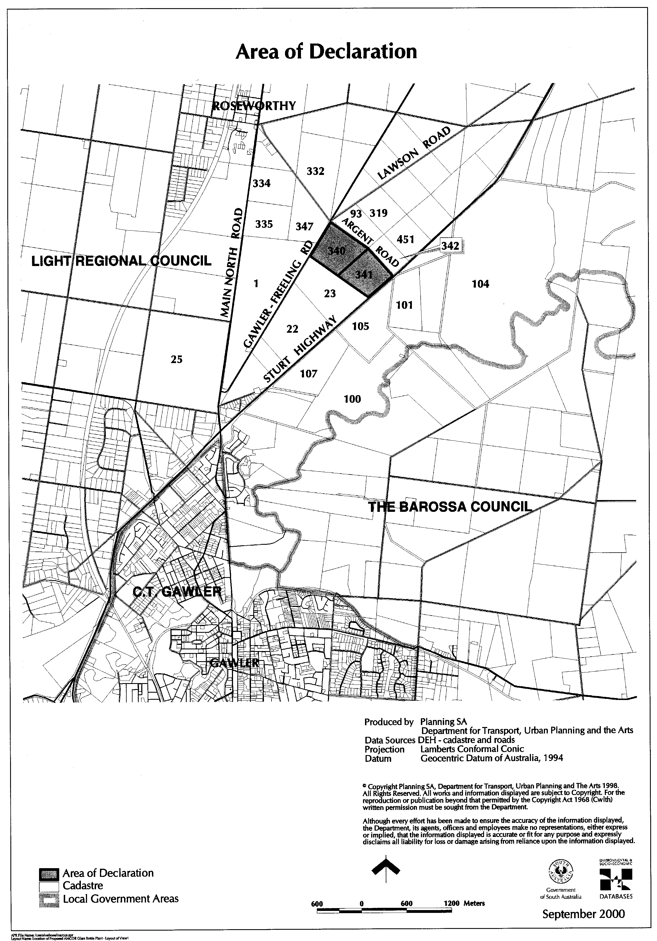

DEVELOPMENT ACT 1993, SECTION 29 (2) (b): AMENDMENT TO THE LACEPEDE (DC) DEVELOPMENT PLAN
Preamble
It is necessary to amend the Lacepede (DC) Development Plan dated 6 July 2000.
Notice
PURSUANT to section 29 (2) (b) of the Development Act 1993, I, Diana Laidlaw, being the Minister administering the Act, amend The Lacepede (DC) Development Plan, dated 6 July 2000 as follows:
1. (a) Delete Maps La/1 to La/13;
(b) insert the contents of Attachment A; and
(c) adjust the mapping references in the Lacepede (DC) Development Plan text accordingly.
2. Replace Fig. In/1 within the Industry Zone with the contents of Attachment B.
3. Amend all references to Lacepede (DC) within the Development Plan text and tables to Kingston (DC).
Attachment A
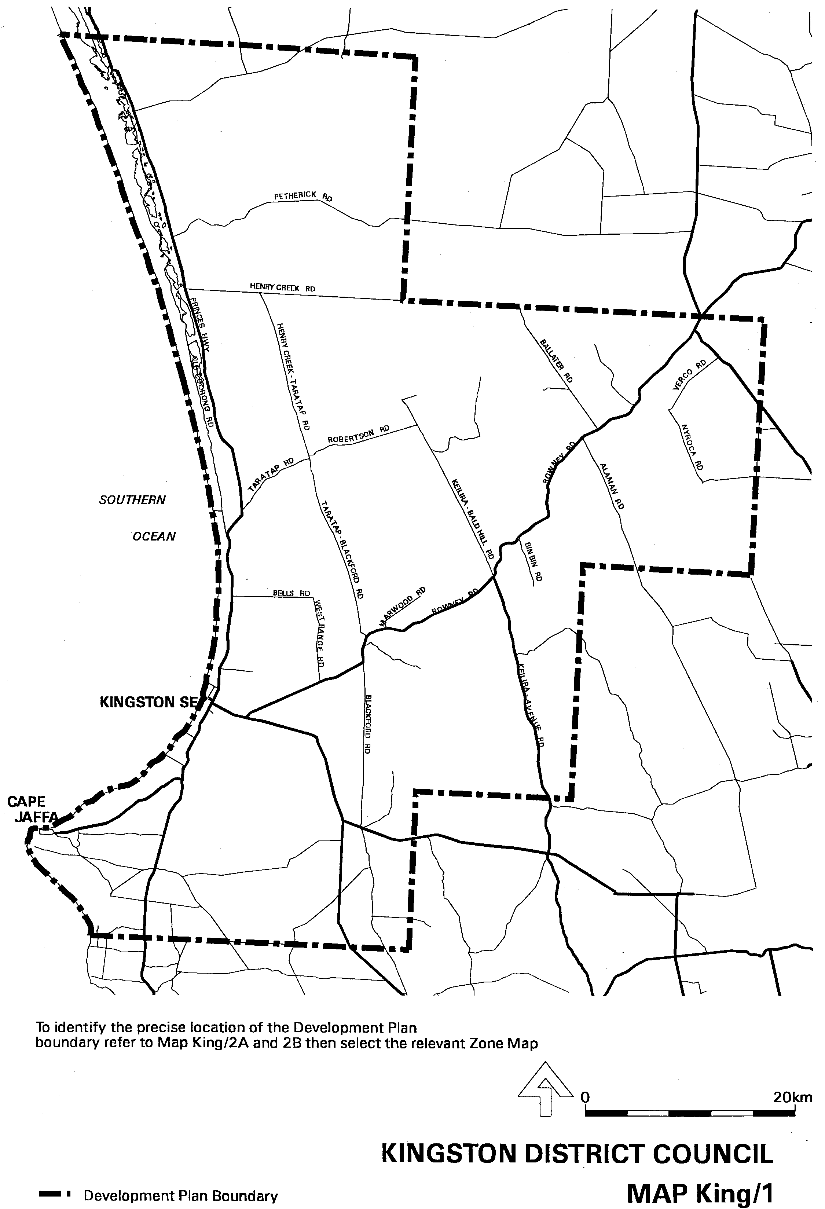
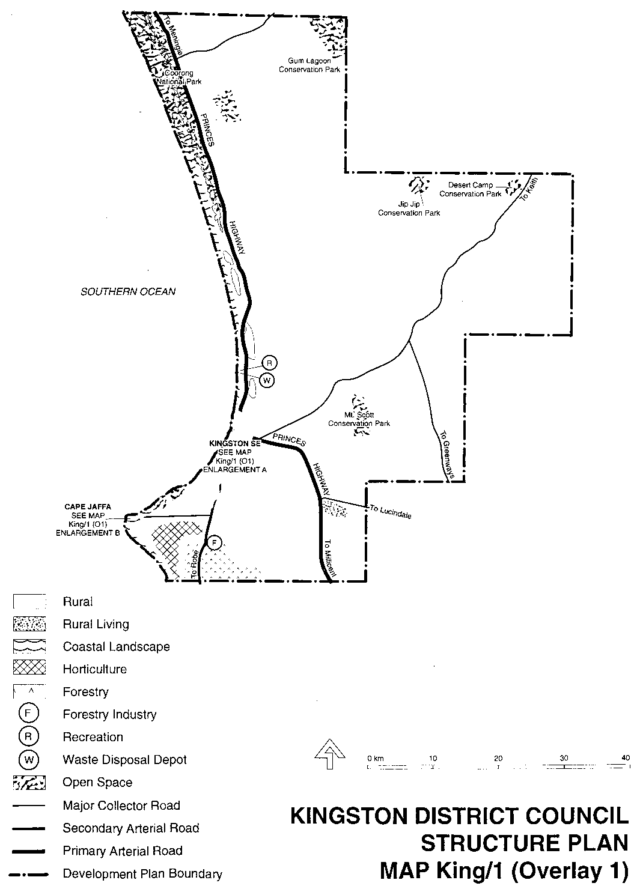
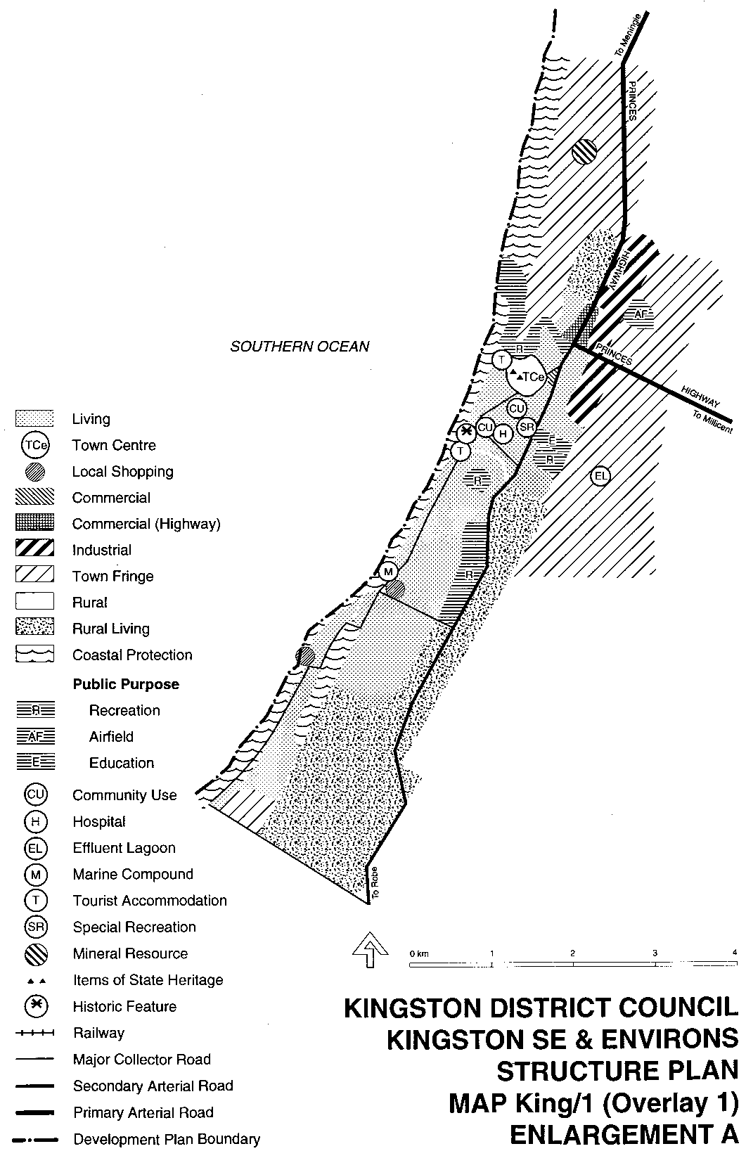
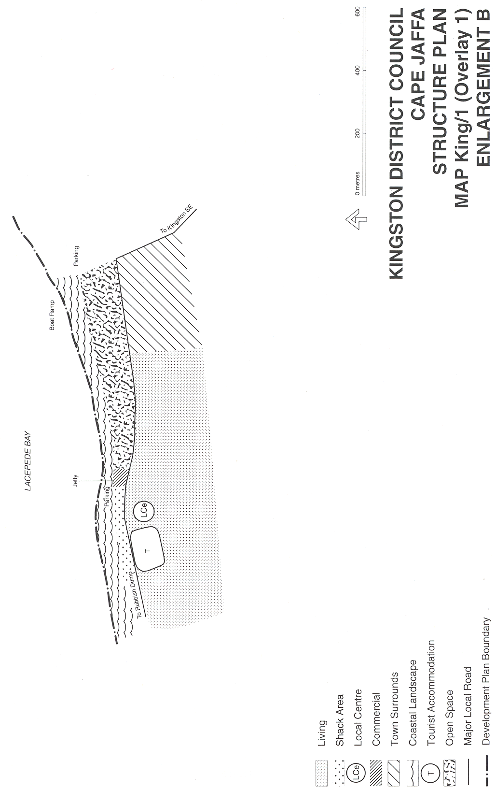
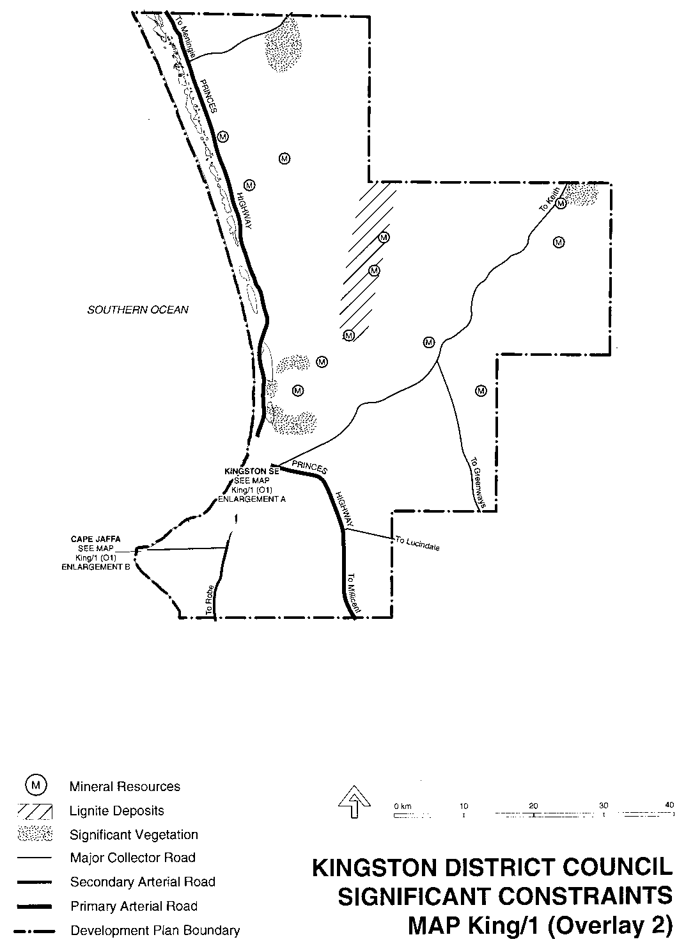
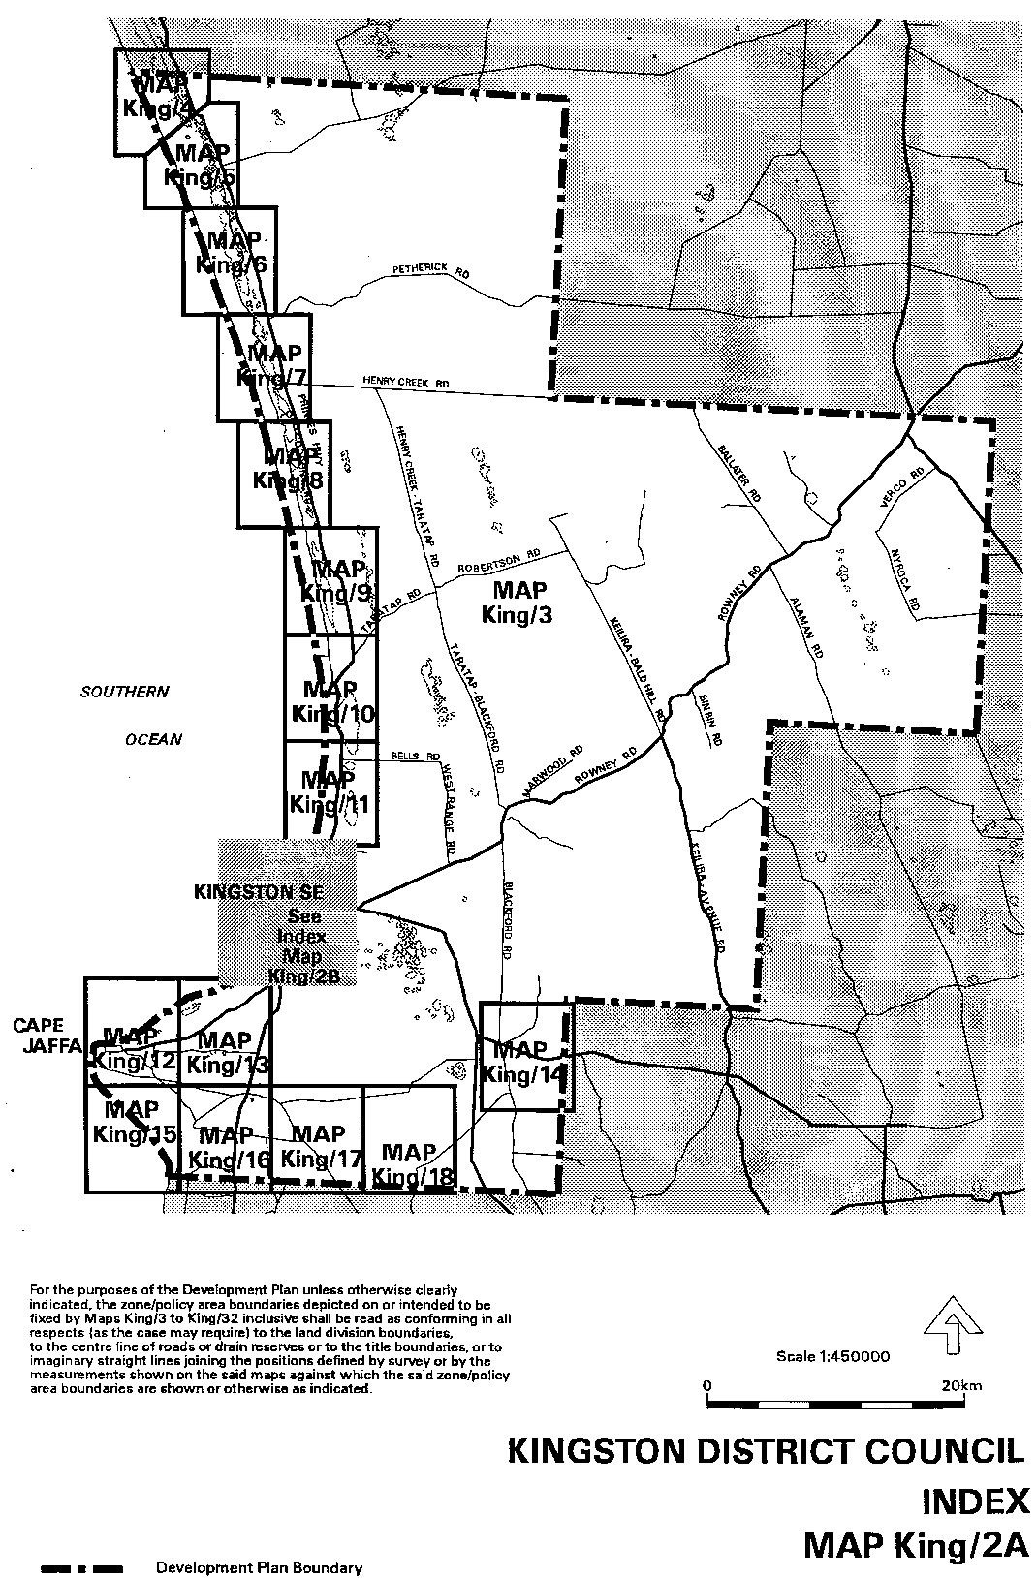
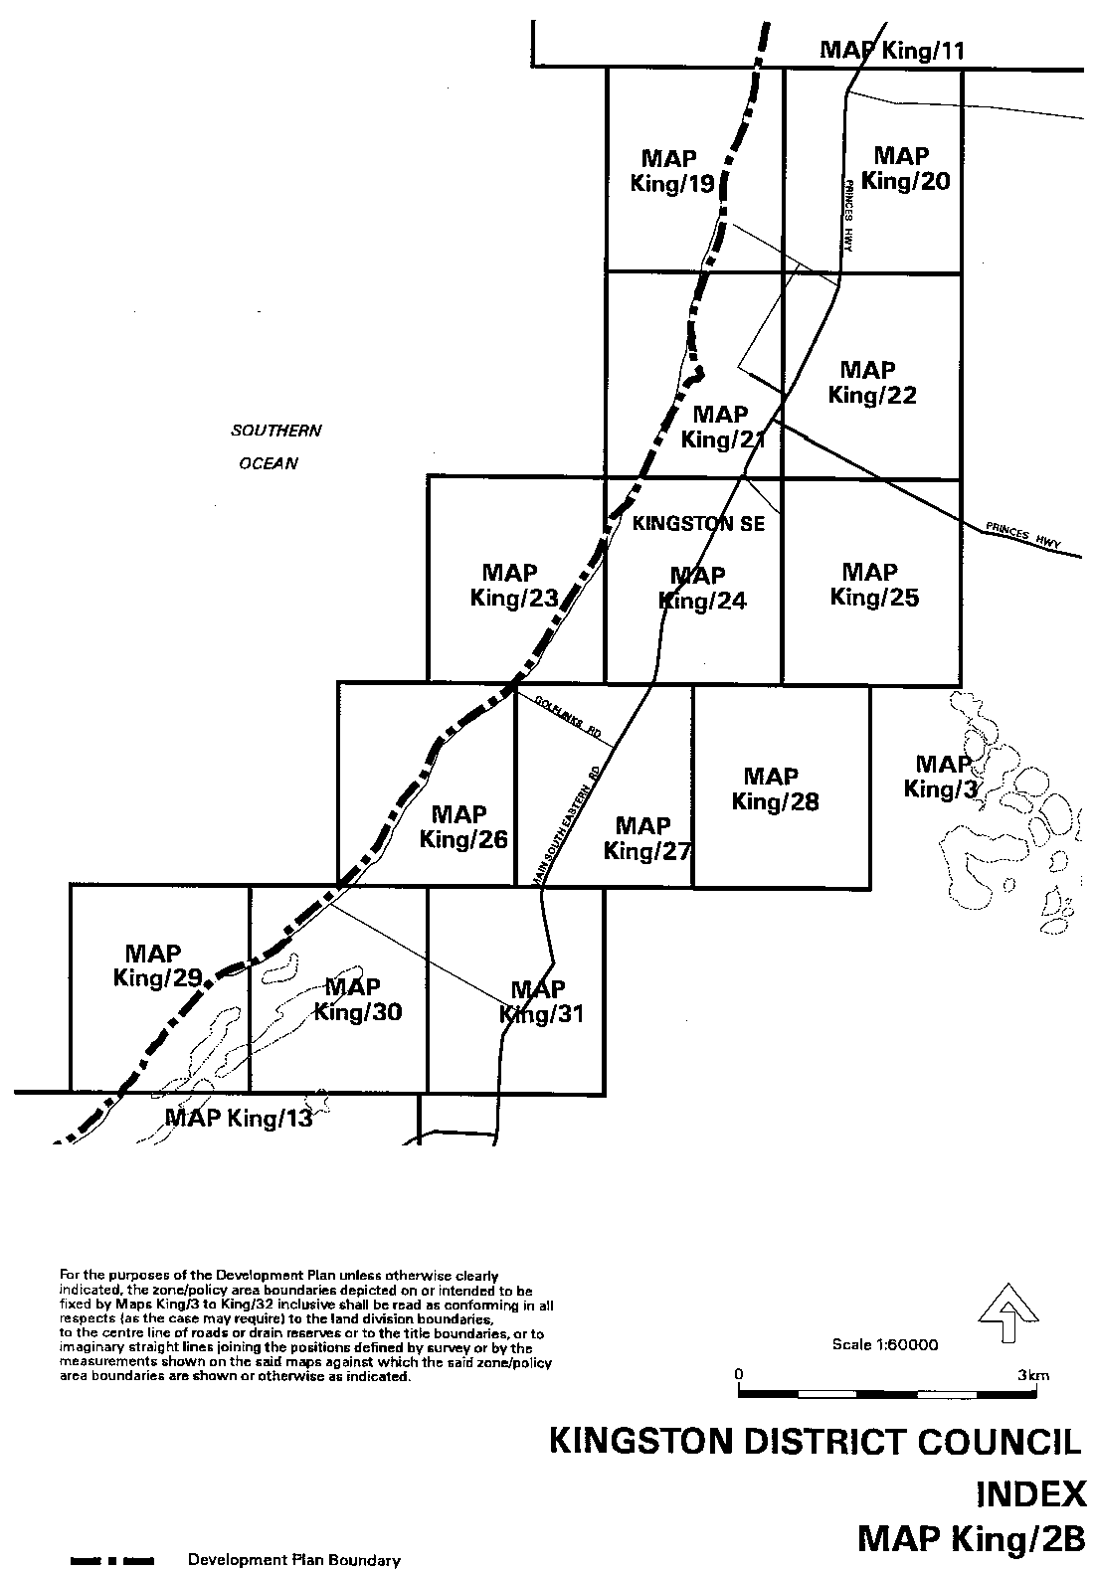
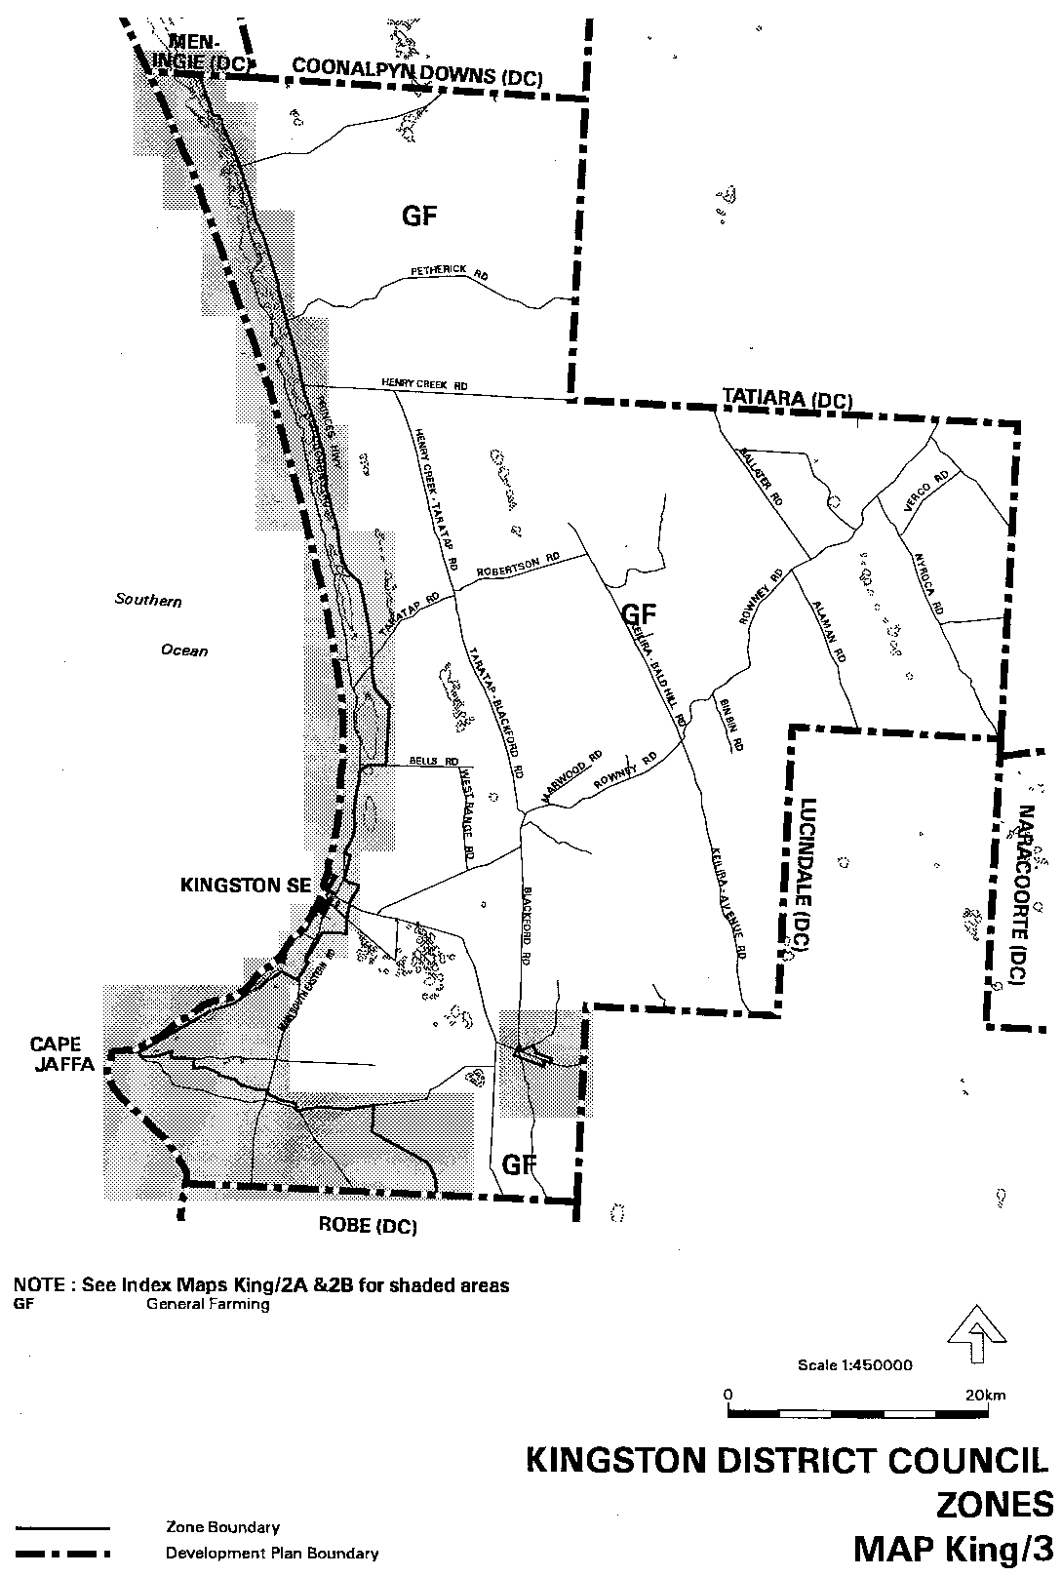
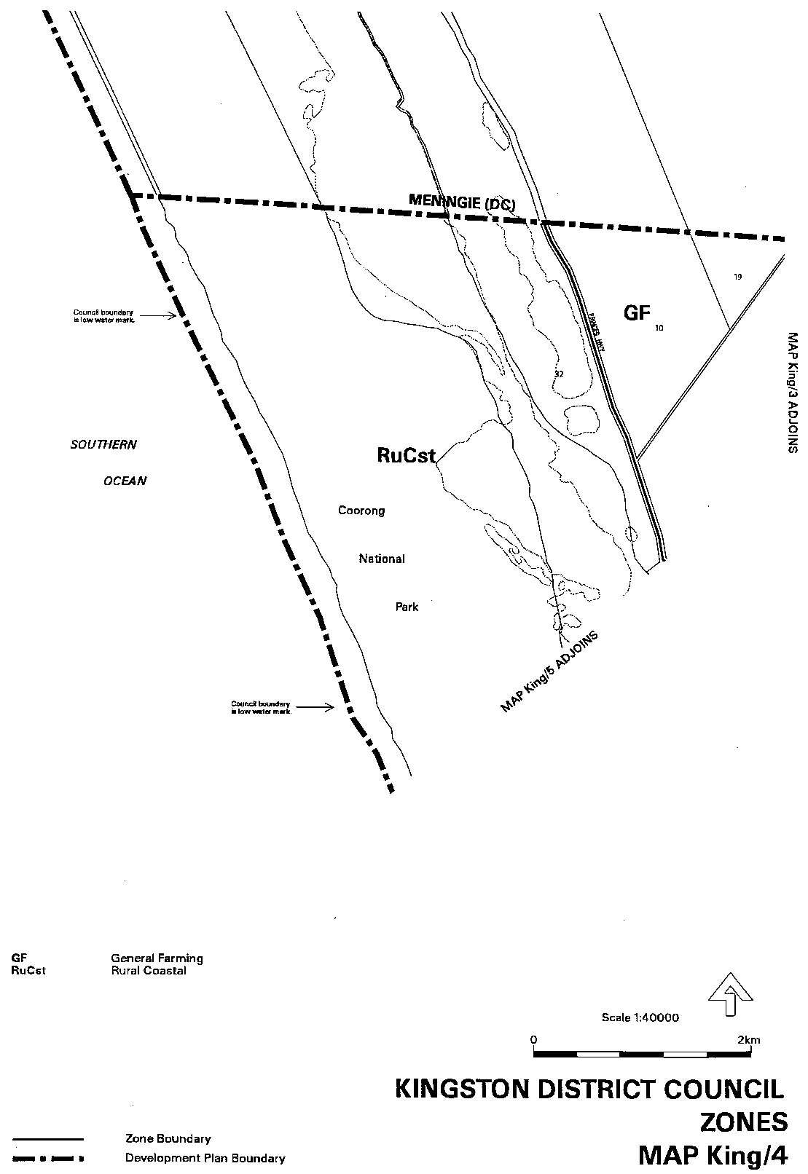
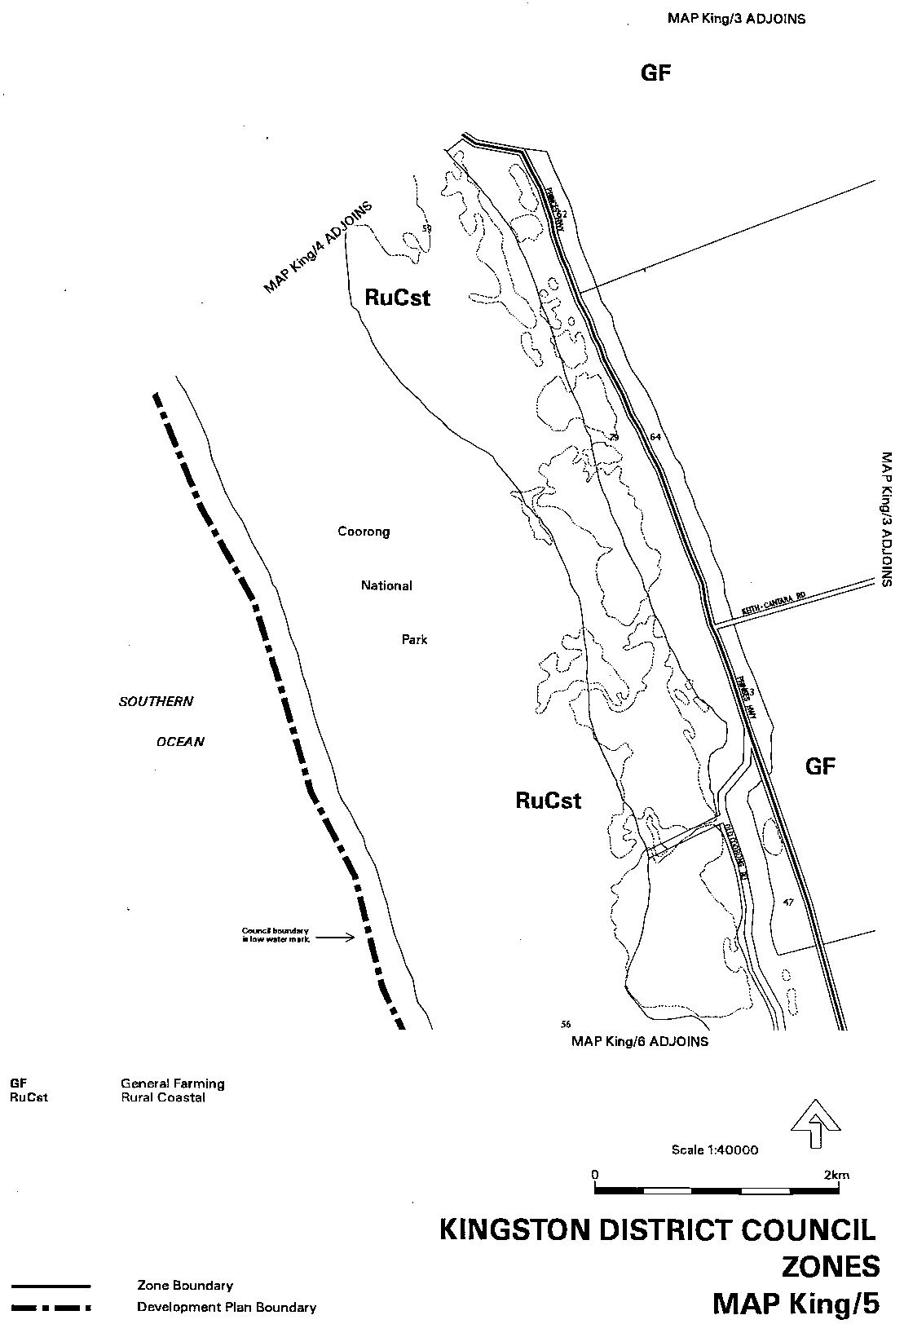
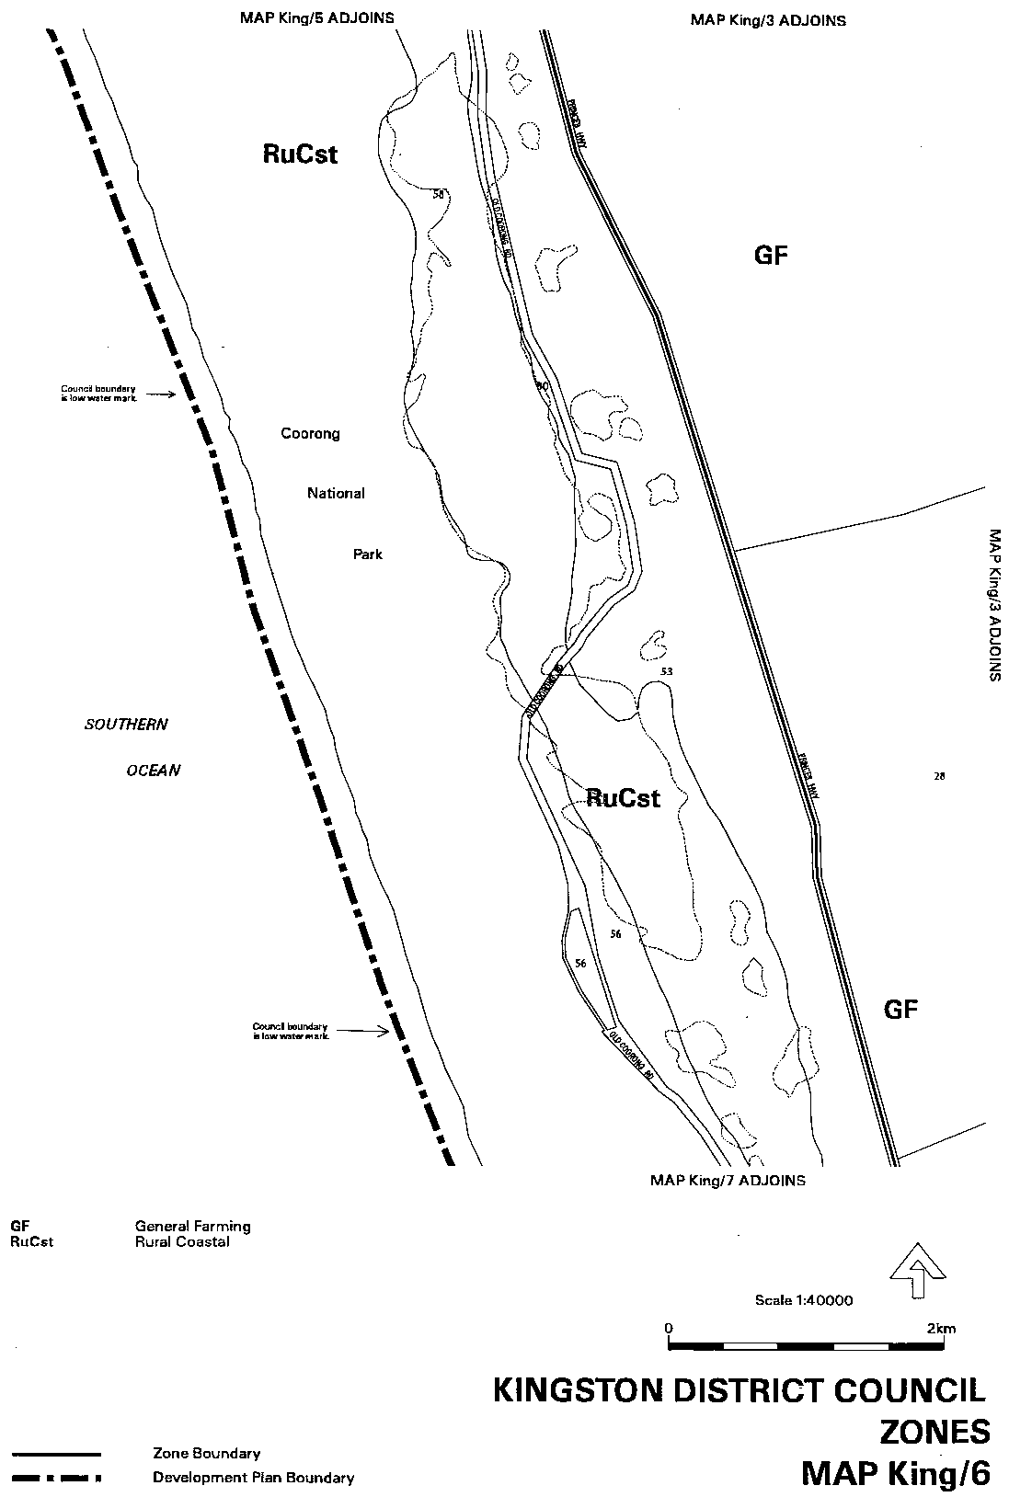
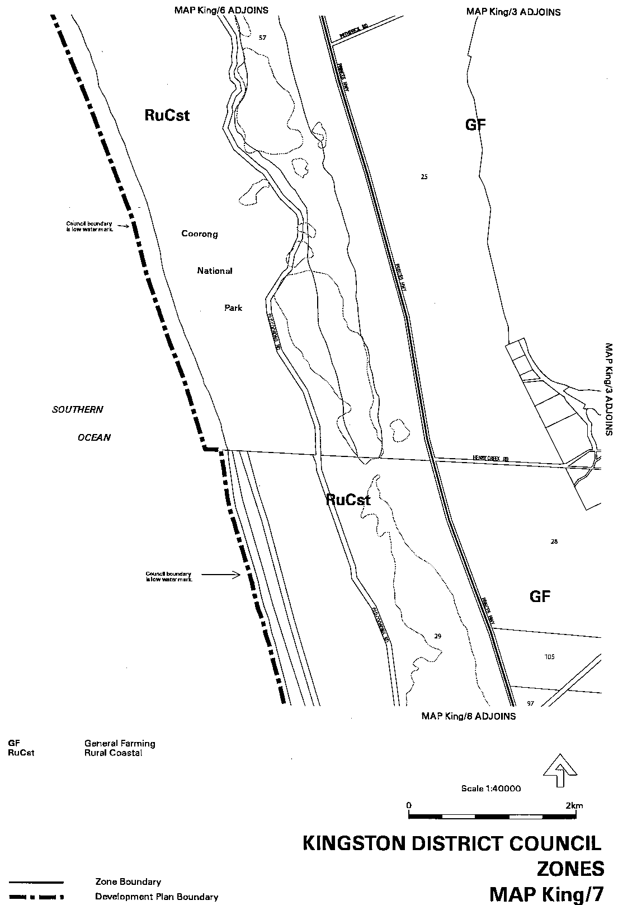
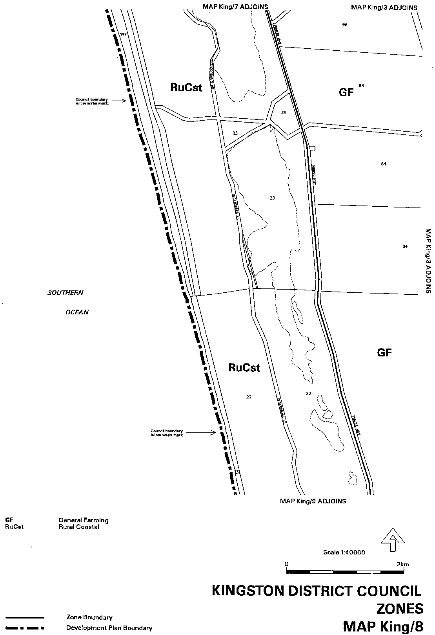
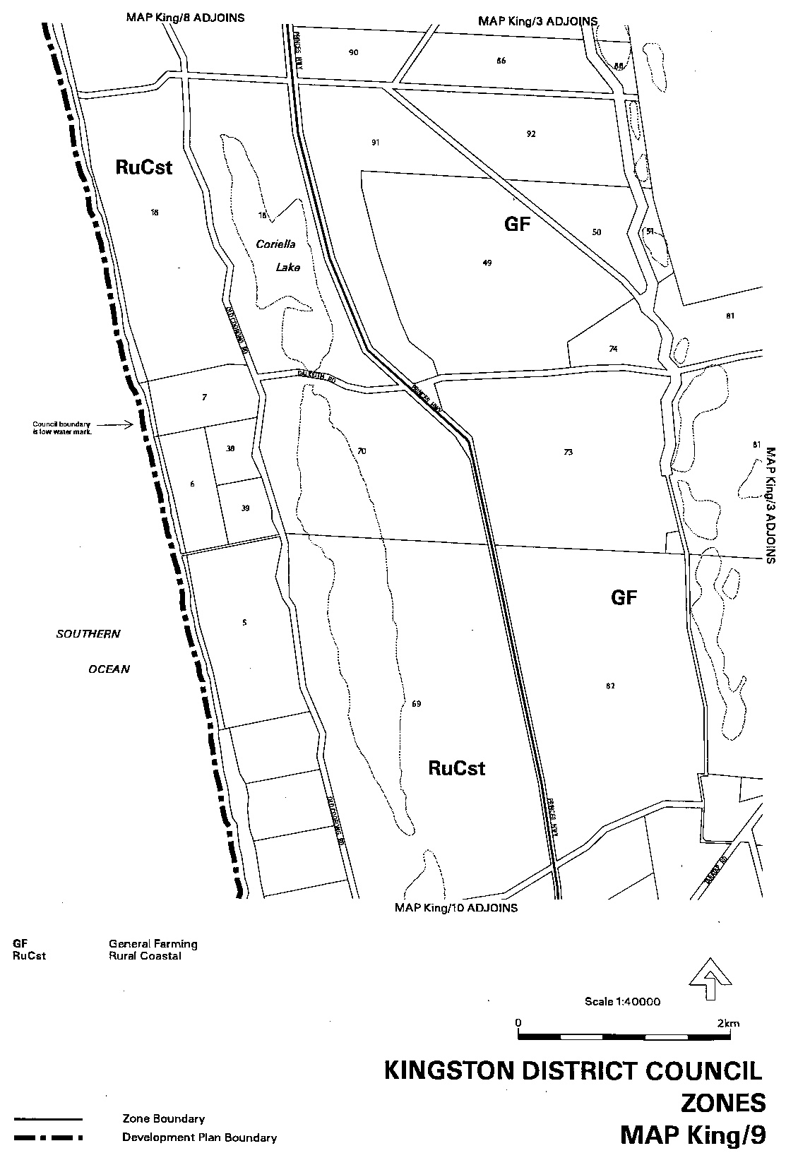
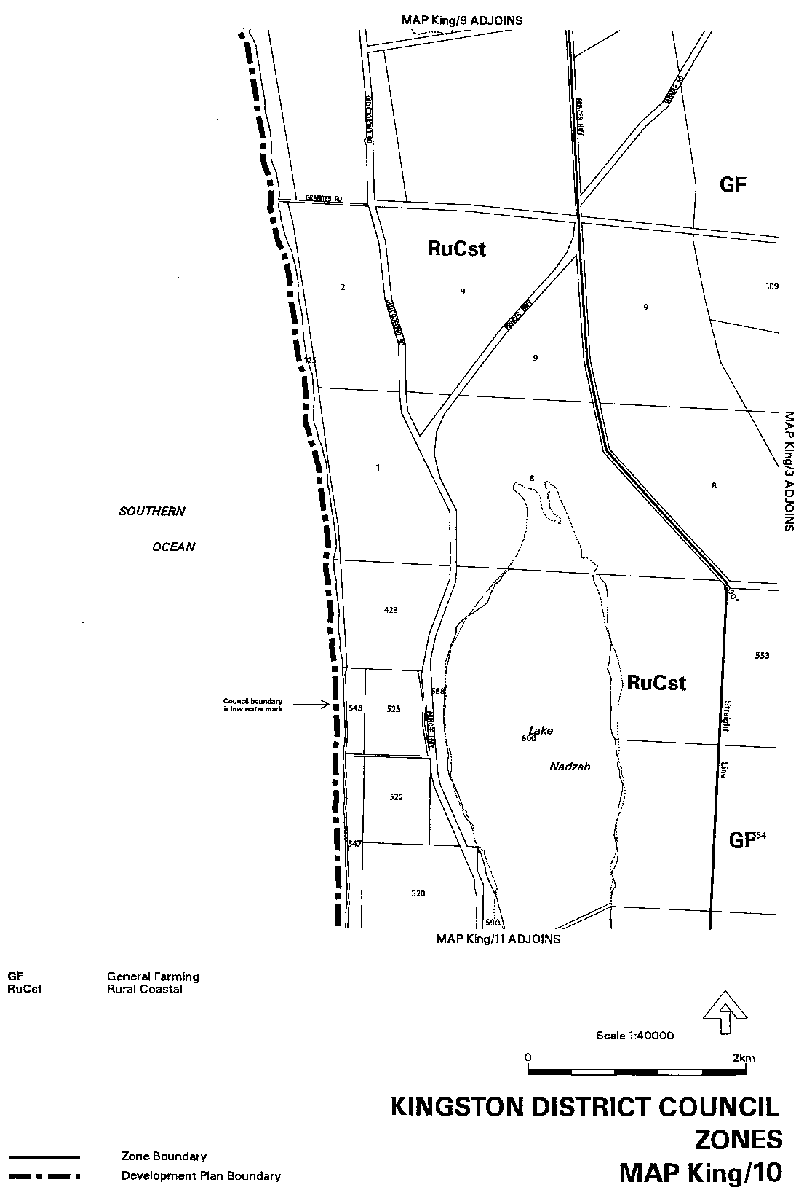
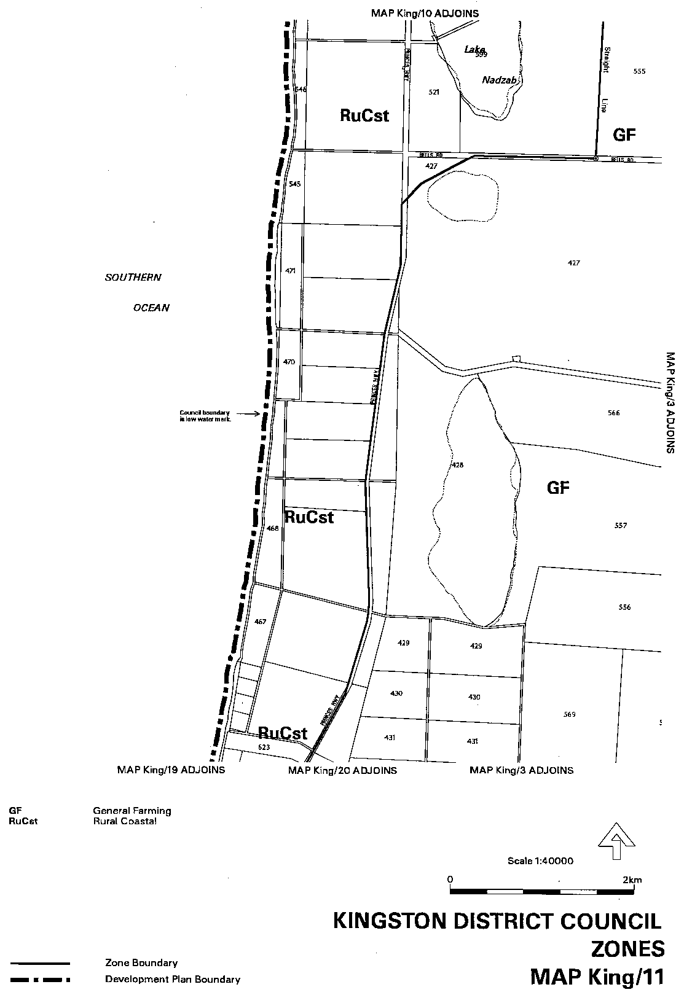
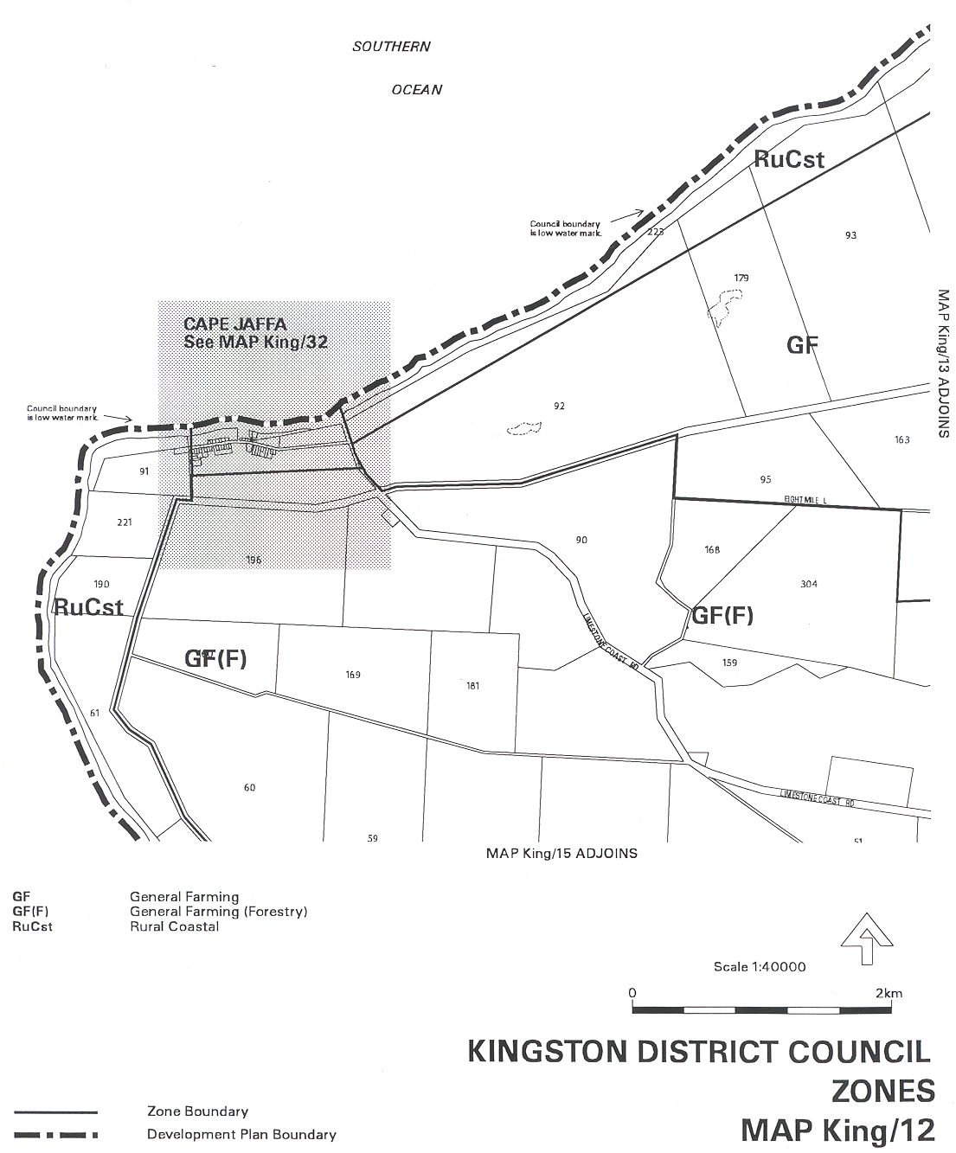
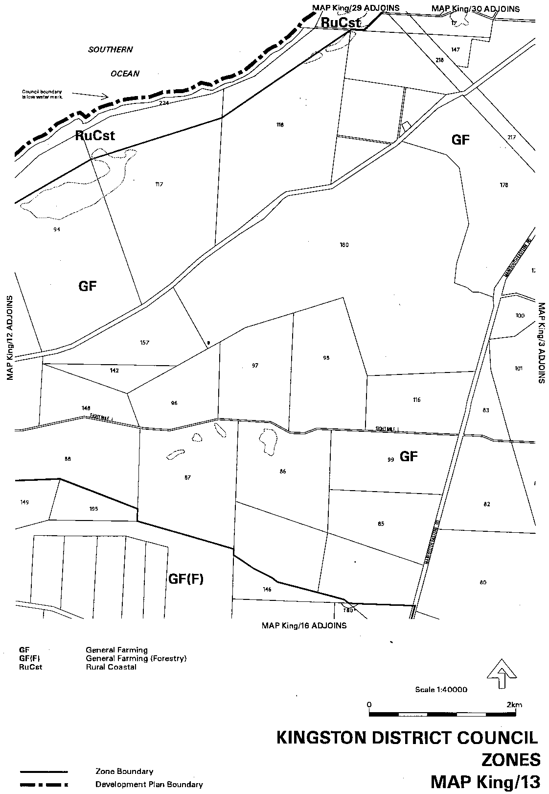
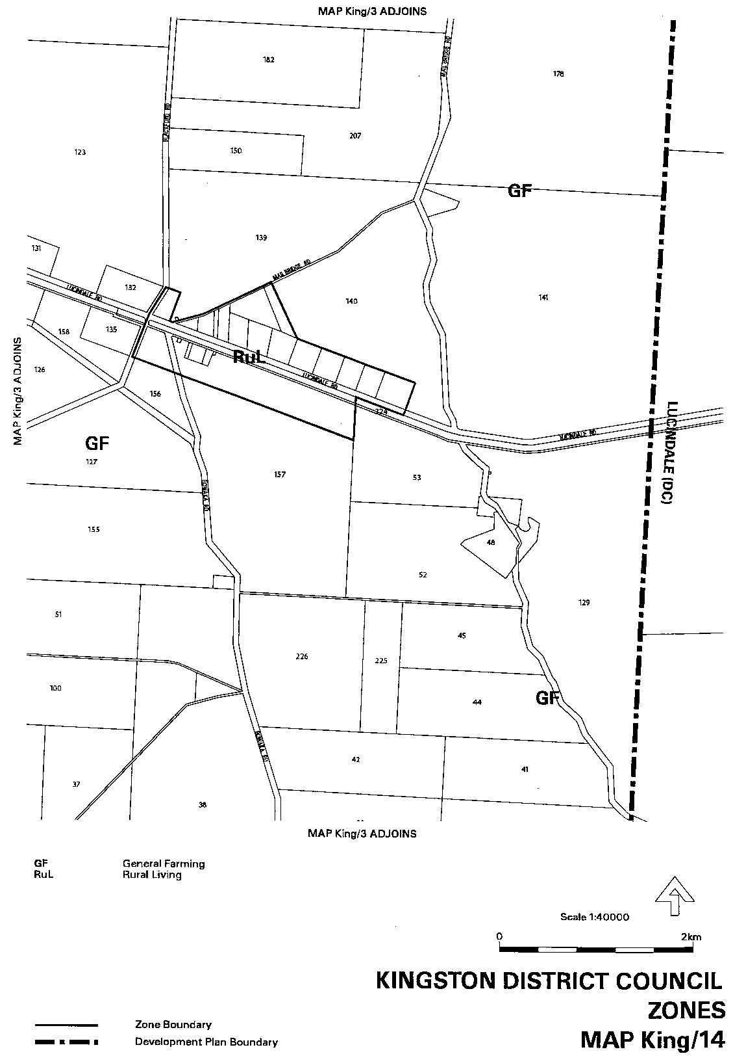
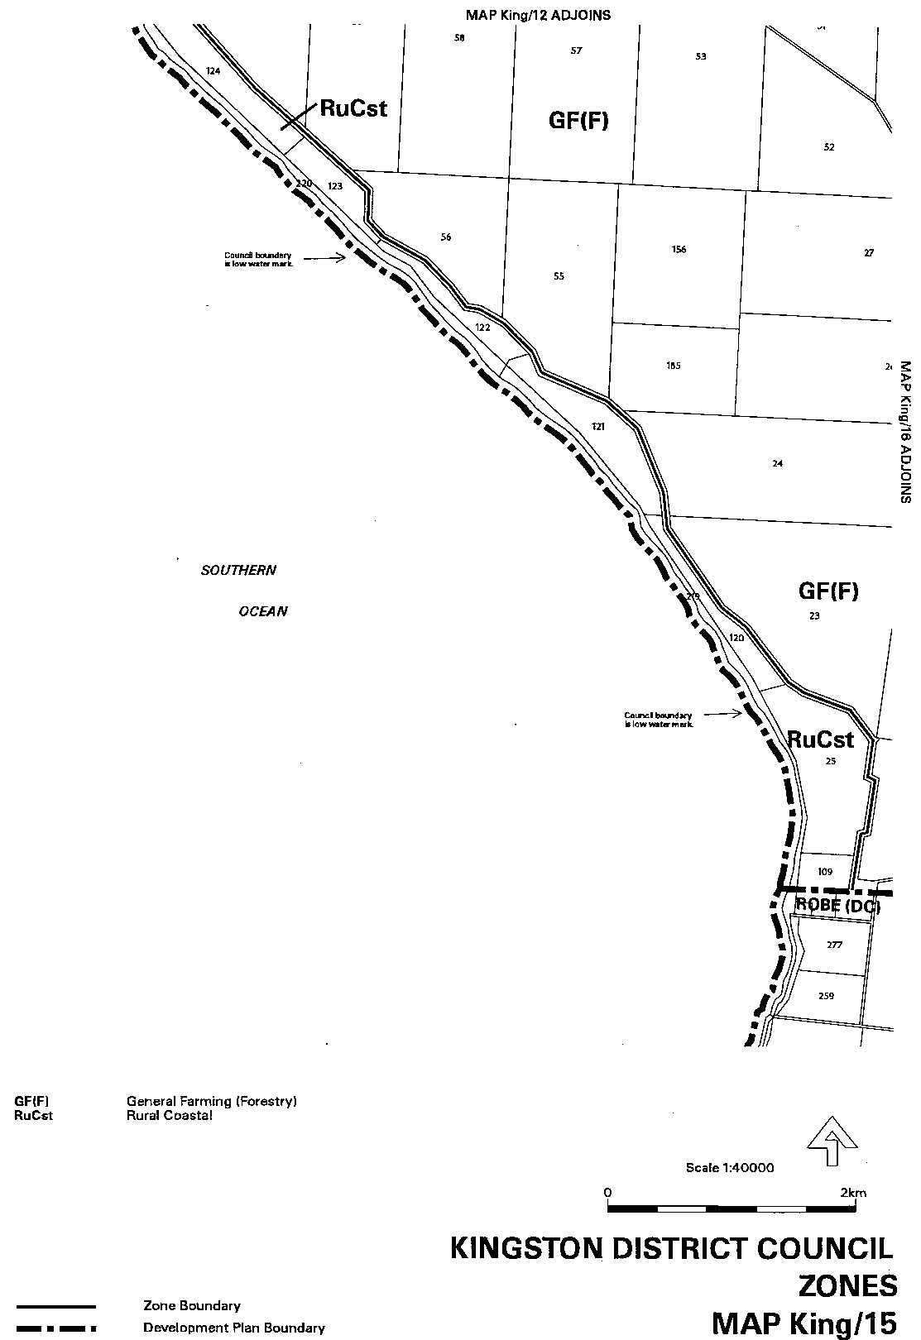
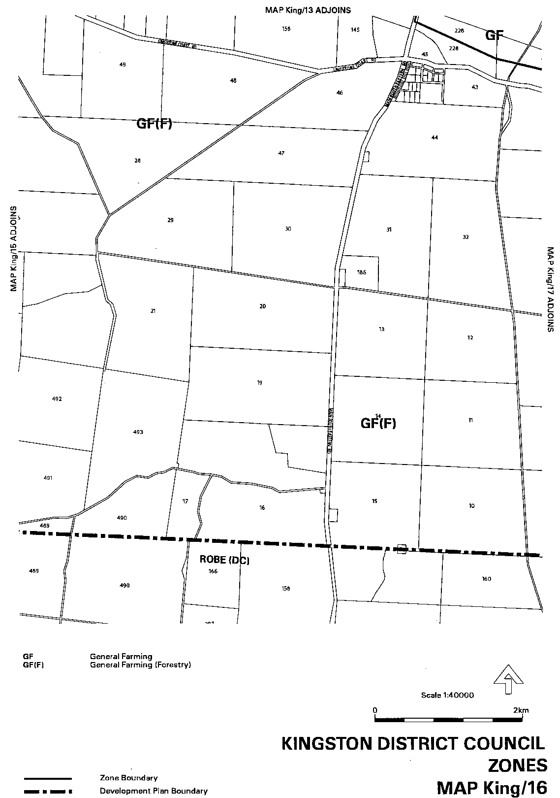
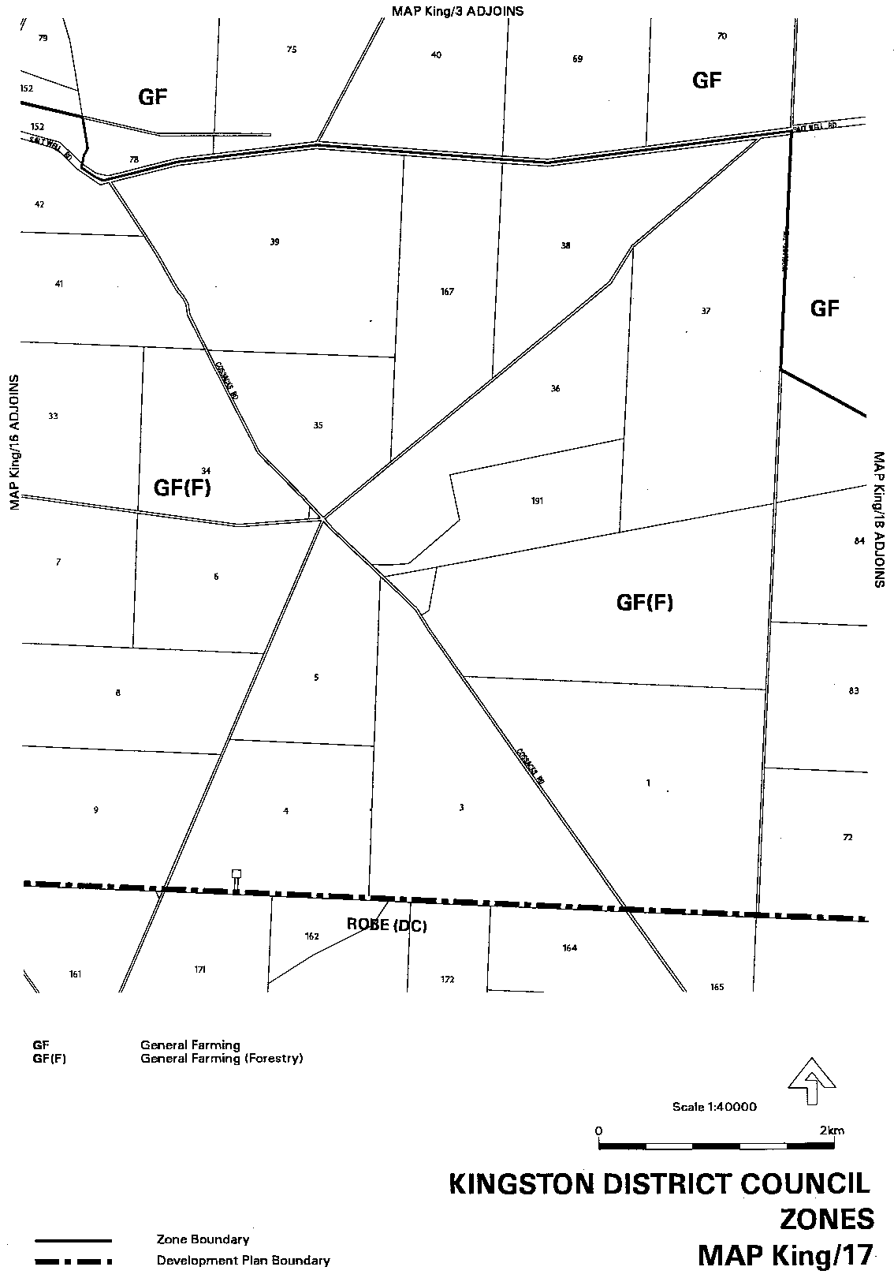
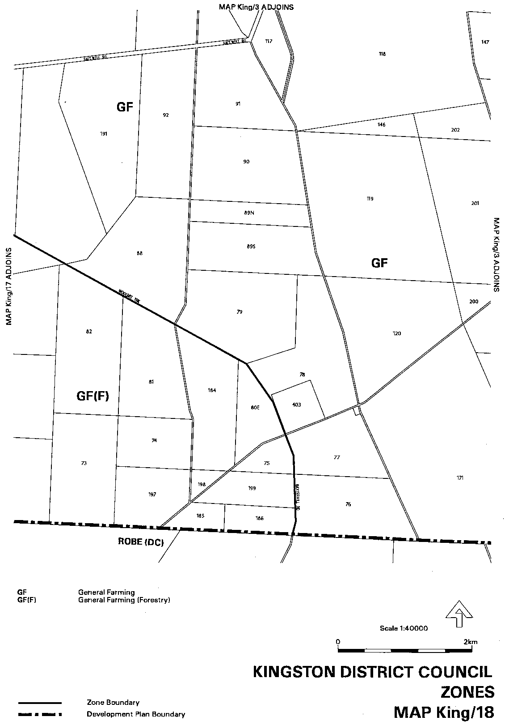
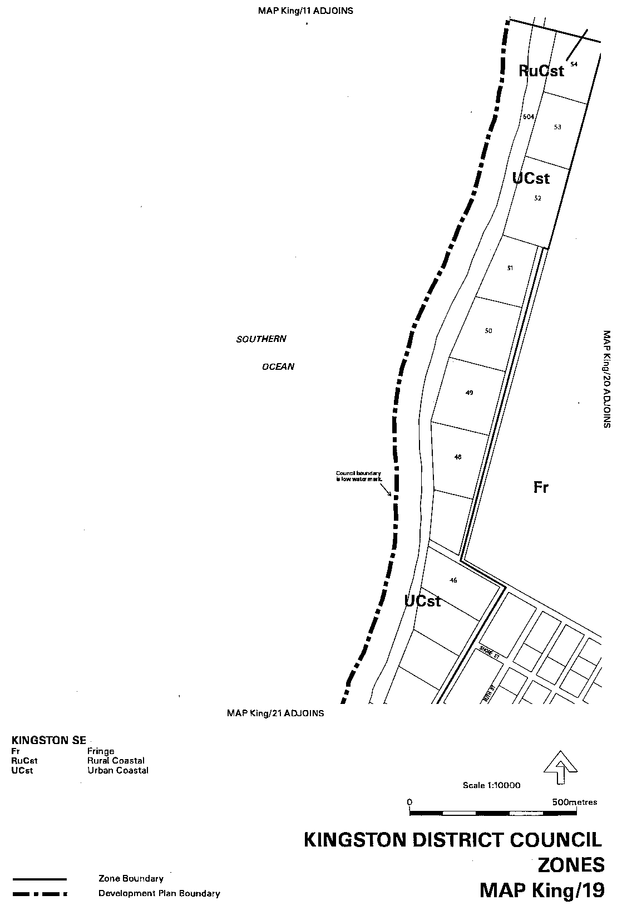
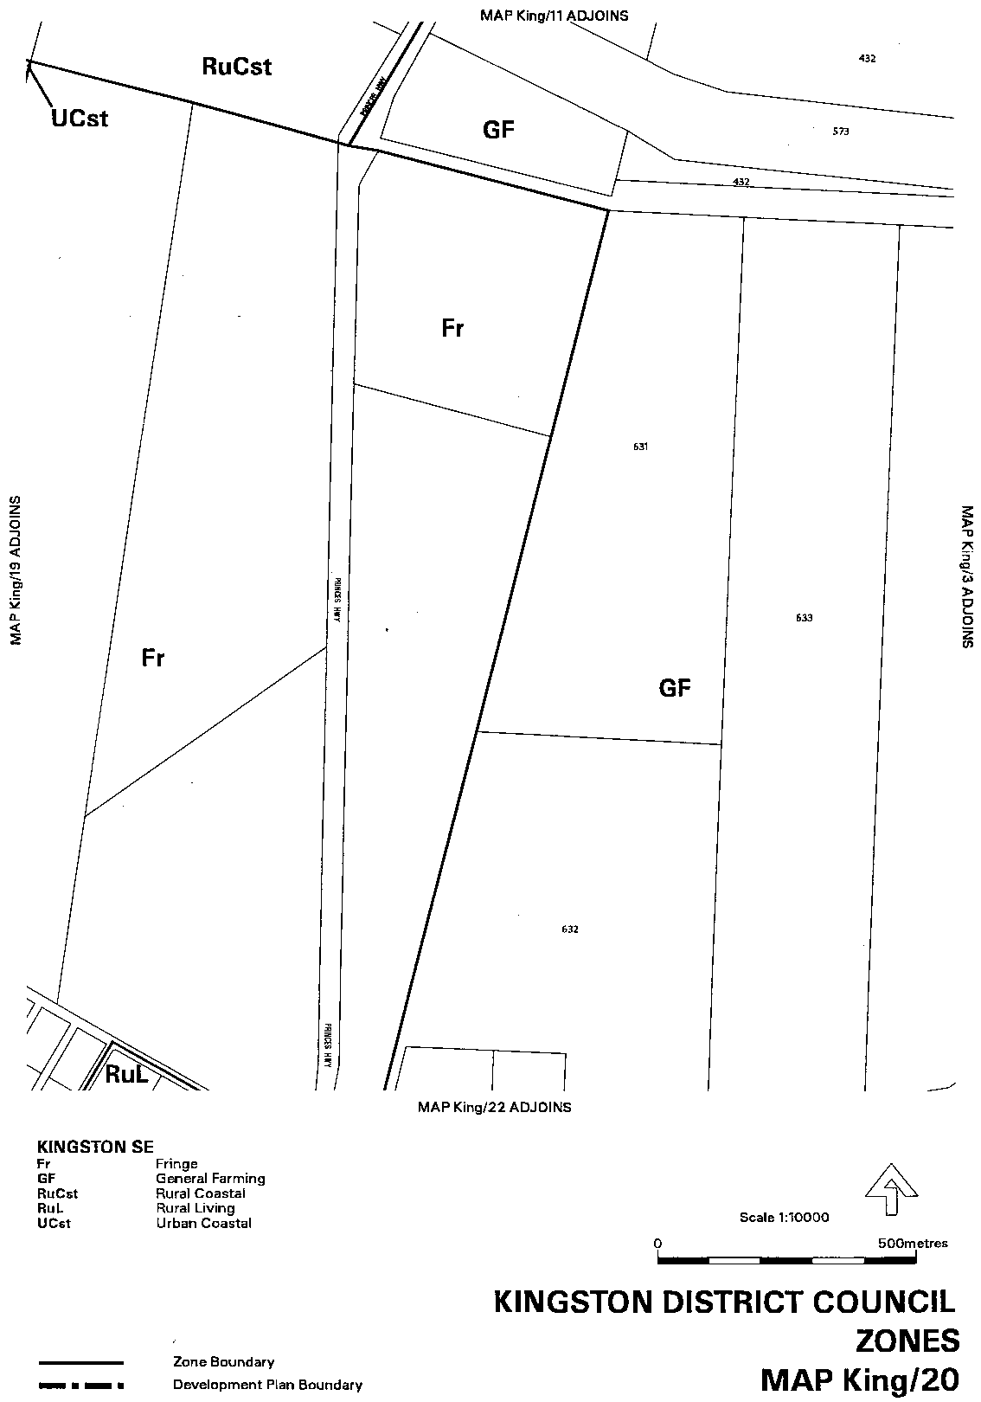
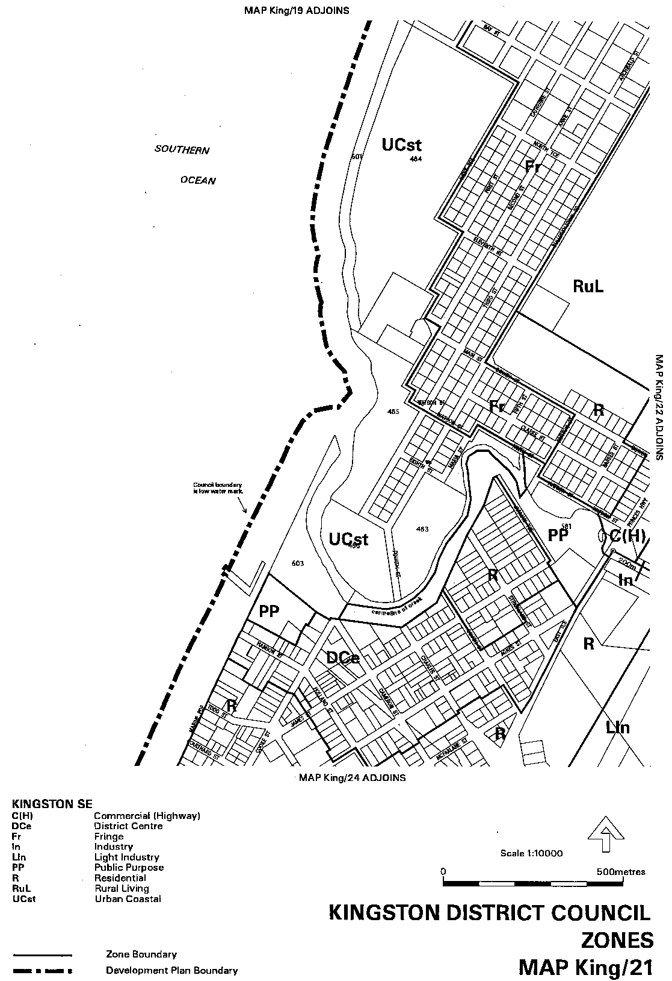
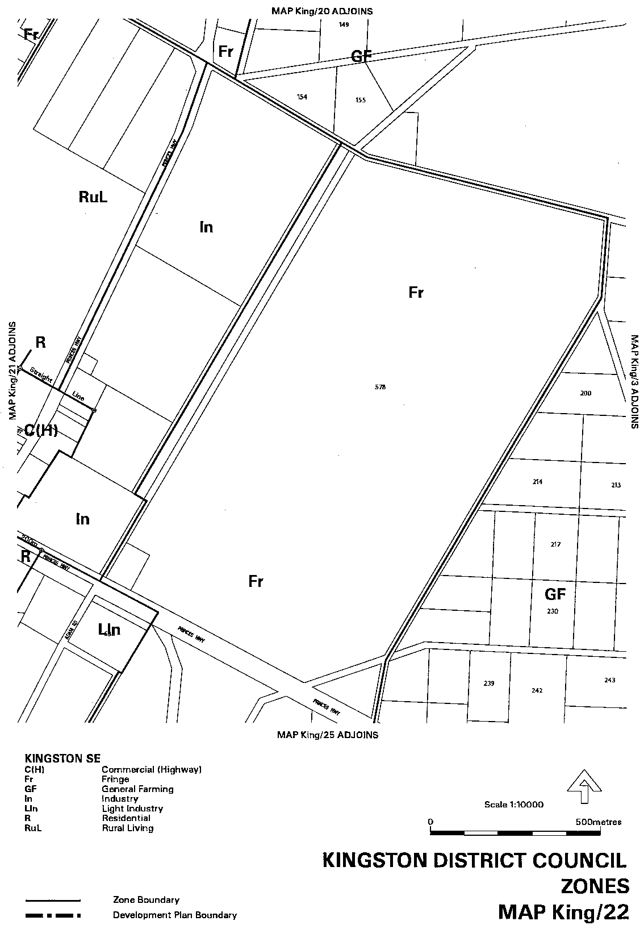
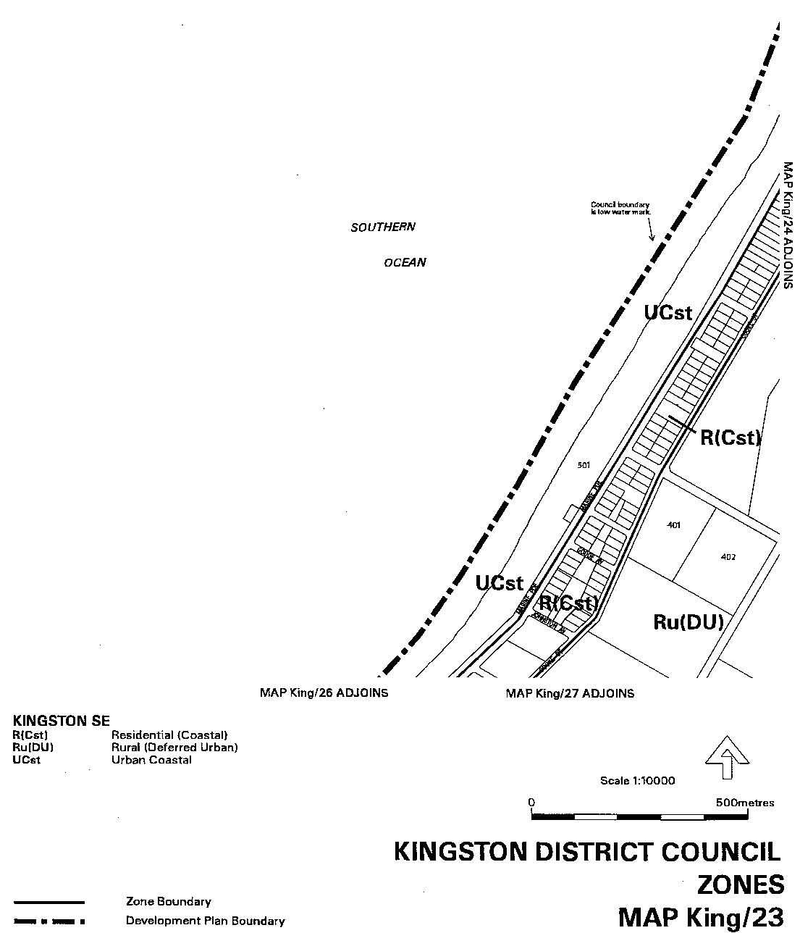
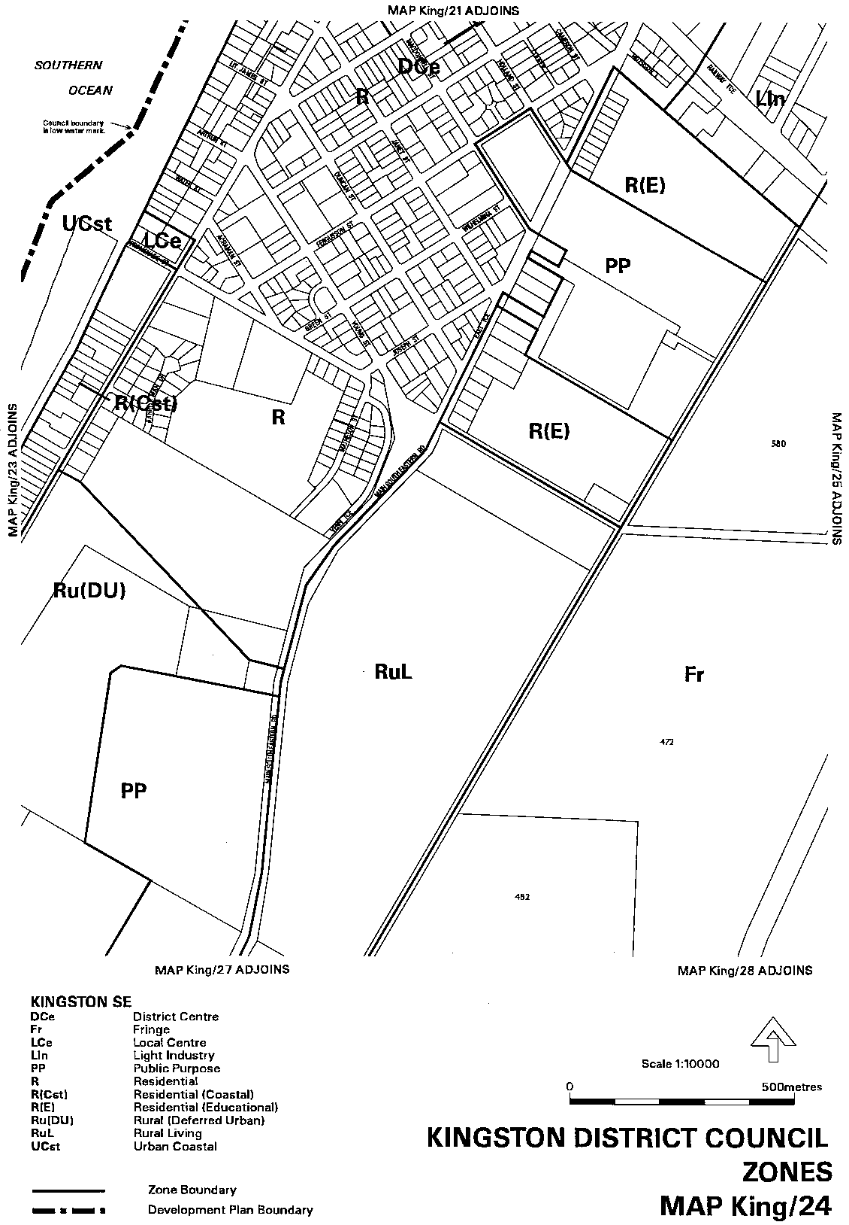
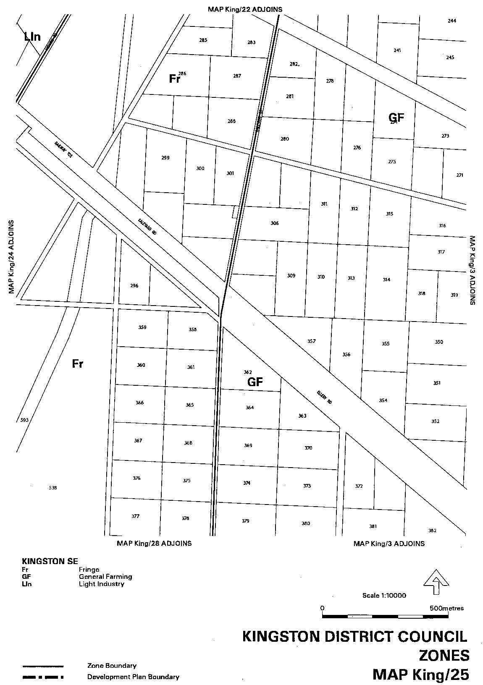
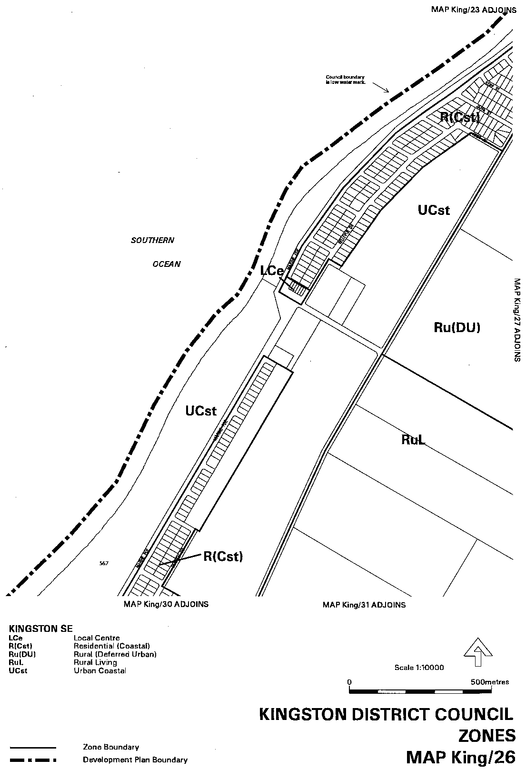
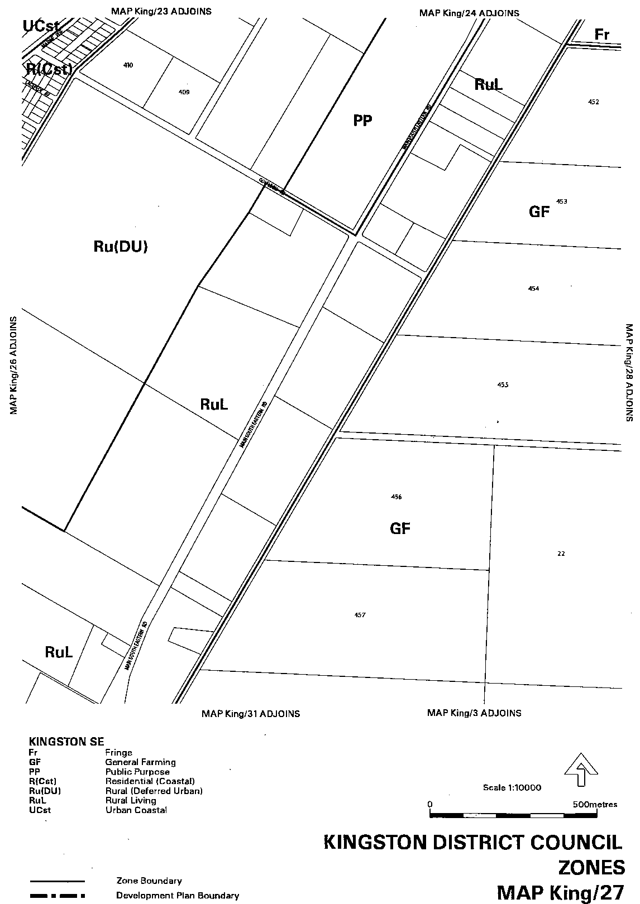
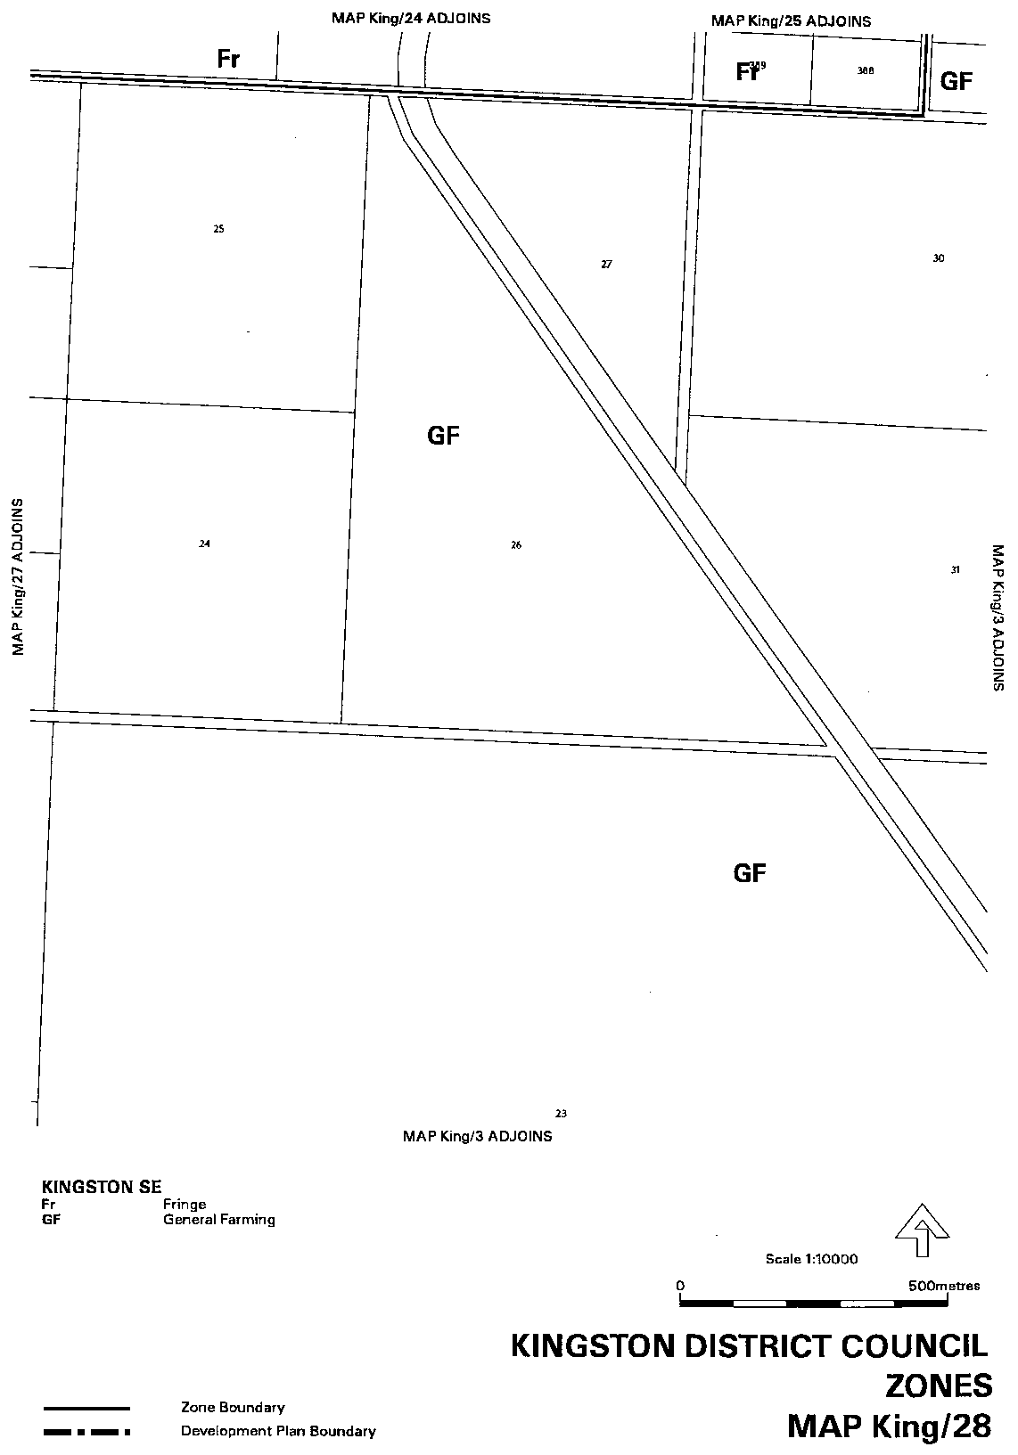
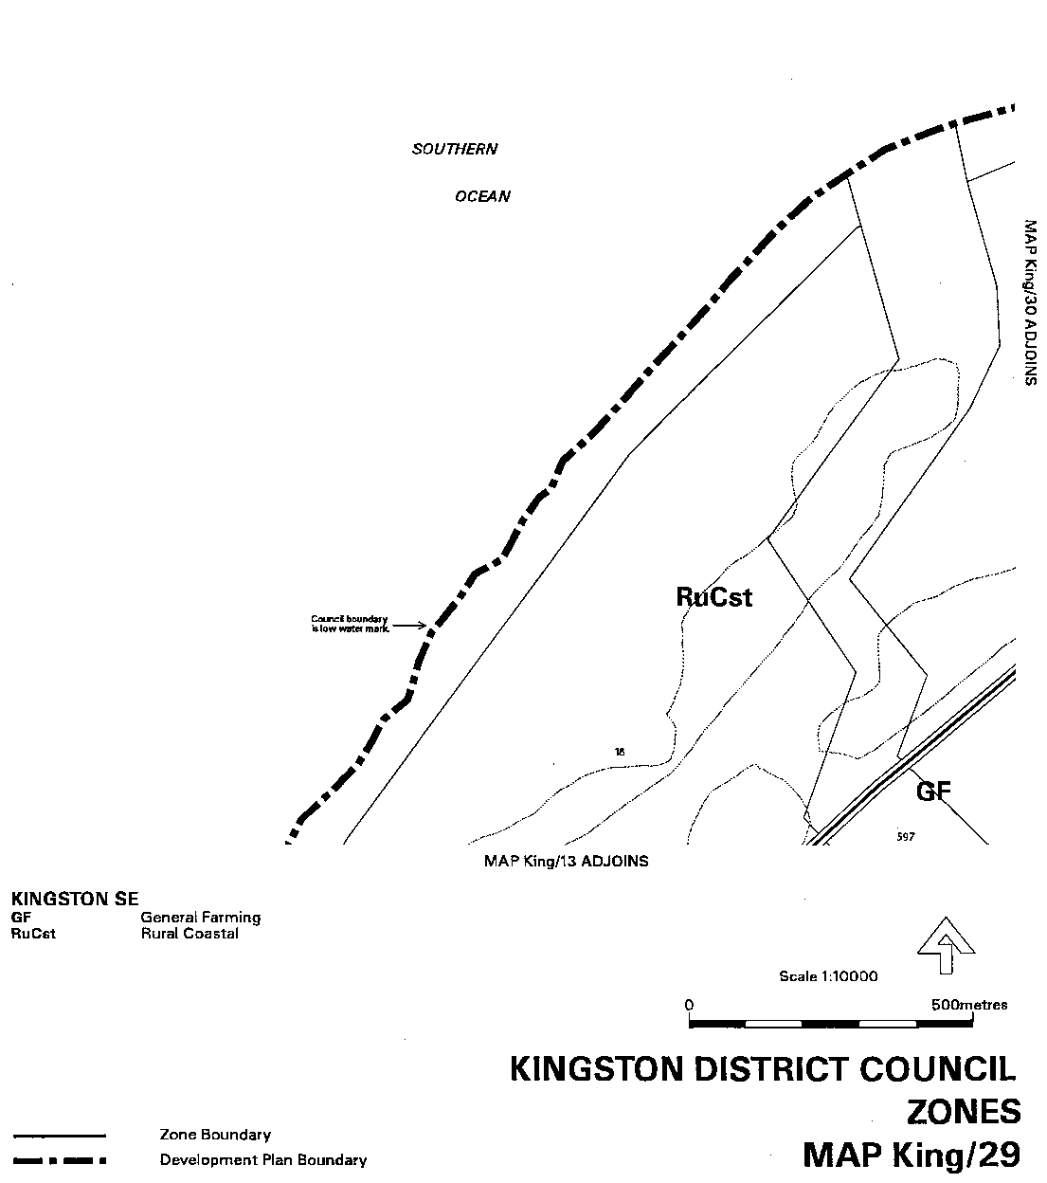
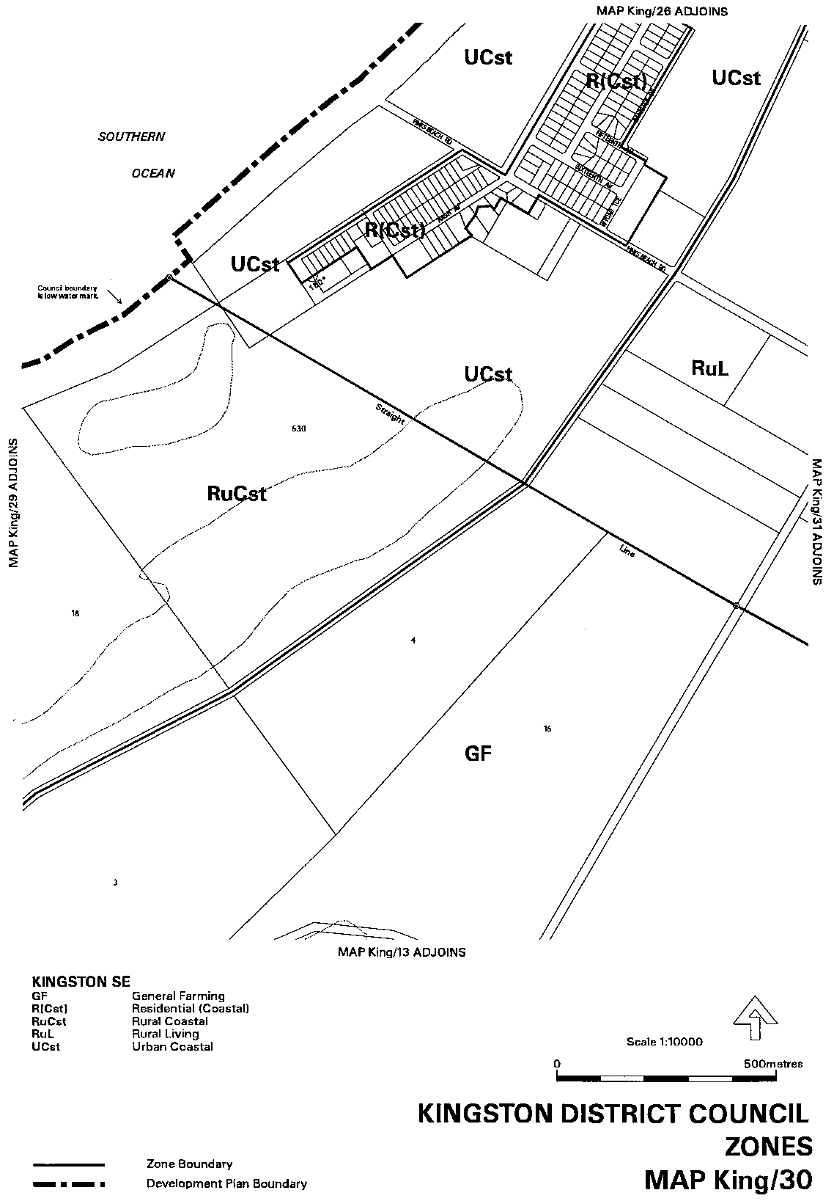
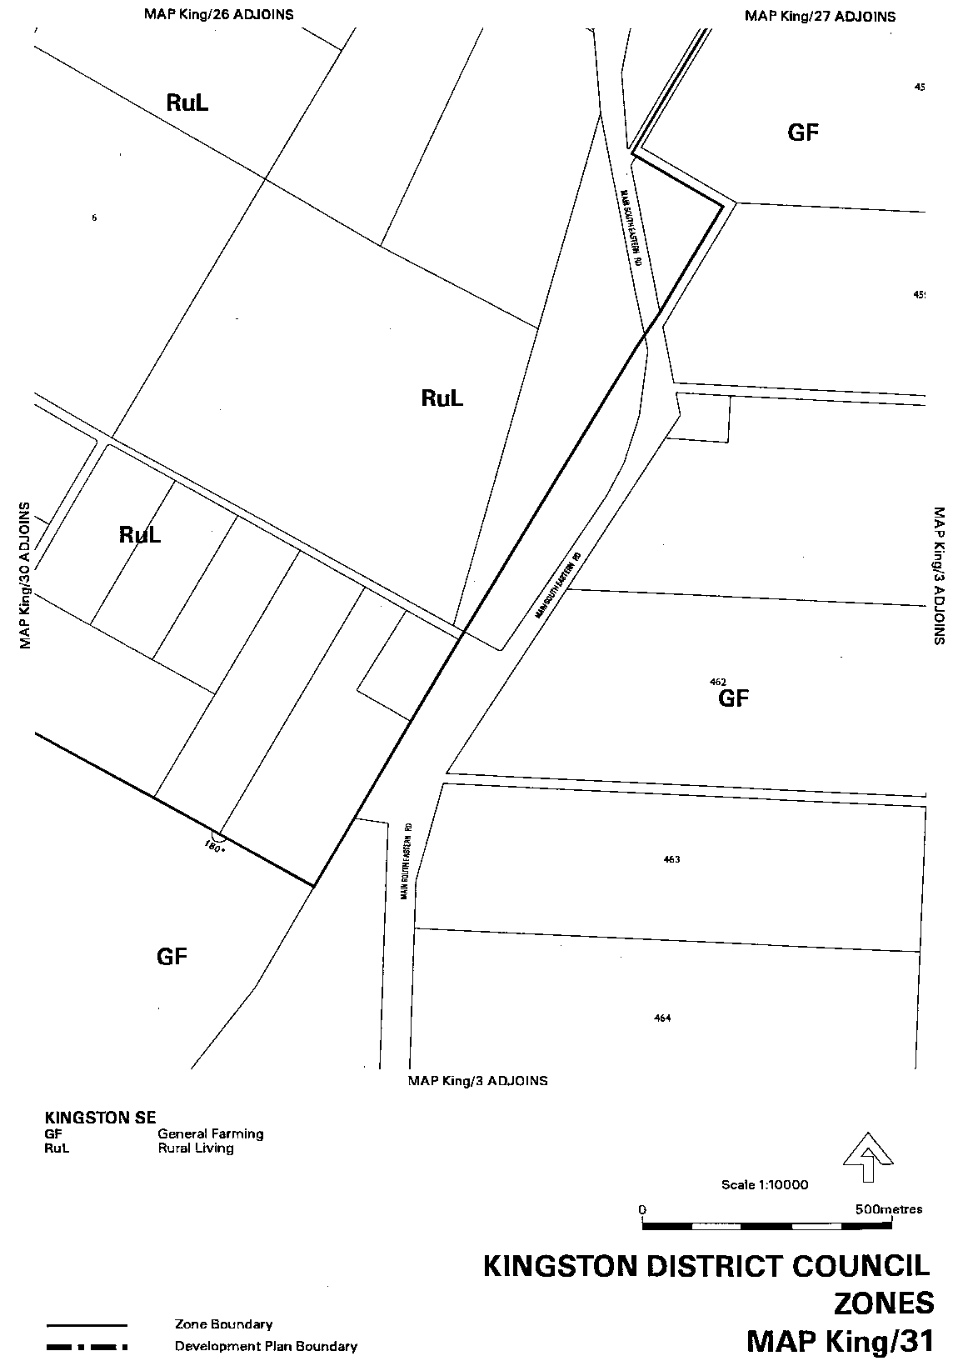
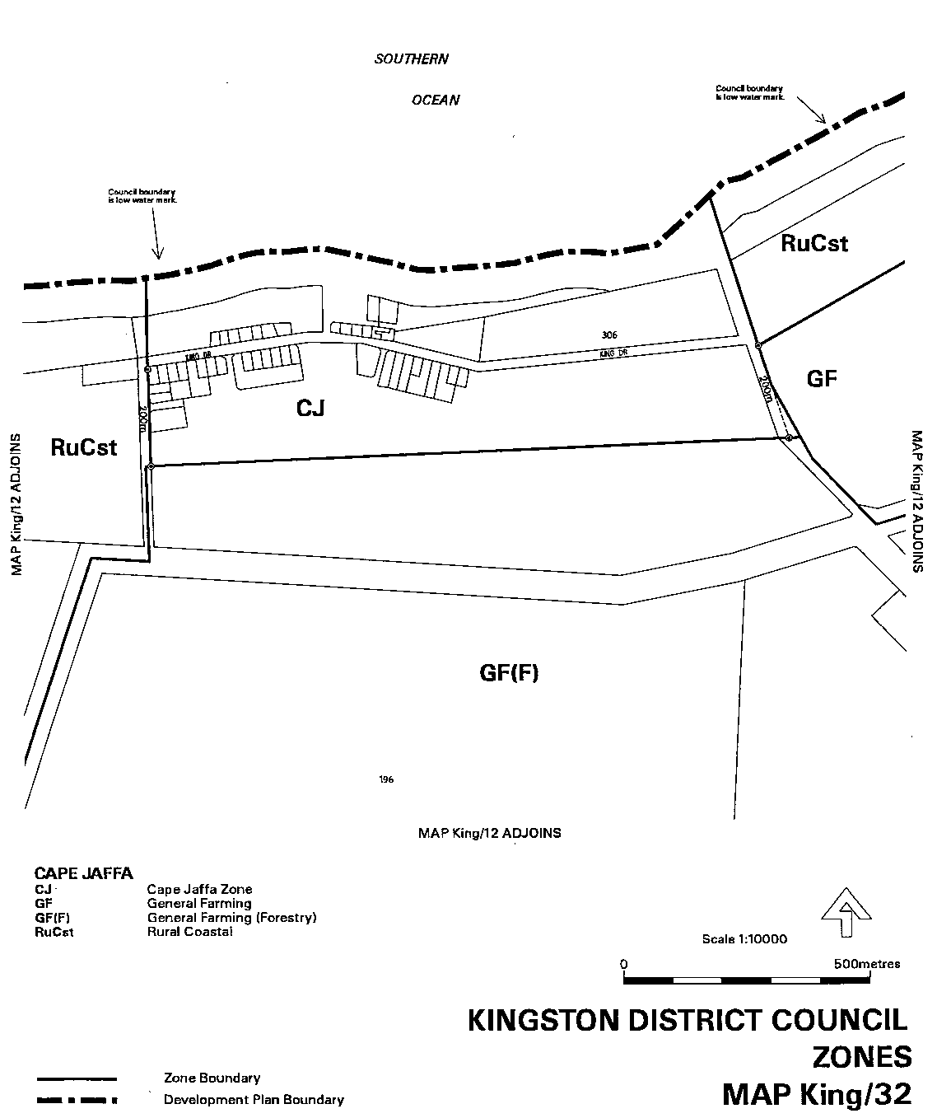
Attachment B
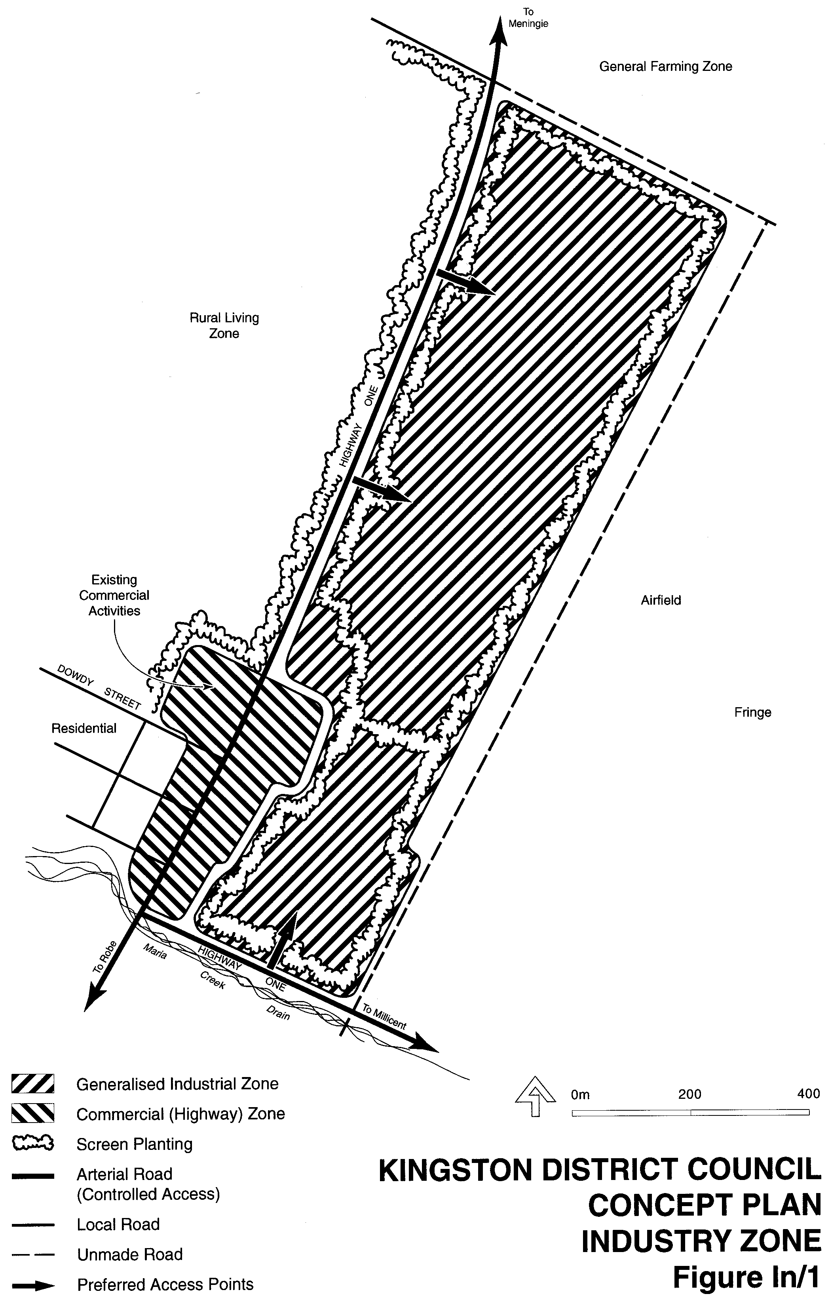

Dated 28 September 2000.
Diana Laidlaw, Minister for Transport, Urban Planning and the Arts

FISHERIES ACT 1982
Marine Mollusc Farming Licence FM00018
(Previous Licence No. F509)
Licence to Farm Fish under section 53 of the Fisheries
Act 1982
WHEREAS the Director of Fisheries has, pursuant to section 50 (2) of the Fisheries Act 1982 (‘the Act’), issued a permit to the undermentioned licensee to release the fish specified in Item 1 of Schedule 2 of this licence (‘the permitted species’), the Minister for Primary Industries (‘the Minister’) hereby grants to:
Christopher J. Wakelin (4608)
Darryl B. Wakelin (14320)
Michael A. Seal (14318)
Michael C. Wakelin (14317)
Murray M. Symonds (4149)
Peter R. Wakelin (14313)
Shane L. Wakelin (14321)
Annelle R. Symonds (14316)
Elizabeth A. Wakelin (14315)
Susanne Wakelin (14314)
Trina M. Seal (14319)
45A High Street
Kimba, S.A. 5641
a non-exclusive licence to occupy and use the waters specified in Item 1 of Schedule 1 of this licence (‘the site’) for the purpose of farming and taking the permitted species (‘the permitted use’) for the period commencing on 1 July 2000 and ending, subject to any earlier termination under this licence, on 30 June 2001 (‘the term’) subject to the following terms and conditions:
Conditions of This Licence
1. Licence
The parties acknowledge and agree that:
1.1 the rights, powers and privileges granted to or vested in the licensee under this licence are contractual only and shall not create or vest in the licensee any estate, interest or right of a proprietary nature in the site; and
1.2 that, subject to section 53A of the Fisheries Act 1982, this licence does not entitle the licensee to exclusive rights of entry to and occupation of the site and that the rights granted by this licence are exercisable by the licensee in common with any other occupiers of the site from time to time.
2. Marked-off Areas
For the purposes of section 53A of the Fisheries Act 1982, the marked-off areas within the site is that area or those areas marked-off or indicated in the manner set out in Item 2 of Schedule 1 of this licence.
3. Permitted Species
The licensee:
3.1 must not farm or introduce any species at the site other than the permitted species; and
3.2 must not take any wild fish from the site except for recreational purposes.
4. Permitted Use
The licensee must not use the site for any purpose other than the permitted use.
5. Permitted Methods
The licensee:
5.1 must not stock the permitted species at a rate greater than that specified in Schedule 2 of this licence;
5.2 must not use the anti-fouling chemical tributyltin (TBT) on any equipment used at the site;
5.3 must not use any chemical or drug for either therapeutic or prophylactic purpose except with the prior approval of the Minister;
5.4 must apply the permitted farming methods set out in Item 2 of Schedule 2 of this licence.
6. Marking and Maintaining the Site
The licensee:
6.1 must ensure that the site is maintained in a good, tidy and safe condition to the satisfaction of the Minister;
6.2 must remove and lawfully dispose of any waste or debris on the site as soon as is reasonably practicable and in particular must comply with any guidelines issued from time to time by the Minister in relation to the removal from the site of any unhealthy or dead fish;
6.3 must maintain all buoys, crosses, and markers on the site in good condition and in accordance with the colours specified in Schedule 1 of this licence; and
6.4 must mark the site boundary in accordance with the specifications in Schedule 1 of this licence.
7. Site Inspection and Supervision
The licensee:
7.1 must at all times permit the Minister, his employees, agents or contractors or any employees, agents or contractors of the Crown to enter the site for the purposes of inspecting the site, the sea floor and the flora and fauna on or in the vicinity of the site; and
7.2 must comply with all reasonable directions of any such person authorised by the Director of Fisheries to inspect the conduct of the licensee’s activities at the site.
8. Fees and Returns
The licensee:
8.1 must pay to the Minister the licence fee in accordance with Item l of Schedule 3 of this licence;
8.2 must on or before 31 January and 31 July during the term, submit to the Minister a return supplying all of the information described in Schedule 4 of this licence.
9. Compliance With Relevant Laws
9.1 the licensee must at all times comply with all laws, by-laws or regulations in force which relate to the site or the activities conducted in the site and with all notices, orders or requirements lawfully given or made by any authority or authorities in respect of the site;
9.2 in particular, without derogating from the general requirement under condition 9 of this licence:
9.2.1 the licensee must not do or permit to be done in upon or about the site anything which in the opinion of the Minister would cause or contribute to the degradation or pollution of any coastal land or the surrounding marine environment; and
9.2.2 in the event that the Minister is satisfied, on reasonable grounds, that the fish taken from the waters are not fit for human consumption or that consumption of fish taken from the waters could present a danger to the health of the consumer, the licensee must, in accordance with a written notice from the Minister, cease or suspend the conduct of the permitted use or else conduct the permitted use as directed within the notice.
10. Public Risk Liability
The licensee must at all times indemnify the Minister, his officers, employees, contractors and agents from and against all claims, demands, actions, judgments, proceedings, damages, losses, costs, charges and expenses in respect of any loss of life, personal injury and/or damage to property caused or suffered in any manner in or about the site.
11. Release
The licensee must use and keep the site at the risk in all things of the licensee and the licensee must release to the full extent permitted by law the Minister, his agents, contractors and servants in the absence of any wilful act, omission, default or neglect on their part from all claims and demands of every kind resulting from any accident damage or injury to persons or property occurring at the site, including loss or damage to the licensee’s fixtures or personal property of the licensee.
12. Public Risk Insurance
The licensee shall at its own cost and expense during the term effect and keep in full force and effect in respect of the site and the permitted use a policy of public risk insurance in the joint names of the licensee and the Minister in which the limits of public risk shall not be less than the amount specified in Item 2 of Schedule 3 of this licence, or such further amount as the Minister may from time to time reasonably require, as the amount which may be paid out in respect of any one single claim and a policy of insurance or copy thereof or a certificate of insurance shall be produced by the licensee to the Minister on request in writing being made by the Minister for its production.
13. Guarantee or Indemnity Scheme
The licensee must either:
13.1 provide a guarantee from its bankers; or
13.2 contribute to an indemnity scheme established for the aquaculture and fisheries industry and approved by the Minister,
to and in favour of and for the benefit of the Minister by way of security for the due and punctual performance by the licensee of the terms and conditions of this licence and in particular the obligations of the licensee to rehabilitate the site immediately prior to the expiration or sooner determination of the term of this licence. Such guarantee or indemnity scheme must have effect from the date of commencement of the term.
14. No Assignment
The licensee acknowledges that this licence is personal and it must not assign or sublet or deal in any other way with any interest in this licence.
15. Default by Licensee and Termination
The Minister may terminate this licence immediately by notice in writing served on the licensee if:
15.1 the licensee commits or permits any breach or default of the obligations imposed on the licensee by this licence, and following the giving by the Minister of written notice of such breach or default, the licensee either fails to rectify such breach or default within one calendar month of the date of such notice (or earlier if the circumstances require) or fails to make diligent progress towards rectifying any such breach which is incapable of rectification within the time so limited; or
15.2 the licensee commits or permits any further breach or default of the obligations imposed on the licensee by this licence for which the Minister has previously given notice in writing of such breach or default pursuant to paragraph 1 of condition 15.1 notwith-standing rectification of the previous breach or default; or
15.3 the licence fee referred to in condition 8 is unpaid for a period of 14 days after notice has been given to the licensee that it is outstanding; or
15.4 if the licensee is a body corporate, any of the following occur:
15.4.1 the licensee is unable to pay its debts as and when they fall due or is otherwise insolvent;
15.4.2 an order is made for the winding up or liquidation of the licensee;
15.4.3 the licensee enters into a scheme of arrangement, compromise, moratorium or other form of composition with its creditors or any class of its creditors;
15.4.4 a receiver, a manager or a receiver and manager, a company administrator or other insolvency administrator is appointed to the licensee; or
15.4.5 a mortgagee, chargee or other encum-brancee is appointed over or takes possession of or appoints an agent to take possession of all or any of the licensee’s assets; or
15.5 if the licensee is an individual, the licensee:
15.5.1 becomes bankrupt or assigns its estate or enters into a deed of arrangement or other form of composition for the benefit of the licensee’s creditors; or
15.5.2 is convicted of an indictable offence.
Termination of this licence by the Minister shall be without prejudice to any rights, remedies or actions that the Minister may have against the licensee in respect of any antecedent breach by the licensee of the terms and conditions contained in this licence.
16. Interpretation
Subject to any inconsistency of subject or context, the following rules of construction shall be used in the interpretation of this licence:
16.1 any word importing the plural includes the singular and vice versa;
16.2 any wording importing a gender shall include all other genders;
16.3 a reference to a body corporate shall include a natural person and vice versa;
16.4 a reference to a recital, party, clause, Schedule or Annexure is a reference to a recital, party, clause, Schedule or Annexure of this licence;
16.5 the captions, headings, section numbers and clause numbers appearing in this licence are inserted only as a matter of convenience and in no way affect the construction of this licence;
16.6 a reference to a statute shall include all statutes amending, consolidating or replacing the statutes referred to;
16.7 where two or more persons are named as licensees, this licence shall bind the licensees jointly and each of them severally; and
16.8 time is of the essence in respect of any obligation relating to time in this licence.
17. Delegation
Any consent, notice, any consultation or any other thing which is pursuant to the terms of this licence either required to be given, done or performed or which may be given, done or performed by the Minister may for the purposes of this licence be properly given, done or performed by any duly authorised agent or employee of the Minister.
18. Severance
If any term or condition of this licence should be for any reason unlawful, void, invalid or unenforceable then the offending term or condition shall be severed from this licence without affecting the validity or enforceability of the remainder of this licence.
19. Modification
No variation of or addition to any provision of this licence shall be binding upon the Minister and the licensee unless such variation or addition is made in writing, signed by both the Minister and the licensee and expressed to be either supplemental to or in substitution for the whole or a part of this licence.
20. Waiver
20.1 A waiver of any provision of this licence by the Minister must both be in writing and be signed by the Minister or by persons duly authorised to execute such a document on the Minister’s part.
20.2 No waiver by the Minister of a breach of a term or condition contained in this licence shall operate as a waiver of any breach of the same or any other term or condition contained in this licence.
20.3 No forbearance, delay or indulgence by the Minister in enforcing the provisions of this licence shall prejudice or restrict the rights of the Minister.
21. Notices
21.1 Notices may be served by delivering the same personally, by mail or facsimile transmission and shall be:
21.1.1 in writing addressed to the Director of Fisheries, PIRSA, 16th Floor, 25 Grenfell Street, Adelaide, S.A. 5000 (in the case of the Minister) and to the address of the licensee set out above (in the case of the licensee);
21.1.2 signed by or on behalf of the sender or by a person duly authorised in that regard by the sender;
21.1.3 deemed to be duly served or made in the following circumstances:
(a) if delivered, upon delivery;
(b) if sending by mail, upon posting;
(c) if sent by facsimile transmission, upon the sender’s facsimile producing a transmission report that the facsimile was satisfactorily sent in its entirety to the addressee’s facsimile number,
but if delivery is not made before 5 p.m. on any day it shall be deemed to be received at 9 a.m. on the next day in that place.
21.2 The Minister and the licensee may each vary their address or facsimile number at any time by written notice.
Granted by the General Manager Aquaculture, delegate of the Minister, on 23 September 2000.
I. Nightingale, General Manager Aquaculture
The licensee hereby acknowledges and agrees to the terms and conditions of this licence.
Signed by the said M. A. Seal
In the presence of: K. Nielsen, Witness
Signed by the said T. M. Seal
In the presence of: K. Nielsen, Witness
Signed by the said C. J. Wakelin
In the presence of: R. J. Steinhauser, Witness
Signed by the said S. Wakelin
In the presence of: R. J. Steinhauser, Witness
Signed by the said P. Wakelin
In the presence of: R. J. Steinhauser, Witness
Signed by the said E. A. Wakelin
In the presence of: R. J. Steinhauser, Witness
Signed by the said D. Wakelin
In the presence of: J. Wiseman, Witness
Signed by the said S. Wakelin
In the presence of: J. Wiseman, Witness
Signed by the said M. Wakelin
In the presence of: D. Sheehan, Witness
Schedule 1
Item 1—The Site
Area applicable to this licence:
Licensed Area Licensed
Hectares
AGD 66—Zone 53
676819E 6262688N 5
676882E 6262658N
676678E 6262306N
676523E 6262380N
676622E 6262561N
676718E 6262515N
All structures, equipment, buoys and flotations (except for that required by the Department for Transport, Urban Planning and the Arts) must be black, dark grey, dark blue, dark brown, or dark green coloured materials.
The boundary of the site to be marked either with:
(a) (1) At the corners with posts extending 900 mm above mean high water springs. Such posts to be marked with a St Andrews cross, each cross arm measuring 900 mm from tip to tip, minimum width 75 mm.
(2) Posts to be not less than 125 mm in diameter.
(3) Posts and crosses to be painted yellow.
(4) The ends of each cross to be marked with a 200 mm strip of yellow retro-reflective tape.
(5) Between the corner posts at intervals not exceeding 50 m, buoys not less than 300 mm in diameter.
(6) All buoys, posts, crosses and markers must be maintained in good condition.
or
(b) (1) At each corner, yellow spar buoys with a St Andrews cross as a top mark placed at least 900 mm above the buoy, cross arms 900 mm long x 75 mm wide.
(2) The buoys and topmarks must all be coloured yellow and marked with a yellow retro-reflective as in (a) (4).
(3) All buoys, posts, crosses and markers must be maintained in good condition.
When the site is in navigable water and a possible danger to navigation, lights must be placed on the top of each St Andrews cross that is located at each corner of the site and these lights must be yellow in colour and flashing once every 4 seconds and visible over an arc of 360 degrees for a distance of at least one mile.
Item 2—Marked-Off Areas
[Co-ordinates of developed areas within the site to be provided by the licensee.]
White buoys of at least 12 inches in diameter must be placed around the whole of the perimeter of the developed areas within the site at a distance of no less than 50 m from one another.
Schedule 2
Item 1⎯Permitted Species
The Director of Fisheries has, pursuant to section 50 (2) of the Act, issued a permit for the release of the fish specified in this Schedule.
Native Oysters (Ostrea angasi)
Pacific Oysters (Crassostrea gigas)
Item 2⎯Permitted Farming Methods
Racks
Longlines
Each unit must not exceed 100 m in length and 2 m in width, and each unit must be at least 5 m from any other unit.
Item 3⎯Stocking Rates
Oysters
Size (mm) Number per Hectare
3 2 500 000
10 1 600 000
20 1 100 000
30 750 000
40 500 000
50 350 000
60 200 000
70 150 000
80 100 000
Schedule 3
Item 1—Fees
Annual licence fees are:
$
FRDC Levy per hectare 5 at $9.50 each 47.50
EMP Fee per hectare 5 at $17.70 each 88.50
Base Licence Fee per hectare 5 at $66 each 330.00
SASQAP (Classified Area) per hectare 5 at $80 each 400.00
Total Annual Licence Fee 866.00
Quarterly Instalments 216.50
Item 2—Public Risk Insurance
Five million dollars ($5 000 000).
Schedule 4
Returns
The licensee must submit the following information to the Minister, c/o Director of Fisheries, PIRSA, 16th Floor, 25 Grenfell Street, Adelaide, S.A. 5000 on or before 31 January and 31 July during the term of this licence:
1. Name of licensee.
2. Address of licensee.
3. Species of fish farmed and held on the site.
4. Location of aquaculture operation.
5. Period covered by return.
6. Number of life stage of each species of fish held.
7. Number, weight and value of each species of fish held.
8. Details of any disease detected in any fish kept.
9. Source (whether interstate or intrastate) of any stock acquired and date of acquisition (if relevant, include name of authority that provided certification that stock was free from disease).
10. If any fish were brought into the state, the number of fish and the life stage of the fish.
11. If fish were brought into the state, the purpose for which they were brought in.
12. Method of disposal of water and packaging use for transporting the fish.
13. If any disease or symptom of disease occurred in the acquired fish.
14. Method of disposal of diseased or dead fish and the number disposed of.
15. Signature, date and telephone number.
16. Use of any chemicals for fish husbandry—type of chemical and quantity used, purpose and date of use.

FISHERIES ACT 1982
Marine Mollusc Farming Licence FM00310
(Previous Licence No. F1521)
Licence to Farm Fish under section 53 of the Fisheries
Act 1982
WHEREAS the Director of Fisheries has, pursuant to section 50 (2) of the Fisheries Act 1982 (‘the Act’), issued a permit to the undermentioned licensee to release the fish specified in Item 1 of Schedule 2 of this licence (‘the permitted species’), the Minister for Primary Industries (‘the Minister’) hereby grants to:
West Coast Enterprises Pty Ltd (12308)
4 Eyre Street
Port Lincoln, S.A. 5606
a non-exclusive licence to occupy and use the waters specified in Item 1 of Schedule 1 of this licence (‘the site’) for the purpose of farming and taking the permitted species (‘the permitted use’) for the period commencing on 1 July 2000 and ending, subject to any earlier termination under this licence, on 30 June 2001 (‘the term’) subject to the following terms and conditions:
Conditions of This Licence
1. Licence
The parties acknowledge and agree that:
1.1 the rights, powers and privileges granted to or vested in the licensee under this licence are contractual only and shall not create or vest in the licensee any estate, interest or right of a proprietary nature in the site; and
1.2 that, subject to section 53A of the Fisheries Act 1982, this licence does not entitle the licensee to exclusive rights of entry to and occupation of the site and that the rights granted by this licence are exercisable by the licensee in common with any other occupiers of the site from time to time.
2. Marked-off Areas
For the purposes of section 53A of the Fisheries Act 1982, the marked-off areas within the site is that area or those areas marked-off or indicated in the manner set out in Item 2 of Schedule 1 of this licence.
3. Permitted Species
The licensee:
3.1 must not farm or introduce any species at the site other than the permitted species; and
3.2 must not take any wild fish from the site except for recreational purposes.
4. Permitted Use
The licensee must not use the site for any purpose other than the permitted use.
5. Permitted Methods
The licensee:
5.1 must not stock the permitted species at a rate greater than that specified in Schedule 2 of this licence;
5.2 must not use the anti-fouling chemical tributyltin (TBT) on any equipment used at the site;
5.3 must not use any chemical or drug for either therapeutic or prophylactic purpose except with the prior approval of the Minister;
5.4 must apply the permitted farming methods set out in Item 2 of Schedule 2 of this licence;
5.5 must conduct an environmental monitoring program as set out in Schedule 5 of this licence.
6. Marking and Maintaining the Site
The licensee:
6.1 must ensure that the site is maintained in a good, tidy and safe condition to the satisfaction of the Minister;
6.2 must remove and lawfully dispose of any waste or debris on the site as soon as is reasonably practicable and in particular must comply with any guidelines issued from time to time by the Minister in relation to the removal from the site of any unhealthy or dead fish;
6.3 must maintain all buoys, crosses, and markers on the site in good condition and in accordance with the colours specified in Schedule 1 of this licence; and
6.4 must mark the site boundary in accordance with the specifications in Schedule 1 of this licence.
7. Site Inspection and Supervision
The licensee:
7.1 must at all times permit the Minister, his employees, agents or contractors or any employees, agents or contractors of the Crown to enter the site for the purposes of inspecting the site, the sea floor and the flora and fauna on or in the vicinity of the site; and
7.2 must comply with all reasonable directions of any such person authorised by the Director of Fisheries to inspect the conduct of the licensee’s activities at the site.
8. Fees and Returns
The licensee:
8.1 must pay to the Minister the licence fee in accordance with Item l of Schedule 3 of this licence;
8.2 must on or before 31 January and 31 July during the term, submit to the Minister a return supplying all of the information described in Schedule 4 of this licence.
9. Compliance With Relevant Laws
9.1 the licensee must at all times comply with all laws, by-laws or regulations in force which relate to the site or the activities conducted in the site and with all notices, orders or requirements lawfully given or made by any authority or authorities in respect of the site;
9.2 in particular, without derogating from the general requirement under condition 9 of this licence:
9.2.1 the licensee must not do or permit to be done in upon or about the site anything which in the opinion of the Minister would cause or contribute to the degradation or pollution of any coastal land or the surrounding marine environment; and
9.2.2 in the event that the Minister is satisfied, on reasonable grounds, that the fish taken from the waters are not fit for human consumption or that consumption of fish taken from the waters could present a danger to the health of the consumer, the licensee must, in accordance with a written notice from the Minister, cease or suspend the conduct of the permitted use or else conduct the permitted use as directed within the notice.
10. Public Risk Liability
The licensee must at all times indemnify the Minister, his officers, employees, contractors and agents from and against all claims, demands, actions, judgments, proceedings, damages, losses, costs, charges and expenses in respect of any loss of life, personal injury and/or damage to property caused or suffered in any manner in or about the site.
11. Release
The licensee must use and keep the site at the risk in all things of the licensee and the licensee must release to the full extent permitted by law the Minister, his agents, contractors and servants in the absence of any wilful act, omission, default or neglect on their part from all claims and demands of every kind resulting from any accident damage or injury to persons or property occurring at the site, including loss or damage to the licensee’s fixtures or personal property of the licensee.
12. Public Risk Insurance
The licensee shall at its own cost and expense during the term effect and keep in full force and effect in respect of the site and the permitted use a policy of public risk insurance in the joint names of the licensee and the Minister in which the limits of public risk shall not be less than the amount specified in Item 2 of Schedule 3 of this licence, or such further amount as the Minister may from time to time reasonably require, as the amount which may be paid out in respect of any one single claim and a policy of insurance or copy thereof or a certificate of insurance shall be produced by the licensee to the Minister on request in writing being made by the Minister for its production.
13. Guarantee or Indemnity Scheme
The licensee must either:
13.1 provide a guarantee from its bankers; or
13.2 contribute to an indemnity scheme established for the aquaculture and fisheries industry and approved by the Minister,
to and in favour of and for the benefit of the Minister by way of security for the due and punctual performance by the licensee of the terms and conditions of this licence and in particular the obligations of the licensee to rehabilitate the site immediately prior to the expiration or sooner determination of the term of this licence. Such guarantee or indemnity scheme must have effect from the date of commencement of the term.
14. No Assignment
The licensee acknowledges that this licence is personal and it must not assign or sublet or deal in any other way with any interest in this licence.
15. Default by Licensee and Termination
The Minister may terminate this licence immediately by notice in writing served on the licensee if:
15.1 the licensee commits or permits any breach or default of the obligations imposed on the licensee by this licence, and following the giving by the Minister of written notice of such breach or default, the licensee either fails to rectify such breach or default within one calendar month of the date of such notice (or earlier if the circumstances require) or fails to make diligent progress towards rectifying any such breach which is incapable of rectification within the time so limited; or
15.2 the licensee commits or permits any further breach or default of the obligations imposed on the licensee by this licence for which the Minister has previously given notice in writing of such breach or default pursuant to paragraph 1 of condition 15.1 notwith-standing rectification of the previous breach or default; or
15.3 the licence fee referred to in condition 8 is unpaid for a period of 14 days after notice has been given to the licensee that it is outstanding; or
15.4 if the licensee is a body corporate, any of the following occur:
15.4.1 the licensee is unable to pay its debts as and when they fall due or is otherwise insolvent;
15.4.2 an order is made for the winding up or liquidation of the licensee;
15.4.3 the licensee enters into a scheme of arrangement, compromise, moratorium or other form of composition with its creditors or any class of its creditors;
15.4.4 a receiver, a manager or a receiver and manager, a company administrator or other insolvency administrator is appointed to the licensee; or
15.4.5 a mortgagee, chargee or other encum-brancee is appointed over or takes possession of or appoints an agent to take possession of all or any of the licensee’s assets; or
15.5 if the licensee is an individual, the licensee:
15.5.1 becomes bankrupt or assigns its estate or enters into a deed of arrangement or other form of composition for the benefit of the licensee’s creditors; or
15.5.2 is convicted of an indictable offence.
Termination of this licence by the Minister shall be without prejudice to any rights, remedies or actions that the Minister may have against the licensee in respect of any antecedent breach by the licensee of the terms and conditions contained in this licence.
16. Interpretation
Subject to any inconsistency of subject or context, the following rules of construction shall be used in the interpretation of this licence:
16.1 any word importing the plural includes the singular and vice versa;
16.2 any wording importing a gender shall include all other genders;
16.3 a reference to a body corporate shall include a natural person and vice versa;
16.4 a reference to a recital, party, clause, Schedule or Annexure is a reference to a recital, party, clause, Schedule or Annexure of this licence;
16.5 the captions, headings, section numbers and clause numbers appearing in this licence are inserted only as a matter of convenience and in no way affect the construction of this licence;
16.6 a reference to a statute shall include all statutes amending, consolidating or replacing the statutes referred to;
16.7 where two or more persons are named as licensees, this licence shall bind the licensees jointly and each of them severally; and
16.8 time is of the essence in respect of any obligation relating to time in this licence.
17. Delegation
Any consent, notice, any consultation or any other thing which is pursuant to the terms of this licence either required to be given, done or performed or which may be given, done or performed by the Minister may for the purposes of this licence be properly given, done or performed by any duly authorised agent or employee of the Minister.
18. Severance
If any term or condition of this licence should be for any reason unlawful, void, invalid or unenforceable then the offending term or condition shall be severed from this licence without affecting the validity or enforceability of the remainder of this licence.
19. Modification
No variation of or addition to any provision of this licence shall be binding upon the Minister and the licensee unless such variation or addition is made in writing, signed by both the Minister and the licensee and expressed to be either supplemental to or in substitution for the whole or a part of this licence.
20. Waiver
20.1 A waiver of any provision of this licence by the Minister must both be in writing and be signed by the Minister or by persons duly authorised to execute such a document on the Minister’s part.
20.2 No waiver by the Minister of a breach of a term or condition contained in this licence shall operate as a waiver of any breach of the same or any other term or condition contained in this licence.
20.3 No forbearance, delay or indulgence by the Minister in enforcing the provisions of this licence shall prejudice or restrict the rights of the Minister.
21. Notices
21.1 Notices may be served by delivering the same personally, by mail or facsimile transmission and shall be:
21.1.1 in writing addressed to the Director of Fisheries, PIRSA, 16th Floor, 25 Grenfell Street, Adelaide, S.A. 5000 (in the case of the Minister) and to the address of the licensee set out above (in the case of the licensee);
21.1.2 signed by or on behalf of the sender or by a person duly authorised in that regard by the sender;
21.1.3 deemed to be duly served or made in the following circumstances:
(a) if delivered, upon delivery;
(b) if sending by mail, upon posting;
(c) if sent by facsimile transmission, upon the sender’s facsimile producing a transmission report that the facsimile was satisfactorily sent in its entirety to the addressee’s facsimile number,
but if delivery is not made before 5 p.m. on any day it shall be deemed to be received at 9 a.m. on the next day in that place.
21.2 The Minister and the licensee may each vary their address or facsimile number at any time by written notice.
Granted by the General Manager Aquaculture, delegate of the Minister, on 23 September 2000.
I. Nightingale, General Manager Aquaculture
The licensee hereby acknowledges and agrees to the terms and conditions of this licence.
The Common Seal of West Coast Enterprises Pty Ltd (ACN 007 940 025) was hereunto affixed in the presence of:
(l.s.) D. Hockaday, Director
T. A. Hockaday, Director
In the presence of: N. Nicholls, Witness
Schedule 1
Item 1—The Site
Area applicable to this licence:
Licensed Area Licensed
Hectares
AGD 66—Zone 53
586750E 6154950N 10
586600E 6154800N
586950E 6154450N
587075E 6154600N
All structures, equipment, buoys and flotations (except for that required by the Department for Transport, Urban Planning and the Arts) must be black, dark grey, dark blue, dark brown, or dark green coloured materials.
The boundary of the site to be marked either with:
(a) (1) At the corners with posts extending 900 mm above mean high water springs. Such posts to be marked with a St Andrews cross, each cross arm measuring 900 mm from tip to tip, minimum width 75 mm.
(2) Posts to be not less than 125 mm in diameter.
(3) Posts and crosses to be painted yellow.
(4) The ends of each cross to be marked with a 200 mm strip of yellow retro-reflective tape.
(5) Between the corner posts at intervals not exceeding 50 m, buoys not less than 300 mm in diameter.
(6) All buoys, posts, crosses and markers must be maintained in good condition.
or
(b) (1) At each corner, yellow spar buoys with a St Andrews cross as a top mark placed at least 900 mm above the buoy, cross arms 900 mm long x 75 mm wide.
(2) The buoys and topmarks must all be coloured yellow and marked with a yellow retro-reflective as in (a) (4).
(3) All buoys, posts, crosses and markers must be maintained in good condition.
When the site is in navigable water and a possible danger to navigation, lights must be placed on the top of each St Andrews cross that is located at each corner of the site and these lights must be yellow in colour and flashing once every 4 seconds and visible over an arc of 360 degrees for a distance of at least one mile.
Item 2—Marked-Off Areas
[Co-ordinates of developed areas within the site to be provided by the licensee.]
White buoys of at least 12 inches in diameter must be placed around the whole of the perimeter of the developed areas within the site at a distance of no less than 50 m from one another.
Schedule 2
Item 1⎯Permitted Species
The Director of Fisheries has, pursuant to section 50 (2) of the Act, issued a permit for the release of the fish specified in this Schedule.
Blue Mussels (Mytilus edulis)
Item 2⎯Permitted Farming Methods
Longlines
Each structure must comply with the construction requirements specified in the Decision Notification Form issued for the site under Regulation 42 of the Development Regulation Act 1993.
Item 3⎯Stocking Rates
Oysters
Size (mm) Number per Hectare
3 2 500 000
10 1 600 000
20 1 100 000
30 750 000
40 500 000
50 350 000
60 200 000
70 150 000
80 100 000
Mussels and Scallops
Size (mm) Number per Hectare
3 30 000 000
10 20 000 000
20 16 000 000
30 13 000 000
40 6 000 000
50 4 000 000
60 2 000 000
70 1 500 000
80 1 000 000
90 750 000
100 500 000
Schedule 3
Item 1—Fees
Annual licence fees are:
10 months at 10 hectares and 2 months at 5 hectares
$
FRDC Levy per hectare 10 at $3.50 each 32.10
Base Licence Fee per hectare 10 at $75 each 687.50
SASQAP (Under Classification) 1 120.00
Total Annual Licence Fee 1 839.60
Quarterly Instalments 459.90
Item 2—Public Risk Insurance
Five million dollars ($5 000 000).
Schedule 4
Returns
The licensee must submit the following information to the Minister, c/o Director of Fisheries, PIRSA, 16th Floor, 25 Grenfell Street, Adelaide, S.A. 5000 on or before 31 January and 31 July during the term of this licence:
1. Name of licensee.
2. Address of licensee.
3. Species of fish farmed and held on the site.
4. Location of aquaculture operation.
5. Period covered by return.
6. Number of life stage of each species of fish held.
7. Number, weight and value of each species of fish held.
8. Details of any disease detected in any fish kept.
9. Source (whether interstate or intrastate) of any stock acquired and date of acquisition (if relevant, include name of authority that provided certification that stock was free from disease).
10. If any fish were brought into the state, the number of fish and the life stage of the fish.
11. If fish were brought into the state, the purpose for which they were brought in.
12. Method of disposal of water and packaging use for transporting the fish.
13. If any disease or symptom of disease occurred in the acquired fish.
14. Method of disposal of diseased or dead fish and the number disposed of.
15. Signature, date and telephone number.
16. Use of any chemicals for fish husbandry—type of chemical and quantity used, purpose and date of use.
Schedule 5
Approved Environmental Monitoring Program
An Environmental Monitoring Program for the site must comply with the general requirements for environmental monitoring specified in the Decision Notification Form issued for the site under Regulation 42 of the Development Regulations 1993.
An Environmental Monitoring Program for the Site must comply with Schedule 10 of the Environment Protection (Marine) Policy 1994.
The licensee must submit a draft Environmental Monitoring Program in writing to the General Manager Aquaculture within 60 days after the grant of the licence by the Minister.

FISHERIES ACT 1982
Marine Mollusc Farming Licence FM00321
Licence to Farm Fish under section 53 of the Fisheries
Act 1982
WHEREAS the Director of Fisheries has, pursuant to section 50 (2) of the Fisheries Act 1982 (‘the Act’), issued a permit to the undermentioned licensee to release the fish specified in Item 1 of Schedule 2 of this licence (‘the permitted species’), the Minister for Primary Industries (‘the Minister’) hereby grants to:
Christopher J. Wakelin (4608)
Darryl B. Wakelin (14320)
Michael A. Seal (14318)
Michael C. Wakelin (14317)
Murray M. Symonds (4149)
Peter R. Wakelin (14313)
Shane L. Wakelin (14321)
Annelle R. Symonds (14316)
Elizabeth A. Wakelin (14315)
Susanne Wakelin (14314)
Trina M. Seal (14319)
45A High Street
Kimba, S.A. 5641
a non-exclusive licence to occupy and use the waters specified in Item 1 of Schedule 1 of this licence (‘the site’) for the purpose of farming and taking the permitted species (‘the permitted use’) for the period commencing on 1 July 2000 and ending, subject to any earlier termination under this licence, on 30 June 2001 (‘the term’) subject to the following terms and conditions:
Conditions of This Licence
1. Licence
The parties acknowledge and agree that:
1.1 the rights, powers and privileges granted to or vested in the licensee under this licence are contractual only and shall not create or vest in the licensee any estate, interest or right of a proprietary nature in the site; and
1.2 that, subject to section 53A of the Fisheries Act 1982, this licence does not entitle the licensee to exclusive rights of entry to and occupation of the site and that the rights granted by this licence are exercisable by the licensee in common with any other occupiers of the site from time to time.
2. Marked-off Areas
For the purposes of section 53A of the Fisheries Act 1982, the marked-off areas within the site is that area or those areas marked-off or indicated in the manner set out in Item 2 of Schedule 1 of this licence.
3. Permitted Species
The licensee:
3.1 must not farm or introduce any species at the site other than the permitted species; and
3.2 must not take any wild fish from the site except for recreational purposes.
4. Permitted Use
The licensee must not use the site for any purpose other than the permitted use.
5. Permitted Methods
The licensee:
5.1 must not stock the permitted species at a rate greater than that specified in Schedule 2 of this licence;
5.2 must not use the anti-fouling chemical tributyltin (TBT) on any equipment used at the site;
5.3 must not use any chemical or drug for either therapeutic or prophylactic purpose except with the prior approval of the Minister;
5.4 must apply the permitted farming methods set out in Item 2 of Schedule 2 of this licence.
6. Marking and Maintaining the Site
The licensee:
6.1 must ensure that the site is maintained in a good, tidy and safe condition to the satisfaction of the Minister;
6.2 must remove and lawfully dispose of any waste or debris on the site as soon as is reasonably practicable and in particular must comply with any guidelines issued from time to time by the Minister in relation to the removal from the site of any unhealthy or dead fish;
6.3 must maintain all buoys, crosses, and markers on the site in good condition and in accordance with the colours specified in Schedule 1 of this licence; and
6.4 must mark the site boundary in accordance with the specifications in Schedule 1 of this licence.
7. Site Inspection and Supervision
The licensee:
7.1 must at all times permit the Minister, his employees, agents or contractors or any employees, agents or contractors of the Crown to enter the site for the purposes of inspecting the site, the sea floor and the flora and fauna on or in the vicinity of the site; and
7.2 must comply with all reasonable directions of any such person authorised by the Director of Fisheries to inspect the conduct of the licensee’s activities at the site.
8. Fees and Returns
The licensee:
8.1 must pay to the Minister the licence fee in accordance with Item l of Schedule 3 of this licence;
8.2 must on or before 31 January and 31 July during the term, submit to the Minister a return supplying all of the information described in Schedule 4 of this licence.
9. Compliance With Relevant Laws
9.1 the licensee must at all times comply with all laws, by-laws or regulations in force which relate to the site or the activities conducted in the site and with all notices, orders or requirements lawfully given or made by any authority or authorities in respect of the site;
9.2 in particular, without derogating from the general requirement under condition 9 of this licence:
9.2.1 the licensee must not do or permit to be done in upon or about the site anything which in the opinion of the Minister would cause or contribute to the degradation or pollution of any coastal land or the surrounding marine environment; and
9.2.2 in the event that the Minister is satisfied, on reasonable grounds, that the fish taken from the waters are not fit for human consumption or that consumption of fish taken from the waters could present a danger to the health of the consumer, the licensee must, in accordance with a written notice from the Minister, cease or suspend the conduct of the permitted use or else conduct the permitted use as directed within the notice.
10. Public Risk Liability
The licensee must at all times indemnify the Minister, his officers, employees, contractors and agents from and against all claims, demands, actions, judgments, proceedings, damages, losses, costs, charges and expenses in respect of any loss of life, personal injury and/or damage to property caused or suffered in any manner in or about the site.
11. Release
The licensee must use and keep the site at the risk in all things of the licensee and the licensee must release to the full extent permitted by law the Minister, his agents, contractors and servants in the absence of any wilful act, omission, default or neglect on their part from all claims and demands of every kind resulting from any accident damage or injury to persons or property occurring at the site, including loss or damage to the licensee’s fixtures or personal property of the licensee.
12. Public Risk Insurance
The licensee shall at its own cost and expense during the term effect and keep in full force and effect in respect of the site and the permitted use a policy of public risk insurance in the joint names of the licensee and the Minister in which the limits of public risk shall not be less than the amount specified in Item 2 of Schedule 3 of this licence, or such further amount as the Minister may from time to time reasonably require, as the amount which may be paid out in respect of any one single claim and a policy of insurance or copy thereof or a certificate of insurance shall be produced by the licensee to the Minister on request in writing being made by the Minister for its production.
13. Guarantee or Indemnity Scheme
The licensee must either:
13.1 provide a guarantee from its bankers; or
13.2 contribute to an indemnity scheme established for the aquaculture and fisheries industry and approved by the Minister,
to and in favour of and for the benefit of the Minister by way of security for the due and punctual performance by the licensee of the terms and conditions of this licence and in particular the obligations of the licensee to rehabilitate the site immediately prior to the expiration or sooner determination of the term of this licence. Such guarantee or indemnity scheme must have effect from the date of commencement of the term.
14. No Assignment
The licensee acknowledges that this licence is personal and it must not assign or sublet or deal in any other way with any interest in this licence.
15. Default by Licensee and Termination
The Minister may terminate this licence immediately by notice in writing served on the licensee if:
15.1 the licensee commits or permits any breach or default of the obligations imposed on the licensee by this licence, and following the giving by the Minister of written notice of such breach or default, the licensee either fails to rectify such breach or default within one calendar month of the date of such notice (or earlier if the circumstances require) or fails to make diligent progress towards rectifying any such breach which is incapable of rectification within the time so limited; or
15.2 the licensee commits or permits any further breach or default of the obligations imposed on the licensee by this licence for which the Minister has previously given notice in writing of such breach or default pursuant to paragraph 1 of condition 15.1 notwith-standing rectification of the previous breach or default; or
15.3 the licence fee referred to in condition 8 is unpaid for a period of 14 days after notice has been given to the licensee that it is outstanding; or
15.4 if the licensee is a body corporate, any of the following occur:
15.4.1 the licensee is unable to pay its debts as and when they fall due or is otherwise insolvent;
15.4.2 an order is made for the winding up or liquidation of the licensee;
15.4.3 the licensee enters into a scheme of arrangement, compromise, moratorium or other form of composition with its creditors or any class of its creditors;
15.4.4 a receiver, a manager or a receiver and manager, a company administrator or other insolvency administrator is appointed to the licensee; or
15.4.5 a mortgagee, chargee or other encum-brancee is appointed over or takes possession of or appoints an agent to take possession of all or any of the licensee’s assets; or
15.5 if the licensee is an individual, the licensee:
15.5.1 becomes bankrupt or assigns its estate or enters into a deed of arrangement or other form of composition for the benefit of the licensee’s creditors; or
15.5.2 is convicted of an indictable offence.
Termination of this licence by the Minister shall be without prejudice to any rights, remedies or actions that the Minister may have against the licensee in respect of any antecedent breach by the licensee of the terms and conditions contained in this licence.
16. Interpretation
Subject to any inconsistency of subject or context, the following rules of construction shall be used in the interpretation of this licence:
16.1 any word importing the plural includes the singular and vice versa;
16.2 any wording importing a gender shall include all other genders;
16.3 a reference to a body corporate shall include a natural person and vice versa;
16.4 a reference to a recital, party, clause, Schedule or Annexure is a reference to a recital, party, clause, Schedule or Annexure of this licence;
16.5 the captions, headings, section numbers and clause numbers appearing in this licence are inserted only as a matter of convenience and in no way affect the construction of this licence;
16.6 a reference to a statute shall include all statutes amending, consolidating or replacing the statutes referred to;
16.7 where two or more persons are named as licensees, this licence shall bind the licensees jointly and each of them severally; and
16.8 time is of the essence in respect of any obligation relating to time in this licence.
17. Delegation
Any consent, notice, any consultation or any other thing which is pursuant to the terms of this licence either required to be given, done or performed or which may be given, done or performed by the Minister may for the purposes of this licence be properly given, done or performed by any duly authorised agent or employee of the Minister.
18. Severance
If any term or condition of this licence should be for any reason unlawful, void, invalid or unenforceable then the offending term or condition shall be severed from this licence without affecting the validity or enforceability of the remainder of this licence.
19. Modification
No variation of or addition to any provision of this licence shall be binding upon the Minister and the licensee unless such variation or addition is made in writing, signed by both the Minister and the licensee and expressed to be either supplemental to or in substitution for the whole or a part of this licence.
20. Waiver
20.1 A waiver of any provision of this licence by the Minister must both be in writing and be signed by the Minister or by persons duly authorised to execute such a document on the Minister’s part.
20.2 No waiver by the Minister of a breach of a term or condition contained in this licence shall operate as a waiver of any breach of the same or any other term or condition contained in this licence.
20.3 No forbearance, delay or indulgence by the Minister in enforcing the provisions of this licence shall prejudice or restrict the rights of the Minister.
21. Notices
21.1 Notices may be served by delivering the same personally, by mail or facsimile transmission and shall be:
21.1.1 in writing addressed to the Director of Fisheries, PIRSA, 16th Floor, 25 Grenfell Street, Adelaide, S.A. 5000 (in the case of the Minister) and to the address of the licensee set out above (in the case of the licensee);
21.1.2 signed by or on behalf of the sender or by a person duly authorised in that regard by the sender;
21.1.3 deemed to be duly served or made in the following circumstances:
(a) if delivered, upon delivery;
(b) if sending by mail, upon posting;
(c) if sent by facsimile transmission, upon the sender’s facsimile producing a transmission report that the facsimile was satisfactorily sent in its entirety to the addressee’s facsimile number,
but if delivery is not made before 5 p.m. on any day it shall be deemed to be received at 9 a.m. on the next day in that place.
21.2 The Minister and the licensee may each vary their address or facsimile number at any time by written notice.
Granted by the General Manager Aquaculture, delegate of the Minister, on 23 September 2000.
I. Nightingale, General Manager Aquaculture
The licensee hereby acknowledges and agrees to the terms and conditions of this licence.
Signed by the said M. A. Seal
In the presence of: M. Boulton, Witness
Signed by the said T. M. Seal
In the presence of: M. Boulton, Witness
Signed by the said D. B. Wakelin
In the presence of: D. Sheehan, Witness
Signed by the said M. Wakelin
In the presence of: D. Sheehan, Witness
Signed by the said S. L. Wakelin
In the presence of: D. Sheehan, Witness
Signed by the said E. A. Wakelin
In the presence of: V. K. Freeth, Witness
Signed by the said C. J. Wakelin
In the presence of: V. K. Freeth, Witness
Signed by the said P. Wakelin
In the presence of: D. Steinhauser, Witness
Signed by the said S. Wakelin
In the presence of: D. Steinhauser, Witness
Schedule 1
Item 1—The Site
Area applicable to this licence:
Licensed Area Licensed
Hectares
AGD 66—Zone 53
675048E 6265908N 5
675486E 6266148N
675534E 6266061N
675096E 6265820N
All structures, equipment, buoys and flotations (except for that required by the Department for Transport, Urban Planning and the Arts) must be black, dark grey, dark blue, dark brown, or dark green coloured materials.
The boundary of the site to be marked either with:
(a) (1) At the corners with posts extending 900 mm above mean high water springs. Such posts to be marked with a St Andrews cross, each cross arm measuring 900 mm from tip to tip, minimum width 75 mm.
(2) Posts to be not less than 125 mm in diameter.
(3) Posts and crosses to be painted yellow.
(4) The ends of each cross to be marked with a 200 mm strip of yellow retro-reflective tape.
(5) Between the corner posts at intervals not exceeding 50 m, buoys not less than 300 mm in diameter.
(6) All buoys, posts, crosses and markers must be maintained in good condition.
or
(b) (1) At each corner, yellow spar buoys with a St Andrews cross as a top mark placed at least 900 mm above the buoy, cross arms 900 mm long x 75 mm wide.
(2) The buoys and topmarks must all be coloured yellow and marked with a yellow retro-reflective as in (a) (4).
(3) All buoys, posts, crosses and markers must be maintained in good condition.
When the site is in navigable water and a possible danger to navigation, lights must be placed on the top of each St Andrews cross that is located at each corner of the site and these lights must be yellow in colour and flashing once every 4 seconds and visible over an arc of 360 degrees for a distance of at least one mile.
Item 2—Marked-Off Areas
[Co-ordinates of developed areas within the site to be provided by the licensee.]
White buoys of at least 12 inches in diameter must be placed around the whole of the perimeter of the developed areas within the site at a distance of no less than 50 m from one another.
Schedule 2
Item 1⎯Permitted Species
The Director of Fisheries has, pursuant to section 50 (2) of the Act, issued a permit for the release of the fish specified in this Schedule.
Native Oysters (Ostrea angasi)
Pacific Oysters (Crassostrea gigas)
Item 2⎯Permitted Farming Methods
Racks
Longlines
Each unit must not exceed 100 m in length and 2 m in width, and each unit must be at least 5 m from any other unit.
Item 3⎯Stocking Rates
Oysters
Size (mm) Number per Hectare
3 2 500 000
10 1 600 000
20 1 100 000
30 750 000
40 500 000
50 350 000
60 200 000
70 150 000
80 100 000
Schedule 3
Item 1—Fees
Annual licence fees are:
$
FRDC Levy per hectare 5 at $9.50 each 47.50
EMP Fee per hectare 5 at $17.70 each 88.50
Base Licence Fee per hectare 5 at $66 each 330.00
SASQAP (Classified Area) per hectare 5 at $80 each 400.00
Total Annual Licence Fee 866.00
Quarterly Instalments 216.50
Item 2—Public Risk Insurance
Five million dollars ($5 000 000).
Schedule 4
Returns
The licensee must submit the following information to the Minister, c/o Director of Fisheries, PIRSA, 16th Floor, 25 Grenfell Street, Adelaide, S.A. 5000 on or before 31 January and 31 July during the term of this licence:
1. Name of licensee.
2. Address of licensee.
3. Species of fish farmed and held on the site.
4. Location of aquaculture operation.
5. Period covered by return.
6. Number of life stage of each species of fish held.
7. Number, weight and value of each species of fish held.
8. Details of any disease detected in any fish kept.
9. Source (whether interstate or intrastate) of any stock acquired and date of acquisition (if relevant, include name of authority that provided certification that stock was free from disease).
10. If any fish were brought into the state, the number of fish and the life stage of the fish.
11. If fish were brought into the state, the purpose for which they were brought in.
12. Method of disposal of water and packaging use for transporting the fish.
13. If any disease or symptom of disease occurred in the acquired fish.
14. Method of disposal of diseased or dead fish and the number disposed of.
15. Signature, date and telephone number.
16. Use of any chemicals for fish husbandry—type of chemical and quantity used, purpose and date of use.

FISHERIES ACT 1982
Marine Mollusc Farming Licence FM00045
(Previous Licence No. F579)
Licence to Farm Fish under section 53 of the Fisheries
Act 1982
WHEREAS the Director of Fisheries has, pursuant to section 50 (2) of the Fisheries Act 1982 (‘the Act’), issued a permit to the undermentioned licensee to release the fish specified in Item 1 of Schedule 2 of this licence (‘the permitted species’), the Minister for Primary Industries (‘the Minister’) hereby grants to:
Ian C. Otto (14827)
Charmaine M. Otto (12169)
Part Section 143, Hundred of Lincoln
Port Lincoln, S.A. 5606
a non-exclusive licence to occupy and use the waters specified in Item 1 of Schedule 1 of this licence (‘the site’) for the purpose of farming and taking the permitted species (‘the permitted use’) for the period commencing on 1 July 2000 and ending, subject to any earlier termination under this licence, on 30 June 2001 (‘the term’) subject to the following terms and conditions:
Conditions of This Licence
1. Licence
The parties acknowledge and agree that:
1.1 the rights, powers and privileges granted to or vested in the licensee under this licence are contractual only and shall not create or vest in the licensee any estate, interest or right of a proprietary nature in the site; and
1.2 that, subject to section 53A of the Fisheries Act 1982, this licence does not entitle the licensee to exclusive rights of entry to and occupation of the site and that the rights granted by this licence are exercisable by the licensee in common with any other occupiers of the site from time to time.
2. Marked-off Areas
For the purposes of section 53A of the Fisheries Act 1982, the marked-off areas within the site is that area or those areas marked-off or indicated in the manner set out in Item 2 of Schedule 1 of this licence.
3. Permitted Species
The licensee:
3.1 must not farm or introduce any species at the site other than the permitted species; and
3.2 must not take any wild fish from the site except for recreational purposes.
4. Permitted Use
The licensee must not use the site for any purpose other than the permitted use.
5. Permitted Methods
The licensee:
5.1 must not stock the permitted species at a rate greater than that specified in Schedule 2 of this licence;
5.2 must not use the anti-fouling chemical tributyltin (TBT) on any equipment used at the site;
5.3 must not use any chemical or drug for either therapeutic or prophylactic purpose except with the prior approval of the Minister;
5.4 must apply the permitted farming methods set out in Item 2 of Schedule 2 of this licence.
6. Marking and Maintaining the Site
The licensee:
6.1 must ensure that the site is maintained in a good, tidy and safe condition to the satisfaction of the Minister;
6.2 must remove and lawfully dispose of any waste or debris on the site as soon as is reasonably practicable and in particular must comply with any guidelines issued from time to time by the Minister in relation to the removal from the site of any unhealthy or dead fish;
6.3 must maintain all buoys, crosses, and markers on the site in good condition and in accordance with the colours specified in Schedule 1 of this licence; and
6.4 must mark the site boundary in accordance with the specifications in Schedule 1 of this licence.
7. Site Inspection and Supervision
The licensee:
7.1 must at all times permit the Minister, his employees, agents or contractors or any employees, agents or contractors of the Crown to enter the site for the purposes of inspecting the site, the sea floor and the flora and fauna on or in the vicinity of the site; and
7.2 must comply with all reasonable directions of any such person authorised by the Director of Fisheries to inspect the conduct of the licensee’s activities at the site.
8. Fees and Returns
The licensee:
8.1 must pay to the Minister the licence fee in accordance with Item l of Schedule 3 of this licence;
8.2 must on or before 31 January and 31 July during the term, submit to the Minister a return supplying all of the information described in Schedule 4 of this licence.
9. Compliance With Relevant Laws
9.1 the licensee must at all times comply with all laws, by-laws or regulations in force which relate to the site or the activities conducted in the site and with all notices, orders or requirements lawfully given or made by any authority or authorities in respect of the site;
9.2 in particular, without derogating from the general requirement under condition 9 of this licence:
9.2.1 the licensee must not do or permit to be done in upon or about the site anything which in the opinion of the Minister would cause or contribute to the degradation or pollution of any coastal land or the surrounding marine environment; and
9.2.2 in the event that the Minister is satisfied, on reasonable grounds, that the fish taken from the waters are not fit for human consumption or that consumption of fish taken from the waters could present a danger to the health of the consumer, the licensee must, in accordance with a written notice from the Minister, cease or suspend the conduct of the permitted use or else conduct the permitted use as directed within the notice.
10. Public Risk Liability
The licensee must at all times indemnify the Minister, his officers, employees, contractors and agents from and against all claims, demands, actions, judgments, proceedings, damages, losses, costs, charges and expenses in respect of any loss of life, personal injury and/or damage to property caused or suffered in any manner in or about the site.
11. Release
The licensee must use and keep the site at the risk in all things of the licensee and the licensee must release to the full extent permitted by law the Minister, his agents, contractors and servants in the absence of any wilful act, omission, default or neglect on their part from all claims and demands of every kind resulting from any accident damage or injury to persons or property occurring at the site, including loss or damage to the licensee’s fixtures or personal property of the licensee.
12. Public Risk Insurance
The licensee shall at its own cost and expense during the term effect and keep in full force and effect in respect of the site and the permitted use a policy of public risk insurance in the joint names of the licensee and the Minister in which the limits of public risk shall not be less than the amount specified in Item 2 of Schedule 3 of this licence, or such further amount as the Minister may from time to time reasonably require, as the amount which may be paid out in respect of any one single claim and a policy of insurance or copy thereof or a certificate of insurance shall be produced by the licensee to the Minister on request in writing being made by the Minister for its production.
13. Guarantee or Indemnity Scheme
The licensee must either:
13.1 provide a guarantee from its bankers; or
13.2 contribute to an indemnity scheme established for the aquaculture and fisheries industry and approved by the Minister,
to and in favour of and for the benefit of the Minister by way of security for the due and punctual performance by the licensee of the terms and conditions of this licence and in particular the obligations of the licensee to rehabilitate the site immediately prior to the expiration or sooner determination of the term of this licence. Such guarantee or indemnity scheme must have effect from the date of commencement of the term.
14. No Assignment
The licensee acknowledges that this licence is personal and it must not assign or sublet or deal in any other way with any interest in this licence.
15. Default by Licensee and Termination
The Minister may terminate this licence immediately by notice in writing served on the licensee if:
15.1 the licensee commits or permits any breach or default of the obligations imposed on the licensee by this licence, and following the giving by the Minister of written notice of such breach or default, the licensee either fails to rectify such breach or default within one calendar month of the date of such notice (or earlier if the circumstances require) or fails to make diligent progress towards rectifying any such breach which is incapable of rectification within the time so limited; or
15.2 the licensee commits or permits any further breach or default of the obligations imposed on the licensee by this licence for which the Minister has previously given notice in writing of such breach or default pursuant to paragraph 1 of condition 15.1 notwith-standing rectification of the previous breach or default; or
15.3 the licence fee referred to in condition 8 is unpaid for a period of 14 days after notice has been given to the licensee that it is outstanding; or
15.4 if the licensee is a body corporate, any of the following occur:
15.4.1 the licensee is unable to pay its debts as and when they fall due or is otherwise insolvent;
15.4.2 an order is made for the winding up or liquidation of the licensee;
15.4.3 the licensee enters into a scheme of arrangement, compromise, moratorium or other form of composition with its creditors or any class of its creditors;
15.4.4 a receiver, a manager or a receiver and manager, a company administrator or other insolvency administrator is appointed to the licensee; or
15.4.5 a mortgagee, chargee or other encum-brancee is appointed over or takes possession of or appoints an agent to take possession of all or any of the licensee’s assets; or
15.5 if the licensee is an individual, the licensee:
15.5.1 becomes bankrupt or assigns its estate or enters into a deed of arrangement or other form of composition for the benefit of the licensee’s creditors; or
15.5.2 is convicted of an indictable offence.
Termination of this licence by the Minister shall be without prejudice to any rights, remedies or actions that the Minister may have against the licensee in respect of any antecedent breach by the licensee of the terms and conditions contained in this licence.
16. Interpretation
Subject to any inconsistency of subject or context, the following rules of construction shall be used in the interpretation of this licence:
16.1 any word importing the plural includes the singular and vice versa;
16.2 any wording importing a gender shall include all other genders;
16.3 a reference to a body corporate shall include a natural person and vice versa;
16.4 a reference to a recital, party, clause, Schedule or Annexure is a reference to a recital, party, clause, Schedule or Annexure of this licence;
16.5 the captions, headings, section numbers and clause numbers appearing in this licence are inserted only as a matter of convenience and in no way affect the construction of this licence;
16.6 a reference to a statute shall include all statutes amending, consolidating or replacing the statutes referred to;
16.7 where two or more persons are named as licensees, this licence shall bind the licensees jointly and each of them severally; and
16.8 time is of the essence in respect of any obligation relating to time in this licence.
17. Delegation
Any consent, notice, any consultation or any other thing which is pursuant to the terms of this licence either required to be given, done or performed or which may be given, done or performed by the Minister may for the purposes of this licence be properly given, done or performed by any duly authorised agent or employee of the Minister.
18. Severance
If any term or condition of this licence should be for any reason unlawful, void, invalid or unenforceable then the offending term or condition shall be severed from this licence without affecting the validity or enforceability of the remainder of this licence.
19. Modification
No variation of or addition to any provision of this licence shall be binding upon the Minister and the licensee unless such variation or addition is made in writing, signed by both the Minister and the licensee and expressed to be either supplemental to or in substitution for the whole or a part of this licence.
20. Waiver
20.1 A waiver of any provision of this licence by the Minister must both be in writing and be signed by the Minister or by persons duly authorised to execute such a document on the Minister’s part.
20.2 No waiver by the Minister of a breach of a term or condition contained in this licence shall operate as a waiver of any breach of the same or any other term or condition contained in this licence.
20.3 No forbearance, delay or indulgence by the Minister in enforcing the provisions of this licence shall prejudice or restrict the rights of the Minister.
21. Notices
21.1 Notices may be served by delivering the same personally, by mail or facsimile transmission and shall be:
21.1.1 in writing addressed to the Director of Fisheries, PIRSA, 16th Floor, 25 Grenfell Street, Adelaide, S.A. 5000 (in the case of the Minister) and to the address of the licensee set out above (in the case of the licensee);
21.1.2 signed by or on behalf of the sender or by a person duly authorised in that regard by the sender;
21.1.3 deemed to be duly served or made in the following circumstances:
(a) if delivered, upon delivery;
(b) if sending by mail, upon posting;
(c) if sent by facsimile transmission, upon the sender’s facsimile producing a transmission report that the facsimile was satisfactorily sent in its entirety to the addressee’s facsimile number,
but if delivery is not made before 5 p.m. on any day it shall be deemed to be received at 9 a.m. on the next day in that place.
21.2 The Minister and the licensee may each vary their address or facsimile number at any time by written notice.
Granted by the General Manager Aquaculture, delegate of the Minister, on 20 September 2000.
I. Nightingale, General Manager Aquaculture
The licensee hereby acknowledges and agrees to the terms and conditions of this licence.
Signed by the said I. C. Otto and C. Otto
In the presence of: C. S. Ambrose, Witness
Schedule 1
Item 1—The Site
Area applicable to this licence:
Licensed Area Licensed
Hectares
AGD 66—Zone 53
537500E 6175820N 2
537585E 6175835N
537530E 6176058N
537450E 6176040N
All structures, equipment, buoys and flotations (except for that required by the Department for Transport, Urban Planning and the Arts) must be black, dark grey, dark blue, dark brown, or dark green coloured materials.
The boundary of the site to be marked either with:
(a) (1) At the corners with posts extending 900 mm above mean high water springs. Such posts to be marked with a St Andrews cross, each cross arm measuring 900 mm from tip to tip, minimum width 75 mm.
(2) Posts to be not less than 125 mm in diameter.
(3) Posts and crosses to be painted yellow.
(4) The ends of each cross to be marked with a 200 mm strip of yellow retro-reflective tape.
(5) Between the corner posts at intervals not exceeding 50 m, buoys not less than 300 mm in diameter.
(6) All buoys, posts, crosses and markers must be maintained in good condition.
or
(b) (1) At each corner, yellow spar buoys with a St Andrews cross as a top mark placed at least 900 mm above the buoy, cross arms 900 mm long x 75 mm wide.
(2) The buoys and topmarks must all be coloured yellow and marked with a yellow retro-reflective as in (a) (4).
(3) All buoys, posts, crosses and markers must be maintained in good condition.
When the site is in navigable water and a possible danger to navigation, lights must be placed on the top of each St Andrews cross that is located at each corner of the site and these lights must be yellow in colour and flashing once every 4 seconds and visible over an arc of 360 degrees for a distance of at least one mile.
Item 2—Marked-Off Areas
[Co-ordinates of developed areas within the site to be provided by the licensee.]
White buoys of at least 12 inches in diameter must be placed around the whole of the perimeter of the developed areas within the site at a distance of no less than 50 m from one another.
Schedule 2
Item 1⎯Permitted Species
The Director of Fisheries has, pursuant to section 50 (2) of the Act, issued a permit for the release of the fish specified in this Schedule.
Native Oysters (Ostrea angasi)
Pacific Oysters (Crassostrea gigas)
Item 2⎯Permitted Farming Methods
Longlines
Each unit must not exceed 100 m in length and 2 m in width, and each unit must be at least 6 m from any other unit.
Item 3⎯Stocking Rates
Oysters
Size (mm) Number per Hectare
3 2 500 000
10 1 600 000
20 1 100 000
30 750 000
40 500 000
50 350 000
60 200 000
70 150 000
80 100 000
Schedule 3
Item 1—Fees
Annual licence fees are:
$
FRDC Levy per hectare 2 at $9.50 each 19.00
EMP Fee per hectare 2 at $17.70 each 35.40
Base Licence Fee per hectare 2 at $66 each 132.00
SASQAP (Classified Area) per hectare 2
at $80 each 160.00
Total Annual Licence Fee 346.40
Quarterly Instalments 86.60
Item 2—Public Risk Insurance
Five million dollars ($5 000 000).
Schedule 4
Returns
The licensee must submit the following information to the Minister, c/o Director of Fisheries, PIRSA, 16th Floor, 25 Grenfell Street, Adelaide, S.A. 5000 on or before 31 January and 31 July during the term of this licence:
1. Name of licensee.
2. Address of licensee.
3. Species of fish farmed and held on the site.
4. Location of aquaculture operation.
5. Period covered by return.
6. Number of life stage of each species of fish held.
7. Number, weight and value of each species of fish held.
8. Details of any disease detected in any fish kept.
9. Source (whether interstate or intrastate) of any stock acquired and date of acquisition (if relevant, include name of authority that provided certification that stock was free from disease).
10. If any fish were brought into the state, the number of fish and the life stage of the fish.
11. If fish were brought into the state, the purpose for which they were brought in.
12. Method of disposal of water and packaging use for transporting the fish.
13. If any disease or symptom of disease occurred in the acquired fish.
14. Method of disposal of diseased or dead fish and the number disposed of.
15. Signature, date and telephone number.
16. Use of any chemicals for fish husbandry—type of chemical and quantity used, purpose and date of use.

FISHERIES ACT 1982
Marine Mollusc Farming Licence FM00134
(Previous Licence No. F811)
Licence to Farm Fish under section 53 of the Fisheries
Act 1982
WHEREAS the Director of Fisheries has, pursuant to section 50 (2) of the Fisheries Act 1982 (‘the Act’), issued a permit to the undermentioned licensee to release the fish specified in Item 1 of Schedule 2 of this licence (‘the permitted species’), the Minister for Primary Industries (‘the Minister’) hereby grants to:
Ian C. Otto (14827)
Charmaine M. Otto (12169)
Part Section 143, Hundred of Lincoln
Port Lincoln, S.A. 5606
a non-exclusive licence to occupy and use the waters specified in Item 1 of Schedule 1 of this licence (‘the site’) for the purpose of farming and taking the permitted species (‘the permitted use’) for the period commencing on 1 July 2000 and ending, subject to any earlier termination under this licence, on 30 June 2001 (‘the term’) subject to the following terms and conditions:
Conditions of This Licence
1. Licence
The parties acknowledge and agree that:
1.1 the rights, powers and privileges granted to or vested in the licensee under this licence are contractual only and shall not create or vest in the licensee any estate, interest or right of a proprietary nature in the site; and
1.2 that, subject to section 53A of the Fisheries Act 1982, this licence does not entitle the licensee to exclusive rights of entry to and occupation of the site and that the rights granted by this licence are exercisable by the licensee in common with any other occupiers of the site from time to time.
2. Marked-off Areas
For the purposes of section 53A of the Fisheries Act 1982, the marked-off areas within the site is that area or those areas marked-off or indicated in the manner set out in Item 2 of Schedule 1 of this licence.
3. Permitted Species
The licensee:
3.1 must not farm or introduce any species at the site other than the permitted species; and
3.2 must not take any wild fish from the site except for recreational purposes.
4. Permitted Use
The licensee must not use the site for any purpose other than the permitted use.
5. Permitted Methods
The licensee:
5.1 must not stock the permitted species at a rate greater than that specified in Schedule 2 of this licence;
5.2 must not use the anti-fouling chemical tributyltin (TBT) on any equipment used at the site;
5.3 must not use any chemical or drug for either therapeutic or prophylactic purpose except with the prior approval of the Minister;
5.4 must apply the permitted farming methods set out in Item 2 of Schedule 2 of this licence.
6. Marking and Maintaining the Site
The licensee:
6.1 must ensure that the site is maintained in a good, tidy and safe condition to the satisfaction of the Minister;
6.2 must remove and lawfully dispose of any waste or debris on the site as soon as is reasonably practicable and in particular must comply with any guidelines issued from time to time by the Minister in relation to the removal from the site of any unhealthy or dead fish;
6.3 must maintain all buoys, crosses, and markers on the site in good condition and in accordance with the colours specified in Schedule 1 of this licence; and
6.4 must mark the site boundary in accordance with the specifications in Schedule 1 of this licence.
7. Site Inspection and Supervision
The licensee:
7.1 must at all times permit the Minister, his employees, agents or contractors or any employees, agents or contractors of the Crown to enter the site for the purposes of inspecting the site, the sea floor and the flora and fauna on or in the vicinity of the site; and
7.2 must comply with all reasonable directions of any such person authorised by the Director of Fisheries to inspect the conduct of the licensee’s activities at the site.
8. Fees and Returns
The licensee:
8.1 must pay to the Minister the licence fee in accordance with Item l of Schedule 3 of this licence;
8.2 must on or before 31 January and 31 July during the term, submit to the Minister a return supplying all of the information described in Schedule 4 of this licence.
9. Compliance With Relevant Laws
9.1 the licensee must at all times comply with all laws, by-laws or regulations in force which relate to the site or the activities conducted in the site and with all notices, orders or requirements lawfully given or made by any authority or authorities in respect of the site;
9.2 in particular, without derogating from the general requirement under condition 9 of this licence:
9.2.1 the licensee must not do or permit to be done in upon or about the site anything which in the opinion of the Minister would cause or contribute to the degradation or pollution of any coastal land or the surrounding marine environment; and
9.2.2 in the event that the Minister is satisfied, on reasonable grounds, that the fish taken from the waters are not fit for human consumption or that consumption of fish taken from the waters could present a danger to the health of the consumer, the licensee must, in accordance with a written notice from the Minister, cease or suspend the conduct of the permitted use or else conduct the permitted use as directed within the notice.
10. Public Risk Liability
The licensee must at all times indemnify the Minister, his officers, employees, contractors and agents from and against all claims, demands, actions, judgments, proceedings, damages, losses, costs, charges and expenses in respect of any loss of life, personal injury and/or damage to property caused or suffered in any manner in or about the site.
11. Release
The licensee must use and keep the site at the risk in all things of the licensee and the licensee must release to the full extent permitted by law the Minister, his agents, contractors and servants in the absence of any wilful act, omission, default or neglect on their part from all claims and demands of every kind resulting from any accident damage or injury to persons or property occurring at the site, including loss or damage to the licensee’s fixtures or personal property of the licensee.
12. Public Risk Insurance
The licensee shall at its own cost and expense during the term effect and keep in full force and effect in respect of the site and the permitted use a policy of public risk insurance in the joint names of the licensee and the Minister in which the limits of public risk shall not be less than the amount specified in Item 2 of Schedule 3 of this licence, or such further amount as the Minister may from time to time reasonably require, as the amount which may be paid out in respect of any one single claim and a policy of insurance or copy thereof or a certificate of insurance shall be produced by the licensee to the Minister on request in writing being made by the Minister for its production.
13. Guarantee or Indemnity Scheme
The licensee must either:
13.1 provide a guarantee from its bankers; or
13.2 contribute to an indemnity scheme established for the aquaculture and fisheries industry and approved by the Minister,
to and in favour of and for the benefit of the Minister by way of security for the due and punctual performance by the licensee of the terms and conditions of this licence and in particular the obligations of the licensee to rehabilitate the site immediately prior to the expiration or sooner determination of the term of this licence. Such guarantee or indemnity scheme must have effect from the date of commencement of the term.
14. No Assignment
The licensee acknowledges that this licence is personal and it must not assign or sublet or deal in any other way with any interest in this licence.
15. Default by Licensee and Termination
The Minister may terminate this licence immediately by notice in writing served on the licensee if:
15.1 the licensee commits or permits any breach or default of the obligations imposed on the licensee by this licence, and following the giving by the Minister of written notice of such breach or default, the licensee either fails to rectify such breach or default within one calendar month of the date of such notice (or earlier if the circumstances require) or fails to make diligent progress towards rectifying any such breach which is incapable of rectification within the time so limited; or
15.2 the licensee commits or permits any further breach or default of the obligations imposed on the licensee by this licence for which the Minister has previously given notice in writing of such breach or default pursuant to paragraph 1 of condition 15.1 notwith-standing rectification of the previous breach or default; or
15.3 the licence fee referred to in condition 8 is unpaid for a period of 14 days after notice has been given to the licensee that it is outstanding; or
15.4 if the licensee is a body corporate, any of the following occur:
15.4.1 the licensee is unable to pay its debts as and when they fall due or is otherwise insolvent;
15.4.2 an order is made for the winding up or liquidation of the licensee;
15.4.3 the licensee enters into a scheme of arrangement, compromise, moratorium or other form of composition with its creditors or any class of its creditors;
15.4.4 a receiver, a manager or a receiver and manager, a company administrator or other insolvency administrator is appointed to the licensee; or
15.4.5 a mortgagee, chargee or other encum-brancee is appointed over or takes possession of or appoints an agent to take possession of all or any of the licensee’s assets; or
15.5 if the licensee is an individual, the licensee:
15.5.1 becomes bankrupt or assigns its estate or enters into a deed of arrangement or other form of composition for the benefit of the licensee’s creditors; or
15.5.2 is convicted of an indictable offence.

Termination of this licence by the Minister shall be without prejudice to any rights, remedies or actions that the Minister may have against the licensee in respect of any antecedent breach by the licensee of the terms and conditions contained in this licence.
16. Interpretation
Subject to any inconsistency of subject or context, the following rules of construction shall be used in the interpretation of this licence:
16.1 any word importing the plural includes the singular and vice versa;
16.2 any wording importing a gender shall include all other genders;
16.3 a reference to a body corporate shall include a natural person and vice versa;
16.4 a reference to a recital, party, clause, Schedule or Annexure is a reference to a recital, party, clause, Schedule or Annexure of this licence;
16.5 the captions, headings, section numbers and clause numbers appearing in this licence are inserted only as a matter of convenience and in no way affect the construction of this licence;
16.6 a reference to a statute shall include all statutes amending, consolidating or replacing the statutes referred to;
16.7 where two or more persons are named as licensees, this licence shall bind the licensees jointly and each of them severally; and
16.8 time is of the essence in respect of any obligation relating to time in this licence.
17. Delegation
Any consent, notice, any consultation or any other thing which is pursuant to the terms of this licence either required to be given, done or performed or which may be given, done or performed by the Minister may for the purposes of this licence be properly given, done or performed by any duly authorised agent or employee of the Minister.
18. Severance
If any term or condition of this licence should be for any reason unlawful, void, invalid or unenforceable then the offending term or condition shall be severed from this licence without affecting the validity or enforceability of the remainder of this licence.
19. Modification
No variation of or addition to any provision of this licence shall be binding upon the Minister and the licensee unless such variation or addition is made in writing, signed by both the Minister and the licensee and expressed to be either supplemental to or in substitution for the whole or a part of this licence.
20. Waiver
20.1 A waiver of any provision of this licence by the Minister must both be in writing and be signed by the Minister or by persons duly authorised to execute such a document on the Minister’s part.
20.2 No waiver by the Minister of a breach of a term or condition contained in this licence shall operate as a waiver of any breach of the same or any other term or condition contained in this licence.
20.3 No forbearance, delay or indulgence by the Minister in enforcing the provisions of this licence shall prejudice or restrict the rights of the Minister.
21. Notices
21.1 Notices may be served by delivering the same personally, by mail or facsimile transmission and shall be:
21.1.1 in writing addressed to the Director of Fisheries, PIRSA, 16th Floor, 25 Grenfell Street, Adelaide, S.A. 5000 (in the case of the Minister) and to the address of the licensee set out above (in the case of the licensee);
21.1.2 signed by or on behalf of the sender or by a person duly authorised in that regard by the sender;
21.1.3 deemed to be duly served or made in the following circumstances:
(a) if delivered, upon delivery;
(b) if sending by mail, upon posting;
(c) if sent by facsimile transmission, upon the sender’s facsimile producing a transmission report that the facsimile was satisfactorily sent in its entirety to the addressee’s facsimile number,
but if delivery is not made before 5 p.m. on any day it shall be deemed to be received at 9 a.m. on the next day in that place.
21.2 The Minister and the licensee may each vary their address or facsimile number at any time by written notice.
Granted by the General Manager Aquaculture, delegate of the Minister, on 20 September 2000.
I. Nightingale, General Manager Aquaculture
The licensee hereby acknowledges and agrees to the terms and conditions of this licence.
Signed by the said I. C. Otto and C. Otto
In the presence of: C. S. Ambrose, Witness
Schedule 1
Item 1—The Site
Area applicable to this licence:
Licensed Area Licensed
Hectares
AGD 66—Zone 53
535130E 6176480N 5
535250E 6176320N
535050E 6176160N
534935E 6176330N
All structures, equipment, buoys and flotations (except for that required by the Department for Transport, Urban Planning and the Arts) must be black, dark grey, dark blue, dark brown, or dark green coloured materials.
The boundary of the site to be marked either with:
(a) (1) At the corners with posts extending 900 mm above mean high water springs. Such posts to be marked with a St Andrews cross, each cross arm measuring 900 mm from tip to tip, minimum width 75 mm.
(2) Posts to be not less than 125 mm in diameter.
(3) Posts and crosses to be painted yellow.
(4) The ends of each cross to be marked with a 200 mm strip of yellow retro-reflective tape.
(5) Between the corner posts at intervals not exceeding 50 m, buoys not less than 300 mm in diameter.
(6) All buoys, posts, crosses and markers must be maintained in good condition.
or
(b) (1) At each corner, yellow spar buoys with a St Andrews cross as a top mark placed at least 900 mm above the buoy, cross arms 900 mm long x 75 mm wide.
(2) The buoys and topmarks must all be coloured yellow and marked with a yellow retro-reflective as in (a) (4).
(3) All buoys, posts, crosses and markers must be maintained in good condition.
When the site is in navigable water and a possible danger to navigation, lights must be placed on the top of each St Andrews cross that is located at each corner of the site and these lights must be yellow in colour and flashing once every 4 seconds and visible over an arc of 360 degrees for a distance of at least one mile.
Item 2—Marked-Off Areas
[Co-ordinates of developed areas within the site to be provided by the licensee.]
White buoys of at least 12 inches in diameter must be placed around the whole of the perimeter of the developed areas within the site at a distance of no less than 50 m from one another.
Schedule 2
Item 1⎯Permitted Species
The Director of Fisheries has, pursuant to section 50 (2) of the Act, issued a permit for the release of the fish specified in this Schedule.
Pacific Oysters (Crassostrea gigas)
Item 2⎯Permitted Farming Methods
Longlines
Each unit must not exceed 100 m in length and 2 m in width, and each unit must be at least 6 m from any other unit.
Item 3⎯Stocking Rates
Oysters
Size (mm) Number per Hectare
3 2 500 000
10 1 600 000
20 1 100 000
30 750 000
40 500 000
50 350 000
60 200 000
70 150 000
80 100 000
Schedule 3
Item 1—Fees
Annual licence fees are:
$
FRDC Levy per hectare 5 at $9.50 each 47.50
EMP Fee per hectare 5 at $17.70 each 88.50
Base Licence Fee per hectare 5 at $66 each 330.00
SASQAP (Classified Area) per hectare 5 at $80 each 400.00
Total Annual Licence Fee 866.00
Quarterly Instalments 216.50
Item 2—Public Risk Insurance
Five million dollars ($5 000 000).
Schedule 4
Returns
The licensee must submit the following information to the Minister, c/o Director of Fisheries, PIRSA, 16th Floor, 25 Grenfell Street, Adelaide, S.A. 5000 on or before 31 January and 31 July during the term of this licence:
1. Name of licensee.
2. Address of licensee.
3. Species of fish farmed and held on the site.
4. Location of aquaculture operation.
5. Period covered by return.
6. Number of life stage of each species of fish held.
7. Number, weight and value of each species of fish held.
8. Details of any disease detected in any fish kept.
9. Source (whether interstate or intrastate) of any stock acquired and date of acquisition (if relevant, include name of authority that provided certification that stock was free from disease).
10. If any fish were brought into the state, the number of fish and the life stage of the fish.
11. If fish were brought into the state, the purpose for which they were brought in.
12. Method of disposal of water and packaging use for transporting the fish.
13. If any disease or symptom of disease occurred in the acquired fish.
14. Method of disposal of diseased or dead fish and the number disposed of.
15. Signature, date and telephone number.
16. Use of any chemicals for fish husbandry—type of chemical and quantity used, purpose and date of use.

FISHERIES ACT 1982
Marine Mollusc Farming Licence FM00179
(Previous Licence No. F767)
Licence to Farm Fish under section 53 of the Fisheries
Act 1982
WHEREAS the Director of Fisheries has, pursuant to section 50 (2) of the Fisheries Act 1982 (‘the Act’), issued a permit to the undermentioned licensee to release the fish specified in Item 1 of Schedule 2 of this licence (‘the permitted species’), the Minister for Primary Industries (‘the Minister’) hereby grants to:
Glyn M. Owen (11695)
Ian C. Otto (14827)
Charmaine M. Otto (12169)
Pamela J. Owen (12191)
Part Section 143, Hundred of Lincoln
Port Lincoln, S.A. 5606
a non-exclusive licence to occupy and use the waters specified in Item 1 of Schedule 1 of this licence (‘the site’) for the purpose of farming and taking the permitted species (‘the permitted use’) for the period commencing on 1 July 2000 and ending, subject to any earlier termination under this licence, on 30 June 2001 (‘the term’) subject to the following terms and conditions:
Conditions of This Licence
1. Licence
The parties acknowledge and agree that:
1.1 the rights, powers and privileges granted to or vested in the licensee under this licence are contractual only and shall not create or vest in the licensee any estate, interest or right of a proprietary nature in the site; and
1.2 that, subject to section 53A of the Fisheries Act 1982, this licence does not entitle the licensee to exclusive rights of entry to and occupation of the site and that the rights granted by this licence are exercisable by the licensee in common with any other occupiers of the site from time to time.
2. Marked-off Areas
For the purposes of section 53A of the Fisheries Act 1982, the marked-off areas within the site is that area or those areas marked-off or indicated in the manner set out in Item 2 of Schedule 1 of this licence.
3. Permitted Species
The licensee:
3.1 must not farm or introduce any species at the site other than the permitted species; and
3.2 must not take any wild fish from the site except for recreational purposes.
4. Permitted Use
The licensee must not use the site for any purpose other than the permitted use.
5. Permitted Methods
The licensee:
5.1 must not stock the permitted species at a rate greater than that specified in Schedule 2 of this licence;
5.2 must not use the anti-fouling chemical tributyltin (TBT) on any equipment used at the site;
5.3 must not use any chemical or drug for either therapeutic or prophylactic purpose except with the prior approval of the Minister;
5.4 must apply the permitted farming methods set out in Item 2 of Schedule 2 of this licence.
6. Marking and Maintaining the Site
The licensee:
6.1 must ensure that the site is maintained in a good, tidy and safe condition to the satisfaction of the Minister;
6.2 must remove and lawfully dispose of any waste or debris on the site as soon as is reasonably practicable and in particular must comply with any guidelines issued from time to time by the Minister in relation to the removal from the site of any unhealthy or dead fish;
6.3 must maintain all buoys, crosses, and markers on the site in good condition and in accordance with the colours specified in Schedule 1 of this licence; and
6.4 must mark the site boundary in accordance with the specifications in Schedule 1 of this licence.
7. Site Inspection and Supervision
The licensee:
7.1 must at all times permit the Minister, his employees, agents or contractors or any employees, agents or contractors of the Crown to enter the site for the purposes of inspecting the site, the sea floor and the flora and fauna on or in the vicinity of the site; and
7.2 must comply with all reasonable directions of any such person authorised by the Director of Fisheries to inspect the conduct of the licensee’s activities at the site.
8. Fees and Returns
The licensee:
8.1 must pay to the Minister the licence fee in accordance with Item l of Schedule 3 of this licence;
8.2 must on or before 31 January and 31 July during the term, submit to the Minister a return supplying all of the information described in Schedule 4 of this licence.
9. Compliance With Relevant Laws
9.1 the licensee must at all times comply with all laws, by-laws or regulations in force which relate to the site or the activities conducted in the site and with all notices, orders or requirements lawfully given or made by any authority or authorities in respect of the site;
9.2 in particular, without derogating from the general requirement under condition 9 of this licence:
9.2.1 the licensee must not do or permit to be done in upon or about the site anything which in the opinion of the Minister would cause or contribute to the degradation or pollution of any coastal land or the surrounding marine environment; and
9.2.2 in the event that the Minister is satisfied, on reasonable grounds, that the fish taken from the waters are not fit for human consumption or that consumption of fish taken from the waters could present a danger to the health of the consumer, the licensee must, in accordance with a written notice from the Minister, cease or suspend the conduct of the permitted use or else conduct the permitted use as directed within the notice.
10. Public Risk Liability
The licensee must at all times indemnify the Minister, his officers, employees, contractors and agents from and against all claims, demands, actions, judgments, proceedings, damages, losses, costs, charges and expenses in respect of any loss of life, personal injury and/or damage to property caused or suffered in any manner in or about the site.
11. Release
The licensee must use and keep the site at the risk in all things of the licensee and the licensee must release to the full extent permitted by law the Minister, his agents, contractors and servants in the absence of any wilful act, omission, default or neglect on their part from all claims and demands of every kind resulting from any accident damage or injury to persons or property occurring at the site, including loss or damage to the licensee’s fixtures or personal property of the licensee.
12. Public Risk Insurance
The licensee shall at its own cost and expense during the term effect and keep in full force and effect in respect of the site and the permitted use a policy of public risk insurance in the joint names of the licensee and the Minister in which the limits of public risk shall not be less than the amount specified in Item 2 of Schedule 3 of this licence, or such further amount as the Minister may from time to time reasonably require, as the amount which may be paid out in respect of any one single claim and a policy of insurance or copy thereof or a certificate of insurance shall be produced by the licensee to the Minister on request in writing being made by the Minister for its production.
13. Guarantee or Indemnity Scheme
The licensee must either:
13.1 provide a guarantee from its bankers; or
13.2 contribute to an indemnity scheme established for the aquaculture and fisheries industry and approved by the Minister,
to and in favour of and for the benefit of the Minister by way of security for the due and punctual performance by the licensee of the terms and conditions of this licence and in particular the obligations of the licensee to rehabilitate the site immediately prior to the expiration or sooner determination of the term of this licence. Such guarantee or indemnity scheme must have effect from the date of commencement of the term.
14. No Assignment
The licensee acknowledges that this licence is personal and it must not assign or sublet or deal in any other way with any interest in this licence.
15. Default by Licensee and Termination
The Minister may terminate this licence immediately by notice in writing served on the licensee if:
15.1 the licensee commits or permits any breach or default of the obligations imposed on the licensee by this licence, and following the giving by the Minister of written notice of such breach or default, the licensee either fails to rectify such breach or default within one calendar month of the date of such notice (or earlier if the circumstances require) or fails to make diligent progress towards rectifying any such breach which is incapable of rectification within the time so limited; or
15.2 the licensee commits or permits any further breach or default of the obligations imposed on the licensee by this licence for which the Minister has previously given notice in writing of such breach or default pursuant to paragraph 1 of condition 15.1 notwith-standing rectification of the previous breach or default; or
15.3 the licence fee referred to in condition 8 is unpaid for a period of 14 days after notice has been given to the licensee that it is outstanding; or
15.4 if the licensee is a body corporate, any of the following occur:
15.4.1 the licensee is unable to pay its debts as and when they fall due or is otherwise insolvent;
15.4.2 an order is made for the winding up or liquidation of the licensee;
15.4.3 the licensee enters into a scheme of arrangement, compromise, moratorium or other form of composition with its creditors or any class of its creditors;
15.4.4 a receiver, a manager or a receiver and manager, a company administrator or other insolvency administrator is appointed to the licensee; or
15.4.5 a mortgagee, chargee or other encum-brancee is appointed over or takes possession of or appoints an agent to take possession of all or any of the licensee’s assets; or
15.5 if the licensee is an individual, the licensee:
15.5.1 becomes bankrupt or assigns its estate or enters into a deed of arrangement or other form of composition for the benefit of the licensee’s creditors; or
15.5.2 is convicted of an indictable offence.
Termination of this licence by the Minister shall be without prejudice to any rights, remedies or actions that the Minister may have against the licensee in respect of any antecedent breach by the licensee of the terms and conditions contained in this licence.
16. Interpretation
Subject to any inconsistency of subject or context, the following rules of construction shall be used in the interpretation of this licence:
16.1 any word importing the plural includes the singular and vice versa;
16.2 any wording importing a gender shall include all other genders;
16.3 a reference to a body corporate shall include a natural person and vice versa;
16.4 a reference to a recital, party, clause, Schedule or Annexure is a reference to a recital, party, clause, Schedule or Annexure of this licence;
16.5 the captions, headings, section numbers and clause numbers appearing in this licence are inserted only as a matter of convenience and in no way affect the construction of this licence;
16.6 a reference to a statute shall include all statutes amending, consolidating or replacing the statutes referred to;
16.7 where two or more persons are named as licensees, this licence shall bind the licensees jointly and each of them severally; and
16.8 time is of the essence in respect of any obligation relating to time in this licence.
17. Delegation
Any consent, notice, any consultation or any other thing which is pursuant to the terms of this licence either required to be given, done or performed or which may be given, done or performed by the Minister may for the purposes of this licence be properly given, done or performed by any duly authorised agent or employee of the Minister.
18. Severance
If any term or condition of this licence should be for any reason unlawful, void, invalid or unenforceable then the offending term or condition shall be severed from this licence without affecting the validity or enforceability of the remainder of this licence.
19. Modification
No variation of or addition to any provision of this licence shall be binding upon the Minister and the licensee unless such variation or addition is made in writing, signed by both the Minister and the licensee and expressed to be either supplemental to or in substitution for the whole or a part of this licence.
20. Waiver
20.1 A waiver of any provision of this licence by the Minister must both be in writing and be signed by the Minister or by persons duly authorised to execute such a document on the Minister’s part.
20.2 No waiver by the Minister of a breach of a term or condition contained in this licence shall operate as a waiver of any breach of the same or any other term or condition contained in this licence.
20.3 No forbearance, delay or indulgence by the Minister in enforcing the provisions of this licence shall prejudice or restrict the rights of the Minister.
21. Notices
21.1 Notices may be served by delivering the same personally, by mail or facsimile transmission and shall be:
21.1.1 in writing addressed to the Director of Fisheries, PIRSA, 16th Floor, 25 Grenfell Street, Adelaide, S.A. 5000 (in the case of the Minister) and to the address of the licensee set out above (in the case of the licensee);
21.1.2 signed by or on behalf of the sender or by a person duly authorised in that regard by the sender;
21.1.3 deemed to be duly served or made in the following circumstances:
(a) if delivered, upon delivery;
(b) if sending by mail, upon posting;
(c) if sent by facsimile transmission, upon the sender’s facsimile producing a transmission report that the facsimile was satisfactorily sent in its entirety to the addressee’s facsimile number,
but if delivery is not made before 5 p.m. on any day it shall be deemed to be received at 9 a.m. on the next day in that place.
21.2 The Minister and the licensee may each vary their address or facsimile number at any time by written notice.
Granted by the General Manager Aquaculture, delegate of the Minister, on 20 September 2000.
I. Nightingale, General Manager Aquaculture
The licensee hereby acknowledges and agrees to the terms and conditions of this licence.
Signed by the said I. C. Otto
In the presence of: C. S. Ambrose, Witness
Signed by the said C. Otto
In the presence of: C. S. Ambrose, Witness
Schedule 1
Item 1—The Site
Area applicable to this licence:
Licensed Area Licensed
Hectares
AGD 66—Zone 53
538207E 6177493N 8
538093E 6177380N
538243E 6177302N
538388E 6177138N
538548E 6177296N
538423E 6177451N
All structures, equipment, buoys and flotations (except for that required by the Department for Transport, Urban Planning and the Arts) must be black, dark grey, dark blue, dark brown, or dark green coloured materials.
The boundary of the site to be marked either with:
(a) (1) At the corners with posts extending 900 mm above mean high water springs. Such posts to be marked with a St Andrews cross, each cross arm measuring 900 mm from tip to tip, minimum width 75 mm.
(2) Posts to be not less than 125 mm in diameter.
(3) Posts and crosses to be painted yellow.
(4) The ends of each cross to be marked with a 200 mm strip of yellow retro-reflective tape.
(5) Between the corner posts at intervals not exceeding 50 m, buoys not less than 300 mm in diameter.
(6) All buoys, posts, crosses and markers must be maintained in good condition.
or
(b) (1) At each corner, yellow spar buoys with a St Andrews cross as a top mark placed at least 900 mm above the buoy, cross arms 900 mm long x 75 mm wide.
(2) The buoys and topmarks must all be coloured yellow and marked with a yellow retro-reflective as in (a) (4).
(3) All buoys, posts, crosses and markers must be maintained in good condition.
When the site is in navigable water and a possible danger to navigation, lights must be placed on the top of each St Andrews cross that is located at each corner of the site and these lights must be yellow in colour and flashing once every 4 seconds and visible over an arc of 360 degrees for a distance of at least one mile.
Item 2—Marked-Off Areas
[Co-ordinates of developed areas within the site to be provided by the licensee.]
White buoys of at least 12 inches in diameter must be placed around the whole of the perimeter of the developed areas within the site at a distance of no less than 50 m from one another.
Schedule 2
Item 1⎯Permitted Species
The Director of Fisheries has, pursuant to section 50 (2) of the Act, issued a permit for the release of the fish specified in this Schedule.
Native Oysters (Ostrea angasi)
Pacific Oysters (Crassostrea gigas)
Item 2⎯Permitted Farming Methods
BST Longlines
Racks
Each unit must not exceed 100 m in length and 2 m in width, and each unit must be at least 6 m from any other unit.
Item 3⎯Stocking Rates
Oysters
Size (mm) Number per Hectare
3 2 500 000
10 1 600 000
20 1 100 000
30 750 000
40 500 000
50 350 000
60 200 000
70 150 000
80 100 000
Schedule 3
Item 1—Fees
Annual licence fees are:
$
FRDC Levy per hectare 8 at $9.50 each 76.00
EMP Fee per hectare 8 at $17.70 each 141.60
Base Licence Fee per hectare 8 at $66 each 528.00
SASQAP (Classified Area) per hectare 8 at $80 each 640.00
Total Annual Licence Fee 1 385.60
Quarterly Instalments 346.40
Item 2—Public Risk Insurance
Five million dollars ($5 000 000).
Schedule 4
Returns
The licensee must submit the following information to the Minister, c/o Director of Fisheries, PIRSA, 16th Floor, 25 Grenfell Street, Adelaide, S.A. 5000 on or before 31 January and 31 July during the term of this licence:
1. Name of licensee.
2. Address of licensee.
3. Species of fish farmed and held on the site.
4. Location of aquaculture operation.
5. Period covered by return.
6. Number of life stage of each species of fish held.
7. Number, weight and value of each species of fish held.
8. Details of any disease detected in any fish kept.
9. Source (whether interstate or intrastate) of any stock acquired and date of acquisition (if relevant, include name of authority that provided certification that stock was free from disease).
10. If any fish were brought into the state, the number of fish and the life stage of the fish.
11. If fish were brought into the state, the purpose for which they were brought in.
12. Method of disposal of water and packaging use for transporting the fish.
13. If any disease or symptom of disease occurred in the acquired fish.
14. Method of disposal of diseased or dead fish and the number disposed of.
15. Signature, date and telephone number.
16. Use of any chemicals for fish husbandry—type of chemical and quantity used, purpose and date of use.

FISHERIES ACT 1982: SECTION 53
TAKE note that the licence to farm fish made under section 53 of the Fisheries Act 1982, and published in the South Australian Government Gazette, dated 8 September 2000, on page number 1815, being the second notice on that page, through to page number 1819 and referring to West Coast Enterprises Pty Ltd is hereby revoked.
Dated 23 September 2000.
I. Nightingale, General Manager Aquaculture, as the delegate of the Minister for Primary Industries

DEPARTMENT OF FISHERIES
NOTICE is hereby given pursuant to section 28 (10) (b) of the South Australian Fisheries Act 1982, that the following items have been seized by officers of the Department of Primary Industries, Fisheries Division at Cape Jaffa on 2 June 2000:
six nautical miles north-east from Cape Jaffa
one rock lobster port orange rope, one red float and one white float red plastic neck
The above items were suspected to have been used or intended to be used, in contravention of the Fisheries Act 1982, and were taken into possession at Kingston.
After the expiration of one month from the date of this notice the items listed above shall, on the order of the Minister of Primary Industries, be forfeited to the Crown and shall be either disposed of by sale or destruction.
The above items may be viewed at Kingston Office, 17 James Street an office of the Department of Primary Industries, Fisheries Division.
Dated 13 September 2000.
T. Rusby, Acting Manager Fisheries Compliance

FISHERIES ACT 1982 SECTION 59
TAKE notice that pursuant to section 59 of the Fisheries Act 1982, the estate of Wilbur J. Gerloff (hereinafter referred to as the ‘exemption holder’), 42 Milstead Street, Port MacDonnell S.A. 5291, holder of Southern Zone Rock Lobster Fishery Licence No. S083, is exempt from the provisions of licence condition number 43 subject to the conditions set out in the Schedule.
The Schedule
1. The exemption holder shall use no more than 62 pots in addition to the number of rock lobster pots currently endorsed on Southern Zone Rock Lobster Fishery Licence S083, the maximum being 123 rock lobster pots in total until 7 October 2000.
2. No fee shall be payable by the exemption holder in respect to the rock lobster pots being used in addition to the number of rock lobster pots currently endorsed on the Southern Zone Rock Lobster Fishery Licence.
3. Rock lobster taken from the additional 62 pots must be recorded on a SZRL1 form for Southern Zone Rock Lobster Fishery Licence S060 (Mark Keith Moody) and not included on the SZRL1 form for Southern \zone Rock Lobster Fishery Licence S083.
4. While engaged in activities pursuant to this notice, the exemption holder shall have in his possession a copy of this notice and must be produced to a PIRSA Fisheries Compliance Officer if such an officer requests that it be produced.
5. The exemption holder shall not contravene or fail to comply with the Fisheries Act 1982 or any Regulation made under that Act or any condition of the licence, except where specifically exempted by this notice.
Dated 27 September 2000.
B. Hemming, Director of Fisheries

GAMING MACHINES ACT 1992
Notice of Application for Increase in Number of Machines
NOTICE is hereby given, pursuant to section 29 (1) (b) of the Gaming Machines Act 1992, that Piriemede Pty Ltd (ACN 089 964 554), c/o Bonnins Commercial Lawyers, Level 14, 100 King William Street, Adelaide, S.A. 5000 has applied to the Licensing Authority for approval to Redefine the Gaming Area and increase the number of Gaming Machines from 18 to 27 in respect of premises situated at 110 Pirie Street, Adelaide, S.A. 5000 and known as the Office Bar and Bistro.
The application has been set down for hearing on 20 October 2000.
Any person may object to the application by lodging a notice of objection in the prescribed form with the Liquor Licensing Commissioner, and serving a copy of the notice on the applicant at the applicant’s address given above, at least seven days before the hearing date.
Plans in respect of the premises the subject of the application are open to public inspection without fee at the Office of the Liquor Licensing Commissioner, 9th Floor, East Wing, G.R.E. Building, 50 Grenfell Street, Adelaide 5000.
Applicant

GEOGRAPHICAL NAMES ACT 1991
Notice to Assign Boundaries to Places
NOTICE is hereby given pursuant to the provisions of the above Act that I, Robert David Lawson, Minister for Administrative and Information Services, Minister of the Crown to whom the administration of the Geographical Names Act 1991, is committed DO HEREBY assign the names PAISLEY, NOTTS WELL, STOCKYARD PLAIN, MURBKO, SUNLANDS, QUALCO, RAMCO HEIGHTS, RAMCO, GOLDEN HEIGHTS, WAIKERIE, HOLDER, NEW WELL, NAIDIA, BAKARA WELL, GALGA, MERCUNDA, MAGGEA, BOOLGUN, HOLDER SIDING, KANNI, TAYLORVILLE, MARKARANKA, POOGINOOK, DEVLINS POUND, LOW-BANK, GOOD HOPE LANDING, WIGLEY FLAT, WOOLPUNDA, KINGSTON ON MURRAY, MOOROOK, MOOROOK SOUTH, YINKANIE, WAPPILKA, MANTUNG, WUNKAR, CALIPH, NEW RESIDENCE, PYAP, PYAP WEST, VEITCH, ALAWOONA, SCHELL WELL, BILLIATT, MALPAS, PATA, LOXTON, LOXTON NORTH, BOOK-PURNONG, BUGLE HUT, TALDRA, WOODLEIGH, TAPLAN, PARUNA, MERIBAH, KRINGIN and PEEBINGA to those areas within the District Council of Loxton Waikerie shown numbered 1 to 56 on Rack Plan 842.
Dated 15 September 2000.
Robert Lawson, Minister for Administrative and Information Services
DEHAA 04/0079

LIQUOR LICENSING ACT 1997 AND GAMING MACHINES ACT 1992
Notice of Application for Transfer of Liquor Licence and Gaming Machine Licence
NOTICE is hereby given that pursuant to section 52 of the Liquor Licensing Act 1997 and section 29 of the Gaming Machines Act 1992, that Daryl Craig Mullan and Joanne Gai Mullan, c/o Kelly & Co. Solicitors, Level 17, 91 King William Street, Adelaide, S.A. 5000 have applied to the Liquor and Gaming Commissioner for the transfer of the Hotel Licence and Gaming Machine Licence in respect of premises situated at 41 Torrens Road, Riverton, S.A. 5412 and known as Hotel Central.
The application have been set down for hearing on 27 October 2000.
Any person may object to the application by lodging a notice of objection in the prescribed form with the Licensing Authority, and serving a copy of the notice on the applicants at the applicants’ address given above, at least seven days before the hearing date.
Plans in respect of the premises the subject of the application are open to public inspection without fee at the Office of the Liquor and Gaming Commissioner, 9th Floor, East Wing, 50 Grenfell Street, Adelaide, S.A. 5000.
Dated 21 September 2000.
Applicants

LIQUOR LICENSING ACT 1997 AND GAMING MACHINES ACT 1992
Notice of Application for Transfer of Liquor Licence and Gaming Machine Licence
NOTICE is hereby given that pursuant to section 52 of the Liquor Licensing Act 1997 and section 29 of the Gaming Machines Act 1992, that Argive Pty Ltd (ACN 094 393 736) has applied to the Liquor and Gaming Commissioner for the transfer of the Hotel Licence and Gaming Machine Licence in respect of premises situated at 414 Prospect Road, Kilburn and known as Blair Athol Hotel.
The application have been set down for hearing on 27 October 2000.
Any person may object to the application by lodging a notice of objection in the prescribed form with the Licensing Authority, and serving a copy of the notice on the applicant at the applicant’s address given above, at least seven days before the hearing date.
Plans in respect of the premises the subject of the application are open to public inspection without fee at the Office of the Liquor and Gaming Commissioner, 9th Floor, East Wing, 50 Grenfell Street, Adelaide, S.A. 5000.
Dated 13 September 2000.
Applicant

LIQUOR LICENSING ACT 1997 AND GAMING MACHINES ACT 1992
Notice of Application for Transfer of Liquor Licence and Gaming Machine Licence
NOTICE is hereby given that pursuant to section 52 of the Liquor Licensing Act 1997 and section 29 of the Gaming Machines Act 1992, that David Roy Piper and Susan Colleen Collins (Piper from 1 October 2000), have applied to the Liquor and Gaming Commissioner for the transfer of the Hotel Licence and Gaming Machine Licence in respect of premises situated at 10 Queen Street, Williamstown, S.A. 5351 and known as The Old Bakehouse Tavern.
The application have been set down for hearing on 27 October 2000.
Any person may object to the application by lodging a notice of objection in the prescribed form with the Licensing Authority, and serving a copy of the notice on the applicants at the applicants’ address given above, at least seven days before the hearing date.
Plans in respect of the premises the subject of the application are open to public inspection without fee at the Office of the Liquor and Gaming Commissioner, 9th Floor, East Wing, 50 Grenfell Street, Adelaide, S.A. 5000.
Dated 12 September 2000.
Applicants

LIQUOR LICENSING ACT 1997 AND GAMING MACHINES ACT 1992
Notice of Application for Transfer of Liquor Licence and Gaming Machine Licence
NOTICE is hereby given that pursuant to section 52 of the Liquor Licensing Act 1997 and section 29 of the Gaming Machines Act 1992, that Frovaya Pty Ltd (ACN 060 083 507), c/o 246 Brighton Road, Somerton Park, S.A. 5044 has applied to the Liquor and Gaming Commissioner for the transfer of the Hotel Licence and Gaming Machine Licence in respect of premises situated at Main Street, Warooka and known as Warooka Hotel Motel.
The application have been set down for hearing on 27 October 2000.
Any person may object to the application by lodging a notice of objection in the prescribed form with the Licensing Authority, and serving a copy of the notice on the applicant at the applicant’s address given above, at least seven days before the hearing date.
Plans in respect of the premises the subject of the application are open to public inspection without fee at the Office of the Liquor and Gaming Commissioner, 9th Floor, East Wing, 50 Grenfell Street, Adelaide, S.A. 5000.
Dated 20 September 2000.
Applicant

LIQUOR LICENSING ACT 1997
Notice of Application
NOTICE is hereby given, pursuant to section 52 (2) (b) of the Liquor Licensing Act 1997, that Woolies Liquor Store Pty Ltd has applied to the Licensing Authority for the Grant of a Retail Liquor Merchant’s Licence in respect of premises situated at south-eastern corner of the existing Woolworths Supermarket, Unley Shopping Centre, 204 Unley Road, Unley, S.A. 5061 and to be known as Mac’s Liquor—Unley.
The application has been set down for hearing on 20 October 2000.
Any person may object to the application by lodging a notice of objection in the prescribed form with the Licensing Authority, and serving a copy of the notice on the applicant at the applicant’s address given above, at least seven days before the hearing date.
Plans in respect of the premises the subject of the application are open to public inspection without fee at the Office of the Liquor and Gaming Commissioner, 9th Floor, East Wing, 50 Grenfell Street, Adelaide, S.A. 5000.
Dated 19 September 2000.
Applicant

LIQUOR LICENSING ACT 1997
Notice of Application
NOTICE is hereby given, pursuant to section 52 (2) (b) of the Liquor Licensing Act 1997, that Bresolin Enterprizes Pty Ltd, 16 Jardine Street, Mount Gambier, S.A. 5290 has applied to the Licensing Authority for a Residential Licence Transfer in respect of premises situated at 180 Jubilee Highway East, Mount Gambier, S.A. 5290 and known as Jubilee Motor Inn.
The application has been set down for hearing on 23 October 2000 at 11 a.m.
Any person may object to the application by lodging a notice of objection in the prescribed form with the Licensing Authority, and serving a copy of the notice on the applicant at the applicant’s address given above, at least seven days before the hearing date.
Plans in respect of the premises the subject of the application are open to public inspection without fee at the Office of the Liquor and Gaming Commissioner, 9th Floor, East Wing, 50 Grenfell Street, Adelaide, S.A. 5000.
Dated 19 September 2000.
Applicant

LIQUOR LICENSING ACT 1997
Notice of Application
NOTICE is hereby given, pursuant to section 52 (2) (b) of the Liquor Licensing Act 1997, that Magu’s Hotels Pty Ltd (ACN 090 080 667) has applied to the Licensing Authority for Approval of Alterations and a Redefinition of the Licensed Area in respect of premises situated at Main Street, Yankalilla and known as Yankalilla Hotel. It is proposed to create a new dining area, gaming area and sports bar.
The application has been set down for hearing on Friday, 27 October 2000 at 9 a.m.
Conditions
The following licence conditions are sought:
Approval is also sought to vary the entertainment consent to include the proposed sports bar and to incorporate that area in the Extended Trading Authorisation for the currently approved days and times.
Any person may object to the application by lodging a notice of objection in the prescribed form with the Licensing Authority, and serving a copy of the notice on the applicant at the applicant’s address given above, at least seven days before the hearing date.
Plans in respect of the premises the subject of the application are open to public inspection without fee at the Office of the Liquor and Gaming Commissioner, 9th Floor, East Wing, 50 Grenfell Street, Adelaide, S.A. 5000.
Dated 21 September 2000.
Applicant

LIQUOR LICENSING ACT 1997
Notice of Application
NOTICE is hereby given, pursuant to section 52 (2) (b) of the Liquor Licensing Act 1997, that Will Taylor Wines Pty Ltd, c/o Finlaysons, 81 Flinders Street, Adelaide, S.A. 5000 has applied to the Licensing Authority for a Removal of a Producer’s Licence in respect of premises situated at 1 Simpson Parade, Goodwood, S.A. 5034 and to be situated at 1B Victoria Avenue, Unley Park, S.A. 5061.
The application has been set down for hearing on 27 October 2000.
Any person may object to the application by lodging a notice of objection in the prescribed form with the Licensing Authority, and serving a copy of the notice on the applicant at the applicant’s address given above, at least seven days before the hearing date.
Plans in respect of the premises the subject of the application are open to public inspection without fee at the Office of the Liquor and Gaming Commissioner, 9th Floor, East Wing, 50 Grenfell Street, Adelaide, S.A. 5000.
Dated 15 September 2000.
Applicant

LIQUOR LICENSING ACT 1997
Notice of Application
NOTICE is hereby given, pursuant to section 52 (2) (b) of the Liquor Licensing Act 1997, that Mila Enterprises Pty Ltd has applied to the Licensing Authority for a Restaurant Licence in respect of premises situated at 220 Esplanade, Seacliff, S.A. 5049 and to be known as Palm Tree Cafe.
The application has been set down for hearing on 27 October 2000.
Any person may object to the application by lodging a notice of objection in the prescribed form with the Licensing Authority, and serving a copy of the notice on the applicant at the applicant’s address given above, at least seven days before the hearing date.
Plans in respect of the premises the subject of the application are open to public inspection without fee at the Office of the Liquor and Gaming Commissioner, 9th Floor, East Wing, 50 Grenfell Street, Adelaide, S.A. 5000.
Dated 23 August 2000.
Applicant

LIQUOR LICENSING ACT 1997
Notice of Application
NOTICE is hereby given, pursuant to section 52 (2) (b) of the Liquor Licensing Act 1997, that Kim Phuc Ngo and Yiu Cheung Lok have applied to the Licensing Authority for a Restaurant Licence in respect of premises to be situated at 116A Gouger Street, Adelaide, S.A. 5000 and to be known as Hong Kong Cafe.
The application has been set down for hearing on 27 October 2000.
Conditions
The following licence conditions are sought:
Authorise the licensee to sell liquor on any day except Good Friday and Christmas Day for consumption on the licensed premises by persons:
(i) seated at a table; or
(ii) attending a function at which food is provided,
to operate pursuant to the Extended Trading Authorisation sought between the hours of:
Monday to Saturday, midnight to 1 a.m. the following day;
Sunday, 8 a.m. to 11 a.m. and 8 p.m. to 1 a.m. the following day.
Any person may object to the application by lodging a notice of objection in the prescribed form with the Licensing Authority, and serving a copy of the notice on the applicants at the applicants’ address given above, at least seven days before the hearing date.
Plans in respect of the premises the subject of the application are open to public inspection without fee at the Office of the Liquor and Gaming Commissioner, 9th Floor, East Wing, 50 Grenfell Street, Adelaide, S.A. 5000.
Applicants

LIQUOR LICENSING ACT 1997
Notice of Application
NOTICE is hereby given, pursuant to section 52 (2) (b) of the Liquor Licensing Act 1997, that Paul Emmanuel, 7 Plane Tree Lane, Norwood, S.A. 5067 has applied to the Licensing Authority for the approval of a Restaurant Licence in respect of premises situated at Shop 56-57, 81 Carrington Street, Adelaide and known as Tequila Cafe.
The application has been set down for hearing on 27 October 2000.
Any person may object to the application by lodging a notice of objection in the prescribed form with the Licensing Authority, and serving a copy of the notice on the applicant at the applicant’s address given above, at least seven days before the hearing date.
Plans in respect of the premises the subject of the application are open to public inspection without fee at the Office of the Liquor and Gaming Commissioner, 9th Floor, East Wing, 50 Grenfell Street, Adelaide, S.A. 5000.
Dated 31 August 2000.
Applicant

LIQUOR LICENSING ACT 1997
Notice of Application
NOTICE is hereby given, pursuant to section 52 (2) (b) of the Liquor Licensing Act 1997, that Murray River Queen Pty Ltd has applied to the Licensing Authority for a variation to the Trading Authorisation in respect of premises situated at the Main Wharf, Goolwa and known as PS Murray River Queen.
The application has been set down for hearing on 27 October 2000.
Conditions
The following licence conditions are sought:
For liquor to be consumed on the licensed premises at any time on any day:
• to bona fide guests who are registered for overnight accommodation, while the vessel is moored;
• to bona fide guests who have pre-booked for a function on the vessel, while the vessel is moored.
Any person may object to the application by lodging a notice of objection in the prescribed form with the Licensing Authority, and serving a copy of the notice on the applicant at the applicant’s address given above, at least seven days before the hearing date.
Plans in respect of the premises the subject of the application are open to public inspection without fee at the Office of the Liquor and Gaming Commissioner, 9th Floor, East Wing, 50 Grenfell Street, Adelaide, S.A. 5000.
Dated 21 September 2000.
Applicant

LIQUOR LICENSING ACT 1997
Notice of Application
NOTICE is hereby given, pursuant to section 52 (2) (b) of the Liquor Licensing Act 1997, that Rockbrew Pty Ltd, c/o Griffins Lawyers, Level 14, 26 Flinders Street, Adelaide, S.A. 5000 has applied to the Licensing Authority for an Entertainment Consent in respect of the whole of the licensed premises and for the whole of the Authorised Trading Hours of the licence in respect of premises situated at Tenancy 13A and Part Tenancy 12, 177-193 The Parade, Norwood, S.A. 5067.
The application has been set down for hearing on Friday, 27 October 2000.
Any person may object to the application by lodging a notice of objection in the prescribed form with the Licensing Authority, and serving a copy of the notice on the applicant at the applicant’s address given above, at least seven days before the hearing date.
Plans in respect of the premises the subject of the application are open to public inspection without fee at the Office of the Liquor and Gaming Commissioner, 9th Floor, East Wing, 50 Grenfell Street, Adelaide, S.A. 5000.
Dated 21 September 2000.
Applicant

LIQUOR LICENSING ACT 1997
Notice of Application
NOTICE is hereby given, pursuant to section 52 (2) (b) of the Liquor Licensing Act 1997, that Atel Pty Ltd has applied to the Licensing Authority for the transfer of a Restaurant Licence in respect of premises situated at Shop 1090, Westfield Shoppingtown, Diagonal Road, Oaklands Park and known as Peppers Restaurant.
The application has been set down for hearing on 30 October 2000.
Any person may object to the application by lodging a notice of objection in the prescribed form with the Licensing Authority, and serving a copy of the notice on the applicant at the applicant’s address given above, at least seven days before the hearing date.
Plans in respect of the premises the subject of the application are open to public inspection without fee at the Office of the Liquor and Gaming Commissioner, 9th Floor, East Wing, 50 Grenfell Street, Adelaide, S.A. 5000.
Dated 18 September 2000.
Applicant

LIQUOR LICENSING ACT 1997
Notice of Application
NOTICE is hereby given, pursuant to section 52 (2) (b) of the Liquor Licensing Act 1997, that Motoring Events Co-ordinating Committee for Adelaide Pty Ltd, c/o 1st Floor, 44 Greenhill Road, Wayville, S.A. 5034 has applied to the Licensing Authority for the transfer of a Restaurant Licence in respect of premises situated at corner James and Gawler Streets, Salisbury Centre and known as La Porchetta.
The application has been set down for hearing on 30 October 2000.
Any person may object to the application by lodging a notice of objection in the prescribed form with the Licensing Authority, and serving a copy of the notice on the applicant at the applicant’s address given above, at least seven days before the hearing date.
Plans in respect of the premises the subject of the application are open to public inspection without fee at the Office of the Liquor and Gaming Commissioner, 9th Floor, East Wing, 50 Grenfell Street, Adelaide, S.A. 5000.
Dated 5 September 2000.
Applicant

LIQUOR LICENSING ACT 1997
Notice of Application
NOTICE is hereby given, pursuant to section 52 (2) (b) of the Liquor Licensing Act 1997, that Kangaroo Island Providores Pty Ltd (ACN 094 118 251) has applied to the Licensing Authority for the transfer of a Restaurant Licence in respect of premises situated at Section 456, Hundred of Dudley, Kangaroo Island, S.A. 5222 and known as Cape Willoughby Cafe.
The application has been set down for hearing on 30 October 2000 at 9.30 a.m.
Any person may object to the application by lodging a notice of objection in the prescribed form with the Licensing Authority, and serving a copy of the notice on the applicant at the applicant’s address given above, at least seven days before the hearing date.
Plans in respect of the premises the subject of the application are open to public inspection without fee at the Office of the Liquor and Gaming Commissioner, 9th Floor, East Wing, 50 Grenfell Street, Adelaide, S.A. 5000.
Dated 20 September 2000.
Applicant

LIQUOR LICENSING ACT 1997
Notice of Application
NOTICE is hereby given, pursuant to section 52 (2) (b) of the Liquor Licensing Act 1997, that Anne Kathleen Wilson and Brenton Mark Altschwager have applied to the Licensing Authority for the transfer of a Restaurant Licence in respect of premises situated at 4A Linden Avenue, Hazelwood Park, S.A. 5066 and known as A Taste of Provence.
The application has been set down for hearing on 31 October 2000.
Any person may object to the application by lodging a notice of objection in the prescribed form with the Licensing Authority, and serving a copy of the notice on the applicants at the applicants’ address given above, at least seven days before the hearing date.
Plans in respect of the premises the subject of the application are open to public inspection without fee at the Office of the Liquor and Gaming Commissioner, 9th Floor, East Wing, 50 Grenfell Street, Adelaide, S.A. 5000.
Dated 21 September 2000.
Applicants

MINING ACT 1971
NOTICE is hereby given in accordance with section 35a (1) of the Mining Act 1971, that an application for a mining lease over the undermentioned mineral claim has been received. Details of the proposal may be inspected at the Department of Primary Industries and Resources, Mineral Resources Group, Level 5, 101 Grenfell Street, Adelaide, S.A. 5000:
Applicant: Robert James Mock
Claim No.: 3129
Location: Section 455, Hundred of Wirrega, 13 km west of Bordertown.
Purpose: For the recovery of limestone rubble.
Ref. T2151
A copy of the proposal has been provided to the Tatiara District Council.
Written submissions in relation to the granting of the mining lease are invited to be received at the Department of Primary Industries and Resources, Mineral Resources Group, Level 5, 101 Grenfell Street, Adelaide, S.A. 5000 or G.P.O. Box 1671, Adelaide, S.A. 5001 no later than 12 October 2000.
L. Johnston, Mining Registrar

MINING ACT 1971
NOTICE is hereby given in accordance with section 35a (1) of the Mining Act 1971, that an application for a mining lease over the undermentioned mineral claim has been received. Details of the proposal may be inspected at the Department of Primary Industries and Resources, Mineral Resources Group, Level 5, 101 Grenfell Street, Adelaide, S.A. 5000:
Applicant: Clay & Mineral Sales Pty Ltd
Claim No.: 3181
Location: Section 354, Hundred of Finniss, 8 km west of Mannum.
Purpose: For the recovery of dune sand.
Ref. T2221
A copy of the proposal has been provided to the Mid Murray Council.
Written submissions in relation to the granting of the mining lease are invited to be received at the Department of Primary Industries and Resources, Mineral Resources Group, Level 5, 101 Grenfell Street, Adelaide, S.A. 5000 or G.P.O. Box 1671, Adelaide, S.A. 5001 no later than 12 October 2000.
L. Johnston, Mining Registrar

MINING ACT 1971
NOTICE is hereby given in accordance with section 28 (5) of the Mining Act 1971, that the Minister for Minerals and Energy proposes to grant an Exploration Licence over the under-mentioned area:
Applicant: Steiner Holdings Pty Ltd
Location: Renmark area⎯Approximately 220 km north-east of Adelaide, bounded as follows: Commencing at a point being the intersection of latitude 34°10′S and longitude 140°20′E, thence north to latitude 34°05′S, east to a western boundary of Block 988, Out of Hundreds (Renmark), thence generally southerly and easterly along the boundary of the said Block 988, the southern boundary of Block 1002, Out of Hundreds (Renmark) and the southern boundary of the Chowilla Game Reserve to the eastern border of the State of South Australia, thence generally southerly along the border of the said State to latitude 34°10′S, and west to the point of commencement, all the within latitudes and longitudes being geodetic and expressed in terms of the Australian Geodetic Datum as defined on p. 4984 of Commonwealth Gazette number 84 dated 6 October 1966.
Term: 1 year
Area in km²: 590
Ref. 451/97
Dated 28 September 2000.
L. Johnston, Mining Registrar, Department of Primary Industries and Resources

MINING ACT 1971
NOTICE is hereby given in accordance with section 28 (5) of the Mining Act 1971, that the Minister for Minerals and Energy proposes to grant an Exploration Licence over the under-mentioned area:
Applicant: Steiner Holdings Pty Ltd
Location: Pine Valley area⎯Approximately 220 km north-east of Adelaide, bounded as follows: Commencing at a point being the intersection of latitude 33°25′S and longitude 140°00′E, thence east to longitude 140°20′E, north to latitude 33°08′S, east to a western boundary of Danggali Conservation Park, thence generally southerly along the boundary of the said Conservation Park to the north-eastern corner of Block 1199, Out of Hundreds (Chowilla), thence generally westerly, southerly and westerly along the northern and western boundaries of the said Block 1199 and the northern boundary of Block 1220, Out of Hundreds (Chowilla) to longitude 140°00′E, and north to the point of commencement, all the within latitudes and longitudes being geodetic and expressed in terms of the Australian Geodetic Datum as defined on p. 4984 of Commonwealth Gazette number 84 dated 6 October 1966.
Term: 1 year
Area in km²: 1 360
Ref. 279/97
Dated 28 September 2000.
L. Johnston, Mining Registrar, Department of Primary Industries and Resources

MINING ACT 1971
NOTICE is hereby given in accordance with section 28 (5) of the Mining Act 1971, that the Minister for Minerals and Energy proposes to grant an Exploration Licence over the under-mentioned area:
Applicant: Steiner Holdings Pty Ltd
Location: Woolpunda area⎯Approximately 160 km north-east of Adelaide, bounded as follows: Commencing at a point being the intersection of longitude 140°00′E and the southern boundary of Block 1066, Out of Hundreds (Chowilla), thence generally easterly, southerly, easterly, northerly, easterly, southerly, easterly and southerly along the southern boundary of the said Block 1066, the western and southern boundaries of section 17, Hundred of Pooginook, the southern boundaries of sections 62 and 63, Hundred of Pooginook, the southern boundaries of sections 64, 68 and 69, Out of Hundreds (Chowilla), the eastern boundary of the said section 69, the southern boundary of section 67, Out of Hundreds (Chowilla), the western and southern boundaries of Block 988, Out of Hundreds (Chowilla), to latitude 34°05′S, west to longitude 140°20′E, south to latitude 34°30′S, west to longitude 140°00′E and north to the point of commencement, but excluding Pooginook Conservation Park and Maize Island Lagoon Conservation Park, all the within latitudes and longitudes being geodetic and expressed in terms of the Australian Geodetic Datum as defined on p. 4984 of Commonwealth Gazette number 84 dated 6 October 1966.
Term: 1 year
Area in km²: 1 706
Ref. 277/97
Dated 28 September 2000.
L. Johnston, Mining Registrar, Department of Primary Industries and Resources

PUBLIC SECTOR MANAGEMENT ACT 1995
Declaration That Statutory Officer to Have the Powers of a
Chief Executive
Ministerial Notice
PURSUANT to section 13 of the Public Sector Management Act 1995, I:
(a) revoke the declaration made by me under section 13 of the Public Sector Management Act 1995 on 31 August 2000;
(b) declare that Paul Joseph Case, Commissioner of Public Employment, will until and including 15 October 2000 have the powers and functions of Chief Executive in relation to the Department of the Premier and Cabinet and in relation to the administrative unit known as the Unattached Unit.
This notice will take effect on 30 September 2000.
Dated 25 September 2000.
John Olsen, Premier

RADIATION PROTECTION AND CONTROL ACT 1982
Section 44
TAKE notice that Dr Chong Ghee Chew, MBBS, FRACP, is exempt from the requirement of Regulation 40 of the Ionizing Radiation Regulations 2000, to the extent that he may authorise the treatment with radionuclides of patients suffering from the disorders listed in Column 1 of the Schedule provided that:
(1) the type and maximum activity of the radionuclides to be used in the treatment shall conform with those listed in Column 2 of the Schedule;
(2) authorisation for treatment of malignant disorders shall only be given following consultation with a radiation oncologist;
(3) the treatments shall only be carried out at premises registered under section 29 of the Radiation Protection and Control Act 1982;
(4) the treatment of malignant disorders using I-131 shall only be carried out at the following hospitals: Royal Adelaide Hospital, North Western Adelaide Health Service (TQEH), Women’s and Children’s Hospital and Flinders Medical Centre; and
(5) the treatment of metastatic breast and small cell lung cancer using Y-90 shall only be carried out at the North Western Adelaide Health Service (TQEH).
The Schedule
Column 1 |  | Column 2
Thyroid carcinoma |  | I-131 | 5 GBq
Thyrotoxicosis |  | I-131 | 600 MBq
Painful bone metastases |  | Sr-89 | 150 MBq
Painful bone metastases |  | Sm-153 | 5 GBq
Myeloproliferative diseases including polycythaemia rubra vera and essential thrombocytosis |  | P-32 | 200 MBq
Arthritis including rheumatoid arthritis, sero negative arthritis and haemophiliac arthropathy |  | Y-90 | 500 MBq
Metastatic breast and small cell lung carcinoma |  | Y-90 | 14 GBq
C. Charles, Chief Executive, Department of Human Services.

ROADS (OPENING AND CLOSING) ACT 1991:
SECTION 24
NOTICE OF CONFIRMATION OF ROAD
PROCESS ORDER
Public Roads adjacent Mount Compass Goolwa Road, Hundred of Goolwa
Deposited Plan 55438
BY Road Process Order made on 5 June 2000, the Alexandrina Council ordered that:
1. The unnamed public roads adjoining allotment 101 in Filed Plan 166475, allotment 11 in Deposited Plan 44180, sections 2149 and 169, allotment 11 and pieces 4 and 5 in Filed Plan 40280 and allotment 91 in Filed Plan 214424 more particularly delineated and lettered ‘A’, portion of ‘B’, ‘D’, ‘F’, ‘G’, portion of ‘H’, ‘J’ and ‘K’, (respectively) in Preliminary Plan No. PP32/0543 be closed.
2. The unnamed public road adjoining the eastern boundary of allotment 91 in Filed Plan 203859 more particularly delineated and lettered ‘E’ in Preliminary Plan No. PP32/0543 be closed.
3. Transfer the whole of the land subject to closure to ISNA PTY LTD and ALLWORTH PTY LTD in accordance with agreement for transfer dated 18 February 2000 entered into between the Alexandrina Council and Isna Pty Ltd and Allworth Pty Ltd.
On 20 September 2000 that order was confirmed by the Minister for Administrative and Information Services, conditionally on approval and deposit of the survey plan by the Registrar-General. The condition has now been fulfilled.
Pursuant to section 24 (5) of the Roads (Opening and Closing) Act 1991, NOTICE of the order referred to above and its confirmation is hereby given.
Dated 28 September 2000.
P. M. Kentish, Surveyor-General

ROADS (OPENING AND CLOSING) ACT 1991:
SECTION 24
NOTICE OF CONFIRMATION OF ROAD
PROCESS ORDER
Walkway between Butterworth and Blacker Roads, Aldinga Beach
Deposited Plan 55616
BY Road Process Order made on 11 August 2000, the City of Onkaparinga ordered that:
1. The whole of the public road (walkway—allotment 728 in Deposited Plan 6722) between Butterworth and Blacker Roads adjoining allotments 701 and 712 in Deposited Plan 6722, more particularly delineated and lettered ‘A’ and ‘B’ (respectively) in Preliminary Plan No. PP32/0554 be closed.
2. Transfer the whole of the land subject to closure lettered ‘A’ to ANGELA ATHANASOPOULOS and ZOI ATHANASOPOULOS in accordance with agreement for transfer dated 10 August 2000 entered into between the City of Onkaparinga and A. Athanasopoulos and Z. Athanasopoulos.
3. Transfer the whole of the land subject to closure lettered ‘B’ to RICHARD JOHN FERBER and KYLIE LOUISE FERBER in accordance with agreement for transfer dated 10 August 2000 entered into between the City of Onkaparinga and R. J. Ferber and K. L. Ferber.
On 1 September 2000 that order was confirmed by the Minister for Administrative and Information Services, conditionally on approval and deposit of the survey plan by the Registrar-General. The condition has now been fulfilled.
Pursuant to section 24 (5) of the Roads (Opening and Closing) Act 1991, NOTICE of the order referred to above and its confirmation is hereby given.
Dated 28 September 2000.
P. M. Kentish, Surveyor-General

SOIL CONSERVATION AND LAND CARE ACT 1989
Appointment
I, ROBERT GERARD KERIN, Minister for Primary Industries and Resources in the State of South Australia to whom the administration of the Soil Conservation and Land Care Act 1989, has been committed, do hereby appoint the following person as member of the Murray Mallee Soil Conservation Board, pursuant to section 24 of the Act until 30 June 2002:
Bernard John Lehmann
Dated 26 September 2000.
Rob Kerin, Minister for Primary Industries and Resources

SOIL CONSERVATION AND LAND CARE ACT 1989
Appointments
I, ROBERT GERARD KERIN, Minister for Primary Industries and Resources in the State of South Australia to whom the administration of the Soil Conservation and Land Care Act 1989, has been committed, do hereby appoint the following persons as members of the Marla/Oodnadatta Soil Conservation Board, pursuant to section 24 of the Act until 31 October 2001:
Wendy Ann Buck
Andrew Smith
Dated 26 September 2000.
Rob Kerin, Minister for Primary Industries and Resources

PETROLEUM ACT 2000
Delegation under Section 7 (1) (a)
I, ROBERT GERARD KERIN, Minister for Primary Industries and Resources, under section 7 (1) (a) of the Act, do hereby delegate to the persons who, from time to time hold, occupy or perform the following positions, Ministerial powers or functions pursuant to the following Sections and Regulations and the power of subdelegation pursuant to section 7 (2) of the Act:
1. To the Chief Executive, Department of Primary Industries and Resources.
2. To the Executive Director, Office of Minerals and Energy Resources, Department of Primary Industries and Resources.
3. To the Director Petroleum, Office of Minerals and Energy Resources, Department of Primary Industries and Resources.
Petroleum Act 2000⎯sections 12, 16 (1), 16 (3), 22 (1), 22 (2), 22 (4) (d), 22 (6), 23, 25 (3), 25 (4), 25 (5), 25 (6), 26 (4), 26 (5), 27 (2), 27 (3), 33 (1), 33 (2), 33 (3), 33 (4), 35 (3), 38 (1), 38 (2), 38 (3), 38 (4), 39 (2), 43 (4) (c), 46 (5), 47 (1), 47 (2), 48 (d), 54, 62 (4), 62 (5), 65 (2) (b), 65 (3), 65 (4), 65 (6), 66 (1), 66 (2), 69, 76 (1), 76 (2), 76 (3), 82 (1), 82 (2), 83 (1), 83 (2), 84 (2), 86 (2), 86 (3), 86 (4), 88 (1), 89 (2), 89 (3), 89 (4), 92 (1), 92 (2), 94 (1), 94 (2), 98 (1), 98 (3), 98 (4), 99 (2), 101 (1), 101 (2), 102 (1), 102 (2), 102 (4), 102 (5), 103, 104 (1), 105 (3), 107 (1), 107 (2), 107 (3), 108 (1), 108 (5), 109 (1), 113 (1), 113 (2), 114 (3), 115 (2) (e), 116 (1), 116 (2), 116 (3), 117 (2) (b), 118 (1) (b), 118 (2), 123 (1), 130 (1) and 134 (1).
Petroleum Act 2000⎯Schedule⎯sections 5, 6 (1) and 7 (1).
Regulations under the Petroleum Act 2000⎯Regulation 3 (1) (k), 4 (c) (vi) (B), 10 (1) (b) (iii), 10 (2), 10 (5), 11 (2), 11 (3), 12 (1), 12 (5), 13 (2) (c), 14 (2) (e), 14 (3), 15, 17 (2), 19 (3), 19 (4), 20 (3), 20 (4), 20 (5), 21, 24 (1), 25 (2) (b), 26, 27 (c), 28, 29 (1), 30 (5), 30 (6) (e), 30 (7), 30 (10), 30 (11), 31 (5), 31 (10), 31 (11), 32 (2) (a), 32 (4), 32 (6), 32 (8), 32 (9), 33 (2) (i), 33 (2) (j), 33 (4), 34 (1), 37 (1) (c), 37 (3), 39 (3), 40 (2) (c) (ii), 41 (2) (c), 46 (1), 46 (3), 48 (2) (b), 48 (3), 48 (4), 48 (5) (b), 48 (6), 49 (1), 49 (2), 49 (3) (b), 49 (4), 49 (6), 49 (7), 50 (1) (b), 50 (3), 52 (1), 52 (2) and 53 (2).
Dated 25 September 2000.
Rob Kerin, Minister for Primary Industries and Resources

PETROLEUM ACT 2000
Designation of Highly Prospective Regions
I, ROBERT GERARD KERIN, Minister for Primary Industries and Resources, pursuant to section 16 of the Petroleum Act 2000 (Act), hereby designate the following regions to be highly prospective:
HIGHLY PROSPECTIVE REGION, COOPER BASIN
FOR ALL REGULATED RESOURCES UNDER THE ACT
Description of Area
All that part of the State of South Australia as shown on the annexed plan, bounded as follows:
Commencing at a point being the intersection of latitude 26°55′S AGD66 and longitude 140°26′E AGD66, thence east to longitude 140°30′E AGD66, south to latitude 27°00′S AGD66, east to longitude 140°40′E AGD66, south to latitude 27°15′S AGD66, east to the eastern border of the State of South Australia, thence southerly along the border of the said State to latitude 28°35′S AGD66, west to longitude 140°40′E AGD66, north to latitude 28°30′S AGD66, west to longitude 140°35′E AGD66, south to latitude 28°40′S AGD66, west to longitude 140°18′20″E AGD66, north to latitude 28°39′10″S AGD66, west to longitude 140°16′40″E AGD66, north to latitude 28°39′S AGD66, west to longitude 140°15′40″E AGD66, south to latitude 28°40′S AGD66, west to longitude 139°50′E AGD66, north to latitude 28°15′S AGD66, west to longitude 139°25′E AGD66, north to latitude 28°05′S AGD66, east to longitude 139°40′E AGD66, north to latitude 27°40′S AGD66, west to longitude 139°35′E AGD66, north to latitude 27°35′S AGD66, west to longitude 139°30′E AGD66, north to latitude 27°30′S AGD66, east to longitude 140°00′E AGD66, south to latitude 27°34′S Clarke 1858, east to longitude 140°03′E Clarke 1858, south to latitude 27°34′10″S AGD66, east to longitude 140°04′20″E AGD66, north to latitude 27°34′S AGD66, east to longitude 140°04′30″E AGD66, north to latitude 27°33′50″S AGD66, east to longitude 140°05′E AGD66, north to latitude 27°30′S AGD66, west to longitude 140°05′E GDA94, north to latitude 27°00′S GDA94, east to longitude 140°26′E AGD66, and north to the point of commencement.
Area: 20 488 km² approximately.

HIGHLY PROSPECTIVE REGION, OTWAY BASIN
FOR ALL REGULATED RESOURCES UNDER THE ACT
EXCEPT GEOTHERMAL ENERGY
Description of Area
All that part of the State of South Australia as shown on the annexed plan, bounded as follows:
Commencing at a point being the intersection of latitude 36°51′S AGD66 and longitude 140°24′E AGD66, thence east to the eastern border of the State of South Australia, thence southerly along the border of the said State to a line being Low Water Mark (Lowest Astronomical Tide), Southern Ocean, thence generally north-westerly along the said Low Water Mark to latitude 37°26′S AGD66, east to longitude 140°22′30″E AGD66, north to latitude 37°25′S AGD66, east to longitude 140°27′30″E AGD66, north to latitude 37°17′30″S AGD66, west to longitude 140°15′E AGD66, north to latitude 37°16′S AGD66, west to longitude 140°02′E AGD66, north to latitude 37°10′S AGD66, east to longitude 140°27′30″E AGD66, south to latitude 37°12′30″S AGD66, east to longitude 140°32′30″E AGD66, north to latitude 37°11′S AGD66, east to longitude 140°35′E AGD66, north to latitude 37°09′S AGD66, west to longitude 140°30′E AGD66, north to latitude 37°08′S AGD66, west to longitude 140°29′E AGD66, north to latitude 37°07′S AGD66, west to longitude 140°28′E AGD66, north to latitude 37°06′S AGD66, west to longitude 140°27′E AGD66, south to latitude 37°08′S AGD66, east to longitude 140°28′E AGD66, south to latitude 37°09′S AGD66, west to longitude 140°24′E AGD66, and north to the point of commencement.
Area: 7 635 km² approximately.
Dated 25 September 2000.
Rob Kerin, Minister for Primary Industries and Resources

MISCELLANEOUS LEGISLATION AND GOVERNMENT PUBLICATIONS PRICES AS FROM 1 JULY 2000

Acts, Bills, Rules, Parliamentary Papers and Regulations
Pages | Main | Amends | Pages | Main | Amends

1-16 | 1.80 | 0.80 | 497-512 | 26.25 | 25.25
17-32 | 2.55 | 1.60 | 513-528 | 27.00 | 26.00
33-48 | 3.25 | 2.35 | 529-544 | 27.75 | 26.75
49-64 | 4.15 | 3.10 | 545-560 | 28.50 | 27.75
65-80 | 4.90 | 4.00 | 561-576 | 29.25 | 28.50
81-96 | 5.60 | 4.70 | 577-592 | 30.25 | 29.00
97-112 | 6.45 | 5.45 | 593-608 | 31.00 | 30.00
113-128 | 7.20 | 6.30 | 609-624 | 31.75 | 31.00
129-144 | 8.10 | 7.10 | 625-640 | 32.50 | 31.50
145-160 | 8.90 | 7.85 | 641-656 | 33.25 | 32.25
161-176 | 9.70 | 8.70 | 657-672 | 33.75 | 33.00
177-192 | 10.40 | 9.50 | 673-688 | 35.00 | 33.75
193-208 | 11.20 | 10.30 | 689-704 | 35.75 | 34.75
209-224 | 12.00 | 11.00 | 705-720 | 36.25 | 35.50
225-240 | 12.70 | 11.80 | 721-736 | 37.50 | 36.00
241-257 | 13.60 | 12.50 | 737-752 | 38.00 | 37.00
258-272 | 14.40 | 13.30 | 753-768 | 39.00 | 37.50
273-288 | 15.20 | 14.20 | 769-784 | 39.50 | 38.75
289-304 | 15.90 | 14.90 | 785-800 | 40.25 | 39.50
305-320 | 16.70 | 15.70 | 801-816 | 41.00 | 40.00
321-336 | 17.50 | 16.50 | 817-832 | 42.00 | 41.00
337-352 | 18.30 | 17.40 | 833-848 | 42.75 | 41.75
353-368 | 19.10 | 18.10 | 849-864 | 43.50 | 42.50
369-384 | 19.90 | 19.00 | 865-880 | 44.25 | 43.50
385-400 | 20.60 | 19.70 | 881-896 | 44.75 | 44.00
401-416 | 21.40 | 20.40 | 897-912 | 46.00 | 44.75
417-432 | 22.30 | 21.30 | 913-928 | 46.50 | 46.00
433-448 | 23.00 | 22.00 | 929-944 | 47.50 | 46.50
449-464 | 23.90 | 22.80 | 945-960 | 48.50 | 47.00
465-480 | 24.50 | 23.60 | 961-976 | 49.00 | 48.00
481-496 | 25.25 | 24.30 | 977-992 | 50.00 | 48.50

Legislation—Acts, Regulations, etc: $
Subscriptions:
Acts 162.85
All Bills as Laid 388.90
Rules and Regulations 388.90
Parliamentary Papers 388.90
Bound Acts 179.75
Index 87.05
Government Gazette
Copy 4.30
Subscription 214.85
Hansard
Copy 11.60
Subscription—per session (issued weekly) 336.95
Cloth bound—per volume 144.70
Subscription—per session (issued daily) 336.95
Legislation on Disk
Whole Database 2 488.80
Annual Subscription for fortnightly updates 765.20
Individual Act(s) including updates POA
Compendium
Subscriptions:
New Subs 1 476.60
Updates 527.10

(All the above prices include GST)

All Legislation, Government Gazette, Hansard and Legislation on disk are available from:
Counter Sales Information SA (State Government Bookshop)
and Mail Orders: Australis Centre, Ground Floor, 77 Grenfell Street, Adelaide, S.A. 5000.
Phone: (08) 8204 1900. Fax: (08) 8204 1909
S.A. Country Customer Free Call: 1800 182 234
TTY (Hearing Impaired): (08) 8204 1923
Subscriptions and Standing Orders:
Phone: (08) 8204 9447, (08) 8204 9448. Fax: (08) 8204 1898
P.O. Box 1, Rundle Mall, Adelaide, S.A. 5000.

GOVERNMENT GAZETTE ADVERTISEMENT RATES

To apply from 1 July 2000

$  Agents, Ceasing to Act as 32.00  Associations:  Incorporation 16.30  Intention of Incorporation 40.25  Transfer of Properties 40.25  Attorney, Appointment of 32.00  Bailiff’s Sale 40.25  Cemetery Curator Appointed 23.90  Companies:  Alteration to Constitution 32.00  Capital, Increase or Decrease of 40.25  Ceasing to Carry on Business 23.90  Declaration of Dividend 23.90  Incorporation 32.00  Lost Share Certificates:  First Name 23.90  Each Subsequent Name 8.20  Meeting Final 26.75  Meeting Final Regarding Liquidator’s Report on  Conduct of Winding Up (equivalent to ‘Final  Meeting’)  First Name 32.00  Each Subsequent Name 8.20  Notices:  Call 40.25  Change of Name 16.30  Creditors 32.00  Creditors Compromise of Arrangement 32.00  Creditors (extraordinary resolution that ‘the Com-pany be wound up voluntarily and that a liquidator be appointed’) 40.25  Release of Liquidator⎯Application⎯Large Ad. 64.00  ⎯Release Granted 40.25  Receiver and Manager Appointed 37.25  Receiver and Manager Ceasing to Act 32.00  Restored Name 30.25  Petition to Supreme Court for Winding Up 55.50  Summons in Action 47.50  Order of Supreme Court for Winding Up Action 32.00  Register of Interests⎯Section 84 (1) Exempt 72.00  Removal of Office 16.30  Proof of Debts 32.00  Sales of Shares and Forfeiture 32.00  Estates:  Assigned 23.90  Deceased Persons⎯Notice to Creditors, etc. 40.25  Each Subsequent Name 8.20  Deceased Persons⎯Closed Estates 23.90  Each Subsequent Estate 1.00  Probate, Selling of 32.00  Public Trustee, each Estate 8.20 |  | $  Firms:  Ceasing to Carry on Business (each insertion) 21.30  Discontinuance Place of Business 21.30  Land⎯Real Property Act:  Intention to Sell, Notice of 40.25  Lost Certificate of Title Notices 40.25  Cancellation, Notice of (Strata Plan) 40.25  Mortgages:  Caveat Lodgment 16.30  Discharge of 17.20  Foreclosures 16.30  Transfer of 16.30  Sublet 8.20  Leases⎯Application for Transfer (2 insertions) each 8.20  Lost Treasury Receipts (3 insertions) each 23.90  Licensing 47.50  Municipal or District Councils:  Annual Financial Statement⎯Forms 1 and 2 451.00  Electricity Supply⎯Forms 19 and 20 319.00  Default in Payment of Rates:  First Name 64.00  Each Subsequent Name 8.20  Noxious Trade 23.90  Partnership, Dissolution of 23.90  Petitions (small) 16.30  Registered Building Societies (from Registrar-  General) 16.30  Register of Unclaimed Moneys⎯First Name 23.90  Each Subsequent Name 8.20  Registers of Members⎯Three pages and over:  Rate per page (in 8pt) 204.00  Rate per page (in 6pt) 269.00  Sale of Land by Public Auction 40.75  Advertisements 2.25  Advertisements, other than those listed are charged at $2.25 per column line, tabular one-third extra.  Notices by Colleges, Universities, Corporations and District Councils to be charged at $2.25 per line.  Where the notice inserted varies significantly in length from that which is usually published a charge of $2.25 per column line will be applied in lieu of advertisement rates listed.  South Australian Government publications are sold on the condition that they will not be reproduced without prior permission from the Government Printer.
All the above prices include GST

GOVERNMENT GAZETTE NOTICES
ALL private advertisements forwarded for publication in the South Australian Government Gazette must be PAID FOR PRIOR TO INSERTION; and all notices, from whatever source, should be legibly written on one side of the paper only and sent to Riverside 2000 so as to be received no later than 4 p.m. Tuesday preceding the day of publication. Phone 8207 1045 or Fax 8207 1040. E-mail: Riv2000@saugov.sa.gov.au. Send as attachments in Word format and please confirm your transmission with a faxed copy of your document, including the date the notice is to be published and to whom the notice will be charged.

SOUTH AUSTRALIAN PARLIAMENTARY SUPERANNUATION SCHEME
Parliamentary Superannuation Scheme
1. LEGISLATION
The Parliamentary Superannuation Scheme operates under the Parliamentary Superannuation Act 1974. The Parliamentary Superannuation (New Scheme) Amendment Act 1995 came into operation on 24 August 1995 and established the New Scheme division of the Parliamentary Superannuation Scheme.
The Old Scheme division of the Parliamentary Superannuation Scheme was closed to new members from 24 August 1995. Members of Parliament elected after this date automatically become members of the New Scheme. The exception is where a previous member of the Old Scheme is subsequently re-elected. In this case the member is re-instated as an Old Scheme Member.
Productivity contributions of 3 per cent are paid into the Southern State Superannuation (Triple S) Scheme for 44 Old Scheme members, and 6 New Scheme members who chose to transfer from the Old Scheme prior to the October 1997 State Government election.
Compliance with the Heads of Government Agreement
The South Australian and Commonwealth Governments have entered into a Heads of Government Agreement to enable certain public sector schemes to be exempt from the Commonwealth’s Superannuation Industry Supervision (SIS) Act 1993.
As a result of the Heads of Government Agreement, the scheme established under the Parliamentary Superannuation Act 1974 is an exempt public sector scheme for the purpose of the Commonwealth’s SIS Act. The scheme is, however, a regulated fund in terms of the SIS Act.
The South Australian Government has made a commitment to ensure that all exempt South Australian public sector schemes conform with the principles of the Commonwealth’s retirement income policy objectives.
2. THE BOARD
There are 3 Members of the Parliamentary Superannuation Board. They are the Members of Parliament holding the office of President of the Legislative Council, Speaker of the House of Assembly and a third person appointed by the Governor on the nomination of the Treasurer.
The Members of the Board are:
Chairman⎯Hon. J. C. Irwin⎯President of the Legislative Council
Member⎯Hon. J. K. G. Oswald⎯Speaker of the House of Assembly
Member⎯J. T. Hill⎯Deputy Under Treasurer
3. ADMINISTRATION
The Department of Treasury and Finance provides the staff and resources required to administer the scheme. John O’Flaherty, General Manager, State Superannuation Office, is the Executive Officer to the Board.
The costs of administering the scheme are met from the Parliamentary Superannuation Fund. For the 1999-2000 year administration costs were $143 091.
4. FINANCE
Under the Parliamentary Superannuation Act 1974, any money required for the purpose of paying benefits is provided from the Parliamentary Superannuation Fund. The scheme’s financial statements will be audited later in the year in accordance with the Auditor-General’s schedule.
The cost to the Fund of benefits paid under the Act during 1999-2000 was as follows:
Pensions : $3.93m
Lump Sums : $0.05m
$3.98m
During the year members contributed $786 000 towards the cost of their accruing benefits. As required under the Act, these contributions were paid to the Treasurer for crediting to the Parliamentary Superannuation Fund.
An assessment of the Government’s liability under the scheme was carried out in respect of members and existing pensioners as at 30 June 2000. The liability was assessed as being $55.3m in respect of existing pensioners, which has varied slightly since June 1999. The liability in respect of members was $43.7m, which compares to $35.4m as at 30 June 1999. The increase reflects assumed salary increases of 1 per cent above the Adelaide Consumer Price Index (CPI) used in calculating expected future benefit payments.
Each year the Board is required by legislation to declare the rate of interest to be credited to member accounts. The crediting rate for the 1999-2000 financial year is 16.99 per cent per annum.
Interest credited to the scheme is now based on the earnings achieved by Funds SA.
Crediting rates for the last 2 years are:
YEAR | RATES (p.a.)
1999-2000 | 16.99%
1998-99 | 9.55%
Prior to the 1997-98 financial year, interest was calculated using the 10 year bond rate declared by the South Australian Government Financing Authority in respect of investments made on the first day of the financial year in respect of which interest was calculated.
The application of the crediting rate to member accounts in this scheme is only relevant where a member leaves Parliament with less than 6 years service.
5. CONTRIBUTORS AND CONTRIBUTIONS
In terms of the Parliamentary Superannuation Act, all members of the Parliament with less than 20 years and 1 month’s service are required to contribute 11.5 per cent of their base and additional salary to the Treasurer. Those members with service exceeding 20 years and 1 month pay contributions of 5.75 per cent of their base salary and 11.5 per cent of their additional salary.
There are currently 44 members in the Old Scheme and 25 members in the New Scheme.
In addition there are 3 members who have preserved a lump sum entitlement in the scheme.

Distribution of Contributory Members by Age as at 30 June 2000
Age Groups | Total
Up to Age 29 | 2
Age 30 to 39 | 1
Age 40 to 49 | 24
Age 50 to 59 | 34
Age over 60 | 8
Total | 69

Distribution of Contributory Members by Service
Period of Service | Members  As at  30 June 1999 | Members  as at  30 June 2000
Up to 6 years | 38 | 21
6 to 10 years | 8 | 18
10 to 15 years | 11 | 18
15 to 20 years | 8 | 4
Over 20 years | 4 | 8
Total | 69 | 69

6. PENSIONERS AND PENSIONS
The number of pensions payable as at 30 June 2000 was 100. Of these 73 were to ex-members of Parliament and 27 to the spouse of an ex-member who had died.
Two pensions are suspended under Section 19 of the Parliamentary Superannuation Act 1974, because the former members concerned currently hold a seat in another Parliament.

Number of Pensions
Nature of Pension | Number of Pensions
 | At 30 June 1999 | At 30 June 2000
Voluntary retirement | 46 | 46
Involuntary retirement | 28 | 27
Invalidity | - | -
Spouse of deceased member | 6 | 6
Spouse of deceased pensioner | 22 | 21
Children (including students) | - | -
Totals | 102 | 100

The average annual rates of pension being paid as at 30 June 2000 were:
$45 841 for voluntary and involuntary retirements,
$22 118 for spouses.
In terms of Section 35 of the Act, pensions were increased by 0.98 per cent as from 7 October 1999. This increase was in accordance with the variation in the Consumer Price Index for the preceding financial year.

Summary of Pensions which Commenced and Ceased During 1999-2000
Type of Pension | Commenced | Ceased
Voluntary retirement | - | -
Involuntary retirement | - | 1
Invalidity | - | -
Spouse of deceased member | - | -
Spouse of deceased pensioner | 1 | 2
Children (including students) | - | -
Total | 1 | 3

Commutation
In terms of Section 21 of the Act, a former member of the scheme may, within 3 months of becoming entitled to a pension, elect to convert prescribed proportions of the pension to a lump sum.
No commutation payments were made to former members during the year.
In terms of Section 26AA of the Act, a spouse of a deceased member or deceased member pensioner may elect to convert the whole or a specified proportion of the pension to a lump sum, by notice in writing to the Board within 6 months after first becoming entitled to a pension.
No commutations of spouse pensions were made.
In terms of Section 21AA of the Act, a former member of the scheme, who is eligible for a pension and who is liable for a deferred superannuation contributions surcharge, may commute so much of the pension as is required to provide a lump sum equivalent to the amount of the surcharge.
There were 2 commutations for surcharge purposes amounting to $8 574.
7. REPORTING TO MEMBERS
It is the Board’s policy to keep the members informed of their entitlements and accrued benefits in the scheme. Benefit statements relating to the 1998-99 financial year were forwarded to members in March 2000. Benefit statements relating to the 1999-2000 year will be forwarded by the end of October 2000.
Surchargeable employer contributions relating to the 1998-99 financial year were reported to the Australian Taxation Office (ATO) in June 2000. 1999-2000 reporting will be completed by December 2000.
The ATO subsequently advises members directly of their surcharge debt. Members were advised of their 1996-97 and 1997-98 debts in February 2000. It is expected that the ATO will remit assessments in relation to 1998-99 by February 2001.

WATER MAINS AND SEWERS

Office of the South Australian Water Corporation
Adelaide, 28 September 2000.

WATER MAINS LAID

Notice is hereby given that the following main pipes or parts of main pipes have been laid down by the South Australian Water Corporation in or near the undermentioned water districts and are now available for a constant supply of water to adjacent land.

ADELAIDE WATER DISTRICT

DISTRICT OF ADELAIDE HILLS COUNCIL
Cross Street, Balhannah. p16

CITY OF CHARLES STURT
Pham Close, Pennington. p22

DISTRICT OF MOUNT BARKER
Hallett Road, Littlehampton. p17
McNicol Lane, Nairne. p18
Bremer Street, Dawesley. p20

CITY OF ONKAPARINGA
Quinliven Road, Port Willunga. p5
Rover Crescent, Port Willunga. p12

CITY OF PLAYFORD
Galleon Close, Blakeview. p1

CITY OF SALISBURY
Countess Street, Paralowie. p4
Caroline Drive, Paralowie. p4
Caroline Grove, Paralowie. p4

BAROSSA COUNTRY LANDS WATER DISTRICT

LIGHT REGIONAL COUNCIL
Atyeo Road, Gawler Belt. p11

COWELL WATER DISTRICT

DISTRICT OF FRANKLIN HARBOR
Third Street, Cowell. p15

GOOLWA WATER DISTRICT

DISTRICT OF ALEXANDRINA COUNCIL
Glendale Grove, Goolwa. p19
Easement in LTRO Strata Plan 7539, Barrage Road, Goolwa South. p21

MUNDALLIO COUNTRY LANDS WATER DISTRICT

CITY OF PORT AUGUSTA
Easement in lot 21, Harris Street, Stirling North. p9

PORT AUGUSTA WATER DISTRICT

CITY OF PORT AUGUSTA
Across Harris Street, Stirling North. p9
Wastell Street, Stirling North. p9

PORT LINCOLN WATER DISTRICT

CITY OF PORT LINCOLN
Across and in Porter Street, Port Lincoln. p13 and 14

PORT NEILL WATER DISTRICT

DISTRICT OF TUMBY BAY
Kinnaird Street, Port Neill. p3

YORKE PENINSULA COUNTRY LANDS WATER
DISTRICT

DISTRICT OF YORKE PENINSULA
Easements in sections 344 (hundred of Tiparra) and 316 (hundred of Maitland), Arthurton and Maitland. p8

WATER MAINS ABANDONED

Notice is hereby given that the undermentioned water main has been abandoned by the South Australian Water Corporation.

YORKE PENINSULA COUNTRY LANDS WATER
DISTRICT

DISTRICT OF YORKE PENINSULA
Easements in sections 344 (hundred of Tiparra) and 316 (hundred of Maitland), Arthurton and Maitland. p8

SEWERS LAID

Notice is hereby given that the following sewers have been laid down by the South Australian Water Corporation in the undermentioned drainage areas and are now available for house connections.

ADELAIDE DRAINAGE AREA

CITY OF CHARLES STURT
Dehaviland Avenue, Hendon. FB 1089 p58
Easement in lots 1, 6 and 7, Arthur Street and lots 3 and 4, Pham Close, Pennington. FB 1089 p60
Pham Close, Pennington. FB 1089 p60

CITY OF MUNNO PARA
Galleon Close, Blakeview. FB 1089 p55 and 56

CITY OF PLAYFORD
Counter Road, Elizabeth Downs. FB 1089 p59

CITY OF SALISBURY
Countess Street, Paralowie. FB 1089 p53 and 54
Caroline Grove, Paralowie. FB 1089 p53 and 54
Caroline Drive, Paralowie. FB 1089 p53 and 54

MOUNT GAMBIER COUNTRY DRAINAGE AREA

CITY OF MOUNT GAMBIER
Wentworth Court, Mount Gambier. FB 1066 p53 and 54
Easement in lot 201, Wentworth Court, Mount Gambier. FB 1066 p53 and 54
Blaxland Court, Mount Gambier. FB 1066 p53 and 54
Conroe Drive, Mount Gambier. FB 1066 p29 and 30
Easement in reserve (lot 300), Conroe Drive, Mount Gambier. FB 1066 p29 and 30
Twila Grove, Mount Gambier. FB 1066 p29 and 30

Easement in lot 112, Twila Grove, Mount Gambier. FB 1066 p29 and 30
Easement in reserve (lot 1003), Honnington Boulevard, Mount Gambier. FB 1066 p29 and 30
Honnington Boulevard, Mount Gambier. FB 1066 p29, 30, 43 and 44
Navajo Drive, Mount Gambier. FB 1066 p43 and 44
Raleigh Terrace, Mount Gambier. FB 1066 p43 and 44
Hulon Place, Mount Gambier. FB 1066 p58 and 59
Easements in reserve (lot 513), Savannah Court, Mount Gambier. FB 1066 p58 and 59
Savannah Court, Mount Gambier. FB 1066 p58 and 59
Easement in reserve (lot 1004), Savannah Court, Mount Gambier. FB 1066 p58 and 59
Parkway Avenue, Mount Gambier. FB 1066 p58 and 59
Easement in lot 615, Parkway Avenue, Mount Gambier. FB 1066 p58 and 59

STIRLING COUNTRY DRAINAGE AREA

DISTRICT OF ADELAIDE HILLS COUNCIL
Easements in lot 15, Gould Lane, Stirling. FB 1089 p57
Easement in lot 40, Erica Road, Heathfield. FB 1091 p4

CORRECTIONS

Correction to notice in “Government Gazette” of 3 December 1998.

“SEWERS LAID”

“Notice is hereby given that the following sewers have been laid down by the South Australian Water Corporation in the undermentioned drainage areas and are now available for house connections.”

“MOUNT GAMBIER COUNTRY DRAINAGE AREA”

“CITY OF MOUNT GAMBIER”
“Annette Street, Mount Gambier. FB 1055 p33”

For “FB 1055 p33” read “FB 1066 p42”

Correction to notices in “Government Gazette” of 17 December 1998.

“SEWERS LAID”

“Notice is hereby given that the following sewers have been laid down by the South Australian Water Corporation in the undermentioned drainage areas and are now available for house connections.”

“MOUNT GAMBIER COUNTRY DRAINAGE AREA”

“CITY OF MOUNT GAMBIER”
“Sturt Street, Mount Gambier. FB 1055 p34”

For “FB 1055 p34” read “FB 1066 p49”

“SEWERS ABANDONED”

“Notice is hereby given that the undermentioned sewer has been abandoned by the South Australian Water Corporation.”

“MOUNT GAMBIER COUNTRY DRAINAGE AREA”

“CITY OF MOUNT GAMBIER”
“Annette Street, Mount Gambier. FB 1055 p33”

For “FB 1055 p33” read “FB 1066 p42”

S. Sullivan, Chief Executive Officer South Australian Water Corporation

REGULATIONS UNDER THE SHERIFF'S ACT 1978
────
No. 237 of 2000
────
At the Executive Council Office at Adelaide 28 September 2000

PURSUANT to the Sheriff's Act 1978, on the recommendation of the State Courts Administration Council and with the advice and consent of the Executive Council, I make the following regulations.
E. J. NEAL Governor

PURSUANT to section 10AA(2) of the Subordinate Legislation Act 1978, I certify that, in my opinion, it is necessary or appropriate that the following regulations come into operation as set out below.

K. T. GRIFFIN Attorney-General
───────────────────
SUMMARY OF PROVISIONS

1. Citation
2. Commencement
3. Insertion of regs. 4 and 5
4. Participating bodies
5. Safe keeping and disposal of items
───────────────────

Citation
1. The Sheriff's Regulations 1992 (see Gazette 2 July 1992 p. 236), as varied, are referred to in these regulations as "the principal regulations".

Commencement
2. These regulations will come into operation on 29 September 2000.

Insertion of regs. 4 and 5
3. The following regulations are inserted after regulation 3 of the principal regulations:

Participating bodies
4. For the purposes of the definition of "participating body" in section 4 of the Act, the following are declared to be participating bodies:

(a) Industrial Relations Commission of South Australia;

(b) Workers Compensation Tribunal.

Safe keeping and disposal of items
5. (1) If a person fails, on leaving the premises of a participating body, to collect items held in safe keeping while the person is on the premises (see section 9G(h)(i) of the Act), the sheriff—

(a) must take reasonable care, for a period of 30 days, of the items (other than perishable items); and

(b) may, in the sheriff's absolute discretion—

(i) in the case of perishable items—destroy or otherwise dispose of the items;

(ii) in any other case—destroy or otherwise dispose of the items after taking reasonable care of them for the period referred to in paragraph (a).

(2) The items may be kept at any place considered appropriate by the sheriff and, before an item is released to a person, the person may be required to produce satisfactory evidence of identity and entitlement to the item.

(3) If the items are sold, the net proceeds of the sale must be paid into the Consolidated Account.

AG CS 10-00 R. DENNIS Clerk of the Council

REGULATIONS UNDER THE LIQUOR LICENSING ACT 1997
────
No. 238 of 2000
────
At the Executive Council Office at Adelaide 28 September 2000

PURSUANT to the Liquor Licensing Act 1997 and with the advice and consent of the Executive Council, I make the following regulations.
E. J. NEAL Governor

PURSUANT to section 10AA(2) of the Subordinate Legislation Act 1978, I certify that, in my opinion, it is necessary or appropriate that the following regulations come into operation as set out below.

K. T. GRIFFIN Minister for Consumer Affairs
───────────────────
SUMMARY OF PROVISIONS

1. Citation
2. Commencement
3. Variation of Sched. 1—Long Term Dry Areas
───────────────────

Citation
1. The Liquor Licensing (Dry Areas—Long Term) Regulations 1997 (see Gazette 6 November 1997 p. 1217), as varied, are referred to in these regulations as "the principal regulations".

Commencement
2. These regulations come into operation on the day on which they are made.

Variation of Sched. 1—Long Term Dry Areas
3. Schedule 1 of the principal regulations is varied—

(a) by striking out from the column headed "Period" in the item headed "Port Adelaide—Area 1" "An authorisation may include area 2 and Semaphore—Area 1 as well.";

(b) by inserting in the column headed "Period" in the item headed "Port Adelaide—Area 1" "in relation to this area" after "three authorisations";

(c) by striking out from the column headed "Period" in the item headed "Port Adelaide—Area 2" "An authorisation may include area 1 and Semaphore—Area 1 as well.";

(d) by inserting in the column headed "Period" in the item headed "Port Adelaide—Area 2" "in relation to this area" after "three authorisations";

(e) by striking out from the column headed "Period" in the item headed "Semaphore—Area 1" "An authorisation may include Port Adelaide—Areas 1 and 2 as well.";

(f) by striking out from the column headed "Period" in the item headed "Semaphore—Area 1" "The City may not grant more than three authorisations in any calendar year.".

LL 17/94 CS R. DENNIS Clerk of the Council

REGULATIONS UNDER THE RACING ACT 1976
────
No. 239 of 2000
────
At the Executive Council Office at Adelaide 28 September 2000

PURSUANT to the Racing Act 1976 and with the advice and consent of the Executive Council, I make the following regulations.
E. J. NEAL Governor

PURSUANT to section 10AA(2) of the Subordinate Legislation Act 1978, I certify that, in my opinion, it is necessary or appropriate that the following regulations come into operation as set out below.

IAIN EVANS Minister for Recreation Sport and Racing
───────────────────
SUMMARY OF PROVISIONS

1. Citation
2. Commencement
3. Variation of reg. 5—Deduction of percentage from totalizator money
───────────────────

Citation
1. The Racing Regulations 1999 (see Gazette 27 May 1999 p. 2738) are referred to in these regulations as "the principal regulations".

Commencement
2. These regulations will come into operation on 1 October 2000.

Variation of reg. 5—Deduction of percentage from totalizator money
3. Regulation 5 of the principal regulations is varied—

(a) by striking out from subregulation (3) "RIDA" and substituting "the Authority";

(b) by striking out from subregulation (4) "RIDA" and substituting "the Authority".

RI 00/0018 CS R. DENNIS Clerk of the Council

FAXING COPY?

IF you fax copy to Riverside 2000, for inclusion in the Government Gazette, there is no need to send a Confirmation Copy to us as well.

This creates confusion and may well result in your notice being printed twice.

Please use the following fax number:

Fax transmission: (08) 8207 1040
Phone Inquiries: (08) 8207 1045

Please include a contact person, phone number and order number so that we can phone back with any queries we may have regarding the fax copy.

NOTE: Closing time for lodging new copy (either fax or hard copy) is 4 p.m. on Tuesday preceding the day of publication.

Government Gazette notices can be E-mailed.

The address is:

Riv2000@saugov.sa.gov.au

Documents should be sent as attachments in Word format.

When sending a document via E-mail, please confirm your transmission with a faxed copy of your document, including the date the notice is to be published.

Fax transmission: (08) 8207 1040
Enquiries: (08) 8207 1045

CITY OF CHARLES STURT
Erratum
THE notice appearing in the Government Gazette of 14 September 2000 on page 2025 is hereby amended as follows:
‘…Crawford Lane and more particularly defined as lot 91 in filed plan 21296…’ should read …Crawford Lane and more particularly defined as lot 91 in filed plan 212196…
Susan Law, Chief Executive Officer

THE RURAL CITY OF MURRAY BRIDGE
Road Naming
NOTICE is hereby given that under section 218 of the Local Government Act 1999, The Rural City of Murray Bridge at its meeting held on 11 September 2000, renamed the 78.6 m long portion of Alice Terrace commencing between Lot 3, F9414 and Lot 542, F167357 to Lot 206, D3289 and Lot 495, F167310 to the name of Clara Street.
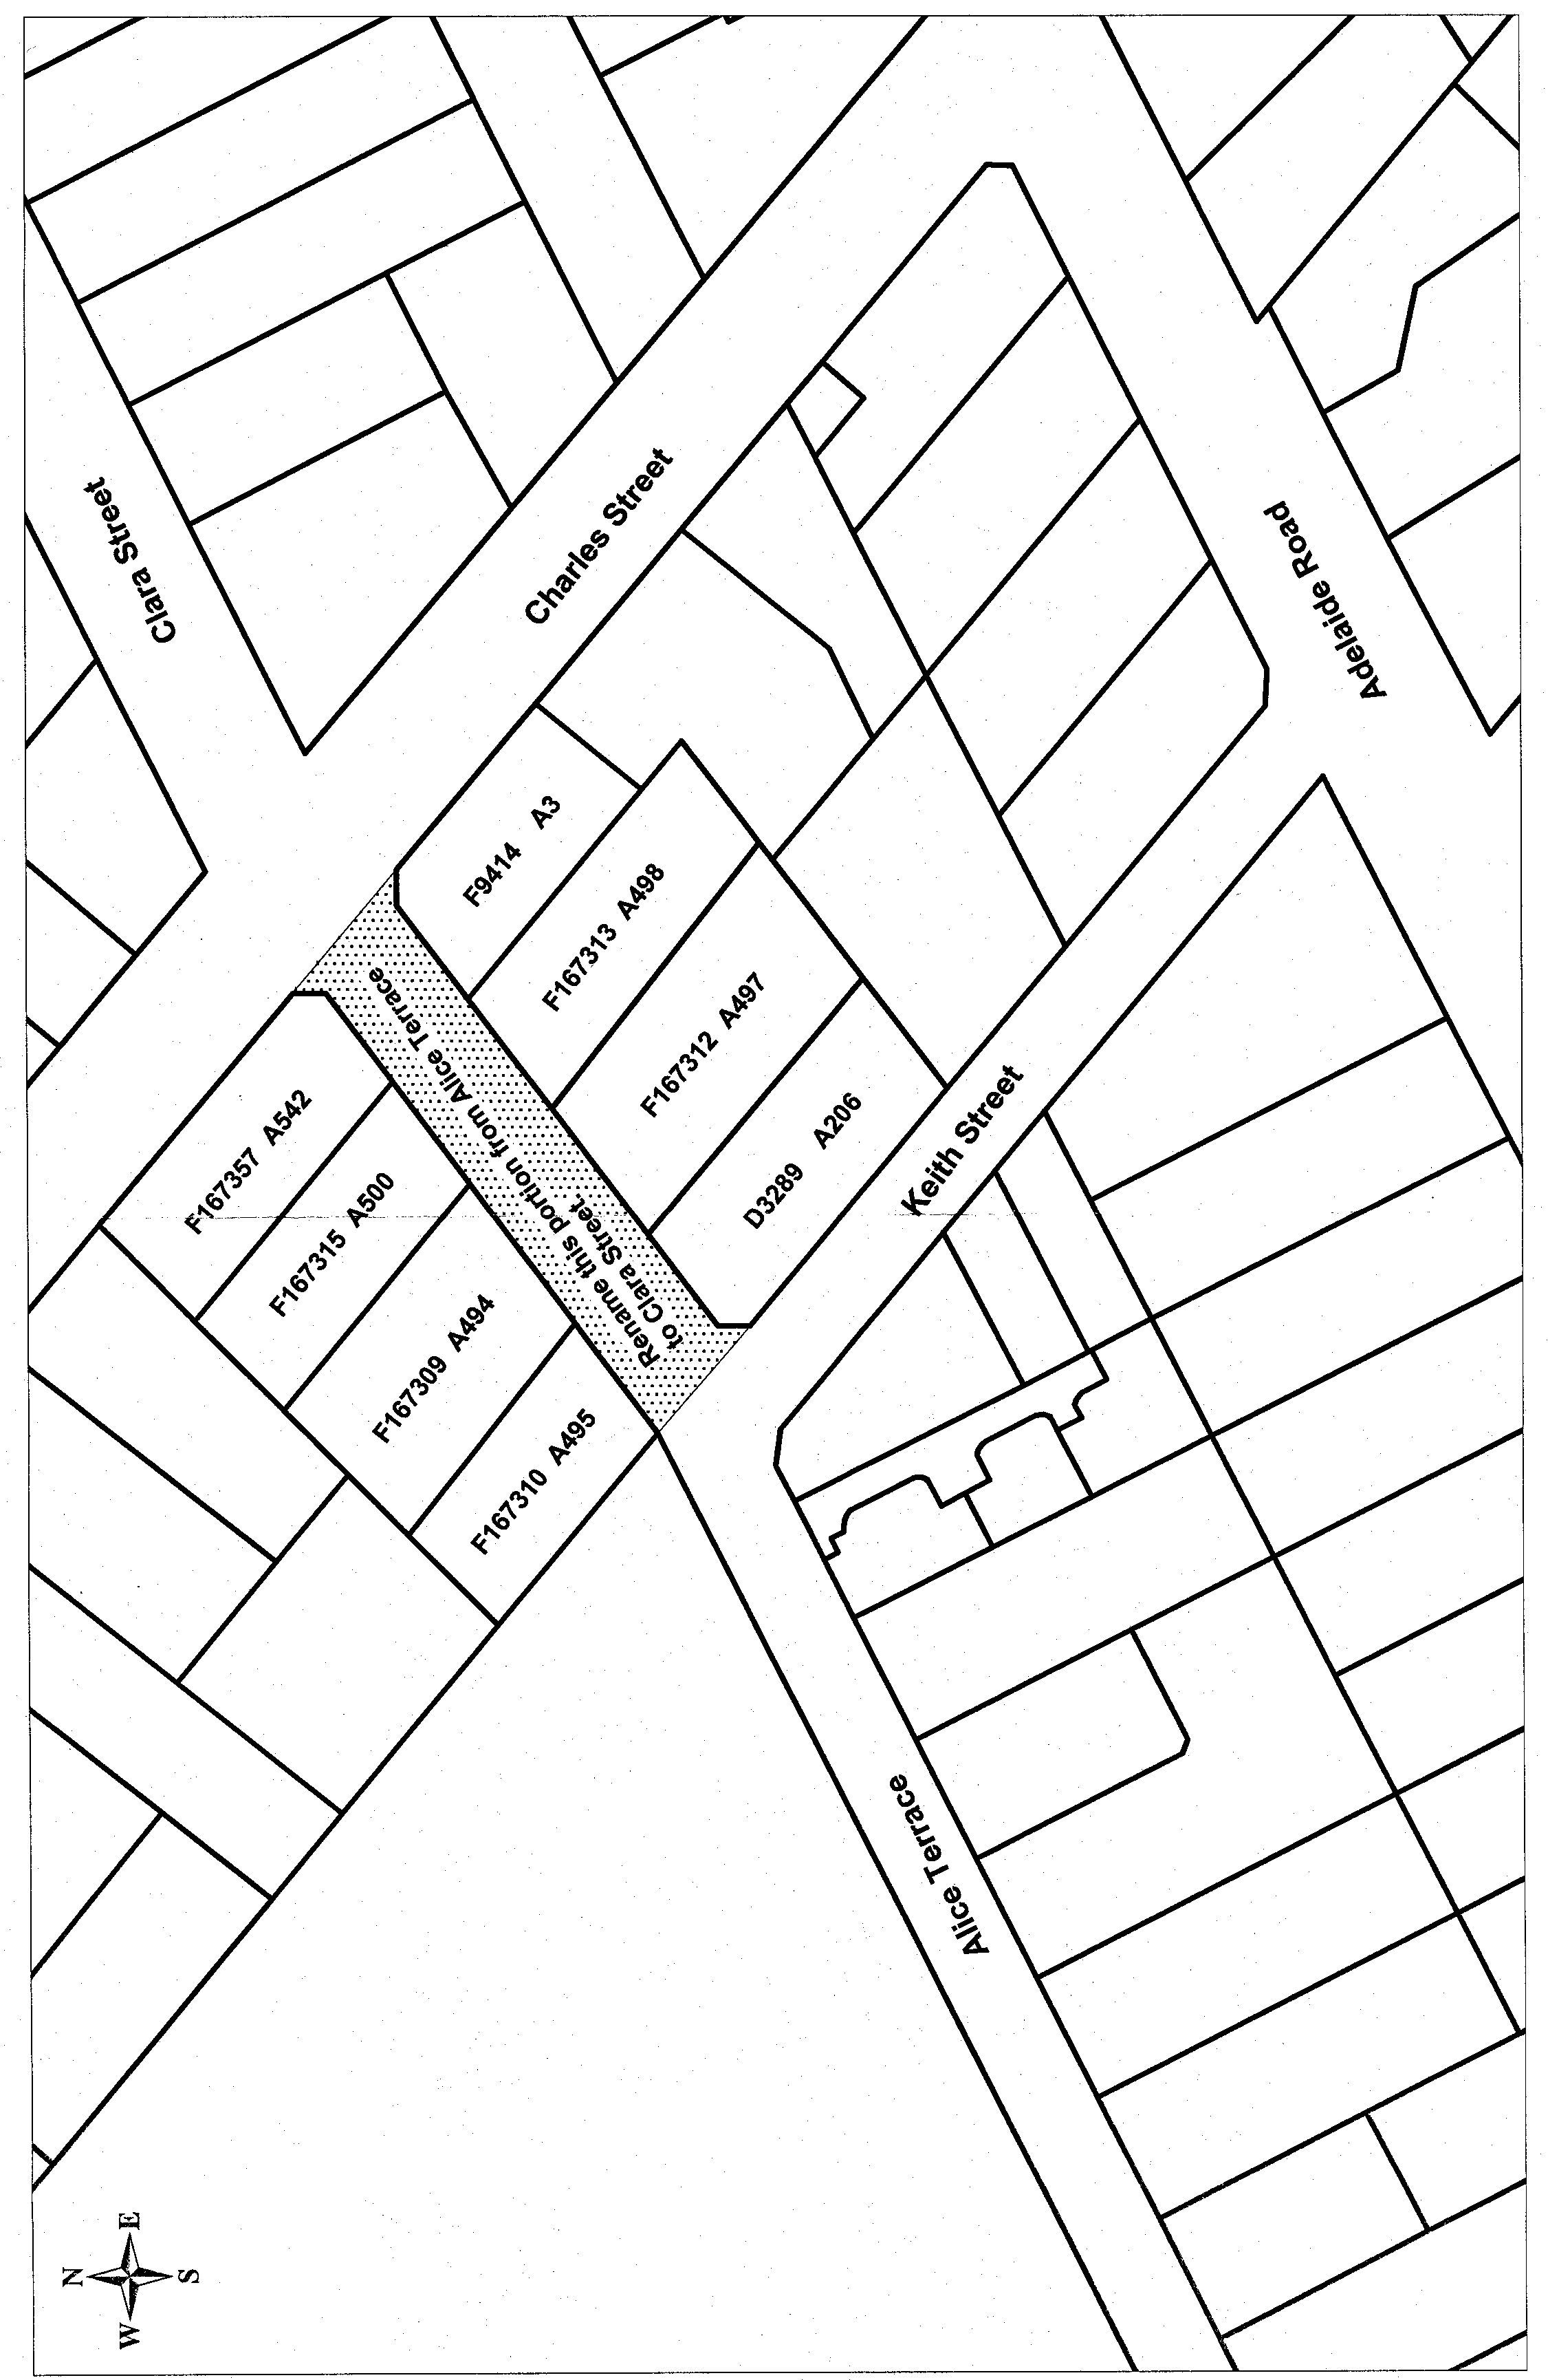
T. Jordan, Technical Assistant

CITY OF ONKAPARINGA
Authorisation of Permit Officers
NOTICE is hereby given under the Country Fires Act 1989, that the following persons are authorised as Permit Officers:
Trevor Wayne Button
Darren James Broadstock
Michael William Pearce
The following authorisations have been revoked:
David Garth Bradley
David Mickan
J. Fielke, Fire Prevention Officer

CITY OF PORT AUGUSTA
Authorised Officer
NOTICE is hereby given that at its meeting held on 18 September 2000, the City of Port Augusta:
• revoked all previous appointments in relation to Authorised Officers pursuant to the provisions of the Public & Environment Health Act 1987; and
• appoint Robert Wayne Rutter as an authorised officer pursuant to the provisions of the Public & Environmental Health Act 1987.
I. D. McSporran, City Manager

CITY OF PORT LINCOLN
Council Representation Review
NOTICE is hereby given that the City of Port Lincoln is currently undertaking a review for the purpose of consideration of:
(a) altering the composition of the council;
(b) divide, or redivide the area of the council into wards, alter the division of the area of the council into wards.
The above issues will be considered by council, taking into account the following factors: community interest, topography, communication, current population, forecast demographic changes in the city and the adequacy, fairness level and comparison with other councils of a similar size and type.
The review is being conducted pursuant to the Local Govern-ment Act 1999, and must be undertaken at least once in every six years.
Any person wishing to make a written submission in relation to the review may do so on or before 5 p.m., on Friday, 10 November 2000, by addressing it to the Chief Executive Officer, City of Port Lincoln, P.O. Box 1787, Port Lincoln, S.A. 5606.
Any person providing a submission will be given the opportunity to address the council on their submission.
I. Burfitt, Chief Executive Officer

TOWN OF WALKERVILLE
Change of Meeting Date
NOTICE is hereby given that the committee meetings which are normally held on the third Monday of the month commencing at 7.30 p.m., will be held on the third Tuesday of the month in October 2000, this being 17 October 2000 at 7.30 p.m.
This change, which was adopted by council at the meeting held on 7 August 2000, has been made to facilitate a State Parliament Community Cabinet meeting to be held at Walkerville on Monday, 16 October 2000.
R. H. Wallace, Chief Executive Officer

THE BAROSSA COUNCIL
Renaming of Road
NOTICE is hereby given that pursuant to section 219 of the Local Government Act 1999, council on 19 September 2000, resolved to alter the name of Summit Road, Mount Pleasant to Hillview Road, Mount Pleasant.
J. G. Jones, Chief Executive Officer

DISTRICT COUNCIL OF THE COPPER COAST
Exclusion of Land
TAKE notice that on Wednesday, 20 September 2000, the District Council of the Copper Coast resolved pursuant to section 193 of the Local Government Act 1999, to exclude the following land from classification as community land:
The council depot situated at section 1694, Chatfield Terrace, Wallaroo, being the land comprised in certificate of title 2108/107.
J. W. Shane, Chief Executive Officer

DISTRICT COUNCIL OF GRANT
Supplementary Election—Nominations Received
NOTICE is hereby given that at the close of nominations at 12 noon on Thursday, 21 September 2000, the following persons have been accepted as candidates and are listed in the order in which they will appear on the ballot paper:
Councillor for North East Ward (one vacancy):
Spehr, Alan
Hay, Albert
Wells, Peter M.
Postal Voting
The election will be conducted entirely by postal voting. No polling booth will be open for voting on polling day. Voting is not compulsory.
Voting material will be despatched by post to every natural person, body corporate and group who were listed on the voters’ roll as at the roll closure on 31 August 2000.
The mail out will commence on Tuesday, 3 October 2000, with all voting materials to be delivered by Friday, 6 October 2000.
A person who has not received voting material and who believes that he or she is entitled to vote should apply to the Australian Electoral Commission Divisional Office, 2 Mitchell Street, Mount Gambier on 8723 1366.
A pre-paid addressed envelope for each elector entitlement will be provided. Completed ballot material must be returned to reach the Deputy Returning Officer no later than 12 noon on Monday, 23 October 2000.
A ballot box will be provided at the Council Office and the Australian Electoral Commission Divisional Office, 2 Mitchell Street, Mount Gambier for electors who wish to personally deliver their completed ballot material during office hours.
Place of Counting Votes
The scrutiny and counting of votes will take place at the Australian Electoral Commission Divisional Office, 2 Mitchell Street, Mount Gambier as soon as practicable after 12.30 p.m. on Monday, 23 October 2000. A provisional declaration will be made at the conclusion of the election.
Campaign Donations Return
Candidates must forward a campaign donations return to the Council’s Chief Executive Officer within six weeks after the conclusion of the election.
S. H. Tully, Returning Officer

LIGHT REGIONAL COUNCIL
Appointment
NOTICE is hereby given that pursuant to section 102 (b) of the Local Government Act 1999, Richard Michael was appointed to act in the position of the Chief Executive Officer in the absence of the Chief Executive Officer.
P. J. Beare, Chief Executive Officer

DISTRICT COUNCIL OF KIMBA
Temporary Street Closure
NOTICE is hereby given that pursuant to the provisions of section 359 of the Local Government Act 1934, as amended, the District Council of Kimba has resolved that Haskett Road, Kimba (between Buckleboo Road and Yates Road) will be closed to all vehicles between 6 a.m. and midnight on Saturday, 14 October 2000 in the interests of traffic control and public safety for the purpose of the Kimba Rodeo.
S. R. Cheriton, Chief Executive Officer

KINGSTON DISTRICT COUNCIL
Supplementary Election
NOTICE is hereby given that at the close of nominations at 12 noon on Thursday, 21 September 2000, the following persons have been accepted as candidates and are listed in the order in which they will appear on the ballot paper:
Woolmit Ward (1 vacancy):
John Hayward Higgins
Michael Harry Broadby
Michelle Kay Mackereth
Postal Voting
The elections will be conducted entirely by postal voting. No polling booth will be open for voting on polling day. Voting is not compulsory.
Voting material will be dispatched by post to every natural person, body corporate and group who were listed on the voters’ roll for the Woolmit Ward as at roll closure on 31 July 2000.
The mail out will commence on Tuesday, 3 October 2000, with all voting materials to be delivered by Friday, 6 October 2000.
A person who has not received voting material and who believes that he or she, is entitled to vote should apply to the council office on (08) 8767 2033.
A pre-paid addressed envelope for each elector entitlement will be provided. Completed ballot material must be returned to reach the deputy returning officer no later than 12 noon on Monday, 23 October 2000.
A ballot box will be provided at the council office for electors who wish to personally deliver their completed ballot material during office hours.
Place of Counting Votes
The scrutiny and counting of votes will take place in the Council Chambers Room at the Kingston District Council Office, 29 Holland Street, Kingston, as soon as practicable after 12 noon on Monday, 23 October 2000. A provisional declaration will be made at the conclusion of the election count.
Campaign Donations Return
Candidates must forward a campaign donations return to the council’s Chief Executive Officer within six weeks after the conclusion of the election.
S. Rufus, Deputy Returning Officer

DISTRICT COUNCIL OF LE HUNTE
Supplementary Election—Nomination Received
NOTICE is hereby given that at the close of nominations at 12 noon on Thursday, 21 September 2000, the following person was nominated as a candidate and elected unopposed:
Graeme Harry Edmonds
No elections will be necessary.
A. F. McGuire, Deputy Returning Officer

DISTRICT COUNCIL OF LE HUNTE
Council Name Change
NOTICE is hereby given that the District Council of Le Hunte, on 17 September 2000, resolved to consider a name change to the ‘Gawler Ranges Council’, and seek written submissions from the public, for consideration prior to final deliberations on this proposal.
Notice is hereby given that written submissions on this issue, addressed to the Chief Executive Officer, District Council of Le Hunte, P.O. Box 6, Wudinna, S.A. 5652 will be received on or before the close of business on Friday, 17 November 2000.
A. F. McGuire, Chief Executive Officer

DISTRICT COUNCIL OF RENMARK PARINGA
Renaming of Streets
NOTICE is hereby given that at a meeting of council held on 29 August 2000, council resolved to change the names of the following streets within the Renmark Paringa District:
Orange Street to Seekamp Street
Lemon Street to Stoney Pinch Road
Avocado Street to Mickan Street
Peach Street to Nicholls Road
Apricot Street to Nuske Road
Almond Street to Cuttle Street
Currant Street to Kernich Street
Sultana Street to Roper Avenue
The Renmark Riverfront Walk will be named the Matulick Riverfront Walkway.
For further information or clarification please contact Katina Nikas, Acting Deputy Chief Executive Officer on (08) 8586 6609.
Dr. Ali Khan, Chief Executive Officer

DISTRICT COUNCIL OF ROBE
Appointment
NOTICE is hereby given that R. J. White has been appointed Acting Chief Executive Officer for the period 16 October 2000 to 10 November 2000 vide Chief Executive Officer on leave.
R. J. Kay, Chief Executive Officer

DISTRICT COUNCIL OF TUMBY BAY
Renaming of Street
NOTICE is hereby given that at the meeting of council held on 18 August 2000, Marina Place in DP 55096 was renamed Saxon Street.
E. A. Roberts, District Clerk

IN the matter of the estates of the undermentioned deceased persons:
Barber, Mary Dorothea, late of 15 Rosemary Street, Woodville West, of no occupation, who died on 6 July 2000.
Batty, Elizabeth Maude, late of 28 Bideford Avenue, Clarence Gardens, widow, who died on 6 August 2000.
Beer, Lorna Caroline, late of 110 Strathfield Terrace, Largs North, widow, who died on 20 July 2000.
Bennet, Evelyn Marjorie, late of Mosart Court, Somerton Park, home duties, who died on 3 August 2000.
Cadd, Trevor Harold, late of 19 Production Road, Wingfield, cabinet maker, who died on 14 June 2000.
Christie, Mark Thomas, late of 39 Francis Street, Clarence Park, project manager, who died on 1 April 2000.
Coulter, Rodney Albert, late of 86 Dover Street, Aldinga Beach, retired carpenter, who died on 4 August 2000.
Coulthard, Douglas William, late of 15 Fairmont Avenue, Black Forest, retired checking officer, who died on 28 July 2000.
Dallwitz, Erwine Wilfred, late of 301 North East Road, Hampstead Gardens, retired clerk, who died on 22 July 2000.
Dolan, Matthew Neil, late of 5 Hincks Avenue, Whyalla Norrie, retired fruit grower, who died on 25 July 2000.
Ellard, Ida Grace, late of 7 Ward Street, Pennington, widow, who died on 20 July 2000.
Englert, Raymond Hayles, late of 31 Lavender Drive, Parafield Gardens, retired motor mechanic, who died on 3 July 2000.
Ferriggi, Arthur George Mifsud, late of 1A Arnold Street, Underdale, of no occupation, who died on 22 August 2000.
Fontana, Anna, late of Grand Junction Road, Oakden, of no occupation, who died on 21 June 2000.
Fordham, Samuel Lawrence, late of 2 Stevens Street, Glengowrie, of no occupation, who died on 22 May 2000.
Hannaford, Daphne Elizabeth Blanche, late of 4 Sylvan Way, Grange, of no occupation, who died on 7 August 2000.
Hansen, Peter Daniel, late of 226 Fullarton Road, Glenside, of no occupation, who died on 25 June 2000.
Hunter, Valda Eileen, late of 80 Moseley Street, Glenelg South, of no occupation, who died on 12 September 2000.
Lake, Georgina Mary, late of 35 Hulbert Road, Hove, retired office clerk, who died on 18 July 2000.
Lemon, Herbert Joseph, late of 37 Janet Street, Maylands, retired foreman, who died on 25 August 2000.
Messenger, Norma Dulcie, late of 63-71 Labrina Avenue, Prospect, retired registered nurse, who died on 30 July 2000.
Moody, Mary, late of 61 Silkes Road, Paradise, of no occupation, who died on 22 July 2000.
Parslow, Eileen, late of 86 Livingstone Avenue, Prospect, widow, who died on 2 June 2000.
Phillips, Leslie Albert, late of 50 Woodcroft Drive, Morphett Vale, retired draftsman, who died on 25 July 2000.
Roberts, Ellen Violet Jane, late of 34 Grange Road, West Hindmarsh, widow, who died on 22 August 2000.
Rowland, Brian Charles, late of 317 Morphett Road, Oaklands Park, laboratory technician, who died on 9 June 2000.
Spence, Ernest John, late of 51 Eve Road, Bellevue Heights, retired telecommunications linesman, who died on 13 June 2000.
Thompson, Eric George Walter, late of 20 Norseman Avenue, Westbourne Park, retired garden contractor, who died on 9 April 2000.
Weger, Doris Irene, late of 53 Second Street, Brompton, of no occupation, who died on 21 July 2000.
Notice is hereby given pursuant to the Trustee Act 1936, as amended, the Inheritance (Family Provision) Act 1972, and the Family Relationships Act 1975, that all creditors, beneficiaries, and other persons having claims against the said estates are required to send, in writing, to the Public Trustee, 25 Franklin Street, Adelaide 5000, full particulars and proof of such claims, on or before 27 October 2000, otherwise they will be excluded from the distribution of the said estate; and notice is also hereby given that all persons who are indebted to the said estates are required to pay the amount of their debts to the Public Trustee or proceedings will be taken for the recovery thereof; and all persons having any property belonging to the said estates are forthwith to deliver the same to the Public Trustee.
Dated 28 September 2000.
J. H. Worrall, Public Trustee

PARTNERSHIP ACT 1891
NOTICE is hereby given pursuant to the Partnership Act 1891, that the partnership trading as Distinctive Trolleys and Steel of Approval and the businesses have been terminated as of 22 September 2000.
Dated 28 September 2000.
G. Klose & J. Crafter

UNCLAIMED MONEYS ACT 1891
Register of Unclaimed Moneys held by Tubemakers of Australia Ltd as at 19 September 2000

Name of owner on books | Address | Cheque No. | Total amount  due to owner
Abeshouse, Leonora Frieda and Barry John | 26 Kambala Road, Bellevue Hill, N.S.W. 2023 | 080642 | 27.99
Achurch, Nicholas Philip | c/o Perpetual Trustees, 50 Queen Street, Melbourne, Vic. 3000 | 051716  062963 | 17.70  16.56
Alexander, Gary Charles | 7 Munji Close, Esperance, W.A. 6450 | 052087  059184 | 10.02  13.36
Alexander, Ronald Keith | P.O. Box 1425, Ballarat Mail Centre, Vic. 3354 | 061844 | 26.64
Altavilla Investments Pty Ltd | c/o June Bell & Assoc., 61 Bracken Street, Moorooka, Qld 4105 | 028300  038286  043755  051536  059038  066086  073149  080156  088184  095193  101990  108447  114461  120397  126353  132368 | 25.60  64.00  38.40  59.76  44.82  59.76  29.88  22.41  22.41  29.88  29.88  44.82  44.82  56.03  56.03  67.23
Amos, Rosemary Mavis | 6 Hutchinson Avenue, Beaumaris, Vic. 3193 | 051721  041955  048842 | 20.00  12.00  18.64
Anderson, Adrainne Ila E. and  Greenberg, Hani | c/o 463A Whitehorse Road, Balwyn, Vic. 3103 | 123546  132370 | 26.25  31.50
Armstrong, Gary David | 22 June Parade, Woonona Heights, N.S.W. 2517 | 116776  122727 | 12.53  12.53
Barrett, Simon | 7 Beamont Road, Killara, N.S.W. 2071 | 121250 | 72.98
Bateman, William Harold | 3/4-6 Crawford Street, Guildford, N.S.W. 2161 | 060739 | 13.36
Beersheba Investments Pty Ltd | 19 Bathurst Street, Woollahra, N.S.W. 2025 | 023609 | 106.68
Benton, Kenneth William | 87 Grant Avenue, Toorak Gardens, S.A. 5065 | 058144 | 19.98
Bernardo, Jose | 15 Tremaine Avenue, Kings Park, Vic. 3021 | 062275 | 13.36
Berndt, Ronald George | 74 Emmett Street, Wynnum West, Qld 4178 | 064372 | 13.36
Besomo, Edne Laurel | 17 Victory Street, Dover Heights, N.S.W. 2030 | 032524 | 80.00
B. G. J. Holdings Pty Ltd | 88 Ricketts Road, Mount Waverley, Vic. 3149 | 132378 | 10.53
Black, Neil Francis | 162 Coventry Road, Smithfield Plains, S.A. 5114 | 064814 | 13.36
Bodley, Raymond Leslie | 24 Kendall Street, Charleston, N.S.W. 2290 | 040211 | 24.00
Bonham, Liam Patrick | 26 Lulie Street, Abbotsford, Vic. 3067 | 055370  062426 | 10.02  13.36
Borrs, Hans Werner | 174 Township Drive, Burleigh Town Village, Qld 4220 | 049960 | 26.64
Boundy, Rhonda Margaret | 74 Belmont Road, Singapore 1026 | 108417 | 54.00
Boyton, Janelle Gail | 86 North Street, Tamworth, N.S.W. 2340 | 046955  059137 | 13.36  10.02
Brien, Sister Mary Cecilia | Hesed Convent, Mercy Family Life Centre, P.O. Box 2118, Hornsby, N.S.W. 4870 | 103045 | 42.00
Brook, Anne Gai | 2 Broome Street, Currumbin Waters, Qld 4223 | 051746 | 20.00
Brown, Betty | Lot 38, John Street, Borden, W.A. 6338 | 051747  043682 | 83.30  49.98
Brown, Eric | 12 Shiral Avenue, Kanahooka, Dapto, N.S.W. 2530 | 047195 | 13.36
Brown, Joseph John | 41 Cruise Road, Safety Bay, W.A. 6169 | 065911 | 13.36
Brown, Roger William | P.O. Box 5, Lyneham, A.C.T. 2602 | 091019 | 103.68
Bryant, Florence Adah | c/o Harry F. Wellington, P.O. Box 506, Belgrave, Vic. 3160 | 026798  035552  043768  051552  059051  066098  073167  080173 | 16.00  40.00  24.00  37.36  28.02  37.36  18.68  14.01
Burgess, Genevive Jefferies | P.O. Box 477, Castle Hill, N.S.W. 2154 | 024998  038299  043770  051554  059052  066099  073168  080174  088201  095212  102006  108462  114475  120411  126369  132382 | 16.00  40.00  24.00  37.36  28.02  37.36  18.68  14.01  14.01  18.68  18.68  28.02  28.02  35.03  35.03  42.03
Burns, Gregory James | 5A Langham Terrace, Unley, S.A. 5061 | 065074 | 13.36
Burns, Neil Andrew | 19 Farleigh Avenue, Burwood, Vic. 3125 | 105561 | 10.02
Byrnes, Suzanne Hazel | 8 Fifteenth Avenue, Mount Isa, Qld 4825 | 064677  107306  113423  119398  131405 | 13.36  10.02  10.02  12.53  15.03
Caffery (est.) Leila Margaret | c/o Aitken & Magney, 32-34 Bridge Street, Sydney, N.S.W. 2000 | 061689 | 93.36
Callesa, Edward Joseph | 28 Oakland Street, Maribyrnong, Vic. 3032 | 055243  062293 | 10.02  13.36
Callinan, John Anthony | 20/5 Princess Lane, Caloundra, Qld 4551 | 049743 | 18.64
Callinan, John Micheal | 20/5 Princess Lane, Caloundra, Qld 4551 | 049744  071240 | 74.64  37.32
Cameron (est.) Late Elizabeth  B. | c/o Nevin White & Associates, Suite 2504 The York, 5 York Street, Sydney, N.S.W. 2000 | 060413 | 49.76
Campbell, Robert William | 2/59 Pantowora Street, Corlette, N.S.W. 2301 | 254050 | 26.68
Carpenter, Glenn Leslie | 5 Elstree Court, Kealba, Vic. 3021 | 062265 | 13.36
Caruana, Paul | 23 Branyan Street, Bundaberg, Qld 4670 | 107231 | 10.02
Casey, Roslyn Anne | c/o Andreasen’s Palm Plantation, Burnett Street, Buderim, Qld 4556 | 078639  086482  093759  100652  108466  114479  120415  126374  132387 | 14.01  14.01  18.68  18.68  28.02  28.02  35.03  35.03  42.03
Catalano, Marie | c/o 334 Stoney Creek Road, Kingsgrove, N.S.W. 2208 | 128020 | 29.07
Cecil, Jonathan Peter Hedworth | c/o Coopers & Lybrand, Share Reg. Dept, G.P.O. Box 4216, Sydney, N.S.W. 2001 | 023430  038300  043772  051556  059054  066101  073172  080177  088204  095215  102009  108467  114480  120416  126375  132388 | 40.00  100.00  60.00  93.36  70.02  93.36  46.68  35.01  35.01  46.68  46.68  70.02  70.02  87.53  87.53  105.03
Chong, Cheng Chye | 7/5 Stanley Street, Randwick, N.S.W. 2031 | 023767  038302  043774  051558  059055  066102  073173  080178  088205  095216  102010  108468  114481  120417  126376  132389 | 16.00  40.00  24.00  37.36  28.02  37.36  18.68  14.01  14.01  18.68  18.68  28.02  28.02  35.03  35.03  42.03
Clark, Keith William | 58 Galong Crescent, Koonawarra, N.S.W. 2530 | 047151 | 13.36
Clarke, Anne Victoria | 39 Towers Street, Ascot, Qld 4007 | 106742 | 74.70
Claxton, Robert Arthur | 28 Videroni Street, Booval, Qld 4304 | 107101 | 10.02
Clymer (est.) Late Dorothy  E. R. | c/o Home Wilkinson & Lowry, Level 42 Nauru House, 80 Collins Street, Melbourne, Vic. 3000 | 040847 | 139.98
Cochrane, Judith Verinica | 9/10 Taranto Road, Marsfield, N.S.W. 2122 | 039861 | 48.00
Collis, Michael David | 5/39 Carters Lane, Towradgi, N.S.W. 2519 | 104526 | 10.02
Conley, Robert Bruce | 3 Aldyth Street, New Lambton, N.S.W. 2305 | 095219 | 18.68
Conway, Scott | 13 Rambler Street, Rainworth, Qld 4065 | 057120 | 13.98
Cooper, Michael Paul | 166 Simpson Road, Elanora, Qld 4223 | 113229 | 60.00
Copley, Anita | c/o Coopers & Lybrand, Locked Bag No. 14, Sydney South, N.S.W. 2001 | 038309  043781  051566  059060  066108  108472  114484  120420  126379  138201 | 20.00  12.00  18.64  13.98  18.64  13.98  13.98  17.48  17.48  20.97
Corporate Licensing Pty Ltd | c/o Don Roach, 16 Burn Street, Pyrmont, N.S.W. 2009 | 108844  126380  132393 | 60.00  75.00  90.00
Cottle, Lianne Norma | 11 Charlson Street, Davoren Park, S.A. 5113 | 094619 | 23.32
Cowdery, Edwina Mary | 83 Cliff Avenue, Northbridge, N.S.W. 2063 | 121086  132394 | 127.50  153.00
Cubbin, David Robert | 8 St Johns Court, 169 Darling Street, Balmain, N.S.W. 2041 | 109051 | 55.98
Curypko, Peter Mark | 14 Cuthbert Avenue, Highton, Geelong, Vic. 3216 | 063574  106256 | 13.36  10.02
Cusack, Kenneth John | 5 Glenelg Court, Dingley, Vic. 3172 | 056255 | 10.02
Daley, Shayne | 22 Flinders Crescent, Hinchinbrook, N.S.W. 2168 | 103644 | 10.02
Dambrauskas, Paul Antoney | 12 Stokoe Street, Warwick Farm, N.S.W. 2170 | 046271  053692 | 13.36  10.02
Davies, Alma | 67 Salisbury Highway, Salisbury, S.A. 5108 | 094586 | 18.68
Davies, Ronald George | G.P.O. Box 5085, Sydney, N.S.W. 2001 | 120766 | 93.38
Davis, Peter Heath | 44 Solveig Crescent, Kareela, N.S.W. 2232 | 090123  097094 | 12.48  12.48
Dawes, Gary Michael | 764 Merrylands Road, Greystanes, N.S.W. 2145 | 103480  109878 | 10.02  10.02
Dean, Alan William | 24 Mooreshead Lane, Camden, N.S.W. 2570 | 066218 | 13.32
Defranck, Richard Alexander  A. | 5 Ridgewood Drive, New Plymouth RD1, N.Z. | 056208  077299  114410  120424  126383  132398 | 28.02  14.01  28.02  35.03  35.03  42.03
Dewett, Alan | 16 Norsworthy Avenue, Salisbury North, S.A. 5108 | 065477 | 13.36
Donavere Pty Ltd | 1 Beagle Street, Red Hill, A.C.T. 2603 | 038315  043786  051571  059065  066114  073185  080191  088216  095225  102018  108476  114487  120425  126384  132399 | 266.70  160.02  248.96  186.72  248.96  124.48  93.36  93.36  124.48  124.48  186.72  186.72  233.40  233.40  280.08
Donk, Dirk Jan | 17 Diosma Drive, Coromandel Valley, S.A. 5051 | 065056  107608 | 26.64  19.98
Douglas-Pennant, Malcolm  Frank | c/o Hattersley Maxwell Noall Ltd, 2nd Floor, 105 Pitt Street, Sydney, N.S.W. 2000 | 052199  059288 | 27.36  36.48
Douthwaite (est.) Late Gordon W. | c/o Maclarens, Maclaren House, 232 Merrylands Road, Merrylands, N.S.W. 2160 | 051779 | 100.00
Dowd, Justin Joseph | 9 Wade Avenue, Leeton, N.S.W. 2705 | 128966 | 13.95
Drieman, Adrian | 10 Iona Place, St Andrews, N.S.W. 2566 | 025171  038316 | 16.00  40.00
Duncan, Eric Grahame | 30 Cherry Street, Windale, N.S.W. 2306 | 116514 | 12.53
Dunlop (est.) Late Gordon | c/o Grahame Goldberg Partners, 3rd Floor, 12-14 O’Connell Street, Sydney, N.S.W. 2000 | 051784 | 266.70
Dunn, Maurice Daniel | 7 Ferdinand Street, Nunawading, Vic. 3131 | 084573 | 11.43
Dunne, Peter John | 21 Andrew Crescent, Croydon South, Vic. 3136 | 027010 | 21.32
Dupree, Annette Margaret | c/o Coopers & Lybrand, Locked Bag 14, Sydney South, N.S.W. 2000 | 038317  132403 | 10.00  10.53
Durrant, Jonathan | 7 Berryman Drive, Modbury, S.A. 5092 | 065391 | 13.36
Dwyer, Grant James | 6 Callan Avenue, Maryland, N.S.W. 2287 | 061162 | 13.36
Dyer, Peter John | 2 Fitzroy Street, Mayfield, N.S.W. 2304 | 097324  104025  128325 | 13.32  19.98  29.97
Edwards, Kenneth George | 1 Wilson Street, Mayfield, N.S.W. 2304 | 025424  038318  043789  051574  059069  066118  073189  080195  088221  095230  102023  108481  114493  120431  126391  132406 | 16.00  40.00  24.00  37.36  28.02  37.36  18.68  14.01  14.01  18.68  18.68  28.02  28.02  35.03  35.03  42.03
Elefano, Rodolfo Villadiego | 24 Oakwood Road, St Albans, Vic. 3021 | 105055  123267 | 10.02  12.53
Emond, Allan William | 19 Maud Street, Cardiff South, N.S.W. 2285 | 090242 | 14.76
Erlich, Pesa | 82 Kilby Road, East Kew, Vic. 3102 | 111615 | 186.72
Farmer, Shane Peter | 29 Carboni Street, Liverpool, N.S.W. 2170 | 053729  060792  103633  110011  120432  121954 | 10.02  13.36  10.02  10.02  12.53  12.53
Farrugia, Joseph | 23 Berkeley Street, Wentworthville, N.S.W. 2145 | 053568 | 10.02
Felstead, Natalie Anne | 13 Wallamoul Street, Oxley Vale, Tamworth, N.S.W. 2340 | 054346  061402 | 10.02  13.36
Fleming, David Irving | 315 Oaklands Road, Marion, S.A. 5046 | 065031 | 26.64
Wilenski (est.) Late Peter | c/o Reid & Vesley, 2nd Floor ‘The Newland’, 29 Newland Street, Bondi Junction, N.S.W. 2022 | 116906  120856  126884 | 116.63  116.63  139.95
Ford, Paul | 55 McIntyre Drive, Altona, Vic. 3018 | 083845  091451  117299  123256  129251 | 29.16  38.88  10.43  10.43  12.51
Fox, Lisa | 14 Scotsburn Grove, Toorak, Vic. 3142 | 051793  041678  051579  059074  066122  108486  114498  120436  126395  132410 | 20.00  12.00  18.64  13.98  18.64  13.98  13.98  17.48  17.48  20.97
Frazer, Paul John | 20 Pendula Street, Leeton, N.S.W. 2705 | 117015  128967 | 12.53  15.03
Freeman, Miley Robert | c/o Crossman Brown & Jolly Pty, P.O. Box 191, Taree, N.S.W. 2430 | 040456  061528  068563  075615  083053  090756  097715  104398  110719  116695  122645  128655 | 160.02  35.60  17.80  13.35  13.35  17.80  17.80  26.70  26.70  33.38  33.38  40.05
Fuller, Michael Alan | 36 Alfreda Avenue, Morley, W.A. 6062 | 114171 | 10.02
Gaden, Alexandra Jane  Caroline | 98 Arabella Street, Longueville, N.S.W. 2066 | 023958  038325  043795  051582  059077  066123  073195  080202  088228  095237  102029  108488  114500  120438  126397  132412 | 24.00  60.00  36.00  56.00  42.00  56.00  28.00  21.00  21.00  28.00  28.00  42.00  42.00  52.50  52.50  63.00
Gamble, Alexander Watson | 191 Highfield Road, Camberwell, Vic. 3142 | 091970 | 18.68
Gibson (est.) Late Helen  Jeannette | c/o T. Anglin, Arthur Andersen, G.P.O. Box 5151AA, Melbourne, Vic. 3001 | 084373 | 699.99
Glaskin, Garry Llewellyn | 25 Sanford Way, Eaton, W.A. 6230 | 051265 | 13.36
Glass, Hannah | 45/546 Toorak Road, Toorak, Vic. 3142 | 099125 | 177.32
Gleeson, Timothy Robert | 15 Lutanda Close, Pennant Hills, N.S.W. 2120 | 053457 | 10.02
Goninan, Christopher Paul | 208 Scenic Highway, Merewether Heights, N.S.W. 2291 | 122350 | 11.63
Gottschall, Martin | 109 Curragundi Road, Jindalee, Qld 4074 | 064235 | 37.36
Grand, Ian McDonald | 11/4 The Gables, Sunshine, Vic. 3020 | 062254 | 13.36
Gray (est.) Late Thomas Hale | c/o Kilpatrick Berryman & Gray, P.O. Box 206, Charleston, N.S.W. 2290 | 051804  046705  054108  061164  068202  075257  082608  090360  097327  104027  110376  116364  122318  128327 | 40.00  37.36  28.02  37.36  18.68  14.01  14.01  18.68  18.68  28.02  28.02  35.03  35.03  42.03
Green, Darrell Robert | 10 Fitzpatrick Road, Mount Annan, N.S.W. 2567 | 061709 | 13.36
Greenall, Lynette Margaret  (A/c J. E. Greenall Trust) | 25 Marlow Street, Mooroolbark, Vic. 3138 | 111866 | 19.32
Grimes, Ashley Keith | 11 Shale Street, Brinsmead, Cairns, Qld 4870 | 131413 | 29.97
Grunhard, Moszek and  (est.) Late Eva | 3/94 Frenchman Road, Randwick, N.S.W. 2031 | 115022  127008 | 35.03  42.03
Guy, Peter Raymond | 253 Rocky Point Road, Sans Souci, N.S.W. 2219 | 025126  038328  043797  051584  059079  066126  073200  080206  088233  095241  102033  108493  114505  120443  126402  132419 | 16.00  40.00  24.00  37.36  28.02  37.36  18.68  14.01  14.01  18.68  18.68  28.02  28.02  35.03  35.03  42.03
Hale, Joan | Lighthouse Road, Currie, Tas. 7256 | 038270  059082  066129  108496  114508  120446  126405  132422 | 20.00  13.98  18.64  13.98  13.98  17.48  17.48  20.97
Hamilton, Burton Wyndham | 33 Marine Parade, Seacliff, S.A. 5049 | 087024 | 37.35
Hammond, John Perrie | 328 Tooronga Road, Glen Iris, Vic. 3146 | 027213  038331  043801  051587  059083  066130  073204  080210  088237  095245  102037  108497  114510  120448  126407  132423 | 32.00  80.00  48.00  74.64  55.98  74.64  37.32  27.99  25.59  34.12  34.12  51.18  51.18  63.98  63.98  76.77
Hansen, Manuela | 6 Snead Court, Mount Waverley, Vic. 3149 | 070243 | 46.68
Harding, Beverlay May | 4 Seymour Grove, Campbelltown, S.A. 5074 | 050716 | 13.36
Hardwick, John Edward | 66 Roebuck Drive, Manning, W.A. 6152 | 058766  065819  120142 | 10.02  13.36  12.53
Harris, Paul John | 163 Evans Street, Rozelle, N.S.W. 2039 | 053590 | 19.98
Harrison, Edna Marjorie | P.O. Box 64, Sunbury, Vic. 3429 | 118610 | 46.65
Hart, Brendan Joseph | 53 Hales Crescent, Jacana, Vic. 3047 | 105139  117393 | 10.02  12.53
Harvey, Dale Mitchell | 30 Mawarra Crescent, Chadstone, Vic. 3148 | 056248  063307 | 10.02  13.36
Hatherly, Leone Rosemary  Lucill | c/o Radio New Zealand, P.O. Box 1484, Christchurch, N.Z. | 132315 | 10.53
Haynes, Peter John | 12/260 Anzac Highway, Plympton, S.A. 5038 | 131703 | 15.03
Hazell, Harold Berkeley | 12 Elmdale Road, Palmers Green, London N13, U.K. | 052030  088131  108434 | 70.02  35.01  70.02
Hedley, Ronald Phillip | 40 Tibbits Street, Bundamba, Qld 4304 | 107106  113252 | 10.02  10.02
Heine Finance Pty Ltd  (A/c 150) | 11 Queens Road, Melbourne, Vic. 3004 | 047783 | 93.36
Hetherton, Kathryn Elizabeth | 13-15 Ann Street, Torquay, Qld 4655 | 113356 | 107.82
Heyson, Diana Miller | 7 Pier Street, Glenelg, S.A. 5043 | 028798 | 16.00
Hicks, Wayne Barry | 68 Primrose Street, Booragul, N.S.W. 2153 | 128437 | 15.03
Hillman, Michael Phillip | Lot 101 Wynne Road, Jimboonba, Qld 4280 | 086358 | 11.43
Hoff, Gary Detlef | 1 Kenton Way, Rockingham, W.A. 6168 | 108233 | 20.94
Howlett, Shane David | 9 Bass Street, Wulkuraka, Ipswich, Qld 4305 | 131236 | 15.03
Huband, Ann Kristine | 38 Lyons Court, Trott Park, S.A. 5158 | 057879  064922 | 10.02  13.36
Jamieson, Glenn Errol | 52 Middle Street, Kingsford, N.S.W. 2032 | 052580 | 10.62
Jamieson, Glenn Errol | 52A Kenneth Lane, Kingsford, N.S.W. 2032 | 088782 | 14.16
Jay, David Kim Teck | c/o F. W. Porter & Co, 35 Grenfell Street, Adelaide, S.A. 5000 | 028620  038341  043810  051599  059094  066140  073213  088244  095253  102044  108504  114518  120458  126415  138239 | 16.00  40.00  24.00  37.36  28.02  37.36  18.68  14.01  18.68  18.68  28.02  28.02  35.03  35.03  42.03
Johnson, Kenneth | 5th Floor, 82 Collins Street, Melbourne, Vic. 3000 | 076181  083702 | 15.51  15.51
Johnston, Harold James | Lot 729 Oaktree Drive, Hampton Park, Vic. 3976 | 056407  063456  106694  112895  118878  126417  132435 | 10.02  13.36  10.02  10.02  12.53  12.53  15.03
Jolly, Harold | c/o Manchester Unity Aged Members Centre, P.O. Box 52, Glen Waverley, Vic. 3150 | 077257 | 18.66
Jones, Glenn Ashley | 57 Canara Street, Cranbrook, Qld 4870 | 049888 | 13.36
J. P. T. T. Pty Ltd | 14 Catherine Avenue, Flinders Park, S.A. 5025 | 064915  073217  080220  088247  095255  102046  108506  114521  120460  126418  132436 | 155.60  77.80  58.35  58.35  77.80  77.80  116.70  116.70  145.88  145.88  175.05
Jullian, David Phillip | Lake Windemere Caravan Park, Lake South, N.S.W. 2528 | 061643  108507  114522  120461  126419  132437 | 13.36  10.02  10.02  12.53  12.53  15.03
J. V. Properties Pty Ltd | 151 William Street, Sydney, N.S.W. 2000 | 095421 | 49.80
Kelly, Brian | 444 Brunswick Road, West Brunswick, Vic. 3055 | 047855 | 13.36
Kelly, David John | 2 Tetian Court, Grovedale, Vic. 3216 | 027654  038344  043813 | 20.00  50.00  30.00
Kirby, Simon John | 6/63 Chapel Street, Rockdale, N.S.W. 2216 | 116084  122041 | 87.53  87.53
Korakis, Matthew George | c/o P.O. Box 173, Civic Centre, A.C.T. 2608 | 047329  068829  083363 | 37.36  18.68  14.01
Kraszlan, John Paul | 1 Short Street, Summer Hill, N.S.W. 2131 | 048877 | 26.64
Kruger, Marjorie May | 14 Lake Street, Merimbula, N.S.W. 2548 | 128797 | 67.23
Lang, Douglas Ian | 88 Towong Street, Tallangatta, Vic. 3700 | 051849  043818  051607  059102  066148  108512  114528  120467  126426  132444 | 20.00  12.00  18.64  13.98  18.64  13.98  13.98  17.48  17.48  20.97
Langdon, Henry Hall | c/o Wallace Bruce & Co., Bagot Street, North Adelaide, S.A. 5006 | 028697  038349  043819  051608  059103  066149  073226  080228  088253  095261  102052  108513  114529  120468  126427  132445 | 16.00  40.00  24.00  37.36  28.02  37.36  18.68  14.01  14.01  18.68  18.68  16.02  16.02  20.03  20.03  24.03
Lawrence, Roger | 54 Nanson Street, Wembley, W.A. 6014 | 107061  113213  119184  125162  131188 | 139.98  139.98  174.98  174.98  209.97
Lazarevski, Atanas | 27 The Fred Hollows Way, Mill Park, Vic. 3082 | 048001  055392 | 13.36  10.02
Leahy, Noela | 181 Manners Street, Tenterfield, N.S.W. 2376 | 081675 | 17.49
Lee (est.) Late Ralph Thomas  and (est.) Late Elsie Jean | 22/60 Corcoran Drive, Delfin Island, West Lakes, S.A. 5021 | 113567  120470 | 23.34  29.18
Leeflang, David Charles | 1 Lorilet Street, Holden Hill, S.A. 5088 | 058228  065281 | 10.02  13.36
Lees, Dinah June | ‘Bandarra’ Fishers Road, Drouin West, Vic. 3818 | 036722  043820 | 160.00  96.00
Leeson, Jayne Louise | 12 Jason Place, North Rocks, N.S.W. 2151 | 096795 | 10.36
Liddy, Thomas Desmond | 66 Fosters Road, Keilor Park, Vic. 3042 | 111406 | 10.02
Lloyd, Charles | P.O. Box 603, Lane Cove, N.S.W. 2066 | 051858  045303  059106  066152  073231  080233  088258  095266  102056  108517  114533  120473  126430  132448 | 113.30  105.76  79.32  105.76  52.88  39.66  39.66  52.88  52.88  79.32  11.34  14.18  14.18  17.01
Lonergan, Kevin James | 41 Adamson Crescent, Wanniassa, A.C.T. 2903 | 117130  129083 | 35.03  42.03
Lowry, Brendan Noel | 25 Charles Street, Cheltenham, Vic. 3192 | 118362 | 12.53
Lundberg, Robyn Margaret | 6 Spencer Court, Baulkham Hills, N.S.W. 2153 | 024989  038353  043824  051613  059109  066154  073234  080236  088261  095269  102059  108520  114536  120477  126433  132451 | 24.00  60.00  36.00  56.00  42.00  56.00  28.00  21.00  21.00  28.00  28.00  42.00  42.00  52.50  52.50  63.00
Lux-Lang & Co. Pty Ltd | 103 Flinders Lane, Melbourne, Vic. 3000 | 034916  108521 | 200.00  67.98
MacFarlane, Trevor John | 14 Isis Court, Rupertswood, Alice River, Qld 4817 | 113419  119395  125376  131402 | 10.02  12.53  12.53  15.03
MacGregor, Duncan Angus | c/o P.O. Mount Isa East, Webb Street, Mount Isa, Qld 4825 | 028593  051867  042981  050220 | 426.68  1 066.70  640.02  995.60
Mackay, Andrea | 6/287 Barkers Road, Kew, Vic. 3101 | 048104 | 37.36
Malanchuk, Robert Harry | 18 Elder Avenue, Baulkham Hills, N.S.W. 2153 | 074806  082040  089855  096826  103549  120479  126435  132453 | 14.01  14.01  18.68  18.68  28.02  35.03  35.03  42.03
Manderson, Shane William | 13 Gladstone Street, Belmore, N.S.W. 2192 | 121980 | 75.00
Mansfield, Colin John | 834 Station Street, Box Hill, Vic. 3129 | 114622  114622  114622  114622  114622  114622  114622  114622  114622  114622  114622  114622  114622  117851  123817  129828 | 48.00  120.00  72.00  112.00  84.00  112.00  56.00  42.00  42.00  56.00  56.00  84.00  84.00  105.00  105.00  126.00
Marek, Walter | 18 Lindley Street, Edgeworth, N.S.W. 2285 | 054319  103919  116263  122217 | 10.02  10.02  12.53  12.53
Marjanovic (est.) Late Milosav | 557 Luxford Road, Shalvey, N.S.W. 2770 | 104781  111075 | 10.02  10.02
Martin, Michael John | 4 Caryota Court, Warnbro, W.A. 6164 | 051392  059111  065900 | 13.36  10.02  13.36
Martinson, Leslie John | 20 Brandon Avenue, Bankstown, N.S.W. 2200 | 121988 | 12.53
Mashford, Katherine Elizabeth | 47 Elkedra Close, Hawker, A.C.T. 2614 | 122906 | 23.33
Mathews, Geoffrey Ernest | 71 Hale Road, Wembley Down, W.A. 6019 | 051252 | 13.36
Maxwell, William Finley | P.O. Box 368, Manjimup, W.A. 6258 | 132195 | 52.47
McCallum, Desmond Maurice | 48 Floreat Village, 1 Barrett Drive, Alice Springs, N.T. 0870 | 044660 | 13.36
McCrohon, Jonathon Marland | 50 Creswell Avenue, Charlestown, N.S.W. 2290 | 090375 | 15.24
McErlean, Robert James | 4/28 Cardross Street, Yeerongpilly, Qld 4105 | 049796  057213 | 13.36  10.02
McFadyen, Helen Margaret | 6 Spicer Street, Woollahra, N.S.W. 2025 | 126918 | 90.00
McGregor, William John | Villa 5, 61-63 Mimosa Street, Bexley, N.S.W. 2207 | 138336  138336  053871  060925  108522  114539  120482  126439  132458 | 12.00  18.64  13.98  18.64  13.98  13.98  17.48  17.48  20.97
McKay, Glenn Dallas | 3/253 Shellharbour Road, Barrack Heights, N.S.W. 2528 | 054581 | 10.02
McKenzie, Winifred | Unit 29 Buckland Ret Village, Hawkesbury Road, Springwood, N.S.W. 2777 | 076030 | 69.99
McManus, Richard Carl | 28 Ashgrove Avenue, Runaway Bay, Qld 4216 | 073809  119156 | 14.01  35.03
Miat Holdings Pty Ltd | 25 Richardson Street, West Perth, W.A. 6005 | 029357  038354  043828  051617  059114  066158  073239  080241  088266  095274  102063  108524  114541  120484  126442  132461 | 40.00  100.00  60.00  93.36  70.02  93.36  46.68  35.01  35.01  46.68  46.68  70.02  70.02  87.53  87.53  105.03
Midson, Arthur Harold | 2 Kushka Street, Robertson, Qld 4109 | 100350  108525  114542  120485  126443  132462 | 23.32  34.98  34.98  43.73  43.73  52.47
Miller, Denise Iris | P.O. Box A554, Sydney South, N.S.W. 2000 | 114721  126444  132463 | 52.50  52.50  63.00
Mills, Mark Ronald | RMB 2335, Horsham, Vic. 3401 | 063721 | 13.36
Mills, Robert Geoffrey and  Margaret Lesley | 50 Foskeit Street, Fraser, A.C.T. 2615 | 110990 | 49.80
Molloy, Glenn Michael | 147 Bourke Street, Kalgoorlie, W.A. 6430 | 059183 | 13.36
Moore, Peter Adam Maitland | 16 Percock Place, Curtin, A.C.T. 2605 | 028586  038357 | 16.00  40.00
Morrisby, Terance James,  Robert Hamilton and Barry  Clay | 288 Cremorne Avenue, Sandford, Tas. 7020 | 043718 | 31.98
Morrissey, John Brendon | 23 Dendy Street, Middle Brighton, Vic. 3186 | 095278  102067  108529  114546  120489  126448  132467 | 12.48  12.48  18.72  18.72  23.40  23.40  28.08
Morse, Jill Mary | P.O. Box 52, Bathurst, N.S.W. 2795 | 083558 | 27.99
Morse, Michael John | P.O. Box 52, Bathurst, N.S.W. 2795 | 083559 | 18.66
Moss, Jeff | 22 Andrew Crescent, Croydon, Vic. 3136 | 123885 | 13.80
Muller, David John | 742 Lane Street, Broken Hill, N.S.W. 2880 | 064850 | 13.36
Murphy, Jenny Gai | 108 Delma Parade, Dee Why, N.S.W. 2099 | 074478  081634 | 45.00  45.00
Murray, Bill Irving | 40 Greenway Drive, Pymble, N.S.W. 2073 | 038360  043834  051621  059119  060035  108531  114548  120491  126450  132469 | 20.00  12.00  18.64  13.98  18.64  13.98  13.98  17.48  17.48  20.97
Nartschick, Eric Phillip | 3/379 Marion Road, Plympton, S.A. 5039 | 057925  064966 | 10.02  13.36
Newland, Gwenyth Inez | c/o John Younger & Co., Level 1, 170 Greenhill Road, Parkside, S.A. 5063 | 079291 | 30.00
Nickson, Anthony Sydney | P.O. Box 300, Roxby Downs, S.A. 5725 | 094444 | 15.24
O’Connor, Ronald Richard | 44 Keating Street, Indooroopilly, Qld 4068 | 064178  131024 | 13.36  15.03
Oldmeadow, Keith Fenton | 28 Odenwald Road, Eaglemont, Vic. 3084 | 055446  091679  098609  108535  114551  120495  126454  132474 | 18.72  12.48  12.48  18.72  18.72  23.40  23.40  28.08
Oliver (est.) Late Leonard William | 7 Greta Court, Loganholme, Qld 4129 | 037084  043836  051623  059121  064335 | 80.00  48.00  74.64  55.98  74.64
Olson, Anna Regina | 5022 Erskine Way South West, Seattle, Washington, U.S.A. | 029641  038432  043837  051624  059122  066164  080248  088272  095280  102069  108536  114552  120496  126455  132475 | 26.68  66.70  40.02  62.24  46.68  62.24  23.34  23.34  31.12  31.12  46.68  46.68  58.35  58.35  70.02
Olson, Kevin | 5022 Erskine Way South West, Seattle, Washington, U.S.A. | 029642  038433  043838  051625  059123  066165  073248  080249  088273  095281  102070  108537  114553  120497  126456  132476 | 13.32  33.30  19.98  31.12  23.34  31.12  15.56  11.67  11.67  15.56  15.56  23.34  23.34  29.18  29.18  35.01
Ormonde, Kevin William | 2/2 Daphne Street, Mount Isa, Qld 4825 | 057644  108538  114554  120498  126457  132477 | 10.02  10.02  10.02  12.53  12.53  15.03
Osburn, Gerald Albert | 21 Jetty Street, Grange, S.A. 5022 | 050407 | 13.36
Owen, Katherine Mary | 12/19 Church Street, Randwick, N.S.W. 2031 | 053526 | 10.02
Owens, Andrew Edward | 224 Centre Road, Bentleigh, Vic. 3204 | 051909 | 53.30
Packer, Eric James | 51 Brenan Street, Smithfield, N.S.W. 2164 | 046279  088322  108539  114555  115981  121934  127947 | 13.36  10.02  10.02  10.02  12.53  12.53  15.03
Padwick, Robert Hugh | 3/148 Victoria Street, Potts Point, N.S.W. 2011 | 023546  051911  038802  051626  059124  066167  073250  080251  088275  095284  102073  108540  114556  120499  126458  132479 | 88.00  220.00  132.00  205.36  154.02  29.36  14.68  11.01  11.01  14.68  14.68  22.02  22.02  27.53  27.53  33.03
Papasavas, Charlie | 17 Somervell Street, Annerley, Qld 4103 | 042733 | 40.02
Parsons, Philip Michael | 4/17 Claude Avenue, Cremorne, N.S.W. 2090 | 115580 | 75.00
Payne (est.) Late Myra Isobel | c/o Mahony Galvin Rylah, 400 Collins Street, Melbourne, Vic. 3000 | 076526 | 14.01
Pease, Carl Devlin | 4 Cunningham Court, Golden Grove, S.A. 5125 | 058486 | 10.02
Peel, Geoffrey Mark | 8 Abel Street, Mayfield, N.S.W. 2304 | 068286  116444 | 10.76  20.18
Perello, Julio Cesar | 32 Holdin Street, Bonnyrigg, N.S.W. 2177 | 053757 | 10.02
Pershin, Alexander | 7 Sienna Crescent, Endeavour Hills, Vic. 3802 | 106587 | 10.02
Petalik, Clara Yvinne | 604 Glynburn Road, Beaumont, S.A. 5066 | 125726  131751 | 116.63  139.95
Powell, Margaret Anne | 40 Sunderland Street, Mayfield, N.S.W. 2304 | 046822 | 13.36
Priori, Barry John | 4 Francie Court, Athelstone, S.A. 5076 | 119806 | 12.53
Puckle, Inez May | c/o Price Waterhouse, G.P.O. Box 4177, Sydney, N.S.W. 2001 | 102340 | 31.98
Quartermain, Cyril Alfred | 508/35 Douglas Avenue, Chatswood, N.S.W. 2067 | 115219 | 431.55
Radford, John Alan | 23 George Street, Kingston, Qld 4114 | 064331 | 13.36
Raseta, Jennifer Gaie | 2 Ada Street, Camberwell, Vic. 3124 | 062812  084444 | 124.40  46.65
Ray, Boyd Martin | 26 Idamea Street, Carina Heights, Qld 4152 | 057657 | 10.02
Reid, William | Unit 3 Berhely Courts, 172-3 Kahibah Road, Charlestown, N.S.W. 2290 | 097347 | 18.68
Rhodes-White, Lucy Miranda | ‘Merriwonga’, via Wootton, N.S.W. 2423 | 097686 | 24.88
Richardson, Scott Boyd | ‘Rainham’, Orton Park, via Bathurst, N.S.W. 2795 | 117072 | 46.65
Richmond, Ethel Mary | c/o Haille Paine, 22 Merrigang Street, Bowral, N.S.W. 2576 | 034538 | 266.70
Riddell Creek Investments Pty Ltd | c/o Skillecorn & Associates, Level 2 161 Clarence Street, Sydney, N.S.W. 2000 | 073454 | 87.51
Rivett, Elizabeth Douglas | 7/40 Millswyn Street, South Yarra, Vic. 3141 | 035851  070010  095292  102081  108555  114572  120515  126474  132494 | 26.70  12.48  12.48  12.48  18.72  18.72  23.40  23.40  28.08
Roberts, Ruby Alice Talbot | c/o Assoc. for the Blind, 61 Kitchener Avenue, Victoria Park,  W.A. 6100 | 029441 | 21.32
Robinson, Patricia Diane | c/o C. W. Robinson & Co., 27 Halifax Street, Adelaide, S.A. 5000 | 107338 | 60.00
Robson, Linda Mavis | 266 Newcastle Road, East Maitland, N.S.W. 2323 | 090615 | 28.00
Rohan, Kenneth Hugh and  Margaret Mary | P.O. Box 1196, Boroko, Papua New Guinea | 029647 | 53.32
Rolton, Mary | 195 George Street, Doncaster, Vic. 3108 | 129657 | 10.53
Rose, Paul Robert | P.O. Box 965, Surfers Paradise, Qld 4217 | 049932  064399  107039  113191  119162 | 13.36  13.36  10.02  10.02  12.53
Ross, Marjorie, John and  Rex, David | c/o David R. Rex, 3/140 Katoomba Street, Katoomba, N.S.W. 2780 | 032171 | 833.30
Rummer, Ross Leslie | 318 Winchester Way, Leeming, W.A. 6155 | 065847  108557 | 13.36  10.02
Russell, Adrian John | 50 Atkinson Street, Slacks Creek, Qld 4127 | 057283 | 10.02
Salmon, Maxwell Allan | 334 Malton Road, Epping, N.S.W. 2121 | 024853  051941 | 40.00  100.00
Saville, Dennis Walton | 8/37 Seabeach Avenue, Mona Vale, N.S.W. 2103 | 045899  059134  066177  108559  114574  120517  126476  132496 | 18.64  13.98  18.64  13.98  13.98  17.48  17.48  20.97
Savvidis, Elias | 24 Mount Lewis Avenue, Punchbowl, N.S.W. 2196 | 053769 | 10.02
Scambary, Anne Francies | 59 Burragorang Road, Nattai, N.S.W. 2570 | 122813  128817 | 12.53  15.03
Scarpino, Antonietta | 347 Albert Street, Brunswick, Vic. 3056 | 098528 | 10.68
Schuur, John | 1-2 Marathon Road, Darling Point, N.S.W. 2027 | 052497  088290 | 46.68  23.34
Serhan, Mavis and  Sheree | 2/173 Ocean View Road, Ettalong, N.S.W. 2257 | 023618  120563  043852  120563  120567  066178  120563  080267  088292  095299  102088  108562  114577  120519 | 44.40  111.00  66.60  103.60  77.70  103.60  51.80  38.85  38.85  51.80  51.80  77.70  77.70  97.13
Shannon, Kenneth Albert | 2 Bradshaw Street, Ballarat, Vic. 3350 | 042277  049229  056645  063694  070714  092883  099796  108563  114578  120520  126478  132498 | 16.02  24.96  18.72  24.96  12.48  12.48  12.48  18.72  18.72  23.40  23.40  28.08
Sharp, John Campbell | 16 Allambie Avenue, Caringbah, N.S.W. 2229 | 128103 | 175.05
Shaw, Rolf | 28 Boolarong Road, Pymble, N.S.W. 2073 | 052962  060045  088293  095300  102089  108564  114579  120521  126479  132499 | 55.98  74.64  27.99  37.32  37.32  55.98  55.98  69.98  69.98  83.97
Simpson, Joan Oliver | 1/29 Gardner Street, Como, W.A. 6152 | 132121 | 96.03
Sinclair, Donald | 214 Croudace Street, New Lambton Heights, N.S.W. 2305 | 046846  054248  068348  075397  082800  090539  097499  110526  116508  122460  128470 | 37.36  28.02  18.68  14.01  14.01  18.68  18.68  28.02  35.03  35.03  42.03
Smiles, John Roy Stuart | 6/34 Elizabeth Street, Toowong, Qld 4066 | 028239  038375  043854  051639  059138  066180  073270  080271  088296  095304  102093  108568  114583  120525  126483  132503 | 16.00  40.00  24.00  37.36  28.02  37.36  18.68  14.01  14.01  18.68  18.68  28.02  28.02  35.03  35.03  42.03
Smith, Raymond Edward  Joseph | 24 Vantage Point Drive, Burleigh Heads, Qld 4220 | 028413  066181  073271  080272  088297  095305  102094  108569  114584  120526  126484  132504 | 53.32  124.40  62.20  46.65  46.65  62.20  62.20  93.30  93.30  116.63  116.63  139.95
Southon, Robert Esmond | 46 Creek Road, Currumbin, Qld 4223 | 108571  114586  120528  126486  132507 | 10.02  10.02  12.53  12.53  15.03
Spink, Gary Bennett | 16 Eastern Street, Craigieburn, Vic. 3064 | 055365 | 10.02
Stapleton, Anthony James | 27 McMillan Street, Seaforth, N.S.W. 2094 | 057395  109488  115495  121445 | 28.02  28.02  35.03  35.03
Steele, Gregory Noel | 51 Luckie Crescent, Tivoli, Ipswich, Qld 4305 | 050027 | 13.36
Steer, Lewis | 3/303 Anzac Highway, Plympton, S.A. 5038 | 079052 | 35.01
Stratton (est.) Late Fay Stuart | c/o Helen Webber, P.O. Box 189, Balmain, N.S.W. 2041 | 102581 | 44.28
Strickland, Isabella | 4/76 Northumberland Street, Tusmore, S.A. 5065 | 119743 | 93.38
Taylor, Frederick Edward | 2 Janita Place, Bossley Park, N.S.W. 2176 | 053749  060812 | 10.02  13.36
Terry, Hilton Davis | 6 Peal Place, Warriewood, N.S.W. 2102 | 088815  127615 | 13.32  29.97
Terry, Noel | 525 Maitland Road, Mayfield West, N.S.W. 2304 | 104168 | 10.02
Thomas, Cheryle Anne | 5 Eighth Street, Bowden, S.A. 5007 | 050334  057772  064812 | 13.36  10.02  13.36
Thompson (est.) Late William Dunstan | c/o R. T. Breen & Co., P.O. Box 38, Brighton, Vic. 3186 | 118327 | 249.98
Thurn, Gordon | ‘Meadowbank’, Koorawatha, N.S.W. 2807 | 034313 | 53.30
T. J. Woods Pty Ltd | Unit 69, 8 Albert Street, Claremont, W.A. 6010 | 132035 | 112.05
Ton, That Hong S. | 43 Joseph Street, Cabramatta, N.S.W. 2166 | 046274 | 13.36
Tranchida, Peter Carmelo | 407 Sumners Road, Riverhills, Qld 4074 | 057645  113429 | 10.02  10.02
Trethowan, William Francis | 100 Wattle Street, Bendigo, Vic. 3550 | 027913 | 10.68
Trewin, Leslie Albert | 84 Sydney Street, Bayview Heights, Qld 4870 | 050238 | 13.36
Vanbrugh, Arthur Richard | 142 Margate Street, Mount Gravatt, Qld 4122 | 113127 | 70.02
Vano, Maripaz | 1 Otway Close, Wetherill Park, N.S.W. 2164 | 053701 | 10.02
Vaschina, Valeen Joy | 5/42 Amery Street, Moorooka, Qld 4105 | 131075 | 18.00
Varley, Charlotte Helen (deceased) | C/o Buckland & Nevett, P.O. Box 4, Camperdown, Vic. 3260 | 070649 | 49.80
Walton, Steven Richard | 9 Mimosa Way, Barrack Heights, N.S.W. 2528 | 110832 | 10.02
Ward (est.) Late Eulalie  Maynard | P.O. Box 501, Strathfield, N.S.W. 2135 | 053530 | 233.34
Wart, Horst | 13-45 Golden Mile Complex, 5001 Beach Road, Singapore | 038438  043871 | 200.00  120.00
Weickhardt, Leonard William | 2 Monomeath Avenue, Canterbury, Vic. 3126 | 129784 | 265.05
Welch, Alan Ronald | 27 Albert Street, Woolloongabba, Qld 4102 | 086109 | 11.07
Went, Alfred John | 46 James Street, Windale, N.S.W. 2306 | 053979  061036  103879  110240  116225  122178  128185 | 10.02  13.36  10.02  10.02  12.53  12.53  15.03
Whitby, Allan Samuel | 27 Boondall Street, Boondall, Qld 4034 | 051990 | 106.70
Whiteman, Maxwell Richard | 6 Carver Street, Baulkham Hills, N.S.W. 2153 | 053583 | 10.02
Wicks, Paul Patrick | 183 Turton Road, Waratah, N.S.W. 2298 | 104100 | 10.02
Wilkinson, Sandra | 18 Oratava Street, Bridgewater, S.A. 5155 | 094661 | 18.68
Williams, Adam Stannett | 23 Dumeresq Street, Sunnybank Hills, Qld 4091 | 100330 | 12.00
Williamson, Helena Bridge | 51 Abbott Street, Ascot, Qld 4007 | 071110 | 14.00
Wilson, Andrew Ian | c/o Baxter House, University of New South Wales, Kensington, N.S.W. 2033 | 023788  038396  043874  051654  059152  066192  108587  114603  120547  126504  132525 | 17.72  44.30  10.62  16.56  12.42  16.56  12.42  12.42  15.53  15.53  18.63
Winter, Mark Britten | c/o Coopers & Lybrand, G.P.O. Box 4216, Sydney, N.S.W. 2001 | 032327  043875  051655  059153  066193  108588  114604  120548  126505  132526 | 20.00  12.00  18.64  13.98  18.64  13.98  13.98  17.48  17.48  20.97
Witherow, Shirley Fay | 171 William Street, Melbourne, Vic. 3000 | 026240  038397  043876  051656  059154  066194  073289  080289  088316  095323  102111  108589  114605  120549  126506  132527 | 24.00  60.00  36.00  56.00  42.00  56.00  28.00  21.00  21.00  28.00  28.00  42.00  42.00  52.50  52.50  63.00
Wood, Simon John | 18 Mews Court, Salisbury East, S.A. 5109 | 065511 | 13.36
Wood, Stanley Lawrence | 18 Barton Drive, Mount Eliza, Vic. 3930 | 028045  038398  043877  051657  059156 | 26.68  66.70  40.02  62.24  46.68
Woods, Bernard | 10 Parramore Street, Richmond, Tas. 7025 | 088050  095325 | 14.01  18.68
Wright, Mary Eyre | 12 Narla Road, Bayview Heights, N.S.W. 2104 | 067438 | 24.88
Wright, Maxwell | Lot 2 Campbells Pkt Road, Mount Mee via Dayboro, Qld 4521 | 029648  038399 | 24.00  60.00
Yates (est.) Late Clarence  Milton | c/o R. H. Yates, 31 Lindfield Avenue, Cooranbong, N.S.W. 2665 | 053953  061011 | 11.22  14.96
Zande, Darren Andrew | 214 Acacia Drive, Ashgrove, Qld 4060 | 113367 | 10.02

ATTENTION

CUSTOMERS requiring a proof of their notice for inclusion in the Government Gazette, please note that the onus is on you to inform Riverside 2000 of any subsequent corrections by 10 a.m. on Thursday, which is our publication deadline.

For any corrections to your notice please phone 8207 1045 or Fax 8207 1040 before 10 a.m. on Thursday.

If we do not receive any communication by 10 a.m. on Thursday (day of publication) we will presume the notice is correct and will print it as it is.

Remember—the onus is on you to inform us of any corrections necessary to your notice.

NOTE: Closing time for lodging new copy (either fax or hard copy) is 4 p.m. on Tuesday preceding the day of publication. Ph. 8207 1045—Fax 8207 1040.

Printed and published by authority every Thursday by M. G. O’CALLAGHAN, Government Printer, South Australia
Price: $4.30, plus postage; to subscribers, $214.85 per annum.
(The above prices are inclusive of GST)

