SUPPLEMENTARY GAZETTE



THE SOUTH AUSTRALIAN

GOVERNMENT GAZETTE

PUBLISHED BY AUTHORITY

ALL PUBLIC ACTS appearing in this GAZETTE are to be considered official, and obeyed as such

ADELAIDE, FRIDAY, 29 SEPTEMBER 2000

FISHERIES ACT 1982: SECTION 59
TAKE notice that pursuant to section 59 of the Fisheries Act 1982, Paul Duncan McDermid and Barry James Fryar (hereinafter referred to as the ‘exemption holders’) of Australian Wild Oysters Pty Ltd, 72 Henley Beach Road, Mile End, S.A. 5031 are exempt from section 41 of the Fisheries Act 1982, but only insofar as the exemption holders shall not be guilty of an offence when taking native oysters (Ostrea angasi) for the purpose of trade or business (hereinafter referred to as the ‘exempted activity’), subject to the conditions specified in Schedule 1, from the gazettal of this notice until 30 November 2000.
Schedule 1
1. The exempted activity may only be undertaken by diving and collection by hand.
2. A maximum of 1 000 dozen native oysters may be taken pursuant to this exemption.
3. The first batch (100 kg) of oysters taken must be tested after a two week minimum delay period and before sale by SASQAP or other registered testing authority, and have less than 2.3 Escherichia coli per gram.
4. Fish taken inside waters of Boston and Proper Bays must be taken from those waters outside the exclusion zone as detailed in the map in Schedule 2.
5. When conducting the exempted activity the exemption holders must be carrying sufficient navigation equipment to identify the areas of the exclusion zones in Boston and Proper Bays.
6. Fish taken outside waters of Boston and Proper Bays but within 5 km of a sewage outfall must immediately be taken to and remain at a registered aquaculture site for a period of 3 months and be batch tested as described on paragraph 3 prior to sale.
7. The exemption holders must provide the Director of Fisheries with details of catches, dive times, harvest locations and aquaculture sites used on a monthly basis. This report must be forwarded to the Director of Fisheries within 7 days of the completion of each calendar month.
8. PIRSA Fisheries retains the right for a departmental officer to observe the exempted activity at any time.
9. The exemption holders must notify the PIRSA Fisheries Compliance Unit on 1800 065 522 at least two hours prior to conducting the exempted activity.
10. Whilst engaged in the exempted activity the exemption holders must have in their possession a copy of this notice and produce a copy of the notice if required by a PIRSA Fisheries Compliance Officer.
11. The exemption holders shall not contravene or fail to comply with the Fisheries Act 1982, or any regulations made under the Act, except where specifically exempted by this notice.

Schedule 2
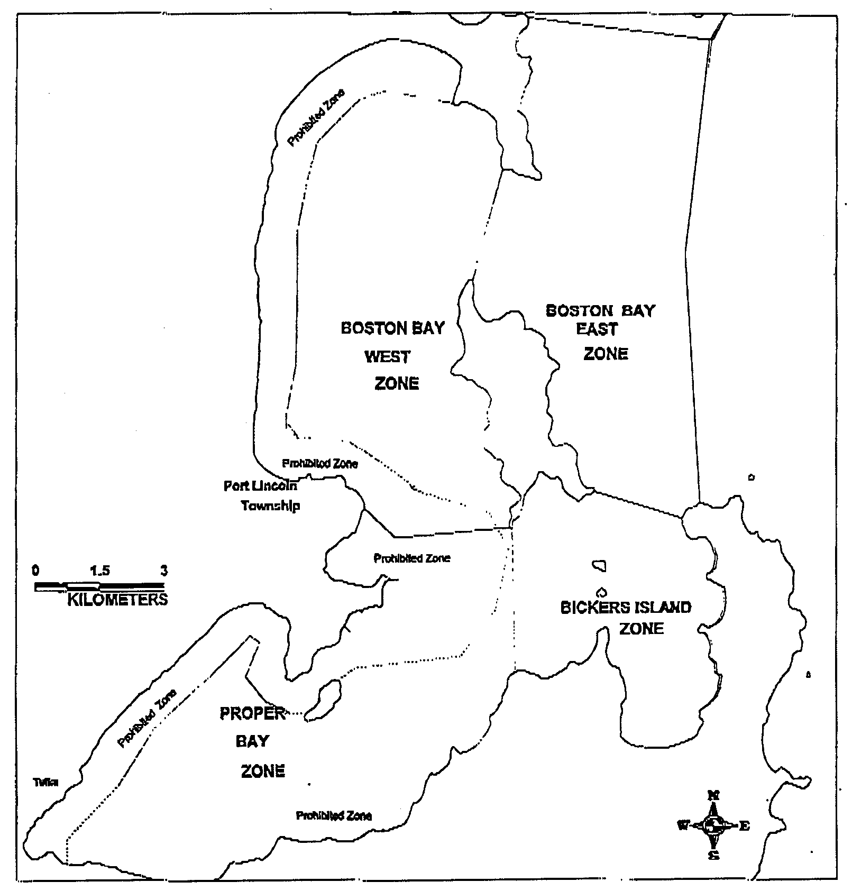
Native Oyster Collection

Dated 28 September 2000.
B. Hemming, Director of Fisheries

FISHERIES ACT 1982: SECTION 59
TAKE notice that pursuant to section 59 of the Fisheries Act 1982, Dr Wolfgang Zeidler or persons acting as his agents (hereinafter referred to as the ‘exemption holder’) from the South Australian Museum, North Terrace, Adelaide, S.A. 5000 is exempt from the provisions of the Fisheries Act (Aquatic Reserves) Regulations 1989 and clause 65 of Schedule 1 of the Fisheries (General) Regulations 1984, but only insofar as the exemption holder may collect marine organisms from South Australian coastal waters including intertidal ‘rocky’ reefs using the gear specified in Schedule 1 (hereinafter referred to as the ‘exempted activity’), subject to the conditions set out in Schedule 2 from the date of gazettal of this notice until 30 June 2001.
Schedule 1
3 hoop nets 5 shrimp traps
3 octopus pots 2 dab nets
1 dredge 2 plankton nets
Schedule 2
1. The specimens collected by the exemption holder are for scientific purposes only and may not be sold.
2. At least 24 hours prior to collecting any specimens pursuant to this notice, the permit holders must advise PIRSA Fisheries Compliance on 1800 065 522 with details of the proposed locations and the dates on which the collections are to be made.
3. While engaging in the exempted activity, the exemption holder must be in possession of a copy of this notice. Such notice must be produced to a PIRSA Fisheries Compliance Officer if such an officer requests that it be produced.
4. The exemption holder shall not contravene or fail to comply with the Fisheries Act 1982 or any regulations made under that Act, except where specifically exempted by this notice.
Dated 29 September 2000.
B. Hemming, Director of Fisheries

M. G. O’CALLAGHAN, Government Printer, South Australia

