No. 98 2823

THE SOUTH AUSTRALIAN

GOVERNMENT GAZETTE

PUBLISHED BY AUTHORITY

ALL PUBLIC ACTS appearing in this GAZETTE are to be considered official, and obeyed as such

ADELAIDE, THURSDAY, 2 AUGUST 2001

CONTENTS

Page
Corporations and District Councils—
Notices 2841
Republished 2844
Crown Lands Act 1929—Notices 2824
Development Act 1993—Notices 2824
Gas Act 1997—Notice 2825
Harbors and Navigation Act 1993—Notice 2834
Land and Business (Sale and Conveyancing) Act 1994—
Notices 2834
Liquor Licensing Act 1997—Notices 2834
Mining Act 1971—Notices 2836
Motor Vehicles Act 1959—Notice 2836
National Parks and Wildlife Act 1972—Notice 2837
Passenger Transport Act 1994—Notice 2838
Public Trustee Office—Administration of Estates 2846
Renmark Irrigation Trust, The—Notice 2838
Roads (Opening and Closing) Act 1991—Notices 2838
Sale of Property 2847
Transport, Department of—Notice to Mariners 2839

GOVERNMENT GAZETTE NOTICES
ALL poundkeepers’ and private advertisements forwarded for publication in the South Australian Government Gazette must be PAID FOR PRIOR TO INSERTION; and all notices, from whatever source, should be legibly written on one side of the paper only and sent to Government Publishing SA so as to be received no later
than 4 p.m. on the Tuesday preceding the day of publication. Phone 8207 1045 or Fax 8207 1040. E-mail: governmentgazette@saugov.sa.gov.au. Send as attachments in Word format and please confirm your transmission with a faxed copy of your document, including the date the notice is to be published and to whom the notice will be charged.

CROWN LANDS ACT 1929: SECTION 5
TAKE NOTICE that pursuant to the Crown Lands Act 1929, I PETER MACLAREN KENTISH, Surveyor-General and Delegate appointed by IAIN EVANS, Minister for Environment and Heritage, Minister of the Crown to whom the administration of the Crown Lands Act 1929 is committed DO HEREBY:
1. Dedicate the Crown Land defined in The First Schedule as a Reserve for District Council Purposes and declare that such land shall be under the care, control and management of the District Council of Cleve.
2. Dedicate the Crown Land defined in The Second Schedule as a Reserve for Conservation Purposes and declare that such land shall be under the care, control and management of the District Council of Cleve.
The First Schedule
Allotment 8 of DP 53746, Hundred of Boothby, County of Jervois, exclusive of all necessary roads.
The Second Schedule
Allotment 9 of DP 53746, Hundred of Boothby, County of Jervois, exclusive of all necessary roads.
Dated 31 July 2001.
P. M. Kentish, Surveyor-General
DENR 08/0326

CROWN LANDS ACT 1929: SECTION 5
TAKE NOTICE that pursuant to the Crown Lands Act 1929, I PETER MACLAREN KENTISH, Surveyor-General and Delegate appointed by IAIN EVANS, Minister for Environment and Heritage, Minister of the Crown to whom the administration of the Crown Lands Act 1929 is committed DO HEREBY:
1. Resume the land defined in The First Schedule.
2. Dedicate the Crown Land defined in The Second Schedule as a Reserve for Natural Features Preservation and Sewerage Purposes and declare that such land shall be under the care, control and management of the Minister for Government Enterprises.
The First Schedule
Reserve for the purposes of the Preservation of Natural Features and Protection of Sewerage Works, section 639, Hundred of Adelaide, County of Adelaide, the proclamation of which was published in the Government Gazette of 15 May 1969 at page 1412, being the whole of the land comprised in Crown Record Volume 5715 Folio 227.
The Second Schedule
Allotment 101 of DP 56982, Hundred of Adelaide, County of Adelaide, exclusive of all necessary roads, subject nevertheless to:
1. An existing easement to the Commonwealth of Australia more particularly described in Government Gazette of 15 May 1969 at page 1412.
2. An easement to the Minister for Water Resources for drainage purposes over that portion of allotment 101 marked C on DP 56982.
Dated 31 July 2001.
P. M. Kentish, Surveyor-General
DEHAA 17/1136 Pt 1

CROWN LANDS ACT 1929: SECTION 5
TAKE NOTICE that pursuant to the Crown Lands Act 1929, I PETER MACLAREN KENTISH, Surveyor-General and Delegate appointed by IAIN EVANS, Minister for Environment and Heritage, Minister of the Crown to whom the administration of the Crown Lands Act 1929 is committed DO HEREBY dedicate the Crown Land defined in The Schedule as a Reserve for Recreation, Access and Public Jetty Purposes and declare that such land shall be under the care, control and management of the District Council of Lower Eyre Peninsula, subject to the Jetty
Structure located on portion of the said land being subject to the same terms and conditions comprised in Memorandum of Lease No. 8902288 dated 17 May 2000.
The Schedule
Block 2, Hundred of Louth, County of Flinders, exclusive of all necessary roads, being the whole of the land comprised in Crown Record Volume 5838 Folio 288.
Dated 31 July 2001.
P. M. Kentish, Surveyor-General
DENR 08/0545

DEVELOPMENT ACT 1993, SECTION 28 (5): DECLARA-TION OF CESSATION OF INTERIM OPERATION OF THE BERRI BARMERA COUNCIL—BERRI (DC) AND BARMERA (DC) DEVELOPMENT PLANS—GENERAL REVIEW AND CONSOLIDATION PLAN AMENDMENT
Preamble
On 27 July 2000 the Governor, under section 28 (1), declared The Berri Barmera Council—Berri (DC) and Barmera (DC) Development Plans—General Review and Consolidation Plan Amendment as an amendment to come into interim operation without delay on that day. The Berri Barmera Council Develop-ment Plan, consolidated on 27 July 2000, incorporated the provisions of The Berri Barmera Council—Berri (DC) and Barmera (DC) Development Plans—General Review and Con-solidation Plan Amendment (incorporated into a published Development Plan pursuant to Section 31 of the Development Act 1993).
The Berri Barmera Council—Berri (DC) and Barmera (DC) Development Plans—General Review and Consolidation Plan Amendment has not been approved by the Minister under Section 25 within the required 12 months period.
As a result the Berri (DC) Development Plan dated 13 April 2000 and the Barmera (DC) Development Plan dated 30 Sep-tember 1999 are the operative Development Plans.
Notice
PURSUANT to section 28 (4) (c) of the Development Act 1993, The Berri Barmera Council—Berri (DC) and Barmera (DC) Development Plans—General Review and Consolidation Plan Amendment ceases to operate under the Interim Operation Order proclaimed by the Governor on 27 July 2000.
Dated 2 August 2001.
Diana Laidlaw, Minister for Transport and Urban Planning.

DEVELOPMENT ACT 1993, SECTION 25 (17): CITY OF
MOUNT GAMBIER—MOUNT GAMBIER (CITY) DEVELOP-MENT PLAN—CAVE GARDENS AND ENVIRONS STATE HERITAGE AREA POLICY AREA PLAN AMENDMENT
Preamble
1. The Development Plan amendment entitled ‘City of Mount Gambier—Mount Gambier (City) Development Plan—Cave Gardens and Environs State Heritage Area Policy Area Plan Amendment’ (the Plan Amendment) has been finalised in accordance with the provisions of the Development Act 1993.
2. The Minister for Transport and Urban Planning has decided to approve the Plan Amendment.
Notice
PURSUANT to section 25 of the Development Act 1993, I:
(a) approve the Plan Amendment; and
(b) fix the day on which this notice is published in the Gazette as the day on which the Plan Amendment will come into operation.
Dated 2 August 2001.
Diana Laidlaw, Minister for Transport and Urban Planning
PLN 99/0026

GAS ACT 1997
(section 33)
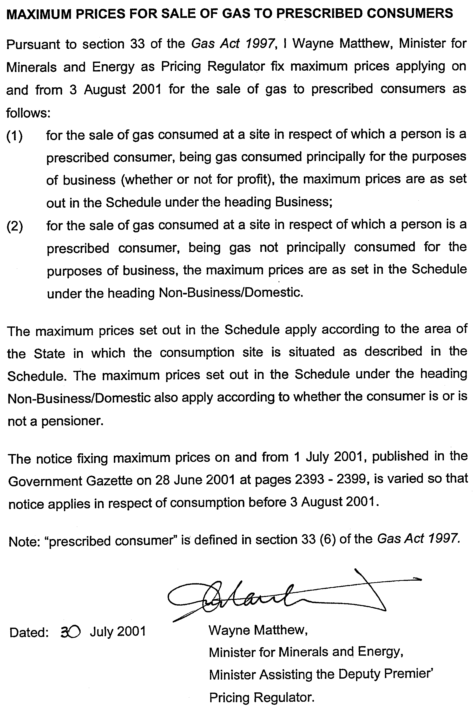

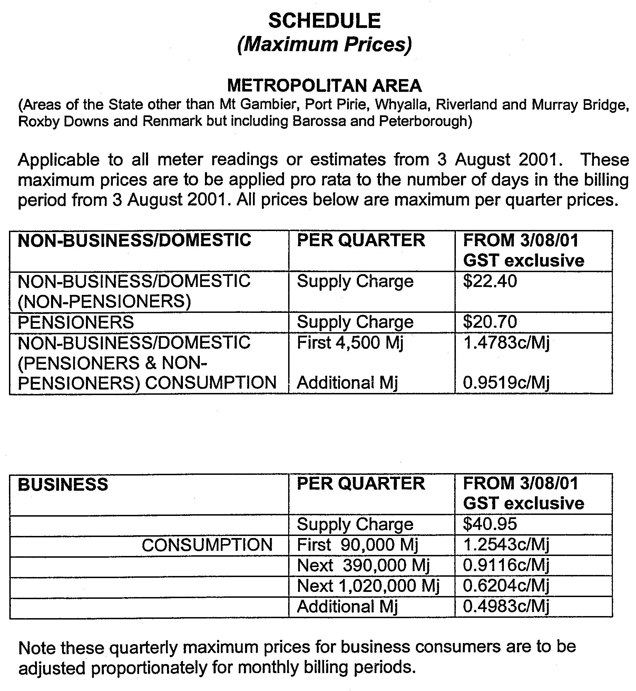
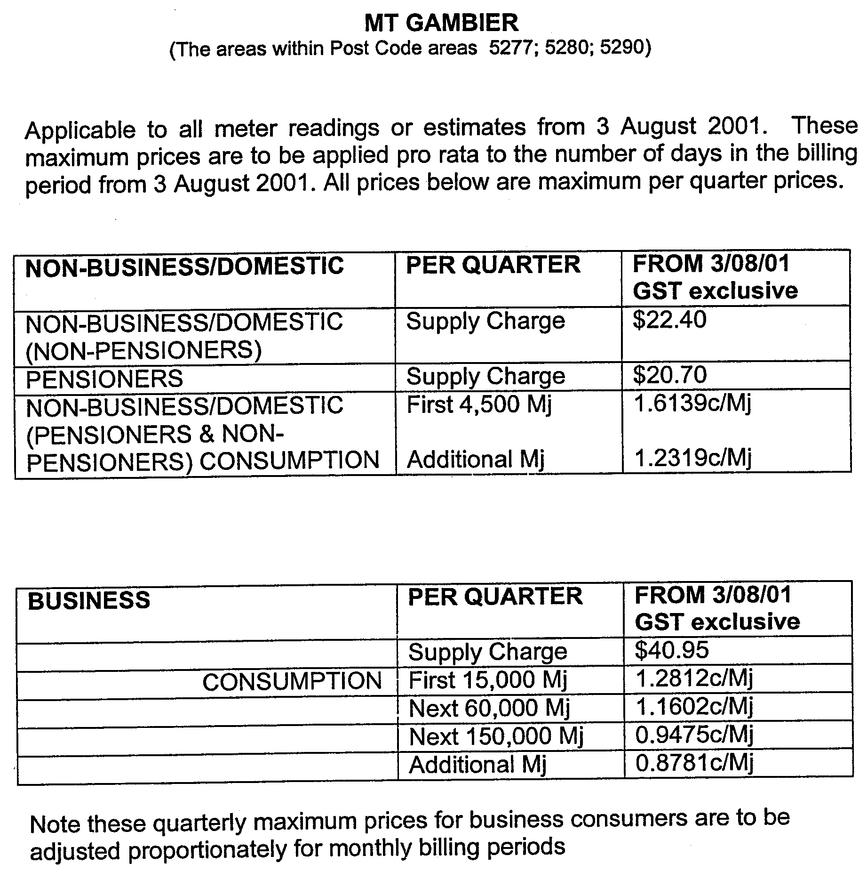
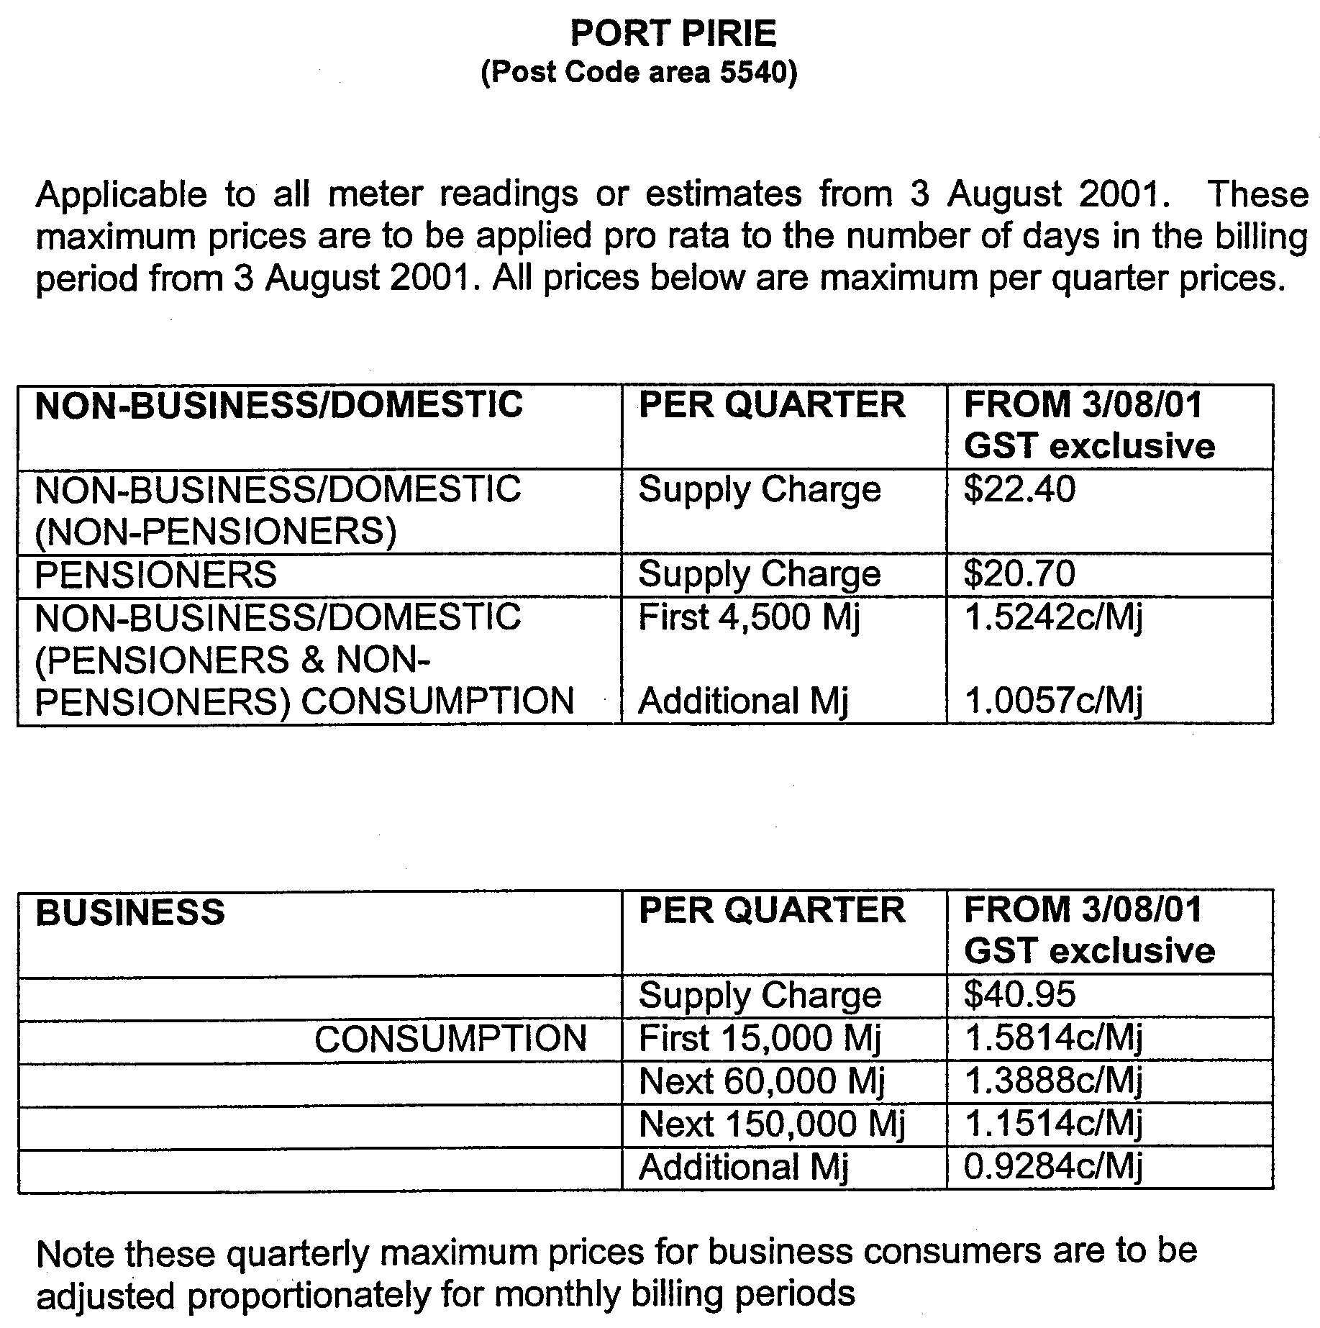
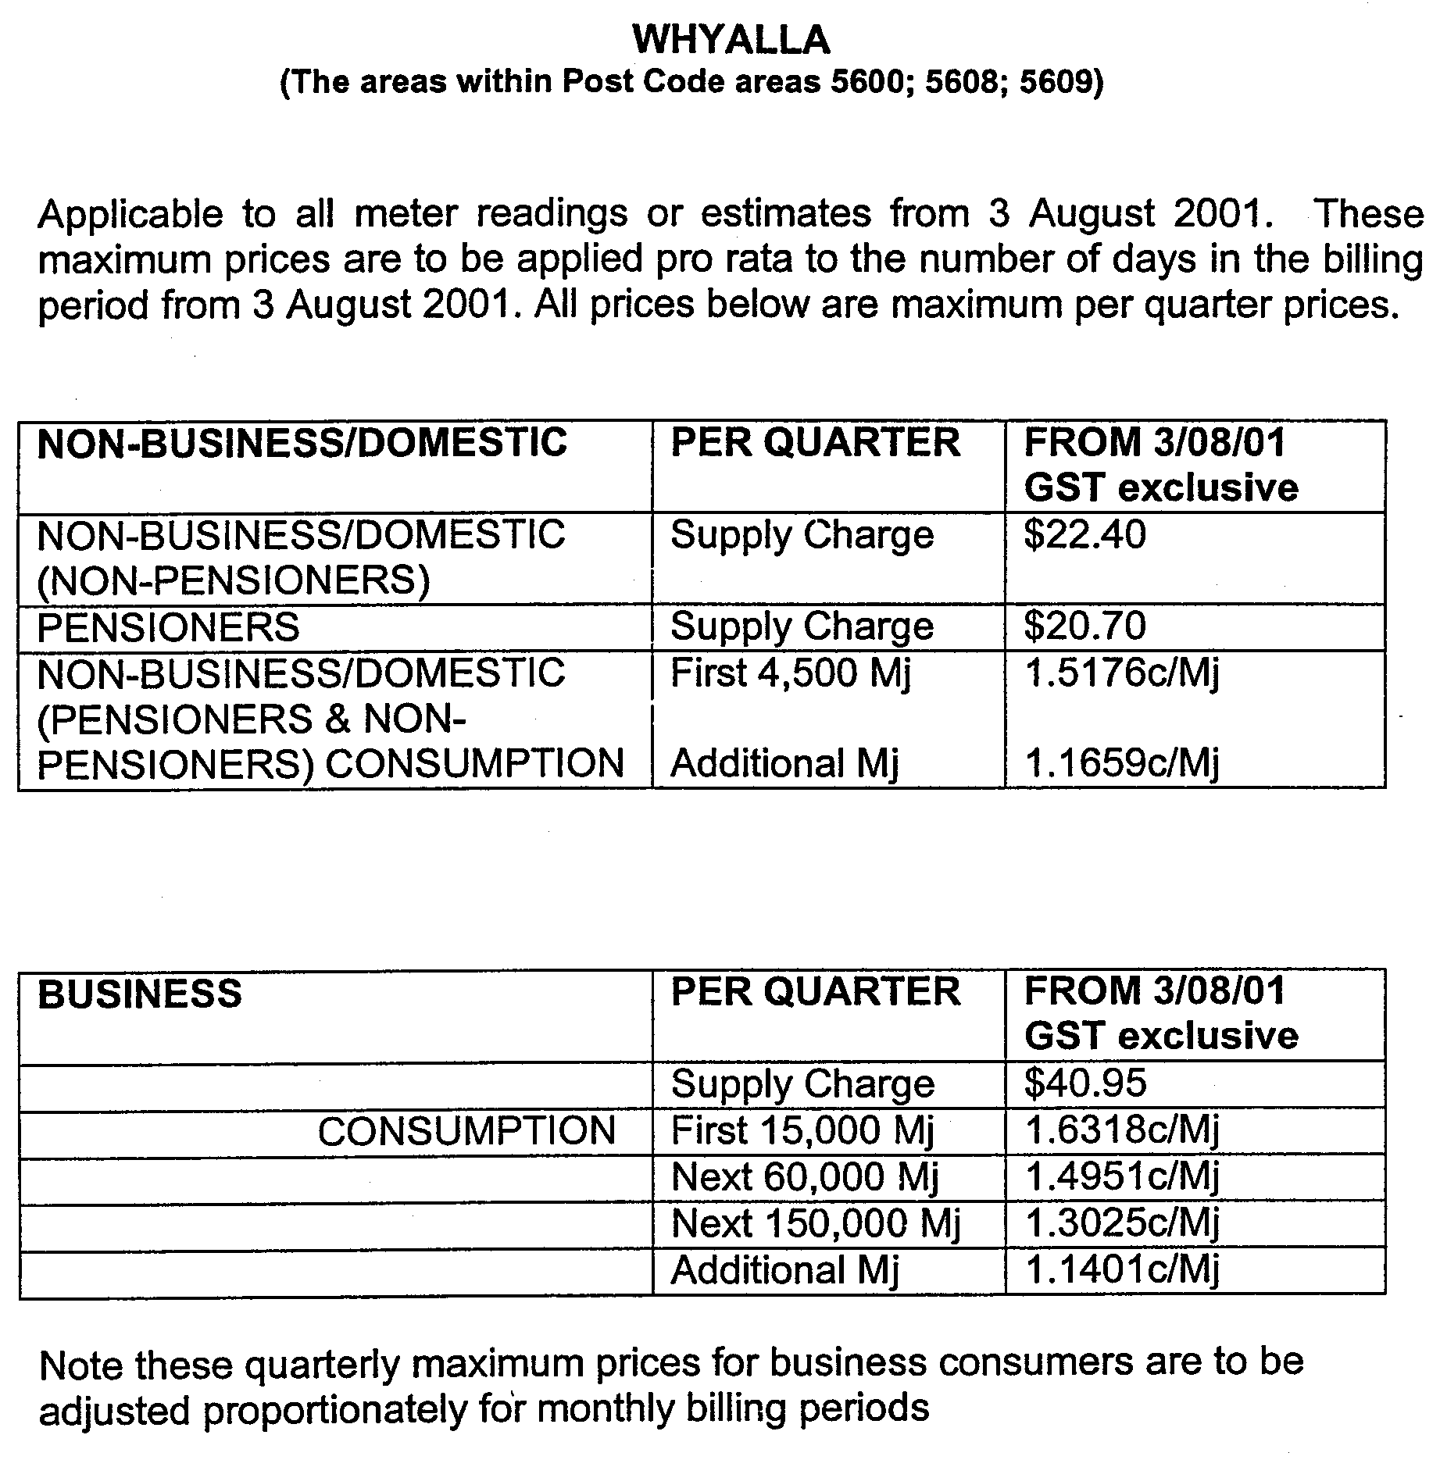
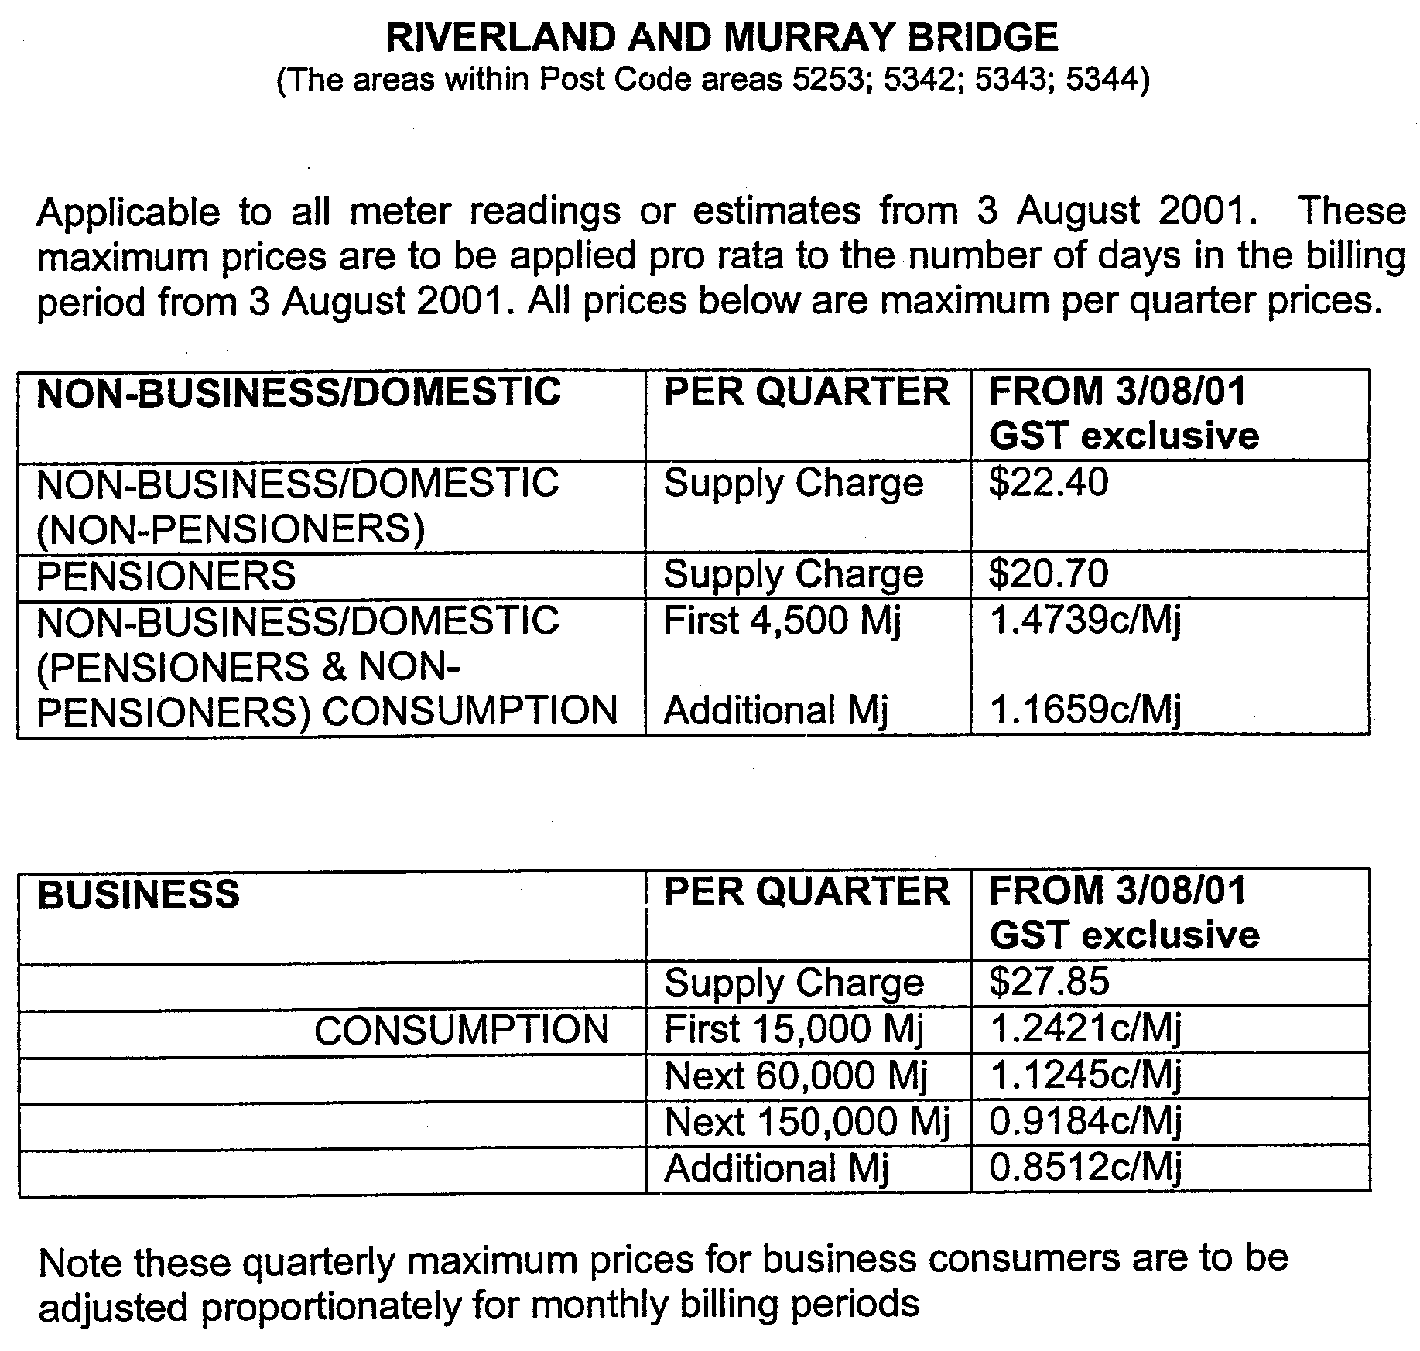

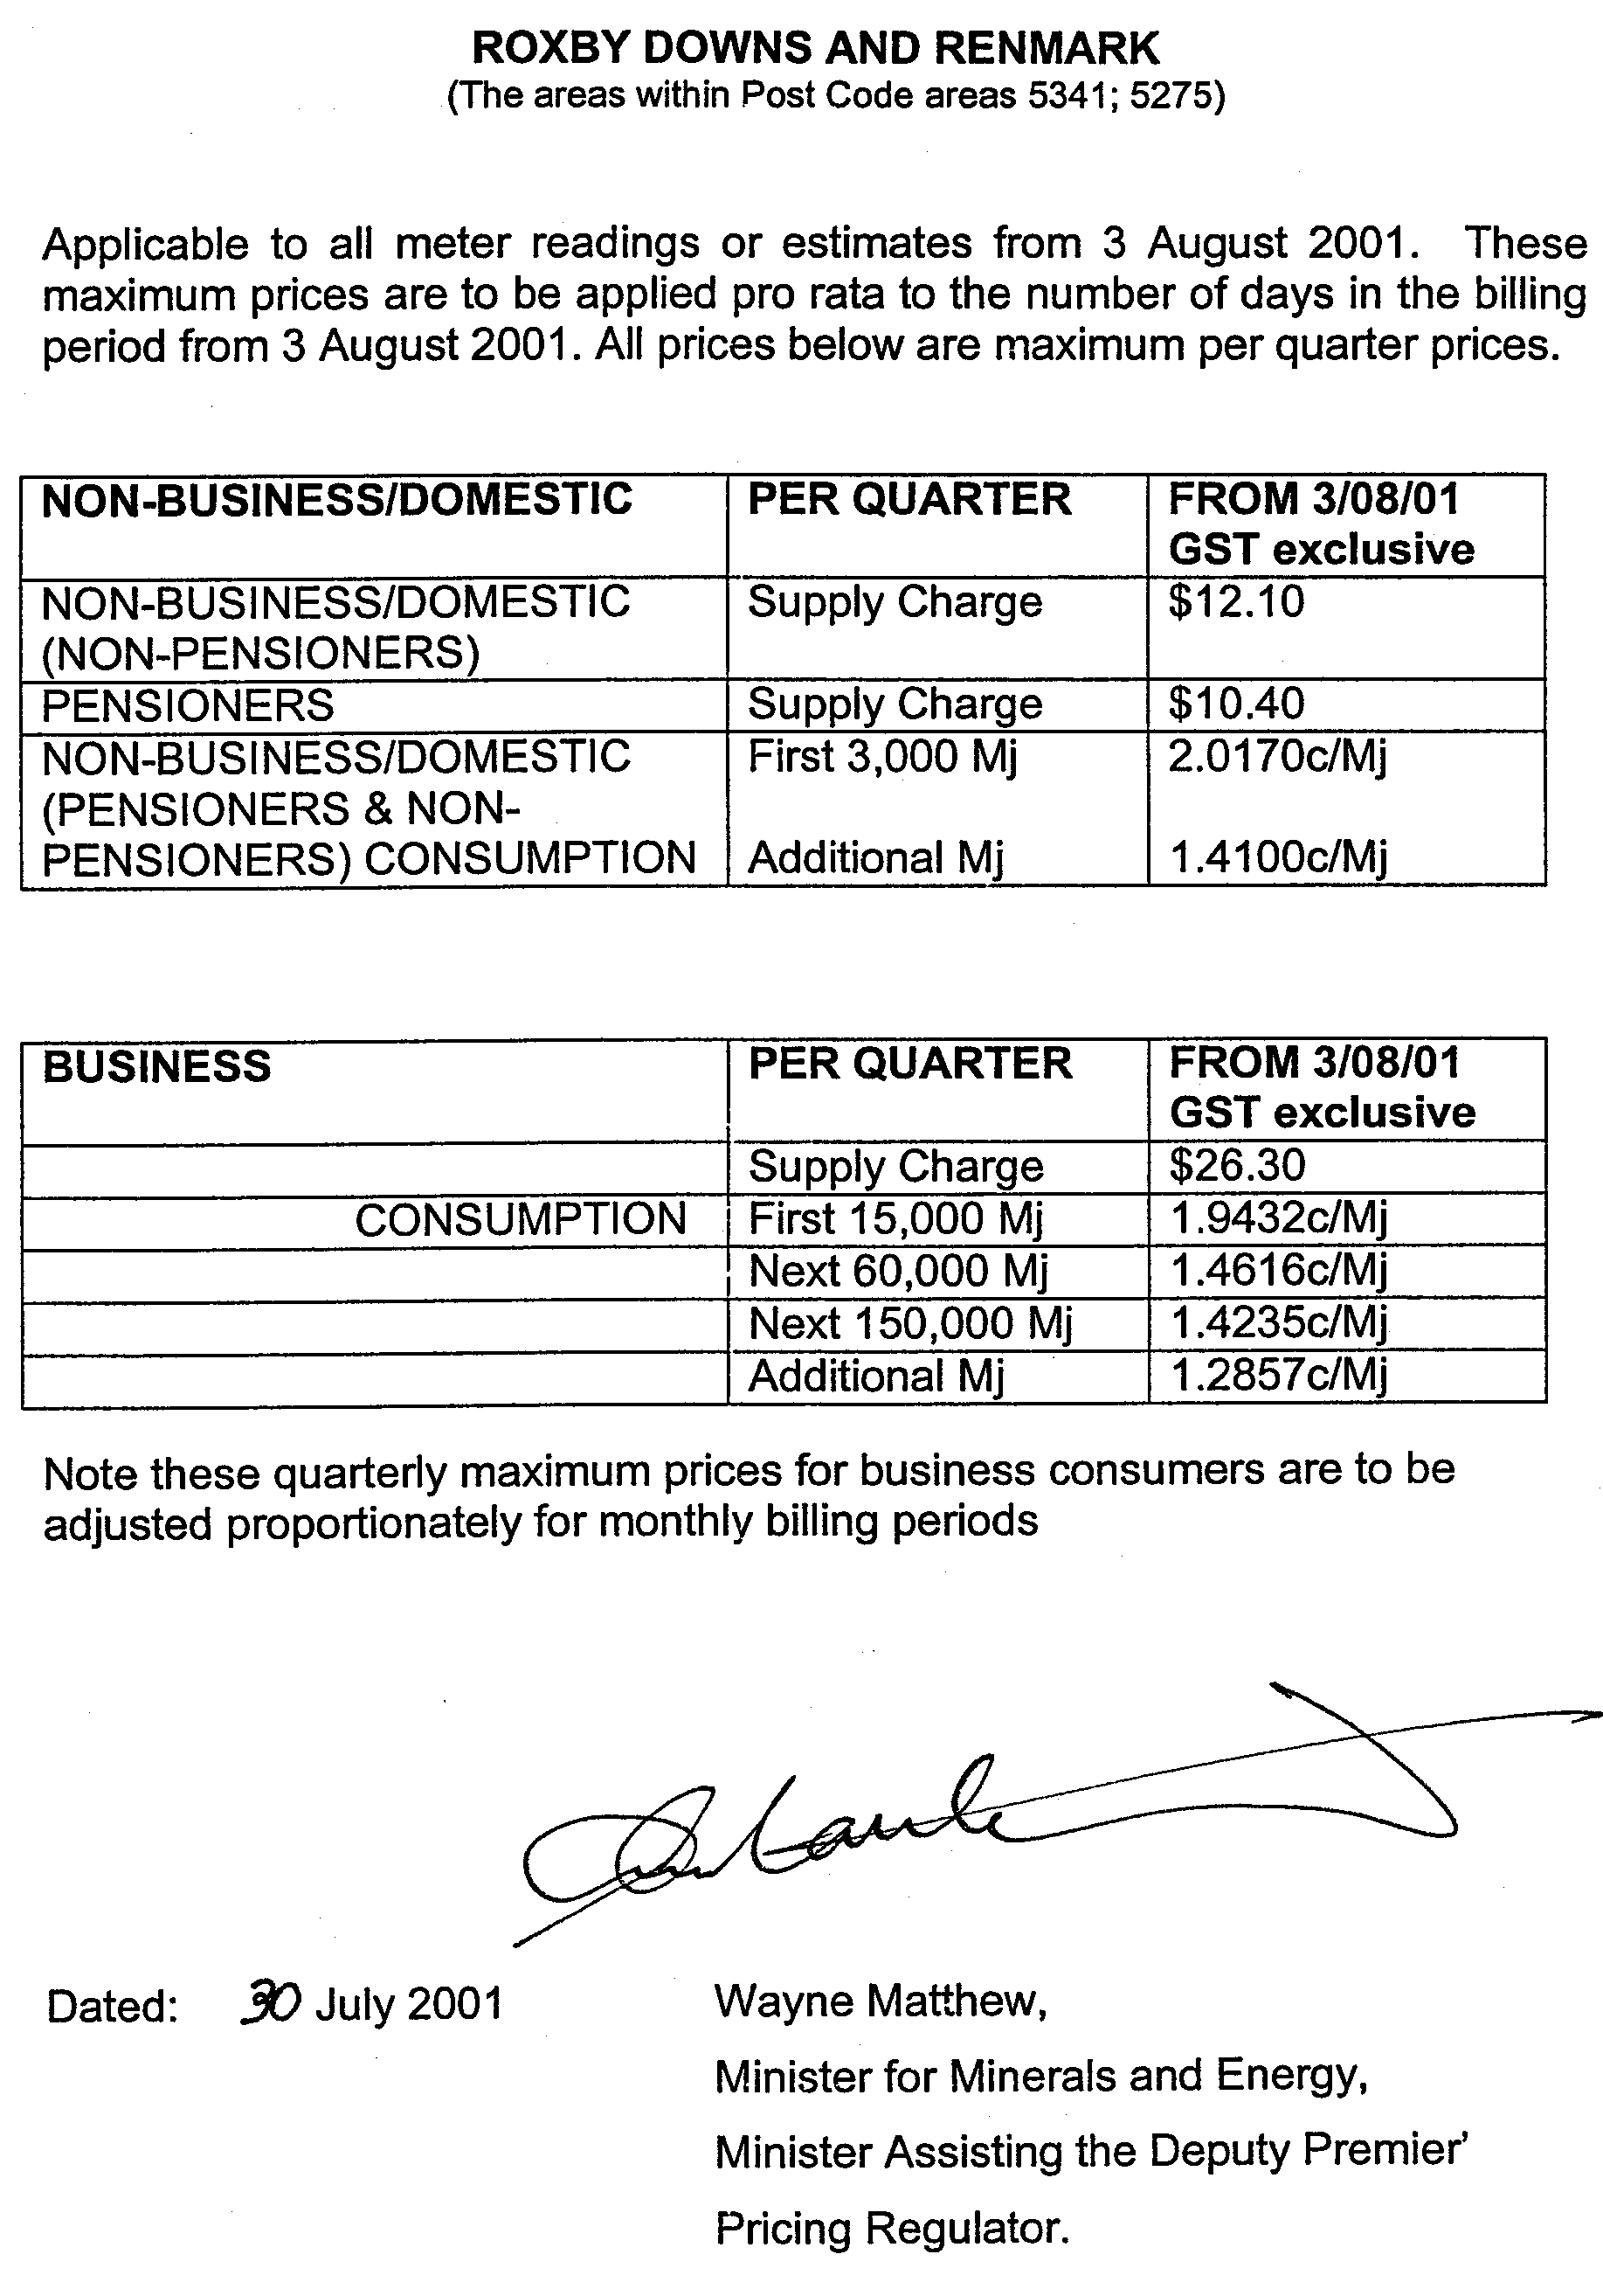

GOVERNMENT GAZETTE ADVERTISEMENT RATES

To apply from 1 July 2001

$  Agents, Ceasing to Act as 32.75  Associations:  Incorporation 16.70  Intention of Incorporation 41.25  Transfer of Properties 41.25  Attorney, Appointment of 32.75  Bailiff’s Sale 41.25  Cemetery Curator Appointed 24.50  Companies:  Alteration to Constitution 32.75  Capital, Increase or Decrease of 41.25  Ceasing to Carry on Business 24.50  Declaration of Dividend 24.50  Incorporation 32.75  Lost Share Certificates:  First Name 24.50  Each Subsequent Name 8.40  Meeting Final 27.50  Meeting Final Regarding Liquidator’s Report on  Conduct of Winding Up (equivalent to ‘Final  Meeting’)  First Name 32.75  Each Subsequent Name 8.40  Notices:  Call 41.25  Change of Name 16.70  Creditors 32.75  Creditors Compromise of Arrangement 32.75  Creditors (extraordinary resolution that ‘the Com-pany be wound up voluntarily and that a liquidator be appointed’) 41.25  Release of Liquidator⎯Application⎯Large Ad. 65.50  ⎯Release Granted 41.25  Receiver and Manager Appointed 38.25  Receiver and Manager Ceasing to Act 32.75  Restored Name 31.00  Petition to Supreme Court for Winding Up 57.00  Summons in Action 48.75  Order of Supreme Court for Winding Up Action 32.75  Register of Interests⎯Section 84 (1) Exempt 74.00  Removal of Office 16.70  Proof of Debts 32.75  Sales of Shares and Forfeiture 32.75  Estates:  Assigned 24.50  Deceased Persons⎯Notice to Creditors, etc. 41.25  Each Subsequent Name 8.40  Deceased Persons⎯Closed Estates 24.50  Each Subsequent Estate 1.05  Probate, Selling of 32.75  Public Trustee, each Estate 8.40 |  | $  Firms:  Ceasing to Carry on Business (each insertion) 21.80  Discontinuance Place of Business 21.80  Land⎯Real Property Act:  Intention to Sell, Notice of 41.25  Lost Certificate of Title Notices 41.25  Cancellation, Notice of (Strata Plan) 41.25  Mortgages:  Caveat Lodgment 16.70  Discharge of 17.60  Foreclosures 16.70  Transfer of 16.70  Sublet 8.40  Leases⎯Application for Transfer (2 insertions) each 8.40  Lost Treasury Receipts (3 insertions) each 24.50  Licensing 48.75  Municipal or District Councils:  Annual Financial Statement⎯Forms 1 and 2 462.00  Electricity Supply⎯Forms 19 and 20 327.00  Default in Payment of Rates:  First Name 65.50  Each Subsequent Name 8.40  Noxious Trade 24.50  Partnership, Dissolution of 24.50  Petitions (small) 16.70  Registered Building Societies (from Registrar-  General) 16.70  Register of Unclaimed Moneys⎯First Name 24.50  Each Subsequent Name 8.40  Registers of Members⎯Three pages and over:  Rate per page (in 8pt) 209.00  Rate per page (in 6pt) 276.00  Sale of Land by Public Auction 41.75  Advertisements 2.30  Advertisements, other than those listed are charged at $2.30 per column line, tabular one-third extra.  Notices by Colleges, Universities, Corporations and District Councils to be charged at $2.30 per line.  Where the notice inserted varies significantly in length from that which is usually published a charge of $2.30 per column line will be applied in lieu of advertisement rates listed.  South Australian Government publications are sold on the condition that they will not be reproduced without prior permission from the Government Printer.
All the above prices include GST

GOVERNMENT GAZETTE NOTICES
ALL private advertisements forwarded for publication in the South Australian Government Gazette must be PAID FOR PRIOR TO INSERTION; and all notices, from whatever source, should be legibly written on one side of the paper only and sent to Government Publishing SA so as to be received no later than 4 p.m. Tuesday preceding the day of publication. Phone 8207 1045 or Fax 8207 1040. E-mail: governmentgazette@saugov.sa.gov.au. Send as attachments in Word format and please confirm your transmission with a faxed copy of your document, including the date the notice is to be published and to whom the notice will be charged.

MISCELLANEOUS LEGISLATION AND GOVERNMENT PUBLICATIONS PRICES AS FROM 1 JULY 2001

Acts, Bills, Rules, Parliamentary Papers and Regulations
Pages | Main | Amends | Pages | Main | Amends

1-16 | 1.85 | 0.80 | 497-512 | 27.00 | 26.00
17-32 | 2.60 | 1.65 | 513-528 | 27.75 | 26.50
33-48 | 3.35 | 2.40 | 529-544 | 28.50 | 27.50
49-64 | 4.25 | 3.20 | 545-560 | 29.25 | 28.50
65-80 | 5.00 | 4.10 | 561-576 | 30.00 | 29.25
81-96 | 5.75 | 4.80 | 577-592 | 31.00 | 29.75
97-112 | 6.60 | 5.60 | 593-608 | 31.75 | 30.75
113-128 | 7.40 | 6.45 | 609-624 | 32.50 | 31.75
129-144 | 8.30 | 7.30 | 625-640 | 33.25 | 32.25
145-160 | 9.10 | 8.05 | 641-656 | 34.00 | 33.00
161-176 | 9.95 | 8.90 | 657-672 | 34.50 | 33.75
177-192 | 10.70 | 9.75 | 673-688 | 36.00 | 34.50
193-208 | 11.50 | 10.60 | 689-704 | 36.75 | 35.50
209-224 | 12.30 | 11.30 | 705-720 | 37.25 | 36.50
225-240 | 13.00 | 12.10 | 721-736 | 38.50 | 37.00
241-257 | 13.90 | 12.80 | 737-752 | 39.00 | 38.00
258-272 | 14.80 | 13.60 | 753-768 | 40.00 | 38.50
273-288 | 15.60 | 14.60 | 769-784 | 40.50 | 39.75
289-304 | 16.30 | 15.30 | 785-800 | 41.25 | 40.50
305-320 | 17.10 | 16.10 | 801-816 | 42.00 | 41.00
321-336 | 17.90 | 16.90 | 817-832 | 43.00 | 42.00
337-352 | 18.80 | 17.80 | 833-848 | 43.75 | 42.75
353-368 | 19.60 | 18.60 | 849-864 | 44.50 | 43.50
369-384 | 20.40 | 19.50 | 865-880 | 45.25 | 44.50
385-400 | 21.10 | 20.20 | 881-896 | 45.75 | 45.00
401-416 | 21.90 | 20.90 | 897-912 | 47.25 | 45.75
417-432 | 22.90 | 21.80 | 913-928 | 47.75 | 47.25
433-448 | 23.60 | 22.60 | 929-944 | 48.75 | 47.75
449-464 | 24.50 | 23.40 | 945-960 | 49.50 | 48.25
465-480 | 25.00 | 24.20 | 961-976 | 50.25 | 49.25
481-496 | 26.00 | 24.90 | 977-992 | 51.25 | 49.75

Legislation—Acts, Regulations, etc: $
Subscriptions:
Acts 166.90
All Bills as Laid 398.60
Rules and Regulations 398.60
Parliamentary Papers 398.60
Bound Acts 184.25
Index 89.20
Government Gazette
Copy 4.40
Subscription 220.20
Hansard
Copy 11.90
Subscription—per session (issued weekly) 345.35
Cloth bound—per volume 148.30
Subscription—per session (issued daily) 345.35
Legislation on Disk
Whole Database 2 551.00
Annual Subscription for fortnightly updates 784.30
Individual Act(s) including updates POA
Compendium
Subscriptions:
New Subs 1 513.50
Updates 540.25

(All the above prices include GST)

All Legislation, Government Gazette, Hansard and Legislation on disk are available from:
Counter Sales Information SA (State Government Bookshop)
and Mail Orders: Ground Floor, 77 Grenfell Street, Adelaide, S.A. 5000.
Phone: (08) 8204 1900. Fax: (08) 8204 1909
Online Shop: www.info.sa.gov.au
S.A. Country Customer Free Call: 1800 182 234
TTY (Hearing Impaired): (08) 8204 1923
Subscriptions and Standing Orders:
Phone: (08) 8207 0908, (08) 8207 0910. Fax: (08) 8207 1040
Box 9, Plaza Level, Riverside Centre, North Terrace, Adelaide, S.A. 5000.

HARBORS AND NAVIGATION ACT 1993
Determination of the State Crewing Committee
THE following determination made on 20 November 2000, by the State Crewing Committee is published pursuant to part 6, section 45 of the Harbors and Navigation Act 1993.
Diana Laidlaw, Minister for Transport and Urban Planning.
TSA 2001/01184 (V28049)

HARBORS AND NAVIGATION ACT 1993
Determination of the State Crewing Committee in respect of the
M.V. ‘Recfish One’
THE following determination is made by the State Crewing Committee pursuant to part 6, section 45 of the Harbors and Navigation Act 1993, in respect of the Recfish One whilst operating within the waters of Spencer Gulf, Gulf of St Vincent, Investigator Strait and Backstairs Passage, east of a line drawn from Cape Catastrophe to Cape Borda and west of a line drawn from Cape Willoughby to the Murray Mouth when within range of a South Australian OTC Seaphone Installation and not more than 15 nautical miles from the coastline.
Minimum complement
One person—Master
Minimum Qualifications of Crew
Master—Certificate of Competency as Coxswain and has successfully completed Elements of Shipboard Safety and Res-tricted Radiotelephony courses.
Capt. C. Kavina, Presiding Member, State Crewing Committee.

LAND AND BUSINESS (SALE AND CONVEYANCING)
ACT 1994
Exemption
TAKE notice that, pursuant to section 23 (3) of the Land and Business (Sale and Conveyancing) Act 1994, I, Kenneth Trevor Griffin, Minister for Consumer Affairs, do hereby exempt the person named in Schedule 1 from the application of section 23 (2) of the Act in relation to the purchase of the land specified in Schedule 2.
Schedule 1
Peter Alexandrou, an officer/employee of Alexandrou Estates Pty Ltd.
Schedule 2
The whole of the land described in certificate of title register book volume 5393, folio 846, situated at 5 Reynolds Street, Blackwood, S.A. 5051.
Dated 2 August 2001.
Signed for and on behalf of the Minister for Consumer Affairs by the Commissioner for Consumer Affairs:
M. D. Bodycoat, Commissioner

LAND AND BUSINESS (SALE AND CONVEYANCING) ACT 1994
Exemption
TAKE notice that, pursuant to section 32 (1) of the Land and Business (Sale and Conveyancing) Act 1994, I, Kenneth Trevor Griffin, Minister for Consumer Affairs, do hereby exempt the person named in Schedule 1 from the application of section 23 (1) of the Act in relation to the purchase of the land specified in Schedule 2.
Schedule 1
Alexandrou Estates Pty Ltd, registered agent.
Schedule 2
The whole of the land described in certificate of title register book volume 5393, folio 846, situated at 5 Reynolds Street, Blackwood, S.A. 5051.
Dated 2 August 2001.
Signed for and on behalf of the Minister for Consumer Affairs by the Commissioner for Consumer Affairs:
M. D. Bodycoat, Commissioner

LIQUOR LICENSING ACT 1997
Notice of Application
NOTICE is hereby given, pursuant to section 52 (2) (b) of the Liquor Licensing Act 1997, that David Neil Nancarrow and Cameron Ross Lewcock, P.O. Box 521, Salisbury, S.A. 5108 have applied to the Licensing Authority for the transfer of a Restaurant Licence in respect of premises situated at 4/47 Jetty Road, Glenelg, S.A. 5045 and known as Zest Café Gallery.
The application has been set down for hearing on 3 September 2001 at 11 a.m.
Any person may object to the application by lodging a notice of objection in the prescribed form with the Licensing Authority, and serving a copy of the notice on the applicants at the applicants’ address given above, at least seven days before the hearing date.
Plans in respect of the premises the subject of the application are open to public inspection without fee at the Office of the Liquor and Gaming Commissioner, 9th Floor, East Wing, 50 Grenfell Street, Adelaide, S.A. 5000.
Dated 26 July 2001.
Applicants

LIQUOR LICENSING ACT 1997
Notice of Application
NOTICE is hereby given, pursuant to section 52 (2) (b) of the Liquor Licensing Act 1997, that Damien Paul Tscharke, P.O. Box 69, Greenock, S.A. 5360 has applied to the Licensing Authority for a Producer’s Licence in respect of premises situated at Lot 867, section 236, Hundred of Nuriootpa and known as Glaymond Wines.
The application has been set down for hearing on 7 September 2001.
Any person may object to the application by lodging a notice of objection in the prescribed form with the Licensing Authority, and serving a copy of the notice on the applicant at the applicant’s address given above, at least seven days before the hearing date.
Plans in respect of the premises the subject of the application are open to public inspection without fee at the Office of the Liquor and Gaming Commissioner, 9th Floor, East Wing, 50 Grenfell Street, Adelaide, S.A. 5000.
Dated 30 July 2001.
Applicant

LIQUOR LICENSING ACT 1997
Notice of Application
NOTICE is hereby given, pursuant to section 52 (2) (b) of the Liquor Licensing Act 1997, that David Ronald Tarr, 37 Charles Street, Unley, has applied to the Licensing Authority for a Residential Licence in respect of premises situated at 14 First Street, Beltana, S.A. 5730 and known as Royal Victoria Hotel.
The application has been set down for hearing on 31 August 2001.
Any person may object to the application by lodging a notice of objection in the prescribed form with the Licensing Authority, and serving a copy of the notice on the applicant at the applicant’s address given above, at least seven days before the hearing date.
Plans in respect of the premises the subject of the application are open to public inspection without fee at the Office of the Liquor and Gaming Commissioner, 9th Floor, East Wing, 50 Grenfell Street, Adelaide, S.A. 5000.
Dated 26 July 2001.
Applicant

LIQUOR LICENSING ACT 1997
Notice of Application
NOTICE is hereby given, pursuant to section 52 (2) (b) of the Liquor Licensing Act 1997, that Marco Binetti as Trustee for the Binetti Family Trust, c/o Starke & Associates, Solicitors, Suite 8, 70 Walkerville Terrace, Walkerville, S.A. 5081 has applied to the Licensing Authority for the transfer of a Restaurant Licence in respect of premises situated at 36A Gouger Street, Adelaide, S.A. 5000 and known as Pretzel’s Cafe.
The application has been set down for hearing on 3 September 2001 at 10 a.m.
Any person may object to the application by lodging a notice of objection in the prescribed form with the Licensing Authority, and serving a copy of the notice on the applicant at the applicant’s address given above, at least seven days before the hearing date.
Plans in respect of the premises the subject of the application are open to public inspection without fee at the Office of the Liquor and Gaming Commissioner, 9th Floor, East Wing, 50 Grenfell Street, Adelaide, S.A. 5000.
Dated 23 July 2001.
Applicant

LIQUOR LICENSING ACT 1997
Notice of Application
NOTICE is hereby given, pursuant to section 52 (2) (b) of the Liquor Licensing Act 1997, that Peter Damian Owen and Patricia Margaret Owen, 61A Edward Street, Norwood, S.A. 5067 have applied to the Licensing Authority for the transfer of a Restaurant Licence in respect of premises situated at 61A Edward Street, Norwood, S.A. 5067 and known as Lemon Tree Gourmet.
The application has been set down for hearing on 3 September 2001 at 10.30 a.m.
Any person may object to the application by lodging a notice of objection in the prescribed form with the Licensing Authority, and serving a copy of the notice on the applicants at the applicants’ address given above, at least seven days before the hearing date.
Plans in respect of the premises the subject of the application are open to public inspection without fee at the Office of the Liquor and Gaming Commissioner, 9th Floor, East Wing, 50 Grenfell Street, Adelaide, S.A. 5000.
Dated 23 July 2001.
Applicants

LIQUOR LICENSING ACT 1997
Notice of Application
NOTICE is hereby given, pursuant to section 52 (2) (b) of the Liquor Licensing Act 1997, that Woolies Liquor Stores Pty Ltd (ACN 007 939 531), 599 Main North Road, Gepps Cross, has applied to the Licensing Authority for the removal of a Retail Liquor Merchant’s Licence from premises situated at 39 Percy Street, Mount Gambier, to premises situated at Shop 3, 145 Commercial Street, Mount Gambier.
The application has been set down for hearing on 31 August 2001.
Any person may object to the application by lodging a notice of objection in the prescribed form with the Licensing Authority, and serving a copy of the notice on the applicant at the applicant’s address given above, at least seven days before the hearing date.
Plans in respect of the premises the subject of the application are open to public inspection without fee at the Office of the Liquor and Gaming Commissioner, 9th Floor, East Wing, 50 Grenfell Street, Adelaide, S.A. 5000.
Applicant

LIQUOR LICENSING ACT 1997
Notice of Application
NOTICE is hereby given, pursuant to section 52 (2) (b) of the Liquor Licensing Act 1997, that Bambridge Pty Ltd, has applied to the Licensing Authority for alterations and redefinition to the licensed premises and variation to the current Extended Trading Authorisation in respect of premises situated at 492 Payneham Road, Glynde, S.A. 5070 and known as Glynde Hotel.
The application has been set down for hearing on 31 August 2001.
Conditions
The following licence conditions are sought:
• to conduct alterations and a redefinition to the licensed premises as shown on the deposited plan lodged with the office of the Liquor and Gaming Commissioner.
• to redefine the current Extended Trading Authorisation to include the new areas and courtyards.
Any person may object to the application by lodging a notice of objection in the prescribed form with the Licensing Authority, and serving a copy of the notice on the applicant at the applicant’s address given above, at least seven days before the hearing date.
Plans in respect of the premises the subject of the application are open to public inspection without fee at the Office of the Liquor and Gaming Commissioner, 9th Floor, East Wing, 50 Grenfell Street, Adelaide, S.A. 5000.
Applicant

LIQUOR LICENSING ACT 1997
Notice of Application
NOTICE is hereby given, pursuant to section 52 (2) (b) of the Liquor Licensing Act 1997, that Mark Woodward, 12 David Street, Victor Harbor, S.A. 5211, has applied to the Licensing Authority for a Restaurant Licence in respect of premises situated at 117 Mentone Road, Victor Harbor, S.A. 5211 and to be known as Ocean Crest Motel and Steakhaus Restaurant.
The application has been set down for hearing on 31 August 2001 at 9 a.m.
Any person may object to the application by lodging a notice of objection in the prescribed form with the Licensing Authority, and serving a copy of the notice on the applicant at the applicant’s address given above, at least seven days before the hearing date.
Plans in respect of the premises the subject of the application are open to public inspection without fee at the Office of the Liquor and Gaming Commissioner, 9th Floor, East Wing, 50 Grenfell Street, Adelaide, S.A. 5000.
Dated 25 July 2001.
Applicant

LIQUOR LICENSING ACT 1997
Notice of Application
NOTICE is hereby given, pursuant to section 52 (2) (b) of the Liquor Licensing Act 1997, that Fabal Wines Pty Ltd, c/o Georgiadis & Co., Solicitors, 4th Floor, 185 Victoria Square, Adelaide, S.A. 5000 has applied to the Licensing Authority for the removal of a Producer’s Licence from premises situated at the corner of Mosquito Creek Road and Tolderol Road, Langhorne Creek, S.A. 5255 to premises situated at 62 Greenhill Road, Wayville, S.A. 5034 and known as Marandoo Estate.
The application has been set down for hearing on 31 August 2001 at 9 a.m.
Any person may object to the application by lodging a notice of objection in the prescribed form with the Licensing Authority, and serving a copy of the notice on the applicant at the applicant’s address given above, at least seven days before the hearing date.
Plans in respect of the premises the subject of the application are open to public inspection without fee at the Office of the Liquor and Gaming Commissioner, 9th Floor, East Wing, 50 Grenfell Street, Adelaide, S.A. 5000.
Dated 20 July 2001.
Applicant

LIQUOR LICENSING ACT 1997
Notice of Application
NOTICE is hereby given, pursuant to section 52 (2) (b) of the Liquor Licensing Act 1997, that Christopher Bryan Hoffmann and Pamela Dawn Hoffmann, c/o Clelands, Solicitors, 208 Carrington Street, Adelaide, S.A. 5000 have applied to the Licensing Authority for an Extended Trading Authorisation to authorise the sale of liquor for consumption on the licensed premises in respect of premises situated at 15 Randell Street, Mannum, S.A. 5238 and known as Mannum Hotel.
The application has been set down for hearing on 31 August 2001 at 9 a.m.
Conditions
The following licence conditions are sought:
Extended Trading Authorisation:
Wednesday to Saturday—midnight to 2 a.m. the following day;
Sunday—8 a.m. to 11 a.m. and 8 p.m. to midnight.
Any person may object to the application by lodging a notice of objection in the prescribed form with the Licensing Authority, and serving a copy of the notice on the applicants at the applicants’ address given above, at least seven days before the hearing date.
Plans in respect of the premises the subject of the application are open to public inspection without fee at the Office of the Liquor and Gaming Commissioner, 9th Floor, East Wing, 50 Grenfell Street, Adelaide, S.A. 5000.
Dated 24 July 2001.
Applicants

LIQUOR LICENSING ACT 1997 AND GAMING MACHINES ACT 1992
Notice of Application
NOTICE is hereby given, pursuant to section 52 of the Liquor Licensing Act 1997 and section 29 of the Gaming Machines Act 1992, that Taverner Hotel Group Pty Ltd (ACN 086 956 890) has applied to the Liquor and Gaming Commissioner for the transfer of a Hotel Licence and a Gaming Machine Licence in respect of premises situated at 1017 Lower North East Road, Highbury, S.A. 5089 and known as Highbury Hotel.
The applications have been set down for hearing on 31 August 2001 at 9 a.m.
Any person may object to the application by lodging a notice of objection in the prescribed form with the Licensing Authority, and serving a copy of the notice on the applicant at the applicant’s address given above, at least seven days before the hearing date.
Plans in respect of the premises the subject of the application are open to public inspection without fee at the Office of the Liquor and Gaming Commissioner, 9th Floor, East Wing, 50 Grenfell Street, Adelaide, S.A. 5000.
Dated 25 July 2001.
Applicant

MINING ACT 1971
NOTICE is hereby given in accordance with section 28 (5) of the Mining Act 1971, that the Minister for Minerals and Energy proposes to grant an Exploration Licence over the under-mentioned area:
Applicant: Consolidated Broken Hill Ltd
Location: Burra area⎯Approximately 160 km north-east of Adelaide, bounded as follows: Commencing at a point being the intersection of latitude 33°37′S and longitude 138°52′E, thence east to longitude 139°00′E, south to latitude 33°44′S, west to longitude 138°52′E and north to the point of commencement, but excluding area reserved (see Government Gazette 10.3.88), all the within latitudes and longitudes being geodetic and expressed in terms of the Australian Geodetic Datum as defined on p. 4984 of Commonwealth Gazette number 84 dated 6 October 1966 (AGD66).
Term: 1 year
Area in km²: 160
Ref. 024/2001
Dated 2 August 2001.
H. Tyrteos, Acting Mining Registrar

MINING ACT 1971
NOTICE is hereby given in accordance with section 28 (5) of the Mining Act 1971, that the Minister for Minerals and Energy proposes to grant an Exploration Licence over the under-mentioned area:
Applicant: Carbotech 2000 Pty Ltd
Location: Bookabie area⎯Approximately 110 km north-west of Ceduna, bounded as follows: Commencing at a point being the intersection of latitude 31°33′S and longitude 132°39′E, thence east to longitude 132°51′E, south to latitude 31°36′S, west to longitude 132°47′E, south to latitude 31°40′S, east to longitude 132°51′E, south to latitude 31°46′S, west to longitude 132°47′E, south to latitude 31°48′S, west to longitude 132°43′E, south to latitude 31°51′S, west to longitude 132°23′E, north to a southern boundary of Yalata Aboriginal Reserve, thence generally easterly, southerly, easterly and north-easterly along the boundary of the said Aboriginal Reserve to latitude 31°41′S, east to longitude 132°30′E, north to latitude 31°40′S, east to longitude 132°33′E, north to latitude 31°38′S, east to longitude 132°37′E, north to latitude 31°36′S, east to longitude 132°39′E, and north to the point of commencement, all the within latitudes and longitudes being geodetic and expressed in terms of the Australian Geodetic Datum as defined on p. 4984 of Commonwealth Gazette number 84 dated 6 October 1966 (AGD66).
Term: 1 year
Area in km²: 956
Ref. 023/01
Dated 2 August 2001.
H. Tyrteos, Acting Mining Registrar

MOTOR VEHICLES ACT 1959
Recognised Historic Motor Vehicle Club
NOTICE is hereby given that the undermentioned club is recognised as an historic motor vehicle club, in accordance with Schedule 1, Clause 3 (3) (a) of the Motor Vehicles Regulations, for the purposes of section 25 of the Motor Vehicles Act 1959:
Rebels Hot Rod Club.
Dated 27 July 2001.
R. J. Frisby, Registrar of Motor Vehicles

NATIONAL PARKS AND WILDLIFE ACT 1972
Declaration of Read Sanctuary
I, IAIN EVANS, Minister for Environment and Heritage and Minister of the Crown for the time being administering the National Parks and Wildlife Act 1972, being of the opinion that it is desirable to conserve the animals and plants for which the land depicted as a sanctuary in the schedule hereto is a natural habitat or environment and having received all necessary consents, do hereby declare the said land to be a sanctuary for the purposes of the said Act.
Dated 16 July 2001.
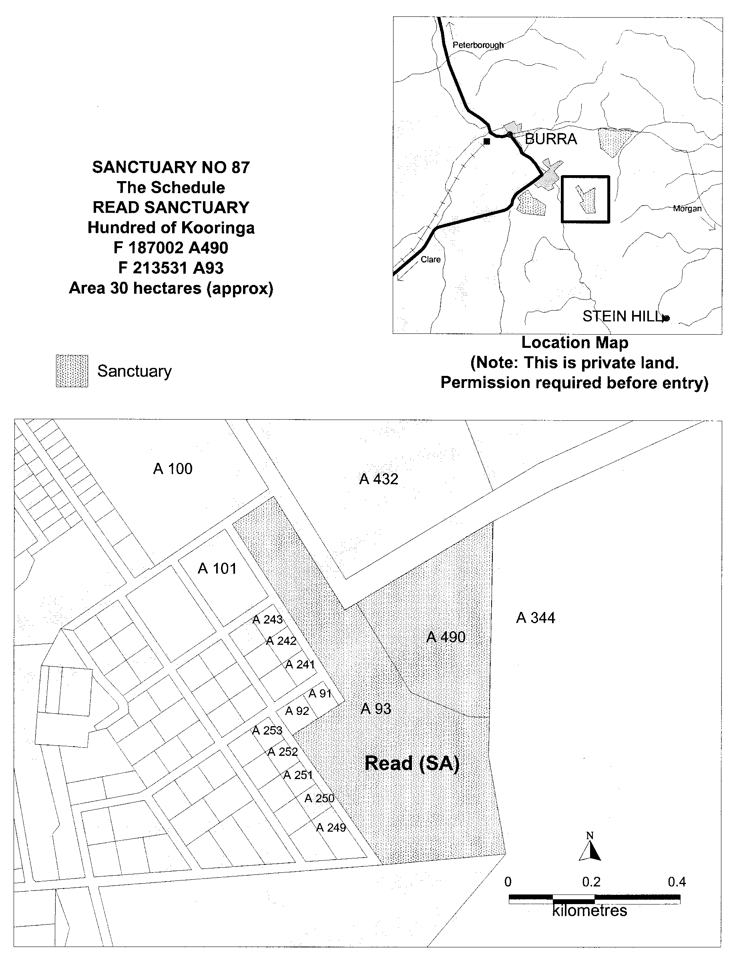

Iain Evans, Minister for Environment and Heritage

PASSENGER TRANSPORT ACT 1994
Appointments
PURSUANT to section 57 of the Passenger Transport Act 1994, the following persons have been authorised by the Passenger Transport Board to act as Prescribed Officers:
Kevin Judge Brett
David George Carr-Moody
Eric John Clifford Taylor
Teunis Holland
Terence William Lee
David Lee Rosenberg
Jeffrey John Schwarz
Peter Arthur Willson
H. Webster, Executive Director, Passenger Transport Board.

THE RENMARK IRRIGATION TRUST
Water Rate Assessment
THE Renmark Irrigation Trust has caused to be made an Assessment of the rateable land within the District by adopting the previous Assessment with, and subject to, certain alterations and additions.
Copies of the Assessment are deposited at the office of the Trust and are open for inspection at all reasonable times.
Any person intending to appeal against the Assessment may do so in the manner required by the Renmark Irrigation Trust Act 1936-2000 within 21 days from the publication of this notice.
Dated 24 July 2001.
W. D. Morris, Chief Executive Officer/Secretary

ROADS (OPENING AND CLOSING) ACT 1991:
SECTION 24
NOTICE OF CONFIRMATION OF ROAD
PROCESS ORDER
The Cove Road, Hallett Cove
Deposited Plan 57002
BY Road Process Order made on 15 March 2001, The Corpora-tion of the City of Marion ordered that:
1. An irregular shaped portion of the public road (The Cove Road) located opposite Drugal Court and adjoining the western boundaries of piece 3 in Filed Plan 101647 and part section 563 in the Hundred of Noarlunga, more particularly delineated and lettered ‘A’ in Preliminary Plan No. PP32/0599 be closed.
2. The whole of the land subject to closure be transferred to TRANSADELAIDE in accordance with agreement for transfer dated 14 March 2001 entered into between The Corporation of the City of Marion and TransAdelaide.
On 9 April 2001, that order was confirmed by the Minister for Administrative and Information Services, conditionally on approval and deposit of the survey plan by the Registrar-General. The condition has now been fulfilled.
Pursuant to section 24 (5) of the Roads (Opening and Closing) Act 1991, NOTICE of the order referred to above and its confirmation is hereby given.
Dated 2 August 2001.
P. M. Kentish, Surveyor-General

ROADS (OPENING AND CLOSING) ACT 1991:
SECTION 24
NOTICE OF CONFIRMATION OF ROAD
PROCESS ORDER
Public Road, Arno Bay
Deposited Plan 53746
BY Road Process Order made on 8 December 2000, The District Council of Cleve ordered that:
1. Portion of allotment 1 in Filed Plan 14818, adjoining the western boundary of the Strata Plan 5295, more particularly delineated and numbered ‘10’ in Preliminary Plan No. PP32/0475 be opened as road.
2. Portion of the unnamed public roads adjoining allotment 5 (Caravan Park) in Deposited Plan 35379 and the north-western boundary of allotment 1 in Filed Plan 14818, more particularly delineated and lettered, ‘B’ and ‘C’ (respectively) in Preliminary Plan No. PP32/0475 be closed.
3. The whole of the land subject to closure lettered ‘B’ be transferred to STAVAIGER PTY LTD in accordance with agreement for transfer dated 6 August 1999, entered into between The District Council of Cleve and Stavaiger Pty Ltd.
4. Vest the whole of the land subject to closure lettered ‘C’ in the Crown.
5. The following easement be granted over the land subject to that closure:
Grant to the Distribution Lessor Corporation an easement for underground electricity supply purposes over portion of the land.
On 5 February 2001, that order was confirmed by the Minister for Administrative and Information Services conditionally on approval and deposit of the survey plan by the Registrar-General. The condition has now been fulfilled.
Pursuant to section 24 (5) of the Roads (Opening and Closing) Act 1991, NOTICE of the order referred to above and its confirmation is hereby given.
Dated 2 August 2001.
P. M. Kentish, Surveyor-General

ROADS (OPENING AND CLOSING) ACT 1991
Road closure—Gilmore Lane, Eight Mile Creek
NOTICE is hereby given, pursuant to section 10 of the Roads (Opening and Closing) Act 1991, that the DISTRICT COUNCIL OF GRANT proposes to make a Road Process Order to close the whole of the public roads (Gilmore Lane and unnamed Road) adjoining sections 663, 181 and 707 in the Hundred of Caroline more particularly delineated and lettered ‘A’, ‘B’ and ‘C’ (respectively) on Preliminary Plan No. PP32/0635.
The whole of the closed road lettered ‘C’ to vest in the Crown.
The balance of the closed roads to vest in the Crown and add to sections 663 and 181 held by NORMAN JOHN CRAWFORD GILMORE and LORNA FAYE GILMORE under Crown Leases Volume 1249 Folio 41 and Volume 825 Folio 50 (respectively).
A copy of the plan and a statement of persons affected are available for public inspection at the offices of the Council, 324 Commercial Street West, Mount Gambier, S.A. 5290 and the Adelaide office of the Surveyor-General during normal office hours.
Any application for easement or objection must set out the full name, address and details of the submission and must be fully supported by reasons.
The application for easement or objection must be made in writing to the Council, P.O. Box 724, Mount Gambier, S.A. 5290 WITHIN 28 DAYS OF THIS NOTICE and a copy must be forwarded to the Surveyor-General, G.P.O. Box 1354, Adelaide, S.A. 5001. Where a submission is made, the Council will give notification of a meeting at which the matter will be considered.
Dated 2 August 2001.
P. M. Kentish, Surveyor-General

ROADS (OPENING AND CLOSING) ACT 1991
Milham Street, Oaklands Park
NOTICE is hereby given, pursuant to section 10 of the Roads (Opening and Closing) Act 1991, that THE CORPORATION OF THE CITY OF MARION proposes to make a Road Process Order:
(i) to open as road portion of allotments 81 and 319 in Deposited Plan 52571 more particularly delineated and numbered ‘1’ and ‘2’ (respectively) in Preliminary Plan No. PP32/0673, forming a widening of Milham Street;
(ii) to close and retain portion of the public road (Milham Street) adjoining Diagonal Road and allotment 571 in Deposited Plan 56981 more particularly delineated and lettered ‘A’ in Preliminary Plan No. PP32/0673 subject to an easement to ETSA Utilities.

A copy of the plan and a statement of persons affected are available for public inspection at the offices of the Council, 245 Sturt Road, Sturt, S.A. 5046 and the Adelaide office of the Surveyor-General during normal office hours.
Any application for easement or objection must set out the full name, address and details of the submission and must be fully supported by reasons.
The application for easement or objection must be made in writing to the Council, P.O. Box 21, Oaklands Park, S.A. 5168 WITHIN 28 DAYS OF THIS NOTICE and a copy must be forwarded to the Surveyor-General, G.P.O. Box 1354, Adelaide, S.A. 5001. Where a submission is made, the Council will give notification of a meeting at which the matter will be considered.
Dated 2 August 2001.
P. M. Kentish, Surveyor-General

ROADS (OPENING AND CLOSING) ACT 1991:
Section 37
NOTICE is hereby given pursuant to section 37 (1) of the Roads (Opening and Closing) Act 1991 that:
WHEREAS it is considered that the South Australian Company of Adelaide was entitled to a Certificate of Title over the closed road ‘B’ in exchange for portion of section 5048, Hundred of Onkaparinga, opened as road and marked ‘1’ in Road Plan No. 2991, deposited in the Office of the Surveyor-General at Adelaide vide notice of confirmation of road order published in the Government Gazette of 26 June 1879 at page 1804:
AND whereas no Certificate of Title was issued in respect of the said closed road and the said South Australian Company is believed to be defunct:
AND whereas application is made by ROGER BRENTON PFEIFFER and ROBYN ELAINE PFEIFFER, P.O. Box 196, Woodside, S.A. 5244 for the issue of a Certificate of Title over the said closed road by virtue of possession:
AND whereas I am satisfied that the applicants are in possession of the said closed road and that there is apparently no other known person entitled to possession thereof:
TAKE NOTICE that unless objection by any person claiming any interest in the said land is made in writing to me within one month from the date of this notice, I propose to issue a Certificate of Title for the said land to the said applicant.
Objections should be addressed to the Surveyor-General, Department for Administrative and Information Services, G.P.O. Box 1354, Adelaide, S.A. 5001.
Dated 2 August 2001.
P. M. Kentish, Surveyor-General
DAIS 32/0674

NOTICE TO MARINERS
No. 37 of 2001
South Australia—Southern Ocean—Restricted Firing
Practice Area
THE Department of Defence have issued a NOTAM warning for the El-Alamein range.
The activity involves field firing practice in restricted area R252 for the following levels and times:
Level: SFC—FL 200 (20 000 feet).
Commencement: 0700 hours local time on 28 July 2001.
Completion: 1500 hours local time on 29 July 2001.
Mariners are advised to exercise caution when navigating in the above areas.
Dated 23 July 2001.
Diana Laidlaw, Minister for Transport and Urban Planning
TSA 2001/00309

FAXING COPY?

IF you fax copy to Government Publishing SA for inclusion in the Government Gazette, there is no need to send a Confirmation Copy to us as well.

This creates confusion and may well result in your notice being printed twice.

Please use the following fax number:

Fax transmission: (08) 8207 1040
Phone Inquiries: (08) 8207 1045

Please include a contact person, phone number and order number so that we can phone back with any queries we may have regarding the fax copy.

NOTE: Closing time for lodging new copy (either fax or hard copy) is 4 p.m. on Tuesday preceding the day of publication.

Government Gazette notices can be E-mailed.

The address is:

governmentgazette@saugov.sa.gov.au

Documents should be sent as attachments in Word format.

When sending a document via E-mail, please confirm your transmission with a faxed copy of your document, including the date the notice is to be published.

Fax transmission: (08) 8207 1040
Enquiries: (08) 8207 1045

CITY OF ADELAIDE
Declaration as Public Road
NOTICE is hereby given pursuant to section 210 of the Local Government Act 1999, that at its meeting of 9 July 2001, council declared the following roads to be public roads:
(1) Gawler Place in town acres 81, 82, 105 and 106, which is delineated as Gawler Place on L.T.O. plan FPX18302.
(2) Twin Street in town acres 85 and 102, which is delineated as Twin Street on L.T.O. plan C-1573.
Susan Law, Chief Executive Officer

CITY OF MARION
Periodical Review of Elector Representation
NOTICE is hereby given that pursuant to the provisions of section 12 (5) of the Local Government Act 1999, the City of Marion is to carry out a review to determine whether a change of arrangements in respect to elector representation, including ward boundaries and the composition of council, will result in the electors of the area being more adequately and fairly represented.
Information regarding the nature of the periodic review is available at the council office, or by contacting Ross Lamb on telephone 8375 6614.
Interested persons are invited to make a written submission to the Chief Executive Officer, P.O. Box 21, Oaklands Park, S.A. 5046, by close of business on Friday, 14 September 2001.
Any person who makes a written submission will be afforded an opportunity to appear before council, or a committee thereof, to be heard in respect to his/her submission.
M. Searle, Chief Executive Officer

CITY OF NORWOOD, PAYNEHAM AND ST PETERS
Result of Supplementary Election for Trinity Ward Conducted on 16 July 2001
Quota: 675
Candidates | First Preference Votes |  | After Distribution  of Preferences
Moore, Evonne | 191
Hatley, Frederika | 49
Owen, Margaret | 41
Izzo, Joe | 131
Short, Lewis | 23
Manser, Lance | 881 |  | (Elected)
Andrews, Darren | 32
Informal | 8
Total | 1 356
S. H. Tully, Returning Officer

CITY OF PLAYFORD
Exclusion of Land from Classification as Community Land
NOTICE is hereby given that the Council of the City of Playford at its meeting held on 27 April 2001, resolved pursuant to the provisions of section 193 (4) of the Local Government Act 1999, that Lot 11, Bishopstone Road, Davoren Park being the land comprised in certificate of title register book volume 5455, folio 256, be excluded from the classification of Community Land.
T. Jackson, Chief Executive Officer

CITY OF TEA TREE GULLY
Exclusion of Land from Classification as Community Land
NOTICE is hereby given that council, at its meeting held on 9 May 2001, resolved pursuant to the provisions of section 34 (3) of the Local Government (Implementation) Act 1999 (the Act), that Lot 102, Montague Road, Modbury, being the land comprised in certificate of title register book volume 5677, folio 731, not be taken to be classified as community land.
Pursuant to section 34 (4) of the Act, the council hereby gives notice that Lot 102, Montague Road, Modbury, being the land comprised in certificate of title register book volume 5677, folio 731, will not be taken to be classified as community land.
G. J. Perkin, Chief Executive Officer

CITY OF TEA TREE GULLY
Development Act 1993
City of Tea Tree Gully Development Plan—City Wide (Miscellaneous) PAR—Draft for Public Consultation
NOTICE is hereby given that the City of Tea Tree Gully has prepared a Plan Amendment Report (PAR) to amend the Tea Tree Gully Development Plan as it affects a number of zones in the City of Tea Tree Gully.
The Plan Amendment Report will amend the Development Plan by addressing anomalies and obsolete zonings and policies in the current Development Plan.
The Plan Amendment Report will be available for public inspection during normal office hours from Tea Tree Gully Civic Centre, 571 Montague Road, Modbury, S.A. 5092 and The Tea Tree Gully Library, 98 Smart Road, Modbury, S.A. 5092
Written submissions regarding the draft amendment will be accepted by the City of Tea Tree Gully until Monday, 8 October 2001. Submissions should be addressed to The Chief Executive Officer, City of Tea Tree Gully, P.O. Box 571, Modbury, S.A. 5092.
Your submission should clearly indicate whether you wish to speak at the public hearing. A public hearing will be held at 7 p.m. at the Civic Centre, 571 Montague Road, Modbury on 13 November 2001 provided that at least one submission indicates an interest in being heard by Council.
Copies of all submissions will be available for inspection by interested persons during business hours from 9 October 2001 until the date of the public hearing at the Tea Tree Gully Civic Centre, 571 Montague Road, Modbury, S.A. 5092 and The Tea Tree Gully Library, 98 Smart Road, Modbury, S.A. 5092.
Dated 2 August 2001.
G. J. Perkin, Chief Executive Officer

ADELAIDE HILLS COUNCIL
Roads (Opening and Closing) Act 1991
NOTICE is hereby given pursuant to section 10 of the Roads (Opening and Closing) Act 1991, that the Adelaide Hills Council proposes to make a Road Process Order to close, sell and transfer to P. A. and A. L. Makin portion of the public road, Acorn Court adjoining allotment 3 in Deposited Plan 1107 shown delineated as ‘A’ on Preliminary Plan No. PP32/0671.
A copy of the plan and a statement of persons affected are available for public inspection at the office of the council, Main Street, Woodside and the Adelaide office of the Surveyor-General during normal office hours.
Any application for easement or objection must be made in writing within 28 days from the date of this notice to the council, P.O. Box 44, Woodside, S.A. 5244 and the Surveyor-General, G.P.O. Box 1354, Adelaide, S.A. 5001 setting out full details. Where a submission is made, the council will give notification of a meeting to deal with the matter.
Dated 8 August 2001.
R. D. Blight, Chief Executive Officer

CLARE AND GILBERT VALLEYS COUNCIL
Adoption of Valuation and Declaration of Rates
NOTICE is hereby given that the Clare and Gilbert Valleys Council, at its meeting held on 23 July 2001, resolved for the financial year ending 30 June 2002 as follows:
Adoption of Valuation
1. The most recent valuation of the Valuer-General available to the council, of the capital value of land within the council’s area, are adopted, totalling $897 502 260.
Declaration of Differential General Rates
2. In exercise of the powers contained in Chapter 10 of the Local Government Act 1999, the following general rates were declared by the council to apply to all rateable land within its area:
(1) land situated within a township, 0.464 cents in the dollar on the capital value of rateable land;
(2) land situated outside of township, 0.315 cents in the dollar on the capital value of rateable land; and
(3) pursuant to section 158 (1) (a) of the Act, a minimum amount payable by way of rates of $320 in respect of all rateable land in the council area.
Payment of Rates
3. Pursuant to section 181 (14) of the Local Government Act 1999, the payment of rates will be made by four approximately equal instalments, with the first of which shall be due on 3 September 2001, second on 3 December 2001, third on 1 March 2002 and the fourth on 3 June 2002.
Discount on Rates
4. Pursuant to section 181 (11) of the Local Government Act 1999, council grants a discount of 2.25% to encourage the full payment of rates by one instalment which shall be due on 3 September 2001.
Effluent Scheme Charge
5. Pursuant to the powers vested in it under section 155 of the Local Government Act 1999, council adopted the following annual service charges:
(a) For all properties included in the area serviced by the Clare Septic Tank Effluent Drainage Scheme, an annual service charge of $31.40 per STEDS unit.
(b) For all properties included in the area serviced by the Saddleworth Septic Tank Effluent Drainage Scheme, an annual service charge of $14.65 per STEDS unit.
(c) For all properties included in the area serviced by the Riverton Septic Tank Effluent Drainage Scheme, an annual service charge of $61.50 per STEDS unit.
M. J. Anderson, Chief Executive Officer

CLARE AND GILBERT VALLEYS COUNCIL
Exclusion of Land from Classification as Community Land
NOTICE is hereby given that the Clare and Gilbert Valleys Council at its meeting held on 16 July 2001, resolved, pursuant to section 193 of the Local Government Act 1999, to exclude the vacant land situated at Hannaford Avenue, Riverton, Lot 205, Deposited Plan 44863, Hundred of Gilbert, being the land comprised in certificate of title 5346/740 from the classification as Community Land.
M. J. Anderson, Chief Executive Officer

CLARE AND GILBERT VALLEYS COUNCIL
Exclusion of Land from Classification as Community Land
NOTICE is hereby given that the Clare and Gilbert Valleys Council at its meeting held on 23 July 2001, resolved, pursuant to section 193 of the Local Government Act 1999, to exclude the land situated at Lot 102, Port Road, Auburn, more particularly delineated on the plan published herewith and being portion of the land comprised in Certificates of Title 259/174 and 5159/687, from the classification as Community Land.
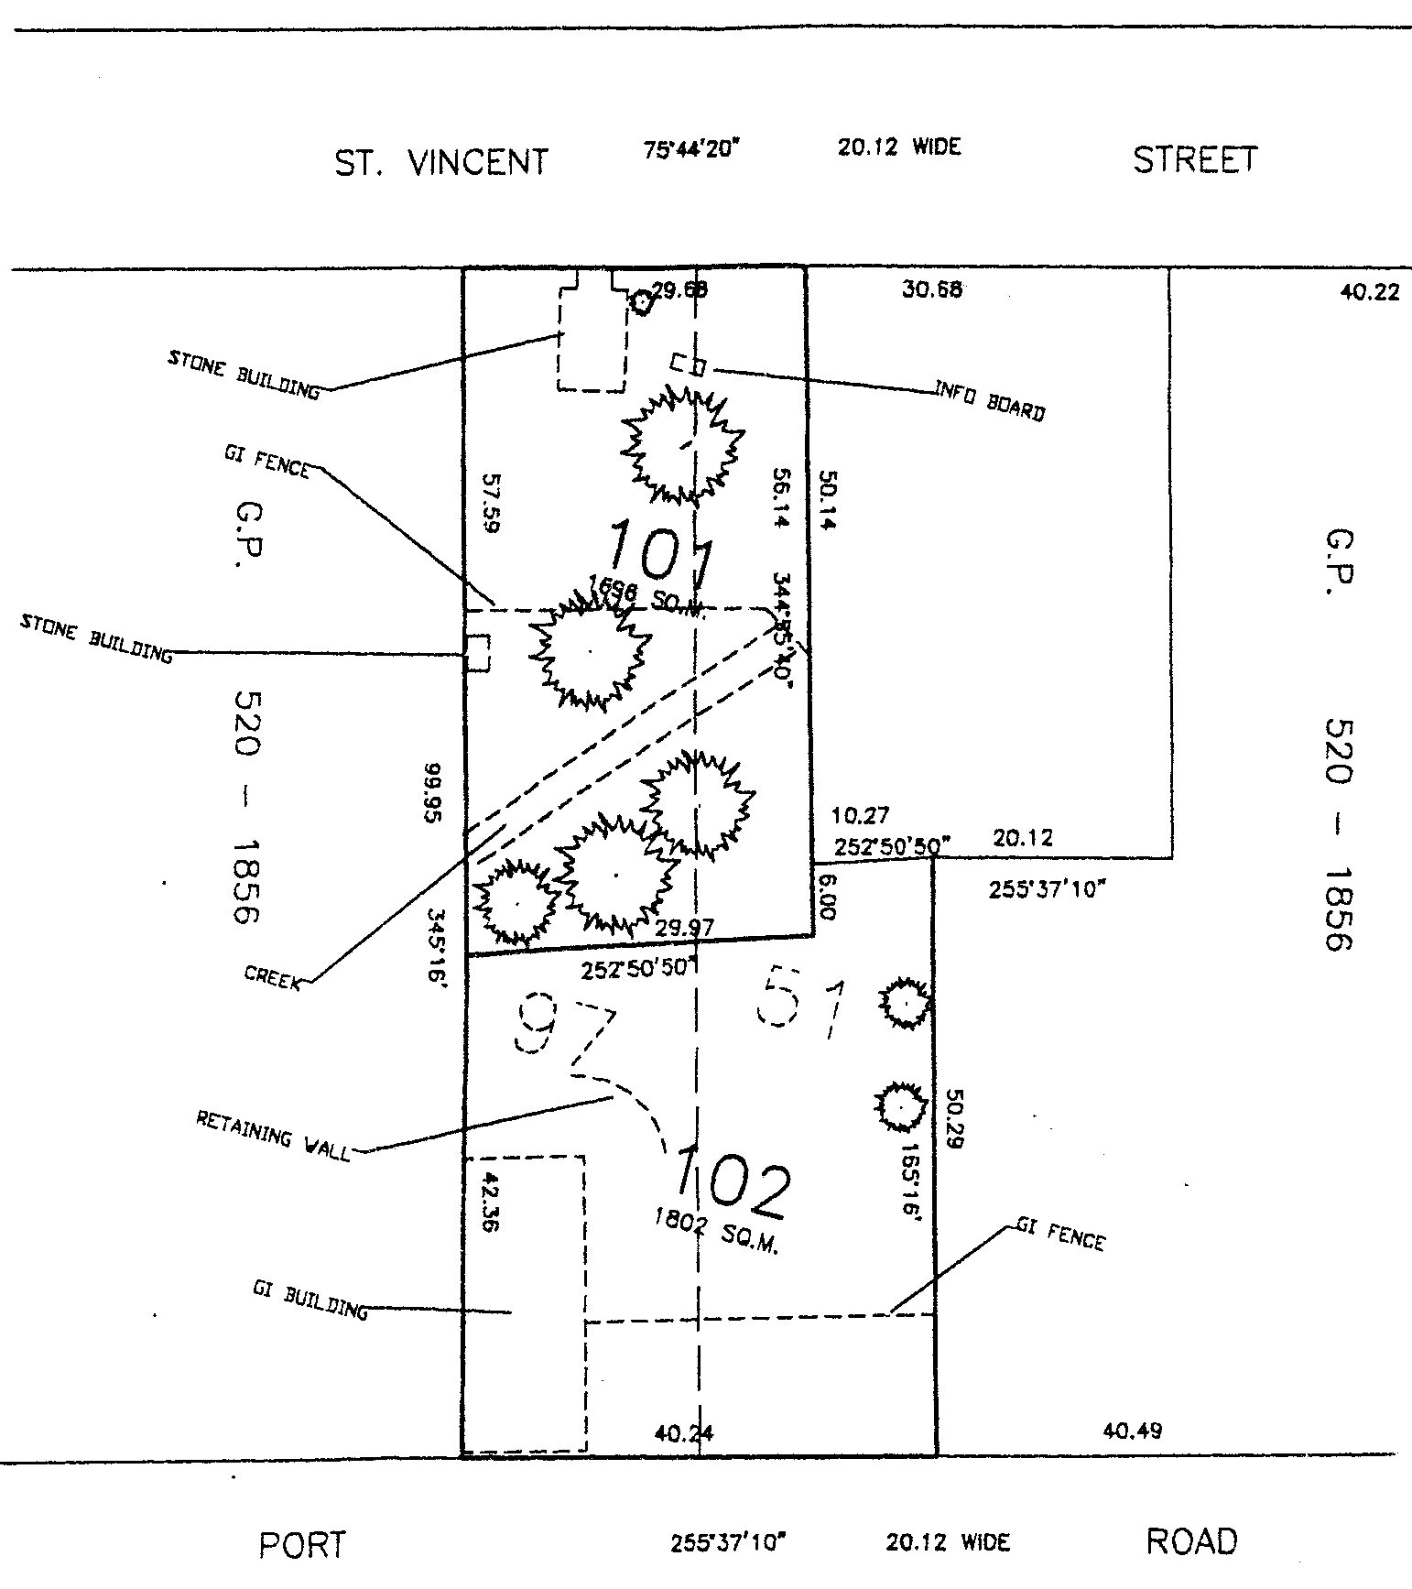
M. J. Anderson, Chief Executive Officer

DISTRICT COUNCIL OF FRANKLIN HARBOUR
Adoption of Valuation
NOTICE is hereby given that the District Council of Franklin Harbour at a meeting held on 11 July 2001, by virtue of the powers contained in section 167 (2) (a) of the Local Government Act 1999, resolved to adopt, for rating purposes for the financial year ending 30 June 2002, the Valuer-General’s valuation of site values applicable to land within the council area, totalling $37 243 180 and that 11 July 2001 is specified as the date on which such values are adopted.
Declaration of Rates
Notice is hereby given that in exercise of the powers contained in sections 153, 156 (1) (b) and 158 of the Local Government Act 1999, the District Council of Franklin Harbour at a meeting held on 30 July 2001, resolved to declare the following rates for the financial year ending 30 June 2002:
1. Differential general rates:
(a) within the township of Cowell, 2.75 cents in the dollar;
(b) within the Lucky Bay Shack area, being sections 38 to 44, Hundred of Wilton—1.82 cents in the dollar;
(c) within the Port Gibbon Shack area, being part block 1 and sections 566 to 571, Hundred of Hawker—2.40 cents in the dollar;
(d) within the remainder of the district—1.44 cents in the dollar.
2. A minimum amount payable by way of rates on any one assessment throughout the whole of the district of $215.
Separate Rate—Water Catchment Levy
Notice is hereby given that in exercise of the powers contained in section 138 of the Water Resources Act 1997 and section 154 of the Local Government Act 1999, the District Council of Franklin Harbour at a meeting held on 30 July 2001, declared a separate rate being a fixed water levy of $20.85 upon all rateable property in the council area. The fixed water levy was declared in order to reimburse the council the amount of $18 115 which council is required to contribute towards the cost of operating the Eyre Peninsula Catchment Water Management Board for the 2001-2002 financial year.
Payment of Rates
Pursuant to section 181 (1) (a) of the Local Government Act 1999, the council declared that rates for the year ending 30 June 2002, will fall due in four equal or approximately equal instalments payable on 15 September 2001, 15 December 2001, 15 March 2002 and 15 June 2002.
B. A. Francis, District Clerk

KANGAROO ISLAND COUNCIL
Adoption of Valuation and Declaration of Rates
NOTICE is hereby given that at its meeting held on 25 July 2001, the Kangaroo Island Council, for the financial year ending 30 June 2002:
Adoption of Valuation
1. Adopted the most recent capital value of the Valuer-General available to the council totalling $440 310 160.
Fixed Charge
2. Imposed a fixed charge of $140 in respect of each sep-arate piece of rateable land in its area.
Differential General Rates
3. Declared differential general rates in accordance with the use of the land, as follows:
(1) Residential—0.2902 cents in the dollar;
(2) Commercial—Shop, Commercial—Office, Com-mercial—Other, Industry—Light, Industry—Other, Primary Production and Other—0.5046 cents in the dollar; and
(3) Vacant Land—0.9653 cents in the dollar.
Service Charges
4. Imposed annual service charges where a septic tank effluent drainage service is available as follows:
(1) within the Townships of Kingscote and Brownlow—$150 on each occupied allotment and $130 on each vacant allotment;
(2) within the Township of Parndana:
Scheme 2 (as defined)—$240 on each occupied and each vacant allotment;
Scheme 3 (as defined)—$196.35 on each occupied and each vacant allotment;
Scheme 4 (as defined)—$125 on each occupied and each vacant allotment.
B. C. Hurst, Chief Executive Officer

DISTRICT COUNCIL OF LOWER EYRE PENINSULA
Casual Vacancy
NOTICE is hereby given in accordance with section 54 (6) of the Local Government Act 1999 that a vacancy has occurred within the council, due to the death of councillor, John Raymond Rogers.
In accordance with section 6 (2) (b) of the Local Government Act 1999, council has adopted a Supplementary Election Policy which does not require one casual vacancy to be filled until the next general election in May 2003.
P. Aird, District Clerk

DISTRICT COUNCIL OF LOXTON WAIKERIE
By-Law No. 7—Moveable Signs
TO set standards for moveable signs on streets and roads and to provide conditions for and the placement of such signs to protect public safety.
Definitions
1. In this by-law:
(1) ‘business’ means the business to which a moveable sign relates;
(2) ‘footpath’ means the part of a road between the property boundary of the road and the edge of the carriageway on the same side as the boundary;
(3) ‘moveable sign’ has the same meaning attributed to that term in section 4 of the Local Government Act 1999;
(4) ‘pole’ includes any pole, post, bollard, garden planter or bench whether resting on or fixed in place on a road or footpath;
(5) ‘premises’ means the premises from which a business is conducted;
(6) ‘reserve’ means any reserve, lawn or garden area forming part of a road or footpath;
(7) ‘road’ means public streets and public roads.
Construction
2. A moveable sign displayed on a public street or road:
(1) shall be of a kind known as an ‘A’ frame or sandwich board sign, an inverted ‘T’ sign or a flat sign;
(2) shall be constructed of timber and/or metal and/or plastic;
(3) shall not exceed 1 000 mm in height with a maximum of 750 mm² in advertisement area per face;
(4) shall be stable when in position;
(5) in the case of an ‘A’ frame or sandwich board sign:
(a) shall be hinged or joined at the top;
(b) shall be of such construction that its sides shall be securely fixed or locked in position when erected, and
(6) in the case of an inverted ‘T’ sign, shall contain no struts or members that run between the display area and the base of the sign.
Position
3. A moveable sign shall not be positioned on a public street or road:
(1) on a footpath area that is less width than 2.5 m;
(2) on a footpath area at a closer distance to any other structure, fixed object, tree, bush or land than 1.9 m; or
(3) (a) within one metre of an entrance to premises adjacent to premises adjacent thereto; or
(b) within 6 m of an intersection or junction,
(4) closer to the edge of the carriageway than 500 mm.
Restrictions
4. (1) A moveable sign shall not be placed on a public street or road:
(a) unless it displays material which advertises a business being conducted on premises adjacent to the sign, or the products available from that business, but no brand names of products shall be displayed unless the name of the business is also displayed on the sign;
(b) if another moveable sign which relates to the same business is already displayed on the street or road;
(c) unless the business to which it relates is open,
(2) in a wind unless in a position such that it cannot be blown over;
(3) in such a position or in such circumstances that the safety of any user of the street or road is a risk;
(4) during the hours of darkness unless it is clearly lit;
(5) unless planning authorisation has been obtained pursuant to the Development Act 1994 (if required by that Act);
(6) if it is in anyway fixed or attached to any structure, tree or pole.
Exemptions
5. (1) Paragraph 1 (b) does not apply to a moveable sign where the premises is on a corner, where one per road frontage may be allowed.
(2) Paragraph 3 or subparagraph 4 (1) do not apply to a moveable sign which is used:
(a) as a directional sign to an event run by an incorporated Association or a charitable body; or
(b) with permission, and which is not placed on the carriageway.
(3) Subparagraph 4 (2) does not apply to a flat sign, the message of which only contains newspaper headlines and the name of a newspaper.
(4) A person may place and maintain a moveable sign on a road without authorisation if:
(a) the sign is placed there pursuant to an authorisation under another Act; or
(b) the sign is designed to direct people to the open inspection of any land or building that is available for purchase or lease; or
(c) the sign is related to a State or Commonwealth Election and complies with the Guidelines for Control of State and Federal Election Signs.
The foregoing by-law was duly made and passed at a meeting of the District Council of Loxton Waikerie held on 27 July 2001 by an absolute majority of members for the time being constituting the Council, there being at least two thirds of the members present.
T. L. Burgemeister, District Manager

[Republished]
DISTRICT COUNCIL OF MOUNT BARKER
Conveyance of Land to Council as a Reserve
NOTICE is hereby given that at a meeting held on 16 July 2001, the council ratified a decision of the previous council to assume care, control and maintenance of allotment 150 in deposited plan 10055 in certificate of title volume 5534, folio 58 and known as 26 Hurling Drive, Mount Barker.
This parcel of land has been declared surplus to Transport SA (TSA) requirements and is to be transferred to council, as reserve, for no monetary consideration.
R. Rattray, Acting Chief Executive Officer
[*]

DISTRICT COUNCIL OF MOUNT REMARKABLE
Adoption of Valuation and Declaration of Rates
NOTICE is hereby given that at a meeting of the District Council of Mount Remarkable held on 10 July 2001, the council resolved that in exercise of the powers contained in Chapter 10 of the Local Government Act 1999 (the ‘Act’) in respect of the financial year ending 30 June 2002:
Adoption of Valuation
1. The Valuer-General’s most recent valuation of rateable land available to the council, being the site valuation of land totalling $134 742 009 be adopted, and specified that 10 July 2001 be the day as and from which such valuation shall apply.
Attributions of Land Uses
2. (1) The numbers indicated against the various categories of land use prescribed by Regulation 10 of the Local Government (General) Regulations 1999, (the ‘Regulations’) be used to designate land uses in the Assessment Records;
(2) The use indicated by those numbers in respect of each separate assessment of land designated in the Assessment Records on this date (as laid before the council) be attributed to each such assessment respectively; and
(3) Reference in this resolution to land being of a certain category use means the use indicated by that category number in the Regulations.
Declaration of Rates
3. In order to raise the amount of $1 038 571:
(1) Differential rates pursuant to section 156 (1) (c) of the Act be declared as follows:
(c) 11.75 cents in the dollar in respect of all other rateable land of Categories 4, 5, 6 and 9 uses;
(d) in respect of all other rateable land of Categories 1, 2, 3, 7 and 8 uses as follows:
(i) 1.192 cents in the dollar on rateable land of Category 1 use;
(ii) 13.46 cents in the dollar on rateable land of Categories 2 and 3 uses;
(iii) 0.421 cents in the dollar on rateable land of Categories 7 and 8 uses;
(a) 13.19 cents in the dollar on all rateable land within the township of Appila;
(b) in respect of land use Categories 1, 2, 3, 7, and 8 within the following townships:
(i) 6 cents in the dollar on rateable land in the townships of Hammond, Moockra and Willowie;
(ii) 7.3 cents in the dollar on rateable land in the township of Murray Town;
(iii) 4.73 cents in the dollar on rateable land in the township of Port Germein;
(iv) 2.7 cents in the dollar on rateable land in the township of Port Flinders;
(v) 5.76 cents in the dollar on rateable land in the township of Melrose;
(vi) 5.28 cents in the dollar on rateable land in the township of Wilmington;
(vii) 7.1 cents in the dollar on rateable land in the township of Wirrabara;
(viii) 10.26 cents in the dollar on rateable land in the township of Booleroo Centre;
(2) A fixed charge component of the general rate of $95 be imposed upon each assessment in accordance with section 152 (1) (c) of the Act.
Payment
4. Pursuant to section 181 (2) (a) of the Act all rates will be payable in four approximately equal instalments which will fall due on:
3rd September 2001;
3rd December 2001;
4th March 2002;
3rd June 2002.
STED Service Charge
5. Pursuant to section 155 of the Act, a Differential Service Charge for the collection, treatment and disposal of waste will be imposed on each assessment of land within the townships of Wilmington and Melrose to which council makes available a Septic Tank Effluent Disposal Service. The Service Charge shall be:
Wilmington—$171 per unit on each assessment of occupied land and $166 per unit on each allotment of vacant land.
Melrose—$190 per unit on each assessment of occupied land and $180 per unit on each allotment of vacant land.
(‘Unit’ being as set out in the document entitled ‘Deter-mination of Service Charges—Septic Tank Effluent Disposal Schemes’ issued by the STEDS Advisory Committee and dated 1 September 1992.)
This service charge applies to non-rateable land to which this service is made available.
Early Payment Discount
6. Pursuant to section 181 (11) of the Act, council offers a 5 per cent discount on the balance of general rates payable to those ratepayers who pay the full year’s rates on or before
3 September 2001.
P. J. Moore, District Clerk

NORTHERN AREAS COUNCIL
Adoption of Valuation
NOTICE is hereby given that the Northern Areas Council at its meeting held on 17 July 2001 resolved in accordance with section 167 of the Local Government Act 1999, to adopt the capital value made by the Valuer-General for the financial year ending 30 June 2002, being $524 650 200 comprising $513 406 900 for rateable land and $11 243 300 for non-rateable land and hereby specifies 17 July 2001 as the day from which such valuation shall become the assessment of council.
Declaration of Rates
Notice is hereby given that the Northern Areas Council at its meeting held on 17 July 2001, in accordance with Chapter 10 of the Local Government Act 1999, declared for the financial year ending 30 June 2002 the following rates:
(1) A differential general rate of 0.5170 cents in the dollar on rateable land within the township of Jamestown and the following adjacent land comprising sections 417, 418, 426 to 431, 464 to 468, 473 to 475, 497 to 501, 503 to 506, 517 to 521, 621, 657 and part sections 491 to 496, Hundred of Belalie and within the townships of Gladstone and Laura, excluding urban farmland properties comprising assessments 7620488002, 7620506004, 7620554006, 7622237004, 7622236001, 762227100*, 7622272002, 7622268003, 7622267000, 7622269006, 7622270007, 7622504002, 762250300*, 7622502007, 762249000*; and within the townships of Georgetown, Gulnare, Yacka, Spalding and Caltowie.
(2) A differential general rate of 0.2770 cents in the dollar on the remainder of rateable land within the council area.
(3) A fixed charge of $105 be imposed on separate rateable land in accordance with section 152 (1) (c) of the Local Government Act 1999.
Service Charges
Notice is hereby given that the Northern Areas Council at its meeting held on 17 July 2001, in accordance with section 155 of the Local Government Act 1999, for the financial year ending 30 June 2002, declared:
(1) A service charge of $146 per unit (‘unit’ being as set out in the document entitled ‘Determination of Service Charges—Septic Tank Disposal Schemes’ issued by the S.T.E.D.S. Advisory Committee and dated 1 September 1992), be imposed on each assessment of occupied land, and a service charge of $142 be imposed on each assessment of vacant land, in the township of Laura to which land the council makes available a septic tank effluent disposal service.
(2) A service charge of $50 per unit (‘unit’ being as set out in the document entitled ‘Determination of Service Charges—Septic Tank Disposal Schemes’ issued by the S.T.E.D.S. Advisory Committee and dated 1 September 1992), be imposed on each assessment of occupied land, and a service charge of $32 be imposed on each assess-ment of vacant land, in the township of Jamestown to which land the council makes available a septic tank effluent disposal service.
(3) A service charge of $147 per unit (‘unit’ being as set out in the document entitled ‘Determination of Service Charges—Septic Tank Disposal Schemes’ issued by the S.T.E.D.S. Advisory Committee and dated 1 September 1992), be imposed on each assessment of occupied land, and a service charge of $32 be imposed on each assess-ment of vacant land, in the Moyletown area to which land the council makes available a septic tank effluent disposal service.
Payment of Rates
1. In accordance with section 181 of the Local Government Act 1999, rates declared for the year ending 30 June 2002 will be payable in four equal or approximately equal instalments, with the instalments falling due on the following dates:
First instalment—17 September 2001;
Second instalment—17 December 2001;
Third instalment—18 March 2002;
Fourth instalment—17 June 2002.
2. In accordance with section 181 (11) of the Local Govern-ment Act 1999, a discount of 3% will be granted for rates paid in full on or before 17 September 2001.
P. A. McInerney, Chief Executive Officer

DISTRICT COUNCIL OF STREAKY BAY
Adoption of Valuation and Declaration of Rates
NOTICE is hereby given that the District Council of Streaky Bay at a meeting held on Wednesday, 18 July 2001, resolved that in exercise of the powers contained in Chapter 10 of the Local Government Act 1999 (‘the Act’) and in respect of the financial year ending 30 June 2002:
Adoption of Budget
The Budget with the above amendments, for that year as laid before the council at this meeting, which consists of:
• the budgeted statement of financial position;
• the budgeted operating statement;
• the budgeted cash flow statement; and
• the budgeted statement as to the basis for the determina-tion of rates,
be adopted, involving:
(1) a total estimated expenditure of $3 890 783;
(2) a total estimated income from sources other than rates of $2 851 121; and
(3) a total amount required to be raised from rates of $1 039 662.
Adoption of Valuation
The most recent valuation of the Valuer-General available to the council of the site value of land within the council’s area be adopted, totalling $67 408 920 for rateable land, and $3 098 120 for non-rateable land.
Attribution of Land Uses
1. The numbers indicated against the various categories of land use prescribed by the Local Government (General) Regulations 1999 (the ‘regulations’), be used to designate land uses in the Assessment Book.
2. The use indicated by those numbers in respect of each separate assessment of land described in the Assessment Book on this date be attributed to each such assessment respectively.
3. Reference in this resolution to land being of a certain category use means the use indicated by that category number in the Regulations.
Declaration of Rates
In order to raise the amount as indicated above that is required to be raised from rates the council declares differen-tial rates on the basis of locality and land use as follows:
(1) (a) in the township of Sceale Bay, 0.79 cents in the dollar of the site value of rateable land;
(b) in the township of Baird Bay, 0.79 cents in the dollar of the site value of rateable land;
(c) in the township of Haslam, 0.79 cents in the dollar of the site value of rateable land;
(d) the in township of Wirrulla, 11.0 cents in the dollar of the site value of rateable land;
(e) in the township of Poochera, 11.0 cents in the dollar of the site value of rateable land;
(f) in the township of Cungena:
(i) 11.0 cents in the dollar of the site value of rateable land of Categories 1-3 and 5-9 use;
(ii) 30.0 cents in the dollar of the site value of rateable land of Category 4 use;
(g) in the township of Streaky Bay:
(i) 1.845 cents in the dollar of the site value of rateable land of Categories 1, 8 and 9 use;
(ii) 2.6 cents in the dollar of the site value of rateable land of Categories 2 to 6 use;
(iii) 0.9047 cents in the dollar of the site value of rateable land of Category 7 use;
(h) in respect of Holiday House and Country Living Zones as identified in council’s Development Plan:
(i) 0.79 cents in the dollar of the site value of rateable land of Category 1 use;
(i) in respect of the Silo Zone as identified in council’s Development Plan:
(i) 30.0 cents in the dollar of the site value of rateable land of Category 4 use;
(j) in respect of all other land for the council area:
(i) 0.79 cents in the dollar of the site value of rateable land of Category 1 use;
(ii) 30.0 cents in the dollar of the site value of rateable land of Category 4 use;
(iii) 0.9047 cents in the dollar of the site value of rateable land of Category 7 use,
including Aquaculture Park Zone, as identified in council’s Development Plan;
(iv) 0.79 cents in the dollar of the site value of rateable land of other category uses.
(2) a fixed charge component of the general rate of $265 be imposed in relation to each assessment of rateable land in the area in accordance with section 152 of the Act.
STEDS Charges
The Septic Tank Effluent Disposal System charges applic-able to land benefiting from the Septic Tank Effluent Disposal Schemes within the township of Streaky Bay are as follows:
(1) Stage 1
(a) Scheme 3—$75 per unit;
(b) Scheme 4—$105 per unit;
(c) Scheme 5—$110 per unit.
(2) Stage 2
$151 per unit.
(3) An additional annual charge of $39 for vacant allot-ments and $59 per unit for occupied allotments apply in respect of all land benefiting from both stages of STEDS.
(4) ‘Unit’ being as set out in the document entitled ‘Determination of Service Charges—Septic Tank Effluent Disposal Schemes’ issued by the STEDS Advisory Committee and dated 1 September 1992.
Payment of Rates
Pursuant to section 181 of the Local Government Act 1999, rates will be payable in four equal or approximately equal instalments and that the due date for those instalments will be
3 September 2001, 3 December 2001, 4 March 2002 and
3 June 2002.
Eyre Peninsula Catchment Water Management Board
Notice is hereby given that pursuant to section 138 of the Water Resources Act 1997 and section 154 of the Local Govern-ment Act 1999, the District Council of Streaky Bay declared a separate rate of $17.82 per separate assessment of rateable land in the council area in order to recoup the amount of $20 296, being council’s contribution to the Eyre Peninsula Catchment Board for the period ending 30 June 2002.
J. Rumbelow, General Manager

IN the matter of the estates of the undermentioned deceased persons:
Arthur, Natalie Catherine Claire, late of 32 Clifton Street, Camden Park, home duties, who died on 8 May 2001.
Ashby, Muriel Enid Mary, late of 40 Winchester Street, Malvern, retired public servant, who died on 27 May 2001.
Brodie, Eric Sydney, late of Everard Street, Largs Bay, retired soldier, who died on 27 May 2001.
Bui, Thi The, late of 2A Orkney Street, Ferryden Park, of no occupation, who died on 20 April 2001.
Castle, Melville Lloyd, late of 36-38 Dunks Street, Parkside, retired tyre inspector, who died on 4 May 2001.
Champion, Frederick John, late of 10 Watson Street, Risdon Park, retired warehouseman, who died on 4 May 2001.
Cooper, Mabel Jean, late of Leighton Avenue, Klemzig, of no occupation, who died on 31 May 2001.
Dinsdale, Doreen Margaret, late of 23 Gores Road, Davoren Park, home duties, who died on 24 May 2001.
Dunkley, Lola Crissie, late of 7 Railway Terrace, Old Reynella, of no occupation, who died on 9 June 2001.
Elliott, Harry Llewellyn, late of 2A McDonnell Avenue, West Hindmarsh, retired labourer, who died on 28 May 2001.
Hanvey, James Karl, late of 28 Katharine Street, Port Noarlunga, retired driver, who died on 19 June 2001.
Harris, Ada Jane, late of 6 Booth Avenue, Linden Park, of no occupation, who died on 5 May 2001.
Henderson, John Richard Desmond, late of Everard Street, Largs Bay, of no occupation, who died on 29 March 2001.
Hewitt, Jean Esther, late of 20 Alpha Road, Prospect, widow, who died on 15 May 2001.
Kinvig, Douglas Allan, late of 35 Hulbert Street, Hove, retired railway employee, who died on 4 April 2001.
Mudie, Alexander Winston, late of 19 Darri Road, Wyongah, New South Wales, retired draftsman, who died on 30 March 2001.
Omsby, Lucia Maria Anne, late of 10 Morton Road, Christie Downs, widow, who died on 13 April 2001.
Rowberry, Eric Thomas Stephen, late of 56 High Street, Grange, retired metal machinist, who died on 30 May 2001.
Siebert, Hans Wilhelm, late of 302 Railway Terrace, Taperoo, retired labourer, who died on 13 June 2001.
Smyth, Norman Thomas, late of 2 Matthews Street, Port Augusta West, retired planning technician, who died on 28 April 2001.
Notice is hereby given pursuant to the Trustee Act 1936, as amended, the Inheritance (Family Provision) Act 1972, and the Family Relationships Act 1975, that all creditors, beneficiaries, and other persons having claims against the said estates are required to send, in writing, to the Public Trustee, 25 Franklin Street, Adelaide, S.A. 5000, full particulars and proof of such claims, on or before 31 August 2001, otherwise they will be excluded from the distribution of the said estate; and notice is also hereby given that all persons who are indebted to the said estates are required to pay the amount of their debts to the Public Trustee or proceedings will be taken for the recovery thereof; and all persons having any property belonging to the said estates are forthwith to deliver the same to the Public Trustee.
Dated 2 August 2001.
J. H. Worrall, Public Trustee

SALE OF PROPERTY
Auction Date: Wednesday, 15 August 2001 at 10 a.m.
Location: Government Auctions SA, 47 Transport Avenue, Netley.
NOTICE is hereby given that on the above date at the time and place stated, by virtue of Orders for Sale issued by the Fines Payment Unit of South Australia, Penalty No. EXREG-00-100035/1 and others, are directed to the Sheriff of South Aus-tralia in an action wherein Daniel Clare Brown is the Defendant, I, Tim Goodes, Sheriff of the State of South Australia, will by my auctioneers, Government Auctions SA make sale of the following:
Honda NSR 250R motor cycle
Registration Number: TIY-865.

SALE OF PROPERTY
Auction Date: Wednesday, 15 August 2001 at 10 a.m.
Location: Government Auctions SA
47 Transport Avenue, Netley
NOTICE is hereby given that on the above date at the time and place stated, by virtue of Orders for Sale issued by the Fines Payment Unit of South Australia, Penalty No. MCPAD-98-3778/1 and others, are directed to the Sheriff of South Australia in an action wherein Wendy Anne Fitzpatrick is the Defendant, I, Tim Goodes, Sheriff of the State of South Australia, will by my auctioneers, Government Auctions SA, make sale of the following:
Holden Commodore VC sedan
Registration Number: SKN-686.

SALE OF PROPERTY
Auction Date: Wednesday, 15 August 2001 at 10 a.m.
Location: Government Auctions SA
47 Transport Avenue, Netley
NOTICE is hereby given that on the above date at the time and place stated, by virtue of Orders for Sale issued by the Fines Payment Unit of South Australia, Penalty No. EXREG-00-76419/1 and others, are directed to the Sheriff of South Australia in an action wherein Graham Dennis Wadewitz is the Defendant, I, Tim Goodes, Sheriff of the State of South Australia, will by my auctioneers, Government Auctions SA, make sale of the following:
Mitsubishi Sigma sedan
Registration Number: ULP-067.

SALE OF PROPERTY
Auction Date: Wednesday, 15 August 2001 at 10 a.m.
Location: Government Auctions SA
47 Transport Avenue, Netley
NOTICE is hereby given that on the above date at the time and place stated, by virtue of Orders for Sale issued by the Fines Payment Unit of South Australia, Penalty No. AMC-95-37661/1 and others, are directed to the Sheriff of South Australia in an action wherein Christopher John McConnell is the Defendant, I, Tim Goodes, Sheriff of the State of South Australia, will by my auctioneers, Government Auctions SA, make sale of the following:
Mazda 808 sedan
Registration Number: SUD-268.

SALE OF PROPERTY
Auction Date: Wednesday, 15 August 2001 at 10 a.m.
Location: Government Auctions SA
47 Transport Avenue, Netley
NOTICE is hereby given that on the above date at the time and place stated, by virtue of Orders for Sale issued by the Fines Payment Unit of South Australia, Penalty No. MCPAD-96-14247/1 and others, are directed to the Sheriff of South Australia in an action wherein Rose Jasmine Peters is the Defendant, I, Tim Goodes, Sheriff of the State of South Australia, will by my auctioneers, Government Auctions SA, make sale of the following:
Ford Falcon XF sedan
Registration Number: UZP-982.

ATTENTION

CUSTOMERS requiring a proof of their notice for inclusion in the Government Gazette, please note that the onus is on you to inform Government Publishing SA of any subsequent corrections by 10 a.m. on Thursday, which is our publication deadline.

For any corrections to your notice please phone 8207 1045 or Fax 8207 1040 before 10 a.m. on Thursday.

If we do not receive any communication by 10 a.m. on Thursday (day of publication) we will presume the notice is correct and will print it as it is.

Remember—the onus is on you to inform us of any corrections necessary to your notice.

NOTE: Closing time for lodging new copy (electronically, fax or hard copy) is 4 p.m. on Tuesday preceding the day of publication. Phone 8207 1045—Fax 8207 1040.
Email: governmentgazette@saugov.sa.gov.au

Printed and published by authority every Thursday by J. D. FERGUSON, Government Printer, South Australia
Price: $4.40, plus postage; to subscribers, $220.20 per annum.
(The above prices are inclusive of GST)

