No. 109 3419

THE SOUTH AUSTRALIAN

GOVERNMENT GAZETTE

PUBLISHED BY AUTHORITY

ALL PUBLIC ACTS appearing in this GAZETTE are to be considered official, and obeyed as such

ADELAIDE, THURSDAY, 30 AUGUST 2001

CONTENTS

Page
Appointments, Resignations, Etc 3421
Corporations and District Councils—Notices 3479
Crown Lands Act 1929—Notices 3421
Development Act 1993—Notice 3422
Dog Fence Act 1946—Notice 3422
Electoral Act 1985—Notice 3422
Fisheries Act 1982—Notices 3422
Housing Improvement Act 1940—Notices 3431
Land and Business (Sale and Conveyancing) Act 1994—
Notice 3430
Liquor Licensing Act 1997—Notices 3433
Local Government Act 1999—Notice 3436
Mining Act 1971—Notices 3437
Partnership Act 1891—Notices 3487
Petroleum Act 2000—Notices 3440, 3441
Petroleum (Submerged Lands) Act 1967—Notices 3441
Private Advertisements 3487
Page
Proclamations 3420
Public Trustee Office—Administration of Estates 3486
Real Property Act 1886—Notice 3440
REGULATIONS
Liquor Licensing Act 1997 (No. 203 of 2001) 3453
Unauthorized Documents Act 1916 (No. 204 of 2001) 3454
Brands Act 1933 (No. 205 of 2001) 3457
Daylight Saving Act 1971 (No. 206 of 2001) 3458
Children’s Services Act 1985 (No. 207 of 2001) 3459
Prices Act 1948 (No. 208 of 2001) 3463
Children’s Services Act 1985 (No. 209 of 2001) 3464
Public Finance and Audit Act 1987 (No. 210 of 2001) 3472
Subordinate Legislation Act 1978 (No. 211 of 2001) 3473
Roads (Opening and Closing) Act 1991—Notice 3442
Road Traffic Act 1961—Notice 3442
Survey Act 1992—Notice 3443
Water Resources Act 1997—Notice 3442

GOVERNMENT GAZETTE NOTICES
ALL poundkeepers’ and private advertisements forwarded for publication in the South Australian Government Gazette must be PAID FOR PRIOR TO INSERTION; and all notices, from whatever source, should be legibly written on one side of the paper only and sent to Government Publishing SA so as to be received no later
than 4 p.m. on the Tuesday preceding the day of publication. Phone 8207 1045 or Fax 8207 1040. E-mail: governmentgazette@saugov.sa.gov.au. Send as attachments in Word format and please confirm your transmission with a faxed copy of your document, including the date the notice is to be published and to whom the notice will be charged.

ANIMAL AND PLANT CONTROL (AGRICULTURAL PROTECTION AND OTHER PURPOSES) ACT 1986 SECTION 51: VARIATION OF DECLARATION OF CLASSES OF PLANTS TO WHICH ACT APPLIES
Proclamation By The Governor
(l.s.) E. J. Neal
PURSUANT to section 51 of the Animal and Plant Control (Agricultural Protection and Other Purposes) Act 1986, on the recommendation of the Animal and Plant Control Commission and with the advice and consent of the Executive Council, I vary the declaration made under that section (see Gazette 3 October 1991, p. 990), as varied—
(a) by inserting in the first column of the entry in the Schedule relating to Class: 1c(i) the following:
Achnatherum caudatum
Broad-kernel espartillo
Nassella hyalina
Cane needlegrass
Nassella tenuissima
Mexican feathergrass;
(b) by striking out from the first column of the entry in the Schedule relating to Class: 2c(i) “Myrsiphyllum spp.” and substituting the following:
Asparagus asparagoides and
Asparagus declinatus;
(c) by striking out from the first column of the entry in the Schedule relating to Class: 2c(ii) “Pentzia suffruticosa” and substituting “Oncosiphon suffruticosum”;
(d) by striking out from the first column of the entry in the Schedule relating to Class: 2f “Homeria spp. Cape tulip” and substituting the following:
Moraea flaccida
One-leaf Cape tulip
Moraea miniata
Two-leaf Cape tulip;
(e) by inserting after the entry in the Schedule relating to Class 2k: False caper the following entry:
 | Class: 2l Stipoid grasses  Jarava plumosa  Plumerillo  Nassella leucotricha  Texas needlegrass  Nassella neesiana  Chilean needlegrass | Sections 52(1), 52(2), 56(1),  56(2) and 57(2) | Whole of the State
(f) by inserting in the first column of the entry in the Schedule relating to Class: 5c Bulbil watsonia “var. bulbillifera” after “Watsonia meriana”;
(g) by striking out the entry in the Schedule relating to Class: 11 Salix and substituting the following entry:
Class: 11 Weeds of national significance
Acacia nilotica subsp. indica
Prickly acacia
Anona glabra
Pond apple
Cabomba caroliniana
Cabomba
Cryptostegia grandiflora
Rubber vine
Hymenachne amplexicaulis
Hymenachne
Lantana camara
Common lantana
Mimosa pigra
Mimosa
Tamarix aphylla
Athel pine
Salix spp.
Willows of all species excluding the following:
Salix babylonica
Salix calodendron
Salix reichardii
Given under my hand and the Public Seal of South Australia, at Adelaide, 30 August 2001.
By command,
Malcolm Buckby, for Premier
MPIR 01/0039 CS

DA COSTA SAMARITAN FUND (INCORPORATION OF TRUSTEES) ACT 1953 SECTION 19(3): INCORPOR-ATED HOSPITALS TO WHICH ACT APPLIES
Proclamation By The Governor
(l.s.) E. J. Neal
PURSUANT to section 19(3) of the Da Costa Samaritan Fund (Incorporation of Trustees) Act 1953, on the recommendation of the trustees of the Da Costa Samaritan Fund Trust and with the advice and consent of the Executive Council, I declare Noarlunga Health Services Incorporated to be a hospital to which section 19 of that Act applies.
Given under my hand and the Public Seal of South Australia, at Adelaide, 30 August 2001.
By command,
Malcolm Buckby, for Premier
AGCS17-95

OATHS ACT 1936 SECTION 33: APPOINTMENT OF MANAGERS TO TAKE DECLARATIONS AND ATTEST THE EXECUTION OF INSTRUMENTS
Proclamation By The Governor
(l.s.) E. J. Neal
PURSUANT to section 33 of the Oaths Act 1936 and with the advice and consent of the Executive Council, I appoint the following managers to take declarations and attest the execution of instruments:
Craig Andrew Briggs of the Adelaide Bank
Maurice Castrechini of the Commonwealth Bank
Julie Kaye Cutting of the Adelaide Bank
Rachel Caroline Hawkins of the Adelaide Bank
James Keith McKenzie of the Australian Central Credit Union
Janine Kay Petkovic of the Adelaide Bank
Kathryn Gwendolene Platten of BankSA
Darryl Wayne Rawson of BankSA
Annette Marcelle Seeliger of the Commonwealth Bank
Lee-Anne Kaye Tonkin of BankSA
Melinda Eilleen Verhage of BankSA.
Given under my hand and the Public Seal of South Australia, at Adelaide, 30 August 2001.
By command,
Malcolm Buckby, for Premier
AGCS47/99

Department of the Premier and Cabinet
Adelaide, 30 August 2001
HIS Excellency the Governor in Executive Council has been pleased to appoint the undermentioned to the Equal Opportunity Tribunal, pursuant to the provisions of the Equal Opportunity Act 1984.
Presiding Officer: (from 30 August 2001 until 29 August 2004)
Terence Anthony Worthington
Deputy Presiding Officer: (from 30 August 2001 until 29 August 2004)
Barry John Jennings
By command,
Malcolm Buckby, for Premier
ATTG 42/95TC1CS

Department of the Premier and Cabinet
Adelaide, 30 August 2001
HIS Excellency the Governor in Executive Council has been pleased to appoint the undermentioned to the Occupational Health, Safety and Welfare Advisory Committee, pursuant to the provisions of the Occupational Health, Safety and Welfare Act 1986:
Member: (from 30 August 2001 until 27 August 2003)
Nicholas Paul Wilson
Cheryl Scopazzi
Allen Harris
Helen O’Connor
David Neville Frith
John White
Mark Anthony Rogers
Jennifer Corkhill
Robert Ashley Edwards
Presiding Member: (from 30 August 2001 until 27 August 2003)
Nicholas Paul Wilson
By command,
Malcolm Buckby, for Premier
MWPR 022/01CS

Department of the Premier and Cabinet
Adelaide, 30 August 2001
HIS Excellency the Governor in Executive Council has been pleased to appoint the undermentioned to the State Disaster Committee, pursuant to the provisions of the State Disaster Act 1980:
Member: (from 1 September 2001 until 20 October 2001)
Barry Joseph Grear
Member: (from 30 August 2001 until 30 November 2001)
John Ernest Freeman
Member: (from 30 August 2001 until 30 June 2003)
Shiralee Reardon
Deputy Member: (from 30 August 2001 until 30 June 2003)
Ricardo Stephen Santucci
Presiding Member: (from 1 September 2001 until 20 October 2001)
Barry Joseph Grear
By command,
Malcolm Buckby, for Premier
CSA 14/00CS

Department of the Premier and Cabinet
Adelaide, 30 August 2001
HIS Excellency the Governor in Executive Council has been pleased to appoint the people listed as Justices of the Peace for South Australia, pursuant to section 4 of the Justices of the Peace Act 1991.
Patricia May Arbon
Catherine Ellinor Battersby
Thomas Matthew Concannon
Wendy Denise Dale
Samantha Yvette Fletcher
Filomena Girolamo
Adrian Charles Holland
Tony Ante Maglica
Ann-Marie Makai
Susan Marie Maloney
Joanne Maree Nunan
Shane Anthony Semmler
Brian Thomas Smith
Tracy Suzanne Smith
Janne Felicity Waters
By command,
Malcolm Buckby, for Premier
ATTG 43/99CS

Department of the Premier and Cabinet
Adelaide, 30 August 2001
HIS Excellency the Governor in Executive Council has removed from office the Justices of the Peace listed, pursuant to section 6 of the Justices of the Peace Act 1991.
Douglas Paul Austin
Douglas Colin Bartel
Robert Wharton Booker
Darren Mark Butterick
Peter Bruce Callander
Geoffrey Fiddick
Ronald Jeffrey Herman
Robert Mcarthur Hetherington
Valerie Maxine Hussey
Robert Bower Martin
Kevin Ronald Moore
Ross Clarence Neate
Washington George Parker
Silvia Leticia Portella
Judith Ann-Marie Presgrave
Rodger Ross
Harold Dean Rowe
Colin James Shiell
David James Speck
Edmond Oscar Thompson
Karen Jane Thompson
Clifton Thorn
Clarence Daniel Wiess
Lloyd Andrew Wilson
By command,
Malcolm Buckby, for Premier
ATTG 54/99CS

CROWN LANDS ACT 1929: SECTION 5
TAKE NOTICE that pursuant to the Crown Lands Act 1929, I PETER MACLAREN KENTISH, Surveyor-General and Delegate appointed by IAIN EVANS, Minister for Environment and Heritage, Minister of the Crown to whom the administration of the Crown Lands Act 1929 is committed DO HEREBY dedicate the Crown Land defined in The Schedule as a Radio Communications Reserve and declare that such land shall be under the care, control and management of the Minister for Government Enterprises.
The Schedule
Allotment 100 of DP 53296, Hundred of Murtho, County of Alfred, together with a free and unrestricted right of way over portion of allotment 101 marked A in DP 53296.
Dated 28 August 2001.
P. M. Kentish, Surveyor-General
DENR 17/0860

CROWN LANDS ACT 1929: SECTION 5
TAKE NOTICE that pursuant to the Crown Lands Act 1929, I PETER MACLAREN KENTISH, Surveyor-General and Delegate appointed by IAIN EVANS, Minister for Environment and Heritage, Minister of the Crown to whom the administration of the Crown Lands Act 1929 is committed DO HEREBY:
1. Resume the land defined in The First Schedule.
2. Dedicate the Crown Land defined in The Second Schedule as a Recreation Reserve and declare that such land shall be under the care, control and management of the City of Port Adelaide Enfield.
The First Schedule
Recreation Reserve, allotment 52 of FP 39397 (formerly numbered as section 786), Hundred of Yatala, County of Adelaide, the proclamation of which was published in the Government Gazette of 31 May 1984 at page 1321, The Second Schedule, being the whole of the land comprised in Crown Record Volume 5641 Folio 736.
The Second Schedule
Allotment 34 of DP 57501, Hundred of Yatala, County of Adelaide, exclusive of all necessary roads, subject nevertheless to:
1. an easement to Distribution Lessor Corporation (subject to Lease 8890000) over that portion of allotment 34 marked C on DP 57501 vide RLG 8643245.
2. an easement to Distributor Lessor Corporation for the transmission of electricity by underground cable over that portion of allotment 34 marked B on DP 57501 and appurtenant to allotment 35 (DP 57501).
3. a free and unrestricted right of way over that portion of allotment 34 marked A on DP 57501 and appurtenant to allotment 35 (DP 57501).
Dated 28 August 2001.
P. M. Kentish, Surveyor-General
DENR 17/0885 PT 2

DEVELOPMENT ACT 1993, NOTICE UNDER SECTION 26 (8): TELECOMMUNICATIONS FACILITIES STATE-WIDE POLICY FRAMEWORK PLAN AMENDMENT
Preamble
1. The Development Plan amendment entitled ‘Telecomm-unications Facilities Statewide Policy Framework Plan Amendment’ (the Plan Amendment) has been finalised in accordance with the provisions of the Development Act 1993.
2. The Minister for Transport and Urban Planning has decided to approve the Plan Amendment.
PURSUANT to section 26 of the Development Act 1993, I:
(a) approve the Plan Amendment; and
(b) fix the day on which this notice is published in the Gazette as the day on which the Plan Amendment will come into operation.
Dated 30 August 2001.
Diana Laidlaw, Minister for Transport and Urban Planning
PLN 97/0348

DOG FENCE ACT 1946
Declaration of Rate
PURSUANT to the provisions of section 25 of the Dog Fence Act 1946, the Dog Fence Board, with the approval of the Minister for Primary Industries and Resources, hereby declares that for the financial year ending 30 June 2002, the dog fence rate shall be:
1. For all the land in:
(a) The whole of the Counties of Musgrave, Flinders, Jervois, Frome, Victoria, Daly, Stanley, Gawler, Fergusson, Light, Eyre, Albert, Alfred, Adelaide, Sturt, Hindmarsh, Russell, Buccleuch, Chandos, Cardwell, Buckingham, MacDonnell, Robe, Grey and Carnarvon.
(b) The whole of the Hundreds of Finlayson, Tarlton, Cungena, Kaldoonera, Scott, Murray, Chandada, Karcultaby, Condada, Pildappa, Ripon, Forrest, Campbell, Inkster, Moorkitabie, Carina, Minnipa, Pinbong, Wrenfordsley, Rounsevell, Witera, Addison, Travers, Yaninee, Pygery, Wudinna, Hill, Peella, Pordia, Palabie, Wannamanna, Mamblin, Kongawa, Pinkawillinie, Cortlinye, Moseley, Wright, Downer, Wallis, Cocata, Kappakoola, Warranboo, Cootra, Caralue, Solomon, Kelly, Barna, Yalanda, Panitya, Coomooroo, Walloway, Pekina, Black Rock Plain, Tarcowie, Mannanarie, Yongala, Terowie, Hallett, Kingston, Mongolata, Kooringa, Baldina, Apoinga and Bright:
Zero cents per km² of rateable land and the minimum amount payable shall be zero dollars.
2. For all other separate holdings of more than 10 km² of land situated inside the dog fence not included in (a) or (b) above:
85 cents per km² of rateable land and the minimum amount payable shall be $60.
M. J. Balharry, Manager, Dog Fence Administration

ELECTORAL ACT 1985: PART IX, DIVISION V
Declared Institutions
PURSUANT to section 83 of the Electoral Act 1985, I, Steven Hunter Tully, Electoral Commissioner, advise that ‘The Schedule’ on page 982 of the Government Gazette dated 22 March 2001, has been amended by the addition of:
Regency Green Westminster, Regency Park, S.A. 5010, Lot 6, Days Road.
Dated 23 August 2001.
S. H. Tully, Electoral Commissioner
SED 513/2001

FISHERIES ACT 1982: SECTION 53
TAKE note that the licence to farm fish made under section 53 of the Fisheries Act 1982, and published in the South Australian Government Gazette, dated 14 August 2001, on page number 3032, being the second notice on that page, through to page number 3034 and referring to David L. Appleby is hereby revoked.
Dated 24 August 2001.
I. Nightingale, General Manager Aquaculture, as the Delegate of the Minister for Primary Industries.

FISHERIES ACT 1982: SECTION 53
TAKE note that the licence to farm fish made under section 53 of the Fisheries Act 1982, and published in the South Australian Government Gazette, dated 14 August 2001, on page number 2994, being the second notice on that page, through to page number 2996 and referring to David L. Appleby is hereby revoked.
Dated 24 August 2001.
I. Nightingale, General Manager Aquaculture, as the Delegate of the Minister for Primary Industries.

FISHERIES ACT 1982: SECTION 53
TAKE note that the licence to farm fish made under section 53 of the Fisheries Act 1982, and published in the South Australian Government Gazette, dated 22 August 2001, on page number 3232, being the second notice on that page, through to page number 3234 and referring to R. I. Zinnack is hereby revoked.
Dated 28 August 2001.
I. Nightingale, General Manager Aquaculture, as the Delegate of the Minister for Primary Industries.

FISHERIES ACT 1982
Marine Mollusc Farming Licence FM00377
Licence to Farm Fish under section 53 of the Fisheries
Act 1982
THE Minister for Primary Industries and Resources (‘the Minister’) hereby grants to:
Rachel V. Johannsen (20117)
Taal J. Johannsen (20116)
26 Bayview Road
Port Lincoln, S.A. 5606
a licence to occupy and use the waters and airspace over the land specified in Item 1 of Schedule 1 of this licence (‘the site’) for the purpose of farming and taking the permitted species (‘the permitted use’) for the period commencing on 1 July 2001 and ending, subject to any earlier termination under this licence, on 30 June 2002 (‘the term’) subject to the following terms and conditions:
Conditions of This Licence
1. Marked-off Areas
1.1 Subject to section 53A of the Fisheries Act 1982, this licence does not entitle the licensee to exclusive rights of entry to and occupation of the site. The rights granted by this licence are exercisable by the licensee in common with any other occupiers of the site from time to time.
1.2 For the purposes of section 53A of the Fisheries Act 1982, the marked-off areas within the site are that area or those areas marked-off or indicated in the manner set out in Item 2 of Schedule 1 of this licence.
2. Permitted Species
The licensee:
2.1 must not farm or introduce any species at the site other than the permitted species referred to in Schedule 2; and
2.2 must not take any wild fish from the site except for recreational purposes.
3. Permitted Use
The licensee must not use the site for any purpose other than the permitted use.
4. Permitted Methods
4.1 The licensee must, in undertaking the permitted use, take all reasonable and practicable measures to prevent or minimise damage to the environment. Without limiting the generality of the foregoing, the licensee:
4.1.1 must ensure the total length of each unit does not exceed 3 km of longline or 1 km of racking per hectare, and each unit must be at least 5 m from any other unit;
4.1.2 must not use the anti-fouling chemical tributyltin (TBT) on any equipment used at the site;
4.1.3 must not use any chemical or drug for either therapeutic or prophylactic purpose except with the prior approval of the Minister;
4.1.4 must undertake an environmental monitoring program approved by the Minister and as specified in Clause 4.3;
4.1.5 must not introduce the permitted species to the site before the approval of the environmental monitoring program referred to in 4.1.4 by the Minister;
4.1.6 must comply with the schedule of reporting for the environmental monitoring program as pre-scribed in Schedule 6 and submit the final results of the environmental monitoring program to the Minister 30 days before expiry of the term of this licence.
4.2 SASQAP
4.2.1 It is a condition of your licence to farm bivalve molluscs that only shellfish from areas Classified under the South Australian Shellfish Quality Assurance Program (SASQAP) may be sold for human consumption.
4.2.2 The licensee must continue to meet all the regulations required under the Food Standards Code to produce a product safe for human con-sumption.
4.3 The licensee must submit a draft environmental moni-toring program to the Minister for approval within 60 days of the grant of the licence by the Minister. The draft environmental monitoring program must include the qualifications and experience of the person(s) designing and undertaking the program and address the matters listed in Schedule 5.
5. Marking and Maintaining the Site
The licensee:
5.1 must ensure that the site is maintained in a good, tidy and safe condition to the satisfaction of the Minister;
5.2 must remove and lawfully dispose of any waste or debris on the site as soon as is reasonably practicable and in particular must comply with any guidelines issued from time to time by the Minister in relation to the removal from the site of any unhealthy or dead fish;
5.3 must maintain all buoys, crosses, and markers on the site in good condition and in accordance with the colours specified in Schedule 1 of this licence; and
5.4 must mark the site boundary in accordance with the requirements of the Minister for Transport.
6. Site Inspection and Supervision
The licensee:
6.1 must at all times permit the Minister, his employees, agents or contractors or any employees, agents or con-tractors of the Crown to enter the site for the purposes of inspecting the site, the sea floor and the flora and fauna on or in the vicinity of the site; and
6.2 must comply with all reasonable directions of any such person authorised by the Director of Fisheries to inspect the conduct of the licensee’s activities at the site.
7. Fees and Returns
The licensee:
7.1 must pay to the Minister the licence fee in accordance with Item 1 of Schedule 3 of this licence;
7.2 must on or before 31 January and 31 July during the term, submit to the Minister a return supplying all of the information described in Schedule 4 of this licence.
8. Public Risk Insurance
The licensee must at its own cost during the term maintain in full force and effect in respect of the site and the permitted use a policy of public risk insurance in the joint names of the licensee and the Minister. The limits of public risk must not be less than the amount specified in Item 2 of Schedule 3 of this licence, or such other amount as the Minister may from time to time reasonably require. A policy of insurance or copy thereof or a certificate of insurance must be produced by the licensee to the Minister on written request.
9. Guarantee or Indemnity Scheme
The licensee must either:
9.1 provide a guarantee from its bankers to the amount specified in Item 3 of Schedule 3; or
9.2 contribute to an indemnity scheme established for the aquaculture and fisheries industry and approved by the Minister,
to and in favour of and for the benefit of the Minister by way of security for the due and punctual performance by the licensee of the terms and conditions of this licence and in particular the obligations of the licensee to rehabilitate the site immediately prior to the expiration or sooner determination of the term of this licence. Such guarantee or indemnity scheme must have effect from the date of commencement of the term.
10. No Assignment
The licensee must not assign or sublet or deal in any other way with any interest in this licence.
11. Variation and Cancellation
11.1 The Minister may without prior notice vary or cancel this licence immediately during the term for the purposes of preventing or minimising any damage or threat of damage to the environment. For the purpose of this condition the Minister may have regard to but is not limited by the following considerations:
11.1.1 the results of monitoring undertaken pursuant to Clause 4.1.5;
11.1.2 the results of any other monitoring as may from time to time be carried out; or
11.1.3 such other relevant information within the knowledge of the Minister.
11.2 Subject to and without limiting Condition 13.1, in the event of breach by the licensee of any term or con-dition of this licence, the Minister may:
11.2.1 give to the licensee written notice of such breach and the Minister’s requirements for rectification thereof; or
11.2.2 cancel this licence for failure to comply with such requirements for rectification.
11.3 The Minister may cancel this licence if the licensee is a body corporate, and any of the following occur:
11.3.1 the licensee is unable to pay its debts as and when they fall due or is otherwise insolvent;
11.3.2 an order is made for the winding up or liquidation of the licensee;
11.3.3 the licensee enters into a scheme of arrange-ment, compromise, moratorium or other form of composition with its creditors or any class of its creditors;
11.3.4 a receiver, a manager or a receiver and manager, a company administrator or other insolvency administrator is appointed to the licensee; or
11.3.5 a mortgagee, chargee or other encumbran-cee is appointed over or takes possession of or appoints an agent to take possession of all or any of the licensee’s assets.
11.4 The Minister may cancel this licence if the licensee is an individual, and the licensee:
11.4.1 becomes bankrupt or assigns its estate or enters into a deed of arrangement or other form of composition for the benefit of the licensee’s creditors; or
11.4.2 is convicted of an indictable offence.
11.5 Cancellation of this licence by the Minister shall be without prejudice to any rights, remedies or actions that the Minister may have against the licensee in respect of any antecedent breach by the licensee of the terms and conditions contained in this licence.
Granted by the General Manager Aquaculture, delegate for the purposes of section 53 of the Minister responsible for adminis-tration of the Fisheries Act 1982, on 10 August 2001.
I. Nightingale, General Manager Aquaculture
Schedule 1
Item 1—The Site
Area applicable to this licence:
Licensed Area Licensed
Hectare
AGD 66—Zone 53
532152E 6178143N 1
532232E 6178143N
532232E 6178018N
532152E 6178018N
All St Andrew’s crosses must be marked with the site’s unique ‘FM number’; that is the licence number.
Item 2—Marked-off Areas
[Co-ordinates of developed areas within the site to be provided by the licensee].
White buoys of at least 12 inches in diameter must be placed around the whole of the perimeter of the developed areas within the site at a distance of no less than 50 m from one another.
Schedule 2
Item 1—Permitted Species
The Director of Fisheries has, pursuant to section 50 (2) of the Act, issued a permit for the release of the fish specified in this Schedule.
Native Oysters (Ostrea angasi)
Pacific Oysters (Crassostrea gigas)
Commercial (King) Scallops, (Pecten fumatus)
Queen Scallops (Equichlamys bifrons)
Dough Boy Scallops (Mimachlamys asperrimus)
Item 2—Criteria for Development of Marine Aquaculture Sites
Development must have commenced on the site within 12 months of the licence being issued.
Schedule 3
Item 1—Fees
Annual licence fees are payable as prescribed in the licence renewal.
Item 2—Insurance
Ten million dollars ($10 000 000).
Item 3—Guarantee
Ten thousand dollars ($10 000).
Schedule 4
Production Returns
The licensee must submit production returns to the Minister on or before 30 December and 30 June during the term of this licence. The information contained in these returns will be deter-mined by the Minister. These returns must be forwarded to the General Manager, Aquaculture SA, 14th Floor, 25 Grenfell Street, Adelaide, S.A. 5000.
Schedule 5
Environmental Monitoring Program
MATTERS TO BE ADDRESSED
The monitoring program should address the following matters in relation to the permitted use:
Farm Management
1. Approximate layout of all structures on the site during the term including location, number and size.
2. Growth and condition of the permitted species.
3. Occurrence of disease incidents in the permitted species.
Water Quality
1. Phytoplankton including species composition and abun-dance.
2. Status of the site under the South Australian Shellfish Quality Assurance Program during the term (including closures).
Feral Oysters
Presence and numbers of feral oysters.
Benthic Sediments
Sedimentation through measuring total organic carbon and particle size analysis of sediment samples.
Benthic Fauna and Flora
Benthic macro-flora communities including composition, dis-tribution and abundance.
METHODOLOGY
Video Transects
Video transects should be used to assess broad scale changes in sediment consistency, presence of farming waste and the com-position and abundance of macro-flora communities.
Video transects must be collected using equipment capable of producing a clear and well lit image. Transects must extend across the site, including sections under the development, and extend 50 m out both sides of the site. The location of the video transects must be identified on a map attached to the environ-mental monitoring report. Each transect must be identified on the video with a unique transect number.
Report
The environmental monitoring report must be legible and contain a declaration regarding the authenticity and source of all data and results contained in the report. This declaration must be signed by the licence holder and the person(s) conducting the monitoring program.
The report must include an assessment of the results of the monitoring program against the provisions of the Environment Protection (Marine) Policy 1994, and must be accompanied by all raw data, video footage and diver notes.
Schedule 6
Schedule of Environmental Monitoring Reports
The licensee must submit a final environmental monitoring program report within 12 months of the commencement of this licence to the Minister, c/o General Manager Aquaculture SA, 14th Floor, 25 Grenfell Street, G.P.O. Box 1625, Adelaide, S.A. 5000.

FISHERIES ACT 1982
Marine Mollusc (Subtidal) Farming Licence FS00025
(Previous Licence No. FM00323)
Licence to Farm Fish under section 53 of the Fisheries
Act 1982
THE Minister for Primary Industries and Resources (‘the Minister’) hereby grants to:
Graham A. Hoffrichter (14543)
Section 33, Hundred of Moule
Denial Bay, S.A. 5690
a licence to occupy and use the waters and airspace over the land specified in Item 1 of Schedule 1 of this licence (‘the site’) for the purpose of farming and taking the permitted species (‘the
permitted use’) for the period commencing on 1 July 2001 and ending, subject to any earlier termination under this licence, on 30 June 2002 (‘the term’) subject to the following terms and conditions:
Conditions of This Licence
1. Marked-off Areas
1.1 Subject to section 53A of the Fisheries Act 1982, this licence does not entitle the licensee to exclusive rights of entry to and occupation of the site. The rights granted by this licence are exercisable by the licensee in common with any other occupiers of the site from time to time.
1.2 For the purposes of section 53A of the Fisheries Act 1982, the marked-off areas within the site are that area or those areas marked-off or indicated in the manner set out in Item 2 of Schedule 1 of this licence.
2. Permitted Species
The licensee:
2.1 must not farm or introduce any species at the site other than the permitted species referred to in Schedule 2; and
2.2 must not take any wild fish from the site except for recreational purposes.
3. Permitted Use
The licensee must not use the site for any purpose other than the permitted use.
4. Permitted Methods
4.1 The licensee must, in undertaking the permitted use, take all reasonable and practicable measures to prevent or minimise damage to the environment. Without limiting the generality of the foregoing the licensee:
4.1.1 must ensure the total length of each unit does not exceed 3 km of longline or 1 km of racking per hectare, and each unit must be at lease 5 m from any other unit;
4.1.2 must not use the anti-fouling chemical tributyltin (TBT) on any equipment used at the site;
4.1.3 must not use any chemical or drug for either therapeutic or prophylactic purpose except with the prior approval of the Minister;
4.1.4 must undertake an environmental monitoring program approved by the Minister and as specified in Clause 4.3;
4.1.5 must not introduce the permitted species to the site before the approval of the environmental monitoring program referred to in 4.1.4 by the Minister;
4.1.6 must comply with the schedule of reporting for the environmental monitoring program as pres-cribed in Schedule 6 and submit the final results of the environmental monitoring program to the Minister 30 days before expiry of the term of this licence.
4.2 SASQAP
4.2.1 It is a condition of your licence to farm bivalve molluscs that only shellfish from areas Classified under the South Australian Shellfish Quality Assurance Program (SASQAP) may be sold for human consumption;
4.2.2 the licensee must continue to meet all the regulations required under the Food Standards Code to produce a product safe for human con-sumption.
4.3 The licensee must submit a draft environmental moni-toring program to the Minister for approval within 60 days of the grant of the licence by the Minister. The draft environmental monitoring program must include the qualifications and experience of the person(s) designing and undertaking the program and address the matters listed in Schedule 5.
5. Marking and Maintaining the Site
The licensee:
5.1 must ensure that the site is maintained in a good, tidy and safe condition to the satisfaction of the Minister;
5.2 must remove and lawfully dispose of any waste or debris on the site as soon as is reasonably practicable and in particular must comply with any guidelines issued from time to time by the Minister in relation to the removal from the site of any unhealthy or dead fish;
5.3 must maintain all buoys, crosses, and markers on the site in good condition and in accordance with the colours specified in Schedule 1 of this licence; and
5.4 must mark the site boundary in accordance with the requirements of the Minister for Transport.
6. Site Inspection and Supervision
The licensee:
6.1 must at all times permit the Minister, his employees, agents or contractors or any employees, agents or contractors of the Crown to enter the site for the purposes of inspecting the site, the sea floor and the flora and fauna on or in the vicinity of the site; and
6.2 must comply with all reasonable directions of any such person authorised by the Director of Fisheries to inspect the conduct of the licensee’s activities at the site.
7. Fees and Returns
The licensee:
7.1 must pay to the Minister the licence fee in accordance with Item l of Schedule 3 of this licence;
7.2 must on or before 31 January and 31 July during the term, submit to the Minister a return supplying all of the information described in Schedule 4 of this licence.
8. Public Risk Liability
The licensee must at its own cost during the term maintain in full force and effect in respect of the site and the permitted use a policy of public risk insurance in the joint names of the licensee and the Minister. The limits of public risk must not be less than the amount specified in Item 2 of Schedule 3 of this licence, or such other amount as the Minister may from time to time reasonably require. A policy of insurance or copy thereof or a certificate of insurance must be produced by the licensee to the Minister on written request.
9. Guarantee or Indemnity Scheme
The licensee must either:
9.1 provide a guarantee from its bankers to the amount specified in Item 3 of Schedule 3; or
9.2 contribute to an indemnity scheme established for the aquaculture and fisheries industry and approved by the Minister,
to and in favour of and for the benefit of the Minister by way of security for the due and punctual performance by the licensee of the terms and conditions of this licence and in particular the obligations of the licensee to rehabilitate the site immediately prior to the expiration or sooner determination of the term of this licence. Such guarantee or indemnity scheme must have effect from the date of commencement of the term.
10. No Assignment
The licensee must not assign or sublet or deal in any other way with any interest in this licence.
11. Variation and Cancellation
11.1 The Minister may without prior notice vary or cancel this licence immediately during the term for the purposes of preventing or minimising any damage or threat of damage to the environment. For the purpose of this condition the Minister may have regard to but is not limited by the following considerations:
11.1.1 the results of monitoring undertaken pursuant to Clause 4.1.5;
11.1.2 the results of any other monitoring as may from time to time carried out; or
11.1.3 such other relevant information within the knowledge of the Minister.
11.2 Subject to an without limiting Condition 13.1, in the event of breach by the licensee of any term or condition of this licence, the Minister may:
11.2.1 give to the licensee written notice of such breach and the Minister’s requirements for rectification thereof; or
11.2.2 cancel this licence for failure to comply with such requirements for rectification.
11.3 The Minister may cancel this licence if the licensee is a body corporate, and any of the following occur:
11.3.1 the licensee is unable to pay its debts as and when they fall due or is otherwise insolvent;
11.3.2 an order is made for the winding up or liquidation of the licensee;
11.3.3 the licensee enters into a scheme of arrangement, compromise, moratorium or other form of composition with its creditors or any class of its creditors;
11.3.4 a receiver, a manager or a receiver and manager, a company administrator or other insolvency administrator is appointed to the licensee; or
11.3.5 a mortgagee, chargee or other encumbran-cee is appointed over or takes possession of or appoints an agent to take possession of all or any of the licensee’s assets.
11.4 The Minister may cancel this licence if the licensee is an individual, and the licensee:
11.4.1 becomes bankrupt or assigns its estate or enters into a deed of arrangement or other form of composition for the benefit of the licensee’s creditors; or
11.4.2 is convicted of an indictable offence.
11.5 Cancellation of this licence by the Minister shall be without prejudice to any rights, remedies or actions that the Minister may have against the licensee in respect of any antecedent breach by the licensee of the terms and conditions contained in this licence.
Granted by the General Manager Aquaculture, delegate for the purposes of section 53 of the Minister responsible for adminis-tration of the Fisheries Act 1982, on 10 August 2001.
I. Nightingale, General Manager Aquaculture
Schedule 1
Item 1—The Site
Area applicable to this licence:
Licensed Area Licensed
Hectare
AGD 66—Zone 53
378608E 6436592N 1
378640E 6436585N
378558E 6436286N
378526E 6436293N
All St Andrew’s crosses must be marked with the Site’s unique ‘FS number’; that is the licence number.
Item 2—Marked-Off Areas
[Co-ordinates of developed areas within the site to be provided by the licensee.]
White buoys of at least 12 inches in diameter must be placed around the whole of the perimeter of the developed areas within the site at a distance of no less than 50 m from one another.
Schedule 2
Item 1⎯Permitted Species
The Director of Fisheries has, pursuant to section 50 (2) of the Act, issued a permit for the release of the fish specified in this Schedule.
Commercial Scallops (King) (Pecten fumatus)
Queen Scallops (Equichlamys bifrons)
Item 2—Permitted Farming Methods
Longlines
Scallops
Size (mm) Number per Hectare
3 30 000 000
10 20 000 000
20 16 000 000
30 13 000 000
40 6 000 000
50 4 000 000
60 2 000 000
70 1 500 000
80 1 000 000
90 750 000
100 500 000
Item 3—Criteria for Development of Marine Aquaculture Sites
Development must have commenced on the site within 12 months of the licence being issued. The minimum level of development on the site must be:
0.1 ha developed with 0.2 km of growout line on the site.
Schedule 3
Item 1—Fees
Annual licence fees are payable as prescribed in the licence renewal.
Item 2—Insurance
Ten million dollars ($10 000 000).
Item 3—Guarantee
Ten thousand dollars ($10 000).
Schedule 4
Production Returns
The licensee must submit the following production returns to the Minister on or before 30 December and 30 June during the term of this licence. The information contained in these returns will be determined by the Minister. These returns must be forwarded to the General Manager, Aquaculture SA, 14th Floor, 25 Grenfell Street, Adelaide, S.A. 5000.
Schedule 5
Environmental Monitoring Program
MATTERS TO BE ADDRESSED
The monitoring program should address the following matters in relation to the permitted use:
Farm Management
1. Approximate layout of all structures on the site during the term including location, number and size.
2. Growth and condition of the permitted species.
3. Occurrence of disease incidents in the permitted species.
Water quality
1. Phytoplankton including species composition and abun-dance.
2. Status of the site under the South Australian Shellfish Quality Assurance Program during the term (including closures).
Benthic Sediments
Sedimentation through measuring total organic carbon and particle analysis of sediment samples.
Benthic Fauna and Flora
Benthic macro-flora communities including composition, dis-tribution and abundance.
METHODOLOGY
Video Transects
Video transects should be used to assess the broad scale changes in sediment consistency, presence of farming waste and the composition and abundance of macro-fauna communities.
Video transects must be collected using equipment capable of producing a clear and well lit image. Transects must extend across the site, including sections under the development, and extend 50 m out both sides of the site. The location of the video transects must be identified on a map attached to the environ-mental monitoring report. Each transect must be identified on the video with a unique transect number.
Report
The environmental monitoring report must be legible and contain a declaration regarding the authenticity and source of all data and results contained in the report. This declaration must be signed by the licence holder and the person(s) conducting the monitoring program.
The report must include an assessment of the results of the monitoring program against the provisions of the Environment Protection (Marine) Policy 1994, and must be accompanied by all raw data, video footage and diver notes.
Schedule 6
Schedule of Environmental Monitoring Reports
The licensee must submit a final environmental monitoring program report within 12 months of the commencement of this licence to the Minister, c/o General Manager Aquaculture S.A., 14th Floor, 25 Grenfell Street, G.P.O. Box 1625, Adelaide, S.A. 5000.

FISHERIES ACT 1982
Marine Finfish Farming Licence FF00035
Licence to Farm Fish under section 53 of the Fisheries
Act 1982
THE Minister for Primary Industries and Resources (‘the Minister’) hereby grants to:
Brian F. Geraghty (9319)
P.O. Box 106
Beachport South, S.A. 5280
a licence to occupy and use the waters and airspace over the land specified in Item 1 of Schedule 1 of this licence (‘the site’) for the purpose of farming and taking the permitted species (‘the permitted use’) for the period commencing on 1 July 2001 and ending, subject to any earlier termination under this licence, on 30 June 2002 (‘the term’) subject to the following terms and conditions:
Conditions of This Licence
1. Marked-off Areas
1.1 Subject to section 53A of the Fisheries Act 1982, this licence does not entitle the licensee to exclusive rights of entry to and occupation of the site. The rights granted by this licence are exercisable by the licensee in common with any other occupiers of the site from time to time.
1.2 For the purposes of section 53A of the Fisheries Act 1982, the marked-off areas within the site are that area or those areas marked-off or indicated in the manner set out in Item 2 of Schedule 1 of this licence.
2. Permitted Species
The licensee:
2.1 must not farm or introduce any species at the site other than the permitted species referred to in Schedule 2; and
2.2 must not take any wild fish from the site except for recreational purposes.
3. Permitted Use
The licensee must not use the site for any purpose other than the permitted use.
4. Permitted Methods
4.1 The licensee must, in undertaking the permitted use, take all reasonable and practicable measures to prevent or minimise damage to the environment. Without limiting the generality of the foregoing, the licensee:
4.1.1 must not stock the permitted species at a rate greater than that specified in Schedule 2 of this licence;
4.1.2 must not use the anti-fouling chemical tributyltin (TBT) on any equipment used at the site;
4.1.3 must not use any chemical or drug for either therapeutic or prophylactic purpose except with the prior approval of the Minister;
4.1.4 must apply the permitted farming methods set out in Schedule 2 of this licence;
4.1.5 must undertake an environmental monitoring program approved by the Minister and as specified in Clause 4.2;
4.1.6 must not introduce the permitted species to the site before the approval of the environmental monitoring program referred to in 4.1.5 by the Minister;
4.1.7 must comply with the schedule of reporting for the environmental monitoring program as pres-cribed in Schedule 6 and submit the final results of the environmental monitoring program to the Minister 30 days before expiry of the term of this licence;
4.1.8 must implement a management strategy approved by the Minister and as specified in Clause 4.3 to manage interactions with seabirds and marine mammals;
4.1.9 must not introduce the permitted species to the site before approval of the management strategy specified in 4.1.8 by the Minister.
4.2 The licensee must submit a draft environmental moni-toring program to the Minister for approval within 60 days of the grant of the licence by the Minister. The draft environmental monitoring program must include the qualifications and experience of the person(s) designing and undertaking the program and address the matters listed in Schedule 5.
4.3 The licensee mus submit a draft strategy for managing interactions with sea birds and marine mammals to the Minister within 60 days of the grant of the licence by the Minister. The draft strategy must identify potential interactions with and risks to sea birds and marine mammals and the measures proposed to minimise interactions with and risks to seabirds and marine mammals.
5. Sea Cages
The licensee must immediately inform an officer of PIRSA (Fisheries) on 1800 065 522 or such other officer as the Minister from time to time notifies to the licensee in writing if any marine animal, other than the permitted species, is caught in any sea cage or other farm structure used by the licensee on the site.
6. Location of Sea Cages
The licensee must not erect or use any sea cages in any location on the site where stocked sea cages have been used in the immediately preceding two year period.
7. Marking and Maintaining the Site
The licensee:
7.1 must ensure that the site is maintained in a good, tidy and safe condition to the satisfaction of the Minister;
7.2 must remove and lawfully dispose of any waste or debris on the site as soon as is reasonably practicable and in particular must comply with any guidelines issued from time to time by the Minister in relation to the removal from the site of any unhealthy or dead fish;
7.3 must maintain all buoys, crosses, and markers on the site in good condition and in accordance with the colours specified in Schedule 1 of this licence; and
7.4 must mark the site boundary in accordance with the requirements of the Minister for Transport.
8. Site Inspection and Supervision
The licensee:
8.1 must at all times permit the Minister, his employees, agents or contractors or any employees, agents or con-tractors of the Crown to enter the site for the purposes of inspecting the site, the sea floor and the flora and fauna on or in the vicinity of the site; and
8.2 must comply with all reasonable directions of any such person authorised by the Director of Fisheries to inspect the conduct of the licensee’s activities at the site.
9. Fees and Returns
The licensee:
9.1 must pay to the Minister the licence fee in accordance with Item 1 of Schedule 3 of this licence;
9.2 must on or before 31 January and 31 July during the term, submit to the Minister a return supplying all of the information described in Schedule 4 of this licence.
10. Public Risk Insurance
The licensee must at its own cost during the term maintain in full force and effect in respect of the site and the permitted use a policy of public risk insurance in the joint names of the licensee and the Minister. The limits of public risk must not be less than the amount specified in Item 2 of Schedule 3 of this licence, or such other amount as the Minister may from time to time reasonably require. A policy of insurance or copy thereof or a certificate of insurance must be produced by the licensee to the Minister on written request.
11. Guarantee or Indemnity Scheme
The licensee must either:
11.1 provide a guarantee from its bankers to the amount specified in Item 3 of Schedule 3; or
11.2 contribute to an indemnity scheme established for the aquaculture and fisheries industry and approved by the Minister,
to and in favour of and for the benefit of the Minister by way of security for the due and punctual performance by the licensee of the terms and conditions of this licence and in particular the obligations of the licensee to rehabilitate the site immediately prior to the expiration or sooner determination of the term of this licence. Such guarantee or indemnity scheme must have effect from the date of commencement of the term.
12. No Assignment
The licensee must not assign or sublet or deal in any other way with any interest in this licence.
13. Variation and Cancellation
13.1 The Minister may without prior notice vary or cancel this licence immediately during the term for the purposes of preventing or minimising any damage or threat of damage to the environment. For the purpose of this condition the Minister may have regard to but is not limited by the following considerations:
13.1.1 the results of monitoring undertaken pursuant to Clause 4.1.5;
13.1.2 the results of any other monitoring as may from time to time be carried out; or
13.1.3 such other relevant information within the knowledge of the Minister.
13.2 Subject to and without limiting Condition 13.1, in the event of breach by the licensee of any term or con-dition of this licence, the Minister may:
13.2.1 give to the licensee written notice of such breach and the Minister’s requirements for rectification thereof; or
13.2.2 cancel this licence for failure to comply with such requirements for rectification.
13.3 The Minister may cancel this licence if the licensee is a body corporate, and any of the following occur:
13.3.1 the licensee is unable to pay its debts as and when they fall due or is otherwise insolvent;
13.3.2 an order is made for the winding up or liquidation of the licensee;
13.3.3 the licensee enters into a scheme of arrange-ment, compromise, moratorium or other form of composition with its creditors or any class of its creditors;
13.3.4 a receiver, a manager or a receiver and manager, a company administrator or other insolvency administrator is appointed to the licensee; or
13.3.5 a mortgagee, chargee or other encumbran-cee is appointed over or takes possession of or appoints an agent to take possession of all or any of the licensee’s assets.
13.4 The Minister may cancel this licence if the licensee is an individual, and the licensee:
13.4.1 becomes bankrupt or assigns its estate or enters into a deed of arrangement or other form of composition for the benefit of the licensee’s creditors; or
13.4.2 is convicted of an indictable offence.
13.5 Cancellation of this licence by the Minister shall be without prejudice to any rights, remedies or actions that the Minister may have against the licensee in respect of any antecedent breach by the licensee of the terms and conditions contained in this licence.
Granted by the General Manager Aquaculture, delegate for the purposes of section 53 of the Minister responsible for adminis-tration of the Fisheries Act 1982, on 10 August 2001.
I. Nightingale, General Manager Aquaculture
Schedule 1
Item 1—The Site
Area applicable to this licence:
Licensed Area Licensed
Hectares
AGD 66—Zone 54
416398E 5849058N 20
416712E 5849320N
416988E 5848990N
416696E 5848737N
All sea cages on the site must be marked with a unique sea cage number and the site’s unique ‘FF number’; that is, the licence number. All St Andrew’s crosses must be marked with the site’s unique ‘FF number’; that is the licence number.
Item 2—Marked-off Areas
Marked-off areas must be marked with no less the 8 equally spaced white buoys, each of at least 12 inches in diameter, each positioned no more than 70 m from each relevant sea cage situated on the site.
Schedule 2
Item 1—Permitted Species
The Director of Fisheries has, pursuant to section 50 (2) of the Act, issued a permit for the release of the fish specified in this Schedule.
Atlantic Salmon (Salmo salar)
Rainbow Trout (Oncorhynchus mykiss)
Item 2—Permitted Farming Methods
There must be a minimum clearance of at least 3 m between the bottom of each sea cage and the sea bed.
Sea Cages 2
Item 3—Stocking Rates
The maximum standing stock on the site must not exceed 40 tonnes.
2 sea cages each with a maximum diameter of 25 m
Item 4—Criteria for Development of Marine Aquaculture Sites
Development must have commenced on the site within 12 months of the licence being issued. The minimum level of development on the site must be 1 cage of 20 m diameter.
Schedule 3
Item 1—Fees
Annual licence fees are payable as prescribed in the licence renewal.
Item 2—Insurance
Ten million dollars ($10 000 000).
Item 3—Guarantee
Ten thousand dollars ($10 000).
Schedule 4
Production Returns
The licensee must submit production returns to the Minister on or before 30 December and 30 June during the term of this licence. The information contained in these returns will be determined by the Minister. These returns must be forwarded to the General Manager Aquaculture SA, 14th Floor, 25 Grenfell Street, Adelaide, S.A. 5000.
Schedule 5
Environmental Monitoring Program
The monitoring program should address the following matters in relation to the permitted use:
Farm Management
Approximate layout of all structures on the site including location, number and size.
Stocking density of the permitted species held on the site.
Dates and numbers of the permitted species stocked and harvested on the site.
Occurrence of disease incidents in the permitted species on the site.
Benthic Sediments
Redox potential.
Infauna communities including composition and abundance.
Benthic Fauna and Flora
Benthic macro-flora communities including composition and abundance.
Benthic macro-fauna communities including composition and abundance.
METHODOLOGY
Draft Environmental Monitoring Program
The draft environmental monitoring program needs to detail the site layout and sampling sites, including control sites.
Sediment Cores
Sediment cores should be used to assess the infauna com-position and abundance of the sediments. Sediment cores should be 50 mm wide and inserted into the sediments to 150 mm. Samples need to be rinsed through a 1 000 µm mesh. Collection of the cores should be visible on the videos when possible.
Infauna samples must be preserved in Bennett’s solution and stained with Thyloxin-B initially. After sorting the samples should be labelled inside and outside the containers with details of the date of collection, site location, collection method, and the collector’s and identifier’s name. The samples must be preserved in 70% alcohol and kept in storage for two years to allow for auditing or further analysis if required.
Video Transects
Video transects should be used to assess the broad scale changes in sediment consistency, presence of farming waste and the composition and abundance of macro-fauna and macro-flora communities.

Video transects must be collected using equipment capable of producing a clear and well lit image in Hi-8 format for computerised image analysis using a Sony Hi-8 digital camera or equivalent capable of operating at a minimum of 3 lux. The underwater housing must be fitted with a minimum of two 50W lights. Transects must be at least 150 m long and a transect line marked at 5 m intervals must be visible at all times. The date and ‘live’ time should also be visible. The location and unique number of each transect must be clearly marked on a map that includes details of the site layout. The diver should gently disturb the sediment by hand at the start, middle and end of each transect to reveal the colour of the sediments below the surface.
Report
The environmental monitoring report must contain a synthesis of the data, statistical analysis and interpretation of the results. All raw data and video footage must also be presented to Aquaculture SA in electronic format and hard copy.
The environmental monitoring report must be legible and contain a declaration regarding the authenticity and source of all data and results contained in the report. This declaration must be signed by the licence holder and the person(s) conducting the monitoring program.
The report must include an assessment of the results of the monitoring program against the provisions of the Environment Protection (Marine) Policy 1994, and must be accompanied by all raw data, video footage and diver notes.
Schedule 6
Schedule of Environmental Monitoring Reports
The licensee must submit an environmental monitoring program report within six months of the commencement of this licence and a final environmental monitoring program report within 12 months of the commencement of this licence to the Minister, c/o General Manager Aquaculture SA, 14th Floor, 25 Grenfell Street, G.P.O. Box 1625, Adelaide, S.A. 5000, during the term of this licence.

LAND AND BUSINESS (SALE AND CONVEYANCING)
ACT 1994
Exemption
TAKE notice that, pursuant to section 23 (3) of the Land and Business (Sale and Conveyancing) Act 1994, I, Kenneth Trevor Griffin, Minister for Consumer Affairs, do hereby exempt the person named in Schedule 1 from the application of section 23 (2) of the Act in relation to the purchase of the land specified in Schedule 2.
Schedule 1
Kevin Little, an officer/employee of Michael Esmond Walsh.
Schedule 2
The whole of the land described in certificate of title register book volume 5645, folio 924, situated at 8 Sheila Street, Rostrevor, S.A. 5073.
Dated 23 August 2001.
Signed for and on behalf of the Minister for Consumer Affairs by the Commissioner for Consumer Affairs:
M. D. Bodycoat, Commissioner

HOUSING IMPROVEMENT ACT 1940
NOTICE is hereby given that the South Australian Housing Trust in the exercise of the powers conferred by the Housing Improvement Act 1940, does hereby declare the houses described in the table hereunder to be substandard for the purposes of Part VII of the Housing Improvement Act 1940.
No. of House and Street | Locality | Allotment, Section, etc. | Certificate of Title  Volume Folio

24 Coulls Street |  | Freeling | Allotment 200 in Deposited Plan 24864, Hundred of Nuriootpa | 5154 | 505
‘Green Valley Stud’, Lot 111, Sturt Highway (also known as Lot 111, Sturt Highway, Gawler) |  | Hewett | Allotment 111 in Deposited Plan 41293, Hundred of Nuriootpa | 5354 | 577
8 Collins Street |  | Jamestown | Allotment 2 in Filed Plan 142964, Hundred of Belalie | 5263 | 344
37 Mildred Street |  | Kapunda | Allotment 2 in Deposited Plan 179, Hundred of Kapunda | 5573 | 102
162 Daws Road |  | Melrose Park | Allotment 103 in Filed Plan 10791, Hundred of Adelaide | 5147 | 790
299 Whites Road |  | Paralowie | Allotment 102 in Filed Plan 30524, Hundred of Munno Para | 5411 | 212
Unit 2/26 Quorn Road |  | Stirling North | Allotment 103 in Deposited Plan 24717, Hundred of Davenport  Allotment 104 in Deposited Plan 24717, Hundred of Davenport | 5431  5431 | 137  138
Unit 3/26 Quorn Road |  | Stirling North | Allotment 103 in Deposited Plan 24717, Hundred of Davenport  Allotment 104 in Deposited Plan 24717, Hundred of Davenport | 5431  5431 | 137  138
9 Dene Avenue |  | Victor Harbor | Allotment 83 in Deposited Plan 353, Hundred of Encounter Bay | 5390 | 109
Flat 2/4 Welland Avenue |  | Welland | Allotment 82 in Filed Plan 116394, Hundred of Yatala | 5710 | 185

Dated at Adelaide, 30 August 2001. G. Black, General Manager, Housing Trust

HOUSING IMPROVEMENT ACT 1940
WHEREAS by notice published in the Government Gazette on the dates mentioned in the following table the South Australian Housing Trust did declare the houses described in the said table to be substandard for the purposes of Part VII of the Housing Improvement Act 1940, the South Australian Housing Trust in the exercise of the powers conferred by the said Part, does hereby fix as the maximum rental per week which shall be payable subject to section 55 of the Residential Tenancies Act 1995, in respect of each house described in the following table the amount shown in the said table opposite the description of such house and this notice shall come into force on the date of this publication in the Gazette.
Address of House | Allotment, Section, etc. | Certificate of Title  Volume Folio | Date and page of Government Gazette in which notice declaring house to be substandard published | Maximum rental per week payable in respect of each house  $

8 Sydney Place, Adelaide |  | Allotment 568 in Filed Plan 182220, Hundred of Adelaide | 5644 | 821 |  | 1.3.62, page 468 | 65.00
11B Walker Street, Birkenhead |  | Allotment 37 in Filed Plan 4202, Hundred of Port Adelaide | 5248 | 530 |  | 29.9.83, page 978 | 150.00
Lot 2, Sambell Road, Peterborough (also known as Lot 813, Sambell Road) |  | Allotment 813 in Filed Plan 185705, Hundred of Yongala | 5847 | 650 |  | 26.4.01, page 1664 | 80.00
32 Gage Street, St Morris |  | Allotment 64 in Deposited Plan 2157, Hundred of Adelaide | 5522 | 965 |  | 26.4.01, page 1664 | 90.00
145 Graeber Road, Smithfield |  | Allotment 4 in Deposited Plan 17830, Hundred of Munno Para | 5852 | 102 |  | 29.4.93, page 1556 | 125.00
234A Henley Beach Road, Torrensville |  | Allotment 42 in Filed Plan 122836, Hundred of Adelaide | 5718 | 666 |  | 6.1.01, page 13 | 130.00

Dated at Adelaide, 30 August 2001. G. Black, General Manager, Housing Trust

HOUSING IMPROVEMENT ACT 1940
WHEREAS by notice published in the Government Gazette on the dates mentioned in the following table, the South Australian Housing Trust did declare the houses described in the said table to be substandard for the purposes of Part VII of the Housing Improvement Act 1940, and whereas the South Australian Housing Trust is satisfied that each of the houses described hereunder has ceased to be substandard, notice is hereby given that, in exercise of the powers conferred by the said Part, the South Australian Housing Trust does hereby revoke the said declaration in respect of each house.
Address of House | Allotment, Section, etc. | Certificate of Title  Volume Folio | Date and page of Government Gazette in which notice declaring house to be substandard published

12 Jenkins Street, Cowandilla |  | Allotment 72 in Filed Plan 145100, Hundred of Adelaide | 5546 | 730 |  | 29.5.97, page 2697
624 Grange Road, Henley Beach |  | Allotment 76 in Filed Plan 12, Hundred of Yatala | 5128 | 66 |  | 25.3.93, page 1081
14 Main Street, Eastwood |  | Allotment 64 in Filed Plan 15158, Hundred of Adelaide | 5788 | 874 |  | 25.6.87, page 1676
41 Powell Terrace, Kadina |  | Section 1577, Hundred of Wallaroo | 5521 | 130 |  | 8.2.79, page 313
20 Eton Street, Malvern |  | Allotment 148 in Deposited Plan 1153, Hundred of Adelaide | 5060 | 649 |  | 24.5.01, page 1868
92 Reservoir Road, Modbury |  | Allotment 11 in Deposited Plan 7262, Hundred of Yatala | 5612 | 281 |  | 1.3.01, page 805
A detached timber framed house at section 172, Moorna Street, Renmark |  | Allotment 332 in Filed Plan 177538, Renmark Irrigation Area | 5787 | 668 |  | 5.3.92, page 632
35 Redin Street, Richmond |  | Portion of allotment 105 of subdivision of portion of sections 94 and 95, Hundred of Adelaide | 1501 | 178 |  | 6.1.00, page 4
144 Graeber Road, Smithfield |  | Allotment 3 in Deposited Plan 17830, Hundred of Munno Para | 5850 | 227 |  | 25.2.93, page 745
Lot 19, Upper Sturt Road, Upper Sturt |  | Allotment 19 in Filed Plan 151274, Hundred of Adelaide | 5619 | 961 |  | 24.5.01, page 1868
Flat 1/6 Vale Street, Vale Park (also known as 4 Vale Street, Vale Park) |  | Allotment 29 in Deposited Plan 2930, Hundred of Yatala | 5484 | 33 |  | 28.11.96, page 1756
Flat 2/6 Vale Street, Vale Park (also known as 6 Vale Street, Vale Park) |  | Allotment 29 in Deposited Plan 2930, Hundred of Yatala | 5484 | 33 |  | 28.11.96, page 1756

Dated at Adelaide, 30 August 2001. G. Black, General Manager, Housing Trust

LIQUOR LICENSING ACT 1997 AND GAMING MACHINES ACT 1992
Notice of Application
NOTICE is hereby given, pursuant to section 52 of the Liquor Licensing Act 1997 and section 29 of the Gaming Machines Act 1992, that Meaford Pty Ltd (ACN 008 222 419) as trustee for the Cimarosti Family Trust, c/o Fisher Jeffries, Level 15, 211 Victoria Square, Adelaide, S.A. 5000 has applied to the Liquor and Gaming Commissioner for the transfer of a Hotel Licence and Gaming Machine Licence held in respect of premises situated at Fourth Street, Cleve, S.A. 5640 and known as Cleve Hotel.
The applications have been set down for hearing on 28 September 2001 at 9 a.m.
Any person may object to the application by lodging a notice of objection in the prescribed form with the Licensing Authority, and serving a copy of the notice on the applicant at the applicant’s address given above, at least seven days before the hearing date.
Plans in respect of the premises the subject of the application are open to public inspection without fee at the Office of the Liquor and Gaming Commissioner, 9th Floor, East Wing, 50 Grenfell Street, Adelaide, S.A. 5000.
Dated 23 August 2001.
Applicant

LIQUOR LICENSING ACT 1997 AND GAMING MACHINES ACT 1992
Notice of Application
NOTICE is hereby given, pursuant to section 52 of the Liquor Licensing Act 1997 and section 29 of the Gaming Machines Act 1992, that That Wee Irish Pub Pty Ltd (ACN 097 260 850), c/o Piper Alderman, 167 Flinders Street, Adelaide, S.A. 5000 has applied to the Liquor and Gaming Commissioner for the transfer of a Hotel Licence and a Gaming Machine Licence, Extended Trading Authorisation and a variation to the existing Entertain-ment Consent in respect of the premises situated at 50-52 Causeway Road, Glanville, S.A. 5015 and known as Glanville Hotel.
The applications have been set down for hearing on 28 September 2001.
Conditions
The following licence conditions are sought:
1. That the licensee be permitted to sell liquor for consump-tion on the licensed premises Wednesday to Saturday from midnight to 3 a.m. the following day; Sunday from 8 a.m. to 11 a.m. and 8 p.m. to midnight and any day preceding a public holiday from midnight to 3 a.m. the following day.
2. That the licensee be permitted to sell liquor for consumption off the licensed premises on Sunday from 8 a.m. to 11 a.m. and 8 p.m. to 9 p.m.
3. That the Extended Trading Authorisation shall apply to the whole of the licensed premises.
4. That the existing entertainment consent be varied so as to apply to the whole of the licensed premises during normal hours and extended trading hours.
Any person may object to the application by lodging a notice of objection in the prescribed form with the Licensing Authority, and serving a copy of the notice on the applicant at the applicant’s address given above, at least seven days before the hearing date.
Plans in respect of the premises the subject of the application are open to public inspection without fee at the Office of the Liquor and Gaming Commissioner, 9th Floor, East Wing, 50 Grenfell Street, Adelaide, S.A. 5000.
Dated 23 August 2001.
Applicant

LIQUOR LICENSING ACT 1997 AND GAMING MACHINES ACT 1992
Notice of Application
NOTICE is hereby given, pursuant to section 52 of the Liquor Licensing Act 1997 and section 29 of the Gaming Machines Act 1992, that Wesmik Pty Ltd (ACN 097 803 551), c/o Piper Alderman, 167 Flinders Street, Adelaide, S.A. 5000 has applied to the Liquor and Gaming Commissioner for the transfer of a Hotel Licence and a Gaming Machine Licence in respect of the premises situated at Albert Street, Gumeracha, S.A. 5233 and known as Gumeracha Hotel.
The applications have been set down for hearing on 28 September 2001 at 9 a.m.
Any person may object to the application by lodging a notice of objection in the prescribed form with the Licensing Authority, and serving a copy of the notice on the applicant at the applicant’s address given above, at least seven days before the hearing date.
Plans in respect of the premises the subject of the application are open to public inspection without fee at the Office of the Liquor and Gaming Commissioner, 9th Floor, East Wing, 50 Grenfell Street, Adelaide, S.A. 5000.
Dated 21 August 2001.
Applicant

LIQUOR LICENSING ACT 1997 AND GAMING MACHINES ACT 1992
Notice of Application
NOTICE is hereby given, pursuant to section 52 of the Liquor Licensing Act 1997 and section 29 of the Gaming Machines Act 1992, that NOID Investments Pty Ltd, 144 St Vincent Street, Port Adelaide, S.A. 5015 has applied to the Liquor Licensing Commissioner for the transfer of a Liquor and Gaming Machine Licence in respect of premises situated at 144 St Vincent Street, Port Adelaide and known as Golden Port Tavern.
The applications have been set down for hearing on 28 September 2001 at 9 a.m.
Conditions
The following licence conditions are sought:
To delete condition No. 2 from the licence:
Minors will not be permitted on the premises after 6 p.m.
Any person may object to the application by lodging a notice of objection in the prescribed form with the Licensing Authority, and serving a copy of the notice on the applicant at the applicant’s address given above, at least seven days before the hearing date.
Plans in respect of the premises the subject of the application are open to public inspection without fee at the Office of the Liquor and Gaming Commissioner, 9th Floor, East Wing, 50 Grenfell Street, Adelaide, S.A. 5000.
Dated 27 August 2001.
Applicant

LIQUOR LICENSING ACT 1997
Notice of Application
NOTICE is hereby given, pursuant to section 52 (2) (b) of the Liquor Licensing Act 1997, that Cockatoo Ridge Sales Pty Ltd (ACN 096 717 458) c/o Fisher Jeffries, SGIC Building, 211 Victoria Square, Adelaide, S.A. 5000 has applied to the Licensing Authority for the transfer of a Wholesale Liquor Merchant’s Licence held in respect of the premises situated at Angaston, S.A. 5353 and known as Yalumba.
The application has been set down for hearing on 26 September 2001 at 10.30 a.m.
Any person may object to the application by lodging a notice of objection in the prescribed form with the Licensing Authority, and serving a copy of the notice on the applicant at the applicant’s address given above, at least seven days before the hearing date.
Plans in respect of the premises the subject of the application are open to public inspection without fee at the Office of the Liquor and Gaming Commissioner, 9th Floor, East Wing, 50 Grenfell Street, Adelaide, S.A. 5000.
Dated 23 August 2001.
Applicant

LIQUOR LICENSING ACT 1997
Notice of Application
NOTICE is hereby given, pursuant to section 52 (2) (b) of the Liquor Licensing Act 1997, that Richard Clynton Dix, Christopher Paul Dix and Janelle Ann Dix, 4 Mulberry Grove, Aberfoyle Park, S.A. 5159 have applied to the Licensing Authority for a Direct Sales Licence in respect of premises situated at 4 Mulberry Grove, Aberfoyle Park, S.A. 5159 and to be known as Vincognita.
The application has been set down for hearing on 28 September 2001 at 9 a.m.
Any person may object to the application by lodging a notice of objection in the prescribed form with the Licensing Authority, and serving a copy of the notice on the applicants at the applicants’ address given above, at least seven days before the hearing date.
Plans in respect of the premises the subject of the application are open to public inspection without fee at the Office of the Liquor and Gaming Commissioner, 9th Floor, East Wing, 50 Grenfell Street, Adelaide, S.A. 5000.
Dated 22 August 2001.
Applicants

LIQUOR LICENSING ACT 1997
Notice of Application
NOTICE is hereby given, pursuant to section 52 (2) (b) of the Liquor Licensing Act 1997, that Bellistic Pty Ltd, P.O. Box 2826, Mount Gambier, S.A. 5290 has applied to the Licensing Authority for a Special Circumstances Licence with Entertainment Consent in respect of premises situated at 7 Percy Street, Mount Gambier, S.A. 5290 and to be known as Baltimores Lounge & Restaurant.
The application has been set down for hearing on 28 September 2001 at 9 a.m.
Conditions
The following licence conditions are sought:
1. To sell liquor for consumption on the licensed premises:
Monday to Wednesday, 10 a.m. to midnight; Thursday to Saturday, midnight to 1 a.m. the following day; Sunday, 10 a.m. to midnight.
2. Entertainment Consent is sought.
Any person may object to the application by lodging a notice of objection in the prescribed form with the Licensing Authority, and serving a copy of the notice on the applicant at the applicant’s address given above, at least seven days before the hearing date.
Plans in respect of the premises the subject of the application are open to public inspection without fee at the Office of the Liquor and Gaming Commissioner, 9th Floor, East Wing, 50 Grenfell Street, Adelaide, S.A. 5000.
Dated 22 August 2001.
Applicant

LIQUOR LICENSING ACT 1997
Notice of Application
NOTICE is hereby given, pursuant to section 52 (2) (b) of the Liquor Licensing Act 1997, that Robert Bruce Morton and Susan Elizabeth Morton, 1 First Avenue, St Peters, S.A. 5069 have applied to the Licensing Authority for a Producer’s Licence in respect of premises situated at Lot 3, Section 51 McRae-Wood Road, Clare, S.A. 5453 and to be known as Morton Estate Vineyard.
The application has been set down for hearing on 28 September 2001.
Any person may object to the application by lodging a notice of objection in the prescribed form with the Licensing Authority, and serving a copy of the notice on the applicants at the applicants’ address given above, at least seven days before the hearing date.
Plans in respect of the premises the subject of the application are open to public inspection without fee at the Office of the Liquor and Gaming Commissioner, 9th Floor, East Wing, 50 Grenfell Street, Adelaide, S.A. 5000.
Dated 17 August 2001.
Applicants

LIQUOR LICENSING ACT 1997
Notice of Application
NOTICE is hereby given, pursuant to section 52 (2) (b) of the Liquor Licensing Act 1997, that Captured Pty Ltd, 36 North East Road, Walkerville, S.A. 5081 has applied to the Licensing Authority for a variation to an Extended Trading Authorisation to authorise the sale of liquor for consumption on the licensed premises in respect of premises situated at 36 North East Road, Walkerville, S.A. 5081 and known as The Walker’s Arms Hotel.
The application has been set down for hearing on 28 September 2001 at 9 a.m.
Condition
The following licence condition is sought:
Variation to the Extended Trading Authorisation:
Monday to Thursday, midnight to 2 a.m. the following day; Sunday, midnight to 1 a.m. the following day; public holidays, to trade from 8 a.m. to 2 a.m. the following day.
Any person may object to the application by lodging a notice of objection in the prescribed form with the Licensing Authority, and serving a copy of the notice on the applicant at the applicant’s address given above, at least seven days before the hearing date.
Plans in respect of the premises the subject of the application are open to public inspection without fee at the Office of the Liquor and Gaming Commissioner, 9th Floor, East Wing, 50 Grenfell Street, Adelaide, S.A. 5000.
Dated 23 August 2001.
Applicant

LIQUOR LICENSING ACT 1997
Notice of Application
NOTICE is hereby given, pursuant to section 52 (2) (b) of the Liquor Licensing Act 1997, that Toby Richard Watson and Claire Cecelia Watson have applied to the Licensing Authority for a Special Circumstances Licence with Entertainment Consent in respect of premises situated at 23 Gilbert Place, Adelaide, S.A. 5000 and known as Red Star Espresso Bar.
The application has been set down for hearing on 28 September 2001.
Conditions
The following licence conditions are sought:
• To authorise the sale, supply and consumption of liquor on the licensed premises with or ancillary to a meal between the hours of 7 a.m. and 5 a.m. the following day, Monday to Sunday.
• To authorise the sale of liquor for consumption on the licensed premises by persons seated at a table or attending a function at which food is provided between the hours of
7 a.m. to midnight, Monday to Saturday and 11 a.m. to 8 p.m. on a Sunday.
• Entertainment consent is sought for the areas outlined in blue on the deposited plan.
• That the licensee be authorised to sell liquor on the licensed premises at any time for consumption at a place other than the licensed premises provided that such consumption is only by persons attending a pre-booked function and ancillary to food provided by the licensee at the function.
Any person may object to the application by lodging a notice of objection in the prescribed form with the Licensing Authority, and serving a copy of the notice on the applicants at the applicants’ address given above, at least seven days before the hearing date.
Plans in respect of the premises the subject of the application are open to public inspection without fee at the Office of the Liquor and Gaming Commissioner, 9th Floor, East Wing, 50 Grenfell Street, Adelaide, S.A. 5000.
Dated 23 August 2001.
Applicants

LIQUOR LICENSING ACT 1997
Notice of Application
NOTICE is hereby given, pursuant to section 52 (2) (b) of the Liquor Licensing Act 1997, that William Fairleigh Gryst, 12 Rowallan Road, Torrens Park, S.A. 5062 has applied to the Licensing Authority for a Wholesale Liquor Merchant’s Licence in respect of premises situated at 12 Rowallan Road, Torrens Park, S.A. 5062.
The application has been set down for hearing on 28 September 2001.
Any person may object to the application by lodging a notice of objection in the prescribed form with the Licensing Authority, and serving a copy of the notice on the applicant at the applicant’s address given above, at least seven days before the hearing date.
Plans in respect of the premises the subject of the application are open to public inspection without fee at the Office of the Liquor and Gaming Commissioner, 9th Floor, East Wing, 50 Grenfell Street, Adelaide, S.A. 5000.
Dated 15 August 2001.
Applicant

LIQUOR LICENSING ACT 1997
Notice of Application
NOTICE is hereby given, pursuant to section 52 (2) (b) of the Liquor Licensing Act 1997, that William Fairleigh Gryst, 12 Rowallan Road, Torrens Park, S.A. 5062 has applied to the Licensing Authority for a Direct Sales Licence in respect of premises situated at 8 Carruth Road, Torrens Park, S.A. 5062.
The application has been set down for hearing on 28 September 2001.
Any person may object to the application by lodging a notice of objection in the prescribed form with the Licensing Authority, and serving a copy of the notice on the applicant at the applicant’s address given above, at least seven days before the hearing date.
Plans in respect of the premises the subject of the application are open to public inspection without fee at the Office of the Liquor and Gaming Commissioner, 9th Floor, East Wing, 50 Grenfell Street, Adelaide, S.A. 5000.
Dated 15 August 2001.
Applicant

LIQUOR LICENSING ACT 1997
Notice of Application
NOTICE is hereby given, pursuant to section 52 (2) (b) of the Liquor Licensing Act 1997, that Seven Water Holes Steering Comm. Inc., c/o 4 Wheaton Road, Evandale, S.A. 5069 has applied to the Licensing Authority for a Limited Club Licence in respect of premises situated at Main Street, Seven Water Holes, Lambina Station, via Marla S.A. 5724 and to be known as Eighth Water Hole.
The application has been set down for hearing on 28 September 2001 at 9 a.m.
Any person may object to the application by lodging a notice of objection in the prescribed form with the Licensing Authority, and serving a copy of the notice on the applicant at the applicant’s address given above, at least seven days before the hearing date.
Plans in respect of the premises the subject of the application are open to public inspection without fee at the Office of the Liquor and Gaming Commissioner, 9th Floor, East Wing, 50 Grenfell Street, Adelaide, S.A. 5000.
Dated 24 August 2001.
Applicant

LIQUOR LICENSING ACT 1997
Notice of Application
NOTICE is hereby given, pursuant to section 52 (2) (b) of the Liquor Licensing Act 1997, that Port Broughton Hotel Pty Ltd has applied to the Licensing Authority for an Extended Trading Authorisation in respect of premises situated at 2 Bay Street, Port Broughton, S.A. 5522 and known as Port Broughton Hotel.
The application has been set down for hearing on 28 September 2001.
Conditions
The following licence conditions are sought:
Hours sought for the Extended Trading Authorisation:
Friday: Midnight to 2 a.m.
Saturday: Midnight to 2 a.m.
Sunday: 8 a.m. to 11 a.m. and 8 p.m. to midnight
Any person may object to the application by lodging a notice of objection in the prescribed form with the Licensing Authority, and serving a copy of the notice on the applicant at the applicant’s address given above, at least seven days before the hearing date.
Plans in respect of the premises the subject of the application are open to public inspection without fee at the Office of the Liquor and Gaming Commissioner, 9th Floor, East Wing, 50 Grenfell Street, Adelaide, S.A. 5000.
Applicant

LIQUOR LICENSING ACT 1997
Notice of Application
NOTICE is hereby given, pursuant to section 52 (2) (b) of the Liquor Licensing Act 1997, that Port Broughton Hotel Pty Ltd has applied to the Licensing Authority for a Special Circum-stances Licence in respect of premises situated at Toyota Coaster (Registration No. STN-056), c/o Port Broughton Hotel, 2 Bay Street, Port Broughton and known as Port Broughton Hotel Courtesy Bus.
The application has been set down for hearing on 28 September 2001.
Conditions
The following licence conditions are sought:
The licence shall authorise the sale and consumption of liquor only to persons travelling on the bus for consumption on the bus and areas adjacent on any day and at any time.
Any person may object to the application by lodging a notice of objection in the prescribed form with the Licensing Authority, and serving a copy of the notice on the applicant at the applicant’s address given above, at least seven days before the hearing date.
Plans in respect of the premises the subject of the application are open to public inspection without fee at the Office of the Liquor and Gaming Commissioner, 9th Floor, East Wing, 50 Grenfell Street, Adelaide, S.A. 5000.
Dated 15 August 2001.
Applicant

LIQUOR LICENSING ACT 1997
Notice of Application
NOTICE is hereby given, pursuant to section 52 (2) (b) of the Liquor Licensing Act 1997, that Iris Roofing Pty Ltd, 5 Henry Avenue, Manningham, S.A. 5086 has applied to the Licensing Authority for the transfer of a Restaurant Licence in respect of premises situated at 211A The Parade, Norwood, S.A. 5067 and known as Yellow Cello and to be known as Kouzina Greek Kitchen.
The application has been set down for hearing on 2 October 2001 at 10 a.m.
Any person may object to the application by lodging a notice of objection in the prescribed form with the Licensing Authority, and serving a copy of the notice on the applicant at the applicant’s address given above, at least seven days before the hearing date.
Plans in respect of the premises the subject of the application are open to public inspection without fee at the Office of the Liquor and Gaming Commissioner, 9th Floor, East Wing, 50 Grenfell Street, Adelaide, S.A. 5000.
Dated 23 August 2001.
Applicant

LIQUOR LICENSING ACT 1997
Notice of Application
NOTICE is hereby given, pursuant to section 52 (2) (b) of the Liquor Licensing Act 1997, that Phuong Thi Hong Tran, 14/15 Kilkenny Road, Woodville Park, S.A. 5011 has applied to the Licensing Authority for the transfer of a Restaurant Licence in respect of premises situated at 14/15 Kilkenny Road, Woodville Park, S.A. 5011 and known as U-Sing.
The application has been set down for hearing on 2 October 2001 10.30 a.m.
Any person may object to the application by lodging a notice of objection in the prescribed form with the Licensing Authority, and serving a copy of the notice on the applicant at the applicant’s address given above, at least seven days before the hearing date.
Plans in respect of the premises the subject of the application are open to public inspection without fee at the Office of the Liquor and Gaming Commissioner, 9th Floor, East Wing, 50 Grenfell Street, Adelaide, S.A. 5000.
Dated 21 August 2001.
Applicant

LIQUOR LICENSING ACT 1997
Notice of Application
NOTICE is hereby given, pursuant to section 52 (2) (b) of the Liquor Licensing Act 1997, that Anudec Pty Ltd, 19 Tod Street, Kapunda, S.A. 5373, has applied to the Licensing Authority for the transfer of a Residential Licence and to redefine the licensed premises in respect of premises situated at 49 McKenzie Street, Ceduna, S.A. 5690 and known as Pine Grove Motel and to be known as Ceduna Motor Inn.
The application has been set down for hearing on 2 October 2001 at 11 a.m.
Condition
The following license condition is sought:
To redefine the licensed premises to include verandahs as per the plan lodged with the Liquor and Gaming Commission.
Any person may object to the application by lodging a notice of objection in the prescribed form with the Licensing Authority, and serving a copy of the notice on the applicant at the applicant’s address given above, at least seven days before the hearing date.
Plans in respect of the premises the subject of the application are open to public inspection without fee at the Office of the Liquor and Gaming Commissioner, 9th Floor, East Wing, 50 Grenfell Street, Adelaide, S.A. 5000.
Dated 22 August 2001.
Applicant

LIQUOR LICENSING ACT 1997
Notice of Application
NOTICE is hereby given, pursuant to section 52 (2) (b) of the Liquor Licensing Act 1997, that Bozidar Vidov and Tanja Vidov, c/o Clelands Solicitors, 208 Carrington Street, Adelaide, S.A. 5000 have applied to the Licensing Authority for the transfer of a Restaurant Licence in respect of premises situated at cnr Washington and Eyre Street, Port Lincoln, S.A. 5606 and known as Bugs Restaurant and to be known as Adriatic Restaurant.
The application has been set down for hearing on 2 October 2001 at 11.30 a.m.
Any person may object to the application by lodging a notice of objection in the prescribed form with the Licensing Authority, and serving a copy of the notice on the applicants at the applicants’ address given above, at least seven days before the hearing date.
Plans in respect of the premises the subject of the application are open to public inspection without fee at the Office of the Liquor and Gaming Commissioner, 9th Floor, East Wing, 50 Grenfell Street, Adelaide, S.A. 5000.
Dated 23 August 2001.
Applicants

LOCAL GOVERNMENT ACT 1999
Eyre Regional Development Board
Notice of Winding Up of a Regional Subsidiary
Preamble
1. The Eyre Regional Development Board was established in 1993 as a controlling authority pursuant to section 200 of the Local Government Act 1934, as amended. Pursuant to section 25 of the Local Government (Implementation) Act 1999, it was continued as a subsidiary under Part 2 of Schedule 2 of the Local Government Act 1999.
2. The constituent councils for this subsidiary are the City of Port Lincoln and the District Councils of Ceduna, Cleve, Elliston, Franklin Harbour, Kimba, Le Hunte, Lower Eyre Peninsula, Streaky Bay and Tumby Bay. These councils have requested that the subsidiary be wound up.
Notice
PURSUANT to clause 33 (1) (a) of Part 2 of Schedule 2 of the Local Government Act 1999, I wind up the Eyre Regional Development Board.
D. C. Kotz, Minister for Local Government

MINING ACT 1971
NOTICE is hereby given in accordance with section 28 (5) of the Mining Act 1971, that the Minister for Minerals and Energy proposes to grant an Exploration Licence over the under-mentioned area:
Applicant: Olliver Geological Services Pty Ltd (10%) and Helix Resources NL (90%)
Location: Pine Row area⎯Approximately 10 km west of Cowell, bounded as follows: Commencing at a point being the intersection of latitude 33°31′S and longitude 136°44′E, thence east to longitude 136°51′E, south to latitude 33°35′S, west to longitude 136°48′E, south to latitude 33°39′S, east to longitude 136°49′E, south to a line parallel to and 800 m inland from highwater mark, Spencer Gulf (western side), thence generally south-westerly along the said parallel line to latitude 33°48′S, west to longitude 136°42′E, north to latitude 33°42′S, west to longitude 136°41′E, north to latitude 33°37′S, east to longitude 136°43′E, north to latitude 33°34′S, east to longitude 136°44′E and north to the point of commence-ment, but excluding Middlecamp Hills Conservation Park all the within latitudes and longitudes being geodetic and expressed in terms of the Australian Geodetic Datum as defined on p. 4984 of Commonwealth Gazette number 84 dated 6 October 1966 (AGD 66).
Term: 1 year
Area in km²: 340
Ref.: 019/2001
Dated 30 August 2001.
H. Tyrteos, Acting Mining Registrar

MINING ACT 1971
NOTICE is hereby given in accordance with section 35A (1) of the Mining Act 1971, that an application for a mining lease over the undermentioned mineral claims has been received. Details of the proposal may be inspected at the Department of Primary Industries and Resources, Mineral Resources Group, Level 5, 101 Grenfell Street, Adelaide, S.A. 5000:
Applicant: G. J. Parsons Nominees Pty Ltd
Claim Nos: 3253 and 3259
Location: Section 111, Hundred of Ramsay, 11 km east of Minlaton.
Purpose: For the recovery of limestone.
Ref.: T2272 and T2278
A copy of the proposal has been provided to the District Council of Yorke Peninsula.
Written submissions in relation to the granting of the mining lease are invited to be received at the Department of Primary Industries and Resources, Mineral Resources Group, Level 5, 101 Grenfell Street, Adelaide, S.A. 5000 or G.P.O. Box 1671, Adelaide, S.A. 5001 no later than 14 September 2001.
H. Tyrteos, Acting Mining Registrar

MINING ACT 1971
NOTICE is hereby given in accordance with section 35A (1) of the Mining Act 1971, that an application for a mining lease over the undermentioned mineral claims has been received. Details of the proposal may be inspected at the Department of Primary Industries and Resources, Mineral Resources Group, Level 5, 101 Grenfell Street, Adelaide, S.A. 5000:
Applicant: Mark Eric and Deborah Ann Hamilton
Claim No.: 3197
Location: Sections 445 and 448, Hundred of Jessie, 20 km south-east of Naracoorte.
Purpose: For the recovery of limestone rubble.
Ref.: T2246
A copy of the proposal has been provided to the District Council of Naracoorte.
Written submissions in relation to the granting of the mining lease are invited to be received at the Department of Primary Industries and Resources, Mineral Resources Group, Level 5, 101 Grenfell Street, Adelaide, S.A. 5000 or G.P.O. Box 1671, Adelaide, S.A. 5001 no later than 14 September 2001.
H. Tyrteos, Acting Mining Registrar

MINING ACT 1971
NOTICE is hereby given in accordance with section 28 (5) of the Mining Act 1971, that the Minister for Primary Industries, Minerals and Energy and Regional Development proposes to grant an Exploration Licence over the undermentioned area:
Applicant: Geological Consultants International Pty Ltd
Location: Cotabena area⎯Approximately 30 km north-west of Hawker, bounded as follows: Commencing at a point being the intersection of latitude 31°33′S and longitude 138°04′E, thence east to longitude 138°20′E, south to latitude 31°47′S, west to longitude 138°15′E, north to latitude 31°43′S, west to longitude 138°10′E, north to latitude 31°40′S, west to longitude 138°04′E, and north to the point of commencement, all the within latitudes and longitudes being geodetic and expressed in terms of the Australian Geodetic Datum as defined on p. 4984 of Commonwealth Gazette number 84 dated 6 October 1966 (AGD 66).
Term: 1 year
Area in km²: 473
Ref.: 036/2001
Dated 30 August 2001.
H. Tyrteos, Acting Mining Registrar

MINING ACT 1971
NOTICE is hereby given in accordance with section 28 (5) of the Mining Act 1971, that the Minister for Primary Industries, Minerals and Energy and Regional Development proposes to grant an Exploration Licence over the undermentioned area:
Applicant: Olliver Geological Services Pty Ltd
Location: Carappee Hill area⎯Approximately 60 km north-west of Cowell, bounded as follows: Commencing at a point being the intersection of latitude 33°23′S and longitude 136°21′E, thence east to longitude 136°25′E, south to latitude 33°29′S, west to longitude 136°22′E, south to latitude 33°30′S, west to longitude 136°19′E, north to latitude 33°24′S, east to longitude 136°21′E, and north to the point of commencement, all the within latitudes and longitudes being geodetic and expressed in terms of the Australian Geodetic Datum as defined on p. 4984 of Commonwealth Gazette number 84 dated 6 October 1966 (AGD 66).
Term: 1 year
Area in km²: 106
Ref.: 071/2001
Dated 30 August 2001.
H. Tyrteos, Acting Mining Registrar

GOVERNMENT GAZETTE ADVERTISEMENT RATES

To apply from 1 July 2001

$  Agents, Ceasing to Act as 32.75  Associations:  Incorporation 16.70  Intention of Incorporation 41.25  Transfer of Properties 41.25  Attorney, Appointment of 32.75  Bailiff’s Sale 41.25  Cemetery Curator Appointed 24.50  Companies:  Alteration to Constitution 32.75  Capital, Increase or Decrease of 41.25  Ceasing to Carry on Business 24.50  Declaration of Dividend 24.50  Incorporation 32.75  Lost Share Certificates:  First Name 24.50  Each Subsequent Name 8.40  Meeting Final 27.50  Meeting Final Regarding Liquidator’s Report on  Conduct of Winding Up (equivalent to ‘Final  Meeting’)  First Name 32.75  Each Subsequent Name 8.40  Notices:  Call 41.25  Change of Name 16.70  Creditors 32.75  Creditors Compromise of Arrangement 32.75  Creditors (extraordinary resolution that ‘the Com-pany be wound up voluntarily and that a liquidator be appointed’) 41.25  Release of Liquidator⎯Application⎯Large Ad. 65.50  ⎯Release Granted 41.25  Receiver and Manager Appointed 38.25  Receiver and Manager Ceasing to Act 32.75  Restored Name 31.00  Petition to Supreme Court for Winding Up 57.00  Summons in Action 48.75  Order of Supreme Court for Winding Up Action 32.75  Register of Interests⎯Section 84 (1) Exempt 74.00  Removal of Office 16.70  Proof of Debts 32.75  Sales of Shares and Forfeiture 32.75  Estates:  Assigned 24.50  Deceased Persons⎯Notice to Creditors, etc. 41.25  Each Subsequent Name 8.40  Deceased Persons⎯Closed Estates 24.50  Each Subsequent Estate 1.05  Probate, Selling of 32.75  Public Trustee, each Estate 8.40 |  | $  Firms:  Ceasing to Carry on Business (each insertion) 21.80  Discontinuance Place of Business 21.80  Land⎯Real Property Act:  Intention to Sell, Notice of 41.25  Lost Certificate of Title Notices 41.25  Cancellation, Notice of (Strata Plan) 41.25  Mortgages:  Caveat Lodgment 16.70  Discharge of 17.60  Foreclosures 16.70  Transfer of 16.70  Sublet 8.40  Leases⎯Application for Transfer (2 insertions) each 8.40  Lost Treasury Receipts (3 insertions) each 24.50  Licensing 48.75  Municipal or District Councils:  Annual Financial Statement⎯Forms 1 and 2 462.00  Electricity Supply⎯Forms 19 and 20 327.00  Default in Payment of Rates:  First Name 65.50  Each Subsequent Name 8.40  Noxious Trade 24.50  Partnership, Dissolution of 24.50  Petitions (small) 16.70  Registered Building Societies (from Registrar-  General) 16.70  Register of Unclaimed Moneys⎯First Name 24.50  Each Subsequent Name 8.40  Registers of Members⎯Three pages and over:  Rate per page (in 8pt) 209.00  Rate per page (in 6pt) 276.00  Sale of Land by Public Auction 41.75  Advertisements 2.30  Advertisements, other than those listed are charged at $2.30 per column line, tabular one-third extra.  Notices by Colleges, Universities, Corporations and District Councils to be charged at $2.30 per line.  Where the notice inserted varies significantly in length from that which is usually published a charge of $2.30 per column line will be applied in lieu of advertisement rates listed.  South Australian Government publications are sold on the condition that they will not be reproduced without prior permission from the Government Printer.
All the above prices include GST

GOVERNMENT GAZETTE NOTICES
ALL private advertisements forwarded for publication in the South Australian Government Gazette must be PAID FOR PRIOR TO INSERTION; and all notices, from whatever source, should be legibly written on one side of the paper only and sent to Government Publishing SA so as to be received no later than 4 p.m. Tuesday preceding the day of publication. Phone 8207 1045 or Fax 8207 1040. E-mail: governmentgazette@saugov.sa.gov.au. Send as attachments in Word format and please confirm your transmission with a faxed copy of your document, including the date the notice is to be published and to whom the notice will be charged.

MISCELLANEOUS LEGISLATION AND GOVERNMENT PUBLICATIONS PRICES AS FROM 1 JULY 2001

Acts, Bills, Rules, Parliamentary Papers and Regulations
Pages | Main | Amends | Pages | Main | Amends

1-16 | 1.85 | 0.80 | 497-512 | 27.00 | 26.00
17-32 | 2.60 | 1.65 | 513-528 | 27.75 | 26.50
33-48 | 3.35 | 2.40 | 529-544 | 28.50 | 27.50
49-64 | 4.25 | 3.20 | 545-560 | 29.25 | 28.50
65-80 | 5.00 | 4.10 | 561-576 | 30.00 | 29.25
81-96 | 5.75 | 4.80 | 577-592 | 31.00 | 29.75
97-112 | 6.60 | 5.60 | 593-608 | 31.75 | 30.75
113-128 | 7.40 | 6.45 | 609-624 | 32.50 | 31.75
129-144 | 8.30 | 7.30 | 625-640 | 33.25 | 32.25
145-160 | 9.10 | 8.05 | 641-656 | 34.00 | 33.00
161-176 | 9.95 | 8.90 | 657-672 | 34.50 | 33.75
177-192 | 10.70 | 9.75 | 673-688 | 36.00 | 34.50
193-208 | 11.50 | 10.60 | 689-704 | 36.75 | 35.50
209-224 | 12.30 | 11.30 | 705-720 | 37.25 | 36.50
225-240 | 13.00 | 12.10 | 721-736 | 38.50 | 37.00
241-257 | 13.90 | 12.80 | 737-752 | 39.00 | 38.00
258-272 | 14.80 | 13.60 | 753-768 | 40.00 | 38.50
273-288 | 15.60 | 14.60 | 769-784 | 40.50 | 39.75
289-304 | 16.30 | 15.30 | 785-800 | 41.25 | 40.50
305-320 | 17.10 | 16.10 | 801-816 | 42.00 | 41.00
321-336 | 17.90 | 16.90 | 817-832 | 43.00 | 42.00
337-352 | 18.80 | 17.80 | 833-848 | 43.75 | 42.75
353-368 | 19.60 | 18.60 | 849-864 | 44.50 | 43.50
369-384 | 20.40 | 19.50 | 865-880 | 45.25 | 44.50
385-400 | 21.10 | 20.20 | 881-896 | 45.75 | 45.00
401-416 | 21.90 | 20.90 | 897-912 | 47.25 | 45.75
417-432 | 22.90 | 21.80 | 913-928 | 47.75 | 47.25
433-448 | 23.60 | 22.60 | 929-944 | 48.75 | 47.75
449-464 | 24.50 | 23.40 | 945-960 | 49.50 | 48.25
465-480 | 25.00 | 24.20 | 961-976 | 50.25 | 49.25
481-496 | 26.00 | 24.90 | 977-992 | 51.25 | 49.75

Legislation—Acts, Regulations, etc: $
Subscriptions:
Acts 166.90
All Bills as Laid 398.60
Rules and Regulations 398.60
Parliamentary Papers 398.60
Bound Acts 184.25
Index 89.20
Government Gazette
Copy 4.40
Subscription 220.20
Hansard
Copy 11.90
Subscription—per session (issued weekly) 345.35
Cloth bound—per volume 148.30
Subscription—per session (issued daily) 345.35
Legislation on Disk
Whole Database 2 551.00
Annual Subscription for fortnightly updates 784.30
Individual Act(s) including updates POA
Compendium
Subscriptions:
New Subs 1 513.50
Updates 540.25

(All the above prices include GST)

All Legislation, Government Gazette, Hansard and Legislation on disk are available from:
Counter Sales Information SA (State Government Bookshop)
and Mail Orders: Ground Floor, 77 Grenfell Street, Adelaide, S.A. 5000.
Phone: (08) 8204 1900. Fax: (08) 8204 1909
Online Shop: www.info.sa.gov.au
S.A. Country Customer Free Call: 1800 182 234
TTY (Hearing Impaired): (08) 8204 1923
Subscriptions and Standing Orders:
Phone: (08) 8207 0908, (08) 8207 0910. Fax: (08) 8207 1040
Box 9, Plaza Level, Riverside Centre, North Terrace, Adelaide, S.A. 5000.

GRANT OF EXPLORATION LICENCE No. GEL99
Office of Minerals and Energy Resources, Adelaide, 22 August 2001
NOTICE is hereby given that the undermentioned Exploration Licence for geothermal energy has been granted under the provisions of the Petroleum Act 2000, pursuant to delegated powers dated 25 September 2000, Gazetted 28 September 2000, page 2289.
T. Aust, Acting Director Petroleum, Office of Minerals and Energy Resources, Delegate of the Minister for Minerals and Energy
No. of  Licence | Licensee | Locality | Date of  Expiry | Area in  km² | Reference

99 | Scopenergy Limited |  | Cooper Basin of South Australia | 21 August 2006 | 496 | SR.27.2.217

Description of the Area
All that part of the State of South Australia bounded as follows: commencing at a point being the intersection of latitude 28°02′S GDA94 and longitude 140°09′E GDA94, thence east to longitude 140°20′E GDA94, south to latitude 28°03′S GDA94, east to longitude 140°23′E GDA94, south to latitude 28°04′S GDA94, east to longitude 140°24′E GDA94, south to latitude 28°13′S GDA94, west to longitude 140°11′E GDA94, north to latitude 28°12′S GDA94, west to longitude 140°10′E GDA94, north to latitude 28°11′S GDA94, west to longitude 140°09′E GDA94, north to latitude 28°10′S GDA94, west to longitude 140°08′E GDA94, north to latitude 28°03′S GDA94, east to longitude 140°09′E GDA94 and north to the point of commencement.

REAL PROPERTY ACT NOTICE
WHEREAS the persons named at the foot hereof have each respectively for himself made application to have the land set forth and described before his name at the foot hereof brought under the operation of the Real Property Act: Notice is hereby given that unless caveat be lodged with the Registrar-General by some person having estate or interest in the said lands on or before the expiration of the period herein below for each case specified, the said several pieces of land will be brought under the operation of the said Act as by law directed. Diagrams delineating these parcels of land may be inspected at the Lands Titles Registration Office, Adelaide, and in the offices of the several corporations or district councils in which the lands are situated.

The Schedule
No. of  Applica-  tion | Description of Property |  | Name |  | Residence | Date up to and  inclusive of which  caveat may be  lodged

30969 | Portions of section 1559, Hundred of Kapunda being allotment 484 in Filed Plan 176557 and allotment 506 in Filed Plan 176578 |  | Ian Geoffrey Williams |  | Burra Road, Kapunda, S.A. 5373 | 29 October 2001

Dated 29 August 2001, at the Lands Titles Registration Office, Adelaide. J. Zaccaria, Deputy Registrar-General

PETROLEUM ACT 2000
Statement of Environmental Objectives for Existing
Regulated Activities
PURSUANT to section 6 (1) of the Schedule to the Petroleum Act 2000 (the Act) I, Robert Anthony Laws, Director Petroleum, Office of Minerals and Energy Resources, Department of Primary Industries and Resources SA, Delegate of the Minister for Minerals and Energy, pursuant to Delegation dated 25 September 2000, Gazetted 28 September 2000, do hereby publish the following document as having fulfilled a purpose correspon-ding to the purpose of a statement of environmental objectives under the Act.
This document is available for public inspection on the Environmental Register section of the Petroleum Group’s web-site www.petroleum.pir.sa.gov.au or at the Public Office deter-mined pursuant to section 107 (1) of the Act to be at:
Minerals and Petroleum Centre
Office of Minerals and Energy Resources
Ground Floor
101 Grenfell Street
Adelaide, S.A. 5000
Document:
1. Riverland Gas Pipeline, Statement of Environmental Objectives, August 2000. Subject to review and assessment in accordance with the requirements of Part 12 of the Petroleum Act 2000 within 12 months of this Gazettal.
R. A. Laws, Delegate of the Minister for Minerals and Energy Resources.

PETROLEUM ACT 2000
Application for Grant of Variation to Pipeline Licence
PURSUANT to section 65 (6) of the Petroleum Act 2000 (the Act) I, Robert Anthony Laws, Director Petroleum, Office of Minerals and Energy Resources, Department of Primary Industries and Resources SA, Delegate of the Minister for Minerals and Energy, pursuant to delegation dated 25 September 2000, Gazetted 28 September 2000, do hereby publish notice of the receipt of an application for a variation to Pipeline Licence 1.
General Description of Application
Epic Energy South Australia Pty Ltd has submitted an application for a variation to provide for an extension to Pipeline Licence 1. The proposed pipeline extension will commence at a point on the Moomba to Adelaide Pipeline and terminate at a proposed meter station adjacent to the proposed AGL Hallett Peak Load Power Station approximately 21 km north-west of Hallett. The pipeline extension will cover a distance of approximately 650 m.
Dated 27 August 2001.
R. A. Laws, Delegate of the Minister for Minerals and Energy Resources

PETROLEUM ACT 2000
Application for Grant of Variation to Pipeline Licence
PURSUANT to section 65 (6) of the Petroleum Act 2000 (the Act) I, Robert Anthony Laws, Director Petroleum, Office of Minerals and Energy Resources, Department of Primary Industries and Resources SA, Delegate of the Minister for Minerals and Energy, pursuant to delegation dated 25 September 2000, Gazetted 28 September 2000, do hereby publish notice of the receipt of an application for a variation to Pipeline Licence 1.
General Description of Application
Epic Energy South Australia Pty Ltd has submitted an application for a variation to provide for an extension to Pipeline Licence 1. The proposed pipeline extension will commence at the Western Wasley’s Loop Line of the Moomba to Adelaide Pipeline and terminate at a meter station adjacent to the proposed Origin Energy Power Station to be constructed on Torrens Island. The pipeline extension will cover a distance of approximately 120 m.
Dated 27 August 2001.
R. A. Laws, Delegate of the Minister for Minerals and Energy Resources

COMMONWEALTH OF AUSTRALIA
Petroleum (Submerged Lands) Act 1967
Delegation Under Section 8H of the Petroleum (Submerged Lands) Act 1967 (Commonwealth)
THE Joint Authority in respect of the adjacent area in respect of the State of South Australia hereby revokes all existing delegations made pursuant to section 8H of the Act and delegates all its powers under the Act (other than the power of delegation), or under an Act that incorporates the Act, to the following two persons together:
• the person from time to time performing the duties of General Manager, Petroleum Exploration and Development Branch, Petroleum and Electricity Division, Commonwealth Department of Industry, Science and Resources, as the person representing the Commonwealth Minister; and
• the person from time to time holding, occupying, or performing the duties of the office of Director, Petroleum Group, Office of Minerals and Energy Resources, Depart-ment of Primary Industries and Resources of the State of South Australia, as the person representing the State Minister.
Dated 15 June 2001.
N. H. Minchin, Minister for Industry, Science and Resources
Dated 21 August 2001.
W. Matthew, Minister for Minerals and Energy

COMMONWEALTH OF AUSTRALIA
Petroleum (Submerged Lands) Act 1967
Delegation Under Section 15 of the Petroleum (Submerged Lands) Act 1967 (Commonwealth)
I, WAYNE ANTHONY MATTHEW, the Minister for Minerals and Energy in the State of South Australia, hereby revoke all existing delegations made pursuant to section 15 of the Act and delegate:
1. All my powers under the Act (other than the power of delegation), or under an Act that incorporates the Act to the person who from time to time holds, occupies or performs the position of Chief Executive, Department of Primary Industries and Resources.
2. All my powers under the Act (other than the power of delegation), or under an Act that incorporates the Act to the person who from time to time holds, occupies or performs the position of Executive Director, Office of Minerals and Energy Resources, Department of Primary Industries and Resources.
3. All my powers under the Act (other than the power of delegation), or under an Act that incorporates the Act to the person who from time to time holds, occupies or performs the position of Director Petroleum, Office of Minerals and Energy Resources, Department of Primary Industries and Resources.
4. To the person who from time to time holds, occupies or performs the position of Manager, Petroleum Licensing and Royalties, Office of Minerals and Energy Resources, Depart-ment of Primary Industries and Resources, the powers set out in the following sections of the Act:
76 (1), 76 (2), 76 (3), 76 (6), 77, 78 (5), 78 (7), 78 (9), 78 (11), 78 (12), 79 (2), 79 (3), 81 (9), 81 (11), 81 (12), 81 (13), 81 (14), 84 (1), 84 (1A), 84 (1B), 85 (1), 85 (1A), 87 (2), 87 (3), 87A (1), 87A (2), 87A (3), 87A (4) and 88 (4).
5. To a person appointed as inspector pursuant to section 125 of the Act, the powers set out in the following sections of the Act:
101 (1), 101 (2C), 107 (1) and 107 (2).
Dated 21 August 2001.
Wayne Matthew, Minister for Minerals and Energy

ROADS (OPENING AND CLOSING) ACT 1991
Road closure—Park Terrace, Morphettville
NOTICE is hereby given, pursuant to section 10 of the Roads (Opening and Closing) Act 1991, that THE CORPORATION OF THE CITY OF MARION proposes to make a Road Process Order to close and transfer to the SOUTH AUSTRALIAN JOCKEY CLUB INC. two strips of public road (Park Terrace) north of Bray Street and adjoining allotment 101 in Deposited Plan 48483 more particularly delineated and lettered ‘A’ and ‘B’ on Preliminary Plan No. PP32/0682.
A copy of the plan and a statement of persons affected are available for public inspection at the offices of the Council, 245 Sturt Road, Sturt and the Adelaide office of the Surveyor-General during normal office hours.
Any application for easement or objection must set out the full name, address and details of the submission and must be fully supported by reasons.
The application for easement or objection must be made in writing to the Council, P.O. Box 21, Oaklands Park, S.A. 5046 WITHIN 28 DAYS OF THIS NOTICE and a copy must be forwarded to the Surveyor-General, G.P.O. Box 1354, Adelaide, S.A. 5001. Where a submission is made, the Council will give notification of a meeting at which the matter will be considered.
Dated 28 August 2001.
P. M. Kentish, Surveyor-General

ROAD TRAFFIC ACT 1961
Notice for the Approval of Alcohol Interlock Devices and Installers
PURSUANT to section 48 (2) of the Road Traffic Act 1961, I, Diana Vivienne Laidlaw, Minister for Transport and Urban Planning, hereby give notice that for the purposes of Division 5A of Part 3 of the Act, I:
1. Approve the following devices as alcohol interlocks:
Guardian WR2
Guardian LifeSafer FC100
2. Approve Guardian Interlock Systems Australasia Pty Ltd as an installer of alcohol interlocks.
Dated 28 August 2001.
Diana Laidlaw, Minister for Transport and Urban Planning

WATER RESOURCES ACT 1997
Notice of Authorisation to take Water pursuant to Section 11
I, MARK KENNION BRINDAL, Minister for Water Resources, hereby authorise any person authorised under the Petroleum Act 2000 to drill a well to take underground water from a prescribed wells area for the purpose of using it in the course of any operation or activity reasonably necessary for, or incidental to the drilling, construction or testing of a hydrocarbon exploration well.
Dated 26 August 2001.
Mark Brindal, Minister for Water Resources

SURVEY ACT 1992
PURSUANT to section 49 (1) (b) of the Survey Act 1992, I declare that from 1 December 2001 the following areas of the State numbered 117-120 inclusive, and 122-127 inclusive, outlined in black on the following plans, to be designated survey areas.

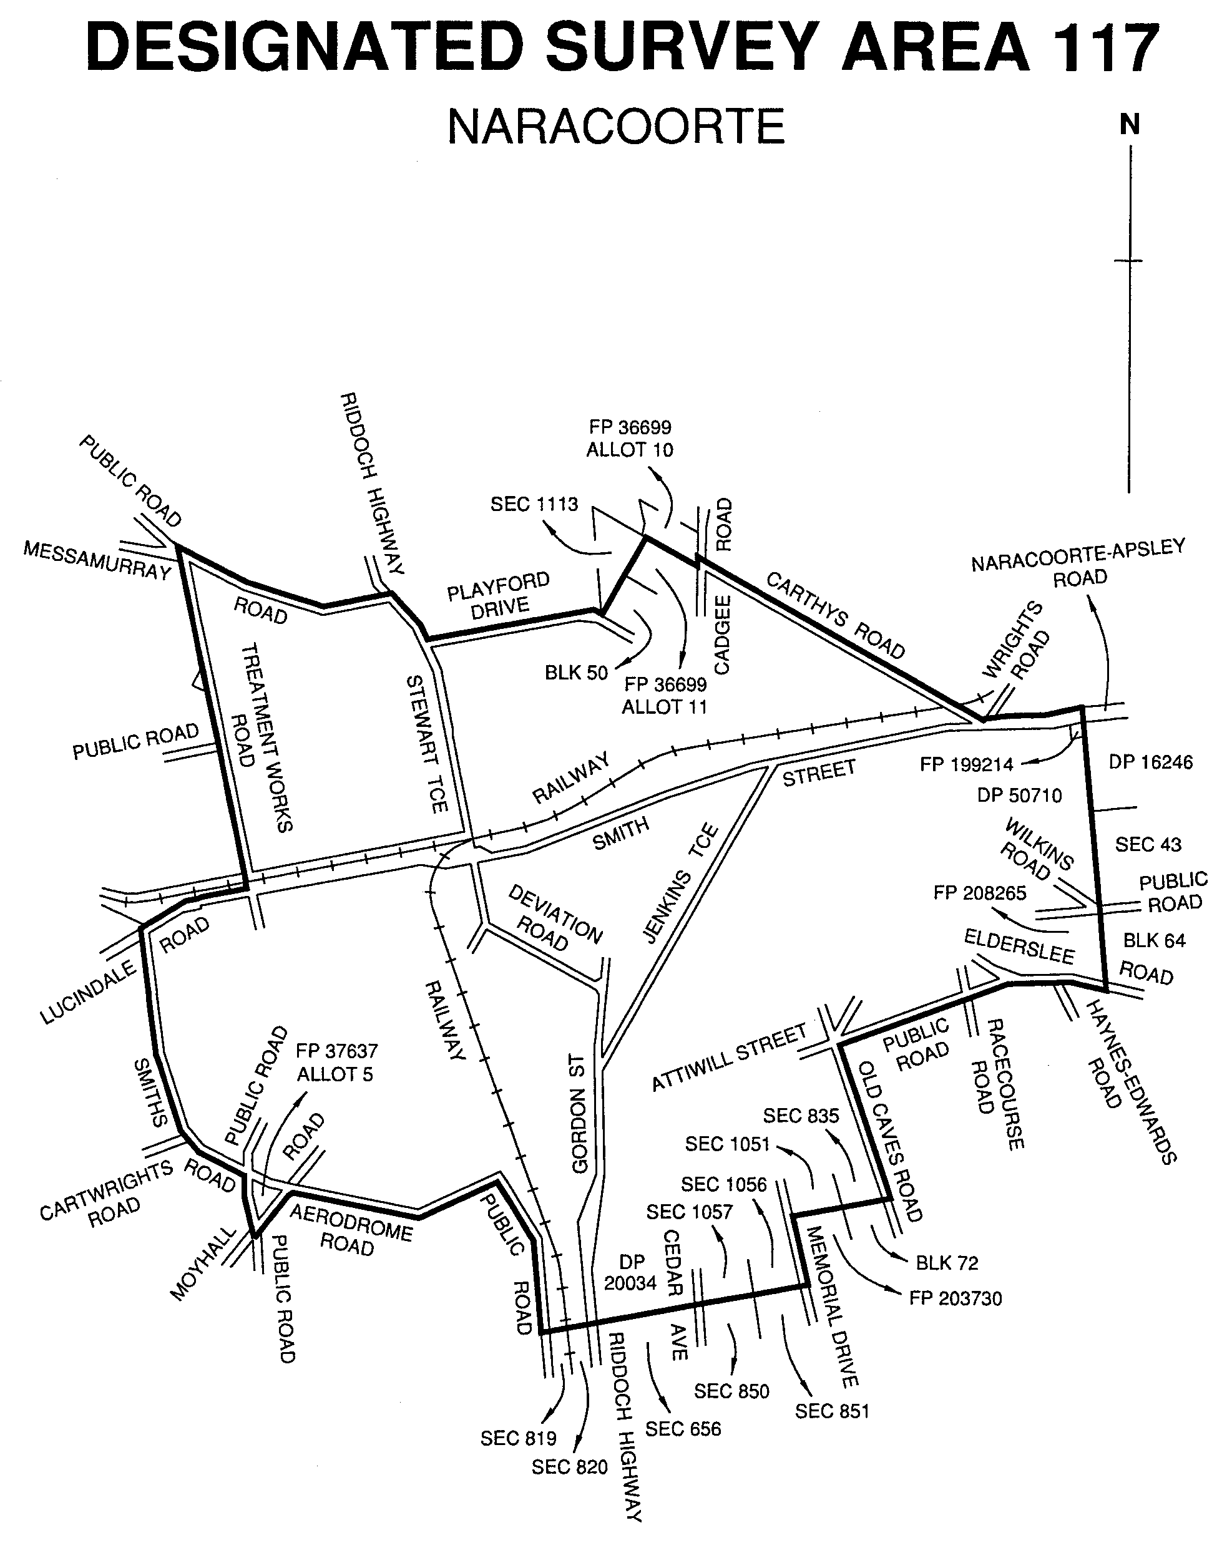
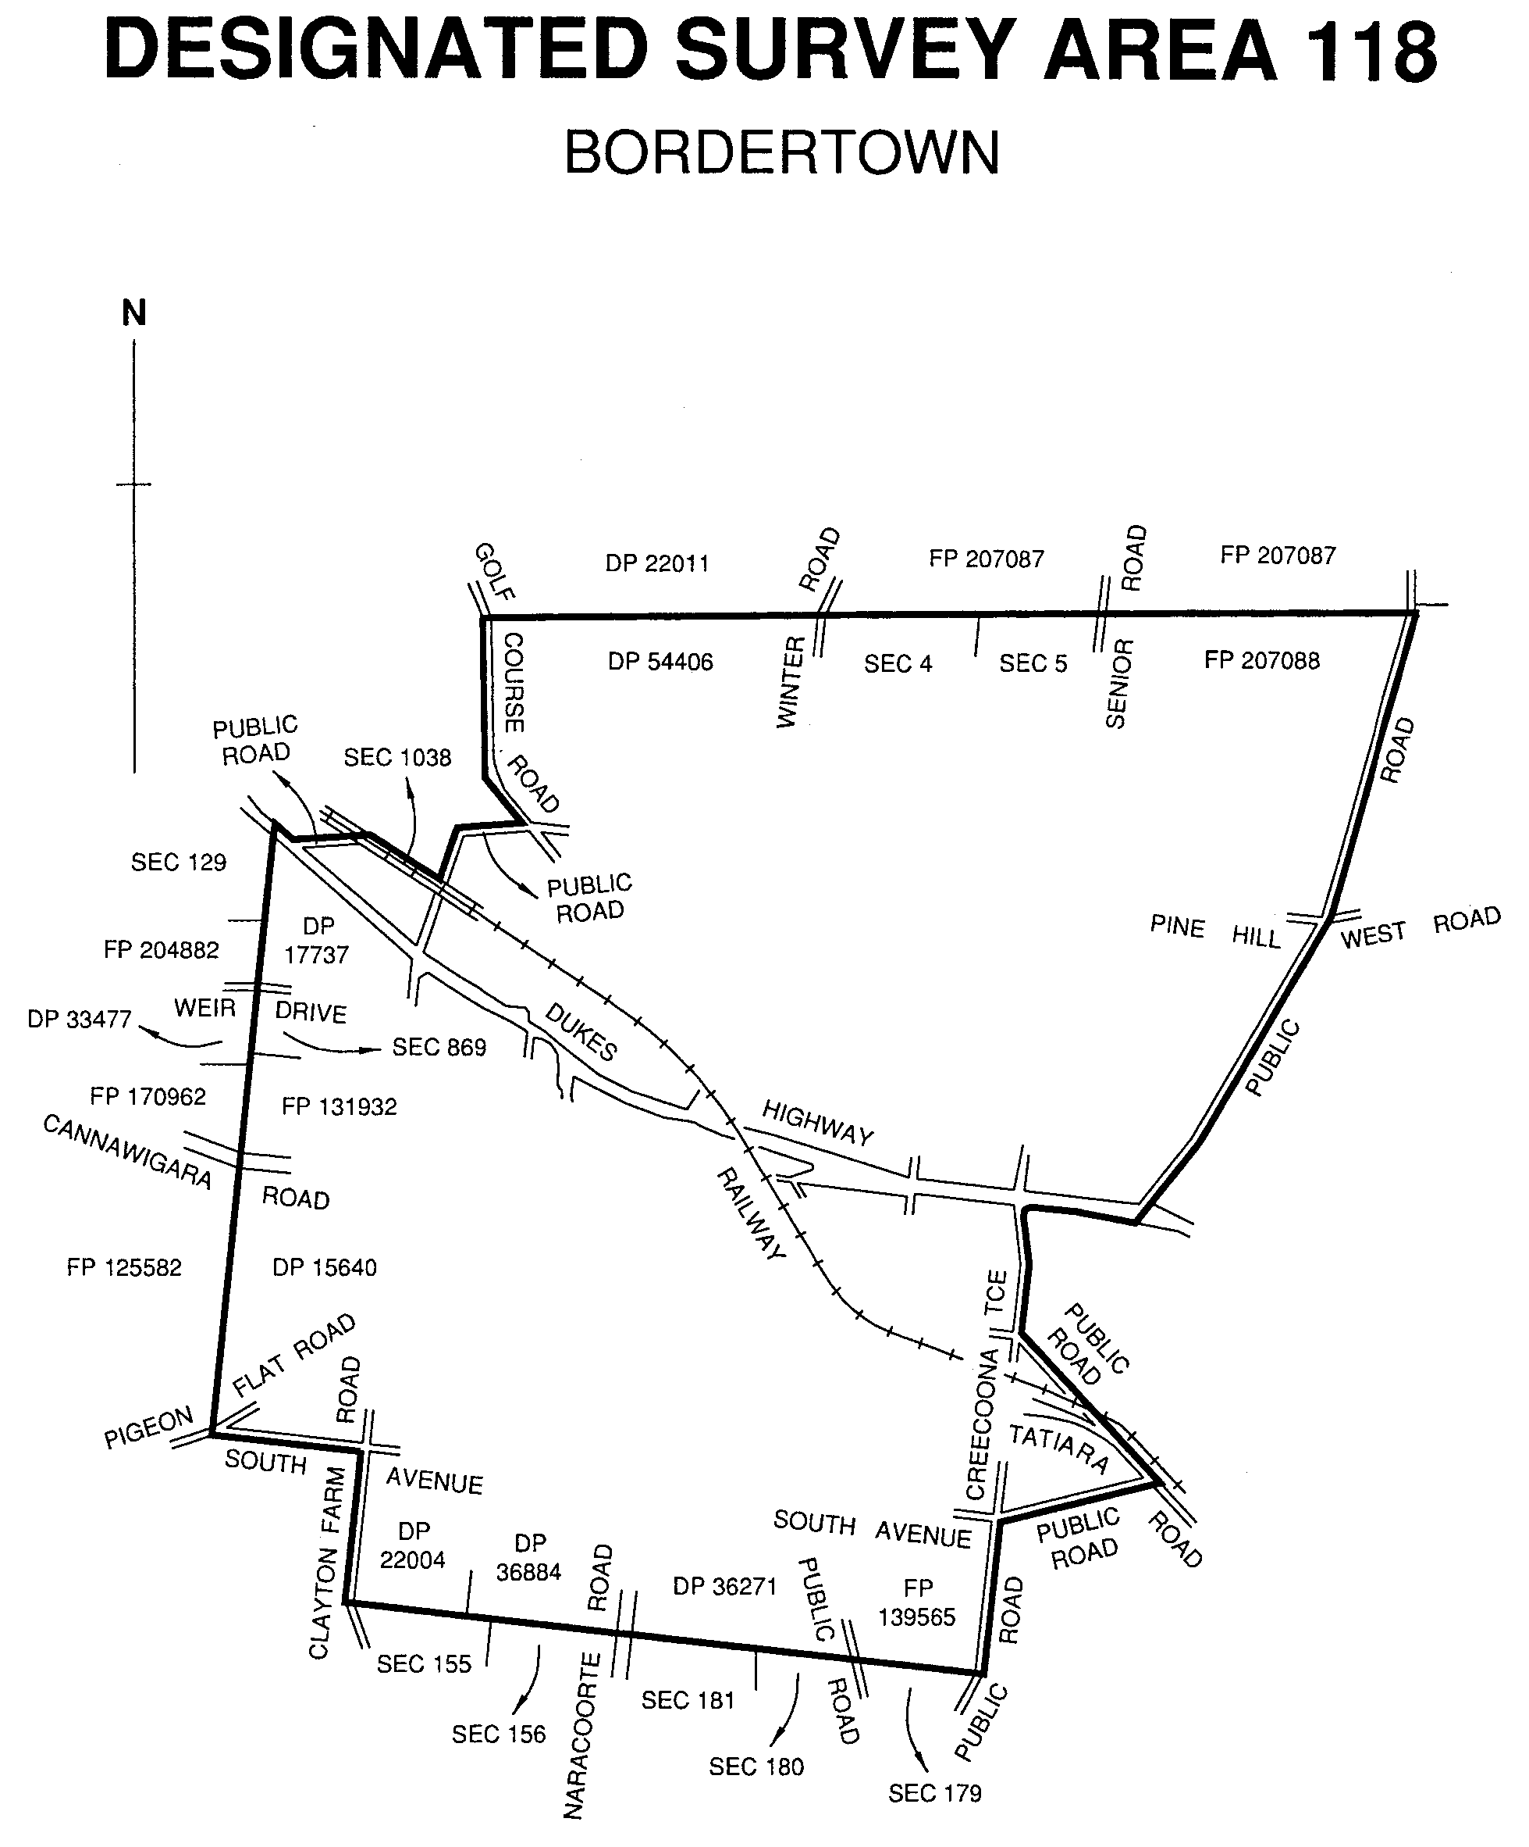
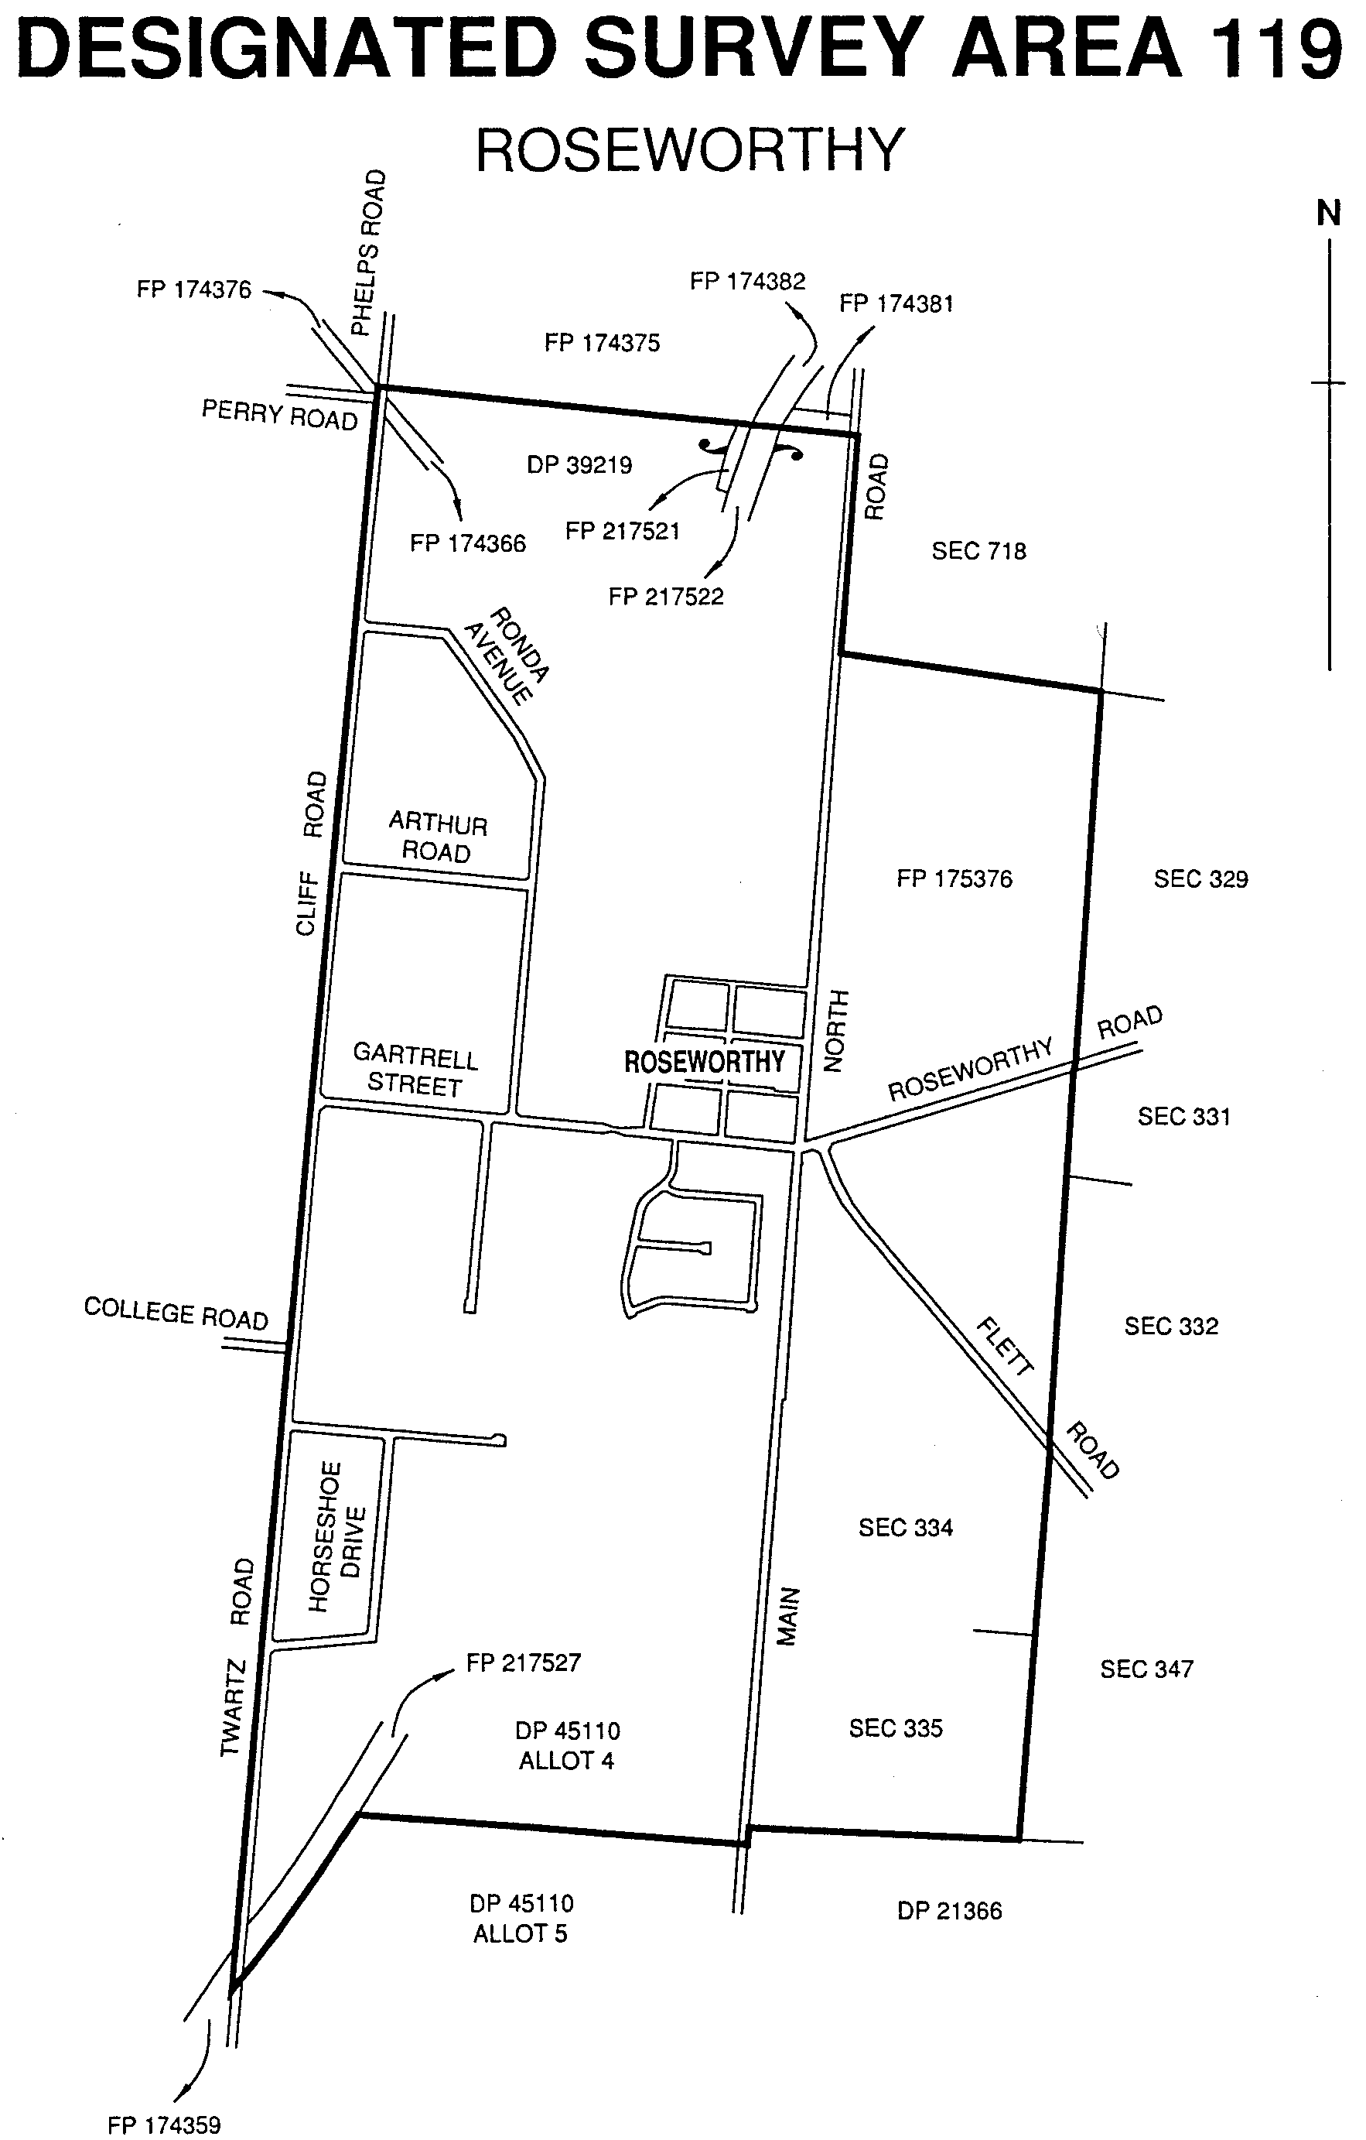
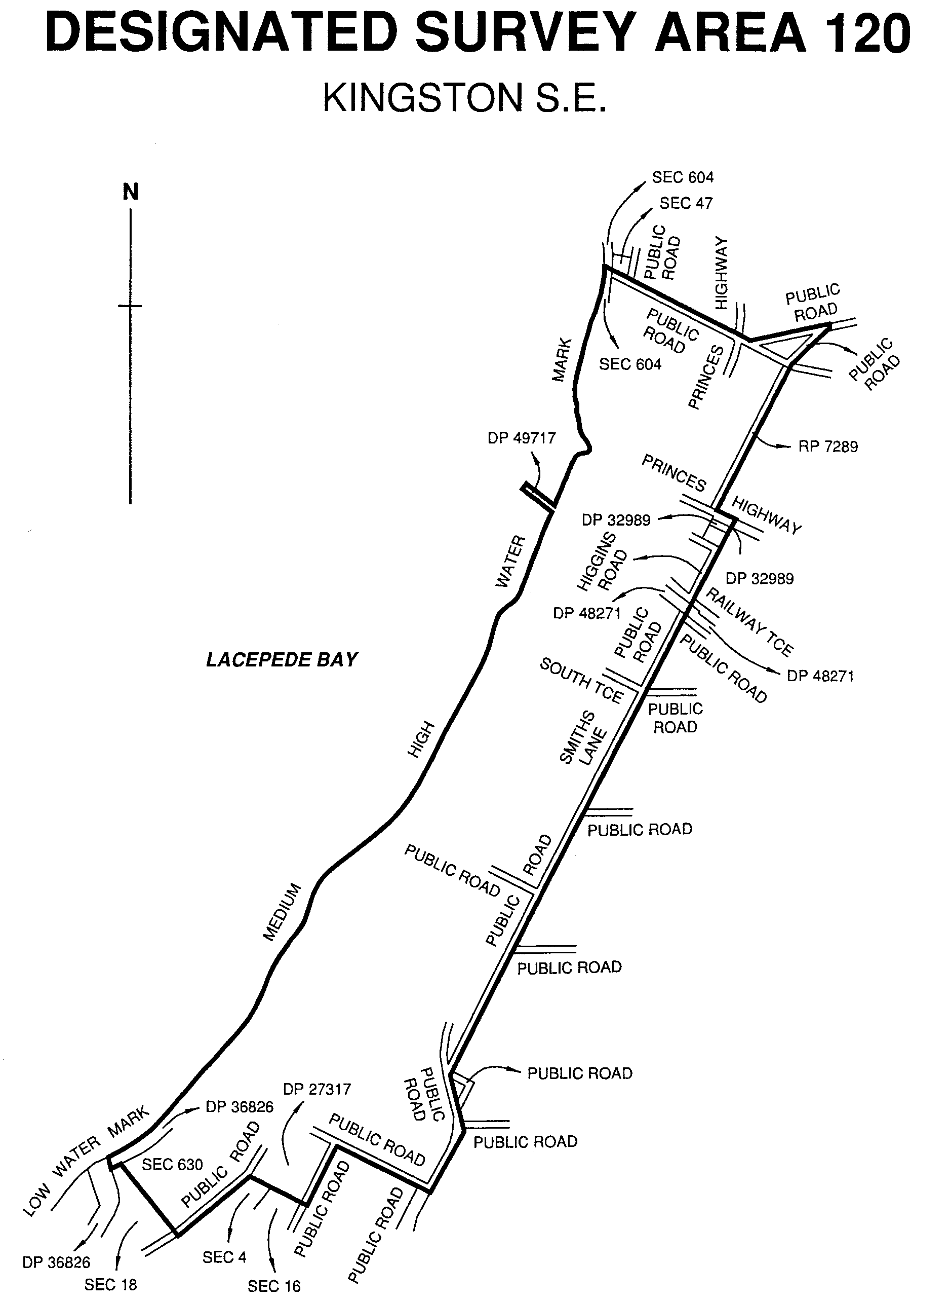
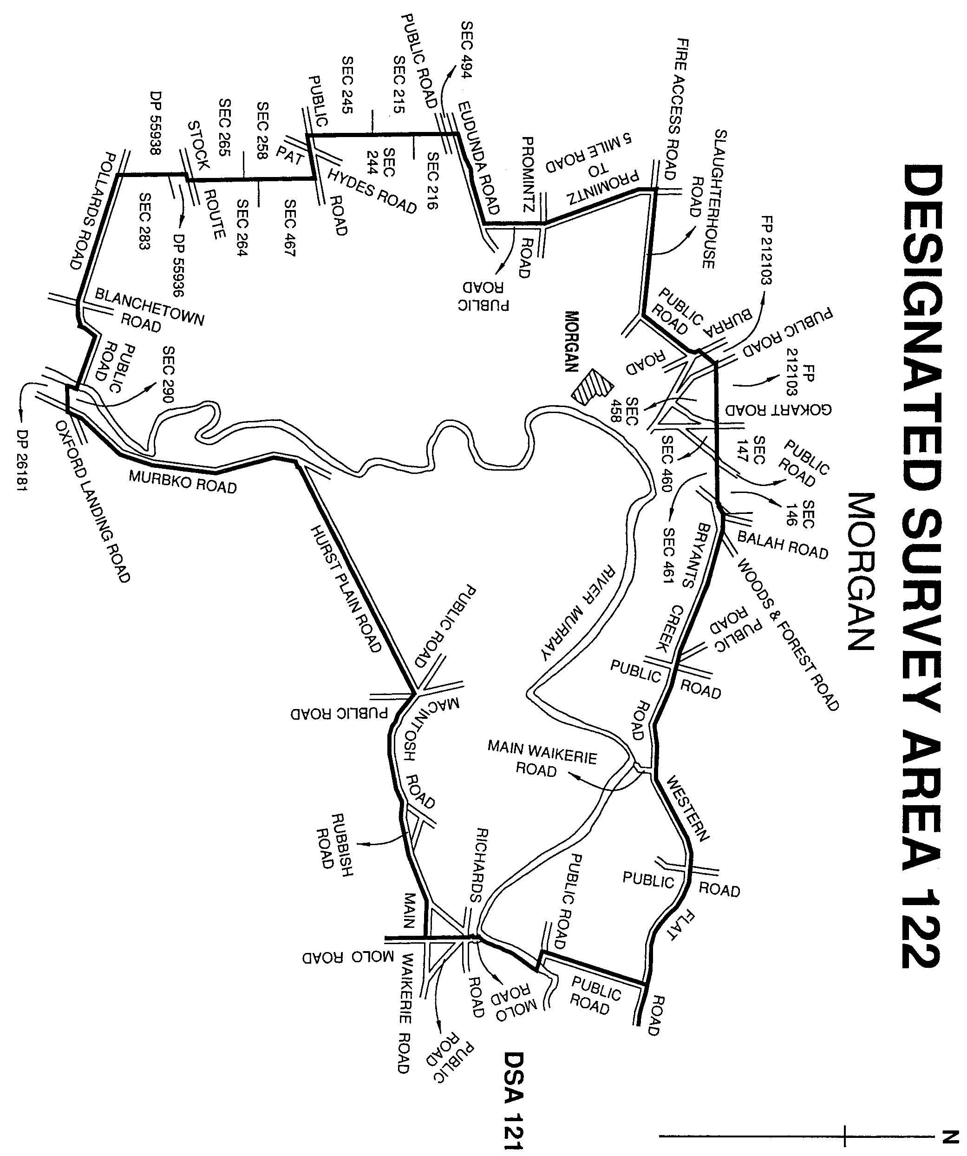
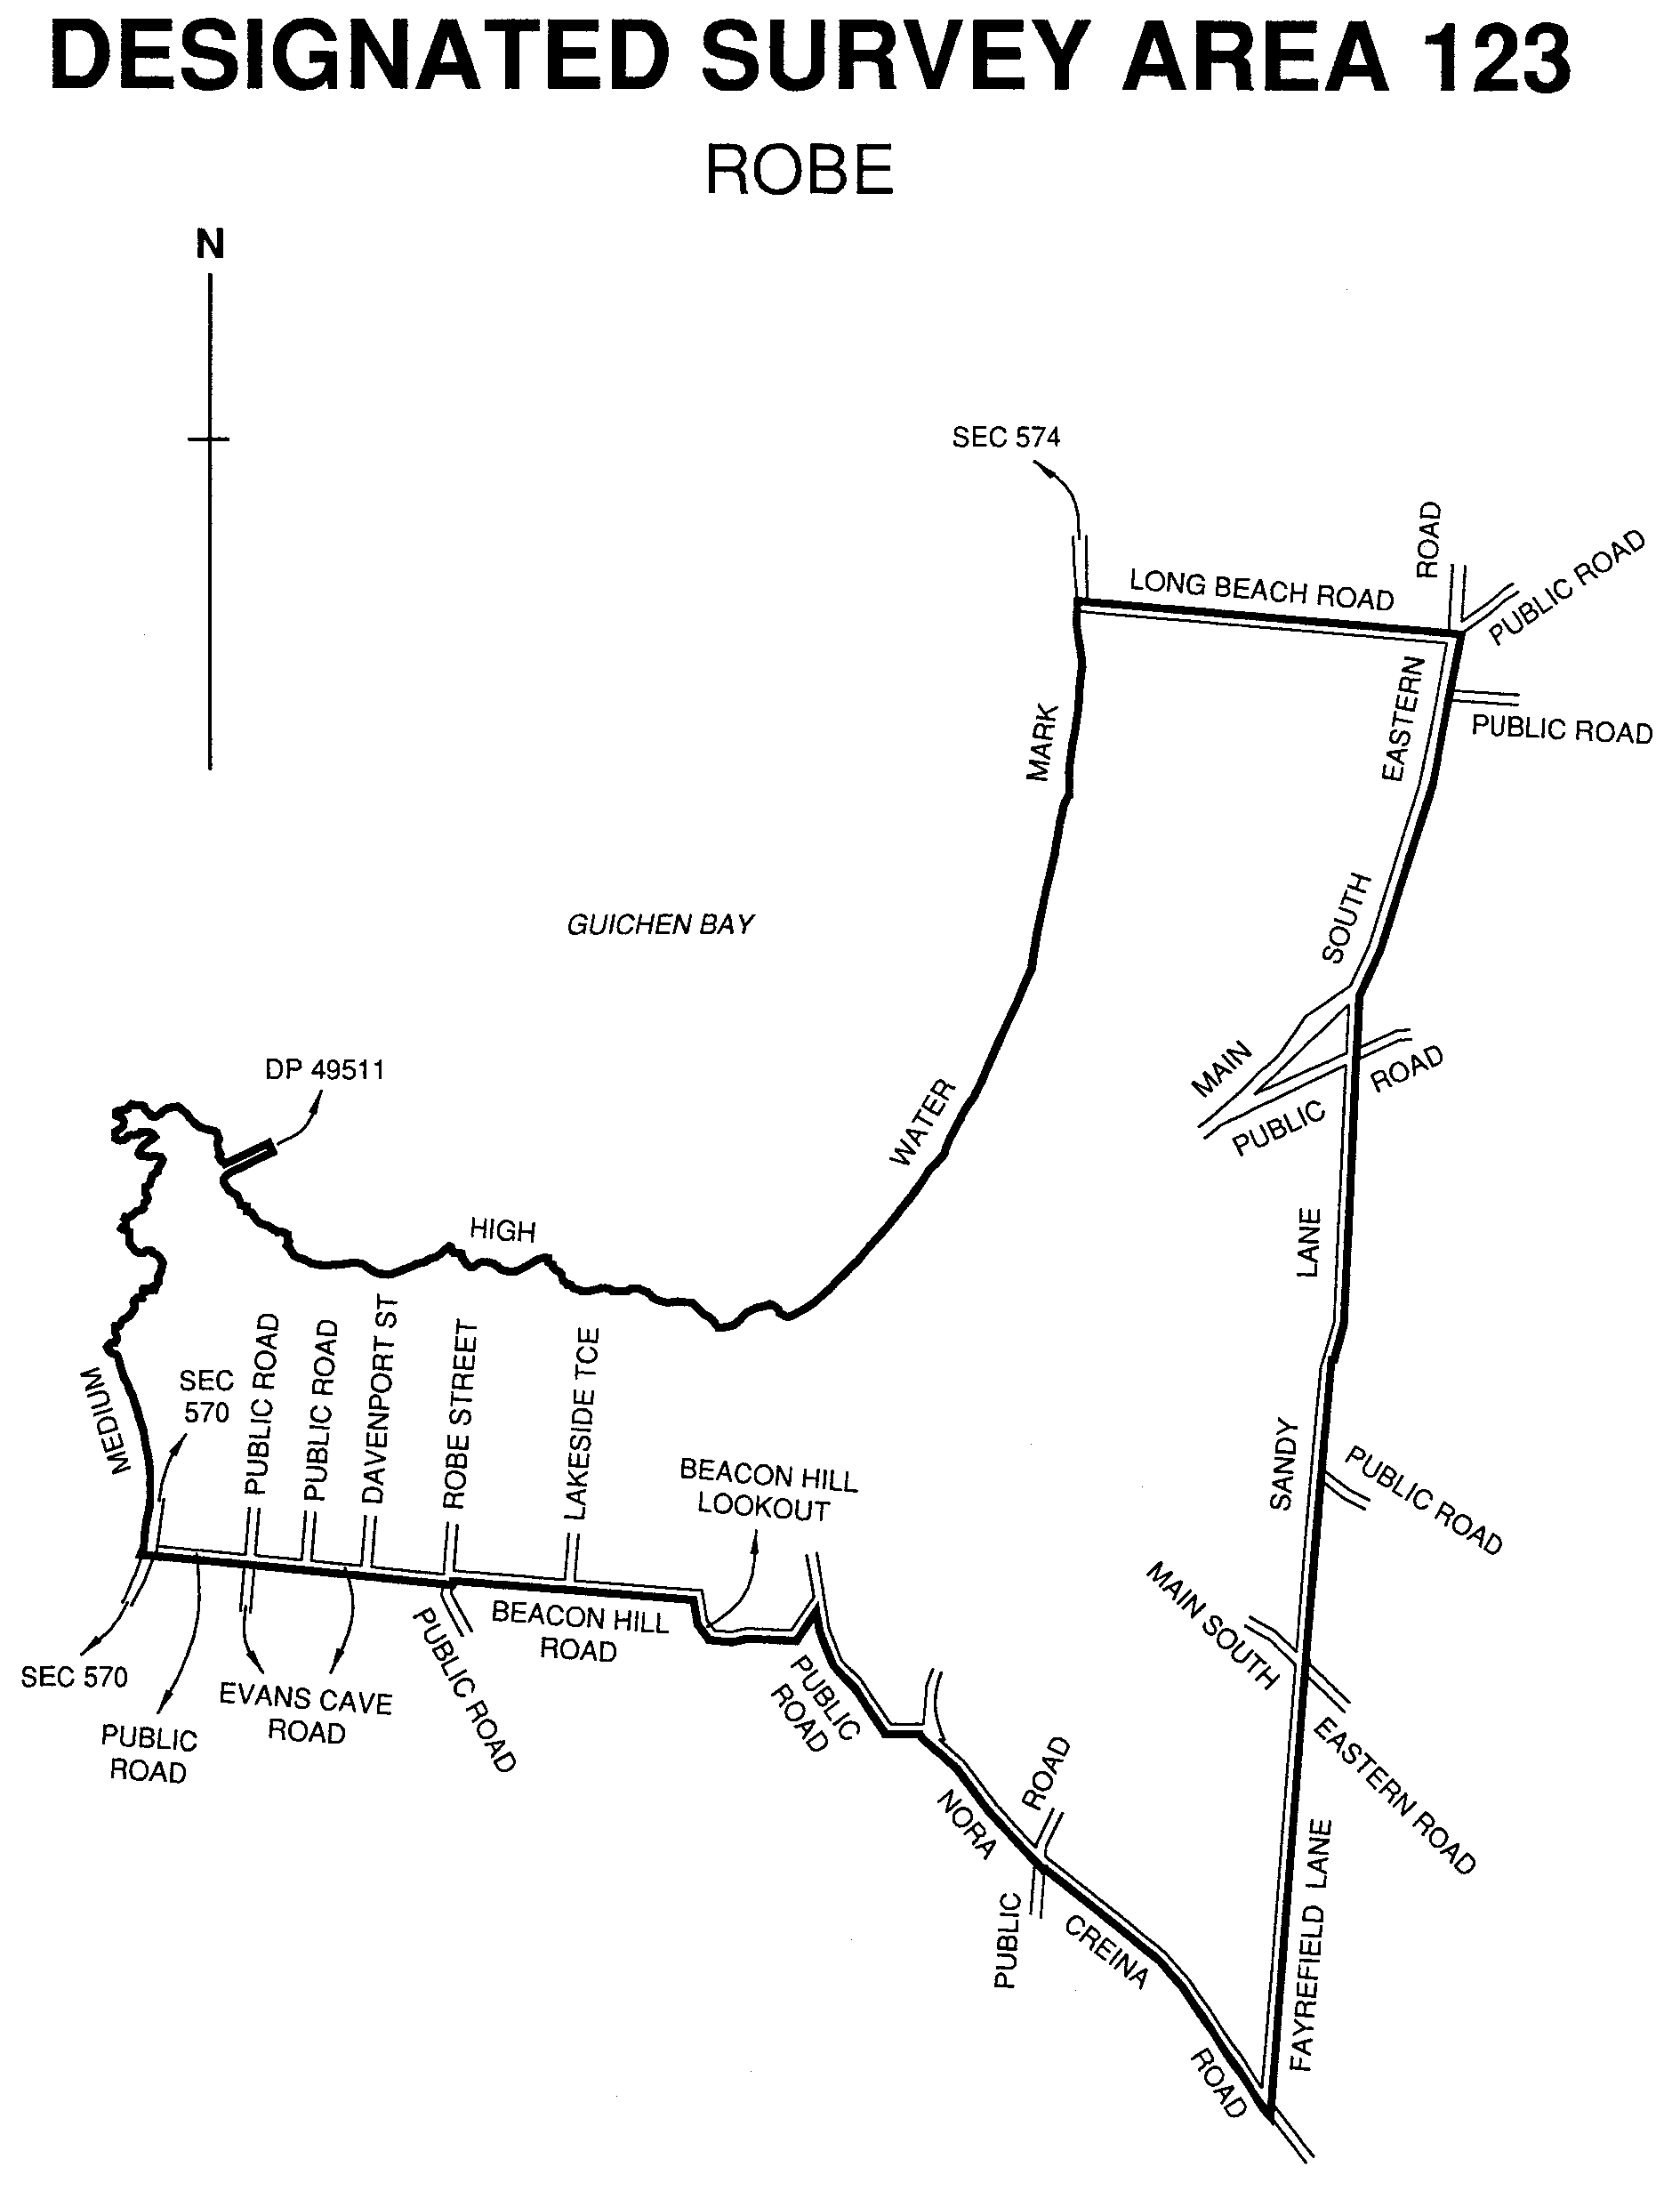
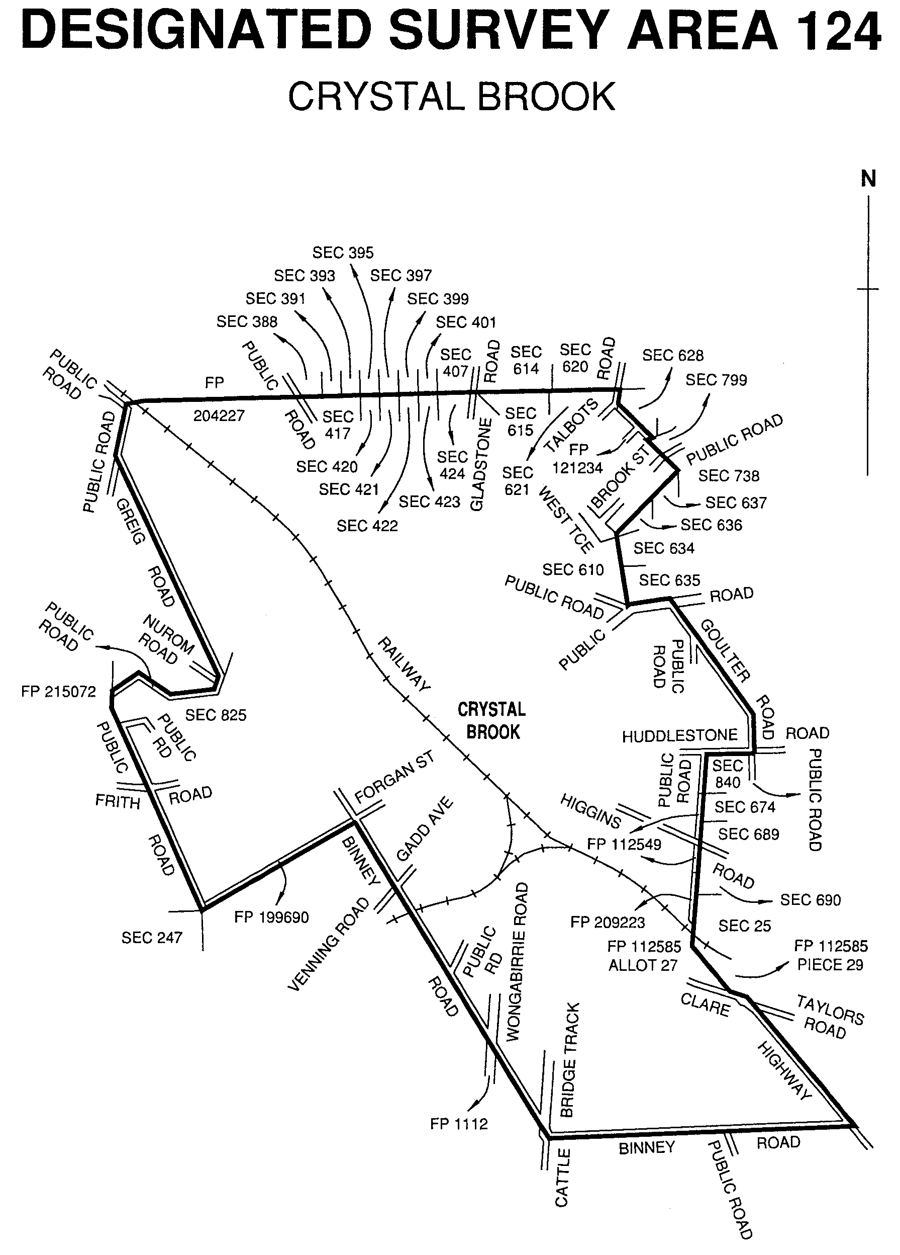
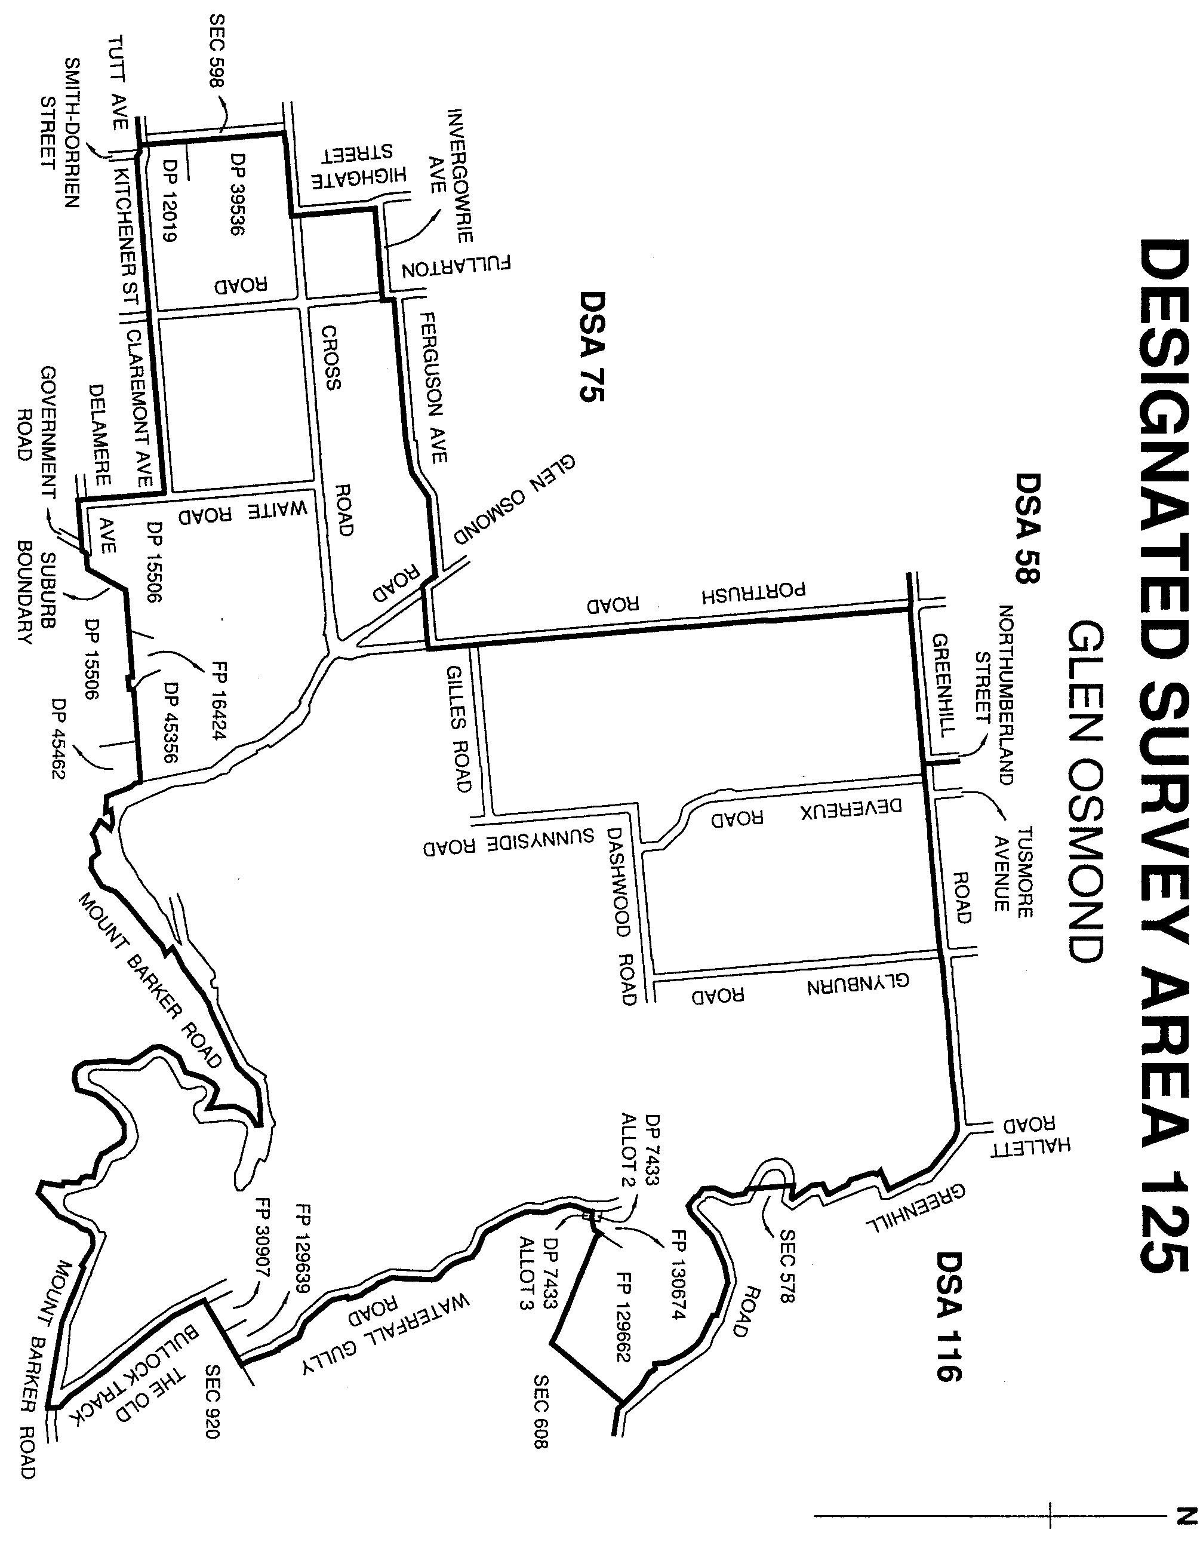
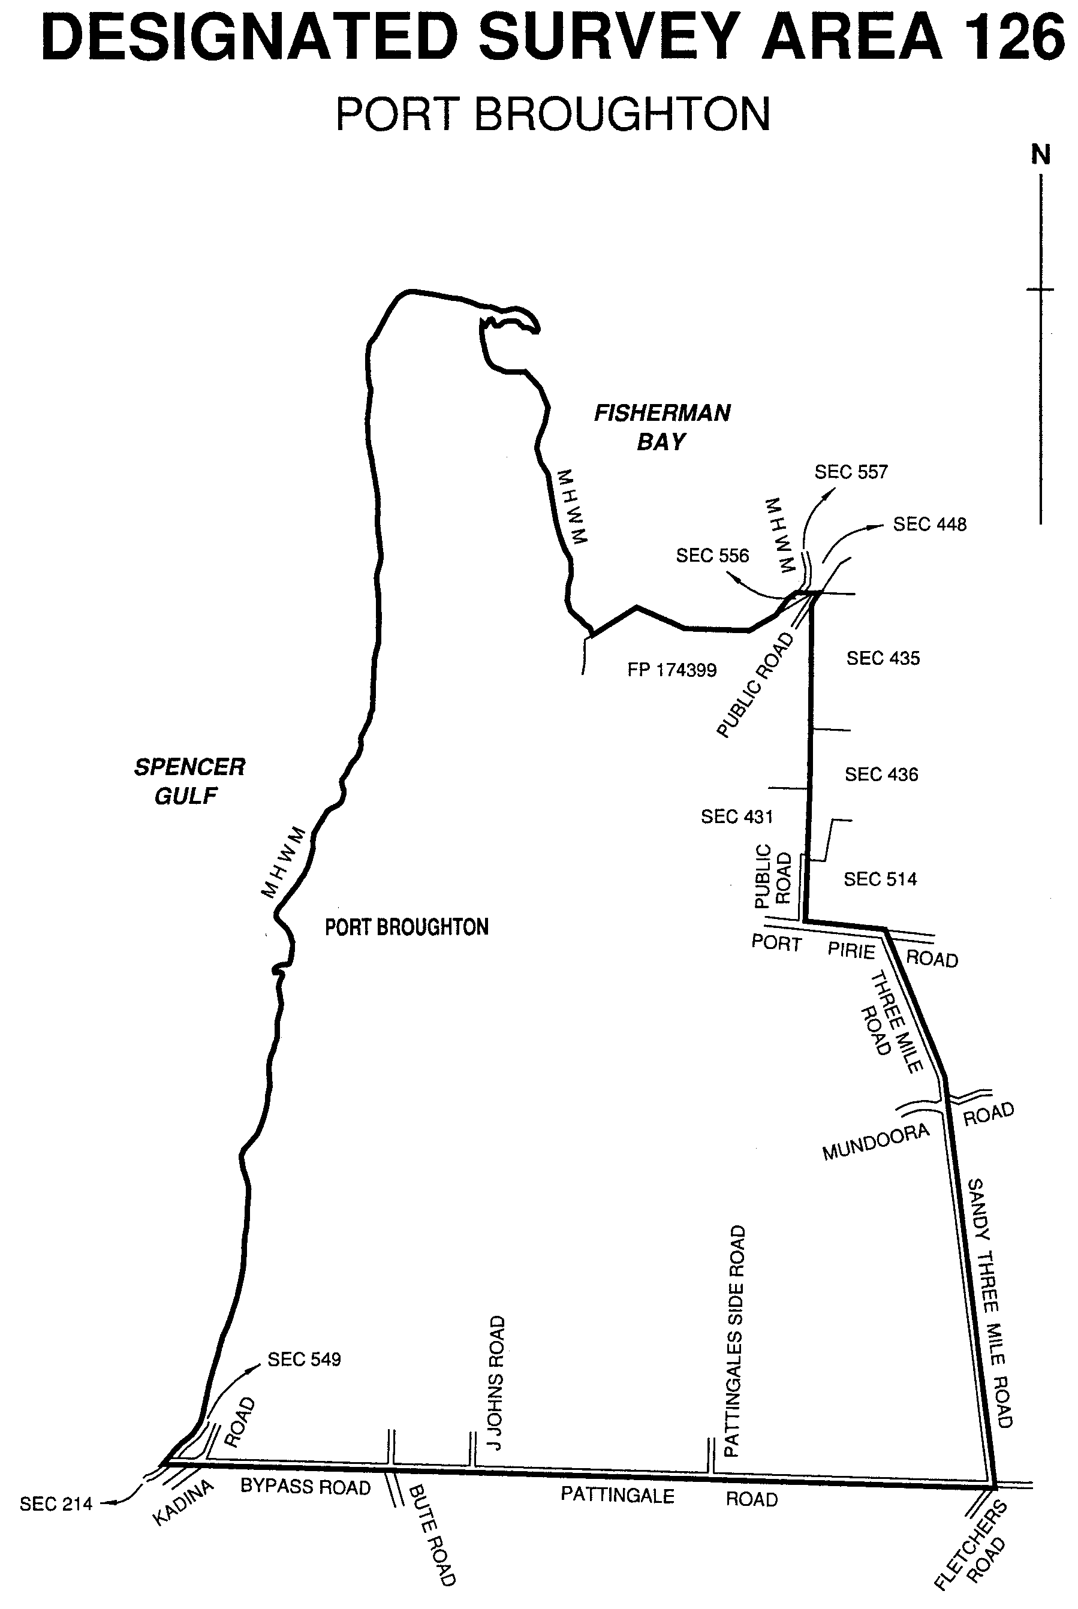
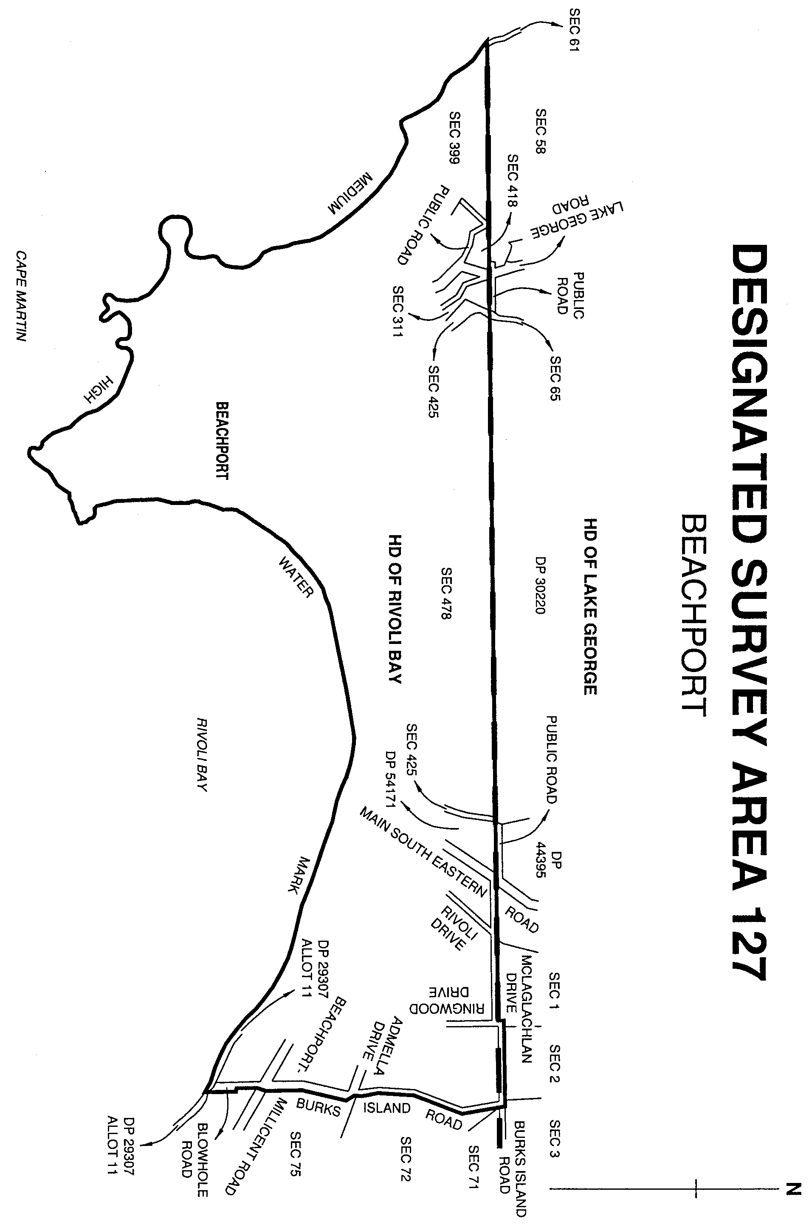
Dated 30 August 2001.
P. M. Kentish, Surveyor-General

REGULATIONS UNDER THE LIQUOR LICENSING ACT 1997
────
No. 203 of 2001
────
At the Executive Council Office at Adelaide, 30 August 2001

PURSUANT to the Liquor Licensing Act 1997 and with the advice and consent of the Executive Council, I make the following regulations.
E. J. NEAL, Governor

PURSUANT to section 10AA(2) of the Subordinate Legislation Act 1978, I certify that, in my opinion, it is necessary or appropriate that the following regulations come into operation as set out below.

K. T. GRIFFIN, Minister for Consumer Affairs
───────────────────
SUMMARY OF PROVISIONS

1. Citation
2. Commencement
3. Variation of reg. 8—Cases where licence is not required
────────────────────────

Citation
1. The Liquor Licensing (General) Regulations 1997 (see Gazette 25 September 1997 p. 913), as varied, are referred to in these regulations as "the principal regulations".

Commencement
2. These regulations come into operation on the day on which they are made.

Variation of reg. 8—Cases where licence is not required
3. Regulation 8 of the principal regulations is varied by striking out from subregulation (2)(j) "Willunga High School or Nuriootpa High School" and substituting "Nuriootpa High School, Urrbrae Agricultural High School or Willunga High School".

OLGC 1/2001 R. DENNIS, Clerk of the Council

REGULATIONS UNDER THE UNAUTHORIZED DOCUMENTS ACT 1916
────
No. 204 of 2001
────
At the Executive Council Office at Adelaide, 30 August 2001

PURSUANT to the Unauthorized Documents Act 1916 and with the advice and consent of the Executive Council, I make the following regulations.
E. J. NEAL, Governor

PURSUANT to section 10AA(2) of the Subordinate Legislation Act 1978, I certify that, in my opinion, it is necessary or appropriate that the following regulations come into operation as set out below.

JOHN OLSEN, Premier
───────────────────
SUMMARY OF PROVISIONS

1. Citation
2. Commencement
3. Revocation
4. Interpretation
5. State Badge and official emblem (s. 3A)
6. State commercial emblem (s. 3B)

SCHEDULE 1
State Badge and Official Emblem of the State

SCHEDULE 2

State Commercial Emblem
───────────────────

Citation
1. These regulations may be cited as the Unauthorized Documents Regulations 2001.

Commencement
2. These regulations will come into operation on 1 September 2001.

Revocation
3. The Unauthorized Documents Regulations 1988 (see Gazette 22 December 1988 p. 2153), as varied, are revoked.

Interpretation
4. In these regulations—

"Act" means the Unauthorized Documents Act 1916.

State Badge and official emblem (s. 3A)
5. For the purposes of section 3A of the Act, the emblem of the piping shrike depicted in Schedule 1 is declared to be a State Badge and an official emblem of the State.

State commercial emblem (s. 3B)
6. For the purposes of section 3B of the Act, the emblem of the piping shrike depicted in Schedule 2 is declared to be a State commercial emblem.

SCHEDULE 1
State Badge and Official Emblem of the State

SCHEDULE 2
State Commercial Emblem



DPC 017/01 CS R. DENNIS, Clerk of the Council

REGULATIONS UNDER THE BRANDS ACT 1933
────
No. 205 of 2001
────
At the Executive Council Office at Adelaide, 30 August 2001

PURSUANT to the Brands Act 1933 and with the advice and consent of the Executive Council, I make the following regulations.
E. J. NEAL, Governor

PURSUANT to section 10AA(2) of the Subordinate Legislation Act 1978, I certify that, in my opinion, it is necessary or appropriate that the following regulations come into operation as set out below.

ROB KERIN, Minister for Primary Industries and Resources
───────────────────
SUMMARY OF PROVISIONS

1. Citation
2. Commencement
3. Revocation
4. Interpretation
5. Sheep paint brands (s. 28)
6. Prescribed fees
───────────────────

Citation
1. These regulations may be cited as the Brands Regulations 2001.

Commencement
2. These regulations will come into operation on 31 August 2001.

Revocation
3. The Brands Act Regulations 1986 (see Gazette 10 July 1986, p. 232) are revoked.

Interpretation
4. In these regulations—

"Act" means the Brands Act 1933.

Sheep paint brands (s. 28)
5. A paint brand for sheep—

(a) must be made with the substance "Si-Ro-Mark" (registered trademark no. 121839); and

(b) must be purple, red, blue or green in colour.

Prescribed fees
6. The following fees are payable under the Act:

 | Item | Fee ($)
 | Registration of any brand or mark | 20
 | Transfer of registration | 15
 | Cancellation of registration | No fee

MPIR 01/0044 CS R. DENNIS, Clerk of the Council

REGULATIONS UNDER THE DAYLIGHT SAVING ACT 1971
────
No. 206 of 2001
────
At the Executive Council Office at Adelaide, 30 August 2001

PURSUANT to the Daylight Saving Act 1971 and with the advice and consent of the Executive Council, I make the following regulations.
E. J. NEAL, Governor

PURSUANT to section 10AA(2) of the Subordinate Legislation Act 1978, I certify that, in my opinion, it is necessary or appropriate that the following regulations come into operation as set out below.

MICHAEL ARMITAGE, Minister for Government Enterprises
───────────────────
SUMMARY OF PROVISIONS

1. Citation
2. Commencement
3. Revocation
4. South Australian summer time 2001-2002
───────────────────

Citation
1. These regulations may be cited as the Daylight Saving Regulations 2001.

Commencement
2. These regulations come into operation on the day on which they are made.

Revocation
3. The Daylight Saving Regulations 2000 (see Gazette 13 July 2000 p. 140) are revoked.

South Australian summer time 2001-2002
4. The period for observance of South Australian summer time for 2001-2002 is the period from 2 a.m. South Australian standard time on 28 October 2001 until 3 a.m. South Australian summer time on 31 March 2002.

01MWR00434 R. DENNIS, Clerk of the Council

REGULATIONS UNDER THE CHILDREN'S SERVICES ACT 1985
────
No. 207 of 2001
────
At the Executive Council Office at Adelaide, 30 August 2001

PURSUANT to the Children's Services Act 1985 and with the advice and consent of the Executive Council, I make the following regulations.
E. J. NEAL, Governor

PURSUANT to section 10AA(2) of the Subordinate Legislation Act 1978, I certify that, in my opinion, it is necessary or appropriate that the following regulations come into operation as set out below.

MALCOLM BUCKBY, Minister for Education and Children's Services
───────────────────
SUMMARY OF PROVISIONS

1. Citation
2. Commencement
3. Revocation
4. Interpretation
5. Licences (s. 30)
6. Prescribed records (s. 32)
7. Expiry

SCHEDULE
Forms
───────────────────

Citation
1. These regulations may be cited as the Children's Services (Baby Sitting Agencies) Regulations 2001.

Commencement
2. These regulations will come into operation on 1 September 2001.

Revocation
3. The Children's Services Act (Baby Sitting Agencies) Regulations 1985 (see Gazette 12 September 1985 p. 805) are revoked.

Interpretation
4. In these regulations unless the contrary intention appears—

"Act" means the Children's Services Act 1985.

Licences (s. 30)
5. (1) An application for a licence or renewal of a licence to carry on the business of a baby sitting agency must be in the form set out in form 1 of the Schedule.

(2) An application for renewal of a licence must be lodged with the Director at least 14 days before the expiry of the licence.

(3) On receipt of an application for a licence or renewal of a licence, the Director may, for the purposes of section 30 of the Act, issue a licence in the form set out in form 2 of the Schedule.

Prescribed records (s. 32)
6. For the purposes of section 32 of the Act, the following are prescribed records to be maintained by a licensed baby sitting agency in relation to each person employed or introduced in the course of its business as a baby sitting agency:

(a) the person's name, address and telephone number (if any);

(b) names and addresses of referees who have provided information about the person's character and competence;

(c) details of the person's relevant training and qualifications;

(d) in respect of each baby sitting assignment undertaken by the person, the date of the assignment and the name and address of the person for whom the assignment was undertaken.

Expiry
7. These regulations will expire on 1 September 2003.

SCHEDULE
Forms

(Regulation 5(1))

Form No. 1
Children's Services Act, 1985

APPLICATION FOR *LICENCE TO CARRY ON THE BUSINESS OF A BABY SITTING AGENCY
*RENEWAL OF LICENCE TO CARRY ON THE BUSINESS OF A BABY
SITTING AGENCY

South (Royal Arms) Australia

To the Director of Children's Services

I/We
Full Name(s)

hereby apply for:

*a licence
*renewal of licence

to carry on the business of the baby sitting agency described below.

APPLICANT(S)
Name
Date of Birth
Address
Telephone No.

BABY SITTING AGENCY
Name
Address
Telephone No.

Signature of Applicant Date
*Strike out whichever is inapplicable.

(Regulation 5(3))

Form No. 2
Children's Services Act, 1985

LICENCE TO CARRY ON THE BUSINESS OF A BABY SITTING AGENCY
South (Royal Arms) Australia

LICENCE No.

is/are hereby licensed to
carry on the business of the baby sitting agency known as

for the period of one year from
subject to the Children's Services Act, 1985, the regulations under that Act and any conditions endorsed on this licence.

Address of licensee

Address of baby sitting agency

Conditions

Date
Director of Children's Services

MECS 14/01 CS R. DENNIS, Clerk of the Council

REGULATIONS UNDER THE PRICES ACT 1948
────
No. 208 of 2001
────
At the Executive Council Office at Adelaide, 30 August 2001

PURSUANT to the Prices Act 1948 and with the advice and consent of the Executive Council, I make the following regulations.
E. J. NEAL, Governor

PURSUANT to section 10AA(2) of the Subordinate Legislation Act 1978, I certify that, in my opinion, it is necessary or appropriate that the following regulations come into operation as set out below.

K. T. GRIFFIN, Minister for Consumer Affairs

───────────────────
SUMMARY OF PROVISIONS

1. Citation
2. Commencement
3. Revocation
4. Prohibition on compensation to retailer for unsold bread
───────────────────

Citation
1. These regulations may be cited as the Prices Regulations 2001.

Commencement
2. These regulations will come into operation on 1 September 2001.

Revocation
3. The Prices Regulations 1985 (see Gazette 4 July 1985 p. 51), as varied, are revoked.

Prohibition on compensation to retailer for unsold bread
4. (1) A person must not enter into a transaction to which this regulation applies or do anything pursuant to such a transaction (whether entered into before or after the commencement of this regulation).

Maximum penalty: $750.

(2) This regulation applies to an agreement, arrangement or understanding under which a person—

(a) is to supply bread for sale by retail; or

(b) is to purchase bread for sale by retail,

and financial relief or compensation is to be directly or indirectly given or received in respect of any bread that, having been supplied for sale by retail, is not sold by retail.

OCBA 3/99 CS R. DENNIS, Clerk of the Council

REGULATIONS UNDER THE CHILDREN'S SERVICES ACT 1985
────
No. 209 of 2001
────
At the Executive Council Office at Adelaide, 30 August 2001

PURSUANT to the Children's Services Act 1985 and with the advice and consent of the Executive Council, I make the following regulations.
E. J. NEAL, Governor

PURSUANT to section 10AA(2) of the Subordinate Legislation Act 1978, I certify that, in my opinion, it is necessary or appropriate that the following regulations come into operation as set out below.

MALCOLM BUCKBY, Minister for Education and Children's Services
───────────────────
SUMMARY OF PROVISIONS

PART 1
PRELIMINARY

1. Citation
2. Commencement
3. Revocation
4. Expiry
5. Interpretation

PART 2
RETURNING OFFICER

6. Returning officer

PART 3
CHILDREN'S SERVICES CONSULTATIVE COMMITTEE

7. Term of office of elected members of Children's Services Consultative Committee
8. Election of members of Children's Services Consultative Committee
9. Constitution of panel

PART 4
REGIONAL ADVISORY COMMITTEES

10. Membership of regional advisory committees
11. Terms and conditions of membership of regional advisory committees
12. Procedure at meetings of regional advisory committees
13. Validity of acts of regional advisory committees
14. Election of parents to regional advisory committees
15. Election of service providers to regional advisory committee

───────────────────

PART 1
PRELIMINARY

Citation
1. These regulations may be cited as the Children's Services (Membership of Committees) Regulations 2001.

Commencement
2. These regulations will come into operation on 1 September 2001.

Revocation
3. The Children's Services Act (Membership of Committees) Regulations 1986 (see Gazette 10 July 1986 p. 225) are revoked.

Expiry
4. These regulations will expire on 1 September 2003.

Interpretation
5. In these regulations, unless the contrary intention appears—

"Act" means the Children's Services Act 1985;

"regional advisory committee" see Part 4.

PART 2
RETURNING OFFICER

Returning officer
6. (1) For the purposes of elections conducted under these regulations, the Director is to be the returning officer.

(2) Subject to the Act and these regulations, the procedure of an election may be determined by the returning officer.

(3) The returning officer has responsibility for ensuring that elections are conducted in accordance with these regulations.

PART 3
CHILDREN'S SERVICES CONSULTATIVE COMMITTEE

Term of office of elected members of Children's Services Consultative Committee
7. An elected member of the Children's Services Consultative Committee holds office for a term of 1 year and, on the expiration of that term, is eligible for re-election.

Election of members of Children's Services Consultative Committee
8. For the purposes of section 15(2)(a) of the Act, each regional advisory committee is to elect 2 of its members (being persons whose children are enrolled at, or attending establishments that provide different kinds of children's services) to be members of the Children's Services Consultative Committee.

Constitution of panel
9. The panel from which 6 persons are to be selected by the Minister for appointment to the Children's Services Consultative Committee under section 15(2)(b) of the Act is to consist of persons nominated as follows:

(a) each regional advisory committee is to nominate 2 of its members, being persons involved in the provision of different kinds of children's services; and

(b) each of the following organisations is to nominate 1 person involved in the provision of children's services:

(i) South Australian Association of Community Based Child Care Centres Inc.;

(ii) Toy Libraries Association of South Australia Inc.;

(iii) Playgroups Association of South Australia Inc.;

(iv) National Association of Community Based Children's Services Inc.;

(v) Australian Early Childhood Association Inc.;

(vi) Preschool Directors Association Inc..
PART 4
REGIONAL ADVISORY COMMITTEES

Membership of regional advisory committees
10. (1) For the purposes of section 22 of the Act—

(a) the regional advisory committee for the area of the State designated by the Minister as the Northern Metropolitan Region is to consist of 34 members of whom—

(i) 7 are to be appointed on the nomination of the Director; and

(ii) 1 is to be appointed on the nomination of the Local Government Association; and

(iii) 18 are to be elected, in accordance with these regulations, by persons whose children are enrolled at, or attending, any establishment that provides children's services within the Northern Metropolitan Region; and

(iv) 8 are to be elected, in accordance with these regulations, by persons involved in the provision of children's services within the Northern Metropolitan Region; and

(b) the regional advisory committee for the area of the State designated by the Minister as the Eastern Metropolitan Region is to consist of 32 members of whom—

(i) 7 are to be appointed on the nomination of the Director; and

(ii) 1 is to be appointed on the nomination of the Local Government Association; and

(iii) 16 are to be elected, in accordance with these regulations, by persons whose children are enrolled at, or attending, any establishment that provides children's services within the Eastern Metropolitan Region; and

(iv) 8 are to be elected, in accordance with these regulations, by persons involved in the provision of children's services within the Eastern Metropolitan Region; and

(c) the regional advisory committee for the area of the State designated by the Minister as the Southern Metropolitan Region is to consist of 34 members of whom—

(i) 7 are to be appointed on the nomination of the Director; and

(ii) 1 is to be appointed on the nomination of the Local Government Association; and

(iii) 18 are to be elected, in accordance with these regulations, by persons whose children are enrolled at, or attending, any establishment that provides children's services within the Southern Metropolitan Region; and

(iv) 8 are to be elected, in accordance with these regulations, by persons involved in the provision of children's services within the Southern Metropolitan Region; and

(d) the regional advisory committee for the area of the State designated by the Minister as the Western Metropolitan Region is to consist of 32 members of whom—

(i) 7 are to be appointed on the nomination of the Director; and

(ii) 1 is to be appointed on the nomination of the Local Government Association; and
(iii) 16 are to be elected, in accordance with these regulations, by persons whose children are enrolled at, or attending, any establishment that provides children's services within the Western Metropolitan Region; and

(iv) 8 are to be elected, in accordance with these regulations, by persons involved in the provision of children's services within the Western Metropolitan Region; and

(e) the regional advisory committee for the area of the State designated by the Minister as the Northern Country Region is to consist of 32 members of whom—

(i) 7 are to be appointed on the nomination of the Director; and

(ii) 1 is to be appointed on the nomination of the Local Government Association; and

(iii) 16 are to be elected, in accordance with these regulations, by persons whose children are enrolled at, or attending, any establishment that provides children's services within the Northern Country Region; and

(iv) 8 are to be elected, in accordance with these regulations, by persons involved in the provision of children's services within the Northern Country Region; and

(f) the regional advisory committee for the area of the State designated by the Minister as the Southern Country Region is to consist of 32 members of whom—

(i) 7 are to be appointed on the nomination of the Director; and

(ii) 1 is to be appointed on the nomination of the Local Government Association; and

(iii) 16 are to be elected, in accordance with these regulations, by persons whose children are enrolled at, or attending, any establishment that provides children's services within the Southern Country Region; and

(iv) 8 are to be elected, in accordance with these regulations, by persons involved in the provision of children's services within the Southern Country Region.

Terms and conditions of membership of regional advisory committees
11. (1) An elected member of a regional advisory committee holds office for a term of 1 year and, on the expiration of that term, is eligible for re-election.

(2) An appointed member of a regional advisory committee holds office for a term of 1 year and, on the expiration of the member's first term of office, is eligible for reappointment for not more than 2 further terms of office.

(3) The Director may remove a member of a regional advisory committee from office—

(a) for misconduct; or

(b) for failure or incapacity to carry out official duties satisfactorily.

(4) The office of a member of a regional advisory committee becomes vacant if the member—

(a) dies; or

(b) completes his or her term of office and is not re-elected or reappointed; or
(c) resigns by written notice to the Director; or

(d) is absent from 3 successive meetings without proper excuse; or

(e) is removed from office under subregulation (3).

Procedure at meetings of regional advisory committees
12. (1) A quorum of a regional advisory committee consists of 7 elected members of whom at least 4 must be parents of children enrolled at, or attending, an establishment that provides children's services.

(2) If the person appointed to chair a regional advisory committee is absent from a meeting of the committee, a person chosen by the members present at the meeting will preside.

(3) A decision carried by a majority of the votes cast by the members present at a meeting of a regional advisory committee is a decision of the committee.

(4) Each member present at a meeting of a regional advisory committee has 1 vote on any question arising for decision and, if the votes are equal, the person presiding may exercise a casting vote.

(5) Regional advisory committee meetings are to be open to observers who may, at the discretion of the members present, take part in the business of the meeting but may not vote on any question arising for decision at the meeting.

(6) Each regional advisory committee must, at least once each year, invite each establishment that provides children's services within its region to send one or more observers to attend a meeting of the committee.

(7) Subject to the Act and these regulations, the business of a regional advisory committee is to be conducted in such manner as it determines.

Validity of acts of regional advisory committees
13. An act or proceeding of a regional advisory committee is not invalid by reason of a vacancy in the membership of the committee or a defect in an appointment or election to the committee.

Election of parents to regional advisory committees
14. (1) For the purposes of an election of members of a regional advisory committee by persons whose children are enrolled at, or attending, an establishment that provides children's services, the area of the State in relation to which the committee is established is to be divided into a number of subregions determined in accordance with the following formula:

where—

N is the number of subregions; and

n is the number of members to be elected.

(2) An election under this regulation is to be conducted at a time and place determined by the returning officer.
(3) Each establishment may nominate a person who is a parent of a child enrolled at, or attending the establishment, to attend at the election.

(4) At an election, the persons nominated to attend must elect two persons to be members of the regional advisory committee, being parents of children enrolled at, or attending establishments that provide different kinds of children's services.

Election of service providers to regional advisory committee
15. (1) For the purposes of an election of members to a regional advisory committee by persons involved in the provision of children's services, each of the following groups of persons must elect 1 person from their number to be a member of the committee:

(a) persons involved in the provision of toy libraries; and

(b) persons involved in the provision of playgroups; and

(c) persons involved with kindergartens that are registered children's services centres or that were registered under the repealed Act as affiliated kindergartens; and

(d) persons involved with licensed child care centres that operate on a non-profit basis; and

(e) officers and employees of the Department of Education, Training and Employment involved in the provision of family day care; and

(f) persons involved in the provision of occasional care services; and

(g) persons involved in the provision of Out of School Hours and Vacation Care services; and

(h) persons involved with child parent centres, pre-schools provided by non-government schools, and any other children's services not specified in the preceding paragraphs.

(2) An election under this regulation is to be conducted by means of a postal ballot or at a meeting of a particular group of persons at a time and place determined by the returning officer.

MECS 15/01 CS R. DENNIS, Clerk of the Council

REGULATIONS UNDER THE PUBLIC FINANCE AND AUDIT ACT 1987
────
No. 210 of 2001
────
At the Executive Council Office at Adelaide, 30 August 2001

PURSUANT to the Public Finance and Audit Act 1987 and with the advice and consent of the Executive Council, I make the following regulations.
E. J. NEAL, Governor

PURSUANT to section 10AA(2) of the Subordinate Legislation Act 1978, I certify that, in my opinion, it is necessary or appropriate that the following regulations come into operation as set out below.

ROB LUCAS, Treasurer
───────────────────
SUMMARY OF PROVISIONS

1. Citation
2. Commencement
3. Variation of reg. 4
───────────────────

Citation
1. The Public Finance and Audit Regulations 1987 (see Gazette 25 June 1987 p. 1718), as varied, are referred to in these regulations as "the principal regulations".

Commencement
2. These regulations come into operation on the day on which they are made.

Variation of reg. 4
3. Regulation 4 of the principal regulations is varied by striking out from each of the lists of bodies in subregulations (1) and (2) "South Austral-Asia Pty. Ltd.".

DPC 023/97 CS R. DENNIS, Clerk of the Council

REGULATIONS UNDER THE SUBORDINATE LEGISLATION ACT 1978
────
No. 211 of 2001
────
At the Executive Council Office at Adelaide, 30 August 2001

PURSUANT to the Subordinate Legislation Act 1978 and with the advice and consent of the Executive Council, I make the following regulations.
E. J. NEAL, Governor

PURSUANT to section 10AA(2) of the Subordinate Legislation Act 1978, I certify that, in my opinion, it is necessary or appropriate that the following regulations come into operation as set out below.

K. T. GRIFFIN, Attorney-General
───────────────────
SUMMARY OF PROVISIONS

1. Citation
2. Commencement
3. Revocation
4. Interpretation
5. Postponement of expiry for one year—Regulations made before 1 January 1991
6. Revocation of obsolete regulations

SCHEDULE 1
Postponement of Expiry

SCHEDULE 2

Revocation
───────────────────

Citation
1. These regulations may be cited as the Subordinate Legislation (Postponement of Expiry) Regulations 2001.

Commencement
2. These regulations will come into operation on 1 September 2001.

Revocation
3. The Subordinate Legislation (Postponement of Expiry) Regulations 2000 (see Gazette 31 August 2000 p. 1016) are revoked.

Interpretation
4. In these regulations, unless the contrary intention appears—

"Act" means the Subordinate Legislation Act 1978.

Postponement of expiry for one year—Regulations made before 1 January 1991
5. The expiry under Part 3A of the Act of the regulations listed in Schedule 1 is postponed for a period of one year commencing on 1 September 2001.

Revocation of obsolete regulations
6. The regulations listed in Schedule 2 are revoked (unless they have already been impliedly revoked).

SCHEDULE 1
Postponement of Expiry

Aboriginal Lands Trust (Control of Alcoholic Liquor and Regulated Substances on Yalata Reserve) Regulations 1990 made under the Aboriginal Lands Trust Act 1966 (see Gazette 30 August 1990 p. 737);

Adoption Regulations 1989 made under the Adoption Act 1988 (see Gazette 17 August 1989 p. 571);

Animal and Plant Control (Agricultural Protection and Other Purposes) Regulations 1987 made under the Animal and Plant Control (Agricultural Protection and Other Purposes) Act 1986 (see Gazette 25 June 1987 p. 1706);

Art Gallery Regulations 1989 made under the Art Gallery Act 1939 (see Gazette 21 December 1989 p. 1865);

Branding of Pigs Regulations 1988 made under the Branding of Pigs Act 1964 (see Gazette 15 September 1988 p. 1055);

Children's Services (Registered Children's Services Centres) Regulations 1988 made under the Children's Services Act 1985 (see Gazette 7 April 1988 p. 899);

Chiropodists Regulations 1989 made under the Chiropodists Act 1950 (see Gazette 16 February 1989 p. 475);

Construction Industry Long Service Leave Regulations 1988 made under the Construction Industry Long Service Leave Act 1987 (see Gazette 24 March 1988 p. 712);

Controlled Substances Act (Exemptions) Regulations 1989 made under the Controlled Substances Act 1984 (see Gazette 6 April 1989 p. 936);

Controlled Substances (Expiation of Simple Cannabis Offences) Regulations 1987 made under the Controlled Substances Act 1984 (see Gazette 30 April 1987 p. 1190);

Controlled Substances (Pesticide) Regulations 1988 made under the Controlled Substances Act 1984 (see Gazette 19 May 1988 p. 1267);

Corporations (South Australia) Regulations 1990 made under the Corporations (South Australia) Act 1990 (see Gazette 20 December 1990 p. 1917);

Country Fires Regulations 1989 made under the Country Fires Act 1989 (see Gazette 31 August 1989 p. 713);

Criminal Injuries Compensation Regulations 1987 made under the Criminal Injuries Compensation Act 1978 (see Gazette 23 December 1987 p. 1962);

Criminal Law (Witness Payments) Regulations 1989 made under the Criminal Law Consolidation Act 1935 (see Gazette 25 May 1989 p. 1423);

Deer Keepers Regulations 1987 made under the Deer Keepers Act 1987 (see Gazette 20 August 1987 p. 589);
Dentists Regulations 1988 made under the Dentists Act 1984 (see Gazette 26 May 1988 p. 1360);

Fees Regulation (Education) Regulations 1990 made under the Fees Regulation Act 1927 (see Gazette 12 July 1990 p. 285);

Fisheries Act (Aquatic Reserves) Regulations 1989 made under the Fisheries Act 1982 (see Gazette 27 July 1989 p. 260);

Forestry (Recreational Access and Use of Reserves) Regulations 1989 made under the Forestry Act 1950 (see Gazette 11 January 1990 p. 58);

Hairdressers Regulations 1988 made under the Hairdressers Act 1988 (see Gazette 15 December 1988 p. 2033);

Health Commission (Prescribed Health Service) Regulations 1987 made under the South Australian Health Commission Act 1976 (see Gazette 20 August 1987 p. 592);

Juries Act (Scale of Remuneration for Jury Service) Regulations 1989 made under the Juries Act 1927 (see Gazette 22 December 1988 p. 2178);

Kangaroo Sealed Tag Regulations 1990 made under the National Parks and Wildlife Act 1972 (see Gazette 15 November 1990 p. 1527);

Local Government Finance Authority Regulations 1987 made under the Local Government Finance Authority Act 1983 (see Gazette 19 November 1987 p. 1633);

Long Service Leave Regulations 1988 made under the Long Service Leave Act 1987 (see Gazette 23 December 1987 p. 1956);

Noxious Insects Regulations 1988 made under the Noxious Insects Act 1934 (see Gazette 22 December 1988 p. 2150);

Occupational Therapists Regulations 1988 made under the Occupational Therapists Act 1974 (see Gazette 7 April 1988 p. 895);

Petroleum Products Subsidy Regulations 1989 made under the Petroleum Products Subsidy Act 1965 (see Gazette 14 December 1989 p. 1815);

Pitjantjatjara Land Rights Act (Mintabie Precious Stones Field) Regulations 1988 made under the Pitjantjatjara Land Rights Act 1981 (see Gazette 20 October 1988 p. 1360);

Police Superannuation Regulations 1990 made under the Police Superannuation Act 1990 (see Gazette 31 May 1990 p. 1491);

Pollution of Waters by Oil and Noxious Substances Regulations 1990 made under the Protection of Marine Waters (Prevention of Pollution from Ships) Act 1987 (see Gazette 1 November 1990 p. 1386);

Private Parking Areas Regulations 1987 made under the Private Parking Areas Act 1986 (see Gazette 17 December 1987 p. 1894);

Public and Environmental Health (Notifiable Diseases) Regulations 1989 made under the Public and Environmental Health Act 1987 (see Gazette 7 December 1989 p. 1705);

Public Finance and Audit Regulations 1987 made under the Public Finance and Audit Act 1987 (see Gazette 25 June 1987 p. 1718);

Rates and Land Tax Remission Regulations 1990 made under the Rates and Land Tax Remission Act 1986 (see Gazette 5 April 1990 p. 964);

Recognized Hospital and Incorporated Health Centre (Medicare Patients) Fees Regulations 1987 made under the South Australian Health Commission Act 1976 (see Gazette 30 July 1987 p. 334);

Retirement Villages Regulations 1987 made under the Retirement Villages Act 1987 (see Gazette 25 June 1987 p. 1662);

Strata Titles Regulations 1988 made under the Strata Titles Act 1988 (see Gazette 21 July 1988 p. 460);

Summary Offences (General) Regulations 1990 made under the Summary Offences Act 1953 (see Gazette 19 July 1990 p. 379);

Swine Compensation Regulations 1988 made under the Swine Compensation Act 1936 (see Gazette 15 September 1988 p. 1049);

Trustee Companies Regulations 1989 made under the Trustee Companies Act 1988 (see Gazette 20 April 1989 p. 1112);

Veterinary Surgeons Regulations 1987 made under the Veterinary Surgeons Act 1985 (see Gazette 25 June 1987 p. 1650);

West Beach Recreation Reserve Act Regulations 1988 made under the West Beach Recreation Reserve Act 1987 (see Gazette 31 March 1988 p. 826).

SCHEDULE 2
Revocation

Petroleum Regulations 1989 made under the Petroleum Act 1940 (see Gazette 5 October 1989 p. 1053);

Seeds Regulations 1986 made under the Seeds Act 1979 (see Gazette 14 August 1986 p. 522).

DPC 023/97 CS R. DENNIS, Clerk of the Council

FAXING COPY?

IF you fax copy to Government Publishing SA for inclusion in the Government Gazette, there is no need to send a Confirmation Copy to us as well.

This creates confusion and may well result in your notice being printed twice.

Please use the following fax number:

Fax transmission: (08) 8207 1040
Phone Inquiries: (08) 8207 1045

Please include a contact person, phone number and order number so that we can phone back with any queries we may have regarding the fax copy.

NOTE: Closing time for lodging new copy (either fax or hard copy) is 4 p.m. on Tuesday preceding the day of publication.

Government Gazette notices can be E-mailed.

The address is:

governmentgazette@saugov.sa.gov.au

Documents should be sent as attachments in Word format.

When sending a document via E-mail, please confirm your transmission with a faxed copy of your document, including the date the notice is to be published.

Fax transmission: (08) 8207 1040
Enquiries: (08) 8207 1045

CITY OF MITCHAM
Roads (Opening and Closing) Act 1991
NOTICE is hereby given that in accordance with section 10 of the Roads (Opening and Closing) Act 1991, notice is hereby given that the City of Mitcham proposes to make a Road Process Order to close the following road in the Hundred of Adelaide, being the whole of Narlene Avenue, Pasadena situate dividing allotment 14 from allotment 15 in Filed Plan 12988 and marked ‘A’, ‘B’ and ‘C’ on Preliminary Plan No. PP32/0681.
It is proposed that the portion of road to be closed marked ‘A’ be sold by auction or tender. It is also proposed that the piece marked ‘B’ be merged with said allotment 14 and the piece marked ‘C’ be merged with said allotment 15 in Filed Plan 12988.
A preliminary plan of the proposal, and a statement are available for public inspection at the Mitcham Council Office, 131 Belair Road, Torrens Park, between the hours of 9 a.m. and 5 p.m. Monday to Friday or at the Adelaide office of the Surveyor-General during normal office hours.
Any person may object to the proposal (and any adjoining landowner or other person substantially affected by the proposed road closure may apply for an easement relative to the closure). Such objection (or application for an easement) must be made in writing to the City of Mitcham within 28 days of the date of this notice. If a submission is made, the City of Mitcham is required to give notice of the time and place at which a meeting will be held to consider the matter, so that the person making the submission (or a representative) may attend to support the sub-mission, if desired. Any submission must set out the full name and address of the person making the submission, and must be fully supported by reasons (and any application for the grant of an easement must give full particulars of the nature and location of the easement and, where made by a person as the owner of adjoining or nearby land, specify the land to which the easement is to be annexed). A copy of the submission must be forwarded to the Surveyor-General at Adelaide.
Dated 30 August 2001.
R. Malcolm, Chief Executive Office

CITY OF PLAYFORD
By-Law made under the Dog and Cat Management
Act 1995
By-Law No. 4—Dogs
TO limit the number of dogs kept in premises, to set specifications for kennel establishments and to provide for the control of dogs on local government land.
Definitions
1. In this by-law:
(1) ‘small dwelling’ means the premises of a self-contained dwelling either:
(a) commonly known as a flat, serviced flat, home unit or the like; or
(b) which is contained in a separate strata title or community title;
(2) ‘kennel establishment’ means a building, structure, premises or area approved by the relevant authority pursuant to the Development Act 1993 for the keeping of dogs on a temporary or permanent basis.
(3) ‘permission’ means the written permission of the council, unless the contrary intention is expressed.
Limit on dog numbers
2. (1) The limit on the number of dogs kept without permission shall be:
(a) in a small dwelling, one dog; and
(b) on premises other than a small dwelling shall be two dogs.
(2) Where female dog kept in circumstances not amounting to a breach of clause 2 (1) has a litter of young then that young may be kept on the same premises as the female parent until the young attain the age of three months.
Application for permission to exceed the limit on dog numbers
3. (1) A written application may be made to the council for permission to exceed the limit on the number of dogs to be kept on one premises. Such application must be in writing, setting out:
(a) the reason(s) for wanting to keep more than the number of dogs specified in this by-law; and
(b) what provisions will be made to ensure the premises are kept in a sanitary condition; and
(c) what provisions will be made to ensure the dogs will not become a nuisance, whether by noise or in other ways; and
(d) the details of compliance with the provisions of this by-law concerning kennel establishments where relevant.
(2) Such applications must be submitted with any fee determined to be paid by the council and set by the council from time to time.
Permit
4. (1) The council may attach such conditions and impose such fees in relation to a grant of permission as it thinks fit, and may vary or revoke such conditions or fees or impose new conditions or fees by notice in writing to the permit holder.
(2) Any permit holder shall comply with every such condition and pay such fees.
(3) The council may revoke such grant of permission at any time by notice in writing to the permit holder.
(4) The permit fee shall be the amount set by the council from time to time.
Kennel establishments
5. (1) No person shall, without the council’s written permission, keep any dog on any premises where the number of dogs on those premises exceeds the limit specified in paragraph 2 of this by-law unless:
(a) the council is satisfied that approval under the Development Act 1993 is not required; or
(b) a kennel establishment is able to operate lawfully under the Development Act 1993;
(c) the kennel complies with any specifications set by the council for kennel establishments in the area generally; and
(d) any business involving the dogs is registered in accordance with the Dog and Cat Management Act 1995 pursuant to section 35.
Dog free areas
6. No person shall, in a place to which this paragraph applies cause, suffer or permit any dog (except guide dogs guiding a person who is wholly or partially blind, or wholly or partially deaf), under that persons control or authority to be or remain in that place.
Dogs on leashes
7. No person shall, in a place to which this paragraph applies, cause, suffer or permit any dog (except guide dogs guiding a person who is wholly or partially blind, or wholly or partially deaf), under that person’s control, charge or authority to be or remain in that place unless such dog is restrained by a strong leash not exceeding two metres in length and either tethered securely to a fixed object or held by a person capable of controlling the dog and preventing it from being a nuisance or danger to other persons.
Dog exercise areas
8. (1) Any person may enter upon any part of local govern-ment land to which this paragraph applies for the purpose of exercising a dog under his or her control.
(2) Where a person enters upon such part of local government land for that purpose, he or she shall ensure that the dog or dogs under his or her control remain under effective control (within the meaning of the Dog and Cat Management Act 1995) while on that land.
(3) Signs shall be erected to denote land to which this para-graph applies, and information shall be provided to the public in a manner determined by the council’s City Manager to inform the public about such land.
Application of paragraphs
9. Paragraphs 6, 7 and 8 of this by-law shall apply only in such portion or portions of the area as the council may by resolution direct (in accordance with section 246 of the Local Government Act 1999).
The foregoing by-law was duly made and passed at a meeting of the City of Playford held on 22 May 2001 by an absolute majority of the members for the time being constituting the council, there being at least two-thirds of the members present.
T. R. S. Jackson, Chief Executive Officer

CITY OF PLAYFORD
By-Law made under the Dog and Cat Management
Act 1995
By-Law No. 5—Cats
THE purpose of this by-law is to prevent the keeping of cats so as to be a nuisance or injurious to health.
Definitions
1. In this by-law:
(a) ‘identified cat’ means a cat identified in the manner set out in part 3 (9) of the Regulations under the Dog and Cat Management Act 1995;
(b) ‘premises’ means any aggregation of contiguous land (including any structures erected thereon) subject to the same occupation;
(c) ‘unidentified cat’ means a cat that is not identified in the manner set out in part 3 (9) of the regulations under the Dog and Cat Management Act 1995;
(d) a ‘cat’ means a cat over six weeks of age;
(e) ‘keep’ includes the provision of food and shelter.
Cats not to be a nuisance
2. No person shall keep or allow to remain on any land of which he or she is the owner or occupier, any cat or cats so as to be a nuisance or injurious to health by reason of:
(a) the noise or odour generated by the presence of the cat or cats;
(b) the aggressive nature of the cat or cats; or
(c) the cat or cats being allowed to wander from the land.
Limit on cat numbers
3. No person shall, without permission:
(a) keep a cat of or over the age of three months unless the cat is an identified cat;
(b) keep more than two cats on any premises.
Notice to remedy
4. (1) If the council is satisfied that any cat kept or allowed to remain on any premises is or is likely to become a nuisance or injurious to health, the council may by notice in writing require the owner or occupier of those premises, within the time stated in the notice, to take such measures as the council considers necessary to prevent the cat from being or continuing to be a nuisance or injurious to health.
(2) Any person to whom notice is given shall comply with the requirements of the notice.
(3) If any person to whom notice is given fails to comply with the requirements thereof, the council may carry out the require-ments and recover the cost in so doing.
The foregoing by-law was duly made and passed at a meeting of the City of Playford held on 22 May 2001 by an absolute majority of the members for the time being constituting the council, there being at least two-thirds of the members present.
T. R. S. Jackson, Chief Executive Officer

CITY OF VICTOR HARBOR
Declaration of Public Road
NOTICE is hereby given that the City of Victor Harbor passed the following resolution:
Resolved that the land contained in form RTC Application for Deposit of Plan of Division transferring from Lorna May Curnow, PMB 4, Wirrabara, S.A. 5481 to the City of Victor Harbor, P.O. Box 11, Victor Harbor, S.A. 5211, dated 2 August 2001 and comprising portion of the land contained in certificate of title register book volume 5747, folio 449 known as allotments 12 and 13 in deposited plan No. 57905 is hereby declared to be a public road pursuant to section 208 of the Local Government Act 1999.
The Common Seal of the City of Victor Harbor was hereunto affixed in the presence of:
(l.s.) J. W. Crompton, Mayor
J. Bohnsack, Acting City Manager

CITY OF VICTOR HARBOR
Declaration of Public Road
NOTICE is hereby given that the City of Victor Harbor passed the following resolution:
Resolved that the land contained in form RTC Application for Deposit of Plan of Division transferring from Joan Olive Rogers, P.O. Box 404, Victor Harbor, S.A. 5211 to the City of Victor Harbor, P.O. Box 11, Victor Harbor, S.A. 5211, dated 21 August 2001 and comprising portion of the land contained in certificate of title register book volume 5503, folio 726 known as allotments 31 and 33 in deposited plan No. 57904 is hereby declared to be a public road pursuant to section 208 of the Local Government Act 1999.
The Common Seal of the City of Victor Harbor was hereunto affixed in the presence of:
(l.s.) J. W. Crompton, Mayor
J. Bohnsack, Acting City Manager

TOWN OF GAWLER
Adoption of Valuation and Declaration of Rates
NOTICE is hereby given that in exercise of the powers contained in Chapters 8, 9 and 10 of the Local Government Act 1999 (the Act) and in respect of the financial year ending 30 June 2002, the Corporation of the Town of Gawler (the Council) declares as follows:
Adoption of Rating Policy
That pursuant to section 171 of the Act, the Rating Policy being Attachment 1, is adopted (as tabled).
Adoption of Budget
That pursuant to section 123 (2) (b) of the Act, the budget for the year is adopted, as detailed in the papers before the council, including:
• Budgeted statement as to the basis for the determination of the rates: Attachment 2 (as tabled);
• Budgeted cash flow statement: Attachment 3 (as tabled);
• Budgeted operating statement: Attachment 4 (as tabled);
• Budgeted statement of financial position: Attachment 5 (as tabled);
• Budgeted statement of changes in equity: Attachment 6 (as tabled),
and all recommendations within these documents, providing for:
• Total estimated expenditure: $10 853 680.
• Total estimated incomings from sources other than rates: $4 084 286.
• Total amount required to be raised from rates: $6 769 394.
1. Adoption of Valuations
That pursuant to section 167 (2) (a) of the Act, the council adopts, for rating purposes for the year, the Valuer-General’s valuation of capital values applicable to land within the area of the council, totalling $964 184 240 and that 14 August 2001 is specified as the date on which such values are adopted.
2. Attribution of Land Uses
2.1 The numbers indicated against the various categories of land use prescribed by Regulation 10 of the Local Government (General) Regulations 1999 are used to designate land uses in the assessment record.
2.2 The use indicated by those numbers in respect of each separate assessment of land described in the assessment record (as laid before the council) is attributed to each such assessment respectively.
2.3 Reference in the council resolutions to land being of a certain category use means the use indicated by that category number in the Regulations.
3. Declaration of General Rates
3.1 That pursuant to section 152 (1) (a) of the Local Government Act 1999, council declares differential general rates upon the basis of land use for the year ending 30 June 2002, as follows:
3.1.1 Pursuant to section 156 (1) (a) of the Act, 0.7177 cents in the dollar of the Capital Value
on rateable land of land use categories 1, 2, 3,
4, 5, 6, 8, and 9 (Residential, Commercial—
Shop, Commercial—Office, Commercial—Other, Industry—Light, Industry—Other, Vacant Land and other);
3.1.2 0.54023 cents in the dollar of the capital value of rateable land of Category 7 (Primary Produc-tion).
3.2 Pursuant to section 158 of the Local Government 1999, the council fixes a minimum amount that shall be pay-able by way of rates on all rateable properties within the whole of the council for the year ending 30 June 2002 at $538.
4. Declaration of Water Catchment Rates
Notice is hereby given that the Corporation of the Town of Gawler, pursuant to section 154 of the Local Government Act 1999, and pursuant to the provisions of section 138 of the Water Resources Act 1997, for the financial year 2001-2002 declares a separate rate of 0.013811 cents in the dollar on the capital value of all rateable land in the council area within the catchment area of the Northern Adelaide and Barossa Water Catchment Board.
5. Declaration Car Parking Rates
5.1 Pursuant to section 154 of the Local Government Act 1999, for the year ending 30 June 2002 the following differential separate rates are declared on all rateable land based upon capital value of the land, subject to the rate as follows:
In order to raise $150 000 to carry out the project of providing additional car parking in the town centre and adjoining areas to enhance business viability in that part of the council’s area comprising of rateable land situated in the area delineated in the enclosed plan.
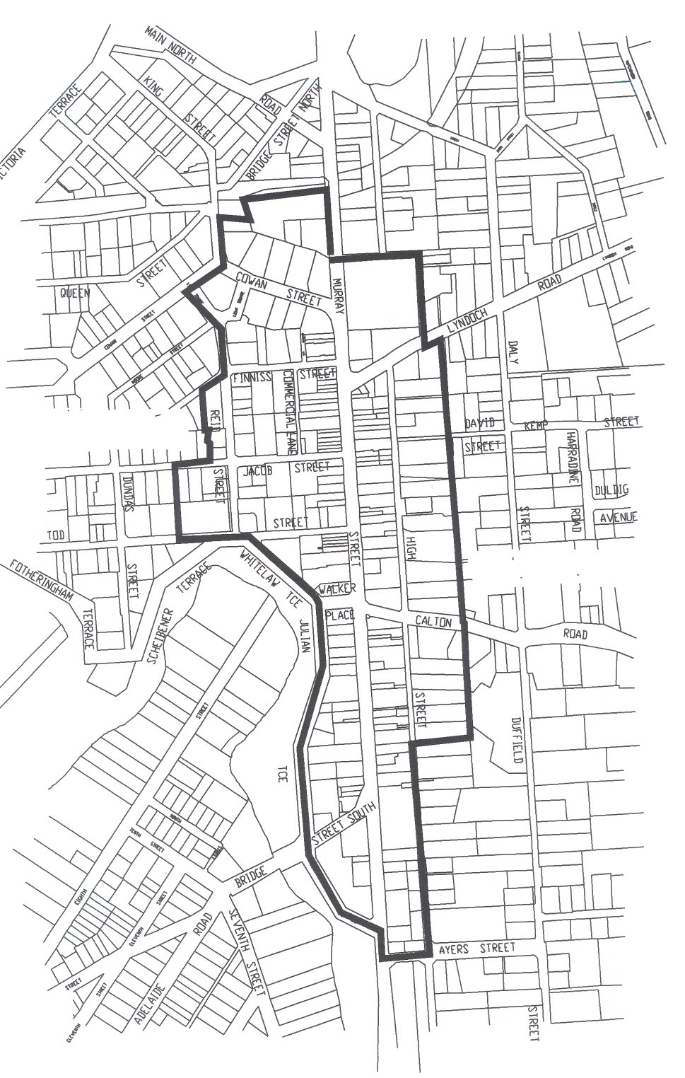
5.2 A separate differential rate in respect of land uses:
Categories 2, 3, 4, 5, 6, 8, and 9 use (Commer
cial—Shop, Commercial—Office, Commercial—Other, Industry—Light, Industry—Other, Vacant Land and other) 0.23367 cents in the dollar.
6. Payment by Instalments
Pursuant to section 181 of the Local Government Act 1999, in respect of the financial year ending on 30 June 2002 all rates are payable in four equal (or approximately equal) quarterly instalments falling due on the following dates:
24 September 2001
14 December 2001
15 March 2002
14 June 2002
7. Rebate of Rates
7.1 In exercise of the powers contained in section 166 (1) (l) of the Act, principal ratepayers of rateable land in land use Categories 1, 8 and 9 where such rateable land is equal or greater than 0.4 hectares and who will not receive a rebate for any other circumstance within Chapter 10 Part 1 Division 5—Rebate of Rates, are granted, for the financial year 2001-2002 a rebate for general rates of 0.17747 cents in the dollar of the capital value of the rateable land.
7.2 In exercise of the powers contained in section 166 (1) (l) of the Act, rebates be provided to Dalkeith Caravan Park, Hillier Park, James Martin Nursing Home, Southern Cross Hostel, Martindale Nursing Home, Trevu Nursing Home and Gawler & District Aged Cottage Homes to have the effect of those rate-payers receiving a maximum rebate of 50% on their 2001-2002 general rates to the extent that those ratepayers pay at least their 2000-2001 general rates plus an additional 6.5%.
J. McEachen, Town Manager

THE BAROSSA COUNCIL
Load Limit—Smyth Road, Tanunda
NOTICE is hereby given that pursuant to section 359 of the Local Government Act 1934, as amended, vehicles of a specific class, being those vehicles over 30 tonnes are excluded from the Smyth Road bridge, Tanunda, commencing from 13 September 2001.
M. Lange, Manager, Works

DISTRICT COUNCIL OF THE COPPER COAST
Development Act 1993
General Plan Amendment Report prepared by the Council—
Draft for Public Consultation
NOTICE is hereby given that the District Council of the Copper Coast has prepared a draft Plan Amendment Report as it affects the whole of the council area.
The draft Plan Amendment report will consolidate the Development Plans for the former District Council of Northern Yorke Peninsula and the Corporate Town of Wallaroo.
Matters addressed in the draft Plan Amendment Report include:
• A regional approach to development.
• Introduction of common zones.
• Uniform format to the Development Plan.
• Incorporation of the regional provisions of the Yorke Peninsula section of the Development Plan.
• A review of the policies applying to all zones, the introduction of new zones and the modification of existing zone boundaries to reflect existing and proposed future land uses.
• New mapping to reflect the current boundary of the Council area and proposed zones.
The draft Plan Amendment Report and Statement of Investigations will be available for public inspection and purchase at $10 a copy during normal working hours, at the Council Offices at 51 Taylor Street, Kadina, 71 George Street, Moonta, or 5 John Terrace, Wallaroo.
The plan will be on display from Monday, 3 September 2001 to Friday, 2 November 2001.
Written submissions regarding the draft amendment should be lodged no later than 5 p.m. on Friday, 2 November 2001. All submissions should be addressed to The Chief Executive Officer, District Council of the Copper Coast, 51 Taylor Street, Kadina, S.A. 5554, and should clearly indicate whether you wish to be heard in support of your submission.
Copies of all submissions will be available for inspection by interested persons at the council offices from 3 September 2001 until 2 November 2001.
A hearing will be held on Wednesday, 14 November 2001 at 4.30 p.m., in the Council Chambers, 51 Taylor Street, Kadina. The hearing will not be held if no submissions are received or if no submission has a request to be heard.
Dated 27 August 2001.
J. W. Shane, Chief Executive Officer

DISTRICT COUNCIL OF KIMBA
Change of Council Meeting Date and Time
NOTICE is hereby given that the District Council of Kimba resolved at its meeting held on 8 August 2001, to change the date of the scheduled council meeting from 12 September 2001 to 13 September 2001, and that this meeting be held in the Kimba Council Chambers, Cross Street, Kimba, commencing at 4 p.m.
S. R. Cheriton, Chief Executive Officer

DISTRICT COUNCIL OF LE HUNTE
Separate Rate
NOTICE is hereby given that in accordance with section 154 (2) (b) of the Local Government Act 1999, and the prescribed authority of the Minister for Local Government, the District Council of Le Hunte at a meeting held on 20 August 2001 imposed a separate rate of $150 based on a proportional basis of expenditure incurred in maintaining the area. The cottage home units within portion section 157 of Pygery—Wudinna Homes for the Aged identified as being assessments:
92702769000; 927027001; 9270271004; 927027007; 927027300*; 9270274002; 9270275005; 9270276008; 9270277000; 9270278003; 927027810*; 9270278206; 9270278302; 9270278409; 927027860.
A. F. McGuire, Chief Executive Officer

LIGHT REGIONAL COUNCIL
By-law Made Under the Local Government Act 1999
By-law No. 1—Permits and Penalties
TO provide for a permit system and penalties in council by-laws, to clarify the construction of such by-laws and to repeal by-laws.
A. All previous by-laws made by council prior to the date this by-law is made, are hereby repealed.
Permits
1. (1) In any by-law of the council unless the contrary intention is clearly indicated the word ‘permission’ means the permission of the council given in writing.
(2) The council may attach such conditions to a grant of permission as it thinks fit and may vary or revoke such con-ditions or impose new conditions by notice in writing to the permit holder.
(3) Any permit holder shall comply with every such condition.
(4) The council may revoke such grant of permission at any time by notice in writing to the permit holder.
Penalties
2. Any person who commits a breach of any by-law of the council shall be guilty of an offence and, in addition to any other penalty that may be imposed, shall be liable to a further penalty for every day on which the offence is continued, such penalty being the maximum amount referred to in the Local Government Act 1934, as amended, and/or the Local Government Act 1999, section 246 (3) (g), which may be prescribed by the by-law for offences.
Construction
3. Every by-law of the council shall be subject to any Act of Parliament and Regulations made thereunder.
The foregoing by-law was duly made and passed at a meeting of the Light Regional Council held on 21 August 2001, by an absolute majority of the members for the time being constituting the council, there being at least two-thirds of the members present.
P. J. Beare, Chief Executive Officer

LIGHT REGIONAL COUNCIL
By-law Made Under the Local Government Act 1999
By-law No. 2—Moveable Signs
TO set standards for moveable signs on streets and roads and to provide conditions for and the placement of such signs.
Definitions
1. In this by-law:
(1) ‘footpath area’ means that part of a street or road between the boundary of the street or road and the edge of the carriageway on the same side as that boundary;
(2) ‘moveable sign’ has the same meaning as in the Local Government Act 1999;
(3) ‘authorised person’ as defined in the Local Government Act 1999.
Construction
2. A moveable sign displayed on a public street or road:
(1) shall be of the kind known as an ‘A’ Frame or Sand-wich Board sign, an ‘inverted “T”’ sign, or a flat sign;
(2) (a) shall be constructed and maintained in good quality and condition;
(b) shall be of strong construction with no sharp or jagged edges or corners;
(c) shall not be unsightly or offensive in appearance;
(3) shall:
(a) be constructed of timber, metal, plastic or plastic coated cardboard, or a mixture of such materials;
(b) not exceed 1 200 mm in height, 800 mm in width or 800 mm in depth;
(c) not have a display area on any side exceeding 1 m²;
(4) shall not be likely to fall over or collapse;
(5) in the case of an ‘A’ Frame or Sandwich Board sign:
(a) shall be hinged or joined at the top;
(b) shall be of such construction that its sides shall be securely fixed or locked in position when erected;
(6) in the case of an ‘inverted “T”’ sign, shall contain no struts or members that run between the display area and the base of the sign.
Position
3. A moveable sign shall not be positioned on a public street or road:
(1) unless it rests on the surface of the footpath area but no closer to the carriageway than 400 mm;
(2) on a footpath area that is of less width than 2.1 m;
(3) on a footpath area attached to or within 1.2 m of any other structure, fixed object, tree, bush or plant (excep-ting a building adjacent to the footpath area);
(4) within 1 m of an entrance to premises adjacent thereto;
(5) on the sealed part of any footpath area, if there is any unsealed part of that area on which the sign can be placed in accordance with this by-law; or
(6) on or attached to a vehicle or object, tree, bush or plant.
Restrictions
4. A moveable sign shall not be placed on a public street or road:
(1) (a) unless it only displays material which advertises a business being conducted on premises which are adjacent to the sign, or the products available from that business;
(b) if another moveable sign which relates to the same business is already displayed on the street or road;
(c) unless the business to which it relates is open;
(2) in a wind, if it is likely to be blown over or swept away;
(3) in such a position or in circumstances that the safety of any user of the street or road is at risk;
(4) during the hours of darkness unless it is clearly lit.
Appearance
5. A moveable sign displayed on a public street or road shall:
(1) be painted or otherwise detailed in a competent and professional manner;
(2) be attractive, legible and simply worded to convey a precise message;
(3) be of such design and contain such colours which are compatible with the architectural design of the premises adjacent to the sign, and which relate well to the overall amenity of the locality in which it is situated;
(4) contain combinations of colour and typographical styles which blend in with and reinforce the heritage qualities of the locality and the buildings where it is situated;
(5) not rotate, contain a flashing light, or have balloons, flags, streamers or other things attached to it.
The foregoing by-law was duly made and passed at a meeting of the Light Regional Council held on 21 August 2001, by an absolute majority of the members for the time being constituting the council, there being at least two-thirds of the members present.
P. J. Beare, Chief Executive Officer

LIGHT REGIONAL COUNCIL
By-law Made Under the Local Government Act 1999
By-law No. 3—Streets and Roads
FOR the management, regulation and control of activities on streets and roads.
Definitions
1. In this by-law:
(1) ‘Authorised Person’ means a person appointed an authorised person pursuant to section 260 of the Local Government Act 1999.
(2) ‘Road’ has the same meaning as in the Local Govern-ment Act 1999.
(3) ‘Permission’ means permission of council given in writing.
Activities Requiring Permission
2. No person shall without permission on any street or road:
Vehicles Generally
(1) (a) being the driver of a vehicle, fail to obey the indications given by any sign erected by or with the authority of the council, for regulating traffic or indicating the direction or route to be followed by traffic on that land;
(b) drive or propel a vehicle on any part thereof where the council has excluded vehicles generally or of that class pursuant to sections 32 or 33 of the Road Traffic Act 1961 or section 359 of the Local Government Act 1934;
Work on Vehicles
(2) perform the work of repairing, washing, painting, panel beating or other work of any nature on or to any vehicle, except for running repairs in the case of a breakdown;
Preaching
(3) preach or harangue;
Donations
(4) ask for or receive or indicate that he or she desires a donation of money or any other thing;
Amplification
(5) use an amplifier or other device whether mechanical or electrical for the purposes of amplifying sound or broadcasting announcements or advertising;
Canvassing
(6) convey any advertising, religious or other message to any bystander, passer by or other person;
Posting of Bills etc.
(7) post any bills, advertisements or other papers or items on a building or structure on a street or road;
Movement of Animals on Roads
(8) (a) the owner or person in charge of any cattle or horses that are driven over, across or along any road in any town or township, shall forthwith after such animals have completed their passage remove any dung left by those animals during their passage;
(b) the person responsible for looking after any cattle, sheep, goats, horses or other farm animals (but not dogs or cats) shall ensure that any of those animals do not move across, along or on any road unattended.
Removal of Animals and Persons
3. (1) If any animal is found on any part of a street and roads in breach of a by-law:
(a) any person in charge of the animal shall forthwith remove it from that part on the request of an authorised person; and
(b) any authorised person may remove it therefrom if the person fails to comply with the request, or if no person is in charge of the animal.
(2) Any authorised person may remove any person from local government land who is found committing a breach of a by-law.
The foregoing by-law was duly made and passed at a meeting of the Light Regional Council held on 21 August 2001, by an absolute majority of the members for the time being constituting the council, there being at least two-thirds of the members present.
P. J. Beare, Chief Executive Officer

LIGHT REGIONAL COUNCIL
By-law Made Under the Local Government Act 1999
By-law No. 4—Local Government Land
FOR the management and regulation of activities and access to local government land vested in or under the control of council (except streets and roads).
Definitions
1. In this by-law:
(1) ‘local government land’ means land owned by the council or under the council’s care, control and management (except streets and roads);
(2) ‘the Council’ means the Light Regional Council;
(3) ‘authorised person’ as defined in the Local Government Act 1999.
Activities requiring permission
2. No person shall without permission on any local govern-ment land:
Vehicles Generally
(1) (a) being the driver of a vehicle, fail to obey the indications given by any sign erected by or with the authority of the council, for regulating traffic or indicating the direction or route to be followed by traffic on that land;
(b) drive or propel a vehicle on any part thereof where the council has excluded vehicles generally or of that class pursuant to sections 32 or 33 of the Road Traffic Act 1961 or section 359 of the Local Government Act 1934;
Vehicles on parklands and cemeteries
(2) comprising a cemetery or parkland or reserve:
(a) drive or propel a vehicle thereon, (except a wheel-chair), unless on an area, path, or road constructed or set aside by the council for the parking or travelling of that kind of vehicle;
(b) promote, organise or take part in any race, test or trial of any kind in which motor vehicles, motor cycles, motor scooters, or bicycles take part (except in parklands or a reserve on a properly constructed area for the purpose);
Trading
(2) (a) carry on the business of buying, selling, offering or exposing for sale or the hiring or leasing of any goods, merchandise, commodity, article, service or thing (including any vehicle watercraft or aircraft); or
(b) set up a van or other vehicle or stall or other structure, tray, carpet or device for the purpose of buying, selling, offering or exposing for sale or the hiring or leasing of any goods, merchandise, commodity, article, service or thing (including any vehicle, watercraft or aircraft);
Advertising
(3) display any sign for the purpose of commercial adver-tising, other than a moveable sign which is displayed on a public street or road in accordance with any by-law of the council concerning moveable signs;
Fires
(4) light or maintain any fire, except:
(a) in a place provided by the council for that purpose; or
(b) in a portable barbecue;
Tents
(5) erect any tent, booth, marquee or other structure (except the council or Government);
Camping
(6) camp or stay overnight;
Attachments to trees
(7) attach, hang or fix any rug, blanket, sheet, rope or other material to any tree, shrub, plant, tree guard, tree stake, notice board, seat, fence, post, wall or other item or structure the property of council;
Flora and fauna
(8) subject to the Native Vegetation Act 1991, and the National Parks and Wildlife Act 1972:
(a) damage, pick or interfere with any plant or flower thereon; or
(b) tease, or cause harm to any animal, bird or marine creature;
Athletic and ball sports
(9) (a) promote, organise or take part in any organised athletic sport;
(b) to which this subparagraph 2 (9) (b) applies, play or practice any game, which involves kicking, hitting or throwing a ball;
No Liquor
(10) to which this paragraph 2 (10) applies, (except streets and roads which are not part of parklands or reserves), consume, carry or be in possession or charge of any liquor;
Swimming
(11) swim or bathe in any pond or lake to which this sub-paragraph applies;
Fishing
(12) (a) fish in any pond or lake to which this subparagraph 2 (12) (a) applies;
(b) fish from any bridge or structure;
Animals in Ponds
(13) to which this paragraph 2 (13) applies, allow or suffer any animal to enter or remain in a pond or lake;
Removal of Soil etc.
(14) carry away or remove any soil, sand, timber, stones, pebbles, other inorganic or organic materials or any part of the land;
Fruit Picking
(15) pick fruits, nuts or berries from any tree or bush;
Weddings and Private Ceremonies
(16) conduct or participate in a group ceremony on any land or reserve;
Cemeteries
(17) comprising a cemetery:
(a) bury or inter any human or animal remains;
(b) erect any memorial;
Use of Boats
(18) use a boat in any pond or lake to which this sub-paragraph 2 (18) applies;
Closed Lands
(19) enter or remain on any part of local government land:
(a) at any time during which the council has declared that it shall be closed to the public;
(b) where the land is enclosed with fences and/or walls and gates, at any time when the gates have been closed or locked; or
(c) where admission charges apply, to enter without paying charges.
Prohibited activities
3. No person shall on local government land:
Smoking
(1) smoke tobacco or any other substance in any building or part thereof to which this subparagraph 3 (1) applies;
Use of equipment
(2) use any equipment or council property other than in the manner and for the purpose for which it was designed or set aside;
Annoyances
(3) annoy or unreasonably interfere with any other person’s normal use of the land by making noise or creating a disturbance;
Interference with permitted use
(4) interrupt or disrupt to interfere with any person’s use of parklands or reserves for which permission has been granted.
Restricted Lands
4. No person shall enter or remain on any part of local government land except a public street or road:
(1) at any time during which the council has by resolution declared that part to be closed to the public, and which is indicated by sign adjacent to the entrance to the part; or
(2) where the land is enclosed with fences and/or walls, and gates, at any time when the gates have been closed and locked; or
(3) at any time when the council has fixed a fee for entry to that part, without payment of the fee, or otherwise without permission.
Removal of Animals and Persons
5. (1) If any animal is found on part of council land in breach of a by-law:
(a) any person in charge of the animal shall forthwith remove it from that part on the request of an authorised person; and
(b) any authorised person may remove it therefrom if the person fails to comply with the request, or if no person is in charge of the animal.
(2) Any authorised person may remove any person from local government land who is found committing a breach of a by-law.
Application
Any of paragraphs 2 (9) (b), 2 (10), 2 (11), 2 (12) (a), 2 (13), 2 (18) or 3 (1) of this by-law shall apply only in such portion or portions of the area as the council may by resolution direct (in accordance with section 246 (3) (e) of the Local Government Act 1999).
The foregoing by-law was duly made and passed at a meeting of the Light Regional Council held on 21 August 2001, by an absolute majority of the members for the time being constituting the council, there being at least two-thirds of the members present.
P. J. Beare, Chief Executive Officer

LIGHT REGIONAL COUNCIL
By-law Made Under the Dog and Cat Management Act 1995 and the Local Government Act 1999
By-law No. 5—Dogs
FOR the control of dogs, within an area, to limit the number of dogs kept in premises and require dogs to be effectively secured.
Definitions
1. In this by-law:
(1) ‘dog’ means a canine of the age of three months or older;
(2) ‘small dwelling’ means the premises of a self-contained dwelling either:
(a) commonly known as a flat, service flat, home unit or the like; or
(b) which is contained in a separate strata title;
(3) ‘approved kennel establishment’ means a building, structure or area approved by the relevant authority, pursuant to the Development Act 1993, for the keeping of dogs on a temporary or permanent basis.
Limit on Number of Dogs
2. (1) The limit on the number of dogs kept shall be:
(a) in a small dwelling, one dog; and
(b) in premises other than a small dwelling, two dogs.
(2) No person shall, without obtaining the written permission of the council, keep any dog on any premises where the number of dogs on those premises exceeds the limit unless the premises are an approved kennel establishment.
Dog free areas
3. No person shall in a public place to which this paragraph applies cause, suffer or permit any dog under that person’s control, charge or authority to be in, or remain in that place.
Dogs on leash areas
4. No person shall in a public place to which this paragraph applies, cause, suffer or permit any dog under that person’s control, charge or authority to be or remain in that public place unless such dog is secured by a strong leash not exceeding 2m in length and either tethered securely to a fixed object or held by a person capable of controlling the dog and preventing it from being a nuisance or a danger to other persons.
Dog exercise areas
5. (1) Any person may enter upon any public place to which this paragraph applies for the purpose of exercising a dog under his or her control.
(2) Where a person enters upon any such public place for that purpose, he or she shall ensure that the dog or dogs are under his or her control and remain under control (within the meaning of the Dog and Cat Management Act 1995) while on that land.
(3) Signs shall be erected to denote the public places to which this paragraph applies, and information shall be provided in a manner determined by the Chief Executive Officer of the Council to inform the public about such land.
Application of paragraphs
6. Any of paragraphs 3, 4, and 5 (1) of this by-law shall apply only in such portion or portions of a public place as the council may by resolution direct (in accordance with section 246 (3) (e) of the Local Government Act 1999).
The foregoing by-law was duly made and passed at a meeting of the Light Regional Council held on 21 August 2001, by an absolute majority of the members for the time being constituting the council, there being at least two-thirds of the members present.
P. J. Beare, Chief Executive Officer

DISTRICT COUNCIL OF PETERBOROUGH
Adoption of Valuation
NOTICE is hereby given that the District Council of Peterborough at the meeting of council held on 20 August 2001 adopted, in accordance with section 167 (2) (a) of the Local Government Act 1999, for the 2001-2002 financial year, the Valuer-General’s valuation of site value for the former District Council of Peterborough area totalling $34 015 460 and capital value for the former Corporation of the Town of Peterborough area totalling $30 327 500 and thereby specified 7 July 2001 as the day as and from which such valuation shall become the valuation of the council.
Declaration of Rates
Notice is hereby given that at the meeting of the District Council of Peterborough held on 20 August 2001, it was resolved that in exercise of the powers contained in section 153 (1) (b) of the Local Government 1999, in respect of the financial year ending 30 June 2002, declared differential general rates as follows:
(a) a rate of 16.05 cents in the dollar on the site value of all rateable property within the townships of Yongala, Hillside, Farraville, Petersville, East Terrace and Rosa Terrace;
(b) a rate of 25.50 cents in the dollar on the site value of all rateable property within the township of Oodlawirra;
(c) a rate of 1.55 cents in the dollar on the capital value of all rateable properties within the township of Peterborough;
(d) a rate of 0.288 cents in the dollar on the site value of all rateable property within the area of the council outside the townships referred to above.
Minimum Amount
Council pursuant to section 158 (1) (a) of the Local Government Act 1999, fixed a minimum amount payable by way of rates for all rateable property for the 2001-2002 financial year of $370 for the township of Peterborough, $120 for the Townships of Oodlawirra and Yongala and the remainder of the council area.
R. R. Mooney, Chief Executive Officer

ROXBY DOWNS COUNCIL
Adoption of Valuation and Declaration of Rates
NOTICE is hereby given that the Municipal Council of Roxby Downs, for the financial year ending 30 June 2002, and in exercise of the powers contained in Chapter 10 of the Local Government Act 1999 and the Roxby Downs (Indenture Ratification) Act 1982, at a meeting, declared the following resolutions:
Adoption of Valuation
1. (1) The rates assessed on the rateable land in the area of the council will be based on the capital value of land for all rateable land.
(2) Pursuant to section 167 (2) (a) of the Local Government Act 1999, the most recent valuation of the Valuer-General available to the council of the capital value of land within the council’s area be adopted, totalling $192 334 100.
Fixed Charge
2. A fixed charge of $150 is imposed in respect of each separate piece of rateable land in the council area.
Declaration of Differential General Rates
3. Differential General Rates are declared in accordance with the use of the land in accordance with the differentiating factors specified at Regulation 10 of the Local Government (General) Regulations 1999 as follows:
(1) Residential Land—a differential rate of 0.454 cents in the dollar on the capital value of such land.
(2) Commercial—Shops, Commercial—Office, Commer-cial—Other—a differential rate of 0.680 cents in the dollar on the capital value of such land.
(3) Industrial—Light, Industrial—Other, Primary Produc-tion and Other—a differential rate of 0.640 cents in the dollar on the capital value of such land.
(4) Vacant Land—a differential rate of 0.380 cents in the dollar on the capital value of such land.
Service Charges
4. A service charge of $100 is imposed upon each separate piece of rateable land to which the council makes available a collection, treatment and disposal of domestic waste service.
Dated 24 August 2001.
W. J. Boehm, Administrator

SOUTHERN MALLEE DISTRICT COUNCIL
Temporary Road Closure
NOTICE is hereby given that pursuant to section 359 of the Local Government Act 1934, as amended, council has approved of the temporary closure of Ivetts, Lameroo South and Trowbridge roads for the purpose of a Mock Road Accident to be conducted by the Lameroo Regional Community School Drug Strategy Team on 19 September 2001 from 9 a.m. to noon.
P. Wood, Chief Executive Officer

WATTLE RANGE COUNCIL
Exclusion of Community Land
NOTICE is hereby given that council, at its meeting held on 21 August 2001, carried the following resolution:
Pursuant to section 193 (2) of the Local Government Act 1999, council resolved to exclude lots 22, 23, 24, 25 and 26 Ross Street, Furner as community land, having concluded its public consultation process.
F. N. Brennan, Chief Executive Officer

IN the matter of the estates of the undermentioned deceased persons:
Collins, Linda Ethel, late of 147 St Bernard’s Road, Ros-trevor, of no occupation, who died on 20 June 2001.
Duncan, Dulcie Joyce, late of 124 East Terrace, Henley Beach, home duties, who died on 17 June 2001.
Egaas, Carmel Mary, late of 3 Whiteleaf Crescent, Glen-gowrie, maried woman, who died on 1 August 1992.
Ewin, Irwin Wentworth, late of 526 Main South Road, Old Noarlunga, retired painter and decorator, who died on 3 July 2001.
Fieldhouse, Arthur Albert, late of 17 Fifth Avenue, Woodville Gardens, retired painter, who died on 8 July 2001.
Freeman, Bridget, late of 360 Senate Road, Risdon Park, retired dressmaker, who died on 26 May 2001.
Goodall, Thomas William Craig, late of 155 Edward Street, Melrose Park, retired senior plant operator, who died on 1 June 2001.
Graham, Roy Leonard, late of 91 Morgan Avenue, Daw Park, retired postman, who died on 15 June 2001.
Hutton, David John, late of 44 West Beach Road, West Beach, maintenance fitter, who died on 8 June 2001.
Jocey-Prior, Brett Allen, late of 31 Pibroch Avenue, Windsor Gardens, care worker, who died on 19 April 2001.
Mostyn, Vauxhall Almond, late of 17 Frederick Street, Glen-gowrie, retired engineer, who died on 28 June 2001.
Sabey, Marjorie Gesche, late of 72 Myrtle Road, Hawthorn-dene, of no occupation, who died on 10 May 2001.
Schaumloffel, Johann Ludwig, late of 52 Lindsay Avenue, Valley View, retired radio engineer, who died on 20 June 2001.
Stewart, Jessie Isobel, late of 285 Goodwood Road, Kings Park, of no occupation, who died on 7 July 2001.
Valentine, Hannah Horne, late of Blamey Road, Elizabeth East, widow, who died on 31 January 2001.
White, Emily Alice, late of 342 Marion Road, North Plympton, retired headmistress, who died on 6 July 2001.
Notice is hereby given pursuant to the Trustee Act 1936, as amended, the Inheritance (Family Provision) Act 1972, and the Family Relationships Act 1975, that all creditors, beneficiaries, and other persons having claims against the said estates are required to send, in writing, to the Public Trustee, 25 Franklin Street, Adelaide, S.A. 5000, full particulars and proof of such claims, on or before 28 September 2001, otherwise they will be excluded from the distribution of the said estate; and notice is also hereby given that all persons who are indebted to the said estates are required to pay the amount of their debts to the Public Trustee or proceedings will be taken for the recovery thereof; and all persons having any property belonging to the said estates are forthwith to deliver the same to the Public Trustee.
Dated 30 August 2001.
J. H. Worrall, Public Trustee

SOUTH AUSTRALIA—In the Supreme Court. No. 226 of 2000. In the matter of Bloomsbury Pty Ltd (in liquidation) (ACN 008 011 863) and in the matter of the Corporations Law.
Notice of Release of Liquidator and Dissolution of the Company
Take notice that by order of the Supreme Court of South Australia dated 15 August 2001, I, John Sheahan, Level 8, 26 Flinders Street, Adelaide, S.A. 5000 the liquidator of the above-named company, was granted my release as liquidator and the company was dissolved as at the date of this order.
Dated 20 August 2001.
J. Sheahan, Liquidator

SOUTH AUSTRALIA—In the Supreme Court. No. 1175 of 2001. In the matter of Cummings Corporations (in liquidation) (ACN 008 291 996) and in the matter of the Corporations Act 2001.
Notice of Release of Liquidator and Dissolution of the Company
Take notice that by order of the Supreme Court of South Australia dated 10 August 2001, I, Austin Robert Meerten Taylor, 99 Frome Street, Adelaide, S.A. 5000, the liquidator of the abovenamed company was granted my release as liquidator and the company was dissolved from that date.
Dated 25 August 2001.
A. R. M. Taylor, Liquidator

SOUTH AUSTRALIA—In the Supreme Court. No. 736 of 2000. In the matter of Leading Investments Pty Ltd (in liquidation) (ACN 091 755 298) and in the matter of the Corporations Law.
Notice of Release of Liquidator and Dissolution of the Company
Take notice that by order of the Supreme Court of South Australia dated 15 August 2001, I, John Sheahan, Level 8, 26 Flinders Street, Adelaide, S.A. 5000 the liquidator of the above-named company, was granted my release as liquidator and the company was dissolved as at the date of this order.
Dated 20 August 2001.
J. Sheahan, Liquidator

PARTNERSHIP ACT 1891
Dissolution of Partnership
NOTICE is hereby given that the partnership between Michael Hamdan and Imad Haddad which carried on business as Pizza Planet was dissolved on 31 March 2001.
Each of the above persons is not responsible for any debts or liabilities incurred in the name of the partnership by the other after the date of dissolution.
Dated 22 August 2001.
M. Hamdan

PARTNERSHIP ACT 1891
Dissolution of Partnership
NOTICE is hereby given that the partnership previously subsisting between the undersigned carrying on business of manufacturing goat products at Two Wells and Cambrai under the firm of Caprine Enterprises, South Australia has been dissolved by mutual consent as from 21 January 2000.
Dated 21 June 2001.
(l.s.) Steven Crawford Nominees Pty Ltd
(l.s.) Leesa Lewis Nominees Pty Ltd

ATTENTION

CUSTOMERS requiring a proof of their notice for inclusion in the Government Gazette, please note that the onus is on you to inform Government Publishing SA of any subsequent corrections by 10 a.m. on Thursday, which is our publication deadline.

For any corrections to your notice please phone 8207 1045 or Fax 8207 1040 before 10 a.m. on Thursday.

If we do not receive any communication by 10 a.m. on Thursday (day of publication) we will presume the notice is correct and will print it as it is.

Remember—the onus is on you to inform us of any corrections necessary to your notice.

NOTE: Closing time for lodging new copy (electronically, fax or hard copy) is 4 p.m. on Tuesday preceding the day of publication. Phone 8207 1045—Fax 8207 1040.
Email: governmentgazette@saugov.sa.gov.au

Printed and published by authority every Thursday by J. D. FERGUSON, Government Printer, South Australia
Price: $4.40, plus postage; to subscribers, $220.20 per annum.
(The above prices are inclusive of GST)

