EXTRAORDINARY GAZETTE



THE SOUTH AUSTRALIAN

GOVERNMENT GAZETTE

PUBLISHED BY AUTHORITY

ALL PUBLIC ACTS appearing in this GAZETTE are to be considered official, and obeyed as such

ADELAIDE, FRIDAY, 16 FEBRUARY 2001

CONTENTS
Page
Appointments, Resignations, Etc. 705
Development Act 1993—Notice 706
National Parks and Wildlife Act 1972—[Republished] 707
Proclamations 704

REGULATIONS
Plumbers, Gas Fitters and Electricians Act 1995—
(No. 11 of 2001) 708
Electoral Act 1985 (No. 12 of 2001) 709
Development Act 1993—
(No. 13 of 2001) 712
(No. 14 of 2001) 714

CRIMES AT SEA ACT 1998 (Act No. 62 of 1998): DAY OF COMMENCEMENT OF SUSPENDED PROVISIONS
Proclamation By The Governor
(l.s.) E. J. Neal
WITH the advice and consent of the Executive Council, I fix 31 March 2001 as the day on which the remaining provisions of the Crimes at Sea Act 1998 will come into operation.
Given under my hand and the Public Seal of South Australia, at Adelaide, 16 February 2001.
By command,
Diana Laidlaw, for Premier
AGCS 9/96

ENVIRONMENT PROTECTION ACT 1993 SECTION 12(3): DESIGNATION OF PUBLIC SERVICE POSITION FOR MEMBERSHIP OF ENVIRONMENT PROTECTION AUTHORITY
Proclamation By The Governor
(l.s.) E. J. Neal
PURSUANT to section 12(3) of the Environment Protection Act 1993 and with the advice and consent of the Executive Council, I—
(a) revoke the proclamation made under that section on
29 September 1994 (see Gazette 29 September 1994 p. 850);
(b) designate the position of Executive Director of the Environment Protection Agency in the Department for Environment and Heritage for the purposes of section 12(1)(b) of that Act.
Given under my hand and the Public Seal of South Australia, at Adelaide, 16 February 2001.
By command,
Diana Laidlaw, for Premier
EH 01/0005CS

NATIONAL PARKS AND WILDLIFE ACT 1972 SECTIONS 30 AND 43: ALTERATION OF BOUNDARIES OF MOUNT BROWN CONSERVATION PARK
Proclamation By The Governor
(l.s.) E. J. Neal
PURSUANT to sections 30 and 43 of the National Parks and Wildlife Act 1972 and with the advice and consent of the Executive Council, I make the following proclamation:
1. I alter the boundaries of the Mount Brown Conservation Park by adding the Crown land described in the Schedule to the park.
2. Subject to clause 4, existing rights of entry, prospecting, exploration or mining under the Mining Act 1971 or the Petroleum Act 2000 may continue to be exercised in respect of the land described in the Schedule.
3. (1) Subject to clause 4, rights of entry, prospecting, exploration or mining may, with the approval of the Minister for Primary Industries and Resources and the Minister for Environ-ment and Heritage, be acquired and exercised pursuant to the Mining Act 1971 or the Petroleum Act 2000, in respect of the land described in the Schedule.
(2) If the Minister for Primary Industries and Resources and the Minister for Environment and Heritage cannot agree as to whether approval should be granted or refused under subclause (1), the Governor may, with the advice and consent of the Executive Council, grant or refuse the necessary approval under that subclause.
4. A person in whom rights of entry, prospecting, exploration or mining are vested pursuant to the Mining Act 1971 or the Petroleum Act 2000, (whether those rights were acquired before or after the making of this proclamation) must not exercise those rights in respect of the land described in the Schedule unless that person complies with the following conditions:
(a) at least three months before commencing any drilling or excavation, any vegetation clearance or the construction of any building or structure not previously authorised, the person must notify the Minister for Primary Industries and Resources and the Minister for Environ-ment and Heritage of the proposed work and must supply each Minister with such information relating to the proposed work as the Minister may require;
(b) the person, in carrying out any work referred to in paragraph (a)—
(i) must comply with such directions as either Minister may give in writing in relation to—
(A) carrying out the work in a manner that minimises damage to the land or the environ-ment or to vegetation or wildlife on the land; or
(B) preserving objects, structures or sites of historical, scientific or cultural interest; or
(C) rehabilitating the land on completion of the work; and
(ii) if the work is being carried out in pursuance of a right of entry, prospecting, exploration or mining acquired after the making of this proclamation—must comply with such directions as the Minister for Primary Industries and Resources and the Minister for Environment and Heritage may give in writing in relation to prohibiting or restricting access to any specified area of the land that the Minister believes would suffer significant detriment as a result of carrying out the work;
(c) if a plan of management is in operation under section 38 of the National Parks and Wildlife Act 1972 in respect of the land, the person must have regard to the provisions of the plan of management;
(d) the person, in addition to complying with any directions given under paragraph (b)—
(i) must take such steps as are reasonably necessary to ensure that objects, structures and sites of historical, scientific or cultural interest and any vegetation or wildlife on the land are not unduly affected by the exercise of those rights; and
(ii) must maintain all work areas in a clean and tidy condition; and
(iii) must, upon the completion of any work, obliterate or remove all installations and structures (other than installations and structures designated by the Minister for Primary Industries and Resources and the Minister for Environment and Heritage as suitable for retention) used exclusively for the purposes of that work; and
(iv) must rehabilitate the land on completion of the work.
Schedule
Sections 209, 212, 324 and 353, Hundred of Woolundunga, County of Frome.
Given under my hand and the Public Seal of South Australia, at Adelaide, 16 February 2001.
By command,
Diana Laidlaw, for Premier
EH01/003CS

PUBLIC SECTOR MANAGEMENT ACT 1995 SCHEDULE 1: PERSONS EXCLUDED FROM PUBLIC SERVICE
Proclamation By The Governor
(l.s.) E. J. Neal
PURSUANT to clause 1(2)(a) of Schedule 1 of the Public Sector Management Act 1995 and with the advice and consent of the Executive Council, I exclude Michael James O’Connell (Victims of Crime Co-ordinator) from the Public Service.
This proclamation will come into force on 1 March 2001.
Given under my hand and the Public Seal of South Australia, at Adelaide, 16 February 2001.
By command,
Diana Laidlaw, for Premier
CSA 01/01CS

SHOP TRADING HOURS ACT 1977 SECTION 13: ALTERATION OF SHOP TRADING HOURS—LOXTON SHOPPING DISTRICT—FEBRUARY 2001
Proclamation By The Governor
(l.s.) E. J. Neal
PURSUANT to section 13 of the Shop Trading Hours Act 1977 and with the advice and consent of the Executive Council, I authorise the opening of all shops in the Loxton Shopping District from 10 a.m. until 4 p.m. on Sunday, 25 February 2001, subject to the conditions specified in the Schedule.
Schedule
This proclamation only authorises the opening of a shop if—
(a) all relevant industrial awards, workplace agreements and enterprise agreements are observed by the shopkeeper and persons employed in the business of the shop during and in relation to the hours specified in this proclamation during which the shop is open; and
(b) subject to an industrial award, workplace agreement or enterprise agreement to the contrary—a person who is employed in the business of the shop is entitled to refuse to work at the shop during the hours specified in this proclamation unless he or she has agreed with the shopkeeper to work during those hours.
Given under my hand and the Public Seal of South Australia, at Adelaide, 16 February 2001.
By command,
Diana Laidlaw, for Premier
MWR01/004 CS

SHOP TRADING HOURS ACT 1977 SECTION 13: ALTERATION OF SHOP TRADING HOURS—LOXTON SHOPPING DISTRICT—EASTER 2001
Proclamation By The Governor
(l.s.) E. J. Neal
PURSUANT to section 13 of the Shop Trading Hours Act 1977 and with the advice and consent of the Executive Council, I authorise the opening of all shops in the Loxton Shopping District from 8.30 a.m. until 12.30 p.m. on Saturday, 14 April 2001, subject to the conditions specified in the Schedule.
Schedule
This proclamation only authorises the opening of a shop if—
(a) all relevant industrial awards, workplace agreements and enterprise agreements are observed by the shopkeeper and persons employed in the business of the shop during and in relation to the hours specified in this proclamation during which the shop is open; and
(b) subject to an industrial award, workplace agreement or enterprise agreement to the contrary—a person who is employed in the business of the shop is entitled to refuse to work at the shop during the hours specified in this proclamation unless he or she has agreed with the shopkeeper to work during those hours.
Given under my hand and the Public Seal of South Australia, at Adelaide, 16 February 2001.
By command,
Diana Laidlaw, for Premier
MWR01/004 CS

STATUTES AMENDMENT AND REPEAL (ATTORNEY-GENERAL’S PORTFOLIO) ACT 2000 (Act No. 57 of 2000): DAY OF COMMENCEMENT OF SUSPENDED PROVISIONS
Proclamation By The Governor
(l.s.) E. J. Neal
WITH the advice and consent of the Executive Council, I fix 31 March 2001 as the day on which the remaining provisions of the Statutes Amendment and Repeal (Attorney-General’s Portfolio) Act 2000 will come into operation.
Given under my hand and the Public Seal of South Australia, at Adelaide, 16 February 2001.
By command,
Diana Laidlaw, for Premier
AGCS 9/96

Department of the Premier and Cabinet
Adelaide, 16 February 2001
HIS Excellency the Governor in Executive Council has been pleased to appoint the undermentioned to the Country Fire Service Board, pursuant to the provisions of the Country Fires Act 1989:
Member: (from 16 February 2001 until 22 December 2002)
Russell Branson
By command,
Diana Laidlaw, for Premier
MES 009/97CS

Department of the Premier and Cabinet
Adelaide, 16 February 2001
HIS Excellency the Governor in Executive Council has been pleased to appoint the undermentioned to the Occupational Health, Safety and Welfare Advisory Committee, pursuant to the provisions of the Occupational Health, Safety and Welfare Act 1986:

Member: (from 16 February 2001 until 27 August 2001)
Nicholas Paul Wilson
Presiding Member: (from 16 February 2001 until 27 August 2001)
Nicholas Paul Wilson
By command,
Diana Laidlaw, for Premier
MWPR 050/00CS

Department of the Premier and Cabinet
Adelaide, 16 February 2001
HIS Excellency the Governor in Executive Council has been pleased to appoint the undermentioned to the Adelaide Festival Centre Trust, pursuant to the provisions of the Adelaide Festival Centre Trust Act 1971:
Trustee: (from 16 February 2001 until 16 January 2004)
Pearce MacArthur Bowman
By command,
Diana Laidlaw, for Premier
ACD 002/94CS

Department of the Premier and Cabinet
Adelaide, 16 February 2001
HIS Excellency the Governor in Executive Council has been pleased to appoint the undermentioned to the South Australian Community Housing Authority, pursuant to the provisions of the South Australian Co-operative and Community Housing Act 1991:
Member: (from 16 February 2001 until 15 February 2002)
Gordon Cleve Folland
By command,
Diana Laidlaw, for Premier
MHS 21/98CS

Department of the Premier and Cabinet
Adelaide, 16 February 2001
HIS Excellency the Governor in Executive Council has been pleased to appoint the undermentioned to the History Trust of South Australia, pursuant to the provisions of the History Trust of South Australia Act 1981:
Member: (from 16 February 2001 until 30 June 2001)
Margaret Allen
Chairman: (from 16 February 2001 until 10 March 2002)
Alec Khoo
By command,
Diana Laidlaw, for Premier
ACD 010/94CS

Department of the Premier and Cabinet
Adelaide, 16 February 2001
HIS Excellency the Governor in Executive Council has been pleased to appoint the undermentioned to the Adelaide Entertain-ments Corporation Board, pursuant to the provisions of the Public Corporations Act 1993:
Director: (from 16 February 2001 until 3 February 2002)
Allison Lesley Ashby
Director: (from 16 February 2001 until 3 February 2003)
Gay Michele Wallace
By command,
Diana Laidlaw, for Premier
MTOR 0005/98CS

Department of the Premier and Cabinet
Adelaide, 16 February 2001
HIS Excellency the Governor in Executive Council has been pleased to appoint Michael James O’Connell to the position of Victims of Crime Co-ordinator attached to the Attorney-General’s Office, pursuant to section 68 of the Constitution Act 1934.
By command,
Diana Laidlaw, for Premier
CSA 01/01

Department of the Premier and Cabinet
Adelaide, 16 February 2001
HIS Excellency the Governor in Executive Council has been pleased to declare the ‘Mid Murray Council Development Plan—River Murray Valley Plan Amendment’ to be an authorised Plan Amendment and fix 16 February 2001 as the day on which it will come into operation, pursuant to section 27 (1) of the Development Act 1993.
By command,
Diana Laidlaw, for Premier
MTUP-PL 35/00CS

DEVELOPMENT ACT 1993, SECTION 27 (1): MID MURRAY COUNCIL DEVELOPMENT PLAN—RIVER MURRAY VALLEY PLAN AMENDMENT
Preamble
The Minister for Transport and Urban Planning has approved the amendment entitled ‘Mid Murray Council Development Plan—River Murray Valley Plan Amendment’ (the Plan Amend-ment) and has referred it to the Governor.
Notice
PURSUANT to section 27 (1) of the Development Act 1993, I, the Governor with the advice and consent of the Executive Council, declare the Plan Amendment to be an authorised Plan Amendment and fix 16 February 2001, as the day on which it will come into operation.
Dated 16 February 2001.
E. J. Neal, Governor
MTUP CAB 57/00

[Republished]
NATIONAL PARKS AND WILDLIFE ACT 1972
Declaration of Highland Valley Sanctuary
I, IAIN EVANS, Minister for Environment and Heritage and Minister of the Crown for the time being administering the National Parks and Wildlife Act 1972, being of the opinion that it is desirable to conserve the animals and plants for which the land depicted as a sanctuary in the Schedule hereto is a natural habitat or environment and having received all necessary consents, do hereby declare the said land to be a sanctuary for the purposes of the said Act.
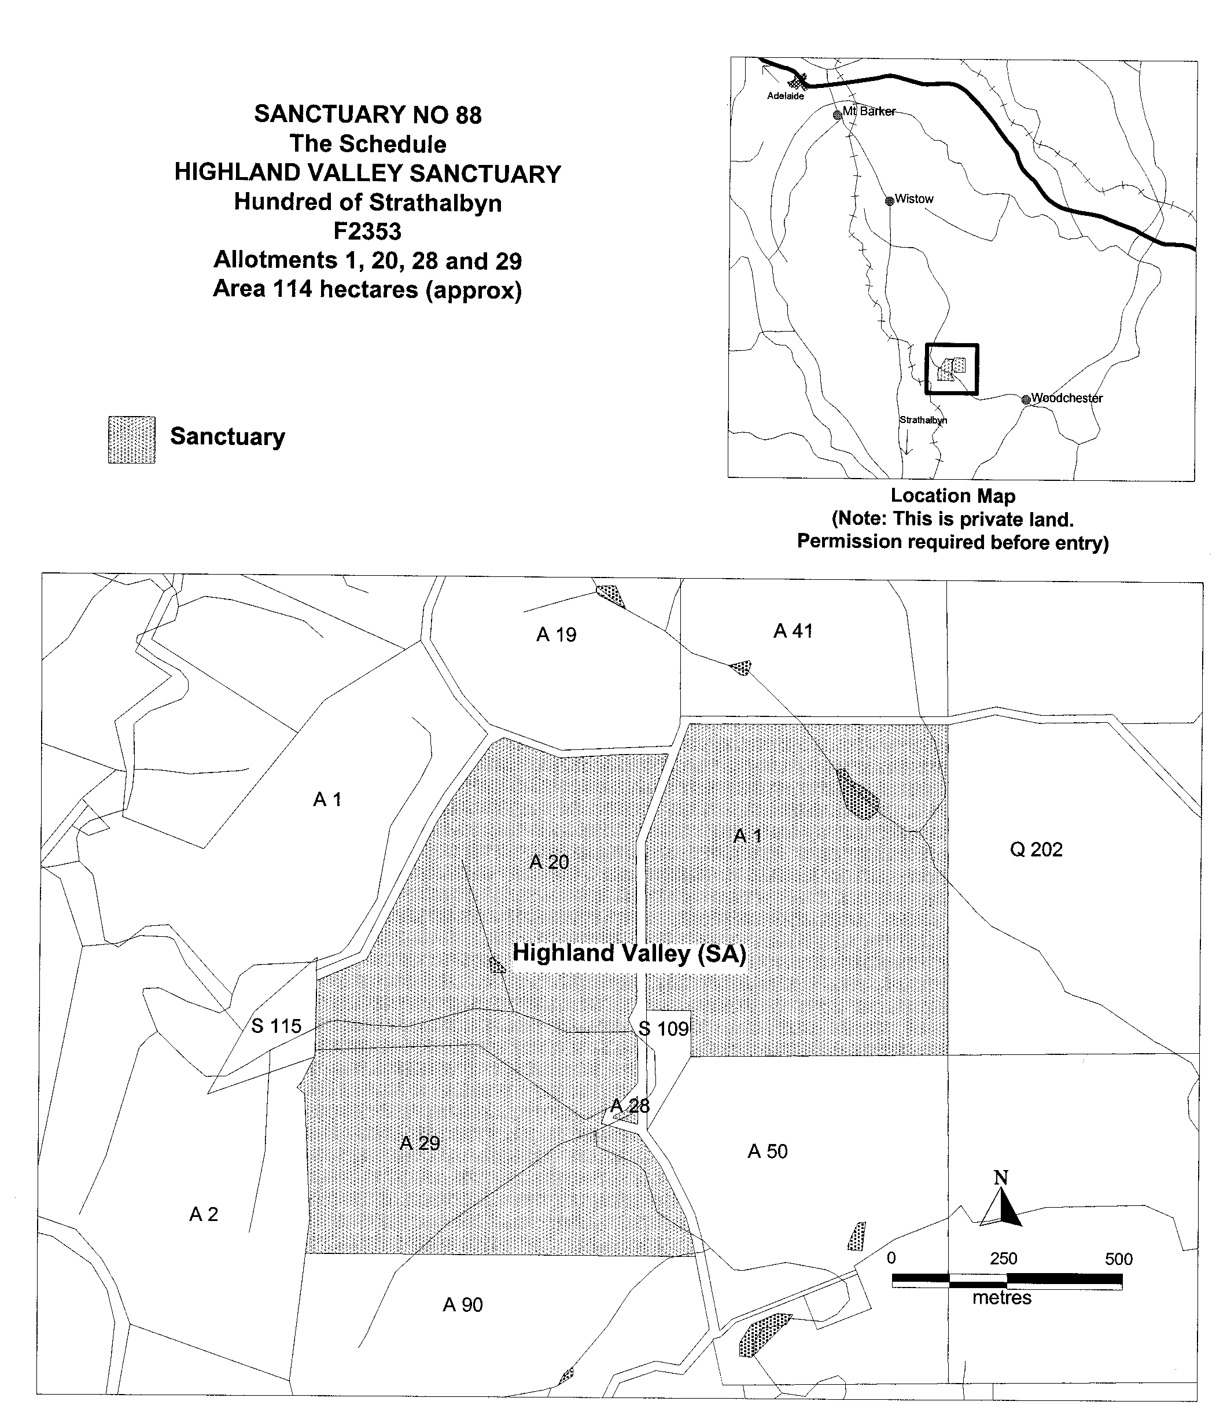
Dated 23 January 2001.

Iain Evans, Minister for Environment and Heritage

REGULATIONS UNDER THE PLUMBERS, GAS FITTERS AND ELECTRICIANS ACT 1995
────
No. 11 of 2001
────
At the Executive Council Office at Adelaide 16 February 2001

PURSUANT to the Plumbers, Gas Fitters and Electricians Act 1995 and with the advice and consent of the Executive Council, I make the following regulations.
E. J. NEAL Governor

PURSUANT to section 10AA(2) of the Subordinate Legislation Act 1978, I certify that, in my opinion, it is necessary or appropriate that the following regulations come into operation as set out below.

K. T. GRIFFIN Minister for Consumer Affairs
───────────────────
SUMMARY OF PROVISIONS
1. Citation
2. Commencement
3. Variation of reg. 4—Exemptions
───────────────────

Citation
1. The Plumbers, Gas Fitters and Electricians Regulations 1995 (see Gazette 29 June 1995 p. 3085), as varied, are referred to in these regulations as "the principal regulations".

Commencement
2. These regulations come into operation on the day on which they are made.

Variation of reg. 4—Exemptions
3. Regulation 4 of the principal regulations is varied by striking out paragraph (b) of subregulation (6) and substituting the following paragraph:

(b) gas fitting—

(i) consisting of connecting or disconnecting a gas cylinder and portable equipment that utilises gas contained in the cylinder; or

(ii) in respect of which a permit is required under the Dangerous Substances Regulations 1998 if carried out by the holder of such a permit;.

MWR 00/039 CS R. DENNIS Clerk of the Council

REGULATIONS UNDER THE ELECTORAL ACT 1985
────
No. 12 of 2001
────
At the Executive Council Office at Adelaide 16 February 2001

PURSUANT to the Electoral Act 1985 and with the advice and consent of the Executive Council, I make the following regulations.
E. J. NEAL Governor

PURSUANT to section 10AA(2) of the Subordinate Legislation Act 1978, I certify that, in my opinion, it is necessary or appropriate that the following regulations come into operation as set out below.

K. T. GRIFFIN Attorney-General
───────────────────
SUMMARY OF PROVISIONS

1. Citation
2. Commencement
3. Variation of reg. 5—Forms
4. Variation of Sched.—Forms
───────────────────

Citation
1. The Electoral Regulations 1997 (see Gazette 28 August 1997 p. 535), as varied, are referred to in these regulations as "the principal regulations".

Commencement
2. These regulations come into operation on the day on which they are made.

Variation of reg. 5—Forms
3. Regulation 5 of the principle regulations is varied by inserting after its present contents (now to be designated as subregulation (1) the following subregulation:

(2) For the purposes of Legislative Council elections—

(a) Form 1 must be used where there are 20 or less groups of candidates and individual candidates to be printed on the ballot paper; and

(b) Form 1A must be used where there are more than 20 groups of candidates and individual candidates to be printed on the ballot paper.

Variation of Sched.—Forms
4. The Schedule of the principal regulations is varied—

(a) by striking out the item for Form 1 in the list of contents of forms and substituting the following items:

Form 1 Ballot paper No. 1 for Legislative Council election (Section 61 of the Act)—for 20 or less groups of candidates and individual candidates

Form 1A Ballot paper No. 2 for Legislative Council election (Section 61 of the Act)—for more than 20 groups of candidates and individual candidates;

(b) by striking out Form 1 and substituting the following forms:

FORM 1
Ballot paper No. 1 for Legislative Council Election

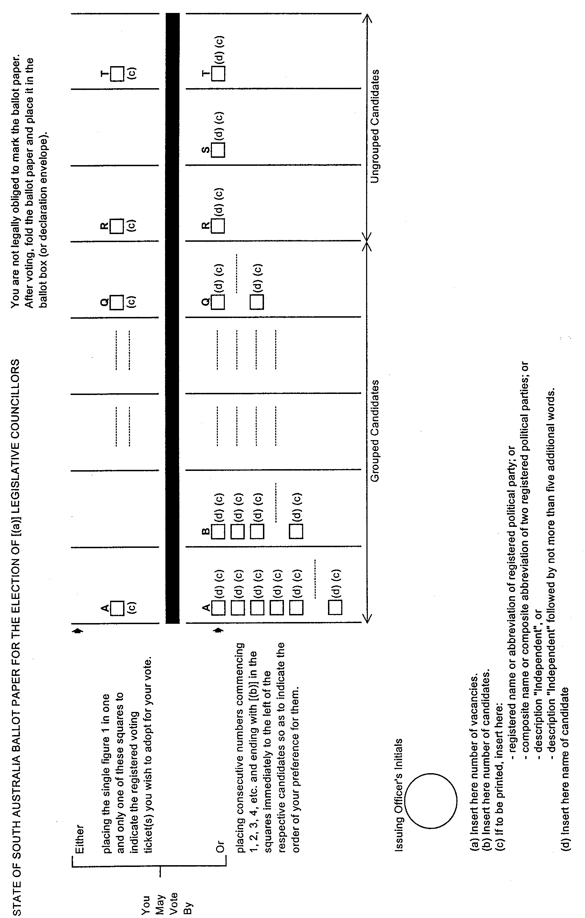

FORM 1A
Ballot Paper No. 2 for Legislative Council Election

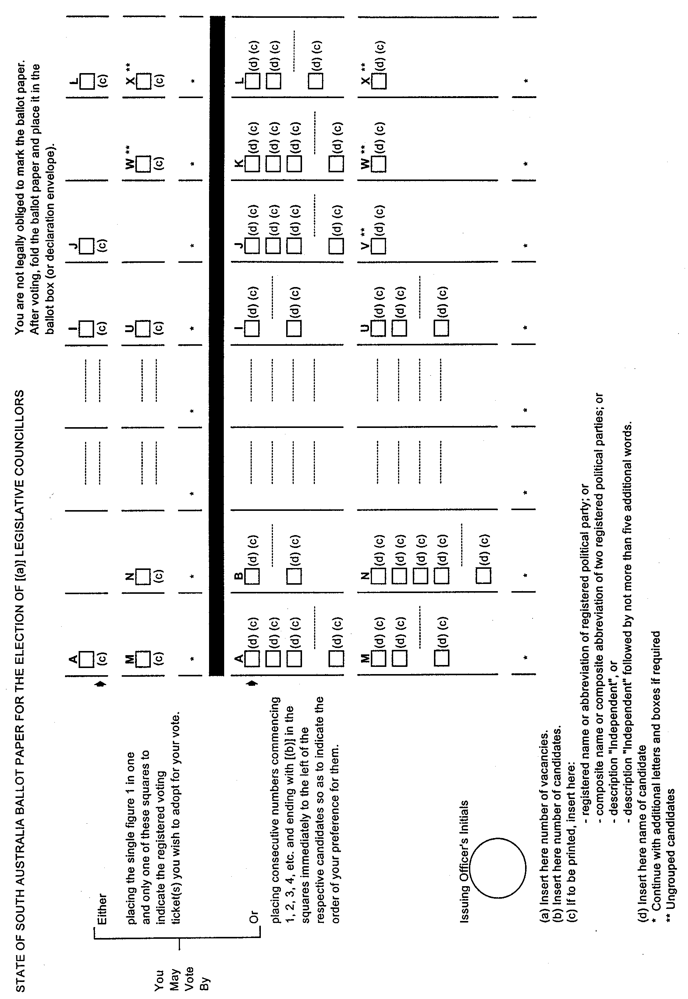

CSA 13/00 R. DENNIS Clerk of the Council
REGULATIONS UNDER THE DEVELOPMENT ACT 1993
────
No. 13 of 2001
────
At the Executive Council Office at Adelaide 16 February 2001

PURSUANT to the Development Act 1993 and with the advice and consent of the Executive Council, I make the following regulations.
E. J. NEAL Governor

PURSUANT to section 10AA(2) of the Subordinate Legislation Act 1978, I certify that, in my opinion, it is necessary or appropriate that the following regulations come into operation as set out below.

DIANA LAIDLAW Minister for Transport and Urban Planning
───────────────────
SUMMARY OF PROVISIONS

1. Citation
2. Commencement
3. Variation of Schedule 4
4. Variation of Schedule 10
───────────────────

Citation
1. The Development Regulations 1993 (see Gazette 27 October 1993 p. 1954), as varied, are referred to in these regulations as "the principal regulations".

Commencement
2. These regulations will come into operation on the day on which they are made.

Variation of Schedule 4
3. Schedule 4 of the principal regulations is varied by striking out from Part 1 "in the River Murray Flood Zone," and substituting "development in the River Murray Flood Zone or the River Murray Zone with the exception of the Primary Production Policy Area within that zone,".

Variation of Schedule 10
4. Schedule 10 of the principal regulations is varied—

(a) by striking out the heading to clause 8 and substituting the following heading:

Conservation Zones or River Murray Zone (Conservation Policy Area);

(b) by inserting in clause 8 "or in the River Murray Zone (Conservation Policy Area) in the Development Plan that relates to the area of the Mid Murray Council" after "Conservation Zone delineated in a Development Plan";

(c) by striking out the heading to clause 9 and substituting the following heading:

River Murray Zones;

(d) by striking out from clause 9 "this clause" and substituting "this subclause";

(e) by striking out from clause 9 "the Mid Murray Council,";

(f) by inserting after the present contents of clause 9 (as varied by paragraphs (d) and (e) and now to be designated as subclause (1)) the following subclause:

(2) Those classes of development set out in the schedule to this subclause in the River Murray Zone in the Development Plan that relates to the Mid Murray Council, other than—

(a) development in the Primary Production Policy Area or the River Settlement Policy Area within that zone; or

(b) in respect of development within the ambit of item B—development in the Shack Settlement Policy Area within that zone.

SCHEDULE

A. The division of an allotment.

B. The erection or construction of a dwelling on an allotment where no dwelling currently exists (but not the alteration of or addition to an existing dwelling).

C. The erection or construction of a marina, or mooring facilities, for more than five boats.

D. The erection, construction, conversion or alteration of, or addition to, residential accommodation for tourists.

E. The erection or construction of a building except where the building will be used in conjunction with a dwelling, and the dwelling and the building are situated on land held by one or more persons pursuant to the one tenure.

MFTUP 35/00 CS R. DENNIS Clerk of the Council

REGULATIONS UNDER THE DEVELOPMENT ACT 1993
────
No. 14 of 2001
────
At the Executive Council Office at Adelaide 16 February 2001

PURSUANT to the Development Act 1993 and with the advice and consent of the Executive Council, I make the following regulations.
E. J. NEAL Governor

PURSUANT to section 10AA(2) of the Subordinate Legislation Act 1978, I certify that, in my opinion, it is necessary or appropriate that the following regulations come into operation as set out below.

DIANA LAIDLAW Minister for Transport and Urban Planning
───────────────────
SUMMARY OF PROVISIONS

1. Citation
2. Commencement
3. Variation of Schedule 4
4. Variation of Schedule 9
───────────────────

Citation
1. The Development Regulations 1993 (see Gazette 27 October 1993 p. 1954), as varied, are referred to in these regulations as "the principal regulations".

Commencement
2. These regulations will come into operation on the day on which they are made.

Variation of Schedule 4
3. Schedule 4 of the principal regulations is varied—

(a) by inserting in paragraph (c) of clause 1 in Part 1 ", other than a dwelling (including an unoccupied dwelling) within a designated area under subclause (2)" after "removal of a building";

(b) by inserting after the present contents of clause 1 in Part 1 (as varied by paragraph (a) and now to be designated as subclause (1)) the following subclauses:

(2) For the purposes of subclause (1)(c), a designated area is an area within Metropolitan Adelaide declared by the Minister on the application of the relevant council to be a designated area.

(3) The Minister may declare the whole, or a part, of the area of a council to be a designated area.

(4) The Minister must not make a declaration under subclause (2) unless the Minister is satisfied that the declaration is appropriate as a temporary measure pending the preparation of amendments by the relevant council to the Development Plan that relates to the area of the council in order to introduce or enhance planning objectives and principles relating to residential building design and neighbourhood character and amenity.

(5) A declaration of the Minister under subclause (2) must be made by notice in the Gazette.

(6) A declaration may be made subject to such conditions as the Minister thinks fit (and specifies in the notice of declaration published in the Gazette).

(7) The Minister may, by subsequent notice in the Gazette, vary or revoke a declaration under subclause (2) or a condition under subclause (6).

(8) However, before taking action under subclause (7), the Minister must give the relevant council a notice in writing—

(a) stating the proposed course of action; and

(b) stating the reasons for the proposed course of action; and

(c) inviting the council to show, within a specified time (of at least one month), why the proposed course of action should not be taken.

(9) Subclause (8) does not apply to a variation or revocation made at the request of the relevant council.

(10) Despite a preceding subclause, any declaration of the Minister under subclause (2) will (unless sooner revoked) cease to have effect by force of this provision on 30 April 2003 (and no further declaration can be made by the Minister under that subclause after that date).

Variation of Schedule 9
4. Schedule 9 of the principal regulations is varied by inserting in Part 1 after clause 14 the following clause:

15. Development which consists of the total demolition and removal of a dwelling (including an unoccupied dwelling) within a designated area under clause 1(2) of Part 1 of Schedule 4, other than—

(a) development within the City of Adelaide; or

(b) development within, or which affects, a State heritage place, a local heritage place, a Historic (Conservation) Zone or a Historic (Conservation) Policy Area.

R. DENNIS Clerk of the Council

J. D. FERGUSON, Government Printer, South Australia

