No. 19 719

THE SOUTH AUSTRALIAN

GOVERNMENT GAZETTE

PUBLISHED BY AUTHORITY

ALL PUBLIC ACTS appearing in this GAZETTE are to be considered official, and obeyed as such

ADELAIDE, THURSDAY, 22 FEBRUARY 2001

CONTENTS

Page
Anglican Church of Australia, The—Notice 720
Appointments, Resignations, Etc. 720
Corporations and District Councils—Notices 762
Crown Lands Act 1929—Notice 720
Fisheries Act 1982—Notices 720
Gaming Supervisory Authority—Notice 724
Land Acquisition Act 1969—Notices 724
Land and Business (Sale and Conveyancing) Act 1994—
Notices 725
Liquor Licensing Act 1997—Notices 726
Local Government Act 1999—Notice 728
Mid Year Budget Review 2000-2001—Notice 742
Mining Act 1971—Notice 731
National Electricity (South Australia) Act 1996—Notice 731
Passenger Transport Act 1994—Notice 735
Private Advertisement 765
Proclamation 720
Public Trustee Office—Administration of Estates 765
Roads (Opening and Closing) Act 1991—Notice 735
Road Traffic Act 1961—Notice 736
State Lotteries Act 1966—Rules 739
Transport, Department of—Notice to Mariners 734
Unclaimed Moneys Act 1891—Notice 765
Water Mains and Sewers—Mains Laid, Replaced, Etc. 759

GOVERNMENT GAZETTE NOTICES
ALL poundkeepers’ and private advertisements forwarded for publication in the South Australian Government Gazette must be PAID FOR PRIOR TO INSERTION; and all notices, from whatever source, should be legibly written on one side of the paper only and sent to Government Publishing SA (formerly Riverside 2000) so as to be received no later than 4 p.m. on the Tuesday preceding the day of publication. Phone 8207 1045 or Fax 8207 1040. E-mail: governmentgazette@saugov.sa.gov.au. Send as attachments in Word format and please confirm your transmission with a faxed copy of your document, including the date the notice is to be published and to whom the notice will be charged.

STATUTES REPEAL (MINISTER FOR PRIMARY INDUSTRIES AND RESOURCES PORTFOLIO) ACT 2000 (Act No. 9 of 2000): DAY OF COMMENCEMENT
Proclamation By The Governor
(l.s.) E. J. Neal

WITH the advice and consent of the Executive Council, I fix 22 February 2001 as the day on which the Statutes Repeal (Minister for Primary Industries and Resources Portfolio) Act 2000 will come into operation.
Given under my hand and the Public Seal of South Australia, at Adelaide, 22 February 2001.
By command,
Mark Brindal, for Premier
MPIR 004/2001 CS

Department of the Premier and Cabinet
Adelaide, 22 February 2001
HIS Excellency the Governor in Executive Council has been pleased to appoint Andrew Bray Cameron Wilson to the office of Judge of the District Court for the period 22 February 2001 to 30 June 2001 inclusive on an auxiliary basis, pursuant to the provisions of the Judicial Administration (Auxiliary Appoint-ments and Powers) Act 1988.
By command,
Mark Brindal, for Premier
CSA 12/00CS

THE ANGLICAN CHURCH OF AUSTRALIA
The Anglican Church of Australia, Constitutional Amendment
NOTICE is hereby given that the Most Reverend Dr Peter Carnley, Archbishop of Perth, President of the General Synod and Primate of The Anglican Church of Australia has declared, pursuant to section 67 (2) of the Constitution and to Rules of the General Synod, that on 14 May 2001 the following Constitutional amendment shall come into effect and the Constitution on and from that day will be altered accordingly.
Revised Constitution Amendment (Interpretation) Canon 1998.
Reverend Dr B. N. Kaye, General Secretary

CROWN LANDS ACT 1929: SECTION 5
TAKE NOTICE that pursuant to the Crown Lands Act 1929, I PETER MACLAREN KENTISH, Surveyor-General and Delegate appointed by IAIN EVANS, Minister for Environment and Heritage, Minister of the Crown to whom the administration of the Crown Lands Act 1929 is committed DO HEREBY resume the land defined in The Schedule.
The Schedule
Portion of reserve for police purposes, allotment 144, town of Ceduna, hundred of Bonython, the proclamation of which together with other land was published in the Government Gazette of 26 November 1964 at page 1636, The Second Schedule, being portion of the land comprised in Crown Record Volume 5753 Folio 858.
Dated 19 February 2001.
P. M. Kentish, Surveyor-General
DEHAA 08/0493

FISHERIES ACT 1982: SECTION 59
TAKE notice that pursuant to section 59 of the Fisheries Act 1982, Kinkawooka Pty Ltd, P.O. Box 792, Port Lincoln, S.A. 5606, (hereinafter referred to as the ‘exemption holder’), are exempt from licence condition 2.2 of Marine Finfish Farming Licence FB00006 but only insofar as they may allow the taking of those fish species specified in Schedule 1 for the purpose of trade or business (hereinafter referred to as the 'exempted activity'), subject to the conditions specified in Schedule 2, from within fish farming cages located within the waters endorsed on Marine Finfish Farming Licence FB00006.
Schedule 1
Australian salmon (Arripus truttaceus).
Schedule 2
1. The exemption holder may only engage in the exempted activity from the date of the gazettal of this notice until 30 October 2001.
2. The exempted activity must be conducted by Don Edmonds, 24 Duncan Avenue, Port Lincoln, S.A. 5606, holder of Marine Scalefish Fishery Licence No. M035.
3. Whilst conducting the exempted activity, the exemption holder must only use a boat that is endorsed on Marine Scalefish Fishery Licence No. M035.
4. Whilst conducting the exempted activity, the exemption holder must only conduct the exempted activity using devices that are endorsed on Marine Scalefish Fishery Licence No. M035.
5. The exemption holder shall not contravene or fail to comply with the Fisheries Act 1982 or any regulation made under the Act, except where specifically exempt by this notice.
6. While engaged in the exempted activity the exemption holder shall carry or have about or near his person a copy of this notice and must be produced to a PIRSA Fisheries Compliance Officer upon request.
Dated 21 February 2001.
W. Zacharin, Director of Fisheries

FISHERIES ACT 1982: SECTION 59
TAKE notice that pursuant to section 59 of the Fisheries Act 1982, Emily Krstina (Australia) Pty Ltd, P.O. Box 792, Port Lincoln, S.A. 5606, (hereinafter referred to as the ‘exemption holder’), are exempt from licence condition 2.2 of Marine Finfish Farming Licence FB00001 and FB00010 but only insofar as they may allow the taking of those fish species specified in Schedule 1 for the purpose of trade or business (hereinafter referred to as the ‘exempted activity’), subject to the conditions specified in Schedule 2, from within fish farming cages located within the waters endorsed on Marine Finfish Farming Licence FB00001 and FB00010.
Schedule 1
Australian salmon (Arripus truttaceus).
Schedule 2
1. The exemption holder may only engage in the exempted activity from the date of the gazettal of this notice until 30 October 2001.
2. The exempted activity must be conducted by Don Edmonds, 24 Duncan Avenue, Port Lincoln, S.A. 5606, holder of Marine Scalefish Fishery Licence No. M035.
3. Whilst conducting the exempted activity, the exemption holder must only use a boat that is endorsed on Marine Scalefish Fishery Licence No. M035.
4. Whilst conducting the exempted activity, the exemption holder must only conduct the exempted activity using devices that are endorsed on Marine Scalefish Fishery Licence No. M035.
5. While engaged in the exempted activity the exemption holder shall carry or have about or near his person a copy of this notice. Such notice must be produced to a PIRSA Fisheries Compliance Officer upon request.
6. The exemption holder shall not contravene or fail to comply with the Fisheries Act 1982 or any regulation made under the Act, except where specifically exempt by this notice.
Dated 21 February 2001.
W. Zacharin, Director of Fisheries

FISHERIES ACT 1982: SECTION 59
TAKE notice that pursuant to section 59 of the Fisheries Act 1982, Marnikol Fisheries Pty Ltd, P.O. Box 10, Port Lincoln, S.A. 5606, (hereinafter referred to as the ‘exemption holder’), are exempt from licence condition 2.2 of Marine Finfish Farming Licence FB00011 but only insofar as they may allow the taking of those fish species specified in Schedule 1 for the purpose of trade or business (hereinafter referred to as the ‘exempted activity’), subject to the conditions specified in Schedule 2, from within fish farming cages located within the waters endorsed on Marine Finfish Farming Licence FB00011.
Schedule 1
Australian salmon (Arripus truttaceus).
Schedule 2
1. The exemption holder may only engage in the exempted activity from the date of the gazettal of this notice until 30 October 2001.
2. The exempted activity must be conducted by Don Edmonds, 24 Duncan Avenue, Port Lincoln, S.A. 5606, holder of Marine Scalefish Fishery Licence No. M035.
3. Whilst conducting the exempted activity, the exemption holder must only use a boat that is endorsed on Marine Scalefish Fishery Licence No. M035.
4. Whilst conducting the exempted activity, the exemption holder must only conduct the exempted activity using devices that are endorsed on Marine Scalefish Fishery Licence No. M035.
5. While engaged in the exempted activity the exemption holder shall carry or have about or near his person a copy of this notice and must be produced to a PIRSA Fisheries Compliance Officer upon request.
6. The exemption holder shall not contravene or fail to comply with the Fisheries Act 1982 or any regulation made under the Act, except where specifically exempt by this notice.
Dated 21 February 2001.
W. Zacharin, Director of Fisheries

FISHERIES ACT 1982: SECTION 59
TAKE notice that pursuant to section 59 of the Fisheries Act 1982, Australian Bluefin Pty Ltd, 1 North Quay Boulevard, Port Lincoln, S.A. 5606, (hereinafter referred to as the ‘exemption holder’), are exempt from licence condition 2.2 of Marine Finfish Farming Licences FB00012, FB00014 and FB00028 but only insofar as they may allow the taking of those fish species specified in Schedule 1 for the purpose of trade or business (hereinafter referred to as the ‘exempted activity’), subject to the conditions specified in Schedule 2, from within fish farming cages located within the waters endorsed on Marine Finfish Farming Licences FB00012, FB00014 and FB00028.
Schedule 1
Australian salmon (Arripus truttaceus).
Schedule 2
1. The exemption holder may only engage in the exempted activity from the date of the gazettal of this notice until 30 October 2001.
2. The exempted activity must be conducted by Don Edmonds, 24 Duncan Avenue, Port Lincoln, S.A. 5606, holder of Marine Scalefish Fishery Licence No. M035.
3. Whilst conducting the exempted activity, the exemption holder must only use a boat that is endorsed on Marine Scalefish Fishery Licence No. M035.
4. Whilst conducting the exempted activity, the exemption holder must only conduct the exempted activity using devices that are endorsed on Marine Scalefish Fishery Licence No. M035.
5. While engaged in the exempted activity the exemption holder shall carry or have about or near his person a copy of this notice and must be produced to a PIRSA Fisheries Compliance Officer upon request.
6. The exemption holder shall not contravene or fail to comply with the Fisheries Act 1982 or any regulation made under the Act, except where specifically exempt by this notice.
Dated 21 February 2001.
W. Zacharin, Director of Fisheries

FISHERIES ACT 1982: SECTION 59
TAKE notice that pursuant to section 59 of the Fisheries Act 1982, Di Fishing Co. Pty Ltd, P.O. Box 2036, Port Lincoln, S.A. 5606, (hereinafter referred to as the ‘exemption holder’), are exempt from licence condition 2.2 of Marine Finfish Farming Licence FB00013 but only insofar as they may allow the taking of those fish species specified in Schedule 1 for the purpose of trade or business (hereinafter referred to as the ‘exempted activity’), subject to the conditions specified in Schedule 2, from within fish farming cages located within the waters endorsed on Marine Finfish Farming Licence FB00013.
Schedule 1
Australian salmon (Arripus truttaceus).
Schedule 2
1. The exemption holder may only engage in the exempted activity from the date of the gazettal of this notice until 30 October 2001.
2. The exempted activity must be conducted by Don Edmonds, 24 Duncan Avenue, Port Lincoln, S.A. 5606, holder of Marine Scalefish Fishery Licence No. M035.
3. Whilst conducting the exempted activity, the exemption holder must only use a boat that is endorsed on Marine Scalefish Fishery Licence No. M035.
4. Whilst conducting the exempted activity, the exemption holder must only conduct the exempted activity using devices that are endorsed on Marine Scalefish Fishery Licence No. M035.
5. While engaged in the exempted activity the exemption holder shall carry or have about or near his person a copy of this notice. Such notice must be produced to a PIRSA Fisheries Compliance Officer upon request.
6. The exemption holder shall not contravene or fail to comply with the Fisheries Act 1982 or any regulation made under the Act, except where specifically exempt by this notice.
Dated 21 February 2001.
W. Zacharin, Director of Fisheries

FISHERIES ACT 1982: SECTION 59
TAKE notice that pursuant to section 59 of the Fisheries Act 1982, Rodney Fox and Andrew Fox, 14 Augusta Street, Glenelg, S.A. 5045 (hereinafter referred to as the ‘permit holder’), is exempt from Regulation 35C of the Fisheries (General) Regulations 1984, in that the permit holder shall not be guilty of an offence when using berley within the waters specified in Schedule 1 to attract white sharks (Carchardon carcharias) for the purpose of cage viewing only (hereinafter referred to as the ‘permitted activity’), subject to the conditions specified in Schedule 2, for the dates specified in Schedule 3.
Schedule 1
Coastal waters contained within the Neptune Islands Conservation Park, and the following portions of the Sir Joseph Banks Islands Conservation Park; Dangerous Reef, English and Sibsey Islands.
Note: A maximum of 15 days per calendar month is permitted at Dangerous Reef which requires consultation with other approved operators through the Great White Shark Cage Viewing Association. During Australian Sea Lion breeding periods, permits will not be provided for eight months. This period will begin eight weeks after the appearance of the first pups. Dates of this period will be provided to operators when determined by DEH.
Schedule 2
1. The permit holder must be on board the boat when conducting the permitted activity.
2. All berley used while conducting the permitted activity must consist of fish based products only. All berley (other than fish oil) must be stored below a maximum temperature of 4°C.
3. The permit holder must notify the public by a Notice to Mariners through the Australian Maritime Safety Authority, by public notice in the Adelaide Advertiser at least 24 hours in advance of berleying operations, advising the local coastguard and the Fisheries Compliance Unit on 1800 065 522 at least two hours prior to conducting the permitted activities.
4. The permit holder shall allow an officer of the Department for Environment and Heritage (DEH) or nominee to be present on board the boat during the permitted activities if requested and subject to negotiation and availability of space.
5. The permit holder must comply with all instructions (including ceasing to berley if so instructed) given by an officer from DEH.
6. Whilst engaged in the permitted activity, a pennant (approved by DEH) must be flown from the boat so as to be clearly visible.
7. Whilst engaged in the permitted activity the permit holder must have in his/her possession a copy of this notice and produce a copy of the notice if required by a Fisheries Compliance Officer.
8. The permit holder shall not contravene or fail to comply with the Fisheries Act 1982, or any regulations made under the Act, except where specifically exempted by this notice.
9. The permit holder must maintain a log whilst engaged in the permitted activity which includes the date and location, number of passengers, number of hours berleying, number of sharks observed and any other relevant observations or comments. Records must be kept in a form determined by the operators association in conjunction with CSIRO Marine Research Unit and endorsed by the Minister for Environment and Heritage. A copy of the log must be provided to the relevant DEH office within 14 days of each calendar month. Failure to submit a log within the agreed time period may preclude the provision of future permits until such outstanding logs are received by the relevant DEH office.
10. The permit holder must conform to a code of conduct developed by the operators association and endorsed by the Minister for Environment and Heritage.
11. The permit holder will operate in co-operation with and in agreement of any other approved operator at the same location.
12. The permit holder must have public liability insurance to an amount determined by the Minister for Environment and Heritage and ensure vessels are surveyed and staffed as per Department of Transport regulations.
Schedule 3
Dates permitted to berley:
30 March 2001 to 3 April 2001
7 April 2001 to 15 April 2001
26 April 2001 to 2 May 2001
9 May 2001 to 15 May 2001
24 May 2001 to 30 May 2001
5 June 2001 to 13 June 2001
20 June 2001 to 25 June 2001
3 July 2001 to 12 July 2001
18 July 2001 to 23 July 2001
30 August 2001 to 4 September 2001
12 September 2001 to 18 September 2001
Dated 19 February 2001.
R. Allen, Acting Regional Manager West

DEPARTMENT OF PRIMARY INDUSTRIES AND RESOURCES SA—FISHERIES DIVISION
NOTICE is hereby given pursuant to section 28 (10) (b) of the Fisheries Act 1982, that the following items have been seized by officers of the Department of Primary Industries and Resources SA, Fisheries Division:
1 bee hive shaped rock lobster pot with red plastic neck, stainless steel mesh covering
1 white float with silver rope attached
The above items were suspected to have been used or intended to be used, in contravention of the Fisheries Act 1982, and were taken into possession west of Cape Forbin, Kangaroo Island on 12 February 2001.
After the expiration of one month from the date of this notice the items listed above shall, on the order of the Minister of Primary Industries and Resources SA, Fisheries, be forfeited to the Crown and shall be either disposed of by sale or destruction.
The above items may be viewed at the Birkenhead office of the Department of Primary Industries and Resources SA, Fisheries Division.
Receipt No. 3839 refers.
Dated 19 February 2001.
B. E. Hemming, Manager Fisheries Compliance Unit

DEPARTMENT OF PRIMARY INDUSTRIES AND RESOURCES SA—FISHERIES DIVISION
NOTICE is hereby given pursuant to section 28 (10) (b) of the Fisheries Act 1982, that the following items have been seized by officers of the Department of Primary Industries and Resources SA, Fisheries Division:
1 bee hive shaped rock lobster pot with red plastic neck, stainless steel mesh covering
1 red float with silver rope attached
1 bee hive shaped rock lobster pot with red plastic neck, black prawn mesh covering
1 white float with silver rope attached
1 bee hive shaped rock lobster pot with red plastic neck, stainless steel mesh covering
2 white floats with silver rope attached
The above items were suspected to have been used or intended to be used, in contravention of the Fisheries Act 1982, and were taken into possession at Pots 1 and 2, Cape Forbin, Kangaroo Island and Pot 3, west of Cape Forbin, Kangaroo Island on 11 February 2001.
After the expiration of one month from the date of this notice the items listed above shall, on the order of the Minister of Primary Industries and Resources SA, Fisheries, be forfeited to the Crown and shall be either disposed of by sale or destruction.
The above items may be viewed at the Birkenhead office of the Department of Primary Industries and Resources SA, Fisheries Division.
Receipt Nos 3836, 3837 and 3838 refers.
Dated 19 February 2001.
B. E. Hemming, Manager Fisheries Compliance Unit

DEPARTMENT OF PRIMARY INDUSTRIES AND RESOURCES SA—FISHERIES DIVISION
NOTICE is hereby given pursuant to section 28 (10) (b) of the Fisheries Act 1982, that the following items have been seized by officers of the Department of Primary Industries and Resources SA, Fisheries Division:
1 black mesh shrimp trap with a length of black rope attached
4 green opera house traps with a length of green rope attached to each
2 wire traps with a length of white rope attached
1 wire trap with a green length of rope attached
The above items were suspected to have been used or intended to be used, in contravention of the Fisheries Act 1982, and were taken into possession at approximately 1 km upstream from Good Hope Landing, River Murray on 11 January 2001.
After the expiration of one month from the date of this notice the items listed above shall, on the order of the Minister of Primary Industries and Resources SA, Fisheries, be forfeited to the Crown and shall be either disposed of by sale or destruction.
The above items may be viewed at the Loxton office of the Department of Primary Industries and Resources SA, Fisheries Division.
Dated 19 February 2001.
B. E. Hemming, Manager Fisheries Compliance Unit

DEPARTMENT OF PRIMARY INDUSTRIES AND RESOURCES SA—FISHERIES DIVISION
NOTICE is hereby given pursuant to section 28 (10) (b) of the Fisheries Act 1982, that the following items have been seized by officers of the Department of Primary Industries and Resources SA, Fisheries Division:
1 opera house trap with a length of black rope attached
1 black plastic (homemade) yabbie trap with a length of white rope attached
The above items were suspected to have been used or intended to be used, in contravention of the Fisheries Act 1982, and were taken into possession at Yarra Glen, River Murray on 11 January 2001.
After the expiration of one month from the date of this notice the items listed above shall, on the order of the Minister of Primary Industries and Resources SA, Fisheries, be forfeited to the Crown and shall be either disposed of by sale or destruction.
The above items may be viewed at the Loxton office of the Department of Primary Industries and Resources SA, Fisheries Division.
Dated 19 February 2001.
B. E. Hemming, Manager Fisheries Compliance Unit

DEPARTMENT OF PRIMARY INDUSTRIES AND RESOURCES SA—FISHERIES DIVISION
NOTICE is hereby given pursuant to section 28 (10) (b) of the Fisheries Act 1982, that the following items have been seized by officers of the Department of Primary Industries and Resources SA, Fisheries Division:
1 opera house trap with yellow and blue rope attached to blue oil bottle
3 opera house traps with yellow and blue rope attached to plastic bottles
4 opera house traps with white rope attached to white oil bottles
2 opera house traps with green rope attached to a square of foam
7 opera house traps with white rope attached to a square of foam
2 opera house traps with orange rope attached to plastic bottles
1 opera house trap with orange rope attached to a square of foam
All the above items have no rings in entrance funnels.
1 opera house trap with green rope attached to a square of foam
1 opera house trap with yellow and blue rope attached to plastic bottle
The above items were suspected to have been used or intended to be used, in contravention of the Fisheries Act 1982, and were taken into possession at Wongulla Lagoon, River Murray on 29 December 2000.
After the expiration of one month from the date of this notice the items listed above shall, on the order of the Minister of Primary Industries and Resources SA, Fisheries, be forfeited to the Crown and shall be either disposed of by sale or destruction.
The above items may be viewed at the Loxton office of the Department of Primary Industries and Resources SA, Fisheries Division.
Dated 19 February 2001.
B. E. Hemming, Manager Fisheries Compliance Unit

DEPARTMENT OF PRIMARY INDUSTRIES AND RESOURCES SA—FISHERIES DIVISION
NOTICE is hereby given pursuant to section 28 (10) (b) of the Fisheries Act 1982, that the following items have been seized by officers of the Department of Primary Industries and Resources SA, Fisheries Division:
1 opera house trap attached by length of orange rope to a plastic milk container, no rings in entrance of funnel
1 opera house trap attached by a length of orange rope to a soft drink bottle
2 opera house traps attached by orange rope to a milk container and soft drink bottle
The above items were suspected to have been used or intended to be used, in contravention of the Fisheries Act 1982, and were taken into possession at Wongulla Lagoon, River Murray on 29 December 2000.
After the expiration of one month from the date of this notice the items listed above shall, on the order of the Minister of Primary Industries and Resources SA, Fisheries, be forfeited to the Crown and shall be either disposed of by sale or destruction.
The above items may be viewed at the Loxton office of the Department of Primary Industries and Resources SA, Fisheries Division.
Dated 19 February 2001.
B. E. Hemming, Manager Fisheries Compliance Unit

DEPARTMENT OF PRIMARY INDUSTRIES AND RESOURCES SA—FISHERIES DIVISION
NOTICE is hereby given pursuant to section 28 (10) (b) of the Fisheries Act 1982, that the following items have been seized by officers of the Department of Primary Industries and Resources SA, Fisheries Division:
2 hoop nets
1 black mesh shrimp trap with orange string attached
The above items were suspected to have been used or intended to be used, in contravention of the Fisheries Act 1982, and were taken into possession opposite Qualco, upstream and near Lock 4, River Murray on 20 November 2000.
After the expiration of one month from the date of this notice the items listed above shall, on the order of the Minister of Primary Industries and Resources SA, Fisheries, be forfeited to the Crown and shall be either disposed of by sale or destruction.
The above items may be viewed at the Loxton office of the Department of Primary Industries, Fisheries Division.
Dated 19 February 2001.
B. E. Hemming, Manager Fisheries Compliance Unit

DEPARTMENT OF PRIMARY INDUSTRIES AND RESOURCES SA—FISHERIES DIVISION
NOTICE is hereby given pursuant to section 28 (10) (b) of the Fisheries Act 1982, that the following items have been seized by officers of the Department of Primary Industries and Resources SA, Fisheries Division:
1 drop net, 1 rope, 1 white buoy
1 rock lobster pot, 1 orange rope, 1 white and green float
The above items were suspected to have been used or intended to be used, in contravention of the Fisheries Act 1982, and were taken into possession in the waters of Streaky Bay on 13 January 2001.
After the expiration of one month from the date of this notice the items listed above shall, on the order of the Minister of Primary Industries and Resources SA, Fisheries, be forfeited to the Crown and shall be either disposed of by sale or destruction.
The above items may be viewed at the Streaky Bay office of the Department of Primary Industries, Fisheries Division.
Dated 19 February 2001.
B. E. Hemming, Manager Fisheries Compliance Unit

DEPARTMENT OF PRIMARY INDUSTRIES AND RESOURCES SA—FISHERIES DIVISION
NOTICE is hereby given pursuant to section 28 (10) (b) of the Fisheries Act 1982, that the following items have been seized by officers of the Department of Primary Industries and Resources SA, Fisheries Division:
1 rock lobster pot with cane neck, 1 orange and yellow rope and 2 red buoys
1 rock lobster pot with red plastic neck and white rope, 1 red buoy and 1 white buoy
The above items were suspected to have been used or intended to be used, in contravention of the Fisheries Act 1982, and were taken into possession between Glen’s Point and Penguin Island, Beachport on 30 November 2000.
After the expiration of one month from the date of this notice the items listed above shall, on the order of the Minister of Primary Industries and Resources SA, Fisheries, be forfeited to the Crown and shall be either disposed of by sale or destruction.
The above items may be viewed at the Kingston office of the Department of Primary Industries, Fisheries Division.
Dated 19 February 2001.
B. E. Hemming, Manager Fisheries Compliance Unit

DEPARTMENT OF PRIMARY INDUSTRIES AND RESOURCES SA—FISHERIES DIVISION
NOTICE is hereby given pursuant to section 28 (10) (b) of the Fisheries Act 1982, that the following items have been seized by officers of the Department of Primary Industries and Resources SA, Fisheries Division:
1 white monofilament mesh net with yellow headline and white floats, 50 mm mesh and 75 m in length
1 small white fish bin
The above items were suspected to have been used or intended to be used, in contravention of the Fisheries Act 1982, and were taken into possession at the Wardang Island Jetty Landing on 27 October 2000.
After the expiration of one month from the date of this notice the items listed above shall, on the order of the Minister of Primary Industries and Resources SA, Fisheries, be forfeited to the Crown and shall be either disposed of by sale or destruction.
The above items may be viewed at the Birkenhead office of the Department of Primary Industries, Fisheries Division.
Dated 19 February 2001.
B. E. Hemming, Manager Fisheries Compliance Unit

DEPARTMENT OF PRIMARY INDUSTRIES AND RESOURCES SA—FISHERIES DIVISION
NOTICE is hereby given pursuant to section 28 (10) (b) of the Fisheries Act 1982, that the following items have been seized by officers of the Department of Primary Industries and Resources SA, Fisheries Division:
Dashwood Bay, Kangaroo Island:
1 bee hive rock lobster pot with yellow rope attached, cane neck and 1 white float and 1 red float attached
Western River, Kangaroo Island:
1 bee hive rock lobster pot with red plastic neck and yellow rope, 1 red float and 1 white float attached
The above items were suspected to have been used or intended to be used, in contravention of the Fisheries Act 1982, and were taken into possession at Dashwood Bay and Western River, Kangaroo Island on 3 December 2000.
After the expiration of one month from the date of this notice the items listed above shall, on the order of the Minister of Primary Industries and Resources SA, Fisheries, be forfeited to the Crown and shall be either disposed of by sale or destruction.
The above items may be viewed at the Birkenhead office of the Department of Primary Industries, Fisheries Division.
Dated 19 February 2001.
B. E. Hemming, Manager Fisheries Compliance Unit

GAMING SUPERVISORY AUTHORITY
Claims against Bookmakers’ Bonds
NOTICE is hereby given that any person wishing to make a claim against a bond held for the purposes of Part 12 of the Bookmakers’ Licensing Rules 2000 in respect of bets made with an individual listed below, in the individual’s capacity as a licensed bookmaker, must give notice of the claim in writing.
The individuals are:
• Clifton Michael O’Connell;
• David Robert Redman;
• Kevan Davison Taylor (deceased).
Notice of a claim must be given to the Manager Operations, Racing Services, Level 16, 30 Wakefield Street, Adelaide, S.A. 5000 or (G.P.O. Box 672, Adelaide, S.A. 5001) by no later than 4 p.m. on Thursday, 8 March 2001.
Dated 22 February 2001.
R. Chappell, Director

LAND ACQUISITION ACT 1969
(Section 16)
Notice of Acquisition
SOUTH AUSTRALIAN WATER CORPORATION (the ‘Authority’), 18th Level, Australis Building, 77 Grenfell Street, Adelaide, S.A. 5000 acquires the following interests in the following land:
Definition of Land Acquired
An easement of sewerage purpose over that piece of land being portion of Allotment 82 in Deposited Plan No. 1417, in the area laid out as West Croydon and being portion of the land comprised and described in certificate of title register book volume 5435, folio 774 more particularly delineated and marked ‘E’ in Filed Plan No. 42463.
Extent of Interest Vested in the Authority
A full free and unrestricted right and liberty of entry, egress and regress from time to time and at all times hereinafter for the Authority and its agents, servants and workmen with or without vehicles, plant equipment and materials, in, through, over, across and along the said piece of land for the purposes herein-aftermentioned and also a full, free and unrestricted right and liberty for the Authority and its agents, servants and workmen from time to time and at all times hereinafter to break the surface of, dig open, up and use the said piece of land for the purpose of laying down, fixing, taking up, repairing, relaying or examining pipes therein and of using and maintaining such pipes.
This notice is given under section 16 of the Land Acquisition Act 1969.
Offer of Compensation
A person who has or had an interest in the land that is divested or diminished by the acquisition or the enjoyment of which is adversely affected by the acquisition who does not receive an offer of compensation from the Authority may apply to the Authority for compensation.
Inquiries
Inquiries should be directed to:
The Property Manager
S.A. Water Corporation
18th Level, Australis Building
77 Grenfell Street
Adelaide, S.A. 5000
Phone 8204 1674
Dated 20 February 2001.
By Order of the Authority,
E. Lewandowski, S.A. Water Corporation
SAWC 6629/00

LAND ACQUISITION ACT 1969
(Section 16)
Notice of Acquisition
SOUTH AUSTRALIAN WATER CORPORATION (the ‘Authority’), 15th Level, Australis Building, 77 Grenfell Street, Adelaide, S.A. 5000 acquires the following interests in the following land:
Definition of Land Acquired
Firstly an estate in fee simple in the whole of Allotment 40 in Deposited Plan No. 56717, in the area laid out as Houghton and being portion of the land comprised in certificate of title volume 5213, folio 952.
Secondly an easement for water supply purposes over that portion of Allotment 41 in Deposited Plan No. 56717, in the area laid out as Houghton and being portion of the land comprised in certificate of title volume 5213, folio 952.
Extent of Interest Vested in the Authority
A full free and unrestricted right and liberty of entry, egress and regress from time to time and at all times hereinafter for the Authority and its agents, servants and workmen with or without vehicles, plant equipment and materials, in, through, over, across and along the said piece of land for the purposes herein-aftermentioned and also a full, free and unrestricted right and liberty for the Authority and its agents, servants and workmen from time to time and at all times hereinafter to break the surface of, dig open, up and use the said piece of land for the purpose of laying down, fixing, taking up, repairing, relaying or examining pipes therein and of using and maintaining such pipes.
This notice is given under section 16 of the Land Acquisition Act 1969.
Offer of Compensation
A person who has or had an interest in the land that is divested or diminished by the acquisition or the enjoyment of which is adversely affected by the acquisition who does not receive an offer of compensation from the Authority may apply to the Authority for compensation.
Inquiries
Inquiries should be directed to:
The Property Manager
S.A. Water Corporation
15th Level, Australis Building
77 Grenfell Street
Adelaide, S.A. 5000
Phone 8204 1674
Dated 20 February 2001.
By Order of the Authority,
E. Lewandowski, S.A. Water Corporation
SAWC 5356/00

LAND AND BUSINESS (SALE AND CONVEYANCING) ACT 1994
Exemption
TAKE notice that, pursuant to section 23 (3) of the Land and Business (Sale and Conveyancing) Act 1994, I, Kenneth Trevor Griffin, Minister for Consumer Affairs, do hereby exempt the person named in Schedule 1 from the application of section 23 (2) of the Act in relation to the purchase of the land specified in Schedule 2.
Schedule 1
Christopher John Hurst, an officer/employee of Auratel Pty Ltd.
Schedule 2
The whole of the land described in certificate of title register book volume 5189, folio 167, situated at Lot 101, Martin Street, Gawler East, S.A. 5118.
Dated 22 February 2001.
Signed for and on behalf of the Minister for Consumer Affairs by the Commissioner for Consumer Affairs:
M. D. Bodycoat, Commissioner

LAND AND BUSINESS (SALE AND CONVEYANCING) ACT 1994
Exemption
TAKE notice that, pursuant to section 23 (3) of the Land and Business (Sale and Conveyancing) Act 1994, I, Kenneth Trevor Griffin, Minister for Consumer Affairs, do hereby exempt the person named in Schedule 1 from the application of section 23 (2) of the Act in relation to the purchase of the land specified in Schedule 2.
Schedule 1
Melissa-Anne Nicole Bussenschutt, an officer/employee of Andrew and Hodges Pty Ltd.
Schedule 2
The whole of the land described in certificate of title register book volume 5141, folio 572, situated at 14 Cochrane Street, Elizabeth Downs, S.A. 5113.
Dated 22 February 2001.
Signed for and on behalf of the Minister for Consumer Affairs by the Commissioner for Consumer Affairs:
M. D. Bodycoat, Commissioner

LAND AND BUSINESS (SALE AND CONVEYANCING) ACT 1994
Exemption
TAKE notice that, pursuant to section 23 (3) of the Land and Business (Sale and Conveyancing) Act 1994, I, Kenneth Trevor Griffin, Minister for Consumer Affairs, do hereby exempt the person named in Schedule 1 from the application of section 23 (2) of the Act in relation to the purchase of the land specified in Schedule 2.
Schedule 1
John Joseph Sexton, an officer/employee of Sexton and Glover Real Estate Pty Ltd.
Schedule 2
The whole of the land described in certificate of title register book volume 5553, folio 483, situated at 5 Wycombe Road, Aldgate, S.A. 5154.
Dated 22 February 2001.
Signed for and on behalf of the Minister for Consumer Affairs by the Commissioner for Consumer Affairs:
M. D. Bodycoat, Commissioner

LAND AND BUSINESS (SALE AND CONVEYANCING) ACT 1994
Exemption
TAKE notice that, pursuant to section 23 (3) of the Land and Business (Sale and Conveyancing) Act 1994, I, Kenneth Trevor Griffin, Minister for Consumer Affairs, do hereby exempt the person named in Schedule 1 from the application of section 23 (2) of the Act in relation to the purchase of the land specified in Schedule 2.
Schedule 1
Annette Kaye McLaughlin, an officer/employee of D. M. Fimmell & Co. Pty Ltd.
Schedule 2
The whole of the land described in certificate of title register book volume 5224, folio 475, situated at Lot 4, Caroline Road, Yahl, S.A. 5291.
Dated 22 February 2001.
Signed for and on behalf of the Minister for Consumer Affairs by the Commissioner for Consumer Affairs:
M. D. Bodycoat, Commissioner

LIQUOR LICENSING ACT 1997
Notice of Application
NOTICE is hereby given, pursuant to section 52 (2) (b) of the Liquor Licensing Act 1997, that Vrahati Pty Ltd (ACN 095 514 819), c/o Walker D’Agostino & Co., 7 Penola Road, Mount Gambier, S.A. 5290 has applied to the Licensing Authority for the transfer of a Restaurant Licence in respect of premises situated at 102 Commercial Street West, Mount Gambier, S.A. 5290 and known as Fasta Pasta Mount Gambier.
The application has been set down for hearing on 1 March 2001.
Any person may object to the application by lodging a notice of objection in the prescribed form with the Licensing Authority, and serving a copy of the notice on the applicant at the applicant’s address given above, at least seven days before the hearing date.
Plans in respect of the premises the subject of the application are open to public inspection without fee at the Office of the Liquor and Gaming Commissioner, 9th Floor, East Wing, 50 Grenfell Street, Adelaide, S.A. 5000.
Dated 14 February 2001.
Applicant

LIQUOR LICENSING ACT 1997
Notice of Application
NOTICE is hereby given, pursuant to section 52 (2) (b) of the Liquor Licensing Act 1997, that Lam and Ly Pty Ltd (ACN 082 133 408), has applied to the Licensing Authority for the transfer of a Restaurant Licence in respect of premises situated at 167 Goodwood Road, Millswood, S.A. 5034 and to be known as East Spice Bistro at Goodwood.
The application has been set down for hearing on 1 March 2001 at 10 a.m.
Any person may object to the application by lodging a notice of objection in the prescribed form with the Licensing Authority, and serving a copy of the notice on the applicant at the applicant’s address given above, at least seven days before the hearing date.
Plans in respect of the premises the subject of the application are open to public inspection without fee at the Office of the Liquor and Gaming Commissioner, 9th Floor, East Wing, 50 Grenfell Street, Adelaide, S.A. 5000.
Dated 15 February 2001.
Applicant

LIQUOR LICENSING ACT 1997
Notice of Application
NOTICE is hereby given, pursuant to section 52 (2) (b) of the Liquor Licensing Act 1997, that Montrose Brothers Pty Ltd, P.O. Box 132, Rundle Mall, S.A. 5000 has applied to the Licensing Authority for the removal of a Wholesale Liquor Merchant’s Licence in respect of premises situated at 28 Restmoral Avenue, Fullarton, S.A. 5063 and to be moved to 55 Hindmarsh Square, Adelaide, S.A. 5000 and known as Montrose Brothers.
The application has been set down for hearing on 16 March 2001 at 9 a.m.
Any person may object to the application by lodging a notice of objection in the prescribed form with the Licensing Authority, and serving a copy of the notice on the applicant at the applicant’s address given above, at least seven days before the hearing date.
Plans in respect of the premises the subject of the application are open to public inspection without fee at the Office of the Liquor and Gaming Commissioner, 9th Floor, East Wing, 50 Grenfell Street, Adelaide, S.A. 5000.
Dated 16 February 2001.
Applicant

LIQUOR LICENSING ACT 1997
Notice of Application
NOTICE is hereby given, pursuant to section 52 (2) (b) of the Liquor Licensing Act 1997, that Sanguine Wines Pty Ltd (ACN 082 970 803), c/o Fisher Jeffries, SGIC Building, 211 Victoria Square, Adelaide, S.A. 5000 has applied to the Licensing Authority for a Producer’s Licence in respect of premises situated at 18 North Terrace, Adelaide, S.A. 5000 and to be known as Sanguine Wines.
The application has been set down for hearing on 23 March 2001 at 9 a.m.
Any person may object to the application by lodging a notice of objection in the prescribed form with the Licensing Authority, and serving a copy of the notice on the applicant at the applicant’s address given above, at least seven days before the hearing date.
Plans in respect of the premises the subject of the application are open to public inspection without fee at the Office of the Liquor and Gaming Commissioner, 9th Floor, East Wing, 50 Grenfell Street, Adelaide, S.A. 5000.
Dated 15 February 2001.
Applicant

LIQUOR LICENSING ACT 1997
Notice of Application
NOTICE is hereby given, pursuant to section 52 (2) (b) of the Liquor Licensing Act 1997, that Alcareka Pty Ltd, 78A Commercial Street East, Mount Gambier, S.A. 5290 has applied to the Licensing Authority for an Extended Trading Authorisation with Entertainment Consent in respect of premises situated at 78A Commercial Street East, Mount Gambier, S.A. 5290 and known as South Australian Hotel.
The application has been set down for hearing on 23 March 2001 at 9 a.m.
Conditions
The following licence conditions are sought:
1. Extended Trading Authorisation:
Thursday, midnight to 1 a.m. the following day
Friday and Saturday, midnight to 2 a.m. the following day
Sunday, 8 a.m. to 11 a.m. and 8 p.m. to 10 p.m.
2. Entertainment Consent to apply to the Extended Trading Authorisation hours sought.
Any person may object to the application by lodging a notice of objection in the prescribed form with the Licensing Authority, and serving a copy of the notice on the applicant at the applicant’s address given above, at least seven days before the hearing date.
Plans in respect of the premises the subject of the application are open to public inspection without fee at the Office of the Liquor and Gaming Commissioner, 9th Floor, East Wing, 50 Grenfell Street, Adelaide, S.A. 5000.
Dated 15 February 2001.
Applicant

LIQUOR LICENSING ACT 1997
Notice of Application
NOTICE is hereby given, pursuant to section 52 (2) (b) of the Liquor Licensing Act 1997, that Lauradon Pty Ltd (ACN 008 287 009) has applied to the Licensing Authority for a variation to the Extended Trading Authorisation which is in force in respect of premises situated at 94 Tasman Terrace, Port Lincoln and known as Grand Tasman Hotel.
The application has been set down for hearing on Friday, 23 March 2001 at 9 a.m.
Conditions
The following additional licence conditions are sought:
1. That the licensee be permitted to sell liquor for consumption in the outdoor area from 9 a.m. to 11 a.m. and 8 p.m. to midnight each Sunday.
2. That the licensee be permitted to sell liquor for consumption off the licensed premises from 8 a.m. to 11 a.m. and from 8 p.m. to 9 p.m. each Sunday.
Any person may object to the application by lodging a notice of objection in the prescribed form with the Licensing Authority, and serving a copy of the notice on the applicant at the applicant’s address given above, no later than 15 March 2001.
Plans in respect of the premises the subject of the application are open to public inspection without fee at the Office of the Liquor and Gaming Commissioner, 9th Floor, East Wing, 50 Grenfell Street, Adelaide, S.A. 5000.
Dated 14 February 2001.
Applicant

LIQUOR LICENSING ACT 1997
Notice of Application
NOTICE is hereby given, pursuant to section 52 (2) (b) of the Liquor Licensing Act 1997, that Gregory John Hobbs and Allison Pauline Hobbs have applied to the Licensing Authority for a Producer’s Licence in respect of premises situated at Flaxmans Valley Road, Wilton via Angaston and to be known as Hobbs Vintners.
The application has been set down for hearing on 23 March 2001.
Any person may object to the application by lodging a notice of objection in the prescribed form with the Licensing Authority, and serving a copy of the notice on the applicants at the applicants’ address given above, at least seven days before the hearing date.
Plans in respect of the premises the subject of the application are open to public inspection without fee at the Office of the Liquor and Gaming Commissioner, 9th Floor, East Wing, 50 Grenfell Street, Adelaide, S.A. 5000.
Dated 14 February 2001.
Applicants

LIQUOR LICENSING ACT 1997
Notice of Application
NOTICE is hereby given, pursuant to section 52 (2) (b) of the Liquor Licensing Act 1997, that Food Service Marketing & Distribution Pty Ltd, c/o Scammell & Co., 86 Franklin Street, Adelaide, S.A. 5000 has applied to the Licensing Authority for a Wholesale Liquor Merchant’s Licence in respect of premises situated at 19 Albert Street, Goodwood, S.A. 5034 and to be known as Food Service Marketing & Distribution Pty Ltd.
The application has been set down for hearing on 23 March 2001 at 9 a.m.
Any person may object to the application by lodging a notice of objection in the prescribed form with the Licensing Authority, and serving a copy of the notice on the applicant at the applicant’s address given above, at least seven days before the hearing date.
Plans in respect of the premises the subject of the application are open to public inspection without fee at the Office of the Liquor and Gaming Commissioner, 9th Floor, East Wing, 50 Grenfell Street, Adelaide, S.A. 5000.
Dated 13 February 2001.
Applicant

LIQUOR LICENSING ACT 1997
Notice of Application
NOTICE is hereby given, pursuant to section 52 (2) (b) of the Liquor Licensing Act 1997, that Distinguished Vineyards (SA) Pty Ltd has applied to the Licensing Authority for a Wholesale Liquor Merchant’s Licence in respect of premises situated at
9 Osmond Terrace, Norwood, S.A. 5067 and to be known as Distinguished Vineyards (SA).
The application has been set down for hearing on 23 March 2001.
Any person may object to the application by lodging a notice of objection in the prescribed form with the Licensing Authority, and serving a copy of the notice on the applicant at the applicant’s address given above, at least seven days before the hearing date.
Plans in respect of the premises the subject of the application are open to public inspection without fee at the Office of the Liquor and Gaming Commissioner, 9th Floor, East Wing, 50 Grenfell Street, Adelaide, S.A. 5000.
Dated 12 February 2001.
Applicant

LIQUOR LICENSING ACT 1997
Notice of Application
NOTICE is hereby given, pursuant to section 52 (2) (b) of the Liquor Licensing Act 1997, that Theatre Logistics Company Pty Ltd (ABN 12 081 862 491), 71 Addison Road, Warradale, S.A. 5046 has applied to the Licensing Authority for the transfer of a Retail Liquor Merchant’s Licence in respect of premises situated at Vivonne Bay, Kangaroo Island, S.A. 5223 and known as Vivonne Bay General Store & Bottle Shop.
The application has been set down for hearing on 26 March 2001 at 9 a.m.
Any person may object to the application by lodging a notice of objection in the prescribed form with the Licensing Authority, and serving a copy of the notice on the applicant at the applicant’s address given above, at least seven days before the hearing date.
Plans in respect of the premises the subject of the application are open to public inspection without fee at the Office of the Liquor and Gaming Commissioner, 9th Floor, East Wing, 50 Grenfell Street, Adelaide, S.A. 5000.
Dated 8 February 2001.
Applicant

LIQUOR LICENSING ACT 1997
Notice of Application
NOTICE is hereby given, pursuant to section 52 (2) (b) of the Liquor Licensing Act 1997, that Kalwant Kaur has applied to the Licensing Authority for the transfer of a Restaurant Licence in respect of premises situated at 482 Goodwood Road, Cumberland Park and known as Geeta’s Indian Restaurant.
The application has been set down for hearing on 26 March 2001.
Any person may object to the application by lodging a notice of objection in the prescribed form with the Licensing Authority, and serving a copy of the notice on the applicant at the applicant’s address given above, at least seven days before the hearing date.
Plans in respect of the premises the subject of the application are open to public inspection without fee at the Office of the Liquor and Gaming Commissioner, 9th Floor, East Wing, 50 Grenfell Street, Adelaide, S.A. 5000.
Dated 13 February 2001.
Applicant

LIQUOR LICENSING ACT 1997 AND GAMING MACHINES ACT 1992
Notice of Application
NOTICE is hereby given, pursuant to section 52 of the Liquor Licensing Act 1997 and section 29 of the Gaming Machines Act 1992, that Kellyvale (No. 87) Pty Ltd and Lamb Spit Restaurant Pty Ltd, c/o Patsouris & Associates, Barristers & Solicitors, 82 Halifax Street, Adelaide, S.A. 5000 have applied to the Liquor and Gaming Commissioner for the transfer of a Liquor and Gaming Machine Licence in respect of premises situated at 58 Grand Junction Road, Rosewater, S.A. 5013 and known as Rosewater Hotel.
The applications have been set down for hearing on 23 March 2001 at 9 a.m.
Any person may object to the application by lodging a notice of objection in the prescribed form with the Licensing Authority, and serving a copy of the notice on the applicants at the applicants’ address given above, at least seven days before the hearing date.
Plans in respect of the premises the subject of the application are open to public inspection without fee at the Office of the Liquor and Gaming Commissioner, 9th Floor, East Wing, 50 Grenfell Street, Adelaide, S.A. 5000.
Dated 15 February 2001.
Applicants

LIQUOR LICENSING ACT 1997 AND GAMING MACHINES ACT 1992
Notice of Application
NOTICE is hereby given, pursuant to section 52 of the Liquor Licensing Act 1997 and section 29 of the Gaming Machines Act 1992, that Belair Hotel (SA) Pty Ltd (ACN 095 244 992) has applied to the Liquor and Gaming Commissioner for the transfer of a Hotel Licence and a Gaming Machine Licence in respect of premises situated at 141 Main Road, Blackwood and known as Belair Hotel.
The applications have been set down for hearing on 23 March 2001.
Any person may object to the application by lodging a notice of objection in the prescribed form with the Licensing Authority, and serving a copy of the notice on the applicant at the applicant’s address given above, at least seven days before the hearing date.
Plans in respect of the premises the subject of the application are open to public inspection without fee at the Office of the Liquor and Gaming Commissioner, 9th Floor, East Wing, 50 Grenfell Street, Adelaide, S.A. 5000.
Applicant

LIQUOR LICENSING ACT 1997 AND GAMING MACHINES ACT 1992
Notice of Application
NOTICE is hereby given, pursuant to section 52 of the Liquor Licensing Act 1997 and section 29 of the Gaming Machines Act 1992, that Rogwil Investments Pty Ltd (ACN 008 068 120), c/o Bonnins Lawyers, Level 14, 100 King William Street, Adelaide, S.A. 5000 has applied to the Liquor and Gaming Commissioner for the transfer of a Hotel Licence and a Gaming Machine Licence in respect of premises situated at 423 Churchill Road, Kilburn, S.A. 5084 and known as Albion Hotel.
The applications have been set down for hearing on 23 March 2001 at 9 a.m.
Any person may object to the application by lodging a notice of objection in the prescribed form with the Licensing Authority, and serving a copy of the notice on the applicant at the applicant’s address given above, at least seven days before the hearing date.
Plans in respect of the premises the subject of the application are open to public inspection without fee at the Office of the Liquor and Gaming Commissioner, 9th Floor, East Wing, 50 Grenfell Street, Adelaide, S.A. 5000.
Dated 14 February 2001.
Applicant

LOCAL GOVERNMENT ACT 1999: NOTICE OF APPROVAL OF A SUBSIDIARY—DIGITAL PRECINCT AUTHORITY
THE City of Charles Sturt has resolved to establish a subsidiary pursuant to section 42 of the Local Government Act 1999, to develop and improve the Digital Precinct as an information technology cluster for metropolitan Adelaide.
Pursuant to Clause 1 of Part 1 of Schedule 2 of the Local Government Act 1999, I approve the establishment of the Digital Precinct Authority.
The Charter of the Digital Precinct Authority is set out below.
D. C. Kotz, Minister for Local Government

Charter of the Digital Precinct Authority
1. Establishment
1.1 The Digital Precinct Authority (‘the Authority’) is established by the City of Charles Sturt (‘the council’) as a subsidiary under section 42 of the Local Govern-ment Act 1999 (‘the Act’) on 22 February 2001, and this Charter governs the affairs of the Authority.
1.2 This Charter must be read in conjunction with Schedule 2 to the Act. The Authority shall conduct its affairs in accordance with Schedule 2 except as modified by this Charter.
2. Objects and Purposes
2.1 The Authority has been established with the following objects and purposes:
2.1.1 to develop and implement policies designed to develop and improve the Digital Precinct (being an area between the Port Railway line, Manton Street, Park Terrace and Adam Street to the east and George Street and Coglin Street to the west) as an information technology cluster for metro-politan Adelaide;
2.1.2 to facilitate and co-ordinate the establishment and growth of information technology business and employment within the Digital Precinct;
2.1.3 to undertake key strategic and policy decisions for the purpose of enhancing, promoting and developing the Digital Precinct;
2.1.4 to rejuvenate and physically upgrade the geo-graphic area which is known as the Digital Precinct;
2.1.5 to increase rate revenue for the council for the benefit of the residents and ratepayers of the council area; and
2.1.6 to be financially self sufficient.
2.2 The Authority is not involved in a significant business activity as defined in the Clause 7 statement prepared under the Competition Principles Agreement of the National Competition Policy.
The Board—Role and Membership
2.3 The Authority will be governed by a Board.
2.4 The Board is responsible for the administration of the affairs of the Authority. The Board must ensure insofar as it is practicable, that the Authority observes the objectives set out in this Charter, that information provided to the council is accurate and that the council is kept informed of the solvency of the Authority as well as any material developments which may affect the operating capacity and financial affairs of the Authority.
2.5 The council will appoint five persons to the Board who are not elected members of the council and who, in the opinion of the council, possess demonstrated business, professional and commercial expertise in the areas of property and/or information technology and/or law and/ or academia and/or banking and finance.
2.6 Members of the Board, shall be entitled to a sitting fee as determined by the council.
2.7 There will be a Chairperson of the Board elected by ballot of the Board for a twelve month period.
2.8 The outgoing Chairperson will be eligible for re-election.
2.9 In the absence of the Chairperson the Board will elect a temporary acting Chairperson.
3. Term of Office—The Board
3.1 Subject only to the following subclauses, the term of office of each member of the Board will be as deter-mined by the council.
3.2 The term of office of a member of the Board expires at the time at which the last result of the periodic elections for the council is certified by the Returning Officer under the Local Government (Elections) Act 1999, or upon the happening of any other event through which the member becomes ineligible to remain as a member of the Board.
(See Clause 4, Part 1 of Schedule 2 to the Act).
3.3 The Board may by a two-thirds majority vote of the members present (excluding the member subject to this Clause 3.3) make a recommendation to the council seeking the council’s approval to terminate the appoint-ment of the member in the event of:
3.3.1 any behaviour of the member which in the opinion of the Board amounts to impropriety;
3.3.2 serious neglect of duty in attending to the respon-sibilities of a member of the Board;
3.3.3 breach of fiduciary duty to the Board or the council;
3.3.4 breach of the duty of confidentiality to the Board or the council;
3.3.5 breach of the conflict of interest rules of the Board; or
3.3.6 any other behaviour which may discredit the Board.
3.4 The council will appoint a replacement member for any member whose term of office becomes vacant.
4. Proceedings of the Board
4.1 Except as otherwise provided by this Clause 4, the proceedings of the Board will be conducted in accor-dance with the principles set out in Part 2 of the Local Government (Proceedings at Meetings) Regulations 2000.
4.2 The Board shall meet together for the despatch of business at least once in every two calendar months.
4.3 Questions arising at any meeting shall be decided by a majority of votes and in the event of an equality of votes the Chairperson shall have a casting vote in addition to a deliberative vote.
4.4 A quorum for a meeting of the Board shall be three members. No meeting of the Board will commence until a quorum of numbers is present and no meeting may continue unless there is a quorum of members present.
4.5 For the purpose of this Clause, the contemporary linking together by a telephone, audio-visual or other instantaneous means (‘telecommunication meeting’) of a number of members of the Board provided that at least a quorum is present, is deemed to constitute a meeting of the Board. Each of the Board members taking part in the telecommunication meeting, must be able to hear and be heard by each of the other Board members present. At the commencement of the meeting, each Board member must announce his/her presence to all other Board members taking part in the meeting. A Board member must not leave a telecommunication meeting by disconnecting his/her telephone, audio-visual or other communication equipment, unless that Board member has previously notified the Chairperson of the meeting.
4.6 In the event that there is not a quorum present at two consecutive meetings of the Board, then an extra-ordinary meeting of the Board may be convened in the same manner as for a special meeting (see Clause 4.9), at which the business which was on the agendas for the two previous but failed meetings may be transacted at the extraordinary meeting of the Board. Decisions made at such a meeting will be binding on all members of the Board and the council.
4.7 Subject only to any specific requirement of this Charter, all matters for decision at a meeting of the Board will be decided by a simple majority of the members present and entitled to vote on the matter. All members present and entitled to vote on a matter are required to cast a vote. Subject to Clause 4.3 all members are entitled only to a deliberative vote. Board members may not vote by proxy.
4.8 Meetings of the Board will be held at such time and such place as the Board decides subject only to the requirement that there will be at least one meeting in every two calendar months.
4.9 A special meeting of the Board may be held at any time and may be called at the request of the Chairman or at the written request of two members of the Board.
4.10 Meetings of the Board will not be open to the public unless the Board so resolves.
4.11 All members must keep confidential all documents and any information provided to them for their consideration prior to a meeting of the Board.
4.12 The Board must ensure that accurate written minutes of its proceedings are kept and are produced for verification at the subsequent meeting of the Board.
5. Propriety of Members of the Board
5.1 The principles regarding conflict of interest prescribed in the Act apply to all members of the Board as if they were elected members of the council.
5.2 The members of the Board will not be required to comply with Division 2, Chapter 5 (Register of Interests) of the Act.
5.3 The members of the Board will at all times act in accordance with their duties of confidence and con-fidentiality and individual fiduciary duties including honesty and the exercise of reasonable care and diligence with respect to the Board as required by Part 4, Division 1 of Chapter 5 of the Act and Clause 7 of Part 1 of Schedule 2 to the Act.
6. Powers
6.1 The Authority is constituted as a body corporate under the Act and in all things acts through the Board.
6.2 The Authority has:
6.2.1 the power to acquire, deal with and dispose of real and personal property (wherever situated) and rights in relation to real and personal property;
6.2.2 the power to sue and be sued in its corporate name;
6.2.3 the power to enter into any kind of contract or arrangement;
6.2.4 the power to return surplus revenue to the council in such proportion as the Board considers appropriate at the end of any financial year either by way of cash payment or reduction of annual contribution;
6.2.5 the power to set aside surplus revenue for future capital expenditure;
6.2.6 the power to invest funds but in so doing must take into account Part 4 of Chapter 9 of the Act; and
6.2.7 the power to do anything else necessary or convenient for, or incidental to, the exercise, performance or discharge of its powers, functions or duties.
6.3 The Authority will have a common seal which may be affixed to documents requiring execution under com-mon seal and must be witnessed by the Chairperson of the Board and one other Board member.
6.4 The common seal must not be affixed to a document except to give effect to a resolution of the Board. The Executive Officer will maintain a register which records the resolutions of the Board giving authority to affix the common seal and details of the documents to which the common seal has been affixed with particulars of the persons who witnessed the fixing of the seal and the date.
6.5 The Board may by instrument under seal authorise a person to execute documents on behalf of the Authority. The Executive Officer will maintain a register of such resolutions and details of any documents executed in this way, together with particulars of the person executing the document.
7. Administrative Matters
7.1 There will be an Executive Officer of the Authority appointed by the Board on terms and conditions to be determined by the council.
7.2 The Executive Officer will be responsible to the Board:
7.2.1 to ensure that the policies and lawful decisions of the Authority are implemented in a timely manner;
7.2.2 for the efficient and effective management of the operations and affairs of the Authority; and
7.2.3 to provide advice and reports to the Board on the exercise and performance of the Authority’s powers and functions.
7.3 The Executive Officer has such powers, functions and duties prescribed by this Clause and as determined necessary by the Board from time to time to ensure the efficient and effective management of the operations and affairs of the Authority.
7.4 Subject to the Authority having made appropriate budgetary provision which has been approved by the council, the Board may employ or engage other officers and it may authorise the Executive Officer to employ or engage such other officers on its behalf as are required for the efficient and effective management of the operations and affairs of the Authority.
7.5 The Board may engage consultants and it may authorise the Executive Officer to engage professional consultants to provide services to the Authority to ensure the proper execution of its decisions and the efficient and effective management of the operations and affairs of the Authority.
8. Financial Contributions to the Authority
8.1 The Board will determine annually the funds required by the Authority to enable it to function.
8.2 The Board may during any year determine that additional funds are required for the continuing function of the Authority.
8.3 The council will contribute to the funds required by the Authority as determined by the Board.
8.4 The annual contribution will be paid by the council in advance by monthly instalments.
8.5 Any additional contributions will be paid by the council in the manner and at the time determined by the Board.
8.6 The Board is accountable to the council to ensure that the Authority functions in accordance with its purpose and approved budgets.
9. Budget
9.1 The Authority must prepare a budget for approval by the council for each financial year.
9.2 The Authority may only adopt it’s budget after it has been approved by the council.
9.3 The Authority must submit the draft budget to the council in time for it to receive appropriate con-sideration by the council prior to adoption by the Authority.
9.4 The Authority must provide a copy of its budget to the council within five business days after adoption.
9.5 The Authority must reconsider its budget in accordance with Regulation 7 of the Local Government (Financial Management) Regulations 1999.
(See Clause 9, Part 1, Schedule 2 to the Act for the contents of the budget).
10. Business Plan
10.1 The Authority shall adopt a business plan after appropriate consultation with the council.
10.2 The Authority must review the Business Plan in conjunction with the council on at least an annual basis.
(See Clause 8, Part 2, Schedule 2 to the Act for the content of the Business Plan).
11. Accounting
The Authority must ensure that its accounting records, accounts and financial statements are prepared and main-tained in accordance with all relevant Australian Accounting Standards.
(See Regulations 8 and 9, Local Government (Financial Management) Regulations 1999 in relation to particular accounting practices).
12. Audit
12.1 The Authority must appoint an auditor.
12.2 The Authority must provide its audited financial state-ments to the Chief Executive Officer of the council by 30 September in each year.
(See Part 5, Local Government (Financial Manage-ment) Regulations 1999 in relation to the Authority’s audit responsibilities).
12.3 The Authority is not obliged to establish an audit committee, but may do so if determined appropriate by the Board or if directed to by the council.
(See Clause 13, Part 1, Schedule 2 to the Act for the functions of an Audit Committee).
13. Finance
13.1 The Board must establish and maintain a bank account with such banking facilities and at a bank to be determined by the Board.
13.2 All cheques to be authorised must be signed by two members of the Board or one member of the Board and the Executive Officer.
13.3 The Executive Officer must act prudently in the handling of all financial transactions for the Board and must provide monthly financial and corporate reports to the Board and quarterly financial and corporate reports to the council.
14. Reports and Information
14.1 The Authority must submit its annual report on its work and operations including its audited financial statements, to the council before 30 September in each year.
14.2 At any time, on written request from the council, the Board shall report to the council on matters being undertaken by the Authority.
14.3 The Authority must submit a quarterly report (in a format determined by the council) to the council upon its performance measured against the performance targets set out in its business plan.
15. Alteration to the Rules
15.1 This Charter may be amended by resolution of the council.
15.2 The Executive Officer of the Authority must ensure that the amended Charter is published in the Gazette and a copy provided to the Minister.
15.3 Before the council votes on a proposal to alter this Charter it must take into account any recommen-dations of the Board.
16. Dissolution of the Authority
16.1 The Authority may be dissolved by the Minister in the circumstances envisaged by Clause 16, Part 2 of Schedule 2 to the Act.
16.2 In the event of there being net assets upon dissolution and after realisation of all assets and meeting all liabilities, the net assets will vest in the council.
16.3 In the event of there being an insolvency of the Authority at the time of dissolution, the council will be responsible to pay the liabilities of the Authority.

MINING ACT 1971
NOTICE is hereby given in accordance with section 35A (1) of the Mining Act 1971, that an application for a mining lease over the undermentioned mineral claim has been received. Details of the proposal may be inspected at the Department of Primary Industries and Resources, Mineral Resources Group, Level 5, 101 Grenfell Street, Adelaide, S.A. 5000:
Applicant: Clare Quarry Pty Ltd
Claim No.: 3178
Location: Approximately 6 km south-east of Clare in section 295, Hundred of Clare.
Purpose: For the recovery of Quartzite
Ref. T2210
A copy of the proposal has been provided to the District Council of Clare and Gilbert Valleys.
Written submissions in relation to the granting of the miscellaneous purposes licences are invited to be received at the Department of Primary Industries and Resources, Mineral Resources Group, Level 5, 101 Grenfell Street, Adelaide, S.A. 5000 or G.P.O. Box 1671, Adelaide, S.A. 5001 no later than 9 March 2001.
Dated 22 February 2001.
H. Tyrteos, Acting Mining Registrar

NATIONAL ELECTRICITY (SOUTH AUSTRALIA)
ACT 1996
Notice Under Section 6 (2) of the National Electricity Law and National Electricity Code—Pricing Under Extreme Market Conditions
NOTICE is hereby given pursuant to section 6 (2) of the National Electricity Law, which forms the Schedule to the National Electricity (South Australia) Act 1996 and Clause 8.3.9 (d) of the National Electricity Code approved under section 6 of the National Electricity Law that the opening words of Clause 3.9.2 and Clauses 3.9.2 (c), 3.9.2 (e) and 3.9.2 (f) of the National Electricity Code are amended.
These amendments to the National Electricity Code commence on 1 March 2001.
As required by Clause 8.3.9 (d) of the National Electricity Code, a copy of the ACCC’s letter granting interim authorisation dated 14 February 2001 is set out below.
The amendments referred to above and copies of the ACCC’s letter dated 14 February 2001 providing interim authorisation can be viewed on the Internet website of National Electricity Code Administrator Limited (ACN 073 942 775) (‘NECA’) at www.neca.com.au under ‘The Code’ section of that website.
The National Electricity Code can be viewed on the NECA Internet website at www.neca.com.au and at the offices of NECA and National Electricity Market Management Company Limited (ACN 072 010 327). A list of addresses where the Code can be viewed is available on the NECA website.
Dated 22 February 2001.
National Electricity Code Administrator

ACCC Letter of Authorisation
14 February 2001
Mr Stephen Kelly
Managing Director
NECA
Level 5
41 Currie Street
ADELAIDE SA 5000
Dear Stephen,
National Electricity Code—Applications for Authorisation Nos: A90766, A90767 and A90768
I refer to your applications for authorisation of the amendments to National Electricity Code, as submitted to the Commission on 8 December 2000 and as subsequently amended on 18 December 2000.
Pursuant to subsection 91 (2) of the Trade Practices Act (TPA), the Commission hereby grants interim authorisation for the amendments to the Code in the applications A90766, A90767 and A90768 relating to Code pricing provisions (Clause 3.9.2). The Commission declined to provide interim authorisation to the changes relating to integrating restrictions into the market (Clauses 3.12A and 3.15.10A) pending further analysis.
This interim authorisation takes effect from Wednesday 14 February and will lapse when the Commission reaches a final determination in regard to the application.
The Commission will seek to release its draft determination regarding this application in March. Please note that under subsection 91 (2) of the TPA, the Commission may revoke an interim authorisation at any time.
If you have any queries about any issue raised in this letter, please contact myself on (02) 6243 1249 or Malcolm Beattie on (02) 6243 1253.
Yours sincerely,
M. Rawstron, General Manager, Regulatory Affairs—Electricity.

MISCELLANEOUS LEGISLATION AND GOVERNMENT PUBLICATIONS PRICES AS FROM 1 JULY 2000

Acts, Bills, Rules, Parliamentary Papers and Regulations
Pages | Main | Amends | Pages | Main | Amends

1-16 | 1.80 | 0.80 | 497-512 | 26.25 | 25.25
17-32 | 2.55 | 1.60 | 513-528 | 27.00 | 26.00
33-48 | 3.25 | 2.35 | 529-544 | 27.75 | 26.75
49-64 | 4.15 | 3.10 | 545-560 | 28.50 | 27.75
65-80 | 4.90 | 4.00 | 561-576 | 29.25 | 28.50
81-96 | 5.60 | 4.70 | 577-592 | 30.25 | 29.00
97-112 | 6.45 | 5.45 | 593-608 | 31.00 | 30.00
113-128 | 7.20 | 6.30 | 609-624 | 31.75 | 31.00
129-144 | 8.10 | 7.10 | 625-640 | 32.50 | 31.50
145-160 | 8.90 | 7.85 | 641-656 | 33.25 | 32.25
161-176 | 9.70 | 8.70 | 657-672 | 33.75 | 33.00
177-192 | 10.40 | 9.50 | 673-688 | 35.00 | 33.75
193-208 | 11.20 | 10.30 | 689-704 | 35.75 | 34.75
209-224 | 12.00 | 11.00 | 705-720 | 36.25 | 35.50
225-240 | 12.70 | 11.80 | 721-736 | 37.50 | 36.00
241-257 | 13.60 | 12.50 | 737-752 | 38.00 | 37.00
258-272 | 14.40 | 13.30 | 753-768 | 39.00 | 37.50
273-288 | 15.20 | 14.20 | 769-784 | 39.50 | 38.75
289-304 | 15.90 | 14.90 | 785-800 | 40.25 | 39.50
305-320 | 16.70 | 15.70 | 801-816 | 41.00 | 40.00
321-336 | 17.50 | 16.50 | 817-832 | 42.00 | 41.00
337-352 | 18.30 | 17.40 | 833-848 | 42.75 | 41.75
353-368 | 19.10 | 18.10 | 849-864 | 43.50 | 42.50
369-384 | 19.90 | 19.00 | 865-880 | 44.25 | 43.50
385-400 | 20.60 | 19.70 | 881-896 | 44.75 | 44.00
401-416 | 21.40 | 20.40 | 897-912 | 46.00 | 44.75
417-432 | 22.30 | 21.30 | 913-928 | 46.50 | 46.00
433-448 | 23.00 | 22.00 | 929-944 | 47.50 | 46.50
449-464 | 23.90 | 22.80 | 945-960 | 48.50 | 47.00
465-480 | 24.50 | 23.60 | 961-976 | 49.00 | 48.00
481-496 | 25.25 | 24.30 | 977-992 | 50.00 | 48.50

Legislation—Acts, Regulations, etc: $
Subscriptions:
Acts 162.85
All Bills as Laid 388.90
Rules and Regulations 388.90
Parliamentary Papers 388.90
Bound Acts 179.75
Index 87.05
Government Gazette
Copy 4.30
Subscription 214.85
Hansard
Copy 11.60
Subscription—per session (issued weekly) 336.95
Cloth bound—per volume 144.70
Subscription—per session (issued daily) 336.95
Legislation on Disk
Whole Database 2 488.80
Annual Subscription for fortnightly updates 765.20
Individual Act(s) including updates POA
Compendium
Subscriptions:
New Subs 1 476.60
Updates 527.10

(All the above prices include GST)

All Legislation, Government Gazette, Hansard and Legislation on disk are available from:
Counter Sales Information SA (State Government Bookshop)
and Mail Orders: Australis Centre, Ground Floor, 77 Grenfell Street, Adelaide, S.A. 5000.
Phone: (08) 8204 1900. Fax: (08) 8204 1909
S.A. Country Customer Free Call: 1800 182 234
TTY (Hearing Impaired): (08) 8204 1923
Subscriptions and Standing Orders:
Phone: (08) 8207 0908, (08) 8207 0910. Fax: (08) 8207 1040
Box 9, Plaza Level, Riverside Centre, North Terrace, Adelaide, S.A. 5000.

GOVERNMENT GAZETTE ADVERTISEMENT RATES

To apply from 1 July 2000

$  Agents, Ceasing to Act as 32.00  Associations:  Incorporation 16.30  Intention of Incorporation 40.25  Transfer of Properties 40.25  Attorney, Appointment of 32.00  Bailiff’s Sale 40.25  Cemetery Curator Appointed 23.90  Companies:  Alteration to Constitution 32.00  Capital, Increase or Decrease of 40.25  Ceasing to Carry on Business 23.90  Declaration of Dividend 23.90  Incorporation 32.00  Lost Share Certificates:  First Name 23.90  Each Subsequent Name 8.20  Meeting Final 26.75  Meeting Final Regarding Liquidator’s Report on  Conduct of Winding Up (equivalent to ‘Final  Meeting’)  First Name 32.00  Each Subsequent Name 8.20  Notices:  Call 40.25  Change of Name 16.30  Creditors 32.00  Creditors Compromise of Arrangement 32.00  Creditors (extraordinary resolution that ‘the Com-pany be wound up voluntarily and that a liquidator be appointed’) 40.25  Release of Liquidator⎯Application⎯Large Ad. 64.00  ⎯Release Granted 40.25  Receiver and Manager Appointed 37.25  Receiver and Manager Ceasing to Act 32.00  Restored Name 30.25  Petition to Supreme Court for Winding Up 55.50  Summons in Action 47.50  Order of Supreme Court for Winding Up Action 32.00  Register of Interests⎯Section 84 (1) Exempt 72.00  Removal of Office 16.30  Proof of Debts 32.00  Sales of Shares and Forfeiture 32.00  Estates:  Assigned 23.90  Deceased Persons⎯Notice to Creditors, etc. 40.25  Each Subsequent Name 8.20  Deceased Persons⎯Closed Estates 23.90  Each Subsequent Estate 1.00  Probate, Selling of 32.00  Public Trustee, each Estate 8.20 |  | $  Firms:  Ceasing to Carry on Business (each insertion) 21.30  Discontinuance Place of Business 21.30  Land⎯Real Property Act:  Intention to Sell, Notice of 40.25  Lost Certificate of Title Notices 40.25  Cancellation, Notice of (Strata Plan) 40.25  Mortgages:  Caveat Lodgment 16.30  Discharge of 17.20  Foreclosures 16.30  Transfer of 16.30  Sublet 8.20  Leases⎯Application for Transfer (2 insertions) each 8.20  Lost Treasury Receipts (3 insertions) each 23.90  Licensing 47.50  Municipal or District Councils:  Annual Financial Statement⎯Forms 1 and 2 451.00  Electricity Supply⎯Forms 19 and 20 319.00  Default in Payment of Rates:  First Name 64.00  Each Subsequent Name 8.20  Noxious Trade 23.90  Partnership, Dissolution of 23.90  Petitions (small) 16.30  Registered Building Societies (from Registrar-  General) 16.30  Register of Unclaimed Moneys⎯First Name 23.90  Each Subsequent Name 8.20  Registers of Members⎯Three pages and over:  Rate per page (in 8pt) 204.00  Rate per page (in 6pt) 269.00  Sale of Land by Public Auction 40.75  Advertisements 2.25  Advertisements, other than those listed are charged at $2.25 per column line, tabular one-third extra.  Notices by Colleges, Universities, Corporations and District Councils to be charged at $2.25 per line.  Where the notice inserted varies significantly in length from that which is usually published a charge of $2.25 per column line will be applied in lieu of advertisement rates listed.  South Australian Government publications are sold on the condition that they will not be reproduced without prior permission from the Government Printer.
All the above prices include GST

GOVERNMENT GAZETTE NOTICES
ALL private advertisements forwarded for publication in the South Australian Government Gazette must be PAID FOR PRIOR TO INSERTION; and all notices, from whatever source, should be legibly written on one side of
the paper only and sent to Government Publishing SA (formerly Riverside 2000) so as to be received no later than 4 p.m. Tuesday preceding the day of publication. Phone 8207 1045 or Fax 8207 1040. E-mail: governmentgazette@saugov.sa.gov.au. Send as attachments in Word format and please confirm your transmission with a faxed copy of your document, including the date the notice is to be published and to whom the notice will be charged.

NOTICE TO MARINERS
No. 4 of 2001
South Australia—Spencer Gulf—Cape Elizabeth—Buoy Replaced by Pile
Former Notice No. 2 of 1988
MARINERS are advised that an unlit pile with the same west cardinal topmark has replaced the buoy referred to in the previous notice. The approximate location of this pile in WGS 84 co-ordinates is 34°07.654′S, 137°26.285′E.
Mariners are advised to proceed with caution in the vicinity of this pile.
Navy Charts affected: Aus 344, 444 and 777
Publication affected: Australian Pilot, Volume 1 (Seventh Edition, 1992) pages 96 and 97
Adelaide, 19 January 2001.
Diana Laidlaw, Minister for Transport and Urban Planning
TSA 2001/00309

NOTICE TO MARINERS
No. 5 of 2001
South Australia—Spencer Gulf—Point Jarrold (Port Davis)—Piles Placed
MARINERS are advised that ten new starboard hand piles (one of which is lit) have been placed at the following approximate WGS 84 locations:
Pile Latitude Longitude Characteristics
1 33°15.885′S 137°46.442′E FI W 0.2s
2 33°15.892′S 137°46.608′E
3 33°15.844′S 137°46.786′E
4 33°15.838′S 137°47.142′E
5 33°15.648′S 137°48.458′E
6 33°15.552′S 137°48.665′E
7 33°15.427′S 137°48.969′E
8 33°15.299′S 137°48.242′E
9 33°15.195′S 137°48.587′E
10 33°15.064′S 137°48.993′E
Mariners are advised to proceed with caution in the vicinity of these piles.
Navy Charts affected: Aus 344, 444 and 778
Publication affected: Australian Pilot, Volume 1 (Seventh Edition, 1992) page 100
Adelaide, 19 January 2001.
Diana Laidlaw, Minister for Transport and Urban Planning
TSA 2001/00309

NOTICE TO MARINERS
No. 6 of 2001
South Australia—River Murray—Renmark and Chowilla—Platforms Placed
MARINERS are advised that three floating platforms containing continuous recording devices for salinity and temperature have been placed in the River Murray near Renmark and Chowilla at the following locations:
570.6 kms upstream from the Murray Mouth (near Renmark)
609 kms upstream from the Murray Mouth (near Chowilla Homestead)
612.3 kms upstream from the Murray Mouth (near Chowilla Creek)
The platforms will be marked with a 1 m high yellow St Andrews Cross on the diagonal corners, reflectors and at night by photo-electric flashing amber lights.
Mariners are advised to proceed with caution in the vicinity of these platforms.
Adelaide, 6 February 2001.
Diana Laidlaw, Minister for Transport and Urban Planning
TSA 2001/00309

NOTICE TO MARINERS
No. 7 of 2001
South Australia—West Coast—Denial Bay—‘Eleni K’ Wreck—North Cardinal Mark Buoy Placed
Former Notice No. 3 of 1989
MARINERS are advised that the isolated danger mark buoy referred to in the previous notice marking the position of a submerged wreck has been replaced with a north cardinal mark buoy. The approximate location of the new buoy in WGS co-ordinates is latitude 32°17.517′S, longitude 133°31.310′E.
Mariners are advised to proceed with caution in the vicinity of this buoy.
Navy Charts affected: Aus 120 and 341
Publication affected: Australian Pilot, Volume 1 (Seventh Edition, 1992) page 72
Adelaide, 12 February 2001.
Diana Laidlaw, Minister for Transport and Urban Planning
TSA 2001/00309

NOTICE TO MARINERS
No. 8 of 2001
South Australia—Port Lincoln—Boston Bay—Submarine Mooring Buoy Damaged
MARINERS are advised that the submarine mooring buoy in approximate location latitude 34°42.96′S, longitude 136°53.47′E has been damaged. Although still partially operational this buoy should be considered unreliable until further notice.
Mariners are advised to proceed with caution in the vicinity of this buoy.
Navy Charts affected: Aus 134, 344, 444 and 776
Publication affected: Australian Pilot, Volume 1 (Seventh Edition, 1992) page 88
Adelaide, 12 February 2001.
Diana Laidlaw, Minister for Transport and Urban Planning
TSA 2001/00309

NOTICE TO MARINERS
No. 9 of 2001
South Australia—Gulf St Vincent—‘Maersk Victory’—Diving Operations
Former Notice No. 8 of 1997
MARINERS are advised that diving operations will be carried out sometime during the period from Saturday, 24 February 2001 until Saturday, 24 March 2001 in Gulf St Vincent adjacent to the damaged legs of the disabled ‘jack-up’ drill rig Maersk Victory at the location referred to in the previous notice.
During the operations, which include cutting and retrieving debris, the vessel Andrew Wilson will be anchored in the vicinity and will exhibit the appropriate lights and shapes.

Mariners are advised to proceed with caution in the vicinity and to keep 500 m clear of the vessel at all times.
Navy Charts affected: Aus 345, 444 and 780
Local Charts affected: Gulf St Vincent
Publication affected: Australia Pilot, Volume 1 (Seventh Edition, 1992), page 121
Adelaide, 12 February 2001.
Diana Laidlaw, Minister for Transport and Urban Planning
TSA 2001/00309

PASSENGER TRANSPORT ACT 1994
Appointments
PURSUANT to section 57 of the Passenger Transport Act 1994 the following persons have been authorised by the Passenger Transport Board to act as prescribed officers:
Lindsay Andreasen
Severina Akeroyd
Kenneth Bell
Joanne Christopoulos
Vaughan Edson
Lindy Hodges
Eddie Kilcullen
John Leaver
Robert Nicholes
Rino Scloscia
Robert Van Loggem
Marshall Wade
H. Webster, Executive Director, Passenger Transport Board

ROADS (OPENING AND CLOSING) ACT 1991:
SECTION 24
NOTICE OF CONFIRMATION OF ROAD
PROCESS ORDER
Telfers Road, Millicent
Deposited Plan 56673
BY Road Process Order made on 22 December 2000, the Wattle Range Council ordered that:
1. Portion of the public road (Telfers Road) adjoining Battye Street and allotment 10 in Deposited Plan 46917 more particularly lettered ‘A’ in Preliminary Plan No. PP32/0602 be closed.
2. The whole of the land subject to closure be transferred to NOEL JAMES TELFER and SANDRA JOAN TELFER in accordance with agreement for transfer dated 20 November 2000 entered into between the Wattle Range Council and N. J. Telfer and S. J. Telfer.
On 19 February 2001 that order was confirmed by the Minister for Administrative and Information Services conditionally on approval and deposit of the survey plan by the Registrar-General. The condition has now been fulfilled.
Pursuant to section 24 (5) of the Roads (Opening and Closing) Act 1991, NOTICE of the order referred to above and its confirmation is hereby given.
Dated 22 February 2001.
P. M. Kentish, Surveyor-General

ROAD TRAFFIC ACT 1961

Approval for Emergency Transport of Long Stobie Poles which when Carried as a Load Exceed a Length of 19 m

PURSUANT to the provisions of section 161A of the Road Traffic Act 1961, and Regulation 35 of the Road Traffic (Miscellaneous) Regulations 1999, I, T. N. Argent, Executive Director, Transport SA, as an authorised delegate of the Minister for Transport and Urban Planning, hereby approve motor vehicles to exceed 19 m in overall length for the emergency transport of Stobie Poles up to 25 m in length by and on behalf of ETSA Utilities in South Australia; and

PURSUANT to the provisions of section 163AA of the Road Traffic Act 1961, I, T. N. Argent, Executive Director, Transport SA, as an authorised delegate of the Minister for Transport and Urban Planning, hereby grant exemption for transporting Stobie Poles up to 25 m in length by and on behalf of ETSA Utilities:

From the following provisions of the Road Traffic (Vehicle Standards) Rules 1999:

- Rule 68—Length of single trailers;
- Rule 69—Length of combination;
- Rule 70—Rear overhang; and

From the following provisions of the Road Traffic (Mass and Loading Requirements) Regulations 1999:

- Schedule 1, Part 2, Regulation 7(2)—Rear projections (warning flags):

Subject to the following conditions:

- Special Conditions

  - This notice or a legible copy shall be carried by the driver of the vehicle at all times when operating under this exemption and be produced when requested by an inspector appointed under the Road Traffic Act 1961 and/or the Motor Vehicles Act 1959, or a Police Officer.

  - Except as otherwise specified in this exemption notice, the standard form conditions prescribed in the Road Traffic (Oversize or Overmass Vehicle Exemptions) Regulations 1999 for the purposes of section 115 of the Act, shall not apply.

  - This notice shall stand alone. It cannot be used in conjunction with any other exemption, notice or permit.

- Length

  - The overall length of the vehicle combination and load shall not exceed 32 m.

- Delineation of Stobie Pole(s)

  - The pole(s) shall be delineated with at least three sight boards as follows:

    - On the rear of the pole, one sight board displaying a vertical surface 750 mm long and 300 mm high to the sides and a vertical surface 400 mm square to the rear.

    - Along the length of the pole, two sight boards each displaying a vertical surface of 350 mm long and 400 mm high to the sides.

    - All vertical surfaces of the sight boards to display 100 mm wide alternate red and yellow reflective stripes at an angle of 45°.

    - At night or during periods of low visibility the overhang section of the pole shall be delineated with a red stop/tail light to the rear and side marker lights which display an amber light to the front and a red light to the rear. Side marker lights shall be spaced no greater than 2 m apart.

    - For the purposes of this notice ‘a period of low visibility’ means any time when, owing to insufficient daylight or unfavourable conditions, persons or vehicles on a road are not clearly visible at a distance of 250 m to a person of normal vision.
- Escort Conditions

  - The vehicle combination shall be accompanied by a pilot vehicle(s) in accordance with the document tilted ‘Escorting Guidelines for Oversize & Overmass Vehicles and Loads’, issued February 2001 by Transport SA.

- Warning Light (Rotating Flashing Yellow Light)

  - The vehicle combination shall display a warning light or lights visible from all sides, fixed to the highest practicable point on the vehicle which meets the following specifications:

    - Emit a rotating, flashing, yellow coloured light; and

    - Flash at a rate between 120 and 200 times per minute; and

    - Have a power of at least 55 watts; and

    - Be clearly visible to other road users at a distance of 500 m; and

    - Not be a strobe light.

  - Warning light(s) shall either be permanently connected into the electrical system of the vehicle or use standard automotive connectors to allow easy electrical disconnection and removal of the light(s) when not required.

  - Warning light(s) shall have incorporated into their electrical system an on/off switch control which is located within easy reach of the driver.

- Warning Signs

  - A warning sign which complies with Clause 7 of this notice shall be affixed to the front of the vehicle.

- Warning Sign Specifications

  - Face of warning sign.

    - The warning sign shall comply with the following specifications.

OVERSIZE VEHICLE WARNING SIGN

    - The face of the warning sign shall have a yellow surface which complies with Class 1 or 2 of Australian/New Zealand Standard AS/NZS 1906.1, ‘Retro-reflective Materials and Devices for Road Traffic Control Purposes’ Part 1: Retro-reflective Materials.

    - The face of the warning sign shall show the words “OVERSIZE” in black upper-case lettering at least 200 mm high, conforming with Australian Standard AS 1744, ‘Forms of Letters and Numerals for Road Signs’, in type face Series C(N).

    - The face of the warning sign must have a black border at least 20 mm wide.

    - The outermost edge of the border of the warning sign must be set at least 10 mm in from the edge of the sign unless the sign has been made with a box edge.

  - Material for warning signs

    - The warning sign must be made of stiff, flat, weatherproof material, for example zincalume at least 0.8 mm thick or aluminium at least 1.6 mm thick.

    - In spite of Clause 7.2.1. a warning sign may be made of a flexible material provided that it complies with all other requirements as if it were a stiff sign and it is mounted in accordance with Clause 8.4.

- Mounting of Warning Signs

  - The warning sign shall be mounted vertically.

  - The lower edge of the warning sign shall be:

    - Above the bottom of the bumper bar; or

    - If there is no bumper bar fitted at least 500 mm from ground level.

  - If the warning sign is split into two parts each part shall be fitted at the same height to each other.

  - If a flexible warning sign is fitted it shall be:

    - Held taught and be clearly visible; and

    - Unlikely to become dislocated, furl or otherwise become difficult to read by other road users.

- General Conditions

  - The person driving the vehicle shall, at regular intervals, when it is practicable to do so and there is not a separate lane available for overtaking, move off the carriageway to allow other vehicles to overtake.

  - The conditions set out in this notice apply to the vehicles, loads, routes and times specified, and does not relieve the owner and/or driver of the duty to observe all other provisions of the Road Traffic Act and Regulations and Local Government by-laws.

  - The conditions set out in this notice may be overridden by a limitation fixed at any time on a bridge, culvert, causeway road or road ferry.

Note: Persons operating under the provisions of this notice are advised that some parts of the road system bridges, signs, roadside furniture and vegetation may not provide sufficient clearance for the passage of a vehicle and load at the dimensions permitted by this notice.
Note: Section 106 of the Road Traffic Act—Damage to roads and works, includes provisions concerning damage to roads, bridges and culverts, interference with roadside furniture and the obligations of persons causing such damage to notify the appropriate authority.

This notice is valid from 27 February 2001 and the notice titled ‘Notice Concerning the Emergency Transport of Long Stobie Poles Which When Carried as a Load Exceed the Statutory Length Limits’ appearing in the South Australian Government Gazette, dated 7 August 1997, is revoked at midnight on 26 February 2001.

T. N. Argent, Executive Director, Transport SA

STATE LOTTERIES ACT 1966
Lotteries (General) Rules
1. Preliminary
1.1 These Rules may be cited as the Lotteries (General) (Amendment) Rules 2001.
1.2 The Lotteries (General) Rules made under the State Lotteries Act 1966 and published in the Government Gazette on 19 July 1999, are hereinafter referred to as the ‘Principal Rules’.
1.3 The Principal Rules are hereby amended effective from 9 a.m. on 18 February 2001 and these Rules will take effect immediately thereafter, except as provided in these Rules.
1.4 All lottery draws conducted by the Commission current as at 9 a.m. on 18 February 2001, will be conducted pursuant to the Principal Rules as if these Rules had not been enacted. For this purpose each game or draw in any particular lottery will be regarded as a separate lottery conducted by the Commission.
2. Amendment of Rule 9.3
Rule 9.3 of the Principal Rules is deleted and the following is substituted therefor:
‘9.3 Any prize won on a share entry will be payable to the bearer of the share entry to the extent of the bearer’s entitlement as appears on the share entry, rounded down in each division to the nearest 5 cents below the bearer’s share of the actual prize otherwise payable, with any resulting surplus being paid into the Prize Reserve Fund.’
The Common Seal of the Lotteries Commission of South Australia was affixed pursuant to a resolution of the Commission in the presence of:
Dated 14 February 2001.
(l.s.) D. P. LeMessurier, Commission Member
P. H. Plummer, Commission Member
Approved,
Michael Armitage, Minister for Government Enterprises

STATE LOTTERIES ACT 1966
Lotteries (Keno) Rules
1. Preliminary
1.1 These Rules may be cited as the Lotteries (Keno) (Amendment) Rules 2001.
1.2 The Lotteries (Keno) Rules made under the State Lotteries Act 1966 and published in the Government Gazette on 19 July 1999, are hereinafter referred to as the ‘Principal Rules’.
1.3 The Principal Rules are hereby amended effective from 9 a.m. on 18 February 2001 and these Rules will take effect immediately thereafter, except as provided in these Rules.
1.4 All Keno draws conducted by the Commission prior to 9 a.m. on 18 February 2001, will be conducted pursuant to the Principal Rules as if these Rules had not been enacted. For this purpose each Keno draw will be regarded as a separate lottery conducted by the Commission.
2. Amendment of Rule 7
Rule 7 of the Principal Rules is amended by striking out Rules 7.2, 7.3 and 7.4 and substituting thereof:
‘7.2 The prizes payable will be as designated in Schedule 1, subject to Rules 7.3, 7.4 and 7.5.
7.3 The prize for 10 hits in a Spot 10 entry:
7.3.1 if there is 1 winner, will be the amount designated in Schedule 1;
7.3.2 if there is more than 1 winner, will be apportioned between such winners in accordance with the following formula:
 | W = Ew x (1 000 000 + J) (where  Et | W | is the amount payable to a particular winner;
 |  | Ew | is the entry fee paid by the particular winner for the winning selection of numbers;
 |  | Et | is the total of all entry fees paid by all winners in respect of winning selections of numbers; and
 |  | J | is the jackpot—see Rule 7.4).
7.4 From time to time, the Commission may set aside a proportion of the total amount received from Spot 10 entry fees to any draw or series of draws. The amounts set aside will be accumulated by the Commission to constitute the jackpot and be applied as follows:
7.4.1 The jackpot will be distributed from time to time as additional prize money to Spot 10 winners in such draws and in such amounts as the Commission determines.
7.4.2 If there is no Spot 10 winner in any draw in which the jackpot is offered, the jackpot will be added to the jackpot in the next draw in which the jackpot is offered and this jackpotting will continue until there is a Spot 10 winner.
7.5 If:
7.5.1 the total amount of the prizes in any draw exceeds $500 000; and
7.5.2 a prize is equal to or greater than $1 001 other than by reason of the fact that the permitted multiple of the entry was greater than 1,
the prize will be reduced (scaled) to an amount calculated in accordance with the following formula:
 | P = W x $500 000 (where  Wt | P  W | is the scaled prize;  is the amount payable to a particular winner under Schedule 1 and Rules 7.3 and 7.4; and
 |  | Wt | is the total of all prizes payable to all winners under Schedule 1 and Rules 7.3 and 7.4).’
3. Amendment of Schedule 1
Schedule 1 of the Principal Rules is amended by striking out the panel headed ‘Spot 10’ and substituting therefor:
‘SPOT 10
Hits Prize
$
5 2.00
6 5.00
7 100.00
8 1 000.00
9 10 000.00
10 1 000 000.00 + jackpot’
The Common Seal of the Lotteries Commission of South Australia was affixed pursuant to a resolution of the Commission in the presence of:
Dated 14 February 2001.
(l.s.) D. P. LeMessurier, Commission Member
P. H. Plummer, Commission Member
Approved,
Michael Armitage, Minister for Government Enterprises

Government of South Australia

MID YEAR BUDGET REVIEW

2000-01

Presented by

The Honourable Rob Lucas MLC

Treasurer of South Australia

CONTENTS

- ECONOMIC CONTEXT

- 2000-01 BUDGET POSITION AND OUTLOOK

- UNIFORM STATISTICAL PRESENTATION

- THE ECONOMIC CONTEXT

The Australian economy continued to grow strongly in 1999-2000, partly due to a depreciated Australian dollar fostering growth through increased exports, as well as strong domestic consumption. The South Australian economy also grew solidly in 1999-2000, growing by 3.5 per cent, up from 2.2 per cent in 1998-99. Underpinning the State’s solid economic performance were increased exports, private dwelling expenditure and household consumption expenditure.

Export growth has remained strong but there has been a weakening in various economic indicators since early December 2000. Expectations are for slower growth at both the national and State level in 2000-01, consistent with a slowdown in the global economy. It is expected that continued softening in national economic conditions over 2001 will lead to lower growth in South Australia in the 2001-02 financial year. Hence, South Australian forecasts reflect a slightly weaker national outlook than the Commonwealth Treasury’s national forecasts, which were released in November. The slowing in economic growth is not expected to be severe as the economy responds to reduced interest rates. Projections for 2002-03 and 2003-04 have taken into consideration the expected performance of the national economy over the medium term and relative population growth rates, indicating a 3 per cent per annum economic growth rate for South Australia.

State employment growth for 2000-01 is forecast to slow to 1½ per cent per annum and 1 per cent in 2001-02, before returning to the medium term projected level of 1½ per cent thereafter.

December quarter Consumer Price Index (CPI) data showed much lower growth than had been anticipated, with a 0.2 per cent quarterly increase in Adelaide and 0.3 per cent for the eight capitals. The Adelaide CPI is estimated to increase by 5½ per cent in 2000-01, with around 2¾ percentage points due to the introduction of the Goods and Services Tax. Inflation is then expected to return to within the Reserve Bank of Australia’s (RBA) target range.

Table 1 below provides a summary of key economic parameters in the next few years, for both South Australia and Australia.

Table 1 Key Economic Assumptions – Australia and South Australia Real Growth Rates (per cent – per annum)
 | 1999-2000  Actual | 2000-01  Budget |  | 2000-01  Revised |  | 2001-02  Forecast |  | 2002-03  Projection | 2003-04  Projection
Australia^{(a)}
GDP | 4.3 | 3¾ |  | 4 |  | 3¾ |  | 3½ | 3½
Domestic Final Demand | 5.4 | 3¼ |  | 3 |  | n/a |  | n/a | n/a
Employment | 2.7 | 2¼ |  | 3 |  | 2 |  | 2 | 2
CPI (exclusive of GST) |  | 2¾ |  | 3¼ | ^{(b)}
CPI (as published) | 2.4 | 5¾ | ^{(c)} | 6 | ^{(b)} | 2¼ | ^{(d)} | 2½ | 2½

South Australia
GSP | 3.5 | 2¾ |  | 2¾ |  | 2½ |  | 3 | 3
State Final Demand | 5.7 | 2¾ |  | 2¼ |  | 2½ |  | 3 | 3
Employment | 2.5 | 1½ |  | 1½ |  | 1 |  | 1½ | 1½
CPI (exclusive of GST) |  | 2¾ |  | 2¾
CPI (as published) | 2.5 | 5¾ | ^{(c)} | 5½ | ^{(e)} | 2¼ | ^{(d)} | 2½ | 2½
- Commonwealth Treasury Mid Year Economic and Fiscal Outlook (MYEFO) – published in November 2000.
- As published in the Commonwealth MYEFO. Based on December quarter CPI data, SA Treasury and Finance estimates that the 8 capital CPI increase for the full year 2000-01 will be 5¾ per cent, somewhat lower than that estimated by Commonwealth Treasury before the release of December quarter CPI results. Of the estimated increase of 5¾ per cent, 2¾ per cent is attributed to the introduction of the Goods and Services Tax, giving a CPI (exclusive of GST) estimate of 3 per cent.
- Includes 3 per cent due to the introduction of the Goods and Services Tax.
- Includes a reduction of ¼ per cent due to the removal of FID and the stamp duty on quoted marketable securities on 1 July 2001.
- Includes 2¾ per cent due to the introduction of the Goods and Services Tax.
Sources: Australian Bureau of Statistics, Commonwealth Treasury ‘Mid-Year Economic and Fiscal Outlook’, and South Australian Department of Treasury and Finance.
2. 2000-01 BUDGET POSITION AND OUTLOOK

Introduction
The Budget outlook and commentary presented in this section is focused on the non commercial sector underlying deficit which is the South Australian Government’s primary fiscal measure. The medium term fiscal strategy of the Government is to balance the budget of the non commercial sector.

The 2000-01 revised Budget position and outlook takes into account Government decisions and economic developments impacting on both revenue and outlays of the non commercial sector since the presentation of the 2000-01 Budget.

Overview
The revised estimates for the non commercial sector are presented in Table 2. The overall financial position remains consistent with budget forecasts, with a slight improvement forecast for 2000-01. Although the variation in the underlying result is marginal, there are significant offsetting movements in revenues and outlays which include the impact of the disposal of the remaining electricity assets during the first half of 2000-01.

The budget estimates presented in May 2000 did not include the impact of the sale/lease of Flinders Power, Terra Gas trader and ElectraNet as the outcome of these transactions had not been finalised. The disposal process was completed in October 2000 and the impact on the underlying deficit is now reflected in the loss of dividends and tax equivalent payments from these entities and savings in interest costs associated with the retirement of debt from the sale/lease proceeds.

Outlays
Total outlays are expected to increase by $95 million in 2000-01 from the original estimate. This increase is mainly due to the carryover of portfolio expenditure that was budgeted to occur in 1999-2000, partially offset by lower net interest payments resulting from the sale/lease of the remaining electricity entities. Over the forward years outlays are expected to decrease by $78 million primarily reflecting lower net interest payments arising from the sale/lease of electricity entities.

Subsidies and other transfer payments relating to National Tax Reform are expected to increase due to higher grants under the First Home Owners Scheme of $27 million. In addition, the State’s contribution to the Australian Taxation Office for the costs of administering the GST has been revised upwards by $14.3 million in 2000-01, and a further $10.9 million in 2001-02.

Net interest payments have been revised downwards by $201 million across the forward estimates period, mainly as a result of the sale/lease of the remaining electricity entities in 2000-01, as proceeds received from the sale/lease process are applied to the retirement of debt.

In 1999-2000, underspending by portfolios enabled additional funding for past service superannuation liabilities to be provided in 1999-2000, resulting in a saving of $42 million in 2000-01 and $58 million in 2001-02. In addition, funding required for accruing superannuation liabilities has been revised downwards by $7 million each year following an actuarial review.

Revenue
Revenue has been revised upwards by $140 million in 2000-01. Over the forward years, revenue forecasts have been revised downwards by a total of $77 million reflecting increased estimates for taxation and royalties, more than offset by a reduction in income from commercial public trading enterprises. The primary sources of these variations are discussed below.

Taxation
Taxation receipts for 2000-01 have been revised up by $58.2 million since budget. Adjusted for classification changes, the improvement since budget in taxation receipts is $66.5 million of which $65 million relates to stamp duty on a number of very large conveyancing transactions including the sale of some electricity entities. Excluding these large transactions, underlying taxation receipts are only $1.5 million above budget.

Upward revisions to gambling tax receipts are the main source of revenue gain since budget but these increases are offset by a downward revision to stamp duty on property conveyances (excluding the large ‘one off’ items referred to above). Although the property market has held up better than expected in the first six months of 2000-01 following the introduction of the GST, provision has been made for some weakening in stamp duty receipts in the second half of the year. Revisions to other tax lines (both upwards and downwards) result in a small net improvement against budget.

There has been an upward revision to taxation revenues of between $4 million and $6 million per annum in the forward outlook for taxation revenue beyond 2000-01 after classification changes. Upward revisions to gambling tax receipts are offset by downward revisions mainly to land tax and stamp duty on motor vehicle registrations and transfers.

Net Operating Surplus of Non Commercial Public Trading Enterprises
Forward estimates have been revised downwards by $53.6 million to reflect the corporatisation of Forestry SA. From 1 July 2001, Forestry SA will be removed from the non commercial sector and reported within the commercial sector. Net operating surplus will be replaced with dividend income from Forestry SA.

Income from Commercial Public Trading Enterprises
Income from commercial public trading enterprises has been revised across the forward years to reflect the sale of ElectraNet, Flinders Power and Terra Gas trader and the transfer of Forestry SA to the commercial sector.

Other Revenue
Revenue from mining royalties has been revised up significantly since Budget in respect of both the Cooper Basin and Roxby Downs.

Although declining production levels at the Cooper Basin continue to be reflected in the forward estimates, revised estimates assume a more optimistic price outlook, particularly in 2000-01, reflecting recent movements in international oil prices and a depreciating Australian dollar.

Royalty estimates for Roxby Downs have been revised up to reflect the completion of the most recent scaling up of operations with a further expansion expected to lift royalty levels in 2003-04. Upward revisions also reflect the benefit of higher commodity prices which have been experienced in the first half of the year. Price assumptions for the forward outlook period have been revised up to a lesser extent for 2000-01.

Dividends from SAAMC and SAFA expected to be received in 1999-2000 totalling $45.5 million have been deferred until 2000-01 as a result of portfolio underspending in 1999-2000.

Commonwealth General Purpose Grants
Although the guaranteed minimum funding amount under national tax reform is expected to exceed budget by $48 million in 2000-01, $41.3 million of this increase is attributable to, and hence offset by, increases in the cost of the First Home Owners Scheme (FHOS) and GST administration costs leaving a net budgetary improvement of $6.7 million. This improvement primarily reflects revised estimates based on more recent population and CPI data.
For the forward estimate period, an upward revision to the guaranteed minimum funding amount in 2001-02 is mainly reflective of higher GST administration costs resulting in no net budgetary improvement. Beyond 2001-02, the guaranteed minimum amount has been revised down mainly on account of revisions to revenue forgone from financial assistance grants and revenue replacement grants for petrol, liquor and tobacco.

Table 2 |  |  | Non Commercial Sector — 2000-01 Budget and Forward Estimates
 |  | (Excludes Net Proceeds of the Sale of Government Businesses)
 |  |  | 2000-01 | 2000-01 | 2001-02 | 2002-03 | 2003-04
 |  |  | Budget | Revised | Estimate | Estimate | Estimate
 |  |  | $m | $m | $m | $m | $m
Current Outlays
 | General Government Final Consumption Expenditure |  |  | 4 316 | 4 366 | 4 525 | 4 722 | 5 010
 | Net Interest Payments |  |  | 347 | 299 | 202 | 191 | 180
 | Subsidies Paid |  |  | 659 | 703 | 614 | 589 | 579
 | Other ^{(a)} |  |  | 1 003 | 1 030 | 994 | 1 019 | 1 039
 |  | Total current outlays | 6 326 | 6 399 | 6 335 | 6 521 | 6 809
Capital Outlays
 | Gross Fixed Capital Expenditure and Other Capital |  |  | 561 | 582 | 572 | 548 | 571
 |  | Outlays
 | Grants |  |  | 74 | 74 | 45 | 45 | 39
 | Advances |  |  | (33) | (33) | (1) | 2 | (7)
 |  | Total Capital Outlays | 602 | 624 | 616 | 595 | 603
 |  | Total Outlays | 6 928 | 7 023 | 6 951 | 7 116 | 7 412
Own Source Revenues
 | Taxes |  |  | 2 089 | 2 147 | 2 028 | 2 099 | 2 169
 | Net Operating Surplus of Non Commercial Public Trading Enterprises |  | 59 | 59 | 31 | 31 | 46
 | Income from Commercial Public Trading Enterprises |  |  | 279 | 240 | 244 | 260 | 259
 | Other Revenue |  |  | 430 | 503 | 335 | 274 | 395
 |  | Own Source Revenues | 2 857 | 2 949 | 2 637 | 2 664 | 2 870
Grants Received |  |  |  |  | 3 962 | 4 010 | 4 236 | 4 375 | 4 463
 |  | Total Revenue and Grants Received | 6 819 | 6 959 | 6 873 | 7 039 | 7 333
Financing Transactions
 | Provisions |  |  | 77 | 77 | 79 | 80 | 80
 | Deficit/(surplus) |  |  | 32 | (13) | (2) | (3) | (1)
Abnormal Items
 | Stamp Duty on Electricity Sales/Leases |  |  | – | 39 | – | – | –
 | Separation Payments |  |  | (20) | (20) | – | – | –
 | Cost Associated with Asset Sales |  |  | (14) | (14) | – | – | –
Underlying Deficit/(Surplus) |  |  |  |  | (2) | (9) | (2) | (3) | (1)
(a) |  | Grants on-passed to Local Government, personal benefit payments etc.

3. UNIFORM PRESENTATION FRAMEWORK
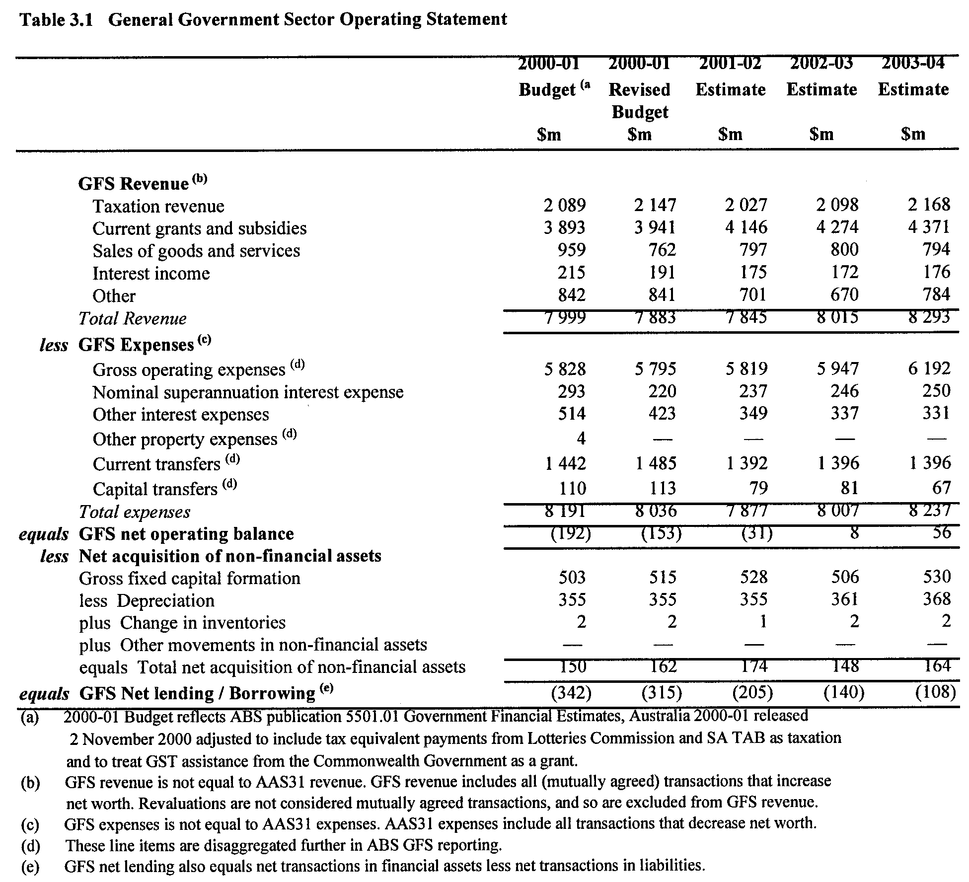
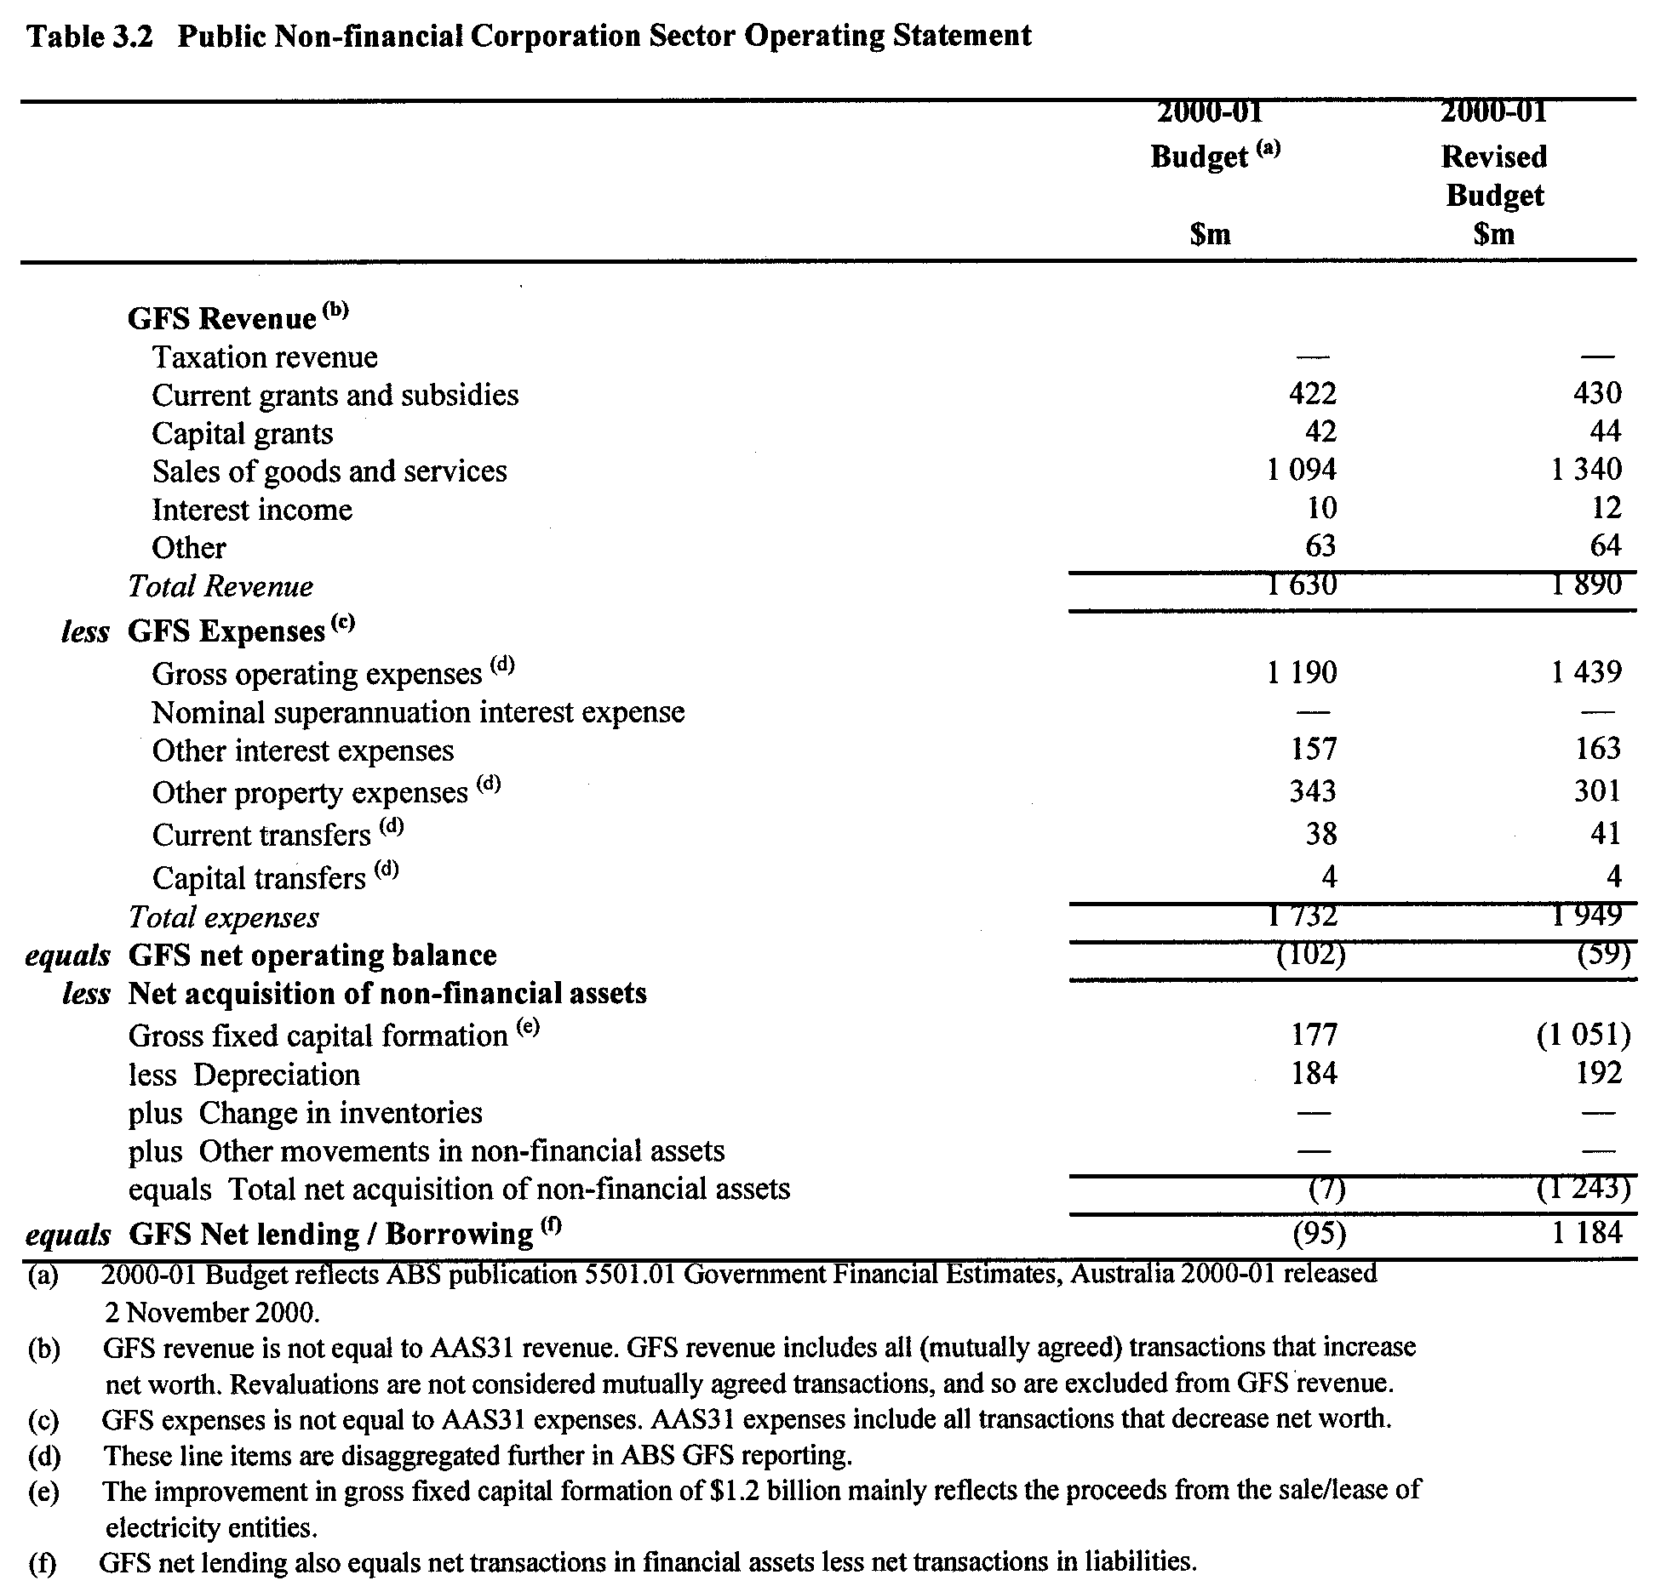
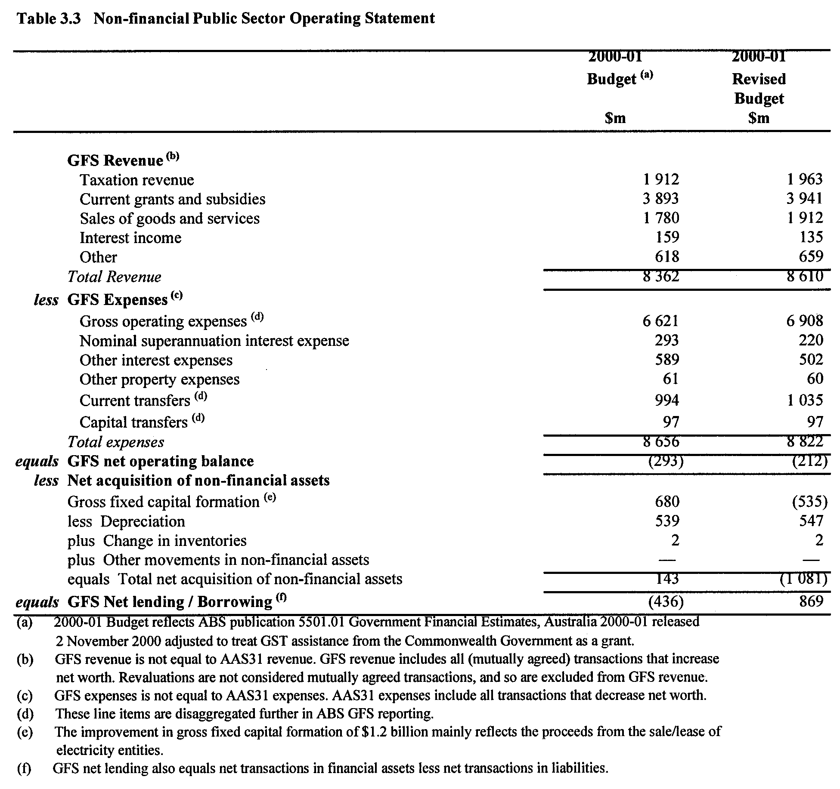
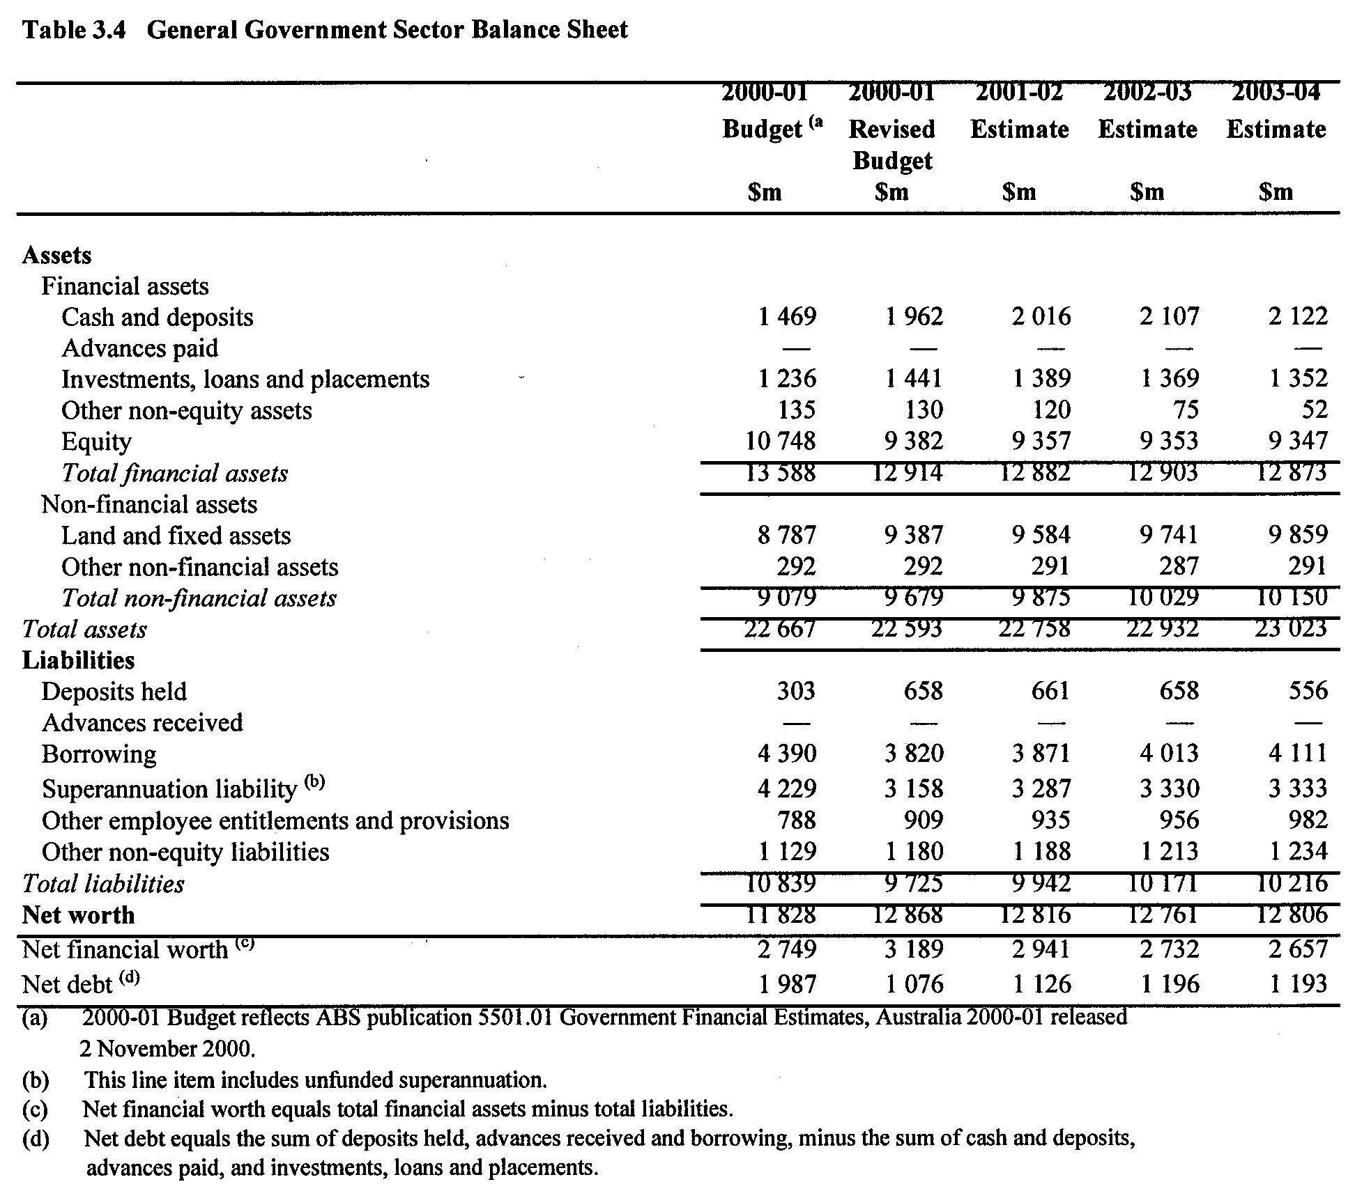
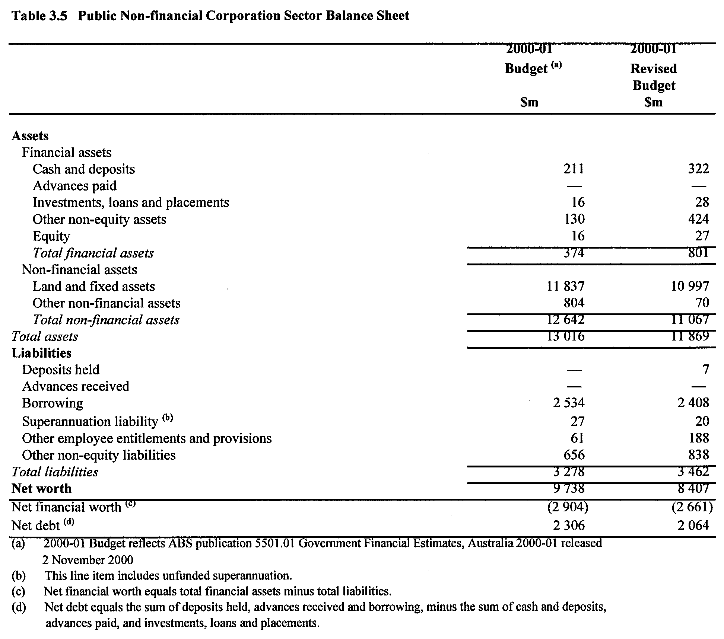
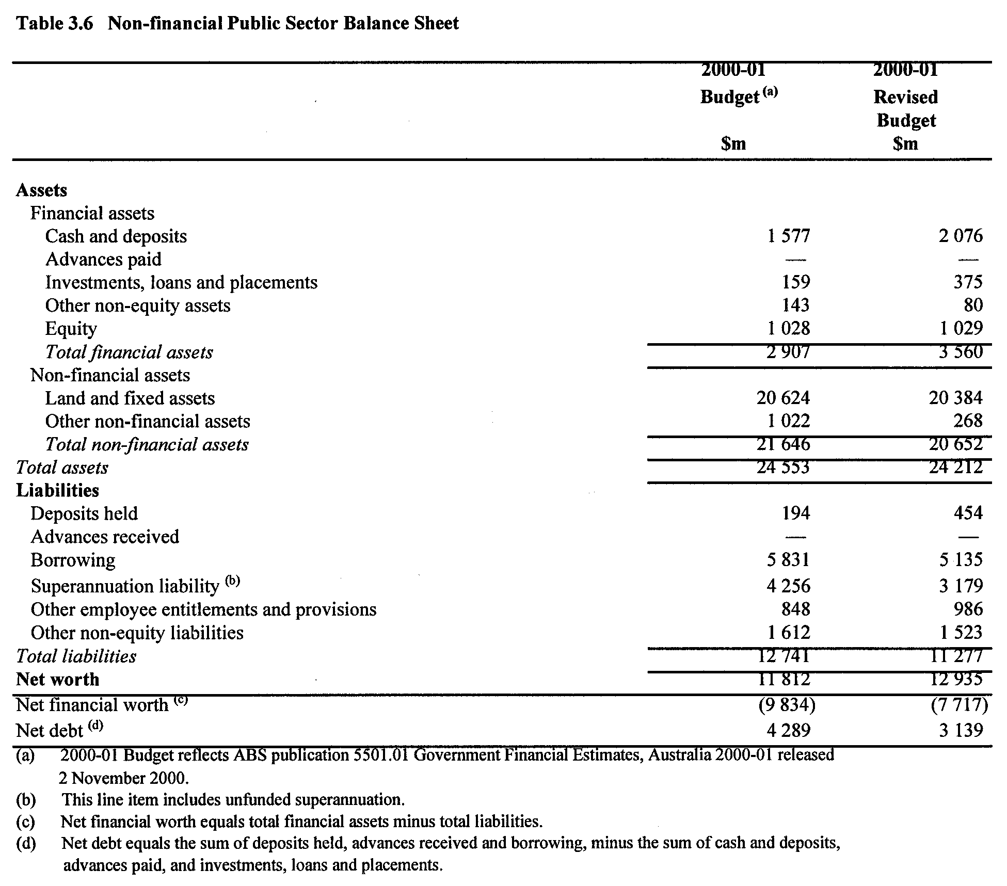
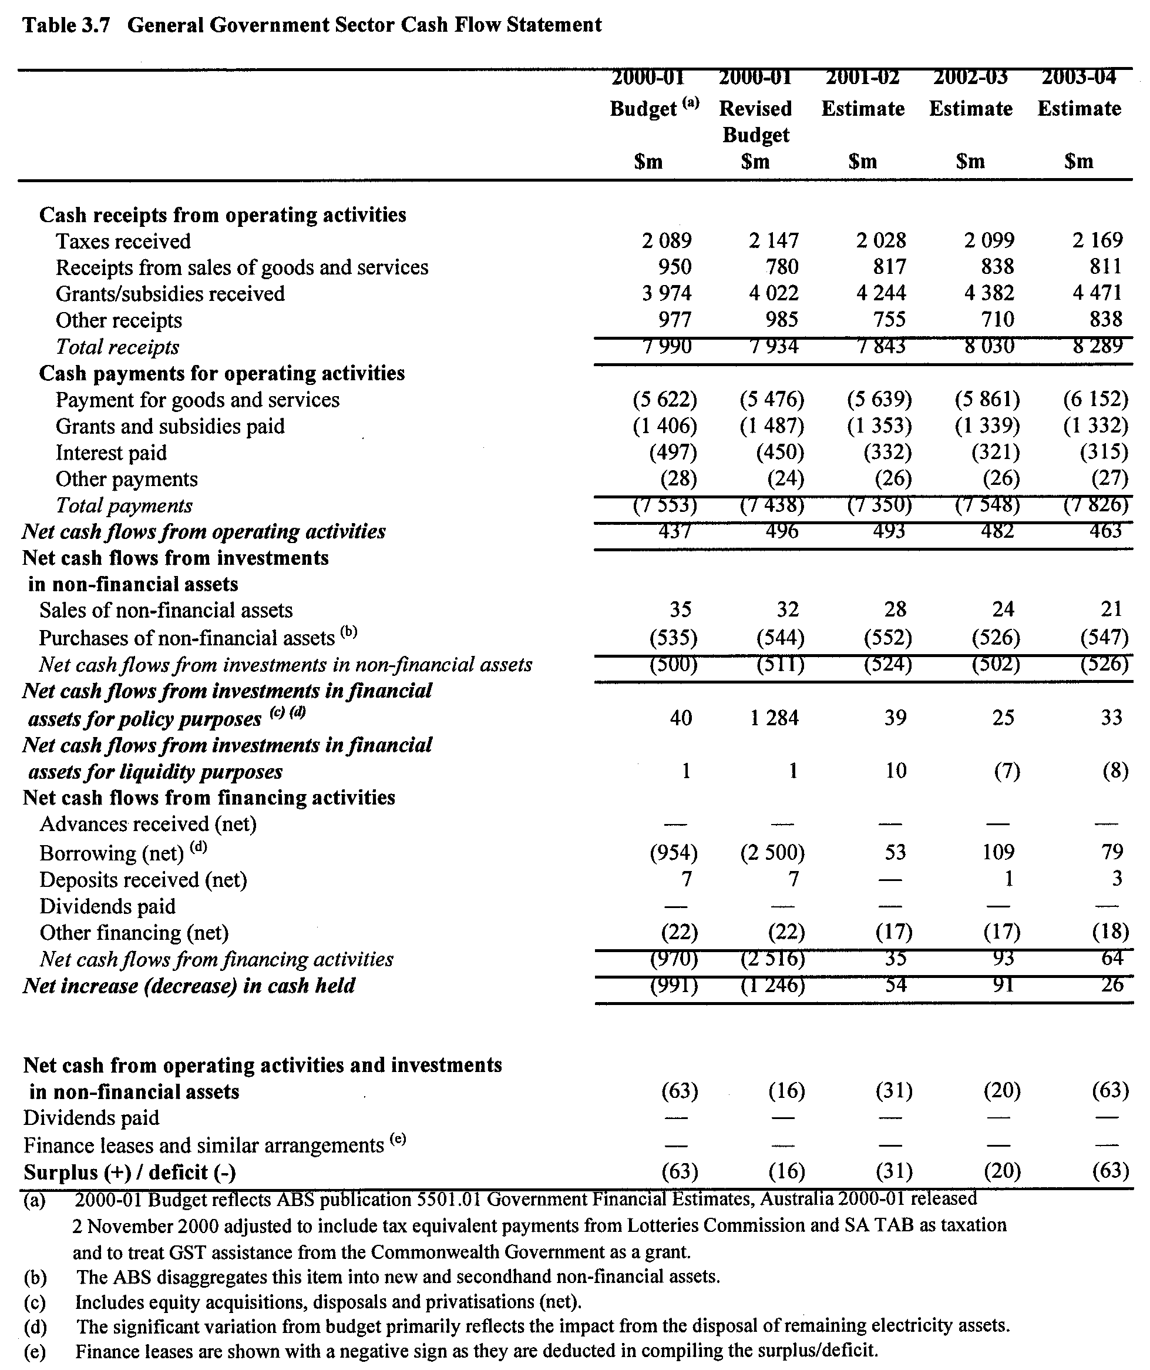
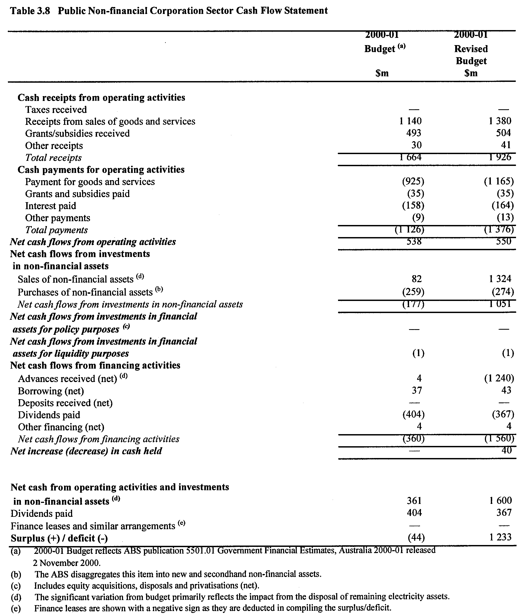
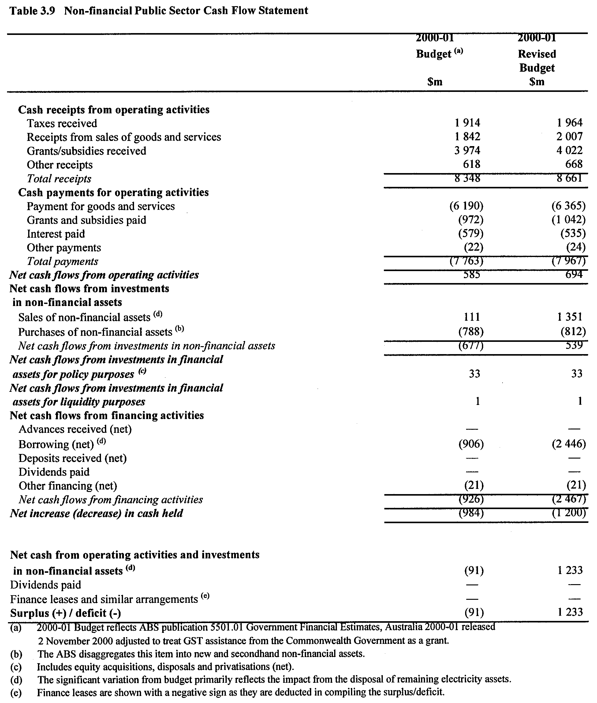
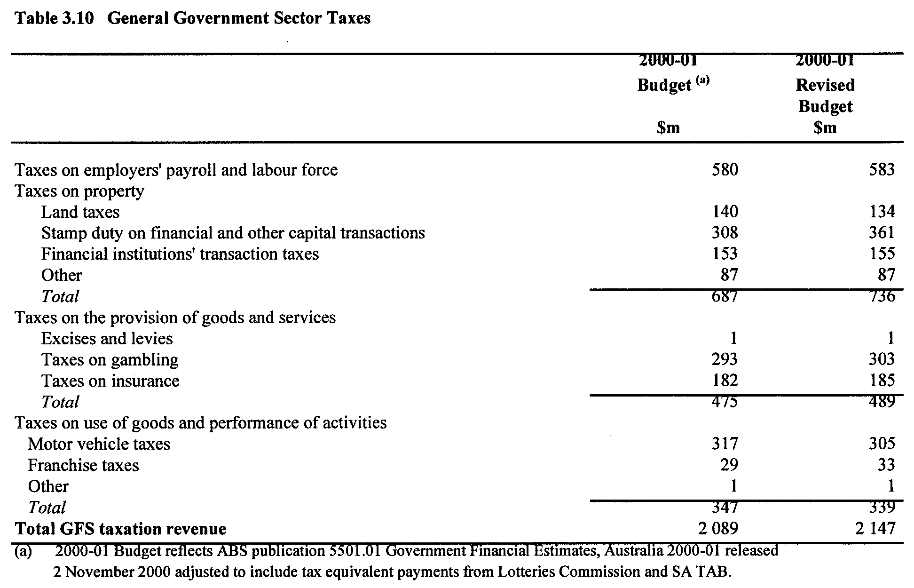
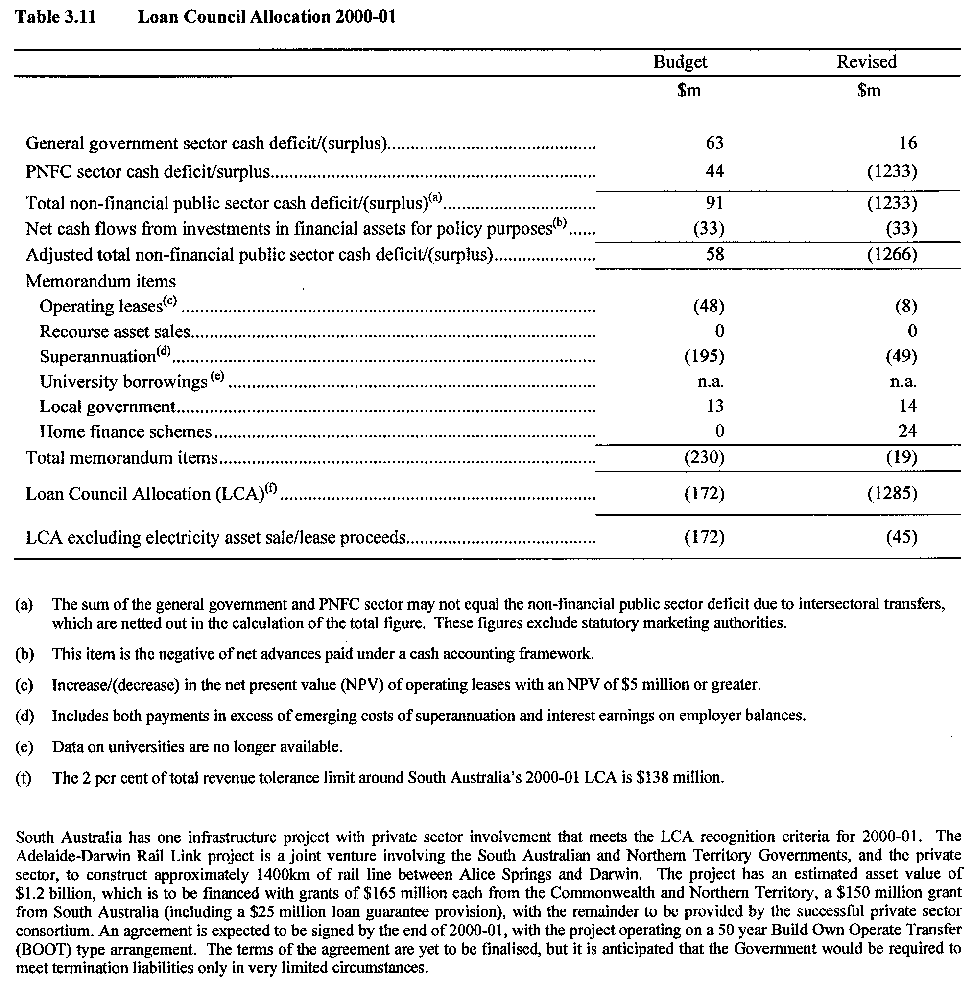
WATER MAINS AND SEWERS

Office of the South Australian Water Corporation
Adelaide, 22 February 2001.

WATER MAINS LAID

Notice is hereby given that the following main pipes or parts of main pipes have been laid down by the South Australian Water Corporation in or near the undermentioned water districts and are now available for a constant supply of water to adjacent land.

ADELAIDE WATER DISTRICT

CITY OF BURNSIDE
Kings Close, Beulah Park. p16

CITY OF MARION
Sandpiper Terrace, Hallett Cove. p8

CITY OF MITCHAM
Across and in Maitland Street, Mitcham. p14
Blythewood Road, Springfield. p17

CITY OF ONKAPARINGA
Cher Court, Aberfoyle Park. p7
Marla Crescent, Noarlunga Downs. p9 and 10
Parken Court, Noarlunga Downs. p9
Naley Court, Noarlunga Downs. p9
Mansfield Street, Noarlunga Downs. p10
Kerley Way, Noarlunga Downs. p10

CITY OF PLAYFORD
Arthur Street, Blakeview. p6
Regent Grove, Blakeview. p6
Kingate Boulevard, Blakeview. p6
Lancelot Street, Blakeview. p6

CITY OF PORT ADELAIDE ENFIELD
Staites Street, Wingfield. p2
Wing Street, Wingfield. p2
George Street, Wingfield. p3

OUTSIDE PORT VICTOR WATER DISTRICT

CITY OF VICTOR HARBOR
Easement in lot 502, Tabernacle Road, Encounter Bay. p11 and 12

PORT VICTOR WATER DISTRICT

CITY OF VICTOR HARBOR
Tabernacle Road, Encounter Bay. p11 and 12
Easement in reserve (lot 1107), Tabernacle Road, Encounter Bay. p11
Cutter Circuit, Encounter Bay. p11
Matthew Flinders Drive, Encounter Bay. p11 and 12

WATER MAINS ABANDONED

Notice is hereby given that the undermentioned water mains have been abandoned by the South Australian Water Corporation.

ADELAIDE WATER DISTRICT

CITY OF MITCHAM
Maitland Street, Mitcham. p14
Fullarton Road, Mitcham. p14

SEWERS LAID

Notice is hereby given that the following sewers have been laid down by the South Australian Water Corporation in the undermentioned drainage areas and are now available for house connections.

ADELAIDE DRAINAGE AREA

CITY OF BURNSIDE
McAllan Avenue, Burnside. FB 1093 p40
Kings Close, Beulah Park. FB 1094 p1

CITY OF MARION
McFarlane Avenue, Mitchell Park. FB 1093 p43 and 44
Bahloo Avenue, Mitchell Park. FB 1093 p44 and 45
Minkie Avenue, Mitchell Park. FB 1093 p44 and 45
Lutana Crescent, Mitchell Park. FB 1093 p44 and 45
Easements in lots 31-36, Sandpiper Terrace, Hallett Cove. FB 1093 p59 and 60
Sandpiper Terrace, Hallett Cove. FB 1093 p59 and 60
Easement in reserve (lot 284), Gannet Court, Hallett Cove. FB 1093 p59 and 60

CITY OF NORWOOD, PAYNEHAM AND ST. PETERS
Ninth Avenue, Joslin. FB 1093 p39

CITY OF ONKAPARINGA
Southbound Avenue, Aberfoyle Park. FB 1093 p57 and 58
Easement in lots 7-2, Taylors Road West, Aberfoyle Park. FB 1093 p57 and 58
Easements in lots 21-16, Cher Court, Aberfoyle Park. FB 1093 p57 and 58
Cher Court, Aberfoyle Park. FB 1093 p57 and 58
Easements in reserve (lot 45), River Road, reserve (lot 304), Kerley Way and lots 1009, 96 and 1007 and reserve (lot 302), Marla Crescent, Noarlunga Downs. FB 1093 p53 and 54
Marla Crescent, Noarlunga Downs. FB 1093 p53-56
Naley Court, Noarlunga Downs. FB 1093 p53 and 54
Easements in reserve (lot 302) and lots 92, 91 and 1004, Marla Crescent, Noarlunga Downs. FB 1093 p53 and 55
Easement in lot 1006, Marla Crescent and lot 804, Liguria Crescent, Noarlunga Downs. FB 1093 p53 and 54
Kerley Way, Noarlunga Downs. FB 1093 p53 and 56
Mansfield Street, Noarlunga Downs. FB 1093 p53 and 56
Easement in lot 1010, Marla Crescent, Noarlunga Downs. FB 1093 p53 and 56

CITY OF PLAYFORD
Arthur Street, Blakeview. FB 1093 p41 and 42
Regent Grove, Blakeview. FB 1093 p41 and 42
Kingate Boulevard, Blakeview. FB 1093 p41 and 42
Easement in lot 59, Arthur Street and lot 2009, Kingate Boulevard, Blakeview. FB 1093 p41 and 42

CITY OF PORT ADELAIDE ENFIELD
Nikola Road, Largs North. FB 1093 p46

CITY OF SALISBURY
George Street, Green Fields. FB 1093 p48

CITY OF TEA TREE GULLY
Easements in lots 2 and 152, Pecan Close and lot 915, The Promenade, Highbury. FB 1093 p33, 35, 34 and 36
The Promenade, Highbury. FB 1093 p33, 34, 36 and 38
Majestic Grove, Highbury. FB 1093 p33, 34 and 36
Domain Commons, Highbury. FB 1093 p33, 34 and 36
Easement in lot 2313, The Promenade and lot 1311, Aqueduct Way, Highbury. FB 1093 p33, 34, 36 and 38
Waterworks land (lot 810), Highbury. FB 1093 p33, 35 and 37
Aqueduct Way, Highbury. FB 1093 p33, 35 and 38
Easement in lots 134-129, Majestic Grove, Highbury. FB 1093 p33, 34 and 37
Easements in lots 143-137, The Promenade, Highbury. FB 1093 p31 and 32
Easement in lot 6, Jasper Court and lot 10, Hancock Road, Banksia Park. FB 1093 p47

OUTSIDE VICTOR HARBOR COUNTRY DRAINAGE
AREA

CITY OF VICTOR HARBOR
Easements in lot 502, Tabernacle Road, Encounter Bay. FB 1093 p49-51

VICTOR HARBOR COUNTRY DRAINAGE AREA

CITY OF VICTOR HARBOR
Tabernacle Road, Encounter Bay. FB 1093 p49-51
Cutter Circuit, Encounter Bay. FB 1093 p49 and 52
Easement in reserve (lot 1107), Tabernacle Road, Encounter Bay. FB 1093 p49 and 52

A. Howe, Acting Chief Executive Officer, South Australian Water Corporation

FAXING COPY?

IF you fax copy to Government Publishing SA (formerly Riverside 2000), for inclusion in the Government Gazette, there is no need to send a Confirmation Copy to us as well.

This creates confusion and may well result in your notice being printed twice.

Please use the following fax number:

Fax transmission: (08) 8207 1040
Phone Inquiries: (08) 8207 1045

Please include a contact person, phone number and order number so that we can phone back with any queries we may have regarding the fax copy.

NOTE: Closing time for lodging new copy (either fax or hard copy) is 4 p.m. on Tuesday preceding the day of publication.

Government Gazette notices can be E-mailed.

The address is:

governmentgazette@saugov.sa.gov.au

Documents should be sent as attachments in Word format.

When sending a document via E-mail, please confirm your transmission with a faxed copy of your document, including the date the notice is to be published.

Fax transmission: (08) 8207 1040
Enquiries: (08) 8207 1045

CITY OF ADELAIDE
Development Act 1993
Adelaide (City) Development Plan—Plan Amendment Report
Plot Ratio Controls for Residential Apartment/Hotel Development in the Central Activities and Frame Districts—
Draft for Public Consultation
NOTICE is hereby given that the Adelaide City Council has prepared a draft Plan Amendment Report to amend the Adelaide (City) Development Plan.
The Plan Amendment Report will amend the Development Plan by increasing the maximum plot ratio allowable for residential/hotel development, and allowing ‘on merit’ rather than ‘non-complying’ assessment of such development exceeding the maximum plot ratio in the Central Activities and Frame Districts.
The draft Plan Amendment Report and statement will be available during normal office hours from the City of Adelaide Customer Centre, 25 Pirie Street, Adelaide, S.A. 5000 from Thursday, 22 February 2001 to Friday, 27 April 2001. Copies of the Plan Amendment Report are free of charge.
Written submissions regarding the draft amendment will be accepted by the City of Adelaide until Friday, 27 April 2001.
The written submissions should also clearly indicate whether you wish to speak at the public hearing on your submission.
All submissions should be addressed to the Chief Executive Officer, City of Adelaide, G.P.O. Box 2252, Adelaide, S.A. 5001.
Copies of all submissions received will be available for inspection by interested persons at the City of Adelaide Customer Centre, 25 Pirie Street, S.A. 5000 from Thursday, 19 April 2001, until the date of public hearing.
A public hearing will be held at 6 p.m. in the Colonel Light Room, Adelaide Town Hall, King William Street, Adelaide, on Wednesday, 16 May 2001. The public hearing may not be held if no submission indicates an interest by its author to speak at the public hearing.
Dated 22 February 2001.
S. Law, Chief Executive Officer

CITY OF ADELAIDE
Declaration as Public Road
NOTICE is hereby given pursuant to section 210 of the Local Government Act 1999, that at its meeting held on 19 February 2001, council declared the following roads to be Public Roads:
Red Lane on L.T.O. Plan C-1416.
Willcox Street and the land marked E on L.T.O. plan C-1416.
S. Law, Chief Executive Officer

CITY OF HOLDFAST BAY
Declaration of Public Road
NOTICE is hereby given that pursuant to section 208 of the Local Government Act 1999, the City of Holdfast Bay declares portion of land comprising allotment 21 as identified in deposited plan D55892 to be a public road.
D. R. Aylen, Chief Executive Officer

CITY OF MITCHAM
Roads (Opening and Closing) Act 1991
NOTICE is hereby given that in accordance with section 10 of the Roads (Opening and Closing) Act 1991, the City of Mitcham proposes to make a Road Process Order to close the following road:
In the Hundred of Adelaide, being the whole of Jose Street, Melrose Park situate dividing allotment 175 from allotment 176 in Deposited Plan 3428 and being between Rozelle Avenue and Penang Avenue and marked ‘A’ on Preliminary Plan No. PP32/0641.
It is proposed that the portion of road to be closed marked ‘A’ be retained by the City of Mitcham and merged with said allotments 175 and 176 being Reserve.
A preliminary plan of the proposal, and a statement, are available for public inspection at the Mitcham Council Office, 1 Cashel Street, Pasadena, between the hours of 9 a.m. and 5 p.m., Monday to Friday, or at the Adelaide office of the Surveyor-General during normal office hours.
Any person may object to the proposal (and any adjoining landowner or other person substantially affected by the proposed road closure may apply for an easement relative to the closure). Such objection (or application for an easement) must be made in writing to the City of Mitcham within 28 days of the date of this notice. If a submission is made, the City of Mitcham is required to give notice of the time and place at which a meeting will be held to consider the matter, so that the person making the submission (or a representative) may attend to support the submission, if desired. Any submission must set out the full name and address of the person making the submission, and must be fully supported by reasons (and any application for the grant of an easement must give full particulars of the nature and location of the easement and, where made by a person as the owner of adjoining or nearby land, specify the land to which the easement is to be annexed). A copy of the submission must be forwarded to the Surveyor-General at Adelaide.
Dated 22 February 2001.
R. Malcolm, Chief Executive Officer

CITY OF MOUNT GAMBIER
Supplementary Election—Results
NOTICE is hereby given that at the close of counting votes on 12 February 2001, the following results for Councillor (1 vacancy) South East Ward are as set out below:
Quota: 722
Number of
1st preference
Candidate Name ballot-papers
White, Mervyn 340
Cleggett, Alan 219
Newberry, Malcolm 187
Schubert, Ruth 269
Gould, Bev 428

Formal Ballot-papers 1 443
Informal Ballot-papers 3

Total Ballot-papers counted 1 446

After the distribution of preferences, Bev Gould was elected.
S. H. Tully, Returning Officer

CITY OF ONKAPARINGA
Supplementary Election—Results
NOTICE is hereby given that at the close of counting votes on 12 February 2001, the following results for Councillor (1 vacancy) Thalassa Ward are as set out below:
Quota: 2 201
Number of
1st preference
Candidate Name ballot-papers
Bayliss, Brett 667
Rogers, Paul 783
Wrobel, Charlie 345
Pine, Graham 425
Chandler, Susanne 1 415
McFarlane, Bevan 637
Simes, Grant 128

Formal Ballot-papers 4 400
Informal Ballot-papers 14

Total Ballot-papers counted 4 414

After the distribution of preferences, Susanne Chandler was elected with 2 132 votes.
S. H. Tully, Returning Officer

CITY OF PROSPECT
Supplementary Election—Nailsworth Ward
NOMINATIONS are hereby invited and will be received at the Office of the City of Prospect located at 128 Prospect Road, Prospect or at the State Electoral Office, 134 Fullarton Road Rose Park, from Thursday, 22 February 2001 until 12 noon on Thursday, 15 March 2001, from any person eligible to be a candidate for election to the vacancy of Councillor to represent Nailsworth Ward.
Nomination forms and candidate’s handbooks may be obtained at the Council Office between 8.45 a.m. and 5.15 p.m., Monday to Friday, or requested by telephone on 8269 5355.
A candidate must submit a profile of not more than 150 words with the nomination form.
A candidate photograph of predominantly the head and shoulders, taken within the preceding 12 months, may also be submitted.
A briefing session for intending candidates will be conducted in the Mayor’s Parlour, Prospect Civic Centre, 128 Prospect Road, Prospect on Tuesday, 6 March 2001, commencing at 5.30 p.m.
If more than one nomination is received for the vacancy, an election will be conducted entirely by postal ballot with voting closing at 12 noon on Monday, 23 April 2001.
S. H. Tully, Returning Officer

CITY OF SALISBURY
Declaration of Public Road
NOTICE is hereby given that pursuant to section 210 (2) of the Local Government Act 1999, the City of Salisbury resolved at its meeting held on 27 November 2000, that a notice of Proposed Declaration of Public Road be made in relation to lot 503 in deposited plan 62795, corner Whites Road and Shepherdson Road, Parafield Gardens.
S. Hains, City Manager

CITY OF WHYALLA
Classification of Community Land
NOTICE is hereby given that at its meeting held on 21 December 2000, council resolved pursuant to section 193 of the Local Government Act 1999, having conducted the public consultation process, that the following parcels of land in its ownership, care and management be excluded from the classification of com-munity land:
Property  Description | Location | CT  Reference
Civic Library | 3 Patterson Street | 5658/614
Lacey Street Bus Depot | Sections 140 and 141, Lacey Street | 1217/21 and 1216/35
Civic Building & Shops | 2-4 Forsyth Street | 5787/948
WEDB Building | Lot 3 Nicolson Ave | 5530/23
D. Knox, City Manager

CITY OF WHYALLA
Classification of Community Land
NOTICE is hereby given that at its meeting held on 11 December 2000, council resolved pursuant to section 193 (6) of the Local Government Act 1999, that the following parcels of land be excluded from the classification of community land:
• Lots 2, 3 and 4 of Deposited Plan 56203 as shown on the below plan, comprising land of 2 620 ha in area of approximate dimension 7 000 m x 5 000 m located on the western side of the Lincoln Highway and extending from the southern boundary of land abutting the Whyalla Conservation Park, to the Iron Knob Road in the south and also comprising a 7.6 ha parcel of land (Lot 4) on the eastern side of the Lincoln Highway which is the land on which is situated the Whyalla Maritime Museum, Tourist Centre and a small parcel of addition land.
• Section 1, certificate of title volume 4215, folio 661, as shown on the below plan being a 22.55 ha parcel of land defined by McBryde Terrace and Charles Avenue, Whyalla Norrie.

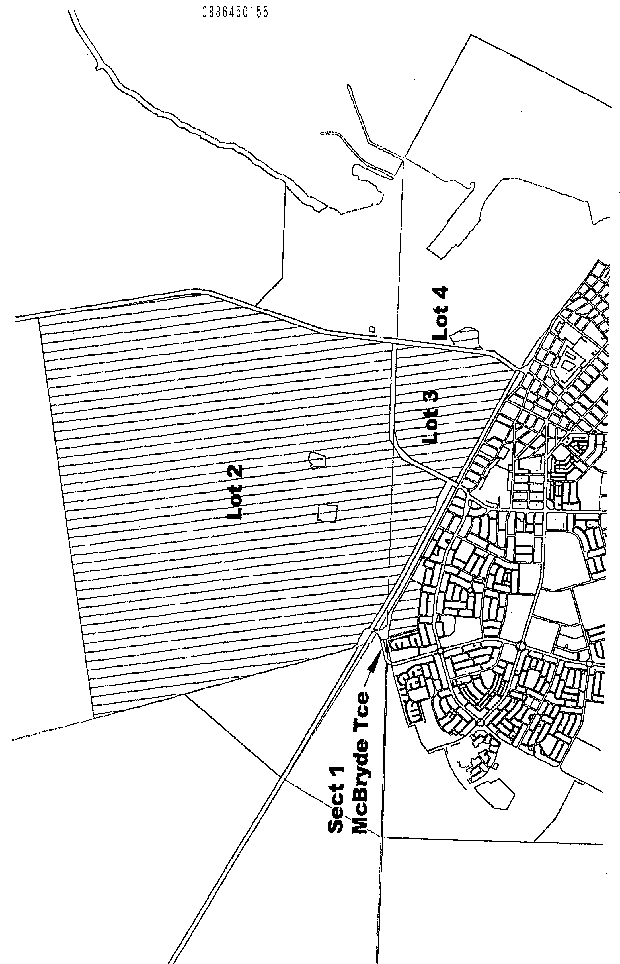
D. Knox, City Manager

CLARE AND GILBERT VALLEYS COUNCIL
Declaration of Public Road
NOTICE is hereby given that at a meeting of council held on 19 February 2001, all land contained in Allotment 9 of Filed Plan 40427 was declared as public road, in accordance with the provisions of section 210 of the Local Government Act 1999.
M. J. Anderson, Chief Executive Officer

DISTRICT COUNCIL OF GRANT
Temporary Road Closure
NOTICE is hereby given that the District Council of Grant, at its meeting held on 11 January 2001, passed a resolution making the following order:
That pursuant to the powers of section 359 (1) of the Local Government Act 1934, as amended, Florence Street, from Bay Road to Kilsby Road has placed a 10 tonne weight restriction on the road with the exception of:
(1) Council vehicles carrying out roadworks.
(2) General access vehicles (delivering or collecting goods from adjacent properties).
M. D. Hutchesson, Works Administration Manager

KINGSTON DISTRICT COUNCIL
Renaming of Public Roads
NOTICE is hereby given that pursuant to section 219 of the Local Government Act 1999, council has resolved to change the names of the following public roads:
Keilira—Avenue Road for the intersection of Rowney Road, adjacent to sections 2 and 208, Hundred of Minecrow, to the council boundary adjacent to sections 106 and 107, Hundred of Minecrow to Minnie Crowe Road.
Long Beach Road, from the intersection of Princes Highway, adjacent to sections 512 and 47, Hundred of Lacepede in a westerly direction to Toop Road.
Second Long Beach Road, from the intersection of Princes Highway, adjoining the Blackford Drain Reserve and sections 623, 513 and 57, Hundred of Lacepede to Long Beach Road.
The previously unnamed road adjacent to sections 49, 73, 74 and 91, Hundred of Duffield, travelling in an easterly direction from the intersection of Princes Highway to Geue’s Road.
Henry Creek/Taratap Road and Taratap/Blackford Road from the intersection of Henry Creek Road, adjacent to section 26, Hundred of Duffield, to the intersection of Rowney Road West, adjacent to section 500, Hundred of Murrabinna to Tapfield Road.
Rowney Road, from the Princes Highway, adjacent to sections 447, 441 and 440, Hundred of Lacepede, to the Riddoch Highway, adjacent to sections 107/11, Hundred of Marcollat to Rowney Road West.
S. Rufus, Chief Executive Officer

DISTRICT COUNCIL OF LOWER EYRE PENINSULA
Roads (Opening and Closing) Act 1991
Public Road (Adjacent Pound Lane) Port Lincoln
NOTICE is hereby given that pursuant to section 10 of the Roads (Opening and Closing) Act 1991, the District Council of Lower Eyre Peninsula hereby gives notice of its intent to make a Road Process Order to:
Close the whole of the public road adjoining allotment 1 in Deposited Plan 39256, allotment 22 in Deposited Plan 52441, allotment 503 in Deposited Plan 52907 and section 250, Hundred of Lincoln, lettered ‘A’ in Preliminary Plan No. PP32/0586. The closed road is to be transferred to Generation Lessor Corporation and merged with allotment 503 in Deposited Plan 52907.
A copy of the preliminary plan and statement of persons affected are available for public inspection at the Council Office, 32 Railway Terrace, Cummins, S.A. 5631 or the Adelaide office of the Surveyor General during normal office hours.
Any application for easement or objection must set out the full name, address and details of the submission and must be fully supported by reasons.
The application for easement or objection must be made in writing to the Council, Box 41, Cummins, S.A. 5631, within 28 days of this notice and a copy must be forwarded to the Surveyor-General, c/o Roads Unit, G.P.O. Box 1354, Adelaide, S.A. 5001. Where a submission is made, the council will give notification of a meeting at which the manner will be considered.
P. W. Aird, District Clerk

DISTRICT COUNCIL OF LOWER EYRE PENINSULA
Elector Representation Review
NOTICE is hereby given that, pursuant to the provisions of section 12 of the Local Government Act 1999, the District Council of Lower Eyre Peninsula has, following the required public consultation, completed a report.
The report is available for public inspection at both the Cummins and Port Lincoln Offices and copies of the report are available at no charge.
Interested persons are invited to make written submissions by 23 March 2001 to the District Clerk, P.O. Box 41, Cummins, S.A. 5631.
An opportunity will be given to any person(s) making written submissions to appear personally or by representative before the council or a Council Committee to be heard upon his or her submission.
P. Aird, District Clerk

DISTRICT COUNCIL OF LOXTON WAIKERIE
Temporary Road Closure
NOTICE is hereby given that the District Council of Loxton Waikerie pursuant to section 359 of the Local Government Act 1934, as amended, hereby resolves to exclude all vehicles, with the exception of emergency vehicles from the eastern and western carriageways of East Terrace, Loxton, between Book-purnong Terrace in the south and Scenic Drive in the north, the roundabout intersection of East Terrace, Kokoda Terrace, Tobruk Terrace, Bookpurnong Terrace, Loxton and Drabsch Streets, Loxton, from McIntosh Street to East Terrace from 11 a.m. to 12.30 p.m. on Saturday, 24 February 2001 for the Loxton Mardi Gras Pageant.
Pursuant to section 33 (1) (b) of the Road Traffic Act 1961, make an order directing persons taking part in the event be exempted, in relation to the road, from the duty to observe the Australian Road Rules specified below and attaching to the exemption Australian Road Rules Exemptions and Conditions.
Australian Road Rules Exemptions and Conditions:
1. Rule 221: Using hazardous warning lights.
2. Rule 230: Crossing a road—general.
3. Rule 237: Getting on or into a moving vehicle—provided the speed of the vehicle does not exceed 5 km/h.
4. Rule 238: Pedestrians travelling along a road (except in or on a wheeled recreation device or toy).
5. Rule 264: Wearing of seat belts by drivers—provided the speed of the vehicle does not exceed 25 km/h.
6. Rule 264: Wearing of seat belts by passengers 16 years old, or older—provided the speed of the vehicle does not exceed 25 km/h.
7. Rule 265: Wearing of seat belts by passengers under 16 years old—provided the speed of the vehicle does not exceed 25 km/h.
8. Rule 268: How persons must travel in or on a motor vehicle—provided the speed of the vehicle does not exceed 25 km/h.
9. Rule 298: Driving with a person in a trailer—provided the speed of the vehicle does not exceed 25 km/h.
T. L. Burgemeister, District Clerk

NARACOORTE LUCINDALE COUNCIL
Temporary Road Closure
NOTICE is hereby given that pursuant to section 33 of the Road Traffic Act 1961, council under its delegated authority declares the temporary road closure of:
(1) one lane of east bound traffic in Smith Street;
(2) the turning road to the north of the War Memorial,
be closed from 10 a.m. to 4 p.m. on Sunday, 25 February 2001.
D. L. Beaton, Chief Executive Officer

IN the matter of the estates of the undermentioned deceased persons:
Collins, Alison Marjorie, late of 14-20 King William Road, Wayville, of no occupation, who died on 27 December 2000.
Dix, Gladys Norma, late of 34 Norman Terrace, Everard Park, of no occupation, who died on 20 October 2000.
Green, Jennifer Kaye, late of Attrill Road, Hindmarsh Tiers, home duties, who died on 15 August 2000.
Johnson, Emile Francis, late of 24 Thistle Avenue, Klemzig, retired delivery foreman, who died on 9 December 2000.
Kalisch, Herold Erwin, late of 1 Miller Street, Waikerie, retired carrier, who died on 18 April 2000.
Keane, Desmond, late of 13 Springbank Road, Colonel Light Gardens, retired builders labourer, who died on 25 December 2000.
Keen, Leo Bernard, late of 23 Angus Avenue, Edwardstown, retired compositor, who died on 30 November 2000.
Lawrie, Kevan Alic, late of 3 Gertrude Street, Brooklyn Park, retired plumber, who died on 15 November 2000.
Marsh, Edna May, late of 2 Jelley Street, Woodville, of no occupation, who died on 1 December 2000.
Parsons, Mary Ida, late of 36 Gage Street, St Morris, home duties, who died on 9 January 2001.
Ringer, Harry, late of 324 Military Road, Semaphore Park, retired publican, who died on 21 July 1999.
Semmler, August Herbert, late of 26 Kirby Street, Waikerie, retired channel man, who died on 24 November 2000.
Slee, Elsa Annie, late of 16 Third Street, Wilmington, retired office worker, who died on 6 December 2000.
Tilley, Evelyn Mary, late of Ruwoldt Road, Yahl, of no occupation, who died on 12 May 2000.
Warren, Catherine Margaret, late of Blamey Road, Elizabeth East, of no occupation, who died on 18 November 2000.
Notice is hereby given pursuant to the Trustee Act 1936, as amended, the Inheritance (Family Provision) Act 1972, and the Family Relationships Act 1975, that all creditors, beneficiaries, and other persons having claims against the said estates are required to send, in writing, to the Public Trustee, 25 Franklin Street, Adelaide 5000, full particulars and proof of such claims, on or before 23 March 2001, otherwise they will be excluded from the distribution of the said estate; and notice is also hereby given that all persons who are indebted to the said estates are required to pay the amount of their debts to the Public Trustee or proceedings will be taken for the recovery thereof; and all persons having any property belonging to the said estates are forthwith to deliver the same to the Public Trustee.
Dated 22 February 2001.
J. H. Worrall, Public Trustee

SOUTH AUSTRALIA—In the Supreme Court. No. 403 of 1998. In the matter of Stop Press Publishing Pty Ltd and in the matter of the Corporations Law.
Notice of Release of Liquidator
Take notice that by order of the Supreme Court of South Australia dated 6 February 2001, I, Russell Heywood-Smith, 248 Flinders Street, Adelaide, S.A. 5000, the liquidator of the abovenamed company was granted my release as liquidator.
Dated 14 February 2001.
R. Heywood-Smith, Liquidator

UNCLAIMED MONEYS ACT 1891
Register of Unclaimed Moneys held by CGU Insurance for 1993
Name | Amount  $
A. W. R. and F. G. W. Drape | 136.20
I. K. Shaw | 245.64
Clarksons | 110.00
B. D. and M. S. Miller | 255.00
Lunch-A-Lot | 100.00
I. Foumakis | 51.99
Fosseys Coimart | 133.95
J. V. and J. A. Capurso | 364.00
A. and M. L. Patterson | 52.91
W. and K. Ritter | 75.75
Total | $1 525.44
Register of Unclaimed Moneys held by CGU Insurance for 1994
Name | Amount  $
K. Ferguson and R. Ruhdorf | 55.00
K. L. and G. J. Rawlins | 144.00
C. Prest | 150.00
Sunroof Centre Rack City | 119.90
Hourglass Jewellery | 160.00
Institute of Municipal Management | 750.00
K. J. and M. G. Collins | 100.51
John Martins | 199.00
Johnson & Pahl | 246.75
Johnson & Pahl | 120.00
Link Telecommunications | 218.00
S. L. Shearer | 118.00
Aust. Medical Enterprises | 378.91
David Jones | 195.00
Mott Property Services | 168.00
M. Aronis | 55.00
S. D. and E. M. Leighton | 76.46
S. G. Bartlet | 81.32
Steven Hansens Painting | 360.00
Saffron Boutique | 94.75
R. H. and A. Wescombe | 74.77
M. Ly | 142.15
M. D. Bryant | 57.00
Morony Video Service | 52.00
R. I. Robinson | 498.48
V. B. Vo | 250.00
F. J. Hill Zoom Portraits | 50.00
MacMont | 50.55
R. I. Robinson | 257.38
D. and A. Callisto | 232.58
D. L. Food Service Pty Ltd | 82.98
Total | $5 538.49

ATTENTION

CUSTOMERS requiring a proof of their notice for inclusion in the Government Gazette, please note that the onus is on you to inform Government Publishing SA (formerly Riverside 2000) of any subsequent corrections by 10 a.m. on Thursday, which is our publication deadline.

For any corrections to your notice please phone 8207 1045 or Fax 8207 1040 before 10 a.m. on Thursday.

If we do not receive any communication by 10 a.m. on Thursday (day of publication) we will presume the notice is correct and will print it as it is.

Remember—the onus is on you to inform us of any corrections necessary to your notice.

NOTE: Closing time for lodging new copy (either fax or hard copy) is 4 p.m. on Tuesday preceding the day of publication. Ph. 8207 1045—Fax 8207 1040.

Printed and published by authority every Thursday by J. D. FERGUSON, Government Printer, South Australia
Price: $4.30, plus postage; to subscribers, $214.85 per annum.
(The above prices are inclusive of GST)

