SUPPLEMENTARY GAZETTE



THE SOUTH AUSTRALIAN

GOVERNMENT GAZETTE

PUBLISHED BY AUTHORITY

ALL PUBLIC ACTS appearing in this GAZETTE are to be considered official, and obeyed as such

ADELAIDE, WEDNESDAY, 4 JULY 2001

FISHERIES ACT 1982: SECTION 59
TAKE notice that pursuant to section 59 of the Fisheries Act 1982, Brad March, c/o Brad March Charter Services, P.O. Box 151, Henley Beach, S.A. 5022 (hereinafter referred to as the ‘principal exemption holder’), and the class of persons specified in Schedule 1 (hereinafter referred to as the ‘other exemption holders’), are exempt from the provisions of Clauses 66, 70, 73, 77A, 77B, 77C and 77D of Schedule 1 of the Fisheries (General) Regulations 2000, insofar as the exemption holders may exceed the bag or boat limits as specified in Schedule 2 (hereinafter referred to as the ‘exempted activity’), subject to the conditions specified in Schedule 3.
Schedule 1
Any person or persons who charter the boat Columbia (hereinafter referred to as the ‘permitted boat’) from the principal exemption holder in South Australia, for the purpose of recreational fishing for scalefish, abalone, blue crab or sand crab, and rock lobster.
Schedule 2
1. The exemption holders may engage in the taking of no more than one rock lobster (Jasus edwardsii) per other exemption holder in any one day where the number of other exemption holders exceeds eight.
2. The exemption holders may engage in the taking of no more than one abalone (Haliotis spp.) per other exemption holder in any one day where the number of other exemption holders exceeds ten.
3. The exemption holders may engage in the taking of no more than twenty blue crab or sand crab or a combination thereof per other exemption holder in any one day, where the number of other exemption holders exceeds six.
4. The exemption holders may engage in the taking of no more than one half of the daily bag limit (for those species of scalefish subject to such a limit as specified in the Fisheries (General) Regulations 2000) per other exemption holder in any one day, where the number of other exemption holders exceeds six.
Schedule 3
1. This exemption is valid from the date of gazettal of this notice until 30 June 2002, unless revoked earlier.
2. The principal exemption holder shall not use any other boat other than the permitted boat for the purpose of engaging in the exempted activity.
3. The principal exemption holder shall accept any fish taken by the other exemption holders as all or part of the consideration for the charter agreement.
4. While engaged in the exempted activity the principal exemption holder shall have in his possession a copy of this notice. Such notice must be produced to a PIRSA Fisheries Compliance Officer if such an officer requests that it be so produced.
5. The principal exemption holder shall not contravene or fail to comply with the Fisheries Act 1982 or any regulations made under that Act except where specifically exempted by this notice.
6. The exemption holder shall not cause, suffer or permit any other exemption holder to contravene or fail to comply with the Fisheries Act 1982, or any regulations made under that Act except where specifically exempted by this notice.
Dated 4 July 2001.
W. Zacharin, Director of Fisheries

FISHERIES ACT 1982: SECTION 59
TAKE notice that pursuant to section 59 of the Fisheries Act 1982, David F. Gill, (hereinafter referred to as the ‘exemption holder’), P.O. Box 137, Maitland, S.A. 5573, holder of Marine Scalefish Fishery Licence No. M175 is exempt from the provisions of section 41 of the Fisheries Act 1982, Regulation 5 and Clause 37 of Schedule 1 of the Fisheries (General) Regulations 2000, but only insofar as the exemption holder may use a fish net specified in Schedule 1 for the purpose of trade or business in waters greater than 5 m in depth (hereinafter referred to as the ‘exempted activity’) specified in Schedule 2, subject to the conditions in Schedule 3 from the date of gazettal of this notice until 30 June 2002.
Schedule 1
One floating hauling net or purse seine net not exceeding 600 m in length and 160 meshes in depth, and with a mesh size of not less than 3 cm.
Schedule 2
The waters of Gulf St Vincent and Investigator Strait within blocks 34, 35, 36, 43 and 44 as defined in the South Australian Commercial Fishing Summary Sheets.
Schedule 3
1. The exemption holder may only conduct the exempted activity from a boat registered on Marine Scalefish Fishery Licence No. M175.
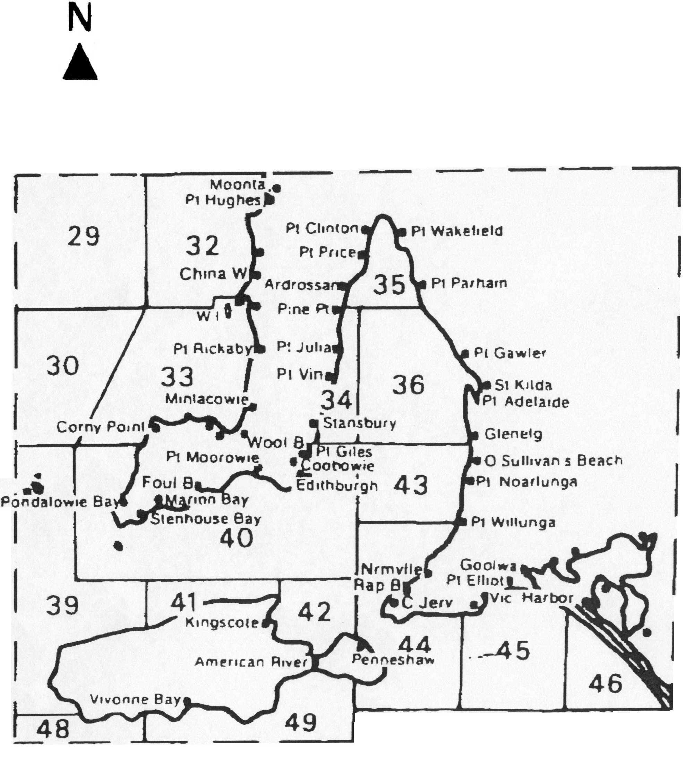 2. The exemption holder must provide separate statistical catch and effort information, in the form of a daily log, with details of fishing conducted pursuant to the exempted activity.
3. PIRSA Fisheries Compliance retains the right for a departmental officer to accompany the exemption holder at any time while engaged in the exempted activity.
4. Whilst engaged in the exempted activity the exemption holder must have in his possession a copy of this notice and produce a copy of the notice if required by a PIRSA Fisheries Compliance Officer.
5. The exemption holder shall not contravene or fail to comply with the Fisheries Act 1982 or any regulation made under that Act except where specifically exempted by this notice.
Dated 4 July 2001.
W. Zacharin, Director of Fisheries

J. D. FERGUSON, Government Printer, South Australia

