No. 70 2143

THE SOUTH AUSTRALIAN

GOVERNMENT GAZETTE

PUBLISHED BY AUTHORITY

ALL PUBLIC ACTS appearing in this GAZETTE are to be considered official, and obeyed as such

ADELAIDE, THURSDAY, 7 JUNE 2001

CONTENTS

Page
Appointments, Resignations, Etc. 2144
Associations Incorporation Act 1985—Notice 2145
Corporations and District Councils—Notices 2206
Crown Lands Act 1929—Notices 2145
Dangerous Substances Act 1979—Notice 2146
Development Act 1993—Notice 2147
Electricity Pricing Order—Notices 2148
Environment Protection Act 1993—Notice 2156
Equal Opportunity Tribunal—Notice 2156
Fisheries Act 1982—Notices 2156
Geographical Names Act 1991—Notice 2170
Industrial and Employee Relations Act 1994—Notice 2171
Land Acquisition Act 1969-1972—Notices 2171
Land and Business (Sale and Conveyancing) Act 1994—
Notices 2172
Liquor Licensing Act 1997—Notices 2173
Mining Act 1971—Notices 2176
Mutual Recognition Act 1992—Notice 2177
National Parks and Wildlife Act 1972—Notice 2178
Page
Occupational Health, Safety and Welfare Act 1986—
Notice 2171
Petroleum Act 2000—Notices 2178
Petroleum Products Regulation Act 1995—Notices 2183
Private Advertisements 2216
Proclamations 2144
Public Trustee Office—Administration of Estates 2216
REGULATIONS
Road Traffic Act 1961—
(No. 121 of 2001) 2189
(No. 122 of 2001) 2192
(No. 123 of 2001) 2194
(No. 124 of 2001) 2195
Motor Vehicles Act 1959 (No. 125 of 2001) 2198
Roads (Opening and Closing) Act 1991—Notices 2183
Soil Conservation and Land Care Act 1989—Notice 2184
Transport SA—Registration and Licensing Third Party
Insurance Premium—Schedule 2185
Veterinary Surgeons Board of South Australia—Notice 2187
Water Resources Act 1997—Notices 2187

GOVERNMENT GAZETTE NOTICES
ALL poundkeepers’ and private advertisements forwarded for publication in the South Australian Government Gazette must be PAID FOR PRIOR TO INSERTION; and all notices, from whatever source, should be legibly written on one side of the paper only and sent to Government Publishing SA so as to be received no later
than 4 p.m. on the Tuesday preceding the day of publication. Phone 8207 1045 or Fax 8207 1040. E-mail: governmentgazette@saugov.sa.gov.au. Send as attachments in Word format and please confirm your transmission with a faxed copy of your document, including the date the notice is to be published and to whom the notice will be charged.

Department of the Premier and Cabinet
Adelaide, 7 June 2001
HIS Excellency the Governor’s Deputy in Executive Council has been pleased to appoint the undermentioned to the Correctional Services Advisory Council, pursuant to the provisions of the Correctional Services Act 1982:
Member: (from 1 July 2002 until 6 June 2004)
Susan Joan Gaffney
Deputy Presiding Member: (from 7 June 2001 until 6 June 2004
Susan Joan Gaffney
By command,
Michael Armitage, for Premier
MCS 9/98CS

Department of the Premier and Cabinet
Adelaide, 7 June 2001
HIS Excellency the Governor’s Deputy in Executive Council has been pleased to appoint the undermentioned to the National Wine Centre Board, pursuant to the provisions of the National Wine Centre Act 1997:
Member: (from 1 July 2001 until 30 November 2001)
Richard Hugh Allert
Brian John Croser
Dianne Davidson
Perry Richard Gunner
Walter John Cleland Harvey
Philip Leslie Laffer
John William Lamb
George William Mackey
Donald Ross McWilliam
Ira John Pendrigh
Christopher Macklin Pfeiffer
Anabel Shears-Carter
Ian William Sutton
Deputy Member: (from 1 July 2001 until 30 November 2001)
David Vincent Atkinson
Linda Jillian Bowes
Graham Cranswick-Smith
Mark de Lacy McKenzie
Alister John Purbrick
Chairman: (from 1 July 2001 until 31 October 2001)
Richard Hugh Allert
By command,
Michael Armitage, for Premier
DPC 012/98CS

Department of the Premier and Cabinet
Adelaide, 7 June 2001
HIS Excellency the Governor’s Deputy in Executive Council has been pleased to appoint the Honourable Robert Gerard Kerin, MP, Deputy Premier, Minister for Primary Industries and
Resources and Minister for Regional Development to be also Acting Premier, Acting Minister for State Development and Acting Minister for Multicultural Affairs for the period 7 June 2001 to 16 June 2001 inclusive during the absence of the Honourable John Wayne Olsen, MP.
By command,
Michael Armitage, for Premier
DIT385/001/042PT1CS

Department of the Premier and Cabinet
Adelaide, 7 June 2001
HIS Excellency the Governor’s Deputy in Executive Council has been pleased to appoint Robert John Whitehead as an inspector for the purposes of the Correctional Services Act 1982, pursuant to section 20 of the Correctional Services Act 1982.
By command,
Michael Armitage, for Premier
MCS 05/01CS

MOTOR VEHICLES (MISCELLANEOUS) AMENDMENT ACT 1999 (Act No. 52 of 1999): DAY OF COMMENCEMENT
Proclamation By The Governor’s Deputy
(l.s.) Bruno Krumins
WITH the advice and consent of the Executive Council, I fix 17 June 2001 as the day on which sections 4 (d), 4 (j), 4 (k), 4 (n), 4 (p), 4 (q), 4 (r), 4 (t), 5, 39, 40, 42, 43, 44 (a), (b), (c), (e) and (f), 45 to 47 (inclusive), 50 (a) to (e) (inclusive), 51 to 56 (inclusive), 58, 60 to 62 (inclusive), 63 (c), 64 to 67 (inclusive), 72 to 75 (inclusive), 78, 85, 86, 87 (a), 90 (c) and 95 of the Motor Vehicles (Miscellaneous) Amendment Act 1999 will come into operation.
Given under my hand and the Public Seal of South Australia, at Adelaide, 7 June 2001.
By command,
Michael Armitage, for Premier
TSAC 2000/02959

SHOP TRADING HOURS ACT 1977, SECTION 13: ALTERATION OF SHOP TRADING HOURS—LOXTON SHOPPING DISTRICT
Proclamation By The Governor’s Deputy
(l.s.) Bruno Krumins
PURSUANT to section 13 of the Shop Trading Hours Act 1977 and with the advice and consent of the Executive Council, I authorise the opening of all shops in the Loxton Shopping District from 10 a.m. until 4 p.m. on Sunday, 17 June 2001, subject to the conditions specified in the schedule.
Schedule
This proclamation only authorises the opening of a shop if:
(a) all relevant industrial awards, workplace agreements and enterprise agreements are observed by the shopkeeper and persons employed in the business of the shop during and in relation to the hours specified in this proclamation during which the shop is open; and
(b) subject to an industrial award, workplace agreement or enterprise agreement to the contrary—a person who is employed in the business of the shop is entitled to refuse to work at the shop during the hours specified in this proclamation unless he or she has agreed with the shopkeeper to work during those hours.
Given under my hand and the Public Seal of South Australia, at Adelaide, 7 June 2001.
By command,
Michael Armitage, for Premier
MWR 01/012 CS

STATUTES AMENDMENT (TRANSPORT PORTFOLIO) ACT 2000 (Act No. 76 of 2000): DAY OF COMMENCEMENT
Proclamation By The Governor’s Deputy
(l.s.) Bruno Krumins
WITH the advice and consent of the Executive Council, I fix 17 June 2001 as the day on which Part 2 of the Statutes Amendment (Transport Portfolio) Act 2000 will come into operation.
Given under my hand and the Public Seal of South Australia, at Adelaide, 7 June 2001.
By command,
Michael Armitage, for Premier
TSA 2001/04404

STATUTES AMENDMENT (TRANSPORT PORTFOLIO) ACT 2001 (Act No. 17 of 2001): DAY OF COMMENCEMENT
Proclamation By The Governor’s Deputy
(l.s.) Bruno Krumins
WITH the advice and consent of the Executive Council, I:
(a) fix 17 June 2001 as the day on which the Statutes Amendment (Transport Portfolio) Act 2001 will come into operation; and
(b) suspend the operation of Part 2, sections 10 and 15 and Part 4 of that Act until a day to be fixed by subsequent proclamation.
Given under my hand and the Public Seal of South Australia, at Adelaide, 7 June 2001.
By command,
Michael Armitage, for Premier
TSA 2001/04404

ASSOCIATIONS INCORPORATION ACT 1985
Deregistration of Associations
NOTICE is hereby given that the Corporate Affairs Commission approves the applications for deregistration received from the associations named below pursuant to section 43A of the Associations Incorporation Act 1985. Deregistration takes effect on the date of publication of this notice.
Bosnjacka Islamska Zajednica—Bosnian Islamic Society S.A. Incorporated
Tarcoola Race Gymkana Club Incorporated
The Australian Local Government Women’s Association (S.A.) Branch
Given at Adelaide, 5 May 2001.
S. C. Wall, a delegate of the Corporate Affairs Commission

CROWN LANDS ACT 1929: SECTION 5
TAKE notice that pursuant to the Crown Lands Act 1929, I KOSTAS SARNECKIS, Acting Surveyor-General and Delegate appointed by IAIN EVANS, Minister for Environment and Heritage, Minister of the Crown to whom the administration of the Crown Lands Act 1929 is committed DO HEREBY dedicate the Crown Land defined in The Schedule as a Public Road.
The Schedule
Allotment 95 of DP 54888, Hundred of Melville, County of Fergusson, being within the Yorke Peninsula district.
Dated 5 June 2001.
K. Sarneckis, Acting Surveyor-General
DENR 10/0172

CROWN LANDS ACT 1929: SECTION 5
TAKE notice that pursuant to the Crown Lands Act 1929, I KOSTAS SARNECKIS, Acting Surveyor-General and Delegate appointed by IAIN EVANS, Minister for Environment and Heritage, Minister of the Crown to whom the administration of the Crown Lands Act 1929 is committed DO HEREBY resume the land defined in The Schedule.
The Schedule
1. Conservation Reserve (Wahgunyah Conservation Reserve), allotment 100 of Filed Plan No. 32303, Hundreds of Russell and Wookata, County of Hopetoun, allotment 1 of Deposited Plan No. 35052, Out of Hundreds (Nullarbor) and sections 35, 36, 37, 38, 40, 50 and 51, Hundred of Wookata, County of Hopetoun, the notice of which was published in the Government Gazette of 11 November 1993 at pages 2438, 2439 and 2440, The Twenty Eighth Schedule, and amended by notice published in the Government Gazette of 5 May 1994 at page 1173, being portion of the land comprised in Crown Record Volume 5775 Folio 147.
2. Conservation Reserve (Wahgunyah Conservation Reserve), allotment 5 of Deposited Plan No. 38861, Hundred of Wookata, County of Hopetoun, the notice of which was published in the Government Gazette of 5 May 1994 at page 1173, The Second Schedule, being portion of the land comprised in Crown Record Volume 5775 Folio 147.
Dated 4 June 2001.
K. Sarneckis, Acting Surveyor-General
DEH 18/0283

DANGEROUS SUBSTANCES ACT 1979
Appointments
I, ROBERT DAVID LAWSON, Minister for Administrative and Information Services and Minister for Workplace Relations in and for the State of South Australia, hereby appoint the undermentioned Officers as Authorised Officers, pursuant to the Dangerous Substances Act 1979:
Christopher Guinane
David James Symons
Igor Visintin
Dated 30 May 2001.
Robert Lawson, Minister for Workplace Relations

DEVELOPMENT ACT 1993: SECTION 29 (2) (b)
Amendment to the Tea Tree Gully (City) Development Plan
Preamble
It is necessary to amend the Tea Tree Gully (City) Development Plan dated 22 March 2001.
Notice
PURSUANT to Section 29 (2) (b) of the Development Act 1993, I, Diana Laidlaw, being the Minister administering the Act, amend:
The Tea Tree Gully (City) Development Plan dated 22 March 2001, as follows:
Delete Map TTG/14 dated 22 March 2001 and insert the contents of Attachment A.
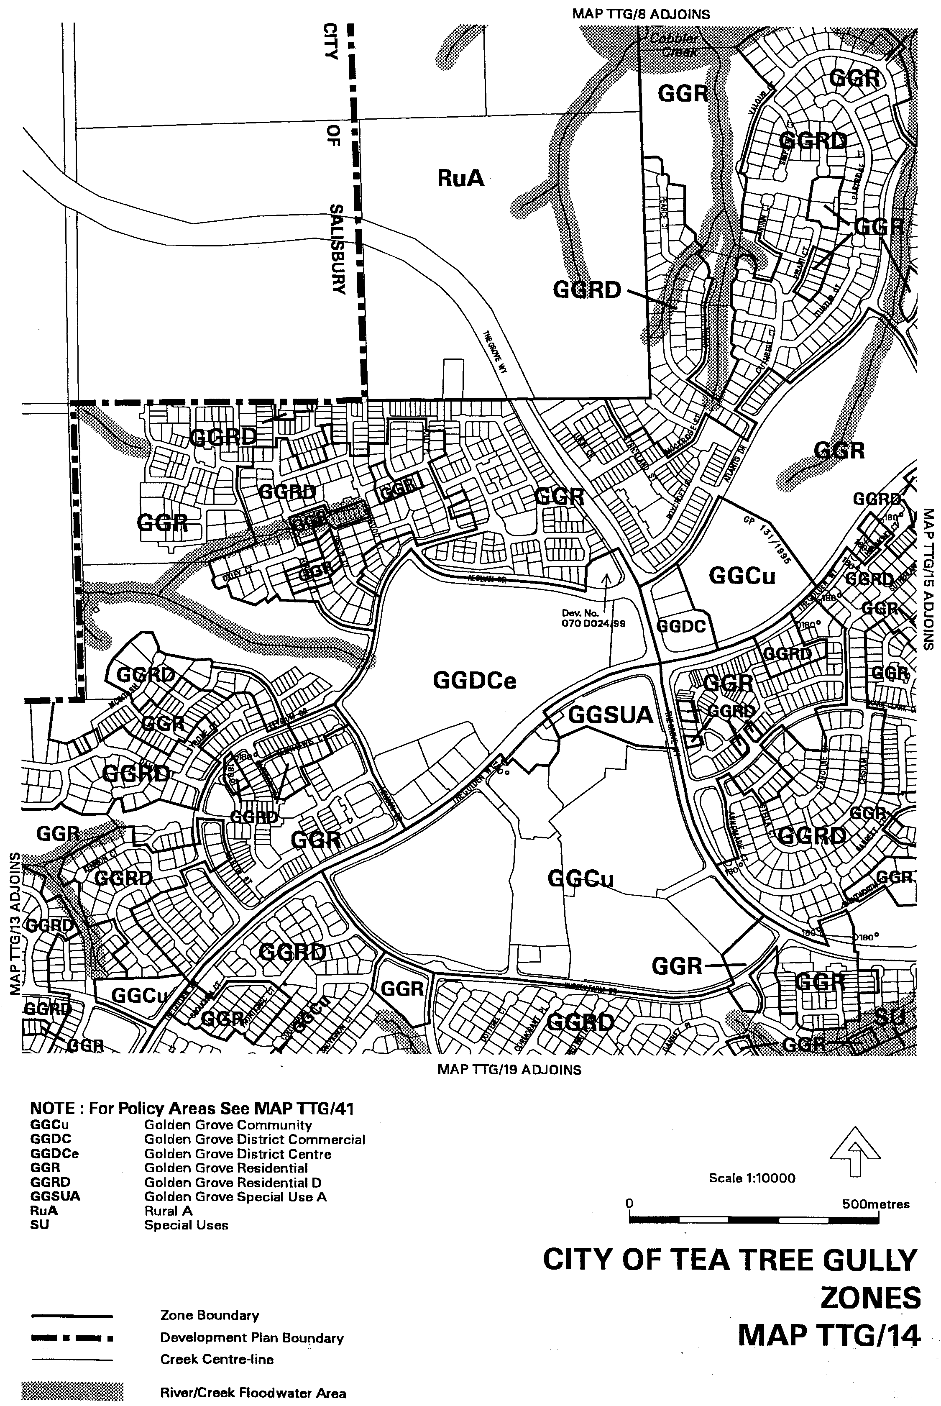
ATTACHMENT A

Dated 7 June 2001.
Diana Laidlaw, Minister for Transport and Urban Planning
PLN/99/0345

ELECTRICITY PRICING ORDER
Notice of change to ETSA Utilities distribution tariffs from 1 July 2001
PURSUANT to clause 1.6 (c) (ii) of the Electricity Pricing Order (EPO), notice is given that the Industry Regulator has approved:
• changes to the ETSA Utilities distribution tariffs, to be applied from 1 July 2001. The changes to the tariffs were calculated in accordance with the formula set out in Schedule 7 of the EPO; and
• the introduction of several new distribution tariffs, to be applied by ETSA Utilities from 1 July 2001. The new tariffs meet all the requirements for introducing new tariffs set out in clause 5.2 of the EPO.
A copy of the altered distribution tariffs and new distribution tariffs may be inspected and/or purchased from Information SA, Ground Floor, SA Water Building, 77 Grenfell Street, Adelaide, SA.
The tariffs and criteria for assignment to the tariffs are:
ETSA UTILITIES DISTRIBUTION TARIFFS FOR THE YEAR 1 JULY 2001 TO 30 JUNE 2002
Customer Category |  |  | Units |  | Min Qty. |  | TUOS incl GST |  | DUOS incl GST |  | Total incl GST
Subtransmission (kVA)
(Cust Sub Tr kVA)
 | Supply Rate | $ p.a. |  |  |  |  |  | 3 953.120 |  | 3 953.120
 | Annual Demand Rate | $/kVA p.a. |  | 11.5 MVA |  | 16.732 |  | 4.207 |  | 20.939
 | Additional Demand | $/kVA p.a. |  |  |  | 1.652 |  | 4.630 |  | 6.282
 | Peak Usage Rate | c/kWh |  |  |  | 1.077 |  | 0.202 |  | 1.279
 | Off-Peak Usage Rate | c/kWh |  |  |  | 0.320 |  | 0.143 |  | 0.463
Zone Sub-station (kVA)
(Cust Zone S/Stn kVA)
 | Supply Rate | $ p.a. |  |  |  |  |  | 1 694.200 |  | 1 694.200
 | Annual Demand Rate | $/kVA p.a. |  | 5.75 MVA |  | 16.436 |  | 11.169 |  | 27.605
 | Additional Demand | $/kVA p.a. |  |  |  | 0.000 |  | 8.281 |  | 8.281
 | Peak Usage Rate | c/kWh } |  | 25 GWh |  | 1.088 |  | 0.481 |  | 1.569
 | Off-Peak Usage Rate | c/kWh } |  |  |  | 0.330 |  | 0.359 |  | 0.689
High Voltage Demand (kVA)
(Cust HV kVA)
 | Supply Rate | $ p.a. |  |  |  |  |  | 1 355.360 |  | 1 355.360
 | Annual Demand Rate | $/kVA p.a. |  | 1.15 MVA |  | 15.430 |  | 23.345 |  | 38.775
 | Additional Demand | $/kVA p.a. |  |  |  | 0.000 |  | 11.632 |  | 11.632
 | Peak Usage Rate | c/kWh |  |  |  | 1.118 |  | 1.048 |  | 2.166
 | Off-Peak Usage Rate | c/kWh |  |  |  | 0.339 |  | 0.783 |  | 1.122
High Voltage Obsolete (kVA)
(Cust HV_Obsolete kVA)
 | Supply Rate | $ p.a. |  |  |  |  |  | 1 355.360 |  | 1 355.360
 | Annual Demand Rate | $/kVA p.a. |  | 300 kVA |  | 15.430 |  | 23.345 |  | 38.775
 | Additional Demand | $/kVA p.a. |  |  |  | 0.000 |  | 11.632 |  | 11.632
 | Peak Usage Rate | c/kWh |  |  |  | 1.118 |  | 1.048 |  | 2.166
 | Off-Peak Usage Rate | c/kWh |  |  |  | 0.339 |  | 0.783 |  | 1.122
Large Low Voltage Demand (kVA)
(Cust Large LV Demand kVA)
 | Supply Rate | $ p.a. |  |  |  |  |  | 1 355.360 |  | 1 355.360
 | Annual Demand Rate | $/kVA p.a. |  | 1.15 MVA |  | 15.151 |  | 29.808 |  | 44.959
 | Additional Demand | $/kVA p.a. |  |  |  | 0.000 |  | 13.488 |  | 13.488
 | Peak Usage Rate | c/kWh |  |  |  | 1.127 |  | 1.336 |  | 2.463
 | Off-Peak Usage Rate | c/kWh |  |  |  | 0.339 |  | 0.950 |  | 1.289
Low Voltage Demand (kVA)
(Cust LV Demand kVA)
 | Supply Rate | $ p.a. |  |  |  |  |  | 1 355.360 |  | 1 355.360
 | Annual Demand Rate | $/kVA p.a. |  | 350 kVA |  | 15.151 |  | 35.583 |  | 50.734
 | Additional Demand | $/kVA p.a. |  |  |  | 0.000 |  | 15.220 |  | 15.220
 | Peak Usage Rate | c/kWh |  |  |  | 1.127 |  | 1.592 |  | 2.719
 | Off-Peak Usage Rate | c/kWh |  |  |  | 0.339 |  | 1.126 |  | 1.465
Medium Low Voltage Demand (kVA)
(Cust Medium LV Demand kVA)
 | Supply Rate | $ p.a. |  |  |  |  |  | 677.670 |  | 677.670
 | Annual Demand Rate | $/kVA p.a. |  | 120 kVA |  | 14.594 |  | 50.544 |  | 65.138
 | Additional Demand | $/kVA p.a. |  |  |  | 0.000 |  | 19.541 |  | 19.541
 | Peak Usage Rate | c/kWh |  |  |  | 1.127 |  | 2.311 |  | 3.438
 | Off-Peak Usage Rate | c/kWh |  |  |  | 0.339 |  | 1.597 |  | 1.936
Low Voltage Business—2 Rate
(Cust LV Bus 2R)
 | Supply Rate | $ p.a. |  |  |  |  |  | 243.970 |  | 243.970
 | Peak Usage Rate | c/kWh |  |  |  | 1.943 |  | 5.582 |  | 7.525
 | Off-Peak Usage Rate | c/kWh |  |  |  | 0.370 |  | 2.344 |  | 2.714
Low Voltage Business—Single Rate
(Cust LV Bus 1R)
 | Supply Rate | $ p.a. |  |  |  |  |  | 67.770 |  | 67.770
 | Anytime Usage Rate | c/kWh |  |  |  | 1.534 |  | 5.549 |  | 7.083
Low Voltage Residential—Single Rate
(Cust LV Res 1R)
 | Supply Rate | $ p.a. |  |  |  |  |  | 66.659 |  | 66.659
 | Anytime Usage Rate | c/kWh |  |  |  | 1.555 |  | 6.068 |  | 7.623
Low Voltage Off-peak Controlled Load
(Cust LV C Load)
 | Supply Rate | $ p.a. |  |  |  |  |  | 24.433 |  | 24.433
 | Anytime Usage Rate | c/kWh |  |  |  | 0.308 |  | 1.380 |  | 1.688
Low Voltage Unmetered Usage (Overnight Usage)
(Cust LV 12 hr Night)
 | Anytime Usage Rate | c/kWh |  |  |  | 0.699 |  | 3.001 |  | 3.700
Low Voltage Unmetered Usage (24 Hour Usage)
(Cust LV 24 hr Continuous)
 | Anytime Usage Rate | c/kWh |  |  |  | 0.874 |  | 3.272 |  | 4.146
Other Unmetered Usage
(Cust Other)
 | Supply Rate | $ p.a. |  |  |  |  |  | 44.459 |  | 44.459
 | Peak Usage Rate | c/kWh |  |  |  | 1.902 |  | 6.045 |  | 7.947
 | Off-Peak Usage Rate | c/kWh |  |  |  | 0.380 |  | 2.370 |  | 2.750
Obsolete Tariffs
Subtransmission (kW)
(Cust Sub Tr kW)
 | Supply Rate | $ p.a. |  |  |  |  | 3 953.120 |  | 3 953.120
 | Annual Demand Rate | $/kW p.a. | 10 MW |  | 17.475 |  | 4.009 |  | 21.484
 | Additional Demand | $/kW p.a. |  |  | 2.733 |  | 5.346 |  | 8.079
 | Peak Usage Rate | c/kWh |  |  | 1.120 |  | 0.298 |  | 1.418
 | Off-Peak Usage Rate | c/kWh |  |  | 0.349 |  | 0.195 |  | 0.544
Zone Sub-station (kW)
(Cust Zone S/Stn kW)
 | Supply Rate | $ p.a. |  |  |  |  | 1 694.200 |  | 1 694.200
 | Annual Demand Rate | $/kW p.a. | 5 MW |  | 17.166 |  | 9.971 |  | 27.137
 | Additional Demand | $/kW p.a. |  |  | 0.000 |  | 10.651 |  | 10.651
 | Peak Usage Rate | c/kWh } | 25 GWh |  | 1.131 |  | 0.658 |  | 1.789
 | Off-Peak Usage Rate | c/kWh } |  |  | 0.360 |  | 0.473 |  | 0.833
High Voltage Demand (kW)
(Cust HV kW)
 | Supply Rate | $ p.a. |  |  |  |  | 1 355.360 |  | 1 355.360
 | Annual Demand Rate | $/kW p.a. | 1 MW |  | 17.063 |  | 21.586 |  | 38.649
 | Additional Demand | $/kW p.a. |  |  | 0.000 |  | 15.958 |  | 15.958
 | Peak Usage Rate | c/kWh |  |  | 1.162 |  | 1.388 |  | 2.550
 | Off-Peak Usage Rate | c/kWh |  |  | 0.370 |  | 1.018 |  | 1.388
High Voltage Obsolete (kW)
(Cust HV_Obsolete kW)
 | Supply Rate | $ p.a. |  |  |  |  | 1 355.360 |  | 1 355.360
 | Annual Demand Rate | $/kW p.a. | 250 kW |  | 17.063 |  | 21.586 |  | 38.649
 | Additional Demand | $/kW p.a. |  |  | 0.000 |  | 15.958 |  | 15.958
 | Peak Usage Rate | c/kWh |  |  | 1.162 |  | 1.388 |  | 2.550
 | Off-Peak Usage Rate | c/kWh |  |  | 0.370 |  | 1.018 |  | 1.388
Large Low Voltage Demand (kW)
Cust Large LV Demand kW)
 | Supply Rate | $ p.a. |  |  |  |  | 1 355.360 |  | 1 355.360
 | Annual Demand Rate | $/kW p.a. | 1 MW |  | 16.755 |  | 27.445 |  | 44.200
 | Additional Demand | $/kW p.a. |  |  | 0.000 |  | 18.502 |  | 18.502
 | Peak Usage Rate | c/kWh |  |  | 1.172 |  | 1.758 |  | 2.930
 | Off-Peak Usage Rate | c/kWh |  |  | 0.370 |  | 1.233 |  | 1.603
Low Voltage Demand (kW)
(Cust LV Demand kW)
 | Supply Rate | $ p.a. |  |  |  |  | 1 355.360 |  | 1 355.360
 | Annual Demand Rate | $/kW p.a. | 300 kW |  | 16.755 |  | 32.688 |  | 49.443
 | Additional Demand | $/kW p.a. |  |  | 0.000 |  | 20.879 |  | 20.879
 | Peak Usage Rate | c/kWh |  |  | 1.172 |  | 2.087 |  | 3.259
 | Off-Peak Usage Rate | c/kWh |  |  | 0.370 |  | 1.460 |  | 1.830
Medium Low Voltage Demand (kW)
Cust Medium LV Demand kW)
 | Supply Rate | $ p.a. |  |  |  |  | 677.670 |  | 677.670
 | Annual Demand Rate | $/kW p.a. | 100kW |  | 16.138 |  | 46.256 |  | 62.394
 | Additional Demand | $/kW p.a. |  |  | 0.000 |  | 26.807 |  | 26.807
 | Peak Usage Rate | c/kWh |  |  | 1.172 |  | 3.012 |  | 4.184
 | Off-Peak Usage Rate | c/kWh |  |  | 0.370 |  | 2.066 |  | 2.436

Notes accompanying 2001/2002 Tariffs
Notes:
1. The distribution tariffs:
(a) are inclusive of the GST imposed as at 1 July 2000; and
(b) include the application of AD_{t} as defined in paragraph E2 of Schedule 7 of the Electricity Pricing Order 1999.
2. ETSA Utilities must assign each Distribution Network User to a distribution tariff in respect of each of its connection points in accordance with the following principles:
(a) A Distribution Network User that has an agreed maximum demand of 250kW or more in respect of a connection point, must be assigned to a distribution tariff that includes a demand component in respect of that connection point.
(b) A Sub-Transmission (kVA) Network User is a Distribution Network User taking supply at 66kV, or at 33kV outside of the Adelaide Metropolitan area. A minimum annual demand of 11.50MVA applies. A type 3 NEM meter or equivalent is required.
(c) A Zone Substation (kVA) customer is a Distribution Network User taking supply generally at 11kV from the low voltage transformer terminals. Supply may also be taken at lower voltages that exceed 1kV. A minimum annual demand of 5.75 MVA and a minimum annual usage of 25GWh apply. A type 3 NEM meter or equivalent is required.
(d) A High Voltage Demand (kVA) customer is a Distribution Network User taking supply generally at 11kV. Supply may also be taken at lower voltages that exceed 1kV or at 33kV in metropolitan Adelaide. A minimum annual demand of 1.15MVA applies. A type 3 NEM meter or equivalent is required.
(e) A High Voltage (kVA) (Obsolete) customer is a Distribution Network User taking supply generally at 11kV. This tariff is available only to Distribution Network Users that were taking supply under the High Voltage Demand (kW) (Obsolete) tariff as at 11 October 1999. Supply may also be taken at lower voltages that exceed 1kV or at 33kV in metropolitan Adelaide. A minimum annual demand of 300kVA applies. A type 3 NEM meter or equivalent is required.
(f) A Large Low Voltage Demand (kVA) customer is a Distribution Network User taking supply at less than 1kV and generally from the low voltage distribution transformer terminals. A minimum annual demand of 1.15MVA applies. A type 3 NEM meter or equivalent is required.
(g) A Low Voltage Demand (kVA) customer is a Distribution Network User taking supply at less than 1kV and generally from the low voltage distribution transformer terminals. A minimum annual demand of 350kVA applies. A type 3 NEM meter or equivalent is required.
(h) A Medium Low Voltage Demand (kVA) customer is a Distribution Network User that is not a residential customer taking supply at less than 1kV and using demand, peak and off-peak metering. A minimum annual demand of 120kVA applies. A type 3 NEM meter or equivalent is required.
(i) A Low Voltage Business 2 rate customer is a Distribution Network User that is not a residential customer taking supply at less than 1kV and using peak and off-peak metering.
(j) A Low Voltage Business single rate customer is a Distribution Network User that is not a residential customer taking supply at less than 1kV and using single rate metering.
(k) A Low Voltage Residential single rate customer is a Distribution Network User that is a residential customer taking supply at less than 1kV and using single rate metering.
(l) A Low Voltage Off-peak Controlled Load is use by a Distribution Network User involving a time switch and separate metering where the timing has been set in accordance with ETSA Utilities’ requirements regarding the timing of loads.
(m) Unmetered Overnight Usage supply is defined as overnight use by a Distribution Network User for public lighting.
(n) Unmetered 24 Hour Usage supply is defined as constant 24 hour per day use by a Distribution Network User, typically public phones, traffic lights and telecommunications installations.
(o) Other Unmetered Supply is defined as unmetered use by Distribution Network Users other than public lighting or continuous use.
(p) A Sub-Transmission Network (kW) User is a Distribution Network User taking supply at 66kV, or at 33kV outside of the Adelaide metropolitan area. A minimum annual demand of 10MW applies. This tariff is available only to Distribution Network Users that were taking supply under this tariff as at 30 June 2001.
(q) A Zone Substation (kW) customer is a Distribution Network User taking supply generally at 11kV from the low voltage transformer terminals. Supply may also be taken at lower voltages that exceed 1kV. A minimum annual demand of 5MW and a minimum annual usage of 25GWh apply. This tariff is available only to Distribution Network Users that were taking supply under this tariff as at 30 June 2001.
(r) A High Voltage Demand (kW) customer is a Distribution Network User taking supply generally at 11kV. Supply may also be taken at lower voltages that exceed 1kV or at 33kV in metropolitan Adelaide. A minimum annual demand of 1MW applies. This tariff is available only to Distribution Network Users that were taking supply under this tariff as at 30 June 2001.
(s) The High Voltage Demand (kW) (Obsolete) tariff is available only to Distribution Network Users that were taking supply under this tariff as at 11 October 1999. Conditions applicable at that date apply.
(t) A Large Low Voltage Demand (kW) customer is a Distribution Network User taking supply at less than 1kV and generally from the low voltage distribution transformer terminals. A minimum annual demand of 1MW applies. This tariff is available only to Distribution Network Users that were taking supply under this tariff as at 30 June 2001.
(u) A Low Voltage Demand (kW) customer is a Distribution Network User taking supply at less than 1kV and generally from the low voltage distribution transformer terminals. A minimum annual demand of 300kW applies. This tariff is available only to Distribution Network Users that were taking supply under this tariff as at 30 June 2001.
(v) A Medium Low Voltage Demand (kW) customer is a Distribution Network User that is not a residential customer taking supply at less than 1kV and using demand, peak and off-peak metering. A minimum annual demand of 100kW applies. This tariff is available only to Distribution Network Users that were taking supply under this tariff as at 30 June 2001.
3. The supply and demand charges are levied and billed to Distribution Network Users periodically on a pro-rata basis.
4. Demand charges are determined on the basis of:
(a) maximum demand (Annual Demand); and
(b) additional maximum demand (Additional Demand),
determined in accordance with paragraph B2 of Schedule 5 of the Electricity Pricing Order.
5. Peak energy is energy consumed on business days between the hours of 0700 and 2100 (Central Standard Time). For Distribution Network Users with metering that does not recognise specific days, peak energy is energy consumed on each day between the hours of 0700 and 2100 (Central Standard Time).
6. Off-peak energy is energy consumed other than peak energy.
L. Owens, Industry Regulator

ELECTRICITY PRICING ORDER
Notice of a change to AGL SA non-contestable tariffs for the year 1 July 2001 to 30 June 2002
NOTICE is hereby given, pursuant to clause 1.6 (c) (ii) of the Electricity Pricing Order (EPO), that the Industry Regulator has approved a change in the AGL SA non-contestable retail tariffs. The changes to the tariffs were calculated in accordance with the formula set out in Schedule 7 of the EPO.
The altered non-contestable retail tariffs are to be applied for consumption during the year 1 July 2001 to 30 June 2002.
A copy of the altered non-contestable retail tariffs may be inspected and/or purchased from Information SA, Ground Floor, SA Water Building, 77 Grenfell Street, Adelaide, S.A.
Queries in relation to the altered tariffs may be directed to the Office of the South Australian Independent Industry Regulator (SAIIR), Level 8, 50 Pirie Street, Adelaide. Telephone (08) 8463 4444 or Freecall 1800 633 592.
The tariffs and criteria for assignment to the tariffs are:
AGL SA NON-CONTESTABLE TARIFFS FOR THE YEAR 1 JULY 2001 to 30 JUNE 2002
Customer category | Tariff components | Amount
Domestic Light/Power 110 | Supply charge | $24.13 per quarter
 | Consumption | 14.66¢ per kWh
Charitable Institutions 112 | Supply charge | $24.13 per quarter
 | Consumption | 14.66¢ per kWh
Off Peak Controlled Load 116 | Supply charge | $2.54 per quarter
 | Consumption | 5.53¢ per kWh
General Supply 126 | Supply charge | $25.28 per quarter
 | Consumption:
 | (a) first 7 500 kWh per quarter | 16.16¢ per kWh
 | (b) next 150 000 kWh per quarter | 15.75¢ per kWh
 | (c) additional kWh | 12.76¢ per kWh
General Supply Time of Use 128 | Supply charge | $52.88 per quarter
 | Consumption
 | (a) Peak Period | 17.04¢ per kWh
 | (b) Off Peak Period | 7.17¢ per kWh
Time of Use Demand 160 | Maximum Demand Charge per kW per month (minimum chargeable demand  -250 kW):
 | (a) each kW registered during Peak Period | $8.61 per kW
 | (b) each kW by which maximum demand recorded during Off Peak Period exceeds the maximum demand recorded during Peak Period | $4.16 per kW
 | Energy Charge:
 | (a) Peak Period
 | (i) first 50 000 kWh per month | 12.23¢ per kWh
 | (ii) additional kWh per month | 8.30¢ per kWh
 | (b) 2 a.m. to 5 a.m. daily | 3.93¢ per kWh
 | (c) all other times | 4.99¢ per kWh
General Purpose and Industrial with Off Peak 120 + 121, 130 + 131 | Supply charge | $33.77 per quarter
 | Consumption:
 | (a) first 7 500 kWh per quarter | 16.45¢ per kWh
 | (b) next 150 000 kWh per quarter | 15.75¢ per kWh
 | (c) next 750 000 kWh per quarter | 12.76¢ per kWh
 | (d) additional kWh | 12.08¢ per kWh
 | Off Peak (121/131):
 | Optional rate for consumption during Off Peak Period | 7.17¢ per kWh
Farm with Off Peak 140 + 141 | Supply charge | $33.77 per quarter
 | Consumption:
 | (a) first 7 500 kW per quarter | 16.45¢ per kWh
 | (b) next 150 000 kWh per quarter | 14.99¢ per kWh
 | (c) additional kWh | 12.76¢ per kWh
 | Off Peak (141)
 | Optional rate for consumption during Off Peak Period | 7.17¢ per kWh

Unmetered supply tariffs | Wattage/other details |  | Charge ($/month unless specified otherwise)
Standard Public Lighting
Sodium (Low Pressure) | 18 |  | 6.40
 | 26 |  | 7.91
 | 55 |  | 11.91
 | 90 |  | 14.14
 | 135 |  | 17.49
Sodium (High Pressure) | 50 |  | 7.91
 | 100 |  | 14.14
 | 150 |  | 15.06
 | 250 |  | 18.65
 | 400 |  | 24.39
Mercury (High Pressure) | 50 |  | 7.89
 | 80 |  | 7.98
 | 250 |  | 15.78
 | 400 |  | 19.89
Customer Lighting Equipment Rate
Sodium Low Pressure | 18 |  | 4.57
 | 26 |  | 5.50
 | 55 |  | 7.31
 | 90 |  | 8.69
 | 135 |  | 11.16
Sodium (High Pressure) | 50 |  | 5.50
 | 100 |  | 8.05
 | 150 |  | 8.61
 | 250 |  | 11.46
 | 400 |  | 16.49
Fluorescent or Gaseous Tube Lights | Fixed Charge |  | 2.94
 | Overnight Usage |  | 40.98¢/10W/month
 | 24 hour usage |  | 61.67¢/10W/month
Special Public Lighting Tariffs
Traffic Control Beacons |  |  | 38.01 per kW of connected load
Traffic Spotlight—Maintenance Charge |  |  | 3.34
Telstra telephone cabinets, porch lighting and stamp vending machines |  |  | 8.20
Special Floodlighting | 1 000 metal halide  (Veale Gardens) |  | 58.65
 | 400 mercury  (limited burning hours)  (SACON—illumination of State Government Buildings) |  | 7.94
Energy-only tariffs  (where all maintenance including lamp replacements carried out by customer) | 50W high pressure sodium |  | $2.77
 | 100W high pressure sodium |  | $5.19
Private Floodlighting | 400 mercury |  | 30.36
 | 360 sodium |  | 34.52
 | 940 sodium |  | 58.60
 | 1 000 mercury |  | 58.60
Unmetered Supply Tariffs (other than public lighting)
Small unmetered supplies (minimal energy usage) |  |  | 9.01
Larger unmetered supplies (flat constant load)—charged based on estimated usage | Supply  All energy |  | 6.92  10.69¢/kWh

Unmetered supply tariffs | Wattage/other details | Charge ($/month unless specified otherwise)
Obsolete Public Lighting Tariffs
Fluorescent | 40 | 7.05
 | Long bracket | 1.15
Incandescent Street Lights | 60 (and less) | 11.36
 | 100 | 12.44
 | 150 | 15.68
 | 200 | 16.11
 | 300 | 21.29
 | 500 | 29.01
 | 1 000 | 49.28
Tubular Fluorescent Street Lights | 2 x 20 | 9.05
 | 2 x 40 | 13.46
 | 3 x 40 | 16.32
 | 4 x 40 | 18.71
Mercury Street Lights | 80 | 14.09
 | 125 | 15.97
Floodlights Incandescent | All year use
 | 300 | 33.46
 | 500 | 43.78
 | 750 | 57.20
 | 1 000 | 71.80
 | 1 500 | 106.83
 | Seasonal use | 36.03
 | Mercury—all year use
 | 250 | 24.64
 | 400 | 34.54
 | Mercury—seasonal use
 | 400 | 28.39
 | Sodium—all year use
 | 90 | 27.23
Mercury Fluorescent (Adelaide and Elizabeth City Councils) | 2 x 400 | 44.26
Gaseous Tube Signs | Fixed Charge | 2.96
 | Usage | 8.42¢/W/month
Holophane Lanterns |  | 2.17
Suspended Support |  | 1.96
Public Lighting using Tubular Steel Poles | Lamp Tariff plus additional charge as follows:
 | (a) poles and ducts supplied by AGL SA Pty Ltd; or | 15.61
 | (b) poles supplied by customer; or | 11.05
 | (c) ducts supplied by customer; or | 7.83
 | (d) poles and ducts supplied by customer. | 3.28

Notes accompanying 2001/ 2002 Tariffs
Notes:
1. The non-contestable tariffs:
(a) are inclusive of the GST imposed at 1 July 2000; and
(b) include the application of AR_{t} as defined in paragraph E2 of Schedule 7 of the Electricity Pricing Order 1999.
2. AGL SA Pty Ltd must assign each non-contestable customer to a non-contestable tariff in accordance with the following principles:
(a) Domestic Light/Power 110 is applicable to all residential consumption (excluding Off-Peak Controlled Load Tariff 116) in premises used wholly or principally as private residences.
(b) Charitable Institutions 112 is available to charitable institutions that are exempt from financial institutions duty or, if this ceases to be applicable, satisfy other eligibility criteria approved by the Regulator.
(c) Off Peak Controlled Load 116 is for electricity used in permanently installed storage water heaters with a rated delivery of not less than 125 litres, storage space heaters and other approved thermal storage applications. The hours of application are fixed from time to time by AGL SA Pty Ltd with control by time switch or other means. This tariff is only available in conjunction with Tariff 110, 112, 120, 126, 128, 130 or 140.
(d) General Supply 126 is available only to non residential customers.
(e) General Supply Time of Use 128 is available only to non residential customers.
(f) Time of Use Demand 160 is available to non residential customers until 31 December 1999. Maximum demand indicators will be reset monthly. No other tariff is permitted with Tariff 160.
(g) General Purpose and Industrial with Off Peak 120 + 121, 130 + 131 are available only to non-contestable customers that were taking supply under these tariffs, or had applied to do so, as at 30 June 1997. Conditions applicable at that date apply.
(h) Farm with Off Peak 140 + 141 is available only to non-contestable customers that were taking supply under this tariff, or who had applied to do so, as at 30 June 1997. Conditions applicable at that date apply.
3. The unmetered supply tariffs apply to public lighting as follows:
(a) Standard Public Lighting tariffs apply in overhead supply situations and where ETSA Utilities Pty Ltd mains are available. The tariffs also apply to underground situations provided that the customer requesting the lights makes a lump sum contribution equal to the additional cost incurred by ETSA Utilities Pty Ltd in providing underground supply and a supporting structure for each light.
(b) Customer Lighting Equipment Rate tariffs apply where the public lighting system is installed and owned by the customer, or where the customer uses lanterns and lighting columns other than standard ETSA Utilities Pty Ltd equipment. ETSA Utilities Pty Ltd will provide only the service point, electrical energy and lamp replacements. All other maintenance is the responsibility of the customer, including lamp replacement where:
(i) lanterns are inaccessible to ETSA Utilities Pty Ltd vehicles; or
(ii) non-standard lamps are used.
(c) Obsolete Public Lighting tariffs apply only to installations existing as at 11 October 1999.
4. A discount applies to non-contestable customers that take supply at a standard high voltage as follows:
(a) 11kV and 33kV—5%; and
(b) 66kV and above—7%.
5. If the account for a non-contestable customer includes any combination of the following tariffs, there will only be one supply charge per quarter applied to the account:

Tariffs | Supply Charge
110, 112, 126 | $31.92
110, 112, 126; with 116 | $34.47
110, 112, 120, 130, 140 | $40.41
110, 112, 120, 130, 140; with 116 | $42.94

6. Peak period is 0700 hours to 2100 hours from Monday to Friday (Central Standard Time).
Off peak period is all times other than peak period.
L. Owens, Industry Regulator

EQUAL OPPORTUNITY TRIBUNAL
No. 76 of 2001
Notice of Exemption
Before Deputy Presiding Officer Hume
Members Balzon and Altman
I HEREBY certify that on 10 May 2001, the Equal Opportunity Tribunal of South Australia on the application of Horwath Recruitment & Training Pty Ltd made the following orders for exemption:
1. Horwath Recruitment & Training Pty Ltd are granted an exemption from the provisions of section 30 of the Act relating to advertising career opportunities for women in automotive sales on behalf of Mitsubishi Motors Australia Limited.
2. That this exemption will be in force for a period of two years, namely until 10 May 2003.
Dated 22 May 2001.
D. Hoban, for Registrar, Equal Opportunity Tribunal

ENVIRONMENT PROTECTION ACT 1993
Exemption
THE following persons are exempt from section 75 of the Environment Protection Act 1993, subject to the provisions of Regulation 6 of the Regulations under the Environment Protection Act 1993 dated 27 October 1994 by virtue of owning or possessing equipment containing ozone depleting substances:
Geoservices Overseas Society Anonyme (1797); Mark Wilksch (539); Brenton Mark Renshaw (7154); Jarlee Investments Pty Ltd (7457); Richardson Automotive Pty Ltd (80); W. K. Motors Pty Ltd (306); Central Refrigeration Pty Ltd (350); Kenneth Lloyd King (370); Anthony Roland McCreanor (462); Anthony Cyril and Kathryn Leesong (631); Heavyside Investments Pty Ltd (855); Brisac Pty Ltd (1019); Jarrett Motor Company Pty Ltd (1243); Trevor G. Altus (1366); Adelaide Community Healthcare Alliance Incorporated (1586); M. Wright Hotel Refrigeration Pty Ltd (1752); Holwade Nominees Pty Ltd (2447); Laszlo and Robyn Jean Purczel (588); Jeanette Rosadoni (1433); Paul Antoni Giadresco (11143); Stuart Donald Gay (4784); Inchcape Shipping Services Pty Ltd (6898); Scott Oschmanns (10123); Don Pat Bergineti (10873); Brian Ivor Olsen (1575); Robert Huddleston (1739); John Flaus (2473); Rick and Valerie Rismondo (3593); Michael Wills (4856); Robin E. Sheehan (5225); Kevin Baldock (7147); John Matthews (5055); Sebastian Steven Sapid (2308); Ronald Brian Cowan (3679); Andrew Hille (10013); Mount Gambier Airconditioning & Refrigeration Pty Ltd (19); Peter’s Auto Electrics Pty Ltd (32); J. W. & R. T. Daniels (53); John Delaine (113); Giuliano Drusetta (114); Stephen Watson (162); Honeywell Pty Ltd (169); R. J. Devitt (179); Leonid Botuch (195); Stephen Falzun (270); R. K. & P. G. Childs (338); Trevor Lindsay Manning (352); Independent Appliance Service Pty Ltd (452); Dean Mason (501); Andrew Kempson (510); University of Adelaide (621); Robin Payne (690); Logan Cab Holdings Pty Ltd (774); W. J. Hesketh (880); Glenn Vivian Stearnes (888); Orica Australia (917); Adelaide Motors Pty Ltd (994); John Tremaine (999); Noel Anthony Reichstein (1148); Zedsol Pty Ltd (1165); Clenton Evans (1293); David Jones Limited (1380); M. J. & L. A. Fuchs Pty Ltd (1649); Neville Clifford Osborn (1975); Awor Pty Ltd (2003); Designtech Controls Pty Ltd (2163); Adrian William Smith (2178); Michael and Sharon Heathfield (2300); Corporation of the City of Whyalla (2480); A. B. & S. Martin (2621); Tundarri Sales & Service Pty Ltd (2704); John Anthony House (3119); Belcar Pty Ltd (3318); Shane’s Refrigeration Pty Ltd (3354); D. B. Algar (3464); Povey Motors (3471); Hicks Auto & Engineering Pty Ltd (3487); Barry Stoneman (3714); Geoffrey Moody (3744); Brian John Ball (4758); Hindmarsh Mechanical & Electrical Services Pty Ltd (4989); Phillip A. Kammermann (5036); Martin Ancone (5241); Darren Hocking (5806); Stan Bournias (6347); Ross Laird (6400); D. A. Newbold (6434); Wayne Smith Motors Pty Ltd (6514); Bob Amos Pty Ltd (6553); Anthony D. Marafioti (6700); Geoffrey Raymond and Mary Elizabeth Smith (6701); Parker Appliance & Electrical Pty Ltd (6945); Chien Dinh Vu (7004); Christopher Barker (7006); Charles Walker (7114); Noel Greatbatch (7125); Peter Heaven (7149); Malcolm Arthur Walden (7185); Kelvin James Bowden (7234); Fine-Tech Pty Ltd (7260); Peter J. Mosel (7423); D. W. Searle (7433); Troy Ryan (7537); Newton Services Pty Ltd (7542); Maxwell John and Pauline Lynnette McCulloch (7546); Felihba Pty Ltd (10039); James G. Poole (10143); John Mokdassi (10188); David Short (10273); Favell Pty Ltd and M. & P. A Bianco (10334); Gavin Paul Jones (10611); Dale Layton (10989); Apollo Sales Pty Ltd (11144); 3M Pharmaceuticals Pty Ltd (147); Glaxo Smith Kline Australia Pty Ltd (150); Trevor D. McHugh (333); Maitland Motors Pty Ltd (395); Leipus & Holland Pty Ltd (567); Mobile Auto Electrical Pty Ltd (1166); Grande Riviere Pty Ltd (1230); Pfitzner Motor Co Pty Ltd (2192); George E. Corbin (2305); Lucas Family Pty Ltd (2436); Stanley Frederick Hawkins (2896); Grand Motors Pty Ltd (3085); Allan William Reimann (3646); Paul A. and Sharon J. Warren (3775); Mark Andrew Podlewski and Alan David Ward (3799); Roderick and Rosemary Hollick (5603); Shane Jackson (6722); James Stanley McCabe (7026); City Dismantlers Pty Ltd (7285); John and Lee Ann Guerin (7321); John Oates and James Edwards (7342); John Kouts (7442); Sheridan Australia (7491); Christopher Mark Bradley (10874); Matthew Ivan and Cindy Elizabeth Bowman (10901); William John Stringer (10924); Peer Tec (11016); Samuel Smith & Son Pty Ltd (11081).
G. C. Sclare, Manager, Licensing and Operations Services

FISHERIES ACT 1982: SECTION 59
TAKE notice that pursuant to section 59 of the Fisheries Act 1982, Rolf Czabayski, 5 Willowbridge Grove, Burnside, S.A. 5066 (hereinafter referred to as the ‘permit holder’) is exempt from regulation 35C of the Fisheries (General) Regulations 1984, in that the permit holder shall not be guilty of an offence when using berley within the waters specified in Schedule 1 to attract white sharks (Carchardon carcharias) for the purpose of cage viewing only (hereinafter referred to as the ‘permitted activity’), subject to the conditions specified in Schedule 2, for the dates specified in Schedule 3.
Schedule 1
Coastal waters contained within the Neptune Islands Conservation Park, and the following portions of the Sir Joseph Banks Islands Conservation Park; English and Sibsey Islands.
Note: During Australian Sea lion breeding periods at Dangerous Reef, permits will not be provided for eight months. This period will begin eight weeks after the appearance of the first pups.
Schedule 2
1. The permit holder must be on board the boat when conducting the permitted activity.
2. All berley used while conducting the permitted activity must consist of fish based products only. All berley (other than fish oil) must be stored below a maximum temperature of 4°C.
3. The permit holder must notify the public by a Notice to Mariners through the Australian Maritime Safety Authority, by public notice in the Adelaide Advertiser at least 24 hours in advance of berleying operations, advising the local coastguard and the Fisheries Compliance Unit on 1800 065 522 at least two hours prior to conducting the permitted activities.
4. The permit holder shall allow an officer of the Department of Environment and Heritage or nominee to be present on board the boat during the permitted activities if requested and subject to negotiation and availability of space.
5. The permit holder must comply with all instructions (including ceasing to berley if so instructed) given by an officer from DEH.
6. Whilst engaged in the permitted activity, an pennant (approved by DEH) must be flown from the boat so as to be clearly visible.
7. Whilst engaged in the permitted activity the permit holder must have in his/her possession a copy of this notice and produce a copy of the notice if required by a fisheries compliance officer.
8. The permit holder shall not contravene or fail to comply with the Fisheries Act 1982, or any regulations made under that Act, except where specifically exempted by this notice.
9. The permit holder must maintain a log whilst engaged in the permitted activity which includes the date and location, number of passengers, number of hours berleying, number of sharks observed and any other relevant observations or comments. Records must be kept in a form determined by the operators association in conjunction with CSIRO Marine Research Unit and endorsed by the Minister for Environment and Heritage. A copy of the log must be provided to the relevant DEH office within 14 days of each calendar month. Failure to submit a log within the agreed time period may preclude the provision of future permits until such outstanding logs are received by the relevant DEH office.
10. The permit holder must conform to a code of conduct developed by the operators association and endorsed by the Minister for Environment and Heritage.
11. The permit holder will operate in cooperation with and in agreement of any other approved operator at the same location.
12. The permit holder must have public liability insurance to an amount determined by the Minister for Environment and Heritage and ensure vessels are surveyed and staffed as per Department of Transport regulations.
Schedule 3
Dates permitted to berley: 8 July to 13 July 2001
16 July to 19 July 2001
Dated 4 June 2001.
R. Allen, Acting Regional Manager West

FISHERIES ACT 1982
Marine Mollusc Subtidal Farming Licence FS00038
Licence to Farm Fish under section 53 of the Fisheries
Act 1982
THE Minister for Primary Industries and Resources (‘the Minister’) hereby grants to:
Todd Packer (12239)
64 Cook Street
Port Lincoln, S.A. 5606
a licence to occupy and use the waters and airspace over the land specified in Item 1 of Schedule 1 of this licence (‘the site’) for the purpose of farming and taking the permitted species (‘the permitted use’) for the period commencing on 1 July 2000 and ending, subject to any earlier termination under this licence, on 30 June 2001 (‘the term’) subject to the following terms and conditions:
Conditions of This Licence
1. Marked-off Areas
1.1 Subject to section 53A of the Fisheries Act 1982, this licence does not entitle the licensee to exclusive rights of entry to and occupation of the site. The rights granted by this licence are exercisable by the licensee in common with any other occupiers of the site from time to time.
1.2 For the purposes of section 53A of the Fisheries Act 1982, the marked-off areas within the site are that area or those areas marked-off or indicated in the manner set out in Item 2 of Schedule 1 of this licence.
2. Permitted Species
The licensee:
2.1 must not farm or introduce any species at the site other than the permitted species referred to in Schedule 2; and
2.2 must not take any wild fish from the site except for recreational purposes.
3. Permitted Use
The licensee must not use the site for any purpose other than the permitted use.
4. Permitted Methods
4.1 The licensee must, in undertaking the permitted use, take all reasonable and practicable measures to prevent or minimise damage to the environment. Without limiting the generality of the foregoing, the licensee:
4.1.1 must ensure the total length of each unit does not exceed 3 km of longline or 1 km of racking per hectare, and each unit must be at least 5 m from any other unit;
4.1.2 must not use the anti-fouling chemical tributyltin (TBT) on any equipment used at the site;
4.1.3 must not use any chemical or drug for either therapeutic or prophylactic purpose except with the prior approval of the Minister;
4.1.4 must undertake an environmental monitoring program approved by the Minister and as specified in Clause 4.3;
4.1.5 must not introduce the permitted species to the site before the approval of the environmental monitoring program referred to in 4.1.4 by the Minister;
4.1.6 must comply with the schedule of reporting for the environmental monitoring program as pres-cribed in Schedule 6 and submit the final results of the environmental monitoring program to the Minister 30 days before expiry of the term of this licence.
4.2 SASQAP
4.2.1 It is a condition of your licence to farm bivalve molluscs that only shellfish from Classified and Approved areas under the South Australian Shellfish Quality Assurance Program (SASQAP) may be sold for human consumption.
4.2.2 The licensee must continue to meet all the regulations required under the Food Standards Code to produce a product safe for human consumption.
4.3 The licensee must submit a draft environmental monitoring program to the Minister for approval within 60 days of the grant of the licence by the Minister. The draft environmental monitoring program must include the qualifications and experience of the person(s) designing and undertaking the program and address the matters listed in Schedule 5.
5. Marking and Maintaining the Site
The licensee:
5.1 must ensure that the site is maintained in a good, tidy and safe condition to the satisfaction of the Minister;
5.2 must remove and lawfully dispose of any waste or debris on the site as soon as is reasonably practicable and in particular must comply with any guidelines issued from time to time by the Minister in relation to the removal from the site of any unhealthy or dead fish;
5.3 must maintain all buoys, crosses, and markers on the site in good condition and in accordance with the colours specified in Schedule 1 of this licence; and
5.4 must mark the site boundary in accordance with the requirements of the Minister for Transport.
6. Site Inspection and Supervision
The licensee:
6.1 must at all times permit the Minister, his employees, agents or contractors or any employees, agents or contractors of the Crown to enter the site for the purposes of inspecting the site, the sea floor and the flora and fauna on or in the vicinity of the site; and
6.2 must comply with all reasonable directions of any such person authorised by the Director of Fisheries to inspect the conduct of the licensee’s activities at the site.
7. Fees and Returns
The licensee:
7.1 must pay to the Minister the licence fee in accordance with Item 1 of Schedule 3 of this licence;
7.2 must on or before 31 January and 31 July during the term, submit to the Minister a return supplying all of the information described in Schedule 4 of this licence.
8. Public Risk Insurance
The licensee must at its own cost during the term maintain in full force and effect in respect of the site and the permitted use a policy of public risk insurance in the joint names of the licensee and the Minister. The limits of public risk must not be less than the amount specified in Item 2 of Schedule 3 of this licence, or such other amount as the Minister may from time to time reasonably require. A policy of insurance or copy thereof or a certificate of insurance must be produced by the licensee to the Minister on written request.
9. Guarantee or Indemnity Scheme
The licensee must either:
9.1 provide a guarantee from its bankers to the amount specified in Item 3 of Schedule 3; or
9.2 contribute to an indemnity scheme established for the aquaculture and fisheries industry and approved by the Minister,
to and in favour of and for the benefit of the Minister by way of security for the due and punctual performance by the licensee of the terms and conditions of this licence and in particular the obligations of the licensee to rehabilitate the site immediately prior to the expiration or sooner determination of the term of this licence. Such guarantee or indemnity scheme must have effect from the date of commencement of the term.
10. No Assignment
The licensee must not assign or sublet or deal in any other way with any interest in this licence.
11. Variation and Cancellation
11.1 The Minister may without prior notice vary or cancel this licence immediately during the term for the purposes of preventing or minimising any damage or threat of damage to the environment. For the purpose of this condition the Minister may have regard to but is not limited by the following considerations:
11.1.1 the results of monitoring undertaken pursuant to Clause 4.1.5;
11.1.2 the results of any other monitoring as may from time to time be carried out; or
11.1.3 such other relevant information within the knowledge of the Minister.
11.2 Subject to and without limiting Condition 13.1, in the event of breach by the licensee of any term or condition of this licence, the Minister may:
11.2.1 give to the licensee written notice of such breach and the Minister’s requirements for rectification thereof; or
11.2.2 cancel this licence for failure to comply with such requirements for rectification.
11.3 The Minister may cancel this licence if the licensee is a body corporate, and any of the following occur:
11.3.1 the licensee is unable to pay its debts as and when they fall due or is otherwise insolvent;
11.3.2 an order is made for the winding up or liquidation of the licensee;
11.3.3 the licensee enters into a scheme of arrange-ment, compromise, moratorium or other form of composition with its creditors or any class of its creditors;
11.3.4 a receiver, a manager or a receiver and manager, a company administrator or other insolvency administrator is appointed to the licensee; or
11.3.5 a mortgagee, chargee or other encumbran-cee is appointed over or takes possession of or appoints an agent to take possession of all or any of the licensee’s assets.
11.4 The Minister may cancel this licence if the licensee is an individual, and the licensee:
11.4.1 becomes bankrupt or assigns its estate or enters into a deed of arrangement or other form of composition for the benefit of the licensee’s creditors; or
11.4.2 is convicted of an indictable offence.
11.5 Cancellation of this licence by the Minister shall be without prejudice to any rights, remedies or actions that the Minister may have against the licensee in respect of any antecedent breach by the licensee of the terms and conditions contained in this licence.
Granted by the General Manager Aquaculture, delegate for the purposes of section 53 of the Minister responsible for adminis-tration of the Fisheries Act 1982, on 31 May 2001.
I. Nightingale, General Manager Aquaculture
Schedule 1
Item 1—The Site
Area applicable to this licence:
Licensed Area Licensed
Hectares
AGD 66—Zone 53
580474E 6152206N 10
580349E 6152013N
580723E 6151785N
580851E 6151975N
All St Andrew’s crosses must be marked with the site’s unique ‘FM number’; that is the licence number.
Item 2—Marked-off Areas
[Co-ordinates of developed areas within the site to be provided by the licensee].
White buoys of at least 12 inches in diameter must be placed around the whole of the perimeter of the developed areas within the site at a distance of no less than 50 m from one another.
Schedule 2
Item 1—Permitted Species
The Director of Fisheries has, pursuant to section 50 (2) of the Act, issued a permit for the release of the fish specified in this Schedule.
Blue Mussels (Mytilus edulis)
Commercial (King) Scallops (Pecten fumatus)
Queen Scallops (Equichlamys bifrons)
Dough Boy Scallops (Mimachlamys asperrimus)
Item 2—Permitted Farming Methods
BST Longlines
Mussels and Scallops
Size (mm) Number per Hectare
3 30 000 000
10 20 000 000
20 16 100 000
30 13 000 000
40 6 000 000
50 4 000 000
60 2 000 000
70 1 500 000
80 1 000 000
90 750 000
100 500 000
Schedule 3
Item 1—Fees
Annual licence fees are:
$
FRDC Levy per hectare (mussels) 10 at $3.50 each 13.30
Base Licence Fee per hectare 10 at $75 each 285.00
SASQAP (Under Classification) 425.60
Total Annual Licence Fee 723.90
Quarterly Instalments 180.98
Item 2—Insurance
Ten million dollars ($10 000 000).
Item 3—Guarantee
Ten thousand dollars ($10 000).
Schedule 4
Returns
The licensee must submit the following information to the Minister, c/o General Manager Aquaculture SA, 14th Floor, 25 Grenfell Street, G.P.O. Box 1625, Adelaide, S.A. 5000 on or before 31 January and 31 July during the term of this license:
1. Name of licensee.
2. Address of licensee.
3. Species of fish farmed and held on the site.
4. Location of aquaculture operation.
5. Period covered by return.
6. Number of life stage of each species of fish held.
7. Number, weight and value of each species of fish held.
8. Details of any disease detected in any fish kept.
9. Source (whether interstate or intrastate) of any stock acquired and date of acquisition (if relevant, include name of authority that provided certification that stock was free from disease).
10. If any fish were brought into the State, the number of fish and the life stage of the fish.
11. If fish were brought into the State, the purpose for which they were brought in.
12. Method of disposal of water and packaging use for transporting the fish.
13. If any disease or symptom of disease occurred in the acquired fish.
14. Method of disposal of diseased or dead fish and the number disposed of.
15. Signature, date and telephone number.
16. Use of any chemicals for fish husbandry—type of chemical and quantity used, purpose and date of use.
Schedule 5
Environmental Monitoring Program
MATTERS TO BE ADDRESSED
The monitoring program should address the following matters in relation to the permitted use:
Farm Management
1. Approximate layout of all structures on the site during the term including location, number and size.
2. Growth and condition of the permitted species.
3. Occurrence of disease incidents in the permitted species.
Water Quality
1. Phytoplankton including species composition and abun-dance.
2. Status of the site under the South Australian Shellfish Quality Assurance Program during the term (including closures).
Feral Oysters
Presence and numbers of feral oysters.
Benthic Sediments
1. Sedimentation.
2. Movement of sand.
Benthic Fauna and Flora
Benthic macro-flora communities including composition, distribution and abundance.
METHODOLOGY
Draft Environmental Monitoring Program
The draft environmental monitoring program should include an initial assessment of the site and analyse the variability of parameters to be measured to identify appropriate numbers of replicates and sample sizes for statistical rigour.
Control Sites
In addition to the site, the draft environmental monitoring program should identify appropriate control sites at which monitoring will occur. At least two controls should be identified at increasing distance from the site. At least one control site must be located more than 1 km from the site.
Video Transects
Video transects should be used to assess broad scale changes in sediment consistency, presence of farming waste and the composition and abundance of macro-flora communities.
Video transects must be collected using equipment capable of producing a clear and well lit image. Transects must be at least 50 m long and a scale must be clearly visible on the video at all times. The location of video transects must be identified on a map attached to the environmental monitoring report. Each transect must be identified on the video with a unique transect number.
Report
The environmental monitoring report must be legible and contain a declaration regarding the authenticity and source of all data and results contained in the report. This declaration must be signed by the licence holder and the person(s) conducting the monitoring program.
The report must include an assessment of the results of the monitoring program against the provisions of the Environment Protection (Marine) Policy 1994, and must be accompanied by all raw data, video footage and diver notes.
Schedule 6
Schedule of Environmental Monitoring Reports
The licensee must submit a final environmental monitoring program report within 12 months of the commencement of this licence to the Minister, c/o General Manager Aquaculture SA, 14th Floor, 25 Grenfell Street, G.P.O. Box 1625, Adelaide, S.A. 5000.

FISHERIES ACT 1982
Marine Mollusc Farming Licence FM00054
(Previous Licence No. F591)
Licence to Farm Fish under section 53 of the Fisheries
Act 1982
THE Minister for Primary Industries and Resources (‘the Minister’) hereby grants to:
Brian K. Swincer (12159)
Penny Tina Swincer (16660)
46 Esplanade
Cowell, S.A. 5602
a licence to occupy and use the waters and airspace over the land specified in Item 1 of Schedule 1 of this licence (‘the site’) for the purpose of farming and taking the permitted species (‘the permitted use’) for the period commencing on 1 July 2000 and ending, subject to any earlier termination under this licence, on 30 June 2001 (‘the term’) subject to the following terms and conditions:
Conditions of This Licence
1. Marked-off Areas
1.1 Subject to section 53A of the Fisheries Act 1982, this licence does not entitle the licensee to exclusive rights of entry to and occupation of the site. The rights granted by this licence are exercisable by the licensee in common with any other occupiers of the site from time to time.
1.2 For the purposes of section 53A of the Fisheries Act 1982, the marked-off areas within the site are that area or those areas marked-off or indicated in the manner set out in Item 2 of Schedule 1 of this licence.
2. Permitted Species
The licensee:
2.1 must not farm or introduce any species at the site other than the permitted species referred to in Schedule 2; and
2.2 must not take any wild fish from the site except for recreational purposes.
3. Permitted Use
The licensee must not use the site for any purpose other than the permitted use.
4. Permitted Methods
4.1 The licensee must, in undertaking the permitted use, take all reasonable and practicable measures to prevent or minimise damage to the environment. Without limiting the generality of the foregoing, the licensee:
4.1.1 must ensure the total length of each unit does not exceed 3 km of longline or 1 km of racking per hectare, and each unit must be at least 5 m from any other unit;
4.1.2 must not use the anti-fouling chemical tributyltin (TBT) on any equipment used at the site;
4.1.3 must not use any chemical or drug for either therapeutic or prophylactic purpose except with the prior approval of the Minister;
4.1.4 must undertake an environmental monitoring program approved by the Minister and as specified in Clause 4.3;
4.1.5 must not introduce the permitted species to the site before the approval of the environmental monitoring program referred to in 4.1.4 by the Minister;
4.1.6 must comply with the schedule of reporting for the environmental monitoring program as pres-cribed in Schedule 6 and submit the final results of the environmental monitoring program to the Minister 30 days before expiry of the term of this licence.
4.2 SASQAP
4.2.1 It is a condition of your licence to farm bivalve molluscs that only shellfish from Classified and Approved areas under the South Australian Shellfish Quality Assurance Program (SASQAP) may be sold for human consumption.
4.2.2 The licensee must continue to meet all the regulations required under the Food Standards Code to produce a product safe for human consumption.
4.3 The licensee must submit a draft environmental monitoring program to the Minister for approval within 60 days of the grant of the licence by the Minister. The draft environmental monitoring program must include the qualifications and experience of the person(s) designing and undertaking the program and address the matters listed in Schedule 5.
5. Marking and Maintaining the Site
The licensee:
5.1 must ensure that the site is maintained in a good, tidy and safe condition to the satisfaction of the Minister;
5.2 must remove and lawfully dispose of any waste or debris on the site as soon as is reasonably practicable and in particular must comply with any guidelines issued from time to time by the Minister in relation to the removal from the site of any unhealthy or dead fish;
5.3 must maintain all buoys, crosses, and markers on the site in good condition and in accordance with the colours specified in Schedule 1 of this licence; and
5.4 must mark the site boundary in accordance with the requirements of the Minister for Transport.
6. Site Inspection and Supervision
The licensee:
6.1 must at all times permit the Minister, his employees, agents or contractors or any employees, agents or contractors of the Crown to enter the site for the purposes of inspecting the site, the sea floor and the flora and fauna on or in the vicinity of the site; and
6.2 must comply with all reasonable directions of any such person authorised by the Director of Fisheries to inspect the conduct of the licensee’s activities at the site.
7. Fees and Returns
The licensee:
7.1 must pay to the Minister the licence fee in accordance with Item 1 of Schedule 3 of this licence;
7.2 must on or before 31 January and 31 July during the term, submit to the Minister a return supplying all of the information described in Schedule 4 of this licence.
8. Public Risk Insurance
The licensee must at its own cost during the term maintain in full force and effect in respect of the site and the permitted use a policy of public risk insurance in the joint names of the licensee and the Minister. The limits of public risk must not be less than the amount specified in Item 2 of Schedule 3 of this licence, or such other amount as the Minister may from time to time reasonably require. A policy of insurance or copy thereof or a certificate of insurance must be produced by the licensee to the Minister on written request.
9. Guarantee or Indemnity Scheme
The licensee must either:
9.1 provide a guarantee from its bankers to the amount specified in Item 3 of Schedule 3; or
9.2 contribute to an indemnity scheme established for the aquaculture and fisheries industry and approved by the Minister,
to and in favour of and for the benefit of the Minister by way of security for the due and punctual performance by the licensee of the terms and conditions of this licence and in particular the obligations of the licensee to rehabilitate the site immediately prior to the expiration or sooner determination of the term of this licence. Such guarantee or indemnity scheme must have effect from the date of commencement of the term.
10. No Assignment
The licensee must not assign or sublet or deal in any other way with any interest in this licence.
11. Variation and Cancellation
11.1 The Minister may without prior notice vary or cancel this licence immediately during the term for the purposes of preventing or minimising any damage or threat of damage to the environment. For the purpose of this condition the Minister may have regard to but is not limited by the following considerations:
11.1.1 the results of monitoring undertaken pursuant to Clause 4.1.5;
11.1.2 the results of any other monitoring as may from time to time be carried out; or
11.1.3 such other relevant information within the knowledge of the Minister.
11.2 Subject to and without limiting Condition 13.1, in the event of breach by the licensee of any term or condition of this licence, the Minister may:
11.2.1 give to the licensee written notice of such breach and the Minister’s requirements for rectification thereof; or
11.2.2 cancel this licence for failure to comply with such requirements for rectification.
11.3 The Minister may cancel this licence if the licensee is a body corporate, and any of the following occur:
11.3.1 the licensee is unable to pay its debts as and when they fall due or is otherwise insolvent;
11.3.2 an order is made for the winding up or liquidation of the licensee;
11.3.3 the licensee enters into a scheme of arrange-ment, compromise, moratorium or other form of composition with its creditors or any class of its creditors;
11.3.4 a receiver, a manager or a receiver and manager, a company administrator or other insolvency administrator is appointed to the licensee; or
11.3.5 a mortgagee, chargee or other encumbran-cee is appointed over or takes possession of or appoints an agent to take possession of all or any of the licensee’s assets.
11.4 The Minister may cancel this licence if the licensee is an individual, and the licensee:
11.4.1 becomes bankrupt or assigns its estate or enters into a deed of arrangement or other form of composition for the benefit of the licensee’s creditors; or
11.4.2 is convicted of an indictable offence.
11.5 Cancellation of this licence by the Minister shall be without prejudice to any rights, remedies or actions that the Minister may have against the licensee in respect of any antecedent breach by the licensee of the terms and conditions contained in this licence.
Granted by the General Manager Aquaculture, delegate for the purposes of section 53 of the Minister responsible for adminis-tration of the Fisheries Act 1982, on 1 June 2001.
I. Nightingale, General Manager Aquaculture
Schedule 1
Item 1—The Site
Area applicable to this licence:
Licensed Area Licensed
Hectares
AGD 66—Zone 53
531992E 6178142N 2
531992E 6178017N
532152E 6178018N
532152E 6178143N
All St Andrew’s crosses must be marked with the site’s unique ‘FM number’; that is the licence number.
Item 2—Marked-off Areas
[Co-ordinates of developed areas within the site to be provided by the licensee].
White buoys of at least 12 inches in diameter must be placed around the whole of the perimeter of the developed areas within the site at a distance of no less than 50 m from one another.
Schedule 2
Item 1—Permitted Species
The Director of Fisheries has, pursuant to section 50 (2) of the Act, issued a permit for the release of the fish specified in this Schedule.
Native Oysters (Ostrea angasi)
Pacific Oysters (Crassostrea gigas)
Scallops, Commercial (King) (Pecten fumatus)
Scalllops (Queen) (Equichlamys bifrons)
Scallops (Dough Boy) (Mimachlamys asperrimus)

Item 2—Permitted Farming Methods
Racks
Longlines
The total length of each unit must not exceed 3 km of longline not less than 3 m apart, or 1 km of racking per hectare, and each unit must be at least 5 m from any other unit.
Schedule 3
Item 1—Fees
Annual licence fees are:
$
FRDC Levy per hectare 5 at $9.50 each 47.50
EMP Fee per hectare 5 at $17.70 each 88.50
Base Licence Fee per hectare 5 at $66 each 330.00
SASQAP (Classified Area) per hectare 5 at $80
each 400.00
Total Annual Licence Fee 866.00
Quarterly Instalments 216.50
Item 2—Insurance
Ten million dollars ($10 000 000).
Item 3—Guarantee
Ten thousand dollars ($10 000).
Schedule 4
Returns
The licensee must submit the following information to the Minister, c/o General Manager Aquaculture SA, 14th Floor, 25 Grenfell Street, G.P.O. Box 1625, Adelaide, S.A. 5000 on or before 31 January and 31 July during the term of this licence:
1. Name of licensee.
2. Address of licensee.
3. Species of fish farmed and held on the site.
4. Location of aquaculture operation.
5. Period covered by return.
6. Number of life stage of each species of fish held.
7. Number, weight and value of each species of fish held.
8. Details of any disease detected in any fish kept.
9. Source (whether interstate or intrastate) of any stock acquired and date of acquisition (if relevant, include name of authority that provided certification that stock was free from disease).
10. If any fish were brought into the State, the number of fish and the life stage of the fish.
11. If fish were brought into the State, the purpose for which they were brought in.
12. Method of disposal of water and packaging use for transporting the fish.
13. If any disease or symptom of disease occurred in the acquired fish.
14. Method of disposal of diseased or dead fish and the number disposed of.
15. Signature, date and telephone number.
16. Use of any chemicals for fish husbandry—type of chemical and quantity used, purpose and date of use.
Schedule 5
Environmental Monitoring Program
MATTERS TO BE ADDRESSED
The monitoring program should address the following matters in relation to the permitted use:
Farm Management
1. Approximate layout of all structures on the site during the term including location, number and size.
2. Growth and condition of the permitted species.
3. Occurrence of disease incidents in the permitted species.
Water Quality
1. Phytoplankton including species composition and abun-dance.
2. Status of the site under the South Australian Shellfish Quality Assurance Program during the term (including closures).
Feral Oysters
Presence and numbers of feral oysters.
Benthic Sediments
1. Sedimentation.
2. Movement of sand.
Benthic Fauna and Flora
Benthic macro-flora communities including composition, distribution and abundance.
METHODOLOGY
Draft Environmental Monitoring Program
The draft environmental monitoring program should include an initial assessment of the site and analyse the variability of parameters to be measured to identify appropriate numbers of replicates and sample sizes for statistical rigour.
Control Sites
In addition to the site, the draft environmental monitoring program should identify appropriate control sites at which monitoring will occur. At least two controls should be identified at increasing distance from the site. At least one control site must be located more than 1 km from the site.
Video Transects
Video transects should be used to assess broad scale changes in sediment consistency, presence of farming waste and the composition and abundance of macro-flora communities.
Video transects must be collected using equipment capable of producing a clear and well lit image. Transects must be at least 50 m long and a scale must be clearly visible on the video at all times. The location of video transects must be identified on a map attached to the environmental monitoring report. Each transect must be identified on the video with a unique transect number.
Report
The environmental monitoring report must be legible and contain a declaration regarding the authenticity and source of all data and results contained in the report. This declaration must be signed by the licence holder and the person(s) conducting the monitoring program.
The report must include an assessment of the results of the monitoring program against the provisions of the Environment Protection (Marine) Policy 1994, and must be accompanied by all raw data, video footage and diver notes.
Schedule 6
Schedule of Environmental Monitoring Reports
The licensee must submit a final environmental monitoring program report within 12 months of the commencement of this licence to the Minister, c/o General Manager Aquaculture SA, 14th Floor, 25 Grenfell Street, G.P.O. Box 1625, Adelaide, S.A. 5000.

FISHERIES ACT 1982
Marine Mollusc Farming Licence FM00377
Licence to Farm Fish under section 53 of the Fisheries
Act 1982
THE Minister for Primary Industries and Resources (‘the Minister’) hereby grants to:
Rachel V. Johannsen (20117)
Taal J. Johannsen (20116)
26 Bayview Road
Port Lincoln, S.A. 5606
a licence to occupy and use the waters and airspace over the land specified in Item 1 of Schedule 1 of this licence (‘the site’) for the purpose of farming and taking the permitted species (‘the permitted use’) for the period commencing on 1 July 2000 and ending, subject to any earlier termination under this licence, on 30 June 2001 (‘the term’) subject to the following terms and conditions:
Conditions of This Licence
1. Marked-off Areas
1.1 Subject to section 53A of the Fisheries Act 1982, this licence does not entitle the licensee to exclusive rights of entry to and occupation of the site. The rights granted by this licence are exercisable by the licensee in common with any other occupiers of the site from time to time.
1.2 For the purposes of section 53A of the Fisheries Act 1982, the marked-off areas within the site are that area or those areas marked-off or indicated in the manner set out in Item 2 of Schedule 1 of this licence.
2. Permitted Species
The licensee:
2.1 must not farm or introduce any species at the site other than the permitted species referred to in Schedule 2; and
2.2 must not take any wild fish from the site except for recreational purposes.
3. Permitted Use
The licensee must not use the site for any purpose other than the permitted use.
4. Permitted Methods
4.1 The licensee must, in undertaking the permitted use, take all reasonable and practicable measures to prevent or minimise damage to the environment. Without limiting the generality of the foregoing, the licensee:
4.1.1 must ensure the total length of each unit does not exceed 3 km of longline or 1 km of racking per hectare, and each unit must be at least 5 m from any other unit;
4.1.2 must not use the anti-fouling chemical tributyltin (TBT) on any equipment used at the site;
4.1.3 must not use any chemical or drug for either therapeutic or prophylactic purpose except with the prior approval of the Minister;
4.1.4 must undertake an environmental monitoring program approved by the Minister and as specified in Clause 4.3;
4.1.5 must not introduce the permitted species to the site before the approval of the environmental monitoring program referred to in 4.1.4 by the Minister;
4.1.6 must comply with the schedule of reporting for the environmental monitoring program as pres-cribed in Schedule 6 and submit the final results of the environmental monitoring program to the Minister 30 days before expiry of the term of this licence.
4.2 SASQAP
4.2.1 It is a condition of your licence to farm bivalve molluscs that only shellfish from Classified and Approved areas under the South Australian Shellfish Quality Assurance Program (SASQAP) may be sold for human consumption.
4.2.2 The licensee must continue to meet all the regulations required under the Food Standards Code to produce a product safe for human consumption.
4.3 The licensee must submit a draft environmental monitoring program to the Minister for approval within 60 days of the grant of the licence by the Minister. The draft environmental monitoring program must include the qualifications and experience of the person(s) designing and undertaking the program and address the matters listed in Schedule 5.
5. Marking and Maintaining the Site
The licensee:
5.1 must ensure that the site is maintained in a good, tidy and safe condition to the satisfaction of the Minister;
5.2 must remove and lawfully dispose of any waste or debris on the site as soon as is reasonably practicable and in particular must comply with any guidelines issued from time to time by the Minister in relation to the removal from the site of any unhealthy or dead fish;
5.3 must maintain all buoys, crosses, and markers on the site in good condition and in accordance with the colours specified in Schedule 1 of this licence; and
5.4 must mark the site boundary in accordance with the requirements of the Minister for Transport.
6. Site Inspection and Supervision
The licensee:
6.1 must at all times permit the Minister, his employees, agents or contractors or any employees, agents or contractors of the Crown to enter the site for the purposes of inspecting the site, the sea floor and the flora and fauna on or in the vicinity of the site; and
6.2 must comply with all reasonable directions of any such person authorised by the Director of Fisheries to inspect the conduct of the licensee’s activities at the site.
7. Fees and Returns
The licensee:
7.1 must pay to the Minister the licence fee in accordance with Item 1 of Schedule 3 of this licence;
7.2 must on or before 31 January and 31 July during the term, submit to the Minister a return supplying all of the information described in Schedule 4 of this licence.
8. Public Risk Insurance
The licensee must at its own cost during the term maintain in full force and effect in respect of the site and the permitted use a policy of public risk insurance in the joint names of the licensee and the Minister. The limits of public risk must not be less than the amount specified in Item 2 of Schedule 3 of this licence, or such other amount as the Minister may from time to time reasonably require. A policy of insurance or copy thereof or a certificate of insurance must be produced by the licensee to the Minister on written request.
9. Guarantee or Indemnity Scheme
The licensee must either:
9.1 provide a guarantee from its bankers to the amount specified in Item 3 of Schedule 3; or
9.2 contribute to an indemnity scheme established for the aquaculture and fisheries industry and approved by the Minister,
to and in favour of and for the benefit of the Minister by way of security for the due and punctual performance by the licensee of the terms and conditions of this licence and in particular the obligations of the licensee to rehabilitate the site immediately prior to the expiration or sooner determination of the term of this licence. Such guarantee or indemnity scheme must have effect from the date of commencement of the term.
10. No Assignment
The licensee must not assign or sublet or deal in any other way with any interest in this licence.
11. Variation and Cancellation
11.1 The Minister may without prior notice vary or cancel this licence immediately during the term for the purposes of preventing or minimising any damage or threat of damage to the environment. For the purpose of this condition the Minister may have regard to but is not limited by the following considerations:
11.1.1 the results of monitoring undertaken pursuant to Clause 4.1.5;
11.1.2 the results of any other monitoring as may from time to time be carried out; or
11.1.3 such other relevant information within the knowledge of the Minister.
11.2 Subject to and without limiting Condition 13.1, in the event of breach by the licensee of any term or condition of this licence, the Minister may:
11.2.1 give to the licensee written notice of such breach and the Minister’s requirements for rectification thereof; or
11.2.2 cancel this licence for failure to comply with such requirements for rectification.
11.3 The Minister may cancel this licence if the licensee is a body corporate, and any of the following occur:
11.3.1 the licensee is unable to pay its debts as and when they fall due or is otherwise insolvent;
11.3.2 an order is made for the winding up or liquidation of the licensee;
11.3.3 the licensee enters into a scheme of arrange-ment, compromise, moratorium or other form of composition with its creditors or any class of its creditors;
11.3.4 a receiver, a manager or a receiver and manager, a company administrator or other insolvency administrator is appointed to the licensee; or
11.3.5 a mortgagee, chargee or other encumbran-cee is appointed over or takes possession of or appoints an agent to take possession of all or any of the licensee’s assets.
11.4 The Minister may cancel this licence if the licensee is an individual, and the licensee:
11.4.1 becomes bankrupt or assigns its estate or enters into a deed of arrangement or other form of composition for the benefit of the licensee’s creditors; or
11.4.2 is convicted of an indictable offence.
11.5 Cancellation of this licence by the Minister shall be without prejudice to any rights, remedies or actions that the Minister may have against the licensee in respect of any antecedent breach by the licensee of the terms and conditions contained in this licence.
Granted by the General Manager Aquaculture, delegate for the purposes of section 53 of the Minister responsible for adminis-tration of the Fisheries Act 1982, on 1 June 2001.
I. Nightingale, General Manager Aquaculture
Schedule 1
Item 1—The Site
Area applicable to this licence:
Licensed Area Licensed
Hectare
AGD 66—Zone 53
532152E 6178143N 1
532232E 6178143N
532232E 6178018N
532152E 6178018N
All St Andrew’s crosses must be marked with the site’s unique ‘FM number’; that is the licence number.
Item 2—Marked-off Areas
[Co-ordinates of developed areas within the site to be provided by the licensee].
White buoys of at least 12 inches in diameter must be placed around the whole of the perimeter of the developed areas within the site at a distance of no less than 50 m from one another.
Schedule 2
Item 1—Permitted Species
The Director of Fisheries has, pursuant to section 50 (2) of the Act, issued a permit for the release of the fish specified in this Schedule.
Native Oysters (Ostrea angasi)
Pacific Oysters (Crassostrea gigas)
Commercial (King) Scallops (Pecten fumatus)
Queen Scallops (Equichlamys bifrons)
Dough Boy Scallops (Mimachlamys asperrimus)
Item 2—Permitted Farming Methods
Racks
Longlines
Schedule 3
Item 1—Fees
Annual licence fees are:
$
FRDC Levy per hectare 1 at $9.50 each 9.50
EMP Fee per hectare 1 at $17.70 each 17.70
Base Licence Fee per hectare 1 at $66 each 66.00
SASQAP (Classified Area) per hectare 1 at $80
each 80.00
Total Annual Licence Fee 173.20
Quarterly Instalments 43.30
Item 2—Insurance
Ten million dollars ($10 000 000).
Item 3—Guarantee
Ten thousand dollars ($10 000).
Schedule 4
Returns
The licensee must submit the following information to the Minister, c/o General Manager Aquaculture SA, 14th Floor, 25 Grenfell Street, G.P.O. Box 1625, Adelaide, S.A. 5000 on or before 31 January and 31 July during the term of this licence:
1. Name of licensee.
2. Address of licensee.
3. Species of fish farmed and held on the site.
4. Location of aquaculture operation.
5. Period covered by return.
6. Number of life stage of each species of fish held.
7. Number, weight and value of each species of fish held.
8. Details of any disease detected in any fish kept.
9. Source (whether interstate or intrastate) of any stock acquired and date of acquisition (if relevant, include name of authority that provided certification that stock was free from disease).
10. If any fish were brought into the State, the number of fish and the life stage of the fish.
11. If fish were brought into the State, the purpose for which they were brought in.
12. Method of disposal of water and packaging use for transporting the fish.
13. If any disease or symptom of disease occurred in the acquired fish.
14. Method of disposal of diseased or dead fish and the number disposed of.
15. Signature, date and telephone number.
16. Use of any chemicals for fish husbandry—type of chemical and quantity used, purpose and date of use.
Schedule 5
Environmental Monitoring Program
MATTERS TO BE ADDRESSED
The monitoring program should address the following matters in relation to the permitted use:
Farm Management
1. Approximate layout of all structures on the site during the term including location, number and size.
2. Growth and condition of the permitted species.
3. Occurrence of disease incidents in the permitted species.
Water Quality
1. Phytoplankton including species composition and abun-dance.
2. Status of the site under the South Australian Shellfish Quality Assurance Program during the term (including closures).
Feral Oysters
Presence and numbers of feral oysters.
Benthic Sediments
1. Sedimentation.
2. Movement of sand.
Benthic Fauna and Flora
Benthic macro-flora communities including composition, distribution and abundance.
METHODOLOGY
Draft Environmental Monitoring Program
The draft environmental monitoring program should include an initial assessment of the site and analyse the variability of parameters to be measured to identify appropriate numbers of replicates and sample sizes for statistical rigour.
Control Sites
In addition to the site, the draft environmental monitoring program should identify appropriate control sites at which monitoring will occur. At least two controls should be identified at increasing distance from the site. At least one control site must be located more than 1 km from the site.
Video Transects
Video transects should be used to assess broad scale changes in sediment consistency, presence of farming waste and the composition and abundance of macro-flora communities.
Video transects must be collected using equipment capable of producing a clear and well lit image. Transects must be at least 50 m long and a scale must be clearly visible on the video at all times. The location of video transects must be identified on a map attached to the environmental monitoring report. Each transect must be identified on the video with a unique transect number.
Report
The environmental monitoring report must be legible and contain a declaration regarding the authenticity and source of all data and results contained in the report. This declaration must be signed by the licence holder and the person(s) conducting the monitoring program.
The report must include an assessment of the results of the monitoring program against the provisions of the Environment Protection (Marine) Policy 1994, and must be accompanied by all raw data, video footage and diver notes.
Schedule 6
Schedule of Environmental Monitoring Reports
The licensee must submit a final environmental monitoring program report within 12 months of the commencement of this licence to the Minister, c/o General Manager Aquaculture SA, 14th Floor, 25 Grenfell Street, G.P.O. Box 1625, Adelaide, S.A. 5000.

FISHERIES ACT 1982
Marine Mollusc Farming Licence FM00378
Licence to Farm Fish under section 53 of the Fisheries
Act 1982
THE Minister for Primary Industries and Resources (‘the Minister’) hereby grants to:
Anthony M. Guidera (20118)
12 East Terrace
Henley Beach, S.A. 5022
a licence to occupy and use the waters and airspace over the land specified in Item 1 of Schedule 1 of this licence (‘the site’) for the purpose of farming and taking the permitted species (‘the permitted use’) for the period commencing on 1 July 2000 and ending, subject to any earlier termination under this licence, on 30 June 2001 (‘the term’) subject to the following terms and conditions:
Conditions of This Licence
1. Marked-off Areas
1.1 Subject to section 53A of the Fisheries Act 1982, this licence does not entitle the licensee to exclusive rights of entry to and occupation of the site. The rights granted by this licence are exercisable by the licensee in common with any other occupiers of the site from time to time.
1.2 For the purposes of section 53A of the Fisheries Act 1982, the marked-off areas within the site are that area or those areas marked-off or indicated in the manner set out in Item 2 of Schedule 1 of this licence.
2. Permitted Species
The licensee:
2.1 must not farm or introduce any species at the site other than the permitted species referred to in Schedule 2; and
2.2 must not take any wild fish from the site except for recreational purposes.
3. Permitted Use
The licensee must not use the site for any purpose other than the permitted use.
4. Permitted Methods
4.1 The licensee must, in undertaking the permitted use, take all reasonable and practicable measures to prevent or minimise damage to the environment. Without limiting the generality of the foregoing, the licensee:
4.1.1 must ensure the total length of each unit does not exceed 3 km of longline or 1 km of racking per hectare, and each unit must be at least 5 m from any other unit;
4.1.2 must not use the anti-fouling chemical tributyltin (TBT) on any equipment used at the site;
4.1.3 must not use any chemical or drug for either therapeutic or prophylactic purpose except with the prior approval of the Minister;
4.1.4 must undertake an environmental monitoring program approved by the Minister and as specified in Clause 4.3;
4.1.5 must not introduce the permitted species to the site before the approval of the environmental monitoring program referred to in 4.1.4 by the Minister;
4.1.6 must comply with the schedule of reporting for the environmental monitoring program as pres-cribed in Schedule 6 and submit the final results of the environmental monitoring program to the Minister 30 days before expiry of the term of this licence.
4.2 SASQAP
4.2.1 It is a condition of your licence to farm bivalve molluscs that only shellfish from Classified and Approved areas under the South Australian Shellfish Quality Assurance Program (SASQAP) may be sold for human consumption.
4.2.2 The licensee must continue to meet all the regulations required under the Food Standards Code to produce a product safe for human consumption.
4.3 The licensee must submit a draft environmental monitoring program to the Minister for approval within 60 days of the grant of the licence by the Minister. The draft environmental monitoring program must include the qualifications and experience of the person(s) designing and undertaking the program and address the matters listed in Schedule 5.
5. Marking and Maintaining the Site
The licensee:
5.1 must ensure that the site is maintained in a good, tidy and safe condition to the satisfaction of the Minister;
5.2 must remove and lawfully dispose of any waste or debris on the site as soon as is reasonably practicable and in particular must comply with any guidelines issued from time to time by the Minister in relation to the removal from the site of any unhealthy or dead fish;
5.3 must maintain all buoys, crosses, and markers on the site in good condition and in accordance with the colours specified in Schedule 1 of this licence; and
5.4 must mark the site boundary in accordance with the requirements of the Minister for Transport.
6. Site Inspection and Supervision
The licensee:
6.1 must at all times permit the Minister, his employees, agents or contractors or any employees, agents or contractors of the Crown to enter the site for the purposes of inspecting the site, the sea floor and the flora and fauna on or in the vicinity of the site; and
6.2 must comply with all reasonable directions of any such person authorised by the Director of Fisheries to inspect the conduct of the licensee’s activities at the site.
7. Fees and Returns
The licensee:
7.1 must pay to the Minister the licence fee in accordance with Item 1 of Schedule 3 of this licence;
7.2 must on or before 31 January and 31 July during the term, submit to the Minister a return supplying all of the information described in Schedule 4 of this licence.
8. Public Risk Insurance
The licensee must at its own cost during the term maintain in full force and effect in respect of the site and the permitted use a policy of public risk insurance in the joint names of the licensee and the Minister. The limits of public risk must not be less than the amount specified in Item 2 of Schedule 3 of this licence, or such other amount as the Minister may from time to time reasonably require. A policy of insurance or copy thereof or a certificate of insurance must be produced by the licensee to the Minister on written request.
9. Guarantee or Indemnity Scheme
The licensee must either:
9.1 provide a guarantee from its bankers to the amount specified in Item 3 of Schedule 3; or
9.2 contribute to an indemnity scheme established for the aquaculture and fisheries industry and approved by the Minister,
to and in favour of and for the benefit of the Minister by way of security for the due and punctual performance by the licensee of the terms and conditions of this licence and in particular the obligations of the licensee to rehabilitate the site immediately prior to the expiration or sooner determination of the term of this licence. Such guarantee or indemnity scheme must have effect from the date of commencement of the term.
10. No Assignment
The licensee must not assign or sublet or deal in any other way with any interest in this licence.
11. Variation and Cancellation
11.1 The Minister may without prior notice vary or cancel this licence immediately during the term for the purposes of preventing or minimising any damage or threat of damage to the environment. For the purpose of this condition the Minister may have regard to but is not limited by the following considerations:
11.1.1 the results of monitoring undertaken pursuant to Clause 4.1.5;
11.1.2 the results of any other monitoring as may from time to time be carried out; or
11.1.3 such other relevant information within the knowledge of the Minister.
11.2 Subject to and without limiting Condition 13.1, in the event of breach by the licensee of any term or condition of this licence, the Minister may:
11.2.1 give to the licensee written notice of such breach and the Minister’s requirements for rectification thereof; or
11.2.2 cancel this licence for failure to comply with such requirements for rectification.
11.3 The Minister may cancel this licence if the licensee is a body corporate, and any of the following occur:
11.3.1 the licensee is unable to pay its debts as and when they fall due or is otherwise insolvent;
11.3.2 an order is made for the winding up or liquidation of the licensee;
11.3.3 the licensee enters into a scheme of arrange-ment, compromise, moratorium or other form of composition with its creditors or any class of its creditors;
11.3.4 a receiver, a manager or a receiver and manager, a company administrator or other insolvency administrator is appointed to the licensee; or
11.3.5 a mortgagee, chargee or other encumbran-cee is appointed over or takes possession of or appoints an agent to take possession of all or any of the licensee’s assets.
11.4 The Minister may cancel this licence if the licensee is an individual, and the licensee:
11.4.1 becomes bankrupt or assigns its estate or enters into a deed of arrangement or other form of composition for the benefit of the licensee’s creditors; or
11.4.2 is convicted of an indictable offence.
11.5 Cancellation of this licence by the Minister shall be without prejudice to any rights, remedies or actions that the Minister may have against the licensee in respect of any antecedent breach by the licensee of the terms and conditions contained in this licence.
Granted by the General Manager Aquaculture, delegate for the purposes of section 53 of the Minister responsible for adminis-tration of the Fisheries Act 1982, on 1 June 2001.
I. Nightingale, General Manager Aquaculture
Schedule 1
Item 1—The Site
Area applicable to this licence:
Licensed Area Licensed
Hectares
AGD 66—Zone 53
532232E 6178143N 2
532391E 6178142N
532391E 6178017N
532232E 6178018N
All St Andrew’s crosses must be marked with the site’s unique ‘FM number’; that is the licence number.
Item 2—Marked-off Areas
[Co-ordinates of developed areas within the site to be provided by the licensee].
White buoys of at least 12 inches in diameter must be placed around the whole of the perimeter of the developed areas within the site at a distance of no less than 50 m from one another.
Schedule 2
Item 1—Permitted Species
The Director of Fisheries has, pursuant to section 50 (2) of the Act, issued a permit for the release of the fish specified in this Schedule.
Native Oysters (Ostrea angasi)
Pacific Oysters (Crassostrea gigas)
Commercial (King) Scallops (Pecten fumatus)
Queen Scallops (Equichlamys bifrons)
Dough Boy Scallops (Mimachlamys asperrimus)
Item 2—Permitted Farming Methods
Racks
Longlines
Schedule 3
Item 1—Fees
Annual licence fees are:
$
FRDC Levy per hectare 2 at $9.50 each 19.00
EMP Fee per hectare 2 at $17.70 each 35.40
Base Licence Fee per hectare 2 at $66 each 132.00
SASQAP (Classified Area) per hectare 2 at $80
each 160.00
Total Annual Licence Fee 346.40
Quarterly Instalments 86.60
Item 2—Insurance
Ten million dollars ($10 000 000).
Item 3—Guarantee
Ten thousand dollars ($10 000).
Schedule 4
Returns
The licensee must submit the following information to the Minister, c/o General Manager Aquaculture SA, 14th Floor, 25 Grenfell Street, G.P.O. Box 1625, Adelaide, S.A. 5000 on or before 31 January and 31 July during the term of this licence:
1. Name of licensee.
2. Address of licensee.
3. Species of fish farmed and held on the site.
4. Location of aquaculture operation.
5. Period covered by return.
6. Number of life stage of each species of fish held.
7. Number, weight and value of each species of fish held.
8. Details of any disease detected in any fish kept.
9. Source (whether interstate or intrastate) of any stock acquired and date of acquisition (if relevant, include name of authority that provided certification that stock was free from disease).
10. If any fish were brought into the State, the number of fish and the life stage of the fish.
11. If fish were brought into the State, the purpose for which they were brought in.
12. Method of disposal of water and packaging use for transporting the fish.
13. If any disease or symptom of disease occurred in the acquired fish.
14. Method of disposal of diseased or dead fish and the number disposed of.
15. Signature, date and telephone number.
16. Use of any chemicals for fish husbandry—type of chemical and quantity used, purpose and date of use.
Schedule 5
Environmental Monitoring Program
MATTERS TO BE ADDRESSED
The monitoring program should address the following matters in relation to the permitted use:
Farm Management
1. Approximate layout of all structures on the site during the term including location, number and size.
2. Growth and condition of the permitted species.
3. Occurrence of disease incidents in the permitted species.
Water Quality
1. Phytoplankton including species composition and abun-dance.
2. Status of the site under the South Australian Shellfish Quality Assurance Program during the term (including closures).
Feral Oysters
Presence and numbers of feral oysters.
Benthic Sediments
1. Sedimentation.
2. Movement of sand.
Benthic Fauna and Flora
Benthic macro-flora communities including composition, distribution and abundance.
METHODOLOGY
Draft Environmental Monitoring Program
The draft environmental monitoring program should include an initial assessment of the site and analyse the variability of parameters to be measured to identify appropriate numbers of replicates and sample sizes for statistical rigour.
Control Sites
In addition to the site, the draft environmental monitoring program should identify appropriate control sites at which monitoring will occur. At least two controls should be identified at increasing distance from the site. At least one control site must be located more than 1 km from the site.
Video Transects
Video transects should be used to assess broad scale changes in sediment consistency, presence of farming waste and the composition and abundance of macro-flora communities.
Video transects must be collected using equipment capable of producing a clear and well lit image. Transects must be at least 50 m long and a scale must be clearly visible on the video at all times. The location of video transects must be identified on a map attached to the environmental monitoring report. Each transect must be identified on the video with a unique transect number.
Report
The environmental monitoring report must be legible and contain a declaration regarding the authenticity and source of all data and results contained in the report. This declaration must be signed by the licence holder and the person(s) conducting the monitoring program.
The report must include an assessment of the results of the monitoring program against the provisions of the Environment Protection (Marine) Policy 1994, and must be accompanied by all raw data, video footage and diver notes.
Schedule 6
Schedule of Environmental Monitoring Reports
The licensee must submit a final environmental monitoring program report within 12 months of the commencement of this licence to the Minister, c/o General Manager Aquaculture SA, 14th Floor, 25 Grenfell Street, G.P.O. Box 1625, Adelaide, S.A. 5000.

FISHERIES ACT 1982: SECTION 59
TAKE notice that, pursuant to section 59 of the Fisheries Act 1982, Philip J. Halls (19938) (or his agent) (hereinafter referred to as the ‘exemption holder’), 4 Keesing Place, West Lakes Shore, S.A. 5020 shall not be guilty of an offence when engaging in the activities and to do the acts specified in Schedule 1 subject to the conditions specified in Schedule 2 from the date of gazettal of this exemption until revoked by the Director of Fisheries.
Schedule 1
The importation and release of Goldfish (Carassius auratus), into tanks located at 4 Keesing Place, West Lakes Shore.
Schedule 2
1. The exemption holder must maintain adequate security arrangements to prevent escapement of fish (ova, fry, or adult) into any South Australian waters.
2. Fish obtained within South Australia for use on the registered fish farm must be obtained from registered fish farmers, licensed fishers or other persons approved by the Director of Fisheries.
3. Fish must not be collected from rivers, streams, lakes or other inland waters of this State unless prior approval for this collection is granted by the Director of Fisheries.
4. The exemption holder must not import any live fish (ova, fry, or adult) into South Australia unless the shipment has certification from an appropriate authority in the State from which they are obtained that they are free from all relevant notifiable diseases listed in Schedule 4 of the Fisheries (Exotic Fish, Fish Farming and Fish Diseases) Regulations 1984.
5. The exemption holder must not contravene or fail to comply with the Fisheries Act 1982, or any regulations made under the Act, except where specifically permitted by this notice.
6. The exemption holder must retain the copy of this permit which has been supplied by the Director of Fisheries, and if requested by a PIRSA Fisheries and Aquaculture Compliance Officer, produce that permit for inspection.
7. The fish farmer must report all notifiable diseases to the General Manager Aquaculture.
8. The fish farmer must monitor farm fish mortalities and notify the General Manager Aquaculture of a mortality rate over 5 per cent in 24 hours.
Dated 4 June 2001.
Ian Nightingale, General Manager Aquaculture, as the Delegate of the Minister For Primary Industries
FT00663

FISHERIES ACT 1982: SECTION 53
TAKE note that the licence to farm fish made under section 53 of the Fisheries Act 1982, and published in the South Australian Government Gazette, dated 15 March 2001, on page number 915, being the first notice on that page, through to page number 917 and referring to Geoffrey M. Octoman and Colleen D. Octoman is hereby revoked.
Dated 4 June 2001.
Ian Nightingale, General Manager Aquaculture, as the Delegate of the Minister For Primary Industries

MISCELLANEOUS LEGISLATION AND GOVERNMENT PUBLICATIONS PRICES AS FROM 1 JULY 2000

Acts, Bills, Rules, Parliamentary Papers and Regulations
Pages | Main | Amends | Pages | Main | Amends

1-16 | 1.80 | 0.80 | 497-512 | 26.25 | 25.25
17-32 | 2.55 | 1.60 | 513-528 | 27.00 | 26.00
33-48 | 3.25 | 2.35 | 529-544 | 27.75 | 26.75
49-64 | 4.15 | 3.10 | 545-560 | 28.50 | 27.75
65-80 | 4.90 | 4.00 | 561-576 | 29.25 | 28.50
81-96 | 5.60 | 4.70 | 577-592 | 30.25 | 29.00
97-112 | 6.45 | 5.45 | 593-608 | 31.00 | 30.00
113-128 | 7.20 | 6.30 | 609-624 | 31.75 | 31.00
129-144 | 8.10 | 7.10 | 625-640 | 32.50 | 31.50
145-160 | 8.90 | 7.85 | 641-656 | 33.25 | 32.25
161-176 | 9.70 | 8.70 | 657-672 | 33.75 | 33.00
177-192 | 10.40 | 9.50 | 673-688 | 35.00 | 33.75
193-208 | 11.20 | 10.30 | 689-704 | 35.75 | 34.75
209-224 | 12.00 | 11.00 | 705-720 | 36.25 | 35.50
225-240 | 12.70 | 11.80 | 721-736 | 37.50 | 36.00
241-257 | 13.60 | 12.50 | 737-752 | 38.00 | 37.00
258-272 | 14.40 | 13.30 | 753-768 | 39.00 | 37.50
273-288 | 15.20 | 14.20 | 769-784 | 39.50 | 38.75
289-304 | 15.90 | 14.90 | 785-800 | 40.25 | 39.50
305-320 | 16.70 | 15.70 | 801-816 | 41.00 | 40.00
321-336 | 17.50 | 16.50 | 817-832 | 42.00 | 41.00
337-352 | 18.30 | 17.40 | 833-848 | 42.75 | 41.75
353-368 | 19.10 | 18.10 | 849-864 | 43.50 | 42.50
369-384 | 19.90 | 19.00 | 865-880 | 44.25 | 43.50
385-400 | 20.60 | 19.70 | 881-896 | 44.75 | 44.00
401-416 | 21.40 | 20.40 | 897-912 | 46.00 | 44.75
417-432 | 22.30 | 21.30 | 913-928 | 46.50 | 46.00
433-448 | 23.00 | 22.00 | 929-944 | 47.50 | 46.50
449-464 | 23.90 | 22.80 | 945-960 | 48.50 | 47.00
465-480 | 24.50 | 23.60 | 961-976 | 49.00 | 48.00
481-496 | 25.25 | 24.30 | 977-992 | 50.00 | 48.50

Legislation—Acts, Regulations, etc: $
Subscriptions:
Acts 162.85
All Bills as Laid 388.90
Rules and Regulations 388.90
Parliamentary Papers 388.90
Bound Acts 179.75
Index 87.05
Government Gazette
Copy 4.30
Subscription 214.85
Hansard
Copy 11.60
Subscription—per session (issued weekly) 336.95
Cloth bound—per volume 144.70
Subscription—per session (issued daily) 336.95
Legislation on Disk
Whole Database 2 488.80
Annual Subscription for fortnightly updates 765.20
Individual Act(s) including updates POA
Compendium
Subscriptions:
New Subs 1 476.60
Updates 527.10

(All the above prices include GST)

All Legislation, Government Gazette, Hansard and Legislation on disk are available from:
Counter Sales Information SA (State Government Bookshop)
and Mail Orders: Australis Centre, Ground Floor, 77 Grenfell Street, Adelaide, S.A. 5000.
Phone: (08) 8204 1900. Fax: (08) 8204 1909
S.A. Country Customer Free Call: 1800 182 234
TTY (Hearing Impaired): (08) 8204 1923
Subscriptions and Standing Orders:
Phone: (08) 8207 0908, (08) 8207 0910. Fax: (08) 8207 1040
Box 9, Plaza Level, Riverside Centre, North Terrace, Adelaide, S.A. 5000.

GOVERNMENT GAZETTE ADVERTISEMENT RATES

To apply from 1 July 2001

$  Agents, Ceasing to Act as 32.75  Associations:  Incorporation 16.70  Intention of Incorporation 41.25  Transfer of Properties 41.25  Attorney, Appointment of 32.75  Bailiff’s Sale 41.25  Cemetery Curator Appointed 24.50  Companies:  Alteration to Constitution 32.75  Capital, Increase or Decrease of 41.25  Ceasing to Carry on Business 24.50  Declaration of Dividend 24.50  Incorporation 32.75  Lost Share Certificates:  First Name 24.50  Each Subsequent Name 8.40  Meeting Final 27.50  Meeting Final Regarding Liquidator’s Report on  Conduct of Winding Up (equivalent to ‘Final  Meeting’)  First Name 32.75  Each Subsequent Name 8.40  Notices:  Call 41.25  Change of Name 16.70  Creditors 32.75  Creditors Compromise of Arrangement 32.75  Creditors (extraordinary resolution that ‘the Com-pany be wound up voluntarily and that a liquidator be appointed’) 41.25  Release of Liquidator⎯Application⎯Large Ad. 65.50  ⎯Release Granted 41.25  Receiver and Manager Appointed 38.25  Receiver and Manager Ceasing to Act 32.75  Restored Name 31.00  Petition to Supreme Court for Winding Up 57.00  Summons in Action 48.75  Order of Supreme Court for Winding Up Action 32.75  Register of Interests⎯Section 84 (1) Exempt 74.00  Removal of Office 16.70  Proof of Debts 32.75  Sales of Shares and Forfeiture 32.75  Estates:  Assigned 24.50  Deceased Persons⎯Notice to Creditors, etc. 41.25  Each Subsequent Name 8.40  Deceased Persons⎯Closed Estates 24.50  Each Subsequent Estate 1.05  Probate, Selling of 32.75  Public Trustee, each Estate 8.40 |  | $  Firms:  Ceasing to Carry on Business (each insertion) 21.80  Discontinuance Place of Business 21.80  Land⎯Real Property Act:  Intention to Sell, Notice of 41.25  Lost Certificate of Title Notices 41.25  Cancellation, Notice of (Strata Plan) 41.25  Mortgages:  Caveat Lodgment 16.70  Discharge of 17.60  Foreclosures 16.70  Transfer of 16.70  Sublet 8.40  Leases⎯Application for Transfer (2 insertions) each 8.40  Lost Treasury Receipts (3 insertions) each 24.50  Licensing 48.75  Municipal or District Councils:  Annual Financial Statement⎯Forms 1 and 2 462.00  Electricity Supply⎯Forms 19 and 20 327.00  Default in Payment of Rates:  First Name 65.50  Each Subsequent Name 8.40  Noxious Trade 24.50  Partnership, Dissolution of 24.50  Petitions (small) 16.70  Registered Building Societies (from Registrar-  General) 16.70  Register of Unclaimed Moneys⎯First Name 24.50  Each Subsequent Name 8.40  Registers of Members⎯Three pages and over:  Rate per page (in 8pt) 209.00  Rate per page (in 6pt) 276.00  Sale of Land by Public Auction 41.75  Advertisements 2.30  Advertisements, other than those listed are charged at $2.30 per column line, tabular one-third extra.  Notices by Colleges, Universities, Corporations and District Councils to be charged at $2.30 per line.  Where the notice inserted varies significantly in length from that which is usually published a charge of $2.30 per column line will be applied in lieu of advertisement rates listed.  South Australian Government publications are sold on the condition that they will not be reproduced without prior permission from the Government Printer.
All the above prices include GST

GOVERNMENT GAZETTE NOTICES
ALL private advertisements forwarded for publication in the South Australian Government Gazette must be PAID FOR PRIOR TO INSERTION; and all notices, from whatever source, should be legibly written on one side of the paper only and sent to Government Publishing SA so as to be received no later than 4 p.m. Tuesday preceding the day of publication. Phone 8207 1045 or Fax 8207 1040. E-mail: governmentgazette@saugov.sa.gov.au. Send as attachments in Word format and please confirm your transmission with a faxed copy of your document, including the date the notice is to be published and to whom the notice will be charged.

GEOGRAPHICAL NAMES ACT 1991
Notice to Assign a Name to a Place
NOTICE is hereby given pursuant to the provisions of the above Act that I, Robert David Lawson, Minister for Administrative and Information Services, Minister of the Crown to whom the administration of the Geographical Names Act 1991, is committed DO HEREBY assign the name ROMA MITCHELL BAY to that bay located on 1:50 000 mapsheet 6527-2 (Yankalilla) between grid references 257300 East, 6078050 North and 257100 East, 6077200 North as shown on the plan below.
The Plan
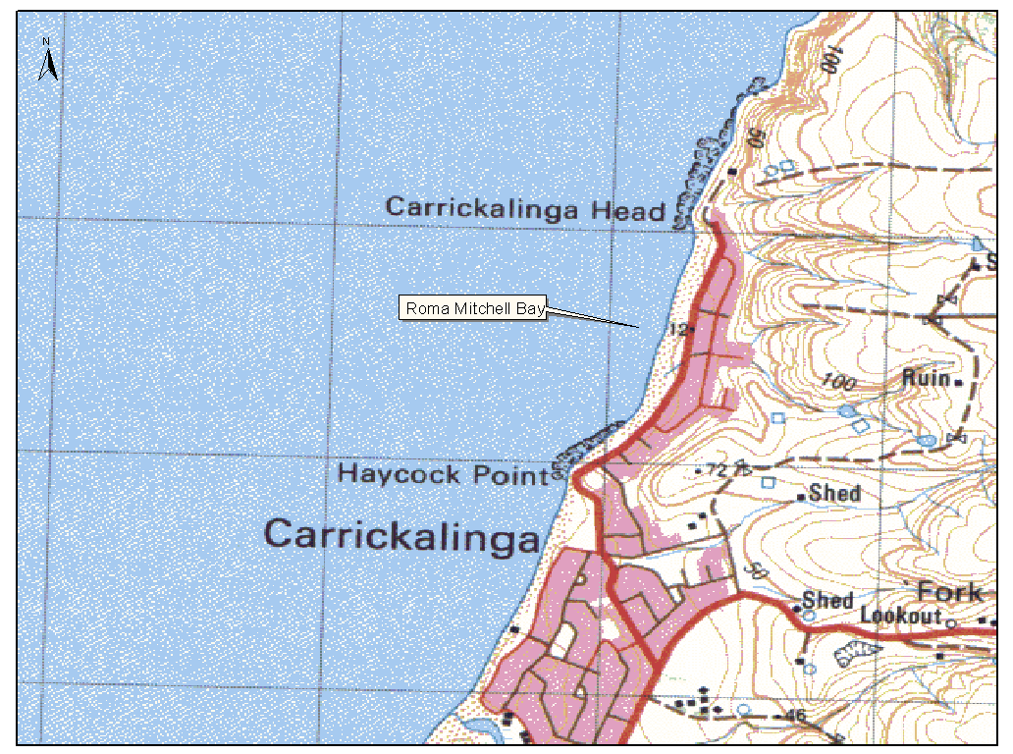
Dated 12 April 2001.
R. D. Lawson, Minister for Administrative and Information Services
DAIS 04/0403

INDUSTRIAL AND EMPLOYEE RELATIONS ACT 1994
Appointments
I, ROBERT DAVID LAWSON, Minister for Administrative and Information Services and Minister for Workplace Relations in and for the State of South Australia, hereby appoint the undermentioned Officers as Inspectors, pursuant to the Industrial and Employee Relations Act 1994:
Harry Gelzinis
Christopher Guinane
David James Symons
Igor Visintin
Dated 30 May 2001.
Robert Lawson, Minister for Workplace Relations

OCCUPATIONAL HEALTH, SAFETY AND WELFARE ACT 1986
Appointments
I, ROBERT DAVID LAWSON, Minister for Administrative and Information Services and Minister for Workplace Relations in and for the State of South Australia, hereby appoint the undermentioned persons as Inspectors, pursuant to the Occupational Health, Safety and Welfare Act 1986:
Christopher Guinane
David James Symons
Igor Visintin
Dated 30 May 2001.
Robert Lawson, Minister for Workplace Relations

LAND ACQUISITION ACT 1969
(Section 16)
Notice of Acquisition
THE Commissioner of Highways (‘the Authority’), 33 Warwick Street, Walkerville, S.A. 5081, acquires the following interests in the following land:
Definition of Land Acquired
That piece of land situated at 362 Portrush Road, Tusmore, being allotment 103 in the plan lodged in the Registrar-General’s Office and numbered DP 55931 and being portion of the land comprised in certificate of title volume 1394, folio 48 now converted certificate of title volume 5758, folio 274 and certificate of title volume 1425, folio 71 now converted certificate of title volume 5802, folio 205.
This notice is given under section 16 of the Land Acquisition Act 1969.
Compensation
A person who has or had an interest in the land that is divested or diminished by the acquisition or the enjoyment of which is adversely affected by the acquisition who does not receive an offer of compensation from the Authority may apply to the Authority for compensation.
Inquiries
Inquiries should be directed to Brian O’Callaghan, P.O. Box 1, Walkerville, S.A. 5081. Telephone (08) 8343 2423.
Dated 5 June 2001.
The Common Seal of the Commissioner of Highways was hereto affixed by direction of the Commissioner of Highways in the presence of:
(l.s.) D. Woods, Manager, Land Acquisition and Disposal, Transport SA

LAND ACQUISITION ACT 1969
(Section 16)
Notice of Acquisition
THE Commissioner of Highways (‘the Authority’), 33 Warwick Street, Walkerville, S.A. 5081, acquires the following interests in the following land:
Definition of Land Acquired
Comprising that piece of land in fee simple situated at 352 Portrush Road, Tusmore, S.A. 5065, being portion of the land contained in certificate of title register book volume 5261, folio 516, and being the whole of allotment 108 in the plan lodged in the Registrar-General’s Office and numbered DP 55940.
This notice is given under section 16 of the Land Acquisition Act 1969.
Compensation
A person who has or had an interest in the land that is divested or diminished by the acquisition or the enjoyment of which is adversely affected by the acquisition who does not receive an offer of compensation from the Authority may apply to the Authority for compensation.
Inquiries
Inquiries should be directed to Brian O’Callaghan, P.O. Box 1, Walkerville, S.A. 5081. Telephone (08) 8343 2423.
Dated 5 June 2001.
The Common Seal of the Commissioner of Highways was hereto affixed by direction of the Commissioner of Highways in the presence of:
(l.s.) D. Woods, Manager, Land Acquisition and Disposal, Transport SA

LAND ACQUISITION ACT 1969
(Section 16)
Notice of Acquisition
THE Commissioner of Highways (‘the Authority’), 33 Warwick Street, Walkerville, S.A. 5081, acquires the following interests in the following land:
Definition of Land Acquired
Comprising that piece of land in fee simple situated at 333 Portrush Road, Toorak Gardens, S.A. 5065, being portion of the land contained in certificate of title register book volume 887, folio 112 now converted to certificate of title register book volume 5810, folio 945, and being the whole of allotment 119 in the plan lodged in the Registrar-General’s Office and numbered DP 55953 expressly excluding the free and unrestricted right of way as is therein mentioned.
This notice is given under section 16 of the Land Acquisition Act 1969.
Compensation
A person who has or had an interest in the land that is divested or diminished by the acquisition or the enjoyment of which is adversely affected by the acquisition who does not receive an offer of compensation from the Authority may apply to the Authority for compensation.
Inquiries
Inquiries should be directed to Brian O’Callaghan, P.O. Box 1, Walkerville, S.A. 5081. Telephone (08) 8343 2423.
Dated 5 June 2001.
The Common Seal of the Commissioner of Highways was hereto affixed by direction of the Commissioner of Highways in the presence of:
(l.s.) D. Woods, Manager, Land Acquisition and Disposal, Transport SA

LAND ACQUISITION ACT 1969
(Section 16)
Notice of Acquisition
THE Commissioner of Highways (‘the Authority’), 33 Warwick Street, Walkerville, S.A. 5081, acquires the following interests in the following land:
Definition of Land Acquired
That piece of land situated at 320 Portrush Road, Tusmore, S.A. 5065, being portion of the land comprised in certificate of title volume 4080, folio 464 now converted to certificate of title volume 5533, folio 438, certificate of title volume 962, folio 63 now converted to certificate of title volume 5803, folio 891 and certificate of title volume 4033, folio 679 now converted to certificate of title volume 5749, folio 945, being allotment 13 in the plan lodged in the Registrar-General’s Office and numbered DP 55955.
This notice is given under section 16 of the Land Acquisition Act 1969.
Compensation
A person who has or had an interest in the land that is divested or diminished by the acquisition or the enjoyment of which is adversely affected by the acquisition who does not receive an offer of compensation from the Authority may apply to the Authority for compensation.
Inquiries
Inquiries should be directed to Brian O’Callaghan, P.O. Box 1, Walkerville, S.A. 5081. Telephone (08) 8343 2423.
Dated 5 June 2001.
The Common Seal of the Commissioner of Highways was hereto affixed by direction of the Commissioner of Highways in the presence of:
(l.s.) D. Woods, Manager, Land Acquisition and Disposal, Transport SA

LAND ACQUISITION ACT 1969
(Section 16)
Notice of Acquisition
THE Commissioner of Highways (‘the Authority’), 33 Warwick Street, Walkerville, S.A. 5081, acquires the following interests in the following land:
Definition of Land Acquired
Comprising that piece of land in fee simple situated at 350 Portrush Road, Tusmore, S.A. 5065, being portion of the land contained in certificate of title register book volume 1466, folio 18 now converted to certificate of title register book volume 5790, folio 871, and being the whole of allotment 111 in the plan lodged in the Registrar-General’s Office and numbered DP 55952.
This notice is given under section 16 of the Land Acquisition Act 1969.
Compensation
A person who has or had an interest in the land that is divested or diminished by the acquisition or the enjoyment of which is adversely affected by the acquisition who does not receive an offer of compensation from the Authority may apply to the Authority for compensation.
Inquiries
Inquiries should be directed to Brian O’Callaghan, P.O. Box 1, Walkerville, S.A. 5081. Telephone (08) 8343 2423.
Dated 5 June 2001.
The Common Seal of the Commissioner of Highways was hereto affixed by direction of the Commissioner of Highways in the presence of:
(l.s.) D. Woods, Manager, Land Acquisition and Disposal, Transport SA

LAND AND BUSINESS (SALE AND CONVEYANCING) ACT 1994
Exemption
TAKE notice that, pursuant to section 23 (3) of the Land and Business (Sale and Conveyancing) Act 1994, I, Kenneth Trevor Griffin, Minister for Consumer Affairs, do hereby exempt the person named in Schedule 1 from the application of section 23 (2) of the Act in relation to the purchase of the land specified in Schedule 2.
Schedule 1
Peter John Keal, an officer/employee of W. B. Real Estate Pty Ltd.
Schedule 2
The whole of the land described in Certificate of Title Register Book Volume 5280, folio 873 situated at 7 Gayland Road, Elizabeth Downs, S.A. 5113.
Dated 7 June 2001.
Signed for and on behalf of the Minister for Consumer Affairs by the Commissioner for Consumer Affairs:
M. D. Bodycoat, Commissioner

LAND AND BUSINESS (SALE AND CONVEYANCING) ACT 1994
Exemption
TAKE notice that, pursuant to section 23 (3) of the Land and Business (Sale and Conveyancing) Act 1994, I, Kenneth Trevor Griffin, Minister for Consumer Affairs, do hereby exempt the person named in Schedule 1 from the application of section 23 (2) of the Act in relation to the purchase of the land specified in Schedule 2.
Schedule 1
Linley Millard Andrews, an officer/employee of Lin Andrews Real Estate Pty Ltd.
Schedule 2
The whole of the land described in Certificate of Title Register Book Volume 5223, folio 554 situated at corner of William Street and Goldsbrough Road, Cavan, S.A. 5094.
Dated 7 June 2001.
Signed for and on behalf of the Minister for Consumer Affairs by the Commissioner for Consumer Affairs:
M. D. Bodycoat, Commissioner

LAND AND BUSINESS (SALE AND CONVEYANCING) ACT 1994
Exemption
TAKE notice that, pursuant to section 23 (3) of the Land and Business (Sale and Conveyancing) Act 1994, I, Kenneth Trevor Griffin, Minister for Consumer Affairs, do hereby exempt the person named in Schedule 1 from the application of section 23 (2) of the Act in relation to the purchase of the land specified in Schedule 2.
Schedule 1
Peter John Keal, an officer/employee of W. B. Real Estate Pty Ltd.
Schedule 2
The whole of the land described in Certificate of Title Register Book Volume 5318, folio 621 situated at 172 Coventry Road, Smithfield Plains, S.A. 5114.
Dated 7 June 2001.
Signed for and on behalf of the Minister for Consumer Affairs by the Commissioner for Consumer Affairs:
M. D. Bodycoat, Commissioner

LIQUOR LICENSING ACT 1997
Notice of Application
NOTICE is hereby given, pursuant to section 52 (2) (b) of the Liquor Licensing Act 1997, that David Thomas Pearce, c/o Lynch Meyer Lawyers, Level 2, 190 Flinders Street, Adelaide, S.A. 5000 has applied to the Licensing Authority for the transfer of a Hotel Licence in respect of premises situated at corner Angaston and Mannum Roads, Sedan, S.A. 5353 and known as Sedan Hotel.
The application has been set down for hearing on 25 June 2001.
Any person may object to the application by lodging a notice of objection in the prescribed form with the Licensing Authority, and serving a copy of the notice on the applicant at the applicant’s address given above, on or before 22 June 2001.
Plans in respect of the premises the subject of the application are open to public inspection without fee at the Office of the Liquor and Gaming Commissioner, 9th Floor, East Wing, 50 Grenfell Street, Adelaide, S.A. 5000.
Applicant

LIQUOR LICENSING ACT 1997
Notice of Application
NOTICE is hereby given, pursuant to section 52 (2) (b) of the Liquor Licensing Act 1997, that Hermitage Road Wines Pty Ltd (ACN 072 676 825), corner McDonald and Broke Roads, Pokolbin, N.S.W. 2320 has applied to the Licensing Authority for a Special Circumstances Licence in respect of premises situated at Lyndoch Road, Lyndoch, S.A. 5351 and known as Yaldara Wines.
The application has been set down for hearing on 6 July 2001.
Conditions
The following licence conditions are sought:
Consumption on and off the licensed premises of products produced by Brian McGuigan Wines Ltd and/or Yaldara Wines Pty Ltd and their related companies.
Any person may object to the application by lodging a notice of objection in the prescribed form with the Licensing Authority, and serving a copy of the notice on the applicant at the applicant’s address given above, at least seven days before the hearing date.
Plans in respect of the premises the subject of the application are open to public inspection without fee at the Office of the Liquor and Gaming Commissioner, 9th Floor, East Wing, 50 Grenfell Street, Adelaide, S.A. 5000.
Dated 31 May 2001.
Applicant

LIQUOR LICENSING ACT 1997
Notice of Application
NOTICE is hereby given, pursuant to section 52 (2) (b) of the Liquor Licensing Act 1997, that Harold Duerden, Lot 295 Waggon Road, Victor Harbour, S.A. 5211 has applied to the Licensing Authority for the grant of a Producer’s Licence in respect of premises situated at Lot 295, Waggon Road, Victor Harbour, S.A. 5211 and to be known as Duerdens Wines.
The application has been set down for hearing on 6 July 2001.
Any person may object to the application by lodging a notice of objection in the prescribed form with the Licensing Authority, and serving a copy of the notice on the applicant at the applicant’s address given above, at least seven days before the hearing date.
Plans in respect of the premises the subject of the application are open to public inspection without fee at the Office of the Liquor and Gaming Commissioner, 9th Floor, East Wing, 50 Grenfell Street, Adelaide, S.A. 5000.
Dated 25 May 2001.
Applicant

LIQUOR LICENSING ACT 1997
Notice of Application
NOTICE is hereby given, pursuant to section 52 (2) (b) of the Liquor Licensing Act 1997, that Graham Lyons and Denise Lyons, 47 Main Street, Woodside, S.A. 5244 have applied to the Licensing Authority for a Restaurant Licence in respect of premises situated at 45 Main Street, Woodside, S.A. 5244 and to be known as Delhi at Woodside.
The application has been set down for hearing on 6 July 2001 at 9 a.m.
Any person may object to the application by lodging a notice of objection in the prescribed form with the Licensing Authority, and serving a copy of the notice on the applicants at the applicants’ address given above, at least seven days before the hearing date.
Plans in respect of the premises the subject of the application are open to public inspection without fee at the Office of the Liquor and Gaming Commissioner, 9th Floor, East Wing, 50 Grenfell Street, Adelaide, S.A. 5000.
Dated 31 May 2001.
Applicants

LIQUOR LICENSING ACT 1997 AND GAMING MACHINES ACT 1992
Notice of Application
NOTICE is hereby given, pursuant to section 52 of the Liquor Licensing Act 1997 and section 29 of the Gaming Machines Act 1992, that Eagle on the Hill Hotel Operations Pty Ltd (ACN 096 982 768) has applied to the Liquor and Gaming Commissioner for the transfer of a Hotel Licence and a Gaming Machine Licence in respect of premises situated at Mount Barker Road, Eagle on the Hill, S.A. 5150 and known as Eagle on the Hill Hotel.
The applications have been set down for hearing on 6 July 2001.
Any person may object to the application by lodging a notice of objection in the prescribed form with the Licensing Authority, and serving a copy of the notice on the applicant at the applicant’s address given above, at least seven days before the hearing date.
Plans in respect of the premises the subject of the application are open to public inspection without fee at the Office of the Liquor and Gaming Commissioner, 9th Floor, East Wing, 50 Grenfell Street, Adelaide, S.A. 5000.
Dated 31 May 2001.
Applicant

LIQUOR LICENSING ACT 1997 AND GAMING MACHINES ACT 1992
Notice of Application
NOTICE is hereby given, pursuant to section 52 of the Liquor Licensing Act 1997 and section 29 of the Gaming Machines Act 1992, that D.C.N. Hotels Pty Ltd (ACN 096 802 309), 77 Murray Street, Gawler, S.A. 5118 has applied to the Licensing Authority for the transfer of a Hotel and Gaming Machine Licence in respect of premises situated at 29 Taylor Street, Kadina, S.A. 5554 and known as Kadina Hotel.
The applications have been set down for hearing on 6 July 2001.
Any person may object to the application by lodging a notice of objection in the prescribed form with the Licensing Authority, and serving a copy of the notice on the applicant at the applicant’s address given above, at least seven days before the hearing date.
Plans in respect of the premises the subject of the application are open to public inspection without fee at the Office of the Liquor and Gaming Commissioner, 9th Floor, East Wing, 50 Grenfell Street, Adelaide, S.A. 5000.
Dated 31 May 2001.
Applicant

LIQUOR LICENSING ACT 1997
Notice of Application
NOTICE is hereby given, pursuant to section 52 (2) (b) of the Liquor Licensing Act 1997, that Anthony Francis Hoffert, 1 Sandra Hennig Court, Greenwith, S.A. 5125 has applied to the Licensing Authority for the transfer of a Special Circumstances Licence in respect of premises situated at 106 Gertrude Street, Port Pirie, S.A. 5540 and known as Harveys Restaurant and to be known as Symphony on the Park Restaurant.
The application has been set down for hearing on 9 July 2001 at 10.30 a.m.
Conditions
The following licence conditions are sought:
1. To vary the Extended Trading Authorisation in all areas:
Monday to Sunday—11 a.m. to 2 a.m. the following day (excluding Christmas Day and Good Friday).
2. To sell and supply liquor at any time of any day to persons seated at a table with or ancillary to a genuine meal.
3. To redefine the Entertainment Area as outlined on the plan lodged with the Licensing Authority.
4. Entertainment consent is sought during the hours applied for in the proposed variation to Extended Trading Author-isation.
Any person may object to the application by lodging a notice of objection in the prescribed form with the Licensing Authority, and serving a copy of the notice on the applicant at the applicant’s address given above, at least seven days before the hearing date.
Plans in respect of the premises the subject of the application are open to public inspection without fee at the Office of the Liquor and Gaming Commissioner, 9th Floor, East Wing, 50 Grenfell Street, Adelaide, S.A. 5000.
Dated 30 May 2001.
Applicant

LIQUOR LICENSING ACT 1997
Notice of Application
NOTICE is hereby given, pursuant to section 52 (2) (b) of the Liquor Licensing Act 1997, that Port Pirie Regional Council, P.O. Box 45, Port Pirie, S.A. 5540 has applied to the Licensing Authority for the transfer of a Restaurant Licence in respect of premises situated at 3 Mary Elie Street, Port Pirie, S.A. 5540 and known as Junction Express.
The application has been set down for hearing on 9 July 2001 at 10 a.m.
Any person may object to the application by lodging a notice of objection in the prescribed form with the Licensing Authority, and serving a copy of the notice on the applicant at the applicant’s address given above, at least seven days before the hearing date.
Plans in respect of the premises the subject of the application are open to public inspection without fee at the Office of the Liquor and Gaming Commissioner, 9th Floor, East Wing, 50 Grenfell Street, Adelaide, S.A. 5000.
Dated 29 May 2001.
Applicant

LIQUOR LICENSING ACT 1997
Notice of Application
NOTICE is hereby given, pursuant to section 52 (2) (b) of the Liquor Licensing Act 1997, that Smutz Pty Ltd, c/o Morgans Solicitors, 154 King William Road, Hyde Park, S.A. 5061 has applied to the Licensing Authority for the transfer of a Retail Liquor Merchant’s Licence in respect of premises situated at 101 Churchill Road, Prospect, S.A. 5082 and known as Churchill Cellars.
The application has been set down for hearing on 9 July 2001 at 11 a.m.
Any person may object to the application by lodging a notice of objection in the prescribed form with the Licensing Authority, and serving a copy of the notice on the applicant at the applicant’s address given above, at least seven days before the hearing date.
Plans in respect of the premises the subject of the application are open to public inspection without fee at the Office of the Liquor and Gaming Commissioner, 9th Floor, East Wing, 50 Grenfell Street, Adelaide, S.A. 5000.
Dated 30 May 2001.
Applicant

LIQUOR LICENSING ACT 1997
Notice of Application
NOTICE is hereby given, pursuant to section 52 (2) (b) of the Liquor Licensing Act 1997, that Caltowie Nominees Pty Ltd (ACN 096 667 079), c/o Fisher Jeffries, SGIC Building, 211 Victoria Square, Adelaide, S.A. 5000, has applied to the Licensing Authority for the transfer of a Hotel Licence, an Extended Trading Authorisation and a variation to the Enter-tainment Consent in respect of premises situated at 6 Charles Street, Caltowie, S.A. 5490 and known as Caltowie Hotel.
The application has been set down for hearing on 9 July 2001 at 11.30 a.m.
Conditions
The following licence conditions are sought:
1. That liquor may be sold for consumption on the licensed premises during the following hours:
1.1 Monday to Thursday—midnight to 1 a.m. the follow-ing day;
1.2 Friday and Saturday—midnight to 2 a.m. the following day;
1.3 Sunday—8 a.m. to 11 a.m. and 8 p.m. to midnight other than Sundays immediately proceeding a public holiday when trading shall continue to 2 a.m. the following day;
1.4 Christmas Day—midnight to 2 a.m. the following day.
2. That liquor may be sold for consumption off the licensed premises on Sundays between 8 a.m. and 11 a.m., and 8 p.m. and 9 p.m.
3. The applicant is seeking to provide entertainment on the licensed premises from midnight to 2 a.m. the following day on Friday, Saturday and public holidays.
Any person may object to the application by lodging a notice of objection in the prescribed form with the Licensing Authority, and serving a copy of the notice on the applicant at the applicant’s address given above, at least seven days before the hearing date.
Plans in respect of the premises the subject of the application are open to public inspection without fee at the Office of the Liquor and Gaming Commissioner, 9th Floor, East Wing, 50 Grenfell Street, Adelaide, S.A. 5000.
Dated 31 May 2001.
Applicant

LIQUOR LICENSING ACT 1997
Notice of Application
NOTICE is hereby given, pursuant to section 52 (2) (b) of the Liquor Licensing Act 1997, that ALH Group Pty Ltd, c/o Kelly & Co, Solicitors, Level 17, 91 King William Street, Adelaide, S.A. 5000 has applied to the Licensing Authority for the transfer of a Special Circumstances Licence in respect of premises situated at 27-29 Ebenezer Place, Adelaide, S.A. 5000 and known as Charlick’s Feed Store.
The application has been set down for hearing on 10 July 2001 at 11 a.m.
Any person may object to the application by lodging a notice of objection in the prescribed form with the Licensing Authority, and serving a copy of the notice on the applicant at the applicant’s address given above, at least seven days before the hearing date.
Plans in respect of the premises the subject of the application are open to public inspection without fee at the Office of the Liquor and Gaming Commissioner, 9th Floor, East Wing, 50 Grenfell Street, Adelaide, S.A. 5000.
Dated 1 June 2001.
Applicant

LIQUOR LICENSING ACT 1997
Notice of Application
NOTICE is hereby given, pursuant to section 52 (2) (b) of the Liquor Licensing Act 1997, that Jeffery Graham Hogben and Brenda Claris Hogben, 51 Mount Gambier Road, Millicent, S.A. 5280 have applied to the Licensing Authority for the transfer of a Residential Licence in respect of premises situated at 51 Mount Gambier Road, Millicent, S.A. 5280 and known as Diplomat Motel.
The application has been set down for hearing on 10 July 2001 at 10.30 a.m.
Any person may object to the application by lodging a notice of objection in the prescribed form with the Licensing Authority, and serving a copy of the notice on the applicants at the applicants’ address given above, at least seven days before the hearing date.
Plans in respect of the premises the subject of the application are open to public inspection without fee at the Office of the Liquor and Gaming Commissioner, 9th Floor, East Wing, 50 Grenfell Street, Adelaide, S.A. 5000.
Dated 1 June 2001.
Applicants

LIQUOR LICENSING ACT 1997
Notice of Application
NOTICE is hereby given, pursuant to section 52 (2) (b) of the Liquor Licensing Act 1997, that Robert Gordon Mathews and Anthony John Kozlovic have applied to the Licensing Authority for the transfer of a Restaurant Licence in respect of premises situated at 110 Flinders Street, Adelaide, S.A. 5000 and known as Eugene’s Food and Wine and to be known as Flinders Street Wine & Tapas
The application has been set down for hearing on 10 July 2001.
Any person may object to the application by lodging a notice of objection in the prescribed form with the Licensing Authority, and serving a copy of the notice on the applicants at the applicants’ address given above, at least seven days before the hearing date.
Plans in respect of the premises the subject of the application are open to public inspection without fee at the Office of the Liquor and Gaming Commissioner, 9th Floor, East Wing, 50 Grenfell Street, Adelaide, S.A. 5000.
Dated 30 May 2001.
Applicants

LIQUOR LICENSING ACT 1997
Notice of Application
NOTICE is hereby given, pursuant to section 52 (2) (b) of the Liquor Licensing Act 1997, that Hermitage Road Wines Pty Ltd (ACN 072 676 825), corner McDonald and Broke Roads, Pokolbin, N.S.W. 2320 has applied to the Licensing Authority for the transfer of a Special Circumstances Licence in respect of premises situated at Lyndoch Road, Lyndoch, S.A. 5351 and known as Yaldara Wines.
The application has been set down for hearing on 12 July 2001.
Any person may object to the application by lodging a notice of objection in the prescribed form with the Licensing Authority, and serving a copy of the notice on the applicant at the applicant’s address given above, at least seven days before the hearing date.
Plans in respect of the premises the subject of the application are open to public inspection without fee at the Office of the Liquor and Gaming Commissioner, 9th Floor, East Wing, 50 Grenfell Street, Adelaide, S.A. 5000.
Dated 31 May 2001.
Applicant

LIQUOR LICENSING ACT 1997
Notice of Application
NOTICE is hereby given, pursuant to section 52 (2) (b) of the Liquor Licensing Act 1997, that Hermitage Road Wines Pty Ltd (ACN 072 676 825), corner McDonald and Broke Roads, Pokolbin, N.S.W. 2320 has applied to the Licensing Authority for the transfer of a Restaurant Licence in respect of premises situated at Lyndoch Road, Lyndoch, S.A. 5351 and known as Yaldara Wines.
The application has been set down for hearing on 12 July 2001.
Any person may object to the application by lodging a notice of objection in the prescribed form with the Licensing Authority, and serving a copy of the notice on the applicant at the applicant’s address given above, at least seven days before the hearing date.
Plans in respect of the premises the subject of the application are open to public inspection without fee at the Office of the Liquor and Gaming Commissioner, 9th Floor, East Wing, 50 Grenfell Street, Adelaide, S.A. 5000.
Dated 31 May 2001.
Applicant

LIQUOR LICENSING ACT 1997
Notice of Application
NOTICE is hereby given, pursuant to section 52 (2) (b) of the Liquor Licensing Act 1997, that Voula Mestros, 36 Tennyson Street, Kurralta Park, S.A. 5037 has applied to the Licensing Authority for a Direct Sales Licence in respect of premises situated at 36 Tennyson Street, Kurralta Park, S.A. 5037.
The application has been set down for hearing on 13 July 2001.
Any person may object to the application by lodging a notice of objection in the prescribed form with the Licensing Authority, and serving a copy of the notice on the applicant at the applicant’s address given above, at least seven days before the hearing date.
Plans in respect of the premises the subject of the application are open to public inspection without fee at the Office of the Liquor and Gaming Commissioner, 9th Floor, East Wing, 50 Grenfell Street, Adelaide, S.A. 5000.
Dated 1 June 2001.
Applicant

MINING ACT 1971
NOTICE is hereby given in accordance with section 28 (5) of the Mining Act 1971, that the Minister for Minerals and Energy proposes to grant an Exploration Licence over the under-mentioned area.
Applicant: Magnesium Developments Ltd
Location: Nelshaby area—Approximately 15 km east of Port Pirie, bounded as follows: Commencing at a point being the intersection of latitude 33°00′S and longitude 138°05′E, thence east to longitude 138°25′E, south to latitude 33°25′S, west to longitude 138°05′E, and north to the point of commencement, but excluding Telowie Gorge Conservation Park, all the within latitudes and longitudes being geodetic and expressed in terms of the Australian Geodetic Datum as defined on p. 4984 of Commonwealth Gazette number 84 dated 6 October 1966 (AGD66).
Term: 1 year
Area in km²: 1 415
Ref. No.: 116/2000
Dated 7 June 2001.
H. Tyrteos, Acting Mining Registrar, Department of Primary Industries and Resources

MINING ACT 1971
NOTICE is hereby given in accordance with section 28 (5) of the Mining Act 1971, that the Minister for Minerals and Energy proposes to grant an Exploration Licence over the under-mentioned area.
Applicant: Goldus Pty Ltd
Location: Yunta area—Approximately 100 km north-east of Peterborough, bounded as follows: Commencing at a point being the intersection of latitude 31°51′S and longitude 139°30′E, thence east to longitude 139°39′E, south to latitude 32°00′S, east to longitude 139°43′E, south to latitude 32°05′S, east to longitude 139°52′E, south to latitude 32°06′S, east to longitude 139°55′E, south to latitude 32°08′S, east to longitude 139°59′E, north to latitude 32°03′S, east to longitude 140°02′E, south to latitude 32°09′S, east to longitude 140°06′E, south to latitude 32°15′S, east to longitude 140°11′E, south to latitude 32°25′S, west to longitude 139°50′E, north to latitude 32°15′S, east to longitude 139°55′E, south to latitude 32°18′S, east to longitude 140°04′E, north to latitude 32°10′S, west to longitude 139°52′E, south to latitude 32°12′S, west to longitude 139°50′E, south to latitude 32°13′S, west to longitude 139°30′E, and north to the point of commencement, all the within latitudes and longitudes being geodetic and expressed in terms of the Australian Geodetic Datum as defined on p. 4984 of Commonwealth Gazette number 84 dated 6 October 1966 (AGD66).
Term: 1 year
Area in km²: 1 621
Ref. No.: 073/2000
Dated 7 June 2001.
H. Tyrteos, Acting Mining Registrar, Department of Primary Industries and Resources

MINING ACT 1971
NOTICE is hereby given in accordance with section 28 (5) of the Mining Act 1971, that the Minister for Minerals and Energy proposes to grant an Exploration Licence over the under-mentioned area.
Applicant: Goldus Pty Ltd
Location: Kate Hill area—Approximately 20 km north-east of Leigh Creek, bounded as follows: Commencing at a point being the intersection of latitude 30°25′S and longitude 138°37′E, thence east to longitude 138°40′E, south to latitude 30°30′S, west to longitude 138°30′E, north to latitude 30°28′S, east to longitude 138°37′E, and north to the point of commencement, all the within latitudes and longitudes being geodetic and expressed in terms of the Australian Geodetic Datum as defined on p. 4984 of Commonwealth Gazette number 84 dated 6 October 1966 (AGD66).
Term: 1 year
Area in km²: 86
Ref. No.: 074/2000
Dated 7 June 2001.
H. Tyrteos, Acting Mining Registrar, Department of Primary Industries and Resources

MINING ACT 1971
NOTICE is hereby given in accordance with section 28 (5) of the Mining Act 1971, that the Minister for Minerals and Energy proposes to grant an Exploration Licence over the under-mentioned area.
Applicant: Goldus Pty Ltd
Location: Manunda area—Approximately 65 km south-west of Olary, bounded as follows: Commencing at a point being the intersection of latitude 32°30′S and longitude 140°00′E, thence east to longitude 140°03′E, south to latitude 32°40′S, west to longitude 140°02′E, south to latitude 32°45′S, west to longitude 140°00′E, south to latitude 32°47′S, west to longitude 139°59′E, south to latitude 32°48′S, west to longitude 139°58′E, south to latitude 32°50′S, west to longitude 139°57′E, south to latitude 32°51′S, west to longitude 139°56′E, south to latitude 32°52′S, west to longitude 139°55′E, south to latitude 32°58′S, west to longitude 139°54′E, south to latitude 32°59′S, west to longitude 139°52′E, south to latitude 33°00′S, west to longitude 139°50′E, north to latitude 32°58′S, west to longitude 139°49′E, south to latitude 32°59′S, west to longitude 139°46′E, south to latitude 33°00′S, west to longitude 139°36′E, north to latitude 32°57′S, east to longitude 139°40′E, south to latitude 32°58′S, east to longitude 139°44′E, north to latitude 32°57′S, east to longitude 139°45′E, south to latitude 32°58′S, east to longitude 139°47′E, north to latitude 32°57′S, east to longitude 139°48′E, north to latitude 32°56′S, east to longitude 139°50′E, north to latitude 32°55′S, east to longitude 139°52′E, north to latitude 32°54′S, west to longitude 139°48′E, south to latitude 32°55′S, west to longitude 139°47′E, south to latitude 32°56′S, west to longitude 139°46′E, north to latitude 32°55′S, west to longitude 139°44′E, south to latitude 32°56′S, west to longitude 139°42′E, north to latitude 32°54′S, east to longitude 139°43′E, north to latitude 32°49′S, west to longitude 139°37′E, north to latitude 32°47′S, east to longitude 139°41′E, north to latitude 32°43′S, east to longitude 139°47′E, north to latitude 32°39′S, east to longitude 139°51′E, north to latitude 32°36′S, east to longitude 139°56′E, north to latitude 32°32′S, east to longitude 140°00′E, and north to the point of commencement, all the within latitudes and longitudes being geodetic and expressed in terms of the Australian Geodetic Datum as defined on p. 4984 of Commonwealth Gazette number 84 dated 6 October 1966 (AGD66).
Term: 1 year
Area in km²: 1 114
Ref. No.: 087/2000
Dated 7 June 2001.
H. Tyrteos, Acting Mining Registrar, Department of Primary Industries and Resources

MINING ACT 1971
NOTICE is hereby given in accordance with section 35A (1) of the Mining Act 1971, that an application for a mining lease over the undermentioned mineral claim has been received. Details of the proposal may be inspected at the Department of Primary Industries and Resources, Mineral Resources Group, Level 5, 101 Grenfell Street, Adelaide, S.A. 5000:
Applicant: Graham Herbert Garwood
Claim No.: 3224
Location: In piece 7 of Deposited Plan 34889, Hundred of Strathalbyn approximately 9 km east-north-east of Strathalbyn
Purpose: Recovery of sand and clay
Ref. No.: T2258
A copy of the proposal has been provided to the District Council of Alexandrina.
Written submissions in relation to the granting of the mining lease are invited to be received at the Department of Primary Industries and Resources, Mineral Resources Group, Level 5, 101 Grenfell Street, Adelaide, S.A. 5000 or G.P.O. Box 1671, Adelaide, S.A. 5001 no later than 22 June 2001.
Dated 7 June 2001.
H. Tyrteos, Acting Mining Registrar, Department of Primary Industries and Resources

MINING ACT 1971
NOTICE is hereby given in accordance with section 35A (1) of the Mining Act 1971, that an application for a mining lease over the undermentioned mineral claim has been received. Details of the proposal may be inspected at the Department of Primary Industries and Resources, Mineral Resources Group, Level 5, 101 Grenfell Street, Adelaide, S.A. 5000:
Applicant: Michael John Wiseman
Claim No.: 3156
Location: Section 79, Hundred of Wanilla approximately 30 km north-west of Port Lincoln
Purpose: To excavate limesand from an open cut pit
Ref. No.: T2181
A copy of the proposal has been provided to the District Council of Lower Eyre Peninsula.
Written submissions in relation to the granting of the mining lease are invited to be received at the Department of Primary Industries and Resources, Mineral Resources Group, Level 5, 101 Grenfell Street, Adelaide, S.A. 5000 or G.PO. Box 1671, Adelaide, S.A. 5001 no later than 29 June 2001.
Dated 7 June 2001.
H. Tyrteos, Acting Mining Registrar, Department of Primary Industries and Resources

MINING ACT 1971
NOTICE is hereby given in accordance with section 35A (1) of the Mining Act 1971, that an application for a mining lease over the undermentioned mineral claim has been received. Details of the proposal may be inspected at the Department of Primary Industries and Resources, Mineral Resources Group, Level 5, 101 Grenfell Street, Adelaide, S.A. 5000:
Applicant: Lindsay Charles Eglinton
Claim No.: 3159
Location: In section 123, Hundred of Nildottie, approximately 4 km east of Swan Reach
Purpose: Excavate fossilised limestone rubble
Ref. No.: T2199
A copy of the proposal has been provided to the District Council of Mid Murray.
Written submissions in relation to the granting of the mining lease are invited to be received at the Department of Primary Industries and Resources, Mineral Resources Group, Level 5, 101 Grenfell Street, Adelaide, S.A. 5000 or G.P.O. Box 1671, Adelaide, S.A. 5001 no later than 29 June 2001.
Dated 7 June 2001.
H. Tyrteos, Acting Mining Registrar, Department of Primary Industries and Resources

MUTUAL RECOGNITION ACT 1992
Ministerial Declaration
WHEREAS no underground coal mines exist in South Australia, we jointly declare that:
1. (a) the occupation which may be carried on only by a person granted a South Australian Certificate Item A in Schedule 1; and
(b) the occupation which may be carried on only by a person granted a New South Wales Certificate Item F in Schedule 1,
are equivalent; and
2. (a) the occupations which may be carried on only by a person granted a South Australian Certificate Item B in Schedule 1; and
(b) the occupations which may be carried on only by a person granted both New South Wales Certificates Items D and F in Schedule 1,
are equivalent; and
3. (a) the occupation which may be carried on only by a person granted a South Australian Certificate Item C in Schedule 1; and
(b) the occupation which may be carried on only by a person granted a New South Wales Certificate Item E in Schedule 1,
are equivalent.
Dated 25 May 2001.
W. Matthew, Minister for Minerals and Energy, S.A.
E. Obeid, Minister for Mineral Resources, N.S.W.

Schedule 1
Domains of Mining being Legally Applicable to the Statutory Certificates of Mine Management Competency hereunder, for South Australia and New South Wales
The hatched domain indicates there are no underground coal mines in South Australia.
The table only depicts those certificates referenced in Ministerial Declarations.
Domain | Metalliferous | Coal
Open-cut | South Australia: Item B  New South Wales: Item D | South Australia: Items A, B  New South Wales: Item F
Underground | South Australia: Items B, C  New South Wales: Item E | South Australia: Items A, B

Item |  | State |  | Certificate | Statute
A | SA |  | First class mine manager’s certificate of competency restricted to coal mines. |  | Mines and Works Inspection Act 1920, as amended, and the Mines and Works Inspection Regulations 1966, as amended.
B | SA |  | First class mine manager’s certificate of competency. |  | Mines and Works Inspection Act 1920, as amended, and the Mines and Works Inspection Regulations 1966, as amended.
C | SA |  | First class underground mine manager’s certificate of competency. |  | Mines and Works Inspection Act 1920, as amended, and the Mines and Works Inspection Regulations 1966, as amended.
D | NSW |  | Above ground mine manager’s certificate of competency (metalliferous mines). |  | Part 2, Division 1, 2A and 3 of the Mines Inspection Act 1901, No. 75, as amended.
E | NSW |  | Below ground mine manager’s certificate of competency (underground metalliferous mines). |  | Part 2, Division 1, 2A and 3 of the Mines Inspection Act 1901, No. 75, as amended.
F | NSW |  | Open cut mine manager’s certificate of competency (open cut coal mines). |  | Part 2, Division 2, 3 and 4 of the Coal Mines Regulation Act 1982, No. 67, as amended.

NATIONAL PARKS AND WILDLIFE ACT 1972
Belair National Park—Draft Management Plan
I, IAIN EVANS, Minister for Environment and Heritage, hereby give notice under the provisions of section 38 of the National Parks and Wildlife Act 1972, that a draft management plan has been proposed for Belair National Park.
Copies of the draft plan may be inspected at or obtained at no cost ($2 postage within South Australia) from The Environment Shop, Ground Floor, SA Water House, 77 Grenfell Street, Adelaide, S.A. 5000 (G.P.O. Box 1047, Adelaide, S.A. 5001) telephone (08) 8204 1910 or, National Parks and Wildlife SA, Sturt District Office, Belair National Park, Upper Sturt Road, Belair, S.A. 5052 (P.O. Box 2, Belair, S.A. 5052) telephone (08) 8278 5477 or at www.parks.sa.gov.au/management_plans.
html#Plan_list.
Any person may make representations in connection with the draft management plan during the period up to and including Friday, 7 September 2001.
Written comments should be forwarded to the Deputy Regional Manager, Adelaide Region, National Parks and Wildlife SA, P.O. Box 2, Belair, S.A. 5052 or emailed to anderson.molly@
saugov.sa.gov.au.
Iain Evans, Minister for Environment and Heritage

PETROLEUM ACT 2000
Statement of Environmental Objectives for Existing Regulated Activities
PURSUANT to section 104 (1) of the Petroleum Act 2000 (the Act) I, Robert Anthony Laws, Director Petroleum, Office of Minerals and Energy Resources, Department of Primary Industries and Resources SA, Delegate of the Minister for Minerals and Energy, pursuant to Delegation dated 25 September 2000, Gazetted 28 September 2000, do hereby publish the following document as having been approved as a statement of environmental objectives under the Act.
This document is available for public inspection on the Environmental Register section of the Petroleum Group’s web site (www.petroleum.pir.sa.gov.au) or at the public office determined pursuant to section 107 (1) of the Act to be at:
Minerals and Petroleum Centre
Office of Minerals and Energy Resources
Ground Floor
101 Grenfell Street
Adelaide, S.A. 5000
Document:
1 Origin Energy Resources Limited Statement of Environmental Objectives for Drilling & Well Operations in Balnaves-1, Otway Basin—South Australia, May 2001 approved on 4 June 2001.
R. A. Laws, Delegate of the Minister for Minerals and Energy Resources

PETROLEUM ACT 2000
Grant of Preliminary Survey Licence No. 1
Office of Minerals and Energy Resources, Adelaide, 26 April 2001
NOTICE is hereby given that the undermentioned Preliminary Survey Licence has been granted under the provisions of the Petroleum Act 2000, pursuant to delegated powers dated 25 September 2000, Gazetted 28 September 2000, page 2289.
R. A. Laws, Director Petroleum, Office of Minerals and Energy Resources, Delegate of the Minister for Minerals and Energy
No. of  Licence | Licensee | Locality | Date of  Expiry | Area in  km² | Reference

1 | • Epic Energy SA Pty Ltd |  | Angaston to Freeling | 25 April 2002 | 21.6 | SR.27.2.221

General Description of Pipeline Preliminary Survey Licence
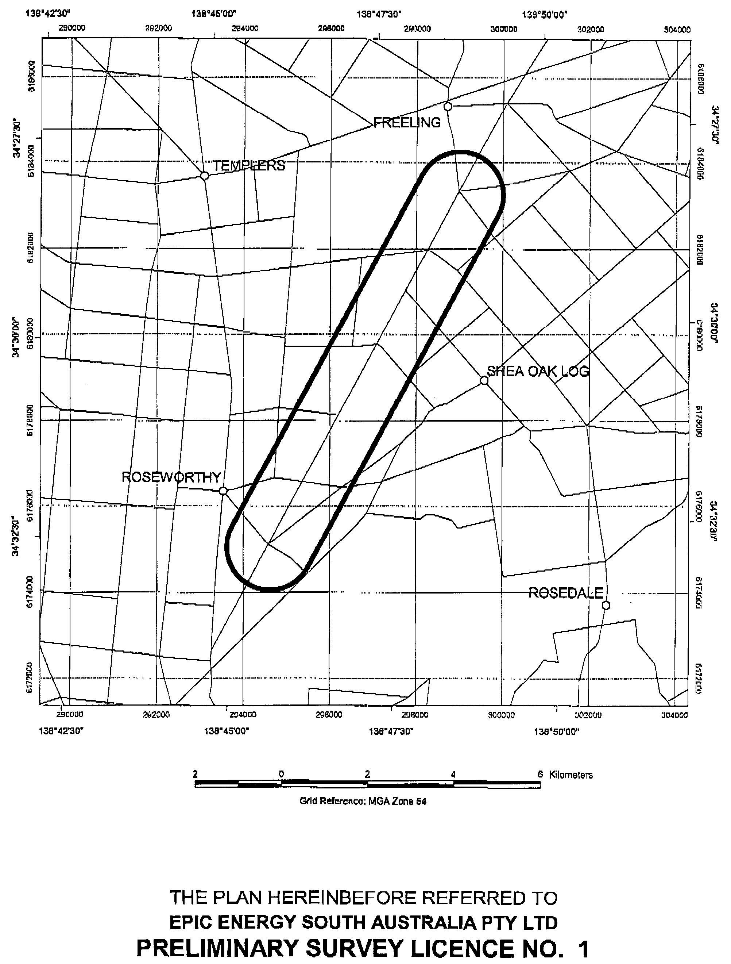
Pipeline preliminary survey activities are authorised within a 2 km corridor whose centre line commences at the proposed Freeling meter station to be constructed at the Angaston Lateral Pipeline and terminating at the proposed Amcor meter station.
PETROLEUM ACT 2000
Grant of Preliminary Survey Licence No. 2
Office of Minerals and Energy Resources, Adelaide, 16 May 2001
NOTICE is hereby given that the undermentioned Preliminary Survey Licence has been granted under the provisions of the Petroleum Act 2000, pursuant to delegated powers dated 25 September 2000, Gazetted 28 September 2000, page 2289.
R. A. Laws, Director Petroleum, Office of Minerals and Energy Resources, Delegate of the Minister for Minerals and Energy
No. of  Licence | Licensee | Locality | Date of  Expiry | Area in  km² | Reference

2 | • GPU Gasnet Pty Ltd |  | Iona to Adelaide | 15 May 2002 | 9 121 | SR.27.2.222

General Description of Pipeline Preliminary Survey Licence
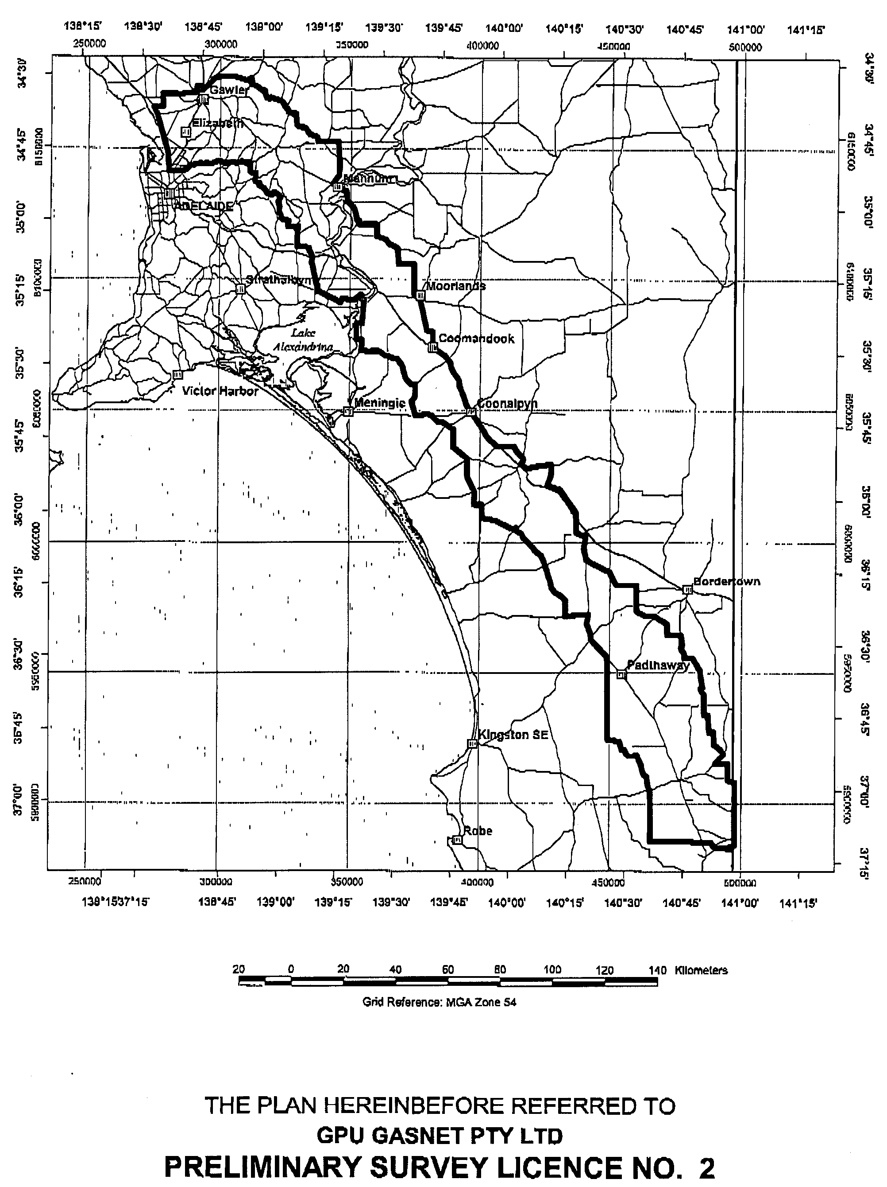
Pipeline preliminary survey activities are authorised in a corridor which is approximately 20 km wide and approximately 380 km in length.
PETROLEUM ACT 2000
Grant of Preliminary Survey Licence No. 3
Office of Minerals and Energy Resources, Adelaide, 10 May 2001
NOTICE is hereby given that the undermentioned Preliminary Survey Licence has been granted under the provisions of the Petroleum Act 2000, pursuant to delegated powers dated 25 September 2000, Gazetted 28 September 2000, page 2289.
R. A. Laws, Director Petroleum, Office of Minerals and Energy Resources, Delegate of the Minister for Minerals and Energy
No. of  Licence | Licensee | Locality | Date of  Expiry | Area in  km² | Reference

3 | • Epic Energy (Victoria) Investments Pty Ltd |  | Darwin to Moomba | 9 May 2002 | 5 230 | SR.27.2.233

General Description of Pipeline Preliminary Survey Licence
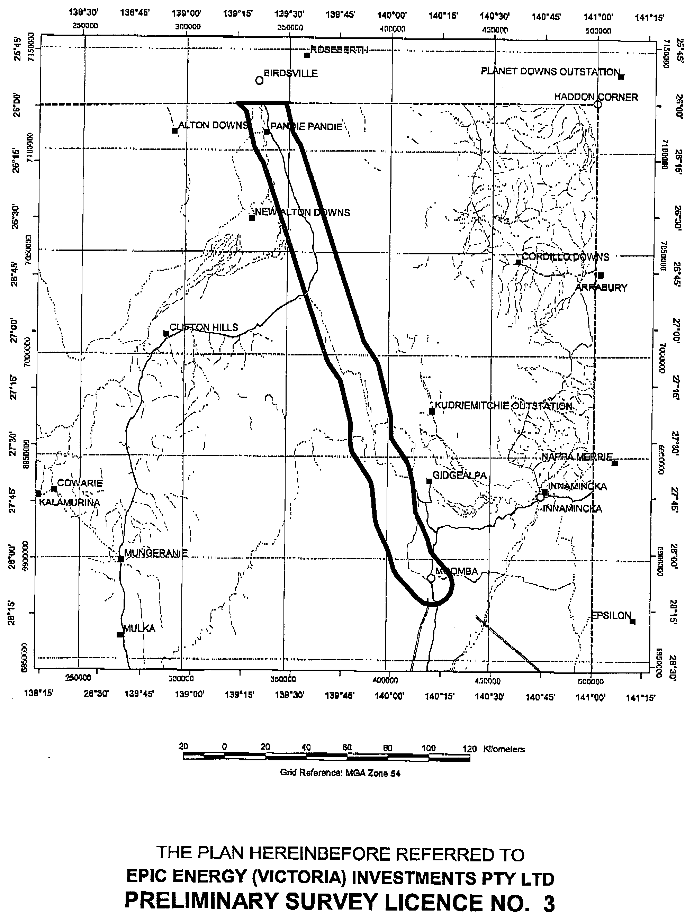
Pipeline preliminary survey activities are authorised in a corridor which is approximately 20 km wide and approximately 200 km in length.
PETROLEUM ACT 2000
Grant of Preliminary Survey Licence No. 4
Office of Minerals and Energy Resources, Adelaide, 2 May 2001
NOTICE is hereby given that the undermentioned Preliminary Survey Licence has been granted under the provisions of the Petroleum Act 2000, pursuant to delegated powers dated 25 September 2000, Gazetted 28 September 2000, page 2289.
R. A. Laws, Director Petroleum, Office of Minerals and Energy Resources, Delegate of the Minister for Minerals and Energy
No. of  Licence | Licensee | Locality | Date of  Expiry | Area in  km² | Reference

4 | • South East Australia Gas Pty Ltd |  | Western Victoria to Adelaide | 1 May 2002 | 9 121 | SR.27.2.224

General Description of Pipeline Preliminary Survey Licence
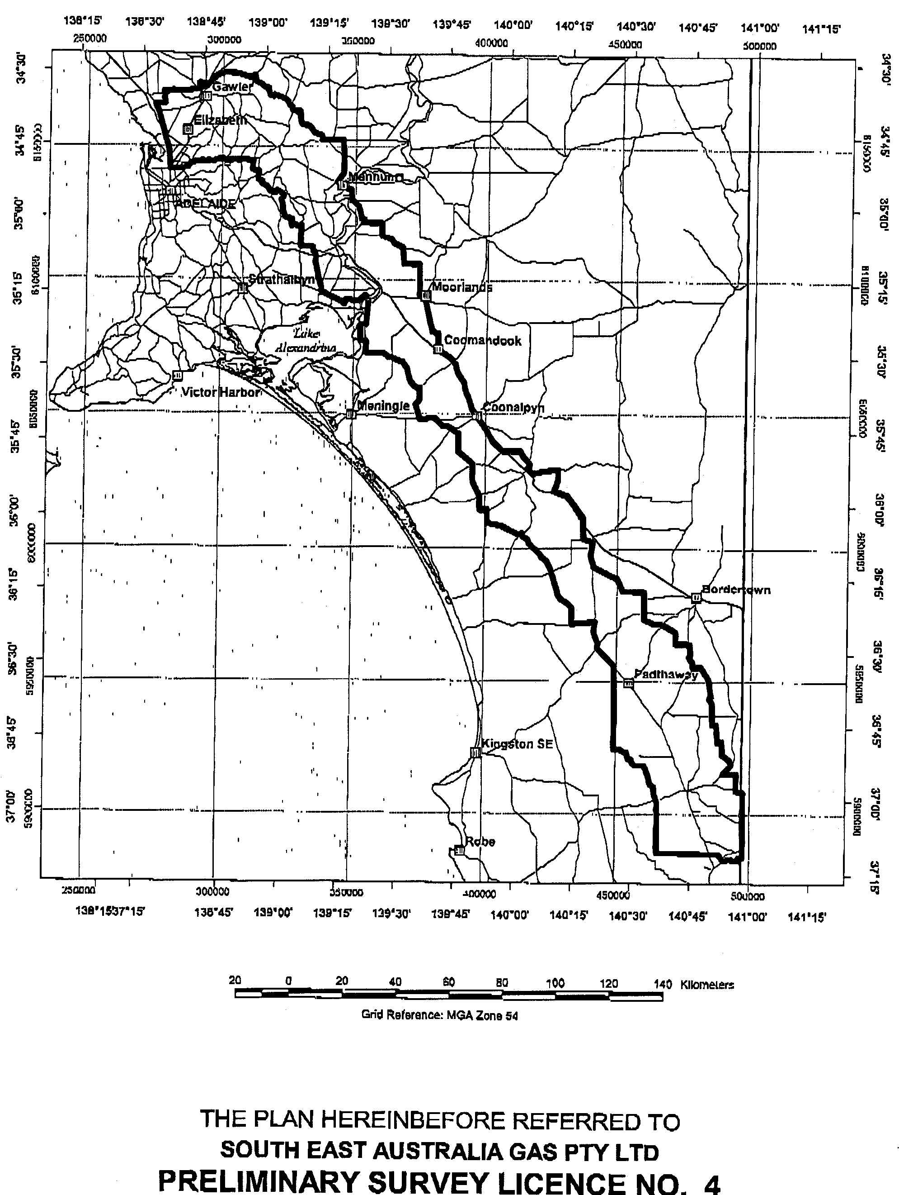
Pipeline preliminary survey activities are authorised in a corridor which is approximately 20 km wide and approximately 380 km in length.
PETROLEUM PRODUCTS REGULATION ACT 1995
Appointments
I, ROBERT DAVID LAWSON, Minister for Administrative and Information Services and Minister for Workplace Relations in and for the State of South Australia, hereby appoint the following persons as Authorised Officers under the Petroleum Products Regulation Act 1995, in accordance with my delegated authority under section 49 of the Petroleum Products Regulation Act 1995:
Christopher Guinane
David James Symons
Igor Visintin
Dated 30 May 2001.
Robert Lawson, Minister for Workplace Relations

PETROLEUM PRODUCTS REGULATION ACT 1995
Records to be Kept
I, ROB LUCAS, Treasurer of South Australia, pursuant to the provisions of section 53 (3) of the Petroleum Products Regulation Act 1995, hereby give notice as follows:
The holder of a Bulk End User Certificate who has purchased petroleum products for use as a bulk end user or sold petroleum products as a bulk end user is required to keep the following accounts, records, receipts, books and documents:
(a) In respect of each purchase or receipt of petroleum products a record as to the quantity of each class of petroleum product purchased or received, the address of the premises at which the purchase or receipt of the petroleum product took place, the name and address of the vendor of the petroleum product purchased or received, and the date of the transaction.
(b) Sufficient accounts, books, records, receipts and any documents to enable the aggregate of purchases of each class of petroleum products made in a calendar month to be accurately determined.
(c) In respect of each sale made of petroleum products or of any other supply of petroleum products a record as to the quantity of each class of petroleum product sold or supplied, the name and address of the person to whom the sale or supply was made, the address of the premises at which the sale or supply was made, the date of the transaction and the licence or certificate number of any licence or certificate held pursuant to this Act, of the person to whom the sale or supply was made.
(d) Sufficient accounts, books, records, receipts and any documents to enable the aggregate of sales including stock transfers, of each class of petroleum products made in a calendar month to be accurately determined.
(e) Sufficient books, records, odometer readings and any other documents establishing petroleum product usage in a calendar month to be accurately determined.
Each of the following is to be regarded as a class of petroleum product for the purposes of this notice:
1. Motor spirit, other than unleaded petrol.
2. Unleaded petrol including lead replacement petrol.
3. Diesel fuel used for the propulsion of diesel engined road vehicles.
4. Diesel fuel used for a purpose other than the propulsion of diesel engined road vehicles.
Rob Lucas, Treasurer

ROADS (OPENING AND CLOSING) ACT 1991:
SECTION 24
NOTICE OF CONFIRMATION OF ROAD
PROCESS ORDER
Public Road, Hundred of Nildottie
Deposited Plan 56403
BY Road Process Order made on 15 January 2001, the Mid Murray Council ordered that:
1. Portion of the unnamed public road adjoining the northern boundaries of allotment 201 in Filed Plan 208577 and allotment 200 in Filed Plan 208576 more particularly lettered ‘A’ and ‘B’ (respectively) in Preliminary Plan No. PP32/0605 be closed.
2. The whole of the land subject to closure lettered ‘A’ be transferred to THE GREENWAYS IRRIGATION BOARD in accordance with agreement for transfer dated 15 January 2001 entered into between the Mid Murray Council and The Greenways Irrigation Board.
3. The whole of the land subject to closure lettered ‘B’ be transferred to WILLIAM THOMAS HALL in accordance with agreement for transfer dated 6 December 2000 entered into between the Mid Murray Council and W. T. Hall.
On 6 February 2001 that order was confirmed by the Minister for Administrative and Information Services conditionally on approval and deposit of the survey plan by the Registrar-General. The condition has now been fulfilled.
Pursuant to section 24 (5) of the Roads (Opening and Closing) Act 1991, NOTICE of the order referred to above and its confirmation is hereby given.
Dated 7 June 2001
K. Sarneckis, Acting Surveyor-General

ROADS (OPENING AND CLOSING) ACT 1991:
SECTION 24
NOTICE OF CONFIRMATION OF ROAD
PROCESS ORDER
Public Road, south of North Shields, Hundred of Lincoln
Deposited Plan 54724
BY Road Process Order made on 16 June 2000, the District Council of Lower Eyre Peninsula ordered that:
1. Portion of allotment 763 in Filed Plan 179985 intersecting the said allotment, more particularly delineated and numbered ‘1’ in Preliminary Plan No. PP32/0430 be opened as road, forming a re-alignment of the adjoining public road.
2. The whole of the unnamed public road between allotment 763 in Filed Plan 179985 and allotment 764 in Filed Plan 179986, more particularly delineated and lettered ‘A’ in Preliminary Plan No. PP32/0430 be closed.
3. The whole of the land subject to closure be transferred to PETER WILLIAM SOUTHAM and ELIZABETH ANNE SOUTHAM in accordance with agreement for exchange dated 16 July 1999 entered into between the District Council of Lower Eyre Peninsula and P. W. and E. A. Southam.
On 24 July 2000 that order was confirmed by the Minister for Administrative and Information Services.
Pursuant to section 24 (5) of the Roads (Opening and Closing) Act 1991, NOTICE of the order referred to above and its confirmation is hereby given.
Dated 7 June 2001
K. Sarneckis, Acting Surveyor-General

ROADS (OPENING AND CLOSING) ACT 1991:
SECTION 24
NOTICE OF CONFIRMATION OF ROAD
PROCESS ORDER
Public Road adjacent Lawless Lane, Hundred of Myponga
Deposited Plan 57133
BY Road Process Order made on 22 March 2001, The District Council of Yankalilla ordered that:
1. The whole of the unnamed public roads adjoining the southern boundaries of pieces 16 and 14 and the eastern boundary of piece 15 in Deposited Plan 50752 more particularly lettered ‘A’, ‘B’ and ‘C’ (respectively) in Preliminary Plan No. PP32/0626 be closed.
2. The whole of the land subject to closure be transferred to GLENSHERA PTY LTD (TRUSTEE) in accordance with agreement for transfer dated 4 January 2001 entered into between The District Council of Yankalilla and Glenshera Pty Ltd (Trustee).
On 1 May 2001 that order was confirmed by the Minister for Administrative and Information Services conditionally on approval and deposit of the survey plan by the Registrar-General. The condition has now been fulfilled.
Pursuant to section 24 (5) of the Roads (Opening and Closing) Act 1991, NOTICE of the order referred to above and its confirmation is hereby given.
Dated 7 June 2001
K. Sarneckis, Acting Surveyor-General

SOIL CONSERVATION AND LAND CARE ACT 1989
Appointments
I, ROBERT GERARD KERIN, Minister for Primary Industries and Resources in the State of South Australia to whom the administration of the Soil Conservation and Land Care Act 1989, has been committed, do hereby appoint the following people as members of the Mount Remarkable Soil Conservation Board pursuant to section 24 of the Act until 31 May 2004:
Peter John Bammann
Jennifer Kaye Carey
Michelle Therese Foulis
Barry George Mudge
Gordon Henry Mudge
Lyell David Woolford
with Roger Lange as the Local Government Representative.
Dated 5 June 2001.
Rob Kerin, Minister for Primary Industries and Resources

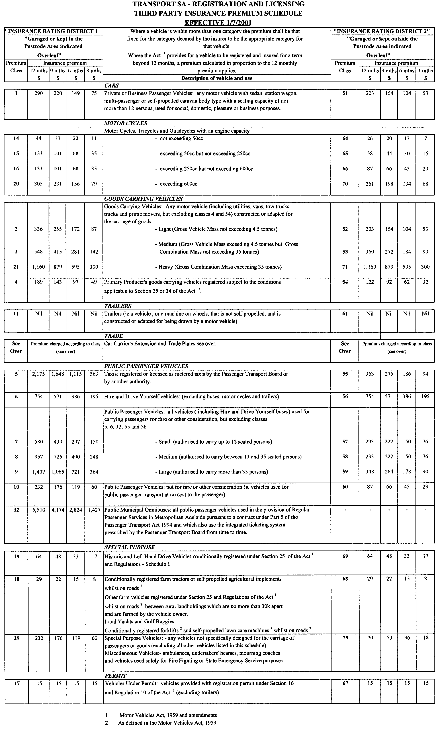
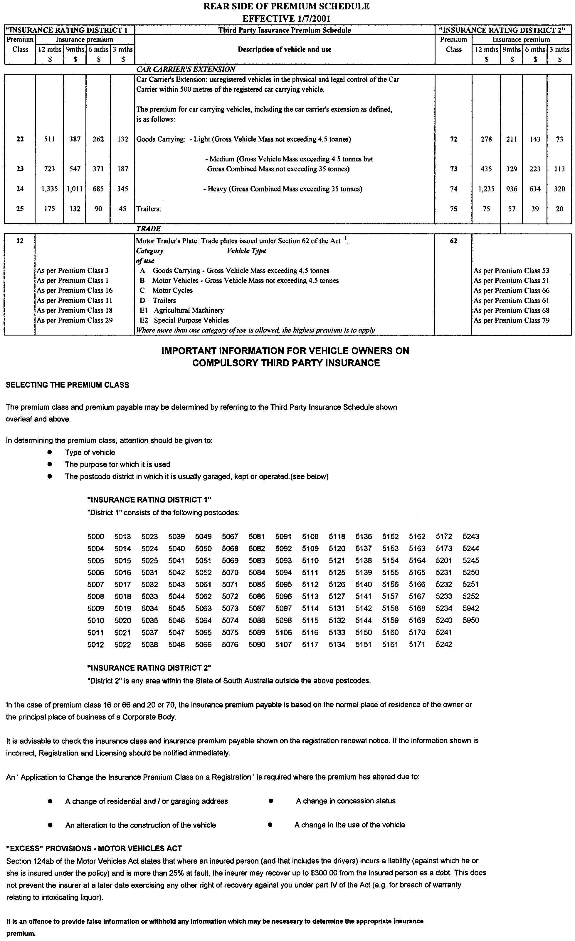
VETERINARY SURGEONS BOARD OF SOUTH AUSTRALIA
Notification of Conditions upon a Registration
AT a Formal Hearing of the Veterinary Surgeons Board of South Australia held on Tuesday, 6 February 2001, Dr Graeme John Mooney of Port Lincoln pleaded guilty to unprofessional conduct in relation to his treatment of four animals.
Pursuant to section 47 (3) (a) of the Veterinary Surgeons Act 1985, Dr Mooney received a formal reprimand and fine, and the following conditions were placed upon registration:
1. Any animal undergoing induction of anaesthetic is to be restrained by an employee of the practice, not the owner of the animal, except in the case of an emergency.
2. No animal is to be discharged whilst under the effects of anaesthesia.
3. Assessment of an animal’s condition is to be carried out by a registered person only. If a registered person is not available, then the nurse must direct the person to an alternative veterinary clinic.
4. The respondent’s practice must use a landline number and when the clinic is unattended a message must give a registered person’s contact number plus the number of an alternative veterinary clinic.
H. Ward, Registrar

WATER RESOURCES ACT 1997
Basis of Levy for 2001-2002 in the Patawalonga Catchment Water Management Board Catchment Area
PURSUANT to section 138 (8) of the Water Resources Act 1997:
1. I, Mark Kennion Brindal, Minister for Water Resources, have determined pursuant to section 138 (3) of the Water Resources Act 1997 that the basis for the levy in the catchment area of the Patawalonga Catchment Water Management Board for the 2001-2002 financial year will be the capital value of rateable land.
2. His Excellency, the Governor’s Deputy, gave his approval of the method referred to in paragraph 1 on 7 June 2001.
Dated 7 June 2001.
Mark Brindal, Minister for Water Resources

Contributions in 2001-2002 by Constituent Councils of the Patawalonga Catchment Water Management Board Catchment Area
PURSUANT to section 135 (6) of the Water Resources Act 1997:
1. I, Mark Kennion Brindal, Minister for Water Resources, have determined pursuant to section 135 of the Water Resources Act 1997 that:
(a) the total amount to be contributed by constituent councils of the catchment area of the Patawalonga Catchment Water Management Board in respect of
the 2001-2002 financial year is to be the sum of $2 297 000; and
(b) constituent councils of the Board’s area will share the liability for the payment of that amount as follows:
Constituent Councils Amount
$
Adelaide 95 300
Adelaide Hills 20 400
Burnside 162 800
Charles Sturt 14 400
Holdfast Bay 354 600
Marion 406 700
Mitcham 481 900
Onkaparinga 71 300
Unley 389 100
West Torrens 342 700
Total $2 339 200

2. His Excellency the Governor’s Deputy gave his approval of the amounts referred to in paragraph 1 on 7 June 2001.
Dated 7 June 2001.
Mark Brindal, Minister for Water Resources

WATER RESOURCES ACT 1997
Basis of Levy for 2001-2002 in the Northern Adelaide and Barossa Catchment Water Management Board Catchment Area
PURSUANT to section 138(8) of the Water Resources Act 1997:
1. I, Mark Kennion Brindal, Minister for Water Resources, have determined pursuant to section 138 (3) of the Water Resources Act 1997 that the basis for the levy in the catchment area of the Northern Adelaide and Barossa Catchment Water Management Board for the 2001-2002 financial year will be the capital value of rateable land.
2. His Excellency, the Governor’s Deputy, gave his approval of the method referred to in paragraph 1 on 7 June 2001.
Dated 7 June 2001.
Mark Brindal, Minister for Water Resources

Contributions in 2001-2002 by Constituent Councils of the Northern Adelaide and Barossa Catchment Water Management Board Catchment Area
PURSUANT to section 135 (6) of the Water Resources Act 1997:
1. I, Mark Kennion Brindal, Minister for Water Resources, have determined pursuant to section 135 of the Water Resources Act 1997 that:
(a) the total amount to be contributed by constituent councils of the catchment area of the Northern Adelaide and Barossa Catchment Water Management Board in respect of the 2001-2002 financial year is to be the sum of $2 132 200; and
(b) constituent councils of the Board’s area will share the liability for the payment of that amount as follows:
Constituent Councils Amount
$
Adelaide Hills 25 800
Barossa 218 400
Gawler 126 200
Kapunda Light 62 200
Mallala 32 700
Playford 357 300
Port Adelaide/Enfield 19 200
Salisbury 620 700
Tea Tree Gully 669 700
Total $2 132 200
2. His Excellency the Governor’s Deputy gave his approval of the amounts referred to in paragraph 1 on 7 June 2001.
Dated 7 June 2001.
Mark Brindal, Minister for Water Resources

WATER RESOURCES ACT 1997
Basis of Levy for 2001-2002 in the Torrens Catchment Water Management Board Catchment Area
PURSUANT to section 138 (8) of the Water Resources Act 1997:
1. I, Mark Kennion Brindal, Minister for Water Resources, have determined pursuant to section 138 (3) of the Water Resources Act 1997 that the basis for the levy in the catchment area of the Torrens Catchment Water Management Board for the 2001-2002 financial year will be the capital value of rateable land.
2. His Excellency, the Governor’s Deputy, gave his approval of the method referred to in paragraph 1 on 7 June 2001.
Dated 7 June 2001.
Mark Brindal, Minister for Water Resources

Contributions in 2001-2002 by Constituent Councils of the Torrens Catchment Water Management Board Catchment Area
PURSUANT to section 135 (6) of the Water Resources Act 1997:
1. I, Mark Kennion Brindal, Minister for Water Resources, have determined pursuant to section 135 of the Water Resources Act 1997 that:
(a) the total amount to be contributed by constituent councils of the catchment area of the Torrens Catchment Water Management Board in respect of the 2001-2002 financial year is to be the sum of $3 971 700; and
(b) constituent councils of the Board’s area will share the liability for the payment of that amount as follows:
Constituent Councils Amount
$
Adelaide 472 200
Adelaide Hills 90 400
Barossa 7 100
Burnside 413 000
Campbelltown 367 800
Charles Sturt 946 300
Norwood Payneham St Peters 417 100
Prospect 209 700
Port Adelaide/Enfield 750 000
Walkerville 111 700
West Torrens 108 200
Tea Tree Gully 78 200
Total $3 971 700
2. His Excellency the Governor’s Deputy gave his approval of the amounts referred to in paragraph 1 on 7 June 2001.
Dated 7 June 2001.
Mark Brindal, Minister for Water Resources

WATER RESOURCES ACT 1997
I, MARK KENION BRINDAL, Minister for Water Resources, hereby give notice for the purposes of the Water Allocation Plan for the Musgrave Prescribed Wells Area, prepared pursuant to Part 7, Division 3 of the Water Resources Act 1997, of the ‘recent recharge rate of the lens’ as set out below:
Quaternary Aquifer | Recent recharge rate of the Lens  (expressed as millimetres per annum)
Bramfield | 22
Kappawanta | 22
Polda | 20
Polda North | 18
Polda East | 8
Sheringa A | 20
Sheringa B | 20
Talia | 20
Tinline | 22
Minor Lenses | 18
Dated 27 May 2001.
Mark Brindal, Minister for Water Resources

REGULATIONS UNDER THE ROAD TRAFFIC ACT 1961
────
No. 121 of 2001
────
At the Executive Council Office at Adelaide 7 June 2001

PURSUANT to the Road Traffic Act 1961 and with the advice and consent of the Executive Council, I make the following regulations.
BRUNO KRUMINS Governor's Deputy

PURSUANT to section 10AA(2) of the Subordinate Legislation Act 1978, I certify that, in my opinion, it is necessary or appropriate that the following regulations come into operation as set out below.

DIANA LAIDLAW Minister for Transport and Urban Planning
───────────────────
SUMMARY OF PROVISIONS
1. Citation
2. Commencement
3. Variation of reg. 4—Interpretation
4. Variation of reg. 20—Prohibition of vehicles carrying dangerous substances on certain roads
5. Variation of reg. 25—Modification of motor vehicles
6. Variation of reg. 39—Prescribed class of vehicles for purposes of s. 163C(1)
7. Variation of reg. 43—Fees for inspections
8. Insertion of reg. 47
47. Proof of GVM, etc.
────────────────────────
Citation
1. The Road Traffic (Miscellaneous) Regulations 1999 (see Gazette 25 November 1999 p. 2690), as varied, are referred to in these regulations as "the principal regulations".

Commencement
2. These regulations come into operation on the day on which they are made.

Variation of reg. 4—Interpretation
3. Regulation 4 of the principal regulations is varied—

(a) by inserting after the definition of "fifth wheel coupling" the following definitions:

"GCM" (gross combination mass), in relation to a motor vehicle, means the greatest possible sum of the maximum loaded mass of the motor vehicle and of any vehicles that may lawfully be towed by it at one time—

(a) as specified by the motor vehicle's manufacturer—

(i) on a plate fixed to the vehicle by the manufacturer; or

(ii) if the manufacturer has not specified the sum of the maximum loaded mass on a plate fixed to the vehicle—in another place; or

(b) as specified by the vehicle registration authority if—

(i) the manufacturer has not specified the sum of the maximum loaded mass; or

(ii) the manufacturer cannot be identified; or

(iii) the vehicle has been modified to the extent that the manufacturer's specification is no longer appropriate;

"GTM" (gross trailer mass) means the maximum loaded mass transmitted to the ground by the axles of a trailer when it is connected to a towing vehicle—

(a) as specified by the manufacturer; or

(b) as specified by the vehicle registration authority if—

(i) the manufacturer has not specified a maximum loaded mass transmitted to the ground by the axles of the trailer when connected to a towing vehicle; or

(ii) the manufacturer cannot be identified; or

(iii) the trailer has been modified to the extent that the manufacturer's specification is no longer appropriate;;

(b) by inserting after the definition of "Transport Department" the following definition:

"vehicle registration authority", in relation to a vehicle, means—

(a) the authority that last registered the vehicle; or

(b) if the vehicle has never been registered—the authority responsible for registering vehicles in the State or Territory in which the vehicle is used or intended to be used.

Variation of reg. 20—Prohibition of vehicles carrying dangerous substances on certain roads
4. Regulation 20 of the principal regulations is varied by striking out the definition of "dangerous substance" in subregulation (4) and substituting the following definition:

"dangerous substance" has the meaning given to "dangerous goods" by regulation 2.2 of the Road Transport Reform (Dangerous Goods) (South Australia) Regulations 1998.

Variation of reg. 25—Modification of motor vehicles
5. Regulation 25 of the principal regulations is varied by inserting after paragraph (j) of subregulation (3) the following paragraph:

(k) alterations affecting any steering components or the steering geometry.

Variation of reg. 39—Prescribed class of vehicles for purposes of s. 163C(1)
6. Regulation 39 of the principal regulations is varied by striking out "Part 4" and substituting "Part 4A".

Variation of reg. 43—Fees for inspections
7. Regulation 43 of the principal regulations is varied—

(a) by inserting in subregulation (1) after the definition of "Transport Department inspection" the following definition:

"Transport Department premises", in relation to a Transport Department inspection, includes premises nominated by the Department as a site for such an inspection.;

(b) by striking out subregulation (5) and substituting the following subregulation:

(5) Where the Transport Department carries out an examination of a motor vehicle for the purposes of section 139(1)(ab)(iii) of the Motor Vehicles Act 1959, the following fees are payable:

(a) if the examination takes place at Transport Department premises—a fee of $18 per vehicle is payable to the Registrar of Motor Vehicles on registration of the motor vehicle;

(b) if the examination takes place at a site other than Transport Department premises—

(i) a fee of $132 per site visit is payable to the Transport Department prior to the examination; and

(ii) a fee of $18 per vehicle is payable to the Registrar of Motor Vehicles on registration of the motor vehicle.;

(c) by striking out from subregulation (10) "to" first occurring.

Insertion of reg. 47
8. The following regulation is inserted after regulation 46 of the principal regulations:

Proof of GVM, etc.
47. In proceedings for an offence against the Road Traffic Act 1961 involving a breach of a regulation or rule made under that Act, an allegation in a complaint that a specified mass was the GVM, GCM or GTM of a specified vehicle is proof of the matter so alleged in the absence of proof to the contrary.

TSA C2000/08632 SUZANNE M. CARMAN Clerk of the Council

REGULATIONS UNDER THE ROAD TRAFFIC ACT 1961
────
No. 122 of 2001
────
At the Executive Council Office at Adelaide 7 June 2001

PURSUANT to the Road Traffic Act 1961 and with the advice and consent of the Executive Council, I make the following regulations.
BRUNO KRUMINS Governor's Deputy

PURSUANT to section 10AA(2) of the Subordinate Legislation Act 1978, I certify that, in my opinion, it is necessary or appropriate that the following regulations come into operation as set out below.

DIANA LAIDLAW Minister for Transport and Urban Planning
───────────────────
SUMMARY OF PROVISIONS
1. Citation
2. Commencement
3. Variation of Sched.1—Mass and Loading Requirements for Heavy Vehicles
4. Variation of Dictionary
────────────────────────
Citation
1. The Road Traffic (Mass and Loading Requirements) Regulations 1999 (see Gazette 25 November 1999 p. 2575) are referred to in these regulations as "the principal regulations".

Commencement
2. These regulations come into operation on the day on which they are made.

Variation of Sched.1—Mass and Loading Requirements for Heavy Vehicles
3. Schedule 1 of the principal regulations is varied—

(a) by inserting in clause 1 after its present contents (now to be designated as subclause (1)) the following subclause:

(2) The mass transmitted to the ground by the axles of a trailer and any load when the trailer is connected to a towing vehicle must not exceed the trailer's GTM.;

(b) by inserting after paragraph (b) of clause 2(6) the following paragraph:

(ba) in the case of an ultra low floor bus with 2 axles that is licensed to carry standing passengers—16.0 tonnes; and;

(c) by inserting after subclause (6) of clause 2 the following subclause:

(7) In this clause and in Table 1—

"ultra low floor bus" means a bus, designed to assist the entry, exit and movement of passengers, that has no internal step at an entrance or exit or otherwise in the passenger walkway areas of the bus.;

(d) by striking out paragraph (b) of the item relating to a "Single axle or single axle group fitted with dual tyres" under the heading "Single axles and single axle groups" in Table 1 at the end of clause 2 and substituting the following paragraphs:

(b) a complying bus or bus licensed to carry standing passengers
(other than a bus referred to in paragraph (ba)) 10.0

(ba) an ultra low floor bus with 2 axles that is licensed to carry
standing passengers 11.0.

Variation of Dictionary
4. The Dictionary of the principal regulations is varied by inserting after the definition of "GCM" the following definition:

"GTM" (gross trailer mass) means the maximum loaded mass transmitted to the ground by the axles of a trailer when it is connected to a towing vehicle:

(a) as specified by the manufacturer; or

(b) as specified by the vehicle registration authority if:

(i) the manufacturer has not specified a maximum loaded mass transmitted to the ground by the axles of the trailer when connected to a towing vehicle; or

(ii) the manufacturer cannot be identified; or

(iii) the trailer has been modified to the extent that the manufacturer's specification is no longer appropriate;.

TSA C2000/08632 SUZANNE M. CARMAN Clerk of the Council

REGULATIONS UNDER THE ROAD TRAFFIC ACT 1961
────
No. 123 of 2001
────
At the Executive Council Office at Adelaide 7 June 2001

PURSUANT to the Road Traffic Act 1961 and with the advice and consent of the Executive Council, I make the following regulations.
BRUNO KRUMINS Governor's Deputy

PURSUANT to section 10AA(2) of the Subordinate Legislation Act 1978, I certify that, in my opinion, it is necessary or appropriate that the following regulations come into operation as set out below.

DIANA LAIDLAW Minister for Transport and Urban Planning
───────────────────
SUMMARY OF PROVISIONS
1. Citation
2. Commencement
3. Variation of Sched.—Standard Form Conditions
────────────────────────
Citation
1 The Road Traffic (Oversize or Overmass Vehicle Exemptions) Regulations 1999 (see Gazette 25 November 1999 p. 2546) are referred to in these regulations as "the principal regulations".

Commencement
2. These regulations come into operation on the day on which they are made.

Variation of Sched.—Standard Form Conditions
3. The Schedule of the principal regulations is varied—

(a) by striking out subclauses (4) and (5) of clause 55 and substituting the following subclauses:

(4) The warning sign must display the sign manufacturer's name or logo, and the brand and class of retro-reflective material used, in block letters at least 3mm but not more than 10mm high.

(5) The manufacturer's name or logo may appear in any visible location on the sign, other than in a bottom corner of a sign used on a pilot vehicle.;

(b) by striking out subclause (2) of clause 56 and substituting the following subclauses:

(2) In spite of subclause (1), a warning sign may be made of a flexible material if the sign—

(a) is held taut; and

(b) is positioned and secured in such a manner, and is maintained in such a condition, that it is clearly visible to, and can easily be read by, other road users.

(3) A flexible warning sign must comply with all other requirements relating to warning signs in these regulations as if it were a stiff sign.

TSAC2000/08632 SUZANNE M. CARMAN Clerk of the Council

RULES UNDER THE ROAD TRAFFIC ACT 1961
────
No. 124 of 2001
────
At the Executive Council Office at Adelaide 7 June 2001

PURSUANT to the Road Traffic Act 1961 and with the advice and consent of the Executive Council, I make the following rules.
BRUNO KRUMINS Governor's Deputy

PURSUANT to section 10AA(2) of the Subordinate Legislation Act 1978, I certify that, in my opinion, it is necessary or appropriate that the following rules come into operation as set out below.

DIANA LAIDLAW Minister for Transport and Urban Planning
───────────────────
SUMMARY OF PROVISIONS
1. Citation
2. Commencement
3. Variation of rule 27—Steering
4. Insertion of rule 57A
57A. Sidecars
5. Variation of rule 70—Rear overhang
6. Variation of rule 118—Other lights and reflectors
7. Variation of Dictionary
────────────────────────
Citation
1. The Road Traffic (Vehicle Standards) Rules 1999 (see Gazette 25 November 1999 p. 2597) are referred to in these rules as "the principal rules".

Commencement
2. These rules come into operation on the day on which they are made.

Variation of rule 27—Steering
3. Rule 27 of the principal rules is varied—

(a) by striking out from subrule (1) "with a GVM over 4.5 tonnes";

(b) by striking out subrule (2).

Insertion of rule 57A
4. The following rule is inserted after rule 57 of the principal rules:

Sidecars
57A. A sidecar on a motor bike must be positioned on the left hand side of the motor bike.

Variation of rule 70—Rear overhang
5. Rule 70 of the principal rules is varied—

(a) by striking out from subrule (3)(a) ", or body,";

(b) by inserting after subrule (4) the following subrule:

(5) In this rule:

"load carrying area", in relation to a trailer, means the part of the trailer on which a load may safely be carried, and may include the drawbar of the trailer.

Variation of rule 118—Other lights and reflectors
6. Rule 118 of the principal rules is varied—

(a) by striking out paragraph (c) of the definition of "exempt vehicle" in subrule (1) and substituting the following paragraph:

(c) a State Government enforcement vehicle; or;

(b) by striking out paragraph (a) of the definition of "special use vehicle" in subrule (1) and substituting the following paragraph:

(a) a vehicle built, fitted or acquired for a special use that when so used may result in a hazardous situation on a road; or;

(c) by inserting after item 2 of the "Examples of special use vehicles to which paragraph (a) applies" at the foot of the definition of "special use vehicle" in subrule (1), the following items:

3. Weed spraying vehicles.
4. Power driven lawn mowers.
5. Animal rescue vehicles.
6. Vehicles used by primary producers droving stock between paddocks.

Variation of Dictionary
7. The Dictionary in the principal rules is varied—

(a) by striking out the definition of "GTM" and substituting the following definition:

"GTM" (gross trailer mass) means the maximum loaded mass transmitted to the ground by the axles of a trailer when it is connected to a towing vehicle:

(a) as specified by the manufacturer; or

(b) as specified by the vehicle registration authority if:

(i) the manufacturer has not specified a maximum loaded mass transmitted to the ground by the axles of the trailer when connected to a towing vehicle; or

(ii) the manufacturer cannot be identified; or

(iii) the trailer has been modified to the extent that the manufacturer's specification is no longer appropriate.;

(b) by inserting after the definition of "Standards Association of Australia" the following definition:

"State Government enforcement vehicle" means a vehicle driven by—

(a) an inspector; or

(b) an authorised officer under the Dangerous Substances Act 1979,

in the course of his or her duty.;

(c) by striking out the definition of "Transport Department enforcement vehicle".

TSAC2000/08632 SUZANNE M. CARMAN Clerk of the Council

REGULATIONS UNDER THE MOTOR VEHICLES ACT 1959
────
No. 125 of 2001
────
At the Executive Council Office at Adelaide 7 June 2001

PURSUANT to the Motor Vehicles Act 1959 and with the advice and consent of the Executive Council, I make the following regulations.
BRUNO KRUMINS Governor's Deputy

PURSUANT to section 10AA(2) of the Subordinate Legislation Act 1978, I certify that, in my opinion, it is necessary or appropriate that the following regulations come into operation as set out below.

DIANA LAIDLAW Minister for Transport and Urban Planning
───────────────────
SUMMARY OF PROVISIONS
1. Citation
2 Commencement
3. Variation of reg. 4—Interpretation
4. Substitution of reg. 7
7. Exemption from registration and insurance for certain vehicles driven by or at direction of member of police force, etc.
5. Variation of reg. 9A—Exemption from registration and insurance for golf carts and certain motor bikes
6. Variation of reg. 12—Carriage of number plates (s. 47(1) of the Act)
7. Variation of reg. 21—Carriage of registration labels and permits
8. Variation of reg. 25—Exemptions from duty to hold licence, permit or particular class of licence
9. Substitution of reg. 27
27. Duties of person acting as qualified passenger for learner driver
10. Variation of reg. 28—Learner's permits—display of "L" plates
11. Variation of reg. 29—Provisional licences—display of "P" plates
12. Variation of reg. 30—Exemption from duty to display "P" plates for members of police force and police cadets
13. Variation of reg. 31—Exemption from provisional licence speed limit for members of police force and police cadets
14. Variation of reg. 32—Attendance at lectures by holder of learner's permit, etc., who contravenes probationary conditions or incurs four or more demerit points
15. Variation of reg. 33—Exemption from duty to carry and produce probationary licence or provisional licence for members of police force and police cadets
16. Variation of reg. 37—Exemption from duty to hold motor driving instructor's licence for approved motor bike training courses
17. Variation of reg. 40—Additional amount payable where certain vehicles are altered or added to
18. Substitution of reg. 42
42. Refund on surrender of licence
19. Variation of reg. 45—Calculation of fees and refunds to nearest 10 cents or whole dollar
20. Variation of reg. 46—Exemption from practical driving test fees
21. Substitution of reg. 51
51. Corresponding laws declared for purposes of demerit points scheme
22. Insertion of reg. 51AA
51AA. Application for review under Part 3E of the Act
23. Insertion of reg. 52A
52A. Corresponding laws declared for purposes of s. 141(2) of the Act
24. Variation of reg. 56—Demerit points for offences in this State
25. Variation of Sched. 2—Classification of driver's licences
26. Variation of Sched. 3—Conditions of driver's licences and learner's permits
27. Variation of Sched. 5—Fees
28. Variation of Sched. 6—Expiation Fees (regs. 54 & 55)
────────────────────────
Citation
1. The Motor Vehicles Regulations 1996 (see Gazette 30 May 1996 p. 2751), as varied, are referred to in these regulations as "the principal regulations".

Commencement
2. These regulations will come into operation on 17 June 2001.

Variation of reg. 4—Interpretation
3. Regulation 4 of the principal regulations is varied—

(a) by striking out from paragraph (a) of the definition of "bike rack" in subregulation (1) "motor cycle or motor tricycle" and substituting "motor bike or motor trike";

(b) by striking out from paragraph (b) of the definition of "bike rack" in subregulation (1) "cycles" (second occurring) and substituting "bikes";

(c) by striking out the definition of "special purpose vehicle" in subregulation (1) and substituting the following definition:

"special purpose vehicle" has the same meaning as in the Commonwealth Road Transport Charges Act;;

(d) by striking out subregulations (2) and (3).

Substitution of reg. 7
4. Regulation 7 of the principal regulations is revoked and the following regulation is substituted:

Exemption from registration and insurance for certain vehicles driven by or at direction of member of police force, etc.
7. (1) A motor vehicle may be driven on roads without registration or insurance if the vehicle is being driven by, or at the direction of, a person of a class prescribed by subregulation (2) acting pursuant to powers conferred on the person, or in the discharge of duties imposed on the person, in relation to the vehicle (whether under the Act or any other Act or law).

(2) For the purposes of subregulation (1), the following classes of persons are prescribed:

(a) members of the police force;

(b) inspectors;

(c) persons authorised to examine motor vehicles under section 139 of the Act.

Variation of reg. 9A—Exemption from registration and insurance for golf carts and certain motor bikes
5. Regulation 9A of the principal regulations is varied by striking out from paragraph (b) of the definition of "prescribed motor vehicle" in subregulation (5) "cycle" and substituting "bike".

Variation of reg. 12—Carriage of number plates (s. 47(1) of the Act)
6. Regulation 12 of the principal regulations is varied by striking out from paragraph (a)(i) "cycle" and substituting "bike".

Variation of reg. 21—Carriage of registration labels and permits
7. Regulation 21 of the principal regulations is varied by striking out from subregulation (1) "cycle" wherever occurring and substituting, in each case, "bike".

Variation of reg. 25—Exemptions from duty to hold licence, permit or particular class of licence
8. Regulation 25 of the principal regulations is varied by striking out from subsection (2) "cycle" wherever occurring and substituting, in each case, "bike".

Substitution of reg. 27
9. Regulation 27 of the principal regulations is revoked and the following regulation is substituted:

Duties of person acting as qualified passenger for learner driver
27. (1) For the purposes of this regulation, a person acts as a qualified passenger for a learner driver if, while the learner driver is driving a motor vehicle, or attempting to put a motor vehicle in motion, on a road, the person occupies a seat in the vehicle next to the learner driver, or, if the vehicle is a motor bike, is a passenger on the bike or in a sidecar attached to the bike.

(2) A person must not, except while conducting a practical driving test under section 79A of the Act, act as a qualified passenger for a learner driver unless the person holds a licence (not being a probationary licence or provisional licence) authorising the person to drive the vehicle that the learner driver is driving, or attempting to put into motion, when the person is so acting.

(3) If a person acting as a qualified passenger for a learner driver is requested by a member of the police force to produce his or her licence, the person must produce the licence—

(a) immediately to the member of the police force who made the request; or

(b) within 48 hours after the making of the request, at a police station nominated by the person to the member of the police force at the time of the making of the request.

(4) A person acting as a qualified passenger for a learner driver must take all reasonable steps to supervise and instruct the learner driver in the safe and efficient driving of motor vehicles.

(5) In this regulation—

"learner driver" means—

(a) the holder of a learner's permit; or

(b) the holder of a licence when driving a motor vehicle on a road as authorised under section 74(1)(b) of the Act.

Variation of reg. 28—Learner's permits—display of "L" plates
10. Regulation 28 of the principal regulations is varied by striking out from subregulation (1)(a) "cycle" wherever occurring and substituting, in each case, "bike".

Variation of reg. 29—Provisional licences—display of "P" plates
11. Regulation 29 of the principal regulations is varied by striking out from subregulation (1)(a) cycle" wherever occurring and substituting, in each case, "bike".

Variation of reg. 30—Exemption from duty to display "P" plates for members of police force and police cadets
12. Regulation 30 of the principal regulations is varied by striking out "section 81A(1)(d)" and substituting "section 81A(1)(e)".

Variation of reg. 31—Exemption from provisional licence speed limit for members of police force and police cadets
13. Regulation 31 of the principal regulations is varied by striking out "section 81A(5b)" and substituting "section 81A(1)(d) and (5b)".

Variation of reg. 32—Attendance at lectures by holder of learner's permit, etc., who contravenes probationary conditions or incurs four or more demerit points
14. Regulation 32 of the principal regulations is varied by striking out from subregulation (2) "or section 81A(5)" and substituting ", section 81A(5) or section 81AB(5)".

Variation of reg. 33—Exemption from duty to carry and produce probationary licence or provisional licence for members of police force and police cadets
15. Regulation 33 of the principal regulations is varied—

(a) by inserting "probationary licence or" before "provisional licence";

(b) by striking out "section 98AAB(2)" and substituting "section 98AAB".

Variation of reg. 37—Exemption from duty to hold motor driving instructor's licence for approved motor bike training courses
16. Regulation 37 of the principal regulations is varied by striking out "cycle" and substituting "bike".

Variation of reg. 40—Additional amount payable where certain vehicles are altered or added to
17. Regulation 40 of the principal regulations is varied by striking out from subregulation (2) "cycle" and substituting "bike".

Substitution of reg. 42
18. Regulation 42 of the principal regulations is revoked and the following regulation is substituted:

Refund on surrender of licence
42. (1) On surrender of a licence, no refund of a licence fee may be made if—

(a) the licence has been surrendered as a consequence of—

(i) a suspension, cancellation or disqualification imposed by a court or pursuant to section 83, 98A(7) or 98BE of the Act; or

(ii) in the case of a probationary licence or provisional licence—a decision or order to cancel the licence or a requirement that the Registrar cancel the licence; or

(b) the amount of the refund calculated in accordance with this regulation does not exceed one dollar.

(2) A refund is to be made in respect of the period unexpired—

(a) in the case of a licence that is surrendered as a consequence of a suspension (other than a suspension referred to in subregulation (1)(a)(i))—at the date that the suspension becomes effective; or

(b) in any other case—at the date of the surrender of the licence.

(3) The amount of the refund is to be calculated by multiplying one-quarter of the annual licence fee paid by the number of complete three month periods unexpired.

Variation of reg. 45—Calculation of fees and refunds to nearest 10 cents or whole dollar
19. Regulation 45 of the principal regulations is varied by striking out from subregulation (2)(d) "provisional driver's licence" and substituting "probationary licence or provisional licence".

Variation of reg. 46—Exemption from practical driving test fees
20. Regulation 46 of the principal regulations is varied by striking out "section 79A or 85" and substituting "section 72(10) or 79A".

Substitution of reg. 51
21. Regulation 51 of the principal regulations is revoked and the following regulation is substituted:

Corresponding laws declared for purposes of demerit points scheme
51. The following laws, as amended or substituted from time to time, are declared to be corresponding laws for the purposes of Part 3B of the Act:

Motor Traffic Act 1936 of the Australian Capital Territory and regulations made under that Act.
Road Transport (Driver Licensing) Act 1998 of New South Wales and regulations made under that Act.
Transport Operations (Road Use Management) Act 1995 of Queensland and regulations made under that Act.
Vehicle and Traffic Act 1999 of Tasmania and regulations made under that Act.
Road Safety Act 1986 of Victoria and regulations made under that Act.

Insertion of reg. 51AA
22. The following regulation is inserted in the principal regulations after regulation 51:

Application for review under Part 3E of the Act
51AA. For the purposes of section 98Z(2) of the Act, an application for a review must—

(a) be in writing; and

(b) set out the decision to which the application relates; and

(c) set out the grounds on which the applicant seeks the review and the decision sought on the review; and

(d) be accompanied by any information that the applicant considers should be taken into account on the review; and

(e) be accompanied by the appropriate fee prescribed by Schedule 5; and

(f) be lodged with the Registrar.

Insertion of reg. 52A
23. The following regulation is inserted in the principal regulations after regulation 52:

Corresponding laws declared for purposes of s. 141(2) of the Act
52A. The following laws, as amended or substituted from time to time, are declared to be corresponding laws for the purposes of section 141(2) of the Act:

Motor Vehicles Act of the Northern Territory
Road Safety Act 1986 of Victoria
Road Traffic Act 1974 of Western Australia
Road Transport (Driver Licensing) Act 1998 of New South Wales
Road Transport (Driver Licensing) Act 1999 of the Australian Capital Territory
Road Transport (Vehicle Registration) Act 1997 of New South Wales
Road Transport (Vehicle Registration) Act 1999 of the Australian Capital Territory
Traffic Act 1949 of Queensland
Vehicle and Traffic Act 1999 of Tasmania.

Variation of reg. 56—Demerit points for offences in this State
24. Regulation 56 of the principal regulations is varied by inserting after subregulation (1) the following subregulation:

(1a) For the purposes of section 98BC(2) of the Act, the offences specified in Part 2 of Schedule 7 are prescribed.

Variation of Sched. 2—Classification of driver's licences
25. Schedule 2 of the principal regulations is varied—

(a) by striking out subclause (3) and substituting the following subclause:

(3) A reference in column 3 of the table to a driver's licence of a particular class includes a reference to an interstate licence of that class.;

(b) by striking out subregulations (5) and (6);

(c) by striking out from column 2 of the table "motor cycle" wherever occurring and substituting, in each case, "motor bike";

(d) by striking out "motor cycle" from the note at the bottom of the table relating to "*R-DATE" and substituting "motor bike".

Variation of Sched. 3—Conditions of driver's licences and learner's permits
26. Schedule 3 of the principal regulations is varied by striking out from the table "motor cycle" and substituting "motor bike".

Variation of Sched. 5—Fees
27. Schedule 5 of the principal regulations is varied—

(a) by striking out from clause 2(1)(b)(i) "cycle" and substituting "bike";

(b) by striking out from clause 14(1)(b) "cycle" and substituting "bike";

(c) by striking out from clause 14(1)(c) "cycle" wherever occurring and substituting, in each case, "bike";

(d) by striking out from clause 18(1)(a)(iii) "75 per cent" and substituting "70 per cent";

(e) by striking out from clause 18(4) "90 days" wherever occurring and substituting, in each case, "6 months";

(f) by striking out from clause 24 "cycle" wherever occurring and substituting, in each case, "bike";

(g) by inserting after clause 31 the following clause:

Application for review of decision of Registrar
31AA. Administration fee payable on application for a review under
s. 98Z of the Act level 3 fee.

Variation of Sched. 6—Expiation Fees (regs. 54 & 55)
28. Schedule 6 of the principal regulations is varied by inserting after the item relating to section 81A(5a) of the Act the following item:

s. 81AB(5):
· contravention of condition involving less than .08 grams of alcohol in 100 millilitres
of blood $122
· in any other case $49

TSA C97/10640
TSA C2001/01483 SUZANNE M. CARMAN Clerk of the Council

FAXING COPY?

IF you fax copy to Government Publishing SA for inclusion in the Government Gazette, there is no need to send a Confirmation Copy to us as well.

This creates confusion and may well result in your notice being printed twice.

Please use the following fax number:

Fax transmission: (08) 8207 1040
Phone Inquiries: (08) 8207 1045

Please include a contact person, phone number and order number so that we can phone back with any queries we may have regarding the fax copy.

NOTE: Closing time for lodging new copy (either fax or hard copy) is 4 p.m. on Tuesday preceding the day of publication.

Government Gazette notices can be E-mailed.

The address is:

governmentgazette@saugov.sa.gov.au

Documents should be sent as attachments in Word format.

When sending a document via E-mail, please confirm your transmission with a faxed copy of your document, including the date the notice is to be published.

Fax transmission: (08) 8207 1040
Enquiries: (08) 8207 1045

CITY OF ADELAIDE
Declaration of Public Roads
NOTICE is hereby given pursuant to section 210 of the Local Government Act 1999, that at a future meeting council intends to declare the following roads to be public roads:
1. Cairns Street in town acres 575, 576, 591 and 592, which is delineated as Cairns Street on LTO plan A1964.
2. The unnamed road in town acre 591, marked ‘D’ on LTO plan DP26095 and contained in partially cancelled certificate of title volume 224, folio 179.
3. Cardwell Street in town acres 574, 575, 592 and 593, which is delineated as Cardwell Street on LTO plan FP19661.
4. Pank Lane in town acre 574, which is delineated as allotments 6 and 7 on LTO plan DP650 and contained in partially cancelled certificate of title volume 270, folio 50 and volume 665, folio 110.
5. Castle Street in town acres 572 and 595, which is delineated as Castle Street on LTO plan A6232 plus allotment 32 on LTO plan DP446 which is contained in certificate of title volume 5833, folio 538.
6. That part of Ely Place in town acres 594 and 595 delineated as allotments 28 and 33 on LTO plan DP446 which are contained in certificate of title volume 5833, folio 538.
7. Saunders Lane in town acre 593, which is delineated as allotments 12 and 13 on LTO plan DP576 and contained in partially cancelled certificate of title volume 256, folio 164.
8. Wakeham Street in town acres 571 and 596, which is delineated as Wakeham Street on LTO plan A6232 plus allotment 29 on LTO plan DP446 which is contained in certificate of title volume 5833, folio 538.
9. The unnamed road in town acre 571 delineated as private road on LTO plan FP2168.
10. The unnamed road in town acre 571 delineated as private road on LTO plan B194 and contained in partially cancelled certificate of title volume 293, folio 143.
Susan Law, Chief Executive Officer

CITY OF PORT ADELAIDE ENFIELD
Declaration and Naming of Public Road
NOTICE is hereby given that at its meeting held on 21 March 2001 council resolved:
That pursuant to the provisions contained within the Local Government Act 1999, the City of Port Adelaide Enfield hereby declares allotment 91 in Filed Plan 215451, contained in Certificate of Title Volume 5592, Folio 432 to be a public road and hereby assigns the names Days Road, to that portion of this allotment situated between Regency Road, Regency Park and South Road, Regency Park and the name South Road to the remainder of this allotment.
H. J. Wierda, City Manager

CITY OF PORT LINCOLN
Casual Vacancy
NOTICE is hereby given that pursuant to section 54 of the Local Government Act 1999, the City of Port Lincoln has a casual vacancy of Councillor for Flinders Ward, due to the resignation of Councillor Heather Robin.
I. L. Burfitt, Chief Executive Officer

CITY OF VICTOR HARBOR
Roads (Opening and Closing) Act 1991
Road Closure—Waitpinga
NOTICE is hereby given that pursuant to section 10 of the Roads (Opening and Closing) Act 1991, the City of Victor Harbor intends to implement a Road Process to close the public road in
the Hundred of Encounter Bay, which divides section 370 from allotment 1 in Deposited Plan 18190, more particularly delineated and lettered ‘A’ on Preliminary Plan No. PP 32/0643. The closed road is to be transferred to Steven Richard Cherifi and Susan Maree Mason and merged with section 370 in the Hundred of Encounter Bay.
A statement of persons affected by the road process, together with a copy of the preliminary plan, is available for public inspection at the office of the City of Victor Harbor, Bay Road, Victor Harbor and at the Adelaide office of the Surveyor-General during normal office hours.
Any person who may wish to object to the proposed road process, or any person who may wish to apply for an easement to be granted in that person’s favour over the land subject to the proposed closure must lodge with the said council a notice of objection or an application for easement within 28 days of the date of the publication of this notice.
All objections shall be in writing stating the objector’s full name and address and the reasons for the objection and whether the objector wishes to appear in person or be represented at a meeting convened by the council for the determination of objections.
An application for easement shall be in writing stating the applicant’s full name and address, the reasons for the application for the grant of easement, full details of the nature and location of the easement applied for and whether the easement will be in favour of adjoining or nearby land, and if so, specifying the land to which the easement will be annexed.
Where a submission is made the council will give notification of a meeting at which the matter will be considered so that the person making the submission or their representative may attend if so desired.
A copy of any notice or application shall, at the same time it is lodged with the council be forwarded to the Adelaide office of the Surveyor-General.
Dated 28 May 2001.
G. Maxwell, Chief Executive Officer

CITY OF VICTOR HARBOR
Change of Council Meeting Date
NOTICE is hereby given that as Monday, 11 June 2001 is a public holiday, the council meeting scheduled for that day will now be held on Tuesday, 12 June 2001, at the Council Chambers, Bay Road, Victor Harbor, commencing at 5.30 p.m.
G. Maxwell, City Manager

CITY OF WHYALLA
Adoption of Valuations
NOTICE is hereby given that the Corporation of the City of Whyalla at its meeting held on 28 May 2001, in accordance with section 167 of the Local Government Act 1999, adopted the Valuer-General’s valuation of site value in the amount of $169 090 100 and hereby specifies that 1 July 2001, shall be the day as and from which such assessment shall become the assessment of the council for the year ending 30 June 2002.
The said valuations are included in the Assessment Book, which is held in the office of the council at Darling Terrace, Whyalla and may be inspected by any interested persons between the hours of 9 a.m. and 5 p.m. daily, Monday to Friday.
D. Knox, City Manager

CLARE & GILBERT VALLEYS COUNCIL
Definition of Town Boundaries
NOTICE is hereby given that the Clare & Gilbert Valleys Council at its recent meeting held on 23 May 2001, declared the townships of Auburn, Clare, Manoora, Mintaro, Sevenhill, Stockport, Tarlee, Waterloo and Watervale within the District of Clare & Gilbert Valleys Council in accordance with the provisions of section 4 of the Local Government Act 1999, defined hereunder the First to Ninth Schedules respectively.
DAIS 32/0649
The First Schedule
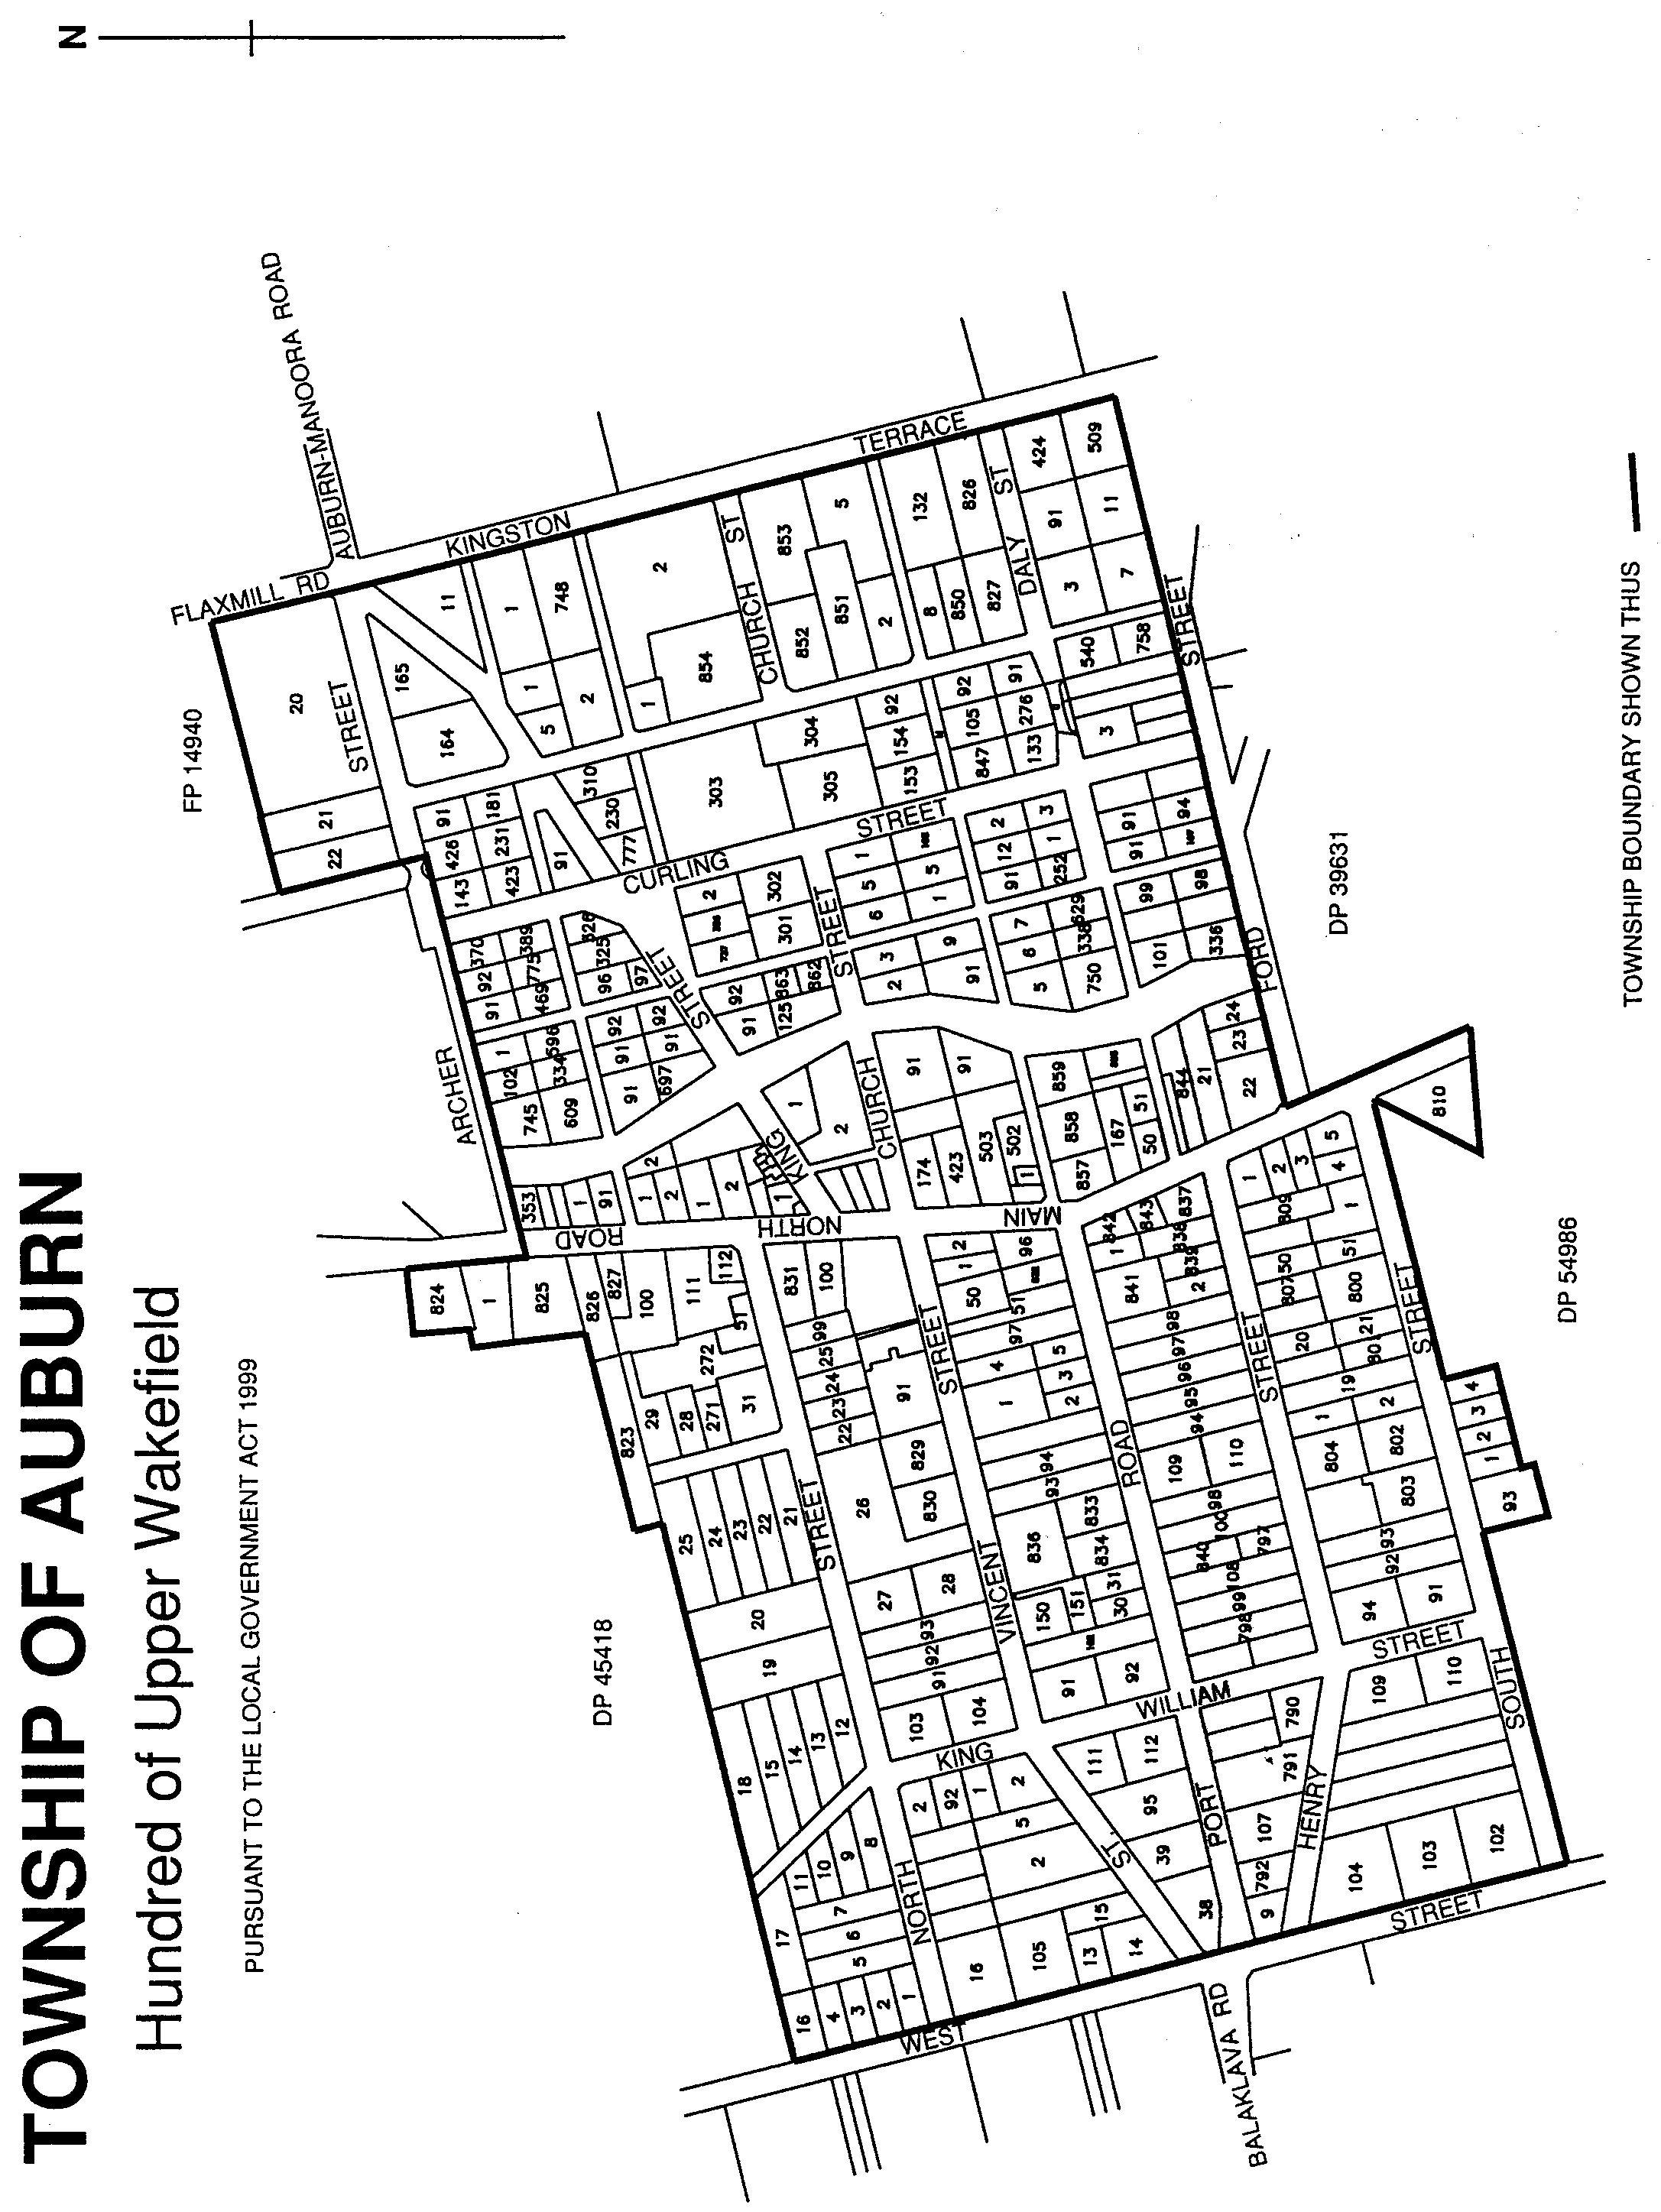
The area of the township of Auburn shall be that land situate in the Hundred of Upper Wakefield, County of Stanley, more particularly delineated on the plan published herewith and deposited in the Department for Administrative and Information Services at Adelaide as General Registry Office Plan 218/2001.

The Second Schedule
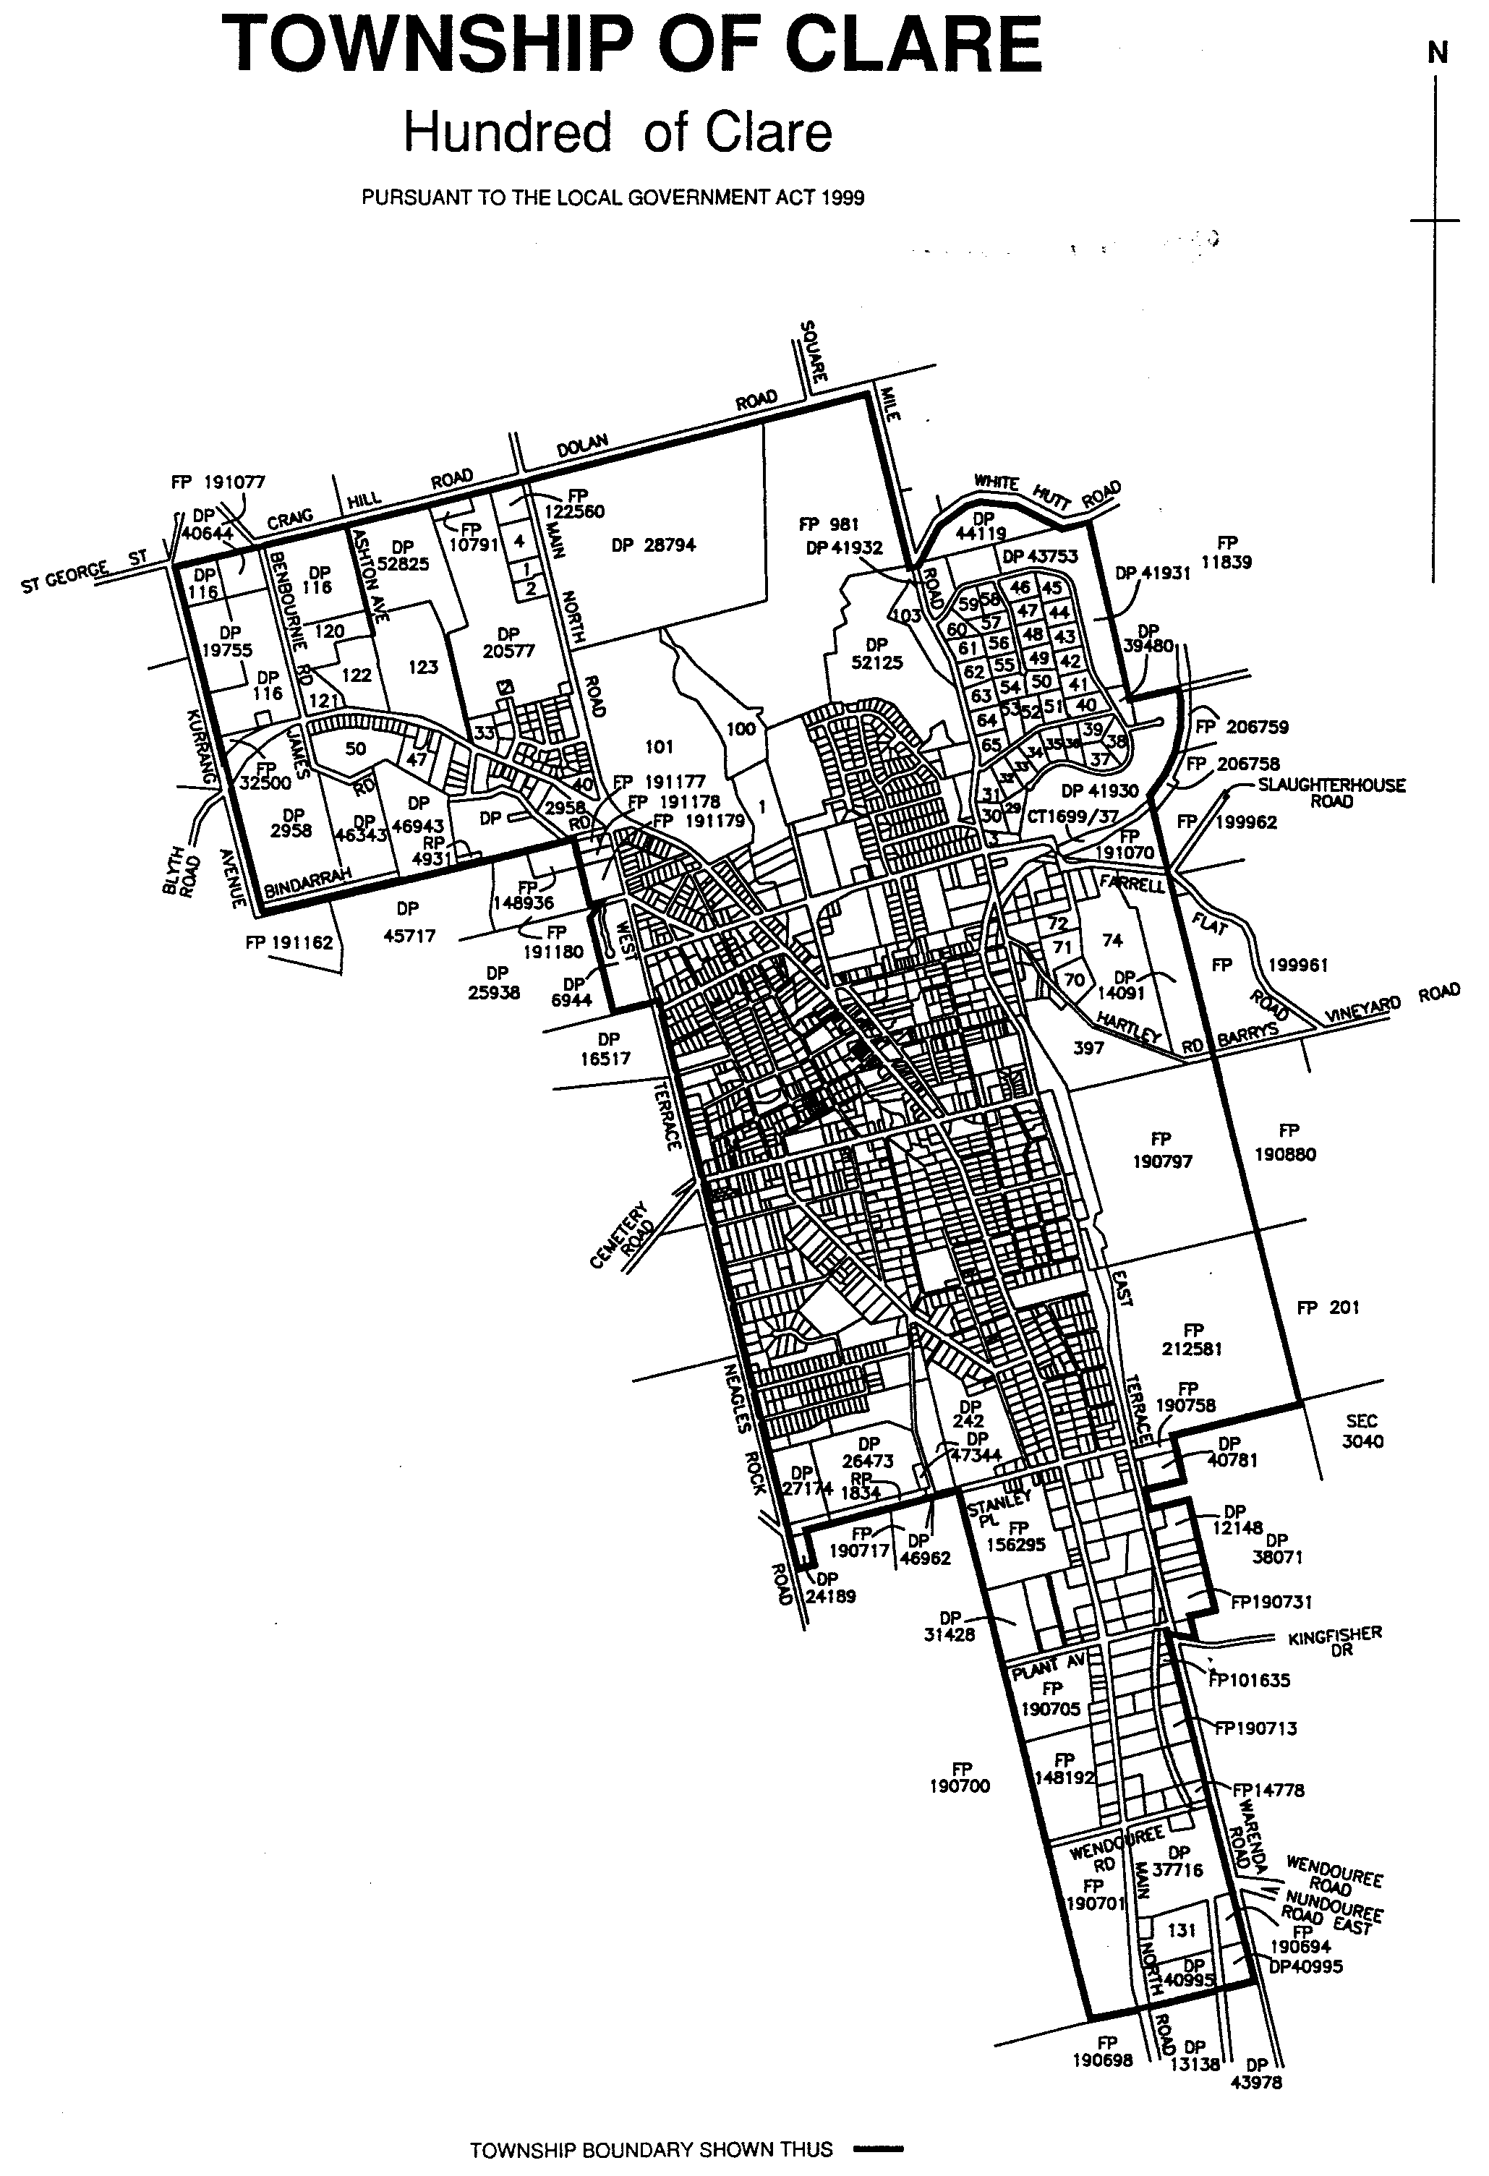
The area of the township of Clare shall be that land situate in the Hundred of Clare, County of Stanley, more particularly delineated on the plan published herewith and deposited in the Department for Administrative and Information Services at Adelaide as General Registry Office Plan 219/2001.

The Third Schedule
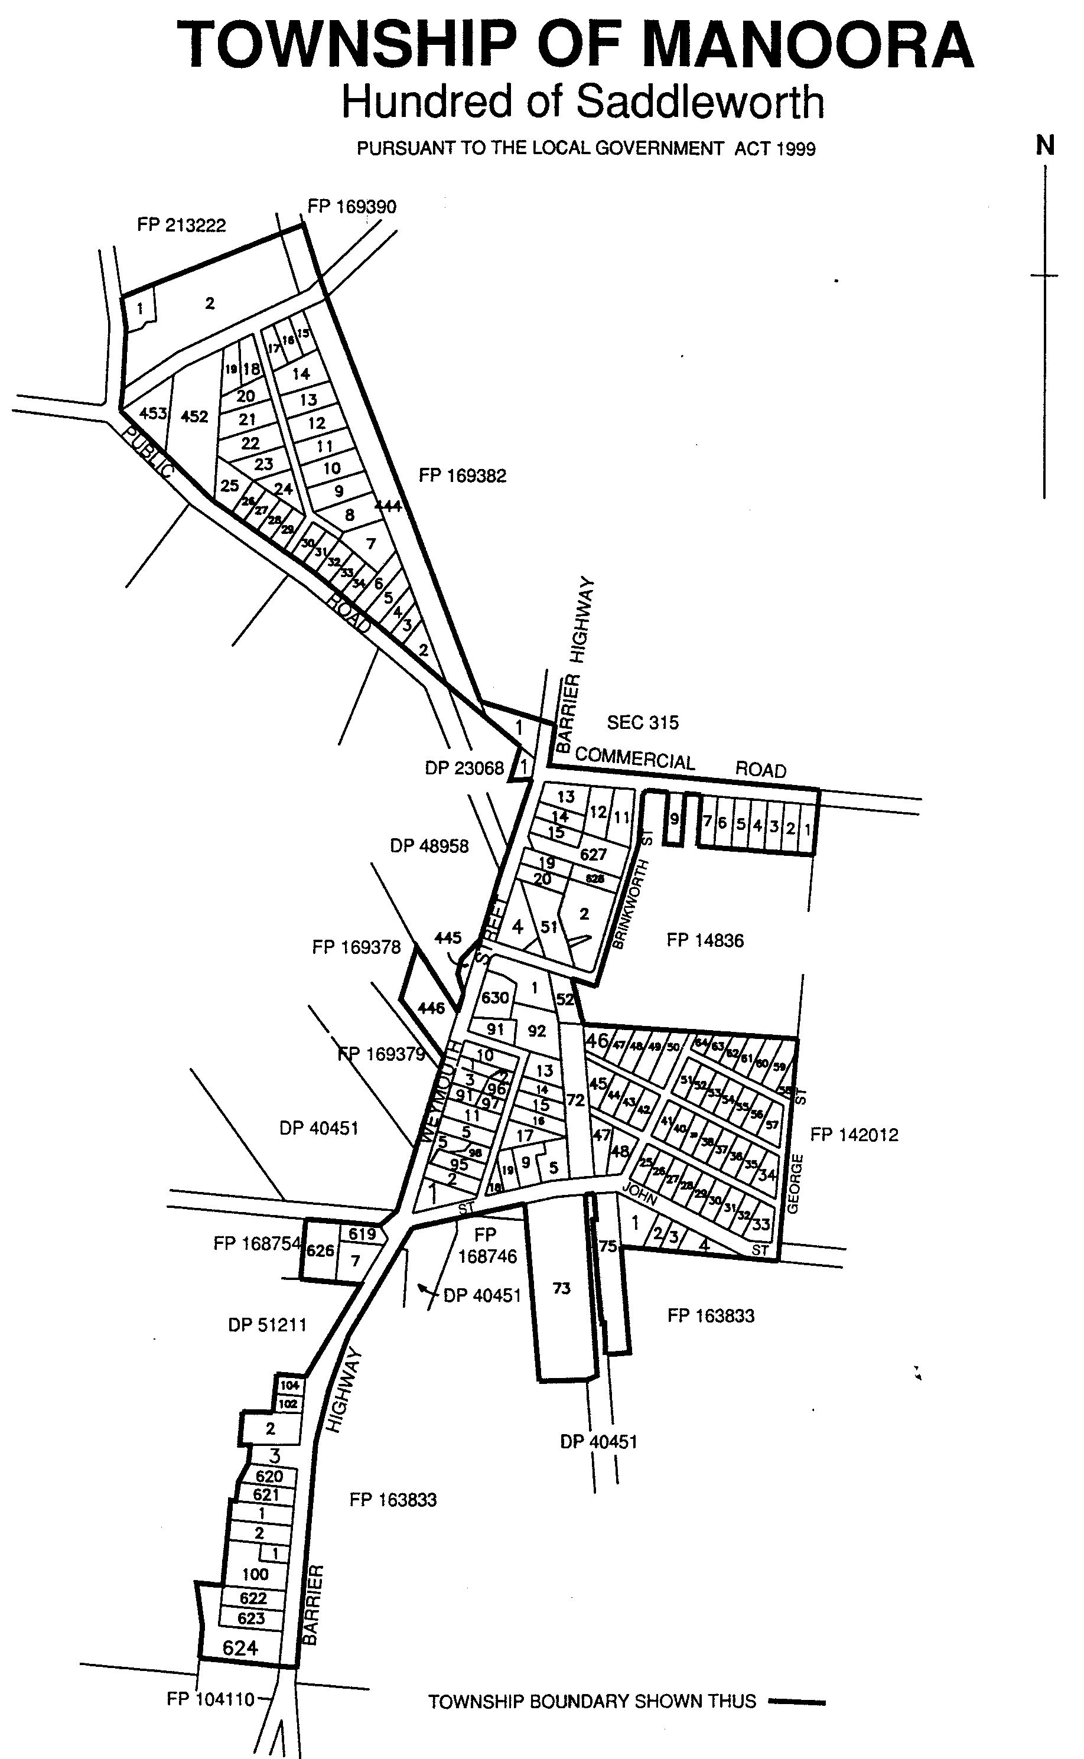
The area of the township of Manoora shall be that land situate in the Hundred of Saddleworth, County of Light, more particularly delineated on the plan published herewith and deposited in the Department for Administrative and Information Services at Adelaide as General Registry Office Plan 220/2001.

The Fourth Schedule
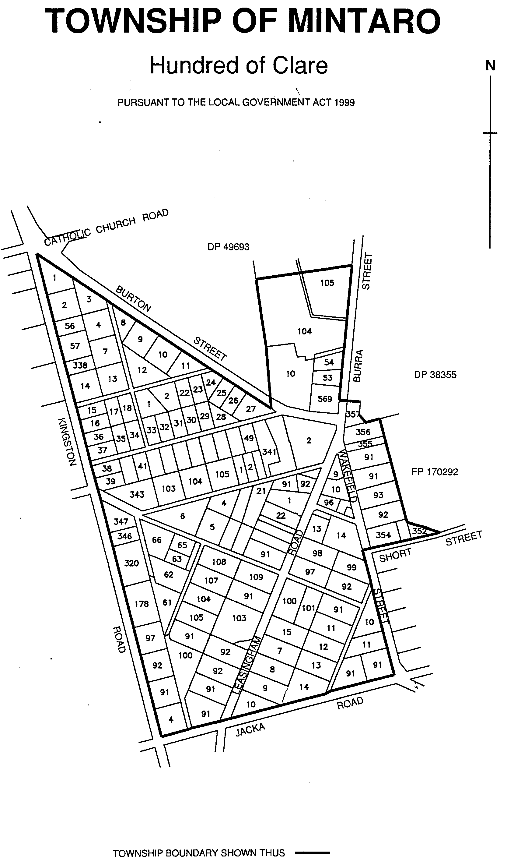
The area of the township of Mintaro shall be that land situate in the Hundred of Clare, County of Stanley, more particularly delineated on the plan published herewith and deposited in the Department for Administrative and Information Services at Adelaide as General Registry Office Plan 221/2001.
The Fifth Schedule
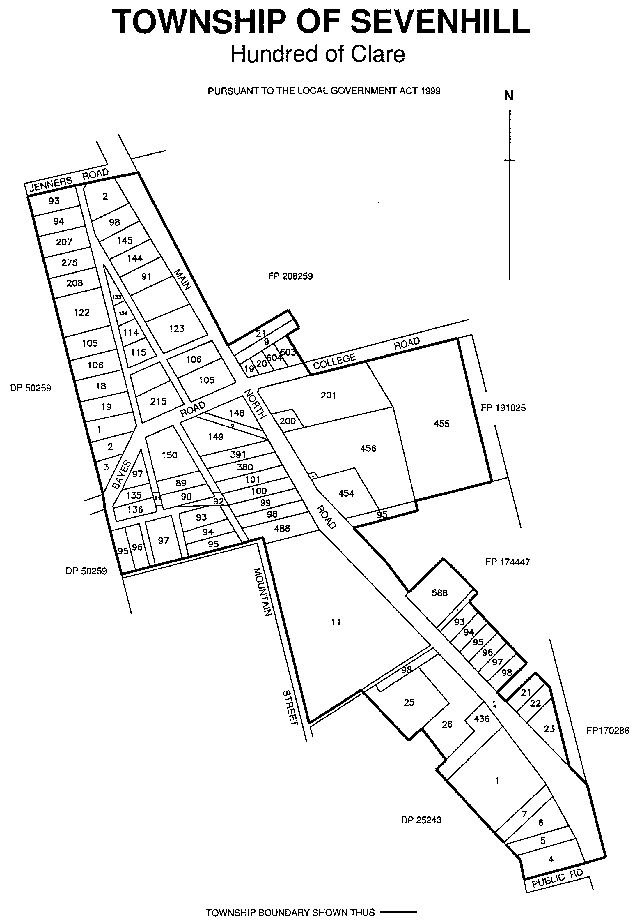
The area of the township of Sevenhill shall be that land situate in the Hundred of Clare, County of Stanley, more particularly delineated on the plan published herewith and deposited in the Department for Administrative and Information Services as Adelaide as General Registry Office Plan 222/2001.

The Sixth Schedule
The area of the township of Stockport shall be that land situate in the Hundred of Light, County of Light, more particularly delineated on the plan published herewith and deposited in the Department for Administrative and Information Services at Adelaide as General Registry Office Plan 223/2001.
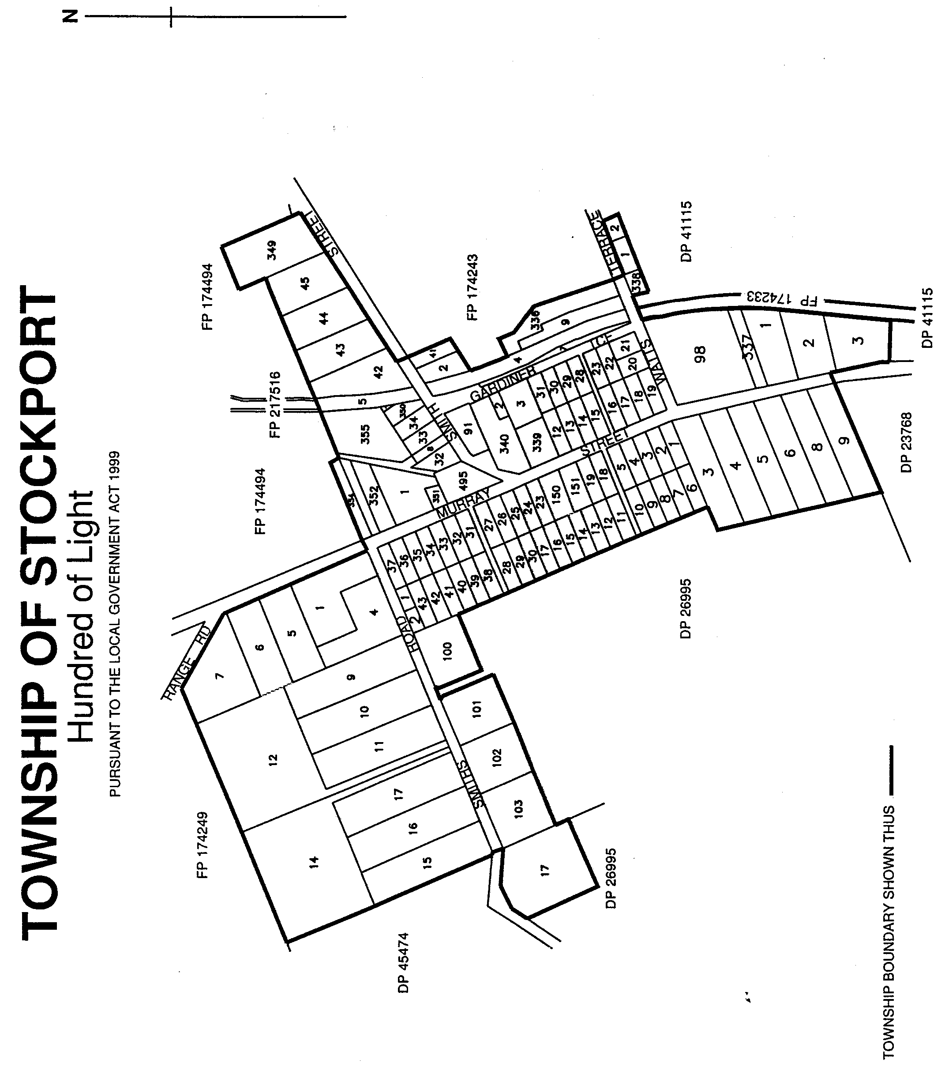
The Seventh Schedule
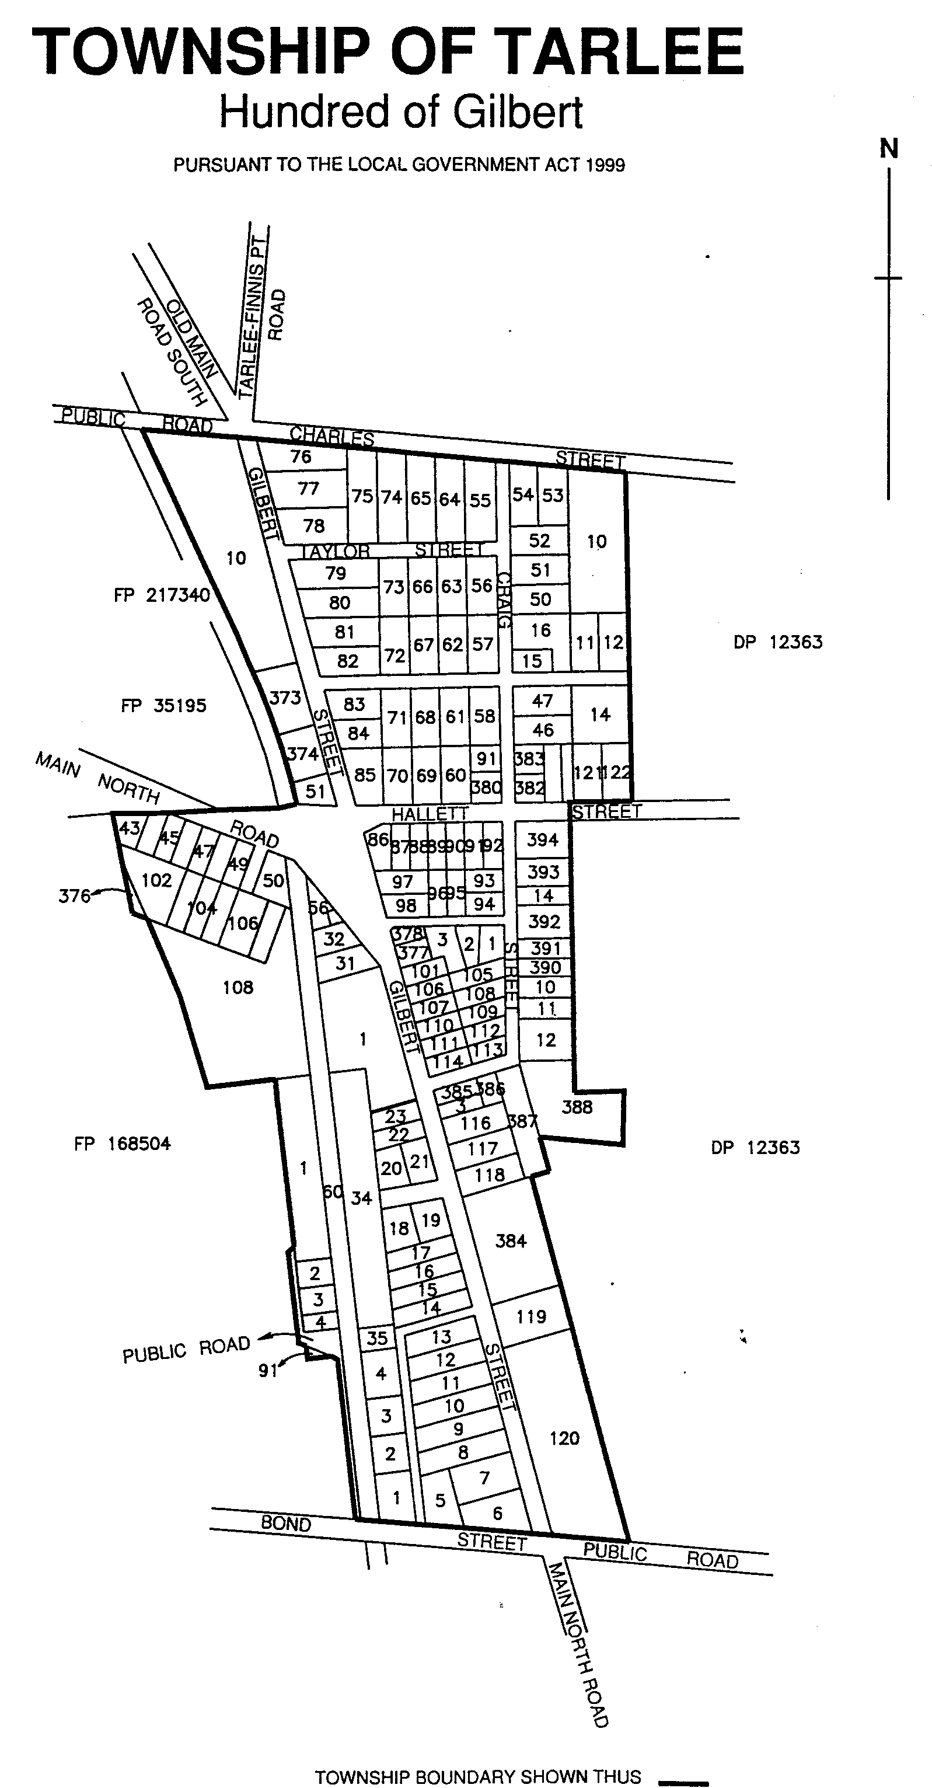
The area of the township of Tarlee shall be that land situate in the Hundred of Gilbert, County of Light, more particularly delineated on the plan published herewith and deposited in the Department for Administrative and Information Services at Adelaide as General Registry Office Plan 224/2001.

The Eighth Schedule
The area of the township of Waterloo shall be that land situate in the Hundred of Waterloo, County of Light, more particularly delineated on the plan published herewith and deposited in the Department for Administrative and Information Services at Adelaide as General Registry Office Plan 225/2001.
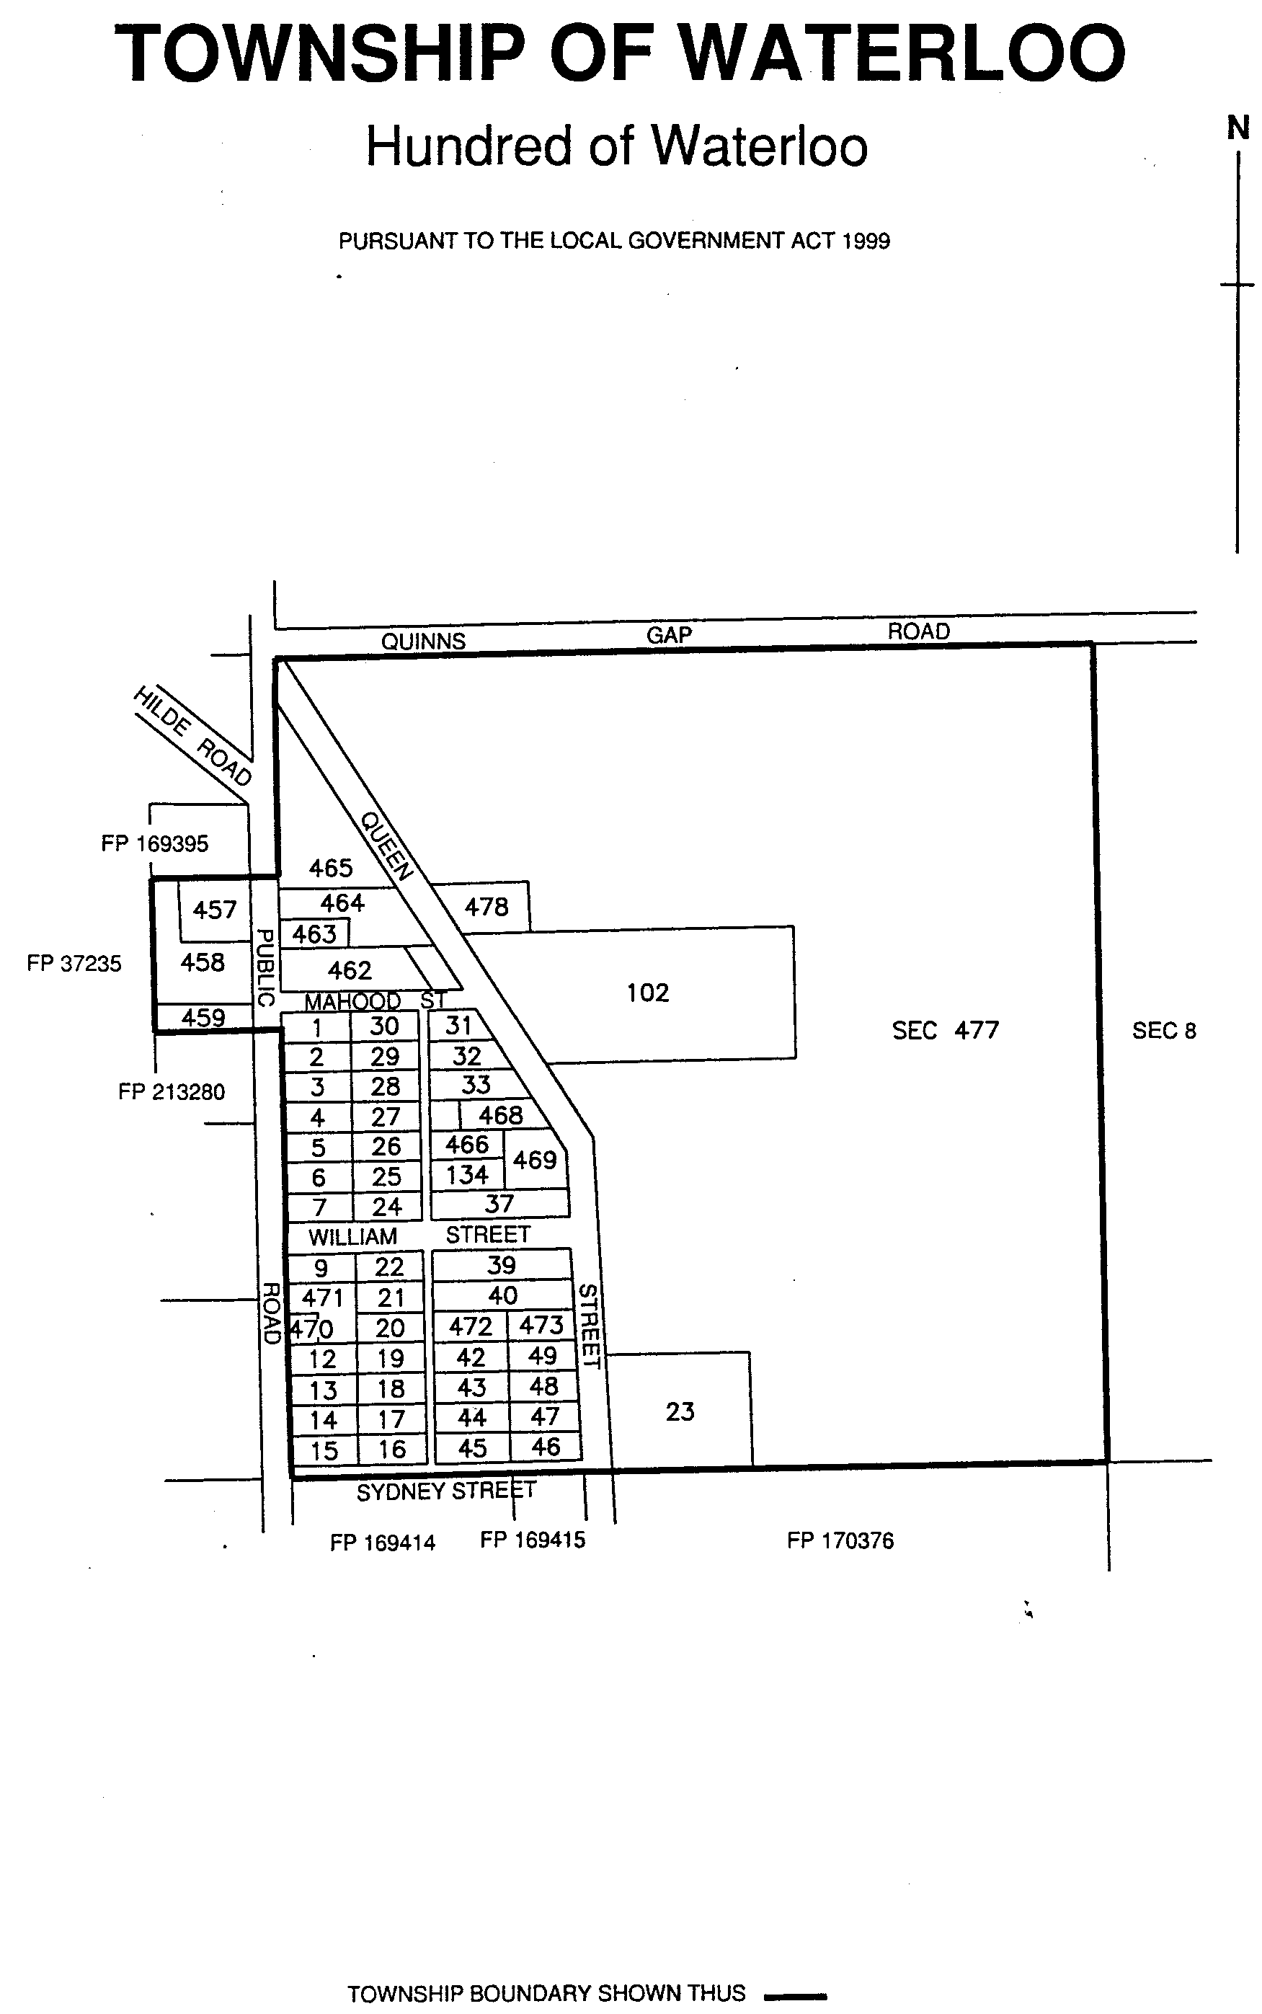

The Ninth Schedule
The area of the township of Watervale shall be that land situate in the Hundred of Upper Wakefield, County of Stanley, more particularly delineated on the plan published herewith and deposited in the Department of Administrative and Information Services at Adelaide as General Registry Office Plan 226/2001.
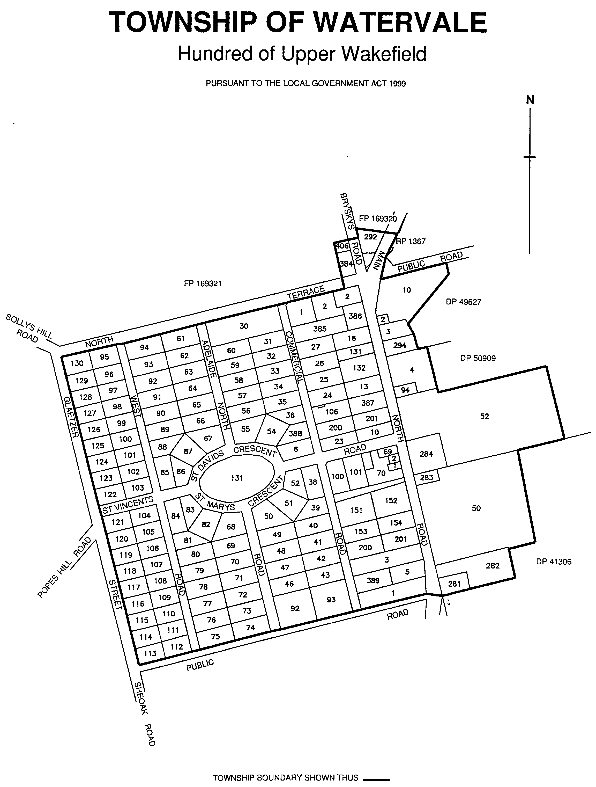
D. P. Jennings, Acting Chief Executive Officer

NARACOORTE LUCINDALE COUNCIL
Declaration of Public Roads
NOTICE is hereby given that under section 219 of the Local Government Act 1999, Naracoorte Lucindale Council at a meeting held on 22 May 2001, hereby declared that:
Portion of road reserve adjacent Allotments 2, 3, 5, 6, 8, 9 and 11 to 13, Hundred of Naracoorte in Deposited Plan 24340, be known as Jim Kelly Road.
Portion of road reserve adjacent Allotments 1 to 15, Hundred of Naracoorte, all 600 in Deposited Plan of part section 762, be known as Panorama Close.
Portion of road reserve adjacent Allotments 7, 8, 11 to 20 and 28 to 37, Hundred of Naracoorte in Deposited Plans 29471 and 21461, be known as Jubilee Avenue.
Portion of road reserve adjacent Allotments 1, 2 and 4 to 10, Hundred of Naracoorte, in Deposited Plan 4141, be known as Ibis Court.
D. L. Beaton, Chief Executive Officer

DISTRICT COUNCIL OF RENMARK PARINGA
Assignment of Road Name
NOTICE is hereby given that pursuant to section 219 of the Local Government Act 1934, as amended, council resolved to assign the name of Gregory Road to the public road defined as allotment 299 (public road) of Deposited Plan 54349.
A plan of the said road and adjoining land may be inspected at the Council Offices, Renmark.
B. Waples, Acting Chief Executive Officer

DISTRICT COUNCIL OF TATIARA
Close of Roll for Supplementary Election
NOTICE is hereby given that due to the resignation of two members of the council a supplementary election will be necessary to fill two vacancies of Councillor for East Ward of the District Council of Tatiara.
The voters roll to conduct this supplementary election closed on Thursday, 31 May 2001.
Nominations to fill these vacancies will open on Thursday, 28 June and will be received up until 12 noon on Thursday, 19 July 2001.
The election will be conducted entirely by post with the return of ballot material to reach the Deputy Returning Officer no later that 12 noon on Monday, 20 August 2001.
S. H. Tully, Returning Officer

IN the matter of the estates of the undermentioned deceased persons:
Bell, May Beatrice, late of 23 Catalina Road, Elizabeth East, of no occupation, who died on 18 April 2001.
Bennett, Phillis Edna, late of 7 Mooringe Avenue, Plympton, widow, who died on 15 April 2001.
Bollenhagen, Allan Howard, late of 49 Buxton Street, North Adelaide, retired advertising manager, who died on 21 March 2001.
Burgess, Margaret Ellen, late of 67 Porter Street, Salisbury, retired fashion purchaser, who died on 15 March 2001.
Dungey, Eric Ronald, late of 60 Patapinda Road, Old Noarlunga, retired dairy man, who died on 12 April 2001.
Forrester, Sheila, late of 410 Henley Beach Road, Lockleys, of no occupation, who died on 24 March 2001.
Goodchild, Kate, late of 160 Walkerville Terrace, Walkerville, of no occupation, who died on 16 February 2001.
Graham, Bernard Leslie, late of 26 Byron Street, Glenelg, retired electrical fitter, who died on 16 February 2001.
Henderson, Kathleen Maud, late of 1 John Street, Firle, of no occupation, who died on 4 April 2001.
Johnson, Charles Drakard, late of 5 Ian Court, Paradise, retired industrial chemist, who died on 19 February 2001.
Kelb, Betty Marie, late of 5 Beaujolais Street, Old Reynella, retired secretary, who died on 22 April 2001.
Killick, Betty Amy, late of 120 Morphett Road, Glengowrie, home duties, who died on 22 April 2001.
Le Cor, Clarence Edwin, late of Bundey Terrace, Pinnaroo, retired car and wagon maker, who died on 8 April 2001.
Noble, Iris Patricia, late of 6 Central Avenue, Enfield, home duties, who died on 23 April 2001.
Pile, Andrea Faye, late of 24 Yeo Avenue, Highgate, home duties, who died on 22 March 2001.
Richards, Cedric Paul, late of 7 Church Street, Lobethal, retired aircraft fitter, who died on 12 April 2001.
Trewartha, Gladys Mavis, late of 64 Augusta Street, Glenelg East, home duties, who died on 19 April 2001.
Notice is hereby given pursuant to the Trustee Act 1936, as amended, the Inheritance (Family Provision) Act 1972, and the Family Relationships Act 1975, that all creditors, beneficiaries, and other persons having claims against the said estates are required to send, in writing, to the Public Trustee, 25 Franklin Street, Adelaide 5000, full particulars and proof of such claims, on or before 6 July 2001, otherwise they will be excluded from the distribution of the said estate; and notice is also hereby given that all persons who are indebted to the said estates are required to pay the amount of their debts to the Public Trustee or proceedings will be taken for the recovery thereof; and all persons having any property belonging to the said estates are forthwith to deliver the same to the Public Trustee.
Dated 7 June 2001.
J. H. Worrall, Public Trustee

SOUTH AUSTRALIA—In the Supreme Court No. 282 of 2000. In the matter of KI Export Abbatoir Ltd (ACN 008 121 702) and in the matter of the Corporations Law.
Notice of Release of Liquidator
Take notice that by order of the Supreme Court of South Australia dated 22 May 2001, I, Russell Heywood-Smith, 248 Flinders Street, Adelaide, S.A. 5000, the liquidator of the abovenamed company was granted my release as liquidator.
Dated 29 May 2001.
R. Heywood-Smith, Liquidator

SOUTH AUSTRALIA—In the Supreme Court No. 394 of 1991. In the matter of Tuggeranong Pty Ltd (ACN 007 958 438) and in the matter of the Corporations Law.
Notice of Release of Liquidator and Dissolution of the Company
Take notice that by order of the Supreme Court of South Australia, dated 18 May 2001, I, John Sheahan, Level 8, 26 Flinders Street, Adelaide, S.A. 5000, the liquidator of the abovenamed company, was granted my release as liquidator and the company was dissolved as at the date of this order.
Dated 28 May 2001.
J. Sheahan, Liquidator

ATTENTION

CUSTOMERS requiring a proof of their notice for inclusion in the Government Gazette, please note that the onus is on you
to inform Government Publishing SA of any subsequent corrections by 10 a.m. on Thursday, which is our publication deadline.

For any corrections to your notice please phone 8207 1045 or Fax 8207 1040 before 10 a.m. on Thursday.

If we do not receive any communication by 10 a.m. on Thursday (day of publication) we will presume the notice is correct and will print it as it is.

Remember—the onus is on you to inform us of any corrections necessary to your notice.

NOTE: Closing time for lodging new copy (either fax or hard copy) is 4 p.m. on Tuesday preceding the day of publication. Phone 8207 1045—Fax 8207 1040.

Printed and published by authority every Thursday by J. D. FERGUSON, Government Printer, South Australia
Price: $4.30, plus postage; to subscribers, $214.85 per annum.
(The above prices are inclusive of GST)

