No. 73 2269

THE SOUTH AUSTRALIAN

GOVERNMENT GAZETTE

PUBLISHED BY AUTHORITY

ALL PUBLIC ACTS appearing in this GAZETTE are to be considered official, and obeyed as such

ADELAIDE, THURSDAY, 21 JUNE 2001

CONTENTS

Page
Acts Assented To 2270
Appointments, Resignations, Etc. 2271
Corporations and District Councils—Notices 2349
Crown Lands Act 1929—Notice 2271
Dangerous Substances Act 1979—Notice 2271
Development Act 1993—Notice 2272
Development Regulations 1993—Notice 2271
Electoral Act 1985—Notice 2272
Employment Agents Registration Act 1993—Notice 2272
Enfield General Cemetery Trust—Fees and Charges 2272
Fisheries Act 1982—Notices 2275
Industrial and Employee Relations Act 1994—Notice 2280
Land and Business (Sale and Conveyancing) Act 1994—
Notices 2280
Libraries Board of South Australia—Fees and Charges 2282
Liquor Licensing Act 1997—Notices 2290
Mining Act 1971—Notices 2293
Motor Vehicles Act 1959—Notice 2296
Occupational Health, Safety and Welfare Act 1986—
Notice 2296

Page
Petroleum Act 2000—Notices 2294
Petroleum Products Regulation Act 1995—Notice 2296
Proclamations 2270
Public Trustee Office—Administration of Estates 2353
Real Property Act 1886—Notice 2297

REGULATIONS
Development Act 1993—
(No. 130 of 2001) 2311
(No. 131 of 2001) 2313
Water Resources Act 1997 (No. 132 of 2001) 2317
Occupational Health, Safety and Welfare Act 1986—
(No. 133 of 2001) 2318
Roads (Opening and Closing) Act 1991—Notices 2296
Rules of Court 2298
Sale of Property 2353
South Eastern Water Conservation and Drainage Act 1992—
Notice 2304
Valuation of Land Act 1971—Notice 2307
Water Resources Act 1997—Notices 2307

GOVERNMENT GAZETTE NOTICES
ALL poundkeepers’ and private advertisements forwarded for publication in the South Australian Government Gazette must be PAID FOR PRIOR TO INSERTION; and all notices, from whatever source, should be legibly written on one side of the paper only and sent to Government Publishing SA so as to be received no later
than 4 p.m. on the Tuesday preceding the day of publication. Phone 8207 1045 or Fax 8207 1040. E-mail: governmentgazette@saugov.sa.gov.au. Send as attachments in Word format and please confirm your transmission with a faxed copy of your document, including the date the notice is to be published and to whom the notice will be charged.

Department of the Premier and Cabinet
Adelaide, 21 June 2001
HIS Excellency the Governor directs it to be notified for general information that he has in the name and on behalf of Her Majesty The Queen, this day assented to the undermentioned Acts passed by the Legislative Council and House of Assembly in Parliament assembled, viz.:
No. 24 of 2001—Dental Practice Act 2001—An Act to protect the health and safety of the public by providing for the registration of dental practitioners and dental students; to regulate the provision of dental treatment for the purpose of maintaining high standards of competence and conduct by persons registered under this Act; to repeal the Dentists Act 1984; and for other purposes.
By command,
Diana Laidlaw, for Premier
DPC 97/0415

ADMINISTRATIVE ARRANGEMENTS ACT 1994 SECTION 5: COMMITTAL OF ACTS TO THE ATTORNEY-GENERAL
Proclamation By The Governor
(l.s.) E. J. Neal
PURSUANT to section 5 of the Administrative Arrangements Act 1994 and with the advice and consent of the Executive Council, I commit the administration of an Act referred to in the Schedule to the Attorney-General.
Schedule
Corporations (Commonwealth Powers) Act 2001
Corporations (Administrative Actions) Act 2001
Corporations (Ancillary Provisions) Act 2001
Given under my hand and the Public Seal of South Australia, at Adelaide, 21 June 2001.
By command,
Diana Laidlaw, for Premier
AGCS 73/00

CORPORATIONS (COMMONWEALTH POWERS) ACT 2001 (Act No. 21 of 2001): DAY OF COMMENCEMENT
Proclamation By The Governor
(l.s.) E. J. Neal
WITH the advice and consent of the Executive Council, I fix 21 June 2001 as the day on which the Corporations (Commonwealth Powers) Act 2001 will come into operation.
Given under my hand and the Public Seal of South Australia, at Adelaide, 21 June 2001.
By command,
Diana Laidlaw, for Premier
AGCS 73/00

DEVELOPMENT (SYSTEM IMPROVEMENT PROGRAM) AMENDMENT ACT 2000 (Act No. 88 of 2000): DAY OF COMMENCEMENT
Proclamation By The Governor
(l.s.) E. J. Neal
Preamble
1. The Development (System Improvement Program) Amendment Act 2000 came into operation on 2 April 2001 (see Gazette 29 March 2001 p. 1436).
2. The operation of various sections of that Act was suspended until a day or days to be fixed by subsequent proclamation.
3. It is now expedient to bring certain of those suspended sections into operation.
Proclamation
With the advice and consent of the Executive Council, I fix 2 July 2001 as the day on which sections 23, 25, 27, 28 and 29 of the Development (System Improvement Program) Amendment Act 2000 will come into operation.
Given under my hand and the Public Seal of South Australia, at Adelaide, 21 June 2001.
By command,
Diana Laidlaw, for Premier
MFTUP CAB 28/99

OATHS ACT 1936 SECTION 33: APPOINTMENT OF MANAGERS TO TAKE DECLARATIONS AND ATTEST THE EXECUTION OF INSTRUMENTS
Proclamation By The Governor
(l.s.) E. J. Neal
PURSUANT to section 33 of the Oaths Act 1936 and with the advice and consent of the Executive Council, I appoint the following managers to take declarations and attest the execution of instruments:
Michelle Ann Bahnisch of the Commonwealth Bank
Craig Geoffrey Baker of the Commonwealth Bank
Robyn Louise Cook of the Commonwealth Bank
Melissa Joy Freebairn of the Westpac Banking Corporation
Alan Douglas Gellard of the Commonwealth Bank
Karen Julie Penfold of the Commonwealth Bank
Dennis James Robertson of the Commonwealth Bank
Lynette Margaret Starr of the Commonwealth Bank
Ian Geoffrey Watts of Bankers Trust
Gregory John Weise of BankSA.
Given under my hand and the Public Seal of South Australia, at Adelaide, 21 June 2001.
By command,
Diana Laidlaw, for Premier
AGCS 47/99

STATUTES AMENDMENT (CORPORATIONS) ACT 2001 (Act No. 23 of 2001): DAY OF COMMENCEMENT
Proclamation By The Governor
(l.s.) E. J. Neal
WITH the advice and consent of the Executive Council, I—
(a) declare that the Statutes Amendment (Corporations) Act 2001 will come into operation on the same day and at the same time as the Corporations Act 2001 of the Commonwealth (as originally enacted) comes into operation; and
(b) suspend the operation of sections 69, 70 and 89 of the Statutes Amendment (Corporations) Act 2001 until a day or days to be fixed by subsequent proclamation or proclamations.
Given under my hand and the Public Seal of South Australia, at Adelaide, 21 June 2001.
By command,
Diana Laidlaw, for Premier
AGCS 73/00

Department of the Premier and Cabinet
Adelaide, 21 June 2001
HIS Excellency the Governor in Executive Council has been pleased to appoint the undermentioned to the South Australian Ports Corporation Board, pursuant to the provisions of the South Australian Ports Corporation Act 1994:
Member: (from 1 July 2001 until 31 December 2001)
Geoffrey Alfred Fry
Nicholas Roy Le Messurier
John Michell
Yvonne Sneddon
Chairperson: (from 1 July 2001 until 31 December 2001)
Geoffrey Alfred Fry
By command,
Diana Laidlaw, for Premier
MGE 036/01 CS

Department of the Premier and Cabinet
Adelaide, 21 June 2001
HIS Excellency the Governor in Executive Council has been pleased to appoint the undermentioned to the Residential Tenancies Tribunal, pursuant to the provisions of the Residential Tenancies Act 1995:
Member: (from 1 July 2001 until 30 June 2002)
Catherine Marcella Cashen
By command,
Diana Laidlaw, for Premier
ATTG 7/99 CS

Department of the Premier and Cabinet
Adelaide, 21 June 2001
HIS Excellency the Governor in Executive Council has been pleased to appoint the undermentioned to the Environment Protection Authority, pursuant to the provisions of the Environment Protection Act 1993:
Member: (from 21 June 2001 until 20 June 2003)
Trevor Fletcher
By command,
Diana Laidlaw, for Premier
MEH 0030/01 CS

Department of the Premier and Cabinet
Adelaide, 21 June 2001
HIS Excellency the Governor in Executive Council has accepted the resignation of Christopher Kuchenmeister as a Coroner appointed under the Coroners Act 1975.
By command,
Diana Laidlaw, for Premier
CSA 26/01 CS

CROWN LANDS ACT 1929: SECTION 5
TAKE NOTICE that pursuant to the Crown Lands Act 1929, I KOSTAS SARNECKIS, Acting Surveyor-General and Delegate appointed by IAIN EVANS, Minister for Environment and Heritage, Minister of the Crown to whom the administration of the Crown Lands Act 1929 is committed DO HEREBY:
1. Resume the land defined in The First Schedule.
2. Dedicate the Crown Land defined in The Second Schedule as a Drainage Reserve and declare that such land shall be under the care, control and management of the South Eastern Water Conservation and Drainage Board.
3. Dedicate the Crown Land defined in The Third Schedule as Public Roads.
The First Schedule
1. Portion of Reserve for Drainage Purposes, section 389, Hundred of Rivoli Bay, County of Grey, the proclamation of which, together with other land was published in the Government Gazette of 26 August 1976 at page 657, The Second Schedule, being the whole of the land comprised in Crown Record Volume 5603 Folio 570.
2. Drainage Reserve, allotment 174 of DP 30221, Hundred of Rivoli Bay, County of Grey, the notice of which was published in the Government Gazette of 11 April 1991 at page 1253, The Second Schedule, being the whole of the land comprised in Crown Record Volume 5603 Folio 572.
The Second Schedule
Allotments 304 and 305 of DP 55711, Hundred of Rivoli Bay, County of Grey, exclusive of all necessary roads.
The Third Schedule
Allotments 306, 309 and 310 of DP 55711, Hundred of Rivoli Bay, County of Grey, being within the Wattle Range district.
Dated 18 June 2001.
K. Sarneckis, Acting Surveyor-General
DEHAA 09/1083

DANGEROUS SUBSTANCES ACT 1979
Appointment
I, ROBERT LAWSON, Minister for Administrative and Infor-mation Services and Minister for Workplace Relations in and for the State of South Australia, hereby appoint the undermentioned person as an Authorised Officer, pursuant to the Dangerous Substances Act 1979:
Hartley Franklin Brakey
Dated 23 April 2001.
Robert Lawson, Minister for Workplace Relations

DEVELOPMENT REGULATIONS 1993
Notice under Schedule 6
Preamble
Schedule 6 of the Development Regulations 1993, refers to a construction index determined by the Minister from time to time and set out in the Schedule of Construction Indices. The con-struction index will be used in the determination of fees payable by applicants seeking assessment against the Building Rules under the Development Act 1993.
Notice
PURSUANT to Schedule 6 of the Development Regulations 1993, I have determined the construction indices in the Schedule for the purposes of Schedule 6 of the Development Regulations 1993.
This notice will come into effect on 1 July 2001.
Schedule
Schedule of Construction Indices
Building Classes | Construction indices
Class 1, 2, 4 | 765
Class 3, 5, 6 | 1 019
Class 7, 8 | 675
Class 9a | 1 155
Class 9b | 1 051
Class 10 | 228

Dated 14 May 2001.
Diana Laidlaw, Minister for Transport and Urban Planning
PLN 91/1444
PLAN 2502/91 TC1

DEVELOPMENT ACT 1993
Alteration to the Building Code of Australia
Preamble
1. The Building Code of Australia as in force from time to time is adopted by the Development Regulations 1993, as part of the Building Rules under the Development Act 1993.
2. The Code has been altered.
3. The Development Act 1993, requires that notice of the alteration must be published before the alteration can take effect.
Notice
PURSUANT to sections 4 (7) and 108 (7) of the Development Act 1993, notice is given of an alteration to the 1996 Edition of the Building Code of Australia, that alteration being Amendment No. 9, published by the Australian Building Codes Board, as modified by the variations and additions for South Australia contained in the appendix to that Code.
The alterations made by Amendment No. 9 to the Building Code of Australia will take effect for the purposes of the Development Act 1993 on 2 July 2001.
Dated 6 June 2001.
Diana Laidlaw, Minister for Transport and Urban Planning

ELECTORAL ACT 1985
Registration of Political Parties
NOTICE is hereby given, pursuant to section 42 of the Electoral Act 1985, that I have this day registered the following political party:
Name of Party: Community Leadership Independence Coalition Party
Abbreviation of name of Party: CLIC Party
Dated 21 June 2001.
S. H. Tully, Electoral Commissioner
SEO 22/2001

EMPLOYMENT AGENTS REGISTRATION ACT 1993
Notice of Exemption
TAKE notice that pursuant to section 4 (1) of the Employment Agents Registration Act 1993, I, Robert Lawson, Minister for Administrative and Information Services and Minister for Workplace Relations in and for the State of South Australia, hereby exempt Steven Michael Burd, 51 La Ronde, Carricka-linga, S.A. 5204, from section 16 (1) of the Act in relation to the requirement that the holder of a licence must not carry on the business of an employment agent except at premises registered under this section.
Dated 13 June 2001.
Robert Lawson, Minister for Workplace Relations

ENFIELD GENERAL CEMETERY TRUST
Scale of Cemetery Charges Effective Monday, 2 July 2001
Cremation Fees
$
Monday-Friday—8.30 a.m.-4.00 p.m (including 1 hour
Chapel and/or Lounge). 616
Delivery Only (with all paperwork complete) 495
Cremation Fees—Children
Child—10 years and under 319
Perinatal (up to 28 days) 121
Cremation Fees—Other
Saturday—8.30 a.m.-11.00 a.m. 803
Saturday outside above hours:
for each half hour or part thereof—Plus 121
Sunday and Public Holidays—9.00 a.m.-11.00 a.m.
only 1 100
Organist by arrangement (per service) 55
Other Fees
Attendance fee—placement of cremated remains 66
Additional chapel time—each half-hour or part thereof 88
Outside hours specified, per half-hour or part thereof 110
Dispersal of Ashes from other crematoria 220
Lounge—in association with cremation service
chapel use No charge
Lounge—Casual Hire:
First half-hour (depending upon availability) 110
Additional time each half hour or part thereof 99
Chapel—Memorial Service only 1st half-hour 110
Chapel—Additional time each half-hour or part thereof 99
Chapel and Lounge—Memorial Service only 1st hour 209
Chapel and Lounge—Additional time each half-hour 99
Postage of Cremated Remains: Within Australia 55
Overseas POA
Pre-need Cremation Certificates available for purchase 616

Cremation Memorials
The cost of a cremation memorial is separated into two price components:
1. Grant fee: This charge covers the ‘right to use’ the allocated ground and the maintenance of the site for the period of tenure.
2. Memorial fee: This is a charge to arrange the memorial, manufacture and install the same on site.
3. Double Site: If a double site cannot be paid in full then payment by instalment for the second site is acceptable. The Grant will then be issued.
4. Renewable Tenure: 25 years from date of expiry.
Pre-purchase: Provision for future use may be made by the purchase of pre-need site. The term will be for 25 years from first use, but not exceeding 30 years from date of issue.
Transfers: All applications for transfer must be made in writing to the Trust.
Memorial Work: Authority to establish a memorial will only be accepted from the deceased representative/grantee of an existing memorial site.
Memorials without cremated remains: Memorials may be established without cremated remains.

R. W. Robinson Garden of Remembrance
Bookleaf Niche Wall
Tenure: 25 years
Single Only—Site Fee 583
Memorial Fee—Supply plaque and installation 198
Memorial Seats—Memorial site for three inurnments
Tenure: 25 years
Site Fee POA
Bronze Plaques on Seats, each 121

Memorial Garden
Tenure: 25 years
Site Fee:
Single 803
Double 1 397
Memorial Fee (see below)
North and South Trellis Garden
Tenure: 25 years
Lawn Site Fees:
Single 803
Double 1 397
Memorial Fee (see below)

Memorials Relating to Robinson Garden and Trellis Garden
Memorial A. Single/Double Memorial (Plaque on granite):
Supply granite, first plaque and installation:
Red, Black or Grey Granite 341
Blue Pearl Granite 363
Second plaque and installation 275
Memorial B. Second detachable plaque and installation
ONLY 198
Memorial C. Double Memorial—two separate plaques on
granite.
Supply granite, first plaque and installation
Red, Black or Grey Granite 341
Blue Pearl Granite 363
Second plaque and installation 231
V. F. Roberts Memorial Rose Garden
Tenure: 25 years
Lawns—Bush Rose:
Single 803
Double 1 419
Circle
Inner Circle Weeping Rose
Outer Circle Standard Rose
Single 803
Double 1 419
Granite Pillars
Climbing Rose 1 672
(Site capacity—four inurnments)
Memorial Trees
Tree Site Fee 803
Single POA
Double POA

Memorial Seats POA
Memorial Plaques
Engraved
Bronze Granite
Type A: Single/Double Memorial:
First Inscription 275 330
Second Inscription 275 330
Type B: Second Inscription only 198 N/A
Type C: Double Memorial Separate Plaques:
First Plaque 264 N/A
Second Plaque 256 N/A
Campbell Memorial Garden
Tenure 25 years
Australian Bush Setting and Birch Forest:
Single—Site Fee 748
Double—Site Fee 1 485
Memorial Fee:
Single at Need (including installation and plaque) 407
Double at Need (including installation and plaque) 506
Reservation Urn—Single 198
Reservation Urn—Double 253
Plaque—single 209
Plaque for double position 253
Sandstone Niche Wall:
Tenure: 25 years
Site Fee:
Single 616
Double 1 067
Memorial Fee:
Single 374
Double:
First Inscription 341
Second Inscription 264
Emblem: (extra) 55
Rill Bronze and Slate Memorials
Note: No sites available placement only in existing sites.
Memorial:
Bronze plaque on Wistow Slate base including two
bronze flower containers.
First interment 308
Second interment 220
Ashes will be in the lawn in front of the plaque.
Circular Rose Garden:
Site Fee:
Single 803
Double 1 430
Memorial Fee:
First interment (coloured bronze plaque) 539
Second interment (complete new plaque) 242
Memorial Book Building
Niche Cabinet:
Tenure: 25 years
Niche Fee Including Urn
Level A Single Urns only—Small 1 958
Level B Large and Double Urns—Large 2 618
Level C Single Urns Only—Small 1 958
Level D Single Urns Only—Small 1 573
Level E Single Urns Only—Small 1 573
• A five line inscription can be placed in the BOOK
OF REMEMBRANCE for an additional fee 132
• All niches to have an engraved single line name plate
of the deceased.
Niche Fee
Level A and C Single Urns Only 1 815
Level B Large and Double Urns 2 420
Level D and E Single Urns Only 1 386
Only approved private urns may be used in the
Niche Cabinet.
Book of Remembrance
Description
Basic Package consisting of the following choices:
Five Line Inscription in Memorial Book
Plus: One personal Remembrance Card inscribed as
in the Memorial Book 352
Five Line Inscription in Memorial Book
Plus: Vinyl Miniature Book 418
Five Line Inscription in Memorial Book
Plus: Leather Miniature Book 495
Other Charges
Additional lines—each 33
Emblem—each 132
Coat of Arms—each 165
Also available: (five line inscription only)
Additional Personal Remembrance Cards—each 99
Vinyl Miniature Book of Remembrance—each 132
Leather Miniature Book of Remembrance—each 165
Children’s Memorial Garden
Cremation Site for Children 10 years and under
Children’s Niche Wall:
Tenure: 25 Years
Single Only—Site Fee 209
Memorial Fee—Supply Plaque and installation 121
Garden Edge—East
Tenure: 25 Years
Single Only—Site Fee 220
Memorial Fee—Supply Plaque and installation 165
Note: Ashes may also be placed in the Children’s Memorial Garden lawn.
Other Fees:
Restore bronze plaque 55
Ashes dispersed within Cemetery Grounds from other
Crematorium 220
Ashes interment in Lawn Burial Site 176
Ashes interment in Children’s Memorial Garden 110
Granite flower containers:
Robinson Garden 66
Rose Garden and Garden Border 88
BURIALS
Burial Sites
General, Catholic, Anglican, Greek, Lutheran and RSL:
Grant Fee—Lawn Site 858
Pavilion Garden:
Lawn (all inclusive fee) 5 016
Vault (all inclusive fee) 9 460
Burial Fees (for above, excluding Pavilion Garden):
Monday-Friday—9.00 a.m.-4.15 p.m.
Standard Level One and Two 682
Standard Level Three 792
Oversize Level One and Two 1 023
Oversize Level Three 1 188
Child 10 years and under interred at child depth 407
Stillborn interred at child depth 407
Ashes in lawn burial site 176
Children’s Memorial Garden: (for children 10 years and under)
Subject to grave size:
Perinatal Section—Up to 28 days:
Grave Size: Maximum 700 mm x 300 mm
Grant Tenure: 25 years
Grant Fee 99
Burial Fee 110
Simultaneous Burial Fee 110
Memorial Plaque Fee (supply and install) 220
Infants Section:
Grave Size: Maximum 1 200 mm x 600 mm
Grant Tenure: 25 years
Grant Fee 264
Burial Fee 231
Memorial Bronze Plaque Fee
(Supply and Installation of red, black, grey, blue pearl
granite base) 374
Additional Burial Fees:
Saturdays—9.00 a.m.-11.15 a.m. 297
Outside specified hours:
Monday-Saturday per half hour or part thereof 121
Sunday/Public Holidays—9.00 a.m.-11.00 a.m. ONLY 616
Simultaneously in one grave each subsequent burial 363
Exhumation 1 848
Other Fees:
Chapel and Lounge for burial service: 1 hour 209
Chapel and/or Lounge for burial service: First half-hour 110
Additional Chapel/Lounge: Each half-hour or part
thereof 99
Lounge ONLY after burial service: First half-hour 110
Each additional half hour 99
Removal/Replacement of memorial tablets:
for second/third burials or upon request 88
Outdoor Canopy—3 m x 3 m each unit 33
Attendance Fee—Placement of Cremated Remains 66
Administration Fees:
Transfer of Burial Grant (minimum fee) 55
Replacement of Burial Grant (by Lost Grant
Declaration)* 55
Cancellation of site purchase on deposit 55
Searching of Records and Supplying Information—
per entry 11
Alteration of Existing Records 55
Repurchase of Grants (minimum fee) 55
*LOST GRANT DECLARATIONS—(see note under BURIALS)
Fees for all other services not covered within the Schedule
will be determined by the Secretary
Western Rose Garden Memorials
Note: No burial sites available.
Bronze Plaques: 560 mm x 305 mm
Book of Life: Double ONLY—maximum 8 lines:
Includes 1st leaf 550
Includes 2nd leaf 286
Additional lines each 22
Design Plaques: Single—8 lines 407
Double—3 line base up to 5 lines
1st plaque ONLY 517
2nd plaque up to 5 lines 120
Motifs: Incorporated only at time of manufacture from
selection in the Arrow Catalogue:
Marked A (No charge)—each additional 33
Marked B 33
Marked C 33
Marked D 44

CHELTENHAM CEMETERY FEES
Burial Sites
Tenure: 50 years
Grant Fee:
All new sites allocated by cemetery 902
Burial Fees
Monday-Friday—9.00 a.m.-4.15 p.m.
Level One and Two 704
Level Three 836
Child 10 years and under interred at child depth 396
Stillborn interred at child depth 396
Ashes in burial site 176
Additional Burial Fees:
• Saturdays—9.00 a.m.-11.15 a.m. 297
Outside specified hours:
• Monday-Saturday per half hour or part thereof 121
• Sunday/Public Holidays—9.00 a.m.-11.00 a.m. only 616
• Simultaneously in one grave each subsequent burial 363
• Oversize or rectangular casket 1 848
Other Fees:
Attendance Fee—Placement of Cremated Remains in
Burial or Memorial Site 66
Outdoor Canopy—3 m x 3 m each unit 33
Removal and Replacement by cemetery staff of*:
• Marble/Granite Slab 242
• Concrete Floor 242
• Concrete Floor for Cremated Remains 77
* Difficult and/or Dangerous work to be referred to a
Monumental Mason.
Administration Fees:
• Transfer of Burial Grant (minimum fee) 55
• Replacement of Burial Grant (by Lost Grant
Declaration)* 55
• Searching of Records and Supplying Information (per
entry) 11
* Lost Grant Declarations—(see note under Burials).
Cremation Memorials
Attendance fee—Placement of Cremated Remains 66
Rose Bush Site—Port Road and High Street
Tenure: 50 years
Site Fee:
Single 649
Double 1 122
Single/First Inurnment including Base and Tablet 407
Second Inurnment 264
Additional lettering will be charged at current ruling rate.
Memorial Gardens: Woodstock Street
New Sites Not Available
Second Inurnment ONLY 286
Additional lettering will be charged at current ruling rate.
Rose Lane—Available monuments on display
Tenure: 25 years
Site Capacity One or Two:
Package 3 201
Package includes all Cemetery and Monument fees.
Monumental Mason Fees
Enfield Memorial Park:
• Permit for New Memorial Tablet 30
• Supply and Installation of Concrete Bearer and
Memorial Tablet 88
• Maintenance around Memorial Tablet for grant term 143
• Permit for Additional Inscription 70
• Removal of Memorial Tablet for other work 88
• Supply and Attach Second Bronze Plaque 88
• Vase insert WRG each 33
Charges for all other services not covered above shall be
determined by the Secretary.
Licence Fee:
Licence covers Enfield Memorial Park, Cheltenham
Cemetery and West Terrace Cemetery:
• Monumental Masons 75
• Renewal 75
Cheltenham Cemetery:
• Permit to place New Memorial 165
• Permit for Additional Inscription 70
Note: Permit and Licence Fees GST Exempt
Armed Services Memorials
Returned Services League: Niche Wall 385
Australian War Graves: Niche Wall 385
Installation and Maintenance: Burial Plaque 220
K. M. Crowden, General Manager

FISHERIES ACT 1982: SECTION 59
TAKE notice that, pursuant to section 59 of the Fisheries Act 1982, SA Mariculture or their agents (hereinafter referred to as the ‘exemption holder’), P.O. Box 2260, Port Lincoln, S.A. 5606 are exempt from section 41 of the Fisheries Act 1982, but only insofar as they may take greenlip abalone (Haliotis laevigata) for the purpose of aquaculture broodstock (hereinafter referred to as the ‘exempted activity’) in the waters specified in Schedule 1 subject to the conditions in Schedule 2.
Schedule 1
South Australian coastal waters south and east of a line drawn due south through Point Brown (latitude 32°32.6′S, longitude 133°50.8′E) and west of the meridian of longitude 136°30′E.
Schedule 2
1. The exemption holder may engage in the exempted activity from the date of gazettal of this notice until 30 June 2002.
2. The exemption holder may take a maximum of 200 greenlip abalone (Haliotis laevigata). All abalone taken pursuant to this notice may not be sold or transferred to another party.
3. All abalone taken pursuant to this notice must be delivered to and retained on the registered aquaculture site of landbased aquaculture licence number FT00423.
4. The exempted activity may only be conducted by Jim Morrison, Doug Graske, Daryl Evans, Christopher Pitney, Craig Marshall and/or Paula Norton.
5. The exemption holder shall notify the PIRSA Fisheries Compliance Unit on 1800 065 522 at least 24 hours prior to conducting the exempted activity with the following information:
• details of the boat that will be used to engage in the exempted activity;
• the name of the person who will be conducting the exempted activity;
• the intended place and time of launching and retrieval of the nominated boat for that day; and
• the intended area of conducting the exempted activity.
6. The exemption holder must, within 50 m of the point of landing of any abalone taken pursuant to this notice, complete the PIRSA Fisheries Form ‘Abalone Broodstock Collection Statement’. Immediately upon arrival at the exemption holders registered aquaculture site, this form must be faxed to PIRSA Fisheries on (08) 8226 2323. Prior to release into the registered aquaculture site, all abalone taken pursuant to this notice must be tagged so as to be clearly identified as wild broodstock.
7. The exemption holder shall record the number of wild broodstock held pursuant to this notice in a register to be maintained at the registered aquaculture site, which must be made available for inspection by a PIRSA Fisheries Compliance Officer upon request.
8. PIRSA Fisheries Compliance Unit retains the right for a departmental officer to accompany the exemption holder at any time during the exempted activity.
9. While engaged in the exempted activity the exemption holder shall carry or have about or near his person a copy of this notice. Such notice must be produced to a PIRSA Fisheries Compliance Officer upon request.
10. The exemption holder shall not contravene or fail to comply with the Fisheries Act 1982, or any regulations made under that Act, except where specifically exempted by this notice.
Dated 18 June 2001.
W. Zacharin, Director of Fisheries

FISHERIES ACT 1982: SECTION 59
TAKE note that the notice made under section 59 of the Fisheries Act 1982, and published in the South Australian Government Gazette, dated 9 November 2000, on page number 3006, being the first notice on that page, which refers to Posaqua Manage-ment Services Pty Ltd, is hereby revoked.
Dated 15 June 2001.
I. Nightingale, General Manager Aquaculture, as the delegate of the Minister for Primary Industries

FISHERIES ACT 1982: SECTION 59
TAKE notice that, pursuant to section 59 of the Fisheries Act 1982, Posaqua Management Services Pty Ltd (12912) (or his agent) (hereinafter referred to as the ‘exemption holder’), 15 Tucker Parade, Kadina S.A. 5554, shall not be guilty of an offence when engaging in the activities and to do the acts specified in Schedule 1 subject to the conditions specified in Schedule 2 from the date of gazettal of this exemption until revoked by the Director of Fisheries.
Schedule 1
The importation and release of Barramundi (Lates calcarifer); Black Bream (Acanthopagrus butcheri) and Blue Swimmer Crab (Portunus pelagicus) in tanks located at Section 585, Hundred of Tickera.
Schedule 2
1. The exemption holder must maintain adequate security arrangements to prevent escapement of fish (ova, fry, or adult) into any South Australian waters.
2. Fish obtained within South Australia for use on the registered fish farm must be obtained from registered fish farmers, licensed fishers or other persons approved by the Director of Fisheries.
3. Fish must not be collected from rivers, streams, lakes or other inland waters of this State unless prior approval for this collection is granted by the Director of Fisheries.
4. The exemption holder must not import any live fish (ova, fry, or adult) into South Australia unless the shipment has certification from an appropriate authority in the State from which they are obtained that they are free from all relevant notifiable diseases listed in Schedule 4 of the Fisheries (Exotic Fish, Fish Farming and Fish Diseases) Regulations 1984.
5. The exemption holder must not contravene or fail to comply with the Fisheries Act 1982 or any regulations made under the Act, except where specifically permitted by this notice.
6. The exemption holder must retain the copy of this permit which has been supplied by the Director of Fisheries, and if requested by a PIRSA Fisheries and Aquaculture Compliance Officer, produce that permit for inspection.
7. The fish farmer must report all notifiable diseases to the General Manager Aquaculture.
8. The fish farmer must monitor farm fish mortalities and notify the General Manager Aquaculture of a mortality rate over 5% in 24 hours.
Dated 15 June 2001.
I. Nightingale, General Manager Aquaculture, as the delegate of the Minister for Primary Industries
FT00549

FISHERIES ACT 1982: SECTION 59
TAKE notice that, pursuant to section 59 of the Fisheries Act 1982, Stephen J. Aitken (20125) (or his agent) (hereinafter referred to as the ‘exemption holder’), c/o Post Office, Callington, S.A. 5254, shall not be guilty of an offence when engaging in the activities and to do the acts specified in Schedule 1 subject to the conditions specified in Schedule 2 from the date of gazettal of this exemption until revoked by the Director of Fisheries.
Schedule 1
The importation and release of Barramundi (Lates calcarifer); in tanks located at Section 2001, Hundred of Kanmantoo.
Schedule 2
1. The exemption holder must maintain adequate security arrangements to prevent escapement of fish (ova, fry, or adult) into any South Australian waters.
2. Fish obtained within South Australia for use on the registered fish farm must be obtained from registered fish farmers, licensed fishers or other persons approved by the Director of Fisheries.
3. Fish must not be collected from rivers, streams, lakes or other inland waters of this State unless prior approval for this collection is granted by the Director of Fisheries.
4. The exemption holder must not import any live fish (ova, fry, or adult) into South Australia unless the shipment has certification from an appropriate authority in the State from which they are obtained that they are free from all relevant notifiable diseases listed in Schedule 4 of the Fisheries (Exotic Fish, Fish Farming and Fish Diseases) Regulations 1984.
5. The exemption holder must not contravene or fail to comply with the Fisheries Act 1982 or any regulations made under the Act, except where specifically permitted by this notice.
6. The exemption holder must retain the copy of this permit which has been supplied by the Director of Fisheries, and if requested by a PIRSA Fisheries and Aquaculture Compliance Officer, produce that permit for inspection.
7. The fish farmer must report all notifiable diseases to the General Manager Aquaculture.
8. The fish farmer must monitor farm fish mortalities and notify the General Manager Aquaculture of a mortality rate over 5% in 24 hours.
Dated 15 June 2001.
I. Nightingale, General Manager Aquaculture, as the delegate of the Minister for Primary Industries
FT00678

FISHERIES ACT 1982: SECTION 59
TAKE notice that pursuant to section 59 of the Fisheries Act 1982, those holders of a marine scalefish fishery licence, being a licence issued pursuant to the Scheme of Management (Marine Scalefish Fisheries) Regulations 1991, shown in Schedule 1 (hereinafter referred to as the ‘exemption holder’) are exempted from the provisions of regulation 12(2) of the Scheme of Management (Marine Scalefish Fisheries) Regulations 1991, but only insofar as the exemption holder shall not be guilty of an offence when using a registered master, being a person registered by endorsement of a fishery licence pursuant to Division 1, Part 4 of the Fisheries Act 1982, for the taking of or an act preparatory to or involved in the taking of pilchards (hereinafter referred to as the ‘exempted activity’), subject to the conditions specified in Schedule 2, from the date of gazettal of this notice until 30 June 2002.
Schedule 1
M153 Garry W. Feuerherdt, P.O. Box 712, Port Lincoln
M172 Lakkana Boonmajaroen, P.O. Box 2013, Port Lincoln
M210 E. F. Hendry Pty Ltd, P.O. Box 1, Warooka
M255 Stanislav Lukin, 62 Lincoln Highway, Port Lincoln
M273 Tony F. Lukin, P.O. Box 603, Port Lincoln
M274 Brendan G. Sheehy, 25 Highview Drive, Port Lincoln
M285 Terrence R. Bryant, 25 Lindsay Avenue, Port Lincoln
M324 Zorica Lukin, 62 Lincoln Highway, Port Lincoln
M329 Mark A. Forster, P.O. Box 154, Port Lincoln
M354 Branko Sarunic, P.O. Box 993, Port Lincoln
M429 Joseph H. Puglisi, P.O. Box 1891, Port Lincoln
M488 Viekoslav Valcic, P.O. Box 1492, Port Lincoln
M491 Mark Waller, 9 Kestral Place, Port Lincoln
M505 Peter A. White, P.O. Box 829, Port Lincoln
Schedule 2
1. The exemption holder may nominate up to two registered masters to conduct fishing operations pursuant to their marine scalefish fishery licence provided that the application to be registered as the master of a boat is made in writing on a form approved by the Director and be accompanied by the applicant’s licence in respect of the fishery.
2. For the purposes of this exemption, pilchards means pilchards (Sardinops neopilchardus) and other species within the Families Clupeidae and Engraulididae
3. Only one boat may be used at any one time during fishing operations pursuant to this exemption.
4. The exemption holder shall not contravene or fail to comply with the Fisheries Act 1982, or any other regulations made under that Act except where specifically exempted by this notice.
Dated 18 June 2001.
W. Zacharin, Director Of Fisheries

DEPARTMENT OF PRIMARY INDUSTRIES AND RESOURCES SA—FISHERIES DIVISION
NOTICE is hereby given pursuant to section 28 (10) (b) of the Fisheries Act 1982, that the following items have been seized by officers of the Department of Primary Industries and Resources SA, Fisheries Division:
1 wire fish trap
17 shrimp traps
1 wire yabbie trap
The above items were suspected to have been used or intended to be used, in contravention of the Fisheries Act 1982, and were taken into possession at 524 km mark, River Murray on 19 May 2001.
After the expiration of one month from the date of this notice the items listed above shall, on the order of the Minister for Primary Industries and Resources SA, Fisheries, be forfeited to the Crown and shall be either disposed of by sale or destruction.
The above items may be viewed at the Loxton office of the Department of Primary Industries and Resources SA, Fisheries Division.
Dated 14 June 2001.
B. E. Hemming, Manager Fisheries Compliance Unit

DEPARTMENT OF PRIMARY INDUSTRIES AND RESOURCES SA—FISHERIES DIVISION
NOTICE is hereby given pursuant to section 28 (10) (b) of the Fisheries Act 1982, that the following items have been seized by officers of the Department of Primary Industries and Resources SA, Fisheries Division:
1 yabbie pot—Opera House
The above items were suspected to have been used or intended to be used, in contravention of the Fisheries Act 1982, and were taken into possession at Rumpagunya Creek on 20 May 2001.
After the expiration of one month from the date of this notice the items listed above shall, on the order of the Minister for Primary Industries and Resources, Fisheries SA, be forfeited to the Crown and shall be either disposed of by sale or destruction.
The above items may be viewed at the Loxton office of the Department of Primary Industries and Resources SA, Fisheries Division.
Dated 14 June 2001.
B. E. Hemming, Manager Fisheries Compliance Unit

DEPARTMENT OF PRIMARY INDUSTRIES AND RESOURCES SA—FISHERIES DIVISION
NOTICE is hereby given pursuant to section 28 (10) (b) of the Fisheries Act 1982, that the following items have been seized by officers of the Department of Primary Industries and Resources SA, Fisheries Division:
2 yabbie pots—Opera House
The above items were suspected to have been used or intended to be used, in contravention of the Fisheries Act 1982, and were taken into possession at Dishers Bend, River Murray on 20 May 2001.
After the expiration of one month from the date of this notice the items listed above shall, on the order of the Minister for Primary Industries and Resources SA, Fisheries, be forfeited to the Crown and shall be either disposed of by sale or destruction.
The above items may be viewed at the Loxton office of the Department of Primary Industries and Resources SA, Fisheries Division.
Dated 14 June 2001.
B. E. Hemming, Manager Fisheries Compliance Unit

DEPARTMENT OF PRIMARY INDUSTRIES AND RESOURCES SA—FISHERIES DIVISION
NOTICE is hereby given pursuant to section 28 (10) (b) of the Fisheries Act 1982, that the following items have been seized by officers of the Department of Primary Industries and Resources SA, Fisheries Division:
1 green mesh drop net
The above items were suspected to have been used or intended to be used, in contravention of the Fisheries Act 1982, and were taken into possession at Amazon Creek on 24 May 2001.
After the expiration of one month from the date of this notice the items listed above shall, on the order of the Minister for Primary Industries and Resources SA, Fisheries, be forfeited to the Crown and shall be either disposed of by sale or destruction.
The above items may be viewed at the Loxton office of the Department of Primary Industries and Resources SA, Fisheries Division.
Dated 14 June 2001.
B. E. Hemming, Manager Fisheries Compliance Unit

DEPARTMENT OF PRIMARY INDUSTRIES AND RESOURCES SA—FISHERIES DIVISION
NOTICE is hereby given pursuant to section 28 (10) (b) of the Fisheries Act 1982, that the following items have been seized by officers of the Department of Primary Industries and Resources SA, Fisheries Division:
1 drop net consisting of fine mesh and two rings
The above items were suspected to have been used or intended to be used, in contravention of the Fisheries Act 1982, and were taken into possession at Pike Creek via Lyrup on 19 May 2001.
After the expiration of one month from the date of this notice the items listed above shall, on the order of the Minister for Primary Industries and Resources SA, Fisheries, be forfeited to the Crown and shall be either disposed of by sale or destruction.
The above items may be viewed at the Loxton office of the Department of Primary Industries and Resources SA, Fisheries Division.
Dated 14 June 2001.
B. E. Hemming, Manager Fisheries Compliance Unit

DEPARTMENT OF PRIMARY INDUSTRIES AND RESOURCES SA—FISHERIES DIVISION
NOTICE is hereby given pursuant to section 28 (10) (b) of the Fisheries Act 1982, that the following items have been seized by officers of the Department of Primary Industries and Resources SA, Fisheries Division:
1 small yellow plastic fish trap
The above items were suspected to have been used or intended to be used, in contravention of the Fisheries Act 1982, and were taken into possession at Pikes Creek on 19 May 2001.
After the expiration of one month from the date of this notice the items listed above shall, on the order of the Minister for Primary Industries and Resources SA, Fisheries, be forfeited to the Crown and shall be either disposed of by sale or destruction.
The above items may be viewed at the Loxton office of the Department of Primary Industries and Resources SA, Fisheries Division.
Dated 14 June 2001.
B. E. Hemming, Manager Fisheries Compliance Unit

DEPARTMENT OF PRIMARY INDUSTRIES AND RESOURCES SA—FISHERIES DIVISION
NOTICE is hereby given pursuant to section 28 (10) (b) of the Fisheries Act 1982, that the following items have been seized by officers of the Department of Primary Industries and Resources SA, Fisheries Division:
2 fish traps
1 trap with brown square plastic mesh
1 trap with green square plastic mesh
The above items were suspected to have been used or intended to be used, in contravention of the Fisheries Act 1982, and were taken into possession at Bookpurnong Cliffs on the River Murray on 19 May 2001.
After the expiration of one month from the date of this notice the items listed above shall, on the order of the Minister for Primary Industries and Resources SA, Fisheries, be forfeited to the Crown and shall be either disposed of by sale or destruction.
The above items may be viewed at the Loxton office of the Department of Primary Industries and Resources SA, Fisheries Division.
Dated 14 June 2001.
B. E. Hemming, Manager Fisheries Compliance Unit

DEPARTMENT OF PRIMARY INDUSTRIES AND RESOURCES SA—FISHERIES DIVISION
NOTICE is hereby given pursuant to section 28 (10) (b) of the Fisheries Act 1982, that the following items have been seized by officers of the Department of Primary Industries and Resources SA, Fisheries Division:
6 assorted unmarked shrimp traps
The above items were suspected to have been used or intended to be used, in contravention of the Fisheries Act 1982, and were taken into possession at Pikes Creek near Lyrup on 19 May 2001.
After the expiration of one month from the date of this notice the items listed above shall, on the order of the Minister for Primary Industries and Resources SA, Fisheries, be forfeited to the Crown and shall be either disposed of by sale or destruction.
The above items may be viewed at the Loxton office of the Department of Primary Industries and Resources SA, Fisheries Division.
Dated 14 June 2001.
B. E. Hemming, Manager Fisheries Compliance Unit

DEPARTMENT OF PRIMARY INDUSTRIES AND RESOURCES SA—FISHERIES DIVISION
NOTICE is hereby given pursuant to section 28 (10) (b) of the Fisheries Act 1982, that the following items have been seized by officers of the Department of Primary Industries and Resources SA, Fisheries Division:
1 drum net with white mesh and 2 rings
The above items were suspected to have been used or intended to be used, in contravention of the Fisheries Act 1982, and were taken into possession at Pikes River Mouth on 20 May 2001.
After the expiration of one month from the date of this notice the items listed above shall, on the order of the Minister for Primary Industries and Resources SA, Fisheries, be forfeited to the Crown and shall be either disposed of by sale or destruction.
The above items may be viewed at the Loxton office of the Department of Primary Industries and Resources SA, Fisheries Division.
Dated 14 June 2001.
B. E. Hemming, Manager Fisheries Compliance Unit

DEPARTMENT OF PRIMARY INDUSTRIES AND RESOURCES SA—FISHERIES DIVISION
NOTICE is hereby given pursuant to section 28 (10) (b) of the Fisheries Act 1982, that the following items have been seized by officers of the Department of Primary Industries and Resources SA, Fisheries Division:
1 fish cauf
4 illegal wire mesh yabbie pots
2 gill nets
2 drum nets with orange mesh
The above items were suspected to have been used or intended to be used, in contravention of the Fisheries Act 1982, and were taken into possession at Follies Camp, Chowilla Creek on 23 May 2001.
After the expiration of one month from the date of this notice the items listed above shall, on the order of the Minister for Primary Industries and Resources SA, Fisheries, be forfeited to the Crown and shall be either disposed of by sale or destruction.
The above items may be viewed at the Loxton office of the Department of Primary Industries and Resources SA, Fisheries Division.
Dated 14 June 2001.
B. E. Hemming, Manager Fisheries Compliance Unit

DEPARTMENT OF PRIMARY INDUSTRIES AND RESOURCES SA—FISHERIES DIVISION
NOTICE is hereby given pursuant to section 28 (10) (b) of the Fisheries Act 1982, that the following items have been seized by officers of the Department of Primary Industries and Resources SA, Fisheries Division:
1 black nylon mesh drum net
The above items were suspected to have been used or intended to be used, in contravention of the Fisheries Act 1982, and were taken into possession at Whirlpool Bend on the River Murray near Renmark on 21 May 2001.
After the expiration of one month from the date of this notice the items listed above shall, on the order of the Minister for Primary Industries and Resources SA, Fisheries, be forfeited to the Crown and shall be either disposed of by sale or destruction.
The above items may be viewed at the Loxton office of the Department of Primary Industries and Resources SA, Fisheries Division.
Dated 14 June 2001.
B. E. Hemming, Manager Fisheries Compliance Unit

DEPARTMENT OF PRIMARY INDUSTRIES AND RESOURCES SA—FISHERIES DIVISION
NOTICE is hereby given pursuant to section 28 (10) (b) of the Fisheries Act 1982, that the following items have been seized by officers of the Department of Primary Industries and Resources SA, Fisheries Division:
1 home made yabbie pot with milk container attached and no name and address
The above items were suspected to have been used or intended to be used, in contravention of the Fisheries Act 1982, and were taken into possession at Willhelm Bend on the River Murray near Renmark on 21 May 2001.
After the expiration of one month from the date of this notice the items listed above shall, on the order of the Minister for Primary Industries and Resources SA, Fisheries, be forfeited to the Crown and shall be either disposed of by sale or destruction.
The above items may be viewed at the Loxton office of the Department of Primary Industries and Resources SA, Fisheries Division.
Dated 14 June 2001.
B. E. Hemming, Manager Fisheries Compliance Unit

DEPARTMENT OF PRIMARY INDUSTRIES AND RESOURCES SA—FISHERIES DIVISION
NOTICE is hereby given pursuant to section 28 (10) (b) of the Fisheries Act 1982, that the following items have been seized by officers of the Department of Primary Industries and Resources SA, Fisheries Division:
1 wire mesh fish trap
The above items were suspected to have been used or intended to be used, in contravention of the Fisheries Act 1982, and were taken into possession at Plushes Bend on 21 May 2001.
After the expiration of one month from the date of this notice the items listed above shall, on the order of the Minister for Primary Industries and Resources SA, Fisheries, be forfeited to the Crown and shall be either disposed of by sale or destruction.
The above items may be viewed at the Loxton office of the Department of Primary Industries and Resources SA, Fisheries Division.
Dated 14 June 2001.
B. E. Hemming, Manager Fisheries Compliance Unit

DEPARTMENT OF PRIMARY INDUSTRIES AND RESOURCES SA—FISHERIES DIVISION
NOTICE is hereby given pursuant to section 28 (10) (b) of the Fisheries Act 1982, that the following items have been seized by officers of the Department of Primary Industries and Resources SA, Fisheries Division:
1 green opera house net and rope
The above items were suspected to have been used or intended to be used, in contravention of the Fisheries Act 1982, and were taken into possession at Ral Ral Creek on 21 May 2001.
After the expiration of one month from the date of this notice the items listed above shall, on the order of the Minister for Primary Industries and Resources SA, Fisheries, be forfeited to the Crown and shall be either disposed of by sale or destruction.
The above items may be viewed at the Loxton office of the Department of Primary Industries and Resources SA, Fisheries Division.
Dated 14 June 2001.
B. E. Hemming, Manager Fisheries Compliance Unit

DEPARTMENT OF PRIMARY INDUSTRIES AND RESOURCES SA—FISHERIES DIVISION
NOTICE is hereby given pursuant to section 28 (10) (b) of the Fisheries Act 1982, that the following items have been seized by officers of the Department of Primary Industries and Resources SA, Fisheries Division:
1 wire square yabbie pot with electrical cord
1 wire round yabbie pot
1 green plastic shrimp trap
1 drop net
1 monofilament mesh net (7 m)
1 wire mesh fish trap (orange string)
1 opera house yabbie pot
1 set line and 1 hook (blue)
The above items were suspected to have been used or intended to be used, in contravention of the Fisheries Act 1982, and were taken into possession at Deep Creek on 21 May 2001.
After the expiration of one month from the date of this notice the items listed above shall, on the order of the Minister for Primary Industries and Resources SA, Fisheries, be forfeited to the Crown and shall be either disposed of by sale or destruction.
The above items may be viewed at the Loxton office of the Department of Primary Industries and Resources SA, Fisheries Division.
Dated 14 June 2001.
B. E. Hemming, Manager Fisheries Compliance Unit

DEPARTMENT OF PRIMARY INDUSTRIES AND RESOURCES SA—FISHERIES DIVISION
NOTICE is hereby given pursuant to section 28 (10) (b) of the Fisheries Act 1982, that the following items have been seized by officers of the Department of Primary Industries and Resources SA, Fisheries Division:
1 green opera house yabbie pot
1 black home made plastic mesh shrimp trap
The above items were suspected to have been used or intended to be used, in contravention of the Fisheries Act 1982, and were taken into possession at 1 km downstream from Schimdt Reserve on River Murray on 21 May 2001.
After the expiration of one month from the date of this notice the items listed above shall, on the order of the Minister for Primary Industries and Resources SA, Fisheries, be forfeited to the Crown and shall be either disposed of by sale or destruction.
The above items may be viewed at the Loxton office of the Department of Primary Industries and Resources SA, Fisheries Division.
Dated 14 June 2001.
B. E. Hemming, Manager Fisheries Compliance Unit

DEPARTMENT OF PRIMARY INDUSTRIES AND RESOURCES SA—FISHERIES DIVISION
NOTICE is hereby given pursuant to section 28 (10) (b) of the Fisheries Act 1982, that the following items have been seized by officers of the Department of Primary Industries and Resources SA, Fisheries Division:
1 set line—blue hand line
1 drop net
The above items were suspected to have been used or intended to be used, in contravention of the Fisheries Act 1982, and were taken into possession at Heading Cliff on 22 May 2001.
After the expiration of one month from the date of this notice the items listed above shall, on the order of the Minister for Primary Industries and Resources SA, Fisheries, be forfeited to the Crown and shall be either disposed of by sale or destruction.
The above items may be viewed at the Loxton office of the Department of Primary Industries and Resources SA, Fisheries Division.
Dated 14 June 2001.
B. E. Hemming, Manager Fisheries Compliance Unit

DEPARTMENT OF PRIMARY INDUSTRIES AND RESOURCES SA—FISHERIES DIVISION
NOTICE is hereby given pursuant to section 28 (10) (b) of the Fisheries Act 1982, that the following items have been seized by officers of the Department of Primary Industries and Resources SA, Fisheries Division:
3 gillnets (damaged, poor condition)
1 wire mesh fish trap
1 wire mesh fish cauf
The above items were suspected to have been used or intended to be used, in contravention of the Fisheries Act 1982, and were taken into possession at Deep Creek via Renmark on 25 May 2001.
After the expiration of one month from the date of this notice the items listed above shall, on the order of the Minister for Primary Industries and Resources SA, Fisheries, be forfeited to the Crown and shall be either disposed of by sale or destruction.
The above items may be viewed at the Loxton office of the Department of Primary Industries and Resources SA, Fisheries Division.
Dated 14 June 2001.
B. E. Hemming, Manager Fisheries Compliance Unit

DEPARTMENT OF PRIMARY INDUSTRIES AND RESOURCES SA—FISHERIES DIVISION
NOTICE is hereby given pursuant to section 28 (10) (b) of the Fisheries Act 1982, that the following items have been seized by officers of the Department of Primary Industries and Resources SA, Fisheries Division:
1 fish cauf
3 wire fish traps
The above items were suspected to have been used or intended to be used, in contravention of the Fisheries Act 1982, and were taken into possession at Chowilla Creek on 23 May 2001.
After the expiration of one month from the date of this notice the items listed above shall, on the order of the Minister for Primary Industries and Resources SA, Fisheries, be forfeited to the Crown and shall be either disposed of by sale or destruction.
The above items may be viewed at the Loxton office of the Department of Primary Industries and Resources SA, Fisheries Division.
Dated 14 June 2001.
B. E. Hemming, Manager Fisheries Compliance Unit

DEPARTMENT OF PRIMARY INDUSTRIES AND RESOURCES SA—FISHERIES DIVISION
NOTICE is hereby given pursuant to section 28 (10) (b) of the Fisheries Act 1982, that the following items have been seized by officers of the Department of Primary Industries and Resources SA, Fisheries Division:
1 opera house yabbie pot
The above items were suspected to have been used or intended to be used, in contravention of the Fisheries Act 1982, and were taken into possession at Little Hunchiee Creek on 23 May 2001.
After the expiration of one month from the date of this notice the items listed above shall, on the order of the Minister for Primary Industries and Resources SA, Fisheries, be forfeited to the Crown and shall be either disposed of by sale or destruction.
The above items may be viewed at the Loxton office of the Department of Primary Industries and Resources SA, Fisheries Division.
Dated 14 June 2001.
B. E. Hemming, Manager Fisheries Compliance Unit

DEPARTMENT OF PRIMARY INDUSTRIES AND RESOURCES SA—FISHERIES DIVISION
NOTICE is hereby given pursuant to section 28 (10) (b) of the Fisheries Act 1982, that the following items have been seized by officers of the Department of Primary Industries and Resources SA, Fisheries Division:
3 set lines
The above items were suspected to have been used or intended to be used, in contravention of the Fisheries Act 1982, and were taken into possession at 608 km mark, Chowilla Homestead, River Murray on 23 May 2001.
After the expiration of one month from the date of this notice the items listed above shall, on the order of the Minister for Primary Industries and Resources SA, Fisheries, be forfeited to the Crown and shall be either disposed of by sale or destruction.
The above items may be viewed at the Loxton office of the Department of Primary Industries and Resources SA, Fisheries Division.
Dated 14 June 2001.
B. E. Hemming, Manager Fisheries Compliance Unit

DEPARTMENT OF PRIMARY INDUSTRIES AND RESOURCES SA—FISHERIES DIVISION
NOTICE is hereby given pursuant to section 28 (10) (b) of the Fisheries Act 1982, that the following items have been seized by officers of the Department of Primary Industries and Resources SA, Fisheries Division:
1 black plastic cylindrical shrimp trap
The above items were suspected to have been used or intended to be used, in contravention of the Fisheries Act 1982, and were taken into possession at 2 km upstream of Chowilla on 24 May 2001.
After the expiration of one month from the date of this notice the items listed above shall, on the order of the Minister for Primary Industries and Resources SA, Fisheries, be forfeited to the Crown and shall be either disposed of by sale or destruction.
The above items may be viewed at the Loxton office of the Department of Primary Industries and Resources SA, Fisheries Division.
Dated 14 June 2001.
B. E. Hemming, Manager Fisheries Compliance Unit

INDUSTRIAL AND EMPLOYEE RELATIONS ACT 1994
Appointment
I, ROBERT LAWSON, Minister for Administrative and Infor-mation Services and Minister for Workplace Relations in and for the State of South Australia, hereby appoint the undermentioned person as an Inspector, pursuant to the Industrial and Employee Relations Act 1994:
Hartley Franklin Brakey
Dated 24 April 2001.
Robert Lawson, Minister for Workplace Relations

LAND AND BUSINESS (SALE AND CONVEYANCING) ACT 1994
Exemption
TAKE notice that, pursuant to section 32 (1) of the Land and Business (Sale and Conveyancing) Act 1994, I, Kenneth Trevor Griffin, Minister for Consumer Affairs, do hereby exempt the person named in Schedule 1 from the application of section 23 (1) of the Act in relation to the purchase of the land specified in Schedule 2.
Schedule 1
P.M. Property Managers Pty Ltd, registered agent.
Schedule 2
The whole of the land described in certificate of title register book volume 5787, folio 892, situated at Lot 12, Evan Avenue, Salisbury, S.A. 5108.
Dated 21 June 2001.
Signed for and on behalf of the Minister for Consumer Affairs by the Commissioner for Consumer Affairs:
M. D. Bodycoat, Commissioner

LAND AND BUSINESS (SALE AND CONVEYANCING) ACT 1994
Exemption
TAKE notice that, pursuant to section 23 (3) of the Land and Business (Sale and Conveyancing) Act 1994, I, Kenneth Trevor Griffin, Minister for Consumer Affairs, do hereby exempt the person named in Schedule 1 from the application of section 23 (2) of the Act in relation to the purchase of the land specified in Schedule 2.

Schedule 1
Graham Charles Nybo, an officer/employee of P.M. Property Managers Pty Ltd.
Schedule 2
The whole of the land described in certificate of title register book volume 5787, folio 892, situated at Lot 12, Evan Avenue, Salisbury, S.A. 5108.
Dated 21 June 2001.
Signed for and on behalf of the Minister for Consumer Affairs by the Commissioner for Consumer Affairs:
M. D. Bodycoat, Commissioner

LAND AND BUSINESS (SALE AND CONVEYANCING) ACT 1994
Exemption
TAKE notice that, pursuant to section 23 (3) of the Land and Business (Sale and Conveyancing) Act 1994, I, Kenneth Trevor Griffin, Minister for Consumer Affairs, do hereby exempt the person named in Schedule 1 from the application of section 23 (2) of the Act in relation to the purchase of the land specified in Schedule 2.
Schedule 1
Gregory Charles Nybo, an officer/employee of P.M. Property Managers Pty Ltd.
Schedule 2
The whole of the land described in certificate of title register book volume 5787, folio 892, situated at Lot 12, Evan Avenue, Salisbury, S.A. 5108.
Dated 21 June 2001.
Signed for and on behalf of the Minister for Consumer Affairs by the Commissioner for Consumer Affairs:
M. D. Bodycoat, Commissioner

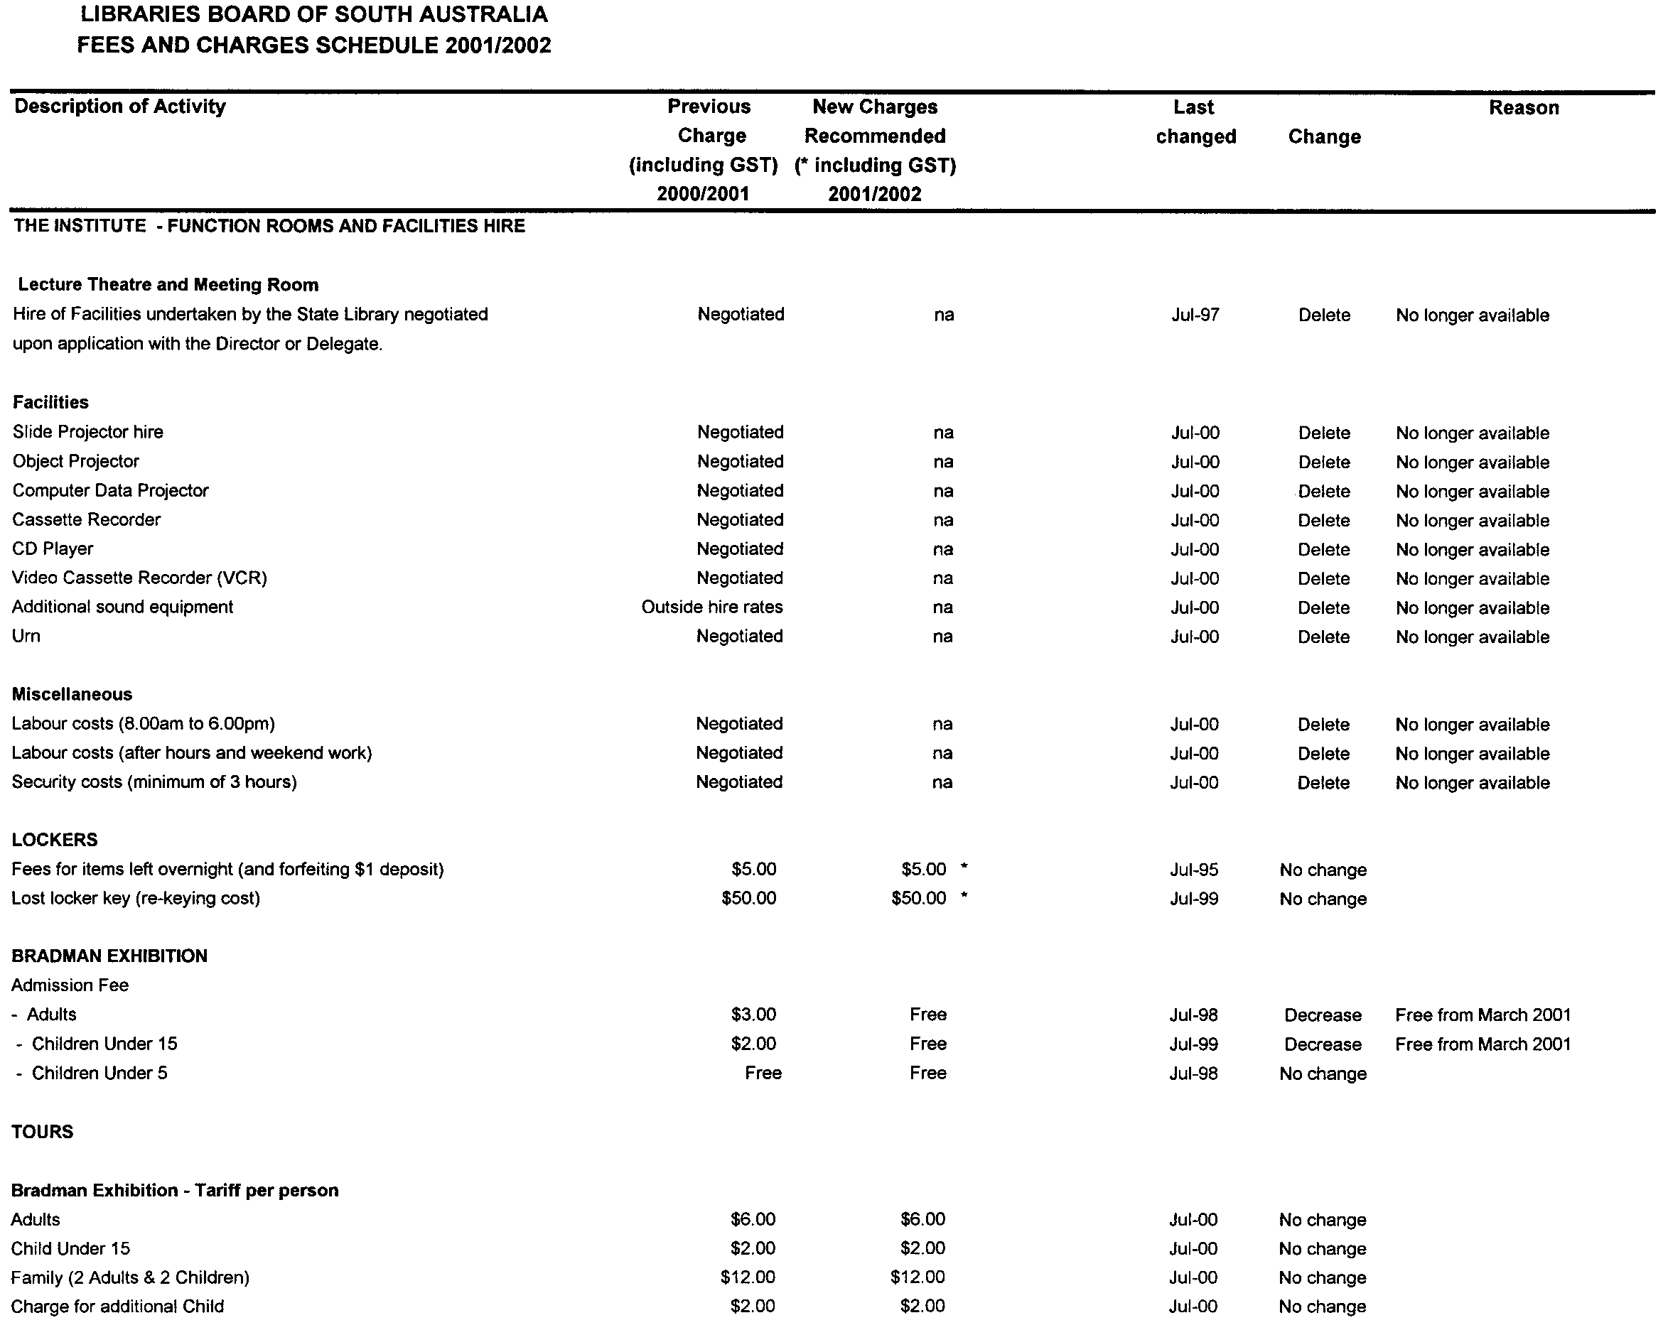
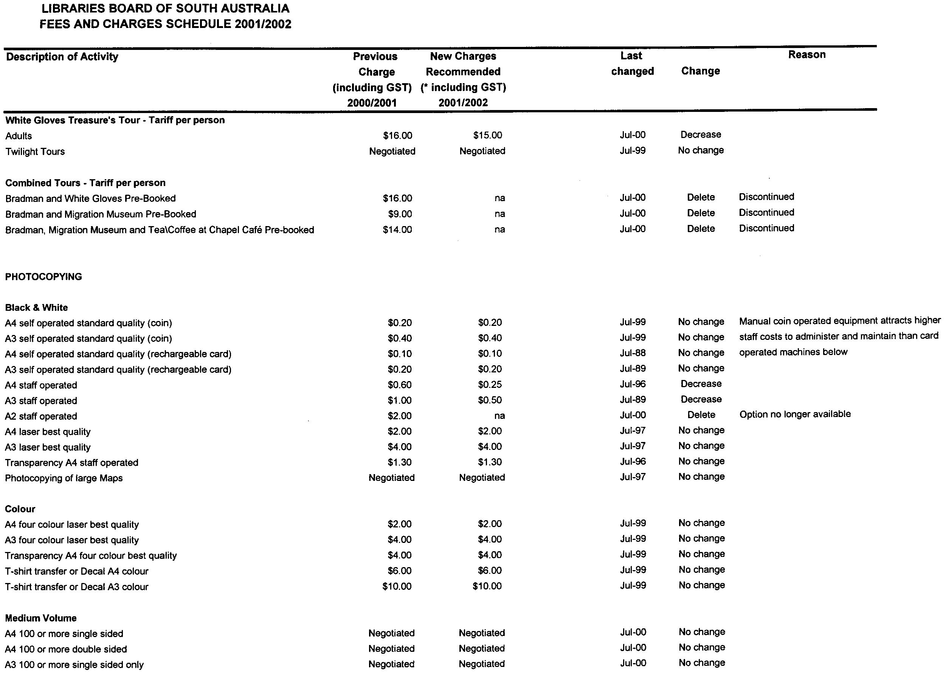
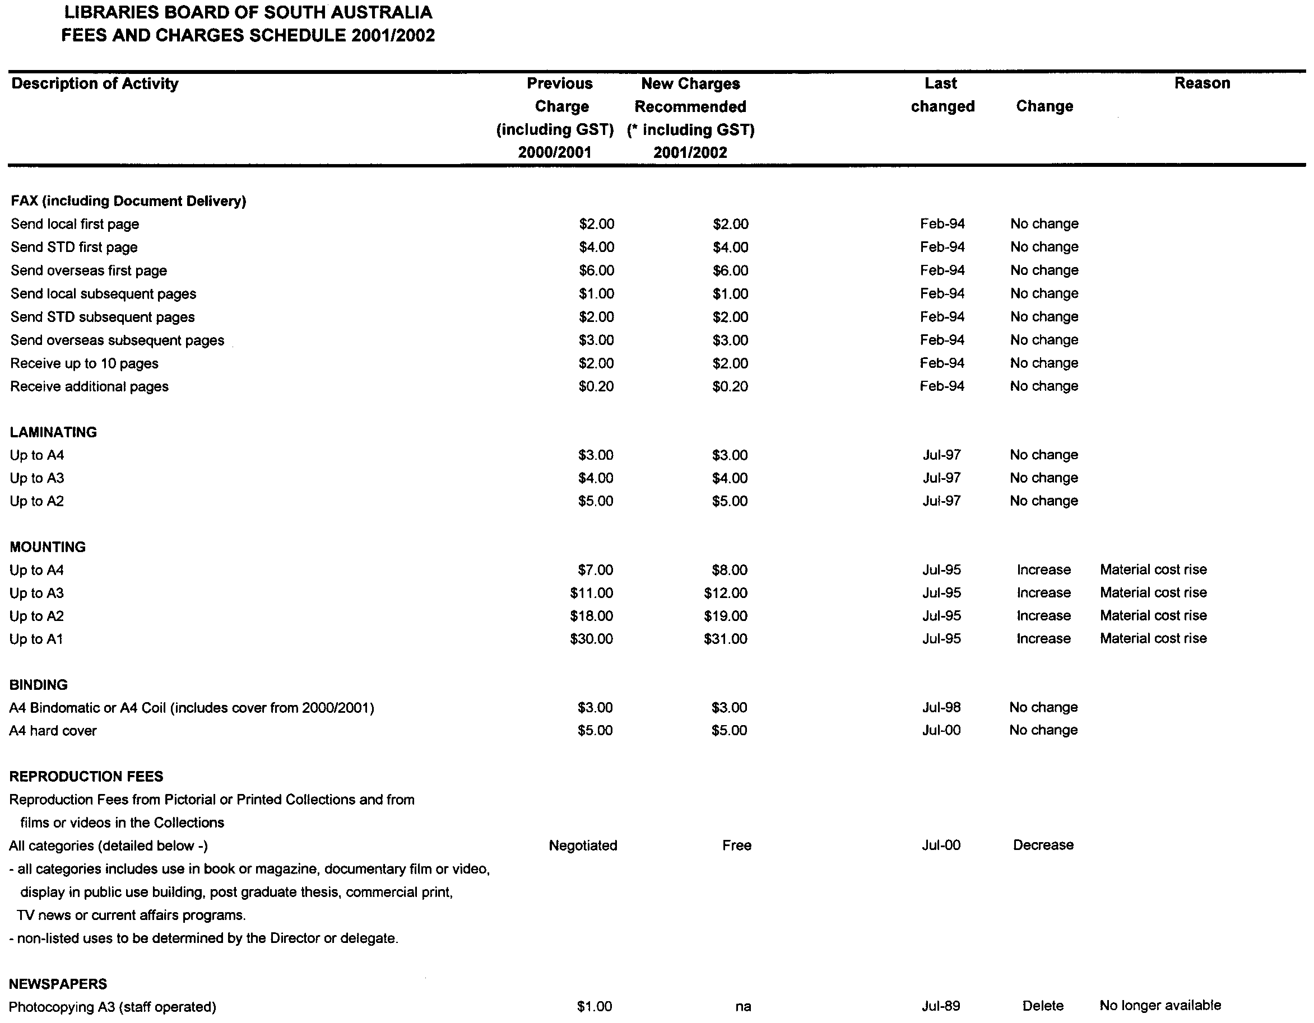
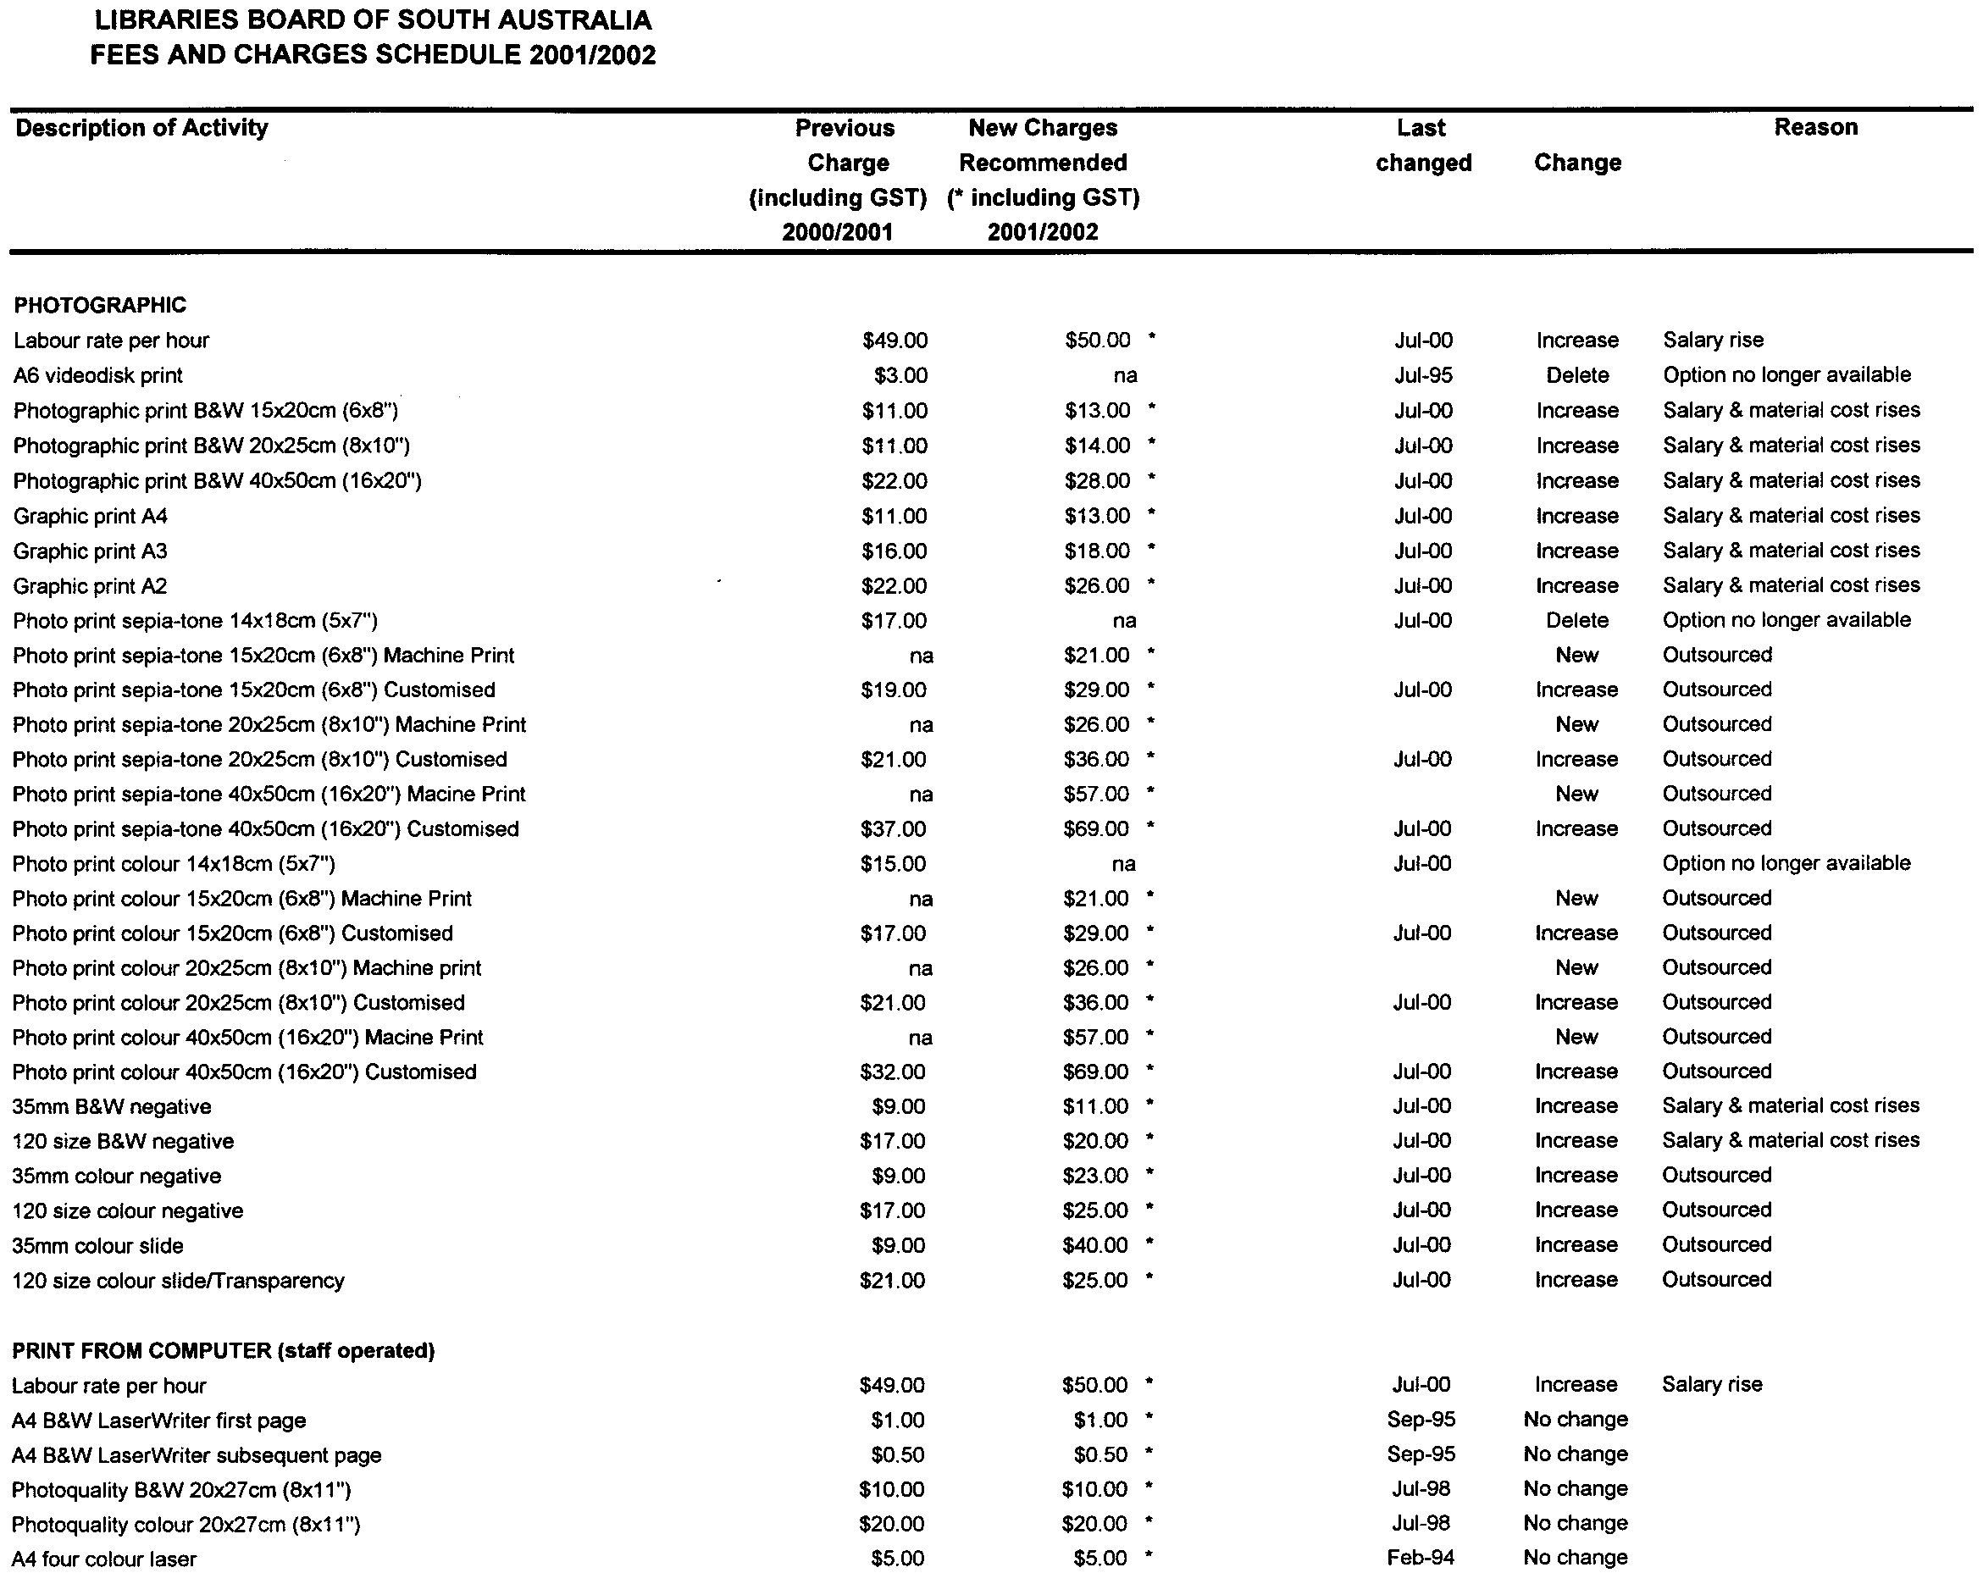
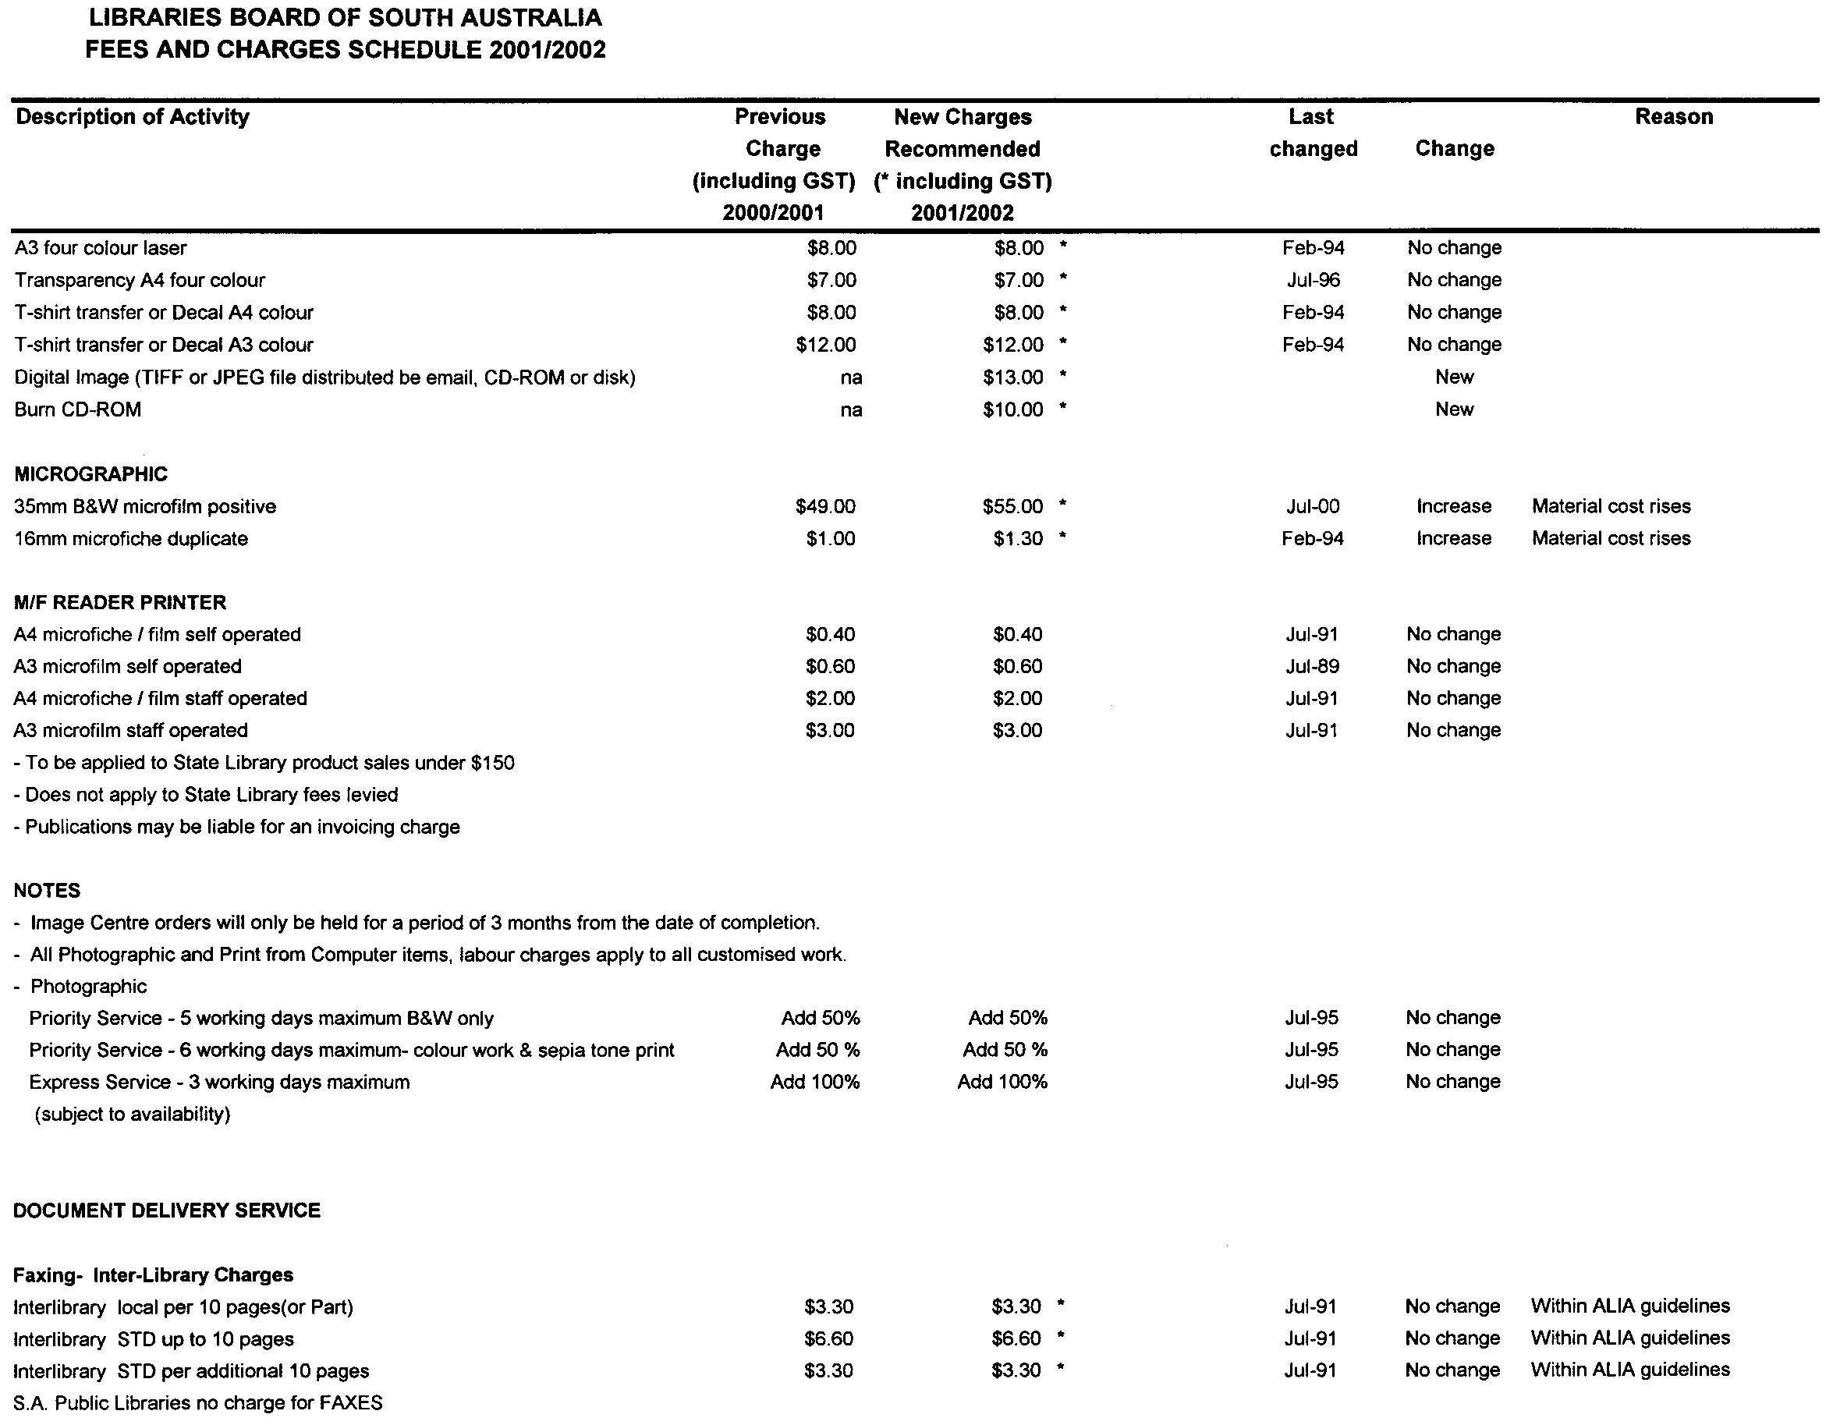
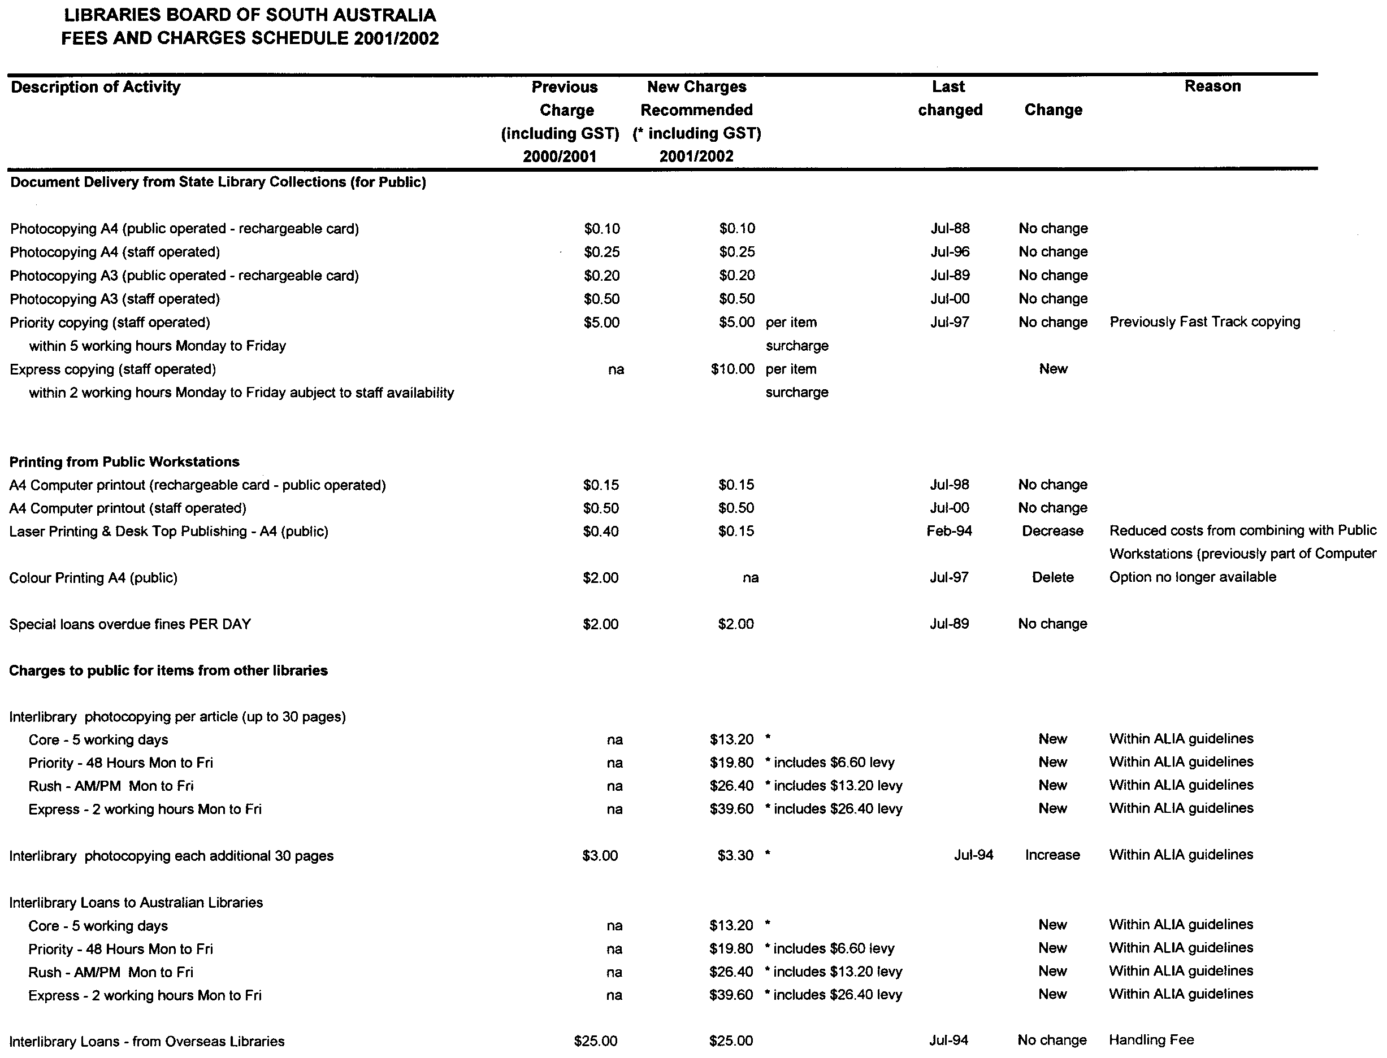
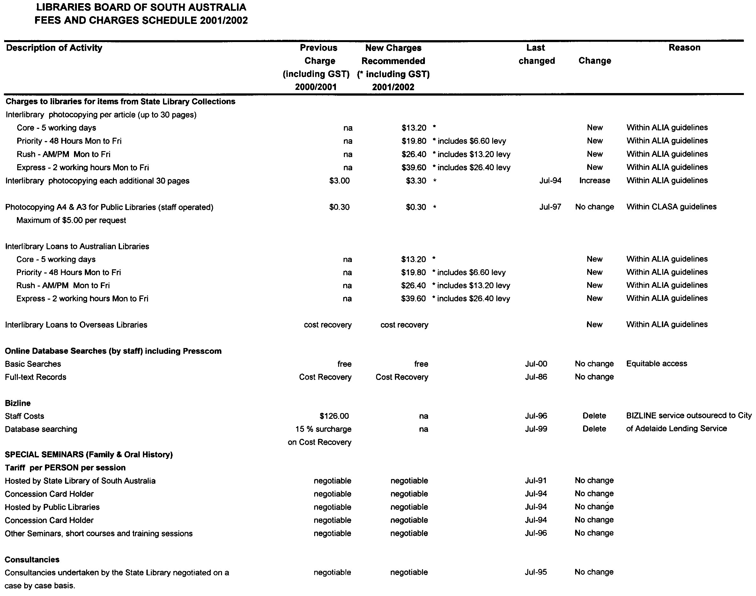

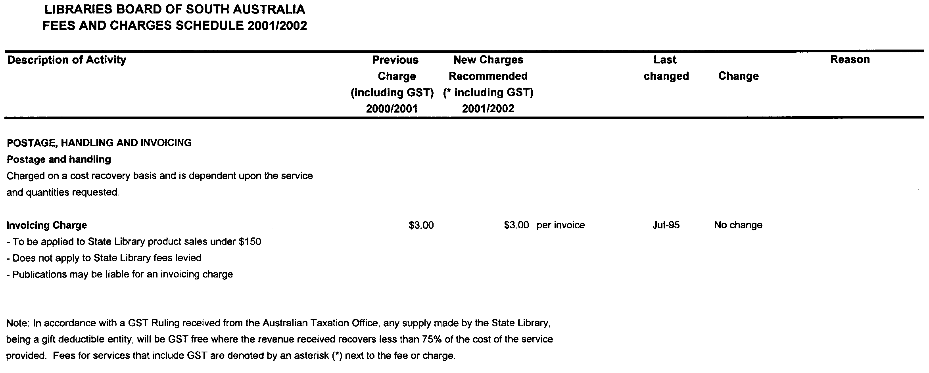

Dated 1 June 2001. B. Halliday, Director State Library of South Australia

LIQUOR LICENSING ACT 1997
Notice of Application
NOTICE is hereby given, pursuant to section 52 (2) (b) of the Liquor Licensing Act 1997, that Andreas Franz Podirsky, 2 Dick Street, Whyalla, S.A. 5600 has applied to the Licensing Authority for a Restaurant Licence with an Extended Trading Authorisation and Entertainment Consent in respect of premises situated at 3 Buttlingarra Way, Whyalla, S.A. 5600 and to be known as Reddust Cafe & Restaurant.
The application has been set down for hearing on 20 July 2001 at 9 a.m.
Conditions
The following licence conditions are sought:
1. An Extended Trading Authorisation:
Thursday: midnight to 1 a.m. the following day;
Friday and Saturday: midnight to 2 a.m. the following day;
Sunday: 8 a.m. to 11 a.m. and 8 p.m. to 1 a.m. the following day;
Public Holidays: 8 a.m. to midnight;
Any day preceeding a Public Holiday being a Sunday and Monday to Saturday: 8 p.m. to 2 a.m. the following day and midnight to 2 a.m. the following day.
2. The licensee is authorised to sell liquor on any day except Good Friday and Christmas Day for consumption on the licensed premises by persons:
(a) seated at a table; or
(b) attending a function at which food is provided.
3. Entertainment Consent is sought during the above hours.
Any person may object to the application by lodging a notice of objection in the prescribed form with the Licensing Authority, and serving a copy of the notice on the applicant at the applicant’s address given above, at least seven days before the hearing date.
Plans in respect of the premises the subject of the application are open to public inspection without fee at the Office of the Liquor and Gaming Commissioner, 9th Floor, East Wing, 50 Grenfell Street, Adelaide, S.A. 5000.
Dated 12 June 2001.
Applicant

LIQUOR LICENSING ACT 1997
Notice of Application
NOTICE is hereby given, pursuant to section 52 (2) (b) of the Liquor Licensing Act 1997, that William Bruce Jameson Withers and Sancha Ann Withers, P.O. Box 642, Lyndoch, S.A. 5351 have applied to the Licensing Authority for the removal of a Producer’s Licence in respect of premises situated at Krondorf Road, Tanunda, S.A. 5352 to be situated at Tweedies Gully Road, Lyndoch, S.A. 5351 and known as Lawley Farm and to be known as Langdale.
The application has been set down for hearing on 20 July 2001 at 9 a.m.
Any person may object to the application by lodging a notice of objection in the prescribed form with the Licensing Authority, and serving a copy of the notice on the applicants at the applicants’ address given above, at least seven days before the hearing date.
Plans in respect of the premises the subject of the application are open to public inspection without fee at the Office of the Liquor and Gaming Commissioner, 9th Floor, East Wing, 50 Grenfell Street, Adelaide, S.A. 5000.
Dated 12 June 2001.
Applicants

LIQUOR LICENSING ACT 1997
Notice of Application
NOTICE is hereby given, pursuant to section 52 (2) (b) of the Liquor Licensing Act 1997, that Anthony Paul Dawson and Marian Dawson have applied to the Licensing Authority for a Producer’s Licence in respect of premises situated at 8 Backler Street, Robe, S.A. 5276 and to be known as A. P. & M. Dawson.
The application has been set down for hearing on 20 July 2001.
Any person may object to the application by lodging a notice of objection in the prescribed form with the Licensing Authority, and serving a copy of the notice on the applicants at the applicants’ address given above, at least seven days before the hearing date.
Plans in respect of the premises the subject of the application are open to public inspection without fee at the Office of the Liquor and Gaming Commissioner, 9th Floor, East Wing, 50 Grenfell Street, Adelaide, S.A. 5000.
Dated 24 May 2001.
Applicants

LIQUOR LICENSING ACT 1997
Notice of Application
NOTICE is hereby given, pursuant to section 52 (2) (b) of the Liquor Licensing Act 1997, that The Semaphore Club Inc. has applied to the Licensing Authority for an Extended Trading Authorisation in respect of premises situated at 93 Esplanade, Semaphore, S.A. 5019 and to be known as Semaphore Workers Club.
The application has been set down for hearing on 20 July 2001.
Conditions
The following licence conditions are sought:
An Extended Trading Authorisation to sell liquor for consumption on the licensed premises between the following hours:
Friday and Saturday: midnight to 1 a.m. the following morning.
Entertainment Consent sought during these hours.
Any person may object to the application by lodging a notice of objection in the prescribed form with the Licensing Authority, and serving a copy of the notice on the applicant at the applicant’s address given above, at least seven days before the hearing date.
Plans in respect of the premises the subject of the application are open to public inspection without fee at the Office of the Liquor and Gaming Commissioner, 9th Floor, East Wing, 50 Grenfell Street, Adelaide, S.A. 5000.
Dated 14 June 2001.
Applicant

LIQUOR LICENSING ACT 1997
Notice of Application
NOTICE is hereby given, pursuant to section 52 (2) (b) of the Liquor Licensing Act 1997, that Robert Betterman and Laxmi Devi, c/o David Watts & Associates, Liquor Licensing Con-sultants, 1 Cator Street, Glenside, S.A. 5065 have applied to the Licensing Authority for a Restaurant Licence in respect of premises situated at 168 Jetty Road, Glenelg, S.A. 5045 and to be known as Laxmi’s Fine Indian Cuisine.
The application has been set down for hearing on 20 July 2001.
Conditions
The following licence conditions are sought:
Section 34 (1) (c) of the Act authorising the licensee to sell liquor on any day except Good Friday and Christmas Day for consumption on the licensed premises by persons:
(a) seated at a table; or
(b) attending a function at which food is provided.
Any person may object to the application by lodging a notice of objection in the prescribed form with the Licensing Authority, and serving a copy of the notice on the applicants at the applicants’ address given above, at least seven days before the hearing date.
Plans in respect of the premises the subject of the application are open to public inspection without fee at the Office of the Liquor and Gaming Commissioner, 9th Floor, East Wing, 50 Grenfell Street, Adelaide, S.A. 5000.
Dated 14 June 2001.
Applicants

LIQUOR LICENSING ACT 1997
Notice of Application
NOTICE is hereby given, pursuant to section 52 (2) (b) of the Liquor Licensing Act 1997, that Coffee Anyone Pty Ltd and Davide De Angelis have applied to the Licensing Authority for a Restaurant Licence with an Entertainment Consent in respect of premises situated at 9G Gays Arcade, Adelaide, S.A. 5000 and to be known as the Adelaide Symposium Cafe.
The application has been set down for hearing on 20 July 2001.
Condition
The following licence condition is sought:
Entertainment Consent is sought for the whole of the licensed premises.
Any person may object to the application by lodging a notice of objection in the prescribed form with the Licensing Authority, and serving a copy of the notice on the applicants at the applicants’ address given above, at least seven days before the hearing date.
Plans in respect of the premises the subject of the application are open to public inspection without fee at the Office of the Liquor and Gaming Commissioner, 9th Floor, East Wing, 50 Grenfell Street, Adelaide, S.A. 5000.
Dated 13 June 2001.
Applicants

LIQUOR LICENSING ACT 1997
Notice of Application
NOTICE is hereby given, pursuant to section 52 (2) (b) of the Liquor Licensing Act 1997, that Turligdon Pty Ltd, c/o Frost Bites, 239 South Terrace, Adelaide, S.A. 5000 has applied to the Licensing Authority for a variation of Trading Hours (area 3 only) in respect of premises situated at 239 South Terrace, Adelaide, S.A. 5000 and known as Frost Bites.
The application has been set down for hearing on 20 July 2001.
Conditions
The following licence conditions are sought:
Monday: midnight to 2 a.m. the following day (in lieu of 1 a.m.) area 3 only;
Tuesday: midnight to 2 a.m. the following day (in lieu of 1 a.m.) area 3 only;
Wednesday: midnight to 2 a.m. (currently approved) area 3 only;
Thursday: midnight to 2 a.m. (currently approved) area 3 only;
Friday: midnight to 2 a.m. (currently approved) area 3 only;
Saturday: midnight to 3 a.m. (currently approved) area 3 only;
Sunday: 8 a.m. to 11 a.m., 8 p.m. to 2 a.m. (in lieu of 1 a.m.) area 3 only.
Any person may object to the application by lodging a notice of objection in the prescribed form with the Licensing Authority, and serving a copy of the notice on the applicant at the applicant’s address given above, at least seven days before the hearing date.
Plans in respect of the premises the subject of the application are open to public inspection without fee at the Office of the Liquor and Gaming Commissioner, 9th Floor, East Wing, 50 Grenfell Street, Adelaide, S.A. 5000.
Dated 14 June 2001.
Applicant

LIQUOR LICENSING ACT 1997
Notice of Application
NOTICE is hereby given, pursuant to section 52 (2) (b) of the Liquor Licensing Act 1997, that Garry Maxwell Sims, Katherine Arnold, Warren Alexander Ferguson and Anne Joyce Ferguson have applied to the Licensing Authority for alterations and redefinition to the Licensed Premises, variation to an existing Extended Trading Authorisation and variation to Entertainment Consent in respect of premises situated at 35 Ayr Street, Jamestown, S.A. 5491 and known as Commercial Hotel.
The application has been set down for hearing on 20 July 2001.
Conditions
The following licence conditions are sought:
To conduct alterations and a redefinition to the Licensed Premises as shown on the plan deposited with the office of the Liquor and Gaming Commissioner.
To vary the Extended Trading Authorisation to authorise the sale of liquor for consumption on the ground floor of the licensed premises (including the planned redefinition) between the following hours:
Friday and Saturday: midnight to 4 a.m. the following morning;
Public Holidays: midnight to 2 a.m.;
Christmas Day: midnight to 2 a.m.;
New Years Eve: midnight to 4 a.m. the following day.
To vary the Entertainment Consent to cover the whole of the ground floor of the Licensed Premises (including the planned redefinition).
Any person may object to the application by lodging a notice of objection in the prescribed form with the Licensing Authority, and serving a copy of the notice on the applicants at the applicants’ address given above, at least seven days before the hearing date.
Plans in respect of the premises the subject of the application are open to public inspection without fee at the Office of the Liquor and Gaming Commissioner, 9th Floor, East Wing, 50 Grenfell Street, Adelaide, S.A. 5000.
Dated 15 June 2001.
Applicants

LIQUOR LICENSING ACT 1997
Notice of Application
NOTICE is hereby given, pursuant to section 52 (2) (b) of the Liquor Licensing Act 1997, that Sturt Basketball Club Inc., c/o Rod Bauer, 2 Wentworth Close, Blackwood, S.A. 5051 has applied to the Licensing Authority for the removal of a Club Licence and an Extended Trading Authorisation in respect of premises situated at Sturt Avenue, Colonel Light Gardens, S.A. 5041 and to be situated at Pasadena Sports Centre, c/o Pasadena High School, Daws Road, Pasadena, S.A. 5042 and known as Sturt Basketball Club and to be known as Sturt Sabres Basketball Club.
The application has been set down for hearing on 20 July 2001 at 9 a.m.
Conditions
The following licence conditions are sought:
An Extended Trading Authorisation: Friday and Saturday, midnight to 1 a.m. the following day; Sunday and Public Holidays, 8 a.m. to 11 a.m. and 8 p.m. to midnight.
Any person may object to the application by lodging a notice of objection in the prescribed form with the Licensing Authority, and serving a copy of the notice on the applicant at the applicant’s address given above, at least seven days before the hearing date.
Plans in respect of the premises the subject of the application are open to public inspection without fee at the Office of the Liquor and Gaming Commissioner, 9th Floor, East Wing, 50 Grenfell Street, Adelaide, S.A. 5000.
Dated 18 June 2001.
Applicant

LIQUOR LICENSING ACT 1997
Notice of Application
NOTICE is hereby given, pursuant to section 52 (2) (b) of the Liquor Licensing Act 1997, that Eurest (Australia) Licence Holdings Pty Ltd (ACN 009 413 165), c/o Eurest Australia, Level 4, 2 Cavill Avenue, Ashfield, N.S.W. 2131 has applied to the Licencing Authority for the removal of a Special Circumstances Licence from premises located 290 South Road, Hilton to existing premises situated at Suite 4, Level 1, 147 Goodwood Road, and known as P. and O. Food Services and to be known as Eurest, where the applicant will conduct the business of arranging licensed catering services at locations other than the proposed licensed premises.
The application has been set down for hearing on 20 July 2001.
Any person may object to the application by lodging a notice of objection in the prescribed form with the Licensing Authority, and serving a copy of the notice on the applicant at the applicant’s address given above, at least seven days before the hearing date.
Plans in respect of the premises the subject of the application are open to public inspection without fee at the Office of the Liquor and Gaming Commissioner, 9th Floor, East Wing, 50 Grenfell Street, Adelaide, S.A. 5000.
Dated 30 May 2001.
Applicant

LIQUOR LICENSING ACT 1997
Notice of Application
NOTICE is hereby given, pursuant to section 52 (2) (b) of the Liquor Licensing Act 1997, that Gianluca Pezzoli and Fiammette Pezzoli, 48 Cliff Avenue, Port Noarlunga South, S.A. 5167 have applied to the Licensing Authority for the transfer of a Restaurant Licence in respect of premises situated at 48 Cliff Avenue, Port Noarlunga South, S.A. 5167 and known as Cliff Pizza Bar/Restaurant & Takeaway Foods.
The application has been set down for hearing on 23 July 2001 at 11 a.m.
Any person may object to the application by lodging a notice of objection in the prescribed form with the Licensing Authority, and serving a copy of the notice on the applicants at the applicants’ address given above, at least seven days before the hearing date.
Plans in respect of the premises the subject of the application are open to public inspection without fee at the Office of the Liquor and Gaming Commissioner, 9th Floor, East Wing, 50 Grenfell Street, Adelaide, S.A. 5000.
Dated 14 June 2001.
Applicants

LIQUOR LICENSING ACT 1997
Notice of Application
NOTICE is hereby given, pursuant to section 52 (2) (b) of the Liquor Licensing Act 1997, that Michelle Kaye Sander has applied to the Licensing Authority for the transfer of a Restaurant Licence in respect of premises situated at 251 Esplanade, Henley Beach, S.A. 5022 and known as Henley on Sea.
The application has been set down for hearing on 24 July 2001.
Any person may object to the application by lodging a notice of objection in the prescribed form with the Licensing Authority, and serving a copy of the notice on the applicant at the applicant’s address given above, at least seven days before the hearing date.
Plans in respect of the premises the subject of the application are open to public inspection without fee at the Office of the Liquor and Gaming Commissioner, 9th Floor, East Wing, 50 Grenfell Street, Adelaide, S.A. 5000.
Dated 15 June 2001.
Applicant

LIQUOR LICENSING ACT 1997
Notice of Application
NOTICE is hereby given, pursuant to section 52 (2) (b) of the Liquor Licensing Act 1997, that Lapond Pty Ltd (ACN 005 607 157), Level 1, Unit 6, 128 Fullarton Road, Norwood, S.A. 5067 as trustee for Cheryl’s Restaurant Trading Trust and as trustee for Klement Restaurant Settlement has applied to the Licensing Authority for the transfer of a Restaurant Licence in respect of premises situated at 323 South Road, Croydon Park, S.A. 5008 and known as Cheryl’s Restaurant and to be known as CJ’s.
The application has been set down for hearing on 24 July 2001.
Any person may object to the application by lodging a notice of objection in the prescribed form with the Licensing Authority, and serving a copy of the notice on the applicant at the applicant’s address given above, at least seven days before the hearing date.
Plans in respect of the premises the subject of the application are open to public inspection without fee at the Office of the Liquor and Gaming Commissioner, 9th Floor, East Wing, 50 Grenfell Street, Adelaide, S.A. 5000.
Dated 14 June 2001.
Applicant

LIQUOR LICENSING ACT 1997
Notice of Application
NOTICE is hereby given, pursuant to section 52 (2) (b) of the Liquor Licensing Act 1997, that Cooper’s Brewery Limited (ACN 007 871 409), c/o Piper Alderman, 167 Flinders Street, Adelaide, S.A. 5000 has applied to the Licensing Authority for the removal of its Producer’s Licence from 9 Statenborough Street, Leabrook, S.A. 5068 to 461 South Road, Regency Park, S.A. 5010 in respect of the premises known as Coopers Brewery.
The application has been set down for hearing on 6 July 2001 at 9 a.m.
Any person may object to the application by lodging a notice of objection in the prescribed form with the Licensing Authority, and serving a copy of the notice on the applicant at the applicant’s address given above, at least seven days before the hearing date.
Plans in respect of the premises the subject of the application are open to public inspection without fee at the Office of the Liquor and Gaming Commissioner, 9th Floor, East Wing, 50 Grenfell Street, Adelaide, S.A. 5000.
Dated 14 June 2001.
Applicant

LIQUOR LICENSING ACT 1997
Notice of Application
NOTICE is hereby given, pursuant to section 52 (2) (b) of the Liquor Licensing Act 1997, that D. J. and S. M. Watson, Lot 50, Plains Road, Sellicks Hill, S.A. 5174 have applied to the Licensing Authority for a Producer’s Licence in respect of premises situated at Lot 50, Plains Road, Sellicks Hill, S.A. 5174 and to be known as Blown Away.
The application has been set down for hearing on 20 July 2001.
Any person may object to the application by lodging a notice of objection in the prescribed form with the Licensing Authority, and serving a copy of the notice on the applicants at the applicants’ address given above, at least seven days before the hearing date.
Plans in respect of the premises the subject of the application are open to public inspection without fee at the Office of the Liquor and Gaming Commissioner, 9th Floor, East Wing, 50 Grenfell Street, Adelaide, S.A. 5000.
Dated 1 January 2001.
Applicants

LIQUOR LICENSING ACT 1997
Notice of Application
NOTICE is hereby given, pursuant to section 52 (2) (b) of the Liquor Licensing Act 1997, that Allen & Rowland Shipshapers Pty Ltd (ACN 082 276 499), c/o David Watts & Associates, Liquor Licensing Consultants, 1 Cator Street, Glenside, S.A. 5065, has applied to the Licensing Authority for a Hotel Licence in respect of premises situated at Railway Terrace, Paruna, S.A. 5311 and to be known as Brown’s Well Tavern.
The application has been set down for hearing on 20 July 2001.
Conditions
The following licence conditions are sought:
Entertainment consent:
An exemption from the condition requiring the licensee to keep the licensed premises open to the public for the sale of liquor on every day (except Good Friday, Christmas Day or Sunday) between 11 a.m. and 8 p.m.
An exemption from the condition requiring the licensee to provide a meal, at the request of a member of the public, between noon and 2 p.m., and between 6 p.m. and 8 p.m., on any day on which the licensed premises are open to the public for the sale of liquor.
Any person may object to the application by lodging a notice of objection in the prescribed form with the Licensing Authority, and serving a copy of the notice on the applicant at the applicant’s address given above, at least seven days before the hearing date.
Plans in respect of the premises the subject of the application are open to public inspection without fee at the Office of the Liquor and Gaming Commissioner, 9th Floor, East Wing, 50 Grenfell Street, Adelaide, S.A. 5000.
Applicant

MINING ACT 1971
NOTICE is hereby given in accordance with section 28 (5) of the Mining Act 1971, that the Minister for Minerals and Energy proposes to grant an Exploration Licence over the under-mentioned area:
Applicant: RMG Services Pty Ltd
Location: Lake Torrens South area—Approximately 80 km north of Port Augusta, bounded as follows:
Area A—Commencing at a point being the intersection of latitude 31°39′S and the western boundary of Lake Torrens National Park, thence east to the eastern boundary of Lake Torrens National Park, south along the boundary of the said National Park to latitude 31°47′S, west to the eastern boundary of Lake
Torrens National Park and north to the point of commencement.
Area B—Commencing at a point being the intersection of latitude 31°47′S and longitude 137°34′E, thence east to longitude 137°37′E, south to latitude 31°50′S, west to longitude 137°34′E and north to the point of commencement, but excluding Lake Torrens National Park.
Area C—Commencing at a point being the intersection of latitude 31°51′S and longitude 137°36′E, thence east to the eastern boundary of Lake Torrens National Park, thence generally south-easterly along the boundary of the said National Park to latitude 31°54′S, west to longitude 137°36′E and north to the point of commencement.
All the within latitudes and longitudes are geodetic and expressed in terms of the Australian Geodetic Datum as defined on p. 4984 of Commonwealth Gazette number 84 dated 6 October 1966 (AGD66).
Term: 1 year
Area in km²: 232
Ref: 3/2001
H. Tyrteos, Acting Mining Registrar, Department of Primary Industries and Resources

MINING ACT 1971
NOTICE is hereby given in accordance with section 28 (5) of the Mining Act 1971, that the Minister for Minerals and Energy proposes to grant an Exploration Licence over the under-mentioned area:
Applicant: Minex (Aust) Pty Ltd
Location: Holywater Area—Approximately 130 km north-west of Marla, bounded as follows:
Area A—Commencing at a point being the intersection of latitude 26°04′S and longitude 133°08′E, thence east to longitude 133°11′E, south to latitude 26°05′S, west to longitude 133°08′E, and north to the point of commencement.
Area B—Commencing at a point being the intersection of latitude 26°04′S and longitude 133°14′E, thence east to longitude 133°19′E, south to latitude 26°05′S, west to longitude 133°14′E, and north to the point of commencement.
Area C—Commencing at a point being the intersection of latitude 26°09′S and longitude 133°20′E, thence east to longitude 133°25′E, north to latitude 26°06′S, west to longitude 133°22′E, north to latitude 26°05′S, west to longitude 133°21′E, north to latitude 26°02′S, west to longitude 133°20′E, north to latitude 26°01′S, west to longitude 133°19′E, north to the northern border of the State of South Australia, thence easterly along the said northern border to longitude 133°27′E, south to latitude 26°10′S, west to longitude 133°20′E and north to the point of commencement, but excluding Tarcoola-Alice Springs Railway (see G.G. 13.11.75).
All the within latitudes and longitudes are geodetic and expressed in terms of the Australian Geodetic Datum as defined on p. 4984 of Commonwealth Gazette number 84 dated 6 October 1966 (AGD66).
Term: 1 year
Area in km²: 182
Ref: 29/2001
H. Tyrteos, Acting Mining Registrar, Department of Primary Industries and Resources

INFORMATION SA
Located on the Ground Floor, SA Water House, 77 Grenfell Street, Adelaide, will be closed on Friday, 29 June 2001 for annual stock-take.

ONLY Government Gazette sales for 28 June 2001 will be available from The Environment Shop, SA Water House, 77 Grenfell Street, Adelaide from 9 a.m. to 5 p.m. on Friday, 29 June 2001. No other publications can be sold.

Manager, Information SA

GRANT OF SPECULATIVE SURVEY LICENCE No. 2
Office of Minerals and Energy Resources, 11 May 2001
NOTICE is hereby given that the undermentioned Speculative Survey Licence has been granted under the provisions of the Petroleum Act 2000, pursuant to delegated powers dated 25 September 2000, Gazetted 28 September 2000, page 2289.
R. A. Laws, Director Petroleum, Office of Minerals and Energy Resources, delegate of the Minister for Minerals and Energy
No. of  Licence | Licensees | Locality | Date of  Expiry | Area in  km² | Reference

2 | Origin Energy Resources Ltd  Lakes Oil NL  Victoria Petroleum NL  Mirboo Ridge Pty Ltd |  | Otway Basin of South Australia | 10 May 2002 | 99 | SR.27.2.220

Description of the Area
All that part of the State of South Australia bounded as follows: commencing at a point being the intersection of latitude 37°55′00″S GDA94 and longitude 140°51′00″E GDA94, thence east to longitude 140°57′30″E GDA94, south to latitude 38°00′00″S AGD66, west to longitude 140°52′30″E AGD66, south to the Territorial Sea Baseline at low water mark, Southern Ocean thence generally north-westerly along the said baseline to longitude 140°51′00″E GDA94 and north to the point of commencement.
Area: 99 km² approximately.

PETROLEUM ACT 2000
Grant of Production Licences
Office of Minerals and Energy Resources Adelaide, 15 June 2001
NOTICE is hereby given that pursuant to delegated powers dated 25 September 2000, Gazetted 28 September 2000, page 2289, the undermentioned Production Licences have been granted under the provisions of the Petroleum Act 2000.
T. Aust, Acting Director, Petroleum Group, Delegate of the Minister for Minerals and Energy
No. of  Licence | Licensees | Locality | Date Effective  From

179, 195  194 | Santos Ltd  Delhi Petroleum Pty Ltd  Origin Energy Resources Ltd  Vamgas Pty Ltd  Novus Australia Resources NL  Alliance Petroleum Australia Pty Ltd  Reef Oil Pty Ltd  Santos Petroleum Pty Ltd  Bridge Oil Developments Pty Ltd  Santos (BOL) Pty Ltd  Basin Oil Pty Ltd  Santos Ltd  Delhi Petroleum Pty Ltd  Origin Energy Resources Ltd  Vamgas Pty Ltd  Novus (Australia) Resources NL | Fortanna and Scrubby Creek Fields in the Cooper Basin of South Australia  Reg Sprigg Field in the Cooper Basin of South Australia | 15 June 2001  15 June 2001
PL 179:
Description of the Area
All that part of the State of South Australia bounded as follows: Commencing at a point being the intersection of latitude 28°22′40′′S AGD66 and longitude 140°05′00′′E AGD66, thence east to longitude 140°05′50′′E AGD66, south to latitude 28°22′50′′S AGD66, east to longitude 140°06′00′′E AGD66, south to latitude 28°23′10′′S AGD66, west to longitude 140°05′55′′E AGD66, south to latitude 28°23′15′′S AGD66, west to longitude 140°05′50′′E AGD66, south to latitude 28°23′25′′S AGD66, west to longitude 140°05′45′′E AGD66, south to latitude 28°23′35′′S AGD66, east to longitude 140°05′55′′E AGD66, south to latitude 28°24′00′′S AGD66, west to longitude 140°05′45′′E AGD66, south to latitude 28°24′20′′S AGD66, west to longitude 140°05′35′′E AGD66, south to latitude 28°24′25′′S AGD66, west to longitude 140°05′30′′E AGD66, south to latitude 28°24′35′′S AGD66, west to longitude 140°05′25′′E AGD66, south to latitude 28°24′40′′S AGD66, west to longitude 140°04′50′′E AGD66, north to latitude 28°23′50′′S AGD66, west to longitude 140°04′40′′E AGD66, north to latitude 28°23′05′′S AGD66, east to longitude 140°04′55′′E AGD66, north to latitude 28°22′55′′S AGD66, east to longitude 140°05′00′′E AGD66, and north to the point of commencement.
Area: 6.07 km² approximately.
PL 194:
Description of the Area
All that part of the State of South Australia bounded as follows: Commencing at a point being the intersection of latitude 27°13′30′′S AGD66 and longitude 140°56′30′′E AGD66, thence east to longitude 140°57′00′′E AGD66, south to latitude 27°13′40′′S AGD66, east to longitude 140°57′30′′E AGD66, south to latitude 27°13′50′′S AGD66, east to longitude 140°57′40′′E AGD66, south to latitude 27°14′00′′S AGD66, east to longitude 140°58′00′′E AGD66, south to latitude 27°14′30′′S AGD66, west to longitude 140°57′50′′E AGD66, south to latitude 27°14′40′′S AGD66, west to longitude 140°57′40′′E AGD66, south to latitude 27°14′50′′S AGD66, west to longitude 140°57′10′′E AGD66, south to latitude 27°15′00′′S Clarke 1858, west to longitude 140°56′10′′E AGD66, north to latitude 27°14′20′′S AGD66, east to longitude 140°56′20′′E AGD66, north to latitude 27°14′00′′S AGD66, east to longitude 140°56′30′′E AGD66, and north to the point of commencement.
Area: 5.99 km² approximately.
PL 195:
Description of the Area
All that part of the State of South Australia bounded as follows: Commencing at a point being the intersection of latitude 27°32′15″S AGD66 and longitude 140°24′50″E AGD66, thence east to longitude 140°25′05″E AGD66, south to latitude 27°32′30″S AGD66, west to longitude 140°24′50″E AGD66, south to latitude 27°32′40″S AGD66, west to longitude 140°24′30″E AGD66, south to latitude 27°32′50″S AGD66, west to longitude 140°24′20″E AGD66, south to latitude 27°33′00″S AGD66, west to longitude 140°24′10″E AGD66, south to latitude 27°33′10″S AGD66, west to longitude 140°24′00″E AGD66, south to latitude 27°33′20″S AGD66, west to longitude 140°23′50″E AGD66, south to latitude 27°33′35″S AGD66, west to longitude 140°23′45″E AGD66, south to latitude 27°33′50″S AGD66, west to longitude 140°23′40″E AGD66, south to latitude 27°33′55″S AGD66, west to longitude 140°23′35″E AGD66, south to latitude 27°34′00″S AGD66, west to longitude 140°23′30″E AGD66, south to latitude 27°34′10″S AGD66, west to longitude 140°23′25″E AGD66, south to latitude 27°34′20″S AGD66, west to longitude 140°23′20″E AGD66, south to latitude 27°34′25″S AGD66, west to longitude 140°23′15″E AGD66, south to latitude 27°34′30″S AGD66, west to longitude 140°23′10″E AGD66, south to latitude 27°34′35″S AGD66, west to longitude 140°23′05″E AGD66, south to latitude 27°34′40″S AGD66, west to longitude 140°23′00″E AGD66, south to latitude 27°34′50″S AGD66, west to longitude 140°22′50″E AGD66, south to latitude 27°34′55″S AGD66, west to longitude 140°22′35″E AGD66, south to latitude 27°35′00″S AGD66, west to longitude 140°22′30″E AGD66, south to latitude 27°35′05″S AGD66, west to longitude 140°22′25″E AGD66, south to latitude 27°35′10″S AGD66, west to longitude 140°22′15″E AGD66, north to latitude 27°34′50″S AGD66, east to longitude 140°22′20″E AGD66, north to latitude 27°34′45″S AGD66, east to longitude 140°22′25″E AGD66, north to latitude 27°34′40″S AGD66, east to longitude 140°22′30″E AGD66, north to latitude 27°33′35″S AGD66, east to longitude 140°22′40″E AGD66, north to latitude 27°33′20″S AGD66, east to longitude 140°22′50″E AGD66, north to latitude 27°33′05″S AGD66, east to longitude 140°23′00″E AGD66, north to latitude 27°32′55″S AGD66, east to longitude 140°23′10″E AGD66, north to latitude 27°32′45″S AGD66, east to longitude 140°23′20″E AGD66, north to latitude 27°32′40″S AGD66, east to longitude 140°23′40″E AGD66, north to latitude 27°32′50″S AGD66, east to longitude 140°24′05″E AGD66, north to latitude 27°32′45″S AGD66, east to longitude 140°24′10″E AGD66, north to latitude 27°32′35″S AGD66, east to longitude 140°24′30″E AGD66, north to latitude 27°32′25″S AGD66, east to longitude 140°24′40″E AGD66, north to latitude 27°32′20″S AGD66, east to longitude 140°24′50″E AGD66 and north to the point of commencement.
Area: 7.57 km² approximately.

PETROLEUM ACT 2000
Statement of Environmental Objectives for New
Regulated Activities
PURSUANT to section 104 (1) of the Petroleum Act 2000 (the Act) I, Robert Anthony Laws, Director Petroleum, Office of Minerals and Energy Resources, Department of Primary Industries and Resources SA, Delegate of the Minister for Minerals and Energy, pursuant to Delegation dated 25 September 2000, Gazetted 28 September 2000, do hereby publish the following document as having been approved as a statement of environmental objectives under the Act.
This document is available for public inspection on the Environmental Register section of the Petroleum Group’s web site (www.petroleum.pir.sa.gov.au) or at the Public Office determined pursuant to section 107 (1) of the Act to be at:
Minerals and Petroleum Centre
Office of Minerals and Energy Resources
Ground Floor
101 Grenfell Street
Adelaide, S.A. 5000
Document:
1. Origin Energy Resources Limited Statement of Environmental Objectives for Drilling and Well Operations in Limestone Ridge-1, Otway Basin—South Australia, May 2001, approved 15 June 2001.
T. Aust, Delegate of the Minister for Minerals and Energy Resources.

PETROLEUM PRODUCTS REGULATION ACT 1995
Appointment
I, ROBERT LAWSON, Minister for Administrative and Infor-mation Services and Minister for Workplace Relations in and for the State of South Australia, hereby appoint the undermentioned person as an Authorised Officer, pursuant to the Petroleum Products Regulation Act 1995:
Hartley Franklin Brakey
Dated 23 April 2001.
Robert Lawson, Minister for Workplace Relations

MOTOR VEHICLES ACT 1959
Appointment
I, DIANA VIVIENNE LAIDLAW, the Minister of the Crown to whom the administration of the Motor Vehicles Act 1959 has been committed, do hereby appoint, pursuant to section 116A of the said Act, the Motor Accident Commission, to be the nominal defendant for the purposes of Part IV of that Act.
Dated 6 June 2001.
Diana Laidlaw, Minister for Transport and Urban Planning

OCCUPATIONAL HEALTH SAFETY AND WELFARE
ACT 1986
Appointment
I, ROBERT LAWSON, Minister for Administrative and Infor-mation Services and Minister for Workplace Relations in and for the State of South Australia, hereby appoint the undermentioned person as an Inspector, pursuant to the Occupational Health Safety and Welfare Act 1986:
Hartley Franklin Brakey
Dated 23 April 2001.
Robert Lawson, Minister for Workplace Relations

ROADS (OPENING AND CLOSING) ACT 1991:
SECTION 24
NOTICE OF CONFIRMATION OF ROAD
PROCESS ORDER
Football Park, West Lakes
Deposited Plan 57182
BY Road Process Order made on 18 April 2001, the City of Charles Sturt ordered that:
1. The whole of the unnamed public road north of Brebner Drive adjoining Football Park (allotment 50 in Filed Plan 30058) more particularly lettered ‘A’, in Preliminary Plan No. PP32/0634 be closed.
2. The whole of the land subject to closure be transferred to THE SOUTH AUSTRALIAN NATIONAL FOOTBALL LEAGUE INC. in accordance with agreement for transfer dated 18 April 2001 entered into between the City of Charles Sturt and The South Australian National Football League Inc.
3. The following easement is granted over portion of the land subject to that closure:
Grant to the Distribution Lessor Corporation an easement for switching cubicle and underground electricity supply purposes.
On 9 May 2001 that order was confirmed by the Minister for Administrative and Information Services conditionally on approval and deposit of the survey plan by the Registrar-General. The condition has now been fulfilled.
Pursuant to section 24(5) of the Roads (Opening and Closing) Act 1991, NOTICE of the order referred to above and its confirmation is hereby given.
Dated 21 June 2001.
K. Sarneckis, Acting Surveyor-General

ROADS (OPENING AND CLOSING) ACT 1991:
SECTION 24
NOTICE OF CONFIRMATION OF ROAD
PROCESS ORDER
Pound Lane, adjacent Port Lincoln
Deposited Plan 57233
BY Road Process Order made on 20 April 2001, the District Council of Lower Eyre Peninsula ordered that:
1. The whole of the unnamed public road adjoining Pound Lane and the southern boundary of allotment 503 in Deposited Plan 52907 more particularly lettered ‘A’, in Preliminary Plan No. PP32/0586 be closed.
2. The whole of the land subject to closure be transferred to the GENERATION LESSOR CORPORATION in accordance with agreement for transfer dated 20 April 2001 entered into between the District Council of Lower Eyre Peninsula and Generation Lessor Corporation.
3. The following easement is granted over portion of the land subject to that closure:
Grant to the Distribution Lessor Corporation an easement for electricity supply purposes.
On 24 May 2001 that order was confirmed by the Minister for Administrative and Information Services conditionally on approval and deposit of the survey plan by the Registrar-General. The condition has now been fulfilled.
Pursuant to section 24(5) of the Roads (Opening and Closing) Act 1991, NOTICE of the order referred to above and its confirmation is hereby given.
Dated 21 June 2001.
K. Sarneckis, Acting Surveyor-General

ROADS (OPENING AND CLOSING) ACT 1991:
SECTION 24
NOTICE OF CONFIRMATION OF ROAD
PROCESS ORDER
Public Road, Hundred of Yackamoorundie
Deposited Plan 53783
BY Road Process Order made on 9 November 1999, the Northern Areas Council ordered that:
1. Portion of the public road north of Mallee Grove Road adjoining sections 84 and 324, more particularly delineated and lettered ‘A’ and ‘B’ (respectively) in Preliminary Plan No. PP32/0315 be closed.
2. Vest the whole of the land subject to closure in the Crown.
On 10 December 1999 that order was confirmed by the Minister for Administrative Services conditionally on approval and deposit of the survey plan by the Registrar-General. The condition has now been fulfilled.
Pursuant to section 24(5) of the Roads (Opening and Closing) Act 1991, NOTICE of the order referred to above and its confirmation is hereby given.
Dated 21 June 2001.
K. Sarneckis, Acting Surveyor-General

REAL PROPERTY ACT NOTICE
WHEREAS the persons named at the foot hereof have each respectively for himself made application to have the land set forth and described before his name at the foot hereof brought under the operation of the Real Property Act: Notice is hereby given that unless caveat be lodged with the Registrar-General by some person having estate or interest in the said lands on or before the expiration of the period herein below for each case specified, the said several pieces of land will be brought under the operation of the said Act as by law directed. Diagrams delineating these parcels of land may be inspected at the Lands Titles Registration Office, Adelaide, and in the offices of the several corporations or district councils in which the lands are situated.

The Schedule
No. of  Applica-  tion | Description of Property |  | Name |  | Residence | Date up to and  inclusive of which  caveat may be  lodged

30910 | A free and unrestricted right of way over portion of allotment 10, marked ‘A’ in Filed Plan No. 41274 appurtenant to the land comprised in Certificates of Title Volume 5499, Folio 65 and Volume 5499, Folio 354 |  | Ian Leslie Pollard |  | 44 Wellington Square, North Adelaide, S.A. 5006 | 21 August 2001

Dated 20 June 2001, at the Lands Titles Registration Office, Adelaide. J. Zaccaria, Deputy Registrar-General

RULES OF COURT
Amending the Supreme Court Criminal Rules 1992
Amendment No. 12 to the Supreme Court
Criminal Rules
BY virtue and in pursuance of section 72 of the Supreme Court Act 1935, and all other powers us thereunto enabling, We, Judges of the Supreme Court of South Australia, do hereby make the following Rules to take effect as amendments to the Supreme Court Criminal Rules 1992, as amended:
1. These Rules may be cited as the ‘Supreme Court Criminal Rules 1992, Amendment No. 12’.
2. The Supreme Court Criminal Rules 1992, as amended, by these Rules may be cited as the ‘Supreme Court Criminal Rules 1992’.
3. That Rule 3 is amended by deleting subrules 3.05, 3.06 and 3.07 and inserting in lieu:
‘3.05 A person who has appeared before the Court pursuant to Rule 3.01 or Rule 3.02 and been remanded in custody for trial, will be brought before the Court on a subsequent occasion:
(a) for the purpose of attending a directions hearing or the trial;
(b) if a Judge so directs;
(c) for the purpose of any application to be made by that person to the Court, if the person so requests.
3.06 The Deputy Registrar (Criminal) shall provide to the Chief Justice a report on all persons who have appeared before the Court pursuant to Rules 3.01 and 3.02 and who have been remanded in custody for trial in relation to the matter or matters upon which they have been arraigned for a period of six months or more since the date of first arraignment.
3.07 The report required pursuant to Rule 3.06 shall be provided to the Chief Justice within 7 days of the expiry of each month and shall contain the names of the persons, the offences with which they have been charged, the date upon which they were first arraigned, any trial dates which have been fixed in relation to the charges and such other information as the Chief Justice shall consider appropriate.’
4. That Rule 6 be amended by inserting after subrule 6.07 (1) (e) (vii) A the following:
‘(vii) B Issuing a bench warrant.’
GIVEN under our hands and the Seal of the Supreme Court of South Australia this 12th day of June 2001.
(l.s.) J. DOYLE, CJ
G. C. PRIOR, J
L. T. OLSSON, J
J. W. PERRY, J
K. P. DUGGAN, J
B. M. DEBELLE, J
M. J. NYLAND, J
B. T. LANDER, J
D. J. BLEBY, J
D. F. WICKS, J
BRIAN MARTIN, J
T. A. GRAY, J

RULES OF COURT
Amending the District Court Rules 1992
Amendment No. 32 to the District Court Rules
BY virtue and in pursuance of section 51 of the District Court Act 1991, and all other powers us thereunto enabling, We, Terence Anthony Worthington, Chief Judge, and Robert Martin Lunn and Peter Anthony John Herriman, Judges of the District Court of South Australia, do hereby make the following Rules of Court:
1. These Rules may be cited as the ‘District Court Rules 1992, Amendment No. 32.’
2. The District Court Rules 1992, as amended, by these Rules, may be cited as the ‘District Court Rules 1992’.
3. That Rule IV-3 is amended by deleting subrules IV-3.05, IV-3.06 and IV-3.07 and inserting in lieu:
‘IV-3.05 A person who has appeared before the Court pursuant to Rule 3.01 or Rule 3.02 and been remanded in custody for trial, will be brought before the Court on a subsequent occasion:
(a) for the purpose of attending a directions hearing or the trial;
(b) if a Judge so directs;
(c) for the purpose of any application to be made by that person to the Court, if the person so requests.
IV-3.06 The Deputy Registrar (Criminal) shall provide to the Chief Judge a report on all persons who have appeared before the Court pursuant to Rules 3.01 and 3.02 and who have been remanded in custody for trial in relation to the matter or matters upon which they have been arraigned for a period of six months or more since the date of first arraignment.
IV-3.07 The report required pursuant to Rule 3.06 shall be provided to the Chief Judge within 7 days of the expiry of each month and shall contain the names of the persons, the offences with which they have been charged, the date upon which they were first arraigned, any trial dates which have been fixed in relation to the charges and such other information as the Chief Judge shall consider appropriate.’
4. That Rule VI-6 be amended by inserting after subrule IV-6.07 (1) (e) (vii) A the following:
‘(vii) B Issuing a bench warrant.’
GIVEN under our hands and the Seal of the Supreme Court of South Australia this 12th day of June 2001.
T. A. WORTHINGTON, CJ
R. M. LUNN, J
P. A. J. HERRIMAN, J

RULES OF COURT
The Magistrates Court of South Australia
Amendment No. 17 to the Magistrates Court (Civil)
Rules 1992
PURSUANT to section 49 of the Magistrates Court Act 1991 and all other enabling powers, we the undersigned do make the following amendments to the Magistrates Court (Civil) Rules 1992:
Rule 2 (1) is amended by:
the deletion of the acronym ‘EDX’, the words ‘authorised user’, ‘E-mail’, ‘the Trial Court’ and their respective definitions; and
the inclusion of the following definitions in the appropriate alphabetical order:
‘authorised user’ means a legal practitioner or law firm authorised by the Courts Administration Authority to file documents by electronic filing. An authorised user will have a user identifier and will nominate a password. The Principal Registrar can withdraw an authorisation by notice to the authorised user and without giving any reason;
‘Electronic filing’ means filing by electronic means at the Courts Administration Authority website;
‘E-mail’ means a transfer of documents from one computer to another correctly addressed to the name, user identification or string which the computer of the addressee recognises;
‘Trial Court’ means:
(a) where an action is filed by electronic means the registry where the defence is filed or the judgment is signed;
(b) in other actions the registry nearest to where the cause of action arose or where the defendant resides or carries on business; or
(c) such other registry as the court may nominate.
Rule 5 (4) is deleted and replaced with the following rule:
The provision by an authorised user of his or her user identifier and current password in relation to the electronic filing of a document is deemed to have the same effect as if the document was signed by the authorised user.
Rule 25 (2) is deleted and replaced with the following subrule:
(2) A claim which is not filed by electronic means must state the basis upon which a particular registry is the Trial Court.
Rule 60 (1) (b) is deleted and replaced with the following subrule:
(b) in an action to which Rule 62 applies, at the Trial Court, or where the claim was filed by electronic means at the registry nearest to where the cause of action arose or where the defendant resides or carries on business.
Rule 42 (1) (b) is deleted and replaced with the following subrules:
(b) It is sufficient for an authorised user to file form 2, 3 and any other form permitted by a practice direction, by electronic filing.
(c) A form filed by electronic filing shall be deemed to be filed on the day when it is accepted for filing by the Courts Administration Authority website.
Rule 119 is deleted and replaced with the following rule:
(1) The first document in an action will have an action number assigned to it and each other document in the action must bear that action number, together with any prefix given to it by the court to designate that it was an action filed by electronic means, or the Trial Court, and the calendar year when the action was commenced.
(2) A new series of numbers will be commenced for claims filed by electronic means and each Trial Court, each calendar year.
Rule 124 (1) is deleted and replaced with the following subrule:
(1) Subject to any order of the court to the contrary, interest for the purpose of section 35 must be calculated at the rate of 10% per annum.
Wherever the acronym ‘EDX’ appears in the rules (including the forms) it is deleted and replaced with the word ‘e-mail’.
The Second Schedule is amended by:
The addition of a note to each of forms 2 and 3 as follows:
Where this form is filed by electronic filing the reference to the Trial Court will be deleted but it shall bear the address of the Adelaide Registry, the phone number (08) 8204 2444, an e-mail address at which the court can be contacted and the method of service will appear in proximity to each defendant.
Form 12 is deleted and replaced with the following form. The list of forms is amended to describe the new form by its heading.

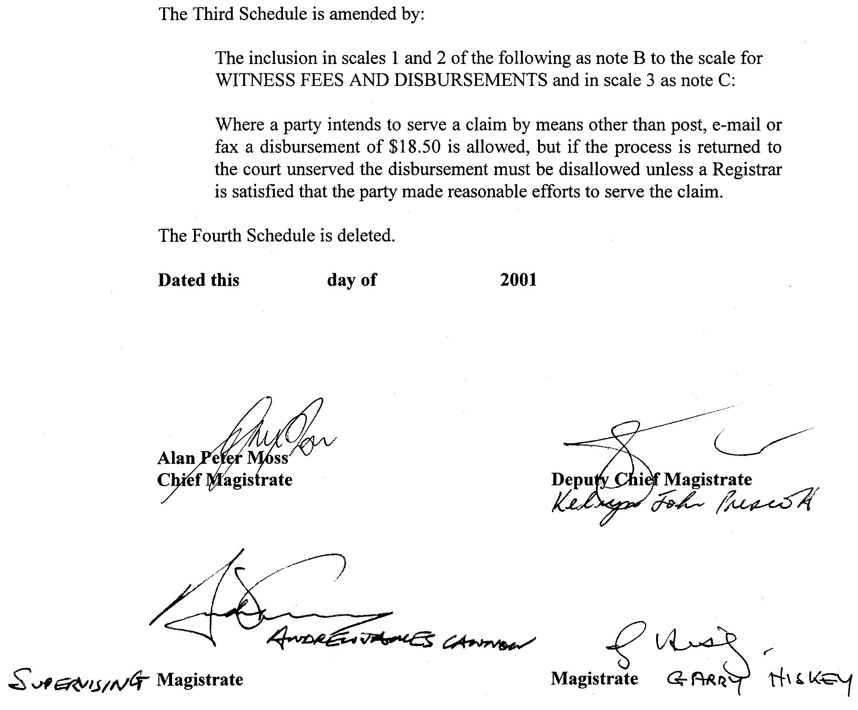

SOUTH EASTERN WATER CONSERVATION AND DRAINAGE ACT 1992
I, ROBERT GERARD KERIN, Minister for Primary Industries and Resources, noting the delegation pursuant to section 9 of the Administration Arrangements Act 1994, and after consulting with the South Eastern Water Conservation and Drainage Board and pursuant to section 34A of the South Eastern Water Conservation and Drainage Act 1992, give notice that:
1. The South Eastern Water Conservation and Drainage Board may, in respect of the 2001-2002 financial year, levy a contribution from all landholders who own or occupy more than 10 ha of private land in that area of the South East as designated in the attached schedule.
2. Contributions will not be levied in respect of private land that:
(a) is subject to a heritage agreement under the Native Vegetation Act 1992; or
(b) is an area of native vegetation in a single block greater than 40 ha per individual property.
3. The money received by the Board will be applied for the local funding component of the Upper South East Project.
4. The levy will be applied to landholders at differing rates according where land is situated as designated in the attached Schedule with more than one payment option being available.
5. The levy will be applied as follows:
Zone A—$2.24 per hectare per year;
Zone B—$1.07 per hectare per year;
Zone C—$0.54 per hectare per year;
Zone D—$0.11 per hectare per year.
In addition to those levy payments indicated landholders in Zone A who did in November 1997 elect to make payment over 8 years the levy will be applied as follows:
$2.29 per hectare per year
Dated 13 June 2001.
Rob Kerin, Minister for Primary Industries and Resources

Schedule
Land comprising Zone A—The Hundreds of Laffer, Landseer, McNamara, Messent, Peacock, Petherick and Wells:
That portion of the Hundred of Santo, County of Buckingham bounded as follows:
Commencing at the northern most point (383650 east, 6003050 north) of that portion of part section 13, Hundred of Santo, bounded by the surveyed road defined by RP 5214 and the eastern boundary of the said Hundred; thence along the southern side of the road boundary in a generally westerly direction to the first bend east of Lot 500 of FP 16677 (378700 east, 6001250 north); dividing Lot 501 of FP 16677 to the easterly corner of Lot 1 of DP 26077; along generally south-easterly boundary of Lot 1 of DP 26077 to its intersection with the Princes Highway road boundary; generally southerly along the eastern side of the Princes Highway road boundary to the intersection with the northern side of the road boundary dividing section 80; generally in a south-easterly direction along the northern boundary of the road reserve through sections 80 and 82; along south-westerly boundary of sections 19, 9 and 22; along south-easterly boundary of section 22; along south-westerly boundary of section 20; dividing section 11 from the southern corner of section 20 to a point on the southern Hundred line boundary of Santo, 800 m from the western corner of section 11; along the southern boundary of the said Hundred to the south-east corner of the said Hundred; along the eastern boundary of the said Hundred to the point of commencement.
That portion of the Hundred of Neville, County of Cardwell, bounded as follows:
Commencing at a point on the northern boundary of the Hundred of Neville 800 m from the north-western corner of section 15 in the said Hundred; thence following a straight line dividing sections 15, 14, 13, 12 and 5 to a point (394400 east, 5970400 north) which is the second bend on the southern boundary of section 5 in an easterly direction from the south-western corner of section 5; south-westerly along the road boundary to the north-western corner of section 54; along the westerly boundary of section 54 to its intersection with the north-westerly boundary of section 46; then generally south-easterly along the north-easterly boundaries of sections 46, 45, 44, 43, 42, 41 and 40 to the southern boundary of the said Hundred to the south-eastern corner of the said Hundred; along the eastern boundary of the said Hundred to the north-eastern corner of the said Hundred; along the northern boundary of the said Hundred to the point of commencement.
That portion of the Hundred of Duffield, County of MacDonnell bounded as follows:
Commencing at a point (396180 east, 5963520 north) which is the north-western corner of that portion of section 28 in the Hundred of Duffield adjacent to section 5 in the Hundred of Neville; thence in a generally southerly direction along the road reserve boundary abutting the western boundaries of sections 28, 107, 95, 84, 63, east portion of 64, 35, 116, 25, 75, 67, 87, 88, 93, 51, 81 and east portion of 82 to the south-western corner of section 126; in a generally easterly direction to the north-eastern corner of section 126; across the road reserve to the north-western corner of section 65; along the generally south-westerly boundaries of sections 65, 94, 31, 71 and 117 to the south-eastern corner of the said Hundred; along the eastern boundary of the said Hundred to the north-eastern corner of the said Hundred; along the northern boundary of the said Hundred to the point of commencement.
That portion of the Hundred of Minecrow, County of MacDonnell, bounded as follows:
Commencing at the north-western corner of the Hundred of Minecrow; thence southwards along the western boundary of the said Hundred to the south-western corner of section 239; in a north-easterly direction along the south-easterly boundaries of sections 239, 110, 109; along the westerly boundary of section 108; along the southerly boundaries of sections 108, 107 and 105; along the westerly boundary of section 104; along the southerly boundaries of sections 104 and 103; along the westerly boundaries of sections 101, 88, 85, 83, 71, 70, 56, 53, 47, 44, 184 and 31; along portion of southerly boundary of section 31; along western boundary of sections 27 and 28; along portion of southern boundary of section 28; along western boundary then southern boundary of section 18; along portion of westerly boundary then portion of southerly boundary of section 16; along western boundaries of sections 4 and 2; along southern boundary of said Hundred to south-eastern corner of said Hundred; along eastern boundary of said Hundred to north-eastern corner of said Hundred; along northern boundary of said Hundred to the point of commencement.
That portion of the Hundred of Townsend, County of Robe denoted by the following sections:
sections 88 and 214.
That portion of the Hundred of Joyce, County of Robe bounded as follows:
Commencing at the north-western corner of the Hundred of Joyce; thence along the western boundary of section 361; along the southern boundaries of sections 361, 1, 436, 2, 3, 4 and 455; along the southern boundary of section 456 to a point (444700 east, 5913880 north) which is 1 000 m past the first bend east of the south-western corner of section 456; following a straight line from this point to the north-western corner of section 378; along the westerly boundary of sections 378 and 379; along the northerly boundary of the Kingston to Naracoorte railway reserve; along the eastern boundary of the said Hundred to the north-eastern corner of the said Hundred; along the northern boundary of the said Hundred to the point of commencement.
That portion of the Hundred of Spence, County of Robe bounded as follows:
Commencing at the north-western corner of the Hundred of Spence; thence along the western boundary of the said Hundred; along the northerly boundary of the Kingston to Naracoorte railway reserve; along the eastern boundary of Lot 3 of FP 17535 and sections 128, 136, 100 and 91; along the northern boundary of the said Hundred; to the point of commencement.
That portion of the Hundred of Lochaber, County of MacDonnell bounded as follows:
Commencing at the south-western corner of the Hundred of Lochaber; thence along the southern boundary of the said Hundred to the south-eastern corner of section 96; along the generally easterly boundaries of sections 96, 303, 312, 316, 306, 343, 178, 189, 203, portion of 202, 213, 216 and 221; along the line defined as the straight line from the south-eastern corner of section 225, Hundred of Lochaber to the south-western corner of section 44, Hundred of Woolum-bool; along the western boundary of the Hundred of Lochaber to the point of commencement.
That portion of the Hundred of Woolumbool, County of MacDonnell bounded as follows:
Commencing at the south-eastern corner of the Hundred of Woolumbool; thence along the eastern boundary of the said Hundred to intersect with the line from the south-western corner of section 44 in the Hundred of Woolumbool to the south-eastern corner of section 225 in the Hundred of Lochaber; along the straight line to the south-western corner of section 44; along generally westerly boundary of section 44; along generally southerly boundary of portion of section 32; along westerly boundary of sections 32, 63 and 58; along northern boundary of said Hundred to north-western corner of the said Hundred; along western boundary of said Hundred to south-western corner of said Hundred; along southern boundary of said Hundred to point of commence-ment.
That portion of the Hundred of Marcollat, County of MacDonnell bounded as follows:
Commencing at the south-western corner of the Hundred of Marcollat; thence along the southern boundary of the said Hundred to the south-eastern corner of section 48; along the road reserve boundary abutting the generally easterly boundary of sections 48; Lot 10 of FP 9642, Lot 12 of DP 17847, Lot 11 of DP 17847, portion of 58, 60, 30, 8, 61, 94 and 91; along the north-westerly boundary of section 91; along the north-easterly boundary of sections 77, portion of 13, 34 and portion of 26; along south-easterly boundary of section 42; along eastern boundary of sections 42 and 81; along northern boundary of said Hundred to north-western corner of said Hundred; along western boundary of said Hundred to point of commencement.
That portion of the Hundred of Willalooka, County of Buckingham bounded as follows:
Commencing at the south-eastern corner of section 112 in the Hundred of Willalooka; thence along generally eastern boundary of sections 112, 85, 108, 49 and 40; along portion of northern boundary of section 40; along generally easterly boundary of sections 66, 65, 64, 22 and 110; along western boundary of said Hundred to south-western corner of said Hundred; along southern boundary of said Hundred to the point of commencement.
Land comprising Zone B:
That portion of the Hundred of Willalooka, County of Buckingham bounded as follows:
Commencing at the south-eastern corner of section 57 in the Hundred of Willalooka; thence along the generally easterly boundary of sections 57, 56, 55, 54, 52, 53, 23, 86, 50, 20, 100, 81, 125 and 124; along the southerly boundary of Lots 1, 2 and 3 of FP 18168; along the eastern boundary of the said Hundred to the north-eastern corner of the said Hundred; along the northern boundary of the said Hundred to the north-western corner of the said Hundred; along the western boundary of sections 114, 115 and portion of 109; along generally easterly boundary of sections 110, 22, 64, 65 and 66; along portion of northern boundary of section 40; along the generally eastern boundary of sections 40, 49, 108, 85 and 112; along the southern boundary of the said Hundred to the point of commencement.
That portion of the Hundred of Marcollat, County of MacDonnell bounded as follows:
Commencing at the north-eastern corner of section 81 in the Hundred of Marcollat; thence along the eastern boundary of sections 81 and 42; along the south-easterly boundary of section 42; along the north-easterly boundary of sections portion of 26, 34, portion of 13 and 77; along the north-westerly boundary of section 91; along the road reserve boundary abutting generally the easterly boundary of sections 91, 94, 61, 8, 30, 60, portion of 58, Lot 11 of DP 17847, Lot 12 of DP 17847, Lot 10 of FP 9642, and section 48; along the southern boundary of said Hundred to south-eastern corner of said Hundred; along the eastern boundary of the said Hundred to the north-eastern corner of Lot 10 of DP 14130; along the generally north-easterly boundary of sections 25, 19, Lots 1 and 2 of FP 14573, 9 and 11 and easterly boundary of section 86; along the northern boundary of the said Hundred to the point of commence-ment.
That portion of the Hundred of Parsons, County of MacDonnell, bounded as follows:
Commencing at the north-western corner of section 20 in the Hundred of Parsons; thence along the western boundary of the said Hundred to the south-western corner of the said Hundred; along the southern boundary of the said Hundred to the south-eastern corner of section 95; along the generally south-westerly road reserve boundary of the main Keith-Padthaway road to the point of commencement.
That portion of the Hundred of Glen Roy, County of MacDonnell, bounded as follows:
Commencing at the north-western corner of the Hundred of Glen Roy; thence along the western boundary of the said Hundred to the south-western corner of the said Hundred; along the southern boundary of the said Hundred to the south-eastern corner of the said Hundred; along the generally south-western road reserve boundary of the main Padthaway to Naracoorte Road; along the northern boundary of the said Hundred to the point of commencement.
That portion of the Hundred of Woolumbool, County of MacDonnell not classified in Zone A.
That portion of the Hundred of Lochaber, County of MacDonnell, bounded as follows:
Commencing at the north-western corner of the Hundred of Lochaber; thence along the western boundary of the said Hundred to intersect with a line defined as the straight line from the south-western corner of section 44 in the Hundred of Woolumbool to the south-eastern corner of section 255 in the Hundred of Lochaber; along this line to the south-eastern corner of section 225; along the generally easterly boundary of sections 221, 216, 213, portion of 202, 203, 189 and 178; along southerly boundary of section 180; along generally south-westerly boundary of sections 179, 93 and 91; along the southern boundary of the said Hundred to the south-eastern corner of the said Hundred; along the eastern boundary of the said Hundred to the north-eastern corner of the said Hundred; along the northern boundary of the said Hundred to the point of commencement.
That portion of the Hundred of Hynam, County of MacDonnell, bounded as follows:
Commencing at the north-western corner of Lot 13 of DP 20900 in the Hundred of Hynam; thence along the western boundary of the said Hundred to the south-western corner of the said Hundred; along the southern boundary of the said Hundred to the south-eastern corner of BK 101; along the generally western road reserve boundary of the main Padthaway to Naracoorte road; along the northern boundary of Lot 13 of DP 20900 to the point of commencement.
That portion of the Hundred of Naracoorte, County of Robe, bounded as follows:
Commencing at the north-western corner of the Hundred of Naracoorte; thence along the western boundary of the said Hundred to south-western corner of section 9; along the generally northerly boundary of the Kingston to Naracoorte railway reserve; along the generally westerly road reserve boundary of the main Padthaway to Naracoorte road; along the northern boundary of the said Hundred to the point of commencement.
That portion of the Hundred of Spence, County of Robe, bounded as follows:
Commencing at the north-eastern corner of section 76 in the Hundred of Spence; thence along the generally north-easterly then northerly boundary of section 76; along the generally westerly boundary of sections Part 48, 46, 45, Lots 1 and 2 of DP 17317, 43N, 83, 42 and 81; along the generally northerly boundary of the Kingston to Naracoorte railway reserve; along the eastern boundary of the said Hundred to the north-eastern corner of the said Hundred; along the northern boundary of the said Hundred to the point of commencement.
That portion of the Hundred of Spence, County of Robe, bounded as follows:
Commencing at the north-western corner of the Kingston to Naracoorte railway reserve boundary in the Hundred of Spence; thence along the western boundary of the said Hundred to the south-western corner of the said Hundred; along the southern boundary of the said Hundred to the south-eastern corner of section 142; along the generally south-easterly boundary of sections 142, 161, 165 and 169; along the generally north-easterly boundary of section 169; along the generally south-easterly boundary of sections of Lot 500 of DP 36919, 71 and 134; along the north-easterly boundary of sections 134 and portion of 70; along the south-easterly boundary of sections 138 and 89; along the southerly boundary of portion of section 68; along the easterly boundary of section 68; along the northerly boundary of sections 68 and portion of 155; along the easterly boundary of section 174; along the northerly boundary of portion of section 174; along the easterly boundary of section 58; along the generally northerly boundary of the Kingston to Naracoorte railway reserve to the point of commencement.
That portion of the Hundred of Joyce, County of Robe, bounded as follows:
Commencing at the north-western corner of section 418 in the Hundred of Joyce; thence along the westerly boundary of section 418 to the south-western corner of section 418; along the production of the westerly boundary of section 418 across section 417 to intersect with the road reserve boundary dividing section 417; along the generally south-easterly road reserve boundary; along the westerly boundary of section 420; along the southern boundary of section 420; along the western boundary of section 482; along a line from the south-western corner of section 482 to the north-western corner of section of Lot 1 of DP 27261 dividing section 383; along the generally westerly boundary of section of Lot 1 of DP 27261; along a portion of the northerly boundary of section 395; along the generally westerly boundary of sections 395, 394, 393, 413 and Lot 2 of FP 1004; along the southern boundary of the said Hundred to the south-eastern corner of the said Hundred; along the easterly boundary of the said Hundred to the north-easterly boundary of the Kingston to Naracoorte railway reserve; along the northerly boundary of the Kingston to Naracoorte railway reserve to a
point intersecting with the production of the westerly boundary of section 418; then to the point of commence-ment.
Land comprising Zone C—The Hundred of Binnum:
That portion of the Hundred of Willalooka, County of Buckingham not included in Zone A or Zone B.
That portion of the Hundred of Marcollat, County of MacDonnell not included in Zone A or Zone B.
That portion of the Hundred of Parsons, County of Macdonnell bounded as follows:
Commencing at the north-western corner of the Hundred of Parsons; thence along the western boundary of the said Hundred to the south-western corner of section 22; along the generally south-westerly road reserve boundary of the main Keith to Padthaway road; along the southern boundary of the said Hundred to the south-eastern corner of section 142; along the eastern boundary of sections 142 and 97; along the generally northerly boundary of sections 97 and 59; along generally north-easterly boundary of sections 58 and portion of 91; along the easterly boundary of section 92; along the generally north-easterly boundary of sections 92, 103, 71, 140, Lots 1 and 2 of 39971, 56 and 55; along the northern boundary of the said Hundred to the point of commence-ment.
That portion of the Hundred of Glen Roy, County of MacDonnell not included in Zone B.
That portion of the Hundred of Hynam, County of MacDonnell not included in Zone B.
That portion of the Hundred of Lochaber, County of MacDonnell not included in Zone A or Zone B.
That portion of the Hundred of Spence, County of Robe not included in Zone A or Zone B and excluding sections 2, 3, 6, 7, 8, 9, 10, 17, 18, 19, 20, 87, 118, 119, 172 and 176.
That portion of the Hundred of Naracoorte, County of Robe bounded as follows:
Commencing at the intersection of the western boundary of the Hundred of Naracoorte and the northerly boundary of the Kingston to Naracoorte railway reserve; thence along the generally northerly railway reserve boundary of the Kingston to Naracoorte railway line; along the generally westerly road reserve boundary of the main Naracoorte to Padthaway road; along the northern boundary of the said Hundred to the north-eastern corner of the said Hundred; along the eastern boundary of the said Hundred to the south-eastern corner of section 357; along the northerly road reserve boundary of the Wimmera Highway; along the western boundary of Lot 1 of 16246 and section 43; along the northerly boundary of sections 802, 801 and 800; along the westerly boundary of sections 800, 807, Part BK 69, Lot 4 of DP 31086, Lots 1, 2 and 3 of DP 12224, 839, Lots 1, 2 and 3 of DP 12226, Lots 11 and 12 of DP 12227, Lot 101 of DP 22018; along the generally southerly boundary of sections 861, 860, BK 73, BK 72, 856, Lot 17 of FP 17895, Lot 2 of DP 13264, Lots 10, 9, 5 and 4 of DP 10884; along the generally easterly road reserve boundary of the main Naracoorte to Penola Road; along the southern boundary of the said Hundred to the south-western corner of the said Hundred; along the western boundary of the said Hundred to the point of commencement.
That portion of the Hundred of Robertson, County of Robe, bounded as follows:
Commencing at the north-western corner of the Hundred of Robertson; thence along the western boundary of the said Hundred; along the southern boundary of section 210; along portion of westerly boundary of section 25; along portion of easterly boundary of section 25; along southern boundary of sections 26 and 27; along generally southern boundary of sections 37, 238, 135 and 137; along generally easterly boundary of section 137 and portion of 136; along generally southerly boundary of sections 247, 248, 159, 339, 340, 370, 348, 180 and 216; along the generally north-easterly road reserve boundary of the main Naracoorte to Penola road; along the northern boundary of the said Hundred to the point of commencement.
That portion of the Hundred of Jessie, County of Robe, bounded as follows:
Commencing at the north-western corner of the Hundred of Jessie; thence along the western boundary of the said Hundred to the south-western corner of section of Lot 1 of FP 4935; along the generally northerly road reserve boundary of the Wimmera Highway; along the generally easterly boundary of sections 394 and 396; along the generally southerly boundary of sections 378, 377, 631 and 632; along the generally easterly boundary of section 632 and portion of 631; along the southern boundary of sections 375 and 606; along the eastern boundary of the said Hundred; along the northern boundary of the said Hundred to the point of commencement.
That portion of the Hundred of Stirling, County of Buckingham, bounded as follows:
Commencing at the north-western corner of the Hundred of Stirling; thence along the western boundary of the said Hundred to the south-western corner of the said Hundred; along the southern boundary of the said Hundred to the south-eastern corner of the said Hundred; along the eastern boundary of the said Hundred; along the generally north-easterly railway reserve boundary of the main Adelaide to Melbourne railway line; along the northern boundary of the said Hundred to the point of commencement.
That portion of the Hundred of Wirrega, County of Buckingham, bounded as follows:
Commencing at the north-western corner of the Hundred of Wirrega; thence along the western boundary of the said Hundred; along the generally southern boundary of sections 413, 414, 415, 620 and Lot 2 of DP 26296; along generally the southerly boundary of sections 303, 333, 332, 579, 258, 308, 309, portion of 312, 313 and 318; along westerly boundary of section 527; along south-westerly boundary of sections 527 and 528; along generally south-easterly boundary of sections 528, 384 and 383; along southern boundary of section 575; along generally south-westerly boundary of sections 379, 369, 366, 359; along generally southerly boundary of Lots 18 and 19 of DP 1921; along eastern boundary of said Hundred to the north-eastern corner of the said Hundred; along the northern boundary of the said Hundred to the point of commencement.
That portion of the Hundred of Tatiara, County of Bucking-ham excluding sections 377, 378, 379, 380, 381, 382, 383, 384, 385, 387, 388, 389, 390, 391, 394, 395 and 890.
Land comprising Zone D—The Hundreds of Pendleton, Cannawigara, Senior, Beeamma and Geegeela:
That portion of the Hundred of Stirling, County of Buckingham not included in Zone C.
That portion of the Hundred of Wirrega, County of Buckingham not included in Zone C.
That portion of the Hundred of Tatiara, County of Buckingham not included in Zone C.
That portion of the Hundred of Parsons, County of MacDonnell not included in Zone B or Zone C.
That portion of the Hundred of Naracoorte, County of Robe not included in Zone B or Zone C.
That portion of the Hundred of Jessie, County of Robe not included in Zone C.
That portion of the Hundred of Robertson, County of Robe, bounded as follows:
Commencing at the north-western corner of Lot 1 of FP 1451 in the Hundred of Robertson; thence along the generally north-easterly road reserve boundary of the main Naracoorte to Penola road; along southern boundary of section 363; along the eastern boundary of the said Hundred to the north-eastern corner of the said Hundred; along the northern boundary of the said Hundred to the point of commencement.

VALUATION OF LAND ACT 1971
Notice of General Valuation
PURSUANT to the Valuation of Land Act 1971, notice is hereby given that within the following Local Government Areas, I have made a general valuation of all land subject to general valuation. The values are assigned as at 1 January 2001:
L.G.A. Local Government Areas
No.
4400 Salisbury
6801 Northern UIA
6807 South East UIA
9340 Port Lincoln
9350 Lower Eyre Peninsula
These values will come into force from 1 July 2001.
Dated 13 June 2001.
N. A. Bray, Valuer-General
CL 110/93

WATER RESOURCES ACT 1997
Notice of Establishment of Levy for the Musgrave and Southern Basins Prescribed Wells Areas
I, MARK KENNION BRINDAL, Minister for Water Resources, hereby declare a levy, payable by persons authorised by a water licence, to take water from a prescribed well or wells within the Musgrave and/or Southern Basins Prescribed Wells Areas. The levy does not apply where the water is taken for domestic purposes or for the watering of stock not subject to intensive farming, or is taken pursuant to a licence, which states that the water is to be taken for environmental purposes.
Pursuant to section 122 (6) of the Water Resources Act 1997, a levy of 1.5 cents per kilolitre for water allocation specified on the water licence is declared.
This notice has effect in relation to the financial year commencing on 1 July 2001.
Dated 18 June 2001.
Mark Brindal, Minister for Water Resources

WATER RESOURCES ACT 1997
Notice of Establishment of Levy for the River Murray Prescribed Watercourse
I, MARK KENNION BRINDAL, Minister for Water Resources, hereby declare the following levies payable by persons who are authorised by a water licence to take water from the River Murray Prescribed Watercourse. The levy does not apply where the water is taken for domestic purposes or for the watering of stock not subject to intensive farming, or is taken pursuant to a licence, which states that the water is to be taken for environmental purposes.
Pursuant to sections 122 (6) and (8) (b) of the Water Resources Act 1997, a levy of 1.0 cent per kilolitre of water allocation specified on the licence where the water is taken for the purpose of providing a reticulated water supply pursuant to the Waterworks Act 1932, is declared.
Pursuant to sections 122 (6) and (8) (b) of the Water Resources Act 1997, a levy of 0.35 cents per kilolitre for water allocation specified on the licence, where the water is not used for the purpose of providing a reticulated water supply pursuant to the Waterworks Act 1932, is declared.
This notice has effect in relation to the financial year commencing on 1 July 2001.
Dated 18 June 2001.
Mark Brindal, Minister for Water Resources

WATER RESOURCES ACT 1997
Notice of Establishment of Levy for the Angas-Bremer Prescribed Wells Areas
I, MARK KENNION BRINDAL, Minister for Water Resources, hereby declare a levy, payable by persons authorised by a water licence, to take water from prescribed wells in the Angas-Bremer Prescribed Wells Area. The levy does not apply where the water is taken for domestic purposes or for the watering of stock not subject to intensive farming, or is taken pursuant to a licence, which states that the water is to be taken for environmental purposes.
Pursuant to section 122 (6) of the Water Resources Act 1997, a levy of 0.35 cents per kilolitre for water allocation specified on the water licence is declared.
This notice has effect in relation to the financial year commencing on 1 July 2001.
Dated 18 June 2001.
Mark Brindal, Minister for Water Resources

WATER RESOURCES ACT 1997
Notice of Establishment of Levy for the Noora Prescribed
Wells Areas
I, MARK KENNION BRINDAL, Minister for Water Resources, hereby declare a levy, payable by persons authorised by a water licence, to take water from prescribed wells in the Noora Prescribed Wells Area. The levy does not apply where the water is taken for domestic purposes or for the watering of stock not subject to intensive farming, or is taken pursuant to a licence, which states that the water is to be taken for environmental purposes.
Pursuant to section 122 (6) of the Water Resources Act 1997, a levy of 0.35 cents per kilolitre for water allocation specified on the water licence is declared.
This notice has effect in relation to the financial year commencing on 1 July 2001.
Dated 18 June 2001.
Mark Brindal, Minister for Water Resources

WATER RESOURCES ACT 1997
Notice of Establishment of Levy for the Mallee Prescribed
Wells Area
I, MARK KENNION BRINDAL, Minister for Water Resources, hereby declare the following levies payable by persons authorised by a water licence to take water from prescribed wells in the Angas-Bremer Prescribed Wells Area. The levy does not apply where the water is taken for domestic purposes or for the watering of stock not subject to intensive farming, or is taken pursuant to a licence, which states that the water is to be taken for environmental purposes.
Pursuant to sections 122 (6) and (8) (b) of the Water Resources Act 1997, a levy of 1.0 cent per kilolitre of water allocation specified on the licence where the water is taken for the purpose of providing a reticulated water supply pursuant to the Waterworks Act 1932, is declared.
Pursuant to sections 122 (6) and (8) (b) of the Water Resources Act 1997, a levy of 0.3 cents per kilolitre for water allocation specified on the licence, where the water is not used for the purpose of providing a reticulated water supply pursuant to the Waterworks Act 1932, is declared.
This notice has effect in relation to the financial year commencing on 1 July 2001.
Dated 18 June 2001.
Mark Brindal, Minister for Water Resources

WATER RESOURCES ACT 1997
Notice of Establishment of Levy for the Northern Adelaide Plains Prescribed Wells Area
I, MARK KENNION BRINDAL, Minister for Water Resources, hereby declare a levy payable by persons who are authorised by a water licence to take water from a prescribed well or wells within the Northern Adelaide Plains Prescribed Wells Area. The levies do not apply where the water is taken for domestic purposes or for the watering of stock not subject to intensive farming, or is taken pursuant to a licence, which states that the water is to be taken for environmental purposes.
Pursuant to section 122 (6) of the Water Resources Act 1997, a levy of 0.5 cents per kilolitre of water allocation specified on the licence is declared for the right to take water.
Pursuant to section 122 (7) of the Water Resources Act 1997, a levy of 0.5 cents per kilolitre of water taken is declared.
This notice has effect in relation to the financial year commencing on 1 July 2001.
Dated 18 June 2001.
Mark Brindal, Minister for Water Resources

WATER RESOURCES ACT 1997
Notice of Establishment of Levy in the Barossa Prescribed Water Resources Area
I, MARK KENNION BRINDAL, Minister for Water Resources, hereby declare a levy, payable by persons authorised by a water licence, to take water from prescribed wells, watercourses and surface water within the Barossa Prescribed Water Resources Area (the Area). The levy does not apply where the water is taken for domestic purposes or for the watering of stock not subject to intensive farming, or is taken pursuant to a licence, which states that the water is to be taken for environmental purposes.
Pursuant to section 122 (6) of the Water Resources Act 1997, the following levy is declared:
(a) where the water allocation on the licence is specified as an annual volume in kilolitres, 1 cent per kilolitre of allocation; and
(b) where the water allocation on the licence is specified as an area of crop, at the following rates:

Crop Type Levy Rate

Lucerne/Full Pasture $50 per hectare of allocation
Vegetables $50 per hectare of allocation
Recreation/lawn $50 per hectare of allocation
Cut Flowers $50 per hectare of allocation
Starter pasture $10 per hectare of allocation
Fruit trees $10 per hectare of allocation
Stone fruit $10 per hectare of allocation
Pome fruit $10 per hectare of allocation
Vines $10 per hectare of allocation
Eucalyptus $10 per hectare of allocation
Native trees $10 per hectare of allocation
Nursery $10 per hectare of allocation
Pistachio $10 per hectare of allocation
Walnuts $10 per hectare of allocation

This notice has effect in relation to the financial year commencing on 1 July 2001.
Dated 18 June 2001.
Mark Brindal, Minister for Water Resources

WATER RESOURCES ACT 1997
Notice of Establishment of Levy for the McLaren Vale Prescribed Wells Areas
I, MARK KENNION BRINDAL, Minister for Water Resources, hereby declare a levy, payable by persons authorised by a water licence, to take water from a prescribed well or wells within the McLaren Vale Prescribed Wells Area. The levy does not apply where the water is taken for domestic purposes or for the watering of stock not subject to intensive farming, or is taken pursuant to a licence, which states that the water is to be taken for environmental purposes.
Pursuant to section 122 (7) of the Water Resources Act 1997, a levy of 1.0 cent per kilolitre of water taken is declared.
This notice has effect in relation to the financial year commencing on 1 July 2001.
Dated 18 June 2001.
Mark Brindal, Minister for Water Resources

WATER RESOURCES ACT 1997
Declaration of Penalty in Relation to the Unauthorised
Taking of Water
I, MARK KENNION BRINDAL, Minister for Water Resources, to whom administration of the Water Resources Act 1997 (the Act) is committed, hereby declare that pursuant to section 132 of the Act, the following penalties are payable in relation to the unauthorised taking of water:
1. Where a licensee takes water from a prescribed well in the Northern Adelaide Plains Prescribed Wells Area in excess of the water allocation endorsed on the water licence:
(a) A rate of 30 cents per kilolitre for all water taken in excess of the water allocation endorsed on the licence, up to and including a quantity equal to 10% of the water allocation endorsed on the water licence; and
(b) A rate of $1 per kilolitre for all water taken in excess of the quantity of water referred to in paragraph (a).
2. Where, in the Barossa Prescribed Water Resources Area:
• water is taken by a licensee from a prescribed well or watercourse; or
• surface water is taken by a licensee,
in excess of the water allocation endorsed on the water licence:
(a) A rate of $1 per kilolitre for all water taken in excess of the water allocation endorsed on the licence, up to and including a quantity equal to 10% of the water allocation endorsed on the water licence; and
(b) A rate of $1.50 per kilolitre for all water taken in excess of the quantity of water referred to in paragraph (a).
3. Where a licensee takes water from the River Murray Prescribed Watercourse or from a prescribed well in the Angas Bremer Prescribed Wells Area or in the Mallee Prescribed Wells Area in excess of the water allocation endorsed on the water licence:
(a) A rate of 15 cents per kilolitre for all water taken in excess of the water allocation endorsed on the licence, up to and including a quantity equal to 10% of the water allocation endorsed on the water licence; and
(b) A rate of 30 cents per kilolitre for all water taken in excess of the quantity referred to in paragraph (a).
4. Where a licensee takes water from a prescribed well in the Southern Basins Prescribed Wells Area or from the Musgrave Prescribed Wells Area in excess of the water allocation endorsed on the water licence:
(a) A rate of 15 cents per kilolitre for all water taken in excess of the water allocation endorsed on the licence, up to and including a quantity equal to 10% of the water allocation endorsed on the water licence; and
(b) A rate of $1 per kilolitre for all water taken in excess of the quantity of water referred to in paragraph (a).
5. Where a licensee takes water from a prescribed well in the McLaren Vale Prescribed Wells Area in excess of the water allocation endorsed on the water licence:
(a) A rate of $3 per kilolitre for all water taken in excess of the water allocation endorsed on the licence, up to and including a quantity equal to 10% of the water allocation endorsed on the water licence; and
(b) A rate of $10 per kilolitre for all water taken in excess of the quantity of water referred to in paragraph (a).
6. Where a licensee takes water from a prescribed well in the Comaum-Caroline Prescribed Wells Area or the Lacepede Kongorong Prescribed Wells Area or the Naracoorte Ranges Prescribed Wells Area or the Padthaway Prescribed Wells Area or the Tatiara Prescribed Wells Area, in excess of the water allocation endorsed on the water licence:
(a) A rate of 50 cents per kilolitre for all water taken in excess of the water allocation endorsed on the licence, up to and including a quantity equal to 10% of the water allocation endorsed on the water licence; and
(b) A rate of $1 per kilolitre for all water taken in excess of the quantity of water referred to in paragraph (a).
7. Where water is taken from the prescribed water resource in the Northern Adelaide Plains Prescribed Wells Area or the River Murray Prescribed Watercourse or the Angas Bremer Prescribed Wells Area or the Mallee Prescribed Wells Area or the Southern Basins Prescribed Wells Area or the Musgrave Prescribed Wells Area or the Comaum-Caroline Prescribed Wells Area or the Lacepede Kongorong Prescribed Wells Area or the Naracoorte Ranges Prescribed Wells Area or the Padthaway Prescribed Wells Area or the Tatiara Prescribed Wells Area or the Clare Prescribed Water Resources Area by a person who is not the holder of a water licence and who is not authorised under section 11 of the Act to take the water:
A rate of $5 per kilolitre of water determined or assessed to have been taken in accordance with section 126 of the Act.
8. Where water is taken from the prescribed water resource in Barossa Prescribed Water Resources Area or the McLaren Vale Prescribed Wells Area, by a person who is not the holder of a water licence and who is not authorised under section 11 of the Act to take the water:
A rate of $15 per kilolitre of water determined or assessed to have been taken in accordance with section 126 of the Act.
Clauses 1, 2, 3, 4, 5, 6 and 7 apply in relation to water taken during the consumption period that corresponds to the financial year commencing on 1 July 2001.
Clause 8 applies in relation to water taken during the financial year commencing on 1 July 2001.
In this notice:
“the Northern Adelaide Plains Prescribed Wells Area” means the area declared to be the Northern Adelaide Plains Proclaimed Region by proclamation under section 41 of the Water Resources Act 1976 (see Gazette 13 May 1976 page 2459);
“the River Murray Prescribed Watercourse” means the watercourses and lakes declared to be the River Murray Proclaimed Watercourse by proclamation under section 25 of the Water Resources Act 1976 (see Gazette 10 August 1978 page 467);
“the Angas Bremer Prescribed Wells Area” means the area declared to be the Angas Bremer Proclaimed Region by proclamation under section 41 of the Water Resources Act 1976 (see Gazette 23 October 1980 page 1192);
“the Mallee Prescribed Wells Area” means the area declared to be the Mallee Proclaimed Region by proclamation under section 41 of the Water Resources Act 1976 (see Gazette, 28 July 1983 and varied on 9 January 1986 page 19);

“the Barossa Prescribed Water Resources Area” means the area bounded by the bold broken line in GRO Plan No. 327 of 1992;
“the Southern Basins Prescribed Wells Area” means the area declared to be the Southern Basins Proclaimed Region by proclamation under section 41 of the Water Resources Act 1976 (see Gazette, 12 March 1987 page 596);
“the Musgrave Prescribed Wells Area” means the area declared to be the Musgrave Proclaimed Region by proclamation under section 41 of the Water Resources Act 1976 (see Gazette, 12 March 1987 page 596);
“the McLaren Vale Prescribed Wells Area” means the area Gazetted on 7 January 1999 page 13, under the provisions of the Water Resources Act 1997;
“the Clare Prescribed Water Resources Area” means the area bounded by the bold unbroken line in GRO Plan No. 368/96, prescribed on 25 July 1996 under the provisions of the Water Resources Act 1990.
“the Comaum-Caroline Prescribed Wells Area” means the area declared to be Comaum-Caroline Prescribed Wells Region by proclamation under section 41 of the Water Resources Act 1976 (see Gazette, 9 January 1986 page 19);
“the Lacepede Kongorong Prescribed Wells Area” means the area declared to be Lacepede Kongorong Prescribed Wells Region by proclamation under section 41 of the Water Resources Act 1976 (see Gazette, 20 March 1997 page 1293);
“the Naracoorte Ranges Prescribed Wells Area” means the area declared to be the Naracoorte Prescribed Wells Region by proclamation under section 41 of the Water Resources Act 1976 (see Gazette, 9 January 1986 page 19);
“the Padthaway Prescribed Wells Area” means the area declared to be the Padthaway Proclaimed Region by proclamation under section 41 of the Water Resources Act 1976 (see Gazette, 13 May 1976);
“the Tatiara Prescribed Wells Area” means the area declared to be the Tatiara Proclaimed Region by proclamation under section 41 of the Water Resources Act 1976 (see Gazette, 12 July 1984 page 134 and varied on 9 January 1986 page 64).
A reference in this notice to a water licence is a reference to a water licence that authorises the taking of water from the water resource to which the reference relates.
Dated 18 June 2001.
Mark Brindal, Minister for Water Resources

REGULATIONS UNDER THE DEVELOPMENT ACT 1993
────
No. 130 of 2001
────
At the Executive Council Office at Adelaide 21 June 2001

PURSUANT to the Development Act 1993 and with the advice and consent of the Executive Council, I make the following regulations.
E. J. NEAL Governor

PURSUANT to section 10AA(2) of the Subordinate Legislation Act 1978, I certify that, in my opinion, it is necessary or appropriate that the following regulations come into operation as set out below.

DIANA LAIDLAW Minister for Transport and Urban Planning
───────────────────
SUMMARY OF PROVISIONS

1. Citation
2. Commencement
3. Variation of reg. 6A—Significant trees
4. Variation of reg. 32—Public notice categories¹
5. Variation of reg. 95—Fees
6. Insertion of reg. 104A
104A. Application of Fund
7. Variation of Sched. 4
8. Variation of Sched. 6
9. Variation of Sched. 7
───────────────────

Citation
1. The Development Regulations 1993 (see Gazette 27 October 1993 p. 1954), as varied, are referred to in these regulations as "the principal regulations".

Commencement
2. (1) Subject to subregulation (2), these regulations will come into operation on 21 June 2001.

(2) Regulation 3 will come into operation on 1 July 2001.

Variation of reg. 6A—Significant trees
3. Regulation 6A of the principal regulations is varied—

(a) by striking out from subregulation (1)(b) "1 July 2001" and substituting "1 July 2002";

(b) by striking out from subregulation (1)(b) "Metropolitan Adelaide" and substituting "the area of The Corporation of the City of Adelaide, the City of Burnside, the City of Mitcham, The Corporation of the City of Norwood Payneham and St. Peters, the City of Prospect or The Corporation of the City of Unley";

(c) by striking out from subregulation (1)(c) "1 July 2001" and substituting "1 July 2002";

(d) by striking out from subregulation (1)(c) "Metropolitan Adelaide" and substituting "the area of The Corporation of the City of Adelaide, the City of Burnside or the City of Mitcham".

Variation of reg. 32—Public notice categories¹
4. Regulation 32 of the principal regulations is varied by inserting after subregulation (3) the following subregulation:

(4) Each clause of schedule 9 is to be read separately so as to constitute a distinct assignment to a relevant category that should not be taken as being subject to satisfying any other clause of the relevant part of the schedule.

Variation of reg. 95—Fees
5. Regulation 95 of the principal regulations is varied by inserting after subregulation (8) the following subregulations:

(9) In schedules 6 and 7—

"GST component" means a component attributable to a liability to GST.

(10) For the purposes of this regulation—

"GST" means the tax payable under the GST law;

"GST law" means—

(a) A New Tax System (Goods and Services Tax) Act 1999 (Cwth); and

(b) the related legislation of the Commonwealth dealing with the imposition of a tax on the supply of goods and services.

Insertion of reg. 104A
6. The following regulation is inserted after regulation 104 of the principal regulations:

Application of Fund
104A Pursuant to section 81(g) of the Act, the use of money standing to the credit of the Planning and Development Fund for a public work or public purpose that promotes or complements a policy or strategy contained in the Planning Strategy is authorised as a purpose for which the Fund may be applied.

Variation of Sched. 4
7. Schedule 4 of the principal regulations is varied by striking out from clause 1(10) in Part 1 "30 April 2003" and substituting "30 June 2003".

Variation of Sched. 6
8. Schedule 6 of the principal regulations is varied by inserting in item 5(1) ", exclusive of any GST component," after "if a council were the relevant authority for that assessment".

Variation of Sched. 7
9. Schedule 7 of the principal regulations is varied by inserting in clause 2(c) ", exclusive of any GST component" after "clause 3(a)(vi) of this schedule".

MFTUP 26/01 CS R. DENNIS Clerk of the Council

REGULATIONS UNDER THE DEVELOPMENT ACT 1993
────
No. 131 of 2001
────
At the Executive Council Office at Adelaide 21 June 2001

PURSUANT to the Development Act 1993 and with the advice and consent of the Executive Council, I make the following regulations.
E. J. NEAL Governor

PURSUANT to section 10AA(2) of the Subordinate Legislation Act 1978, I certify that, in my opinion, it is necessary or appropriate that the following regulations come into operation as set out below.

DIANA LAIDLAW Minister for Transport and Urban Planning
───────────────────
SUMMARY OF PROVISIONS

1. Citation
2. Commencement
3. Variation of reg. 74—Notifications during building work
4. Insertion of reg. 80A
80A. Building inspection policies
5. Variation of reg. 83—Certificates of occupancy
6. Variation of reg. 83AB—Statement—Class 1a buildings
7. Variation of reg. 87—Qualifications in building
8. Variation of reg. 96—Prescribed rate of interest
9. Insertion of reg. 103B
103B. Notice of appointment of a member of a panel
10. Variation of Schedule 6
───────────────────

Citation
1. The Development Regulations 1993 (see Gazette 27 October 1993 p. 1954), as varied, are referred to in these regulations as "the principal regulations".

Commencement
2. These regulations will come into operation on the day on which section 23 of the Development (System Improvement Program) Amendment Act 2000 comes into operation.

Variation of reg. 74—Notifications during building work
3. Regulation 74 of the principal regulations is varied—

(a) by striking out from subregulation (1) "Except as otherwise determined by the council, a person proposing to undertake or undertaking building work on land (or who is in charge of such work) must give the council—" and substituting "The following periods and stages are prescribed for the purposes of section 59(1) of the Act:";

(b) by inserting in subregulation (1)(a) "intended" after "notice of the";

(c) by inserting in subregulation (1)(b) "intended" after "notice of the";

(d) by striking out subregulation (2) and substituting the following subregulation:

(2) If the building owner is giving a notice under subregulation (1)(a), the notice must include the name, address and telephone number—

(a) of the person who is proposed to provide any statement that may be required under regulation 83(2)(a) or (b); and

(b) of the person who is proposed to provide any statement that may be required under regulation 83AB.

Insertion of reg. 80A
4. The following regulation is inserted in Part 12 of the principal regulations after regulation 80:

Building inspection policies
80A For the purposes of section 71A(2) of the Act, Class 1 and 2 buildings under the Building Code are prescribed.

Variation of reg. 83—Certificates of occupancy
5. Regulation 83 of the principal regulations is varied—

(a) by striking out paragraph (a) of subregulation (2) and substituting the following paragraph:

(a) a written statement—

(i) from a licensed building work contractor who carried out the relevant work or who was in charge of carrying out the relevant work; or

(ii) if there is no such licensed building work contractor—from a registered building work supervisor or a private certifier,

that—

(iii) the notifications required by section 59 of the Act have been given in accordance with the requirements of that section and these regulations; and

(iv) the relevant building work has been carried out in accordance with any relevant approval and the provisions of the Building Rules (disregarding any variation of a minor nature which has no adverse effect on the structural soundness or safety of the building, or on the health of the occupants of the building, or any variation undertaken with the written consent of the relevant authority (including a private certifier));;

(b) by striking out subparagraphs (i) and (ii) of subregulation (2)(b) and substituting the following subparagraphs:

(i) from a licensed building work contractor who carried out the relevant work or who was in charge of carrying out the relevant work; or

(ii) if there is no such licensed building work contractor—from a registered building work supervisor or a private certifier,;

(c) by striking out from subregulation (3a) "two or more licensed builders" and substituting "two or more licensed building work contractors";

(d) by striking out from subregulation (3a) "each licensed builder" and substituting "two or more persons".

Variation of reg. 83AB—Statement—Class 1a buildings
6. Regulation 83AB of the principal regulations is varied—

(a) by striking out from subregulation (1) the definition of "relevant person" and substituting the following definition:

"relevant person" in relation to the provision of a statement under this regulation means—

(a) a licensed building work contractor who has carried out the relevant work, or who was in charge of carrying out the relevant work, to which the statement relates; or

(b) if there is no such licensed building work contractor—a registered building work supervisor or a private certifier.;

(b) by striking out paragraph (b) of subregulation (4) and substituting the following paragraph:

(b) the statement must declare—

(i) that the notifications required under section 59 of the Act have been given in accordance with the requirements of that section and these regulations; and

(ii) that the building work has been carried out in accordance with any relevant approval and the provisions of the Building Rules (disregarding any variation of a minor nature which has no adverse effect on the structural soundness or safety of the building, or on the health of the occupants of the building, or any variation undertaken with the written consent of the relevant authority);.

Variation of reg. 87—Qualifications in building
7. Regulation 87 of the principal regulations is varied—

(a) by striking out from subregulation (3) "and 71(2)";

(b) by striking out from subregulation (4) "and 71(1)" and substituting "71(1) and 71(1a)";

(c) by striking out subregulation (5) and substituting the following subregulation:

(5) For the purposes of section 71(19)(a)(i) of the Act, the prescribed qualifications in building surveying are—

(a) current accreditation as a Building Surveyor issued by an approved building industry accreditation authority; or

(b) with respect to buildings that do not have a rise in storeys exceeding 3 and do not have a floor area exceeding 2000 square metres—current accreditation as an Assistant Building Surveyor issued by an approved building industry accreditation authority.

Variation of reg. 96—Prescribed rate of interest
8. Regulation 96 of the principal regulations is varied by striking out from subregulation (1) "71(9)(a),".

Insertion of reg. 103B
9. The following regulations is inserted after regulation 103A of the principal regulations:

Notice of appointment of a member of a panel
103B For the purposes of section 56A(5) of the Act, the following particulars relating to a person who has been appointed as a member of a development assessment panel are prescribed:

(a) the full name of the person;

(b) the term of the appointment.

Variation of Schedule 6
10. Schedule 6 of the principal regulations is varied by inserting in item 1(1) "plus $40 if the application requires a relevant authority to assess the development against the provisions of the Building Rules and the development cost exceeds $5 000" after "$29".

MFTUP 28/99 CS R. DENNIS Clerk of the Council

REGULATIONS UNDER THE WATER RESOURCES ACT 1997
────
No. 132 of 2001
────
At the Executive Council Office at Adelaide 21 June 2001

PURSUANT to the Water Resources Act 1997 and with the advice and consent of the Executive Council, I make the following regulations.
E. J. NEAL Governor

PURSUANT to section 10AA(2) of the Subordinate Legislation Act 1978, I certify that, in my opinion, it is necessary or appropriate that the following regulations come into operation as set out below.

MARK BRINDAL Minister for Water Resources
───────────────────
SUMMARY OF PROVISIONS

1. Citation
2. Commencement
3. Variation of reg. 4—Extension of period
───────────────────

Citation
1. The Water Resources (Extension of Adopted Management Policies) Regulations 1998 (see Gazette 30 June 1998 p. 2771), as varied, are referred to in these regulations as "the principal regulations".

Commencement
2. These regulations come into operation on the day on which they are made.

Variation of reg. 4—Extension of period
3. Regulation 4 of the principal regulations is varied—

(a) by striking out paragraph (b) of subregulation (1);

(b) by striking out subregulations (3) and (4) and substituting the following subregulations:

(3) Subregulation (4) applies in relation to the management policy adopted by the Minister under clause 2(15) of Schedule 3 of the Act that relates to the River Murray prescribed watercourse.

(4) The period of one year referred to in clause 2(15)(a) of Schedule 3 of the Act is extended by three years and nine months in relation to the management policy in relation to which this subregulation applies so that it remains in force until the expiration of four years and nine months after the commencement of the Act.

WR 01/0017 CS R. DENNIS Clerk of the Council

REGULATIONS UNDER THE OCCUPATIONAL HEALTH, SAFETY AND WELFARE ACT 1986
────
No. 133 of 2001
────
At the Executive Council Office at Adelaide 21 June 2001

PURSUANT to the Occupational Health, Safety and Welfare Act 1986 and with the advice and consent of the Executive Council, I make the following regulations.
E. J. NEAL Governor

PURSUANT to section 10AA(2) of the Subordinate Legislation Act 1978, I certify that, in my opinion, it is necessary or appropriate that the following regulations come into operation as set out below.

MICHAEL ARMITAGE Minister for Government Enterprises
───────────────────
SUMMARY OF PROVISIONS

1. Citation
2. Commencement
3. Amendment of reg. 1.1.5—Interpretation
4. Variation of reg. 1.2.6—Owners of plant
5. Variation of reg. 3.1.2—Definitions
6. Variation of reg. 3.1.3—Scope
7. Variation of reg. 3.2.16—Training, information, instruction and supervision
8. Revocation of reg. 3.2.34
9. Variation of reg. 3.2.36—Application
10. Variation of reg. 3.4.7—Transitional provisions
11. Insertion of Part 3A
PART 3A
AMUSEMENT STRUCTURES
DIVISION 3A.1—PRELIMINARY

3A.1.1 Purpose
3A.1.2 Application of Act to amusement structures
3A.1.3 Interpretation
3A.1.4 Inconsistent safety instructions

DIVISION 3A.2—DUTIES ASSOCIATED WITH THE DESIGN,
MANUFACTURE AND SUPPLY OF AMUSEMENT STRUCTURES
Duties of Designers
3A.2.1 Hazard identification and risk assessment
3A.2.2 Control of risk
3A.2.3 Provision of information

Duties of Manufacturers
3A.2.4 Special duty
3A.2.5 Hazard identification and risk assessment
3A.2.6 Control of risk
3A.2.7 Provision of information

Duties of Importers
3A.2.8 Special duty

Duties of Suppliers
3A.2.9 Control of risk
3A.2.10 Provision of information

DIVISION 3A.3—DUTIES ASSOCIATED WITH THE INSTALLATION,
MAINTENANCE AND USE OF AMUSEMENT STRUCTURES

3A.3.1 Duties of proprietor
3A.3.2 Erection or installation
3A.3.3 Hazard identification and initial testing
3A.3.4 Appointment of competent operators
3A.3.5 Daily inspections
3A.3.6 Maintenance and periodic inspections
3A.3.7 Repairs and alterations
3A.3.8 Dismantling and storage
3A.3.9 Additional requirements

DIVISION 3A.4—GENERAL REQUIREMENTS FOR HAZARD IDENTIFICATION,
RISK ASSESSMENT AND CONTROL OF RISK

3A.4.1 Hazard identification
3A.4.2 Risk assessment
3A.4.3 Control of risk

DIVISION 3A.5—REGISTRATION OF DESIGNS AND AMUSEMENT STRUCTURES

3A.5.1 Preliminary
3A.5.2 Registration of designs
3A.5.3 Registration of amusement structures
3A.5.4 Registration may lapse in certain cases
3A.5.5 Re-registration generally
3A.5.6 Display of registration details
3A.5.7 Notification of compliance
3A.5.8 Transitional provisions

12. Insertion of reg. 6.9.3A
6.9.3A False information

13. Variation of Schedule 1
14. Variation of Schedule 2
15. Variation of Schedule 3
16. Variation of Schedule 4
17. Variation of Schedule 8

───────────────────

Citation
1. The Occupational Health, Safety and Welfare Regulations 1995 (see Gazette 23 February 1995 p. 423), as varied, are referred to in these regulations as "the principal regulations".

Commencement
2. These regulations will come into operation on 1 July 2001.

Amendment of reg. 1.1.5—Interpretation
3. Regulation 1.1.5 of the principal regulations is varied—

(a) by inserting in the definition of "amusement structure" in subregulation (1) ", or provided on hire or lease" after "hire or reward";

(b) by inserting in paragraph (a) of the definition of "amusement structure" in subregulation (1) ", or on which persons may jump or slide" after "any part of the structure or device";

(c) by striking out from paragraph (b) of the definition of "amusement structure" in subregulation (1) "either";

(d) by inserting after subparagraph (ii) of paragraph (b) of the definition of "amusement structure" in subregulation (1) the following word and subparagraph:

or

(iii) a structure or arrangement of equipment through or on which, or down which, a person moves, where the desired effect is achieved primarily by the person's self-powered motion, by motion induced by gravity, or by some other process or means associated with the design or operation of the structure or equipment;.

Variation of reg. 1.2.6—Owners of plant
4. Regulation 1.2.6 of the principal regulations is varied by inserting after subregulation (2) the following subregulation:

(3) For the purposes of this regulation (and schedule 1), a reference to an owner of plant will be taken to include a reference to any proprietor of an amusement structure under Part 3A.

Variation of reg. 3.1.2—Definitions
5. Regulation 3.1.2 of the principal regulations is varied by striking out subregulation (1).

Variation of reg. 3.1.3—Scope
6. Regulation 3.1.3 of the principal regulations is varied by inserting after its present contents (now to be designated as subregulation (1)) the following subregulation:

(2) This Part does not apply to amusement structures^{1.}.

^{1.} Part 3A applies to amusement structures.

Variation of reg. 3.2.16—Training, information, instruction and supervision
7. Regulation 3.2.16 of the principal regulations is varied by striking out from paragraph (c) "or amusement structure".

Revocation of reg. 3.2.34
8. Regulation 3.2.34 of the principal regulations is revoked.

Variation of reg. 3.2.36—Application
9. Regulation 3.2.36 of the principal regulations is varied by striking out subparagraph (iv) of paragraph (b).

Variation of reg. 3.4.7—Transitional provisions
10. Regulation 3.4.7 of the principal regulations is varied—

(a) by striking out paragraph (b) of subregulation (4);

(b) by striking out subregulation (5);

(c) by striking out subregulation (7).

Insertion of Part 3A
11. The following Part is inserted after Part 3 of the principal regulations:

PART 3A
AMUSEMENT STRUCTURES

DIVISION 3A.1—PRELIMINARY

Purpose
3A.1.1 The purpose of this Part is to protect the safety of persons from hazards arising from the use of amusement structures by—

(a) ensuring that hazards associated with the use of amusement structures are identified and risks to safety are assessed and controlled; and

(b) eliminating or, if that is not reasonably practicable, minimising, risks to safety; and

(c) specifying various requirements with respect to the design, manufacture, testing, installation, commissioning, use, maintenance, repair, alteration, erection, installation and dismantling of amusement structures; and

(d) requiring the provision of relevant information and training; and

(e) requiring the registration of certain amusement structure designs and amusements structures.

Application of Act to amusement structures
3A.1.2 A structure or device that falls within the definition of "amusement structure" under these regulations is a structure or device of a prescribed kind for the purposes of the definition of "amusement structure" under schedule 2 of the Act (Extension of Act to Specified Plant).

Interpretation
3A.1.3 In this Part—

"Class 1 structure" means—

(a) an amusement structure classified as a Class 1 structure under the prescribed standard; or

(b) a coin-operated amusement structure classified as a Class 2 structure under the prescribed standard only because of the operation of clause 2.1.6 of AS 3533.1;

"operate"—a person does not operate an amusement structure merely by—

(a) directing or assisting a person to a seat or position on the amusement structure, or securing a person before an amusement structure is activated; or

(b) undertaking any checking before a ride or other activity commences; or

(c) giving directions to a person in connection with the use of an amusement structure;

"prescribed standard" means AS 3533.1 and AS 3533.2 published by Standards Australia (as in force from time to time);

"professional engineer" means a person—

(a) who is registered on the National Professional Engineers Register administered by the Institution of Engineers, Australia and has experience in dealing with amusement structures; or

(b) who has skills, qualifications and experience determined by the Director to be appropriate for the purposes of this Part;

"proprietor", in relation to an amusement structure, means the owner of the amusement structure, and includes a person in possession of the amusement structure for the purposes of a business (including a business involving the hiring or leasing of the amusement structure to other persons);

"safety instruction" means—

(a) safety information contained in the prescribed standard; and

(b) information prepared under Division 2 by a designer, manufacturer, importer or supplier of an amusement structure; and

(c) information relating to an amusement structure prepared by a professional engineer for the purposes of this Part; and

(d) information prepared by the proprietor of an amusement structure for the purposes of this Part.

Inconsistent safety instructions
3A.1.4 In the event of an inconsistency between information prepared by a professional engineer for the purposes of this Part and any other safety instruction, the information prepared by the professional engineer will prevail (and a person must comply with the information prepared by the professional engineer, and need not comply with the other safety instruction, to the extent of the inconsistency).

DIVISION 3A.2—DUTIES ASSOCIATED WITH THE DESIGN,
MANUFACTURE AND SUPPLY OF AMUSEMENT STRUCTURES

Duties of Designers

Hazard identification and risk assessment
3A.2.1 (1) The designer of any amusement structure must ensure that hazards are identified in accordance with regulation 3A.4.1.

(2) If a hazard is identified under subregulation (1), the designer must ensure that an assessment is made of the risks associated with the hazard.

(3) In carrying out an assessment required by subregulation (2), the designer must—

(a) comply with the requirements of regulation 3A.4.2; and

(b) ensure that the following are assessed:

(i) the range of environmental and operational conditions in which the amusement structure is intended to be transported, installed, erected and used; and

(ii) the ergonomic and safety needs of persons who may use the amusement structure; and

(iii) the need for safe access and egress for persons who install, erect, use, repair, maintain, clean or dismantle the amusement structure.

Control of risk
3A.2.2 (1) If an assessment of risk under regulation 3A.2.1 identifies a risk to safety, the designer must ensure that the risk is eliminated or, if that is not reasonably practicable, minimised.

(2) A designer must, in relation to the implementation of subregulation (1), ensure that the minimisation of a risk is achieved by applying—

(a) the appropriate requirements of regulation 3A.4.3; and

(b) as may be appropriate, the following measures:

(i) the use of designs that minimise the risks to safety associated with the manufacture, transportation, erection, installation, use or dismantling of the amusement structure;

(ii) the use of designs that enable components to be accessed for maintenance, repair or cleaning purposes with minimised risks to health and safety;

(iii) the use of designs that have regard to ergonomic and safety principles;

(iv) ensuring that the amusement structure is designed according to the prescribed standard;

(v) ensuring that the amusement structure is designed to minimise the risk of the amusement structure overturning or collapsing, or of objects falling on a person who may be on, or in the vicinity of, the amusement structure;

(vi) if a risk assessment has identified a risk of a person being ejected from a seat, or from any other part of the amusement structure, the use of appropriate devices to eliminate or minimise the risk;

(vii) if a particular system of work or operator competency is a factor in the control of the risk—the specification of that system or competency;

(viii) if a risk assessment has identified an increased risk due to the build up of unwanted substances or materials—the use of designs that minimise that build up.

Provision of information
3A.2.3 The designer of an amusement structure must ensure that a manufacturer is provided with information for the amusement structure to be manufactured in accordance with the design specifications and, so far as is reasonably practicable, with information relating to—

(a) the testing or inspections to be carried out on the amusement structure; and

(b) the erection, installation, commissioning, operation, maintenance, repairing, cleaning, transport, storage and, if the amusement structure is capable of being dismantled, dismantling of the amusement structure; and

(c) the systems necessary for the safe use of the amusement structure; and

(d) the knowledge, training or skill which should be possessed by a person who undertakes any inspection or testing of the amusement structure; and

(e) emergency procedures.

Duties of Manufacturers

Special duty
3A.2.4 If the designer of an amusement structure is situated outside Australia, the manufacturer must comply with the requirements of regulations 3A.2.1 and 3A.2.2 as if the manufacturer were the designer.

Hazard identification and risk assessment
3A.2.5 If a hazard which arises from the design of an amusement structure is identified during the manufacturing process, the manufacturer must comply with the requirements of regulation 3A.4.2 in relation to risk assessment.

Control of risk
3A.2.6 (1) If an assessment under regulation 3A.2.5 identifies a risk to safety, the manufacturer must—

(a) ensure that the design is altered to eliminate or, if that is not reasonably practicable, minimise the risk, taking into account the appropriate requirements of regulation 3A.2.2; or

(b) ensure that the risk is eliminated or, if that is not reasonably practicable, minimised, taking into account the appropriate requirements of regulation 3A.4.3.

(2) A manufacturer of an amusement structure must, subject to subregulation (3), ensure that the amusement structure is manufactured, inspected and, where required, tested having regard to the prescribed standard and to the designer's specifications.

(3) If a fault in the design of an amusement structure that may affect safety is identified during the manufacturing process, the manufacturer must ensure—

(a) that the fault is not incorporated into the amusement structure; and

(b) so far as is reasonably practicable, that the designer of the amusement structure is consulted about the rectification of the fault.

(4) If an amusement structure is found after manufacture to have a fault that may affect safety, the manufacturer must, so far as is reasonably practicable, ensure that the persons to whom the amusement structure has been supplied are notified of the fault and of the steps required to rectify it.

Provision of information
3A.2.7 The manufacturer of an amusement structure must ensure that a supplier who obtains the amusement structure from the manufacturer is provided with—

(a) information provided by the designer relating to—

(i) the testing or inspections to be carried out on the amusement structure; and

(ii) the erection, installation, commissioning, operation, maintenance, repairing, cleaning, transport, storage and, if the amusement structure is capable of being dismantled, dismantling of the amusement structure; and

(iii) the systems necessary for the safe use of amusement structure; and

(iv) the knowledge, training or skill necessary which should be possessed by a person who undertakes any inspection or testing of the amusement structure; and

(v) emergency procedures; and

(b) any document relating to testing.

Duties of Importers

Special duty
3A.2.8 The importer of an amusement structure designed or manufactured outside Australia must—

(a) comply with the requirements of regulation 3A.2.1 relating to hazard identification and risk assessment as if the importer were the designer; and

(b) if an assessment identifies a risk to safety, ensure that the amusement structure is altered to eliminate or, if that is not reasonably practicable, minimise the risk, taking into account the appropriate requirements of regulation 3A.2.2; and

(c) insofar as information of the kind referred to in regulations 3A.2.3 and 3A.2.7 is not available from the designer or manufacturer of the amusement structure, arrange for a competent person to prepare that information; and
(d) ensure that any safety information from the designer or manufacturer, and any information prepared under paragraph (c), is provided to the person to whom the amusement structure is supplied.

Duties of Suppliers

Control of risk
3A.2.9 (1) The supplier of an amusement structure must ensure—

(a) insofar as the supplier has control over the condition of the amusement structure—that risks to safety from the use of an amusement structure are eliminated or, if that is not reasonably practicable, minimised;

(b) insofar as paragraph (a) does not apply—that any faults are, so far as is reasonably practicable, identified, and that the person to whom the amusement structure is supplied is advised in writing, before the amusement structure is supplied, of those faults and, if appropriate, that the amusement structure should not be used until those faults are rectified.

(2) A person who is a supplier of an amusement structure by virtue of hiring or leasing the amusement structure to others must—

(a) ensure that the amusement structure is inspected between each hiring or leasing so as to identify and, if necessary, minimise any risk to safety; and

(b) ensure that an assessment is carried out on a regular basis to determine the need for testing the amusement structure to check whether new or increased risks to safety have developed, and to determine the frequency for such testing; and

(c) ensure that the testing identified under paragraph (b) is carried out and recorded, and that the records are maintained for so long as the person hires or leases the amusement structure to other persons; and

(d) in respect of each hiring or leasing, ensure that the amusement structure is erected or installed, and dismantled or removed, in accordance with the requirements of these regulations.

Provision of information
3A.2.10 The supplier of an amusement structure must ensure—

(a) in respect of a new amusement structure, that the person to whom the amusement structure is supplied is provided with safety information provided to the supplier under these regulations;

(b) in any other case, that the person to whom the amusement structure is supplied is provided with the following information insofar as it is readily available:

(i) relevant safety information prepared by the designer or manufacturer of the amusement structure; and

(ii) any records kept by a previous owner or proprietor of the amusement structure under these regulations.

DIVISION 3A.3—DUTIES ASSOCIATED WITH THE INSTALLATION,
MAINTENANCE AND USE OF AMUSEMENT STRUCTURES

Duties of proprietor
3A.3.1 (1) The proprietor of an amusement structure must—

(a) subject to the operation of Division 3A.5—ensure—

(i) that the amusement structure design is registered under this Part; and

(ii) that the amusement structure is registered under this Part; and

(b) ensure that the classification of the amusement structure has been determined by a professional engineer, and that a record of that classification has been included in the log book required under paragraph (f);

(c) except in the case of a Class 1 structure—ensure that a person is appointed as supervisor for the amusement structure or, if the proprietor is suitably qualified and considers it appropriate to do so, assume responsibility as supervisor for the purposes of this Part; and

(d) ensure that all information relating to the amusement structure required or prepared under this Part is available and, if a supervisor has been appointed, make that information available to the supervisor; and

(e) to the extent that the information available under paragraph (d) does not provide comprehensive information and instructions for the safe operation and appropriate maintenance of the amusement structure, ensure that such information or instructions are prepared and available for use in connection with the amusement structure; and

(f) ensure that an up-to-date log book that complies with any requirements determined by the Director is kept for the amusement structure, taking into account the requirements of this Division; and

(g) in respect of the amusement structure, ensure compliance with all requirements of this Division.

(2) For the purposes of subregulation (1)(c), a supervisor must be a person who can demonstrate a level of competence and knowledge sufficient to ensure that an amusement structure is operated in a safe manner, and to ensure compliance with the other requirements of this Division.

(3) The proprietor must ensure that a supervisor is appropriately trained and undertakes appropriate refresher courses (if any) from time to time.

(4) A supervisor must have attained the age of 18 years.

(5) Any information or instructions required by subregulation (1)(e) must be prepared by a competent person.

(6) Except in the case of a Class 1 structure, the log book required by subregulation (1)(g) must be kept with the amusement structure.
(7) In the case of an amusement structure in operation before 5 December 1997, the proprietor of the amusement structure must, within a reasonable time after the commencement of this regulation—

(a) ensure that hazards associated with the use of the amusement structure are identified in accordance with regulation 3A.4.1; and

(b) if a hazard is identified under paragraph (a), ensure that an assessment is made of the risks associated with the hazard in accordance with regulation 3A.4.2; and

(c) if a risk to safety is identified under paragraph (b), take reasonable steps to eliminate the risk or, if that is not reasonably practicable, to minimise the risk.

Erection or installation
3A.3.2 (1) The erection or installation of an amusement structure must be carried out by, or under the direct supervision of, a competent person.

(2) A person who erects or installs an amusement structure must ensure that hazards associated with the erection or installation of the amusement structure are identified in accordance with regulation 3A.4.1 before and during the erection or installation of the amusement structure.

(3) If a hazard is identified under subregulation (2), the erector or installer must ensure that an assessment is made of the risks associated with the hazard.

(4) In carrying out an assessment under subregulation (3), the erector or installer must—

(a) comply with the requirements of regulation 3A.4.2; and

(b) ensure that the following are assessed:

(i) the impact of the erection or installation process on the work environment during erection or installation; and

(ii) the need for safe access and egress during erection and installation, and for the subsequent use of the amusement structure.

(5) If an assessment of risk under subregulation (4) identifies a risk to safety, the erector or installer must ensure that the risk is eliminated or, if that is not reasonably practicable, minimised.

(6) The erector or installer must—

(a) comply with the appropriate requirements of regulation 3A.4.3; and

(b) ensure—

(i) that the amusement structure is erected or installed having regard to any safety instruction that relates to the erection or installation of the amusement structure; and

(ii) that an amusement structure designed to be operated in a fixed position is positioned on and, if necessary, fixed to, a secure base in order to prevent inadvertent movement when power is applied or while the amusement structure is being used; and

(iii) that all components are installed so as to minimise any risk to safety.

(7) In addition to any other requirement, the proprietor (in the case of a Class 1 structure), or the supervisor (in any other case), must—

(a) provide any relevant safety instructions to the erector or installer; and

(b) ensure that the amusement structure is erected or installed in a location suitable for the type of structure; and

(c) ensure that there are sufficient space separation distances around the amusement structure to allow the amusement structure to be operated and used without causing a risk to the safety of any person who may be in the vicinity of the structure; and

(d) ensure that appropriate safeguarding is in place; and

(e) ensure that the following information is included in the log book for the amusement structure:

(i) the date of erection or installation; and

(ii) the name, address and telephone number of the person undertaking the erection or installation; and

(iii) information concerning any special issues or considerations that arose in connection with the erection or installation of the amusement structure; and

(iv) information concerning any testing undertaken during the erection or installation of the amusement structure.

Hazard identification and initial testing
3A.3.3 (1) The proprietor of an amusement structure must, before it is first used at a particular location—

(a) ensure that all hazards associated with the use of the amusement structure are identified in accordance with regulation 3A.4.1; and

(b) comply with any safety instruction that relates to the testing, checking or inspection of the amusement structure before it is used.

(2) If a hazard is identified under subregulation (1)(a), the proprietor or supervisor (as the case may be) must ensure that an assessment is made of the risks associated with the hazard.

(3) In carrying out an assessment under subregulation (2), the proprietor or supervisor must comply with the requirement of regulation 3A.4.2.
(4) If an assessment of risk under subregulation (3) identifies a risk to safety, the proprietor or supervisor must ensure that the risk is eliminated or, if that is not reasonably practicable, minimised.

(5) The proprietor or supervisor must, in relation to the implementation of subregulation (1)—

(a) comply with the appropriate requirements of regulation 3A.4.3; and

(b) ensure that control measures are maintained, and systems implemented and effectively supervised, so as to minimise any risk to safety.

(6) The proprietor or supervisor must ensure that information concerning any measure or system required under subregulation (5) is recorded in the log book for the amusement structure.

Appointment of competent operators
3A.3.4 (1) This regulation does not apply with respect to a Class 1 structure.

(2) A person must not operate an amusement structure with a classification under the prescribed standard that is at Class 4 or above unless the person has attained the age of 18 years.

(3) A person must not perform any task associated with the operation of an amusement structure (including as an attendant) unless the person—

(a) is the supervisor for the amusement structure; or

(b) is acting under the direct supervision of the supervisor for the amusement structure.

(4) The operator of an amusement structure must have a reasonable level of knowledge and skill with respect to—

(a) daily inspection procedures; and

(b) procedures for the normal operation of the amusement structure, and the procedures to be followed in the event of a malfunction or failure involving any part of the amusement structure, or in the event of any other emergency situation; and

(c) procedures to be followed in adverse weather conditions; and

(d) the safe speed limits, loads, ride-times and ride-frequencies; and

(e) how to manage any issues that may arise in connection with the location of the amusement structure; and

(f) any other issue or circumstance associated with the safe operation and use of the amusement structure.

(5) The proprietor of an amusement structure must ensure that an operator of the amusement structure is—

(a) provided with any safety instruction that relates to the operation and use of the amusement structure; and

(b) appropriately trained, including, insofar as may be reasonably practicable, by undertaking refresher courses (if any) from time to time.

Daily inspections
3A.3.5 (1) This regulation does not apply with respect to a Class 1 structure.

(2) An amusement structure must be inspected or tested by a competent person on a daily basis in order to ensure that there is no defect, deficiency or other circumstance that could adversely affect the safe operation and use of the amusement structure.

(3) An inspection or test under subregulation (2)—

(a) should be undertaken—

(i) before the amusement structure is first used on a particular day; or

(ii) if the amusement structure is being used on a constant basis—at least once in every 24 hours; and

(b) must be undertaken in accordance with any relevant safety instruction but, subject to such an instruction, may be limited to visual inspections.

(4) The following information must be included in the log book for the amusement structure at the conclusion of an inspection or test under this regulation:

(a) the date and time of the inspection or testing; and

(b) the name of the person who has undertaken the inspection or testing; and

(c) information concerning any defect or problem found or encountered during the inspection or testing and, in such a case, the steps taken to rectify or address the defect or problem.

Maintenance and periodic inspections
3A.3.6 (1) There must be a maintenance and inspection program for an amusement structure in order—

(a) to maintain its mechanical and structural integrity; and

(b) to identify any part that may be subject to excessive corrosion, wear, fatigue, stress or strain, or to identify any other situation or circumstance that may give rise to a risk to safety.

(2) A maintenance and inspection program must incorporate—

(a) any procedure or process specified by a safety instruction that relates to the maintenance or routine inspection of the amusement structure; and
(b) a detailed inspection at least in every 12 months; and

(c) any other procedures or processes necessary to ensure that the amusement structure is in good working order.

(3) If the designer or manufacturer of an amusement structure has not provided a maintenance and inspection program, a professional engineer must be used to develop the maintenance and inspection program for the amusement structure.

(4) A maintenance and inspection program must be carried out by a competent person.

(5) The person who carries out a maintenance and inspection program must record the following information in the log book for the amusement structure:

(a) the date on which it is undertaken; and

(b) the name, address and telephone number of the person; and

(c) the qualifications or status of the person; and

(d) information concerning any defect or problem found or encountered during the maintenance and inspection program and, in such a case, the steps taken to rectify or address the defect or problem; and

(e) information concerning any other work carried out on the amusement structure.

Repairs and alterations
3A.3.7 (1) Any repair or alteration undertaken with respect to an amusement structure must be undertaken by a competent person.

(2) If the function or condition of an amusement structure has been impaired or damaged in a manner or to the extent that it increases a risk to safety—

(a) the amusement structure must be inspected by a professional engineer; and

(b) any repair must be carried out in accordance with—

(i) any relevant safety instruction; and

(ii) any direction of a professional engineer who has inspected the amusement structure; and

(c) the amusement structure must not be used again unless or until it has been inspected and certified safe to operate and use by a professional engineer.

(3) Any repair or alteration must not result in an amusement structure exceeding any design limitation (unless a new design has been registered under this Part).

(4) The design of any alteration to an amusement structure must be assessed in accordance with regulation 3A.2.1, 3A.2.2 and 3A.2.3.

(5) The person who carries out any repair or alteration must record the following information in the log book for the amusement structure:

(a) the date on which it is carried out; and

(b) the name, address and telephone number of the person; and

(c) the qualifications or status of the person; and

(d) specific details of the repair or alteration (including information concerning the nature of any damage).

Dismantling and storage
3A.3.8 (1) The dismantling or storage of an amusement structure must be carried out by, or under the direct supervision of, a competent person.

(2) The person undertaking the dismantling or storage of an amusement structure must have regard to any relevant safety instruction.

(3) The proprietor must—

(a) provide any relevant safety instruction to the person carrying out the dismantling or storage; and

(b) ensure that the following information is included in the log book for the amusement structure:

(i) the date of the dismantling or storage; or

(ii) the name, address and telephone number of the person undertaking the dismantling or storage.

Additional requirements
3A.3.9 Without limiting any other regulation, the proprietor of an amusement structure must ensure—

(a) if the function or condition of the amusement structure is impaired or damaged to an extent that gives rise to a risk to safety, that the amusement structure is withdrawn from use until the risk is controlled or the amusement structure is repaired; and

(b) that measures are provided to prevent, so far as is reasonably practicable, any unauthorised interference, alteration or use of the amusement structure that is capable of making the amusement structure a risk to safety; and

(c) if safety features or warning devices are incorporated into the amusement structure, that they are used in a proper manner; and

(d) that a person is not allowed to work between any fixed and traversing parts so as to minimise any risk to the safety of a person who maintains, inspects or cleans the amusement structure; and

(e) that any safety feature or warning device is maintained, and tested on a regular basis.
DIVISION 3A.4—GENERAL REQUIREMENTS FOR HAZARD IDENTIFICATION,
RISK ASSESSMENT AND CONTROL OF RISK

Hazard identification
3A.4.1 (1) This regulation requires the identification of all reasonably foreseeable hazards to safety arising from an amusement structure, or systems associated with an amusement structure.

(2) In particular, any hazard associated with the following factors must be identified, insofar as they are relevant to the design, manufacture, erection, installation, commissioning, use or dismantling of the amusement structure:

(a) the environmental conditions and terrain in which amusement structure may be used any foreseeable abnormal situations, situations of misuse, or fluctuations of operating conditions;

(b) the potential for injury due to entanglement, crushing, trapping, cutting, stabbing, puncturing, shearing, abrasion, tearing or stretching;

(c) the generation of hazardous conditions due to pressurised content, electricity, noise, radiation, friction, vibration, fire, explosion, temperature, moisture, vapour, gases, dust or hot or cold parts;

(d) the failure of the amusement structure in a case involving the loss of load, unintended ejection of any piece or component, explosion, fragmentation or collapse of parts;

(e) the ability of the amusement structure to lift and move people, and materials and the suitability of any secondary backup system to support the load;

(f) any control systems, including guarding and communication systems;

(g) the potential for falling objects;

(h) the suitability of materials used for the amusement structure;

(i) the suitability and condition of all accessories;

(j) any ergonomic needs relating to installation and use;

(k) the possibility of a hazard arising through failure to comply with any specified procedure;

(l) the location of the amusement structure;

(m) the suitability and stability of the amusement structure and supports;

(n) any additional hazard that may arise from the presence of persons and plant in the vicinity;

(o) the potential for inadvertent movement or operation of the amusement structure;

(p) the need for, and the adequacy of, access and egress.
Risk assessment
3A.4.2 The method used for risk assessment must adequately address the hazards that have been identified and include one or more of the following:

(a) a visual inspection of the amusement structure and any associated environment;

(b) auditing;

(c) testing;

(d) technical or scientific evaluation;

(e) an analysis of injury and near-miss data;

(f) discussions with designers, manufacturers, suppliers, importers, employers, employees or any other relevant parties;

(g) a quantitative hazard analysis.

Control of risk
3A.4.3 (1) One or more of the following must be used to eliminate or, if that is not reasonably practicable, minimise any risk to health or safety:

(a) firstly, the application, so far as is reasonably practicable, of engineering controls, including substitution, isolation, modifications to design and guarding;

(b) secondly, if steps taken under paragraph (a) do not minimise the risk, the application, so far as is reasonably practicable, of administrative controls, including safe work practices;

(c) thirdly, if steps taken under paragraphs (a) and (b) do not minimise the risk, the provision of appropriate personal protective equipment.

Access/Egress
(2) There must be sufficient access and egress to any place where a person who uses or works with the amusement structure is expected to go.

Dangerous parts
(3) If risk assessment has identified a risk of exposure to a dangerous part during the operation, examination, or maintenance of any part of the amusement structure, that risk must be eliminated or, if that is not reasonably practicable, minimised.

Guarding
(4) If guarding is used as a control measure, a person with the responsibility for the control of risk must ensure that any guard is—

(a) a permanently fixed physical barrier where no part of a person requires access to the dangerous area during normal operation; or

(b) an interlocked physical barrier; or

(c) if compliance with paragraph (a) or (b) is not reasonably practicable—a physical barrier securely fixed in position by means of fasteners or other suitable devices, which ensures that the guard cannot be inadvertently detached.

(5) If a guard is used in accordance with subregulation (4), it must be—

(a) of solid construction and securely mounted so as to resist impact and shock; and

(b) regularly maintained; and

(c) designed so as not to cause a risk in itself.

Operational controls
(6) Operational controls must be—

(a) suitably identified so as to indicate their nature and function; and

(b) located so as to be readily and conveniently operated; and

(c) located or guarded to prevent unintentional activation; and

(d) able to be locked into the "off" position to enable the disconnection of all motive power and forces.

(7) If the amusement structure is designed to be operated or attended by more than one person and more than one control is fitted, the multiple controls must be of the "stop and lock-off" type so that the amusement structure cannot be restarted after a stop control has been used unless each stop control is reset.

Emergency stops and warning devices
(8) Emergency stop devices must—

(a) be prominent, not recessed or shrouded, clearly and durably marked, and immediately accessible to each operator of the amusement structure; and

(b) have handles, bars or push buttons coloured red; and

(c) as far as reasonably practicable, operate reliably and be fail-safe.

(9) If a risk assessment identifies a need to have an emergency warning device, such a device must be installed in a position which enables its purpose to be achieved easily and effectively.

DIVISION 3A.5—REGISTRATION OF DESIGNS AND AMUSEMENT
STRUCTURES

Preliminary
3A.5.1 (1) In this Division—

"design verifier" in relation to the design of an amusement structure means a competent person who is responsible for the verification of the design.

(2) For the purposes of this Division—

(a) a design verifier must not have had any involvement in the design of the relevant amusement structure; and

(b) the designer and design verifier of an amusement structure must not be employed or engaged by the same person unless the person uses a quality system to undertake the design of any amusement structure and that system has been certified by a body accredited or approved by the Joint Accreditation System of Australia and New Zealand (commonly known as "JAS—ANZ").

(3) This Division does not apply to a Class 1 structure.

Registration of designs
3A.5.2 (1) Subject to subregulation (2), a person—

(a) must not manufacture or supply an amusement structure unless the amusement structure has a current design registration number issued by the Director under this Division; and

(b) must not use the amusement structure, or permit or cause the amusement structure to be used, unless the amusement structure has a current design registration number issued by the Director under this Division.

Maximum penalty: Division 6 fine.

(2) Subregulation (1) does not apply to—

(a) an amusement structure that has a current design registration number issued under the law of another State or a Territory, or of the Commonwealth, that is determined by the Director to correspond to this Part; or

(b) an amusement structure designed before 1 July 1996.

(3) An application for the registration of a design must be made to the Director.

(4) A person who applies for the registration of a design must (subject to this regulation) ensure that the design has been verified by a design verifier as complying with the prescribed standard.

(5) An application for registration of a design—

(a) must be made in a manner and form determined by the Director; and

(b) must incorporate, or be accompanied by—

(i) a compliance statement, signed by the designer, that verifies compliance with the provisions of this Part relating to designers; and

(ii) a verification statement, signed by the design verifier, that—

(A) verifies compliance with the prescribed standard; and

(B) specifies the name, business address and qualifications of the design verifier and, if applicable, the name and business address of the design verifier's employer; and

(iii) a representational drawing of the design; and
(c) must be accompanied by the appropriate fee specified by schedule 8.

(6) A person who applies for the registration of a design must, at the request of the Director (made either at the time of the application, or at a later time), supply any of the following:

(a) detailed drawings of the design;

(b) design calculations;

(c) details of operating instructions;

(d) diagrams of control systems, including the sequence for operating the controls;

(e) details of maintenance requirements;

(f) a statement of limitations of use.

(7) If the Director decides to register the design—

(a) the registration may be made on such conditions (if any) as the Director thinks fit and specifies at the time of registration; and

(b) the Director must issue a design registration number.

(8) A person must not contravene or fail to comply with a condition imposed by the Director under subregulation (7).

Maximum penalty: Division 6 fine.

(9) If the Director decides to refuse to register the plant design, the Director must give the applicant a written notice setting out the reasons for the refusal.

(10) A person who is issued a design registration number under this regulation must provide the number to any manufacturer, importer or supplier of the relevant amusement structure who deals with the person and each manufacturer, importer or supplier must, in turn, provide that number to any person to whom he or she supplies the amusement structure.

(11) Subject to subregulation (12), the Director must not disclose any information provided to the Director for the purposes of this regulation on a confidential basis unless the disclosure is—

(a) necessary for the performance of an official duty; or

(b) made with the consent of the person who provided the information; or

(c) required by a court or tribunal constituted by law.

(12) The Director may, if he or she thinks fit, disclose any information provided by a person for the purposes of registration under this Division—

(a) if the disclosure is to another authority responsible for the registration of plant designs under the law of another State or a Territory, or of the Commonwealth, that corresponds to this Division; or

(b) if the disclosure is to an employee, or a health and safety representative, who has a reasonable interest in the matter, and is limited to information contained in a verification statement under subregulation (5)(b)(ii); or

(c) if the Director cannot locate the person who provided the information, if the disclosure is to the owner of an amusement structure built to the relevant design, and the information is reasonably necessary to ensure the safe operation of the amusement structure.

(13) If a design registered under this regulation is altered, the design registration will lapse unless an application for re-registration is made to the Director within 21 days after the alteration.

(14) An application for re-registration must be in a manner and form determined by the Director and must be accompanied by the appropriate fee specified by schedule 8.

(15) If an application for re-registration is made in accordance with subregulations (13) and (14), the registration continues pending the decision of the Director on the application.

(16) The Director may, if the Director thinks fit, by notice in writing to a person who has been issued a design registration number under this regulation—

(a) cancel the registration; or

(b) suspend the registration for a period of up to 12 months; or

(c) vary a condition imposed under subregulation (7).

(17) A notice under subregulation (16) must include a statement of the grounds on which the decision of the Director is based.

Registration of amusement structures
3A.5.3 (1) An amusement structure must not be used in this State unless it is registered with the Director.

Maximum penalty: Division 6 fine.

(2) An application for the registration of an amusement structure must be made to the Director.

(3) An application for registration of an amusement structure—

(a) must be made by the proprietor; and

(b) must be made in a manner and form determined by the Director; and

(c) must include, or be accompanied by—

(i) sufficient information to clearly identify the amusement structure; and

(ii) a signed statement from a professional engineer—

(A) that the professional engineer has determined the classification of the amusement structure and inspected it on the basis of that classification; and

(B) that the professional engineer considers that the amusement structure is safe to use or operate; and

(d) must be accompanied by the appropriate fee specified by schedule 8.

(4) A person who applies for the registration of an amusement structure must, at the request of the Director (made either at the time of the application or within a reasonable time after the making of the application), supply such additional information as the Director may reasonably require to determine the application.

(5) If the Director decides to register the amusement structure, the registration will be subject to—

(a) a condition that a policy of public liability insurance, indemnifying the proprietor and any authorised operator of the amusement structure in an amount that is at least equal to an amount recommended to the proprietor by a professional insurance risk assessor in relation to death or bodily injury caused by, or arising out of, the use or operation of the amusement structure, must be in force wherever the amusement structure is in use, or available for use; and

(b) any other condition determined by the Director and specified in connection with the registration.

(6) Without limiting the operation of subregulation (5)(b), the Director may specify that the registration is subject to the condition that the proprietor must, at intervals determined by the Director, supply to the Director a statement from a professional engineer that the professional engineer has inspected the amusement structure and it is, in his or her opinion, safe to use or operate.

(7) The Director may, if the Director considers it appropriate to do so, on his or her own initiative or on application under this subregulation, vary a condition of registration previously specified by the Director.

(8) The conditions may be varied by the addition, substitution or deletion of one or more conditions.

(9) If a condition is not complied with—

(a) the proprietor is guilty of an offence and liable to a Division 6 fine; and

(b) the Director may, by notice in writing to the proprietor of the amusement structure, or the person who apparently has the management of the amusement structure, cancel the registration of the amusement structure.
(10) The Director will register an amusement structure for a period, not exceeding 12 months, determined by the Director and specified in the instrument of registration.

(11) An application may be made for the re-registration of an amusement structure on the expiration of a period of registration.

(12) If the Director decides to refuse to register an amusement structure, the Director must give the applicant a written notice setting out the reasons for the refusal.

(13) Subregulation (1) does not extend to a case where an amusement structure is undergoing commissioning testing.

Registration may lapse in certain cases
3A.5.4 (1) If—

(a) an amusement structure is altered; or

(b) in the case of an amusement structure normally fixed in a particular place—the amusement structure is relocated; or

(c) a change in the ownership of an amusement structure occurs,

then the registration will lapse unless an application for the re-registration of the amusement structure is made to the Director within 21 days after the relevant event.

(2) If an application for re-registration is made in accordance with this regulation, the registration continues pending the decision of the Director on the application.

Re-registration generally
3A.5.5 An application for the re-registration of an amusement structure must be made in the same manner as an application for registration under regulation 3A.5.3 and accompanied by the appropriate fee specified by schedule 8 (and then regulation 3A.5.3 will, subject to regulation 3A.5.4, apply with respect to the matter).

Display of registration details
3A.5.6 The proprietor of a registered amusement structure must ensure that a registration certificate issued by the Director is kept in the log book for the amusement structure, and that the amusement structure is clearly marked with its registration number.

Maximum penalty: Division 6 fine.

Notification of compliance
3A.5.7 (1) The Director may require that the proprietor of an amusement structure notify the Director, at intervals determined by the Director, of information concerning the maintenance of the amusement structure.

(2) A notification under subregulation (1)—

(a) must be made in a manner and form determined by the Director; and

(b) must include—

(i) the registration number of the amusement structure; and
(ii) a statement that the amusement structure has been maintained in a safe condition and is safe to operate; and

(iii) other information (if any) required by the Director.

(3) The Director may, after the receipt of a notification under subregulation (1), require that additional information be supplied in relation to the notification.

(4) If a requirement of this regulation is not complied with—

(a) the person to whom the requirement is addressed is guilty of an offence and liable to a division 6 fine; and

(b) the Director may, by notice in writing to the proprietor of the amusement structure, or a person who apparently has the management of the amusement structure, cancel the registration of the amusement structure.

Transitional provisions
3A.5.8 (1) A design for an amusement structure registered under Part 3 immediately before the commencement of this Part will be taken to be registered under this Part.

(2) The Director may, in relation to an amusement structure registered under Part 3 immediately before the commencement of this Part, dispense with any requirement connected with the registration of the amusement structure under this Part.

(3) The Director may, in dispensing with a requirement under subregulation (2)—

(a) require that specified action be taken within a period specified by the Director;

(b) grant the dispensation on other conditions specified by the Director.

(4) If a condition is not complied with—

(a) the person who has breached the condition is guilty of an offence and liable to a Division 6 fine; and

(b) the Director may, by notice in writing to the proprietor of the amusement structure, cancel the registration of the amusement structure under this Part.

(5) Despite regulation 3A.5.3(10), the Director may, in relation to the initial registration of an amusement structure under this Part, register the amusement structure for a period, not exceeding 18 months, determined by the Director and specified in the instrument of registration.

Insertion of reg. 6.9.3A
12. The following regulation is inserted after regulation 6.9.3 of the principal regulations:

False information
6.9.3A A person who, in furnishing information to the Director under or for the purposes of these regulations, makes a statement that is false or misleading in a material particular is guilty of an offence.

Penalty: Division 6 fine.
Variation of Schedule 1
13. Schedule 1 of the principal regulations is varied by inserting the following references and ticks under the relevant headings that appear in that schedule (as indicated by the headings set out below in italics^{1.}) immediately above the material that relates to Part 4 of the principal regulations:

^{1.} The headings in italics are provided for guidance purposes only and are not being inserted into the principal regulations by these regulations.

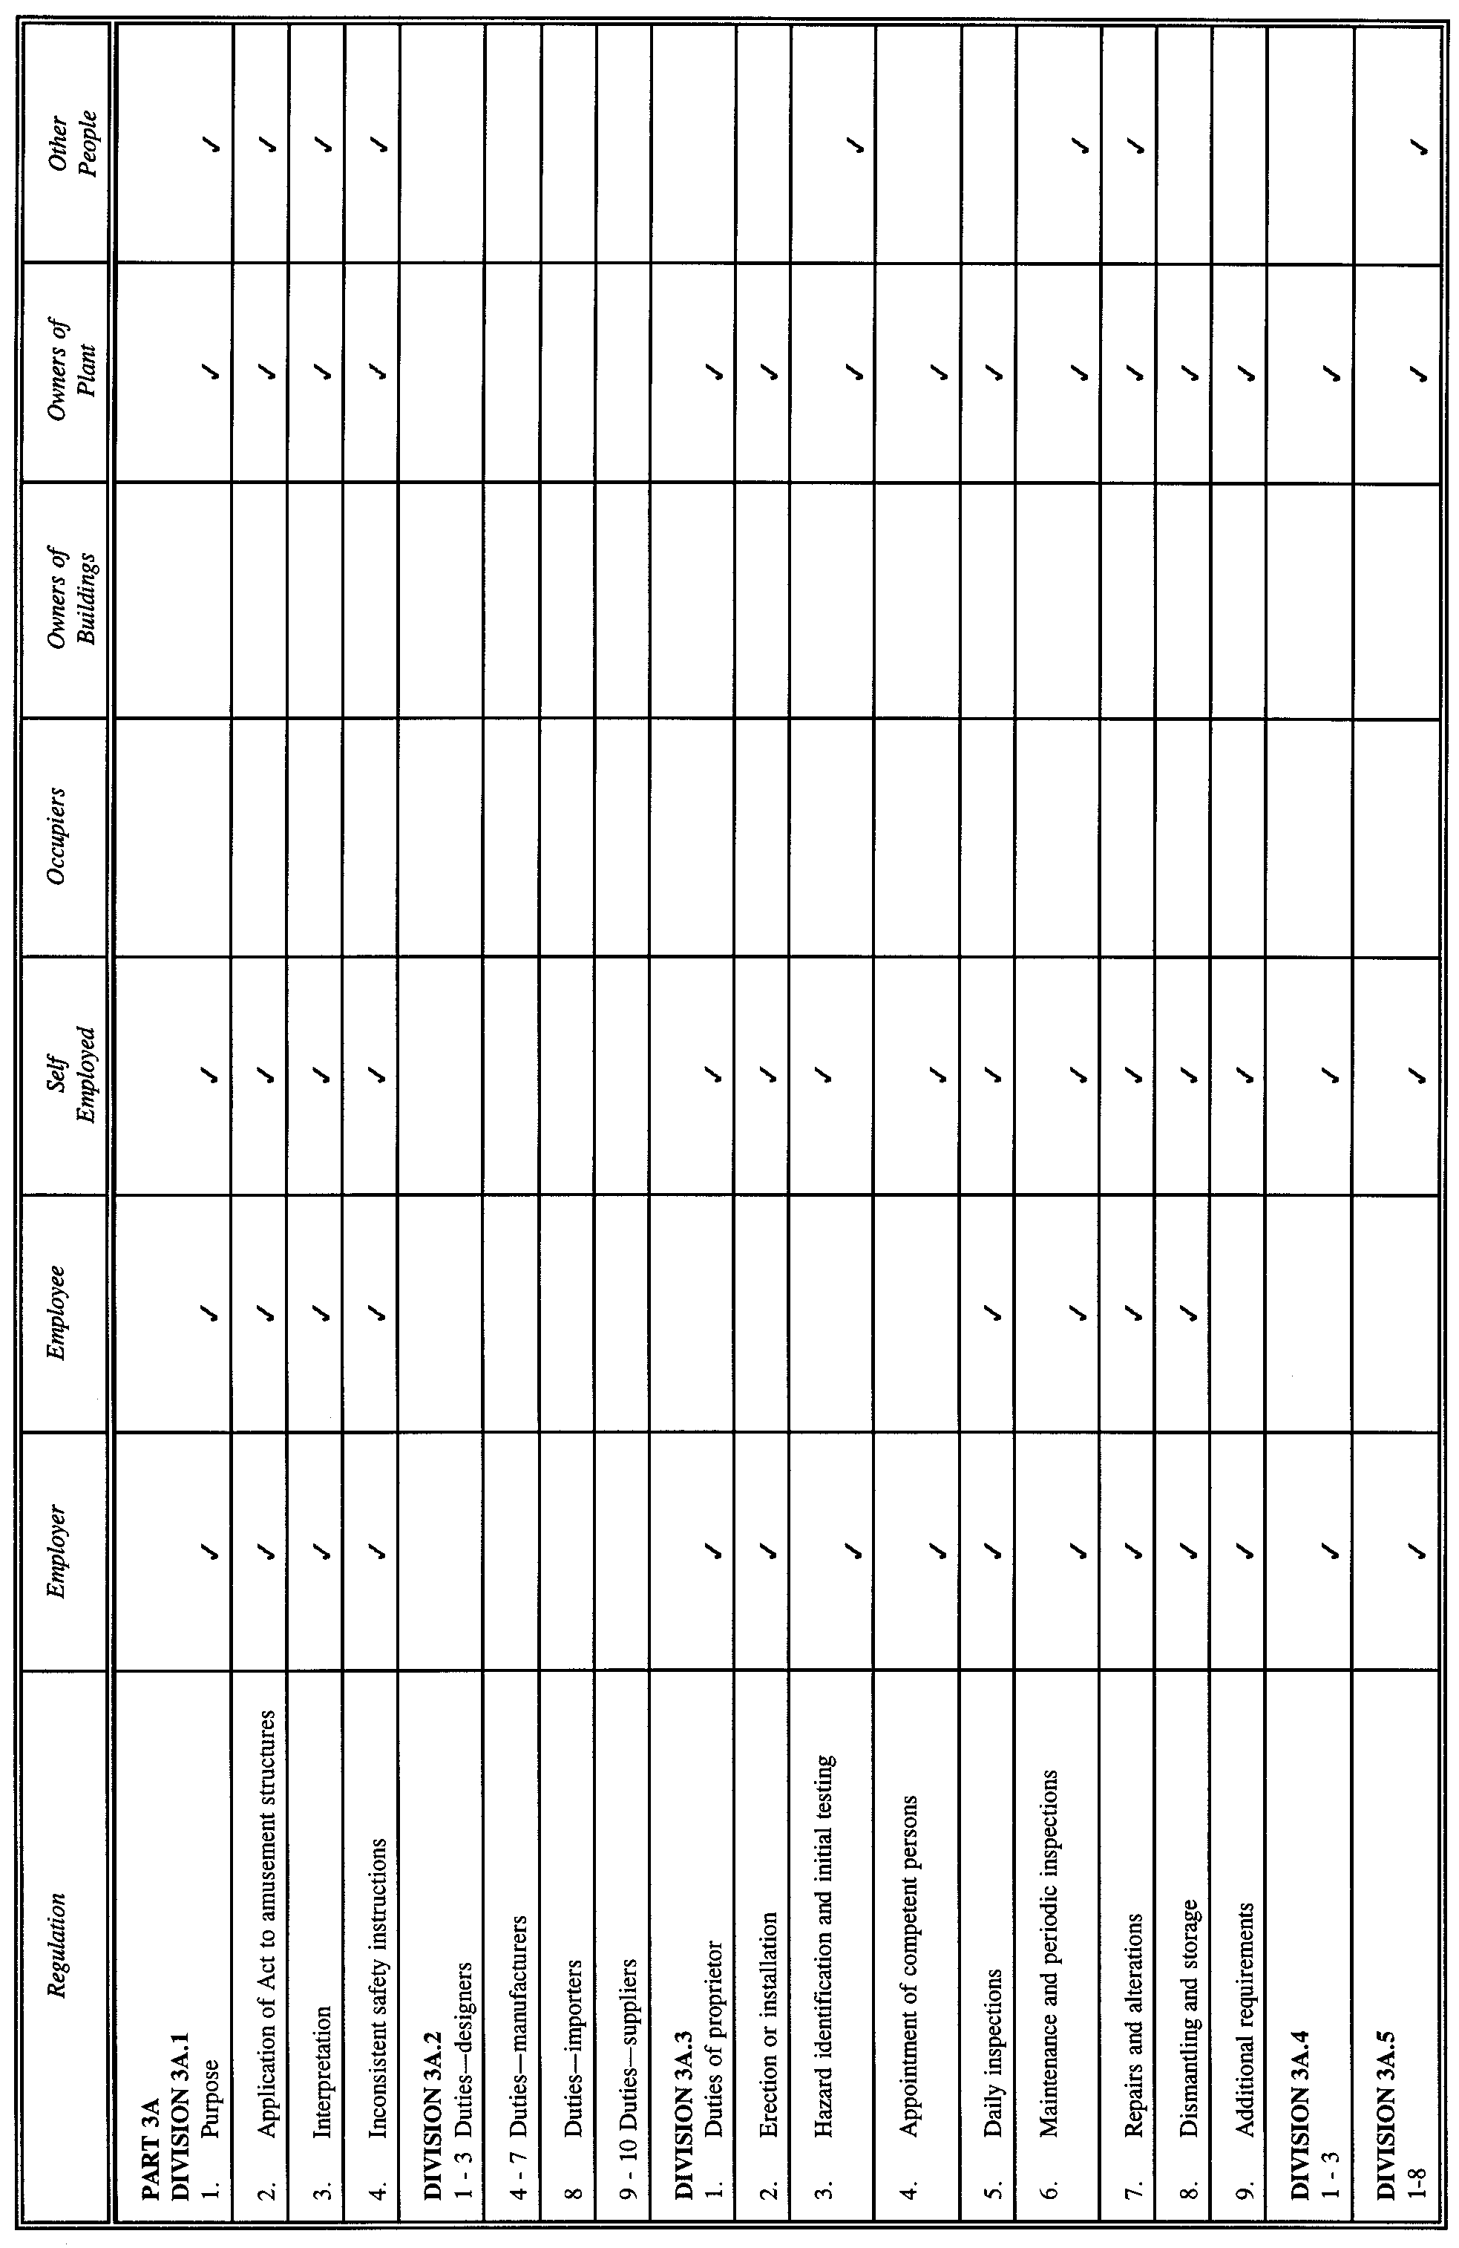

14. Schedule 2 of the principal regulations is varied by inserting the following references and ticks under the relevant headings that appear in that schedule (as indicated by the headings set out below in italics^{2.})

^{2.} The headings in italics are provided for guidance purposes only and are not being inserted into the principal regulations by these regulations.

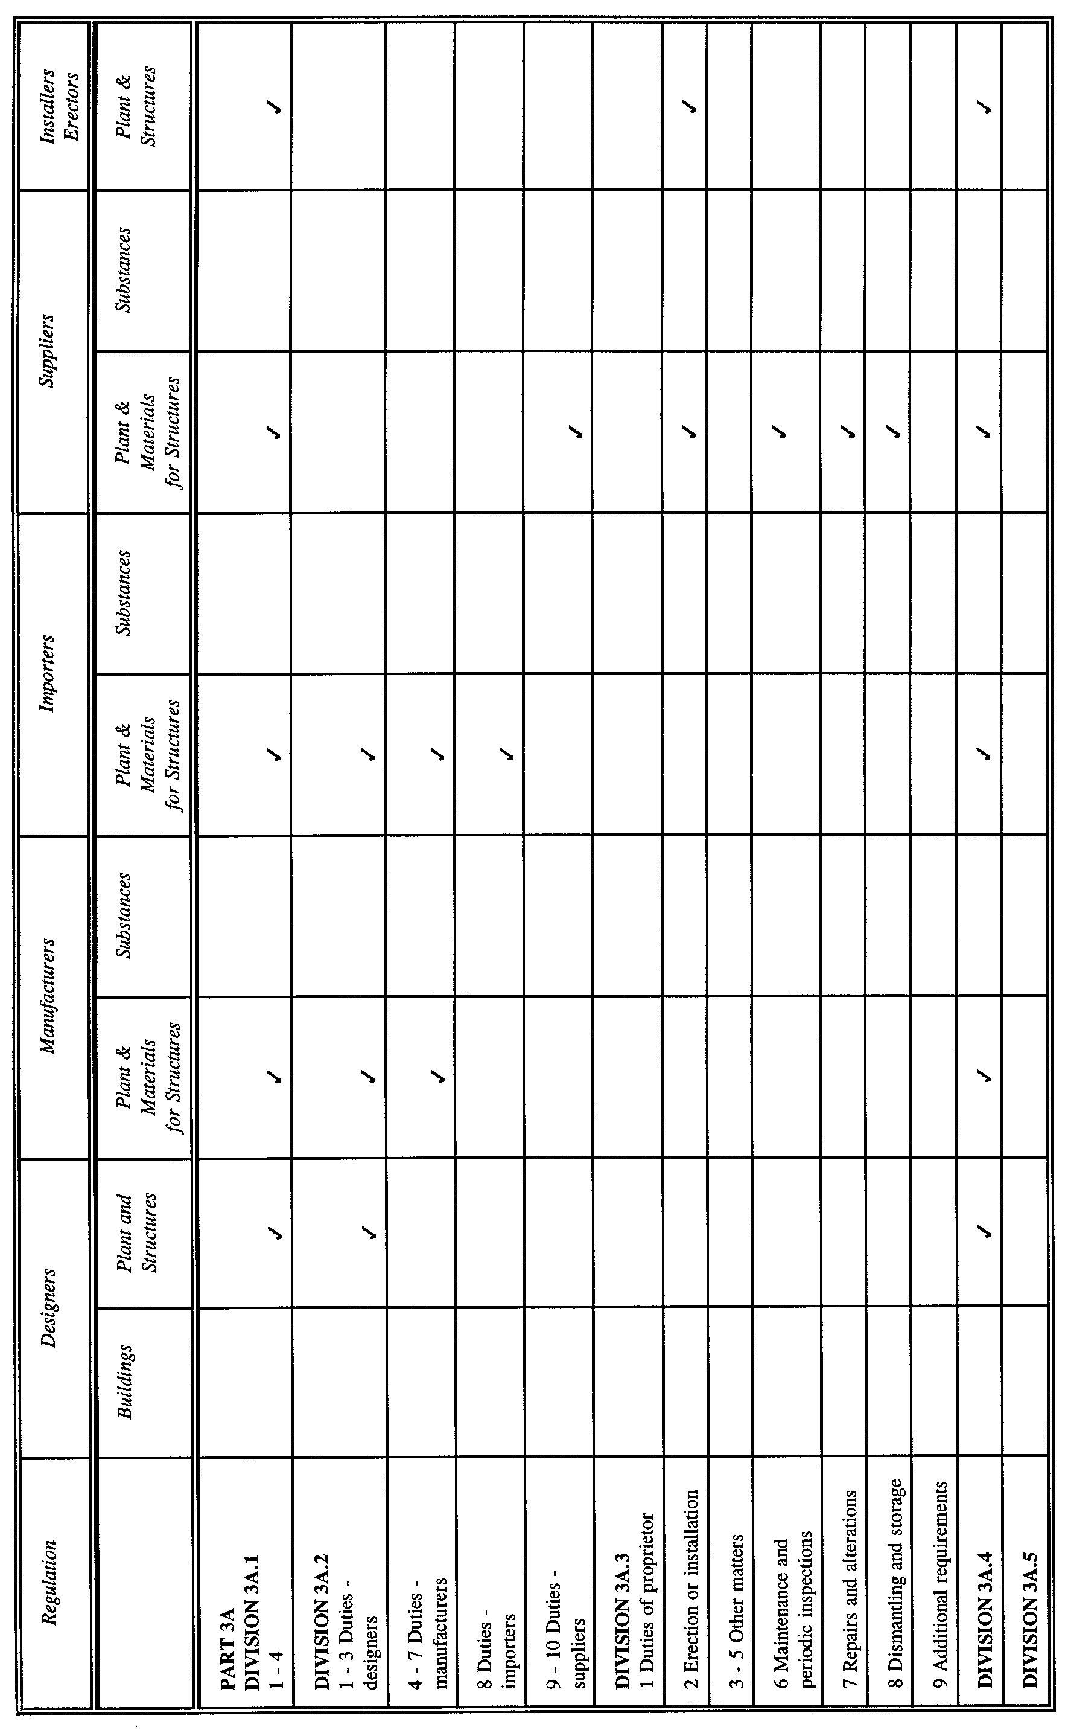

15. Schedule 3 of the principal regulations is varied by striking out the following item:

AS 3533 Amusement Rides and Devices.

Variation of Schedule 4
16. Schedule 4 of the principal regulations is varied—

(a) by striking out item 8 of Part 1;

(b) by striking out item 6 of Part 2.

Variation of Schedule 8
17. Schedule 8 of the principal regulations (as inserted in the principal regulations on 1 July 2001) is varied—

(a) by inserting after item 2 the following item:

2A. Application fee for the registration of an amusement structure design under Part 3A,
or for the re-registration of an amusement structure design (reg. 3A.5.2) $72.50;

(b) by inserting after item 4 the following item:

4A. Application fee for the registration, or re-registration, of an amusement structure
under Part 3A $41.50.

MWR 01/010 CS R. DENNIS Clerk of the Council

FAXING COPY?

IF you fax copy to Government Publishing SA for inclusion in the Government Gazette, there is no need to send a Confirmation Copy to us as well.

This creates confusion and may well result in your notice being printed twice.

Please use the following fax number:

Fax transmission: (08) 8207 1040
Phone Inquiries: (08) 8207 1045

Please include a contact person, phone number and order number so that we can phone back with any queries we may have regarding the fax copy.

NOTE: Closing time for lodging new copy (either fax or hard copy) is 4 p.m. on Tuesday preceding the day of publication.

Government Gazette notices can be E-mailed.

The address is:

governmentgazette@saugov.sa.gov.au

Documents should be sent as attachments in Word format.

When sending a document via E-mail, please confirm your transmission with a faxed copy of your document, including the date the notice is to be published.

Fax transmission: (08) 8207 1040
Enquiries: (08) 8207 1045

CITY OF ADELAIDE
Declaration of Public Roads
NOTICE is hereby given pursuant to section 210 of the Local Government Act 1999, that at a future meeting council intends to declare the following roads to be public roads:
Advertiser Lane, Advertiser Place, Post Office Lane and Post Office Place in town acres 201 and 202, delineated as the said named roads plus the road marked ‘X’ on LTO Plan FP35790 with the road marked ‘X’ to be limited to a height of 4.27 m above the level of the footpath in Waymouth Street.
Susan Law, Chief Executive Officer

Declaration of Public Road
NOTICE is hereby given pursuant to section 210 of the Local Government Act 1999, that at a future meeting, council intends to declare the following road to be public road:
The unnamed road in town acre 487 and to the west of Surflen Street, delineated as private road on LTO plan DP45105.
Susan Law, Chief Executive Officer

Declaration of Public Roads
NOTICE is hereby given pursuant to section 210 of the Local Government Act 1999, that at a future meeting, council intends to declare the following roads to be public roads:
1. Blackburn Street in town acres 653 and 670 which is delineated as allotment 35 on LTO Plan DP221.
2. Louisa Street in town acres 652 and 671 which is delineated as allotment 34 and labelled Frederick Street on LTO Plan DP221.
3. The unnamed roads in town acres 652, 653, 670 and 671 which is delineated as allotments 35, 36, 37 and 38 on LTO Plan DP221 and includes partially cancelled certificate of title volume 64, folio 140.
4. The unnamed road in town acre 654 delineated as private road on LTO Plan A-916 and contained in partially cancelled certificate of title volume 12, folio 116.
5. The unnamed roads in town acres 653 and 670 which are delineated as private road on LTO Plan A-916 and includes certificate of title volume 140, folio 72.
6. Charlotte Place in town acres 672 and 673 which is delineated as Charlotte Place on LTO Plan FPX26296.
7. The unnamed road in town acres 672 and 673 delineated as marked ‘A’ on LTO Plan FPX26296.
8. Charlotte Street in town acres 650 and 673 which is delineated as Charlotte Street on LTO Plan B-2047 and includes certificate of title volume 5550, folio 790.
9. Cromwell Street in town acre 647 which is delineated as Cromwell Street on LTO Plan B-2047.
10. The unnamed road in town acres 675 and 676 which is delineated as private road on LTO Plan B-2047 and is contained in partially cancelled certificates of title volume 646, folios 184 and 185, volume 647, folio 35 and volume 666, folio 92.
11. Cromwell Alley in town acre 647 delineated as the private road on LTO Plan B-2047 excluding the land contained in certificate of title volume 5067, folio 404.
Susan Law, Chief Executive Officer

CITY OF BURNSIDE
Adoption of Valuation and Declaration of Rates
NOTICE is hereby given that the Burnside Council, at a meeting held on Tuesday, 5 June 2001, pursuant to its powers contained in section 167 of the Local Government Act 1999, adopted the most recent valuations of the Valuer-General available to the council, totalling $5 199 071 500 for the financial year ending 30 June 2002.
The said valuation is included in the Assessment Record, which is held in the office of the Council, 401 Greenhill Road, Tusmore and may be inspected by any person between the hours of 8.30 a.m. and 5 p.m. Monday to Friday.
Declaration of General Rate
That pursuant to its powers contained in section 153 of the Local Government Act 1999, and in order to raise the amount required by the rates determination statement council declare:
(i) a general rate of 0.00338 cents in the dollar on the capital value of all rateable land within its area for the financial year ending 30 June 2002;
(ii) pursuant to section 158 (1) (a) of the Local Government Act 1999, a minimum amount payable in respect of the said general rates in respect to rateable land within its area to be fixed at $450.
Declaration of Separate Rate—River Torrens Catchment Water Management Board
In exercise of the powers contained in section 138 of the Water Resources Act 1997 and Chapter 10 of the Local Government Act 1999, and in order to reimburse to the council the amount the council collects on behalf of the River Torrens Catchment Water Management Board, being $413 000 for the financial year ending 30 June 2002, a separate rate of 0.000125 cents in the dollar, based on the Capital Value of rateable land, be declared on all rateable land in the council’s area in the catchment area of that Board.
Declaration of Separate Rate—Patawalonga Catchment Water Management Board
In exercise of the powers contained in section 138 of the Water Resources Act 1997 and Chapter 10 of the Local Government Act 1999, and in order to reimburse to the council the amount the council collects on behalf of the Patawalonga Catchment Water Management Board, being $162 800 for the financial year ending 30 June 2002, a separate rate of 0.000099 cents in the dollar, based on the Capital Value of rateable land, be declared on all rateable land in the council’s area in the catchment area of that Board.
Payment
Pursuant to section 181 (1) (a) of the Local Government Act 1999, the council resolved that the rates (general and separate) declared by these resolutions, be payable in four equal or approximately equal instalments due on 14 September 2001 and 14 December 2001, and 14 March 2002 and 14 June 2002.
Rating Policy
That pursuant to section 171 of the Local Government Act 1999, the amended rating policy be adopted and a summary accompany and be distributed with the rates notices.
R. W. S. Donne, Chief Executive Officer

CITY OF BURNSIDE
Classification of Community Land
NOTICE is hereby given that at its meeting held on Wednesday, 23 May 2001, council resolved that the following property, owned by the City of Burnside, be classified as Community Land, such land having previously been excluded from classification:
Burnside War Memorial Hospital
120 Kensington Road, Toorak Gardens
Certificate of Title Volume 5431, Folio 670
Allotment 8, Section 275, Filed Plan 141069
R. W. S. Donne, Chief Executive Officer

CITY OF CHARLES STURT
Adoption of Valuations and Declaration of Rates
NOTICE is hereby given that at its meeting held on 12 June 2001, the council:
1. Adoption of the most recent capital valuations of the Valuer-General that are to apply in its area for rating purposes for the 2001-2002 financial year, totalling $8 103 958 920.
2. Declared differential general rates on rateable land within its areas as follows:
(a) 0.4113 cents in the dollar on rateable land of Category 1 use;
(b) 0.7954 cents in the dollar on rateable land of Categories 2, 3 and 4 use;
(c) 0.8634 cents in the dollar on rateable land of Categories 5 and 6 use;
(d) 1.1189 cents in the dollar on rateable land of Category 7 use;
(e) 1.0517 cents in the dollar on rateable land of Category 8 use;
(f) 0.7171 cents in the dollar on rateable land of Category 9 use.
3. Declared a minimum rate of $400 for rateable land in the council’s area.
4. Declared separate rates as follows:
In exercise of the powers contained in section 138 of the Water Resources Act 1997 and section 154 of the Local Government Act 1999 and in order to reimburse to the council the amount contributed to:
(a) the River Torrens Catchment Water Management Board for the council’s area, being a separate rate of 0.012527 cents in the dollar, based on the capital value of rateable land, on all rateable land in the council’s area in the catchment area of the Board, the capital value of such land comprising $7 561 894 200; and
(b) the Patawalonga Catchment Water Board for the council’s area, being a separate rate of 0.01022 cents in the dollar, based on the capital value of rateable land, on all rateable land in the council’s area in the catchment area of the Board, the capital value of such land comprising $140 958 500.
Dated 13 June 2001.
P. Lockett, Chief Executive Officer

CITY OF NORWOOD, PAYNEHAM AND ST PETERS
Supplementary Election—Trinity Ward
NOTICE is hereby given that at the close of nominations at 12 noon on Thursday, 14 June 2001, the following persons have been accepted as candidates and are listed in the order in which they will appear on the ballot paper:
Councillor: (one vacancy)
Moore, Evonne
Hatley, Frederika
Owen, Margaret
Izzo, Joe
Short, Lewis
Manser, Lance
Andrews, Darren
Postal Voting
The election will be conducted entirely by postal voting. No polling booth will be open for voting on polling day. Voting is not compulsory.
Voting material will be dispatched by post to every natural person, body corporate and group listed on the voters’ roll as at roll closure on 30 April 2001.
The mailout will commence on 26 June 2001, with all voting materials to be delivered by 2 July 2001.
A person who has not received voting material and who believes that he or she is entitled to vote should apply to the State Electoral Office on 8401 4323.
A pre-paid addressed envelope for each elector entitlement will be provided. Completed ballot material must be returned to reach the Returning Officer no later than 12 noon on Monday, 16 July 2001.
A ballot box will be provided at the Council Office, 175 The Parade, Norwood for electors who wish to personally deliver their completed ballot material during office hours.
Place of Counting Votes
The scrutiny and counting of votes will take place at the Norwood Town Hall as soon as practicable after 12 noon on Monday, 16 July 2001. A provisional declaration will be made at the conclusion of the election count.
Campaign Donations Return
Candidates must forward a campaign donations return to the Council Chief Executive Officer within six weeks after the conclusion of the election.
S. H. Tully, Returning Officer

CITY OF UNLEY
Adoption of Valuation
NOTICE is hereby given that the Corporation of the City of Unley in accordance with section 167 (2) (a) of the Local Government Act 1999, at a meeting held on 4 June 2001 adopted for the year ending 30 June 2002 the Government assessment of capital value being $3 969 704 200 as detailed in the valuation roll prepared by the Valuer-General in relation to the areas of the Corporation of the City of Unley and hereby specifies 1 July 2001 as the day as and from which such valuation shall become and be the valuation of the council.
Declaration of Rates
Notice is hereby given that at a meeting held on Monday,
4 June 2001, the Corporation of the City of Unley in accordance with section 156 (1) (a) of the Local Government Act 1999, declared differential general rates based upon the capital value of the land subject to the rate, for the year ending 30 June 2002, as follows:
(a) in respect to rateable property which is categorised by land use Category 1—Residential in Regulation 10 of the Local Government (General) Regulations 1999 as a prescribed permissible differentiating factor a differential general rate of 0.3810 cents in the dollar;
(b) in respect to rateable property which is categorised by land use Category 2—Commercial—Shop, Category 5—Industry—Light, Category 6—Industry—Other, Cate-gory 7—Primary Production, Category 8—Vacant Land and Category 9—Other in Regulation 10 of the Local Government (General) Regulations 1999 as a prescribed permissible differentiating factor a differential general rate of 0.6984 cents in the dollar;
(c) in respect to rateable property which is categorised by land use Category 3—Commercial—Office and Category 4—Commercial—Other in Regulation 10 of the Local Government (General) Regulations 1999 as prescribed permissible differentiating factors a differential general rate of 1.1252 cents in the dollar.
Pursuant to section 158 of the Local Government Act 1999, the council fixed a minimum amount that shall be payable by way of rates on all rateable properties within the whole of the municipality for the year ending 30 June 2002 at $420.
Pursuant to section 154 of the Local Government Act 1999, and in respect to all rateable properties within the City of Unley a separate rate of 0.010053 cents in the dollar was declared as the Catchment Environment Levy under the Water Resources Act 1997.
Pursuant to section 154 of the Local Government Act 1999, for the year ending 30 June 2002 the following differential separate rates are declared on all rateable land based upon capital value of the land, subject to the rate as follows:
1. In order to raise the amount of $40 000 to carry out the project of promoting and enhancing business viability, profitability, trade and commerce in that part of the council’s area comprising rateable land with an Unley Road address, a differential separate rate, in respect of land uses:
Category 2—Commercial—Shop; Category 3—Commer-cial—Office and Category 4—Commercial—Other 0.0358 cents in the dollar.
2. In order to raise the amount of $24 500 to carry out the project of promoting and enhancing business viability, profitability, trade and commerce in that part of the council’s area comprising rateable land with a Goodwood Road address and situated between Mitchell Street/Arundel Avenue to the south and Leader Street/Parsons Street to the north, a differential separate rate in respect of land uses:
Category 2—Commercial—Shop; Category 3—Commer-cial—Office and Category 4—Commercial—Other 0.1675 cents in the dollar.
3. In order to raise the amount of $30 000 to carry out the project of promoting and enhancing business viability, profitability, trade and commerce in that part of the council’s area comprising rateable land with a King William Road address and situated between Greenhill Road and Commercial Road (eastern side), a differential separate rate in respect of land uses:
Category 2—Commercial—Shop 0.1266 cents in the dollar.
4. In order to raise the amount of $12 500 to carry out the project of promoting and enhancing business viability, profitability, trade and commerce in that part of the council’s area comprising rateable land along the western side of Glen Osmond Road and situated between Greenhill Road and Katherine Street, a differential separate rate in respect of:
Category 2—Commercial—Shop 0.1393 cents in the dollar.
R. Green, City Manager

ADELAIDE HILLS COUNCIL
Change of Road Names
NOTICE is hereby given that pursuant to section 219 of the Local Government Act 1999, council resolved to name the previously unnamed roads as follows:
The short length of public road, which runs north-east from Mount Barker Road to the Onkaparinga Valley Road at Verdun, will be known as Red Road.
The short length of public road, which runs north from the Adelaide-Mannum Road approximately 650 m east from the Kenton Hill Road/Rust Road/Albert Street junction at Gumeracha will be known as Benalla Road.
Notice is hereby given that pursuant to section 219 of the Local Government Act 1999, council resolved that the previously named roads be renamed:
Summit Road, Crafers from the South Eastern Freeway to Greenhill Road be renamed Mount Lofty Summit Road.
Summit Road, Crafers West from the South Eastern Freeway to Waverley Ridge Road be renamed Waverley Ridge Road.
R. D. Blight, Chief Executive Officer

DISTRICT COUNCIL OF CLEVE
Adoption of Valuations
NOTICE is hereby given that the District Council of Cleve in accordance with section 167 of the Local Government Act 1999, at a meeting held on 15 June 2001, adopted for the year ending 30 June 2002, the site valuations made by the Valuer-General in relation to the area of the council, being the most recent valuations available and totalling $90 852 600.
Declaration of Rates and Charges
Notice is hereby given pursuant to section 170 of the Local Government Act 1999, that the District Council of Cleve at a meeting held on 15 June 2001, declared the following rates and charges for the year ending 30 June 2002:
1. Pursuant section 153 of the Local Government Act 1999, differential general rates based on the site value of land according to locality as hereunder:
Arno Bay Town 5.3335 cents in the dollar
Arno Bay—Coastal Zone 3.1232 cents in the dollar
Cleve Town 3.2720 cents in the dollar
Cleve—Rural Living/Fringe
Zone 2.6137 cents in the dollar
Towns of Kielpa, Caralue,
Rudall and Darke Peak 50.000 cents in the dollar
Outside of towns—Rural 1.0075 cents in the dollar
Special Industry Zone
(SACBH Silos) 43.1088 cents in the dollar
2. Pursuant to section 158 of the Local Government Act 1999, a minimum amount that shall be payable by way of rates on rateable properties of $250.
3. Pursuant to section 155 of the Local Government Act 1999, annual service charges payable on land serviced by prescribed services as hereunder:
Cleve Common Effluent Drainage
Scheme $90 per unit
Arno Bay Foreshore Waste Drainage and
Treatment Scheme $110 per unit
Common Antenna TV Retransmission
Service $55 per unit
4. Pursuant to section 154 of the Local Government Act 1999, a separate rate of 10.4667 cents in the dollar payable on the site value of the following specified land at Arno Bay undergoing the shack site freeholding process, which activity, the council has agreed to support. Allotment Nos 5, 7, 10, 12, 14, 16, 19, 22 and 25 of D35669, Hundred of Boothby, Arno Bay.
Rating Policy
Pursuant to section 171 of the Local Government Act 1999, the District Council of Cleve has prepared and adopted a rating policy in conjunction with the declaration of rates and charges for the 2001-2002 financial year. A summary version of the policy will accompany each rates notice sent to ratepayers and copies of the policy are available at the council office.
Payment of Rates and Discounts
The District Council of Cleve has resolved pursuant to section 181 of the Local Government Act 1999, that rates shall be payable by four equal or approximately equal instalments due on the 15th days of September, December, March and June for the 2001-2002 financial years.
Pursuant to section 181 (11) of the Act, a discount of 2 per cent is offered if the annual rates amount is paid in full, prior to 16 September 2001.
F. L. Gillings, Chief Executive Officer

DISTRICT COUNCIL OF ELLISTON
Supplementary Election—Anxious Bay Ward
NOTICE is hereby given that at the close of nominations at 12 noon on Thursday, 14 June 2001, the following persons have been accepted as candidates and are listed in the order in which they will appear on the ballot paper:
Councillor: (one vacancy)
Wright, John
Little, Denise D.
Postal Voting
The election will be conducted entirely by postal voting. No polling booth will be open for voting on polling day. Voting is not compulsory.
Voting material will be dispatched by post to every natural person, body corporate and group listed on the voters’ roll as at roll closure on 30 April 2001.
The mailout will commence on 26 June 2001, with all voting materials to be delivered by 2 July 2001.
A person who has not received voting material and who believes that he or she is entitled to vote should apply to the District Council of Elliston, Beach Terrace, Elliston on 8687 9177.
A pre-paid addressed envelope for each elector entitlement will be provided. Completed ballot material must be returned to reach the Deputy Returning Officer no later than 12 noon on 16 July 2001.
A ballot box will be provided at the Council Office, Beach Terrace, Elliston for electors who wish to personally deliver their completed ballot material during office hours.
Place of Counting Votes
The scrutiny and counting of votes will take place at the District Council of Elliston, Beach Terrace, Elliston as soon as practicable after 12 noon on Monday, 16 July 2001. A pro-visional declaration will be made at the conclusion of the election count.
Campaign Donations Return
Candidates must forward a campaign donations return to the Council Chief Executive Officer within six weeks after the conclusion of the election.
S. H. Tully, Returning Officer

LIGHT REGIONAL COUNCIL
Temporary Road Closure
NOTICE is hereby given that pursuant to the provisions of Section 359 of the Local Government Act 1934, as amended, Council resolved that Argent Road, at the intersection of the Sturt Highway at Gawler, be closed to all traffic, with the exception of emergency vehicles and authorised service vehicles, from Friday, 22 June 2001, up to and including Wednesday, 4 July 2001, for the purpose of the construction of the intersection.
P. J. Beare, Chief Executive Officer

DISTRICT COUNCIL OF MOUNT REMARKABLE
Supplementary Election—Willochra Ward
NOTICE is hereby given that at the close of nominations at 12 noon on Thursday, 14 June 2001, the following persons have been accepted as candidates and are listed in the order in which they will appear on the ballot paper:
Councillor: (one vacancy)
Hitch, Neville Thomas
Modystach, John V.
Postal Voting
The election will be conducted entirely by postal voting. No polling booth will be open for voting on polling day. Voting is not compulsory.
Voting material will be dispatched by post to every natural person, body corporate and group listed on the voters’ roll as at roll closure on 30 April 2001.
The mailout will commence on 26 June 2001, with all voting materials to be delivered by 2 July 2001.
A person who has not received voting material and who believes that he or she is entitled to vote should apply to the State Electoral Office on 8401 4322.
A pre-paid addressed envelope for each elector entitlement will be provided. Completed ballot material must be returned to reach the Returning Officer no later than 12 noon on Monday, 16 July 2001.
A ballot box will be provided at the Council Office, Stuart Street, Melrose for electors who wish to personally deliver their completed ballot material during office hours.
Place of Counting Votes
The scrutiny and counting of votes will take place at the District Council of Mount Remarkable Council Chambers as soon as practicable after 12 noon on Monday, 16 July 2001. A provisional declaration will be made at the conclusion of the election count.
Campaign Donations Return
Candidates must forward a campaign donations return to the Council Chief Executive Officer within six weeks after the conclusion of the election.
S. H. Tully, Returning Officer

DISTRICT COUNCIL OF YANKALILLA
Roads (Opening and Closing) Act 1991
NOTICE is hereby given pursuant to section 10 of the Roads (Opening and Closing) Act 1991, that the District Council of Yankalilla proposes to make a Road Process Order to firstly close and transfer that portion of public road marked ‘A’ on the Preliminary Plan No. PP32/0658.
Transfer ‘A’ to P. and B. Norman, 16 Gagarin Street, Modbury North, S.A. 5092, administrators of R. H. Norman deceased 31 October 1883, and to merge that portion with certificate of title volume 5695, folio 998.
Secondly, the District Council of Yankalilla also proposes to make a Road Process Order to open roads, in exchange for the road closure mentioned above, those portions marked ‘1’ and ‘2’ on the Preliminary Plan No. PP32/0658, and currently contained within certificate of title volume 5695, folio 998, Hundred of Yankalilla.
A statement of persons affected by the proposed road process together with a copy of the preliminary plan is available for inspection at the offices of the District Council of Yankalilla, Main Road, Yankalilla, during normal office hours. Copies may also be inspected at the Adelaide office of the Surveyor-General, 101 Grenfell Street, Adelaide, during normal office hours.
Any person is entitled to object to the proposed road process, or any person affected by the proposed road process, or any person affected by the proposed closure is entitled to apply for an easement to be granted in that person’s favour over the land subject to the proposed closure. Such objection or application for an easement must set out the full name and address of the person making the objection of application and must be fully supported by reasons. Any application for an easement must give full particulars of the nature and location of the easement and, where made by a person as the owner of adjoining land or nearby land, specify the land to which the easement is to be annexed.
The objection or application for an easement must be made in writing to the District Council of Yankalilla, P.O. Box 9, Yankalilla, S.A. 5203; within 28 days of this notice, and a copy shall be forwarded to the Adelaide office of the Surveyor-General, G.P.O. Box 1354, Adelaide, S.A. 5001. Where a submission is made, the District Council of Yankalilla will give notification of a meeting at which the matter will be considered, so that the person making the submission or a representative may attend, if desired.
Dated 21 June 2001.
R. Sweetman, Chief Executive Officer

IN the matter of the estates of the undermentioned deceased persons:
Baranow, Vera, late of 172 Trimmer Parade, Seaton, of no occupation, who died on 24 April 2001.
Dawson, Marjory Winifred, late of 160 O.G. Road, Felixstow, of no occupation, who died on 14 April 2001.
Drysdale, Andrew, late of 160 Walkerville Terrace, Walkerville, retired machinist, who died on 30 March 2001.
Elliott, Douglas, late of Martin Terrace, Kimba, retired boilermaker, who died on 19 May 2001.
Grime, Daphne Lorna, late of 7 Laura Street, Stepney, home duties, who died on 29 April 2001.
Grindley, Lawrence Steve, late of 2 Tuit Road, Aldinga, retired contractor, who died on 4 December 2000.
Hancock, Doris Gaynor, late of Parilla, home duties, who died on 19 November 2000.
Harvy, Dulcie Myra, late of Grand Junction Road, Oakden, of no occupation, who died on 12 February 2001.
Hayman, Blanche, late of 101 Lake Terrace East, Mount Gambier, widow, who died on 7 April 2001.
James, Mabel Melva, late of 19 Mills Street, Clarence Park, home duties, who died on 24 April 2001.
Jeffery, Peter Charles, late of 32 Eaton Street, Cumberland Park, retired public servant, who died on 21 April 2001.
Jones, Patricia Lorraine, late of 18 Wallala Avenue, Park Holme, widow, who died on 20 April 2001.
Mills, Mavis Pearl, late of 342 Marion Road, North Plympton, retired salesperson, who died on 11 May 2001.
Phillips, Russell Walter, late of 15-21 Seymour Avenue, Modbury, retired recorder, who died on 20 March 2001.
Webb, Ada Jean, late of 81 Tapleys Hill Road, Hendon, of no occupation, who died on 6 March 2001.
Williams, Frank, late of 60B Holder Road, North Brighton, retired soldier, who died on 14 May 2001.
Williams, Rona Daphne, late of 34 Hospital Road, Port Augusta, home duties, who died on 25 March 2001.
Notice is hereby given pursuant to the Trustee Act 1936, as amended, the Inheritance (Family Provision) Act 1972, and the Family Relationships Act 1975, that all creditors, beneficiaries, and other persons having claims against the said estates are required to send, in writing, to the Public Trustee, 25 Franklin Street, Adelaide 5000, full particulars and proof of such claims, on or before 20 July 2001, otherwise they will be excluded from the distribution of the said estate; and notice is also hereby given that all persons who are indebted to the said estates are required to pay the amount of their debts to the Public Trustee or proceedings will be taken for the recovery thereof; and all persons having any property belonging to the said estates are forthwith to deliver the same to the Public Trustee.
Dated 21 June 2001.
J. H. Worrall, Public Trustee

SALE OF PROPERTY
Auction Date: Wednesday, 4 July 2001 at 10 a.m.
Location: Government Auctions SA
47 Transport Avenue, Netley
NOTICE is hereby given that on the above date at the time and place stated, by virtue of Order for Sale issued by the Fines Payment Unit of South Australia—Penalty No. EXREG—98—8952/1 and others, are directed to the Sheriff of South Australia in an action wherein Koenraad Willem Kous is the Defendant, I, Tim Goodes, Sheriff of the State of South Australia, will by my auctioneers, Government Auctions SA make sale of the following:
EA Ford Fairmont Ghia sedan
Registration Number: VCD 424

SALE OF PROPERTY
Auction Date: Wednesday, 4 July 2001 at 10 a.m.
Location: Government Auctions SA
47 Transport Avenue, Netley
NOTICE is hereby given that on the above date at the time and place stated, by virtue of Order for Sale issued by the Fines Payment Unit of South Australia—Penalty No. EXREG—00—78265/1 and others, are directed to the Sheriff of South Australia in an action wherein Matthew Lucas Macaitis is the Defendant, I, Tim Goodes, Sheriff of the State of South Australia, will by my auctioneers, Government Auctions SA make sale of the following:
XF Ford Falcon sedan
Registration Number: UET 612

SALE OF PROPERTY
Auction Date: Wednesday, 4 July 2001 at 10 a.m.
Location: Government Auctions SA
47 Transport Avenue, Netley
NOTICE is hereby given that on the above date at the time and place stated, by virtue of Order for Sale issued by the Fines Payment Unit of South Australia—Penalty No. EXREG—99—61570/1 and others, are directed to the Sheriff of South Australia in an action wherein Thomas Parsons is the Defendant, I, Tim Goodes, Sheriff of the State of South Australia, will by my auctioneers, Government Auctions SA make sale of the following:
Mitsubishi L300 Express van
Registration Number: VGN 113

ATTENTION

CUSTOMERS requiring a proof of their notice for inclusion in the Government Gazette, please note that the onus is on you
to inform Government Publishing SA of any subsequent corrections by 10 a.m. on Thursday, which is our publication deadline.

For any corrections to your notice please phone 8207 1045 or Fax 8207 1040 before 10 a.m. on Thursday.

If we do not receive any communication by 10 a.m. on Thursday (day of publication) we will presume the notice is correct and will print it as it is.

Remember—the onus is on you to inform us of any corrections necessary to your notice.

NOTE: Closing time for lodging new copy (either fax or hard copy) is 4 p.m. on Tuesday preceding the day of publication. Phone 8207 1045—Fax 8207 1040.

Printed and published by authority every Thursday by J. D. FERGUSON, Government Printer, South Australia
Price: $4.30, plus postage; to subscribers, $214.85 per annum.
(The above prices are inclusive of GST)

