No. 27 883

THE SOUTH AUSTRALIAN

GOVERNMENT GAZETTE

PUBLISHED BY AUTHORITY

ALL PUBLIC ACTS appearing in this GAZETTE are to be considered official, and obeyed as such

ADELAIDE, THURSDAY, 15 MARCH 2001

CONTENTS

Page
Appointments, Resignations, Etc. 886
Associations Incorporation Act 1985—Notice 888
Corporations and District Councils—Notices 940
Crown Lands Act 1929—Notice 889
Development Act 1993—Notices 889
Environment, Resources and Development Court Rules 890
Explosives Act 1936-1982—Notice 911
Fisheries Act 1982—Notices 915
Land and Business (Sale and Conveyancing) Act 1994—
Notice 917
Liquor Licensing Act 1997—Notices 918
Mining Act 1971—Notice 921
Mount Gambier Circuit Court—Notice 888
National Parks and Wildlife Act 1972—Notice 921
Proclamations 884
Public Sector Management Act 1995—Notice 923
Public Trustee Office—Administration of Estates 944

REGULATIONS
Harbors and Navigation Act 1993 (No. 20 of 2001) 930
Development Act 1993 (No. 21 of 2001) 932
Roads (Opening and Closing) Act 1991—Notices 921
Trade Standards Act 1979—Notice 922
Unclaimed Moneys Act 1891—Notice 945
Water Resources Act 1997—Notice 927

GOVERNMENT GAZETTE NOTICES
ALL poundkeepers’ and private advertisements forwarded for publication in the South Australian Government Gazette must be PAID FOR PRIOR TO INSERTION; and all notices, from whatever source, should be legibly written on one side of the paper only and sent to Government Publishing SA (formerly Riverside 2000) so as to be received no later than 4 p.m. on the Tuesday preceding the day of publication. Phone 8207 1045 or Fax 8207 1040. E-mail: governmentgazette@saugov.sa.gov.au. Send as attachments in Word format and please confirm your transmission with a faxed copy of your document, including the date the notice is to be published and to whom the notice will be charged.

FORESTRY ACT 1950 SECTION 3: DECLARATION OF NATIVE FOREST RESERVES
Proclamation By The Governor
(l.s.) E. J. Neal
PURSUANT to section 3 of the Forestry Act 1950 and with the advice and consent of the Executive Council, I—
(a) declare that each portion of forest reserve described in the schedule is a native forest reserve; and
(b) assign to each native forest reserve the name appearing in the schedule in italics above the description of the land comprising the reserve; and
(c) declare that each of the native forest reserves is established for the purposes of the conservation, development and management of the land of the reserve to support native flora and fauna.
Schedule
Mount Burr Forest District
1. Bagdad Native Forest Reserve:
Sections 150, 151, 174 and 175, Hundred of Waterhouse, more particularly delineated on the plan numbered GP 424/2000 deposited in the General Registry Office at Adelaide.
2. Burr Slopes South Native Forest Reserve:
Portions of sections 361 and 559, Hundred of Hindmarsh, more particularly delineated on the plan numbered GP 425/2000 deposited in the General Registry Office at Adelaide.
3. Gillap North Native Forest Reserve:
Portion of section 90, Hundred of Kennion, more particularly delineated on the plan numbered GP 436/2000 deposited in the General Registry Office at Adelaide.
4. Gillap South Native Forest Reserve:
Portion of section 213, Hundred of Kennion, more particularly delineated on the plan numbered GP 431/2000 deposited in the General Registry Office at Adelaide.
5. Glencoe Hill Native Forest Reserve:
Portion of section 450, Hundred of Hindmarsh, more particularly delineated on the plan numbered GP 544/2000 deposited in the General Registry Office at Adelaide.
6. Kay Native Forest Reserve:
Portions of sections 1, 105 and 115, Hundred of Riddoch, more particularly delineated on the plan numbered GP 428/2000 deposited in the General Registry Office at Adelaide.
7. Kennion Native Forest Reserve:
Section 56, Hundred of Kennion, more particularly delineated on the plan numbered GP 432/2000 deposited in the General Registry Office at Adelaide.
8. Konetta Native Forest Reserve:
Portions of sections 35, 36, 37 and 190, Hundred of Smith, more particularly delineated on the plan numbered GP 422/2000 deposited in the General Registry Office at Adelaide.
9. Long Native Forest Reserve:
Portions of section 428 and piece 1 of Filed Plan No. 33421, Hundred of Hindmarsh, more particularly delineated on the plan numbered GP 552/2000 deposited in the General Registry Office at Adelaide.
10. Malone Heath Native Forest Reserve:
Portions of sections 207 and 208, Hundred of Mount Muirhead, more particularly delineated on the plan numbered GP 429/2000 deposited in the General Registry Office at Adelaide.
11. McRosties Native Forest Reserve:
Portions of sections 274 and 275, Hundred of Riddoch, more particularly delineated on the plan numbered GP 451/2000 deposited in the General Registry Office at Adelaide.
12. Mount Benson Native Forest Reserve:
Portions of sections 10 and 15, Hundred of Mount Benson, more particularly delineated on the plan numbered GP 434/2000 deposited in the General Registry Office at Adelaide.
13. Mount McIntyre Native Forest Reserve:
Portions of sections 117 and 118, Hundred of Riddoch, more particularly delineated on the plan numbered GP 427/2000 deposited in the General Registry Office at Adelaide.
14. Mount Watch Native Forest Reserve:
Allotment 4 and portion of piece 1 of FP 33421, Hundred of Hindmarsh, more particularly delineated on the plan numbered GP 543/2000 deposited in the General Registry Office at Adelaide.
15. Native Wells Native Forest Reserve:
Portions of sections 450, 560 and 561, Hundred of Hindmarsh, more particularly delineated on the plan numbered GP 573/2000 deposited in the General Registry Office at Adelaide.
16. Overland Track Native Forest Reserve:
Portions of sections 125 and 275, Hundred of Riddoch, more particularly delineated on the plan numbered GP 575/2000 deposited in the General Registry Office at Adelaide.
17. Rock Shelter Native Forest Reserve:
Portion of section 268, Hundred of Riddoch, more particularly delineated on the plan numbered GP 426/2000 deposited in the General Registry Office at Adelaide.
18. Rocky Reserve Native Forest Reserve:
Portions of sections 39 and 55, Hundred of Kennion, more particularly delineated on the plan numbered GP 448/2000 deposited in the General Registry Office at Adelaide.
19. The Bluff Native Forest Reserve:
Portions of piece 13 of FP 38522 and piece 1 of FP 33421, Hundred of Hindmarsh, more particularly delineated on the plan numbered GP 608/2000 deposited in the General Registry Office at Adelaide.
20. The Woolwash Native Forest Reserve:
Portions of piece 13 of FP 38522 and piece 1 of FP 33421, Hundred of Hindmarsh, more particularly delineated on the plan numbered GP 607/2000 deposited in the General Registry Office at Adelaide.
21. Whennen Native Forest Reserve:
Section 116 and portions of sections 106 and 114, Hundred of Riddoch, more particularly delineated on the plan numbered GP 576/2000 deposited in the General Registry Office at Adelaide.
22. White Waterhole Native Forest Reserve:
Portions of sections 25 and 39, Hundred of Kennion, more particularly delineated on the plan numbered GP 430/2000 deposited in the General Registry Office at Adelaide.
23. Windy Hill Native Forest Reserve:
Portions of piece 1 of FP 33421, Hundred of Hindmarsh, more particularly delineated on the plan numbered GP 605/2000 deposited in the General Registry Office at Adelaide.
Mount Crawford Forest District
1. Coralinga Native Forest Reserve:
Section 513 and portions of sections 209 and 521, Hundred of Onkaparinga, more particularly delineated on the plan numbered GP 599/2000 deposited in the General Registry Office at Adelaide.
2. Kersbrook Native Forest Reserve:
Section 30 and portions of sections 99, 263, 266, 267 284, 285, 286 and 414, Hundred of Para Wirra, more particularly delineated on the plan numbered GP 606/2000 deposited in the General Registry Office at Adelaide.
3. Little Mount Crawford Native Forest Reserve:
Sections 147 and 148 and portions of sections 146 and 390, Hundred of Para Wirra, more particularly delineated on the plan numbered GP 600/2000 deposited in the General Registry Office at Adelaide.
4. Tower Hill Native Forest Reserve:
Section 416 and portions of section 6622 and allotment 204 of Filed Plan No. 34493, Hundred of Para Wirra, more particularly delineated on the plan numbered GP 547/2000 deposited in the General Registry Office at Adelaide.
Mount Gambier Forest District
1. Dry Creek Native Forest Reserve:
Section 577 and portions of sections 578 and 586, Hundred of Caroline, more particularly delineated on the plan numbered GP 446/2000 deposited in the General Registry Office at Adelaide.
2. Grundy Lane Native Forest Reserve:
Portions of sections 122, 123, 130 and 395, Hundred of Young, more particularly delineated on the plan numbered GP 440/2000 deposited in the General Registry Office at Adelaide.
3. Hacket Hill Native Forest Reserve:
Portions of sections 85, 86, 346, 347 and 369, Hundred of Young, more particularly delineated on the plan numbered GP 441/2000 deposited in the General Registry Office at Adelaide.
4. Hells Hole Native Forest Reserve:
Portions of sections 408 and 411, Hundred of Caroline, more particularly delineated on the plan numbered GP 439/2000 deposited in the General Registry Office at Adelaide.
5. Honan Native Forest Reserve:
Portions of sections 313 and 433, Hundred of Hindmarsh, and sections 4, 5, 9, 10, 237 and 355 and portions of section 3 and allotment 17 of DP 1762, Hundred of Young, more particularly delineated on the plan numbered GP 604/2000 deposited in the General Registry Office at Adelaide.
6. Honeysuckle Native Forest Reserve:
Portions of sections 199, 361, 365, 366 and 582, Hundred of Caroline, more particularly delineated on the plan numbered GP 550/2000 deposited in the General Registry Office at Adelaide.
7. Kangaroo Flat Native Forest Reserve:
Portions of sections 15, 24, 104, 105, 106 and 240, Hundred of Young, more particularly delineated on the plan numbered GP 549/2000 deposited in the General Registry Office at Adelaide.
8. Laslett Native Forest Reserve:
Portion of section 833, Hundred of Caroline, more particularly delineated on the plan numbered GP 438/2000 deposited in the General Registry Office at Adelaide.
9. Pond Flat Native Forest Reserve:
Portion of section 562, Hundred of Caroline, more particularly delineated on the plan numbered GP 435/2000 deposited in the General Registry Office at Adelaide.
10. Wandilo Native Forest Reserve:
Sections 114 and 115 and portions of sections 108, 109, 111, 112 and 113, Hundred of Young, more particularly delineated on the plan numbered GP 577/2000 deposited in the General Registry Office at Adelaide.
11. Warreanga Native Forest Reserve:
Portions of sections 387 to 392 inclusive and 404, 405, 407, 563 and 564, Hundred of Caroline, more particularly delineated on the plan numbered GP 437/2000 deposited in the General Registry Office at Adelaide.
Northern Forest District
King Tree Native Forest Reserve:
Sections 301 and 302, Hundred of Darling, more particularly delineated on the plan numbered GP 445/2000 deposited in the General Registry Office at Adelaide.
Penola Forest District
1. Boolara Native Forest Reserve:
Portions of sections 243 and 245, Hundred of Comaum, more particularly delineated on the plan numbered GP 447/2000 deposited in the General Registry Office at Adelaide.
2. Cave Range Native Forest Reserve:
Portions of sections 403 and 406, Hundred of Naracoorte, more particularly delineated on the plan numbered GP 423/2000 deposited in the General Registry Office at Adelaide.
3. Comaum Native Forest Reserve:
Portions of sections 247 and 248, Hundred of Comaum, more particularly delineated on the plan numbered GP 551/2000 deposited in the General Registry Office at Adelaide.
4. Deadmans Swamp Native Forest Reserve:
Portions of sections 17, 473 and 476, Hundred of Joanna, more particularly delineated on the plan numbered GP 574/2000 deposited in the General Registry Office at Adelaide.
5. Island Swamp Native Forest Reserve:
Portions of sections 110, 181 and 185, Hundred of Nangwarry, more particularly delineated on the plan numbered GP 449/2000 deposited in the General Registry Office at Adelaide.
6. Muddy Flat Native Forest Reserve:
Section 197 and portion of section 196, Hundred of Nangwarry, more particularly delineated on the plan numbered GP 450/2000 deposited in the General Registry Office at Adelaide.
7. Nangwarry Native Forest Reserve:
Portions of sections 343, 344, and 471, Hundred of Penola and portions of sections 188, 189, 234 and 235, Hundred of Nangwarry, more particularly delineated on the plan numbered GP 442/2000 deposited in the General Registry Office at Adelaide.
8. Round Waterhole Native Forest Reserve:
Portions of sections 333, 334, 337, 338, 341, 342 and 345, Hundred of Penola, more particularly delineated on the plan numbered GP 433/2000 deposited in the General Registry Office at Adelaide.
9. The Heath Native Forest Reserve:
Section 121 and portions of sections 102, 103 and 122, Hundred of Nangwarry, more particularly delineated on the plan numbered GP 546/2000 deposited in the General Registry Office at Adelaide.
10. Wombat Flat Native Forest Reserve:
Section 366 and portions of sections 273, 316, 317 and 318, Hundred of Comaum, more particularly delineated on the plan numbered GP 443/2000 deposited in the General Registry Office at Adelaide.
Southern Hills Forest District
1. Christmas Hill Native Forest Reserve:
Portions of sections 245, 246, 247, 248, 251, 252, 253, 275 and 285, Hundred of Kuitpo, more particularly delineated on the plan numbered GP 545/2000 deposited in the General Registry Office at Adelaide.
2. Kalamunda Native Forest Reserve:
Portions of sections 90, 101 and 109, Hundred of Yankalilla, more particularly delineated on the plan numbered GP 548/2000 deposited in the General Registry Office at Adelaide.
3. Mount Panorama Native Forest Reserve:
Portions of sections 204 and 205, Hundred of Kuitpo, more particularly delineated on the plan numbered GP 444/2000 deposited in the General Registry Office at Adelaide.
Given under my hand and the Public Seal of South Australia, at Adelaide, 15 March 2001.
By command,
Mark Brindal, for Premier
MGE 00/096 CS

SHOP TRADING HOURS ACT 1977 SECTION 13: ALTERATION OF SHOP TRADING HOURS—EASTER 2001
Proclamation By The Governor
(l.s.) E. J. Neal
Preamble
1. On 8 March 2001 a proclamation was made by the Governor authorising certain alterations to shop trading hours in the Central Shopping District, the Metropolitan Shopping District and the Glenelg Tourist Precinct during April 2001 (see Gazette 8 March 2001 p. 833).
2. It is now expedient to revoke the proclamation and make a new proclamation in substitution for it.
Proclamation
PURSUANT to section 13 of the Shop Trading Hours Act 1977 (the Act) and with the advice and consent of the Executive Council—
1. I revoke the proclamation referred to in the preamble.
2. I authorise the opening of shops (subject to the conditions specified in the schedule) and require the closing of shops as follows:
Metropolitan Shopping District
Wednesday 11 April 2001
All shops are authorised to be open until 9 p.m.
Saturday 14 April 2001
All shops (other than shops the business of which is solely or predominantly the retail sale of boats or motor vehicles) are authorised to be open until 5 p.m.
Glenelg Tourist Precinct
Saturday 14 April 2001
Those shops the business of which is solely or predominantly the retail sale of boats or motor vehicles are required to be closed at times when it would otherwise be lawful to open them.
Sunday 15 April 2001
All shops (other than exempt shops and shops to which section 13(5e) of the Act applies) are required to be closed at times when it would otherwise be lawful to open them.
Central Shopping District
Saturday 14 April 2001
Those shops the business of which is solely or predominantly the retail sale of boats or motor vehicles are required to be closed at times when it would otherwise be lawful to open them.
Sunday 15 April 2001
All shops (other than exempt shops and shops to which section 13(5e) of the Act applies) are required to be closed at times when it would otherwise be lawful to open them.
Schedule
This proclamation only authorises the opening of a shop if—
(a) all relevant industrial awards, workplace agreements and enterprise agreements are observed by the shopkeeper and persons employed in the business of the shop during and in relation to the hours specified in this proclamation during which the shop is open; and
(b) subject to an industrial award, workplace agreement or enterprise agreement to the contrary—a person who is employed in the business of the shop is entitled to refuse to work at the shop during the hours specified in this proclamation unless he or she has agreed with the shopkeeper to work during those hours.
Given under my hand and the Public Seal of South Australia, at Adelaide, 15 March 2001.
By command,
Mark Brindal, for Premier
MGE 01/041 CS

Department of the Premier and Cabinet
Adelaide, 8 March 2001
Erratum
HIS Excellency the Governor in Executive Council has been pleased to appoint the undermentioned to the South Australian Multicultural and Ethnic Affairs Commission, pursuant to the provisions of the South Australian Multicultural and Ethnic Affairs Commission Act 1980:
Chairperson: (from 8 March 2001 until 31 December 2001)
Antonio Cocchiaro
Deputy Chairperson: (from 8 March 2001 until 31 December 2002)
John Kiosoglous
Member: (from 8 March 2001 until 31 December 2003)
John Di Fede
Hieu Van Le
Stavroula Raptis
Paremjeet Singh Sandhu
By command,
M. R. Buckby, for Premier
DPC 042/95CS

Department of the Premier and Cabinet
Adelaide, 15 March 2001
HIS Excellency the Governor in Executive Council has been pleased to appoint the undermentioned to the Pharmacy Board of South Australia, pursuant to the provisions of the Pharmacists Act 1991:
Member: (from 19 March 2001 until 18 March 2004)
Dianne Christine Wilkins
Deputy Member: (from 19 March 2001 until 18 March 2004)
Susan Fiona Harris (Deputy to Wilkins)
By command,
Mark Brindal, for Premier
MHS 030/004/058CS

Department of the Premier and Cabinet
Adelaide, 15 March 2001
HIS Excellency the Governor in Executive Council has been pleased to appoint the undermentioned to the Native Vegetation Council, pursuant to the provisions of the Native Vegetation Act 1991:
Member: (from 15 March 2001 until 14 March 2003)
Henry Peter Kestel Dunn
Mourilyan Frances Nicholls
Ali Ben Kahn
Ivan Murray I’Anson
Graham Neil Smith
Harry Alan Abrahams
Allen Stott
Deputy Member: (from 15 March 2001 until 14 March 2003)
Mark Dennis (Deputy to Nicholls)
Andrew Black (Deputy to Kahn)
Prudence Margaret Henschke (Deputy to I’Anson)
William Murray (Deputy to Smith)
Frank Bergersen (Deputy to Abrahams)
Presiding Member: (from 15 March 2001 until 14 March 2003)
Henry Peter Kestel Dunn
By command,
Mark Brindal, for Premier
MEH 0011/01CS

Department of the Premier and Cabinet
Adelaide, 15 March 2001
HIS Excellency the Governor has been pleased to appoint as officers of the Crown for the purpose of providing the range of custodial services for Prisoner Movement and In-Court Management Services, in accordance with the contract, without pay or other industrial entitlement, staff of Group 4 Correction Services Pty Ltd as listed, pursuant to section 68 of the Constitution Act 1934:
Simon John Deamer
Malcolm Frick
Jerry Richard Kozicki
Frank Marron
Alexander Gordon Munn
Rosemary Anne Robins
Ricky David Wilksch
By command,
Mark Brindal, for Premier
MCS 2/98CS

Department of the Premier and Cabinet
Adelaide, 15 March 2001
HIS Excellency the Governor has revoked the appointment as officers of the Crown for the purpose of providing the range of custodial services for Prisoner Movement and In-Court Management Services of the people listed, pursuant to section 68 of the Constitution Act 1934 and section 36 of the Acts Interpretation Act 1915:
Lucas Cundy
Gary Morris
Amanda Johnson
Richard McBeath
Greg Baxendale
Malcolm Bauer
Dirk Crafford
Lynn Rice
James Keegan
Mark Burns
Paul Anderson
Cassandra Hemmings
Wayne Mason
Timothy Turner
Colin Crafter
Tracey Cooper
Linda McKee
Lisa Payne
Darren Hayes
Anthony Miralis
Helen Galpin
Mark Kendall
Andrew Sbroiavacca
John Jackson
Ronald Shaw
Keith Augier
Debra Gee
Tomothy Powell
Christopher Bishop
Mark Hodgkinson
Allen Copley
Michael Mildren
Simion Brown
Heather Williams
David Williams
John Stephens
Myles Cundy
Stanley Short
James Totani
David Ogden
Christine Warner
Scott Chamings
Gail Kaeding
Mark Mattner
Philip Rae
Sidney Clark
Elizabeth Denham
Douglas Warren
Garth Johnston
Michael Ellis
Robert Finocchiaro
Ronald Cook
Christopher Foord
Janet Howard
Philip Dean
Darren Goldsworthy
Mark Parham
Raymond McCreadie
Henri Van-Praet
Ann London
Michael Stone
Matthew Thomas
Frank Parker
Graham Tolland
Jason Andrew March
Barrie Charles Fitzgerald
Lisa Cowden
Anthony William Bullock
By command,
Mark Brindal, for Premier
MCS 2/98CS

Department of the Premier and Cabinet
Adelaide, 15 March 2001
HIS Excellency the Governor in Executive Council has been pleased to appoint the Land Valuers listed to the panels established in relation to the regions set out from 15 March 2001 to 14 March 2004, pursuant to section 25A (2) of the Valuation of Land Act 1971:
Robert Millar De Garis South East
Peter Charles Moriarty City of Adelaide
Central
Bruce Gibson Ballantyne City of Adelaide
Central
Denis Ronald Gilbert Barrett Murraylands
Andrea Jane Carolan City of Adelaide
Central
Eyre/Northern
Murraylands
South East
Robert Murray Ellis Eyre/Northern
Murraylands
John Robert Eyre City of Adelaide
Central
Janet Rosemary Hawkes City of Adelaide
Central
John Frank Metters Central
John Lincoln Morgan City of Adelaide
Central
Eyre/Northern
Murraylands
South East
Ian Hamilton Quigley City of Adelaide
Central
David Rees Riggall City of Adelaide
Central
Robin Hugh Simmons Central
Alfonso Taormina City of Adelaide
Central
Robin Graham Turner City of Adelaide
Central
By command,
Mark Brindal, for Premier
MAS 001/01CS

Department of the Premier and Cabinet
Adelaide, 15 March 2001
HIS Excellency the Governor has been pleased to declare the ‘Corporation of the Town of Gawler Development Plan—Rural Living in Gawler Plan Amendment’ to be an authorised Plan Amendment and fix 15 March 2001 as the day on which it will come into operation, pursuant to section 27 (1) of the Development Act 1993.
By command,
Mark Brindal, for Premier
MTUP-PL 0005/2000CS

ASSOCIATIONS INCORPORATION ACT 1985
Deregistration of Associations
NOTICE is hereby given that the Corporate Affairs Commission approves the applications for deregistration received from the associations named below pursuant to section 43A of the Associations Incorporation Act 1985. Deregistration takes effect on the date of publication of this notice:
Celebrating Diversity Coalition Incorporated
Institute of Refrigeration and Air Conditioning Service Engineers of South Australia Incorporated
Campbelltown Shareskills Incorporated
The Glencoe District Protection Auxiliary Incorporated
Strathalbyn Districts Bikes Boards & Blades Group Incorporated
Kangaroo Island Major Events Incorporated
Macs Social Club Incorporated
L300 Club An Expression of Freedom Incorporated
Time Out Occasional Child Care Service Incorporated
Vietnamese Social/Welfare Workers Association in S.A. Incorporated
The Morgan Tennis Club Incorporated
Central Eyre Peninsula Care Service Incorporated
Hallett Cove Progress Association Incorporated
The Friends of The City of Adelaide Incorporated
Given at Adelaide, 14 February 2001.
S. C. Wall, a Delegate of The Corporate Affairs Commission

MOUNT GAMBIER CIRCUIT COURT
The Combined Sittings of the Supreme and District Courts of South Australia
Sheriff’s Office, Adelaide, 12 March 2001
IN pursuance of a precept from the Supreme Court and the District Council to me directed, I do hereby give notice that the said Court will sit as a Court of Oyer and Terminer and General Gaol Delivery at the Courthouse at Mount Gambier on the day and time undermentioned and all parties bound to prosecute and give evidence and all jurors summoned and all others having business at the said court are required to attend the sittings thereof and the order of such business will be, unless a Judge otherwise orders, as follows:
Monday, 2 April 2001 at 10 a.m. the first day of the sittings the only business taken will be the arraignment of prisoners in gaol and the passing of sentences on prisoners in gaol committed for sentence; surrender of prisoners on bail committed for sentence; the surrender of persons in response to ex officio informations or of persons on bail and committed for trial who have signified their intentions to plead guilty and the passing of sentences for all matters listed for disposition by the District Court.
Matters listed for disposition before the Supreme Court will be listed for a date to be fixed.
Juries will be summoned for Tuesday, 3 April 2001 and persons will be tried on this and subsequent days of the sittings.
Prisoners in H.M. Gaol and on Bail for Sentence and for Trial at the Sittings of the Mount Gambier Courthouse, commencing Monday, 7 August 2000.
District Court
Rowland, Paul Leonard |  | Assault occasioning actual bodily harm (2) | On bail
Jackway, John Glen |  | Breach of bond | On bail
Dihm, Gary Norman |  | Causing death by dangerous driving; drive with excess blood alcohol; due care | On bail
Keenan, Gerald Bradley |  | Forge or utter bank note (16) | In gaol
Keenan, Gerald Bradley |  | Forgery (2); attempted false pretences | In gaol
Hutchesson, Darryle John |  | Common assault on person other than family member (2); aggravated serious criminal trespass—residence occupied | On bail

Walladge, Ross William |  | Causing bodily harm by dangerous driving | On bail
Harris, Alan James |  | Drive or use motor vehicle without consent non-aggravated serious criminal trespass—place of residence (2) | In gaol
Parker, Darryl Kenneth |  | Drive or use motor vehicle without consent non-aggravated serious criminal trespass—place of residence (2) | On bail
Brown, Jason Graeme |  | Sacrilege | On bail
Greenmount, Rebecca Violet |  | Forge or utter bank note (4) | On bail
B |  | Rape (3) | On bail
Brown, Jason Graeme |  | Aggravated serious criminal trespass (non residential) | On bail
Stewart, Wayne Maxwell |  | Aggravated serious trespass—not known if place occupied (2) | On bail
Brine, Bradley Donald |  | Damaging property (2); threatening life (2) | On bail
T |  | Non-aggravated serious criminal trespass (place of residence); assault with intent to commit offence; false imprisonment; fail to comply—domestic/foreign violence restraining order; unlawful possession; discharge firearm to cause injury or damage to property; possess a firearm without a licence | In gaol
Brine, Bradley Donald |  | Possessing a controlled substance for supply | On bail
Coulthard, Alexander George |  | Wounding with intent to do grievous bodily harm; common assault on person other than family member | On bail
Dobie, Daniel Phillip |  | Breach of bond | In gaol
T |  | Rape (5) | On bail
Hales, Damien Paul |  | Aggravated serious criminal trespass (non residential) | On bail
Gurney, Steven |  | Aggravated serious criminal trespass (non residential) | On bail
Cary, Rodney Craig |  | Aggravated serious criminal trespass—residence occupied | On bail
Rigney, Jamie Vondoussa |  | Aggravated serious criminal trespass—residence occupied | In gaol
Reiter, Wesley Thomas |  | Threaten life (2) | On bail
Mitrovich, Joe Zlatko |  | Threatening life | On bail
Virtanen, Janne |  | Aggravated serious criminal trespass—residence not occupied; arson; damaging property | On bail
Virtanen, Petri Henrik |  | Aggravated serious criminal trespass—residence not occupied; arson; damaging property | On bail
Adams, Robert James |  | Taking part in the production of a controlled substance | On bail
Giddings, Tammy Lee |  | Breach of bond | On bail
Prisoners on bail must surrender at 10 a.m. of the day appointed for their respective trials. If they do not appear when called upon their recognizances and those of their bail will be estreated and a bench warrant will be issued forthwith.
By order of the Court,
T. Goodes, Sheriff

CROWN LANDS ACT 1929: SECTION 5
TAKE NOTICE that pursuant to the Crown Lands Act 1929, I PETER MACLAREN KENTISH, Surveyor-General and Delegate appointed by IAIN EVANS, Minister for Environment and Heritage, Minister of the Crown to whom the administration of the Crown Lands Act 1929 is committed DO HEREBY:
1. Resume the land defined in The First Schedule.
2. Dedicate the Crown Land defined in The Second Schedule as an Emergency Services Reserve and declare that such land shall be under the care, control and management of the Minister for Emergency Services.
The First Schedule
Recreation Reserve, allotment 100 of DP 43027, Town of Coober Pedy, Out of Hundreds (Coober Pedy), the notice of which was published in the Government Gazette of 7 September 1995 at page 666, being the whole of the land comprised in Crown Record Volume 5298 Folio 903.
The Second Schedule
Allotment 100 of DP 43027, Town of Coober Pedy, Out of Hundreds (Coober Pedy), exclusive of all necessary roads, being the whole of the land comprised in Crown Record Volume 5298 Folio 903.
Dated 13 March 2001.
P. M. Kentish, Surveyor-General
DENR 4047/1995

DEVELOPMENT ACT 1993, SECTION 27 (1): CORPORA-TION OF THE TOWN OF GAWLER DEVELOPMENT PLAN—RURAL LIVING IN GAWLER PLAN AMEND-MENT
Preamble
The Minister for Transport and Urban Planning has approved the amendment entitled ‘Corporation of the Town of Gawler Development Plan—Rural Living in Gawler Plan Amendment’ (the Plan Amendment) and has referred it to the Governor.
Notice
PURSUANT to section 27 (1) of the Development Act 1993, I, the Governor with the advice and consent of the Executive Council, declare the Plan Amendment to be an authorised Plan Amendment and fix 15 March 2001 as the day on which it will come into operation.
Dated 15 March 2001.
E. J. Neal, Governor
MTUP CAB 05/00CS

DEVELOPMENT ACT 1993, SECTION 28 (5): DECLARA-TION OF CESSATION OF INTERIM OPERATION OF THE CORPORATION OF THE TOWN OF GAWLER—RURAL LIVING IN GAWLER PLAN AMENDMENT REPORT
Preamble
On 9 March 2000 the Governor, under section 28 (1), declared the Corporation of the Town of Gawler—Rural Living in Gawler Plan Amendment Report as an amendment to come into interim operation without delay on that day. The Gawler (CT) Develop-ment Plan, consolidated on 9 March 2000, incorporated the provisions of the ‘Rural Living in Gawler Plan Amendment Report’.
The Corporation of the Town of Gawler—Rural Living in Gawler Plan Amendment Report has not been authorised by the Governor under section 27 (1) within the required 12 months period.
Notice
PURSUANT to Section 28 (4) (c) of the Development Act 1993, the Corporation of the Town of Gawler—Rural Living in Gawler Plan Amendment Report ceases to operate under the Interim Operation Order proclaimed by the Governor on 9 March 2000.
Dated 10 March 2001.
Diana Laidlaw, Minister for Transport and Urban Planning
MFTUP CAB 05/00

ENVIRONMENT, RESOURCES AND DEVELOPMENT
COURT RULES
BY virtue of the provisions of section 48 of the Environment, Resources and Development Court Act 1993, and of all other enabling powers, we, Michael Lester Wheatley Bowering, Presiding Member of the Environment, Resources and Development Court, and Christine Louise Trenorden, a Judge of that Court, hereby make the following Rules of Court.
Rules of the Environment, Resources and Development Court
Part 1—General
1.1 These Rules may be cited as the Environment, Resources and Development Court Rules 2001, and revoke the Environment, Resources and Development Court Rules 1995.
1.2 These Rules are divided into Parts as follows:
Part 1 - General
Part 2 - Definitions
Part 3 - Administration
Part 4 - General Powers of the Court
Part 5 - Appeals
Part 6 - Applications
Part 7 - Enforcement/Compliance Applications
Part 8 - Conferences
Part 9 - Mediation
Part 10 - Building References
Part 11 - Provision of Documents and Copy Documents
Part 12 - Service
Part 13 - Jurisdiction of Master
Part 14 - Costs
Part 15 - Contempt
Part 16 - Procedure upon trial of any Charge of an Offence
1.3 Purpose and General Procedure
1.3.1 These Rules are to be construed and applied so as to best ensure the attainment of the following objects:
• the simplification of practice and procedure;
• the identification of the real issues between the parties prior to the hearing of proceedings;
• the saving of expense; and
• the fair and expeditious disposal of the business of the Court,
and to this end:
(a) the evidence of any expert witness must be in the form of a statement or report which clearly states the opinions of the witness and the basis for those opinions;
(b) where an expert witness has provided a statement or report in relation to the subject of the proceedings, that statement or report must be provided to the Court (one copy for each member constituting the Court hearing the matter and one additional copy) and each party in accordance with the relevant Practice Directions issued by the Court;
(c) oral examination in chief of any witness will not be necessary where the evidence of that witness has been reduced to a statement or report, or in the case of enforcement and other applications, is set out in an affidavit;
(d) such plans, diagrams, photographs, specifications or other documents (including any plan or other document amending a development or proposal the subject of proceedings) which are reasonably capable of being copied without undue expense and which are to be relied upon at any hearing must be provided to the Court (one copy for each member constituting the Court hearing the matter and one additional copy) and each party in accordance with the relevant Practice Directions issued by the Court;
(e) parties must be prepared at any conference held pursuant to section 16 of the Act to identify the issues;
(f) in respect of an appeal pursuant to section 86 (1) (a) or (b) of the Development Act 1993, the applicant for development authorisation must notify each party of any proposed amendment to the development or proposal in accordance with a timetable as directed by the Court, or, where a timetable has not been set, at least 14 days prior to the hearing; and
(g) on the hearing of an appeal by a representor, under the Development Act 1993 or the Water Resources Act 1997, the applicant for consent must be prepared to inform the Court as to the proposal, at the commencement of the hearing.
1.3.2 It is acknowledged that the business of the Court will include proceedings involving parties who will not be represented by counsel, solicitor or other qualified representative familiar with these Rules. These Rules are not intended to frustrate the presentation of a case in good faith by a party not so represented, and the Rules are to be construed and applied accordingly, having regard to the duty of the Court, expressed in placitum 21 (1) (c) of the Act.
1.3.3 In accordance with the objects set out in paragraph 1.3.1, counsel need not robe for the hearing of any proceedings in the Court.
1.3.4 The Court may, at any stage of any proceedings and subject to any statutory requirement, dispense with the observance of any part of these Rules.
Part 2—Definitions
2.1 In these Rules, unless the context indicates otherwise:
“address for service” means an address at a place where any document may be left for the party giving such address, provided that where the address given is of a building or property which is divided into parts which are capable of separate occupation, such address must also clearly specify which part of the building or the property is the address for service, which:
(i) must be within the State of South Australia;
(ii) may be the office where the solicitor acting for the party to be served practices where such address has been given as the address for service and a number for facsimile transmission has been included in such address;
(iii) may include a facsimile number or email address where such number or address has been given by the party to be served; and
(iv) may include a telephone number at which the party to be served may be contacted during normal business hours;
“appeal” means any appeal to the Court instituted pursuant to:
(i) any of the following provisions of the Development Act 1993, namely:
• subsection 6 (4);
• subsection 74 (6);
• subsection 86 (1) (a) or (b);
• subsection 86 (1) (d) (i), but not being an application for an order pursuant to section 55;
• subsection 86 (1) (d) (ii);
• subsection 86 (1) (d) (iii), being an appeal or a notice issued pursuant to section 71;
(ii) section 106 of the Environment Protection Act 1993;
(iii) section 20 of the Heritage Act 1993;
(iv) subsections 17 (6) and 33 (2) of the Mining Act 1971;
(v) section 142 of the Water Resources Act 1997;
(vi) subsections 65 (1) and 67 (1) of the Irrigation Act 1994;
(vii) section 48 of the South Eastern Water Conservation and Drainage Act 1992; or
(viii) subsection 35 (2) of the Ground Water (Qualco-Sunlands) Control Act 2000;
“application” means any application to the Court instituted pursuant to:
(i) any of the following provisions of the Development Act 1993, namely:
subsection 41 (2);
subsection 55 (1);
subsection 60 (3);
(ii) section 42, subsections 49 (8) or 89 (4) of the Environment Protection Act 1993;
(iii) sections 30 or 35 of the Heritage Act 1993;
(iv) the power of the Court to make a declaration of right pursuant to section 28 of the Act; or
(v) the power of the Court to make a determination, contemplated by subsection 49 (2) of the Irrigation Act 1994,
but does not include an enforcement or compliance application or an interlocutory application.
“Authority” means the Development Assessment Commission, a Council, the Environment Protection Authority, the State Heritage Authority, a Minister of the Crown or a public authority against whom an appeal to the Court may be instituted, or an irrigation trust constituted under the Irrigation Act 1994, as the case may be.
“building referee” and “building referees” mean a Commissioner or Commissioners to whom a dispute is referred for determination as a building referee or building referees.
“building reference” means an appeal against a refusal under section 67, a refusal under section 68 and an order under subsection 69 (1) (a) of the Development Act 1993.
“certificate of title” means every certificate of title issued pursuant to the Real Property Act 1886, every memorandum of lease issued pursuant to the Crown Lands Act 1929, the Pastoral Land Management and Conservation Act 1989, or the Irrigation Act 1930, and every mining production tenement.
“compliance application” means an application pursuant to section 74A of the Mining Act 1991 or section 86 of the Opal Mining Act 1995.
“conference” means a conference conducted pursuant to section 16 of the Act.
“Council” means a municipal or district council.
“Court” means the Environment, Resources and Development Court and includes a Judge, Commissioner, Master or Magistrate of the Court.
“decision” means any decision, assessment, request, declaration, direction, restriction, order or other act (including a proposal pursuant to section 67 (1) of the Irrigation Act 1994), against which an appeal may be instituted or which may be the subject of a reference to building referees.
“District Registry” means any Registry of the Court other than the Principal Registry of the Court.
“enforcement application” means an application to the Court for an order pursuant to either section 85 of the Development Act 1993 or section 104 of the Environment Protection Act 1993, or section 141 of the Water Resources Act 1997.
“interim injunction” means any injunction or other order of the Court issued pursuant to section 34 of the Act.
“interlocutory order” means any injunction, interim injunction, interlocutory order or other order made by the Court which does not finally dispose of the rights of parties, pursuant to or as contemplated by:
(i) sections 17 (3), 28a, 34 or 35 of the Act;
(ii) subsections 69 (11), 71 (13), 84 (10) or 85 (10) of the Development Act 1993;
(iii) subsections 106 (4) or 107 (2) of the Environment Protection Act 1993;
(iv) section 71 of the Water Resources Act 1997; or
(v) Part 4 of these Rules.
“interlocutory application” means any application for an interlocutory order of the Court.
“mining application” means any application to the Court for:
• a determination of compensation pursuant to subsection 9 (3), sections 54 or 61 of the Mining Act 1971 or section 38 of the Opal Mining Act 1995;
• a determination of any difference between the Minister and an applicant for the declaration as to the area to be declared a private mine pursuant to subsection 19 (5) of the Mining Act 1971;
• an order that a person named in the application should indemnify the proprietor of a private mine wholly or partly for the payment of royalty, pursuant to subsection 19 (10) of the Mining Act 1971;
• a determination of any question or dispute as to the effect or enforcement of a contract, agreement, assignment, mortgage, change or other instrument affected by the provisions of subsection 19 (12) of the Mining Act 1971, pursuant to subsection 19 (13) of that Act;
• an order that the provisions of section 19 of the Mining Act 1971, apply to the applicant, made pursuant to subsection (26) of that section;
• a determination of the compensation payable and an order that the Minister pay such compensation to the holder of a licence pursuant to subsection 33 (5) of the Mining Act 1971;
• a determination consequent upon the lodging of a notice of objection pursuant to section 58A of the Mining Act 1971 or section 32 of the Opal Mining Act 1995;
• a determination of the conditions on which declared equipment may be used on land, pursuant to subsection 59 (8) of the Mining Act 1971,
and includes the determination of an application referred to the Court by the Minister pursuant to subsection 19 (19) of the Mining Act 1971.
“Registrar” means the Registrar of the Court and includes an Assistant Registrar.
“registry” means the Principal Registry and any District Registry of the Court.
“related decisions” means any decisions made or issued by the same authority and relating to the same development, land, or watercourse.
“signed” includes executed under seal or by virtue of power of attorney or of delegation.
“the Act” means the Environment, Resources and Development Court Act 1993.
Part 3—Administration
3.1 Seal of the Court
3.1.1 The Registrar shall be responsible for the safe keeping and due and proper use of the seal of the Court.
3.1.2 The Registrar must ensure that a seal of the Court is kept at each registry of the Court.
3.1.3 Subject to paragraph 3.1.4 of this Rule, the seal of the Court shall be affixed to each originating process and all orders issued by the Court, and to such other documents as the Court may from time to time determine.
3.1.4 The Court may, if it considers it to be appropriate, direct that any order, other than a final order or an interim injunction, need not be drawn up or sealed, in which case the endorsement of the order in the Court record shall take effect as the order of the Court as from the date of such endorsement.
3.1.5 The Court may, of its own motion, affix its seal to any order issued by it.
3.1.6 The Court may vary or amend any order issued by it (including any order to which the seal of the Court has been affixed) in order to remedy any error or omission in such order.
3.2 Registries of the Court
3.2.1 The Principal Registry of the Court shall be at the Sir Samuel Way Building, Victoria Square, Adelaide.
3.2.2 The District Registries of the Court shall be at the same places as the District Registries of the District Court, namely at Berri, Mount Gambier, Port Lincoln, Port Pirie and Whyalla.
3.3 Practice Directions
3.3.1 The Presiding Member and one other Judge, may issue practice directions, not inconsistent with these Rules, with respect to the business of the Court, for the information and guidance of parties and their representatives.
Part 4—General Powers of the Court
4.1 The Court shall have power generally to give effect to the purpose of these Rules and, in particular may:
(a) dispense (either prospectively or retrospectively) with compliance with all or any part of these Rules;
(b) give leave to any party to amend, alter or withdraw any step in the proceedings;
(c) extend or abridge any periods of time within or by which any step in a proceeding is required to be taken, irrespective of whether such period of time has expired;
(d) correct, revoke or vary any order by a subsequent order; and
(e) do anything or give such directions relating to the conduct of the action or the conduct of the hearing as may expedite the resolution of the issues between the parties.
4.2 The Court may give such directions as it thinks appropriate with respect to any matter referred or removed to it by or from another Court or in circumstances not provided for either by the Act, any Regulations made thereunder, or by these Rules.
4.3 The Court may order that:
(a) two or more actions be consolidated, where such actions concern related decisions;
(b) two or more actions be heard together;
(c) two or more actions be heard one immediately after the other; and
(d) evidence taken in one action be taken as evidence in another.
4.4 Particulars, Discovery and Production of Documents
4.4.1 The Court may, at any time prior to or in the course of the hearing of proceedings, order a party to produce to the Court and to each other party:
(a) further particulars of that party’s case;
(b) full particulars of the reasons for decision of the relevant authority;
(c) a list of documents which are in the possession of that party and are directly relevant to the proceedings;
(d) a specified document in the possession of that party, which is directly relevant to the proceedings.
4.4.2 Where a party is ordered to produce a list of documents, the party must comply with the following:
(a) a list of documents should not describe a document separately where it is:
(i) part of a file which is discovered as a file;
(ii) contained on a computer disc which is discovered as a disc;
(iii) part of a related group of documents where the group is discovered, e.g., the accounting records for a stated financial year;
(iv) a different version of a document already discovered;
(v) of similar type but of different date or content to a document already discovered;
(b) a party’s list of documents must include any claim by that party for privilege for a document and the grounds upon which the claim is based;
(c) a list of documents must identify a place where the documents may be inspected by the other party or parties to the proceedings and that party or those parties are entitled to inspect the documents and obtain copies of such documents as they require, upon payment of a reasonable fee to the party producing the copies.
4.5 Interlocutory Applications
4.5.1 Every application for an order:
(a) pursuant to the provisions of this Part;
(b) for substituted service pursuant to Part 12 of these Rules;
(c) for an interim order; or
(d) for any interlocutory order,
shall be made by interlocutory application.
4.5.2 Every interlocutory application must:
(a) be in writing;
(b) set out the order sought and the grounds for it;
(c) state whether the application is to be served on any person and, if so, upon whom.
4.5.3 Where an interlocutory application is for an injunction or restraining order, it must be accompanied by an affidavit setting out the facts and circumstances upon which the applicant relies.
4.5.4 Where the Court is of the opinion that an interlocutory application should be supported by affidavit, it may adjourn such application until such affidavit has been filed.
4.5.5 Any interlocutory application may be included in any document instituting proceedings before the Court or may be made by subsequent interlocutory application.
4.5.6 Where the Court is of the opinion that an interlocutory application should have been served upon a person or party upon whom it has not been served, the Court may:
(a) give such directions as it thinks fit relating to the service of the interlocutory application and adjourn further consideration; or
(b) dismiss the interlocutory application.
4.6 Powers on Application for Restraining Order
4.6.1 Where an interlocutory application is for a restraining order pursuant to section 28A of the Act, and the Court considers it appropriate to exercise its powers under subsection 28A (5) of the Act, the Court may:
(a) direct the Registrar to issue and cause to be served, a summons directing the respondent or defendant, as the case may be, to appear before the Court at a specified time and place to be examined concerning the identification of property the subject of the proposed restraining order; or
(b) issue a warrant for the arrest of the respondent or defendant, as the case may be, under the hand of a Judge, directed to the Sheriff, ordering the Sheriff to take the person into custody and to hold him or her in custody until he or she can be brought before the Court to be examined concerning the identification of property the subject of the proposed restraining order.
4.7 Court May Make Orders Without Application by Party
4.7.1 Where, for any reason, the Court considers it necessary or desirable that an order be made pursuant to this Part, but no interlocutory application has been made, the Court may require the parties to attend before it and may give orders relating to the conduct of the action.
4.8 Failure to Comply with Rules/Orders of Court
4.8.1 Where a party fails to comply with:
(a) these Rules in relation to the production of a statement or other material which the party intends to produce or rely on at the hearing; or
(b) an order pursuant to paragraph 4.4.1 of these Rules,
the Court may direct that any statement (including oral testimony of any expert witness whose statement should have been produced) or document shall not be admitted into evidence at the hearing.
Part 5—Appeals
5.1 Institution of Appeals
5.1.1 Every appeal to the Court must be by notice of appeal in writing which shall:
(a) identify the land, watercourse or building to which the appeal relates;
(b) name and provide (to the extent the appellant knows) the postal and email(s) addresses and telephone and facsimile numbers of the Authority against which the appeal is instituted;
(c) specify the decision or notice of the Authority to which the appeal relates;
(d) specify the grounds of appeal against such decision or notice;
(e) specify the full name of and the address for service of the appellant and, if available, the telephone and facsimile numbers and email address of the appellant;
(f) if the appeal relates to the issue or refusal of a development authorisation, specify whether the appellant was the applicant for the development authorisation or is a person who made a representation and to whom notice was given pursuant to section 38 of the Development Act 1993; and
(g) be signed by the appellant, or on his or her behalf by a solicitor, agent or other representative.
5.1.2 Every notice of appeal to the Court must have affixed to it a copy of the order, notice or notice of decision of the Authority which is the subject of the appeal.
5.1.3 No appeal shall be duly instituted until:
(a) a notice of appeal meeting the requirements of these Rules has been filed in a registry of the Court;
(b) the prescribed fee has been paid; and
(c) the notice of appeal has been served on the Authority in the manner prescribed by these Rules.
5.1.4 Notwithstanding that a notice of appeal has not been served in accordance with these Rules, the Court may hear and grant any interlocutory application.
5.2 Joint Parties and Appeals
5.2.1 A notice of appeal may be lodged by or on behalf of one or more appellants, provided:
(a) the appeal relates to one order, notice or decision or to related decisions; and
(b) the notice of appeal specifies one address for service at or to which documents or notices may be served or delivered upon all appellants or may be deemed to have been so served.
5.3 Representor Appeals
5.3.1 Where an appeal is instituted pursuant to placitum 86 (1) (b) of the Develop-ment Act 1993 or subsection 19 (10) or 40 (10) of the Water Resources Act 1997 by a person who is or was entitled to be given notice of a decision under the relevant Act, the Registrar must, as soon as is reasonably practicable provide a copy of the notice of appeal to the applicant for consent in each case, and advise the applicant that he, she or it is a party to the appeal.
5.4 Participation in Appeal Hearings
5.4.1 Where an appeal is instituted pursuant to placitum 86 (1) (a) of the Develop-ment Act 1993 or placita 142 (1) (a) or (b) of the Water Resources Act 1997, by an applicant for consent in each case, the Registrar must, subject to paragraph 5.3.2, give notice to each person who made a representation to the relevant authority and whose name and address has been given to the Court pursuant to placitum 38 (12) (b) of the Development Act 1993 or placita 19 (8) (b) (ii) or 41 (8) (b) (ii) of the Water Resources Act 1997, of the fact that an appeal has been instituted and that he or she may apply, in accordance with the provisions of this Rule, to be joined as a party to the appeal.
5.4.2 Where a representation has been made by two or more persons, notice shall only be given to the person nominated as the person making the representation, or (where no such nomination has been made), to the first person named in the representation, who shall be deemed to be the person who made the representation.
5.4.3 Any person to whom the Registrar has given notice pursuant to paragraph 5.4.1 of this Rule may, within seven business days of the giving of such notice, apply in writing to the Court to be joined as a party to the appeal to which such notice relates.
5.4.4 The Court may, after hearing such application, join the person to whom such notice has been given.
Part 6—Applications
6.1 Institution of Applications
6.1.1 Every application (not being an interlocutory or an enforcement application) to the Court shall be by notice of application in writing which must:
(a) briefly state the facts, circumstances and other relevant matters upon which the application is based;
(b) identify the land, buildings or watercourse to which the application relates;
(c) specify the declaration, order or orders which the applicant seeks from the Court, and the grounds upon which such declaration, order or orders are sought;
(d) identify the Authority or person against whom such declaration, order or orders are sought and set out (to the extent the applicant knows) the postal and email address and telephone and facsimile numbers of such Authority or person;
(e) specify the full name of and the address for service of the applicant, and, if available, the telephone and facsimile numbers and email address of the applicant; and
(f) be signed by the applicant, or on his or her behalf by a solicitor, agent or other representative.
6.1.2 Where an application seeks an order pursuant to section 55 of the Development Act 1993, the notice of application must also set out the name and an address for service of the owner and/or occupier of the land to which the application relates and of any other person who (to the best knowledge of the applicant) has a material interest in the application, and must have affixed to it a copy of the certificate of title of the land.
6.1.3 Where the State Heritage Authority seeks an order pursuant to subsection 30 (3) of the Heritage Act 1993, the application must be accompanied by an affidavit setting out the facts in support thereof.
6.1.4 No application shall be duly made or instituted until:
(a) a notice of application meeting the requirements of these Rules has been filed in a registry of the Court;
(b) the prescribed fee has been paid; and
(c) excepting an application pursuant to subsection 30 (3) of the Heritage Act 1993, the notice of application has been served upon the person or Authority against whom or which the applicant seeks any declaration or order and, in the case of an application for an order pursuant to section 55 of the Development Act 1993, the notice of application has also been so served upon any owner and/or occupier whose name has been set out in the notice pursuant to paragraph 6.1.2 of this Rule.
Part 6A—Mining Applications
6A.1 Institution of Mining Applications
6A.1.1 Every mining application to the Court shall be by written notice of application which must:
(a) specify the full name and address for service of the applicant and, if applicable, the telephone and facsimile numbers and email address of the applicant;
(b) be signed by the applicant, or on his or her behalf by a solicitor, agent or other properly appointed representative;
(c) specify both the body or person against whom or which any order or declaration is sought by the applicant and any other person or body upon whom it is intended to serve the application and set out (to the extent the applicant knows) the address, and telephone and facsimile numbers and email address of such people or bodies;
(e) identify the land, buildings or mining tenements which are involved in or to which the application relates;
(f) briefly specify the details and nature of the dispute (if any) between the parties to the application; and
(g) Specify the declaration or order which the applicant seeks from the Court, and the grounds upon which such declaration or order is sought; and
6A.1.2 If the mining application relates to any order, declaration, assessment or other documents, such order, declaration, assessment or document must be affixed to or be filed with the application and for the purposes of these Rules (including the calculation of any fees payable upon filing the application), shall be regarded as part of the application.
6A.1.3 The Court may decline to deal with any mining application until proof of service meeting the requirements of these Rules has filed in a registry of the Court.
6A.2.1 No mining application shall be accepted as having been duly made or instituted until:
. • a notice of application meeting the requirements of these Rules has been filed in a registry of the Court; and
• the prescribed fee has been paid.
Part 7—Enforcement and Compliance Applications
7.1 Institution of Application
7.1.1 An order for enforcement pursuant to section 85 of the Development Act 1993, section 104 of the Environment Protection Act 1993 or section 141 of the Water Resources Act 1997 shall be sought by summons.
7.1.2 Proceedings for an enforcement order (but not including a compliance order sought pursuant to the provisions of section 74A of the Mining Act 1971 or section 86 of the Opal Mining Act 1995), shall be commenced by filing in a registry of the Court the following documents:
(a) an application seeking leave to serve a summons (and where the applicant is a person other than those contemplated by subsections 104 (7) (a) and (7) (b) of the Environment Protection Act 1993, or subsections 141 (6) (a) and (6) (b) of the Water Resources Act 1997 seeking leave to bring the application);
(b) the summons in respect of which leave is sought;
(c) one or more supporting affidavits; and
(d) where the applicant brings the proceedings in a representative capacity, a memorandum.
7.1.2a Proceedings for an compliance order to be sought pursuant to the provisions of section 74A of the Mining Act 1971 or section 86 of the Opal Mining Act 1995 shall be commenced by filing in a registry of the Court the following documents:
(a) the summons which the applicant seeks to be issued by the Court;
(b) one or more supporting affidavits setting out briefly the facts upon which the applicant will request the court to make the order set out in the summons.
7.1.3 Every application must:
(a) be in writing and give the full name of the applicant;
(b) identify the person or persons on whom it is sought to serve the summons;
(c) specify the address for service of the applicant and, if available, the telephone and facsimile numbers and email address of the applicant; and
(d) be signed by the applicant, or on his or her behalf by a solicitor, agent or other representative.
7.1.4 Every summons must be in the following form:
SOUTH AUSTRALIA
IN THE ENVIRONMENT RESOURCES AND
DEVELOPMENT COURT
No. of 20
IN THE MATTER OF THE
DEVELOPMENT ACT 1993/ENVIRONMENT
PROTECTION ACT 1993/WATER
RESOURCES ACT 1997/MINING ACT 1971/ OPAL MINING ACT 1995
BETWEEN
A.B. Applicant
and
C.D. Respondent
Let C.D. (insert full names) of (insert full address) (and insert full names and addresses of any other persons upon whom the summons is to be served) within fourteen days after the service of this summons on him (her/them) cause an appearance to be entered to the summons which is issued at the request of A.B. (insert full name of the applicant) of (insert full address) seeking from the Court an order (orders) as follows:
(insert the order(s) sought)
The facts upon which the applicant relies are set out in the affidavit of
(or affidavits of ) served with this summons.
Dated the day of 20......
This summons remains in force for three months only after its date of issue unless it has been extended by order of the Court.
A respondent may enter an appearance by filing an appropriate document either personally or by a solicitor at a Registry of the Environment, Resources and Development Court. The Principal Registry of such Court is situated at Sir Samuel Way Building, Victoria Square, Adelaide. If a respondent does not enter an appearance within 14 days of service, the Court may make orders on this summons without reference to him or her.
.........................
Registrar
This summons is taken out by (applicant or applicant’s solicitor) whose address for service is
telephone number facsimile number email address.
7.1.5 Every accompanying affidavit (or, where more than one, the affidavits taken together) must set out:
(a) the facts and circumstances upon which the applicant relies; and
(b) the name (and, as far as is known, the address, telephone and facsimile numbers) of any person who, in the opinion of the deponent, either has or might reasonably be expected to have a legal or equitable interest in the land the subject of the application.
7.1.6 Every memorandum must specify all the people or organisations upon behalf of whom or which the proceedings are brought and signed by all the people or organisations in such manner as shows that all the people or organisations consent to the proceedings being brought on their behalf.
7.2 Leave to Serve Summons
7.2.1 The Court, on the hearing of an application for leave either pursuant to placitum 104 (7) (c) of the Environment Protection Act 1993 or to serve a summons, may refuse to grant the application or may amend or strike out part of the summons where, on the evidence before the Court, there is no reasonable prospect that the Court would make any order of the nature sought.
7.2.2 Every summons in respect of which leave has been granted by the Court:
(a) shall not be issued by the Court after one month of such leave being granted; and
(b) will remain in force for three months only after the date of such issue,
unless the Court extends such period.
7.2.3 As soon as is reasonably practicable after a summons and accompanying affidavits have been served upon any person (including an Authority, where such service is required), the applicant shall file an affidavit verifying such service.
7.3 Appearance
7.3.1 A person served with a summons and wishing to be heard by the Court in response must file a document in a registry of the Court within fourteen days of the date of service upon him, her or it, (“an appearance”) stating his, her or its desire to be heard.
7.3.2 An appearance must set out the name of the person entering the appearance who desires to be heard in response to the summons and specify an address for service and, if available, telephone and facsimile numbers and email address.
7.4 Affidavit in Response
7.4.1 A person (other than a relevant Authority) served with a summons issued pursuant to this Rule and wishing to be heard must, at least fourteen days prior to the hearing, file and serve on all other parties to the summons an affidavit setting out such facts and circumstances as he, she or it may ask the Court to take into account upon the hearing of the summons.
7.5 Legal or Equitable Interest
7.5.1 Where an affidavit filed pursuant to paragraph 7.1.2 of this Part sets out the name of any person who, in the opinion of the deponent, either has or might reasonably be expected to have a legal or equitable interest in the land the subject of the application, the Court may order that notice of the summons be given to that person.
7.5.2 Where, in the opinion of the Court, any person has a legal or equitable interest in the land the subject of the application, the Court may order that notice of the summons be given to that person.
7.5.3 Where an order that notice be given to any person is made pursuant to this Part, an affidavit verifying that such notice has been given must be filed by the applicant as soon as is reasonably practicable after such notice has been given.
7.5.4 Any person to whom notice has been given pursuant to this Rule and who desires to be heard by the Court upon the hearing of the summons, must file a written notice of his, her or its desire to be so heard, within fourteen days of being served with such notice.
7.5.5 Every notice filed pursuant to paragraph 7.5.4 of this Rule must give an address for service (and, if available, a contact telephone number, or facsimile number and email address) of the person filing the notice and must contain a brief statement of the person’s interest in either the land or the proceedings.
7.5.6 Every notice given to a person in consequence of an order made pursuant to paragraphs 7.5.1 or 7.5.2 of this Rule shall:
(a) be in writing;
(b) have attached to it a copy of the summons; and
(c) contain the following endorsement:
To . . . . . . . . . . .
TAKE NOTICE that if you wish to be heard by the Environment Resources and Development Court on any question or matter relating to these proceedings, you must file at a registry of the Court a written notice of your wish to be heard. Such notice must:
• be filed within 14 days of the service of this notice upon you;
• contain an address (and, if available, telephone and facsimile numbers and email address) at which documents and com-munications can be directed to you; and
• contain a brief statement of your interest in either these proceedings or in the land to which they relate.
7.6 Setting Down for Hearing
7.6.1 The summons shall be set down for hearing as soon as is practicable after the time for such filing appearances and notices has expired, and the Registrar must give notice of the time appointed for the conference to the applicant, any respondent who has entered an appearance, any person who has filed a notice pursuant to and meeting the requirements of paragraphs 7.5.4 and 7.5.5 of this Part, and any Authority which has been served.
Part 8—Conferences
8.1 A judge, commissioner, master or magistrate of the Court may preside at any conference.
8.2 Matters to be Referred to a Conference
8.2.1 In addition to the matters which must be referred to a conference pursuant to subsections 85 (5) and 86 (6) of the Development Act 1993, and subsections 104 (2) and 106 (5) of the Environment Protection Act 1993, subsections 141 (11) and 142 (6) of the Water Resources Act 1997 and subsection 38 (4) of the Ground Water (Qualco-Sunlands) Control Act 2000, the following actions must at first instance be referred to a conference, namely:
(a) any appeal to the Court pursuant to subsections 6 (4) or 74 (6) of the Development Act 1993;
(b) any appeal to the Court pursuant to section 48 of the South Eastern Water Conservation and Drainage Act 1992;
(c) any appeal to the Court pursuant to section 20 of the Heritage Act 1993;
(d) any appeal to the Court pursuant to subsections 65 (1) or 67 (1) of the Irrigation Act 1994;
(e) any appeal to the Court pursuant to section 17 of the Mining Act 1971;
(f) any compliance application to the Court pursuant to section 74A of the Mining Act 1971 or section 86 of the Opal Mining Act 1995;
(g) any mining application which involves a party other than the applicant;
(h) any application to the Court pursuant to subsections 41 (2), 55 (1) or 60 (3) of the Development Act 1993, section 35 of the Heritage Act 1993 or subsection 49 (2) of the Irrigation Act 1994.
8.3 Authority to Provide Application and Reports
8.3.1 Where the decision of an Authority is the subject of proceedings to be referred to a conference, the Authority must, at least two clear business days prior to the scheduled conference date, provide to the Court and to each party to the proceedings, a copy of each of the application documents and any represen-tation, submission or report with respect to the application (including a report by staff of, and any consultant engaged by, the Authority), submitted to the Authority or any person or Committee acting under delegation from the Authority prior to its decision. Nothing in this Rule derogates from the duty of an Authority to provide notice to the Court of persons who made representations, pursuant to subsections 38 (12) and 38 (13) of the Develop-ment Act 1993.
8.4 The Conference
8.4.1 The purpose of a conference is to enable the member of the Court presiding at the conference to assist the parties to explore any possible resolution of the matters in dispute without resorting to a formal hearing and to that end, it is expected that:
(a) the issues or matters in dispute, from the perspective of each party, will be aired and discussed openly at the conference, with a view to a fair and reasonable exchange of views in good faith;
(b) the party or his, her or its representative(s) attending the conference will attend in good faith, and that the representative(s) will have obtained the authority to discuss, negotiate and authorise a settlement of the proceed-ings, or agree on such issues or part of the proceedings as may be agreed;
(c) each party or his, her or its representative(s), will be prepared at the conference, to discuss its case, identifying the issues it proposes to argue, and the grounds therefor and respond as best it then can to the case of each other party.
8.5 Adjournment of Conference to Give Notice to Another Person
8.5.1 Where, during the course of a conference, the member presiding concludes that the parties have reached or may reach a settlement which will or may prejudice any person not represented at the conference but who has a direct or material interest in the proceedings to which the conference relates, the member presiding may adjourn the conference and direct the Registrar to give notice of the conference and of the proposed or probable settlement to such person and the Registrar must give notice accordingly.
8.5.2 Any person to whom a notice has been given pursuant to this paragraph may:
(a) attend at the adjourned conference and participate in it; and
(b) apply to be joined as a party to the proceedings the subject of the conference.
8.6 Order for Costs
8.6.1 Where the member of the Court presiding at a conference makes an order for costs pursuant to placitum 16 (7) (h) of the Act, the amount of costs so ordered shall be determined by reference to Part 14 of these Rules.
Part 9—Mediation
9.1 “Mediation” is a process voluntarily entered into by the parties whereby a neutral third party assists and encourages the parties in dispute as to one or more matters in a proceeding, to achieve their own negotiated settlement of the matter or matters in dispute.
9.2 Mediation Pursuant to section 28B of the Act
9.2.1 Mediation may be conducted in relation to proceedings at any stage thereof. The Court may appoint a mediator with the consent of the parties.
9.3 Settlement Resulting from Mediation
9.3.1 In the event that a mediation results in the settlement of any of the matters in dispute between the parties, the outcome shall be reduced to writing, signed by the mediator and the parties, (“the mediation report”) and filed in a registry of the Court.
9.3.2 Following receipt of a mediation report, the Court may record a settlement and make any decision or order it considers appropriate.
Part 10—Building References
10.1 All matters to be determined by the Court pursuant to subsection 86 (5) and section 87 of the Development Act 1993 shall be commenced by reference to the Court (“a building reference”).
10.2 Building Referees
10.2.1 Every building referee determining a building reference shall be a Commissioner with practical knowledge of, and experience in architecture, civil engineering, building, building safety or building regulation.
10.3 Institution of Building Reference
10.3.1 Every building reference must be in writing and:
(a) identify the building work (current or proposed) to which the reference relates;
(b) specify the decision, direction or dispute the subject of the reference and, if appropriate, have annexed to it or be accompanied by, any plans, specifications or other documents (including any order or notice of refusal) either the subject of or relating to the reference;
(c) briefly set out the order, direction or modification which the party seeking the reference is requesting the Court to make or give;
(d) identify and give the address (and, if known) the telephone and facsimile numbers and email address of the Council or other party to the reference;
(e) specify the address for service of the party seeking the reference and, if available, the telephone and facsimile numbers and email address of such party; and
(f) be signed by or on behalf of the party seeking the reference by his or her solicitor, agent or other representative.
10.3.2 Subject to paragraph 10.4.1 of this Part, no building reference shall be duly instituted until:
(a) a reference meeting the requirements of these Rules has been filed in a registry of the Court;
(b) the prescribed fee has been paid; and
(c) the reference has been served on the relevant authority.
10.3.3 A building reference shall not seek a decision of the Court on any matter in dispute between the parties excepting those identified by subsection 86 (5) of the Development Act 1993.
10.4 Additional Powers of Building Referees
10.4.1 For the purpose of expediting the hearing and determination of any building reference, the building referees, without limiting any other power of the Court, may:
(a) waive the filing of any document or the payment of the prescribed fees until the commencement of the hearing of the building reference;
(b) conduct the proceedings at any place (including upon the land or within the building the subject of the reference), at any time and in such form or manner as he or she thinks will be conducive to the expeditious determination of the issues between the parties; and
(c) keep or cause to be kept such transcript or other record of the proceedings of the reference as he or she thinks fit.
Part 11—Provision of Documents and Copy Documents
11.1 Copy Documents—Civil Enforcement Applications
11.1.1 The applicant must provide to the Court and each other party copy documents in the form, and within the time, specified in the relevant Practice Directions issued by the Court.
11.2 Documents Requested by the Court
11.2.1 Where any material has been delivered or sent to the Principal Registry as a consequence of a notice given pursuant to subsection 21 (2) of the Act, the Registrar must make it available for inspection by the parties or their representatives, in the matter to which the notice relates, at a registry of the Court.
11.2.2 The Registrar may provide a copy of such material as may reasonably be copied in the Registry to any party or representative thereof upon such party or representative paying to the Registrar the relevant fee, or where there is no fee, an amount sufficient to cover the cost of producing such copy.
11.3 Documents for the Hearing—Appeals
11.3.1 The applicant for consent, and the authority whose decision is the subject of an appeal, must each provide to the Court and each other party, those documents specified in the relevant Practice Directions issued by the Court, in the form and within the time required by the Practice Directions.
11.4 Statements of Expert Witnesses
11.4.1 A copy of the signed and dated Statement or Report of any expert to be called as a witness at the hearing of proceedings shall be provided to the Court and to any other party, in the form and within the time required by the relevant Practice Directions issued by the Court.
Part 12—Service of Documents
12.1 Service Generally
12.1.1 Subject to the provisions of the Electronic Transactions Act 2000, any notice required to be served or given, or anything required to be delivered, by the Act or these Rules may be served upon, given or delivered to:
(a) the Development Assessment Commission—unless subparagraph (d) applies, by delivering it to the office of the Secretary to the Commission, or by posting in an envelope addressed to the Secretary to the Commission at his or her office;
(b) a Council—unless subparagraph (d) applies, by delivering it to the office of the chief executive officer of the Council or by posting it in an envelope addressed to the chief executive officer, at his or her office;
(c) any other person, unless subparagraph (d) applies, by:
(i) delivering it personally either to the person or his or her solicitor, agent, or other representative;
(ii) posting it in an envelope addressed to the person at his or her usual or last known place of address or business;
(iii) where the person is a body corporate, by delivering it to the registered or principal office of that body, and leaving it with a person apparently over the age of 16 years, or by posting it in an envelope addressed to the body at its registered or principal office;
(iv) facsimile transmission to a facsimile number known to be used by the person or his or her solicitor, agent or other representative (in which case the notice or document will be taken to have been served at the time of transmission); or
(v) delivering it to the box or other receptacle used by the party or his or her solicitor, agent or other representative, at the Australian Document Exchange (in which case the notice or document will be taken to have been served or given on the day following the day on which the notice or document was delivered to the box or receptacle);
and
(d) where a party to an appeal has filed a notice or other document in the proceedings which contains an address for service, leaving the notice or document to be served at the address for service with some person apparently in charge thereof, or by sending it by pre-paid post addressed to the party at the address for service.
12.2 Personal Service
12.2.1 Personal service of any document on any person or party shall be proved by the person so serving such document swearing an affidavit or statutory declaration containing the following facts:
(a) the time, date and place of service;
(b) the person upon whom service was effected and the capacity in which such person was served; and
(c) sufficient facts to prove the identity (or apparent connection) of the person served with the person or party named in the document.
12.3 Proof of Service
12.3.1 Service, other than personal service, of any document on any person or party shall be proved by the person so serving such document swearing an affidavit or statutory declaration setting out the manner in which such service was effected.
12.4 Substituted Service
12.4.1 Where reasonable efforts have been made but have failed to effect service of a document in accordance with these Rules, the party wishing to serve such document may apply to the Court for an order for substituted service.
12.4.2 Every application for substituted service must be supported by an affidavit setting out the grounds for such application.
12.4.3 The Court may make an order for substituted service if the justice of the case so requires.
Part 13—Jurisdiction of Master
13.1 In addition to any other powers conferred upon him or her by these Rules or otherwise, the Master of the Court has jurisdiction to:
(a) with the consent of all parties to any action, make any order which the Court is empowered to make in that action;
(b) make any interim or interlocutory order or issue any interim injunction;
(c) make an order requiring a party to produce particulars, a list of relevant documents or specified documents pursuant to Part 4 of these Rules;
(d) make an order for substituted service or any other order relating to the service of documents;
(e) where the Court has made an order for costs against any party, tax the costs to be paid pursuant to such order;
(f) order any party to proceedings before the Court to give security for the payment of costs or make any other order pursuant to section 39 of the Act or subsection 104 (17) of the Environment Protection Act 1993;
(g) make an order remitting or reducing any court fees to be paid by any party in accordance with subsection 45 (2) of the Act;
(h) preside at any conference conducted pursuant to section 16 of the Act, and may, whilst so presiding, refer any question of law to a Judge of the Court for determination;
(i) adjourn any matter set for hearing or list any matter for hearing, including making any order for the early hearing of any matter; and
(j) settle any order of the Court (either final, interlocutory or interim) and direct that such order be sealed.
13.2 When exercising any of the powers or jurisdiction conferred by this Part or by any of these Rules, the Master shall constitute the Court.
Part 14—Costs
14.1 Scale of Costs
14.1.1 The Scale of Costs prescribed by the Court for the purposes of sections 29 and 44 of the Act is that which applies generally, mutatis mutandis, in the District Court at the relevant time.
Disbursements
1. Where any plan, photograph, model or other exhibit not covered by the scale prescribed by these Rules is purchased or prepared by any party for the purpose of tendering to the Court, the Court may allow the actual cost of purchasing or preparing such exhibit.
2. Where any fees have been paid to the Court in accordance with the scale prescribed in the Environment, Resources and Development Court Regulations 1993 or where liability to pay such fees either has been or is likely to be incurred, the Court may allow the amount of such fees.
3. Where a witness has attended the Court for the purpose of giving evidence, the Court may allow fees payable to such witness upon any of the following bases:
(a) where the witness was accepted by the Court as an expert witness in a recognised profession or trade, or would have been likely to have been accepted if called, the witness shall be allowed a fee of such amount per hour necessarily attended at Court, as is reasonable having regard to the profession or trade;
(b) where a witness was accepted by the Court as an expert witness in a recognised profession or trade, or would have been likely to have been so accepted if called, the Court may allow any reasonable costs properly incurred by a party in obtaining from such witness any report on matters relevant to the proceedings before the Court;
(c) where a witness is not an expert witness but attends the Court for the purpose of giving evidence relevant to the proceedings before the Court, the witness shall be allowed a fee of $30.00 per hour necessarily attended or such greater amount as is reasonable; and
(d) where a witness incurs travelling expenses for the purpose of attending Court, the fee payable to such witness may include such amount as the Court thinks reasonable to reimburse to the witness such expenses.
4. Such out of pocket expenses as are not otherwise provided for herein which have been properly incurred, as the Court shall allow.
14.2 Order Against Parties
14.2.1 Where the Court makes an order for costs pursuant to section 29 of the Act against more than one party, it may, if it thinks it just so to do, make an order directing the amount or proportion of such costs as shall be paid by each party.
14.3 Order on Issue of Summons to Witness
14.3.1 Where the Court, at the application of a party to proceedings, issues a summons, pursuant to section 22 of the Act, requiring a person to appear before the Court, the Court may, either at the time of the issue of the summons or at any time before the conclusion of the action, order the party which applied for the issue of the summons to pay to the person required to appear the cost of that person attending before the Court.
14.3.2 When determining the amount to be paid pursuant to paragraph 14.4.1, the Court shall have regard to:
• the principles enunciated in subparagraph 3 under the heading “Disbursements” in paragraph 14.1.1 of this Part; and
• any travelling, accommodation or other costs actually incurred or likely to be incurred by the person in attending the Court.
14.3.3 The Court may make an order pursuant to this paragraph either upon an application by the person required to appear or a party to the proceedings, or of its own motion.
14.3.4 Where an order is made pursuant to this paragraph, the amount ordered to be paid shall be a debt payable to the person required to attend by the party against whom the order is made.
Part 15—Contempt
15.1 Meaning of “Contempt of Court”
15.1.1 “Contempt of court” for the purposes of this Rule shall include:
(a) a contempt in the face of the Court as referred to in section 37 of the Act; and
(b) contempt arising from non-compliance with any order, direction, summons or other process of the Court.
15.2 Action by Court
15.2.1 Where it is alleged or appears to the Court on its own view, that a person is guilty of contempt of court the Court may:
(a) by oral order direct that the person be brought forthwith before the Court by the Sheriff or other appropriate officer; or
(b) issue a warrant for the arrest of the person under the hand of a Judge directed to the Sheriff ordering the Sheriff to take the person into custody and to hold him or her in custody until he or she can be brought before the Court to answer the alleged contempt.
15.2.2 Where it is alleged that a contempt has been committed the Court may, in lieu of ordering the immediate arrest of the person, direct the Registrar to issue a summons in the form set out in paragraph 15.3.1 of this Part and cause it to be served upon the person alleged to be in contempt; the said summons to state the nature of the alleged contempt with sufficient particularity for the person charged to make his or her defence to the charge, and to state a specific time and place for him or her to attend.
15.2.3 Where the contempt consists of an insult offered to a Judge or Magistrate of the Court, except where in the opinion of such Judge or Magistrate it is just and expedient to take immediate action, the contempt proceedings shall be heard before another Judge or Magistrate of the Court.
15.3 Form of Summons
15.3.1 The Judge or Magistrate of the Court may direct the Registrar to issue a summons in the following form:
SOUTH AUSTRALIA
IN THE ENVIRONMENT, RESOURCES AND
DEVELOPMENT COURT
No. of 20.....
Re proceedings for an alleged
contempt of Court by A.B.
LET A.B. of attend before the Court on day the day of 20...... at a.m./p.m. at the Adelaide (or if the Court considers it appropriate, the Court sitting in the court house at another specified place) at .............. on the hearing of this summons which is issued by the Registrar of the Court to answer a charge of contempt of Court in that he or she did on the day of 20..... (set out details of the alleged contempt)
DATED the day of 20......
..................................
Registrar
THIS SUMMONS is issued pursuant to Part 15 of the Environment, Resources and Development Court Rules.
N.B. If you fail to attend at the time and place set out above, a warrant may be issued for your arrest, and orders may be made against you in your absence and you may be punished for contempt of Court.
15.4 Powers of Court
15.4.1 Where the person charged with contempt is brought before the Court, the Court may:
(a) cause him or her to be informed orally of the contempt with which he or she is charged, with sufficient particularity and direct him or her to make his or her defence to the charges;
(b) upon hearing the person’s defence proceed forthwith, or after an adjourn-ment, to determine the matter of the charge;
(c) after hearing any submissions in mitigation make such order for the punishment or discharge of the person as is just;
(d) remand the person for the hearing of the contempt charge before another Judge; or
(e) in a proper case recall or rescind the charge of contempt.
15.5 Procedure on Hearing of Charge
15.5.1 When the person so charged comes before the Court for the hearing or the adjourned hearing of the charge, the procedure shall be:
(a) if he or she is not represented by counsel, he or she shall be advised or reminded of the nature and substance of the charge of contempt with sufficient particularity for him or her to understand the charge and the nature of the proceedings;
(b) in all proceedings, irrespective of whether he or she is represented, he or she shall be asked whether he or she pleads guilty or not guilty;
(c) if he or she is not represented by counsel, he or she shall be advised and reminded from time to time of his or her rights;
(d) if he or she pleads not guilty, evidence in support of the charge of contempt shall be presented to the Court by a person and in the manner directed by the Court;
(e) where substantial punishment is a practical possibility, the procedures to be adopted and the onus of proof to be applied and the rules of evidence to be followed, shall be those generally applicable in criminal proceed-ings to the extent that they are appropriate, except as follows:
(i) for the purposes of the proof of the charge of contempt, any affidavits previously filed in the matter, or in preparation for the hearing of the contempt charge, or during the course of the hearing on the contempt charge, may be used in evidence as proof beyond reasonable doubt of the facts therein stated provided the Judge or Magistrate is satisfied that it is safe so to act and provided the said person has been given a copy of the affidavit and afforded an opportunity to peruse it and to consider the same and thereafter elects not to require the deponent to be called for cross-examination; and
(ii) the Judge or Magistrate shall be entitled to call witnesses who may then be cross-examined by those persons supporting and contesting a finding of guilt;
(f) at the conclusion of the hearing the Court shall make a finding whether the said person is guilty or not guilty of the contempt alleged or of the substance of the alleged contempt; and
(g) where the Court finds the person guilty, he or she shall be heard in mitigation of penalty.
15.5.2 The Court may, pending disposal of the charge:
(a) direct that the person be detained in such custody as the Court directs;
(b) direct that the person be released, upon such terms to secure his or her appearance to answer the charge as the Court may direct; or
(c) where the person so charged fails to attend before the Court in answer to a summons issued and served on him or her pursuant to this Part of the Rules, the Court may issue a warrant for the arrest of the person under the hand of a Judge directed to the Sheriff ordering the Sheriff to take the person into custody and to hold him or her in custody until he or she can be brought before the Court to answer the alleged contempt.
15.6 Punishment of Contempt
15.6.1 The Court may punish contempt of Court by committal of the person to prison or fine or both.
15.6.2 When the Court imposes a fine, it may allow time to pay and in default of payment within that time order that the person be imprisoned for a fixed period.
15.6.3 The Court may on the person making proper tender of apology and amends recall or reconsider any previous order of the Court punishing him or her for his or her contempt.
15.7 Power of the Court to Dispense with Requirements
15.7.1 The Court may, where it is just and expedient to do so, dispense with the requirements as to personal or substituted service of any order, notice, application or summons, provided the Court is satisfied that the person had knowledge of the substance of the terms of the order, notice, application or summons and has been evading service.
Part 16—Procedure upon trial of any Charge of an Offence
16.1 The Magistrates Court Rules 1992 (Criminal Jurisdiction) apply generally, mutatis mutandis, to the practice and procedure of the Court in the exercise of its jurisdiction over offences.
16.2 The Court may, in its unfettered discretion, modify the application of the Magistrates Court Rules either generally or having regard to the exigencies of particular cases, in the light of the nature of the Court’s jurisdiction over offences and the number of prosecutions that may from time to time be commenced in the Court.
Dated 1 March 2001.
M.L.W. Bowering, Presiding Member
C.L. Trenorden, Judge

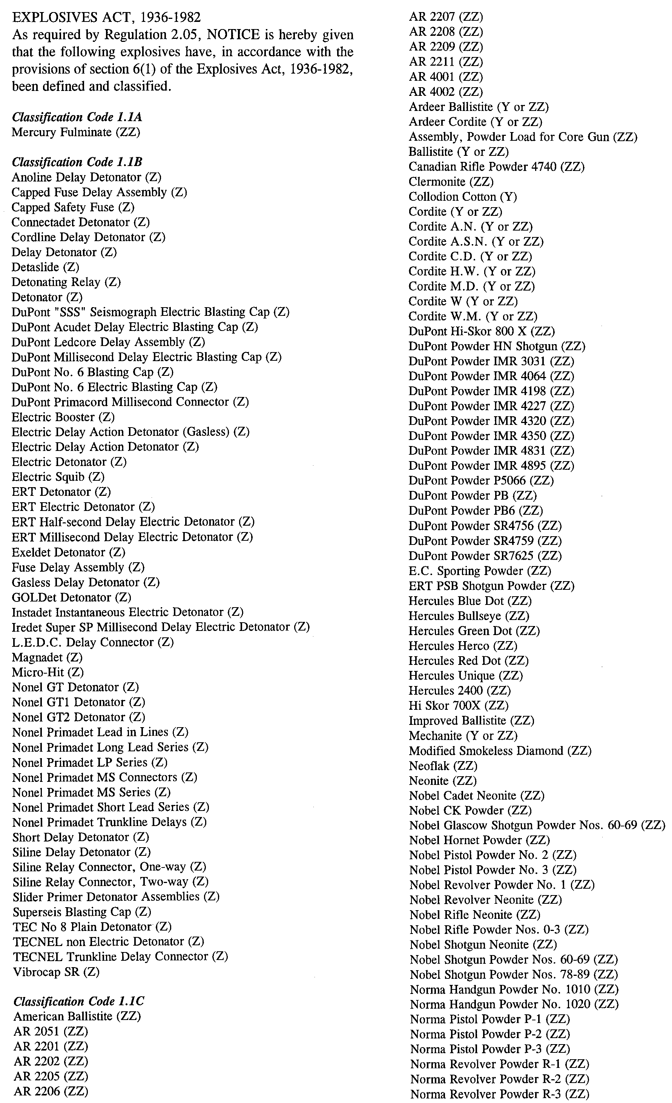
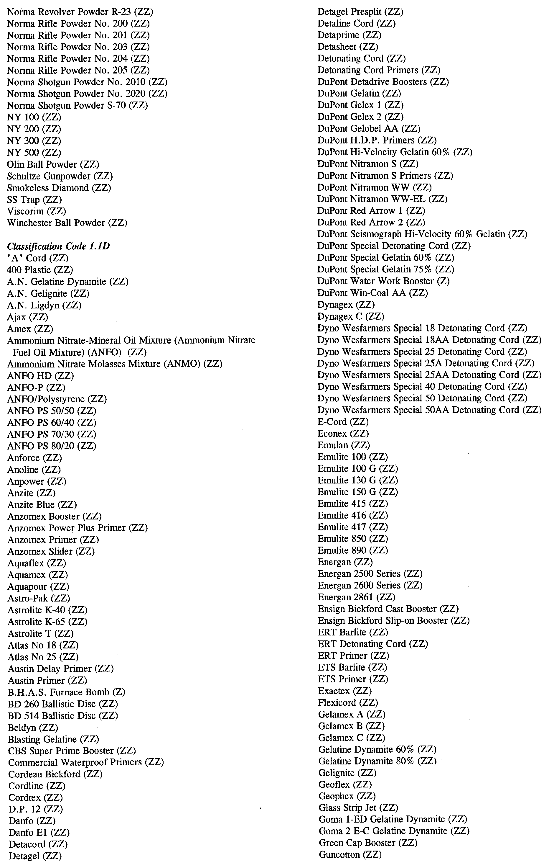
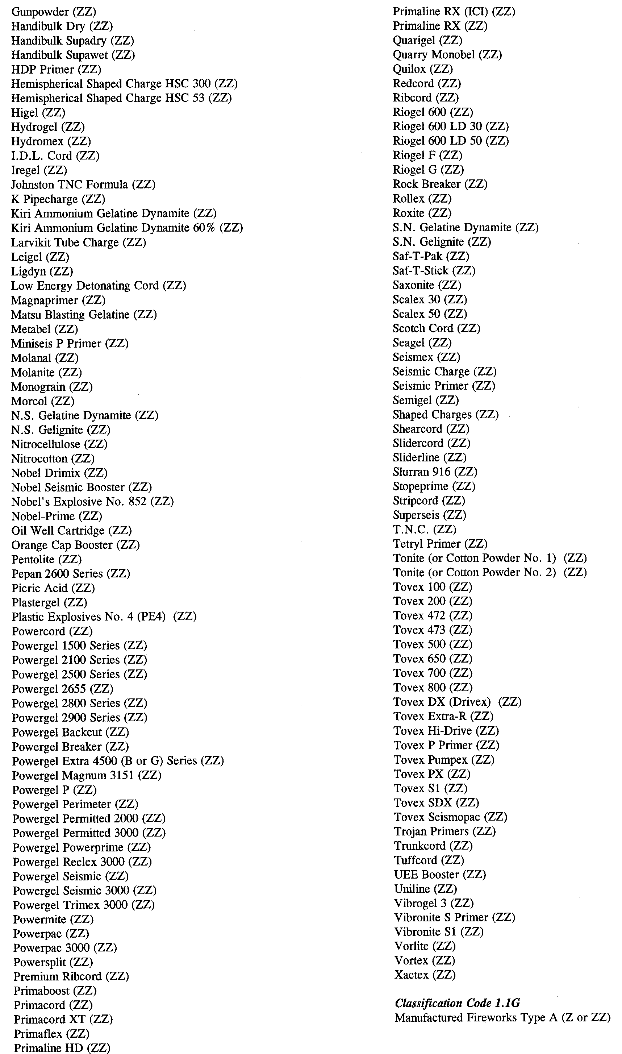
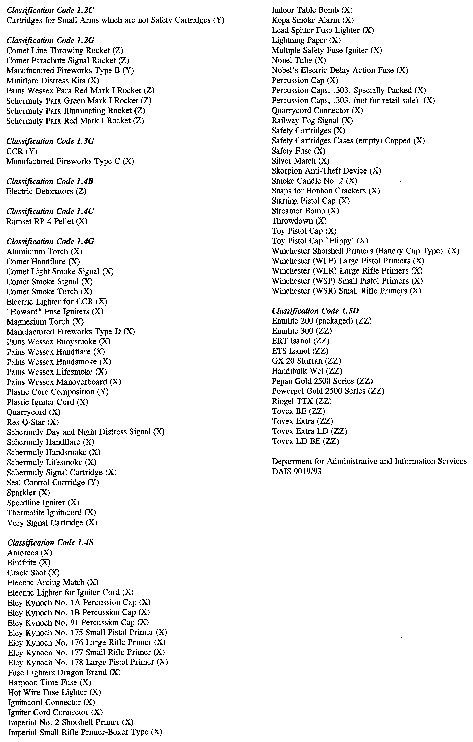
FISHERIES ACT 1982
Marine Mollusc Farming Licence FM00054
(Previous Licence No. F591 and F841)
Licence to Farm Fish under section 53 of the Fisheries
Act 1982
THE Minister for Primary Industries and Resources (‘the Minister’) hereby grants to:
Geoffrey M. Octoman (12180)
Colleen Dawn Octoman (16957)
25 Douglas Street
Coffin Bay, S.A. 5607
a licence to occupy and use the waters and airspace over the land specified in Item 1 of Schedule 1 of this licence (‘the site’) for the purpose of farming and taking the permitted species (‘the permitted use’) for the period commencing on 1 July 2000 and ending, subject to any earlier termination under this licence, on 30 June 2001 (‘the term’) subject to the following terms and conditions:
Conditions of This Licence
1. Marked-off Areas
1.1 Subject to section 53A of the Fisheries Act 1982, this licence does not entitle the licensee to exclusive rights of entry to and occupation of the site. The rights granted by this licence are exercisable by the licensee in common with any other occupiers of the site from time to time.
1.2 For the purposes of section 53A of the Fisheries Act 1982, the marked-off areas within the site are that area or those areas marked-off or indicated in the manner set out in Item 2 of Schedule 1 of this licence.
2. Permitted Species
The licensee:
2.1 must not farm or introduce any species at the site other than the permitted species referred to in Schedule 2; and
2.2 must not take any wild fish from the site except for recreational purposes.
3. Permitted Use
The licensee must not use the site for any purpose other than the permitted use.
4. Permitted Methods
4.1 The licensee must, in undertaking the permitted use, take all reasonable and practicable measures to prevent or minimise damage to the environment. Without limiting the generality of the foregoing, the licensee:
4.1.1 must ensure the total length of each unit does not exceed 3 km of longline or 1 km of racking per hectare, and each unit must be at least 5 m from any other unit;
4.1.2 must not use the anti-fouling chemical tributyltin (TBT) on any equipment used at the site;
4.1.3 must not use any chemical or drug for either therapeutic or prophylactic purpose except with the prior approval of the Minister;
4.1.4 must undertake an environmental monitoring program approved by the Minister and as specified in Clause 4.3;
4.1.5 must not introduce the permitted species to the site before the approval of the environmental monitoring program referred to in 4.1.4 by the Minister;
4.1.6 must comply with the schedule of reporting for the environmental monitoring program as pres-cribed in Schedule 6 and submit the final results of the environmental monitoring program to the Minister 30 days before expiry of the term of this licence.
4.2 SASQAP
4.2.1 It is a condition of your licence to farm bivalve molluscs that only shellfish from Classified and Approved areas under the South Australian Shellfish Quality Assurance Program (SASQAP) may be sold for human consumption.
4.2.2 The licensee must continue to meet all the regulations required under the Food Standards Code to produce a product safe for human consumption.
4.3 The licensee must submit a draft environmental monitoring program to the Minister for approval within 60 days of the grant of the licence by the Minister. The draft environmental monitoring program must include the qualifications and experience of the person(s) designing and undertaking the program and address the matters listed in Schedule 5.
5. Marking and Maintaining the Site
The licensee:
5.1 must ensure that the site is maintained in a good, tidy and safe condition to the satisfaction of the Minister;
5.2 must remove and lawfully dispose of any waste or debris on the site as soon as is reasonably practicable and in particular must comply with any guidelines issued from time to time by the Minister in relation to the removal from the site of any unhealthy or dead fish;
5.3 must maintain all buoys, crosses, and markers on the site in good condition and in accordance with the colours specified in Schedule 1 of this licence; and
5.4 must mark the site boundary in accordance with the requirements of the Minister for Transport.
6. Site Inspection and Supervision
The licensee:
6.1 must at all times permit the Minister, his employees, agents or contractors or any employees, agents or contractors of the Crown to enter the site for the purposes of inspecting the site, the sea floor and the flora and fauna on or in the vicinity of the site; and
6.2 must comply with all reasonable directions of any such person authorised by the Director of Fisheries to inspect the conduct of the licensee’s activities at the site.
7. Fees and Returns
The licensee:
7.1 must pay to the Minister the licence fee in accordance with Item 1 of Schedule 3 of this licence;
7.2 must on or before 31 January and 31 July during the term, submit to the Minister a return supplying all of the information described in Schedule 4 of this licence.
8. Public Risk Insurance
The licensee must at its own cost during the term maintain in full force and effect in respect of the site and the permitted use a policy of public risk insurance in the joint names of the licensee and the Minister. The limits of public risk must not be less than the amount specified in Item 2 of Schedule 3 of this licence, or such other amount as the Minister may from time to time reasonably require. A policy of insurance or copy thereof or a certificate of insurance must be produced by the licensee to the Minister on written request.
9. Guarantee or Indemnity Scheme
The licensee must either:
9.1 provide a guarantee from its bankers to the amount specified in Item 3 of Schedule 3; or
9.2 contribute to an indemnity scheme established for the aquaculture and fisheries industry and approved by the Minister,
to and in favour of and for the benefit of the Minister by way of security for the due and punctual performance by the licensee of the terms and conditions of this licence and in particular the obligations of the licensee to rehabilitate the site immediately prior to the expiration or sooner determination of the term of this licence. Such guarantee or indemnity scheme must have effect from the date of commencement of the term.
10. No Assignment
The licensee must not assign or sublet or deal in any other way with any interest in this licence.
11. Variation and Cancellation
11.1 The Minister may without prior notice vary or cancel this licence immediately during the term for the purposes of preventing or minimising any damage or threat of damage to the environment. For the purpose of this condition the Minister may have regard to but is not limited by the following considerations:
11.1.1 the results of monitoring undertaken pursuant to Clause 4.1.5;
11.1.2 the results of any other monitoring as may from time to time be carried out; or
11.1.3 such other relevant information within the knowledge of the Minister.
11.2 Subject to and without limiting Condition 13.1, in the event of breach by the licensee of any term or condition of this licence, the Minister may:
11.2.1 give to the licensee written notice of such breach and the Minister’s requirements for rectification thereof; or
11.2.2 cancel this licence for failure to comply with such requirements for rectification.
11.3 The Minister may cancel this licence if the licensee is a body corporate, and any of the following occur:
11.3.1 the licensee is unable to pay its debts as and when they fall due or is otherwise insolvent;
11.3.2 an order is made for the winding up or liquidation of the licensee;
11.3.3 the licensee enters into a scheme of arrange-ment, compromise, moratorium or other form of composition with its creditors or any class of its creditors;
11.3.4 a receiver, a manager or a receiver and manager, a company administrator or other insolvency administrator is appointed to the licensee; or
11.3.5 a mortgagee, chargee or other encumbran-cee is appointed over or takes possession of or appoints an agent to take possession of all or any of the licensee’s assets.
11.4 The Minister may cancel this licence if the licensee is an individual, and the licensee:
11.4.1 becomes bankrupt or assigns its estate or enters into a deed of arrangement or other form of composition for the benefit of the licensee’s creditors; or
11.4.2 is convicted of an indictable offence.
11.5 Cancellation of this licence by the Minister shall be without prejudice to any rights, remedies or actions that the Minister may have against the licensee in respect of any antecedent breach by the licensee of the terms and conditions contained in this licence.
Granted by the General Manager Aquaculture, delegate for the purposes of section 53 of the Minister responsible for adminis-tration of the Fisheries Act 1982, on 9 March 2001.
I. Nightingale, General Manager Aquaculture
Schedule 1
Item 1—The Site
Area applicable to this licence:
Licensed Area Licensed
Hectares
AGD 66—Zone 53
531992E 6178142N 5
532391E 6178142N
532391E 6178017N
531992E 6178017N
All St Andrew’s crosses must be marked with the site’s unique ‘FM number’; that is the licence number.
Item 2—Marked-off Areas
[Co-ordinates of developed areas within the site to be provided by the licensee].
White buoys of at least 12 inches in diameter must be placed around the whole of the perimeter of the developed areas within the site at a distance of no less than 50 m from one another.
Schedule 2
Item 1—Permitted Species
The Director of Fisheries has, pursuant to section 50 (2) of the Act, issued a permit for the release of the fish specified in this Schedule.
Pacific Oysters (Crassostrea gigas)
Native Oysters (Ostrea angasi)
Item 2—Permitted Farming Methods
Racks 1
BST Longlines
The total length of each unit must not exceed 3 km of longline not less than 3 m apart, or 1 km of racking per hectare, and each unit must be at least 5 m from any other unit.
Schedule 3
Item 1—Fees
Annual licence fees are:
$
FRDC Levy per hectare 5 at $9.50 each 47.50
EMP Fee per hectare 5 at $17.70 each 88.50
Base Licence Fee per hectare 5 at $66 each 330.00
SASQAP (Classified Area) per hectare 5 at $80
each 400.00
Total Annual Licence Fee 866.00
Quarterly Instalments 216.50
Item 2—Insurance
Ten million dollars ($10 000 000).
Item 3—Guarantee
Ten thousand dollars ($10 000).
Schedule 4
Returns
The licensee must submit the following information to the Minister, c/o General Manager Aquaculture SA, 14th Floor, 25 Grenfell Street, G.P.O. Box 1625, Adelaide, S.A. 5000 on or before 31 January and 31 July during the term of this licence:
1. Name of licensee.
2. Address of licensee.
3. Species of fish farmed and held on the site.
4. Location of aquaculture operation.
5. Period covered by return.
6. Number of life stage of each species of fish held.
7. Number, weight and value of each species of fish held.
8. Details of any disease detected in any fish kept.
9. Source (whether interstate or intrastate) of any stock acquired and date of acquisition (if relevant, include name of authority that provided certification that stock was free from disease).
10. If any fish were brought into the State, the number of fish and the life stage of the fish.
11. If fish were brought into the State, the purpose for which they were brought in.
12. Method of disposal of water and packaging use for transporting the fish.
13. If any disease or symptom of disease occurred in the acquired fish.
14. Method of disposal of diseased or dead fish and the number disposed of.
15. Signature, date and telephone number.
16. Use of any chemicals for fish husbandry—type of chemical and quantity used, purpose and date of use.
Schedule 5
Environmental Monitoring Program
MATTERS TO BE ADDRESSED
The monitoring program should address the following matters in relation to the permitted use:
Farm Management
1. Approximate layout of all structures on the site during the term including location, number and size.
2. Growth and condition of the permitted species.
3. Occurrence of disease incidents in the permitted species.
Water Quality
1. Phytoplankton including species composition and abundance.
2. Status of the site under the South Australian Shellfish Quality Assurance Program during the term (including closures).
Feral Oysters
Presence and numbers of feral oysters.
Benthic Sediments
1. Sedimentation.
2. Movement of sand.
Benthic Fauna and Flora
Benthic macro-flora communities including composition, distribution and abundance.
METHODOLOGY
Draft Environmental Monitoring Program
The draft environmental monitoring program should include an initial assessment of the site and analyse the variability of parameters to be measured to identify appropriate numbers of replicates and sample sizes for statistical rigour.
Control Sites
In addition to the site, the draft environmental monitoring program should identify appropriate control sites at which monitoring will occur. At least two controls should be identified at increasing distance from the site. At least one control site must be located more than 1 km from the site.
Video Transects
Video transects should be used to assess broad scale changes in sediment consistency, presence of farming waste and the composition and abundance of macro-flora communities.
Video transects must be collected using equipment capable of producing a clear and well lit image. Transects must be at least 50 m long and a scale must be clearly visible on the video at all times. The location of video transects must be identified on a map attached to the environmental monitoring report. Each transect must be identified on the video with a unique transect number.
Report
The environmental monitoring report must be legible and contain a declaration regarding the authenticity and source of all data and results contained in the report. This declaration must be signed by the licence holder and the person(s) conducting the monitoring program.
The report must include an assessment of the results of the monitoring program against the provisions of the Environment Protection (Marine) Policy 1994, and must be accompanied by all raw data, video footage and diver notes.
Schedule 6
Schedule of Environmental Monitoring Reports
The licensee must submit a final environmental monitoring program report within 12 months of the commencement of this licence to the Minister, c/o General Manager Aquaculture SA, 14th Floor, 25 Grenfell Street, G.P.O. Box 1625, Adelaide, S.A. 5000.

FISHERIES ACT 1982: SECTION 53
TAKE note that the licence to farm fish made under section 53 of the Fisheries Act 1982, and published in the South Australian Government Gazette, dated 25 August 2000, on page number 900, being the second notice on that page, through to page number 903 and referring to Geoffrey M. Octoman and Colleen Dawn Octoman is hereby revoked.
Dated 9 March 2001.
I. Nightingale, General Manager Aquaculture as the delegate of the Minister for Primary Industries

FISHERIES ACT 1982: SECTION 53
TAKE note that the licence to farm fish made under section 53 of the Fisheries Act 1982, and published in the South Australian Government Gazette, dated 8 September 2000, on page number 1809, being the second notice on that page, through to page number 1812 and referring to Geoffrey M. Octoman and Colleen Dawn Octoman is hereby revoked.
Dated 9 March 2001.
I. Nightingale, General Manager Aquaculture as the delegate of the Minister for Primary Industries

LAND AND BUSINESS (SALE AND CONVEYANCING) ACT 1994
Exemption
TAKE notice that, pursuant to section 23 (3) of the Land and Business (Sale and Conveyancing) Act 1994, I, Kenneth Trevor Griffin, Minister for Consumer Affairs, do hereby exempt the person named in Schedule 1 from the application of section 23 (2) of the Act in relation to the purchase of the land specified in Schedule 2.
Schedule 1
Thomas Peter Redden, an officer/employee of Stephen Paul Redden.
Schedule 2
The whole of the land described in Certificate of Title Register Book Volume 5277, Folio 502, 503 and 504 situated at allotments 512 and 513 in Deposited Plan 56552, being approximately 87 hectares at Stockport, S.A. 5410.
Dated 15 March 2001.
Signed for and on behalf of the Minister for Consumer Affairs by the Commissioner for Consumer Affairs:
M. D. Bodycoat, Commissioner

LIQUOR LICENSING ACT 1997
Notice of Application
NOTICE is hereby given, pursuant to section 52 (2) (b) of the Liquor Licensing Act 1997, that Ventura & Maiorana Pty Ltd, (ACN 086 529 919), 35 Seventh Avenue, St Morris, S.A. 5068 has applied to the Licensing Authority for the transfer of a Restaurant Licence in respect of premises situated at 94-98 Melbourne Street, North Adelaide, S.A. 5006 and known as Cafe Zambracca.
The application has been set down for hearing on 6 April 2001.
Any person may object to the application by lodging a notice of objection in the prescribed form with the Licensing Authority, and serving a copy of the notice on the applicant at the applicant’s address given above, at least seven days before the hearing date.
Plans in respect of the premises the subject of the application are open to public inspection without fee at the Office of the Liquor and Gaming Commissioner, 9th Floor, East Wing, 50 Grenfell Street, Adelaide, S.A. 5000.
Applicant

LIQUOR LICENSING ACT 1997
Notice of Application
NOTICE is hereby given, pursuant to section 52 (2) (b) of the Liquor Licensing Act 1997, that Laugh Gas Comedy Pty Ltd has applied to the Licensing Authority for a Special Circumstances Licence with Entertainment Consent in respect of premises situated at 181 Hindley Street, Adelaide, S.A. 5000 and known as Laughing Gas Comedy Club.
The application has been set down for hearing on 12 April 2001.
Conditions
The following licence conditions are sought:
The applicant applies to supply and sell liquor on the premises at 181 Hindley Street, Adelaide, between the hours of 12 noon to the following 2 a.m. on Mondays, Tuesdays and Wednesdays, from 12 noon to 3 a.m. on Thursdays, from 12 noon to 5 a.m. on Fridays and Saturdays and from 12 noon to midnight on Sundays.
Any person may object to the application by lodging a notice of objection in the prescribed form with the Licensing Authority, and serving a copy of the notice on the applicant at the applicant’s address given above, at least seven days before the hearing date.
Plans in respect of the premises the subject of the application are open to public inspection without fee at the Office of the Liquor and Gaming Commissioner, 9th Floor, East Wing, 50 Grenfell Street, Adelaide, S.A. 5000.
Applicant

LIQUOR LICENSING ACT 1997
Notice of Application
NOTICE is hereby given, pursuant to section 52 (2) (b) of the Liquor Licensing Act 1997, that M. Chapoutier Australia and Tournon Pty Ltd, 2/164 Highett Street, Richmond, Vic. 3121 have applied to the Licensing Authority for a Wholesale Liquor Merchant’s Licence in respect of premises situated at Limestone Coast Road, Mount Benson, S.A. 5275 and to be known as M. Chapoutier Australia.
The application has been set down for hearing on 12 April 2001 at 9 a.m.
Any person may object to the application by lodging a notice of objection in the prescribed form with the Licensing Authority, and serving a copy of the notice on the applicants at the applicants’ address given above, at least seven days before the hearing date.
Plans in respect of the premises the subject of the application are open to public inspection without fee at the Office of the Liquor and Gaming Commissioner, 9th Floor, East Wing, 50 Grenfell Street, Adelaide, S.A. 5000.
Dated 2 March 2001.
Applicants

LIQUOR LICENSING ACT 1997
Notice of Application
NOTICE is hereby given, pursuant to section 52 (2) (b) of the Liquor Licensing Act 1997, that Master Pty Ltd has applied to the Licensing Authority for the variation to conditions of a Special Circumstances Licence in respect of premises situated at 114 Hindley Street, Adelaide, S.A. 5000 and known as The Black Rose Piano Bar.
The application has been set down for hearing on 12 April 2001.
Conditions
The following licence conditions are sought:
Seeking to vary trading authorisation to include Thursday, Friday and Saturday or any day preceding a public holiday from 2.30 p.m. to 9 a.m. the following day in area 1, when live entertainment is being provided.
Any person may object to the application by lodging a notice of objection in the prescribed form with the Licensing Authority, and serving a copy of the notice on the applicant at the applicant’s address given above, at least seven days before the hearing date.
Plans in respect of the premises the subject of the application are open to public inspection without fee at the Office of the Liquor and Gaming Commissioner, 9th Floor, East Wing, 50 Grenfell Street, Adelaide, S.A. 5000.
Dated 2 March 2001.
Applicant

LIQUOR LICENSING ACT 1997
Notice of Application
NOTICE is hereby given, pursuant to section 52 (2) (b) of the Liquor Licensing Act 1997, that Tina Marie Kies has applied to the Licensing Authority for a Wholesale Liquor Merchant’s Licence in respect of premises to be situated at Barossa Valley Way, Lyndoch, S.A. 5351 and to be known as Kies Family Wines.
The application has been set down for hearing on 12 April 2001 at 9 a.m.
Any person may object to the application by lodging a notice of objection in the prescribed form with the Licensing Authority, and serving a copy of the notice on the applicant at the applicant’s address given above, at least seven days before the hearing date.
Plans in respect of the premises the subject of the application are open to public inspection without fee at the Office of the Liquor and Gaming Commissioner, 9th Floor, East Wing, 50 Grenfell Street, Adelaide, S.A. 5000.
Applicant

LIQUOR LICENSING ACT 1997
Notice of Application
NOTICE is hereby given, pursuant to section 52 (2) (b) of the Liquor Licensing Act 1997, that Caersbrook Vineyards Pty Ltd, Wellington Road, Langhorne Creek, S.A. 5255 has applied to the Licensing Authority for a Wholesale Liquor Merchant’s Licence in respect of premises situated at Wellington Road, Langhorne Creek and known as Kookaburra Estate.
The application has been set down for hearing on 12 April 2001.
Any person may object to the application by lodging a notice of objection in the prescribed form with the Licensing Authority, and serving a copy of the notice on the applicant at the applicant’s address given above, at least seven days before the hearing date.
Plans in respect of the premises the subject of the application are open to public inspection without fee at the Office of the Liquor and Gaming Commissioner, 9th Floor, East Wing, 50 Grenfell Street, Adelaide, S.A. 5000.
Dated 4 March 2001.
Applicant

LIQUOR LICENSING ACT 1997
Notice of Application
NOTICE is hereby given, pursuant to section 52 (2) (b) of the Liquor Licensing Act 1997, that Spencer Cole, c/o David Watts & Associates, Liquor Licensing Consultants, 1 Cator Street, Glenside, S.A. 5065 has applied to the Licensing Authority for a Restaurant Licence in respect of premises situated at 160 Fullarton Road, Rose Park, S.A. 5065 and to be known as Queen Victoria Eatery.
The application has been set down for hearing on 12 April 2001.
Conditions
The following licence conditions are sought:
Section 34 (1) (c) approval with extended trading on Fridays and Saturdays until 2 a.m. the following day and on Sundays from 8 p.m. to 10 p.m.
Entertainment consent.
Any person may object to the application by lodging a notice of objection in the prescribed form with the Licensing Authority, and serving a copy of the notice on the applicant at the applicant’s address given above, at least seven days before the hearing date.
Plans in respect of the premises the subject of the application are open to public inspection without fee at the Office of the Liquor and Gaming Commissioner, 9th Floor, East Wing, 50 Grenfell Street, Adelaide, S.A. 5000.
Applicant

LIQUOR LICENSING ACT 1997
Notice of Application
NOTICE is hereby given, pursuant to section 52 (2) (b) of the Liquor Licensing Act 1997, that Rhobe Pty Ltd has applied to the Licensing Authority for an Extended Trading Authorisation in respect of premises situated at Railway Terrace, Wolseley, S.A. 5269 and known as Wolseley Hotel.
The application has been set down for hearing on 12 April 2001.
Conditions
The following licence conditions are sought:
That the licensee be permitted to sell liquor for consumption on the licensed premises between the hours of 12 midnight and 1 a.m. the following day each Friday and Saturday.
Any person may object to the application by lodging a notice of objection in the prescribed form with the Licensing Authority, and serving a copy of the notice on the applicant at the applicant’s address given above, at least seven days before the hearing date.
Plans in respect of the premises the subject of the application are open to public inspection without fee at the Office of the Liquor and Gaming Commissioner, 9th Floor, East Wing, 50 Grenfell Street, Adelaide, S.A. 5000.
Dated 7 March 2001.
Applicant

LIQUOR LICENSING ACT 1997
Notice of Application
NOTICE is hereby given, pursuant to section 52 (2) (b) of the Liquor Licensing Act 1997, that Renmark Club Inc., Murray Avenue, Renmark, S.A. 5341 has applied to the Licensing Authority for Extended Trading Hours in respect of premises situated at Murray Avenue, Renmark and known as Renmark Club Inc.
The application has been set down for hearing on 12 April 2001.
Conditions
The following licence conditions are sought:
Extended trading authorisation:
• Friday and Saturday, 12 midnight to 2 a.m. the following morning.
• Entertainment is proposed during the extended hours.
Any person may object to the application by lodging a notice of objection in the prescribed form with the Licensing Authority, and serving a copy of the notice on the applicant at the applicant’s address given above, at least seven days before the hearing date.
Plans in respect of the premises the subject of the application are open to public inspection without fee at the Office of the Liquor and Gaming Commissioner, 9th Floor, East Wing, 50 Grenfell Street, Adelaide, S.A. 5000.
Dated 7 March 2001.
Applicant

LIQUOR LICENSING ACT 1997
Notice of Application
NOTICE is hereby given, pursuant to section 52 (2) (b) of the Liquor Licensing Act 1997, that Parker Estates Pty Ltd (ACN 003 573 760), 110B Elizabeth Bay Road, Elizabeth Bay, N.S.W. 2011 has applied to the Licensing Authority for the grant of a Producer’s Licence in respect of premises situated at Lot 11, Main Road, Coonawarra, S.A. 5263 and known as Parker Coonawarra Estate.
The application has been set down for hearing on 12 April 2001.
Any person may object to the application by lodging a notice of objection in the prescribed form with the Licensing Authority, and serving a copy of the notice on the applicant at the applicant’s address given above, at least seven days before the hearing date.
Plans in respect of the premises the subject of the application are open to public inspection without fee at the Office of the Liquor and Gaming Commissioner, 9th Floor, East Wing, 50 Grenfell Street, Adelaide, S.A. 5000.
Dated 8 March 2001.
Applicant

LIQUOR LICENSING ACT 1997
Notice of Application
NOTICE is hereby given, pursuant to section 52 (2) (b) of the Liquor Licensing Act 1997, that Corked Pty Ltd (ACN 008 123 608), c/o Wallmans Lawyers, 173 Wakefield Street, Adelaide, S.A. 5000 has applied to the Licensing Authority for a Direct Sales Licence in respect of premises situated at Lot 4, Jones Road, Balhannah, S.A. 5151.
The application has been set down for hearing on 12 April 2001.
Any person may object to the application by lodging a notice of objection in the prescribed form with the Licensing Authority, and serving a copy of the notice on the applicant at the applicant’s address given above, at least seven days before the hearing date.
Plans in respect of the premises the subject of the application are open to public inspection without fee at the Office of the Liquor and Gaming Commissioner, 9th Floor, East Wing, 50 Grenfell Street, Adelaide, S.A. 5000.
Dated 7 March 2001.
Applicant

LIQUOR LICENSING ACT 1997
Notice of Application
NOTICE is hereby given, pursuant to section 52 (2) (b) of the Liquor Licensing Act 1997, that Silesian Wine Co. Pty Ltd, c/o Teusner & Co., Solicitors, P.O. Box 70, Tanunda, S.A. 5352 has applied to the Licensing Authority for a Producer’s Licence in respect of premises situated at Lot 4, Nitschke Road, Tanunda, S.A. 5352 and known as Silesian Wine Co. Pty Ltd.
The application has been set down for hearing on 12 April 2001 at 9 a.m.
Any person may object to the application by lodging a notice of objection in the prescribed form with the Licensing Authority, and serving a copy of the notice on the applicant at the applicant’s address given above, at least seven days before the hearing date.
Plans in respect of the premises the subject of the application are open to public inspection without fee at the Office of the Liquor and Gaming Commissioner, 9th Floor, East Wing, 50 Grenfell Street, Adelaide, S.A. 5000.
Dated 9 March 2001.
Applicant

LIQUOR LICENSING ACT 1997
Notice of Application
NOTICE is hereby given, pursuant to section 52 (2) (b) of the Liquor Licensing Act 1997, that Philip Marafioti has applied to the Licensing Authority for a Producer’s Licence in respect of premises situated at 3 Hadley Street, Fulham, S.A. 5024 and known as Quirino Wines.
The application has been set down for hearing on 12 April 2001.
Any person may object to the application by lodging a notice of objection in the prescribed form with the Licensing Authority, and serving a copy of the notice on the applicant at the applicant’s address given above, at least seven days before the hearing date.
Plans in respect of the premises the subject of the application are open to public inspection without fee at the Office of the Liquor and Gaming Commissioner, 9th Floor, East Wing, 50 Grenfell Street, Adelaide, S.A. 5000.
Dated 9 March 2001.
Applicant

LIQUOR LICENSING ACT 1997
Notice of Application
NOTICE is hereby given, pursuant to section 52 (2) (b) of the Liquor Licensing Act 1997, that Angelo Agius and Alison Agius, 10 Hurst Road, Gawler East, S.A. 5118 have applied to the Licensing Authority for a Restaurant Licence in respect of premises situated at 3 Walker Place, Gawler, S.A. 5118 and known as Yesteryear Cafe and to be known as Cafe Mojo.
The application has been set down for hearing on 17 April 2001.
Any person may object to the application by lodging a notice of objection in the prescribed form with the Licensing Authority, and serving a copy of the notice on the applicants at the applicants’ address given above, at least seven days before the hearing date.
Plans in respect of the premises the subject of the application are open to public inspection without fee at the Office of the Liquor and Gaming Commissioner, 9th Floor, East Wing, 50 Grenfell Street, Adelaide, S.A. 5000.
Dated 6 March 2001.
Applicants

LIQUOR LICENSING ACT 1997
Notice of Application
NOTICE is hereby given, pursuant to section 52 (2) (b) of the Liquor Licensing Act 1997, that Michael Richard Lewin, 20 Fissell Road, Lyndoch has applied to the Licensing Authority for the transfer of a Special Circumstances Licence in respect of premises situated at Shop 1, corner Basedow Road-Murray Street, Tanunda and known as Cafe Placebo to be known as Cafe True Blue.
The application has been set down for hearing on 17 April 2001.
Any person may object to the application by lodging a notice of objection in the prescribed form with the Licensing Authority, and serving a copy of the notice on the applicant at the applicant’s address given above, at least seven days before the hearing date.
Plans in respect of the premises the subject of the application are open to public inspection without fee at the Office of the Liquor and Gaming Commissioner, 9th Floor, East Wing, 50 Grenfell Street, Adelaide, S.A. 5000.
Dated 8 March 2001.
Applicant

LIQUOR LICENSING ACT 1997
Notice of Application
NOTICE is hereby given, pursuant to section 52 (2) (b) of the Liquor Licensing Act 1997, that Alan Vaughn Wohlfeil and Helen Joy Wohlfeil, Lot 3, Martin Road, Murray Bridge, S.A. 5253 have applied to the Licensing Authority for the transfer of a Restaurant Licence in respect of premises situated at 55 Bridge Street, Murray Bridge, S.A. 5253 and known as Amorosa Restaurant.
The application has been set down for hearing on 17 April 2001.
Any person may object to the application by lodging a notice of objection in the prescribed form with the Licensing Authority, and serving a copy of the notice on the applicants at the applicants’ address given above, at least seven days before the hearing date.
Plans in respect of the premises the subject of the application are open to public inspection without fee at the Office of the Liquor and Gaming Commissioner, 9th Floor, East Wing, 50 Grenfell Street, Adelaide, S.A. 5000.
Dated 7 March 2001.
Applicants

LIQUOR LICENSING ACT 1997
Notice of Application
NOTICE is hereby given, pursuant to section 52 (2) (b) of the Liquor Licensing Act 1997, that Phin Thi Chau, 6/17 Radstock Street, Woodville Park, S.A. 5011 and Dinh Phuc Vu, 379A Churchill Road, Kilburn, S.A. 5084 have applied for the transfer of a Restaurant Licence in respect of premises situated at 89 Gouger Street, Adelaide, S.A. 5000 and known as the Lime & Lemon Thai Cafe.
The application has been set down for hearing on 17 April 2001.
Any person may object to the application by lodging a notice of objection in the prescribed form with the Licensing Authority, and serving a copy of the notice on the applicants at the applicants’ addresses given above, at least seven days before the hearing date.
Plans in respect of the premises the subject of the application are open to public inspection without fee at the Office of the Liquor and Gaming Commissioner, 9th Floor, East Wing, 50 Grenfell Street, Adelaide, S.A. 5000.
Dated 5 March 2001.
Applicants

MINING ACT 1971
NOTICE is hereby given in accordance with section 35A (1) of the Mining Act 1971, that an application for a mining lease over the undermentioned mineral claim has been received. Details of the proposal may be inspected at the Department of Primary Industries and Resources, Mineral Resources Group, Level 5, 101 Grenfell Street, Adelaide, S.A. 5000:
Applicant: Olliver Geological Services Pty Ltd.
Claim Number: 3135.
Location: In section 48, Hundred of Pascoe, 70 km north-west of Cowell.
Purpose: For the recovery of Granite.
Reference: T2174.
A copy of the proposal has been provided to the District Council of Cleve.
Written submissions in relation to the granting of the mining lease are invited to be received at the Department of Primary Industries and Resources, Mineral Resources Group, Level 5, 101 Grenfell Street, Adelaide, S.A. 5000 or G.P.O. Box 1671, Adelaide, S.A. 5001 no later than 30 March 2001.
H. Tyrteos, Acting Mining Registrar

NATIONAL PARKS AND WILDLIFE ACT 1972
Naracoorte Caves National Park Plan of Management
I, IAIN EVANS, Minister for Environment and Heritage, hereby give notice under the provisions of section 38 of the National Parks and Wildlife Act 1972, that I have adopted a plan of management in respect of Naracoorte Caves National Park.
Copies of the plan may be inspected at or obtained from the offices of the Department for Environment and Heritage at The Environment Shop, Sixteenth Floor, SA Water Building, 77 Grenfell Street, Adelaide, S.A. 5000, (G.P.O. Box 1047, Adelaide, S.A. 5001) telephone (08) 8204 1910 or South East Region, 11 Helen Street, Mount Gambier, S.A. 5290 (P.O. Box 1046, Mount Gambier, S.A. 5290) telephone (08) 8735 1177.
Copies of this publication can be purchased at a cost of $5 per copy (plus $2 postage within South Australia) from the addresses above.
I. Evans, Minister for Environment and Heritage

ROADS (OPENING AND CLOSING) ACT 1991:
SECTION 24
NOTICE OF CONFIRMATION OF ROAD
PROCESS ORDER
Cooltong Avenue, Renmark
Deposited Plan 56356
BY Road Process Order made on 22 December 2000, the District Council of Renmark Paringa ordered that:
1. A triangular portion of allotment 4 in Deposited Plan 44669, more particularly delineated and numbered ‘1’ in Preliminary Plan No. PP32/0570 be opened as road.
2. Portions of Cooltong Avenue adjoining allotments 3, 4 and 6 in Deposited Plan 44669 more particularly delineated and lettered ‘A’, ‘B’, ‘C’ and ‘D’ (respectively) in Preliminary Plan No. PP32/0570 be closed.
3. The whole of the land subject to closure be transferred to RANDHIR SINGH POONI in accordance with agreement for exchange dated 22 December 2000, entered into between the District Council of Renmark Paringa and R. S. Pooni.
4. The following easements be granted over the whole of the land subject to that closure:
Grant to the Distribution Lessor Corporation easements for overhead electricity supply purposes.
Grant to the Renmark Irrigation Trust easements for water supply.
On 18 January 2001, that order was confirmed by the Minister for Administrative and Information Services, conditionally on approval and deposit of the survey plan by the Registrar-General. The condition has now been fulfilled.
Pursuant to section 24(5) of the Roads (Opening and Closing) Act 1991, NOTICE of the order referred to above and its confirmation is hereby given.
Dated 15 March 2001.
P. M. Kentish, Surveyor-General

ROADS (OPENING AND CLOSING) ACT 1991:
SECTION 24
NOTICE OF CONFIRMATION OF ROAD
PROCESS ORDER
Heitmann Court, Tea Tree Gully
Deposited Plan 55783
BY Road Process Order made on 7 December 2000, the City of Tea Tree Gully ordered that:
1. Portion of Heitmann Court adjoining Bowen Road and allotment 19 in Filed Plan 131264 more particularly lettered ‘A’ in Preliminary Plan No. PP32/0550 be closed.
2. The whole of the land subject to closure be transferred to DAVID NEIL MURRAY and KERRI ANNE MURRAY in accordance with agreement for transfer dated 12 September 2000, entered into between the City of Tea Tree Gully and
D. N. Murray and K. A. Murray.
On 30 January 2001, that order was confirmed by the Minister for Administrative and Information Services conditionally on approval and deposit of the survey plan by the Registrar-General. The condition has now been fulfilled.
Pursuant to section 24(5) of the Roads (Opening and Closing) Act 1991, NOTICE of the order referred to above and its confirmation is hereby given.
Dated 15 March 2001.
P. M. Kentish, Surveyor-General

ROADS (OPENING AND CLOSING) ACT 1991:
SECTION 24
NOTICE OF CONFIRMATION OF ROAD
PROCESS ORDER
St Kilda, Hundred of Port Adelaide
Deposited Plan 50216
BY Road Process Order made on 4 June 1998, the Development Assessment Commission ordered that:
1. Portions of section 1032 and portions of part of St Kilda town allotment 46 adjoining Mangrove Street and Salt Street, more particularly delineated and numbered ‘1’, ‘2’, ‘3’ and ‘4’ in Preliminary Plan No. PP32/0090 be opened as road.
2. Portions of Fooks Terrace and Salt Street adjoining the foreshore, section 470 and section 1032 (respectively), more particularly delineated and lettered ‘A’, ‘B’, ‘C’, ‘D’ and ‘E’, (respectively) in Preliminary Plan No. PP32/0090 be closed.
3. Vest in the Crown the whole of the closed road subject to an easement over portion to the South Australian Water Corporation for water supply purposes.
On 7 March 2000, that order was confirmed by the Minister for Administrative Services, conditionally on approval and deposit of the survey plan by the Registrar-General. The condition has now been fulfilled.
Pursuant to section 24(5) of the Roads (Opening and Closing) Act 1991, NOTICE of the order referred to above and its confirmation is hereby given.
Dated 15 March 2001.
P. M. Kentish, Surveyor-General

ROADS (OPENING AND CLOSING) ACT 1991:
SECTION 34
ORDER BY THE MINISTER TO CLOSE ROAD
Long Gully Road, McLaren Vale
Deposited Plan 56738
BY an Order made on 1 February 2001 under Sections 6 and 34 of the Roads (Opening and Closing) Act 1991, the Minister for Administrative and Information Services ordered that the portion of Long Gully Road situate dividing pieces 103 and 104 from 105 in Deposited Plan 36654 be closed.
Vest in the Crown the whole of the land subject to closure.
Notice of the Order is hereby published in accordance with Section 34(7) of the said Act.
Dated 15 March 2001.
P. M. Kentish, Surveyor-General
DAIS 32/0630

ROADS (OPENING AND CLOSING) ACT 1991:
SECTION 34
ORDER BY THE MINISTER TO CLOSE ROAD
Botanic Avenue, Flagstaff Hill
Deposited Plan 56671
BY an Order made on 1 February 2001 under Sections 6 and 34 of the Roads (Opening and Closing) Act 1991, the Minister for Administrative and Information Services ordered that the whole of the Botanic Avenue north of Broadmeadow Drive adjoining Section 1561, Hundred of Noarlunga and Section 625, Hundred of Adelaide be closed.
Vest in the Crown the whole of the land subject to closure.
Notice of the Order is hereby published in accordance with Section 34(7) of the said Act.
Dated 15 March 2001.
P. M. Kentish, Surveyor-General
DAIS 32/0631

TRADE STANDARDS ACT 1979: SECTION 25
Imposition of Declaration of Dangerous Goods
PURSUANT to the Trade Standards Act 1979, I, K. T. Griffin, Minister for Consumer Affairs, to whom the administration of the Trade Standards Act 1979, is committed, declare that the goods specified in the attached Schedule are dangerous goods. I am satisfied that the declaration is necessary in order to avert serious risk of injury or impairment to health and that it is not appropriate in the circumstances to deal with the matter by the prescription of safety standards.
The effect of this declaration is that forthwith, a person shall not in the course of a trade or business, manufacture, supply or sell the items referred to in the Schedule.
Schedule
Novelty toy mobile telephones incorporating a cigarette lighter.
Dated 27 February 2001.
K. T. Griffin, Minister for Consumer Affairs

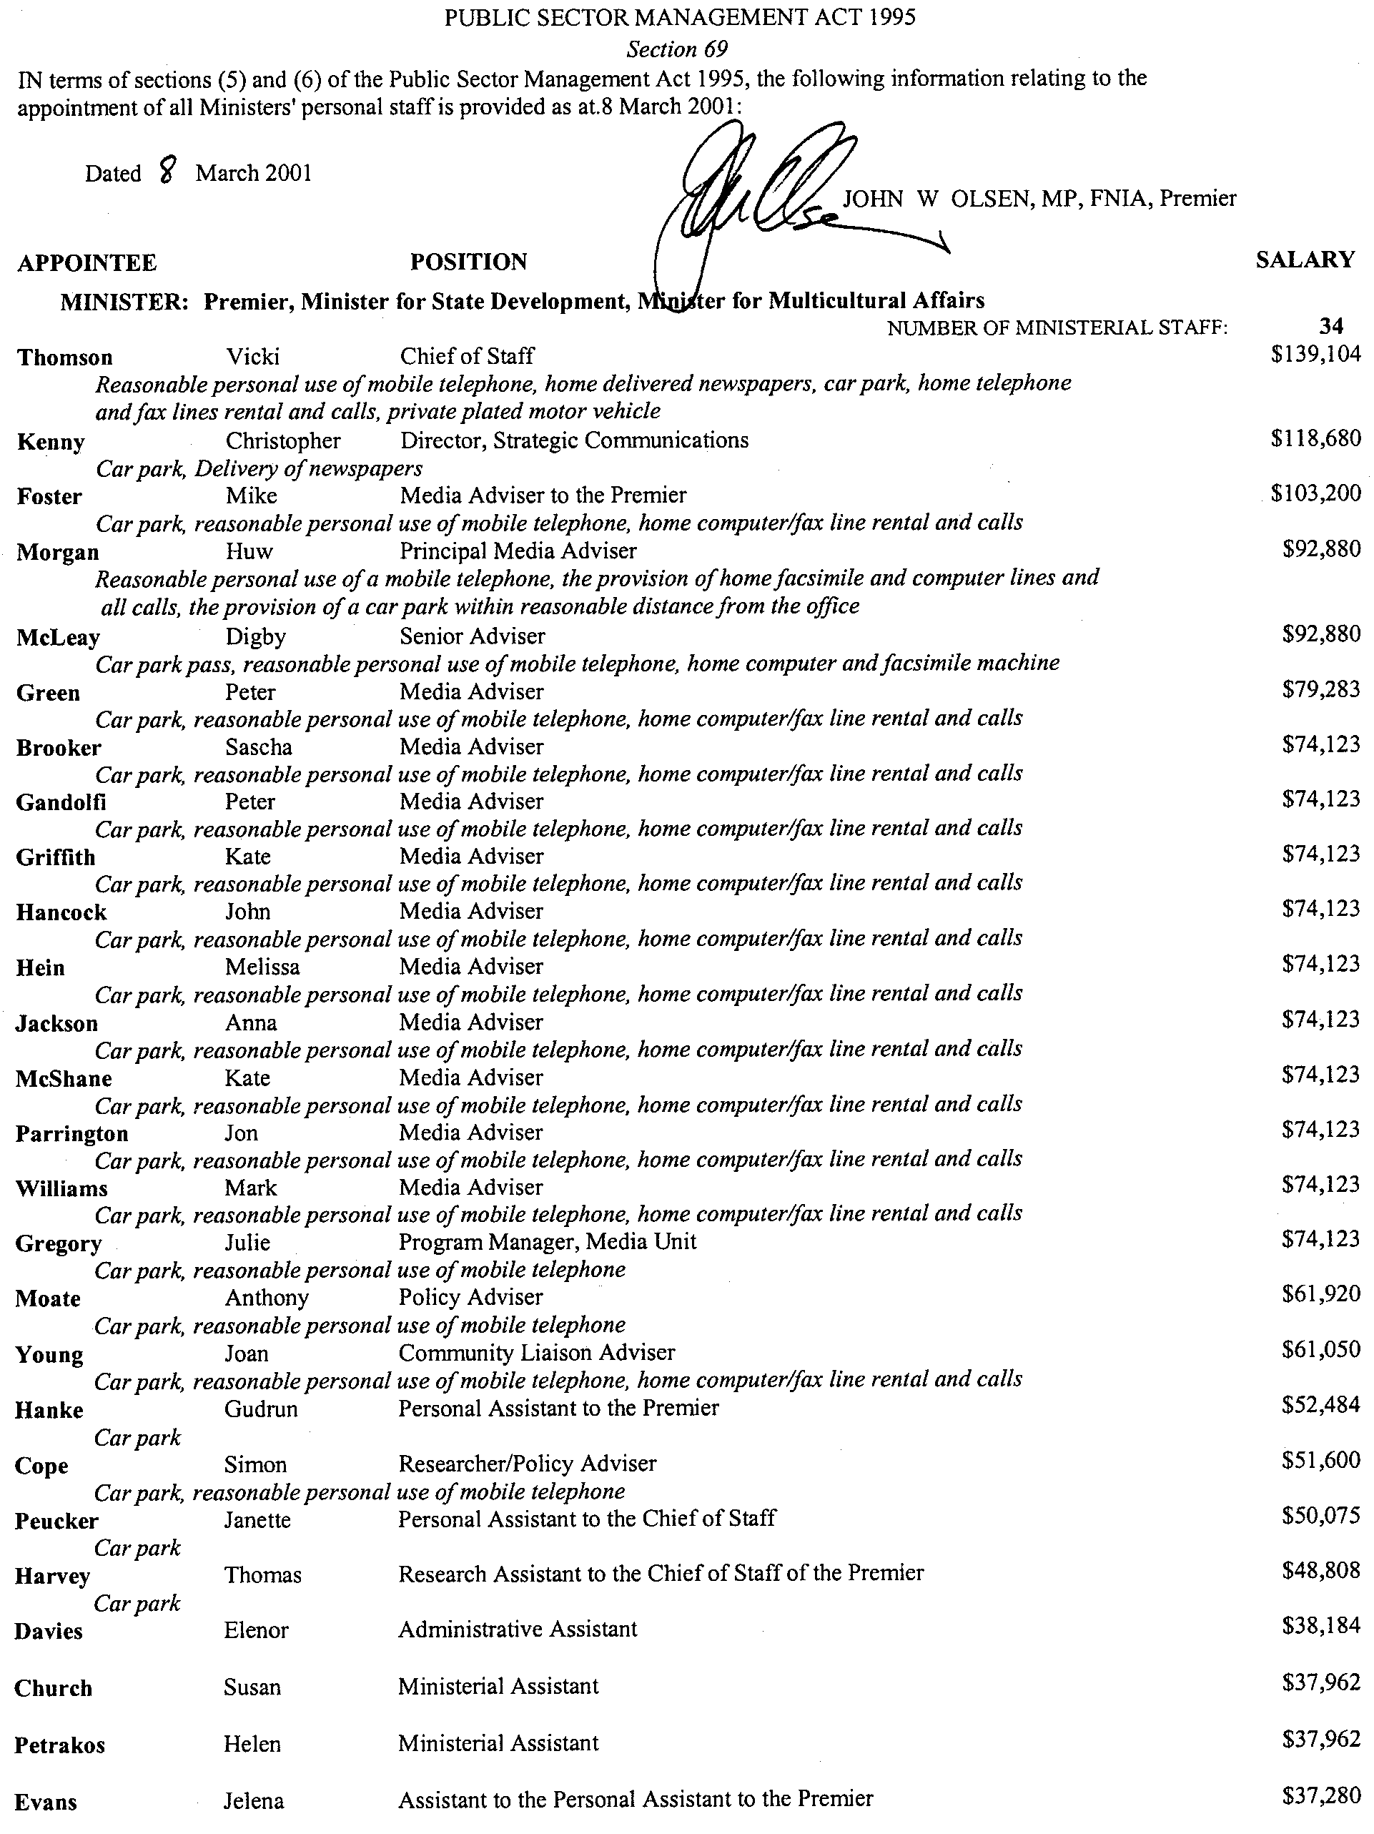
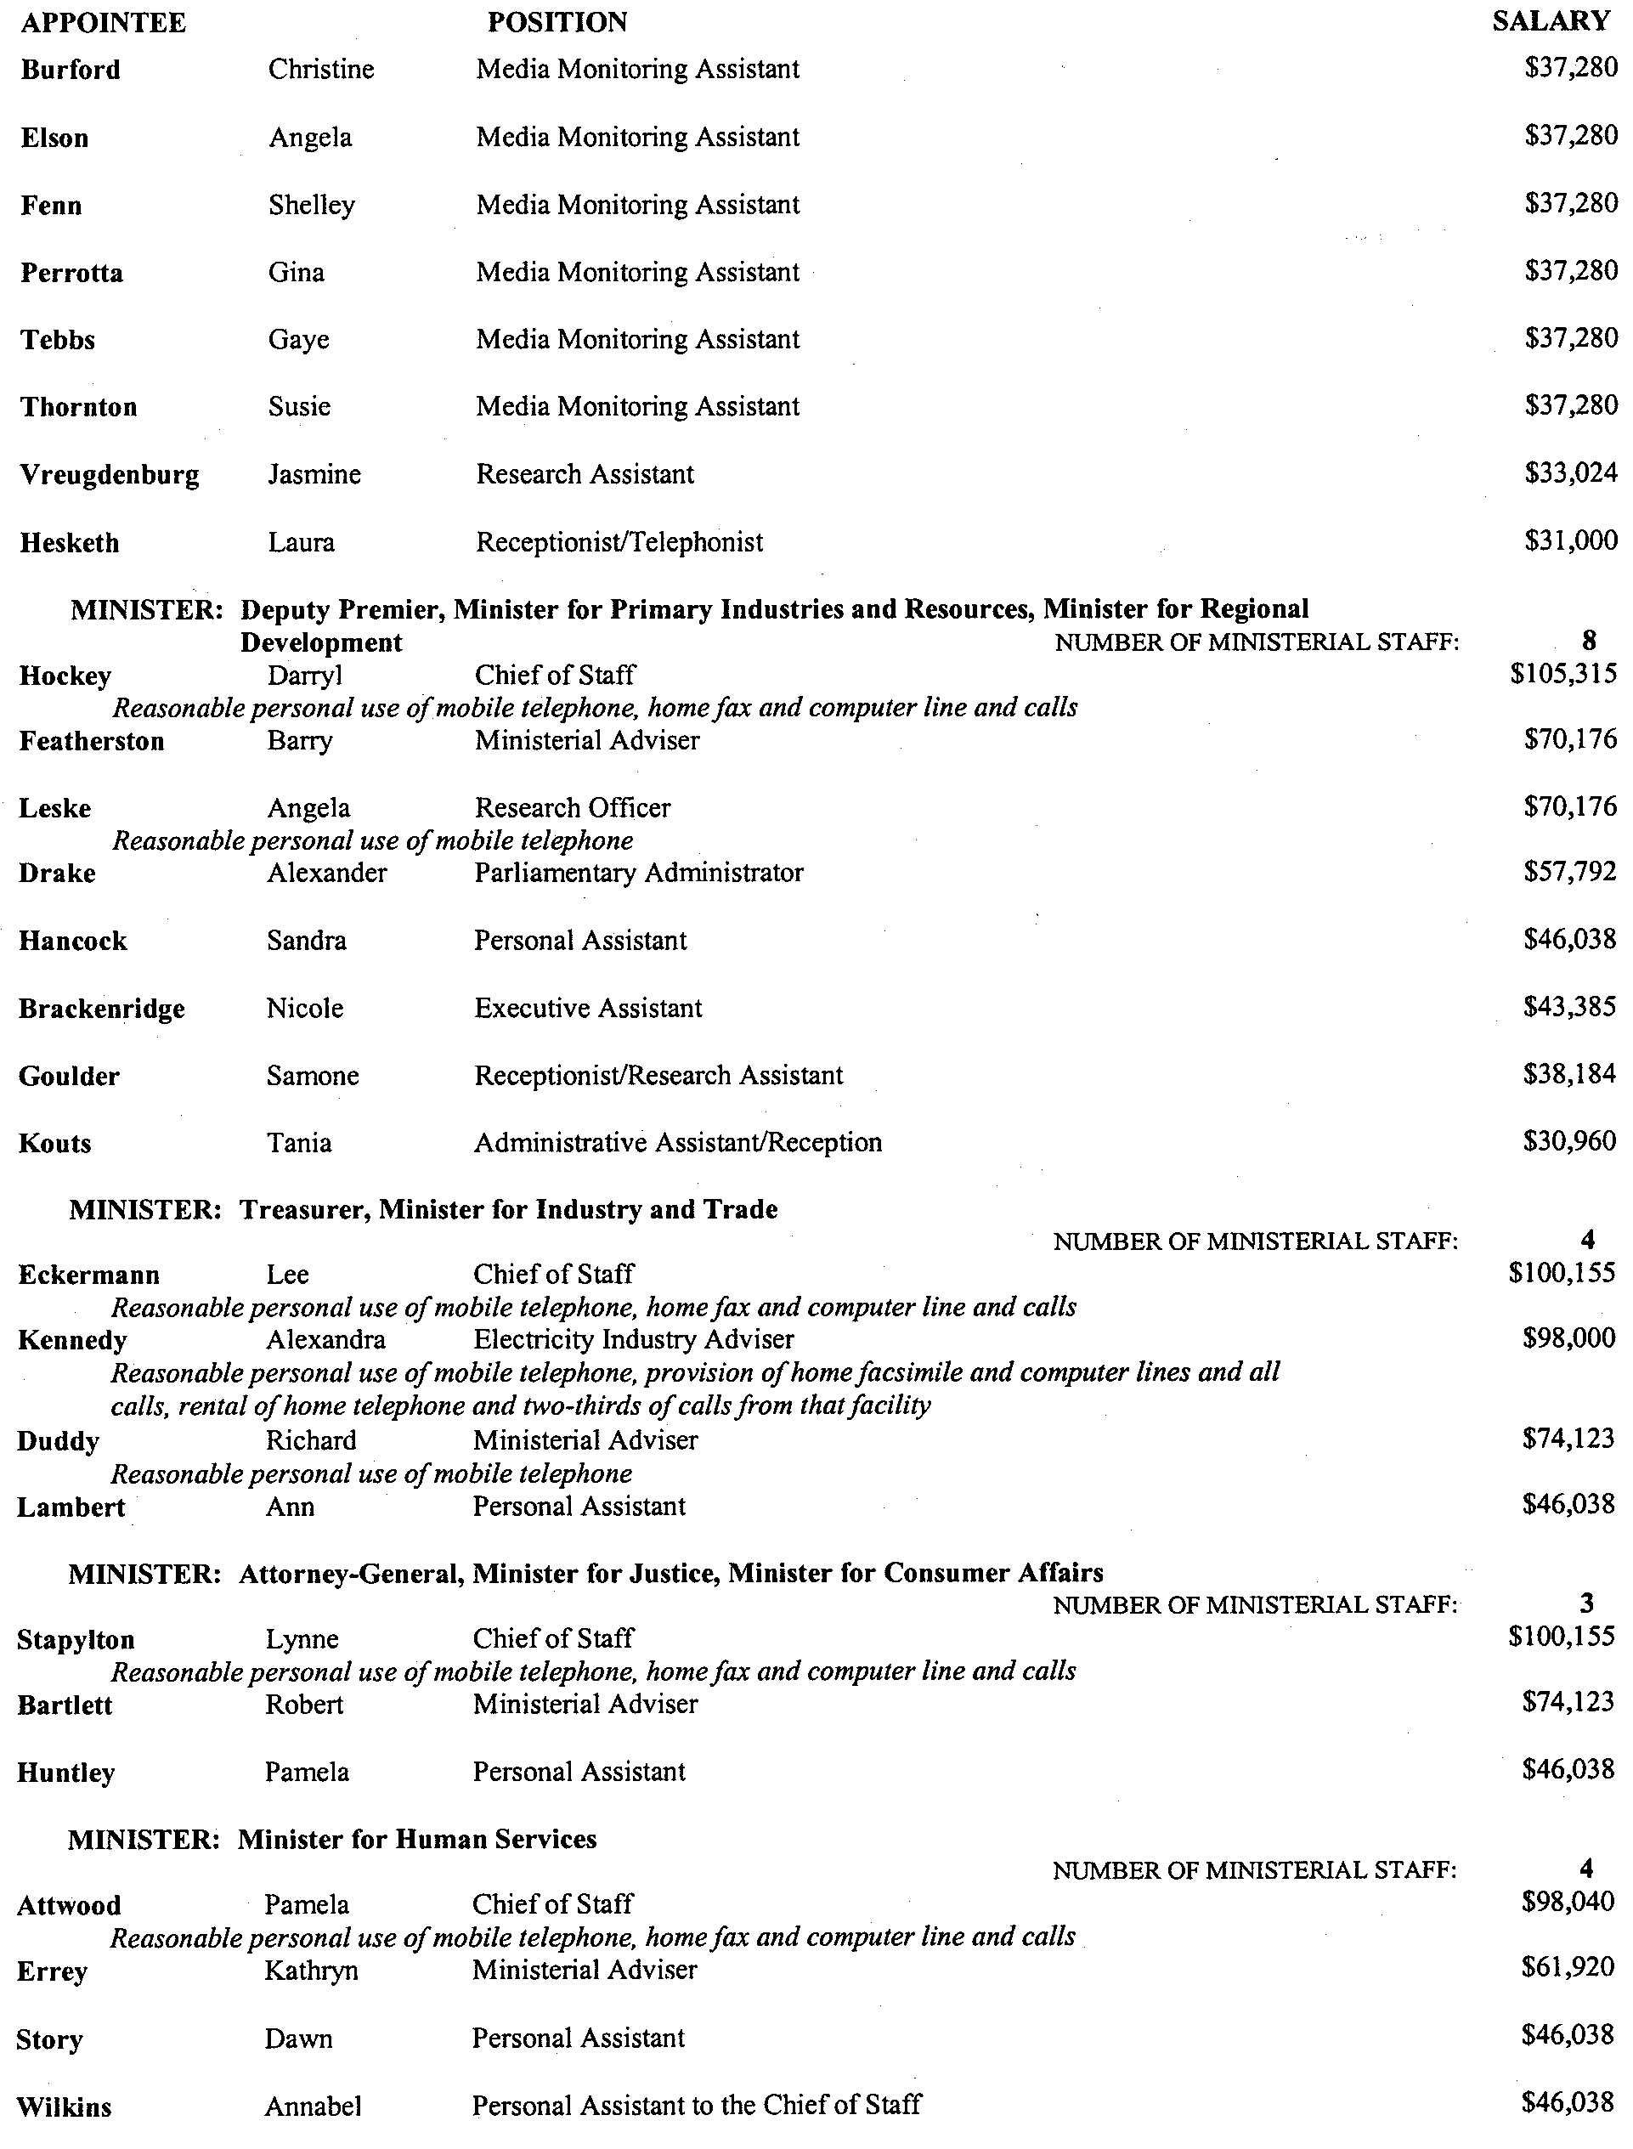
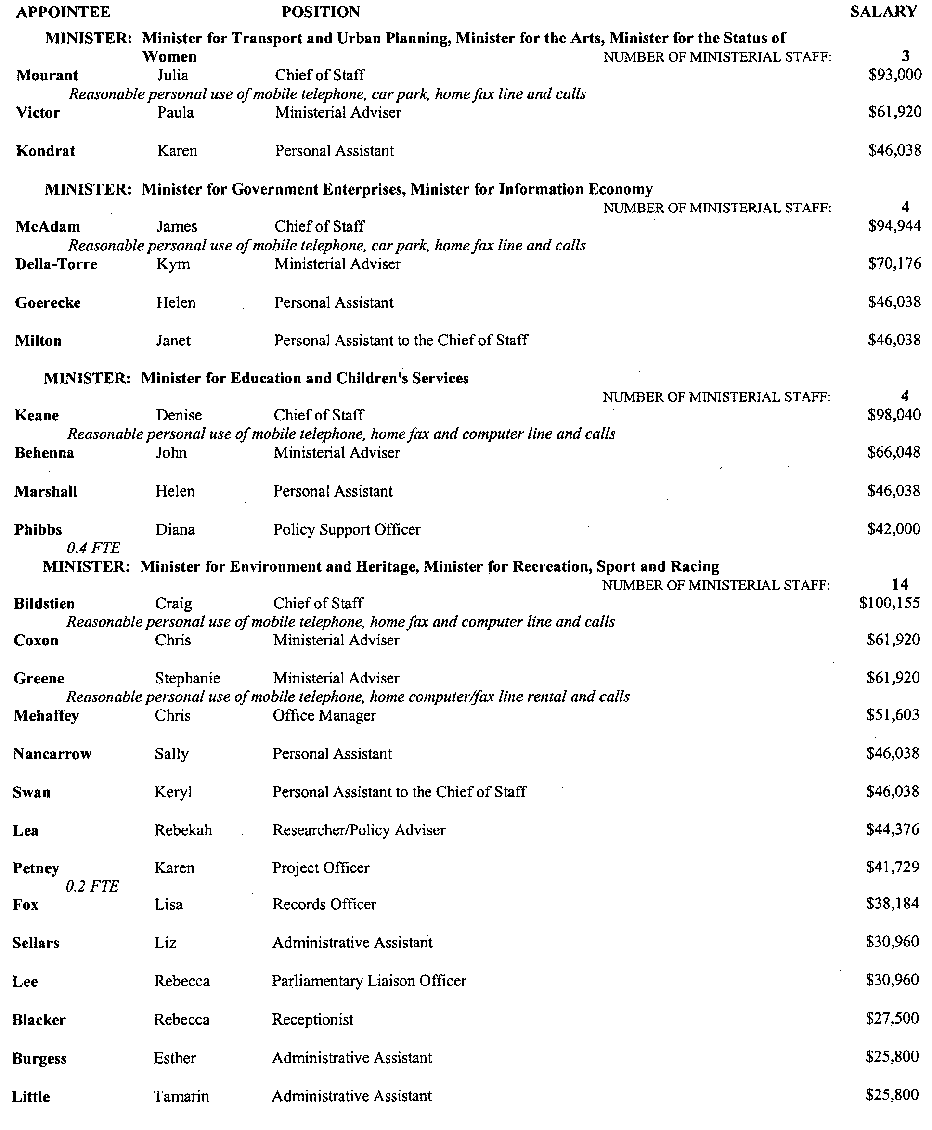
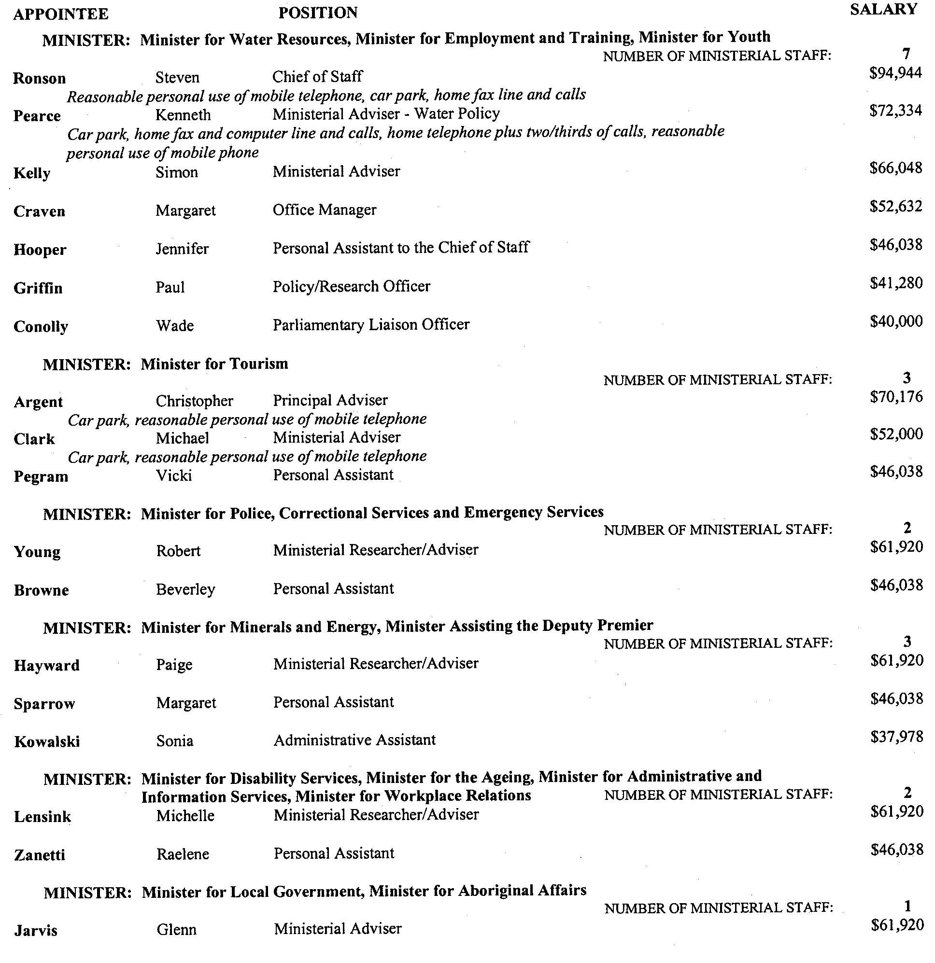

WATER RESOURCES ACT 1997
Notice of Intention to Revoke the Proclamation of the River Murray Catchment Water Management Board
I, MARK BRINDAL, Minister for Water Resources in the State of South Australia, do hereby give notice, pursuant to section 54 of the Water Resources Act 1997, of my intention to revoke the proclamation of the River Murray Catchment Water Management Board.
The River Murray Catchment Water Management Board was establishd by proclamation under the Act on 11 September 1997 (see Government Gazette, 11 September 1997, p. 704). The proclamation was varied pursuant to section 53 (3) of the Act on 8 March 2001, (see Gaovernment Gazette, 8 March 2001, p. 832) to more fully incorporate the South Australian portion of the Murray-Darling Basin. The Board’s catchment area is illustrated in the map below.
In light of this very significant increase in the Board’s catchment area, I am of the opinion that it would be prudent to ensure that the membership of the Board has the most appropriate blend of skills and experience to manage all the water resources under the jurisdiction of the Board.
Accordingly, the proclamation is being revoked to revise the entire membership of the Board. The new River Murray Catchment Water Management Board will:
• prepare and implement, in consultation with the community, a catchment water management plan for the proposed area in accordance with the Act;
• advise both myself and constituent councils within the proposed area about the management of water resources in accordance with the Act; and
• promote public awareness of the importance of proper management and sustainable use of the water resources in the proposed area.
I hereby invite interested persons to make written submissions on this proposal by Monday, 7 May 2001. All submission and enquiries on this proposal should be directed in the first instance to:
Jim Burston
Senior Policy Adviser
Murray-Darling Division
Department for Water Resources
G.P.O. Box 1047
Adelaide, S.A. 5001
Telephone: (08) 8204 9108
Facsimile: (08) 8204 9144
Email: Burston.Jim@saugov.sa.gov.au
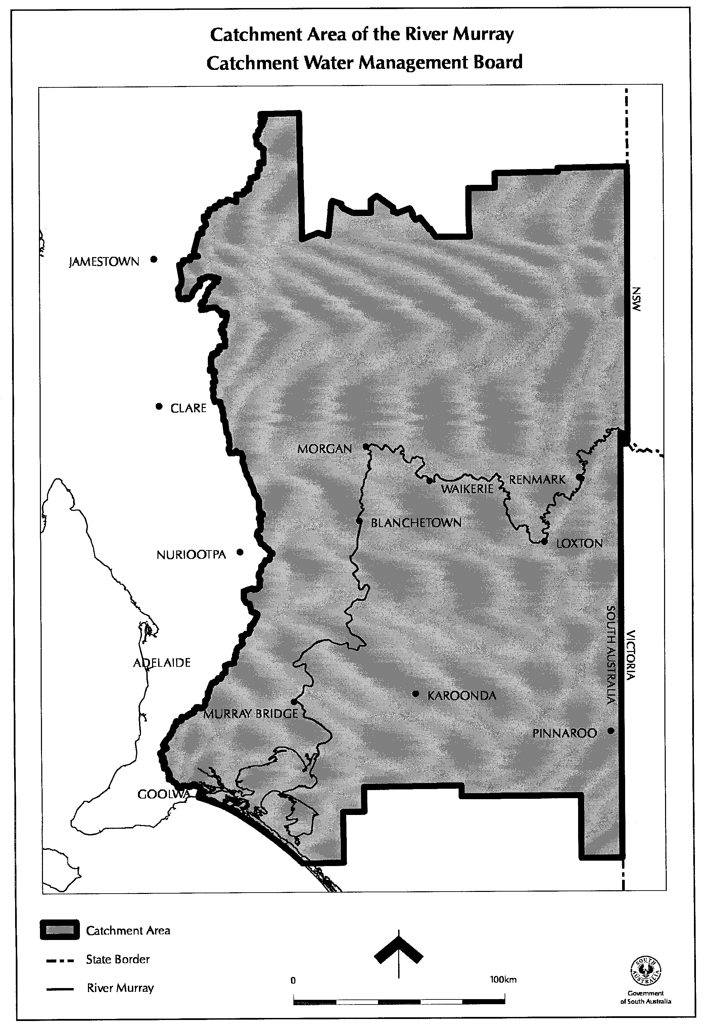

Dated 15 March 2001.
Mark Brindal, Minister for Water Resources

MISCELLANEOUS LEGISLATION AND GOVERNMENT PUBLICATIONS PRICES AS FROM 1 JULY 2000

Acts, Bills, Rules, Parliamentary Papers and Regulations
Pages | Main | Amends | Pages | Main | Amends

1-16 | 1.80 | 0.80 | 497-512 | 26.25 | 25.25
17-32 | 2.55 | 1.60 | 513-528 | 27.00 | 26.00
33-48 | 3.25 | 2.35 | 529-544 | 27.75 | 26.75
49-64 | 4.15 | 3.10 | 545-560 | 28.50 | 27.75
65-80 | 4.90 | 4.00 | 561-576 | 29.25 | 28.50
81-96 | 5.60 | 4.70 | 577-592 | 30.25 | 29.00
97-112 | 6.45 | 5.45 | 593-608 | 31.00 | 30.00
113-128 | 7.20 | 6.30 | 609-624 | 31.75 | 31.00
129-144 | 8.10 | 7.10 | 625-640 | 32.50 | 31.50
145-160 | 8.90 | 7.85 | 641-656 | 33.25 | 32.25
161-176 | 9.70 | 8.70 | 657-672 | 33.75 | 33.00
177-192 | 10.40 | 9.50 | 673-688 | 35.00 | 33.75
193-208 | 11.20 | 10.30 | 689-704 | 35.75 | 34.75
209-224 | 12.00 | 11.00 | 705-720 | 36.25 | 35.50
225-240 | 12.70 | 11.80 | 721-736 | 37.50 | 36.00
241-257 | 13.60 | 12.50 | 737-752 | 38.00 | 37.00
258-272 | 14.40 | 13.30 | 753-768 | 39.00 | 37.50
273-288 | 15.20 | 14.20 | 769-784 | 39.50 | 38.75
289-304 | 15.90 | 14.90 | 785-800 | 40.25 | 39.50
305-320 | 16.70 | 15.70 | 801-816 | 41.00 | 40.00
321-336 | 17.50 | 16.50 | 817-832 | 42.00 | 41.00
337-352 | 18.30 | 17.40 | 833-848 | 42.75 | 41.75
353-368 | 19.10 | 18.10 | 849-864 | 43.50 | 42.50
369-384 | 19.90 | 19.00 | 865-880 | 44.25 | 43.50
385-400 | 20.60 | 19.70 | 881-896 | 44.75 | 44.00
401-416 | 21.40 | 20.40 | 897-912 | 46.00 | 44.75
417-432 | 22.30 | 21.30 | 913-928 | 46.50 | 46.00
433-448 | 23.00 | 22.00 | 929-944 | 47.50 | 46.50
449-464 | 23.90 | 22.80 | 945-960 | 48.50 | 47.00
465-480 | 24.50 | 23.60 | 961-976 | 49.00 | 48.00
481-496 | 25.25 | 24.30 | 977-992 | 50.00 | 48.50

Legislation—Acts, Regulations, etc: $
Subscriptions:
Acts 162.85
All Bills as Laid 388.90
Rules and Regulations 388.90
Parliamentary Papers 388.90
Bound Acts 179.75
Index 87.05
Government Gazette
Copy 4.30
Subscription 214.85
Hansard
Copy 11.60
Subscription—per session (issued weekly) 336.95
Cloth bound—per volume 144.70
Subscription—per session (issued daily) 336.95
Legislation on Disk
Whole Database 2 488.80
Annual Subscription for fortnightly updates 765.20
Individual Act(s) including updates POA
Compendium
Subscriptions:
New Subs 1 476.60
Updates 527.10

(All the above prices include GST)

All Legislation, Government Gazette, Hansard and Legislation on disk are available from:
Counter Sales Information SA (State Government Bookshop)
and Mail Orders: Australis Centre, Ground Floor, 77 Grenfell Street, Adelaide, S.A. 5000.
Phone: (08) 8204 1900. Fax: (08) 8204 1909
S.A. Country Customer Free Call: 1800 182 234
TTY (Hearing Impaired): (08) 8204 1923
Subscriptions and Standing Orders:
Phone: (08) 8207 0908, (08) 8207 0910. Fax: (08) 8207 1040
Box 9, Plaza Level, Riverside Centre, North Terrace, Adelaide, S.A. 5000.

GOVERNMENT GAZETTE ADVERTISEMENT RATES

To apply from 1 July 2000

$  Agents, Ceasing to Act as 32.00  Associations:  Incorporation 16.30  Intention of Incorporation 40.25  Transfer of Properties 40.25  Attorney, Appointment of 32.00  Bailiff’s Sale 40.25  Cemetery Curator Appointed 23.90  Companies:  Alteration to Constitution 32.00  Capital, Increase or Decrease of 40.25  Ceasing to Carry on Business 23.90  Declaration of Dividend 23.90  Incorporation 32.00  Lost Share Certificates:  First Name 23.90  Each Subsequent Name 8.20  Meeting Final 26.75  Meeting Final Regarding Liquidator’s Report on  Conduct of Winding Up (equivalent to ‘Final  Meeting’)  First Name 32.00  Each Subsequent Name 8.20  Notices:  Call 40.25  Change of Name 16.30  Creditors 32.00  Creditors Compromise of Arrangement 32.00  Creditors (extraordinary resolution that ‘the Com-pany be wound up voluntarily and that a liquidator be appointed’) 40.25  Release of Liquidator⎯Application⎯Large Ad. 64.00  ⎯Release Granted 40.25  Receiver and Manager Appointed 37.25  Receiver and Manager Ceasing to Act 32.00  Restored Name 30.25  Petition to Supreme Court for Winding Up 55.50  Summons in Action 47.50  Order of Supreme Court for Winding Up Action 32.00  Register of Interests⎯Section 84 (1) Exempt 72.00  Removal of Office 16.30  Proof of Debts 32.00  Sales of Shares and Forfeiture 32.00  Estates:  Assigned 23.90  Deceased Persons⎯Notice to Creditors, etc. 40.25  Each Subsequent Name 8.20  Deceased Persons⎯Closed Estates 23.90  Each Subsequent Estate 1.00  Probate, Selling of 32.00  Public Trustee, each Estate 8.20 |  | $  Firms:  Ceasing to Carry on Business (each insertion) 21.30  Discontinuance Place of Business 21.30  Land⎯Real Property Act:  Intention to Sell, Notice of 40.25  Lost Certificate of Title Notices 40.25  Cancellation, Notice of (Strata Plan) 40.25  Mortgages:  Caveat Lodgment 16.30  Discharge of 17.20  Foreclosures 16.30  Transfer of 16.30  Sublet 8.20  Leases⎯Application for Transfer (2 insertions) each 8.20  Lost Treasury Receipts (3 insertions) each 23.90  Licensing 47.50  Municipal or District Councils:  Annual Financial Statement⎯Forms 1 and 2 451.00  Electricity Supply⎯Forms 19 and 20 319.00  Default in Payment of Rates:  First Name 64.00  Each Subsequent Name 8.20  Noxious Trade 23.90  Partnership, Dissolution of 23.90  Petitions (small) 16.30  Registered Building Societies (from Registrar-  General) 16.30  Register of Unclaimed Moneys⎯First Name 23.90  Each Subsequent Name 8.20  Registers of Members⎯Three pages and over:  Rate per page (in 8pt) 204.00  Rate per page (in 6pt) 269.00  Sale of Land by Public Auction 40.75  Advertisements 2.25  Advertisements, other than those listed are charged at $2.25 per column line, tabular one-third extra.  Notices by Colleges, Universities, Corporations and District Councils to be charged at $2.25 per line.  Where the notice inserted varies significantly in length from that which is usually published a charge of $2.25 per column line will be applied in lieu of advertisement rates listed.  South Australian Government publications are sold on the condition that they will not be reproduced without prior permission from the Government Printer.
All the above prices include GST

GOVERNMENT GAZETTE NOTICES
ALL private advertisements forwarded for publication in the South Australian Government Gazette must be PAID FOR PRIOR TO INSERTION; and all notices, from whatever source, should be legibly written on one side of
the paper only and sent to Government Publishing SA (formerly Riverside 2000) so as to be received no later than 4 p.m. Tuesday preceding the day of publication. Phone 8207 1045 or Fax 8207 1040. E-mail: governmentgazette@saugov.sa.gov.au. Send as attachments in Word format and please confirm your transmission with a faxed copy of your document, including the date the notice is to be published and to whom the notice will be charged.

REGULATIONS UNDER THE HARBORS AND NAVIGATION ACT 1993
────
No. 20 of 2001
────
At the Executive Council Office at Adelaide 15 March 2001

PURSUANT to the Harbors and Navigation Act 1993 and with the advice and consent of the Executive Council, I make the following regulations.
E. J. NEAL Governor

PURSUANT to section 10AA(2) of the Subordinate Legislation Act 1978, I certify that, in my opinion, it is necessary or appropriate that the following regulations come into operation as set out below.

DIANA LAIDLAW Minister for Transport and Urban Planning
───────────────────
SUMMARY OF PROVISIONS

1. Citation
2. Commencement
3. Variation of reg. 132—Life-jackets on certain recreational vessels
4. Variation of Sched. 4—Restricted Areas—Controls
5. Variation of Sched. 5—Restricted Areas—Delineation
────────────────────────

Citation
1. The Harbors and Navigation Regulations 1994 (see Gazette 20 October 1994 p. 987), as varied, are referred to in these regulations as "the principal regulations".

Commencement
2. These regulations will come into operation one week after the day on which they are made.

Variation of reg. 132—Life-jackets on certain recreational vessels
3. Regulation 132 of the principal regulations is varied—

(a) by inserting before paragraph (a) the following paragraph:

(aa) a vessel (other than a surfboard, surf ski or racing shell) that can only carry the operator and no other person; or;

(b) by striking out "each occupant of the vessel is wearing a properly adjusted life-jacket or personal flotation device" and substituting "the operator and any other occupants of the vessel are wearing properly adjusted life-jackets or personal flotation devices".

Variation of Sched. 4—Restricted Areas—Controls
4. Schedule 4 of the principal regulations is varied by inserting after the entry relating to Tumby Bay Areas 2 and 3 in the table in clause 2 the following entry:
Tumby Bay Area 5 | Controls 3 and 5

Variation of Sched. 5—Restricted Areas—Delineation
5. Schedule 5 of the principal regulations is varied—

(a) by inserting after the description of Area 4 in the entry relating to Tumby Bay the following description:

Area 5: the area of the sea at Tumby Bay bounded as follows: commencing at the northern most starboard hand channel marker of the marked navigation channel leading to the Tumby Bay Marina, then generally easterly across the marked navigation channel to the northern most port hand channel marker of the marked navigation channel, then generally south-easterly along the eastern edge of the marked navigation channel to its intersection with the breakwater, then generally south-easterly along the western edge of the breakwater to the point at which there is a bend in the breakwater, then generally south-westerly along the eastern edge of marked navigation channel to its intersection with the north-eastern corner of Allotment 75 in DP 55096, then generally southerly, westerly and easterly around the boundary of that Allotment (including Allotment 66 in DP 55096) to its intersection with the north-eastern corner of Allotment 548 in DP 15461, then generally north-easterly and northerly along the western edge of the marked navigation channel to the point of commencement.;

(b) by inserting after the map showing Area 4 in the entry relating to Tumby Bay the following map:
TSA C2001/01099 R. DENNIS Clerk of the Council
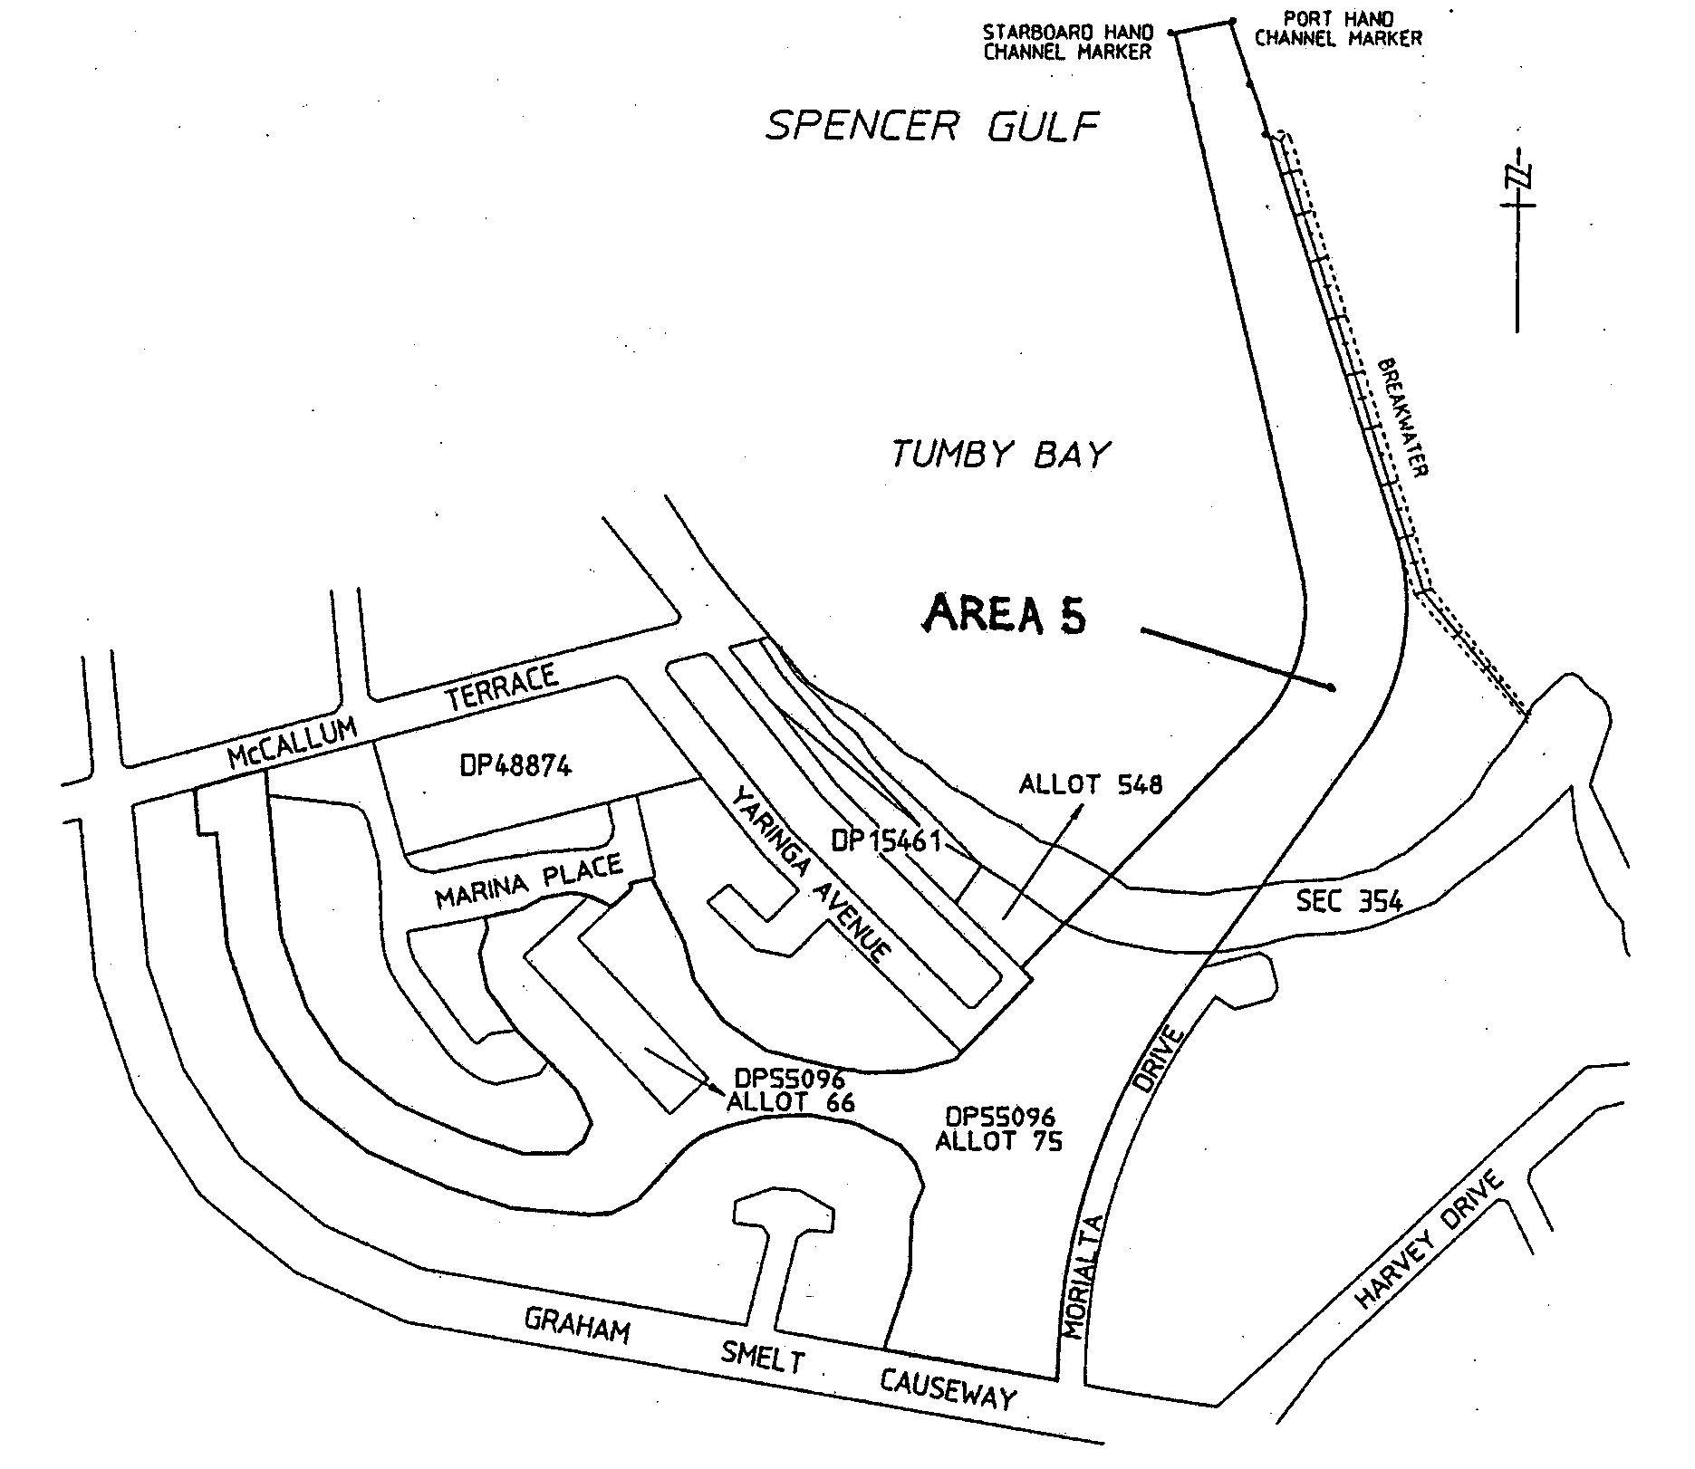

REGULATIONS UNDER THE DEVELOPMENT ACT 1993
────
No. 21 of 2001
────
At the Executive Council Office at Adelaide 15 March 2001

PURSUANT to the Development Act 1993 and with the advice and consent of the Executive Council, I make the following regulations.
E. J. NEAL Governor

PURSUANT to section 10AA(2) of the Subordinate Legislation Act 1978, I certify that, in my opinion, it is necessary or appropriate that the following regulations come into operation as set out below.

DIANA LAIDLAW Minister for Transport and Urban Planning
───────────────────
SUMMARY OF PROVISIONS

1. Citation
2. Commencement
3. Variation of reg. 6A—Significant trees
4. Variation of reg. 21—Certification of building indemnity insurance
5. Insertion of reg. 22A
22A. Applications extending beyond two years
6. Variation of reg. 24—Referrals
7. Variation of reg. 55—Supplementary provisions
8. Variation of reg. 58—General land division
9. Variation of reg. 69—Development excluded from approval and notice
10. Variation of reg. 70—Criteria relevant to development at variance with Building Rules
11. Variation of reg. 74—Notifications during building work
12. Variation of reg. 76B—Fire safety requirements—Smoke alarms in dwellings
13. Variation of reg. 86—Qualifications in planning
14. Variation of reg. 88—Certificate of independent technical expert in certain cases
15. Variation of reg. 89—Private certification—authorised functions
16. Variation of reg. 92—Provision of information
17. Variation of reg. 98—Register of applications
18. Variation of reg. 101—Accreditation of building products
19. Substitution of reg. 106
106. Notification of urgent work
20. Variation of Schedule 1
21. Variation of Schedule 3
22. Variation of Schedule 4
23. Variation of Schedule 5
24. Variation of Schedule 6
25. Variation of Schedule 8
26. Variation of Schedule 9
27. Variation of Schedule 10
28. Variation of Schedule 14
29. Variation of Schedule 14A
30. Variation of Schedule 21
────────────────────────

Citation
1. The Development Regulations 1993 (see Gazette 27 October 1993 p. 1993), as varied, are referred to in these regulations as "the principal regulations".

Commencement
2. These regulations will come into operation on the day on which they are made.

Variation of reg. 6A—Significant trees
3. Regulation 6A of the principal regulations is varied by striking out from subregulation (3) "making" and substituting "preparation".

Variation of reg. 21—Certification of building indemnity insurance
4. Regulation 21 of the principal regulations is varied—

(a) by inserting in subregulation (2) "copy of a" after "must ensure that a";

(b) by inserting in subregulation (3) "copy of a" after "unless or until a".

Insertion of reg. 22A
5. The following regulation is inserted after regulation 22 of the principal regulations:

Applications extending beyond two years
22A. (1) A relevant authority may lapse an application for a development authorisation under Part 4 of the Act if at least two years have passed since the date on which the application was lodged with the relevant authority under the Act.

(2) A relevant authority must, before it takes action to lapse an application under subregulation (1)—

(a) take reasonable steps to notify the applicant of the action under consideration; and

(b) allow the applicant a reasonable opportunity to make submissions to the relevant authority (in a manner and form determined by the relevant authority) about the proposed course of action.

(3) An applicant is not entitled to a refund of any fees if an application is lapsed under this regulation.

(4) If—

(a) an application relates to a Category 2 or 3 development; and

(b) at least two years have passed since the date on which notice of the application was given under section 38(4)(a) or (5)(c) of the Act (as the case may be),

the relevant authority must not give its consent unless a new notice of the application has been given under section 38(4) or (5) of the Act.

Variation of reg. 24—Referrals
6. Regulation 24 of the principal regulations is varied by inserting after subregulation (3) the following subregulation:

(4) A prescribed body must, within five business days after making a request under section 37(2) of the Act, notify the relevant authority of the request (and, in so doing, provide reasonable information about what has been requested).

Variation of reg. 55—Supplementary provisions
7. Regulation 55 of the principal regulations is varied by striking out from subregulation (4) "Chief Executive of the Engineering and Water Supply Department" and substituting "Chief Executive of the South Australian Water Corporation".

Variation of reg. 58—General land division
8. Regulation 58 of the principal regulations is varied by striking out from subregulation (3) "Minister of Public Infrastructure" wherever occurring and substituting, in each case, "Minister for Government Enterprises".

Variation of reg. 69—Development excluded from approval and notice
9. Regulation 69 of the principal regulations is varied by inserting in subregulation (3) ", Schedule 3A" after "Schedule 3".

Variation of reg. 70—Criteria relevant to development at variance with Building Rules
10. Regulation 70 of the principal regulations is varied by inserting in subregulation (1) (b) "relevant" after "the objects of the".

Variation of reg. 74—Notifications during building work
11. Regulation 74 of the principal regulations is varied by inserting after paragraph (d) of subregulation (3) the following word and paragraph:

or

(e) by transmitting an electronic version of the notice to the council's E-mail address.

Variation of reg. 76B—Fire safety requirements—Smoke alarms in dwellings
12. Regulation 76B of the principal regulations is varied by inserting after subregulation (5) the following subregulation:

(6) For the purposes of this regulation—

(a) the transfer of the interest of—

(i) a unit holder of a unit under the Strata Titles Act 1988; or

(ii) an owner of a community lot under the Community Titles Act 1996; or

(iii) an occupant of a unit in a building unit scheme,

will be taken to be a transfer of title of land; and

(b) land will be taken to include a unit under the Strata Titles Act 1988, a community lot under the Community Titles Act 1996 and a unit in a building unit scheme (and to the extent that such a unit or community lot comprises a building, it will be taken that the building is situated on that unit or lot); and
(c) a unit holder of a unit under the Strata Titles Act 1988, an owner of a community lot under the Community Titles Act 1996 or an occupant of a unit in a building unit scheme will be taken to be the owner of any building comprising the unit or lot.

Variation of reg. 86—Qualifications in planning
13. Regulation 86 of the principal regulations is varied by striking out subregulations (3) and (4).

Variation of reg. 88—Certificate of independent technical expert in certain cases
14. Regulation 88 of the principal regulations is varied by striking out from subregulation (1)(a) "Part 2.1 of the Housing Provisions" and substituting "Part 2.1—Housing Provisions—Volume 2".

Variation of reg. 89—Private certification—authorised functions
15. Regulation 89 of the principal regulations is varied—

(a) by inserting in subregulation (2)(a) ", other than a development classified as a complying development under these regulations or the relevant Development Plan," after "which requires provisional development plan consent";

(b) by striking out from subregulation (2)(b) "is required" and substituting "has been granted".

Variation of reg. 92—Provision of information
16. Regulation 92 of the principal regulations is varied by striking out from subregulation (2)(c) "is required" and substituting "has been granted".

Variation of reg. 98—Register of applications
17. Regulation 98 of the principal regulations is varied by inserting after subregulation (2) the following subregulation:

(2a) A relevant authority may, on payment of a fee fixed by the relevant authority, make available to a member of the public a copy of any part of a register or document kept for the purposes of subregulation (1).

Variation of reg. 101—Accreditation of building products
18. Regulation 101 of the principal regulations is varied by striking out paragraphs (c) and (d).

Substitution of reg. 106
19. Regulation 106 of the principal regulations is revoked and the following regulation is substituted:

Notification of urgent work
106. For the purposes of sections 54(2)(a) and 54A(2)(a) of the Act, the relevant notification must be given—

(a) by telephone or facsimile transmission, using the main telephone or facsimile number at the principal office of the relevant authority, or a number determined by the relevant authority for the purposes of this regulation; or

(b) by transmitting an electronic version of the notification to the relevant authority's E-mail address.

Variation of Schedule 1
20. Schedule 1 of the principal regulations is varied by striking out the definition of "bank".

Variation of Schedule 3
21. Schedule 3 of the principal regulations is varied—

(a) by striking out from clause 1(h) "for the purposes of section 370 of the Local Government Act 1934" and substituting "under the Local Government Act 1999";

(b) by striking out from clause 3(5) ", or the alteration of a boundary of an allotment,";

(c) by striking out subparagraph (i) of clause 4(1)(e) and substituting the following subparagraph:

(i) a fence in—

(A) the Hills Face Zone, a Historic (Conservation) Zone, a Historic (Conservation) Policy Area, a Watercourse Zone, a Flood Zone or Flood Plain delineated by the relevant Development Plan, or in any other zone or area shown as being subject to flooding or inundation in the relevant Development Plan; or

(B) a Regional Centre Zone, or in any Centre Zone in the area of The Corporation of the City of Campbelltown; or

(C) a Residential 2 Zone in the area of the City of Charles Sturt in the former area of the City of Henley and Grange; or

(D) a Residential 1W Zone, Residential 2A Zone, Residential 3B Zone or Residential 3C Zone, or the Residential (Hallett Brickworks) Zone, in the area of the City of Charles Sturt in the former area of the City of Hindmarsh and Woodville; or;

(d) by inserting after paragraph (c) of clause 10 the following word and paragraph:

or

(d) where the dam is to have a capacity exceeding 5 megalitres.

Variation of Schedule 4
22. Schedule 4 of the principal regulations is varied by striking out subparagraph (i) of clause 1(d) in Part 1 and substituting the following subparagraph:

(i) a fence in—

(A) the Hills Face Zone, a Historic (Conservation) Zone, a Historic (Conservation) Policy Area, a Watercourse Zone, a Flood Zone or Flood Plain delineated by the relevant Development Plan, or in any other zone or area shown as being subject to flooding or inundation in the relevant Development Plan; or

(B) a Regional Centre Zone, or in any Centre Zone in the area of The Corporation of the City of Campbelltown; or

(C) a Residential 2 Zone in the area of the City of Charles Sturt in the former area of the City of Henley and Grange; or

(D) a Residential 1W Zone, Residential 2A Zone, Residential 3B Zone or Residential 3C Zone, or the Residential (Hallett Brickworks) Zone, in the area of the City of Charles Sturt in the former area of the City of Hindmarsh and Woodville; or.

Variation of Schedule 5
23. Schedule 5 of the principal regulations is varied—

(a) by inserting in clause 3(1)(a) "relevant" after "in respect of the";

(b) by inserting in clause 4(1) "relevant" after "in respect of the".

Variation of Schedule 6
24. Schedule 6 of the principal regulations is varied by striking out from item 1(2) "appropriate" and substituting "relevant".

Variation of Schedule 8
25. Schedule 8 of the principal regulations is varied—

(a) by inserting in item 1A(c) "relevant" after "in respect of the";

(b) by inserting after item 15 the following items:

16. Dams in water restriction areas

A Development that will involve the construction or enlargement of a dam in a part of the State within the ambit of a notice under section 16 of the Water Resources Act 1997.

B The Minister for the time being administering the Water Resources Act 1997.

C Six weeks.

D Direction.

17. Historic shipwrecks

(1) A Development to be undertaken within 500 metres of a historic shipwreck or historic relic within the meaning of the Historic Shipwrecks Act 1981.

B The Minister for the time being administering the Historic Shipwrecks Act 1981.

C Eight weeks.

D Direction.

(2) A Development to be undertaken within 500 metres of a historic shipwreck or historic relic within the meaning of the Historic Shipwrecks Act 1976 (Commonwealth).

B The Commonwealth Minister for the time being administering the Historic Shipwrecks Act 1976 (Commonwealth).

C Eight weeks.

D Direction.

Variation of Schedule 9
26. Schedule 9 of the principal regulations is varied—

(a) by striking out paragraph (a) of subclause (1) of clause 2 in Part 1 and substituting the following paragraph:

(a) the construction of any of the following (or of any combination of any of the following):

(i) one or more detached dwellings;

(ii) one or more single storey dwellings;

(iii) one or more sets of semi-detached dwellings, provided that no such dwelling is more than two storeys high;

(iv) three or more row dwellings or one or more additional row dwellings, provided that no such dwelling is more than two storeys high;;

(b) by inserting in clause 5 in Part 1 "relevant" after "under the";

(c) by inserting in paragraphs (b), (c), (d), (e), (f), (g), (h), (i), (j) and (k) of clause 6(1) in Part 1 "relevant" after "delineated in the" (wherever occurring);

(d) by inserting in subclause (3) of clause 6 in Part 1 the following definition:

"bank" means premises of an ADI¹;

^{1.} An ADI is an authorised deposit-taking institution within the meaning of the Banking Act (Cwth).

Variation of Schedule 10
27. Schedule 10 of the principal regulations is varied by inserting in paragraph (c) of item B in the schedule to clause 3(1) "within the ambit of the relevant application or previously" after "rural development".

Variation of Schedule 14
28. Schedule 14 of the principal regulations is varied—

(a) by inserting in clause 1(b)(i) "relevant" after "in respect of the";

(b) by inserting in clause 1(f) "1950" after "Forestry Act".

Variation of Schedule 14A
29. Schedule 14A of the principal regulations is varied by inserting in paragraph (a)(i) "relevant" after "in respect of the".

Variation of Schedule 21
30. Schedule 21 of the principal regulations is varied by inserting in clause 7(9)(a) "relevant" after "delineated in the".

MFTUP 46/00 CS R. DENNIS Clerk of the Council

FAXING COPY?

IF you fax copy to Government Publishing SA (formerly Riverside 2000), for inclusion in the Government Gazette, there is no need to send a Confirmation Copy to us as well.

This creates confusion and may well result in your notice being printed twice.

Please use the following fax number:

Fax transmission: (08) 8207 1040
Phone Inquiries: (08) 8207 1045

Please include a contact person, phone number and order number so that we can phone back with any queries we may have regarding the fax copy.

NOTE: Closing time for lodging new copy (either fax or hard copy) is 4 p.m. on Tuesday preceding the day of publication.

Government Gazette notices can be E-mailed.

The address is:

governmentgazette@saugov.sa.gov.au

Documents should be sent as attachments in Word format.

When sending a document via E-mail, please confirm your transmission with a faxed copy of your document, including the date the notice is to be published.

Fax transmission: (08) 8207 1040
Enquiries: (08) 8207 1045

CITY OF PLAYFORD
By-law Made Under the Local Government Act 1999
By-law No. 1—Permits and Penalties
TO provide for a permit system and penalties in council by-laws, to clarify the construction of such by-laws, and to repeal by-laws.
A. All previous by-laws made or adopted by the council, prior to the date this by-law is made, are hereby repealed.
Permits
1. (1) In any by-law of the council unless the contrary intention is clearly indicated the word ‘Permission’ means the permission of the council given in writing.
(2) The council may attach such conditions to a grant of permission as it thinks fit, and may vary or revoke such conditions or impose new conditions by notice in writing to the permit holder.
(3) Any permit holder shall comply with every such condition.
(4) The council may revoke such grant of permission at any time by notice in writing to the permit holder.
(5) A permit fee shall be $200 per year on a pro rata basis or $10 per day.
Penalties
2. (1) Any person who commits a breach of any by-law of the council shall be guilty of an offence and is liable to pay penalties and fees provided for in the Local Government Act 1999.
(2) The maximum penalty shall be $750. The minimum penalty shall be $250. The expiation fee shall be $100.
Construction
3. Every by-law of the council shall be subject to any Act of Parliament and Regulations made thereunder.
The foregoing by-law was duly made and passed at a council meeting of the City of Playford held on 27 February 2001.
T. R. S. Jackson, Chief Executive Officer

CITY OF PLAYFORD
By-law Made Under the Local Government Act 1999
By-law No. 2—Moveable Signs
TO set standards for moveable signs on streets and roads and to provide conditions for the placement of such signs.
Definitions
1. In this by-law:
(1) ‘footpath area’ means that part of a street or road between the boundary of the street or road and the edge of the carriageway on the same side as that boundary;
(2) ‘moveable signs’ has the same meaning as in the Local Government Act 1999; and
(3) ‘authorised person’ means a person appointed as an authorised person pursuant to section 260 of the Local Government Act 1999.
Construction
2. A moveable sign displayed on a road:
(1) shall be a kind known as an ‘A’ Frame or Sandwich Board sign, an ‘inverted “T”’ sign, or a flat sign;
(2) (a) shall be constructed and maintained in good quality and condition;
(b) shall be of strong construction with no sharp or jagged edges or corners;
(c) shall not be unsightly or offensive in appearance;
(3) shall:
(a) be constructed of timber, metal or plastic coated cardboard, or a mixture of such materials;
(b) not exceed 900 mm in height, 600 mm in width or 600 mm in depth;
(4) shall not be likely to fall over or collapse;
(5) in the case of an ‘A’ Frame or Sandwich Board sign:
(a) shall be hinged or joined at the top;
(b) shall be of such construction that its sides shall be securely fixed or locked in position when erected;
(6) in the case of an ‘inverted “T”’ sign, shall contain no struts or members that run between the display area and the base of the sign; and
(7) shall not rotate, contain flashing lights or be illuminated internally.
Position
3. A moveable sign shall not be positioned on a public street or road:
(1) unless it rests on the surface of the footpath area but no closer to the carriageway than 400 mm;
(2) on a footpath area that is of less width than 2 m;
(3) on a footpath area attached to or within 1.4 m of any other structure, fixed object, tree, bush or plant (excepting a building adjacent to the footpath area); or
(4) within 1 m of an entrance to premises adjacent thereto;
(5) on the sealed part of any footpath area, if there is any unsealed part of that area on which the sign can be placed in accordance with this by-law;
(6) within 1 m of a building line or fence line adjacent thereto if it causes or is likely to cause an obstruction to people using the footway; or
(7) on a median strip, traffic island or carriageway.
Restrictions
4. A moveable sign shall not be placed on a public street or road:
(1) (a) unless it only displays material which advertises a business being conducted on premises which are not used in whole for residential or primary production purposes and which are adjacent to the sign, or the products available from that business;
(b) if another moveable sign which relates to the same business is already displayed on the street or road;
(c) unless the business to which it relates is open;
(2) in a wind if it is likely to be blown over or swept away;
(3) in such a position or in such circumstances that the safety of any user of the street or road is at risk;
(4) during the hours of darkness unless it is clearly visible.
Appearance
5. A moveable sign displayed on a public street or road shall:
(1) be painted or otherwise detailed in a competent and professional manner;
(2) be attractive, legible and simply worded to convey a precise message;
(3) be of such design and contain such colours which are compatible with the architectural design of the premises adjacent to the sign, and which relate well to the townscape and overall amenity of the locality in which it is situated;
(4) contain combinations of colour and typographical styles which blend in with and reinforce the heritage qualities of the locality and the buildings where it is situated;
(5) not have balloons, flags, streamers or other things attached to it.
Banners
6. No person shall without permission place, erect or display a banner on any council property.
Removal of signs
7. Where an authorised person has removed a sign placed on a public street, road or local government land in contravention of this by-law or a provision of the Local Government Act 1999, the owner of the sign shall not be entitled to reclaim the sign until they have paid council the reasonable costs of removal and storage of the sign.
Exemptions
8. (1) Subparagraphs 3 (1), (2), (4), (5), (7) and 4 (1) and paragraph 5 do not apply to a moveable sign which is used:
(a) by a Land Agent to indicate only that a residential premises is open for inspection for sale;
(b) to advertise a garage sale taking place from residential premises; or
(e) as a directional sign to an event run by a charitable body,
and which is not placed on the carriageway of a street or road.
(2) Subparagraph 4 (1) does not apply to a flat sign the message of which only contains newspaper headlines and the name of a newspaper.
(3) Paragraphs 2 (3), 3, 4 (1) and 4 (4) do not apply to a banner.
(4) A requirement of this by-law will not apply where permission has been granted for the sign to be displayed contrary to that requirement.
The foregoing by-law was duly made and passed at a council meeting of the City of Playford held on 27 February 2001.
T. R. S. Jackson, Chief Executive Officer

CITY OF PLAYFORD
By-law Made Under the Local Government Act 1999
By-law No. 3—Local Government Land
FOR the management of parklands, reserves, public places, the foreshore, and other land vested in or under the control of the council.
Definitions
1. In this by-law:
(1) ‘Local government land’ means all parklands, reserves, ornamental grounds, jetties, bridges, public places, and other land, vested in or under control of the council (except streets and roads);
(2) ‘Disability’ means a disability as defined in the Disability Discrimination Act 1992, with the exception of a disability that previously existed but no longer exists, may exist in the future or is imputed to a person;
(3) ‘Guide Dog’ means a guide dog as defined in the Dog and Cat Management Act l995;
(4) ‘liquor’ has the same meaning as defined in the Liquor Licensing Act 1995;
(5) ‘open container’ means a container which:
(a) after the contents thereof have been sealed at the time of manufacture and:
(i) being a bottle it has had its cap or cork or top removed (whether it has since been replaced or not);
(ii) being a can it has been opened or punctured;
(iii) being a cask it has had its tap placed in a position to allow it to be used;
(iv) being any form or container it has been opened, broken, punctured or manipulated in such a way as to allow access to the contents thereof; or
(b) is a flask, glass or mug or other container used for drinking purposes;
(6) ‘authorised person’ means a person appointed as an authorised person pursuant to section 260 of the Local Government Act 1999.
Activities requiring permission
2. No person shall without permission on any local govern-ment land:
Vehicles generally
(1) (a) being the driver of a vehicle, fail to obey the indications given by any traffic control device (within the meaning of the Road Traffic Act 1961), or any sign erected by or with the authority to the council, for regulating traffic or indicating the direction of route, to be followed by traffic on that land;
(b) drive or propel a vehicle on any part thereof where the council has excluded vehicles generally pursuant to section 32 of the Road Traffic Act 1961;
(c) drive or propel a vehicle of a class on any part thereof where the council has excluded vehicles of that class pursuant to section 32 of the Road Traffic Act 1961;
Vehicles on parklands etc.
(2) comprising parklands or reserves:
(a) drive or propel a motor vehicle thereon, unless on an area or road constructed or set aside by the council for the parking or travelling of motor vehicles;
(b) except on a properly constructed area for the purpose, promote, organise or take part in any race, test or trial of any kind in which motor vehicles, motor cycles, motor scooters or bicycles take part;
Vehicles on foreshore
(3) (a) drive or propel a vehicle onto or from the foreshore other than by a ramp or thoroughfare constructed or provided by the council for that purpose;
(b) launch or retrieve a boat other than from a boat ramp constructed for that purpose;
(c) allow any vehicle to remain stationary on any boat ramp longer than is necessary to launch or retrieve a boat;
(d) drive or propel any vehicle on such a ramp or thoroughfare or elsewhere on the foreshore at a speed greater than 25 km/h;
Repairs to vehicles
(4) perform the work of repairing, washing, painting, panel-beating or other work of any nature on or to any vehicle, provided that this paragraph shall not extend to running repairs in the case of breakdown;
Busking
(5) sing, busk or play any recording or upon any musical instrument so as to appear to be for the purpose of entertaining other persons or receiving money;
Amplification
(6) use an amplifier or other device whether mechanical or electrical for the purpose of amplifying sound or broadcasting announcements;
Donations
(7) ask for or receive or indicate that he or she desires a donation of money or any other thing;
Preaching
(8) preach, harangue or tout for business;
Distribution of printed material
(9) place on any vehicle (without the owner’s consent) or give out or distribute to any bystander or passer-by any handbill, book, notice, or other printed matter, provided that this restriction shall not apply to any handbill or leaflet given out or distributed by or with the authority of a candidate during the course of a Federal, State or Local Government Election or to a handbill or leaflet given out or distributed during the course and for the purposes of a Referendum;
Removing soil etc.,
(10) carry away or remove any soil, sand, timber, stones, pebbles or any part of the land;
Picking fruit etc.,
(11) pick fruit, nuts or berries from any trees or bushes thereon;
Digging soil
(12) to which this subparagraph applies, dig the soil for or to collect worms, grubs or insects;
Games
(13) (a) to which this subparagraph applies, participate in any game recreation or amusement which involves the use of a ball, missile or other object which by the use thereof may cause or be likely to cause injury or discomfort to any person being on or in the vicinity of that land; or
(b) play any organised competition sport;
Fires
(14) light any fire except:
(a) in a place provided by the council for that purpose;
(b) in a portable barbeque in parklands;
No liquor
(15) consume, carry or be in possession or charge of any liquor in areas of parklands and reserves, as designated by resolution of the council;
Smoking
(16) smoke tobacco or any other substance in any building or part thereof to which this paragraph applies;
Animals on foreshore
(17) (a) allow or suffer any animal under his or her control to swim or bathe in the sea or any other open public water to the inconvenience, annoyance or danger of any other person bathing or swimming;
(b) comprising the foreshore, drive, lead or ride any horse thereon from midnight to 5 a.m. and 8 a.m. to midnight;
(c) comprising the foreshore, ride, drive or exercise any horse in such a manner as to endanger the safety of any person thereon;
Closed lands
(18) enter or remain on any part of local government land:
(a) at any time during which the council has declared that the part shall be closed to the public, and which is indicated by a sign adjacent to the entrance to that part;
(b) where the land is enclosed with fences and/or walls, and gates have been closed and locked; or
(c) where admission charges are payable for that person to enter that part, without paying those charges;
Tents
(19) (except the council or other Government authority) erect any tent or other structure of calico, canvass, plastic or similar material as a place of habitation;
Camping
(20) camp or remain overnight on any parklands, reserves or other local government land;
Suspending articles
(21) hang or suspend any article or thing from any building, verandah, pergola or other structure under the control of the council;
Use of toilets
(22) enter any toilet that is set aside for use of the opposite sex; provided however that:
(a) a child under the age of five years may enter a public convenience set apart for the use of the other sex if the child is accompanied by an adult person of that other sex; and
(b) a person, using discretion, may enter a public convenience for the purpose of providing assistance to a person with a disability;
Fauna
(23) (a) take, interfere with or disturb any animal or bird or the eggs or young of any animal or bird;
(b) disturb, interfere with or damage any burrow, nest or habitat of any animal or bird; or
(c) use, possess or have control of any device for the purpose of killing or capturing any animal or bird;
Flora
(24) (a) take, uproot or damage any plant;
(b) remove, take or disturb any soil, stone, wood, tinder or bark;
(c) collect or take any dead wood or timber for the purpose of using the same to make or maintain a fire; or
(d) ride or drive any vehicle or animal or run, stand or walk on any flowerbed or garden plot;
Horses, cattle etc.
(25) ride, lead or drive any horse, cattle or sheep, except on any street, road or car park or where the council has set aside a track or other area for use by or in connection with the animal of that kind;
Animals
(26) (a) allow any stock to stray into or depasture therein;
(b) allow any animal to damage any flower bed, garden plot, tree, lawn or other item or place;
(c) take any animal into any area to which this sub-paragraph applies;
Boats
(27) propel or float any boat, raft, pontoon or water craft on any pond or lake or reservoir or part thereof to which this subparagraph applies;
Fireworks
(28) use, discharge or explode any fireworks;
Firearms
(29) carry, use, discharge or explode any firearm, explosive, fireworks, air gun or any other weapon.
Prohibited activities
3. No person shall on any local government land:
Use of equipment
(1) use any form of equipment or property belonging to the council other than in the manner and for the purpose for which it was designed or set aside;
Annoyances
(2) annoy or unreasonably interfere with any other person’s use of the land by making a noise or creating a disturbance that has not been authorised by the council;
Directions
(3) fail to comply with any reasonable direction or request from an authorised person of the council relating to:
(a) that person’s use of the land;
(b) that person’s conduct and behaviour on the land;
(c) that person’s safety on the land; or
(d) the safety and enjoyment of the land by other persons;
Missiles
(4) throw, roll or discharge any stone, substance or missile to the danger of any person or animal therein;
Glass
(5) wilfully break any glass, china or other brittle material;
Defacing property
(6) deface, paint, write, cut names or make marks on or fix bills or advertisements to any tree, rock, gate, fence, building, sign or other property of the council therein.
Removal of animals and persons
4. (1) If any animal is found on any part of local government land in breach of a by-law:
(a) any person in charge of the animal shall forthwith remove it from that part on the request of an authorised person; and
(b) any authorised person may remove it therefrom if the person fails to comply with the request, or if no person is in charge of the animal.
(2) An authorised person may direct any person who is considered to be committing or has committed a breach of this by-law to leave that part of the Local Government Land. Failure to comply with that direction forthwith is a breach of this by-law.
Exemptions
5. The restrictions in this by-law do not apply to any council officer or employee acting in the course and within the scope of that person’s normal duties, or to a contractor while performing work for the council and while acting under the supervision of a Council Officer, or to the driver of an exempt vehicle (within the meaning of section 40 of the Road Traffic Act 1961) while driving that vehicle in relation to an emergency.
Application of paragraphs
6. Any subparagraphs of 2 (12), 2 (13) (a), 2 (14), 2 (15),
2 (16), 2 (26) (c) or 2 (27) of this by-law shall apply only in such portion or portions of the area as the council may by resolution direct (in accordance with section 246 of the Local Government Act 1999).
The foregoing by-law was duly made and passed at a council meeting of the City of Playford held on 27 February 2001.
T. R. S. Jackson, Chief Executive Officer

CITY OF PORT LINCOLN
Supplementary Election for Bishop Ward—Nominations
NOTICE is hereby given that nominations are hereby invited and will be received at the offices of the City of Port Lincoln Council, Civic Centre, 60 Tasman Terrace, Port Lincoln, from Thursday, 22 March 2001, until 12 noon on Thursday, 12 April 2001, from any person eligible to be a candidate for election to the vacancy of councillor to represent the Bishop Ward.
Nomination forms and candidate’s handbooks may be obtained at the Council Office during business hours, or requested by telephone on (08) 8682 3033.
A candidate must submit a profile of not more than 150 words with the nomination form.
A candidate photograph of predominantly the head and shoulders, taken within the preceding 12 months, may also be submitted.
A briefing session for prospective candidates will be conducted on Monday, 2 April 2001 commencing at 6 p.m. in the Council Chambers, 60 Tasman Terrace, Port Lincoln.
If more than the required number of nominations are received for the vacancy, an election will be conducted entirely by postal ballot with the return of the completed ballot papers to reach the Deputy Returning Officer no later than 12 noon on Tuesday, 22 May 2001.
S. H. Tully, Returning Officer

CITY OF VICTOR HARBOR
Supplementary Election—Close of Roll
NOTICE is hereby given that due to the death of a member of the council, a supplementary election will be necessary to fill one vacancy of Area Councillor for the City of Victor Harbor.
The voters roll to conduct this supplementary election will close at 5 p.m. on Friday, 30 March 2001.
Nominations to fill the vacancy will open on Thursday,
26 April 2001 and will be received up until 12 noon on Thursday, 17 May 2001.
The election will be conducted entirely by post with the return of ballot material to the Returning Officer no later than 12 noon on Wednesday, 20 June 2001.
S. H. Tully, Returning Officer

CITY OF WHYALLA
Supplementary Election for Area Councillor—Nominations
NOTICE is hereby given that nominations are hereby invited and will be received at the City of Whyalla, Civic Building, Darling Terrace, Whyalla, from Thursday, 22 March 2001 until 12 noon on Thursday, 12 April 2001, from any person eligible to be a candidate for election to the vacancy of councillor to represent the area.
Nomination forms and candidate’s handbooks may be obtained at the council office during business hours, or requested by telephone on (08) 8640 3444.
A candidate must submit a profile of not more than 150 words with the nomination form.
A candidate photograph of predominantly the head and shoulders, taken within the preceding 12 months, may also be submitted.
A briefing session for prospective candidates will be conducted on Tuesday, 3 April 2001, commencing at 6 p.m. in the Council Chambers, Civic Building, Darling Terrace, Whyalla.
If more than the required number of nominations are received for the vacancy, an election will be conducted entirely by postal ballot with the return of the completed ballot papers to reach the Deputy Returning Officer no later than 12 noon on Tuesday, 22 May 2001.
S. H. Tully, Returning Officer

BERRI BARMERA COUNCIL
Roads (Opening and Closing) Act 1991
Phillips Road, Berri
NOTICE is hereby given that the Berri Barmera Council, pursuant to section 10 of the Roads Opening and Closing Act 1991, proposes to make a Road Process Order to:
(i) open as road portion of allotment 201 (reserve) in Deposited Plan 45786, numbered ‘1’ in Preliminary Plan No. PP32/0616;
(ii) close portions of Phillips Road, adjoining reserve allotment 115 in Deposited Plan 25492, allotment 201 in Deposited Plan 45786, and the northern boundary of allotment 28 in Deposited Plan 55166 more particularly lettered ‘A’, ‘B’ and ‘C’ on Preliminary Plan No. PP32/0616.
A certificate of title is to be issued for the closed road marked ‘A’ and ‘B’ to the Berri Barmera Council and merged with allotment 115 in Deposited Plan 25492 and allotment 201 in Deposited Plan 45786 respectively, and
Closed road ‘C’ is to be transferred to Barossa Hub Pty Ltd.
Subject to any easements that may be required.
The plan and a statement of affected owners may be inspected at the council’s office and the office of the Surveyor-General at Adelaide during normal office hours. Any application for easement or objection must be lodged with the Berri Barmera Council, 19 Wilson Street, Berri, S.A. 5343, and the Office of the Surveyor-General, P.O. Box 1354, Adelaide, S.A. 5001, in writing, giving full details and made within 28 days of this notice.
Where a submission is made, the council will give notification of a meeting at which the matter will be considered.
Dated 15 March 2001.
M. Hurley, Chief Executive Officer

DISTRICT COUNCIL OF CEDUNA
Council Representation Review
NOTICE is hereby given that the District Council of Ceduna has undertaken a review for the purposes of consideration of:
(a) altering the composition of the council;
(b) divide, or redivide the area of the council into wards, alter the division of the area of the council into wards,
and this review was adopted at the Ordinary Meeting of Council on Wednesday, 7 March 2001.
A copy of this report is now available for the public to view at the Council Offices, or may be purchased for a small fee.
Any person wishing to make a written submission in relation to the report may do so by addressing a submission to the Chief Executive Officer, District Council of Ceduna, P.O. Box 175, Ceduna, S.A. 5690. Submissions should be received by no later than 4pm on Thursday, 5 April 2001.
Any person providing a submission will be given the opportunity to address the council on their submission.
T. Irvine, Chief Executive Officer

DISTRICT COUNCIL OF LE HUNTE
Results of Survey for Change of Council Name
Council name quota: 449.

Council Names | Primary Votes | After  Distribution of  Preferences
District Council of Le Hunte | 565 | 622
Wudinna Regional Council | 161 | 222
Gawler Ranges Council | 63
Wudinna and Le Hunte | 108
Informal | 3
Total | 900
Consideration will be given by council at its general meeting to be held on Monday, 19 March 2001 to decide its position with respect to a council name change.
A. F. McGuire, Deputy Returning Officer

NARACOORTE LUCINDALE COUNCIL
Change of Venue for Council/Committee Meetings
NOTICE is hereby given that council/committee meetings to be held on Tuesday, 27 March 2001, will be held at the Lucindale Memorial Hall at Lucindale, in lieu of the Council Chambers, DeGaris Place, Naracoorte, commencing at 2 p.m.
D. L. Beaton, Chief Executive Officer

DISTRICT COUNCIL OF RENMARK PARINGA
Supplementary Election for Area Councillor—Nominations
NOTICE is hereby given that nominations are hereby invited and will be received at the offices of the District Council of Renmark Paringa, Ral Ral Avenue, Renmark, from Thursday, 22 March 2001, until 12 noon on Thursday, 12 April 2001, from any person eligible to be a candidate for election to the vacancy of councillor to represent the area.
Nomination forms and candidate’s handbooks may be obtained at the Council Office during business hours, or requested by telephone on (08) 8586 6609.
A candidate must submit a profile of not more than 150 words with the nomination form.
A candidate photograph of predominantly the head and shoulders, taken within the preceding 12 months, may also be submitted.
A briefing session for prospective candidates will be conducted on Monday, 9 April 2001 commencing at 6 p.m. in the Council Chambers, Ral Ral Avenue, Renmark.
If more than the required number of nominations are received for the vacancy, an election will be conducted entirely by postal ballot with the return of the completed ballot papers to reach the Deputy Returning Officer no later than 12 noon on Tuesday, 22 May 2001.
S. H. Tully, Returning Officer

IN the matter of the estates of the undermentioned deceased persons:
Adams, Andrew, late of 210 Railway Terrace, Port Pirie South, retired labourer, who died on 4 December 2000.
Amey, Edith, late of 6 Berryman Street, Greenacres, home duties, who died on 25 January 2001.
Beck, Marjorie Edith, late of 37 Fifth Street, Ardrossan, widow, who died on 1 December 2000.
Biele, Hilda Esther, late of 24-34 Avenue Road, Glynde, of no occupation, who died on 29 November 2000.
Elms, Gladys May, late of Blamey Road, Elizabeth East, of no occupation, who died on 25 November 2000.
Elson, Neil George, late of 6 Foreshore, Arno Bay, of no occupation, who died on 26 December 2000.
Garriock, Beryl Vyvienne, late of 11 Walkers Road, Somerton Park, widow, who died on 25 December 2000.
Lakich, Nicholas, late of Fosters Road, Oakden, retired medical orderly, who died on 8 December 2000.
MacDonald, Alan Murray, late of 101 Frederick Road, Seaton, retired real estate consultant, who died on 6 January 2001.
Milencewicz, Witalius, late of 18 Marleston Avenue, Ashford, retired medical practitioner, who died on 7 December 2000.
Nitschke, Elvie Muriel, late of 17 Griffiths Drive, Moana, of no occupation, who died on 30 December 2000.
Richards, Ada Ruby, late of 34 Grange Road, West Hindmarsh, widow, who died on 7 November 2000.
Walker, John James, late of 296 Military Road, Largs Bay, of no occupation, who died on 12 September 2000.
Wells, George Lewis, late of 65 Cudmore Terrace, Henley Beach, retired painter, who died on 13 January 2001.
Wildman, Margaret Emily, late of 1-13 Deland Avenue, Gawler East, retired cook, who died on 13 January 2001.
Notice is hereby given pursuant to the Trustee Act 1936, as amended, the Inheritance (Family Provision) Act 1972, and the Family Relationships Act 1975, that all creditors, beneficiaries, and other persons having claims against the said estates are required to send, in writing, to the Public Trustee, 25 Franklin Street, Adelaide 5000, full particulars and proof of such claims, on or before 13 April 2001, otherwise they will be excluded from the distribution of the said estate; and notice is also hereby given that all persons who are indebted to the said estates are required to pay the amount of their debts to the Public Trustee or proceedings will be taken for the recovery thereof; and all persons having any property belonging to the said estates are forthwith to deliver the same to the Public Trustee.
Dated 15 March 2001.
J. H. Worrall, Public Trustee

UNCLAIMED MONEYS ACT 1891
Register of Unclaimed Moneys Held by K. & S. Corporation Limited (formerly Scott Corporation Limited) in Respect to Dividends
Name and Address of Owner  on Books | Total Amount  Due to  Owner  $ |  | Description of  Unclaimed Moneys | Date of  Last Claim
Jonathan Neall Baxter, 48 Johnson Parade, Blackwood, S.A. 5051 | 23.10 |  | April 1992 dividend on 660 shares | 25.10.91
Clark Thomas, 2/231 Karoo Street, South Perth, W.A. 6151 | 35.00 |  | April 1992 dividend on 1 000 shares | 25.10.91
Archibald F. J. Knight, 12 Anthony Street, Yagoona, N.S.W. 2199 | 21.88 |  | October 1992 dividend on 625 shares | 24.4.91
Jonathan Neall Baxter, 48 Johnson Parade, Blackwood, S.A. 5051 | 23.10 |  | October 1992 dividend on 660 shares | 24.4.92
Graeme Robert Mendoza, 21 Irving Road, Dandenong North, Vic. 3175 | 35.00 |  | October 1992 dividend on 1 000 shares | 24.4.92
Peter McDonald Todd, 791 Forest Road, Peakhurst, NSW 2210 | 43.75 |  | October 1992 dividend on 1 250 shares | 24.4.92
Suzanne Lock, 23 Jensen Street, Colyton, NSW 2760 | 43.75 |  | April 1993 dividend on 1 250 shares | 24.4.91
Micheal Kalc, 10 Palmerston Road, Ferntree Gully, Vic. 3156 | 70.00 |  | April 1993 dividend on 2 333 shares
Graeme Mendoza, 21 Irving Road, Dandenong North, Vic. 3175 | 35.00 |  | April 1993 dividend on 1 000 shares | 25.10.92
Jamie Scott Hall | 10.50 |  | April 1993 dividend on 300 shares
Lemma Elizabeth Purdey | 52.50 |  | April 1993 dividend on 1 750 shares
Darren Lindsay Saul | 17.50 |  | April 1993 dividend on 583 shares
Jonathan Neall Baxter, 48 Johnson Parade, Blackwood, S.A. 5051 | 23.10 |  | April 1993 dividend on 660 shares | 24.4.92
Penelope Murray | 83.32 |  | October 1993 dividend on 2 777 shares
Graeme Mendoza, 21 Irving Road, Dandenong North, Vic. 3175 | 40.00 |  | October 1993 dividend on 1 333 shares | 24.4.92
Micheal David Bye | 16.68 |  | October 1993 dividend on 556 shares
Susan Elefsen, 2 Power Street, Mount Gambier, S.A. 5290 | 31.24 |  | October 1993 dividend on 1 041 shares
Russel Jones, 34 Pleasant Drive, Albany Creek, Qld 4035 | 20.00 |  | October 1993 dividend on 666 shares
Jonathan Neall Baxter, 48 Johnson Parade, Blackwood, S.A. 5051 | 26.40 |  | October 1993 dividend on 880 shares | 25.10.92
Anthony Cranley | 35.00 |  | October 1993 dividend on 1 166 shares | 24.4.92
Micheal David Bye | 20.85 |  | April 1994 dividend on 417 shares | 22.4.94
Rebecca Taprell | 50.00 |  | April 1994 dividend on 1 000 shares | 22.4.94
Russell Jones | 25.00 |  | April 1994 dividend on 500 shares | 22.4.94
Debbie Lyn Doman | 10.30 |  | April 1994 dividend on 206 shares | 22.4.94
Jonathan Neall Baxter, 48 Johnson Parade, Blackwood, S.A. 5051 | 33.00 |  | April 1994 dividend on 660 shares | 22.4.94
Graeme Mendoza, 21 Irving Road, Dandenong North, Vic. 3175 | 50.00 |  | April 1994 dividend on 1 000 shares | 22.4.94
Jean E. Armytage | 19.08 |  | October 1994 dividend on 318 shares | 21.10.94
Micheal David Bye | 25.02 |  | October 1994 dividend on 417 shares | 21.10.94
David Charles Jackson | 123.72 |  | October 1994 dividend on 2 062 shares | 21.10.94
Jonathan Neall Baxter, 48 Johnson Parade, Blackwood, S.A. 5051 | 39.60 |  | October 1994 dividend on 660 shares | 21.10.94
Graeme Mendoza, 21 Irving Road, Dandenong North, Vic. 3175 | 60.00 |  | October 1994 dividend on 1 000 shares | 21.10.94
Total of Unclaimed Moneys | $1 143.39

ATTENTION

CUSTOMERS requiring a proof of their notice for inclusion in the Government Gazette, please note that the onus is on you to inform Government Publishing SA (formerly Riverside 2000) of any subsequent corrections by 10 a.m. on Thursday, which is our publication deadline.

For any corrections to your notice please phone 8207 1045 or Fax 8207 1040 before 10 a.m. on Thursday.

If we do not receive any communication by 10 a.m. on Thursday (day of publication) we will presume the notice is correct and will print it as it is.

Remember—the onus is on you to inform us of any corrections necessary to your notice.

NOTE: Closing time for lodging new copy (either fax or hard copy) is 4 p.m. on Tuesday preceding the day of publication. Ph. 8207 1045—Fax 8207 1040.

Printed and published by authority every Thursday by J. D. FERGUSON, Government Printer, South Australia
Price: $4.30, plus postage; to subscribers, $214.85 per annum.
(The above prices are inclusive of GST)

